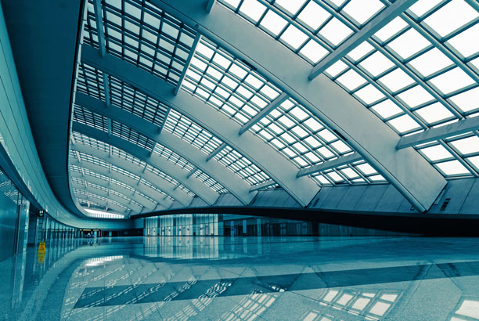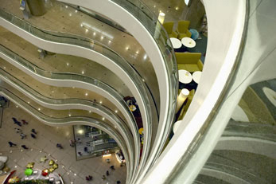

show different Splash page by wifi-ssids

2020.01.08

abel

Main

Then after connecting to WiFi, it can automatically provide subway station information (some local services and facilities),

Without entering the station name

Detail

In windows we:

The check_output method will execute the netsh wlan show network command in the child process, and the result will be returned in the form of a string, the type is bytes, use the decode method to convert the data to str, here we must pay attention to the encoding, which is used when executing the code in my computer It is gbk. If you report an error here during the experiment, you can change it to ascii or utf-8.

Why use \r\n for segmentation, because the returned string is \r\n at the end of each paragraph, so as to ensure that a string can be divided into lines when displayed on the screen, otherwise it can only be displayed on one line Up.

报告标题

2

As for the modulus of 5 in the for loop, it is because in the lst list, the element whose index is a multiple of 5 is exactly the name of the wifi, which is caused by the previous use of split.

In mac osx:

we read result from

/System/Library/PrivateFrameworks/Apple80211.framework/Versions/Current/Resources/airport , then do similar process like windows to get ssid information.

main code get ssid is at i0get_local_ssid.py

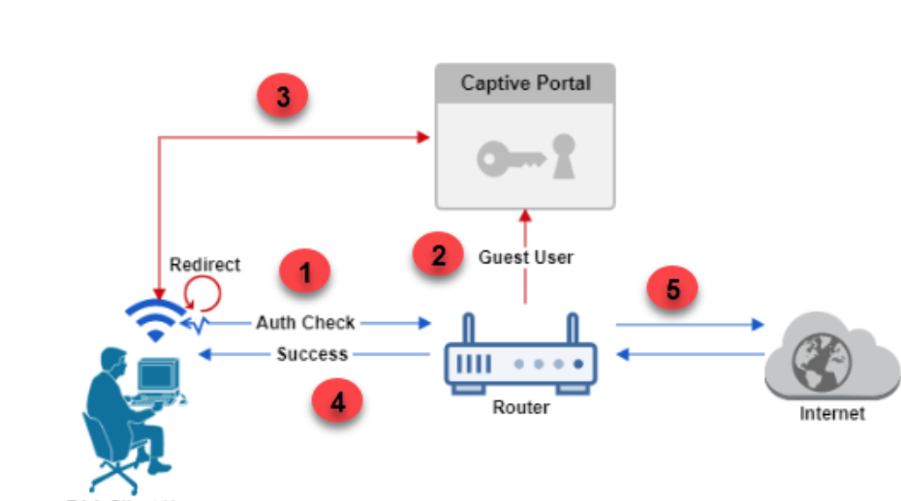

Then we run a web-server and api to show different html content according by ssids.

In this experiment, we don not use router hardware, we use old macbook/windows notbook to simulate a router,

so the auth check is done at web-server api, you can see code in i1flask_api.py