A Cloud-based Smart Home Control System
Content
1 Introduction 2
1.1Background 2
1.2 Statement of our project 2
2 Technical Background 2
2.1 Background Knowledge 2
2.2 Software tools 3
2.3 Hardware tools 6
3 System Design 6
3.1 Problems and solutions 6
3.2 Design 6
3.2.1 Cloud data center 6
3.2.2 Control end 7
3.2.3 Home equipment 8
4 Implementation 11
4.1 Hardware 11
4.2 Application implementation 12
5 Evaluation 16
5.1 Solution Verification 16
5.2 Network Verification 17
5.3 Software Verification 17
5.4 Hardware Verification 17
6 Conclusion 17
6.1 Project Approach 18
6.2 Results discussion 18
6.3 Future Work 18

1 Introduction

1.1Background
Smart home system based on cloud computing is a smart home system, which provides computing and storage resources with the help of cloud server, combines sensors, and communication technology.

1.2 Statement of our project
In this project, we aim to design a system including a control function for various home appliances (simulated). The architecture of the system includes a smartphones frontend, a Raspberry Pi device as the gateway and the cloud as a hosting environment for all other command processing system. We also aim to define a set of unified interfaces for Smart Home.

2 Technical Background

2.1 Background Knowledge
The concept of smart home was first put forward in the 1980s In the 1990s, smart home was already used in some high-end buildings Traditionally, smart home system is developed by some industrial automation companies, providing a complete set of solutions including home control equipment, sensors, communication components and so on. Due to the lack of interoperability and high cost among various schemes, they have not been popularized on a large scale for a long time. In recent years, smart home system continues to develop. In the United States, after operators successively called out remote intelligent applications at the end of 2010, intelligent home management has become the core of the next wave of broadband applications. It is expected to bring new revenue growth by integrating the appreciation services of home intelligent applications such as security, monitoring and automatic control.
From these trends, it can be seen that the research direction of smart home has quietly changed, that is, from control-based to network-based, from centralized control of various household equipment to transforming the home system into a part of a larger Internet of things, and studying how to obtain the information of the system more conveniently and quickly, control the system from many aspects and make deeper use of the system itself. With the rapid popularization of high-speed broadband network and smart phone, the network has penetrated into people's life more deeply All kinds of household appliances are also more intelligent, which changes the situation of PC as the only information terminal in the family in the past. These changes provide new ideas and opportunities for the development of smart home. The intelligence of household appliances means that more control functions can be developed. The development of ZigBee, RFID, NFC and other short-range communication networks means that we can establish a cheaper and reliable home intranet, and the popularity of smart phones provides people with an intelligent terminal that can access the Internet anytime and anywhere.

2.2 Software tools
Flask is a lightweight web framework based on python. The WSGI toolbox adopts Werkzeug and the template engine uses jinja2. It is defined as a "micro" framework because it does not rely on special tools or libraries, and does not have data abstraction layer, form verification or any other functions that can be competent by many existing libraries, so as to keep the core simple and easy to expand. However, flask can add application functions through extension. Moreover, flask has the characteristics of its own development server and debugger, integration unit test, restful request scheduling and support for secure cookies. We mainly use the website part of flask and the API part of WSGI.
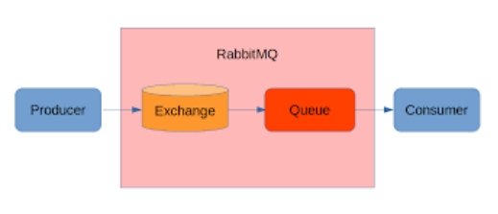
Fig 1. RabbitMq

Rabbitmq message queue is a communication method for applications. Applications can communicate by reading and writing opposite messages. MQ is an implementation of the producer customer pattern. The producer consumer model consists of three modules: producer, consumer and buffer. The existence of cache as an intermediary, the producer puts the data into the cache, and the consumer takes the data out of the cache. In this system, flask is the producer, salesforce is the consumer, and MQ is the intermediate cache. The application of producer consumer model can effectively reduce the coupling between them and reduce their dependence on each other; Due to the existence of cache, consumers do not need to obtain data directly from the producer, which can support concurrent tasks and reduce congestion.
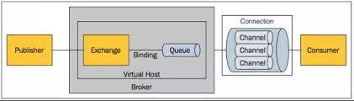
Fig 2. Producer-Customer mode
Specific communication process of AMQP protocol message: rabbitmq still uses the concept of producer and consumer. The flash we developed can be used as a producer, and the accepted i14py belongs to consumers. The producer creates a message, sets a label (routing key) on the message, and sends the message to rabbitmq; Consumers also connect to rabbitmq to subscribe to messages, so as to realize asynchronous communication between producers and consumers. When consuming a message, the received message is only the content of the message and has no label.
Jinja2 is a Python based template engine that supports Unicode, has an integrated sandbox execution environment, and supports automatic escape. Jinja2 has a powerful automatic HTML transfer system, which can effectively prevent cross site script attacks; Use similar layout for all templates through template inheritance mechanism; By converting the source code into Python bytecode at the first load, the template execution time is accelerated. The part of the page we can see on our website is this development.

2.3 Hardware tools

3 System Design

3.1 Problems and solutions
How to introduce these cloud computing technologies and new trends into the development of smart home? This paper will try to put forward and discuss the concept of smart home system based on cloud computing.
The traditional smart home system takes the home gateway as the core. All devices want to connect with the home gateway, provide data to the home gateway and accept the instructions of the home gateway. The smart home system based on cloud computing is mainly composed of three parts: cloud data center, control end and home equipment.

3.2 Design

3.2.1 Cloud data center
Cloud data center is a server cluster that provides cloud services Provide the following functions:
(1) Receive and store the data from the home gateway through the Internet, and transmit the control data to the home gateway according to the built-in policy or the instruction from the control end;
(2) Connect with the control terminal through the Internet, provide real-time data or historical data of the system to the control terminal, and receive instructions from the control terminal;
(3) Built in a large number of home device control models for home gateway download;
(4) Data mining is carried out on a large amount of stored data to find knowledge for further use.
In the construction of cloud data center, we need not consider the hardware, but focus on the development of software to provide users with reliable and easy-to-use services as much as possible. For the required storage and computing resources, we use the buy as you go method, so that the whole structure has great flexibility and scalability.
On the cloud computing platform, we provide a basic service layer to provide the system with some necessary functions, such as user authentication, data storage, networking and programming interface with home gateway and intelligent terminal This provides some standard basic services for higher application layers Next, using these basic services, the system developer becomes the maintainer of a software ecosystem. A large number of third-party manufacturers can develop applications for the system, such as providing web sites, mobile applications, data analysis, etc Home appliance and sensor manufacturers can use these program interfaces to provide the latest device drivers to the system for the home gateway to call.

3.2.2 Control end
The control end is a man - machine interface device, which is the medium for users to use the system The control terminal can be software on an ordinary home computer, an application on a smartphone or tablet, or a built-in function of a smart TV It enables users to obtain all aspects of the system information, configure and use the system.
Taking mobile applications as an example, Android application developers can develop an application based on the operating system, connect the cloud service of the system and bind the account, so they can see the real-time situation and historical data of their own system, configure and operate it In fact, Google has released the software platform "Android home" Google hopes Android will not only be the operating system of mobile phones and laptops, but also make electrical appliances "intelligent", including electric lights, household appliances, irrigation systems, thermostats and so on.
Man is the controller of the system, configures and uses the system, and is also a part of the system Through simple indoor positioning system and portable RFID tag, the system can perceive the existence of people For example, when people enter the study from the living room, the system will turn on the light and music in the study and turn off the equipment in the living room. When the system detects that there is no one in the house, the whole system will enter the lowest power consumption operation These controls are performed by pre - set control policies in the cloud data center, and people are the served.

3.2.3 Home equipment
Home devices include home gateways, sensors and various controlled devices. Home gateway is a network connection device connecting home intranet and extranet Smart home gateway is the home resource management and configuration center, which completes the functions of home networking and node control The gateway of smart home connects the sensor switch nodes in the home network through ZigBee networking technology, realizes the internal management and control of the internal network of smart home through standard communication protocol, and acts as the interactive interface of information between home network and external network With the profile function of Zigbee, the home gateway can call its basic functions after the sensor and the controlled device are connected to the home network, and automatically download the control model of the device from the cloud data center to achieve more comprehensive control.
In recent years, ZigBee is a low-cost wireless communication standard, which is a prominent advantage Its network capacity is large, the amount of data exchange is small, and the transmission rate is not high In communication, its connection time is short, which can greatly reduce the probability of communication data collision In terms of network security, it encrypts the transmitted data and information, with high security Therefore, it fully meets the requirements of home sensor networking.
The home gateway can adopt the module based on CPLD and MCU CPLD has the characteristics of strong confidentiality, small volume and high reliability, and can provide a large number of I / O. it is convenient to communicate with ZigBee and provide control for lighting and other systems with direct wiring. The home gateway is equipped with a LCD screen to display the status Some independent keys are provided for simple setting The home gateway shall be equipped with flash to store firmware, and OTA upgrade can be carried out uniformly through the cloud data center like the current smart phone.
Various controlled devices are mainly developed by corresponding manufacturers. ZigBee modules are added according to the unified requirements of the system, and the control model is submitted to the cloud data center In this way, when the device is purchased by the end user and connected to the home system, the home gateway can automatically download its control model from the cloud data center to realize automatic configuration.
Functions of home gateway:
(1) Automatic networking, realizing ZigBee wireless coverage within the family through reasonable layout; Automatically download the control model of the newly added equipment from the cloud data center;
(2) Data collection, caching and uploading to cloud data center;
(3) Download the user's instructions or configuration from the cloud data center and send it to the actuator in the home network;
(4) Configure the interlock between the equipment to realize basic local control, such as automatically closing the window when the humidity is detected in rainy days, prohibiting the opening of the electrical equipment in the kitchen when the gas alarm is detected, and closing the equipment with lower priority such as electric water heater when the household power load is detected to be too high;
(5) Automatically upgrade firmware from cloud data center to correct program defects;
(6) Provide a simple browser-based debugging interface to facilitate the basic configuration of installers or users.
Sensors here generally refer to all devices that provide data to home gateways, such as temperature and humidity sensors, gas detection devices, surveillance cameras, electronic fences, etc., as well as information acquisition devices built into home appliances, such as RFID readers in refrigerators or hot water thermometers in electric water heaters This information is collected and transmitted to the cloud data center, which becomes the basis for the control system to adopt strategies On the home gateway side, these data can also be used to activate some interlocking mechanisms.
Actuators refer to all devices that implement control strategies, including various household appliances. With the development of intelligent home appliances, it will be possible to connect every home device to the home network.

4 Implementation

4.1 Hardware
The combination of smart home and cloud computing is not only to meet our demand for home device control, but also will bring some new application prospects Overall control refers to the simultaneous control of multiple home systems In a narrow sense, the home system is aimed at family users. In fact, hotels, apartments, student dormitories, prisons and so on can also be regarded as special "family users", and the system can also be used to realize overall control For example, the control end of the central control room of the hotel can operate the gateways of all guest rooms through the cloud data center, automatically adjust the air conditioning temperature of all rooms according to the temperature change, automatically stop the heating of some electric water heaters with high water temperature during the peak load, and charge all equipment using rechargeable batteries during the power valley.
The cloud server stores a large amount of data from the home gateway, including the operation data of various sensors and controlled devices, which enables the cloud server to form a data warehouse Based on this data warehouse mining, the system can optimize the control strategy and provide development guidance for household equipment development enterprises; Supermarket operators can purchase the changes of food (with RFID tags) in the refrigerator of system users within a radius of 5 kilometers from the system operator to predict customers' purchase intention, or deliver fruits and vegetables regularly Home appliance manufacturers can understand the usage habits of customers in different regions and develop more targeted products.

4.2 Application implementation
We use the subscriber pattern in the design process. We simulate the acceptance of rabbitmq messages, and the waiting and display parts are implemented using the subscriber mode, which is based on Python multi process. In this process, rabbitmq acts as an eventbus, which can be understood as a collection of subscription events. It provides functions such as subscription, publishing, cancellation and so on. Subscribers subscribe to events and publishers publish events through the event bus. In the future, multiple IOT devices can be simulated to subscribe to messages, consume messages, and even feedback interaction.
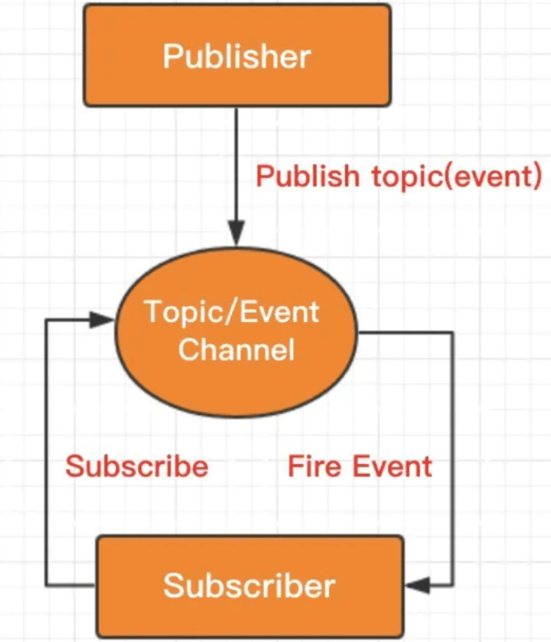
Fig 3. Subscriber mode

Rabbitmq is an open source implementation of AMQP (Advanced message queuing protocol) developed by Erlang. As a message queue management tool, rabbitmq is responsible for handling the communication tasks between servers after integration with celery. The usage process of rabbitmq is as follows:
1. The client connects to the message queue server and opens a channel (at present, we only use one channel, namely Hello channel).
2. The client declares an exchange and a queue, and sets relevant properties respectively.
3. The client uses the routing key to bind the relationship between exchange and queue.
4. The client delivers the message to exchange. Exchange delivers the message to the queue according to the key of the message and the set binding.
There are three types of exchange types commonly used by rabbitmq:
1. Fanout: it can deliver all messages sent to the exchange to all queues bound to it.
2. Direct: deliver messages to queues where the binding key matches the routing key exactly.
3. Topic: route messages to a queue whose binding key matches the routing key pattern.
We temporarily use the type of topic to facilitate our expansion. If necessary, we can not only receive the topic of Hello channel from the API side, but also set the message topic fed back from the Internet of things device side, such as message_warning topic, which represents the queue of various alarm and prompt messages of the Internet of things.
My system uses the flash framework to realize the page, and my operations can be carried out on the page. This is very convenient. Whether using mobile phone or PC, I can operate with the help of browser without installing any applications.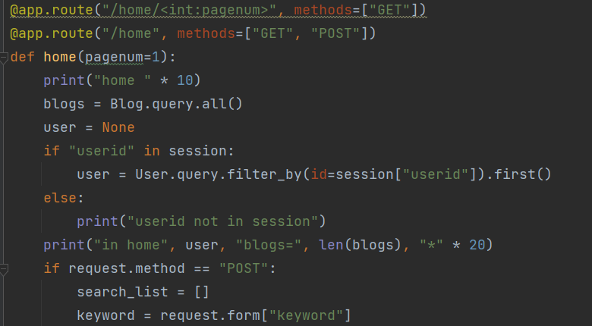
As can be seen from the above figure, I use the flash framework to realize page routing and network requests.
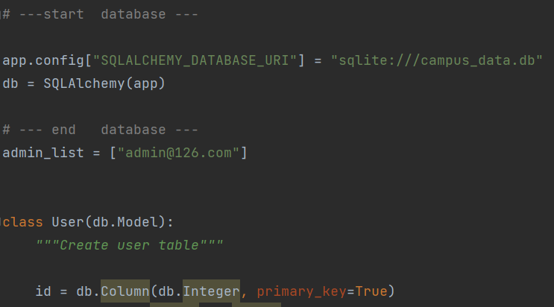
In addition, the database management system I use is SQLite It belongs to an embedded database, which can be used out of the box. The SQLite database itself is very small (only about 4MB under windows, and the mainstream Linux comes with SQLite) In the case of a small amount of data, if the system has only tens of thousands or even thousands of data, SQLite is the most suitable. I use SQLite in the app to store cached data, such as login data cache, historical data cache, etc.
The following figure shows some of our virtual device operation interfaces. I use Tkinter library to develop simple graphical user interface. Tkinter is equivalent to Python's standard GUI library. Where there is python, there is Tkinter. There is no need to find a third-party library to install it separately, so as to avoid a lot of compatibility, version and other problems. This is more friendly for beginners.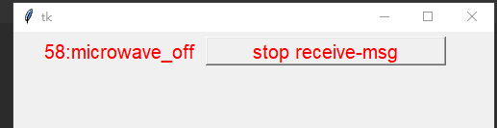
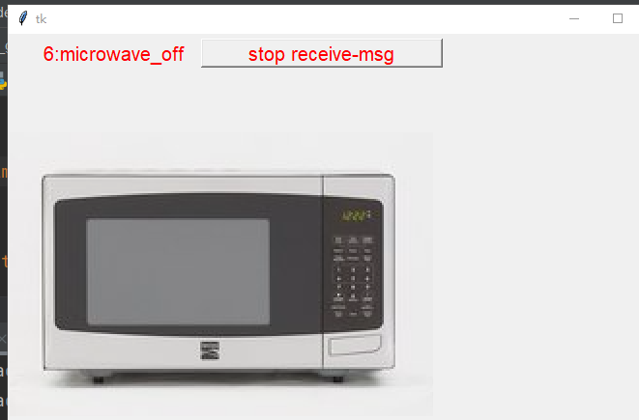

5 Evaluation

5.1 Solution Verification

5.2 Network Verification

5.3 Software Verification
During verification, the main assessment indicators include average response time and transaction success rate. Rabbitmq server is the key bridge connecting the foreground and background communication. In order to ensure the high reliability of the cloud platform system, a certain stress test is carried out after the function test Using the Loadrunner test tool, 500 virtual users are constructed to access the cloud platform concurrently. The system reaches 500 concurrency in 4 minutes and lasts for 20 minutes. It can be found that in these 20 minutes, the average response time of the system is about 4 seconds and the number of clicks per second is about 150.

添加部分________________________
Pytest is a unit test framework of python, similar to the unittest test framework that comes with python, but it is simpler and more efficient to use than the unittest framework. According to the official website of pytest, it has the following characteristics:

Very easy to use, easy to get started, rich documentation, there are many examples in the documentation for reference

Ability to support simple unit tests and complex functional tests

Support parameterization

During test execution, some tests can be skipped, or some expected failure cases can be marked as failures

Support repeated execution of failed cases
Supports running test cases written by nose, unittest
Has many third-party plugins and can be custom extended
Easy continuous integration
We can easily add unit tests, regression tests, and use the plugin pytest-cov to count the test coverage of all code(pytest-cov is a plugin for pytest, and its essence is to refer to the python coverage library for statistical code coverage. For our project, we all use api to call the interface.
Another note: coverage is a type of statement coverage, and you cannot interpret your logic. If it is true, it needs to be combined with the project itself. This coverage data is not very convincing, so don’t blindly pursue it.
Generally speaking:
Path Coverage > Decision Coverage > Statement Coverage)
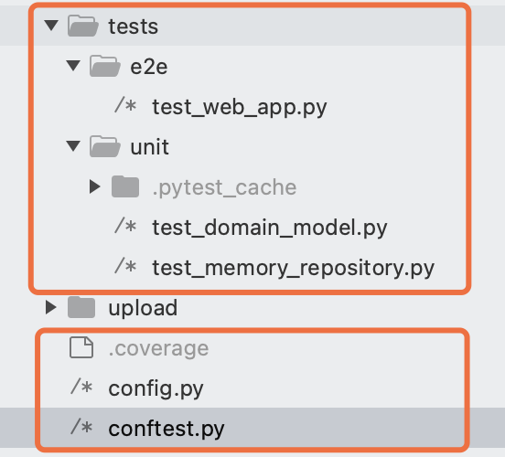
We have conducted various return value tests related to api
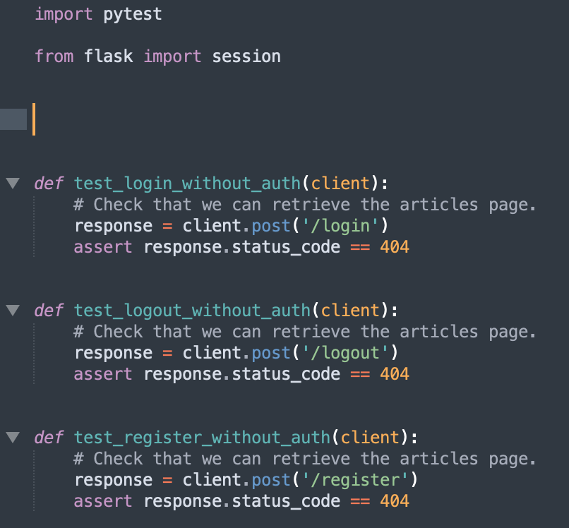
We performed fixture mock operations on objects in some key places
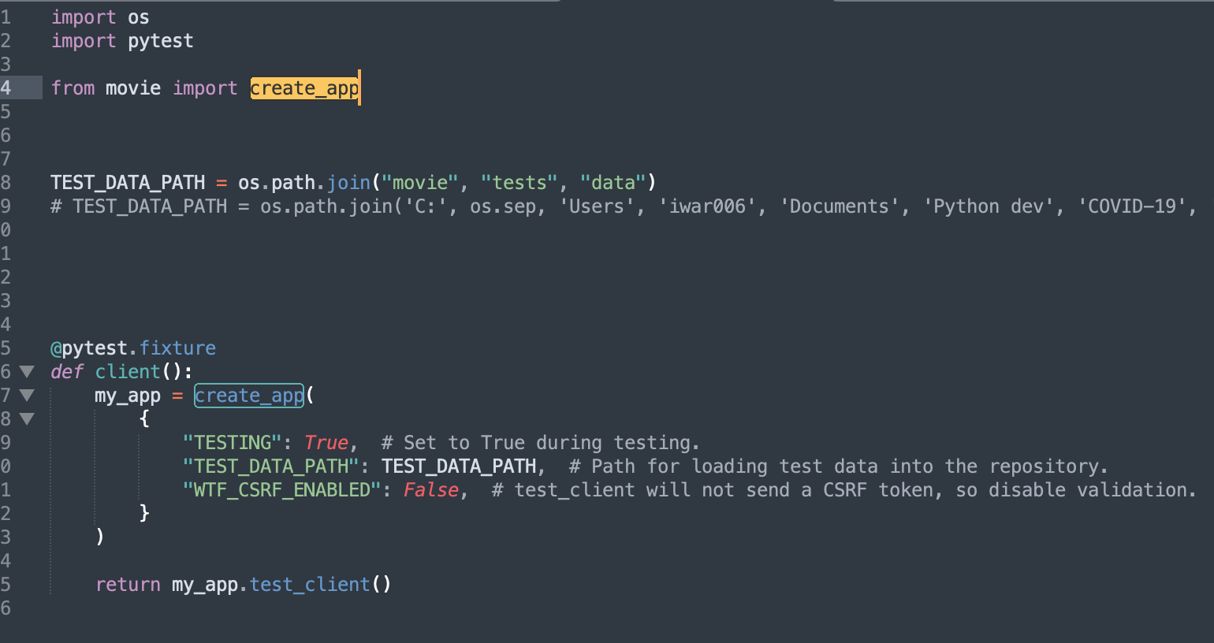
The statistical results of unit testing and regression testing are as follows：
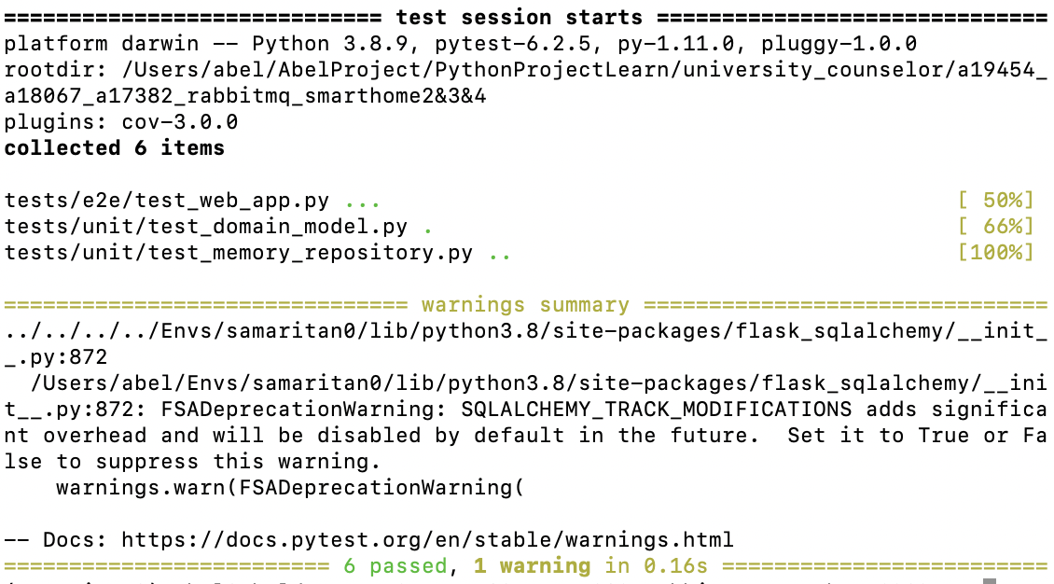
The overall code branch and path coverage is as follows：

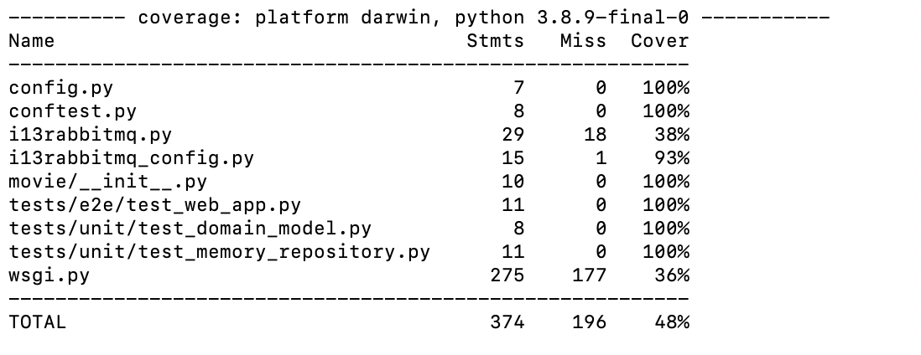
end添加部分________________________

5.4 Hardware Verification

6 Conclusion
Based on the existing smart home cloud platform, this paper realizes the application mode of rabbitmq server in multi foreground and multi background distributed system through the research of rabbitmq The serious coupling problem between multiple modules is solved The high reliability of rabbitmq is unmatched by other message oriented middleware, which is one of the main reasons why the platform system adopts rabbitmq server Moreover, rabbitmq server provides a visual monitoring page, which is conducive to the monitoring and maintenance of the platform system Rabbitmq message queue realizes a reliable and effective information exchange mode It provides a solid and reliable foundation for the whole smart home cloud platform architecture.

6.1 Project Approach

6.2 Results discussion

6.3 Future Work

Reference
[1] Xiao-Ping, Q. U., and L. I. Li-Xian. "A Smart Home System Based on Cloud Computing." Computer Knowledge and Technology (2015).
[2] Li, L., and J. Luo. "Smart Home and Its Development Trend." Computer and Modernization (2007).
[3] Ding, J., T. R. Li, and X. L. Chen. "The Application of Wifi Technology in Smart Home." Journal of Physics Conference Series 1061(2018).
[4] Basarudin, N. A., et al. "Smart home and legal safeguard against cyber threat: A review." (2017).
[5] Lu, X. H. , et al. "Mining and Analyzing Behavior Patterns of Smart Home Users Based on Cloud Computing." Springer, Cham (2020).
[6] Albataineh, H. , M. Nijim , and D. Bollampall . "The Design of a Novel Smart Home Control System using Smart Grid Based on Edge and Cloud Computing." 2020 IEEE 8th International Conference on Smart Energy Grid Engineering (SEGE) IEEE, 2020.
[7] Zahra, Mma , et al. "Artificial intelligent smart home automation with secured camera management-based GSM, cloud computing and arduino." Periodicals of Engineering and Natural Sciences (PEN) 4.8(2020):2160-2168.
[8] Yuan, D. , et al. "Intrusion Detection for Smart Home Security Based on Data Augmentation with Edge Computing." ICC 2020 - 2020 IEEE International Conference on Communications (ICC) IEEE, 2020.
[9] Wang, Y. . "Research on Smart Home Security Access Control Technology Based on Internet of Things and Cloud Computing." Video Engineering (2018).
[10] Xie, X. , and W. Huang . "Research on Smart Home System Construction based on the Internet of Things (IOT) and Big Data." International Conference on Education 2016.

