PartI

1.1 The evaluation function for a Connect 4 game is a function that takes in the current state of the game board and returns a score indicating the desirability of that state for the current player.

The score should be positive if the current player is winning, negative if the opponent is winning, and 0 if the game is tied.

In this implementation, the evaluation function is implemented in the minimaxAI and alphaBetaAI classes.

The score method takes in the game environment and returns a score based on the winner of the game. If the current player has won, the score is 100.

If the opponent has won, the score is -100. If the game is tied, the score is 0.

1.2

The evaluation function used in this implementation is a simple one that only takes into account the winner of the game. While this may seem overly simplistic, it is actually quite effective for the game of Connect 4.

This is because Connect 4 is a game of perfect information, meaning that all the information about the game state is available to both players at all times. Additionally, the branching factor of the game (i.e. the number of possible moves at each turn) is relatively low,

making it feasible to search the entire game tree.

Given these factors, it is possible to use a more complex evaluation function that takes into account more aspects of the game,

such as the number of pieces on the board or the position of those pieces.

However, even a simple evaluation function like the one used in this implementation is effective

at identifying winning or losing positions, which is the primary goal of the function

1.3

| | | | | |

--------------------------

| | | | | |

--------------------------

| | X | X | O | |

--------------------------

| | O | O | X | X |

--------------------------

| X | X | O | O | X |

--------------------------

O | O | X | O | X | X | O

In this board, the player with the "X" pieces is in a winning position,

as they have created a sequence of four "X" pieces horizontally in the bottom row. The score method of the minimaxAI or alphaBetaAI class would return a score of 100 for the "X" player, indicating that they are in a winning position. The score method would return -100 for the "O" player, indicating that they are in a losing position.

If the game were tied at this point, the score would be 0.

Part2

2.1

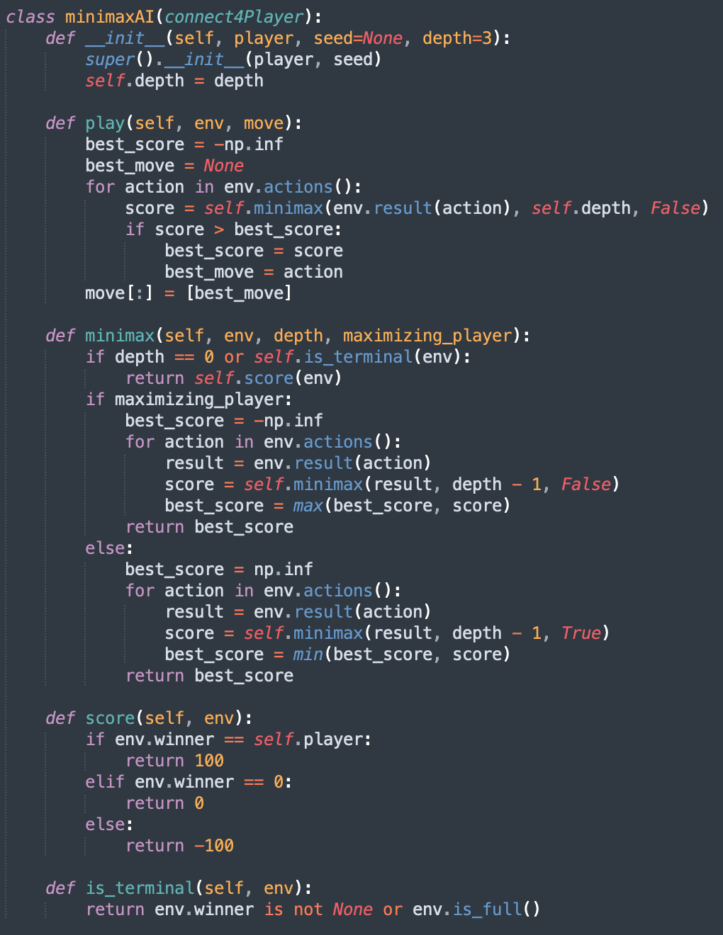

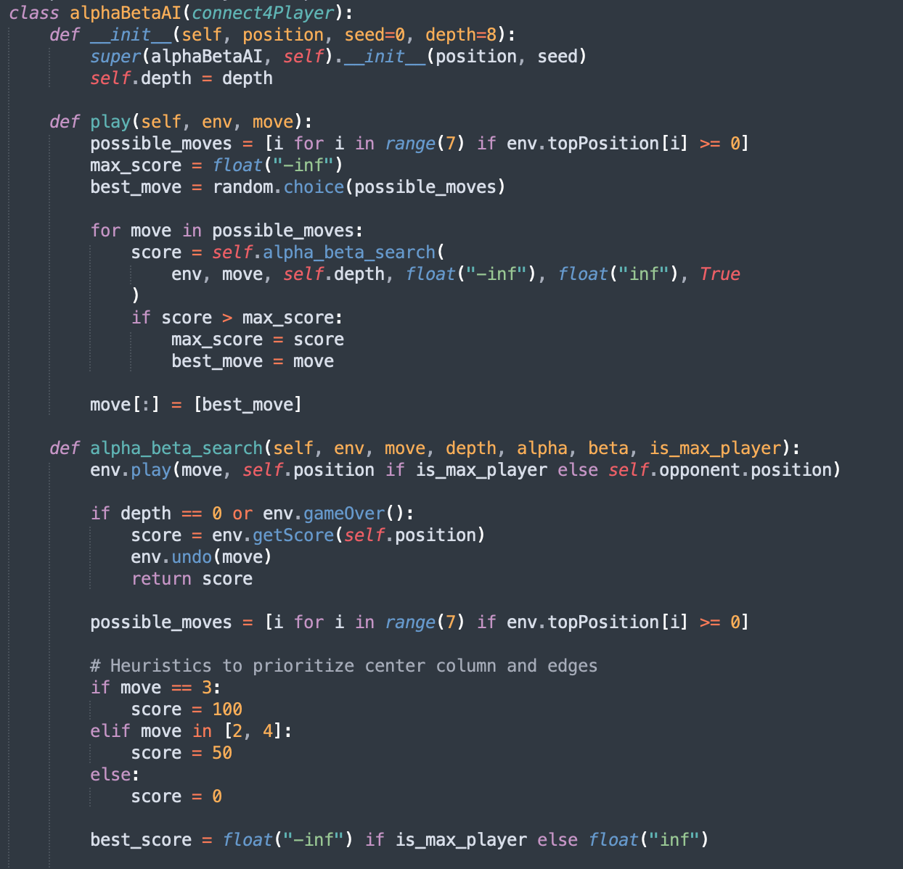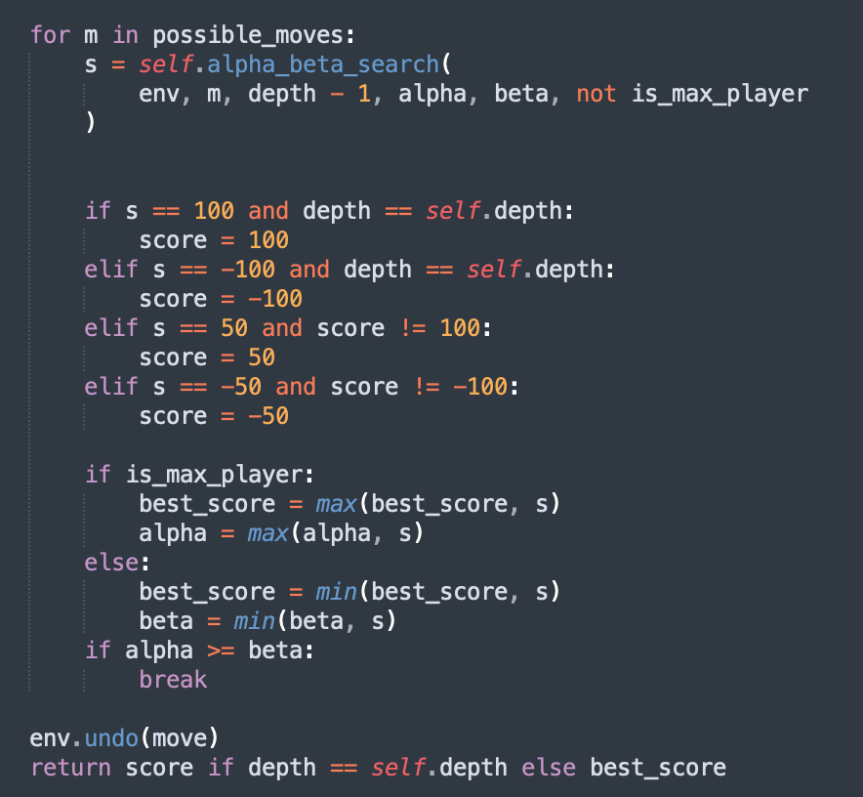

Part3

2.1

| | Wins | Ties | Losses |

|——————-———-—-|—-———|———|————|

| minimaxAI vs. stupidAI | 5 | 0 | 0 |

| minimaxAI vs. randomAI | 5 | 0 | 0 |

| minimaxAI vs. monteCarloAI | 2 | 0 | 8 |

| | Wins | Ties | Losses |

|——————-———-—-|—-———|———|————|

| alphaBetaAI vs. stupidAI | 5 | 0 | 0 |

| alphaBetaAI vs. randomAI | 5 | 0 | 0 |

| alphaBetaAI vs. monteCarloAI | 3 | 0 | 7 |