Artworks on Campus

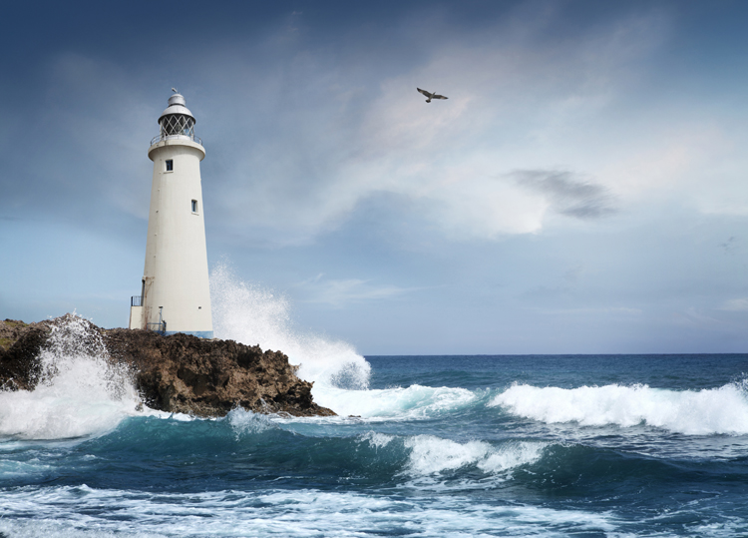2021.01.09 hanjiangxue

Introduction

On the welcome Splash page, we download the data from the API-service (the first time), and synchronize the data from API at other times.

When the data synchronization is complete, we pop up an alert window to tell the user: The website is in good condition and we can synchronize. Then click the "Enter Now!” button to enter the main view.

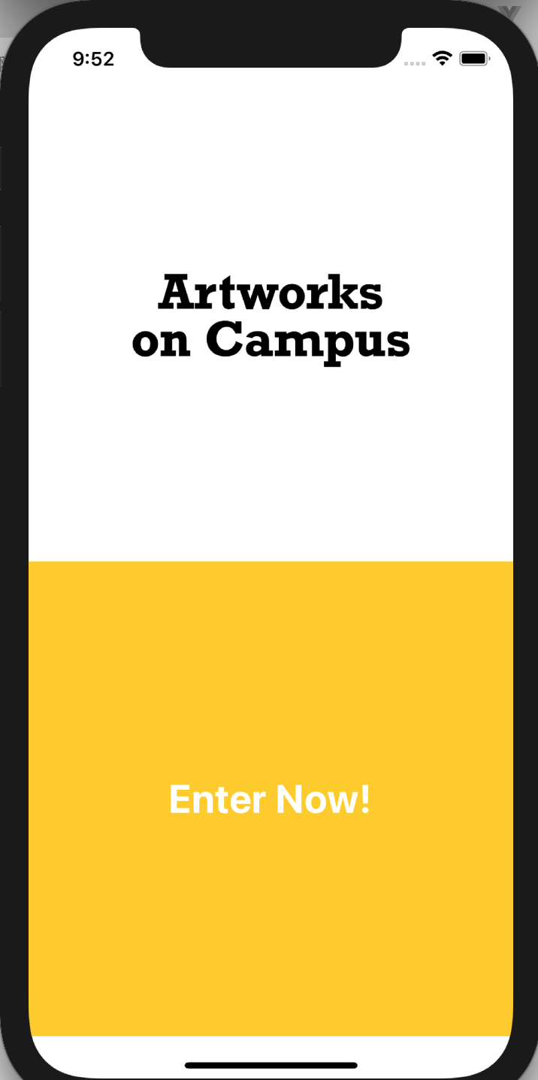

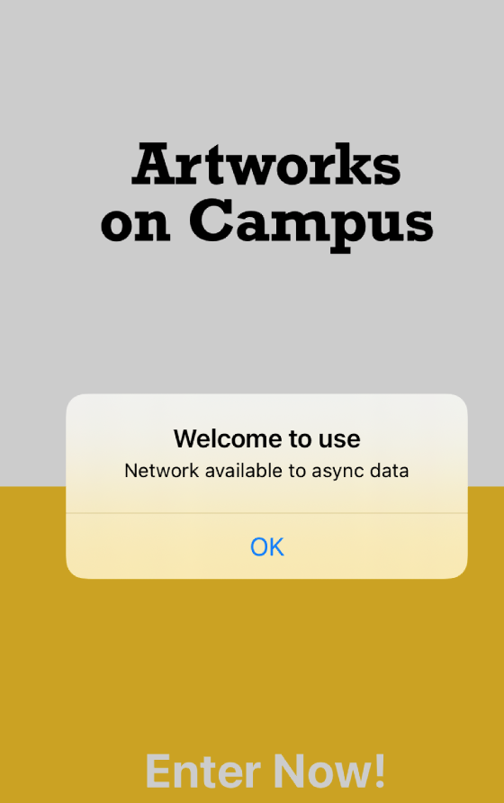

main view

In the main interface, we implemented the map interface and the location-artwork grouping exhibition tableview.

Our main idea for the map is: a bird’s eye view of the panorama, and then know the approximate location in which direction, how can I go there, and when I have time in the future, this project can be further expanded: if the campus is divided into multiple campuses, we can provide route planning functions.

The corresponding relationship between locations and artworks is mainly maintained in the following table structure. The first level is the location list. Each location list is a section. There are multiple artworks in the section. Click on each artwork to enter the details page. At the same time, click on the annotaion on the map, you can also enter the details page of the top artwork of the place.

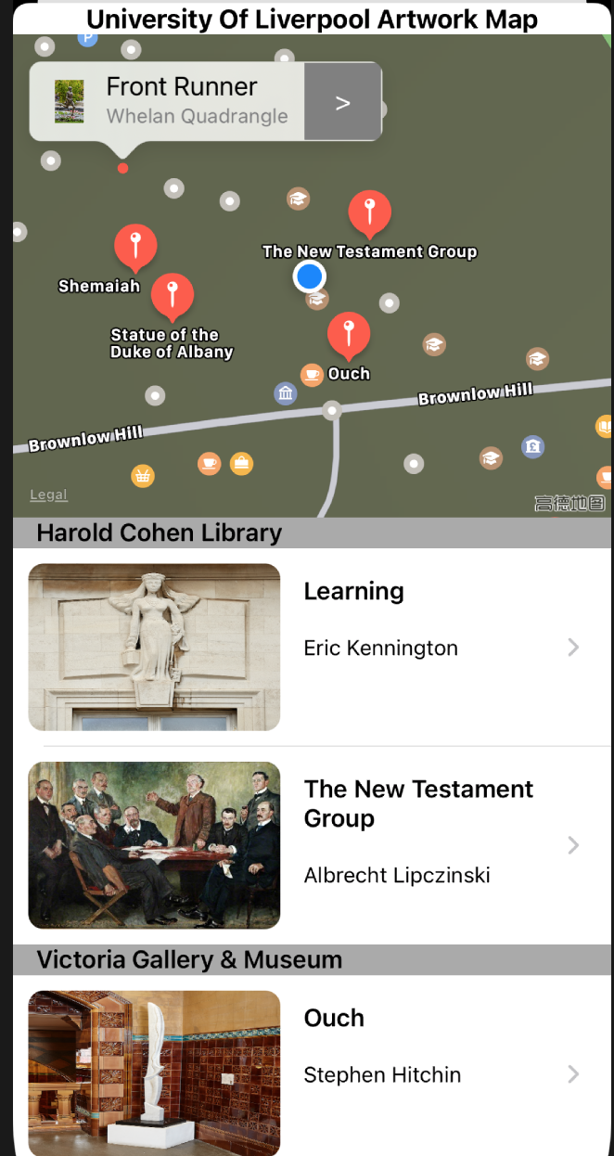

addtional extract function

We use stackview to do amazing things: in the main interface, we implemented the map interface and the location-artwork grouping exhibition table interface.

Our main idea for the map is: a bird’s eye view of the panorama, and then know the approximate location in which direction, how can I go there, and when I have time in the future, this project can be further expanded: if the campus is divided into multiple campuses, we can provide route planning functions.

The corresponding relationship between locations and artworks is mainly maintained in the following table structure. The first level is the location list. Each location list is a section. There are multiple artworks in the section. Click on each artwork to enter the details page. At the same time, click on the annotaion on the map, you can also enter the details page of the top artwork of the place.

