Scheduler Java Client

This program will be a planner that lets users create, store, and modify events. The program will be able to display a calendar view, as well as a more detailed weekly view. It will also let users create group events with other users, and it will automatically suggest the best times based on the users’ schedules and availabilities. Other features will also be supported, including time zone support.

The program uses a SQL database that stores user accounts (usernames and passwords), user information (name, day-to-day availabilities), and event information (name, start time, end time, attendees, location, and whether or not the event is a recurring event).

**Features**

* Event Management
  + Users can create new events
  + Program will store events in SQL database
  + Users can modify their own events
* UI
  + Calendar view of events
  + Detailed weekly view of events
* Group Events
  + Users can create group events and invite other users
  + Users can accept invitations for events
  + Program will automatically suggest the best times based on the users’ schedules and availabilities
* Misc. Features
  + Time zone support (users can input their current time zone)

**SQL Database**

* User Accounts
  + User’s username/password, and user information (first name, last name, availabilities)
* Event Information
  + Name of event, start/end time, attendees, location, and whether or not the event is a recurring event

**Sample Runs**

Top left: Login window

Top right: Edit event window

Bottom: Monthly view

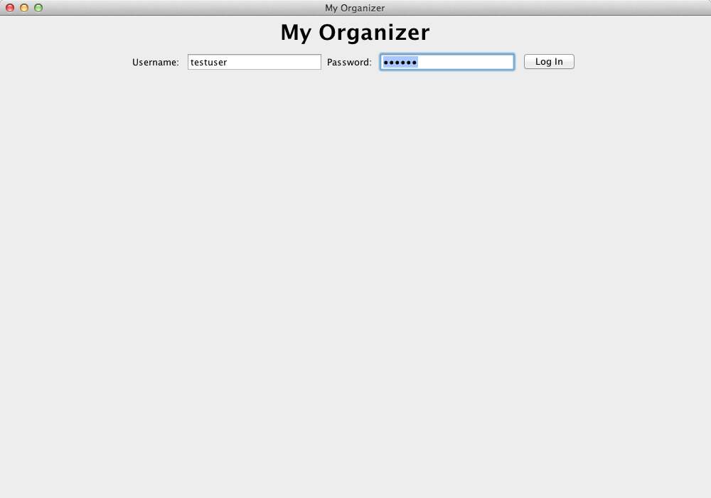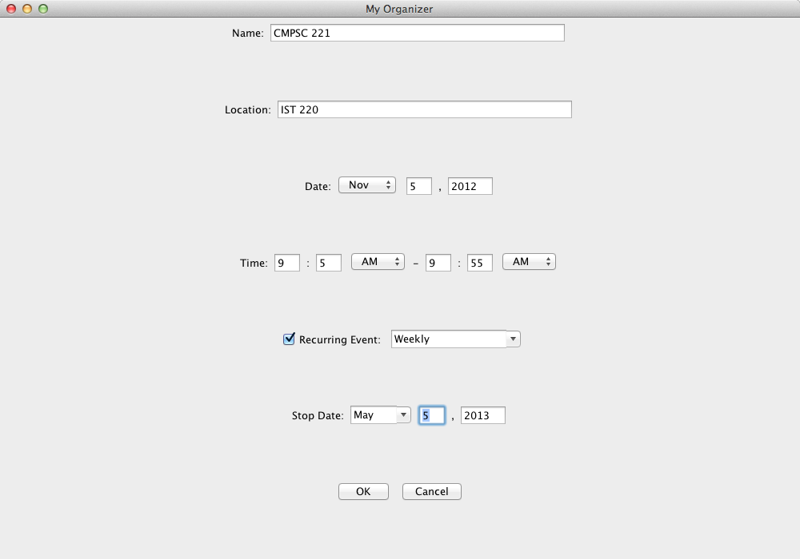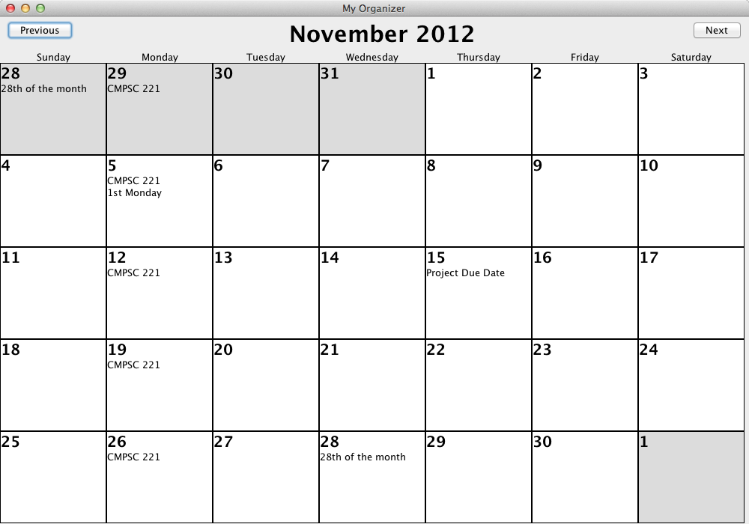

**Contribution**

Amu implemented the high-level application functions, the calendar monthly view, and the login page. He also worked to integrate the view and edit event panels Nicholas implemented into the monthly view.

Nicholas implemented the panels to view, create, and edit an event. He also restructured existing classes to make the different Event classes more compatible.