Java Scheduler
CMPSC 221 Project 2 Report
Date: 18 November 2012
Names: Amuthan Narthana and Nicholas Dyszel
PSU IDs: aen5078, nwd5069
Team Number: 13
Section: 2

System Description
This program is a scheduler that allows users to create and manage events. The events can be one-time events (Oct. 8, 2012 from 10am-11am) or recurring events (every Monday from 9:05am-9:55am). Users will be able to view their events in a calendar view (by month, by week, or by day). Users will also be able to invite other users to events. After setting their general availabilities (e.g. M-F 9:00-5:00), the program can compute the times that a user is available based on his/her general availabilities and scheduled events. This will be used for comparing several users’ availabilities to determine an “optimal” time for an event attended by all of these users.
We use Java’s GregorianCalendar and Date classes to represent times and dates. We have written logic for calculating all of the occurrences of a recurring event within a time frame (e.g. finding all November occurrences of an event that occurs every Monday from 9:05am-9:55am). We have also written logic for computing the availability of a user based on when he/she is typically available and what events he/she has scheduled that day.

Class Hierarchy

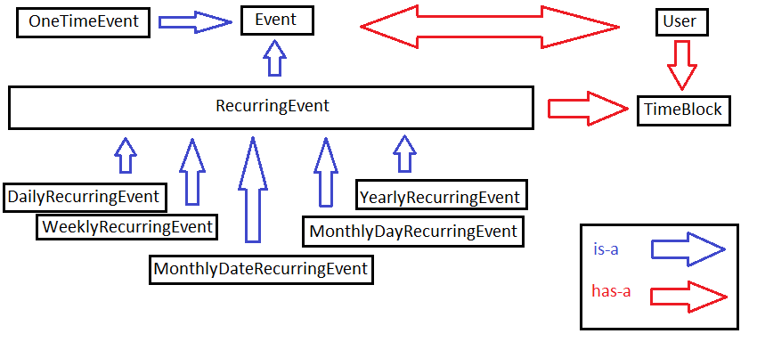

Sample Runs

Login window

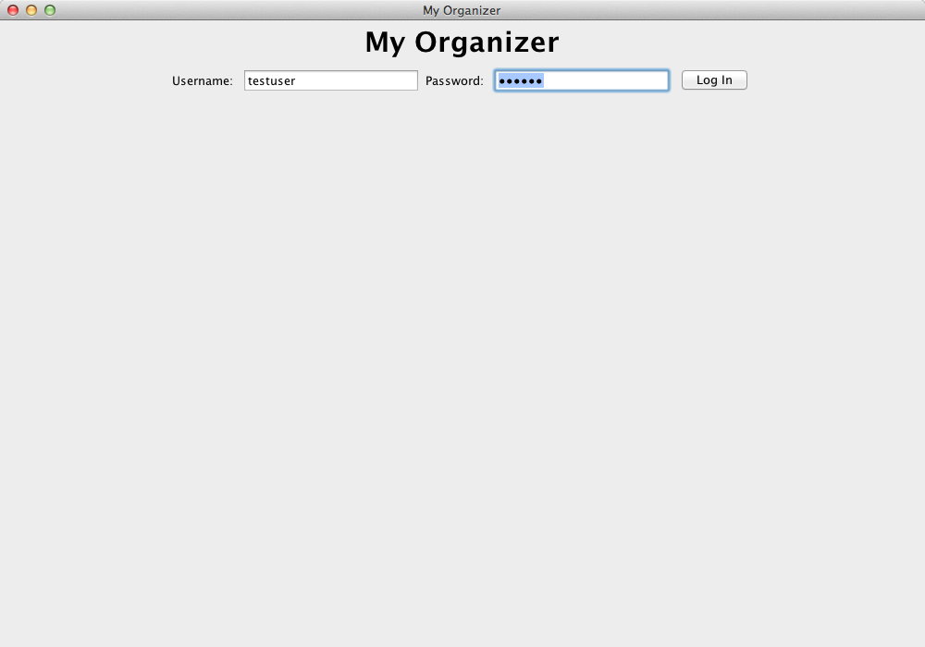

Monthly view

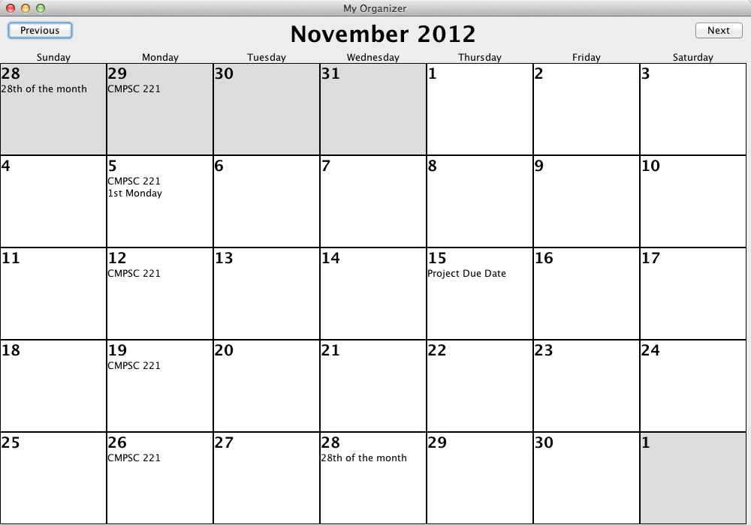

Edit event window

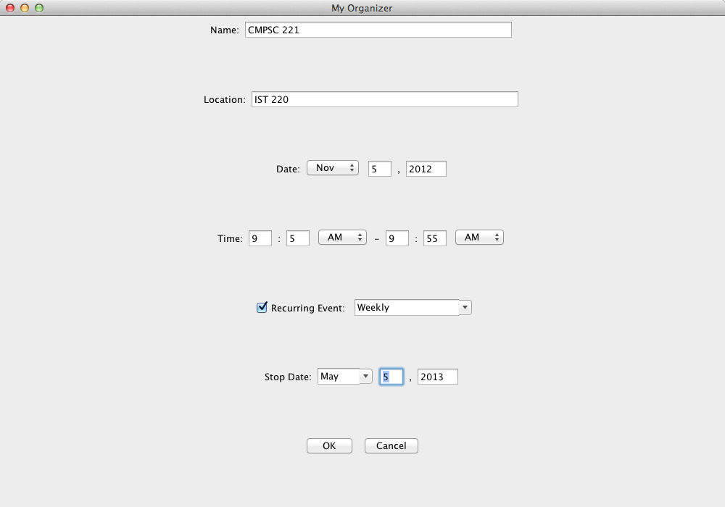

Discussion

The important logic in our Java code so far is implemented in the RecurringEvent class and the TimeBlock class. In the RecurringEvent class, we have implemented the function getEvents, which we will use when we create the GUI for the program (e.g. when we view November in the calendar, we will call getEvents to get a list of November occurrences of an event). This uses an elegant design since RecurringEvent has many subclasses, but a lot of the logic between the subclasses is the same. By keeping most of the logic in RecurringEvent, we avoid duplicating code.

The TimeBlock class has “set logic” (logic with sets, intersections, complements, etc.) for finding the intersection, complements, or difference of lists of TimeBlock objects. This will be used when we need to compute the availability of a user based on the user’s general availability and scheduled events. By writing generic “set logic” here, we let ourselves use this code in various situations (e.g. computing a user’s availability, comparing users’ schedules together, etc.).

We chose not to subclass Exception for invalid time inputs because we were only printing a different message in this case (which can easily be done using the Exception class). If we start handling time input exceptions differently from other exceptions, then we will make a separate subclass for time input exceptions.

One issue we ran into was the deprecated methods of Java’s Date class. To solve this issue, we opted to use Java’s GregorianCalendar class wherever needed. In our program, Date objects are mainly used to represent fixed dates, while GregorianCalendar objects are used for date manipulation.

In the GUI components, we encountered problems creating new JPanels every time the edit panel for an event was opened. By suggestion, we switched to an implementation in which the application uses a card layout to switch between four panels: login, monthly calendar view, view event, and edit event. Each panel type is a subclass of abstract class PagePanel, which includes an activate method that is called to re-initialize the panel before it appears.

Contribution

Amu implemented the high-level application functions, the calendar monthly view, and the login page. He also worked to integrate the view and edit event panels Nicholas implemented into the monthly view. He created an abstract class (PagePanel) that the four panel types would inherit from.

Nicholas implemented the panels to view, create, and edit an event. He also restructured existing classes to make the different Event classes more compatible. He edited TimeBlock to check for valid times.

