CInt
函数，将浮点类型、双精度类型的数值转换为整形数值（Integer，16位，2Bytes）

四舍五入特性：
'------------------------------------------------------------------------------
'@summary 程序入口
'------------------------------------------------------------------------------
Public Sub Main()
Set Console = New CConsole
'--------------------------------------------------------------------------

'TODO: 在此编辑代码
Console.WriteLine "Result Of CInt(1.45)=" & CInt(1.45)
Console.WriteLine "Result Of CInt(1.47)=" & CInt(1.47)
Console.WriteLine "Result Of CInt(1.50)=" & CInt(1.5)
Console.WriteLine "Result Of CInt(1.51)=" & CInt(1.51)
Console.WriteLine "Result Of CInt(1.52)=" & CInt(1.52)
Console.WriteLine "Result Of CInt(1.6)=" & CInt(1.6)
'--------------------------------------------------------------------------
#If VB_DEBUG Then
Console.WriteText "Press any key to continue..."
Console.ReadKey
#End If
Console.WriteLine
End Sub
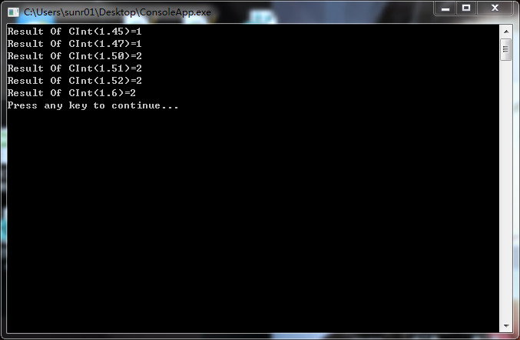
负数时的处理：

Public Sub Main()
Set Console = New CConsole
'--------------------------------------------------------------------------

'TODO: 在此编辑代码
Console.WriteLine "Result Of CInt(-1.45)=" & CInt(-1.45)
Console.WriteLine "Result Of CInt(-1.47)=" & CInt(-1.47)
Console.WriteLine "Result Of CInt(-1.50)=" & CInt(-1.5)
Console.WriteLine "Result Of CInt(-1.51)=" & CInt(-1.51)
Console.WriteLine "Result Of CInt(-1.52)=" & CInt(-1.52)
Console.WriteLine "Result Of CInt(-1.6)=" & CInt(-1.6)

'--------------------------------------------------------------------------
#If VB_DEBUG Then
Console.WriteText "Press any key to continue..."
Console.ReadKey
#End If
Console.WriteLine
End Sub

可以得知，负数的特性

Int
我们知道：
Int(0.1)=0
Int(0.9)=0
即用数学语言来描述的话，
