**FPT University**

***Project Report***

**Part 1: Initiating Project**

1. **Project Information**

* **Name of project: Auction Management Software**
* **Donors:** FPT Students SE1210
* **Participants in the project:**
* Đỗ Hải Giang (SE06127)
* Nguyễn Xuân Lộc (SE05343)
* Nguyễn Bảo Long (SE05816)
* **Project Implementation Time :**
* **Duration:** 4 weeks
* **Start:** 17/06/2018
* **End:** 09/07/2018

1. **Project Determination**

|  |  |  |  |
| --- | --- | --- | --- |
| Team Performance | College student FPT for class SE1210 | | |
| Project Management | Đỗ Hải Giang | | |
| Project’s Name | Auction Management Software | | |
| Project’s Time | 17/06/2018 |  | 09/07/2018 |
| Group Participants | 1. Đỗ Hải Giang 2. Nguyễn Bảo Long 3. Ngô Xuân Lộc | | |
| Project Goal | This auction helps people buy or sell everything they want more easily and convenience | | |
| Project Objectives | - Beautiful Interface  - Easy to use for the user  - Show full of details  - Accomplish a product on time  - High efficiency | | |
| Clients | - Age must higher than 18 | | |
| Project Scope | - This software is used by every people in the world  - Information of User (Protected)  - Product conforms to regulations | | |

**Part 2:Set Project Plan & Execution**

* **Group Member Information:**

1. Đỗ Hải Giang

Class: SE1210

Identification Number: SE06127

Dormitory Room: C410

Email: giangdhse06127@fpt.edu.vn

Phone Number: 01627919568

1. Nguyễn Bảo Long

Class: SE1210

Identification Number: SE05816

Dormitory Room: C410

Email: longnbse05816@fpt.edu.vn

Phone Number:0934538675

1. Nguyễn Xuân Lộc

Class: SE1210

Identification Number: SE05343

Dormitory Room: C410

Email: locnxse05343@fpt.edu.vn

Phone Number: 01254846990

* **Time Distribution**

***Week 1:***

* Day 1 to Day 5: Learn and get acquainted with JavaSwing
* Day 6: Draw the layout of the parts for the Auction and divide it for members
* Day 7: Get up to work

***Week 2:***

* Day 1 to Day 5: Each members performs their duties
* Day 6 to Day 7: Have group discussions to edit the functions of Program

***Week 3:***

* Day 1 to Day 5: Review the shortcomings of the program
* Day 6 to Day 7: Redesigned Interface

Final Week:

* Prepare for the presentation
* **The task of each member**
* Giang :
* Prepare for the server connection
* Revise the program after someone else completes it
* Long :
* Prepare for “History”,”Edit User”,”Register Account”,”Table Product Information”
* Lộc :
* prepare for “Login “, “Add product “, “Change point “
* **Business Process:**
* **Note:**



* **Avatar:**



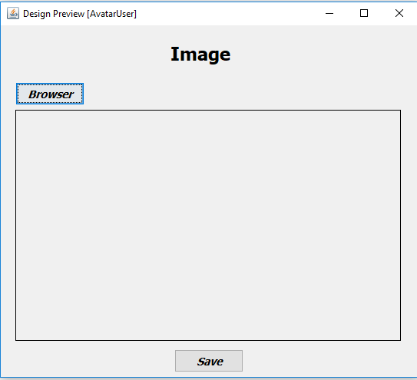

|  |  |  |  |
| --- | --- | --- | --- |
| Use case ID: |  | | |
| Use case name: | AvatarUser | | |
| Created by: | Longnb | Last updated by: | Longnb |
| Date created: | 22/6/2018 | Last revision updated by: | 9/7/2018 |
| Actors: | Customer Users | | |
| Summary: | User can upload his/her image from users’ computer | | |
| Goal: | Allow users to get image avatar | | |
| Trigger: | Avatar Button | | |
| Precondition: | Users logged to the application. | | |
| Normal flow: | * Browser Button => Click this to Open the file from users’ computer * Save Button => Save the image to database | | |
| Alternative flow: | N/A | | |
| Exceptions: | * The upload file isn’t an image   => show a message and you may upload again to save an image   * Enter <Save> button   => “Error”.. | | |
| Relationship: | Extend User | | |
| Business rule: | N/A | | |

* **Register:**



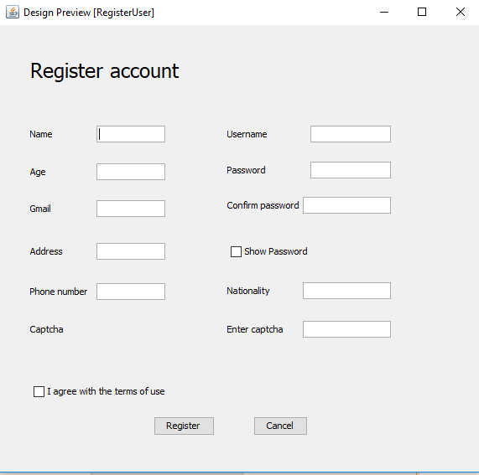

|  |  |  |  |
| --- | --- | --- | --- |
| Use case ID: |  | | |
| Use case name: | RegisterUser | | |
| Created by: | Longnb | Last updated by: | Longnb |
| Date created: | 17/6/2018 | Last revision updated by: | 9/7/2018 |
| Actors: | Customer Users | | |
| Summary: | User must register to have an account after using login | | |
| Goal: | Allow users create an account | | |
| Trigger: | Register Button | | |
| Precondition: | Users logged to the application. | | |
| Normal flow: | * Register Button => Save the account to the database * I agree with the terms of use box => User must check this to create an account * Cancel Button => Exit ‘RegisterUser’ panel * Show Password Box => Show hidden passwords | | |
| Alternative flow: | N/A | | |
| Exceptions: | * The values is empty. * Enter <Register> button   => “Error”. | | |
| Relationship: | Extend Login | | |
| Business rule: | N/A | | |

* **Edit:**



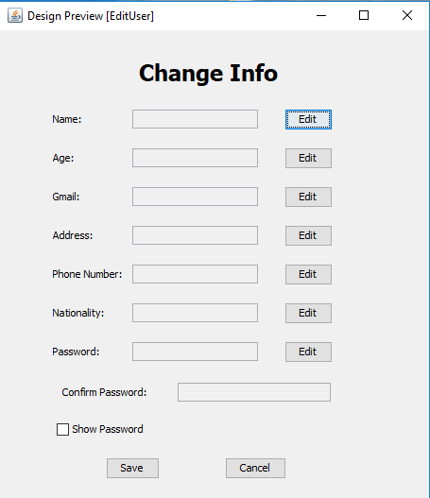

|  |  |  |  |
| --- | --- | --- | --- |
| Use case ID: |  | | |
| Use case name: | EditUser | | |
| Created by: | Longnb | Last updated by: | Longnb |
| Date created: | 17/6/2018 | Last revision updated by: | 9/7/2018 |
| Actors: | Customer Users | | |
| Summary: | When user view his/her profile, user can change his/her profile’s information . | | |
| Goal: | Allow user can complete and edit their profile | | |
| Trigger: | Edit button | | |
| Precondition: | Users logged to the application. | | |
| Normal flow: | * Edit Button => Change the data profile when you click on it * Save Button => Save the data to database * Cancel Button => Exit ‘EditUser’ panel * Show Password Box => Show hidden passwords | | |
| Alternative flow: | N/A | | |
| Exceptions: | * The values is empty. * Enter <Edit> button   => “Error”. | | |
| Relationship: | Extend User | | |
| Business rule: | N/A | | |

* **History**:



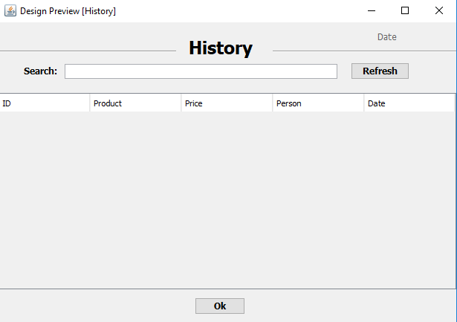

|  |  |  |  |
| --- | --- | --- | --- |
| Use case ID: |  | | |
| Use case name: | History | | |
| Created by: | Longnb | Last updated by: | Longnb |
| Date created: | 20/6/2018 | Last revision updated by: | 9/7/2018 |
| Actors: | Customer Users | | |
| Summary: | User can view history of them | | |
| Goal: | Allow users to view the history of every exchange | | |
| Trigger: | History Button | | |
| Precondition: | Users logged to the application. | | |
| Normal flow: | * Refresh Button => Upload the data from database to the table * Search Box => Search the data you want to find * Okl Button => Exit ‘History’ panel | | |
| Alternative flow: | N/A | | |
| Exceptions: | N/A | | |
| Relationship: | Extend User | | |
| Business rule: | N/A | | |

* **Login**:



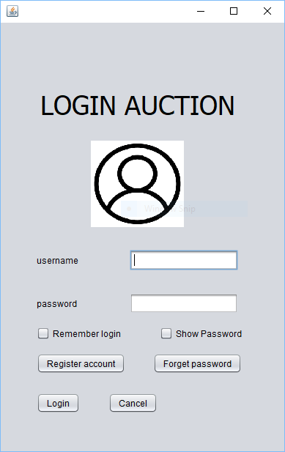

|  |  |  |  |  |
| --- | --- | --- | --- | --- |
| Use case ID: |  | | | |
| Use case name: | Login an account | | | |
| Created by: | Locnx | | Last updated by: | Locnx |
| Date crated: | 17/6/2018 | | Last revision updated by: | 9/7/2018 |
| Actors: | | Users | | |
| Summary: | | After registering for an account. Users can login with the account they registered. | | |
| Goal: | | Allow user login to application. | | |
| Trigger: | | N/A | | |
| Precondition: | | Users had not logged in the application.  User performs login in steps. | | |
| Normal flow: | | 1. Enter user name and password.  2. Tap<Login> button. “User” displayed.  3. Tap<Show password> button. Password showed.  4. Tap<Register account>button. “Register” displayed.  5. Tap<Forget password>button. “ForgetPassword” displayed. | | |
| Alternative flow: | | N/A | | |
| Exceptions: | | 1.a. Don’t enter username and password.  b.Tap<Login>button  => “Invalid username or wrong password”.  2.a. Enter invalid username field.  b.Tap<Login>button  => “Invalid username or wrong password”.  3.a. Enter invalid password field.  b.Tap<Login>button  => “Invalid username or wrong password”. | | |
| Relationship: | | Extend user. | | |
| Business rule: | | N/A | | |
|  |  |  |  |  |

* **Forget Password:**



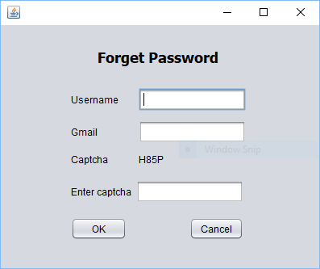

|  |  |  |  |  |
| --- | --- | --- | --- | --- |
| Use case ID: |  | | | |
| Use case name: | Forget password | | | |
| Created by: | Locnx | | Last updated by: | Locnx |
| Date created: | 17/6/2018 | | Last revision updated by: | 9/7/2018 |
| Actors: | | Users | | |
| Summary: | | Users forget password. Enter username and gmail to get new password. | | |
| Goal: | | Allow user get new password. | | |
| Trigger: | | N/A | | |
| Precondition: | | Users had not logged in the application.  User performs get new password. | | |
| Normal flow: | | 1. Enter user name, gmail and capcha.  2. Tap<ok> button. Alert notification show new password. | | |
| Alternative flow: | | N/A | | |
| Exceptions: | | 1.a. Don’t enter username and gmail.  b.Tap<OK>button  => “Invalid username or wrong gmail”.  2.a. Enter invalid username field.  b.Tap<OK>button  => “Invalid username or wrong gmail”.  3.a. Enter invalid gmail field.  b.Tap<OK>button  => “Invalid username or wrong gmail”. | | |
| Relationship: | | Extend Login. | | |
| Business rule: | | N/A | | |
|  |  |  |  |  |

* **Add Product:**

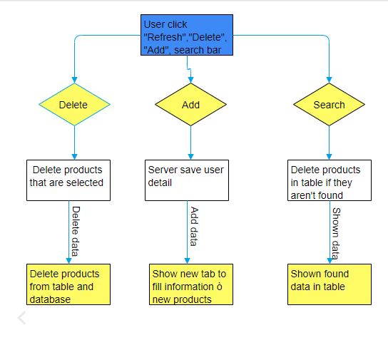

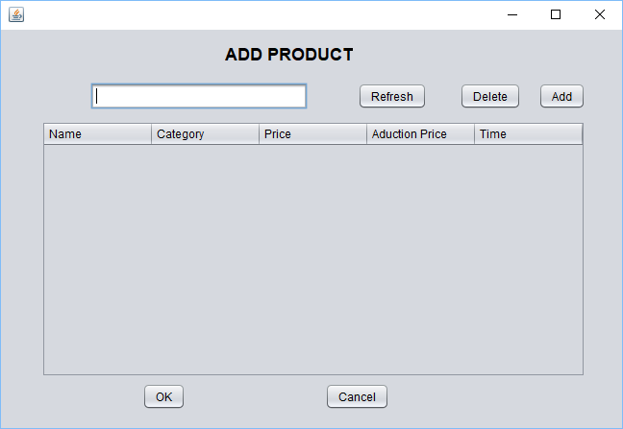

|  |  |  |  |  |
| --- | --- | --- | --- | --- |
| Use case ID: |  | | | |
| Use case name: | Add product | | | |
| Created by: | Locnx | | Last updated by: | Locnx |
| Date created: | 21/6/2018 | | Last revision updated by: | 9/7/2018 |
| Actors: | | Users | | |
| Summary: | | Users can post products on application. | | |
| Goal: | | Allow user can auction products.. | | |
| Trigger: | | N/A | | |
| Normal flow: | | 1. Tap<Add> button. “AuctionUser” displayed.  2. Tap a row in the table. Tap<Delete> button will delete that row  3. Refresh Button => Upload the data from database to the table  4. Search Box => Search the data you want to find | | |
| Alternative flow: | | N/A | | |
| Relationship: | | Extend User. | | |
| Business rule: | | N/A | | |
|  |  |  |  |  |

* **Add Information Product:**



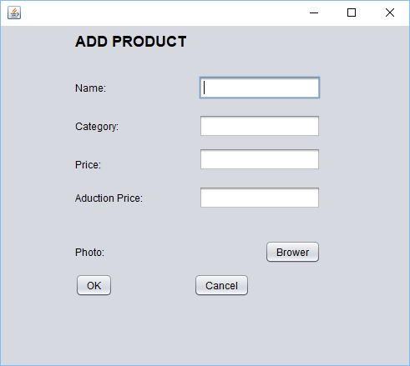

|  |  |  |  |  |
| --- | --- | --- | --- | --- |
| Use case ID: |  | | | |
| Use case name: | Add information for product | | | |
| Created by: | Locnx | | Last updated by: | Locnx |
| Date created: | 23/6/2018 | | Last revision updated by: | 9/7/2018 |
| Actors: | | Users | | |
| Summary: | | Users want to add products to auction. Enter information for products and add. | | |
| Goal: | | Allow user to add new products. | | |
| Trigger: | | N/A | | |
| Precondition: | |  | | |
| Normal flow: | | 1. Enter name, category, price, auction price and a photo.  2. Tap<ok> button. Add a product to User. | | |
| Alternative flow: | | N/A | | |
| Exceptions: | | 1.a. name, category, price, auction price.  b.Tap<OK>button  => show red text “Error!!!” next to text field.  2.a. Enter invalid name field.  b.Tap<OK>button  => show red text “Error!!!” next to text field.  3.a. Enter invalid category field.  b.Tap<OK>button  => show red text “Error!!!” next to text field.  4.a. Enter invalid price field.  b.Tap<OK>button  => show red text “Error!!!” next to text field.  5.a. Enter invalid auction price field.  b.Tap<OK>button  => show red text “Error!!!” next to text field. | | |
| Relationship: | | Extend AddProduct. | | |
| Business rule: | | N/A | | |
|  |  |  |  |  |

* **Change point:**



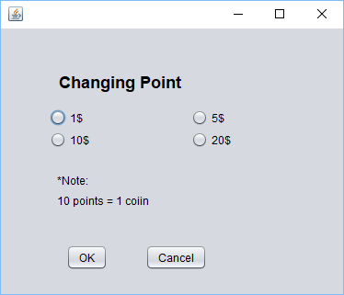

|  |  |  |  |  |
| --- | --- | --- | --- | --- |
| Use case ID: |  | | | |
| Use case name: | Change point | | | |
| Created by: | Locnx | | Last updated by: | Locnx |
| Date created: | 24/6/2018 | | Last revision updated by: | 9/7/2018 |
| Actors: | | Users | | |
| Summary: | | Users can change point to money. | | |
| Goal: | | Allow user can point to money. | | |
| Trigger: | | N/A | | |
| Normal flow: | | 1. Tap<1$>,<5$>,<10$>,<20$> button to select money you want to change. | | |
| Exceptions: | | Select more money than you have. Notification “You don't have enough money”. | | |
| Alternative flow: | | N/A | | |
| Relationship: | | Extend User. | | |
| Business rule: | | N/A | | |
|  |  |  |  |  |

**Part 3: Project monitoring and control**

* **Risk Arising from :**
* Can’t connect server to many people (Status: fixed)
* Image is not recognize when send it to other client (Status: waiting)
* Server can only active in one computer(Status: waiting)
* **Risk Arising from members:**
* Members do not understand each other
* There are many shortcomings in group practice

**Part 4: Closing**

**Have rechecked and completed at level:** 95%