**Q1. how many agent_transaction did we have in the months of 2022(broken down by month)**

SELECT MONTH(when_created) AS months_of_transactions,

COUNT(*) AS count_of_transactions

FROM agent_transactions

WHERE YEAR(when_created) = '2022'

GROUP BY MONTH(when_created)

ORDER BY MONTH(when_created);

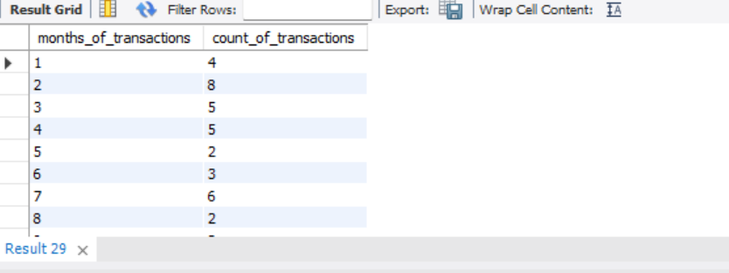

**Q2: Over the of the first half of 2022, how many Wave agents were ‘net depositors’ vs. ‘net withdrawals’?**

WITH total_agents AS

(SELECT agent_id, SUM(amount),MONTH(when_created) AS months,

CASE

WHEN SUM(amount) > 0 THEN 'NET WITHDRAWAL'

WHEN SUM(amount) < 0 THEN 'NET DEPOSITOR'

END AS class_of_agent

FROM agent_transactions

WHERE YEAR(when_created) = '2022' AND MONTH(when_created) BETWEEN 1 AND 6

GROUP BY agent_id, MONTH(when_created))

SELECT class_of_agent, COUNT(agent_id)

FROM total_agents

GROUP BY class_of_agent;

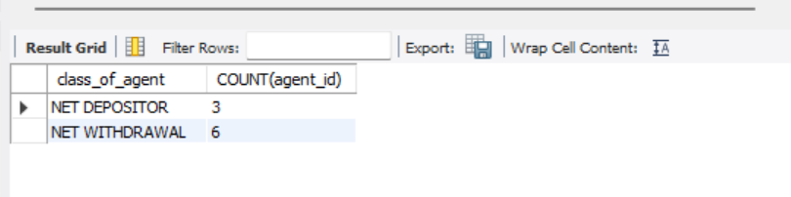

**Q3: Build an atx volume city summary table:find the volume of agent transactions created in the first half of 2022, group by city.**

SELECT city, SUM(amount) AS transaction_volume

FROM agent_transactions AS agtrx

JOIN agents

ON agents.agent_id = agtrx.agent_id

WHERE YEAR(agtrx.when_created) = '2022' AND MONTH(agtrx.when_created) BETWEEN 1 AND 6

GROUP BY city;

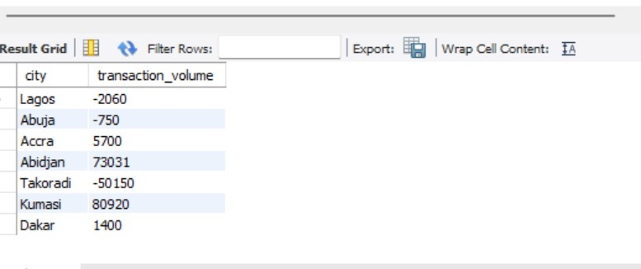

**Q4) Seperate the atx volume by country as well (so your columns should be country, city, volume)**

SELECT country, city, SUM(amount) AS transaction_volume

FROM agent_transactions AS agtrx

JOIN agents

ON agents.agent_id = agtrx.agent_id

WHERE YEAR(agtrx.when_created) = '2022' AND MONTH(agtrx.when_created) BETWEEN 1 AND 6

GROUP BY country, city;

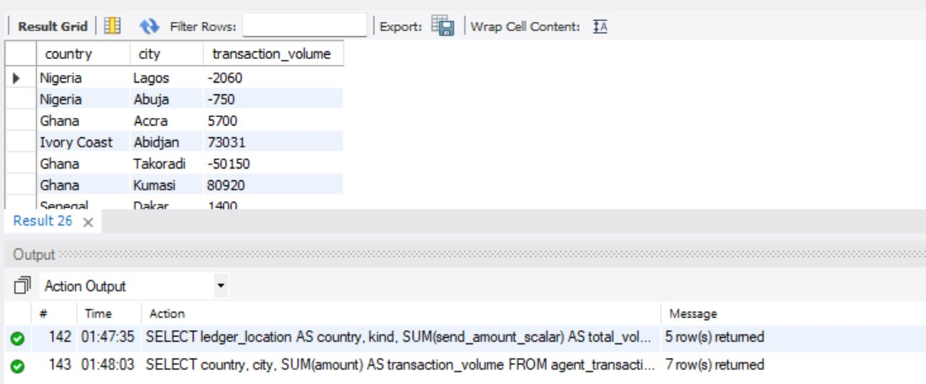

**Q5) build a send volume by country and kind table:find the total volume of transfers(by send_amount_scalar) sent in the first half of 2022, grouped by country and transfer kind**

SELECT ledger_location AS country, kind, SUM(send_amount_scalar) AS total_volume

FROM transfers

JOIN wallets

ON transfers.source_wallet_id = wallets.wallet_id

WHERE YEAR(transfers.when_created) = '2022' AND MONTH(transfers.when_created) BETWEEN 1 AND 6

GROUP BY country, kind;

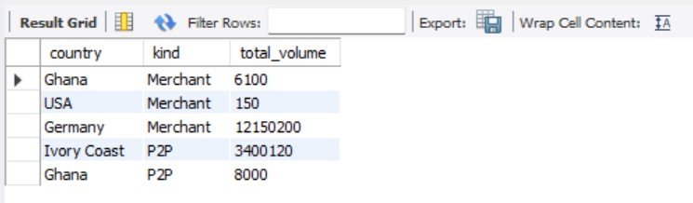

**-- Q6) Add columns for transaction count and number of unique senders(still broken down by country and kind)**

SELECT ledger_location AS country, kind, SUM(send_amount_scalar) AS total_volume,

COUNT(DISTINCT(source_wallet_id)) AS unique_senders, COUNT(transfer_id) AS transaction_count

FROM transfers

JOIN wallets

ON transfers.source_wallet_id = wallets.wallet_id

WHERE YEAR(transfers.when_created) = '2022' AND MONTH(transfers.when_created) BETWEEN 1 AND 6

GROUP BY country, kind;

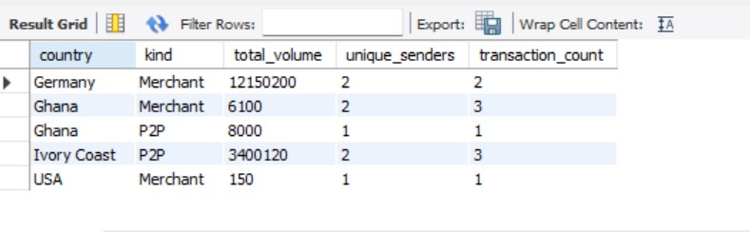

**-- Q7) which wallets sent more than 1000000 CFA in transfers in the first quarter(as identified by the source_wallet_id column in the transfers table and how much did they send?**

SELECT source_wallet_id, SUM(send_amount_scalar) AS total_sent_amount, send_amount_currency

FROM transfers

JOIN wallets

ON transfers.source_wallet_id = wallets.wallet_id

WHERE (YEAR(transfers.when_created) = '2022' AND MONTH(transfers.when_created) BETWEEN 1 AND 3)

AND (send_amount_scalar > 1000000) AND (send_amount_currency = 'CFA')

GROUP BY source_wallet_id, send_amount_currency;

