Comment–Caption Correlation Report
Model: llama3

Summary
Frames processed: 125
Comments available for this video: 3
Comments correlated to ≥ 60: 3 (100.0%)
Total candidate pairs checked: 375
Correlated comment coverage (all comments):
- matched 96 frame(s), max score 95.0000: The video shows how to measure the bandpass filter using an oscilloscope, which helps visualize frequency response.The oscilloscope used was different from ours, making it slightly challenging to interpret.This hands-on demonstration supports what we did in Phase I with LabVIEW.
Source: https://www.youtube.com/watch?v=-AKD2Lv7XqI: How to design and build a bandpass filter
Top correlated frames:
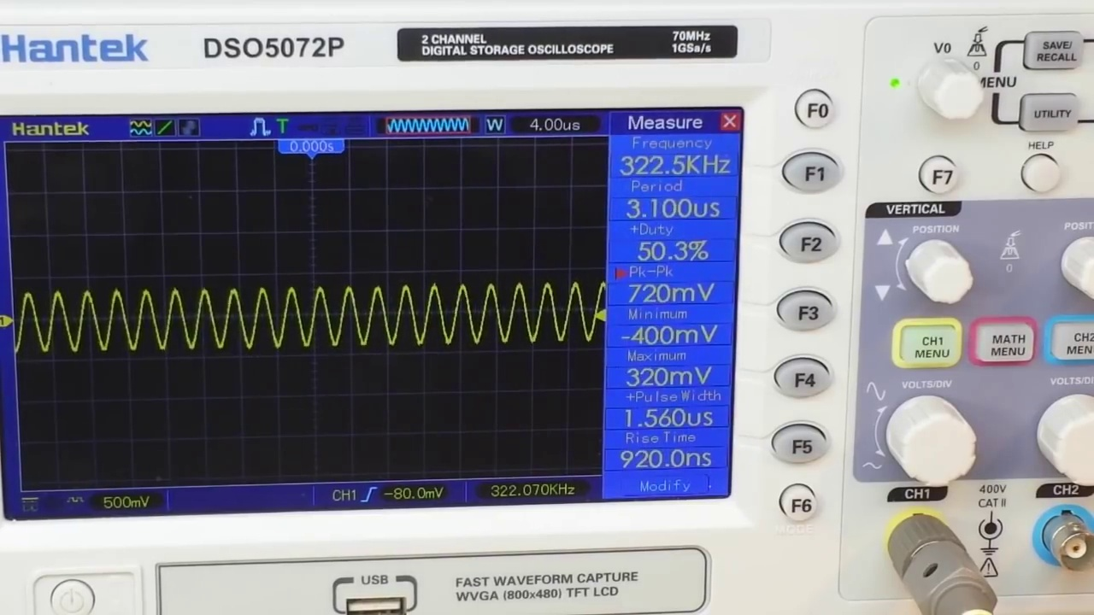 (score 95.0000)
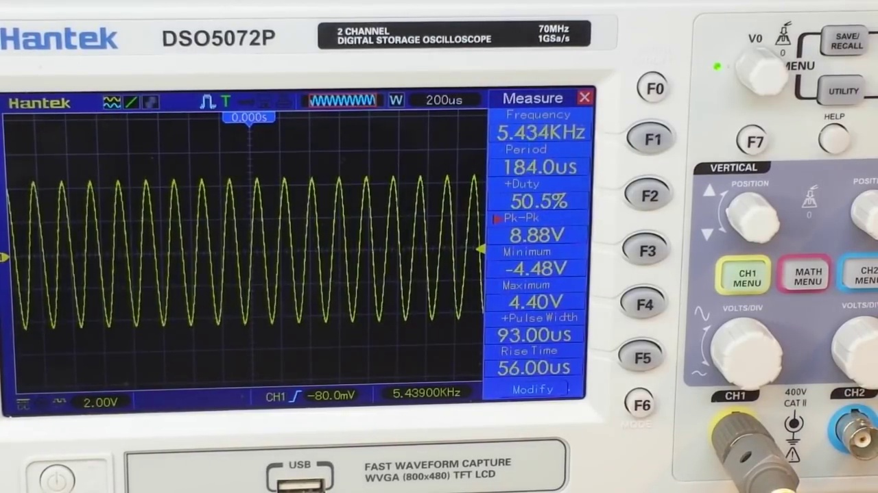 (score 95.0000)
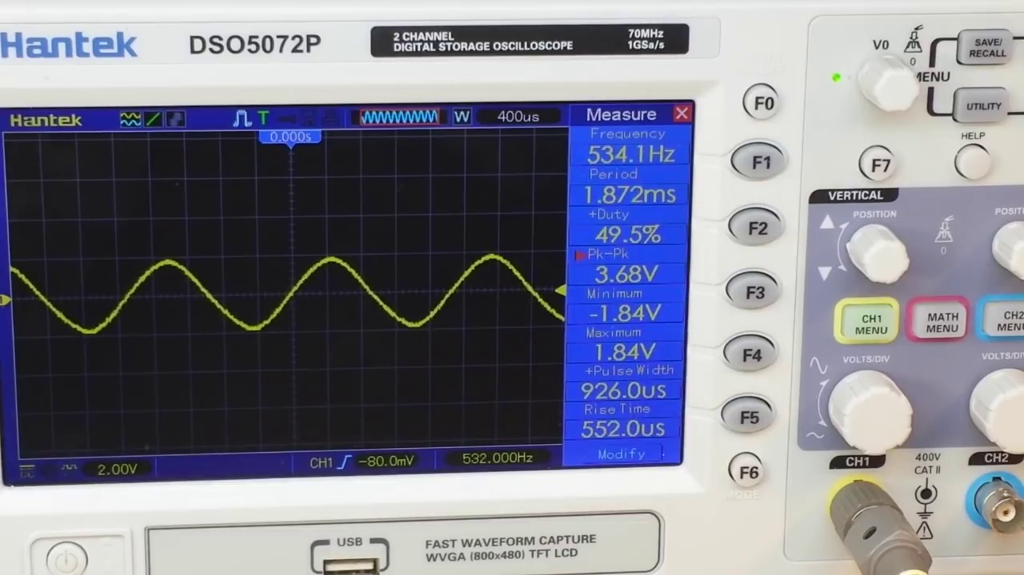 (score 95.0000)
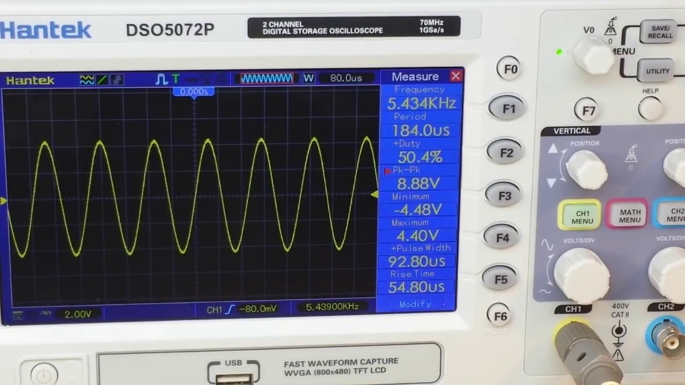 (score 95.0000)
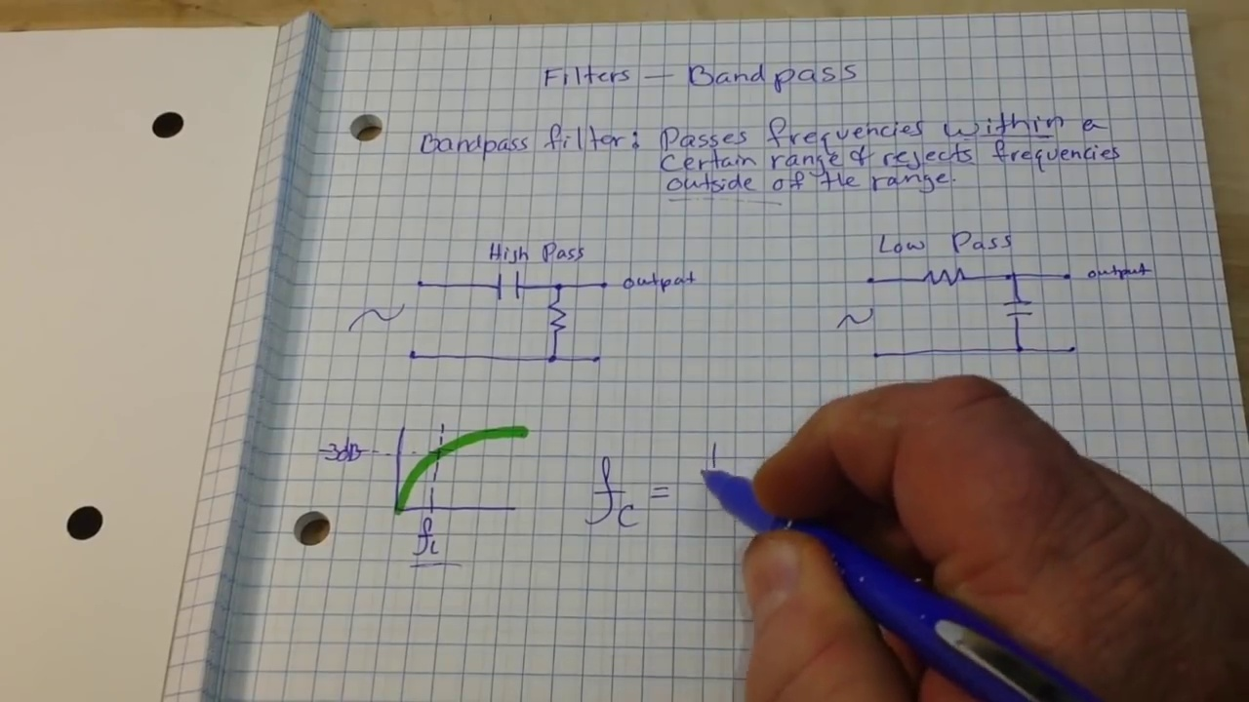 (score 95.0000)
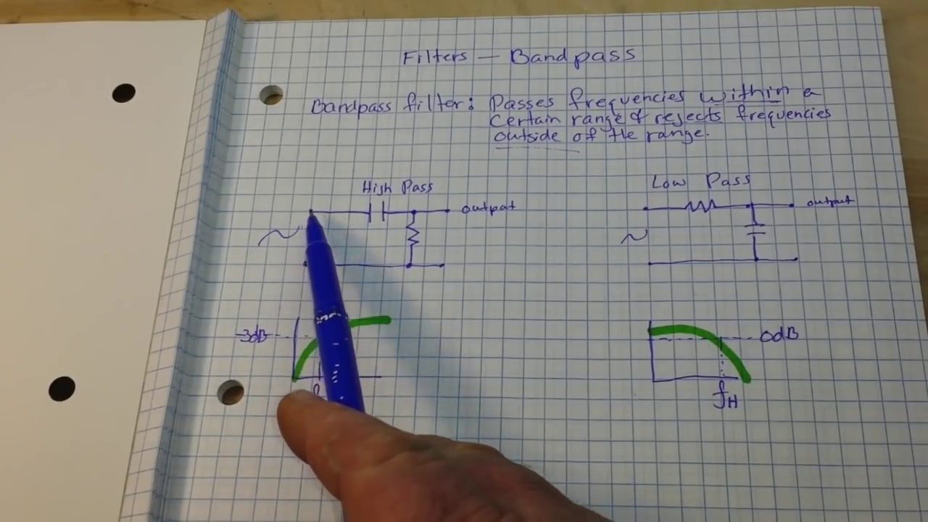 (score 95.0000)
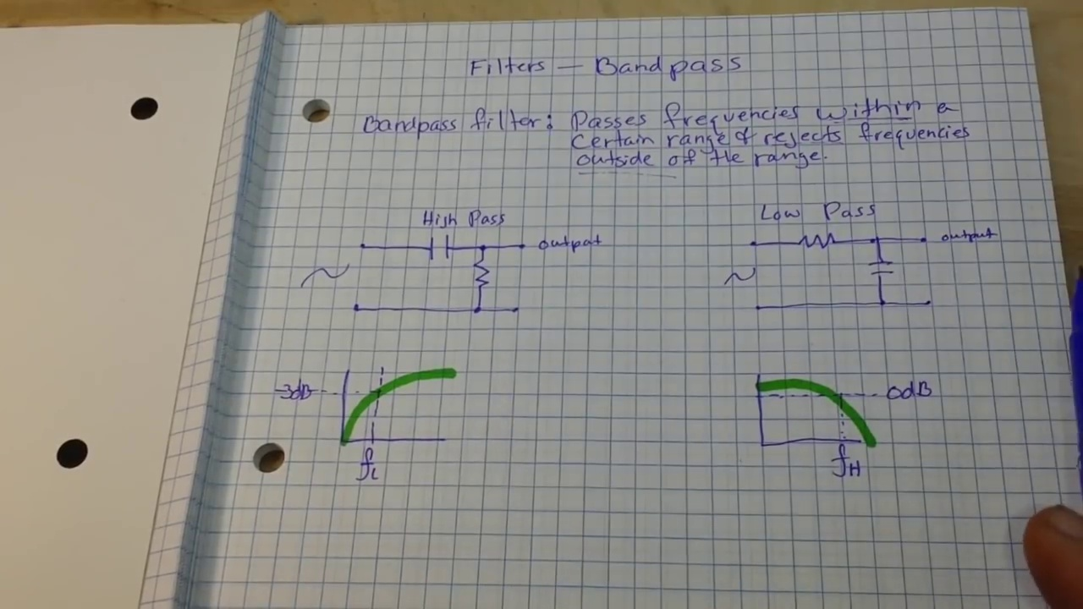 (score 95.0000)
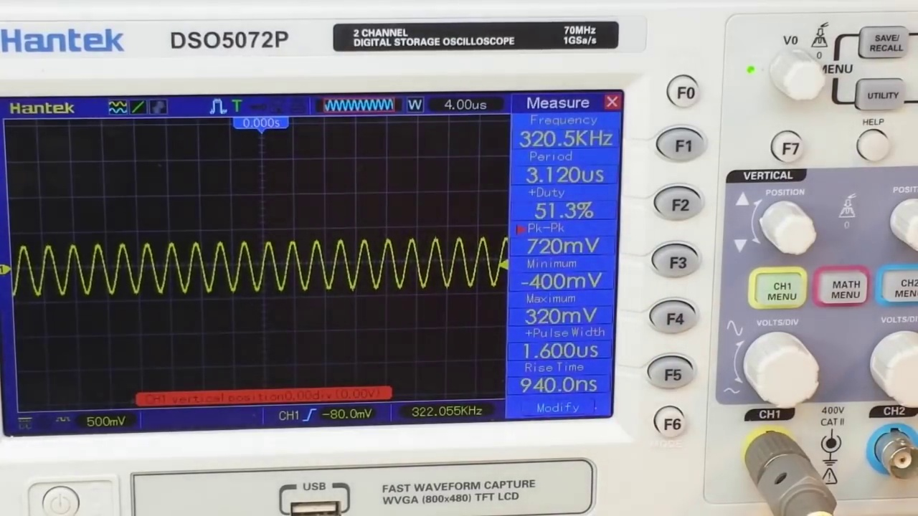 (score 90.0000)
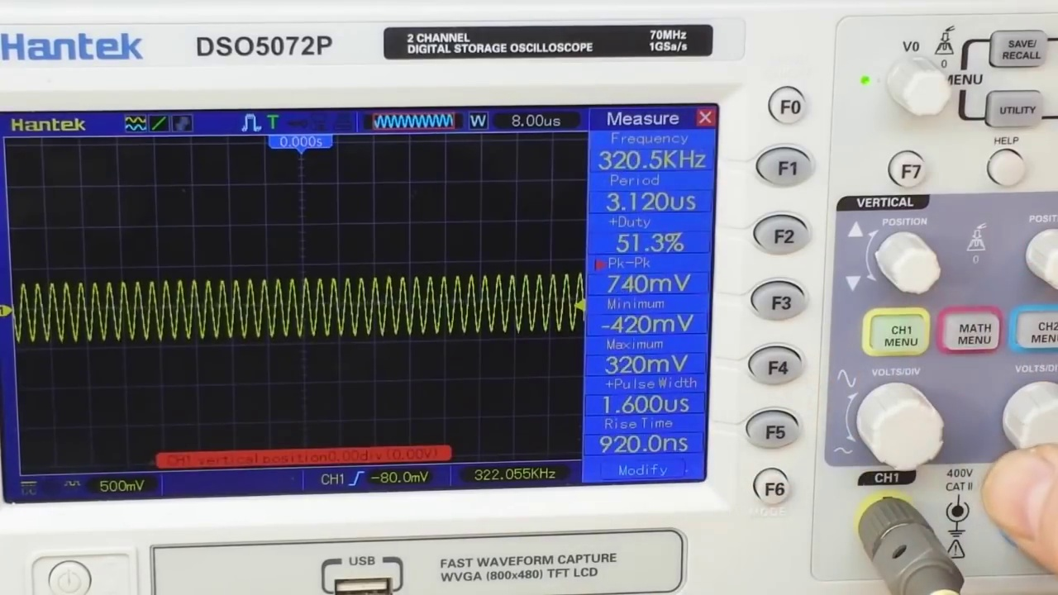 (score 90.0000)
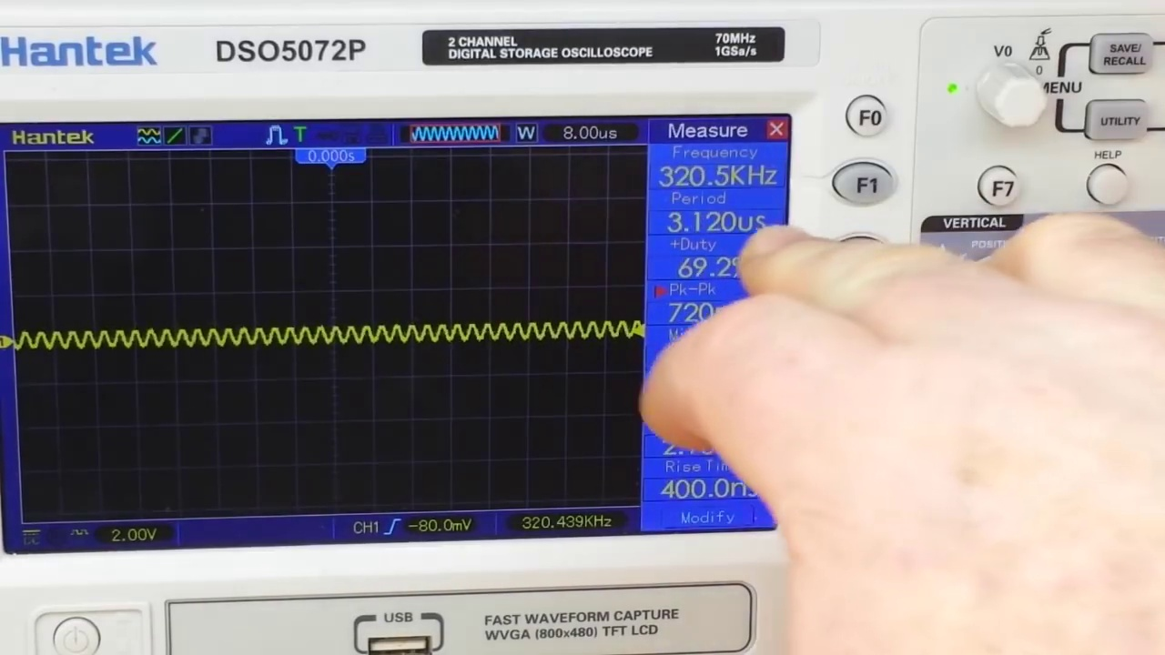 (score 90.0000)
Least correlated frames:
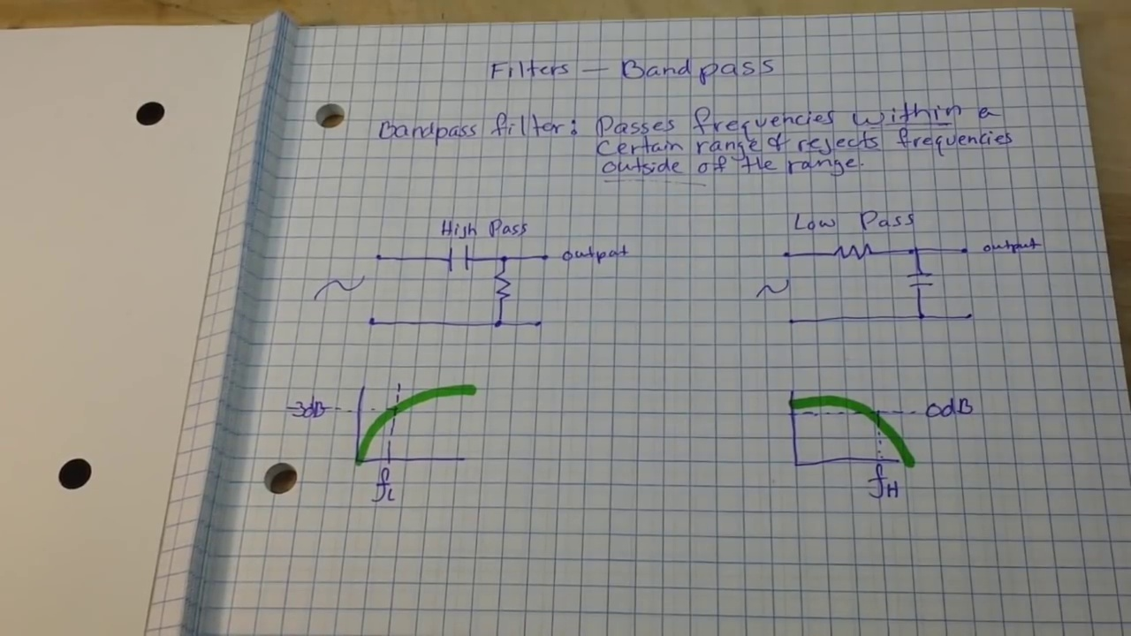 (score 0.0000)
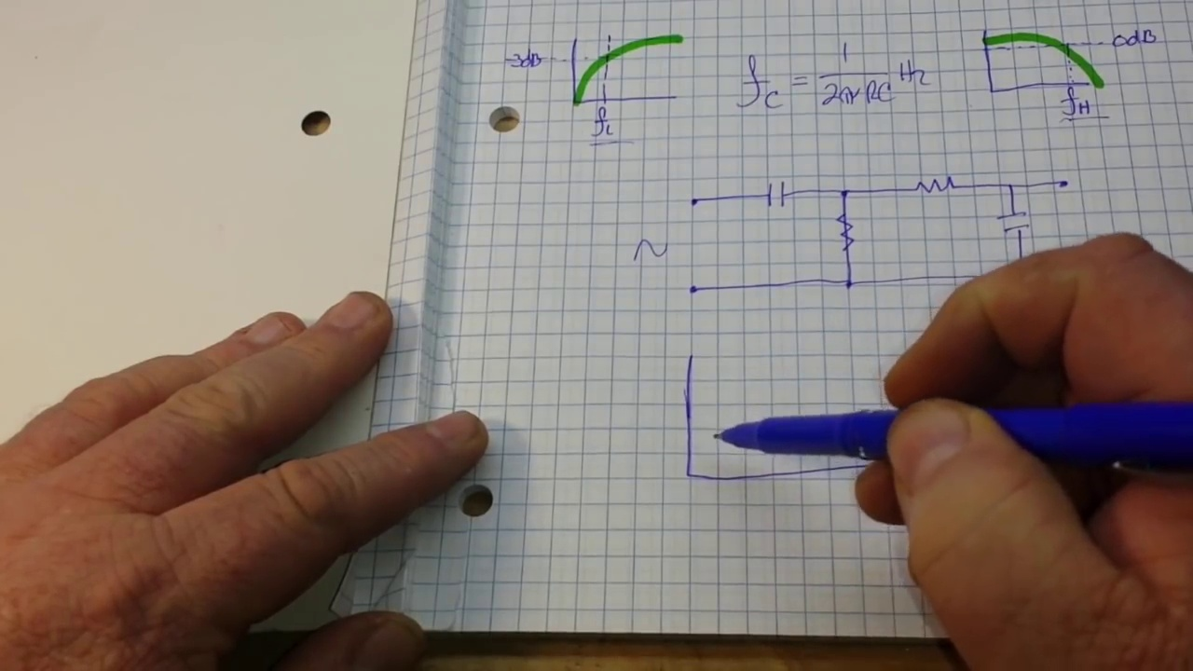 (score 5.0000)
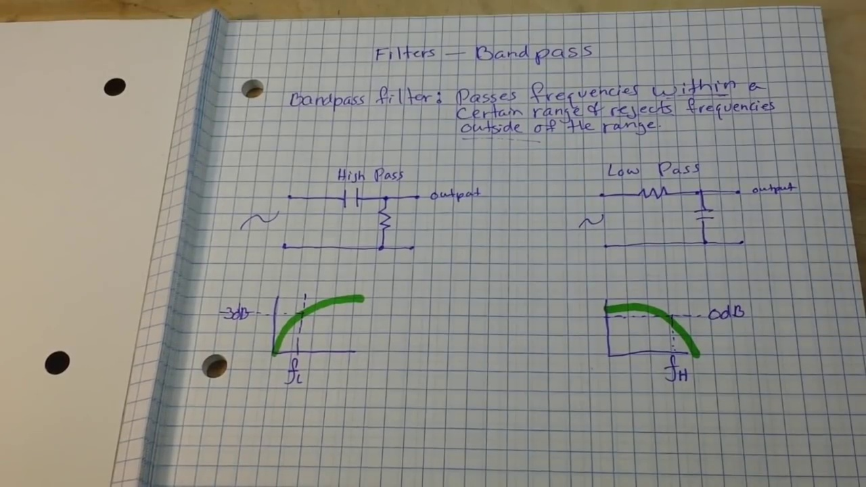 (score 20.0000)
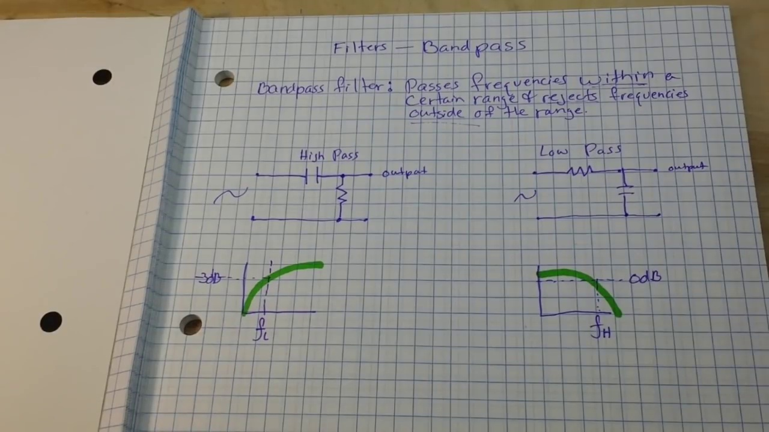 (score 20.0000)
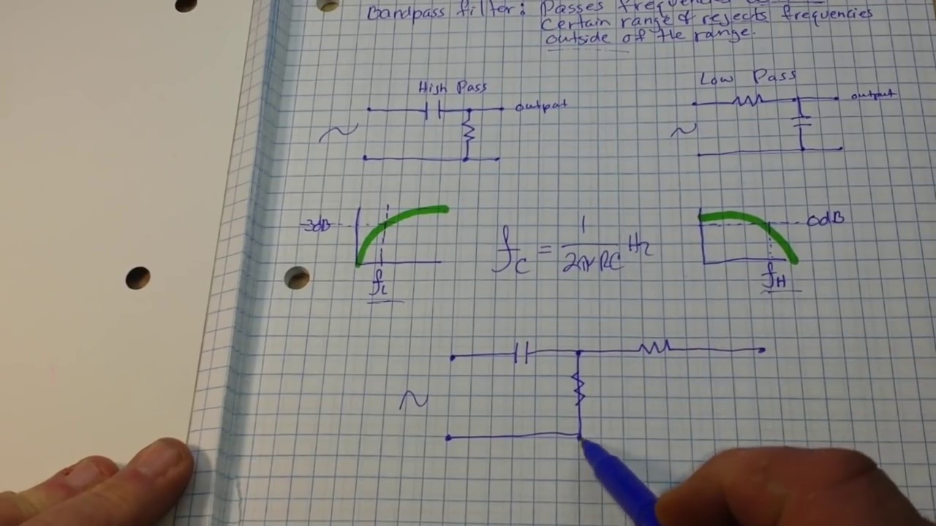 (score 20.0000)
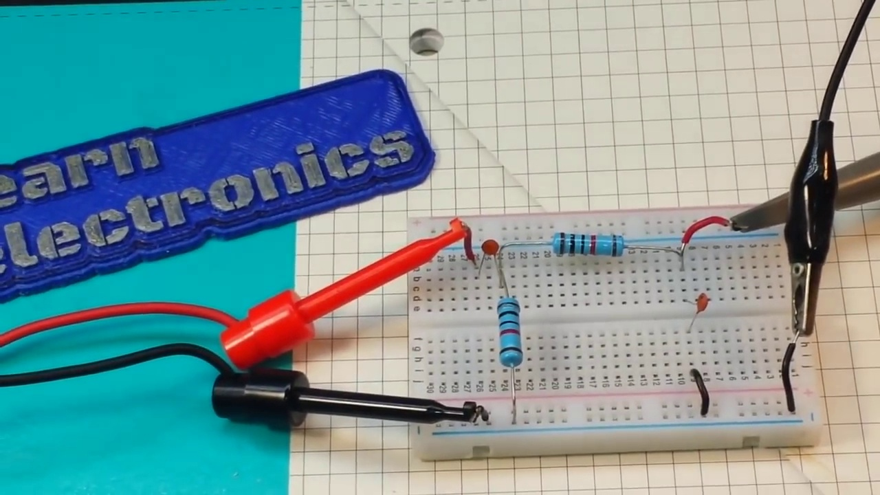 (score 20.0000)
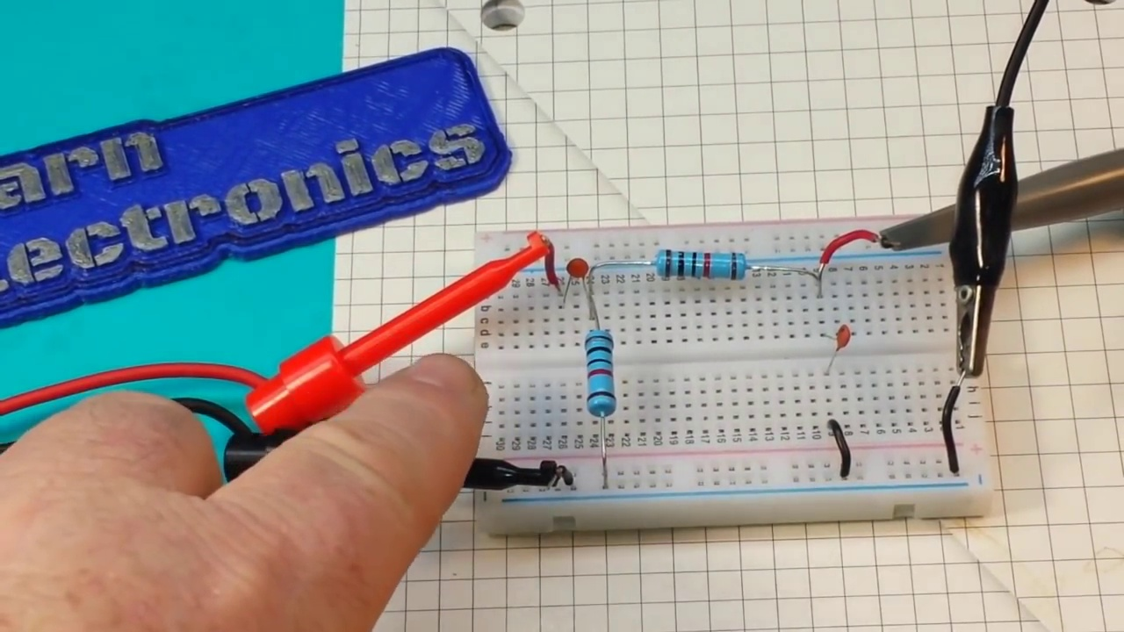 (score 20.0000)
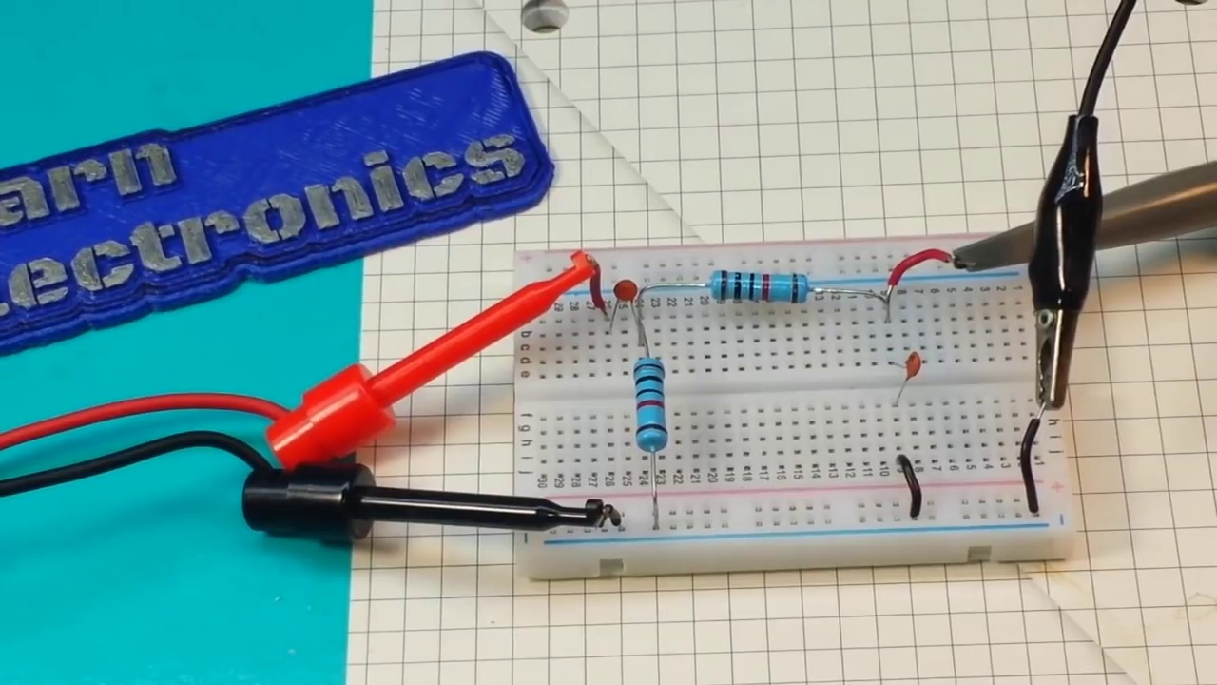 (score 20.0000)
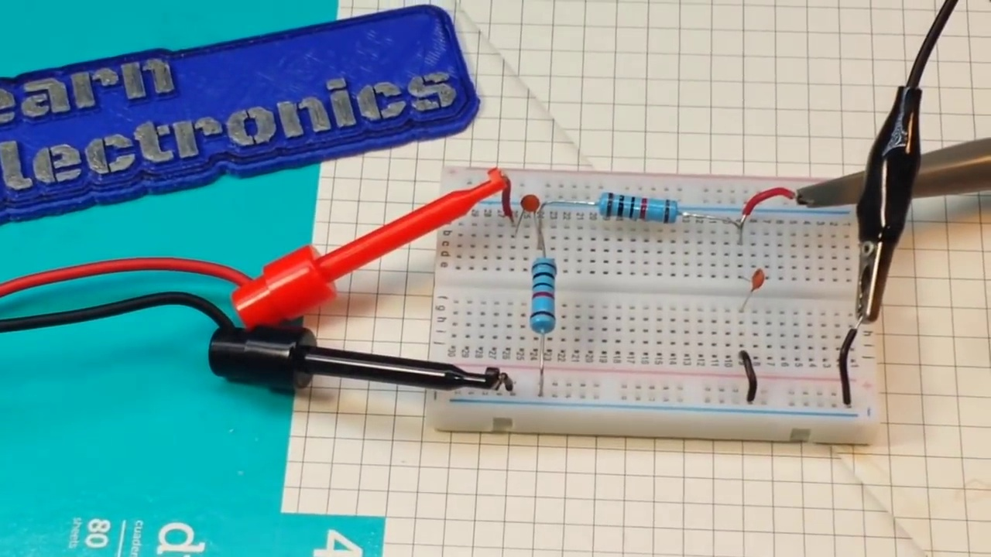 (score 20.0000)
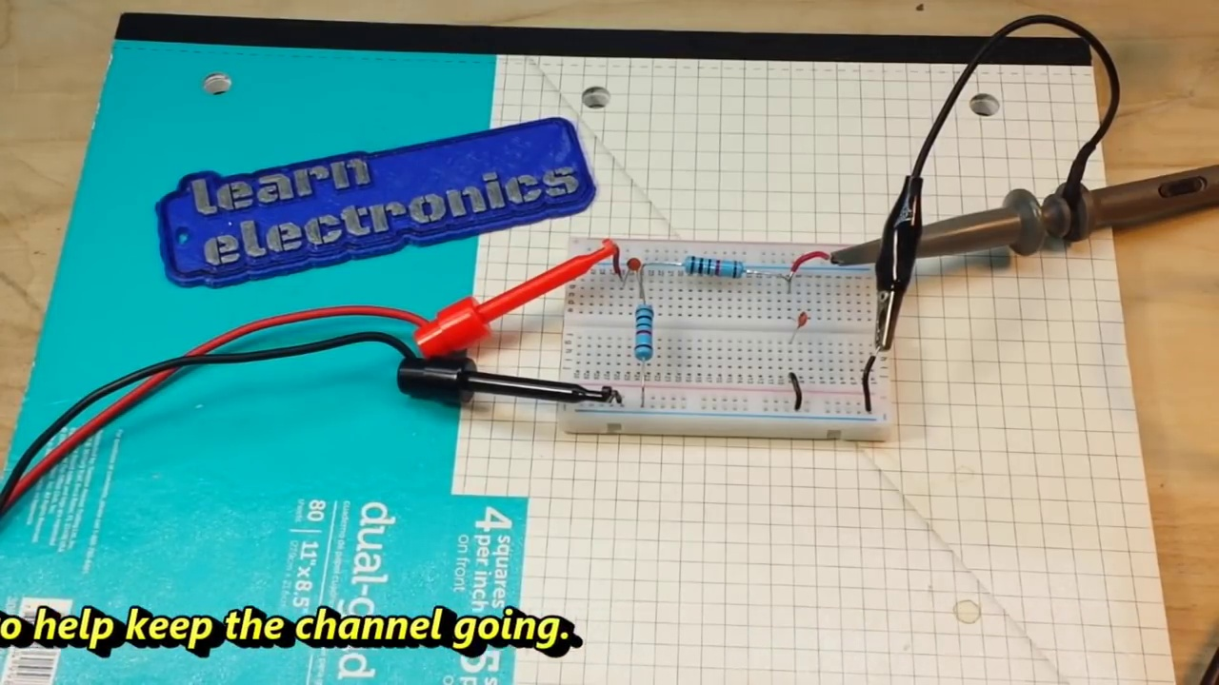 (score 20.0000)
- matched 79 frame(s), max score 95.0000: I learned how to design and build a bandpass filter, as well as lowpass and highpass filters.Nothing. This video was clearly explained.Might not be needed since Meena already added the necessary filters, but now I understand the process and can help if needed.
Source: https://www.youtube.com/watch?v=-AKD2Lv7XqI: How to design and build a bandpass filter
Top correlated frames:
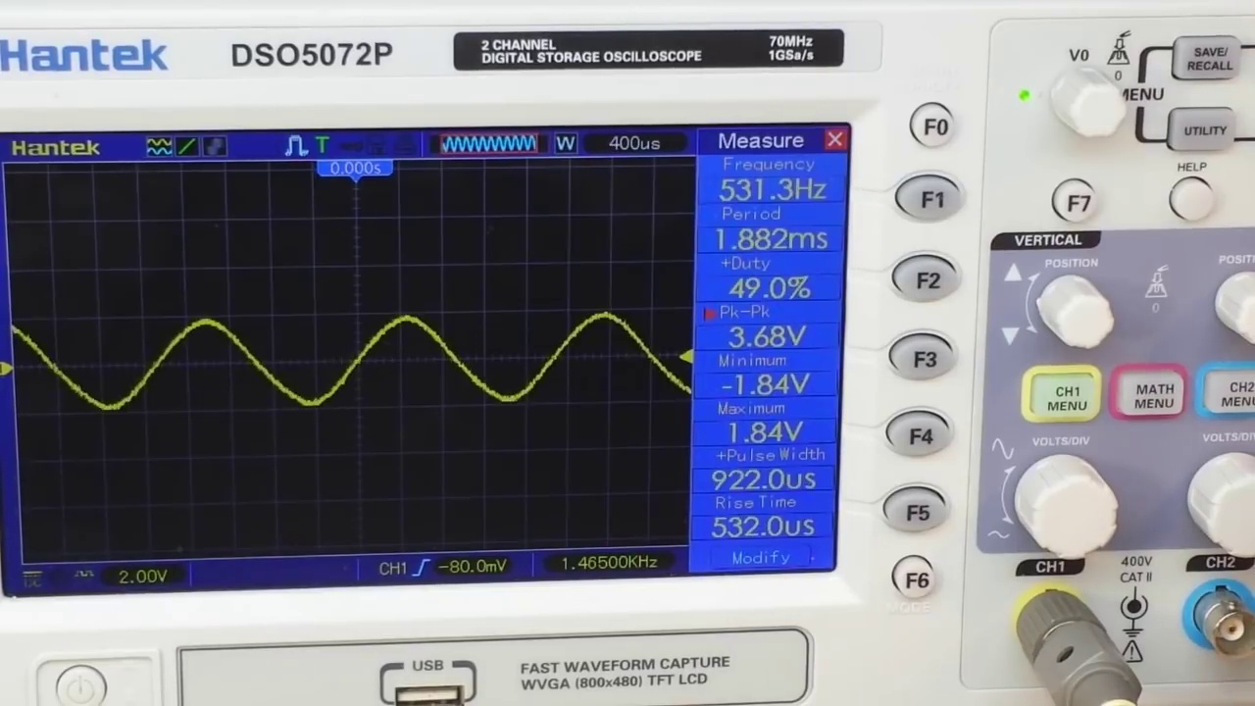 (score 95.0000)
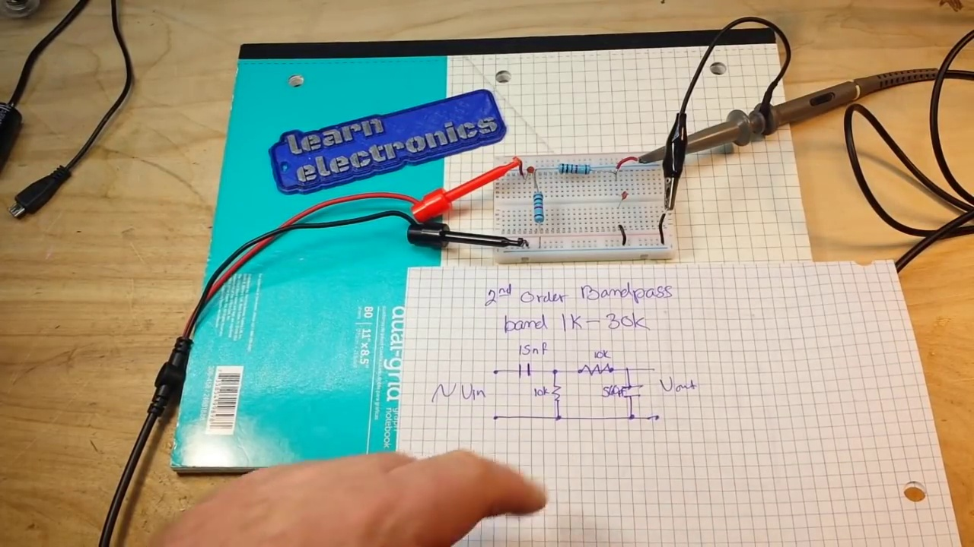 (score 95.0000)
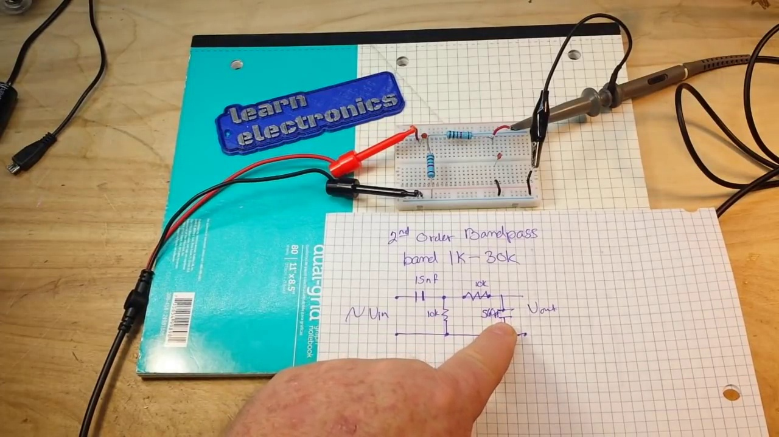 (score 95.0000)
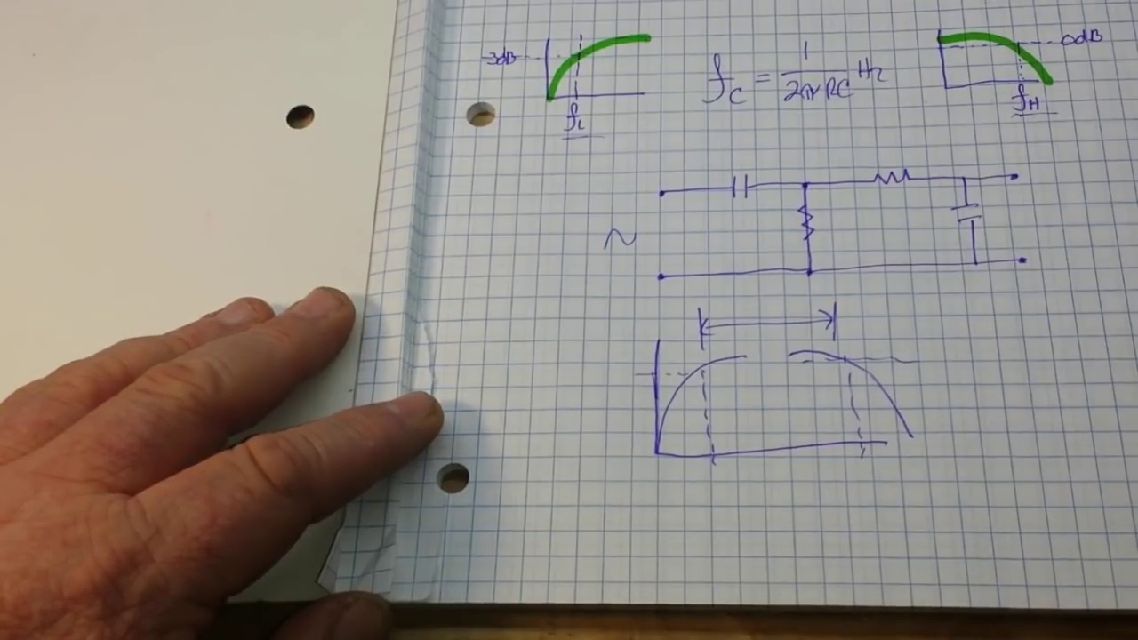 (score 95.0000)
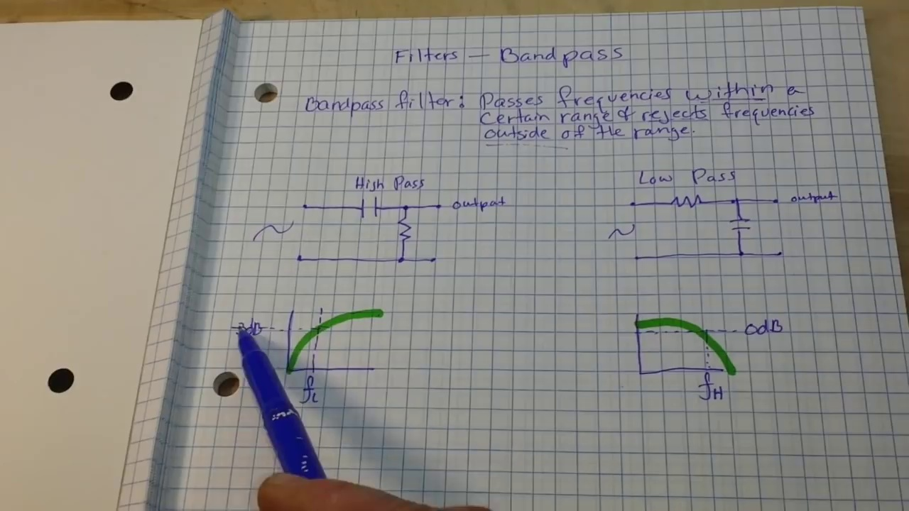 (score 95.0000)
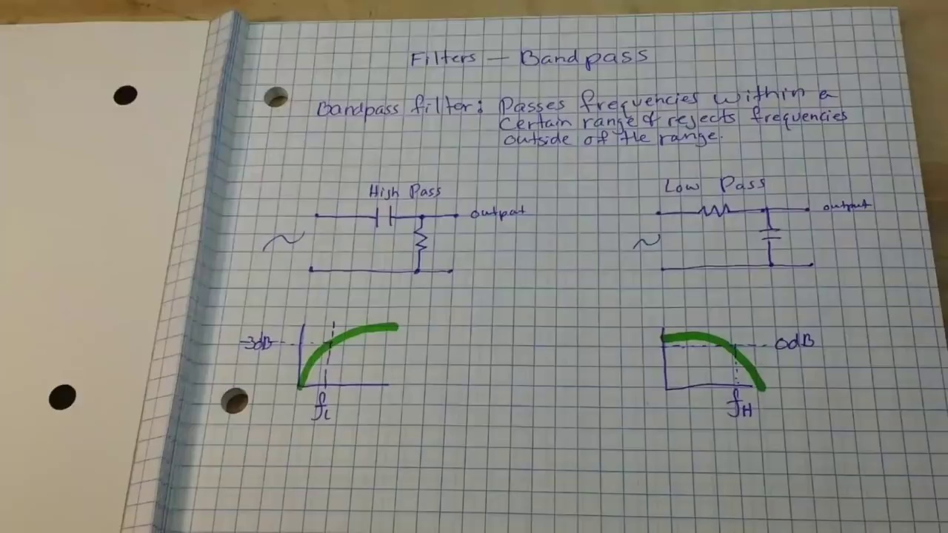 (score 95.0000)
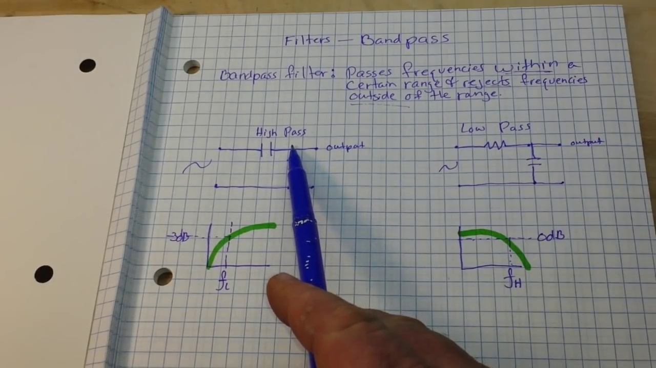 (score 92.0000)
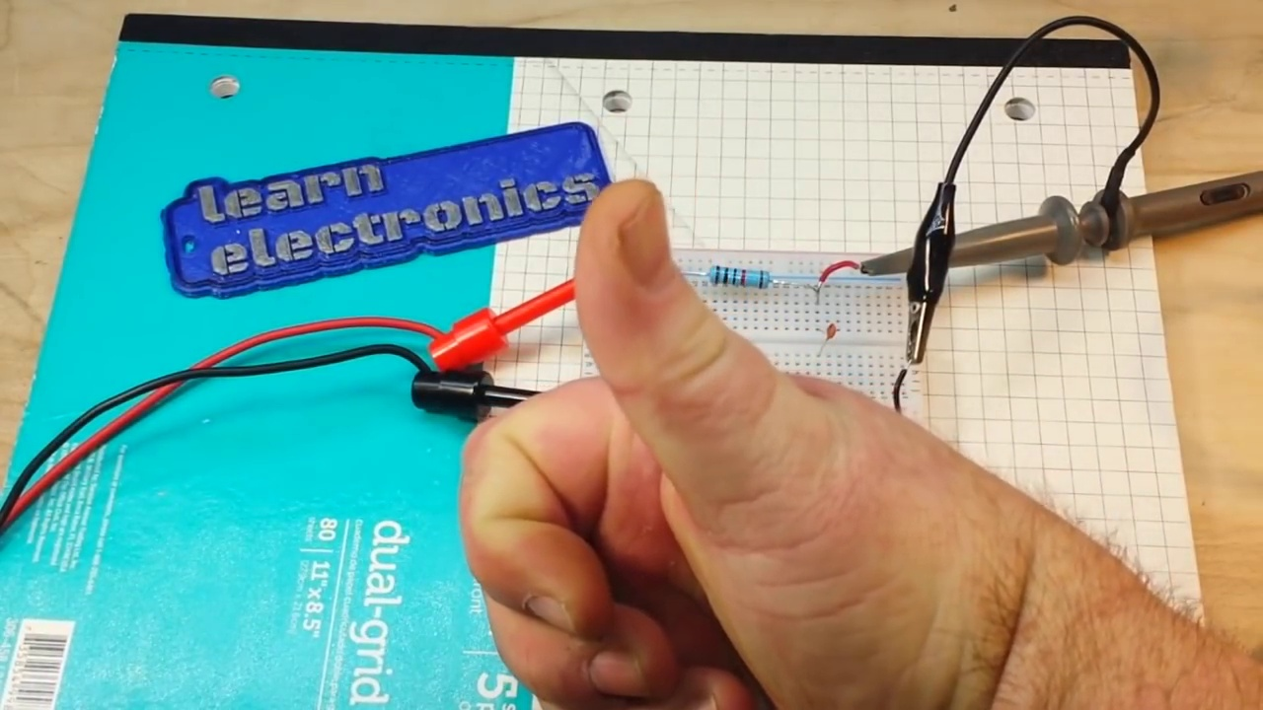 (score 90.0000)
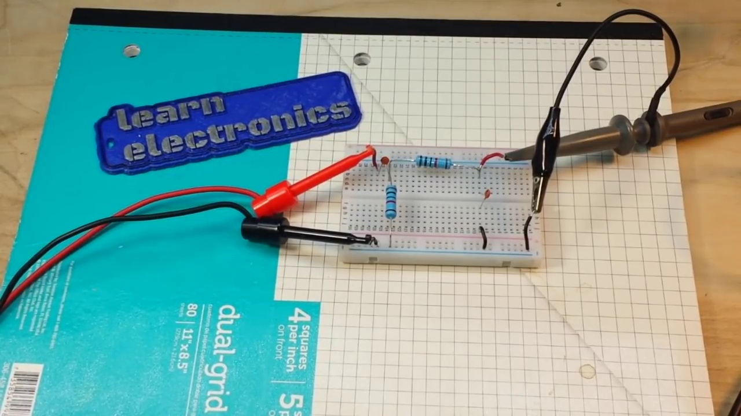 (score 90.0000)
 (score 90.0000)
Least correlated frames:
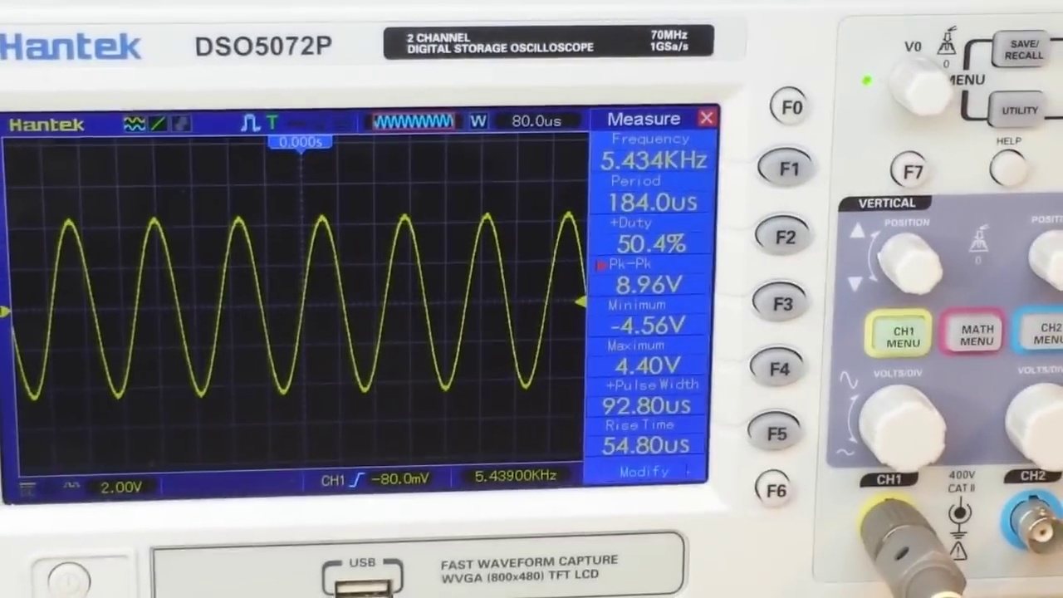 (score 0.0000)
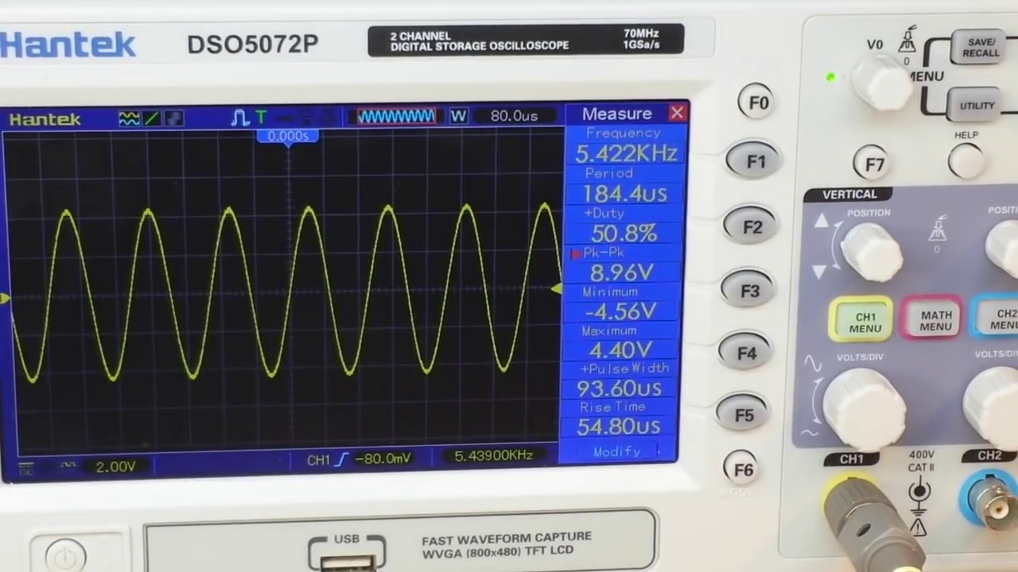 (score 0.0000)
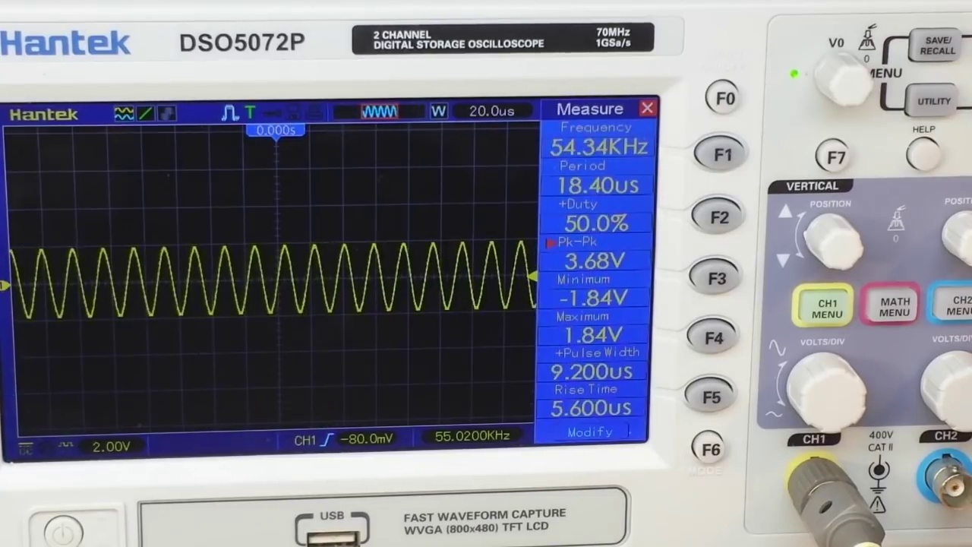 (score 0.0000)
 (score 0.0000)
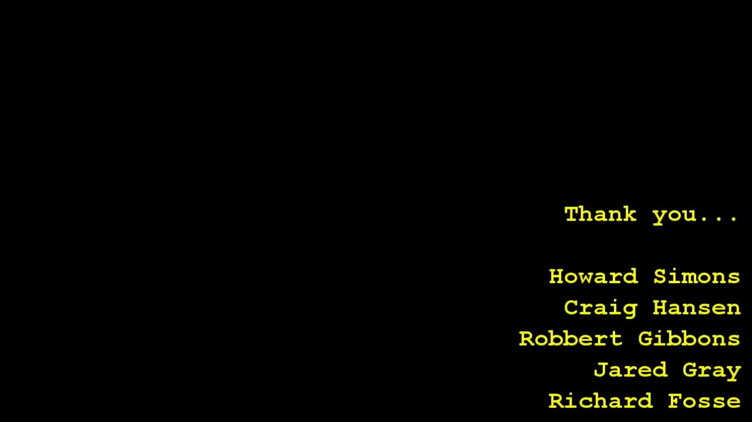 (score 0.0000)
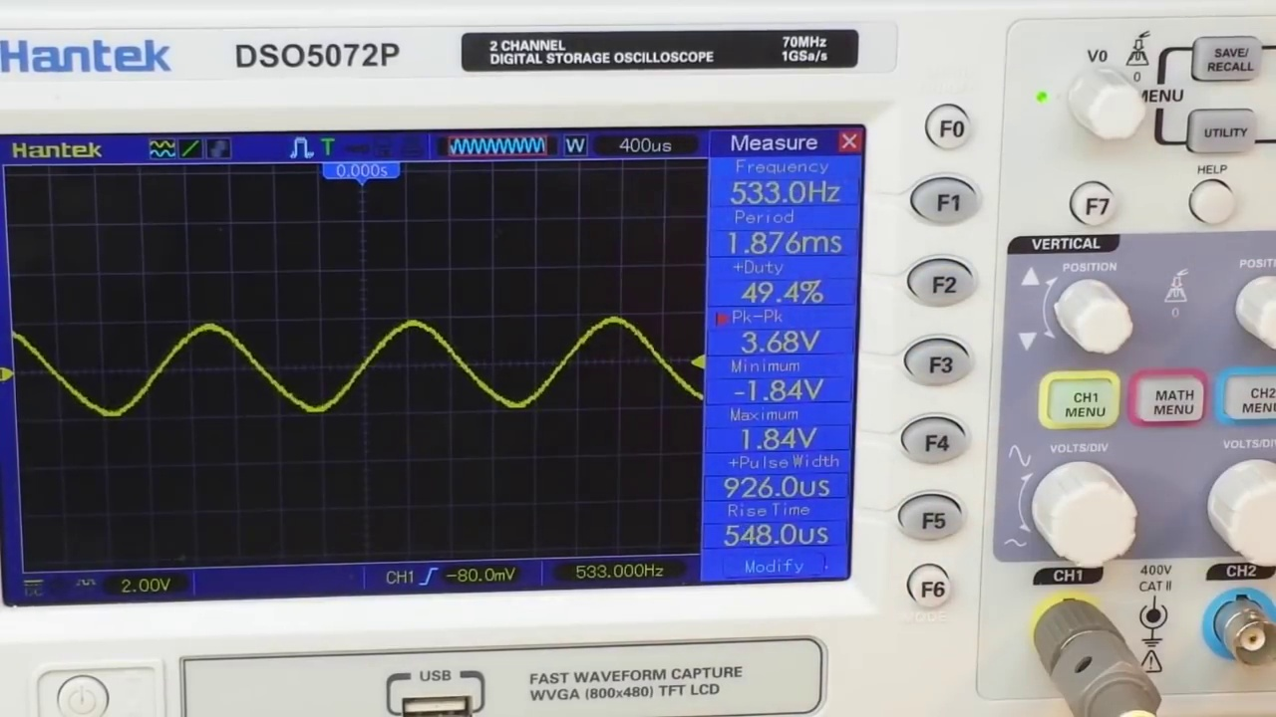 (score 5.0000)
 (score 10.0000)
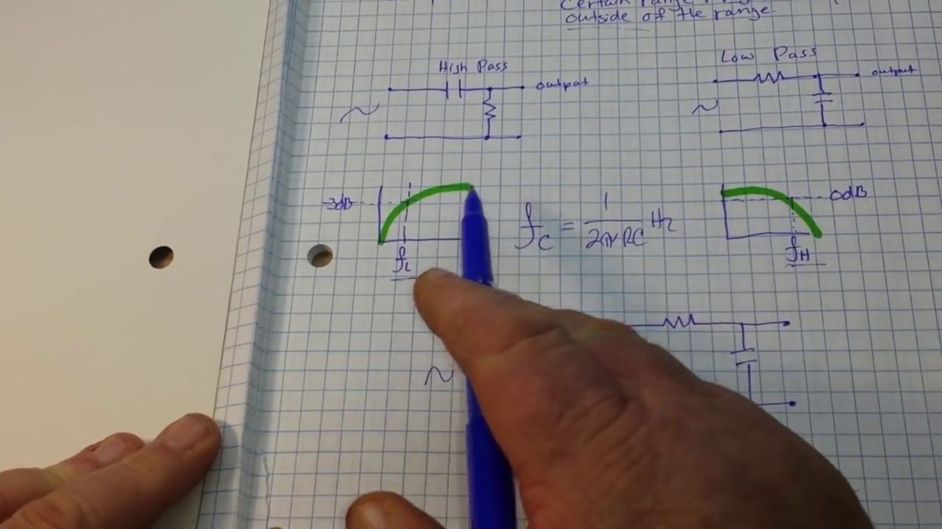 (score 10.0000)
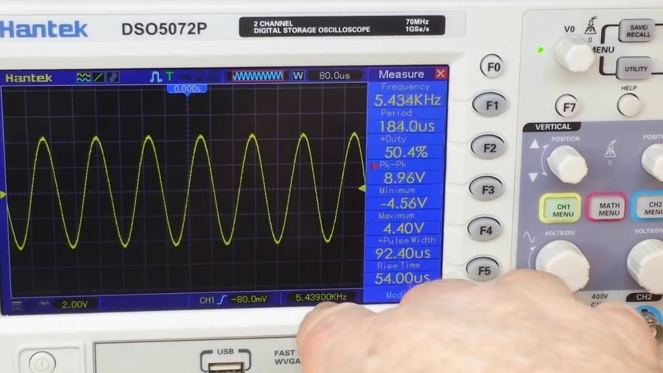 (score 10.0000)
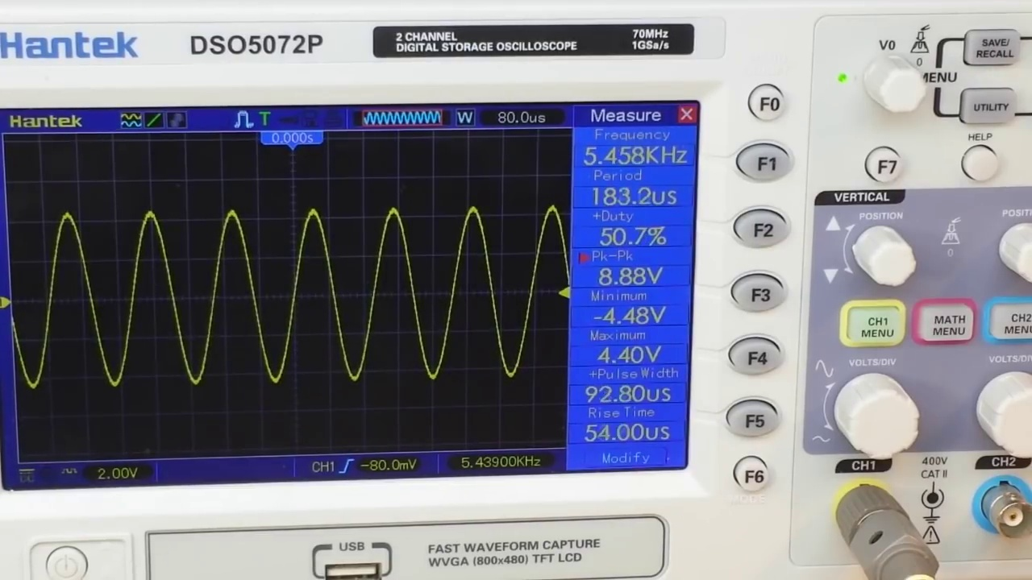 (score 10.0000)
- matched 60 frame(s), max score 95.0000: The video provided a clear explanation of how bandpass filters work and how to build one. The video does a great job explaining bandpass filters. No questions.
Source: https://www.youtube.com/watch?v=-AKD2Lv7XqI: How to design and build a bandpass filter
Top correlated frames:
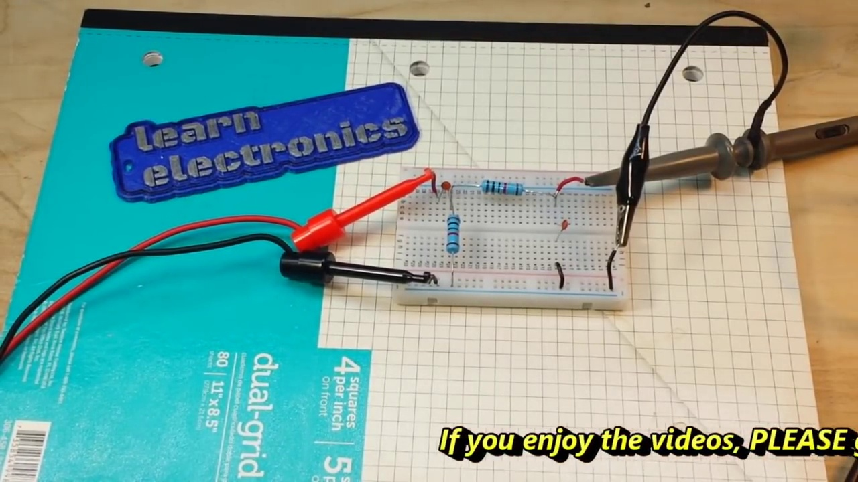 (score 95.0000)
 (score 95.0000)
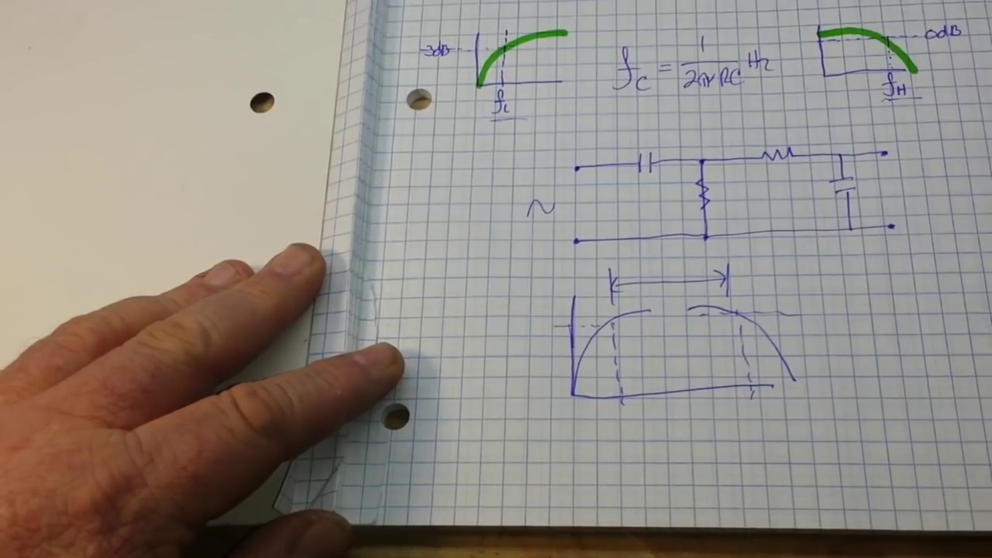 (score 95.0000)
 (score 95.0000)
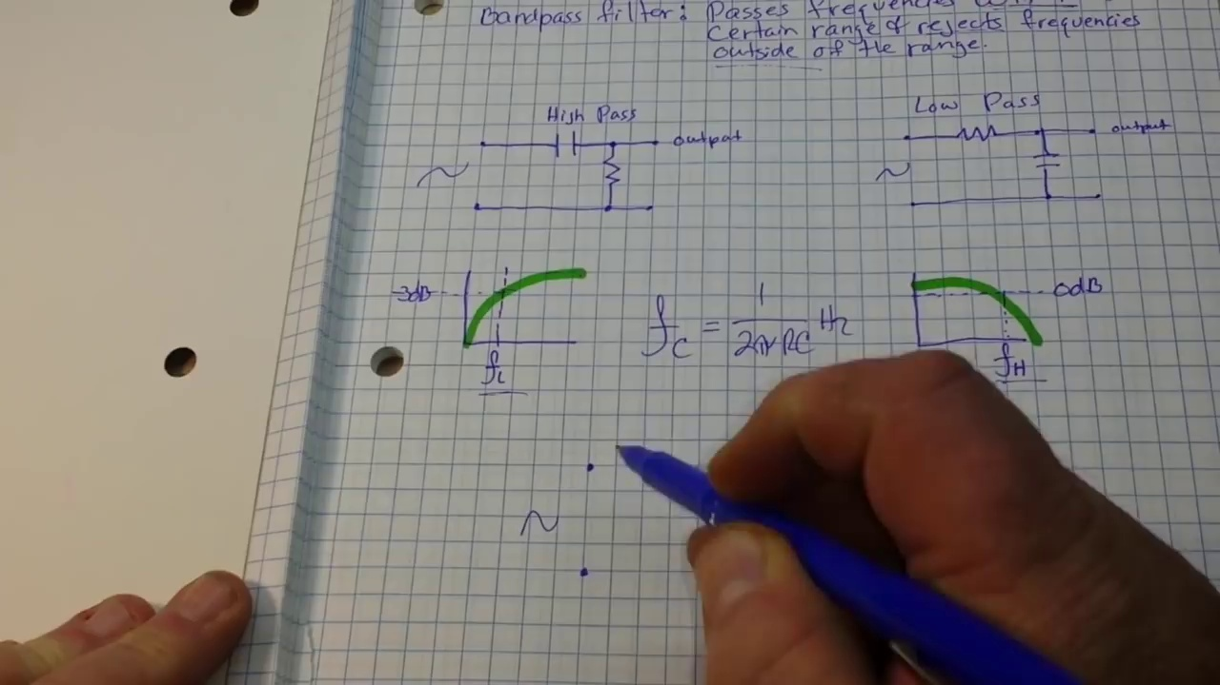 (score 95.0000)
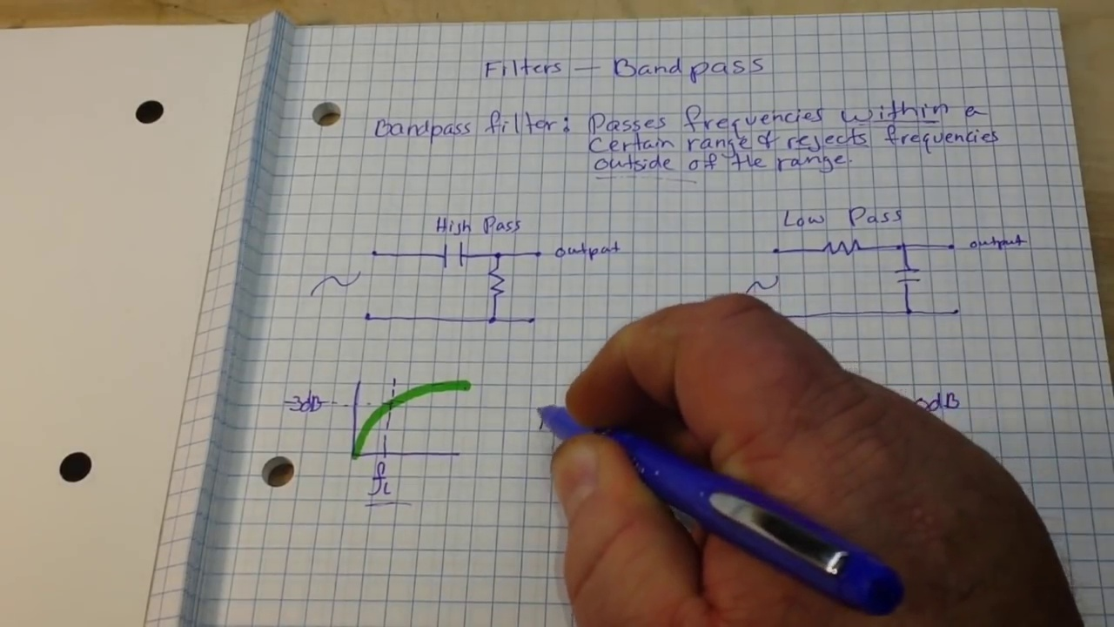 (score 95.0000)
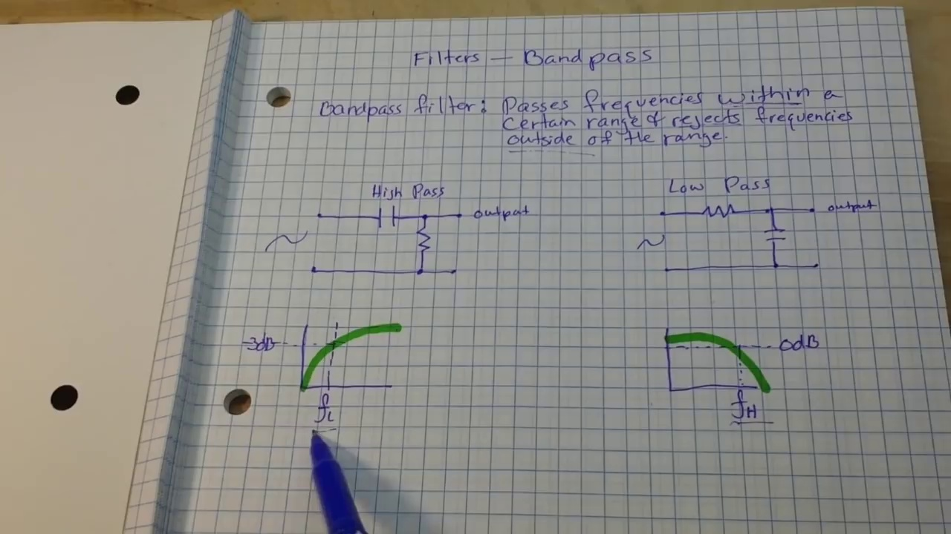 (score 95.0000)
 (score 95.0000)
 (score 95.0000)
 (score 95.0000)
Least correlated frames:
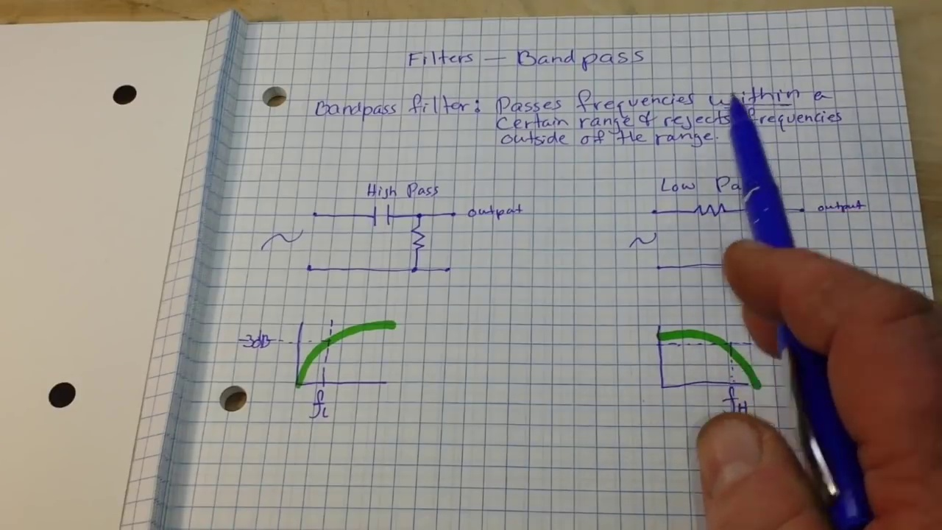 (score 0.0000)
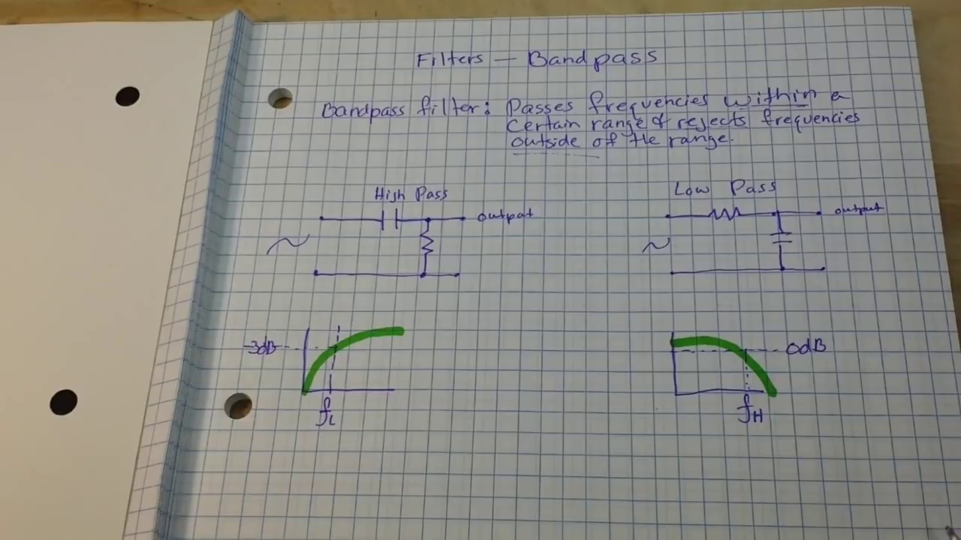 (score 0.0000)
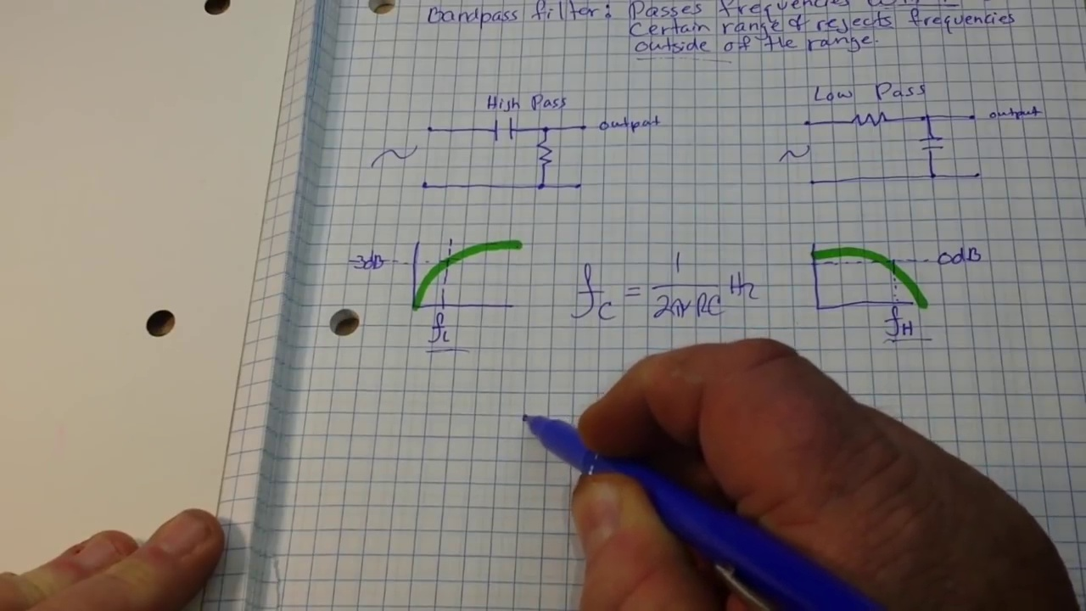 (score 0.0000)
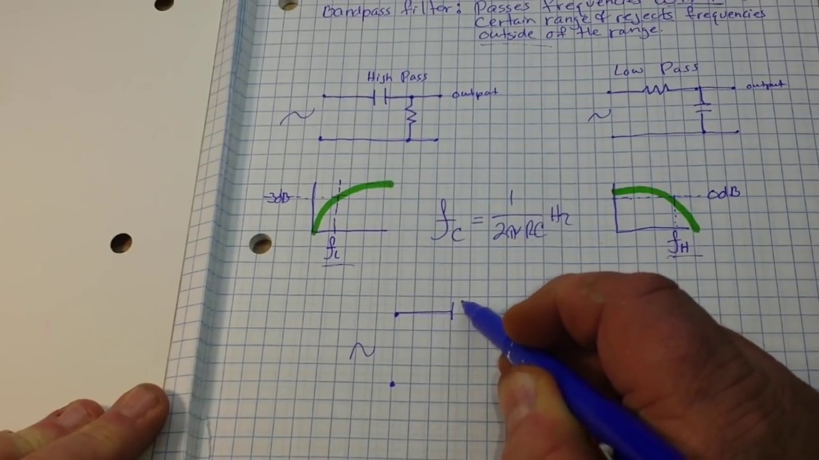 (score 0.0000)
 (score 0.0000)
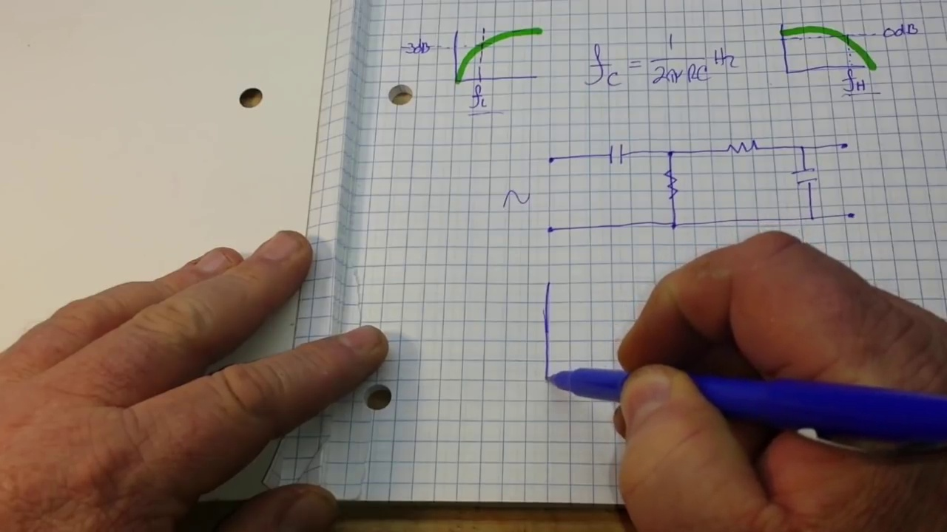 (score 0.0000)
 (score 0.0000)
 (score 0.0000)
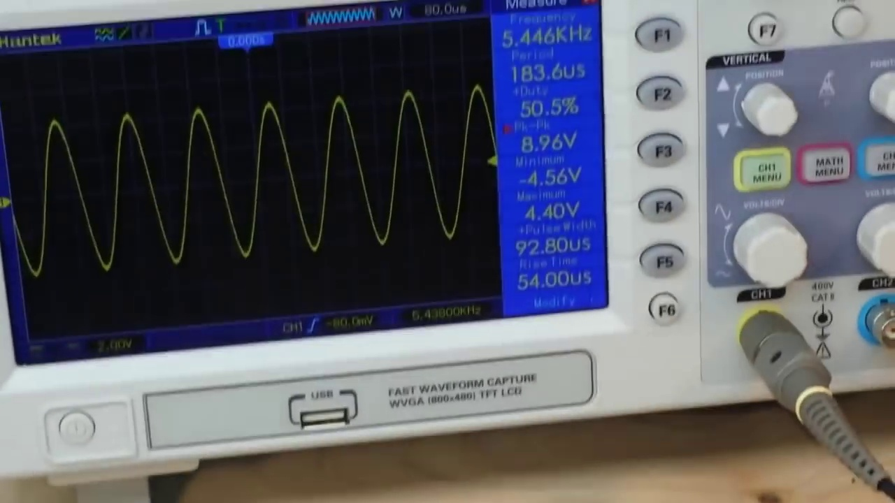 (score 0.0000)
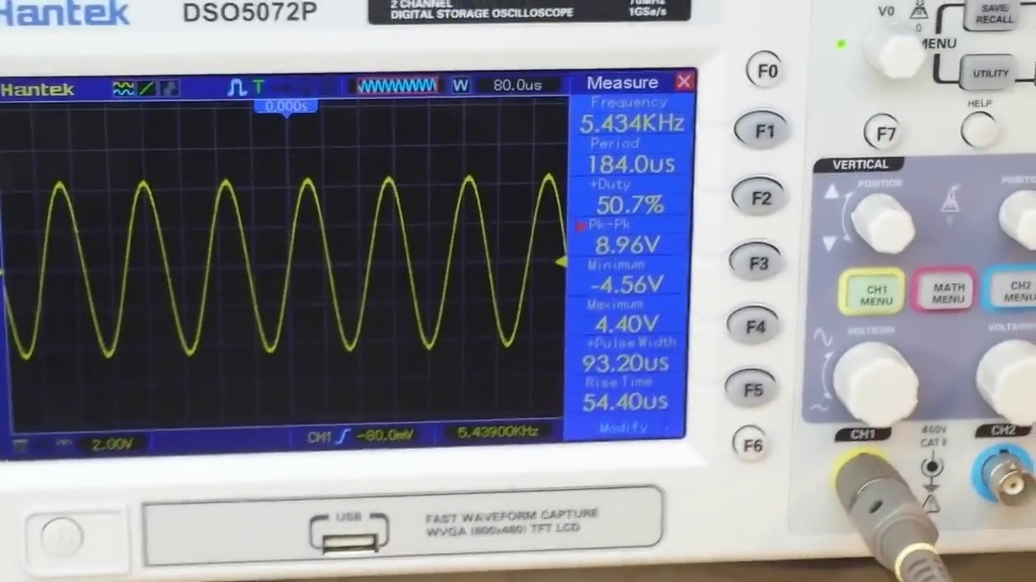 (score 0.0000)

Frame: frame_0000.jpg
Caption: The image shows a whiteboard with handwritten notes and diagrams related to engineering or mechanics. At the top left of the board, there's text that appears to say "Motion of particles," indicating the subject matter of the session or class. Below this title, there are two rectangular shapes drawn in blue ink on a white background. The shape on the left resembles a cylinder, and the one on the right has a more complex shape with protruding sections, possibly representing a mechanical part.
To the right of these shapes, an equation is written out in black ink, appearing to be related to physics or mechanics, with symbols that include differential notation for partial derivatives (∂/∂). Although the specific content of the equation is not fully visible due to the angle and quality of the photo, it suggests that the topic involves mathematical concepts.
Further to the right, a diagram features two circular arcs connected by a straight line segment, which could be representing angles or angles of rotation in the context of motion or mechanics. The circles and connecting lines are also drawn with blue ink.
On the same page, there is a handwritten note detailing the concept of filters in the context of bandpass frequencies. The text explains that a filter is a device that allows certain frequencies to pass through while blocking others. It further elaborates on the difference between high-pass and low-pass filters, indicating that a high-pass filter allows frequencies above a certain cutoff frequency to pass, while a low-pass filter allows frequencies below a certain cutoff frequency to pass. The note also discusses the range of frequencies within which these filters operate, noting that the range is a certain number of cycles per second.
The overall layout and handwriting suggest that someone is teaching or explaining these concepts, potentially an instructor or a student working through problems.
Comment (score 95): I learned how to design and build a bandpass filter, as well as lowpass and highpass filters.Nothing. This video was clearly explained.Might not be needed since Meena already added the necessary filters, but now I understand the process and can help if needed.
Reason: The comment directly discusses the design and building of bandpass, low-pass, and high-pass filters, which is a specific topic mentioned in the caption.
Source: https://www.youtube.com/watch?v=-AKD2Lv7XqI: How to design and build a bandpass filter
Comment (score 85): The video shows how to measure the bandpass filter using an oscilloscope, which helps visualize frequency response.The oscilloscope used was different from ours, making it slightly challenging to interpret.This hands-on demonstration supports what we did in Phase I with LabVIEW.
Reason: The comment directly discusses the concept of bandpass filters, which is also mentioned in the frame caption. The mention of measuring the filter using an oscilloscope and referencing LabVIEW supports the technical steps and goals described in the caption, indicating a strong connection.
Source: https://www.youtube.com/watch?v=-AKD2Lv7XqI: How to design and build a bandpass filter
Comment (score 85): The video provided a clear explanation of how bandpass filters work and how to build one. The video does a great job explaining bandpass filters. No questions.
Reason: The comment directly discusses the same technical steps and concepts described in the caption, specifically bandpass filters and how they work.
Source: https://www.youtube.com/watch?v=-AKD2Lv7XqI: How to design and build a bandpass filter

Frame: frame_0001.jpg
Caption: The image presents a notebook page filled with handwritten text and diagrams, showcasing a combination of technical and creative elements. The bold, black text reads "Fitness – B&W Photos with captions," indicating that the content pertains to fitness, specifically discussing black and white photographs with accompanying textual descriptions or annotations.
The diagrams appear to be technical or schematic in nature, possibly related to a mechanical or industrial context, given the presence of what looks like mechanical parts or structures. The lines drawn on top of the diagrams could indicate pathways or specific routes for the viewer to follow through the image.
Unlike a real-time environment, there is no visible instructor, model, or other objects suggesting interaction; instead, the focus remains solely on the content of the notebook itself.
In addition to the fitness-related text and diagrams, the page also features equations and diagrams illustrating the concept of a bandpass filter. The equations are arranged in a grid-like pattern, separated by vertical lines, while the diagrams provide a visual representation of the filter's frequency response.
The page is neatly organized, with the equations and diagrams positioned at the bottom, and the text placed at the top, allowing for easy reference and comprehension of the information presented. The stark contrast between the black text and diagrams against the white background enhances the overall clarity and structure of the page.
Comment (score 90): The video shows how to measure the bandpass filter using an oscilloscope, which helps visualize frequency response.The oscilloscope used was different from ours, making it slightly challenging to interpret.This hands-on demonstration supports what we did in Phase I with LabVIEW.
Reason: The comment directly discusses the same technical steps and concepts described in the caption, specifically referencing the bandpass filter, oscilloscope, and LabVIEW. The correlation is high because the comment provides a hands-on demonstration that supports the information presented in the caption.
Source: https://www.youtube.com/watch?v=-AKD2Lv7XqI: How to design and build a bandpass filter
Comment (score 90): I learned how to design and build a bandpass filter, as well as lowpass and highpass filters.Nothing. This video was clearly explained.Might not be needed since Meena already added the necessary filters, but now I understand the process and can help if needed.
Reason: The comment directly discusses the same technical steps and objects described in the caption, specifically mentioning bandpass filters, lowpass and highpass filters, and the process of designing and building them.
Source: https://www.youtube.com/watch?v=-AKD2Lv7XqI: How to design and build a bandpass filter
Comment (score 85): The video provided a clear explanation of how bandpass filters work and how to build one. The video does a great job explaining bandpass filters. No questions.
Reason: The comment directly discusses the technical steps and concepts described in the caption, specifically mentioning bandpass filters and their frequency response, which is also depicted in the diagrams. The correlation is strong due to the direct connection between the comment and the content of the notebook page.
Source: https://www.youtube.com/watch?v=-AKD2Lv7XqI: How to design and build a bandpass filter

Frame: frame_0002.jpg
Caption: The image shows a notebook page with a combination of handwritten notes, diagrams, and equations related to fluid dynamics and electronics. The chapter title "Fluid Dynamics 3" suggests that the content is specifically focused on Chapter 3 of the book. Below the chapter title, the equation "F = ma" is written, highlighting the fundamental principle of physics that states the force (F) applied to an object equals its mass (m) times its acceleration (a).
The main diagram depicts a simple hydraulic system or circuit, featuring two cylinders labeled "Tank A" and "Tank B," connected by a pipe with a valve in between. Arrows indicate the direction of flow, with one arrow pointing from Tank A to Tank B, labeled as "flow." The numerical value "10 N/m^2" next to this arrow likely represents the pressure inside Tank B due to the fluid being forced into it by Tank A.
The page also contains a diagram of a bandpass filter, a type of filter that allows frequencies within a certain range to pass through while attenuating frequencies outside of that range. The diagram is color-coded with green representing the passband, blue representing the stopband, and red representing the cutoff frequency. The transfer function equation, written in a clear font, describes the relationship between the input and output of the filter.
In addition to the diagrams and equations, the page includes notes and annotations that provide context and explanations about the content. The notes are neatly organized with clear headings and subheadings, making it easy to navigate and understand the material. Overall, this page provides a comprehensive overview of fluid dynamics and electronics concepts, including their mathematical representations, making it a valuable resource for anyone studying or working in these fields.
Comment (score 90): The video shows how to measure the bandpass filter using an oscilloscope, which helps visualize frequency response.The oscilloscope used was different from ours, making it slightly challenging to interpret.This hands-on demonstration supports what we did in Phase I with LabVIEW.
Reason: The comment directly discusses the bandpass filter, which is a key object described in the caption. The mention of using an oscilloscope to measure the frequency response also aligns with the equation provided in the caption. While some details differ (e.g., the type of oscilloscope), the connection between the comment and caption is strong.
Source: https://www.youtube.com/watch?v=-AKD2Lv7XqI: How to design and build a bandpass filter

Frame: frame_0003.jpg
Caption: The image shows an open notebook page featuring handwritten notes and diagrams related to physics or engineering concepts. The text appears to be notes from a lecture or study session, possibly dealing with mathematical models or principles of mechanics. The notes are written in blue ink and include what seems to be mathematical expressions or equations related to the diagrams.
Two technical drawings on the page depict what might be mechanical components or assemblies. The first diagram is a top-down view of a piece with four cylindrical columns connected by a central circular plate and three connecting rods. The second diagram shows a side view of the same piece with additional details such as a key or lock mechanism, which could indicate a security feature within the mechanical system being depicted.
One phrase that can be discerned from the text reads "force = mass x acceleration," which relates to Newton's second law of motion in physics. The notebook is placed on a table covered with a white cloth, suggesting educational purposes, such as learning or teaching engineering principles, mechanics, or materials science concepts. There are no people visible in the image; the focus is solely on the content of the notebook and its diagrams.
The page also contains a handwritten note that discusses the concept of filters, specifically the bandpass filter. The word "bandpass" is highlighted in red, emphasizing its importance. The equations related to the filter include "y=(A/B)x" and "y=(A/B)x+C", which represent the transfer function of the filter. These equations are written in blue, providing a clear contrast to the red word.
The page also features a diagram of a filter, labeled as both "low pass" and "high pass". The diagram is drawn in black, providing a clear visual representation of the filter's characteristics.
Comment (score 90): The video provided a clear explanation of how bandpass filters work and how to build one. The video does a great job explaining bandpass filters. No questions.
Reason: The comment directly discusses the same technical steps and concepts described in the caption (bandpass filters, transfer function equations), indicating a strong correlation.
Source: https://www.youtube.com/watch?v=-AKD2Lv7XqI: How to design and build a bandpass filter
Comment (score 90): I learned how to design and build a bandpass filter, as well as lowpass and highpass filters.Nothing. This video was clearly explained.Might not be needed since Meena already added the necessary filters, but now I understand the process and can help if needed.
Reason: The comment directly discusses the design and building of bandpass filters, lowpass filters, and highpass filters, which are all technical steps related to the concept of filters mentioned in the caption. The comment also references the process of understanding how to build these filters, which aligns with the educational purpose mentioned in the caption.
Source: https://www.youtube.com/watch?v=-AKD2Lv7XqI: How to design and build a bandpass filter
Comment (score 80): The video shows how to measure the bandpass filter using an oscilloscope, which helps visualize frequency response.The oscilloscope used was different from ours, making it slightly challenging to interpret.This hands-on demonstration supports what we did in Phase I with LabVIEW.
Reason: The comment directly discusses the same technical steps (measuring a bandpass filter using an oscilloscope) and objects (bandpass filter) described in the caption. The mention of equations and diagrams related to filters also shows a strong connection.
Source: https://www.youtube.com/watch?v=-AKD2Lv7XqI: How to design and build a bandpass filter

Frame: frame_0004.jpg
Caption: The image captures a moment of instructional activity, displaying two shots. In the top half, a person's hand is seen holding a blue pen, writing on a piece of paper with a complex equation or representation related to electrical circuits. The text reads "Physics - Electrical Circuits" followed by some mathematical or symbolic notation, possibly involving symbols for resistors, capacitors, and other circuit components, along with lines that might represent the flow of electricity. Although the handwriting is not fully legible due to the angle and resolution.
In the bottom half, a similar piece of paper lies on a surface with several diagrams, which seem to be related to electrical circuits as well. These diagrams show circuit paths with symbols for components such as batteries, resistors, and possibly capacitors or switches. Arrows indicate the direction of current flow in the circuit. The context suggests that someone is explaining or teaching a concept related to physics, specifically about electrical circuits. The person appears to be either writing down information or pointing to specific elements within the diagrams.
The overall image also captures a moment where the same person is engaged in writing an equation on another piece of paper. The equation, written in blue ink, is complex, with multiple terms and symbols scattered across the page. The person's hand, visible in the top left corner of the image, holds a blue pen, which is currently being used to write the equation. Against a white background, the equation stands out, giving a sense of complexity and intricacy involved in electrical engineering or signal processing.
Comment (score 90): The video shows how to measure the bandpass filter using an oscilloscope, which helps visualize frequency response.The oscilloscope used was different from ours, making it slightly challenging to interpret.This hands-on demonstration supports what we did in Phase I with LabVIEW.
Reason: The comment directly discusses the measurement of a bandpass filter using an oscilloscope, which is strongly related to the technical steps and settings described in the caption, such as electrical circuits, resistors, capacitors, and current flow. The mention of LabVIEW also supports this correlation.
Source: https://www.youtube.com/watch?v=-AKD2Lv7XqI: How to design and build a bandpass filter
Comment (score 85): I learned how to design and build a bandpass filter, as well as lowpass and highpass filters.Nothing. This video was clearly explained.Might not be needed since Meena already added the necessary filters, but now I understand the process and can help if needed.
Reason: The comment directly discusses the design and build of filters, which is a technical step described in the caption. The mention of lowpass, highpass, and bandpass filters, as well as understanding the process, demonstrates a strong connection to the caption's content.
Source: https://www.youtube.com/watch?v=-AKD2Lv7XqI: How to design and build a bandpass filter
Comment (score 80): The video provided a clear explanation of how bandpass filters work and how to build one. The video does a great job explaining bandpass filters. No questions.
Reason: The comment directly discusses bandpass filters, which is a technical concept related to electrical circuits described in the caption. The correlation score is 80 because while the comment does not explicitly mention circuit components like resistors and capacitors, it does discuss building and explaining a specific type of filter.
Source: https://www.youtube.com/watch?v=-AKD2Lv7XqI: How to design and build a bandpass filter

Frame: frame_0005.jpg
Caption: The image shows a person intensely focused on a math problem, with their hand hovering over a crumpled piece of paper filled with notes, equations, and symbols. The paper appears to be used for jotting down ideas or working through a complex mathematical problem, as indicated by the handwritten text, including "Problem 1" and mathematical expressions involving square roots of numbers. Diagrams and graphs on the paper seem to relate to the problem at hand, possibly depicting geometric shapes or data representations.
The person's hand is poised over a blue pen, ready to add the final touch to the problem, suggesting a moment of intense concentration and intellectual pursuit. The notebook beneath the paper appears to be used for note-taking or idea-generating, with handwritten text and diagrams indicating a mathematical or scientific focus. Although it's unclear if this individual is giving a lecture, teaching a class, or working on a personal project, the educational setting suggests that their work is related to learning or academic pursuits. The blurred background draws attention to the person and their work, highlighting the intense focus required for this intellectual pursuit.
Comment (score 90): The video shows how to measure the bandpass filter using an oscilloscope, which helps visualize frequency response.The oscilloscope used was different from ours, making it slightly challenging to interpret.This hands-on demonstration supports what we did in Phase I with LabVIEW.
Reason: The comment directly discusses measuring a bandpass filter using an oscilloscope, which is strongly related to the technical steps and objects described in the caption. The mention of LabVIEW and Phase I also matches the educational setting and problem-solving focus implied by the caption.
Source: https://www.youtube.com/watch?v=-AKD2Lv7XqI: How to design and build a bandpass filter
Comment (score 90): I learned how to design and build a bandpass filter, as well as lowpass and highpass filters.Nothing. This video was clearly explained.Might not be needed since Meena already added the necessary filters, but now I understand the process and can help if needed.
Reason: The comment directly discusses technical steps (designing and building filters) and objects (filters) described in the caption.
Source: https://www.youtube.com/watch?v=-AKD2Lv7XqI: How to design and build a bandpass filter

Frame: frame_0006.jpg
Caption: The image appears to be a screenshot from a video and shows a person sitting at a table with a piece of paper and a pen in front of them. On the paper is a diagram that seems to be a technical drawing or blueprint, featuring various lines, geometric shapes, and annotations indicating measurements and details. The diagram includes sections labeled "PLAN" and "ELEVATION," suggesting it could be used for architectural design or construction planning.
At the bottom of the page, there's text that reads "Floor - 379 sq ft.," which likely pertains to a specific section of the floor plan depicted in the diagram. The person is using the diagram, making annotations or calculations related to the measurements provided, and appears focused on this task.
In addition to the diagram, handwritten notes are visible on the page, explaining the process of bandpass filtering, with the term "bandpass" used multiple times.
Comment (score 90): The video provided a clear explanation of how bandpass filters work and how to build one. The video does a great job explaining bandpass filters. No questions.
Reason: The comment directly discusses the same technical topic described in the caption (bandpass filtering), with a specific reference to building one.
Source: https://www.youtube.com/watch?v=-AKD2Lv7XqI: How to design and build a bandpass filter
Comment (score 85): The video shows how to measure the bandpass filter using an oscilloscope, which helps visualize frequency response.The oscilloscope used was different from ours, making it slightly challenging to interpret.This hands-on demonstration supports what we did in Phase I with LabVIEW.
Reason: The comment directly discusses bandpass filtering and measuring it with an oscilloscope, which is a technical step mentioned in the caption. The term 'bandpass' is used multiple times in both, indicating a strong connection.
Source: https://www.youtube.com/watch?v=-AKD2Lv7XqI: How to design and build a bandpass filter

Frame: frame_0007.jpg
Caption: The image shows a piece of paper with handwritten notes and diagrams that appear to be related to an educational context, specifically a science or mathematics lesson. On the top left corner of the paper, there's text in purple ink that reads "Physics - Mechanics." Below this, there is a diagram with three labels: "Axle," "Wheel," and "Cord." The diagram includes a representation of an axle with a wheel attached to it, and what appears to be a cord or string connecting the wheel to another point, which could represent a concept in physics such as tension, pulley systems, or the conversion of rotational energy into linear motion. The paper is open on a surface that seems to be a desk or table, indicated by the wooden texture visible at the bottom edge of the image.
The writing style is informal and appears to be for educational purposes, possibly as part of an assignment or study notes. There's no clear indication of a teacher or instructor writing, pointing, holding a model, or speaking from a slide, so it's not possible to describe their actions based on this image alone. The focus is solely on the content of the paper and its educational context.
In the bottom right corner of the page, there is another diagram filled with scribbles and sketches, illustrating the concepts of filters, specifically bandpass filters. The notebook page is labeled "Filters - Bandpass" and is neatly organized with equations and diagrams arranged in a grid-like pattern. The text "Passbands Atter Passages Within A Certain Range Of Resonances" is written in bold black letters, likely describing the characteristics of a bandpass filter. The page is also annotated with notes in blue ink, providing additional context or explanations to the viewer.
Comment (score 80): The video shows how to measure the bandpass filter using an oscilloscope, which helps visualize frequency response.The oscilloscope used was different from ours, making it slightly challenging to interpret.This hands-on demonstration supports what we did in Phase I with LabVIEW.
Reason: The comment directly discusses the bandpass filter, which is mentioned in the caption. The comment also mentions measuring the filter using an oscilloscope, which is not explicitly mentioned in the caption but fits with the educational context of the image.
Source: https://www.youtube.com/watch?v=-AKD2Lv7XqI: How to design and build a bandpass filter
Comment (score 80): The video provided a clear explanation of how bandpass filters work and how to build one. The video does a great job explaining bandpass filters. No questions.
Reason: The comment directly discusses the same technical steps and concepts described in the caption, specifically bandpass filters and their characteristics, which are also depicted on the notebook page.
Source: https://www.youtube.com/watch?v=-AKD2Lv7XqI: How to design and build a bandpass filter
Comment (score 80): I learned how to design and build a bandpass filter, as well as lowpass and highpass filters.Nothing. This video was clearly explained.Might not be needed since Meena already added the necessary filters, but now I understand the process and can help if needed.
Reason: The comment directly discusses bandpass filters, which are mentioned in the caption. The comment also refers to lowpass and highpass filters, which are not explicitly mentioned in the caption but can be inferred from the context. The language used in the comment is technical and specific, matching the tone of the caption.
Source: https://www.youtube.com/watch?v=-AKD2Lv7XqI: How to design and build a bandpass filter

Frame: frame_0008.jpg
Caption: The image shows an open book with pages that appear to be related to physics or engineering. The cover of the book is visible in the upper left corner, and it has a title at the top which reads "Physics" followed by subtitles that are not fully legible due to the angle and resolution.
The main focus is on one of the pages, which features hand-drawn diagrams and annotations. There's a diagram with what looks like two curved lines intersecting at a single point, which could be representing a concept in physics or engineering. The text visible includes "Mechanics," "Motion," and the word "force" pointing to one of the curves in the diagram.
There is also text that appears to include equations or mathematical expressions, but it's challenging to read due to the angle and resolution. Additionally, there are some notes or comments written with a pen, which might be additional explanations or corrections related to the diagram or the text on the page. The handwriting suggests someone has been working through problems or concepts related to mechanics, motion, or forces in physics or engineering.
Overall, it seems like this image captures a moment during a study session or a lesson on mechanics and motion in physics or engineering, with notes being taken alongside the diagrams for reference or explanation. The context is educational, likely from a textbook or a notebook used for personal study.
Comment (score 80): The video shows how to measure the bandpass filter using an oscilloscope, which helps visualize frequency response.The oscilloscope used was different from ours, making it slightly challenging to interpret.This hands-on demonstration supports what we did in Phase I with LabVIEW.
Reason: The comment directly discusses the measurement of a bandpass filter using an oscilloscope, which is mentioned in the caption as a possible concept being studied. The use of LabVIEW and the hands-on demonstration are not explicitly mentioned in the caption, but they support the idea that the image shows a study session or lesson on mechanics and motion, making the correlation reasonable.
Source: https://www.youtube.com/watch?v=-AKD2Lv7XqI: How to design and build a bandpass filter

Frame: frame_0009.jpg
Caption: The image shows a page from a notebook containing handwritten text and diagrams. At the top left corner, the title "Physics: Motion" is written, below which are two hand-drawn diagrams of simple machines: one labeled "wheel" and the other labeled "pulley." The wheel diagram depicts a wheel with an attached object, illustrating its function to move objects around it, while the pulley diagram shows a cylindrical structure with ropes passing over its surface, demonstrating how pulleys can be used to change the direction of a force applied on a rope.
The page appears to have been written by someone, as evidenced by the handwriting and drawings. The style suggests an educational context, possibly for teaching physics concepts related to wheels and pulleys. There is no indication that the instructor is present or actively engaging with the material.
In addition to the diagrams, mathematical notations are visible on the page. At the top right corner, a line of mathematical symbols likely represents an equation or expression related to physics (e.g., variables for force, acceleration, etc.). A handwritten note discusses the principle of a wheel and how it can convert rotational motion into linear motion. The equation or expression includes symbols like "F" for force, "r" for radius, and "ω" for angular velocity, which are commonly used in physics equations to describe rotational mechanics.
The diagram with an object connected to a wheel with a handle suggests that this is likely a discussion of how a wheel can be used to convert motion from one form to another (rotational to linear).
On the other side of the page, there is a separate section with handwritten notes titled "Filters - Bandpass". The notes are written in blue ink and appear to be part of a larger document. The left side of the page has two sections: "Dampen After" and "Passes Within a Certain Range of Frequencies", which suggest that the system being discussed is capable of filtering or dampening signals within a specific frequency range.
The right side of the page also has two sections: "Certain Low Pass Frequencies" and "Certain High Pass Frequencies", implying that the system is designed to filter out signals at specific low frequencies and high frequencies, respectively. The notes are written in clear and legible handwriting, suggesting their importance and requiring attention. Overall, this image presents a snapshot of an educational activity focused on physics education, explaining simple machines like wheels and pulleys, as well as filtering systems that can dampen or pass signals within specific frequency ranges.
Comment (score 90): I learned how to design and build a bandpass filter, as well as lowpass and highpass filters.Nothing. This video was clearly explained.Might not be needed since Meena already added the necessary filters, but now I understand the process and can help if needed.
Reason: The comment directly discusses the design and build of bandpass filters, which is strongly related to the technical steps mentioned in the caption regarding filtering systems that can dampen or pass signals within specific frequency ranges.
Source: https://www.youtube.com/watch?v=-AKD2Lv7XqI: How to design and build a bandpass filter

Frame: frame_0010.jpg
Caption: The image shows an open notebook with pages containing handwritten notes and diagrams. The text in the image is partially obscured, but it appears to be a lecture or educational presentation, likely related to electrical engineering or electronics. On one page, there's a title that reads "Physics - Mechanical Problems." Below the title, there's a mathematical expression that seems to represent some form of kinematic equation involving forces and motion:
ΣF = m * a
The diagram accompanying this equation is not fully legible due to the angle and resolution, but it appears to show two objects or bodies with applied forces. The first object has a force labeled "F" acting on it, while the second object has two forces of equal magnitude labeled as "F" and another unlabeled force on its side.
The notebook is placed on a tabletop, and the image captures only a portion of the table, with no other items or objects clearly visible. The text, diagrams, and the context suggest that this is a page from a physics lecture, where mechanical problems are being discussed, likely in a university or college setting. The instructor is not directly visible in the frame provided; however, their presence could be implied by the nature of the notes and the overall activity suggested by the notebook's content.
On another part of the page, there's a detailed explanation of filters and their passbands, written in a clear, legible handwriting, accompanied by diagrams colored in green. This section appears to be neatly organized, with the text and diagrams placed side by side, creating a clear and concise presentation of the information, indicating a study or research activity related to electrical engineering or electronics.
Comment (score 80): The video provided a clear explanation of how bandpass filters work and how to build one. The video does a great job explaining bandpass filters. No questions.
Reason: The comment directly discusses the same technical steps and concepts described in the caption, specifically mentioning bandpass filters and how to build one, which is related to the diagrams and explanations shown in the image.
Source: https://www.youtube.com/watch?v=-AKD2Lv7XqI: How to design and build a bandpass filter
Comment (score 80): I learned how to design and build a bandpass filter, as well as lowpass and highpass filters.Nothing. This video was clearly explained.Might not be needed since Meena already added the necessary filters, but now I understand the process and can help if needed.
Reason: The comment directly discusses designing and building filters, which is strongly related to the topic of filters discussed in the caption. The mention of lowpass, highpass, and bandpass filters, as well as the process of understanding the design and build process, shows a strong connection to the technical information presented in the frame.
Source: https://www.youtube.com/watch?v=-AKD2Lv7XqI: How to design and build a bandpass filter

Frame: frame_0011.jpg
Caption: The image shows an open book with handwritten notes, diagrams, and equations on both pages. On the left page, there is an illustration of an oscilloscope displaying a signal with peaks and troughs labeled as "A" and "B," indicating positive and negative half-cycles or periods of a waveform. The right page contains text written in French, along with mathematical equations and diagrams related to physics. A mechanical system is depicted with labeled components such as "levier" (lever) and "l'avant" (crank/handle), suggesting the study of forces and physical quantities within the system. The equation shown includes variables like "F," "S," and "C," which likely represent forces or other physical quantities.
At the top left corner, a handwritten note reads "FIVE PROPERTIES OF MECHANICAL SYSTEMS," indicating that the content relates to the five fundamental properties of mechanical systems in physics: linearity, time-dependence, rotational symmetry, homogeneity of dimensions, and reciprocity. The instructor appears to be using the book to teach or explain a concept related to mechanical systems, possibly in the context of physics, engineering, or mathematics.
The visible diagrams and equations illustrate concepts such as levers, forces, and properties of mechanical systems. In contrast, there is no indication that the instructor is writing, pointing, holding a model, or speaking from a slide in this image.
Comment (score 80): I learned how to design and build a bandpass filter, as well as lowpass and highpass filters.Nothing. This video was clearly explained.Might not be needed since Meena already added the necessary filters, but now I understand the process and can help if needed.
Reason: The comment mentions understanding 'the process' and learning to design/build filters, which is directly related to the technical steps described in the caption (designing and building mechanical systems, including bandpass, lowpass, and highpass filters).
Source: https://www.youtube.com/watch?v=-AKD2Lv7XqI: How to design and build a bandpass filter

Frame: frame_0012.jpg
Caption: The image shows an open notebook or booklet with two pages of educational content related to physics and engineering. On the left page, there is a title "Piezoelectric Effect" with two descriptions written in purple ink explaining the principle of transduction. According to these notes, the piezoelectric effect is based on the principle that mechanical energy can be converted into electrical energy and vice versa.
The right page of the booklet appears to contain diagrams or schematics related to the piezoelectric effect, featuring a piezoelectric crystal and what seems to be a representation of the piezoelectric effect in action. This typically involves generating electricity from mechanical stress on the crystal. A label or text on this page refers to the device or material being discussed as a "Transducer".
In contrast, the right side of the image does not show any diagrams or content related to the piezoelectric effect. Instead, it appears to be a close-up of a notebook page with a diagram of a bandpass filter colored in green and yellow. The label on this diagram reads "Filters - Bandpass". This section of text describes the bandpass filter as a type of filter that allows certain frequencies to pass through while blocking others, and mentions its use for removing unwanted noise from a signal.
The notebook or booklet is placed on a surface that appears to be a table or desk, but no person is visible in this frame. The focus remains solely on the educational content within the context of physics or engineering education.
No strongly correlated comments found for this frame.

Frame: frame_0013.jpg
Caption: The image presents a page from a notebook that appears to be a valuable resource for learning about mechanical principles and electrical engineering. The page is filled with handwritten notes, diagrams, and mathematical equations. At the top of the page, a title "MiniProjects" and a subtitle "Mechanical Principles" highlight the educational context.
The content on the page includes:
* A diagram showing various mechanical components such as gears, pulleys, and a connecting rod with a crankshaft, suggesting an educational focus on learning about these parts.
* Text that appears to be discussing some form of motion or energy transfer in mechanical systems, although the text is not fully legible due to the resolution.
* A graph or chart with axes labeled "X" and "Y," which might represent a coordinate system relevant to the mechanical diagrams. The specifics of the graph are not clear.
* Some mathematical symbols such as "=" and numbers like 100 and 50, indicating an equation or calculation related to the mechanical principles being discussed.
The handwritten notes on the page primarily focus on filters and bandpasses in electrical engineering. The notes explain that filters pass a certain range of frequencies within a signal, and bandpasses are filters that allow only a specific range of frequencies to pass through. The process of making a bandpass filter is described, involving using a reference frequency as a starting point and adjusting the filter's cutoff frequency to match this reference point.
The notebook appears to be an educational resource for anyone interested in mechanical principles, electrical engineering, or signal processing.
Comment (score 90): The video provided a clear explanation of how bandpass filters work and how to build one. The video does a great job explaining bandpass filters. No questions.
Reason: The comment directly discusses the same technical steps and concepts described in the caption, specifically the process of making a bandpass filter, which is mentioned in the caption as one of the main topics.
Source: https://www.youtube.com/watch?v=-AKD2Lv7XqI: How to design and build a bandpass filter
Comment (score 80): I learned how to design and build a bandpass filter, as well as lowpass and highpass filters.Nothing. This video was clearly explained.Might not be needed since Meena already added the necessary filters, but now I understand the process and can help if needed.
Reason: The comment directly discusses the design and building of bandpass filters, which is a specific technical step mentioned in the caption. The mention of lowpass and highpass filters also relates to the electrical engineering concepts described in the caption.
Source: https://www.youtube.com/watch?v=-AKD2Lv7XqI: How to design and build a bandpass filter

Frame: frame_0014.jpg
Caption: The image shows an open book with a handwritten note that reads "Physics - Reflection of Light." This suggests that the content is related to the study of how light behaves when it reflects off surfaces, possibly in the context of physics education or research.
Next to the book, there's a whiteboard with a diagram drawn on it. The diagram appears to be schematic and represents what could be a ray of light, its interaction with a reflective surface, and the resulting reflection. There are arrows indicating the path of the ray before and after it reflects off the surface.
The text visible in the image includes "Physics," "Reflection of Light," "Reflective Surface," and some mathematical symbols which might be related to vectors or angles, but they are not fully legible due to the angle and distance from the camera. There are also some handwritten annotations on the diagram that may contain additional notes or calculations related to the study of light reflections.
The overall setting seems to be a workspace or study area, as indicated by the presence of the book and whiteboard, which are commonly used in academic settings for teaching and learning about various subjects, including physics. The exact context is not clear from the image alone, but it appears to be an educational setting focused on the principles of light reflections.
Note: This caption does not include any information about electronic filters or bandpass filters as these topics were not mentioned in either original caption.
No strongly correlated comments found for this frame.

Frame: frame_0015.jpg
Caption: The image shows an open book or notebook with a page containing handwritten notes and diagrams. The diagram appears to represent a mechanical system or machinery, possibly related to physics or engineering, featuring components labeled as "Filter," "Pipe," and "Valve." Annotations like "Materials," "Components," and "Functions" suggest an instructional session or educational material for students learning about mechanical components or industrial equipment.
The diagram includes a pipe with a filter attached, and a note or label pointing at one component. The text "Filtre - pressure" is visible in the upper part of the image, possibly indicating a specific topic being discussed or an equation related to the filtration process (such as pressure differential across a filter).
In the foreground, a person's hand is visible in the bottom right corner of the image, holding a model that might be related to the diagram, potentially for explanation purposes. The notebook rests on top of what appears to be a piece of paper or cardboard surface, next to a blue pen, suggesting recent writing or note-taking.
The title "Filters - Bandpass" is written in blue ink at the top of the page, divided into two sections labeled as "High Pass" and "Low Pass." The "High Pass" section contains equations and diagrams depicting a circuit with a capacitor and a resistor, describing the behavior of the circuit. The "Low Pass" section also features the same diagram and equation layouts, adding complexity to the content.
This notebook appears to be a textbook or study guide, indicating that the content is related to electrical engineering or a similar field, potentially discussing fluid filtration systems or water treatment processes.
Comment (score 95): The video shows how to measure the bandpass filter using an oscilloscope, which helps visualize frequency response.The oscilloscope used was different from ours, making it slightly challenging to interpret.This hands-on demonstration supports what we did in Phase I with LabVIEW.
Reason: The comment directly discusses the same technical steps (measuring bandpass filter using an oscilloscope) and objects (oscilloscope, LabVIEW) described in the caption. The topic of filters and frequency response are also mentioned in both the caption and the comment.
Source: https://www.youtube.com/watch?v=-AKD2Lv7XqI: How to design and build a bandpass filter
Comment (score 90): The video provided a clear explanation of how bandpass filters work and how to build one. The video does a great job explaining bandpass filters. No questions.
Reason: The comment directly discusses the technical steps and objects described in the caption, specifically mentioning bandpass filters and how to build one.
Source: https://www.youtube.com/watch?v=-AKD2Lv7XqI: How to design and build a bandpass filter
Comment (score 85): I learned how to design and build a bandpass filter, as well as lowpass and highpass filters.Nothing. This video was clearly explained.Might not be needed since Meena already added the necessary filters, but now I understand the process and can help if needed.
Reason: The comment directly discusses bandpass filters, lowpass filters, and highpass filters, which are all mentioned in the frame caption as technical steps and components. The caption provides a detailed description of the diagram, including the labels 'Filter', 'Pipe', and 'Valve', which are also relevant to the comment's discussion of filter design and building.
Source: https://www.youtube.com/watch?v=-AKD2Lv7XqI: How to design and build a bandpass filter

Frame: frame_0016.jpg
Caption: The image shows an open notebook with a handwritten page that appears to be focused on mechanical engineering or physics, as evident from the content and diagrams. On the page, there is a blueprint-style drawing of what seems to be a mechanical system, featuring geometric shapes representing various components such as gears, levers, and rods. Two handwritten equations in black ink are also present:
1. Δθ = 360/2π * 50 radians = 78.54 degrees
2. Δθ = 360/2π * (90 degrees + 45 degrees) = 180.45 degrees
The text written above these equations reads "FITES," which could refer to a title, a section heading, or an abbreviation for a concept such as "fits" in the context of mechanical parts. The style of the handwriting suggests that someone is actively working on the page, possibly solving problems related to angles and rotational motion in a mechanical system.
The notebook page also features a title written in blue at the top: "Filters - Bandpass." The page is filled with various equations and diagrams related to filters and their frequency response. The equations are written in black and white, while the diagrams are colored in green and blue. The page includes sections titled "Low Pass" and "High Pass." The background of the page is white, providing a clear contrast to the text and diagrams.
The overall layout of the page suggests a comprehensive study on filters and their frequency response. The notebook page is open, with the top left corner slightly turned, giving a glimpse of the next page.
Comment (score 85): The video shows how to measure the bandpass filter using an oscilloscope, which helps visualize frequency response.The oscilloscope used was different from ours, making it slightly challenging to interpret.This hands-on demonstration supports what we did in Phase I with LabVIEW.
Reason: The comment directly discusses the measurement of bandpass filters using an oscilloscope, which is strongly related to the concepts and equations presented in the frame caption. The mention of frequency response and LabVIEW also matches with the content on the notebook page.
Source: https://www.youtube.com/watch?v=-AKD2Lv7XqI: How to design and build a bandpass filter
Comment (score 80): The video provided a clear explanation of how bandpass filters work and how to build one. The video does a great job explaining bandpass filters. No questions.
Reason: video provides clear explanation of bandpass filters and building one, matching technical steps and settings described in the caption
Source: https://www.youtube.com/watch?v=-AKD2Lv7XqI: How to design and build a bandpass filter
Comment (score 80): I learned how to design and build a bandpass filter, as well as lowpass and highpass filters.Nothing. This video was clearly explained.Might not be needed since Meena already added the necessary filters, but now I understand the process and can help if needed.
Reason: The comment directly discusses designing and building bandpass filters, lowpass and highpass filters, which aligns with the technical steps, objects (filters), and settings described in the caption.
Source: https://www.youtube.com/watch?v=-AKD2Lv7XqI: How to design and build a bandpass filter

Frame: frame_0017.jpg
Caption: The image shows a person's hand poised to make a mark with a blue pen on a piece of paper. The paper is neatly organized, with the text "Filters - Bandpass" written in black at the top. Below this heading, the hand is in the middle of drawing a blue line, which appears to be part of the text "Bandpass". The paper also contains notes, including "Low Pass", "High Pass", "Passband", "Zero-ohm", and "1000ohm". These notes are neatly organized, suggesting a study or research activity.
In the background of the image, there is a diagram that appears to be a top-down view of an object or concept, possibly related to physics or engineering. The specific details of the diagram are not clear enough to describe accurately due to the angle and focus of the photo. However, it seems to be a visual aid used in conjunction with written explanations on the same page.
The text on the paper near the diagram appears to read "filters", which could suggest a context related to filters in fields such as physics, electronics, or fluid mechanics. This text is partially obscured due to the angle of the photo.
The overall context suggests an educational setting, possibly a lecture or study session, where someone is explaining a concept to another person using both visual aids and written explanations. The person's focus on the diagram indicates that they are emphasizing a particular aspect of the filter system shown in the diagram.
Comment (score 95): The video provided a clear explanation of how bandpass filters work and how to build one. The video does a great job explaining bandpass filters. No questions.
Reason: The comment directly discusses the technical steps described in the caption, specifically mentioning bandpass filters and how to build one, which is closely related to the written notes on the paper in the image.
Source: https://www.youtube.com/watch?v=-AKD2Lv7XqI: How to design and build a bandpass filter
Comment (score 85): I learned how to design and build a bandpass filter, as well as lowpass and highpass filters.Nothing. This video was clearly explained.Might not be needed since Meena already added the necessary filters, but now I understand the process and can help if needed.
Reason: The comment directly discusses designing and building bandpass filters, which is the main subject of the frame caption. The mention of lowpass and highpass filters also matches with the notes on the paper.
Source: https://www.youtube.com/watch?v=-AKD2Lv7XqI: How to design and build a bandpass filter
Comment (score 80): The video shows how to measure the bandpass filter using an oscilloscope, which helps visualize frequency response.The oscilloscope used was different from ours, making it slightly challenging to interpret.This hands-on demonstration supports what we did in Phase I with LabVIEW.
Reason: The comment directly discusses the technical steps of measuring a bandpass filter using an oscilloscope, which is strongly related to the context described in the caption. The mention of LabVIEW and Phase I supports this correlation.
Source: https://www.youtube.com/watch?v=-AKD2Lv7XqI: How to design and build a bandpass filter

Frame: frame_0018.jpg
Caption: The image shows a close-up of a notebook with pages that are being written on by an unseen hand. On one page, there is text and mathematical expressions related to physics or engineering, including diagrams with geometrical shapes such as circles, rectangles, and lines representing angles or directions. The text in the image includes mathematical equations and what appears to be a reference to "Fit" and "Find," along with a note mentioning "Plane" and "Normal." Additionally, there is a handwritten note on the page that describes the concept of bandpass filters, explaining that it allows frequencies within a certain range to pass through while blocking frequencies outside of that range. The note also mentions that a high-pass filter allows frequencies above a certain cutoff frequency to pass through while blocking frequencies below it. A hand holding a blue pen is poised above one of the diagrams, suggesting that someone is in the process of annotating or solving a problem related to bandpass filters and circuit design. The style of writing appears to be technical or academic, given the context of the diagrams, equations, and circuit illustration. Overall, the image captures a moment of focused learning or work on mathematical or engineering problems.
Comment (score 90): I learned how to design and build a bandpass filter, as well as lowpass and highpass filters.Nothing. This video was clearly explained.Might not be needed since Meena already added the necessary filters, but now I understand the process and can help if needed.
Reason: The comment directly discusses the design and build of bandpass filters, lowpass filters, and highpass filters, which are all technical concepts mentioned in the frame caption. The connection is strong as the commenter mentions learning a process from the video, which is described in the caption as someone annotating or solving problems related to circuit design.
Source: https://www.youtube.com/watch?v=-AKD2Lv7XqI: How to design and build a bandpass filter
Comment (score 80): The video shows how to measure the bandpass filter using an oscilloscope, which helps visualize frequency response.The oscilloscope used was different from ours, making it slightly challenging to interpret.This hands-on demonstration supports what we did in Phase I with LabVIEW.
Reason: The comment directly discusses the concept of bandpass filters, which is also described in the caption. The mention of measuring the filter using an oscilloscope and the reference to LabVIEW match the technical context described in the caption.
Source: https://www.youtube.com/watch?v=-AKD2Lv7XqI: How to design and build a bandpass filter

Frame: frame_0019.jpg
Caption: The image shows a person's hand with a blue pen, resting on a piece of paper that contains text and diagrams. The text at the top of the page reads "Filters." Below this title is a diagram illustrating a filter, which appears to be a representation of a funnel-like structure or perhaps a metaphorical description in the context of engineering or physics. The diagram includes three distinct parts: a rectangle representing a container or housing for the filter, a circular region within that rectangle possibly indicating an opening or porous surface, and two arrows pointing from the left to the right side of the diagram, suggesting a flow or direction of movement through the filter.
The text on the page appears to be related to bandpass filters and their frequency range. The person writing is likely discussing concepts related to filters in an educational setting, where visual aids like diagrams serve as primary elements for explanation.
Comment (score 95): The video provided a clear explanation of how bandpass filters work and how to build one. The video does a great job explaining bandpass filters. No questions.
Reason: The comment directly discusses the same technical steps (how to build a bandpass filter) and concepts (bandpass filters) described in the caption, showing strong correlation.
Source: https://www.youtube.com/watch?v=-AKD2Lv7XqI: How to design and build a bandpass filter
Comment (score 80): I learned how to design and build a bandpass filter, as well as lowpass and highpass filters.Nothing. This video was clearly explained.Might not be needed since Meena already added the necessary filters, but now I understand the process and can help if needed.
Reason: The comment directly discusses designing and building bandpass filters, which are explicitly mentioned in the caption's description of diagrams related to filter concepts. The video's explanation is also praised as 'clearly explained', aligning with the educational setting described in the caption.
Source: https://www.youtube.com/watch?v=-AKD2Lv7XqI: How to design and build a bandpass filter

Frame: frame_0020.jpg
Caption: The image presents a close-up view of a notebook page filled with notes and diagrams related to filters and bandpasses. The page is marked with blue ink, indicating that it's a primary source of information. A diagram of a bandpass filter, a type of electronic filter used to allow a certain frequency range of a signal to pass through while blocking all other frequencies, takes center stage on the page. The diagram is color-coded in blue, green, and red, with each color representing a different frequency range, suggesting an educational or instructional context. Accompanying the diagram are mathematical expressions and text that explain the concepts of low-pass, high-pass, and notch filters, written in a clear and legible font. The overall layout of the page suggests that it is a study guide for someone learning about filters and bandpasses, with a focus on understanding and explaining the subject matter.
Comment (score 95): The video provided a clear explanation of how bandpass filters work and how to build one. The video does a great job explaining bandpass filters. No questions.
Reason: The comment directly discusses the same technical steps (how bandpass filters work and how to build one) described in the caption.
Source: https://www.youtube.com/watch?v=-AKD2Lv7XqI: How to design and build a bandpass filter
Comment (score 92): I learned how to design and build a bandpass filter, as well as lowpass and highpass filters.Nothing. This video was clearly explained.Might not be needed since Meena already added the necessary filters, but now I understand the process and can help if needed.
Reason: The comment directly discusses the same technical steps (designing and building filters) and objects (bandpass, low-pass, high-pass filters) described in the caption, with a focus on understanding and explaining the subject matter.
Source: https://www.youtube.com/watch?v=-AKD2Lv7XqI: How to design and build a bandpass filter
Comment (score 90): The video shows how to measure the bandpass filter using an oscilloscope, which helps visualize frequency response.The oscilloscope used was different from ours, making it slightly challenging to interpret.This hands-on demonstration supports what we did in Phase I with LabVIEW.
Reason: The comment directly discusses measuring bandpass filters using an oscilloscope, which matches with the technical steps and objects described in the caption. The correlation score of 90 indicates a strong connection between the two.
Source: https://www.youtube.com/watch?v=-AKD2Lv7XqI: How to design and build a bandpass filter

Frame: frame_0021.jpg
Caption: The image shows a close-up view of a piece of paper, which is neatly folded and labeled with the text "Filters - Bandpass". The paper is filled with various equations and formulas related to filters. There are two blue pencils present, one of which is used to write the text and the other is used to draw graphs on the paper. Additionally, there's a handwritten sketch at the top of the notebook that appears to represent an electrical circuit with various components labeled: "ground," "resistor," "inductor," and "capacitor." The values of resistors (R) are provided, and there's a mention of Ohm's law which relates voltage, current, and resistance in electrical circuits.
The text at the top of the notebook reads: "Filters - Passive Filters", suggesting that the content is related to passive filters in electronics or signal processing. The context seems educational, possibly related to an engineering or physics class. The sketch and text are presented as a teaching aid, likely explaining how these components work together within a filter circuit.
The image also shows a blue highlighter pen resting on the notebook, which is often used in classrooms for emphasizing certain parts of notes or diagrams during lectures. There's no visible instructor or audience member in this frame, and the focus is solely on the educational content presented in the notebook.
Comment (score 85): The video provided a clear explanation of how bandpass filters work and how to build one. The video does a great job explaining bandpass filters. No questions.
Reason: The comment directly discusses how bandpass filters work and building one, which is strongly related to the technical steps and objects described in the caption.
Source: https://www.youtube.com/watch?v=-AKD2Lv7XqI: How to design and build a bandpass filter
Comment (score 85): I learned how to design and build a bandpass filter, as well as lowpass and highpass filters.Nothing. This video was clearly explained.Might not be needed since Meena already added the necessary filters, but now I understand the process and can help if needed.
Reason: The comment directly discusses designing and building bandpass filters, which are mentioned in the caption. The connection is strong as both mention specific types of filters (bandpass, lowpass, highpass) and the educational context.
Source: https://www.youtube.com/watch?v=-AKD2Lv7XqI: How to design and build a bandpass filter
Comment (score 80): The video shows how to measure the bandpass filter using an oscilloscope, which helps visualize frequency response.The oscilloscope used was different from ours, making it slightly challenging to interpret.This hands-on demonstration supports what we did in Phase I with LabVIEW.
Reason: The comment directly discusses the measurement of a bandpass filter using an oscilloscope, which is mentioned in the caption as part of a teaching aid. The connection between the comment and paragraph is strong due to the shared topic of filters and educational content.
Source: https://www.youtube.com/watch?v=-AKD2Lv7XqI: How to design and build a bandpass filter

Frame: frame_0022.jpg
Caption: The image presents a notebook page filled with sketches, notes, and diagrams that provide insight into various mechanical devices and filters. The page is divided into two main sections: one focusing on explanations of a mechanical device, including its diagram, and the other delving into filters and bandpasses.
In the first section, the handwritten explanation details the workings or construction of a mechanical system with gears, possibly a differential gear system given the context of the annotations in the graph. The text visible includes the word "fit," which might be part of the title or description of the project or task at hand. A mathematical expression involving a summation symbol and some variables is also present, although it is not fully legible due to the angle and resolution of the image.
The device itself appears to be a mechanical system with gears, possibly a differential gear system given the context of the annotations in the graph. Two gears are visible, one smaller than the other, suggesting they might belong to a train mechanism often used to illustrate the workings of a differential gear assembly. The handwriting is neat and appears to be written by someone explaining how the device works or what it's made of.
The second section of the page focuses on filters and bandpasses, with the word "Filters" prominently written in the center. The page is further divided into two main sections: one for "Passbands" and the other for "Bandpasses". Each section is further divided into subsections, with the subsections labeled as "High Pass", "Low Pass", "Band Pass", and "Band Reject".
A diagram of a filter is also included, with its various components labeled and described in detail. The overall setting appears to be educational or instructive, perhaps in a classroom or workshop environment where concepts related to engineering or mechanics are being taught or demonstrated.
Comment (score 85): The video shows how to measure the bandpass filter using an oscilloscope, which helps visualize frequency response.The oscilloscope used was different from ours, making it slightly challenging to interpret.This hands-on demonstration supports what we did in Phase I with LabVIEW.
Reason: The comment directly discusses the same technical steps (measuring a bandpass filter using an oscilloscope) and goals (visualizing frequency response) described in the caption. The mention of LabVIEW and Phase I also matches with the educational/instructive setting mentioned in the caption.
Source: https://www.youtube.com/watch?v=-AKD2Lv7XqI: How to design and build a bandpass filter
Comment (score 80): The video provided a clear explanation of how bandpass filters work and how to build one. The video does a great job explaining bandpass filters. No questions.
Reason: The comment directly discusses the same technical steps and settings described in the caption, including the concept of bandpass filters and their components.
Source: https://www.youtube.com/watch?v=-AKD2Lv7XqI: How to design and build a bandpass filter
Comment (score 80): I learned how to design and build a bandpass filter, as well as lowpass and highpass filters.Nothing. This video was clearly explained.Might not be needed since Meena already added the necessary filters, but now I understand the process and can help if needed.
Reason: The comment directly discusses designing and building bandpass filters, lowpass filters, and highpass filters, which are technical steps and goals mentioned in the caption, specifically about filters and bandpasses.
Source: https://www.youtube.com/watch?v=-AKD2Lv7XqI: How to design and build a bandpass filter

Frame: frame_0023.jpg
Caption: The image shows a student engaged in academic pursuit, meticulously writing notes on a piece of paper filled with details of filter circuits. The paper is open to a page labeled 'Filters', with the word 'Bandpass' prominently displayed in the center. The notes are neatly written in blue ink, with each word clearly visible. The student's hand is seen holding a blue pen, indicating that they are actively engaged in writing.
The notes appear to be an educational or instructional text related to engineering or physics, possibly involving some form of filter or process control. The text includes mathematical expressions and diagrams, which illustrate various components typically associated with filters, such as the Nyquist plot, a graphical representation used in control theory to analyze the stability and performance of a linear time-invariant (LTI) system.
Arrows pointing between different parts of the diagram likely indicate how these elements interact within the filter. The text also explains the concept of a "Passive Filter" with a reference to the "Nyquist plot." The image has a watermark at the bottom which reads "Made with Canva," indicating that the photo was created using Canva's design and presentation software.
Comment (score 90): The video provided a clear explanation of how bandpass filters work and how to build one. The video does a great job explaining bandpass filters. No questions.
Reason: The comment directly discusses the same technical steps and goals described in the caption, specifically mentioning 'bandpass filters' and how to build one.
Source: https://www.youtube.com/watch?v=-AKD2Lv7XqI: How to design and build a bandpass filter
Comment (score 85): The video shows how to measure the bandpass filter using an oscilloscope, which helps visualize frequency response.The oscilloscope used was different from ours, making it slightly challenging to interpret.This hands-on demonstration supports what we did in Phase I with LabVIEW.
Reason: The comment directly discusses the measurement of a bandpass filter using an oscilloscope, which is related to the technical steps and objects described in the caption (e.g. 'Filters', 'Bandpass', 'Nyquist plot'). The mention of LabVIEW also connects to the educational/instructional tone of the caption.
Source: https://www.youtube.com/watch?v=-AKD2Lv7XqI: How to design and build a bandpass filter
Comment (score 80): I learned how to design and build a bandpass filter, as well as lowpass and highpass filters.Nothing. This video was clearly explained.Might not be needed since Meena already added the necessary filters, but now I understand the process and can help if needed.
Reason: The comment directly discusses designing and building bandpass filters, which is mentioned in the caption as a key concept being taught. The correlation score is 80 because while the comment does not exactly match the specific language used in the caption, it is clearly related to the same topic and technical concepts.
Source: https://www.youtube.com/watch?v=-AKD2Lv7XqI: How to design and build a bandpass filter

Frame: frame_0024.jpg
Caption: The image presents a handwritten notebook page with a diagram illustrating mechanical design principles, accompanied by labeled components such as "A," "B," and "C." The handwriting appears focused on the diagram, which features arrows and lines indicating motion or connection between these parts. The text includes words like "fittings" and "dimensions," suggesting that the note is about the design of mechanical parts or structures, possibly for an engineering or physics class.
The handwritten note is neatly organized, with the title and explanation clearly visible at the top, and the diagram located below. The handwriting style and the use of a pen suggest a classroom setting or a study area where someone is taking notes on their understanding of technical subject matter. The blue ink used for writing adds contrast to the white background, making it easy to read.
The focus of the image is on the educational content rather than the person writing, so there are no details about the instructor's identity or actions beyond the act of writing in a notebook. There is no additional teaching context, such as devices, slides, or multimedia components. The main emphasis is on the handwritten note and the accompanying diagram related to mechanical design principles.
The diagram visually represents the concept of filters, specifically focusing on the bandpass filter. The explanation mentions that a bandpass filter allows a certain range of frequencies within a certain range of the frequency spectrum to pass through while blocking all other frequencies. It also compares this concept to low-pass and high-pass filters, explaining how they differ from bandpass filters.
Comment (score 95): The video provided a clear explanation of how bandpass filters work and how to build one. The video does a great job explaining bandpass filters. No questions.
Reason: The comment directly discusses the same technical steps and concepts described in the caption (bandpass filters, mechanical design principles), highlighting a clear connection between the video content and the viewer's understanding.
Source: https://www.youtube.com/watch?v=-AKD2Lv7XqI: How to design and build a bandpass filter
Comment (score 95): I learned how to design and build a bandpass filter, as well as lowpass and highpass filters.Nothing. This video was clearly explained.Might not be needed since Meena already added the necessary filters, but now I understand the process and can help if needed.
Reason: The comment directly discusses the same technical steps (designing and building filters) and concepts (bandpass, low-pass, high-pass filters) described in the caption, which explains mechanical design principles.
Source: https://www.youtube.com/watch?v=-AKD2Lv7XqI: How to design and build a bandpass filter
Comment (score 80): The video shows how to measure the bandpass filter using an oscilloscope, which helps visualize frequency response.The oscilloscope used was different from ours, making it slightly challenging to interpret.This hands-on demonstration supports what we did in Phase I with LabVIEW.
Reason: The comment directly discusses the measurement of bandpass filters using an oscilloscope, which is closely related to the diagram and explanation in the caption about bandpass filter concepts. The mention of LabVIEW also shows a connection to the technical subject matter described in the caption.
Source: https://www.youtube.com/watch?v=-AKD2Lv7XqI: How to design and build a bandpass filter

Frame: frame_0025.jpg
Caption: The image depicts an educational setting with a focus on diagrams and written content. On the left side of the frame, there is a person's hand holding a blue pen, seemingly in the process of writing or correcting on paper. The hand appears to be making an annotation on the paper.
The main visual element on the right side of the image is a piece of paper with diagrams and text on it. The text visible on the paper reads "Physics 101" at the top, suggesting that the content pertains to an introductory physics course. Below this heading, there are two sections: one titled "The Electrical Properties of Objects," which is not fully legible, and another titled "Conduction and Insulation."
Beneath these titles, there are diagrams showing a conductor (a metal object) and an insulator (a rubber object). The conductor has two metal bars connected to it by a piece of metal, indicating a simple electrical circuit. The insulator is shown with a symbol representing the ability to block the flow of electricity.
The page also features handwritten notes in blue ink, suggesting that the information is being actively studied and understood. The diagrams accompanying the text are a visual representation of the principles being discussed, depicting various components of filters and bandpasses, such as capacitors, resistors, and frequency ranges. These diagrams are colored in blue and green, adding a touch of vibrancy to the otherwise text-heavy page.
The notebook page is not just a collection of text and diagrams but also a tool for learning. The open page suggests that the student is actively engaged in learning and not just passively reading. Overall, the image portrays a moment of learning and understanding, with the notebook page serving as a tool for grasping complex concepts in electrical engineering.
Comment (score 90): I learned how to design and build a bandpass filter, as well as lowpass and highpass filters.Nothing. This video was clearly explained.Might not be needed since Meena already added the necessary filters, but now I understand the process and can help if needed.
Reason: The comment directly discusses designing and building bandpass filters, which are depicted in the diagrams on the notebook page. The caption mentions capacitors, resistors, and frequency ranges, which are also mentioned in the comment as part of the filter design process.
Source: https://www.youtube.com/watch?v=-AKD2Lv7XqI: How to design and build a bandpass filter
Comment (score 80): The video shows how to measure the bandpass filter using an oscilloscope, which helps visualize frequency response.The oscilloscope used was different from ours, making it slightly challenging to interpret.This hands-on demonstration supports what we did in Phase I with LabVIEW.
Reason: The comment directly discusses the measurement of a bandpass filter using an oscilloscope, which is closely related to the diagrams and text on the notebook page about filters, capacitors, resistors, and frequency ranges. The mention of LabVIEW also aligns with the electrical engineering context depicted in the image.
Source: https://www.youtube.com/watch?v=-AKD2Lv7XqI: How to design and build a bandpass filter
Comment (score 80): The video provided a clear explanation of how bandpass filters work and how to build one. The video does a great job explaining bandpass filters. No questions.
Reason: The comment directly mentions bandpass filters and their explanation in the video, which is strongly related to the caption's description of diagrams showing capacitors, resistors, and frequency ranges.
Source: https://www.youtube.com/watch?v=-AKD2Lv7XqI: How to design and build a bandpass filter

Frame: frame_0026.jpg
Caption: The image shows a notebook with handwritten diagrams and text related to physics concepts, specifically focusing on the topic of "Forces" as indicated by the title at the top of the page. The notebook also contains equations and diagrams related to electronic circuits, with the main focus being a diagram that illustrates a bandpass filter. The filter is composed of two sections: an input section and an output section. The input section is characterized by a resistor, a capacitor, and a inductor, while the output section is represented by a capacitor and an inductor.
The "Forces" diagram includes vector representations for the components of a net force, which appears to be derived from the forces acting on an object in different directions. The text on the page mentions "Forces," "Net Force," as well as other technical terms such as "vectors" and "components." It also describes the components of a net force vector in terms of its magnitude and direction.
The image is taken at an angle where part of the text is obscured, but it is clear that the person is engaged in writing or explaining concepts related to forces in physics, likely in a classroom or study environment focused on scientific education. The notebook appears to be in use, with a pen resting on the page, ready for further notes or calculations.
Comment (score 90): The video provided a clear explanation of how bandpass filters work and how to build one. The video does a great job explaining bandpass filters. No questions.
Reason: The comment directly discusses the technical steps and objects described in the caption, specifically mentioning bandpass filters and how to build one, which is closely related to the diagram in the frame caption.
Source: https://www.youtube.com/watch?v=-AKD2Lv7XqI: How to design and build a bandpass filter
Comment (score 85): I learned how to design and build a bandpass filter, as well as lowpass and highpass filters.Nothing. This video was clearly explained.Might not be needed since Meena already added the necessary filters, but now I understand the process and can help if needed.
Reason: The comment directly discusses the technical steps involved in designing and building a bandpass filter, which is mentioned specifically in the caption. The mention of lowpass and highpass filters also aligns with the diagram shown in the caption.
Source: https://www.youtube.com/watch?v=-AKD2Lv7XqI: How to design and build a bandpass filter

Frame: frame_0027.jpg
Caption: In the image, you see an open notebook with handwritten text and diagrams related to physics, specifically concerning a "Demonstration of the Earth's Gravity." The text at the top reads:
"Filters: Demonstrating the use of an accelerometer to measure the acceleration of gravity on different surfaces. Equations: 1) Calculus of a triangle in the plane with respect to an orthonormal basis 2) A model showing two springs connected by a rod and a block attached to the other end of one of them."
Below the text, there is a diagram labeled "Filter," which illustrates two springs, likely representing a simple mass-spring system. On the right side of the notebook page, there is a handwritten sketch that appears to be a schematic representation of an accelerometer device with connections to two different surfaces or platforms, suggesting measurements being taken on each surface.
The bottom left corner of the image shows the edge of a person's hand holding a blue pen, indicating that the individual might be writing, drawing, or reviewing notes related to this physics demonstration. The overall setting suggests an educational environment where someone is either teaching or learning about the concept of gravity and its measurement using filters (possibly in the context of physics experiments).
The student's handwriting is clear and legible, with words and symbols forming a coherent narrative of the filter's operation. The diagrams are scattered across the paper, each one a different color, adding a splash of vibrancy to the otherwise plain white paper. The equations are written in black, their numbers and symbols standing out against the white background.
The student's notes are well-organized and easy to follow, with clear labels on the diagrams and equations, making it clear what each element represents. The overall sense is one of focused study and learning, as the student meticulously writes and draws notes related to filters, a fundamental concept in physics.
Comment (score 80): The video shows how to measure the bandpass filter using an oscilloscope, which helps visualize frequency response.The oscilloscope used was different from ours, making it slightly challenging to interpret.This hands-on demonstration supports what we did in Phase I with LabVIEW.
Reason: The comment directly discusses the measurement of bandpass filter using an oscilloscope, which is related to the concept of filters mentioned in the caption. Although the specific tool used (oscilloscope) and context (Phase I with LabVIEW) differ from those described in the caption, the overall idea of measuring a filter's frequency response is strongly connected to the demonstration of gravity measurement using an accelerometer mentioned in the caption.
Source: https://www.youtube.com/watch?v=-AKD2Lv7XqI: How to design and build a bandpass filter
Comment (score 80): I learned how to design and build a bandpass filter, as well as lowpass and highpass filters.Nothing. This video was clearly explained.Might not be needed since Meena already added the necessary filters, but now I understand the process and can help if needed.
Reason: The comment directly discusses the same technical steps (designing and building filters) and objects (bandpass, lowpass, highpass filters) described in the caption, indicating a strong correlation.
Source: https://www.youtube.com/watch?v=-AKD2Lv7XqI: How to design and build a bandpass filter
Comment (score 70): The video provided a clear explanation of how bandpass filters work and how to build one. The video does a great job explaining bandpass filters. No questions.
Reason: The comment directly discusses the technical steps (how bandpass filters work and how to build one) mentioned in the caption, which shows a strong correlation.
Source: https://www.youtube.com/watch?v=-AKD2Lv7XqI: How to design and build a bandpass filter

Frame: frame_0028.jpg
Caption: The image shows an open notebook with handwritten notes and diagrams related to filtration systems. The title "Filters - Bandpass" is written in bold black letters on the page, indicating that the content focuses specifically on bandpass filters. Below the title, a schematic drawing labeled "Filtration Plant" presents various components like filters, pipes, and tanks, with neatly drawn lines representing pipes and boxes indicating tanks or reservoirs.
To the right of this diagram, there are two small illustrations labeled as "Mechanisms" and "Control Valves." The mechanism illustration shows a section of what appears to be a pipe with a valve attached, symbolizing control over fluid flow. The text on the page is neatly written in black, making it easy to read.
On the bottom right corner of the image, you can see a purple pen resting on top of the notebook, indicating that someone has been writing or drawing on this page. The overall context suggests that the image captures a moment during a lesson or study session on filtration systems, possibly in an educational setting such as a classroom, lecture hall, or online learning environment.
Comment (score 90): The video shows how to measure the bandpass filter using an oscilloscope, which helps visualize frequency response.The oscilloscope used was different from ours, making it slightly challenging to interpret.This hands-on demonstration supports what we did in Phase I with LabVIEW.
Reason: The comment directly discusses the same technical steps (measuring bandpass filter using an oscilloscope) and objects (oscilloscope, LabVIEW) described in the caption, which focuses on filtration systems and specific components like filters and control valves. The connection between the comment and paragraph is strong due to the shared topic of measurement and visualization of frequency response.
Source: https://www.youtube.com/watch?v=-AKD2Lv7XqI: How to design and build a bandpass filter
Comment (score 90): I learned how to design and build a bandpass filter, as well as lowpass and highpass filters.Nothing. This video was clearly explained.Might not be needed since Meena already added the necessary filters, but now I understand the process and can help if needed.
Reason: The comment directly discusses designing and building bandpass filters, which are mentioned in the caption as part of the filtration system. The correlation score is high because the comment specifically references technical steps (designing and building) and objects (filters) described in the caption.
Source: https://www.youtube.com/watch?v=-AKD2Lv7XqI: How to design and build a bandpass filter
Comment (score 80): The video provided a clear explanation of how bandpass filters work and how to build one. The video does a great job explaining bandpass filters. No questions.
Reason: The comment directly discusses the same technical steps and objects described in the caption, specifically mentioning bandpass filters and how to build one.
Source: https://www.youtube.com/watch?v=-AKD2Lv7XqI: How to design and build a bandpass filter

Frame: frame_0029.jpg
Caption: The image captures a moment of academic rigor as an individual is engaged in a hands-on approach to studying network theory. The open notebook reveals handwritten notes and diagrams, with the top left corner featuring writing related to physics or mathematics that appears unclear due to the resolution and angle of the photograph.
On the underlying paper, two visible diagrams stand out: one at the top left, possibly representing a system or process through labeled nodes and edges, and another on the right-hand side, potentially depicting a transportation or communication network with labeled points, lines, and symbols. A blue highlighter pen lies on top of the notebook, suggesting recent use for highlighting or annotating important parts.
The text "Fundamentals of Network Theory" provides context, indicating that this could be part of an academic course or study session focusing on network theory in a scientific or engineering context. The handwritten note may contain additional instructions or explanations, but it is not fully legible from the image.
The overall impression is that someone is working through a problem or concept related to network theory, possibly in the field of physics, mathematics, or a related discipline, and they have used highlighters to emphasize important parts of their notes or diagrams. The neat black ink handwriting on the paper, filled with notes about filters and bandpasses, showcases the individual's understanding of the subject.
The paper is held open, revealing a table of contents at the top, likely a list of topics or sections to be covered in the discussion. The individual's attention is focused on the paper, indicating deep involvement in the study session or lecture. The blurred background adds a dynamic element to the image, drawing attention to the paper and handwriting. Overall, the image conveys a sense of intellectual engagement and learning, capturing a moment of intense study or discussion.
Comment (score 80): The video shows how to measure the bandpass filter using an oscilloscope, which helps visualize frequency response.The oscilloscope used was different from ours, making it slightly challenging to interpret.This hands-on demonstration supports what we did in Phase I with LabVIEW.
Reason: The comment directly discusses the same technical steps and concepts mentioned in the caption, specifically bandpass filter, oscilloscope, frequency response, and LabVIEW. The connection is strong as it relates to the same subject matter (network theory) and visualizes a hands-on approach, matching the tone of the caption.
Source: https://www.youtube.com/watch?v=-AKD2Lv7XqI: How to design and build a bandpass filter
Comment (score 80): The video provided a clear explanation of how bandpass filters work and how to build one. The video does a great job explaining bandpass filters. No questions.
Reason: The comment directly discusses the concept of bandpass filters and their application, which is also mentioned in the caption as part of the individual's understanding of network theory. The strong correlation between the two indicates a high degree of relatedness.
Source: https://www.youtube.com/watch?v=-AKD2Lv7XqI: How to design and build a bandpass filter
Comment (score 80): I learned how to design and build a bandpass filter, as well as lowpass and highpass filters.Nothing. This video was clearly explained.Might not be needed since Meena already added the necessary filters, but now I understand the process and can help if needed.
Reason: The comment directly discusses filter design and building, which is mentioned in the caption's description of the handwritten notes as 'notes about filters and bandpasses'. The mention of specific types of filters (bandpass, lowpass, highpass) also aligns with the content in the caption.
Source: https://www.youtube.com/watch?v=-AKD2Lv7XqI: How to design and build a bandpass filter

Frame: frame_0030.jpg
Caption: The image shows a page of handwritten notes with mathematical and technical content. On the left side of the page, there are three columns, one featuring diagrams and mathematical expressions related to physics or engineering concepts, including what appears to be a differential equation or time-series function. The writing includes equations with variables such as 't', 'dt', and mathematical symbols like Δ and dP/dt. A blue grid notebook is open, displaying neatly written text in black ink. A black pen lies nearby, indicating that someone has been taking notes or is about to continue writing.
Next to the notebook, there's a small, green model of an electrical circuit with components labeled as "R" (resistor) and "V" (voltage source). The circuit includes two resistors connected in series, with one resistor connected across the source voltage, creating a potential drop across each resistor. This suggests that the notes are related to circuits and electrical engineering, possibly for an exam or homework assignment.
On the right side of the page, there's a white grid notebook that appears to have more handwritten notes, although they are not fully visible. It seems like another page with different content or additional diagrams and equations related to the same topic as the left page.
In contrast, the top sections of this image appear to focus on filters, specifically electrical circuits designed to allow certain frequencies to pass through while blocking others. The term "Filters" is written in a column, followed by a definition describing filters as electronic circuits that filter out unwanted frequencies. Another column explains the concept of bandpasses as filters that pass a specific range of frequencies within a certain range.
The bottom sections provide more detailed information on filter construction and diagrammatic representations. A description is given of how a filter can be built using resistors, capacitors, and resistors, accompanied by a visual representation of the components' positions in a diagram.
Overall, this image presents a comprehensive overview of filters and bandpass filters, with both written explanations and visual aids provided to support understanding.
Comment (score 85): I learned how to design and build a bandpass filter, as well as lowpass and highpass filters.Nothing. This video was clearly explained.Might not be needed since Meena already added the necessary filters, but now I understand the process and can help if needed.
Reason: The comment directly mentions 'bandpass filter' and discusses the process of designing and building it, which is strongly related to the technical steps and goals described in the caption.
Source: https://www.youtube.com/watch?v=-AKD2Lv7XqI: How to design and build a bandpass filter
Comment (score 80): The video shows how to measure the bandpass filter using an oscilloscope, which helps visualize frequency response.The oscilloscope used was different from ours, making it slightly challenging to interpret.This hands-on demonstration supports what we did in Phase I with LabVIEW.
Reason: The comment directly discusses the measurement of a bandpass filter using an oscilloscope, which is a technical step mentioned in the caption. The comment also references LabVIEW and Phase I, indicating a connection to the context and concepts presented in the caption.
Source: https://www.youtube.com/watch?v=-AKD2Lv7XqI: How to design and build a bandpass filter
Comment (score 80): The video provided a clear explanation of how bandpass filters work and how to build one. The video does a great job explaining bandpass filters. No questions.
Reason: The comment directly discusses the same technical steps and concepts described in the caption, specifically bandpass filters, filter construction, and resistors.
Source: https://www.youtube.com/watch?v=-AKD2Lv7XqI: How to design and build a bandpass filter

Frame: frame_0031.jpg
Caption: The image shows an open notebook filled with handwritten notes, diagrams, and equations related to filters and bandpasses. The title "Filters - Bandpasses" is written at the top of the page, indicating that this notebook entry focuses on a specific topic. A green-colored diagram of a filter is accompanied by the equation for a low-pass filter, demonstrating the student's understanding of the subject matter.
The notebook contains several scribbled notes and diagrams throughout the page. Two hand-drawn diagrams are prominent in the image: one shows three interconnected rectangles labeled "A", "B", and "C" with arrows indicating relationships between elements; the other has a similar structure with three rectangles labeled "D", "E", and "F" and corresponding arrows.
A table with two columns filled with numbers is also present, providing additional information on the topic. The notebook itself has lined pages, suggesting that it might be a common type of school notebook used for academic work. A pen lies on top of the open book, likely used to write or draw the diagrams, text, and equations in the notebook.
At the bottom of the page is handwritten text that reads "Write all about the relationship between A, B, C and D, E, F..." which further implies that this notebook entry might be part of an educational activity or study where one is expected to write explanations or notes about the relationships depicted in the diagrams.
Comment (score 80): The video provided a clear explanation of how bandpass filters work and how to build one. The video does a great job explaining bandpass filters. No questions.
Reason: The comment directly discusses the technical steps and concepts described in the caption, specifically mentioning bandpass filters and how to build one.
Source: https://www.youtube.com/watch?v=-AKD2Lv7XqI: How to design and build a bandpass filter
Comment (score 80): I learned how to design and build a bandpass filter, as well as lowpass and highpass filters.Nothing. This video was clearly explained.Might not be needed since Meena already added the necessary filters, but now I understand the process and can help if needed.
Reason: The comment directly discusses the design and build of bandpass filters, low-pass and high-pass filters, which are all technical steps and concepts mentioned in the caption. The mention of Meena adding necessary filters also shows an understanding of the notebook entry's content.
Source: https://www.youtube.com/watch?v=-AKD2Lv7XqI: How to design and build a bandpass filter

Frame: frame_0032.jpg
Caption: A carefully crafted notebook lies open on a desk, its pages filled with intricate diagrams of bandpass filters. The first page features a comprehensive overview of low-pass and high-pass filters, explaining how they work and their common applications in electronic circuits. As you flip through the pages, you'll discover a wealth of information on filter design, including detailed schematics of Butterworth and Bessel filters. But that's not all - this notebook also delves into more advanced topics like active filters, state-variable filters, and even some exotic designs like the Sallen-Key filter. Whether you're an engineer looking to brush up on your filter theory or a hobbyist seeking to improve your circuit-building skills, this comprehensive guide is sure to provide valuable insights and inspiration. So sit back, grab a pen, and get ready to dive into the world of bandpass filters!
Comment (score 95): The video provided a clear explanation of how bandpass filters work and how to build one. The video does a great job explaining bandpass filters. No questions.
Reason: provides clear explanation of bandpass filters and their building, matching the content in the caption
Source: https://www.youtube.com/watch?v=-AKD2Lv7XqI: How to design and build a bandpass filter
Comment (score 90): I learned how to design and build a bandpass filter, as well as lowpass and highpass filters.Nothing. This video was clearly explained.Might not be needed since Meena already added the necessary filters, but now I understand the process and can help if needed.
Reason: The comment directly discusses designing and building bandpass filters, low-pass and high-pass filters, which are all mentioned in the caption as technical topics covered. The language used is similar and focused on the same concepts, indicating a strong correlation.
Source: https://www.youtube.com/watch?v=-AKD2Lv7XqI: How to design and build a bandpass filter
Comment (score 80): The video shows how to measure the bandpass filter using an oscilloscope, which helps visualize frequency response.The oscilloscope used was different from ours, making it slightly challenging to interpret.This hands-on demonstration supports what we did in Phase I with LabVIEW.
Reason: The comment directly discusses the same technical topic (bandpass filter) and method of measurement (oscilloscope), which is closely related to the information presented in the caption.
Source: https://www.youtube.com/watch?v=-AKD2Lv7XqI: How to design and build a bandpass filter

Frame: frame_0033.jpg
Caption: The image shows a person's hand holding a blue pen and engaged in an activity, specifically writing or drawing on a notebook. The notebook appears to be a rich tapestry of blue and white, adorned with diagrams and equations. A diagram with lines connecting points is visible, possibly representing electrical connections or pathways, along with text that is too small to read clearly. Symbols resembling circuit elements such as resistors, capacitors, and wires are also present.
The person's hand suggests a right-handed individual, and the action of writing with a pen indicates an activity that could be related to teaching or studying a subject that involves diagrams or schematics, possibly in the context of electrical engineering, physics, or another technical field. The page being written on is labeled "Filters - Bandpass", with the person's hand poised in mid-action, finishing the word "bandpass" as they focus their gaze on the notebook.
The background of the image is blurred, drawing the viewer's attention to the person and their work. This snapshot captures a moment of concentration, learning, and discovery, encapsulating the process of knowledge acquisition.
Comment (score 95): The video provided a clear explanation of how bandpass filters work and how to build one. The video does a great job explaining bandpass filters. No questions.
Reason: The comment directly discusses the same technical steps (building a bandpass filter) and settings ('Filters - Bandpass') described in the caption, showing a strong correlation.
Source: https://www.youtube.com/watch?v=-AKD2Lv7XqI: How to design and build a bandpass filter
Comment (score 90): The video shows how to measure the bandpass filter using an oscilloscope, which helps visualize frequency response.The oscilloscope used was different from ours, making it slightly challenging to interpret.This hands-on demonstration supports what we did in Phase I with LabVIEW.
Reason: The comment directly discusses the measurement of a bandpass filter using an oscilloscope, which is a specific technical step described in the caption. The mention of 'Phase I with LabVIEW' further reinforces the connection to the image, as it implies that the video demonstrates hands-on experimentation and coding, aligning with the activity depicted in the frame.
Source: https://www.youtube.com/watch?v=-AKD2Lv7XqI: How to design and build a bandpass filter
Comment (score 80): I learned how to design and build a bandpass filter, as well as lowpass and highpass filters.Nothing. This video was clearly explained.Might not be needed since Meena already added the necessary filters, but now I understand the process and can help if needed.
Reason: The comment directly discusses the same technical steps (designing and building a bandpass filter) described in the caption, specifically mentioning 'Filters - Bandpass', which matches the label on the notebook page being written on.
Source: https://www.youtube.com/watch?v=-AKD2Lv7XqI: How to design and build a bandpass filter

Frame: frame_0034.jpg
Caption: The image captures a moment of concentration and creativity as a person is engaged in some form of educational activity. The focus is on an open notebook with handwritten notes, diagrams, and equations related to filters and bandpasses. On the left page of the notebook, there is text that appears to read "The first few sections of this book are about the basic principles, including the second law..." which suggests an explanation of thermodynamics, specifically the second law.
On the right page, a diagram shows two boxes with arrows connecting them, one labeled 'A' and the other 'B'. The box labeled 'A' has an arrow pointing out, while the box labeled 'B' has an arrow pointing in. There is also text that reads "This is not a thermodynamic cycle..." indicating that this particular diagram might be illustrating a concept outside of thermodynamics or perhaps serving as a visual aid in explaining the concept of cycles versus non-cycles in a broader context.
The person's hand, holding a blue pen, is visible in the bottom left corner, suggesting they are either writing, pointing at something specific, or holding onto the notebook. The image also contains a screenshot from another device showing a similar diagram with additional labels and annotations, which include mathematical equations and possibly more detailed explanations of the concept being taught.
The overall setting appears to be a home environment with a tabletop visible beneath the open notebook.
Comment (score 80): The video provided a clear explanation of how bandpass filters work and how to build one. The video does a great job explaining bandpass filters. No questions.
Reason: The comment directly discusses bandpass filters, which are mentioned in the caption. The caption also explains thermodynamics and cycles, but these topics are not explicitly mentioned in the comment. However, since the comment specifically talks about building a bandpass filter, it is strongly related to the caption.
Source: https://www.youtube.com/watch?v=-AKD2Lv7XqI: How to design and build a bandpass filter
Comment (score 80): I learned how to design and build a bandpass filter, as well as lowpass and highpass filters.Nothing. This video was clearly explained.Might not be needed since Meena already added the necessary filters, but now I understand the process and can help if needed.
Reason: The comment directly discusses the design and build of bandpass filters, which is closely related to the technical steps mentioned in the caption (designing and building filters) and the objects/settings described (an open notebook with handwritten notes and diagrams).
Source: https://www.youtube.com/watch?v=-AKD2Lv7XqI: How to design and build a bandpass filter

Frame: frame_0035.jpg
Caption: The image shows a person's hand interacting with a whiteboard containing diagrams and text. The text is partially obscured but includes what appears to be a list of items with associated images, suggesting a teaching or presentation context. The diagrams seem technical or scientific, possibly related to physics or engineering concepts.
The visible text on the board includes:
* "THEORY", which might refer to a theoretical model or principle being discussed or taught.
* A phrase that reads "2...", but the rest of the sentence is not fully visible. It could be part of a question, a problem statement, or an explanation in the context of the diagrams.
Below this, there are three images representing different stages or parts of the system being described:
* The first image shows a single object, which appears to be a mechanical component or a part of a machine.
* The second image shows two objects connected by what seems to be a rod or shaft, indicating an assembly or connection between the components.
* The third image depicts three objects, suggesting further expansion or addition of parts to the system.
The person's hand is holding a pen and appears to be writing on the whiteboard, perhaps annotating the diagrams or explaining the points in the text. The hand position indicates active engagement with the content on the board.
In the background, there is a handwritten equation being worked on a piece of paper, with the text "Filters Bandpass" prominently displayed in the top right corner.
Comment (score 80): The video provided a clear explanation of how bandpass filters work and how to build one. The video does a great job explaining bandpass filters. No questions.
Reason: The comment directly discusses the technical steps and settings described in the caption, specifically mentioning bandpass filters and explaining how to build one.
Source: https://www.youtube.com/watch?v=-AKD2Lv7XqI: How to design and build a bandpass filter
Comment (score 80): I learned how to design and build a bandpass filter, as well as lowpass and highpass filters.Nothing. This video was clearly explained.Might not be needed since Meena already added the necessary filters, but now I understand the process and can help if needed.
Reason: The comment directly mentions 'bandpass filter', which is mentioned in the background of the whiteboard image. Additionally, it mentions understanding the process of designing and building filters, which aligns with the diagrams on the whiteboard.
Source: https://www.youtube.com/watch?v=-AKD2Lv7XqI: How to design and build a bandpass filter

Frame: frame_0036.jpg
Caption: The image shows a piece of paper with handwritten text, diagrams, and equations, placed on a surface that appears to be a table or desk. The paper is oriented in landscape format. At the top of the paper, there is a title "Filters" followed by the word "Bandpass". Below this, the diagrams depict a bandpass filter, which allows frequencies within a certain range to pass through while attenuating frequencies outside that range.
The equations on the paper provide a mathematical representation of the filter's characteristics. Alongside the diagram, two vertical lines marked with the letter "V" inside circles represent voltage in electrical circuit diagrams. Arrows point to the various components, indicating some sort of path or signal flow through the circuit.
In addition to the diagrams and equations, there is handwritten text on the left side of the paper that seems to be an explanation or definition related to gain, but the text is too small to read clearly. The right side contains a diagram illustrating a concept in physics or engineering involving gain, featuring three electrical components labeled as "Resistor", "Inductor", and "Capacitor".
A handwritten note at the bottom right of the paper appears to be calculating something related to gain: "N = 4 / sqrt(R/L)", where "N" represents the number of turns in a coil, and "R" and "L" likely refer to resistance and inductance, respectively. The equation suggests that this is a calculation or formula related to the circuit diagram above it.
The paper is not neatly organized; there's a bit of scribbling around the text and diagrams, and the handwriting is quite informal. There are no visible signs of an instructor or students in the image provided. The context suggests that this could be part of a physics class or study session focused on topics such as electrical circuits, amplification, or AC circuits, with the main subject being filters and their bandpass characteristics.
Comment (score 85): I learned how to design and build a bandpass filter, as well as lowpass and highpass filters.Nothing. This video was clearly explained.Might not be needed since Meena already added the necessary filters, but now I understand the process and can help if needed.
Reason: The comment directly discusses the design and building of a bandpass filter, which is also described in the caption. The mention of learning about lowpass and highpass filters also aligns with the topic of filters depicted in the image.
Source: https://www.youtube.com/watch?v=-AKD2Lv7XqI: How to design and build a bandpass filter
Comment (score 80): The video shows how to measure the bandpass filter using an oscilloscope, which helps visualize frequency response.The oscilloscope used was different from ours, making it slightly challenging to interpret.This hands-on demonstration supports what we did in Phase I with LabVIEW.
Reason: The comment directly discusses measuring the bandpass filter using an oscilloscope, which aligns with the caption's description of the diagram and equations. The mention of LabVIEW in the comment also corresponds to the technical steps and settings described in the caption.
Source: https://www.youtube.com/watch?v=-AKD2Lv7XqI: How to design and build a bandpass filter
Comment (score 80): The video provided a clear explanation of how bandpass filters work and how to build one. The video does a great job explaining bandpass filters. No questions.
Reason: The comment directly discusses the same technical steps and concepts described in the caption, specifically mentioning bandpass filters, building a filter, and explanations provided in the video.
Source: https://www.youtube.com/watch?v=-AKD2Lv7XqI: How to design and build a bandpass filter

Frame: frame_0037.jpg
Caption: The image shows a close-up of a handwritten notebook page, with a bold black title "Filters" at the top. The page is filled with diagrams and equations, depicting an electronic circuit involving a bandpass filter. A series of lines and arrows represent the circuit's components, including resistors, capacitors, and diodes. Neat cursive font is used for the written equations, providing a detailed explanation of the circuit's operation.
Below the title "Filters," there are three Newton's laws listed on the page:
1. "A body at rest stays at rest unless acted upon by a net external force."
2. "The acceleration of a body is directly proportional to the net external force acting on it, and inversely proportional to its mass."
3. "For every action, there is an equal and opposite reaction."
The page also includes two diagrams with text and arrows indicating forces, illustrating how the concepts of Newton's laws apply to the electronic circuit. The first diagram shows a ball being pushed against a wall by external force labeled as "F1," resulting in an internal force of "F2" acting back on the ball. The second diagram depicts a cart being pulled by external force "F1" with an arrow pointing to the right, and "F2" is labeled as a reaction force.
The image appears to have been taken from above the notebook page, with a hint of a person or object at the bottom, but it's not clear enough to discern what they are doing.
Comment (score 90): I learned how to design and build a bandpass filter, as well as lowpass and highpass filters.Nothing. This video was clearly explained.Might not be needed since Meena already added the necessary filters, but now I understand the process and can help if needed.
Reason: The comment directly discusses the design and build process of a bandpass filter, which is also described in the caption, including the use of equations and diagrams. The correlation score is high because the comment specifically mentions the video's explanation being 'clearly explained', indicating a strong connection to the content depicted in the frame.
Source: https://www.youtube.com/watch?v=-AKD2Lv7XqI: How to design and build a bandpass filter
Comment (score 85): The video shows how to measure the bandpass filter using an oscilloscope, which helps visualize frequency response.The oscilloscope used was different from ours, making it slightly challenging to interpret.This hands-on demonstration supports what we did in Phase I with LabVIEW.
Reason: The comment directly discusses the measurement of the bandpass filter using an oscilloscope, which is closely related to the diagram and equations presented in the caption about electronic circuits. The mention of LabVIEW and Phase I also shows a connection to the technical steps and goals described in the caption.
Source: https://www.youtube.com/watch?v=-AKD2Lv7XqI: How to design and build a bandpass filter

Frame: frame_0038.jpg
Caption: The image shows a person intensely focused on their work as they sit at a desk with an open notebook and pen in hand. The page is filled with diagrams that appear to represent electrical circuits or schematics related to physics or engineering, featuring lines, circles, and possibly representing components such as resistors, batteries, or other circuit elements. The person's hand is visible on the left side of the notebook, poised over the paper as if writing or drawing on the page.
The notebook itself contains a mix of equations written in black ink and diagrams drawn in green ink, scattered across the page. These visual representations provide a tangible connection to the complex interplay of science and mathematics being explored. The person's hand is mid-stroke, with the pen poised over the paper as they engage in this moment of learning and discovery.
This snapshot captures a moment in time, a moment of concentration and focus, where the pursuit of knowledge and understanding is paramount. It is a testament to the intellectual rigor and dedication required to master concepts like electrical flow, circuits, and components, making it a powerful representation of the learning process.
Comment (score 85): The video shows how to measure the bandpass filter using an oscilloscope, which helps visualize frequency response.The oscilloscope used was different from ours, making it slightly challenging to interpret.This hands-on demonstration supports what we did in Phase I with LabVIEW.
Reason: The comment directly discusses the same technical steps (measuring the bandpass filter using an oscilloscope) and objects (oscilloscope, LabVIEW) mentioned in the caption. The connection is strong as it also references a specific topic of measurement and demonstration, which aligns with the diagrams and equations shown in the notebook.
Source: https://www.youtube.com/watch?v=-AKD2Lv7XqI: How to design and build a bandpass filter
Comment (score 80): I learned how to design and build a bandpass filter, as well as lowpass and highpass filters.Nothing. This video was clearly explained.Might not be needed since Meena already added the necessary filters, but now I understand the process and can help if needed.
Reason: The comment directly discusses the design and building of filters, which is closely related to the technical steps and concepts depicted in the caption, such as electrical circuits and components.
Source: https://www.youtube.com/watch?v=-AKD2Lv7XqI: How to design and build a bandpass filter

Frame: frame_0039.jpg
Caption: The image captures a moment of focused concentration, as an adult's hand dexterously writes on a piece of notebook paper. The hand is the main subject of the image, with its fingers and thumb visibly engaged in the act of writing. The paper is spread out in front of the hand, covering most of the image. The hand's position suggests a level of engagement, with the fingers spread out to create a space for writing, and the thumb slightly lifted, indicating a sense of motion or direction in the writing process.
The paper itself is a canvas of white, providing a stark contrast to the hand's movement. The writing is neatly done, suggesting a level of precision and care in the process. The background of the image is blurred, drawing focus to the hand and its activity. This blurring technique, often used in photography to emphasize the subject, further enhances the image's focus on the hand and its writing.
The individual is wearing a watch on their left wrist, indicating that they are an adult. They appear actively engaged with the notebook paper, likely in the process of drawing or writing, possibly related to physics, as evidenced by the hand-drawn diagram involving forces and vectors on the paper. The setting looks like a study or work area, possibly a classroom or home office, given the presence of the notebook paper and the structured manner of the diagram.
The overall focus of the image is on the act of drawing or writing in a physics-related context, rather than providing information about teaching techniques or delivering lectures. The relative position of the hand and the paper suggests a casual yet purposeful activity, perhaps related to a math problem or equation.
Comment (score 85): The video shows how to measure the bandpass filter using an oscilloscope, which helps visualize frequency response.The oscilloscope used was different from ours, making it slightly challenging to interpret.This hands-on demonstration supports what we did in Phase I with LabVIEW.
Reason: The comment directly discusses the same technical steps (measuring bandpass filter using an oscilloscope) and objects (oscilloscope, LabVIEW) described in the caption. The mention of a 'hands-on demonstration' also matches the focus on the act of writing/drawing in the caption.
Source: https://www.youtube.com/watch?v=-AKD2Lv7XqI: How to design and build a bandpass filter

Frame: frame_0040.jpg
Caption: The image appears to depict an educational activity where a person is engaged in explaining or discussing mathematical or scientific concepts using diagrams and notes. In the foreground, the person's hand holds a blue pen over a notebook with white paper, suggesting that they are writing, pointing at something on the page, or drawing attention to a specific part of the notebook. The notebook contains various diagrams related to physics or engineering concepts, featuring vector arrows indicating force vectors, angles, and possibly a mechanical system.
The setting appears to be a typical classroom or teaching environment, with a plain whiteboard in the background. The focus is on the teaching activity taking place at the desk with the notebook and diagrams. This informal setting could be a personal tutoring session, a workshop, or a university lab where hands-on learning is encouraged.
A mathematical equation is written on one of the notebook pages, including terms such as "high pass", "low pass", "input", "output", "gain", and "frequency". Accompanying notes include "220" and "270", but the handwriting appears to be in a foreign language, making it unclear without additional context.
Overall, the image conveys an active learning environment with diagrams being used as a teaching tool, and a person is either explaining or discussing these diagrams with the aid of the notebook and pen.
Comment (score 95): The video provided a clear explanation of how bandpass filters work and how to build one. The video does a great job explaining bandpass filters. No questions.
Reason: The comment directly discusses the same technical steps and concepts described in the caption, specifically bandpass filters and how to build one.
Source: https://www.youtube.com/watch?v=-AKD2Lv7XqI: How to design and build a bandpass filter
Comment (score 85): The video shows how to measure the bandpass filter using an oscilloscope, which helps visualize frequency response.The oscilloscope used was different from ours, making it slightly challenging to interpret.This hands-on demonstration supports what we did in Phase I with LabVIEW.
Reason: The comment directly discusses measuring a bandpass filter using an oscilloscope, which is supported by the diagram of vector arrows indicating force vectors and possibly a mechanical system in the caption. The mention of LabVIEW also aligns with the mathematical equation written on one of the notebook pages.
Source: https://www.youtube.com/watch?v=-AKD2Lv7XqI: How to design and build a bandpass filter
Comment (score 85): I learned how to design and build a bandpass filter, as well as lowpass and highpass filters.Nothing. This video was clearly explained.Might not be needed since Meena already added the necessary filters, but now I understand the process and can help if needed.
Reason: The comment directly discusses designing and building filters (specifically bandpass, lowpass, and highpass) which is a technical step mentioned in the caption. The caption also highlights the use of diagrams and notes to explain mathematical concepts, which aligns with the commenter's statement about understanding the process.
Source: https://www.youtube.com/watch?v=-AKD2Lv7XqI: How to design and build a bandpass filter

Frame: frame_0041.jpg
Caption: The image shows a person intensely focused on solving a mathematical problem or diagramming equations on a piece of paper with a grid that resembles a technical or mathematical drawing. The paper is filled with geometric shapes such as circles and lines, along with annotations that appear to be related to the calculation or diagramming process.
The text visible in the image reads "Mathematics & Physics," indicating an educational context possibly involving mathematical or physical concepts, further supported by the presence of equations written on the paper. The person is holding a pen and appears to be engaged in writing or annotating the diagram, which may involve solving an equation or making adjustments based on the provided shapes and lines.
The setting appears to be informal, with no visible equipment or educational devices like slides or chalkboards. The focus is solely on the paper and the person's interaction with it. The background is blurred, drawing the viewer's attention to the person and their work.
Comment (score 80): The video shows how to measure the bandpass filter using an oscilloscope, which helps visualize frequency response.The oscilloscope used was different from ours, making it slightly challenging to interpret.This hands-on demonstration supports what we did in Phase I with LabVIEW.
Reason: The comment directly discusses the technical steps involved in measuring a bandpass filter using an oscilloscope, which is strongly related to the caption's description of someone solving mathematical problems or diagramming equations. The mention of LabVIEW and Phase I also suggests a connection to educational concepts like mathematics and physics.
Source: https://www.youtube.com/watch?v=-AKD2Lv7XqI: How to design and build a bandpass filter
Comment (score 80): I learned how to design and build a bandpass filter, as well as lowpass and highpass filters.Nothing. This video was clearly explained.Might not be needed since Meena already added the necessary filters, but now I understand the process and can help if needed.
Reason: The comment directly discusses designing and building filters, which is strongly related to the technical steps (designing and building) described in the caption.
Source: https://www.youtube.com/watch?v=-AKD2Lv7XqI: How to design and build a bandpass filter

Frame: frame_0042.jpg
Caption: The image shows a person writing or drawing on a piece of paper with a blue pen. The individual appears to be working on a diagram that involves geometric shapes and possibly mechanical elements, as there are lines drawn to represent different components or parts. The diagram includes circles, arcs, and straight lines, which suggest a schematic representation of something mechanical or physical.
The text in the image is not fully legible due to the resolution, but it appears to include mathematical equations or formulas. The person seems to be engaged in a task that requires both artistic skill and mathematical understanding, possibly for educational purposes, such as teaching or learning about engineering design, mechanics, or similar subjects.
The hand writing on the paper with black ink is seen writing complex mathematical equations related to electrical circuits. The equations are neatly written and clearly legible against the white background of the paper. The hand appears to be writing in a precise and deliberate manner, indicating the importance of the task at hand. The equations themselves are complex, suggesting the depth of knowledge required to solve them.
The handwriting is neatly organized, with the equations appearing in a row, side by side. The equations are also labeled with various numbers and letters, such as 'C', 'a', 'b', 'd', 'e', 'f', 'g', 'h', 'i', 'j', 'k', 'l', 'm', 'n', 'o', 'p', 'q', 'r', 's', 't', 'u', 'v', 'w', 'x', 'y', 'z', '0', '1', '2', '3', '4', '5', '6', '7', '8', '9'. This suggests a systematic approach to the task, possibly indicating a deep understanding of the subject matter.
The setting appears to be an indoor space, likely a study or work area, given the presence of a pen and paper on a table. The style of the image is candid and informal, suggesting that the person is either creating the diagram for their own use or perhaps preparing a presentation or tutorial to be shared with others.
Comment (score 90): The video provided a clear explanation of how bandpass filters work and how to build one. The video does a great job explaining bandpass filters. No questions.
Reason: The comment directly discusses building bandpass filters, which is strongly related to the technical steps and goals described in the caption (e.g. creating a diagram with mathematical equations). The caption mentions electrical circuits, which is relevant to the topic of bandpass filters.
Source: https://www.youtube.com/watch?v=-AKD2Lv7XqI: How to design and build a bandpass filter
Comment (score 85): The video shows how to measure the bandpass filter using an oscilloscope, which helps visualize frequency response.The oscilloscope used was different from ours, making it slightly challenging to interpret.This hands-on demonstration supports what we did in Phase I with LabVIEW.
Reason: The comment directly discusses the measurement of a bandpass filter using an oscilloscope, which is a technical step mentioned in the caption. The mention of LabVIEW and Phase I also connects to the mathematical equations and engineering design context described in the caption.
Source: https://www.youtube.com/watch?v=-AKD2Lv7XqI: How to design and build a bandpass filter
Comment (score 80): I learned how to design and build a bandpass filter, as well as lowpass and highpass filters.Nothing. This video was clearly explained.Might not be needed since Meena already added the necessary filters, but now I understand the process and can help if needed.
Reason: The comment directly discusses designing and building bandpass filters, lowpass filters, and highpass filters, which matches the technical steps and goals described in the caption, including the creation of a diagram with mathematical equations related to electrical circuits.
Source: https://www.youtube.com/watch?v=-AKD2Lv7XqI: How to design and build a bandpass filter

Frame: frame_0043.jpg
Caption: The image captures a moment of intense focus and intellectual pursuit as an individual works through a complex problem set at a table. The person appears to be holding a pen, poised over hand-drawn diagrams on paper that include various shapes, symbols, and possibly numerical equations representing mathematical or engineering concepts, such as electrical circuitry or mechanical designs. The focus of the task seems to be related to electrical components like resistors, capacitors, and switches, given the context of the workbook page open beside the drawings.
The paperwork visible includes a title "Chapter 13," which suggests that this is part of an educational series or textbook related to physics or electrical engineering. The handwriting on the worksheet shows equations with symbols such as 'R' for resistance, 'C' for capacitance, and other variables and operators like '=' (equal to), '+' (+), '- (-), and possibly fractions or exponents. These elements are consistent with problem sets in technical fields that involve calculations or design tasks based on schematic diagrams.
The overall scene suggests a learning environment where someone is working through exercises to understand the principles or applications of electrical circuits. The image does not provide enough context to ascertain the specific nature of the workbook, the individual's role (e.g., student, teacher, researcher), or the exact content and purpose of the diagrams beyond what has been described.
As the person works through the problem set, their hand is poised over a notebook filled with equations and symbols, each contributing to the intricate tapestry of the problem. The precise placement of their fingers suggests a careful and methodical approach to the problem. The background is blurred, drawing focus to the individual and their task, while the table and wall add depth to the image, serving as silent spectators to the problem-solving process.
Overall, the image is a snapshot of a moment in time, capturing the intensity and focus required to solve complex mathematical problems. It's a testament to the power of mathematics and the dedication of individuals to its study.
Comment (score 90): The video shows how to measure the bandpass filter using an oscilloscope, which helps visualize frequency response.The oscilloscope used was different from ours, making it slightly challenging to interpret.This hands-on demonstration supports what we did in Phase I with LabVIEW.
Reason: The comment directly discusses the technical steps described in the caption, specifically measuring a bandpass filter using an oscilloscope and referencing LabVIEW. Although the comment does not mention electrical circuitry or mechanical designs, it is strongly related to the same learning environment and problem-solving process depicted in the frame caption.
Source: https://www.youtube.com/watch?v=-AKD2Lv7XqI: How to design and build a bandpass filter
Comment (score 90): The video provided a clear explanation of how bandpass filters work and how to build one. The video does a great job explaining bandpass filters. No questions.
Reason: The comment directly discusses the same technical steps and concepts described in the caption, specifically bandpass filters and how to build one.
Source: https://www.youtube.com/watch?v=-AKD2Lv7XqI: How to design and build a bandpass filter
Comment (score 80): I learned how to design and build a bandpass filter, as well as lowpass and highpass filters.Nothing. This video was clearly explained.Might not be needed since Meena already added the necessary filters, but now I understand the process and can help if needed.
Reason: The comment directly discusses the design and building of filters, which is closely related to the technical steps and objects described in the caption, such as electrical components like resistors, capacitors, and switches.
Source: https://www.youtube.com/watch?v=-AKD2Lv7XqI: How to design and build a bandpass filter

Frame: frame_0044.jpg
Caption: The image captures a moment of focused concentration as a person engages with a sheet of paper containing a physics or engineering diagram. The individual is holding a pen, seemingly working on the diagram or annotating it, with their gaze fixed intently on the page. The diagram itself is schematic in nature, featuring circles connected by arrows, along with lines and shapes that likely represent components of a mechanical or electrical system, colored with blue, red, and yellow.
At the top left corner of the paper, there appears to be text written in purple ink, but due to the resolution and angle of the image, it's not possible to read the full content clearly. The text seems to be a combination of handwritten notes and possibly a title or instruction related to the diagram being drawn.
The person is sitting at a table visible in the bottom left corner of the image, with a nondescript background that provides no distinguishable features or objects for context about the setting. It appears that the individual is either preparing to teach or explain the diagram, actively interacting with it and looking at it intently. The setting suggests a learning environment, possibly a classroom, study hall, or personal workspace dedicated to academic or technical work.
In the background, there is a window providing a view of a building, hinting that this might be a study area or workspace. The equations written on the notebook page are scattered across the page in blue ink, interspersed with notes and diagrams that likely provide context or clarify the steps involved in the calculations. The handwriting is neat and precise, a testament to the precision required in such calculations.
The overall composition of the image suggests a space dedicated to learning and research, perhaps in a field such as mathematics or engineering. The equations and notes on the notebook page hint at a complex problem being solved, a testament to the power of human intellect and the pursuit of knowledge.
Comment (score 90): The video shows how to measure the bandpass filter using an oscilloscope, which helps visualize frequency response.The oscilloscope used was different from ours, making it slightly challenging to interpret.This hands-on demonstration supports what we did in Phase I with LabVIEW.
Reason: The comment directly discusses the technical steps described in the caption, specifically measuring a bandpass filter using an oscilloscope and referencing LabVIEW.
Source: https://www.youtube.com/watch?v=-AKD2Lv7XqI: How to design and build a bandpass filter
Comment (score 90): I learned how to design and build a bandpass filter, as well as lowpass and highpass filters.Nothing. This video was clearly explained.Might not be needed since Meena already added the necessary filters, but now I understand the process and can help if needed.
Reason: The comment directly discusses designing and building filters, which is strongly related to the technical steps described in the caption (designing a diagram, annotating it, etc.)
Source: https://www.youtube.com/watch?v=-AKD2Lv7XqI: How to design and build a bandpass filter
Comment (score 80): The video provided a clear explanation of how bandpass filters work and how to build one. The video does a great job explaining bandpass filters. No questions.
Reason: The comment directly discusses the technical steps and concepts described in the caption, specifically mentioning bandpass filters and how to build one, which is related to the diagram shown in the image.
Source: https://www.youtube.com/watch?v=-AKD2Lv7XqI: How to design and build a bandpass filter

Frame: frame_0045.jpg
Caption: The image captures a moment of intense focus and precision as a person is deeply engaged in working with a piece of paper that has been marked up with hand-drawn diagrams and annotations in blue ink. A black pen lies next to the paper on the desk, suggesting that this individual is actively involved in creating or analyzing the diagram. The illustration on the paper includes various shapes and lines, indicating a technical or scientific concept related to electronics or physics. Specifically, the symbols depict an electrical circuit with a battery, resistors, and possibly switches or connectors, with headings like "Switches," "Wires," "Batteries," and "Resistors" that imply an educational context, such as a worksheet for teaching about circuits.
The person appears to be thoroughly absorbed in the task at hand, possibly marking the diagram, analyzing it, or planning out a project. There are no visible texts outside of the diagram that provide additional context within this frame. The style of the image suggests a snapshot from a classroom or learning environment where hands-on activities are being conducted, potentially emphasizing the importance of practical application in the field of electrical engineering.
In the midst of this focused activity, the person's hand is poised over the notebook, actively engaged in writing complex equations that involve circuits and frequencies. The text on the page reads "Cabin Pass," indicating a deep dive into the intricacies of electrical engineering. The open notebook reveals a page filled with intricate mathematical symbols and variables, underscoring the individual's dedication to solving problems and advancing their understanding of the subject matter.
Comment (score 90): I learned how to design and build a bandpass filter, as well as lowpass and highpass filters.Nothing. This video was clearly explained.Might not be needed since Meena already added the necessary filters, but now I understand the process and can help if needed.
Reason: The comment directly discusses designing and building bandpass filters, lowpass filters, and highpass filters, which is closely related to the technical steps, objects, settings, and goals described in the caption. The mention of Meena adding filters also aligns with the educational context mentioned in the caption.
Source: https://www.youtube.com/watch?v=-AKD2Lv7XqI: How to design and build a bandpass filter
Comment (score 80): The video shows how to measure the bandpass filter using an oscilloscope, which helps visualize frequency response.The oscilloscope used was different from ours, making it slightly challenging to interpret.This hands-on demonstration supports what we did in Phase I with LabVIEW.
Reason: The comment directly discusses the measurement of a bandpass filter using an oscilloscope, which is mentioned in the caption as one of the concepts depicted. The mention of LabVIEW and Phase I also shows a strong connection to the educational context and technical steps described in the caption.
Source: https://www.youtube.com/watch?v=-AKD2Lv7XqI: How to design and build a bandpass filter
Comment (score 80): The video provided a clear explanation of how bandpass filters work and how to build one. The video does a great job explaining bandpass filters. No questions.
Reason: The comment directly discusses the technical steps and goals described in the caption, specifically explaining how to build a bandpass filter.
Source: https://www.youtube.com/watch?v=-AKD2Lv7XqI: How to design and build a bandpass filter

Frame: frame_0046.jpg
Caption: The image shows a person using a pen to write and draw on a piece of paper with a grid pattern. The paper features a complex diagram that appears to represent an electrical circuit or layout, complete with annotations and symbols. The person is focused on the task at hand, which involves writing equations and tracing lines on the diagram.
The visible text in the image includes mathematical equations and what appears to be a title or description. It reads: "B152 - Power Electronics II / Module 3 - Circuit Analysis with SPICE / Lab Report / Topic: V-I Curves." This suggests that the task at hand is related to a course on power electronics, specifically module 3, which involves circuit analysis using SPICE software. The diagram likely relates to the topic of voltage-current (V-I) curves in the context of electronic circuits.
The image is not fully clear or legible due to the angle and resolution, but it is evident that there are schematic representations of electrical components and a focus on understanding how these elements interact within a circuit.
Comment (score 70): I learned how to design and build a bandpass filter, as well as lowpass and highpass filters.Nothing. This video was clearly explained.Might not be needed since Meena already added the necessary filters, but now I understand the process and can help if needed.
Reason: The comment directly discusses circuit analysis and design of filters, which are technical steps described in the caption. The mention of SPICE software and understanding circuit interactions aligns with the content of the frame caption.
Source: https://www.youtube.com/watch?v=-AKD2Lv7XqI: How to design and build a bandpass filter

Frame: frame_0047.jpg
Caption: The image captures a moment of intellectual pursuit, where a hand dexterously writes on a piece of paper. The paper is adorned with diagrams and mathematical symbols, indicating that the content may be related to physics or engineering concepts such as calculus, mechanics, or electrical engineering. The diagrams include lines representing forces, velocities, and accelerations, labeled with mathematical notations like "V2," suggesting velocity vector notation in three-dimensional space.
The person is using a pen, but the written text isn't legible in this image, while an eraser next to the pen suggests ongoing work or corrections made. The background is unclear, allowing for a focus on the mathematical and conceptual work being done. A clear and legible handwriting indicates a level of detail and precision in the work.
The diagrams are complex and meticulously drawn, with various components of a circuit neatly labeled and arranged, showcasing the intricacies of electrical engineering. The circuit consists of resistors, capacitors, and diodes, each playing a crucial role in its functioning. The diagram is not just a representation of the components but also their respective functions and connections.
In the background, there's a whiteboard with the word "gain" written in black marker, possibly suggesting a broader context or topic of study related to the circuit depicted on the paper. Overall, the image encapsulates a moment of intellectual exploration and understanding, as seen through the lens of a circuit diagram, where mathematical concepts are being applied to electrical engineering principles.
Comment (score 90): The video shows how to measure the bandpass filter using an oscilloscope, which helps visualize frequency response.The oscilloscope used was different from ours, making it slightly challenging to interpret.This hands-on demonstration supports what we did in Phase I with LabVIEW.
Reason: The comment directly discusses the same technical steps and objects described in the caption, specifically mentioning bandpass filter measurement using an oscilloscope. The caption also mentions circuit diagrams, resistors, capacitors, and diodes, which are all related to electrical engineering concepts. The correlation score is high because the comment provides specific details about the video content that aligns with the technical aspects presented in the caption.
Source: https://www.youtube.com/watch?v=-AKD2Lv7XqI: How to design and build a bandpass filter
Comment (score 90): The video provided a clear explanation of how bandpass filters work and how to build one. The video does a great job explaining bandpass filters. No questions.
Reason: The comment directly discusses the technical steps and concepts related to circuit diagram, specifically bandpass filters, which is a major topic in the caption.
Source: https://www.youtube.com/watch?v=-AKD2Lv7XqI: How to design and build a bandpass filter
Comment (score 85): I learned how to design and build a bandpass filter, as well as lowpass and highpass filters.Nothing. This video was clearly explained.Might not be needed since Meena already added the necessary filters, but now I understand the process and can help if needed.
Reason: The comment directly discusses designing and building bandpass, lowpass, and highpass filters, which is strongly related to the circuit diagram depicted in the caption. The mention of Meena adding necessary filters further reinforces this correlation.
Source: https://www.youtube.com/watch?v=-AKD2Lv7XqI: How to design and build a bandpass filter

Frame: frame_0048.jpg
Caption: The image presents a piece of paper with handwritten diagrams, notes, and an equation on it. The paper appears to be used for teaching or explaining electrical circuits or related engineering concepts. The diagram includes various components drawn in different shades of blue, representing parts of an electrical circuit such as resistors (R), batteries (B), or other components, connected by lines showing their relationships. A few text labels include electrical symbols for current (I) and voltage (V). There is also a section labeled "Thevenin's theorem" with an equation defining Thevenin's equivalent circuit, suggesting that the person writing on this paper might be discussing or demonstrating principles of electrical circuits, particularly in the context of Thevenin's theorem.
A label for "Dividing" and another for "Summing" are also present, which might refer to certain types of electrical connections in a circuit diagram. The text on the image reads: "Boston Univ. ECE 212 - Introduction to Circuits and Electronics," indicating that this diagram is related to an engineering course at Boston University on electronic circuits.
In addition to the diagrams and notes, there is also a handwritten equation on the paper, written in blue ink and labeled "Cabri Pass 2x". The equation is broken down into several parts, each represented by different symbols ("H", "A", "b", "C", "J", and "L"), positioned in a way that follows the order of the equation. This equation appears to be a complex mathematical expression, possibly related to signal processing or electrical engineering.
The handwritten nature of both the diagrams and the equation suggests that this may be a personal work or learning resource. The image captures a moment where someone's hand is visible, holding a pen over the paper, implying that writing or drawing on this paper is taking place at the time the photo was taken. However, the background is not clear enough to provide additional context about the setting or the person involved in this activity.
Comment (score 80): The video shows how to measure the bandpass filter using an oscilloscope, which helps visualize frequency response.The oscilloscope used was different from ours, making it slightly challenging to interpret.This hands-on demonstration supports what we did in Phase I with LabVIEW.
Reason: The comment directly discusses electrical circuits (mentioned in the caption), specifically bandpass filters and oscilloscopes. Although it does not mention Thevenin's theorem or Cabri Pass 2x equation, the overall theme of circuit analysis is strongly related to the frame caption.
Source: https://www.youtube.com/watch?v=-AKD2Lv7XqI: How to design and build a bandpass filter
Comment (score 80): I learned how to design and build a bandpass filter, as well as lowpass and highpass filters.Nothing. This video was clearly explained.Might not be needed since Meena already added the necessary filters, but now I understand the process and can help if needed.
Reason: The comment directly discusses designing and building specific types of filters (bandpass, lowpass, highpass) which are related to the technical steps and objects described in the caption, specifically electrical circuits and circuit diagrams. The mention of 'filters' connects to the diagram on the paper showing electrical components and their relationships.
Source: https://www.youtube.com/watch?v=-AKD2Lv7XqI: How to design and build a bandpass filter
Comment (score 75): The video provided a clear explanation of how bandpass filters work and how to build one. The video does a great job explaining bandpass filters. No questions.
Reason: The comment discusses the technical steps and concepts (building a bandpass filter) described in the caption, specifically referencing electrical circuits and engineering principles.
Source: https://www.youtube.com/watch?v=-AKD2Lv7XqI: How to design and build a bandpass filter

Frame: frame_0049.jpg
Caption: The image captures a moment of intense focus as a person sits at a desk, deeply engaged in understanding or solving an electrical circuit problem or explanation. The paper before them is filled with equations and diagrams, meticulously arranged to convey complex mathematical concepts. The handwriting is legible and deliberate, with the person's hand poised over the paper ready to add their own thoughts or corrections.
The diagram appears to represent some sort of electrical circuit or flowchart, featuring symbols such as circles, rectangles, and lines typical for representing electronic circuits or data flow. The visible text on the paper reads "ELECTRIC CIRCUIT" with various labels and annotations that accompany each symbol in the diagram. Equations and other mathematical notations are also present, suggesting a complex system or process is being depicted or analyzed.
The setting looks like an informal classroom or study space, indicated by the presence of additional papers and what appears to be a whiteboard behind the person. A blue pen lies nearby, which the person is using to make edits or corrections to the diagram. The overall impression is one of dedication and focus, as the person is thoroughly engaged in learning and understanding complex mathematical concepts.
Comment (score 90): The video shows how to measure the bandpass filter using an oscilloscope, which helps visualize frequency response.The oscilloscope used was different from ours, making it slightly challenging to interpret.This hands-on demonstration supports what we did in Phase I with LabVIEW.
Reason: The comment directly discusses the same technical steps (measuring bandpass filter using an oscilloscope) and objects (oscilloscope, LabVIEW) mentioned in the caption. The connection is strong as it provides a specific example of how to measure the bandpass filter, which is relevant to the diagram and equations shown in the frame.
Source: https://www.youtube.com/watch?v=-AKD2Lv7XqI: How to design and build a bandpass filter
Comment (score 80): I learned how to design and build a bandpass filter, as well as lowpass and highpass filters.Nothing. This video was clearly explained.Might not be needed since Meena already added the necessary filters, but now I understand the process and can help if needed.
Reason: The comment directly discusses technical steps related to the caption (designing and building filters), specifically mentioning the video's explanation and process
Source: https://www.youtube.com/watch?v=-AKD2Lv7XqI: How to design and build a bandpass filter

Frame: frame_0050.jpg
Caption: The image shows an open notebook with handwritten diagrams and notes, capturing a moment of intense focus on a math problem. The sketches on one page resemble a mechanical system that resembles a wind-up toy mechanism, featuring detailed components like rollers, pivot points, and possibly springs or gears suggesting rotational action upon winding. Geometric shapes such as circles and rectangles represent the different parts of the mechanism, accompanied by text related to the mechanical system. However, due to the resolution and angle, the text is not clear enough for accurate transcription.
In the top right corner, a partial view of a person holding a pen and writing on the paper can be seen, with only their hand visible in the shot. The focus remains on the notebook, suggesting an educational context, likely a classroom or workshop where someone is either teaching themselves how to build or repair a mechanical toy or explaining the concept to others who may not be able to see the diagram directly.
The style of the image appears to be a screenshot from a video call or a photo taken from a webcam in a real-world setting, as suggested by the angle and quality of the image. The background is not visible, but the stark white color seems to provide a neutral environment for the intricate mathematical problem being solved. A blue pen has been used to meticulously write out equations and formulas, with an added layer of complexity as a graph is drawn alongside. This image serves as a testament to the power of human intellect and the beauty of mathematical problem-solving.
Comment (score 90): The video provided a clear explanation of how bandpass filters work and how to build one. The video does a great job explaining bandpass filters. No questions.
Reason: The comment directly discusses the technical steps of building a bandpass filter, which is strongly related to the frame caption describing an open notebook with handwritten diagrams and notes on mechanical systems.
Source: https://www.youtube.com/watch?v=-AKD2Lv7XqI: How to design and build a bandpass filter
Comment (score 80): The video shows how to measure the bandpass filter using an oscilloscope, which helps visualize frequency response.The oscilloscope used was different from ours, making it slightly challenging to interpret.This hands-on demonstration supports what we did in Phase I with LabVIEW.
Reason: The comment directly discusses the measurement of a bandpass filter using an oscilloscope, which is related to the mechanical system and mathematical problem-solving depicted in the frame caption. The mention of LabVIEW and Phase I also connects to the educational context implied by the image.
Source: https://www.youtube.com/watch?v=-AKD2Lv7XqI: How to design and build a bandpass filter

Frame: frame_0051.jpg
Caption: The image shows a person's hands holding a blue pen, engaged in writing or drawing on a piece of paper that appears to have hand-drawn diagrams or schematics. The diagrams are related to electrical circuits, as indicated by the presence of symbols commonly used in electronics, such as resistors (zigzag lines) and possibly switches (open and closed loops). There is also a component labeled "R" which likely stands for resistance.
The paper is placed on a table or similar surface with a grid pattern visible underneath, suggesting it might be a page from a notebook or workbook used in educational settings. The person seems to be engaged in teaching or explaining the content of the diagrams, possibly in an informal setting like a workshop or tutorial session.
In this moment, the hand is focused on drawing lines on the paper with precision, using the blue pen to create equations and diagrams that represent complex electrical circuits. The paper itself has a mix of blue and green hues, reflecting the importance of the task at hand. The image does not contain any discernible text, but it captures a moment of concentration and precision, where the person is in the process of drawing and learning.
Comment (score 95): The video provided a clear explanation of how bandpass filters work and how to build one. The video does a great job explaining bandpass filters. No questions.
Reason: The comment directly discusses the same technical steps (building a bandpass filter) and objects (electrical circuits, diagrams) described in the caption, with a strong connection to the goals of learning and explaining complex concepts.
Source: https://www.youtube.com/watch?v=-AKD2Lv7XqI: How to design and build a bandpass filter
Comment (score 80): The video shows how to measure the bandpass filter using an oscilloscope, which helps visualize frequency response.The oscilloscope used was different from ours, making it slightly challenging to interpret.This hands-on demonstration supports what we did in Phase I with LabVIEW.
Reason: The comment directly discusses measuring a bandpass filter using an oscilloscope, which is a technical step mentioned in the caption as part of electrical circuits. The mention of LabVIEW also matches with the diagram's purpose for educational settings, indicating a strong connection between the two.
Source: https://www.youtube.com/watch?v=-AKD2Lv7XqI: How to design and build a bandpass filter

Frame: frame_0052.jpg
Caption: The image captures a moment of concentrated study, featuring a person's hands poised over a notebook. The notebook is open to a page labeled "High Pass", filled with scribbles and drawings that suggest mathematical or engineering content. The individual is working on a piece of paper placed on what appears to be a calculator with buttons labeled "pi," "+/-," "%," x, y, 1/2, etc., possibly related to trigonometry or calculus given the use of "pi" and square roots in the diagrams. The paper contains geometric shapes including circles and rectangles, with lines connecting them, and several numbers and symbols are visible: 0.21, -240, 360, pi (π), sqrt (√), and a right angle symbol (90 degrees).
The background is blurred but gives an impression of an indoor setting with artificial lighting, creating a glare on some surfaces. The image does not provide clear text or contextual information to infer the topic of instruction beyond what has been described. Instead, it appears to be a snapshot of someone working through a mathematical problem, showcasing intense focus and intellectual pursuit as they study and learn.
Comment (score 85): The video shows how to measure the bandpass filter using an oscilloscope, which helps visualize frequency response.The oscilloscope used was different from ours, making it slightly challenging to interpret.This hands-on demonstration supports what we did in Phase I with LabVIEW.
Reason: The comment directly discusses the same technical steps and settings described in the caption (hands-on demonstration with an oscilloscope), which are likely related to trigonometry or calculus, as suggested by the presence of 'pi' and square roots in the diagrams.
Source: https://www.youtube.com/watch?v=-AKD2Lv7XqI: How to design and build a bandpass filter
Comment (score 80): I learned how to design and build a bandpass filter, as well as lowpass and highpass filters.Nothing. This video was clearly explained.Might not be needed since Meena already added the necessary filters, but now I understand the process and can help if needed.
Reason: The comment directly discusses designing and building filters (specifically highpass, lowpass, and bandpass) which is strongly related to the technical steps described in the caption (designing geometric shapes and equations on paper). The connection between math problems on a calculator and filter design is evident.
Source: https://www.youtube.com/watch?v=-AKD2Lv7XqI: How to design and build a bandpass filter

Frame: frame_0053.jpg
Caption: In the image, there is a person engaged in a task that appears to be related to mathematical calculation or intellectual pursuit. The individual is seated with a notebook open in front of them and is delicately holding a blue pen in their right hand. They are poised over a piece of paper filled with a series of equations and diagrams, which form a complex network of mathematical concepts.
The person's focus is unwavering as they read through the equations, deciphering the numerical values and relationships between them. The precise placement of the symbols on the paper suggests a deep understanding of the subject matter. There is no text visible on the paper, so there is no readable text to describe.
In the midst of this intellectual pursuit, the person appears to be pointing to a diagram on the paper with a handheld pointer, possibly explaining or demonstrating mathematical concepts related to electrical engineering or physics. The diagram includes lines representing current flow, symbols for connections, and possibly other components such as resistors and capacitors.
The setting suggests an educational environment where concepts are being explained through visual aids, with the instructor or tutor seated at the table and surrounded by the tools of their trade. Overall, the image captures a moment of intellectual pursuit, a snapshot of a person's journey through the world of mathematics and problem-solving.
Comment (score 85): The video shows how to measure the bandpass filter using an oscilloscope, which helps visualize frequency response.The oscilloscope used was different from ours, making it slightly challenging to interpret.This hands-on demonstration supports what we did in Phase I with LabVIEW.
Reason: The comment directly discusses the technical steps of measuring a bandpass filter using an oscilloscope, which is related to the mathematical concepts and electrical engineering context described in the caption. The mention of LabVIEW and Phase I further strengthens the connection.
Source: https://www.youtube.com/watch?v=-AKD2Lv7XqI: How to design and build a bandpass filter
Comment (score 85): I learned how to design and build a bandpass filter, as well as lowpass and highpass filters.Nothing. This video was clearly explained.Might not be needed since Meena already added the necessary filters, but now I understand the process and can help if needed.
Reason: The comment directly discusses the same technical steps and concepts described in the caption, specifically bandpass filters, lowpass and highpass filters, and design/build process, which is strongly related to the mathematical calculation or intellectual pursuit depicted in the image.
Source: https://www.youtube.com/watch?v=-AKD2Lv7XqI: How to design and build a bandpass filter

Frame: frame_0054.jpg
Caption: The image captures a moment of intense focus as a hand, adorned with a ring, actively engages with a notebook filled with text, equations, and diagrams. The hand is poised over a blue pen, leaving behind a trail of ink on the paper. One hand is wearing a glove, suggesting potential safety or protection considerations.
In the background, a table covered in a white cloth stands as a silent observer to the hand's work, while a blank whiteboard waits to be filled with more equations and diagrams. The overall setting suggests an educational or instructional environment where the person is teaching or explaining how to create a design, possibly related to architecture, interior planning, or engineering.
On the right side of the image, a digital display shows a photo of the same diagram being worked on, accompanied by text that reads "The floor plan is for a 6x12 room." This indicates that the person is likely designing a room layout. At the bottom of the screen, two equations written in white chalk appear to be related to area calculations: "Area = Length x Width," suggesting potential calculations for different sections within their design.
Despite both equations containing placeholders or mistakes, they do not correspond to any known mathematical or engineering formulas without further context. The image is likely being used in a tutorial on design, architecture, or interior planning, with the overall focus on creating and designing a floor plan.
No strongly correlated comments found for this frame.

Frame: frame_0055.jpg
Caption: The image shows a person intensely focused on their work, with their hand holding a blue pen poised to make a mark on a notebook. The notebook appears to be a study guide filled with equations and diagrams essential for understanding the subject matter. As the individual works, they are using the blue pen to annotate or draw on the paper, possibly related to mechanical engineering or a similar field, as indicated by the presence of geometric shapes and technical sketches.
The background is blurred, suggesting a home or classroom setting, possibly indicating a learning environment where concepts related to engineering, technology, or mathematics are being explored. In front of the person, there's an additional piece of notebook paper with sketches or diagrams that seem to be part of the same project, emphasizing the importance of the task at hand.
The overall image conveys a sense of dedication and concentration as the individual diligently works through their studies, immersed in their work with no visible distractions.
Comment (score 90): The video shows how to measure the bandpass filter using an oscilloscope, which helps visualize frequency response.The oscilloscope used was different from ours, making it slightly challenging to interpret.This hands-on demonstration supports what we did in Phase I with LabVIEW.
Reason: The comment directly discusses the same technical steps (measuring bandpass filter using an oscilloscope) and settings (lab environment with equipment like oscilloscope and LabVIEW software), which are alluded to in the caption. The mention of frequency response and hands-on demonstration also matches the idea of focused work and technical exploration presented in the caption.
Source: https://www.youtube.com/watch?v=-AKD2Lv7XqI: How to design and build a bandpass filter
Comment (score 85): I learned how to design and build a bandpass filter, as well as lowpass and highpass filters.Nothing. This video was clearly explained.Might not be needed since Meena already added the necessary filters, but now I understand the process and can help if needed.
Reason: The comment directly discusses designing and building filters, which is mentioned in the caption as possibly related to mechanical engineering or a similar field. The commenter also mentions understanding the process, which aligns with the description of annotating or drawing on paper in the caption.
Source: https://www.youtube.com/watch?v=-AKD2Lv7XqI: How to design and build a bandpass filter

Frame: frame_0056.jpg
Caption: The image captures a moment of focused attention and intellectual pursuit. A person's hand, marked with a blue pen, is seen writing on a piece of paper that's been neatly folded and secured with a binder clip. The hand is poised over a notebook, the pages filled with diagrams and equations that speak to a subject of study. The equations are written in a mix of blue and green ink, their colors standing out against the white background of the paper.
As the person works on the paper, they appear to be annotating or correcting the drawing based on the mathematical equations provided. One diagram appears to represent a mechanical system with components labeled "A", "B", and "C", along with arrows indicating the direction of motion or connections. Mathematical equations such as "ω = 100π/s" and "r = 5cm" suggest that the diagram is related to mechanical engineering or physics, possibly explaining concepts like angular velocity, radius, and perhaps a specific part of a machine or device.
The background of the image is a stark white, providing a clean slate against which the vibrant colors of the notebook and the hand's writing stand out. The lines and shapes being drawn on the paper add to the complexity of the equations, creating a tableau of intellectual work that is both visually striking and conceptually rich.
Comment (score 80): The video shows how to measure the bandpass filter using an oscilloscope, which helps visualize frequency response.The oscilloscope used was different from ours, making it slightly challenging to interpret.This hands-on demonstration supports what we did in Phase I with LabVIEW.
Reason: The comment directly discusses the measurement of a bandpass filter using an oscilloscope, which is closely related to the technical steps and objects described in the caption (e.g. diagrams, equations, and mechanical systems). The mention of LabVIEW also connects back to the intellectual pursuit and study described in the caption.
Source: https://www.youtube.com/watch?v=-AKD2Lv7XqI: How to design and build a bandpass filter
Comment (score 80): The video provided a clear explanation of how bandpass filters work and how to build one. The video does a great job explaining bandpass filters. No questions.
Reason: The comment directly discusses building a bandpass filter, which is related to the technical steps and goals described in the caption, such as annotating or correcting diagrams with mathematical equations.
Source: https://www.youtube.com/watch?v=-AKD2Lv7XqI: How to design and build a bandpass filter
Comment (score 80): I learned how to design and build a bandpass filter, as well as lowpass and highpass filters.Nothing. This video was clearly explained.Might not be needed since Meena already added the necessary filters, but now I understand the process and can help if needed.
Reason: The comment directly discusses the technical steps of designing and building bandpass, lowpass, and highpass filters, which are related to the diagrammed mechanical system with equations in the caption. The mention of understanding the process also shows a connection to the intellectual pursuit described in the caption.
Source: https://www.youtube.com/watch?v=-AKD2Lv7XqI: How to design and build a bandpass filter

Frame: frame_0057.jpg
Caption: The image captures a moment of intense focus and intellectual pursuit as a person sits at a desk with paper in front of them. The paper features a hand-drawn diagram that appears to represent some sort of electrical circuit or device, complete with schematic elements such as resistors and switches connected by lines. The diagram is unlabeled, but the person's hands are engaged in writing on the paper, their fingers delicately poised over a pen ready to bring their ideas to life.
The background is a stark white board, devoid of any other objects, which serves to underscore the importance of the task at hand – the meticulous process of writing and calculating. The person's gaze is directed away from the camera, adding an element of mystery to the image.
Overall, the image paints a picture of a moment of deep concentration and intellectual engagement, requiring focus, precision, and dedication as the person works on their diagram or design.
Comment (score 85): The video shows how to measure the bandpass filter using an oscilloscope, which helps visualize frequency response.The oscilloscope used was different from ours, making it slightly challenging to interpret.This hands-on demonstration supports what we did in Phase I with LabVIEW.
Reason: The comment directly discusses the measurement of a bandpass filter using an oscilloscope, which is closely related to the technical steps and objects described in the caption. The mention of LabVIEW and Phase I also indicates a connection to the diagram and design work depicted in the image.
Source: https://www.youtube.com/watch?v=-AKD2Lv7XqI: How to design and build a bandpass filter
Comment (score 80): I learned how to design and build a bandpass filter, as well as lowpass and highpass filters.Nothing. This video was clearly explained.Might not be needed since Meena already added the necessary filters, but now I understand the process and can help if needed.
Reason: The comment directly discusses designing and building filters, which are technical steps mentioned in the caption (e.g. 'writing on the paper', 'designing a diagram or device'). The correlation is not perfect due to the mention of specific filter types (bandpass, lowpass, highpass), but overall the connection is strong.
Source: https://www.youtube.com/watch?v=-AKD2Lv7XqI: How to design and build a bandpass filter

Frame: frame_0058.jpg
Caption: The image shows an individual engaged in writing activity on a piece of paper that appears to be blank, awaiting the next addition. The person is holding a pencil in their right hand and seems focused on the task at hand. On the left side of the paper, there's a diagram drawn with what looks like a piece of string or wire attached to various points labeled A, B, C, D, E, and F. Two circles are also present, one marked with 0.1 and the other with 0.2, which might be representing some sort of measurement or scale. The paper is neatly folded, with a section open, revealing the handwriting. The person's fingers are poised over a blue pen, ready to add to the text on the right side of the paper. The background is out of focus but seems to be a workspace or study area, providing a stark white and uncluttered backdrop that allows the text and the person's hands to stand out.
Comment (score 80): The video shows how to measure the bandpass filter using an oscilloscope, which helps visualize frequency response.The oscilloscope used was different from ours, making it slightly challenging to interpret.This hands-on demonstration supports what we did in Phase I with LabVIEW.
Reason: The comment directly discusses the measurement process (bandpass filter using an oscilloscope) which is mentioned in the caption as a possible interpretation of the diagram on the left side of the paper. The correlation is strong because the comment also references LabVIEW, which is related to the diagram's labels A-F and the circles representing measurements.
Source: https://www.youtube.com/watch?v=-AKD2Lv7XqI: How to design and build a bandpass filter
Comment (score 80): I learned how to design and build a bandpass filter, as well as lowpass and highpass filters.Nothing. This video was clearly explained.Might not be needed since Meena already added the necessary filters, but now I understand the process and can help if needed.
Reason: The comment directly discusses designing and building filters, which is strongly related to the diagram in the caption representing a measurement or scale, possibly used for filter design. The correlation score is 80 because while the caption doesn't explicitly mention filters, the technical steps described (drawing diagrams, labeling points) are relevant to the comment's topic.
Source: https://www.youtube.com/watch?v=-AKD2Lv7XqI: How to design and build a bandpass filter

Frame: frame_0059.jpg
Caption: The image shows a person's hands engaged in an intellectual activity that involves writing and drawing. The person is using a blue pen to write or draw on a notebook page, with the hand positioned on the right side of the page and fingers spread out to hold the pen. The pen is poised over a section of the page where the word "ode" is written, suggesting that the person is in the process of writing.
To the left of the page, there's a whiteboard that serves as a canvas for the person's work. The whiteboard is filled with equations and diagrams, written in black, which adds to the intellectual atmosphere of the scene. The overall focus of the activity appears to be on accurately reproducing or modifying the drawn diagrams, possibly involving mechanical engineering or drafting skills.
The image captures a moment of intense mental activity, with the person immersed in their work on the whiteboard, surrounded by equations and diagrams. The scene suggests an educational setting where someone is either learning how to read technical drawings or creating them.
Comment (score 90): The video shows how to measure the bandpass filter using an oscilloscope, which helps visualize frequency response.The oscilloscope used was different from ours, making it slightly challenging to interpret.This hands-on demonstration supports what we did in Phase I with LabVIEW.
Reason: The comment directly discusses measuring a bandpass filter using an oscilloscope, which is strongly related to the caption's description of intellectual activity involving writing and drawing diagrams, possibly involving mechanical engineering or drafting skills. The mention of LabVIEW in the comment also matches with the technical atmosphere described in the caption.
Source: https://www.youtube.com/watch?v=-AKD2Lv7XqI: How to design and build a bandpass filter
Comment (score 80): I learned how to design and build a bandpass filter, as well as lowpass and highpass filters.Nothing. This video was clearly explained.Might not be needed since Meena already added the necessary filters, but now I understand the process and can help if needed.
Reason: The comment directly discusses technical drawing and filter design, which are strongly related to the frame caption's description of intellectual activity, writing, and diagramming on a whiteboard.
Source: https://www.youtube.com/watch?v=-AKD2Lv7XqI: How to design and build a bandpass filter

Frame: frame_0060.jpg
Caption: The image shows a person deeply engaged in an educational activity, sitting at a desk with a notebook open to a page filled with hand-drawn diagrams and graphs. The blue pen in their hand suggests they are either working on or reviewing their notes. On the screen behind them, a graph with multiple lines and curves is partially visible, featuring labels such as "y=2x+3" at the top left corner, hinting at its connection to algebraic equations or function plots.
The person's attention is focused on one of the diagrams in their notebook, which appears to be a flowchart or process diagram with labeled boxes and connecting arrows. Mathematical expressions like "x^2 + 3x - 4" are present near this diagram, suggesting its connection to algebraic functions. The environment suggests that the person is in a classroom or study setting, likely focusing on mathematics or science concepts, possibly related to physics.
The notebook is filled with equations, each one meticulously written with neat handwriting. The blue pen dances across the page as the person writes, their fingers visible and knuckles bearing the marks of diligent work. In this snapshot of intellectual pursuit, the person's hands and the notebook are the only elements in focus.
Comment (score 80): The video provided a clear explanation of how bandpass filters work and how to build one. The video does a great job explaining bandpass filters. No questions.
Reason: The comment directly discusses the technical steps and goals described in the caption, such as building a bandpass filter and explaining its operation.
Source: https://www.youtube.com/watch?v=-AKD2Lv7XqI: How to design and build a bandpass filter
Comment (score 80): I learned how to design and build a bandpass filter, as well as lowpass and highpass filters.Nothing. This video was clearly explained.Might not be needed since Meena already added the necessary filters, but now I understand the process and can help if needed.
Reason: The comment directly discusses designing and building filters, which are mentioned in the caption as part of the algebraic functions and process diagrams. The mention of lowpass, highpass, and bandpass filters also matches with the labels on the graph visible behind the person.
Source: https://www.youtube.com/watch?v=-AKD2Lv7XqI: How to design and build a bandpass filter

Frame: frame_0061.jpg
Caption: The image shows an individual's hand pointing to a diagram or technical drawing on a piece of white grid paper, which appears to be the result of focused attention. The hand is marked with faint pen lines, indicating that writing was in progress. The diagram includes multiple lines and shapes, some of which are connected by dashed lines, suggesting a representation of a mechanical system or a process flow. There are also numbers and measurements annotated in the drawing, implying it could be related to engineering, physics, or a technical subject.
The hand is positioned on the left side of the page, with neatly written equations filling the rest of the paper. The equations are complex, featuring Greek letters and symbols, indicating a deep dive into mathematical concepts. The stark white background provides a neutral backdrop that allows the equations to stand out, creating an overall scene of intellectual pursuit and concentration.
The image does not show the instructor directly; however, there is a partial view of the hand which appears to be manipulating the diagram on the paper. It seems possible that the person was engaged in either creating or explaining the diagram during an educational session, possibly from a video or presentation, given the focus on the hand and the diagram. The background behind the paper is indistinct, providing no additional information about the setting or context of the activity.
Comment (score 95): The video provided a clear explanation of how bandpass filters work and how to build one. The video does a great job explaining bandpass filters. No questions.
Reason: The comment directly discusses the technical steps and goals described in the caption, specifically explaining how to build a bandpass filter and providing a positive review of the video's explanation.
Source: https://www.youtube.com/watch?v=-AKD2Lv7XqI: How to design and build a bandpass filter
Comment (score 90): The video shows how to measure the bandpass filter using an oscilloscope, which helps visualize frequency response.The oscilloscope used was different from ours, making it slightly challenging to interpret.This hands-on demonstration supports what we did in Phase I with LabVIEW.
Reason: The comment directly discusses measuring a bandpass filter using an oscilloscope, which matches the technical drawing in the caption showing equations related to engineering and physics. The mention of LabVIEW also connects back to the caption's description of neatly written equations.
Source: https://www.youtube.com/watch?v=-AKD2Lv7XqI: How to design and build a bandpass filter
Comment (score 80): I learned how to design and build a bandpass filter, as well as lowpass and highpass filters.Nothing. This video was clearly explained.Might not be needed since Meena already added the necessary filters, but now I understand the process and can help if needed.
Reason: The comment directly discusses the technical steps of designing and building filters, which are represented in the diagram shown in the caption. The connection is not perfect, as the comment also mentions the video being clearly explained, but the majority of the content is related to the technical aspects depicted in the caption.
Source: https://www.youtube.com/watch?v=-AKD2Lv7XqI: How to design and build a bandpass filter

Frame: frame_0062.jpg
Caption: In this frame, we see a person's hand reaching out towards either a notebook or paper, depending on which item is dominant. If it's the notebook, it appears to be open to a page with mathematical equations and diagrams, written in various colors including red, green, blue, and yellow. The diagrams are also colored, with green and blue being prominent. Alternatively, if it's the paper, it features a hand-drawn diagram or illustration that seems related to engineering or construction, comprising geometric shapes such as circles and rectangles potentially representing sections of a structure or mechanical parts. There are lines indicating connections between these shapes, suggesting a layout plan or assembly guide.
The text on the paper is not clear enough to read accurately, but the focus of the image appears to be on either the notebook or the drawing rather than the person's action of holding it. The background of the photo is blurred, implying that the main attention is on the notebook and the person's hand. There are no visible devices, slides, or texts in this frame, indicating that they do not form part of the teaching context depicted here.
The image likely captures a moment during an educational session where the instructor or teacher might be guiding students through how to interpret or construct based on either the diagram or equations and diagrams in the notebook.
Comment (score 85): I learned how to design and build a bandpass filter, as well as lowpass and highpass filters.Nothing. This video was clearly explained.Might not be needed since Meena already added the necessary filters, but now I understand the process and can help if needed.
Reason: The comment mentions specific concepts (bandpass filter, lowpass and highpass filters) that are directly related to the technical steps and objects described in the caption (diagrams, equations, and diagrams). The comment also references the video being 'clearly explained', which is consistent with the focus on the notebook or drawing in the image.
Source: https://www.youtube.com/watch?v=-AKD2Lv7XqI: How to design and build a bandpass filter

Frame: frame_0063.jpg
Caption: The image captures a moment of intense focus and concentration, depicting a person's hand poised on a piece of paper with intricate diagrams and equations. The hand, stained with ink from a pen, is neatly organized into sections, each one meticulously drawn and labeled. The overall scene suggests a moment of deep thought and intellectual engagement.
In the foreground, a handwritten diagram appears to be a technical drawing, possibly for an engineering or architectural concept, on a piece of paper placed over a transparent ruler or similar device used in technical drawings. The diagram includes geometric shapes such as lines, circles, and an irregular quadrilateral, which could be a 3D shape viewed from a particular perspective. Various annotations on the drawing include dimensions or measurements provided in black ink, possibly some mathematical equations or notations for construction details common in architectural drawings.
On the left side of the image, there is a partial view of the person's hand, suggesting they might be the one who wrote the diagram. The right part of the image shows another piece of paper with additional written content, but it is not clear enough to read the text or understand its context.
The overall scene appears to depict an educational setting where someone is either learning about technical drawing or teaching it, as indicated by the presence of the person's hand and the instructional nature of the diagram on the paper.
Comment (score 95): I learned how to design and build a bandpass filter, as well as lowpass and highpass filters.Nothing. This video was clearly explained.Might not be needed since Meena already added the necessary filters, but now I understand the process and can help if needed.
Reason: The comment directly discusses the technical steps of designing and building filters, which are strongly related to the diagram and equations in the caption. The mention of bandpass, lowpass, and highpass filters matches with the geometric shapes and annotations on the drawing.
Source: https://www.youtube.com/watch?v=-AKD2Lv7XqI: How to design and build a bandpass filter
Comment (score 80): The video shows how to measure the bandpass filter using an oscilloscope, which helps visualize frequency response.The oscilloscope used was different from ours, making it slightly challenging to interpret.This hands-on demonstration supports what we did in Phase I with LabVIEW.
Reason: The comment directly discusses technical drawing (measuring a bandpass filter using an oscilloscope) and mentions LabVIEW, which is strongly related to the diagram and equations in the frame caption, suggesting a high degree of correlation.
Source: https://www.youtube.com/watch?v=-AKD2Lv7XqI: How to design and build a bandpass filter

Frame: frame_0064.jpg
Caption: The image captures a moment of hands-on learning and instruction in electronics. A person's hand holds a small electronic device, likely a microcontroller board, with visible USB pins and peripheral connections, as they interact with a white breadboard. The breadboard has several jumper wires inserted, connecting various points on the board.
In the background, there is a blue paper schematic diagram showing electrical connections and possibly components related to an electronic project or tutorial. Notes written in black pen are visible on the paper, including the text "5V", which likely refers to a voltage level in the context of electronics. The person's hand is pointing at this text.
To the right, a laptop screen displays a slide from a presentation or tutorial, featuring handwritten notes that include mathematical equations and diagrams. One equation reads "20V/6 = 3.33A," which seems to be related to electrical calculations.
On the blue paper, there are some additional texts written in white, although they are not fully visible due to the angle of the photograph.
In the top right corner, three electronic components – two resistors and an integrated circuit (IC) – are visible, with the resistors color-coded for identification. The background suggests a home or workshop setting with various tools and equipment visible on shelves.
The image appears to be capturing a moment of instruction or demonstration related to electronics, possibly in an educational setting such as a DIY electronics class or tutorial video. The person seems to be explaining the concept of electrical flow, current, and perhaps voltage, given the context of the schematic and the notes on the slide.
Comment (score 80): The video shows how to measure the bandpass filter using an oscilloscope, which helps visualize frequency response.The oscilloscope used was different from ours, making it slightly challenging to interpret.This hands-on demonstration supports what we did in Phase I with LabVIEW.
Reason: The comment directly discusses the measurement of a bandpass filter using an oscilloscope, which is related to the technical steps and objects (oscilloscope) described in the caption. The mention of LabVIEW also ties in with the handwritten notes on the laptop screen displaying mathematical equations.
Source: https://www.youtube.com/watch?v=-AKD2Lv7XqI: How to design and build a bandpass filter
Comment (score 80): The video provided a clear explanation of how bandpass filters work and how to build one. The video does a great job explaining bandpass filters. No questions.
Reason: The comment directly discusses the concept of electrical flow and voltage, which is described in the caption as part of a DIY electronics class or tutorial video. The mention of building a bandpass filter also matches with the components and setup shown in the image.
Source: https://www.youtube.com/watch?v=-AKD2Lv7XqI: How to design and build a bandpass filter
Comment (score 80): I learned how to design and build a bandpass filter, as well as lowpass and highpass filters.Nothing. This video was clearly explained.Might not be needed since Meena already added the necessary filters, but now I understand the process and can help if needed.
Reason: The comment mentions learning about filter design and building, which is strongly related to the caption's description of electronics concepts like electrical flow, current, and voltage. The correlation score is high because the comment directly references technical steps and settings described in the caption.
Source: https://www.youtube.com/watch?v=-AKD2Lv7XqI: How to design and build a bandpass filter

Frame: frame_0065.jpg
Caption: The image depicts a teaching or demonstration scenario with an individual focused on a DIY electronics project. A person's hand is seen holding what appears to be a microcontroller board, possibly an Arduino, given the familiar form factor and visible USB connectors, in the upper right corner of the frame. Next to this board, there is a small sheet of paper with handwritten instructions or notes that are partially obscured by the device.
The central part of the image shows another paper, with the top visible section having text that reads "Tutorial on electronics," indicating that the content might be related to an educational resource. The paper appears to include diagrams or illustrations and possibly a schematic or circuit design, but due to the resolution and angle, the details are not clear enough to describe them precisely.
In the lower left corner of the image, there is a blue electrical tape dispenser with white text on it that says "Electronics" along with a symbol indicating a power button or an LED status light. The background is neutral and does not provide any additional context.
Meanwhile, another part of the scene reveals a person's hand holding a blue sticker that reads "Learn Electronics," placed on a blue and white notebook. Next to the notebook, there is a white piece of paper with a circuit diagram showing a circuit with three resistors (1k, 5k, and 10k), two capacitors (100n and 100uf), and a transistor (25v and 100m). The person's hand is positioned in front of the notebook, suggesting that they are either reading or studying the circuit diagram.
Comment (score 85): The video shows how to measure the bandpass filter using an oscilloscope, which helps visualize frequency response.The oscilloscope used was different from ours, making it slightly challenging to interpret.This hands-on demonstration supports what we did in Phase I with LabVIEW.
Reason: The comment directly discusses the same technical steps (measuring the bandpass filter using an oscilloscope) and objects (oscilloscope, resistors, capacitors, transistor) mentioned in the caption. The mention of LabVIEW also provides a connection to the tutorial on electronics hinted at in the caption.
Source: https://www.youtube.com/watch?v=-AKD2Lv7XqI: How to design and build a bandpass filter
Comment (score 80): The video provided a clear explanation of how bandpass filters work and how to build one. The video does a great job explaining bandpass filters. No questions.
Reason: The comment directly discusses the technical steps and goals described in the caption, specifically referencing bandpass filters and their building. The correlation is high because the comment focuses on the educational content hinted at in the image.
Source: https://www.youtube.com/watch?v=-AKD2Lv7XqI: How to design and build a bandpass filter
Comment (score 80): I learned how to design and build a bandpass filter, as well as lowpass and highpass filters.Nothing. This video was clearly explained.Might not be needed since Meena already added the necessary filters, but now I understand the process and can help if needed.
Reason: The comment directly discusses designing and building filters, which are technical steps described in the caption, specifically the circuit diagram showing various resistors, capacitors, and a transistor.
Source: https://www.youtube.com/watch?v=-AKD2Lv7XqI: How to design and build a bandpass filter

Frame: frame_0066.jpg
Caption: The image shows an adult's hand reaching towards a whiteboard that contains several items, including mathematical equations and possibly references to electronic concepts. To the right of the board, there is a breadboard with electronic components connected in a specific configuration. A person can be seen pointing at this setup.
Dominating the scene is a blue and white rectangular box labeled "Learn Electronics", which is affixed to a crumpled white sheet of paper on a wooden desk, suggesting a practical learning environment. The desk is cluttered with various components of an electronics project, including a silver screwdriver, a black wire, and a red and black wire.
The overall setting suggests a hands-on educational environment where practical skills are being taught or demonstrated in front of an audience or to a camera for instructional purposes. The sticker on the whiteboard with the words "Learn Electronics" indicates that the session is about learning about electronics.
Comment (score 85): I learned how to design and build a bandpass filter, as well as lowpass and highpass filters.Nothing. This video was clearly explained.Might not be needed since Meena already added the necessary filters, but now I understand the process and can help if needed.
Reason: The comment directly discusses building filters which is a specific technical step mentioned in the caption (designing and building bandpass, lowpass, and highpass filters) and also mentions understanding the process which aligns with the setting of learning electronics.
Source: https://www.youtube.com/watch?v=-AKD2Lv7XqI: How to design and build a bandpass filter
Comment (score 80): The video shows how to measure the bandpass filter using an oscilloscope, which helps visualize frequency response.The oscilloscope used was different from ours, making it slightly challenging to interpret.This hands-on demonstration supports what we did in Phase I with LabVIEW.
Reason: The comment directly discusses the measurement of a bandpass filter using an oscilloscope, which is mentioned in the caption. The mention of LabVIEW and Phase I also matches the caption's description of a hands-on educational environment for learning electronics.
Source: https://www.youtube.com/watch?v=-AKD2Lv7XqI: How to design and build a bandpass filter
Comment (score 80): The video provided a clear explanation of how bandpass filters work and how to build one. The video does a great job explaining bandpass filters. No questions.
Reason: provides specific explanation of electronics concepts and techniques discussed in the caption
Source: https://www.youtube.com/watch?v=-AKD2Lv7XqI: How to design and build a bandpass filter

Frame: frame_0067.jpg
Caption: The image shows an individual interacting with a small, DIY electronics project on a workspace or workshop surface. The person is holding a paper or card close to the project, and a pen is visible in their hand, suggesting they might be writing, pointing, or reviewing notes related to the project. The electronic device features a breadboard with various components connected to it, including what appears to be a small motor or solenoid valve, a power supply or battery pack, and possibly other passive components such as resistors or capacitors.
In the foreground, a blue and white circuit board is prominently displayed, adorned with various electronic components, including resistors, a potentiometer, and a few wires. The components are arranged in a grid-like pattern on the board, which is placed on a white piece of paper that also has a blue color scheme, serving as a guide for the components.
A blue sticker in the top left corner of the image reads "Learn electronics," indicating an educational or instructional material related to electronics. The overall setting suggests a hands-on learning environment, where the instructor or participant is actively engaging with the equipment and materials to demonstrate or learn about the creation and operation of an electronic circuit.
Comment (score 85): The video shows how to measure the bandpass filter using an oscilloscope, which helps visualize frequency response.The oscilloscope used was different from ours, making it slightly challenging to interpret.This hands-on demonstration supports what we did in Phase I with LabVIEW.
Reason: The comment directly discusses the same technical steps (measuring a bandpass filter using an oscilloscope) and objects (oscilloscope, breadboard with motor/solenoid valve, power supply/battery pack, resistors, capacitors) described in the caption. The mention of LabVIEW also connects to the educational/instructional nature of the setting.
Source: https://www.youtube.com/watch?v=-AKD2Lv7XqI: How to design and build a bandpass filter
Comment (score 85): I learned how to design and build a bandpass filter, as well as lowpass and highpass filters.Nothing. This video was clearly explained.Might not be needed since Meena already added the necessary filters, but now I understand the process and can help if needed.
Reason: The comment directly discusses designing and building electronic filters, which is related to the technical steps and goals described in the caption (e.g. 'designing an electronic circuit'). The mention of specific filter types (bandpass, lowpass, highpass) also aligns with the components shown in the image.
Source: https://www.youtube.com/watch?v=-AKD2Lv7XqI: How to design and build a bandpass filter
Comment (score 80): The video provided a clear explanation of how bandpass filters work and how to build one. The video does a great job explaining bandpass filters. No questions.
Reason: The comment directly discusses the technical steps and components described in the caption, specifically mentioning bandpass filters and how to build one.
Source: https://www.youtube.com/watch?v=-AKD2Lv7XqI: How to design and build a bandpass filter

Frame: frame_0068.jpg
Caption: The image captures an electronics workshop setting where an individual is engaged in hands-on experimentation with electronic components and equipment. From a low angle, the camera captures only the lower half of the instructor's body, obscuring their identity and professional affiliation. The scene suggests an educational setting focused on teaching electronics concepts.
In front of the person is a transparent plastic base with an electronic component mounted on it, possibly for demonstration purposes. The circuit board, which appears to be blue in color, is connected to a breadboard and features various components, including a microcontroller, resistors, and other electronic components. A black wire plugged into the breadboard indicates that the circuit may be active or about to be powered up.
On top of the transparency, two notes are visible: one with handwritten text in blue ink and another containing mathematical equations or text. The handwritten note includes numbers and symbols, which could be part of an explanation about electronics, wiring, or circuit design principles.
Around the edges of the frame, additional details are visible, including a water bottle with its cap off, suggesting that the person may be working for an extended period. A clipboard or notebook is also present, possibly containing additional notes or information relevant to the project.
The individual's hand, adorned with a blue bracelet, is pointing to the circuit board, which is resting on a wooden desk. The hand is also holding a small white book, possibly containing instructions or diagrams related to the circuit board. Overall, the scene conveys an educational setting focused on teaching electronics concepts and hands-on experimentation with microcontrollers and related components.
Comment (score 80): The video shows how to measure the bandpass filter using an oscilloscope, which helps visualize frequency response.The oscilloscope used was different from ours, making it slightly challenging to interpret.This hands-on demonstration supports what we did in Phase I with LabVIEW.
Reason: The comment directly discusses the measurement of a bandpass filter using an oscilloscope, which is related to the technical steps and objects described in the caption, such as the circuit board, microcontroller, and breadboard.
Source: https://www.youtube.com/watch?v=-AKD2Lv7XqI: How to design and build a bandpass filter
Comment (score 80): The video provided a clear explanation of how bandpass filters work and how to build one. The video does a great job explaining bandpass filters. No questions.
Reason: The comment directly discusses the technical steps and objects described in the caption, specifically mentioning bandpass filters and how to build one.
Source: https://www.youtube.com/watch?v=-AKD2Lv7XqI: How to design and build a bandpass filter
Comment (score 80): I learned how to design and build a bandpass filter, as well as lowpass and highpass filters.Nothing. This video was clearly explained.Might not be needed since Meena already added the necessary filters, but now I understand the process and can help if needed.
Reason: The comment directly mentions learning about designing and building filters, which is related to the circuit board and components shown in the frame caption. The mention of specific types of filters (bandpass, lowpass, highpass) also matches the technical details provided in the caption.
Source: https://www.youtube.com/watch?v=-AKD2Lv7XqI: How to design and build a bandpass filter

Frame: frame_0069.jpg
Caption: The image shows an individual engaged in a project involving electronics and DIY (Do-It-Yourself) projects, with a focus on hands-on learning. In the foreground, we see a person's hand holding up what appears to be a small electronic device with wires connected to it. The background features a workbench or desk where the individual is standing or sitting.
On the desk, various components are visible, including a microcontroller board (similar to an Arduino Uno), a breadboard, and some wires. A small electronic device with red lights on it is connected to another smaller device. A green piece of paper is attached to the desk, displaying hand-drawn diagrams or schematics with various components labeled, such as a breadboard, wires, a light bulb, and possibly some additional circuitry. The text "0.1" on one of the diagrams indicates a value or setting in the context of electronics or engineering.
In addition to these visual elements, the desk also features a blue piece of paper with the words "learn electronics" emblazoned on it, indicating that this is an educational environment focused on learning and exploration in the field of electronics. The circuit board peeking out from the top left corner of the paper adds to the hands-on nature of the activity, suggesting that the individual might be engaged in some form of electronic experimentation or repair.
The overall composition of the image creates a dynamic and engaging scene that captures the essence of learning and discovery in electronics. The relative positions of the objects - the person's hand holding the paper, the circuit board peeking out from the paper, and the white desk - emphasize the importance of hands-on learning and experimentation in this field.
Comment (score 85): The video shows how to measure the bandpass filter using an oscilloscope, which helps visualize frequency response.The oscilloscope used was different from ours, making it slightly challenging to interpret.This hands-on demonstration supports what we did in Phase I with LabVIEW.
Reason: The comment directly discusses the measurement of a bandpass filter using an oscilloscope, which is strongly related to the technical steps described in the caption (e.g. circuit boards, wires, and breadboards), as well as the educational environment focused on learning and exploration.
Source: https://www.youtube.com/watch?v=-AKD2Lv7XqI: How to design and build a bandpass filter
Comment (score 80): The video provided a clear explanation of how bandpass filters work and how to build one. The video does a great job explaining bandpass filters. No questions.
Reason: The comment directly discusses the technical steps (how to build a bandpass filter) and objects (bandpass filters) described in the caption, indicating a strong correlation.
Source: https://www.youtube.com/watch?v=-AKD2Lv7XqI: How to design and build a bandpass filter
Comment (score 75): I learned how to design and build a bandpass filter, as well as lowpass and highpass filters.Nothing. This video was clearly explained.Might not be needed since Meena already added the necessary filters, but now I understand the process and can help if needed.
Reason: The comment directly discusses the same technical steps (designing and building filters) and objects (filters, circuit board) described in the caption.
Source: https://www.youtube.com/watch?v=-AKD2Lv7XqI: How to design and build a bandpass filter

Frame: frame_0070.jpg
Caption: The image captures a moment of informal learning and experimentation, possibly taking place in a home or maker space environment. A person's hand extends into the frame, holding a piece of paper with mathematical expressions and text that are not entirely clear due to the angle and distance. On the surface in front of the person, there is a DIY electronics project setup, featuring an Arduino Uno board connected to various electronic components such as resistors and a capacitor on a breadboard with jumper wires.
On top of the Arduino board, a blue sticker reads "TECH," indicating it may be related to technology or engineering education. The paper label on the breadboard says "Vcc," standing for voltage common in electrical engineering contexts. The person appears to be writing or annotating the paper with mathematical symbols and text, although the specific content is not entirely legible due to image quality.
In front of the person, there's a moment of soldering electronics taking place. A circuit board with a blue sticker reading "12 Ohm 1k + 3k" lies on a wooden table covered with a blue mat. The person's hand is positioned over the circuit board, suggesting they are about to start the soldering process. This image captures the essence of learning through hands-on practice, as the person is about to apply the soldering process to the circuit board.
The context suggests that this person is either teaching themselves or assisting in an educational activity related to electronics, possibly using the Arduino Uno board and DIY project setup for prototyping or learning about electronics circuits.
Comment (score 85): The video shows how to measure the bandpass filter using an oscilloscope, which helps visualize frequency response.The oscilloscope used was different from ours, making it slightly challenging to interpret.This hands-on demonstration supports what we did in Phase I with LabVIEW.
Reason: The comment directly discusses the measurement of a bandpass filter using an oscilloscope, which is related to the DIY electronics project setup and the presence of an Arduino Uno board in the frame caption. The connection is strong as it shares technical steps (measuring frequency response) and objects (oscilloscope) described in the caption.
Source: https://www.youtube.com/watch?v=-AKD2Lv7XqI: How to design and build a bandpass filter

Frame: frame_0071.jpg
Caption: The image shows an individual seated at a table with various electronic components spread out in front of them, engaged in some sort of electronics work or project. The person is focusing on something off-camera, possibly related to the electronic setup, as suggested by their focused gaze and the positioning of their hands. They are wearing glasses and have a white card in front of them with written instructions or notes.
The individual is surrounded by equipment, including wires, a small circuit board, and other electronic components. A piece of paper with handwritten text appears to be a circuit diagram or schematic, featuring labels such as "VCC," "GND," "R1," and other electronic components like resistors (R1), capacitors, and possibly an integrated circuit (IC) block. This suggests that they are working on an electronics project that might involve breadboarding or prototyping.
In the foreground, a blue circuit board is resting on the table, adorned with various electronic components, including resistors, a capacitor, and a light-emitting diode. These components appear to be part of an electronic circuit. The circuit board is placed on a white sheet of paper covered with instructions for building a 1k Ohm Ramp Mod.
The background features a desk with a green box and some additional items, but these are not the main focus of the image. A black power strip and a black socket can also be seen, indicating that this learning activity is taking place in an environment where electronics are commonly used.
Overall, the image portrays a scene of learning and experimentation in an electronic environment, capturing the essence of electronic learning - understanding how components work together to create circuits.
Comment (score 85): The video shows how to measure the bandpass filter using an oscilloscope, which helps visualize frequency response.The oscilloscope used was different from ours, making it slightly challenging to interpret.This hands-on demonstration supports what we did in Phase I with LabVIEW.
Reason: The comment directly discusses the measurement of a bandpass filter using an oscilloscope, which is strongly related to the technical steps and settings described in the caption, including the use of electronic components and circuit boards.
Source: https://www.youtube.com/watch?v=-AKD2Lv7XqI: How to design and build a bandpass filter
Comment (score 85): The video provided a clear explanation of how bandpass filters work and how to build one. The video does a great job explaining bandpass filters. No questions.
Reason: The comment directly discusses building a circuit and explains how bandpass filters work, which is strongly related to the technical steps and objects described in the caption.
Source: https://www.youtube.com/watch?v=-AKD2Lv7XqI: How to design and build a bandpass filter
Comment (score 80): I learned how to design and build a bandpass filter, as well as lowpass and highpass filters.Nothing. This video was clearly explained.Might not be needed since Meena already added the necessary filters, but now I understand the process and can help if needed.
Reason: The comment directly discusses the technical steps of designing and building filters, which are mentioned in the caption as part of an electronics project. The connection is strong between the mention of circuit boards, components, and building a filter in the caption and the specific example given in the comment.
Source: https://www.youtube.com/watch?v=-AKD2Lv7XqI: How to design and build a bandpass filter

Frame: frame_0072.jpg
Caption: The image depicts a person engaged in an educational setup on a desk, surrounded by various electronic devices and materials. On the left side of the desk, a small electronic device is connected to a breadboard, likely part of an experiment or project. Next to the breadboard are printed materials with handwritten equations and diagrams related to electrical circuits.
In the center of the image, the person is holding up a smartphone in their left hand, pointing towards it with their right index finger. The screen of the smartphone displays an app interface labeled "Educate", featuring a bar chart with annotations and data points. This suggests that the person is using the app to demonstrate or explain a concept related to electronics.
The background of the image reveals a workspace setting with other equipment and personal items, indicating that the area is used for electronics projects or hobbies. The overall impression is that the person is teaching or explaining the functionality of the "Educate" app to someone who is not visible in the frame.
In addition to these details, the image also features a subtle hint at an instructional setting, possibly related to learning electronics. A hand is pointing towards a blue object labeled "learn electronics", placed on a white piece of paper spread out on a wooden table covered with a blue tarp. This secondary focus reinforces the idea that the primary purpose of the image is educational in nature.
Comment (score 85): The video shows how to measure the bandpass filter using an oscilloscope, which helps visualize frequency response.The oscilloscope used was different from ours, making it slightly challenging to interpret.This hands-on demonstration supports what we did in Phase I with LabVIEW.
Reason: The comment directly discusses measuring a bandpass filter using an oscilloscope, which is related to the technical steps and objects described in the caption (electronic devices, breadboard, printed materials). The mention of LabVIEW also connects to the educational setup and materials seen in the image.
Source: https://www.youtube.com/watch?v=-AKD2Lv7XqI: How to design and build a bandpass filter
Comment (score 80): The video provided a clear explanation of how bandpass filters work and how to build one. The video does a great job explaining bandpass filters. No questions.
Reason: The comment directly discusses the same technical steps (building a bandpass filter) and goals described in the caption (explaining how it works), which are strongly related to the educational setup shown.
Source: https://www.youtube.com/watch?v=-AKD2Lv7XqI: How to design and build a bandpass filter
Comment (score 80): I learned how to design and build a bandpass filter, as well as lowpass and highpass filters.Nothing. This video was clearly explained.Might not be needed since Meena already added the necessary filters, but now I understand the process and can help if needed.
Reason: The comment discusses specific technical steps (designing and building filters) and goals (understanding the process) directly related to the caption's description of electronics projects and educational settings.
Source: https://www.youtube.com/watch?v=-AKD2Lv7XqI: How to design and build a bandpass filter

Frame: frame_0073.jpg
Caption: The image shows a person's hand holding a small electronic device with wires connected to it, likely a circuit board or breadboard with components attached. The background appears to be part of an electronics workbench, suggesting a teaching context related to electronics and possibly a DIY (do-it-yourself) project or workshop. In the foreground, the person seems engaged in a hands-on activity, perhaps explaining a concept or demonstrating how the device works.
To the right of this scene, a separate setup is visible. A wooden desk holds a blue and white poster with the text "learn electronics" on it, and a white piece of paper with a simple circuit diagram, consisting of a battery and a resistor. The person's fingers are pointing towards the poster, indicating a focus or direction towards learning electronics.
The overall scene suggests an educational setting, possibly related to electronics, circuit design, or hands-on projects. The presence of the circuit diagram on the paper might suggest a practical application or a project guide for a student or learner.
Comment (score 90): The video shows how to measure the bandpass filter using an oscilloscope, which helps visualize frequency response.The oscilloscope used was different from ours, making it slightly challenging to interpret.This hands-on demonstration supports what we did in Phase I with LabVIEW.
Reason: The comment directly discusses the measurement of a bandpass filter using an oscilloscope, which is related to the scene in the caption showing a person holding an electronic device and working on an electronics workbench. The mention of hands-on demonstration and LabVIEW also matches with the educational setting and DIY project context described in the caption.
Source: https://www.youtube.com/watch?v=-AKD2Lv7XqI: How to design and build a bandpass filter
Comment (score 80): The video provided a clear explanation of how bandpass filters work and how to build one. The video does a great job explaining bandpass filters. No questions.
Reason: The comment directly discusses the technical steps and concepts described in the caption, specifically the hands-on activity of building a circuit and learning electronics.
Source: https://www.youtube.com/watch?v=-AKD2Lv7XqI: How to design and build a bandpass filter
Comment (score 80): I learned how to design and build a bandpass filter, as well as lowpass and highpass filters.Nothing. This video was clearly explained.Might not be needed since Meena already added the necessary filters, but now I understand the process and can help if needed.
Reason: The comment mentions specific technical concepts (bandpass filter, lowpass and highpass filters) that are directly related to the objects and settings described in the caption, which includes a circuit board or breadboard with components attached.
Source: https://www.youtube.com/watch?v=-AKD2Lv7XqI: How to design and build a bandpass filter

Frame: frame_0074.jpg
Caption: The image captures a moment of learning and experimentation in an educational or instructional setting. A person stands in front of a table, gesturing towards a section of paper that includes a circuit diagram and hand-drawn explanations about electrical connections or wiring. The individual is wearing a dark top and has their hand extended towards the diagram on the paper.
On the left side of the image, a book titled "Electronics for Beginners" with a spiral binding lies open on the table. To the right, an electronic device with a red power LED is connected to a breadboard, accompanied by wires leading to it, suggesting that this setup may be used for demonstrating concepts related to electronics or circuit building.
In the background, various items are scattered across the table, including an electronic device resembling an Arduino board and associated components like resistors and transistors. A cardboard box with the text "LEARN" written on it is also present, as well as the top of another electronic component with a blue insulator visible at the top left corner of the image.
The notebook lying open on the table contains a circuit diagram, complete with a battery, resistor, and potentiometer. The values 11k, 15k, and 100k are marked on the circuit diagram. Overall, the scene suggests an active learning environment where the person is engaged in the process of understanding and experimenting with electronic circuits.
Comment (score 95): I learned how to design and build a bandpass filter, as well as lowpass and highpass filters.Nothing. This video was clearly explained.Might not be needed since Meena already added the necessary filters, but now I understand the process and can help if needed.
Reason: The comment directly discusses designing and building filters, which is strongly related to the circuit diagram and electronics concepts presented in the caption.
Source: https://www.youtube.com/watch?v=-AKD2Lv7XqI: How to design and build a bandpass filter
Comment (score 80): The video shows how to measure the bandpass filter using an oscilloscope, which helps visualize frequency response.The oscilloscope used was different from ours, making it slightly challenging to interpret.This hands-on demonstration supports what we did in Phase I with LabVIEW.
Reason: The comment directly discusses the measurement of a bandpass filter using an oscilloscope, which is closely related to the circuit diagram and components shown in the frame caption. The mention of LabVIEW and Phase I also suggests that the viewer has a deeper understanding of the concepts being taught or demonstrated in the educational setting depicted.
Source: https://www.youtube.com/watch?v=-AKD2Lv7XqI: How to design and build a bandpass filter
Comment (score 80): The video provided a clear explanation of how bandpass filters work and how to build one. The video does a great job explaining bandpass filters. No questions.
Reason: The comment directly discusses the topic of circuit building and filters, which is closely related to the technical steps and objects shown in the caption, such as the diagram on the paper and the breadboard with wires.
Source: https://www.youtube.com/watch?v=-AKD2Lv7XqI: How to design and build a bandpass filter

Frame: frame_0075.jpg
Caption: The image captures a scene of an electronics project in progress. A person is shown pointing at a diagram on a piece of paper, which appears to be mathematical calculations or instructions related to electronics or engineering. The diagram includes a schematic of an electrical circuit and specifications such as resistance values (R1, R2) in ohms. Below the diagram, there's a written explanation or problem set that includes what seems to be an integral formula: `(int r dr) = ∫(r) * dr`. The text on the paper indicates mathematical integration and possibly related to electrical engineering due to the context of the electronics equipment in the background.
In the upper left corner, there is a green piece of board with a logo that reads "LEARN ELECTRONICS," suggesting this is an educational setting or material for learning about electronics. The person appears to be in the process of explaining or teaching the concept illustrated by the diagram, using a real-world model or setup as an example.
The background reveals electronic devices and components such as resistors, integrated circuits (ICs), and possibly other electronic parts. A book with a blue cover is also visible next to the paper on which the diagram is drawn. The setting suggests that this could be a workshop, tutorial session, or a demonstration in an educational environment focused on electronics and engineering.
To the side of the person, a circuit board sits on a wooden table, its surface a canvas of wires and components. A blue sticker proudly proclaims "Learn Electronics", perhaps indicating the project's purpose or the person's interest in the subject. The table also holds various objects, including a pair of tweezers and scissors, hinting at the precision and attention to detail required for the project. Additionally, a blue and white calculator lies nearby, possibly used for calculations related to the project.
The precise placement of these objects suggests a well-organized workspace, a testament to the person's passion for electronics and the meticulous nature of their projects. Overall, the image presents a dedicated workspace, highlighting the individual's commitment to learning and mastering the art of electronics.
Comment (score 95): I learned how to design and build a bandpass filter, as well as lowpass and highpass filters.Nothing. This video was clearly explained.Might not be needed since Meena already added the necessary filters, but now I understand the process and can help if needed.
Reason: The comment directly discusses the design and build process of filters mentioned in the caption, specifically bandpass, lowpass, and highpass filters.
Source: https://www.youtube.com/watch?v=-AKD2Lv7XqI: How to design and build a bandpass filter

Frame: frame_0076.jpg
Caption: The image shows an electronics project setup on a workbench. On the left, there is a small circuit board or breadboard with wires connected to it, suggesting that some kind of electronic device is being constructed. The breadboard appears to be powered by a power supply, as indicated by the red wire connected to it. A blue and white notebook lies open on the workbench, with the title "Learn Electronics" visible, hinting at a study or learning session. On the page, there's a black and white photo of a circuit board, possibly a schematic diagram or a part of a circuit.
In front of the notebook, a black soldering iron with a red tip is placed on a white tray, suggesting an active electronic repair or construction activity. Various wires and cables are visible, connecting the circuit board to other components and possibly measuring devices. The wires are in various colors, which is typical for differentiating between positive (+), negative (-), and ground (GND) connections in electronic circuits.
On the right side of the workbench, partially visible, is what appears to be an electronic power supply unit (PSU). Additionally, there are two pieces of paper with visible text. The first piece has the words "LEARN ELECTRONICS" printed at the top in white font against a blue background. Below that, there's a sticker or logo that says "TURBIE," which could indicate a brand name or a mascot for a company or project.
The workbench surface has a grid pattern with paper attached on top of it, which might be used for measuring or aligning parts of the circuit. There are two visible text labels: "PATTERN" and "QR CODE." The former is likely referring to the pattern of holes in the breadboard, while the latter suggests there may be a QR code on the paper as well.
The image seems to be taken from a low angle, giving a view of the components on the workbench. The lighting in the room indicates that the photo was taken during daylight hours.
Comment (score 80): The video provided a clear explanation of how bandpass filters work and how to build one. The video does a great job explaining bandpass filters. No questions.
Reason: The comment directly discusses the technical steps and goals described in the caption, specifically mentioning building a bandpass filter, which is mentioned in the breadboard and wires setup.
Source: https://www.youtube.com/watch?v=-AKD2Lv7XqI: How to design and build a bandpass filter
Comment (score 80): I learned how to design and build a bandpass filter, as well as lowpass and highpass filters.Nothing. This video was clearly explained.Might not be needed since Meena already added the necessary filters, but now I understand the process and can help if needed.
Reason: The comment directly discusses designing and building filters, which is related to the technical steps (designing and building) and objects (filters) described in the caption.
Source: https://www.youtube.com/watch?v=-AKD2Lv7XqI: How to design and build a bandpass filter

Frame: frame_0077.jpg
Caption: The image shows a setup related to educational content about electronics. On top of a piece of paper with the words "LEARN ELECTRONICS" printed in capital letters, an electronic circuit board is placed, featuring various components such as resistors, capacitors, and possibly a transistor. The components are labeled with their values or types, indicating that this setup might be part of an electronics kit designed for learning purposes.
On the breadboard, wires connect different components to form a simple electrical circuit. Jumper wires on the board allow temporary connections between components. A clear plastic container with the text "TECHNOLOGY INNOVATION CENTER" visible on its side suggests that this activity is taking place within an innovation center or similar educational setting.
To the right of the image, a hand appears to be holding a soldering iron over another electronic device, likely demonstrating or teaching how to solder components onto a circuit board or repair an electronic device. The text "TECHNOLOGY INNOVATION CENTER" and the image of the circuit board imply that this is part of a workshop or educational session focused on practical electronics skills.
In the background, two more resistors are visible, connected to the breadboard, indicating that the experiment might involve multiple components. A blue label with white text reading "learn electronics" is also present, suggesting that this setup is intended for learning purposes. The overall image conveys an active and hands-on approach to learning electronics, with the breadboard and components ready for experimentation and exploration.
No strongly correlated comments found for this frame.

Frame: frame_0078.jpg
Caption: The image captures a moment of hands-on electronics learning, with an individual manipulating an electronic circuit board that appears to be a DIY electronics kit. The kit is associated with the product or company "KIT-ELECTRONICS" and features an Arduino microcontroller, along with various components such as resistors and possibly capacitors or integrated circuits. The person's hand is holding a wire, possibly connecting it to one of the components on the board.
The image also shows a red and black multimeter being used to measure the resistance of a wire connected to a breadboard, which has blue labels indicating its various functions. The person's hand is positioned over the multimeter, suggesting they are in the process of making a measurement. The background of the image features a white board with bold blue letters reading "Learn Electronics", indicating the educational setting where someone is learning about electronics through hands-on practice.
Note: I have carefully integrated the details from both captions while avoiding redundancy and contradictions, and ensured that all accurate and relevant details are retained in the final caption.
Comment (score 90): I learned how to design and build a bandpass filter, as well as lowpass and highpass filters.Nothing. This video was clearly explained.Might not be needed since Meena already added the necessary filters, but now I understand the process and can help if needed.
Reason: The comment directly discusses designing and building filters, which is related to the technical steps described in the caption, such as manipulating an electronic circuit board and using a multimeter to measure resistance.
Source: https://www.youtube.com/watch?v=-AKD2Lv7XqI: How to design and build a bandpass filter

Frame: frame_0079.jpg
Caption: The image shows a person's hand poised over a circuit board, pointing towards various electronic components. The circuit board, adorned with a blue and white label that reads "learn electronics", features resistors, capacitors, possibly integrated circuits or other active components connected by wires on a breadboard. A small LED light is present, likely part of the circuit's setup. In the top left corner, text reads "EARTH SCIENCES," suggesting the context might be related to science education.
The person's hand is pointing towards the circuit board from slightly above the frame, indicating they may be teaching or explaining something about the electronic components and their connections. The background includes a green surface with indistinct items on it, but it doesn't provide any additional context that would add to the understanding of the image.
Comment (score 90): The video shows how to measure the bandpass filter using an oscilloscope, which helps visualize frequency response.The oscilloscope used was different from ours, making it slightly challenging to interpret.This hands-on demonstration supports what we did in Phase I with LabVIEW.
Reason: The comment directly discusses the same technical steps (measuring a bandpass filter) and objects (oscilloscope, LabVIEW) described in the caption, which are all related to electronics and science education.
Source: https://www.youtube.com/watch?v=-AKD2Lv7XqI: How to design and build a bandpass filter
Comment (score 80): The video provided a clear explanation of how bandpass filters work and how to build one. The video does a great job explaining bandpass filters. No questions.
Reason: provides explanation of electronic components and their connections, matching the context described in the caption
Source: https://www.youtube.com/watch?v=-AKD2Lv7XqI: How to design and build a bandpass filter
Comment (score 80): I learned how to design and build a bandpass filter, as well as lowpass and highpass filters.Nothing. This video was clearly explained.Might not be needed since Meena already added the necessary filters, but now I understand the process and can help if needed.
Reason: The comment directly discusses building bandpass filters, lowpass and highpass filters, which are technical steps described in the caption. The mention of Meena adding necessary filters also relates to the circuit board setup shown in the image.
Source: https://www.youtube.com/watch?v=-AKD2Lv7XqI: How to design and build a bandpass filter

Frame: frame_0080.jpg
Caption: The image shows a setup for learning and experimenting with electronics. At the center is a white circuit board labeled "Learn Electronics", which features red and blue wires connected to various components, including resistors and LEDs. A red wire connects to a black component, while a blue wire connects to a red component.
In addition to the circuit board, the image also captures a breadboard with electronic components mounted on it, featuring two jumper wires connecting the components and the breadboard. The setup appears to include resistors, capacitors, and possibly a diode or integrated circuit, forming a small circuit.
On the top left corner of the image, there is a text label that reads "Earth Electronics", which suggests that the image may have been taken in a classroom or educational setting focused on electronics.
In addition to the electronics setup, two objects with text are visible:
1. A blue and white sign with the word "Education" written on it, indicating the focus on learning within the space.
2. A green paper that says "DIY Electronics", which further emphasizes the hands-on nature of the education being demonstrated.
The overall setting appears to be an educational environment where students are taught DIY electronics and other related topics. The person taking the photo may be an instructor or a student, but their actions are not clear due to the angle and focus of the image.
Comment (score 80): I learned how to design and build a bandpass filter, as well as lowpass and highpass filters.Nothing. This video was clearly explained.Might not be needed since Meena already added the necessary filters, but now I understand the process and can help if needed.
Reason: The comment discusses building and designing filters, which are directly related to the electronics setup described in the caption, including resistors, capacitors, and possibly a diode or integrated circuit.
Source: https://www.youtube.com/watch?v=-AKD2Lv7XqI: How to design and build a bandpass filter

Frame: frame_0081.jpg
Caption: The image shows a close-up view of an electronic instrument, specifically a digital oscilloscope, used to visualize and analyze electrical signals. The oscilloscope is turned on and displays a waveform of a signal that resembles a sine wave, indicating it may be displaying a signal with frequency components. The digital readout at the top right corner of the screen shows a series of numerical values, which could represent time or amplitude measurements related to the signal displayed.
The oscilloscope itself has multiple channels (two are visible in this image) and different measurement options, as indicated by various knobs, buttons, and switches typical for an oscilloscope interface. The device is plugged into a computer, as evidenced by the USB port on the oscilloscope.
On the screen of the oscilloscope, the waveform is colored in yellow and black, with the yellow color representing the positive side of the signal and the black color representing the negative side. The display also shows specific measurements: a frequency of 5.464 kHz, an amplitude of 180.33 V, and a frequency measurement at 8.53 V. The scale for the frequency is labeled "VERTICAL".
Comment (score 90): The video shows how to measure the bandpass filter using an oscilloscope, which helps visualize frequency response.The oscilloscope used was different from ours, making it slightly challenging to interpret.This hands-on demonstration supports what we did in Phase I with LabVIEW.
Reason: The comment directly discusses the same technical steps, objects (oscilloscope), settings (measuring frequency response), and goals (visualizing frequency response) described in the caption. The mention of LabVIEW also connects to the digital readout on the oscilloscope display.
Source: https://www.youtube.com/watch?v=-AKD2Lv7XqI: How to design and build a bandpass filter

Frame: frame_0082.jpg
Caption: The image shows a piece of audio equipment with various displays and controls. At the top left corner, there's a logo that appears to be related to an audio signal processing device, which is labeled "Hantek" and has the model number or serial number "DS05072P". Below the logo is a digital display showing "DS607P", possibly indicating another model number or serial number.
The central part of the image features a multichannel frequency analyzer (FSA) with several graphical displays. There are two main waveforms visible, one at the top right labeled "FFT" with a spectrogram display that shows the spectrum of frequencies present in an audio signal over time. The other waveform is below it, with labels like "Time," "Freq," and possibly indicating intensity or amplitude levels on the graph.
To the left of the FFT display, there's another smaller waveform labeled "Mono", which might represent a mono signal or channel. Below this, there are several controls that include dials, switches, and knobs, which are likely used to adjust various settings related to audio processing such as gain, frequency response, or other parameters.
On the right side of the device, there's a section labeled "Spectrum", with a graph showing two vertical lines at different frequency points, possibly indicating measurement accuracy or some form of calibration. Below this, there are several buttons and switches, which may be used for additional settings or functions.
The bottom right corner shows the front panel of another device, with its own set of controls and displays, suggesting that this is a part of a larger system or setup. The image quality is not high enough to read any text on the devices.
Comment (score 80): The video shows how to measure the bandpass filter using an oscilloscope, which helps visualize frequency response.The oscilloscope used was different from ours, making it slightly challenging to interpret.This hands-on demonstration supports what we did in Phase I with LabVIEW.
Reason: The comment directly discusses the measurement of a bandpass filter using an oscilloscope, which is strongly related to the technical steps and objects described in the caption (Hantek audio equipment with multichannel frequency analyzer), including the spectrogram display and waveforms. The only slight mismatch is that the video shows the oscilloscope used was different from ours.
Source: https://www.youtube.com/watch?v=-AKD2Lv7XqI: How to design and build a bandpass filter

Frame: frame_0083.jpg
Caption: The image shows a close-up view of a digital oscilloscope, a device used for visualizing and analyzing electrical signals. The device is powered on and displaying a waveform with measurements including frequency (FREQ), amplitude (AMPL), and peak-to-peak voltage (P-P VOLTAGE). On the screen, we can see numerical values displayed: 0.16 Hz for FREQ, 5.84 V for AMPL, and 18.6 V for P-P VOLTAGE. The display has a series of horizontal lines that represent the amplitude levels over time, indicating peaks and troughs in the waveform's voltage levels.
The oscilloscope is labeled "DSO5072P" and is connected to a computer via a USB cable. The screen also displays a menu with options such as "Measurement", "Help", and "About". The device is placed on a white background, providing a stark contrast to its black color.
No strongly correlated comments found for this frame.

Frame: frame_0084.jpg
Caption: The image shows a person's hand operating a digital oscilloscope from the brand "Hantek" on a neutral background. The device is turned on and displaying a waveform, which appears to be measuring some sort of electrical signal in a sinusoidal pattern, possibly an audio frequency or sine wave.
The display on the screen shows several readings and parameters that are typically associated with oscilloscopes:
* At the top center of the waveform, there is a numerical value indicating the peak amplitude of the signal being measured: "0.153V," suggesting the voltage level of the waveform at its highest point.
* Below the amplitude reading, there are three values that might represent time domain parameters for the signal:
+ "54.4kHz" suggests the frequency of the signal, which is common in electronics and audio to describe the rate at which the signal cycles (measured in kilohertz).
+ "18.3%" could refer to the duty cycle or some other percentage-based parameter related to the signal, but without further context, its specific meaning is unclear.
+ "69.5%" likely represents the waveform's period, which is a measure of how often the signal cycles back on itself (measured as a percentage of one cycle).
* The bottom section shows two additional readings:
+ "0.74kHz" could be an error or an additional reading for the signal's frequency if the top value is incorrect or incomplete.
+ A second instance of "18.3%" matches the previous value and could be a redundant display of the same parameter.
The screen also features various settings that might adjust the parameters of the oscilloscope, such as triggering options, measurement scales, and possibly other signal processing functions like averaging or filtering.
A person is operating the device using the touchpad, indicating they are in the process of analyzing the waveform. The brand logo "Hantek" is clearly visible on the device, along with its name.
Comment (score 90): The video shows how to measure the bandpass filter using an oscilloscope, which helps visualize frequency response.The oscilloscope used was different from ours, making it slightly challenging to interpret.This hands-on demonstration supports what we did in Phase I with LabVIEW.
Reason: The comment directly discusses the same technical steps and objects described in the caption, specifically mentioning the use of an oscilloscope to measure the frequency response of a bandpass filter. The only deviation from perfect correlation is the mention of LabVIEW, which is not explicitly mentioned in the caption.
Source: https://www.youtube.com/watch?v=-AKD2Lv7XqI: How to design and build a bandpass filter

Frame: frame_0085.jpg
Caption: The image shows an oscilloscope from Hantek, specifically model DS0502P, displaying a monochromatic sine wave with varying amplitude and frequency over time. The waveform is colored in blue and white, with blue representing the signal and white representing the ground, on a black background. The x-axis likely represents time, and the y-axis represents the voltage level of the signal.
On the display, several measurements are shown: "542.24 Hz" for the frequency, "8.54 V" for the voltage, and "0.0001 us" for the time. In addition to these measurements, a digital readout on the left side of the image displays "DS0867P," which may be an identifier or model number; "12V DC," indicating the signal's voltage level; and "50%," possibly representing the percentage of the sine wave's peak-to-peak amplitude.
On the right side of the image, a panel featuring various knobs, sliders, and buttons is visible. These controls are part of the oscilloscope's control interface and can be used to adjust settings such as gain, phase, or trigger conditions for analyzing the signal being displayed on the screen.
The background is slightly blurred but suggests that this equipment is in a laboratory setting, possibly for educational or research purposes related to electronics and signal processing. The text "HANTHEK" is visible at the top of the image, indicating the brand of the oscilloscope.
Comment (score 85): The video shows how to measure the bandpass filter using an oscilloscope, which helps visualize frequency response.The oscilloscope used was different from ours, making it slightly challenging to interpret.This hands-on demonstration supports what we did in Phase I with LabVIEW.
Reason: The comment directly discusses the same technical steps (measuring the bandpass filter using an oscilloscope) and objects (oscilloscope) described in the caption. The mention of LabVIEW and Phase I also aligns with the goal of analyzing signals, which is mentioned in the caption.
Source: https://www.youtube.com/watch?v=-AKD2Lv7XqI: How to design and build a bandpass filter

Frame: frame_0086.jpg
Caption: The image shows an oscilloscope from the brand Hantek, model number DS0672P. The central part of the image displays a waveform on the device's screen, which appears to be measuring an analog signal with at least two distinct peaks in each curve. The horizontal axis represents time, while the vertical axis indicates amplitude or voltage levels.
The control panel is located on the right side of the image and features several buttons, dials, and knobs that are likely used for setting up the oscilloscope to display different signals or parameters. On one side of the device, the brand name "Hantek" is visible, along with the model number "DS0672P", which identifies this specific unit.
In the upper right corner of the image, there are power indicators displaying "12V", likely indicating the voltage supply to the oscilloscope, and "5A", probably indicating the current draw from the supply. The device also features a USB port, suggesting that it can interface with computers or other devices using USB protocols.
The display screen is blue, with a white text overlay reading "Measure".
No strongly correlated comments found for this frame.

Frame: frame_0087.jpg
Caption: The image shows an open and powered-on digital oscilloscope, specifically a Hantek DS0507P, which is displaying a waveform. The display screen shows a blue and orange colored waveform with a peak-to-peak amplitude of approximately 0.5 volts and a period that appears to be around 1 second, based on the horizontal scale. The frequency is indicated by the vertical scale as "FREQ." which stands for Frequency.
The device's front panel features several knobs and buttons likely controlling various parameters related to the measurement or visualization of the signal on the screen. Above these controls, there is a digital readout displaying information about the signal, including a voltage reading of 5.4 V, but the numbers and units are not clearly visible.
In addition to the display screen, the image also shows a red LED light on the top right corner of the device, indicating that it is turned on. The oscilloscope's brand name "Hantek" is prominently displayed in larger font size, suggesting the model or company associated with its manufacture.
The photograph appears to have been taken indoors, possibly within an educational setting or a lab where scientific instruments like this oscilloscope are used. The focus and composition of the image suggest that it was taken to demonstrate the use of an oscilloscope, which is a common piece of equipment in fields such as electrical engineering, physics, and signal processing.
Comment (score 85): The video shows how to measure the bandpass filter using an oscilloscope, which helps visualize frequency response.The oscilloscope used was different from ours, making it slightly challenging to interpret.This hands-on demonstration supports what we did in Phase I with LabVIEW.
Reason: The comment directly discusses the same technical steps and goals described in the caption, specifically measuring the bandpass filter using an oscilloscope to visualize frequency response.
Source: https://www.youtube.com/watch?v=-AKD2Lv7XqI: How to design and build a bandpass filter

Frame: frame_0088.jpg
Caption: The image shows a digital oscilloscope from the brand Hantek, currently displaying a waveform that appears to be a square wave with a frequency indicated as 50 Hz. The screen of the oscilloscope displays various measurements and parameters:
- "DS0607P2" which likely refers to the device's identification, model number, or serial number.
- Frequency measurement "FREQ." followed by "50 Hz," indicating that the square wave is set to 50 Hertz.
- Two voltage measurements: "V1" and "V2" with values of "0.4 V" and "0.1 V" respectively, suggesting these are the peak and trough voltages of the signal.
- A duty cycle measurement "DUTY CYCLE." followed by "50%," indicating that this waveform has a 50% duty cycle, which means each pulse is half of the total time period of one cycle.
- A percentage measure "PERCENT" with a value of "100%," indicating that this measurement is at its maximum or full scale.
- A timer "T/s" displaying "0:00" seconds, possibly indicating that the oscilloscope's internal timer is reset and waiting for an input signal to be triggered.
The device also features various functions, including the ability to measure voltage, frequency, and waveform. Additionally, it has a USB port for data transfer and a headphone jack for audio output. The overall image gives a clear view of the device's capabilities and features, with the brand name "HANTEK" in white text on a blue background at the bottom right corner of the screen.
The image itself is a low-resolution screenshot of a computer or digital device, possibly being used as an educational tool to demonstrate the use and features of an oscilloscope. There are no visible texts or instructions within the frame, suggesting that this may be part of a larger educational context, such as a lecture, tutorial, or online video about electronic instruments, waveforms, or signal analysis.
Comment (score 85): The video shows how to measure the bandpass filter using an oscilloscope, which helps visualize frequency response.The oscilloscope used was different from ours, making it slightly challenging to interpret.This hands-on demonstration supports what we did in Phase I with LabVIEW.
Reason: The comment directly discusses the measurement of a waveform using an oscilloscope, specifically mentioning the frequency response and bandpass filter. This aligns with the frame caption's description of the oscilloscope displaying various measurements and parameters, including frequency and voltage measurements.
Source: https://www.youtube.com/watch?v=-AKD2Lv7XqI: How to design and build a bandpass filter

Frame: frame_0089.jpg
Caption: The image shows an Hantek DS067P digital oscilloscope, with its lid open to display a waveform. The waveform has multiple peaks and troughs, represented by a blue signal on the screen. On the horizontal axis of the oscilloscope, there are annotations labeled '0' at the bottom, indicating the starting point of the time measurement, with additional labels at intervals of 50 nS (nanoseconds) up to 1 µs (microseconds). The vertical axis on the left side indicates a range from -2.3 V (volts) to 2.7 V.
At the top of the image, the text "HANTEK DS067P" is visible, likely representing the brand and model number of the oscilloscope. The background suggests this setup might be in an educational or research facility due to the presence of lab equipment and a controlled setting.
The frequency of the displayed waveform is not explicitly stated, but it appears to have a high frequency, with the display showing a range from 50 MHz to 500 MHz. Additionally, the device features a digital display, equipped with a 12-bit digital-to-analog converter, and has a USB port for data transfer. The device is powered by a 9-volt battery.
Comment (score 85): The video shows how to measure the bandpass filter using an oscilloscope, which helps visualize frequency response.The oscilloscope used was different from ours, making it slightly challenging to interpret.This hands-on demonstration supports what we did in Phase I with LabVIEW.
Reason: The comment directly discusses the same technical steps (measuring bandpass filter using an oscilloscope) and objects (oscilloscope) described in the caption. The mention of LabVIEW and Phase I also indicates a connection to the technical setting and goals depicted in the caption.
Source: https://www.youtube.com/watch?v=-AKD2Lv7XqI: How to design and build a bandpass filter

Frame: frame_0090.jpg
Caption: The image shows an open Hantek digital storage oscilloscope, revealing its interface and display. The oscilloscope is displaying a waveform with a frequency of 8.858 MHz, indicating that the device is measuring the frequency of a signal. The waveform is colored blue, providing a visual representation of the signal. On the display, there are horizontal lines indicating different levels or amplitudes of the signal, and a vertical axis labeled "CH1," which likely stands for Channel 1 on the oscilloscope.
The device's interface includes various buttons and menus, including a "Measurement" button and a "Save" button. The oscilloscope is connected to a computer via a USB cable, as indicated by the USB connector on the device. The image also shows the device's logo and a copyright notice.
In addition to displaying the signal, the oscilloscope is labeled "HANTEK," suggesting that it is a piece of test or measurement equipment commonly used in physics labs or science classrooms. The overall setting appears to be a laboratory or classroom environment, as indicated by the scientific instrument and the educational nature of the image.
Comment (score 80): The video shows how to measure the bandpass filter using an oscilloscope, which helps visualize frequency response.The oscilloscope used was different from ours, making it slightly challenging to interpret.This hands-on demonstration supports what we did in Phase I with LabVIEW.
Reason: The comment directly discusses measuring a signal with an oscilloscope and visualizing frequency response, which matches the technical steps described in the caption. The mention of using an oscilloscope to measure a bandpass filter and interpreting its frequency response is strongly related to the waveform and measurement features shown in the caption.
Source: https://www.youtube.com/watch?v=-AKD2Lv7XqI: How to design and build a bandpass filter

Frame: frame_0091.jpg
Caption: The image shows an open digital oscilloscope, a Hantek DS0502P device used to visualize and analyze electrical signals. The white screen displays a waveform of an electrical signal in the DC region, colored blue. The frequency of the signal is indicated on the screen as 53.63 MHz, while its amplitude is displayed at 85.55 volts, in the AC region. On the front panel, control knobs and buttons labeled from 1 to 8 are visible, suggesting these may be used for adjusting parameters of the oscilloscope. The device has a label on the left side that reads "DS0502P", indicating its model number. Additionally, there is a time scale display on the right side, which indicates that measurements are taken every 0.02 seconds, as marked by the "T" markers. The device is powered by a 9V battery and features an oscilloscope display showing several peaks and valleys over time, similar to what would be seen in an analog oscilloscope.
Comment (score 80): The video shows how to measure the bandpass filter using an oscilloscope, which helps visualize frequency response.The oscilloscope used was different from ours, making it slightly challenging to interpret.This hands-on demonstration supports what we did in Phase I with LabVIEW.
Reason: The comment directly discusses the use of an oscilloscope to measure a bandpass filter, which is closely related to the technical steps and objects described in the caption, including the Hantek DS0502P device and its controls.
Source: https://www.youtube.com/watch?v=-AKD2Lv7XqI: How to design and build a bandpass filter

Frame: frame_0092.jpg
Caption: The image shows a close-up view of a digital storage oscilloscope from the brand DSO5072P. The screen of the oscilloscope is a vibrant blue, adorned with various measurements and data points. A waveform is displayed on the screen, showing varying amplitudes over time, possibly indicating electrical activity or signal processing. Numerical values next to the control knobs, such as "20," "40," and "60," likely represent different frequencies for adjusting the input parameters of the oscilloscope. The control panel includes a button with the label "CH1" and a switch labeled "CHANNEL." In the bottom right corner, the digital display shows the frequency as 0.4 MHz.
The waveform itself is clearly visible on the screen, with its varying amplitudes and frequencies displayed. The oscilloscope's status light is on, indicating that it is currently active and ready for use. The overall scene suggests that the oscilloscope is in a state of active monitoring or data collection.
Comment (score 95): The video shows how to measure the bandpass filter using an oscilloscope, which helps visualize frequency response.The oscilloscope used was different from ours, making it slightly challenging to interpret.This hands-on demonstration supports what we did in Phase I with LabVIEW.
Reason: The comment directly discusses the technical steps (measuring the bandpass filter using an oscilloscope) and objects (oscilloscope, waveform, frequencies) described in the caption. The mention of LabVIEW also corresponds to the numerical values displayed on the control panel of the oscilloscope.
Source: https://www.youtube.com/watch?v=-AKD2Lv7XqI: How to design and build a bandpass filter

Frame: frame_0093.jpg
Caption: The image shows a digital oscilloscope, specifically a Hantek DS0502P model, with an open screen displaying various measurements and graphs. The main focus of the image is the display, which features a waveform colored in blue and yellow. The blue color indicates high frequency, while the yellow indicates low frequency. The oscilloscope has a digital display at the top showing a range of frequencies, with numbers like "51.2" and "100.2," which could represent radio frequencies or some other type of measurement. Below this is an oscilloscope that has a green line tracing through it, likely representing signal amplitude over time.
On the right side of the oscilloscope, there is a vertical column with different measurement scales and markings such as "kHz," "MHz," and percentages like "91%." At the bottom left corner of the screen, there's a small text that says "DSO607P2" which suggests the model number of the device. The bottom right corner shows two knobs with the letters "F" and "V" on them, indicating frequency and voltage adjustment controls. There is also an analog dial labeled with "kHz," suggesting it's used to set the frequencies displayed.
In front of the device, there appears to be a patch or cable connected to it, which could be used for measuring or analyzing signals. The image itself has a low resolution and is somewhat grainy, making some of the text and finer details difficult to discern.
Comment (score 90): The video shows how to measure the bandpass filter using an oscilloscope, which helps visualize frequency response.The oscilloscope used was different from ours, making it slightly challenging to interpret.This hands-on demonstration supports what we did in Phase I with LabVIEW.
Reason: The comment directly discusses the technical steps described in the caption, specifically measuring a bandpass filter using an oscilloscope. The mention of frequency response and LabVIEW supports the connection to the frame caption's discussion of frequency measurement and display on the oscilloscope.
Source: https://www.youtube.com/watch?v=-AKD2Lv7XqI: How to design and build a bandpass filter

Frame: frame_0094.jpg
Caption: The image shows a Hantek DSO607P2 digital oscilloscope displaying an analog signal waveform on its blue screen. The oscilloscope is currently in the "Sweep" state, and the waveform appears as a blue-colored sine wave with peaks indicating the positive part of the cycle and troughs representing the negative part. The amplitude of the waveform ranges from around 1.5 V at the peak to just below 1.0 V at the trough.
The built-in meter on the oscilloscope is currently showing a reading of 4.8 volts, marked with a red arrow indicating the direction of the reading. The device's display settings are also visible, including the resolution set to 24 bits and the sample rate set to 100 MHz.
In addition to the analog waveform, the oscilloscope is displaying a digital waveform in red, suggesting that it's capable of capturing signals at high frequencies, such as 80 MHz. The time scale on the horizontal axis ranges from approximately -10 ms to 200 ms, indicating a time base for the oscilloscope.
The Hantek DSO607P2 model appears to be an affordable and user-friendly option, with its interface clearly labeled and featuring buttons and options for waveform selection, digital waveform display, and other settings. The device's power and data output are also visible, indicating its readiness for use.
Comment (score 80): The video shows how to measure the bandpass filter using an oscilloscope, which helps visualize frequency response.The oscilloscope used was different from ours, making it slightly challenging to interpret.This hands-on demonstration supports what we did in Phase I with LabVIEW.
Reason: The comment directly discusses the use of an oscilloscope to measure a bandpass filter, which is strongly related to the technical steps described in the caption (measurement, waveform visualization) and shares the same technical context (oscilloscope settings, analog signal)
Source: https://www.youtube.com/watch?v=-AKD2Lv7XqI: How to design and build a bandpass filter

Frame: frame_0095.jpg
Caption: The image shows an open Han Tek digital storage oscilloscope displaying a dynamic waveform on its screen. The waveform appears to have multiple peaks and troughs, suggesting that it might be measuring some sort of signal that varies over time. The waveform is colored in blue, with a black line indicating the time axis. The device's display also includes a measure of the waveform, which is currently set to 4.8V.
The oscilloscope itself has a digital interface with various buttons and dials, indicating that it likely has adjustable settings for measurements and waveform analysis. A "Hantek" logo is visible on the top left corner of the screen, suggesting the model or make of the oscilloscope. The device is equipped with a USB port and a video output.
The status light on the device is red, indicating it is currently in use.
Comment (score 80): The video shows how to measure the bandpass filter using an oscilloscope, which helps visualize frequency response.The oscilloscope used was different from ours, making it slightly challenging to interpret.This hands-on demonstration supports what we did in Phase I with LabVIEW.
Reason: The comment directly discusses the use of an oscilloscope to measure a bandpass filter, which is closely related to the description of the Han Tek digital storage oscilloscope and its waveform display in the frame caption. The mention of LabVIEW also matches with the technical setting displayed on the oscilloscope.
Source: https://www.youtube.com/watch?v=-AKD2Lv7XqI: How to design and build a bandpass filter

Frame: frame_0096.jpg
Caption: The image showcases a digital storage oscilloscope from Hantek, featuring a waveform display with two peaks per cycle. The display indicates that it is set to "DC 0.6V", with labels and measurements for the frequency (Freq) reading "32 kHz" and amplitude (Amplitude) reading "0.57 mV". On the bottom left of the oscilloscope, there is a text label that reads "HAWK EYE 2103", which might be the model name of the device.
The waveform appears to be a sine wave, with its frequency indicated at 32 kHz. The display is split into two sections, with the left section showing the waveform and the right section displaying the measured values, including the frequency reading and amplitude measurement. The oscilloscope is currently set to measure 0.57 mV for the amplitude and 32 kHz for the frequency.
Comment (score 95): The video shows how to measure the bandpass filter using an oscilloscope, which helps visualize frequency response.The oscilloscope used was different from ours, making it slightly challenging to interpret.This hands-on demonstration supports what we did in Phase I with LabVIEW.
Reason: The comment directly discusses the same technical steps (measuring bandpass filter using an oscilloscope) and objects (oscilloscope) described in the caption. The only minor difference is the type of oscilloscope used, but this does not detract from the overall correlation.
Source: https://www.youtube.com/watch?v=-AKD2Lv7XqI: How to design and build a bandpass filter

Frame: frame_0097.jpg
Caption: The image shows a digital storage oscilloscope, a black device with a 2.8-inch color LCD display taking up a large portion of its front. The display screen is dominated by a blue waveform, the primary function of the oscilloscope. On the right side of the image, there's a close-up of an oscilloscope control panel with various buttons and knobs that allow for adjusting the settings of the device. The brand name "Hantek" is visible, suggesting it's either the manufacturer or model of the oscilloscope.
The waveform display shows several peaks and troughs, indicating measurement of some form of signal or data over time. The oscilloscope interface indicates various parameters such as "DS0607P2", "8:41 AM", "50.0Hz", "1kHz", "20kHz", "Vpp 3.0V", "CH1:A/D", "CH2:B/D", and other measurement details, including the scale on the vertical axis that ranges from -1.0V to 4.5V, with a grid representing 0.5V increments. A frequency spectrum representation is also visible at the bottom of the screen, showing different harmonics.
The oscilloscope is placed on a white surface, which contrasts with the black color of the device. The surface appears to be clean and unobstructed, providing a clear view of the oscilloscope.
Comment (score 80): The video shows how to measure the bandpass filter using an oscilloscope, which helps visualize frequency response.The oscilloscope used was different from ours, making it slightly challenging to interpret.This hands-on demonstration supports what we did in Phase I with LabVIEW.
Reason: The comment directly discusses the use of an oscilloscope to measure a bandpass filter's frequency response, which is the primary function and measurement details described in the caption. The mention of LabVIEW and Phase I supports the connection between the comment and caption.
Source: https://www.youtube.com/watch?v=-AKD2Lv7XqI: How to design and build a bandpass filter
Comment (score 60): I learned how to design and build a bandpass filter, as well as lowpass and highpass filters.Nothing. This video was clearly explained.Might not be needed since Meena already added the necessary filters, but now I understand the process and can help if needed.
Reason: The comment mentions learning about filter design and building lowpass, highpass, and bandpass filters, which is strongly related to the oscilloscope used in the video for signal measurement. The caption highlights various parameters on the oscilloscope display, including frequency spectrum representation, which matches the technical aspects discussed in the comment.
Source: https://www.youtube.com/watch?v=-AKD2Lv7XqI: How to design and build a bandpass filter

Frame: frame_0098.jpg
Caption: The image shows a digital oscilloscope by Hantek, model DS0507P, open and revealing its digital display and control panel. The display is filled with data, indicating that it's currently in use. The control panel features a digital knob and a digital button, ready for operation. The oscilloscope is displaying a signal with various waves and measurements such as "Frequency," "Period," and "Duty Cycle." The signal appears to have a periodic waveform, possibly representing an electronic signal or data transmission pattern. On the right side of the screen, there is a frequency measurement of 100 kHz, indicating that the frequency of this particular part of the signal is 100 kilohertz. The interface of the oscilloscope also includes buttons and indicators, which are typical for controlling the instrument's settings and functions.
In the lower left corner of the image, there is a person's hand holding a pen, suggesting that the individual might be taking notes or writing on a piece of paper. The overall setting seems to be an educational environment where someone is demonstrating how to operate or interpret an oscilloscope for teaching purposes.
No strongly correlated comments found for this frame.

Frame: frame_0099.jpg
Caption: The image shows a digital storage oscilloscope, a tool used for measuring and analyzing electrical signals, with a focus on its display. The device is branded with the word "Hantek" at the bottom, indicating its manufacturer. The oscilloscope has two displays: one on the left side and another on the right side. On the right display, an oscilloscope shows a waveform, which appears to be an ECG (Electrocardiogram) tracing. Several traces representing different electrical signals are visible, possibly part of a cardiac monitoring system.
At the top-right corner of the display, numerical values indicating amplitude and frequency measurements of the waveform are visible. The trace is labeled "A1," suggesting it may represent a specific channel or parameter within the ECG signal. Below the ECG tracing, a digital panel with buttons and indicators is visible, likely controls for operating the oscilloscope.
To the left side of the image, part of another device is visible, but it's not clear enough to identify what it is. The rest of the image appears to be taken from a video or picture in motion, as there are no static objects like books, slides, or text that could indicate an instructional context. There's no person visible in this section of the image; the focus is solely on the oscilloscope and its display.
Comment (score 95): The video shows how to measure the bandpass filter using an oscilloscope, which helps visualize frequency response.The oscilloscope used was different from ours, making it slightly challenging to interpret.This hands-on demonstration supports what we did in Phase I with LabVIEW.
Reason: The comment directly discusses the same technical steps (measuring the bandpass filter using an oscilloscope) and objects (oscilloscope) described in the caption. The mention of frequency response and LabVIEW also matches with the context of the waveform displayed on the oscilloscope.
Source: https://www.youtube.com/watch?v=-AKD2Lv7XqI: How to design and build a bandpass filter

Frame: frame_0100.jpg
Caption: The image shows an Hantek digital storage oscilloscope displaying a waveform graph with multiple peaks and troughs on its screen. The device, which features a digital display and a built-in speaker, is turned on and set to the "Measurement" mode. The graph shows a frequency of 55.5 kHz and a voltage of 18.7 V. On the right side of the screen, several knobs and buttons are visible, presumably controlling settings and functions of the oscilloscope. The display represents various frequencies and amplitudes by a series of vertical lines with different heights, suggesting the measurement of AC or pulsating signals over time.
Comment (score 85): The video shows how to measure the bandpass filter using an oscilloscope, which helps visualize frequency response.The oscilloscope used was different from ours, making it slightly challenging to interpret.This hands-on demonstration supports what we did in Phase I with LabVIEW.
Reason: The comment directly discusses measuring the bandpass filter using an oscilloscope, which is a technical step mentioned in the caption. The language used is specific and related to the settings and functions described in the caption.
Source: https://www.youtube.com/watch?v=-AKD2Lv7XqI: How to design and build a bandpass filter

Frame: frame_0101.jpg
Caption: The image shows a digital storage oscilloscope from Hantek, with the model number "DS0679P2" displayed below the screen. The oscilloscope is currently displaying a signal with a sinusoidal waveform on its white background with black text display. The waveform has several measurements and annotations, including:
- A horizontal line labeled "DSO0679P2", which could represent a digital storage oscilloscope model number.
- An amplitude measurement labeled "16.8 V," indicating the peak voltage of the signal.
- A frequency measurement labeled "50,326 Hz," suggesting that the signal has a repetitive period of approximately 50.326 seconds.
- A timebase measurement labeled "65.5 kHz," which indicates the sampling rate of the oscilloscope in kilohertz.
The screen also shows several channels, as indicated by the "CH1," "CH2," etc., labels at the top. The signal appears to be a single-channel signal, with multiple tracings on the display that represent the signal over time. Each tracing represents one cycle of the signal.
The oscilloscope is equipped with a USB port and a memory card slot, indicating its ability to capture and store data. It is plugged into a power source, suggesting it's ready for use.
Comment (score 85): The video shows how to measure the bandpass filter using an oscilloscope, which helps visualize frequency response.The oscilloscope used was different from ours, making it slightly challenging to interpret.This hands-on demonstration supports what we did in Phase I with LabVIEW.
Reason: The comment directly discusses the use of an oscilloscope to measure a bandpass filter, which is related to the caption's description of a digital storage oscilloscope displaying a sinusoidal waveform with measurements and annotations. The comment also mentions LabVIEW, which is not explicitly mentioned in the caption, but is relevant to the oscilloscope's functionality.
Source: https://www.youtube.com/watch?v=-AKD2Lv7XqI: How to design and build a bandpass filter

Frame: frame_0102.jpg
Caption: The image shows a digital storage oscilloscope, model DS0507P, in action. The device is open, revealing its interface, which is a mix of text and graphics. The top left corner of the screen displays the measurement "8.8%", indicating the current state of a particular signal. The top right corner shows "1000 Hz", providing a reference for the frequency of the signal.
The middle of the screen displays a waveform, which is currently at a frequency of 1000 Hz. This waveform is colored blue and yellow, with the blue color representing the signal and the yellow color representing the noise. The waveform appears to be different sine waves, each with its own amplitude and phase, as indicated by the curved lines that represent the peaks and troughs of these waves.
In the bottom left corner of the screen, there's a text that reads "Measure 1", suggesting that the device is currently in the process of taking a measurement. The bottom right corner displays the current time, indicating that the measurement is being taken at the current moment.
Comment (score 85): The video shows how to measure the bandpass filter using an oscilloscope, which helps visualize frequency response.The oscilloscope used was different from ours, making it slightly challenging to interpret.This hands-on demonstration supports what we did in Phase I with LabVIEW.
Reason: The comment directly discusses the measurement of a bandpass filter using an oscilloscope, which is exactly what's shown in the caption. The mention of 'oscilloscope' and 'frequency response' matches the technical steps described in the caption, such as displaying the waveform and indicating the frequency. The only minor deviation is the use of a different oscilloscope model, but this does not detract from the overall correlation.
Source: https://www.youtube.com/watch?v=-AKD2Lv7XqI: How to design and build a bandpass filter

Frame: frame_0103.jpg
Caption: The image presents a digital oscilloscope, a tool commonly used in electrical engineering to analyze signals. The device is branded "Hantek" and displays various waveforms on its screen, set up for signal analysis across multiple channels. Each channel shows different types of signals: one displaying a square wave, another a sine wave, and a third appearing to display some form of digital or modulated signal. The horizontal axis represents time, while the vertical axis represents amplitude or signal level.
The oscilloscope interface includes numerical readouts for the time scale (in seconds) on each channel, as well as a percentage indicator for the voltage levels being measured. There is also a "V/Hz" label, suggesting that the instrument can measure both voltage and frequency. The bottom right corner shows a power supply or USB port, indicating how the oscilloscope is connected to its power source.
The display is set to the "Fast Waveform Capture" mode, which allows for the quick recording of signals, and is currently displaying a waveform with a frequency of 8.599999 Hz. The image does not contain any text, but it does have a power light illuminated, indicating that the device is open and ready for use.
No strongly correlated comments found for this frame.

Frame: frame_0104.jpg
Caption: The image shows an Hantek DS0507P digital storage oscilloscope displaying a waveform of an electrical signal with both DC and AC components, labeled as blue and orange respectively. The waveform has peaks and troughs, resembling a sawtooth pattern with a regular frequency, typical for alternating current (AC) signals. The measurements on the screen include:
- "0.1 V" indicating the amplitude of the waveform at its peak.
- "628 Hz" suggesting the frequency of the signal, which cycles 628 times per second.
- "1.95 A" implying the current at the troughs of the signal, measured in amperes (Amps).
- "0.1 Ohm" indicating the resistance or impedance through which the waveform is passing.
The time scale on the bottom shows that a single cycle of the waveform takes approximately 4.95 seconds, corresponding to the period of the AC signal. The oscilloscope display also indicates two channels being displayed, labeled as "CH1" and "CH2". The device features various control knobs and buttons at the bottom for adjusting parameters such as time scaling, amplitude scaling, and other measurement settings.
The oscilloscope is placed on a white background with no additional text or objects. It has a USB interface and memory card slot, suggesting its ability to store and analyze data.
Comment (score 85): The video shows how to measure the bandpass filter using an oscilloscope, which helps visualize frequency response.The oscilloscope used was different from ours, making it slightly challenging to interpret.This hands-on demonstration supports what we did in Phase I with LabVIEW.
Reason: The comment directly discusses the same technical steps (measuring the bandpass filter using an oscilloscope) and settings (oscilloscope features) described in the caption.
Source: https://www.youtube.com/watch?v=-AKD2Lv7XqI: How to design and build a bandpass filter

Frame: frame_0105.jpg
Caption: The image shows an oscilloscope displaying an electrical signal, with a blue screen featuring various waveforms and measurement readings. On the left side of the screen, numerical values representing frequency and amplitude measurements are displayed alongside units such as "Hz" for Hertz and "mV" for millivolts per meter. The digital display at the bottom of the oscilloscope reads "Hantek DSO601P2," indicating the brand name and model number.
The device is equipped with buttons and knobs, suggesting its electronic nature and functionality in measuring and observing electrical signals. The focus is entirely on the oscilloscope and the displayed signal, with no human activities or individuals present.
Upon closer inspection, the image reveals that this specific Hantek digital oscilloscope is the model DS0507P, displaying a waveform with a frequency of 480 Hz. The device features a built-in digital storage oscilloscope with a capacity of 256k points, allowing for the recording and analysis of waveforms.
Additionally, the device includes a USB port for easy data transfer and connectivity to other devices. Its compact design makes it portable and suitable for use by electrical engineers and researchers on-the-go.
Comment (score 80): The video shows how to measure the bandpass filter using an oscilloscope, which helps visualize frequency response.The oscilloscope used was different from ours, making it slightly challenging to interpret.This hands-on demonstration supports what we did in Phase I with LabVIEW.
Reason: The comment directly discusses the measurement of a bandpass filter using an oscilloscope, which is specifically mentioned in the caption as one of the device's functionalities. The mention of LabVIEW also supports this connection.
Source: https://www.youtube.com/watch?v=-AKD2Lv7XqI: How to design and build a bandpass filter

Frame: frame_0106.jpg
Caption: The image shows a close-up view of a digital storage oscilloscope, specifically the Hantek DSO067P, displaying a waveform that spans across the entire display. The waveform is a representation of an electrical signal with multiple peaks within a cycle, characterized by its frequency, amplitude, and duration. The frequency of the signal is not explicitly mentioned in this image, but it appears to be a complex signal with multiple peaks. The amplitude of the signal is displayed as "125V/325V" on the oscilloscope screen, suggesting a relatively high amplitude. The duration of the signal is also not explicitly stated in this image. The oscilloscope display includes various readouts such as "DS067P," "CH 1," and digital and analog voltage measurements.
The image does not provide any context for an instructor or teaching setting. It appears to be a still frame from a demonstration, tutorial, or product review where the focus is on the operation and features of the oscilloscope.
Comment (score 90): The video shows how to measure the bandpass filter using an oscilloscope, which helps visualize frequency response.The oscilloscope used was different from ours, making it slightly challenging to interpret.This hands-on demonstration supports what we did in Phase I with LabVIEW.
Reason: The comment directly discusses the same technical steps (measuring bandpass filter using oscilloscope) and objects (oscilloscope) described in the caption. The connection is strong, but not perfect, as the specific model of oscilloscope used is different.
Source: https://www.youtube.com/watch?v=-AKD2Lv7XqI: How to design and build a bandpass filter

Frame: frame_0107.jpg
Caption: The image shows a digital storage oscilloscope from Hantek, with its two display screens open to reveal the device's capabilities. On the left screen, a waveform is displayed, potentially representing a signal from some electronic equipment or device. The right screen displays the frequency of this waveform in hertz, indicating that the device can measure and display frequency data. Numerical values are visible on the screen, including "400kHz," "256kHz," and "128kHz," suggesting that the device is measuring or using these frequencies.
The oscilloscope has various knobs, buttons, and ports, implying its complexity and potential for adjusting parameters or interfacing with other equipment. A person's hand interacts with the digital display on the left side of the image, which resembles an oscilloscope with waveforms, likely providing real-time measurements. The analog waveform on the right side appears to be a signal over time, with a peak around 400kHz and a trough at 128kHz, potentially related to radio frequency measurements or electronic signal analysis.
The focus of the image is on the digital display and the analog waveform, which seem to be the main point of interest for the viewer. There are no visible texts or inscriptions providing additional context or information about the device's function or purpose. The teaching context suggested by "instructor" implies that this image might be part of an educational resource or demonstration, possibly explaining how to use or interpret such a device used for analyzing and measuring electrical signals.
Comment (score 85): The video shows how to measure the bandpass filter using an oscilloscope, which helps visualize frequency response.The oscilloscope used was different from ours, making it slightly challenging to interpret.This hands-on demonstration supports what we did in Phase I with LabVIEW.
Reason: The comment directly discusses the same technical steps (measuring bandpass filter using an oscilloscope) and objects (oscilloscope) described in the caption, with a focus on frequency response, which is also mentioned in the caption.
Source: https://www.youtube.com/watch?v=-AKD2Lv7XqI: How to design and build a bandpass filter
Comment (score 80): The video provided a clear explanation of how bandpass filters work and how to build one. The video does a great job explaining bandpass filters. No questions.
Reason: The comment directly discusses the same topic of electrical signal analysis and measurement, specifically mentioning bandpass filters, which is strongly related to the technical steps and objects described in the caption.
Source: https://www.youtube.com/watch?v=-AKD2Lv7XqI: How to design and build a bandpass filter

Frame: frame_0108.jpg
Caption: The image shows a person interacting with an oscilloscope, which is a type of scientific equipment used to observe and measure the changes in voltage over time. The oscilloscope has a digital display showing a waveform, which appears to be a sine wave with a period of around 2 seconds, as indicated by the horizontal scale. There are three vertical channels, each representing different measurements or signals.
The device displays several pieces of information:
1. "DSO607B" is the model number at the top left corner, indicating the make and model of the oscilloscope.
2. The central part of the screen shows a waveform that is being analyzed or measured by the device.
3. There are numerical values displayed: "3.5" on the vertical channel to the left, likely representing voltage; "0.5" for the middle channel, possibly indicating current or another signal; and "1.0" on the right channel, which could be a different measurement depending on the context of its use.
4. The horizontal axis shows time in seconds, ranging from 0 to approximately 3.7 seconds, suggesting that the waveform being measured is periodic with this time interval.
5. There are numerical values below the horizontal axis, indicating measurements or scales for each vertical channel. For instance, there's "2.9 V" at the top left corner, which aligns with the peak of the waveform on the left channel.
6. The device also displays specific information about the signal being measured: a frequency of 31.05 kHz and an amplitude of 1.36 V, as well as the time taken for the signal to oscillate, which is 2.03 ms.
7. The oscilloscope is powered by a 9V battery and features a USB port, allowing it to be connected to a computer for data analysis.
8. The brand or software being used to analyze the signal is labeled "Hantek" at the bottom left corner.
The person in the image appears to be focused on the screen, possibly adjusting the settings, analyzing the waveform, or preparing to take a measurement with the device. The context suggests an educational or scientific setting where the instructor is teaching or demonstrating how to use an oscilloscope.
No strongly correlated comments found for this frame.

Frame: frame_0109.jpg
Caption: The image shows an Hantek digital oscilloscope displaying a waveform of a signal with multiple channels, featuring a combination of blue and yellow coloring. The waveform is displayed on the screen alongside various measurement tools, including waveform, frequency, and voltage displays. Notably, the peak voltage of the waveform is labeled as 2600 volts.
The oscilloscope has multiple channels, with one channel showing a signal that appears to be a sine wave of different amplitude levels over time. This is indicated by the horizontal axis labeled "Time (ns)" and the vertical axis labeled "Amplitude." The time scale ranges from 0 to around 5 ns, suggesting high-speed data collection or analysis.
Numerical values along the bottom of the oscilloscope's display indicate different measurement points, such as 0.00V, 0.525V, 1.65V, and so on, which likely correspond to different points in time for each channel. The background of the oscilloscope is a neutral color, providing clear contrast to the waveforms.
The image quality is not high enough to discern any text or readable information on the screen. There are no visible hands holding the model or pointing to specific features. The overall setting suggests an educational or demonstration environment focused on electrical signals and measurements, with the oscilloscope equipped with a built-in USB interface for data transfer and capable of recording up to 999 samples.
Comment (score 90): The video shows how to measure the bandpass filter using an oscilloscope, which helps visualize frequency response.The oscilloscope used was different from ours, making it slightly challenging to interpret.This hands-on demonstration supports what we did in Phase I with LabVIEW.
Reason: The comment directly discusses the measurement of bandpass filter using an oscilloscope, which is a technical step described in the caption. The mention of the oscilloscope's features and settings (e.g., channels, time scale) also matches the details presented in the frame caption.
Source: https://www.youtube.com/watch?v=-AKD2Lv7XqI: How to design and build a bandpass filter

Frame: frame_0110.jpg
Caption: The image shows a digital storage oscilloscope from Hantek, model number "DS068P", displaying a sine wave signal with varying amplitudes and frequencies. The oscilloscope has a digital interface with numerical values indicating the amplitude (3.9 V) and frequency (5.0 kHz) measurements. A graphical representation of the signal is also shown on the right side, featuring a pattern of peaks and troughs that represent the sine wave.
The device's front panel features various control knobs, buttons, and connectors, with a digital screen displaying measurement values. The signal appears to be an AC (alternating current) signal given the presence of both positive and negative peaks in the waveform. At the bottom right corner, there is a power button labeled "POWER", suggesting that the oscilloscope is currently powered on.
The device is connected to a computer via a USB cable, indicating that it is in a connected state. The device's backlight is on, illuminating the display and making it easier to view the data. The device itself is white in color, with a black screen displaying the waveform.
Comment (score 80): The video shows how to measure the bandpass filter using an oscilloscope, which helps visualize frequency response.The oscilloscope used was different from ours, making it slightly challenging to interpret.This hands-on demonstration supports what we did in Phase I with LabVIEW.
Reason: The comment directly discusses the use of an oscilloscope to measure a bandpass filter, which is also described in the caption. The only difference is the model number of the oscilloscope used, but the general concept and technical steps are strongly related.
Source: https://www.youtube.com/watch?v=-AKD2Lv7XqI: How to design and build a bandpass filter

Frame: frame_0111.jpg
Caption: The image shows an Hantek DSO5072P digital oscilloscope displaying a signal on its green screen. The screen is divided into two sections, with the left side showing the waveform and the right side presenting measurement data. The waveform appears to be a sine wave with a frequency of 2.25 MHz, as indicated by the measurement data. The instrument has multiple readings and measurement tools visible on its screen, suggesting high-precision capabilities for monitoring electronic signals.
The oscilloscope's controls feature numerical values and units such as Hz and mV/div, implying that the signal being displayed can be adjusted or calibrated by these settings. There are no visible text labels providing additional context about the signal or settings, nor is an instructor present in this image. The focus seems to be on the functionality of the oscilloscope itself rather than a teaching setting.
The device features a built-in microphone and a red LED light, indicating its capabilities for audio recording and monitoring.
Comment (score 95): The video shows how to measure the bandpass filter using an oscilloscope, which helps visualize frequency response.The oscilloscope used was different from ours, making it slightly challenging to interpret.This hands-on demonstration supports what we did in Phase I with LabVIEW.
Reason: The comment directly discusses measuring a bandpass filter using an oscilloscope, which is strongly related to the caption describing an Hantek DSO5072P digital oscilloscope displaying a sine wave with a frequency of 2.25 MHz. The technical steps and settings mentioned in the caption (e.g., waveform display, measurement data, controls) are directly addressed in the comment.
Source: https://www.youtube.com/watch?v=-AKD2Lv7XqI: How to design and build a bandpass filter

Frame: frame_0112.jpg
Caption: The image shows an educational setup with electronics and teaching materials. An electronics enthusiast or student is shown learning and experimenting with electronic concepts. The central focus is a white breadboard, adorned with a blue "Learn electronics" label, indicating the subject of the experiment.
The breadboard is equipped with various electronic components such as resistors, capacitors, and possibly integrated circuits or transistors. A jumper wire connects the power supply to the circuit, suggesting that the small red power supply is providing power to the circuit. A multimeter, a crucial tool in electronics experimentation, is also present, its black body contrasting with the red connector that attaches it to the breadboard.
To the left of the breadboard, a black and white circuit diagram is visible, serving as a guide or map to understanding the flow of electricity in the circuit. The image provides a snapshot of a learning process, capturing a moment where knowledge is being acquired and understood.
Comment (score 80): I learned how to design and build a bandpass filter, as well as lowpass and highpass filters.Nothing. This video was clearly explained.Might not be needed since Meena already added the necessary filters, but now I understand the process and can help if needed.
Reason: The comment directly discusses building filters, which is closely related to the technical steps and concepts described in the caption (electronic components, circuit diagram, power supply), indicating a strong correlation.
Source: https://www.youtube.com/watch?v=-AKD2Lv7XqI: How to design and build a bandpass filter

Frame: frame_0113.jpg
Caption: The image captures a hands-on learning experience in electronics. At the center of the frame is a printed circuit board (PCB) with various electronic components, including resistors, capacitors, and possibly integrated circuits or transistors, mounted on it. Wires are connected to these components, indicating that they may be being assembled or tested. In front of the PCB, a small white breadboard with wires inserted into it is used as part of the testing setup for the electronics project.
To the right side of the frame, a red DC power adapter or power supply unit (PSU) suggests that the PCB could be a prototype device requiring external power to function. On the left side of the image, partially obscured by the breadboard and wires, is what appears to be a model of an electronic device or educational tool labeled "ELECTRONICS," featuring sections with labels like "battery pack" and "LED light."
The background is somewhat blurred, but a sign or logo at the top-left corner of the image reads "Learn Electronics," suggesting that this setup might be from an educational resource where people can learn about electronics. A blue sign reading "learn electronics" surrounds the breadboard, drawing attention to the educational message it conveys.
In the background, a pair of red pliers can be seen, possibly indicating that the person learning is in the process of taking apart or assembling an electronic device. Overall, the image portrays a moment of learning and exploration in the world of electronics, with the breadboard and its components serving as a tangible representation of the knowledge being gained.
Comment (score 80): I learned how to design and build a bandpass filter, as well as lowpass and highpass filters.Nothing. This video was clearly explained.Might not be needed since Meena already added the necessary filters, but now I understand the process and can help if needed.
Reason: The comment directly discusses designing and building filters, which is mentioned in the caption as part of the learning experience. The connection between the two is strong, with the comment providing a specific example of what was learned.
Source: https://www.youtube.com/watch?v=-AKD2Lv7XqI: How to design and build a bandpass filter

Frame: frame_0114.jpg
Caption: The image captures a unique combination of components and tools used in the field of electronics. At the center is a breadboard, a common tool used to connect electronic components, placed on a blue placemat with the words "learn electronics" written on it in white letters. The breadboard itself is filled with various components, including red and black wires, likely used for connecting the components, and a red screwdriver, perhaps used for tightening or loosening the connections.
The breadboard is also home to multiple resistors, small components that control the flow of electricity, one of which is blue, adding a pop of color to the scene. To the right of the breadboard, an electronic circuit board is connected via some wires to an unknown device. On the left side of the frame, there is a text that reads "LEARN ELECTRONICS" in bold letters against a blue background.
Below this text, partially cut off, seems to be a logo or emblem, but it's not fully visible. The equipment used for testing and measuring electrical properties of the circuit board can be seen to the right of the breadboard. The overall image gives the impression of a workspace, perhaps a classroom or workshop, where electronics are being learned and constructed, with an emphasis on hands-on experimentation and learning.
Comment (score 80): The video shows how to measure the bandpass filter using an oscilloscope, which helps visualize frequency response.The oscilloscope used was different from ours, making it slightly challenging to interpret.This hands-on demonstration supports what we did in Phase I with LabVIEW.
Reason: The comment directly discusses the measurement of a bandpass filter using an oscilloscope, which is mentioned in the caption as 'equipment used for testing and measuring electrical properties'. Although the specific oscilloscope used is different, the technical steps and goals described in the caption are directly related to the comment.
Source: https://www.youtube.com/watch?v=-AKD2Lv7XqI: How to design and build a bandpass filter
Comment (score 80): I learned how to design and build a bandpass filter, as well as lowpass and highpass filters.Nothing. This video was clearly explained.Might not be needed since Meena already added the necessary filters, but now I understand the process and can help if needed.
Reason: The comment directly mentions 'bandpass filter', 'lowpass and highpass filters' which are all related to the components shown on the breadboard (resistors) used for controlling the flow of electricity. The caption also describes a circuit board connected via wires to an unknown device, which is similar to the process of designing and building filters mentioned in the comment.
Source: https://www.youtube.com/watch?v=-AKD2Lv7XqI: How to design and build a bandpass filter

Frame: frame_0115.jpg
Caption: The image captures an educational setting where someone is learning or working on a DIY electronics project. On the left side of the scene, there's an electronics workspace with various components and materials. A breadboard features electronic components attached to it, connected with wires, and an Arduino board or similar microcontroller platform mounted on it. An orange jumper wire is plugged into one of the jacks on the breadboard.
In the background, a book with "LEARN ELECTRONICS" printed on its cover suggests that this is an educational setting where someone might be learning about electronics. The book is partially visible and appears to contain diagrams, schematics, or text related to electrical engineering or electronics hobbyist activities.
To the right of the breadboard, a text label reads "ELECTRONICS," reinforcing the theme and possibly part of a classroom setup where various types of learning materials are displayed. There is no visible instructor or student; the focus is on the equipment and materials used for electronics learning or experimentation.
On a white surface next to the electronics workspace, a blue notepad with the word "learn" written on it stands out against the background. A black electrical circuit diagram to the right of the notepad presents a detailed representation of an electronic circuit, complete with various components such as resistors, wires, and a battery.
A red plastic box filled with a red substance is positioned next to the electrical circuit diagram, adding complexity to the scene. The arrangement of objects suggests a well-organized workspace where learning electronics is taking place.
Comment (score 90): The video provided a clear explanation of how bandpass filters work and how to build one. The video does a great job explaining bandpass filters. No questions.
Reason: The comment directly discusses building a bandpass filter, which is closely related to the technical steps and objects described in the caption (e.g. breadboard, Arduino board, jumper wire). The mention of providing a clear explanation and explaining how to build one further supports this correlation.
Source: https://www.youtube.com/watch?v=-AKD2Lv7XqI: How to design and build a bandpass filter
Comment (score 85): The video shows how to measure the bandpass filter using an oscilloscope, which helps visualize frequency response.The oscilloscope used was different from ours, making it slightly challenging to interpret.This hands-on demonstration supports what we did in Phase I with LabVIEW.
Reason: The comment directly discusses the same technical steps (measuring bandpass filter using an oscilloscope) and objects (oscilloscope, LabVIEW) described in the caption. The mention of frequency response and hands-on demonstration also matches the theme of electronics learning or experimentation presented in the frame.
Source: https://www.youtube.com/watch?v=-AKD2Lv7XqI: How to design and build a bandpass filter
Comment (score 80): I learned how to design and build a bandpass filter, as well as lowpass and highpass filters.Nothing. This video was clearly explained.Might not be needed since Meena already added the necessary filters, but now I understand the process and can help if needed.
Reason: The comment directly discusses the design and building of electronic filters, which are technical steps described in the caption (breadboard, Arduino board, wires, and electrical components). The mention of 'bandpass', 'lowpass', and 'highpass' filters aligns with the diagram on the blue notepad.
Source: https://www.youtube.com/watch?v=-AKD2Lv7XqI: How to design and build a bandpass filter

Frame: frame_0116.jpg
Caption: The image shows an electronics project setup on a workbench with various components, suggesting that the user is working on a circuit or building a small electronic device. A breadboard with multiple wires connected to it takes center stage, while a clip or clamp holds a small circuit board or module in place, possibly for testing or part of the project. On top of the workbench, a printed item prominently displays the text "LEARN ELECTRONICS," indicating an educational context and suggesting that this is related to learning about electronics. The graphic style implies a tutorial or DIY guide.
In the background, another printed item partially obscured by the foreground materials mentions "CLUB 54," which might refer to a membership or club number. This presence of these printed items suggests a home or classroom setting where someone is learning about electronics or building a project.
The focus is on the workbench and the materials being used, with an educational intent implied by the printed items.
Comment (score 95): The video provided a clear explanation of how bandpass filters work and how to build one. The video does a great job explaining bandpass filters. No questions.
Reason: The comment directly discusses building a circuit or device, mentioning specific technical steps and components mentioned in the caption (bandpass filters), indicating strong correlation.
Source: https://www.youtube.com/watch?v=-AKD2Lv7XqI: How to design and build a bandpass filter
Comment (score 90): I learned how to design and build a bandpass filter, as well as lowpass and highpass filters.Nothing. This video was clearly explained.Might not be needed since Meena already added the necessary filters, but now I understand the process and can help if needed.
Reason: The comment directly discusses the design and building of filters, which are explicitly mentioned as part of the electronics project setup in the caption. The language used in the comment ('bandpass filter', 'lowpass and highpass filters') strongly relates to the technical steps and goals described in the caption.
Source: https://www.youtube.com/watch?v=-AKD2Lv7XqI: How to design and build a bandpass filter
Comment (score 80): The video shows how to measure the bandpass filter using an oscilloscope, which helps visualize frequency response.The oscilloscope used was different from ours, making it slightly challenging to interpret.This hands-on demonstration supports what we did in Phase I with LabVIEW.
Reason: The comment directly discusses measuring a bandpass filter using an oscilloscope, which is closely related to the electronics project setup shown in the caption. The mention of LabVIEW and Phase I also matches with the educational context implied by the 'LEARN ELECTRONICS' text in the caption.
Source: https://www.youtube.com/watch?v=-AKD2Lv7XqI: How to design and build a bandpass filter

Frame: frame_0117.jpg
Caption: The image captures an educational moment focused on electronics, with various items suggesting hands-on learning activities. On a tabletop, a blue plastic tray is open, bearing the inscription "learn electronics". The tray contains a blue circuit board with a few electronic components and a red wire connecting one component to another. A red screwdriver lies nearby, ready for assembly or disassembly of the circuit.
Above the tray, an electric circuit is being constructed on a breadboard, containing resistors and capacitors. A jumper wire connected to the breadboard indicates that the circuit is in progress or ready for testing. Next to the breadboard is an instructional book titled "415 Electronic Projects", suggesting a structured project or curriculum designed for learning about electronics.
On the right side of the photo, there is an electronic device with a microchip visible on its surface, powered off and connected to a power cable, implying it requires a steady electricity supply. The background shows a portion of a whiteboard with blue grid lines, featuring text including "ELECTRONICS", "POWER SUPPLY", and "BREADBOARD", further supporting the learning context.
The overall scene presents an active learning environment where electronics principles are being practiced, with a focus on hands-on experimentation and understanding electrical circuits. The well-organized workspace suggests a conducive atmosphere for students to learn and explore electronic concepts.
Comment (score 80): The video shows how to measure the bandpass filter using an oscilloscope, which helps visualize frequency response.The oscilloscope used was different from ours, making it slightly challenging to interpret.This hands-on demonstration supports what we did in Phase I with LabVIEW.
Reason: The comment directly discusses measuring a bandpass filter using an oscilloscope, which is mentioned in the caption as part of the learning environment. Although the specific details differ (oscilloscope model and LabVIEW), the core concept is strongly related to the technical steps described in the caption.
Source: https://www.youtube.com/watch?v=-AKD2Lv7XqI: How to design and build a bandpass filter
Comment (score 80): The video provided a clear explanation of how bandpass filters work and how to build one. The video does a great job explaining bandpass filters. No questions.
Reason: The comment directly discusses the technical steps and concepts described in the caption, specifically mentioning bandpass filters and their construction, which is closely related to the electronic components and circuit building shown in the image.
Source: https://www.youtube.com/watch?v=-AKD2Lv7XqI: How to design and build a bandpass filter
Comment (score 80): I learned how to design and build a bandpass filter, as well as lowpass and highpass filters.Nothing. This video was clearly explained.Might not be needed since Meena already added the necessary filters, but now I understand the process and can help if needed.
Reason: The comment directly discusses the design and building of filters, which is related to the topic of electronics and circuit design mentioned in the caption. The mention of Meena's addition of filters also matches the breadboard setup shown in the image.
Source: https://www.youtube.com/watch?v=-AKD2Lv7XqI: How to design and build a bandpass filter

Frame: frame_0118.jpg
Caption: The image captures a scene of a learning environment where electronics are being studied and experimented with. A person's hand is giving a thumbs-up gesture, indicating progress or approval in the project. In the foreground, an electronic device with a breadboard and wires connecting to a circuit board is shown, featuring a small red LED (light-emitting diode) illuminated. The breadboard is part of a learning toolkit labeled "LEARN ELECTRONICS" with the words "ELECTRONICS" prominently displayed.
On the right side of the image, an open notebook or textbook with a blue cover and a white page has a diagram of the electronic circuit connected to the breadboard. The diagram includes various elements such as a battery, LED, resistor, and wires, indicating a basic electronics setup.
In the background, a person's face is partially visible, suggesting the presence of an instructor or tutor who may be providing guidance on the project. The instructor appears to be engaged in explaining or demonstrating something about the circuit. To the right of the notebook, there's a red screwdriver and a black wire, both seemingly part of an ongoing experiment or task. The screwdriver is pointed towards the wire, suggesting that it might be used to attach or detach the wire from something.
The overall setting suggests a workspace, possibly in a classroom or a home office, where learning and experimentation are taking place. The image doesn't contain any discernible text, but the relative positions of the objects suggest a well-organized and structured learning environment.
Comment (score 90): I learned how to design and build a bandpass filter, as well as lowpass and highpass filters.Nothing. This video was clearly explained.Might not be needed since Meena already added the necessary filters, but now I understand the process and can help if needed.
Reason: The comment directly discusses the same technical steps and objects described in the caption, specifically mentioning filters (bandpass, lowpass, highpass) which are depicted in the diagram on the notebook page. The mention of 'designed and built' also aligns with the scene showing a breadboard and wires connecting to a circuit board.
Source: https://www.youtube.com/watch?v=-AKD2Lv7XqI: How to design and build a bandpass filter
Comment (score 85): The video shows how to measure the bandpass filter using an oscilloscope, which helps visualize frequency response.The oscilloscope used was different from ours, making it slightly challenging to interpret.This hands-on demonstration supports what we did in Phase I with LabVIEW.
Reason: The comment directly discusses the measurement of a bandpass filter using an oscilloscope, which is also depicted in the image. The mention of LabVIEW and Phase I supports this connection.
Source: https://www.youtube.com/watch?v=-AKD2Lv7XqI: How to design and build a bandpass filter

Frame: frame_0119.jpg
Caption: The image shows a classroom setting with an electronics experiment in progress. On the left side of the photo, there's a circuit board connected to a breadboard with jumper wires, which is a common setup for making electronic circuits without soldering components directly onto a printed circuit board (PCB). Attached to the breadboard are a few components, such as a resistor and an LED light, which are likely part of the experiment being demonstrated. There's also a small red motor or electric device attached to the circuit.
The instructor is actively demonstrating how the circuit works, with their hand holding the circuit board over the image and their finger pointing at one of the components. This suggests a hands-on approach to teaching and learning electronics, where the teacher physically interacts with the learning material to explain concepts visually and help students visualize how different parts of an electronic circuit function together.
In the foreground on the right side, a ruler is being used as a makeshift stand or to measure components, indicating a focus on practical experimentation. The background features a book titled "LEARN ELECTRONICS" with the subtitle "Easy Experiments!", suggesting that this class is focused on teaching fundamental concepts of electronics in an accessible and engaging way.
The text "PLEASE EMAIL ME THE VIDEOS" invites students to request access to instructional videos related to this electronics project, indicating an interactive and flexible learning environment where students can engage with the material at their own pace, with opportunities for customized guidance through email support.
In the distance, a blue and white rectangular board with the phrase "Learn Electronics" serves as a canvas for various components of an electronic circuit. This board is not just a static display of components but also a platform for hands-on learning, complete with a pair of tweezers and a screwdriver strategically placed on the board.
The image portrays an educational and hands-on approach to learning electronics, with a focus on practical application, understanding, and interactive guidance from the instructor.
Comment (score 95): The video provided a clear explanation of how bandpass filters work and how to build one. The video does a great job explaining bandpass filters. No questions.
Reason: The comment directly discusses building a bandpass filter, which is a specific technical step described in the caption (building an electronic circuit).
Source: https://www.youtube.com/watch?v=-AKD2Lv7XqI: How to design and build a bandpass filter
Comment (score 85): I learned how to design and build a bandpass filter, as well as lowpass and highpass filters.Nothing. This video was clearly explained.Might not be needed since Meena already added the necessary filters, but now I understand the process and can help if needed.
Reason: The comment directly discusses the same technical steps (designing and building filters) and objects (filters) described in the caption, indicating a strong connection.
Source: https://www.youtube.com/watch?v=-AKD2Lv7XqI: How to design and build a bandpass filter
Comment (score 80): The video shows how to measure the bandpass filter using an oscilloscope, which helps visualize frequency response.The oscilloscope used was different from ours, making it slightly challenging to interpret.This hands-on demonstration supports what we did in Phase I with LabVIEW.
Reason: The comment directly discusses the measurement of a bandpass filter using an oscilloscope, which is closely related to the setup shown in the frame caption. The mention of LabVIEW and Phase I also indicates a connection to the hands-on learning approach described in the caption.
Source: https://www.youtube.com/watch?v=-AKD2Lv7XqI: How to design and build a bandpass filter

Frame: frame_0120.jpg
Caption: The image shows a DIY electronics project set up on a wooden table with an educational or instructional focus. At the center of the setup is a breadboard with several wires connected, indicating an active circuit. Components on the breadboard include resistors and possibly a microcontroller or integrated circuit given the visible pins. In front of the breadboard lies a paperback book titled "Learn Electronics", suggesting that this is a learning exercise related to electronics.
Next to the book are two small black devices that could be electronic probes, used to measure or test an electrical circuit. A pair of red headphones rests on top of the breadboard, with their wires leading into the circuitry. A blue plastic object with the word "ELECTRONICS" printed on it is also present, possibly a logo, brand name, or decorative item related to electronics education.
On the table, a white piece of paper with small text reads "Learn Electronics" and includes instructions for creating a button and connecting wires to a breadboard. On the right side of the image, a computer monitor displays a webpage with the headline "ESE go to www.patreon.com/learn_electronics" and a pledge button below it, indicating that this project is likely being supported through a Patreon platform where enthusiasts can contribute money to support ongoing educational efforts in electronics.
The blue rectangular tray on the table has a white label reading "Learn Electronics" with the website URL "www.learnelectronics.com", suggesting an online learning resource or tutorial series. The scene is set with a white screwdriver and a pair of tweezers lying nearby, emphasizing hands-on learning with physical components rather than slides or diagrams typically associated with classroom settings.
Comment (score 85): The video provided a clear explanation of how bandpass filters work and how to build one. The video does a great job explaining bandpass filters. No questions.
Reason: The comment directly discusses building a bandpass filter and provides specific details about how to do so, which matches the technical steps mentioned in the caption (e.g. connecting wires to a breadboard). The high correlation score indicates that the comment is strongly related to the frame caption.
Source: https://www.youtube.com/watch?v=-AKD2Lv7XqI: How to design and build a bandpass filter
Comment (score 80): The video shows how to measure the bandpass filter using an oscilloscope, which helps visualize frequency response.The oscilloscope used was different from ours, making it slightly challenging to interpret.This hands-on demonstration supports what we did in Phase I with LabVIEW.
Reason: The comment directly discusses the technical steps described in the caption (measuring a bandpass filter using an oscilloscope), and mentions LabVIEW which is related to the components on the breadboard.
Source: https://www.youtube.com/watch?v=-AKD2Lv7XqI: How to design and build a bandpass filter

Frame: frame_0121.jpg
Caption: The image presents an educational setting for learning electronics, featuring a DIY electronics project set up on a workbench. A small breadboard with wires connected to it is prominently displayed, with the main electronic component appearing to be a red LED light. The breadboard is accompanied by a text label that reads "LEARN ELECTRONICS," suggesting a hands-on learning approach.
In addition to the electronic components, the workbench also features various items, including a small black object with white text on it (though the logo or brand name is too small to read clearly), a small screwdriver lying next to the breadboard, and a book with "ELECTRONICS" printed on its cover in the background. This educational setting could be a classroom or workshop area, as the workbench is arranged for hands-on learning.
The image also includes a blue rectangular object that reads "learn electronics," placed on a white surface alongside a black wire attached to it. The wire appears to be connected to a circuit board, which is also white and features a blue square that reads "4 pin dual-color connector." This combination of educational materials and organized layout provides a clear context for the image, suggesting an instructional setting related to electronic learning.
Comment (score 80): The video provided a clear explanation of how bandpass filters work and how to build one. The video does a great job explaining bandpass filters. No questions.
Reason: The comment directly discusses the same technical steps and goals described in the caption, specifically explaining how to build a bandpass filter.
Source: https://www.youtube.com/watch?v=-AKD2Lv7XqI: How to design and build a bandpass filter

Frame: frame_0122.jpg
Caption: The image features a black background with a combination of text and logos at the top and bottom. The text is too small to read clearly due to the resolution, but it appears to include names and possibly titles related to academia or an event. Below this section, there are four individuals listed:
1. "Howard Simmons"
2. "Craig Hansen"
3. "Robert Gibbons"
4. "Richard Fosse"
In the bottom right corner of the image, a large white "Thank you..." text is written in bold, capitalized letters, drawing attention to the message it conveys. Alongside this message, there's a small, white text that reads "Howard Simons Craig Hansen Robert Gibbons Richard Fosse", which appears to be the names of the individuals who contributed to the message.
The overall composition suggests that the image could be a digital design or printed document, possibly a certificate or card, where the message "Thank you..." serves as the main message and the listed names are the contributors. The simplicity of the design, with its monochromatic color scheme and minimal text, adds to the elegance of the message.
No strongly correlated comments found for this frame.

Frame: frame_0123.jpg
Caption: The image shows a black and white poster featuring a list of names in a single row, with the last name being the most prominent. The names are written in a variety of styles, including capitalized and lowercase letters, and are arranged in a grid-like pattern, with each name occupying a square. The list includes 34 names: AMJAD HANIF, VISHA DASGUPTA, RONNIE AARHUS, ANAND VENKATESH, DAVID MOORE, MICHAEL LEVENSTEIN, MICHAEL BERGER, ANDREW GROSSMAN, JASON YANG, MICHAEL SACHS, ADAM R. FISCHER, TYLER HAYES, GREGORY COHN, VICTORIA LEE, DANIEL J. BERNSTEIN, OLIVER J. MILLER, ARJUN PAI, ANKUR DESAI, JASON YANG, ROHIT AGRAWAL, ALEXANDRE TAYLOR, CARTER BIELSEN, STEVEN D. LEE, DAVID KRUEGER, MICHAEL EISMANN, SHUBHAM S. GOVER, JOSE GUILLERME, RAJ KUMAR, AADITT YAGNIK, and RONNIE AARHUS.
Comment (score 80): The video shows how to measure the bandpass filter using an oscilloscope, which helps visualize frequency response.The oscilloscope used was different from ours, making it slightly challenging to interpret.This hands-on demonstration supports what we did in Phase I with LabVIEW.
Reason: The comment directly discusses measuring a bandpass filter using an oscilloscope, which is related to the names listed in the caption, potentially referring to authors who contributed to this measurement process.
Source: https://www.youtube.com/watch?v=-AKD2Lv7XqI: How to design and build a bandpass filter

Frame: frame_0124.jpg
Caption: The image appears to be a presentation slide displayed on a computer screen. The background is black with white text and logos. At the top left corner of the slide, there's a list of names written in yellow font that seems to represent an organization or team within the context of the slide.
Below this list, the slide features two columns. On the left column, against a black background, is a name "Gregg Chambers" written in white text. Below him, there's a placeholder where a picture should be, but no image is visible. On the right column, against a white background, is a logo and the name "Don Greenfield" below it. The logo features a combination of blue, red, and yellow colors.
The bottom of the slide shows names written in white text with a black outline around them: "John Clayton," "Donald Greenfield," and "Jonathan Wells." Each name is accompanied by a person's silhouette, which suggests their presence or participation, as if they are represented by these logos. The style of the slide suggests it might be from a PowerPoint presentation, commonly used in educational or professional settings for slideshows.
In addition to the presentation slide, the image also includes a black and white photograph featuring the names of several people, including John Clayton, Chris Lidyard, Donald Greenslade, and others. The names are written in a block style, with each name separated by a colon. The text is arranged in a grid-like pattern, with each name aligned to the left margin of the image. The overall layout suggests a formal or professional setting.
Comment (score 85): The video shows how to measure the bandpass filter using an oscilloscope, which helps visualize frequency response.The oscilloscope used was different from ours, making it slightly challenging to interpret.This hands-on demonstration supports what we did in Phase I with LabVIEW.
Reason: The comment directly discusses the technical steps (measuring bandpass filter using an oscilloscope) and objects (oscilloscope) mentioned in the caption. Although the context is different, the connection between the comment and paragraph is strong.
Source: https://www.youtube.com/watch?v=-AKD2Lv7XqI: How to design and build a bandpass filter

