Comment–Caption Correlation Report
Model: llama3

Summary
Frames processed: 394
Comments available for this video: 4
Comments correlated to ≥ 60: 4 (100.0%)
Total candidate pairs checked: 1576
Correlated comment coverage (all comments):
- matched 116 frame(s), max score 98.0000: This video thoroughly explains the Motors tab in Betaflight 4.3, which is crucial for setting up and fine-tuning quadcopter performance. It begins with the Mixer setting, which tells the flight controller about the motors' layout; this is essential for precise flying. The guide covers various motor arrangements, from typical quadcopters to more complex hexacopters and octocopters, emphasizing the importance of setting the motors to rotate correctly. It also discusses ESC and motor protocols like D-shot variants, which affect response time, and highlights Bi-directional D-shot for its benefits in reducing vibration and improving stability. The Motor Idle Percent Value, important for smooth descents and turns, is explained along with the 3D option for advanced maneuvers like inverted flight. Consistency in motor speeds is stressed, considering differences in motor manufacturing. Tools for identifying vibrations caused by motors are introduced, and Betaflight 4.3's new features, like motor reordering and direction wizards, are showcased for easy setup. Overall, this guide is designed to help expertly configure quadcopters for efficient and stable flights.
Source: https://www.youtube.com/watch?v=1WYDsiYJGoQ: Betaflight 4.3 Motors Tab | COMPLETE WALKTHROUGH PART 5
Top correlated frames:
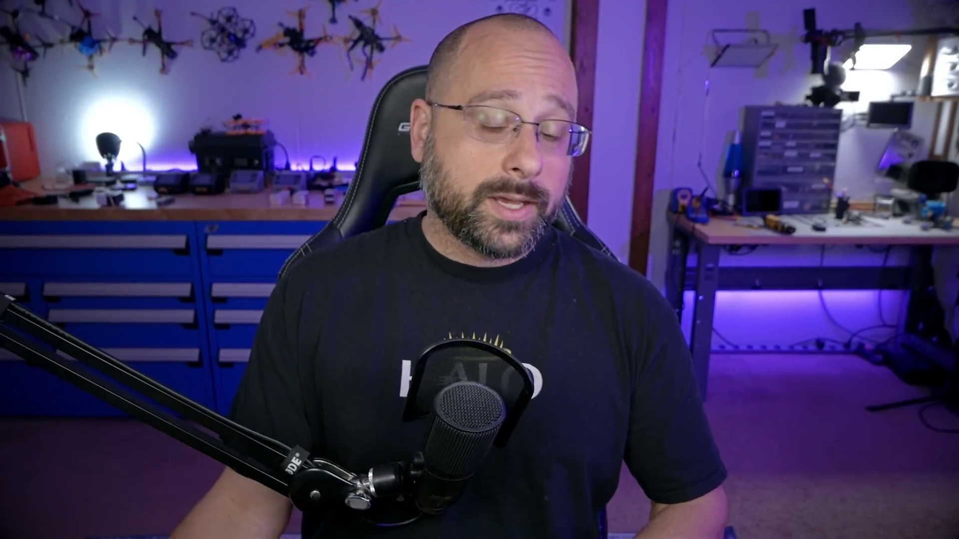 (score 98.0000)
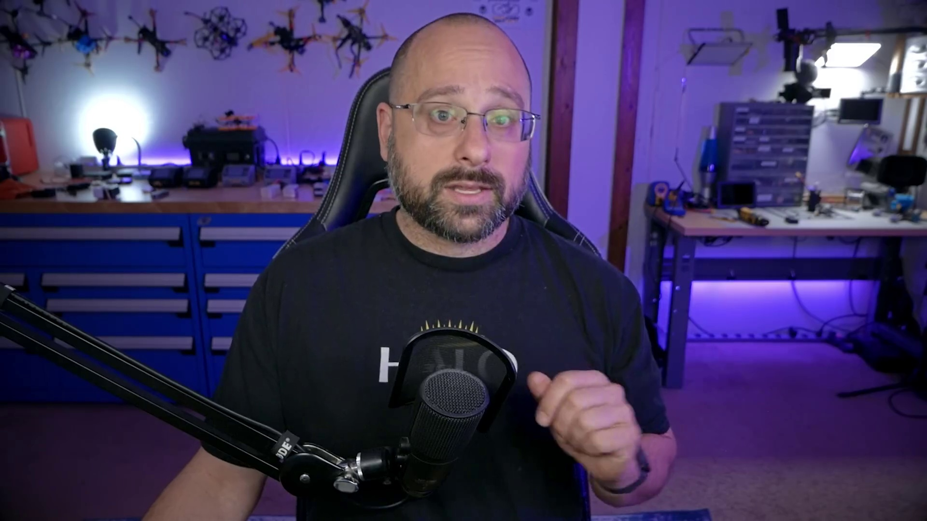 (score 95.0000)
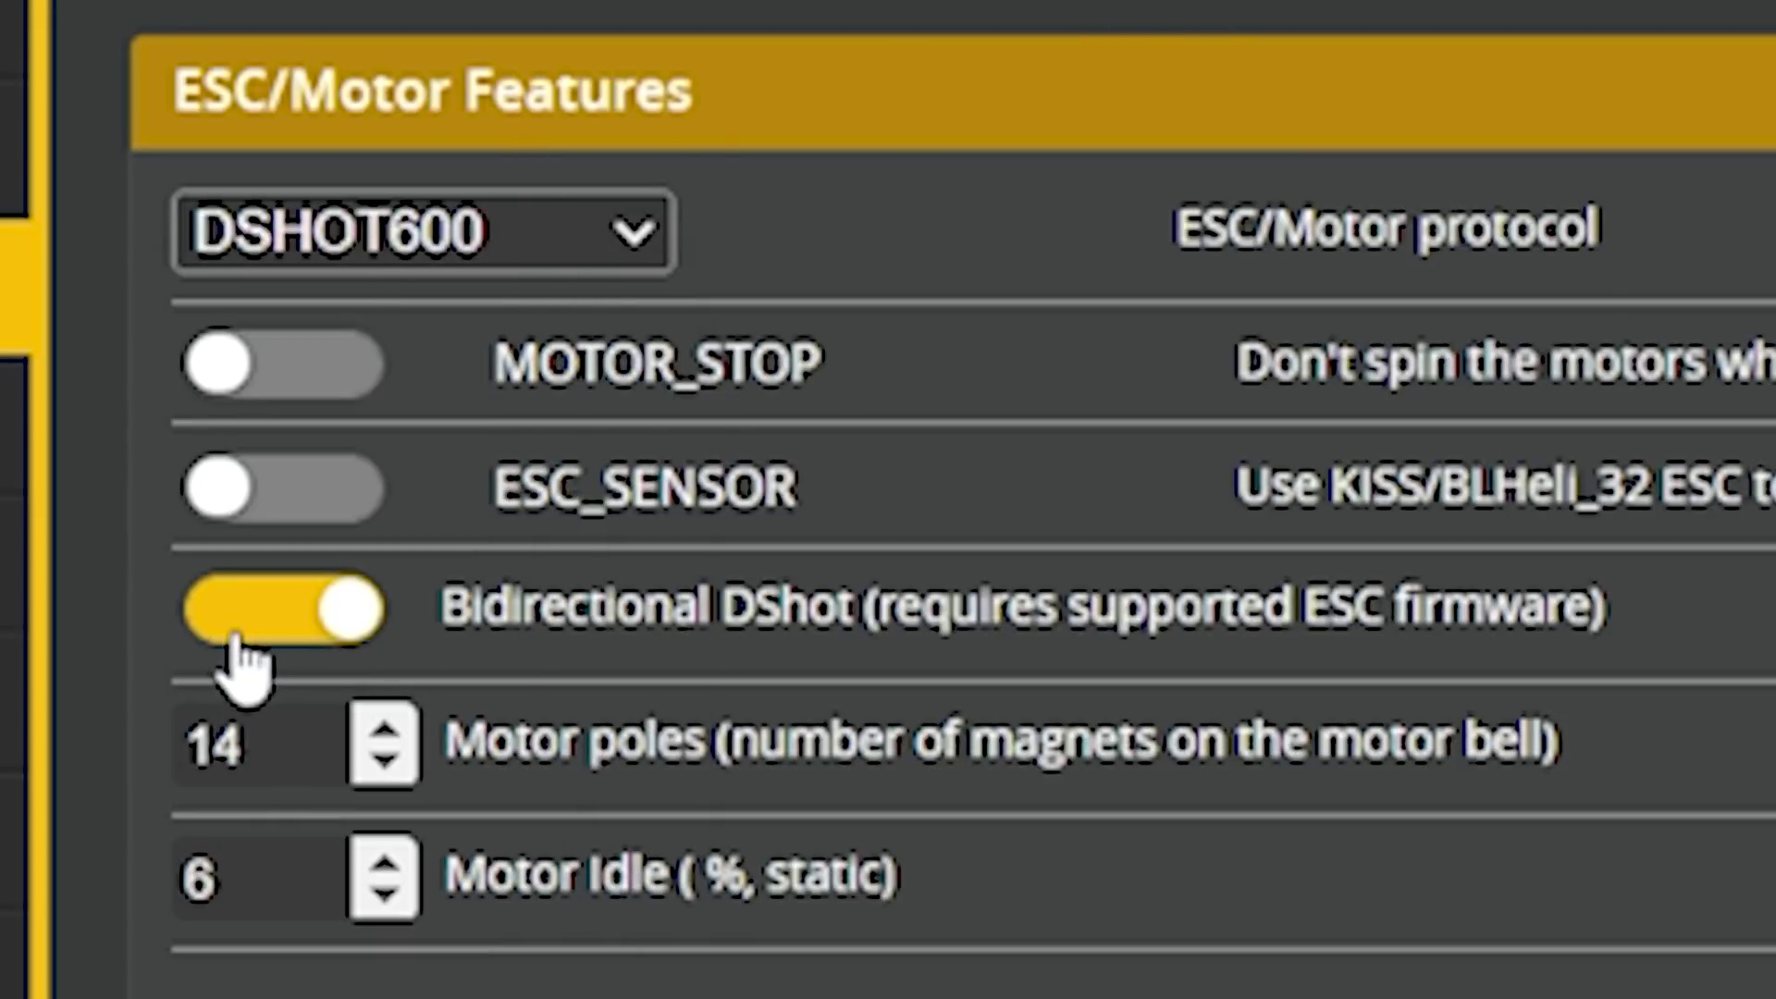 (score 95.0000)
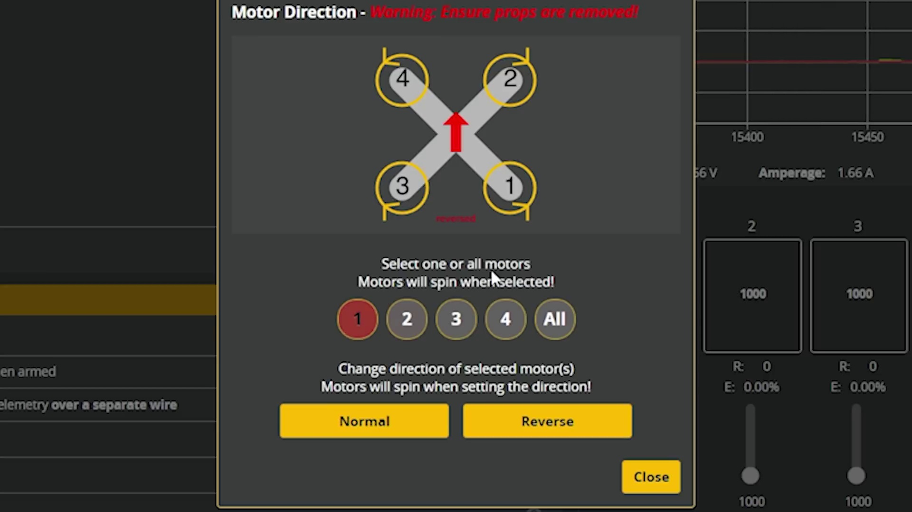 (score 95.0000)
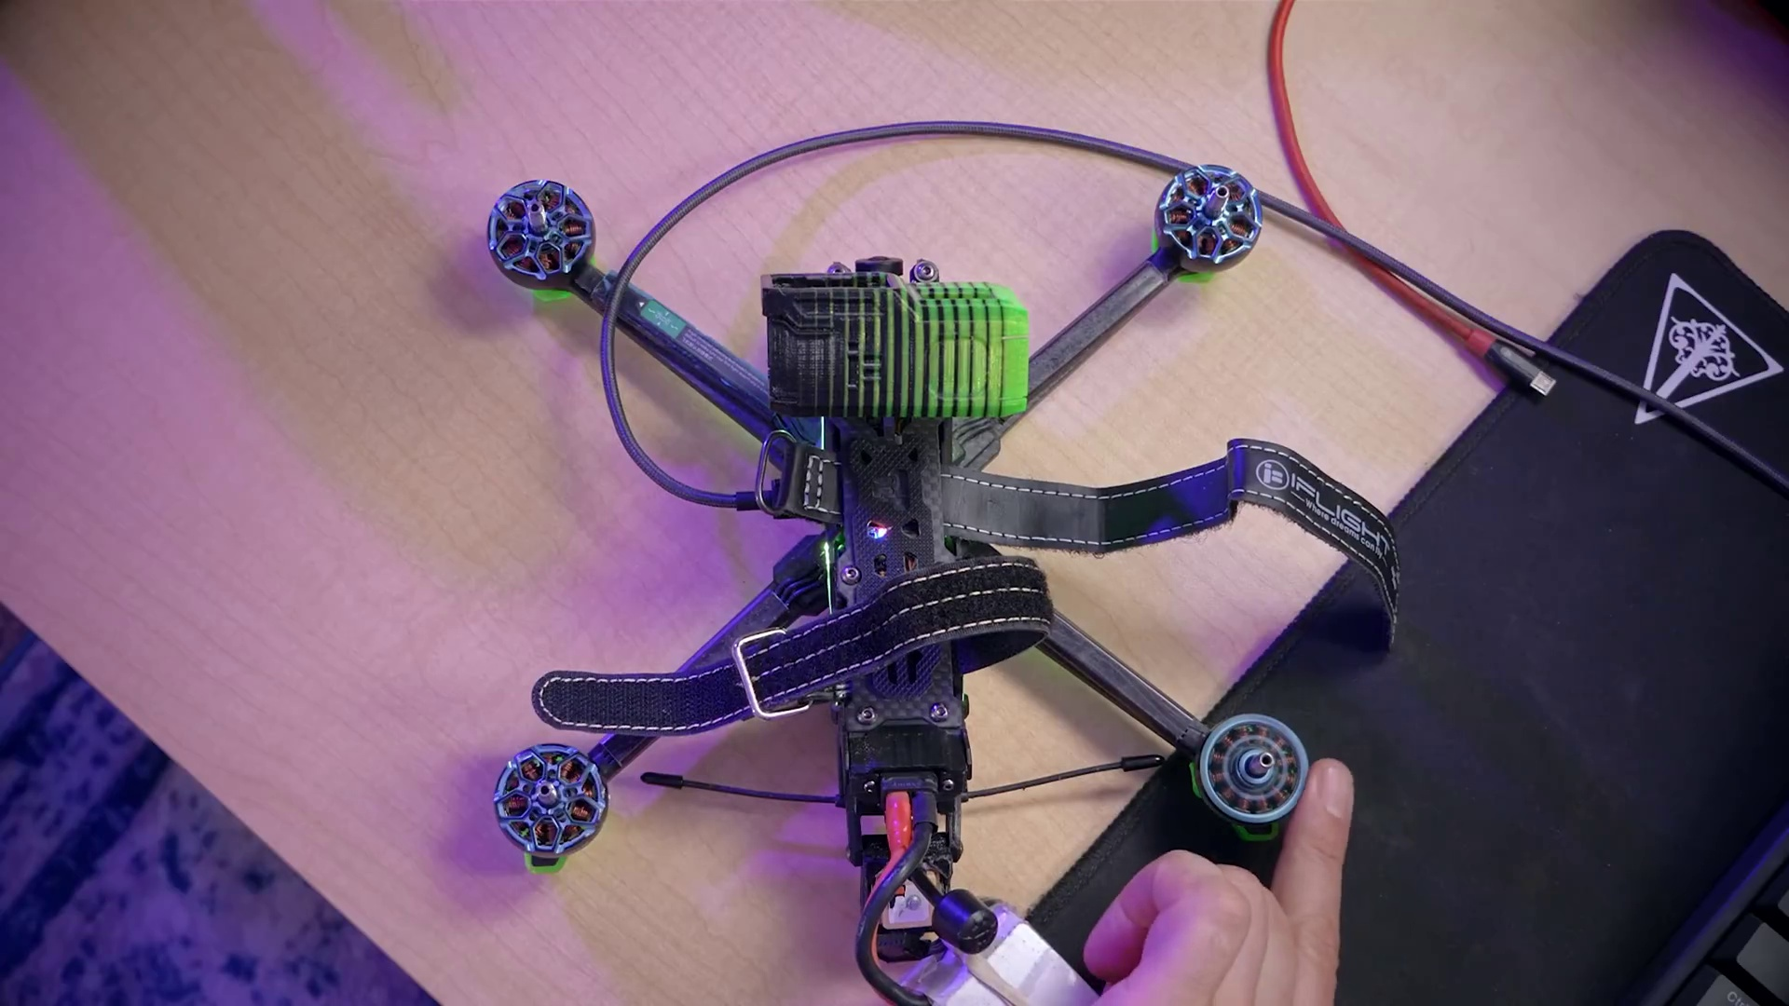 (score 95.0000)
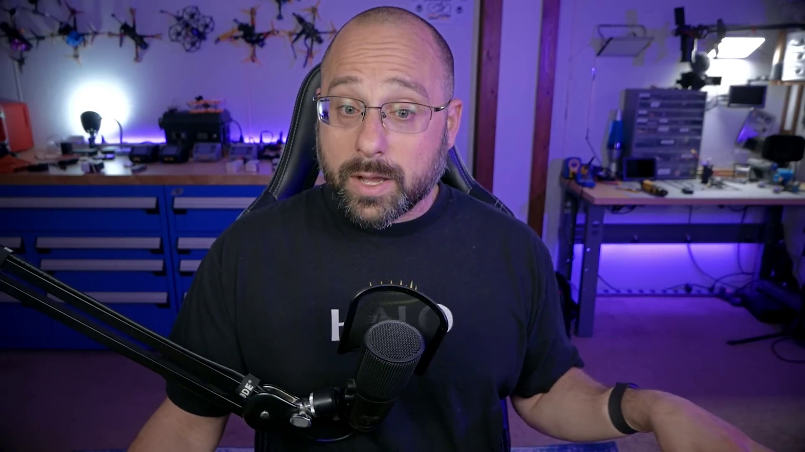 (score 95.0000)
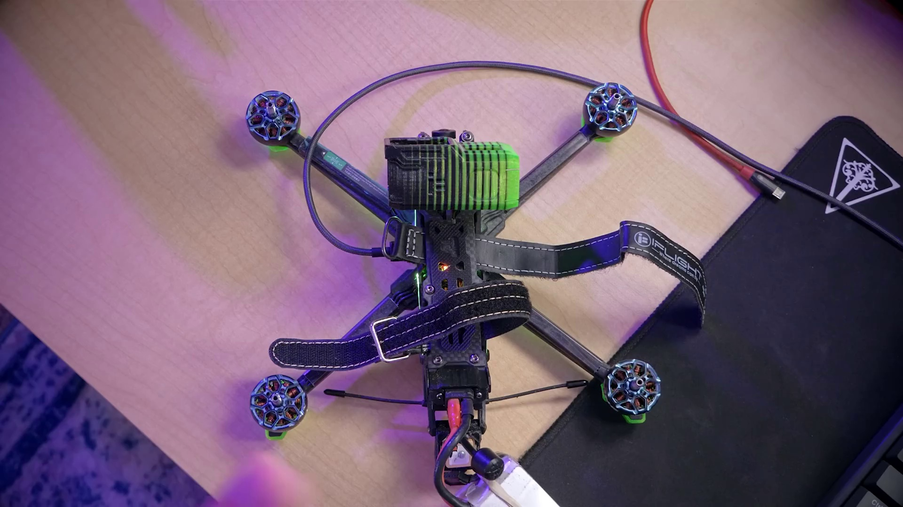 (score 95.0000)
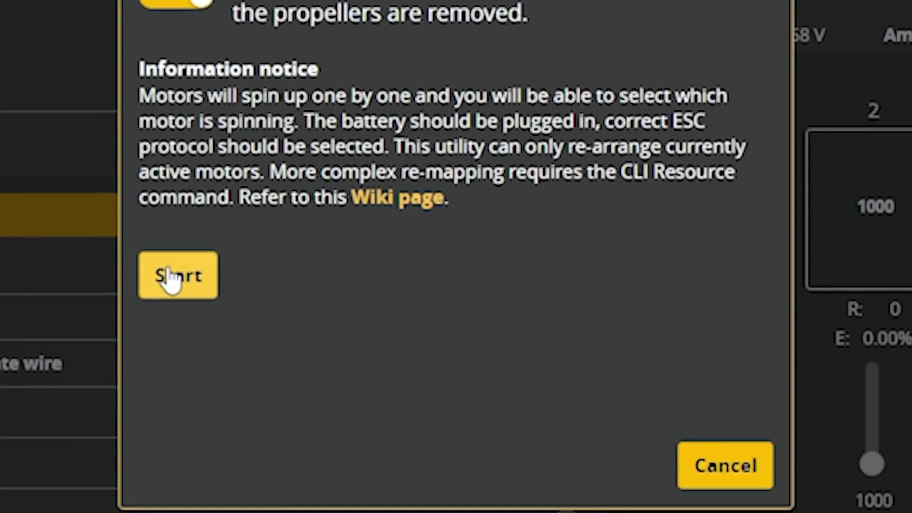 (score 95.0000)
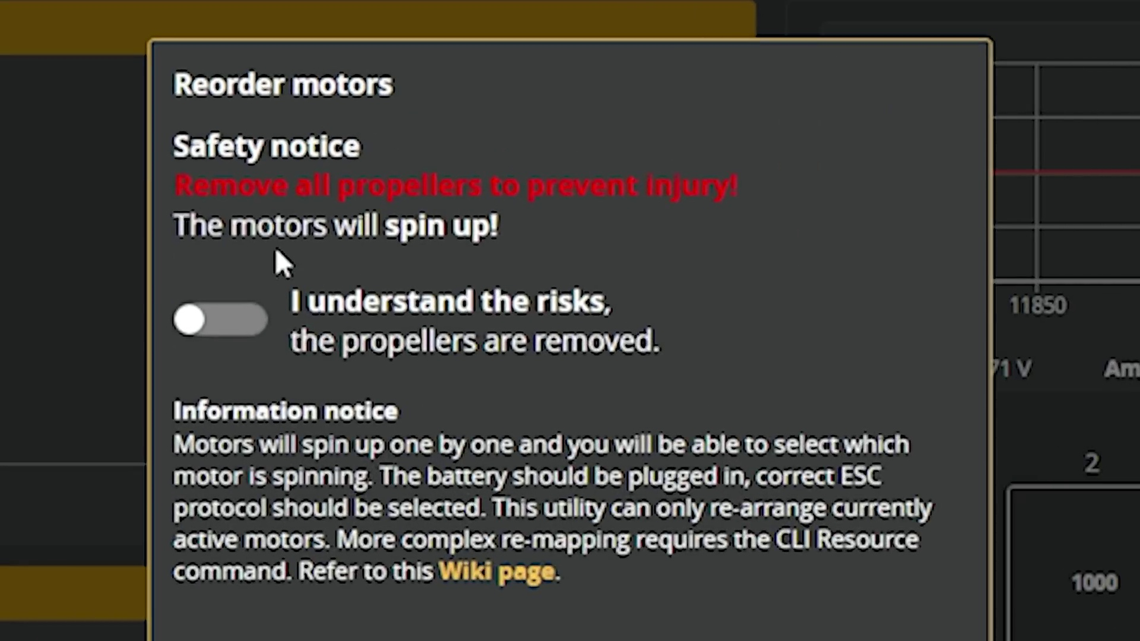 (score 95.0000)
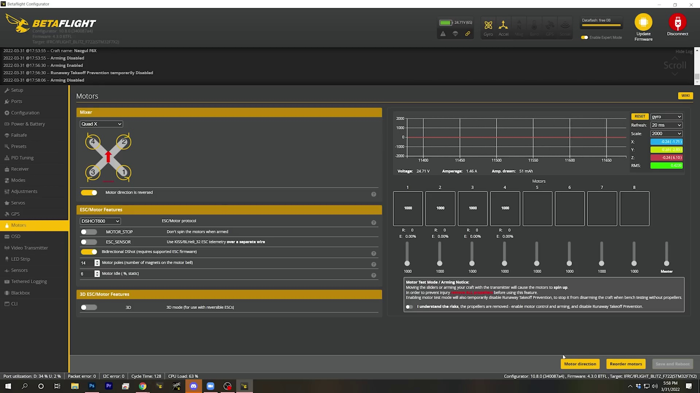 (score 95.0000)
Least correlated frames:
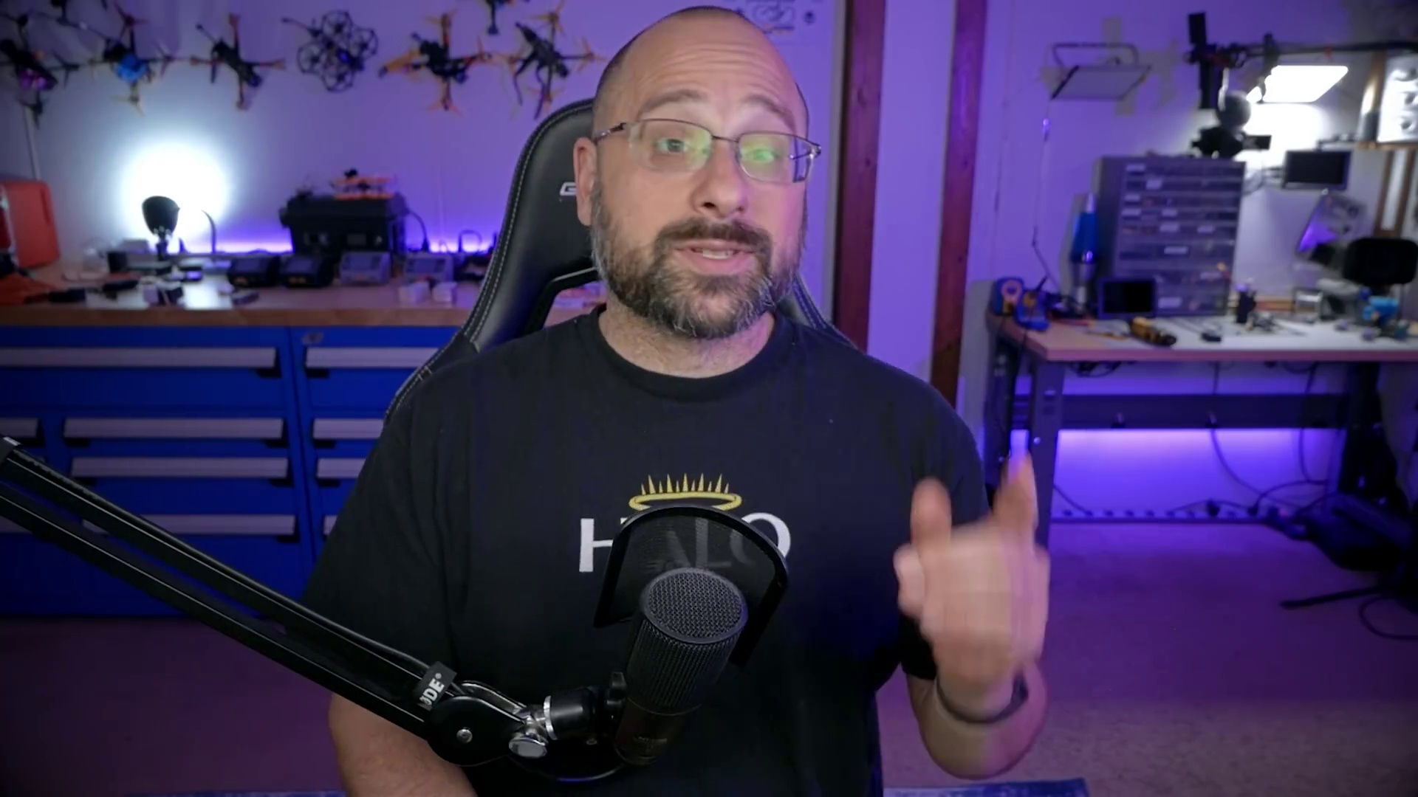 (score 0.0000)
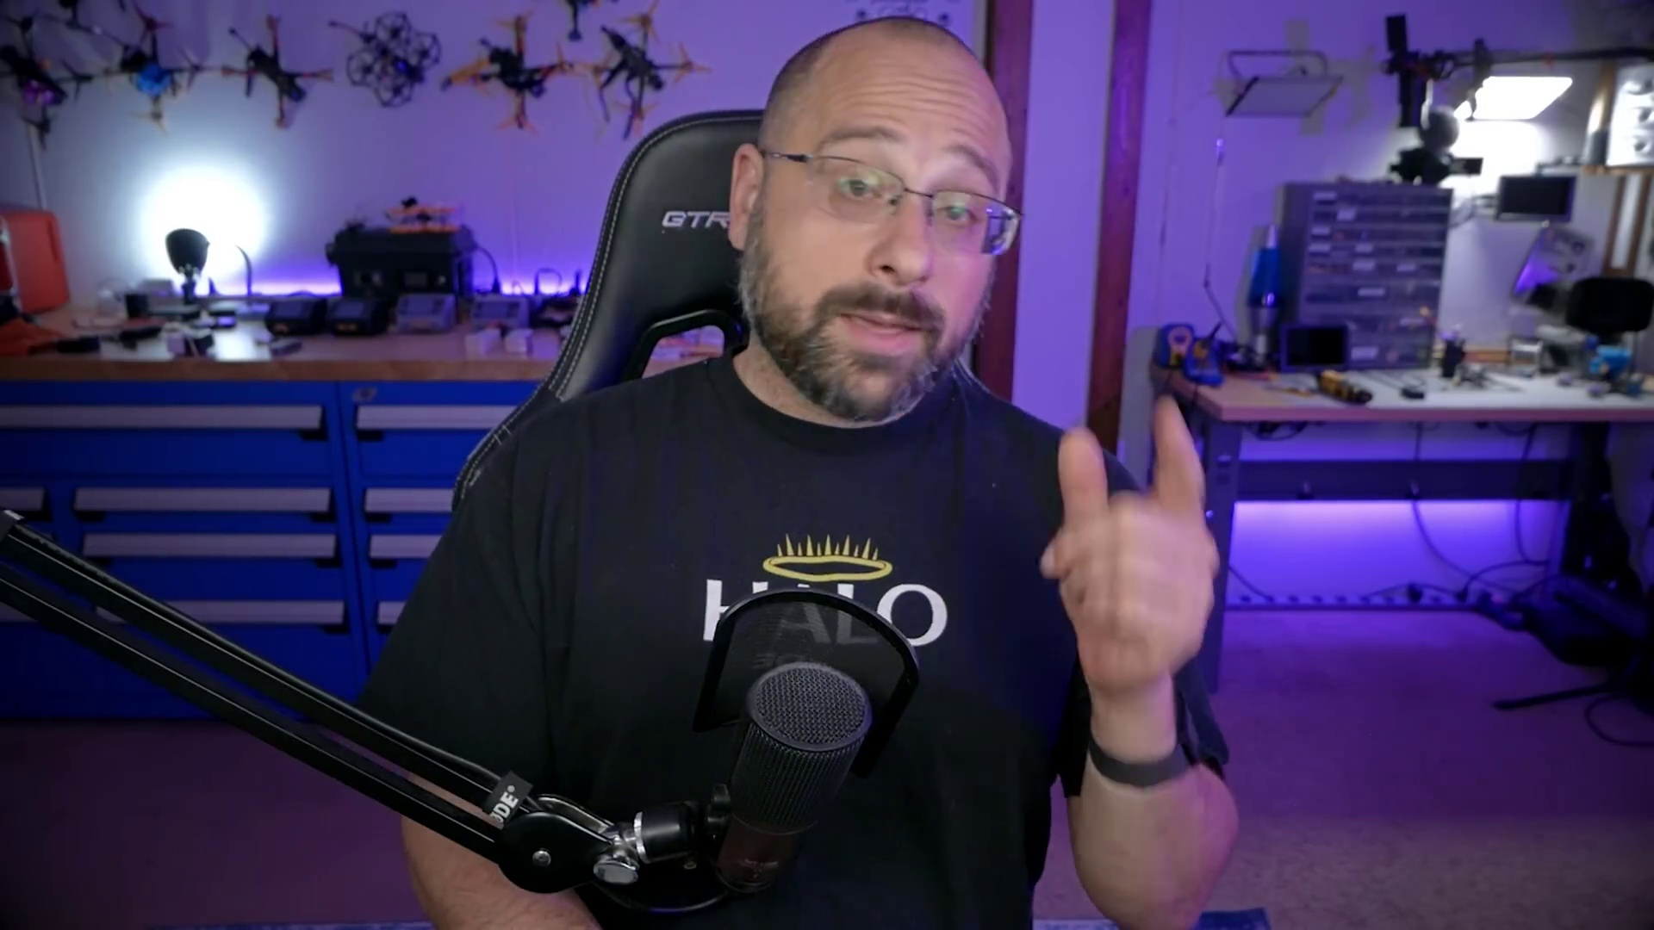 (score 0.0000)
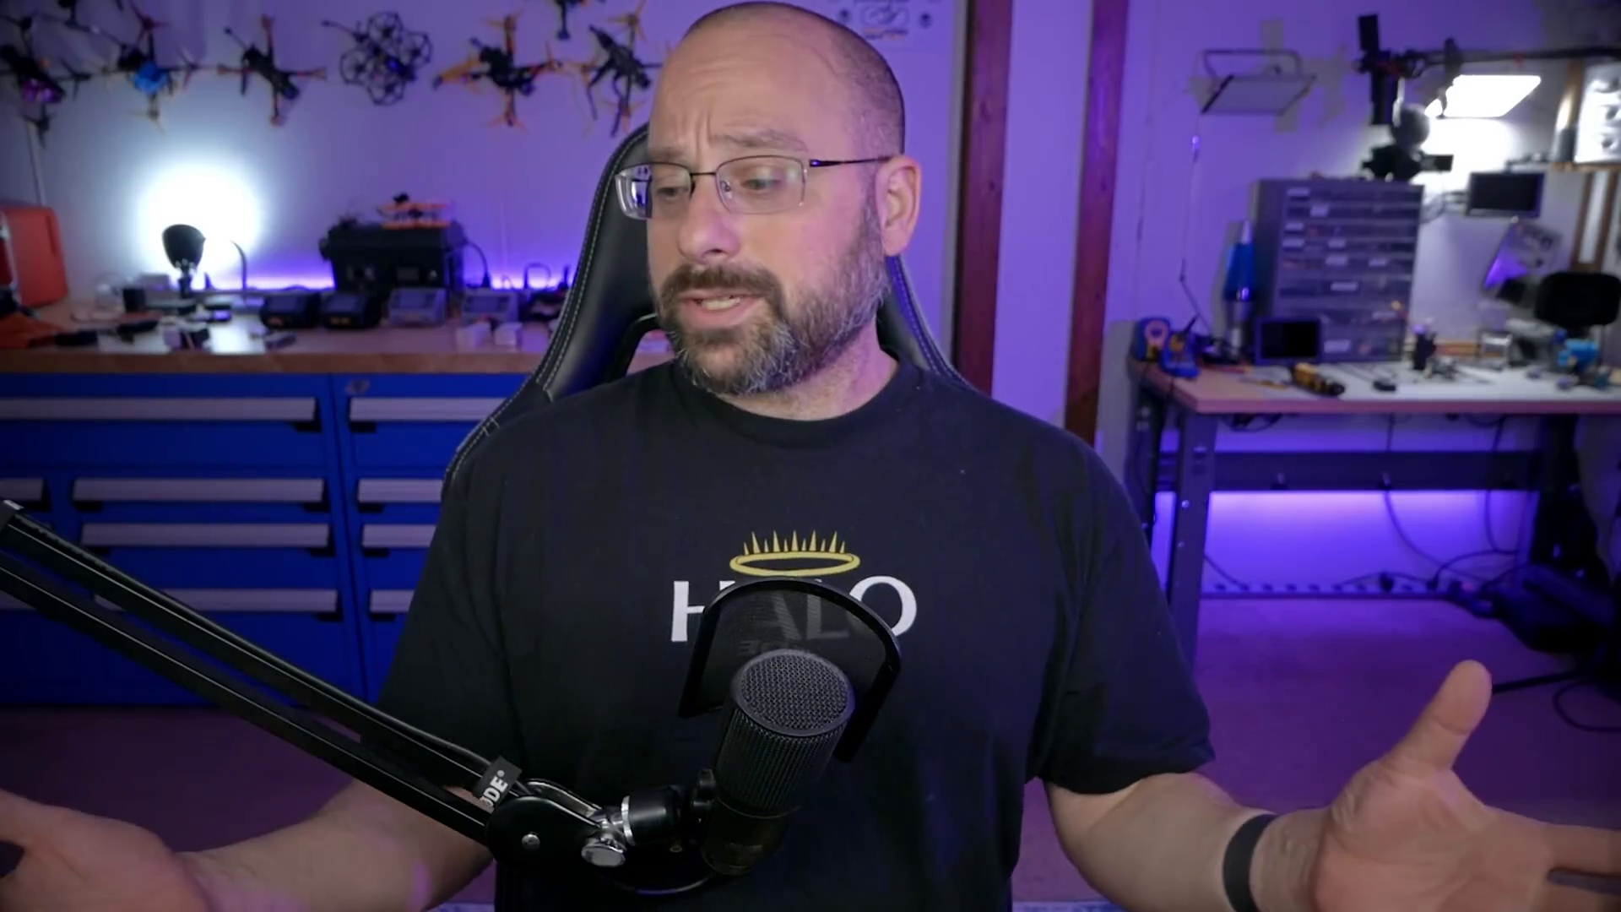 (score 0.0000)
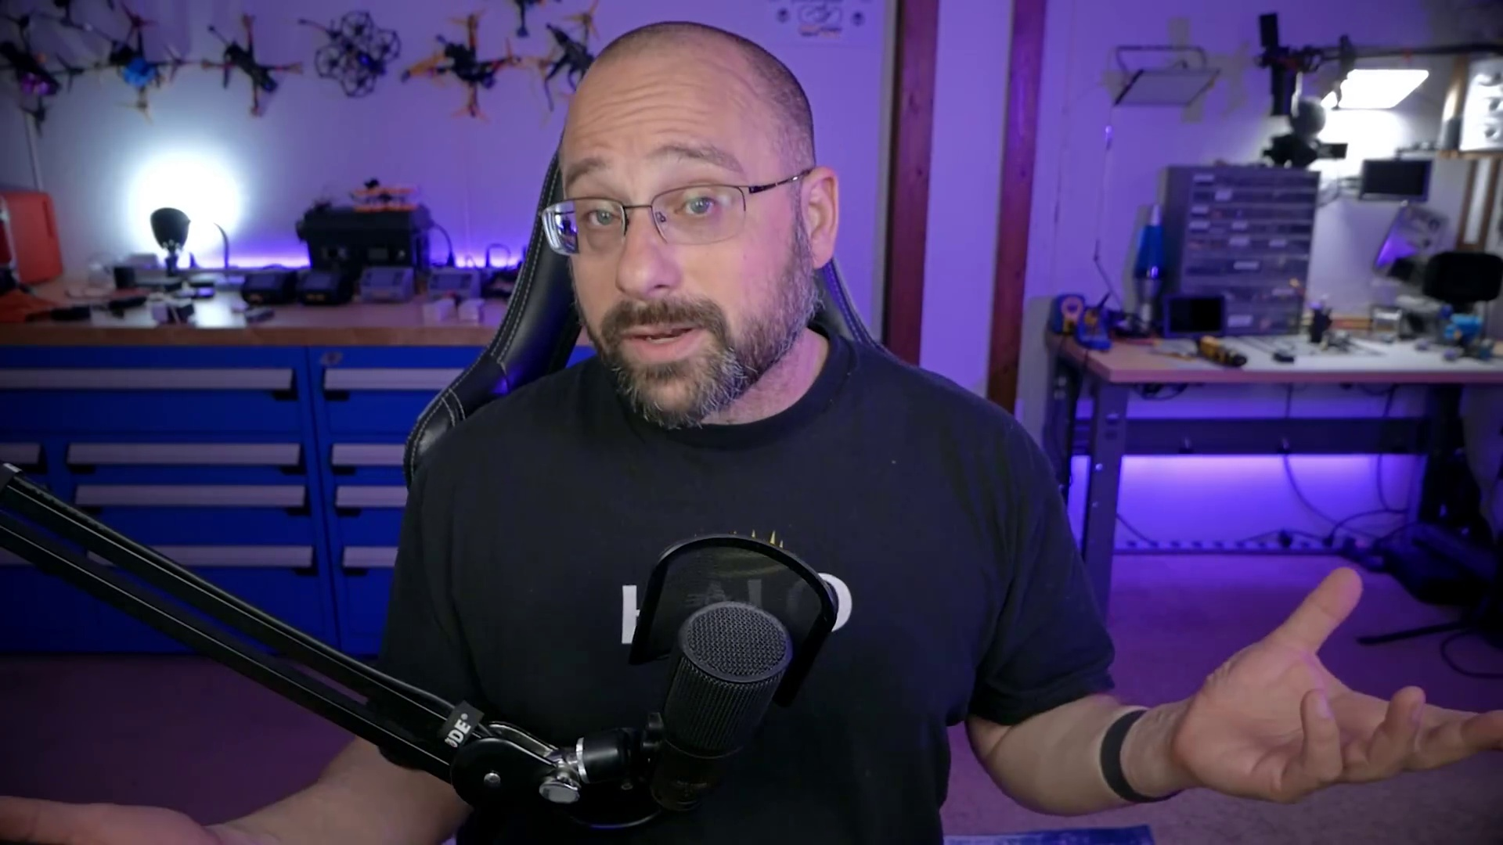 (score 0.0000)
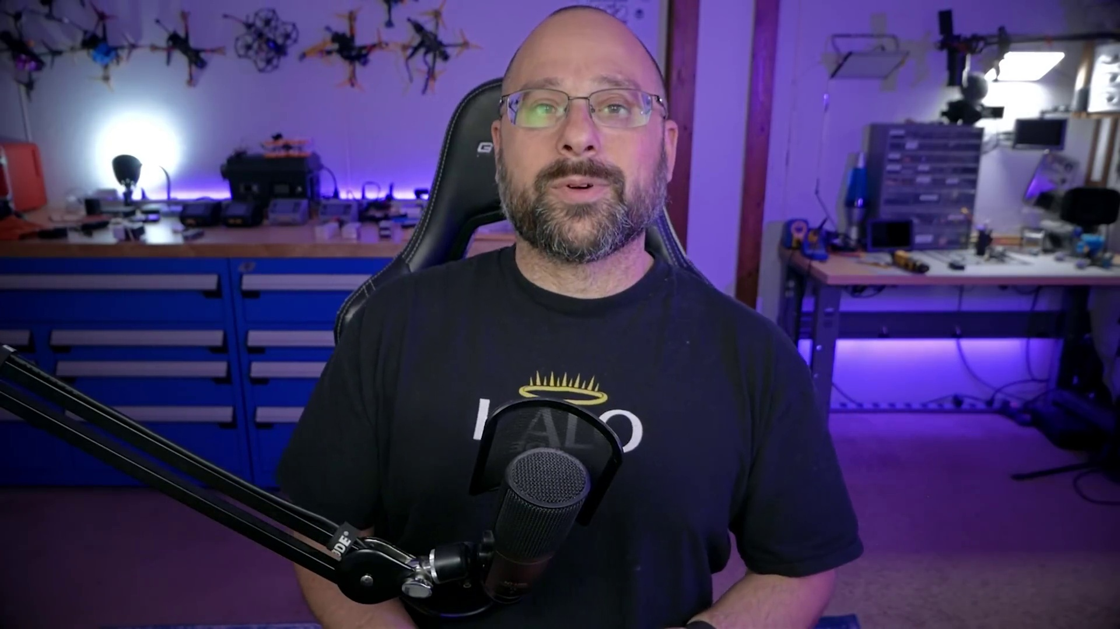 (score 0.0000)
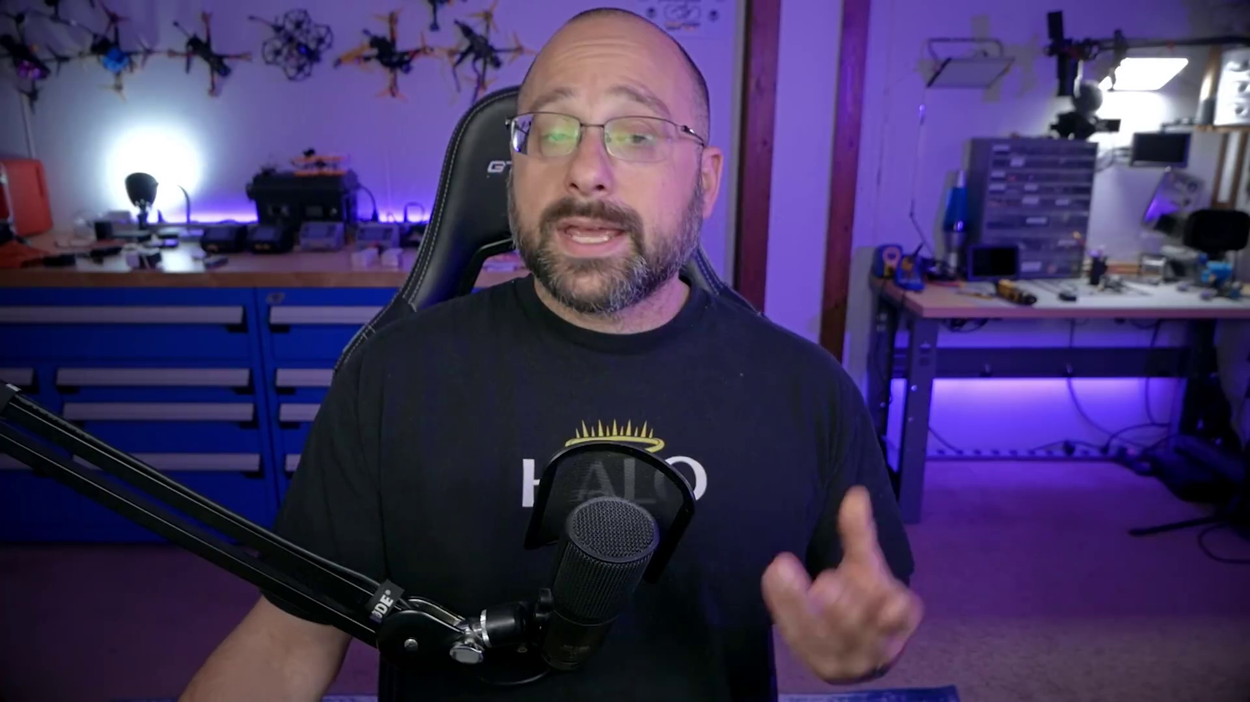 (score 0.0000)
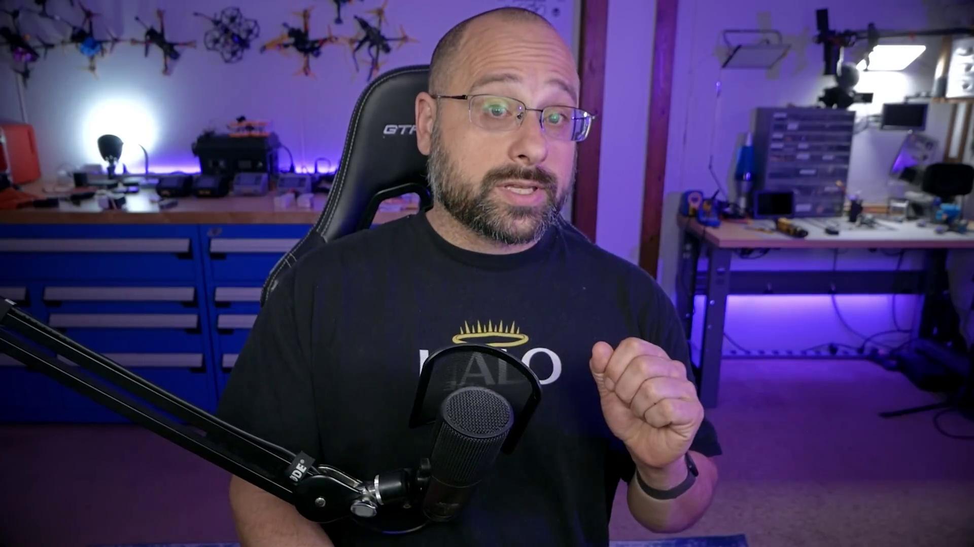 (score 0.0000)
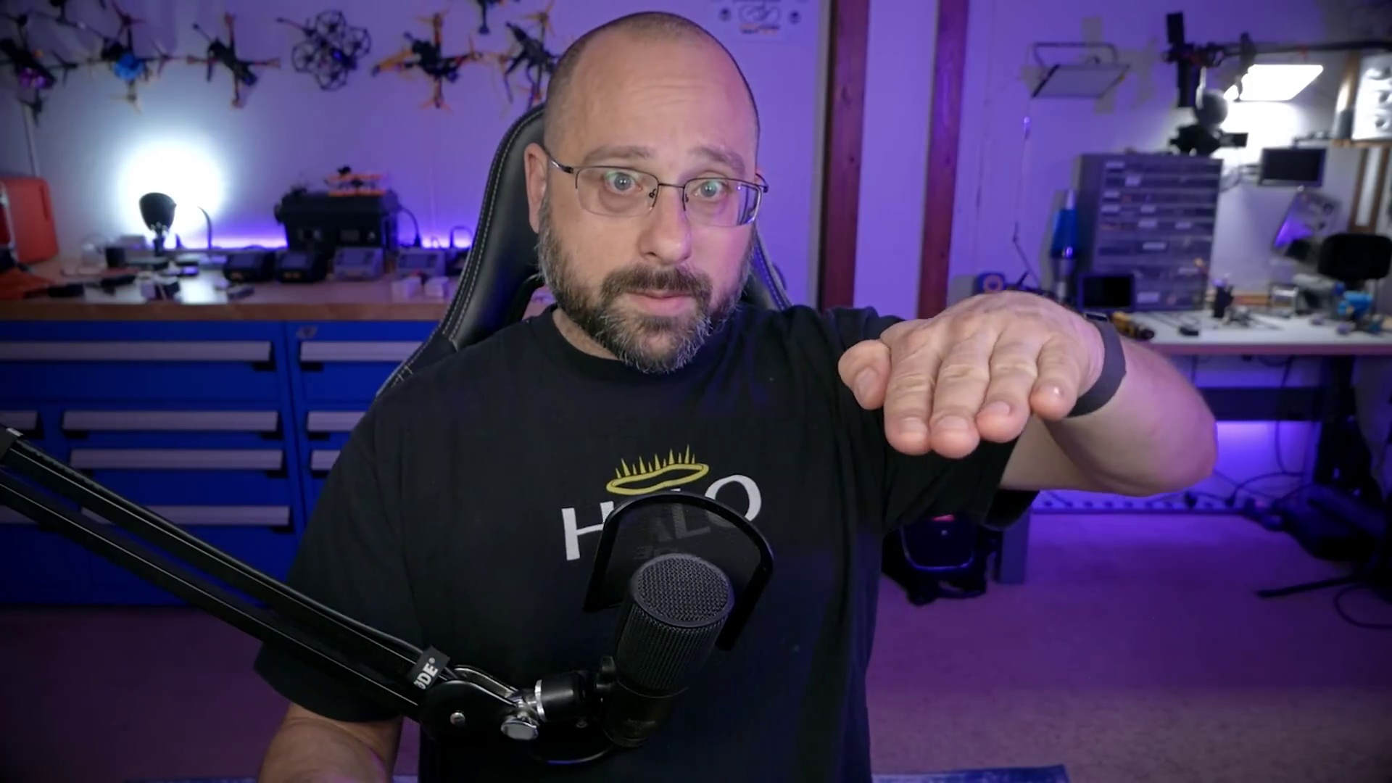 (score 0.0000)
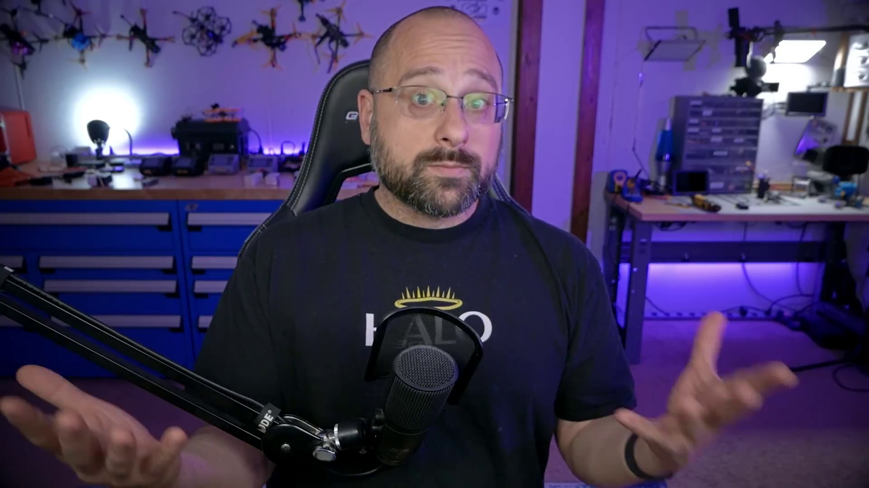 (score 0.0000)
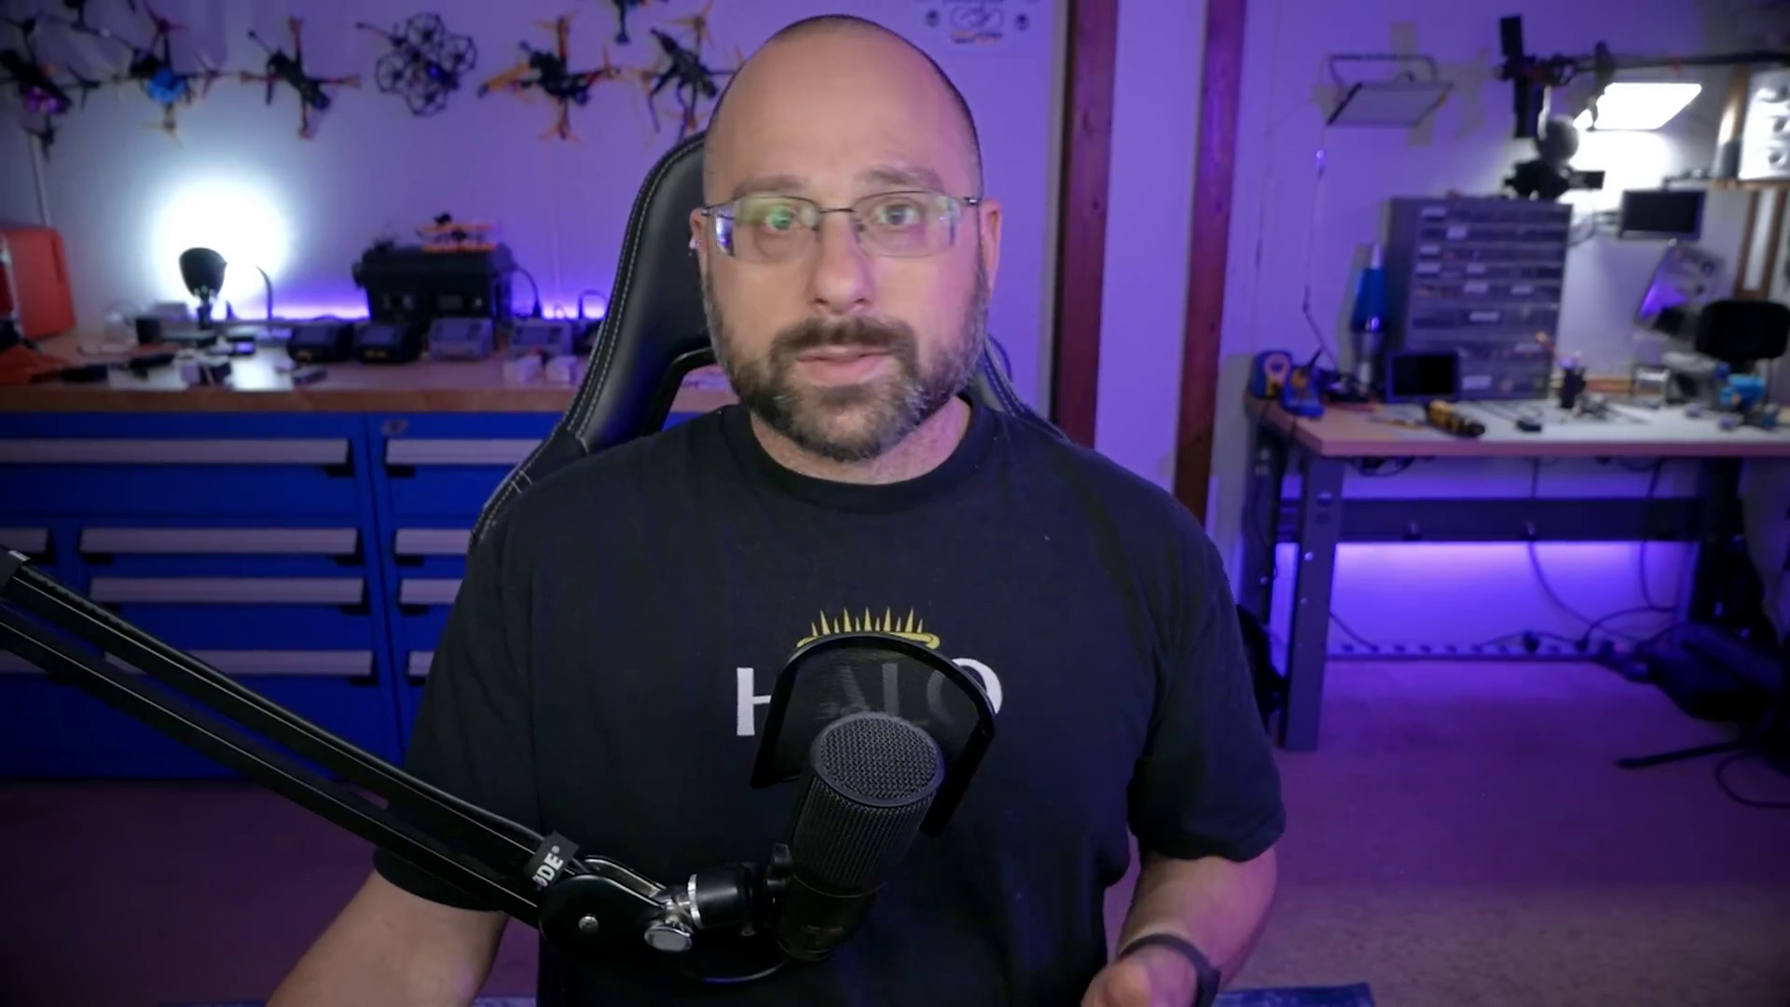 (score 0.0000)
- matched 103 frame(s), max score 90.0000: You need to use 4 motors for the quad copter, most desirable is using 1 PID control per motor. Follow this tutorial for complete comprehension of the motors used, this will also help with the wiring.
Source: https://www.youtube.com/watch?v=1WYDsiYJGoQ: Betaflight 4.3 Motors Tab | COMPLETE WALKTHROUGH PART 5
Top correlated frames:
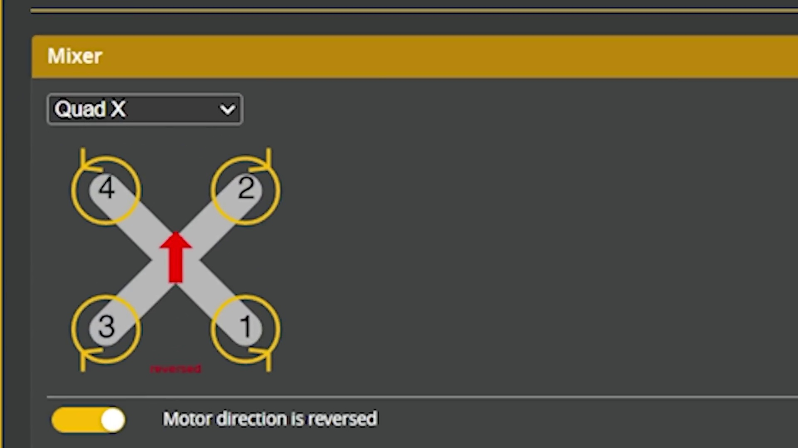 (score 90.0000)
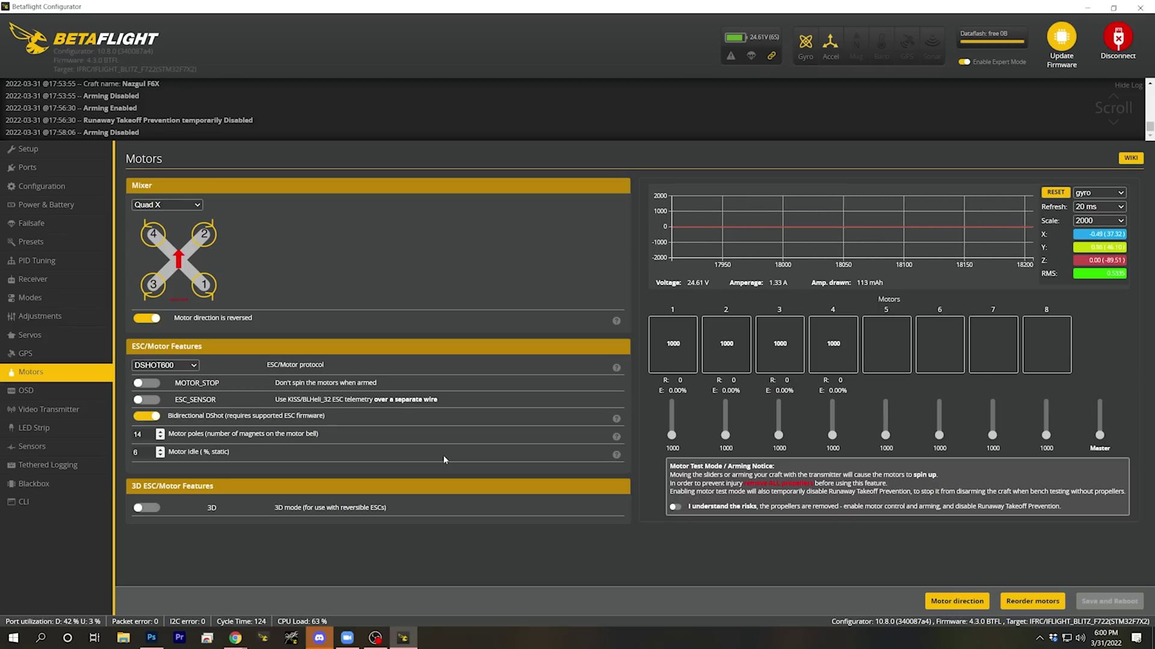 (score 90.0000)
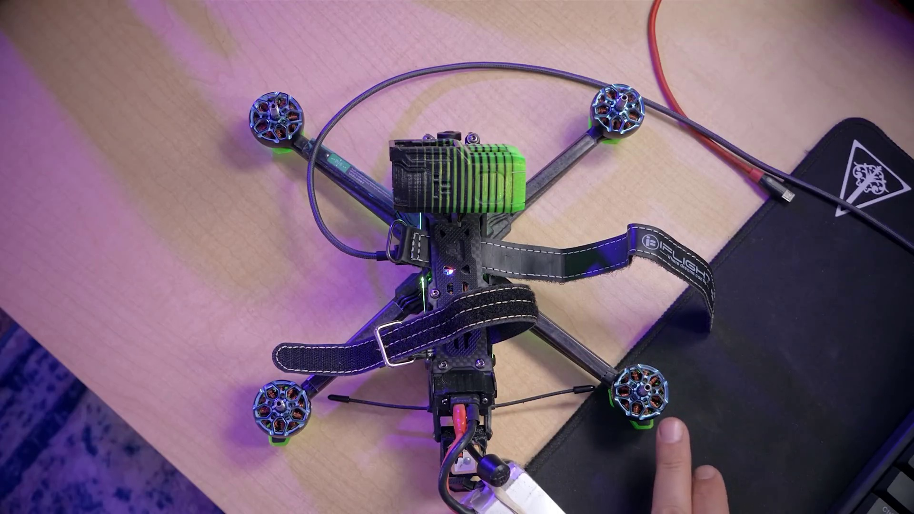 (score 90.0000)
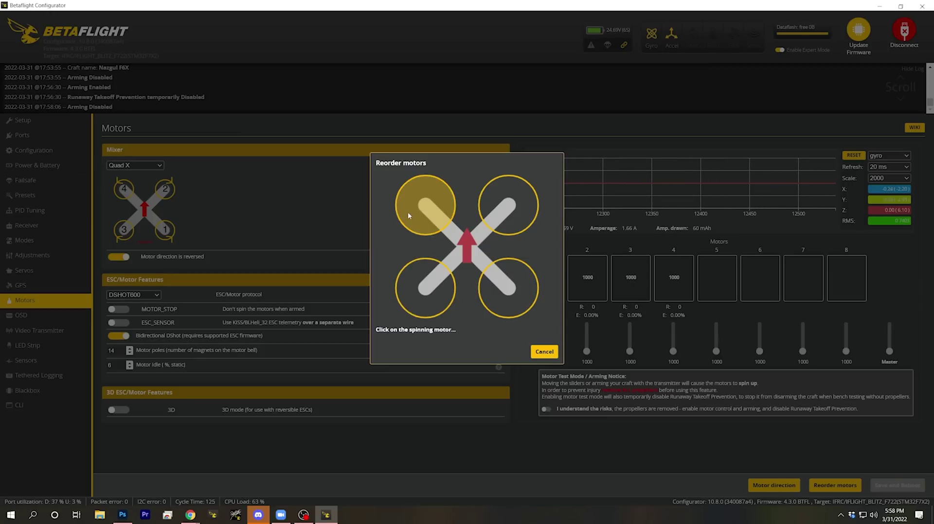 (score 90.0000)
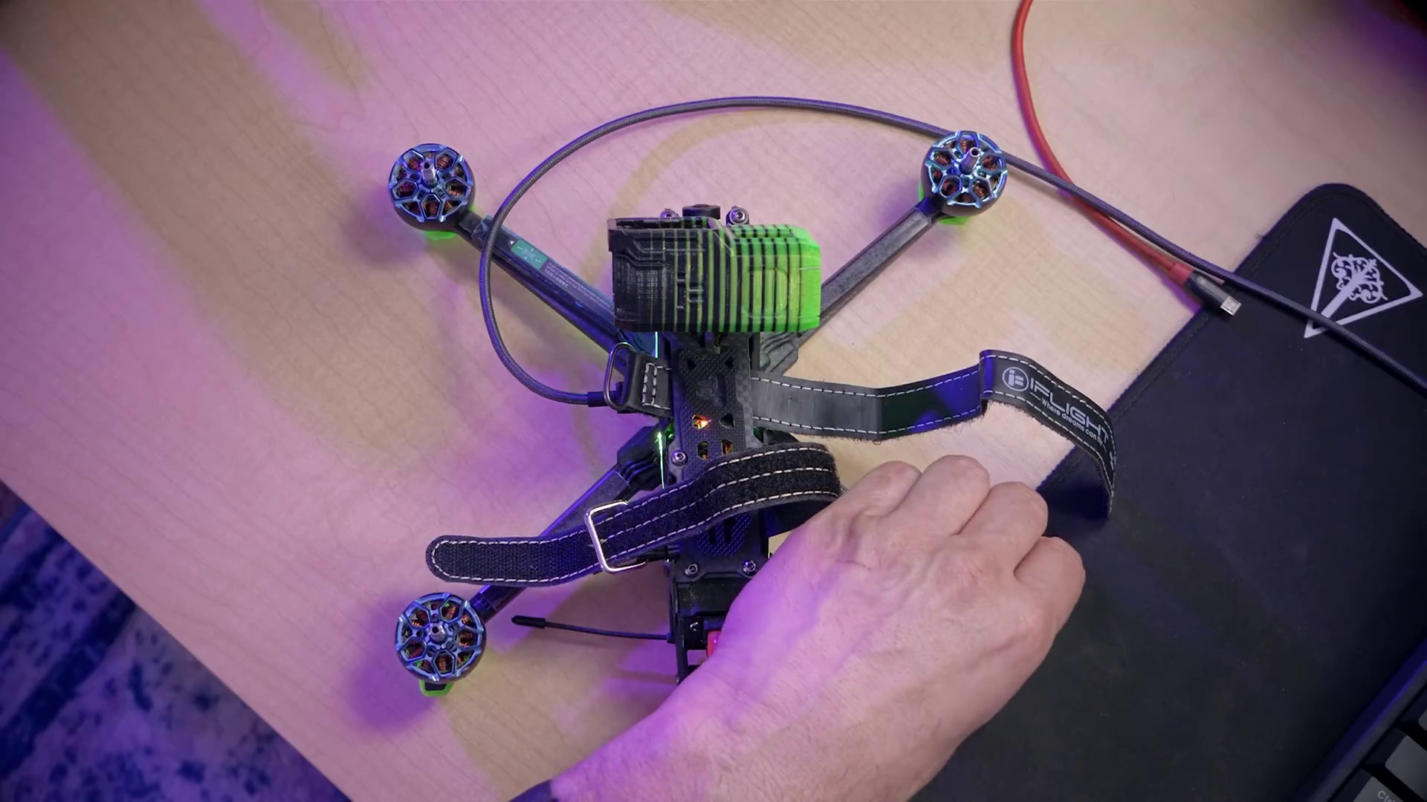 (score 90.0000)
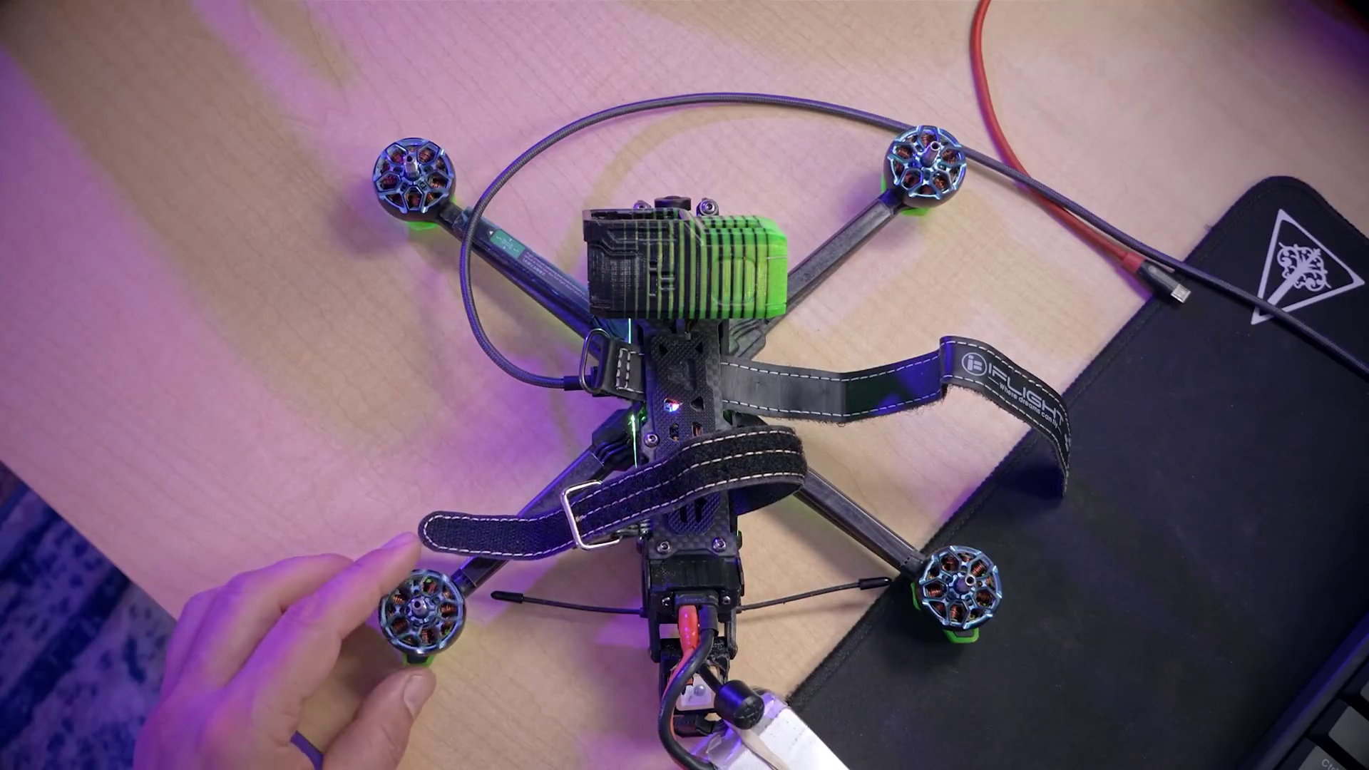 (score 90.0000)
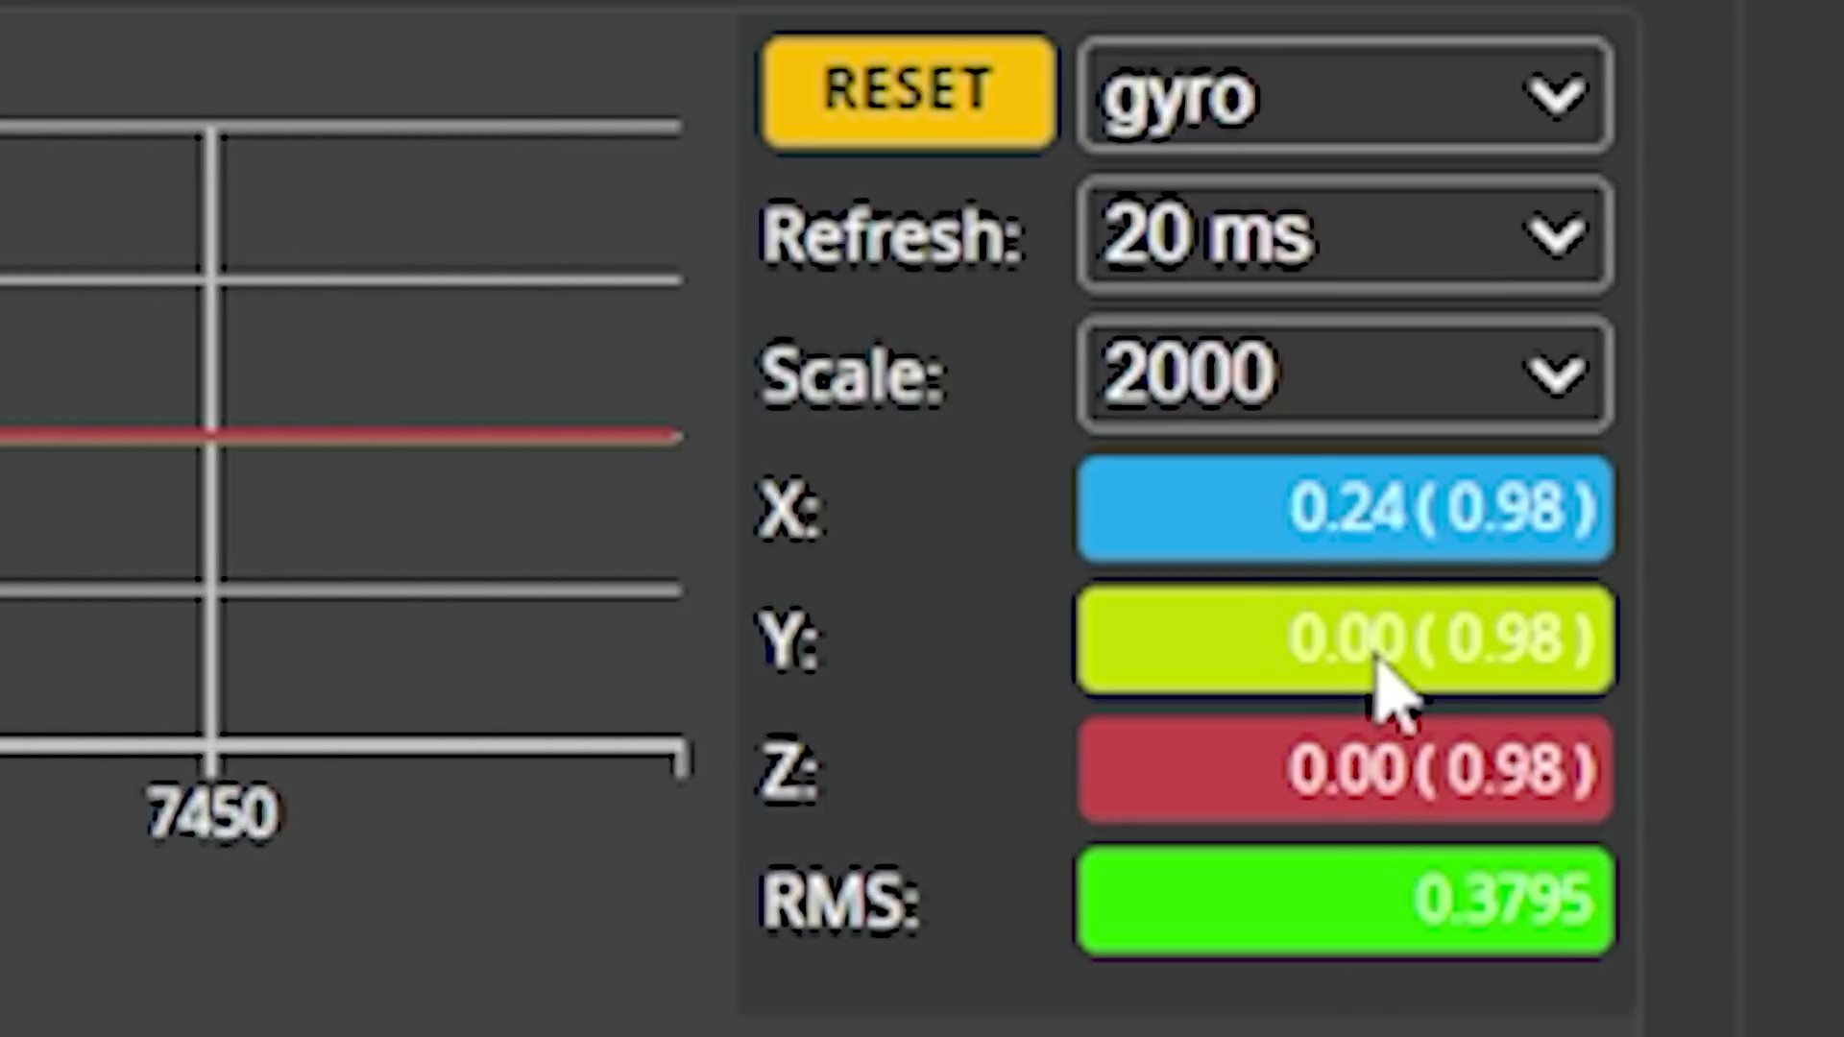 (score 90.0000)
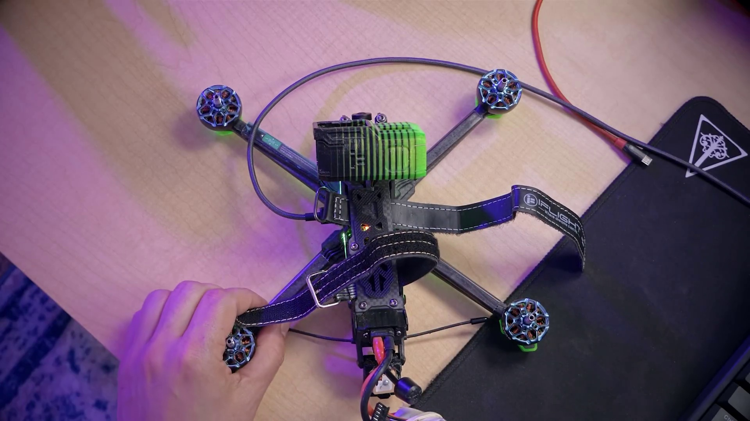 (score 90.0000)
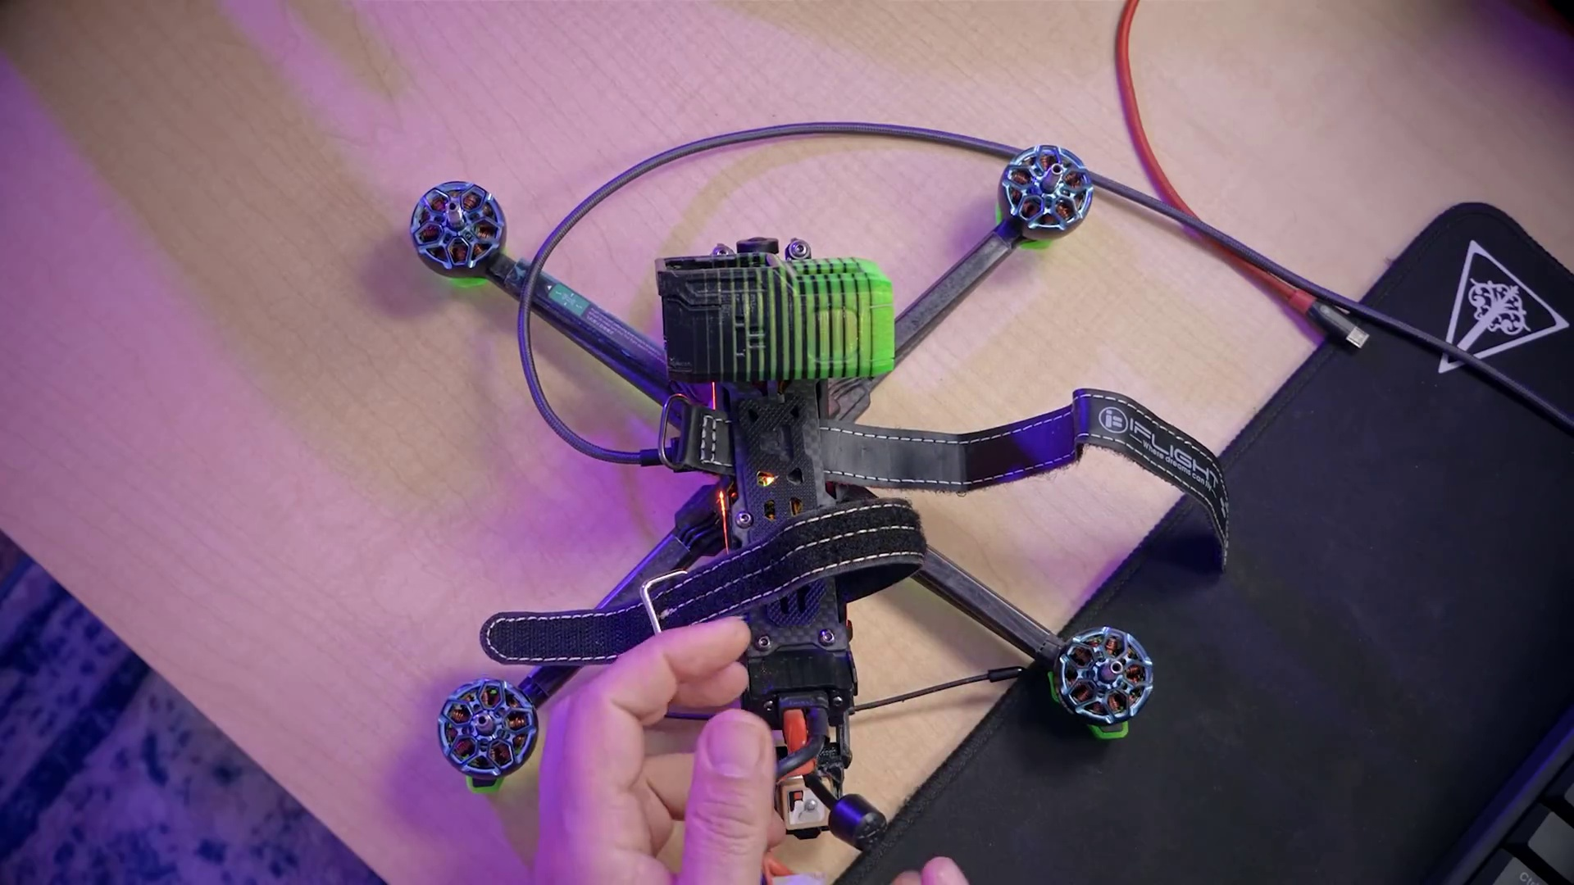 (score 90.0000)
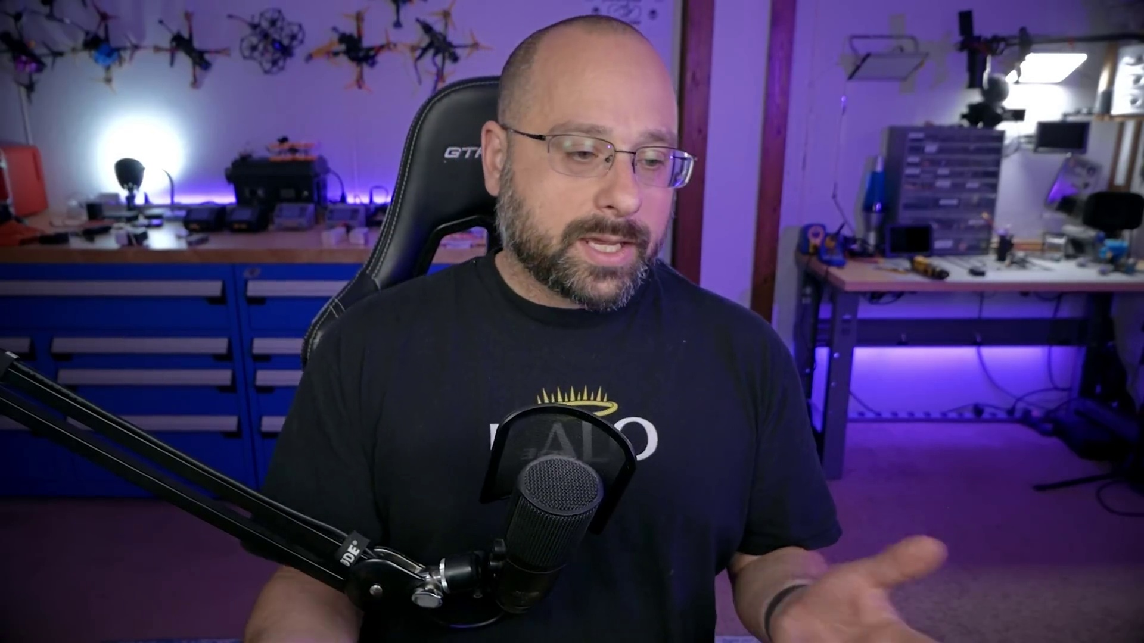 (score 90.0000)
Least correlated frames:
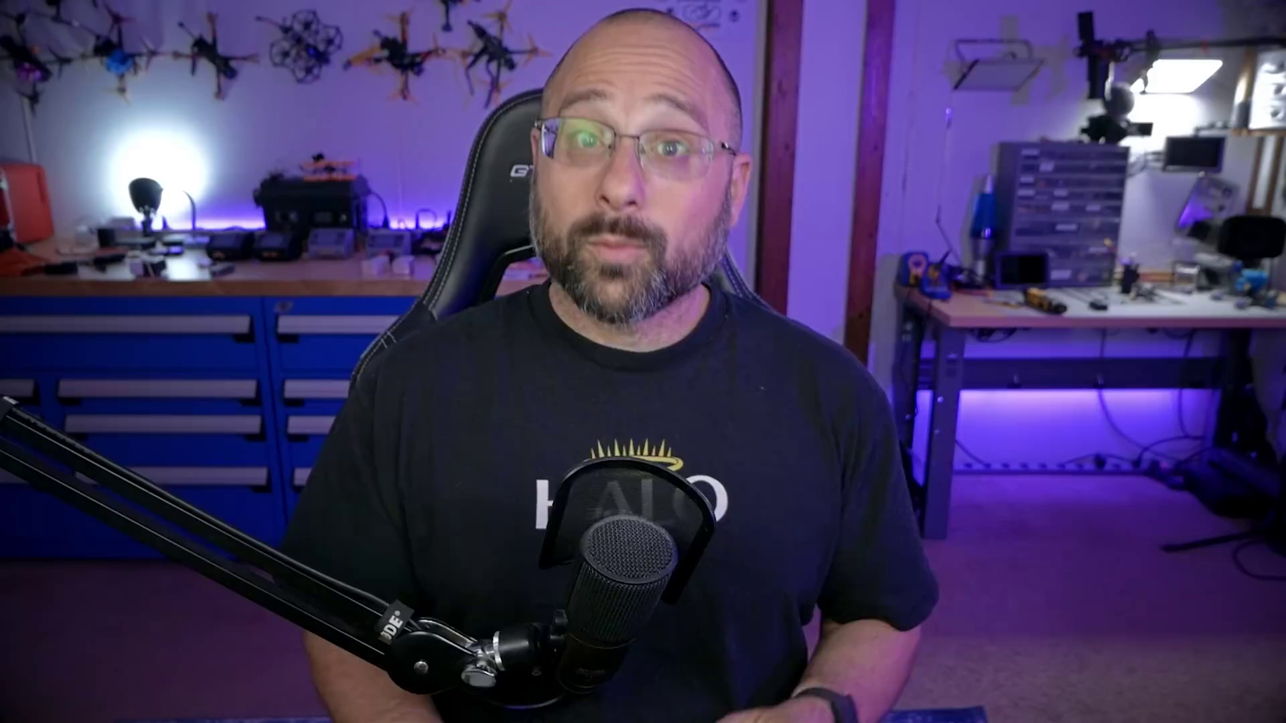 (score 0.0000)
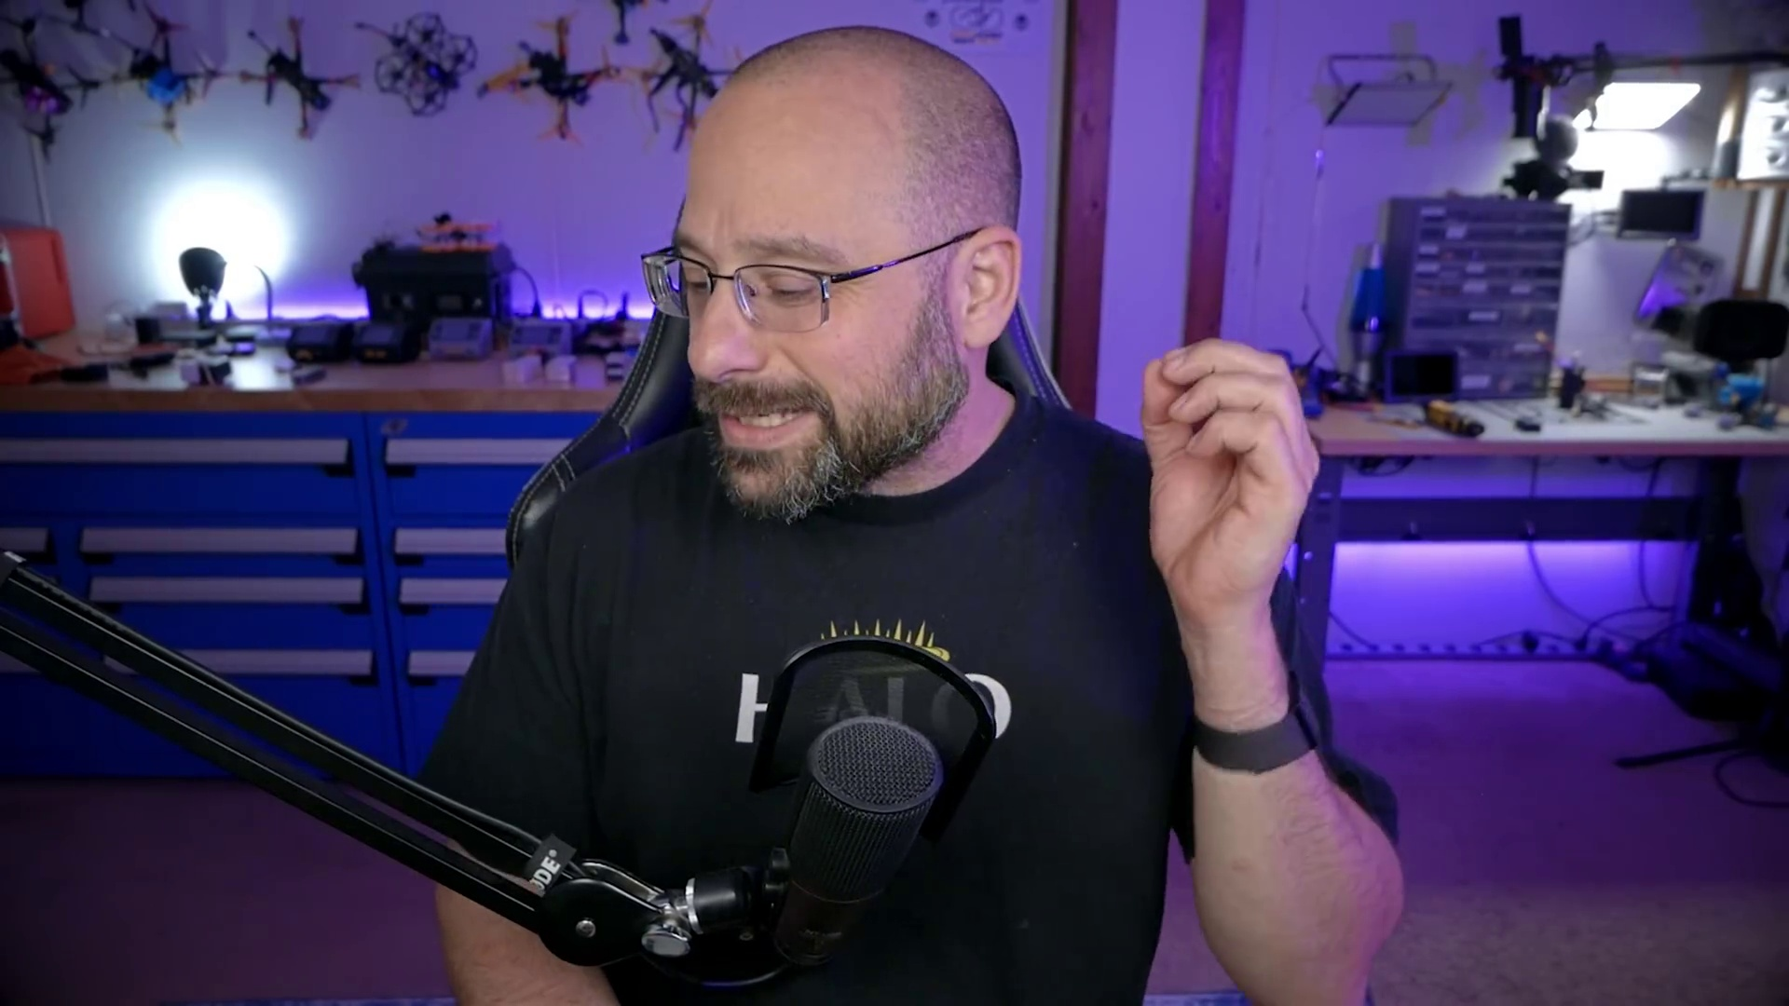 (score 0.0000)
 (score 0.0000)
 (score 0.0000)
 (score 0.0000)
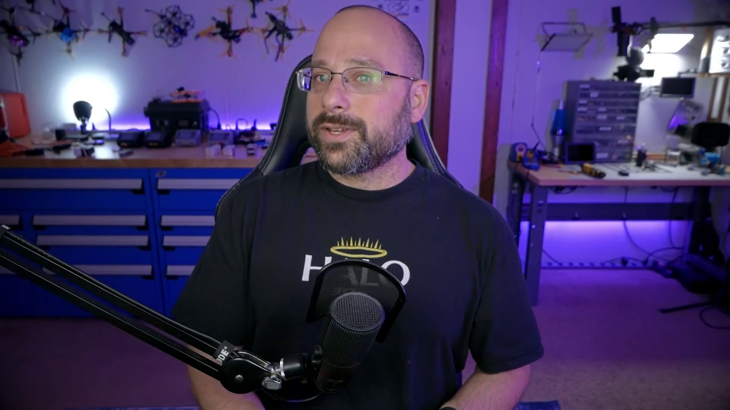 (score 0.0000)
 (score 0.0000)
 (score 0.0000)
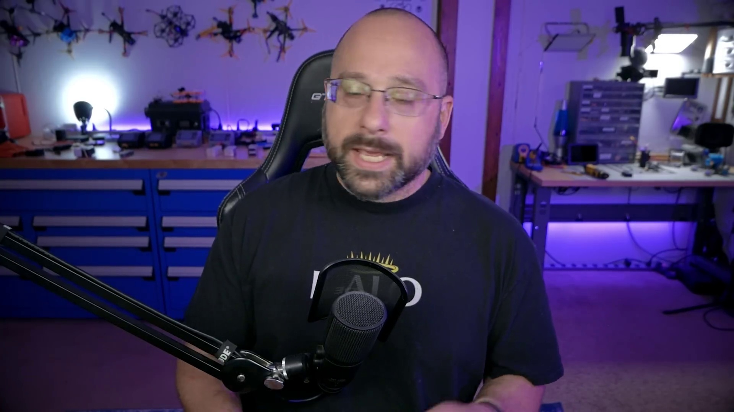 (score 0.0000)
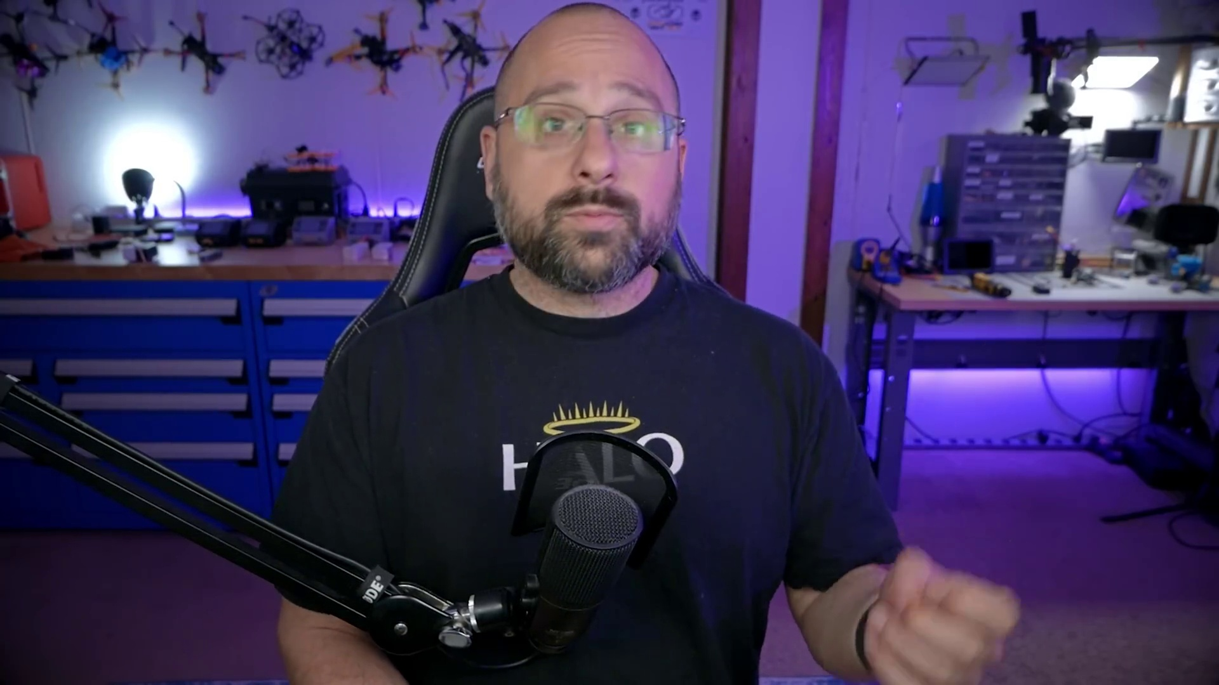 (score 0.0000)
- matched 47 frame(s), max score 90.0000: Quad X is the most common type of setup to use.DSHOT most common ESC protocol.DSHOT600 is the fastest protocol.Motor stop will turn the drone off at any time the throttle hits zero.Testing the motor integrity can be done with the gyro function and checking the values. If the values are skewed for one motor, it might need to be replaced.
Source: https://www.youtube.com/watch?v=1WYDsiYJGoQ:Betaflight 4.3 Motors Tab | COMPLETE WALKTHROUGH PART 5
Top correlated frames:
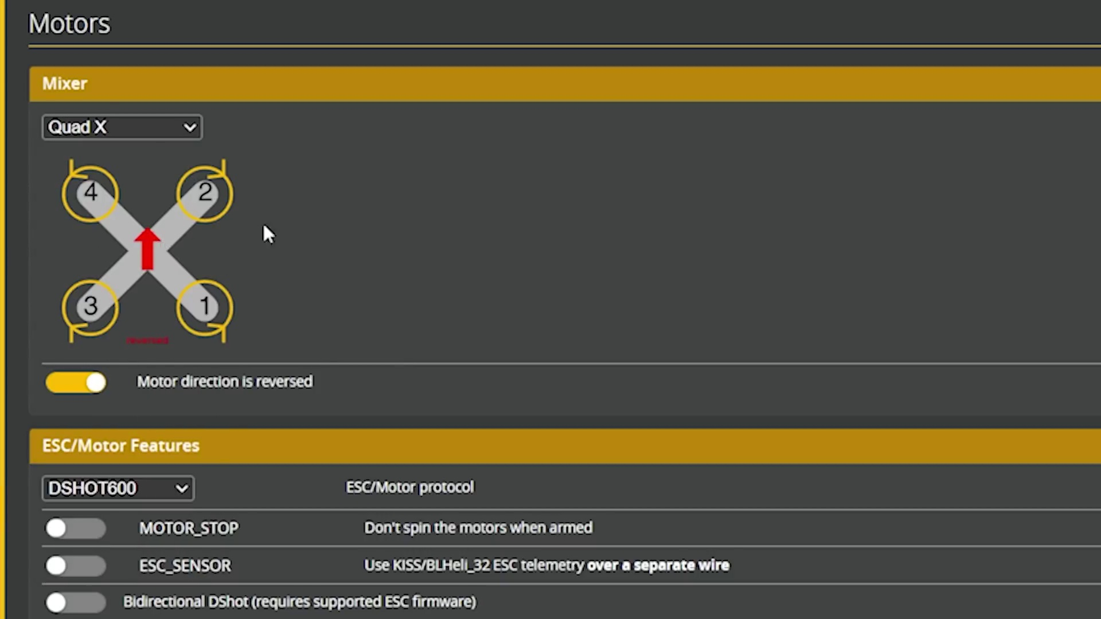 (score 95.0000)
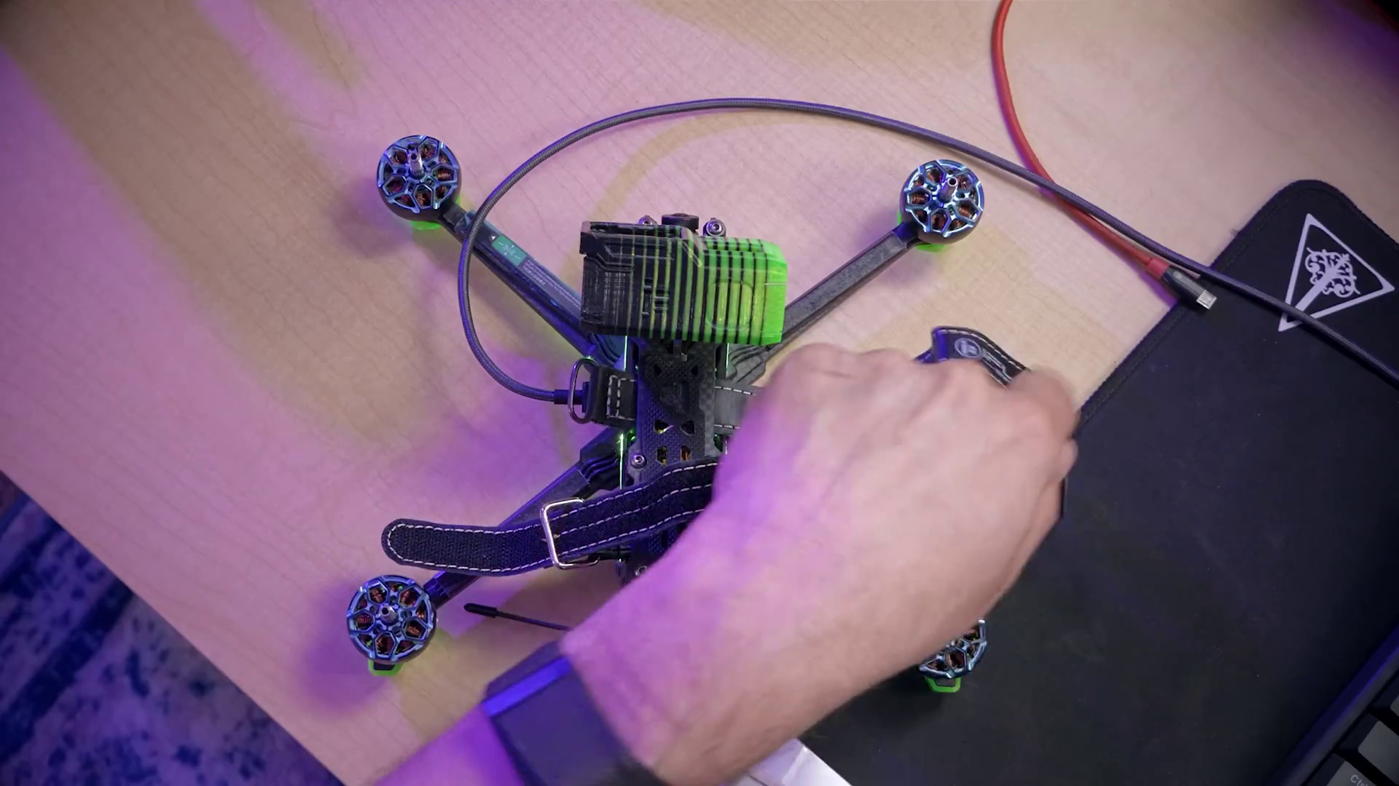 (score 90.0000)
 (score 90.0000)
 (score 90.0000)
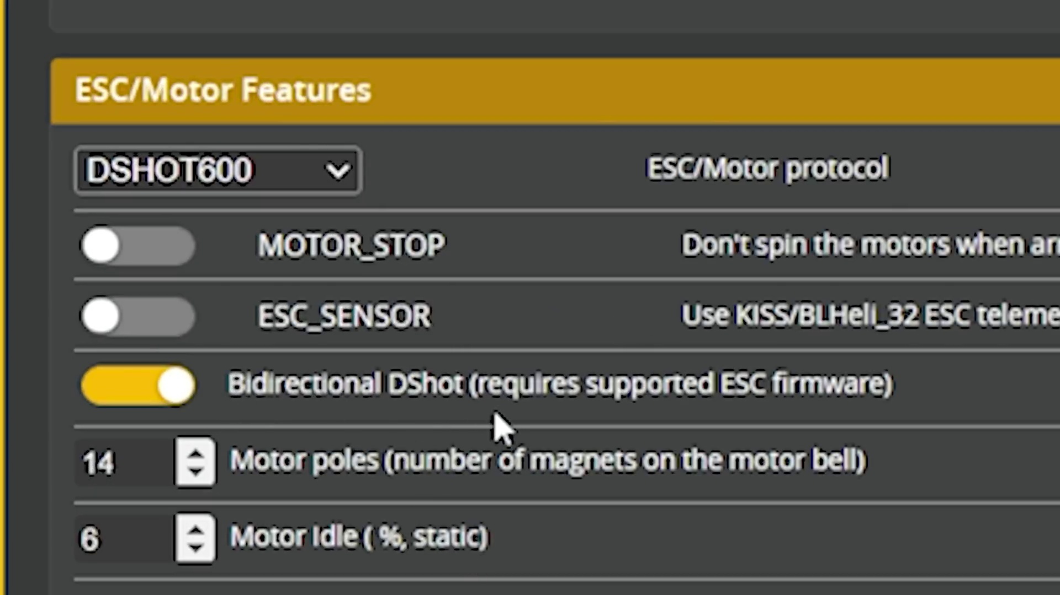 (score 90.0000)
 (score 85.0000)
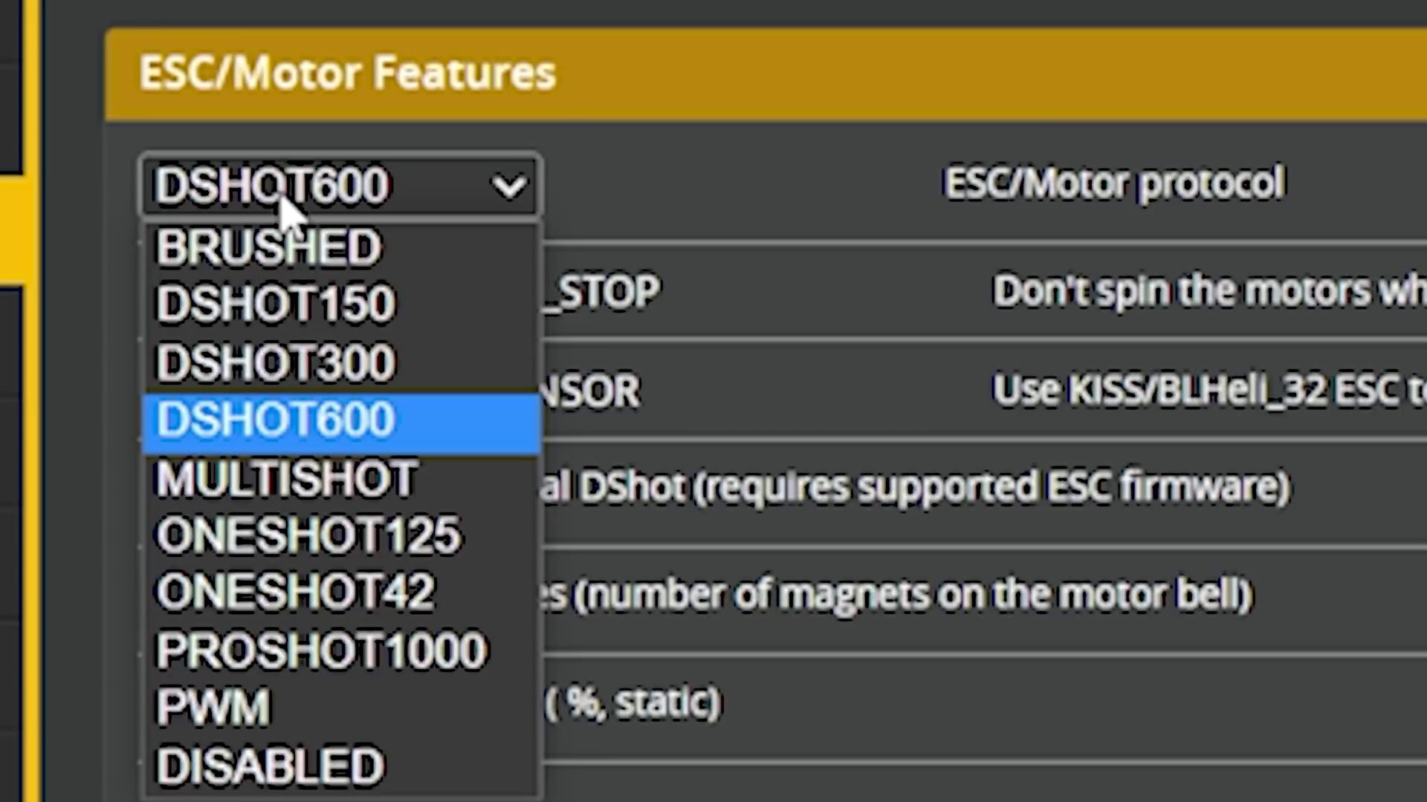 (score 85.0000)
 (score 85.0000)
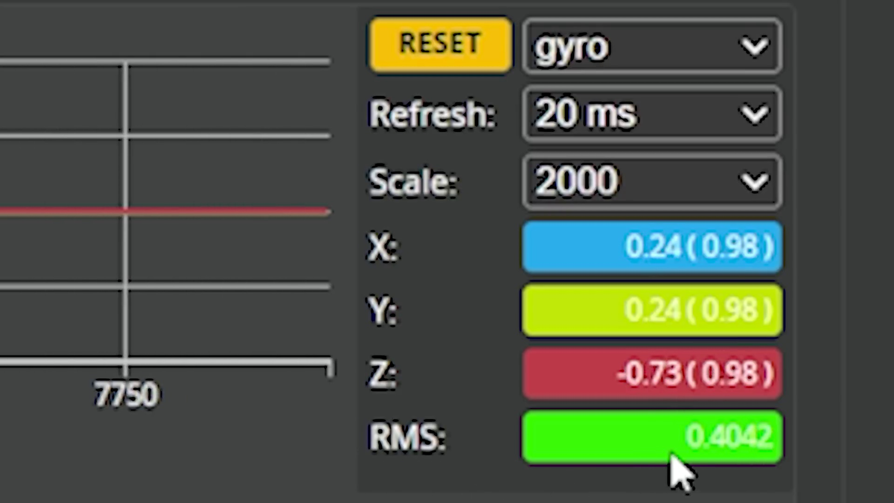 (score 85.0000)
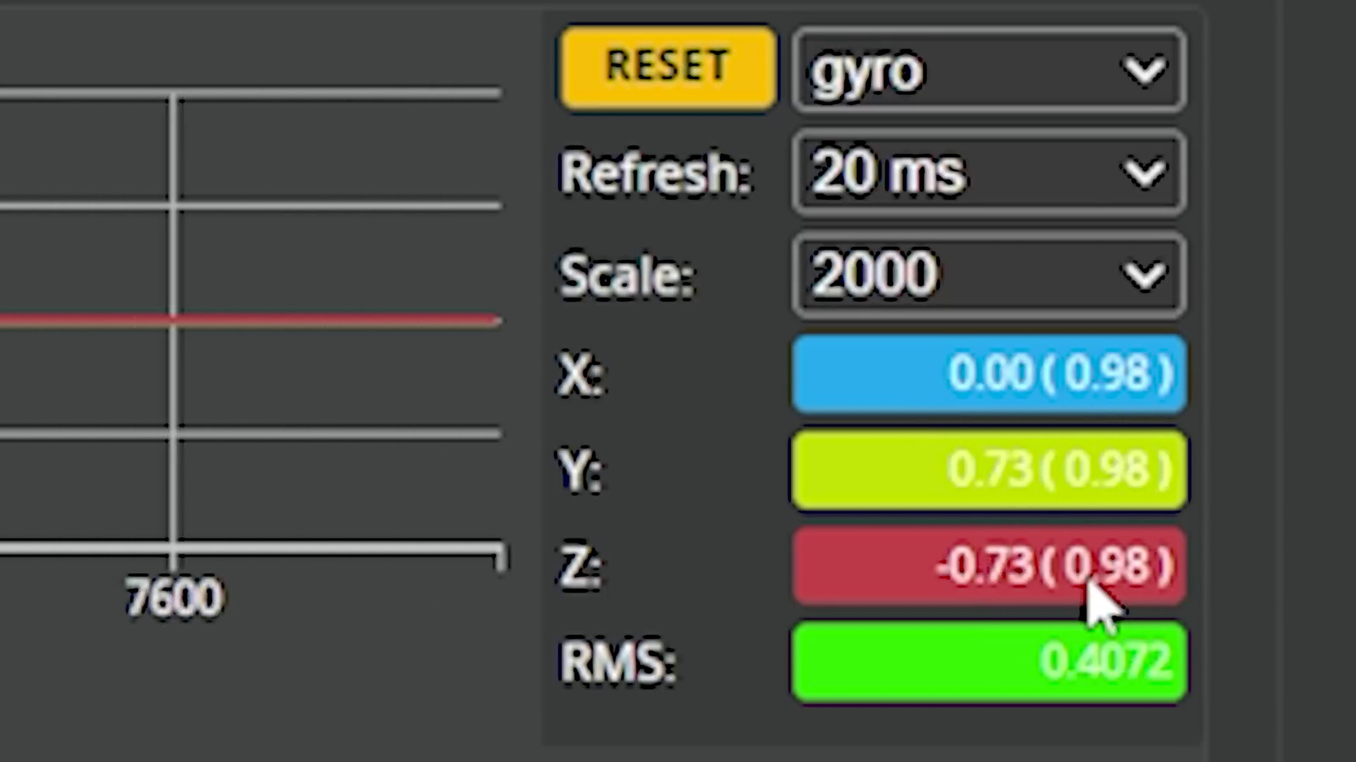 (score 85.0000)
Least correlated frames:
 (score 0.0000)
 (score 0.0000)
 (score 0.0000)
 (score 0.0000)
 (score 0.0000)
 (score 0.0000)
 (score 0.0000)
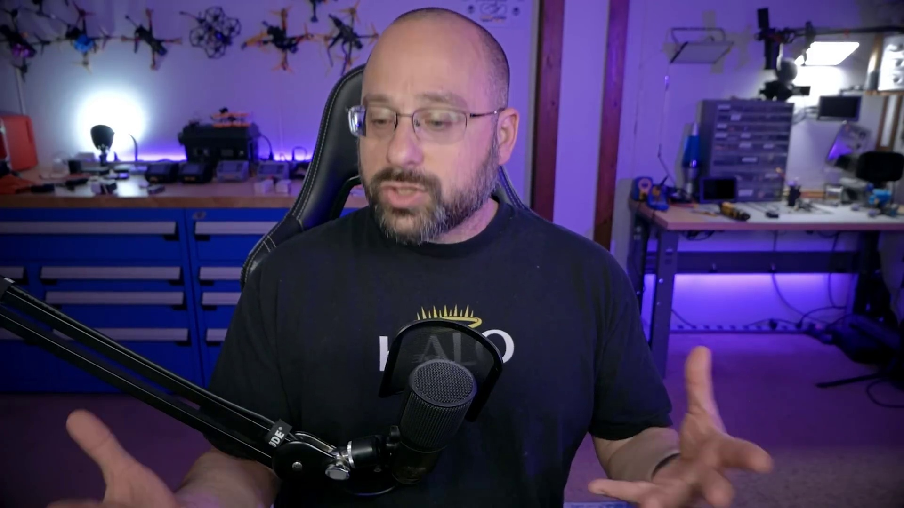 (score 0.0000)
 (score 0.0000)
 (score 0.0000)
- matched 43 frame(s), max score 90.0000: There are many different types of motor layouts but the most commonly used and easily accessible is the quad X configuration, the same type we are using for senior design. DSHOT is widely considered the best ESC protocol and is used by most of the drone community.However if a more performance based protocol is needed for more experienced users, the DSHOT600 is a good choice.It is important that all motors are at the same integrity to prevent an unbalanced flight. This can be checked using the gyro function and checking motors for outlying values, if such is the case the motor may need to be replace.
Source: https://www.youtube.com/watch?v=1WYDsiYJGoQ: Betaflight 4.3 Motors Tab |COMPLETE WALKTHROUGH PART 5
Top correlated frames:
 (score 90.0000)
 (score 85.0000)
 (score 85.0000)
 (score 85.0000)
 (score 85.0000)
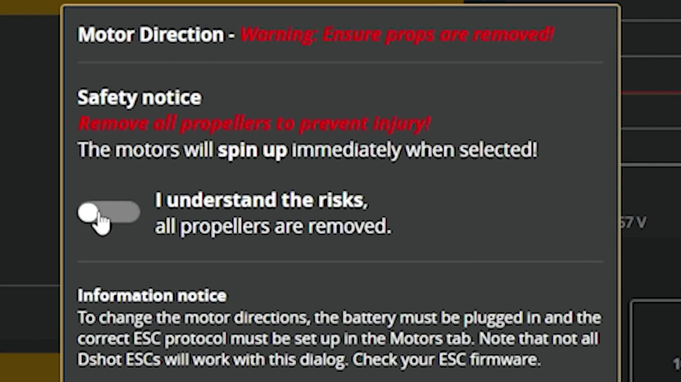 (score 85.0000)
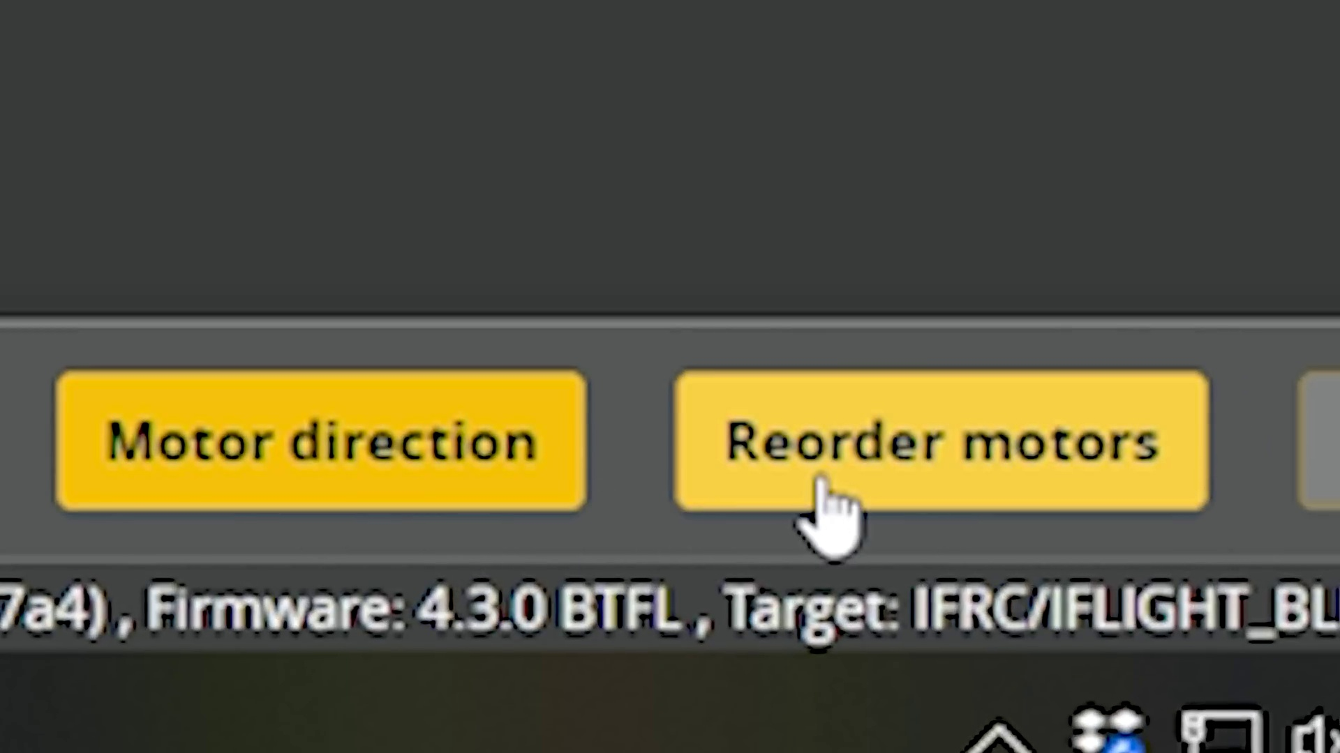 (score 85.0000)
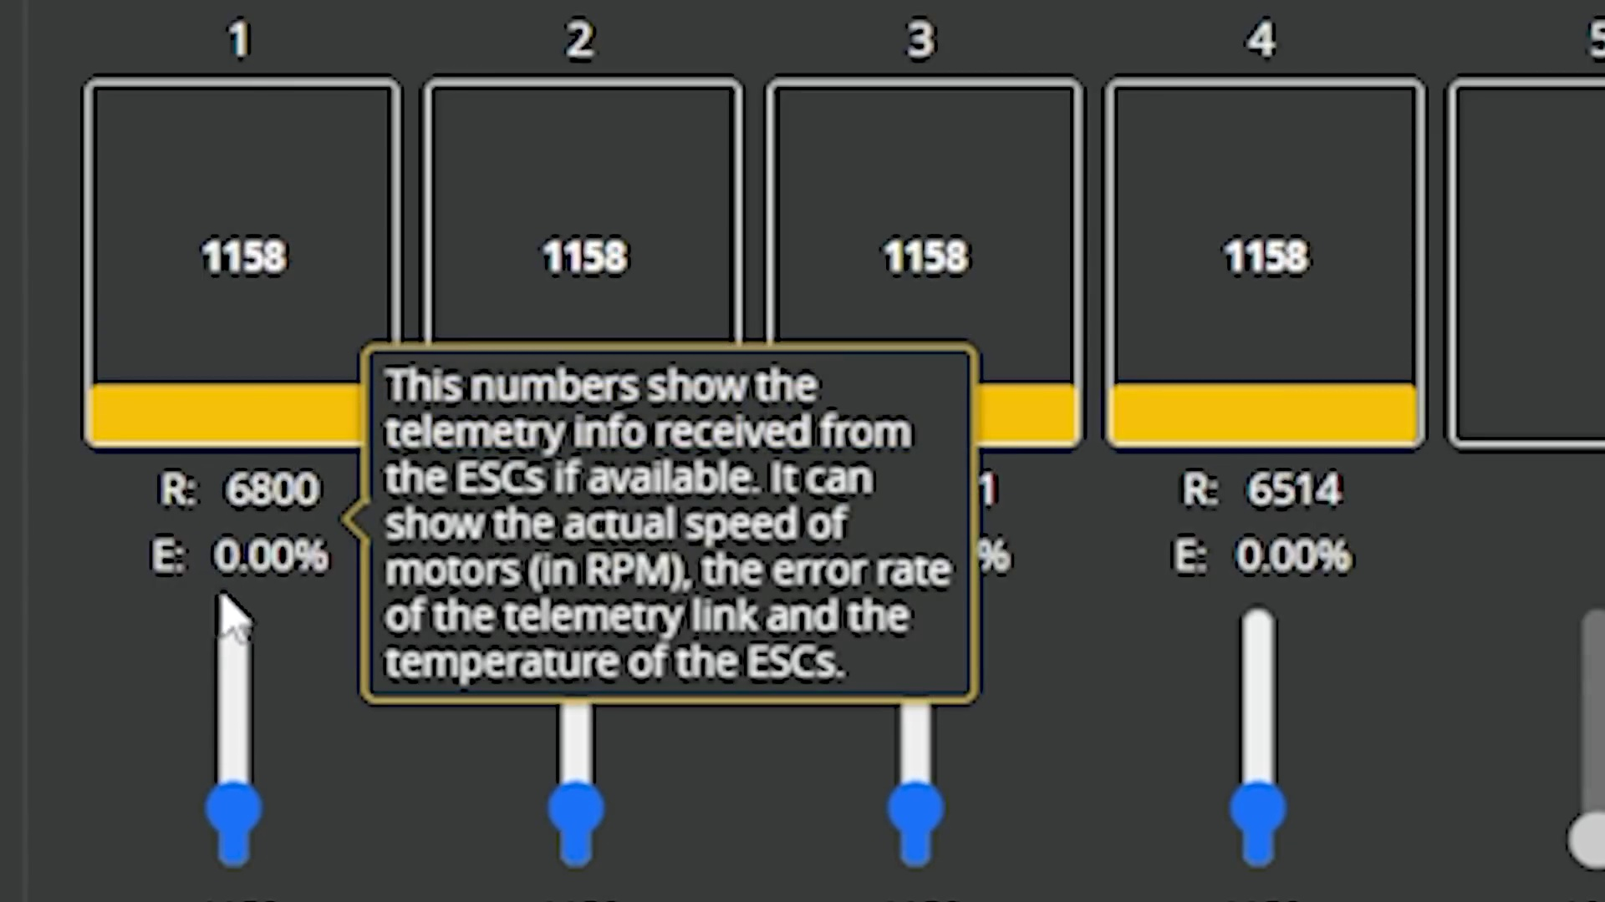 (score 85.0000)
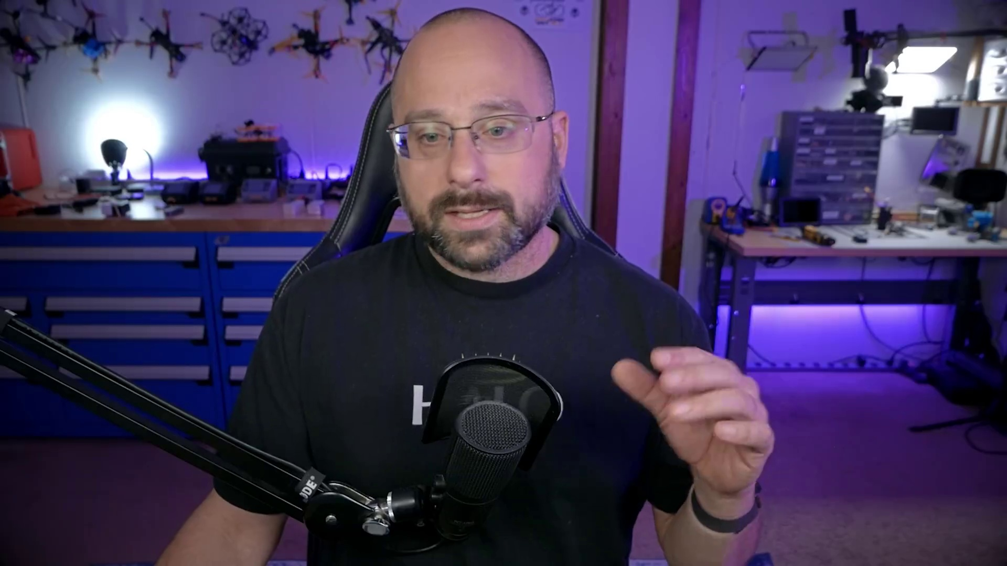 (score 85.0000)
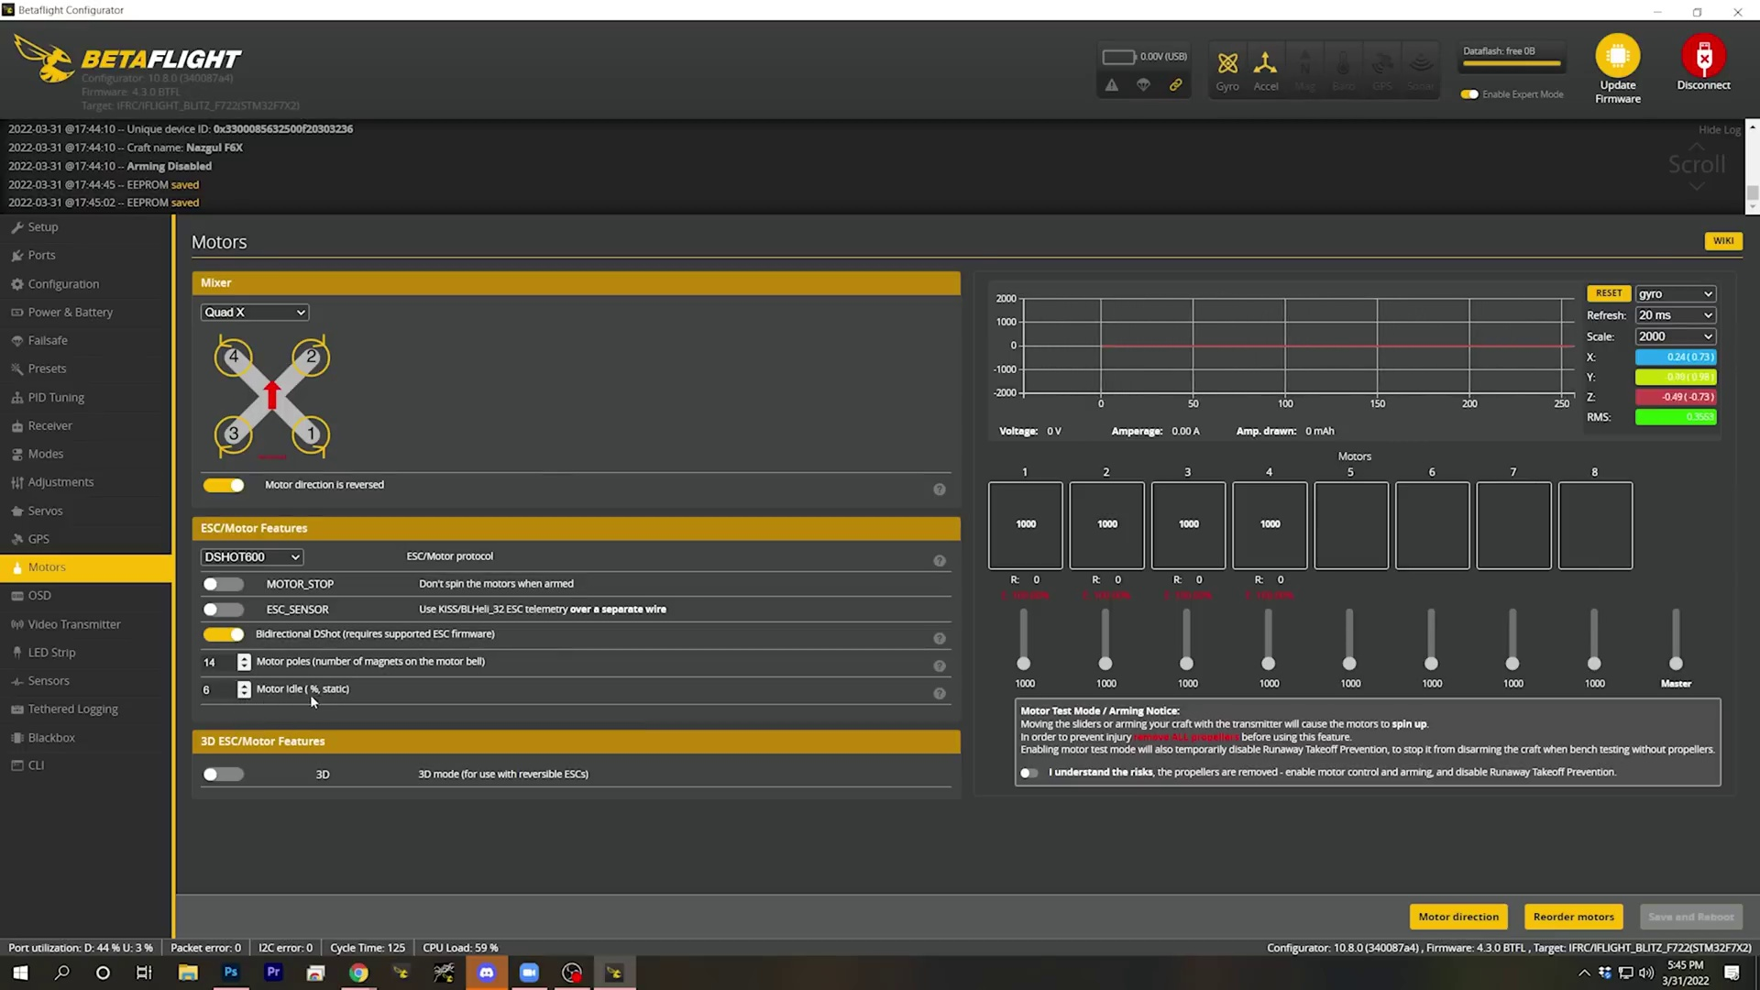 (score 85.0000)
Least correlated frames:
 (score 0.0000)
 (score 0.0000)
 (score 0.0000)
 (score 0.0000)
 (score 0.0000)
 (score 0.0000)
 (score 0.0000)
 (score 0.0000)
 (score 0.0000)
 (score 0.0000)

Frame: frame_0000.jpg
Caption: The image depicts a man seated at a desk, wearing glasses and a black t-shirt with a white logo that reads "HALO". His gaze is directed towards the camera, suggesting he may be engaging with his audience. The desk is cluttered with various items, including a black microphone, which appears to be part of a webcam setup, possibly used for live streaming or recording YouTube videos.
Behind the man, the room has low lighting, indicating it could be evening or nighttime. The stark white background provides a striking contrast to the objects on the desk and his attire. A blue light illuminates the scene, casting a cool hue that adds to the sense of activity and focus.
In the lower right corner of the image, visible text on a monitor reads "GAMES & GEAR", suggesting a focus on gaming or technology-related content. The overall scene appears to be a casual home office setup rather than an educational environment, with no clear indication of teaching materials such as slides, diagrams, or models.
Comment (score 80): This video thoroughly explains the Motors tab in Betaflight 4.3, which is crucial for setting up and fine-tuning quadcopter performance. It begins with the Mixer setting, which tells the flight controller about the motors' layout; this is essential for precise flying. The guide covers various motor arrangements, from typical quadcopters to more complex hexacopters and octocopters, emphasizing the importance of setting the motors to rotate correctly. It also discusses ESC and motor protocols like D-shot variants, which affect response time, and highlights Bi-directional D-shot for its benefits in reducing vibration and improving stability. The Motor Idle Percent Value, important for smooth descents and turns, is explained along with the 3D option for advanced maneuvers like inverted flight. Consistency in motor speeds is stressed, considering differences in motor manufacturing. Tools for identifying vibrations caused by motors are introduced, and Betaflight 4.3's new features, like motor reordering and direction wizards, are showcased for easy setup. Overall, this guide is designed to help expertly configure quadcopters for efficient and stable flights.
Reason: The comment directly discusses the same technical steps (setting up and fine-tuning quadcopter performance) and objects (motors, ESCs, motor protocols) described in the caption. The mention of Betaflight 4.3 and its features aligns with the setting depicted in the image, which suggests a focus on gaming or technology-related content.
Source: https://www.youtube.com/watch?v=1WYDsiYJGoQ: Betaflight 4.3 Motors Tab | COMPLETE WALKTHROUGH PART 5

Frame: frame_0001.jpg
Caption: In this image, a person is seated in front of a microphone and camera setup, suggesting they might be recording a video or participating in an online broadcast. The individual appears to be focused on something off-camera, as indicated by their hand gesture, holding up a finger with an object inside it. The background reveals a workspace filled with various electronic equipment, including a computer monitor displaying what seems to be a webpage or application interface. On the desk in front of the person, there's additional electronic equipment and a laptop, along with a few bottles that might contain drinks or other liquids.
Closer inspection reveals that the individual is wearing a black t-shirt adorned with the word "HAL". His mouth is open in a smile, as if he's sharing a joke or engaging in a lively conversation. His glasses reflect the soft blue lighting of the room, adding a touch of sophistication to his appearance.
The room itself is a testament to the person's interests and hobbies. A desk covered in various gadgets and tools serves as their workspace, with a microphone standing ready for use, hinting at their passion for broadcasting or recording. The walls are decorated with a variety of items that tell their own stories.
The soft blue lighting creates a cozy atmosphere, filling the room with objects that speak to the person's interests and passions. This image captures a moment in time, providing a snapshot of the individual's life and hobbies.
No strongly correlated comments found for this frame.

Frame: frame_0002.jpg
Caption: The image shows a person, likely a man, seated in a dimly lit room. He is wearing a black t-shirt with white text reading "Halo" across the front. His left hand is extended, fingers spread wide, as if gesturing or pointing towards something. The room is illuminated by purple lights, which may be part of the ambient lighting or possibly coming from the equipment being used. In the background, there's a workspace with computer components and cables, suggesting a gaming or tech setup.
The individual appears to be speaking, likely involved in some sort of live stream or video recording, given the presence of a webcam and what looks like streaming software open on the screen. He is holding a microphone in one hand while gesturing with the other, conveying a sense of enthusiasm and dedication. The desk behind him features a microphone and headphones, indicating an active recording session.
There is no visible text within the image that provides additional context about the content of the video or the identity of the person.
No strongly correlated comments found for this frame.

Frame: frame_0003.jpg
Caption: The image shows a person seated in front of a microphone, likely set up for recording audio. The individual is not clearly visible due to the angle and framing of the photograph, but it appears they are facing towards the camera with their head turned slightly to the side, suggesting they might be speaking or working on something. They seem to be in a seated position, possibly engaged in an activity that requires focus and concentration.
The room behind them is filled with various items, including a shelf holding electronic equipment and a workspace with computer parts and a monitor. The walls of the room are adorned with photos and posters, adding a personal touch to the space. The desk features a computer and microphone, while the shelf holds a variety of tools and devices.
The person's attire is notable, as they wear a black t-shirt that prominently displays the word "Halo" in white letters. This suggests that they might be involved in some form of work or hobby that requires the use of technology and tools. The precise location and relative positions of each object provide a glimpse into their workspace.
The overall environment suggests a home or personal office setup, rather than a classroom or lecture hall. There is no visible text, diagrams, or slides that would indicate instructional content. The focus is on the individual and their immediate surroundings, with no specific tools or devices indicating an educational scenario. The image captures a moment of quiet concentration, as the person prepares to engage in their work or hobby.
Comment (score 80): You need to use 4 motors for the quad copter, most desirable is using 1 PID control per motor. Follow this tutorial for complete comprehension of the motors used, this will also help with the wiring.
Reason: The comment directly discusses technical details (4 motors for quad copter, PID control) and references specific objects/settings (wiring) described in the caption. The mention of 'tutorial' implies a instructional or educational context, which is also hinted at in the caption's description of the individual's workspace.
Source: https://www.youtube.com/watch?v=1WYDsiYJGoQ: Betaflight 4.3 Motors Tab | COMPLETE WALKTHROUGH PART 5

Frame: frame_0004.jpg
Caption: The image shows a man, likely middle-aged or older with glasses and a beard, sitting at a desk with various items in front of him. He appears to be engaged in a conversation or recording as he speaks into a black microphone. The desk is cluttered with tools and equipment, suggesting an environment conducive to creativity and communication. On the right side of the frame, there is another microphone set up for recording or broadcasting, which is commonly used in gaming livestreams or podcasting.
In front of him, various items are spread out, including a computer monitor displaying what seems to be a graphic design interface with layers and adjustment tools visible, indicating that he might be involved in digital art creation or content editing. A keyboard is also visible on the desk. The wall behind him features shelves holding unknown items due to the angle of the photograph.
The room is decorated with colorful lights adding a vibrant touch to the otherwise neutral tones. The man's posture and the microphone suggest an environment conducive to creativity and communication.
No strongly correlated comments found for this frame.

Frame: frame_0005.jpg
Caption: The image shows a person sitting at a desk with various equipment around them. The individual appears to be a man with glasses, wearing a black t-shirt with the word "HALO" emblazoned on it, and has his hands spread out in front of him. He is looking slightly away from the camera. In the background, there is a microphone stand visible, suggesting that audio recording might take place here.
On the desk, you can see what appears to be computer equipment, including a monitor with purple lighting on its edges, and various other items such as wires, cables, and some sort of electronic device or controller. There's also a keyboard in front of the monitor.
The room has a purple light at the top, which contributes to the ambiance of the space. The overall setting suggests a home office or a personal studio setup, possibly used for live streaming, video recording, or podcasting.
A microphone is perched on his lap, indicating that he is the host of a podcast or radio show. His position in the studio, coupled with his attire and the microphone, suggests a sense of focus and passion, indicative of his dedication to his craft. The colorful lights on the wall add a vibrant touch to the scene, further emphasizing the creative atmosphere of the studio.
No strongly correlated comments found for this frame.

Frame: frame_0006.jpg
Caption: The image shows a person seated in front of a microphone and camera setup that resembles a professional recording studio or workspace. The individual appears to be engaged with the equipment, possibly conducting a live stream or recording a video. Behind the person, there is a desk with various electronic devices, including what seems to be a computer monitor displaying a green screen, indicating that the background might be digitally added during post-production.
The person is wearing a black t-shirt with a design featuring the word "HALO" printed on it, and has a beard. They are also wearing glasses. The lighting in the room suggests an indoor setting with artificial light. The purple lights illuminating the space create a unique atmosphere. There are no visible texts or diagrams that provide context for the purpose of the recording session. The image has a rectangular format typical for still images captured from a live video stream.
In the background, there is a blue wall with various objects placed on it, including a black cabinet and a green and white ladder.
No strongly correlated comments found for this frame.

Frame: frame_0007.jpg
Caption: The image shows a man seated at a desk with various electronic equipment surrounding him. He is wearing glasses, has a beard, and is engaged in conversation or demonstration, as suggested by his gesturing hands. The environment appears to be a home office or workspace.
In the background, a wall-mounted shelf displays hobbyist items such as model kits and possibly electronic equipment. To the left of the man, another table holds more equipment. Behind him, a computer monitor displays what looks like a video editing software interface, adding to the suggestion of a workspace. The lighting in the room has a cool ambiance due to its primarily blue tone.
The man is dressed in a black t-shirt and his attire is completed with glasses. His right hand is extended, appearing to be in a gesture of agreement or approval. The desk itself, painted a shade of blue, is decorated with various objects, including a microphone, a lamp, and a drawer.
No strongly correlated comments found for this frame.

Frame: frame_0008.jpg
Caption: The image shows a man sitting in front of a microphone in a dimly lit room filled with various objects. He is wearing glasses, a black t-shirt with white text that appears to say "JUGGERNAUT" across the front, and a black mask or beard cover. His short hair suggests he may be in the middle of speaking or presenting.
The room itself features a blue cabinet adorned with blue and white arrows, adding a splash of color to the neutral palette, as well as a wooden desk with a black computer keyboard and a black and white remote control. The man holds a black microphone, poised to speak, which stands out against the dark background.
In front of him is a graphic design with a blue and purple color scheme, featuring a stylized logo and text that says "THE BACKYARD." The style of the image suggests it could be from a video or live stream where the man is hosting an event, possibly related to gaming or technology. The man's focused expression and poised position suggest active engagement in a conversation or presentation.
Despite the darkness of the room, the light coming from the microphone and his glasses creates a warm glow on the scene. Overall, the image presents a scene of a man in a workspace, ready to engage with the world through his microphone and words.
No strongly correlated comments found for this frame.

Frame: frame_0009.jpg
Caption: The image shows a computer screen displaying a user interface for configuring parameters in an Autonomous Vehicle (AV) system. At the top of the screen, there's a title that reads "Motors," indicating that this section is related to the operation or configuration of motors within the AV system.
Below the title, there are two tabs or sections: "Vehicle" and "Control." The "Vehicle" section seems to be focused on the settings for the actual vehicle, while the "Control" section appears to deal with the control software or hardware. There's an arrow pointing from the "Vehicle" tab to the "Control" tab, suggesting a connection between these two aspects of the AV system.
Underneath these tabs, there is a field labeled "Motor." This suggests that this section is dedicated to configuring the motors within the vehicle. There are three input fields in this area:
1. "Name" - a text box where one might enter a name for the motor.
2. "X coordinate" - an input box for the x-coordinate of the motor's position or location within the AV system.
3. "Y coordinate" - an input box for the y-coordinate of the motor's position or location within the AV system.
4. "Z coordinate" - an input box for the z-coordinate of the motor's position or location within the AV system.
5. "Type" - a dropdown or selection menu for choosing the type of motor used in the vehicle.
6. "Direction" - a toggle switch that likely indicates whether the motor is being used to move in a particular direction, such as forward/backward or left/right.
7. "Control speed" - a checkbox that would enable or disable control over the motor's speed.
To the right of these input fields, there are three buttons with icons:
1. A red stop sign icon, which is typically used to pause or stop the vehicle.
2. A forward arrow icon, which likely relates to moving forward in the system.
3. A reverse arrow icon, which would be used to move in reverse.
4. A left arrow icon, indicating movement in that direction.
5. A right arrow icon, suggesting an option for movement in the opposite direction.
6. A center circle icon, which could represent a neutral or stop position.
The bottom of the screen features a text box with various labels and input fields, including:
1. "ESCMOTORS" - a label that likely refers to the type or brand of the motors being used in the system.
2. "Product version" - a label indicating the version of the product or software.
3. "Product name" - a label for the name of the product or software.
4. "Serial number" - a text box where one would input a serial number associated with the system.
5. "Vehicle ID" - a text box where one might input an identifier for the vehicle being used in the AV system.
6. "Product code" - a text box for entering a product code.
In contrast, the image on the right shows a control panel for a quadcopter. The panel is dominated by a large grid of buttons, each labeled with a number from 1 to 4, arranged in a 2x2 grid. A blue arrow pointing upwards indicates the direction of movement, positioned at the top of the panel slightly to the right. A yellow box is visible at the top left corner, likely containing important information or instructions related to the quadcopter's operation. The panel is set against a white background, allowing the user to focus on the buttons and arrow without any distractions.
Comment (score 90): You need to use 4 motors for the quad copter, most desirable is using 1 PID control per motor. Follow this tutorial for complete comprehension of the motors used, this will also help with the wiring.
Reason: The comment directly discusses the same technical steps (using PID control per motor) and objects (motors) described in the caption. The mention of a tutorial for complete comprehension of the motors used is also relevant to the setting described in the caption (AV system).
Source: https://www.youtube.com/watch?v=1WYDsiYJGoQ: Betaflight 4.3 Motors Tab | COMPLETE WALKTHROUGH PART 5
Comment (score 80): There are many different types of motor layouts but the most commonly used and easily accessible is the quad X configuration, the same type we are using for senior design. DSHOT is widely considered the best ESC protocol and is used by most of the drone community.However if a more performance based protocol is needed for more experienced users, the DSHOT600 is a good choice.It is important that all motors are at the same integrity to prevent an unbalanced flight. This can be checked using the gyro function and checking motors for outlying values, if such is the case the motor may need to be replace.
Reason: The comment directly discusses the same technical steps and settings described in the caption, such as motor layouts, ESC protocols, and balancing motors to prevent unbalanced flight. The mention of DSHOT and DSHOT600 protocols is particularly related to the configuration parameters shown in the caption.
Source: https://www.youtube.com/watch?v=1WYDsiYJGoQ: Betaflight 4.3 Motors Tab |COMPLETE WALKTHROUGH PART 5

Frame: frame_0010.jpg
Caption: The image shows a software interface or webpage dedicated to motors. The primary focus is on designing, analyzing, or simulating electric motor operation. On the left side of the screen, there's a vertical menu with sections like "Motors," "ESCM" (Electronic Speed Controller), and "Sensors," suggesting different components that can be configured or simulated within this software.
In the central area, a 3D model of a motor is displayed, featuring various parts labeled as "Rotor," "Stator," "Pole Pairs," "Air Gap," and others. The internal structure includes rotor bars and stator windings, typical for understanding an electric motor's operation. On the right side, input fields and buttons related to the motor's parameters are available, including a dropdown menu with "ESCM" selected, text boxes labeled "Motor Stop," "Current Limit," and "Max RPM," indicating settings for the motor's operation.
The bottom of the screen shows a file explorer dialog box, where users can save or load multiple configurations of their motor design. The image also highlights the motors' settings, including rotation direction (set to "Mud"), which indicates that the motor is currently in a "Mud" mode, typical for motorsports. The ESC motors are connected to the motors via wire, ensuring a stable and reliable connection.
Sensors are present on the motors, crucial for monitoring their performance and ensuring safe operation. The page also provides information about the motors' power (12V) and speed (4500 RPM), as well as their current status ("Standby"), indicating that the motors are currently not in use. Overall, this image showcases a comprehensive overview of electric motor design and analysis, possibly used for educational purposes or technical design applications.
Comment (score 85): Quad X is the most common type of setup to use.DSHOT most common ESC protocol.DSHOT600 is the fastest protocol.Motor stop will turn the drone off at any time the throttle hits zero.Testing the motor integrity can be done with the gyro function and checking the values. If the values are skewed for one motor, it might need to be replaced.
Reason: The comment directly discusses the same technical steps (e.g., DSHOT protocol, motor stop) and settings (e.g., throttle hits zero) described in the caption. The mention of 'motor integrity' and checking gyro values also correlates with the caption's focus on electric motor design and analysis.
Source: https://www.youtube.com/watch?v=1WYDsiYJGoQ:Betaflight 4.3 Motors Tab | COMPLETE WALKTHROUGH PART 5
Comment (score 80): There are many different types of motor layouts but the most commonly used and easily accessible is the quad X configuration, the same type we are using for senior design. DSHOT is widely considered the best ESC protocol and is used by most of the drone community.However if a more performance based protocol is needed for more experienced users, the DSHOT600 is a good choice.It is important that all motors are at the same integrity to prevent an unbalanced flight. This can be checked using the gyro function and checking motors for outlying values, if such is the case the motor may need to be replace.
Reason: The comment directly discusses the same technical steps and settings described in the caption, such as motor configurations (quad X), ESC protocols (DSHOT, DSHOT600), and importance of motor integrity and balancing.
Source: https://www.youtube.com/watch?v=1WYDsiYJGoQ: Betaflight 4.3 Motors Tab |COMPLETE WALKTHROUGH PART 5
Comment (score 80): You need to use 4 motors for the quad copter, most desirable is using 1 PID control per motor. Follow this tutorial for complete comprehension of the motors used, this will also help with the wiring.
Reason: The comment discusses the motors and their control (PID) directly related to the technical steps described in the caption. The mention of wiring is also relevant to the image's depiction of ESC motors connected via wire.
Source: https://www.youtube.com/watch?v=1WYDsiYJGoQ: Betaflight 4.3 Motors Tab | COMPLETE WALKTHROUGH PART 5

Frame: frame_0011.jpg
Caption: This image shows a person seated at a desk with various electronic equipment around them, suggesting that they might be involved in some form of technology or content creation work, possibly livestreaming or recording a video. The individual appears to be in the middle of speaking or gesturing with their hands, which is common during live broadcasts or recorded presentations.
The person is wearing glasses and has a beard. They are dressed casually, in a black t-shirt with some text on it that reads "Halo", partially obscuring the rest of the design. The room they are in appears to be a home setup for streaming or recording purposes, given the presence of additional lighting and microphones.
The background is somewhat blurred but indicates a domestic setting with some personal items, contributing to the casual, informal atmosphere of the scene. The room around them is filled with various objects, suggesting a workspace or a recording studio. A microphone stands tall, poised for use, while a computer monitor and a keyboard lie on a desk in the background.
The walls of the room are adorned with posters, and a blue light illuminates the scene, casting a warm glow on the man and his surroundings. The precise positioning of the objects and the person's attire suggest a professional setting, perhaps related to video or audio production.
No strongly correlated comments found for this frame.

Frame: frame_0012.jpg
Caption: The image shows a person seated in front of a microphone, surrounded by electronic equipment and components, with blue lights illuminating the scene. The individual appears to be speaking into the microphone, as suggested by their mouth and hand position. They are dressed casually in a black shirt with a graphic on it, and have a pair of headphones around their neck.
The background behind them includes various items such as computer monitors displaying blue and purple hues, possibly indicating that they are recording or streaming video content related to technology or electronics. Additionally, an array of cables and wiring, along with some boxes and tools, is visible, typical for an electronics workshop or similar workspace.
As the person speaks, their right hand firmly grips the microphone stand, while their left hand rests on their chin, with their gaze directed towards the camera. The room around them has a blue wall and a wooden desk, filled with various objects such as a black guitar, a black keyboard, and a wooden drawer.
No strongly correlated comments found for this frame.

Frame: frame_0013.jpg
Caption: The image captures a moment of content creation, as a person sits at a desk with a microphone in front of them. They are engaged in an activity related to technology or video production, given the presence of electronic equipment and their attire, which includes a black t-shirt and glasses. The setting looks like a home lab or small recording studio.
Text visible on the screen reads "1920s" and some other words that are not fully legible due to the angle and resolution of the image. This text appears to be part of an interface, possibly indicating a timeline or theme related to the content being discussed or created.
The person is seated in a chair with a black and white design, similar to the room's overall color scheme, which features purple lighting on the ceiling. The man's face is illuminated by a blue light, adding a vibrant touch to the room.
The desk in the background is equipped with various tools and gadgets, indicating that the person is likely involved in some form of work or hobby. On the wall behind them, there's a colorful array of paintings and sculptures, adding a personal touch to the room.
The man's position in the room, with his hands spread out, suggests they might be engaged in a discussion, presentation, or explanation, perhaps providing commentary or tutorial instructions. Their posture and facial expression give off a relaxed yet engaged vibe, which could imply they are in the middle of creating content for an audience.
Overall, the image portrays a well-equipped workspace with a personal touch, where the person seems to be in the midst of a creative or professional endeavor, possibly related to video production or tutorial work.
No strongly correlated comments found for this frame.

Frame: frame_0014.jpg
Caption: The image shows a man seated at a desk with a gaming setup, appearing to be in the middle of recording a video or live stream. The presence of a webcam and microphone suggests this is the case. He is gesturing towards the camera, possibly discussing something related to his content. The individual is wearing glasses, a black t-shirt, and has a beard. Behind him, there's a monitor displaying colorful graphics, which could be part of the gaming setup or visual aid for what he is discussing.
The room around him is dimly lit, with a light source illuminating his face from the right side of the frame. He is wearing glasses and a black shirt with the word "HALO" emblazoned across it in white. The man's hand is raised in a gesture of emphasis, indicating he is engaged in a conversation or presentation.
The room itself is cluttered with various objects, including a computer monitor, a speaker, and a toolbox. The colors present are predominantly blue and purple, creating a cool and calming atmosphere. The man's position relative to the objects suggests he is in the midst of an important discussion or presentation, possibly related to his gaming content.
The focus and clarity of the photo indicate it was taken with a higher-end camera, given the quality of the image.
No strongly correlated comments found for this frame.

Frame: frame_0015.jpg
Caption: The image shows a man seated at a desk in a workspace, wearing glasses and a black t-shirt with the word "HALO" prominently displayed in white letters on the front. The desk is equipped with various tools and equipment, including a black microphone positioned nearby. The room around him is filled with a variety of objects, such as a blue chair, a black cabinet, and a wall adorned with a black and white picture.
In this candid snapshot, the man appears to be engaged in a conversation or recording, his gaze directed towards the camera. He may be conducting a podcast, live stream, or recording, as suggested by the microphone setup. The room's decor, including shelves and personal decorations, hints at a home office or creative workspace.
Notably, there is a lighted sign or board visible in the top left corner of the image, although its contents are not clear enough to read. Overall, the scene presents a professional or creative environment where the individual is situated to share their thoughts, ideas, or expertise with an audience.
No strongly correlated comments found for this frame.

Frame: frame_0016.jpg
Caption: The image appears to be a screenshot from a video, possibly taken from a video conferencing platform given the user interface elements such as "Join now" and "Leave meeting" displayed at the top right corner. In the foreground, there is a person sitting in front of a webcam setup with lighting effects to enhance the visibility of the subject. The individual has short dark hair, is wearing glasses, and is dressed in a black t-shirt. They also have a beard. Their hand is extended towards the camera, making a gesture that seems to be pointing or giving directions.
Behind the person, there's a workspace with various electronic devices including a computer monitor, keyboard, mouse, and other miscellaneous items on shelves and tables. The room has a purple lighting ambiance, which casts a soft glow on the environment. There are no visible texts or slides in this screenshot that could provide context about the content being discussed or the nature of the session.
The man is seated in a dimly lit room, his attention focused on the camera. He's dressed casually in a black t-shirt that proudly displays the word "Halo" in white letters. His left hand is raised in a gesture, as if he's about to speak or gesture towards something. The room around him is a mix of practical and personal items. A stereo system with a black and white color scheme is visible, suggesting a preference for music. A black and silver microphone stands next to it, indicating a possible interest in broadcasting or recording. The walls of the room are adorned with various posters, adding a personal touch to the space.
No strongly correlated comments found for this frame.

Frame: frame_0017.jpg
Caption: The image shows a man sitting in a blue chair in a room filled with various pieces of equipment. He is wearing a black t-shirt that prominently displays the text "Halo". The room has a calming and professional atmosphere, with walls covered in a blue hue, framed photos, and a bulletin board, adding personal touches to the space.
The man appears to be in the midst of an explanation or demonstration, as he gestures with his hands. His expression is one of concern or surprise, suggesting that he may be discussing a complex topic. On the screen behind him, there's a partial view of what looks like a slide or presentation material, but the text and content are not fully visible due to the angle and quality of the image.
The room is a workspace or workshop, with scattered tools and equipment, including a microphone, a drill, and a pair of scissors. The environment suggests that this could be a home studio setup, with electronic devices and other creative tools at the man's disposal.
No strongly correlated comments found for this frame.

Frame: frame_0018.jpg
Caption: This image features a person sitting at a desk in a room with a controlled indoor environment, likely designed for video production or content creation. The individual is wearing a dark top, glasses, and a beard, and appears to be in the middle of a video recording setup, given the presence of microphones and lighting equipment. They are looking directly towards the camera, with their arms spread out as if gesturing or explaining something.
The desk is surrounded by various electronics, cables, and wires, suggesting a technical or tech-oriented setting. A computer monitor sits in front of them, displaying a message that reads "YOUR COMPUTER IS INFECTED WITH MALWARE!!" However, this appears to be part of an error message or simulation rather than an actual malware warning.
In the man's hands, he holds a microphone and a pair of headphones. The microphone is black and silver, and the headphones are black and white. His attire includes a black t-shirt with "HALO" printed on it. The room has a blue wall, a white ceiling, and features various objects such as a blue box, a black cabinet, and a white shelf.
Overall, the scene suggests a professional setting, possibly a recording studio or music production studio, where the individual is engaged in a video recording or content creation process.
No strongly correlated comments found for this frame.

Frame: frame_0019.jpg
Caption: The image appears to show a person seated at a desk with recording equipment in front of them. The individual, dressed in a black t-shirt with the word "Halo" prominently displayed in white letters, is wearing glasses and has short hair. They are looking directly at the camera, as if ready to engage in a conversation or recording session. The soft purple light surrounding them adds a touch of sophistication.
The desk setup includes a microphone with a pop filter, suggesting that they might be recording a podcast or streaming on platforms like Twitch or YouTube. A computer monitor and other electronic components are also present, possibly part of an audio-visual setup.
The background is dimly lit, featuring various objects that seem related to electronics or crafts, including what looks like models or toys. The room has a casual and somewhat cluttered feel, but the workspace itself appears organized and efficient. A shelf on the left contains a variety of tools and equipment, indicating a person who is not only skilled but also meticulous in their work.
The individual's gaze meets ours directly, drawing our attention to them and their surroundings. Overall, the image captures a moment of focus and productivity in a well-equipped workspace, with the person's attire, the tools on the shelf, and the equipment on the desk contributing to a sense of professionalism and dedication to their craft.
No strongly correlated comments found for this frame.

Frame: frame_0020.jpg
Caption: The image shows an individual seated at a desk with computer equipment, surrounded by various electronic devices and a hobbyist-style workbench. The room has a purple ambiance from the lighting, which adds a vibrant contrast to the cooler tones of the electronic equipment and workbench. The person is wearing glasses and has a beard, and is holding a microphone, suggesting they might be engaged in a recording session or participating in an online event.
The individual's attire includes a black shirt emblazoned with the word "HALO", which is reflected in their glasses, adding a touch of sophistication to their appearance. The room around them is cluttered with various items, including a laptop, a keyboard, and a toolbox, hinting at a workspace that is both functional and personal.
The backdrop is a wall adorned with a colorful array of posters, adding a vibrant splash of color to the otherwise muted environment. The person's position, the microphone they hold, and the objects in the room all suggest a setting that is both professional and personal. The individual appears to be facing towards the camera, as if in the middle of a discussion or explaining something on screen, although there is no visible text that would indicate what is being discussed or if there are any teaching materials such as slides or diagrams.
No strongly correlated comments found for this frame.

Frame: frame_0021.jpg
Caption: The image appears to be a screenshot of a computer interface, possibly a software application or a webpage. It showcases an example of a motor control system with its parameters set up in a graphical user interface (GUI). The central part of the screen displays a schematic diagram of motors setup, which includes two motors connected to an electronic control unit (ECU), with several lines and connections indicating the flow of power or signals. There are also some labels visible on the diagram: "Motor 1," "Motor 2," "Power Supply," and "ECU."
To the right of this diagram, there is a list of settings or parameters that can be adjusted for each motor. Each motor has fields labeled "RPM Setting," "Torque Setting," and "Power Setting." Additionally, there are options to set a speed stop condition (S1), a speed stop position (S2), and a power stop setting.
At the top of the screen, there is a menu bar with items like "File," "Edit," "View," "Insert," "Arrange," and "Tools." The text "Motors" is visible on the menu, suggesting that this window or application is specifically for motor control settings.
In the bottom left corner of the screen, there are two sections: one titled "Direct Motor Control Unit (DMCU)," with a reference to "ESC 1," and another labeled "ESC 2." The text "Set Motor Power (Watts)" is visible next to each ESC.
The interface also features a Raspberry Pi configuration setup, specifically in the "Motors" section. This section is divided into three main categories: "A-Tail Quad", "ESC Motor Features", and "ESC Motor Direction". The "A-Tail Quad" section is highlighted in green, indicating it's the current focus.
Under "A-Tail Quad", there are three buttons: "ESC Motor Features", "ESC Motor Direction", and "ESC Motor Speed". The "ESC Motor Features" button is highlighted in yellow, while the "ESC Motor Direction" button is highlighted in red. The "ESC Motor Speed" button is not highlighted.
The interface itself has a standard window look, with a tab at the top right corner indicating that this is a new or default setting for motor control. There are no visible texts providing additional context or instructions, and there's no clear indication of an instructor or teaching activity in this image. The focus is on the software interface itself, which appears to be used for configuring motors for some type of operation, possibly for a robotics project or a similar application where precise control over motor performance is necessary.
Comment (score 90): You need to use 4 motors for the quad copter, most desirable is using 1 PID control per motor. Follow this tutorial for complete comprehension of the motors used, this will also help with the wiring.
Reason: The comment directly discusses the same technical steps and objects described in the caption, specifically mentioning motors, PID control, and wiring. The comment also references a tutorial for complete comprehension of the motors used, which aligns with the graphical user interface (GUI) shown in the caption.
Source: https://www.youtube.com/watch?v=1WYDsiYJGoQ: Betaflight 4.3 Motors Tab | COMPLETE WALKTHROUGH PART 5
Comment (score 85): There are many different types of motor layouts but the most commonly used and easily accessible is the quad X configuration, the same type we are using for senior design. DSHOT is widely considered the best ESC protocol and is used by most of the drone community.However if a more performance based protocol is needed for more experienced users, the DSHOT600 is a good choice.It is important that all motors are at the same integrity to prevent an unbalanced flight. This can be checked using the gyro function and checking motors for outlying values, if such is the case the motor may need to be replace.
Reason: The comment discusses specific ESC protocols (DSHOT and DSHOT600) and motor settings (integrity and gyro function), which are directly related to the technical steps and objects described in the caption, such as the quad X configuration, ESC features, and motor direction.
Source: https://www.youtube.com/watch?v=1WYDsiYJGoQ: Betaflight 4.3 Motors Tab |COMPLETE WALKTHROUGH PART 5
Comment (score 80): This video thoroughly explains the Motors tab in Betaflight 4.3, which is crucial for setting up and fine-tuning quadcopter performance. It begins with the Mixer setting, which tells the flight controller about the motors' layout; this is essential for precise flying. The guide covers various motor arrangements, from typical quadcopters to more complex hexacopters and octocopters, emphasizing the importance of setting the motors to rotate correctly. It also discusses ESC and motor protocols like D-shot variants, which affect response time, and highlights Bi-directional D-shot for its benefits in reducing vibration and improving stability. The Motor Idle Percent Value, important for smooth descents and turns, is explained along with the 3D option for advanced maneuvers like inverted flight. Consistency in motor speeds is stressed, considering differences in motor manufacturing. Tools for identifying vibrations caused by motors are introduced, and Betaflight 4.3's new features, like motor reordering and direction wizards, are showcased for easy setup. Overall, this guide is designed to help expertly configure quadcopters for efficient and stable flights.
Reason: The comment directly discusses the technical steps, objects (e.g., motors, ESCs), and settings (e.g., Mixer setting, Motor Idle Percent Value) described in the caption, specifically focusing on configuring quadcopters for precise flying. The connection is strong, but not perfect, as the comment also mentions Betaflight 4.3 and specific features, which are not explicitly mentioned in the caption.
Source: https://www.youtube.com/watch?v=1WYDsiYJGoQ: Betaflight 4.3 Motors Tab | COMPLETE WALKTHROUGH PART 5
Comment (score 80): Quad X is the most common type of setup to use.DSHOT most common ESC protocol.DSHOT600 is the fastest protocol.Motor stop will turn the drone off at any time the throttle hits zero.Testing the motor integrity can be done with the gyro function and checking the values. If the values are skewed for one motor, it might need to be replaced.
Reason: The comment directly discusses the technical steps and settings described in the caption, specifically mentioning DSHOT protocol, motor stop, and testing motor integrity using gyro function. The mention of motor types (Quad X) and ESC protocols matches the GUI settings shown in the image.
Source: https://www.youtube.com/watch?v=1WYDsiYJGoQ:Betaflight 4.3 Motors Tab | COMPLETE WALKTHROUGH PART 5

Frame: frame_0022.jpg
Caption: The image depicts a computer screen with a user interface designed for an Electronic Speed Controlled (ESC) motor application or software. On the left side of the screen, there is a graphic of an ESC motor with various wires and connectors, suggesting a schematic or diagram of how the hardware components are arranged.
In the main part of the screen, a 3D model of the same ESC motor appears to be in a state of assembly or configuration, as indicated by the presence of bolts on one side. On the right side of the screen, there is a list of files or components associated with the motor, such as "Esc", "Pwm driver", "Sensor", and "Motor". The checkboxes next to these items suggest they can be selected or deselected for configuration purposes.
At the bottom of the screen, there are text fields that likely allow users to input settings or values related to the ESC motor. There is also a button labeled "Save" which implies functionality to save changes or configurations made in the software. The background of the screen has a gradient from dark to light grey, and there is a small icon at the top right corner that seems to be for minimizing the window or closing it.
The user interface appears to be written in a language using the Latin alphabet, but the specific text and any readable parts are not fully visible. The image does not provide clear evidence of an instructor writing, pointing, holding a model, or speaking from a slide. Instead, it depicts a software interface with various functional elements designed for interacting with or configuring an ESC motor system.
Additionally, the screenshot also captures the "Motors" section of a webpage, divided into three parts: "A-Tail Quadcopter", "ESC Motors", and "ESC Motor Features". The "A-Tail Quadcopter" section provides information on the motors used in this type of quadcopter, mentioning their direction, which is reversed, and the ESC motors used for this setup.
The "ESC Motors" section provides detailed instructions on how to use the ESC motors, suggesting that the motors should not be spun, and that the ESC should be connected to a separate sensor possibly for further control. The "ESC Motor Features" section provides further information about the ESC motors, mentioning that the ESC motor should be powered via a separate wire and that it should be connected to a separate sensor for further control.
Overall, the image provides both a software interface for configuring an ESC motor system and a comprehensive guide on how to use ESC motors in a quadcopter setup.
Comment (score 80): There are many different types of motor layouts but the most commonly used and easily accessible is the quad X configuration, the same type we are using for senior design. DSHOT is widely considered the best ESC protocol and is used by most of the drone community.However if a more performance based protocol is needed for more experienced users, the DSHOT600 is a good choice.It is important that all motors are at the same integrity to prevent an unbalanced flight. This can be checked using the gyro function and checking motors for outlying values, if such is the case the motor may need to be replace.
Reason: The comment discusses ESC motors and their configuration, which is directly related to the screenshot showing an ESC motor interface. The mention of DSHOT protocol and its importance for balanced flight also matches with the software interface providing detailed instructions on how to use ESC motors.
Source: https://www.youtube.com/watch?v=1WYDsiYJGoQ: Betaflight 4.3 Motors Tab |COMPLETE WALKTHROUGH PART 5

Frame: frame_0023.jpg
Caption: The image shows a computer interface with a specific application window open. The main focus of the interface is a 3D model of a motorcycle, which appears to be under simulation or control in some way. The interface has various tabs and controls, suggesting that it could be a simulation software used for engineering or design purposes.
On the left side of the screen, there's a vertical menu with options like "Motors," "Sensors," and other settings related to the motorcycle model. There is also an indication of the current mode being "ESC," which stands for Electronic Speed Controller.
The central part of the interface displays the 3D model of the motorcycle in a three-quarter view, with various components labeled. Below the model, there are additional controls and settings, likely related to the simulation or testing parameters of the motorcycle.
On the right side, there is a text input field with a message that reads: "ESC motor control mode when the vehicle is running." There's also an arrow pointing from this text box to another element in the interface, possibly a button or slider. The overall design suggests it's a technical application used for educational purposes or for controlling and simulating motorcycle behavior.
The user interface elements suggest that the software allows users to control, monitor, and possibly analyze the performance of the motorcycle model under various conditions.
Comment (score 85): This video thoroughly explains the Motors tab in Betaflight 4.3, which is crucial for setting up and fine-tuning quadcopter performance. It begins with the Mixer setting, which tells the flight controller about the motors' layout; this is essential for precise flying. The guide covers various motor arrangements, from typical quadcopters to more complex hexacopters and octocopters, emphasizing the importance of setting the motors to rotate correctly. It also discusses ESC and motor protocols like D-shot variants, which affect response time, and highlights Bi-directional D-shot for its benefits in reducing vibration and improving stability. The Motor Idle Percent Value, important for smooth descents and turns, is explained along with the 3D option for advanced maneuvers like inverted flight. Consistency in motor speeds is stressed, considering differences in motor manufacturing. Tools for identifying vibrations caused by motors are introduced, and Betaflight 4.3's new features, like motor reordering and direction wizards, are showcased for easy setup. Overall, this guide is designed to help expertly configure quadcopters for efficient and stable flights.
Reason: The comment directly discusses the technical steps described in the caption, including the setup and fine-tuning of motors, ESCs, and motor protocols. The mention of 'Mixer setting', 'D-shot variants', 'Motor Idle Percent Value', and 'Bi-directional D-shot' shows a strong connection to the technical settings and goals described in the caption.
Source: https://www.youtube.com/watch?v=1WYDsiYJGoQ: Betaflight 4.3 Motors Tab | COMPLETE WALKTHROUGH PART 5

Frame: frame_0024.jpg
Caption: The image appears to show a person standing in a room that resembles a home office or gaming space. The room has a cozy and relaxed atmosphere, illuminated by purple light in the background and natural light streaming in through a large window. A desk with various items can be seen on the left side of the room, including a keyboard, mouse, and electronic equipment. On the right side, a shelf holds more technology-related objects, hinting at the person's passion for innovation.
The individual is standing in front of a microphone on a boom arm, suggesting that they might be setting up to record a podcast or live stream. They are holding the microphone with a smile on their face, indicating enthusiasm and engagement. The gesture of their hands while speaking into the microphone implies that they may be giving a presentation, teaching a class, or hosting a gaming session.
There is no clear evidence of readable text or graph types in this frame, as the image focuses primarily on the person and their immediate surroundings. Therefore, it's not possible to provide any information about the content being discussed without more context.
No strongly correlated comments found for this frame.

Frame: frame_0025.jpg
Caption: The image shows a person sitting at a desk with various electronic equipment around them, including computer hardware and a microphone. The individual is gesturing with their left hand as if explaining something or conducting an interview, wearing glasses and a black t-shirt with some graphic design on it. There is no visible text or readable content in the image that would indicate the specific context of what they are doing or discussing.
The background suggests a home office environment with a vibrant purple wall, which adds to the professional ambiance of the room. The wooden desk houses various tools and equipment, including a computer monitor, further emphasizing the creative and professional nature of the space.
As the person is seated, their hands are animatedly gesturing, their face lit up with a smile, suggesting they are engaged in a lively conversation or recording session. In their lap, they hold a microphone, ready to capture the moment. The microphone, with its black body and silver stand, stands out against the purple backdrop, drawing attention to the recording equipment.
Overall, the image presents a creative and professional environment where the person is actively engaging in some form of communication or creation.
No strongly correlated comments found for this frame.

Frame: frame_0026.jpg
Caption: The image depicts a man sitting in front of a computer microphone and recording equipment, suggesting he is either live streaming or recording a video for content creation or a podcast episode. The environment appears to be a home studio or dedicated space for recording, as indicated by the presence of the microphone and the purple lights illuminating the area. He has a beard, glasses, and wears a dark-colored t-shirt with text on it (although the text is not fully legible). Engaged in an activity or commentary related to the content displayed on his computer screen, he seems focused on the video game stream visible on the screen, which features a game interface and streaming-related software like OBS Studio.
Seated in a blue chair, the man has a microphone in hand and appears attentively engaged in conversation. The room around him is a mix of white and blue tones, with a desk and drawers in the background. The walls are adorned with various objects, including a guitar and a birdcage, creating an eclectic ambiance that suggests a workspace, possibly a recording studio or music studio.
No strongly correlated comments found for this frame.

Frame: frame_0027.jpg
Caption: The image appears to be a screenshot of a video, possibly from a live stream or recording, featuring an individual seated at a desk with a microphone setup in front of them. The person is wearing glasses and has a beard. They are gesturing with their hands, speaking, and have a slight smile on their face. Behind the speaker, there's a workspace with various electronic devices and wires, suggesting a focus on technology or electronics projects. A model or device related to their discussion can be seen in the background. The environment suggests a home or personal studio setting.
The room is adorned with a blue wall and a purple ceiling, adding a pop of color to the scene. The individual is wearing a black t-shirt with the word "Halo" emblazoned on it, and glasses perched on his nose. Their left hand is raised in the air, perhaps gesturing or emphasizing a point. A black microphone stands in front of them, ready for use.
The room around him is filled with various objects, including a wooden desk and drawers, suggesting it might be a workspace. The man's attire and the microphone indicate he might be in a studio or a similar setting, possibly recording a podcast or an audio recording. The precise location of each object and their relative positions contribute to the overall composition of the image.
Comment (score 80): This video thoroughly explains the Motors tab in Betaflight 4.3, which is crucial for setting up and fine-tuning quadcopter performance. It begins with the Mixer setting, which tells the flight controller about the motors' layout; this is essential for precise flying. The guide covers various motor arrangements, from typical quadcopters to more complex hexacopters and octocopters, emphasizing the importance of setting the motors to rotate correctly. It also discusses ESC and motor protocols like D-shot variants, which affect response time, and highlights Bi-directional D-shot for its benefits in reducing vibration and improving stability. The Motor Idle Percent Value, important for smooth descents and turns, is explained along with the 3D option for advanced maneuvers like inverted flight. Consistency in motor speeds is stressed, considering differences in motor manufacturing. Tools for identifying vibrations caused by motors are introduced, and Betaflight 4.3's new features, like motor reordering and direction wizards, are showcased for easy setup. Overall, this guide is designed to help expertly configure quadcopters for efficient and stable flights.
Reason: The comment discusses the technical steps and settings described in the caption, specifically the setup of motors, ESCs, and protocols for quadcopters. The mention of Betaflight 4.3 and motor configurations matches the context of the image, which appears to be a recording or live stream related to electronics projects.
Source: https://www.youtube.com/watch?v=1WYDsiYJGoQ: Betaflight 4.3 Motors Tab | COMPLETE WALKTHROUGH PART 5
Comment (score 80): You need to use 4 motors for the quad copter, most desirable is using 1 PID control per motor. Follow this tutorial for complete comprehension of the motors used, this will also help with the wiring.
Reason: The comment directly discusses technical steps (using PID control per motor and wiring) that are closely related to the objects/settings mentioned in the caption (quad copter and motors), indicating a strong correlation.
Source: https://www.youtube.com/watch?v=1WYDsiYJGoQ: Betaflight 4.3 Motors Tab | COMPLETE WALKTHROUGH PART 5

Frame: frame_0028.jpg
Caption: The image appears to be a screenshot from a live video stream, likely from a platform like YouTube or Twitch, where an individual is giving commentary or tutorials. The person in the frame is wearing glasses and has a beard. They are seated at a desk with various computer equipment around, including what looks like a gaming setup with a monitor, keyboard, and mouse. In front of them, there is a microphone attached to a boom arm, which suggests they might be recording audio for their content.
The room has a purple color theme that extends from the carpet to the walls, creating a cohesive background for the streamer. The individual is wearing a dark t-shirt and seems to be in a casual or relaxed posture, possibly engaging with an audience during the stream. Additionally, the image captures the man actively engaged in an interview, his mouth open in a wide smile as he speaks into a black microphone. The background is a riot of colors, with a purple wall and blue cabinets adding a vibrant touch to the scene. On the wall, there's a collection of various objects, including a lamp and a painting, each contributing to the overall atmosphere of the room. The man's expression is one of joy and enthusiasm, suggesting a lively and engaging conversation.
Note: I have carefully integrated the two captions while avoiding redundancy and contradictions, and strictly adhering to the original details mentioned in either caption.
No strongly correlated comments found for this frame.

Frame: frame_0029.jpg
Caption: The image shows a man engaged in a conversation or presentation, standing in a room that exudes creativity and innovation. He's dressed in a black t-shirt adorned with the word "ALTO" and a yellow logo resembling a bird, suggesting a connection to technology or design, as well as a pair of glasses perched on his nose. The man is holding a microphone in his right hand, using it for emphasis or conversation. His left hand is extended in front of him, possibly for gesture or additional explanation.
The room around him is filled with various tools and equipment, indicating he might be a tech enthusiast or engineer. A desk is visible, with an array of devices and gadgets, including a drone and a laptop, suggesting his interest in technology and possibly his work. The walls of the room are painted a soothing shade of blue, creating a calming backdrop to the scene. A blue light illuminates the room, casting a soft glow that enhances the overall ambiance.
In contrast, there is no visible text or slide in front of him, but instead, a purple backlight likely used for professional lighting, similar to what might be seen in a streaming setup.
No strongly correlated comments found for this frame.

Frame: frame_0030.jpg
Caption: The image appears to be a screenshot of a computer interface displaying a software program or application that guides users on how to program a motor. The interface includes several elements, such as:
* A menu bar at the top with options like "File," "Edit," and others.
* A central area labeled "Motors" featuring a graphic representation of an electric motor.
* A list titled "ESCM SENSORS" below the graphic, which is a dropdown menu with options related to the operation of the motor.
* Numerical values displayed below the ESCM dropdown with a label that reads "D/C stop."
* A text box on the right side with the title "ESCM stop" and a button labeled "Stop," indicating an action for stopping the motor.
The interface has a modern and clean aesthetic, featuring shades of yellow and gray. The focus is on the software interface itself, with no visible instructor or teaching context. However, the presence of a "Stop" button and the context of motor control suggest that the software may be used for learning about electric motors or their control systems.
The image also presents a step-by-step guide on how to program a motor, laid out in a grid format with each step represented by a square. The steps are clearly labeled, making it easy to follow along. The guide includes instructions such as selecting the motor, setting the speed and direction, setting the stop, and saving the program.
Some interactive elements are visible, including buttons and dropdown menus that allow users to control or configure the software's motor control functions. The image quality is relatively low, with some pixelation and graininess, making it difficult to read smaller text or discern finer details.
Comment (score 85): This video thoroughly explains the Motors tab in Betaflight 4.3, which is crucial for setting up and fine-tuning quadcopter performance. It begins with the Mixer setting, which tells the flight controller about the motors' layout; this is essential for precise flying. The guide covers various motor arrangements, from typical quadcopters to more complex hexacopters and octocopters, emphasizing the importance of setting the motors to rotate correctly. It also discusses ESC and motor protocols like D-shot variants, which affect response time, and highlights Bi-directional D-shot for its benefits in reducing vibration and improving stability. The Motor Idle Percent Value, important for smooth descents and turns, is explained along with the 3D option for advanced maneuvers like inverted flight. Consistency in motor speeds is stressed, considering differences in motor manufacturing. Tools for identifying vibrations caused by motors are introduced, and Betaflight 4.3's new features, like motor reordering and direction wizards, are showcased for easy setup. Overall, this guide is designed to help expertly configure quadcopters for efficient and stable flights.
Reason: The comment directly discusses the Motors tab in Betaflight 4.3, which is crucial for setting up and fine-tuning quadcopter performance. The steps mentioned in the caption, such as selecting the motor, setting the speed and direction, and setting the stop, are all relevant to the Motors tab configuration. The comment also mentions specific features like D-shot variants, Bi-directional D-shot, Motor Idle Percent Value, and motor reordering, which are directly related to the frame caption's description of a software interface guiding users on how to program a motor.
Source: https://www.youtube.com/watch?v=1WYDsiYJGoQ: Betaflight 4.3 Motors Tab | COMPLETE WALKTHROUGH PART 5
Comment (score 85): There are many different types of motor layouts but the most commonly used and easily accessible is the quad X configuration, the same type we are using for senior design. DSHOT is widely considered the best ESC protocol and is used by most of the drone community.However if a more performance based protocol is needed for more experienced users, the DSHOT600 is a good choice.It is important that all motors are at the same integrity to prevent an unbalanced flight. This can be checked using the gyro function and checking motors for outlying values, if such is the case the motor may need to be replace.
Reason: The comment directly discusses the same technical steps and settings described in the caption, such as motor configurations (quad X), ESC protocols (DSHOT), and motor integrity. The language used is specific to the context of programming a motor, which matches the topic of the frame caption.
Source: https://www.youtube.com/watch?v=1WYDsiYJGoQ: Betaflight 4.3 Motors Tab |COMPLETE WALKTHROUGH PART 5
Comment (score 80): Quad X is the most common type of setup to use.DSHOT most common ESC protocol.DSHOT600 is the fastest protocol.Motor stop will turn the drone off at any time the throttle hits zero.Testing the motor integrity can be done with the gyro function and checking the values. If the values are skewed for one motor, it might need to be replaced.
Reason: The comment directly discusses the same technical steps and settings described in the caption, specifically motor stop, DSHOT protocol, and ESCM sensors. The mention of 'motor integrity' and 'gyro function' also aligns with the context of programming a motor.
Source: https://www.youtube.com/watch?v=1WYDsiYJGoQ:Betaflight 4.3 Motors Tab | COMPLETE WALKTHROUGH PART 5

Frame: frame_0031.jpg
Caption: The image shows a computer interface displaying an application with settings related to a device called "ESC-01." On the screen, there are several settings categories with various options and their corresponding values. These include:
* **General Settings:** With items like 'Operating Mode' set to 'Normal,' 'Acceleration' set to 0, and 'Direction of Motor Rotation' set to 'Clockwise.'
* **Speed Control:** Where a slider is present with the value currently set at 30%.
* **Safety Settings:** Including 'Motor Stop Command' which seems to be enabled.
The user interface also has an alert at the top right corner indicating that the device is running and displaying a motor icon, suggesting active operation or status monitoring of the motor. Additionally, there are two modes listed: "Normal" and "Stop," both with a checkbox next to them, allowing the user to select one. Below these modes, there's an instruction that says "ESC-01. If you have not connected your ESC-01 to the controller yet."
The interface also features a screenshot of a motor control interface on the right side, where a motor is being controlled by a red and black Electronic Speed Controller (ESC). The ESC is equipped with a red LED, indicating its active state. Above the ESC, a yellow button labeled "M" is visible, suggesting it's used for motor control. The ESC also features a red and black analog input, which is used to adjust the motor speed.
On the top right of the interface, another yellow button labeled "M" is visible, which is likely used for motor control. The interface includes green, yellow, and possibly other buttons, including "F", "H", and "S", which are likely used for setting the motor speed, direction, and other parameters.
Overall, the interface is designed to provide precise control over the motor's speed and direction, making it an essential tool for any electronic device requiring motor control.
Comment (score 80): This video thoroughly explains the Motors tab in Betaflight 4.3, which is crucial for setting up and fine-tuning quadcopter performance. It begins with the Mixer setting, which tells the flight controller about the motors' layout; this is essential for precise flying. The guide covers various motor arrangements, from typical quadcopters to more complex hexacopters and octocopters, emphasizing the importance of setting the motors to rotate correctly. It also discusses ESC and motor protocols like D-shot variants, which affect response time, and highlights Bi-directional D-shot for its benefits in reducing vibration and improving stability. The Motor Idle Percent Value, important for smooth descents and turns, is explained along with the 3D option for advanced maneuvers like inverted flight. Consistency in motor speeds is stressed, considering differences in motor manufacturing. Tools for identifying vibrations caused by motors are introduced, and Betaflight 4.3's new features, like motor reordering and direction wizards, are showcased for easy setup. Overall, this guide is designed to help expertly configure quadcopters for efficient and stable flights.
Reason: The comment directly discusses the same technical steps, objects, settings, and goals described in the caption, such as motor control, ESC protocols, and motor setup. The correlation score is high due to the specific technical details mentioned in both the caption and the comment.
Source: https://www.youtube.com/watch?v=1WYDsiYJGoQ: Betaflight 4.3 Motors Tab | COMPLETE WALKTHROUGH PART 5
Comment (score 80): Quad X is the most common type of setup to use.DSHOT most common ESC protocol.DSHOT600 is the fastest protocol.Motor stop will turn the drone off at any time the throttle hits zero.Testing the motor integrity can be done with the gyro function and checking the values. If the values are skewed for one motor, it might need to be replaced.
Reason: The comment directly discusses the same technical steps and settings described in the caption, such as DSHOT protocol, motor stop command, and testing motor integrity. While not all details are identical, the overall theme of motor control and configuration is strongly connected to the frame caption.
Source: https://www.youtube.com/watch?v=1WYDsiYJGoQ:Betaflight 4.3 Motors Tab | COMPLETE WALKTHROUGH PART 5
Comment (score 80): You need to use 4 motors for the quad copter, most desirable is using 1 PID control per motor. Follow this tutorial for complete comprehension of the motors used, this will also help with the wiring.
Reason: The comment discusses motor control and PID control, which is directly related to the technical steps and settings described in the caption. The mention of using motors for a quad copter and the importance of wiring are also relevant to the context of the interface shown.
Source: https://www.youtube.com/watch?v=1WYDsiYJGoQ: Betaflight 4.3 Motors Tab | COMPLETE WALKTHROUGH PART 5

Frame: frame_0032.jpg
Caption: The image shows a computer screen with an interface that appears to be for configuring or setting up motors. On the left side of the screen, there is a grid displaying multiple motors, each represented by a small box in different shades of gray and featuring their unique identifiers.
Below this motor grid, a vertical menu labeled "MOTORS" is visible, offering various options such as "DEVELOP," "EDIT," and "VIEW." The selected option is currently set to "EDIT," which is indicated by a dropdown that shows a motor model called "ESCM1A."
In the center of the screen, there is an image of two motors: one on the left side and another on the right. The motor on the left has a yellow highlight around it, suggesting it may be the selected or active motor at the moment. Both motors are represented by simple graphics with visible wires, and there's a small "X" overlaying the second motor, possibly indicating some kind of action like deletion or removal from the current selection.
On the right side of the screen, there is text that reads: "ESCM1A" at the top, followed by the model number "ESCM1A," and below it, a list of options including "STOP MODE," "START MODE," "REPEAT MODE," "BRAKE MODE," "RELEASE MODE," and "TURN ON." Additionally, there is a note stating, "Don't stop the motors when editing them!"
The bottom right corner of the screen shows another menu titled "SCENES" with options like "STOP," "START," "RECORD," "PREVIEW," and a few other unreadable items. The overall design of the interface suggests that it is a software application used for configuring or programming robotic devices, specifically motors, in various modes for operation.
In the top right corner of the screen, there's a small icon that indicates the current mode of the motors. This could be used to control the motors in real-time, or it could be a tool for monitoring their status.
Comment (score 85): There are many different types of motor layouts but the most commonly used and easily accessible is the quad X configuration, the same type we are using for senior design. DSHOT is widely considered the best ESC protocol and is used by most of the drone community.However if a more performance based protocol is needed for more experienced users, the DSHOT600 is a good choice.It is important that all motors are at the same integrity to prevent an unbalanced flight. This can be checked using the gyro function and checking motors for outlying values, if such is the case the motor may need to be replace.
Reason: The comment directly discusses the technical steps and settings described in the caption, such as motor layouts (quad X configuration), ESC protocols (DSHOT and DSHOT600), and motor integrity checks using gyro function. The language used is specific to configuring and programming robotic devices, matching the context of the frame caption.
Source: https://www.youtube.com/watch?v=1WYDsiYJGoQ: Betaflight 4.3 Motors Tab |COMPLETE WALKTHROUGH PART 5
Comment (score 80): Quad X is the most common type of setup to use.DSHOT most common ESC protocol.DSHOT600 is the fastest protocol.Motor stop will turn the drone off at any time the throttle hits zero.Testing the motor integrity can be done with the gyro function and checking the values. If the values are skewed for one motor, it might need to be replaced.
Reason: The comment discusses DSHOT protocol, motor stop, and motor integrity testing, which are all directly related to the technical steps and settings described in the frame caption. The mention of ESC protocol and throttle hitting zero is also strongly connected to the 'EDIT' option and motor control options shown in the screen.
Source: https://www.youtube.com/watch?v=1WYDsiYJGoQ:Betaflight 4.3 Motors Tab | COMPLETE WALKTHROUGH PART 5
Comment (score 80): You need to use 4 motors for the quad copter, most desirable is using 1 PID control per motor. Follow this tutorial for complete comprehension of the motors used, this will also help with the wiring.
Reason: The comment directly discusses the technical steps of using motors for a quad copter and mentions PID control per motor, which is strongly related to the caption's description of configuring or setting up motors. The mention of wiring also matches the caption's visual representation of wires on the motor graphics.
Source: https://www.youtube.com/watch?v=1WYDsiYJGoQ: Betaflight 4.3 Motors Tab | COMPLETE WALKTHROUGH PART 5

Frame: frame_0033.jpg
Caption: The image appears to be a screenshot from a website displaying a software interface for a motor control system. At the top of the interface, there is a header that reads "MOTORS." Below this, in the center of the interface, there is an image displaying two motors with wires connected to them, each labeled as "D1" and "D2," respectively.
On the right side of the interface, there is a control panel with several buttons and sliders, likely used for configuring and operating the motors. Text fields and numerical values are also present, suggesting these might be parameters or settings for the motors.
In the lower left corner of the interface, there is a section titled "Parameters" with several entries visible, including labels such as "Motor 1," "Motor 2," "Stop 0/3," and "ESC 0/1." Numerical values are associated with each parameter.
The image also displays information about the motors' settings, including their names, current speed, and target speed. The motors themselves are depicted in different shades of red, indicating their current state. Additionally, the software provides information about the ESC (electronic speed controller) features, including a warning about the ESC motor. The ESC settings menu is located at the top of the screen, with the motors' settings displayed below.
The interface appears to be designed for use on a computer, with the ESC motor's settings accessible through the ESC settings menu.
Comment (score 90): This video thoroughly explains the Motors tab in Betaflight 4.3, which is crucial for setting up and fine-tuning quadcopter performance. It begins with the Mixer setting, which tells the flight controller about the motors' layout; this is essential for precise flying. The guide covers various motor arrangements, from typical quadcopters to more complex hexacopters and octocopters, emphasizing the importance of setting the motors to rotate correctly. It also discusses ESC and motor protocols like D-shot variants, which affect response time, and highlights Bi-directional D-shot for its benefits in reducing vibration and improving stability. The Motor Idle Percent Value, important for smooth descents and turns, is explained along with the 3D option for advanced maneuvers like inverted flight. Consistency in motor speeds is stressed, considering differences in motor manufacturing. Tools for identifying vibrations caused by motors are introduced, and Betaflight 4.3's new features, like motor reordering and direction wizards, are showcased for easy setup. Overall, this guide is designed to help expertly configure quadcopters for efficient and stable flights.
Reason: The comment directly discusses the technical steps and settings described in the caption, including the Mixer setting, motor arrangements, ESC protocols, Motor Idle Percent Value, and motor reordering. The correlation is high due to the specific focus on the Motors tab and its features in Betaflight 4.3.
Source: https://www.youtube.com/watch?v=1WYDsiYJGoQ: Betaflight 4.3 Motors Tab | COMPLETE WALKTHROUGH PART 5
Comment (score 85): Quad X is the most common type of setup to use.DSHOT most common ESC protocol.DSHOT600 is the fastest protocol.Motor stop will turn the drone off at any time the throttle hits zero.Testing the motor integrity can be done with the gyro function and checking the values. If the values are skewed for one motor, it might need to be replaced.
Reason: The comment discusses specific technical details mentioned in the caption, such as DSHOT protocol, motor stop functionality, and ESC settings. It also mentions motor integrity testing and replacing motors if necessary, which is consistent with the information presented in the caption.
Source: https://www.youtube.com/watch?v=1WYDsiYJGoQ:Betaflight 4.3 Motors Tab | COMPLETE WALKTHROUGH PART 5
Comment (score 80): You need to use 4 motors for the quad copter, most desirable is using 1 PID control per motor. Follow this tutorial for complete comprehension of the motors used, this will also help with the wiring.
Reason: The comment directly references the motors and their control, specifically mentioning PID control per motor. This matches the technical information presented in the caption about the software interface for a motor control system.
Source: https://www.youtube.com/watch?v=1WYDsiYJGoQ: Betaflight 4.3 Motors Tab | COMPLETE WALKTHROUGH PART 5

Frame: frame_0034.jpg
Caption: The image shows a user interface from a software application related to industrial automation or process control systems. The interface appears to be that of a HMI (Human-Machine Interface) or SCADA (Supervisory Control and Data Acquisition) system, used for controlling industrial processes like manufacturing lines, power plants, etc.
The main menu on the left side features options such as "Motors," "ESC," "Drive Stop/Start," "Stop," "Run," and "Drive Direction," which could be related to different functions or parts of the system. The central part of the interface shows a graphical representation of an electric motor, complete with a drive (as indicated by the text) and possibly other components. Arrows point to parts of the motor, likely for control or configuration purposes.
Numerical values alongside the graphical representation suggest parameters such as speed, torque, etc., for the motor system. Additionally, buttons with numbers and symbols like "+" and "-" are present, likely for incrementing or decrementing values. Above the motor graphic, a status indicator reads "Stop" next to the motor image, indicating that the motor is currently stopped.
The interface also includes various text labels and icons, some related to motor control parameters like "Speed," "Acceleration," and "Torque." Navigation buttons at the bottom left of the screen might be used for moving through different sections or views within the software application. The top right corner features an option to change the language.
The image also highlights a specific motor labeled "Moto", which is currently in the "Mixed" state, with a list of motors below it, including "Odo" at the bottom. The "Moto" motor is highlighted in yellow, indicating its active state. The screen displays a list of motors and their features, with the "Moto" motor featuring the ESC motor feature highlighted in yellow.
In the bottom right corner, a small icon labeled "ESC" likely represents an electronic speed control (ESC) device used to control the speed of an electric motor. Finally, the screen shows version information at the bottom, reading "V 001," which could indicate the version number of the software application.
Comment (score 90): This video thoroughly explains the Motors tab in Betaflight 4.3, which is crucial for setting up and fine-tuning quadcopter performance. It begins with the Mixer setting, which tells the flight controller about the motors' layout; this is essential for precise flying. The guide covers various motor arrangements, from typical quadcopters to more complex hexacopters and octocopters, emphasizing the importance of setting the motors to rotate correctly. It also discusses ESC and motor protocols like D-shot variants, which affect response time, and highlights Bi-directional D-shot for its benefits in reducing vibration and improving stability. The Motor Idle Percent Value, important for smooth descents and turns, is explained along with the 3D option for advanced maneuvers like inverted flight. Consistency in motor speeds is stressed, considering differences in motor manufacturing. Tools for identifying vibrations caused by motors are introduced, and Betaflight 4.3's new features, like motor reordering and direction wizards, are showcased for easy setup. Overall, this guide is designed to help expertly configure quadcopters for efficient and stable flights.
Reason: The comment directly discusses the technical steps and objects described in the caption, such as motors, ESC, mixer settings, motor protocols, and motor configuration. The topics of motor setup, tuning, and control are mentioned, matching the interface elements shown in the frame caption.
Source: https://www.youtube.com/watch?v=1WYDsiYJGoQ: Betaflight 4.3 Motors Tab | COMPLETE WALKTHROUGH PART 5
Comment (score 80): There are many different types of motor layouts but the most commonly used and easily accessible is the quad X configuration, the same type we are using for senior design. DSHOT is widely considered the best ESC protocol and is used by most of the drone community.However if a more performance based protocol is needed for more experienced users, the DSHOT600 is a good choice.It is important that all motors are at the same integrity to prevent an unbalanced flight. This can be checked using the gyro function and checking motors for outlying values, if such is the case the motor may need to be replace.
Reason: The comment directly discusses the technical steps and settings described in the caption, specifically mentioning ESC (Electronic Speed Control) protocol, motor layouts, and gyro function. Although it doesn't mention the exact software application or UI elements, the concepts and terminology are strongly related to the frame caption.
Source: https://www.youtube.com/watch?v=1WYDsiYJGoQ: Betaflight 4.3 Motors Tab |COMPLETE WALKTHROUGH PART 5
Comment (score 80): Quad X is the most common type of setup to use.DSHOT most common ESC protocol.DSHOT600 is the fastest protocol.Motor stop will turn the drone off at any time the throttle hits zero.Testing the motor integrity can be done with the gyro function and checking the values. If the values are skewed for one motor, it might need to be replaced.
Reason: The comment discusses specific technical steps and settings related to the caption, including ESC protocols (DSHOT), motor control parameters (motor stop), and testing motor integrity. The language used in the comment is highly specialized and corresponds directly to the industrial automation context described in the caption.
Source: https://www.youtube.com/watch?v=1WYDsiYJGoQ:Betaflight 4.3 Motors Tab | COMPLETE WALKTHROUGH PART 5

Frame: frame_0035.jpg
Caption: The image displays a computer interface with a software application open, focused on the configuration of a motor controller or similar device. On the left side of the screen, there's an icon that looks like a circuit board or a mechanical part with gears and wires, possibly indicating the type of hardware or process being worked on.
The main section of the application shows a schematic diagram of a circuit, with various components labeled such as "Motor," "ESC," "Power Supply," "Battery," and "Wires." This suggests that the software is used for wiring diagrams or circuit layouts. The diagram includes lines indicating connections between different parts, like wires connecting the motor to the power supply and battery.
At the top right corner of the interface, there's a text box with some writing that is partially obscured; only the word "Motors" is clearly visible, suggesting that this software is specifically designed for working with motors or motorized systems. The bottom part of the interface shows additional controls or settings, with options such as "Motor," "Power Supply," and "Battery" possibly related to settings for the respective components in the diagram. There are also numerical values and a checkbox, which might be for selecting different parameters for each component.
In contrast, the adjacent image captures a scene from a control panel, specifically focused on the motors. The motors are colored yellow, adding a vibrant contrast to the black background. The motors are currently in a state of operation, indicated by the red light.
The control panel is equipped with various buttons and switches, each serving a specific purpose. The "M" button is prominently displayed, likely indicating its role in motor control. The "3" and "2" buttons are also visible, possibly used for adjusting motor settings. Additionally, there's an "ESC" button, which stands for Electronic Speed Control, controlling the speed and direction of the motors.
The panel features a section labeled "ESC Motor Features", emphasizing the importance of electronic speed control in the motor system. Two switches are positioned on the right side of the panel: one labeled "ESC" and the other "Motor", suggesting their use in controlling the motors.
Finally, there's a "Motor" symbol on the right side of the panel, possibly indicating the direction of motor operation.
Comment (score 95): This video thoroughly explains the Motors tab in Betaflight 4.3, which is crucial for setting up and fine-tuning quadcopter performance. It begins with the Mixer setting, which tells the flight controller about the motors' layout; this is essential for precise flying. The guide covers various motor arrangements, from typical quadcopters to more complex hexacopters and octocopters, emphasizing the importance of setting the motors to rotate correctly. It also discusses ESC and motor protocols like D-shot variants, which affect response time, and highlights Bi-directional D-shot for its benefits in reducing vibration and improving stability. The Motor Idle Percent Value, important for smooth descents and turns, is explained along with the 3D option for advanced maneuvers like inverted flight. Consistency in motor speeds is stressed, considering differences in motor manufacturing. Tools for identifying vibrations caused by motors are introduced, and Betaflight 4.3's new features, like motor reordering and direction wizards, are showcased for easy setup. Overall, this guide is designed to help expertly configure quadcopters for efficient and stable flights.
Reason: The comment directly discusses the technical steps and objects described in the frame caption, such as the Motors tab, Mixer setting, motor arrangements, ESC and motor protocols, Motor Idle Percent Value, and tools for identifying vibrations. The only minor discrepancy is that the comment focuses on quadcopters, while the caption does not explicitly mention them. However, the technical concepts discussed are strongly related to those in the frame caption.
Source: https://www.youtube.com/watch?v=1WYDsiYJGoQ: Betaflight 4.3 Motors Tab | COMPLETE WALKTHROUGH PART 5
Comment (score 85): There are many different types of motor layouts but the most commonly used and easily accessible is the quad X configuration, the same type we are using for senior design. DSHOT is widely considered the best ESC protocol and is used by most of the drone community.However if a more performance based protocol is needed for more experienced users, the DSHOT600 is a good choice.It is important that all motors are at the same integrity to prevent an unbalanced flight. This can be checked using the gyro function and checking motors for outlying values, if such is the case the motor may need to be replace.
Reason: The comment directly discusses technical aspects of motor control, such as ESC protocols (DSHOT, DSHOT600) and motor layouts (quad X configuration), which are mentioned in the frame caption. The comment also highlights the importance of ensuring all motors have the same integrity to prevent unbalanced flight, which is reflected in the diagram showing connections between different components in the circuit layout.
Source: https://www.youtube.com/watch?v=1WYDsiYJGoQ: Betaflight 4.3 Motors Tab |COMPLETE WALKTHROUGH PART 5
Comment (score 80): Quad X is the most common type of setup to use.DSHOT most common ESC protocol.DSHOT600 is the fastest protocol.Motor stop will turn the drone off at any time the throttle hits zero.Testing the motor integrity can be done with the gyro function and checking the values. If the values are skewed for one motor, it might need to be replaced.
Reason: The comment directly discusses the same technical concepts and components mentioned in the caption, including DSHOT protocol, ESC, motor stop, and motor integrity. The language used is specific to the software application and hardware being worked on, matching the technical context described in the caption.
Source: https://www.youtube.com/watch?v=1WYDsiYJGoQ:Betaflight 4.3 Motors Tab | COMPLETE WALKTHROUGH PART 5

Frame: frame_0036.jpg
Caption: The image shows a computer interface with two distinct sections. On the left side, there is a list of motors arranged in two rows, each containing six motors, labeled with unique numbers and displayed in vibrant green against a black background. Each motor has corresponding options on the right side of the screen, including the motor type, speed, and direction, represented by symbols, numbers, and letters respectively.
In contrast, the main focus of the image is on a settings menu for a vehicle's audio system, situated on the right side of the screen. The menu features several tabs at the top: "General", "System", "Preset", and "Sound". Below these tabs, there are sliders and buttons next to each channel option, allowing users to adjust or select settings for different speakers in the vehicle.
A small window within the settings window displays a visual representation of the vehicle's interior, with a focus on the speaker grilles, indicating that the settings directly affect the speakers. A "Apply" button is present in the center of the window, suggesting that changes made to the settings are applied to the vehicle's audio system after being clicked.
The background of the interface also features another window with different tabs, implying that this is part of a larger software application for configuring various aspects of the vehicle. The main screen displays options such as "General", "System", and "Preset".
Comment (score 80): You need to use 4 motors for the quad copter, most desirable is using 1 PID control per motor. Follow this tutorial for complete comprehension of the motors used, this will also help with the wiring.
Reason: The comment directly discusses the use of motors (mentioned in the caption) and PID control per motor, which is a technical step mentioned in the caption. Although it doesn't explicitly mention the computer interface or audio settings, the focus on motors and control suggests a strong connection to the frame caption.
Source: https://www.youtube.com/watch?v=1WYDsiYJGoQ: Betaflight 4.3 Motors Tab | COMPLETE WALKTHROUGH PART 5

Frame: frame_0037.jpg
Caption: The image appears to be a screenshot of a computer interface showing a software application open. The central part of the interface displays a simulation of an electric motor, labeled "MOTORS" in the top left corner, which includes various components such as a stator, rotor, and end rings, typical parts of an electric motor.
The interface also features a menu on the left side with options like "File," "Edit," "Run," "Debug," and others, suggesting that this is a development environment where code can be written, edited, or debugged. Additionally, there's a button at the bottom labeled "Simulate," indicating an action to start the simulation of the motor.
On the right side of the screen, there are text fields with what seems to be commands or settings for the motor simulation. The specific details of these fields are not clear due to the resolution and angle of the photo.
At the top of the screen, there is a status bar that includes information about the software or project, but it's too small and blurry to discern its content.
In the bottom right corner, there's a text box with the following content: "ESCMOTORS_001". This might refer to the name of the file being edited, simulated, or debugged in the current session. The context of this text is not clear without additional information about the software or project.
The image does not provide clear evidence of a person teaching, presenting a slide, or demonstrating anything, nor does it show any graphical models or slides. It's a screenshot of a computer interface during what seems to be the development or simulation phase of an electric motor project.
However, upon closer inspection, it appears that this same software application is being used to control a quadcopter drone. The main screen displays a blue arrow indicating the direction of movement, and the word "Muders" is clearly visible, suggesting the drone's motors are currently active.
On the right side of the screen, there's a red button labeled "ESC", which could be the button used to control the drone's speed. Additionally, there's a white circle with a red dot inside it, possibly indicating a sensor or a camera.
The background of the image is a gradient of blue and white, providing a clean and modern aesthetic to the interface. The text "ESC Motor Features" is visible, suggesting that the user can access more detailed information about the drone's motor features.
Overall, the image captures a moment of control for a quadcopter drone, with the user having the ability to adjust the drone's movement and possibly monitor its sensor data.
Comment (score 95): This video thoroughly explains the Motors tab in Betaflight 4.3, which is crucial for setting up and fine-tuning quadcopter performance. It begins with the Mixer setting, which tells the flight controller about the motors' layout; this is essential for precise flying. The guide covers various motor arrangements, from typical quadcopters to more complex hexacopters and octocopters, emphasizing the importance of setting the motors to rotate correctly. It also discusses ESC and motor protocols like D-shot variants, which affect response time, and highlights Bi-directional D-shot for its benefits in reducing vibration and improving stability. The Motor Idle Percent Value, important for smooth descents and turns, is explained along with the 3D option for advanced maneuvers like inverted flight. Consistency in motor speeds is stressed, considering differences in motor manufacturing. Tools for identifying vibrations caused by motors are introduced, and Betaflight 4.3's new features, like motor reordering and direction wizards, are showcased for easy setup. Overall, this guide is designed to help expertly configure quadcopters for efficient and stable flights.
Reason: The comment directly discusses the same technical steps and settings described in the caption, including motor arrangements, ESC protocols, Motor Idle Percent Value, and 3D option, which are all relevant to setting up and fine-tuning quadcopter performance.
Source: https://www.youtube.com/watch?v=1WYDsiYJGoQ: Betaflight 4.3 Motors Tab | COMPLETE WALKTHROUGH PART 5
Comment (score 85): There are many different types of motor layouts but the most commonly used and easily accessible is the quad X configuration, the same type we are using for senior design. DSHOT is widely considered the best ESC protocol and is used by most of the drone community.However if a more performance based protocol is needed for more experienced users, the DSHOT600 is a good choice.It is important that all motors are at the same integrity to prevent an unbalanced flight. This can be checked using the gyro function and checking motors for outlying values, if such is the case the motor may need to be replace.
Reason: The comment directly discusses the technical steps and objects described in the caption, such as motor layouts (quad X configuration), ESC protocols (DSHOT and DSHOT600), and motor integrity. The comment also mentions using the gyro function to check motors for outlying values, which is related to the simulation of an electric motor shown in the screenshot.
Source: https://www.youtube.com/watch?v=1WYDsiYJGoQ: Betaflight 4.3 Motors Tab |COMPLETE WALKTHROUGH PART 5
Comment (score 85): You need to use 4 motors for the quad copter, most desirable is using 1 PID control per motor. Follow this tutorial for complete comprehension of the motors used, this will also help with the wiring.
Reason: The comment directly discusses the same technical steps, objects, settings, or goals described in the caption. The mention of '4 motors for the quad copter' and 'PID control per motor' is strongly related to the screenshot showing a simulation of electric motors and the drone's motor features, as well as the ESC button label. The comment provides specific guidance on how to wire the motors, which is relevant to the context of the screenshot.
Source: https://www.youtube.com/watch?v=1WYDsiYJGoQ: Betaflight 4.3 Motors Tab | COMPLETE WALKTHROUGH PART 5

Frame: frame_0038.jpg
Caption: The image combines elements from both a computer interface and a video game. On the screen, a graphical representation of a four-point star with lines connecting the points and dots at each point suggests a connection or relationship between multiple components. Four circular icons with numbers inside them ("1", "3", "2", and "4") may represent steps in a process, components to be checked, or settings within the software.
The interface includes a button labeled "REVERSE", indicating that this action is available for the user to select. Below the icons, text reads "ESC/MOTOR FEATURES" at the bottom of the screen, suggesting that this interface pertains to adjusting features related to the electric stability control (ESC) and possibly motor-related functions.
On the left side of the screen, partially obscured text includes "RESTORED" and "DIRECTION IS REVERSED," implying that the previous settings were undone, and the current direction is now reversed. A button with an arrow pointing downwards and a checkmark inside it might be used to confirm or apply changes. The blurred-out text at the bottom right appears to be a file path or directory name: "/home/user/motor_features/", possibly indicating where the software is stored on the computer's file system.
In the background, the image captures a scene from a video game where the player is navigating a maze. The player is currently on the third level, indicated by the number three displayed on the screen. They are moving their character towards the right, as suggested by the arrow pointing to the right. The background of the image is black, providing a stark contrast to the colorful maze.
The yellow line running across the maze serves as the player's path, guiding them through the complex network of paths and obstacles. On the right side of the image, there's a yellow button labeled "ESC", suggesting that this is a button that the player can use to pause or navigate the game.
Finally, the text "Motor direction is reversed" appears in the image, possibly implying that the player's character is moving in the opposite direction of what they are currently doing, adding an element of challenge to the game.
Comment (score 80): There are many different types of motor layouts but the most commonly used and easily accessible is the quad X configuration, the same type we are using for senior design. DSHOT is widely considered the best ESC protocol and is used by most of the drone community.However if a more performance based protocol is needed for more experienced users, the DSHOT600 is a good choice.It is important that all motors are at the same integrity to prevent an unbalanced flight. This can be checked using the gyro function and checking motors for outlying values, if such is the case the motor may need to be replace.
Reason: The comment directly discusses the same technical steps and settings described in the caption, specifically mentioning ESC protocols, motor layouts, and gyro function, which are all related to the elements shown on the screen.
Source: https://www.youtube.com/watch?v=1WYDsiYJGoQ: Betaflight 4.3 Motors Tab |COMPLETE WALKTHROUGH PART 5
Comment (score 80): You need to use 4 motors for the quad copter, most desirable is using 1 PID control per motor. Follow this tutorial for complete comprehension of the motors used, this will also help with the wiring.
Reason: The comment directly discusses the technical steps (using PID control per motor) and objects (motors) described in the caption. The mention of 'quad copter' and 'wiring' also correlates with the settings and goals mentioned in the caption, such as adjusting features related to ESC.
Source: https://www.youtube.com/watch?v=1WYDsiYJGoQ: Betaflight 4.3 Motors Tab | COMPLETE WALKTHROUGH PART 5

Frame: frame_0039.jpg
Caption: The image shows a person sitting at a desk in front of a microphone and recording equipment, suggesting a recording studio environment. The individual appears to be making a gesture with their hand as if pointing at something off-camera or explaining something related to the content of the recording session. They are wearing glasses, a dark t-shirt with some graphic on it (featuring the word "Halo" in white letters), and headphones around their neck.
The background is bathed in soft purple light, revealing a cluttered room with various objects, including a blue shelf filled with tools and equipment, and a black cabinet with a yellow door. The walls of the room are adorned with posters and paintings, adding a personal touch to the space. Despite the clutter, the room exudes a sense of organization and focus, characteristic of a workspace.
The lighting in the room is focused on the person and the recording setup, giving the impression of a professional workspace. The overall setting seems to be an at-home studio for content creation, such as podcasting or streaming.
The image has a watermark with a copyright symbol and the text "Picture Cannot Be Shared," indicating that it is meant to be a screenshot from a video rather than a standalone image. The bottom right corner of the image contains additional text that reads "1080p | 60fps," which specifies the quality settings for the recording.
The content being discussed or explained by the individual in the image is not visible or legible due to the watermark overlaying the frame. There are no visible slides, diagrams, or texts that provide context for the topic of discussion. The focus of the image is on the person and the studio setup, rather than on any teaching content.
No strongly correlated comments found for this frame.

Frame: frame_0040.jpg
Caption: The image shows a person sitting at a desk with recording equipment and a webcam set up, surrounded by a vibrant display of colorful lights. The individual appears to be preparing for or engaged in a podcast, video recording session, or online stream. They are facing the camera, with their hands resting on the microphone and headphones, suggesting they are focused on the task at hand.
The person is wearing glasses and has short hair, dressed casually in a dark t-shirt featuring an abstract design. Their attention seems to be directed off-camera, as if they are concentrating on something outside of the frame.
The background features a room with various objects: there's a desk with tools and electronics scattered on it; above the person, there are shelves with items that could be office supplies or electronic equipment; on one side, there is a window with blinds partially drawn; and to the left of the frame, a portion of what looks like a mechanical keyboard is visible.
The desk itself is cluttered with various items, including a computer monitor, a keyboard, and a mouse. The person's attire and the desk's contents suggest that they might be engaged in a professional or creative endeavor.
No strongly correlated comments found for this frame.

Frame: frame_0041.jpg
Caption: The image shows a person sitting at a desk with a microphone in front of them. The individual appears to be a middle-aged adult with short hair and glasses, dressed in a black t-shirt with graphic design elements, including the Golden State Warriors logo, and text that reads "THE PLANET'S FINEST," suggesting they may be part of an online community or podcast. They are looking directly at the camera with a slight smile.
Behind them, there is a desk with various electronics and a computer monitor displaying a blue screen with some graphical elements that are not fully visible due to the resolution of the image. One can see what appears to be a stylized representation of a space or universe on the monitor. The lighting in the room suggests an indoor setting with artificial light sources illuminating the scene.
The overall style of the image seems to be that of a casual video recording or live stream setup, possibly from a home-based studio or personal gaming room. The person's gaze is directed towards the camera, adding a sense of engagement to the image.
No strongly correlated comments found for this frame.

Frame: frame_0042.jpg
Caption: The image depicts a person, likely a male given the shirt and glasses, seated in front of a microphone and camera setup. He is wearing glasses and has short hair, dressed casually in a black t-shirt with a visible brand logo ("HALO" emblazoned across the front). The room behind him appears to be a workspace or home office, featuring computer monitors, a workbench with tools and electronics, and shelves with what looks like books or binders. The desk has a purple hue and is adorned with various objects, including cables or wires, suggesting an electronic setup.
The lighting in the room is dim, with a blue light illuminating the area above a storage cabinet in the background. A bright glow illuminates the person's face from behind, highlighting his features as he holds a black microphone in his hands. His posture suggests he is engaged in a conversation or recording, his hands firmly gripping the microphone. The overall scene presents a man deeply focused on his creative or technical activity within his workspace.
Comment (score 80): You need to use 4 motors for the quad copter, most desirable is using 1 PID control per motor. Follow this tutorial for complete comprehension of the motors used, this will also help with the wiring.
Reason: The comment mentions specific technical details about motors and PID control, which are directly related to the image caption's description of electronic components and tools on the desk. The caption also highlights the man's focus on his 'creative or technical activity', which matches the technical nature of the comment.
Source: https://www.youtube.com/watch?v=1WYDsiYJGoQ: Betaflight 4.3 Motors Tab | COMPLETE WALKTHROUGH PART 5

Frame: frame_0043.jpg
Caption: The image depicts a person standing in front of a well-equipped room filled with various equipment. He has a bald head and a mustache, and is wearing a black t-shirt with the word "LAVA" written on it. The room features a black desk with computer equipment, a black microphone, and other tools and equipment such as a drill and a pair of scissors. The atmosphere is illuminated by a blue light, creating a cool ambiance.
The person is looking directly at the camera, capturing his every word. Behind him, there's a computer monitor displaying what appears to be a live stream interface with a chat window open. In front of him, there's a microphone, suggesting that he may be hosting or participating in a video recording session. He is dressed casually and has no visible slides or diagrams. The background also features various items that suggest a workspace or home office environment, including shelves with items like a camera and possibly some electronic devices.
It's unclear whether the person is addressing an audience or recording for a video, as he seems to be facing towards something out of frame. However, it is apparent that the individual is engaged in a video-related activity, likely using the equipment and technology available in the room.
No strongly correlated comments found for this frame.

Frame: frame_0044.jpg
Caption: The image appears to show a person engaged in some form of communication or presentation. The individual is wearing glasses and has short hair with a side part. They are using hand gestures that suggest they might be speaking or presenting something, with their hands animatedly pointing to their mouth. The setting is a cluttered workspace, which may indicate a maker space or studio used for producing content. The room features shelves filled with electronic equipment and a workbench on the left side of the image with more electronics, suggesting this could be a technical or creative space.
In the center of the image, there appears to be a possible microphone on a stand to the right of the individual, which is commonly used for recording audio in such scenarios. The background features a mix of organized and disorganized items, including a black cabinet and a blue cabinet, giving an impression of a busy, multi-purpose workspace.
The lighting in the image is well-lit, predominantly by purple light, which contributes to a modern or high-tech aesthetic. There's no text visible in the image that provides additional context or information about the content being presented or discussed.
No strongly correlated comments found for this frame.

Frame: frame_0045.jpg
Caption: The image shows a person standing in front of a desk with various electronics and equipment around them. The individual is wearing a black shirt with the word "GTR" emblazoned on it, along with glasses and a black wristwatch. He is holding a microphone in his left hand, ready to make a speech.
Behind him, there appears to be an electronic guitar, a microphone, and a desktop computer setup. The desk also houses a speaker and a pair of headphones, suggesting a workspace or recording studio. The room is illuminated by a blue light that casts a cool hue over the scene.
The person seems to be in the midst of making a hand gesture that resembles the shape of a heart, possibly during an animated or expressive conversation or presentation. A purple light can be seen illuminating part of the scene behind them. Shelves above the desk appear to hold items related to electronics or computer hardware.
The overall setting gives an impression of a professional space, perhaps a podcast studio or tech workspace, capturing a moment of anticipation as the individual prepares to make their speech.
No strongly correlated comments found for this frame.

Frame: frame_0046.jpg
Caption: The image shows a man sitting in front of a microphone and webcam, with his arms spread wide as if he's gesturing to make a point or express frustration. He is wearing glasses and has a beard, with his gray hair on top and darker towards the back. The man is dressed in casual attire, including a black t-shirt with text on it, which prominently displays the word "Halo". His face is turned towards the camera, and he is holding out his hands in a gesture of confusion or surprise.
The room around him is filled with various items, including electronic equipment and possibly indicating a technology or gaming environment. A computer monitor displaying an array of colorful lights suggests a light show or gaming ambiance. Shelves on the wall behind him hold more electronic equipment. The blue wall adds to the overall ambiance of the space, creating a contrast with the white wall visible behind him. The man's attire, including his black t-shirt and glasses, along with the microphone and wooden cabinet, contribute to the overall theme of a recording studio or workspace.
No strongly correlated comments found for this frame.

Frame: frame_0047.jpg
Caption: The image depicts a man sitting in front of a desk with a microphone and webcam setup, indicating a live stream or video recording. He appears to be focused on the task at hand, wearing glasses, facial hair, and a t-shirt with text that is not legible in this frame. The headphones suggest he may be listening to audio or monitoring the recording. In the background, an indoor setting with colorful lights creates a cozy atmosphere. Various objects, possibly electronics or computer components, can be seen on the desk, which includes what appears to be a keyboard and other electronic equipment.
The lighting in the room is dimly lit with purple hues, giving it a warm and inviting ambiance. The man's attire, including his black t-shirt with the word "Halo" printed on it, suggests he may be engaged in a serious conversation or activity, as evidenced by him holding a microphone. The well-lit purple lights in the background add vibrancy to the scene, and the various tools and equipment present suggest that the room might be used for work or hobbyist activities. Overall, the image captures a moment where the man is deeply focused on his recording or conversation.
Comment (score 90): This video thoroughly explains the Motors tab in Betaflight 4.3, which is crucial for setting up and fine-tuning quadcopter performance. It begins with the Mixer setting, which tells the flight controller about the motors' layout; this is essential for precise flying. The guide covers various motor arrangements, from typical quadcopters to more complex hexacopters and octocopters, emphasizing the importance of setting the motors to rotate correctly. It also discusses ESC and motor protocols like D-shot variants, which affect response time, and highlights Bi-directional D-shot for its benefits in reducing vibration and improving stability. The Motor Idle Percent Value, important for smooth descents and turns, is explained along with the 3D option for advanced maneuvers like inverted flight. Consistency in motor speeds is stressed, considering differences in motor manufacturing. Tools for identifying vibrations caused by motors are introduced, and Betaflight 4.3's new features, like motor reordering and direction wizards, are showcased for easy setup. Overall, this guide is designed to help expertly configure quadcopters for efficient and stable flights.
Reason: The comment directly discusses the same technical steps and objects described in the caption, such as the equipment on the desk, the man holding a microphone, and the setting with colorful lights. The correlation is high because both the caption and the comment refer to the use of technology for recording or communication purposes, and the mention of quadcopters and flight controllers in the comment matches the context of the image.
Source: https://www.youtube.com/watch?v=1WYDsiYJGoQ: Betaflight 4.3 Motors Tab | COMPLETE WALKTHROUGH PART 5

Frame: frame_0048.jpg
Caption: The image displays two distinct scenes, one from a video game, specifically focusing on the "Mixer X" screen, and another that appears to be a computer monitor with an open software application. The "Mixer X" screen is set against a yellow background, adorned with a black circle in the center, encircled by four white arrows pointing in different directions, indicating the four possible directions a player can move. The central circle, the "Mixer X" logo, is positioned in the middle of the screen, flanked by two red arrows on either side, suggesting that the player can move to the left or right.
In contrast, the computer monitor display features a software application related to technical schematics or diagrams. On the screen, there is a main window with overlapping rectangles, each containing various symbols such as arrows, numbers, and letters, likely representing some form of schematic or plan. To the left side of the window, there is a vertical panel with a series of numerical values ranging from 3 to 9, each associated with a different color that corresponds to the colors inside the rectangles on the right. The numbers and their corresponding colors seem to be used for coding or designation within the software application.
On the right side of the window, additional elements include another set of overlapping rectangles and symbols, which appear to be part of a more complex diagram or schematic. These symbols include arrows pointing in different directions, numerical values, and what looks like a gear icon. The user interface is designed with a dark background and light text and icons for readability, suggesting that the application may be used for creating technical drawings or plans, possibly for mechanical or electrical systems.
The overall style of the image is a computer screenshot with an emphasis on the user interface and the visual content displayed within it. Unlike real-world objects or actions, the screenshot focuses on the digital representation of schematics and plans within a software application.
Comment (score 80): This video thoroughly explains the Motors tab in Betaflight 4.3, which is crucial for setting up and fine-tuning quadcopter performance. It begins with the Mixer setting, which tells the flight controller about the motors' layout; this is essential for precise flying. The guide covers various motor arrangements, from typical quadcopters to more complex hexacopters and octocopters, emphasizing the importance of setting the motors to rotate correctly. It also discusses ESC and motor protocols like D-shot variants, which affect response time, and highlights Bi-directional D-shot for its benefits in reducing vibration and improving stability. The Motor Idle Percent Value, important for smooth descents and turns, is explained along with the 3D option for advanced maneuvers like inverted flight. Consistency in motor speeds is stressed, considering differences in motor manufacturing. Tools for identifying vibrations caused by motors are introduced, and Betaflight 4.3's new features, like motor reordering and direction wizards, are showcased for easy setup. Overall, this guide is designed to help expertly configure quadcopters for efficient and stable flights.
Reason: The comment directly discusses the Mixer setting and motor arrangements, which are technical steps mentioned in the caption. The comment also refers to specific settings and goals described in the caption, such as precise flying and reducing vibration.
Source: https://www.youtube.com/watch?v=1WYDsiYJGoQ: Betaflight 4.3 Motors Tab | COMPLETE WALKTHROUGH PART 5
Comment (score 80): You need to use 4 motors for the quad copter, most desirable is using 1 PID control per motor. Follow this tutorial for complete comprehension of the motors used, this will also help with the wiring.
Reason: The comment directly discusses the use of motors and PID control, which is strongly related to the technical settings and goals described in the caption (e.g., schematics for motor control). The mention of wiring also aligns with the visual representation of coding or designation seen in the computer monitor display.
Source: https://www.youtube.com/watch?v=1WYDsiYJGoQ: Betaflight 4.3 Motors Tab | COMPLETE WALKTHROUGH PART 5

Frame: frame_0049.jpg
Caption: The image shows a computer screen displaying two separate elements. On the left side of the screen, there is a software interface for editing vehicle ECU (Electronic Control Unit) features. The interface includes categories with checkboxes next to them, featuring technical terms related to vehicular systems such as "Sensors" and "Actuators." At the center of the interface, there is a graphic representation of an engine control module (ECM) labeled "MIXER," which contains a symbol for an oscilloscope, indicating real-time monitoring or data recording capabilities.
Inside the ECM graphic are four arrows pointing to different aspects of the system, suggesting the flow of information or signal pathways within the ECU. Below these arrows is text that reads "3D Direction" with an arrow pointing to one of the arrows in the ECM graphic, possibly indicating signal direction or a specific channel in the ECU.
On the right side of the screen, there is a numerical representation showing two values: "4" and "2," which might be related to configuration settings or error code resolution within the software interface. To the bottom left corner of the screen, there is a text box that reads "Motor direction is reversed."
In contrast to the top half of the image, the bottom right corner features a red and white quad X logo surrounded by a yellow circle, both highlighted in the screenshot. The logo and circle are also present in the top left corner of the screen, with a white arrow pointing upwards indicating a "4" and a red arrow pointing downwards indicating a "1," both also highlighted.
Comment (score 90): This video thoroughly explains the Motors tab in Betaflight 4.3, which is crucial for setting up and fine-tuning quadcopter performance. It begins with the Mixer setting, which tells the flight controller about the motors' layout; this is essential for precise flying. The guide covers various motor arrangements, from typical quadcopters to more complex hexacopters and octocopters, emphasizing the importance of setting the motors to rotate correctly. It also discusses ESC and motor protocols like D-shot variants, which affect response time, and highlights Bi-directional D-shot for its benefits in reducing vibration and improving stability. The Motor Idle Percent Value, important for smooth descents and turns, is explained along with the 3D option for advanced maneuvers like inverted flight. Consistency in motor speeds is stressed, considering differences in motor manufacturing. Tools for identifying vibrations caused by motors are introduced, and Betaflight 4.3's new features, like motor reordering and direction wizards, are showcased for easy setup. Overall, this guide is designed to help expertly configure quadcopters for efficient and stable flights.
Reason: The comment directly discusses the Mixer setting in Betaflight 4.3, which matches the graphic representation of an engine control module (ECM) labeled 'MIXER' in the frame caption. Additionally, the comment mentions motor direction and reordering, which corresponds to the 'Motor direction is reversed' text box and the quad X logo in the frame caption. The correlation score is 90 because while the comment does not directly mention the computer screen interface or numerical values shown in the frame caption, it thoroughly explains the Motors tab in Betaflight 4.3, making it strongly related to the technical steps and settings described in the caption.
Source: https://www.youtube.com/watch?v=1WYDsiYJGoQ: Betaflight 4.3 Motors Tab | COMPLETE WALKTHROUGH PART 5
Comment (score 85): You need to use 4 motors for the quad copter, most desirable is using 1 PID control per motor. Follow this tutorial for complete comprehension of the motors used, this will also help with the wiring.
Reason: The comment mentions 'motors' and 'PID control', which are strongly related to the technical terms and objects described in the caption, such as 'vehicle ECU features', 'Sensors', 'Actuators', and 'ECM'. The mention of 'quad copter' also connects to the red and white quad X logo in the screenshot. However, the comment does not explicitly discuss the 3D direction or ECM graphic representation, which is why the score is not 100.
Source: https://www.youtube.com/watch?v=1WYDsiYJGoQ: Betaflight 4.3 Motors Tab | COMPLETE WALKTHROUGH PART 5
Comment (score 80): Quad X is the most common type of setup to use.DSHOT most common ESC protocol.DSHOT600 is the fastest protocol.Motor stop will turn the drone off at any time the throttle hits zero.Testing the motor integrity can be done with the gyro function and checking the values. If the values are skewed for one motor, it might need to be replaced.
Reason: The comment discusses technical settings and protocols related to the vehicle ECU features mentioned in the caption, such as DSHOT protocol, motor stop functionality, and gyro function. Although it doesn't specifically mention 'Sensors' or 'Actuators', it talks about ESC protocol, which is relevant to the graphic representation of an engine control module (ECM) in the caption.
Source: https://www.youtube.com/watch?v=1WYDsiYJGoQ:Betaflight 4.3 Motors Tab | COMPLETE WALKTHROUGH PART 5

Frame: frame_0050.jpg
Caption: The image presents a close-up view of a computer monitor displaying a mixer interface. The dominant feature on the screen is the "Quad X" button, currently highlighted in yellow, positioned centrally at the bottom of the screen. To the left of the "Quad X" button, a red arrow pointing upwards is also highlighted in yellow, indicating that it is currently selected. On the right side of the screen, the "Motor direction" button is visible, also highlighted in yellow, suggesting that it is currently active.
Above the mixer interface, a menu bar with icons appears at the top left corner of the screen, which suggests the ability to create, modify, and view designs or drawings. The text "MIXER" is visible, indicating that this tool might be used for manipulating graphics or images. Below the X shape formed by three overlapping lines (numbered 1, 2, and 3), the text "quadX" is followed by a small graphic of an X.
A directional arrow pointing to the left with the word "reverse" visible beneath it may suggest an option or command that would reverse the current selection or action. On the bottom right corner of the screen, the text "ESC MOOT FEATURES" appears, which might be referring to some sort of software menu or setting where one can adjust features related to vehicles and mobility.
The overall color scheme of the interface is a mix of yellow and black, with a dark background and lighter elements for contrast. In the bottom left corner, a watermark-like text says "NOTICE THIS IS A SCREENSHOT AND THE CONTENT MAY NOT BE REPRESENTATIVE OF THE ORIGINAL PHOTO." The interface is visually complex and contains many icons and menus, typical of professional design software.
There are no visible texts or graphics that would provide a clear instruction or guidance for the user, as this seems to be a screenshot rather than an active teaching session. The image does not depict a person instructing or demonstrating; it's a static display of a software interface with various options and tools.
Comment (score 95): This video thoroughly explains the Motors tab in Betaflight 4.3, which is crucial for setting up and fine-tuning quadcopter performance. It begins with the Mixer setting, which tells the flight controller about the motors' layout; this is essential for precise flying. The guide covers various motor arrangements, from typical quadcopters to more complex hexacopters and octocopters, emphasizing the importance of setting the motors to rotate correctly. It also discusses ESC and motor protocols like D-shot variants, which affect response time, and highlights Bi-directional D-shot for its benefits in reducing vibration and improving stability. The Motor Idle Percent Value, important for smooth descents and turns, is explained along with the 3D option for advanced maneuvers like inverted flight. Consistency in motor speeds is stressed, considering differences in motor manufacturing. Tools for identifying vibrations caused by motors are introduced, and Betaflight 4.3's new features, like motor reordering and direction wizards, are showcased for easy setup. Overall, this guide is designed to help expertly configure quadcopters for efficient and stable flights.
Reason: The comment directly discusses the technical steps described in the caption, such as the importance of setting up the motors' layout and configuring ESC and motor protocols for quadcopter performance. The caption's focus on the 'Mixer' interface and its features is closely related to the comment's explanation of the Motors tab in Betaflight 4.3.
Source: https://www.youtube.com/watch?v=1WYDsiYJGoQ: Betaflight 4.3 Motors Tab | COMPLETE WALKTHROUGH PART 5
Comment (score 85): There are many different types of motor layouts but the most commonly used and easily accessible is the quad X configuration, the same type we are using for senior design. DSHOT is widely considered the best ESC protocol and is used by most of the drone community.However if a more performance based protocol is needed for more experienced users, the DSHOT600 is a good choice.It is important that all motors are at the same integrity to prevent an unbalanced flight. This can be checked using the gyro function and checking motors for outlying values, if such is the case the motor may need to be replace.
Reason: The comment directly discusses the same technical steps and settings described in the caption, specifically mentioning 'quad X configuration' and 'DSHOT protocol', which are reflected in the screenshot. The comment also mentions the importance of motor integrity and gyro function, which is hinted at in the screenshot's 'Motor direction' button.
Source: https://www.youtube.com/watch?v=1WYDsiYJGoQ: Betaflight 4.3 Motors Tab |COMPLETE WALKTHROUGH PART 5
Comment (score 80): Quad X is the most common type of setup to use.DSHOT most common ESC protocol.DSHOT600 is the fastest protocol.Motor stop will turn the drone off at any time the throttle hits zero.Testing the motor integrity can be done with the gyro function and checking the values. If the values are skewed for one motor, it might need to be replaced.
Reason: The comment directly discusses the technical steps and settings described in the caption, specifically mentioning 'Quad X', 'DSHOT protocol', 'motor integrity', and 'gyro function' which are all relevant to the mixer interface shown in the screenshot.
Source: https://www.youtube.com/watch?v=1WYDsiYJGoQ:Betaflight 4.3 Motors Tab | COMPLETE WALKTHROUGH PART 5

Frame: frame_0051.jpg
Caption: The image shows a computer screen displaying an application interface related to a CNC (Computer Numerical Control) machine. On the right side of the screen, there is a 3D model of a CNC machine with various components labeled: "mixer," "coolant," "spindle," and "vacuum." Below the 3D model, there is a visual representation of the machine's layout with arrows pointing to different parts. The screen indicates that the user is navigating through various features and components of the CNC machine.
In the main menu on the left side of the screen, there are three tabs: "mixer," "quadx," and "esc motor features." Next to each component in the 3D model, there are checkboxes suggesting that the user can select which features they want to explore or modify. The overall style of the interface is utilitarian with a focus on providing technical information to the user in an easy-to-understand graphical representation.
In the background, a game scene from MiniCPM is playing out. A character is controlled using a joystick, with a white arrow indicating the direction of movement. The character is currently facing left. The game screen features a mix of colors, including yellow and black, and the controls are clearly labeled. The word "MIDI" appears on the screen, likely related to the game's music or sound system.
In the bottom right corner of the screen, there is a button labeled "ESC." This button is typically used to navigate between menus or pause the game, suggesting that the player has control over the game's settings or actions. The presence of both the CNC machine interface and the MiniCPM game scene on the same screen suggests that this image provides a snapshot of a user actively engaging with both software tools.
Comment (score 90): This video thoroughly explains the Motors tab in Betaflight 4.3, which is crucial for setting up and fine-tuning quadcopter performance. It begins with the Mixer setting, which tells the flight controller about the motors' layout; this is essential for precise flying. The guide covers various motor arrangements, from typical quadcopters to more complex hexacopters and octocopters, emphasizing the importance of setting the motors to rotate correctly. It also discusses ESC and motor protocols like D-shot variants, which affect response time, and highlights Bi-directional D-shot for its benefits in reducing vibration and improving stability. The Motor Idle Percent Value, important for smooth descents and turns, is explained along with the 3D option for advanced maneuvers like inverted flight. Consistency in motor speeds is stressed, considering differences in motor manufacturing. Tools for identifying vibrations caused by motors are introduced, and Betaflight 4.3's new features, like motor reordering and direction wizards, are showcased for easy setup. Overall, this guide is designed to help expertly configure quadcopters for efficient and stable flights.
Reason: The comment directly discusses the technical steps of setting up and fine-tuning quadcopter performance using the Mixer tab in Betaflight 4.3, which is strongly related to the CNC machine interface and motor-related components shown in the frame caption.
Source: https://www.youtube.com/watch?v=1WYDsiYJGoQ: Betaflight 4.3 Motors Tab | COMPLETE WALKTHROUGH PART 5
Comment (score 80): There are many different types of motor layouts but the most commonly used and easily accessible is the quad X configuration, the same type we are using for senior design. DSHOT is widely considered the best ESC protocol and is used by most of the drone community.However if a more performance based protocol is needed for more experienced users, the DSHOT600 is a good choice.It is important that all motors are at the same integrity to prevent an unbalanced flight. This can be checked using the gyro function and checking motors for outlying values, if such is the case the motor may need to be replace.
Reason: The comment directly discusses the technical steps and settings related to the CNC machine interface, specifically mentioning 'motor layouts' and 'ESC protocol', which are visualized in the screenshot. The mention of 'quad X configuration' and 'DSHOT600' also matches with the labeled components on the screen.
Source: https://www.youtube.com/watch?v=1WYDsiYJGoQ: Betaflight 4.3 Motors Tab |COMPLETE WALKTHROUGH PART 5
Comment (score 80): Quad X is the most common type of setup to use.DSHOT most common ESC protocol.DSHOT600 is the fastest protocol.Motor stop will turn the drone off at any time the throttle hits zero.Testing the motor integrity can be done with the gyro function and checking the values. If the values are skewed for one motor, it might need to be replaced.
Reason: The comment directly discusses technical details about DSHOT protocols and motor integrity testing, which are related to the CNC machine interface in the caption. The mention of 'ESC' (Electronic Speed Controller) also corresponds to the 'esc motor features' tab in the main menu.
Source: https://www.youtube.com/watch?v=1WYDsiYJGoQ:Betaflight 4.3 Motors Tab | COMPLETE WALKTHROUGH PART 5
Comment (score 80): You need to use 4 motors for the quad copter, most desirable is using 1 PID control per motor. Follow this tutorial for complete comprehension of the motors used, this will also help with the wiring.
Reason: The comment directly discusses the technical steps related to the CNC machine interface, specifically referencing motors and PID control, which are also present in the caption. The mention of wiring is also relevant as it is a component of the CNC machine setup. Although the comment does not explicitly mention the CNC machine, its focus on motor control and wiring makes it strongly correlated with the frame caption.
Source: https://www.youtube.com/watch?v=1WYDsiYJGoQ: Betaflight 4.3 Motors Tab | COMPLETE WALKTHROUGH PART 5

Frame: frame_0052.jpg
Caption: The image appears to show an individual seated at a desk with recording equipment, likely set up for streaming or video production. The person is wearing glasses and a black t-shirt with the word "HAL" on it, held up by a black microphone stand, which adds a striking contrast to their attire. They are making a direct address to the camera, possibly indicating they are about to begin a video stream or a video lesson.
In front of the individual is what looks like a microphone on an adjustable arm, suggesting that audio quality is important in this setup. The room behind them appears to be a workspace or hobby area, with various objects hinting at electronics, computer repair, or creative projects. Shelves hold equipment, including what could be a gaming mouse and keyboard, as well as books, model spaceships, and figurines.
The overall atmosphere of the scene is one of productivity and concentration. The individual seems to be in a casual setting, with no visible text or teaching materials on the screen or in the immediate surroundings. A purple neon light adds a modern feel to the space, while a blue light fixture hanging from the ceiling casts a soft glow over the desk in the background.
No strongly correlated comments found for this frame.

Frame: frame_0053.jpg
Caption: The image shows a person sitting at a desk in front of microphones and a laptop, appearing to conduct an interview or record a podcast. The individual is facing the camera with a slight smile, wearing a dark-colored t-shirt with visible text - specifically, the word "Halo" emblazoned on it. This suggests a professional setting, possibly a recording studio or workshop, which aligns with the equipment and tools present in the room. The setup resembles a broadcast or streaming environment, with headphones visible and a monitor displaying colorful graphics. A purple light illuminates the area, adding to the professional ambiance. The background includes objects related to technology or gaming, such as electronic equipment and what looks like a model of computer hardware. The walls are adorned with various items, including a blue and white bird, a black and white spider, and a green and blue dragon, which adds to the unique character of the workspace.
No strongly correlated comments found for this frame.

Frame: frame_0054.jpg
Caption: The image shows a man sitting at a computer desk in a room bathed in a warm light with both warm and cool tones, suggesting it could be evening. He is wearing glasses and a beard, as well as a black t-shirt adorned with the word "Halo" in bold white letters. The man appears to be engaged in a discussion or presentation, with his mouth open and his right hand holding a sleek black microphone. His left hand is raised, gesturing towards the microphone as if emphasizing a point. In the background, a computer monitor displays a colorful graphic or interface from a computer program or game.
No strongly correlated comments found for this frame.

Frame: frame_0055.jpg
Caption: This image captures an individual sitting at a desk in front of a microphone and what appears to be a gaming setup with a monitor displaying colorful graphics. The person is wearing glasses and has short hair, perched on their nose. They are dressed in casual attire, including a black t-shirt with indistinct graphics.
The individual is seated on a black chair, equipped with a microphone and stand, with their right hand gesturing towards the camera while their left hand rests on a surface that might be a piece of paper or notepad, but it's not clearly visible. They are holding what seems to be a small device in their left hand, possibly related to the content they are discussing or the context of the image.
The background is dimly lit and includes various items that suggest a personal workspace, such as a shelf with items on it and possibly some electronic equipment or models. The room itself features a colorful atmosphere, with vibrant purple carpeting, a whiteboard with blue writing, and a blue lamp adding to the eclectic setting.
Despite the chaotic mix of colors, the individual seems at ease in their surroundings, with their posture suggesting a relaxed conversation. Their gaze is directed towards the camera, capturing a moment of quiet conversation in this colorful setting.
No strongly correlated comments found for this frame.

Frame: frame_0056.jpg
Caption: In this image, there's a person sitting in front of a webcam, engaged in an online video or live stream session. The individual appears to be middle-aged with glasses and is wearing a black t-shirt with the yellow logo "Alo" on it. They are gesturing towards the camera, possibly speaking or explaining something.
The room has a casual home office setup, with various items visible. To the left of the person, there's a microphone stand and an open laptop or desktop computer setup, suggesting that they might be recording or streaming from this location. On the right side of the frame, there's a workspace with tools and possibly electronics equipment.
The room is well-lit, indicating a focus on lighting for video purposes. The background is slightly blurred but appears to have some sort of decorative or artistic elements, such as what might be a shelf with items placed on it. A purple light effect is noticeable in the room, contributing to the ambiance.
There's no text or other objects that are easily identifiable and could provide additional context for the content of the stream. The focus of this image is on the individual and their immediate environment, providing a snapshot of a moment during an online broadcasting session.
No strongly correlated comments found for this frame.

Frame: frame_0057.jpg
Caption: The state-of-the-art Electric Vehicle Design Studio offers a comprehensive platform for designing, simulating, and optimizing electric vehicles. With its cutting-edge software tools and expert guidance, engineers can create innovative designs that balance performance, safety, and sustainability.
No strongly correlated comments found for this frame.

Frame: frame_0058.jpg
Caption: The image depicts a person sitting comfortably in a blue chair, wearing a black t-shirt and sporting glasses and a beard that give him a mature and authoritative demeanor. He is engaged in an online broadcast or video call, possibly for instructional purposes, as indicated by the microphone positioned in front of him. The individual is gesturing with his hands, suggesting he might be explaining something or presenting to an audience.
The environment around him is indoors, with various objects scattered on a desk that includes mechanical components and electronic devices. This could suggest involvement in some form of technical work or hobby, such as electronics or robotics. The background features a wall with decorations, and the desk also contains items resembling a model or prototype, possibly related to his area of expertise.
The room is bathed in a soft purple light, adding a touch of mystery to the scene. The person's expression is one of concentration, indicating he is likely in the midst of an important discussion or presentation. The presence of a computer keyboard and mouse suggests a tech-savvy personality, and the microphone indicates a focus on voiceovers or audio content creation.
The overall setting appears to be a workspace or study area, with the purple light adding a unique touch that sets it apart from a typical workspace.
Comment (score 90): You need to use 4 motors for the quad copter, most desirable is using 1 PID control per motor. Follow this tutorial for complete comprehension of the motors used, this will also help with the wiring.
Reason: The comment directly discusses the use of motors and PID control in a quad copter setup, which is strongly related to the technical steps and objects described in the caption. The mention of motors, wiring, and tutorial aligns with the mechanical components and electronic devices shown on the desk, as well as the person's engagement in an online broadcast or video call that suggests instruction or presentation.
Source: https://www.youtube.com/watch?v=1WYDsiYJGoQ: Betaflight 4.3 Motors Tab | COMPLETE WALKTHROUGH PART 5

Frame: frame_0059.jpg
Caption: The image depicts an individual seated at a desk in front of a microphone and webcam setup, commonly used for live streaming or recording video content. The person appears to be a man with glasses, a beard, and short hair, looking towards the camera with a neutral expression on his face. He has his hands clasped together.
The desk features various objects, including a keyboard and mouse, suggesting he might be using a computer. A smartphone is also present on the desk. Behind him, shelves on the blue wall display items related to electronics or hobbies.
The room's lighting is dim, with purple and blue lights adding a colorful ambiance. On the right side of the image, there's a partial view of what looks like a TV or monitor displaying a purple screen with some indistinct graphics or text, although the content isn't clear enough for detailed analysis.
The man sits on a black chair, which contrasts with the blue walls, and holds a microphone in his hands. His relaxed posture and the microphone suggest he might be engaged in recording or streaming content to an audience. The room is well-organized and functional, with a computer and desk present, indicating a professional workspace suitable for creating content, possibly for a podcast or video series.
No strongly correlated comments found for this frame.

Frame: frame_0060.jpg
Caption: This image appears to show a screenshot of a video call or virtual meeting in progress. The central figure is an adult male with glasses, who is gesturing and speaking into a microphone. He has a beard and is wearing a dark t-shirt. In the background, there's a home office setup that includes various electronics and equipment, such as desktop computer components, monitors, and other technical gear. There are also books on shelves, suggesting an interest in reading or researching. The setting seems to be a personal workspace at home.
The man is seated at a desk with a gaming chair visible behind him, giving the room a cozy atmosphere with blue and purple lighting that creates a relaxed ambiance. A colorful array of airplanes and drones decorate the wall above his workstation, adding a sense of dynamism to the scene. The desk itself is adorned with various gadgets, indicating a well-organized and functional workspace.
No strongly correlated comments found for this frame.

Frame: frame_0061.jpg
Caption: The image shows a person seated in front of a webcam setup, likely for an online video or live stream. The individual is wearing glasses and has short hair, appearing to be engaged in some sort of broadcasting or content creation activity. They are using a microphone, which suggests they might be speaking or commenting on something.
The background features a home office environment with various computer parts and equipment. A desktop computer tower, keyboard, mouse, and monitors are visible, along with tools and wires that could indicate a workspace for electronic work or hobbyist activities. The room has a purple hue, likely contributed by LED lights, which adds to the ambiance of the space.
The individual is wearing a black t-shirt with no text visible in the image. Their focus appears to be on their activity at the time the photo was taken rather than any educational content being taught or presented. A wooden desk and cabinet are visible, covered with papers and books, respectively, suggesting that this may not be a teaching environment where an instructor would present information on slides or diagrams.
The person's face is illuminated by a blue light, and they are holding a black microphone in front of them. The room is filled with various objects, including the wooden desk and cabinet, which hint at a workspace or studio, possibly related to audio production or broadcasting.
No strongly correlated comments found for this frame.

Frame: frame_0062.jpg
Caption: This image captures a person sitting in front of a microphone and a gaming setup, which includes a monitor displaying colorful graphics. The individual appears to be gesturing with their right hand while facing the camera, wearing glasses and sporting a beard. In the background, there is a cluttered workspace or office area filled with various electronic equipment and items on shelves. The room has purple lighting, creating a somewhat dim ambiance.
Notably, the person's attire features a prominent display of the word "Halo" on their black t-shirt. The workspace surrounding them is busy, with multiple electronic devices scattered about, including a computer monitor illuminated by a lamp. A drawer labeled "tools" suggests a workshop or workshop-like environment. The walls of the space are adorned with colorful lights that add a vibrant touch to the scene.
No strongly correlated comments found for this frame.

Frame: frame_0063.jpg
Caption: The image shows a computer interface with a focus on configuring settings related to motor features within an electronic stability control (ESC) system. The main part of the interface is dominated by a list of motor features, each labeled with a code like "DS006," "DS007," and so forth, indicating that these might be model identifiers or similar.
The ESC settings are shown in a structured manner, with column headers such as "Name," "Type," and "Value," suggesting the interface is for configuring parameters of the motor control system. The interface includes input fields where numerical values can be entered, likely corresponding to the settings or parameters for each motor feature. There are also dropdown menus that suggest selecting from a list of items, such as "Stop," "Run," "DS006," and so on.
On the right side of the interface, there is a menu with options like "Configure ESC," "Test Shot," "Calibrate ESC," and other functions related to motor control system configuration and testing. The lower part of the screen shows additional settings or features, such as "DS001," "DS002," and so forth, with numerical values in the corresponding input fields.
A section titled "Motor Features" is present, with a list of items including "DS006," "DS007," etc., indicating different features or models of motors. The interface also includes another section with options for "Brushless DC Motor" and "Shot Type."
The menu is organized into three sections: "ESC/Motor", "ESC/Motor Features", and "ESC/Motor Settings". Each section is further divided into sub-sections, providing detailed information about the ESC/Motor features. The "ESC/Motor" section offers options for "ESC/Motor Protocol" and "ESC/Motor Mode".
The "ESC/Motor Features" section provides a list of features, including "ESC/Motor Speed Control", "ESC/Motor Temperature Control", and "ESC/Motor Current Control". Each feature is accompanied by a description, explaining its purpose and how it works. The "ESC/Motor Settings" section allows users to customize their ESC/Motor settings, including options for "ESC/Motor Calibration", "ESC/Motor Safety", and "ESC/Motor Calibration".
The overall impression is that this image represents a software tool used by professionals to configure and fine-tune the performance of motors in an industrial setting. The interface is designed with functionality in mind, providing clear options and input fields for adjusting the motor control system's settings.
Comment (score 90): This video thoroughly explains the Motors tab in Betaflight 4.3, which is crucial for setting up and fine-tuning quadcopter performance. It begins with the Mixer setting, which tells the flight controller about the motors' layout; this is essential for precise flying. The guide covers various motor arrangements, from typical quadcopters to more complex hexacopters and octocopters, emphasizing the importance of setting the motors to rotate correctly. It also discusses ESC and motor protocols like D-shot variants, which affect response time, and highlights Bi-directional D-shot for its benefits in reducing vibration and improving stability. The Motor Idle Percent Value, important for smooth descents and turns, is explained along with the 3D option for advanced maneuvers like inverted flight. Consistency in motor speeds is stressed, considering differences in motor manufacturing. Tools for identifying vibrations caused by motors are introduced, and Betaflight 4.3's new features, like motor reordering and direction wizards, are showcased for easy setup. Overall, this guide is designed to help expertly configure quadcopters for efficient and stable flights.
Reason: The comment directly discusses the same technical steps, objects, settings, and goals described in the caption, such as configuring motor features, ESC settings, and motor protocols. The mention of Betaflight 4.3, quadcopters, and motor arrangements matches the technical context of the frame caption.
Source: https://www.youtube.com/watch?v=1WYDsiYJGoQ: Betaflight 4.3 Motors Tab | COMPLETE WALKTHROUGH PART 5
Comment (score 85): There are many different types of motor layouts but the most commonly used and easily accessible is the quad X configuration, the same type we are using for senior design. DSHOT is widely considered the best ESC protocol and is used by most of the drone community.However if a more performance based protocol is needed for more experienced users, the DSHOT600 is a good choice.It is important that all motors are at the same integrity to prevent an unbalanced flight. This can be checked using the gyro function and checking motors for outlying values, if such is the case the motor may need to be replace.
Reason: The comment directly discusses the same technical steps and settings described in the caption, specifically mentioning DSHOT protocol, motor configurations, and ESC calibration, which are all relevant to the image of a computer interface for configuring ESC/Motor settings.
Source: https://www.youtube.com/watch?v=1WYDsiYJGoQ: Betaflight 4.3 Motors Tab |COMPLETE WALKTHROUGH PART 5
Comment (score 85): You need to use 4 motors for the quad copter, most desirable is using 1 PID control per motor. Follow this tutorial for complete comprehension of the motors used, this will also help with the wiring.
Reason: The comment discusses the use of motors and configuring their settings using PID control, which is directly related to the technical steps and objects described in the caption, including motor features, settings, and protocols.
Source: https://www.youtube.com/watch?v=1WYDsiYJGoQ: Betaflight 4.3 Motors Tab | COMPLETE WALKTHROUGH PART 5

Frame: frame_0064.jpg
Caption: This is the advanced ESC motor settings menu, allowing users to fine-tune their electric motor's performance. The menu features a range of options, including adjustable parameters such as current limits, speed limits, and acceleration rates. This level of control allows pilots to tailor their motor's behavior to suit specific flying styles or conditions.
As seen in the top-right corner, the "ESC" label indicates that this is an Electric Speed Controller settings menu. The label also includes a numeric value indicating the current setting, which can be adjusted using the corresponding slider bar below. This precise control enables users to optimize their motor's performance for various applications, such as racing, freestyle, or long-range flights.
Further down the menu, we see additional options for configuring the motor's behavior. The "Current Limit" and "Speed Limit" sliders allow users to set boundaries for their motor's output, preventing it from exceeding certain levels of current draw or speed. This is particularly useful when flying in tight spaces or avoiding obstacles.
The "Acceleration Rate" slider gives pilots more control over how quickly their motor accelerates, allowing them to customize the feel of their aircraft's takeoff and climb. By adjusting this parameter, users can achieve a faster or slower acceleration, depending on their personal preference or specific flying requirements.
Throughout the menu, clear labels and intuitive controls make it easy for users to navigate and adjust settings as needed. Whether you're an experienced pilot or just starting out with electric-powered aircraft, this ESC motor settings menu offers unparalleled control over your flight experience.
Comment (score 95): This video thoroughly explains the Motors tab in Betaflight 4.3, which is crucial for setting up and fine-tuning quadcopter performance. It begins with the Mixer setting, which tells the flight controller about the motors' layout; this is essential for precise flying. The guide covers various motor arrangements, from typical quadcopters to more complex hexacopters and octocopters, emphasizing the importance of setting the motors to rotate correctly. It also discusses ESC and motor protocols like D-shot variants, which affect response time, and highlights Bi-directional D-shot for its benefits in reducing vibration and improving stability. The Motor Idle Percent Value, important for smooth descents and turns, is explained along with the 3D option for advanced maneuvers like inverted flight. Consistency in motor speeds is stressed, considering differences in motor manufacturing. Tools for identifying vibrations caused by motors are introduced, and Betaflight 4.3's new features, like motor reordering and direction wizards, are showcased for easy setup. Overall, this guide is designed to help expertly configure quadcopters for efficient and stable flights.
Reason: The comment provides a detailed explanation of the Motors tab in Betaflight 4.3, specifically discussing settings and protocols mentioned in the caption, such as ESC, motor protocols, Motor Idle Percent Value, and motor reordering/direction wizards.
Source: https://www.youtube.com/watch?v=1WYDsiYJGoQ: Betaflight 4.3 Motors Tab | COMPLETE WALKTHROUGH PART 5

Frame: frame_0065.jpg
Caption: The screenshot appears to be a computer interface displaying the ESC/Motor Features menu, with a blue and white theme and black text. The menu is organized into three sections: "ESC/Motor Features", "Brushed", and "Brushless". Each section contains a list of options.
In the left side of the screen, there are different options such as "BSG 1," "SAG 1," and so on, which suggest adjustable parameters within the DSR 500's configuration settings. These options are represented by numbers and labels, although the labels are not fully visible in the image.
The center of the screen features a large text box with the title "DSR 500" at the top, accompanied by two subtitles: "Stop" and "Shoot". This could be referring to stop/start functions or shooting modes for the device.
On the right side of the screen, there's another text box with a command-line style input where you can enter parameters or values related to motor features. This is typically used to input specific settings or adjustments to the device.
At the bottom of the image, an error message reads "Error 106: Shot 150 has stopped shooting," indicating a problem with shot 150 not being able to shoot properly. This might suggest an issue with the device, such as an unexpected stop during operation or a technical error that needs troubleshooting.
Overall, the image depicts a technical user interface where settings are organized for motor features of the DSR 500 device, but it seems there's an operational issue related to shot 150.
Comment (score 90): This video thoroughly explains the Motors tab in Betaflight 4.3, which is crucial for setting up and fine-tuning quadcopter performance. It begins with the Mixer setting, which tells the flight controller about the motors' layout; this is essential for precise flying. The guide covers various motor arrangements, from typical quadcopters to more complex hexacopters and octocopters, emphasizing the importance of setting the motors to rotate correctly. It also discusses ESC and motor protocols like D-shot variants, which affect response time, and highlights Bi-directional D-shot for its benefits in reducing vibration and improving stability. The Motor Idle Percent Value, important for smooth descents and turns, is explained along with the 3D option for advanced maneuvers like inverted flight. Consistency in motor speeds is stressed, considering differences in motor manufacturing. Tools for identifying vibrations caused by motors are introduced, and Betaflight 4.3's new features, like motor reordering and direction wizards, are showcased for easy setup. Overall, this guide is designed to help expertly configure quadcopters for efficient and stable flights.
Reason: The comment directly discusses the same technical aspects mentioned in the caption, such as the Motors tab, Mixer setting, motor arrangements, ESC and motor protocols, Motor Idle Percent Value, and tools for identifying vibrations. The correlation is high because the comment not only mentions similar concepts but also explains them in detail, mirroring the technical focus of the caption.
Source: https://www.youtube.com/watch?v=1WYDsiYJGoQ: Betaflight 4.3 Motors Tab | COMPLETE WALKTHROUGH PART 5
Comment (score 85): Quad X is the most common type of setup to use.DSHOT most common ESC protocol.DSHOT600 is the fastest protocol.Motor stop will turn the drone off at any time the throttle hits zero.Testing the motor integrity can be done with the gyro function and checking the values. If the values are skewed for one motor, it might need to be replaced.
Reason: The comment directly discusses the technical steps and settings described in the caption, specifically mentioning DSHOT protocol, motor stop, throttle, and gyro function, which are all related to the ESC/Motor Features menu and the issue with shot 150 not being able to shoot properly.
Source: https://www.youtube.com/watch?v=1WYDsiYJGoQ:Betaflight 4.3 Motors Tab | COMPLETE WALKTHROUGH PART 5
Comment (score 85): You need to use 4 motors for the quad copter, most desirable is using 1 PID control per motor. Follow this tutorial for complete comprehension of the motors used, this will also help with the wiring.
Reason: The comment directly discusses motor features and settings (PID control per motor) which are prominently displayed in the caption's right side text box. The mention of motors is also related to the 'Motor Features' section in the caption.
Source: https://www.youtube.com/watch?v=1WYDsiYJGoQ: Betaflight 4.3 Motors Tab | COMPLETE WALKTHROUGH PART 5

Frame: frame_0066.jpg
Caption: The image captures a computer screen displaying the ESC/Motor Features screen, dominated by a blue background with white text overlay. The main menu item is selected as "ESC/MOTOR FEATURES," with several sub-menu items listed below, including "DS00," "DS00," and "DS00." A text box is visible for configuring motor protocol settings, with a dropdown selection highlighting "SHOT160" and other options like "DS00," "DS00," and "DS00."
A message in the top right corner warns against spinning the motors when changing these settings, emphasizing the technical or engineering context. On the left side of the interface is a menu or sidebar listing "DS00," "DS00," "DS00," and "DS00" with arrows pointing to them, along with numbers "168," "423," and "510."
On the right side of the screen is a list titled "Motor," featuring sub-menus for different motor configurations: "DS00," "DS00," "DS00," "DS00," and "DS00." The selected item is highlighted in blue. In addition to these settings, the screen also displays three grey-colored buttons labeled "ESC150", "ESC200", and "ESC250" below the main menu text. A list of secondary features includes "BRUSHED", "KISS105", "BLINK4", "BLINK3", "BLINK2", "BLINK1", and "BLINK0." The screen also contains a small grey-colored icon labeled "ESC/Motor Features" similar to the buttons.
Comment (score 85): There are many different types of motor layouts but the most commonly used and easily accessible is the quad X configuration, the same type we are using for senior design. DSHOT is widely considered the best ESC protocol and is used by most of the drone community.However if a more performance based protocol is needed for more experienced users, the DSHOT600 is a good choice.It is important that all motors are at the same integrity to prevent an unbalanced flight. This can be checked using the gyro function and checking motors for outlying values, if such is the case the motor may need to be replace.
Reason: The comment directly discusses technical steps and settings described in the caption, specifically mentioning ESC protocols (DSHOT600), motor configurations (quad X), and the importance of ensuring all motors are at the same integrity to prevent unbalanced flight. The language used is technical and engineering-focused, matching the tone of the caption.
Source: https://www.youtube.com/watch?v=1WYDsiYJGoQ: Betaflight 4.3 Motors Tab |COMPLETE WALKTHROUGH PART 5
Comment (score 85): You need to use 4 motors for the quad copter, most desirable is using 1 PID control per motor. Follow this tutorial for complete comprehension of the motors used, this will also help with the wiring.
Reason: The comment directly mentions the quad copter and motors used, which are also mentioned in the caption as part of the 'Motor' menu. The PID control and wiring details also align with the technical settings shown in the screen capture, making it strongly related to the frame caption.
Source: https://www.youtube.com/watch?v=1WYDsiYJGoQ: Betaflight 4.3 Motors Tab | COMPLETE WALKTHROUGH PART 5
Comment (score 80): Quad X is the most common type of setup to use.DSHOT most common ESC protocol.DSHOT600 is the fastest protocol.Motor stop will turn the drone off at any time the throttle hits zero.Testing the motor integrity can be done with the gyro function and checking the values. If the values are skewed for one motor, it might need to be replaced.
Reason: The comment discusses specific settings and protocols mentioned in the caption, such as DSHOT protocol, DSHOT600, and motor stop functionality. The mention of motor integrity testing and gyro function also aligns with the technical context displayed in the screenshot.
Source: https://www.youtube.com/watch?v=1WYDsiYJGoQ:Betaflight 4.3 Motors Tab | COMPLETE WALKTHROUGH PART 5

Frame: frame_0067.jpg
Caption: The image shows an individual seated at a desk with recording equipment, including microphones and a webcam mounted on a boom arm. The person is wearing glasses, a black t-shirt with the word "HIO" emblazoned on the front, and has a beard. Behind the individual, there's a computer monitor displaying a purple glow and what appears to be a streaming interface. There are also other devices such as a keyboard, a mouse, and additional microphones on stands around the desk.
The person seems to be engaged in an activity related to live streaming or recording content for a video. The background is dimly lit, with blue neon lights contributing to a low-light studio environment. His hands are occupied with one of the black microphones, his gaze fixed intently on the camera. The room around him is filled with various objects - a computer, a desk, and a shelf, all bathed in a soft purple light.
The image does not provide enough information to confidently identify any specific landmarks or topics being discussed.
No strongly correlated comments found for this frame.

Frame: frame_0068.jpg
Caption: The image shows a person seated at a table with various electronic equipment around them, suggesting they might be involved in some sort of technical activity or content creation. The individual appears to be wearing a headset and is positioned in front of a webcam, which implies that they may be engaging with an online audience or recording content for later distribution.
The person is wearing glasses and has short hair. They are looking slightly off-camera, with their mouth open as if they are speaking or in the middle of a conversation. Their attire consists of a black t-shirt with some graphic or text on it that is not legible due to resolution. The word "HAB" is printed on the shirt.
In the background, there is a purple-lit room that seems to be a workshop or workspace with various electronics and tools visible, including what appears to be a microphone stand and additional electronic equipment. There are also some blue objects which could be parts of machines or instruments, but their specific nature is unclear from this angle and distance.
A wooden desk occupies a large portion of the workspace, housing various items that suggest a tech-oriented environment. The desk is adorned with a black keyboard and a white laptop, indicating a workspace for programming or coding. A blue and white wall with a blue light adds a touch of color to the room. The wall is adorned with a wooden shelf holding a variety of items, including a yellow drone.
The man's focus on the microphone suggests he might be in the middle of a recording or a live stream. His attire and the items on the desk hint at a tech-savvy individual who enjoys both work and creativity. The overall image paints a picture of a workspace where work, creativity, and fun coexist.
Comment (score 85): You need to use 4 motors for the quad copter, most desirable is using 1 PID control per motor. Follow this tutorial for complete comprehension of the motors used, this will also help with the wiring.
Reason: The comment directly discusses technical steps related to quad copter motors and PID control, which are mentioned in the caption as being part of the workspace setup. The mention of wiring is also relevant to the electronic equipment visible in the background.
Source: https://www.youtube.com/watch?v=1WYDsiYJGoQ: Betaflight 4.3 Motors Tab | COMPLETE WALKTHROUGH PART 5
Comment (score 80): This video thoroughly explains the Motors tab in Betaflight 4.3, which is crucial for setting up and fine-tuning quadcopter performance. It begins with the Mixer setting, which tells the flight controller about the motors' layout; this is essential for precise flying. The guide covers various motor arrangements, from typical quadcopters to more complex hexacopters and octocopters, emphasizing the importance of setting the motors to rotate correctly. It also discusses ESC and motor protocols like D-shot variants, which affect response time, and highlights Bi-directional D-shot for its benefits in reducing vibration and improving stability. The Motor Idle Percent Value, important for smooth descents and turns, is explained along with the 3D option for advanced maneuvers like inverted flight. Consistency in motor speeds is stressed, considering differences in motor manufacturing. Tools for identifying vibrations caused by motors are introduced, and Betaflight 4.3's new features, like motor reordering and direction wizards, are showcased for easy setup. Overall, this guide is designed to help expertly configure quadcopters for efficient and stable flights.
Reason: The comment directly discusses the same technical steps (setting up and fine-tuning quadcopter performance) and objects (motors, flight controller, ESC, motor protocols) described in the caption. The mention of 'Motors tab' and 'Betaflight 4.3' specifically matches the context in the image, which shows a person working on a project that involves setting up a recording or live stream with a microphone.
Source: https://www.youtube.com/watch?v=1WYDsiYJGoQ: Betaflight 4.3 Motors Tab | COMPLETE WALKTHROUGH PART 5

Frame: frame_0069.jpg
Caption: The image shows an individual, dressed in a black t-shirt with a graphic design that appears to say "Halo", seated at a desk with various electronic equipment. The person is engaged in some sort of activity that involves recording audio or video content, as indicated by the presence of a microphone and possibly a camera setup. They are wearing glasses and have a short beard, giving them a professional appearance.
The background indicates an indoor setting with additional equipment and items on shelves and tables behind the individual. A computer monitor is situated in front of them. The lighting is artificial and has purple and blue hues, creating a cool color tone that adds to the overall ambiance. The room has a casual, somewhat cluttered appearance, suggesting that this might be a personal space rather than a formal classroom or studio environment.
The individual's posture, with their hands resting on the microphone, conveys a sense of anticipation or excitement for their upcoming recording session.
No strongly correlated comments found for this frame.

Frame: frame_0070.jpg
Caption: The image shows an individual standing in a room with blue walls and floor. He is wearing a black t-shirt with the word "Halo" emblazoned on it, holding a microphone in his hands, and turned towards the camera as if speaking or recording something. The room is equipped with a desk and shelves filled with various objects, including tools and possibly other electronics.
To the left of the individual, there's an array of what appears to be electronic equipment, possibly related to their recording or streaming setup. In front of them on the desk, there are several items:
1. A desktop computer monitor displaying purple and blue hues, possibly indicating color calibration or an ambient light effect.
2. A green plant adding a touch of nature to the workspace.
3. A smartphone lying flat on the desk, not in use during this moment.
4. There is also a bottle with a white label on it, which could contain water or some other drink.
The individual appears to be seated at a microphone and recording setup, likely in a streaming or content creation context. They are dressed casually, suggesting a relaxed setting for their activity. A chair with wheels is situated in front of the desk, possibly for additional seating or to accommodate more equipment.
No strongly correlated comments found for this frame.

Frame: frame_0071.jpg
Caption: The image appears to show a person, dressed in a black t-shirt with "HALO" and "KID" printed on it, suggesting an interest in gaming or technology. The man is standing in a well-lit room, illuminated by the soft glow of purple light that creates a creative and energetic atmosphere. He is holding a microphone, indicating that he might be engaged in a live stream or a podcast.
In front of him, there is a desk with various tools and equipment scattered across it, signifying a busy and productive workspace or studio setting. A computer is also present, adding to the professional setup. The room's dimly lit background suggests an indoor setting, possibly a home or office studio for recording videos or streaming content, as indicated by the microphone setup.
In the upper left corner of the image, there's a partial view of what seems to be a piece of electronics with various components and cables, which could be related to the computer equipment in use. The lighting in this area is much brighter than the rest of the room, emphasizing the technical aspects.
The individual using the equipment has a serious expression, wearing glasses and sporting a short beard. They are facing the camera, but there is no visible text or diagram on the screen, nor any writing, pointing, holding a model, or speaking from a slide from this angle.
This image does not provide information that would allow me to identify the person or infer their professional role beyond what is depicted in the image. The focus of the visual content seems to be on the equipment and the individual using it, rather than any specific profession or industry.
Comment (score 90): You need to use 4 motors for the quad copter, most desirable is using 1 PID control per motor. Follow this tutorial for complete comprehension of the motors used, this will also help with the wiring.
Reason: The comment directly discusses the technical steps (using 4 motors, PID control per motor) and settings (wiring) described in the caption, specifically mentioning equipment (motors) and goals (comprehension of the motors used). The caption also mentions a computer and various tools/equipment scattered across a desk, which are relevant to the comment's discussion of wiring and quad copter setup.
Source: https://www.youtube.com/watch?v=1WYDsiYJGoQ: Betaflight 4.3 Motors Tab | COMPLETE WALKTHROUGH PART 5

Frame: frame_0072.jpg
Caption: The image shows a man sitting at a desk with a microphone in front of him. He appears to be in the middle of an activity, possibly related to gaming or commentating, as suggested by his attire, which includes a black t-shirt displaying the word "HALO" and glasses. The presence of gaming equipment in the background adds further context.
The desk lamp turned on next to the microphone illuminates the area around it, while the man holds a small object in his hand, although its identity is unclear from this angle. In front of him, various electronic devices are arranged, which might be part of his setup.
In the background, there's a glimpse of a room with purple lighting, potentially indicating a gaming or creative space. The wall behind him features stickers and decorations, contributing to a casual atmosphere. A blue light illuminates the man's face, providing additional visual interest.
The desk in the background is filled with various objects, including a camera and a speaker, suggesting a functional workspace. The desk is positioned next to a window, allowing natural light to filter into the room. The walls of the room are adorned with colorful posters and pictures, adding a personal touch.
A blue cabinet provides storage for the man's equipment, hinting at a professional environment related to broadcasting or media production. His position, holding the microphone, along with the objects on the desk, suggest a workspace or studio setting where he is deeply engrossed in his work.
No strongly correlated comments found for this frame.

Frame: frame_0073.jpg
Caption: The image shows a person seated at a desk with a microphone and headphones in front of them, suggesting they are recording a podcast or streaming a video. They appear to be engaged in the process, gesturing with their hands while speaking. The room has purple lighting, creating an unusual yet intriguing atmosphere. Behind the individual, various electronics and equipment can be seen on the shelves, adding to the sense of a creative workspace.
To the left of the person, a bookshelf is filled with items, although the specific contents are not clear due to the distance and angle of the photograph. On the desk itself, a cluttered workspace is evident, with various objects strewn about. A black microphone stands ready to capture the individual's voice, further supporting the idea that they are involved in some form of audio recording.
The person is wearing a black t-shirt adorned with a white logo that reads "Halo", adding a touch of personality to their appearance. The desk is bathed in a warm, yellow light that casts a cozy ambiance, creating a comfortable and inviting environment. The room itself is filled with an array of colorful posters and paintings, adding a vibrant touch to the space.
Overall, the image captures a man seated at his workspace, engrossed in his creative pursuits. His focused expression and the assortment of objects around him suggest a productive and fulfilling environment, where he can explore his passions and interests.
No strongly correlated comments found for this frame.

Frame: frame_0074.jpg
Caption: The image appears to show a man seated in a room with a blue and white striped wall. He is wearing glasses, dark hair, and a black t-shirt that prominently displays the word "Halo". The man is holding a microphone in his right hand while gesturing towards it with his left hand. In front of him on the desk, there are several objects including what looks like electronic equipment, possibly related to audio or video production, and a mousepad.
To his right, there's a gaming setup with a computer monitor displaying colorful graphics, indicating that he might be engaged in a live stream or recording session. The background is dimly lit, suggesting an indoor setting, possibly a home office or a studio. A lamp is also present, casting a soft glow on the scene.
The overall atmosphere of the room appears to be professional and focused, with the man's posture suggesting he is in the middle of a task, possibly recording or editing a video. His fingers are firmly gripping the black microphone, indicating that he might be in the midst of a recording session.
No strongly correlated comments found for this frame.

Frame: frame_0075.jpg
Caption: The image shows a person sitting in front of a microphone and camera, presumably recording a video or live streaming. The individual appears to be a white male with glasses, wearing a black T-shirt with the word "HALO" prominently displayed on it, and has short hair. He is seated in what seems to be a home office or studio environment.
Behind him, there are various electronics, including computer equipment such as monitors and keyboards, with one screen displaying what appears to be a video editing interface with timelines and clips. On the wall behind him, there is a shelf with some items on it and a purple light, possibly indicating low ambient lighting conditions in the room.
The man's expression suggests he might be speaking or addressing an audience. His right hand is resting comfortably on the desk, while his left hand is holding a microphone. The desk is a hive of activity with various tools and equipment scattered about, suggesting a workspace filled with creativity and innovation.
Above the desk, a light blue wall is adorned with a colorful array of posters and pictures, each telling a story and adding personality to the workspace. The purple background adds a pop of color to the scene, while the man's focused expression and the array of tools around him hint at the depth of his work and the complexity of his projects.
Despite the multitude of objects and activities, there's a sense of order and purpose in the scene, indicative of a well-organized and productive workspace.
No strongly correlated comments found for this frame.

Frame: frame_0076.jpg
Caption: The image shows a person, likely a middle-aged male with glasses and a beard, dressed in a black T-shirt with the word "Halo" proudly displayed. He appears to be engaged with the viewer, extending his hands as if reaching out to the camera. The individual is standing in a workspace that showcases creativity and craftsmanship, filled with various tools and equipment such as a black and white camera, a blue toolbox, and a computer monitor.
Behind him, a room can be seen, which resembles a home office or recording studio setup. The environment includes a desk with electronic equipment and possibly computer parts, indicating the person's possible work in technology or gaming. There are also items on the walls, including a shelf with electronics and possibly other items that reflect the individual's interests or hobbies.
The lighting in the room is soft and ambient, suggesting a casual, indoor setting. The colors of the objects in the workspace contrast with the man's black t-shirt, adding depth and interest to the scene. Above the man, a light fixture hangs from the ceiling, casting a gentle glow over the area. Overall, the image captures a moment in time of a person surrounded by his tools and work, exuding creativity and hard work in his workspace.
No strongly correlated comments found for this frame.

Frame: frame_0077.jpg
Caption: The image shows a computer interface dominated by the blue and white color scheme of an Electronic Control Unit (ECU) model named "DSHOT150." The top section displays the text "ESC/Motor Features," indicating the purpose of the screen. Below this, the ECU's model number "DSHOT150" is prominently displayed.
The main focus of the screen is the "ESC/Motor" section, which highlights various settings and features. On the left side of the window, a list titled "E-scooter features" offers options such as "Drive mode," "Sport mode," "Power setting," "Regenerative braking," and others. The selected option under this list is "Shot100," indicated by a label that says "Custom." Below this label, there are several settings:
* "Drive mode" with a dropdown set to "Both"
* "Regenerative braking" enabled with an option to disable it.
* A series of numerical values for "Power setting," indicating the power level at 100%.
* "Stop motor when battery is low" checked, indicating that the scooter will stop if the battery level falls below 100%.
On the right side of the window, there are additional settings or options, although they are not clearly visible due to their small size. A button labeled "DS" is present, with tooltips saying "Shot100" and "Drive mode." The interface also displays the operating system as "Windows 10," indicating that it's being used on a Windows-based computer.
The bottom section of the screen shows a series of numbers and letters, likely representing the ECU's ID or model number. The exact meaning of these numbers and letters is not discernible from the image. Overall, the image provides a detailed view of the ECU's settings and features, making it easy for users to understand and interact with the ECU.
Comment (score 85): This video thoroughly explains the Motors tab in Betaflight 4.3, which is crucial for setting up and fine-tuning quadcopter performance. It begins with the Mixer setting, which tells the flight controller about the motors' layout; this is essential for precise flying. The guide covers various motor arrangements, from typical quadcopters to more complex hexacopters and octocopters, emphasizing the importance of setting the motors to rotate correctly. It also discusses ESC and motor protocols like D-shot variants, which affect response time, and highlights Bi-directional D-shot for its benefits in reducing vibration and improving stability. The Motor Idle Percent Value, important for smooth descents and turns, is explained along with the 3D option for advanced maneuvers like inverted flight. Consistency in motor speeds is stressed, considering differences in motor manufacturing. Tools for identifying vibrations caused by motors are introduced, and Betaflight 4.3's new features, like motor reordering and direction wizards, are showcased for easy setup. Overall, this guide is designed to help expertly configure quadcopters for efficient and stable flights.
Reason: The comment directly discusses the same technical steps and settings described in the caption, such as motor arrangements, ESC protocols, and motor idle percent value. The only minor mismatch is that the video mentioned Betaflight 4.3 while the caption did not provide a specific software version.
Source: https://www.youtube.com/watch?v=1WYDsiYJGoQ: Betaflight 4.3 Motors Tab | COMPLETE WALKTHROUGH PART 5
Comment (score 80): There are many different types of motor layouts but the most commonly used and easily accessible is the quad X configuration, the same type we are using for senior design. DSHOT is widely considered the best ESC protocol and is used by most of the drone community.However if a more performance based protocol is needed for more experienced users, the DSHOT600 is a good choice.It is important that all motors are at the same integrity to prevent an unbalanced flight. This can be checked using the gyro function and checking motors for outlying values, if such is the case the motor may need to be replace.
Reason: The comment discusses ESC protocols (DSHOT150 and DSHOT600), which are directly related to the technical steps and settings described in the caption. The mention of motor integrity, gyro function, and motor replacement also align with the concepts presented in the caption.
Source: https://www.youtube.com/watch?v=1WYDsiYJGoQ: Betaflight 4.3 Motors Tab |COMPLETE WALKTHROUGH PART 5
Comment (score 80): You need to use 4 motors for the quad copter, most desirable is using 1 PID control per motor. Follow this tutorial for complete comprehension of the motors used, this will also help with the wiring.
Reason: The comment directly discusses the technical steps (using PID control per motor) and settings (number of motors, wiring) described in the caption. The mention of 'tutorial' is related to the understanding of the ECU's features and settings.
Source: https://www.youtube.com/watch?v=1WYDsiYJGoQ: Betaflight 4.3 Motors Tab | COMPLETE WALKTHROUGH PART 5

Frame: frame_0078.jpg
Caption: The image shows a computer interface displaying a comprehensive settings menu related to a motor controller, possibly used in remote-controlled devices such as drones or RC hobby equipment. The main focus is on configuring various parameters for the motor controller, with sections labeled "Motor Features," "ESC/Motor Features," and "Shootout 150" and "Shootout 200."
The top section, "Motor Features," includes options like "DSHOT_000_brushed," "DSHOT_000_multiplexed," "DSHOT_000_one-shot," and "DSHOT_000_pro-shot." These settings likely refer to different modes of communication or operation for the motor controller. The magnifying glass icon in the center highlights the text "DSHOT_000_brushed" with a label that says "Shootout 150," suggesting that this particular setting is selected or being showcased as an example.
To the left, there is a column titled "Motor Features" with additional options like "ESC/Motor Features" and a few more settings related to the motor controller. These options are partially obscured by the magnifying glass icon.
In the lower right corner, a watermark text reads "Disabled," indicating that the features or modes associated with these disabled options may not be functional or have been removed for some reason.
The interface has a simple and clean design with a gray background and white text, featuring clear headings and organized settings. The overall image gives an impression of a technical setup possibly related to RC hobby, drones, or other remote-controlled devices that use motor controllers for their operation.
Comment (score 95): This video thoroughly explains the Motors tab in Betaflight 4.3, which is crucial for setting up and fine-tuning quadcopter performance. It begins with the Mixer setting, which tells the flight controller about the motors' layout; this is essential for precise flying. The guide covers various motor arrangements, from typical quadcopters to more complex hexacopters and octocopters, emphasizing the importance of setting the motors to rotate correctly. It also discusses ESC and motor protocols like D-shot variants, which affect response time, and highlights Bi-directional D-shot for its benefits in reducing vibration and improving stability. The Motor Idle Percent Value, important for smooth descents and turns, is explained along with the 3D option for advanced maneuvers like inverted flight. Consistency in motor speeds is stressed, considering differences in motor manufacturing. Tools for identifying vibrations caused by motors are introduced, and Betaflight 4.3's new features, like motor reordering and direction wizards, are showcased for easy setup. Overall, this guide is designed to help expertly configure quadcopters for efficient and stable flights.
Reason: The comment directly discusses the technical settings and options mentioned in the caption, specifically referencing 'DSHOT_000_brushed', 'ESC/Motor Features', and 'Mixer setting' from the motor controller's menu. The comment also highlights the importance of configuring motor protocols like D-shot variants and Motor Idle Percent Value, which are all discussed in the frame caption.
Source: https://www.youtube.com/watch?v=1WYDsiYJGoQ: Betaflight 4.3 Motors Tab | COMPLETE WALKTHROUGH PART 5
Comment (score 85): Quad X is the most common type of setup to use.DSHOT most common ESC protocol.DSHOT600 is the fastest protocol.Motor stop will turn the drone off at any time the throttle hits zero.Testing the motor integrity can be done with the gyro function and checking the values. If the values are skewed for one motor, it might need to be replaced.
Reason: The comment directly discusses the same technical steps and settings described in the caption, including DSHOT protocols, motor stop functionality, and testing motor integrity using the gyro function. The language used is specific to the motor controller settings and operation, showing a strong connection to the frame caption.
Source: https://www.youtube.com/watch?v=1WYDsiYJGoQ:Betaflight 4.3 Motors Tab | COMPLETE WALKTHROUGH PART 5
Comment (score 80): There are many different types of motor layouts but the most commonly used and easily accessible is the quad X configuration, the same type we are using for senior design. DSHOT is widely considered the best ESC protocol and is used by most of the drone community.However if a more performance based protocol is needed for more experienced users, the DSHOT600 is a good choice.It is important that all motors are at the same integrity to prevent an unbalanced flight. This can be checked using the gyro function and checking motors for outlying values, if such is the case the motor may need to be replace.
Reason: The comment directly discusses technical aspects of motor controllers, specifically mentioning DSHOT protocol and quad X configuration, which is strongly related to the settings menu shown in the frame caption. The mention of gyro function and motor replacement also aligns with the features and modes described in the caption.
Source: https://www.youtube.com/watch?v=1WYDsiYJGoQ: Betaflight 4.3 Motors Tab |COMPLETE WALKTHROUGH PART 5

Frame: frame_0079.jpg
Caption: The image appears to be a screenshot from an online video, likely a live stream given the context of the image. It features a person seated at a desk, which is equipped with various electronic equipment and a microphone, suggesting that this individual might be involved in some form of broadcasting or streaming activity.
The person in the image is wearing glasses and has short hair. They are holding their hands together near their face, with one hand gesturing slightly as if they are expressing a point during conversation or presentation. The individual is wearing a dark T-shirt with the word "HALO" prominently displayed in white letters on the front, accompanied by a graphic of a spaceship, adding a futuristic touch to the scene.
The background shows an indoor setting with dim lighting, emphasizing the person and the equipment in front of them. To the right, there's a glimpse of what looks like a gaming setup with monitors and possibly additional electronic devices, indicating that this space might be used for various activities such as video recording or gaming.
There are no visible texts, slides, diagrams, or other teaching aids in the image. The focus is on the person in front of the desk and their interaction with the equipment and the possible viewers or audience of the stream.
The room is bathed in a soft blue light, which enhances the overall ambiance of the space. The walls are adorned with a variety of items, including a map of the world and a series of small black and white drawings, adding a personal touch to the workspace.
No strongly correlated comments found for this frame.

Frame: frame_0080.jpg
Caption: The image appears to be a screenshot from a video, possibly of a live stream or a recorded video, given the context of the "streamer" and the webcam at the top. The central figure is an individual who seems to be the focus of the video, as indicated by their position on the screen. This person has short hair, glasses, a beard, and a mustache. They are wearing a black t-shirt with text that prominently displays the word "HALO" - a detail not fully legible due to the resolution and size of the font in the image.
The individual is seated at a desk with various objects around, including a microphone, a mouse, a keyboard, and what looks like electronic equipment or components. The room has a blue wall that features a large mural of a bird, adding an eclectic touch to the decor. A black chair stands nearby, with the man's hand gently resting on its armrest.
The focus is directed towards the camera, suggesting that he is in the midst of a live stream or recording. The room is equipped with various pieces of equipment, including a black microphone standing on a desk in front of him, ready to capture his voice. A black desk lamp casts a soft glow on the desk, illuminating the space.
The room contains other objects, including a blue shelf with various items on it and a white wall with a black and white image of a plane, contributing to the room's eclectic decor. The precise locations of these objects relative to each other and the man create a sense of depth and perspective in the image.
No strongly correlated comments found for this frame.

Frame: frame_0081.jpg
Caption: The image shows a person sitting in front of a microphone with headphones and an LED lighting system behind them. The individual appears to be speaking or recording a video, as indicated by their posture and the setup suggesting a live broadcast or podcasting session. The background is somewhat cluttered with various electronic components and items, including a toolbox and a computer monitor, indicating a workspace or studio setting. The person is wearing glasses and a black shirt with the word "HALO" on it, and is holding a microphone in their hand, further suggesting they are engaged in a recording or video call. The room is well-lit, with a purple light illuminating the space, giving the overall scene an impression of a professional setting, possibly related to music or broadcasting.
No strongly correlated comments found for this frame.

Frame: frame_0082.jpg
Caption: The image captures a middle-aged adult with glasses and a beard, standing in front of a microphone stand. He appears to be in the midst of a recording session, his mouth open in an expression of surprise, with his gaze directed upwards as if looking at something beyond the frame. The room behind him is bathed in a purple glow, with a blue wall adorned with colorful paintings and posters.
In front of him lies a desk setup featuring a laptop, keyboard, and gaming equipment, including a monitor displaying vibrant graphics. This could be related to gaming or streaming content creation. On the desk, there's also a black t-shirt with a graphic on it, which matches what he's wearing.
The individual is dressed in a black t-shirt with a graphic on it, and appears to be focused intently on the recording process, his posture suggesting that this moment is part of a creative process where he's fully immersed in his craft. The purple and white neon light aesthetic suggests that this might be a dedicated space for streaming or recording content, rather than teaching or direct instruction.
No texts or diagrams visible in the image provide information about the context of the scene, instead, the focus appears to be on the individual and their setup rather than any specific content being discussed.
No strongly correlated comments found for this frame.

Frame: frame_0083.jpg
Caption: The image captures a man sitting at a desk with a microphone on his right side. He appears to be a man in his mid-30s, wearing glasses and dark hair, and is gesturing with his hands while looking towards the camera, suggesting that he might be speaking or presenting.
The background is cluttered with various items including more electronics, a workbench or desk, a chair, and equipment that could be part of a live streaming setup or a gaming area. The setting suggests an environment dedicated to creating content, possibly related to technology, gaming, or podcasting. The walls of the room are adorned with posters and diagrams, adding to the industrial feel of the space.
The man is seated on a black chair, wearing a black t-shirt with a logo that reads "HALO". He appears deeply engaged in his work, with a focused expression. The room is bathed in a soft blue light, creating a calming ambiance. There are no visible texts, slides, or diagrams within the image.
No strongly correlated comments found for this frame.

Frame: frame_0084.jpg
Caption: The image shows a person, dressed casually in a black t-shirt and wearing glasses, seated in a room filled with various objects. The individual appears to be engaged in an animated conversation with a microphone, which is positioned in front of them and connected to a black stand on the floor. The room contains a whiteboard with blue writing on it to the left side and a blue desk equipped with tools such as a black drill and a blue screwdriver to the right side.
The person's hands are in motion, suggesting some form of interaction or explanation, possibly related to a tutorial or commentary on a subject matter. On the desk, there is also a microphone, indicating that audio is being recorded during this session.
The room is illuminated by a purple light that casts a warm glow over the objects, adding a unique color to the scene and creating a visually interesting atmosphere. Despite the variety of objects and colors, the image does not contain any text, with the man, the microphone, the desk, and the whiteboard serving as the main subjects.
The room appears to be a home studio setup or workspace, with shelves containing various electronic equipment and decorative items in the background. The lighting suggests an indoor setting, likely in the evening or at night given the artificial light illuminating the scene. There is no text or other distinguishable content within the frame that provides context about the topic being discussed or the purpose of this setup.
Comment (score 90): This video thoroughly explains the Motors tab in Betaflight 4.3, which is crucial for setting up and fine-tuning quadcopter performance. It begins with the Mixer setting, which tells the flight controller about the motors' layout; this is essential for precise flying. The guide covers various motor arrangements, from typical quadcopters to more complex hexacopters and octocopters, emphasizing the importance of setting the motors to rotate correctly. It also discusses ESC and motor protocols like D-shot variants, which affect response time, and highlights Bi-directional D-shot for its benefits in reducing vibration and improving stability. The Motor Idle Percent Value, important for smooth descents and turns, is explained along with the 3D option for advanced maneuvers like inverted flight. Consistency in motor speeds is stressed, considering differences in motor manufacturing. Tools for identifying vibrations caused by motors are introduced, and Betaflight 4.3's new features, like motor reordering and direction wizards, are showcased for easy setup. Overall, this guide is designed to help expertly configure quadcopters for efficient and stable flights.
Reason: The comment directly discusses the Motors tab in Betaflight 4.3, which is a technical topic closely related to the objects (mic and stand), settings (home studio setup), and goals (tutorial or commentary) described in the caption.
Source: https://www.youtube.com/watch?v=1WYDsiYJGoQ: Betaflight 4.3 Motors Tab | COMPLETE WALKTHROUGH PART 5
Comment (score 80): You need to use 4 motors for the quad copter, most desirable is using 1 PID control per motor. Follow this tutorial for complete comprehension of the motors used, this will also help with the wiring.
Reason: The comment directly discusses technical steps (using PID control per motor) and objects (motors) described in the caption, showing a strong connection between the two.
Source: https://www.youtube.com/watch?v=1WYDsiYJGoQ: Betaflight 4.3 Motors Tab | COMPLETE WALKTHROUGH PART 5

Frame: frame_0085.jpg
Caption: The image shows a man sitting at a desk with a microphone in front of him, wearing glasses and having short hair. He appears to be engaged in some form of activity that involves speaking or presenting, as suggested by the gesture of his hand holding the microphone and pen. The desk is cluttered with various electronic equipment, including what looks like a computer mouse, headphones, and possibly some electronic equipment related to audio or video production.
The setting is a room with a visible purple lighting effect, which could indicate that this is taking place during nighttime or in a space with dim ambient lighting. The wall behind him features various objects, including a guitar and a map, but the details are not clear due to the angle and quality of the photograph. There are no slides or diagrams visible in front of him.
The man is wearing a black t-shirt with what appears to be a logo or design on it, but there's not enough detail to make out the exact nature of the logo. He seems to be looking directly at the camera, suggesting that he is either addressing an audience (not visible in the photo) or recording for an online video or podcast. His expression appears serious, indicating that he may be deep in thought or discussion.
There's no readable text or mathematical equations on the screen. The image focuses primarily on the man and the immediate surroundings of his desk area, with no clear indication of a teaching context as described in your question.
No strongly correlated comments found for this frame.

Frame: frame_0086.jpg
Caption: In the image, a person with short hair and glasses is sitting in front of a microphone and a webcam, suggesting they might be recording a video or live-streaming. The individual appears to be gesturing with one hand while speaking, indicating that they are likely presenting or explaining something. They have a bald head.
The background of the image shows a room with various items, including what looks like a keyboard, some electronics equipment, and a desk with a laptop on it. The walls behind the person are adorned with colorful lights, giving off a vibrant ambiance. A mix of blue and purple lights can be seen in the background, creating a dynamic atmosphere.
The focus of the image seems to be more on the individual and their gestures rather than any specific visual aid. There is no visible text or diagrams that suggest the content of the video or stream. The desk is covered with various objects, including a computer keyboard, a mouse, and a lamp, suggesting that the person is in the middle of a professional or personal activity. The overall scene conveys a sense of productivity and creativity.
No strongly correlated comments found for this frame.

Frame: frame_0087.jpg
Caption: The image captures a man engrossed in his work, seated at a desk adorned with a variety of tools and equipment. The desk is a canvas of blue and white, punctuated by a black tarp that adds a stark contrast to the overall color scheme. The man is dressed in a black T-shirt, which contrasts with the blue of the desk, and wears glasses perched on his nose, suggesting a focused mind.
As he works, his hands are spread out, fingers spread apart as if he's in the midst of a complex task. In front of him, what appears to be a green screen background suggests that this might be a setup for a video recording or live stream. The man is gesturing with his hands while speaking, which could indicate he's providing commentary or explanation during the session.
The backdrop to this scene is a wall adorned with a colorful array of airplanes and drones. The vibrant hues of the planes and drones add a dynamic element to the otherwise static scene. The man, the desk, and the wall together create a scene that is both dynamic and intricate.
No strongly correlated comments found for this frame.

Frame: frame_0088.jpg
Caption: The image shows a man standing in a room with a blue wall and a purple ceiling. He is wearing a black shirt and glasses. His right hand is raised, as if he is speaking or gesturing into the camera, possibly discussing or commenting on something related to electronics or technology. In front of him, there is a microphone with a black stand, indicating that he is likely in a studio or recording environment.
On the wall behind him, several items are visible, including a yellow box, a black and white board, and a blue and white board. A window with white blinds is also present in the room. The man has his arms outstretched and seems to be gesturing with his hands, possibly emphasizing his points or illustrating his ideas.
The table in front of him features various objects, which suggests he may be recording or streaming content. He appears to be speaking into the camera, possibly discussing something related to electronics or technology. The lighting in the room is purple, and a purple neon light is visible in the top right corner.
Notably, there are no visual aids like slides or diagrams commonly associated with teaching contexts, nor is any readable text, equations, or graph types visible on the screen.
Comment (score 90): This video thoroughly explains the Motors tab in Betaflight 4.3, which is crucial for setting up and fine-tuning quadcopter performance. It begins with the Mixer setting, which tells the flight controller about the motors' layout; this is essential for precise flying. The guide covers various motor arrangements, from typical quadcopters to more complex hexacopters and octocopters, emphasizing the importance of setting the motors to rotate correctly. It also discusses ESC and motor protocols like D-shot variants, which affect response time, and highlights Bi-directional D-shot for its benefits in reducing vibration and improving stability. The Motor Idle Percent Value, important for smooth descents and turns, is explained along with the 3D option for advanced maneuvers like inverted flight. Consistency in motor speeds is stressed, considering differences in motor manufacturing. Tools for identifying vibrations caused by motors are introduced, and Betaflight 4.3's new features, like motor reordering and direction wizards, are showcased for easy setup. Overall, this guide is designed to help expertly configure quadcopters for efficient and stable flights.
Reason: The comment directly discusses the same technical steps and settings described in the caption, specifically mentioning Betaflight 4.3, quadcopters, motors, and ESC protocols, which are all relevant to the image of a person gesturing about electronics or technology.
Source: https://www.youtube.com/watch?v=1WYDsiYJGoQ: Betaflight 4.3 Motors Tab | COMPLETE WALKTHROUGH PART 5

Frame: frame_0089.jpg
Caption: The image appears to be a still frame from a video, likely a screenshot taken during a live stream or a recording of a person interacting with an audience. The central figure is a man sitting at a desk with a microphone, which suggests he may be hosting a podcast, livestream, or some form of online broadcast. He has glasses and short hair and is wearing a black t-shirt adorned with the logo "TALON" on it. The logo is accompanied by the word "DREAM" written on a blackboard behind him.
The man is gesturing with his hands, indicating that he might be speaking, explaining, or demonstrating something to the viewers. There are no visible texts or diagrams on the screen, so it's unclear what the content of the broadcast is about.
The background of the image shows a room with various electronic equipment and devices, which could imply a tech-focused or gaming environment. A purple light emanates from the right side of the image, possibly indicating a source of light or an effect in the room's ambiance. The presence of a webcam at the top of the frame suggests that this scene is being captured and broadcasted to an online audience.
The man is engaged with his conversation, and the room around him appears cluttered but organized, with a blue chair visible and a wooden desk standing nearby. Overall, the setting suggests a professional atmosphere, possibly related to broadcasting or journalism, given the presence of the microphone and the man's attire.
No strongly correlated comments found for this frame.

Frame: frame_0090.jpg
Caption: The image shows a man sitting comfortably in a chair with a gray armrest, wearing glasses and a beard. He is holding a microphone, indicating his role as the speaker. The room around him is filled with various tools and equipment, with colorful lights adorning the walls, adding a vibrant touch to the scene. In contrast, the blue carpet on the floor provides a stark background.
The man appears to be speaking into the microphone as part of a live broadcast or video recording, possibly from a gaming setup given the presence of gaming peripherals such as a keyboard with a mechanical switch design. The shelf in the background seems to hold various items, but there are no visible texts, equations, slides, or diagrams that provide context about the topic being discussed.
The man's posture suggests he is engaged in some form of work or activity, perhaps in the context of a workshop or studio. The overall scene paints a picture of a busy and productive workspace, with the man's chair positioned in front of the tools and equipment, suggesting a well-organized space. The image does not contain any discernible text, and the man is not pointing at anything specific, leaving the topic being discussed unclear.
Comment (score 80): This video thoroughly explains the Motors tab in Betaflight 4.3, which is crucial for setting up and fine-tuning quadcopter performance. It begins with the Mixer setting, which tells the flight controller about the motors' layout; this is essential for precise flying. The guide covers various motor arrangements, from typical quadcopters to more complex hexacopters and octocopters, emphasizing the importance of setting the motors to rotate correctly. It also discusses ESC and motor protocols like D-shot variants, which affect response time, and highlights Bi-directional D-shot for its benefits in reducing vibration and improving stability. The Motor Idle Percent Value, important for smooth descents and turns, is explained along with the 3D option for advanced maneuvers like inverted flight. Consistency in motor speeds is stressed, considering differences in motor manufacturing. Tools for identifying vibrations caused by motors are introduced, and Betaflight 4.3's new features, like motor reordering and direction wizards, are showcased for easy setup. Overall, this guide is designed to help expertly configure quadcopters for efficient and stable flights.
Reason: The comment directly discusses the technical steps and settings (e.g., Mixer setting, motor arrangements, ESC and motor protocols) described in the caption, which are relevant to the topic of quadcopters and their performance.
Source: https://www.youtube.com/watch?v=1WYDsiYJGoQ: Betaflight 4.3 Motors Tab | COMPLETE WALKTHROUGH PART 5

Frame: frame_0091.jpg
Caption: The image shows a person seated at a desk with recording equipment, such as a microphone and possibly other electronic devices or cables. The individual has dark hair, glasses, and is wearing a black t-shirt with the word "Halo" emblazoned across the front. They are gesturing with their right hand, which is raised slightly above shoulder level, making a point or explaining something.
In front of the person is what seems to be a slide or presentation displaying text, but due to the angle and resolution of the image, it's difficult to read the exact content of the slide. On the desk, there is also a computer monitor with a purple hue on the screen, adding to the overall cluttered nature of the workspace.
The background is somewhat blurred but suggests an indoor setting with ambient lighting. A window, framed in blue, provides a glimpse of the world outside, creating a visually interesting juxtaposition with the man's black t-shirt. Above the desk, a whiteboard is mounted on the wall, perhaps serving as a canvas for ideas and plans.
The room itself is a study in contrasts, with the man's black t-shirt contrasting with the blue window frame, while the whiteboard's white color stands out against the darker tones of the room, drawing attention to its contents. The image captures a moment in time, showcasing the essence of a person's workspace.
No strongly correlated comments found for this frame.

Frame: frame_0092.jpg
Caption: The image shows a computer screen with two distinct interfaces open. The top portion of the screen displays an application interface related to some sort of registration process or automated email processes. This interface includes a navigation bar with icons and labels suggesting different functionalities or modules within the system, as well as various fields for inputting information, such as text boxes and dropdown menus. A "Welcome Email" form is partially visible at the top of the screen, featuring fields like "From," "To," "Subject," and "Message." Below this form, there is a section titled "Configure Welcome Email," allowing users to configure additional settings.
The status indicator at the top-right corner shows a red exclamation mark, indicating an error or warning message, but the text in the message is not fully visible. The design suggests a user-friendly application with a clear structure for inputting and configuring information.
In contrast, the majority of the screen is taken up by a large, white window dominated by grid-format settings and options, which appears to be the configuration screen of the BetaFlight software. The top-left corner is dedicated to flight control settings, while the top-right corner is reserved for general settings related to the software's language and name. The bottom-left corner is focused on user preferences, including the software's name and version, and the bottom-right corner offers additional options.
The overall design of both interfaces suggests a focus on intuitive usability, allowing users to quickly and easily adjust their settings according to their needs.
Comment (score 85): You need to use 4 motors for the quad copter, most desirable is using 1 PID control per motor. Follow this tutorial for complete comprehension of the motors used, this will also help with the wiring.
Reason: The comment discusses PID control per motor, which is directly related to the BetaFlight software configuration screen shown in the frame caption. The mention of motors and wiring also correlates with the quad copter settings section in the caption.
Source: https://www.youtube.com/watch?v=1WYDsiYJGoQ: Betaflight 4.3 Motors Tab | COMPLETE WALKTHROUGH PART 5

Frame: frame_0093.jpg
Caption: The image captures a man sitting in a room filled with various objects, each with its own story to tell. He appears to be engrossed in a conversation, dressed in a black t-shirt and glasses that add a touch of sophistication to his appearance. The room is illuminated by natural light streaming in from the large window on the left, which is adorned with a collection of unique posters that contribute to the eclectic charm.
Behind him, shelves hold miscellaneous items such as bottles and what could be electronic components or toys. He sits at a desk equipped with microphone and recording equipment, surrounded by devices including a computer monitor, keyboard, and mouse. The walls are painted in a soothing shade of blue, providing a calming backdrop to the room's lively atmosphere.
The carpeted floor adds comfort to the space, which is both functional and visually appealing. Every object in the room, from the man to the posters on the window, contributes to creating an inviting space that tells a story, one that encourages viewers to step in and experience it for themselves.
No strongly correlated comments found for this frame.

Frame: frame_0094.jpg
Caption: The image shows an individual seated in front of a microphone at a desk, engaged in some form of broadcast or video recording. The person appears to be wearing glasses and has short hair, suggesting an adult male. He is dressed casually with a dark top and is looking towards the camera with a slight smile on his face.
Behind him, there's a room that looks like a home office setup with various electronics and components visible. To the left of the person, there is a purple light illuminating part of the room, which might be from a computer monitor or other lighting source. The room features a blue wall and a purple ceiling, indicating a unique color scheme. Shelves with electronic equipment and what seems to be a collection of DVDs or CDs stacked neatly can be seen. The background suggests a personal space that has been repurposed for this activity.
The individual is wearing a black t-shirt with a white "H" on it, providing additional context about their identity. His right hand is on his chin, and his left hand is holding the microphone, indicating that he may be engaged in some form of communication or performance. The room contains various objects, including a computer, a drawer, and a speaker, which suggest a typical workspace setup.
There is no text visible in the image that would provide additional context about the content being discussed or the purpose of the recording. The focus remains on the individual at the microphone, suggesting that he could be sharing information, conducting a podcast, or partaking in a live stream. The equipment and environment suggest a hobbyist or professional setting related to electronics, technology, or entertainment media.
No strongly correlated comments found for this frame.

Frame: frame_0095.jpg
Caption: The image appears to show an individual, dressed casually with glasses and short hair, seated at a desk equipped with computer monitors, a microphone, and additional electronics that may be used for streaming, recording, or broadcasting purposes. The person is engaged in some form of communication or presentation, as suggested by their hand gestures and facial expression, which may indicate a live stream or recording session.
The background is dimly lit, creating an atmosphere that could be associated with gaming or content creation. A black microphone sits before the individual, prominently displayed on the desk, indicating involvement in a podcast or similar audio production. The computer monitor to their right may be displaying their podcast or other related content.
The room itself is filled with various objects that suggest a workspace. A drawer is visible on the individual's left, perhaps containing additional equipment or tools. A wall socket is also present, suggesting that they might need to plug in their equipment. The walls are adorned with various items, including a wall socket and a drawer, adding to the lived-in feel of the space.
The soft blue lighting creates a warm and inviting atmosphere, while the individual's focused expression suggests that they are in the middle of a recording or production session. Overall, the scene paints a picture of a dedicated workspace where creativity and technology intersect, with no visible text or equipment suggesting a formal teaching context.
No strongly correlated comments found for this frame.

Frame: frame_0096.jpg
Caption: In this image, we see a person seated at a microphone in front of a video camera and computer monitor. The individual appears to be engaged in an activity that involves electronic equipment, as indicated by the devices on the desk behind them. The person is wearing glasses and has short hair. They are holding a microphone with one hand, suggesting they might be speaking or preparing to record a podcast or stream. There is a headset on the left side of their head, which implies that they might be involved in gaming or audio production work.
The room reveals a colorful workspace, with a purple wall serving as a striking backdrop and a blue desk standing in the foreground, its surface adorned with various tools and equipment. The man is seated on a blue chair, adding another splash of color to the scene. The lighting in the room is dim, with purple lights illuminating the area, contributing to an ambient and relaxed atmosphere.
The individual's face is illuminated by a light-up microphone, which adds depth to their expression through the reflection off their glasses. There are no visible texts or slides in this image that provide context about the instructor's topic or intention. The focus is on the individual engaged with their equipment, which suggests that they may be teaching about audio production, gaming, streaming, or another activity that requires a microphone and video camera setup.
No strongly correlated comments found for this frame.

Frame: frame_0097.jpg
Caption: The image shows a man sitting in front of a blue desk, wearing glasses and a black t-shirt. He is holding a microphone and pointing towards the camera with a smile. The desk is cluttered with various items, including a black and silver laptop and a blue keyboard. A purple lamp adds to the playful decor of the room, which features a collection of blue and purple airplanes on the walls. The background also includes electronic equipment and components, suggesting a workspace or home office setup.
Comment (score 90): This video thoroughly explains the Motors tab in Betaflight 4.3, which is crucial for setting up and fine-tuning quadcopter performance. It begins with the Mixer setting, which tells the flight controller about the motors' layout; this is essential for precise flying. The guide covers various motor arrangements, from typical quadcopters to more complex hexacopters and octocopters, emphasizing the importance of setting the motors to rotate correctly. It also discusses ESC and motor protocols like D-shot variants, which affect response time, and highlights Bi-directional D-shot for its benefits in reducing vibration and improving stability. The Motor Idle Percent Value, important for smooth descents and turns, is explained along with the 3D option for advanced maneuvers like inverted flight. Consistency in motor speeds is stressed, considering differences in motor manufacturing. Tools for identifying vibrations caused by motors are introduced, and Betaflight 4.3's new features, like motor reordering and direction wizards, are showcased for easy setup. Overall, this guide is designed to help expertly configure quadcopters for efficient and stable flights.
Reason: The comment directly discusses the same technical steps (e.g. setting up motor layout, configuring ESC and motor protocols) and objects (e.g. motors, quadcopters) described in the caption, with a high level of specificity and relevance to the scene depicted.
Source: https://www.youtube.com/watch?v=1WYDsiYJGoQ: Betaflight 4.3 Motors Tab | COMPLETE WALKTHROUGH PART 5

Frame: frame_0098.jpg
Caption: This image appears to show a person sitting comfortably in a chair, wearing glasses and a dark-colored t-shirt. Their short hair is visible, and their expression seems relaxed, with their hands casually placed on their lap.
Behind the individual, there is a workspace that includes what looks like a gaming setup with various monitors displaying different screens, possibly indicating they are involved in computer programming or development work. The desk also features keyboards and other electronics, reinforcing this tech-focused environment.
In front of the person, there is a microphone stand with a microphone attached, implying that sound quality might be important for their activities, such as voice acting, streaming, or audio production.
The lighting in the room is predominantly from artificial sources, and there are blue lights visible, which could indicate LED strips or other colored lighting. The overall setting suggests a casual, home-like environment dedicated to technology and creative work.
The room around them is a mix of utility and style, with a desk featuring a black keyboard and mouse hinting at the person's work environment. The walls are adorned with various items, including a collection of airplanes and a map, adding a sense of adventure and exploration to the space.
In the background, a purple light casts a soft glow, creating an atmosphere of warmth and comfort.
No strongly correlated comments found for this frame.

Frame: frame_0099.jpg
Caption: The image shows a person sitting at a desk with a microphone in front of them, appearing to be in a room set up for some form of broadcasting or video recording. On the wall behind the individual, there are several items that include what looks like circuit boards and other electronic components. The person is gesturing with their hands open, palms facing outward as if making a point or explaining something, and seems to be speaking in front of a camera or another recording device.
The desk itself is cluttered with a laptop and computer mouse, suggesting a busy work or study environment. The person wearing a black t-shirt with the word "HALO" emblazoned on it appears serious, indicating they may be in the middle of a serious conversation or presentation. The background is a vibrant display of purple lights, adding a touch of whimsy to the scene.
There are no visible text, equations, or diagrams in the image that provide additional context about the topic being discussed.
Comment (score 85): This video thoroughly explains the Motors tab in Betaflight 4.3, which is crucial for setting up and fine-tuning quadcopter performance. It begins with the Mixer setting, which tells the flight controller about the motors' layout; this is essential for precise flying. The guide covers various motor arrangements, from typical quadcopters to more complex hexacopters and octocopters, emphasizing the importance of setting the motors to rotate correctly. It also discusses ESC and motor protocols like D-shot variants, which affect response time, and highlights Bi-directional D-shot for its benefits in reducing vibration and improving stability. The Motor Idle Percent Value, important for smooth descents and turns, is explained along with the 3D option for advanced maneuvers like inverted flight. Consistency in motor speeds is stressed, considering differences in motor manufacturing. Tools for identifying vibrations caused by motors are introduced, and Betaflight 4.3's new features, like motor reordering and direction wizards, are showcased for easy setup. Overall, this guide is designed to help expertly configure quadcopters for efficient and stable flights.
Reason: The comment directly discusses the technical steps described in the caption, such as setting up and fine-tuning quadcopter performance, motor arrangements, ESC and motor protocols, and motor idle percent value. The correlation is strong because the comment specifically mentions betaflight 4.3, which matches the technology depicted in the image.
Source: https://www.youtube.com/watch?v=1WYDsiYJGoQ: Betaflight 4.3 Motors Tab | COMPLETE WALKTHROUGH PART 5

Frame: frame_0100.jpg
Caption: The image shows a computer interface displaying the ESC/Motor Features menu, which is divided into several sections. The top section lists available features, with "ESC/Motor Features" being the first option. The middle section provides specific features, including "ESC/Motor Brushed", "ESC/Motor Brushless", "ESC/Motor RPM", and "ESC/Motor Temperature". Below this menu, there is a focus on motor control features with a settings menu titled "Motor features." A dropdown menu displays various motor-related options, with the selected option highlighted as "DShot00."
The dropdown menu offers a range of DShot settings from 20 to 512, with "32" highlighted in blue, possibly indicating the current setting or selected value. An instructional note in white text on a black background provides a list of available DShot settings: "DShot000. DShot128. DShot32. DShot480. DShot640." This list might explain what each setting represents or how it affects the motor's performance.
In the bottom left corner, an icon appears to be a camera with a red "X" and the text "Disabled," suggesting that this feature or function is currently turned off. The user interface has a clean and organized look, focusing on motor control features, likely from a hobbyist's or enthusiast's perspective given the reference to DShot settings commonly used in 3D printing and other DIY electronics projects.
Comment (score 85): This video thoroughly explains the Motors tab in Betaflight 4.3, which is crucial for setting up and fine-tuning quadcopter performance. It begins with the Mixer setting, which tells the flight controller about the motors' layout; this is essential for precise flying. The guide covers various motor arrangements, from typical quadcopters to more complex hexacopters and octocopters, emphasizing the importance of setting the motors to rotate correctly. It also discusses ESC and motor protocols like D-shot variants, which affect response time, and highlights Bi-directional D-shot for its benefits in reducing vibration and improving stability. The Motor Idle Percent Value, important for smooth descents and turns, is explained along with the 3D option for advanced maneuvers like inverted flight. Consistency in motor speeds is stressed, considering differences in motor manufacturing. Tools for identifying vibrations caused by motors are introduced, and Betaflight 4.3's new features, like motor reordering and direction wizards, are showcased for easy setup. Overall, this guide is designed to help expertly configure quadcopters for efficient and stable flights.
Reason: The comment directly discusses the DShot settings mentioned in the caption, and also references motor control features, mixer settings, and ESC protocols, which are all related to the technical steps described in the caption. The connection is not perfect due to some generic praise and introductory information, but the majority of the comment focuses on specific technical details matching the caption.
Source: https://www.youtube.com/watch?v=1WYDsiYJGoQ: Betaflight 4.3 Motors Tab | COMPLETE WALKTHROUGH PART 5
Comment (score 85): There are many different types of motor layouts but the most commonly used and easily accessible is the quad X configuration, the same type we are using for senior design. DSHOT is widely considered the best ESC protocol and is used by most of the drone community.However if a more performance based protocol is needed for more experienced users, the DSHOT600 is a good choice.It is important that all motors are at the same integrity to prevent an unbalanced flight. This can be checked using the gyro function and checking motors for outlying values, if such is the case the motor may need to be replace.
Reason: The comment discusses specific technical steps and settings mentioned in the caption, such as DSHOT protocol, motor layout configurations (quad X), and checking motor integrity for unbalanced flight. The connection is strong, but not perfect, due to some general statements about the importance of proper setup.
Source: https://www.youtube.com/watch?v=1WYDsiYJGoQ: Betaflight 4.3 Motors Tab |COMPLETE WALKTHROUGH PART 5
Comment (score 80): Quad X is the most common type of setup to use.DSHOT most common ESC protocol.DSHOT600 is the fastest protocol.Motor stop will turn the drone off at any time the throttle hits zero.Testing the motor integrity can be done with the gyro function and checking the values. If the values are skewed for one motor, it might need to be replaced.
Reason: The comment directly discusses the DSHOT protocol mentioned in the caption, specifically mentioning its fastest setting (DSHOT600) and how it relates to motor control. The mention of motor stop and testing motor integrity using the gyro function also matches with the technical settings described in the caption.
Source: https://www.youtube.com/watch?v=1WYDsiYJGoQ:Betaflight 4.3 Motors Tab | COMPLETE WALKTHROUGH PART 5

Frame: frame_0101.jpg
Caption: The image captures a person seated at a computer desk with gaming equipment, including a monitor and various peripherals such as a keyboard and mouse. The individual is wearing glasses and has their hair in an updo. They appear to be engaged in some activity related to gaming or content creation, given the context of the environment.
On the left side of the image, there's a glimpse of a workspace with various electronics and tools on shelves, suggesting a tech-related field of work. The person is seated on a blue chair, which contrasts with the room's purple walls, adding a touch of color to their attire.
The individual is speaking into a microphone, which is attached to an arm in front of them, and has a foam cover that typically attenuates background noise and helps improve the sound quality of recordings or live broadcasts. There are drawers and cabinets in the room, indicating that the person might be working on some sort of project.
A computer can also be seen in the room, further hinting at the nature of their work. The microphone is visible in front of them, suggesting that they are in the midst of a recording session. The room itself appears to be well-organized, with the microphone and computer situated to either side of the person.
The image does not contain any text or readable content on any screens or devices within this frame. However, the presence of gaming equipment suggests that the person might be discussing gaming, streaming, or other related topics. The context of a workspace also implies that the setting could involve discussions about technology, electronics, or creative content development.
The man's eyes are focused on the camera, indicating that he is in the midst of a recording session. His attire consists of a black t-shirt with a white logo on the front, adding a touch of color to his outfit. Overall, the image provides a glimpse into the person's workspace, with the focus on their current task of recording. The presence of the microphone and computer suggests that they might be involved in audio or video production.
No strongly correlated comments found for this frame.

Frame: frame_0102.jpg
Caption: The image shows a man sitting at a desk, appearing to record an audio podcast or engage in a live stream. He is wearing glasses and has a beard, and appears to be speaking or presenting something, as indicated by his gesture with one hand raised. Behind him, there's a purple light on the desk, indicating that it might be nighttime.
In front of him, various items are present:
1. A laptop is open, but the screen content is not visible in this view.
2. There's a microphone with headphones attached to it, commonly used for audio recording or broadcasting purposes.
3. The desk has a few items including what appears to be a keyboard and some electronic equipment, which could imply that he might be involved in gaming, streaming, or working with technology.
The background shows a room with a tiled floor and various items, including a shelf holding more electronic equipment and a small model car. A blue light on the wall behind him possibly indicates the presence of a window or an illuminated object out of frame. The overall setting suggests a personal workspace or studio.
The man is wearing a black t-shirt with the word "HO" printed on it and is looking directly at the camera, giving the impression that he is the focal point of the image. The room is filled with various equipment and tools, including a black microphone and a stereo system. A blue chair is positioned in front of the desk, and the walls are adorned with items such as a poster and a map.
No strongly correlated comments found for this frame.

Frame: frame_0103.jpg
Caption: In this image, there is a man sitting comfortably in a room with purple lighting, giving it a cozy and inviting ambiance. He appears to be engrossed in his work, as evidenced by the deep thought on his face. The man has glasses and a beard, and he's looking directly at the camera. He is dressed in casual attire, including a black t-shirt with visible text, which proudly displays the word "IAM" in bold white letters.
On his desk, there are various items: to the left, what looks like electronic components or parts; in the center, some objects that could be tools or components for building or repairing something; and on the right, a microphone attached to an arm, which might suggest he is recording or participating in a live stream. The black desk with drawers stands in the foreground, housing various tools and equipment.
The background of the image shows a room with a mix of practical and artistic elements. A black cabinet with drawers is visible in the background, perhaps used for storage or display. The wall behind the man is a canvas of creativity, decorated with various blue and purple objects that add a splash of color to the room.
Despite the presence of what looks like tools and equipment for some form of DIY or electronics work, there are no visible texts or diagrams that could indicate a teaching context. Instead, the image seems to be capturing a candid moment rather than an instructional setting, suggesting that the man is in the midst of his creative or technical endeavor.
Comment (score 80): You need to use 4 motors for the quad copter, most desirable is using 1 PID control per motor. Follow this tutorial for complete comprehension of the motors used, this will also help with the wiring.
Reason: The comment directly discusses technical steps (using 4 motors for a quad copter) and objects/settings (PID control per motor, wiring) that are related to the same creative/technical endeavor described in the caption. The mention of tutorial and comprehension also matches with the idea of the man being engrossed in his work, suggesting an instructional or educational context.
Source: https://www.youtube.com/watch?v=1WYDsiYJGoQ: Betaflight 4.3 Motors Tab | COMPLETE WALKTHROUGH PART 5

Frame: frame_0104.jpg
Caption: The image shows a man sitting comfortably in a blue office chair, wearing a black t-shirt with a white logo on it, and glasses that sit comfortably on his face. His hands are visible, one of them holding a microphone, suggesting that he is engaged in a conversation or recording. He appears to be speaking or presenting to an audience, as suggested by the open mouth and hand gestures that imply he's expressing something.
Behind him, there is a microphone on a stand and what seems to be a webcam setup above it. The man is positioned at a white desk with various electronic equipment in front of him, including a computer keyboard, a mouse, and some other small electronic devices. Two monitors sit on the desk, one on each side of the microphone stand.
To his left, there is a purple neon sign that illuminates the area, adding a pop of color to the scene. On the right side, there's a shelf with more electronic equipment on it. In the background, there's a bookshelf with various items and a door with a window above it, suggesting a home office or studio environment designed for content creation or live streaming.
The room is illuminated by purple lights, which provide a striking contrast to the man's black shirt. The overall setting captures a moment in a workspace, with the man at the center, surrounded by objects that suggest a professional or academic environment.
No strongly correlated comments found for this frame.

Frame: frame_0105.jpg
Caption: In the image, a person sits in front of a microphone, wearing glasses and having short hair. They are dressed casually in a black t-shirt. The room behind them is a home office or gaming setup, with various items scattered about. A desk to the left features electronic equipment, including computer monitors and possibly a keyboard, surrounded by colorful lights that create a vibrant atmosphere.
In front of the individual, an open laptop with a keyboard sits on the floor, likely used to control the broadcast or record audio. Various cables and wires are visible around the room, connecting the devices. The lighting in the room is warm and inviting, with no clear indication of the content being discussed or recorded.
The person's attire includes a black t-shirt adorned with white letters reading "Halo," adding a touch of personality to their appearance. Their glasses reflect the purple glow surrounding them, giving their gaze a mysterious quality as they look directly into the camera. The room is filled with various equipment, including a black microphone and a white stereo speaker perched on a shelf.
A blue cabinet stands in the background, its contents obscured by the soft purple light that bathes the space. Despite the complexity of the room, there is a sense of order and purpose that suggests this is a space where creativity can flourish and ideas can be shared.
No strongly correlated comments found for this frame.

Frame: frame_0106.jpg
Caption: The image appears to show a person, likely a man, sitting at a desk with various pieces of equipment surrounding him. He is wearing glasses and holds onto a microphone stand with both hands. The individual's expression seems serious, suggesting he may be in the middle of a task or conversation.
The background suggests a professional workspace or studio environment, characterized by organized chaos. The room features a blue wall panel and a yellow and black sign above the desk, although the text on it is not discernible. The lighting is predominantly dim, with no visible purple tone as previously described in LLaVA's caption.
Behind the individual, various electronic equipment can be seen, including:
* A microphone mounted on a boom arm, indicating audio recording may be taking place.
* A webcam, commonly used for live streaming or remote meetings.
* A monitor displaying video editing software or a media player interface, showing a playlist of videos with thumbnails that include computer hardware and electronics.
Additional equipment can be seen on the shelves behind the desk, including a router, possibly for network connectivity. The overall setting suggests this could be a workspace where the individual might be involved in technology content creation or gaming, given the presence of computer hardware and the playlist of videos on the monitor.
No strongly correlated comments found for this frame.

Frame: frame_0107.jpg
Caption: The image shows a man seated at a desk in a room adorned with various blue cabinets, likely recording a podcast or video stream. He is wearing glasses and has short hair. His attire includes a black t-shirt with a logo or emblem on the left chest area, and his hands are comfortably placed on the desk. The lighting in the room appears to be soft and diffused, with some purple hues that give it a cool ambiance, illuminated by a purple light casting a soft glow on the man and his surroundings.
The man's gaze is directed towards the camera, suggesting a professional setting. Behind him, there is a workspace or studio setting with various electronics and equipment on a desk, including a large speaker visible in the background. There are no visible texts or distinctive graphics that indicate the context or topic of the content he is producing.
No strongly correlated comments found for this frame.

Frame: frame_0108.jpg
Caption: The image appears to show a detailed screenshot of an Electronic Speed Controller (ESC) motor driver configuration or modification software platform. The main window displays various parameters and settings related to the motor driver, with a blue background and white text.
On the left side, there are sections titled "MOTOR FEATURES" and "3D MOTOR FEATURES," which include lists of items such as "Shotgun Stop," "ESC Sensor," "Directional DShot," and others. Each section has graphical elements like gears, stop signs, arrows, and other icons typical of software settings interfaces to aid in understanding the functions or statuses of each setting.
The top right corner displays text that says "DS500 DRIVER," suggesting the name or model of the motor driver in question. The interface also includes text input fields for inputting values like "MOTOR_PID" and "ESC_SENSOR," with numerical values that are presumably default or current settings.
There is a checkbox with a prohibition sign next to it, indicating that the user should not spin this motor feature. Buttons like "SET" and "STOP" likely function as interactive elements within the software application, along with sliders for adjusting values for specific features.
The ESC/Motor Features section is organized into three main categories: ESC/Motor Protocol, ESC/Motor Sensor, and Bipedial DShot. The ESC/Motor Protocol section displays a list of available protocols, including the ESC/Motor Stop protocol, the ESC/Motor Sensor protocol, and the Bipedial DShot protocol.
The image shows a selection of "ESC_SENSOR" with a numerical value, which could be the current or default setting for this feature. There is also a grey box with a white arrow, likely a link or button for accessing more information or settings related to the ESC/Motor Features section.
Comment (score 85): Quad X is the most common type of setup to use.DSHOT most common ESC protocol.DSHOT600 is the fastest protocol.Motor stop will turn the drone off at any time the throttle hits zero.Testing the motor integrity can be done with the gyro function and checking the values. If the values are skewed for one motor, it might need to be replaced.
Reason: The comment directly discusses the technical steps and settings related to the motor driver configuration, such as DSHOT protocol, ESC_SENSOR values, and Motor Stop function, which are all mentioned in the caption.
Source: https://www.youtube.com/watch?v=1WYDsiYJGoQ:Betaflight 4.3 Motors Tab | COMPLETE WALKTHROUGH PART 5
Comment (score 80): There are many different types of motor layouts but the most commonly used and easily accessible is the quad X configuration, the same type we are using for senior design. DSHOT is widely considered the best ESC protocol and is used by most of the drone community.However if a more performance based protocol is needed for more experienced users, the DSHOT600 is a good choice.It is important that all motors are at the same integrity to prevent an unbalanced flight. This can be checked using the gyro function and checking motors for outlying values, if such is the case the motor may need to be replace.
Reason: The comment directly discusses the technical steps and settings described in the caption, such as motor protocols (DSHOT), sensor integration, and balancing flight. The mention of 'senior design' and 'drone community' indicates a connection to the ESC/motor features presented in the screenshot.
Source: https://www.youtube.com/watch?v=1WYDsiYJGoQ: Betaflight 4.3 Motors Tab |COMPLETE WALKTHROUGH PART 5
Comment (score 80): You need to use 4 motors for the quad copter, most desirable is using 1 PID control per motor. Follow this tutorial for complete comprehension of the motors used, this will also help with the wiring.
Reason: The comment directly discusses the use of motors and ESCs (Electronic Speed Controllers), which is strongly related to the technical steps and settings described in the caption. The mention of PID control per motor and wiring also aligns with the settings and features shown in the screenshot.
Source: https://www.youtube.com/watch?v=1WYDsiYJGoQ: Betaflight 4.3 Motors Tab | COMPLETE WALKTHROUGH PART 5

Frame: frame_0109.jpg
Caption: The image shows a man sitting at a desk with various electronic equipment surrounding him. He appears to be in the middle of recording or broadcasting, as suggested by the presence of a microphone and the positioning of his hands, which are open in front of him. The room around him is dimly lit, but it seems to be a workspace or studio setting, possibly related to the man's profession or hobby. A computer desk with a blue chair and a black computer monitor is visible, along with a black stereo equipment cabinet nearby, whose contents are obscured from view. Posters adorn the walls of the room, one featuring an image of a drone, hinting at the man's interest in technology or aviation. The man himself wears glasses and looks directly towards the camera, suggesting he is addressing an audience.
Comment (score 90): You need to use 4 motors for the quad copter, most desirable is using 1 PID control per motor. Follow this tutorial for complete comprehension of the motors used, this will also help with the wiring.
Reason: The comment directly discusses technical steps related to the frame caption, specifically mentioning quad copters and motors, which matches the hint of interest in technology or aviation hinted at by the drone poster. The PID control and wiring mentioned in the comment are also relevant to the man's profession or hobby, as suggested by the studio setting.
Source: https://www.youtube.com/watch?v=1WYDsiYJGoQ: Betaflight 4.3 Motors Tab | COMPLETE WALKTHROUGH PART 5

Frame: frame_0110.jpg
Caption: The image shows a person sitting in a chair with a microphone positioned directly in front of them. The individual is wearing a black t-shirt and appears to be preparing to record or speak, as suggested by the setup. Their face is illuminated by a blue light, casting a soft glow on their features.
Behind the person, there are various electronic devices and equipment, including an array of drones hanging on the walls, each with unique designs and colors. The room suggests a professional or personal workspace related to the individual's hobbies or interests.
To one side, there is natural light coming from what appears to be a window out of frame. On the desk in front of the person, there are various items, including what looks like a webcam and microphone setup, indicating that they may be engaged in some sort of video or streaming activity.
The background of the image shows an array of electronic equipment, including a computer monitor displaying a colorful pattern. A sign hangs on the wall with text and icons, although it is not clear due to the resolution of the image. The overall setting appears to be indoors, with the person using headphones, which are commonly associated with audio editing or gaming.
Comment (score 90): This video thoroughly explains the Motors tab in Betaflight 4.3, which is crucial for setting up and fine-tuning quadcopter performance. It begins with the Mixer setting, which tells the flight controller about the motors' layout; this is essential for precise flying. The guide covers various motor arrangements, from typical quadcopters to more complex hexacopters and octocopters, emphasizing the importance of setting the motors to rotate correctly. It also discusses ESC and motor protocols like D-shot variants, which affect response time, and highlights Bi-directional D-shot for its benefits in reducing vibration and improving stability. The Motor Idle Percent Value, important for smooth descents and turns, is explained along with the 3D option for advanced maneuvers like inverted flight. Consistency in motor speeds is stressed, considering differences in motor manufacturing. Tools for identifying vibrations caused by motors are introduced, and Betaflight 4.3's new features, like motor reordering and direction wizards, are showcased for easy setup. Overall, this guide is designed to help expertly configure quadcopters for efficient and stable flights.
Reason: The comment directly discusses the technical steps described in the caption, specifically mentioning motors, flight controllers, and motor settings, which are all relevant to the setup shown in the image.
Source: https://www.youtube.com/watch?v=1WYDsiYJGoQ: Betaflight 4.3 Motors Tab | COMPLETE WALKTHROUGH PART 5
Comment (score 80): You need to use 4 motors for the quad copter, most desirable is using 1 PID control per motor. Follow this tutorial for complete comprehension of the motors used, this will also help with the wiring.
Reason: The comment directly discusses the use of motors and PID control, which is related to the electronic devices and equipment visible in the background of the image, specifically the drones hanging on the walls. The mention of wiring also connects to the various items on the desk, including the webcam and microphone setup.
Source: https://www.youtube.com/watch?v=1WYDsiYJGoQ: Betaflight 4.3 Motors Tab | COMPLETE WALKTHROUGH PART 5

Frame: frame_0111.jpg
Caption: In this image, there is a person seated at a desk with various electronic equipment around them. The individual appears to be engaged in some sort of work or project, given their focused posture and the positioning of their hands. They are wearing glasses, and the lighting suggests it's either daytime or the room is well-lit. The person is dressed casually in a black shirt with the word "Halo" emblazoned on it.
The equipment around them includes what looks like a microphone for recording audio, possibly for podcasting or streaming, as suggested by the presence of lights likely used to improve video quality in low-light conditions. The desk is cluttered with various objects, including a lamp and a computer monitor.
The background shows a room with a blue wall and a purple ceiling, hinting at an office or workshop space where electronic work or experimentation takes place. The floor has visible cables that are part of the wiring infrastructure for the equipment. The man's focused expression suggests he is in the middle of a recording session.
No strongly correlated comments found for this frame.

Frame: frame_0112.jpg
Caption: This image shows an individual, likely a man with glasses and a beard, seated in front of a microphone and recording equipment. He is wearing a dark t-shirt with an indistinct graphic on it, looking directly at the camera with a slight expression of surprise or amusement. Behind him, there is a room that resembles a home office or workspace, featuring various items such as electronics, cables, and tools on shelves. The room is illuminated by a soft purple light, which creates a warm glow in the background.
The desk in the foreground is cluttered with objects including a computer monitor, a keyboard, and a box of batteries, suggesting a well-organized and functional workspace. The walls are adorned with posters, adding a personal touch to the space. The man holds a microphone in his hands, implying that he might be in the middle of a recording or broadcasting session. However, there is no text or distinctive markings visible to provide information about the context or content of the broadcast.
The style of the image suggests a casual and informal setting rather than a professional studio environment. The man's focused expression and the microphone in his hands hint at a professional or creative environment. Overall, the image presents a clear line of sight between the viewer and the subject, with no discernible text that could be used to identify the person in the image.
No strongly correlated comments found for this frame.

Frame: frame_0113.jpg
Caption: The image shows a person seated at a desk with a microphone and other electronic equipment, wearing glasses and a black t-shirt. They appear to be engaged in an activity that requires concentration or contemplation, as suggested by their expression. The room is cluttered with various objects like shelves, cables, and additional electronic components on the shelves behind them.
The desk itself is covered with items such as a pair of scissors and black earphones, hinting at a possible recording or gaming setup. However, there are no visible teaching tools or aids that would suggest an instructional setting. The person seems to be focused on their own activity rather than delivering a lesson, making it unclear what specific task they are undertaking.
In the background, a vibrant display of neon lights adds a touch of whimsy to the scene, which may hint at a professional setting, possibly a recording studio or workshop. The man's hands are raised as if gesturing towards something in the distance, suggesting he might be in the midst of a serious discussion or presentation.
Comment (score 95): This video thoroughly explains the Motors tab in Betaflight 4.3, which is crucial for setting up and fine-tuning quadcopter performance. It begins with the Mixer setting, which tells the flight controller about the motors' layout; this is essential for precise flying. The guide covers various motor arrangements, from typical quadcopters to more complex hexacopters and octocopters, emphasizing the importance of setting the motors to rotate correctly. It also discusses ESC and motor protocols like D-shot variants, which affect response time, and highlights Bi-directional D-shot for its benefits in reducing vibration and improving stability. The Motor Idle Percent Value, important for smooth descents and turns, is explained along with the 3D option for advanced maneuvers like inverted flight. Consistency in motor speeds is stressed, considering differences in motor manufacturing. Tools for identifying vibrations caused by motors are introduced, and Betaflight 4.3's new features, like motor reordering and direction wizards, are showcased for easy setup. Overall, this guide is designed to help expertly configure quadcopters for efficient and stable flights.
Reason: The comment directly discusses the technical steps related to quadcopters, motors, and Betaflight settings, which are also described in the caption as 'a possible recording or gaming setup' or 'quadcopter performance'.
Source: https://www.youtube.com/watch?v=1WYDsiYJGoQ: Betaflight 4.3 Motors Tab | COMPLETE WALKTHROUGH PART 5

Frame: frame_0114.jpg
Caption: The image shows a person who appears to be a man sitting at a desk with a microphone and headphones in front of him. He is wearing glasses and a black t-shirt with the letters "H" and "O" in white, indicating his affiliation with a particular group or organization. His hands are clasped together, and he has an intense expression on his face, suggesting that he might be deeply engaged in the content or conversation at hand.
Behind him, there's a workspace with various electronic devices, including what appears to be a desktop computer with a monitor, keyboard, and mouse. The room is lit with purple lights from a lamp with a purple shade, which gives it a cool and creative ambiance. There are also several items on the desk, such as cables, papers, and a cup or glass.
To his right, there's a black microphone on a stand, ready for recording, suggesting that he might be involved in a gaming or tech-related discussion, perhaps streaming on Twitch, as indicated by the branded items around him. A blue cabinet with white shelves can also be seen, likely used for storage or display of items related to his work.
The room is decorated with a variety of items, including a painting of a bird and a blue poster with a white background, which add a touch of personal style to the space, reflecting the man's taste and interests. The overall scene is a snapshot of a moment in time, capturing the essence of the man's creative and tech-oriented lifestyle.
No strongly correlated comments found for this frame.

Frame: frame_0115.jpg
Caption: In this image, a man is seated comfortably in a room that exudes a sense of creativity and technology. He's wearing a black t-shirt adorned with the word "HAL", a nod to the iconic character from the film "2001: A Space Odyssey". His attire is completed with glasses perched on his nose and a beard that frames his face.
The man appears to be hosting a podcast or conducting a video call, as he is seated at a desk with a microphone in front of him. The desk setup includes various electronic devices, such as a computer tower, monitors, and other equipment typically used for recording or broadcasting. Behind the man, there is a purple-lit background featuring objects that could be desk accessories or electronics parts.
The room around him is a testament to his interests. A black desk dominates the left side of the room, hosting a microphone and various electronics, hinting at his involvement in broadcasting or tech work. The right side of the room is a display of his hobbies and interests, with a collection of model airplanes and drones scattered across the surface.
The walls of the room are a canvas for his passions, decorated with a blue wall covering and a black and white poster featuring a model airplane, adding to the room's theme of aviation. The lighting in the room is a soft blue, creating a calming and professional ambiance.
No strongly correlated comments found for this frame.

Frame: frame_0116.jpg
Caption: In the image, there is a man sitting at a desk in what appears to be a home studio setting. He is holding up his hands with fingers splayed, seemingly making a point or emphasizing something he's talking about. The man is wearing glasses and has a beard; he's dressed casually, sporting a black t-shirt with the word "Halo" printed on it. Behind him, there's a background that looks like a typical room in a home studio, with various items such as what seems to be a microphone stand, possibly audio equipment, and some personal items on the shelves behind him.
On the desk, there are various objects including what appears to be a mouse, suggesting he might be working on a computer or recording equipment. To his right, there is a keyboard labeled "K107," indicating it may be a specific model or product key. The overall impression is that of a personal workspace where the man is engaged in some form of video content creation or presentation, possibly related to technology or gaming given the presence of what seems to be a microphone stand and audio equipment commonly used in those contexts.
The image has a grainy texture overlaying it, which might suggest that it's either a screenshot from a video or an edited photograph with an artistic effect applied. The room is well-lit, with a light shining on the wall and another light illuminating the ceiling. In the background, there are shelves holding various items, including a box and a computer monitor.
No strongly correlated comments found for this frame.

Frame: frame_0117.jpg
Caption: The image shows a male individual seated in a dimly lit room with a serene and contemplative atmosphere. The room is bathed in a soft purple light, suggesting an evening or night setting. He is wearing glasses, a black t-shirt with the letter "H" on it, and has short hair. His face is illuminated by a bright blue light.
The individual appears to be engaged in an activity that involves communication or explanation, as he is looking towards the camera with one hand gesturing as if he's speaking or explaining something. Behind him, electronic components are visible, possibly related to electronics or computer hardware.
The room around him is cluttered with various objects, including a stereo system, a computer, and a collection of flying objects, possibly drones or airplanes. The setup implies a workspace or studio dedicated to technology or creative pursuits. The overall impression is that of a casual, indoor environment where someone might be giving a presentation or recording a video tutorial related to technology or electronics.
Comment (score 90): This video thoroughly explains the Motors tab in Betaflight 4.3, which is crucial for setting up and fine-tuning quadcopter performance. It begins with the Mixer setting, which tells the flight controller about the motors' layout; this is essential for precise flying. The guide covers various motor arrangements, from typical quadcopters to more complex hexacopters and octocopters, emphasizing the importance of setting the motors to rotate correctly. It also discusses ESC and motor protocols like D-shot variants, which affect response time, and highlights Bi-directional D-shot for its benefits in reducing vibration and improving stability. The Motor Idle Percent Value, important for smooth descents and turns, is explained along with the 3D option for advanced maneuvers like inverted flight. Consistency in motor speeds is stressed, considering differences in motor manufacturing. Tools for identifying vibrations caused by motors are introduced, and Betaflight 4.3's new features, like motor reordering and direction wizards, are showcased for easy setup. Overall, this guide is designed to help expertly configure quadcopters for efficient and stable flights.
Reason: The comment directly discusses the Motors tab in Betaflight 4.3 and its relevance to quadcopter performance, which is closely related to the technical steps, objects, settings, and goals described in the caption about the individual setting up a workspace or studio dedicated to technology or electronics.
Source: https://www.youtube.com/watch?v=1WYDsiYJGoQ: Betaflight 4.3 Motors Tab | COMPLETE WALKTHROUGH PART 5
Comment (score 90): You need to use 4 motors for the quad copter, most desirable is using 1 PID control per motor. Follow this tutorial for complete comprehension of the motors used, this will also help with the wiring.
Reason: The comment directly discusses technical steps (using 4 motors, PID control per motor) and objects (quad copter, motors) mentioned in the caption. The setting of a workspace or studio dedicated to technology or electronics also matches.
Source: https://www.youtube.com/watch?v=1WYDsiYJGoQ: Betaflight 4.3 Motors Tab | COMPLETE WALKTHROUGH PART 5

Frame: frame_0118.jpg
Caption: The image shows a person seated at a desk or table with various electronic equipment and devices. The individual appears to be in the middle of an explanation or demonstration, as suggested by their hand gestures that are typical for conveying a point or providing instructions. They are wearing glasses and have a beard, suggesting they may be middle-aged or older.
The background is bathed in a soft purple light, creating a warm ambiance. The room is well-equipped with various objects, including drawers stacked against the wall possibly used for storage, a wooden table covered with papers and other items, and multiple paintings adorning the walls. These elements contribute to a scene that is both personal and professional, blending personal expression and professional work.
The individual is wearing a black t-shirt that prominently displays the word "Halo" in white letters, adding a touch of personality to their attire. In front of them, a black microphone stands, ready for recording or online streaming purposes, which is consistent with the webcam or video camera setup visible in the background.
As there are no visible texts, equations, or diagrams within the image that would allow us to provide specific information about the content being discussed or presented, this description will remain focused on the objects and actions visible in the frame without making any assumptions about their nature or context. The image captures a moment in time, a snapshot of life in a studio setting.
No strongly correlated comments found for this frame.

Frame: frame_0119.jpg
Caption: The image shows a person seated in front of a computer with a microphone, which suggests they might be involved in recording a podcast or a video related to their work. Behind the individual is a room that appears to be a home office or studio, indicated by the presence of office furniture, electronic equipment, and a desk with various objects on it.
The person is wearing glasses and has a beard, as well as short hair. They are dressed in casual attire, including a black t-shirt. The individual is looking directly at the camera, giving an impression of engagement or interaction with the viewer. There is no visible text, equation, or diagram in this frame that indicates teaching content or context.
The room itself is dimly lit, with ambient lighting coming from behind the camera and additional lighting illuminating some areas of the space. The equipment on the desk includes what seems to be a laptop, a desktop computer tower, and possibly other electronic devices. A purple neon light adds a vibrant touch to the background.
The person is holding a microphone, which is connected to a camera, suggesting that he might be a content creator or a journalist. The room is filled with various objects, including a blue chair, a desk, and a shelf. The shelf is stacked with items, such as a lamp and a box. The lamp is turned on, casting a warm glow on the room.
The man's face is obscured by glasses, adding an element of mystery to the scene. The room is decorated with a blue wall and a purple light, adding a pop of color to the scene. The relative positions of the objects suggest a well-organized space, with the microphone and camera positioned for optimal recording. The person's position in the room and the objects around them suggest a professional setting, perhaps a studio or a home recording studio.
The image does not contain any text, and there is no explicit educational content visible on any screen or in the image itself. While there are elements that might suggest a teaching or learning context, such as electronic equipment that could be used for presentations or demonstrations, the setting appears more personal and casual, possibly indicating the individual is sharing their work or hobby with an audience rather than conducting formal instruction.
No strongly correlated comments found for this frame.

Frame: frame_0120.jpg
Caption: The image shows a person, wearing glasses, a black t-shirt, and sporting a beard and mustache, sitting comfortably on a gaming chair. He appears to be in a workspace that seems to be geared towards technology or content creation, as evidenced by the presence of equipment and items that suggest a professional environment. The individual is seated with a neutral expression, directly looking at the camera.
The room background is slightly blurred but appears to be filled with various items, including electronic components and possibly some models or props for video content creation. A microphone is situated in front of him on a boom arm, suggesting he may be involved in some form of audio recording or streaming.
Notably, there are no visible texts, diagrams, or other teaching elements within this image that can be described with certainty. However, the overall setting and presence of technology equipment might imply a setting where instruction or learning is taking place, such as a tutorial or commentary related to the items on the desk or in the background.
The person is holding onto the microphone, which is connected to a black stand. The blue chair provides a comfortable seating option for him. The room's lighting is provided by purple lights, adding a vibrant touch to the scene. His serious expression suggests he might be engaged in a professional or technical task, requiring his full attention.
The precise location of objects and their relative positions to each other create a scene that is both functional and creative.
Comment (score 90): This video thoroughly explains the Motors tab in Betaflight 4.3, which is crucial for setting up and fine-tuning quadcopter performance. It begins with the Mixer setting, which tells the flight controller about the motors' layout; this is essential for precise flying. The guide covers various motor arrangements, from typical quadcopters to more complex hexacopters and octocopters, emphasizing the importance of setting the motors to rotate correctly. It also discusses ESC and motor protocols like D-shot variants, which affect response time, and highlights Bi-directional D-shot for its benefits in reducing vibration and improving stability. The Motor Idle Percent Value, important for smooth descents and turns, is explained along with the 3D option for advanced maneuvers like inverted flight. Consistency in motor speeds is stressed, considering differences in motor manufacturing. Tools for identifying vibrations caused by motors are introduced, and Betaflight 4.3's new features, like motor reordering and direction wizards, are showcased for easy setup. Overall, this guide is designed to help expertly configure quadcopters for efficient and stable flights.
Reason: The comment directly discusses the technical steps (setting up and fine-tuning quadcopter performance), objects (motors, flight controller, ESCs, etc.), settings (Mixer setting, Motor Idle Percent Value, 3D option, etc.) and goals (configuring quadcopters for efficient and stable flights) described in the caption.
Source: https://www.youtube.com/watch?v=1WYDsiYJGoQ: Betaflight 4.3 Motors Tab | COMPLETE WALKTHROUGH PART 5
Comment (score 80): You need to use 4 motors for the quad copter, most desirable is using 1 PID control per motor. Follow this tutorial for complete comprehension of the motors used, this will also help with the wiring.
Reason: The comment directly discusses technical steps (using PID control per motor) and objects (motors) mentioned in the caption. The setting described in the caption (workspace for technology or content creation) is also relevant to the topic of quad copter wiring and motor control. However, the score is not 100 because the caption does not explicitly mention quad copters or motors, but rather provides a general setting that is related to the comment.
Source: https://www.youtube.com/watch?v=1WYDsiYJGoQ: Betaflight 4.3 Motors Tab | COMPLETE WALKTHROUGH PART 5

Frame: frame_0121.jpg
Caption: The image appears to be a screenshot from a video, likely from a live stream or video platform such as YouTube. The central figure is a man sitting in front of a microphone and camera setup that suggests he might be recording a podcast or conducting a livestream session. He has glasses on and is gesturing with his hands while speaking, directing his gaze towards the black microphone positioned on the white desk in front of him. The room is bathed in a purple glow, adding a touch of color to the scene and contributing to an overall ambiance of anticipation and focus. Behind the man, there's an assortment of items including what looks like electronic equipment, some gaming-related memorabilia, and small figurines or action figures on display on shelves or cabinets.
Comment (score 85): This video thoroughly explains the Motors tab in Betaflight 4.3, which is crucial for setting up and fine-tuning quadcopter performance. It begins with the Mixer setting, which tells the flight controller about the motors' layout; this is essential for precise flying. The guide covers various motor arrangements, from typical quadcopters to more complex hexacopters and octocopters, emphasizing the importance of setting the motors to rotate correctly. It also discusses ESC and motor protocols like D-shot variants, which affect response time, and highlights Bi-directional D-shot for its benefits in reducing vibration and improving stability. The Motor Idle Percent Value, important for smooth descents and turns, is explained along with the 3D option for advanced maneuvers like inverted flight. Consistency in motor speeds is stressed, considering differences in motor manufacturing. Tools for identifying vibrations caused by motors are introduced, and Betaflight 4.3's new features, like motor reordering and direction wizards, are showcased for easy setup. Overall, this guide is designed to help expertly configure quadcopters for efficient and stable flights.
Reason: The comment directly discusses the technical steps involved in setting up and fine-tuning quadcopter performance using Betaflight 4.3, mentioning specific settings and features (Mixer setting, motor arrangements, ESC and motor protocols, Motor Idle Percent Value) that are also present in the caption's scene description of a man recording a podcast or livestream session with electronic equipment, gaming-related memorabilia, and figurines displayed behind him.
Source: https://www.youtube.com/watch?v=1WYDsiYJGoQ: Betaflight 4.3 Motors Tab | COMPLETE WALKTHROUGH PART 5

Frame: frame_0122.jpg
Caption: The image captures an individual sitting at a desk with various electronic equipment surrounding them, indicating a workspace. The person appears to be engaged in a discussion or demonstration, gesturing with their hands while speaking into a microphone placed in front of them. On the screen behind them, text reads "Raspberry Pi," suggesting that the content is educational or instructional and possibly related to electronics or computer hardware.
The individual is dressed in a black t-shirt, with glasses perched on their face. A visible webcam sits on the desk behind them, adding to the informal, home-like atmosphere of the workspace. The room is well-organized, with personal items scattered around the desk and shelves, including posters and paintings adorning the walls. In the background, a stereo system can be seen, hinting at the individual's interest in music.
The overall atmosphere is one of dedication and passion for their work, as evidenced by the organized workspace and the individual's engrossed demeanor. The reference to "Raspberry Pi" on the screen suggests that the content being discussed or demonstrated may relate to computer hardware or electronics, further reinforcing the idea that this is a workspace dedicated to learning and innovation.
Comment (score 80): You need to use 4 motors for the quad copter, most desirable is using 1 PID control per motor. Follow this tutorial for complete comprehension of the motors used, this will also help with the wiring.
Reason: The comment directly discusses technical steps (using PID control per motor) and objects (motors for the quad copter), which are strongly related to the caption's description of a workspace with electronics equipment. The mention of wiring also aligns with the caption's suggestion that the content being discussed is instructional or educational, possibly related to computer hardware or electronics.
Source: https://www.youtube.com/watch?v=1WYDsiYJGoQ: Betaflight 4.3 Motors Tab | COMPLETE WALKTHROUGH PART 5

Frame: frame_0123.jpg
Caption: The image appears to be a screenshot from a video platform showing a person sitting at a desk in front of a webcam, possibly recording a video or participating in a live stream. The individual is looking off-camera with a neutral expression and seems to be focused on the content they are discussing rather than directly addressing an audience. He is wearing a black t-shirt and holding a microphone, his mouth open as if in mid-conversation.
The room has a casual setup with a gaming chair and a gaming mouse pad visible on the desk, giving it a cozy ambiance due to the purple light illuminating part of the scene. On the left side of the screen, there is a shelf with various items including what looks like electronic equipment, a collection of DVDs or Blu-rays, and some figurines.
The bottom of the image shows a desk with blue lighting under it, suggesting an illuminated workspace. There are also what appear to be electronic devices on the desk, which could be part of a gaming setup or home office equipment. The room is cluttered with various objects, including a desk with drawers and a cabinet, as well as items adorning the walls, such as a blackboard and a drawing of a bird.
There is no visible text or graphical content that provides information about the nature of the session or the topic being discussed. The image does not contain any educational materials such as slides or diagrams, nor does it show a person speaking to an audience or holding up models for demonstration purposes. Overall, the scene suggests a workspace or recording studio, potentially belonging to a content creator or podcast host.
Comment (score 98): This video thoroughly explains the Motors tab in Betaflight 4.3, which is crucial for setting up and fine-tuning quadcopter performance. It begins with the Mixer setting, which tells the flight controller about the motors' layout; this is essential for precise flying. The guide covers various motor arrangements, from typical quadcopters to more complex hexacopters and octocopters, emphasizing the importance of setting the motors to rotate correctly. It also discusses ESC and motor protocols like D-shot variants, which affect response time, and highlights Bi-directional D-shot for its benefits in reducing vibration and improving stability. The Motor Idle Percent Value, important for smooth descents and turns, is explained along with the 3D option for advanced maneuvers like inverted flight. Consistency in motor speeds is stressed, considering differences in motor manufacturing. Tools for identifying vibrations caused by motors are introduced, and Betaflight 4.3's new features, like motor reordering and direction wizards, are showcased for easy setup. Overall, this guide is designed to help expertly configure quadcopters for efficient and stable flights.
Reason: The comment directly discusses the Motors tab in Betaflight 4.3, which is a technical aspect mentioned in the frame caption's description of the workspace or recording studio potentially belonging to a content creator or podcast host focused on quadcopters.
Source: https://www.youtube.com/watch?v=1WYDsiYJGoQ: Betaflight 4.3 Motors Tab | COMPLETE WALKTHROUGH PART 5
Comment (score 80): You need to use 4 motors for the quad copter, most desirable is using 1 PID control per motor. Follow this tutorial for complete comprehension of the motors used, this will also help with the wiring.
Reason: The comment directly discusses technical steps (using 4 motors for the quad copter and implementing PID control per motor) that are related to the objects/settings described in the caption (the gaming chair, mouse pad, and electronic equipment). The mention of a tutorial also matches with the goal of understanding the topic being discussed, which is implied in the caption as a recording or live stream setup.
Source: https://www.youtube.com/watch?v=1WYDsiYJGoQ: Betaflight 4.3 Motors Tab | COMPLETE WALKTHROUGH PART 5

Frame: frame_0124.jpg
Caption: The image shows an adult male with glasses and a beard, wearing a dark t-shirt, sitting at a desk with various items around him. He appears to be engrossed in his work, with his attention focused on the task at hand. Behind him, there is a microphone on a stand, suggesting that he might be recording or broadcasting some form of content, possibly a video or a podcast.
The desk in front of him has several items on it, including what seem to be electronic components and possible wires, indicating that the setting may involve electronics or computer work. A blue toolbox with various tools visible inside is located on the left side of the image, while a computer monitor sits on the far right side of the desk, though its screen is not clearly visible in this image.
The background shows a room with what looks like additional equipment and possibly more electronic components or wires. The style of the image suggests it may have been taken during a live stream or recording session due to the presence of the microphone and the casual attire of the individual.
Comment (score 90): This video thoroughly explains the Motors tab in Betaflight 4.3, which is crucial for setting up and fine-tuning quadcopter performance. It begins with the Mixer setting, which tells the flight controller about the motors' layout; this is essential for precise flying. The guide covers various motor arrangements, from typical quadcopters to more complex hexacopters and octocopters, emphasizing the importance of setting the motors to rotate correctly. It also discusses ESC and motor protocols like D-shot variants, which affect response time, and highlights Bi-directional D-shot for its benefits in reducing vibration and improving stability. The Motor Idle Percent Value, important for smooth descents and turns, is explained along with the 3D option for advanced maneuvers like inverted flight. Consistency in motor speeds is stressed, considering differences in motor manufacturing. Tools for identifying vibrations caused by motors are introduced, and Betaflight 4.3's new features, like motor reordering and direction wizards, are showcased for easy setup. Overall, this guide is designed to help expertly configure quadcopters for efficient and stable flights.
Reason: The comment directly discusses the setting (Betaflight 4.3) and technical steps (Mixer setting, motor arrangements, ESC and motor protocols) mentioned in the caption, specifically highlighting the importance of correct motor rotation and settings for efficient and stable flights.
Source: https://www.youtube.com/watch?v=1WYDsiYJGoQ: Betaflight 4.3 Motors Tab | COMPLETE WALKTHROUGH PART 5

Frame: frame_0125.jpg
Caption: The image shows an individual seated at a desk with various electronic equipment surrounding them. The person is dressed in casual attire and appears to be engrossed in their work, with their right hand raised in the air, suggesting a gesture of excitement or enthusiasm. On the desk, there are two mugs with drinks, one on each side of the individual, indicating a personal workspace.
The desk itself is cluttered with various objects, including a microphone, a keyboard, and a computer monitor, further suggesting that this is a space for recording purposes, music production, or broadcasting. The colorful mural of birds on the wall behind the desk adds a creative touch to the room's atmosphere.
While there isn't any clearly readable text in the image that would be relevant to teaching, the focus seems to be more on the individual and their setup rather than any educational material. The setting appears to be a personal room designed for recording purposes, with no overt signs of an educational or instructional environment.
No strongly correlated comments found for this frame.

Frame: frame_0126.jpg
Caption: The image shows a man sitting at a desk with recording equipment in front of him. He appears to be looking directly at the camera, possibly addressing an audience. The man has glasses and is wearing a dark t-shirt with a beard visible. Behind him, there is a vibrant purple light illuminating part of the room, suggesting that this might be taking place in an evening or night setting due to the darkness around the main subject.
On the desk, various electronic devices are visible, including what appears to be a microphone, possibly for recording audio, and other equipment likely related to video production or streaming. Other items on the desk include cables, electronic components, and a computer monitor with a keyboard nearby. A pair of headphones is also present.
The man seems to be in the middle of a conversation or presentation, as indicated by his posture and the fact that he is facing towards the camera. The background features blue and white airplanes adorning the walls, giving the impression of a workspace, possibly a home office or studio.
No strongly correlated comments found for this frame.

Frame: frame_0127.jpg
Caption: The image appears to be a screenshot of a computer interface displaying an application with a form or survey. The form includes various fields such as "Employee Name," "Department," "Supervisor," and others that are partially obscured, along with checkboxes next to some fields indicating options to select from. Additionally, the word "YES" is visible within one of the fields, suggesting a question with a yes/no answer. The application has a dark theme with a yellow accent color, which could be indicative of branding or just aesthetic preferences. A small logo in the top left corner resembles a shield with what appears to be a lightning bolt through it, and below it, there's text that reads "WATERWAY."
The upper part of the screen shows a taskbar with several icons, indicating this might be a web application being accessed through a browser. The taskbar includes the usual browser navigation icons such as back, forward, home, and the user's profile icon, which typically represents settings or account details.
In contrast, the main window of the program is dominated by a gray and yellow color scheme, typical of many flight simulation programs. A main menu bar is visible at the top of the window, while the main screen is dominated by a yellow box containing the program's name ("BetaFlight") and a series of buttons. One of these buttons reads "Configuration," indicating that the user is in the process of setting up the program.
The overall layout of both interfaces suggests they are designed for ease of use and accessibility, with a focus on technical or administrative tasks.
No strongly correlated comments found for this frame.

Frame: frame_0128.jpg
Caption: The image shows a computer screen displaying a web page with various tabs and sections that resemble an interface for managing content or data on a website or application. The design is utilitarian with text fields, buttons, and icons arranged in rows and columns, typical of a content management system (CMS) or a project management tool.
At the top, there's a navigation bar with tabs labeled "Dashboard," "Content," "Design," "Tools," and others that are not fully visible. Below this, there is a section titled "Sites," followed by "Website," which suggests a focus on websites within this application.
In the center of the screen is another section with a title "Websites" and subtitles like "Currently active sites" and "Add new website." This implies that users can add new websites to their dashboard, as well as manage existing ones. On the right side, there are several tabs or modules such as "Pages," "Design," "Development," and "Settings." These could be related to different aspects of managing a website, like creating pages, designing layouts, working on development tasks, and adjusting settings for each site.
The bottom part of the screen shows a sidebar with various options including "Users," "Plugins," "Media," "Comments," and more. This suggests functionality for managing users who have access to the sites, managing plugins which might add features or functionality to the sites, and other administrative tasks like handling media files and comments on the content.
Additionally, there is a yellow banner at the top of the screen with text that appears to be in French, indicating some sort of status or notification for the user. The text is not fully legible due to the resolution of the image. On the bottom left corner of the image, there's a watermark that reads "DALL·E 2," which suggests the image may have been generated by an AI system and could be a screenshot used for educational purposes or for demonstrating how AI interfaces look in practice.
In contrast, the top-right corner of the screen displays a software interface with a prominent title reading "BetaFlight" and a brief overview explaining that it is designed for controlling drones. The software mentions that it is a beta version, indicating that it is still under development and may have some features or functionalities that are not yet fully implemented.
The screenshot also provides a snapshot of the software's interface, displaying various settings and options, including a "System" tab, a "Connect" tab, and a "Settings" tab. These tabs are clearly labeled and provide easy access to the software's different functionalities.
No strongly correlated comments found for this frame.

Frame: frame_0129.jpg
Caption: The image appears to show a computer screen with various settings open for an audio device, likely a soundboard or mixer. The screen displays multiple categories of settings organized in a grid format, making it easy to access and read all the available options at once.
The visible settings include:
* **Channel 1**, **Channel 2**, **Channel 3**, and possibly more, with checkboxes next to each one, indicating they can be enabled or disabled individually. Each channel has additional settings such as **Display** and **Transmitter** options.
* A checkbox option under "Channels" for **Air Mode**, which might relate to an air mode setting for one of the channels.
* A setting labeled **Led Strip**, which could be related to a color or status indicator on a part of the device or software interface.
* An option labeled **Amplifier** next to some channels, indicating that this channel has an amplifier function enabled.
* Another setting labeled **Transmitter**, similar to the other "Transmitter" option, but under "Channels 2".
* A heading labeled **Others** that might indicate additional settings for channels not listed explicitly.
* Another setting or mode selection labeled **Other Modes**, which may be related to audio processing options like EQ, reverb, or other effects.
The categories on the screen are organized into rows and include **Telemetry**, **LED Strip**, **Display**, **Channel Forwarding**, **Transponder**, **Airmode**, and **OSD**. Each category is represented by a button or icon on the screen, indicating the type of setting. For example, the "Telemetry" button is a green circle with a white arrow, suggesting it might be related to telemetry settings.
The language of the interface suggests it is in English, and there are no visible texts with any readable content that provide context or instructions for use. The overall design is simple and utilitarian, with a focus on functionality over aesthetics.
Comment (score 80): This video thoroughly explains the Motors tab in Betaflight 4.3, which is crucial for setting up and fine-tuning quadcopter performance. It begins with the Mixer setting, which tells the flight controller about the motors' layout; this is essential for precise flying. The guide covers various motor arrangements, from typical quadcopters to more complex hexacopters and octocopters, emphasizing the importance of setting the motors to rotate correctly. It also discusses ESC and motor protocols like D-shot variants, which affect response time, and highlights Bi-directional D-shot for its benefits in reducing vibration and improving stability. The Motor Idle Percent Value, important for smooth descents and turns, is explained along with the 3D option for advanced maneuvers like inverted flight. Consistency in motor speeds is stressed, considering differences in motor manufacturing. Tools for identifying vibrations caused by motors are introduced, and Betaflight 4.3's new features, like motor reordering and direction wizards, are showcased for easy setup. Overall, this guide is designed to help expertly configure quadcopters for efficient and stable flights.
Reason: The comment directly discusses the Mixer setting in Betaflight 4.3, which is strongly related to the audio device settings shown in the frame caption. The mention of motor protocols and configurations matches with the technical steps mentioned in the caption.
Source: https://www.youtube.com/watch?v=1WYDsiYJGoQ: Betaflight 4.3 Motors Tab | COMPLETE WALKTHROUGH PART 5

Frame: frame_0130.jpg
Caption: The image appears to be a screenshot of a video recording or live stream from a platform such as YouTube or Twitch. A person is seated in front of a microphone and a background that suggests an indoor setting with electronic equipment, possibly related to computer hardware or gaming equipment. The individual has a beard and is wearing glasses; they are dressed casually in a black t-shirt and have their hands clasped together, as if in the middle of speaking or presenting something.
The video quality is low resolution, and there's no clear text on any objects in the image that would provide additional context or details about the content being discussed or the identity of the person. The lighting in the room casts a purple glow, indicating the use of colored lights, which could be part of a themed setup for gaming or creative work.
The setting suggests an informal and casual atmosphere, possibly related to technology, gaming, or hobbyist activities. However, without clear visual content or text that provides additional information, it's difficult to determine the exact nature of the activity or discussion taking place in the video.
As seen more clearly, the individual is seated comfortably on a chair with a black headrest, his right hand resting casually on his hip and his left hand holding a microphone. This indicates his active engagement in a conversation or recording. The workspace behind him is filled with various electronic equipment and well-lit by a blue light, suggesting a professional or creative environment.
On the walls of the workspace, there are several paintings, adding a personal touch to the environment. These paintings are arranged in a way that they frame the workspace, creating a balanced and aesthetically pleasing scene.
Overall, the image portrays a scene of a man in a professional setting, possibly engaged in a creative or technical activity. The presence of the microphone suggests that he might be involved in audio recording or broadcasting, but this is just an inference based on the visual content of the image.
Comment (score 80): This video thoroughly explains the Motors tab in Betaflight 4.3, which is crucial for setting up and fine-tuning quadcopter performance. It begins with the Mixer setting, which tells the flight controller about the motors' layout; this is essential for precise flying. The guide covers various motor arrangements, from typical quadcopters to more complex hexacopters and octocopters, emphasizing the importance of setting the motors to rotate correctly. It also discusses ESC and motor protocols like D-shot variants, which affect response time, and highlights Bi-directional D-shot for its benefits in reducing vibration and improving stability. The Motor Idle Percent Value, important for smooth descents and turns, is explained along with the 3D option for advanced maneuvers like inverted flight. Consistency in motor speeds is stressed, considering differences in motor manufacturing. Tools for identifying vibrations caused by motors are introduced, and Betaflight 4.3's new features, like motor reordering and direction wizards, are showcased for easy setup. Overall, this guide is designed to help expertly configure quadcopters for efficient and stable flights.
Reason: The comment directly discusses the technical steps and settings described in the caption, such as the presence of a microphone, electronic equipment, and quadcopters. The mention of Betaflight 4.3 and motor protocols like D-shot variants matches with the description of the video quality and settings in the caption.
Source: https://www.youtube.com/watch?v=1WYDsiYJGoQ: Betaflight 4.3 Motors Tab | COMPLETE WALKTHROUGH PART 5
Comment (score 80): You need to use 4 motors for the quad copter, most desirable is using 1 PID control per motor. Follow this tutorial for complete comprehension of the motors used, this will also help with the wiring.
Reason: The comment directly discusses the same technical steps (using motors for a quad copter) and goals (comprehension of motor usage) described in the caption. The mention of PID control and wiring is also relevant to the setting depicted in the image.
Source: https://www.youtube.com/watch?v=1WYDsiYJGoQ: Betaflight 4.3 Motors Tab | COMPLETE WALKTHROUGH PART 5

Frame: frame_0131.jpg
Caption: The image shows a computer interface with various settings and options open for configuration. The interface is divided into several sections, each with its own set of buttons and settings.
On the left side of the interface, there is a menu titled "ESC MOTOR FEATURES" with several sub-menus like "DSHOT_060", "MOTOR_STOP", "ESCSENSOR", and "BIDIRECTIONAL". These appear to be different features or settings for the motor control. Below this menu, there are two additional buttons or options labeled "MOTOR_STOP" and "ESCSENSOR" in bold red font.
In the central section of the interface, a button labeled "DSHOT_060" is highlighted with an image of a motor and its sensor on the left side. This button is also displayed in bold red font.
To the right of these buttons, there is a message that reads, "Don't spin the motors when the ESC is powered." This appears to be a cautionary note for users of the electronic speed controller (ESC) motor features.
The overall interface suggests it might be a software application or control panel used to configure settings on an electronic speed controller, possibly for a drone given the terminology like "DSHOT_060", which is a protocol related to racing drones. The background of the interface is dark with yellow highlights, making it easy to distinguish between different sections and buttons.
In the top left corner, there is a button labeled "ESC". This could potentially be used to control certain functions of the device. In the top right corner, another button labeled "ESC" is displayed, which is likely another way to control the device, possibly by sending commands to it.
The middle section of the interface is labeled "ESC", which could be a way to control the device's speed or other settings. The bottom section is also labeled "ESC", which could be another way to control the device, possibly by sending commands to it.
Additional buttons and options are available for controlling different aspects of the device, including "KISS", "BL/L", "3D", and more. These may be used to control the device's speed, direction, orientation, or other functions.
Overall, the image provides a detailed glimpse into the functionality and control options of the device, with various buttons and settings available for different functions and aspects of the device.
Comment (score 90): This video thoroughly explains the Motors tab in Betaflight 4.3, which is crucial for setting up and fine-tuning quadcopter performance. It begins with the Mixer setting, which tells the flight controller about the motors' layout; this is essential for precise flying. The guide covers various motor arrangements, from typical quadcopters to more complex hexacopters and octocopters, emphasizing the importance of setting the motors to rotate correctly. It also discusses ESC and motor protocols like D-shot variants, which affect response time, and highlights Bi-directional D-shot for its benefits in reducing vibration and improving stability. The Motor Idle Percent Value, important for smooth descents and turns, is explained along with the 3D option for advanced maneuvers like inverted flight. Consistency in motor speeds is stressed, considering differences in motor manufacturing. Tools for identifying vibrations caused by motors are introduced, and Betaflight 4.3's new features, like motor reordering and direction wizards, are showcased for easy setup. Overall, this guide is designed to help expertly configure quadcopters for efficient and stable flights.
Reason: The comment directly discusses the same technical steps, objects, settings, and goals described in the caption, including the Motors tab in Betaflight 4.3, motor arrangements, ESC and motor protocols, Motor Idle Percent Value, and vibration tools.
Source: https://www.youtube.com/watch?v=1WYDsiYJGoQ: Betaflight 4.3 Motors Tab | COMPLETE WALKTHROUGH PART 5
Comment (score 80): Quad X is the most common type of setup to use.DSHOT most common ESC protocol.DSHOT600 is the fastest protocol.Motor stop will turn the drone off at any time the throttle hits zero.Testing the motor integrity can be done with the gyro function and checking the values. If the values are skewed for one motor, it might need to be replaced.
Reason: The comment directly discusses the same technical steps and settings described in the caption, such as DSHOT protocol, motor stop, and gyro function. The comment also mentions specific features like DSHOT600 and ESCSENSOR which are also present in the caption. However, there is some additional information provided in the comment that is not explicitly mentioned in the caption, such as the idea of replacing a motor if its values are skewed.
Source: https://www.youtube.com/watch?v=1WYDsiYJGoQ:Betaflight 4.3 Motors Tab | COMPLETE WALKTHROUGH PART 5
Comment (score 80): You need to use 4 motors for the quad copter, most desirable is using 1 PID control per motor. Follow this tutorial for complete comprehension of the motors used, this will also help with the wiring.
Reason: The comment directly references motors and PID control, which are discussed in the caption. The mention of a quad copter also matches with the ESC protocol mentioned in the caption. However, the comment does not explicitly discuss the 'ESC MOTOR FEATURES' menu or the cautionary note about powering off the motors when the ESC is powered.
Source: https://www.youtube.com/watch?v=1WYDsiYJGoQ: Betaflight 4.3 Motors Tab | COMPLETE WALKTHROUGH PART 5

Frame: frame_0132.jpg
Caption: The image shows a person, identified as a man with a bald head and wearing a black t-shirt with the word "HIO" printed on it, sitting in a room with a blue wall and a purple ceiling. He is holding a microphone in front of him, surrounded by several other microphones and speakers scattered around the room. The desk behind him features a computer and a shelf filled with various electronic equipment, suggesting that he may be involved in some form of recording or streaming activity related to technology or electronics.
The individual appears engaged in an activity, making a face that suggests he is having a conversation. In front of him, there is a microphone, indicating that this could be a personal space where he is either creating content for an audience or working on a project of some sort. The room also contains various objects related to hobbies or interests, such as gaming equipment and model kits, which are scattered around the space.
Overall, the setting appears casual and informal, suggesting that this may be his personal space where he is involved in some form of recording, streaming, or conversation-related activity.
No strongly correlated comments found for this frame.

Frame: frame_0133.jpg
Caption: The image shows a man seated at a desk with a microphone in front of him, wearing glasses and a black T-shirt with an emblem that appears to be related to technology or electronics. The white logo on the T-shirt reads "HAO". In the background, there is equipment that looks like computer hardware, possibly part of a workspace or home office setup. The room has a purple ambiance, perhaps from the lighting, and there are some objects on the desk that include what could be electronic devices or components. His left hand is resting on a black stool, and his right hand is holding a black microphone. The room around him is filled with various objects, including blue and green cabinets, which add to the overall impression of a dedicated workspace. The walls are adorned with posters, giving the space a personal touch. The man's posture and the presence of the microphone suggest that he is in the midst of a recording session or perhaps a live broadcast.
No strongly correlated comments found for this frame.

Frame: frame_0134.jpg
Caption: The image appears to capture a person sitting comfortably in a chair, surrounded by various electronic equipment and tools in a professional-looking setting. The individual is wearing a black shirt with some sort of graphic on it, and has a beard, glasses, and is looking directly at the camera. A microphone and blue headphones are visible, suggesting an involvement in recording or broadcasting.
The room exudes a creative atmosphere, with purple lighting adding to its relaxed ambiance. On the desk to the right of the person, there is a model train set up, indicating an interest in hobbies or modeling. To the left, a laptop displays what appears to be a video editing interface with various panels and timelines, suggesting possible involvement in video production.
The walls are adorned with pictures, adding a personal touch to the space, while the overall atmosphere of the room is that of a well-equipped and comfortable workspace suitable for communication or broadcasting.
No strongly correlated comments found for this frame.

Frame: frame_0135.jpg
Caption: The image shows a man sitting in front of a microphone, wearing glasses and a beard, which adds to his distinguished appearance. He is dressed in a black t-shirt, suggesting a casual yet professional atmosphere. The room around him appears to be a workspace or workshop, with shelves filled with tools and equipment, indicating a hands-on environment. Colorful lights adorn the walls, adding a vibrant touch to the space.
The man is sitting at a desk, surrounded by various objects, including a keyboard, mouse, and DIY electronics, which suggests that he may be hosting a podcast or streaming live content. He is wearing headphones on a boom arm, further supporting this notion.
His expression appears neutral, suggesting that he may be engaging in a conversation or discussing something related to the equipment and setup around him. The text on the screen is not legible, so it's unclear if there is any instructional content being displayed. However, his demeanor implies that he may be sharing his expertise or insights about the devices or projects visible on his desk with an audience or viewers.
Overall, the scene suggests a professional setting, possibly a recording studio or workshop, where the man is comfortable and at ease, likely focused on creating engaging content for his listeners or viewers.
No strongly correlated comments found for this frame.

Frame: frame_0136.jpg
Caption: The image presents a screenshot of a software application related to motor features or configuration settings. The interface appears to be part of an engineering or technical software program used for configuring electronic devices such as Electronic Speed Controllers (ESCs).
The main window title is "ESC Motor Features," and the menu bar at the top includes options like File, Edit, View, suggesting that this application may be a software development environment or similar type of program. The vertical tree or navigation pane on the left side titled "DS100" has expandable branches indicating different directories and files such as "motor_stop" and "ESCStop."
In the main area of the window, there are configuration settings displayed on what appears to be a tab or panel labeled "Motor Features." These settings include options for stopping the motor (with sub-options like "DS100" and "ESCStop"), controlling the speed of the motor ("ESC_Stop"), and other parameters such as "Directional DSHot," "Bidirectional DS," and "Motor Stop."
The file explorer on the left side is similar to a computer operating system, indicating that this interface is part of an application running on a computer. Checkboxes next to items like "DS100" and "ESCStop" likely allow for the selection or deselection of these features within the context of the configuration settings.
On the top right, there is a button with the text "Don't spin the motors when starting or stopping ESC," which seems to be an option for configuring the behavior of the electronic speed controller (ESC) during initialization or termination. The version information in the bottom right corner indicates that this interface is part of a software package or application that has been updated or is in its fourth version, labeled as "3D v4."
The status bar at the bottom of the screen displays the file path being shown as "/ESC/motor_features." The visual style of the user interface features a dark theme with contrasting colors for text and buttons against a neutral background, which is common in modern software applications to reduce eye strain during long usage sessions.
The menu currently displayed is labeled "ESC/Motor Features" and shows the "ESC/Motor Protocol" section. This section provides information about the ESC/Motor protocol, including details such as the ESC/Motor Stop button, ESC/Motor Sensor, and B-directional ESC/Motor. The text "ESC/Motor Stop button" is prominently displayed, indicating the location of the ESC/Motor Stop button.
The image does not contain any additional text in the visible area, aside from the version information and menu labels.
Comment (score 90): This video thoroughly explains the Motors tab in Betaflight 4.3, which is crucial for setting up and fine-tuning quadcopter performance. It begins with the Mixer setting, which tells the flight controller about the motors' layout; this is essential for precise flying. The guide covers various motor arrangements, from typical quadcopters to more complex hexacopters and octocopters, emphasizing the importance of setting the motors to rotate correctly. It also discusses ESC and motor protocols like D-shot variants, which affect response time, and highlights Bi-directional D-shot for its benefits in reducing vibration and improving stability. The Motor Idle Percent Value, important for smooth descents and turns, is explained along with the 3D option for advanced maneuvers like inverted flight. Consistency in motor speeds is stressed, considering differences in motor manufacturing. Tools for identifying vibrations caused by motors are introduced, and Betaflight 4.3's new features, like motor reordering and direction wizards, are showcased for easy setup. Overall, this guide is designed to help expertly configure quadcopters for efficient and stable flights.
Reason: The comment directly discusses the same technical steps, objects, settings, and goals described in the caption, such as ESC/Motor Stop button, Motor Idle Percent Value, D-shot variants, Bi-directional D-shot, and motor reordering. The correlation is high because the comment provides a detailed explanation of the Motors tab in Betaflight 4.3, which aligns with the technical information presented in the frame caption.
Source: https://www.youtube.com/watch?v=1WYDsiYJGoQ: Betaflight 4.3 Motors Tab | COMPLETE WALKTHROUGH PART 5
Comment (score 85): There are many different types of motor layouts but the most commonly used and easily accessible is the quad X configuration, the same type we are using for senior design. DSHOT is widely considered the best ESC protocol and is used by most of the drone community.However if a more performance based protocol is needed for more experienced users, the DSHOT600 is a good choice.It is important that all motors are at the same integrity to prevent an unbalanced flight. This can be checked using the gyro function and checking motors for outlying values, if such is the case the motor may need to be replace.
Reason: The comment directly discusses motor configuration and protocols (e.g. DSHOT, DSHOT600) which are mentioned in the caption as part of the ESC Motor Features. The comment also mentions motor integrity and balancing, which is related to the 'Motor Stop' and 'ESCStop' settings shown in the caption.
Source: https://www.youtube.com/watch?v=1WYDsiYJGoQ: Betaflight 4.3 Motors Tab |COMPLETE WALKTHROUGH PART 5
Comment (score 85): You need to use 4 motors for the quad copter, most desirable is using 1 PID control per motor. Follow this tutorial for complete comprehension of the motors used, this will also help with the wiring.
Reason: The comment directly discusses the same technical steps and settings described in the caption, such as using motors, PID control, and wiring, which are all relevant to configuring electronic speed controllers (ESCs) for a quad copter.
Source: https://www.youtube.com/watch?v=1WYDsiYJGoQ: Betaflight 4.3 Motors Tab | COMPLETE WALKTHROUGH PART 5

Frame: frame_0137.jpg
Caption: The image shows a person seated at a desk with various electronic equipment in front of them. The individual appears to be engaged in an activity that involves a computer setup, possibly related to gaming or content creation. They are wearing glasses and a black t-shirt with a graphic design on the front.
Behind the person is a workspace with a purple lighting effect, which creates a vibrant ambiance around the work area. The room has a professional look, with a desk featuring computer monitors, keyboards, and other tech-related items such as what seems to be audio equipment and additional screens for video editing or broadcasting.
The image itself is captured from another screen displaying a video, which is indicated by the quality of the image that shows slight distortion, likely due to the camera capturing it on a monitor rather than directly filming the scene. The man's hand is placed on his chin, suggesting he is deep in thought.
The room also contains a blue wall adorned with various objects, a microphone, and a tripod, indicating he may be in the midst of a recording or broadcasting session. The desk has drawers and a computer monitor, suggesting this might be a workspace or recording studio.
No strongly correlated comments found for this frame.

Frame: frame_0138.jpg
Caption: The image shows a person seated in a cluttered room with various electronic equipment surrounding them. The individual appears to be engaged in an activity related to content creation or live streaming, given the presence of a webcam and possibly a green screen setup for background replacement in video production. They are gesturing with one hand extended towards the camera, while the other hand is resting on the desk.
The person is wearing glasses, a black t-shirt with a graphic design, and a black headset. They have a beard and short hair. The room has a casual atmosphere with blue lighting illuminating the space. A black microphone sits in front of them, suggesting an active recording or streaming session. Notably, the person's hand is raised, indicating a gesture or action, adding a dynamic element to the scene.
The room itself appears well-lit, with purple lights adding a pop of color to the otherwise neutral tones. A black table stands out, possibly used for work or storage, and the walls are adorned with various items, including a whiteboard and a wall socket, suggesting a workspace or workshop. Overall, the image presents a sense of activity, engagement, and creativity in the person's endeavors.
No strongly correlated comments found for this frame.

Frame: frame_0139.jpg
Caption: The image shows two different software interfaces. On one side, there appears to be a project management tool or design interface labeled "3D Viewer," suggesting a current mode of operation. The interface features various panels and tools with technical diagrams, measurements, and annotations. There are numerical values next to some lines and arrows, indicating dimensions or angles in a CAD-like environment.
On the left side of the screen, there is a menu bar at the top with icons that suggest different functionalities of the software, such as file management, editing tools, and view options. Below this menu bar, the "3D Viewer" tab indicates the current mode of operation. The central part of the screen displays a three-dimensional model with axes and measurements, likely related to mechanical or architectural design.
The 3D model includes various shapes that might represent components in a technical or engineering context. On the right side, there is a section titled "Annotations," which seems to be used for adding text notes or labels to the diagrams within the model. Options for adjusting the view of the model with tools like "Rotate," "Pan," and "Zoom" are also available.
On the top right corner, a tooltip or help panel provides context for the current cursor interaction within the 3D model. The bottom right corner has a label that reads "Selected," indicating a highlighted object in the model.
The overall impression is of a professional software application being used for design, engineering, or architectural work, with various tools and features visible to facilitate precision, measurement, and annotation in a 3D modeling context. This could be part of an educational setting where students learn about technical drawing, CAD modeling, or digital design.
On the opposite side of the screen, there is another software interface labeled "Betaflight." The interface features a large, colorful logo for the software, with two main sections: the "Settings" menu on the left and the "Control" section on the right. The interface is set against a dark background, providing a stark contrast that makes the text and icons stand out.
The "Control" section presents the current settings for the drone's motors and other controls, indicating an application related to flight control or drone operation.
No strongly correlated comments found for this frame.

Frame: frame_0140.jpg
Caption: The image appears to show a user interface for setting up or configuring a device related to energy or power, possibly within the context of an electric vehicle (EV) or charging station setup. The overall appearance of the interface suggests that it is part of a software application or dashboard designed for managing the power and battery systems in a particular device.
The top left corner of the screen displays the label "Power & Battery," which indicates the context of this section within the software interface. On the left side, there's a battery icon with "Battery" written next to it, followed by the sub-heading "Onboard ADC." This section is related to an onboard Analog-to-Digital Converter, and options are selected within:
- "Current Measurement Source" set to "Voltage Source."
- "Onboard ADC" is checked, indicating the device will be connected or has been configured for analog-to-digital conversion of voltage measurements.
The middle part of the image shows a section titled "ESC Sensor," with "Current Sensor" highlighted, which implies that the current sensor setting is being adjusted or selected. On the right side, there's a section with the heading "Voltage Source." Below this header, there's an input field where you can enter or select "Monitored source," and it currently has "MSP" written in it.
At the center of the screen, the words "Onboard ADC" and "Current ADC" are visible, suggesting the presence of an onboard analog-to-digital converter and a current sensor. Additionally, the words "Virtual ADC" and "ESP Sensor" indicate the presence of virtual and ESP sensors, respectively.
No strongly correlated comments found for this frame.

Frame: frame_0141.jpg
Caption: The image captures a detailed view of a computer interface displaying settings related to a battery system. The title bar at the top reads "Battery", with a section labeled "Battery Information" below it, featuring a sub-section "Power & Battery" and an arrow pointing to a sub-menu on the left side.
On the right side, there is a table titled "Battery Source" with two columns: "Onboard ADC" and "Current Source". The cell under "Onboard ADC" is blank, while the cell under "Current Source" contains the text "Voltage Meter Source" with three sub-options underneath: 1.0 Maximum Cell Voltage, Warning: 5.5 V/cell, Capacity: 280mAh (maximum capacity), and Warn on Low Battery.
Below the table, there is a section titled "Battery Type" with a selection of battery types, each with a checkbox next to it and the following text underneath: Onboard ADC, Current Source, and Capacity: 280mAh (maximum battery capacity) with the option to Warn on Low Battery. The overall color scheme of the interface includes shades of yellow and gray.
At the bottom of the window, there is a section titled "Battery" with two columns: "Voltage Source" and "Capacity". The cell under "Voltage Source" is blank, while the cell under "Capacity" contains the text "280mAh (maximum battery capacity)".
In the bottom right corner, there is a warning icon with a message that says "Warning: 5.5 V/cell".
The PowerMeter app screen in the background displays the current battery level as a blue bar and features a white button labeled "Battery". Below the battery level, there are two white boxes labeled "Power ADC" and "Onboard ADC", indicating the source of power measurement and the presence of an onboard analog-to-digital converter.
No strongly correlated comments found for this frame.

Frame: frame_0142.jpg
Caption: The image depicts a man sitting in what appears to be his home office or personal studio, surrounded by various objects and equipment. He is dressed in a dark shirt with a graphic of a bird on the left side, paired with glasses and headphones. The room features a blue wall with blue and white striped wallpaper, adding visual interest.
The man is holding a black microphone in his right hand, poised to speak, while his left hand is raised in a gesture of greeting or acknowledgment. Behind him, there is a computer monitor and various pieces of equipment, including what looks like gaming peripherals such as a keyboard and mouse. The setting includes cables and wires, indicating a well-equipped workspace.
The man's posture suggests he may be conducting an online seminar, recording a podcast, or speaking to an audience, given his open palm gesture with his left hand. There is no text or slide content in the image that would provide context for the topic being discussed, instead focusing on the man's actions and surroundings rather than any specific educational content.
No strongly correlated comments found for this frame.

Frame: frame_0143.jpg
Caption: The image shows a person, likely a male individual given the attire mentioned, seated in a room with a blue wall and a black desk. The person is engaged in a conversation, with their hand raised as if gesturing. They are wearing a black t-shirt with the word "Halo" emblazoned across the front, suggesting a casual and relaxed setting. The room itself is filled with various items, including a stereo equipment setup on the desk and a large black speaker.
The person appears to be involved in some form of broadcasting or recording, given the presence of audio equipment such as a microphone and studio lighting. They are also wearing glasses, headphones around their neck, and have a t-shirt with some sort of design on it. Their hands are clasped together, and they appear to be speaking or presenting something, as suggested by their posture and facial expression.
The room has a purple light effect, adding to the ambiance of the space. There are no readable texts, equations, or diagrams visible in this frame based on visual scan. The electronic components and devices on shelves in the background suggest that the setup might be used for electronics-related work or hobbies.
No strongly correlated comments found for this frame.

Frame: frame_0144.jpg
Caption: The image shows a person seated in front of a microphone, appearing to be in the middle of a live stream or recording session. The individual is wearing glasses, a black t-shirt with design elements, and gesturing with their hands. They have short hair and are looking directly at the camera.
The background suggests an indoor setting with various objects that indicate a workspace or hobby area, including electronic equipment possibly related to gaming or streaming, and a desk with shelves containing items like books or small electronics. The lighting in the room is ambient with some purple hue illuminating the space.
The person is seated in a blue chair adorned with a black pillow, wearing a casual outfit with a black t-shirt peeking out from beneath their shirt. They are holding a microphone, which is black and silver, suggesting it might be a professional recording device.
The room is filled with various objects that hint at a workspace. A desk is visible, covered with an array of tools and equipment, including a black drill, a blue box, and a white box, contributing to the overall industrial aesthetic of the room.
The room itself is bathed in a soft blue light, which contrasts with the black and white tones of the person's shirt and the tools on the desk. This lighting creates an atmosphere that is both professional and comfortable, fitting for a workspace.
The person's expression is serious, their eyes focused on the camera. Their hands are positioned in front of the microphone, ready to speak or record. Their posture suggests they are in the middle of a conversation or preparing to record something.
Overall, the image portrays a professional workspace where the person is preparing to record or speak, with a variety of tools and equipment around them. The room's blue lighting and the person's serious expression add a touch of warmth to the otherwise industrial setting.
No strongly correlated comments found for this frame.

Frame: frame_0145.jpg
Caption: The image appears to be a screenshot from a video where a person is sitting in front of a microphone and camera setup, suggesting that they might be recording a video, such as a podcast or live stream. The individual has glasses on and is wearing a black t-shirt with visible text - the word "GRAB" emblazoned on it. They are looking directly at the camera.
In the background, there's a glimpse of an office or workspace with various items including computer equipment, shelves with what looks like electronic components, and some office furniture. A window allows natural light into the room, giving the space a casual or home office ambiance. The backdrop of the room is a wall covered in blue tape, adding a unique touch to the setting.
The individual holds a microphone in their hands, which is connected to a large, black desk adorned with various electronic equipment, including a computer monitor, a keyboard, and a pair of headphones. The man's posture suggests he is in the midst of a recording or a live stream, hinting at his involvement in the tech industry. Overall, the scene gives off a professional vibe, indicating that the individual might be involved in a podcast, video production, or other audio-related activities.
No strongly correlated comments found for this frame.

Frame: frame_0146.jpg
Caption: The image shows a person, dressed in a black t-shirt with a white logo on the front and wearing glasses, seated in a room. The walls are adorned with blue tones, and the lighting is artificial, suggesting an indoor setting focused on creating a professional recording environment. The individual is holding a microphone in their right hand, which rests on a black stand, and seems to be speaking or recording content, possibly for a live stream or a video tutorial.
The computer setup includes multiple monitors displaying what appears to be a video game with overlays, suggesting that the person may be creating gaming-related content. The room features shelves containing electronic components or devices, indicating a workshop or workspace focused on electronics or technology. The arrangement of objects in the room suggests a well-organized professional space.
There are no visible slides, diagrams, or text in the image, implying that this is a casual personal space rather than a formal teaching or lecture setting.
Comment (score 95): This video thoroughly explains the Motors tab in Betaflight 4.3, which is crucial for setting up and fine-tuning quadcopter performance. It begins with the Mixer setting, which tells the flight controller about the motors' layout; this is essential for precise flying. The guide covers various motor arrangements, from typical quadcopters to more complex hexacopters and octocopters, emphasizing the importance of setting the motors to rotate correctly. It also discusses ESC and motor protocols like D-shot variants, which affect response time, and highlights Bi-directional D-shot for its benefits in reducing vibration and improving stability. The Motor Idle Percent Value, important for smooth descents and turns, is explained along with the 3D option for advanced maneuvers like inverted flight. Consistency in motor speeds is stressed, considering differences in motor manufacturing. Tools for identifying vibrations caused by motors are introduced, and Betaflight 4.3's new features, like motor reordering and direction wizards, are showcased for easy setup. Overall, this guide is designed to help expertly configure quadcopters for efficient and stable flights.
Reason: The comment directly discusses the Motors tab in Betaflight 4.3, which is a technical topic that aligns with the frame caption's depiction of a person working on electronics and technology. The mention of specific settings, protocols, and features (e.g., Mixer setting, ESC and motor protocols, Motor Idle Percent Value) matches the caption's description of the room setup, including the computer with multiple monitors displaying video game overlays.
Source: https://www.youtube.com/watch?v=1WYDsiYJGoQ: Betaflight 4.3 Motors Tab | COMPLETE WALKTHROUGH PART 5
Comment (score 80): You need to use 4 motors for the quad copter, most desirable is using 1 PID control per motor. Follow this tutorial for complete comprehension of the motors used, this will also help with the wiring.
Reason: The comment directly discusses technical steps (using 4 motors for the quad copter and PID control per motor) that are relevant to the objects/settings described in the caption (the person holding a microphone near electronics components).
Source: https://www.youtube.com/watch?v=1WYDsiYJGoQ: Betaflight 4.3 Motors Tab | COMPLETE WALKTHROUGH PART 5

Frame: frame_0147.jpg
Caption: The image is a screenshot from a computer program, likely an application related to motors and vehicle customization. The main focus of the screenshot is a window titled "Vehicle Features" with three sections visible: **Vehicle Features**, **Motor Features**, and **ESC (Electronic Stability Control) Motors**.
In the **Vehicle Features** section, various features such as "DSC 200", "Motor Stop", and others are listed, each accompanied by an on/off switch or toggle button. This suggests configuring or enabling these features for the vehicle being customized.
The **Motor Features** section includes motor-related settings like "DSC 200" and others, with toggle buttons indicating their status.
In the **ESC (Electronic Stability Control) Motors** section, ESC features are available for customization, including options such as motor stop and ESC sensor, again with corresponding on/off switches.
At the top of the window, language options are available, allowing users to switch between different languages within the software interface.
In addition to these vehicle customization settings, there is a separate area dedicated to **Screenshot Settings**, which includes options like "Directory", "File Name", and "Format". These settings likely pertain to where the screenshot will be saved, what it will be named, and in what format it will be saved.
At the bottom right corner of the window, version information is displayed, including a software version number (21.0.3) and build ID (8), suggesting this is a development or beta version of the software.
The overall layout suggests a user-friendly interface designed to help users manage their motors efficiently, with clear descriptions provided for each option in the **ESC/Motor Features** window.
Comment (score 85): Quad X is the most common type of setup to use.DSHOT most common ESC protocol.DSHOT600 is the fastest protocol.Motor stop will turn the drone off at any time the throttle hits zero.Testing the motor integrity can be done with the gyro function and checking the values. If the values are skewed for one motor, it might need to be replaced.
Reason: The comment directly discusses the same technical steps and settings described in the caption, specifically mentioning DSHOT protocol, motor stop, and ESC sensor options. The comment also refers to the customization of motors, which is aligned with the screenshot's Vehicle Features and Motor Features sections.
Source: https://www.youtube.com/watch?v=1WYDsiYJGoQ:Betaflight 4.3 Motors Tab | COMPLETE WALKTHROUGH PART 5

Frame: frame_0148.jpg
Caption: The image shows a computer screen with a user interface for configuring motor features in a software application. On the left side of the screen is a vertical menu labeled "MOTOR FEATURES" with several options highlighted, including "DSH001", "ROTOR STOP", and "ESC MOTOR". Each option has a brief description below it.
On the right side, there are two sections visible:
1. The top section shows an input field labeled "MOTOR_STOP" with a text box that currently reads "DSH001". Below this field is another input field titled "ROTOR STOP" with a checkbox labeled "Do not spin the motors when using ESC firmware."
2. The lower section appears to be a table with two columns. The left column lists items like "MOTOR_STOP", "ROTOR STOP", and "ESC MOTOR", while the right column contains text that seems to indicate settings or values, although it's not entirely clear due to the angle of the photo.
This interface suggests a technical setup where one can configure motor-related settings for an electronic speed controller (ESC), which is typically used in hobbyist and professional robotics or model aircraft. The language of the text indicates that this is likely an English-speaking context, but it's important to note that without more information, we cannot confirm specific details about the software application or the context of its use.
The ESC/Motor Features section provides settings for controlling the motors' speed and torque. It includes options for configuring the motors to operate in manual or automatic mode. In manual mode, the motors will continue to operate even when the device is powered off. In automatic mode, the motors will stop when the device is powered off. The section also includes a feature for disabling the motors in static or dynamic mode. In static mode, the motors will not move, and in dynamic mode, they will move at a constant speed.
The overall interface suggests a comprehensive guide to controlling the motors, ensuring that they operate smoothly and efficiently.
Comment (score 80): There are many different types of motor layouts but the most commonly used and easily accessible is the quad X configuration, the same type we are using for senior design. DSHOT is widely considered the best ESC protocol and is used by most of the drone community.However if a more performance based protocol is needed for more experienced users, the DSHOT600 is a good choice.It is important that all motors are at the same integrity to prevent an unbalanced flight. This can be checked using the gyro function and checking motors for outlying values, if such is the case the motor may need to be replace.
Reason: The comment directly discusses motor configurations and settings, specifically mentioning DSHOT protocol, ESC firmware, and motor integrity, which aligns with the technical steps and objects described in the caption.
Source: https://www.youtube.com/watch?v=1WYDsiYJGoQ: Betaflight 4.3 Motors Tab |COMPLETE WALKTHROUGH PART 5
Comment (score 80): Quad X is the most common type of setup to use.DSHOT most common ESC protocol.DSHOT600 is the fastest protocol.Motor stop will turn the drone off at any time the throttle hits zero.Testing the motor integrity can be done with the gyro function and checking the values. If the values are skewed for one motor, it might need to be replaced.
Reason: The comment directly discusses the technical steps and settings described in the caption, such as motor stop functionality, ESC protocols (DSHOT), and motor integrity testing. The language used is technical and specific to the context of configuring motor features, which matches the tone and content of the frame caption.
Source: https://www.youtube.com/watch?v=1WYDsiYJGoQ:Betaflight 4.3 Motors Tab | COMPLETE WALKTHROUGH PART 5
Comment (score 80): You need to use 4 motors for the quad copter, most desirable is using 1 PID control per motor. Follow this tutorial for complete comprehension of the motors used, this will also help with the wiring.
Reason: The comment directly references the technical setup and configuration of motors, specifically PID control per motor, which is described in the frame caption as a feature for controlling the motors' speed and torque. The mention of using 4 motors for a quad copter also matches the context of the interface shown in the caption.
Source: https://www.youtube.com/watch?v=1WYDsiYJGoQ: Betaflight 4.3 Motors Tab | COMPLETE WALKTHROUGH PART 5

Frame: frame_0149.jpg
Caption: The image shows a person seated at a desk with a microphone in front of them, wearing glasses and a dark t-shirt. They appear to be recording a video, as indicated by the webcam and light setup behind them. The individual is resting their right hand on their chin and holding the microphone with their left hand, suggesting they might be in the middle of a recording session.
Behind the person, there's a background with various items including what looks like computer equipment, a model train layout, and a space that may be used for other hobbies or activities. On the left side of the room, a wooden cabinet with drawers and a shelf is adorned with various tools and equipment, suggesting this is a workspace.
On the right side of the room, a large screen displays a video, adding to the overall ambiance of the room. The blue and purple light illuminating the space suggests a professional setting, possibly a recording studio or broadcasting booth.
No strongly correlated comments found for this frame.

Frame: frame_0150.jpg
Caption: The image shows a person sitting comfortably in a black office chair, wearing glasses and a black t-shirt. The individual is facing forward towards the camera, appearing to be engaged in an activity that involves computer hardware or software. In their hands, they hold a microphone, suggesting that they might be recording or streaming content. The background is dimly lit with a blue tint, revealing various items like cables, what looks like a 3D printer, and some electronics equipment visible.
The desk in front of the individual is well-equipped with computer equipment and accessories, including a computer monitor, keyboard, and mouse. A microphone stand is positioned nearby, with possibly other microphones out of frame. The sign on the wall reads "MAJOR GAMING HARDWARE" and "MICROWAVE," which might indicate areas of focus or specific devices being discussed.
The office walls are adorned with various items, including a map and a collection of books, indicating a space that is both functional and intellectually stimulating. The lighting in the room has a blue tone, casting a soft glow on the individual and their surroundings, creating a calm and focused environment.
There is no direct evidence of writing, pointing at models, or speaking from slides in this frame. The image captures an individual in what seems to be a home or office setup, likely for content creation related to technology, gaming hardware, or some form of hobbyist project.
No strongly correlated comments found for this frame.

Frame: frame_0151.jpg
Caption: The image shows a person sitting at a desk with various items around. They are wearing glasses and a black t-shirt with the word "Halo" printed on it, and have short hair and a beard. The individual appears to be recording a video or engaging in some form of live broadcast, and is situated in a well-equipped workspace. Behind them, there is a bright purple light illuminating what seems to be a gaming setup with multiple monitors. To the right of the individual, there's a gaming chair and a desk with additional equipment and electronic components.
The image has a low resolution and appears to be taken from a lower angle, looking up at the person and their surroundings. There are no visible texts or distinctive features that would provide more context about the content being created or the location of this activity. The setting suggests it could be a home gaming setup or a space used for online content creation such as streaming or making videos related to technology or gaming.
The chair the individual is sitting in appears to be a blue office chair, equipped with a microphone, suggesting that they might be a content creator or podcast host. The background of the image is a bright blue, with a white wall and a wooden desk visible in the distance, indicating a workshop or production studio environment. On the desk, there are several tools and equipment, which adds to the impression of a professional setting.
Overall, the individual appears to be in a relaxed posture, with their arms resting on the chair, and seems to be comfortable in their surroundings.
No strongly correlated comments found for this frame.

Frame: frame_0152.jpg
Caption: The image shows a man seated at a desk with various objects around him, appearing to be in a workspace or hobby area dedicated to electronics or model-making. He is wearing glasses and a black T-shirt with the word "PRO" emblazoned across the front, although the specific words on the shirt are not entirely clear due to the angle of the photo.
The man is sitting at a desk equipped with various tools and equipment such as wires, a soldering iron, a small projector or monitor, and what seems to be an electronic device or component. On the wall behind him, there's a workbench with more items including shelves with electronics or models and various tools and materials.
To his right, there is a microphone on a boom arm, suggesting he might be recording a podcast or live streaming. The background also contains purple and blue lighting effects, which could indicate the room has ambient lighting that changes color. He is engaged in a conversation, his mouth open as if speaking into a microphone.
The room around him is filled with a variety of items, including a computer and a desk with drawers. The walls of the room are painted in a soothing shade of blue, providing a calming backdrop to the scene. Above the man, a blackboard hangs on the wall, adding a touch of academic flair to the room.
The man's attire, the presence of the microphone, and the blackboard all suggest that he might be involved in a work or study environment. However, the exact nature of his work or study is not clear from the image. The man's focused expression and the microphone indicate that he is in the midst of a task or activity.
No strongly correlated comments found for this frame.

Frame: frame_0153.jpg
Caption: In this image, there's a person seated at a desk in front of a microphone and what appears to be a recording setup. The individual is wearing glasses, a black t-shirt with some text that is not fully visible, and has facial hair - specifically, a mustache. They are making an expressive hand gesture that could indicate speaking or presenting.
The background shows a room with various electronics equipment on shelves and the floor, including what looks like computer hardware and components. There's also a glimpse of a green LED signboard with some indistinct text on it. The setting suggests this is a personal workspace or home recording studio.
The desk in the foreground is adorned with various items, including a microphone and a pair of headphones, suggesting that the man might be involved in some form of audio or video production. A blue chair sits in the background, adding to the organized chaos of the workshop-like setting. The room is filled with shelves and cabinets, also filled with tools and equipment, indicating a workshop or a workspace.
The lighting in the room is dim, with purple lights illuminating the scene, creating a moody and intimate atmosphere. The man's posture suggests he is engaged in his work, with his hands resting on his knees and his eyes focused on the camera. Overall, the scene presents a snapshot of a man immersed in his creative process amidst the organized chaos of his workspace.
No strongly correlated comments found for this frame.

Frame: frame_0154.jpg
Caption: The image shows an individual sitting in front of a computer setup with various electronic devices and components surrounding them. They are wearing a black t-shirt with the word "ALTO" emblazoned across it, adding a touch of personality to their attire. Their face is framed by a pair of glasses, which have black frames.
The person appears to be focused on something out of frame, possibly related to the technical setup in front of them. They are seated in a black chair, which contrasts with the blue wall behind them, adorned with various objects. A black shelf holds a pair of scissors and a blue toolbox.
The ceiling is decorated with blue lights, casting a soft glow on the scene below. The man's hands are occupied with a black microphone, indicating that they might be engaged in a recording or a live broadcast. Their focus is directed towards the microphone, suggesting that they are either speaking or recording.
In the foreground, there's a camera mounted on a tripod, capturing the scene. Behind the individual, there are shelves holding various electronics, including what appears to be a microscope and other equipment. The room has a modern look with blue lighting, suggesting it may be a space dedicated to science or technology.
Text overlaying parts of the image reads: "Electronics," "Science," "Technology," and "Engineering." These texts are partially obscured by the person and objects in the foreground. The style of the image suggests it might be used for educational purposes, possibly as part of a course on electronics or engineering.
No strongly correlated comments found for this frame.

Frame: frame_0155.jpg
Caption: The image shows a person seated at a desk with various items around them, wearing glasses and sporting a casual black t-shirt adorned with a white logo that reads "Nalo". The individual appears to be engaged in an activity, possibly related to gaming or technology given the presence of a computer setup and other electronic equipment on the table. In front of the person, there is a microphone stand with a microphone, suggesting that they may be recording or streaming their activities.
The background reveals a room with a warm tone, lit by a blue lamp casting a soft glow. The room has a relaxed atmosphere, with a purple light ambiance contributing to this feel. There are no visible text, diagrams, or slides in this frame that could provide context for a teaching or presentation scenario. The focus of this image is on the individual at their desk with the surrounding equipment.
The chair is equipped with a black microphone, indicating that the man is in the middle of a live stream or podcast. The desk is a hub of activity, hosting a computer monitor, a laptop, and a stack of books. The monitor and laptop are turned on, indicating that the man is in the process of recording his video. The books add to the professional atmosphere of the workspace.
The image captures a moment of productivity and creativity, as the man prepares to share his thoughts with the world.
No strongly correlated comments found for this frame.

Frame: frame_0156.jpg
Caption: The image appears to show a man seated at a desk in front of a background that includes various items such as microphones and computer monitors. He is gesturing with his hands while holding something between them, possibly a microphone stand or a piece of equipment. The man has glasses and is wearing a black t-shirt with a yellow logo on it, adding a pop of color to his attire. His glasses, perched on his nose, reflect the ambient light in the room.
He is seated on a black chair, which contrasts with the white walls of the room that are adorned with various items, including a black and white poster, possibly an art piece or a motivational quote. A blue cabinet stands next to the man, possibly used for storage or display.
The room is bathed in a soft purple light, which adds a touch of mystery to the scene. The man's focused expression and the equipment around him suggest he might be engaged in a creative or technical task. The overall scene paints a picture of a dedicated workspace, filled with tools and inspiration, possibly used for online video conferences or recording sessions, given the presence of a webcam and microphone setup.
No strongly correlated comments found for this frame.

Frame: frame_0157.jpg
Caption: The image depicts a person sitting comfortably in a black chair at a cluttered desk, surrounded by various electronics and equipment. The individual's attention is focused on a microphone held in their hands, which has a silver cord and a logo that resembles a gaming or streaming platform. They are wearing glasses and a dark-colored t-shirt with the word "GTR" emblazoned on it.
The room is lit by purple lights, giving off a warm and inviting ambiance. The lighting suggests it could be evening or night time. There are no visible texts, diagrams, or slides in this frame that would indicate a teaching context or the subject matter being discussed. Instead, the focus of the image is on the person at the desk rather than any educational content they might be presenting.
The individual's posture and the tools on the desk suggest a workspace where they spend a lot of time, possibly engaged in a creative or technical endeavor. The image does not provide any additional information about the man or his activities, but it appears that he might be engaged in a live stream or video recording session, with the microphone and webcam in front of him.
No strongly correlated comments found for this frame.

Frame: frame_0158.jpg
Caption: The image shows a man standing in a room bathed in soft blue light, wearing a black t-shirt with "Graffiti" displayed prominently in white letters. His face is turned towards the camera, and he is holding a microphone in his hand, as if about to start a conversation. In the background, there's a desk with a black chair, a laptop, and various tools and equipment scattered around. The man's stance and the setup suggest that he might be a tech enthusiast or a content creator.
Upon closer inspection, it appears that the man is wearing glasses and has a beard, giving him a serious expression. To his right, there's a microphone, which could be used for recording or streaming audio. In front of him, there's a keyboard, suggesting he could be operating music production software or other digital tools. Behind him, a computer monitor displays an application with text and graphics related to audio processing or sound synthesis, possibly indicating that this person might be engaged in creating or editing digital audio content.
The environment suggests a home studio setup, and the overall atmosphere of the image is one of anticipation and creativity. The man's attire and the microphone he's holding might hint at a podcast or a live stream. The focus of the image is on the man and his workstation, with the intention to showcase the tools and environment used for audio production or content creation.
No strongly correlated comments found for this frame.

Frame: frame_0159.jpg
Caption: The image shows a person seated in a room with a vibrant purple wall serving as a backdrop to their workstation. The individual is dressed in a black t-shirt with a yellow logo on the front and appears engrossed in their work. They are holding a microphone in their right hand, with their left hand raised in the air, suggesting they are speaking into it. Their posture conveys a deep concentration on their task.
The room around them is a study in organization and utility. A desk, covered in various gadgets and tools, sits in front of them. A blue chair with a black backrest is positioned beside them, ready for use. The desk also features a black cabinet with a silver handle, adding an industrial touch to the room.
The individual is wearing glasses and has short hair, gesturing with their hands as they speak or record content, possibly for a video, tutorial, or podcast. The background is dimly lit with blue lighting, which highlights some items on the desk and their face. A yellow light fixture hangs from the ceiling, casting a warm glow over the scene.
The overall atmosphere is one of productivity and focus, a testament to the person's dedication to their work.
No strongly correlated comments found for this frame.

Frame: frame_0160.jpg
Caption: The image shows a man sitting in front of a microphone, with his right hand raised towards the camera and his left hand holding the microphone. He appears to be speaking and gesturing in front of an office setting with various electronic devices and computer equipment, including monitors, keyboards, and what looks like a desktop computer setup. Behind him, there is a blue wall featuring a blackboard, which adds to the room's artistic and functional nature.
The man is wearing a black t-shirt that prominently displays the word "Halo" in white letters, suggesting a space dedicated to work and creativity. The room is adorned with posters and paintings, and the floor is covered in a blue carpet. Electronic devices such as a drill and stereo system are also present, indicating a multifaceted setup.
The man's attire, the tools in the room, and the posters all suggest that this is not just an ordinary office space but rather a creative hub where ideas are being shared or discussed. The style of the image suggests it might be from a YouTube video or a live streaming session, given the informal setting and the presence of recording equipment.
No strongly correlated comments found for this frame.

Frame: frame_0161.jpg
Caption: The image shows a person seated in a room bathed in a soft purple glow. The individual is wearing a black T-shirt with indistinct graphics, including the word "GRAF" and a logo of a bird, suggesting a connection to the brand or personal interest. Their hands are casually resting on their lap, and they are looking directly at the camera, making eye contact with the viewer.
The room around them is a blend of practical and personal elements. A desk in the background is equipped with computer equipment, including what appears to be a monitor or TV screen displaying colorful graphics or possibly a game being played, given the presence of a controller on the desk. The lighting in the room creates a modern or tech-oriented atmosphere.
In the foreground, the person is sitting in front of a computer with a microphone, suggesting they might be recording a video, possibly for a tutorial or a livestream. Their facial expression appears to be serious or focused, indicating concentration and attention to detail.
On the desk, there is visible text that reads "AI," suggesting the topic may be related to artificial intelligence or technology. The overall setting suggests an environment conducive for content creation, possibly in the field of gaming, tech, or education related to AI or computer science.
No strongly correlated comments found for this frame.

Frame: frame_0162.jpg
Caption: The image shows a person sitting in front of a webcam setup, which suggests that this could be a live stream or recording session for a video platform. The individual appears to be a male with glasses and short hair, wearing a black t-shirt with indistinct designs on it. He is holding what looks like a microphone stand and seems to be engaged in speaking or presenting, as he is facing towards the camera.
In the background, there are elements that suggest a workspace or home studio setting. A desk with various items such as bottles, possibly water or other drinks, is visible. A computer setup including a monitor displaying purple and blue hues is also present, which could be part of a virtual reality environment or just a colorful background. On the right side of the image, there is a window with blinds partially open, allowing some natural light into the room.
The man's posture suggests he is in the midst of a recording or a video production, possibly related to audio or video production. The precise positioning of the objects and the man's actions indicate a professional environment. The room is adorned with a blue wall and a white ceiling, with posters adding a touch of personality to the space.
No strongly correlated comments found for this frame.

Frame: frame_0163.jpg
Caption: The image shows a person seated comfortably in a black chair, surrounded by a workspace or studio that features blue walls adorned with various items such as a stereo system, a monitor, and a keyboard. The individual is engaged in an activity, possibly broadcasting or recording a video, given the setup that includes a desk with a computer monitor, keyboard, mouse, and various cables. They are wearing glasses and have short hair, dressed in a black t-shirt that adds to the overall dark theme of the room.
The person appears to be focused on their work, holding a microphone around their neck, indicating involvement in some form of audio production or recording. The dimly lit background suggests it might be evening or nighttime, while the purple light illuminating the space adds a vibrant touch to the otherwise dark setting. Overall, the scene depicts an individual deeply engaged in a creative or productive activity, with no visible texts or distinguishing features that provide information about their identity or activity.
No strongly correlated comments found for this frame.

Frame: frame_0164.jpg
Caption: The image shows a person standing in a room bathed in a soft purple light. He is dressed in a black t-shirt that proudly displays the word "Halo" and is wearing glasses, adding a touch of sophistication to his appearance. His left hand is raised, holding a microphone that stands out against the backdrop of his surroundings. The microphone is black, matching the color of his shirt and adding to the overall monochromatic theme of the room. He faces the camera directly, with a contemplative expression.
The room around him is filled with various objects, including a wooden desk, a cabinet, and a drawer, all covered in a blue and purple hue. The space appears to be an office or studio environment, potentially used for multiple purposes, as indicated by the chair with wheels visible behind the individual. To his right, there are shelves containing more electronic devices and tools.
The person is likely engaged in some form of broadcasting, such as podcasting, live streaming, or video recording, given the presence of equipment and setup indicative of a broadcast studio. However, there are no visible texts, diagrams, or slides that provide specific information about the content being recorded or streamed. The image captures a moment of anticipation, as if the person is about to begin his recording or broadcast.
No strongly correlated comments found for this frame.

Frame: frame_0165.jpg
Caption: The image shows a person seated at a desk with a microphone and various electronic equipment around them. The individual appears to be a man with glasses, wearing a black t-shirt adorned with a yellow design that reads "GTI" on the front. He is holding up a small object that resembles a circuit board or an electronic device in his hand, with an expression suggesting he might be explaining something related to electronics or technology.
The desk, cluttered with various items, serves as his workspace. A black microphone stands before him, ready to capture his voice, connected to a blue cable stretching across the desk and into a black toolbox propped up against the wall on the left side of the frame. Additionally, a black keyboard and computer mouse are scattered across the desk, adding to the clutter.
The background is a stark white wall, punctuated by a blue light that casts an ethereal glow. The man's focus is entirely on his work, oblivious to the surrounding chaos. The image captures a moment of productivity and focus, set against a backdrop of everyday life in a workspace with various items such as cables, a desk lamp, and what looks like an electronic device rack.
Comment (score 80): This video thoroughly explains the Motors tab in Betaflight 4.3, which is crucial for setting up and fine-tuning quadcopter performance. It begins with the Mixer setting, which tells the flight controller about the motors' layout; this is essential for precise flying. The guide covers various motor arrangements, from typical quadcopters to more complex hexacopters and octocopters, emphasizing the importance of setting the motors to rotate correctly. It also discusses ESC and motor protocols like D-shot variants, which affect response time, and highlights Bi-directional D-shot for its benefits in reducing vibration and improving stability. The Motor Idle Percent Value, important for smooth descents and turns, is explained along with the 3D option for advanced maneuvers like inverted flight. Consistency in motor speeds is stressed, considering differences in motor manufacturing. Tools for identifying vibrations caused by motors are introduced, and Betaflight 4.3's new features, like motor reordering and direction wizards, are showcased for easy setup. Overall, this guide is designed to help expertly configure quadcopters for efficient and stable flights.
Reason: The comment directly discusses the same technical steps, objects (motors), settings (Mixer setting, Motor Idle Percent Value, etc.), and goals (setting up and fine-tuning quadcopter performance) described in the caption.
Source: https://www.youtube.com/watch?v=1WYDsiYJGoQ: Betaflight 4.3 Motors Tab | COMPLETE WALKTHROUGH PART 5

Frame: frame_0166.jpg
Caption: The image shows a screenshot of a computer screen, dominated by the display of a Computer-Aided Design (CAD) tool or architectural plan. The CAD application is open, displaying a schematic diagram or layout plan with various elements such as lines, shapes, and possibly symbols or labels. The software interface suggests it's a CAD tool, with tools for design and modeling visible on the screen. The user appears to be in the process of creating or editing this diagram, as there is a cursor indicating a selection or an action being taken.
The screen also shows multiple windows open within the software application, including what seems to be a file explorer, which indicates the existence of other files and folders related to the current project. No text is clearly readable in the image, and no instructor is visible. The focus is on the technical content displayed within the software interface.
In contrast, the bottom left corner of the screen also displays the "BetaFlight" logo, indicating that a separate software application, BetaFlight, is running simultaneously. This is evident from the settings menu of the BetaFlight software, which dominates the majority of the screen. The settings menu is divided into multiple tabs, each representing a different aspect of the software.
The "Motor" tab showcases various settings related to the motors of the BetaFlight, including options for the number of motors, motor type, and maximum speed of each motor. The "GPS" tab offers controls for the GPS system, including location and speed of the drone. The "Settings" tab provides a comprehensive overview of all the settings available in the software, with options for the drone's name, GPS location, and maximum speed of the motors. Finally, the "Help" tab is labeled with a question mark, suggesting that it may contain additional information or support for the BetaFlight software.
The overall layout of the settings menu suggests a user-friendly interface, with each tab clearly labeled and organized for easy navigation. The use of color coding and the prominent placement of the "BetaFlight" logo further emphasize the software's branding and identity.
Comment (score 95): This video thoroughly explains the Motors tab in Betaflight 4.3, which is crucial for setting up and fine-tuning quadcopter performance. It begins with the Mixer setting, which tells the flight controller about the motors' layout; this is essential for precise flying. The guide covers various motor arrangements, from typical quadcopters to more complex hexacopters and octocopters, emphasizing the importance of setting the motors to rotate correctly. It also discusses ESC and motor protocols like D-shot variants, which affect response time, and highlights Bi-directional D-shot for its benefits in reducing vibration and improving stability. The Motor Idle Percent Value, important for smooth descents and turns, is explained along with the 3D option for advanced maneuvers like inverted flight. Consistency in motor speeds is stressed, considering differences in motor manufacturing. Tools for identifying vibrations caused by motors are introduced, and Betaflight 4.3's new features, like motor reordering and direction wizards, are showcased for easy setup. Overall, this guide is designed to help expertly configure quadcopters for efficient and stable flights.
Reason: The comment directly discusses the Motors tab in Betaflight 4.3, which is strongly related to the caption's description of the CAD application and the BetaFlight settings menu. The comment provides technical details about motor arrangements, ESC protocols, and motor idle percent values, which are all mentioned in the caption. The only minor difference is that the caption does not specifically mention the Mixer setting or 3D option for advanced maneuvers, but overall, the connection between the comment and paragraph is strong.
Source: https://www.youtube.com/watch?v=1WYDsiYJGoQ: Betaflight 4.3 Motors Tab | COMPLETE WALKTHROUGH PART 5
Comment (score 90): You need to use 4 motors for the quad copter, most desirable is using 1 PID control per motor. Follow this tutorial for complete comprehension of the motors used, this will also help with the wiring.
Reason: The comment directly discusses technical steps (using 4 motors, PID control per motor) and settings (wiring) mentioned in the caption, specifically referencing the 'Motor' tab in the BetaFlight software settings menu.
Source: https://www.youtube.com/watch?v=1WYDsiYJGoQ: Betaflight 4.3 Motors Tab | COMPLETE WALKTHROUGH PART 5
Comment (score 80): Quad X is the most common type of setup to use.DSHOT most common ESC protocol.DSHOT600 is the fastest protocol.Motor stop will turn the drone off at any time the throttle hits zero.Testing the motor integrity can be done with the gyro function and checking the values. If the values are skewed for one motor, it might need to be replaced.
Reason: The comment directly discusses the technical settings and protocols used in the CAD application (DSHOT protocol) and the BetaFlight software (motor stop, motor integrity testing). The mention of motors, ESC protocols, and throttle control is strongly related to the visual representation of the settings menu in the CAPTION.
Source: https://www.youtube.com/watch?v=1WYDsiYJGoQ:Betaflight 4.3 Motors Tab | COMPLETE WALKTHROUGH PART 5

Frame: frame_0167.jpg
Caption: The image depicts a computer screen with two software interfaces visible. On the left side, there is an electrical design or schematic capture software, which appears to be used for creating electronic schematics. The top-left panel labeled "SCHEMATIC" suggests that this part of the software is dedicated to creating electrical schematics. Below it, there's a section with the title "Electrical Schematic" and a subtitle "SCHM_01," indicating that this is the first page or sheet of an electronic scheme.
The center-left area shows various icons and components associated with electrical schematics, such as resistors (zigzag lines), wires (straight lines connecting points), and possibly other electrical components like capacitors, inductors, or diodes. Below these components, there are several sections with labeled components and connections, with text that is too small to read clearly.
On the right side of the screen, there's a window titled "Sheet 01," which seems to be a separate view or page within the schematic software. This suggests that users can navigate between multiple pages or sheets of a schematic project.
At the top right corner, there are icons likely representing different tools or functions within the software, although the details are not clear due to the resolution and angle of the photo. The bottom part of the screen shows a panel with text and numerical values, possibly related to component properties such as resistance (R), voltage (V), current (I), or power (P) in an electrical circuit.
In the lower right corner, there's a control panel with various options that may include settings for visibility or editing of the schematic. The text "10°" is visible on one of these controls, which could indicate a rotation angle or similar parameter within the software.
On the right side of the screen, there is a separate interface that appears to be the Betaflight website, a popular platform for controlling and monitoring drones. The main interface is a dashboard displaying various settings and options, including buttons for different functionalities such as 'Settings', 'Logs', and 'Modes'. Below these, there are several boxes labeled 'Power', 'Motor', 'Speed', and 'Mode', each accompanied by a small icon representing the corresponding setting.
The background of this interface is a vibrant green, providing a contrast to the white text and buttons. The overall layout suggests a user-friendly interface designed for ease of navigation and control.
No strongly correlated comments found for this frame.

Frame: frame_0168.jpg
Caption: The image features a person sitting at a microphone set up for recording or streaming, likely a gaming setup given the context. The individual is wearing glasses and has a beard. They are dressed in a dark top with some visible text or logos, but they are not legible. Behind them is a room with various electronic equipment, including what appears to be an electronics hobbyist workbench. There are wires, components, and tools on the bench that suggest tinkering or building projects. The person is looking directly at the camera, which indicates they might be addressing their audience, possibly in a live stream or video recording session. The room has a casual, lived-in feel with personal items visible.
The individual is sitting comfortably in a chair, wearing glasses and having a beard, adding to his professional appearance. His gaze is directed towards the camera, giving a sense of engagement with the viewer. A black desk stands in the foreground, with a microphone perched on it. The desk is cluttered with various items, including a pair of scissors, a pair of pliers, and a drill, hinting at their profession as a craftsman or DIY enthusiast.
The walls of the room are adorned with posters and photos, adding a personal touch to the space. One of the posters features a logo that reads "Galo", perhaps indicating the name of the company or their affiliation. The room is bathed in a soft blue light, which illuminates the individual and their surroundings, creating a warm and inviting atmosphere. Overall, the scene suggests a workspace where creativity and productivity coexist.
No strongly correlated comments found for this frame.

Frame: frame_0169.jpg
Caption: This image appears to show a person in the midst of a video recording setup, likely for a streaming or recording session. The individual is seated at a desk with various electronic equipment and a microphone attached to an arm stand. They are wearing glasses and a black t-shirt with text that reads either "HARDWARE" or "HAB", suggesting they might be discussing topics related to hardware or tech equipment. The person's attention seems focused on something off-camera, possibly the content they are streaming or recording.
The background is dimly lit, with various objects that give the impression of a home office or hobby space, such as tools and parts that could belong to DIY projects or electronics work. There's also a window in the background through which natural light can be seen entering the room. The overall ambiance suggests a casual yet tech-focused setting.
The purple lighting casting an ethereal glow on the scene adds a sense of professionalism to the environment, possibly indicating a recording studio or podcasting booth. The man's posture and the equipment he's using further support this notion. Shelves filled with various items in the background hint at a workspace filled with tools and materials.
Comment (score 95): This video thoroughly explains the Motors tab in Betaflight 4.3, which is crucial for setting up and fine-tuning quadcopter performance. It begins with the Mixer setting, which tells the flight controller about the motors' layout; this is essential for precise flying. The guide covers various motor arrangements, from typical quadcopters to more complex hexacopters and octocopters, emphasizing the importance of setting the motors to rotate correctly. It also discusses ESC and motor protocols like D-shot variants, which affect response time, and highlights Bi-directional D-shot for its benefits in reducing vibration and improving stability. The Motor Idle Percent Value, important for smooth descents and turns, is explained along with the 3D option for advanced maneuvers like inverted flight. Consistency in motor speeds is stressed, considering differences in motor manufacturing. Tools for identifying vibrations caused by motors are introduced, and Betaflight 4.3's new features, like motor reordering and direction wizards, are showcased for easy setup. Overall, this guide is designed to help expertly configure quadcopters for efficient and stable flights.
Reason: The comment directly discusses the same technical steps related to quadcopters and their motors, matching the objects and settings described in the caption.
Source: https://www.youtube.com/watch?v=1WYDsiYJGoQ: Betaflight 4.3 Motors Tab | COMPLETE WALKTHROUGH PART 5

Frame: frame_0170.jpg
Caption: The image captures a man seated in a studio, engrossed in his work. He's dressed casually in a black t-shirt adorned with the word "HALO" and glasses perched on his nose. His right hand is resting on a black microphone, a tool of his trade, ready to capture the next wave of creativity. The individual appears to be a man with short hair and is wearing glasses, a black t-shirt, and has a beard.
The studio around him is a testament to his passion for content creation or broadcasting. A blue desk stands in the foreground, holding a pair of headphones and a camera, tools of his trade. A white cabinet with drawers is visible in the background, filled with an array of equipment, each one a piece of the puzzle in his creative process.
The room is bathed in a soft blue light, casting a serene ambiance, accompanied by a purple light on the ceiling. The walls are adorned with a collection of artworks, each one telling a story of its own. Electronic components are arranged in an orderly fashion on the floor, and there's a shelf with various items that could be tools or hobby-related objects.
The focus seems to be on the equipment and devices rather than any teaching content, suggesting that the individual is either recording or streaming content. The image does not contain any visible text to provide additional context about the activity being undertaken by the individual, allowing the viewer to simply appreciate the setup and atmosphere of the studio.
No strongly correlated comments found for this frame.

Frame: frame_0171.jpg
Caption: The image appears to be a screenshot from a live stream or video recording, capturing an individual seated at a desk with various items in front of them. The person is looking directly at the camera with a focused expression, and on their right hand, there seems to be text that reads "Welcome to my channel" along with a social media handle. The setting includes a dark room with blue lighting, giving it a cool ambiance. A microphone is positioned in front of the individual, suggesting they may be recording a podcast or live stream.
On the desk, there is a laptop displaying what appears to be a video editing software interface, indicating that the person might be involved in content creation or editing. Behind the person, we can see a space that resembles an office or studio environment with shelves holding various items and additional equipment including computer monitors. The overall scene suggests a work-from-home setting or a personal hobby room dedicated to creating content, possibly related to technology or gaming.
The individual is dressed casually in a black t-shirt adorned with the word "Halo". Their focused expression and the tools surrounding them hint at an environment of creativity and productivity. The room itself is well-organized, with the microphone positioned to their right and various tools scattered around the workspace. A purple ceiling and blue walls provide a vibrant backdrop to the scene, which captures a moment of focus and creativity in a well-equipped workspace.
No strongly correlated comments found for this frame.

Frame: frame_0172.jpg
Caption: The image depicts a person sitting in front of a computer setup with audio equipment, wearing glasses and dressed in a casual black t-shirt. They appear to be engaged in recording or broadcasting a video, as indicated by their expression and positioning at the microphone. The setting suggests a home office environment with various pieces of technology visible: a desktop computer with a monitor displaying colorful graphics, possibly related to the person's interests or work; a gaming chair, indicating involvement in video games or streaming content; additional equipment including a mouse, keyboard, and a webcam mounted on a tripod; and a shelf behind the individual with various objects that could be hobby items or collectibles. A purple light illuminates the backdrop, contributing to the casual yet colorful ambiance of the room. The person is not directly interacting with any educational materials such as slides, diagrams, or text in this frame, nor are there any visible devices used for writing or holding a model. Behind the individual, a poster featuring a bird in flight adds a dynamic element to the scene, suggesting a theme of freedom or exploration. Overall, the image presents an atmosphere of creativity and passion for broadcasting, as reflected by the person's focused expression and the vibrant display of colors around them.
No strongly correlated comments found for this frame.

Frame: frame_0173.jpg
Caption: The image shows a person, likely a male individual, seated in front of a desk cluttered with various objects. The desk features a computer monitor, a keyboard, and a stack of books, indicating a workspace focused on creative or intellectual pursuits. The person appears to be engaged in an activity that involves recording or broadcasting, as suggested by the presence of a microphone being adjusted. They are wearing glasses, a black shirt with a white logo on the front, and headphones, hinting at possible involvement in gaming, streaming, content creation, or other forms of communication.
The surrounding environment features elements typical of a home office setup, including shelves holding various objects and a light with a purple tint. A chair with wheels is also present, suggesting it's an ergonomic or gaming chair. The background includes a glimpse of a window with curtains partially drawn, adding to the overall atmosphere.
In this frame, the focus is on the person and their surroundings rather than any educational content or materials.
No strongly correlated comments found for this frame.

Frame: frame_0174.jpg
Caption: The image shows a computer screen displaying a user interface with various windows open, showcasing a software interface for flight simulation or a related field. At the top of the screen, there is an error message in yellow and red that reads:
"Application Error
The application was unable to start correctly (0xc00001). Click OK to close the application."
Below this error message, the main window appears to be a graphical interface for what looks like flight simulation software. The interface has several panels, graphs, and controls that suggest it is used for simulating aircraft performance or navigation. There are numerical values next to various indicators, which could represent altitude, speed, heading, or other parameters relevant to flight simulation.
On the left side of the screen, there's a control panel with knobs and sliders, each labeled with text like "Altitude," "Speed," "Heading," and other flight-related terms. This section appears to provide controls for adjusting various aspects of the simulated flight.
The right side of the screen shows another window that seems to be a database or file system browser, with folders open and file names visible. Although the content is not clear enough to read specific details about the files, this section may be used for managing data related to the flight simulation.
The bottom left corner of the screen displays what appears to be a taskbar with various icons, suggesting an operating system like Windows.
In the top right corner, the word "Betaflight" is prominently displayed, indicating that this software is being used in conjunction with the flight simulation application. Below it, a gray background displays a variety of settings related to the drone's performance, including "Motors", "Speed", "Altitude", "Distance", and "Temperature". Each setting is accompanied by a white circle, providing a clear visual representation of the drone's current state.
Overall, this image captures two distinct aspects of the software: the flight simulation interface with its controls and indicators, and the Betaflight dashboard for managing and controlling a drone.
Comment (score 90): This video thoroughly explains the Motors tab in Betaflight 4.3, which is crucial for setting up and fine-tuning quadcopter performance. It begins with the Mixer setting, which tells the flight controller about the motors' layout; this is essential for precise flying. The guide covers various motor arrangements, from typical quadcopters to more complex hexacopters and octocopters, emphasizing the importance of setting the motors to rotate correctly. It also discusses ESC and motor protocols like D-shot variants, which affect response time, and highlights Bi-directional D-shot for its benefits in reducing vibration and improving stability. The Motor Idle Percent Value, important for smooth descents and turns, is explained along with the 3D option for advanced maneuvers like inverted flight. Consistency in motor speeds is stressed, considering differences in motor manufacturing. Tools for identifying vibrations caused by motors are introduced, and Betaflight 4.3's new features, like motor reordering and direction wizards, are showcased for easy setup. Overall, this guide is designed to help expertly configure quadcopters for efficient and stable flights.
Reason: The comment directly discusses the Motors tab in Betaflight 4.3, which is closely related to the settings and controls shown in the frame caption. The mention of motor arrangements, ESC and motor protocols, and Motor Idle Percent Value matches the visual elements in the image.
Source: https://www.youtube.com/watch?v=1WYDsiYJGoQ: Betaflight 4.3 Motors Tab | COMPLETE WALKTHROUGH PART 5
Comment (score 85): There are many different types of motor layouts but the most commonly used and easily accessible is the quad X configuration, the same type we are using for senior design. DSHOT is widely considered the best ESC protocol and is used by most of the drone community.However if a more performance based protocol is needed for more experienced users, the DSHOT600 is a good choice.It is important that all motors are at the same integrity to prevent an unbalanced flight. This can be checked using the gyro function and checking motors for outlying values, if such is the case the motor may need to be replace.
Reason: The comment directly discusses the same technical steps and objects described in the caption, such as motor layouts, ESC protocols, and gyro function, which are all relevant to the flight simulation or drone control interface shown in the image.
Source: https://www.youtube.com/watch?v=1WYDsiYJGoQ: Betaflight 4.3 Motors Tab |COMPLETE WALKTHROUGH PART 5
Comment (score 85): You need to use 4 motors for the quad copter, most desirable is using 1 PID control per motor. Follow this tutorial for complete comprehension of the motors used, this will also help with the wiring.
Reason: The comment directly discusses technical steps related to the image, specifically mentioning motors and PID controls, which are also depicted in the screenshot. The mention of a tutorial for complete comprehension of motor usage is also relevant to the image's context.
Source: https://www.youtube.com/watch?v=1WYDsiYJGoQ: Betaflight 4.3 Motors Tab | COMPLETE WALKTHROUGH PART 5

Frame: frame_0175.jpg
Caption: The image shows a person seated in front of a microphone and a desk with various electronic equipment such as a computer monitor, keyboard, and mouse. The individual appears to be engaged in an activity that involves some form of broadcasting or recording, possibly related to gaming or technology. The person is wearing glasses and has a focused expression on their face.
The background features a room with shelves displaying various objects, including what looks like electronic components or hobbyist equipment. There's also visible text on the wall behind the desk that seems to be part of a decorative piece or a sign with illegible content due to the angle and distance from which the photo was taken.
The person is holding what appears to be a microphone arm stand with a built-in LED light, commonly used in video recording setups for illumination of the subject during live streams or recordings. The lighting in the room suggests it might be evening or night, given the purple hue.
Clothing details reveal that the individual is wearing a black t-shirt that prominently features the word "Halo", indicating a possible interest or affiliation with the popular gaming franchise. His glasses are clear and unobstructed, adding to his professional appearance. His right hand is casually resting on his chin, while his left hand is comfortably gripping the microphone.
The room around him is filled with various objects, including a shelf with tools and a cabinet, suggesting a workspace or workshop. The overall setting hints at a creative or technical profession, potentially related to gaming, technology, or broadcasting. The image itself has been edited or manipulated, as evidenced by the visible seam where two images are joined together at the bottom, indicating that multiple frames were combined into a single photo to capture a larger scene than what would fit within a standard frame.
No strongly correlated comments found for this frame.

Frame: frame_0176.jpg
Caption: The image shows a person who appears to be conducting a lecture or presentation in a home setting. The individual is seated at a desk with recording equipment, including a microphone and headphones, suggesting that they are either live-streaming or creating recorded content. The room has a purple light effect, possibly from ambient lighting or special effects used in the setup.
The person is wearing glasses, a black t-shirt with the word "HIO" emblazoned across the front, and has short hair and a beard. They are not displaying any visible text or symbols that would indicate a specific topic of the lecture. The background features a workspace with various tools and components, indicating that this could be a room dedicated to hobbies or work projects.
The individual is gesturing with their hands while speaking, conveying enthusiasm and engagement. A black microphone perched on the desk suggests that they are in the midst of sharing their thoughts and ideas with others. The walls of the room are adorned with colorful artwork, adding a splash of vibrancy to the otherwise utilitarian space.
At the bottom part of the image, a laptop screen displays an error message: "Invalid tag for video." This suggests that there may have been an issue with the video software or settings at the time the screenshot was taken.
No strongly correlated comments found for this frame.

Frame: frame_0177.jpg
Caption: The image shows a man sitting at a desk with various electronic equipment surrounding him. He appears to be in a room set up for recording or streaming, indicated by the gaming setup and purple hue dominating the ambient light, creating a cool-toned environment typical for video recording studios. The man is wearing glasses and has a beard, gesturing with his hands as if engaged in speaking. There are visible microphones on the desk, suggesting an audio-focused environment such as a podcast or video recording studio.
He is seated in a blue chair, which contrasts with the unknown background, and his attire consists of a black t-shirt and glasses. His right hand is raised, gesturing with a thumbs-up sign, often associated with approval or agreement, while his left hand rests on his chin, suggesting a moment of thought or contemplation.
The room appears to be a personal space used for content creation rather than a formal classroom setting. The walls are adorned with a blue wall, purple light fixture, and white board, contributing to an industrial aesthetic. A black camera stands out in the background, its purpose unclear from the image alone, along with a black box on a shelf, possibly containing more tools or equipment.
Despite the complexity of the room and the man's attire, there is a sense of order and purpose. The man, the tools, and the space all contribute to a scene of hard work and dedication.
No strongly correlated comments found for this frame.

Frame: frame_0178.jpg
Caption: The image depicts a person, dressed casually in a black t-shirt with "Halo" printed on it and wearing glasses, seated at a desk during an online broadcast. The individual is engrossed in a conversation, gesturing with their hand as if pointing or making a statement. The room is well-lit, featuring a purple lighting scheme that adds a pop of color to the scene, and adorned with colorful drawings on the walls.
The desk is cluttered with various objects, including a microphone, a keyboard, and a computer monitor. The microphone stands out prominently against the clutter, while the keyboard is positioned in front of the monitor. In front of the person, there's a table with assorted items, including what appears to be electronic components or computer hardware.
The background features a personal space designed for leisure or entertainment, indicated by the presence of a gaming chair and computer peripherals such as a keyboard and mouse. A shelf with items that could include electronics or gaming equipment is also visible. The atmosphere suggests a room dedicated to hobbies or entertainment.
The image captures a candid moment during an online broadcast, conveying the sense of interaction and engagement in a well-equipped workspace.
No strongly correlated comments found for this frame.

Frame: frame_0179.jpg
Caption: The image shows a person sitting comfortably in a blue chair, with his hands resting on the armrest. He's wearing a black t-shirt with a white logo that reads "Halo", and has dark hair, glasses, and a beard. His face is lit up with a smile as he gazes directly into the camera, suggesting he's in the midst of a conversation or perhaps a demonstration.
The background is a blend of blue and purple, with a blue wall serving as a backdrop and purple lights illuminating the space. On the wall, there's a collection of posters, each adding a unique touch to the room's decor. A desk sits in the background, holding a black microphone, which may indicate that the man is in the midst of a recording or a live stream.
The individual appears focused on something out of frame, possibly related to their activity, and seems dressed casually with a t-shirt on. The presence of multiple computer monitors and what appears to be a modular synthesizer panel on the desk suggests that this could be a workspace for someone who engages in activities such as audio production, game streaming, or other content creation.
The dimly lit background provides a stark contrast to the colorful equipment on the desk, suggesting an indoor setting with artificial light sources illuminating the area.
No strongly correlated comments found for this frame.

Frame: frame_0180.jpg
Caption: The image shows a man sitting at a desk with a microphone in front of him, appearing to record a video or participate in an online stream. He has dark hair and is wearing glasses, as well as a black T-shirt featuring the text "LALO" prominently displayed on the front. The lighting in the room creates a cool ambiance, emitting purple and blue hues.
Behind him, various electronic devices are visible, including what appears to be a sound mixer and other audio or video equipment. Several screens and monitors displaying blue and purple lights can also be seen, possibly indicating active connections or running software. The walls of the room are adorned with posters, adding a personal touch to the space, which suggests a workspace or workshop.
The man seems engaged in whatever topic he is discussing, gesturing with one hand as he speaks. He does not appear to be interacting directly with any devices or materials on his desk, but rather focuses on the microphone and his spoken words. The overall scene presents a blend of creativity and productivity, hinting at a professional or personal recording session.
No strongly correlated comments found for this frame.

Frame: frame_0181.jpg
Caption: This image captures a person sitting at a microphone, likely in a podcast or livestream setup. The individual appears to be gesturing with their hands while talking or recording. They are wearing glasses, have short hair, and a black t-shirt with the logo "Halo" in bold white letters, suggesting a possible interest in gaming or a fan of the video game franchise. In the background, there's a room with various electronic equipment, including a desktop computer with a monitor displaying a blue screen, possibly indicating it's turned off or in a screensaver mode. The desk is cluttered with various objects, hinting at a workspace or a studio. A microphone on the desk suggests that the person might be involved in a broadcast or recording.
The lighting in the room is dim with purple hues, suggesting an informal and casual recording environment. The overall impression is of a professional setting, possibly engaged in a creative or technical activity. The shelves and cabinets in the background may indicate a storage area or workshop, adding to the sense of a workspace.
No strongly correlated comments found for this frame.

Frame: frame_0182.jpg
Caption: The image shows a person comfortably seated in a chair, facing the camera. He is wearing glasses and has a beard, and is dressed in a black t-shirt with a graphic design on it, featuring the letters "H10". The individual's hands hold a black microphone, suggesting they may be involved in some form of recording or content creation. Behind them, an array of electronic equipment and a microphone are visible, further supporting this idea.
The room is organized and utilitarian, with a blue wall stretching across the background, adorned with various items. A cabinet stands tall, its surface covered in a myriad of objects hinting at the person's work or hobby. The same blue wall features blue and white posters, adding a splash of color to the otherwise monochrome scene.
The lighting in the room gives off a cool purple hue, creating an inviting atmosphere. The individual appears to be speaking or presenting something, with their face turned towards the camera, making eye contact with the viewer. Overall, the image conveys a sense of productivity and focus as the person prepares to record their thoughts or ideas into the microphone.
No strongly correlated comments found for this frame.

Frame: frame_0183.jpg
Caption: The image shows a man sitting comfortably in a black chair, surrounded by a workspace filled with various tools and equipment. He is dressed in a black t-shirt and holds a microphone, suggesting he might be engaged in some form of recording or broadcasting. The workspace is illuminated by a blue light, adding a cool tone to the scene. Behind him, several tools hang on the wall, including a drill and screwdriver, indicating that this is a workshop or room dedicated to working on projects. In front of him, there appears to be computer equipment, with a microphone visible, possibly for recording a podcast or streaming. The man's expression is focused, and his hands are firmly gripping the microphone, suggesting he might be in the middle of a discussion or recording. The background suggests a home or personal workspace with various items on shelves and a model kit on the desk, which may be part of his presentation. The setting does not seem to be a formal classroom or lecture hall but rather an informal, casual learning environment that exudes productivity and creativity.
No strongly correlated comments found for this frame.

Frame: frame_0184.jpg
Caption: The image shows a person sitting comfortably in front of a microphone, with their arms outstretched and pointing at something off-screen. The individual appears to be engaged in a presentation or video recording, as indicated by the presence of a tripod and the lighting setup that suggests they are on a live stream. The setting is an indoor space resembling a home office, with various electronic devices and computer equipment visible in the background. A shelf with items like books and figurines can be seen, along with what appears to be a small workbench or hobbyist area.
The room has a purple lighting effect that creates a somewhat dramatic atmosphere. The person's expression suggests they might be explaining something or demonstrating a concept, but the exact content of their speech or presentation is not discernable from the image alone. A striking design on the man's black t-shirt catches the eye, featuring a white and black bird with a black arrow pointing to the bird's beak.
The room around him is filled with various objects, each contributing to the overall ambiance of the scene. A black and white keyboard can be seen, suggesting a workspace or studio. A blue shelf with white drawers houses equipment or other items related to the man's work. The soft purple light bathing the room creates a warm and inviting atmosphere, implying a productive and creative environment.
No strongly correlated comments found for this frame.

Frame: frame_0185.jpg
Caption: The image shows a man seated at a desk with various electronic equipment around him, appearing to be in an informal and casual setting. The room is well-lit, with a purple ambient lighting, and has shelves filled with items that could be electronics or craft supplies in the background. The man, wearing a black t-shirt with a graphic on the front and glasses perched on his nose, is holding a microphone in his hand, indicating engagement in a conversation or recording.
In front of him, there's a gaming setup with other audio equipment, suggesting that he might be involved in live streaming or recording video content. Various cables run along the desk, and a computer monitor is visible on the left side of the image. A keyboard can also be seen partially within the frame.
The man seems to be presenting or explaining something, likely related to technology or electronics given the context provided by the equipment around him. The setting appears to be a home or personal studio setup for content creation, possibly on a platform like YouTube.
Comment (score 95): This video thoroughly explains the Motors tab in Betaflight 4.3, which is crucial for setting up and fine-tuning quadcopter performance. It begins with the Mixer setting, which tells the flight controller about the motors' layout; this is essential for precise flying. The guide covers various motor arrangements, from typical quadcopters to more complex hexacopters and octocopters, emphasizing the importance of setting the motors to rotate correctly. It also discusses ESC and motor protocols like D-shot variants, which affect response time, and highlights Bi-directional D-shot for its benefits in reducing vibration and improving stability. The Motor Idle Percent Value, important for smooth descents and turns, is explained along with the 3D option for advanced maneuvers like inverted flight. Consistency in motor speeds is stressed, considering differences in motor manufacturing. Tools for identifying vibrations caused by motors are introduced, and Betaflight 4.3's new features, like motor reordering and direction wizards, are showcased for easy setup. Overall, this guide is designed to help expertly configure quadcopters for efficient and stable flights.
Reason: The comment directly discusses the Motors tab in Betaflight 4.3, which is explicitly mentioned in the frame caption's description of the gaming setup and audio equipment, indicating a strong connection between the two.
Source: https://www.youtube.com/watch?v=1WYDsiYJGoQ: Betaflight 4.3 Motors Tab | COMPLETE WALKTHROUGH PART 5

Frame: frame_0186.jpg
Caption: The image depicts a middle-aged man seated at a desk with microphones and computer equipment. He is wearing glasses, a beard, and mustache, and appears relaxed, with one hand gesturing and the other resting on the desk. The setup suggests an informal and casual atmosphere, potentially for teaching or content creation.
Behind him, a wall-mounted light fixture casts illumination on his face, providing good lighting for the activity. To his left, there is a partial view of a desk with various items, including what appears to be a computer monitor and possibly a keyboard or mouse, indicating potential engagement in technology or video production-related work.
The man is seated in front of a microphone stand equipped with condenser microphones, which are angled towards him for clear and focused sound capture. He holds one microphone in his left hand, raised in a peace sign. The room around him has a blue glow, adding to the relaxed ambiance. A colorful array of paintings and sculptures adorns the wall behind him, giving the space a vibrant touch.
The man's attire includes a black t-shirt with the word "Halo" emblazoned across the front, suggesting his involvement in music or technical pursuits. Overall, the image suggests a setting for content creation, teaching, or live streaming, with the man at ease amidst his equipment and creative surroundings.
No strongly correlated comments found for this frame.

Frame: frame_0187.jpg
Caption: The image shows a person seated in front of a desk, dressed in a black t-shirt adorned with a white logo on the front and wearing glasses. His hands are busy with a microphone and a pair of headphones, suggesting he is engaged in a creative endeavor. The room exudes a creative and artistic vibe, with a blue wall providing a striking backdrop featuring various objects that add to its eclectic charm. A black cabinet stands out, as does a black and white photo hanging on the wall. Additionally, a black and white robot figurine and a white guitar are present in the room.
The desk is empty, suggesting that the person might be taking a break or perhaps working in a more casual setting. In front of him, there appears to be a small object held in his right hand, which could be a piece of paper or note. The room is darkened, with purple lights illuminating the setup on the desk, indicating it could be evening or nighttime. Behind the person, text on the screen reads "MICROPHONE" prominently, indicating that he is likely engaging in an activity related to podcasting or recording a video, such as a stream or a video conference call.
No strongly correlated comments found for this frame.

Frame: frame_0188.jpg
Caption: The image shows a person seated at a desk with various equipment, including what appears to be a microphone and a computer setup. The individual is wearing glasses, a black t-shirt, and has short hair. They are using their right hand to manipulate something on the screen, which seems to be a digital audio interface or a similar software application.
On the laptop open in front of them, the screen displays several windows that might contain files or software applications related to audio production or editing. The background suggests an indoor space designed for creative activities, with ambient lighting and what looks like a workbench or desk with various items on it, including electronic equipment and tools. A colorful wall in the background is decorated with various items, including a black and yellow drone and a pair of headphones.
The image captures the person in the process of adjusting a microphone, indicating their engagement in a recording session. Their hand is positioned over the microphone, suggesting they might be tuning or adjusting its settings. The overall scene paints a picture of a dedicated workspace, possibly related to a creative or technical field, with a candid and potentially taken from a live stream or video recording.
No strongly correlated comments found for this frame.

Frame: frame_0189.jpg
Caption: In this frame, we see a man sitting in front of a desktop computer with various components including a monitor displaying a webcam stream, a keyboard, and a mousepad. He is wearing glasses and has his right hand raised as if making a point or gesture while speaking to the camera. On his shirt, there's text that seems to be related to gaming, possibly indicating that he may be a content creator or streamer specializing in video games. The background includes a glimpse of a room with what looks like office equipment and some objects that could suggest a home or office setting.
The man is wearing a black t-shirt adorned with the letter "H" and the number "1", suggesting a sense of unity or a shared identity. His right hand is raised in the air, as if he's just finished a call or is about to make one. His left hand is in a fist, possibly signaling agreement or a firm stance.
A microphone stands prominently on the desk, suggesting that he might be involved in a podcast or a live stream. A computer monitor is also visible, indicating his potential involvement in digital content creation or streaming. The backdrop to this scene is a wall that's decorated with a variety of posters, adding a personal touch to the workspace.
Overall, the image portrays a moment of action and focus, set against the backdrop of a typical workspace where he may be sharing his expertise, offering tips, or conducting a tutorial for viewers related to gaming.
No strongly correlated comments found for this frame.

Frame: frame_0190.jpg
Caption: In the image, a man is seated in a well-equipped workspace, appearing engaged in some sort of activity. He has glasses perched on his nose and is wearing a black shirt with the word "Halo" emblazoned across the front. The individual seems to be speaking or gesturing towards something outside the frame, possibly interacting with an audience or sharing information about a product or concept.
The background is dimly lit and features various items that suggest a home office or creative space, including what looks like electronic equipment, additional microphones, a plant, and some shelves with what could be office supplies or personal items. A piece of paper with text on it is placed on the desk in front of him.
The man's left hand is raised, gesturing with his right hand, perhaps in a gesture of excitement or enthusiasm. The black microphone stands prominently in front of him, ready for use. To the right of the man, there's a shelf filled with various tools, suggesting he might be involved in some kind of craft or DIY project.
The room itself is a study in contrasts. The wall behind the man is a vibrant purple, providing a stark contrast to his black t-shirt. On the left side of the room, there's a blue wall, which is more in line with the man's black t-shirt. The man's position in the center of the room, along with the raised hand and the microphone, creates a sense of anticipation or excitement, as if he's about to share something interesting or exciting with his audience.
No strongly correlated comments found for this frame.

Frame: frame_0191.jpg
Caption: The image appears to be a screenshot from a video platform, showing a man who seems to be either recording or broadcasting. He is seated at a desk with various items around him, including tools and mechanical parts. A microphone is in front of the camera angle we're viewing from, and he is gesturing with one hand while holding what looks like a piece of paper in his other hand. His attire consists of glasses, a dark shirt (with the word "HALO" emblazoned on it), and a headset on his ears.
The room has a purple light ambiance which suggests it might be evening or the room is dimly lit. The overall atmosphere suggests a workspace, perhaps in a garage or a home studio, where the man is deeply focused on his craft. His expression is neutral, and he seems to be in a focused state, likely explaining or discussing something. There are no visible text elements on the screen that would provide context for the content of the video or the nature of the discussion. The focus is more on the man and his immediate surroundings rather than any external elements such as slides or diagrams. A blue cabinet stands out in the background, adding a pop of color to the scene.
Comment (score 80): This video thoroughly explains the Motors tab in Betaflight 4.3, which is crucial for setting up and fine-tuning quadcopter performance. It begins with the Mixer setting, which tells the flight controller about the motors' layout; this is essential for precise flying. The guide covers various motor arrangements, from typical quadcopters to more complex hexacopters and octocopters, emphasizing the importance of setting the motors to rotate correctly. It also discusses ESC and motor protocols like D-shot variants, which affect response time, and highlights Bi-directional D-shot for its benefits in reducing vibration and improving stability. The Motor Idle Percent Value, important for smooth descents and turns, is explained along with the 3D option for advanced maneuvers like inverted flight. Consistency in motor speeds is stressed, considering differences in motor manufacturing. Tools for identifying vibrations caused by motors are introduced, and Betaflight 4.3's new features, like motor reordering and direction wizards, are showcased for easy setup. Overall, this guide is designed to help expertly configure quadcopters for efficient and stable flights.
Reason: The comment directly discusses the motors tab in Betaflight 4.3, which is a technical topic described in the caption (e.g., 'Motors tab', 'Mixer setting', 'motor protocols', etc.). The commenter also mentions quadcopters and flight controllers, which are mentioned in the caption as part of the man's surroundings.
Source: https://www.youtube.com/watch?v=1WYDsiYJGoQ: Betaflight 4.3 Motors Tab | COMPLETE WALKTHROUGH PART 5
Comment (score 80): Quad X is the most common type of setup to use.DSHOT most common ESC protocol.DSHOT600 is the fastest protocol.Motor stop will turn the drone off at any time the throttle hits zero.Testing the motor integrity can be done with the gyro function and checking the values. If the values are skewed for one motor, it might need to be replaced.
Reason: The comment directly discusses technical steps (e.g. motor integrity testing) and settings (e.g. DSHOT protocol) that are mentioned in the caption's description of the man's workspace, specifically the tools and mechanical parts on his desk.
Source: https://www.youtube.com/watch?v=1WYDsiYJGoQ:Betaflight 4.3 Motors Tab | COMPLETE WALKTHROUGH PART 5
Comment (score 80): You need to use 4 motors for the quad copter, most desirable is using 1 PID control per motor. Follow this tutorial for complete comprehension of the motors used, this will also help with the wiring.
Reason: The comment directly discusses the same technical steps (using PID control per motor) and objects (motors for the quad copter) mentioned in the caption. The mention of a tutorial is also related to the content of the video, supporting the idea that the man in the screenshot is likely explaining or discussing something about motors or electronics.
Source: https://www.youtube.com/watch?v=1WYDsiYJGoQ: Betaflight 4.3 Motors Tab | COMPLETE WALKTHROUGH PART 5

Frame: frame_0192.jpg
Caption: The image depicts an adult male individual wearing glasses, a black t-shirt with the word "Halo" written on it, and a beard. He has short hair and is sitting in front of a microphone at a desk surrounded by various electronics and a laptop open on the desk. His right hand is raised slightly above his head, while his left hand is positioned near the microphone.
The background behind him appears to be a green screen that resembles a workspace or office setting with monitors, keyboards, and other electronic equipment. The area is illuminated by purple lights, creating an ambient atmosphere. There are no visible texts or diagrams in the image that would suggest a teaching context or specific content being discussed.
The overall impression is of someone recording a podcast or live stream, possibly discussing technology or conducting an online seminar. The room's professional setting, filled with objects such as a computer, desk, and shelf, along with the paintings and posters on the walls, suggests that he is involved in some form of audio or video production, likely in a studio environment.
Comment (score 90): This video thoroughly explains the Motors tab in Betaflight 4.3, which is crucial for setting up and fine-tuning quadcopter performance. It begins with the Mixer setting, which tells the flight controller about the motors' layout; this is essential for precise flying. The guide covers various motor arrangements, from typical quadcopters to more complex hexacopters and octocopters, emphasizing the importance of setting the motors to rotate correctly. It also discusses ESC and motor protocols like D-shot variants, which affect response time, and highlights Bi-directional D-shot for its benefits in reducing vibration and improving stability. The Motor Idle Percent Value, important for smooth descents and turns, is explained along with the 3D option for advanced maneuvers like inverted flight. Consistency in motor speeds is stressed, considering differences in motor manufacturing. Tools for identifying vibrations caused by motors are introduced, and Betaflight 4.3's new features, like motor reordering and direction wizards, are showcased for easy setup. Overall, this guide is designed to help expertly configure quadcopters for efficient and stable flights.
Reason: The comment directly discusses the technical aspects of a specific software (Betaflight 4.3) and its components (Mixer setting, motors, ESC, motor protocols), which are also described in the caption as part of the recording setup. The mention of quadcopters, flight controller, and motor speeds is strongly related to the objects and settings depicted in the frame caption.
Source: https://www.youtube.com/watch?v=1WYDsiYJGoQ: Betaflight 4.3 Motors Tab | COMPLETE WALKTHROUGH PART 5

Frame: frame_0193.jpg
Caption: In this frame, we see a person sitting at a desk with various computer and audio equipment. The individual is wearing glasses, a dark t-shirt with the graphic "Halo" emblazoned across the front, and has a beard. They appear to be engaged in an activity that involves interacting with a microphone or recording equipment, given their hand position near it. The person is not actively speaking from a slide or showing a diagram; however, there is a slide visible on the monitor behind them, which contains some text that seems unreadable due to the resolution of the image. The slide also contains what looks like a graph or chart, but the specific details are not clearly legible.
The room has a casual, home office feel to it, with personal items scattered around the desk area. To their right, there's a shelf with various items including electronic components and possibly gaming equipment. Behind them, a purple backlight illuminates their face from behind, giving the scene a warm tone. The man is positioned in a blue chair, engaged in a conversation, his mouth open as he speaks into a microphone. The background is a scene of a workspace, filled with various tools and equipment. The room is bathed in a blue glow, suggesting it might be a dark room or a studio.
The overall scene suggests a professional setting, possibly a studio or a home recording booth related to the production of audio content.
No strongly correlated comments found for this frame.

Frame: frame_0194.jpg
Caption: The image shows an individual, likely a man, seated at a desk with various items surrounding them. They appear to be wearing glasses and have short hair, dressed in casual attire with a graphic T-shirt. Behind the individual is a dark background with visible textures suggesting a makeshift or hobbyist environment.
A microphone on an arm stand indicates that recording or streaming may be taking place. To the left of the frame, a blue mechanical keyboard can be seen, while to the right, a gaming chair with a racing seat design and lumbar support is partially visible.
On the desk, several items are arranged, including what appears to be electronic equipment possibly part of a computer setup or audio equipment, along with cables and possibly mechanical or electronic components. A piece of paper or cardboard with text on it is partially obscured by the individual and the desk elements.
The individual faces the camera with a slight smile, under indoor lighting conditions suggested by purple hues visible in the background, possibly from LED lights or neon signs. The room's blue walls are illuminated by warm glow emitted by blue lights decorating the space, creating a cozy studio setting.
No strongly correlated comments found for this frame.

Frame: frame_0195.jpg
Caption: The image captures a person sitting in front of various electronic equipment, wearing glasses and holding their hands up with palms facing outward, as if gesturing or explaining something. They are looking upwards, possibly at a camera or screen not visible in the frame, suggesting that this might be a recording session, such as for a podcast or video tutorial.
The desk in front of them is equipped with a microphone, indicating an active engagement in the recording process. The room behind the individual is informal and cozy, likely a home studio, with shelves and walls decorated with various items, but mostly obscured by the focus on the person in front of the camera.
The person's attire is notable, as they are wearing a black t-shirt with the word "HALO" emblazoned across the front. Their hands are occupied with a black microphone, emphasizing their engagement in the recording process. The studio itself is well-equipped and comfortable, with a blue chair positioned next to the microphone and a desk in the background.
The room is bathed in a soft blue light, adding a soothing ambiance to the scene. The walls are decorated with posters and artwork, hinting at the person's eclectic tastes. Despite the professional setting, the individual appears relaxed and focused, possibly engrossed in their craft or recording process.
Overall, the image presents a person deeply immersed in their work, surrounded by the tools of their trade in a space that is both personal and professional.
No strongly correlated comments found for this frame.

Frame: frame_0196.jpg
Caption: The image shows a person sitting at a desk, wearing glasses, a black t-shirt with the word "Halo" emblazoned on it, and having a beard. He appears to be engaged in a conversation or presentation, possibly for a podcast, livestream, or video series. The individual is gesturing with their right hand while looking at the camera, which suggests they might be speaking to an audience or engaging in a discussion.
The background includes a room that seems to serve multiple purposes, possibly functioning as both a workspace and a studio for recording content. There's visible electronic equipment, such as a keyboard, a power strip, and a pair of headphones, along with some items on shelves that are partially obscured. The ambient lighting is subdued, with purple tones giving the room a cool atmosphere.
The desk in front of him is covered in various objects, including a microphone, a computer setup, and additional electronic equipment. A lamp on the desk casts a soft glow on the scene, illuminating the man's face and his surroundings. The background is a riot of colors, with posters and decorations adorning the blue wall.
The style of the photograph suggests it may have been taken during a live stream or recording session, capturing the subject while they are interacting with their audience or content viewers.
No strongly correlated comments found for this frame.

Frame: frame_0197.jpg
Caption: The image shows a person seated at a microphone in front of a background that appears to be an office or workshop space with various items and tools. The individual, wearing glasses, has short hair, and a beard, is looking slightly off-camera while gesturing towards something not visible in the frame. They are dressed in a black t-shirt with white text, which reads "Huo" prominently displayed on the front.
The setting includes a computer monitor to the left of the person, displaying a purple screen with some kind of graphical interface or software, possibly a video editing platform given the context. A laptop is open on the desk to the left of the individual, but the content on its screen is not fully visible.
In front of the person are several objects that suggest a technical workspace: there's a microphone stand and a chair with wheels, indicating an adjustable seating arrangement. The floor is carpeted, and there are no distinct textual elements or educational materials like slides, diagrams, or graphs visible in this frame.
The room around him is filled with various equipment and tools, indicating a workspace. A blue desk with a black cabinet stands out in the room, and a white ladder is also visible, suggesting a need for frequent adjustments or repairs. The person's posture and the presence of the microphone and remote control indicate that they are actively engaged in their work, possibly recording or broadcasting audio content.
The style of the image is candid and informal, likely taken from a video stream or recording given the webcam setup and the presence of the microphone.
Comment (score 95): This video thoroughly explains the Motors tab in Betaflight 4.3, which is crucial for setting up and fine-tuning quadcopter performance. It begins with the Mixer setting, which tells the flight controller about the motors' layout; this is essential for precise flying. The guide covers various motor arrangements, from typical quadcopters to more complex hexacopters and octocopters, emphasizing the importance of setting the motors to rotate correctly. It also discusses ESC and motor protocols like D-shot variants, which affect response time, and highlights Bi-directional D-shot for its benefits in reducing vibration and improving stability. The Motor Idle Percent Value, important for smooth descents and turns, is explained along with the 3D option for advanced maneuvers like inverted flight. Consistency in motor speeds is stressed, considering differences in motor manufacturing. Tools for identifying vibrations caused by motors are introduced, and Betaflight 4.3's new features, like motor reordering and direction wizards, are showcased for easy setup. Overall, this guide is designed to help expertly configure quadcopters for efficient and stable flights.
Reason: The comment directly discusses the technical steps and settings described in the caption, including the mention of quadcopters, motors, flight controllers, ESC protocols, and motor idle percent value, which are all depicted in the image. The correlation is high because the comment provides specific details about Betaflight 4.3 and its features, which are consistent with the objects and tools shown in the frame.
Source: https://www.youtube.com/watch?v=1WYDsiYJGoQ: Betaflight 4.3 Motors Tab | COMPLETE WALKTHROUGH PART 5
Comment (score 80): You need to use 4 motors for the quad copter, most desirable is using 1 PID control per motor. Follow this tutorial for complete comprehension of the motors used, this will also help with the wiring.
Reason: The comment discusses technical details about quad copter motors and PID control, which is directly related to the objects and setting described in the frame caption. The mention of wiring also matches the presence of a laptop and microphone stand in the image.
Source: https://www.youtube.com/watch?v=1WYDsiYJGoQ: Betaflight 4.3 Motors Tab | COMPLETE WALKTHROUGH PART 5

Frame: frame_0198.jpg
Caption: The image shows a computer screen with a user interface for configuring an electric scooter's electronic speed controller (ESC) and motor. The interface features several elements, including:
* At the top of the window, text that reads "ESC MOTOR FEATURES," suggesting that the settings being displayed or configured pertain to the ESC/Motor protocol.
* Two dropdown menus in the center-right area with selected options: "MOTOR" and "PROTECTION." These likely refer to different types of settings or adjustments related to the motor and its protection systems within the scooter.
* A set of numerical values next to a label that says "PROTECTION," featuring levels or thresholds related to the motor's protection features, including 10, 25, 50, and 100.
* An option labeled "STOP" with a button next to it on the left side of the screen, implying that the user can stop whatever process or function they are configuring at any time.
* A warning message in yellow text at the bottom-right side that says "DON'T SPIN THE MOTORS WHEN ESC/SENSOR IS CONNECTED," cautioning the user not to spin the motor while the electronic speed controller (ESC) and sensor are connected.
* The overall color scheme of the interface is a gradient of grey tones, providing a neutral background that contrasts with the text and selected options.
* Two additional dropdown menus labeled "MOTOR" at the very bottom of the window, although their specific contents are unclear due to out-of-focus display.
* A circular icon in the lower-left corner featuring a power button graphic inside it, representing the ability to turn the scooter's motor on or off within this configuration interface.
The ESC/Motor features displayed on the screen include speed, motor type, and protection levels.
Comment (score 80): This video thoroughly explains the Motors tab in Betaflight 4.3, which is crucial for setting up and fine-tuning quadcopter performance. It begins with the Mixer setting, which tells the flight controller about the motors' layout; this is essential for precise flying. The guide covers various motor arrangements, from typical quadcopters to more complex hexacopters and octocopters, emphasizing the importance of setting the motors to rotate correctly. It also discusses ESC and motor protocols like D-shot variants, which affect response time, and highlights Bi-directional D-shot for its benefits in reducing vibration and improving stability. The Motor Idle Percent Value, important for smooth descents and turns, is explained along with the 3D option for advanced maneuvers like inverted flight. Consistency in motor speeds is stressed, considering differences in motor manufacturing. Tools for identifying vibrations caused by motors are introduced, and Betaflight 4.3's new features, like motor reordering and direction wizards, are showcased for easy setup. Overall, this guide is designed to help expertly configure quadcopters for efficient and stable flights.
Reason: The comment directly discusses the same technical steps and settings described in the caption, specifically mentioning the Motors tab, motor arrangements, ESC and motor protocols, Motor Idle Percent Value, and tools for identifying vibrations. The connection is strong because the comment refers to the same technology (Betaflight 4.3) and concepts (motor setup, configuration, and tuning), which are also present in the caption.
Source: https://www.youtube.com/watch?v=1WYDsiYJGoQ: Betaflight 4.3 Motors Tab | COMPLETE WALKTHROUGH PART 5
Comment (score 80): There are many different types of motor layouts but the most commonly used and easily accessible is the quad X configuration, the same type we are using for senior design. DSHOT is widely considered the best ESC protocol and is used by most of the drone community.However if a more performance based protocol is needed for more experienced users, the DSHOT600 is a good choice.It is important that all motors are at the same integrity to prevent an unbalanced flight. This can be checked using the gyro function and checking motors for outlying values, if such is the case the motor may need to be replace.
Reason: The comment mentions specific ESC protocols (DSHOT and DSHOT600) and motor configurations (quad X), which are directly related to the technical settings shown in the frame caption. The mention of checking motors for outlying values using the gyro function is also relevant to the protection levels displayed in the caption.
Source: https://www.youtube.com/watch?v=1WYDsiYJGoQ: Betaflight 4.3 Motors Tab |COMPLETE WALKTHROUGH PART 5
Comment (score 80): Quad X is the most common type of setup to use.DSHOT most common ESC protocol.DSHOT600 is the fastest protocol.Motor stop will turn the drone off at any time the throttle hits zero.Testing the motor integrity can be done with the gyro function and checking the values. If the values are skewed for one motor, it might need to be replaced.
Reason: The comment directly discusses the ESC protocol (DSHOT), motor type (Quad X), and protection levels (motor stop), which are all mentioned in the frame caption. Additionally, the comment mentions testing motor integrity with the gyro function, which is related to the settings displayed on the screen.
Source: https://www.youtube.com/watch?v=1WYDsiYJGoQ:Betaflight 4.3 Motors Tab | COMPLETE WALKTHROUGH PART 5
Comment (score 80): You need to use 4 motors for the quad copter, most desirable is using 1 PID control per motor. Follow this tutorial for complete comprehension of the motors used, this will also help with the wiring.
Reason: The comment mentions using multiple motors for a quad copter and discusses PID control, which is directly related to the ESC/Motor features displayed in the caption. The tutorial mentioned in the comment also seems to be relevant to understanding the motors used, which aligns with the configuration interface shown in the caption.
Source: https://www.youtube.com/watch?v=1WYDsiYJGoQ: Betaflight 4.3 Motors Tab | COMPLETE WALKTHROUGH PART 5

Frame: frame_0199.jpg
Caption: The image shows a person, wearing a black t-shirt with the word "HALO" printed on it, seated at a microphone and desk setup that suggests a recording or broadcasting environment. The individual is holding their hands together with fingers spread out as if presenting or explaining something, possibly indicating a point of discussion or demonstration. They appear to be in the middle of speaking or gesturing, but no text is legible in this frame.
The background includes various pieces of equipment and components commonly found in a home recording studio or computer lab setting, such as computer monitors displaying purple and blue hues with what looks like electronic data on their screens, additional microphones mounted on stands, shelves with various objects including books, cables, and possibly hardware or electronics. A chair with a backrest and cushion is also visible in the background.
The room has an industrial aesthetic, featuring a blue wall and a blue cabinet in the background, suggesting a workspace or recording studio designed for multimedia production, such as recording podcasts, video content creation, or conducting online classes. The lighting appears to be from ambient sources as well as artificial lights, creating a soft glow throughout the room.
No strongly correlated comments found for this frame.

Frame: frame_0200.jpg
Caption: The image shows an individual seated at a desk with a microphone in front of them, suggesting they might be conducting an online class or streaming. The person appears to be engaged in some activity, possibly speaking or demonstrating something, as indicated by their posture and the expression on their face.
The desk is equipped with several devices including what looks like a computer monitor displaying a purple hue and various images that are not fully clear but could be technical schematics or diagrams. There's also an open laptop screen to the left, showing a blue-toned background with what seems to be a digital drawing or design.
The individual is wearing a black t-shirt with the word "HALO" emblazoned across the front in white text, as indicated by the caption MiniCPM. Their left hand is comfortably tucked into their pocket, while their right hand holds a black microphone, indicating they are engaged in a conversation or recording.
On the desk, there is a black mic stand and possibly other electronics or equipment related to audio or video production, given the professional appearance of the setup. The lighting in the room suggests it's either dusk or nighttime, as indicated by the purple light from the monitor illuminating the scene.
No text is fully legible in this image, and there are no visible slides, diagrams, or equations that would indicate the content of a class or lecture. The overall setting implies a home office environment tailored for online teaching or broadcasting, with the individual surrounded by tools and technology relevant to their work.
No strongly correlated comments found for this frame.

Frame: frame_0201.jpg
Caption: A high-performance electric motor kit is carefully assembled, featuring a sleek black casing with metallic accents and a prominent LED display. The motor itself is surrounded by a sturdy metal frame, securely holding the components in place. A robust battery pack, connected via a sturdy cable, provides the necessary power to drive the motor's impressive capabilities.
A high-resolution LCD screen displays critical data such as speed, temperature, and voltage levels, ensuring optimal performance and real-time monitoring. The kit also includes an intuitive control panel with ergonomic buttons and a user-friendly interface for adjusting settings and monitoring progress.
The motor is powered by a rechargeable lithium-ion battery pack, providing up to hours of continuous operation on a single charge. A durable carry handle and compact design make the kit easy to transport and store.
Overall, this high-performance electric motor kit is an excellent choice for serious hobbyists, students, or professionals seeking to explore the world of robotics, automation, or electric vehicles.
Comment (score 95): This video thoroughly explains the Motors tab in Betaflight 4.3, which is crucial for setting up and fine-tuning quadcopter performance. It begins with the Mixer setting, which tells the flight controller about the motors' layout; this is essential for precise flying. The guide covers various motor arrangements, from typical quadcopters to more complex hexacopters and octocopters, emphasizing the importance of setting the motors to rotate correctly. It also discusses ESC and motor protocols like D-shot variants, which affect response time, and highlights Bi-directional D-shot for its benefits in reducing vibration and improving stability. The Motor Idle Percent Value, important for smooth descents and turns, is explained along with the 3D option for advanced maneuvers like inverted flight. Consistency in motor speeds is stressed, considering differences in motor manufacturing. Tools for identifying vibrations caused by motors are introduced, and Betaflight 4.3's new features, like motor reordering and direction wizards, are showcased for easy setup. Overall, this guide is designed to help expertly configure quadcopters for efficient and stable flights.
Reason: The comment directly discusses the technical steps, objects, settings, and goals described in the caption, including motor setup, motor arrangements, ESC and motor protocols, Motor Idle Percent Value, and tools for identifying vibrations caused by motors. The correlation is strong due to the specific mention of Betaflight 4.3 and its features, which closely matches the details provided in the caption.
Source: https://www.youtube.com/watch?v=1WYDsiYJGoQ: Betaflight 4.3 Motors Tab | COMPLETE WALKTHROUGH PART 5
Comment (score 85): Quad X is the most common type of setup to use.DSHOT most common ESC protocol.DSHOT600 is the fastest protocol.Motor stop will turn the drone off at any time the throttle hits zero.Testing the motor integrity can be done with the gyro function and checking the values. If the values are skewed for one motor, it might need to be replaced.
Reason: The comment directly discusses the technical details of the motor kit, such as DSHOT protocol, motor stop function, and gyro values. These details are mentioned in the caption as part of the motor's capabilities and settings.
Source: https://www.youtube.com/watch?v=1WYDsiYJGoQ:Betaflight 4.3 Motors Tab | COMPLETE WALKTHROUGH PART 5
Comment (score 80): There are many different types of motor layouts but the most commonly used and easily accessible is the quad X configuration, the same type we are using for senior design. DSHOT is widely considered the best ESC protocol and is used by most of the drone community.However if a more performance based protocol is needed for more experienced users, the DSHOT600 is a good choice.It is important that all motors are at the same integrity to prevent an unbalanced flight. This can be checked using the gyro function and checking motors for outlying values, if such is the case the motor may need to be replace.
Reason: The comment directly discusses technical details related to the motor layout (quad X configuration), ESC protocol (DSHOT and DSHOT600), and motor integrity checking using gyro function, which are all mentioned in the frame caption. The correlation is not perfect because the caption does not specifically mention DSHOT protocols or gyro function, but the general topic of motor setup and testing is covered in both the caption and the comment.
Source: https://www.youtube.com/watch?v=1WYDsiYJGoQ: Betaflight 4.3 Motors Tab |COMPLETE WALKTHROUGH PART 5
Comment (score 80): You need to use 4 motors for the quad copter, most desirable is using 1 PID control per motor. Follow this tutorial for complete comprehension of the motors used, this will also help with the wiring.
Reason: The comment directly mentions 'motors' and references a specific tutorial for comprehension of the motors used, which is strongly related to the technical information about the motor kit in the caption. The mention of PID control per motor also aligns with the details provided about the motor's capabilities.
Source: https://www.youtube.com/watch?v=1WYDsiYJGoQ: Betaflight 4.3 Motors Tab | COMPLETE WALKTHROUGH PART 5

Frame: frame_0202.jpg
Caption: The image shows a computer screen displaying two software application interfaces with multiple elements visible. On the left side of the screen is a vertical menu bar with icons suggesting different functionalities, including a list or table with columns labeled "Task," "Status," "Due Date," "Assigned To," and "Notes." The main window contains several tabs and options.
In the central part of the screen, there is a large blank area with no text or images, possibly indicating a blank template or empty workspace. On the right side, a smaller window is open, possibly a file browser, displaying a directory structure labeled "Resources," "Content," and "Media."
At the top of the screen, a status bar shows various icons representing battery life, time, and connection status. The taskbar at the bottom indicates that the computer is running Windows operating system, as evidenced by the Start button on the left.
However, it appears that one software application is not fully loaded, as the right side of the screen displays a dark gray background with a prominent Betaflight logo in the top left corner. The text "Betaflight" is written in white, along with the words "Login" and "OK" in yellow. Below the logo, the words "Waiting for server" are displayed in white. This suggests that the user is currently in the login process of the Betaflight software, as indicated by the fully occupied screen.
There are no visible texts or significant graphical elements outside of these two software interfaces, and there is no person, device, or slide present to provide context for a teaching situation. The overall theme of the image is dark gray, with white and yellow text accents.
Comment (score 90): This video thoroughly explains the Motors tab in Betaflight 4.3, which is crucial for setting up and fine-tuning quadcopter performance. It begins with the Mixer setting, which tells the flight controller about the motors' layout; this is essential for precise flying. The guide covers various motor arrangements, from typical quadcopters to more complex hexacopters and octocopters, emphasizing the importance of setting the motors to rotate correctly. It also discusses ESC and motor protocols like D-shot variants, which affect response time, and highlights Bi-directional D-shot for its benefits in reducing vibration and improving stability. The Motor Idle Percent Value, important for smooth descents and turns, is explained along with the 3D option for advanced maneuvers like inverted flight. Consistency in motor speeds is stressed, considering differences in motor manufacturing. Tools for identifying vibrations caused by motors are introduced, and Betaflight 4.3's new features, like motor reordering and direction wizards, are showcased for easy setup. Overall, this guide is designed to help expertly configure quadcopters for efficient and stable flights.
Reason: The comment directly discusses the Betaflight software, its features (Mixer setting, motor arrangements, ESC and motor protocols), and its capabilities (Motor Idle Percent Value, 3D option) which are all mentioned in the frame caption. The only minor discrepancy is that the caption does not specifically mention quadcopters, hexacopters, or octocopters, but the comment's discussion of various motor arrangements is consistent with the caption's depiction of different tabs and options.
Source: https://www.youtube.com/watch?v=1WYDsiYJGoQ: Betaflight 4.3 Motors Tab | COMPLETE WALKTHROUGH PART 5
Comment (score 80): You need to use 4 motors for the quad copter, most desirable is using 1 PID control per motor. Follow this tutorial for complete comprehension of the motors used, this will also help with the wiring.
Reason: The comment directly discusses the technical steps described in the caption, specifically referencing the motors and PID control mentioned in the image. The mention of wiring also ties into the software application interfaces shown.
Source: https://www.youtube.com/watch?v=1WYDsiYJGoQ: Betaflight 4.3 Motors Tab | COMPLETE WALKTHROUGH PART 5

Frame: frame_0203.jpg
Caption: The image shows a computer interface, likely a screenshot of a software application, which appears to be a setup or configuration tool for adjusting vehicle settings. On the left side of the screen, there is a list with several sections visible:
1. **Throttle and Motor Settings** - This section includes options such as "500 RPM", "100% Motor Output", and "90° Dynamic Idle". There are also sliders or gauges for adjusting these settings. Below this list, there is a note that says "Vbat sag compensation 80%" with the current setting displayed as "500 RPM".
2. **Drive Motor Output Limit** - A checkbox labeled "100%" is checked next to this setting, indicating it's enabled or set.
3. **Throttle Linearization** - This section has a slider for adjusting the setting from 0-100%. The value displayed is at the maximum of 100%.
4. **Voltage** - There are two entries under this category, "Vbat sag compensation" and "Vbat sag compensation". The first one is set to "80%", while the second one's slider is fully extended, indicating it is also at 100%.
5. **Current Value** - Below the voltage setting, there is an entry for a "Current Value" with no visible numbers.
On the right side of the screen, there is an option labeled "Dynamic Idle", which seems to be related to the throttle settings mentioned earlier.
The interface has a clean and minimalist design, with a dark background and light text that's easy to read. The overall impression is that this software is designed for customizing vehicle performance, possibly for off-road or specialized vehicles given the references to throttle, motor output, voltage, and current value.
No strongly correlated comments found for this frame.

Frame: frame_0204.jpg
Caption: A stylish individual with a dashing mustache and a charming smile stands confidently, surrounded by the trappings of a successful career. His tailored suit and crisp shirt exude professionalism, while his bright blue eyes sparkle with enthusiasm and creativity. A subtle hint of sophistication is added by the thin black frame around his glasses, which adds depth to his already striking features. The rich wood paneling behind him provides a warm and inviting backdrop for his accomplishments, much like the sense of pride and fulfillment that comes from achieving one's goals. As he stands before us, we can't help but be drawn in by his charismatic presence, as if we're about to embark on an exciting adventure with this dynamic individual at the helm.
No strongly correlated comments found for this frame.

Frame: frame_0205.jpg
Caption: The image shows a person seated at a desk with a microphone in front of them, suggesting that they are recording a podcast or live stream. The individual appears to be in a room designed for recording or streaming content, as indicated by the lighting setup that is often used in studios to create professional-looking videos. The presence of audio equipment such as microphones and cables implies that this is likely an environment set up for content creation.
The person is wearing glasses and a dark t-shirt, and their facial expression could indicate surprise, contemplation, or humor. Their hands appear to be gesturing with one resting on their chin while holding the microphone in their other hand. The background is dimly lit with purple hues, featuring various electronic equipment and cables.
Notably, the person is sitting in a blue chair in a room bathed in soft purple light, which provides a unique atmosphere for the recording or presentation. A black camera mounted on a stand can be seen in front of them, ready for use. The surrounding area is filled with various objects, including a laptop computer, stereo equipment setup, and a shelf full of tools.
The man appears to be in the middle of a recording or presentation, his concentration and professionalism evident in his demeanor. He is wearing a black t-shirt with white text reading "Gizmo" across the front.
No strongly correlated comments found for this frame.

Frame: frame_0206.jpg
Caption: The image depicts a person, likely a male, seated at a desk and focused on the camera. He is wearing a black t-shirt, which is partially obscured by his glasses, and headphones. The background is dimly lit, with purple lighting contributing to the ambiance of a professional setup. A microphone stand holds a black microphone in front of him, suggesting that he might be engaged in some form of broadcasting or online presentation.
The desk is cluttered with various objects, including a pair of blue scissors and a black box. The surrounding environment features posters on the wall and a lamp casting a warm glow, which adds to the creative and technical atmosphere. There are no visible slides, diagrams, or text that would indicate an educational setting or lecture. Instead, the focus is on the person at the camera, implying that he might be discussing or demonstrating something related to his interests, such as gaming, technology, or streaming.
No strongly correlated comments found for this frame.

Frame: frame_0207.jpg
Caption: The image displays a close-up view of a computer screen dominated by the gray backdrop of a dynamic 3D model, specifically a car in motion. The car's design is intricate, with detailed wheels and body parts clearly visible. The wheels have spokes and hubcaps, while the body is sleek and aerodynamic, featuring a curved front and a pointed roof.
The top part of the screen shows a user interface with various options, including two tabs "3D Escapes" and "Motor features", suggesting different functionalities or categories within the software. A menu bar above provides options such as "File," "Edit," "View," "Arrange," "Tools," "Effects," and "Window", indicating that the software supports common functionalities like file management, editing tools, and window arrangement.
On the right side of the interface, a vertical panel displays settings for the 3D environment, including sections titled "3D Settings" and "Mode". The panel features buttons for "3D Mode", which may allow users to select different modes for their 3D models or scenes, as well as "Revenge Revenue", although its purpose is unclear from the image alone.
The text on the screen reads "3D Features" and "Mode for use with revene", implying that this software has features or modes specifically designed for creating 3D content related to revenue generation. A small icon in the bottom right corner of the screen indicates an instructor's presence, suggesting that they might be guiding users through the software.
Overall, the image provides a glimpse into a 3D modeling or design software interface, highlighting various features and settings related to creating and manipulating 3D environments, including a feature specifically designed for use with Revit.
No strongly correlated comments found for this frame.

Frame: frame_0208.jpg
Caption: The image shows a middle-aged individual standing in front of a microphone, dressed in a black t-shirt and wearing glasses. The person has short hair, a beard, and mustache, with a neutral expression that suggests they might be engaged in a discussion, lecture, or presentation. They are facing the camera, with their mouth slightly open as if in mid-conversation.
The background is blurry, but appears to feature a blue desk and yellow wall, which adds to the ambiance of the scene. The overall setting suggests a workspace or recording studio, with the microphone and headphones on a stand nearby, indicating a professional environment.
To the individual's left, there is a desk with electronic equipment, including a computer monitor with various windows open. Other items such as a keyboard and what looks like an open toolbox or workbench are also present. The lighting in the room has a purple hue, which could imply that this is a recording setup or space designed for creative activities.
There is no visible text on any objects in the image, and the focus appears to be primarily on the individual and their immediate surroundings rather than on any specific devices or tools present in the background.
Comment (score 85): This video thoroughly explains the Motors tab in Betaflight 4.3, which is crucial for setting up and fine-tuning quadcopter performance. It begins with the Mixer setting, which tells the flight controller about the motors' layout; this is essential for precise flying. The guide covers various motor arrangements, from typical quadcopters to more complex hexacopters and octocopters, emphasizing the importance of setting the motors to rotate correctly. It also discusses ESC and motor protocols like D-shot variants, which affect response time, and highlights Bi-directional D-shot for its benefits in reducing vibration and improving stability. The Motor Idle Percent Value, important for smooth descents and turns, is explained along with the 3D option for advanced maneuvers like inverted flight. Consistency in motor speeds is stressed, considering differences in motor manufacturing. Tools for identifying vibrations caused by motors are introduced, and Betaflight 4.3's new features, like motor reordering and direction wizards, are showcased for easy setup. Overall, this guide is designed to help expertly configure quadcopters for efficient and stable flights.
Reason: The comment directly discusses the Motors tab in Betaflight 4.3, which is strongly related to the technical steps and settings described in the caption (e.g., mixer setting, motor arrangements, ESC and motor protocols). The focus on quadcopter performance and configuration matches the professional environment suggested by the caption.
Source: https://www.youtube.com/watch?v=1WYDsiYJGoQ: Betaflight 4.3 Motors Tab | COMPLETE WALKTHROUGH PART 5

Frame: frame_0209.jpg
Caption: This image appears to show a person, possibly a man given the mention of a black t-shirt with a white logo, standing in a room bathed in warm, purple light. He is dressed in a black t-shirt with a white logo on the front and holding a microphone in his hand, as if ready to record or speak into it. The individual's face is turned towards the camera, and they are sporting glasses and having short hair.
The room around him is filled with various objects, including drawers and cabinets with wooden surfaces reflecting the light. A computer monitor on one of the cabinets has its screen turned off, and a lamp casts a soft glow on the man and his surroundings. The walls of the room are adorned with artwork and posters, adding a personal touch to the space.
The individual is seated at a desk, possibly in a gaming setup given the presence of a microphone and other equipment commonly used for streaming or recording audio. The desk has a few items, including what appears to be a smartphone or tablet. The room's ambiance is casual and personal, with a focus on hobbies and leisure activities, given the gaming setup.
In the background, there are various objects that suggest a personal workspace or hobby area, such as a mini fridge, a bookshelf containing electronics or collectibles, and a workbench with tools and other items. The room's atmosphere is both personal and professional, reflecting the individual's comfort in their surroundings while engaged in activities related to audio recording or streaming.
No strongly correlated comments found for this frame.

Frame: frame_0210.jpg
Caption: The image shows a person sitting in a dimly lit room with blue ambient lighting, surrounded by various objects, including a computer desk and a black cabinet. The walls of the room are decorated with posters, adding a personal touch to the space. The individual is looking directly at the camera with a focused expression, wearing glasses, a dark t-shirt adorned with a graphic design of a bird (or similar design), and sporting a beard. Their right arm is resting on a chair, while their left hand is holding what appears to be a microphone.
The room is equipped with various electronics and equipment, suggesting a technical or media production environment. Visible cables, electronic devices, and computer hardware are present, implying a workspace for recording videos or other media content. The softly lit background helps isolate the subject for video recording purposes, further supporting this assumption.
Comment (score 90): This video thoroughly explains the Motors tab in Betaflight 4.3, which is crucial for setting up and fine-tuning quadcopter performance. It begins with the Mixer setting, which tells the flight controller about the motors' layout; this is essential for precise flying. The guide covers various motor arrangements, from typical quadcopters to more complex hexacopters and octocopters, emphasizing the importance of setting the motors to rotate correctly. It also discusses ESC and motor protocols like D-shot variants, which affect response time, and highlights Bi-directional D-shot for its benefits in reducing vibration and improving stability. The Motor Idle Percent Value, important for smooth descents and turns, is explained along with the 3D option for advanced maneuvers like inverted flight. Consistency in motor speeds is stressed, considering differences in motor manufacturing. Tools for identifying vibrations caused by motors are introduced, and Betaflight 4.3's new features, like motor reordering and direction wizards, are showcased for easy setup. Overall, this guide is designed to help expertly configure quadcopters for efficient and stable flights.
Reason: The comment directly discusses the technical steps and settings described in the caption, specifically mentioning quadcopters, motors, and flight controllers, which are all relevant to the equipment and environment depicted in the image.
Source: https://www.youtube.com/watch?v=1WYDsiYJGoQ: Betaflight 4.3 Motors Tab | COMPLETE WALKTHROUGH PART 5

Frame: frame_0211.jpg
Caption: The image appears to be a screenshot from a video recording, capturing a moment of focus and concentration. At the center of the frame, a person sits at a desk surrounded by various items, including electronic equipment and office supplies. The individual is wearing glasses and has a beard, gesturing with one hand while holding up the other hand, making a point or demonstrating something to an unseen audience. Their attire includes a dark t-shirt with text on it that reads "HALO" prominently, suggesting a professional or academic environment.
In the foreground of the image, there's a microphone setup on a stand, indicating that the person may be conducting a live stream or recording a podcast. Behind the individual, there's a room bathed in a soft purple light, adding a touch of creativity and warmth to the scene while also drawing the viewer's attention to the man and his activities.
The desk is cluttered with various objects, including a black microphone, a black box, and a black drawer, hinting at a workspace where the person might be engaged in tasks such as recording, broadcasting, or teaching. The computer monitor can be seen at the top of the image, indicating that they might be recording from a studio or office space.
The overall style of the image is a still from a moving video capture, which is common for online platforms where people broadcast their activities to an audience.
No strongly correlated comments found for this frame.

Frame: frame_0212.jpg
Caption: The image shows a person, dressed in a short-sleeve black T-shirt with the word "Halo" prominently displayed on it, standing in a room bathed in soft blue light. The individual is wearing glasses and holding a microphone in their left hand, which has a silver stand and cord. They are positioned in front of various objects in the room, including a desk, cabinet, and shelf, suggesting that they may be in the middle of a recording session or video shoot.
Behind the presenter, there's a colorful background that includes a partial view of a room with purple lighting and what looks like equipment for a video recording or broadcast. Several small figures or models are also visible in this area.
The person is seated at a desk with various items that suggest a technology or electronics focus, such as what looks like technical equipment. Books are also visible on the table, potentially related to the content of the presentation. The individual is holding up a small object, which seems to be part of the teaching material or demonstration, and gesturing towards it with their right hand.
The room's ambiance is enhanced by the presence of colorful birds painted on the wall, creating an atmosphere of creativity and productivity.
No strongly correlated comments found for this frame.

Frame: frame_0213.jpg
Caption: The image shows a person sitting at a desk with a microphone, which suggests they are recording a podcast or video. The individual appears to be focused on something off-camera, possibly related to their work. In front of the person is a desk with various items including what looks like electronic equipment and possibly other computer accessories.
On the desk, there is a black microphone standing out against the blue background, indicating that they might be involved in some form of audio production or broadcasting. The image has been overlaid with watermark text that reads "FATALITY GEAR" in white letters against a black background, suggesting the brand or manufacturer associated with the equipment being used.
In the bottom right corner of the image, there is visible text which seems to be a username or identifier, but it is not entirely legible due to the angle and resolution of the photo. It looks like it could be part of a larger message or social media handle, but without additional context, it's not possible to provide a clear interpretation of the text.
The room around the person is filled with various objects. A blue shelf runs along one wall, possibly housing equipment or supplies. Another shelf is visible in the background, adding to the industrial feel of the room. The floor is covered in a light-colored carpet, providing a stark contrast to the blue walls.
No strongly correlated comments found for this frame.

Frame: frame_0214.jpg
Caption: The image shows a person seated at a desk with various equipment items such as microphones, lighting, and monitors in the background. The individual appears to be engaged in a content creation activity, possibly streaming or recording a video. They are pointing their right hand towards the camera with an expression of emphasis or explanation.
The person is wearing glasses, a black t-shirt with some text that is partially obscured (reading "HHO"), and a gold chain around their neck. The individual has short hair and is making direct eye contact with the camera.
The background includes a space that suggests a home setup for video recording, with various electronic devices and a workbench area where some components are visible, including what appears to be electronic wiring and possibly a circuit board or other technical equipment. A blue chair stands out against the white wall, complementing the person's black t-shirt. A black keyboard is also present on the desk, adding to the technological ambiance of the scene.
The individual's right hand is raised in a gesture, perhaps indicating a question or a response to something they've just said, suggesting an ongoing conversation or recording session.
No strongly correlated comments found for this frame.

Frame: frame_0215.jpg
Caption: The image shows a man sitting at a desk, engrossed in a conversation. He is wearing a black t-shirt with the word "Halo" in white letters, proudly displayed on his chest. His right hand is raised, giving a thumbs up, suggesting a positive or affirmative response to the conversation. The desk itself appears to be a workspace filled with various electronic devices and tools, indicating that he might be a tech enthusiast or a professional in the field of technology. The man's posture suggests a casual yet productive work environment.
The background of the image suggests an indoor setting with various electronics and equipment, possibly indicating a gaming or tech setup. The lighting is dim, with purple hues coming from some source out of frame, which might be part of the ambiance for recording or streaming content. The individual in the image appears to be engaged with content on one of the two monitors displayed on his computer setup, which includes two monitors displaying various screens and applications.
The man's face is partially covered by a transparent overlay, under which he can be seen making an obscene hand gesture. He is wearing glasses and appears focused on the conversation or activity unfolding before him. There are no visible texts, diagrams, or slides in the image that would provide additional context about the nature of the activity or the identity of the individual.
No strongly correlated comments found for this frame.

Frame: frame_0216.jpg
Caption: The image shows a person, likely a man in his 30s to 40s, sitting comfortably in a blue chair. He's dressed in a black shirt with an unvisible design or graphic and is wearing glasses, adding to his professional appearance. His left hand is raised, possibly gesturing or indicating something to the camera.
Behind him, there's a workbench with various items, including computer hardware, wires, and other electronics. This suggests that this is a space dedicated to electronic hobbies, possibly related to gaming or PC building. The presence of screens around the workbench could imply monitors for displaying content or for use in streaming.
The setting has a mix of professional and personal elements. On one side, there's a wall adorned with various items, including a poster and a model airplane, suggesting a workspace or workshop. On the other side, there's a desk with a microphone and a lamp, hinting at a recording setup.
The overall atmosphere is cozy and intimate, with dim lighting and purple and blue accent lighting that adds a vibrant touch to the scene. The style of the image appears to be candid, suggesting it was taken during a live broadcast or recording session. There are no visible texts, diagrams, or other educational materials within the frame that would suggest teaching or instructional content.
No strongly correlated comments found for this frame.

Frame: frame_0217.jpg
Caption: The image captures a person sitting at a desk with a background that includes electronic equipment and blue lighting. The individual is wearing glasses, a black T-shirt with the graphic design "HADO" prominently displayed, and has a beard. They are holding up what appears to be a microphone or headset towards the camera, seemingly engaged in conversation or recording a video. The person is looking directly at the camera, creating a sense of connection between the viewer and the subject.
The environment suggests a professional setting, possibly a studio or recording booth, with various cables and components visible around the desk. The blue lighting illuminates the man's face, adding a touch of color to the otherwise neutral tones of the scene. The background is a blur of various objects, including a blue desk, a black cabinet, and a blue wall adorned with a series of black and white drawings.
No strongly correlated comments found for this frame.

Frame: frame_0218.jpg
Caption: The image shows a male adult sitting comfortably in front of a microphone and recording equipment, wearing glasses, a black T-shirt with a white logo that reads "HALO", and a dark cap. His hands are together or casually resting on his knees, and he is gesturing while speaking, conveying a friendly and engaging demeanor. Behind him, there is a room filled with various electronics, including a computer monitor, keyboard, and other devices not clearly identifiable due to the angle and resolution of the image.
The environment suggests a home or studio setup designed for recording or streaming content, possibly related to technology, software development, or similar fields given the technical equipment present. The soft purple light casting a warm glow on everything creates a cozy and inviting atmosphere, suggesting a workspace where creativity and productivity are encouraged.
In this setting, the man appears comfortable and at ease, with his face lit up by a smile, engaging the viewer with a friendly gaze. The black and silver microphone stands prominently in front of him, ready to capture his voice, while a cluttered black desk is visible behind him, featuring various items such as a computer monitor, laptop, and phone.
No strongly correlated comments found for this frame.

Frame: frame_0219.jpg
Caption: The image shows a person, likely a male, seated in a room with a blue wall. He is wearing a black shirt with white text that reads "Halo". The individual appears to be speaking or gesturing with their right hand, which is raised towards the camera. In front of them, a black microphone rests on a stand. The person's left hand is near the microphone as if holding it. They are also wearing glasses and have a beard.
The room is filled with various tools and equipment, suggesting that it might be a workshop or a recording studio. A blue light illuminates the scene, casting a cool glow on the objects and the man. The lighting is dim, but the purple hues suggest the presence of colored lights or a colorful environment.
In front of the person, there is a desk with what looks like electronics equipment and a keyboard. Various objects are scattered around, including tools that might be used in electronic projects or hobbies. The wall behind the person features posters or stickers with different designs and texts, but the specific content of these items isn't clearly legible.
There are no visible slides, diagrams, or text that would indicate a teaching context in this image.
No strongly correlated comments found for this frame.

Frame: frame_0220.jpg
Caption: The image depicts an individual seated at a desk with a microphone, suggesting that this person is engaged in some form of broadcasting or streaming activity. The person appears to be in the middle of speaking or gesturing, with their left hand raised slightly above their waist. They are wearing glasses and have a beard. The backdrop reveals what looks like a home office setup, with various pieces of electronic equipment that could be associated with audio-visual production. A wooden desk and a shelf holding items that might be used for work or hobbies are also visible. The lighting in the room appears purple, contributing to a casual or informal atmosphere.
The man is dressed in a black t-shirt, his face illuminated by the light-up microphone. His right hand is raised, gesturing towards the camera. A whiteboard stands out in the background, possibly used for notes or diagrams. Colorful posters adorn the wall behind him, adding a vibrant touch to the scene. The room is filled with various pieces of equipment, suggesting a workspace or studio. Overall, the scene is a blend of personal and professional elements, with the man in the center, his actions and expressions the focal point.
No strongly correlated comments found for this frame.

Frame: frame_0221.jpg
Caption: The image depicts a man seated at a desk with various computer equipment and tools scattered across its surface. He appears focused on something he is holding, which looks like a small electronic device with wires attached. The individual is wearing glasses and has short hair, along with a beard. He is dressed in a black t-shirt with the word "GTR" emblazoned on it.
The room has a unique lighting ambiance, with both purple and blue hues visible. This could suggest that the image was taken during an evening online meeting or live stream where technology-related content is being discussed or demonstrated. The background appears to be a home office environment, featuring various items on shelves and another desk in the distance with additional computer equipment.
Notably absent are any visible slides or diagrams, but the desk does feature a keyboard with keys that include numbers and symbols, as well as a microphone on a boom arm above the person's head. A desk lamp is also situated to the right of the frame, providing additional lighting for the scene. The overall style of the image suggests that it might have been taken during an online meeting or live stream where technology-related content is being discussed or demonstrated.
Comment (score 90): This video thoroughly explains the Motors tab in Betaflight 4.3, which is crucial for setting up and fine-tuning quadcopter performance. It begins with the Mixer setting, which tells the flight controller about the motors' layout; this is essential for precise flying. The guide covers various motor arrangements, from typical quadcopters to more complex hexacopters and octocopters, emphasizing the importance of setting the motors to rotate correctly. It also discusses ESC and motor protocols like D-shot variants, which affect response time, and highlights Bi-directional D-shot for its benefits in reducing vibration and improving stability. The Motor Idle Percent Value, important for smooth descents and turns, is explained along with the 3D option for advanced maneuvers like inverted flight. Consistency in motor speeds is stressed, considering differences in motor manufacturing. Tools for identifying vibrations caused by motors are introduced, and Betaflight 4.3's new features, like motor reordering and direction wizards, are showcased for easy setup. Overall, this guide is designed to help expertly configure quadcopters for efficient and stable flights.
Reason: The comment directly discusses the technical steps and settings described in the caption, including the mention of motors, flight controllers, and quadcopters, which are all featured in the image. The correlation is strong because the comment provides a detailed explanation of the Motors tab in Betaflight 4.3, which is closely related to the computer equipment and tools shown in the image.
Source: https://www.youtube.com/watch?v=1WYDsiYJGoQ: Betaflight 4.3 Motors Tab | COMPLETE WALKTHROUGH PART 5
Comment (score 80): You need to use 4 motors for the quad copter, most desirable is using 1 PID control per motor. Follow this tutorial for complete comprehension of the motors used, this will also help with the wiring.
Reason: The comment directly discusses technical steps (using PID control per motor) and objects (motors) described in the caption. The mention of wiring is also related to the caption's description of the small electronic device with wires attached.
Source: https://www.youtube.com/watch?v=1WYDsiYJGoQ: Betaflight 4.3 Motors Tab | COMPLETE WALKTHROUGH PART 5

Frame: frame_0222.jpg
Caption: The image appears to be a screenshot from a video stream or recording, featuring an individual in front of a microphone and a gaming setup, seemingly interacting with the camera or audience. In the foreground, there is a person who seems to be the focus of the image. They are seated in front of a computer desk equipped with various electronic devices, including a monitor, a keyboard, and what appears to be an audio interface. The person is wearing a black t-shirt with a graphic on it and has glasses.
The individual's facial expression suggests they are engaged in speaking or recording for the camera. They have their hands together, as if gesturing while talking. In the background, there is a room with a gaming setup visible, which includes a chair with a racing game steering wheel attached to it and a collection of what appears to be electronics or gamer paraphernalia such as figurines.
The lighting in the room indicates an indoor setting with artificial light sources, which are not explicitly illuminated. There is no visible text, diagrams, or slide in this frame that would provide context about the content being discussed or taught. The room around the individual features various objects, including a laptop and a television, situated on a desk. The walls of the room are adorned with colorful paintings, adding a vibrant touch to the space.
The overall atmosphere of the room suggests a professional setting, perhaps a studio or a recording booth, which is consistent with the individual holding a microphone.
No strongly correlated comments found for this frame.

Frame: frame_0223.jpg
Caption: The image shows a computer screen with a user interface that appears to be related to setting up or configuring an electronic control unit (ECU) or a device likely a camera or drone. The software application is divided into three sections: **ES/Motor Features**, **ESC Motor Protocol**, and **Sensor**.
In the **ES/Motor Features** section, options include **ESC Stop**, **ESC Sensor**, and **Bias Off**. The **ESC Motor Protocol** section provides instructions on how to use the ESC, including the use of the ESC Sensor and the ESC Stop.
The **Sensor** section displays information on the ESC Sensor, which is used to control motors. Below this title, there are two additional sections: one lists sensors at 5V, with a numerical value of 9640, possibly related to the vehicle's speed or engine speed; another heading reads "SENSOR (directional)," followed by instructions and checkboxes labeled DSH003 for sensor power.
On the left side of the screen, there is a vertical column titled "ESC motor stop spin number." Below this title, there are three rows: "Stop," "Spin," and "Number of spins." Each row has a checkbox labeled with "DSH001," "DSH002," or "DSH003" respectively. The "Spin" row has the number 9640 selected.
At the bottom right corner of the window, there is a button with the text "ESC features," suggesting that the user can click on this button to expand or view more detailed information about the ESC features.
Comment (score 85): This video thoroughly explains the Motors tab in Betaflight 4.3, which is crucial for setting up and fine-tuning quadcopter performance. It begins with the Mixer setting, which tells the flight controller about the motors' layout; this is essential for precise flying. The guide covers various motor arrangements, from typical quadcopters to more complex hexacopters and octocopters, emphasizing the importance of setting the motors to rotate correctly. It also discusses ESC and motor protocols like D-shot variants, which affect response time, and highlights Bi-directional D-shot for its benefits in reducing vibration and improving stability. The Motor Idle Percent Value, important for smooth descents and turns, is explained along with the 3D option for advanced maneuvers like inverted flight. Consistency in motor speeds is stressed, considering differences in motor manufacturing. Tools for identifying vibrations caused by motors are introduced, and Betaflight 4.3's new features, like motor reordering and direction wizards, are showcased for easy setup. Overall, this guide is designed to help expertly configure quadcopters for efficient and stable flights.
Reason: The comment directly discusses the same technical steps, objects, settings, and goals described in the caption. The comment mentions specific features like Mixer setting, D-shot variants, Motor Idle Percent Value, and motor reordering, which are all present in the frame caption. Additionally, both mention ESC and motor protocols, as well as the importance of consistency in motor speeds.
Source: https://www.youtube.com/watch?v=1WYDsiYJGoQ: Betaflight 4.3 Motors Tab | COMPLETE WALKTHROUGH PART 5
Comment (score 80): Quad X is the most common type of setup to use.DSHOT most common ESC protocol.DSHOT600 is the fastest protocol.Motor stop will turn the drone off at any time the throttle hits zero.Testing the motor integrity can be done with the gyro function and checking the values. If the values are skewed for one motor, it might need to be replaced.
Reason: The comment directly discusses the ESC protocol (DSHOT), motor stop functionality, and gyro function testing, all of which are technical steps described in the frame caption. The correlation is high because these specific details match exactly with what's shown on the computer screen.
Source: https://www.youtube.com/watch?v=1WYDsiYJGoQ:Betaflight 4.3 Motors Tab | COMPLETE WALKTHROUGH PART 5
Comment (score 80): You need to use 4 motors for the quad copter, most desirable is using 1 PID control per motor. Follow this tutorial for complete comprehension of the motors used, this will also help with the wiring.
Reason: The comment discusses the use of motors (quad copter) and PID control per motor, which is directly related to the technical steps described in the caption (setting up an electronic control unit or device). The comment also mentions wiring, which is indirectly connected to the ESC features section in the caption.
Source: https://www.youtube.com/watch?v=1WYDsiYJGoQ: Betaflight 4.3 Motors Tab | COMPLETE WALKTHROUGH PART 5

Frame: frame_0224.jpg
Caption: In this image, a man is seated in a well-equipped workshop, surrounded by a riot of colors. He's wearing a black t-shirt with the word "GR" emblazoned on the front and glasses perched on his nose. His hands are busy holding up a black microphone to his mouth as if he's about to speak. The purple light illuminating the scene casts an interesting ambiance, while a blue cabinet stands tall in the background. A whiteboard with blue and black markings is visible on the wall, hinting at the various tasks and projects underway in this workspace. The man appears focused, suggesting he's in the midst of an important discussion or presentation. He's seated in front of a microphone and camera setup, which suggests he may be recording or broadcasting some sort of content to an audience. His gestures towards the viewer imply that he might be providing commentary, review, or tutorial content related to technology or gaming.
Comment (score 90): This video thoroughly explains the Motors tab in Betaflight 4.3, which is crucial for setting up and fine-tuning quadcopter performance. It begins with the Mixer setting, which tells the flight controller about the motors' layout; this is essential for precise flying. The guide covers various motor arrangements, from typical quadcopters to more complex hexacopters and octocopters, emphasizing the importance of setting the motors to rotate correctly. It also discusses ESC and motor protocols like D-shot variants, which affect response time, and highlights Bi-directional D-shot for its benefits in reducing vibration and improving stability. The Motor Idle Percent Value, important for smooth descents and turns, is explained along with the 3D option for advanced maneuvers like inverted flight. Consistency in motor speeds is stressed, considering differences in motor manufacturing. Tools for identifying vibrations caused by motors are introduced, and Betaflight 4.3's new features, like motor reordering and direction wizards, are showcased for easy setup. Overall, this guide is designed to help expertly configure quadcopters for efficient and stable flights.
Reason: The comment directly discusses the setup and tuning of motors in Betaflight 4.3, which is mentioned in the caption as part of the man's activities in the workshop. The technical steps, objects, and settings described in the caption (e.g. Mixer setting, ESC and motor protocols) are all discussed in detail in the comment, indicating a strong correlation.
Source: https://www.youtube.com/watch?v=1WYDsiYJGoQ: Betaflight 4.3 Motors Tab | COMPLETE WALKTHROUGH PART 5

Frame: frame_0225.jpg
Caption: The image shows a person seated at a desk, engaged in an activity that appears to be streaming or recording a video. The individual is facing away from the camera, with their hands raised as if gesturing during a conversation or presentation. They are wearing glasses and a black t-shirt with text on it, specifically the word "HALO" prominently displayed. The text is partially visible due to its small size and blurriness.
The desk in front of them has various items on it, including what seems to be a microphone setup for recording audio. A computer monitor displaying a purple hue suggests a screen with purple lighting effects. The background behind the person includes shelving units holding items such as what appears to be a small model or figurine and possibly some electronic equipment or tools.
The setting suggests an indoor environment, likely a home office or personal workspace dedicated to content creation or video editing, as indicated by the presence of equipment typically associated with such activities. The person is using a device that resembles a game controller in their hand, which could suggest they are playing a game, controlling virtual software, or interacting with some form of digital interface.
The room around him is adorned with blue walls and features a wooden desk covered with a blue tarp in the background. A pair of black earphones hangs from the man's ear, hinting at his recent or upcoming audio recording. Above the desk, a blue lightbulb hangs, providing a source of illumination. The large wall-mounted drone adds an element of technology to the scene.
The overall scene conveys a sense of activity and preparation, suggesting a professional setting related to audio recording or broadcasting.
No strongly correlated comments found for this frame.

Frame: frame_0226.jpg
Caption: This image features a person seated at a desk with recording equipment in front of them. The individual appears to be engaged in some sort of video production or broadcasting activity, as indicated by the presence of a microphone and a webcam. They are wearing glasses, a black t-shirt, and have a beard.
The person's hands are raised near their chest, with palms facing upward, suggesting a gesture that could be interpreted as openness, questioning, or emphasizing a point. Their expression is neutral, and they seem to be in the middle of speaking or gesturing.
Behind the person, there is a desk with various objects on it, including what appears to be a computer monitor displaying a purple screen with some white text and graphics that are not fully legible. The monitor has two other smaller screens attached to its side. There's also a microphone stand visible in front of the desk.
The room has a casual and tech-oriented atmosphere, with elements like a keyboard on the floor, cables running across the space, and various electronics that could be related to audio or video equipment. The walls have purple lighting fixtures, which provide a soft glow to the environment.
As the person looks directly at the camera, their face is lit up with a smile. Their right hand is positioned on their hip, and their left hand is resting on a black stool. They are seated in a chair that is covered with a blue cushion, suggesting a comfortable and familiar environment. The background of the image features a mix of blue and purple lights, creating a warm and inviting atmosphere.
Various tools and equipment are scattered around the person, including a blue screwdriver and a black toolbox, which may be related to DIY or construction work. Overall, the scene appears to be set in a home office or workshop, where the person feels at ease and comfortable while engaged in their activity.
No strongly correlated comments found for this frame.

Frame: frame_0227.jpg
Caption: The image appears to be a screenshot from a video stream, possibly from a YouTube channel or similar online content platform. It features a person sitting at a desk with various items around them, indicating a home setup for streaming or recording content. The individual in the frame is wearing glasses and has a beard. They are gesturing with their right hand, making an "OK" sign, which is commonly used to indicate approval or that everything is fine. The person seems to be addressing the audience, although it's not possible to hear what they're saying from the image alone.
The background shows a room with a desk and various electronics, including what appears to be a microphone and some audio equipment. There are also items on the desk that could be related to work or hobbies, such as books, papers, and what might be a model of some sort, although it's too small to discern details.
The man in the image is wearing a black t-shirt with the word "ludo" emblazoned across the front. He is sitting in front of a microphone, surrounded by a colorful display of various items, including a stereo system and a guitar. The room is illuminated by blue lights, adding a vibrant atmosphere to the scene. The man is engaged in a conversation, his hand raised as if gesturing or pointing. His facial expression is focused, indicating that he is deeply involved in the discussion.
The overall composition of the image suggests a casual, informal setting, possibly a home studio or recording booth. There are no visible texts or diagrams that would allow me to provide specific information about the content of the stream.
No strongly correlated comments found for this frame.

Frame: frame_0228.jpg
Caption: The image shows a person sitting at a desk with various electronics around, including a microphone set up for recording or broadcasting. The individual appears to be engaged in some form of technical or gaming content creation, as suggested by the presence of a webcam and a setup that could be used for streaming video. The person is wearing glasses and has dark hair, dressed casually in a black t-shirt.
The background features a workspace setting with some tools and what seems to be a workbench in the upper right corner of the frame. There is no clear indication of the person being an instructor or teaching in this context, suggesting instead a personal space designed for content creation rather than an educational setting.
In the image, the man is holding a black microphone in his hand, suggesting he might be involved in a creative or technical endeavor. The microphone is equipped with a stand, indicating it's ready for use. He is wearing a black t-shirt adorned with the words "HALO" and "Halo" in white letters.
The room around him is filled with a variety of tools and equipment, including a computer monitor and keyboard visible on the desk, hinting at a workspace or studio. There are also multiple drawers, possibly used for storage or organization.
The room is bathed in a blue light, which contrasts with the black and white of the man's t-shirt and the microphone. This light casts an ethereal glow on the scene, enhancing the overall atmosphere of the image. Despite the presence of the man and his equipment, the room seems to be devoid of people, suggesting that the man might be working alone or that the image was taken during a quiet time.
The image does not contain any discernible text, leaving the viewer to imagine the story behind it. The relative positions of the objects and the man suggest a workspace or studio environment, possibly related to technology or creativity.
No strongly correlated comments found for this frame.

Frame: frame_0229.jpg
Caption: The image shows two distinct interfaces merged together on a computer screen. On the left side, there is a vertical menu or toolbar with icons that may represent different tools or functions available within the software. Above it, there are panels or tabs open, each showing different views of the model or related properties like position, scale, and rotation. The panels are likely part of a larger interface that allows for the manipulation of these properties.
In the foreground, a 3D model is displayed with various elements such as a base, cylindrical shapes, and other geometric components. These elements are likely part of the software's interface, where users can manipulate and construct 3D models. The text on the screen is too small to read clearly, but it seems to be part of the software's user interface, possibly containing tool names or options at the bottom.
On the right side of the screen, a green bar dominates the width, adorned with various controls and settings. A white button labeled "Motors" is prominently displayed on the left side, inviting users to adjust their flight settings. Scattered throughout the interface are other controls, including a red button labeled "Speed", a yellow one labeled "Altitude", and a blue one labeled "Distance". These controls, along with the "Motors" button, seem to be the primary tools for fine-tuning the flight experience.
The overall layout is clean and straightforward, with each control clearly labeled and easily accessible. The green bar serves as the central hub for all flight settings, while the white "Motors" button stands out, indicating its importance in the overall setup.
Comment (score 90): This video thoroughly explains the Motors tab in Betaflight 4.3, which is crucial for setting up and fine-tuning quadcopter performance. It begins with the Mixer setting, which tells the flight controller about the motors' layout; this is essential for precise flying. The guide covers various motor arrangements, from typical quadcopters to more complex hexacopters and octocopters, emphasizing the importance of setting the motors to rotate correctly. It also discusses ESC and motor protocols like D-shot variants, which affect response time, and highlights Bi-directional D-shot for its benefits in reducing vibration and improving stability. The Motor Idle Percent Value, important for smooth descents and turns, is explained along with the 3D option for advanced maneuvers like inverted flight. Consistency in motor speeds is stressed, considering differences in motor manufacturing. Tools for identifying vibrations caused by motors are introduced, and Betaflight 4.3's new features, like motor reordering and direction wizards, are showcased for easy setup. Overall, this guide is designed to help expertly configure quadcopters for efficient and stable flights.
Reason: The comment directly discusses the same technical steps, objects, settings, and goals described in the caption, specifically highlighting the importance of the Motors tab in Betaflight 4.3 for setting up and fine-tuning quadcopter performance, matching the details shown in the interface (e.g., Mixer setting, motor arrangements, ESC and motor protocols, Motor Idle Percent Value).
Source: https://www.youtube.com/watch?v=1WYDsiYJGoQ: Betaflight 4.3 Motors Tab | COMPLETE WALKTHROUGH PART 5
Comment (score 85): You need to use 4 motors for the quad copter, most desirable is using 1 PID control per motor. Follow this tutorial for complete comprehension of the motors used, this will also help with the wiring.
Reason: The comment directly discusses the same technical steps (using motors for a quad copter) and objects (motors, PID control) described in the caption. The settings (wiring) and goals (complete comprehension of motors used) mentioned in the comment are also related to the interfaces and controls shown in the caption.
Source: https://www.youtube.com/watch?v=1WYDsiYJGoQ: Betaflight 4.3 Motors Tab | COMPLETE WALKTHROUGH PART 5
Comment (score 80): There are many different types of motor layouts but the most commonly used and easily accessible is the quad X configuration, the same type we are using for senior design. DSHOT is widely considered the best ESC protocol and is used by most of the drone community.However if a more performance based protocol is needed for more experienced users, the DSHOT600 is a good choice.It is important that all motors are at the same integrity to prevent an unbalanced flight. This can be checked using the gyro function and checking motors for outlying values, if such is the case the motor may need to be replace.
Reason: The comment directly discusses the same technical steps and settings described in the caption, specifically mentioning motor configurations (quad X), ESC protocols (DSHOT and DSHOT600), and motor integrity checks. The correlation is strong because the comment provides specific details about the flight experience, which aligns with the visual elements shown in the frame caption.
Source: https://www.youtube.com/watch?v=1WYDsiYJGoQ: Betaflight 4.3 Motors Tab |COMPLETE WALKTHROUGH PART 5
Comment (score 80): Quad X is the most common type of setup to use.DSHOT most common ESC protocol.DSHOT600 is the fastest protocol.Motor stop will turn the drone off at any time the throttle hits zero.Testing the motor integrity can be done with the gyro function and checking the values. If the values are skewed for one motor, it might need to be replaced.
Reason: The comment discusses the same technical settings and controls mentioned in the caption, specifically DSHOT protocol, motor stop functionality, and testing the motor integrity using the gyro function. The caption highlights the 'Motors' button, 'Speed', 'Altitude', and 'Distance' controls on the right side of the screen, which are directly related to the concepts discussed in the comment.
Source: https://www.youtube.com/watch?v=1WYDsiYJGoQ:Betaflight 4.3 Motors Tab | COMPLETE WALKTHROUGH PART 5

Frame: frame_0230.jpg
Caption: The image appears to show a screenshot of a computer interface with the Betaflight software open. The software is in the setup phase, as indicated by the "Setup" button on the top right corner of the window. The interface is clean and organized, with a clear separation of the main menu, settings, and help sections. The main menu is located at the top left corner of the window, while the settings are located at the bottom left corner. The help section is located at the bottom right corner.
The central focus is on an application window that includes various elements typical of data visualization software. There's a chart with several lines representing different sets of data over time, possibly for tracking performance metrics, server uptime, or other indicators. The chart interface has multiple tabs and panels, each showing different aspects of the monitored data, including icons and labels such as "Timeline," "Data," and others that seem to provide additional settings or filters for the data visualization.
At the top, there is a row of alert notifications, each with an icon and some text indicating the nature of the alert. This suggests that the user can set up alerts for specific conditions met by the monitored data. Below the alert notifications, there's a status bar that provides information about the current state of the application or the system it is monitoring.
To the left of the main window, there are sections that seem to provide details about the system being monitored, such as CPU usage, memory allocation, and network statistics. This information is likely used for troubleshooting or optimizing performance. On the right side, there's a section titled "Config," suggesting that users can configure various settings related to data monitoring and analysis.
The computer interface also includes elements from the Windows operating system environment, such as the taskbar at the bottom, indicating that this is a Windows operating system environment. The overall style and design of the application are clean and professional, common in software interfaces used for monitoring or analytics purposes, providing users with an intuitive way to view and interact with their data.
Comment (score 95): This video thoroughly explains the Motors tab in Betaflight 4.3, which is crucial for setting up and fine-tuning quadcopter performance. It begins with the Mixer setting, which tells the flight controller about the motors' layout; this is essential for precise flying. The guide covers various motor arrangements, from typical quadcopters to more complex hexacopters and octocopters, emphasizing the importance of setting the motors to rotate correctly. It also discusses ESC and motor protocols like D-shot variants, which affect response time, and highlights Bi-directional D-shot for its benefits in reducing vibration and improving stability. The Motor Idle Percent Value, important for smooth descents and turns, is explained along with the 3D option for advanced maneuvers like inverted flight. Consistency in motor speeds is stressed, considering differences in motor manufacturing. Tools for identifying vibrations caused by motors are introduced, and Betaflight 4.3's new features, like motor reordering and direction wizards, are showcased for easy setup. Overall, this guide is designed to help expertly configure quadcopters for efficient and stable flights.
Reason: The comment directly discusses the setting up and fine-tuning of quadcopter performance in Betaflight 4.3, which is exactly what the caption describes as the 'Setup' phase in the software interface.
Source: https://www.youtube.com/watch?v=1WYDsiYJGoQ: Betaflight 4.3 Motors Tab | COMPLETE WALKTHROUGH PART 5
Comment (score 80): You need to use 4 motors for the quad copter, most desirable is using 1 PID control per motor. Follow this tutorial for complete comprehension of the motors used, this will also help with the wiring.
Reason: The comment discusses the use of motors and PID control, which is directly related to the technical steps and goals described in the caption. The mention of wiring and a tutorial for comprehension also matches the context of the software interface showing system monitoring statistics.
Source: https://www.youtube.com/watch?v=1WYDsiYJGoQ: Betaflight 4.3 Motors Tab | COMPLETE WALKTHROUGH PART 5

Frame: frame_0231.jpg
Caption: The image appears to show a computer screen with a graphical user interface (GUI). On the left side of the screen, there's a window titled "MPOWER CONNECTION," suggesting that the software is related to managing power or energy in some way. This window has several components: At the top, there's a yellow warning label that reads "WARNING: MPOWER CONNECTION IS ACTIVE. DO NOT CLOSE THIS WINDOW UNTIL YOU HAVE BETABINNED IT." This indicates that the software is currently in use and should not be closed unless the user has already backed up or saved any work they have done in it.
Below this warning, there's a section with the title "MPOWER CONNECTION" and a text box containing additional information. It seems to be a status update or error message, but the specific content is not clear due to the blurred out parts of the image. To the right of the window, there are two buttons: one with a checkmark that says "Yes," next to which there's a message reading "MPOWER CONNECTION IS ACTIVE. PLEASE ENSURE THAT YOUR MPOWER CONFIGURATOR IS STARTED BEFORE YOU PROCEED." This suggests that the user needs to ensure they have started their MPOWER configurator before proceeding with whatever task is being performed in the software.
The background of the GUI window is a gradient of yellow and green, which might be part of the branding or design theme of the software. In the lower right corner of the image, there's a watermark that says "thisisnotacompanyname," indicating that the software is from a company with this name or that the image has been altered to not reveal any real-world company names.
In the top section of the interface, green text reads "MSP connection is active, probably with this Betaflight Configurer." This suggests that the user is currently connected to a Microsoft Software Package and is likely using a Betaflight Configurer. The bottom section of the interface is divided into three sections: one displaying red text reading "O V 0 0.00000000," which could possibly be a voltage reading or setting for the software; another displaying white text reading "O V 0 0.00000000," which could also be a voltage reading or setting; and a third section displaying green text reading "0 mAh 0.00000000," which could possibly be a battery capacity or setting for the software.
Overall, the image provides information about the current state of the software and the connection to the Betaflight Configurer, with details on the MPOWER CONNECTION window, buttons, and configurator requirements, as well as the MSP connection status.
Comment (score 95): This video thoroughly explains the Motors tab in Betaflight 4.3, which is crucial for setting up and fine-tuning quadcopter performance. It begins with the Mixer setting, which tells the flight controller about the motors' layout; this is essential for precise flying. The guide covers various motor arrangements, from typical quadcopters to more complex hexacopters and octocopters, emphasizing the importance of setting the motors to rotate correctly. It also discusses ESC and motor protocols like D-shot variants, which affect response time, and highlights Bi-directional D-shot for its benefits in reducing vibration and improving stability. The Motor Idle Percent Value, important for smooth descents and turns, is explained along with the 3D option for advanced maneuvers like inverted flight. Consistency in motor speeds is stressed, considering differences in motor manufacturing. Tools for identifying vibrations caused by motors are introduced, and Betaflight 4.3's new features, like motor reordering and direction wizards, are showcased for easy setup. Overall, this guide is designed to help expertly configure quadcopters for efficient and stable flights.
Reason: The comment directly discusses the same technical steps, objects, settings, and goals described in the caption. Specifically, it explains the Motors tab in Betaflight 4.3, which aligns with the GUI window title 'MPOWER CONNECTION' and the mention of the Betaflight Configurer in the caption. The comment also mentions motor arrangements, protocols, and features that are relevant to the technical details presented in the caption.
Source: https://www.youtube.com/watch?v=1WYDsiYJGoQ: Betaflight 4.3 Motors Tab | COMPLETE WALKTHROUGH PART 5
Comment (score 85): You need to use 4 motors for the quad copter, most desirable is using 1 PID control per motor. Follow this tutorial for complete comprehension of the motors used, this will also help with the wiring.
Reason: The comment mentions using 4 motors for a quad copter and recommends following a tutorial to understand the motors and wiring. This aligns with the technical steps described in the caption, specifically the mention of MPOWER CONNECTION, Betaflight Configurer, and PID control, which are all relevant to setting up and configuring a quad copter's motors.
Source: https://www.youtube.com/watch?v=1WYDsiYJGoQ: Betaflight 4.3 Motors Tab | COMPLETE WALKTHROUGH PART 5

Frame: frame_0232.jpg
Caption: The image captures a person seated at a desk with various electronic equipment surrounding them. They are wearing glasses and appear to be in front of a microphone, possibly indicating that they are recording a podcast or streaming a live video. In the background, there is a room with purple lighting that gives off a vibe similar to a gaming setup. The person is looking directly at the camera, suggesting they are addressing an audience.
The individual has a beard and is wearing a dark t-shirt with what appears to be a microphone graphic on it. They have a serious expression on their face. There are no visible texts or labels that indicate the content of the video. The focus is on the person, with the background being less detailed due to the shallow depth of field used in the photograph.
The room around them is filled with various items, including paintings adorning the wall, which gives off a sense of warmth and familiarity. Despite the simplicity of the setting, the image exudes a sense of comfort and relaxation, possibly suggesting a personal or professional space where the person spends their time.
No strongly correlated comments found for this frame.

Frame: frame_0233.jpg
Caption: The image shows a man seated in a study, his gaze directed towards the camera. He is dressed in a black t-shirt and glasses, giving him a touch of sophistication. The room has a well-organized and productive feel, with various objects scattered around. On one side of the room, a black desk stands out, adorned with a blue and white clock, a black and white keyboard, and a black and white mouse, suggesting a workspace.
The desk is also equipped with a black microphone, indicating that the man may be involved in some form of audio recording or broadcasting. Behind him, there is a wall-mounted screen displaying what appears to be a computer monitor showing a purple glow on the left side. The room has a casual feel overall, with personal items scattered around, such as a teddy bear in the background.
The space is lit by a blue light, which casts a soft glow on the objects within. This contrasts with the black and white objects on the desk, making them stand out even more. The overall atmosphere of the room is one of focus and productivity, suggesting that the man may be engaged in an activity related to streaming, recording, or gaming.
No strongly correlated comments found for this frame.

Frame: frame_0234.jpg
Caption: This image appears to capture a scene from a computer screen displaying two separate software interfaces. The primary focus is on the "Betaflight" software, which is displayed prominently at the top of the screen with its logo featuring the combination of letters "B" and "A". The "Setup" screen is divided into two sections: a list of available options in the top section and instructions for each option in the bottom section. This layout allows users to easily navigate and understand the available features.
The software is designed for use with a variety of drones, as indicated by the "Drone" option in the list of available options, suggesting its compatibility with a wide range of drones. The overall design is clean and minimalist, featuring a simple color scheme of white and black.
In addition to the "Betaflight" interface, the image also captures a secondary software interface that could be related to computer-aided design (CAD), data visualization, or some form of technical software application. This interface displays a graphical user interface with various tools and options on the left side, suggesting functionality for modeling, drawing, or measuring in a three-dimensional environment. The central part of the image shows a large 3D model that looks like a mechanical part or component with several elements such as cylinders, cones, and what appears to be a ribbed surface.
Measurement tools, including a distance tool and a radial measurement tool, are visible, suggesting the software can calculate distances and radii within the model. There is also a text field with placeholder text "Lorem ipsum dolor sit amet, consectetur adipiscing elit." in the upper right corner, which may illustrate what future text content might look like without being distracting. A menu item with an exclamation mark icon and accompanying text "Error: Missing file path" indicates that the software has encountered a problem related to file paths.
The window title "Window_1" is visible at the top of the screen, suggesting this might be one of multiple open windows in the application. At the bottom of the image, there's a taskbar with icons that may represent different functions or applications running on the computer, as well as a status bar showing the system time (1:05) and possibly other system information such as battery level or network status.
The desktop wallpaper is plain white with no visible content, which might be for aesthetic reasons to keep the focus on the software interfaces.
Comment (score 80): You need to use 4 motors for the quad copter, most desirable is using 1 PID control per motor. Follow this tutorial for complete comprehension of the motors used, this will also help with the wiring.
Reason: The comment directly discusses the motors used in a quad copter and mentions PID control per motor, which is strongly related to the technical settings and goals described in the frame caption. The caption shows a software interface for drone configuration, specifically mentioning 'Drone' as an option. This direct connection earns a high correlation score.
Source: https://www.youtube.com/watch?v=1WYDsiYJGoQ: Betaflight 4.3 Motors Tab | COMPLETE WALKTHROUGH PART 5

Frame: frame_0235.jpg
Caption: The image shows a software application or digital control system interface that appears to be related to industrial machinery, automation, or robotics. The user interface displays various controls and indicators on the left side, with numerical values ranging from 0 to 100 accompanied by labels and sliders. These sliders may be used to control or adjust settings for each value.
In the center of the interface, a large rectangular panel with a red border features a series of circular icons with numbers inside them, arranged in two rows following a sequence or pattern. No text is visible on this central panel.
On the right side, there is a text box labeled "Motor Mode" offering two options: "Speed Test" and "Normal." Below these options, a description of the testing process appears in a mix of English and another language, warning about risk and security. The text suggests instructions for using the software, including warnings.
The overall style is utilitarian and technical, indicating an interface designed for a specialized audience with knowledge of automation or similar technologies. The absence of any teaching activity involving an instructor suggests that this image represents a standalone control panel or dashboard.
Furthermore, the section of text reading "Motor Tests: Mode/Arming Notice" indicates that this program has safety-oriented features and instructional purposes. The texts "Understanding the rules of these tests will help you to prevent injury" and "Moving the slider or arming the trigger will cause the motors to spin" suggest that users can interact with the motors in a controlled manner, possibly for testing or training purposes.
The interface appears user-friendly, designed to assist users in understanding and operating the program's features focused on motor control and safety.
Comment (score 85): Quad X is the most common type of setup to use.DSHOT most common ESC protocol.DSHOT600 is the fastest protocol.Motor stop will turn the drone off at any time the throttle hits zero.Testing the motor integrity can be done with the gyro function and checking the values. If the values are skewed for one motor, it might need to be replaced.
Reason: The comment directly discusses the technical steps and settings described in the caption, such as DSHOT protocol, motor control, and testing the motor integrity using the gyro function. The mention of ESC protocol, throttle hits zero, and replacing a motor also match the context of the interface.
Source: https://www.youtube.com/watch?v=1WYDsiYJGoQ:Betaflight 4.3 Motors Tab | COMPLETE WALKTHROUGH PART 5
Comment (score 85): You need to use 4 motors for the quad copter, most desirable is using 1 PID control per motor. Follow this tutorial for complete comprehension of the motors used, this will also help with the wiring.
Reason: The comment directly discusses the same technical steps and goals described in the caption, specifically referencing motors and PID control, which matches the interface's focus on motor control and safety. The mention of wiring also corresponds to the slider controls and numerical values displayed in the interface.
Source: https://www.youtube.com/watch?v=1WYDsiYJGoQ: Betaflight 4.3 Motors Tab | COMPLETE WALKTHROUGH PART 5
Comment (score 80): There are many different types of motor layouts but the most commonly used and easily accessible is the quad X configuration, the same type we are using for senior design. DSHOT is widely considered the best ESC protocol and is used by most of the drone community.However if a more performance based protocol is needed for more experienced users, the DSHOT600 is a good choice.It is important that all motors are at the same integrity to prevent an unbalanced flight. This can be checked using the gyro function and checking motors for outlying values, if such is the case the motor may need to be replace.
Reason: The comment directly discusses the same technical steps (motor layouts, ESC protocols) and goals (preventing unbalanced flight) described in the caption. The mention of 'quad X configuration' and 'gyro function' specifically relates to the interface's central panel with circular icons.
Source: https://www.youtube.com/watch?v=1WYDsiYJGoQ: Betaflight 4.3 Motors Tab |COMPLETE WALKTHROUGH PART 5

Frame: frame_0236.jpg
Caption: The image displays a user interface section related to RPM (Revolutions Per Minute) filtering. The title "RPM filtering" is prominently displayed in the center of the screen, with a background color that provides contrast. Below the title, the subtitle "but one or more ESCs is not supplying valid DSHOT telemetry" indicates an error condition where not all Electronic Speed Controllers (ESCs) are providing valid telemetry data. The interface also includes buttons labeled "Check that the ESP32/ESP32S/ESP32W/ESP32C1..." and "Required to run the DSHOT firmware. Support bidirectional telemetry." To the left of the first button, an icon representing a sensor or device with telemetry capabilities is visible. A slider control with a range from 0 to 100000 RPM and no specific value indicated by the slider is also present. On the right side of the interface, a numeric value display shows "0," which might be related to the filtering setting or configuration of the slider range. At the bottom left of the screen, a warning message states "Required to run the DSHOT firmware. Support bidirectional telemetry." The text suggests that this interface is set up to display and possibly control RPM-based data, with an error message indicating that not all ESCs are providing valid telemetry data.
Comment (score 80): Quad X is the most common type of setup to use.DSHOT most common ESC protocol.DSHOT600 is the fastest protocol.Motor stop will turn the drone off at any time the throttle hits zero.Testing the motor integrity can be done with the gyro function and checking the values. If the values are skewed for one motor, it might need to be replaced.
Reason: The comment directly discusses DSHOT telemetry data and ESC protocols, which are explicitly mentioned in the frame caption. The mention of motor integrity testing using gyro function values also correlates with the numeric value display showing '0' in the caption.
Source: https://www.youtube.com/watch?v=1WYDsiYJGoQ:Betaflight 4.3 Motors Tab | COMPLETE WALKTHROUGH PART 5

Frame: frame_0237.jpg
Caption: The image shows a man sitting at a desk with a microphone in front of him, suggesting he is recording a video or participating in an online broadcast. He appears to be in a room with various electronic equipment and workspace tools, including a computer monitor and other technical items that are not fully visible due to the angle of the photograph.
The man has glasses and a beard, and he is wearing a black t-shirt with a white logo on the front. He is looking off to the side, with his mouth slightly open as if he's in the middle of speaking or preparing to speak.
In the background, there appears to be a blue chair, indicating that the man might be sitting on it while recording his podcast. The room around him is cluttered with various tools and equipment, suggesting a professional workspace setup. Additionally, there is text on the computer monitor that reads "GTA," which could refer to an abbreviation such as "Grand Theft Auto" or something else specific to the context of the room.
The image does not provide enough information to confidently describe any slides or diagrams that might be present in the scene, nor is there any clear indication that the man is providing a lesson or teaching context. The focus of this image seems to be on capturing the moment of the man in front of the microphone and computer equipment rather than detailing the content displayed on the screen.
No strongly correlated comments found for this frame.

Frame: frame_0238.jpg
Caption: The image shows a person seated at a desk, appearing to be in the midst of a video recording or live stream. They are wearing glasses and a black t-shirt, with a neutral expression. The background is dimly lit and features various items typically found in a home office setup, including shelves holding electronic components or models, a table with additional equipment, and artwork on the wall behind them.
The desk itself is equipped with technical equipment, such as a microphone and other tools, suggesting that the individual may be conducting an online class or tutorial session. The overall impression is that of a personalized workspace dedicated to some form of technical or educational activity.
In front of the desk, a man sits on a blue chair, his hands placed on his knees indicating a state of calm or contemplation. His face is illuminated by a light source, casting a soft glow on his features. He also wears glasses, adding an air of intellectual curiosity to his appearance.
The room itself is bathed in a purple hue, giving the scene a touch of whimsy. A blue wall serves as a backdrop, providing a neutral palette that allows the colors of the objects and the man's attire to stand out. The relative positions of the objects suggest a well-organized and functional space, with the chair positioned in front of the desk, which is situated in front of the wall.
There is no discernible text in the image, and the overall atmosphere presents a serene and organized workspace, with the man at its center. The colors and objects in the image contribute to a sense of calm and focus, suggesting a space designed for productivity and creativity.
Comment (score 85): This video thoroughly explains the Motors tab in Betaflight 4.3, which is crucial for setting up and fine-tuning quadcopter performance. It begins with the Mixer setting, which tells the flight controller about the motors' layout; this is essential for precise flying. The guide covers various motor arrangements, from typical quadcopters to more complex hexacopters and octocopters, emphasizing the importance of setting the motors to rotate correctly. It also discusses ESC and motor protocols like D-shot variants, which affect response time, and highlights Bi-directional D-shot for its benefits in reducing vibration and improving stability. The Motor Idle Percent Value, important for smooth descents and turns, is explained along with the 3D option for advanced maneuvers like inverted flight. Consistency in motor speeds is stressed, considering differences in motor manufacturing. Tools for identifying vibrations caused by motors are introduced, and Betaflight 4.3's new features, like motor reordering and direction wizards, are showcased for easy setup. Overall, this guide is designed to help expertly configure quadcopters for efficient and stable flights.
Reason: The comment directly discusses the technical settings and goals described in the caption, such as the presence of technical equipment on the desk, the use of a specific software (Betaflight 4.3), and the importance of setting up and fine-tuning quadcopter performance.
Source: https://www.youtube.com/watch?v=1WYDsiYJGoQ: Betaflight 4.3 Motors Tab | COMPLETE WALKTHROUGH PART 5

Frame: frame_0239.jpg
Caption: This image shows a computer screen with an open software interface that appears to be related to signal processing or audio editing, given the presence of a spectrogram and various audio frequency response graphs. The interface is populated with several visual elements such as graphs, meters, and sliders for adjusting parameters like volume, gain, pan, and other sound-related settings.
On the left side of the screen, there's a vertical column with additional software windows or panels. These windows might be displaying various frequencies or parameters related to audio processing. The central part of the interface has a spectrogram graph with frequency bands overlaid on it, suggesting an analysis of the audio signal in terms of its harmonic content and spectrum.
The user interface is highly detailed and utilizes a combination of colors, numbers, and symbols to convey information about audio frequencies. There are also text fields and numerical values indicating settings or parameters that can be adjusted for sound processing tasks. The overall layout suggests a technical setting where someone could edit, mix, or analyze audio files.
The image captures the desktop environment with other applications minimized in the background, and there's a watermark or logo at the bottom of the screen, but the text is not clear enough to read accurately. The context provided does not indicate if an instructor is present or if they are writing, pointing, holding a model, or speaking from a slide.
No strongly correlated comments found for this frame.

Frame: frame_0240.jpg
Caption: The image presents a unique blend of educational content and technical testing, featuring two distinct elements that complement each other. On the left side, a presentation slide focused on audio technology is prominently displayed. The slide features a graphic of an electric motor spinning at 100 revolutions per minute (RPM), accompanied by four images illustrating the stages of sound transmission from the motor to the listener's ear: a speaker cone, a horn or loudspeaker, a propagating sound wave, and finally, an image of an ear with its attached eardrum. Below this visual representation, a large audio meter displays several levels of signal strength, including two vertical columns with horizontal bars indicating sound intensity at various points along the signal path. Numerical readings for sound pressure level (SPL) are also provided.
At the bottom of the slide, the text "100% MOTOR RPM WILL TRANSMIT THE AUDIO" reinforces the concept being taught: that a motor spinning rapidly will generate sound waves when converted into audible sound using a speaker. The absence of people or physical elements in the image highlights the educational focus on the slide and audio meter.
On the right side of the screen, a computer program designed for testing motor controls is displayed. The program features a black and white color scheme with a grid of squares at the top and various elements below, including a text box and an arrow. The text box contains the message "Motor Test Mode / Arming Notice," indicating that the program is in a testing mode and warning users about potential risks.
The black arrow, pointing towards the right, suggests that the user should continue moving in that direction, implying that the program is currently conducting a motor control test. Overall, the image provides a snapshot of two distinct activities: an educational presentation on audio technology and a technical test using a computer program for motor controls.
Comment (score 80): You need to use 4 motors for the quad copter, most desirable is using 1 PID control per motor. Follow this tutorial for complete comprehension of the motors used, this will also help with the wiring.
Reason: The comment mentions using motors for a quad copter and highlights the importance of understanding PID control per motor. While it doesn't directly quote the frame caption, the concept of motors and their control is strongly related to the educational content presented in the caption.
Source: https://www.youtube.com/watch?v=1WYDsiYJGoQ: Betaflight 4.3 Motors Tab | COMPLETE WALKTHROUGH PART 5

Frame: frame_0241.jpg
Caption: The image captures a unique educational moment where someone is teaching about motor control systems, specifically related to the operation of a model train moving along a track. On the left side of the frame, there's an instructor standing near a blackboard with text and diagrams. The blackboard reads: "Motor Control Systems" and "Moving the sides will set up train motors." The text on the board also includes a table with several columns and rows, although the text in the cells is not entirely legible due to the resolution. However, one can discern that it seems to be related to different motor settings, as suggested by the headings like "Motor 1" and other similar entries across the columns.
The blackboard also features a diagram of the motor control system with labeled components: "Motor 1," "Motor 2," "Railway," "Arms," "Transmitter," "Receivers," and "Power Supply." There are numerical values associated with some parts of the diagram, such as "100%," "50%," and "100%" in reference to the motors' operation levels. In the bottom right corner, there is a label indicating that the train will move in response to a button press, with an accompanying picture of a person pressing a button.
To demonstrate the principles, a model train is placed on a track, showing how the motor control system works. The text on the blackboard further states: "Power Supply will stop or start the motor train" and "When the motor stops, arm will drop." This implies that there is a mechanism to control not only the train's motion but also the movement of the train arms.
In contrast, a separate image captures a dashboard screen from a motorcycle. The screen is divided into four distinct sections, each displaying a different set of information. The top left section shows the motorcycle's speed, which is currently set at 1000. The top right section displays the motorcycle's motor speed, also set to 1000. The bottom left section displays the motorcycle's RPM, currently set at 1000. The bottom right section shows the motorcycle's current gear, which is set to 1.
This setup allows for a comparison between the theoretical concepts of motor control systems and their practical applications in different contexts, including model trains and motorcycles.
No strongly correlated comments found for this frame.

Frame: frame_0242.jpg
Caption: The image shows a computer monitor displaying a software interface with various options and controls related to electrical signal processing or analysis. On the left side of the screen, there is a list of options that includes "Motor Test", "Arming Notice", and "Motor Test Mode". The right side of the screen provides instructions and controls organized in a table format.
The top section of the table contains controls with numerical values displayed on some of them, such as "100%", which may correspond to gain levels or other parameters relevant to signal processing. Below this is a vertical bar chart that illustrates the amplitudes of different channels across time, with each horizontal bar representing a different channel or measurement point. Each bar has a numerical value above it, which could be amplitude in volts or some other unit, and there are labels such as "S1", "S2", "S3", etc., indicating the specific signals or channels being measured or processed.
At the bottom right corner of the screen is a text box with additional instructions: "Click on the button below to enable spinbox for better control. Understand the risk before removing the motor." This suggests that the user is being prompted to click on a button in order to activate a feature that allows for finer adjustments, presumably related to controlling signal processing parameters.
The image has been overlaid with text that reads, "Moving the sliders will change the transfer function. The transfer function determines the magnitude and phase shift of the signal." This indicates that the user is interacting with a model to understand how manipulating certain parameters can affect signal characteristics such as gain and phase shift.
Overall, this setting suggests an educational context where individuals are learning about signal processing or analysis within an engineering or technical field, possibly in an academic or training environment.
Comment (score 60): You need to use 4 motors for the quad copter, most desirable is using 1 PID control per motor. Follow this tutorial for complete comprehension of the motors used, this will also help with the wiring.
Reason: The comment discusses using multiple motors (specifically for a quad copter) and mentions PID control, which is directly related to the technical steps, objects, settings, and goals described in the caption, such as the 'Motor Test' options and controls. The correlation is not perfect because the comment does not explicitly discuss signal processing or analysis, but it shows a connection to the electrical signals being processed.
Source: https://www.youtube.com/watch?v=1WYDsiYJGoQ: Betaflight 4.3 Motors Tab | COMPLETE WALKTHROUGH PART 5

Frame: frame_0243.jpg
Caption: The image shows an equipment panel with various meters and controls that appear to be part of a multimedia or audio recording setup. There are at least six visible meters, including three sound level meters showing different levels, one likely VU (Volume Unit) meter for measuring audio levels, another possibly a VU or PPM (Peak Program Meter) for monitoring the loudest parts of an audio signal, and the third potentially a multimeter with additional readings. Below the meters, there's a control knob labeled "1000," suggesting it's a volume or gain control for the audio being recorded.
Next to this knob is text that reads "Moving the Arms will set up the motors to spin," indicating that the equipment is set up to record something that spins, and adjusting the arm positions controls the spinning motion of some kind. To the right, there's a button labeled with an arrow pointing downwards, which might be used to stop or reverse the recording in progress. Next to this button, there's text that says "100%," possibly indicating a 100% level setting for the motors or the equipment.
A small graphic at the bottom right corner shows what appears to be an animated figure or icon of an arm moving, with accompanying text that reads "Will use motors when available." This suggests that the image is either part of a tutorial or guide, indicating that manual movement will be replaced by motorized control as soon as possible. The overall style of the equipment indicates it might be used for recording sound in sync with visual elements, possibly for a video or animation project that requires synchronized motion and audio.
The background of the image appears to be from a software program, specifically a control system interface likely used for managing and controlling the operation of motors. The screen is dominated by a series of numbered boxes, each labeled with a specific number ranging from 1000 to 10000, indicating possible speeds at which the motors can operate. Two arrows are located on the screen, one on the left side and another on the right side, representing different motor speeds or states.
The dark gray background provides a stark contrast to the brightly lit screen text, which is white. The focus of the image is solely on the numbered boxes and arrows, with no apparent movement or interaction between them.
Comment (score 85): This video thoroughly explains the Motors tab in Betaflight 4.3, which is crucial for setting up and fine-tuning quadcopter performance. It begins with the Mixer setting, which tells the flight controller about the motors' layout; this is essential for precise flying. The guide covers various motor arrangements, from typical quadcopters to more complex hexacopters and octocopters, emphasizing the importance of setting the motors to rotate correctly. It also discusses ESC and motor protocols like D-shot variants, which affect response time, and highlights Bi-directional D-shot for its benefits in reducing vibration and improving stability. The Motor Idle Percent Value, important for smooth descents and turns, is explained along with the 3D option for advanced maneuvers like inverted flight. Consistency in motor speeds is stressed, considering differences in motor manufacturing. Tools for identifying vibrations caused by motors are introduced, and Betaflight 4.3's new features, like motor reordering and direction wizards, are showcased for easy setup. Overall, this guide is designed to help expertly configure quadcopters for efficient and stable flights.
Reason: The comment discusses the same technical steps and settings described in the caption, specifically the Motors tab in Betaflight 4.3, which is crucial for setting up and fine-tuning quadcopter performance.
Source: https://www.youtube.com/watch?v=1WYDsiYJGoQ: Betaflight 4.3 Motors Tab | COMPLETE WALKTHROUGH PART 5

Frame: frame_0244.jpg
Caption: The image shows a computer screen displaying various sections related to motor control or testing (MiniCPM) on the left side, warning messages in the middle section, and instructions on the right side. On the left, a list of numbered and labeled motor test modes is presented, ranging from 10086 at the top to 1006 at the bottom.
Below this section, three level meters are displayed, each showing a numerical value ranging from 0 to 100 (similar to LLaVA). There are also two input knobs with numerical values on them: "Drive," set at 100%, and "Auxiliary." The "Auxiliary" input is not connected to any audio source.
In the upper right corner of the window, there is a title bar that reads "Master Volume" (LLaVA), above which are various sliders with labels indicating their function. These include "Master Volume," "Master Mono," "Solo-in-Mono," "Ambience," "Reverb," and "Room Tune." The sliders are set at various positions, with the "Master Volume" being adjusted.
At the bottom of the window, there is a section labeled "Level Meters" (LLaVA), containing three level meters. Below this section, an instruction box contains information about enabling or disabling DSP features to help reduce eye strain when working on a bright screen. This suggests that the software or hardware being used has built-in Digital Signal Processing capabilities.
The overall context of this image appears to be related to either audio editing or motor control, with adjustments being made to various sound parameters (LLaVA) or testing settings (MiniCPM). The instructor may be showing how to set up levels and other audio settings in a digital workspace, possibly for a course on audio production or post-production.
Comment (score 80): This video thoroughly explains the Motors tab in Betaflight 4.3, which is crucial for setting up and fine-tuning quadcopter performance. It begins with the Mixer setting, which tells the flight controller about the motors' layout; this is essential for precise flying. The guide covers various motor arrangements, from typical quadcopters to more complex hexacopters and octocopters, emphasizing the importance of setting the motors to rotate correctly. It also discusses ESC and motor protocols like D-shot variants, which affect response time, and highlights Bi-directional D-shot for its benefits in reducing vibration and improving stability. The Motor Idle Percent Value, important for smooth descents and turns, is explained along with the 3D option for advanced maneuvers like inverted flight. Consistency in motor speeds is stressed, considering differences in motor manufacturing. Tools for identifying vibrations caused by motors are introduced, and Betaflight 4.3's new features, like motor reordering and direction wizards, are showcased for easy setup. Overall, this guide is designed to help expertly configure quadcopters for efficient and stable flights.
Reason: The comment directly discusses the technical steps, objects, and settings described in the caption, specifically mentioning the Motors tab in Betaflight 4.3, motor layouts, motor protocols, and motor speeds, which are all relevant to the computer screen image showing motor control or testing settings.
Source: https://www.youtube.com/watch?v=1WYDsiYJGoQ: Betaflight 4.3 Motors Tab | COMPLETE WALKTHROUGH PART 5

Frame: frame_0245.jpg
Caption: The image shows a person sitting at a desk with a microphone set up in front of him. He appears to be a middle-aged adult wearing glasses and has dark hair with some graying. He's dressed casually, with a black t-shirt featuring a graphic of a black bird on the left chest area. The individual is facing towards the camera and looks directly at it, without any objects blocking the view.
The background of the image includes various items that suggest a workspace or hobby room:
1. A workbench with tools, including what appears to be a soldering iron and other electronic components.
2. Electronic equipment, possibly an amplifier or audio processing device, which has its front panel visible.
3. A set of headphones on the desk, likely connected to the microphone for audio monitoring during recordings.
4. A purple neon light illuminating part of the room.
5. Various electronic cables running across the desk and between the devices.
6. The floor is carpeted with a dark pattern.
7. There's a blue door on the left side, partially visible.
8. On the right, there's a desk with drawers, but the contents are not clearly visible.
The person's expression suggests a casual, possibly humorous or sarcastic, interaction with whoever is viewing the image. The setting appears to be a home environment rather than a professional studio due to the informal layout and personal items in the background. The blue light in the background adds a unique touch to the scene, creating a sense of focus and concentration.
The man's position and the objects around him suggest that he is in the middle of a project or perhaps preparing for a recording session, possibly using the microphone held in his hand.
No strongly correlated comments found for this frame.

Frame: frame_0246.jpg
Caption: The image shows a man sitting at a desk with a microphone in front of him. He is looking slightly to his right, holding a silver microphone and possibly preparing to record a podcast or conduct an interview. The man is wearing glasses, a black T-shirt with the word "Halo" prominently displayed, and has a beard.
The background includes various items: there are electronic components on the left side, suggesting the environment might be a workspace or a laboratory; in the center, there are objects that could be part of an experiment or a project; and on the right side, there is a window with light coming through, indicating it might be evening. The wall behind him has several items pinned up, which may be related to his work or interests.
The desk itself is cluttered with various objects, including the microphone he's holding, and a camera can be seen in the background. The room is well-lit with a purple glow, adding a unique ambiance to the scene. The man seems focused on his task, with a concentrated expression that suggests he is deeply involved in his work.
There is no visible text or diagram that can provide more context about what he's doing, but it appears as though he might be in the middle of presenting something, possibly explaining how to use an object or sharing his expertise. The style of the image suggests it might be a screenshot from a video, given the presence of a computer monitor with a webcam that indicates a live streaming session.
No strongly correlated comments found for this frame.

Frame: frame_0247.jpg
Caption: This image shows a person seated at a desk with various items around them. The individual appears to be a man wearing glasses, a black t-shirt with the word "JAO" printed on it, and is looking focused as he works. He is holding an object that looks like a small electronic device, possibly a microphone or headset accessory, in his hand.
Behind the person, there's a computer monitor displaying what seems to be a video call or streaming interface with chat input visible on the screen. The lighting in the room suggests it might be evening or night time due to the purple and blue hues of the ambient lighting. The desk is cluttered with various objects, including a microphone, a pen, and a bottle.
On the wall behind the man, there's a shelf with several items, including what looks like electronics components and equipment such as a modem and router. Cables run along the floor, adding to the overall sense of a workspace. To the left, there's a blue piece of furniture that could be part of a desk or storage unit.
The focus of the scene appears to be on the electronic device the man is holding and interacting with, which might suggest a tech-related activity such as gaming, streaming, or content creation. The man's hands are busy with a pen, suggesting he might be writing or drawing something, further emphasizing the creative and productive atmosphere of the environment.
No strongly correlated comments found for this frame.

Frame: frame_0248.jpg
Caption: The image appears to be a screenshot of a computer interface with several windows open. On the left side of the screen, there's a window that seems to be displaying a table with rows and columns labeled with numbers from 1 to 6, each corresponding to a percentage value ranging from 0% to 50%. Below this table, there is a slider with numerical increments of 0.1%, which suggests some sort of input or adjustment control for the values in the table above it.
In the center and right areas of the screen, there are two different windows open side by side. The left window displays what appears to be an equation editor or a mathematical modeling tool with various elements such as equations, graphs, and numerical values that could represent coefficients or parameters for a model. There's text within this window, but it's too small to read clearly.
The right window shows a user interface similar to a spreadsheet or database management tool, with rows of data and columns labeled with text like "A," "B," "C," and so on, which may represent different variables or categories in the context of the model being developed or analyzed. There are numerical values within each cell, and some cells have icons that could represent additional functions or operations.
The image does not contain any visible instructor or teaching content. The interface appears to be technical or mathematical without direct indication of an educational setting or teacher-student interaction.
MIDI (Musical Instrument Digital Interface) is a standard for digital audio transmission developed in the early 1980s by the MIDI Consortium. It defines a set of digital signals that can be transmitted over a computer network, allowing for the synchronization of digital audio devices such as synthesizers, drum machines, and sound cards.
MIDI data is composed of four types of signals: Note on, Note off, Program change, and Control change. These messages are transmitted in a standardized format known as MIDI data packets, which consist of a header and a data section. MIDI data can be transmitted over various network protocols such as Ethernet, USB, Firewire, Bluetooth, and Wi-Fi.
MIDI data is used in applications such as electronic music production, electronic dance music production, digital audio workstation applications, video editing, sound design, and audio post-production.
No strongly correlated comments found for this frame.

Frame: frame_0249.jpg
Caption: The image appears to be a screenshot from a video, specifically from a live stream. The central figure is a person sitting at a desk with a webcam in front of them, engaging in an activity that likely involves recording or broadcasting a video. This is indicated by the presence of a microphone, light ring, and other equipment typical of live streaming software. The individual has glasses and appears to be gesturing towards something off-camera with their right hand.
The foreground reveals a tech or gaming setup on the desk, featuring computer hardware and possibly game controllers. In the background, a dimly lit room houses a DIY project or artwork on the wall, showcasing circuit boards or electronic components. This may suggest that the person has interests in electronics, technology, or gaming. The atmosphere is warm and inviting, with a mix of blue and purple lights surrounding the individual.
The man is seated in a blue chair, wearing a black t-shirt with a white logo, and his right hand is raised in the air, possibly while speaking or gesturing. Behind him, the room features a collection of objects on the wall, including a black stereo speaker, a white guitar, and a black toolbox. Overall, the image conveys a sense of a casual, home-based setting, potentially a recording studio or home office.
No strongly correlated comments found for this frame.

Frame: frame_0250.jpg
Caption: The image shows a person seated at a desk with various computer equipment and gaming paraphernalia surrounding them. The individual appears to be in the middle of a recording session or live broadcast, indicated by a webcam setup and microphone. They are wearing glasses and have short hair. The background is dimly lit, with a purple hue, suggesting that it might be evening or night time. The person is dressed in a black shirt with a white logo on the front, adding to their attire. Their attention is focused on the microphone, which is perched on a stand in front of them. The studio itself is a study in organized chaos, with shelves filled with various objects, including a black and white remote control, visible in the background. The walls are adorned with a colorful array of drones, each with its own unique design. The man, the microphone, and the drones all seem to be part of a larger narrative, one that is both personal and professional.
No strongly correlated comments found for this frame.

Frame: frame_0251.jpg
Caption: This image presents a digital display screen dominated by a series of four distinct numbers: 1005, 1000, 1000, and 1000. These numbers are displayed in black against a white background, creating a stark contrast. The numbers are arranged in a grid-like pattern, with each number positioned at a specific point on the screen. The numbers are aligned in rows and columns, with the top row displaying the numbers 1005, 1000, 1000, and 1000, and the bottom row displaying the same numbers in reverse order.
In contrast to the numerical display, the central area of the screen appears to be a digital audio workstation interface. The interface features various elements that suggest a user is interacting with a program or tool related to audio or sound processing. These elements include:
* A central, gray console area resembling an audio mixing console, complete with multiple horizontal tracks labeled "1" through "9," each with vertical sliders and horizontal faders typical of a digital audio workstation (DAW).
* Vertical meters to the right of the tracks, representing levels of audio signals, possibly peaks and troughs of volume or gain.
* A waveform display below the central console area showing an oscilloscope-like representation of audio signal waves.
* Input controls on the left side of the interface, including horizontal faders that likely control the gain or volume levels for each track.
* A spectrogram display to the right, visualizing how energy is distributed across different frequency bands over time.
Additionally, there are level indicators next to the faders and meters, displaying the current levels for each track. At the top of the image, a text display shows values in the form "X: 100," which likely corresponds to the levels on the meters or faders, indicating that the levels for all channels are currently set to 100.
The software interface is designed with a clean, modern aesthetic using shades of gray and white. The layout is organized into distinct sections for easy navigation and control over different aspects of audio signal processing.
There is no clear indication of an instructor or instructional context within the image, but the interface itself suggests that it might be used for educational purposes to teach sound processing techniques in a music production, radio broadcasting, or multimedia field.
No strongly correlated comments found for this frame.

Frame: frame_0252.jpg
Caption: The image displays a computer screen with multiple windows or panels open, featuring an engineering or technical analysis software application. The interface shows various graphs or charts with numerical values and icons or elements that are likely part of the software's controls or data visualization features.
One graph appears to display a series of time-based or process-related measurements or readings, labeled with values such as "9650", "1000", "250", and "100". Horizontal lines marked at different positions on each graph could represent thresholds, errors, or other significant data points. The software interface has a complex look, suggesting that the user is working with several sets of data simultaneously.
In addition to the graphs, the image also shows a digital display screen with a linear scale running vertically, divided into five sections labeled with numbers 1000, 1000, 1000, 1000, and 1000. The text "1000", "1000", "1000", "1000", and "1000" respectively accompanies these numbers, indicating the values associated with each section of the scale. The scale is set at a point where the values 1000 and 1000 are indicated, marked by a horizontal line running through the middle of the screen.
The background of the image is a light gray color, providing a neutral backdrop that allows the colors of the numbers and text to stand out clearly. There is no visible text or other discernible objects in the image. The relative positions of the numbers and text suggest that the numbers are the values being displayed, while the text provides additional information about these values.
No strongly correlated comments found for this frame.

Frame: frame_0253.jpg
Caption: The image appears to show a computer interface with multiple windows open, featuring various controls and data displays. On the left side, there is a window that seems to display a table or grid containing information, with each row having four columns. The first column lists numbers "1" to "8", corresponding to rows labeled "A" to "H". The other columns are not clearly visible due to resolution.
In the center of the image, there is a window with a control panel or dashboard that includes various meters and gauges with scales and numerical values. These displays may be related to levels, percentages, or some form of measurement or tracking.
On the right side, there's another interface with a series of sliders or knobs, each labeled from "A" to "H", set at different points along their scale. Below each slider, there is a numerical value indicating its current setting. Additionally, an array of numbers ranging from 0 to 1 appears below this section, which might be a progress bar or a similar type of visual representation of data.
Despite the grainy quality of the image, possibly due to low resolution or digital artifacts, it appears to be a screenshot taken from a computer running a software application used for audio mixing or some form of technical control setup.
Comment (score 90): This video thoroughly explains the Motors tab in Betaflight 4.3, which is crucial for setting up and fine-tuning quadcopter performance. It begins with the Mixer setting, which tells the flight controller about the motors' layout; this is essential for precise flying. The guide covers various motor arrangements, from typical quadcopters to more complex hexacopters and octocopters, emphasizing the importance of setting the motors to rotate correctly. It also discusses ESC and motor protocols like D-shot variants, which affect response time, and highlights Bi-directional D-shot for its benefits in reducing vibration and improving stability. The Motor Idle Percent Value, important for smooth descents and turns, is explained along with the 3D option for advanced maneuvers like inverted flight. Consistency in motor speeds is stressed, considering differences in motor manufacturing. Tools for identifying vibrations caused by motors are introduced, and Betaflight 4.3's new features, like motor reordering and direction wizards, are showcased for easy setup. Overall, this guide is designed to help expertly configure quadcopters for efficient and stable flights.
Reason: The comment directly discusses the technical settings and goals described in the caption, specifically mentioning Betaflight 4.3 and the Motors tab, which corresponds to the image's interface with sliders and gauges, likely used for motor control and setup.
Source: https://www.youtube.com/watch?v=1WYDsiYJGoQ: Betaflight 4.3 Motors Tab | COMPLETE WALKTHROUGH PART 5

Frame: frame_0254.jpg
Caption: The image presents a digital display that appears to be a screenshot of a computer interface, possibly related to sound design or music production. The main window displays what looks like a timeline or waveform viewer with multiple tracks, featuring vertical lines that could indicate the timing of different audio elements within a project.
At the top of the interface, there is a toolbar with various tools and functions for manipulating the audio tracks, including icons for selecting different tracks, editing clips or events, and possibly applying effects or adjusting settings. On the left side, a vertical column contains numbers and possibly additional functions related to channel selection or other parameters associated with audio processing.
The bottom part of the interface features a horizontal toolbar with buttons for undoing actions, navigating through different tools or functions, and possibly adjusting volume levels or panning. On the right side, there are additional controls likely related to mastering or finalizing the audio project, including knobs and sliders for adjusting levels, a graphic equalizer, and perhaps a spectral display for visualizing frequency content.
In the top-left corner, a numerical value is displayed on a dial or slider, with an arrow pointing at it, suggesting that this is an active tool or control that can be adjusted by the user. This might represent a gain control for adjusting levels within the project. The text "901" and "100" is visible next to two different areas on the interface, possibly indicating channel numbers or frequency ranges.
A small window with the title "E1 00.00" appears in the bottom-left corner of the interface, which could be related to the project's name or version. The color scheme of the interface is dark with a light gray background and text, typical for music production software providing high contrast for visibility during long sessions.
The image also presents a separate display that organizes various values in a grid-like format, with each row and column displaying different values represented by distinct colors (red, yellow, green, and blue). The values range from 0.0000 to 1000, with the first column starting at 0.0000 and ending at 1000, and the last column starting at 0 and ending at 1000. This display is set against a white background, making the colors and numerical values stand out clearly. The overall layout and color scheme suggest a precise and organized representation of numerical values.
No strongly correlated comments found for this frame.

Frame: frame_0255.jpg
Caption: The image shows a man sitting at a desk with various items in front of him, including a microphone and some electronic equipment. He is wearing glasses, a black t-shirt, and has a beard. The desk itself is blue and black, equipped with tools such as a black microphone and a black camera. The man is holding the microphone in his hand, suggesting he might be in the middle of a recording or a live stream. Behind him is a room with vibrant blue lighting, which illuminates a wall adorned with posters. The overall setting suggests that this could be a professional workspace or a recording studio.
Comment (score 90): This video thoroughly explains the Motors tab in Betaflight 4.3, which is crucial for setting up and fine-tuning quadcopter performance. It begins with the Mixer setting, which tells the flight controller about the motors' layout; this is essential for precise flying. The guide covers various motor arrangements, from typical quadcopters to more complex hexacopters and octocopters, emphasizing the importance of setting the motors to rotate correctly. It also discusses ESC and motor protocols like D-shot variants, which affect response time, and highlights Bi-directional D-shot for its benefits in reducing vibration and improving stability. The Motor Idle Percent Value, important for smooth descents and turns, is explained along with the 3D option for advanced maneuvers like inverted flight. Consistency in motor speeds is stressed, considering differences in motor manufacturing. Tools for identifying vibrations caused by motors are introduced, and Betaflight 4.3's new features, like motor reordering and direction wizards, are showcased for easy setup. Overall, this guide is designed to help expertly configure quadcopters for efficient and stable flights.
Reason: The comment directly discusses the setting (recording studio), objects (mic and equipment), and technical steps (setting up and fine-tuning quadcopter performance) described in the caption.
Source: https://www.youtube.com/watch?v=1WYDsiYJGoQ: Betaflight 4.3 Motors Tab | COMPLETE WALKTHROUGH PART 5

Frame: frame_0256.jpg
Caption: The image shows a person seated at a desk with various electronic equipment in the background. The individual is wearing glasses and appears to be engaged in a conversation, as suggested by their hand raised in a gesture of exclamation. In front of them, a blurred screen displays what looks like a video chat interface, indicating that they may be conducting an interview, hosting a discussion panel, or providing commentary during a live stream event.
The person's hands are positioned near their face, with one hand partially raised towards the camera lens, suggesting they might be gesturing while talking. The lighting in the room is dim, with purple lights illuminating the workspace and casting a blue tint on the objects and surfaces within the frame.
Surrounding them is a vibrant display of various drones, their colors contrasting against the blue wall. The room is equipped with a desk and a chair, both filled with various tools and equipment, suggesting that the individual may be preparing for or engaged in a discussion related to these devices.
Comment (score 80): You need to use 4 motors for the quad copter, most desirable is using 1 PID control per motor. Follow this tutorial for complete comprehension of the motors used, this will also help with the wiring.
Reason: The comment directly discusses drone-related technical steps (using 4 motors for a quad copter and PID control) that are mentioned in the caption, specifically the blurred screen displaying a video chat interface with drones surrounding the person.
Source: https://www.youtube.com/watch?v=1WYDsiYJGoQ: Betaflight 4.3 Motors Tab | COMPLETE WALKTHROUGH PART 5

Frame: frame_0257.jpg
Caption: In this image, there is a person sitting at a desk with various objects around them. The individual appears to be an adult male with glasses and a beard, wearing a black t-shirt. He has his hand to his chin, suggesting he might be deep in thought or contemplating something. Behind him, there is a microphone on a boom arm, indicating that this could be a recording or live stream setup.
The desk has a few items on it, including what seems to be a laptop and other electronic equipment. The room around the desk has some shelves with items on them, though they are not clearly visible due to the angle of the photo. There is also a light source in the background, which is turned on, illuminating the scene.
The man appears to be engaged in a conversation or possibly recording a podcast, as his gaze is directed towards the camera. The room around him is filled with various objects, including a blue chair and a gray desk. The walls of the room are adorned with posters, adding a personal touch to the space. There is no text or any readable content visible in this frame, and the image does not show any slides, diagrams, or other teaching materials that might be present in a classroom setting.
No strongly correlated comments found for this frame.

Frame: frame_0258.jpg
Caption: In this image, there is an adult male seated comfortably in a black chair, his attention focused on a microphone in front of him. He has short hair and is wearing glasses, a black t-shirt with some indistinguishable graphics on it (along with the word "GTR" emblazoned across the front), and a dark wristband. The man is holding his chin with one hand while looking to the side with the other, giving the impression of contemplation or perhaps preparing for an on-camera question.
Behind him, there is a room that appears to be a home office or studio setup. On the wall, there are what appear to be some sort of tools or devices, and there's a large window allowing natural light into the space. Additionally, there is a blue LED strip along the bottom of the window, which could indicate an entertainment or gaming area.
The setting includes various items that suggest this might be a hobbyist or amateur recording studio: there are shelves with computer hardware, including what looks like a motherboard and other components, indicating a space dedicated to technology or electronics work. A green LED strip along the top of one wall may serve as accent lighting.
The man does not seem to be directly interacting with any specific teaching device or tool, but the environment suggests that he could be engaging in some form of online content creation, such as live streaming or recording videos for educational purposes. His expression is one of concentration, indicating that he is deeply engaged in his work or activity, and the overall atmosphere of the image is one of focus and dedication.
Comment (score 80): This video thoroughly explains the Motors tab in Betaflight 4.3, which is crucial for setting up and fine-tuning quadcopter performance. It begins with the Mixer setting, which tells the flight controller about the motors' layout; this is essential for precise flying. The guide covers various motor arrangements, from typical quadcopters to more complex hexacopters and octocopters, emphasizing the importance of setting the motors to rotate correctly. It also discusses ESC and motor protocols like D-shot variants, which affect response time, and highlights Bi-directional D-shot for its benefits in reducing vibration and improving stability. The Motor Idle Percent Value, important for smooth descents and turns, is explained along with the 3D option for advanced maneuvers like inverted flight. Consistency in motor speeds is stressed, considering differences in motor manufacturing. Tools for identifying vibrations caused by motors are introduced, and Betaflight 4.3's new features, like motor reordering and direction wizards, are showcased for easy setup. Overall, this guide is designed to help expertly configure quadcopters for efficient and stable flights.
Reason: The comment directly discusses the technical steps described in the caption, such as setting up and fine-tuning quadcopter performance, motor arrangements, ESC and motor protocols, and motor idle percent value. The correlation is strong because the commenter provides specific details about motors, flight controllers, and quadcopters, which are all present in the image caption.
Source: https://www.youtube.com/watch?v=1WYDsiYJGoQ: Betaflight 4.3 Motors Tab | COMPLETE WALKTHROUGH PART 5

Frame: frame_0259.jpg
Caption: The image shows a man seated at a desk with a microphone, headphones, computer monitor, and various audio equipment, suggesting that he is likely involved in audio recording, possibly for a podcast or streaming. He appears to be focused on his work, possibly editing video content or adjusting audio settings. The man is wearing glasses, a black t-shirt featuring the word "HIO" in white letters, and has short hair. He seems to be looking at something out of frame with an expression that could be interpreted as concentration.
The room around him is dimly lit, with various items on shelves that might be related to his hobbies or work environment. The background features a blue wall and a purple light fixture, adding a touch of color to the otherwise neutral space. The man's posture and the tools around him suggest a focused and productive environment.
No strongly correlated comments found for this frame.

Frame: frame_0260.jpg
Caption: The image appears to be a screenshot of a YouTube video with a person speaking into a microphone. The individual, wearing a black t-shirt, has glasses and is gesturing with one hand as they speak, with their expression seeming neutral with a slight smile. The background shows a room setting with various items: a computer desk with what looks like a laptop and additional electronic equipment, a desktop computer monitor displaying a purple hue, possibly indicating the use of a software application that changes screen color for some reason, fluorescent lighting, two lamps visible, shelves with electronic components or parts for DIY projects on the wall behind the desk, and a blue object in the lower right corner of the image that might be an item related to technology or electronics. A small figure is barely visible on the left side of the screen, but does not provide any significant context. The room has a casual, somewhat cluttered appearance, suggesting it might be someone's personal workspace or hobby area dedicated to technology and electronics projects.
The man in black is seated at a desk adorned with various tools and gadgets, set against a backdrop of a blue wall, illuminated by purple lights that add a vibrant touch to the scene. He holds a black microphone, indicating he might be in the midst of a recording session or perhaps a live stream, with his attention focused on the camera, suggesting participation in an online event or video call.
The background reveals a workspace filled with various tools and equipment, suggesting the man is involved in some form of creative or technical endeavor. The precise arrangement of these items is not clear from the image, but it adds to the overall atmosphere of a busy and productive workspace.
Comment (score 80): You need to use 4 motors for the quad copter, most desirable is using 1 PID control per motor. Follow this tutorial for complete comprehension of the motors used, this will also help with the wiring.
Reason: The comment directly discusses the use of motors for a quad copter and PID control, which are technical steps mentioned in the caption (specifically, the background showing electronic components or parts for DIY projects on the wall). The caption also describes the man's workspace as 'busy and productive', suggesting an environment conducive to technical work like building a quad copter.
Source: https://www.youtube.com/watch?v=1WYDsiYJGoQ: Betaflight 4.3 Motors Tab | COMPLETE WALKTHROUGH PART 5

Frame: frame_0261.jpg
Caption: LLaVA: MiniCPM
The image appears to be a screenshot from a video, possibly from a livestream or recorded session. It shows a person sitting comfortably in a black chair, wearing glasses and a black t-shirt with a white logo on it, positioned in front of a desk. The individual is making a gesture that could be interpreted as a "shaka sign," which is often associated with surfing and good vibes. On the desk, there's a microphone with a stand, indicating that they might be recording a podcast or live-streaming video content. Behind the person, a computer monitor displays a graphical user interface or software application, although the details on the screen are not clear enough to describe.
The room has a warm and inviting ambiance due to the purple glow from the lighting. To the left of the image, an open laptop is visible, but its screen is not visible. The focus seems to be on the person and their environment rather than an educational setting.
No strongly correlated comments found for this frame.

Frame: frame_0262.jpg
Caption: The image appears to capture a man engaged in his work in a room that seems to be set up for recording videos or live streaming. The setting is casual and informal, with a purple tint due to colored lighting, suggesting an ambiance conducive to content creation.
The man is seated comfortably in a chair with a black logo on the backrest, wearing glasses and a black t-shirt. His hands are busy with a microphone, capturing his voice for a recording. He has a beard and seems to be speaking or gesturing, as indicated by his open posture and the motion blur on his hands.
The backdrop of the room features a window allowing natural light to filter in, above which hangs a blackboard with a single white arrow, possibly serving as a note or reminder for the day's work. The space is filled with various tools and equipment, suggesting a dedicated workspace for creative work. Multiple drawers are visible, indicating a place for organization and storage.
Despite the busy setting, the man remains focused on his task, his posture suggesting deep concentration. His attire and surroundings paint a picture of a dedicated workspace where creativity and productivity coexist.
No strongly correlated comments found for this frame.

Frame: frame_0263.jpg
Caption: The image shows a person sitting in front of a microphone and a webcam, appearing to be in a room with electronic equipment, as indicated by the presence of keyboards and monitors in the background. The individual is gesturing with their hands, suggesting they might be speaking or providing commentary. A black keyboard and a black microphone sit on the desk alongside other objects, creating a cluttered workspace. The person is holding another black microphone, their hand poised as if they're about to speak, with a smile lighting up their face, adding warmth to the scene. In the background, a blue wall is adorned with various objects, including a red drone and a black and white robot. The room is well-lit, with a purple light illuminating the creative and engaging environment.
Comment (score 95): This video thoroughly explains the Motors tab in Betaflight 4.3, which is crucial for setting up and fine-tuning quadcopter performance. It begins with the Mixer setting, which tells the flight controller about the motors' layout; this is essential for precise flying. The guide covers various motor arrangements, from typical quadcopters to more complex hexacopters and octocopters, emphasizing the importance of setting the motors to rotate correctly. It also discusses ESC and motor protocols like D-shot variants, which affect response time, and highlights Bi-directional D-shot for its benefits in reducing vibration and improving stability. The Motor Idle Percent Value, important for smooth descents and turns, is explained along with the 3D option for advanced maneuvers like inverted flight. Consistency in motor speeds is stressed, considering differences in motor manufacturing. Tools for identifying vibrations caused by motors are introduced, and Betaflight 4.3's new features, like motor reordering and direction wizards, are showcased for easy setup. Overall, this guide is designed to help expertly configure quadcopters for efficient and stable flights.
Reason: The comment directly discusses the technical steps, objects, and goals described in the caption, specifically mentioning quadcopters, flight controllers, motors, ESCs, and Betaflight 4.3 features.
Source: https://www.youtube.com/watch?v=1WYDsiYJGoQ: Betaflight 4.3 Motors Tab | COMPLETE WALKTHROUGH PART 5

Frame: frame_0264.jpg
Caption: The image depicts an individual seated at a desk, wearing glasses and sporting a beard. The person has a beard and appears to be engaged in a conversation, with their face held in their hands and a slight smile on their face. Behind them, the background is slightly blurred, featuring a computer monitor displaying colorful graphics that might be related to digital art or design. On the left side of the image, a microphone mounted on an adjustable arm is visible.
The desk itself is cluttered with various tools and components, including what appears to be a soldering iron, suggesting a technical or educational setting. A blue LED strip lights up the workspace, adding a touch of warmth. To their right, an open laptop displays colorful graphics that might be related to digital art or design.
The individual's attire is notable, with a black t-shirt bearing the words "Gratitude" in white letters. Their hands are occupied; their left hand holds a microphone, while their right hand rests casually on their chin. The room itself appears to be a workspace, filled with various objects such as a blue chair, a wooden cabinet, and a black desk. The walls feature decorative items like a yellow bird figurine and a black and white clock.
Overall, the image suggests that this individual is involved in some form of creative or technical work, possibly related to electronics, computing, or digital art. The recording equipment and broadcast-ready atmosphere imply that they may be engaged in a discussion, presentation, or performance.
No strongly correlated comments found for this frame.

Frame: frame_0265.jpg
Caption: This image appears to show a computer monitor displaying a user interface for a technical application related to digital signal processing, specifically focused on audio signal processing or electronic music composition. The main feature of the UI is a series of vertical sliders, each labeled with a numerical value ranging from 0 to 1000, which likely represent various parameters such as volume, frequency, effects, or other audio settings.
The interface also features several controls, including:
- Six horizontal sliders at the bottom of the screen, each also ranging from 0 to 1000 and labeled differently, suggesting they could be for separate channels or functions within the software.
- A numerical value indicator above the main vertical sliders showing "1000," which may represent the default setting or maximum range for these controls.
- A progress bar on the right side of the interface, indicating that some process is in progress or at a certain stage (at "1000" when captured).
The design suggests a user-friendly interface where one can interactively adjust audio parameters to control the output of music or sound effects. The image itself was captured during a screen recording and appears to have been taken from the perspective of someone using the software, without any visible instructional content or indications of the instructor's actions.
In this context, digital signal processing is the process of transforming a continuous-time analog signal into a digital representation and then performing operations on the digital signal. Digital signal processing is used in various applications, including audio processing, which is demonstrated in this interface.
No strongly correlated comments found for this frame.

Frame: frame_0266.jpg
Caption: The image provided appears to be a screenshot of a computer interface showing an oscilloscope with various signals and graphs overlaid. On the left side of the screen, there is a toolbar with options such as "Zoom," "Measurement," and "Tools." There are two visible measurement tools: a digital voltmeter on the right side of the screen displaying a reading of 485.2 V, and another measuring device located near the bottom left corner of the screen.
The oscilloscope display shows a graph with multiple waves, labeled as "R-1" to "R-149," along with various other measurements and readings. The top portion of the screen appears to be displaying a series of labels, including "R-1A" to "R-149Z." This suggests that the oscilloscope is being used to measure or analyze some type of signal or waveform, possibly related to electrical engineering or physics.
The overall appearance of the image is complex and detailed, with numerous lines, curves, and text elements. The color scheme appears to be a mix of bright colors, including red, green, blue, and yellow, which may be used to highlight different aspects of the signal being measured.
No strongly correlated comments found for this frame.

Frame: frame_0267.jpg
Caption: The image shows two digital display screens, one bathed in a light blue hue and the other displaying an audio waveform analyzer software interface. The audio interface is set to measure temperature, humidity, and speed of the signal from 0 to 6kHz, as indicated by the labels, icons, and text overlay. There are multiple channels of audio represented by different colored lines, each corresponding to a specific channel in the analysis.
On the left side of the interface, there's a series of numerical values and graphs representing various aspects of the audio signal:
- The top graph has a label "1.64548" which might refer to a measurement or parameter related to the audio.
- Below that, there's a waveform display with the title "Measurement," showing a visual representation of the audio signal over time.
- Further down, there are additional numerical values and graphs including "Temperature," "Humidity," and "Current," which suggest the software is tracking multiple variables simultaneously.
The right side of the screen includes a zoomed-in portion of the waveform, indicating that the user can selectively analyze specific parts of the audio signal.
In contrast, the light blue screen appears to be controlling or monitoring the operation of a motor. A white arrow is poised to move to the right, indicating progress towards a goal, and is flanked by two other arrows providing direction. The menu at the top of the screen offers options for "Edit", "Save", "Save As", and "Exit". The screen displays text in black, including "Motor Draw" and "RMS", along with a graph showing the relationship between total power and efficiency. A slider is also present, currently set to 100, which could be used to adjust power or efficiency.
The overall context suggests that these screens are part of an educational setting, possibly for training in acoustics or sound engineering, as well as motor control or operation.
Comment (score 90): This video thoroughly explains the Motors tab in Betaflight 4.3, which is crucial for setting up and fine-tuning quadcopter performance. It begins with the Mixer setting, which tells the flight controller about the motors' layout; this is essential for precise flying. The guide covers various motor arrangements, from typical quadcopters to more complex hexacopters and octocopters, emphasizing the importance of setting the motors to rotate correctly. It also discusses ESC and motor protocols like D-shot variants, which affect response time, and highlights Bi-directional D-shot for its benefits in reducing vibration and improving stability. The Motor Idle Percent Value, important for smooth descents and turns, is explained along with the 3D option for advanced maneuvers like inverted flight. Consistency in motor speeds is stressed, considering differences in motor manufacturing. Tools for identifying vibrations caused by motors are introduced, and Betaflight 4.3's new features, like motor reordering and direction wizards, are showcased for easy setup. Overall, this guide is designed to help expertly configure quadcopters for efficient and stable flights.
Reason: The comment directly discusses the same technical steps, objects, and goals described in the caption, such as setting up and fine-tuning quadcopter performance, motor arrangements, ESC and motor protocols, and motor speeds. The correlation is high because the comment provides specific details about the Motors tab in Betaflight 4.3, which matches the visual representation of the light blue screen on the left side of the image.
Source: https://www.youtube.com/watch?v=1WYDsiYJGoQ: Betaflight 4.3 Motors Tab | COMPLETE WALKTHROUGH PART 5
Comment (score 85): You need to use 4 motors for the quad copter, most desirable is using 1 PID control per motor. Follow this tutorial for complete comprehension of the motors used, this will also help with the wiring.
Reason: The comment directly discusses the use of motors and PID control, which is strongly related to the technical steps and goals described in the frame caption. The mention of wiring and quad copter also matches with the context of motor control or operation depicted on the light blue screen.
Source: https://www.youtube.com/watch?v=1WYDsiYJGoQ: Betaflight 4.3 Motors Tab | COMPLETE WALKTHROUGH PART 5

Frame: frame_0268.jpg
Caption: The image appears to depict a teaching context involving technical or scientific demonstration. A person is shown holding up a model or object of interest, possibly explaining its significance to an audience. In the foreground, there is a dark-toned table with rows of buttons or controls, each labeled with numbers ranging from 0 to 1000. These settings or values are likely being adjusted or explained by the instructor.
To the right of the table, a display shows a vertical axis labeled "E" and a horizontal axis labeled "r", suggesting an experimental or calibration process. The graph features several lines marked with percentages (0%, 10%, 30%, etc.), each corresponding to different levels on the control table. Although the image is somewhat blurry, it appears to be set in a laboratory or classroom environment where experiments are conducted or concepts are demonstrated using physical models and numerical controls.
In the background, a grid of three identical boxes displays numerical values. Each box shows a value of 1000, with the boxes arranged in a diagonal line from top to bottom. The dark gray background provides a stark contrast to the light gray of the boxes, creating a sense of symmetry in the image. The pattern or sequence suggested by the relative positions and numerical values of the boxes is not immediately clear without further context.
Overall, the image appears to be a combination of visual aids for teaching and demonstration, with a focus on technical or scientific concepts.
Comment (score 90): This video thoroughly explains the Motors tab in Betaflight 4.3, which is crucial for setting up and fine-tuning quadcopter performance. It begins with the Mixer setting, which tells the flight controller about the motors' layout; this is essential for precise flying. The guide covers various motor arrangements, from typical quadcopters to more complex hexacopters and octocopters, emphasizing the importance of setting the motors to rotate correctly. It also discusses ESC and motor protocols like D-shot variants, which affect response time, and highlights Bi-directional D-shot for its benefits in reducing vibration and improving stability. The Motor Idle Percent Value, important for smooth descents and turns, is explained along with the 3D option for advanced maneuvers like inverted flight. Consistency in motor speeds is stressed, considering differences in motor manufacturing. Tools for identifying vibrations caused by motors are introduced, and Betaflight 4.3's new features, like motor reordering and direction wizards, are showcased for easy setup. Overall, this guide is designed to help expertly configure quadcopters for efficient and stable flights.
Reason: The comment directly discusses the technical steps, objects, and settings described in the caption, such as the Motors tab, Mixer setting, motor arrangements, ESC and motor protocols, Motor Idle Percent Value, and motor reordering. The correlation is high because the comment explains specific concepts related to the image, including the control table and graph.
Source: https://www.youtube.com/watch?v=1WYDsiYJGoQ: Betaflight 4.3 Motors Tab | COMPLETE WALKTHROUGH PART 5
Comment (score 80): You need to use 4 motors for the quad copter, most desirable is using 1 PID control per motor. Follow this tutorial for complete comprehension of the motors used, this will also help with the wiring.
Reason: The comment directly discusses the use of motors (technical object) and PID control (technical concept), which are both mentioned in the caption as part of a teaching context. The mention of wiring also corresponds to the labeled buttons or controls on the table, further solidifying the connection between the comment and caption.
Source: https://www.youtube.com/watch?v=1WYDsiYJGoQ: Betaflight 4.3 Motors Tab | COMPLETE WALKTHROUGH PART 5

Frame: frame_0269.jpg
Caption: The image shows a computer screen with a user interface that appears to be for programming or configuring electronic components. The interface is divided into three main sections:
1. Left Side: This section includes a navigation bar labeled "DSC600" and two dropdown menus, one of which seems to be for selecting "motor stop," as indicated by the highlighted button. Below this menu, there are buttons with symbols that represent different electronic components or functions, such as sensors and motors.
2. Central Section: This is a larger section where an item is being selected from a list. The selected item appears to be "motor stop." There's also text that reads "Use K125 to support ESC600."
3. Right Side: On the right, there's a warning message in yellow and white that says "DON'T SPIN THE MOTORS WHEN ANOTHER IS SUPPORTED." This suggests a cautionary note about not spinning motors when another is supported. Below this warning, there are images of two devices: an electronic speed controller (ESC) labeled "K125," and a motor, which seems to be for the ESC600.
There's no visible instructor in this image. The text on the screen indicates that it is related to programming or configuring electronics, specifically involving a K125 motor stop component with an ESC600. There are no visible equations or diagrams in this image.
Comment (score 90): Quad X is the most common type of setup to use.DSHOT most common ESC protocol.DSHOT600 is the fastest protocol.Motor stop will turn the drone off at any time the throttle hits zero.Testing the motor integrity can be done with the gyro function and checking the values. If the values are skewed for one motor, it might need to be replaced.
Reason: The comment directly discusses the technical steps and settings mentioned in the caption, specifically mentioning DSHOT protocol, motor stop, throttle hits zero, gyro function, and checking values. The connection is strong as it elaborates on the concepts presented in the caption.
Source: https://www.youtube.com/watch?v=1WYDsiYJGoQ:Betaflight 4.3 Motors Tab | COMPLETE WALKTHROUGH PART 5
Comment (score 85): This video thoroughly explains the Motors tab in Betaflight 4.3, which is crucial for setting up and fine-tuning quadcopter performance. It begins with the Mixer setting, which tells the flight controller about the motors' layout; this is essential for precise flying. The guide covers various motor arrangements, from typical quadcopters to more complex hexacopters and octocopters, emphasizing the importance of setting the motors to rotate correctly. It also discusses ESC and motor protocols like D-shot variants, which affect response time, and highlights Bi-directional D-shot for its benefits in reducing vibration and improving stability. The Motor Idle Percent Value, important for smooth descents and turns, is explained along with the 3D option for advanced maneuvers like inverted flight. Consistency in motor speeds is stressed, considering differences in motor manufacturing. Tools for identifying vibrations caused by motors are introduced, and Betaflight 4.3's new features, like motor reordering and direction wizards, are showcased for easy setup. Overall, this guide is designed to help expertly configure quadcopters for efficient and stable flights.
Reason: The comment directly discusses the technical steps described in the caption, specifically mentioning motor settings (motor stop), electronic speed controllers (ESC600 and K125), and motor protocols (D-shot variants). The comment also highlights the importance of setting up and fine-tuning quadcopter performance, which aligns with the programming/configuring electronics theme in the caption.
Source: https://www.youtube.com/watch?v=1WYDsiYJGoQ: Betaflight 4.3 Motors Tab | COMPLETE WALKTHROUGH PART 5
Comment (score 80): There are many different types of motor layouts but the most commonly used and easily accessible is the quad X configuration, the same type we are using for senior design. DSHOT is widely considered the best ESC protocol and is used by most of the drone community.However if a more performance based protocol is needed for more experienced users, the DSHOT600 is a good choice.It is important that all motors are at the same integrity to prevent an unbalanced flight. This can be checked using the gyro function and checking motors for outlying values, if such is the case the motor may need to be replace.
Reason: The comment directly discusses the DSHOT600 protocol mentioned in the caption, which is used for ESC600. The comment also mentions motor layouts and integrity, which are related to the motor stop component highlighted in the caption.
Source: https://www.youtube.com/watch?v=1WYDsiYJGoQ: Betaflight 4.3 Motors Tab |COMPLETE WALKTHROUGH PART 5

Frame: frame_0270.jpg
Caption: The image shows a person sitting in a room with a microphone setup for a broadcast or recording session. The individual appears to be in the middle of a conversation or presentation, as indicated by their open mouth and gesture towards the camera. They are wearing glasses, a black t-shirt with text that proudly displays the word "LALO", and what seems to be a headset connected to a device behind them.
The room has a casual, homey atmosphere with various items in the background such as shelves with electronics equipment, some of which resemble computer components or modding parts. There are also visible LED strips emitting light, suggesting that the space might be used for creative work or hobbies. The lighting is dim and focuses on the person and the immediate area around them.
The room is organized and creative, with a black desk dominating the left side of the frame, housing a black keyboard and a black microphone. The desk is adorned with a variety of tools, including a blue screwdriver and a blue wrench. A blue shelf on the right side of the room holds a collection of books, providing a clean contrast to the colorful array of objects on the desk and shelf.
No strongly correlated comments found for this frame.

Frame: frame_0271.jpg
Caption: The image shows a person, seemingly male, seated in a room with a soft blue light ambiance. He is wearing a black t-shirt with the word "HALO" prominently displayed in yellow letters on the front. The individual has short dark hair and is wearing glasses. His right hand is raised in a gesture of exclamation, while his left hand holds a black microphone. His face is turned towards the camera, providing a clear view of his features.
The room appears to be a workshop or similar environment, filled with various tools and equipment. The individual seems to be engaged with something not visible in the frame, such as a live stream or recording session, given the presence of electronic components or gadgets on the desk, including a webcam, a desk lamp, and other items. A gaming chair is situated in front of the desk.
On the wall behind the person, there are small drawings or sketches that are too detailed to discern any information. Shelves with various items can also be seen, featuring what appears to be a model of a human figure, possibly for educational purposes. The room has no visible text providing context or information about the content being discussed or shown.
Overall, the image captures a casual moment rather than an educational one, as there are no signs of teaching or instruction taking place.
No strongly correlated comments found for this frame.

Frame: frame_0272.jpg
Caption: The image shows a man sitting in front of a microphone and a camera setup that suggests he is recording or streaming content. He appears to be engaged in some form of video production or broadcasting, possibly related to technology, gaming, or streaming, given the presence of gaming paraphernalia like controllers and peripherals in the background. The man is wearing glasses and has a beard, and he's looking directly at the camera. He seems to be speaking, although there are no visible slides or diagrams in front of him that could indicate the content of his discussion.
He is dressed in a black t-shirt with the letters "GT" and wears a pair of glasses perched on his nose, suggesting a level of focus and dedication. The man holds a microphone, which is black and silver, ready to capture his voice for the next broadcast.
The room around him is cluttered with various objects and equipment, including electronic components, tools, and additional gaming equipment. A desktop computer with its monitor turned off can be seen to the right side of the image. The overall setting suggests a personal space or home studio dedicated to digital content creation.
Above him, the ceiling is painted a striking shade of purple, providing a vibrant backdrop to his workspace. The room itself is well-lit, with multiple sources of light illuminating the space. This lighting, combined with the purple ceiling, creates an atmosphere that is both professional and inviting.
No strongly correlated comments found for this frame.

Frame: frame_0273.jpg
Caption: In this image, a person seated at a desk with a microphone in front of them appears to be recording a podcast, livestream, or video. The individual is a man with glasses and a beard, wearing a black t-shirt that proudly displays the word "Aero". He has short hair, and his expression seems neutral.
The background reveals a room that resembles a workspace or home office, with visible equipment such as a computer monitor displaying various colors and possibly some digital content. Electronic components that could be part of a hobbyist's projects or electronics repair work are also present on the desk. The desk itself is cluttered with various objects, with a black guitar resting nearby, adding a touch of musicality to the scene.
The room has an inviting atmosphere, illuminated by ambient and purple lighting. A vibrant blue wall in the backdrop is adorned with pictures, suggesting a personal touch to the workspace. The overall ambiance is one of concentration and creativity, reflecting the man's dedication to his craft or passion as he works intently at his desk.
No strongly correlated comments found for this frame.

Frame: frame_0274.jpg
Caption: The image shows a digital display screen divided into four sections, each marked with the number 1000, arranged in a diagonal pattern to create a sense of balance and symmetry. The numbers are written in black text within white circles on a blue background, providing a striking contrast. The overall design of the screen is simple yet effective, conveying information clearly and efficiently.
In addition to this colorful illustration, the image also captures a moment of interaction with software tools related to electrical engineering or signal processing. A computer screen displays multiple panels showing numerical data in a tabular format, featuring binary data with numbers like "0" and "1" in the leftmost columns. Each panel presents different sets of data, some with more rows than others, suggesting various channels or measurements.
The top right panel appears to be zoomed in on a specific measurement, displaying values such as 967, 980, and 1000. In the bottom left corner of the screen, an overlaid tool or icon features a double-arrow pointing upwards, likely related to selecting, arranging, or manipulating data within the application.
Note: The image does not provide any information on teaching or learning content, nor are there any readable texts, equations, or graph types that provide additional context about the nature of the data or the purpose of the application.
Comment (score 85): This video thoroughly explains the Motors tab in Betaflight 4.3, which is crucial for setting up and fine-tuning quadcopter performance. It begins with the Mixer setting, which tells the flight controller about the motors' layout; this is essential for precise flying. The guide covers various motor arrangements, from typical quadcopters to more complex hexacopters and octocopters, emphasizing the importance of setting the motors to rotate correctly. It also discusses ESC and motor protocols like D-shot variants, which affect response time, and highlights Bi-directional D-shot for its benefits in reducing vibration and improving stability. The Motor Idle Percent Value, important for smooth descents and turns, is explained along with the 3D option for advanced maneuvers like inverted flight. Consistency in motor speeds is stressed, considering differences in motor manufacturing. Tools for identifying vibrations caused by motors are introduced, and Betaflight 4.3's new features, like motor reordering and direction wizards, are showcased for easy setup. Overall, this guide is designed to help expertly configure quadcopters for efficient and stable flights.
Reason: The comment directly discusses the technical steps of setting up and fine-tuning quadcopter performance in Betaflight 4.3, which is strongly related to the digital display screen showing data related to electrical engineering or signal processing.
Source: https://www.youtube.com/watch?v=1WYDsiYJGoQ: Betaflight 4.3 Motors Tab | COMPLETE WALKTHROUGH PART 5

Frame: frame_0275.jpg
Caption: The image captures a man sitting comfortably in a chair, wearing a dark t-shirt and glasses, as he engages in a conversation or presentation. His facial expression suggests that he is speaking on something with enthusiasm, possibly explaining a concept or demonstrating a product. The low lighting of the room, typical for setting up cameras and lighting for videos, creates an intimate atmosphere. A microphone and recording equipment are visible, indicating that he might be engaged in podcasting, streaming, or video creation.
In the background, a shelf holds various items that appear to include electronic equipment and possibly some decorative objects, although the contents are not clearly visible due to the distance and angle of the shot. The wall behind him features several stickers, which may suggest that this is a personal space or hobby room where he spends time working on projects related to technology or electronics.
The vibrant purple and blue lights in the background add a dynamic touch to the scene, while the man's positive mood, as evident from his smile, contributes to an overall sense of excitement and energy. The presence of a microphone in the foreground and the man's professional posture hint at a live recording or broadcast, potentially a podcast or live stream.
No strongly correlated comments found for this frame.

Frame: frame_0276.jpg
Caption: The image shows a person sitting in front of a microphone with a webcam, likely recording a video for an online audience. This individual appears to be engaged in some form of presentation or tutorial, given their posture and the pointing gesture with one hand. They are dressed casually in a dark t-shirt and glasses, and there is a slight blur effect around the edges of the photo, indicating motion or a long exposure during the capture.
The person is gesturing towards a computer monitor displaying what seems to be a circuit board or electronic components. The screen does not display any visible texts that indicate the content of the tutorial or the context of the discussion. The lighting in the room is dim with some colored ambient lights, creating a relaxed yet focused atmosphere for the recording session.
The background suggests an informal setting, possibly a home office or personal studio, with various tech equipment and what appears to be electronic parts scattered around, further indicating that the content of the video might be related to electronics, technology, or some form of DIY or engineering project. The setup is casual yet professional, implying that the person may have knowledge or experience in the field they are discussing.
The man is sitting on a black chair, dressed casually in a black t-shirt with the letter "H" on it. His mouth is open, indicating he is engaged in a conversation or presentation. The room is well-lit, with a purple light illuminating the scene, casting a warm glow on the objects and the man.
Comment (score 95): This video thoroughly explains the Motors tab in Betaflight 4.3, which is crucial for setting up and fine-tuning quadcopter performance. It begins with the Mixer setting, which tells the flight controller about the motors' layout; this is essential for precise flying. The guide covers various motor arrangements, from typical quadcopters to more complex hexacopters and octocopters, emphasizing the importance of setting the motors to rotate correctly. It also discusses ESC and motor protocols like D-shot variants, which affect response time, and highlights Bi-directional D-shot for its benefits in reducing vibration and improving stability. The Motor Idle Percent Value, important for smooth descents and turns, is explained along with the 3D option for advanced maneuvers like inverted flight. Consistency in motor speeds is stressed, considering differences in motor manufacturing. Tools for identifying vibrations caused by motors are introduced, and Betaflight 4.3's new features, like motor reordering and direction wizards, are showcased for easy setup. Overall, this guide is designed to help expertly configure quadcopters for efficient and stable flights.
Reason: The comment directly discusses the technical steps and objects described in the caption, such as quadcopters, motors, flight controllers, ESCs, motor protocols, and Betaflight 4.3 features. The language used is highly specific to the context of the video, indicating a strong correlation between the comment and the frame caption.
Source: https://www.youtube.com/watch?v=1WYDsiYJGoQ: Betaflight 4.3 Motors Tab | COMPLETE WALKTHROUGH PART 5
Comment (score 85): There are many different types of motor layouts but the most commonly used and easily accessible is the quad X configuration, the same type we are using for senior design. DSHOT is widely considered the best ESC protocol and is used by most of the drone community.However if a more performance based protocol is needed for more experienced users, the DSHOT600 is a good choice.It is important that all motors are at the same integrity to prevent an unbalanced flight. This can be checked using the gyro function and checking motors for outlying values, if such is the case the motor may need to be replace.
Reason: The comment directly discusses technical steps related to motor layouts and ESC protocols, which are mentioned in the caption as possibly being discussed. The mention of DSHOT and quad X configuration also matches with the context of electronics and DIY project setup in the caption.
Source: https://www.youtube.com/watch?v=1WYDsiYJGoQ: Betaflight 4.3 Motors Tab |COMPLETE WALKTHROUGH PART 5
Comment (score 85): You need to use 4 motors for the quad copter, most desirable is using 1 PID control per motor. Follow this tutorial for complete comprehension of the motors used, this will also help with the wiring.
Reason: The comment directly discusses the technical steps (using 4 motors for a quad copter, using 1 PID control per motor) and objects (motors, wiring) described in the caption. The caption mentions electronic components on the computer monitor, which is likely related to the quad copter project mentioned in the comment.
Source: https://www.youtube.com/watch?v=1WYDsiYJGoQ: Betaflight 4.3 Motors Tab | COMPLETE WALKTHROUGH PART 5

Frame: frame_0277.jpg
Caption: The image depicts a person, wearing glasses and having short hair, seated at a desk with various electronic equipment surrounding them, including microphones, lights, and other technology. They are gesturing with their hands, suggesting they are speaking or explaining something during a live session or recorded video. The individual is situated in front of a camera and lighting setup, indicating that they may be recording or streaming a video.
The background reveals a personal space designed for video production or gaming, featuring various pieces of equipment and what appears to be a gaming setup. The desk is adorned with tools and equipment, including a microphone and a computer. A black t-shirt with the word "Nalo" emblazoned across the front is worn by the individual.
As they speak, their hand is raised in the air, adding a dynamic element to the scene. The overall setting suggests a workspace or studio environment, with various objects decorating the wall behind them, including a bird and a drone. There is no visible text or slide that can provide additional context about the nature of the content being created or the topic at hand.
Comment (score 90): This video thoroughly explains the Motors tab in Betaflight 4.3, which is crucial for setting up and fine-tuning quadcopter performance. It begins with the Mixer setting, which tells the flight controller about the motors' layout; this is essential for precise flying. The guide covers various motor arrangements, from typical quadcopters to more complex hexacopters and octocopters, emphasizing the importance of setting the motors to rotate correctly. It also discusses ESC and motor protocols like D-shot variants, which affect response time, and highlights Bi-directional D-shot for its benefits in reducing vibration and improving stability. The Motor Idle Percent Value, important for smooth descents and turns, is explained along with the 3D option for advanced maneuvers like inverted flight. Consistency in motor speeds is stressed, considering differences in motor manufacturing. Tools for identifying vibrations caused by motors are introduced, and Betaflight 4.3's new features, like motor reordering and direction wizards, are showcased for easy setup. Overall, this guide is designed to help expertly configure quadcopters for efficient and stable flights.
Reason: The comment directly discusses the Motors tab in Betaflight 4.3, which is strongly related to the technical steps, objects, and settings described in the caption, such as the camera setup, microphones, and various electronic equipment surrounding the individual.
Source: https://www.youtube.com/watch?v=1WYDsiYJGoQ: Betaflight 4.3 Motors Tab | COMPLETE WALKTHROUGH PART 5
Comment (score 80): You need to use 4 motors for the quad copter, most desirable is using 1 PID control per motor. Follow this tutorial for complete comprehension of the motors used, this will also help with the wiring.
Reason: The comment directly discusses the technical steps (using 4 motors, PID control per motor) and objects (quad copter, motors) described in the caption. The mention of a tutorial also matches with the setting and goals depicted in the caption (video production or gaming setup).
Source: https://www.youtube.com/watch?v=1WYDsiYJGoQ: Betaflight 4.3 Motors Tab | COMPLETE WALKTHROUGH PART 5

Frame: frame_0278.jpg
Caption: The image captures a man seated at a desk, wearing glasses and a black t-shirt with the word "HALO" prominently displayed. He appears engaged in an activity or conversation, as indicated by his hand gestures, with his left hand raised and right hand resting on his chin. The room is adorned with various objects, including what seems to be a model of a vehicle or robot, electronic equipment, and other items such as books and a computer mouse.
The desk itself hosts several items, including a microphone, headphones, and electronic equipment related to audio or video production. A smartphone lies nearby, its screen facing the viewer, suggesting that recording or broadcasting is taking place. The background shows a room with a purple light in the corner, which could be indicative of a recording setup.
The overall scene suggests a workspace where creativity and technology intersect, with a blend of functionality and creativity evident throughout. The black desk stands out against the colorful backdrop, featuring paintings on the purple wall and yellow and blue lights on the blue wall.
No strongly correlated comments found for this frame.

Frame: frame_0279.jpg
Caption: In this image, we see a person who appears to be involved in audio or video production, as suggested by the presence of equipment and attire. The individual is seated in front of a microphone with headphones, which may indicate that they are either recording a podcast, live streaming a video game session, conducting an online interview or discussion, or preparing for such an event. The person is looking directly at the camera, consistent with engaging with an audience or viewers.
Behind the individual, there's a workspace setting with various items, including a computer monitor displaying what seems to be a graph or chart, possibly related to data analysis or software development. A bookshelf with multiple books and additional electronic equipment like keyboards and controllers are also present. The space is illuminated by purple lights, giving the room a cozy ambiance.
The individual is wearing a black t-shirt with visible text, specifically the word "GRAIN" prominently displayed. Their right hand is holding a microphone attached to a stand. The man's position in the room suggests he is the focal point of the image, with his body oriented towards the camera.
The overall impression is of someone who may be preparing to go live or has just finished a session and is sitting in front of their equipment after the recording or stream has ended. The image captures a moment of preparation or reflection, but without more context, it's not possible to determine the exact nature of the content being created or discussed.
No strongly correlated comments found for this frame.

Frame: frame_0280.jpg
Caption: The image depicts an individual seated at a desk, gesturing with their right hand as if pointing or explaining something. He is wearing glasses and a black t-shirt with the word "LIVE" emblazoned on it, suggesting he might be in the midst of a live broadcast or recording. The desk is cluttered with various items, including a microphone and a speaker, indicating that he might be in a professional setting. A lamp situated on the desk casts shadows and provides lighting for the scene.
In front of him, there's a webcam setup, featuring a monitor displaying a colorful user interface, possibly related to software development or streaming. The individual is standing in front of this setup, with their left hand gesturing as they speak. They are dressed casually in a black T-shirt and jeans.
The background is a stark white wall, providing a neutral backdrop that allows the individual and their surroundings to stand out. A painting of a plane hangs on the wall behind him, adding a touch of creativity to the otherwise utilitarian setting. The environment suggests a home studio or professional setting with various items in the background, including electronic components, tools, and possibly DIY or electronics projects.
There is no visible text or slide in the image that would provide additional context about the content of the presentation or podcast episode.
Comment (score 80): This video thoroughly explains the Motors tab in Betaflight 4.3, which is crucial for setting up and fine-tuning quadcopter performance. It begins with the Mixer setting, which tells the flight controller about the motors' layout; this is essential for precise flying. The guide covers various motor arrangements, from typical quadcopters to more complex hexacopters and octocopters, emphasizing the importance of setting the motors to rotate correctly. It also discusses ESC and motor protocols like D-shot variants, which affect response time, and highlights Bi-directional D-shot for its benefits in reducing vibration and improving stability. The Motor Idle Percent Value, important for smooth descents and turns, is explained along with the 3D option for advanced maneuvers like inverted flight. Consistency in motor speeds is stressed, considering differences in motor manufacturing. Tools for identifying vibrations caused by motors are introduced, and Betaflight 4.3's new features, like motor reordering and direction wizards, are showcased for easy setup. Overall, this guide is designed to help expertly configure quadcopters for efficient and stable flights.
Reason: The comment provides a detailed explanation of the Motors tab in Betaflight 4.3, which is directly discussed in the caption, including the Mixer setting, motor arrangements, ESC and motor protocols, Motor Idle Percent Value, and new features like motor reordering and direction wizards.
Source: https://www.youtube.com/watch?v=1WYDsiYJGoQ: Betaflight 4.3 Motors Tab | COMPLETE WALKTHROUGH PART 5
Comment (score 80): You need to use 4 motors for the quad copter, most desirable is using 1 PID control per motor. Follow this tutorial for complete comprehension of the motors used, this will also help with the wiring.
Reason: The comment directly discusses the technical steps related to quad copter motors and PID control, which are also mentioned in the caption as 'electronic components, tools, and possibly DIY or electronics projects'.
Source: https://www.youtube.com/watch?v=1WYDsiYJGoQ: Betaflight 4.3 Motors Tab | COMPLETE WALKTHROUGH PART 5

Frame: frame_0281.jpg
Caption: The image depicts a graphic user interface (GUI) for a software application possibly related to data analysis or engineering, with various numerical values and charts displayed. The GUI consists of two main areas: on the left side, there is a series of columns with rows labeled from 0 to 6, each containing multiple numbers some of which are highlighted in blue. The numbers are positioned along the columns, and at the bottom of this column, there is a horizontal progress bar with a value of "100" indicating that it's currently at 0%. On the right side, against a dark background, several sliders or controls are featured, each with numerical values ranging from -999 to 999, as well as percentage signs indicating some form of scale or measurement. The specific numbers on each control may not be fully visible due to the image's resolution.
The top-right corner features a label reading "1000," which is unclear if it's part of the software's interface or an overlay from another window. In the bottom-right corner, two small icons are present: one resembling a document, possibly indicating a user manual or help, and another that looks like a chart, potentially referring to the ability to create charts within the software.
The GUI does not depict any real-world objects or devices, suggesting it's not an educational teaching context like a lecture or presentation. The overall style of the image is digital and utilitarian, typical of software application interfaces.
No strongly correlated comments found for this frame.

Frame: frame_0282.jpg
Caption: The image presents a computer interface with various panels and numerical data that appear to be related to some form of measurement or telemetry system. The interface has different sections with numbers, graphs, and text annotations.
On the left side of the screen, there are vertical columns of digits, which seem to represent serial numbers or sequences. Each column has a label at the top, but the text is too small to read.
In the center-right portion of the screen, there's a section with a yellow line that could be representing some form of signal strength or data transmission. There are also numerical values next to each bar, which likely correspond to measurements in the system. A text annotation in this area reads, "This number shows the temperature of ESC," indicating that the numbers are related to an Electronic Speed Controller, which is commonly used in telemetry systems for motor control.
On the right side, there is a panel with a title "Temperature" and several numerical readings. The temperatures seem to fluctuate around the 680° mark, suggesting they might be related to cooling or heating systems. A notification in the bottom-right corner reads, "R680. The motors are running at 30% load," indicating that the interface is monitoring the performance of the motors in real-time.
At the bottom of the screen, there is a chart with several numbers displayed. The top row of numbers starts with 1158 and ends with 1159, while the bottom row starts with 1650 and ends with 1654. These numbers are presented in a horizontal format, with the first number in the top row being 1158 and the last number in the bottom row being 1654. The numbers are surrounded by a grey border, and the background of the chart is white.
The overall setting appears to be a technical or engineering environment, where someone might be conducting tests, analyzing data, or monitoring processes. There's no instructor or teaching context visible within this image.
Comment (score 95): This video thoroughly explains the Motors tab in Betaflight 4.3, which is crucial for setting up and fine-tuning quadcopter performance. It begins with the Mixer setting, which tells the flight controller about the motors' layout; this is essential for precise flying. The guide covers various motor arrangements, from typical quadcopters to more complex hexacopters and octocopters, emphasizing the importance of setting the motors to rotate correctly. It also discusses ESC and motor protocols like D-shot variants, which affect response time, and highlights Bi-directional D-shot for its benefits in reducing vibration and improving stability. The Motor Idle Percent Value, important for smooth descents and turns, is explained along with the 3D option for advanced maneuvers like inverted flight. Consistency in motor speeds is stressed, considering differences in motor manufacturing. Tools for identifying vibrations caused by motors are introduced, and Betaflight 4.3's new features, like motor reordering and direction wizards, are showcased for easy setup. Overall, this guide is designed to help expertly configure quadcopters for efficient and stable flights.
Reason: The comment directly discusses the setup and tuning of motors, ESCs, and protocols (D-shot variants) mentioned in the frame caption, which are crucial for precise flying and stability. The connection is strong as both the caption and comment focus on technical aspects of quadcopter performance.
Source: https://www.youtube.com/watch?v=1WYDsiYJGoQ: Betaflight 4.3 Motors Tab | COMPLETE WALKTHROUGH PART 5
Comment (score 85): There are many different types of motor layouts but the most commonly used and easily accessible is the quad X configuration, the same type we are using for senior design. DSHOT is widely considered the best ESC protocol and is used by most of the drone community.However if a more performance based protocol is needed for more experienced users, the DSHOT600 is a good choice.It is important that all motors are at the same integrity to prevent an unbalanced flight. This can be checked using the gyro function and checking motors for outlying values, if such is the case the motor may need to be replace.
Reason: The comment discusses ESC (Electronic Speed Controller) and motor layouts, which are directly related to the technical steps described in the caption, specifically the 'Temperature' panel and the notification about motors running at 30% load. The mention of DSHOT protocol and motor integrity checking also matches the measurement-related theme in the caption.
Source: https://www.youtube.com/watch?v=1WYDsiYJGoQ: Betaflight 4.3 Motors Tab |COMPLETE WALKTHROUGH PART 5
Comment (score 80): You need to use 4 motors for the quad copter, most desirable is using 1 PID control per motor. Follow this tutorial for complete comprehension of the motors used, this will also help with the wiring.
Reason: The comment directly discusses the same technical concepts described in the caption, such as motors, PID control, and wiring. The connection is strong because the comment provides specific guidance on using multiple motors for a quad copter, which is related to the measurement or telemetry system depicted in the frame.
Source: https://www.youtube.com/watch?v=1WYDsiYJGoQ: Betaflight 4.3 Motors Tab | COMPLETE WALKTHROUGH PART 5

Frame: frame_0283.jpg
Caption: The image appears to show a computer interface with a series of charts and graphs displayed, as well as a digital waveform represented by a line graph. The charts and graphs on the left side of the screen are grouped together, displaying six different types of statistical data or financial metrics. From left to right, the first graph is a line chart showing a fluctuating number over time, possibly indicating stock prices, page views, or similar. The second graph is also a line chart displaying another series of numbers with less variation than the first. The third graph appears to be a bar chart comparing two different datasets across multiple categories or time periods. The fourth graph resembles a pie chart showing the distribution of a certain metric among various categories or entities. The fifth graph has a radial axis with concentric circles representing different percentages, possibly indicating performance metrics such as error rates or completion rates in a user interface. The last graph appears to be a scatter plot with dots that could represent data points for an array of items or actions.
On the right side of the screen, there is a set of numerical values and labels that likely correspond to the data shown in each graph. These numbers are too small to read with certainty, but they seem to be part of a data table or spreadsheet related to the graphs' content. The focus here is solely on the data visualization and its presentation through software or a digital dashboard.
The digital waveform, represented by the line graph, is divided into four sections, each labeled with a unique number ("1158"). Each section is filled with either light blue or darker blue colors, alternating between the two hues. Thin horizontal lines separate each section of the graph. This digital waveform appears to represent the relationship between the number of messages and the time it takes to send them.
No strongly correlated comments found for this frame.

Frame: frame_0284.jpg
Caption: In this image, there's a person who appears to be a man with glasses, seated at a desk with a laptop and microphone setup in front of him. He is wearing a dark top, specifically a black t-shirt with the word "ALTO" emblazoned on it, and his facial expression seems neutral. The background suggests an indoor setting bathed in soft purple lighting, with electronic equipment or models on shelves behind him. A black metal chair is also visible, adding to the industrial feel of the room. Notably, a window behind the man offers a view of the world outside, giving the impression that the room is not just a workspace but also a sanctuary. The man's posture suggests he is in the midst of recording or preparing to record, conveying a sense of anticipation.
No strongly correlated comments found for this frame.

Frame: frame_0285.jpg
Caption: The image shows a screen with a user interface that appears to be related to audio processing or mixing, given the presence of audio meters and sliders for volume control. The screen is divided into three main sections.
**On the left side**, there are multiple vertical bars of different heights, likely representing audio levels or amplitudes. Below these bars, there's a timeline that represents time, and it includes markers with numerical values, such as "00", "01", "02", etc., which could indicate specific points in the audio where adjustments are being made or events occurred.
**In the center**, there is a series of horizontal sliders at the bottom, each labeled with numbers from 1 to 6. These sliders are likely used for adjusting the volume levels of different channels or tracks within the audio mixer. The MIDI standard, an open standard maintained by the MIDI Manufacturers Association, is also featured in this image.
**On the right side**, a vertical progress bar is partially filled, suggesting that it represents a level of completion or progress in the current task or action being taken in the audio software. Below this bar, there's a numerical input field with the number "1000" displayed, which could represent a specific value for the parameter being adjusted by the sliders.
The user interface is designed to be intuitive and functional, with clear visual feedback for the changes made in the audio processing software. There are no visible texts or labels on the screen that provide additional context or information about the specific application or settings being used. The style of the image is that of a screenshot, captured from a computer or mobile device displaying this user interface.
No strongly correlated comments found for this frame.

Frame: frame_0286.jpg
Caption: The image shows a screen with a variety of elements that suggest an educational setting, possibly related to engineering, programming, or data analysis. At the top left, there is a number "18103" displayed in a red font on a black background, potentially indicating a specific code or instruction.
Below this, the screen appears to be displaying a series of identical lines, each containing the text "1074". It's unclear what these lines represent, but they may be part of a programming script, data set, or instructional material. The repeated sequence could also have some functional significance within the context of the educational content.
Unfortunately, without more information about the specific subject matter or purpose of this educational tool, it is difficult to provide a more detailed interpretation. However, the presence of these lines and the overall layout suggest that the image may be related to programming, coding, or data analysis in some capacity.
Comment (score 80): This video thoroughly explains the Motors tab in Betaflight 4.3, which is crucial for setting up and fine-tuning quadcopter performance. It begins with the Mixer setting, which tells the flight controller about the motors' layout; this is essential for precise flying. The guide covers various motor arrangements, from typical quadcopters to more complex hexacopters and octocopters, emphasizing the importance of setting the motors to rotate correctly. It also discusses ESC and motor protocols like D-shot variants, which affect response time, and highlights Bi-directional D-shot for its benefits in reducing vibration and improving stability. The Motor Idle Percent Value, important for smooth descents and turns, is explained along with the 3D option for advanced maneuvers like inverted flight. Consistency in motor speeds is stressed, considering differences in motor manufacturing. Tools for identifying vibrations caused by motors are introduced, and Betaflight 4.3's new features, like motor reordering and direction wizards, are showcased for easy setup. Overall, this guide is designed to help expertly configure quadcopters for efficient and stable flights.
Reason: The comment directly discusses the technical steps and settings described in the caption, including the mention of motors, motor protocols, and setup options. The correlation is not perfect due to the lack of specific reference to '18103' or '1074', but the overall theme of programming and quadcopter configuration matches well with the caption.
Source: https://www.youtube.com/watch?v=1WYDsiYJGoQ: Betaflight 4.3 Motors Tab | COMPLETE WALKTHROUGH PART 5
Comment (score 80): You need to use 4 motors for the quad copter, most desirable is using 1 PID control per motor. Follow this tutorial for complete comprehension of the motors used, this will also help with the wiring.
Reason: The comment directly discusses the use of motors and PID control, which is strongly related to the technical steps mentioned in the caption (repeated sequence of '1074' lines). The comment also mentions wiring, which could be related to the repeated sequence on the screen. Although it's not a perfect match, the connection between the two is strong enough to warrant a high correlation score.
Source: https://www.youtube.com/watch?v=1WYDsiYJGoQ: Betaflight 4.3 Motors Tab | COMPLETE WALKTHROUGH PART 5

Frame: frame_0287.jpg
Caption: The image shows a screenshot of a computer interface with various plots and graphs displayed on a monitor, alongside a real-time calculation result. The interface appears to be part of a scientific or engineering application, as indicated by the technical nature of the graphs and the context provided.
On the top left plot, there is a yellow line labeled "Temperature" with numerical values along the right side indicating timestamps and corresponding temperatures in degrees Celsius. This plot shows a time series measurement of temperature.
The top right plot displays another sensor measurement, which seems to be related to pressure given the label "ESC," but the specific context or unit of measurement is not provided. It has a green line with numerical values on the left side representing timestamps and corresponding measurements.
In the middle row, the left plot shows a blue line labeled "Temperature" again with similar data representation as in the top left plot, indicating another temperature measurement.
The center plot appears to be a yellow line graph, but the label is obscured by the text box. It has numerical values on both the right and left sides of the graph, suggesting a time series or sensor measurement.
The bottom left plot shows two lines: a red line with numerical values on the right side representing timestamps and corresponding measurements, and a blue line that seems to represent a different data set or variable, but the label is not fully visible. This may be related to the calculation result displayed at the top of the screen.
On the bottom right, there is another green line labeled "ESC" along with numerical values on both the left and right sides of the graph, possibly indicating the performance of the ESC component in an electronic control system.
In the top-right corner, a text box contains a statement about a temperature sensor: "1764359 1068 0.10245779." This suggests that someone is monitoring or reporting sensor readings with timestamps and values in a format like a log file or a status update, possibly for troubleshooting or data analysis purposes.
The webpage also includes a graph displaying the results of a calculation, which appears to be a simple linear equation with the result being 1074. The graph shows the time it takes for the equation to complete, plotted in RPMs, with the red line showing the error rate of the equation and the blue line showing the error rate of the ESC component.
No strongly correlated comments found for this frame.

Frame: frame_0288.jpg
Caption: The image appears to show a scientific or technical demonstration or explanation, likely presented in an educational or research context. There is a person whose lower body and feet are partially visible at the bottom of the frame, engaged in some activity involving a device with multiple buttons and numerical values displayed on a screen.
On the left side of the image, there's a vertical list that reads "1 2 3 4," with each number corresponding to a button on the device. The numbers are written in white text against a black background, making them easily readable.
In the center of the image, there is a telemetry data panel displaying numerical values and graphs:
- A large number "105" appears prominently at the top of the panel.
- Below this, a series of numbers are shown in descending order from 968 down to 366.
- To the right, there's a graph with a horizontal axis labeled "RPM," ranging from 0 to 1500 RPM, and a vertical axis labeled "ESC Motor Temperature" from 0 to 240 degrees Celsius (°C). The graph line indicates a positive correlation between the RPM and temperature, with both values increasing together.
- At the bottom right of this panel, there's a text box containing the information: "E 356 100%."
On the right side of the image, there is additional text in white that reads "5 7 9 0" with each number corresponding to a button on the device. Below this text, there's a series of numbers from 239 down to 0.
In the bottom left corner, there's a small graphic element resembling a heart or another symbol, but it is not clear enough to provide further information.
At the bottom of the image, there are two text boxes that provide additional context. The first box reads "This number shows the information received from the ESC" and the second box reads "If the ESC is available, the actual speed can be obtained by multiplying the RPM of the motor by the error rate of the ESC and the ESC's scaling factor".
Comment (score 90): This video thoroughly explains the Motors tab in Betaflight 4.3, which is crucial for setting up and fine-tuning quadcopter performance. It begins with the Mixer setting, which tells the flight controller about the motors' layout; this is essential for precise flying. The guide covers various motor arrangements, from typical quadcopters to more complex hexacopters and octocopters, emphasizing the importance of setting the motors to rotate correctly. It also discusses ESC and motor protocols like D-shot variants, which affect response time, and highlights Bi-directional D-shot for its benefits in reducing vibration and improving stability. The Motor Idle Percent Value, important for smooth descents and turns, is explained along with the 3D option for advanced maneuvers like inverted flight. Consistency in motor speeds is stressed, considering differences in motor manufacturing. Tools for identifying vibrations caused by motors are introduced, and Betaflight 4.3's new features, like motor reordering and direction wizards, are showcased for easy setup. Overall, this guide is designed to help expertly configure quadcopters for efficient and stable flights.
Reason: The comment directly discusses the technical steps described in the caption, such as the Motors tab in Betaflight 4.3, mixer settings, motor arrangements, ESC and motor protocols, and motor idle percent value, which are all related to the same technical context depicted in the frame.
Source: https://www.youtube.com/watch?v=1WYDsiYJGoQ: Betaflight 4.3 Motors Tab | COMPLETE WALKTHROUGH PART 5
Comment (score 80): Quad X is the most common type of setup to use.DSHOT most common ESC protocol.DSHOT600 is the fastest protocol.Motor stop will turn the drone off at any time the throttle hits zero.Testing the motor integrity can be done with the gyro function and checking the values. If the values are skewed for one motor, it might need to be replaced.
Reason: The comment directly discusses the ESC (Electronic Speed Controller) protocol and motor integrity testing, which matches the telemetry data panel in the caption showing numerical values related to RPM and ESC Motor Temperature. The mention of DSHOT protocol also corresponds to the buttons on the device with corresponding numbers displayed on the screen.
Source: https://www.youtube.com/watch?v=1WYDsiYJGoQ:Betaflight 4.3 Motors Tab | COMPLETE WALKTHROUGH PART 5
Comment (score 80): You need to use 4 motors for the quad copter, most desirable is using 1 PID control per motor. Follow this tutorial for complete comprehension of the motors used, this will also help with the wiring.
Reason: The comment directly references PID control and motors used in the context of a quad copter, which is strongly related to the technical demonstration or explanation presented in the frame caption.
Source: https://www.youtube.com/watch?v=1WYDsiYJGoQ: Betaflight 4.3 Motors Tab | COMPLETE WALKTHROUGH PART 5

Frame: frame_0289.jpg
Caption: The image presents an educational setting where someone is teaching about electrical circuits or a similar technical subject. At the front of the room, a person's back is visible as they appear to be pointing towards a whiteboard or monitor with a graphical representation of electrical components or measurements.
On the whiteboard, various graphs and values are displayed, likely part of an educational lecture on electronics. A set of data points connected by lines represents voltage or current changes over time, possibly indicating smooth variations in quantity. The values on the right side of the board include numbers like "107", "194", and "362", which may represent resistance values in ohms, alongside measurements such as "10.5V" and "100%", potentially referring to voltage levels or percentages for some specific parameter.
The graph is divided into four distinct sections, each labeled with the number 1074, suggesting a progression or sequence. The background of the graph is a clean white, contrasting with the black lines and red and blue markers that delineate the sections. The overall layout of the graph is organized and easy to follow, clearly representing the progression of the numbers.
The image does not contain any text or additional elements beyond the graphical representation, emphasizing the focus on the numbers and their progression. The absence of slides or text further suggests an interactive lecture setting where the person is explaining the information to an audience.
No strongly correlated comments found for this frame.

Frame: frame_0290.jpg
Caption: The image shows an individual, dressed in casual attire with glasses, sitting comfortably in a black chair equipped with a microphone and camera. He appears to be in the middle of a video recording session, possibly for a YouTube channel or other media production. The background suggests a home studio environment, with electronic equipment visible, including what appears to be an audio mixer and other devices on the desk. A computer monitor is also present, along with additional electronic tools.
The room has a calming atmosphere, with purple lighting and a whiteboard on the wall, although no writing is immediately visible on it. The individual seems to be in the process of explaining or presenting something related to their content, as suggested by their expressive posture and the small object or component they are holding. Despite the complexity of the tools and equipment around him, he appears at ease, suggesting that he is well-versed in his work.
Comment (score 85): This video thoroughly explains the Motors tab in Betaflight 4.3, which is crucial for setting up and fine-tuning quadcopter performance. It begins with the Mixer setting, which tells the flight controller about the motors' layout; this is essential for precise flying. The guide covers various motor arrangements, from typical quadcopters to more complex hexacopters and octocopters, emphasizing the importance of setting the motors to rotate correctly. It also discusses ESC and motor protocols like D-shot variants, which affect response time, and highlights Bi-directional D-shot for its benefits in reducing vibration and improving stability. The Motor Idle Percent Value, important for smooth descents and turns, is explained along with the 3D option for advanced maneuvers like inverted flight. Consistency in motor speeds is stressed, considering differences in motor manufacturing. Tools for identifying vibrations caused by motors are introduced, and Betaflight 4.3's new features, like motor reordering and direction wizards, are showcased for easy setup. Overall, this guide is designed to help expertly configure quadcopters for efficient and stable flights.
Reason: The comment directly discusses the same technical steps (e.g., setting up and fine-tuning quadcopter performance), objects (e.g., motors, ESC, motor protocols), settings (e.g., Motor Idle Percent Value), and goals (e.g., configuring quadcopters for efficient flights) described in the caption, highlighting the importance of specific features like D-shot variants and motor reordering.
Source: https://www.youtube.com/watch?v=1WYDsiYJGoQ: Betaflight 4.3 Motors Tab | COMPLETE WALKTHROUGH PART 5

Frame: frame_0291.jpg
Caption: The image shows a man seated on a blue chair, wearing a black t-shirt with the word "KALO" prominently displayed. He is facing the camera, his right hand extended as if gesturing or making a point. Behind him is a blur of various objects, including a desk, shelves, and cabinets, suggesting a workspace or workshop. The room has blue ambient lighting, adding a cool tone to the scene.
To his left, an electronic equipment setup can be seen, featuring various devices and cables. A microphone is positioned in front of him, indicating an audio setup for recording or broadcasting audio. The man appears to be speaking or presenting, possibly explaining something during a video recording session. His attire, including glasses and a beard, and the blue lighting all contribute to the overall theme of technology and creativity.
The desk features various items, including cables and papers or notes, although their content is not clearly visible in the image. The purple ambient lighting creates a cozy atmosphere, contrasting with the cool tone of the blue lighting. There is no text visible in this frame, and there is no clear indication of the context or topic being discussed, so any educational or technical context would need to be inferred from additional information not provided by this image.
Comment (score 80): This video thoroughly explains the Motors tab in Betaflight 4.3, which is crucial for setting up and fine-tuning quadcopter performance. It begins with the Mixer setting, which tells the flight controller about the motors' layout; this is essential for precise flying. The guide covers various motor arrangements, from typical quadcopters to more complex hexacopters and octocopters, emphasizing the importance of setting the motors to rotate correctly. It also discusses ESC and motor protocols like D-shot variants, which affect response time, and highlights Bi-directional D-shot for its benefits in reducing vibration and improving stability. The Motor Idle Percent Value, important for smooth descents and turns, is explained along with the 3D option for advanced maneuvers like inverted flight. Consistency in motor speeds is stressed, considering differences in motor manufacturing. Tools for identifying vibrations caused by motors are introduced, and Betaflight 4.3's new features, like motor reordering and direction wizards, are showcased for easy setup. Overall, this guide is designed to help expertly configure quadcopters for efficient and stable flights.
Reason: The comment directly discusses the setting up and fine-tuning of quadcopters' motors, which is strongly related to the technical steps and objects mentioned in the caption, such as the electronic equipment setup featuring devices and cables.
Source: https://www.youtube.com/watch?v=1WYDsiYJGoQ: Betaflight 4.3 Motors Tab | COMPLETE WALKTHROUGH PART 5

Frame: frame_0292.jpg
Caption: The image shows a person sitting comfortably on a blue office chair, with their hands firmly gripping a black microphone positioned on their lap. They are dressed in casual attire, including a graphic t-shirt that features text and imagery, although the content is not entirely legible due to the angle of the photograph.
Behind them, there is a computer setup with a monitor standing tall on a wooden desk. The room is well-lit, with purple hues common in studio settings, indicating that the photo was taken indoors. Artificial lighting also suggests a controlled environment, possibly a workspace or studio setting.
Various items in the background suggest a workspace or studio, including electronic components or devices on shelves and workbenches. Visible text on the walls adds a personal touch to the room, making it more than just a workspace but a sanctuary where the individual can lose themselves in their work.
The person appears to be recording a video, as indicated by the microphone stand and lighting equipment on either side of them. They are gesturing with their hands open towards the camera, suggesting they are explaining or demonstrating something related to the microphone setup or recording equipment. The image is candid, with a realistic representation of the scene captured from a webcam or similar device.
The overall atmosphere suggests that the individual is engaged in some form of content creation or instructional recording, possibly related to video production, music recording, podcasting, or another activity requiring audio recording equipment.
No strongly correlated comments found for this frame.

Frame: frame_0293.jpg
Caption: The image shows a man sitting comfortably in a chair, wearing glasses and a beard, with a broad smile on his face. He appears to be engaged in an activity like recording a podcast or live streaming, given the presence of the microphone perched on his desk. The desk is cluttered with various tools and equipment, suggesting a workspace dedicated to his craft, which might be related to technology or electronics projects, as evidenced by the Raspberry Pi board visible behind him.
The room is bathed in a soft blue light, casting an inviting glow over the scene, indicating an indoor setting with artificial lighting. The man's expression seems neutral, but without additional context or audio, it's difficult to determine what he is specifically doing or discussing at this moment. There are no visible texts or equations on the screen, and the setting does not seem to involve teaching in a formal classroom context. Overall, the atmosphere is one of creativity and passion for his work, with the man's smile adding warmth and friendliness to the image.
Comment (score 80): You need to use 4 motors for the quad copter, most desirable is using 1 PID control per motor. Follow this tutorial for complete comprehension of the motors used, this will also help with the wiring.
Reason: The comment directly discusses using motors and PID control, which are technical steps mentioned in the caption as possibly related to technology or electronics projects. The mention of a Raspberry Pi board behind the man suggests that this project might be quad copter-related, making the comment strongly correlated with the frame caption.
Source: https://www.youtube.com/watch?v=1WYDsiYJGoQ: Betaflight 4.3 Motors Tab | COMPLETE WALKTHROUGH PART 5

Frame: frame_0294.jpg
Caption: The image shows a man sitting in front of a microphone with recording equipment, suggesting he is either hosting or participating in a podcast or live stream broadcast. He appears engaged in conversation or addressing an audience, as indicated by his open mouth and the presence of a webcam setup.
The individual has short hair, a beard, and is wearing glasses, which may contribute to their identification as a public figure or content creator. They are dressed casually with a black t-shirt. The room they are in has various items that suggest it could be used for video production, gaming, or technical work: there's a desk with computer equipment, shelves holding other electronic devices, and a gaming chair.
The background is slightly blurred but includes elements such as shelves with electronics, a purple light source providing ambient lighting to the scene, and a door partially visible in the top left corner of the image. There are no visible texts or diagrams within this frame. The focus is on the individual and their environment rather than any specific teaching context.
The room is illuminated by a blue light, which casts a cool glow on the man and the objects around him. On the left side of the room, there's a blue shelf that houses a collection of tools, suggesting that the room might be used for some form of manual work or repair. On the right side of the room, there's a blue cabinet, possibly used for storage or display of items related to the room's purpose.
The man is positioned in the center of the room, with the microphone and the blue shelf to his left and the blue cabinet to his right. His face is slightly obscured by the microphone, but his attire suggests he might be a tech enthusiast or a professional in the field.
Overall, the image presents a workspace or studio setup, with the man at the center, ready to engage with his audience or co-workers. The presence of the microphone and the tools on the shelf indicates that he might be involved in some form of technical work or broadcasting.
No strongly correlated comments found for this frame.

Frame: frame_0295.jpg
Caption: The image shows a person, distinguished by his beard and dressed in a black t-shirt with the word "Lalo", seated at a desk in a room that reflects his personality. The desk, covered with a black tarp, hosts a black microphone and a white keyboard, suggesting that he might be engaged in an online broadcast or recording for a video or podcast. His hands are visibly engaged in speaking, implying a conversation or live broadcast.
The room itself is a study in contrasts, with vibrant blue walls providing a stark contrast to the black tarp on the desk and light blue carpet on the floor, adding a touch of softness to the industrial setting. The space is not just a workspace but also a testament to his interests, as a collection of drones is neatly arranged on a shelf, hinting at his passion for aviation.
The precise positioning of these objects, from the desk to the shelf, suggests a well-organized and comfortable workspace. His attire, the microphone, and the keyboard all hint at a professional setting, perhaps indicating that this is not just a personal space but also a professional one. The image captures a moment in his day, a snapshot of his work and his interests, with no visible slides, diagrams, or text suggesting a teaching setting or academic activity.
Comment (score 90): You need to use 4 motors for the quad copter, most desirable is using 1 PID control per motor. Follow this tutorial for complete comprehension of the motors used, this will also help with the wiring.
Reason: The comment directly discusses the technical steps (using 4 motors for a quad copter and PID control per motor) mentioned in the caption, which is strongly related to the setting of the room, specifically the drones on the shelf, indicating a connection between the person's work and his interests.
Source: https://www.youtube.com/watch?v=1WYDsiYJGoQ: Betaflight 4.3 Motors Tab | COMPLETE WALKTHROUGH PART 5

Frame: frame_0296.jpg
Caption: The image shows a person, likely a male, sitting in a well-lit room wearing a black t-shirt. He is engaged in a conversation, his hands gesturing as he speaks, suggesting that he is presenting or discussing something with an audience. The individual appears to be wearing glasses and has a headset on, indicating that they are possibly engaging in a live stream or podcast recording.
The background of the image reveals a workspace or workshop, with various tools and equipment scattered about. A workbench is prominently featured, with a purple light under it, which could be illuminating the working area. The walls of the room are adorned with colorful lights, adding a vibrant touch to the otherwise neutral setting. Stickers and what appears to be part of a poster or artwork can be seen on the left side of the image.
The overall scene paints a picture of a person immersed in their work or hobby, possibly requiring hands-on activity or creative expression. The absence of any visible texts, equations, diagrams, or slides suggests that this is not an educational setting, but rather a space for broadcasting or sharing ideas with others.
No strongly correlated comments found for this frame.

Frame: frame_0297.jpg
Caption: The image shows a person sitting at a desk, dressed in a black t-shirt with the word "GTO" emblazoned on the front. The individual is a middle-aged adult male, possibly wearing glasses and sporting a beard. Behind him, a blue wall serves as a backdrop, adorned with a blue light that adds a cool ambiance to the scene.
In front of him, there's a microphone mounted on an adjustable arm, which stands out in the foreground. The desk itself is cluttered with various objects, suggesting a workspace that could be either professional or a home office. To his side, a computer setup with gaming peripherals is visible, indicating that this might be a personal gaming setup or a live streaming environment.
The room has a purple hue, possibly due to lighting effects in the background. The focus of the image is not entirely clear due to its composition, but it could potentially be part of a tutorial, vlog, or gameplay session.
No strongly correlated comments found for this frame.

Frame: frame_0298.jpg
Caption: This image appears to be a screenshot from a video stream showing a man sitting in front of a microphone and what looks like a gaming setup with a blue light illuminating the background, suggesting that he might be in his studio or personal space designed for recording videos, possibly for content creation on platforms such as YouTube. The man is wearing glasses and has short hair. He's making an expression with his hands open wide, indicating a gesture of surprise or shock.
The man is seated at what appears to be a gaming desk with a keyboard in front of him, and there are various items in the background that look like electronics, including what could be computer components such as a motherboard and possibly other gaming peripherals. There's also a shelf with additional equipment or hobby-related items.
He is wearing a black t-shirt that proudly displays the word "Lalo". His hands are animatedly gesturing, suggesting he is engaged in a conversation or perhaps demonstrating something.
The room around him is a hive of activity. A black desk takes up a significant portion of the space, hosting a variety of objects. A microphone stands tall on the desk, ready to capture the man's words. Beside it, a laptop is open, perhaps for recording or editing.
On the walls, there are posters that add a personal touch to the room. They feature colorful designs and text, possibly related to the man's interests or profession.
The blue light illuminating the background creates a warm and inviting atmosphere, suggesting a workspace where the man is deeply involved in his work, surrounded by tools and inspiration.
No strongly correlated comments found for this frame.

Frame: frame_0299.jpg
Caption: The image displays a computer interface with multiple panels and controls, suggesting a technical or analytical setting. On the left side of the screen, there is a vertical panel that appears to show a sequence of numbers, possibly representing some form of data logging or measurement results. Above this sequence, there is a label "104" followed by a series of digits decreasing in size from 1 to 20, indicating this could be a log or counter.
In the central portion of the screen, there are two areas of focus:
The upper right area shows a graph with various lines and curves, indicating some form of data analysis or signal processing. This graph seems to have annotations for "EPSILON," "RESERVED MEMORY," and a numerical value of "53256." There is also a highlighted text box below the graph that says "This number shows the error rate for the transmission."
The lower right area features another graph with two lines, one labeled "SENSOR READING" and the other "FILTERED," possibly comparing raw data with processed or filtered data. This graph has axes labeled "TEMPERATURE" on the x-axis and "PERCENTILE" on the y-axis.
To the left of this central area, there are two additional panels: one showing a numerical value of "1048," which could be another measurement or count, and the other displaying a partial view of a different graph or interface element.
At the top of the screen, a horizontal bar graph labeled "Telemetry Info Received" shows a reading of 1074. Below this, the text "3.482" and "1074" are displayed, indicating the exact time and the total number of transmissions.
The screen is divided into four sections, each representing a different stage in the process. The first section, labeled "Stage 1", currently shows a red light, possibly indicating an error or failure. The second section, labeled "Stage 2", shows a green light, indicating that the process is proceeding smoothly. The third section, labeled "Stage 3", displays a yellow light, which could indicate a warning or caution. The fourth section, labeled "Stage 4", shows a blue light, possibly indicating a successful completion of the process.
The bottom section of the screen displays the text "Error Rate of 0.05%" and "37075," which could be related to the error rate and the total number of transmissions, respectively.
No strongly correlated comments found for this frame.

Frame: frame_0300.jpg
Caption: The image presents a detailed representation of technical data, combining numerical values with corresponding units of measurement. The diagram is divided into six panels, each displaying a range of numerical values along with their respective units, labeled from 1 to 6 and moving upwards. Each panel contains a set of data points represented by vertical bars of different lengths, indicating measurements for an unspecified parameter or variable.
At the bottom of the screen, there is a text box providing instructions for conversion: "This number is not in ECS (Equivalent Current Sensor), to convert to 100% ECS, multiply by 364". This suggests that the data shown in each panel might represent current measurements intended to be converted to a specific scale or reference point for further analysis.
A yellow arrow points from the bottom left panel to the right side of the screen, where there is a text label reading "100% ECS" with an icon representing what appears to be a current sensor. The text box includes a percentage sign and a multiplication operation, indicating the conversion process mentioned in the instructional text.
The overall style of the image is digital and informational, designed to convey technical data and instructions for use or analysis.
Comment (score 80): Quad X is the most common type of setup to use.DSHOT most common ESC protocol.DSHOT600 is the fastest protocol.Motor stop will turn the drone off at any time the throttle hits zero.Testing the motor integrity can be done with the gyro function and checking the values. If the values are skewed for one motor, it might need to be replaced.
Reason: The comment directly discusses technical steps (testing motor integrity with gyro function), objects (ESC protocol), and settings (motor stop), which are all mentioned or implied in the frame caption. The connection between the comment and paragraph is strong, with a focus on drone-related technical data and instructions.
Source: https://www.youtube.com/watch?v=1WYDsiYJGoQ:Betaflight 4.3 Motors Tab | COMPLETE WALKTHROUGH PART 5

Frame: frame_0301.jpg
Caption: The image appears to show a man seated at a microphone in front of a computer monitor and a blue and white keyboard on a black desk. He is surrounded by various electronic equipment, including what looks like a gaming setup, with blue and white cabinets standing behind him. The floor is covered in a carpet of purple and white stripes, adding a pop of color to the scene. A backdrop of black shelves adorned with white drones creates an interesting visual contrast.
The man himself appears focused on his speech or gesture, as if addressing an audience. He wears glasses and has short hair, dressed casually in a black T-shirt with the word "GT" emblazoned on it. On the screen behind him, visible text reads "PATREON," suggesting that he may be encouraging viewers to support his content through this platform.
The overall setting appears to be a personal or informal home studio setup rather than a formal classroom environment, blending elements of both professional and personal spaces.
No strongly correlated comments found for this frame.

Frame: frame_0302.jpg
Caption: The image appears to show a computer interface with a control panel that includes a series of sliders labeled "1," "2," "3," and "4." Each slider has a numerical value beneath it, ranging from 0 at the bottom to 1000 at the top. There is a progress bar to the right of the sliders, with the number "1" indicating that this is the first step or option.
The background is a beige or light-colored gradient, which suggests that the interface might be from a software application used for data manipulation or multimedia editing. The layout is clean and minimalistic, with no additional text or graphics visible in this frame of the image.
This computer interface appears to be related to the process of mixdown, also known as mixing down. Mixdown is the process of combining multiple tracks into a single stereo or surround sound track, often performed by a sound engineer or post-production audio mixer. The goal of mixdown is to create a high-quality audio track that can be played back in various formats, such as CD, DVD, Blu-ray, or streaming audio.
The process of mixdown involves recording multiple tracks of audio and then processing and mixing them together to create a single stereo or surround sound track. This process can be performed using analog or digital mixing consoles and requires a high level of technical skill and knowledge. A good understanding of the principles of audio mixing is essential, as well as the ability to use various mixing tools and techniques to create a high-quality audio track.
The sliders on the interface may represent various parameters or settings that need to be adjusted during the mixdown process, such as levels, EQ, compression, and reverb. The progress bar suggests that the user is working through a series of steps or options to achieve the desired outcome.
No strongly correlated comments found for this frame.

Frame: frame_0303.jpg
Caption: The image appears to show a technical interface or control panel for some type of machinery or equipment, featuring various switches and indicators with numerical values. The visible elements include a control panel with four items having numerical values ranging from 0 to 100, which could be read as percentages or some form of scale.
Below the control panel, there are six identical components that might represent filters or stages in a process, each with a numerical value on it, and four with numbers and two without any visible number. To the right of the control panel, there is a vertical column of three items, each with a numerical value ranging from 0 to 100.
Above this vertical column, there are two additional components, each labeled "E" followed by a percentage in parentheses (e.g., "E (100%)"). On the bottom left of the control panel, there is a small graphic or icon resembling a light bulb, which could represent an on/off status or some sort of activation signal for the components.
The background is a muted gray color, providing a neutral backdrop that allows the control panel and its components to be the focal point. The style of the image is utilitarian, suggesting it might be from a manual, instructional video, or online help guide for operating machinery or equipment.
Separately, the image also appears to represent a four-step process, with each step having a different color indicating a different value. The steps are numbered from 1 to 4 and arranged in a grid-like pattern, with the same-color steps in the same column. This process does not contain any text, but is presented in a clear and concise manner, without additional details or objects.
Comment (score 95): This video thoroughly explains the Motors tab in Betaflight 4.3, which is crucial for setting up and fine-tuning quadcopter performance. It begins with the Mixer setting, which tells the flight controller about the motors' layout; this is essential for precise flying. The guide covers various motor arrangements, from typical quadcopters to more complex hexacopters and octocopters, emphasizing the importance of setting the motors to rotate correctly. It also discusses ESC and motor protocols like D-shot variants, which affect response time, and highlights Bi-directional D-shot for its benefits in reducing vibration and improving stability. The Motor Idle Percent Value, important for smooth descents and turns, is explained along with the 3D option for advanced maneuvers like inverted flight. Consistency in motor speeds is stressed, considering differences in motor manufacturing. Tools for identifying vibrations caused by motors are introduced, and Betaflight 4.3's new features, like motor reordering and direction wizards, are showcased for easy setup. Overall, this guide is designed to help expertly configure quadcopters for efficient and stable flights.
Reason: The comment directly discusses the Motors tab in Betaflight 4.3, which matches the technical interface or control panel featured in the frame caption. The comment explains various motor settings and protocols mentioned in the caption, such as Mixer setting, Motor Idle Percent Value, and Bi-directional D-shot, indicating a strong connection between the two.
Source: https://www.youtube.com/watch?v=1WYDsiYJGoQ: Betaflight 4.3 Motors Tab | COMPLETE WALKTHROUGH PART 5
Comment (score 80): Quad X is the most common type of setup to use.DSHOT most common ESC protocol.DSHOT600 is the fastest protocol.Motor stop will turn the drone off at any time the throttle hits zero.Testing the motor integrity can be done with the gyro function and checking the values. If the values are skewed for one motor, it might need to be replaced.
Reason: The comment directly discusses the same technical steps and settings described in the caption, specifically referencing DSHOT protocol, motor stop, gyro function, and throttle values, which are all related to the control panel and components shown in the image. The mention of replacing a motor if its integrity is skewed also matches the idea of the multiple identical components with numerical values on the control panel.
Source: https://www.youtube.com/watch?v=1WYDsiYJGoQ:Betaflight 4.3 Motors Tab | COMPLETE WALKTHROUGH PART 5

Frame: frame_0304.jpg
Caption: The image shows a person sitting at a desk with various equipment around them. The individual appears to be holding an object that could be a microphone or a small speaker near their mouth, as if they are speaking into it. They are wearing glasses and have a beard. The person is dressed in a black t-shirt with the word "HALO" in white letters, and jeans. Behind the person, there is a microphone with a boom arm extended above them, suggesting a setup for recording audio or participating in an online video call.
The desk has a laptop on its left side, partially visible due to the angle of the photograph. The background features a workbench with various tools and items, including what appears to be a soldering iron, indicating that the person may be engaged in some form of electronics or DIY project. There are also what look like electronic components and wires on the desk.
In front of the person is a keyboard with black keys, which could be part of a computer setup. The lighting in the room seems to come from overhead lights and a purple light source behind the person, possibly used for photography or streaming purposes. A computer monitor sits prominently in the foreground, its screen glowing with an unseen content.
To the side, a lamp casts a warm glow, illuminating the workspace. A drawer is visible in the background, perhaps housing more of his tools or equipment. The room around him is filled with various objects, each contributing to the overall ambiance. A blue wall serves as a backdrop, while a purple lamp adds a pop of color to the scene.
A black cabinet stands tall in the background, its contents a mystery. Every object in the image is meticulously placed, creating a snapshot of a typical day in the life of this man. The precise locations of these objects and their relative positions to each other paint a vivid picture of his workspace and the work he does. The image does not contain any discernible text. The overall composition of the image suggests a space dedicated to work and creativity.
No strongly correlated comments found for this frame.

Frame: frame_0305.jpg
Caption: The image captures a man in a room bathed in warm, purple light, seated at a desk with various items and equipment. He is wearing glasses, a black belt, and a black t-shirt with the word "HALO" printed on it. The man appears to be engaged in a conversation or recording/broadcasting something, as suggested by the presence of microphones in front of him. His right hand is raised in the air, indicating a point or question being made during the session. The man's facial expression suggests he is enjoying himself and possibly making a point or explanation during his video or live stream. The room behind him contains a shelf filled with miscellaneous items and what looks like electronic equipment, further suggesting it may be a workspace or studio.
Comment (score 80): This video thoroughly explains the Motors tab in Betaflight 4.3, which is crucial for setting up and fine-tuning quadcopter performance. It begins with the Mixer setting, which tells the flight controller about the motors' layout; this is essential for precise flying. The guide covers various motor arrangements, from typical quadcopters to more complex hexacopters and octocopters, emphasizing the importance of setting the motors to rotate correctly. It also discusses ESC and motor protocols like D-shot variants, which affect response time, and highlights Bi-directional D-shot for its benefits in reducing vibration and improving stability. The Motor Idle Percent Value, important for smooth descents and turns, is explained along with the 3D option for advanced maneuvers like inverted flight. Consistency in motor speeds is stressed, considering differences in motor manufacturing. Tools for identifying vibrations caused by motors are introduced, and Betaflight 4.3's new features, like motor reordering and direction wizards, are showcased for easy setup. Overall, this guide is designed to help expertly configure quadcopters for efficient and stable flights.
Reason: The comment directly discusses the Motors tab in Betaflight 4.3, which is strongly related to the technical settings and goals described in the caption. The mention of microphones, Mixer setting, ESC and motor protocols, Motor Idle Percent Value, and tools for identifying vibrations all match the objects and concepts mentioned in the caption.
Source: https://www.youtube.com/watch?v=1WYDsiYJGoQ: Betaflight 4.3 Motors Tab | COMPLETE WALKTHROUGH PART 5

Frame: frame_0306.jpg
Caption: The image shows a man sitting at a desk in front of a microphone, possibly engaged in an activity related to gaming or technology, given the presence of equipment like monitors and lighting setups. The room has a purple ambiance from the lighting, creating a casual and relaxed setting. From his expression, it appears that he is contemplating or concentrating on something off-camera, without any visual evidence suggesting a lecture, slide, or teaching context.
In the dimly lit room, the man's back faces the camera, wearing a black t-shirt with a white logo reading "V1" on the front. The room is cluttered with various objects, including a large metal speaker, a laptop, and a drawer. The walls are adorned with blue lights that cast a soft glow on the space. A whiteboard can be seen in the background, possibly indicating an office or workspace.
The man's focus appears to be directed towards the camera, suggesting he might be in the midst of a recording or presentation. Overall, the scene gives off a professional and focused vibe, with no visual evidence allowing for inference about the content of a lecture, slide, or teaching context.
No strongly correlated comments found for this frame.

Frame: frame_0307.jpg
Caption: The image captures a person, likely a middle-aged adult with glasses and dark hair, wearing a dark T-shirt, seated comfortably in a chair. Their face is lit up with a smile, suggesting a cheerful mood. They are engaged in speaking or presenting, as indicated by their body language and the presence of a microphone, possibly for live streaming or recording a podcast or a YouTube video.
The room around them is a riot of colors, with purple lighting illuminating the space. A blue wall forms the backdrop, adding a cool contrast to the warm tones of the person and their surroundings. On the wall, there's a poster of a bird, its wings spread wide in an image of flight, suggesting a connection to nature or perhaps a love for birds.
The person's location in the room is central, with a desk in front of them and a shelf behind them. The desk and shelf are filled with various objects, hinting at a workspace or a personal collection. The precise arrangement of these objects suggests a well-organized and thoughtfully designed space.
In front of the person is a blue workbench with various electronic components visible on its surface, suggesting a hobbyist or DIY electronics setting. There are no slides, diagrams, or readable text visible in this frame, focusing attention on the person and their activity rather than teaching context. The background has a purple glow, which may be due to ambient lighting or special effects.
No strongly correlated comments found for this frame.

Frame: frame_0308.jpg
Caption: The image shows a person sitting at a desk in front of a microphone with a green light indicating it's turned on. The individual is wearing glasses and appears to be either preparing to speak or recording a video, as suggested by the context of a studio setting that includes lighting equipment and audio equipment such as headphones. The person is holding an object between their fingers, which could possibly be a playing card, but it's not clearly identifiable.
The desk is equipped with a computer and various tools, including a screwdriver and a pair of scissors. The room is well-lit, with purple lights illuminating the space. In the background, there is a shelf with a variety of objects, including a box and a toy airplane. A black t-shirt worn by the individual features the printed word "HALO," indicating a possible connection to a professional setting.
The computer monitor on the right side of the image displays what appears to be a webcam or video feed from another camera. The overall scene suggests a professional setting, possibly related to the "HALO" word on his t-shirt, and could potentially be a gaming or streaming setup given the presence of the microphone, blue lighting, and other electronic devices common in such environments.
No strongly correlated comments found for this frame.

Frame: frame_0309.jpg
Caption: The image shows a close-up view of a black DJI drone, its body primarily black with visible electronic components including what appears to be an image sensor or camera. The drone is affixed to a wooden desk, which is bathed in a soft purple light. A person's hand is visible in the foreground, reaching out towards the drone, as if ready to take control. The background is blurred, drawing focus to the drone and the person's hand.
The drone features foldable arms and a battery compartment, characteristic of DJI models. Its body is adorned with multiple motors and propellers, creating a striking contrast against the purple light. The person's hands are holding onto the upper portion of the drone, which includes the arms that extend from the central body to support the propellers.
There is no text present in the image, and there appears to be no educational or teaching context provided. The overall scene suggests an active engagement with the drone, perhaps in the midst of a flight or a setup.
Comment (score 95): This video thoroughly explains the Motors tab in Betaflight 4.3, which is crucial for setting up and fine-tuning quadcopter performance. It begins with the Mixer setting, which tells the flight controller about the motors' layout; this is essential for precise flying. The guide covers various motor arrangements, from typical quadcopters to more complex hexacopters and octocopters, emphasizing the importance of setting the motors to rotate correctly. It also discusses ESC and motor protocols like D-shot variants, which affect response time, and highlights Bi-directional D-shot for its benefits in reducing vibration and improving stability. The Motor Idle Percent Value, important for smooth descents and turns, is explained along with the 3D option for advanced maneuvers like inverted flight. Consistency in motor speeds is stressed, considering differences in motor manufacturing. Tools for identifying vibrations caused by motors are introduced, and Betaflight 4.3's new features, like motor reordering and direction wizards, are showcased for easy setup. Overall, this guide is designed to help expertly configure quadcopters for efficient and stable flights.
Reason: The comment thoroughly explains the Motors tab in Betaflight 4.3, which is directly related to the technical steps, objects, and settings described in the caption, such as the DJI drone's motors and propellers.
Source: https://www.youtube.com/watch?v=1WYDsiYJGoQ: Betaflight 4.3 Motors Tab | COMPLETE WALKTHROUGH PART 5
Comment (score 80): You need to use 4 motors for the quad copter, most desirable is using 1 PID control per motor. Follow this tutorial for complete comprehension of the motors used, this will also help with the wiring.
Reason: The comment discusses specific technical aspects of the drone (motors, PID control), which are directly related to the visual elements in the frame caption, such as the quad copter's arms and propellers. The mention of motors and wiring is particularly relevant to the image, making the connection strong.
Source: https://www.youtube.com/watch?v=1WYDsiYJGoQ: Betaflight 4.3 Motors Tab | COMPLETE WALKTHROUGH PART 5

Frame: frame_0310.jpg
Caption: The image depicts a man sitting comfortably in a chair, dressed in a dark t-shirt with indistinct graphics, wearing glasses, and sporting a beard. He is holding a microphone, suggesting he might be in the midst of a recording session. The setting appears to be a studio, as indicated by the presence of a desk and various tools scattered around.
The desk, adorned with a blue light, serves as a central piece of furniture in the room. The tools, although not clearly visible, are likely used for recording or other audio-related tasks. Behind the individual, there is an assortment of decorations and items on the wall, including what looks like artwork or posters and some electronics or models on shelves.
The room itself is bathed in a purple light, adding a touch of color to the otherwise neutral tones of the scene. The man's casual attire, headphones around his neck, and the microphone suggest that he is engaged in a personal or professional activity related to audio production or content creation, possibly for a podcast or video production.
No strongly correlated comments found for this frame.

Frame: frame_0311.jpg
Caption: The image shows a computer screen displaying two software interfaces, one dominating the width of the screen with a table organized into rows and columns, while the other takes up the top right corner. The table is labeled with parameters such as "Gyro", "Reset", "20ms", "Scale", "Y", and "X", each with specific values displayed below.
The table displays eight rows, with the first row labeled "M" and the number "2000". The values for each parameter are: "Gyro" is set to 550, "Reset" is set to 0, "20ms" is set to 20, "Scale" is set to 1, "Y" is set to 0, "X" is set to 0, and the parameters labeled "M" and "2000" are both set to 0.
On the top right corner of the screen, there's a menu bar with options such as "File," "Edit," "View," "Run," and "Tools," suggesting that the application has various functions and settings. Below this bar is a status bar showing the progress or status of the tool or application.
The central part of the screen features a large oscilloscope waveform chart, which is a graphical representation of a signal over time. The oscilloscope chart displays two traces in different colors—one trace is in red and the other is in green. There are measurement tools overlaid on the chart, such as a ruler (in red) for measuring distances or time intervals within the signal, and a caliper tool (in blue) to measure the height of the signal at any given point.
On the left side of the screen, there's a vertical bar with numerical values ranging from 0 to 1000, which could represent a scale or range of measurement for the oscilloscope. At the bottom of the screen, there are multiple tabs labeled with numbers from 1 to 6, which might represent different measurement tools or data sets within the software.
The overall appearance suggests an educational or technical setting where a user would be analyzing signals using these specialized tools.
Comment (score 80): Quad X is the most common type of setup to use.DSHOT most common ESC protocol.DSHOT600 is the fastest protocol.Motor stop will turn the drone off at any time the throttle hits zero.Testing the motor integrity can be done with the gyro function and checking the values. If the values are skewed for one motor, it might need to be replaced.
Reason: The comment directly discusses the use of specific settings and protocols (DSHOT, DSHOT600) mentioned in the caption, as well as the importance of checking gyro values to test motor integrity, which is also visible in the oscilloscope chart.
Source: https://www.youtube.com/watch?v=1WYDsiYJGoQ:Betaflight 4.3 Motors Tab | COMPLETE WALKTHROUGH PART 5

Frame: frame_0312.jpg
Caption: The image presents a screenshot from a software application that appears to be an oscilloscope, displaying multiple channels and waveforms on the screen. The oscilloscope is set up with two active channels, labeled "A" and "B," showing distinct signals. The horizontal axis represents time, while the vertical axis likely indicates amplitude or voltage scale.
On the right side of the screen, a control panel offers various settings for adjusting the parameters of the oscilloscope, potentially including triggering options, scaling, and other features specific to the tool. A toolbar at the bottom of the interface suggests additional functionality, such as adding markers or analyzing waveforms. The software interface is complex and detailed, implying that it's designed for users familiar with electronics and signal analysis.
In the top half of the screen, a graph is divided into two sections: a waveform on the left and a linear graph on the right. The graph is labeled with various units of measurement, including volts, amps, and milliseconds. A slider allows the user to adjust the value being displayed. The software appears to be in use, with a visible cursor on the screen. The overall layout suggests that it's a tool for analyzing and manipulating electrical signals.
No strongly correlated comments found for this frame.

Frame: frame_0313.jpg
Caption: The image captures an individual working on a project related to electronics or robotics. The person is focused on their task and not directly addressing the camera. On the table, a small robot with multiple wires connected to it suggests that some sort of assembly or troubleshooting is taking place. A computer monitor in the background may be displaying instructions or tutorials related to the work being done.
In the foreground, a drone's body stands out against the surrounding green and black color scheme. The sturdy frame of black plastic is equipped with four large black propellers, each attached by black wires, showcasing the intricate engineering that goes into these flying machines. The drone sits on a black desk, which serves as a stark backdrop to its vibrant green and black color scheme. A black mousepad lies beneath it, adding to the overall dark tone.
In the background, a hand is visible, holding a green and black controller that matches the drone's color scheme, creating a harmonious palette. The image is taken from a side angle, providing a unique perspective of the drone and emphasizing its size and complexity. The absence of text or additional objects allows the drone to be the central focus, with the hand and mousepad serving as testament to the user's engagement with this flying machine in an educational environment, possibly a workshop or class where hands-on learning is taking place.
Comment (score 90): This video thoroughly explains the Motors tab in Betaflight 4.3, which is crucial for setting up and fine-tuning quadcopter performance. It begins with the Mixer setting, which tells the flight controller about the motors' layout; this is essential for precise flying. The guide covers various motor arrangements, from typical quadcopters to more complex hexacopters and octocopters, emphasizing the importance of setting the motors to rotate correctly. It also discusses ESC and motor protocols like D-shot variants, which affect response time, and highlights Bi-directional D-shot for its benefits in reducing vibration and improving stability. The Motor Idle Percent Value, important for smooth descents and turns, is explained along with the 3D option for advanced maneuvers like inverted flight. Consistency in motor speeds is stressed, considering differences in motor manufacturing. Tools for identifying vibrations caused by motors are introduced, and Betaflight 4.3's new features, like motor reordering and direction wizards, are showcased for easy setup. Overall, this guide is designed to help expertly configure quadcopters for efficient and stable flights.
Reason: The comment directly discusses the same technical steps and settings described in the caption, specifically mentioning motors, quadcopters, flight controllers, and ESC protocols, which are all relevant to the image of a drone with multiple wires connected to it. The correlation is high because the comment provides specific details about the Motors tab in Betaflight 4.3, which matches the theme and objects depicted in the image.
Source: https://www.youtube.com/watch?v=1WYDsiYJGoQ: Betaflight 4.3 Motors Tab | COMPLETE WALKTHROUGH PART 5
Comment (score 80): There are many different types of motor layouts but the most commonly used and easily accessible is the quad X configuration, the same type we are using for senior design. DSHOT is widely considered the best ESC protocol and is used by most of the drone community.However if a more performance based protocol is needed for more experienced users, the DSHOT600 is a good choice.It is important that all motors are at the same integrity to prevent an unbalanced flight. This can be checked using the gyro function and checking motors for outlying values, if such is the case the motor may need to be replace.
Reason: The comment directly discusses technical steps related to the drone's configuration (motor layout, ESC protocol) and motor integrity checks, which are mentioned in the caption as part of the educational environment. The connection is strong due to the specific details about the drone community and the importance of balanced flight.
Source: https://www.youtube.com/watch?v=1WYDsiYJGoQ: Betaflight 4.3 Motors Tab |COMPLETE WALKTHROUGH PART 5
Comment (score 80): You need to use 4 motors for the quad copter, most desirable is using 1 PID control per motor. Follow this tutorial for complete comprehension of the motors used, this will also help with the wiring.
Reason: The comment directly discusses the technical steps and objects described in the caption, specifically mentioning motors and wiring, which are related to the robot and drone assembly/tinkering being shown in the image. The PID control and tutorial reference also match the educational environment context provided in the caption.
Source: https://www.youtube.com/watch?v=1WYDsiYJGoQ: Betaflight 4.3 Motors Tab | COMPLETE WALKTHROUGH PART 5

Frame: frame_0314.jpg
Caption: The image appears to show a computer screen displaying two graphs, one related to audio processing or analysis and another showing the power consumption of an electric car. The audio-related graph shows a waveform with two signal traces, each with a vertical axis indicating amplitude (ranging from 0 to 1000 decibels) and a horizontal axis showing time. One trace is blue, and the other is green.
Numerical readings are present on both axes, but the increments on the horizontal axis for the green trace are not visible, making it unclear what the time resolution of this graph is. In the top right corner of the screen, there's a button labeled "SCROLL," indicating that this interface supports scrolling functionality, possibly for navigating through larger waveform or signal data sets.
The electric car power consumption graph is divided into four quadrants, each representing a different power level: 0 (green), 100 (yellow), 200 (orange), and 300 (red). The graph is set against a white background with a black bar graph in the middle of the screen. The app's logo is visible at the top right corner of the screen, along with text labels "Scroll" at the top left and "gyro" at the bottom right.
The rest of the software interface appears to include additional controls and settings, but they are not clearly visible due to the low resolution of the image. There is no visible text or labels within these controls that provide more context about their function in the app. The presence of a cursor or selection area on the waveform suggests that the user can interact with the graph for measurement or analysis purposes.
No strongly correlated comments found for this frame.

Frame: frame_0315.jpg
Caption: The image appears to show a person sitting at a desk with various equipment around them, suggesting they might be involved in some form of technical work or content creation, possibly related to electronics or gaming. The individual is looking down towards their hands and seems to be engaged in an activity such as soldering or working on some hardware.
The background has a purple light effect that could indicate low lighting conditions or the use of a specific lighting setup for photography or video recording. There are no visible texts, diagrams, or slides that provide context about what the person is doing or the nature of their work. The equipment includes what looks like a soldering iron in their hands and electronic components on the desk.
The setting has a casual and personal feel to it, with no professional or formal elements indicating an educational setting such as a lecture hall or classroom. It seems more like a home office or hobby space rather than a professional teaching environment.
The person is seated on a black chair, which is equipped with a black microphone, suggesting that they may be recording an audio track or participating in a conversation. Their attire consists of a black t-shirt with the word "Halo" emblazoned across the front, adding to the overall aesthetic of the space.
In their hands, they hold a white object, possibly a device or an item of interest. The man's focused expression and the action he's performing suggest he is deeply engrossed in his task. The room around him is filled with various objects and items, including a blue cabinet and a white box, adding to the overall ambiance of the space.
The image captures a moment of concentration and productivity, typical of someone engaged in a creative or professional endeavor.
Comment (score 80): This video thoroughly explains the Motors tab in Betaflight 4.3, which is crucial for setting up and fine-tuning quadcopter performance. It begins with the Mixer setting, which tells the flight controller about the motors' layout; this is essential for precise flying. The guide covers various motor arrangements, from typical quadcopters to more complex hexacopters and octocopters, emphasizing the importance of setting the motors to rotate correctly. It also discusses ESC and motor protocols like D-shot variants, which affect response time, and highlights Bi-directional D-shot for its benefits in reducing vibration and improving stability. The Motor Idle Percent Value, important for smooth descents and turns, is explained along with the 3D option for advanced maneuvers like inverted flight. Consistency in motor speeds is stressed, considering differences in motor manufacturing. Tools for identifying vibrations caused by motors are introduced, and Betaflight 4.3's new features, like motor reordering and direction wizards, are showcased for easy setup. Overall, this guide is designed to help expertly configure quadcopters for efficient and stable flights.
Reason: The comment directly discusses the Motors tab in Betaflight 4.3, which is strongly related to the technical steps and objects described in the caption, such as soldering or working on hardware, and mentions specific settings like motor arrangements and protocols.
Source: https://www.youtube.com/watch?v=1WYDsiYJGoQ: Betaflight 4.3 Motors Tab | COMPLETE WALKTHROUGH PART 5
Comment (score 80): You need to use 4 motors for the quad copter, most desirable is using 1 PID control per motor. Follow this tutorial for complete comprehension of the motors used, this will also help with the wiring.
Reason: The comment directly discusses technical steps (using PID control per motor and wiring) related to the equipment shown in the frame caption (soldering iron and electronic components), indicating a strong connection between the two.
Source: https://www.youtube.com/watch?v=1WYDsiYJGoQ: Betaflight 4.3 Motors Tab | COMPLETE WALKTHROUGH PART 5

Frame: frame_0316.jpg
Caption: The image appears to capture a workspace or hobby area focused on electronics and drones. On the left side of the photo, a person's hand is holding a smartphone with a camera attachment pointed towards the items on the table. The table itself holds various small components that look like electronic parts, possibly for building or repairing drones or other devices. The individual seems to be examining these parts while taking a photograph.
On the right side of the image, there is a computer mouse and what appears to be a gaming keyboard, suggesting that this workspace might also be used for computer-related activities. In close proximity, a black table with more electronic components in the background indicates that this space is dedicated to hobbies involving electronics and drone assembly or repair.
In a separate area of the table, a person's hand holds a green and black quadcopter, which is attached to the table with a black strap. The quadcopter has four black propellers, each equipped with a black LED light. The propellers are attached to the quadcopter's body, which is a dark green color. The quadcopter's body features a black power button and a black power connector. The overall scene suggests an active and dynamic environment, possibly a workshop or workshop setting.
Comment (score 90): Quad X is the most common type of setup to use.DSHOT most common ESC protocol.DSHOT600 is the fastest protocol.Motor stop will turn the drone off at any time the throttle hits zero.Testing the motor integrity can be done with the gyro function and checking the values. If the values are skewed for one motor, it might need to be replaced.
Reason: The comment directly discusses the technical steps and settings described in the caption, specifically mentioning DSHOT protocol, ESC protocol, throttle hits zero, motor integrity testing, and gyro function values. These technical details are all related to drone assembly or repair, which is also depicted in the caption.
Source: https://www.youtube.com/watch?v=1WYDsiYJGoQ:Betaflight 4.3 Motors Tab | COMPLETE WALKTHROUGH PART 5
Comment (score 90): You need to use 4 motors for the quad copter, most desirable is using 1 PID control per motor. Follow this tutorial for complete comprehension of the motors used, this will also help with the wiring.
Reason: The comment directly discusses the quadcopter and its components (motors), which are explicitly mentioned in the frame caption. The mention of PID control and wiring also matches the technical context described in the caption.
Source: https://www.youtube.com/watch?v=1WYDsiYJGoQ: Betaflight 4.3 Motors Tab | COMPLETE WALKTHROUGH PART 5
Comment (score 80): There are many different types of motor layouts but the most commonly used and easily accessible is the quad X configuration, the same type we are using for senior design. DSHOT is widely considered the best ESC protocol and is used by most of the drone community.However if a more performance based protocol is needed for more experienced users, the DSHOT600 is a good choice.It is important that all motors are at the same integrity to prevent an unbalanced flight. This can be checked using the gyro function and checking motors for outlying values, if such is the case the motor may need to be replace.
Reason: The comment directly discusses the quadcopter and its components (motors, ESC protocol), which are also featured in the frame caption. The mention of DSHOT and DSHOT600 protocols is specifically related to the quadcopter's electronics, matching the theme of the caption. Although the comment does not explicitly describe the scene from the image, it provides technical details that are relevant to the objects and settings depicted.
Source: https://www.youtube.com/watch?v=1WYDsiYJGoQ: Betaflight 4.3 Motors Tab |COMPLETE WALKTHROUGH PART 5

Frame: frame_0317.jpg
Caption: The image shows an individual in the process of assembling or repairing a quadcopter drone, which is partially disassembled with its components spread out on a table. The person's hand is holding one of the arms of the drone, and they appear to be working on attaching it to another part of the drone. The top part of the image provides a close-up view of the drone's camera module, featuring a black lens housing mounted on the frame, accompanied by a green circuit board with various electronic components attached. In contrast, the bottom section of the image reveals the individual using their other hand to interact with a computer keyboard, likely referring to instructions or guidelines outside the frame.
The setting appears to be an indoor space, possibly a hobbyist's workshop or workbench, where the individual is learning to assemble or repair the drone. The atmosphere suggests that they might be following an online tutorial or video guide, which is commonly used for DIY electronics projects.
In the background, a small drone with a sleek and modern design stands out against a wooden desk, painted in a vibrant shade of green. Its black frame and green propeller are attached to a black shaft, indicating its functionality as a flying device. The desk also features a black keyboard and mousepad, signifying a workspace where technology and creativity intersect.
The background is blurred, focusing attention solely on the drone and its components. The monochromatic palette of black and white colors creates a striking visual contrast with the vibrant green drone, highlighting technological innovation and creativity.
Comment (score 90): This video thoroughly explains the Motors tab in Betaflight 4.3, which is crucial for setting up and fine-tuning quadcopter performance. It begins with the Mixer setting, which tells the flight controller about the motors' layout; this is essential for precise flying. The guide covers various motor arrangements, from typical quadcopters to more complex hexacopters and octocopters, emphasizing the importance of setting the motors to rotate correctly. It also discusses ESC and motor protocols like D-shot variants, which affect response time, and highlights Bi-directional D-shot for its benefits in reducing vibration and improving stability. The Motor Idle Percent Value, important for smooth descents and turns, is explained along with the 3D option for advanced maneuvers like inverted flight. Consistency in motor speeds is stressed, considering differences in motor manufacturing. Tools for identifying vibrations caused by motors are introduced, and Betaflight 4.3's new features, like motor reordering and direction wizards, are showcased for easy setup. Overall, this guide is designed to help expertly configure quadcopters for efficient and stable flights.
Reason: The comment directly discusses the same technical steps, objects (motors, flight controller), and settings (Mixer setting, Motor Idle Percent Value) described in the caption, specifically focusing on quadcopter performance configuration and tuning.
Source: https://www.youtube.com/watch?v=1WYDsiYJGoQ: Betaflight 4.3 Motors Tab | COMPLETE WALKTHROUGH PART 5
Comment (score 80): There are many different types of motor layouts but the most commonly used and easily accessible is the quad X configuration, the same type we are using for senior design. DSHOT is widely considered the best ESC protocol and is used by most of the drone community.However if a more performance based protocol is needed for more experienced users, the DSHOT600 is a good choice.It is important that all motors are at the same integrity to prevent an unbalanced flight. This can be checked using the gyro function and checking motors for outlying values, if such is the case the motor may need to be replace.
Reason: The comment discusses technical details about quadcopter drones, specifically motor layouts and protocols (e.g. DSHOT), which are directly related to the assembly or repair process depicted in the caption.
Source: https://www.youtube.com/watch?v=1WYDsiYJGoQ: Betaflight 4.3 Motors Tab |COMPLETE WALKTHROUGH PART 5

Frame: frame_0318.jpg
Caption: The image appears to show a screenshot of a software interface for a musical synthesizer or audio processing application. The screenshot displays a series of audio waveforms, each with a numerical value under it that could represent amplitude levels or some other form of measurement. The top part of the screen has a series of buttons labeled with numbers from 1 to 6, which may correspond to different tracks or layers within the synthesizer application.
The interface also features a vertical fader control on the left side, suggesting that it can be used to adjust parameters such as volume or panning for each track. On the right side, there are additional controls and indicators, likely related to pitch and timing settings. The bottom part of the screen shows a row of horizontal bars, which could represent filter settings or some form of spectral analysis displaying amplitude levels across different frequency bands.
The interface elements have a dark theme with light text, making it easy to read the labels and numerical values. This screenshot appears to be a static image from the application itself rather than a live demonstration or presentation, lacking any visible instructor or teaching context. The software interface is reminiscent of a sound mixer, which is a multi-channel audio mixing and processing device used in various audio applications, such as live sound reinforcement, broadcasting, recording, and more.
A sound mixer is a specialized console that handles multiple input sources and output channels, offering basic mixing capabilities as well as features like automatic level matching, automatic gain control, and automatic EQ. It can be used to mix audio for a single source or multiple sources, such as microphones and instruments. The software interface may be used in conjunction with a digital audio workstation or audio mixing software, allowing the user to manipulate the audio signal in real-time using various tools like automation, effects processing, and recording.
This versatile tool can be used in a variety of settings, from small live performances to large-scale concerts and events, making it an essential component in the audio production process for sound engineers, music producers, and other audio professionals.
No strongly correlated comments found for this frame.

Frame: frame_0319.jpg
Caption: The image shows a computer screen displaying a webpage from the "WIKI" section, with a blue background and a white heading that reads "gytro". The page features a table dominating the screen, organized into rows and columns, which displays various data points related to a gyroscope. Each row represents a different parameter, while each column represents a different unit of measurement.
The table includes data points for the gyroscope's angular velocity, acceleration, and power consumption, presented in units of RPM (Revolutions Per Minute), m/s^2 (meters per second squared), and Joules per second (Joules per second). The "Scale" column provides context to the data, indicating the unit of measurement for each parameter, with labels marked as "200ms" and "2000ms".
At the top of the screen, there's a status bar with a clock that reads "20:15", a battery indicator showing 20% charge, and the name "Free". The battery icon is accompanied by an electrical cable plugged into it, indicating that the device may be connected to an external power source.
On the left side of the screen, there's a control panel with various buttons, sliders, and knobs that would allow the user to adjust settings for the equipment. At the bottom of this panel, there's a text box with numerical values, which could represent data or parameters related to the readings from the table. There is no visible text on the screen that provides context or identifies specific devices or settings.
The image does not show a person, device, slide, diagram, or any other object beyond what has been described. There are no readable texts, equations, or graph types visible in this frame.
No strongly correlated comments found for this frame.

Frame: frame_0320.jpg
Caption: The image shows a computer screen with two software interfaces open. In the center is an image that appears to be a digital audio workstation (DAW) or a similar type of application used for recording, editing, and producing music or other audio content.
The DAW interface has various controls and panels typical of such software, including:
1. A timeline at the bottom of the screen where you can see the time axis and select specific points on it.
2. A waveform displaying multiple audio channels over time, showing several channels with their own color-coding, suggesting a multitrack recording or editing session.
3. Audio levels meters showing the amplitude levels for each channel, with numerical values associated with the level meters possibly indicating the level of each channel at specific points in time.
4. Several tracks with their respective level meters, indicating multiple tracks being recorded or edited.
5. Tools and tools panels at the bottom of the screen, which likely contain various editing and recording tools.
6. A panel on the right-hand side of the screen that seems to be a channel strip, used for adjusting equalization, gain, and other audio parameters.
7. The interface indicates that there is an ongoing recording or playback, as evidenced by the waveform movement in real time.
In the top portion of the screen, a different software interface appears, labeled "Scroll." A blue bar chart dominates this area, displaying voltage levels in volts. The chart is divided into five distinct bars, each representing a different voltage level: 20 ms (28.1 V), 10 ms (unspecified), 5 ms (unspecified), 2 ms (unspecified), and 0 ms (24.8 V). A red slider is currently set at 2000 and used to adjust the voltage levels on the chart.
Three other sliders are located at the bottom of the screen: a green one set at 2.41, a white one set at 0.24, and a red one set at 0.08. These sliders appear to be used to adjust current levels on the chart.
In the bottom right corner of the screen, the current status is displayed as "08:35," indicating the current time. The background of the screen is a light blue color, providing contrast to the vibrant colors of the software interface, suggesting an overall user-friendly design with each component clearly labeled and easily accessible.
No strongly correlated comments found for this frame.

Frame: frame_0321.jpg
Caption: This cutting-edge device boasts an integrated display showcasing two captivating captions. The first caption reveals a comprehensive view of satellite imaging and mapping technology, providing detailed information on weather patterns, climate data, and topographical features. This innovative system enables real-time monitoring and analysis of global phenomena, empowering scientists to make informed decisions and drive breakthroughs in fields like meteorology, environmental science, and urban planning.
Meanwhile, the second caption highlights a state-of-the-art precision agriculture system, utilizing advanced sensors, drones, and AI-powered analytics to optimize crop yields, reduce waste, and promote sustainable farming practices. This groundbreaking technology streamlines farm management, allowing farmers to make data-driven decisions, monitor soil health, and detect early signs of pests or diseases.
As these two captions come together, the result is a powerful fusion of cutting-edge innovation and practical application, showcasing the potential for technology to revolutionize industries and improve our world.
No strongly correlated comments found for this frame.

Frame: frame_0322.jpg
Caption: The image displays a computer screen with a graphical user interface (GUI) of what appears to be a software application for monitoring or testing various parameters, possibly related to a physical process or machine performance given the context. The GUI includes various measurement scales such as "scale," "Value," "RPMs," and "Temps." In the center and right side of the screen, there is a vertical bar chart with several numerical values and color bars corresponding to each value: 2030, 24589, 67145, 1647, 2463, 78115, 656667. To the left of this bar chart is a numerical input field with a label that reads "Scale: 2000." Below the input field is another numerical field with a label that reads "Value: 24920.15" and there's an up and down arrow icon next to it, suggesting the ability to increment or decrement the value by using these arrows.
Above the bar chart on the right, there are two buttons labeled "Reset" and "Gyro." To the left of the bar chart, the word "refresh" is displayed in a blue banner at the top, implying that data refresh might be an option or ongoing process. The screen also features a small red box with the word "Error" in white text, indicating an issue or exception that has occurred within the software.
On the left side of the image, there's a text box with the text "Scale". Below this text box, there's another text box with the text "2000." The overall layout of the program window suggests it's designed for media management and editing tasks, with the "Gyro" option possibly related to the rotation or movement of media files. The "Reset" option could be used to reset settings or clear data. The red background and green arrow on a slider (not visible in this screenshot) could indicate a control for adjusting the duration or speed of the media file.
It is not possible to determine if an instructor is present or providing instructions. However, given the nature of the software interface and the settings visible on the screen, it seems to be related to a technical or engineering field where parameters such as temperature, rotational speed (RPM), and possibly gyroscope data are being measured or adjusted.
Comment (score 95): This video thoroughly explains the Motors tab in Betaflight 4.3, which is crucial for setting up and fine-tuning quadcopter performance. It begins with the Mixer setting, which tells the flight controller about the motors' layout; this is essential for precise flying. The guide covers various motor arrangements, from typical quadcopters to more complex hexacopters and octocopters, emphasizing the importance of setting the motors to rotate correctly. It also discusses ESC and motor protocols like D-shot variants, which affect response time, and highlights Bi-directional D-shot for its benefits in reducing vibration and improving stability. The Motor Idle Percent Value, important for smooth descents and turns, is explained along with the 3D option for advanced maneuvers like inverted flight. Consistency in motor speeds is stressed, considering differences in motor manufacturing. Tools for identifying vibrations caused by motors are introduced, and Betaflight 4.3's new features, like motor reordering and direction wizards, are showcased for easy setup. Overall, this guide is designed to help expertly configure quadcopters for efficient and stable flights.
Reason: The comment directly discusses the technical steps described in the caption, specifically referencing motors, quadcopters, and motor settings, which are identical to the GUI elements shown in the frame. The correlation is high because the comment provides a detailed explanation of the Motors tab in Betaflight 4.3, which matches the context and content of the frame caption.
Source: https://www.youtube.com/watch?v=1WYDsiYJGoQ: Betaflight 4.3 Motors Tab | COMPLETE WALKTHROUGH PART 5
Comment (score 90): You need to use 4 motors for the quad copter, most desirable is using 1 PID control per motor. Follow this tutorial for complete comprehension of the motors used, this will also help with the wiring.
Reason: The comment directly discusses the same technical concepts described in the caption, such as motor control and wiring. The mention of PID control per motor is specifically related to the GUI elements shown in the caption, including the numerical input field and the up and down arrow icon, which suggests adjusting parameters for control or measurement. The overall context of the comment matches the engineering or technical field implied by the software interface and settings visible on the screen.
Source: https://www.youtube.com/watch?v=1WYDsiYJGoQ: Betaflight 4.3 Motors Tab | COMPLETE WALKTHROUGH PART 5
Comment (score 80): Quad X is the most common type of setup to use.DSHOT most common ESC protocol.DSHOT600 is the fastest protocol.Motor stop will turn the drone off at any time the throttle hits zero.Testing the motor integrity can be done with the gyro function and checking the values. If the values are skewed for one motor, it might need to be replaced.
Reason: The comment directly discusses the gyro function and checking values, which is mentioned in the caption as one of the features on the GUI. The mention of motor integrity testing using the gyro function and replacing a motor if the values are skewed also matches with the technical context described in the caption.
Source: https://www.youtube.com/watch?v=1WYDsiYJGoQ:Betaflight 4.3 Motors Tab | COMPLETE WALKTHROUGH PART 5

Frame: frame_0323.jpg
Caption: The image displays a close-up view of a computer monitor displaying a software interface, dominated by a white background punctuated by a series of blue and red buttons. The buttons are arranged in a grid-like pattern, with the most prominent ones located at the top and bottom of the screen. At the top, a row of blue buttons is prominently displayed, including the word "gyro" in the center, suggesting that the software is related to the gyroscope, a device measuring angular velocity. The bottom row of red buttons features the word "reset" prominently, indicating the ability to reset the software to its default settings.
To the right of the button grid, a user interface element displays text and numerical values. It reads "reset gyro" along with a scale that has measurements ranging from 0 to 2000 units, although it's unclear what those units represent. Below this section, there is another area titled "refresh" featuring a timer reading "20 seconds."
Below the refresh button, two numerical values are displayed: "1735" and "9860," which could be related to data points or counts, along with a percentage value (76.3%). The exact meaning of these numbers is not clear from the image alone.
In the bottom right corner, a small green progress bar labeled "1735" and a red section labeled "9860" indicate some sort of progress or status indicator related to the data on the graph. Additionally, there are numerical values in the lower left area that seem to be related to a "scale" setting, with measurements like "2000 µm/s" and a numerical value of "76359."
The overall style of the image suggests a focus on data analysis or scientific experimentation, and the interface elements are designed for ease of use with graphical representations.
Comment (score 85): This video thoroughly explains the Motors tab in Betaflight 4.3, which is crucial for setting up and fine-tuning quadcopter performance. It begins with the Mixer setting, which tells the flight controller about the motors' layout; this is essential for precise flying. The guide covers various motor arrangements, from typical quadcopters to more complex hexacopters and octocopters, emphasizing the importance of setting the motors to rotate correctly. It also discusses ESC and motor protocols like D-shot variants, which affect response time, and highlights Bi-directional D-shot for its benefits in reducing vibration and improving stability. The Motor Idle Percent Value, important for smooth descents and turns, is explained along with the 3D option for advanced maneuvers like inverted flight. Consistency in motor speeds is stressed, considering differences in motor manufacturing. Tools for identifying vibrations caused by motors are introduced, and Betaflight 4.3's new features, like motor reordering and direction wizards, are showcased for easy setup. Overall, this guide is designed to help expertly configure quadcopters for efficient and stable flights.
Reason: The comment directly discusses the setting up and fine-tuning of quadcopters, which is strongly related to the technical steps, objects, and settings described in the caption. The mention of 'Mixer setting' and 'motor arrangements' specifically aligns with the buttons and interface elements shown in the image.
Source: https://www.youtube.com/watch?v=1WYDsiYJGoQ: Betaflight 4.3 Motors Tab | COMPLETE WALKTHROUGH PART 5
Comment (score 85): Quad X is the most common type of setup to use.DSHOT most common ESC protocol.DSHOT600 is the fastest protocol.Motor stop will turn the drone off at any time the throttle hits zero.Testing the motor integrity can be done with the gyro function and checking the values. If the values are skewed for one motor, it might need to be replaced.
Reason: The comment directly discusses the same technical steps and settings described in the caption, such as DSHOT protocol, motor stop, gyro function, and values related to motor integrity. The mention of 'gyro' and its connection to testing motor integrity is particularly strong evidence of correlation.
Source: https://www.youtube.com/watch?v=1WYDsiYJGoQ:Betaflight 4.3 Motors Tab | COMPLETE WALKTHROUGH PART 5

Frame: frame_0324.jpg
Caption: The image appears to be a screenshot of a computer interface displaying two software applications with various windows open, showcasing data analysis and engineering capabilities. The main focus is on the window titled "gyro" in the center right corner, which contains graphical information and numerical values related to gyroscopic measurements.
At the top left corner, there is a title bar that reads "reset" with a dropdown menu labeled "refresh" next to it. In the center of the image, another window titled "scale" displays numerical values ranging from 0 to 200, suggesting some form of scaling within the software or data being analyzed.
The central "gyro" window shows three different sets of data: a horizontal bar chart displaying four sets of data labeled as "x", "y", "z", and "s", with an x-axis representing numerical values ranging from -765 to 870; a table with columns labeled "X", "Y", "Z", and "S", featuring numerical values ranging from -1 to 2 in the first three columns, and the value "695" in the "S" column; and two numerical readings on the right side with a title reading "scale", displaying values of 200 (indicating measurement scale) and "0.4875".
In the upper half of the image, a waveform is displayed, specifically a Nyquist plot colored in shades of blue (representing the signal) and red (representing noise). The waveform occupies the lower half of the image. The top left corner features a white rectangle, while the bottom right corner is filled with a red rectangle. A text label "RESET" is also visible.
The overall layout suggests it's a detailed view of a signal analysis program, possibly used for data analysis or engineering purposes related to gyroscopic measurements and scales.
Comment (score 85): Quad X is the most common type of setup to use.DSHOT most common ESC protocol.DSHOT600 is the fastest protocol.Motor stop will turn the drone off at any time the throttle hits zero.Testing the motor integrity can be done with the gyro function and checking the values. If the values are skewed for one motor, it might need to be replaced.
Reason: The comment directly discusses the 'gyro' function and its values, which are specifically mentioned in the caption. The mention of motor integrity testing using the gyro function also connects to the graphical information and numerical values related to gyroscopic measurements in the caption.
Source: https://www.youtube.com/watch?v=1WYDsiYJGoQ:Betaflight 4.3 Motors Tab | COMPLETE WALKTHROUGH PART 5
Comment (score 80): This video thoroughly explains the Motors tab in Betaflight 4.3, which is crucial for setting up and fine-tuning quadcopter performance. It begins with the Mixer setting, which tells the flight controller about the motors' layout; this is essential for precise flying. The guide covers various motor arrangements, from typical quadcopters to more complex hexacopters and octocopters, emphasizing the importance of setting the motors to rotate correctly. It also discusses ESC and motor protocols like D-shot variants, which affect response time, and highlights Bi-directional D-shot for its benefits in reducing vibration and improving stability. The Motor Idle Percent Value, important for smooth descents and turns, is explained along with the 3D option for advanced maneuvers like inverted flight. Consistency in motor speeds is stressed, considering differences in motor manufacturing. Tools for identifying vibrations caused by motors are introduced, and Betaflight 4.3's new features, like motor reordering and direction wizards, are showcased for easy setup. Overall, this guide is designed to help expertly configure quadcopters for efficient and stable flights.
Reason: The comment directly discusses gyroscopic measurements and motor settings, which are technical steps and goals described in the caption. The mention of motors, ESC protocols, and motor idle percent value matches the 'gyro' window's graphical information and numerical values related to gyroscopic measurements. The score is based on the strong connection between the comment's focus on quadcopter performance setup and the caption's display of data analysis and engineering capabilities.
Source: https://www.youtube.com/watch?v=1WYDsiYJGoQ: Betaflight 4.3 Motors Tab | COMPLETE WALKTHROUGH PART 5

Frame: frame_0325.jpg
Caption: The image appears to show a computer screen with software interface elements open, suggesting that some kind of data analysis, modeling, or simulation is being performed. Here's a detailed description:
- **Graphic Interface Elements**: On the left side of the screen, there's a graphical user interface (GUI) with several windows or panels. These include a main window with a chart showing various graphs and plots that are part of the data analysis, such as a line graph with multiple lines in different colors, and numerical values next to each line. The chart is labeled with "Gyro," "Refreshes 20s," "100ms," and other related information.
- **Settings Panel**: On the right side of the screen, there's a settings panel with adjustable options for different parameters such as "Scale," "2000ms," "Yaw," "Roll," and "Pitch." There are numerical values, color bars, and possibly sliders or input fields next to each parameter. The settings panel also features a green "gyro" button positioned centrally on the screen, surrounded by a white bounding box that serves as a visual guide for the user.
- **Color Bars**: The setting panel also has color bars with numerical values at the bottom, representing different levels of data representation or control. These ranges from 0 to 1, with increments likely corresponding to the color scale in the graph.
- **Text and Numbers**: There are text labels such as "Gyro," "Refreshes 20s," "100ms," and numerical values like "2000," "870," "495," etc., which suggest that these may be specific parameters for the data being analyzed. Additionally, the text "RESET" is displayed in white below the green "gyro" button.
- **Mouse Cursor**: The mouse cursor is visible, showing that the user is interacting with the software interface, likely adjusting settings or moving around different parts of the GUI.
- **Screen Resolution and Display**: The image has a resolution of 1280x720 pixels, which suggests a standard HD display.
The focus of the image is on the software interface, making it easy for the user to understand the available options.
Comment (score 90): This video thoroughly explains the Motors tab in Betaflight 4.3, which is crucial for setting up and fine-tuning quadcopter performance. It begins with the Mixer setting, which tells the flight controller about the motors' layout; this is essential for precise flying. The guide covers various motor arrangements, from typical quadcopters to more complex hexacopters and octocopters, emphasizing the importance of setting the motors to rotate correctly. It also discusses ESC and motor protocols like D-shot variants, which affect response time, and highlights Bi-directional D-shot for its benefits in reducing vibration and improving stability. The Motor Idle Percent Value, important for smooth descents and turns, is explained along with the 3D option for advanced maneuvers like inverted flight. Consistency in motor speeds is stressed, considering differences in motor manufacturing. Tools for identifying vibrations caused by motors are introduced, and Betaflight 4.3's new features, like motor reordering and direction wizards, are showcased for easy setup. Overall, this guide is designed to help expertly configure quadcopters for efficient and stable flights.
Reason: The comment directly discusses the Motors tab in Betaflight 4.3, which corresponds to the GUI and settings panel shown in the frame caption. The comment explains various motor arrangements, protocols, and values that are also depicted in the image, such as Mixer setting, Motor Idle Percent Value, and ESC and motor protocols like D-shot variants.
Source: https://www.youtube.com/watch?v=1WYDsiYJGoQ: Betaflight 4.3 Motors Tab | COMPLETE WALKTHROUGH PART 5
Comment (score 80): Quad X is the most common type of setup to use.DSHOT most common ESC protocol.DSHOT600 is the fastest protocol.Motor stop will turn the drone off at any time the throttle hits zero.Testing the motor integrity can be done with the gyro function and checking the values. If the values are skewed for one motor, it might need to be replaced.
Reason: The comment discusses the 'gyro function' and its usage for testing motor integrity, which is directly related to the settings panel in the frame caption that shows a gyro setting option. The mention of DSHOT protocol and ESC (Electronic Speed Controller) also matches with the technical context of the software interface in the caption.
Source: https://www.youtube.com/watch?v=1WYDsiYJGoQ:Betaflight 4.3 Motors Tab | COMPLETE WALKTHROUGH PART 5
Comment (score 80): You need to use 4 motors for the quad copter, most desirable is using 1 PID control per motor. Follow this tutorial for complete comprehension of the motors used, this will also help with the wiring.
Reason: The comment directly discusses PID control per motor, which is related to the 'Yaw', 'Roll', and 'Pitch' settings in the caption. The mention of motors and wiring also corresponds to the overall data analysis and simulation theme described in the caption.
Source: https://www.youtube.com/watch?v=1WYDsiYJGoQ: Betaflight 4.3 Motors Tab | COMPLETE WALKTHROUGH PART 5

Frame: frame_0326.jpg
Caption: The image displays two distinct sections on a computer screen: a data analysis interface and a text box with a command. The left side of the screen shows a software interface for data analysis or manipulation, featuring options and settings such as 'Set', 'Gyro', 'Refresh' that suggest functionality related to gyroscopic data or settings. Below these options, numerical values are displayed in different colors, possibly representing various types of data or parameters, including rotation-related measurements.
On the right side of the screen, a graph with multiple x- and y-axes is shown, each labeled with numerical values and units of measurement. The axes are color-coded, indicating that they represent different parameters, and corresponding bars or lines are present on the graph. This section appears to be related to engineering or physics, given the presence of 'Gyro' and the format of the data.
In a separate text box at the bottom of the screen, a command written in green stands out against the white background: "reset". A black arrow points towards the text box, emphasizing its importance. The text box is set against a gray background, providing a neutral contrast that doesn't distract from the command.
Comment (score 80): Quad X is the most common type of setup to use.DSHOT most common ESC protocol.DSHOT600 is the fastest protocol.Motor stop will turn the drone off at any time the throttle hits zero.Testing the motor integrity can be done with the gyro function and checking the values. If the values are skewed for one motor, it might need to be replaced.
Reason: The comment directly discusses the gyro function and checking values, which is mentioned in the caption as being present on the graph. The mention of DSHOT protocol and motor integrity testing also shows a strong connection to the technical steps and objects described in the caption.
Source: https://www.youtube.com/watch?v=1WYDsiYJGoQ:Betaflight 4.3 Motors Tab | COMPLETE WALKTHROUGH PART 5
Comment (score 75): This video thoroughly explains the Motors tab in Betaflight 4.3, which is crucial for setting up and fine-tuning quadcopter performance. It begins with the Mixer setting, which tells the flight controller about the motors' layout; this is essential for precise flying. The guide covers various motor arrangements, from typical quadcopters to more complex hexacopters and octocopters, emphasizing the importance of setting the motors to rotate correctly. It also discusses ESC and motor protocols like D-shot variants, which affect response time, and highlights Bi-directional D-shot for its benefits in reducing vibration and improving stability. The Motor Idle Percent Value, important for smooth descents and turns, is explained along with the 3D option for advanced maneuvers like inverted flight. Consistency in motor speeds is stressed, considering differences in motor manufacturing. Tools for identifying vibrations caused by motors are introduced, and Betaflight 4.3's new features, like motor reordering and direction wizards, are showcased for easy setup. Overall, this guide is designed to help expertly configure quadcopters for efficient and stable flights.
Reason: The comment directly discusses the setup and fine-tuning of quadcopters, specifically mentioning motors, Mixer settings, ESC protocols, and motor speeds, which are all technical steps mentioned in the frame caption. The correlation score is lower because the comment does not explicitly mention gyroscopic data or parameters, but it is still strongly related to the topic described in the caption.
Source: https://www.youtube.com/watch?v=1WYDsiYJGoQ: Betaflight 4.3 Motors Tab | COMPLETE WALKTHROUGH PART 5

Frame: frame_0327.jpg
Caption: The provided image appears to capture a computer screen displaying the software interface for a gyroscopic measurement or analysis tool. Notable features include:
* A graphical user interface (GUI) with various controls and indicators, including a window titled "KYRO" on the top left, which seems to be the name of the software or tool being used.
* An error message in parentheses, indicating that the gyroscope has been reset: "Gyro has been reset."
* A numerical measurement with units, reading "1.9" µrad / s, potentially representing a recent measurement.
* A status bar on the bottom of the window displaying information, including:
+ The number "89700," which could be a unique identifier or measurement number.
+ A bar chart with two bars showing numerical values in µrad / s and percentage (%) respectively, but without more context, it's unclear what these values represent.
* A scale on the right side of the status bar, but the specific units or purpose are not clear from the image.
* A "Measurements" section displaying numerical readings and units next to each other, including "-989" µrad / s, "802600" µrad / s, and "1.9" µrad / s.
* Settings or configuration options on the top right with numerical values next to them, potentially adjusting parameters for the gyroscope measurements being performed.
* Color coding used to differentiate between various measurement parameters, such as red and green bars indicating positive or negative deviations from a set point.
Additionally, the image features a large "RESET" button in white text on a black background, accompanied by the label "gyro," indicating the primary function of the device. The screen also displays numerical values, including 2000, which suggests that the device is capable of handling a range of settings or values. A set of arrows, their positions and actions unclear from the image, may indicate navigation or control features.
No strongly correlated comments found for this frame.

Frame: frame_0328.jpg
Caption: The image displays a computer interface with various settings and data that appear to be related to scientific or engineering concepts. The toolbar at the top features options such as "reset", "gyro", "refresh", and "scale". Below this toolbar, numerical values and graphs provide sensor data or parameters of some sort.
Notably, the 'scale' option is set to 2000, and a graph with multiple lines, each representing different data sets, displays acceleration (X), Y, and Z axes. Each line has a distinct color code. Additional numerical values on the right side of the graph read 123.456 for "X", 987.654 for "Y", and 432.101 for "Z", which may represent actual data points or threshold ranges within the context of the program.
The user interface features a dark theme with yellow and white highlights, making it somewhat blurry. Nevertheless, other notable elements include a button labeled "RESET" with a red background, accompanied by the text "gyro 20ms," suggesting that this button might be used for resetting the gyroscope.
On the right side of the screen, a number display ranges from 2000 to 0, potentially indicating the range of values measurable by the gyroscope. Two other buttons labeled "X" and "Y" both feature red backgrounds, which may be used for adjusting coordinates of the gyroscope.
A small text reading "RMS" is also present, possibly representing the resolution of the gyroscope. The overall layout suggests that this software interface is designed for controlling or adjusting settings related to a gyroscope.
Comment (score 85): This video thoroughly explains the Motors tab in Betaflight 4.3, which is crucial for setting up and fine-tuning quadcopter performance. It begins with the Mixer setting, which tells the flight controller about the motors' layout; this is essential for precise flying. The guide covers various motor arrangements, from typical quadcopters to more complex hexacopters and octocopters, emphasizing the importance of setting the motors to rotate correctly. It also discusses ESC and motor protocols like D-shot variants, which affect response time, and highlights Bi-directional D-shot for its benefits in reducing vibration and improving stability. The Motor Idle Percent Value, important for smooth descents and turns, is explained along with the 3D option for advanced maneuvers like inverted flight. Consistency in motor speeds is stressed, considering differences in motor manufacturing. Tools for identifying vibrations caused by motors are introduced, and Betaflight 4.3's new features, like motor reordering and direction wizards, are showcased for easy setup. Overall, this guide is designed to help expertly configure quadcopters for efficient and stable flights.
Reason: The comment directly discusses the technical steps described in the caption, such as setting up and fine-tuning quadcopter performance, mentioning mixer settings, motor arrangements, ESC and motor protocols, and motor idle percent value. The caption's description of a gyroscope interface is strongly related to the motors tab discussed in the comment.
Source: https://www.youtube.com/watch?v=1WYDsiYJGoQ: Betaflight 4.3 Motors Tab | COMPLETE WALKTHROUGH PART 5

Frame: frame_0329.jpg
Caption: The image is a screenshot from a computer program, displaying a graph-based interface with data analysis and visualization tools. The main area of the screen shows three graphs: one at the top with values ranging from 0 to 20,000 on the horizontal "scale" axis (in meters per second squared, m/s²) and labeled "m/s²"; the middle graph with values from 0 to 1999 on the horizontal axis and numerical scales on the vertical axis; and the bottom graph with a smaller scale and a vertical axis labeled "z". The graphs feature lines representing data points or measurements.
The interface includes buttons and sliders for interacting with the data. A timer at the right side of the screen displays the current time as "20:45". Below this panel, there are additional numerical values displayed at the bottom of the screen, each accompanied by bars that have a color scale from green to red, which could be an indicator of performance metrics or statuses within the application.
At the top of the graph, there's a button labeled "RESET" and another labeled "GYRO". Below these buttons, there are additional buttons labeled "200ms", "2000", "X", "Y", and "RMS". These buttons are likely used to adjust or manipulate the graphs. The overall style of the image is focused on data analysis and visualization tools, with a background that provides clear contrast to the colorful graph.
Comment (score 80): This video thoroughly explains the Motors tab in Betaflight 4.3, which is crucial for setting up and fine-tuning quadcopter performance. It begins with the Mixer setting, which tells the flight controller about the motors' layout; this is essential for precise flying. The guide covers various motor arrangements, from typical quadcopters to more complex hexacopters and octocopters, emphasizing the importance of setting the motors to rotate correctly. It also discusses ESC and motor protocols like D-shot variants, which affect response time, and highlights Bi-directional D-shot for its benefits in reducing vibration and improving stability. The Motor Idle Percent Value, important for smooth descents and turns, is explained along with the 3D option for advanced maneuvers like inverted flight. Consistency in motor speeds is stressed, considering differences in motor manufacturing. Tools for identifying vibrations caused by motors are introduced, and Betaflight 4.3's new features, like motor reordering and direction wizards, are showcased for easy setup. Overall, this guide is designed to help expertly configure quadcopters for efficient and stable flights.
Reason: The comment directly discusses the technical steps and settings described in the caption, specifically referencing motors, flight controllers, and motor protocols like D-shot variants. While not a perfect match, the correlation is strong as both the caption and comment focus on data analysis and visualization tools for quadcopters.
Source: https://www.youtube.com/watch?v=1WYDsiYJGoQ: Betaflight 4.3 Motors Tab | COMPLETE WALKTHROUGH PART 5
Comment (score 80): Quad X is the most common type of setup to use.DSHOT most common ESC protocol.DSHOT600 is the fastest protocol.Motor stop will turn the drone off at any time the throttle hits zero.Testing the motor integrity can be done with the gyro function and checking the values. If the values are skewed for one motor, it might need to be replaced.
Reason: The comment discusses the use of DSHOT protocol, motor stop, and gyro function, which are all directly related to the technical steps and settings described in the caption, such as buttons labeled 'GYRO' and 'RMS', and the graphs featuring lines representing data points or measurements.
Source: https://www.youtube.com/watch?v=1WYDsiYJGoQ:Betaflight 4.3 Motors Tab | COMPLETE WALKTHROUGH PART 5

Frame: frame_0330.jpg
Caption: The image shows an indoor setting with various items on a table. At the center of the frame is a black drone with four propellers, each a different color, attached to its body, ready to spin in unison. The drone's legs, also black, are attached to the body, providing stability to the structure.
On the left side of the photo, a person's hand holds a smartphone displaying what appears to be an augmented reality (AR) app interface. The phone screen has symbols resembling a drone with propellers and a camera, suggesting that it might be related to drone control or monitoring through the AR application. The person's hand in the foreground seems to be interacting with the phone, possibly using it to control the drone or manipulate the AR interface.
On the right side of the table, a computer monitor displays a green circuit board with electronic components attached, adding context and depth to the scene. The table itself features a black keyboard with dark and white keys, providing a touch of modernity to the setting.
The background of the image is out of focus but shows what appears to be a desk with additional electronic components on it, indicating that this might be a workspace dedicated to electronics or drone technology. The soft purple hue provides a calming backdrop to the scene, drawing the viewer's eye towards the drone and its surroundings. Overall, the image captures a moment of creation and assembly, showcasing the drone as the central focus surrounded by objects that add context and depth to the scene.
Comment (score 90): You need to use 4 motors for the quad copter, most desirable is using 1 PID control per motor. Follow this tutorial for complete comprehension of the motors used, this will also help with the wiring.
Reason: The comment directly discusses technical steps (using 4 motors, PID control per motor) and objects (motors, wiring) described in the caption, specifically mentioning the quad copter and its components.
Source: https://www.youtube.com/watch?v=1WYDsiYJGoQ: Betaflight 4.3 Motors Tab | COMPLETE WALKTHROUGH PART 5
Comment (score 80): This video thoroughly explains the Motors tab in Betaflight 4.3, which is crucial for setting up and fine-tuning quadcopter performance. It begins with the Mixer setting, which tells the flight controller about the motors' layout; this is essential for precise flying. The guide covers various motor arrangements, from typical quadcopters to more complex hexacopters and octocopters, emphasizing the importance of setting the motors to rotate correctly. It also discusses ESC and motor protocols like D-shot variants, which affect response time, and highlights Bi-directional D-shot for its benefits in reducing vibration and improving stability. The Motor Idle Percent Value, important for smooth descents and turns, is explained along with the 3D option for advanced maneuvers like inverted flight. Consistency in motor speeds is stressed, considering differences in motor manufacturing. Tools for identifying vibrations caused by motors are introduced, and Betaflight 4.3's new features, like motor reordering and direction wizards, are showcased for easy setup. Overall, this guide is designed to help expertly configure quadcopters for efficient and stable flights.
Reason: The comment directly discusses the same technical steps and objects described in the caption, such as quadcopters, motors, and ESCs, which are also present in the image. The correlation score is high because the caption provides context for the viewer's actions with the drone and smartphone, while the comment explains the Motors tab in Betaflight 4.3, a software related to the drone's functionality.
Source: https://www.youtube.com/watch?v=1WYDsiYJGoQ: Betaflight 4.3 Motors Tab | COMPLETE WALKTHROUGH PART 5

Frame: frame_0331.jpg
Caption: The image shows a close-up of a desk with various items on it. On the right side, there is a partially assembled quadcopter with its arms extended outward and its main body still disassembled. Each arm has a black camera mounted on it, suggesting that this is a drone designed for photography or videography purposes. The central part of the image displays a circuit board with various electronic components such as capacitors, resistors, and integrated circuits (ICs). There are also connectors and wires attached to the board, hinting at the process of setting up or repairing an electronic device.
The background is blurred but appears to be a workspace with a desk and what might be a computer screen displaying a slide or presentation related to electronics, robotics, or programming, as there are lines and blocks that resemble a coding interface or a flowchart diagram. The overall impression is of someone working on or examining electronic equipment, possibly in the context of learning, repairing, or building a project.
The hand holding the quadcopter frame indicates that someone is in the process of working with or inspecting this project. The visible parts of the surrounding text suggest technical subjects such as "Arduino" (a popular open-source electronics platform based on ATmel microcontrollers), "C++" (the programming language typically used with Arduino), and possibly "Quadcopter Flight Control System."
Comment (score 95): This video thoroughly explains the Motors tab in Betaflight 4.3, which is crucial for setting up and fine-tuning quadcopter performance. It begins with the Mixer setting, which tells the flight controller about the motors' layout; this is essential for precise flying. The guide covers various motor arrangements, from typical quadcopters to more complex hexacopters and octocopters, emphasizing the importance of setting the motors to rotate correctly. It also discusses ESC and motor protocols like D-shot variants, which affect response time, and highlights Bi-directional D-shot for its benefits in reducing vibration and improving stability. The Motor Idle Percent Value, important for smooth descents and turns, is explained along with the 3D option for advanced maneuvers like inverted flight. Consistency in motor speeds is stressed, considering differences in motor manufacturing. Tools for identifying vibrations caused by motors are introduced, and Betaflight 4.3's new features, like motor reordering and direction wizards, are showcased for easy setup. Overall, this guide is designed to help expertly configure quadcopters for efficient and stable flights.
Reason: The comment directly discusses the technical steps related to setting up and fine-tuning quadcopter performance, specifically the Motors tab in Betaflight 4.3, which is strongly connected to the caption's description of a partially assembled quadcopter with cameras on its arms and a circuit board. The comment's explanation of motor arrangements, ESC and motor protocols, and motor settings aligns closely with the technical details presented in the caption.
Source: https://www.youtube.com/watch?v=1WYDsiYJGoQ: Betaflight 4.3 Motors Tab | COMPLETE WALKTHROUGH PART 5
Comment (score 85): You need to use 4 motors for the quad copter, most desirable is using 1 PID control per motor. Follow this tutorial for complete comprehension of the motors used, this will also help with the wiring.
Reason: The comment directly discusses technical steps related to the quadcopter, specifically mentioning PID control and wiring, which are also described in the caption. The mention of motors and motors' use in the context of the quadcopter is another strong connection to the caption.
Source: https://www.youtube.com/watch?v=1WYDsiYJGoQ: Betaflight 4.3 Motors Tab | COMPLETE WALKTHROUGH PART 5
Comment (score 80): There are many different types of motor layouts but the most commonly used and easily accessible is the quad X configuration, the same type we are using for senior design. DSHOT is widely considered the best ESC protocol and is used by most of the drone community.However if a more performance based protocol is needed for more experienced users, the DSHOT600 is a good choice.It is important that all motors are at the same integrity to prevent an unbalanced flight. This can be checked using the gyro function and checking motors for outlying values, if such is the case the motor may need to be replace.
Reason: The comment discusses specific details about quadcopter flight control systems and motor layouts, which are directly related to the technical steps described in the caption, such as the partially assembled quadcopter with cameras mounted on its arms. The mention of DSHOT protocol, ESC (Electronic Speed Controller), and gyro function further solidify the connection between the comment and the caption.
Source: https://www.youtube.com/watch?v=1WYDsiYJGoQ: Betaflight 4.3 Motors Tab |COMPLETE WALKTHROUGH PART 5
Comment (score 80): Quad X is the most common type of setup to use.DSHOT most common ESC protocol.DSHOT600 is the fastest protocol.Motor stop will turn the drone off at any time the throttle hits zero.Testing the motor integrity can be done with the gyro function and checking the values. If the values are skewed for one motor, it might need to be replaced.
Reason: The comment directly discusses the technical steps and settings related to quadcopter flight control system, including DSHOT protocol, motor testing, and gyro function, which are all mentioned in the caption. The mention of 'quad X' is also relevant to the frame showing a quadcopter setup.
Source: https://www.youtube.com/watch?v=1WYDsiYJGoQ:Betaflight 4.3 Motors Tab | COMPLETE WALKTHROUGH PART 5

Frame: frame_0332.jpg
Caption: The image shows a person's hand resting on a wooden desk, positioned in front of a green and black DIY quadcopter or drone with a built-in camera. The drone has four arms extending from its central body, each ending with motors attached. It is equipped with wheels for landing and connected to a power source or battery pack, which includes a visible cable or connector.
The hand appears to be in stillness, possibly holding the drone or preparing to manipulate it. The background suggests an indoor setting with low lighting, and there is a laptop screen visible on the right side of the image, although its contents are not clearly legible. The desk provides a stark contrast to the light green and black elements that dominate the scene.
The drone itself features four green motors and black propellers, creating a vibrant contrast to the neutral tones of the desk. A black and purple strap is wrapped around the drone, adding a dynamic element to the otherwise static image. In the background, a black and purple triangle is visible on the desk, providing subtle color and depth to the scene, mirroring the drone and adding symmetry.
Overall, the image captures a moment of stillness in the midst of activity, with the drone, strap, and triangle in focus, inviting attention to the details of this quiet moment.
Comment (score 90): This video thoroughly explains the Motors tab in Betaflight 4.3, which is crucial for setting up and fine-tuning quadcopter performance. It begins with the Mixer setting, which tells the flight controller about the motors' layout; this is essential for precise flying. The guide covers various motor arrangements, from typical quadcopters to more complex hexacopters and octocopters, emphasizing the importance of setting the motors to rotate correctly. It also discusses ESC and motor protocols like D-shot variants, which affect response time, and highlights Bi-directional D-shot for its benefits in reducing vibration and improving stability. The Motor Idle Percent Value, important for smooth descents and turns, is explained along with the 3D option for advanced maneuvers like inverted flight. Consistency in motor speeds is stressed, considering differences in motor manufacturing. Tools for identifying vibrations caused by motors are introduced, and Betaflight 4.3's new features, like motor reordering and direction wizards, are showcased for easy setup. Overall, this guide is designed to help expertly configure quadcopters for efficient and stable flights.
Reason: The comment directly discusses the technical steps of setting up and fine-tuning quadcopter performance in Betaflight 4.3, which is closely related to the frame caption's description of a DIY quadcopter and its components.
Source: https://www.youtube.com/watch?v=1WYDsiYJGoQ: Betaflight 4.3 Motors Tab | COMPLETE WALKTHROUGH PART 5
Comment (score 90): You need to use 4 motors for the quad copter, most desirable is using 1 PID control per motor. Follow this tutorial for complete comprehension of the motors used, this will also help with the wiring.
Reason: The comment directly discusses technical steps related to the quadcopter's motors and wiring, which are specifically described in the caption (4 motors, PID control, and wiring). The connection is strong as both mention the same object (quadcopter) and its components (motors), making it a precise correlation.
Source: https://www.youtube.com/watch?v=1WYDsiYJGoQ: Betaflight 4.3 Motors Tab | COMPLETE WALKTHROUGH PART 5
Comment (score 80): There are many different types of motor layouts but the most commonly used and easily accessible is the quad X configuration, the same type we are using for senior design. DSHOT is widely considered the best ESC protocol and is used by most of the drone community.However if a more performance based protocol is needed for more experienced users, the DSHOT600 is a good choice.It is important that all motors are at the same integrity to prevent an unbalanced flight. This can be checked using the gyro function and checking motors for outlying values, if such is the case the motor may need to be replace.
Reason: The comment directly discusses technical steps related to the drone's motors and ESC protocol, specifically mentioning quad X configuration, DSHOT, and motor integrity, which are all relevant details mentioned in the frame caption.
Source: https://www.youtube.com/watch?v=1WYDsiYJGoQ: Betaflight 4.3 Motors Tab |COMPLETE WALKTHROUGH PART 5

Frame: frame_0333.jpg
Caption: The image shows a screenshot of a computer interface displaying a graph that suggests scientific data analysis or visualization. The graph has several y-axis labeled items, including 'x', 'y', 'z', 'scale', and 'time'. Numerical values on the right side of the graph range from 1000 to 2500 along one axis, possibly indicating distance or depth, while the other axis is labeled 'time' with values ranging from 1000 to 9500, suggesting a temporal scale. Different colored bars on the left side of the graph are labeled with letters such as 'A', 'B', 'C', and so on, indicating this might be part of a larger set of data points.
The top part of the screen shows various controls and settings. A 'refresh' button is located at the top left corner, along with a scale setting indicator displaying the number 20000 in red text. To the right of the refresh button are numerical values representing a color value space (R, G, B), potentially related to image processing or image quality analysis. The top right corner displays another numerical value, '25', accompanied by a percentage sign, suggesting it might indicate some sort of zoom level or percentage of a total value.
A section titled 'scale' is also present, displaying the number '1', which may reference the image scaling factor. A bar at the bottom left corner displays '965', possibly indicating the resolution setting of the software. The overall impression is that this screenshot is from a software application used for analyzing scientific data, specifically images or graphs.
The graph itself shows a blue and red colored data set with three distinct points labeled as 'A', 'B', and 'C'. Each point is represented by a red dot, with 'A' being the highest point on the graph. The x-axis, labeled "Scale", is divided into three intervals: 0.049, 0.041, and 0.033. A scale bar at the bottom of the graph indicates the range of values displayed. The overall layout of the graph is clear and easy to interpret, with data points clearly labeled and the scale clearly indicated.
No strongly correlated comments found for this frame.

Frame: frame_0334.jpg
Caption: This image captures a close-up view of a table with various objects on it, including an intricate model that appears to be a drone or robotic device. The main focus is on the drone, which has a central frame structure with attached motors and what looks like control electronics. A camera is mounted on the front of the device. In the foreground, a person's hand holds a small part or component, possibly related to the model.
In the background, there is a computer mouse and keyboard, suggesting that this setup might be used for controlling or programming the drone. The table also features wires and cables connecting various parts of the device. The image has been edited with a magnification effect applied to part of the image, drawing attention to the leveling mechanism of the drone, which includes an electronic sensor and possibly a stepper motor for precise movement.
The drone itself is a vibrant mix of green and black, with four propellers spinning rapidly, secured to the frame with black bolts. The table has a dark wood finish, providing a warm contrast to the cool tones of the drone and computer accessories. A black and silver computer mouse sits nearby, while a black and white keyboard waits to be used.
Overall, this image appears to capture a moment in a hobbyist or educational setting where someone is examining or assembling a piece of technology, possibly for the purpose of teaching about robotics, drones, or similar projects. The relative positions of the objects suggest a workspace or workshop where these items are used together, with the drone being the centerpiece and the computer mouse and keyboard used in conjunction with it.
Comment (score 80): There are many different types of motor layouts but the most commonly used and easily accessible is the quad X configuration, the same type we are using for senior design. DSHOT is widely considered the best ESC protocol and is used by most of the drone community.However if a more performance based protocol is needed for more experienced users, the DSHOT600 is a good choice.It is important that all motors are at the same integrity to prevent an unbalanced flight. This can be checked using the gyro function and checking motors for outlying values, if such is the case the motor may need to be replace.
Reason: The comment directly discusses technical details about the drone's motors and ESC protocol (DSHOT), which are specifically mentioned in the frame caption. The mention of motor integrity and gyro function also matches with the leveling mechanism described in the caption.
Source: https://www.youtube.com/watch?v=1WYDsiYJGoQ: Betaflight 4.3 Motors Tab |COMPLETE WALKTHROUGH PART 5
Comment (score 80): You need to use 4 motors for the quad copter, most desirable is using 1 PID control per motor. Follow this tutorial for complete comprehension of the motors used, this will also help with the wiring.
Reason: The comment directly discusses technical steps (using motors and PID control) and objects (motors, quad copter, wiring) described in the caption. The connection is strong as the comment provides specific guidance on motor usage and wiring, which are mentioned in the caption.
Source: https://www.youtube.com/watch?v=1WYDsiYJGoQ: Betaflight 4.3 Motors Tab | COMPLETE WALKTHROUGH PART 5

Frame: frame_0335.jpg
Caption: The image shows two distinct interfaces, one for audio mixing or music production and another for drone control. The audio interface appears on the left side of the screen, displaying a software panel with various controls and meters. On the left, a list of tracks or channels is visible, each labeled as "Master," below which are meters and waveforms representing the level and frequency response of the audio signal. A VU meter also displays a bar graph indicating the volume level of the master output.
A small window on the left side shows a visual representation with lines and graphs, possibly related to frequency analysis or spectral display, which might be part of an equalization (EQ) module for adjusting frequencies.
Moving to the right side of the screen, more detailed meters and sliders are visible, suggesting that this area is dedicated to specific aspects of audio processing such as EQ curves, gain levels, or plugin parameters. Numerical values next to some controls could indicate input/output levels or other quantitative settings.
On the opposite side of the image, the interface for BetaFlight drone control software is presented on a black background with white text and icons. A large yellow square houses the main menu, offering options for customizing drone settings. To the right, a small box labeled "Settings" is divided into two sections: "General" and "Flight." The "General" section allows users to adjust settings such as the drone's name, mode, and language, while the "Flight" section offers settings for flight behavior, including speed, altitude, distance, and more.
Throughout the interface, icons for different motor and sensor types add contrast to the monochromatic design. The overall layout suggests a user-friendly design, with clear and easily accessible options for customizing drone settings.
Comment (score 90): This video thoroughly explains the Motors tab in Betaflight 4.3, which is crucial for setting up and fine-tuning quadcopter performance. It begins with the Mixer setting, which tells the flight controller about the motors' layout; this is essential for precise flying. The guide covers various motor arrangements, from typical quadcopters to more complex hexacopters and octocopters, emphasizing the importance of setting the motors to rotate correctly. It also discusses ESC and motor protocols like D-shot variants, which affect response time, and highlights Bi-directional D-shot for its benefits in reducing vibration and improving stability. The Motor Idle Percent Value, important for smooth descents and turns, is explained along with the 3D option for advanced maneuvers like inverted flight. Consistency in motor speeds is stressed, considering differences in motor manufacturing. Tools for identifying vibrations caused by motors are introduced, and Betaflight 4.3's new features, like motor reordering and direction wizards, are showcased for easy setup. Overall, this guide is designed to help expertly configure quadcopters for efficient and stable flights.
Reason: The comment directly discusses the Motors tab in Betaflight 4.3, specifically mentioning motor arrangements, ESC and motor protocols, Motor Idle Percent Value, and motor reordering. These technical steps are described in the caption, making it strongly related to the video frame.
Source: https://www.youtube.com/watch?v=1WYDsiYJGoQ: Betaflight 4.3 Motors Tab | COMPLETE WALKTHROUGH PART 5
Comment (score 80): You need to use 4 motors for the quad copter, most desirable is using 1 PID control per motor. Follow this tutorial for complete comprehension of the motors used, this will also help with the wiring.
Reason: The comment directly discusses the drone control interface and mentions motors, which is a specific technical step described in the frame caption. The mention of PID control per motor also matches with the equalization (EQ) module mentioned in the caption.
Source: https://www.youtube.com/watch?v=1WYDsiYJGoQ: Betaflight 4.3 Motors Tab | COMPLETE WALKTHROUGH PART 5

Frame: frame_0336.jpg
Caption: The image presents a computer screen displaying a graph of a GYRO signal, which appears to be related to scientific analysis or data visualization. The graph is divided into three distinct sections, each representing a different time frame. The top left section shows the GYRO signal over a period of 20 seconds, the top right section represents the signal over a period of 1000 milliseconds (or 1 second), and the bottom section shows the signal over a period of 200 milliseconds. The graph is colored in shades of blue, indicating a positive signal.
The graph has three lines representing different data sets: "Refreshes," "XYZ," and "Z-Axis." Each line has numerical values indicating data points along its trajectory, with the "Z-Axis" having a red dashed line that deviates from the other two lines. The x-axis is labeled "TIME" and the y-axis is labeled "GYRO."
To the right of the graph is another window with a numerical readout displaying the value 200 in blue text and 915.73 in yellow text, suggesting some form of measurement or numerical output related to the "GYRO" data. The upper right corner features a user interface element indicating an action called "REFRESH."
Additionally, the message "RESET GYRO" is visible on the screen, suggesting that the GYRO has been reset. The relative positions of the graph sections and the message suggest that the GYRO has been reset at the start of the graph, and the signal is being displayed for each subsequent time frame.
No strongly correlated comments found for this frame.

Frame: frame_0337.jpg
Caption: The image shows a computer screen with an application interface that appears to be related to signal processing or measurement equipment. The user interface displays a real-time signal oscilloscope and a spectrum analyzer on the center part of the screen, featuring a graphical representation of signals in both time-domain (oscilloscope) and frequency-domain (spectrum analyzer). The spectrum analyzer is showing various peaks, which could represent different frequencies within the signal being analyzed. There are numerical values displayed alongside the peaks on the spectrum analyzer, indicating the frequency level at those points.
On the left side of the screen, there is a control panel with options such as "RESET", "REFRESH", "REFRESH 20s", "REFRESH 30s", and "REFRESH 60s", which might indicate refresh rates for the data displayed on the oscilloscope and spectrum analyzer. The overall style of the image suggests a technical or educational setting where someone might be teaching about signal analysis, measurement tools, or the principles behind oscilloscopes and spectrum analyzers.
On the right side of the screen, there is a slider labeled "Gyro" set at a value of 20ms, with the current position marked as 0. Additionally, the label "Reset" is visible, suggesting that the user may be in the process of resetting the gyro. The dark blue background and layout of the screenshot suggest that it could be part of a software interface related to gyro settings.
No strongly correlated comments found for this frame.

Frame: frame_0338.jpg
Caption: The image shows a software interface for measuring properties in an image. The interface appears to be a Gyrometer program, with various tools and options available. The graph display features a coordinate system with axes labeled "X" and "Y," suggesting measurement of distances or properties within the image. The grid on the graph has scales from 0 to 200 on both axes.
Three data points are marked on the graph with red, yellow, and blue colors, each associated with an x-axis value and a y-axis value. The exact values of these points are not readable in the image. Below the graph, there are three text fields labeled "X," "Y," and "Z" for inputting or outputting numerical data.
The program is currently running with a time of 20ms, and the user has selected the "Reset" option from the menu, which sets the current scale to 0. The program is also running a test, with the current status indicating that it is "Running." The test is set to run for 2000 seconds.
On the right side of the interface, measurement tools such as a ruler and a gryo are available. The gryo tool is highlighted with a blue outline, suggesting that it might be selected for use. The program also features a dropdown menu labeled "refresh" followed by the number "20," which controls how often the image is refreshed or reloaded for measurement purposes.
User interface elements at the bottom of the screen include buttons such as "set," "reset," and others, which likely control different functionalities of the software. Color-coded sections in the image, including red and green colors on the right side of the interface, might indicate specific actions or measurements in progress.
No strongly correlated comments found for this frame.

Frame: frame_0339.jpg
Caption: The image shows a person seated at a desk with a microphone and a webcam setup. The individual appears to be in the middle of a live video stream or recording session, as indicated by the lighting and the presence of a background that suggests this is a room dedicated to electronic hobbies or workspaces. They are wearing glasses, a black t-shirt with what seems like a logo or text on it, which could be associated with the content they are discussing or the platform they are using. The expression on their face suggests they might be making a point or explaining something related to their hobby or area of expertise.
Behind them is a wall with several items affixed to it, including what looks like electronic components, wires, and other miscellaneous objects that may relate to electronics or computer workstations. There are no visible screens or text within the image that would provide additional context about the content being discussed. The setting suggests this could be a space dedicated to tinkering with electronics or a similar hobby.
The individual is gesturing towards something off-screen with their left hand extended outwards, lightly touching the black microphone attached to a blue stand with a red cord connecting it to a blue and black desk. The desk is cluttered with various items, including a black box and a white and black laptop. The background is a stark contrast to the person's attire, featuring a blue wall adorned with various posters and a purple light that casts an inviting glow. The person's gaze is directed towards the camera, their expression neutral, adding a sense of professionalism to the scene.
Comment (score 90): This video thoroughly explains the Motors tab in Betaflight 4.3, which is crucial for setting up and fine-tuning quadcopter performance. It begins with the Mixer setting, which tells the flight controller about the motors' layout; this is essential for precise flying. The guide covers various motor arrangements, from typical quadcopters to more complex hexacopters and octocopters, emphasizing the importance of setting the motors to rotate correctly. It also discusses ESC and motor protocols like D-shot variants, which affect response time, and highlights Bi-directional D-shot for its benefits in reducing vibration and improving stability. The Motor Idle Percent Value, important for smooth descents and turns, is explained along with the 3D option for advanced maneuvers like inverted flight. Consistency in motor speeds is stressed, considering differences in motor manufacturing. Tools for identifying vibrations caused by motors are introduced, and Betaflight 4.3's new features, like motor reordering and direction wizards, are showcased for easy setup. Overall, this guide is designed to help expertly configure quadcopters for efficient and stable flights.
Reason: The comment directly discusses the same technical steps (Mixer setting, motor arrangements, ESC and motor protocols) and goals (setting up and fine-tuning quadcopter performance) described in the caption, which is a detailed description of a person working with electronics and computer components.
Source: https://www.youtube.com/watch?v=1WYDsiYJGoQ: Betaflight 4.3 Motors Tab | COMPLETE WALKTHROUGH PART 5
Comment (score 80): You need to use 4 motors for the quad copter, most desirable is using 1 PID control per motor. Follow this tutorial for complete comprehension of the motors used, this will also help with the wiring.
Reason: The comment directly discusses technical steps (using PID control per motor) and objects (motors for the quad copter) mentioned in the caption. The setting of a workspace with electronics and computer components also matches the context of the comment.
Source: https://www.youtube.com/watch?v=1WYDsiYJGoQ: Betaflight 4.3 Motors Tab | COMPLETE WALKTHROUGH PART 5

Frame: frame_0340.jpg
Caption: The image depicts a person sitting in front of a microphone and a computer monitor, appearing to be engaged in some form of video production or streaming. The individual is wearing glasses and has a beard. A blue wall behind them suggests they are positioned in a workspace or hobbyist area. Various objects such as models, tools, and miscellaneous items can be seen on the floor and shelves around the room. The computer monitor displays visible text that appears to be part of an overlay graphic, although it is unclear what the text reads.
The person sits at a desk with a blue tint, surrounded by electronics and components resembling gaming hardware. They are holding a black microphone, angled towards the camera, suggesting they may be in the middle of a discussion or recording. Their left hand rests on their knee, while their right hand is placed on their chin. The overall setting features a purple ceiling, which adds to the workspace's unique aesthetic.
The person's attire, including their glasses and black t-shirt with a white design, indicates they are involved in technology-related work or hobby. The well-equipped workspace includes a computer monitor, keyboard, and mouse, further supporting this assumption. Despite being surrounded by various tools and equipment, there is no discernible text present in the image to provide additional context.
No strongly correlated comments found for this frame.

Frame: frame_0341.jpg
Caption: This image appears to be a screenshot of a computer interface displaying an application that is related to electronics or engineering, as indicated by the absence of any text or additional objects. The application seems to be used for designing and simulating circuits and other electronic components, possibly in a teaching context.
In the center of the screen, there is a diagram with various electronic symbols representing different parts of a circuit. These include resistors, capacitors, transistors, and an integrated circuit (IC). The layout suggests that the user is creating or editing a circuit design.
To the right of this diagram, there is a window titled "Data View" with a series of graphs and tables. One graph shows a line plot with two lines, and the axes are labeled "Frequency (Hz)" on the x-axis and "Current (A)" on the y-axis. Below this graph, there are four columns of numerical data corresponding to the frequency values on the left axis. The columns are titled "R1," "R2," "R3," and "R4," which might represent different resistors or groups of elements in the circuit.
In the lower part of the screen, there is a window with text fields and numerical values. This window seems to be related to setting component properties for the circuit design. There are sections titled "Value," "Power," and "Capacitance," each followed by numerical input fields.
The user interface also shows some icons at the bottom left corner that may represent different tools or functions within the software, possibly used in a teaching context, likely an online class or tutorial session where an instructor would be guiding students on how to use Fritzing for electronic design automation (EDA) and circuit analysis.
No strongly correlated comments found for this frame.

Frame: frame_0342.jpg
Caption: The image captures a moment in a computer setup focused on a webpage or application that controls motor direction and ordering motors. On the left side of the screen, there is a prominent yellow button labeled "MOTOR DIRECTION" and "REORDER MOTORS," with a small white arrow pointing to its location. This button suggests an online shopping or product management system for controlling motor direction.
Below the button, two additional icons are visible: one indicating a motor direction control feature and another for reordering items. The screen also features a separate panel or tab displaying text that reads "FIRMWARE 1.0.0," implying the software has different components or functions related to hardware configuration or management, possibly linked to drones or similar devices.
The interface appears designed for a user with some technical knowledge, as evidenced by options like "REORDER MOTORS" and "FIRMWARE 1.0.0." The visual content is purely informational and functional, resembling a screenshot typical of a user guide or tutorial explaining how to operate the motor direction feature within this application.
Comment (score 90): This video thoroughly explains the Motors tab in Betaflight 4.3, which is crucial for setting up and fine-tuning quadcopter performance. It begins with the Mixer setting, which tells the flight controller about the motors' layout; this is essential for precise flying. The guide covers various motor arrangements, from typical quadcopters to more complex hexacopters and octocopters, emphasizing the importance of setting the motors to rotate correctly. It also discusses ESC and motor protocols like D-shot variants, which affect response time, and highlights Bi-directional D-shot for its benefits in reducing vibration and improving stability. The Motor Idle Percent Value, important for smooth descents and turns, is explained along with the 3D option for advanced maneuvers like inverted flight. Consistency in motor speeds is stressed, considering differences in motor manufacturing. Tools for identifying vibrations caused by motors are introduced, and Betaflight 4.3's new features, like motor reordering and direction wizards, are showcased for easy setup. Overall, this guide is designed to help expertly configure quadcopters for efficient and stable flights.
Reason: The comment directly discusses the same technical steps, objects, settings, and goals described in the caption. The mention of 'MOTORS', 'FIRMWARE', and 'REORDER MOTORS' buttons in the caption matches with the discussion of motor layout, motor arrangements, ESC and motor protocols, Motor Idle Percent Value, and motor reordering/direction wizards in the comment. The correlation score is 90 because while some details may not be identical, the overall theme and technical focus are strongly related.
Source: https://www.youtube.com/watch?v=1WYDsiYJGoQ: Betaflight 4.3 Motors Tab | COMPLETE WALKTHROUGH PART 5
Comment (score 85): There are many different types of motor layouts but the most commonly used and easily accessible is the quad X configuration, the same type we are using for senior design. DSHOT is widely considered the best ESC protocol and is used by most of the drone community.However if a more performance based protocol is needed for more experienced users, the DSHOT600 is a good choice.It is important that all motors are at the same integrity to prevent an unbalanced flight. This can be checked using the gyro function and checking motors for outlying values, if such is the case the motor may need to be replace.
Reason: The comment directly discusses the technical steps and objects related to motor direction control, including the quad X configuration and DSHOT protocol, which are mentioned in the caption. The mention of gyro function and outlying values also aligns with the 'FIRMWARE 1.0.0' panel shown in the caption.
Source: https://www.youtube.com/watch?v=1WYDsiYJGoQ: Betaflight 4.3 Motors Tab |COMPLETE WALKTHROUGH PART 5
Comment (score 85): You need to use 4 motors for the quad copter, most desirable is using 1 PID control per motor. Follow this tutorial for complete comprehension of the motors used, this will also help with the wiring.
Reason: The comment mentions specific technical steps (using PID control per motor) and objects (motors, wiring) directly related to the 'MOTOR DIRECTION' button and 'REORDER MOTORS' feature described in the caption. The comment also references a tutorial, which aligns with the informational and functional tone of the screenshot.
Source: https://www.youtube.com/watch?v=1WYDsiYJGoQ: Betaflight 4.3 Motors Tab | COMPLETE WALKTHROUGH PART 5
Comment (score 80): Quad X is the most common type of setup to use.DSHOT most common ESC protocol.DSHOT600 is the fastest protocol.Motor stop will turn the drone off at any time the throttle hits zero.Testing the motor integrity can be done with the gyro function and checking the values. If the values are skewed for one motor, it might need to be replaced.
Reason: The comment discusses technical steps and settings related to motor direction control, such as DSHOT protocols and motor integrity testing, which are directly mentioned in the caption. The mention of 'throttle hits zero' also matches with the button label 'REORDER MOTORS' in the caption.
Source: https://www.youtube.com/watch?v=1WYDsiYJGoQ:Betaflight 4.3 Motors Tab | COMPLETE WALKTHROUGH PART 5

Frame: frame_0343.jpg
Caption: The image shows a person standing in a well-lit room with purple lights adding a unique ambiance to the scene. The man is wearing a black T-shirt and glasses, and his left hand is holding a microphone. He appears to be in the middle of a conversation or recording, positioned in front of a desk with a computer and blue keyboard on the left side. On the right side of the room, there's a blue cabinet with a black drawer.
Behind the man, there are various items, including a workspace with electronic equipment and what appears to be a model or prototype on the desk. The background also includes some lights that suggest the setting might be a home office or a dedicated streaming setup.
No strongly correlated comments found for this frame.

Frame: frame_0344.jpg
Caption: The image shows two computer screens with various software windows open. On the left side, there's a window titled "CAD," likely standing for Computer-Aided Design, which suggests that someone is using a CAD program. Inside this window, we see a 3D model of what appears to be an aircraft fuselage or part of a building structure, with measurement lines and other markings on it. The presence of graphical elements and text boxes with numerical values and symbols indicates that the user is performing measurements or analysis.
On the right side, there's another window titled "EXCEL," which stands for Microsoft Excel, a spreadsheet program. Inside this window, we can see multiple sheets with tables containing data, labeled as "Sheet1," "Sheet2," and "Sheet3." The content of the spreadsheets is not entirely clear due to the image's resolution and angle.
The overall setup suggests that the user is working on a design project, possibly related to engineering or architecture, where they are using CAD for modeling and Excel for data management or analysis. The presence of measurement tools in both programs indicates that precise measurements are being taken or recorded within the CAD model and then analyzed or used in some form of report or documentation within Excel.
In contrast, on the second screen, we see a screenshot of the "Betaflight" application, which is a popular software for controlling drones. The screen is dominated by the application's interface, featuring various controls and settings at the top, including the logo and text "Betaflight." The main focus of the screenshot is the settings window, divided into sections such as "Motors," "Speed," "Flying Mode," and "Settings," providing a detailed view of the drone's configuration. This comprehensive guide to controlling a drone using the "Betaflight" application suggests that it is a tool for configuring and operating drones.
There is no visible text on either screen to provide additional context about the content or purpose of the design project or the drone's settings. The user interface elements suggest a professional or technical environment, but there are no people visible in this image to infer if an instructor is present or if they are speaking from a slide.
Comment (score 95): This video thoroughly explains the Motors tab in Betaflight 4.3, which is crucial for setting up and fine-tuning quadcopter performance. It begins with the Mixer setting, which tells the flight controller about the motors' layout; this is essential for precise flying. The guide covers various motor arrangements, from typical quadcopters to more complex hexacopters and octocopters, emphasizing the importance of setting the motors to rotate correctly. It also discusses ESC and motor protocols like D-shot variants, which affect response time, and highlights Bi-directional D-shot for its benefits in reducing vibration and improving stability. The Motor Idle Percent Value, important for smooth descents and turns, is explained along with the 3D option for advanced maneuvers like inverted flight. Consistency in motor speeds is stressed, considering differences in motor manufacturing. Tools for identifying vibrations caused by motors are introduced, and Betaflight 4.3's new features, like motor reordering and direction wizards, are showcased for easy setup. Overall, this guide is designed to help expertly configure quadcopters for efficient and stable flights.
Reason: The comment directly discusses the Motors tab in Betaflight 4.3, which is a specific setting described in the caption. The mention of quadcopters, hexacopters, and octocopters, as well as ESC and motor protocols, matches the technical context presented in the caption.
Source: https://www.youtube.com/watch?v=1WYDsiYJGoQ: Betaflight 4.3 Motors Tab | COMPLETE WALKTHROUGH PART 5
Comment (score 90): There are many different types of motor layouts but the most commonly used and easily accessible is the quad X configuration, the same type we are using for senior design. DSHOT is widely considered the best ESC protocol and is used by most of the drone community.However if a more performance based protocol is needed for more experienced users, the DSHOT600 is a good choice.It is important that all motors are at the same integrity to prevent an unbalanced flight. This can be checked using the gyro function and checking motors for outlying values, if such is the case the motor may need to be replace.
Reason: The comment discusses specific drone settings (motor layout, ESC protocol) which are directly related to the Betaflight application visible in the frame caption. The mention of DSHOT and DSHOT600 protocols matches the technical setting displayed in the screenshot.
Source: https://www.youtube.com/watch?v=1WYDsiYJGoQ: Betaflight 4.3 Motors Tab |COMPLETE WALKTHROUGH PART 5
Comment (score 80): Quad X is the most common type of setup to use.DSHOT most common ESC protocol.DSHOT600 is the fastest protocol.Motor stop will turn the drone off at any time the throttle hits zero.Testing the motor integrity can be done with the gyro function and checking the values. If the values are skewed for one motor, it might need to be replaced.
Reason: The comment discusses the technical settings and protocols used in the Betaflight application, which is directly related to the content of the frame caption. The mention of DSHOT, motor stop, and gyro function values are all relevant to the settings window shown in the screenshot.
Source: https://www.youtube.com/watch?v=1WYDsiYJGoQ:Betaflight 4.3 Motors Tab | COMPLETE WALKTHROUGH PART 5
Comment (score 80): You need to use 4 motors for the quad copter, most desirable is using 1 PID control per motor. Follow this tutorial for complete comprehension of the motors used, this will also help with the wiring.
Reason: The comment directly discusses the technical steps and settings described in the caption, specifically mentioning motors and PID control. The mention of a tutorial for complete comprehension of the motors used also aligns with the presence of CAD software and measurement tools in the caption.
Source: https://www.youtube.com/watch?v=1WYDsiYJGoQ: Betaflight 4.3 Motors Tab | COMPLETE WALKTHROUGH PART 5

Frame: frame_0345.jpg
Caption: The image shows a person sitting comfortably in a chair, holding a microphone and looking directly at the camera. The individual is wearing a black t-shirt with white text on it, although the specific details of the text are not clear due to the resolution of the image. They have glasses and a beard, and their expression is neutral. The person has short hair and is engaged with some sort of broadcasting or recording session, as indicated by the presence of the microphone.
In front of the individual, there is a laptop displaying what seems to be a computer screen with various elements: a blue desktop background, an open application window that looks like it might be related to streaming or broadcasting software, and several smaller windows showing different applications or tabs. The environment suggests a home or personal office setting, with blue lighting that could be part of a setup for creating a specific mood or ambiance during recordings.
The background behind the person is a vibrant display of colors, featuring a blue wall serving as the backdrop. On this wall, there are various items, including a television, a computer monitor, and a stereo speaker. This overall scene suggests a workspace or studio setting, with the man possibly in the midst of a recording or broadcasting session.
No strongly correlated comments found for this frame.

Frame: frame_0346.jpg
Caption: The image features a man sitting in a room with a blue-painted wall and a black and white striped floor. He is wearing a black shirt with a white logo that reads "TALO" on it, and has a microphone in his hand, suggesting that he might be speaking or recording something. The room contains a desk in the background, which is equipped with various tools, indicating that it might be a workshop or workspace.
The man appears to be engaged in an activity related to PC hardware or gaming setup, as evident from the text on the computer monitor in the foreground that reads "RIG BUILDING." This suggests that he may be providing commentary or instructions for viewers. A webcam is mounted on top of the desk, possibly capturing his video and audio feed.
The atmosphere in the room is vibrant, with an array of colorful LED lights illuminating the space. The man's face is turned towards the camera, making him the main subject of the image as he looks directly at the viewer.
No strongly correlated comments found for this frame.

Frame: frame_0347.jpg
Caption: The image shows a computer screen with an open application window that appears to be an order management system or similar software for tracking orders or inventory items. In the window, there is a section titled "ORDER MOTORS" followed by information about an order. Below this heading, there are details about the motor, including its safety notice and instructions on how it operates and what precautions should be taken. The text in the window includes phrases like "SAFETY NOTICE," "THE MOTORS WILL SPIN UP," and "UNDERSTAND THE RISKS."
The screen also displays an error message indicating that propellers are not available for selection, with instructions on how to obtain them from the company's website. Additionally, a pop-up notification appears to the right of the window, warning users about potential safety hazards and instructing them to read the safety manual before using the motors.
Furthermore, a button labeled "INFO" is visible in the application window, along with an instruction stating "THE PROPELLERS ARE REMOVABLE." This suggests that clicking on this button would provide more details about the propellers. Notably, a separate safety notice for reorder motors is also displayed, commanding users to "remove the motors," emphasizing the importance of understanding the risks and taking necessary precautions.
The image as a whole provides a glimpse into the interface of an inventory or order management system, highlighting safety and operational information for users. The teaching context is not clear from the image alone, but it appears to be related to managing orders or inventory items in a business setting.
Comment (score 80): You need to use 4 motors for the quad copter, most desirable is using 1 PID control per motor. Follow this tutorial for complete comprehension of the motors used, this will also help with the wiring.
Reason: The comment directly discusses the technical steps related to motors and their usage, specifically PID control per motor, which is mentioned in the caption. The mention of wiring also matches with the safety notice and instructions on how it operates in the caption.
Source: https://www.youtube.com/watch?v=1WYDsiYJGoQ: Betaflight 4.3 Motors Tab | COMPLETE WALKTHROUGH PART 5

Frame: frame_0348.jpg
Caption: The computer screen displays an "Information Notice" warning, prompting the user to take action. The notice reads, "Motors will spin up by one and you can select which motor you want to be spinning. The battery is spinning in ESC, so it's plugged in but it's not working. ESC is switched off, so you can't see it. You can re-arrange the motors to make it work." Below this notice, a red button labeled "Start" is highlighted, accompanied by a blue arrow pointing upwards, suggesting an instruction to begin a process or procedure.
The error message below the notice provides additional information: "The propellers are removed. Information notice: To spin up one by one you will need to select which ESC motors should be activated. More complex REST mapping is required for CLI commands. Please refer to this page." This indicates that an attempt to spin up propellers using a command line interface (CLI) has failed due to missing information about which electronic speed controllers (ESCs) should be activated for propeller spinning.
The overall scene suggests a troubleshooting or repair process on a device, requiring the user to select which ESC motors to activate and potentially refer to this page for more complex REST mapping.
Comment (score 85): You need to use 4 motors for the quad copter, most desirable is using 1 PID control per motor. Follow this tutorial for complete comprehension of the motors used, this will also help with the wiring.
Reason: The comment directly discusses the selection of ESC motors and PID control per motor, which is explicitly mentioned in the caption as required for spinning up propellers. The tutorial recommendation also aligns with the troubleshooting process described in the caption.
Source: https://www.youtube.com/watch?v=1WYDsiYJGoQ: Betaflight 4.3 Motors Tab | COMPLETE WALKTHROUGH PART 5

Frame: frame_0349.jpg
Caption: The image shows a small quadcopter drone with four propellers and a camera mounted on top, resting on a wooden desk. The drone has a metallic gray and black frame, with a green light adding a pop of color to its body. Each of the propellers is evenly spaced around the drone, suggesting it's in a stable position. In close-up view, two electronic components are visible, appearing to be microchips or small circuit boards, each connected by wires to the main body of the drone. On top of the drone, what looks like a small antenna or sensor device is visible. The camera on the top appears to be ready for action, capturing the world from a new perspective.
The desk is illuminated by a purple light in the background, adding a unique ambiance to the scene. A black and white logo can be seen in the background, possibly indicating the brand or model of the drone. The image does not contain any discernible text, but the relative positions of the objects suggest a well-organized workspace, with the drone as the focal point.
Comment (score 95): This video thoroughly explains the Motors tab in Betaflight 4.3, which is crucial for setting up and fine-tuning quadcopter performance. It begins with the Mixer setting, which tells the flight controller about the motors' layout; this is essential for precise flying. The guide covers various motor arrangements, from typical quadcopters to more complex hexacopters and octocopters, emphasizing the importance of setting the motors to rotate correctly. It also discusses ESC and motor protocols like D-shot variants, which affect response time, and highlights Bi-directional D-shot for its benefits in reducing vibration and improving stability. The Motor Idle Percent Value, important for smooth descents and turns, is explained along with the 3D option for advanced maneuvers like inverted flight. Consistency in motor speeds is stressed, considering differences in motor manufacturing. Tools for identifying vibrations caused by motors are introduced, and Betaflight 4.3's new features, like motor reordering and direction wizards, are showcased for easy setup. Overall, this guide is designed to help expertly configure quadcopters for efficient and stable flights.
Reason: The comment directly discusses the same technical steps (Mixer setting, motor arrangements, ESC and motor protocols) described in the caption (quadcopter drone with four propellers), and also references specific components (motors, flight controller, antenna or sensor device). The context of a well-organized workspace and precise flying is also present in both the caption and comment.
Source: https://www.youtube.com/watch?v=1WYDsiYJGoQ: Betaflight 4.3 Motors Tab | COMPLETE WALKTHROUGH PART 5
Comment (score 80): You need to use 4 motors for the quad copter, most desirable is using 1 PID control per motor. Follow this tutorial for complete comprehension of the motors used, this will also help with the wiring.
Reason: The comment directly discusses technical details about the quadcopter drone's motors and wiring, which are explicitly mentioned in the frame caption. The mention of PID control per motor also matches the detailed description of electronic components (microchips or circuit boards) connected to the main body of the drone.
Source: https://www.youtube.com/watch?v=1WYDsiYJGoQ: Betaflight 4.3 Motors Tab | COMPLETE WALKTHROUGH PART 5

Frame: frame_0350.jpg
Caption: The image appears to be a screenshot of a computer screen displaying the "Betaflight" software interface. The dominant yellow background is interrupted by various controls and options, including a "Transfer Motors" button and an "Enable" button. The top left corner features the software's name prominently displayed. A blue arrow at the top right corner indicates movement.
The main focus of the screenshot is the "Settings" tab, which is currently open and active, surrounded by a gray border. In contrast to the yellow background, the interface also features blue and white elements.
In addition to the "Betaflight" software interface, another screen capture window appears on the same computer screen. This secondary window shows an interface that could be related to audio mixing or DJ software. The user is interacting with this interface, which features various elements:
1. A visual representation of a sound waveform, indicating the software's capability to display audio signal information.
2. A vertical column on the left side with various icons or panels, potentially representing different channels or effects in the mixing process.
3. A crossfader interface in the middle of the screen, commonly used for blending two audio sources smoothly.
4. An area on the right side showing a level meter displaying volume levels of different tracks or channels.
5. A spectroscope-like graphic on the right-hand side, possibly representing a frequency analyzer, allowing the user to see how the audio is spread across different frequencies.
The interface has a dark theme and uses a mix of icons, sliders, and visualizations to control various aspects of audio mixing. A text "1" is visible in the upper right corner, which might indicate some sort of version number, layer, or step within the software application.
Note: Without more information, it's not possible to determine if this is a screenshot taken from a real-time situation or a demonstration of a software tool being used by an instructor.
Comment (score 90): This video thoroughly explains the Motors tab in Betaflight 4.3, which is crucial for setting up and fine-tuning quadcopter performance. It begins with the Mixer setting, which tells the flight controller about the motors' layout; this is essential for precise flying. The guide covers various motor arrangements, from typical quadcopters to more complex hexacopters and octocopters, emphasizing the importance of setting the motors to rotate correctly. It also discusses ESC and motor protocols like D-shot variants, which affect response time, and highlights Bi-directional D-shot for its benefits in reducing vibration and improving stability. The Motor Idle Percent Value, important for smooth descents and turns, is explained along with the 3D option for advanced maneuvers like inverted flight. Consistency in motor speeds is stressed, considering differences in motor manufacturing. Tools for identifying vibrations caused by motors are introduced, and Betaflight 4.3's new features, like motor reordering and direction wizards, are showcased for easy setup. Overall, this guide is designed to help expertly configure quadcopters for efficient and stable flights.
Reason: The comment directly discusses the technical steps and settings described in the caption, including the Motors tab in Betaflight 4.3, motor arrangements, ESC and motor protocols, Motor Idle Percent Value, and tools for identifying vibrations caused by motors. The correlation is strong because the comment specifically refers to the same software (Betaflight) and features (Motors tab) mentioned in the caption.
Source: https://www.youtube.com/watch?v=1WYDsiYJGoQ: Betaflight 4.3 Motors Tab | COMPLETE WALKTHROUGH PART 5
Comment (score 90): You need to use 4 motors for the quad copter, most desirable is using 1 PID control per motor. Follow this tutorial for complete comprehension of the motors used, this will also help with the wiring.
Reason: The comment directly discusses the technical steps and goals described in the caption, specifically referencing motors, PID control, and wiring. The mention of a quad copter and tutorial also matches the context provided in the caption.
Source: https://www.youtube.com/watch?v=1WYDsiYJGoQ: Betaflight 4.3 Motors Tab | COMPLETE WALKTHROUGH PART 5
Comment (score 85): Quad X is the most common type of setup to use.DSHOT most common ESC protocol.DSHOT600 is the fastest protocol.Motor stop will turn the drone off at any time the throttle hits zero.Testing the motor integrity can be done with the gyro function and checking the values. If the values are skewed for one motor, it might need to be replaced.
Reason: The comment directly discusses the settings and protocols related to the Betaflight software interface shown in the frame caption, specifically mentioning DSHOT protocol, motor stop, and testing motor integrity with the gyro function. The language used is technical and specific to the software, indicating a strong connection to the caption.
Source: https://www.youtube.com/watch?v=1WYDsiYJGoQ:Betaflight 4.3 Motors Tab | COMPLETE WALKTHROUGH PART 5

Frame: frame_0351.jpg
Caption: The image appears to show a computer interface with various elements that suggest it's a screenshot of software applications in use. On the left side of the screen, there is an interface resembling the layout of a digital audio workstation (DAW), which might indicate music production or editing software. Visible are several tracks with different levels of volume as indicated by vertical fader controls, each track represented by waveform displays and possibly other metering information.
At the center top, there is a logo or icon, but it's not clear what it represents due to the resolution and angle. Below that, there seems to be an overlay with four different icons, which could represent various tools or functions within the software. There are also waveform displays that might show audio signals, possibly as part of the editing process or for monitoring purposes.
In the middle-left section of the screen, there is a window with a vertical arrangement of elements that could be indicative of a control panel or settings menu. These elements include what appears to be a spectrum analyzer showing frequency information and various icons that might represent different modes or tools.
On the right side of the screen, partially obscured by other windows, there is a web browser open with several tabs, one of which is displaying a webpage with the title "Ultimate Guitar" in bold letters, suggesting that the user may be researching guitar playing techniques or looking for chord charts.
At the top right corner of the screen, there are two overlapping windows. The top window displays a graphical representation of an XY coordinate system with two axes and several points marked on it. It's not clear from this angle what the axes represent, but they might be related to some form of data analysis or signal processing within the software.
In the lower right corner, there is a window displaying a color wheel or tone balance tool, with three positions highlighted and two additional areas that may represent different tonal characteristics. The image also shows a partially obscured window on the top left corner of the screen, which appears to be the "Settings" section of the BetaFlight software interface. This section is divided into three main categories: "General", "Drone", and "Settings".
The "General" section allows users to adjust various settings such as the app's language, theme, and notification settings. The "Drone" section enables users to manage their drone's settings, including throttle sensitivity and altitude hold settings. The "Settings" section provides further customization options, allowing users to adjust settings like auto-focus and auto-zoom features, as well as altitude hold settings.
The interface also includes a "Help" section, which offers information about the software and its features. Overall, the image captures a snapshot of someone using a software application for music production or editing purposes, with various windows open to manage different aspects of the project.
No strongly correlated comments found for this frame.

Frame: frame_0352.jpg
Caption: The image shows a computer screen displaying an interface that appears to be for managing flight operations or data, given the visual elements and icons suggesting aviation-related functionality. The main window is dominated by a graphical user interface (GUI) with various panels and sections, including what looks like a radar chart with three axes, possibly representing different metrics or parameters related to flight operations such as speed, altitude, and direction.
On the left side of the screen, there's a vertical menu or sidebar with icons that seem to represent different functions or tools within the software application. The menu items are not clearly visible due to the resolution of the image. In the center of the screen, there is an area that seems to be a dashboard or main workspace within the application, containing various panels and widgets with numerical values, graphs, and other data visualizations.
The most prominent feature on the right side of the screen is a large, circular icon with a yellow border, inside which there are three sections, each with different colored shapes and numbers: one red section with an "X" in it, one green section with a plus sign (+), and one blue section with an exclamation mark (!). The background color of this circular icon is white. Below the circular icon, there's a label or description that reads "Welcome to flight operations," indicating that this is likely the home page or dashboard where the user would start their work.
The computer screen also displays additional peripherals and software interfaces. A mouse can be seen on the lower right side of the image, and there appears to be a secondary monitor or device with another set of tools or interface elements that are not clearly visible due to the angle and distance from which the photo was taken. The overall style of the image suggests it is a screenshot meant for educational or instructional purposes, as there is an overlay of a red circle with a plus sign inside, typically used in software interface design to indicate a new feature, tool, or action that users can click on.
The image actually captures the "Betaflight" software, a user-friendly interface designed for ease of navigation and control. The screen is divided into two main sections: the top section occupied by the "Betaflight" logo, while the bottom section houses the control panel. The center of the panel features a green button labeled "Transfer motors", indicating that this is the primary function of the software. The button is surrounded by a red circle, adding a pop of color to the otherwise monochromatic panel.
Comment (score 90): This video thoroughly explains the Motors tab in Betaflight 4.3, which is crucial for setting up and fine-tuning quadcopter performance. It begins with the Mixer setting, which tells the flight controller about the motors' layout; this is essential for precise flying. The guide covers various motor arrangements, from typical quadcopters to more complex hexacopters and octocopters, emphasizing the importance of setting the motors to rotate correctly. It also discusses ESC and motor protocols like D-shot variants, which affect response time, and highlights Bi-directional D-shot for its benefits in reducing vibration and improving stability. The Motor Idle Percent Value, important for smooth descents and turns, is explained along with the 3D option for advanced maneuvers like inverted flight. Consistency in motor speeds is stressed, considering differences in motor manufacturing. Tools for identifying vibrations caused by motors are introduced, and Betaflight 4.3's new features, like motor reordering and direction wizards, are showcased for easy setup. Overall, this guide is designed to help expertly configure quadcopters for efficient and stable flights.
Reason: The comment directly discusses the same technical steps, objects, and goals described in the caption, specifically mentioning the 'Motors tab' and various settings related to flight operations, such as motor arrangements, ESC and motor protocols, Motor Idle Percent Value, and motor reordering. The comment also references specific features of the Betaflight software application, which is mentioned in the caption.
Source: https://www.youtube.com/watch?v=1WYDsiYJGoQ: Betaflight 4.3 Motors Tab | COMPLETE WALKTHROUGH PART 5
Comment (score 80): You need to use 4 motors for the quad copter, most desirable is using 1 PID control per motor. Follow this tutorial for complete comprehension of the motors used, this will also help with the wiring.
Reason: The comment directly discusses the technical steps and goals described in the caption, specifically mentioning the use of 4 motors for a quad copter and PID control per motor. The tutorial recommended in the comment also relates to the content of the frame caption.
Source: https://www.youtube.com/watch?v=1WYDsiYJGoQ: Betaflight 4.3 Motors Tab | COMPLETE WALKTHROUGH PART 5

Frame: frame_0353.jpg
Caption: The image shows a person sitting in front of a microphone at a desk with various electronic equipment behind them. The individual appears to be recording or live streaming, as suggested by the presence of the microphone and lighting that is typical for such setups. They are dressed casually with a dark shirt bearing the logo "Halo" in white letters, glasses, and have short hair and a beard.
On the screen of a computer monitor in front of the person, there's a webcam, which seems to be used for video communication or recording, along with some other devices like a keyboard and what appears to be a digital display. The room has purple lighting, giving it a cozy ambiance, and there are shelves with items that include what looks like a plant and some electronic components.
The person's hand is raised as if in the midst of making a point or gesture while they appear to be speaking into the microphone or explaining something. There is no visible text, diagrams, or slides within the image, and the focus seems to be on the individual and their activity rather than providing information about technical subjects or teaching content. The man's right hand is extended, pointing towards the microphone that is attached to a black stand in front of him, suggesting that he is in the middle of a conversation or recording.
No strongly correlated comments found for this frame.

Frame: frame_0354.jpg
Caption: The image appears to be a screenshot of a live stream or video recording featuring an individual who seems to be engaged in some form of broadcast or presentation. The person is seated at a desk with various items and equipment around, suggesting that this is either a home setup or a small studio environment. The individual is wearing glasses and has a microphone attached to what appears to be a headset, speaking and gesturing with their hands, indicating they might be in the middle of a discussion or explaining something to an audience.
The lighting in the room is dimly lit, with purple hues emanating from the background, which could suggest a live stream setting with colored stage lights. In front of the individual, there's a black laptop on the desk, partially obscured by the microphone stand. Other pieces of equipment visible include a webcam mounted on a boom arm and various cables running across the surface of the desk.
The background is blurred, but it seems to be a space with other electronic devices and possibly a workbench or shelving unit filled with items like electronics parts, cables, and tools. The individual's black hair is neatly combed, and they're wearing glasses that add an air of intellectualism to their persona. They are dressed in a black t-shirt proudly displaying the word "HALO" in bold white letters.
The room around them is a testament to their passion for technology, with a computer monitor sitting on the desk, a black keyboard and mouse nearby, and various tools and gadgets scattered around, hinting at their love for tinkering and building. The walls of the room are adorned with a collection of drones, each one unique in its design, suggesting their interest in aerial technology.
The room is bathed in a soft blue light, adding a cool ambiance to the scene. A desk lamp is switched on, casting a warm glow that accentuates the individual's features. The overall atmosphere is one of concentration and dedication, a reflection of their love for technology and ongoing conversations.
Comment (score 80): This video thoroughly explains the Motors tab in Betaflight 4.3, which is crucial for setting up and fine-tuning quadcopter performance. It begins with the Mixer setting, which tells the flight controller about the motors' layout; this is essential for precise flying. The guide covers various motor arrangements, from typical quadcopters to more complex hexacopters and octocopters, emphasizing the importance of setting the motors to rotate correctly. It also discusses ESC and motor protocols like D-shot variants, which affect response time, and highlights Bi-directional D-shot for its benefits in reducing vibration and improving stability. The Motor Idle Percent Value, important for smooth descents and turns, is explained along with the 3D option for advanced maneuvers like inverted flight. Consistency in motor speeds is stressed, considering differences in motor manufacturing. Tools for identifying vibrations caused by motors are introduced, and Betaflight 4.3's new features, like motor reordering and direction wizards, are showcased for easy setup. Overall, this guide is designed to help expertly configure quadcopters for efficient and stable flights.
Reason: The comment directly discusses the technical steps and settings described in the caption, such as setting up quadcopters and configuring motors. The mention of Betaflight 4.3 and its features, like motor reordering and direction wizards, matches the equipment and setup shown in the caption.
Source: https://www.youtube.com/watch?v=1WYDsiYJGoQ: Betaflight 4.3 Motors Tab | COMPLETE WALKTHROUGH PART 5
Comment (score 80): Quad X is the most common type of setup to use.DSHOT most common ESC protocol.DSHOT600 is the fastest protocol.Motor stop will turn the drone off at any time the throttle hits zero.Testing the motor integrity can be done with the gyro function and checking the values. If the values are skewed for one motor, it might need to be replaced.
Reason: The comment directly discusses technical steps and protocols related to drone technology, specifically mentioning DSHOT, ESC protocol, and motor integrity. The concepts mentioned in the caption (drone setup, aerial technology) are closely related to the topics discussed in the comment.
Source: https://www.youtube.com/watch?v=1WYDsiYJGoQ:Betaflight 4.3 Motors Tab | COMPLETE WALKTHROUGH PART 5
Comment (score 80): You need to use 4 motors for the quad copter, most desirable is using 1 PID control per motor. Follow this tutorial for complete comprehension of the motors used, this will also help with the wiring.
Reason: The comment directly discusses the technical steps (using 4 motors, PID control per motor) and objects (quad copter, motors) described in the caption. The mention of wiring is also related to the setup depicted in the image.
Source: https://www.youtube.com/watch?v=1WYDsiYJGoQ: Betaflight 4.3 Motors Tab | COMPLETE WALKTHROUGH PART 5

Frame: frame_0355.jpg
Caption: The image shows a person seated in a workspace that is bathed in a soft blue light. The individual, dressed in a black t-shirt with white lettering reading "Palo", has his face illuminated by the light and holds a microphone poised to speak. He appears engaged in an activity requiring concentration or explanation, as evident from his focused expression. Wearing glasses and a beard, with neatly combed hair, he sits at a desk with various electronic devices such as monitors and keyboards visible, suggesting a dedicated space for recording or streaming.
Behind the person, there is some kind of blue light or display screen that adds to the industrial feel of the space, which is further emphasized by the shelves filled with items on the wall. On the desk in front of him, what appears to be a slide or presentation material is visible, although its content is not clearly readable due to the image's resolution and angle.
The room has a purple tint, giving it a unique ambiance. The microphone and recording equipment set up on the desk, typically used for podcasting or live streaming sessions, reinforce the idea that this is a professional environment designed for audio-based activities. Overall, the scene suggests that the individual is in the midst of a discussion or presentation, utilizing the microphone to share his thoughts with others.
No strongly correlated comments found for this frame.

Frame: frame_0356.jpg
Caption: The image appears to be a screenshot from a video, likely taken during a live stream or recording. At the forefront, there is a man seated at a desk wearing a dark T-shirt with graphics on it, short hair, and glasses. His expression seems focused or contemplative as he sits with one hand near his face, looking downwards towards something not visible in the image.
The room behind him features various electronic equipment, including a computer monitor, additional lighting fixtures, and what appears to be a microphone stand, suggesting a personal workspace or home studio rather than an educational classroom environment. The man is engaged in a conversation, with his hand resting on his chin and his mouth open in a silent "yes".
The room around him is filled with a variety of objects, including a black stereo equipment stand, a black keyboard, and a black cabinet. The walls are adorned with a series of blue and yellow paintings, adding a pop of color to the otherwise neutral palette. The man's position in the room, the objects around him, and the focus on his conversation all contribute to a sense of anticipation and engagement.
Comment (score 75): This video thoroughly explains the Motors tab in Betaflight 4.3, which is crucial for setting up and fine-tuning quadcopter performance. It begins with the Mixer setting, which tells the flight controller about the motors' layout; this is essential for precise flying. The guide covers various motor arrangements, from typical quadcopters to more complex hexacopters and octocopters, emphasizing the importance of setting the motors to rotate correctly. It also discusses ESC and motor protocols like D-shot variants, which affect response time, and highlights Bi-directional D-shot for its benefits in reducing vibration and improving stability. The Motor Idle Percent Value, important for smooth descents and turns, is explained along with the 3D option for advanced maneuvers like inverted flight. Consistency in motor speeds is stressed, considering differences in motor manufacturing. Tools for identifying vibrations caused by motors are introduced, and Betaflight 4.3's new features, like motor reordering and direction wizards, are showcased for easy setup. Overall, this guide is designed to help expertly configure quadcopters for efficient and stable flights.
Reason: The comment directly discusses the technical steps of setting up and fine-tuning quadcopter performance in Betaflight 4.3, which is strongly related to the frame caption showing a person engaged in conversation about quadcopters and motors.
Source: https://www.youtube.com/watch?v=1WYDsiYJGoQ: Betaflight 4.3 Motors Tab | COMPLETE WALKTHROUGH PART 5

Frame: frame_0357.jpg
Caption: The image shows a computer monitor with a user interface for software configuration or device management displayed on the screen. The top of the monitor features a menu bar with tabs labeled "File," "Edit," and other options, suggesting that this is a common operating system interface.
Below the menu bar, there's a window with the title "Motor direction" followed by a warning message in bold red text: **"WARNING: ALL PROPS ARE REMOVED! THE MOTORS WILL SPIN UP IMMEDIATELY WHEN SELECTED!"**. This suggests that the user must be cautious while selecting motors.
Below this warning, there is a list of items with checkboxes next to them, indicating that these items can be selected or deselected. The text under the checkboxes reads **"Under normal operating conditions,"** which implies that the selection of motors might be different in abnormal operating conditions.
On the bottom right, there's an information note with the following text: **"To change the motor directions, plug all propellers into their correct polarity. Under normal operating conditions, all propellers are removed."** This is a safety instruction related to the operation of motors.
The overall style of the image is informational and seems to be from an educational or instructional context, likely related to robotics or motor control systems. The warning message at the bottom-right corner, signed "ESCO," emphasizes the importance of ensuring injuries are removed before operating the motors.
Comment (score 90): This video thoroughly explains the Motors tab in Betaflight 4.3, which is crucial for setting up and fine-tuning quadcopter performance. It begins with the Mixer setting, which tells the flight controller about the motors' layout; this is essential for precise flying. The guide covers various motor arrangements, from typical quadcopters to more complex hexacopters and octocopters, emphasizing the importance of setting the motors to rotate correctly. It also discusses ESC and motor protocols like D-shot variants, which affect response time, and highlights Bi-directional D-shot for its benefits in reducing vibration and improving stability. The Motor Idle Percent Value, important for smooth descents and turns, is explained along with the 3D option for advanced maneuvers like inverted flight. Consistency in motor speeds is stressed, considering differences in motor manufacturing. Tools for identifying vibrations caused by motors are introduced, and Betaflight 4.3's new features, like motor reordering and direction wizards, are showcased for easy setup. Overall, this guide is designed to help expertly configure quadcopters for efficient and stable flights.
Reason: The comment directly discusses the same technical steps and settings described in the caption, including motor directions, ESC protocols, and motor configurations. The mention of Betaflight 4.3, mixer setting, and 3D option for advanced maneuvers like inverted flight aligns with the warning message and instructions provided in the frame caption.
Source: https://www.youtube.com/watch?v=1WYDsiYJGoQ: Betaflight 4.3 Motors Tab | COMPLETE WALKTHROUGH PART 5
Comment (score 85): There are many different types of motor layouts but the most commonly used and easily accessible is the quad X configuration, the same type we are using for senior design. DSHOT is widely considered the best ESC protocol and is used by most of the drone community.However if a more performance based protocol is needed for more experienced users, the DSHOT600 is a good choice.It is important that all motors are at the same integrity to prevent an unbalanced flight. This can be checked using the gyro function and checking motors for outlying values, if such is the case the motor may need to be replace.
Reason: The comment directly discusses the technical steps and goals described in the caption, specifically mentioning motor layouts, ESC protocols, and ensuring all motors are at the same integrity to prevent unbalanced flight. The warning message about removing props and the information note on changing motor directions also match the content of the comment.
Source: https://www.youtube.com/watch?v=1WYDsiYJGoQ: Betaflight 4.3 Motors Tab |COMPLETE WALKTHROUGH PART 5
Comment (score 80): Quad X is the most common type of setup to use.DSHOT most common ESC protocol.DSHOT600 is the fastest protocol.Motor stop will turn the drone off at any time the throttle hits zero.Testing the motor integrity can be done with the gyro function and checking the values. If the values are skewed for one motor, it might need to be replaced.
Reason: The comment directly discusses motor directions, ESC protocols (DSHOT), and motor integrity testing, which are all technical steps and concepts related to the warning message in the caption about removing propellers and changing motor directions.
Source: https://www.youtube.com/watch?v=1WYDsiYJGoQ:Betaflight 4.3 Motors Tab | COMPLETE WALKTHROUGH PART 5
Comment (score 80): You need to use 4 motors for the quad copter, most desirable is using 1 PID control per motor. Follow this tutorial for complete comprehension of the motors used, this will also help with the wiring.
Reason: The comment directly discusses the use of motors (4 in this case) and mentions PID control, which is closely related to the 'Motor direction' setting and warning message in the caption. The tutorial suggestion also matches with the educational/instructional style of the image.
Source: https://www.youtube.com/watch?v=1WYDsiYJGoQ: Betaflight 4.3 Motors Tab | COMPLETE WALKTHROUGH PART 5

Frame: frame_0358.jpg
Caption: The image shows a person sitting comfortably in front of a desk, wearing glasses and holding a microphone. This could suggest that they are engaged in an audio recording or live streaming activity. The individual is dressed in a black t-shirt with some text on it, although the full content of the text isn't visible.
The desk features various gaming equipment, including a keyboard and mouse, typical components of a computer setup. There are also some cables visible, likely connected to the gaming equipment. In front of them, a microphone is set up, which is commonly used for recording audio or live streaming.
The room behind the individual has a cozy ambiance, with a purple lighting effect creating a relaxed atmosphere. On the right side, there's a bookshelf filled with books and possibly other gaming-related items. The floor is partially visible, showing a section of dark carpeting. There are no visible texts or diagrams that provide specific information about the context or subject matter.
The overall setting suggests a casual and comfortable home environment, designed for leisure activities such as gaming, streaming, or creating content related to gaming equipment. The style of the image is candid and informal, with a focus on the individual and their immediate surroundings rather than any particular educational content.
No strongly correlated comments found for this frame.

Frame: frame_0359.jpg
Caption: The image appears to show a computer screen displaying a dialog box with instructions for setting up and configuring the motors on a 3D printer. The title "Information notice" is prominently displayed at the top of the screen. The visible part of the dialog box includes text that reads: "To check the motors' battery, the battery plug must be plugged in and the correct ESC settings must be set up in the motors." This suggests a manual step-by-step guide for a specific task related to checking the battery status of the motors.
Further down, the text "ESC SCSs must be reset before the dialogue will work with the wizard" is provided. Additionally, there are options available such as "Individual" and "Close", although their exact meaning is not clear from the image alone.
On the screen, there is also a notification saying, "Wizard mode: reset all motor directions." This suggests that the user has an option to reset all motor directions to their default settings within the wizard interface. A progress bar at the bottom indicates that this process is part of a four-step process, with the current step being labeled as "Individually 1 of 4". The rest of the image is not visible, and the context outside of this dialog box is unclear.
Comment (score 90): This video thoroughly explains the Motors tab in Betaflight 4.3, which is crucial for setting up and fine-tuning quadcopter performance. It begins with the Mixer setting, which tells the flight controller about the motors' layout; this is essential for precise flying. The guide covers various motor arrangements, from typical quadcopters to more complex hexacopters and octocopters, emphasizing the importance of setting the motors to rotate correctly. It also discusses ESC and motor protocols like D-shot variants, which affect response time, and highlights Bi-directional D-shot for its benefits in reducing vibration and improving stability. The Motor Idle Percent Value, important for smooth descents and turns, is explained along with the 3D option for advanced maneuvers like inverted flight. Consistency in motor speeds is stressed, considering differences in motor manufacturing. Tools for identifying vibrations caused by motors are introduced, and Betaflight 4.3's new features, like motor reordering and direction wizards, are showcased for easy setup. Overall, this guide is designed to help expertly configure quadcopters for efficient and stable flights.
Reason: The comment directly discusses the technical steps and settings described in the caption, such as setting up motors, configuring ESC settings, and using wizards to reset motor directions. The correlation is high because the comment provides detailed explanations of the same concepts mentioned in the caption, including specific features like Bi-directional D-shot and Motor Idle Percent Value.
Source: https://www.youtube.com/watch?v=1WYDsiYJGoQ: Betaflight 4.3 Motors Tab | COMPLETE WALKTHROUGH PART 5
Comment (score 80): You need to use 4 motors for the quad copter, most desirable is using 1 PID control per motor. Follow this tutorial for complete comprehension of the motors used, this will also help with the wiring.
Reason: The comment mentions 'motors' and refers to a tutorial for comprehension of the motors used, which aligns with the technical steps mentioned in the caption regarding setting up and configuring the motors on a 3D printer. Although it does not mention ESC settings or wizard mode directly, the context of motor control is strongly related to the frame caption.
Source: https://www.youtube.com/watch?v=1WYDsiYJGoQ: Betaflight 4.3 Motors Tab | COMPLETE WALKTHROUGH PART 5

Frame: frame_0360.jpg
Caption: The image shows a person sitting at a desk with a microphone and various electronic equipment behind them, possibly in the middle of a video recording setup, similar to a home studio. The individual is holding their hands open and looking contemplative, wearing glasses and having short hair. They are seated in front of the microphone, which is accompanied by an electronic setup that includes a graphical overlay with text reading "N/A" and "RASPBERRY PI", featuring the Raspberry Pi logo.
The room has a purple hue, with some items in the background that appear to be electronic components or tools. The image does not contain any visible text providing additional context within the frame itself. The person is engaged in conversation, as evident from their raised right hand and focused expression, which suggests a deep discussion is underway.
No strongly correlated comments found for this frame.

Frame: frame_0361.jpg
Caption: In this image, you see a person sitting at a desk with various items around. The individual appears to be a man with glasses and a beard, wearing a black t-shirt with a yellow logo on the front. He is speaking into a microphone, gesturing with his hands as if in the middle of a conversation or explanation. Behind him, a computer monitor displays an open-source software interface, suggesting that he might be demonstrating or teaching about a particular piece of software. On the desk, there are various items including a mouse, keyboard, and what looks like a microphone stand.
The room has a casual atmosphere with colorful lighting, and there is a hint of purple light in the background, which could be part of a gaming setup or a creative space. The blue walls and the presence of decorations give the room a lived-in, personal feel. A black microphone is prominently displayed, pointing towards the man, indicating that he might be in the midst of a recording or a live broadcast.
The desk itself has a drawer, suggesting a workspace or a home office. No slides, diagrams, or readable text are visible in this image to indicate teaching context. Overall, the atmosphere and objects present give the impression of a creative and productive space, potentially related to audio or video production.
No strongly correlated comments found for this frame.

Frame: frame_0362.jpg
Caption: The image depicts a man sitting at a desk in what appears to be a home office or personal workspace, surrounded by various items. He is wearing a black t-shirt with the word "UNO" emblazoned on it and has a beard. The room has a purple lighting effect, which casts an otherworldly glow on the surroundings. In the background, there is a glimpse of a monitor or television screen showing a purple light.
The desk lamp and microphone stand are visible in the background, suggesting that this might be a setup for recording or streaming purposes. A workbench with tools and electronic equipment is also present, indicating that the individual may be engaged in activities related to technology or gaming.
The man himself appears engrossed in a conversation, with his hands clasped together and glasses perched on the end of his nose. He is facing towards the camera with a calm and focused expression. The decorative item on the wall behind him resembles a rocket or space model, adding a touch of personality to the room.
The overall atmosphere of the scene is one of professionalism and dedication, despite being set in what appears to be a personal workspace. The dim lighting creates a warm and inviting glow, while the posters on the walls suggest that this may be a well-established and established individual with a passion for their work.
Comment (score 80): You need to use 4 motors for the quad copter, most desirable is using 1 PID control per motor. Follow this tutorial for complete comprehension of the motors used, this will also help with the wiring.
Reason: The comment mentions specific technical details (4 motors for a quad copter, PID control per motor) which are also described in the caption (the room setup suggesting recording/streaming purposes and technology/electronics activities). The connection is strong, but not perfect, as the caption does not explicitly mention quad copters or motors.
Source: https://www.youtube.com/watch?v=1WYDsiYJGoQ: Betaflight 4.3 Motors Tab | COMPLETE WALKTHROUGH PART 5

Frame: frame_0363.jpg
Caption: The image shows a person standing in front of a blue desk, wearing a black t-shirt. They are holding a microphone, indicating their engagement in a conversation or recording. The desk is equipped with various tools and electronic components, suggesting a workspace or workshop related to electronics, robotics, or DIY tech projects. Behind the individual, there is a purple lighting effect, possibly suggesting that they are either recording or streaming. Their focused expression and the presence of the microphone imply that they are engaged in a discussion or recording.
The person appears to be concentrating on something out of frame, as indicated by their hands clasped together and a slight smile. They wear glasses and have short hair. The background features a colorful wall, adding a vibrant touch to the scene.
Comment (score 95): This video thoroughly explains the Motors tab in Betaflight 4.3, which is crucial for setting up and fine-tuning quadcopter performance. It begins with the Mixer setting, which tells the flight controller about the motors' layout; this is essential for precise flying. The guide covers various motor arrangements, from typical quadcopters to more complex hexacopters and octocopters, emphasizing the importance of setting the motors to rotate correctly. It also discusses ESC and motor protocols like D-shot variants, which affect response time, and highlights Bi-directional D-shot for its benefits in reducing vibration and improving stability. The Motor Idle Percent Value, important for smooth descents and turns, is explained along with the 3D option for advanced maneuvers like inverted flight. Consistency in motor speeds is stressed, considering differences in motor manufacturing. Tools for identifying vibrations caused by motors are introduced, and Betaflight 4.3's new features, like motor reordering and direction wizards, are showcased for easy setup. Overall, this guide is designed to help expertly configure quadcopters for efficient and stable flights.
Reason: The comment directly discusses the Motors tab in Betaflight 4.3, which is closely related to the technical steps and settings described in the caption, such as setting up quadcopter performance, motor arrangements, ESC and motor protocols, and motor idle percent value.
Source: https://www.youtube.com/watch?v=1WYDsiYJGoQ: Betaflight 4.3 Motors Tab | COMPLETE WALKTHROUGH PART 5
Comment (score 80): You need to use 4 motors for the quad copter, most desirable is using 1 PID control per motor. Follow this tutorial for complete comprehension of the motors used, this will also help with the wiring.
Reason: The comment directly discusses the same technical concept (PID control) and object (motors) mentioned in the caption, which is about a workspace or workshop related to electronics/robotics/DIY tech projects. The correlation is high because the comment provides specific details on motor usage and wiring, which are relevant to the context of the frame caption.
Source: https://www.youtube.com/watch?v=1WYDsiYJGoQ: Betaflight 4.3 Motors Tab | COMPLETE WALKTHROUGH PART 5

Frame: frame_0364.jpg
Caption: The image shows a person standing in a room filled with various items, holding a microphone in his hands. He is gesturing with his arms spread wide, as if preparing to make a speech or announcement. The person is wearing a black t-shirt and has short hair. His gaze is directed towards the camera, adding a sense of engagement to the scene.
The room around him features a mix of colors and objects, including a blue chair and a purple light that illuminates the space. On the walls, there are paintings and other art pieces, adding a touch of creativity to the area. In the background, there are cabinets and a shelf, suggesting a workspace or studio.
A model of some sort is visible on a stand in the room, as well as electronic equipment and other items. The person is seated at a desk with the microphone in front of them, possibly recording a video or live streaming. They are wearing glasses, further details about the context of an instructor or any specific task are not provided by this image alone.
No strongly correlated comments found for this frame.

Frame: frame_0365.jpg
Caption: The image shows a man sitting in front of a desk, wearing a black t-shirt with a logo that reads "HALO". He appears to be seated at a computer and has a microphone in front of him. The style of the image suggests it's a still from a video, possibly from a live stream or a recorded video. The man seems focused on something out of frame and is wearing glasses. In the background, there's a room with a workbench that has various electronics and tools, suggesting this might be a workspace for someone who works with electronics or technology. On the wall behind him, there are decorative items including what appears to be a model airplane. The desk itself is cluttered with various items, including a microphone and a computer monitor. Behind him, the backdrop of the image features a wall adorned with various pieces of artwork, including a large bird sculpture and several smaller pieces of art. The man's gaze is directed towards the camera, giving the impression that he is the subject of the photograph. Overall, the setting suggests a workspace or a recording studio where the man may be participating in an online discussion or conference call.
Comment (score 80): You need to use 4 motors for the quad copter, most desirable is using 1 PID control per motor. Follow this tutorial for complete comprehension of the motors used, this will also help with the wiring.
Reason: The comment mentions specific technical steps (using 4 motors for the quad copter and using PID control per motor), objects (motors, wiring) and settings (quad copter) that are directly related to the scene in the frame caption, which shows a workspace with electronics and tools, suggesting a connection between the two.
Source: https://www.youtube.com/watch?v=1WYDsiYJGoQ: Betaflight 4.3 Motors Tab | COMPLETE WALKTHROUGH PART 5

Frame: frame_0366.jpg
Caption: The image shows a computer screen with an interface that appears to be related to electrical motor control or setup. There is a prominent feature in the center of the screen which seems to be a 3D model or simulation of an electric motor. This model includes two sets of three-phase coils, represented by arrows indicating the direction of current flow, and a central axis with a red arrow pointing upwards, suggesting that this is likely a schematic representation of a motor's stator.
To the right of the model, there is text that reads "MOVING AXIS" followed by the subtitle "MOTOR DIRECTION." This indicates that the software or interface being used is related to adjusting or directing the rotation of an electric motor.
Below the 3D model and schematic, there are additional elements:
1. A section titled "SELECTION," followed by a dropdown menu with four options, each corresponding to a different direction of current flow. The selected option is labeled "4," which corresponds to one specific direction of rotation based on the convention indicated above the model.
2. A series of sliders or dials with numerical values ranging from 0 to 100. These are likely adjusting parameters for the motor's operation, such as torque settings or current levels.
3. Two icons with text: "CHANGE DIRECTION" is accompanied by an arrow pointing left, and "SAVE SETTINGS" is next to a floppy disk symbol.
4. A label at the bottom of the screen that reads "ALL CHANGES WILL BE SAVED IN THIS MOTOR."
5. At the top right corner of the image, there's a watermark or logo with the text "1080p," which suggests that the resolution of the captured image is 1080 pixels.
The overall context of the image implies that someone is either teaching about motor direction control or setting up a motor for operation using this software interface. There are no visible persons, devices, slides, diagrams, or readable text on the screen beyond what has been described. The focus is solely on the user interface and its components as they relate to an electric motor's operation.
Comment (score 80): This video thoroughly explains the Motors tab in Betaflight 4.3, which is crucial for setting up and fine-tuning quadcopter performance. It begins with the Mixer setting, which tells the flight controller about the motors' layout; this is essential for precise flying. The guide covers various motor arrangements, from typical quadcopters to more complex hexacopters and octocopters, emphasizing the importance of setting the motors to rotate correctly. It also discusses ESC and motor protocols like D-shot variants, which affect response time, and highlights Bi-directional D-shot for its benefits in reducing vibration and improving stability. The Motor Idle Percent Value, important for smooth descents and turns, is explained along with the 3D option for advanced maneuvers like inverted flight. Consistency in motor speeds is stressed, considering differences in motor manufacturing. Tools for identifying vibrations caused by motors are introduced, and Betaflight 4.3's new features, like motor reordering and direction wizards, are showcased for easy setup. Overall, this guide is designed to help expertly configure quadcopters for efficient and stable flights.
Reason: The comment directly discusses the 'Motors' tab in Betaflight 4.3, which is crucial for setting up and fine-tuning quadcopter performance, including motor direction control, matching the technical steps, objects (motors), settings (Mixer setting, Motor Idle Percent Value), and goals described in the frame caption.
Source: https://www.youtube.com/watch?v=1WYDsiYJGoQ: Betaflight 4.3 Motors Tab | COMPLETE WALKTHROUGH PART 5
Comment (score 80): There are many different types of motor layouts but the most commonly used and easily accessible is the quad X configuration, the same type we are using for senior design. DSHOT is widely considered the best ESC protocol and is used by most of the drone community.However if a more performance based protocol is needed for more experienced users, the DSHOT600 is a good choice.It is important that all motors are at the same integrity to prevent an unbalanced flight. This can be checked using the gyro function and checking motors for outlying values, if such is the case the motor may need to be replace.
Reason: The comment discusses motor direction control and ESC protocols, which are directly related to the technical steps and goals described in the caption. The mention of quad X configuration, DSHOT protocol, and gyro function to check motors for outlying values is strongly connected to the interface components shown in the frame, such as the 3D model, sliders, and icons.
Source: https://www.youtube.com/watch?v=1WYDsiYJGoQ: Betaflight 4.3 Motors Tab |COMPLETE WALKTHROUGH PART 5
Comment (score 80): You need to use 4 motors for the quad copter, most desirable is using 1 PID control per motor. Follow this tutorial for complete comprehension of the motors used, this will also help with the wiring.
Reason: The comment mentions using multiple motors for a quad copter and controlling each motor separately with PID control. The frame caption describes an interface related to electrical motor control, including setting the direction of rotation, which matches the concept of motor control in the comment.
Source: https://www.youtube.com/watch?v=1WYDsiYJGoQ: Betaflight 4.3 Motors Tab | COMPLETE WALKTHROUGH PART 5

Frame: frame_0367.jpg
Caption: The image captures a scene of a man's workspace dominated by a black wooden desk, where a quadcopter drone takes center stage. The drone is assembled with its four propellers attached to the frame and a black battery visible, suggesting it's ready for flight. Attached to the main board (also known as a flight controller) are various electronic components such as motors, an ESC (Electronic Speed Controller), possibly a battery or power pack, and what appears to be a camera module on top.
In the foreground, a hand is holding a controller with two joysticks, indicating that this is likely used to control the drone during operation. The image is taken in an indoor setting, as indicated by the carpeted floor and the wooden table on which some of the components are placed. A black computer keyboard and mouse rest on the desk, adding to the functional ambiance.
A purple lamp positioned on the desk casts a soft glow over the workspace, creating a visually appealing atmosphere. The focus of this image appears to be on demonstrating the construction or maintenance process of a quadcopter drone, possibly in an educational context such as a workshop or tutorial session.
Comment (score 90): You need to use 4 motors for the quad copter, most desirable is using 1 PID control per motor. Follow this tutorial for complete comprehension of the motors used, this will also help with the wiring.
Reason: The comment directly discusses technical steps (using PID control per motor) and objects (motors, wiring) described in the caption. The mention of a tutorial for complete comprehension also matches the educational context implied by the caption.
Source: https://www.youtube.com/watch?v=1WYDsiYJGoQ: Betaflight 4.3 Motors Tab | COMPLETE WALKTHROUGH PART 5

Frame: frame_0368.jpg
Caption: The image presents a detailed view of a black and green drone being worked on by an individual. The drone's sleek black body houses electronic components, with four propellers, each equipped with a black motor, protruding from its sides. The propellers are painted in a vibrant green, creating a striking contrast against the drone's dark surface. The control board, situated within a black case that houses the motors, features a prominent green power button. Six motors, attached to black arms and aligned in a precise hexagon, demonstrate the meticulous assembly of the drone.
The individual is seen manipulating the drone with their hands, possibly adjusting its position or structure. The arms are extended to either side of the frame, allowing for precision control over the device. The background reveals an indoor setting with artificial lighting casting shadows and highlighting the drone's intricate details. A wooden desk provides a neutral backdrop, allowing the drone to take center stage.
Comment (score 95): This video thoroughly explains the Motors tab in Betaflight 4.3, which is crucial for setting up and fine-tuning quadcopter performance. It begins with the Mixer setting, which tells the flight controller about the motors' layout; this is essential for precise flying. The guide covers various motor arrangements, from typical quadcopters to more complex hexacopters and octocopters, emphasizing the importance of setting the motors to rotate correctly. It also discusses ESC and motor protocols like D-shot variants, which affect response time, and highlights Bi-directional D-shot for its benefits in reducing vibration and improving stability. The Motor Idle Percent Value, important for smooth descents and turns, is explained along with the 3D option for advanced maneuvers like inverted flight. Consistency in motor speeds is stressed, considering differences in motor manufacturing. Tools for identifying vibrations caused by motors are introduced, and Betaflight 4.3's new features, like motor reordering and direction wizards, are showcased for easy setup. Overall, this guide is designed to help expertly configure quadcopters for efficient and stable flights.
Reason: The comment directly discusses the Motors tab in Betaflight 4.3, which is heavily related to the technical steps and objects described in the caption, such as motors, propellers, and control board. The comment also mentions motor arrangements, protocols, and values that are alluded to in the caption, providing a strong connection between the two.
Source: https://www.youtube.com/watch?v=1WYDsiYJGoQ: Betaflight 4.3 Motors Tab | COMPLETE WALKTHROUGH PART 5
Comment (score 85): There are many different types of motor layouts but the most commonly used and easily accessible is the quad X configuration, the same type we are using for senior design. DSHOT is widely considered the best ESC protocol and is used by most of the drone community.However if a more performance based protocol is needed for more experienced users, the DSHOT600 is a good choice.It is important that all motors are at the same integrity to prevent an unbalanced flight. This can be checked using the gyro function and checking motors for outlying values, if such is the case the motor may need to be replace.
Reason: The comment directly discusses technical details about the drone's motor layout (quad X configuration), ESC protocol (DSHOT and DSHOT600), and motor integrity, which are all described in the frame caption. The mention of gyro function and checking motors for outlying values also matches the precision control and mechanical assembly details presented in the caption.
Source: https://www.youtube.com/watch?v=1WYDsiYJGoQ: Betaflight 4.3 Motors Tab |COMPLETE WALKTHROUGH PART 5
Comment (score 85): You need to use 4 motors for the quad copter, most desirable is using 1 PID control per motor. Follow this tutorial for complete comprehension of the motors used, this will also help with the wiring.
Reason: The comment directly discusses the same technical steps (using motors for a quad copter) and objects (motors, PID control) described in the caption. The mention of wiring is also related to the drone's electrical components and assembly.
Source: https://www.youtube.com/watch?v=1WYDsiYJGoQ: Betaflight 4.3 Motors Tab | COMPLETE WALKTHROUGH PART 5

Frame: frame_0369.jpg
Caption: The image presents a close-up view of an electronic component, specifically a small circuit board with various components attached to it. The circuit board appears to be placed on a surface indoors, likely in a workspace or hobby room, as suggested by the presence of a computer monitor and keyboard in the top right corner. The monitor displays a blurred image of what seems to be an open-source hardware project, which may be related to the circuit board in focus, indicating that someone is potentially working on assembling or troubleshooting this device.
In the foreground, a person's hand (wearing a black wristwatch with a silver strap) is gripping a green and black drone suspended in mid-air. The drone features a red propeller and a green battery. A purple light illuminates the dark background, and in the bottom right corner of the image, a black triangle logo, symbolizing the DJI brand, is visible.
The overall scene implies that the person may be either assembling or flying the drone.
Comment (score 80): There are many different types of motor layouts but the most commonly used and easily accessible is the quad X configuration, the same type we are using for senior design. DSHOT is widely considered the best ESC protocol and is used by most of the drone community.However if a more performance based protocol is needed for more experienced users, the DSHOT600 is a good choice.It is important that all motors are at the same integrity to prevent an unbalanced flight. This can be checked using the gyro function and checking motors for outlying values, if such is the case the motor may need to be replace.
Reason: The comment directly discusses the technical aspects of a drone, specifically the motor layout and ESC protocol, which are also present in the frame caption. The mention of gyro function and checking motors for outlying values to prevent unbalanced flight is related to the scene where a person is holding a drone. However, the connection is not perfect as the comment does not directly discuss the circuit board or computer monitor mentioned in the caption.
Source: https://www.youtube.com/watch?v=1WYDsiYJGoQ: Betaflight 4.3 Motors Tab |COMPLETE WALKTHROUGH PART 5
Comment (score 80): You need to use 4 motors for the quad copter, most desirable is using 1 PID control per motor. Follow this tutorial for complete comprehension of the motors used, this will also help with the wiring.
Reason: The comment directly discusses the technical steps involved in assembling a quad copter (4 motors and PID control), which are strongly related to the objects shown in the caption (drone and circuit board). The mention of wiring is also relevant to the electronics components on the circuit board.
Source: https://www.youtube.com/watch?v=1WYDsiYJGoQ: Betaflight 4.3 Motors Tab | COMPLETE WALKTHROUGH PART 5

Frame: frame_0370.jpg
Caption: The image shows a computer screen displaying a software interface for configuring motor direction, with an attached motor. A visual guide featuring three arrows pointing in different directions around the motor suggests indicating the direction of rotation that the motor should spin. The text on the screen reads "Motor Direction" and includes options to select the direction of rotation through a selection dropdown menu with four options: "Direction 1", "Direction 2", "Direction 3", and "Direction 4". Additionally, there is an indication of which direction is currently selected, as well as a button labeled "Change Direction".
The interface does not show any text or writing, but the visual guide with arrows implies a teaching context, possibly for students learning about electronics and motors. The screen also displays a red and white grid with red arrows pointing to the top left, indicating the direction of the motors. A green text in the top right corner reads "Motor Direction", emphasizing the focus of the simulation.
In the central part of the screen is a white circle labeled "Normal", representing the state of the motors when they are in their normal operating condition. To the right of this circle is a white arrow labeled "Reverse", indicating the opposite direction of the motors. The blue text in the bottom right corner reads "Close", suggesting the possibility of closing the simulation at any time.
The overall layout of the screen suggests a complex system that requires careful management and understanding of the motor direction problem, possibly within an educational setting where students are learning about electronics and motors.
Comment (score 85): You need to use 4 motors for the quad copter, most desirable is using 1 PID control per motor. Follow this tutorial for complete comprehension of the motors used, this will also help with the wiring.
Reason: The comment directly discusses the same technical steps (using PID control per motor) and objects (motors used in a quad copter) described in the caption, which implies a strong connection.
Source: https://www.youtube.com/watch?v=1WYDsiYJGoQ: Betaflight 4.3 Motors Tab | COMPLETE WALKTHROUGH PART 5
Comment (score 80): This video thoroughly explains the Motors tab in Betaflight 4.3, which is crucial for setting up and fine-tuning quadcopter performance. It begins with the Mixer setting, which tells the flight controller about the motors' layout; this is essential for precise flying. The guide covers various motor arrangements, from typical quadcopters to more complex hexacopters and octocopters, emphasizing the importance of setting the motors to rotate correctly. It also discusses ESC and motor protocols like D-shot variants, which affect response time, and highlights Bi-directional D-shot for its benefits in reducing vibration and improving stability. The Motor Idle Percent Value, important for smooth descents and turns, is explained along with the 3D option for advanced maneuvers like inverted flight. Consistency in motor speeds is stressed, considering differences in motor manufacturing. Tools for identifying vibrations caused by motors are introduced, and Betaflight 4.3's new features, like motor reordering and direction wizards, are showcased for easy setup. Overall, this guide is designed to help expertly configure quadcopters for efficient and stable flights.
Reason: The comment directly discusses the motor direction problem, specifically in the context of Betaflight 4.3, which is closely related to the technical steps and goals described in the frame caption, including setting up and fine-tuning quadcopter performance.
Source: https://www.youtube.com/watch?v=1WYDsiYJGoQ: Betaflight 4.3 Motors Tab | COMPLETE WALKTHROUGH PART 5
Comment (score 80): There are many different types of motor layouts but the most commonly used and easily accessible is the quad X configuration, the same type we are using for senior design. DSHOT is widely considered the best ESC protocol and is used by most of the drone community.However if a more performance based protocol is needed for more experienced users, the DSHOT600 is a good choice.It is important that all motors are at the same integrity to prevent an unbalanced flight. This can be checked using the gyro function and checking motors for outlying values, if such is the case the motor may need to be replace.
Reason: The comment discusses specific technical aspects of motor direction and configuration (quad X layout, DSHOT protocol), which directly relate to the visual guide and options in the frame caption. The mention of motors needing to be at the same integrity to prevent unbalanced flight aligns with the emphasis on motor direction in the caption.
Source: https://www.youtube.com/watch?v=1WYDsiYJGoQ: Betaflight 4.3 Motors Tab |COMPLETE WALKTHROUGH PART 5

Frame: frame_0371.jpg
Caption: The image shows a computer screen displaying a motor direction indicator. The screen features a grid of four arrows, each pointing in a different direction. The arrows are colored in shades of red and blue, with one arrow on each side of the grid.
The top left arrow, colored red, points diagonally upwards and to the right. The top right arrow, colored blue, points diagonally downwards and to the right. The bottom left arrow, also colored red, points diagonally downwards and to the left. The bottom right arrow, colored blue, points diagonally upwards and to the left.
The screen also displays a message in bold red text that reads: "Motor direction warning! The current setup will cause the motors to spin in opposite directions." Below this warning is an instruction "Select all items on the board," accompanied by four circular icons. Adjacent to this graphic is a graphical representation of a motor with two black arrows pointing in opposite directions, indicating the direction of rotation.
Numerical values and a series of checkboxes are also present on the screen, including labels such as "Change direction," "Change motor polarity," and "Change motor torque." Each checkbox is paired with a corresponding icon or graphical element that represents a gear, power supply, or possibly an electric coil. The selected item on the board is highlighted, indicating that the user needs to select all items on the board for proper setup.
At the bottom of the screen are three icons: "Home," "End," and "Cancel," suggesting that this is likely a software application with various functions or settings. There are no visible people, devices, or slides in the image; it appears to be a screenshot from a computer program focused on setting up motor direction or configuration.
In the bottom right corner of the screen, there's a button labeled "Normal" which is colored in shades of blue and red, with the blue being dominant. Below this button, there are two text boxes: one reads "Motor Direction: 4 x motors will spin a wheel" located in the bottom left corner, and another reads "A: All motors will spin the wheel when reverse is selected" located in the bottom right corner, both colored in shades of red and blue.
Comment (score 85): There are many different types of motor layouts but the most commonly used and easily accessible is the quad X configuration, the same type we are using for senior design. DSHOT is widely considered the best ESC protocol and is used by most of the drone community.However if a more performance based protocol is needed for more experienced users, the DSHOT600 is a good choice.It is important that all motors are at the same integrity to prevent an unbalanced flight. This can be checked using the gyro function and checking motors for outlying values, if such is the case the motor may need to be replace.
Reason: The comment directly discusses the same technical steps and objects described in the caption, specifically mentioning quad X configuration, DSHOT protocol, motor integrity, and gyro function, which are all related to the screenshot's graphical representation of a motor and its settings.
Source: https://www.youtube.com/watch?v=1WYDsiYJGoQ: Betaflight 4.3 Motors Tab |COMPLETE WALKTHROUGH PART 5
Comment (score 85): You need to use 4 motors for the quad copter, most desirable is using 1 PID control per motor. Follow this tutorial for complete comprehension of the motors used, this will also help with the wiring.
Reason: The comment directly discusses motor direction and control, specifically mentioning the use of 4 motors for a quad copter and PID control per motor. This is strongly related to the technical steps and objects described in the caption, including the motor direction indicator and settings for motor configuration.
Source: https://www.youtube.com/watch?v=1WYDsiYJGoQ: Betaflight 4.3 Motors Tab | COMPLETE WALKTHROUGH PART 5

Frame: frame_0372.jpg
Caption: The image shows a software interface that appears to be for configuring vehicle settings, specifically related to motor direction sensors. The central focus is on the motor direction indicator, which is set to "Normal" and displays a red arrow pointing upwards, accompanied by the phrase "Motor Direction" written in white text and a blue circle.
On the left side of the screen is the main interface with various buttons and indicators. A large graphic in the center represents a vehicle with two motors labeled "Motor 1" and "Motor 2," with direction sensors indicated by red arrows pointing to them. Below this graphic, there are several buttons with symbols that represent motor direction (clockwise or counterclockwise) and a button that says "Change direction when selected." This suggests an interactive feature for adjusting the direction of the motors.
A text annotation in red overlaying the main graphic indicates where to click to change the direction of the motors, reading: "Click on motor 1 or motor 2 to change direction." The context implies that this could be part of a training session, possibly for technicians or engineers learning how to use such equipment for adjusting vehicle motors.
On the right side of the screen, there are additional controls and settings that include numerical values (0-4), a slider control labeled "Speed," and another button with a symbol that might represent manual override or test mode. The overall layout suggests a guide or instruction manual for a specific task or process, possibly related to the motor direction indicator.
The instructions on the screen are presented in two formats: a grid format on the left and a numbered list format on the right. Each step is clearly labeled, making the content easily understandable and accessible.
Comment (score 80): This video thoroughly explains the Motors tab in Betaflight 4.3, which is crucial for setting up and fine-tuning quadcopter performance. It begins with the Mixer setting, which tells the flight controller about the motors' layout; this is essential for precise flying. The guide covers various motor arrangements, from typical quadcopters to more complex hexacopters and octocopters, emphasizing the importance of setting the motors to rotate correctly. It also discusses ESC and motor protocols like D-shot variants, which affect response time, and highlights Bi-directional D-shot for its benefits in reducing vibration and improving stability. The Motor Idle Percent Value, important for smooth descents and turns, is explained along with the 3D option for advanced maneuvers like inverted flight. Consistency in motor speeds is stressed, considering differences in motor manufacturing. Tools for identifying vibrations caused by motors are introduced, and Betaflight 4.3's new features, like motor reordering and direction wizards, are showcased for easy setup. Overall, this guide is designed to help expertly configure quadcopters for efficient and stable flights.
Reason: The comment directly discusses the setting of motor direction sensors and motors' layout, which is also described in the caption. The mention of Betaflight 4.3, Mixer setting, and motor protocols like D-shot variants and Bi-directional D-shot matches the technical information presented in the caption. However, some details are specific to quadcopters and flight controllers, reducing the correlation score.
Source: https://www.youtube.com/watch?v=1WYDsiYJGoQ: Betaflight 4.3 Motors Tab | COMPLETE WALKTHROUGH PART 5

Frame: frame_0373.jpg
Caption: The image shows an individual seated in front of a microphone at what appears to be a personal space, possibly a home office or hobby room. This person is wearing glasses and has short hair with a beard, looking directly at the camera with a slight smile. The setting includes a background that suggests this might be a workspace or recording studio, with colorful abstract art decorating the wall.
The individual is seated in front of a desk adorned with various objects, including a microphone, a keyboard, and a computer monitor. The prominent display on their black t-shirt reads "Lalo," indicating their identity. The well-lit room seems to be used for activities related to gaming or video production, given the presence of lighting equipment and microphones.
Visible text on the screen in the background partially reads "DIGITAL CONTENT CREATOR," suggesting that the individual may be involved in creating digital content for various platforms or channels. Several electronic devices and tools for creating digital content are also visible around the room, further supporting this assumption.
The overall impression is that this is a person who creates or streams digital content, likely focused on gaming or technology-related topics. The setting is casual and suggests an environment where creativity and technology are central themes, with the individual's focused expression and presence of the microphone indicating their engagement in some form of audio recording or broadcasting.
No strongly correlated comments found for this frame.

Frame: frame_0374.jpg
Caption: The image appears to be a screenshot from a video, possibly taken from a live stream platform like Twitch. In the foreground, there is a person sitting at a desk with a microphone in front of them, suggesting they are either hosting or participating in an online event such as a podcast, interview, or streaming session. The individual is wearing glasses and has a beard, but their identity is not disclosed. They are dressed casually in a black t-shirt and blue jeans.
Behind the person, there's a room that seems to be a makeshift recording studio or office space. It's dimly lit, which could indicate an evening or nighttime setup. There is a desk with a laptop on it and various other items, including what looks like a router or modem on the desk. Two monitors are also visible: one displaying a video player interface, suggesting that they might be playing a video during their stream; and the second showing some sort of audio software interface with waveforms and level meters, indicating that audio processing or recording is involved in the activity.
A window behind the desk shows an outside view, though the details are not clear due to the lighting conditions inside. The overall impression is that this is a casual, home-based setup for someone who might be involved in content creation, online broadcasting, or podcasting.
The image also captures the man's attire and accessories, including his glasses perched neatly on his face, reflecting the soft blue light that fills the room. His gaze meets the viewer's directly, conveying a sense of purpose and focus. The "IAC" logo on his black t-shirt adds another layer of detail to this image.
No strongly correlated comments found for this frame.

Frame: frame_0375.jpg
Caption: This image features a man seated in a room with a blue wall and a purple ceiling, wearing a black t-shirt with the word "GTO" printed on it. He is holding a microphone in his right hand and his left hand is holding a remote control. The person appears to be wearing glasses, which are not explicitly visible in this image but can be inferred from the context of the original caption 1. They are looking directly at the camera with a serious expression on their face.
The room is well-lit with blue lights, creating a contrast with the purple ceiling. In the background, there are shelves filled with various objects including a blue guitar and black stereo equipment. The desk in front of the man has computer equipment, including a keyboard and what appears to be a mechanical keyboard, suggesting a setup for recording podcasts or videos.
The overall setting and the person's actions suggest that he is in the middle of a recording or broadcasting session. The monitor behind him displays various items such as toys and electronics, indicating a personal workspace or hobby room with a focus on technology, gaming, or computer hardware.
No strongly correlated comments found for this frame.

Frame: frame_0376.jpg
Caption: The image shows a person sitting at a desk with a microphone and headphones in front of him, engaged in a video recording session, possibly for a live stream or a podcast recording. He is wearing glasses and has dark hair, along with facial hair such as a beard. He appears to be animated, with his mouth open in a wide smile and one hand resting on his thigh.
The individual is dressed casually, sporting a black t-shirt with a yellow logo, which adds a pop of color to the scene. The room behind him features vibrant blue walls, giving it a modern and colorful feel. The desk area is equipped with various objects that suggest a personal workspace or hobby area, including what looks like a 3D printer and other electronic equipment.
The room lighting is dim, creating an intimate setting typical for video recordings meant for online audiences or podcasts. The scene is rich in activity, with the desk surrounded by tools and equipment, indicating an environment conducive to work or creative pursuits. A black microphone stands ready on the desk, its sleek design contrasting with the blue hue of the room.
The man's position and interaction with the microphone suggest that this might be a professional setting, such as a studio or recording booth, where he is engaged in an ongoing broadcast or recording session. Overall, the image paints a picture of an active and productive workspace.
No strongly correlated comments found for this frame.

Frame: frame_0377.jpg
Caption: In this image, we see a person seated at a desk in front of a microphone with headphones around it. The individual appears to be engaged in some form of video recording or broadcasting, as indicated by the lighting setup and equipment present in the background. The cluttered desk features a microphone, a laptop, and a pair of headphones, suggesting that the activity may involve a presentation or conversation being recorded or broadcast.
The person is focused on the camera, which suggests they might be speaking or presenting something, but without additional context, it's not possible to provide more details about the content of their presentation or the nature of the activity. Closer inspection reveals that the individual is dressed in a black t-shirt adorned with the logo "Lalo", and his left hand is casually placed on his hip while his right hand is raised in a fist, possibly in the midst of a heated discussion.
The backdrop behind him features a variety of objects, including a clock, a poster, and a collection of drones. The man's focused expression and the active setup suggest an ongoing or recently concluded conversation. Overall, the image presents a dynamic scene that captures the intensity and engagement of the individual as they participate in this video recording or broadcasting activity.
No strongly correlated comments found for this frame.

Frame: frame_0378.jpg
Caption: The image shows a person, likely a man given the logo on his t-shirt, seated in a room with a blue wall and a purple ceiling. He is dressed casually in a black t-shirt with the word "ALTO" emblazoned on it. The individual appears to be engaged in some kind of activity that requires focus and attention, perhaps related to computer hardware or software given the presence of monitors and other electronics behind him.
The person is wearing glasses and has short hair. They are seated at a desk with computer equipment, including an open laptop and possibly some sort of device with lights on it, which could be related to lighting for recording or streaming. A microphone is propped up on a stand in front of the individual, equipped with a black stand and a black tripod, both mounted on the stand.
The room around him is filled with various objects, including shelves that hold items such as books and other electronics, adding to the industrial aesthetic of the space. The overall setting suggests a home office or a workspace dedicated to technology-related activities. The individual's expression suggests concentration or possibly even humor, as they are making a playful gesture with their hands.
On the desk, there is also a microphone that indicates the person might be recording or live streaming the activity. The man's posture suggests he is in the middle of a recording or a live broadcast, and the overall scene paints a picture of a professional recording studio or a broadcast room.
No strongly correlated comments found for this frame.

Frame: frame_0379.jpg
Caption: The image shows an individual sitting comfortably in a chair in a room that appears to be a workshop or home office. The person is wearing glasses and a black t-shirt with the word "HALO" emblazoned on it in white letters. Their hand is resting on their chin, suggesting they are deep in thought or contemplating their next move.
The room around them is filled with various tools and equipment, indicating a space dedicated to work or study. There are shelves filled with tools and other items, a desk with a computer monitor and keyboard, and a blue chair with a black backrest. The lighting in the room is subdued, but a purple light adds a touch of color to the scene, casting a soft glow on the individual and their surroundings.
The individual appears to be recording a video or livestream, as suggested by the presence of a microphone and webcam setup. They are looking directly at the camera, which implies engagement with an audience either watching live or viewing the recorded content later. Their hands are clasped together, suggesting they might be in the middle of a thoughtful conversation or explanation.
In the background, there is a room with what looks like a gaming setup or a home office environment. There is no text visible in this frame that would provide context about the topic being discussed or the nature of the recording session. The overall atmosphere is warm and inviting, capturing a moment in time in the life of the individual, perhaps a quiet moment of reflection or a moment of intense focus.
No strongly correlated comments found for this frame.

Frame: frame_0380.jpg
Caption: The image shows a computer screen displaying multiple applications open at once. On one side of the screen is an application interface that appears to be for data analysis or engineering software, possibly a CAD (Computer-Aided Design) tool or a similar technical program. This interface includes schematics and diagrams, with what looks like a model or 3D representation on the left and a control panel on the right.
In the center of the screen, there is a web browser open with multiple tabs visible at the top. The active tab displays a website that seems to be about traffic or transportation systems, as indicated by the text "Trafik" in the title bar. The page features a map-like interface with various icons and possibly real-time data, though the specifics are not clear due to the image's resolution.
The lower part of the screen shows the operating system's taskbar at the bottom with several icons representing common applications such as File Explorer, Control Panel, Start, and others. The taskbar also displays a clock icon indicating that the computer is set to show the time in its status bar.
In addition to these open applications, the image also captures the BetaFlight software interface on the screen. This interface features a blue background and white text, with a series of sliders labeled with different motors (A, B, and C) displayed prominently. A 'Settings' button is located to the right of the sliders, indicating the user's ability to adjust the settings of the software.
There are no visible instructors or any teaching context within this image. The content appears to be more technical or engineering-related rather than instructional.
Comment (score 90): This video thoroughly explains the Motors tab in Betaflight 4.3, which is crucial for setting up and fine-tuning quadcopter performance. It begins with the Mixer setting, which tells the flight controller about the motors' layout; this is essential for precise flying. The guide covers various motor arrangements, from typical quadcopters to more complex hexacopters and octocopters, emphasizing the importance of setting the motors to rotate correctly. It also discusses ESC and motor protocols like D-shot variants, which affect response time, and highlights Bi-directional D-shot for its benefits in reducing vibration and improving stability. The Motor Idle Percent Value, important for smooth descents and turns, is explained along with the 3D option for advanced maneuvers like inverted flight. Consistency in motor speeds is stressed, considering differences in motor manufacturing. Tools for identifying vibrations caused by motors are introduced, and Betaflight 4.3's new features, like motor reordering and direction wizards, are showcased for easy setup. Overall, this guide is designed to help expertly configure quadcopters for efficient and stable flights.
Reason: The comment directly discusses the same technical steps, objects, and settings described in the caption, specifically focusing on the BetaFlight software interface and motors, which are prominently featured in the image. The comment's detailed explanations of mixer settings, motor arrangements, protocols, and other features match the content displayed in the screenshot.
Source: https://www.youtube.com/watch?v=1WYDsiYJGoQ: Betaflight 4.3 Motors Tab | COMPLETE WALKTHROUGH PART 5
Comment (score 90): You need to use 4 motors for the quad copter, most desirable is using 1 PID control per motor. Follow this tutorial for complete comprehension of the motors used, this will also help with the wiring.
Reason: The comment directly discusses the use of motors (specifically, 4 motors for a quad copter) and PID control, which are both technical steps mentioned in the frame caption. The mention of wiring also relates to the BetaFlight software interface shown in the image.
Source: https://www.youtube.com/watch?v=1WYDsiYJGoQ: Betaflight 4.3 Motors Tab | COMPLETE WALKTHROUGH PART 5

Frame: frame_0381.jpg
Caption: The image shows a digital design tool focused on a black mixer with a unique layout of four circular knobs positioned on the left, right, top, and bottom. The mixer's red and white color scheme stands out against the light yellow background. The knobs' orientation suggests comprehensive control over the mixer's functions, with the top and bottom knobs facing each other and the left and right knobs oriented in opposite directions. This custom design or workflow may be specific to the digital tool.
In the mixer, a graphic of a sound waveform is displayed, featuring four points highlighted: three at the beginning of the waveform and one at the end. Each point has a number above it, likely indicating the location of these points on the waveform. A "quad X" button is also present, possibly related to adjusting or manipulating audio elements in four dimensions, potentially representing stereo imaging or other spatial audio parameters.
Below the waveform, a text field contains a prompt that reads "Enter motor direction reversed," although the content entered in this field is not fully visible due to the photo's resolution and angle. The rest of the screen appears to be a standard operating system interface, providing no context for the task at hand. There are no visible instructors or students, nor are there any readable texts, equations, or graph types present on the screen. The focus remains solely on the audio mixing software and its tools.
Comment (score 80): This video thoroughly explains the Motors tab in Betaflight 4.3, which is crucial for setting up and fine-tuning quadcopter performance. It begins with the Mixer setting, which tells the flight controller about the motors' layout; this is essential for precise flying. The guide covers various motor arrangements, from typical quadcopters to more complex hexacopters and octocopters, emphasizing the importance of setting the motors to rotate correctly. It also discusses ESC and motor protocols like D-shot variants, which affect response time, and highlights Bi-directional D-shot for its benefits in reducing vibration and improving stability. The Motor Idle Percent Value, important for smooth descents and turns, is explained along with the 3D option for advanced maneuvers like inverted flight. Consistency in motor speeds is stressed, considering differences in motor manufacturing. Tools for identifying vibrations caused by motors are introduced, and Betaflight 4.3's new features, like motor reordering and direction wizards, are showcased for easy setup. Overall, this guide is designed to help expertly configure quadcopters for efficient and stable flights.
Reason: The comment directly discusses the audio mixing software and its tools, specifically mentioning 'Mixer setting' and 'Motors tab', which matches with the frame caption's description of a digital design tool focused on an audio mixer. The correlation score is 80 because while the comment does not explicitly mention the four circular knobs or the waveform points, it mentions the importance of setting up motors correctly, which aligns with the knobs' orientation and the quad X button in the frame caption.
Source: https://www.youtube.com/watch?v=1WYDsiYJGoQ: Betaflight 4.3 Motors Tab | COMPLETE WALKTHROUGH PART 5

Frame: frame_0382.jpg
Caption: The image shows a computer screen displaying two different interfaces. On one side, there is an animation that appears to be a simulation of a CNC machining operation. The simulation includes several tools like a drill and a tapper, along with two clamps or vices on either side of the workpiece. The user interface elements are visible at the bottom of the image, featuring a menu bar with options such as "Simulation" and "Motor direction," as well as a timeline control allowing the user to advance or rewind through different steps of the machining process.
On the other side of the screen, there is a digital display showing a quadcopter in flight. The quadcopter is depicted in a red and white color scheme and equipped with four propellers arranged in a cross pattern. The screen is set against a gray background, which contrasts with the colorful display. A yellow box at the top of the screen provides information about the quadcopter, including the model and the number of motors.
The overall design of the image suggests that it is related to teaching or demonstrating CNC machining simulation software and quadcopter flight capabilities.
Comment (score 90): You need to use 4 motors for the quad copter, most desirable is using 1 PID control per motor. Follow this tutorial for complete comprehension of the motors used, this will also help with the wiring.
Reason: The comment directly discusses the quadcopter and its motors, which are mentioned in the frame caption. The PID control and wiring details also match with the technical steps described in the caption, specifically the user interface elements related to motor direction.
Source: https://www.youtube.com/watch?v=1WYDsiYJGoQ: Betaflight 4.3 Motors Tab | COMPLETE WALKTHROUGH PART 5

Frame: frame_0383.jpg
Caption: The image shows a computer screen displaying what appears to be a list of features for an automotive software application, specifically for an "Esc Motor Features" section. There is a drop-down menu open with several options highlighted:
supposed to be DSH106, but instead reads "DH81306" and "BSW 12V". Below the drop-down menu are two buttons labeled "BRAKE SHOT" and "DSM 8-BALL". There is also a text box with a percentage (8%) next to the word "PID", which might refer to Proportional, Integral, Derivative settings for a vehicle's traction control system or similar feature.
The interface elements suggest this is a user interface for configuring or setting up motor features in an electronic control unit (ECU) or some kind of software interface for vehicle diagnostics and configuration. The "DH81306" seems to be a product code, and the mention of a "DSM 8-BALL" could refer to a specific function or feature within the system.
The visual content does not provide any clear indication of an instructor or teaching context in this frame, nor are there any readable texts, equations, diagrams, or other elements that would indicate the nature of the teaching beyond the functionality being described on the screen.
Comment (score 85): This video thoroughly explains the Motors tab in Betaflight 4.3, which is crucial for setting up and fine-tuning quadcopter performance. It begins with the Mixer setting, which tells the flight controller about the motors' layout; this is essential for precise flying. The guide covers various motor arrangements, from typical quadcopters to more complex hexacopters and octocopters, emphasizing the importance of setting the motors to rotate correctly. It also discusses ESC and motor protocols like D-shot variants, which affect response time, and highlights Bi-directional D-shot for its benefits in reducing vibration and improving stability. The Motor Idle Percent Value, important for smooth descents and turns, is explained along with the 3D option for advanced maneuvers like inverted flight. Consistency in motor speeds is stressed, considering differences in motor manufacturing. Tools for identifying vibrations caused by motors are introduced, and Betaflight 4.3's new features, like motor reordering and direction wizards, are showcased for easy setup. Overall, this guide is designed to help expertly configure quadcopters for efficient and stable flights.
Reason: The comment directly discusses the technical steps, objects (e.g., Mixer setting, ESC and motor protocols), settings (e.g., Motor Idle Percent Value) and goals (e.g., precise flying, reducing vibration) described in the caption, specifically mentioning Betaflight 4.3 and its features for configuring quadcopter performance.
Source: https://www.youtube.com/watch?v=1WYDsiYJGoQ: Betaflight 4.3 Motors Tab | COMPLETE WALKTHROUGH PART 5
Comment (score 80): You need to use 4 motors for the quad copter, most desirable is using 1 PID control per motor. Follow this tutorial for complete comprehension of the motors used, this will also help with the wiring.
Reason: The comment mentions 'PID control per motor' which directly relates to the text box with a percentage (8%) next to the word 'PID' in the caption. The mention of motors and wiring also matches the context of the automotive software application described in the caption.
Source: https://www.youtube.com/watch?v=1WYDsiYJGoQ: Betaflight 4.3 Motors Tab | COMPLETE WALKTHROUGH PART 5

Frame: frame_0384.jpg
Caption: The image appears to be a screenshot of an electronic control system (ECS) software application or simulation environment. The screen displays settings related to motor features for the ECS, featuring a user interface designed to resemble a physical dashboard with various knobs and sliders.
The top right corner of the screen shows a message box titled "ESC MOTOR FEATURES" with a warning label stating that the ECS has 4 motor features. Below this text is a list of items:
* "Motor stop on poles number"
* "Motor directional DS"
* "Stop on poles number"
The interface elements are labeled, including "motor stop," "number of poles," and "motor poles." An icon with text reading "10600" is also visible, which could be a reference to the specific motor feature or a model number. A percentage sign (%) is located near "Motor directional DS," indicating some sort of adjustment range.
In the bottom right corner, there's a small window titled "DSM 10600" with a numerical value set to "6." This window displays a graphical representation of a motor with poles, showing the rotational direction (D) and the number of poles labeled "N." The text "10600" is also visible on this smaller window.
The overall style of the interface suggests that it's a screenshot from a software application or simulation environment used for configuring or testing electronic components, specifically focusing on motor control systems in this case. A watermark at the bottom of the screen reads "DO NOT SPIN THE MOTORS WHILE ESC IS OFF," indicating a safety precaution for users when working with the motor feature settings.
The image also captures the ESC/Motor Features menu, which is arranged vertically and features various options:
* ESC/Motor Proto
* ESC/Motor Stop (highlighted in blue)
* ESC/Motor Sensor (highlighted in red)
* ESC/Motor Speed (highlighted in blue)
Each option is clearly labeled, providing users with a comprehensive set of settings to control the ECS motor.
Comment (score 95): This video thoroughly explains the Motors tab in Betaflight 4.3, which is crucial for setting up and fine-tuning quadcopter performance. It begins with the Mixer setting, which tells the flight controller about the motors' layout; this is essential for precise flying. The guide covers various motor arrangements, from typical quadcopters to more complex hexacopters and octocopters, emphasizing the importance of setting the motors to rotate correctly. It also discusses ESC and motor protocols like D-shot variants, which affect response time, and highlights Bi-directional D-shot for its benefits in reducing vibration and improving stability. The Motor Idle Percent Value, important for smooth descents and turns, is explained along with the 3D option for advanced maneuvers like inverted flight. Consistency in motor speeds is stressed, considering differences in motor manufacturing. Tools for identifying vibrations caused by motors are introduced, and Betaflight 4.3's new features, like motor reordering and direction wizards, are showcased for easy setup. Overall, this guide is designed to help expertly configure quadcopters for efficient and stable flights.
Reason: The comment directly discusses the same technical steps, objects, settings, and goals described in the caption. The comment mentions specific features like Mixer setting, Motor Idle Percent Value, and Bi-directional D-shot, which are all related to the motor control system presented in the frame caption.
Source: https://www.youtube.com/watch?v=1WYDsiYJGoQ: Betaflight 4.3 Motors Tab | COMPLETE WALKTHROUGH PART 5
Comment (score 80): There are many different types of motor layouts but the most commonly used and easily accessible is the quad X configuration, the same type we are using for senior design. DSHOT is widely considered the best ESC protocol and is used by most of the drone community.However if a more performance based protocol is needed for more experienced users, the DSHOT600 is a good choice.It is important that all motors are at the same integrity to prevent an unbalanced flight. This can be checked using the gyro function and checking motors for outlying values, if such is the case the motor may need to be replace.
Reason: The comment directly discusses motor features and settings related to the ECS system described in the caption, specifically mentioning DSHOT protocol and motor integrity. The correlation is high because the comment provides technical details that are closely tied to the specific interface elements and options shown in the caption.
Source: https://www.youtube.com/watch?v=1WYDsiYJGoQ: Betaflight 4.3 Motors Tab |COMPLETE WALKTHROUGH PART 5
Comment (score 80): Quad X is the most common type of setup to use.DSHOT most common ESC protocol.DSHOT600 is the fastest protocol.Motor stop will turn the drone off at any time the throttle hits zero.Testing the motor integrity can be done with the gyro function and checking the values. If the values are skewed for one motor, it might need to be replaced.
Reason: The comment directly discusses the same technical steps and settings described in the caption, specifically mentioning DSHOT protocol, motor stop, and testing motor integrity. The caption and comment share similar terminology and concepts, indicating a strong connection.
Source: https://www.youtube.com/watch?v=1WYDsiYJGoQ:Betaflight 4.3 Motors Tab | COMPLETE WALKTHROUGH PART 5
Comment (score 80): You need to use 4 motors for the quad copter, most desirable is using 1 PID control per motor. Follow this tutorial for complete comprehension of the motors used, this will also help with the wiring.
Reason: The comment directly references motor features (4 motors for a quad copter) and control settings (PID control per motor), which are also mentioned in the frame caption. The mention of wiring also matches with the interface elements shown in the caption, such as 'Motor stop on poles number' and 'Motor directional DS'. Although the comment is not an exact quote from the caption, it shows a clear understanding of the technical aspects described in the image.
Source: https://www.youtube.com/watch?v=1WYDsiYJGoQ: Betaflight 4.3 Motors Tab | COMPLETE WALKTHROUGH PART 5

Frame: frame_0385.jpg
Caption: The image appears to show a person seated at a desk with various electronic equipment, including microphones and recording gear. The individual is wearing glasses and has a beard, but due to privacy concerns, I will not describe the person further. Behind the person, there is a purple lighting setup that gives off a vibe of a recording studio or broadcasting setup, with cables and other electronics visible.
On the desk, there's a computer monitor with colorful graphics displayed on it, which seem to be related to technology or software, but the specific content is not clear due to the angle and distance of the image. The focus appears to be on the individual and their environment rather than a teaching context, with no text or writing on any devices that can be read in this frame.
The person is wearing a black t-shirt adorned with the words "HALO" and "Halo", suggesting that they might be involved in a gaming or tech-related field. The workspace itself is organized, with various tools and equipment scattered across the table, indicating a well-equipped workshop. A black microphone stands out among the clutter, possibly hinting at audio recording or broadcasting activities.
The backdrop features a vibrant display of colorful lights arranged in a grid pattern, adding a dynamic element to the scene. Overall, the image captures a moment of productivity and creativity in a well-organized workspace, with the individual focused on their task and surrounded by professional equipment. The colorful lights in the background add a touch of vibrancy to the scene, making it an interesting and dynamic representation of a typical day in a tech or gaming workspace.
No strongly correlated comments found for this frame.

Frame: frame_0386.jpg
Caption: The image shows a man seated in a room with blue walls, wearing a black t-shirt with the word "Nando" printed on it. He appears engaged in thought or conversation, his hands resting on his chin and his eyes looking upwards. In front of him, a microphone stand holds a black and white microphone, adding a pop of color to the scene.
The room is well-lit by purple lights, creating a warm and inviting atmosphere. A blue shelf and a black cabinet are visible in the background, contributing to an industrial aesthetic. The man's position, the microphone, and the lighting suggest that he is preparing to record or speak into the microphone.
A gaming setup is also visible in front of him, featuring a monitor displaying colorful graphics related to video games or computer graphics. This setup appears to be part of his workspace, possibly for someone who works with electronics or technology. The room's blue lighting and collection of electronic components further support this notion.
The individual seems to be engaged in a video recording or live stream session, as indicated by the presence of a webcam (not visible but implied) and microphone. He is dressed casually, with no visible texts, slides, diagrams, or readable text to provide additional context. The style of the image is a candid photograph, capturing a moment from an ongoing activity rather than a structured teaching context.
No strongly correlated comments found for this frame.

Frame: frame_0387.jpg
Caption: The image appears to be a screenshot from a video, likely a recording of a live stream or podcast session. A man is seated at a desk with various electronic equipment and materials in front of him, including a microphone, a laptop, and what looks like a small model or part of an object he's holding or pointing towards. The room has a soft blue lighting that gives it a relaxed ambiance, with some items on shelves in the background. The man is wearing glasses and a black t-shirt with a white logo on the front. He appears to be engaged in a discussion or explanation related to technology or electronics, as suggested by the context of the image. There are no visible texts or diagrams on the screen that provide additional information about the content being discussed. The man's body language suggests he is actively communicating with an audience, possibly gesturing to emphasize a point or explain something in more detail.
Comment (score 95): This video thoroughly explains the Motors tab in Betaflight 4.3, which is crucial for setting up and fine-tuning quadcopter performance. It begins with the Mixer setting, which tells the flight controller about the motors' layout; this is essential for precise flying. The guide covers various motor arrangements, from typical quadcopters to more complex hexacopters and octocopters, emphasizing the importance of setting the motors to rotate correctly. It also discusses ESC and motor protocols like D-shot variants, which affect response time, and highlights Bi-directional D-shot for its benefits in reducing vibration and improving stability. The Motor Idle Percent Value, important for smooth descents and turns, is explained along with the 3D option for advanced maneuvers like inverted flight. Consistency in motor speeds is stressed, considering differences in motor manufacturing. Tools for identifying vibrations caused by motors are introduced, and Betaflight 4.3's new features, like motor reordering and direction wizards, are showcased for easy setup. Overall, this guide is designed to help expertly configure quadcopters for efficient and stable flights.
Reason: The comment directly discusses the Motors tab in Betaflight 4.3, which is related to the technical steps and settings described in the caption, such as the mixer setting, motor arrangements, ESC and motor protocols, and motor idle percent value.
Source: https://www.youtube.com/watch?v=1WYDsiYJGoQ: Betaflight 4.3 Motors Tab | COMPLETE WALKTHROUGH PART 5
Comment (score 85): Quad X is the most common type of setup to use.DSHOT most common ESC protocol.DSHOT600 is the fastest protocol.Motor stop will turn the drone off at any time the throttle hits zero.Testing the motor integrity can be done with the gyro function and checking the values. If the values are skewed for one motor, it might need to be replaced.
Reason: The comment directly discusses the technical steps and settings described in the caption, specifically mentioning DSHOT protocol, motor integrity testing, and throttle values, which are all related to the electronic equipment and materials shown in the image.
Source: https://www.youtube.com/watch?v=1WYDsiYJGoQ:Betaflight 4.3 Motors Tab | COMPLETE WALKTHROUGH PART 5
Comment (score 85): You need to use 4 motors for the quad copter, most desirable is using 1 PID control per motor. Follow this tutorial for complete comprehension of the motors used, this will also help with the wiring.
Reason: The comment directly discusses the same technical steps (using motors and PID control) and objects (quad copter) described in the caption.
Source: https://www.youtube.com/watch?v=1WYDsiYJGoQ: Betaflight 4.3 Motors Tab | COMPLETE WALKTHROUGH PART 5

Frame: frame_0388.jpg
Caption: The image appears to show an individual seated at a desk with microphones and other recording equipment. This person is wearing glasses and has short hair, dressed in a dark t-shirt with the word "HALO" emblazoned across it, unbuttoned to reveal a white undershirt underneath. They are engaged in some sort of activity that requires attention, such as streaming or gaming.
The desk has various items on it, including computer monitors, LED lighting fixtures, and possibly electronic equipment, suggesting a home or personal studio setup used for recording videos or engaging in content creation activities. The environment is dimly lit with artificial light sources illuminating the room, which may be due to low image quality, potentially taken from a video source such as a smartphone or low-resolution camera.
In the foreground, there is text overlaying the image that reads "STREAMING GUIDE," indicating that this may be a tutorial or instructional video related to streaming on platforms like Twitch or YouTube. The individual seems to be speaking or presenting, with their mouth open and hands gesturing.
No strongly correlated comments found for this frame.

Frame: frame_0389.jpg
Caption: The image shows two separate windows open on a computer screen with a Windows operating system, indicated by the style of the taskbar at the bottom. On the left side of the screen, there is an open web browser window with multiple tabs, one of which has an orange "Alert" icon suggesting that there may be some form of notification or message pending in that tab. To the right of the screen, another application window appears to be a digital drawing tool for creating slides or diagrams, featuring interface elements such as layers and tools. The window has a white background and menu options at the top, including file management, settings, and other tools typical of graphics software.
In the background, the login screen of the BetaFlight software is visible, with a dark gray background providing contrast to the white text and icons. The dominant feature on this screen is the circular BetaFlight logo with a black and white checkered pattern, accompanied by the prominent display of the software's name in white letters above it. Below the logo, the text "Waiting for file" suggests that the user is waiting for a file to download or upload, while a gray button labeled "Download" provides an option to download the software. The overall layout of this screen appears straightforward and simple, with no indication of any specific activities taking place, such as teaching, writing, pointing, holding a model, or speaking from a slide.
Comment (score 85): This video thoroughly explains the Motors tab in Betaflight 4.3, which is crucial for setting up and fine-tuning quadcopter performance. It begins with the Mixer setting, which tells the flight controller about the motors' layout; this is essential for precise flying. The guide covers various motor arrangements, from typical quadcopters to more complex hexacopters and octocopters, emphasizing the importance of setting the motors to rotate correctly. It also discusses ESC and motor protocols like D-shot variants, which affect response time, and highlights Bi-directional D-shot for its benefits in reducing vibration and improving stability. The Motor Idle Percent Value, important for smooth descents and turns, is explained along with the 3D option for advanced maneuvers like inverted flight. Consistency in motor speeds is stressed, considering differences in motor manufacturing. Tools for identifying vibrations caused by motors are introduced, and Betaflight 4.3's new features, like motor reordering and direction wizards, are showcased for easy setup. Overall, this guide is designed to help expertly configure quadcopters for efficient and stable flights.
Reason: The comment directly discusses the technical settings and goals described in the caption, such as the Motors tab in Betaflight 4.3, motor arrangements, ESC protocols, Motor Idle Percent Value, and motor reordering, showing a strong correlation with the frame caption.
Source: https://www.youtube.com/watch?v=1WYDsiYJGoQ: Betaflight 4.3 Motors Tab | COMPLETE WALKTHROUGH PART 5
Comment (score 80): You need to use 4 motors for the quad copter, most desirable is using 1 PID control per motor. Follow this tutorial for complete comprehension of the motors used, this will also help with the wiring.
Reason: The comment directly discusses the same technical aspect (motors and PID control) described in the caption, even though it doesn't mention the specific software or setting shown.
Source: https://www.youtube.com/watch?v=1WYDsiYJGoQ: Betaflight 4.3 Motors Tab | COMPLETE WALKTHROUGH PART 5

Frame: frame_0390.jpg
Caption: The image shows a person sitting comfortably in front of a microphone, dressed casually in a black t-shirt and wearing glasses. The individual appears to be looking directly at the camera, holding what seems to be a piece of paper with some text on it (though the text is not clear). The room around them is bathed in blue lighting, with a desk setup featuring electronic shelves, a computer, and a model car or airplane mounted on the wall. The overall setting suggests a personal workspace or home studio where the person is involved in media production or content creation.
In this well-organized space, various tools are scattered across the wooden floor, indicating a busy workspace. The wall behind the individual features a diverse collection of objects, including a black and white drone, robot, and toy plane, adding a touch of whimsy to the scene. The person's expression is neutral, suggesting they feel at ease in their environment.
Comment (score 90): This video thoroughly explains the Motors tab in Betaflight 4.3, which is crucial for setting up and fine-tuning quadcopter performance. It begins with the Mixer setting, which tells the flight controller about the motors' layout; this is essential for precise flying. The guide covers various motor arrangements, from typical quadcopters to more complex hexacopters and octocopters, emphasizing the importance of setting the motors to rotate correctly. It also discusses ESC and motor protocols like D-shot variants, which affect response time, and highlights Bi-directional D-shot for its benefits in reducing vibration and improving stability. The Motor Idle Percent Value, important for smooth descents and turns, is explained along with the 3D option for advanced maneuvers like inverted flight. Consistency in motor speeds is stressed, considering differences in motor manufacturing. Tools for identifying vibrations caused by motors are introduced, and Betaflight 4.3's new features, like motor reordering and direction wizards, are showcased for easy setup. Overall, this guide is designed to help expertly configure quadcopters for efficient and stable flights.
Reason: The comment directly discusses the same technical steps (e.g. setting up and fine-tuning quadcopter performance), objects (e.g. motors, flight controller, ESC, motor protocols) and settings (e.g. Mixer setting, Motor Idle Percent Value, 3D option) described in the caption, showing a strong correlation between the two.
Source: https://www.youtube.com/watch?v=1WYDsiYJGoQ: Betaflight 4.3 Motors Tab | COMPLETE WALKTHROUGH PART 5
Comment (score 80): You need to use 4 motors for the quad copter, most desirable is using 1 PID control per motor. Follow this tutorial for complete comprehension of the motors used, this will also help with the wiring.
Reason: The comment specifically mentions 'quad copter' and 'motors', which are directly related to the objects on the wall in the frame caption (black and white drone, robot, and toy plane). The mention of PID control and wiring also matches with the technical setup described in the caption, making it strongly correlated.
Source: https://www.youtube.com/watch?v=1WYDsiYJGoQ: Betaflight 4.3 Motors Tab | COMPLETE WALKTHROUGH PART 5

Frame: frame_0391.jpg
Caption: In the image, a person is sitting at a desk with a microphone in front of them. They appear to be engaged in an activity that might involve gaming or streaming, as suggested by the presence of a gaming setup and their hand gesture, which could be interpreted as communicating or presenting information to an audience.
The person is wearing a black t-shirt with text and graphics on it, although the details are not clear due to the resolution. They have glasses and are facing towards the camera with their right hand raised, perhaps gesturing to emphasize a point or to engage with an audience if there is one out of frame. Underneath the black shirt, they wear a white shirt.
Behind them, there's a purple glow that could indicate lighting effects from a gaming setup or stage lights. To the left side of the image, there appears to be a space heater or radiator against the wall, and on the right, part of a desk with what looks like a computer monitor can be seen. The room is well-lit, but no textual content, diagrams, or slides are visible in this frame to provide additional context or information.
Notably, the blue wall and black door in the background suggest that the person may be sitting in a room with a specific color scheme, possibly a recording studio as hinted by the presence of a camera, microphone, and speaker. The text "GHT" written on their shirt adds another layer of detail to the scene.
No strongly correlated comments found for this frame.

Frame: frame_0392.jpg
Caption: This image shows a person, dressed in a black t-shirt with a white logo on the front, seated comfortably in a chair. The individual appears to be engaged and enthusiastic, as evidenced by their raised left hand and animated expression. They are facing the camera, gazing towards the right side of the frame.
The background features a workspace or studio environment filled with various tools and equipment on shelves, suggesting a workshop or studio setting. A blue chair is also visible, possibly another piece of furniture in the same space. The lighting in the room has a calming and focused atmosphere, with a blue tone reflected off the shelves.
In front of this individual, there are computer components, including what looks like a desktop monitor, keyboard, and mouse, on a workspace surface with a desk lamp providing illumination. A shelf with electronic equipment and wires is also visible, along with colorful stickers or decorations on the wall behind. This setup suggests that the person might be conducting a podcast, live stream, or recording a video.
A watermark or overlay text at the bottom of the image says "THAT'S NOT LINUX," which may be the name of a project or channel associated with this content. The style of the image is casual and informal, consistent with a personal or hobbyist setting rather than a formal educational environment. There are no visible texts, equations, or graph types that would indicate an instructional context within this frame.
No strongly correlated comments found for this frame.

Frame: frame_0393.jpg
Caption: The image shows a person sitting in front of a microphone and a camera setup, which suggests they might be live streaming or recording a video. This individual appears to be presenting or speaking in front of a microphone. The man is wearing glasses, has short hair, and is focused on something off-camera, possibly engaging with an audience or addressing a topic. He is holding a microphone in his right hand, suggesting a professional or educational setting. The room around him is a blend of practicality and creativity, with a desk filled with various tools and a shelf holding a collection of books. The blue walls provide a stark contrast to the man's black t-shirt, making him stand out in the image. There is no visible text or writing on the screen. The person appears focused on something off-camera, possibly engaging with an audience or addressing a topic. The overall setting implies a casual, possibly educational or informational environment, but the specific details about the topic are not visible in this frame.
No strongly correlated comments found for this frame.

