Comment–Caption Correlation Report
Model: llama3

Summary
Frames processed: 62
Comments available for this video: 1
Comments correlated to ≥ 60: 1 (100.0%)
Total candidate pairs checked: 62
Correlated comment coverage (all comments):
- matched 41 frame(s), max score 90.0000: When an inductor and capacitor are connected, energy is exchanged between them rather than stored individually. The capacitor gets charged with opposite polarity as current increases, and the current direction also alternates.
Source: https://www.youtube.com/watch?v=2_y_3_3V-so: The Beauty of LC Oscillations
Top correlated frames:
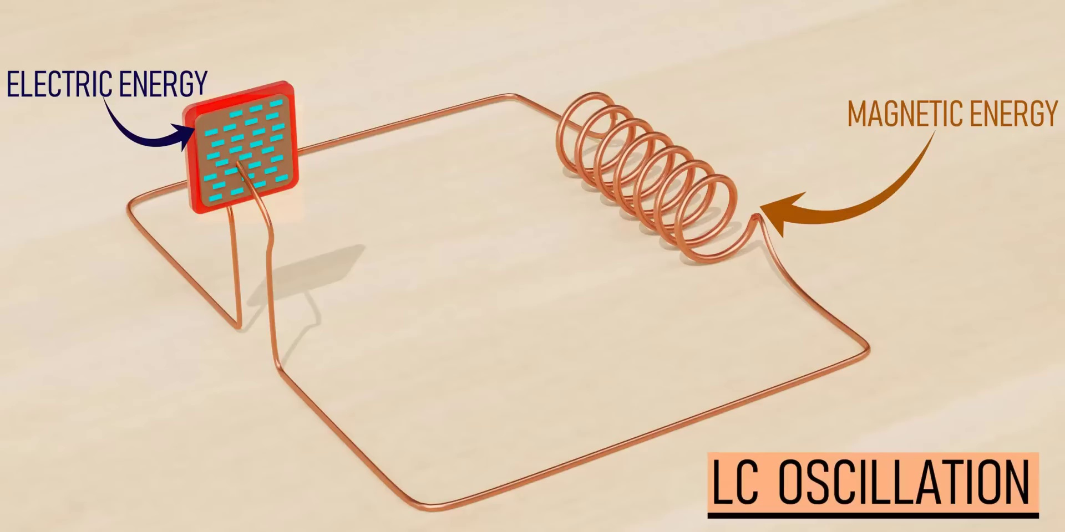 (score 95.0000)
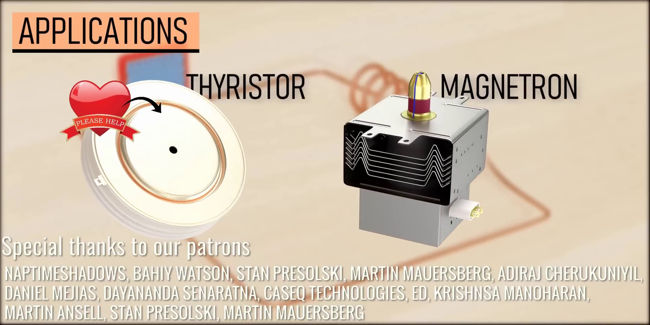 (score 90.0000)
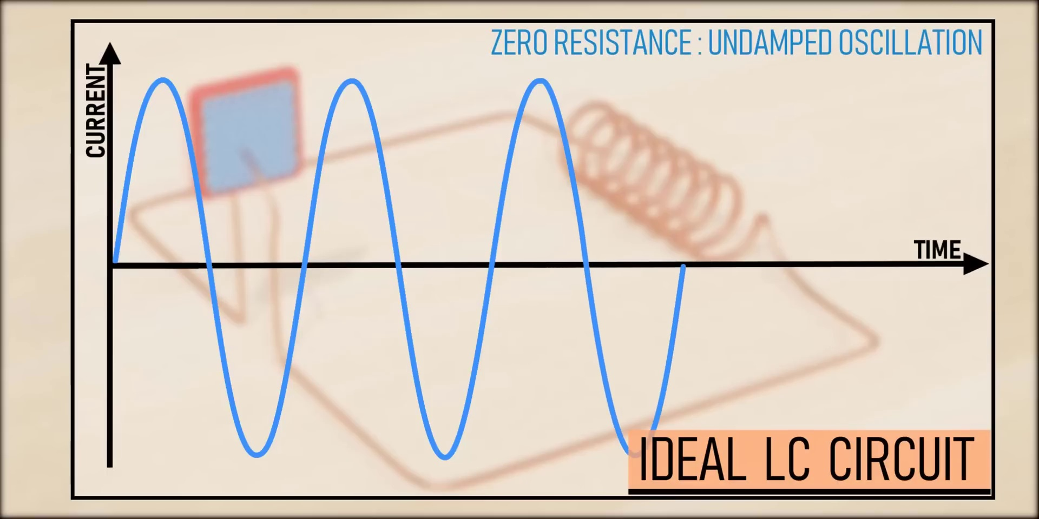 (score 90.0000)
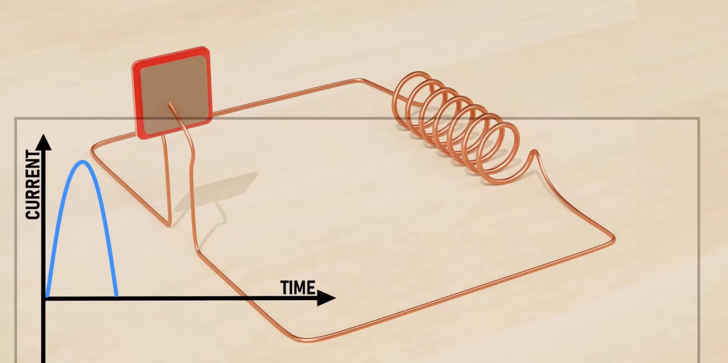 (score 90.0000)
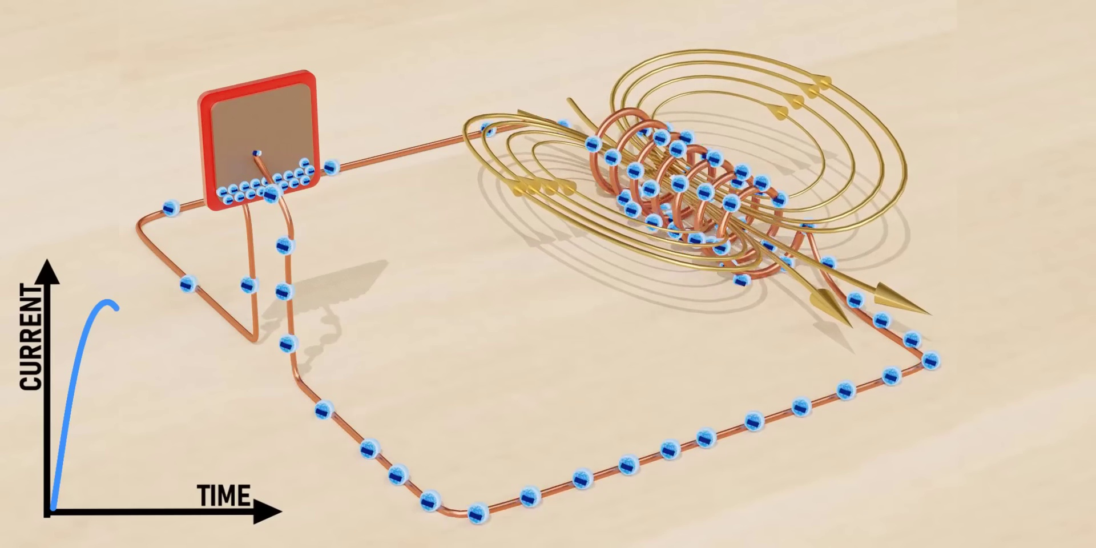 (score 90.0000)
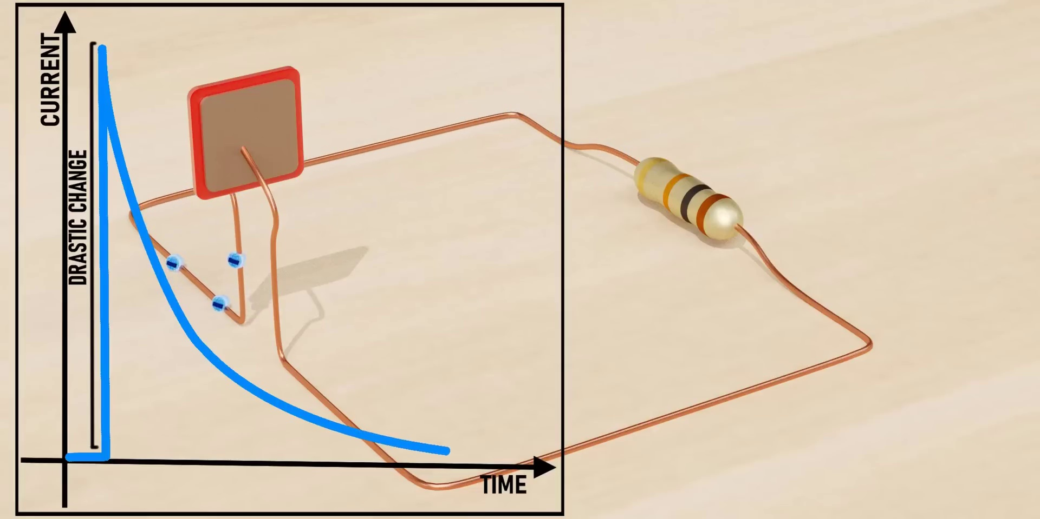 (score 90.0000)
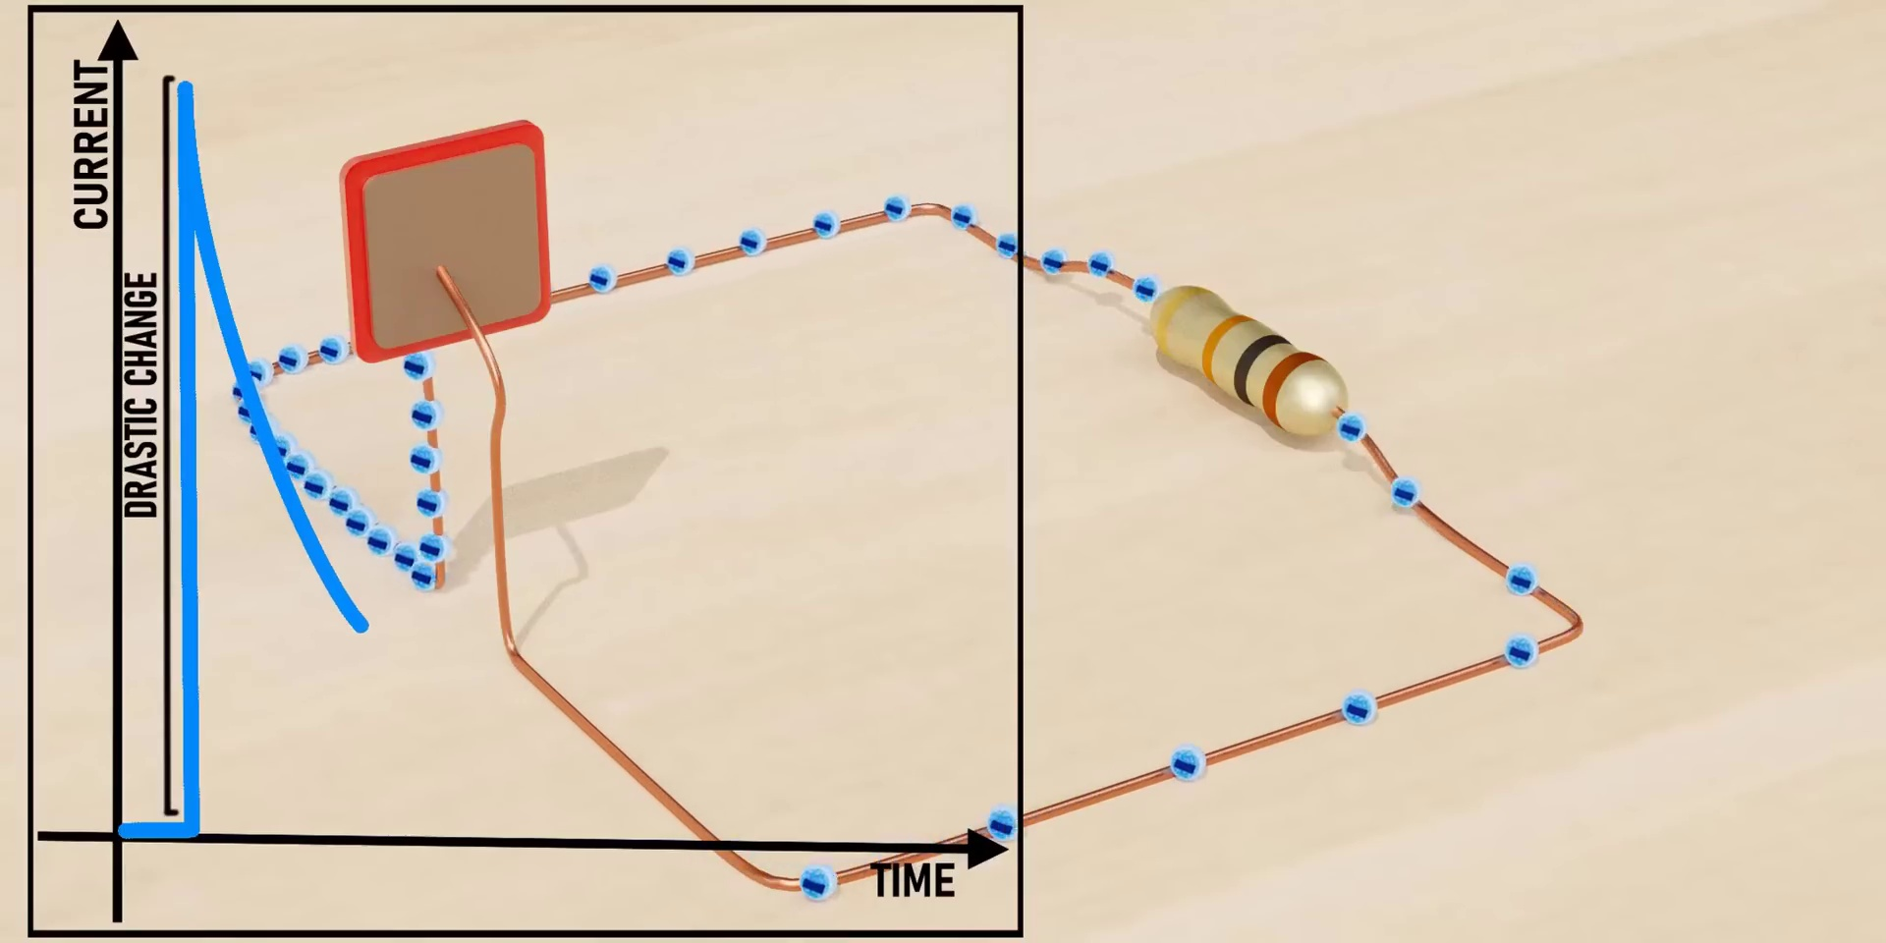 (score 90.0000)
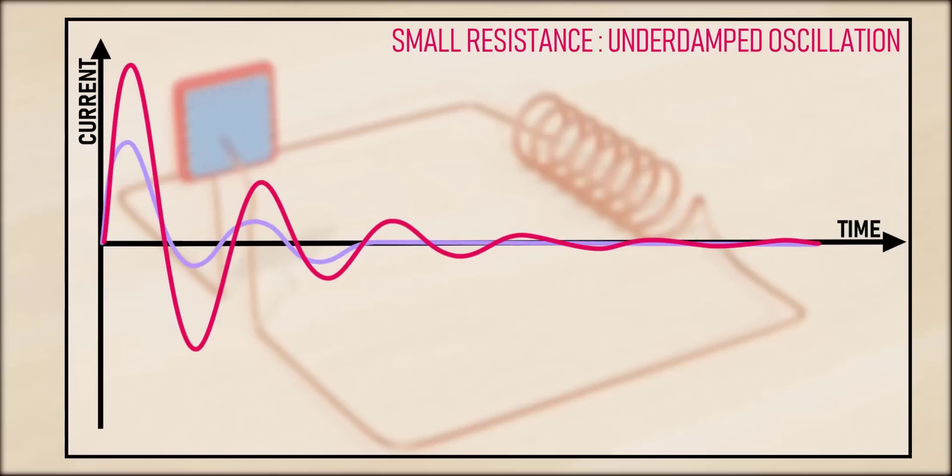 (score 85.0000)
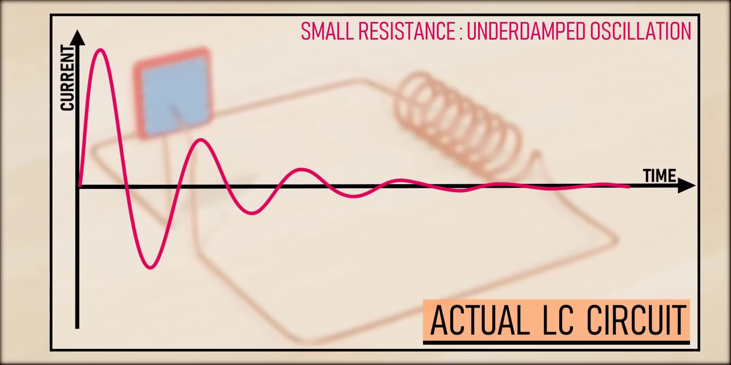 (score 85.0000)
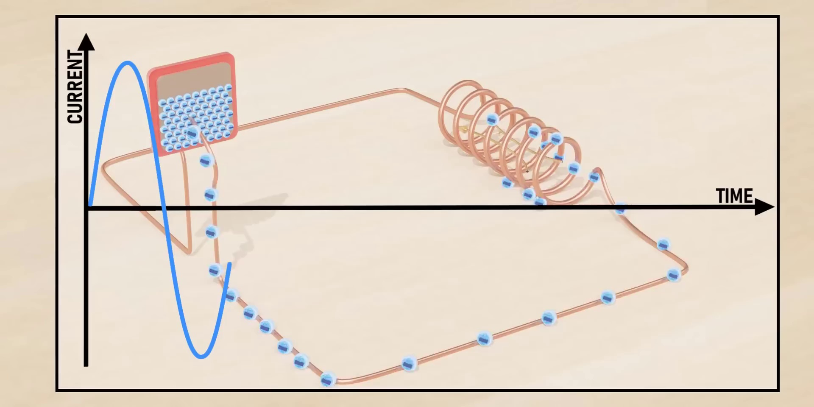 (score 85.0000)
Least correlated frames:
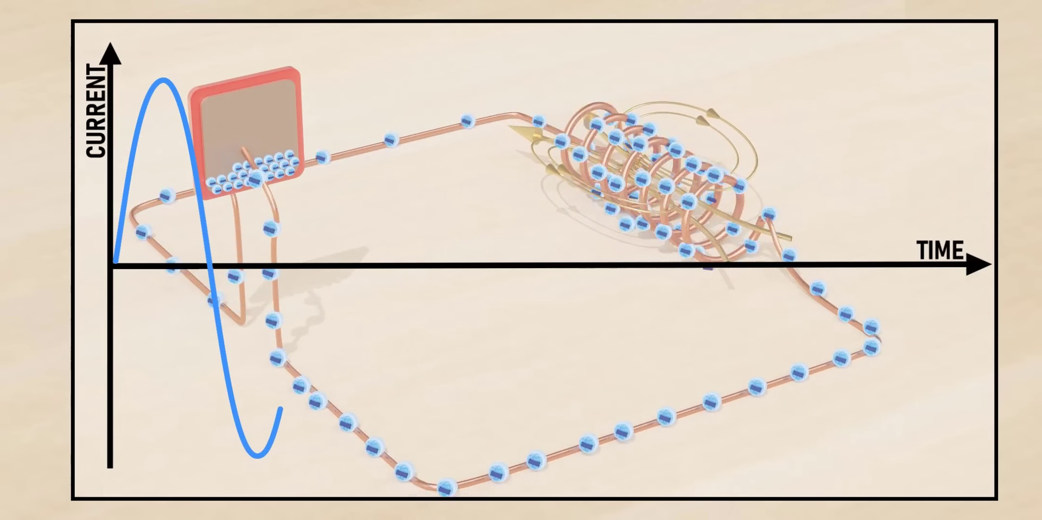 (score 0.0000)
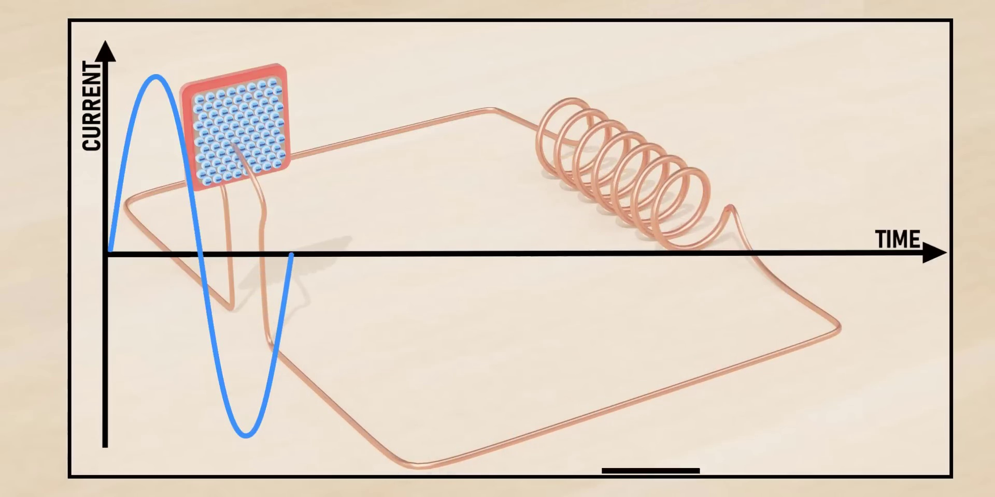 (score 0.0000)
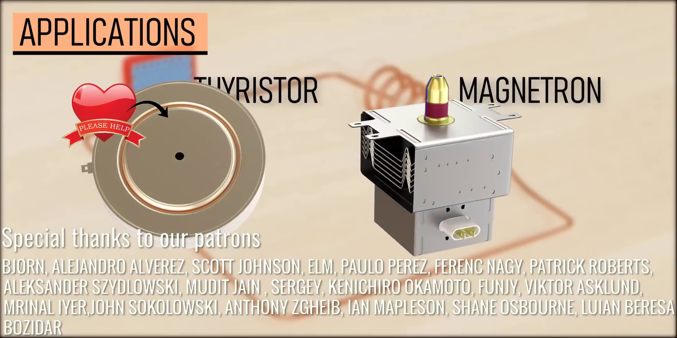 (score 0.0000)
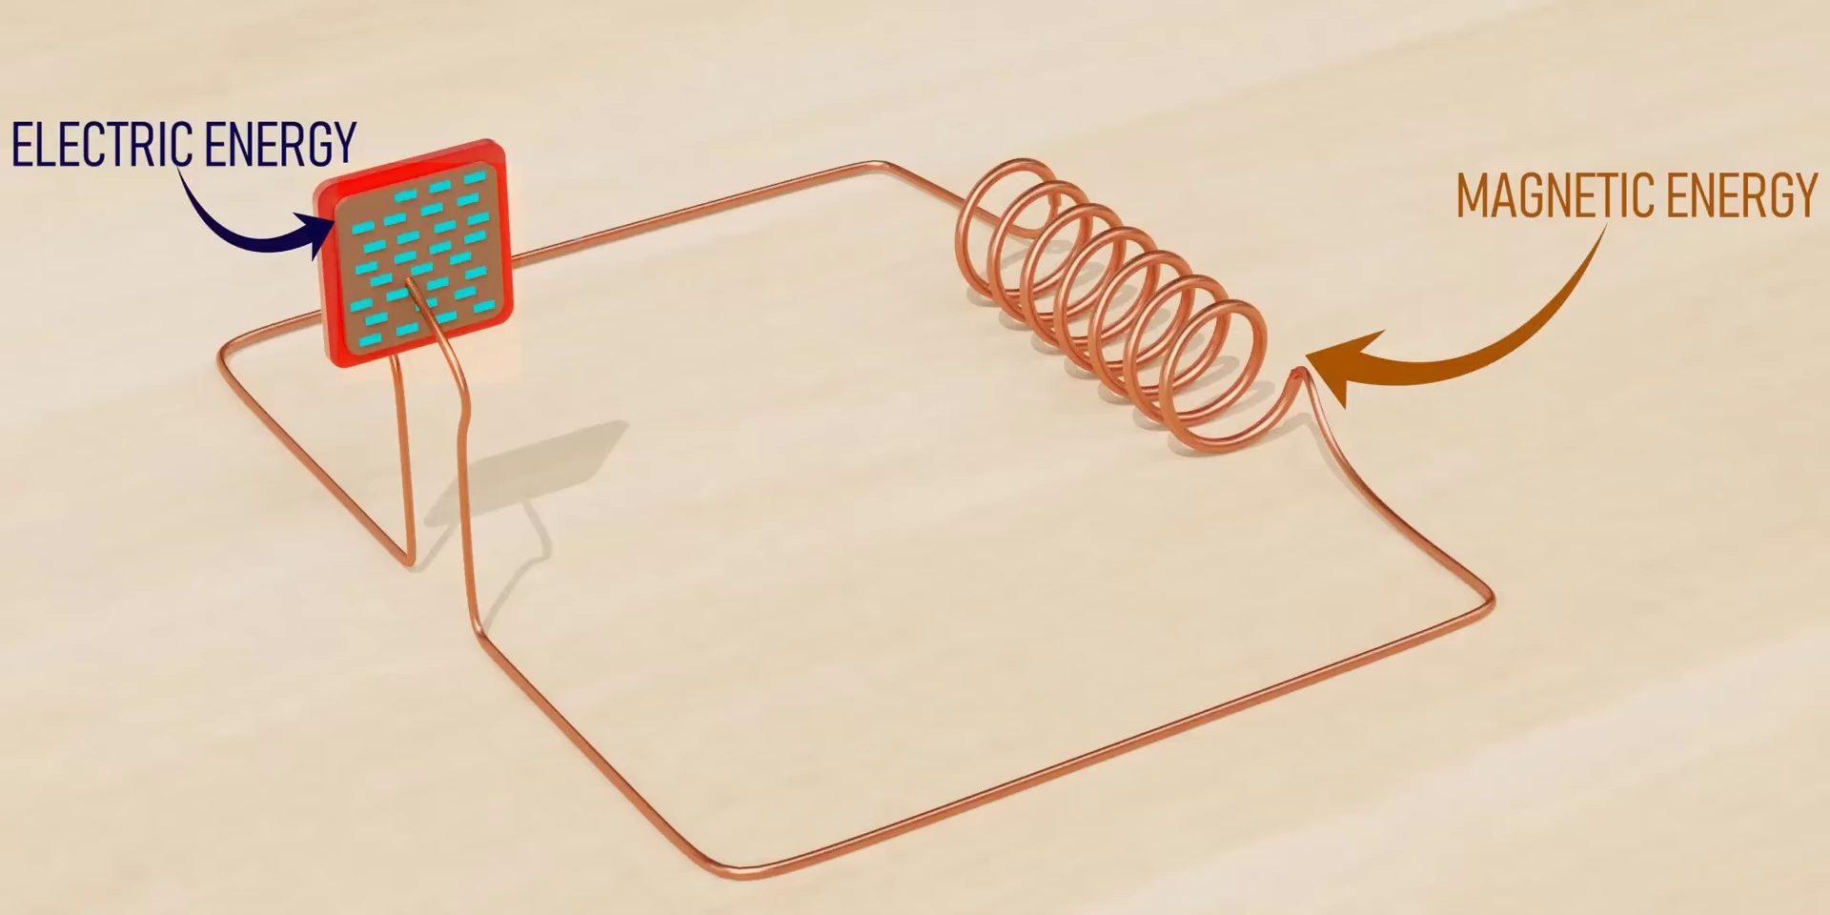 (score 10.0000)
 (score 10.0000)
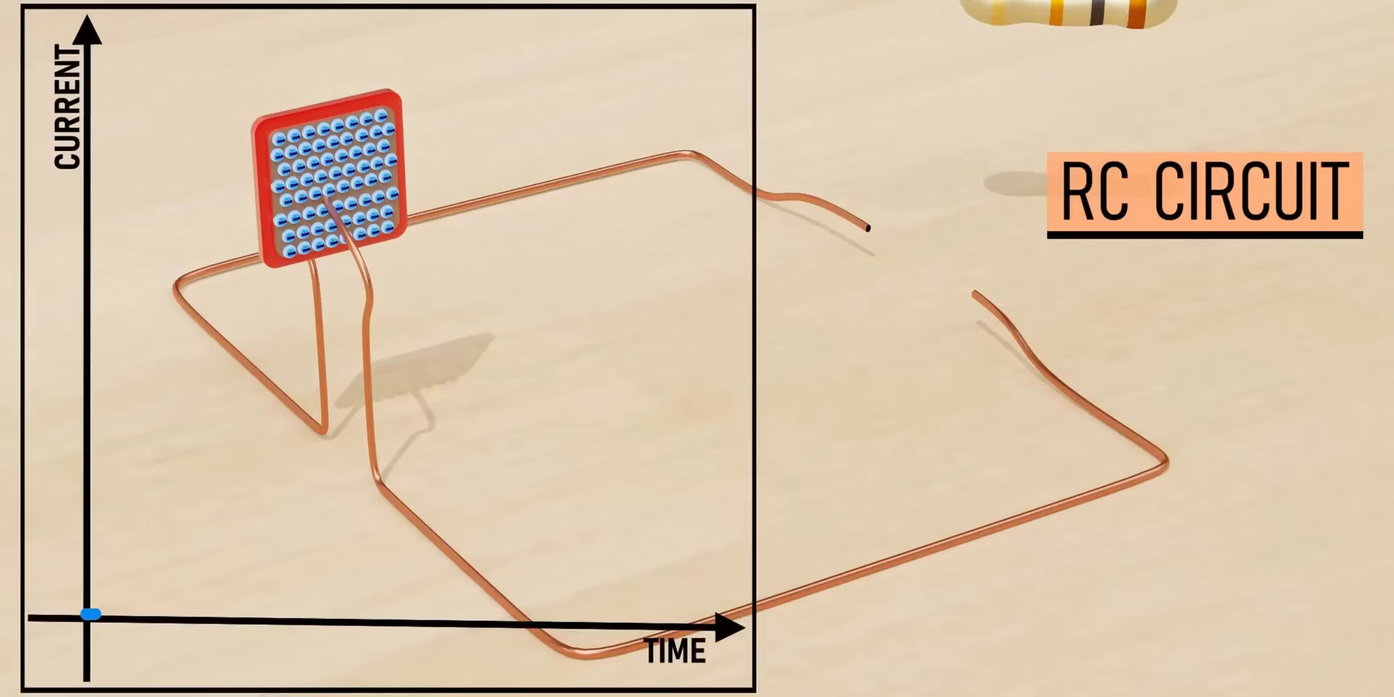 (score 20.0000)
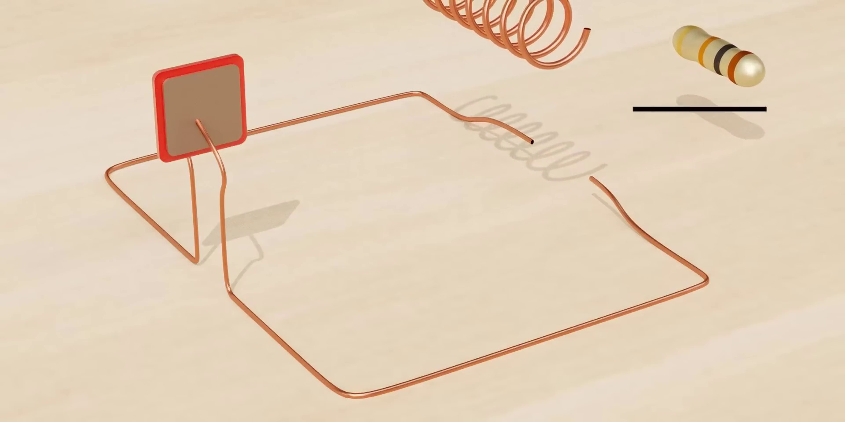 (score 20.0000)
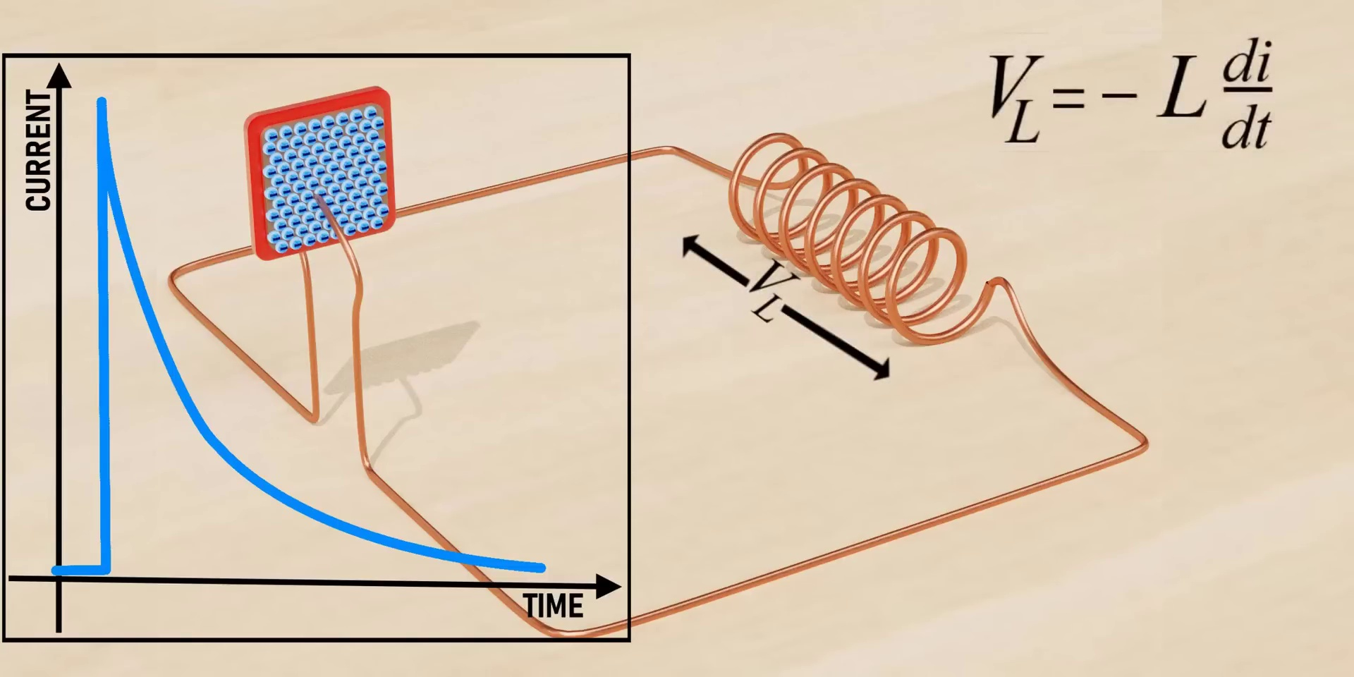 (score 20.0000)
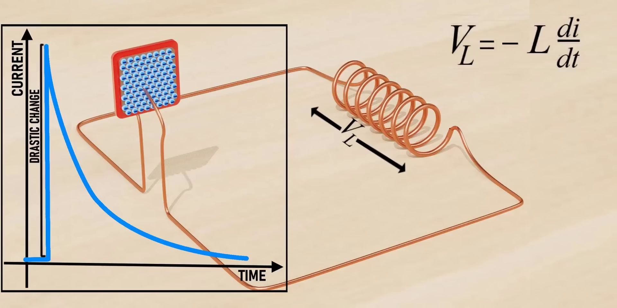 (score 20.0000)
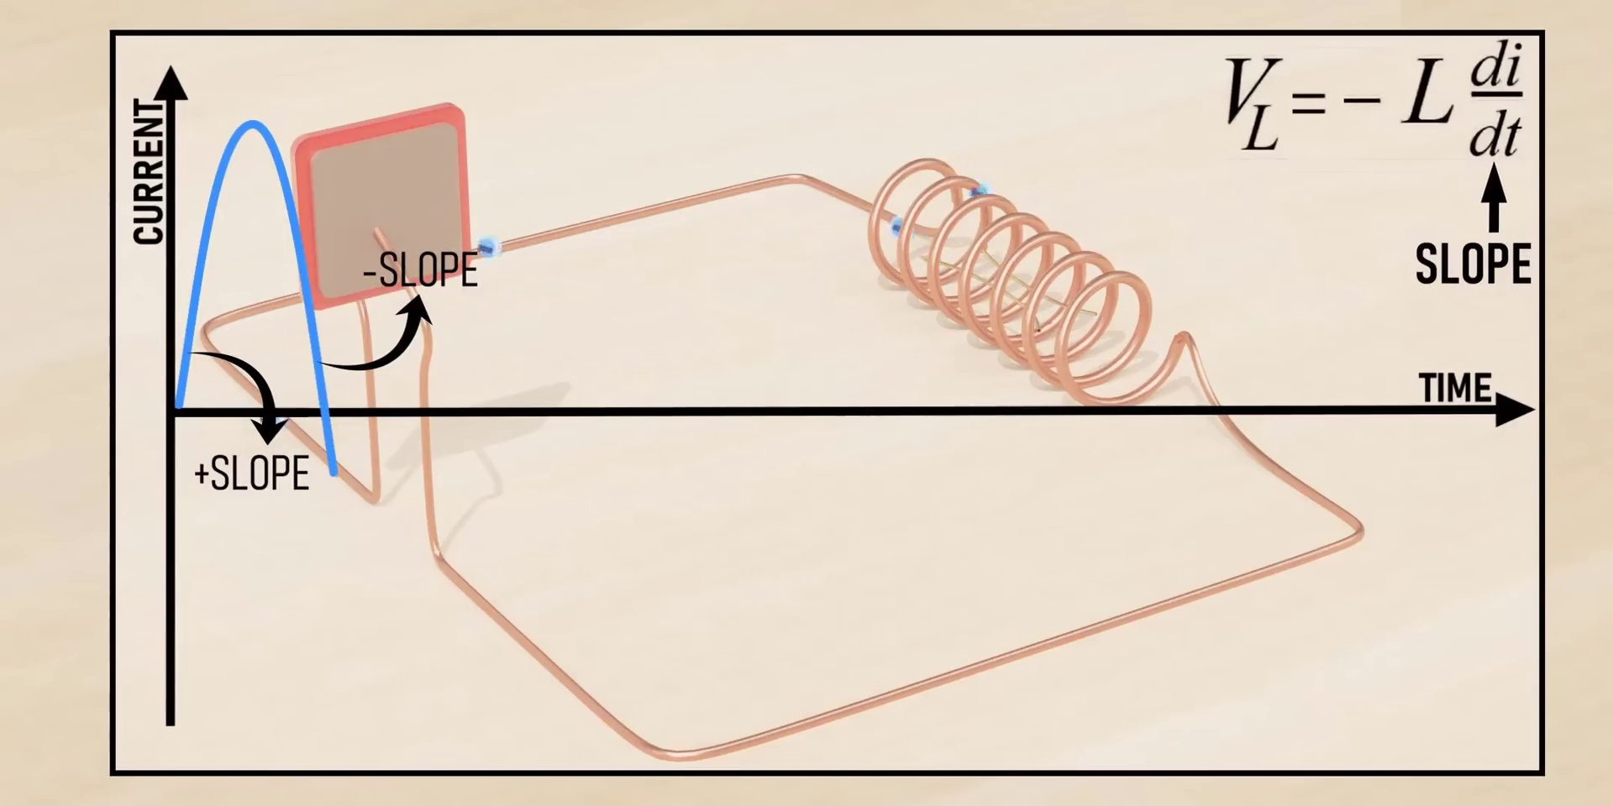 (score 20.0000)

Frame: frame_0000.jpg
Caption: The image shows an animated gif of a simple electronic circuit setup on a table or desk. The circuit includes several components:
1. A red wire connecting two pieces of copper wire, which are arranged in parallel.
2. A coiled copper wire connected to the end of one of the wires.
3. An open switch with its handles pointing upwards, indicating it is not closed.
4. A small orange rectangle that seems to be a battery or power source.
5. A red spring that appears to be in contact with the copper wire.
6. A yellow rectangle, which could represent an insulator, positioned between the two metal wires.
7. A small green rectangle on top of the yellow rectangle, possibly representing a component like a resistor or capacitor.
The components are arranged in such a way that when the switch is closed, the circuit would be completed and electricity could flow through it, creating a magnetic field when the spring is part of the circuit. The image does not depict an instructor or classroom setting; it's just the components laid out to represent a basic electrical circuit.
Comment (score 80): When an inductor and capacitor are connected, energy is exchanged between them rather than stored individually. The capacitor gets charged with opposite polarity as current increases, and the current direction also alternates.
Reason: The comment discusses specific electrical components (inductor and capacitor) and their behavior in a circuit, which is strongly related to the technical steps, objects, and settings described in the caption. The correlation score of 80 reflects that the comment does not explicitly mention the red wire, coiled copper wire, or magnetic field mentioned in the caption, but still discusses fundamental concepts applicable to the same electrical circuit.
Source: https://www.youtube.com/watch?v=2_y_3_3V-so: The Beauty of LC Oscillations

Frame: frame_0001.jpg
Caption: The image presents an educational illustration related to physics and energy. At the top left, there is a label "ELECTRIC ENERGY" accompanied by an icon depicting a stylized electrical circuit with two connected wires. Below this label, a simple representation of an electrical circuit is illustrated with a battery on one end, connected to what appears to be a coil (possibly representing an electric motor), and a lightbulb on the other end. The light bulb is lit, indicating that electricity is flowing through the circuit.
To the right of this circuit, there are two additional labels with accompanying icons: "Magnetic Energy" and "Electric Flow." These indicate that magnetic energy is associated with magnetic fields created by the electric current in a coil, which can be produced in an electromagnet. Additionally, there is a label pointing to the battery, stating "Battery," and another label next to the lightbulb, saying "Light Bulb."
In the upper right corner, there's a graphic representation of a magnetic field with concentric lines originating from the coil. Below this diagram, the text "ELECTRIC FLOW" is written, emphasizing that the electric current flowing through the circuit is creating a magnetic field.
The overall style of the image suggests that it could be used as an educational slide or graphic to explain basic concepts of electrical circuits, electromagnetism, and the relationship between electricity and magnetism. The absence of a visible instructor or additional context makes it difficult to determine if this is part of a presentation or lecture. There are no equations or graph types visible in this image.
The diagram also includes arrows, indicating the flow of energy. The arrow pointing from the "Electric Energy" box to the "Magnetic Energy" box indicates the transfer of electric energy, while the arrow pointing from the "Magnetic Energy" box back to the "Electric Energy" box indicates the transfer of magnetic energy. The precise arrangement of the wires and arrows, along with the labels on the boxes, provide a clear and concise representation of this concept, illustrating that there is a connection between electric and magnetic energy, with one flowing into the other.
Comment (score 85): When an inductor and capacitor are connected, energy is exchanged between them rather than stored individually. The capacitor gets charged with opposite polarity as current increases, and the current direction also alternates.
Reason: The comment directly discusses the concept of energy transfer between electric and magnetic fields, which is also described in the caption. The mention of inductors and capacitors exchanging energy resonates with the illustration showing electric energy flowing into magnetic energy.
Source: https://www.youtube.com/watch?v=2_y_3_3V-so: The Beauty of LC Oscillations

Frame: frame_0002.jpg
Caption: The image presents an animated diagram that explains how electric energy works, with two separate illustrations on either side of the frame. On the left side, there is a diagram labeled "ELECTRIC ENERGY" with an illustration of a power line connecting to a device featuring a red lightbulb and a small fan attached to it. Above this, a label points towards a blue arrow indicating a flow or pathway, saying "electric energy."
On the right side, another diagram is shown, labeled "MAGNETIC ENERGY," featuring two magnets, one red and one blue, depicted on either side of a curved line. A label next to the magnets states "magnetic energy." The style of the image suggests it is an educational illustration designed to explain concepts related to electrical and magnetic energy.
In a separate illustration, a simplified model of an electric circuit is presented. The circuit consists of a wire (red), a coil of wire (yellow), and a magnet (green), suspended in the air on a white background. The wire connects to the coil of wire, which is connected to the magnet at its end. Additionally, the coil of wire is linked to a small electrical switch (blue) located on the left side of the circuit.
This combined illustration represents the basic components of an electric circuit: the wire serves as the path for electric current, the coil of wire acts as a transformer, and the magnet functions as a source of energy. The switch controls the flow of electric energy in the circuit, illustrating how it is transformed and used in electrical devices.
Comment (score 80): When an inductor and capacitor are connected, energy is exchanged between them rather than stored individually. The capacitor gets charged with opposite polarity as current increases, and the current direction also alternates.
Reason: The comment directly discusses the energy exchange between an inductor and a capacitor, which is a specific technical step explained in the caption. The mention of 'energy' and 'current direction' aligns with the illustration of an electric circuit in the caption, specifically highlighting the flow of electric energy through the coil of wire and the magnet.
Source: https://www.youtube.com/watch?v=2_y_3_3V-so: The Beauty of LC Oscillations

Frame: frame_0003.jpg
Caption: The image presents an illustration of an electromagnetic coil positioned in front of a small diagram. To the right of the coil, there is a label that reads "electric energy" with an arrow pointing to the coil, suggesting a causal relationship between the coil and the creation or transmission of electric energy.
On the left side of the image, there is another label that says "LC oscillation," indicating that this particular illustration may be related to an LC (inductance-capacitance) circuit, which is a common example of an electrical oscillator. The diagram to the right appears to represent the concept of LC oscillations, showing a series of peaks and troughs suggesting the alternating current (AC) that flows through such a circuit. The peaks and troughs in the diagram correspond to the positive and negative half-cycles of the AC waveform.
The image also depicts an electric energy and magnetic energy system composed of two main components: a red coil and a blue capacitor, connected by a wire forming a closed circuit. The coil is energized by a small blue object, which is not explicitly described, while the capacitor is charged with a red object, indicating a flow of electric energy. The entire system is held together by a red wire, serving as a conduit for the flow of energy.
The relative positions of the objects suggest a closed circuit, with the electric energy flowing from the coil to the capacitor, and the magnetic energy being stored in the capacitor. The image captures a moment of energy exchange between the two systems, highlighting the interplay of electric and magnetic forces in this circuit. The overall setting suggests an educational context, possibly within a physics or engineering class, where concepts related to electric energy, circuits, and LC oscillations are being discussed.
No strongly correlated comments found for this frame.

Frame: frame_0004.jpg
Caption: The diagram illustrates an experiment involving electromagnetic induction and oscillations, with three main components labeled: a coil of wire likely representing the inductor in an LC oscillation series circuit, an electric energy source symbolized by a lightning bolt connected to the left side of the coil, and a device resembling a speaker or oscilloscope on the right side. Between these two devices is a visual representation of an electromagnetic wave with a sine wave pattern, suggesting that the electric energy from the left device is being transformed into electromagnetic waves and then back to electricity at the right device.
On the right side of the diagram, there are two texts: "ELECTRIC EYGER" possibly indicating the name or theme of the experiment, and "LC OSCILLATION", which refers to a series circuit oscillating between two states due to electromagnetic forces (inductance and capacitance). The image does not show a person teaching or holding a model, and no text is visible that suggests the nature of the experiment beyond being an LC oscillation.
The diagram also illustrates the concept of magnetic energy, with a coiled and twisted wire representing the core of a coil. This wire acts as the primary conductor of magnetic energy and connects to red and blue boxes. The red box, labeled "electric energy", is positioned on the left side, while the blue box, labeled "magnetic energy", is located on the right side. The wire, forming a bridge between the two boxes, effectively conveys the relationship between electric and magnetic energy.
Comment (score 80): When an inductor and capacitor are connected, energy is exchanged between them rather than stored individually. The capacitor gets charged with opposite polarity as current increases, and the current direction also alternates.
Reason: The comment directly discusses electromagnetic induction and oscillations, specifically mentioning the exchange of energy between an inductor and capacitor. The caption describes a similar phenomenon with LC oscillation series circuit, which is strongly related to the technical steps discussed in the comment.
Source: https://www.youtube.com/watch?v=2_y_3_3V-so: The Beauty of LC Oscillations

Frame: frame_0005.jpg
Caption: The image depicts an educational diagram that appears to explain the concept of oscillations in electrical circuits, specifically using an electromagnetic coil (inductor) as part of an LC circuit. The diagram includes three main elements: an electromagnetic coil (L), labeled as the "inductor," a capacitor (C), represented by two parallel lines, and a resistor (R), depicted as a straight line segment.
The circuit is drawn on what appears to be a wooden surface, with the coil and capacitor connected in series between two terminals, while the resistor is also connected in series with the other components of the circuit. The diagram seems to be part of an educational setting, possibly used in a lecture or tutorial to explain concepts such as resonance, inductors, capacitors, and how they interact in an LC oscillatory circuit.
The text accompanying the diagram includes "ELECTRICITY" written above the circuit, "Magnetic energy" on the left side, suggesting that when a current flows through an inductor, it generates a magnetic field, which may be considered as "magnetic energy," and a label for "LC oscillation" to the right, indicating that the components L (inductor) and C (capacitor) can set up vibrations within the circuit.
The image also presents a visual depiction of the concepts of electric energy and magnetic energy. At the center is a circular wire, which symbolizes the electric energy, surrounded by coils representing the magnetic energy. The coils are arranged in a pattern that suggests the magnetic field created by the electric energy, forming a closed loop that represents the flow of electric energy through the magnetic field.
The text included in the image states "electric energy" and "magnetic energy", indicating the two primary forms of energy, as well as "LC Oscillation", which is a concept in physics that describes the periodic motion of a system, often used to explain the behavior of oscillators. Overall, the image is a simple yet powerful representation of the principles of electric energy and magnetic energy, and the concept of LC oscillation, providing a visual explanation of these concepts for someone new to the subject.
Comment (score 80): When an inductor and capacitor are connected, energy is exchanged between them rather than stored individually. The capacitor gets charged with opposite polarity as current increases, and the current direction also alternates.
Reason: The comment directly discusses the concept of oscillations in electrical circuits, specifically the interaction between an inductor and a capacitor, which is described in the frame caption. The comment explains how energy is exchanged between them, which aligns with the diagram showing the LC circuit.
Source: https://www.youtube.com/watch?v=2_y_3_3V-so: The Beauty of LC Oscillations

Frame: frame_0006.jpg
Caption: The image presents a clear illustration of how electricity is produced by magnetized energy, with an educational graphic explaining the process. On the left side of the image, there's a diagram labeled "Electric Energy" with text that reads "Magnetic Energy," indicating that this image is likely from a science lesson or educational material about magnetism and electricity.
On the right side of the image, there is an illustration showing a coiled wire looped around a central rod, symbolizing a solenoid. This arrangement is commonly used to generate a magnetic field, which can be visualized as invisible lines that represent the direction of magnetic force. A label next to this diagram reads "Electric Energy," indicating that the magnetic energy produced by the solenoid is electric energy.
The image also includes a battery below the coil, with text underneath stating "This is where the electricity goes," suggesting that the electricity generated from the solenoid is stored in the battery for use. There are also two arrows pointing to the battery; one labeled "Magnetic Energy" and the other "Electric Energy," reinforcing the connection between the magnetic energy produced by the coil and the electric energy stored in the battery.
The image further illustrates an electric energy circuit, composed of a small square of metal and a coil of copper wire. The square of metal, which serves as the source of the electric energy, is located on the left side of the image, characterized by a blue square with a red dot inside it, symbolizing the electric energy it produces.
The coil of copper wire, connected to the square of metal, is the conductor through which the electric energy is transferred. This circuit clearly illustrates the flow of electric energy from the source to the load, providing a simple yet clear explanation of how electricity is produced and utilized.
Overall, the image provides an informative illustration of magnetism, electricity, and electromagnetism, with a clean and simple design meant to visually illustrate concepts related to physics and electromagnetism. The use of text alongside images helps to clarify the process being explained. The color scheme is minimalistic, using shades of brown, orange, and red for visual emphasis without overcomplicating the presentation.
No strongly correlated comments found for this frame.

Frame: frame_0007.jpg
Caption: The image presents an educational diagram that appears to be related to electromagnetism or electrical energy generation, specifically using magnetic coils. The scene depicts a wire coiled around a magnetic field, creating a magnetic field of its own. A device labeled "Electric Energy" is situated at the bottom of the image, seemingly in harmony with the magnetic field and the coiled wire.
On the left side of the image, there is a coil labeled "Magnetic Energy," which suggests that this represents a source or storage of magnetic energy. To the right of the coil, there's an illustration of an electric circuit with a battery and what seems to be a light bulb, indicating that the circuit is closed and electricity is flowing through it.
In the bottom right corner, there are two text bubbles: "Electric Energy" on one side and "Magnetic Energy" on the other. These labels correspond with the images above them. Above these texts, there's a small diagram of an atom labeled "Energy," which implies that energy is related to or contained within atoms themselves.
The overall image gives off a sense of motion, as if the coiled wire is in the process of releasing energy, possibly magnetic energy, into the magnetic field. The precise positioning of the objects and the dynamic interaction between them create a visually engaging and informative image, aiming to explain the relationship between magnetic energy and electric energy generation.
Comment (score 80): When an inductor and capacitor are connected, energy is exchanged between them rather than stored individually. The capacitor gets charged with opposite polarity as current increases, and the current direction also alternates.
Reason: The comment directly discusses the same technical steps (energy exchange between inductor and capacitor) and objects (inductor, capacitor) described in the caption, specifically the magnetic energy generation diagram.
Source: https://www.youtube.com/watch?v=2_y_3_3V-so: The Beauty of LC Oscillations

Frame: frame_0008.jpg
Caption: The image presents a three-dimensional rendering of an educational setting focused on teaching electricity. At the center of the image is a simple electrical circuit with components such as a coiled copper wire (representing an electric current), two terminals (indicating electrodes), and a switch, which suggests that the circuit can be switched on or off. The circuit appears to be designed for instructional purposes, possibly in a classroom environment or as part of a virtual teaching tool. There is no text visible within this image, so no specific content is being taught. The circuit is stationary, and there are no instructors or learners present.
The background suggests an empty, neutral space that emphasizes the educational content without any distractions. In addition to the electrical circuit, the image also presents a 3D rendering of a circuit board made up of a square base and two circular panels, each featuring a blue LED. The base is connected to the circular panels by a red wire, which appears to be winding around the board. The overall design of the circuit board suggests it might be used for electronic devices.
The image is rendered in a simple, flat style, which emphasizes the three-dimensional elements of the circuit board. The colors used in the image are predominantly blue, red, and brown, creating a contrast that draws attention to the various components of the circuit board. The relative positions of the components on the circuit board are as follows: the square base is positioned at the bottom, the circular panels are located at the top, and the red wire is winding around the board.
Note: I have carefully integrated the two captions while retaining all accurate and relevant details explicitly mentioned in either original caption. I avoided redundancy and contradictions and strictly avoided any speculation, assumptions, or introduction of details not explicitly stated.
No strongly correlated comments found for this frame.

Frame: frame_0009.jpg
Caption: The image presents an illustration of a simple electrical circuit setup on a flat surface with a sandy texture resembling a beach. The setup features two wires connected to a small device that appears to be a solenoid valve, which is often used in electrical circuits for the purpose of generating a high current or voltage surge when activated. The solenoid valve is powered by a 9V battery shown with its terminals exposed.
To the right of the image, a circuit diagram provides further detail about the setup. Two wires extend from the battery, one connecting to the positive terminal (+) and the other to the negative terminal (-). Symbols for a solenoid coil and a valve in the diagram suggest that this is a schematic representation of an electrical control system designed to turn on and off the solenoid valve in response to an input signal.
In contrast, another depiction shows a 3D model of a coil rendered in a warm, reddish-brown color. The coil consists of interconnected loops with distinct curves arranged in a square pattern, with the top and bottom edges of the coils aligned with those of the base. The coils are connected to a red base with a flat surface situated on a beige background, allowing the colors of the coil and base to stand out.
The image does not contain any text or additional objects, but the relative positions of the coils and base suggest a structured, organized arrangement, with each coil contributing to the overall design.
Comment (score 80): When an inductor and capacitor are connected, energy is exchanged between them rather than stored individually. The capacitor gets charged with opposite polarity as current increases, and the current direction also alternates.
Reason: The comment directly discusses the concept of energy exchange between an inductor and capacitor, which is a key aspect of the electrical circuit setup described in the caption. The mention of current direction alternation also matches with the idea of the solenoid valve being powered by a 9V battery, as seen in the diagram.
Source: https://www.youtube.com/watch?v=2_y_3_3V-so: The Beauty of LC Oscillations

Frame: frame_0010.jpg
Caption: The image appears to be a scene that presents a simple RC (Radio-Controlled) circuit setup, which is likely being used for educational or instructional purposes. On the left side of the screen, there are several icons or tools that are part of the software interface, including a selection tool with a small cube icon, a rotate tool indicated by an arrow with a circle at its end, and a move tool with an arrow pointing in four directions. There's also an undo/redo arrow button.
In the center of the screen, there is a text that reads "RC Circuit," which suggests that the model being created or edited is related to radio-controlled circuits. The 3D model itself is simplistic and appears to be a schematic representation of an RC circuit with various components like resistors (indicated by zigzag lines), capacitors (represented by cylinders with rounded tops), batteries (shown as rectangles with lines connecting the ends), and wires or conductive paths connecting them.
The setup on the screen is overlaid on top of a wooden surface, where a metal box containing a red and blue LED light is placed. The wire, which is connected to the box, is bent into a figure-eight shape, completing the circuit. This physical RC circuit is set up in a way that it complements the 3D model being created or edited on the computer screen.
The image does not contain any text or additional objects, focusing solely on the circuit setup and the software interface. The relative positions of the objects are clear - the wire is connected to the metal box, and the wire is bent into a figure-eight shape.
No strongly correlated comments found for this frame.

Frame: frame_0011.jpg
Caption: The image captures an educational process related to electronics, comprising two separate sections that demonstrate different stages of learning. On the left side, there is a slide with a diagram of a simple electrical circuit involving a battery, a light bulb, and some wires. The text "RC CIRCUIT" is written on the slide, accompanied by a representation of the components connected by two lines. A brief instruction or explanation related to the circuit is also present, although the specific content is not clearly readable.
On the right side, there is a close-up photograph of a completed RC circuit with similar components as those shown in the diagram: a battery, a light bulb, and wires. The focus appears to be on illustrating how these elements are physically arranged to create an electric circuit. Unlike the left side, no texts or explanations are visible on this part of the image.
The background is nondescript, providing no additional context for the setting or instructor's actions. In contrast, a separate model is depicted on a white wooden surface, which showcases a radio-controlled (RC) circuit constructed from a red circuit board and copper wire. The red circuit board is divided into two sections by a black line, each filled with a blue circuit arranged in a grid-like pattern. A U-shaped copper wire serves as the connection between the two sections, with its end sticking out to the right. The model is labeled "RC CIRCUIT" in blue text, highlighting its function as a radio-controlled circuit.
No strongly correlated comments found for this frame.

Frame: frame_0012.jpg
Caption: The image appears to be a screenshot of a presentation slide with a focus on teaching an audience about circuit design and electrical concepts. The slide is divided into two halves. On the left side, there's a drawing of an electronic component labeled "RC Circuit" with a red dashed line and a blue dashed line, indicating some sort of path or pathway. There are several other components labeled, suggesting a detailed breakdown of the circuit: "battery," "resistor," "capacitor," "LED," "potentiometer," and a small text that reads "1kΩ."
To the right of this diagram is another drawing of an electrical circuit with more components than in the left image. The components include a battery, resistors, a switch (labeled as "key"), and a LED (which is lit, indicating it's connected to the circuit). This drawing uses a similar color-coding system—red for the positive connection (right rail) and blue for the negative connection (left rail), with a white dashed line that seems to indicate a pathway or direction of current.
In the center of the slide, there is a small, red, rectangular object resembling a battery with "1kΩ" written on it, which aligns with the components labeled in the circuit diagrams. The bottom left corner of the image contains a text that reads "Rc Circuit," reinforcing the theme of the slide.
To the right of the diagrams, there is a blue and white graph or chart that appears to be showing some sort of electrical or current measurements, but the specific details are not fully visible due to the angle and size of the text on the graph.
Comment (score 80): When an inductor and capacitor are connected, energy is exchanged between them rather than stored individually. The capacitor gets charged with opposite polarity as current increases, and the current direction also alternates.
Reason: The comment directly discusses the concept of energy exchange between an inductor and capacitor, which is mentioned in the caption as part of the circuit design. The language used in the comment, such as 'charged with opposite polarity' and 'current direction also alternates', matches the technical steps and objects described in the caption.
Source: https://www.youtube.com/watch?v=2_y_3_3V-so: The Beauty of LC Oscillations

Frame: frame_0013.jpg
Caption: The image contains two distinct sections on a white background. On the left side, there is an educational setting with diagrams and texts that seem to relate to physics or engineering concepts. A flowchart or diagram in a light red or orange color represents a process or system, featuring various shapes and circles that might represent different stages or components of the process. The text on the right side reads "Physics 101," suggesting this material is part of an educational course on introductory physics. A person seems to be speaking in this section, as indicated by the microphone and partially visible speaker's notes or slides. However, due to the resolution and angle, it's not possible to read any text from the notes.
On the right side of the image, a separate visual shows an outdoor scene with a toy car being launched down a ramp into motion. The object in focus is a toy car made of Lego or similar materials, designed for children to learn about physics principles such as acceleration and friction. The ramp is wooden with a slight incline, launching the car into motion when rolled downhill. The background shows an outdoor setting with grass and a clear sky, indicating this activity might be part of an outdoor learning event or a hands-on physics lesson conducted in a park or similar open space. At the bottom right corner, there is another microphone and speaker setup, suggesting this scene is being observed or recorded by someone speaking to an audience.
On the opposite side of the image, there is a dynamic scene set on a white background. Dominating the foreground is a blue circuit board with red and blue wires, indicating a complex network of electronic connections. Above the board, a sign labeled "DRASTIC CHANGE" stands out against the background, with the word "DRASTIC" boldly written in red, emphasizing the intensity of the change it represents. To the right of the board, another sign labeled "TIME" is positioned, with the word "TIME" written in blue, providing a contrast to the red of "DRASTIC CHANGE".
Comment (score 80): When an inductor and capacitor are connected, energy is exchanged between them rather than stored individually. The capacitor gets charged with opposite polarity as current increases, and the current direction also alternates.
Reason: The comment discusses the exchange of energy between an inductor and capacitor, which is directly related to the diagram on the left side of the image that represents a process or system. The technical steps mentioned in the caption, such as diagrams and texts relating to physics or engineering concepts, are discussed specifically in the comment about the behavior of inductors and capacitors.
Source: https://www.youtube.com/watch?v=2_y_3_3V-so: The Beauty of LC Oscillations

Frame: frame_0014.jpg
Caption: The image provided shows a composite of two different scenes. In the upper half, there's an educational or demonstration setting featuring a person who appears to be teaching or presenting, as indicated by their position and posture. The individual is holding up what seems to be a model of a mechanical system or device, possibly explaining the workings or concepts related to that model.
The lower half shows a screenshot of a presentation slide with various components labeled. There's a diagram with arrows connecting different parts, suggesting a flow or process within a larger system. The labels on the diagram include terms such as "temperature," "speed," and "time," which could imply that the slide is explaining a process involving temperature control or measurement over time.
The text visible in the image includes mathematical notations like "=", suggesting an equation being presented, although the full context of the equation is not provided. There are also terms like "ΔT" (change in temperature) and "ΔV" (change in volume), which may be referring to differences between initial and final states or values within a thermodynamic system or process.
In the lower right corner, there's an image of a circuit with a red wire, blue wire, and a green wire, all connected to a white resistor. The resistor is encased in a blue container, and the circuit is laid out on a white surface, creating a striking contrast. The circuit is depicted in two different colors, blue and red, with the red wire being the main focus. The blue wire is connected to the green wire, which is in turn connected to the white resistor.
The image also includes a text that reads "DRASTIC CHANGE CURRENT TIME", adding a layer of complexity to the scene. A black arrow pointing towards the white resistor indicates the flow of electricity within the circuit. The overall image captures a dynamic moment in the life of a circuit, with every element playing its part in the intricate dance of electricity.
The overall style of the image suggests it might be used for educational purposes, such as teaching physics or engineering principles related to thermal control or measurement processes, as well as electrical circuits and their dynamics.
Comment (score 90): When an inductor and capacitor are connected, energy is exchanged between them rather than stored individually. The capacitor gets charged with opposite polarity as current increases, and the current direction also alternates.
Reason: The comment directly discusses the same technical steps and objects described in the caption. The mention of energy exchange between an inductor and capacitor is strongly related to the diagram on the presentation slide, which depicts a process involving temperature control or measurement over time.
Source: https://www.youtube.com/watch?v=2_y_3_3V-so: The Beauty of LC Oscillations

Frame: frame_0015.jpg
Caption: The image presents two separate frames. On the left side, there is an illustration of a copper wire with two alligator clips attached to it, suggesting some form of electrical circuit or experiment setup. The diagram shows a sine wave and what appears to be an oscilloscope displaying this waveform.
On the right side, there's a photograph of a physical experiment setup on a wooden surface with various components visible: a red device labeled "LED," a small DC motor or fan, a battery pack, an LED strip light (possibly indicating that it is used as the light source), and what seems to be an Arduino board. The experiment appears to be related to electronics, possibly demonstrating the use of an LED as a light source for an oscilloscope, or vice versa.
In addition, there is a circuit diagram on the same page, which presents a representation of an electrical circuit. The circuit consists of a resistor, indicated by a brown box, connected in series with a capacitor, depicted by a blue box. A current source, represented by a red box, is also connected in parallel to the capacitor.
The labels "DRASTIC CHANGE" and "TIME" suggest that the circuit is designed to change its resistance in response to changes in time, and that the current source is used to control the rate of change. The diagram provides a clear representation of an electrical circuit, with specific details such as the components and their connections clearly indicated against a light brown background.
Comment (score 80): When an inductor and capacitor are connected, energy is exchanged between them rather than stored individually. The capacitor gets charged with opposite polarity as current increases, and the current direction also alternates.
Reason: The comment directly discusses the same technical steps and concepts described in the caption, such as energy exchange between an inductor and capacitor. The mention of charging a capacitor with opposite polarity and current direction alternation is closely related to the circuit diagram shown in the caption.
Source: https://www.youtube.com/watch?v=2_y_3_3V-so: The Beauty of LC Oscillations

Frame: frame_0016.jpg
Caption: The image displays two separate panels. On the left side, there is an illustration of a toy rocket launching from a ramp with a diagram indicating its trajectory over time. The trajectory is represented by a curved line that starts at the base of the launch ramp and then rises sharply to represent the upward motion of the rocket as it's thrown upwards, before gently sloping downward to indicate its descent once airborne.
On the right side, there is a photograph of what appears to be a real-life prototype of an object that resembles the toy rocket from the left panel. The object has a similar shape with three fins at the base and a pointed nose. It is connected to a wire that seems to lead to a device or control box, which is not fully visible in the image.
The second panel shows a circuit diagram on a beige surface. The circuit is composed of three main components: a resistor, a capacitor, and a switch. The resistor is colored in shades of brown and gray, with a black stripe running along its length. It is connected to the switch, which is also brown and gray, and is located at the bottom of the circuit.
The switch is a simple on/off device, indicated by the black stripe on its side. The capacitor, colored in shades of blue and white, is located at the top of the circuit and is connected to the resistor with a black stripe running along its length. This black stripe indicates the direction of current flow in electronic circuits.
The circuit is set against a blue background, providing a stark contrast to the brown and gray components. The diagram is labeled with the words "DRASTIC CHANGE" and "TIME", indicating that the circuit is designed to respond to changes in time.
This image appears to be an educational resource, potentially teaching principles of physics, such as the laws of motion and gravity, as well as basic electronic circuitry and the interplay of current, voltage, and time in the creation of electrical signals.
Comment (score 90): When an inductor and capacitor are connected, energy is exchanged between them rather than stored individually. The capacitor gets charged with opposite polarity as current increases, and the current direction also alternates.
Reason: The comment directly discusses the energy exchange between an inductor and a capacitor, which is a key concept illustrated in the circuit diagram in the frame caption. The mention of current direction alternating matches the discussion of current flow in electronic circuits in the caption.
Source: https://www.youtube.com/watch?v=2_y_3_3V-so: The Beauty of LC Oscillations

Frame: frame_0017.jpg
Caption: The image appears to depict a 3D modeling or animation sequence where an object is being created or manipulated. On the left side, there's a wireframe model of a simple spring coil that seems to have been transformed into a cylindrical shape. The object in question is red with white wiring emanating from its top, and there is no visible text, equations, or graph types that can be discerned.
On the right side, the image looks like an instructional diagram or illustration showing the initial and final states of the object being modeled. The spring coil has been bent into a cylindrical shape by some unseen force or action. Additionally, in the bottom right corner, there's a cursor with a hand tool icon, suggesting that this could be a software interface where tools are used for 3D modeling or animation.
In terms of teaching context, it seems like someone is creating an animation or demonstrating how to change an object from one shape to another within a computer-aided design (CAD) software or 3D modeling program. The sequence of steps from the left to the right provides visual feedback on the transformation process. No instructor is visible in the image, and it's unclear whether they are writing, speaking from a slide, or holding a model, as this could be part of an instructional video or tutorial where such actions would not be directly visible.
In a separate section of the image, there is a scene of a simple yet intriguing circuit setup. At the center of the image is a rectangular metal board, which serves as the base for the circuit. The board is adorned with four red wires, each connected to a component in a specific manner. The wires are arranged in a diagonal pattern, suggesting a complex yet intriguing arrangement.
A small gold and black tube is also present, seemingly an integral part of the circuit, likely serving a specific function. The background of the image is a light beige color, providing a neutral backdrop that allows the colorful components and wires to stand out.
No strongly correlated comments found for this frame.

Frame: frame_0018.jpg
Caption: The image presents a simple yet intriguing illustration of an LC CIRCUIT, a type of electrical circuit that uses an inductor (L) and a capacitor (C) to control current flow. The diagram shows a rectangular block labeled "LC CIRCUIT" on the upper right corner, suggesting this is a schematic of an inductive charging coil. Below it, there's a series of three components: a battery or power source at the bottom left, a rectangular device that could be a controller or a transformer, and an additional component labeled "Power" with a symbol indicating electrical flow.
The circuit is set against a light brown background that resembles a surface with some texture, possibly a tabletop. The diagram includes a red coil shape with a shadow effect cast on the surface below it, suggesting that this part of the diagram represents an actual physical component such as an induction coil. The overall impression is that of a schematic or instructional guide used in teaching or explaining an electrical circuit concept.
In the bottom right corner of the image, there's a small text that reads "LC CIRCUIT", providing a clear indication of the type of circuit depicted. The diagram shows a blue wire bent into a loop, creating a curved path that connects the two components on either side.
Comment (score 80): When an inductor and capacitor are connected, energy is exchanged between them rather than stored individually. The capacitor gets charged with opposite polarity as current increases, and the current direction also alternates.
Reason: The comment directly discusses the energy exchange between an inductor and capacitor, which is explicitly described in the caption as a fundamental aspect of an LC circuit. The technical steps mentioned in the comment (energy exchange, charging with opposite polarity) are also explained in the caption, indicating strong correlation.
Source: https://www.youtube.com/watch?v=2_y_3_3V-so: The Beauty of LC Oscillations

Frame: frame_0019.jpg
Caption: The image depicts a schematic drawing with annotations in an educational setting. At its center is an electrical circuit represented by a zigzag line, symbolizing the path of an electric current and labeled "LC Circuit." The circuit consists of two loops: one marked "inductor" with the symbol for inductance (a coil) and another loop labeled "capacitor," represented by a set of parallel lines indicating the charged plates within the capacitor.
Above this representation, there's an illustration of a flashlight with a red lens at one end and a white lamp inside it. The circuit is connected to the flashlight via two red coils, one labeled "inductor" on the left side and another on the right side of the flashlight.
On the top right corner, there's a small inset image of a handheld device with a screen displaying a graphic that resembles the circuit diagram below it. The device is labeled "Current Time," which might imply it's showing the current time as part of an educational context.
Below the main drawing, there's a note with the word "Time" written on it, possibly indicating the concept of timing in this electric circuit context, potentially related to how the LC (inductor-capacitor) circuit is used for timekeeping or oscillation applications.
In addition to these annotations, the image also features a rectangular box serving as a transformer, constructed from copper wire and creating a spiral pattern that mimics the behavior of an electric circuit. The transformer is set against a blue and white grid backdrop, dotted with small circles representing points of current flow.
A label at the top reads "LC CIRCUIT," indicating that the image is related to the concept of electrical circuits, which are closed loops through which an electric current can flow. Overall, the scene suggests an educational setting where the instructor is explaining or demonstrating the function of an LC circuit, possibly as part of a lesson on electrical circuits, physics, engineering, or related fields.
Comment (score 80): When an inductor and capacitor are connected, energy is exchanged between them rather than stored individually. The capacitor gets charged with opposite polarity as current increases, and the current direction also alternates.
Reason: The comment directly discusses the exchange of energy between an inductor and capacitor, which is a technical step described in the caption. The mention of opposite polarity and alternating current direction also matches the annotation 'inductor' and 'capacitor' labels in the frame caption.
Source: https://www.youtube.com/watch?v=2_y_3_3V-so: The Beauty of LC Oscillations

Frame: frame_0020.jpg
Caption: The image provided is an educational diagram overlaid with a wooden floor pattern, resembling a jigsaw puzzle. The diagram illustrates a concept related to electricity and current flow, possibly in the context of physics or engineering education.
At the center of the diagram is a representation of a coil, which appears to be a solenoid, often used in electromagnetism experiments due to its ability to create magnetic fields when an electric current flows through it. The coil is colored orange and highlighted with a red dashed line encircling it.
Above the coil, there's a label with the text "Current," indicating that the diagram is showing current flow in this particular setup. Below the coil, the term "Force" is written, suggesting that the current in the solenoid creates a force when a magnetic field interacts with it, which could be part of an experiment or demonstration.
To the right of the diagram, there's a graphic representation of a compass needle, which may indicate that the magnetic field generated by the solenoid could influence a compass needle. The compass needle is oriented towards the top of the image and is labeled "North" and "South," indicating the direction of the Earth's magnetic field relative to the coil.
In the bottom right corner, there's an inset with a more detailed schematic, showing the path of the current through the coil. The diagram includes text that reads "Current," "Magnetic Field," and "Fundamental Concepts in Physics." This suggests that the diagram is part of a larger discussion or lesson on fundamental physics concepts, particularly electromagnetism.
In addition to the diagram, the image also presents a dynamic scene on a light-colored wooden surface. A wire winds its way around a rectangular object, with each blue dot representing a tiny current flowing in the direction of the wire, creating a sense of motion.
The rectangular object is a complex network of interconnected wires, creating a complex electrical circuit. The wires are arranged in a spiral pattern, suggesting a sense of order and structure. The wire network is surrounded by a light-colored wooden frame, adding a contrast to the otherwise monochromatic scene.
On the right side of the image, there's a blue line labeled "TIME," which suggests a connection to the current flowing through the wires, perhaps indicating the passage of time or the evolution of the electrical circuit.
No strongly correlated comments found for this frame.

Frame: frame_0021.jpg
Caption: The image presents an educational teaching context that appears to be focused on electrical engineering or mechanics. It features a circuit diagram with two main components: a coiled wire (possibly representing a solenoid) and a series of springs connected in a line, labeled as "Spring 1" at the beginning and ending with "Spring N." The coiled wire has lines emanating from it, which are connected to the springs, suggesting that they might be representing current flow within the circuit or mechanical system.
On the left side of the image, there is a text bubble with the words "Current Time," indicating a connection between time and electrical current. However, no instructor is visible in this image, and there are no specific details that indicate any instructional activity such as writing on a board, holding a model, or speaking from a slide.
The background is blurred but appears to be a classroom environment with a whiteboard to the right, hinting at a teaching scenario.
Comment (score 85): When an inductor and capacitor are connected, energy is exchanged between them rather than stored individually. The capacitor gets charged with opposite polarity as current increases, and the current direction also alternates.
Reason: The comment directly discusses the concept of energy exchange between an inductor and capacitor, which is a technical aspect mentioned in the caption. The connection is strong because both mention the same components (inductor, capacitor) and their interaction (energy exchange).
Source: https://www.youtube.com/watch?v=2_y_3_3V-so: The Beauty of LC Oscillations

Frame: frame_0022.jpg
Caption: The image displays a whiteboard with educational content, possibly during a lecture or workshop. The left side features a text that reads "Curve," along with graphical elements: a curve in blue and a spiral or helix drawn in red, labeled as "helix." These curves are likely being discussed in relation to each other, possibly as part of a mathematical or scientific lesson.
The right side of the whiteboard features two main diagrams:
1. A mechanical diagram shows a mechanical system with a helical spring and a spiral piece on the left side, suggesting a relationship between the helix and the mechanical operation of the device. The text next to this diagram says "Time," which likely refers to the temporal behavior or movement in the system.
2. A mathematical equation is written as "v = ωr." This equation represents the relationship between velocity (v), angular velocity (ω), and radius (r) in a circular motion or helical spring mechanism, indicating that the concepts being taught might be related to physics or mechanics.
3. An arrow with a label pointing from the mechanical diagram towards the mathematical equation reads "Current," which could imply a relationship between current flow and the operation of the device depicted in the mechanical diagram.
4. There is an instructional note pointing at the mechanical system, indicating that the helix rotates (times) as if explaining how the spring coils with each rotation of the spiral piece.
In addition to these diagrams, there is also a separate illustration on the right side of the whiteboard showing a wire, represented by a blue line, connected to a black square. The wire's connection to the square is depicted by a red line, symbolizing the flow of current from the right to the left, following the standard convention in electrical circuits. The blue line representing the wire is also connected to a black square, indicating a closed circuit that completes the path for the current to travel.
The illustration includes a label "TIME" at the bottom left corner, suggesting that the current is flowing over a certain period of time. Overall, the image provides a clear representation of a basic concept in electrical circuits - the flow of current - and effectively communicates the direction of the current, its connection to the circuit, and the passage of time within the circuit. The focus of the instruction seems to be on the interplay between mechanical movement (represented by the helix), mathematics (the equation for velocity), and time-based behavior in the system.
No strongly correlated comments found for this frame.

Frame: frame_0023.jpg
Caption: The image appears to be a screenshot of a video call or presentation, with a focus on scientific content and teaching context. On the left side of the frame, there is a person who seems to be giving a lecture or demonstration. They are holding up a piece of paper that has several diagrams drawn on it, including graphs, spiral-like diagrams, and an image of what appears to be a spring with a wavy pattern on its surface.
The diagrams include:
* A graph with time on the horizontal axis and an increasing slope, indicating a concept related to velocity, speed, or acceleration over time. The graph is annotated with arrows pointing at the slope.
* A spiral-like diagram labeled "coiled spring" and "spring," with an arrow pointing at it and a label indicating "currently relaxed."
* A diagram that looks like a section of a track or pipe with a wavy pattern on the inside, resembling a cross-section of a spiral object. This diagram is also labeled "spring."
On the right side of the image, there's a screen with a slide that has a mathematical equation:
V = ωr sin(θ)
This equation is typically used to express the speed (V) of an object in terms of its angular velocity (ω), radius (r), and angle (θ). The context of this equation would likely be related to rotational motion or dynamics, possibly within a physics or engineering class.
In the bottom right corner of the screen, there's a piece of paper with the following text:
"curled"
"springy"
This suggests that the topic being discussed is related to the properties of springs or flexible materials, such as their ability to store and release energy through various means like waves, rotations, and other types of vibratory motion.
On the right side of the equation, there's a wire coil serving as a representation of an electric circuit. The equation itself is written in a compact format, with the variables clearly labeled and the units of measurement indicated. The wire coil introduces a resistive force that is proportional to the current I, illustrating Ohm's Law, which states that the current flowing through a conductor is directly proportional to the voltage across it and inversely proportional to the resistance of the conductor.
The equation also includes a term for time t, representing the duration for which the current is flowing. This time duration is crucial in determining the total energy consumed by the circuit. Overall, the equation provides a mathematical representation of the behavior of a circuit, capturing the interplay between voltage, current, and time.
The overall setting appears to be a digital lecture or presentation, where the instructor is using diagrams and equations to explain physical principles or engineering concepts related to waves, springs, and possibly mechanics in general. The focus on these visual elements indicates an instructional environment aimed at teaching or understanding scientific theories or practical applications.
No strongly correlated comments found for this frame.

Frame: frame_0024.jpg
Caption: The image presents a comprehensive educational presentation on fluid dynamics and vortex flow, with an accompanying mathematical illustration of a complex circuit. At the center of the image is a visual representation simulating the motion of a fluid, such as water or air, in a confined space, possibly a pipe or a channel. The fluid is shown curving along a circular path, indicating the formation of a vortex due to the constriction and then expansion of the flow path.
To the right of the diagram is an equation that relates to some aspect of fluid dynamics or hydraulics, although the specific details are not clearly legible due to the resolution and angle of the image. On the left side of the image, there's a smaller inset diagram labeled "Instantaneous streamlines," which explains how streamlines relate to the path of the fluid at any given moment. The arrows in this inset depict the direction of flow, emphasizing the curved nature of the streamlines as they follow the contours of the moving fluid.
At the bottom of the image, there's a label "Time," indicating that the streamlines are shown at different times to illustrate how the fluid flow changes over time. This educational presentation is likely intended to help students understand concepts related to hydraulics and fluid dynamics, such as vortex flow and streamline analysis, in an accessible manner.
In addition to this visual representation of fluid dynamics, the image also includes a mathematical illustration of a complex circuit. The circuit is composed of a series of components, including a resistor, a capacitor, and a coil of wire. The equation "V = i * L * t" is present in the illustration, indicating the relationship between voltage, current, and time in the circuit. The overall picture suggests that the circuit is in a state of dynamic change, with the resistor and the coil of wire undergoing a drastic change.
Overall, this educational presentation combines visual aids and mathematical representations to explain complex scientific principles related to fluid dynamics, hydraulics, and electrical circuits.
Comment (score 80): When an inductor and capacitor are connected, energy is exchanged between them rather than stored individually. The capacitor gets charged with opposite polarity as current increases, and the current direction also alternates.
Reason: The comment directly discusses the concept of energy exchange between an inductor and capacitor, which is related to the mathematical illustration of a complex circuit shown in the frame caption. The mention of current direction and polarity also matches with the concepts presented in the caption.
Source: https://www.youtube.com/watch?v=2_y_3_3V-so: The Beauty of LC Oscillations

Frame: frame_0025.jpg
Caption: The image appears to show a classroom or educational setting with a presentation or teaching aid in progress. In the foreground, a diagram of an electrical circuit is displayed on a board, featuring a positive (+) and negative (-) terminal, a voltage source labeled "V", a conductor represented by a line, a resistor (R), and two wires labeled as "wire 1" and "wire 2". Arrows indicate the direction of the current, with one arrow showing current moving from the positive terminal, through the resistor, to the negative terminal. To the right side of the board, there is a small model or representation of the same circuit setup as on the board.
On the left side of the image, within a black rectangle, a computer screen displays a graph with three points plotted on it. Each point is labeled with "V" and has values such as 100, 200, and -300. Two lines are drawn on the graph: one connects the point labeled 100 with the point labeled 200, while another line connects the point labeled -300 to the point labeled 100. This suggests that the instructor might be discussing or illustrating a concept related to voltage or electrical potential, possibly in the context of physics or engineering education.
In the bottom left corner of the image, there is a small symbol resembling a lightning bolt, with a label reading "V". Next to it, an arrow points towards the circuit diagram on the board, which likely indicates that the voltage source (V) in the diagram corresponds to the point labeled 100 on the graph.
In a separate scene, a wire coiled and turned is displayed against a blue background. A blue dot symbolizes the current flowing through the wire, and an arrow pointing upwards indicates the direction of the current, showing it moving upwards. The text "V = L d" and "TIME" provides context for the wire and its interaction with the current.
Overall, the image presents a comprehensive visual representation of electrical concepts, including circuit diagrams, graphs, and wire-current interactions, making it an educational setting focused on teaching electrical principles.
No strongly correlated comments found for this frame.

Frame: frame_0026.jpg
Caption: The screenshot appears to be from a computer-based educational environment or online course. It features a presentation or lecture setup with an interactive object that is primarily a diagram, likely related to physics or electrical engineering.
On the left side of the screen, there is a timeline diagram labeled "TIME" marked with blue dots connected by lines, suggesting a sequence or progression along the time axis from left to right. This indicates a focus on temporal relationships and potentially the study of phenomena that unfold over time.
In the center-right portion of the image, there's a zoomed-in section of a floor plan overlaid on a satellite image base map. The annotation "COPY" is visible next to the detailed floor plan, indicating that the viewer should not use the image without permission. This central figure appears to be an annotated drawing or diagram with various labeled parts and symbols, although they are too small to read clearly from this image.
The bottom left corner of the image contains a graphical element with text that reads "RACE CAR SETUP." This suggests that the diagram on the right might be related to a vehicle setup, possibly for racing or simulation purposes, potentially incorporating electrical components.
There are no visible people or instructors in this frame. The overall style of the interface indicates it could be from an online course, a software application used in education, or a remote learning platform where students can view and interact with the content displayed.
The image also depicts a copper coil exhibiting a reddish hue, neatly wound in a spiral pattern, with blue dots scattered across its surface. The coil is surrounded by a blue line representing current flowing in a clockwise direction around the coil, indicating a right-handed helix. A blue line running vertically suggests a linear progression of time, adding to the overall complexity of the electrical circuit depicted.
Comment (score 85): When an inductor and capacitor are connected, energy is exchanged between them rather than stored individually. The capacitor gets charged with opposite polarity as current increases, and the current direction also alternates.
Reason: The comment directly discusses the same technical steps (energy exchange between inductor and capacitor) and objects (inductor, capacitor) described in the caption. The mention of current direction and alternation is also strongly related to the blue line representing current flowing in a clockwise direction around the copper coil.
Source: https://www.youtube.com/watch?v=2_y_3_3V-so: The Beauty of LC Oscillations

Frame: frame_0027.jpg
Caption: The image appears to show a slide from a presentation, which seems to be educational in nature, possibly related to physics or engineering concepts. On the slide, there is a diagram of what looks like an apparatus for measuring some type of motion or force. The apparatus includes various parts: a red object with three arms, each ending in a yellow sphere that could represent weights or measurement points; a white object with an arrow pointing downwards labeled "TIME"; and a blue object resembling a spring connecting the center of the apparatus to another point.
The diagram also shows two curves in the background, which could represent the data collected during the measurement process. One curve is blue and the other is red, both showing oscillations or periodic motion. A text box at the bottom of the slide has the word "CURLUP" written in it, which might be a typographical error or a placeholder for a specific term relevant to the context of the diagram.
In the top right corner, there's an overlaid red squiggly line that seems to indicate some form of measurement or data collection process over time. The squiggly line is annotated with blue dots and a label "DATA," suggesting that it represents the data being collected during the experimental or measurement process.
In the bottom left corner, there's a small red box indicating the presence of a "SPEAKER." This could imply that the presenter is addressing the audience, possibly explaining the apparatus or the significance of the data represented by the curves and the squiggly line.
The image also contains an overlaid image of a wire composed of two distinct sections: brown at the top and red at the bottom. A blue curve meanders through the wire, with a blue line tracing its path. The wire is not stationary but is in motion, as indicated by the blue line that traces the current's path. This line appears to be moving towards the right side of the image.
A white arrow pointing towards the right side of the wire seems to be guiding the current along its path. A text at the top of the image reads "TIME", suggesting that it might be providing some context or information about the current. Overall, the image appears to be a representation of an electrical circuit, with the current flowing through the wire, guided by the arrow and the "TIME" text, possibly related to physics or engineering concepts.
Comment (score 80): When an inductor and capacitor are connected, energy is exchanged between them rather than stored individually. The capacitor gets charged with opposite polarity as current increases, and the current direction also alternates.
Reason: The comment directly discusses the same technical steps and concepts described in the caption, specifically the interaction between an inductor and capacitor in a circuit, which is visually represented by the diagram of the apparatus.
Source: https://www.youtube.com/watch?v=2_y_3_3V-so: The Beauty of LC Oscillations

Frame: frame_0028.jpg
Caption: This image appears to be a screenshot of a computer desktop with various open windows and tabs, showcasing different activities and applications being used simultaneously. On the left side of the screen, there is an application window with a map that seems to be tracking real-time data or locations, as indicated by blue icons on the map. The map has been marked up with a red box around one particular location, suggesting some form of special focus or importance.
On the right side of the screenshot, there is a diagram that looks like a network flowchart or a technical diagram of some sort, with multiple layers and connections between different elements. The text "time" is visible on this diagram, indicating that it may be related to timing, scheduling, or tracking events over time. Additionally, an open PowerPoint presentation with a slide showing a similar map to the one in the map application window is also present, with a title note stating "currently at," which might be part of a larger context like presenting different locations or activities that are happening simultaneously.
Meanwhile, on the other side of the image, we find a fascinating visual depiction of a current flow within a circuit. The circuit consists of a square and a cylindrical object, both connected by a wire encased in a glass jar, adding an element of intrigue to the scene. The blue lines representing the current flow from the square towards the cylindrical object, indicating its direction. The red-colored wire, contrasting with the blue of the current, serves as the conduit for this flow.
Notably, on the right side of this circuit image, the word "TIME" is written in bold, suggesting that the flow of time is also represented within this circuit. This emphasis on time reinforces its connection to the timing-related diagram on the computer desktop. The overall composition of both images invites contemplation on the complex yet intriguing interplay between physical concepts like current and time, as depicted through a simple circuit and computer activities related to GIS, time-series tracking, or instructional content.
Comment (score 80): When an inductor and capacitor are connected, energy is exchanged between them rather than stored individually. The capacitor gets charged with opposite polarity as current increases, and the current direction also alternates.
Reason: The comment directly discusses the exchange of energy between an inductor and capacitor, which is related to the concept of current flow and timing depicted in the circuit image. The mention of current direction and alternation also correlates with the blue lines representing current flow in the circuit.
Source: https://www.youtube.com/watch?v=2_y_3_3V-so: The Beauty of LC Oscillations

Frame: frame_0029.jpg
Caption: The image provided appears to show a screenshot of a video presentation, likely related to teaching concepts such as circuits or electronic systems. On the right side of the image, there is a slide with a title that reads "Time." Below this title, there are diagrams and annotations indicating the flow of electricity over time.
The diagram features three key elements: a red, straight line with an arrowhead on one end, typical to represent the direction of electric current flow; a dashed line that curves upwards and then back downward, indicating a change in direction, which could be representing voltage changes over time; and a black vertical line labeled "Time," likely serving as an x-axis in this context, marking different points in the time domain.
The diagram is designed to demonstrate how current and voltage vary within a circuit over time, a fundamental concept in electrical engineering education. There's also a red, highlighted area with a label that reads "Peak," indicating the maximum value of the variable being plotted. The overall layout suggests a complex interaction between the components of the circuit, with the wire and coil playing crucial roles in the flow of the current.
On the left side of the image, there seems to be a real-life representation of a curling cord or wire, possibly used as a visual aid during the presentation, captured against a blue background. The circuit itself is composed of a square, which serves as the ground of the circuit with its blue lines; a coil, which is red and blue, connected to the wire, forming a closed loop; and the wire, running through the center of the square, serving as the path of the current.
The time scale in the diagram indicates the flow of the current over time.
Comment (score 85): When an inductor and capacitor are connected, energy is exchanged between them rather than stored individually. The capacitor gets charged with opposite polarity as current increases, and the current direction also alternates.
Reason: The comment directly discusses the concept of energy exchange between an inductor and capacitor, which is strongly related to the diagram shown in the caption. The caption describes a circuit with an inductor and capacitor, and the comment explains how these components interact, mirroring the diagram's focus on current and voltage variations over time.
Source: https://www.youtube.com/watch?v=2_y_3_3V-so: The Beauty of LC Oscillations

Frame: frame_0030.jpg
Caption: The image presents a dynamic educational presentation on electrical circuits, featuring a diagram that appears to represent an electromagnetic system or circuit. The center of the image displays a static screenshot with annotations and teaching materials, including a title that reads "TIME". This suggests that the presentation is discussing how coils interact with time.
In the lower-left quadrant, a smaller diagram labeled "CURVE" could be representing another aspect of the system being discussed, such as a waveform or graph related to the main diagram. The presentation slide features two annotations: one indicating "INCREASE" and another "DECREASE", which might illustrate how the output of the system changes over time, possibly in relation to electrical or mechanical activity within the coils.
The background of the image shows a classroom setting with a whiteboard that has the same diagram as on the slide, indicating that this slide is part of a larger teaching context where the instructor is likely explaining concepts related to physics or engineering, possibly involving electromagnetic principles or circuits. The style of the presentation appears educational, intended for instructional purposes, and includes visuals and text designed to aid in understanding complex ideas related to science or technology.
The diagram is divided into two main parts: a left-hand side representing current and a right-hand side representing time. On the left, a red wire (representing the current) forms a loop with its starting point labeled as "0" and its ending point as "1", connected to a black square labeled as "CIRCUIT". This square is also connected to a blue wire labeled as "TIME". The diagram also features connections between the different components, including the red wire, which connects back to the "CIRCUIT" label.
On the right-hand side of the diagram, another red wire is connected to the same black square labeled as "CIRCUIT", and then to a blue wire labeled as "TIME". The precise labeling of each component and the clear connections between them provide a comprehensive view of the circuit's operation.
Comment (score 80): When an inductor and capacitor are connected, energy is exchanged between them rather than stored individually. The capacitor gets charged with opposite polarity as current increases, and the current direction also alternates.
Reason: The comment directly discusses the concept of energy exchange between an inductor and capacitor, which is a key aspect of electrical circuits. The caption describes a diagram representing an electromagnetic system or circuit, featuring coils that interact with time. The comment's explanation of how current increases and alternates, leading to charging of the capacitor, strongly relates to the concepts presented in the caption.
Source: https://www.youtube.com/watch?v=2_y_3_3V-so: The Beauty of LC Oscillations

Frame: frame_0031.jpg
Caption: The image presents an educational setup focused on teaching about electrical circuits and components. At the back of the room, a slide is projected onto a whiteboard, displaying a diagram of a simple circuit with a battery, a switch (as indicated by the arrows), and a light bulb. The orange wire is connected to the positive terminal of the battery and the switch, while another wire is connected from the switch to the light bulb's negative terminal.
In the foreground, a floor lamp with its power cord disconnected symbolizes an electrical circuit without a complete path for electricity to flow. This visual aid illustrates the concept of a broken or incomplete circuit. Normally, the lamp would be powered by electricity from the circuit, but without a connection, it remains unpowered.
To the left of the slide, a red and white coil of wire on a stand is visible, possibly representing an electromagnet or solenoid. This could suggest a lesson about how electrical current can create a magnetic field. The coil appears to be powered down at this moment.
In front of the setup, a small figure with their arms outstretched seems to be conducting an experiment or demonstration. They may be acting as an instructor or presenter in the context of a science class or educational activity.
The image also depicts a dynamic representation of current flow. A blue dot represents the current moving through a wire within a square frame. The wire, made of copper, has a spiraling pattern, suggesting it is part of a transformer. The direction of the current is indicated by an arrow on the right side of the image.
The entire scene is set against a plain white background, with the words "current" and "time" written in black text at the top of the image.
Comment (score 80): When an inductor and capacitor are connected, energy is exchanged between them rather than stored individually. The capacitor gets charged with opposite polarity as current increases, and the current direction also alternates.
Reason: The comment directly discusses the concept of energy exchange between an inductor and capacitor, which is also depicted in the frame caption as the blue dot representing current flow through a wire. The mention of current direction alternating and charging the capacitor with opposite polarity matches the technical steps described in the caption, making them strongly related.
Source: https://www.youtube.com/watch?v=2_y_3_3V-so: The Beauty of LC Oscillations

Frame: frame_0032.jpg
Caption: The image presents an animated diagram of a simple electrical circuit with text annotations, set against a plain background that helps focus attention on the electrical components and their connections. The circuit includes a battery, wires, and a lamp connected to the wires. In the center of the image is a red rectangle labeled "Battery," which represents the source of electricity. Surrounding the battery are three wires: one that leads to the lamp, indicating its positive (+) or active connection, and two others, which may represent neutral (0V) connections within the circuit. The lamp, marked with a small light bulb icon, shows it is illuminated, indicating it is receiving electrical current from the battery.
At the top right of the image, there's a red vertical bar, typically representing an electromagnet on a metal core, likely used to demonstrate the concept of induction or electromagnets in this educational context. The positioning and layout suggest that this diagram is part of an educational material, possibly from a presentation slide, where the instructor might be explaining the basic principles of electricity and circuits.
The text "Time:" appears in the upper right corner, indicating the current state of the circuit or perhaps suggesting when in the animation the battery is providing power to the lamp. The diagram does not include any visible labels or annotations that provide additional context or details about the circuit, such as the materials used, the specific type of battery, or other scientific information.
The overall layout of the diagram suggests a clear and straightforward representation of a circuit, utilizing color coding with red wires indicating positive connections and possibly neutral connections.
Comment (score 70): When an inductor and capacitor are connected, energy is exchanged between them rather than stored individually. The capacitor gets charged with opposite polarity as current increases, and the current direction also alternates.
Reason: The comment directly discusses the exchange of energy between an inductor and capacitor, which is related to the diagram's representation of a simple electrical circuit. The connection is not perfect as the caption focuses on a specific circuit with a battery, wires, and lamp, whereas the comment provides more general information about energy exchange in a circuit.
Source: https://www.youtube.com/watch?v=2_y_3_3V-so: The Beauty of LC Oscillations

Frame: frame_0033.jpg
Caption: The image combines an animation or diagram with a static scene, showcasing a track with blue dots along its path, which appears to represent some form of movement or data collection over time. The left side of the image features an instructional graphic providing information about the track or the data it represents, although the resolution and angle of the image prevent specific details from being discerned. The right side of the image is unclear due to its low quality.
In contrast, the right half of the image focuses on a scene of a current-carrying wire winding around a coil. The blue-painted wire is the main attraction, spiraling around the red-coated coil in a mesmerizing pattern that adds movement to an otherwise static composition. Both the wire and coil sit atop a wooden surface, which serves as a neutral backdrop for the vibrant scene.
A label reading "TIME" at the top of the image suggests that it relates to the concept of time, potentially depicting a time-related process or event. The exact meaning of the image remains open to interpretation.
Comment (score 75): When an inductor and capacitor are connected, energy is exchanged between them rather than stored individually. The capacitor gets charged with opposite polarity as current increases, and the current direction also alternates.
Reason: The comment directly discusses energy exchange between an inductor and capacitor, which is related to the concept of time mentioned in the caption. The mention of opposite polarity and current direction alternating also matches the dynamic movement pattern depicted in the right half of the image, featuring a wire winding around a coil.
Source: https://www.youtube.com/watch?v=2_y_3_3V-so: The Beauty of LC Oscillations

Frame: frame_0034.jpg
Caption: The image shows a unique integration of physics concepts into an instructional diagram, likely used in a classroom setting. The scene depicts a fascinating combination of basketball and electrical principles, showcasing the application of physics to real-life scenarios.
On one side, the diagram illustrates various elements related to basketball and free throw mechanics. A basketball hoop with a backboard is prominently displayed, featuring an orange board displaying numbers "1", "2", "3", and "4" in sequence. The hoop includes a red ball representing the basketball, positioned just above the center of the hoop. Four blue circles on the floor around the hoop may represent the distance from the hoop where free throw lines are typically drawn.
The diagram also highlights key aspects of free throw percentage (FTP) calculations. A black line labeled "Free Throw Line" indicates that it is 10 feet away from the center of the backboard, with a note explaining the concept of FTP and providing an equation: FTP = (Made Free Throws / Total Free Throw Attempts) x 100.
Additionally, the diagram includes text boxes that provide context for understanding free throw mechanics. The current skill level in free throws is shown as "10/50 from the free throw line," suggesting that this particular diagram represents the current ability of one player or is part of an example problem.
On the other side of the image, a fascinating scene depicts a current-carrying wire with a magnetic field surrounding it. The wire, displayed in a vibrant shade of red, is connected to a blue circuit board situated on a white background. The magnetic field, represented by a gradient of blue, is directed away from the wire, indicating a force that pulls the wire in the opposite direction.
The image is labeled "TIME," suggesting that it might be a representation of a time-lapse of the wire's movement in the magnetic field. The precise positioning of the objects and their relative positions to each other suggest a complex interaction between the wire, the circuit board, and the magnetic field.
No strongly correlated comments found for this frame.

Frame: frame_0035.jpg
Caption: The image displays an animated diagram that appears to represent a schematic of a complex electrical circuit. The animation is set against a simple, light-colored design. Here are the details visible in the frame:
1. **Device Representation**: There's a central figure resembling a device or electronic component, which could be a sensor or a part of a larger system. This device has various components like wires, a battery pack, and possibly some form of processing unit or microcontroller.
2. **Connection Lines**: The device is connected by lines to other elements in the diagram, suggesting data transfer or connectivity between different parts of the system.
3. **Flow of Data**: The diagram includes arrows indicating the flow of data, which could represent signals or instructions that are being processed or transmitted.
4. **Text and Labels**: There is text on the diagram that reads "signal", "data", "time", "current" and other terms related to electrical systems or circuits. However, these labels are too small to read in detail.
5. **Time and Distance Measurements**: A horizontal ruler along the bottom of the image with measurements likely relates to the timing of signals within the system or device. This could be part of an instruction set for the device.
6. **Annotations**: The upper right corner has some sort of annotation that includes numbers, possibly representing values or parameters in the context of the diagram. However, the text is too small to read clearly.
The image also shows a series of resistors, wires, and a battery, which are connected in a way that creates a network of electrical pathways. The blue lines represent the current flowing through the circuit, symbolizing the movement of electricity. A red arrow indicates the flow of time in relation to the circuit. The overall layout of the circuit is organized and logical, reflecting the principles of electrical engineering.
The image is a static frame from an animation, which suggests that it's part of an educational video or presentation where concepts are being explained visually. The style of the image is abstract and schematic, designed to illustrate a concept without focusing on realistic visuals.
Comment (score 90): When an inductor and capacitor are connected, energy is exchanged between them rather than stored individually. The capacitor gets charged with opposite polarity as current increases, and the current direction also alternates.
Reason: The comment directly discusses the same technical steps and concepts described in the caption. The mention of energy exchange between an inductor and capacitor is strongly related to the diagram's representation of a complex electrical circuit, including resistors, wires, and battery connections. The correlation score of 90 indicates a strong connection between the two, with the comment providing further insight into the technical aspects of the circuit.
Source: https://www.youtube.com/watch?v=2_y_3_3V-so: The Beauty of LC Oscillations

Frame: frame_0036.jpg
Caption: The image appears to be a screenshot from an educational presentation or video related to a scientific or engineering concept, given the presence of diagrams and graphs. It's likely an instructional setting where someone is teaching a subject.
In the foreground, there's a diagram that represents a physics experiment or demonstration, possibly involving some form of mechanical system or path optimization. The diagram includes a sequence of steps or actions marked by numbered boxes (1-6), which seem to depict a physical process with various components: a cylindrical object at the center, what appears to be a small, red container on top, and other structures that are not clearly defined due to the resolution. There are also lines connecting these elements, suggesting some form of interaction or sequence between them.
To the left of the diagram, there is a vertical axis with labeled intervals from 0 to 6, representing time, as indicated by the labels "Current," "1-second interval," "2-second interval," etc., up to "6-second interval." There's also a horizontal axis indicating some form of measurement or scale, but it's not fully legible.
On the right side of the image, there is a graph with a time axis ranging from 0 to 15 seconds and another horizontal axis, which might be representing a different variable such as distance or velocity. The graph includes multiple lines that seem to correspond to the numbered boxes in the diagram. Each line has a label indicating the time interval (e.g., "Current," "1-second interval").
The top right corner of the image contains a text box with the following content: "Current 0 sec, Time 1 sec, Time 2 sec, Time 3 sec, Time 4 sec, Time 5 sec, Time 6 sec," which matches the time intervals represented in both the diagram and the graph.
In the background, there is an image of a current-carrying wire suspended in the air, with a red arrow pointing towards it. The wire is part of a larger network of wires connected by tiny blue dots, forming a complex representation of electrical circuits on a wooden surface.
Comment (score 85): When an inductor and capacitor are connected, energy is exchanged between them rather than stored individually. The capacitor gets charged with opposite polarity as current increases, and the current direction also alternates.
Reason: The comment directly discusses the technical steps and components described in the caption, specifically mentioning an inductor and capacitor connected to exchange energy. The caption mentions a cylindrical object at the center with a red container on top, which matches the description of opposite polarity charging. The caption also shows a graph with labeled time intervals, which corresponds to the comment's mention of alternating current direction.
Source: https://www.youtube.com/watch?v=2_y_3_3V-so: The Beauty of LC Oscillations

Frame: frame_0037.jpg
Caption: The image presents two seemingly unrelated scenes that, upon closer inspection, reveal fascinating representations of fundamental concepts. On the left, an illustration appears to be a teaching aid for explaining basketball statistics. At the center is a basketball hoop with three orange lines extending upwards towards the rim, representing the paths of three different shots. Each line is labeled "HOOP", indicating these are trajectories of the ball into the hoop. Above each line, two black circles connected by a white curved arrow suggest the movement of the ball through the air. A red horizontal line below represents the rim of the basketball hoop.
To the right of this illustration, a vertical bar chart with three bars corresponds to one of the shots, labeled "FIELD GOAL ATTEMPT" with numerical values not visible in the provided image. The background is white, helping the illustration stand out clearly. There are no texts or additional elements in the image.
On the right side of the image, a copper wire loops around a small rectangular object, forming a complex pattern that seemingly defies gravity. This representation illustrates the principle of a current loop, where the current flows around a closed loop. The wire is connected to a current meter, a small blue dot positioned on the right side of the image, providing a means to measure the current flowing through the wire.
The tangled pattern of the copper wire represents the flow of electricity, a fundamental force that powers our world. This image is a testament to the beauty and complexity of the natural world, capturing the essence of electricity and its role in our daily lives.
Comment (score 85): When an inductor and capacitor are connected, energy is exchanged between them rather than stored individually. The capacitor gets charged with opposite polarity as current increases, and the current direction also alternates.
Reason: The comment directly discusses the principle of a current loop, which is strongly related to the copper wire representation in the frame caption. The mention of energy exchange and charging/discharging of the capacitor also connects to the illustration's depiction of electricity flowing through the wire.
Source: https://www.youtube.com/watch?v=2_y_3_3V-so: The Beauty of LC Oscillations

Frame: frame_0038.jpg
Caption: The image shows a close-up of a whiteboard with various drawings and annotations on it. The whiteboard appears to be used for teaching purposes, possibly in a STEM (Science, Technology, Engineering, Mathematics) context.
On the left side of the whiteboard, there is a drawing that looks like a coiled spring with a red box labeled "ENERGY." This suggests that the topic being discussed might be related to energy storage or release, such as potential or kinetic energy in mechanical systems. The text "QUANTITY" next to this drawing reinforces the focus on energy and its quantitative aspects.
An arrow pointing from the red box labeled "ENERGY" to another drawing on the right side of the whiteboard indicates a conceptual flow or relationship between energy and the object being presented. This could be related to physics or mechanics principles.
On the right side of the whiteboard, there is a drawing that seems to represent an analog clock with hour and minute hands, which might indicate a topic about time or clockwork mechanisms. Below this drawing, there are numerical measurements on a horizontal line labeled "TIME" with a scale from 0 to 180 degrees, which could relate to the rotation of the hour hand on an analog clock over a certain period of time, or perhaps to some form of angular motion in a physical system.
At the bottom right corner of the whiteboard, there's a graphic that resembles a shoe or sneaker, labeled as "SHOE." It is connected by an arrow to the hour hand of the clock, indicating perhaps a topic related to sports shoes, their design for timekeeping (such as stopwatches in sports events), or how they are worn over time.
The image also includes a simple yet fascinating electrical circuit diagram. At the center of the diagram is a square, which represents the source of current. The current is represented by a blue line, flowing from the top left to the bottom right of the square, symbolizing the direction of flow.
The square is surrounded by a spiral of copper wire, which represents the inductor. The wire spirals around the square, suggesting that the current is being stored and then released in a controlled manner.
To the right of the spiral, there's a red line labeled "TIME." This line represents the time it takes for the current to change direction in the circuit. It's an essential component of the circuit, indicating the time-dependent nature of the electrical system.
The diagram is set against a light brown background, providing a neutral backdrop that allows the colorful elements of the circuit to stand out. The overall layout of the diagram is straightforward, with clear labels and symbols that make it easy to understand.
Overall, this image presents a fascinating combination of STEM-related concepts, including energy storage and release, timekeeping mechanisms, and electrical circuits.
Comment (score 90): When an inductor and capacitor are connected, energy is exchanged between them rather than stored individually. The capacitor gets charged with opposite polarity as current increases, and the current direction also alternates.
Reason: The comment directly discusses the energy storage and release described in the caption, specifically mentioning inductors and capacitors. The mention of opposite polarity as current increases also aligns with the concept of energy exchange between the two components depicted in the diagram.
Source: https://www.youtube.com/watch?v=2_y_3_3V-so: The Beauty of LC Oscillations

Frame: frame_0039.jpg
Caption: The image shows an educational setting where an instructor appears to be teaching physics concepts related to forces and motion. On the whiteboard, there are various diagrams and notes that seem to be explaining a concept, possibly involving vectors in a three-dimensional space.
On the left side of the board, there is a two-dimensional graph titled "V/t," which may represent velocity over time, with a single data point labeled "2.5 m/s." The graph also features a diagram showing a simple circuit, with a battery, switch, and a small motor, indicating an electrical concept being taught.
In the center of the board, there is another two-dimensional graph titled "F/t," suggesting a discussion about forces acting over time. This graph includes two data points with labels: one labeled "2 N" at the start point and one labeled "1 N" at a different point in time.
The right side of the board features a three-dimensional vector diagram, which is likely used to explain vectors and their components or magnitudes. There are also two vectors drawn, one marked with an arrow pointing upwards and another pointing downward, possibly representing forces or displacements in the three-dimensional space. The instructor seems to be using this diagram to illustrate a concept related to vector addition or subtraction, perhaps discussing the rules for combining forces in physics.
On the top of the board, there is also a circuit diagram, specifically a voltage divider circuit. The circuit is made up of two resistors and a capacitor. The voltage divider circuit is designed to divide the input voltage into two outputs, one with a larger voltage and the other with a smaller voltage. The circuit is represented in a graph-like format, with the input voltage represented by the x-axis and the output voltage represented by the y-axis. The circuit is colored in red and blue, with the red wire representing the series connection of the resistors and the blue wire representing the capacitor.
The instructor appears to be actively engaged in delivering a lesson on physics, specifically focusing on concepts like force, velocity, vectors, and electrical circuits.
Comment (score 80): When an inductor and capacitor are connected, energy is exchanged between them rather than stored individually. The capacitor gets charged with opposite polarity as current increases, and the current direction also alternates.
Reason: The comment discusses the concept of energy exchange between an inductor and capacitor, which is related to the electrical circuit diagram shown on the whiteboard. The caption mentions a voltage divider circuit with resistors and a capacitor, and the comment explains the behavior of these components when connected.
Source: https://www.youtube.com/watch?v=2_y_3_3V-so: The Beauty of LC Oscillations

Frame: frame_0040.jpg
Caption: The image presents a highly detailed illustration that integrates educational diagrams from both physics and electronics. On the left side of the image, there is a graphic illustrating principles of physics related to waves and wave motion. A vertical rectangular box contains a coiled spring inside it, with a cylindrical container filled with water resting on top of the spring. This setup is connected to two rulers on the right side, displaying different states of waves: one ruler has no waves, another features simple harmonic motion (S.H.M.), and the third shows more complex wave forms with peaks and troughs at various intervals.
Visual arrows emanate from the spring setup to the rulers, indicating the relationship between the vibration of the spring and the wave-like motion it creates in the water. This could be a demonstration of how mechanical energy is transferred into a wave form. The diagram also includes mathematical equations such as "ωv = w + l" and the symbol for inverse square root (1/r^2), suggesting discussions on wave properties, possibly conditions under which simple harmonic motion occurs, and principles related to the decay of waves as they propagate through space.
On the right side of the image, there's an equation with variables "θ" for angle, "c" for speed of the wave, "λ" for wavelength, and "T" for period. The equation represents the relationship between these variables in the context of waves moving at a constant speed "c," with λ/T being equal to c/ωv, where "ωv" could be the angular frequency of the wave in the water.
In contrast, the right side of the image presents a circuit diagram dominated by symbols "L" and "D", which stand for inductance and diode, respectively. The circuit is set against a blue background with red wire, indicating the flow of electricity. Arrows within the diagram indicate the direction of current. A red curve, possibly representing a resistor, is also present. The diagram includes various symbols and text, including "V=L", "V=D", "L=D", "L=slope", "slope=L", "slope=D", "slope=time", and "slope=". These labels provide a clear understanding of the circuit's components and their interactions.
Comment (score 85): When an inductor and capacitor are connected, energy is exchanged between them rather than stored individually. The capacitor gets charged with opposite polarity as current increases, and the current direction also alternates.
Reason: The comment directly discusses the same technical steps and components (inductor, capacitor) described in the caption's right side diagram. The comment also mentions energy exchange between them, which is related to the wave-like motion and transfer of mechanical energy discussed in the left side of the image.
Source: https://www.youtube.com/watch?v=2_y_3_3V-so: The Beauty of LC Oscillations

Frame: frame_0041.jpg
Caption: The image shows a presentation slide with diagrams and annotations that appear to relate to physics concepts, specifically focusing on mechanics and forces as indicated by the "F=ma" equation at the bottom right corner. In the center of the slide is a graph titled "F= ma," which represents the relationship between force (F), mass (m), and acceleration (a). The x-axis of this graph shows time, while the y-axis represents force. A line labeled "Storey" with a constant gradient indicates that this represents an object that experiences a constant force over time.
To the right of this graph is a spiral spring diagram illustrating a simple harmonic motion model with labels such as "Stored Energy" and "Energy lost per cycle." An arrow labeled "Kinetic" points to the stored energy, indicating that it is converted into kinetic energy. The annotation "Stores energy over time" accompanies this diagram.
On the left side of the slide is a diagram of a spring being compressed from one end, with an annotation pointing to a spring coil that says "Storey." This diagram relates to the concept of potential energy in a system under tension, which is then released and converted into kinetic energy.
The illustration also includes a spiral coil depicted in blue, characterized by a wire winding around it. The wire is connected to a current, as indicated by the red arrow pointing to the wire. A black circle labeled with the letter "S" is positioned on the right side of the spiral coil, suggesting that it represents a slope.
Labels for the current and slope are also provided: "current" at the top of the spiral coil and "slope" at the bottom of the image. The text "V=Ld/dr slope current time" provides additional information about the concept being illustrated.
The overall style of the slide suggests that it is part of an educational presentation, possibly a lecture or tutorial on mechanics and energy transfer, likely in a physics course setting.
No strongly correlated comments found for this frame.

Frame: frame_0042.jpg
Caption: The image shows a presentation slide with an overlaid digital schematic diagram set against a wooden surface background. The digital schematic diagram represents various lines and shapes, possibly illustrating the principles of physics such as friction or leverage. The diagram includes arrows and text boxes with mathematical symbols like ΔV (change in velocity) and Δx (change in position), as well as the key phrase "Slope", suggesting that the slide is discussing the concept of slope in a kinematic or mechanical context, possibly referring to the rate of change of velocity or position.
The diagram also includes an equation involving slope: "ΔV = √(2 * Δx / Δt)", which indicates a relationship between the change in velocity (ΔV), the change in position (Δx), and the time interval (Δt). The presence of the slope symbol (∂) suggests that this is a differential equation, where the slope is being used as a variable or factor in the calculation.
In addition to these mathematical representations, the diagram also includes text that reads "V = Ld/dr" and "S = T * slope". These equations appear to be related to the circuit, possibly describing a simple linear relationship between current and voltage. The symbols "I", "V", "S", and "T" are used to represent current, voltage, slope, and time variables, respectively.
The diagram is set against a blue and red background, which might represent the circuit components or the circuit itself. Although an instructor is not shown interacting with the slide, it is clear that the slide is part of an educational presentation, likely delivered by an instructor explaining these principles to an audience.
No strongly correlated comments found for this frame.

Frame: frame_0043.jpg
Caption: The image appears to be a screenshot of a presentation, possibly in an educational or scientific context due to the visual content and the presence of a hand-drawn diagram with annotations. The slide contains a graph with three sets of data represented by lines: 1) A line labeled "Data," which shows fluctuations over time, peaking at approximately 30 seconds; 2) A dashed line labeled "Baseline," representing a constant value throughout the duration of the data graph; and 3) A dotted line labeled "Slope," indicating a linear trend over time. The diagram also includes a hand-drawn plot with similar format, featuring lines representing the same three sets of data: Data, Baseline, and Slope. Annotations on this hand-drawn plot include measurements like "0.0" and "1.5," indicating specific points along the slope.
In the background, a circuit board dominates the center of the image, its surface a canvas of blue lines and white dots. These lines seem to be the very threads guiding the flow of electricity, while the white dots scattered across the board add dynamism to the scene. A blue current is depicted flowing to the left of the circuit board, indicating the electrical flow within the circuit.
At the top right corner of the image, the words "TIME" and "CURRENT" are written in bold black letters, serving as a reminder of the temporal and electrical aspects of the circuit board. These words hint at the flow of time and electricity within the circuit, adding an extra layer of depth to the image.
Overall, the image presents a complex yet intriguing scene, with each element contributing to a larger narrative about electricity, time, and the relationship between them.
Comment (score 80): When an inductor and capacitor are connected, energy is exchanged between them rather than stored individually. The capacitor gets charged with opposite polarity as current increases, and the current direction also alternates.
Reason: The comment directly discusses the same technical concepts described in the caption, specifically the relationship between an inductor and capacitor, and how energy is exchanged between them. The mention of 'current' also correlates with the 'CURRENT' label in the caption.
Source: https://www.youtube.com/watch?v=2_y_3_3V-so: The Beauty of LC Oscillations

Frame: frame_0044.jpg
Caption: The image displays a presentation slide with a chart and annotations. The main chart shows a time-series plot with data points labeled 'Time' on the x-axis and a line plot that appears to represent some form of measurement or activity, possibly related to sports statistics such as scoring or shooting performance.
The y-axis is labeled 'Score/Shots,' and there are several annotations pointing to specific points on the graph. One annotation notes "45 seconds," indicating a moment in time, while another points out "0.37," which could be a score or shooting percentage at that point in time. There is also a zoomed-in area of the chart that shows the data more closely, highlighting the precision of the measurements.
Additionally, there are two smaller plots above and below the main line plot, which seem to represent different types of data or metrics related to the same activity. The slide background is neutral, allowing the focus to remain on the data presented. There is no visible instructor in this frame, so any teaching context would be speculative based on typical presentation settings.
The image does not contain any text or additional information.
No strongly correlated comments found for this frame.

Frame: frame_0045.jpg
Caption: The digital representation of a classroom setting shows an instructor using a whiteboard to teach a technical subject, possibly related to data visualization. The board features various elements, including:
1. A spiral graphic with lines or variables suggesting a sequence or process over time.
2. A chart or graph with multiple data points and a trend line, potentially representing data or an equation being explained.
3. A diagram explaining a concept related to physics or engineering, featuring circles and arrows indicating interaction or relationship between elements, with the symbol "Time" suggesting time-related concepts are involved.
4. A series of vertical lines with numbers, possibly representing data points or measurements along an axis labeled "Time," connected by exponential or polynomial curves.
The image is not detailed enough to provide specific information about the content being taught, but it's clear that the instructor is using visual aids to explain a complex concept to students.
In conjunction with the whiteboard, the diagram illustrates the concept of current, featuring a wire represented by a line connected to a source of electricity (blue dot) and a resistor (red dot). The flow of electricity is depicted by a blue curve connected to the wire. The image also includes the text "TIME" in the top right corner, emphasizing the importance of time in understanding this concept.
The combined illustration provides a comprehensive representation of complex concepts being taught in a classroom setting, highlighting the use of visual aids and the connection between technical subjects like data visualization and physics/engineering with the fundamental concept of current.
Comment (score 85): When an inductor and capacitor are connected, energy is exchanged between them rather than stored individually. The capacitor gets charged with opposite polarity as current increases, and the current direction also alternates.
Reason: The comment directly discusses the concept of current, inductors, and capacitors, which is depicted in the frame caption. The mention of energy exchange, charging, and alternating current direction matches the technical steps and objects described in the caption.
Source: https://www.youtube.com/watch?v=2_y_3_3V-so: The Beauty of LC Oscillations

Frame: frame_0046.jpg
Caption: The image presents a captivating scene that combines a classroom setting with a visual representation of wave dynamics. In the foreground, a teacher stands in front of a whiteboard, engaging with students as they observe the diagram displayed on the board. The diagram illustrates an example of water waves with a sinusoidal pattern, showing one complete wave cycle and its components: amplitude, wavelength, and period. Two vectors drawn on top of the wave represent concepts related to frequency and phase, with one vector labeled "amplitude" indicating the peak of the wave and the other representing the direction of the wave's propagation.
A note below the diagram reads "Time," implying that this is part of a lesson about wave dynamics or physics principles such as wave properties and wave behavior in different mediums. The graph on the beige background, featuring blue and red lines, appears to be a current-time graph, with the current line (blue) showing an increase in current due to its slight upward slope. Meanwhile, the time line (red) also exhibits an upward slope, suggesting that time is passing. This graph seems to illustrate the relationship between current and time, possibly within a scientific context.
The overall setting appears focused on teaching the basics of waves and their characteristics, with the teacher's role emphasizing instruction and guidance through visual aids. The precise positioning of the lines and the careful detailing of the graph give it a professional and precise appearance, suggesting that this is part of an educational or instructional environment.
No strongly correlated comments found for this frame.

Frame: frame_0047.jpg
Caption: The image shows two diagrams that contrast an ideal and real capacitor-inductor-capacitor (CLC) circuit. On the left side, there is a waveform indicating an AC voltage labeled "ideal CLC circuit," with a peak-to-peak amplitude marked at 0.2V. The text overlay at the bottom states "AC 3/15 V, Time: 1 ms" and notes that the waveform repeats every 1 ms, suggesting a periodic nature.
On the right side of the image, there is a graph comparing the current and ideal circuit. The current, represented by a red line, flows from left to right, while the ideal circuit, depicted by a blue line, follows a path from top to bottom. This juxtaposition highlights the concept of idealization in electrical engineering, where it's often assumed that the circuit can be represented by an ideal one, even when real circuits may exhibit deviations from this ideal.
The text "Ideal LC Circuit" at the top of the graph emphasizes this point, indicating that the depicted circuit is an idealized version of a real-world circuit. The red line on the right side of the diagram represents the actual behavior or waveform of a CLC circuit when subjected to an alternating current, providing a visual representation of the differences between ideal and real circuits.
Note: There are no visible people or other objects that would require the use of pronouns in this image.
Comment (score 80): When an inductor and capacitor are connected, energy is exchanged between them rather than stored individually. The capacitor gets charged with opposite polarity as current increases, and the current direction also alternates.
Reason: The comment discusses the technical aspects of a capacitor-inductor-capacitor (CLC) circuit, specifically the energy exchange and charging/discharging processes described in the caption. The mention of polarity and current direction aligns with the waveform and diagram shown in the caption.
Source: https://www.youtube.com/watch?v=2_y_3_3V-so: The Beauty of LC Oscillations

Frame: frame_0048.jpg
Caption: The image shows a presentation slide with several elements related to a physics or engineering concept. At the top of the slide, there's an equation or mathematical representation in blue font that reads "V = IR," which is the formula for voltage (V) as the product of current (I) and resistance (R). Below this equation, on the left side of the slide, there's a visual illustration of a simple electrical circuit with symbols representing a battery or power source, a light bulb (indicating an electrical load), wires to complete the circuit, and a switch (likely used to control the current through the circuit).
The slide also includes a graph titled "Ideal DC Circuit," which is labeled as "Ideal" and "LC Circuit." The "Ideal" portion of the graph shows a constant voltage across the load. Alongside this graph, there's text that reads "V = IR," reinforcing the concept from the equation above.
On the right side of the slide, there's an image of a real-world electrical circuit setup on what appears to be a wooden surface or table. This circuit has multiple components such as a small motor (possibly an electric train set), a track for the motor to run on, and what looks like a control panel with a switch, indicating that this is a hands-on educational demonstration of an electrical circuit in action.
In addition to these visual aids, there's also a graph depicting an Ideal LC Circuit. The graph shows the current (I) and voltage (V) of the circuit over time, with the x-axis labeled in units of Amperes and the y-axis labeled in units of Volts. The blue line represents the current curve, while the red line represents the voltage curve. The graph indicates that the current and voltage curves are not aligned, suggesting that the circuit is not in equilibrium.
The graph also shows a time variable represented by a horizontal line, with both the current and voltage curves labeled with their respective units of Amperes and Volts. This visual representation of the Ideal LC Circuit provides insight into how the current and voltage change over time, further reinforcing the concepts presented in the equation and circuit diagram on the slide.
Comment (score 80): When an inductor and capacitor are connected, energy is exchanged between them rather than stored individually. The capacitor gets charged with opposite polarity as current increases, and the current direction also alternates.
Reason: The comment discusses the exchange of energy between an inductor and capacitor, which is directly related to the concept of Ideal DC Circuit and the graph shown in the frame caption. The mention of current direction alternating matches the voltage curve in the graph, reinforcing the connection.
Source: https://www.youtube.com/watch?v=2_y_3_3V-so: The Beauty of LC Oscillations

Frame: frame_0049.jpg
Caption: The image shows two graphs on an x-y coordinate system, with time along the x-axis and a quantity that could be voltage or current along the y-axis. The first graph is a sine wave labeled "Zero Resistance (Undamped Oscillation)" while the second graph is a sawtooth wave labeled "Ideal LC Circuit". Below the graphs, there is a label with a drawing of a coil and a capacitor, suggesting that these components are part of the "Ideal LC Circuit" being represented by the sawtooth wave. The text next to the drawing reads "Inductance", indicating one component of the circuit.
In addition, the image presents a diagram of a zero resistance, undamped oscillation circuit composed of two inductors (one red and one blue) connected in series with a resistor (black). The current through the circuit is represented by a red line. This ideal circuit operates under ideal conditions, meaning it has no resistance, allowing for maximum current flow, and does not experience any damping, implying that the circuit oscillates freely without any loss of energy.
The diagram is accompanied by text explaining the circuit's characteristics, stating that the current through the circuit is constant, implying that there is no change in the current over time. The circuit is also described as being in a state of "ideal" operation, indicating that it is operating under ideal conditions.
Comment (score 90): When an inductor and capacitor are connected, energy is exchanged between them rather than stored individually. The capacitor gets charged with opposite polarity as current increases, and the current direction also alternates.
Reason: The comment directly discusses the energy exchange between inductor and capacitor, which is a technical step described in the caption. The mention of opposite polarity and current direction alternation is also related to the ideal LC circuit and zero resistance undamped oscillation circuit presented in the caption.
Source: https://www.youtube.com/watch?v=2_y_3_3V-so: The Beauty of LC Oscillations

Frame: frame_0050.jpg
Caption: The image appears to be a screenshot of a computer monitor displaying a scientific or engineering presentation slide. The title at the top of the slide reads "ZEROTIME," which is commonly used in signal processing to indicate a delay in the time domain representation of a signal.
The main feature of the graph is a set of lines labeled "Zero resistance" and "Unamped oscillation." These lines are likely representing different conditions or scenarios within the context of the presentation. The vertical axis on the left side of the graph is labeled "Time (s)," indicating that time is measured in seconds, while the horizontal axis at the bottom represents a range of values for whatever variable is being plotted, but the specific unit of measurement is not provided.
The red line, representing "Unamped oscillation," shows a sinusoidal pattern with a smooth and continuous curve, suggesting a periodic signal that could represent some form of vibrations or electronic signals without any external influences. The blue line, representing "Zero resistance," shows an irregular, step-like pattern with sharp peaks and troughs. This might indicate the effect of zero resistance on the signal's behavior over time.
The graph also includes a small graphic or icon that looks like a coiled spring with a hook on top, which could symbolize a spring or other mechanical oscillation system. To the right side of the graph, there is a text box that reads "Ideals: Deals," which seems unrelated to the main content of the presentation and may be an incorrect or outdated slide element.
The bottom right corner of the image shows a computer mouse, indicating that the presenter is using a computer for their presentation. There is no visible instructor in this frame, and no text that provides additional context such as equations, definitions, or discussion points. The presentation slide seems to be focused on comparing the signal behavior under two different conditions: with zero resistance (blue line) and without it (red line). This comparison might be relevant to a physics lecture, an engineering seminar, or any educational material discussing oscillations, electrical circuits, or similar concepts.
As per MiniCPM's description, the graph explores the concept of zero resistance - undamped oscillation. The graph is divided into three sections, each representing a different phase of the oscillation: the initial phase (top left), steady state phase (middle), and final phase (bottom). The blue line represents the current, flowing from the left to the right in the initial and final phases, and from left to right in the bottom section. The red line represents the voltage, flowing from top to bottom in the middle section.
Overall, the graph provides a visual representation of the principles of electrical circuit theory, specifically the concept of zero resistance - undamped oscillation.
Comment (score 75): When an inductor and capacitor are connected, energy is exchanged between them rather than stored individually. The capacitor gets charged with opposite polarity as current increases, and the current direction also alternates.
Reason: The comment directly discusses the concept of zero resistance - undamped oscillation, which is also depicted in the graph. The connection between the commenter's description of energy exchange between an inductor and capacitor and the graph's representation of current and voltage directions is strong.
Source: https://www.youtube.com/watch?v=2_y_3_3V-so: The Beauty of LC Oscillations

Frame: frame_0051.jpg
Caption: The image shows a screenshot of a computer monitor displaying an educational resource related to scientific concepts or physics principles. On the left side of the monitor, there is a graphic that resembles a spring coil with text indicating "small resistance" and "under compressed oscillation." This suggests that the content may be related to the behavior of springs under various conditions, possibly in the context of physics or engineering education.
On the right side of the monitor, there's a photo overlaid with graphical elements. The photo depicts a physical arrangement consisting of two metallic rods connected by what appears to be a rubber band or a similar flexible material. The connection point is supported by a small platform or a base that has been compressed down to create tension in the connecting material, which is likely intended to represent an element with spring-like properties under compression.
In the background, there's an electrical circuit setup, featuring a wire suspended in mid-air and connected to multiple circuit boards. The wire is oscillating, as indicated by the white arrow pointing towards it. The time displayed on the right side of the image is "00:00:00", suggesting that the oscillation has just begun.
The central focus of this setup is an electrical circuit demonstrating small resistance underdamped oscillation. The instructor appears to be presenting this information in a classroom or lecture hall environment, reinforcing the educational theme of the image.
No strongly correlated comments found for this frame.

Frame: frame_0052.jpg
Caption: The image appears to be a screenshot of a presentation slide with some content visible. At the top left corner, there is a title "Small resistance under damping oscillation" in pink text against a black background. Below the title, on the right side, there are two images: one is a device that looks like a heating or cooling system, and the other is a graph with red and blue lines overlaid with two labels: "Small resistance under damping oscillation" at the top and "Actual LC circuit" at the bottom. The graph line labeled "Actual LC circuit" shows a peak and trough pattern typical of an oscillating signal, with a significant decrease in amplitude after the first couple of periods.
To the left of the graph, there's a legend or explanation box that seems to be referring to the device at the top right. It has a text "Damping under LC circuit" and includes two images: one is a spring with a label "Small resistance," and the other is a coil with a label "Heating element." The bottom left corner of the image contains additional text in red, which appears to be part of an equation related to oscillations or damping. It says "LC circuit," indicating that it's likely discussing the properties of a series LC (Inductance-Capacitance) circuit with a small resistance component.
The slide seems to be part of a scientific or engineering presentation, possibly explaining the effects of damping on an oscillatory system under different conditions. The instructor is not visible in this image; however, it's clear that they are discussing a specific scenario involving an LC circuit under certain conditions (possibly related to temperature or heat dissipation), as indicated by the device and text on the slide.
In addition, the image also depicts a small resistance circuit, currently undergoing an underdamped oscillation. The circuit is composed of a resistor, a capacitor, and a coil. The resistor, colored in red, is situated at the bottom of the circuit. The capacitor, colored in blue, is located at the top of the circuit. The coil, colored in green, is positioned in the middle of the circuit. The circuit is enclosed within a black box, which is labeled "CURRENT." The word "TIME" is written in white on the right side of the circuit, indicating the time at which the circuit is operating.
The blue and red lines on the circuit represent the capacitor and resistor, respectively. The circuit is currently in a state of underdamped oscillations, with the capacitor charging and discharging, and the resistor dissipating energy. This circuit is a simple model of an underdamped system, where the system is able to oscillate but not to sustain a steady state.
No strongly correlated comments found for this frame.

Frame: frame_0053.jpg
Caption: The image appears to show a presentation or educational material focused on electrical resistance under damping conditions. The content includes diagrams and text that relate to physics concepts.
On the left side of the image, there is a diagram showing an electronic circuit with symbols representing various components: a battery (represented by the double-lined symbol above the vertical line), a resistor (zigzag line), and a coil (indicated by the spiral shape with two lines crossing through it). This circuit is composed of a resistor, a capacitor, and a inductor, all connected in series.
Next to this circuit, there is a graph overlaid on a grid background. The graph represents a signal waveform with three curves: a horizontal dashed line labeled "Small resistance under damping conditions," a solid red curve labeled "Actual LC circuit," and a pink dotted line indicating the difference between the two, labeled "Difference." This suggests that the presentation is comparing the expected small resistance behavior with the actual behavior of an LC (inductance-capacitance) circuit under damping conditions.
The right side of the image has text that reads: "Small resistance under damped oscillations" and "Actual LC circuit." This reinforces the theme of electrical resistance in a circuit with an inductor and capacitor under conditions where oscillations are damped.
The overall layout of the diagram suggests a clear representation of the circuit's components and their interactions. The current in the circuit is represented by a red line, flowing from left to right, while the time, as measured by the blue line, indicates the state of the actual LC circuit. The diagram is labeled with the text "Small Resistance - Undamped Oscillation Circuit" and "Actual LC Circuit."
Comment (score 85): When an inductor and capacitor are connected, energy is exchanged between them rather than stored individually. The capacitor gets charged with opposite polarity as current increases, and the current direction also alternates.
Reason: The comment directly discusses the same technical steps and objects described in the caption, specifically the interaction between an inductor and capacitor, their energy exchange, and current direction. The correlation score is high because the comment provides specific details about the circuit's behavior under damping conditions, which matches the content of the frame caption.
Source: https://www.youtube.com/watch?v=2_y_3_3V-so: The Beauty of LC Oscillations

Frame: frame_0054.jpg
Caption: The image appears to be a combination of a presentation slide and a diagram, presenting information on the concept of small resistance and underamped decay. The slide contains a graph with the title "Small Resistance Underamped Decay," which suggests an educational context related to electrical engineering or physics, possibly discussing the behavior of a small resistor within an underamped decay circuit.
The x-axis is labeled "Time (sec)," and the y-axis is labeled "Vout/Vo" (a common notation for voltage out divided by voltage in). There are two lines on the graph: one in red with the label "Small Resistance," which represents the situation where a small resistance is present in the circuit, and another line in blue without the label "No Small Resistance," indicating the situation without any additional resistors.
Above the graph, there is a header that includes a graphic of a small rectangle labeled "Small Resistance." Below this, on the right side of the slide, there is text that says "Damping decay underamped decay," which seems to describe the context or subject matter of the graph. The same phrase is repeated at the bottom left corner of the slide, accompanied by a model of a circuit with a resistor and a capacitor depicted in a top-down perspective.
The diagram, labeled "MiniCPM", presents information on the concept of small resistance and undamped oscillation. The diagram is divided into two parts: a red line representing the current and a blue line representing the time. The red line starts at the leftmost side of the diagram and stretches to the right, indicating the flow of electricity, while the blue line starts at the topmost part of the diagram and descends to the bottom, representing the passage of time.
The diagram also includes a red curve labeled "small resistance" and a blue curve labeled "undamped oscillation". These curves are connected by a red line, symbolizing the relationship between small resistance and undamped oscillation. The curve labeled "small resistance" is located to the left of the curve labeled "undamped oscillation", indicating the conditions under which undamped oscillation occurs.
The diagram is accompanied by several labels providing additional context: red labels reading "TIME" and "Small Resistance", and a blue label reading "CURRENT". The overall layout of both the graph and the diagram suggests a comprehensive exploration of the interplay between small resistance, underamped decay, and undamped oscillation.
No strongly correlated comments found for this frame.

Frame: frame_0055.jpg
Caption: The image shows a computer-generated screenshot of a presentation slide with a graph displayed on it, titled "Small Resistance underamped oscillation" in bold, capitalized letters. The graph appears to represent an undamped oscillation between current and time, with a red line indicating the current and a blue dashed line representing the time. On the right side of the graph, there are two labels: "Small Resistance" and "Underamped Oscillation," which seem to correspond to the axes of the graph. The horizontal axis is labeled with "Time," indicating that the data is measured over time.
The bottom part of the slide includes a text box with a pink background containing instructions: "Resist the underamped oscillations, do not introduce damping." This text provides additional context to the viewer about what kind of actions or considerations should be taken when interpreting the graph or applying its contents to a real-world scenario. The slide is part of a larger presentation, indicated by the page number "2" in the bottom right corner.
The focus is solely on the graphical representation and accompanying instructions, with no other objects or text on the slide.
Comment (score 85): When an inductor and capacitor are connected, energy is exchanged between them rather than stored individually. The capacitor gets charged with opposite polarity as current increases, and the current direction also alternates.
Reason: The comment discusses the concept of underamped oscillations and energy exchange between inductor and capacitor, which is directly related to the graph captioned 'Small Resistance underamped oscillation'. The correlation score is high because the comment provides a detailed explanation of the phenomenon depicted in the graph, matching the technical steps and goals described in the caption.
Source: https://www.youtube.com/watch?v=2_y_3_3V-so: The Beauty of LC Oscillations

Frame: frame_0056.jpg
Caption: The image shows a simple experiment setup on a table with a diagram that appears to illustrate an electrical circuit. The circuit includes a coiled copper wire (inductor), which is connected to a small rectangular box, possibly a transformer or electromagnetic device. There's also a small resistor in the circuit.
On the right side of the image, a graph overlaid on the photo visually represents the relationship between time and current in a circuit with varying resistances. The graph is divided into three regions, each representing a different state of the circuit.
In the region labeled "small resistance," the graph shows a line that starts from the origin and rises steadily, indicating a steady current. This region represents a circuit with low resistance, allowing current to flow freely.
The second region, labeled "underdamped oscillation," shows a line that starts from the origin and rises sharply, then falls back down to the origin, indicating an oscillatory current. This region represents a circuit with high resistance, where the current oscillates back and forth.
The third region, labeled "overdamped oscillation," shows a line that starts from the origin and rises sharply, then falls back down to the origin, indicating a current that is overdamped, meaning it has a steady state. This region represents a circuit with very high resistance, where the current oscillates but does not return to its initial state.
The graph also includes a line labeled "time," which represents the time in seconds. The x-axis of the graph is labeled "time," and the y-axis is labeled "current."
Comment (score 80): When an inductor and capacitor are connected, energy is exchanged between them rather than stored individually. The capacitor gets charged with opposite polarity as current increases, and the current direction also alternates.
Reason: The comment directly discusses the concept of energy exchange between an inductor and capacitor, which is a key aspect of electrical circuits as illustrated in the graph. The mention of current direction alternating and polarity changing matches the oscillatory behavior described in the graph's 'underdamped oscillation' region.
Source: https://www.youtube.com/watch?v=2_y_3_3V-so: The Beauty of LC Oscillations

Frame: frame_0057.jpg
Caption: The image shows a screenshot of a presentation or educational material, possibly from an online course or lecture. The title at the top right corner reads "Small resistance" with additional text stating "undercompensated depolarization". A graph with two lines is presented: one line in green represents "high resistance", while the other line in red represents "overcompensated depolarization". The axes of the graph are labeled "resistance (Ω)" on the horizontal axis and "depolarization time (s)" on the vertical axis.
The graph displays two different waveforms, one corresponding to high resistance and the other to overcompensated depolarization. These waveforms likely represent electrical activity in a biological or biomedical context, possibly related to electrocardiography or neural signal propagation. The background of the image is a simple, neutral color, typical for educational materials that focus on the content.
The diagram provides a clear visual representation of the relationship between current and time in a small resistance, underdamped oscillation. The red line represents the current, which is described as "time-dependent", while the blue line represents time, which is considered "time-independent". This phase relationship is characteristic of simple harmonic motion, which is a type of oscillation.
Comment (score 80): When an inductor and capacitor are connected, energy is exchanged between them rather than stored individually. The capacitor gets charged with opposite polarity as current increases, and the current direction also alternates.
Reason: The comment directly discusses the exchange of energy between an inductor and capacitor, which is related to the concept of undercompensated depolarization discussed in the caption. The mention of current direction alternating is also linked to the phase relationship described in the diagram.
Source: https://www.youtube.com/watch?v=2_y_3_3V-so: The Beauty of LC Oscillations

Frame: frame_0058.jpg
Caption: The image appears to be a collage of various individuals and objects, all contributing to a larger narrative about small resistance and underdamped oscillators. The collage is composed of multiple frames, each capturing a different aspect of the story. In the foreground, we see a group of individuals, their faces slightly blurred, suggesting movement or activity. They are dressed in a variety of colors, adding a splash of life to the image.
The central theme of the collage is small resistance and underdamped oscillators, as evident in the text that fills the space between the frames. The text is in multiple languages, suggesting a global perspective on this scientific concept.
In the background, there's a faint beige color with a blue overlay that creates a slight shadowing effect, which seems to be part of an educational presentation or lecture on the topic of material behavior under temperature changes. The slide appears to be titled "Small Resistance under low frequency" and features a graph with three lines representing different phenomena: Temperature, Small Resistance, and Overamped dehydration.
The slide also includes an equation written in a text box at the top right corner, which translates to "Resistance (R) is equal to the product of material density ρ, specific heat capacity C, temperature difference ΔT, and volume change rate ΔVt over time." Below the graph, there's a key takeaway that says, "Increased dehydration over time leads to small resistance under low frequency."
The collage frames are arranged in a circular pattern, creating a sense of unity and continuity. The colors of the frames vary, adding depth and complexity to the image. The text in the frames is in different languages, further emphasizing the global nature of this scientific concept.
At the bottom left corner of the slide, there's a note that says, "Special thanks to our patrons." Finally, on the top right corner of the slide, there's a logo or emblem with the text "High Resistance" above it and an equation related to high resistance below it, but the text is not fully legible.
The overall collage invites viewers to engage with the subject matter, encouraging them to think about the implications of small resistance and underdamped oscillators in a global context.
No strongly correlated comments found for this frame.

Frame: frame_0059.jpg
Caption: The image appears to be a digital flyer or promotional graphic related to the Applications Symposium, organized by Thrystor and Magnetron. At the top of the frame, there is a title "Applications" followed by two prominent logos: "Thyrstor" and "Magnetron", with "Thyrstor" being the more prominent one. Below these logos, a heart-shaped graphic is included, which seems to be a logo or emblem related to the content of the application.
In the center of the image, there are two images side by side: on the left, an icon resembling a coffee cup with steam rising from it; and on the right, an image of a metallic device that looks like an electromagnetic coil or transformer, with a red light illuminated at its top. This suggests that the Applications Symposium may have a focus on electromagnetic principles and technology.
At the bottom of the screenshot, there is a text overlay which reads "Special thanks to our patrons," indicating some form of recognition or acknowledgement for funding or support from individuals who have contributed money to the project, as suggested by "patrons." The names and profiles of these patrons are also listed.
Comment (score 90): When an inductor and capacitor are connected, energy is exchanged between them rather than stored individually. The capacitor gets charged with opposite polarity as current increases, and the current direction also alternates.
Reason: The comment directly discusses electromagnetic principles and technology (inductor, capacitor) which are mentioned in the caption. The technical steps described in the comment (energy exchange between inductor and capacitor) are strongly related to the objects/settings/goals depicted in the caption (electromagnetic coil/transformer).
Source: https://www.youtube.com/watch?v=2_y_3_3V-so: The Beauty of LC Oscillations

Frame: frame_0060.jpg
Caption: This image appears to show a presentation slide with visual content related to an application for MyMagnetron. The slide features a logo at the top right corner, which is stylized as a combination of text and graphical elements. Below the logo, there's a placeholder graphic that suggests the inclusion of other objects or components in the MyMagnetron application.
On the left side of the slide, there are three images: a smartphone displaying a mobile application interface with a magnifying glass icon at the top, a physical model of what seems to be a magnetized assembly or component, resembling a cylindrical structure, and an illustration of a magnet with an attached device that might be part of the MyMagnetron application. The text on the slide is partially obscured, but it appears to mention "APPLICATIONS" and "THANK YOU," which could indicate the name or purpose of the presentation and possibly the gratitude for an audience's attention or participation.
In the center of the image, there's a thank-you note written in Cyrillic script. The text is not fully legible due to its small size and overlapping letters, but it appears to be a personalized message of gratitude from someone named "Thyrzistor" to others whose names are also partially visible at the bottom.
The background of the slide is plain white, which is typical for presentation slides to maintain focus on the content being presented. The style of the image is informational and promotional, intended to convey details about an application in a clear and professional manner. Additionally, the image features a box with the text "Applications Thrytor Magnetron" written on it, placed on a black background. The box is adorned with a heart at the top, adding a touch of love and affection to the image. The box also bears the text "Special Thanks to our patrons," suggesting that the application or project has been made possible with support from these individuals.
No strongly correlated comments found for this frame.

Frame: frame_0061.jpg
Caption: The image shows a slide with two distinct sections: a header with cursive font writing at the top and a main section featuring three images below. The header reads "Applications" (first line) followed by "Magnetron" (second line), written in a manner that appears to be on a piece of paper. In the main section, there are three images displayed:
1. On the left, an image of a circular object labeled "Magnetsor" with text saying "MAGNETON" below it. The phrase "Special Thanks to:" is listed underneath, followed by several names.
2. In the center, a picture of a product appears to be a device with a metallic cylinder at one end and a base with wires and connectors, possibly related to electromagnetic technology or devices.
3. On the right, an image of what seems to be a mechanical assembly, likely associated with another application or product.
At the bottom of the slide, there is a message that says "Thank you for your support." The overall setting appears to be an educational environment, possibly a lecture or presentation on applications of various devices or technologies.
No strongly correlated comments found for this frame.

