Comment–Caption Correlation Report
Model: llama3

Summary
Frames processed: 152
Comments available for this video: 1
Comments correlated to ≥ 60: 1 (100.0%)
Total candidate pairs checked: 152
Correlated comment coverage (all comments):
- matched 7 frame(s), max score 85.0000: I learned that fiberglass or rockwool are great for stuffing speaker boxes to improve sound. This is helpful for speaker setup in Phase 2.I'm unsure if this stuffing is only beneficial for bass speakers, and if box designs with internal walls can use stuffing in the same way.
Source: https://www.youtube.com/watch?v=3xe-g35SmEY: Best Stuffing for Speakers Tested - Unexpected Results
Top correlated frames:
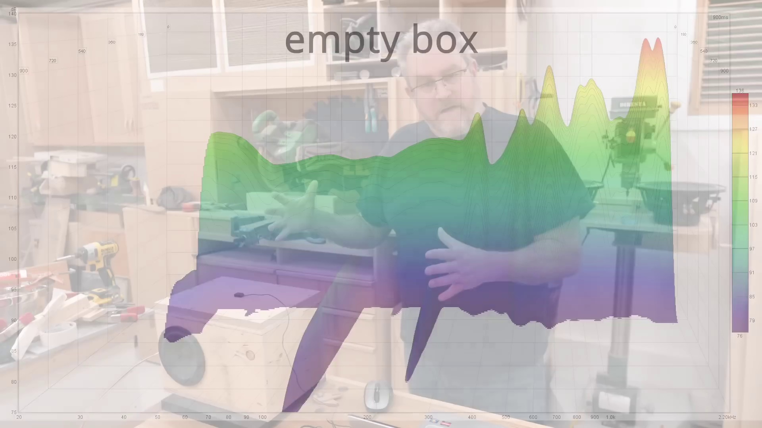 (score 85.0000)
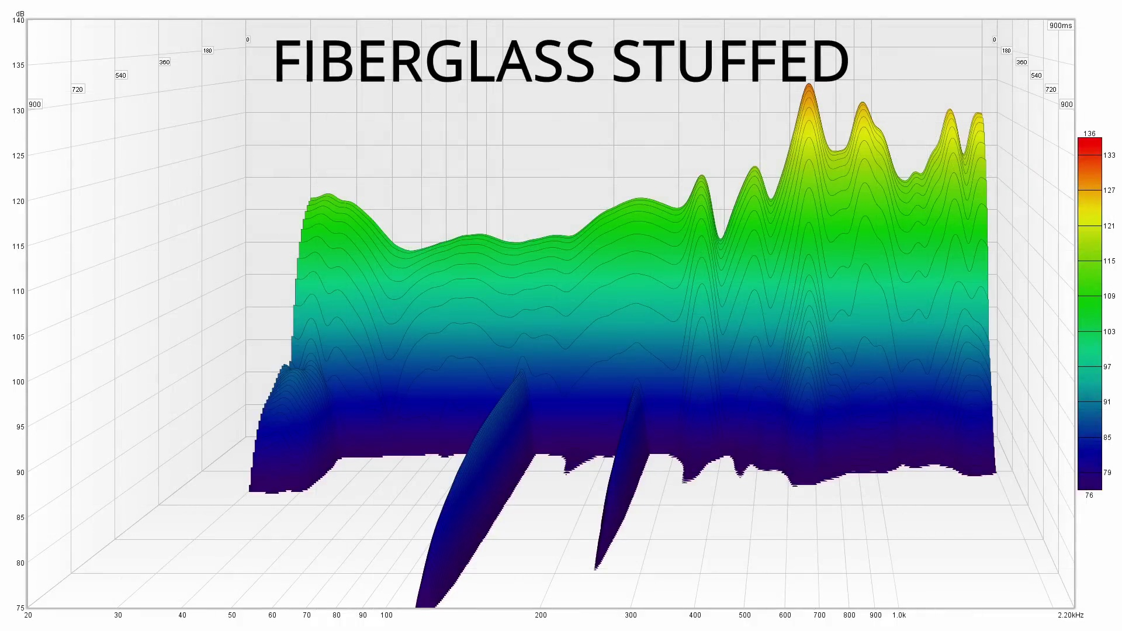 (score 85.0000)
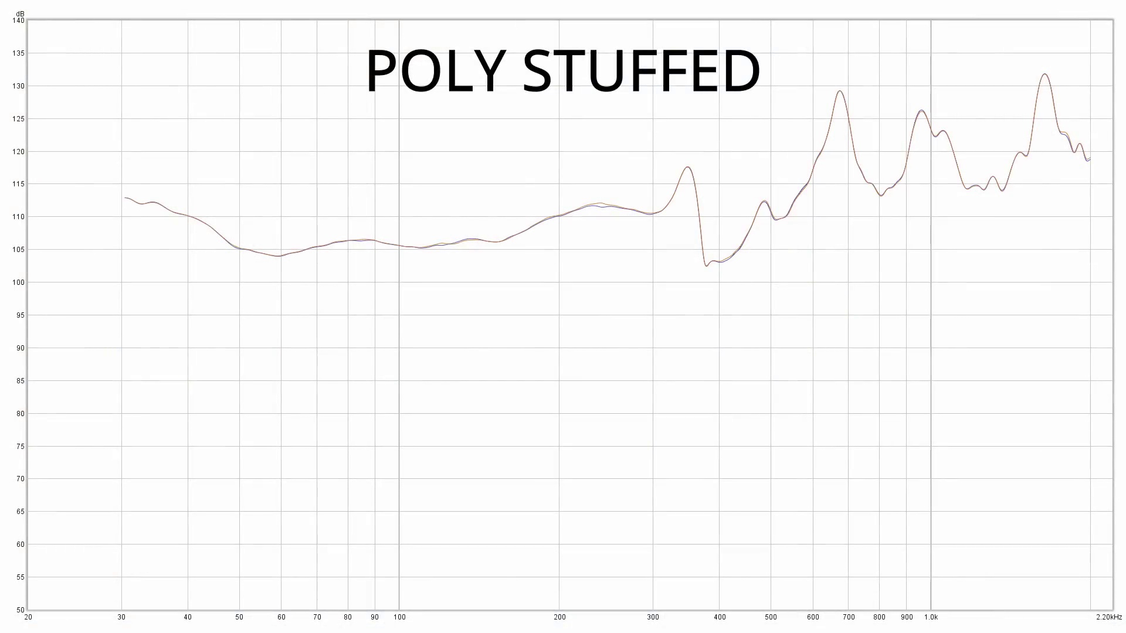 (score 85.0000)
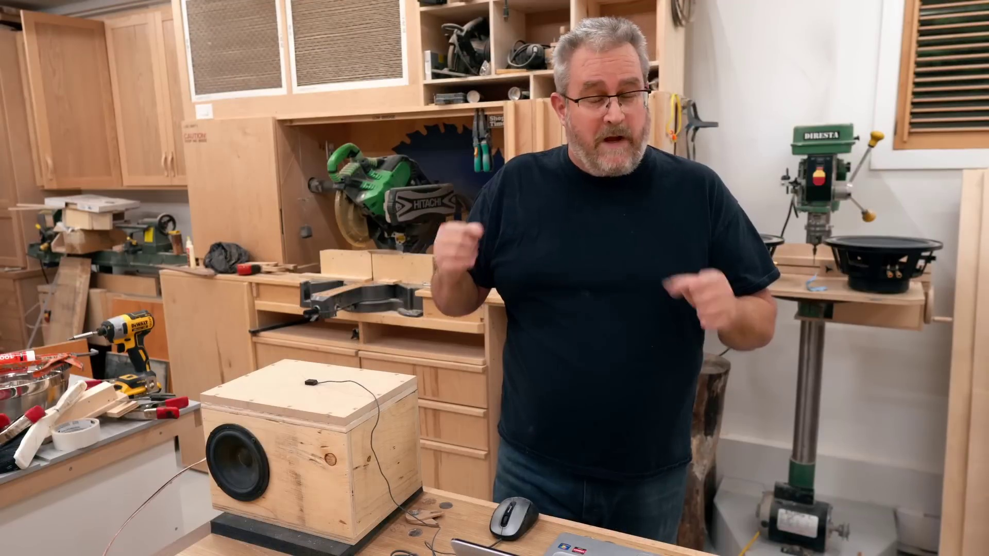 (score 85.0000)
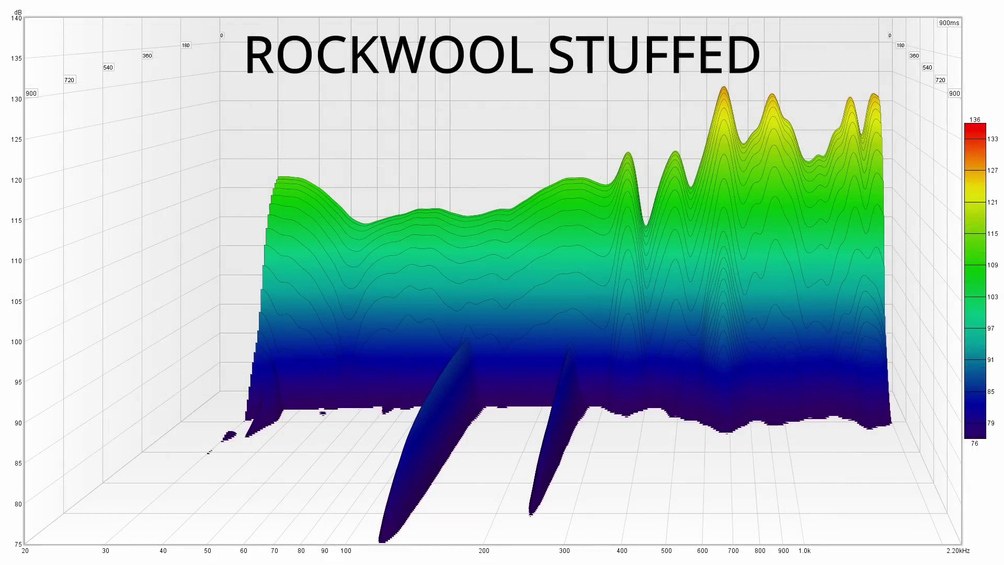 (score 80.0000)
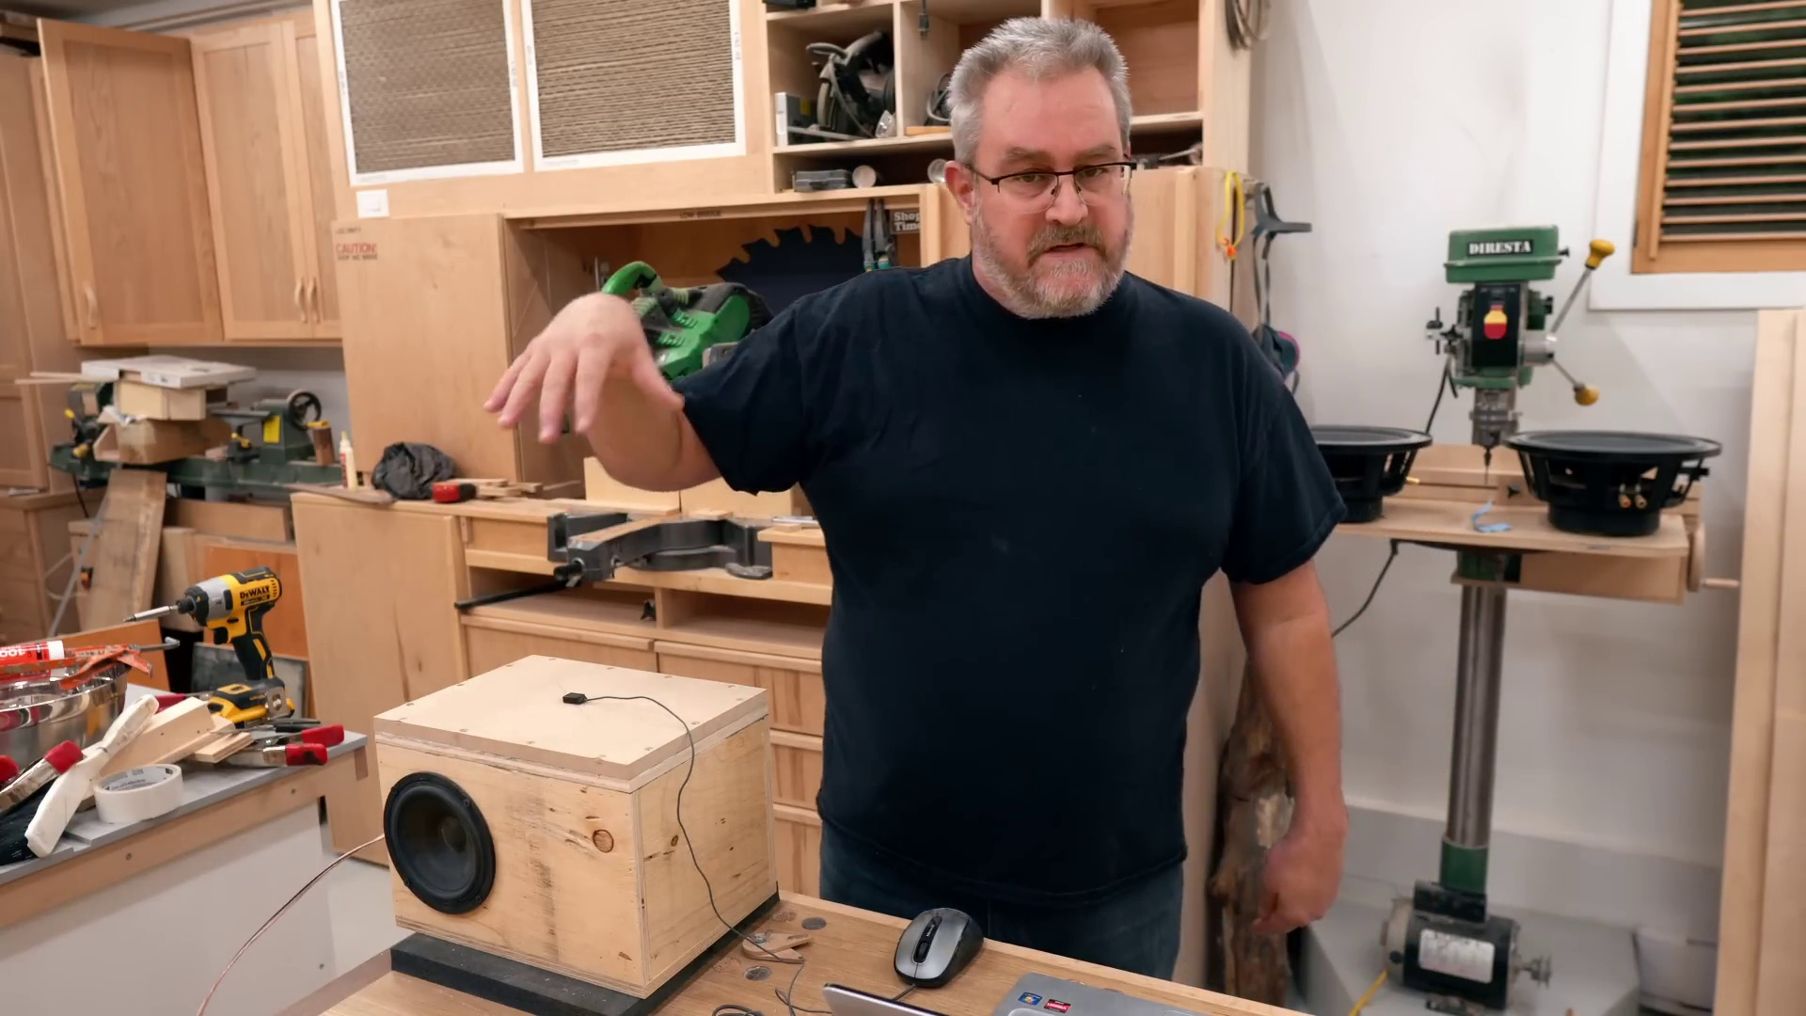 (score 80.0000)
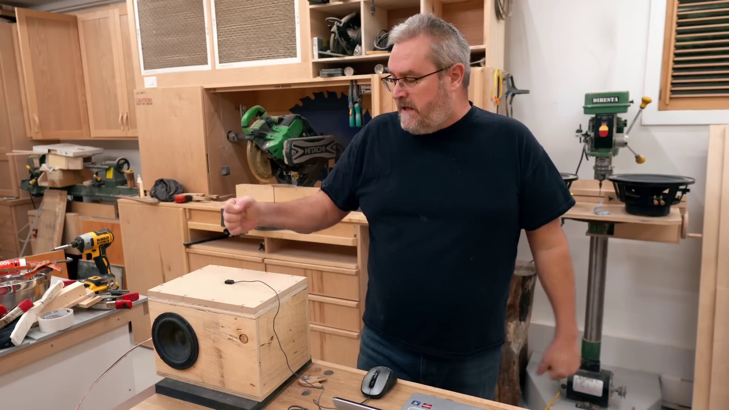 (score 80.0000)
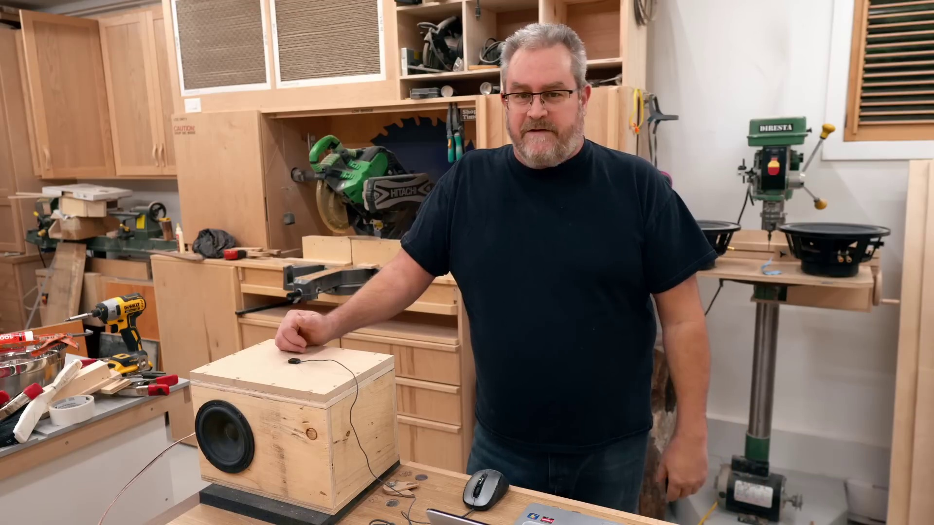 (score 80.0000)
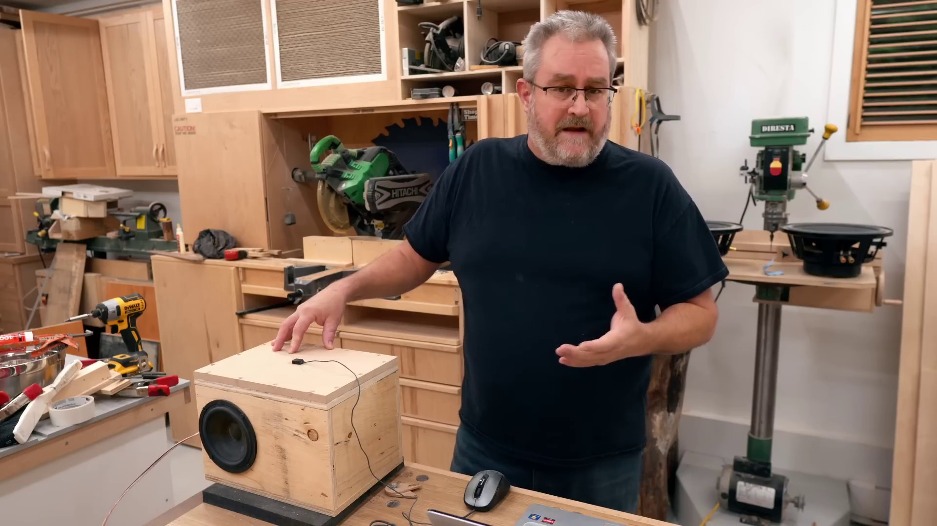 (score 60.0000)
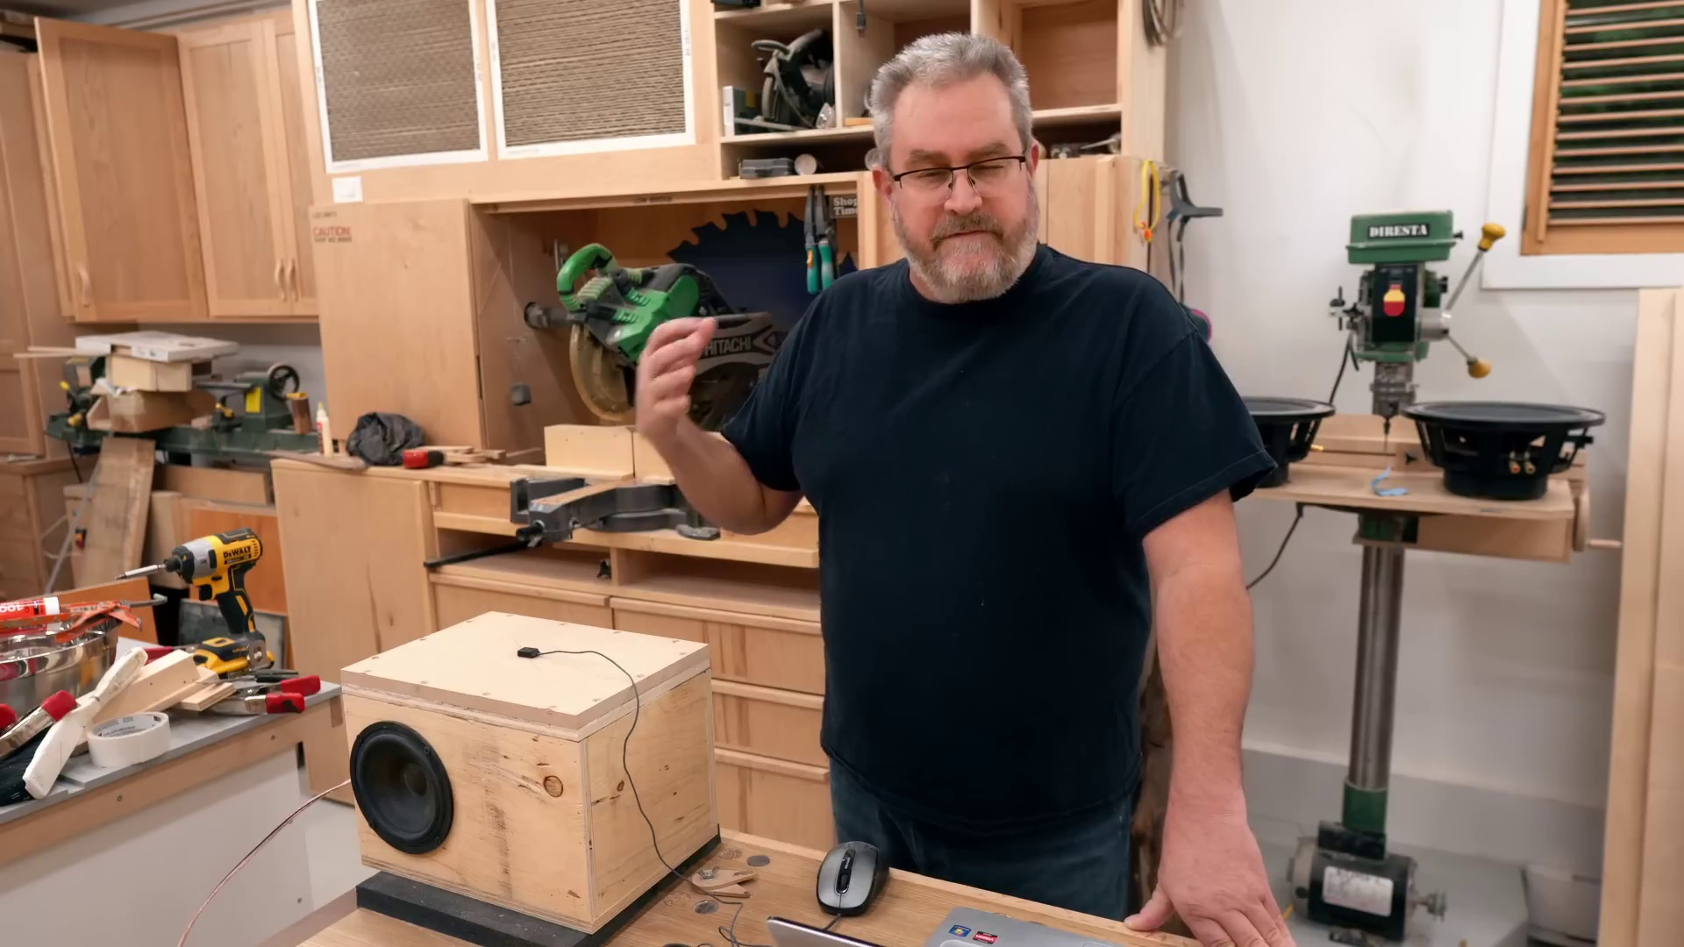 (score 30.0000)
Least correlated frames:
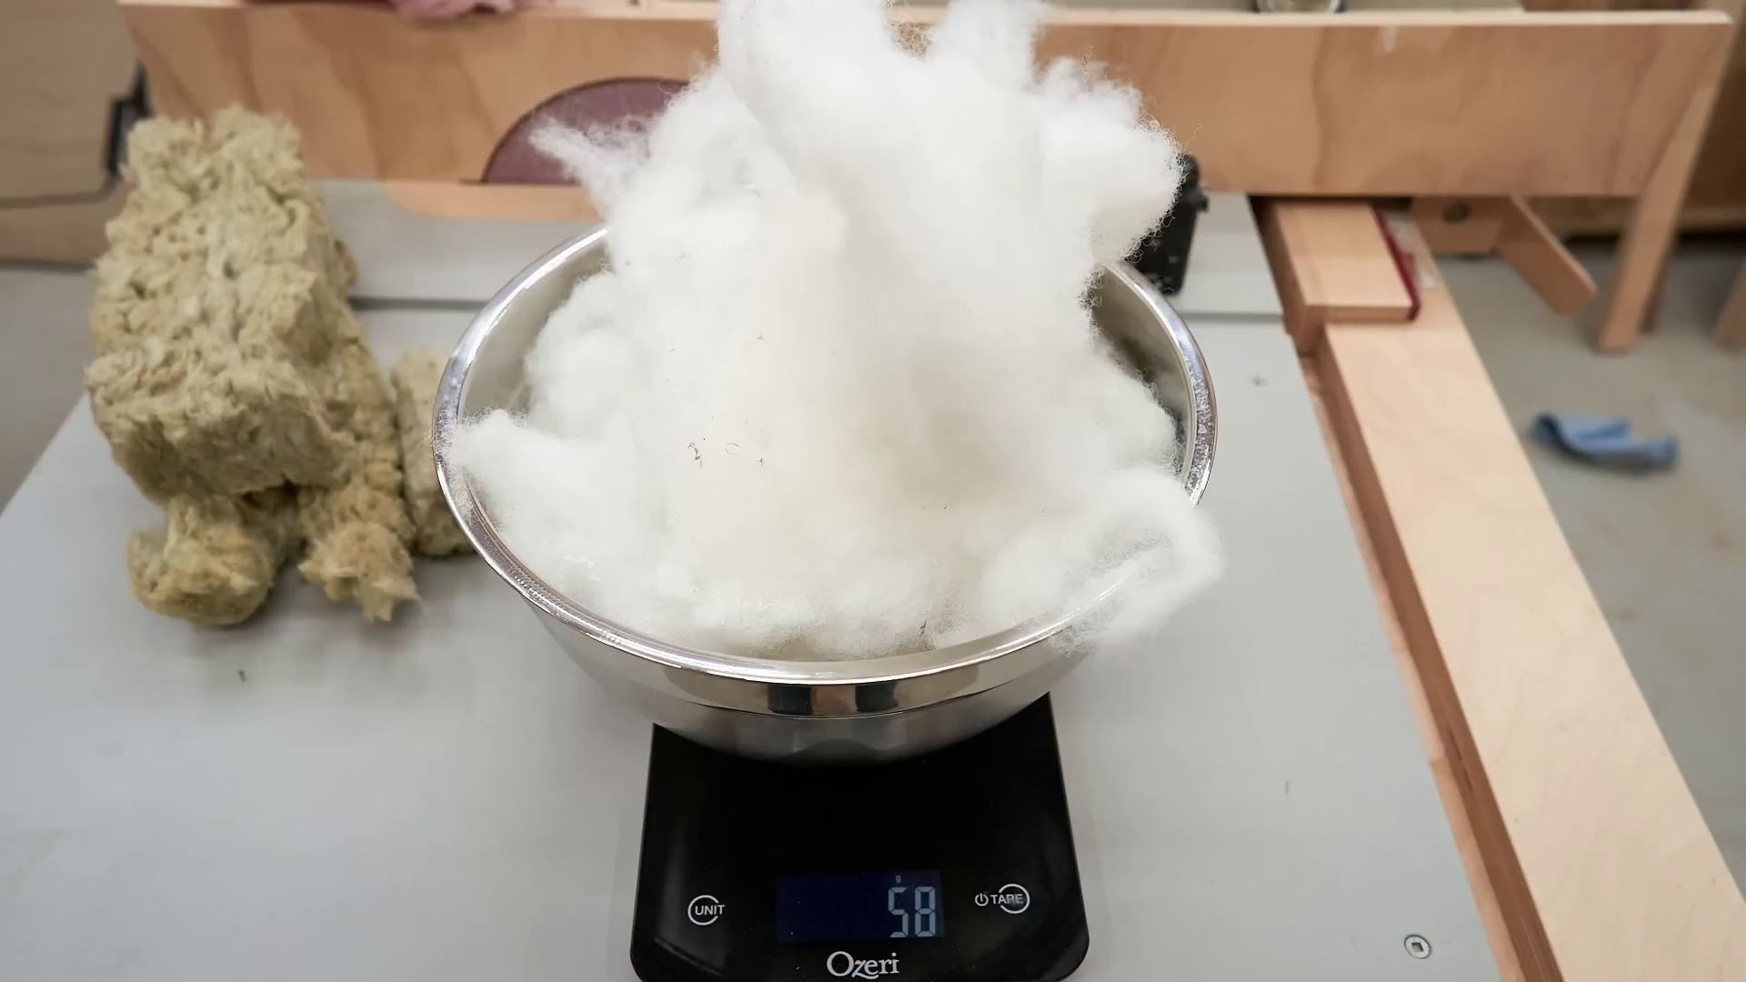 (score 0.0000)
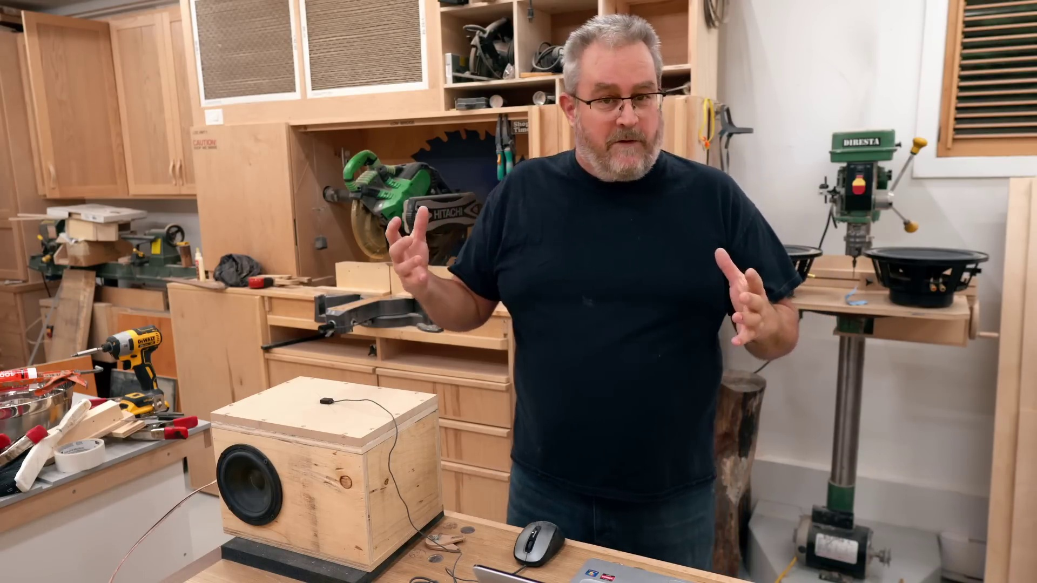 (score 0.0000)
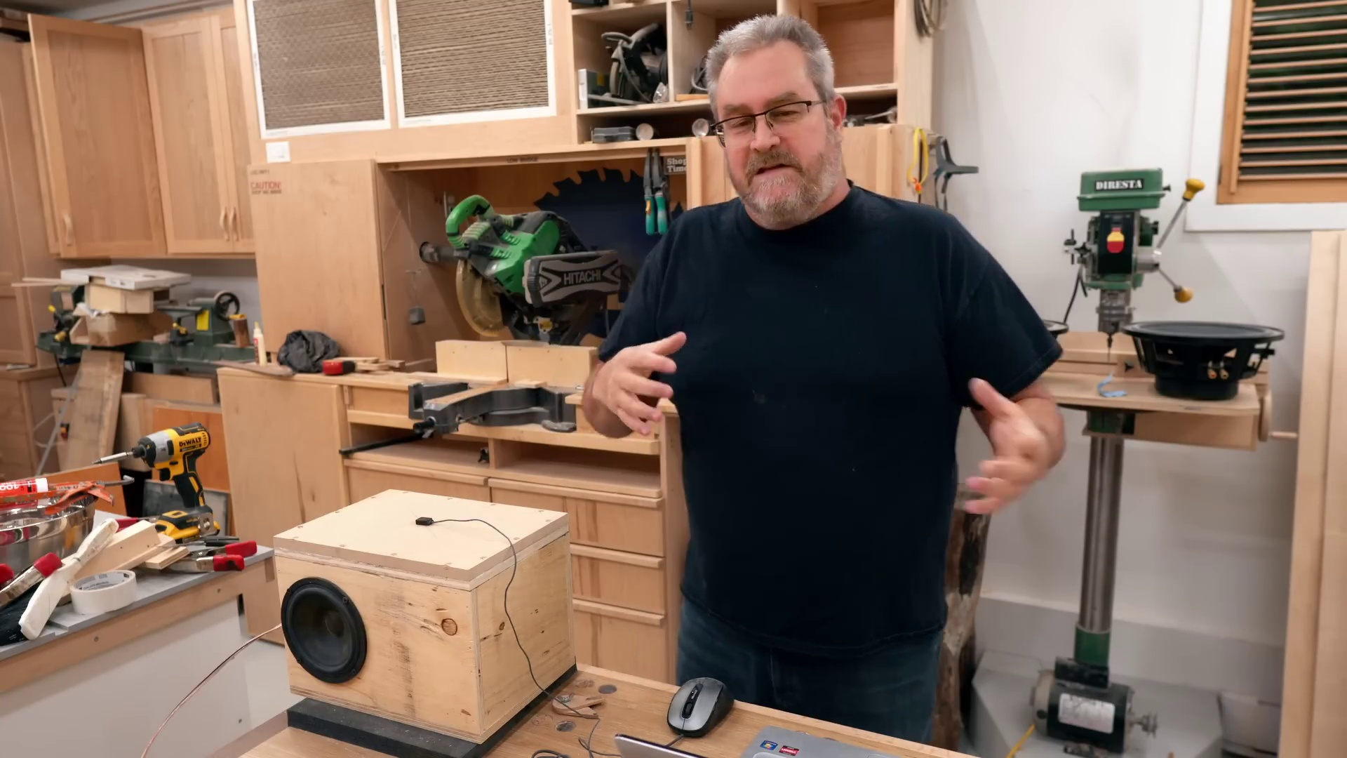 (score 0.0000)
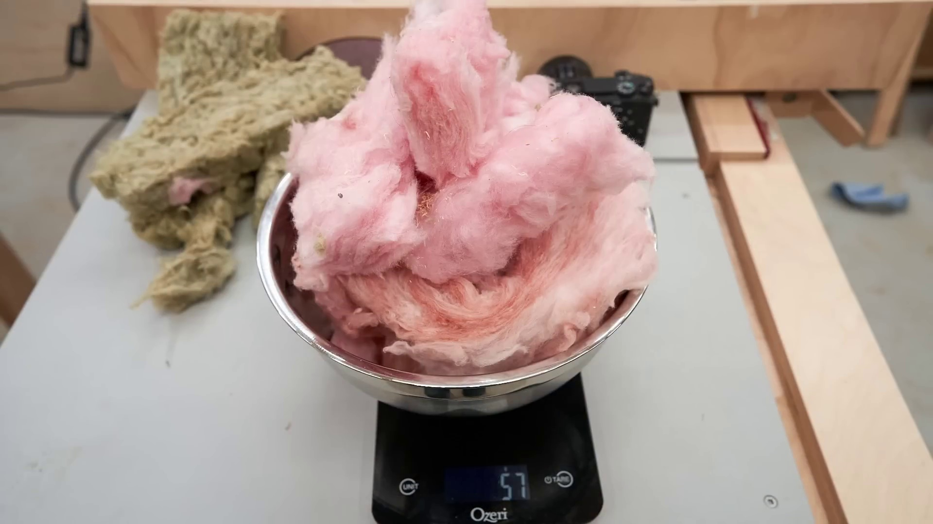 (score 0.0000)
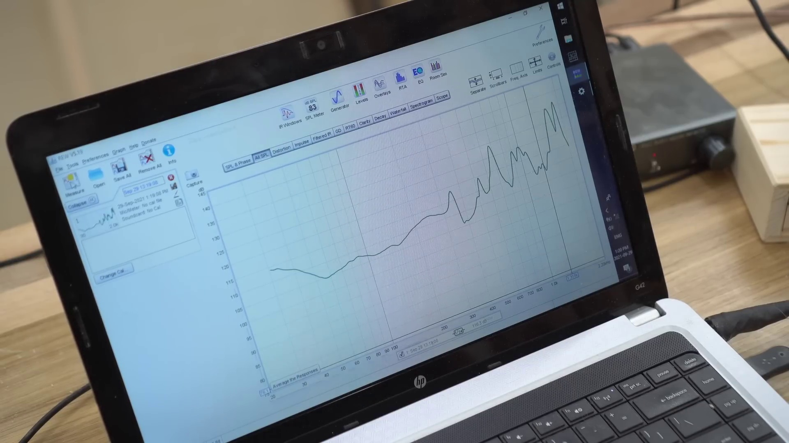 (score 0.0000)
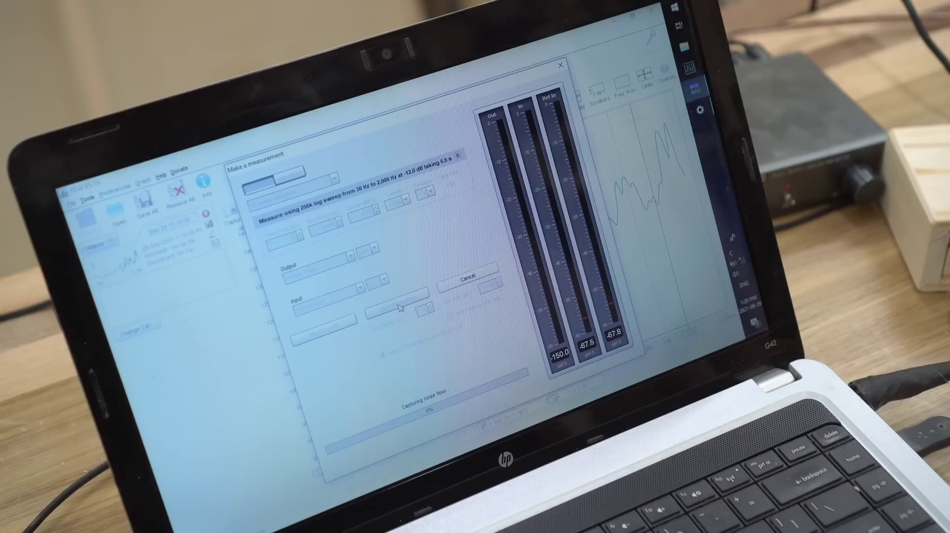 (score 0.0000)
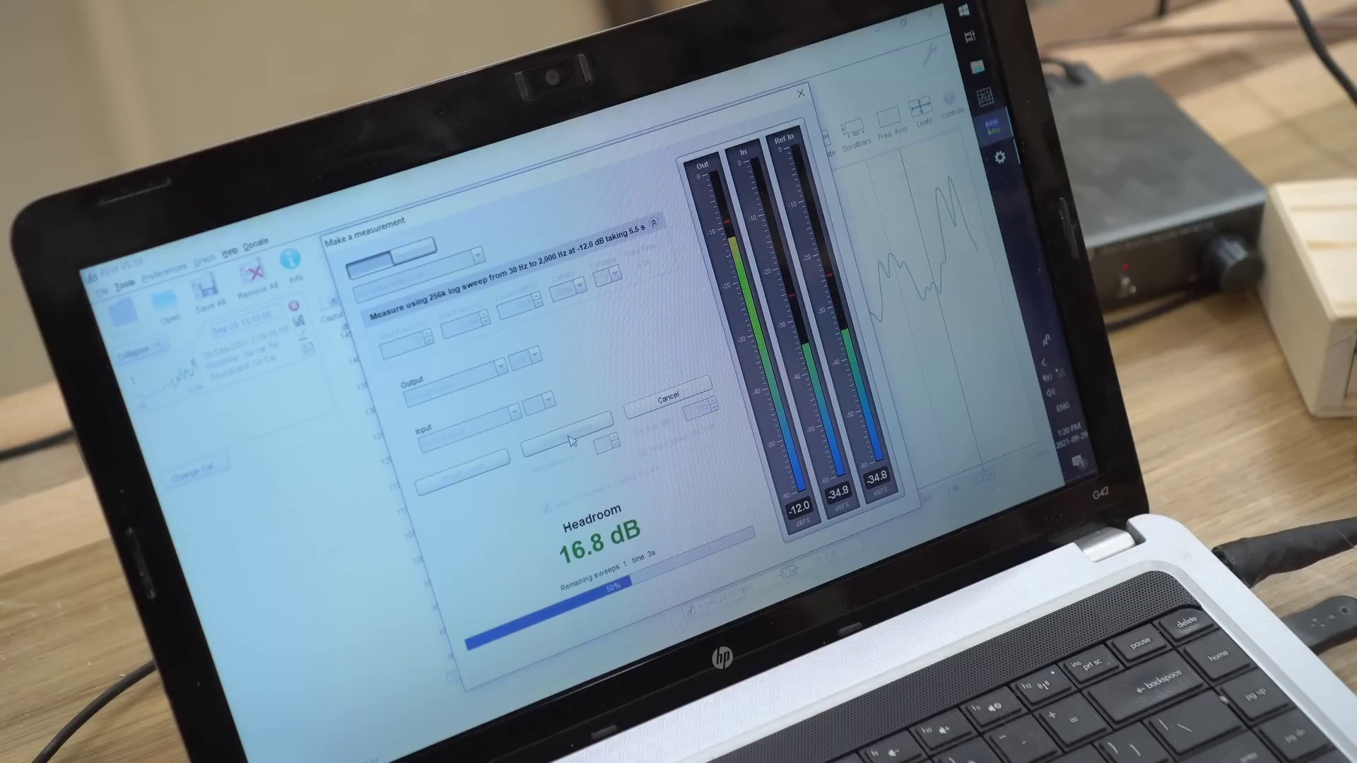 (score 0.0000)
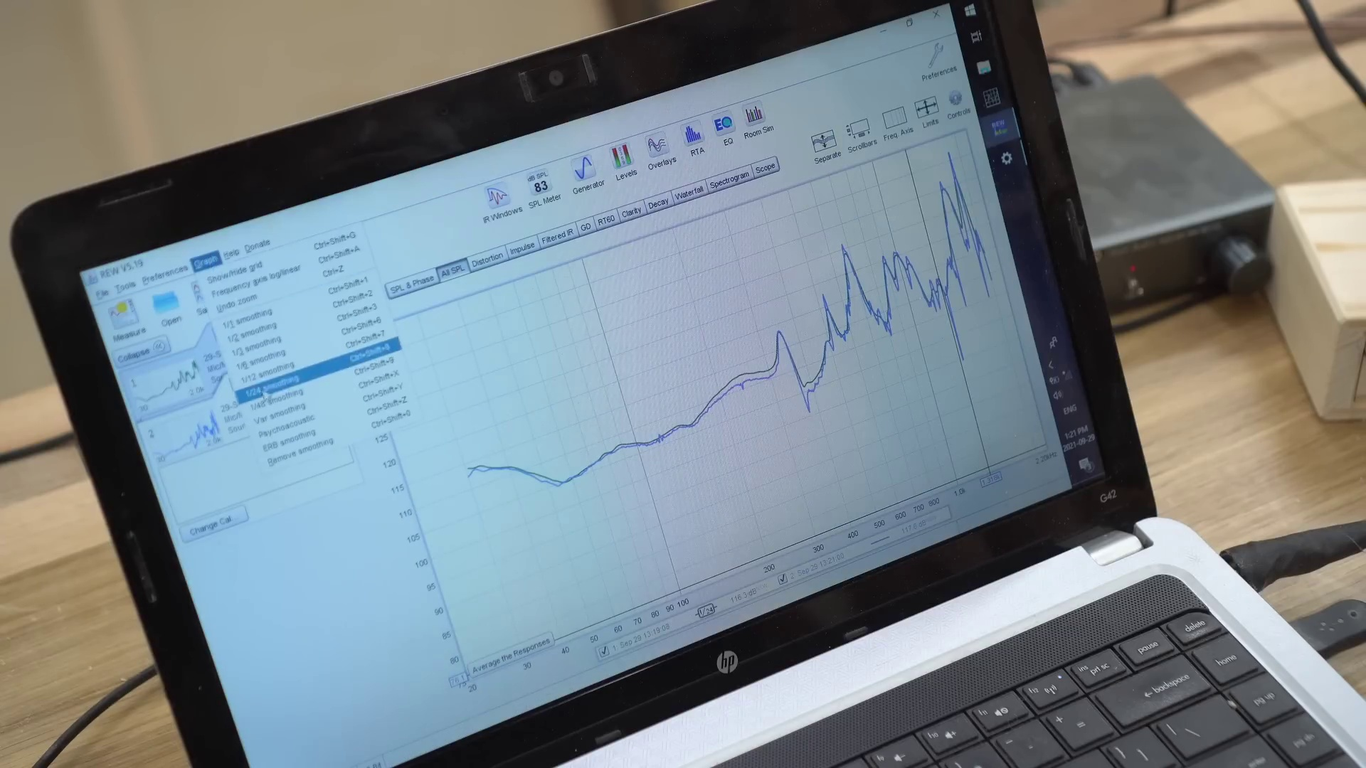 (score 0.0000)
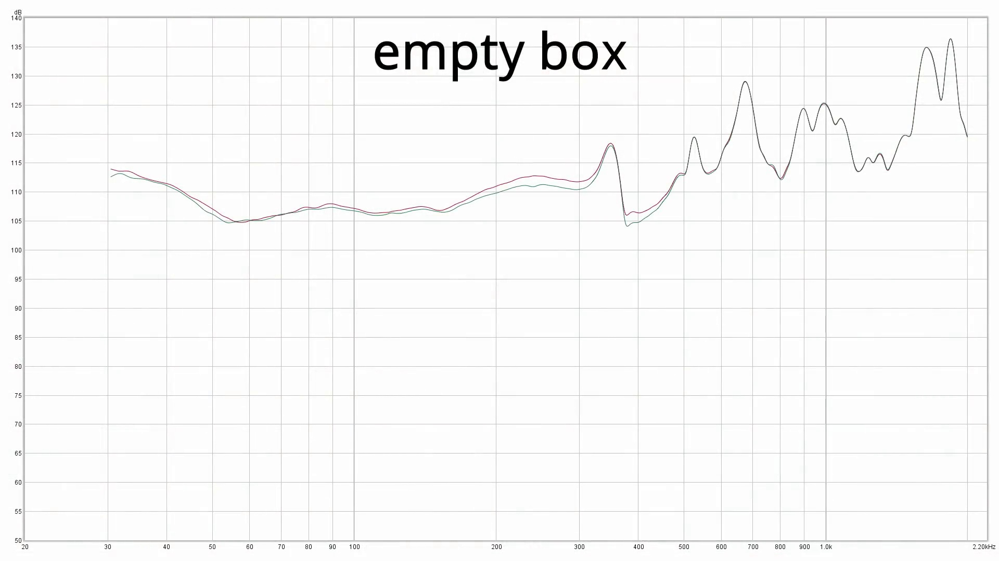 (score 0.0000)
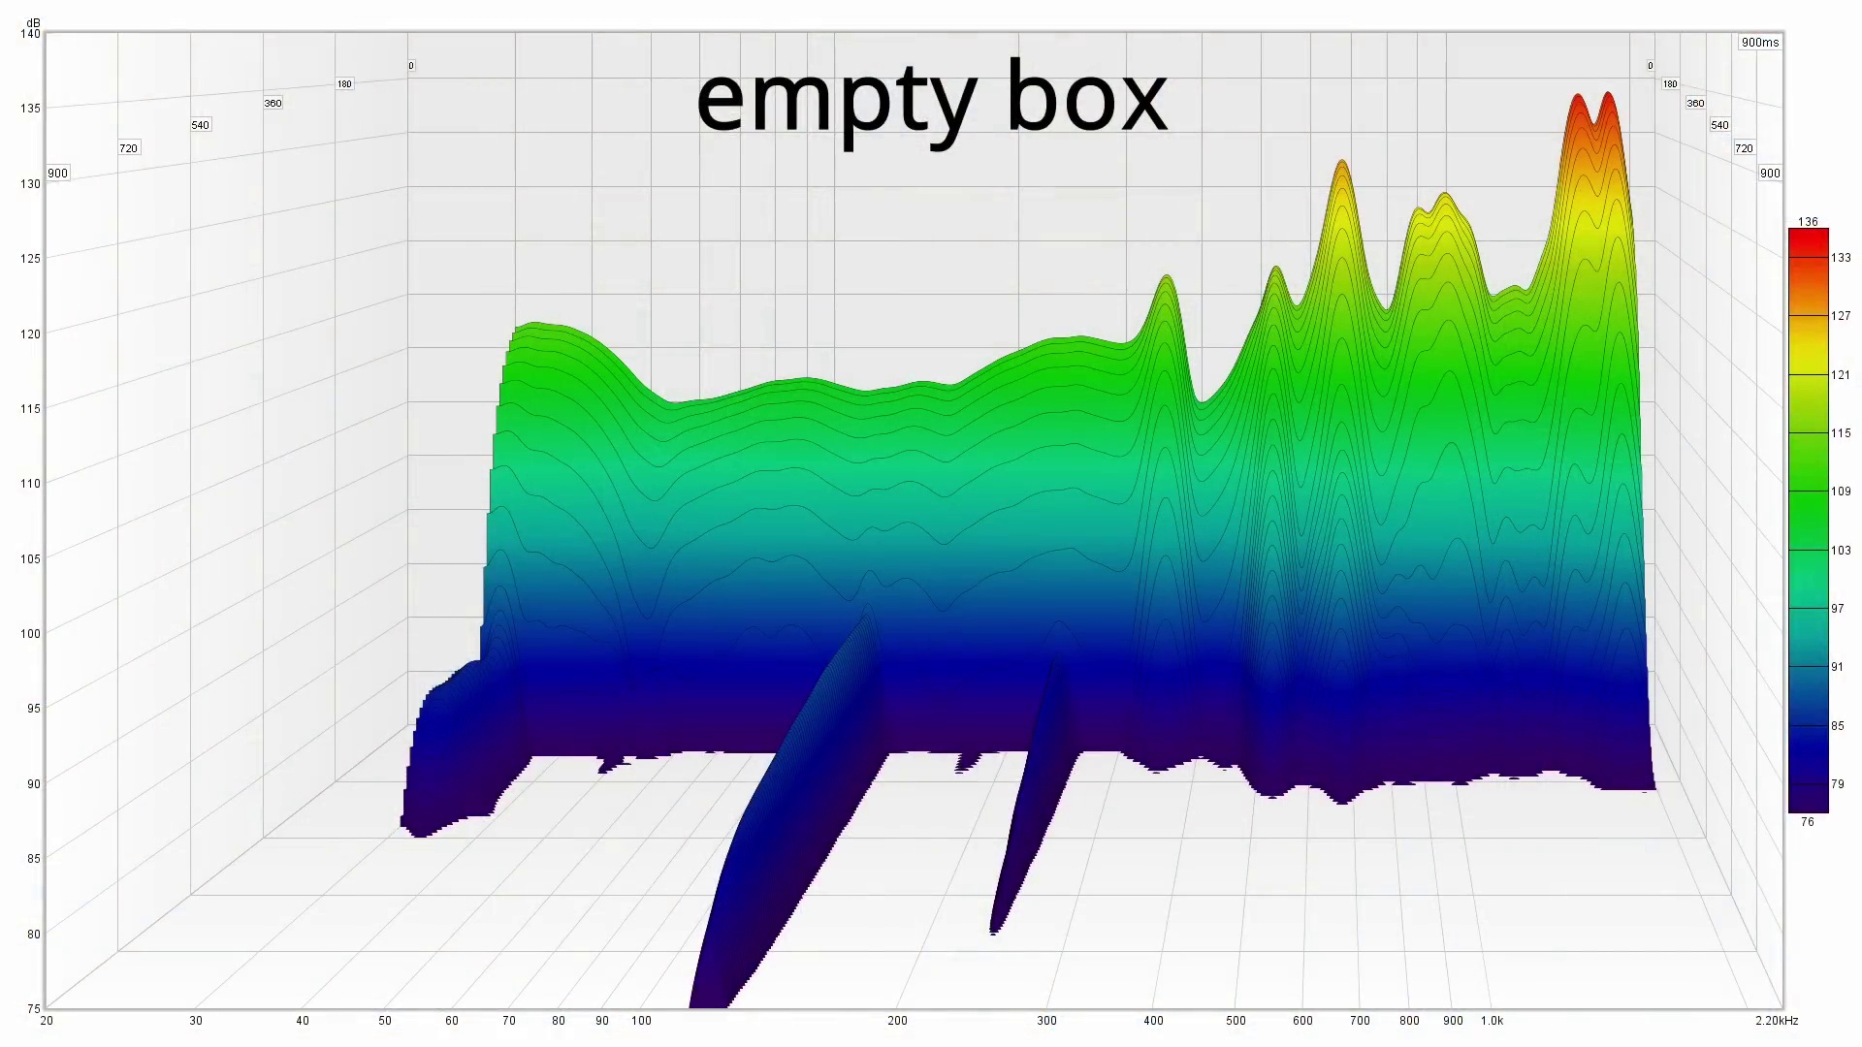 (score 0.0000)

Frame: frame_0000.jpg
Caption: The image shows a person working with electronic equipment in a well-equipped workshop setting. The individual, dressed in a black t-shirt, is standing at a wooden table that serves as the hub of activity, with various tools and equipment spread out before them. The person appears to be engaged in a task that involves soldering or connecting electronic components, possibly working on an audio device given the visible wires and circuitry.
The workshop is well-organized, with shelves stocked with an array of tools and equipment, indicating a space dedicated to craftsmanship and engineering. The precise arrangement of the tools and equipment suggests a space that is both functional and well-maintained. The computer mouse and drill are being used simultaneously, signifying the complexity of the task at hand.
The person's posture suggests they are in the midst of some complex task, with no discernible text visible in the image to indicate a teaching context or specific content being taught. Instead, the individual is focused on their work, with no interaction with teaching aids such as slides, diagrams, or models. The environment suggests a space dedicated to technical hobbies or DIY electronics projects, where tools are readily accessible and used in conjunction.
No strongly correlated comments found for this frame.

Frame: frame_0001.jpg
Caption: In the image, an individual is engaged in a workshop or demonstration setting, standing in front of a workbench with various tools and equipment. The person appears to be focused on their task, with their hands busy shaping a piece of wood into a rectangular box constructed from light-colored wood. They are dressed casually in a black t-shirt and blue jeans, with short dark hair and wearing glasses.
The workbench is filled with multiple devices, including a small electronic device on a breadboard, commonly used for prototype electronics, as well as metalworking tools and a drill press, typically used for precision drilling and machining. The individual seems to be gesturing with their left hand while looking towards the camera with a slight smile on their face, suggesting they might be speaking or explaining something to an audience not visible in the image.
The room around them is filled with shelves of tools and equipment, including a drill machine in the background, showcasing the individual's craftsmanship. The overall atmosphere of the scene suggests a moment of creation and dedication to a craft, potentially in an educational context such as teaching woodworking or DIY projects.
No strongly correlated comments found for this frame.

Frame: frame_0002.jpg
Caption: The image shows a person standing inside what appears to be a woodworking shop or garage. The individual is wearing a dark t-shirt, likely black judging by the mention of another similar-colored shirt, and has short grey hair. They are looking downwards with an expression of concentration or thoughtfulness. On the right side of the image, there's a wooden bench with various tools and equipment, including what looks like woodworking machines and a metal vice.
On the left side of the image, there is a whiteboard with text on it, although the text is not entirely legible due to the angle and quality of the photo. The visible portion of the text suggests it may be instructions or notes related to woodworking or some form of project.
In the foreground, the person holds a wooden speaker in their hands, crafted from multiple wooden panels and held in place by a metal stand. The workshop itself is a hub of activity with a green power drill stationed on the left side, its power source visible in the form of a black cord. Next to it, a black router is positioned, ready for use. The floor beneath them is covered in a variety of tools, their metallic sheen reflecting the workshop's industrial ambiance.
On the right side of the workshop, a computer mouse and keyboard are visible, suggesting the person's ongoing work on a project. The background of the image is a blur of activity, with various tools scattered across the space. Overall, the image captures a moment in the life of a person in their workshop, surrounded by tools and materials that speak to their passion for craftsmanship.
No strongly correlated comments found for this frame.

Frame: frame_0003.jpg
Caption: This image features an individual standing in what appears to be a workshop or garage setting. The person is wearing a black t-shirt and glasses, and they are holding up a device with visible wiring and connectors that looks like some sort of electronics project. They seem to be examining the device, possibly testing its functionality or adjusting its components.
Behind the individual, there's a workbench with various tools, a vice, and what appears to be a power tool on a stand, suggesting a space used for practical tasks such as woodworking or DIY projects. On the wall, there is a shelf with binders and other items, further indicating this environment is used for storage or organization of materials related to these activities.
In front of the individual, a wooden box sits on a table, surrounded by additional tables in the background. The man's attention is focused on the device he holds, which could indicate they are engaged in an educational activity or demonstration related to electronics or technology. There is no visible text or clear indication of a slide or presentation being used in this context, suggesting a hands-on learning environment where practical skills and knowledge are being demonstrated or applied.
The overall atmosphere suggests that the individual is working on a project, possibly building or assembling something, while also utilizing their problem-solving skills to troubleshoot or improve their device. The well-lit workshop provides ample space for creativity and innovation to flourish.
No strongly correlated comments found for this frame.

Frame: frame_0004.jpg
Caption: The image appears to show an individual standing in a well-equipped workshop environment, filled with various tools and equipment suitable for woodworking and electronics work. The man is dressed casually in a black t-shirt and glasses. He is holding a wooden speaker and pointing towards a wooden box on the nearby workbench, possibly explaining or demonstrating how to use certain tools or techniques.
The workbench itself appears to be stocked with machinery and tools, including a large green power drill, a black power saw, and a black router, suggesting a setting where woodworking, electronics, or similar crafts are practiced. The man is standing in front of the workbench, gesturing towards the wooden box and speaker with his left hand, which implies an educational or demonstration context.
The photograph provides a view of the person and part of the workspace from a distance, allowing for focus on the individual's interaction with the tools and objects, possibly during an instructional setting where he is teaching others about woodworking, electronics, or other crafts.
No strongly correlated comments found for this frame.

Frame: frame_0005.jpg
Caption: The image shows an individual standing in a well-equipped workshop or garage setting. The person is wearing a dark t-shirt, has short hair, and glasses. They are pointing at something out of frame with their right hand, while their left hand is on their hip. Their posture suggests that they might be explaining or discussing the object they're pointing at.
The background reveals a workspace environment with various tools and equipment. A workbench to the right side has woodworking tools and possibly some machinery or electronics. On the left, there is a shelf with different items on it, though their exact nature is not clear. The flooring suggests this could be a garage or a workshop due to the concrete and the presence of tools.
The wooden table in front of the individual is covered with various tools and equipment, including a black drill, a green power saw, and a blue hammer. The overall scene suggests a busy and productive workshop environment.
No strongly correlated comments found for this frame.

Frame: frame_0006.jpg
Caption: The image shows a man standing in a well-equipped workshop setting, wearing a dark black t-shirt and glasses. He is holding a microphone and appears to be examining it, possibly preparing for a presentation or demonstration related to the projects or equipment surrounding him. The workshop is filled with various tools and machinery, including a power drill mounted on the wall and a table saw in the background.
The man looks directly at the camera, as if speaking or presenting something to someone off-camera. Shelves behind him display a collection of items, including tools, parts of machinery, and other miscellaneous objects. The image has a watermark or overlay text that reads "WASH", suggesting it may be an error message or a software issue with the image file.
There are no visible texts, diagrams, or teaching materials in this frame. Instead, the context suggests that the man might be discussing or demonstrating a particular project or tool to someone not present in the image. The environment indicates an educational setting where hands-on learning and experimentation take place, possibly related to woodworking or crafting activities.
No strongly correlated comments found for this frame.

Frame: frame_0007.jpg
Caption: The image shows an indoor setting that appears to be a cluttered woodworking shop. A man in a black shirt is standing behind a wooden box, his right hand raised in the air. The box, which is constructed from wood, has a small speaker built into it. In front of him, there's a man facing away from the camera towards his left, with one hand on his hip and the other holding what looks like a small mechanical device or component. He is looking down at this item. This individual appears to be in the middle of examining or working on the device.
Behind them, there's a bench with various tools and equipment on it, suggesting a space for crafting or repair work. The background reveals more details about the environment: shelves filled with items that could be parts for a project or general workshop tools. On the right side of the image, you can see another person sitting at what seems to be a desk with computer equipment and additional tools, possibly indicating an area for design work or computer-aided manufacturing (CAM).
The overall impression is that of a well-equipped workspace where someone might be working on a DIY project, conducting repairs, or perhaps teaching others about mechanical systems given the presence of the small device being examined. The context does not suggest an educational setting with slides or diagrams, but rather a practical environment for hands-on activities and learning.
No strongly correlated comments found for this frame.

Frame: frame_0008.jpg
Caption: This image depicts an indoor setting that appears to be a workshop or garage. At the center of the frame is a man standing at a workbench, facing away from the camera towards some equipment on the bench. He is dressed in casual attire, wearing a black shirt and possibly glasses (although this detail is not explicitly visible). His body language suggests that he might be engaged in a task or explanation related to the devices present on the table.
The workbench has various items, including what looks like electronic components or tools. There are visible wires connected to some sort of device or object on the table. Additionally, there appears to be a small model of an electronic setup, which could indicate that he is demonstrating or constructing something. The man holds a speaker in his hand, which is plugged into a computer.
Behind the man, there's a shelf with various items and shelves filled with more tools and equipment. The background shows a standard garage setting with cabinets for storage. A window can be seen in the distance, providing natural light to the well-lit workshop. The image has an overlaid digital artifact that distorts the scene; this effect seems to have been added after the photo was taken.
Note: No texts, slides, or diagrams are directly visible in this frame.
No strongly correlated comments found for this frame.

Frame: frame_0009.jpg
Caption: This image depicts an individual, dressed in casual attire consisting of a black t-shirt and blue jeans, with short, dark hair, standing in front of a workbench with various tools and equipment. The person appears to be engaged in some sort of hands-on activity or explanation. On their left hand, they hold a wooden box with an electric cord running out of it, which leads to an outlet, suggesting that the box is connected to a power source and may be some sort of power tool or accessory.
The background features shelves lined with more tools, parts, and what seems like a display case containing various crafting materials. There is also visible machinery that might be related to the work being done or the instruction being given. The setting appears to be focused on practical work rather than formal instruction, as there are no slides or diagrams visible to indicate a teaching context.
Comment (score 80): I learned that fiberglass or rockwool are great for stuffing speaker boxes to improve sound. This is helpful for speaker setup in Phase 2.I'm unsure if this stuffing is only beneficial for bass speakers, and if box designs with internal walls can use stuffing in the same way.
Reason: The comment mentions speaker boxes and stuffing materials, which are directly related to the technical steps described in the caption (e.g., using fiberglass or rockwool for speaker box improvement). The caption also highlights a specific power tool or accessory being used, which is relevant to the commenter's experience with speaker setup.
Source: https://www.youtube.com/watch?v=3xe-g35SmEY: Best Stuffing for Speakers Tested - Unexpected Results

Frame: frame_0010.jpg
Caption: This image shows an indoor setting that appears to be a well-equipped workshop or garage used for DIY projects. A man stands in front of a workbench, surrounded by various tools and equipment, including a green power tool and a black toolbox. He is engrossed in his work, holding open a wooden box with a distinct design, revealing its contents.
The individual's attire consists of a dark top and dark pants, indicating a casual yet focused atmosphere. There are no visible slides, diagrams, or other educational materials that suggest he is conducting an instructional class. The tools and equipment around him suggest a mechanical or engineering context for the activity.
A small amount of text on one of the items on the workbench reads "12V DC," indicating that the model or device being worked on uses a 12-volt direct current power supply. To the right of the man, there is a computer mouse, which might suggest he is using it for his project or accessing information.
The image captures a moment in the man's work, showcasing his focus and dedication to his craft. The workshop, with its tools and equipment, serves as a testament to his passion for woodworking.
No strongly correlated comments found for this frame.

Frame: frame_0011.jpg
Caption: The image captures a moment of meticulous precision in a laboratory setting. A stainless steel bowl, resting on a wooden table, is filled with white cotton fibers, which are being processed using a traditional spinning wheel. The wheel has been used to spin the thread and has resulted in a pile of fibers in the bowl. On top of the wheel, there's a piece of machinery that resembles a gears or pulleys system, possibly related to the spinning process.
To the right of the spinning wheel, a digital scale is displaying "95" on its screen, indicating the weight of the cotton fibers in the bowl. The scale is calibrated and seems to be measuring the amount of material collected from the spinning process.
In the background, a pile of white cotton fabric is visible, neatly folded and adding a sense of order to the scene. The fabric and the bowl with the fibers are positioned on the same wooden table, suggesting a workspace or laboratory setting.
The image does not contain any discernible text or additional objects, but it captures the essence of precision and attention to detail.
No strongly correlated comments found for this frame.

Frame: frame_0012.jpg
Caption: The image shows a precise and meticulous textile production setup. In the center of the frame, a silver metal bowl contains a neatly arranged pile of white fluffy fabric, hinting at its softness. The bowl is situated on a wooden table with a grainy surface, adding rustic charm to the scene.
A digital scale is present on the table, displaying the weight of the fabric as 58.2 grams, suggesting that the fabric is being weighed for measurement or processing purposes. A separate scale with a digital readout displaying "61" is also visible on the left side of the image, indicating weight measurement for the project being undertaken.
In the background, a piece of brown wood is visible, potentially used in the production process as a cutting board or part of the machinery. On the same wooden table, there appears to be a ball of dough or clay and a wiggly worm-shaped sculpture made from the same fluffy material as the fabric in the bowl.
The image also features a text overlay that reads "61g 0.5%," which could imply the percentage of something mixed into the material in the bowl, suggesting precision or recipe measurements for the crafting process. The image appears to be taken from a webcam feed or a screenshot, given the video quality and the visible digital interface at the bottom. There is no text overlay that indicates an instructor or provides additional context, so it's unclear if someone is teaching or presenting in this frame.
No strongly correlated comments found for this frame.

Frame: frame_0013.jpg
Caption: The image captures a moment of tranquility in a laboratory setting where a science experiment is taking place. On a scale, there appears to be a white substance being weighed, which resembles cotton candy. Behind the scale, a person with their back facing the camera, likely an instructor or scientist conducting the experiment, can be seen. To the right of the scale, various materials are arranged on a table, including what could be a syringe and a pipette, alluding to the experiment's purpose.
The scene is set against a backdrop of lab equipment, possibly including a fume hood or chemical storage area, contributing to the atmosphere of scientific precision. The focus remains on the process and materials rather than any theoretical or educational content.
No strongly correlated comments found for this frame.

Frame: frame_0014.jpg
Caption: The image appears to show an indoor setting that resembles a workshop or garage. At the center of the frame is a man who is holding his hands out to his sides and looking at someone or something off-camera with a thoughtful expression. He has dark hair, is wearing a black t-shirt, and glasses.
The man is standing in front of a workbench that contains various tools and equipment. On the bench, there's a power drill, a clamp, and other miscellaneous items. To his right, there's a small wooden cabinet or stand with drawers, and on top of it, there's what looks like a small electrical device or circuit board with components visible.
Behind the man, the background is filled with shelves containing more tools and materials. The walls are made of wood panels, and there's a visible vent on one wall. A wooden box is also present in front of him, which is open and contains a white speaker inside. On a nearby table, a computer mouse can be seen, along with various tools including a screwdriver and drill.
The workshop appears to be well-lit and organized, suggesting that the man could be giving a tour or demonstration related to electronics, DIY projects, or some form of hands-on work. However, without further context, it's not possible to determine the exact nature of the lesson or activity taking place.
No strongly correlated comments found for this frame.

Frame: frame_0015.jpg
Caption: The image shows an individual standing in a woodworking shop, which appears to be equipped with various tools and equipment. The person is wearing a dark T-shirt and shorts. In the foreground, they are standing in front of a wooden table, on which there is a wooden speaker and a black computer mouse. As the focus of the image is on the person and their actions, not the content of any slides or text that may be present in the background, it's clear that the man is engaged in creative and possibly instructive activity.
He is wearing glasses and gesturing with his right hand towards the speaker, suggesting that he is talking about it. The environment looks like a personal workshop where someone might engage in DIY projects or hobbies. In the background, there are shelves filled with items that suggest a workspace for woodworking or similar crafts, including visible workbenches with woodworking tools such as clamps, saws, and measuring instruments.
No strongly correlated comments found for this frame.

Frame: frame_0016.jpg
Caption: This image shows a middle-aged individual standing in front of well-equipped workbenches, wearing a black t-shirt and gesturing with their right hand towards the camera. The person appears engaged in an activity or demonstration, possibly explaining something to someone off-camera. Behind them, various tools and equipment are visible, including drills, power tools, and possible mechanical parts or components.
To their right, a workbench features a clear glass top, revealing additional tools below it. The individual is positioned in front of a wooden table covered with an array of tools and equipment, including a green power drill, a black saw, and a black screwdriver. They are holding a black computer mouse in their hand, which appears to be the focal point of their explanation or demonstration.
The workshop environment is filled with various tools and equipment, indicating a space dedicated to woodworking and other manual tasks. The overall atmosphere of the image suggests hands-on activity and engagement, with no visible texts, equations, or diagrams providing specific information about the context or topic being discussed.
No strongly correlated comments found for this frame.

Frame: frame_0017.jpg
Caption: The image shows an individual standing in a well-equipped workshop or garage, wearing glasses and having short hair. The person is gesturing with one hand, possibly explaining something, while holding a black mouse suggesting they might be using it for some work on their computer. They are standing in front of a wooden table that has various tools and equipment on it, including what appears to be power tools, construction materials, and specific tools such as a saw, drill, and table saw.
Behind the individual, there are shelves with more tools and equipment visible, which could include parts for machinery or projects in progress. The left side of the image is partially obscured by the person, revealing a large machine with various parts that might be part of a larger project. No texts or slides are visible on which the person might be writing or pointing.
The background of the image shows more tools and equipment, as well as items that might be stored or kept for future use. The lighting suggests it is an indoor setting, likely illuminated by natural light coming in through a window. The style of the image appears to be candid, taken during a break in work or as part of documenting a project or activity in this workshop space.
No strongly correlated comments found for this frame.

Frame: frame_0018.jpg
Caption: The image depicts an individual standing in a well-equipped woodworking workshop, dressed in a black shirt and glasses. The person is facing towards the camera and appears to be gesturing with their left hand while speaking or explaining something about a wooden project on their hands. The project, which is in the process of being assembled, is a stereo speaker.
The workshop is filled with various tools and equipment, including a large workbench, a table saw, a drill press, and a band saw, indicating a space dedicated to woodworking and electronics. On the shelf behind the individual, there are more tools and equipment, as well as wooden parts that may suggest some form of woodworking or construction activity.
On the left side of the image, another figure is partially visible, dressed in overalls, possibly indicating the presence of another person in the workshop.
No strongly correlated comments found for this frame.

Frame: frame_0019.jpg
Caption: The image appears to show an indoor setting with a person standing behind a workbench, gesturing and speaking, possibly explaining a concept or demonstrating a project. The individual's face and upper body are visible, but their identity is not discernible from the image. Behind the person, there are various items that suggest this space might be used for both hands-on work and digital tasks.
On the left side of the workshop, a wooden cabinet contains what seems to be a vacuum cleaner inside it, as well as a small object that could be an electronic component or tool on top of it. In the center, there is a wooden plank with some tools and possibly parts for a woodworking project. To the right, a machine with a metal frame sits next to various other tools and pieces that could be related to woodworking or engineering.
The background features a partial view of someone seated at a table with a computer monitor, indicating that this space might be used for both hands-on work and digital tasks. The workshop is well-equipped and suggests a passion for DIY projects, as the individual dressed in a black t-shirt gestures triumphantly with their right hand. A green power drill stands prominently on the left side of the workshop, its handle pointing upwards.
On the right side of the workshop, a black and white keyboard perches on a wooden table, possibly indicating the individual's interest in computer programming or music. The overall environment suggests a workshop or home laboratory where DIY projects are undertaken, and the various tools and equipment scattered around testify to the individual's skills and passion for woodworking and technology.
No strongly correlated comments found for this frame.

Frame: frame_0020.jpg
Caption: The image shows an individual standing in front of a well-equipped workshop, dressed in a black t-shirt and glasses. They appear to be engaged in some sort of activity that involves electronic or woodworking components, as there are visible cables, a small circuit board, and other technical items on the workbenches surrounding them. The person is wearing a dark t-shirt and is holding up what looks like a small model or component with their left hand, which might be related to their current task.
The workshop is filled with various tools and equipment, including a green power drill, a black saw, a white router, and shelves holding additional tools and storage space. The walls of the workshop are adorned with more shelves, providing ample storage for the many items on display. A whiteboard in the background seems to have some scribbles on it, possibly outlines or notes related to the activity at hand.
To the left of the person, there are additional workbenches with similar items, and a microphone stand is visible, suggesting they may be recording a podcast or giving an online lecture. However, no camera or microphone is present in the image, leaving the purpose of the setup unclear. The focus seems to be on the individual and their immediate work area, rather than any instructional setting.
No strongly correlated comments found for this frame.

Frame: frame_0021.jpg
Caption: This image presents a unique blend of creative and digital workspaces. In the foreground, a silver bowl filled with light pink cotton candy sits on a wooden table, adding a playful touch to the scene. The cotton candy is fluffy and vibrant against the metallic bowl, creating an interesting contrast.
Behind the bowl, a scale stands out in the center of the image, featuring a ball of fluffy pink material weighing approximately 125 grams. This could imply that the material is being used for a specific purpose or recipe, perhaps related to spinning yarn or similar fiber arts.
To the side of the bowl and scale, a piece of fabric with designs on it is visible, possibly linked to the project at hand. The blurred background suggests an indoor setting with a countertop where various crafting items might be kept.
On the gray wooden table in the distance, a digital display screen mounted on it displays the number 51, hinting that this area might be used for some form of digital work or activity. Overall, the image presents a workspace that combines creative and digital elements, with cotton candy adding an unexpected yet intriguing element to the scene.
No strongly correlated comments found for this frame.

Frame: frame_0022.jpg
Caption: The image captures a candid moment in a room where a digital scale is set against a wooden table. The black digital device displays a reading of 175 grams, indicating the weight of the greenish substance contained within a bowl placed on top of it. The bowl appears to be made of silver and holds a pile of brown materials, with the surrounding environment reflected in its surface.
The wooden table adds a touch of warmth to the otherwise sterile environment, suggesting that this may be a workshop or kitchen setting. There are no people visible in the frame, nor is there any text or additional objects present. The digital scale and bowl are stationary, with their positions remaining unchanged throughout the image.
While the exact color of the brown materials cannot be confidently determined, they appear to be some type of insulation or material used in construction or home improvement projects. Overall, the image presents a detailed snapshot of this moment in a workspace, focusing on the digital scale and bowl of brown materials, with no signs of writing, pointing, holding a model, or speaking from a slide.
No strongly correlated comments found for this frame.

Frame: frame_0023.jpg
Caption: The image shows a person standing in a room that appears to be a workshop or garage. The individual is wearing a dark t-shirt and glasses, with one hand placed on their hip and the other holding up a small electronic device, possibly a controller or switch. The setting includes various tools and equipment scattered around, including what seems to be a woodworking project in progress.
The room has wooden shelves with additional tools and equipment. On the wall behind the person, there is a large wooden crate with a metal grate on top. To the left of the frame, there is a door with a metal mesh pattern, and above it, a whiteboard with some writing on it, which appears to be incomplete or illegible due to the angle of the photograph. There are no visible slides or diagrams that provide additional context or information about the topic being taught.
In front of the person, a wooden table is a hub of activity, featuring a speaker being assembled, its components neatly arranged. A computer mouse is also present, suggesting that this might be a workspace for more than just woodworking. The person's attention is focused on the electronic device they are holding, possibly explaining or demonstrating a technical aspect or repair process involving electronic components.
The overall setting suggests an informal learning environment where hands-on activities and practical knowledge are being shared or demonstrated. The person's animated gestures and intense focus convey a sense of creativity and problem-solving, as if they are working on their wooden project while also sharing their expertise with others.
Comment (score 85): I learned that fiberglass or rockwool are great for stuffing speaker boxes to improve sound. This is helpful for speaker setup in Phase 2.I'm unsure if this stuffing is only beneficial for bass speakers, and if box designs with internal walls can use stuffing in the same way.
Reason: The comment directly discusses the use of stuffing (fiberglass or rockwool) in speaker boxes to improve sound, which is closely related to the technical aspect shown in the frame caption, where a speaker is being assembled.
Source: https://www.youtube.com/watch?v=3xe-g35SmEY: Best Stuffing for Speakers Tested - Unexpected Results

Frame: frame_0024.jpg
Caption: The image appears to show an individual standing in a well-equipped workshop setting. The person is gesturing with their right hand, which is outstretched towards the camera, while holding something that seems to be a model or a small object they are presenting. They are wearing glasses and have short hair, suggesting they may be older or middle-aged.
The environment suggests this may be a video recording setup, given the presence of a backdrop with what looks like a green screen behind the person. The background also shows various items typical of a workshop, such as tools, equipment, and possibly materials for crafting or woodworking. On the left side of the image, there is a wooden cabinet with a glass front, which appears to have shelves holding what could be tools, parts, or other supplies related to the workshop activities.
The individual is dressed in casual attire, wearing a black t-shirt. In their right hand, they hold a black mouse, possibly indicating that they are engaged in computer-aided design or programming for a project. The workshop is well-equipped with various tools, including a green power drill, a black power saw, and a white power drill. The walls of the workshop are lined with cabinets, each containing various tools.
The overall scene suggests a workspace where craftsmanship, creativity, and possibly technology come together. The individual's gesture and the context suggest that they might be instructing someone about a project or explaining how something works, possibly building a speaker or a piece of furniture.
No strongly correlated comments found for this frame.

Frame: frame_0025.jpg
Caption: The image shows an individual working on a wooden speaker in a well-equipped workshop. Here are the details that can be observed:
1. The person is standing at a workbench with various tools and components surrounding them, including what looks like a soldering iron, tweezers, wires, and possibly other items related to woodworking.
2. In front of the individual, there's an unfinished project in progress, suggesting they might be building or repairing something. It appears to involve some form of mechanical assembly, as indicated by the presence of gears and other parts on the workbench.
3. The workbench is equipped with a clamp, possibly used for holding parts securely during assembly or repair work.
4. The person is wearing a black t-shirt and has short hair. They seem focused on the task at hand, which involves working on the wooden speaker attached to a wooden table.
5. The individual is holding a black object in their hand, which appears to be a computer mouse.
6. In the background, there are shelves or cabinets that contain various items, possibly related to their work, such as boxes and other materials.
7. To the left of the image, there's a cabinet with compartments that may store additional tools or components.
8. The overall setting appears to be a garage or workshop, given the presence of the workbench, wooden speaker, and utilitarian nature of the space.
From this description, it's not possible to determine if there is a teaching context involved. However, the image captures someone engaged in hands-on work that could be related to an educational setting, such as a DIY or engineering class.
No strongly correlated comments found for this frame.

Frame: frame_0026.jpg
Caption: The image appears to be a screenshot from a video editing or recording software, featuring a black screen with white bold text centered. The text reads: "Camera Stopped Recording test setup change speaker on 1” thick foam and not clamped to the workbench." At the top of the screen, there is a message that says "Camera stopped recording," suggesting a paused or live video recording session.
Below this message, on the left side of the image, a test setup with a smartphone in the foreground and a speaker or sound waveform on the screen indicates audio testing or analysis. The text below reads: "Test setup change: Speaker on 1” thick foam and not claimed to the workbench." This text appears to be discussing changes made to the test setup, specifically involving a speaker placed on top of a 1-inch thick material, which is currently not secured in the workspace.
The overall layout of the image is simple and clear, with the bold white text being the primary focus. The style of the image suggests it might be an instructional video or screenshot from a technical or educational context related to audio equipment testing or setup.
No strongly correlated comments found for this frame.

Frame: frame_0027.jpg
Caption: The image depicts a man standing in a well-equipped workshop or garage setting, focused on a small electronic device that appears to be an open-frame electronic project. He is making a gesture with his left hand, which is directed towards the camera, and seems to be either speaking or explaining something about the device. The individual is wearing glasses, has short gray hair, and a dark-colored t-shirt.
The background of the workshop includes various tools and materials, such as power drills, saws, and other equipment that suggests this environment is used for woodworking or metalwork projects. A bench with a vice on one end is visible, along with shelves containing additional tools and components. The workshop has a clean and organized appearance.
The man is holding a wooden box with a speaker inside, which is supported by a metal stand and visible through a hole in the box. His attention is focused on the speaker, indicating his involvement in its construction or repair. The tools arranged neatly on the workbench suggest a well-organized workspace, including a large black drill, a green power saw, and a black power drill.
The man's posture and the tools in the workshop indicate a space dedicated to crafting and building, where he is likely engaged in some form of woodworking or audio equipment repair. The image captures a moment of concentration and skill, as the man works on his project.
No strongly correlated comments found for this frame.

Frame: frame_0028.jpg
Caption: The image shows an individual standing in a well-equipped workshop, possibly for woodworking or machining, given the presence of tools and equipment. The person, dressed in a black t-shirt, is holding a wooden box in their right hand and appears to be engaged in a discussion or presentation, with their hands outstretched as if gesturing towards something they are showing or explaining. The workshop is filled with various tools and equipment, including a green power drill, a black power saw, and a white screwdriver.
In the background of the image, there is a window visible, suggesting that the workshop is located in a building. Construction materials are also visible, indicating an environment that supports manual work or crafts. The focus of the image is on the person, their hands, and the immediate surroundings in the workshop, with no visual elements to infer topics or intentions beyond what can be seen. The man is not holding any written text or slides, which further emphasizes the focus on his actions and the workshop environment.
No strongly correlated comments found for this frame.

Frame: frame_0029.jpg
Caption: The image shows an individual standing in front of a well-equipped workshop area. The person, wearing a dark t-shirt, appears to be focused on their work, with their hands placed on either side of them, possibly gesturing or explaining something. The background reveals multiple workbenches, shelves containing various tools and equipment, and machinery that includes what seems to be a CNC (Computer Numerical Control) router.
The individual is holding a wooden box, constructed from wood with a silver handle attached, which appears to be the centerpiece of their work. A computer is visible in front of them, suggesting they may be working on a project that involves technology. The workshop is equipped with various tools such as a drill, saw, and screwdriver.
The overall scene suggests a professional workshop where the individual is engaged in a task requiring both physical and mental effort.
No strongly correlated comments found for this frame.

Frame: frame_0030.jpg
Caption: The image shows an individual, dressed in a black t-shirt and wearing glasses, standing in front of a wooden box in a cluttered workshop. The person is engaged in some kind of activity, gesturing with their left hand (partially cropped out of the frame). They are holding a mouse in their right hand, suggesting they might be using it for some work.
The workshop is filled with various tools and equipment, including a large green power drill, a black saw, and a yellow workbench. On the workbench, there are multiple shelves with more items, such as what appears to be a drill press, power tools, and a metalworking or woodworking project in progress.
The setting suggests that this is a workspace dedicated to crafting or repair activities, with no visible texts, diagrams, or slides providing context for the activity taking place. The focus seems to be on the act of demonstrating or explaining something rather than on any pre-prepared educational material.
No strongly correlated comments found for this frame.

Frame: frame_0031.jpg
Caption: The image shows an individual, a man wearing a dark shirt and dark pants, standing in front of a workshop bench. He appears to be gesturing with his hands while facing away from the camera, suggesting he may be speaking or explaining something about the various tools and equipment behind him. The workshop is well-equipped with a variety of power tools, including a drill press, a table saw, and a miter saw, all of which are currently in use. Additionally, there are other tools and equipment visible, such as a tape measure and what appears to be a box containing electronics components. The man is holding a black object, which is a speaker, and seems to be working on it. The overall scene suggests a busy and productive work environment.
No strongly correlated comments found for this frame.

Frame: frame_0032.jpg
Caption: The image captures a moment of scientific exploration, with a laptop computer serving as the focal point. The laptop's screen displays a graph representing data, featuring two lines that fluctuate over time. One line appears to be a constant value, while the other shows periodic or cyclical patterns, potentially indicating signal processing or oscillatory behavior within the context of data analysis.
The x-axis of the chart is labeled "Time (s)," suggesting that the data points are plotted in seconds, and the y-axis is labeled with "Y (a.u.)," indicating that the vertical axis represents an arbitrary unit of measurement. Below the laptop screen, another device displays a spectrum analyzer or similar software tool, providing a frequency domain representation that may be related to radio frequencies, audio signals, or electromagnetic radiation measurement.
The laptop sits on a wooden table, which provides a contrast to the metallic sheen of the device, and is accompanied by a speaker in the background. The speaker suggests that the laptop is connected to a sound system, implying a well-equipped workspace for data analysis. The overall scene presents a well-organized workspace dedicated to data processing, with no discernible text visible.
No strongly correlated comments found for this frame.

Frame: frame_0033.jpg
Caption: The image captures a moment on a wooden desk where a black laptop computer is open and in use, displaying a user interface that appears to be a software application or development environment. The interface includes multiple windows, some of which have code editors open, along with a graphic that looks like a flowchart or state diagram. However, the text within these windows is not legible due to the resolution and angle of the image.
The laptop is placed on what appears to be a table, covered with a white tablecloth, suggesting a workspace or study area where data analysis may be being conducted. In the background, a black speaker can be seen, indicating that the laptop is connected to a sound system. A small, portable power supply and a few cables are also visible next to the laptop.
While it's clear that someone is demonstrating software development on this device, there are no visible signs of an instructor, such as a person writing on a whiteboard or holding a model. There are no slides or diagrams directly related to the laptop's screen content, and there is no text present in the image that can be read accurately.
The overall setting appears to be educational or professional, focused on the demonstration of software development tools or techniques using a laptop computer. The blue screen filled with graphs and charts suggests data analysis or processing is being conducted, possibly related to the software development process.
No strongly correlated comments found for this frame.

Frame: frame_0034.jpg
Caption: The image captures a moment of digital audio processing on a laptop situated on a wooden desk. The screen displays a green bar graph indicating the progress of a task, labeled as "Healthroom" and featuring a numerical value ("16.8 dB"). This suggests that the task involves measuring or analyzing audio levels. In addition to the audio processing window, multiple graphs and charts are open, displaying data related to engineering or scientific analysis. The axis labels and gridlines typical of such visuals are present, with one graph labeled as "Temperature vs Time" featuring a temperature profile over time. Another graph shows two sets of data on the x-axis and y-axis, implying correlation or relationship between different variables. Numerical values ("10", possibly units of measurement) and mathematical symbols are also present in these graphs. A pie chart is visible, potentially representing a percentage distribution.
In the background, an individual's face is not visible due to the angle and distance from the camera, but they appear to be interacting with the laptop, possibly an instructor explaining a concept. The setting appears to be a classroom or lab environment, which is reinforced by the presence of a black and silver keyboard and mouse powering the laptop.
No strongly correlated comments found for this frame.

Frame: frame_0035.jpg
Caption: The image captures a scene of an indoor environment, possibly a classroom or office, where a laptop is the focal point. The laptop, open and turned on, displays a graph on its screen. The graph, a series of lines and points, is set against a backdrop of blue and white, suggesting a scientific or technical context. The laptop is positioned on a wooden desk, which provides a neutral background for the laptop and the graph.
The laptop's screen is not the only source of information. A computer monitor, also turned on, is visible in the background. The monitor, which is white and black, adds another layer of detail to the scene. It's positioned behind the laptop, suggesting that it's a secondary screen or a separate monitor for the laptop.
On the laptop screen, a chart with fluctuating data points and a line graph is displayed, possibly representing financial data or some form of time-series analysis. The chart is overlaid on a dashboard with various widgets, suggesting that this could be a financial application or a tool for monitoring performance indicators. Numerical figures are also displayed alongside the chart, possibly indicating specific values related to the data shown.
A keyboard and part of a person's arm are visible below the laptop screen, indicating that someone is interacting with or observing the content displayed on the screen. The overall setting appears to be an indoor environment, and the focus is clearly on the laptop screen and its content.
No strongly correlated comments found for this frame.

Frame: frame_0036.jpg
Caption: The image shows an individual standing in front of a well-equipped wooden table with various tools and equipment. The person appears to be engrossed in some sort of crafting or repair activity, wearing glasses and a dark t-shirt. Their hands are partially raised as if they are in the midst of working on something. On the table, there's a small device that resembles an electronic component, possibly a transformer or a coil given its cylindrical shape.
The individual is focused on a wooden box, which serves as the centerpiece of the scene. In the background, there is a partial view of another person who seems to be observing or assisting with the task at hand. The table is cluttered with various items, including what looks like a piece of wood and tools that might be related to woodworking or electronics repair.
The workshop appears to be an indoor space, given the presence of wooden walls and shelves filled with tools and materials. The lighting in the room is bright and even, suggesting good ventilation and well-lit space. A window in the background lets in natural light, illuminating the scene.
No strongly correlated comments found for this frame.

Frame: frame_0037.jpg
Caption: The image shows an individual, a man wearing a black t-shirt, glasses, and a watch on his wrist, standing in front of a workshop bench with various tools and machinery behind him. He appears to be in the middle of a project or demonstration, as suggested by the focused expression and gestures toward something out of frame. The person is surrounded by an array of equipment and materials typically found in a workshop, including saws, drills, sanding tools, and possibly other woodworking or metalworking machines.
In his hands, he holds a wooden box with a computer mouse inside, suggesting that he may be working on a project that involves combining manual craftsmanship with digital technology. On the nearby bench, there is a model or prototype on display, which the person seems to be working on or discussing.
The workshop environment is filled with various tools and equipment, including a drill, a saw, and a table saw, providing context for the individual's work. However, there are no visible text, equations, slides, diagrams, or readable content in this frame that would provide additional context about the teaching or learning environment. The focus of the image is primarily on the person and their immediate workspace, rather than any educational materials or presentations.
No strongly correlated comments found for this frame.

Frame: frame_0038.jpg
Caption: In this image, we see an individual standing in what appears to be a well-equipped workshop or garage. The person is facing towards the camera with their right hand extended outward, as if they are pointing at something specific or drawing attention to it. They are dressed in casual attire, wearing a dark T-shirt and jeans.
The background reveals that this space is used for various tasks such as woodworking and metalwork, as evidenced by the visible tools and equipment. There's also some sort of machinery or device with visible wiring and components that the individual might be working on or explaining. On the right side of the image, partially obscured, there appears to be a person seated at a desk with various items such as a keyboard and what looks like a microphone set up, suggesting that this space could also be used for electronic projects or recording sessions.
The individual is standing behind a wooden table, pointing towards a speaker, which is currently in the process of being assembled. The speaker is a DIY project, with wooden pieces and wires visible. The person's attention is focused on the speaker, suggesting they are in the middle of the assembly process.
The workshop itself is well-stocked with various tools and equipment. A green power drill stands prominently in the background, along with a black saw and a yellow tape measure. The tools are neatly arranged on the wooden table, ready for use.
There is no visible text on any screen, and the individual does not seem to be using any sort of presentation device or holding a model. The focus seems to be on demonstrating or explaining the contents of the image rather than on delivering an educational lecture.
No strongly correlated comments found for this frame.

Frame: frame_0039.jpg
Caption: The image shows a person standing in front of a well-equipped workshop, his hands gently touching the wooden table in front of him. He is dressed in a dark top and glasses, his gaze directed towards something off-camera or explaining his work. The workshop is filled with various tools and equipment, including a piece of wood mounted on a vice, a drill press visible in the background, and what seems to be a router or a similar machine placed next to the workbench. A black drill stands out among the array of tools, and a black saw rests nearby, ready for use.
The person's attention is focused on the wooden box he is working on, its surface marked with lines and curves. The workshop environment suggests a home workspace where hobbies and projects are undertaken, with no visible slides or diagrams to describe his work.
No strongly correlated comments found for this frame.

Frame: frame_0040.jpg
Caption: In this image, there's a person standing in a workshop surrounded by various tools and equipment. The individual appears to be engaged in some sort of activity or demonstration, possibly related to electronics or crafting, given the presence of components that look like circuit boards or model parts on the workbench.
The person is wearing glasses and has short hair, but their face isn't visible due to a digital distortion effect applied to the image, making it appear pixelated and blurred. They are positioned in front of the workbench, which includes what seems to be a power drill on the left side and other items that could be tools or components for a project.
In the background, there's a whiteboard with some text on it, although it's not entirely clear due to the angle and resolution of the image. The text appears to contain mathematical equations or diagrams, which might suggest a technical or educational setting.
The man is wearing a black shirt and glasses, suggesting he might be a professional or a hobbyist. His right hand is extended, holding a black mouse, indicating he might be working on a computer.
The workshop itself is a mix of tools and equipment. There are multiple drill presses, some of which are green, scattered around the room. A black drill press stands out among the others. There are also a few tables in the room, each equipped with different tools. One table features a speaker made of wood, suggesting that the man might be working on a project related to audio or music.
The overall scene suggests a workspace where a variety of tasks are being performed, possibly involving hands-on learning and experimentation. The image does not provide enough context to determine the exact nature of the activity or the specific content of the whiteboard's text.
Comment (score 80): I learned that fiberglass or rockwool are great for stuffing speaker boxes to improve sound. This is helpful for speaker setup in Phase 2.I'm unsure if this stuffing is only beneficial for bass speakers, and if box designs with internal walls can use stuffing in the same way.
Reason: The comment mentions speaker boxes and stuffing materials like fiberglass or rockwool, which are directly related to the objects (speaker made of wood) and setting (workshop with audio/music project) described in the caption. The mention of Phase 2 also suggests a specific context that is connected to the workshop scene.
Source: https://www.youtube.com/watch?v=3xe-g35SmEY: Best Stuffing for Speakers Tested - Unexpected Results

Frame: frame_0041.jpg
Caption: The image shows an individual standing in a well-equipped workshop, surrounded by various tools and equipment. He appears to be working on a project, with his hand extended towards a wooden box constructed from light-colored wood, which is open to reveal a small black speaker inside. The speaker is the focal point of the image.
In front of the individual stands a large saw, possibly used for cutting wood or other materials, and next to it are some mechanical components that could be parts of the current project. Behind him, various items are arranged on a workbench, including woodworking tools such as clamps. The background suggests an organized space, possibly a garage or workshop, with tools hanging on the wall and other equipment neatly arranged.
The individual is wearing a dark-colored t-shirt and has glasses perched on his head, indicating that he may be focused on the task at hand rather than worried about visibility or clarity. A green power drill stands out against the white surface of the desk, next to which is a black toolbox ready for use. A black keyboard and mouse are also visible on the desk, hinting at the individual's interest in technology.
The overall impression is one of concentration and dedication to a craft or hobby, with the workshop space revealing a workspace filled with tools and equipment that suggests the individual may be engaged in a project that requires both woodworking and technological expertise.
No strongly correlated comments found for this frame.

Frame: frame_0042.jpg
Caption: The image appears to be a screenshot of an educational or instructional content, possibly used in a teaching context such as a workshop or lecture. The main focus of the content is a graph displayed against a light-colored background. The graph shows two line sections, labeled "A" and "B", each with a y-axis ranging from -200 to 200, and a x-axis ranging from -100 to 100. Both sections are colored in black, providing a stark contrast against the white background of the graph. The title "empty box" is prominently displayed at the top of the graph. The style of the image suggests that this could be from an online course, lecture slide, or presentation deck. However, due to the limited information available within the image itself, I am unable to provide details about the instructor's actions, additional content outside the graph, or any text that is too small to read. The focus is solely on the graph and its associated title.
No strongly correlated comments found for this frame.

Frame: frame_0043.jpg
Caption: The image presents a graphical representation of an empty box, displayed on a computer monitor with a blurred background suggesting a classroom setting. The graph, titled "empty box," features a simple line graph that appears to have a single vertical line without any horizontal lines or data points, creating an empty box effect. Below the graph, two pieces of text are presented in separate bubbles: one containing the word "empty" and another containing the word "box." The graph itself represents the volume of the box over time, with the x-axis denoting time and the y-axis representing the volume. Initially, the box has a small volume, indicated by a small line on the graph, which increases as time progresses, depicted by an upward-curving line. The graph ends with a large volume, suggesting that the box is full. The image also features the word "empty" written at the top in black, providing context for the visual representation of the empty box.
No strongly correlated comments found for this frame.

Frame: frame_0044.jpg
Caption: The image shows a dual-scaled 3D chart with multiple color lines representing different data sets, alongside a smaller window labeled "empty box". The chart appears to be part of a software tool for analyzing and visualizing data. On the left side of the screen, the "empty box" window contains some form of data or statistical output, as indicated by the presence of mean square error (MSE) at the bottom right corner, suggesting it might be related to machine learning or regression analysis.
The main chart is labeled with numerical values along both axes, indicating dimensions for one axis and time steps for the other, typical of a line plot in a scientific or data analysis context. The different colored lines represent various datasets being compared, possibly related to signal processing or time series analysis. There are no visible texts providing additional information or labels for the specific data sets represented by the colors.
In the center of the image is a 3D rendering of an empty box, rendered in a rich palette of colors ranging from deep blue to vibrant red, creating a dynamic and visually appealing scene. The box is positioned centrally, with its base oriented towards the bottom and its top towards the top. The colors of the box are evenly distributed, suggesting a symmetrical and balanced design. The box's edges are clearly defined, indicating a smooth and clean line.
The image is labeled with the text "empty box" and the numerical value "0.9999", possibly indicating the size or density of the box. The image is set against a white background, which allows the colors of the box to stand out prominently. The image does not contain any additional text or objects, providing no context beyond the visual representation of the 3D box and the data analysis chart.
No strongly correlated comments found for this frame.

Frame: frame_0045.jpg
Caption: The image displays two distinct visual representations. On one side, there is a computer screen showing a line graph with multiple colored lines representing various variables or data sets over an 'x' axis, labeled "empty box". The graph lacks any visible text providing additional information about the data represented by the lines. On the left side of the image, a watermark or logo featuring the word "empty" within a box is present, suggesting a possible connection to a software tool or platform.
On the other side of the image, there is a three-dimensional representation of a sound wave. The sound wave is depicted as a series of color-coded lines on a white background, with a black bounding box marking its boundary. The colors range from red at the top of the wave, indicating the highest frequency, to blue at the bottom, indicating the lowest frequency. A legend located at the top of the image provides a clear and concise explanation of the colors and their corresponding frequencies.
The sound wave's bounding box has dimensions of 2000 x 2000, suggesting that it is quite large. The overall context of this image suggests an educational setting where someone might be teaching about data visualization or analyzing trends in a dataset, possibly incorporating audio frequency analysis.
No strongly correlated comments found for this frame.

Frame: frame_0046.jpg
Caption: The image shows a person standing in front of what appears to be a well-equipped workshop, dressed casually in a black t-shirt and jeans. The individual is holding an open wooden box containing a black speaker with a white cord, and looks as if they are about to make a move or adjustment towards the right side of the frame.
The workshop itself is filled with various tools and equipment, including a power drill on the left side of the image, a table saw on the right, and a box of screws visible in the background. A blue tablecloth covers a table surrounded by shelves filled with more tools and equipment.
Above the equipment, there are shelves holding additional items that might be used in the workspace. On the left side of the image, there is a workbench with different items, including a drill press, other machinery, and what looks like a piece of wood being worked on.
In the background, the colors of the image mainly feature black, white, and brown, typical for woodworking workshops. The overall scene suggests that the person is in the process of building or repairing a speaker, with no visible slides, diagrams, or text to indicate an educational context at this moment.
No strongly correlated comments found for this frame.

Frame: frame_0047.jpg
Caption: The image shows a man in a workshop setting, standing in front of a workbench and table filled with various tools and materials. He appears to be in the process of assembling or building something, specifically a wooden box that serves as the base for his speaker. The box is constructed from wood and is being filled with cotton wool, which will act as the speaker's diaphragm.
The man is diligently working to ensure that the cotton wool is evenly distributed inside the box, using tools such as a drill, screwdriver, and hammer, all of which are in use. In the background, there are various tools and equipment commonly found in workshops, including what appears to be a drill press and a clamp.
The man is wearing casual attire and seems focused on his task, with a noticeable circular motion visible around an object wrapped in blue tape, suggesting the action of winding or wrapping the material. The room is a testament to his craftsmanship, with each tool and material playing its own role in the construction of the speaker.
No strongly correlated comments found for this frame.

Frame: frame_0048.jpg
Caption: The image shows a person, likely a man, standing in a cluttered workshop or garage where DIY projects are undertaken. He is wearing a black t-shirt and glasses, suggesting a professional or technical setting. The individual appears to be involved in some sort of technical activity, possibly related to electronics or mechanical projects. In front of him, there is a workbench with various tools and equipment scattered across it, including what looks like a power drill and other small appliances. On the table beside him, more tools and parts are scattered, suggesting that he might be in the process of constructing or repairing something.
The room is filled with tools, indicating a space dedicated to crafting or building. A green drill stands out against the wooden table, while a black saw and a red screwdriver are also present. The man's position on the table, along with the scattered tools, suggests that he might be in the process of constructing or repairing something. His hands appear to be resting on the table, implying a moment of concentration and dedication to his craft or hobby.
No strongly correlated comments found for this frame.

Frame: frame_0049.jpg
Caption: The image shows a person engaged in a DIY project, constructing a wooden speaker box. The individual is standing at a cluttered workbench, surrounded by various tools and parts. A drill and screwdriver are visible in the background, indicating that these tools have been used to assemble the speaker box. The speaker box itself is constructed from a single piece of wood, cut into a square shape and secured together with screws.
The person appears to be holding a wooden model that serves as a template or guide for their project. This model likely represents the structure they are working on, which in this case seems to be an audio speaker. The presence of a voice coil and other components suggests that the speaker box is intended for an audio speaker.
On the workbench, there's also a small woodworking project underway, along with possibly additional electronic components or parts. A drill is visible in the background, suggesting recent drilling activity may have been part of constructing or adjusting the equipment. The overall setting appears to be a workshop or garage, providing no visible text or diagrams that offer additional context or instructions about what the person is doing.
The image captures a moment of hands-on work with electronics and woodworking, showcasing the individual's DIY efforts in creating a custom speaker box.
No strongly correlated comments found for this frame.

Frame: frame_0050.jpg
Caption: The image shows an individual, likely a man given his attire, standing in what appears to be a workshop or garage setting. He is gesturing with his right hand while holding a small wooden box that contains electronics, possibly related to audio equipment given the visible wiring and components. The box has a white label with black text that reads "VHF/UHF", suggesting it may be used for radio frequency transmission or reception.
The man is wearing a black t-shirt, and he has glasses on his head. His expression suggests he may be explaining or demonstrating something about the device in his hands. In the background, there are various tools and items commonly found in workshops, including what looks like a workbench with clamps, metalworking equipment, and other miscellaneous items. A tool that resembles a power drill is visible on the left side of the image.
There is no visible text or diagrams in this frame that provide additional context about the topic being taught or discussed. The focus seems to be on the man and his demonstration or explanation of the wooden box, which contains a speaker on top.
No strongly correlated comments found for this frame.

Frame: frame_0051.jpg
Caption: In this frame, a man standing in front of a well-equipped workbench is engaged in some sort of project or demonstration. He appears to be explaining a concept or showing an object he has created, holding out his hands and gesturing towards something not fully visible, possibly pointing at a piece of equipment or a specific part of the workbench.
The workbench is filled with tools and materials, indicating that this could be a workshop or garage where various projects are undertaken. A power drill and other similar tools are visible on the bench, alongside an object that looks like a small wooden project with a circuit board mounted on it, which might be related to his demonstration.
In the background, a shelf holds additional tools and equipment. On the wall behind him, there is a poster or sign featuring technical drawings or diagrams, possibly related to the work being done at the bench. The image has a watermark-like texture, suggesting that this might be a still from a video or a screenshot from a digital presentation.
The man is wearing a black shirt and glasses, his attention focused on the object he's working on, which appears to be a wooden box. The workshop is well-equipped with various tools and equipment, including a drill, saw, and table saw.
No strongly correlated comments found for this frame.

Frame: frame_0052.jpg
Caption: This image appears to show an individual in a well-equipped workshop or garage environment, with various tools and machinery arranged neatly on the shelves. The person is standing near a workbench, dressed in a black shirt and glasses, and holding a wooden box in their hand. The box seems to be part of a larger project, as there are tools scattered around them.
The individual appears to be engaged in some sort of hands-on activity or demonstration, gesturing towards a small electronic instrument or gadget that resembles a device related to sound, music, or electronics. The focus is on the person and their interaction with the equipment rather than a structured educational setting like a classroom.
The environment suggests an informal, practical approach to learning or teaching, possibly about woodworking or other DIY activities, given the presence of tools and materials commonly used in such spaces. A mouse is seen on the floor, and a computer monitor is sitting on a shelf, indicating that the project may require both manual and digital skills.
Comment (score 60): I learned that fiberglass or rockwool are great for stuffing speaker boxes to improve sound. This is helpful for speaker setup in Phase 2.I'm unsure if this stuffing is only beneficial for bass speakers, and if box designs with internal walls can use stuffing in the same way.
Reason: The comment directly discusses speaker boxes and stuffing materials, which are mentioned in the caption as part of a larger project. The connection is strong because the comment explains how to apply this knowledge in a specific context (speaker setup), but it's not a perfect match since the focus is on sound rather than the general DIY/woodworking activities suggested by the environment.
Source: https://www.youtube.com/watch?v=3xe-g35SmEY: Best Stuffing for Speakers Tested - Unexpected Results

Frame: frame_0053.jpg
Caption: This image shows an individual standing in front of what appears to be a well-equipped workshop area with various tools and equipment behind him. The person is gesturing with their hands, suggesting they might be explaining something or giving instructions. They are wearing a black T-shirt and have glasses on their face.
The background includes a workbench with a vice clamp attached to the top, several hand tools such as pliers and wrenches, power tools like a drill and saw, and what seems to be a small machine or device that could possibly be related to woodworking or metalworking. There are also wooden planks leaning against the wall, indicating some kind of construction or repair activity.
In front of the workbench, a wooden table is propped up with an unfinished speaker box on it, suggesting that the individual is in the process of building this project. The workshop is well-lit, with natural light streaming in from a window on the left side of the image. A green power drill, a black power saw, and a gray box of tools are visible among the equipment, providing additional context to the individual's work.
No strongly correlated comments found for this frame.

Frame: frame_0054.jpg
Caption: The image depicts an individual standing behind a cluttered workshop table, dressed in casual attire including a black t-shirt and possibly wearing glasses. The person appears to be middle-aged and is engaged in a hands-on activity, gesturing with their hands as if explaining or demonstrating something.
On the table, various tools and equipment are visible, including a saw, drill, and toolbox, suggesting a workspace for woodworking or mechanical projects. An unfinished wooden project lies before the individual, accompanied by a small power saw and additional tools and components that seem to be related to the crafting activity.
Behind the person, more tools and equipment are visible on the table, including what appears to be a jigsaw and some woodworking clamps. Additionally, an electronic device with a screen is present, but the text or content displayed is not legible.
The overall setting of the image conveys an informal atmosphere, suggesting a personal workspace rather than a classroom or lecture hall. The focus seems to be on practical demonstration rather than formal instruction, with no visible text, diagrams, or other visual aids that would indicate teaching content or specific topics being addressed.
No strongly correlated comments found for this frame.

Frame: frame_0055.jpg
Caption: The image depicts an individual, a man wearing a dark top, glasses, and facial hair, standing at the forefront of a well-equipped woodworking workshop. He is engaged in a conversation, possibly explaining or demonstrating something, as he gestures with his hands. The table in front of him is covered in various tools and equipment, including electronic components, tools, and possible audio project materials.
To the left of the man, there is an array of electronic equipment or control panels with knobs and dials, while on the right side of the image, a shelf contains more tools and possibly electronic components or equipment. The workshop itself is cluttered but well-organized, with various cabinets surrounding the table. A green-lidded cabinet to the left might be used for storing wood or materials, while a red-lidded cabinet to the right could store tools or other items.
The man holds a mouse in his right hand, suggesting he may be using a computer in the workshop, and his left hand is on his mouth, indicating he's speaking or gesturing during the conversation. The saw, drill, and router are all visible on the table, ready for use, hinting at the man's current project.
In the background, we can see additional workspaces with equipment, indicating a well-equipped workshop where creativity and productivity thrive.
No strongly correlated comments found for this frame.

Frame: frame_0056.jpg
Caption: This image shows an individual standing in a well-equipped workshop environment. The person appears to be engrossed in their work, possibly constructing or repairing something. They are dressed in casual attire, with the man wearing a black shirt, and their expression suggests they are focused on the task at hand.
The background reveals a spacious and organized workspace with various tools, equipment, and materials. A workbench is visible, stocked with tools such as a drill, vice, and metalworking supplies. On the bench, there's a piece of wood being cut or processed using one of these machines. The setting seems to be a garage or workshop space, given the presence of machinery like a saw, drill press, and table saw.
The individual is holding a green-colored drill in their hand, suggesting that they are working on a project. A wooden speaker with a black cover and a black and white mouse are also visible on the worktable. The walls of the workshop are painted white, and there is a window in the background providing natural light.
No strongly correlated comments found for this frame.

Frame: frame_0057.jpg
Caption: The image shows an open laptop computer displaying a chart with various lines and numerical values that appear to represent data points over time. The chart includes what looks like a line graph and possibly other types of charts, given the different colors and styles of the lines. There is also a section of the screen displaying a dashboard or interface that has additional graphs and numbers, suggesting it may be related to financial analysis or trading tools.
To the right of the laptop, there's a partial view of a person sitting at a table with a legible portion from the knee down, wearing what seems to be casual attire. The person is not actively engaged in the content displayed on the screen and appears to be focused on something off-camera or outside the frame of the image.
The setting appears to be an indoor environment, possibly a home office or classroom, given the presence of a desk and chair. The laptop is open on a wooden desk, which also holds a speaker mounted on it, its purpose unclear from the image. A white notebook is placed on the desk, perhaps used for taking notes or recording data.
The graph displayed on the laptop appears to be a graph of a stock's performance over time, filled with blue and red lines. The overall scene suggests a professional setting, possibly a laboratory or research office, although the blurred background makes it difficult to discern any specific details.
No strongly correlated comments found for this frame.

Frame: frame_0058.jpg
Caption: The image shows an open laptop computer on a wooden desk, with its silver exterior positioned in the center of the frame. The laptop's screen is displaying a vibrant graph, which appears to be a visual representation of a multivariate distribution with four variables on the axes: one vertical axis labeled "Y" (likely for the dependent variable), and three horizontal axes labeled "X1", "X2", and "X3". The data points are color-coded, suggesting different categories or groups within the dataset.
The graph seems to be some kind of data visualization tool, possibly used for scientific analysis or data processing. The software interface displayed on the screen features several graphs and charts visible, each representing different types of data plotted in different formats such as line charts, bar charts, and histograms.
In the background, a black speaker is visible, suggesting that the laptop is connected to a sound system. A computer monitor is also present, though it appears to be turned off at the moment. The desk itself has a brown hue, which contrasts with the silver of the laptop.
The setting appears to be a workspace dedicated to scientific analysis, possibly a classroom or laboratory, indicated by the presence of what looks like a chalkboard in the background and other unidentified objects. The overall scene suggests that this image was taken during an educational session or a scientific presentation, where the software is being used to illustrate concepts related to data analysis, multivariate statistics, or machine learning.
No strongly correlated comments found for this frame.

Frame: frame_0059.jpg
Caption: The image shows a screenshot of a computer displaying a data visualization with the title "Poly Stuffed". The graph is divided into two parts, each represented by a line on a white background. The top half of the graph appears to plot some variable over time, which is labeled as "Time" on the x-axis and has values ranging from 0 to 10. On the y-axis, there's a label "Poly Stuffed", but without additional context, it's unclear what "Poly Stuffed" refers to in this graph.
The main feature of the graph is the line that increases in value over time, following an irregular and somewhat erratic pattern. This suggests that whatever "Poly Stuffed" means, there are fluctuations in the quantity or value being tracked by the graph. The line itself has a jagged appearance and does not show any smooth trend.
The graph also provides a visual representation of the relationship between frequency and volume in the context of sound. The top half of the graph represents the frequency of the sound wave, which starts at 120 Hz and continues upwards. The bottom half of the graph represents the volume of the sound wave, which starts at 0 dB and continues upwards.
The style of the image is utilitarian, with a focus on the data representation rather than aesthetics. There is no visible text providing context or interpretation for the graph, nor any additional elements like slides or diagrams that suggest an educational setting or interactive presentation. The instructor is not visible in this frame, and there are no indications of their actions or presence.
Comment (score 85): I learned that fiberglass or rockwool are great for stuffing speaker boxes to improve sound. This is helpful for speaker setup in Phase 2.I'm unsure if this stuffing is only beneficial for bass speakers, and if box designs with internal walls can use stuffing in the same way.
Reason: The comment directly discusses the application of 'Poly Stuffed' (insinuating fiberglass or rockwool) in speaker boxes to improve sound quality, which is closely related to the technical steps and goals described in the caption, including representing frequency and volume in the context of sound.
Source: https://www.youtube.com/watch?v=3xe-g35SmEY: Best Stuffing for Speakers Tested - Unexpected Results

Frame: frame_0060.jpg
Caption: The image presents a combination of visual content on a computer monitor and instructor-led explanation. The main focus is on a chart with a title "Empty box overlay ay", displaying an empty box as the primary visual element. The instructor appears to be holding up the screen, writing or pointing towards the chart, likely explaining the concept of an empty box overlay.
Accompanying the chart is a graph that illustrates the relationship between the empty box overlay and the frequency of a sound. The graph is divided into two regions: the top region depicts the empty box overlay, which is a line graph showing the frequency of the sound at different points in time, while the bottom region represents the frequency of the sound itself, also presented as a line graph. The graph is color-coded, with each line representing a different color, and is labeled as "empty box overlay" and "frequency of the sound". A legend located at the bottom of the graph provides easy-to-read information about the colors used in the graph.
The combined visual content effectively conveys the concept of an empty box overlay and its relationship to the frequency of a sound, making it easy to understand for viewers.
No strongly correlated comments found for this frame.

Frame: frame_0061.jpg
Caption: The image shows a dual-view display that combines a computer screen with a 3D model. The computer screen features a three-dimensional plot displayed on the screen, with the title "POLY STUFFED" prominently featured at the top of the graph. The x-axis is labeled with the term "Stuff", and the y-axis is labeled with the terms "Poly" and "Stuffed". There are three colored lines representing different types or aspects of something being plotted, with each line corresponding to a label on the y-axis: "Blue", "Green", and "Red". The plot itself has several peaks and valleys, indicating fluctuations in whatever is being represented. At the bottom of the screen, there appears to be a gray surface or base that the graph is resting upon.
The 3D model depicts a body of water, rendered in a vibrant rainbow color scheme, with the water transitioning from a darker shade at the bottom to a lighter one at the top. The model is oriented to draw the viewer's eye upwards, towards the top of the image. The top of the image features a light blue gradient, while the bottom is a darker shade of blue, creating a visually striking effect.
The 3D model is set against both white and black backgrounds, which serve to highlight the colors of the water. A text overlay at the top of the image reads "POLY STUFFED", in white, contrasting with the black background and the rainbow colors of the water model. The overall image presents a colorful and visually appealing representation of a water body, with the text "POLY STUFFED" adding an element of intrigue and interest.
No strongly correlated comments found for this frame.

Frame: frame_0062.jpg
Caption: The image shows a detailed view of an empty box, rendered in a vibrant spectrum of colors, with the box represented in a rainbow of hues ranging from darkest blue to brightest red. The colors are spread out across the box, creating a sense of depth and dimension. The box is situated on a white background, which contrasts sharply with the colorful box, making it stand out.
In the corner of the image, a line graph appears to be displaying the box's dimensions, with the x-axis labeled "Width" and the y-axis labeled "Height". The graph is colored in shades of blue and green, which complement the colors of the box. Below the graph, a computer screen displays a graph with various data points plotted in different colors and shapes, titled "empty box", suggesting a possible connection between the empty box concept or function and the graph.
The y-axis of the graph on the computer screen is labeled "X-axis (x)", indicating that one axis represents an independent variable, likely representing a value being measured across different categories represented by the x-axis. The x-axis labels are partially obscured, but they appear to be related to some sort of quantitative measure, such as temperature, humidity, or another environmental parameter.
The graph on the computer screen includes multiple lines and areas with different colors, which could represent different sets of data or different categories within the data set. Each line or area seems to have a unique color and shape, indicating that there might be various groups or variables being compared in this analysis.
Below the graph, the text "EMPTY BOX" is displayed without any context provided for what it means in this context. This could suggest that the graph is related to a programming concept, possibly from Python where an empty box can refer to an instance of the class `None` or `NoneType`.
No strongly correlated comments found for this frame.

Frame: frame_0063.jpg
Caption: The image shows a wooden box with an open top and an electronic device inside, specifically a microphone with a windscreen or pop filter attached. The device appears to be related to audio recording equipment, featuring visible electrical components such as wires and connectors, suggesting it may have been recently assembled or is under construction. On the side of the box, duct tape secures the top, which is not a standard method for securing an electronic component housing but might indicate a temporary setup in the midst of building or testing something.
The wooden table beneath the box, covered in a tan cloth, provides a stable surface for the speaker construction. Inside the box, a speaker is being assembled, comprising a black speaker cone, woofer, and tweeter, all securely fastened to the box. The speaker cone is mounted on a black base, with the woofer and tweeter attached to this base. The tweeter is located on the right side of the box, while the woofer is on the left.
The image does not contain any text or other objects, and the relative positions of the objects are clear: the box is the central object, the speaker is inside the box, and the table is beneath the box. The image provides a detailed representation of both a speaker construction and an audio recording device, capturing the process from start to finish in a hands-on workshop setting with other pieces of equipment and possibly some tools.
No strongly correlated comments found for this frame.

Frame: frame_0064.jpg
Caption: The image appears to be a candid and documentary capture of a DIY project or instructional content, showcasing a person engaged in meticulous craftsmanship. The individual is delicately handling small components, possibly foam and wires, using tools to modify an electronic device with visible circuit board or electronic components. In the foreground, a small model of a device being constructed suggests that this could be part of an educational sequence where one component is added at a time.
In the background, a wooden table is cluttered with construction tools and equipment, indicating that the project involves careful handling and attention to detail. The person's hand, wearing a white glove, is seen delicately working on a small pink object, possibly a piece of cotton, nestled within a wooden box adorned with a black hinge and a silver bolt. This adds an industrial touch to the scene, highlighting the level of craftsmanship involved in the project. The image does not contain any text providing additional context or instructions, instead capturing the moment of creation and attention to detail.
No strongly correlated comments found for this frame.

Frame: frame_0065.jpg
Caption: The image captures a scene of scientific research on a wooden desk. Dominating the frame is a laptop computer, its screen displaying a graph that appears to be the result of some data analysis. The graph is a series of lines and points, each representing a different set of data, with varying colors suggesting the presence of multiple data sets. The laptop screen also displays a spreadsheet with several columns having headers including "Date" and "Value," indicating a financial or economic dataset being analyzed.
The laptop is open on the desk, positioned in the center and facing towards the viewer, surrounded by various objects that could suggest an office or study environment. These objects are not discernible due to the grainy and low-resolution quality of the image. The desk itself has a natural wooden texture, adding warmth to the scene.
Connected to the laptop are devices such as a microphone located on the right side, hinting at the possibility of audio recording, and a speaker on the left side, whose role in the research process is not immediately clear from the image. Overall, the image provides a snapshot of a moment in scientific research, capturing the tools and methods used in the process.
No strongly correlated comments found for this frame.

Frame: frame_0066.jpg
Caption: The image captures a moment of scientific exploration as it showcases an open laptop computer on a wooden table. The laptop is displaying a colorful waveform chart with multiple peaks and valleys, suggesting some form of signal data over time. A black speaker is positioned in front of the laptop, indicating that the user is actively engaged in the analysis.
In the foreground, a partially visible person appears to be seated and focused on the screen, looking at the waveform chart but not interacting directly with the laptop. Only their face and upper body are visible, conveying a sense of concentration. The background of the image appears to be an interior space with a neutral color palette, providing no additional context or text that can be confidently discerned.
The overall style of the image seems casual and candid, possibly taken during a moment of work or study, offering a glimpse into the scientific exploration being conducted in this setting.
No strongly correlated comments found for this frame.

Frame: frame_0067.jpg
Caption: The image shows a man standing in a well-organized workshop or garage setting, surrounded by various tools and equipment. He is holding an open wooden box that contains a speaker with a distinctive black and white design, suggesting it could be a custom-made piece. The speaker is positioned on a workbench, accompanied by other tools such as a drill and saw. The man's attire is casual, indicating he is working on a project that doesn't require formal wear.
In one hand, the individual holds a small device (not specified), giving a thumbs-up gesture to the camera while facing it directly. The workshop background includes shelves with more tools and what appears to be mechanical parts, providing a glimpse into the man's projects or endeavors. There is no visible text or slide in the image, suggesting that the focus is on the person's actions rather than conveying information through text.
The atmosphere of the workshop seems lively, with the man at its center, possibly explaining the function or operation of the device he is holding or demonstrating its use to an unseen audience.
No strongly correlated comments found for this frame.

Frame: frame_0068.jpg
Caption: The image shows a graph displayed on a computer monitor, which appears to be part of an instructional setting such as a classroom or a training session. The graph is a line plot with two lines representing different sets of data, with no visible text within the image providing additional context or information about the graph's content or purpose. The line on the left represents one set of data, while the line on the right represents another set, both plotted against a horizontal axis labeled "time" and a vertical axis labeled "value." The values along the y-axis range from -0.5 to 2.5 with increments of 0.5, suggesting a numerical scale for measurement or comparison. The x-axis has numerical tick marks indicating points in time. The data points on both lines are connected by straight lines to create smooth curves.
The graph is set against a white background and displayed in a rectangular format. It does not contain any other objects, nor is it animated or interactive. The graph is divided into two distinct regions: the top region features a predominantly blue line with a gradient of 0.2, while the bottom region features a predominantly red line with a gradient of 0.3.
No strongly correlated comments found for this frame.

Frame: frame_0069.jpg
Caption: The image presents a captivating view of a 3D model of a glass sculpture, situated on a white background that serves to highlight its intricate details. The sculpture is a complex structure, composed of a series of interconnected geometric shapes that are arranged in a way that creates a sense of depth and perspective. The colors of the sculpture are vibrant and diverse, ranging from deep blues and greens to bright pinks and oranges.
To the left side of the screen, there is a graph titled "fiberglass stuffed," which appears to be a data representation or measurement of the stuffing material's density or another related property. The graph includes multiple colored lines representing different measurements or conditions, such as "density" and "specific gravity." Each line is color-coded and plotted against an unspecified horizontal axis that represents the weight percentage (%) of the fiberglass material in the stuffing.
The text visible on the image includes the word "fiberglass," which suggests the name of the stuffing material, and possibly some form of measurement unit or label for the axes of the graph. There are no visible signs of an instructor presenting this data in a lecture format, but it seems that the focus is educational and technical in nature, likely related to materials science or engineering education.
The overall setting is centered around the properties of fiberglass materials when used as stuffing, with a possible emphasis on their application in composites.
No strongly correlated comments found for this frame.

Frame: frame_0070.jpg
Caption: The image presents a unique combination of visual elements, featuring both a graph and a 3D visualization. At the top left corner of the image, the title "empty box" is superimposed over a graph with a series of peaks and valleys, each corresponding to a specific time point along an x-axis labeled from 0 to 10 in increments of 1. The graph appears to represent some form of data over time, possibly a signal or trend in a particular variable.
Below the title, several horizontal bars of varying lengths and colors are displayed, each color corresponding to a different time point on the x-axis. These bars seem to represent different values or measurements for each time point.
In addition to the graph, the image also features a 3D visualization of an empty box. The box is colored in a rainbow of hues, with the top left corner being the darkest color and the bottom right corner being the lightest. The box is positioned centrally in the image, spanning across the entire width and height, and is rotated to face the viewer. The background of the image is a solid white color, providing a stark contrast to the colorful box.
The overall style of the image suggests that it could be a screenshot from a presentation, lecture, or educational material meant to illustrate a concept in a visual and interactive manner. The overlay text at the bottom right corner, reading "reading," further supports this notion, possibly indicating that this image is part of a teaching or learning resource related to data analysis, scientific research, or engineering concepts.
No strongly correlated comments found for this frame.

Frame: frame_0071.jpg
Caption: The image shows a close-up view of a wooden speaker box with an internal perspective that reveals its electronic components. The box is not yet complete, as it remains open on one side, providing a clear view of the inner workings. Inside the box, a black speaker cone can be seen, its wire connected to a black metal pole. The pole is secured to the box with a black bolt and held in place by a black screw. The box rests on a white wooden surface, which provides a striking contrast to the dark tones of the wood. The image does not contain any discernible text, but the relative positions of the objects suggest that the box is being assembled, with the pole and bolt likely serving as the foundation for the speaker cone. The focus is solely on the speaker box itself and its contents, providing a technical perspective on audio equipment assembly.
No strongly correlated comments found for this frame.

Frame: frame_0072.jpg
Caption: LLaVA
The image shows a laptop with its screen displaying an audio frequency analysis software interface. The software appears to have a spectrogram visualization, which is commonly used in signal processing and acoustics to analyze frequencies within a range of time. On the laptop screen, there are three horizontal bars indicating levels or values corresponding to different frequencies.
In the foreground, part of a person's hand can be seen on the bottom right side of the frame, suggesting that someone is interacting with the laptop, possibly an instructor or presenter in a teaching context. The rest of the image is blurred and out of focus, but it seems to be taken from above the laptop, in front of which there is a desk and some papers or notes are visible.
The laptop's display also shows the current volume level of the soundboard, which is set at 16.5 dB, indicating that the soundboard is currently in use. The soundboard, located on the right side of the laptop, is equipped with a microphone and a speaker, with the microphone in recording mode and the speaker in playback mode.
The overall scene suggests a setting where sound analysis or processing is taking place, possibly in a professional or technical environment. The precise positioning of the laptop and soundboard, as well as the display of the volume levels, provide a detailed snapshot of this activity.
No strongly correlated comments found for this frame.

Frame: frame_0073.jpg
Caption: The image captures a scene of a computer setup featuring an open laptop on a wooden desk. The laptop's screen is glowing with the vibrant colors of a spreadsheet application, displaying rows of data with highlighted cells and conditional formatting to check for errors. Numerical values are entered in the cells, accompanied by a status indicator showing whether the data is valid or not, with green checkmarks indicating successful validation.
To the right of the laptop, a bar chart is visible on the screen, possibly representing some sort of financial analysis or inventory management. On the left side of the laptop, a black keyboard is present, its keys neatly arranged and ready for use. The laptop's touchpad is located in the center of the keyboard area.
A black computer monitor sits to the right of the laptop, its screen currently blank and suggesting it's not in use at this moment. In the background, a black speaker can be seen, possibly mounted on a stand or attached to the wall, ready to provide sound to the computer setup.
The scene does not contain any discernible text or additional objects, but the relative positions of the items suggest a well-organized workspace with each item serving its purpose in the overall setup. The laptop brand is not clearly visible due to the angle at which the photo was taken.
No strongly correlated comments found for this frame.

Frame: frame_0074.jpg
Caption: The image captures a scene on a wooden desk that suggests an educational or working setting. The dominant focus is on a laptop, its screen alive with data, particularly a graph displaying analyzed and interpreted information. The graph features a vibrant mix of colors, each representing a different data point.
To the right of the laptop, a speaker stands ready to emit sound at a moment's notice. The desk itself is plain and unadorned, providing a stable platform for the laptop and speaker. A human hand can be seen holding what appears to be a device with a colorful display in the foreground. This device has multiple color-coded displays with different patterns and possibly buttons or controls on its right side.
The device seems to be used in conjunction with the laptop, as indicated by the cables connecting it to the laptop. In the background, a person wearing glasses is seen standing, possibly facing someone or something outside of frame for instructional purposes. The environment suggests a focus on science, technology, engineering, and mathematics (STEM), possibly related to scientific instruments, sensors, or data analysis equipment.
The overall impression is that of an educational or technical demonstration where someone is explaining the use of the device for data collection or analysis. The scene presents a digital workspace, with the laptop and speaker serving as the main actors on the wooden stage.
No strongly correlated comments found for this frame.

Frame: frame_0075.jpg
Caption: The image shows a chart labeled "ROCKWOOL STUFFED" with a line graph plotting data points against an unspecified horizontal axis. The main graph plots the frequency response of a rockwool stuffed speaker, with two distinct regions: the left and right halves.
On the left side of the graph, the frequency response is relatively flat, indicating that the speaker is capable of producing a wide range of frequencies, typical of many speakers and suggesting they are designed to reproduce a broad spectrum of sounds.
As we move to the right side of the graph, the frequency response starts to curve upwards, representing the degree to which the speaker is capable of producing overtones or harmonics. These additional frequencies occur above the fundamental frequency of a sound and contribute to the overall tone of the sound. The slope of the curve on the right side of the graph represents the level of these overtones, with a steeper curve suggesting a higher degree and a flatter curve indicating a lower degree.
The chart also includes a secondary smaller graph within the main one, which appears to be a waveform or some kind of oscillatory signal.
No strongly correlated comments found for this frame.

Frame: frame_0076.jpg
Caption: The image presents a screenshot of a digital display with a graph and some text. The graph is a line chart that appears to be tracking some form of data over time, divided into three distinct regions. On the horizontal axis of the leftmost region, there's a label that reads "empty box" (x-axis), while the vertical axis (y-axis) is labeled "overlay". This region represents the empty box itself.
The center region has an x-axis labeled "empty box overlay" and a y-axis labeled "empty box", indicating the relationship between the empty box and its overlay. The line in this region appears to show fluctuations in whatever is being measured, possibly representing the dynamic interaction between the empty box and its overlay.
In the rightmost region, both the x-axis and y-axis are labeled "empty box overlay", suggesting a representation of the relationship between the empty box overlay and its own overlay. The overall style of the image suggests that it may have been taken from a presentation slide, as indicated by the presence of text and the overlay format of the graph.
At the bottom of the image, there's a slide with text that reads "empty box overlay ay." The abbreviation "ay" might be an abbreviation for "and you," but without additional context, it's unclear if this is part of a presentation or if it has a different meaning. The title of the graph says "Empty Box Overlay", which suggests that this overlay is related to or represents some sort of empty box concept. However, without further context, it's difficult to determine the exact nature or significance of the "Empty Box" reference.
The quality of the image is low resolution, making some elements difficult to read in detail.
No strongly correlated comments found for this frame.

Frame: frame_0077.jpg
Caption: The image presents a captivating visual of a scientific or educational presentation that appears to be focused on rockwool. On the left side of the frame, there is a photo of a physical object that resembles a box of rocks with a label reading "ROCKWOOL STUFFED." This object seems to be a sample or a model of some kind.
To the right, there is a slide from a presentation with visible text and two graphs plotting data. The text on the slide includes the phrase "rockwool stuff," which likely refers to the same concept as the label on the physical object. Below this text, there are three bars of varying heights, indicating different levels or measurements, but the labels for these bars are not fully visible in this image.
One graph shows a color-coded gradient representing the progression of a process from left to right along the x-axis, with different colors corresponding to different ranges on the y-axis. The graph includes numerical values and what appears to be a temperature scale on the right side, suggesting that the data could relate to temperature measurements or effects during some experiment or study.
The second graph below also features a similar color gradient and possibly additional measurements, but the text and labels for this graph are not fully visible in this image. The style of the presentation suggests an educational setting, such as a lecture or seminar, where the presenter might be discussing processes related to rockwool, which could be related to materials science, environmental science, or a similar field.
In addition to the graphs, the image prominently displays a model labeled "ROCKWOOL STUFFED" at its center. The model is characterized by a complex array of colorful lines, each representing a different material, arranged in a grid-like pattern that creates a sense of depth and dimension. The colors of the lines vary from deep blue to vibrant green, adding a dynamic touch to the otherwise static image. The background of the image is a solid white, providing a stark contrast to the colorful lines of the model.
Comment (score 80): I learned that fiberglass or rockwool are great for stuffing speaker boxes to improve sound. This is helpful for speaker setup in Phase 2.I'm unsure if this stuffing is only beneficial for bass speakers, and if box designs with internal walls can use stuffing in the same way.
Reason: The comment directly discusses the use of rockwool for stuffing speaker boxes to improve sound, which is related to the topic of materials science and presentation of data on temperature measurements or effects, as described in the frame caption.
Source: https://www.youtube.com/watch?v=3xe-g35SmEY: Best Stuffing for Speakers Tested - Unexpected Results

Frame: frame_0078.jpg
Caption: The image shows a graph displayed on a computer screen, which appears to be in a classroom setting. The graph is colorful and has several peaks and troughs across different axes. The x-axis is labeled "empty box" with values ranging from 0 to 6, while the y-axis is labeled with "color intensity," indicating various shades of colors on a scale that seems to be related to intensity or brightness. A legend at the bottom left corner of the graph suggests each color represents a different level of intensity, with each level corresponding to specific values in the box.
The graph appears as a representation of an empty box, its contents visualized as a colorful spectrum of lines and points. The box is positioned on a white background, which contrasts sharply with the vibrant colors of the box. The lines and points are scattered across the box, some extending from the top, some from the bottom, and others from the left and right sides. The colors of the lines and points range from a bright blue at the top to a deep purple at the bottom, and from a warm yellow at the left to a cool blue at the right.
No strongly correlated comments found for this frame.

Frame: frame_0079.jpg
Caption: A man stands in a well-organized workshop, surrounded by various tools and equipment. He wears a black shirt and glasses, and holds a mouse in his hand, suggesting he may be using computer-aided design (CAD) software to guide his work. The workshop is tidy, with shelves and cabinets for storage against the walls. A lathe can be seen on the right side of the image, commonly used for shaping materials like wood or metal. Nearby, a device resembling a 3D printer is also present. The man's hands are gesturing as if he is explaining something to an audience, but the exact content of what is being taught is not clear from this single frame. Additional tools and parts are stored on shelves against the wall behind him, including equipment such as a drill, saw, wrench, and hammer. Overall, the setting appears to be a workshop or garage, where the man may be engaged in some form of DIY project or teaching activity related to woodworking or metalworking.
No strongly correlated comments found for this frame.

Frame: frame_0080.jpg
Caption: The image appears to show a person engaging in a DIY or craft activity. They are working with a piece of light-colored wood, which has been cut into a zigzag pattern, as indicated by the smooth edges and irregular shape. The hands are meticulously working on the wooden surface, holding a piece of black material - possibly paper or fabric - and placing it on the surface covered in white dots, which could be a design or pattern. The person is using a knife to cut the black material, suggesting that it is being prepared for a specific purpose. The hands are positioned in such a way that the knife is held in the right hand and the black material is held in the left hand. The focus of the image is on the hands and the immediate action being performed, rather than providing a broader context or setting for the activity. There is no clear indication of the person's activity beyond this point, but it could be inferred to woodworking, carpentry, or a similar craft. The environment suggests a domestic or workshop setting, given the presence of what looks like a kitchen countertop in the background.
No strongly correlated comments found for this frame.

Frame: frame_0081.jpg
Caption: The image appears to show a hands-on craft project where an individual is engaged in a meticulous and precise process. Two human figures are visible, with one person working on a wooden construction using tools such as a drill press or table saw. The other hand is gently touching the workpiece, possibly for balance or to apply pressure as needed during the process. The person's focus is entirely on the task at hand.
The image captures the action shot from two angles; one perspective shows the hands working with tools and materials, while the other angle provides a wider view of the workspace. There are no texts, equations, or graph types visible in this frame. The setting suggests an educational environment, possibly a workshop or classroom, where practical skills are being taught and practiced.
One person is specifically shown sanding a wooden surface using a black cloth, which is positioned over the surface to smooth out its texture. The individual's hands are positioned over the cloth, indicating that they are in the process of sanding. The wooden surface appears to be a box with a metal base, suggesting a professional or personal crafting activity.
The overall scene emphasizes precision and control in manual tasks such as cutting or shaping wood, with attention to detail and a focus on creating a high-quality finish.
No strongly correlated comments found for this frame.

Frame: frame_0082.jpg
Caption: The image shows a close-up of a person's hands engaged in an activity that appears to be part of an assembly or DIY project. The individual is using red-handled tools, which resemble scissors, to manipulate materials and secure pieces together. The materials being worked with include black tape or adhesive strips, as well as an orange-like substance that may be a material being bonded or tested.
The person's hands are firmly gripping the tools, indicating the task's intensity and attention to detail required. The background is blurred, but suggests a work environment where precision is crucial.
No strongly correlated comments found for this frame.

Frame: frame_0083.jpg
Caption: The image captures two wooden structures, one small and one larger, both resting on a wooden table. The smaller box, made of light-colored wood, features two black rubber strips, neatly aligned on the front and back, adding contrast to the otherwise wooden palette. A dark-colored wood strip runs along the top edge, providing a visual break in the color scheme. This smaller box is nestled within the larger structure, which also appears to be a wooden box, suggesting a possible grouping or arrangement of items.
In a separate moment, a person can be seen working on another wooden project in the background, which appears to be in the process of being assembled. The individual is adjusting a piece of wood by turning it with their hands, highlighting a moment of manual craftsmanship rather than teaching within the frame. The indoor setting, slightly blurred in the background, could be a workshop or DIY space.
No strongly correlated comments found for this frame.

Frame: frame_0084.jpg
Caption: The image shows an open laptop displaying a black screen with a graph that features a black line and two blue lines, indicating data analysis or visualization. The laptop is positioned on a wooden table, which adds a touch of warmth to the scene, accompanied by a wooden box slightly larger than the laptop. A power cord is present on the table, suggesting that the laptop is powered on.
The graph may be tracking changes over time, possibly displaying some form of data or trend. The setting suggests a workspace or study area where the laptop is used for tasks that require data analysis or visualization. The presence of the wooden box and table adds a touch of homeliness to the setting, implying that this could be a personal workspace or a study area in a home or office.
The image does not provide enough information to confidently identify the specific tasks or applications being used on the laptop, but it appears to be in use for data analysis or inventory management. The organized nature of the setup and the presence of a spreadsheet with various columns and rows further support this conclusion.
No strongly correlated comments found for this frame.

Frame: frame_0085.jpg
Caption: The image shows an open laptop displaying a graph with various lines and shaded areas that suggest some sort of data analysis or financial tracking. The laptop, with its silver and black color scheme, is positioned on a wooden table, providing a stark contrast between the modern design of the laptop and the natural texture and warm tones of the table.
The graph on the screen displays different colored graphs with numerical values along the y-axis, which might represent monetary figures such as stock prices, sales figures, or market indices. There are icons that resemble financial data points with time stamps beneath them, suggesting a chart that updates in real-time or with an overlay of some kind of technical analysis indicators like moving averages or trend lines.
Below the laptop, there is a keyboard with visible keys. The setting appears to be indoors, and part of a person's leg can be seen at the bottom right corner of the image, indicating that someone is present but not the focus of the image. There are no texts or equations visible in this frame, and it's not clear whether any teaching is taking place as there are no signs of a teacher or student, nor any visual clues to suggest a teaching context such as a whiteboard or classroom setting.
In the background, a wooden box and a wooden box with a wooden handle are visible, adding a touch of rustic charm to the scene. These objects, though small in size, contribute to the overall composition of the image, their presence subtly framing the laptop and its data-laden screen.
The image is a snapshot of a moment of exploration and discovery, where data and technology intersect in a dance of numbers and graphs.
No strongly correlated comments found for this frame.

Frame: frame_0086.jpg
Caption: The image shows an open laptop computer displaying a complex data graph, a colorful representation of a process or experiment. The graph is a time-series data with various color gradients indicating different stages or conditions. There are no visible texts or labels on the screen to indicate the nature of the data or the axes' scales. The laptop is placed on a wooden surface, providing a warm contrast to the cool tones of the laptop screen. The table is cluttered with various objects, suggesting a busy research environment.
The scene appears to be an indoor setting, likely a study area due to the presence of educational materials and the setup resembling a learning environment. Although there are no instructors or students visible in the frame, the image still suggests a scientific research environment, with a wooden box and a wooden box with a black lid adding to the rustic aesthetic.
The laptop is positioned in such a way that it is facing towards the right side of the image, possibly suggesting that the researcher is working on the right side of the laptop, analyzing or interpreting the data displayed on the screen. Overall, the image presents a well-organized workspace with the laptop as the focal point, amidst a cluttered yet dynamic research environment.
No strongly correlated comments found for this frame.

Frame: frame_0087.jpg
Caption: The image shows an individual standing in a woodworking workshop, surrounded by various tools and equipment on shelves behind him. He appears to be focused on a specific task, holding a mouse on a wooden table in front of him. The table is cluttered with tools such as a drill, saw, and vise, indicating that he might be in the middle of a project.
The individual is dressed casually in a black shirt and dark pants, suggesting a relaxed setting for the activity taking place. In the background, there is visible text on the screen behind him that reads "TURNING OFF A/C UNIT," which implies that the workshop might be related to home maintenance or repair, specifically focusing on heating and cooling systems.
In front of the person are two large fans with visible blades, one larger than the other, positioned between which he appears to be standing. This could be part of a demonstration or experiment related to airflow or fan function. On the table in front of him, there is what looks like a power strip with multiple plugs and some kind of small electronic device.
The overall scene suggests an informal learning environment where hands-on work is being demonstrated or taught. The individual's gestures suggest that he might be explaining or demonstrating a concept to someone off-camera, possibly related to the project he is working on.
No strongly correlated comments found for this frame.

Frame: frame_0088.jpg
Caption: The image shows a graph titled "RUBBER DAMPING" on a whiteboard, with the name "DAMPING" highlighted in purple. The graph displays the behavior of a rubber damper, with the x-axis representing time and the y-axis indicating the amplitude of vibration. The graph features a downward slope, illustrating a decrease in amplitude over time.
In conjunction with the graph, there is a photograph of an actual rubber damper device on the left side of the image. This device appears as a black cylindrical shape with a red component at one end, which may be part of the damper mechanism. The overall setting suggests an educational context where the rubber damper is being discussed or demonstrated, possibly illustrating how it behaves under certain conditions or when subjected to impacts or vibrations.
The graph includes annotations and markings that could relate to specific points of interest or analysis, although these details are not clear enough to read.
No strongly correlated comments found for this frame.

Frame: frame_0089.jpg
Caption: The image shows a screenshot of a computer monitor displaying a line graph on a white background. The graph is labeled "empty box overlay" and displays a time range of "00:00:00 - 00:00:10". The graph itself is a line chart, with a horizontal axis labeled "time" and a vertical axis labeled "amplitude". One line on the graph is labeled "box", while another line is labeled "empty box overlay ay".
The x-axis of the graph appears to be marked from 0 to around 13, although the specific values are not fully visible due to the image's resolution. The y-axis of the graph appears to be a numerical scale, but the actual numbers are not entirely clear.
The line representing "box" has a higher peak compared to the line labeled "empty box overlay ay". There is no visible text or context provided that explains the significance or meaning of the graph. It appears that an individual is engaged in creating or presenting the graph, as indicated by the mouse cursor on the computer screen; however, without additional information, it's unclear if this person is teaching or learning, or what specific context they are operating within.
The graph indicates that the "empty box overlay" has a slope and y-intercept of 0, suggesting that the data points are at the same y-value, implying that the empty box has no volume. The x-axis being set to zero means that the empty box is not being filled.
No strongly correlated comments found for this frame.

Frame: frame_0090.jpg
Caption: The image presents a captivating view of a device labeled "RUBBER DAMPING" connected to a vibration analysis setup, which includes a force platform and an oscilloscope with a display showing a real-time graph of vibrational data. The graph is multi-colored, with different colors likely representing different measurements or parameters related to the vibration analysis. There are also numerical values on the horizontal axis, which could be time stamps or data points.
The device itself features a complex system of lines and curves that form a three-dimensional representation, scattered across its surface in various shades of blue, red, orange, and green. These curves and lines seem to be in motion, adding a dynamic element to the otherwise static image.
A watermark or logo on the top left corner reads "DAMPING," which may be related to the brand of the device or the context in which the image was taken. The overall setting suggests an educational or research environment focused on mechanical engineering or materials science, specifically regarding how rubber damping affects vibrations in structures or components.
In the background, a cylindrical object with a gradient of vibrant hues ranging from deep purple at the bottom to vibrant green at the top is embedded within a white background. This object, the rubber damper, is crucial in many mechanical systems and provides a clear indication of its function through a text overlay that reads "RUBBER DAMPING", located at the top of the image, slightly to the left.
The overall composition of the image is balanced, with the device as the focal point, the lines and curves creating a sense of depth, and the text providing essential information. The graph on the oscilloscope display shows a series of peaks and valleys that represent accelerations or movements detected by the force platform, indicating the vibrational data being measured.
This image is a testament to the beauty and complexity of engineering, where even the most basic objects can be transformed into intricate and beautiful systems.
No strongly correlated comments found for this frame.

Frame: frame_0091.jpg
Caption: The image shows a person's hand gently touching an empty box, with multiple displays on a device in the background. The hand, with its fingers delicately placed on the box, is the focal point of the image. The box itself is a vibrant spectacle, adorned with a rainbow of colors that stretch across its surface, creating a sense of depth and dimension.
The background of the image is a plain white surface, providing a neutral backdrop that allows the colorful box to stand out. The device in the background has multiple displays showing various charts and graphs with colors, numbers, and symbols on them, although the details are not clear enough to provide a specific description of their contents or purpose.
The text "empty box" is present in the image, which might suggest a context related to data visualization or programming, where an empty box can be used for certain purposes. However, without additional information, this is speculative and doesn't allow for any definite conclusions about the content of the box or the context of its usage.
The image itself is taken at an angle, which obscures some parts of the devices, making it difficult to discern all elements in detail. Despite these challenges, the image captures a moment of tranquility, featuring the person's hand and the colorful box as the main subjects. The box and the hand are the only elements in the image, creating a sense of isolation and focus.
No strongly correlated comments found for this frame.

Frame: frame_0092.jpg
Caption: The image shows an individual working on a DIY project involving a wooden structure, possibly part of an electronic device given the presence of wires and a cylindrical component that could be a speaker or other audio component. The person is focused on the task at hand, with their hands adjusting or working with the wood. Visible screws and components inside the wooden frame suggest a process of assembly or repair.
The image has a watermark text "Microsoft," indicating that it might have been taken or processed using Microsoft software or devices. The focus of the image is on the hands-on activity, providing a visual tutorial or example of woodworking and electronic DIY projects. In the background, there's a wooden box with a silver label bearing the word "CAB" located towards the upper right corner. The box itself is made of light brown wood, its edges marked with a black line, and features two horizontal slats with a small black button situated between them, positioned towards the left side.
The overall scene suggests the process of building or assembling a speaker or some other similar device.
No strongly correlated comments found for this frame.

Frame: frame_0093.jpg
Caption: The image depicts a man meticulously working on a wooden surface with a power drill in hand, focusing on an area that is not clearly visible due to the angle of the shot. The individual appears to be engaged in a DIY project or perhaps some form of assembly work, as evidenced by the presence of screws and bolts scattered across the table constructed from light brown wood. A yellow power drill is used to drive these screws into the wood, with the man's hand firmly gripping the drill handle. The drill is attached to a black power drill stand, positioned to the left of the man. The wooden surface stretches from the bottom to the top of the image, supporting the table on which the man is working. Although the man's face is not visible in the image, his hand holding the drill is clearly visible, indicating his active engagement in the task. The overall scene suggests a focused and industrious work environment, with no slides, diagrams, or text visible to distract from the action of drilling.
No strongly correlated comments found for this frame.

Frame: frame_0094.jpg
Caption: The image shows an individual standing in front of a well-equipped workshop, engaged in a crafting activity. The person is wearing a black t-shirt and glasses, and appears to be focused on their task at the wooden table. Various tools and equipment are visible around them, including a black drill, a black saw, a green power tool mounted on the wall, and a blue power tool hanging from the ceiling. A black mouse is also held in the individual's hand, suggesting they might be using it for their work. The workshop background reveals a space filled with tools and equipment, indicating that this is a place for crafting or woodworking.
No strongly correlated comments found for this frame.

Frame: frame_0095.jpg
Caption: The image shows a person sitting at a desk with an open black laptop computer in front of them. The laptop's screen is displaying several windows with various interfaces and graphs that appear to be related to data analysis, signal processing, or electronic work. There are waveforms with annotations indicating frequency or time domains, as well as numerical values possibly representing measurements or data points. A chart on the screen shows a line graph with multiple lines in different colors, suggesting some form of comparison or data over time. The laptop's screen is dominated by large red and white text that reads "15.2.08".
The individual is not clearly visible due to the angle and resolution of the image. There are no slides or diagrams directly visible in this frame. The environment around the laptop suggests a workspace setting, possibly used for research, engineering, or education in the field of electronics or signal processing. A black and white speaker is connected to the laptop and positioned on the right side, adding a sense of activity to the scene. The overall setting conveys a sense of organized chaos, typical of digital environments.
No strongly correlated comments found for this frame.

Frame: frame_0096.jpg
Caption: The image shows an open laptop with its screen displaying a chart-like interface on a wooden desk. The laptop is positioned on the right side of the frame, with the screen facing towards the left, illuminating the black keyboard and trackpad beneath it. A black box is also present on the desk, but its purpose is unclear from this angle.
The laptop screen features several graphs and charts that appear to be part of a data analysis or financial application, including multiple lines and bars with annotations. Although specific details about the content of these charts are not clear due to the resolution and angle of the photo, it suggests ongoing work or study in the field of data analysis and research.
The desk provides a warm contrast to the cold metallic surface of the laptop, creating an environment conducive to scientific exploration and data analysis. A whiteboard is visible in the background, adorned with handwritten notes and figures that are not fully legible from this angle, suggesting an indoor setting possibly used as a workspace or classroom.
A person is seated at the table, though their body is not fully visible in the frame due to the camera's angle. The presence of a keyboard near the laptop indicates that the setup is intended for computer use. The overall scene captures a moment in time, freezing the essence of scientific exploration and data analysis as ongoing work or study unfolds on the laptop screen.
No strongly correlated comments found for this frame.

Frame: frame_0097.jpg
Caption: The image captures a moment of scientific exploration. A black HP laptop, open and displaying a vibrant graph, sits on a wooden desk. The graph, a spectrum of colors, stretches across the screen, with labels and axes indicating measurements in different units (possibly degrees Celsius or another temperature scale) and numerical values along the axes. The graph appears to represent data or signals over time, with several lines of different colors.
In the background, a speaker is visible, its black and white exterior contrasting with the wooden desk. A black box sits nearby, its purpose unknown but its presence adding to the scene of scientific work. The laptop, the graph, and the speaker, all elements of this scientific workspace, are arranged on the desk, creating a snapshot of a moment of data analysis in what appears to be a lab or workspace setting, possibly involving temperature readings given the presence of equipment that could be used for such measurements.
No strongly correlated comments found for this frame.

Frame: frame_0098.jpg
Caption: The image shows a close-up view of a graphing device with a chart displayed, part of an educational or instructional setting. The chart appears to be a graph with several lines representing data over time, with the axes labeled "Time (s)" on the x-axis and "Distance (m)" or another unit of measurement on the y-axis. A purple line is visible, which could represent the braking performance metric being analyzed.
On the right side, there is a text box with the phrase "BRAKING ONLY" written on it, suggesting an instructional context within the image, possibly related to a course or tutorial about braking in a certain field, such as motorsports, engineering, or transportation. The overall style and format suggest this could be a screenshot from an online lecture, training session, or a presentation slide showing a graph related to some sort of engineering or science project involving vehicle dynamics or similar subject matter.
The graph itself displays the results of a Bracing Only test, with a clear comparison between two lines: one in red representing the Bracing Only results and another in black representing the noise results. The x-axis is labeled "Bracing Only", while the y-axis is labeled "Noise". A vertical black line runs across the middle of the graph, providing visual separation between the two sets of data.
No strongly correlated comments found for this frame.

Frame: frame_0099.jpg
Caption: The image shows a digital display of a graph with text overlaying it, featuring a line chart with two lines: one labeled "Empty Box Overlays" in blue and the other labeled "Ay" in red. The graph appears to be a dynamic visual representation of an "empty box overlay", showcasing a relationship between time and value over a certain period. The x-axis is labeled as "time" and the y-axis is labeled as "value". The blue line, representing the box, exhibits a simple, straight-line relationship, suggesting a linear function. In contrast, the red line, representing the overlay, displays a more complex pattern, indicating a more intricate relationship. Additionally, there are horizontal axes that seem to represent some sort of measurement or scale, although the specific units or labels are not clearly visible. The text overlay includes the title "Empty Box Overlays" and the phrase "Ay", which may be part of a mathematical or technical expression. A note also states "Do not infer topics or intentions beyond what can be seen.", advising viewers to avoid making assumptions about the context or purpose of the graph based solely on its visual content.
No strongly correlated comments found for this frame.

Frame: frame_0100.jpg
Caption: This image depicts a data visualization in a teaching context, featuring a graph with multiple lines of varying colors and shapes. The axes are labeled "empty box" on the x-axis and an unreadable unit on the y-axis, representing different time series or variables likely from a field such as meteorology, ecology, or environmental science. The graph appears to be used for educational or analytical purposes rather than for practical application.
In the background, the image captures the essence of an empty box, surrounded by vibrant colors that represent different states of the box. The top and bottom of the box are painted in shades of blue and purple respectively, suggesting a sense of calm and tranquility. The sides of the box are painted in a mix of red and orange, evoking a sense of warmth and energy. The bottom of the box is painted in shades of green and yellow, representing growth and vitality.
The instructor's hand is visible in the lower left corner, holding up or pointing to the graph, suggesting an explanation or explanation of the data being shown. There is no visible slide or textbook, with the focus seemingly on the interactive use of the graph for instructional purposes.
No strongly correlated comments found for this frame.

Frame: frame_0101.jpg
Caption: The image depicts an individual in a workshop setting, wearing a black t-shirt, surrounded by tools and equipment on shelves. The person appears engrossed in some form of woodworking or crafting, possibly explaining a process or showing off their work. They are standing near a wooden table cluttered with various tools and materials, including a green power drill to the left and a black power saw to the right.
In the foreground, the individual is focused on working on a wooden box, which is positioned on the table. The overall scene suggests a space dedicated to woodworking and crafting, where hands-on projects are being undertaken. There are no visible texts or diagrams in the image that would allow for specific details about the content being taught or discussed; instead, the focus is on the person and their interaction with the workshop setting.
No strongly correlated comments found for this frame.

Frame: frame_0102.jpg
Caption: The image shows an individual standing in a well-equipped workshop. The person appears to be older, wearing glasses and a black T-shirt. The workshop features various tools and equipment around, including a workbench with tools on it and shelves containing more tools or parts.
The focus of the image seems to be on the individual and their interaction with something in front of them. Although it's not entirely clear from this angle what they are examining or working on, they do not appear to be pointing at anything specific in the frame provided. There is no visible text or diagrams that would indicate a teaching context or the nature of the activity being performed.
The individual's hands are occupied with a pair of pliers, suggesting that they might be involved in some form of woodworking or crafting. The wooden speaker and black microphone on the table add to the rustic charm of the scene.
The workshop is filled with various tools and equipment. A green power drill is positioned on the left side of the table, while a black power saw sits on the right. Other tools and equipment can be seen scattered around the workspace, indicating a well-used and well-maintained area.
The room is filled with a warm, natural light that illuminates the individual and their work, highlighting the details of the wooden table, the speaker, and the microphone. The overall scene paints a picture of a dedicated workspace, filled with tools and projects, where the individual is deeply engaged in their craft.
No strongly correlated comments found for this frame.

Frame: frame_0103.jpg
Caption: The image depicts an indoor scene where an adult male appears to be in the middle of an explanation or demonstration. He is standing with his right hand resting on a wooden box, adorned with a green logo and a black inscription that reads "DENZEL". The man's attire is casual, with a slightly balding head and gray hair, wearing a black t-shirt and a pair of glasses perched on his nose. His expression is serious, suggesting that the content or activity being discussed is important or requires attention.
The background reveals a workspace environment filled with various tools and equipment commonly found in woodworking or crafting areas, such as drills, saws, and other machinery. A bench with more specialized tools can also be seen, indicating that this might be a specialized workshop or studio. The man's position and the tools in the background suggest he is engaged in some form of manual work, possibly related to crafting, woodworking, or a similar hands-on field.
Given the context of an educational video, it is likely that the man is teaching or explaining some form of manual work, possibly related to crafting, woodworking, or a similar hands-on field. However, without visible text or other indicators, it's not possible to determine the exact subject matter or the specific details being conveyed.
No strongly correlated comments found for this frame.

Frame: frame_0104.jpg
Caption: In this image, you see a person's hands working with woodworking tools at a well-organized workbench in a woodworking workshop. The individual is holding a small wooden box, constructed from several pieces of wood held together with small wooden pegs. The box is square in shape and has a rectangular lid. The person's hands, covered in a protective glove, are in the process of either assembling or demonstrating the process of crafting the box. The workbench also features some tools visible on it, including what looks like a clamp for securing pieces of wood together. The surrounding workspace is filled with various tools and materials, indicating the ongoing activity of woodworking. There are no readable texts or other graphical elements that provide additional context about the content of the image. The focus of the image remains on the hands working with the wood and the immediate surroundings, including the wooden box and the tools.
No strongly correlated comments found for this frame.

Frame: frame_0105.jpg
Caption: This image captures a person engaged in the act of working with wood or cardboard at a workbench. The workbench is equipped with various tools, including hand tools such as a screwdriver and drill, suggesting a DIY or construction project is in progress. The person is focused on the task at hand, using their hands to work with the material on the bench, with their left hand holding a screwdriver that indicates they are securing or assembling parts.
In the foreground, there's a video camera pointed towards the working area, which implies someone is filming the person for an instructional video, tutorial, or DIY project. Two texts are visible: "DIY" on the screen, indicating the nature of the activity (Do-It-Yourself), and "1/3rd", likely a reference to a step in the process being demonstrated or captured by the video camera.
The instructor appears to be standing behind the workbench, possibly narrating or demonstrating the steps of the project for an audience not visible in the image. They are looking down at the bench and their hands, suggesting they might be explaining what they are doing.
A blue tape on the table could be used to mark measurements or secure parts during the project. The background includes other equipment typically found in a workshop, like a bench and additional tools; however, these are not the main focus of the image.
The overall setting suggests an instructional video or tutorial being made, focusing on the hands-on process of woodworking or crafting.
No strongly correlated comments found for this frame.

Frame: frame_0106.jpg
Caption: The image shows a black laptop computer with a silver keyboard, placed on a wooden table. The laptop screen displays a graph that appears to be related to some form of analysis or calculation. The graph features a series of lines, each representing different data points, plotted in a vertical direction against a white background. The x-axis runs from left to right and the y-axis runs from top to bottom.
On the laptop screen, multiple charts and graphs are displayed in a dashboard-like interface, with lines and bars that represent various metrics or data points. A table or spreadsheet is also visible, along with what appears to be an input field for text entry, suggesting that this software may be used for creating or editing reports.
To the right of the laptop, there are no visible texts, people, or significant landmarks in the image, giving the impression of a technical or analytical task being performed. The focus is entirely on the laptop screen and its content, drawing attention to its functionality and the data it is displaying.
No strongly correlated comments found for this frame.

Frame: frame_0107.jpg
Caption: The image captures a scene of financial analysis or trading, centered around an open laptop computer displaying a software interface with various charts and graphs. The laptop screen shows multiple windows, each featuring different types of financial data such as line charts and candlestick charts, accompanied by numerical values alongside them. There are also what seem to be indicators or annotations on top of the charts.
The laptop is placed on a wooden surface, possibly a table or desk, which also has some other items that are not fully visible due to their placement behind the laptop. The keyboard of the laptop is partially visible at the bottom of the image. There is no text visible in the software interface on the laptop screen.
The environment around the laptop suggests an informal setting rather than a classroom or lecture hall, as there are no indications of teaching contexts such as a podium, slides, or a teacher present. The focus of the image seems to be solely on the technology and its application in finance.
Note:
No strongly correlated comments found for this frame.

Frame: frame_0108.jpg
Caption: The image depicts an open laptop displaying a colorful line graph with multiple lines and areas of shading in different colors. The laptop's keyboard and mouse are visible, suggesting it is currently in use. To the right of the laptop, there appears to be a piece of electronic equipment or a control box, connected by several cables. The wooden desk on which the laptop sits provides a contrasting backdrop to the metallic laptop and the colorful graph. The scene suggests an indoor setting, likely a laboratory or workshop, given the presence of technical equipment and the informal arrangement of the space. There are no visible texts or diagrams on the screen that provide context for the content being displayed. It is not clear if there is an instructor or any other person in the frame, as they are not visible or distinguishable from the surrounding objects.
No strongly correlated comments found for this frame.

Frame: frame_0109.jpg
Caption: The image presents a graph that combines two sections, each representing a different frequency. The left section, labeled "DOUBLE", shows a red curve that starts at 0 Hz and peaks at 100 Hz, indicating a lower frequency. In contrast, the right section also labeled as "DOUBLE" displays a blue curve that begins at 100 Hz and reaches its peak at 200 Hz, representing a higher frequency. The graph is set against a white background with the word "DOUBLE" written in red at the top. The x-axis of the graph is labeled "Frequencies", while the y-axis is labeled "Amplitude". Additionally, the graph features a line graph on the computer monitor's display, showing a trend or pattern with fluctuations above and below the baseline. On the x-axis, numerical values range from 0 to 12, suggesting a progression of time or another variable. The title "DOUBLE" at the top might indicate that the graph is used to illustrate a concept related to doubling a value or quantity over time, possibly in the context of investing, finance, or other numerical data analysis.
No strongly correlated comments found for this frame.

Frame: frame_0110.jpg
Caption: The image appears to show a screenshot of a computer monitor displaying a chart and some text. The chart is a line graph with two lines: one in red and another in black, representing the frequency of sound waves over time on an x-axis labeled "time" and a y-axis labeled "frequency". The gridlines along both axes indicate the scale, making it possible to accurately read the values. Below the graph, the text reads "blank box overlay" with a red arrow pointing to the upper graph line.
The chart presents an empty box overlay, which suggests that the sound waves are being reflected or absorbed by a boundary, causing the frequency to remain constant. This effect is often observed in sound waves interacting with reflective surfaces or in the case of an empty box. The title "empty box overlay" at the top of the graph provides clear indication of what the graph represents.
The image quality is low, making some details difficult to discern, but overall, the graph and its values stand out clearly against a white background.
No strongly correlated comments found for this frame.

Frame: frame_0111.jpg
Caption: The image provided appears to be a screenshot of a computer screen displaying a line graph with multiple lines, each representing different data sets. The graph is a visual representation of time-series data related to conflict scores within an ICU setting across three different categories or groups ("DOUBLE," "YOURS," and "THIRDS"). On the left side of the graph, there are labels categorizing different sets of data points.
The x-axis is labeled "TIME" with ticks every 0.25 units, suggesting that the data is being measured or recorded over time at regular intervals. The y-axis is labeled "CONFLICT_SCORE," indicating that the graph measures some sort of conflict score over time across different categories.
There are three lines on the graph, each with a color code for easy identification: one line represents "DOUBLE" and has peaks and valleys throughout the time frame; another line represents "YOURS" and exhibits fluctuations in its score over time; and a third line represents "THIRDS," which follows a more consistent upward trend throughout the time frame.
Below the graph, there's an additional horizontal axis labeled with the acronym "ICU," which could stand for Intensive Care Unit or another relevant context. This axis spans across the bottom of the graph but does not have any visible data points associated with it.
A watermark in the bottom right corner of the image reads "INFLUENCE_MODEL," implying that this graph is part of an analysis related to an influence model, possibly from a presentation or academic paper discussing time-series data within an ICU setting across three different categories or groups.
In the lower portion of the image, there is a separate scene depicting a double-beam scattering experiment in a cylindrical geometry. The experiment takes place on a plane oriented at 45 degrees to the scattering axis, with two beams of light traveling in opposite directions and polarized in different directions (one parallel to the scattering axis and one perpendicular).
The experiment occurs within a medium with a refractive index of 1.5, represented by a color gradient indicating the intensity of scattered light. The intensity decreases as one moves away from the scattering axis.
A scale bar is positioned at the bottom of the image, measuring 2000 mm in width, providing a comparison of the sizes of the different components of the experiment. A legend provides information about the different components of the experiment, including labels for the scattering axis, plane, double-beam, medium, and scattering intensity.
The image provides a detailed and informative view of both the line graph and the double-beam scattering experiment, with clear labels and a scale bar for comparison.
No strongly correlated comments found for this frame.

Frame: frame_0112.jpg
Caption: The image shows a man standing in a workshop or garage environment, leaning against a wooden cabinet filled with various tools, including a drill and a saw. The man is dressed in a casual black t-shirt and appears to be in the middle of an explanation or demonstration, as suggested by his gestures and the context of the surroundings.
The workbench next to him has multiple components and tools visible on it, such as power tools like drills and saws, and what appears to be a wooden project or prototype in progress. The bench also features a power strip with multiple cords plugged into it, indicating that electricity might be involved in the work being done.
On the wall behind him, there is a pegboard with various hooks holding different tools and equipment, suggesting a well-organized space designed for hands-on activities or crafts. In front of the bench, there are pieces of wood or metal with notches in them, possibly used for sawing or drilling tasks. A small workbench with a vice on it is also visible, which can be used to hold objects securely while they are being worked on or modified.
The background of the image features a wall with a green paint roller on it, and there is a computer mouse on the countertop next to the cabinet, possibly indicating that digital design or planning is involved in the project. The man's expression and posture suggest he is engaged in conversation or instruction, but the content of his speech or the context of his teaching is not visible in the image.
No strongly correlated comments found for this frame.

Frame: frame_0113.jpg
Caption: In a well-equipped workshop or indoor setting that appears to be a room with tools and equipment, a person clad in unknown attire stands in front of a wooden table or workbench. The table is adorned with various items, including what looks like a woodworking machine, electronics or mechanical parts, a black power drill, a green power saw, and a black mouse. The individual seems to be engaged in a task related to the equipment at hand, possibly involving woodworking or technical maintenance. The person's focus appears to be directed towards the table, with their attention seemingly centered on the project or activity underway. The room is filled with a sense of purpose and activity, each object and tool contributing to the overall scene of a person at work.
No strongly correlated comments found for this frame.

Frame: frame_0114.jpg
Caption: The image shows an individual, a man with a beard, standing in what appears to be a woodworking shop. He is wearing glasses and has short gray hair, dressed in a black t-shirt. Behind him, various tools and equipment typically found in a workshop are visible, including drills, saws, clamps, and workbenches.
The individual seems to be in the middle of an activity or demonstration, as indicated by their hand placement near what appears to be a piece of wood they are working on. The wooden speaker held by the man is placed on top of a wooden table, which suggests that this space is used for hands-on projects related to carpentry or woodworking.
The background is filled with additional equipment, indicating that this space is dedicated to hands-on work and possibly used for demonstrations or creative endeavors.
No strongly correlated comments found for this frame.

Frame: frame_0115.jpg
Caption: The image shows an individual standing in a workshop environment. This person appears to be middle-aged or older, with facial features that include glasses and facial hair. The individual is dressed casually in a black T-shirt and jeans, looking slightly to the side with their left hand resting on their hip while their right hand is holding what looks like a piece of wood or a small project. The workshop itself has a variety of tools and equipment visible, suggesting it's used for woodworking, metalwork, or similar crafting. There are saws, drills, and other power tools present, along with various workstations with wooden benches. On the bench to the right, a small project resembling a guitar or musical instrument is being worked on.
Notable tools in the workshop include a green drill with a black handle on the left side of the image and a blue power saw with a black handle on the right side. A white box is also visible on the right side of the image. The man appears to be in the middle of a task, possibly building something, rather than giving a presentation or instruction. The setting appears to be a personal workspace rather than a classroom or presentation environment.
No strongly correlated comments found for this frame.

Frame: frame_0116.jpg
Caption: The image shows an individual, possibly a craftsman or DIY enthusiast, standing in a workshop filled with various tools and equipment. The person is wearing glasses, including black frames on their upper face. They are holding a small object, potentially a wooden component, close to their face while standing in front of a workbench. The background features a pegboard on the left side with various tools hanging on it, as well as woodworking equipment such as a router table, circular saw, and other tools.
To the right of the individual is an unfinished piece of wooden furniture, suggesting that they may be in the process of building or repairing something. A wooden box is placed on top of another object in the center of the image. The workshop appears to be dedicated to woodworking or crafting, rather than an educational environment, as there are no visible text, slides, diagrams, or other indicators of teaching.
The individual's hand is not raised in a gesture of approval, but instead holds the small object close to their face. They may be examining it carefully or contemplating its design. The speaker on the wooden table behind them hints at the possibility of working on a project involving audio equipment.
No strongly correlated comments found for this frame.

Frame: frame_0117.jpg
Caption: In the image, a person is working with wood in a workshop setting, using a drill to either start drilling into a small wooden structure or box or having just finished drilling. The focus is on the hands holding the drill, positioned near the center of the image, with a close-up view of a mechanical screw gun with a red handle next to the person's hand.
The background reveals a workshop environment with various tools and equipment visible, including a yellow tool box on the right side of the image, suggesting that this space may be used for storing or organizing tools. The setting appears to be a garage or similar work area.
As the person works, they are in the process of assembling a wooden box using a Dewalt drill and screwdriver. They are standing in front of the box, placed on a wooden surface, and holding a bottle of white glue. At this moment, they are applying the glue to seal the edges of the box. The box itself is constructed of wood and features a black hinge on the side.
No strongly correlated comments found for this frame.

Frame: frame_0118.jpg
Caption: The image shows a person diligently working on a wooden box, currently in the process of being assembled. The individual is wearing a yellow shirt and appears to be focused on their task. The box, constructed from light-colored wood, sits on a wooden table covered with a white tarp, providing a clean and organized surface for work. The tarp ensures that the glue does not stain the table.
In the foreground, we can see the person using a hot glue gun to secure a small wooden part to the larger structure of the box. Alternatively, they are also applying white glue in a zigzag pattern to another part of the box, indicating precision and attention to detail. The background provides a view into what seems to be a workshop or crafting area with various tools and equipment visible, including a drill and screwdriver, suggesting that the person is engaged in a task that requires precision and careful handling.
The image captures a moment of focused work, where the person is intensely concentrated on their task, using their tools to create something from the raw material of wood. The relative positions of the objects suggest a well-organized workspace, with the box being the main focus of the person's attention. There are no visible texts, diagrams, or slides in this image that indicate teaching or instructional content.
No strongly correlated comments found for this frame.

Frame: frame_0119.jpg
Caption: This image shows an individual at work in a workshop setting, carefully drilling a hole into a wooden box made of light-colored wood. The box has a screw on top, and the person's hand is holding the drill, with their fingers wrapped around the black drill bit. The drill bit is attached to a black drill bit holder, and the sound of the drill in use fills the air.
In the background, we can see additional elements typical of a workshop environment, such as other tools and possibly another project or component being prepared on a wooden workbench. Notably, there is a piece of wood with several screws visible in the foreground, suggesting that the individual may be working on a wooden structure or component. The focus is on the hands and tools interacting with the materials; specifically, the person appears to be either tightening or inserting a small electronic device into a hole in the wooden structure.
Overall, the scene suggests a practical, hands-on activity related to woodworking, electronics, or a similar craft project, with no visible teaching context that would suggest it's part of a tutorial or instructional material.
No strongly correlated comments found for this frame.

Frame: frame_0120.jpg
Caption: The image shows a computer workstation featuring a black and silver laptop, placed on a wooden desk surrounded by other electronic devices. The laptop's screen is open and displaying a white background with a green text overlay, showcasing a waveform with a frequency of 15.5 Hz. The surrounding environment suggests a professional or technical setting.
Additionally, the tablet device in the same scene appears to be related to data analysis or signal processing, as its screen displays various graphs and charts. These plots may include waveforms, frequency responses, and other technical indicators, hinting at potential use in engineering, physics, signal processing, or a related field.
Notably, there is no clear indication of an instructor's actions or any specific topics being discussed on the tablet or laptop screens. The overall setup seems to be a lab or workshop environment, where individuals may work on projects or analyze data using these devices.
No strongly correlated comments found for this frame.

Frame: frame_0121.jpg
Caption: The image shows an open black and silver laptop with its display visible and facing towards us. On the screen, there is a window that appears to be displaying some sort of data or analysis, with various tables, charts, and graphs, which could be part of a spreadsheet application such as Microsoft Excel. The specific content of the screen's display isn't clear enough for accurate interpretation.
In front of the laptop is a small electronic controller or dashboard, with multiple buttons and knobs, possibly used for controlling or monitoring experiments or processes in a laboratory setting. The exact purpose of this controller remains unclear from the image.
The background suggests an indoor environment, possibly a lab or workshop, with what appears to be scientific equipment, including a piece of machinery and perhaps some electrical wiring or piping. A wooden desk stands to the right of the laptop, featuring a black power strip and a black speaker, adding a touch of rustic charm. The desk's surface is a mix of wood and metal.
The laptop is placed on the desk, its screen facing the viewer, as if ready to share its digital world with us. The precise location of the objects and their relative positions create a sense of harmony and balance in the image. The black and silver color scheme of the laptop and the desk provides a sleek and modern aesthetic.
Overall, the image portrays a moment of digital connectivity, where technology and nature coexist in harmony within an indoor environment that could be a lab or workshop.
No strongly correlated comments found for this frame.

Frame: frame_0122.jpg
Caption: The image appears to be a snapshot of technological advancement in a workspace setting. The dominant feature is a laptop computer with its screen illuminated, positioned centrally and open for use. A monitor, also displaying a colorful display, serves as a companion to the laptop and is located to the right.
In the foreground, partially obscuring the view of the laptop screen, is another laptop with its screen angled in a way that makes it difficult to read the exact details. This laptop is situated on a surface that appears to be a desk or table, with no clear indication of a person interacting with the device. There are no other objects in the immediate vicinity that provide context about the activity or setting.
On the right side of the screen displaying the colorful graph, there's a text box that says "CDL Wet," which could indicate that this is a chart related to wet conditions in the context of cloud droplet life (CDL). The graph overlaid with several lines in various colors suggests different sets of data are being compared or visualized.
The image quality is low due to the camera angle and focus, making it difficult to read the exact details on the screens. However, the overall scene suggests an educational or scientific environment where data analysis or visualization is taking place.
In the background, a whiteboard is visible, serving as a neutral backdrop to the technological devices. The board is blank, providing a canvas for ideas and concepts.
No strongly correlated comments found for this frame.

Frame: frame_0123.jpg
Caption: The image shows a computer screen with a presentation slide titled "Empty Box Overlay". On this slide, there is an overlaid image of a graph depicting the relationship between an empty box and its overlay. The x-axis, labeled "empty box", spans from 0 to 100, while the y-axis, labeled "overlay", goes from 0 to 100. The graph is plotted in black, with the empty box represented by a blue line that starts at 0 and increases to 100, indicating the full state of the box. The red line represents the empty state of the box, starting at 0 and decreasing to 100. The slide also includes an overlaid chart representing some form of data analysis, which includes multiple plots and lines, suggesting the use of statistical methods or mathematical modeling. The title "Empty Box Overlay" implies that the slide may be discussing a technique related to data visualization, possibly using boxplots to represent data distribution.
The specific details of the graph are not clear due to the overlay and resolution limitations. However, the slide seems to be part of an educational or instructional presentation, as suggested by the presence of the instructor in the bottom right corner, who appears to be pointing at the chart with their hand. There is no visible text on the slide that provides additional context or information about the content being discussed. The image's focus on the overlaid graph and the instructor indicates that the current point of discussion relates to the visual analysis represented by the graph.
No strongly correlated comments found for this frame.

Frame: frame_0124.jpg
Caption: The image presents a dual representation of the CLD Wet concept, featuring both a computer-generated graph and a three-dimensional model. The graph displays a two-dimensional plot with one axis labeled 'x' and another labeled 'y', although without additional context or information about what 'x' and 'y' represent, it's not possible to determine their specific meaning in relation to "CLD WET." The graph has multiple horizontal lines representing various data points, with numerical values along each line, likely indicating measurement data for a specific parameter related to "CLD WET."
The graph is divided into two distinct areas: an orange area above and a purple area below, suggesting different levels or conditions. The title "CLD WET" appears in bold letters at the top left corner of the graph. Meanwhile, the three-dimensional model of the CLD Wet algorithm, situated within a white box, is a type of artificial neural network. The model is surrounded by a gradient of colors that represent different regions of the model, ranging from deep purple at the bottom to bright green at the top.
The two representations are visually striking and provide a comprehensive overview of the CLD Wet concept. The plain white background allows both the graph and the model to stand out prominently. There are no visible texts or legends providing additional context or a legend explaining the colors or symbols used on the graph, nor is there any instructor or teaching devices present in the image.
No strongly correlated comments found for this frame.

Frame: frame_0125.jpg
Caption: The image presents an educational setting where an activity seems to be taking place. In the right side of the frame, a whiteboard displays two box plots in shades of blue and green, with some text labels that are not legible due to the resolution. On the left side of the board, a colorful bar chart is partially visible, featuring bars in purple, orange, and yellow. The instructor appears to be either writing or speaking from a slide on the left side of the whiteboard.
In the bottom-right corner of the image, a label reads "empty box" with an arrow pointing at one of the box plot bars, suggesting that the topic may be about box plots and the concept of an "empty box." The instructor's attention is directed towards the slide or writing on the board. The room features a large window with bright light entering from outside, indicating it's daytime.
In the far-left corner of the image, there is a partial view of a device or screen displaying some sort of graphical interface, although the details are unclear due to the angle and distance from which the photo was taken.
At the center of the frame, an empty box is displayed as a three-dimensional representation. The box has a gradient color scheme, with red at the top and bottom, and blue on the sides. It is positioned on a white background, creating a striking contrast between the vibrant colors of the box and the neutral background. The text overlay reads "empty box," indicating the state of the object. The box's dimensions are not specified in the image.
No strongly correlated comments found for this frame.

Frame: frame_0126.jpg
Caption: The image shows an individual standing in front of a wooden table, covered with a black tarp, which is likely used to protect the surface from dust or maintain a tidy workshop. The man is dressed in a black t-shirt and appears to be engrossed in his work, holding a black object in his hand, possibly a speaker or tool.
The surrounding environment suggests a dedicated workshop for woodworking or similar crafts, with various tools and equipment displayed prominently. A green power drill and a black saw are visible, along with a black computer mouse and a black box, indicating a well-organized workspace.
The individual is standing near a workbench with tools such as sanding tools, a vice, and a router, which hints at possible activities related to woodworking or wood finishing. The man's position in front of the table suggests he is working on a project that requires his attention and direct interaction with the tools.
Notably, the individual appears to be explaining a process or pointing out a specific tool or technique, as they are gesturing with their left hand towards something off-camera.
No strongly correlated comments found for this frame.

Frame: frame_0127.jpg
Caption: The image shows a man standing in a well-equipped workshop, surrounded by various tools and equipment. He appears to be in the middle of a project or demonstration, possibly related to woodworking or machinery repair, as suggested by the presence of power tools such as drills, saws, and a router. The individual is dressed casually in a dark t-shirt, blue jeans, and black shoes.
The man is facing slightly away from the camera, with his hands gesturing toward something off-screen. His focus is on the lower body and upper arms, making it difficult to discern facial features or the exact nature of his activity. He is holding a piece of wood, possibly in the process of building or repairing something.
The workshop itself is cluttered with various tools, including a drill press and a circular saw. There are also wooden planks and a piece of metal with holes for bolts on the workbench. A measuring tape and other hand tools can be seen scattered across the surface. In the background, there's a bench with more tools, and above it, a series of shelves hold additional equipment and materials.
The walls of the workshop are lined with cabinets, providing storage for tools and other materials. The overall atmosphere is one of hard work and dedication to craftsmanship, suggesting an informal, hands-on learning environment rather than a formal classroom setup.
No strongly correlated comments found for this frame.

Frame: frame_0128.jpg
Caption: The image shows an individual standing in a cluttered workshop or garage with various tools and equipment visible in the background. The person is wearing a dark t-shirt, has short hair, and is looking down at something, possibly working on a project or examining a piece of machinery or equipment. It's difficult to determine their exact activity without more context.
The room is filled with various items including woodworking tools, machinery, and shelves that hold more tools and equipment. A green power drill sits on the floor, its motor humming with activity. A black toolbox rests on a nearby shelf, ready for the next task. The walls of the workshop are lined with shelves, each filled with tools and equipment, a testament to the individual's craftsmanship.
In the center of the workspace, a wooden box stands out, crafted from a variety of wood and metal. A small computer monitor is attached to the side of the box, suggesting it might be used for design or programming. The individual, dressed casually in a black t-shirt with glasses perched on their nose, appears engaged in some form of manual labor, one hand resting on their hip and the other clutching a tool.
The image captures a moment of quiet concentration, a snapshot of the individual's work in progress. It's a scene of creativity and dedication, a testament to their passion for woodworking and commitment to their craft.
No strongly correlated comments found for this frame.

Frame: frame_0129.jpg
Caption: The image shows a woodworking workshop environment where an individual, wearing glasses and a black T-shirt with an emblem or logo on it, stands behind a workbench filled with various tools and equipment. The person gestures towards the bench, which features power drills, files, pliers, and other machine tools.
In front of the individual, a sheet of paper displays the caption "THIS IS LOUD," suggesting that the topic being discussed or demonstrated may relate to sound or acoustics. The background reveals wooden shelves stocked with drill bits, power cords, and other workshop supplies.
The setting implies an informal teaching or demonstration context where the individual is either explaining the concept of loudness or preparing to use one of the tools on the bench. Alternatively, it could be a hands-on workshop related to woodworking or DIY projects that involve loud machinery. The image captures a moment during what appears to be a discussion about noise levels, acoustics, or perhaps a workshop focused on assembling or working with a speaker, as indicated by the presence of a labeled "THIS IS LOUD!" speaker nearby.
No strongly correlated comments found for this frame.

Frame: frame_0130.jpg
Caption: The image captures an indoor scene where an individual, a man wearing a black shirt, appears to be engaged in some form of workshop or DIY project. He stands near a well-equipped workbench with various tools and equipment, including a circular saw, hammers, pliers, files, and more. The workbench is situated in front of a shelving unit filled with additional tools and equipment, indicating an organized workspace dedicated to woodworking or a similar craft.
The man's hands are firmly gripping a mouse, suggesting that he may be adjusting or assembling something on the workbench. Behind him, cabinets along the walls hold different tools or pieces of equipment, adding to the industrial feel of the space. The floor is covered in a mix of wood and metal, contributing to this sense of order and purpose.
The room is well-lit by natural light, indicating that the photo was likely taken during daylight hours. A green power saw and black drill are among the tools on display, ready for use. The overall scene suggests a space dedicated to manual work and precision, with every object and their relative positions contributing to a sense of purpose in the workspace.
There is no discernible text in the image, but a textual overlay in the upper right corner reads "Social Media Influencer," which could imply that the individual or the setting might be related to content creation or influencing on social media platforms.
No strongly correlated comments found for this frame.

Frame: frame_0131.jpg
Caption: The image shows an indoor scene that appears to be a workspace or workshop with various tools and equipment around. At the center of the image stands a man who seems to be engaging with the viewer in some way, as indicated by his direct gaze into the camera. He is wearing a black T-shirt, has a beard, and glasses, indicating a professional setting. His expression suggests he might be giving instructions or explaining something related to woodworking or crafting.
The background reveals an environment that looks like a maker space or a workshop dedicated to DIY projects. There are shelves filled with various tools and materials, including what appears to be a table saw, power drills, and other equipment typically used in construction or woodworking. The floor is covered with a non-slip material, and there is a wooden workbench visible.
In his right hand, he holds a black mouse, suggesting he might be working on a computer or a similar device. A green drill and a black saw are positioned on wooden tables, indicating they might be used for drilling holes, making precise cuts, or cutting/shaping materials.
The workshop is not just a place of work, but also a display of personal style. The man's attire, including his black shirt and glasses, stands out against the wooden tables and tools. The green drill and saw add a splash of color to the scene, contrasting with the darker tones of the workshop.
The image captures a moment of focused work in a well-equipped workshop, with the man standing at the center of it all.
No strongly correlated comments found for this frame.

Frame: frame_0132.jpg
Caption: The image shows a screenshot of a computer interface that presents both visual and numerical information. At the center of the image is a line graph that displays a single fluctuating line, representing the amplitude of a sound wave over time. The x-axis of the graph corresponds to time, while the y-axis represents the amplitude or intensity of the sound.
The graph has two annotated points: one labeled "CLD DRY" in red at the top-right corner and another point marked as "160" in white near the bottom-left corner. This suggests that the graph is specifically related to custom settings for "CLD DRY." Additionally, there is a text at the bottom of the image reading "CUSTOM CLD DRY," further emphasizing this connection.
The annotated points on the graph provide a visual representation of the sound wave's journey from quiet to loud and back to quiet. The line begins with low amplitude, indicating a quiet start, and then gradually increases in amplitude as time progresses, suggesting a build-up of sound intensity. The sound wave reaches its peak at a high amplitude, signifying a loud moment, before decreasing in amplitude and returning to its initial quiet state.
Overall, the graph provides a clear visual representation of the sound's progression over time, offering insight into its dynamic changes from soft to loud and back again.
No strongly correlated comments found for this frame.

Frame: frame_0133.jpg
Caption: The image presents a graph that depicts Calcium-Lactate Dehydration (CLD WET) on a white background with a grid, suggesting it represents some aspect of wet conditions. The graph has two lines labeled "Green" and "Red," indicating different data sets or conditions. The red line is higher than the green line throughout the visible time span, implying that whatever is represented by the red line has a greater value over this period.
The horizontal axis appears to be marked in units of time, although the exact interval between each mark is unclear. The vertical axis displays a range of values from 0 to approximately 350, with non-uniformly spaced increments. The chart itself shows two lines, one in green and one in red, which may represent different data sets or conditions.
At the top center of the graph, the title "CLD WET" is visible, while below it on the right side, a legend includes droppers labeled "Green" and "Red." In the bottom left corner, additional text reads "CLD WET," likely referring to Calcium-Lactate Dehydration in wet conditions. The font and style of this text suggest it might be part of an instructional context or related to scientific analysis.
The background of the image features a gray area with a subtle pattern that resembles fabric, as well as a watermark in the bottom right corner containing some text that is not fully legible, including what appears to be "Green," possibly relating to the color legend on the graph. However, due to the resolution and angle of the photo, the rest of the text is difficult to read.
The graph provides a clear view of CLD WET in wet conditions, which could be related to scientific or technical data analysis. The context suggests that this might be used for educational purposes or as part of a presentation to explain trends or comparisons between different wet conditions over time.
No strongly correlated comments found for this frame.

Frame: frame_0134.jpg
Caption: The image shows an individual in a well-equipped workshop setting, focused on a task at hand. The person is standing behind a workbench that has various tools and equipment, including what looks like a drill press and some cutting or grinding tools. They are wearing a black t-shirt and are facing away from the camera, so their identity is not visible.
The workshop environment suggests a practical, hands-on approach to crafting or repair work. The individual appears to be engaged in woodworking or metalworking, possibly working with machinery or materials. There is no text, writing, or diagrams in the image that provide clear context or instructions related to teaching or learning.
In this moment of intense focus and concentration, the individual is holding a black object, possibly a piece of wood, and appears to be in the process of cutting it. Their posture suggests they are in the midst of a precise cut, perhaps marking out a specific shape or size for the wooden object they are creating.
The workshop itself is filled with various tools and equipment, each with its own purpose. A green power drill stands out among the assortment, its motor humming quietly. A black toolbox is also present, likely filled with the necessary tools for the project.
The individual is positioned in front of a wooden table, which is covered with various wooden pieces. This table likely serves as their workspace, where they can arrange the pieces and make their cuts. The abundance of wooden pieces suggests that the ongoing construction of a piece of furniture or a wooden object is taking place.
Overall, the image captures the individual's dedication to their woodworking project in their well-equipped workshop.
No strongly correlated comments found for this frame.

Frame: frame_0135.jpg
Caption: The image presents a digital display of scientific data related to soil moisture levels (CWD) as measured by the Closest Weather Station (CWS). This graph is used in agricultural or environmental applications to monitor the water content in soil. The x-axis represents time, with intervals ranging from 1 to 24 hours after some event, such as rainfall or irrigation, which is not specified in the image. The y-axis is labeled "CWD," indicating the Closest Weather Station's measurement of soil moisture content at a specific location.
The graph includes several lines, each representing different time intervals, and there are shaded areas that likely represent a moving average or other form of smoothing. The lines have different colors and symbols, suggesting that they represent different data sets or measurement sources. There are labels for some of the peaks and valleys on the graph, which could be significant events in terms of agricultural or environmental management practices.
The graph is divided into two sections, one representing the "cold" and the other representing the "dry." The "cold" section starts at a low intensity and gradually increases towards the top, while the "dry" section starts at a high intensity and gradually decreases towards the bottom. The overall pattern suggests a gradual change in the intensity of the data points over time.
The text "CWD DRY" is visible at the top right corner of the graph, which might be a title or descriptive note related to the Closest Weather Station (CWS) and dry conditions in the CWD measurements.
No strongly correlated comments found for this frame.

Frame: frame_0136.jpg
Caption: The image appears to capture a man deeply engaged in his work, standing in front of a large wooden table covered with various tools and equipment. The tools and equipment are arranged in a haphazard manner, suggesting a busy and productive work environment. He is dressed in a black t-shirt and glasses, indicating a casual yet professional demeanor.
As he works, his posture suggests that he is focused on a specific task, his hands actively engaged in the activity out of view. In the foreground, a large computer screen displays a colorful graph with various peaks and troughs, hinting at some form of data analysis or tracking. The graph features multiple peaks that could indicate performance metrics or measurements over time.
The background shows a workshop environment with tools and equipment typically found in such spaces, including a workbench and what appears to be a projector or light source. This setting suggests that this might be a classroom or educational space where hands-on activities are conducted. A model or object sits on the table to the right of the man, but its significance is unclear from the image.
In the background, a computer monitor displays a waveform, adding a modern touch to the scene. The waveform appears to be of a musical instrument, suggesting that the man might be involved in some kind of musical or audio production.
A text overlay reading "empty box" is centered in the image, drawing attention to the man and his work. Overall, the image presents a vivid picture of a person deeply invested in their task, surrounded by tools and equipment that hint at creative or technical endeavors.
Comment (score 85): I learned that fiberglass or rockwool are great for stuffing speaker boxes to improve sound. This is helpful for speaker setup in Phase 2.I'm unsure if this stuffing is only beneficial for bass speakers, and if box designs with internal walls can use stuffing in the same way.
Reason: The comment directly discusses speaker boxes and stuffing to improve sound, which is strongly related to the technical steps described in the caption, such as audio production. The mention of 'Phase 2' also suggests that the commenter is discussing a specific stage or goal in the process, which aligns with the focus on a specific task in the caption.
Source: https://www.youtube.com/watch?v=3xe-g35SmEY: Best Stuffing for Speakers Tested - Unexpected Results

Frame: frame_0137.jpg
Caption: The image shows an individual, likely a man, standing in front of a well-equipped wooden table in a workshop setting. He is facing away from the camera and appears to be intensely focused on his work, with his hands busy adjusting a piece of wood. The table is cluttered with various tools and equipment, including woodworking equipment such as a sander and drills, suggesting that he is engaged in some form of DIY project or building something.
The workshop itself is well-organized and spacious, with cabinets and shelves filled with a variety of tools and equipment. A green drill press and a black toolbox adorn the walls, adding to the industrial ambiance of the space. In the background, there's a wall socket and a wooden cabinet, indicating that the workshop has necessary utilities and storage solutions.
The individual's attire consists of a black t-shirt and jeans, suggesting a casual or relaxed atmosphere. The shelves behind him contain additional tools and equipment, implying an organized space for his activity. A few other objects can be seen, including what appears to be a power drill, various screws, and possibly a piece of wood or a wooden structure being worked on.
The overall impression is that of a person deeply engaged in their work, likely in the process of building something or conducting an experiment. The precise nature of the activity or project cannot be determined from this image alone, but it appears to require focus, dedication, and a range of tools and equipment.
No strongly correlated comments found for this frame.

Frame: frame_0138.jpg
Caption: In this image, we see a man in a black shirt engaged in the process of building a wooden speaker. He stands in front of a wooden box, carefully placing it on a wooden workbench. The box is crafted from light wood and features a grid pattern on its surface, adding an element of design to its appearance.
As he works, the man's focused expression suggests that he is deeply immersed in his task, a testament to his passion for woodworking. He wears glasses, indicating a close-up look at the task at hand, and holds a tool in his hand, indicating that he is assembling or adjusting the speaker.
The workshop itself is a reflection of the man's craftsmanship, with walls lined with shelves housing an assortment of tools and equipment. These tools include a drill, saw, and wrench, all ready for use.
In the background, various woodworking and crafting materials can be seen, including saws, power tools, and other equipment on shelves and racks, as well as loose materials like wood pieces and sandpaper. The lighting suggests an indoor space with ample natural light coming from windows not visible in the image.
The style of the photograph is candid, capturing a moment of action or inspection, possibly as the man adjusts or examines the device. There is no text visible that provides additional context about the activity or the person's role. No other individuals are present in the immediate vicinity, suggesting a focus on the task at hand.
No strongly correlated comments found for this frame.

Frame: frame_0139.jpg
Caption: In this image, we see an individual standing in front of a wooden workbench in a woodworking workshop. The person appears to be giving a presentation or demonstration, gesturing with their hands and possibly explaining the construction or design of the wooden object they are holding. There is no visible text or slide that can confirm the nature of the presentation, but the hand gesture suggests they are speaking or teaching.
The workbench behind them is well-equipped with various tools and equipment, including a vice or clamp, a power drill, and other items on the shelf above. This setting suggests an environment where hands-on work or projects are being undertaken, possibly related to woodworking or DIY/maker activities. The person's attire, consisting of a black t-shirt, and their casual posture imply a relaxed, informal teaching context.
The workshop itself is well-lit, allowing for easy visibility of the tools and objects. The individual is wearing glasses and the same black shirt as mentioned in Caption 1, further reinforcing the connection between the two captions.
No strongly correlated comments found for this frame.

Frame: frame_0140.jpg
Caption: The image shows an individual standing in a workshop environment that appears to be well-organized with shelves and cabinets, providing ample space for tools and materials. The person is wearing a black T-shirt and seems engaged while addressing an audience or camera, suggesting they might be giving a presentation or teaching a class. In the background, there are various tools and machinery, including what could be a drill press or similar device on the left side of the photo, as well as other equipment such as a jigsaw or scroll saw on a shelf above it. A workbench with further tools is also visible.
The individual is holding a computer mouse, indicating that they may be working on a project that involves computer programming or design. To their right, there is a wooden speaker, which adds to the overall atmosphere of a workshop focused on DIY projects or woodworking. The setting suggests that the individual is teaching about tools, woodworking, or some form of DIY project, but without any visible text or diagrams, no specific teaching content can be inferred from the visual alone.
No strongly correlated comments found for this frame.

Frame: frame_0141.jpg
Caption: In the image, a man in a black shirt stands in a workshop, gesturing with his hands. He appears to be holding both a computer mouse and a toolbox, possibly using them as visual aids or props while explaining something related to the tools and equipment surrounding him. The individual is wearing glasses.
The background of the workshop setting features shelves holding various tools and equipment, creating a cluttered atmosphere. A whiteboard is visible on one side of the room, but it remains blank with no text or drawings providing additional context about the content being discussed.
On the workbench in front of him, several items can be seen, including what appears to be a saw, power tools, and a small wooden structure that may be the object of discussion or demonstration. The overall impression is one of an educational or demonstrative activity taking place within a woodworking or crafting workshop, possibly with a focus on computer-aided design or fabrication techniques.
No strongly correlated comments found for this frame.

Frame: frame_0142.jpg
Caption: The image shows a man standing in a workshop environment with a wooden table in front of him. He is wearing a black shirt and a light-colored beard, and is gesturing with his hands, which appear to be pointing at something out of frame. The background reveals various tools and equipment on wooden shelves and a metal cabinet. On the worktable, several objects are arranged: what seems to be a mechanical component that resembles a fan or turbine, another circular device that might be an electromagnetic coil or part of a larger machine, as well as pliers, wires, and possibly a saw or hacksaw.
No strongly correlated comments found for this frame.

Frame: frame_0143.jpg
Caption: LLaVA: The image shows an individual, a man, standing in what appears to be a workshop or garage. He is gesturing with his hands while looking towards something outside of the frame. The man is wearing a dark-colored t-shirt (black) and blue jeans, and also wears glasses. The environment suggests a space dedicated to DIY projects or hobbies, with various tools and equipment visible in the background. There's a workbench with different objects on it, including power tools and other hardware items. On the right side of the image, there is a wooden structure that could be part of a project or piece of furniture being constructed. The man holds a black box and computer mouse in his hand, indicating an activity related to technology or computing.
No strongly correlated comments found for this frame.

Frame: frame_0144.jpg
Caption: The image shows a man standing in a workshop or garage setting, gesturing with his hands while looking towards the camera. He appears to be speaking or explaining something, as suggested by his open-mouthed expression and the position of his body, which is oriented towards someone not visible in the frame.
The background reveals a workspace equipped with various tools and equipment. To the right, there's a bench with wooden planks and metalworking tools, including clamps and possibly other machinery or devices. There are also multiple drill presses, some of which are covered with protective plastic sheets. Above these machines, there is a shelving unit that houses additional equipment and parts. On the left side, more wooden boards and possibly wooden beams are visible, indicating a woodworking area.
The man is wearing a black shirt and standing amidst the tools and equipment. He is gesturing with his hands, possibly explaining something to the viewer. The workshop is filled with wooden shelves and cabinets, where tools like a drill and a saw are stored. Additionally, he is holding a computer mouse, suggesting that he might be working on a computer or using it for some other purpose.
The overall atmosphere of the workshop is one of craftsmanship and creativity, indicating a setting used for various DIY activities or small-scale manufacturing. The focus of this image appears to be on the man in the workshop, possibly providing a glimpse into his hobbyist's or professional's workspace where projects related to woodworking and metalworking could be undertaken.
No strongly correlated comments found for this frame.

Frame: frame_0145.jpg
Caption: The image appears to be a screenshot from a video, as suggested by the interface elements such as playback controls and the 'Vimeo' watermark in the corner. The central figure is a person standing in front of what seems to be a well-equipped workshop or garage setting. The individual is wearing a dark t-shirt, glasses, and has a beard, gesturing with one hand while speaking, likely explaining something related to woodworking or DIY projects. They are holding a wooden block, possibly one of the components of the speaker they're building.
The environment suggests a hands-on activity, potentially related to a tutorial or demonstration video. The workshop itself is filled with various tools and equipment, including a drill, saw, screwdriver, and other implements neatly arranged on the wooden cabinet housing them. The man's focused expression and the tools at his disposal suggest a meticulous and precise process of building the speaker.
No strongly correlated comments found for this frame.

Frame: frame_0146.jpg
Caption: This image appears to show an indoor setting that resembles a workshop or a garage. A man in a black shirt is standing in the workshop, holding a wooden box and a mouse. The individual's focus on their task suggests expertise and dedication to their craft.
The workshop itself is well-equipped with various tools and equipment, including a table saw, a drill press, and a power tool box. On the right side of the image, there is a bench with various tools and parts arranged on it, suggesting a workspace for woodworking or some form of DIY project. The background is relatively busy with items that could be related to a workshop environment, such as shelves holding more tools or possibly parts for projects.
The photo appears to have been taken from another image or screen due to the grainy quality and the visible border at the bottom which suggests it might be a screenshot from a video or a digitally shared image. There is no text overlaying the image that would provide additional context or information about the scene. The focus of the image is on the person and the immediate vicinity around them, with no visible texts, diagrams, or other educational elements.
No strongly correlated comments found for this frame.

Frame: frame_0147.jpg
Caption: The image presents two separate visuals, each conveying a distinct message. On the left side of the image, an arrow points to a section of text that reads "THIS CHANNEL," suggesting that the content to the left of the arrow is part of or refers to a specific channel, such as a TV channel, social media channel, or online course platform. The context of this message is not clear from the image alone and could vary widely depending on what precedes or follows the text in the real-world situation where this image was taken.
On the right side of the image, a vertical sequence of text reads "MAIN CHANNEL" followed by "This channel," reinforcing the message that "THIS CHANNEL" refers to the main channel within some context. This could be part of a teaching or instructional material where the instructor is explaining different channels in their content distribution strategy.
The overall style of the image appears to be a simple slide presentation with a white background and black text, which is commonly used for educational or instructional purposes. The arrow on the left side suggests that the viewer should focus on the part of the screen that refers to "THIS CHANNEL." The simplicity of the image, with its limited color palette and clear, straightforward text, emphasizes the message being conveyed by the two arrows, positioned side by side, which are oriented in the same direction, pointing upwards.
No strongly correlated comments found for this frame.

Frame: frame_0148.jpg
Caption: The image displays two panels, each with visual content and an arrow pointing to it from the other panel. The left panel features a large black arrow pointing towards the right panel, indicating that the viewer should look at the right panel for information relevant to the left panel.
The right panel contains a graphic representation of a text box followed by a larger box labeled "MAIN CHANNEL" in white font on a dark background. Below this, another graphic shows an arrow pointing upwards from the main channel into a larger box labeled "THIS CHANNEL", suggesting that "THIS CHANNEL" is part of or located within the main channel.
The image also features two arrows pointing in opposite directions, each adorned with the text "THIS CHANNEL". The arrows are black, and their white bounding boxes contrast sharply against the white background. The text "THIS CHANNEL" is written in a simple, sans-serif font, with the words "THIS" and "CHANNEL" separated by a space.
The overall design is clean and straightforward, with the text and arrows serving as the main elements. The image appears to be a simplified graphic meant to illustrate the concept of channels or sections within a larger structure or system, possibly in an educational or instructional context.
No strongly correlated comments found for this frame.

Frame: frame_0149.jpg
Caption: The image features a visual comparison or contrast between two channels or concepts. On the left side, there is a photograph of a person standing beside a whiteboard that has some text and diagrams related to "Channel." The visible text on the whiteboard includes the word "CHANNEL" at the top and "MAIN CHANNEL" below it, with an arrow pointing from "MAIN CHANNEL" to "THIS CHANNEL," indicating a hierarchy or relationship between the two channels.
On the right side of the image is a plain light gray background with overlaid text that reads "THIS CHANNEL" at the top, followed by the phrase "I CAN MAKE IT BETTER." This suggests a statement about the main channel being improved upon by the current channel or state. The font and style of the text are simple and clear.
The image also features two black arrows pointing in opposite directions on a white background. The arrows are aligned vertically, with the top arrow pointing to the right and the bottom arrow pointing to the left. The text "THIS CHANNEL" is prominently displayed below the top arrow, while "MAIN CHANNEL" is below the bottom arrow. This layout suggests a connection between the two channels, with one pointing to the other.
Overall, the image is set up to provide a visual comparison or contrast between two channels or concepts, possibly in an educational or instructional context.
No strongly correlated comments found for this frame.

Frame: frame_0150.jpg
Caption: The image presents a unique graphic design featuring two distinct sections with different content and text overlay. The left side of the image features a darker gray background with a white arrow pointing towards a light brown section labeled "THIS CHANNEL" and "MAIN CHANNEL" in black, capitalized letters. Below this arrow, another label reads "MAIN CHANNEL" in a lighter shade of gray.
The right side of the image appears to be a screenshot of a digital screen or a slide from a presentation, showcasing a light brown background with a darker gray area on the left side. Within this area, there's a white arrow pointing towards text that reads "This channel" in black letters, and underneath it says "Main channel" in a smaller font size, also in black letters.
The design features two arrows, composed of bold, sans-serif font text reading "THIS CHANNEL" and "MAIN CHANNEL", positioned diagonally from the top left to the bottom right of the image. The overall design is simple yet effective, with the arrows serving as a powerful symbol of direction and guidance, potentially illustrating the concept of a main channel and additional channels within a content streaming platform.
The style of the image suggests an educational or instructional context, possibly explaining the difference between a primary channel and additional channels within a content streaming platform.
No strongly correlated comments found for this frame.

Frame: frame_0151.jpg
Caption: The image presents two rectangular shapes placed one above the other against a neutral background. The top rectangle contains white text that reads "THIS CHANNEL." Directly below it is another rectangle with the same text "THIS CHANNEL" and underneath that, the phrase "MAIN CHANNEL" in bold letters. To the right of these two rectangles is an arrow pointing to the bottom rectangle, indicating a directive or relationship between the two pieces of information.
The simplicity of the image is accentuated by the stark contrast between black and white colors, with no other objects or text present. The positioning of the elements is such that the arrow appears on the left side, while the text "THIS CHANNEL" occupies the right side, creating a clean and minimalist aesthetic reminiscent of classic design principles.
The style of the image suggests it might be used in an educational context, possibly for teaching viewers how to channel their focus on a specific topic within a larger subject matter.
No strongly correlated comments found for this frame.

