Comment–Caption Correlation Report
Model: llama3

Summary
Frames processed: 119
Comments available for this video: 5
Comments correlated to ≥ 60: 5 (100.0%)
Total candidate pairs checked: 595
Correlated comment coverage (all comments):
- matched 84 frame(s), max score 95.0000: This video is to inform its audience on how to make a basic amplifier circuit using the LM386 op amp. It’s a very common concept and has been used for while now in common electronics. It’s good to note that the capacitors mentioned play a big role in helping supply power to bass notes and provide filtering to prevent oscillation.
Source: https://www.youtube.com/watch?v=4ObzEft2R_g: (188) 🔊 How to make an LM386 audio amplifier circuit - YouTube
Top correlated frames:
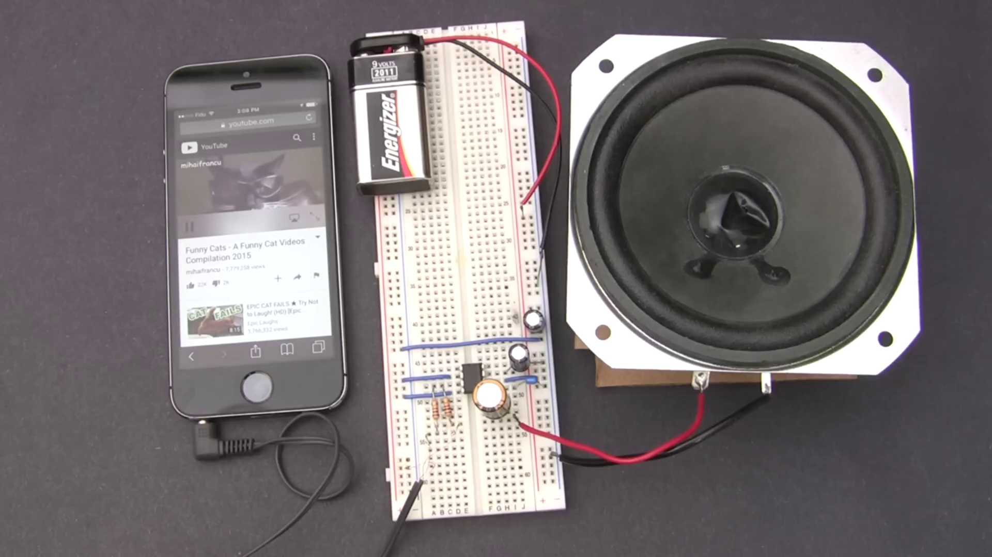 (score 95.0000)
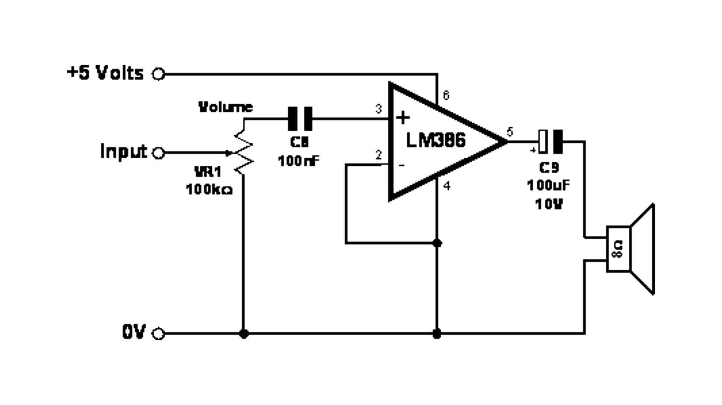 (score 95.0000)
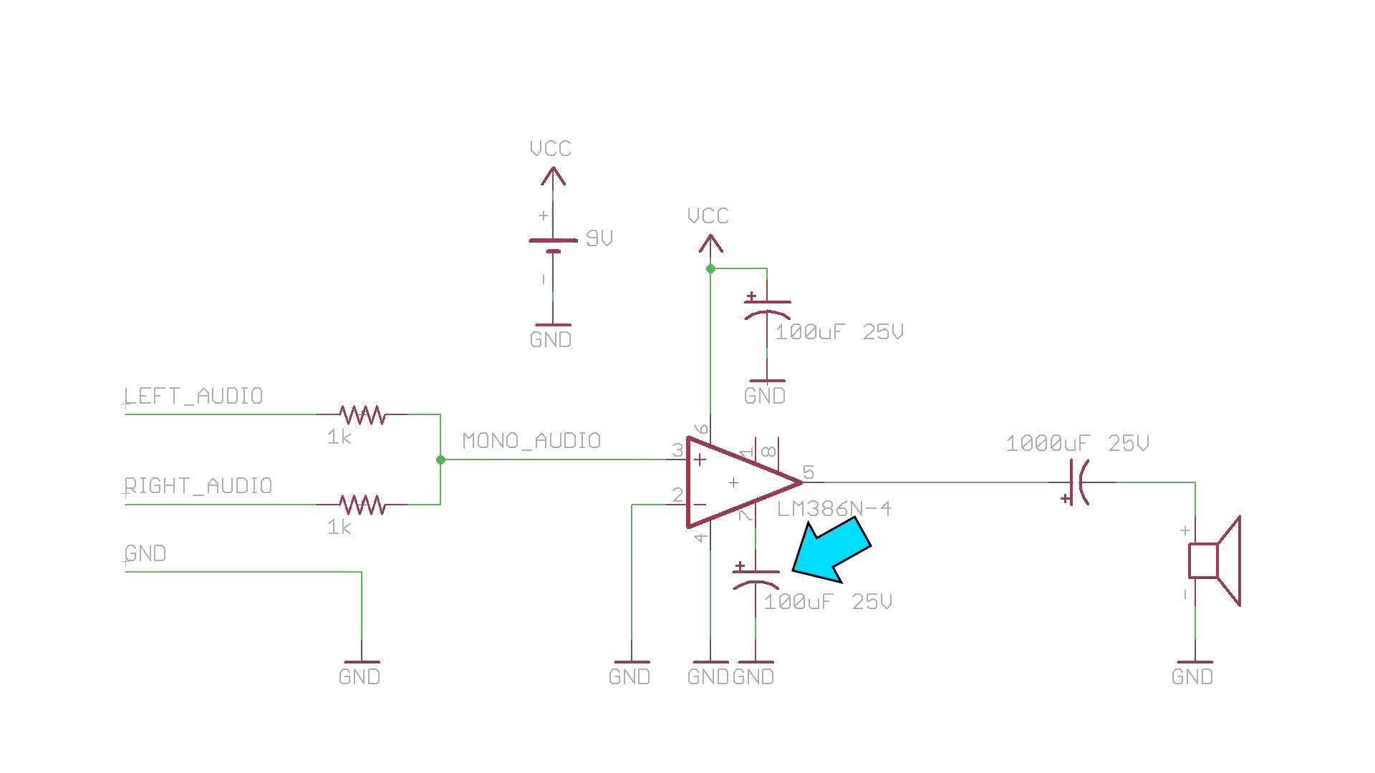 (score 95.0000)
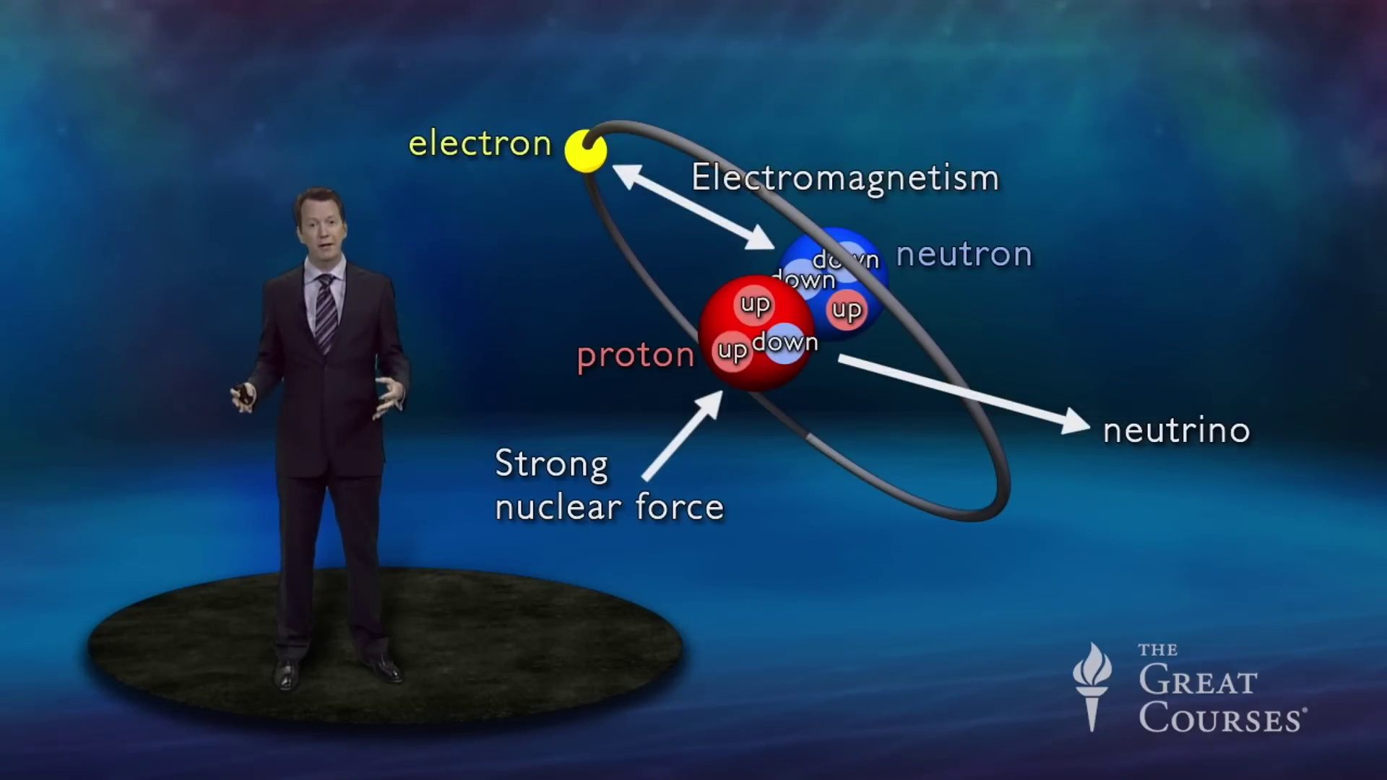 (score 90.0000)
 (score 90.0000)
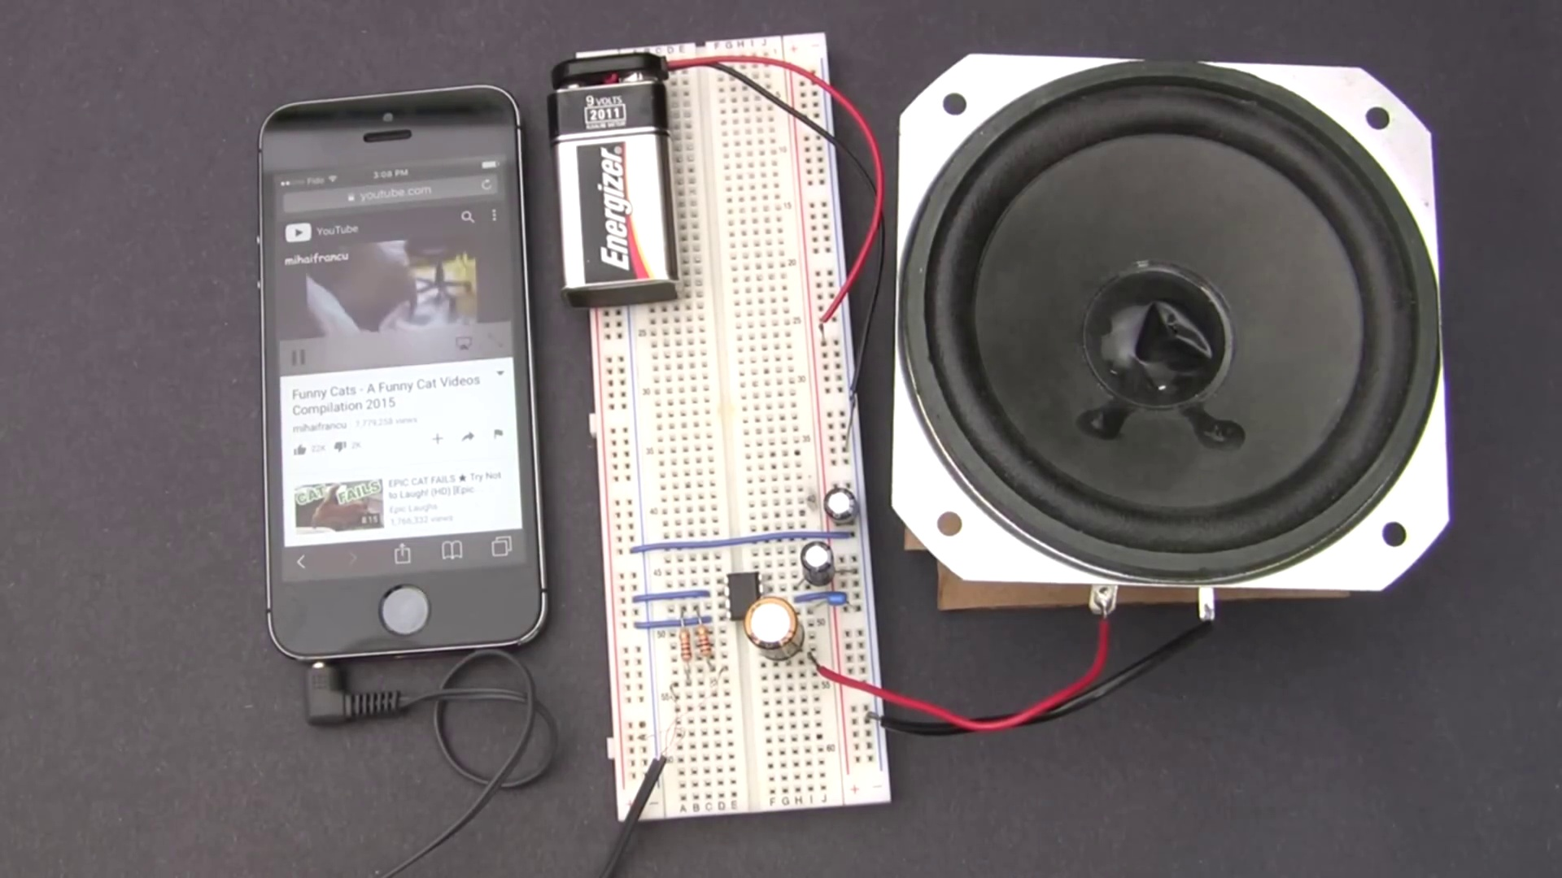 (score 90.0000)
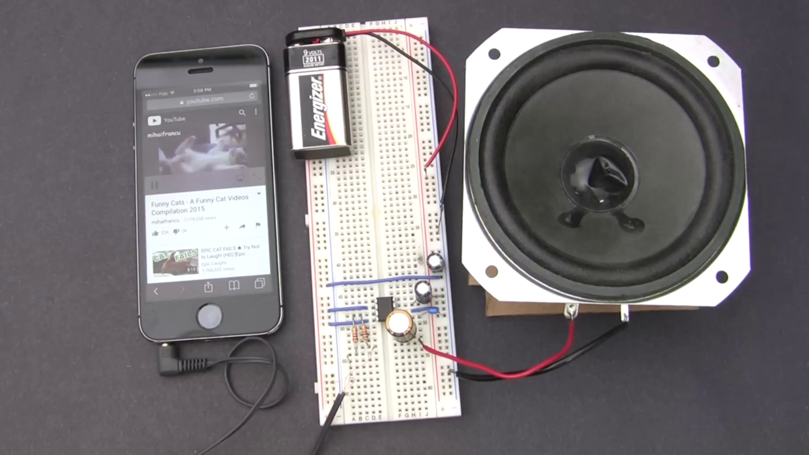 (score 90.0000)
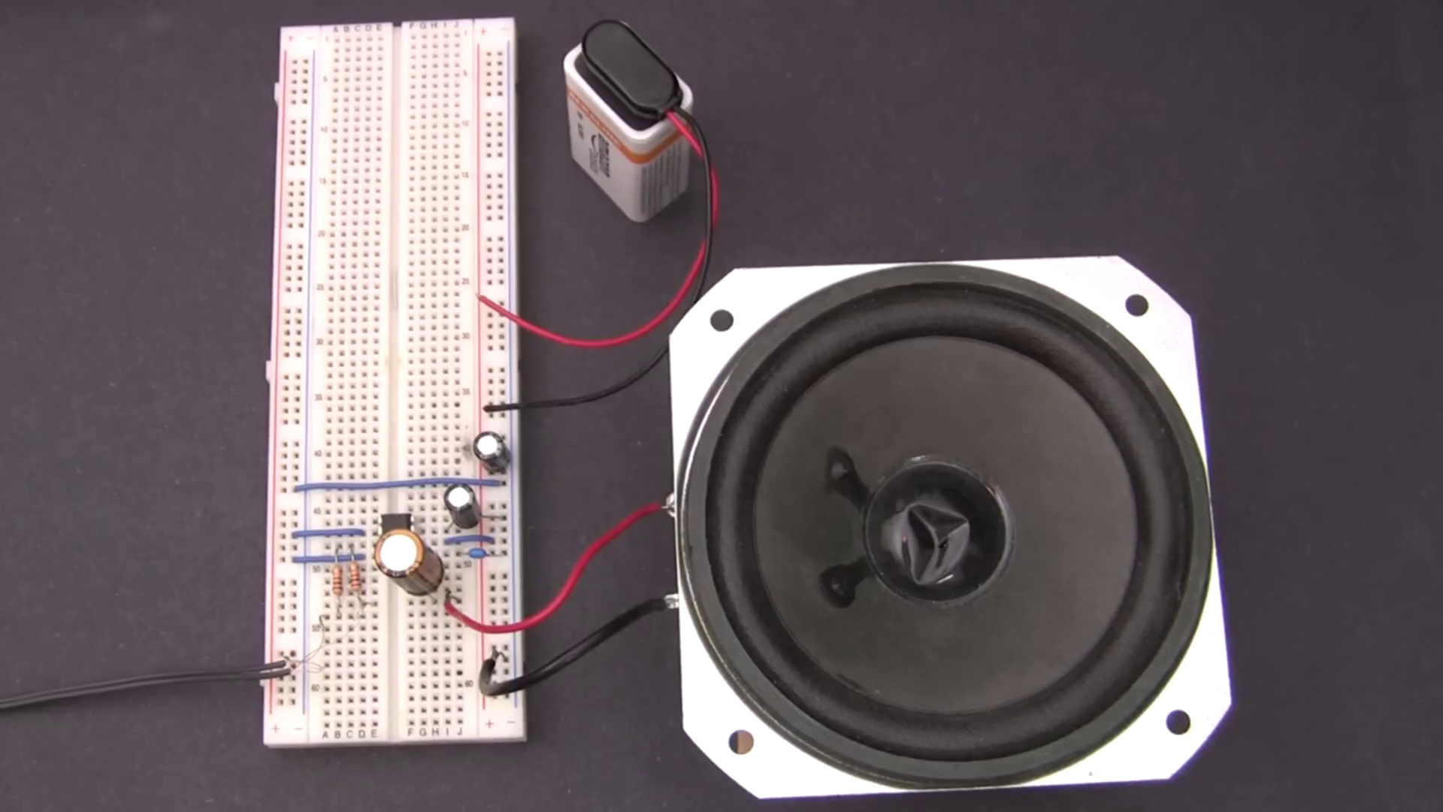 (score 90.0000)
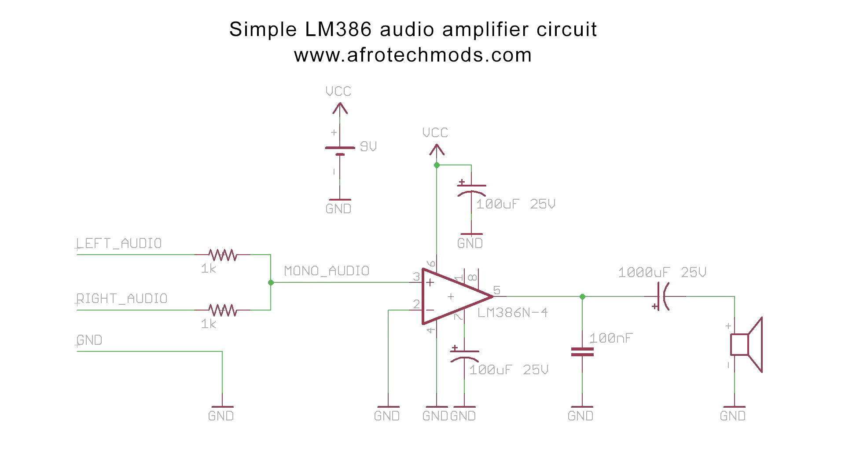 (score 90.0000)
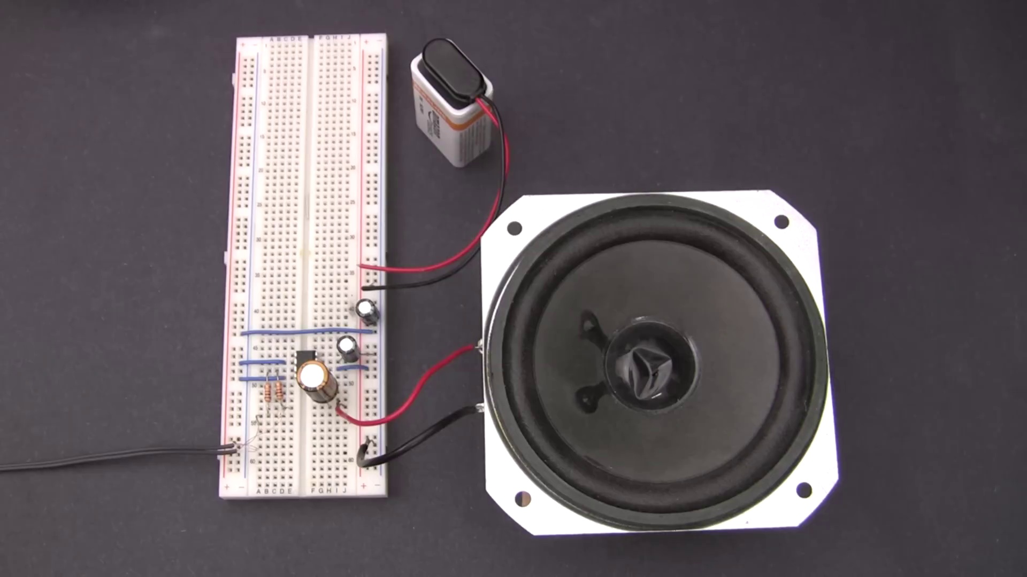 (score 90.0000)
Least correlated frames:
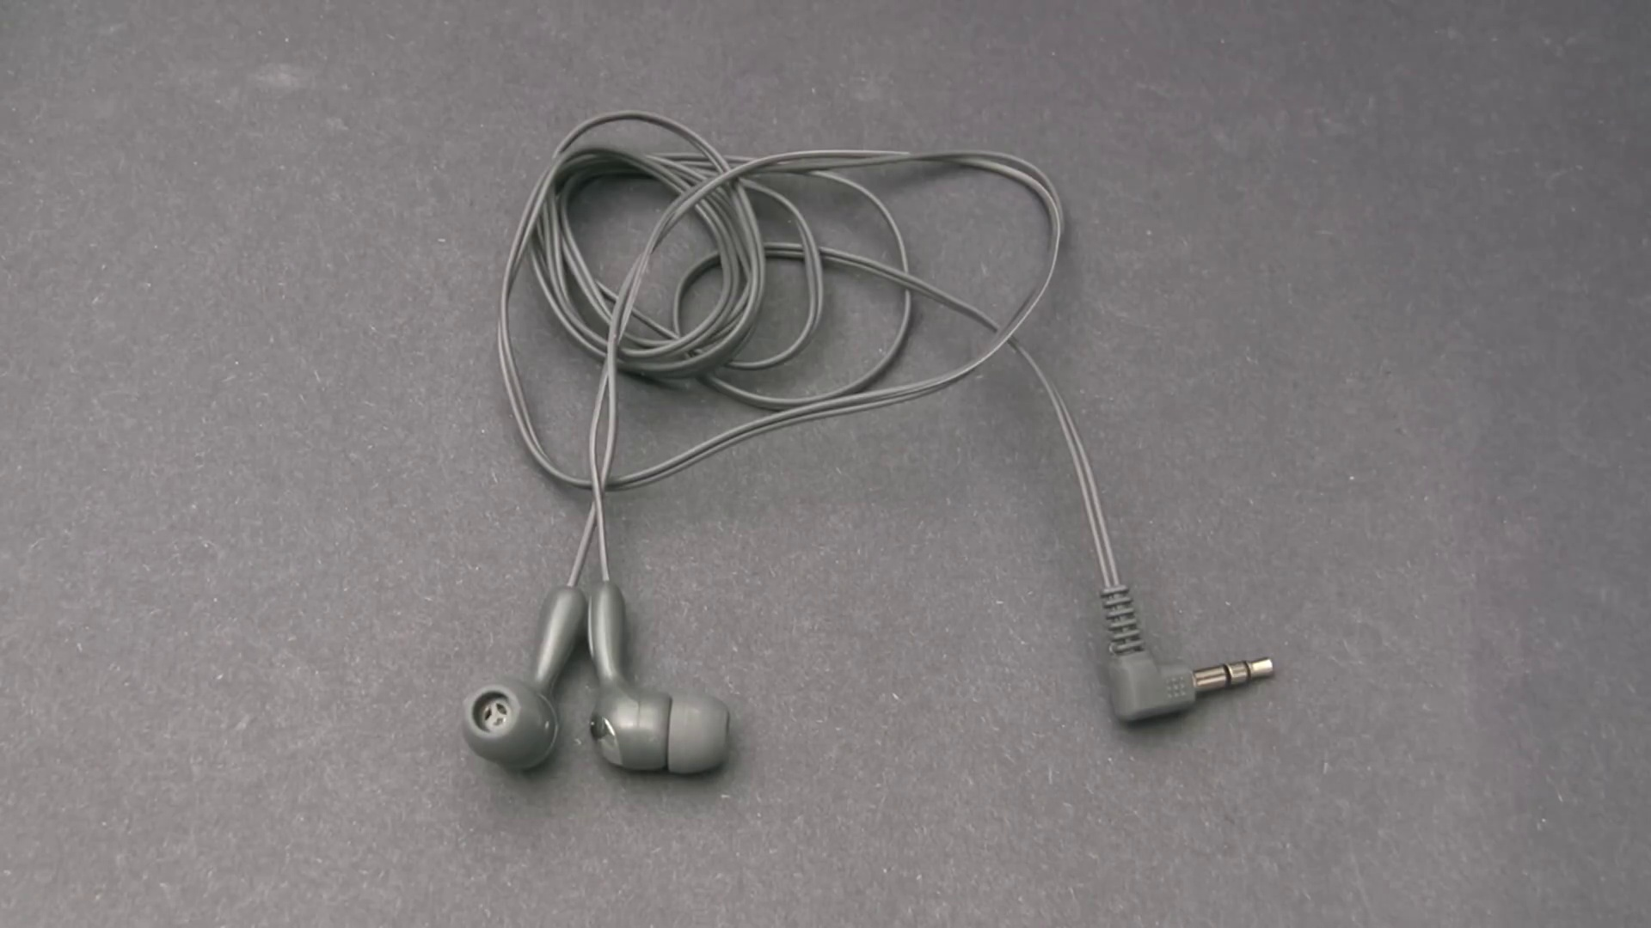 (score 0.0000)
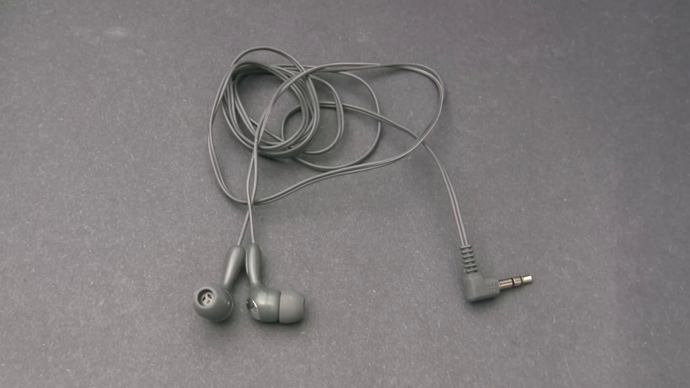 (score 0.0000)
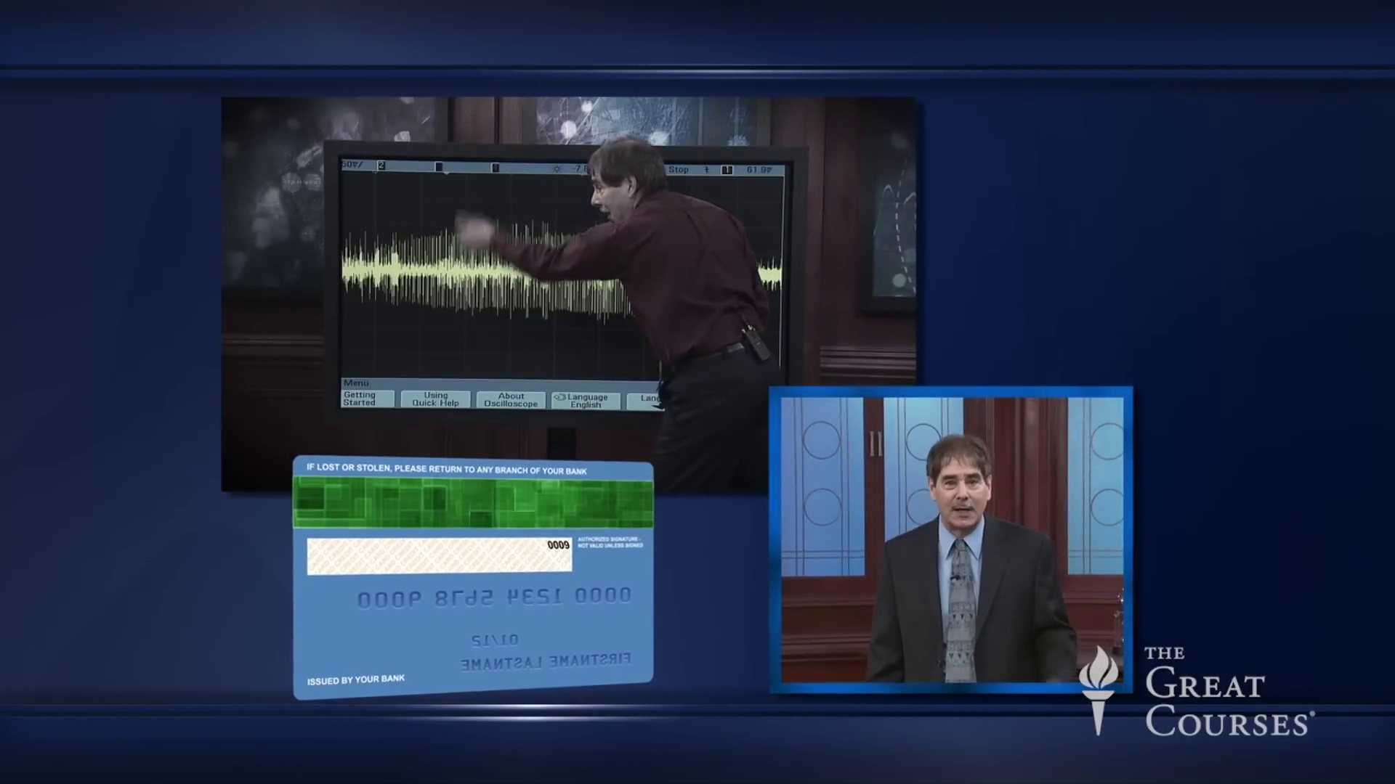 (score 0.0000)
 (score 0.0000)
 (score 5.0000)
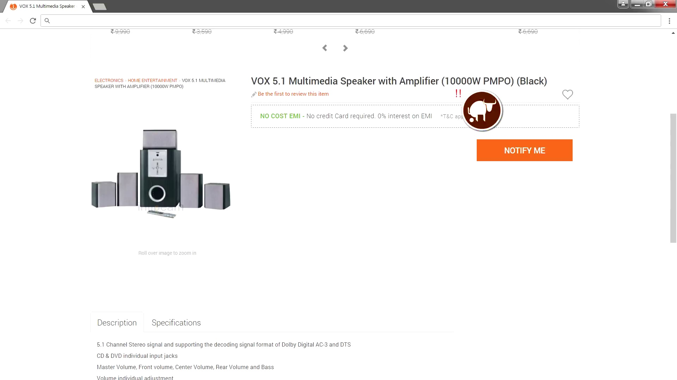 (score 5.0000)
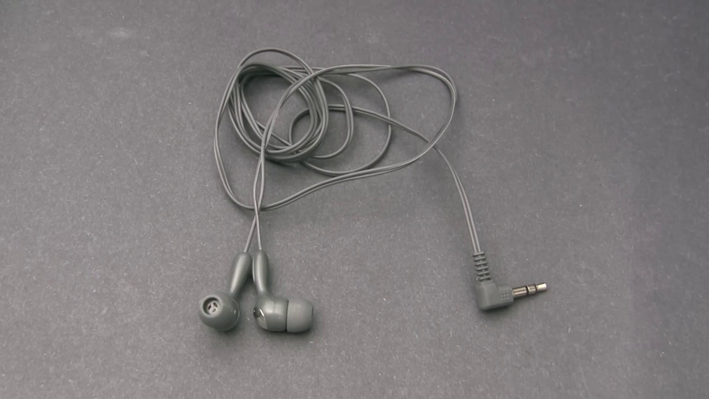 (score 5.0000)
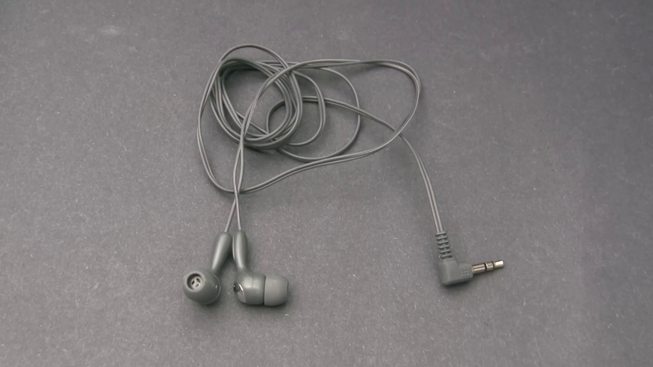 (score 10.0000)
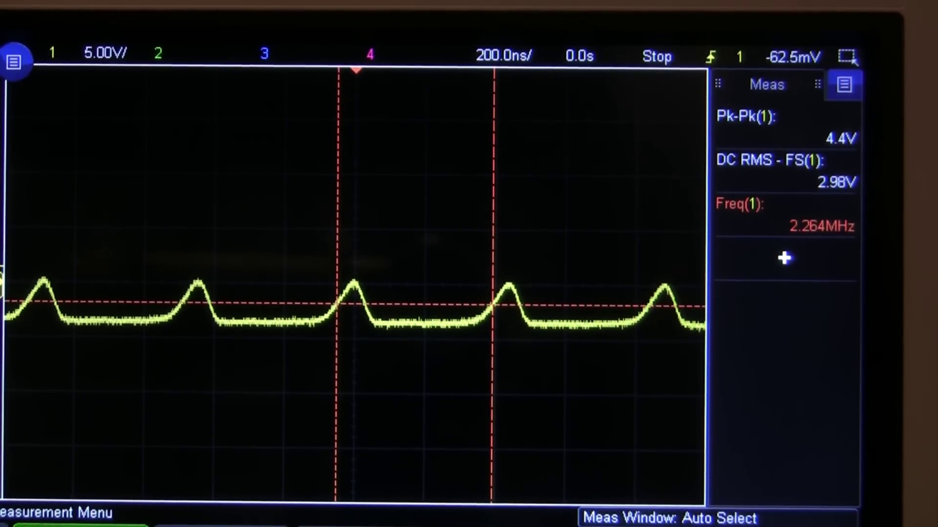 (score 10.0000)
 (score 10.0000)
- matched 83 frame(s), max score 95.0000: The video provides a step-by-step guide on assembling an LM386 audio amplifier circuit, detailing how to connect components and understanding the IC pin configuration. The explanation of selecting the appropriate capacitor values for different frequencies was complex, and it wasn't clear how those values influence the audio output. How I plan to use the electrical system in the future: Use this amplifier design to build small audio amplification systems for DIY speaker projects or guitar amplifiers.
Source: https://www.youtube.com/watch?v=4ObzEft2R_g&t=14s: How to Make an LM386 Audio Amplifier
Top correlated frames:
 (score 95.0000)
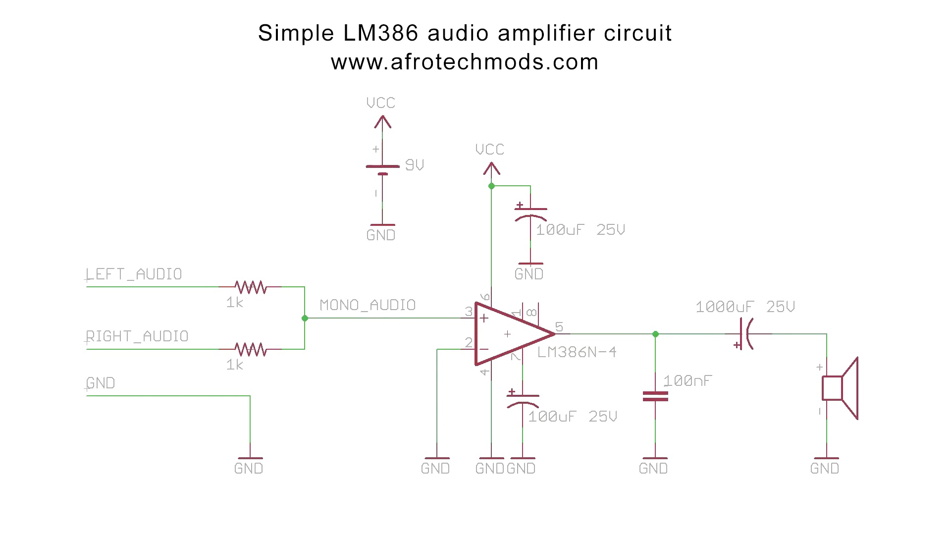 (score 95.0000)
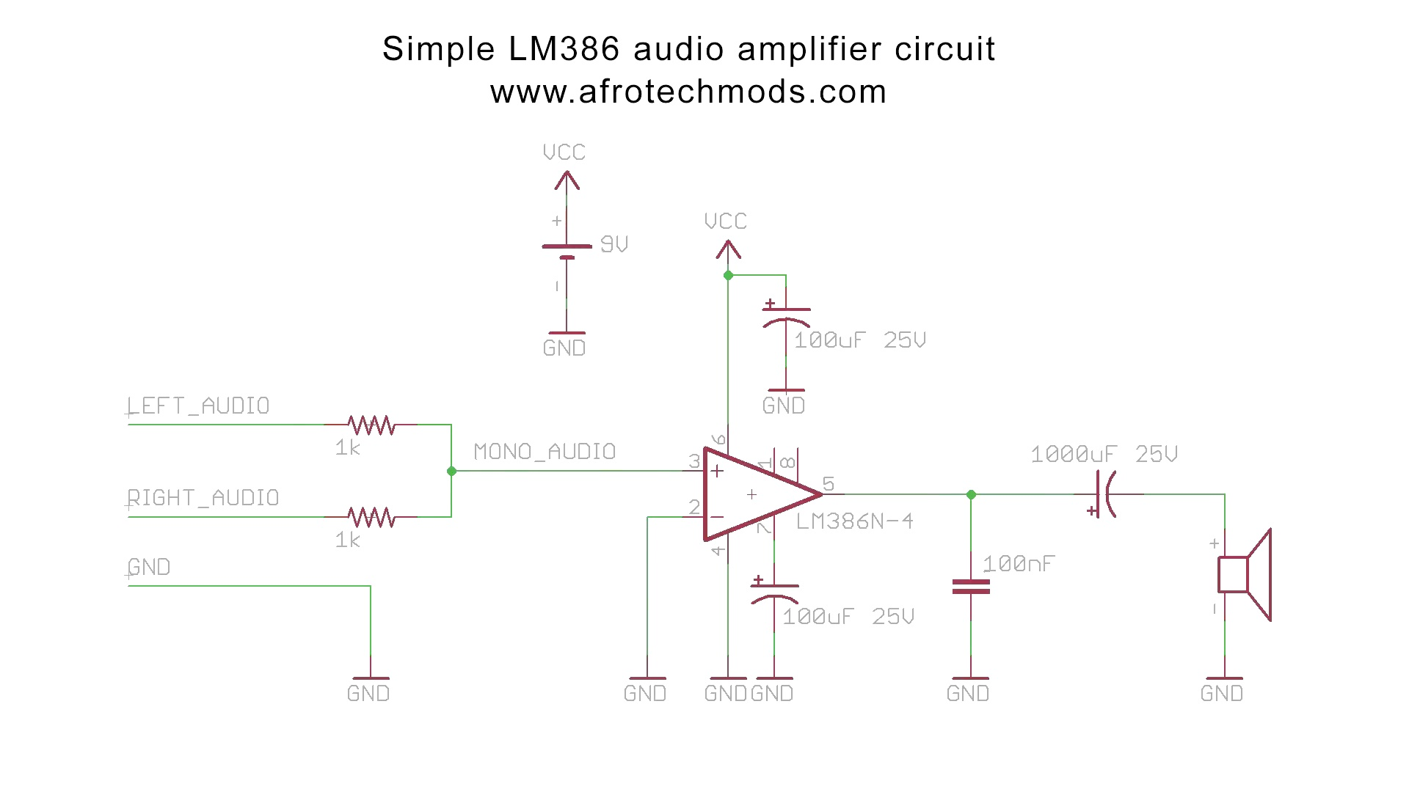 (score 95.0000)
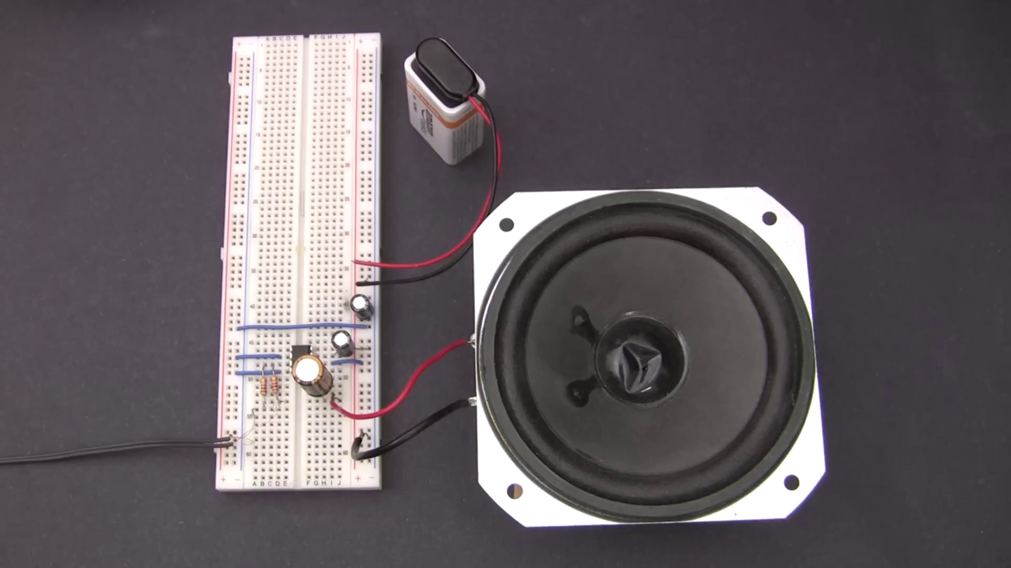 (score 95.0000)
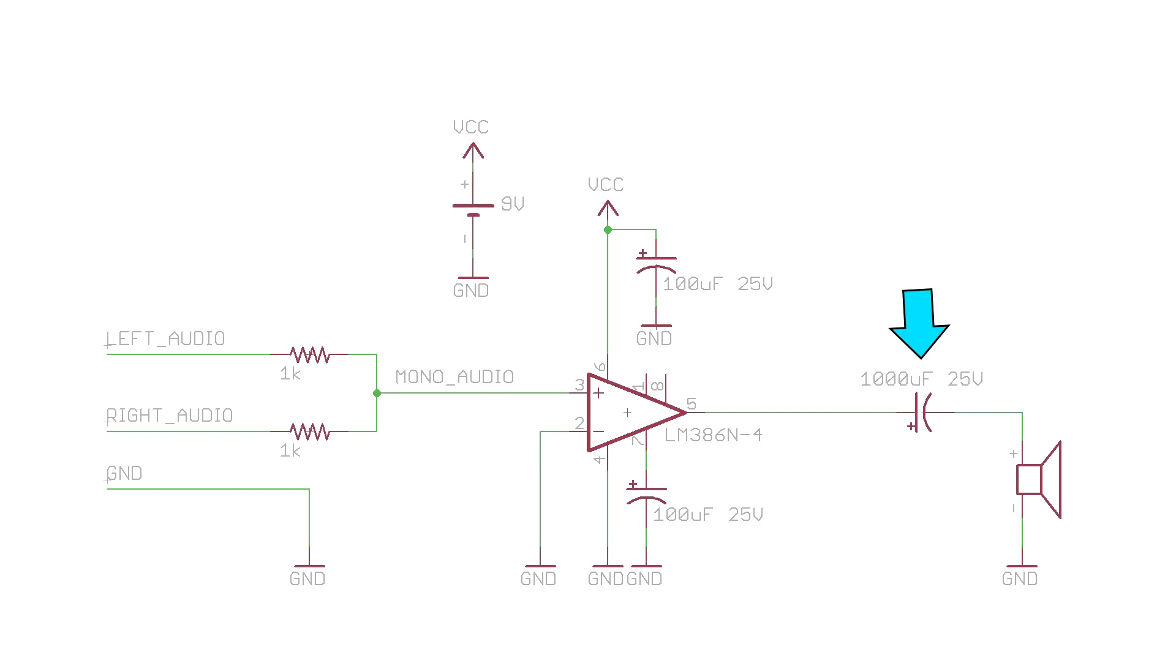 (score 95.0000)
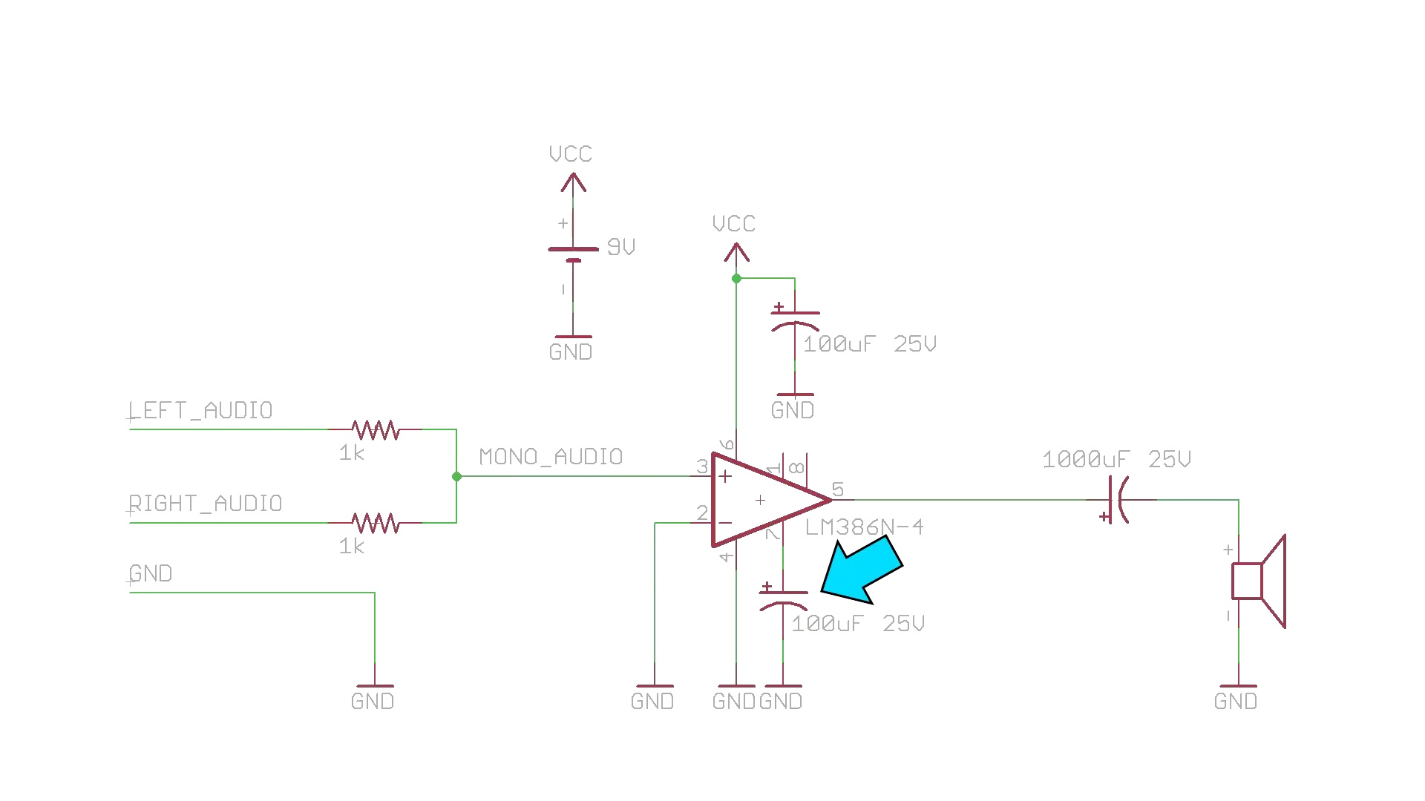 (score 95.0000)
 (score 95.0000)
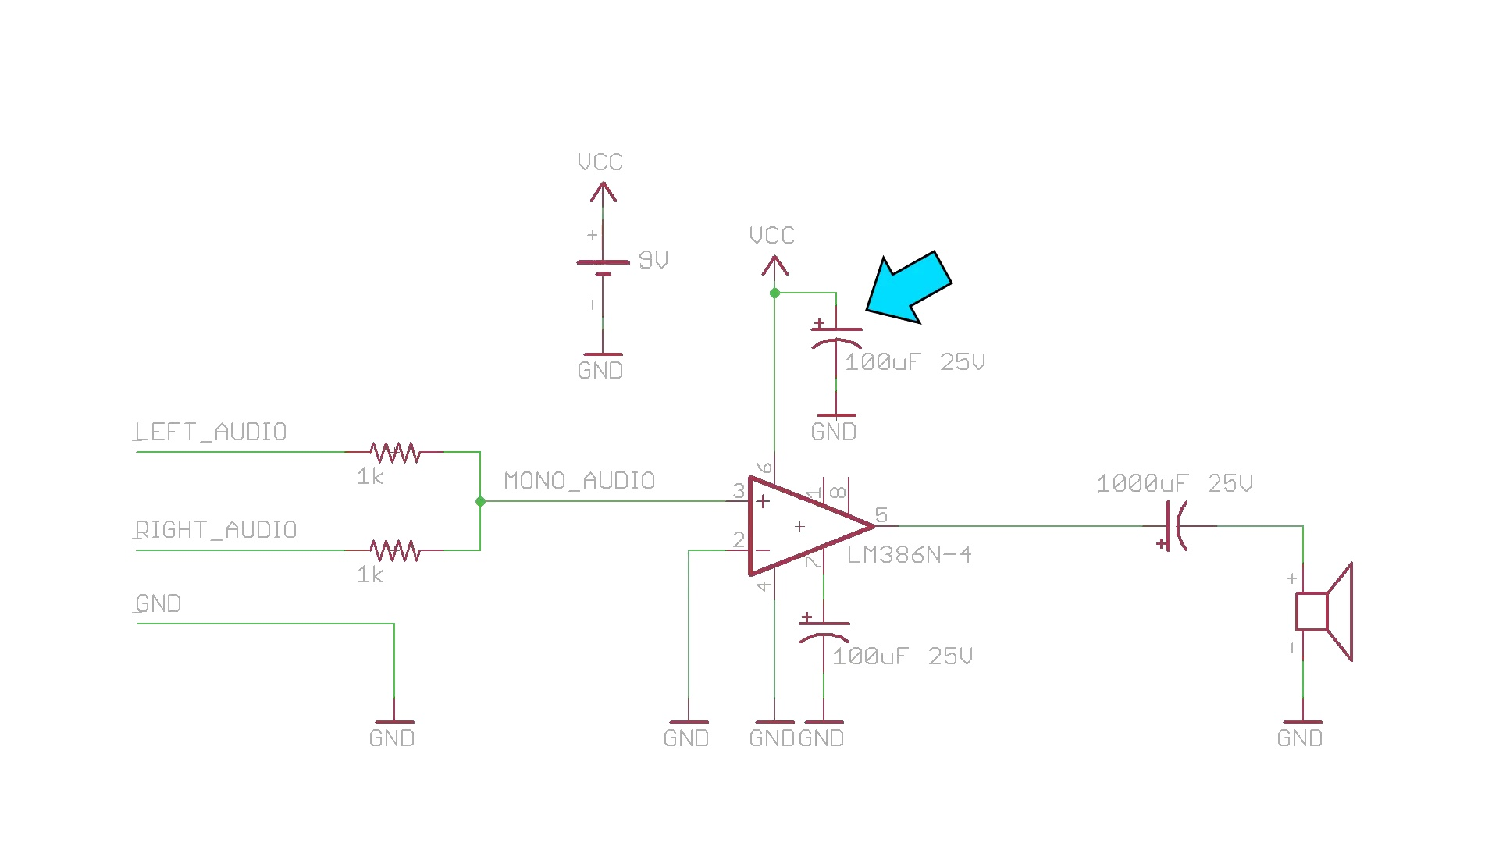 (score 95.0000)
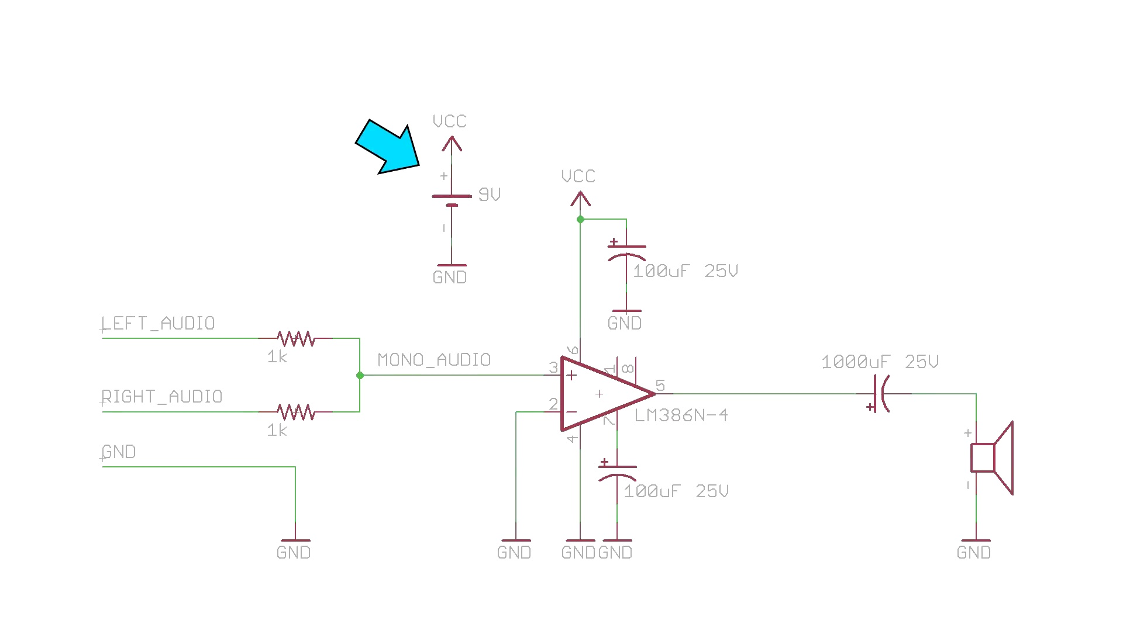 (score 95.0000)
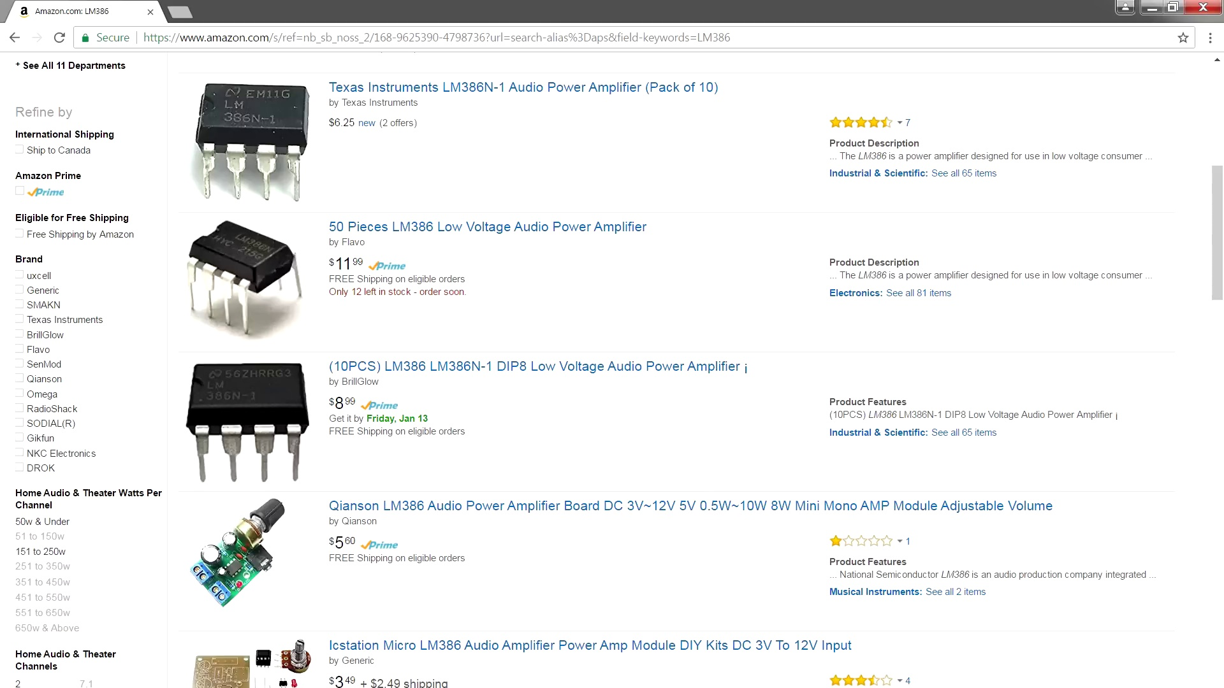 (score 95.0000)
Least correlated frames:
 (score 0.0000)
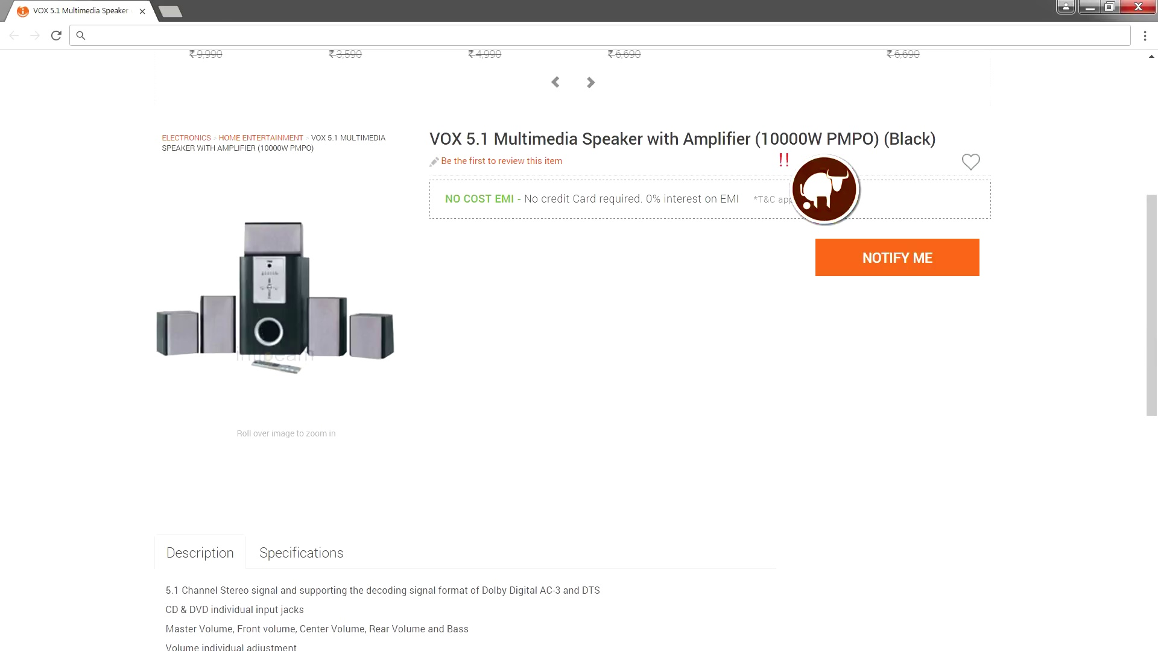 (score 0.0000)
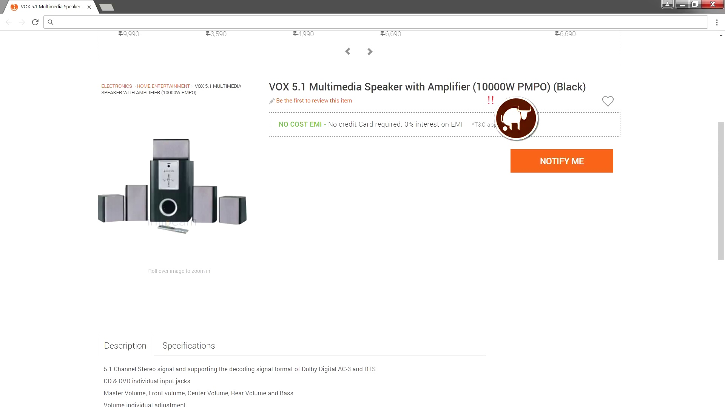 (score 0.0000)
 (score 0.0000)
 (score 0.0000)
 (score 0.0000)
 (score 0.0000)
 (score 0.0000)
 (score 0.0000)
 (score 0.0000)
- matched 74 frame(s), max score 95.0000: Step-by-step guide on building an LM386-based audio amplifier and capacitor specifications for optimal sound.Understanding the causes of high-frequency oscillations and their solutions.Using this simple amplifier design for DIY audio projects and understanding audio electronics basics.
Source: https://www.youtube.com/watch?v=4ObzEft2R_g: How to Make an LM386 Audio Amplifier Circuit
Top correlated frames:
 (score 95.0000)
 (score 95.0000)
 (score 95.0000)
 (score 95.0000)
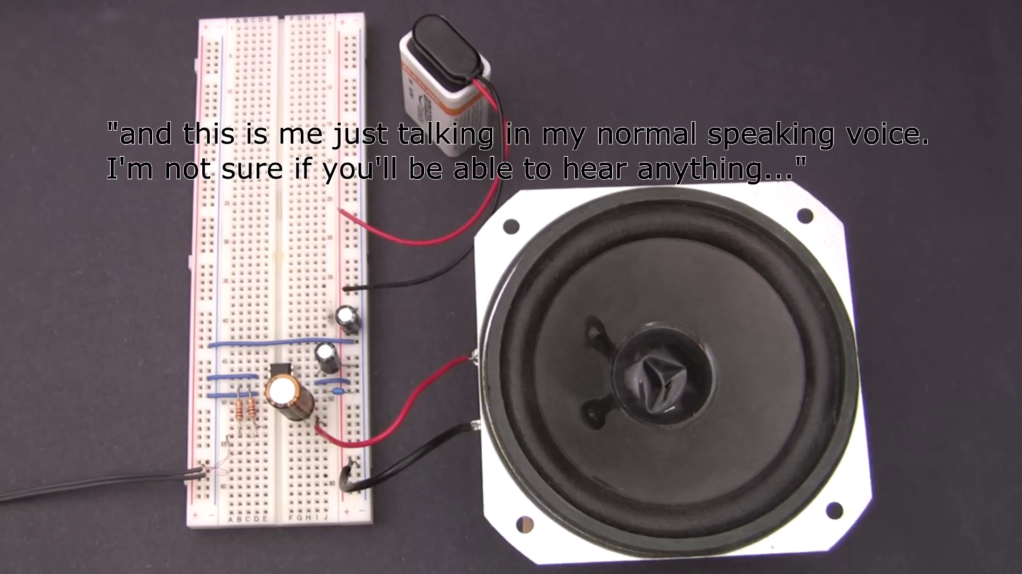 (score 95.0000)
 (score 95.0000)
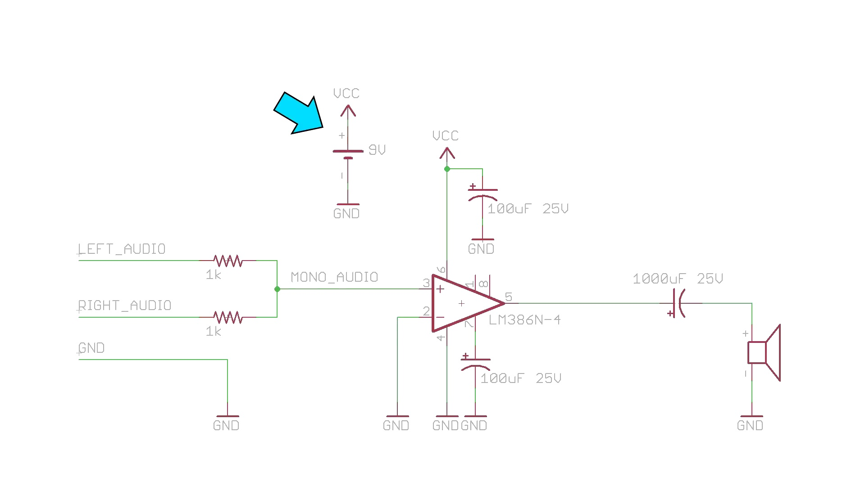 (score 95.0000)
 (score 90.0000)
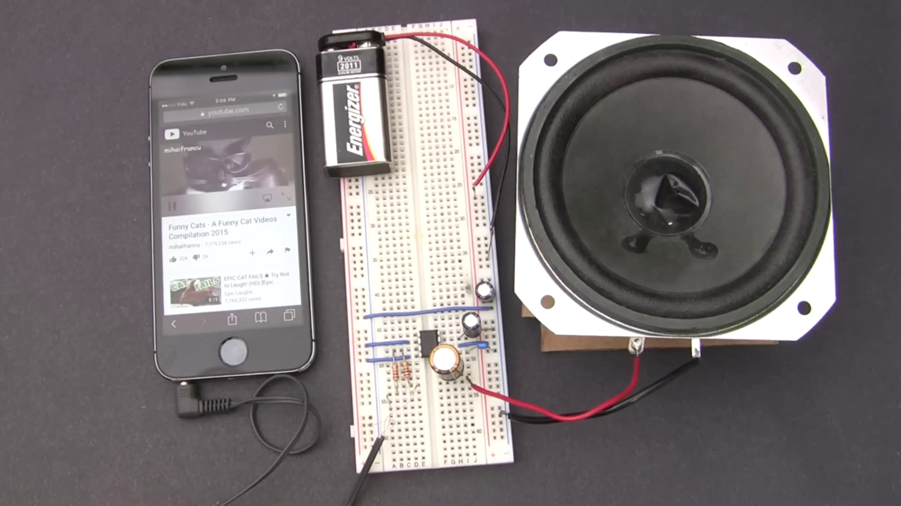 (score 90.0000)
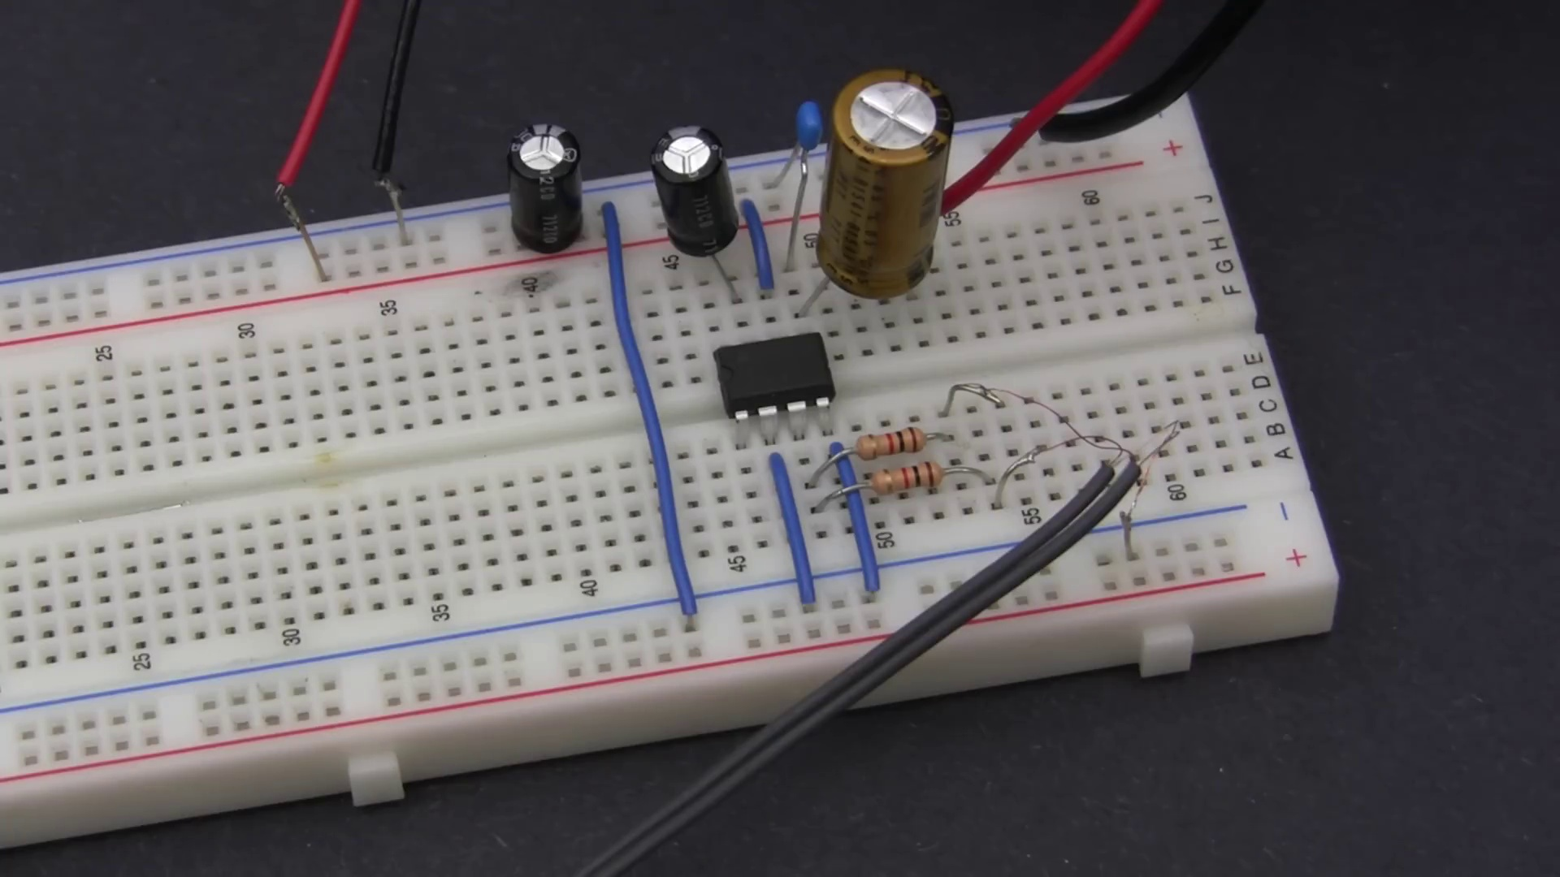 (score 90.0000)
Least correlated frames:
 (score 0.0000)
 (score 0.0000)
 (score 0.0000)
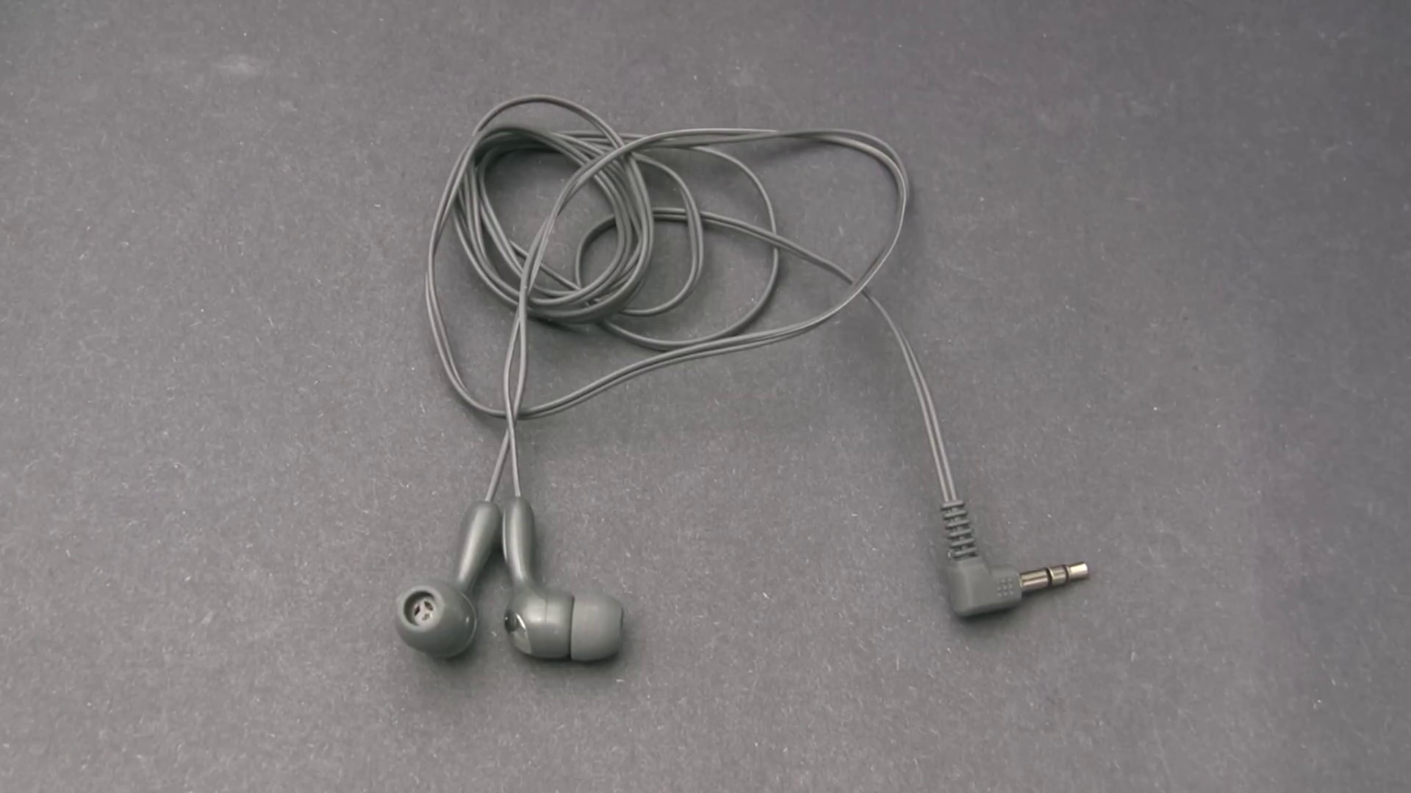 (score 0.0000)
 (score 0.0000)
 (score 0.0000)
 (score 0.0000)
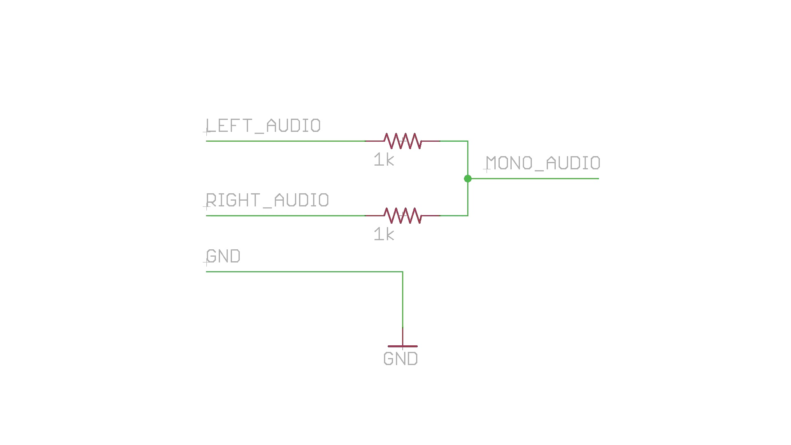 (score 0.0000)
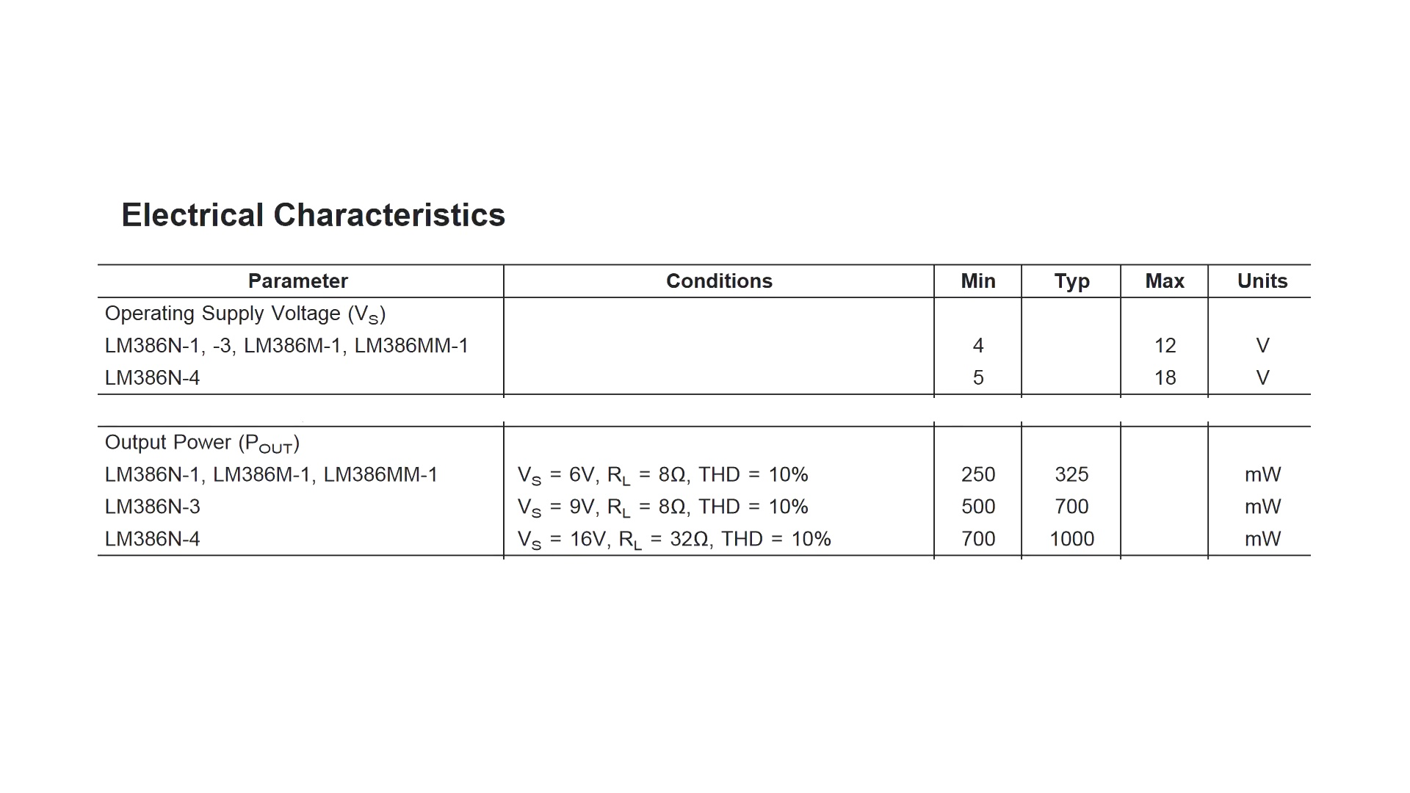 (score 0.0000)
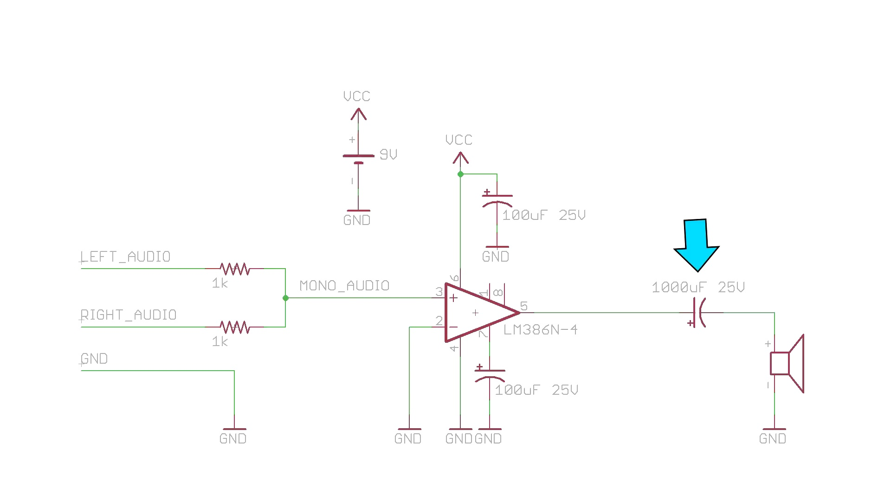 (score 0.0000)
- matched 71 frame(s), max score 95.0000: Covers cost, circuit diagram, and how to build it.No confusion; everything was clear. Useful for Phase 2 and possibly for building the subwoofer.
Source: https://www.youtube.com/watch?v=4ObzEft2R_g: How to Make an LM386 Audio Amplifier Circuit
Top correlated frames:
 (score 95.0000)
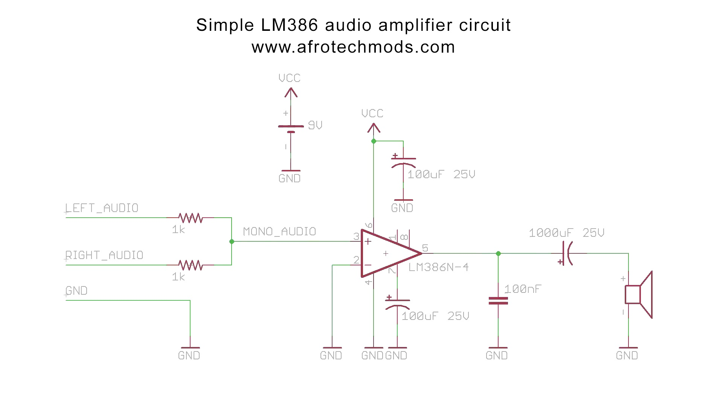 (score 95.0000)
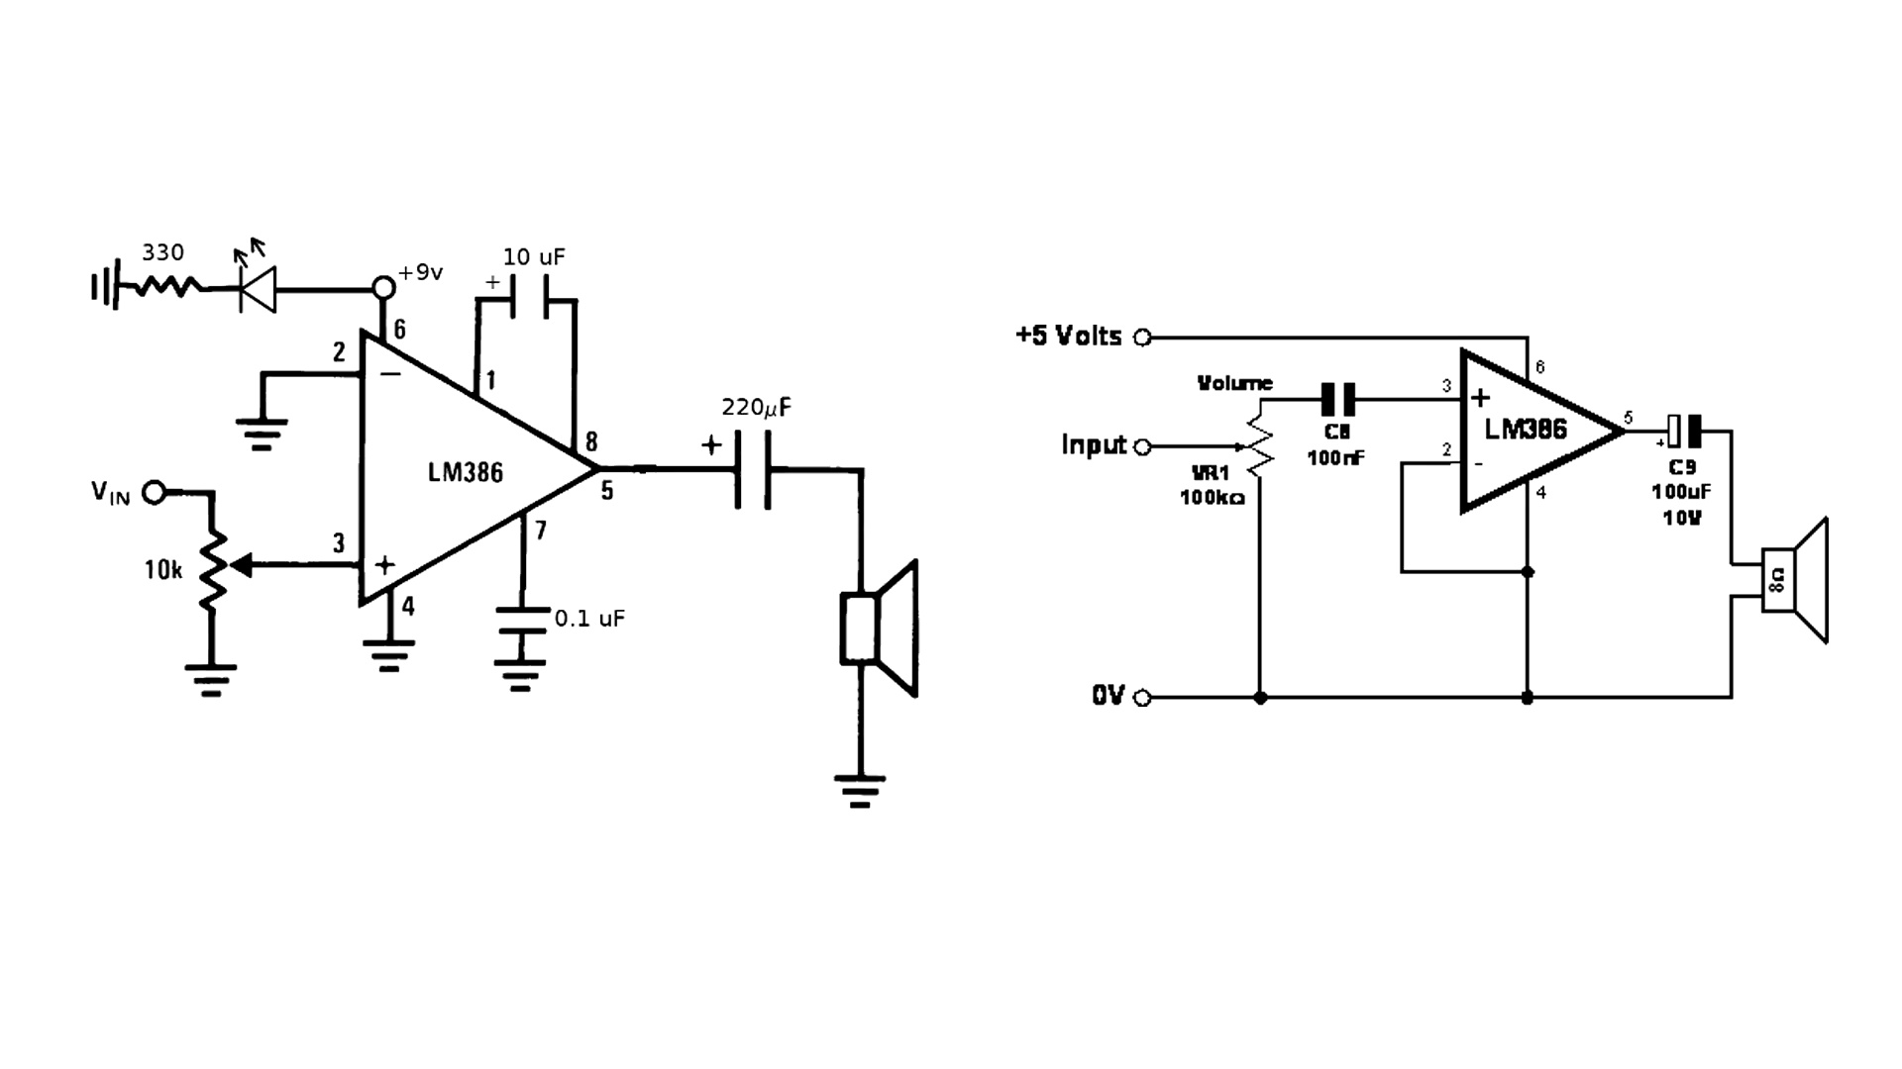 (score 95.0000)
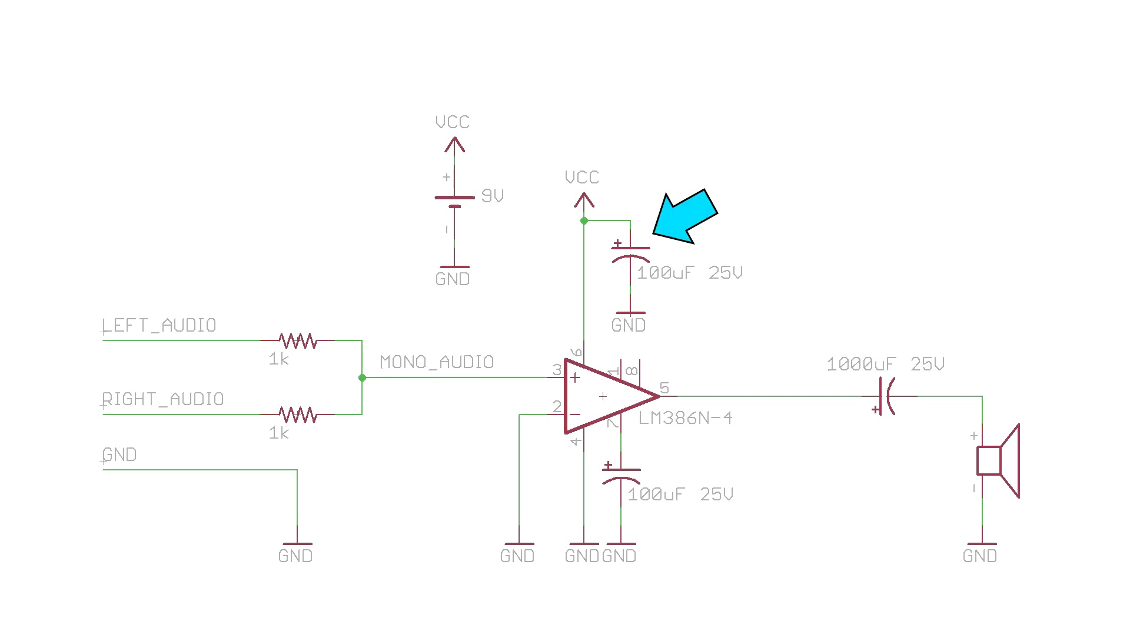 (score 95.0000)
 (score 95.0000)
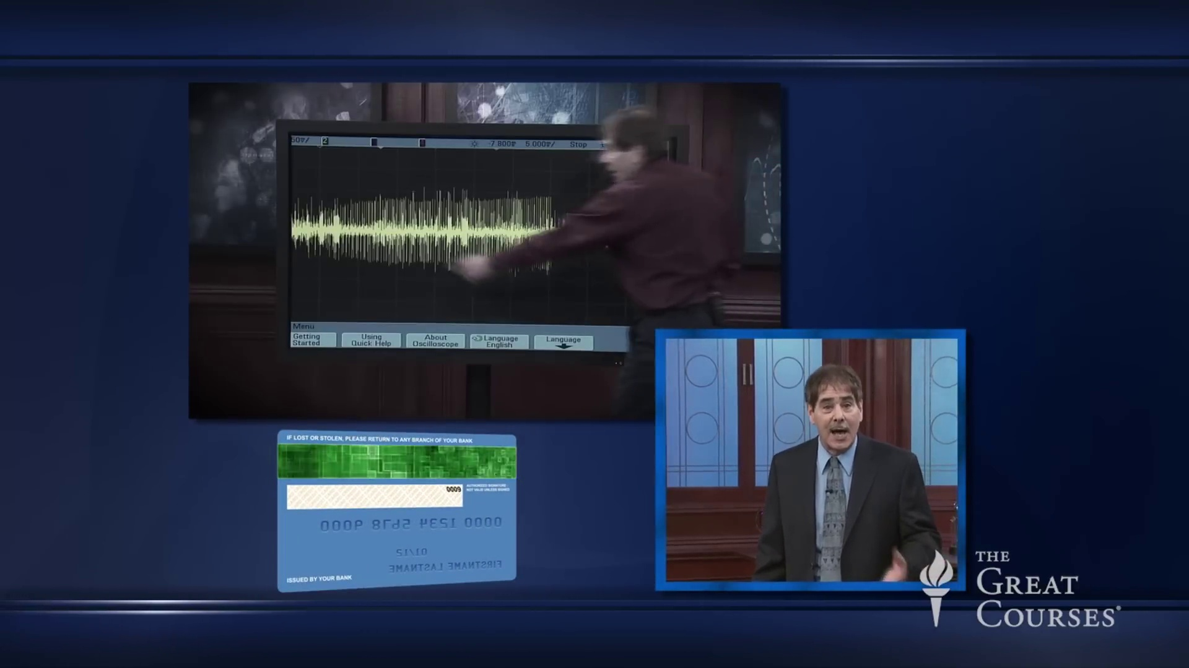 (score 90.0000)
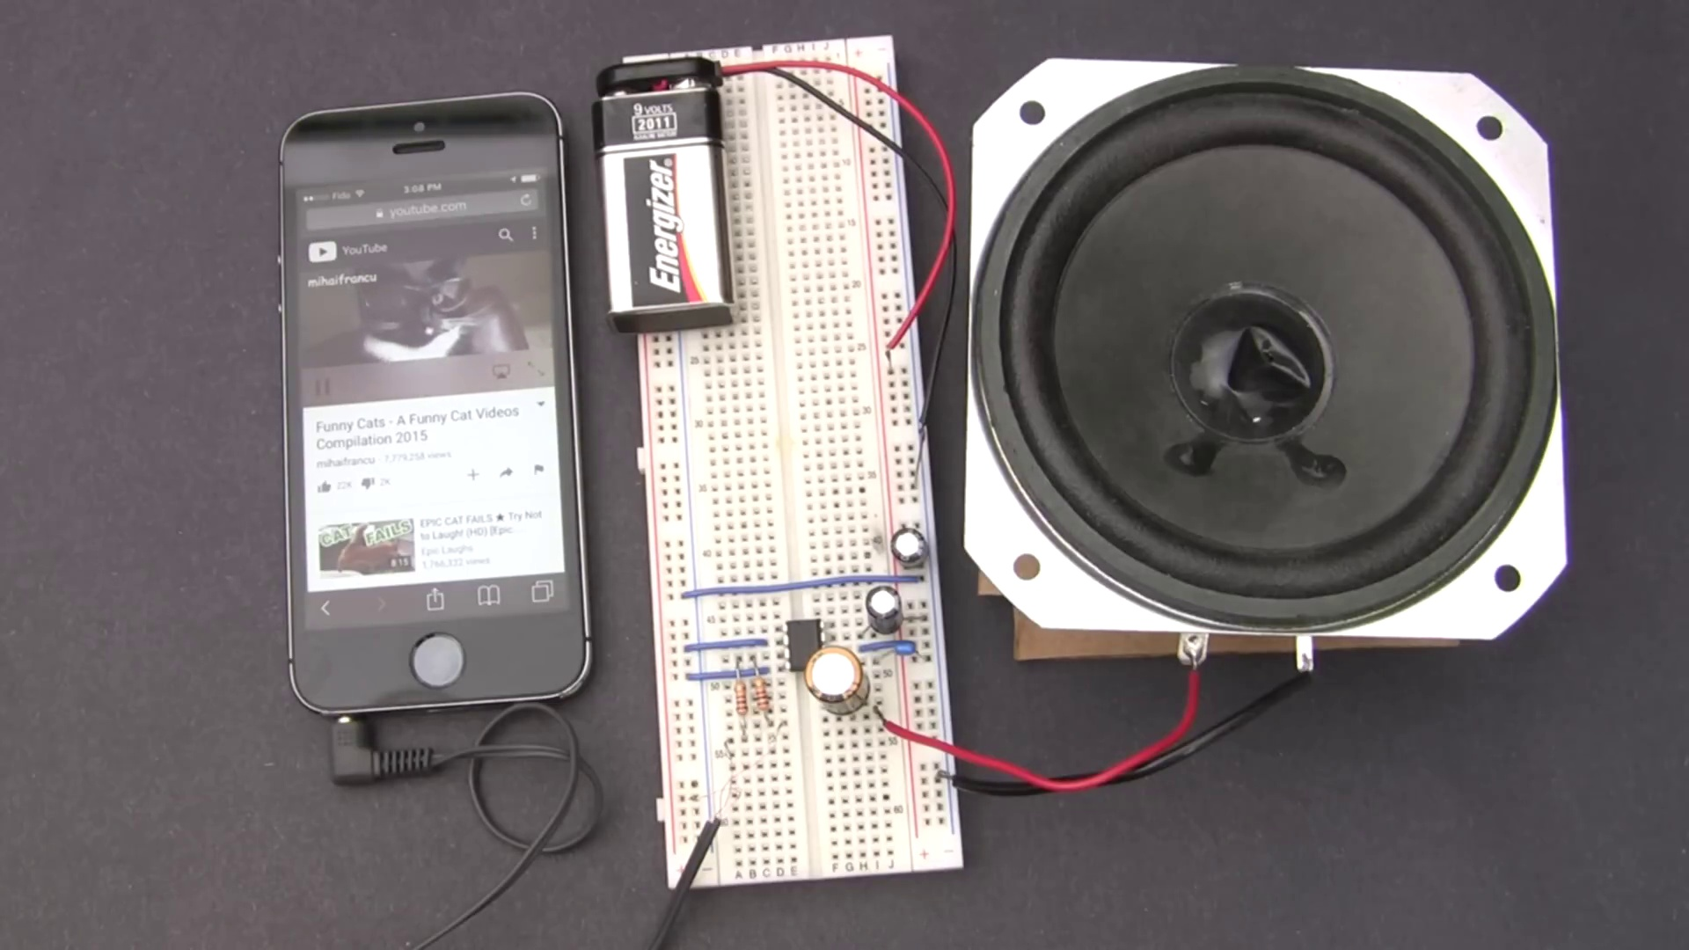 (score 90.0000)
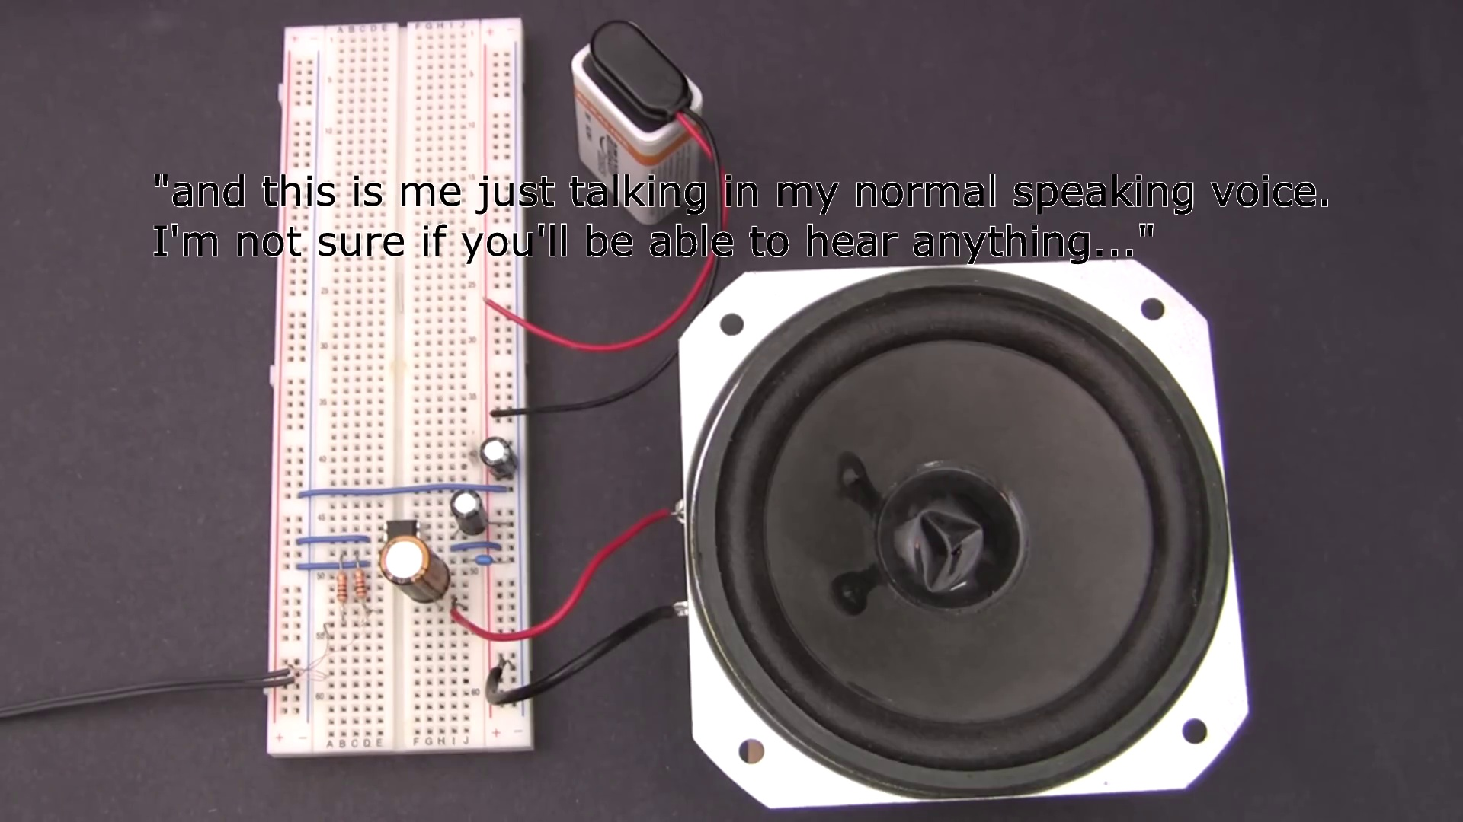 (score 90.0000)
 (score 90.0000)
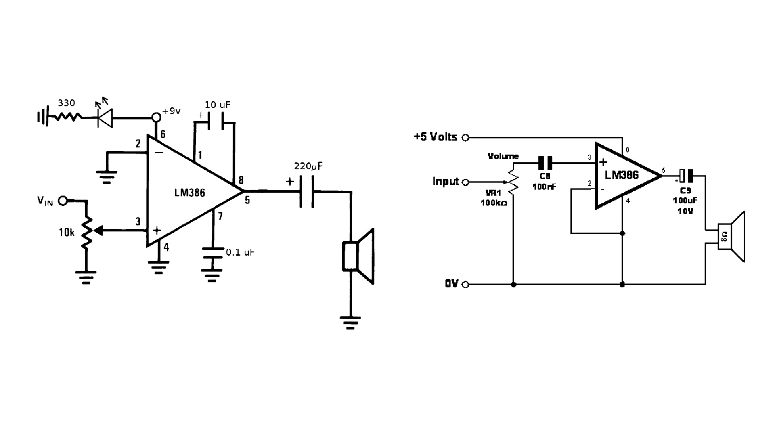 (score 90.0000)
Least correlated frames:
 (score 0.0000)
 (score 0.0000)
 (score 0.0000)
 (score 0.0000)
 (score 0.0000)
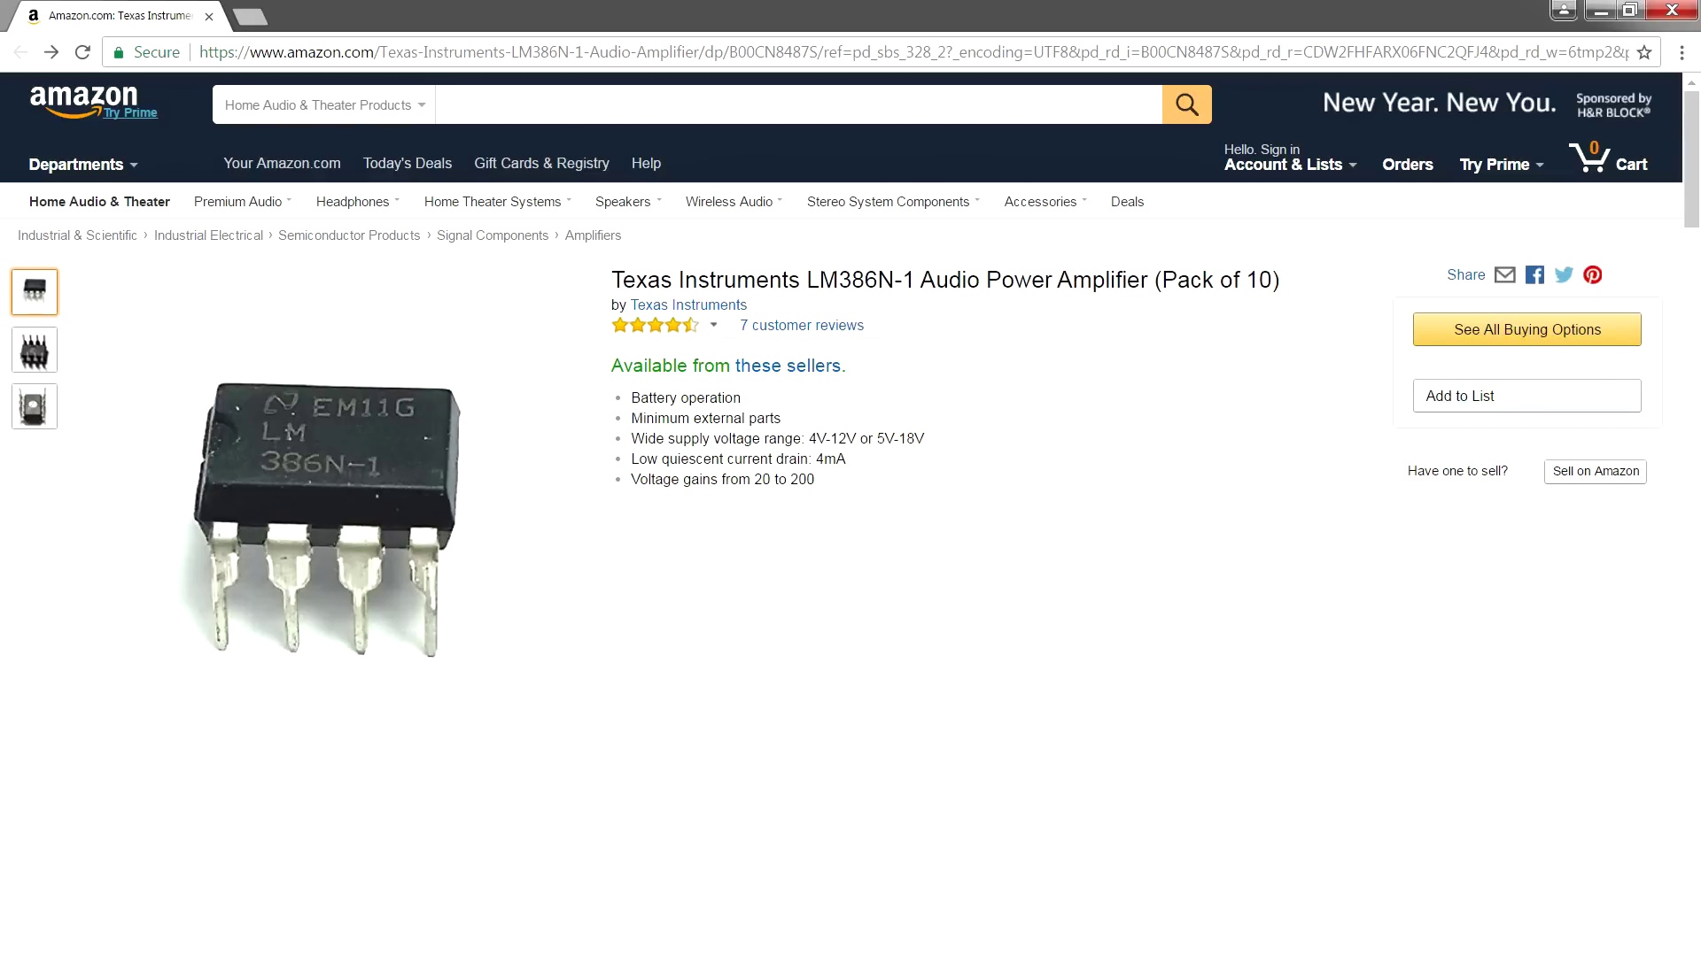 (score 0.0000)
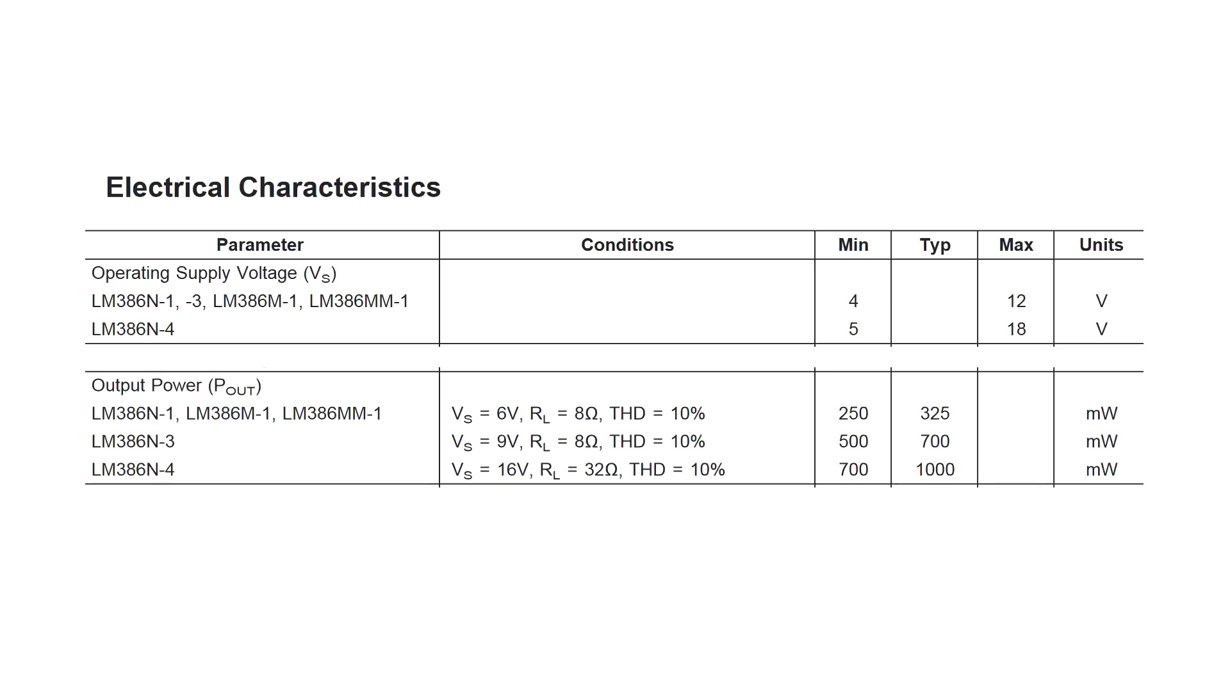 (score 0.0000)
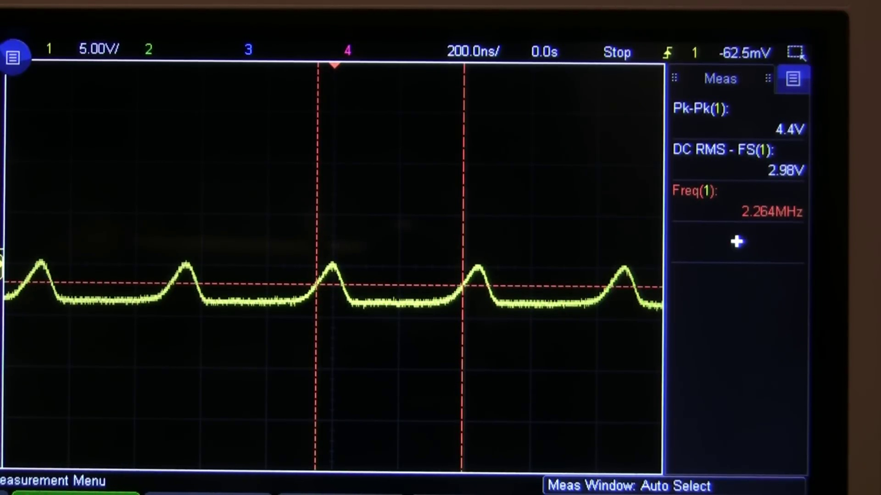 (score 0.0000)
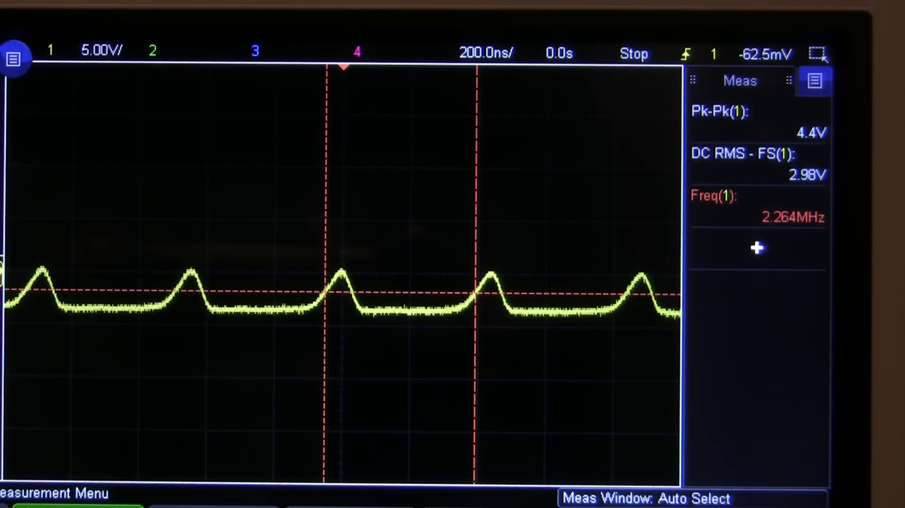 (score 0.0000)
 (score 0.0000)
- matched 65 frame(s), max score 95.0000: This video taught me some basics of using the LM386 to amplify a speaker. One important fact it states is to use a 1000 uF capacitor instead of a 47uF one.I’m curious as to why a larger capacitor is necessary.
Source: https://www.youtube.com/watch?v=4ObzEft2R_g: How to make an LM386 audio amplifier circuit (youtube.com)
Top correlated frames:
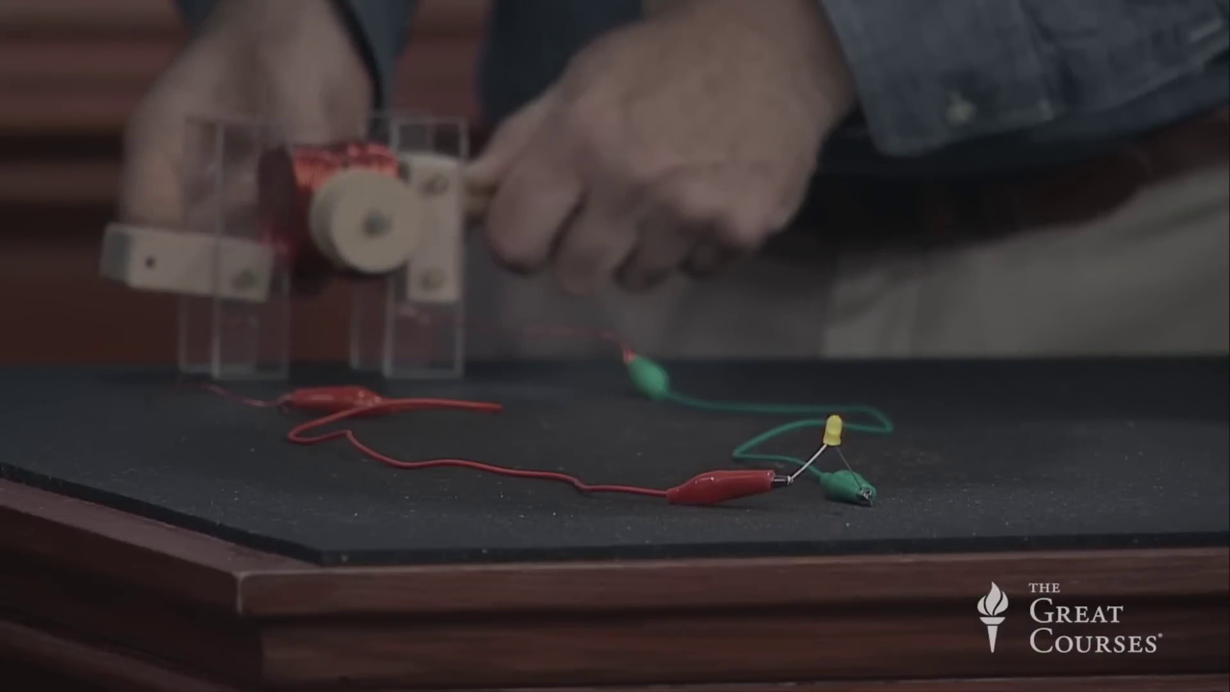 (score 95.0000)
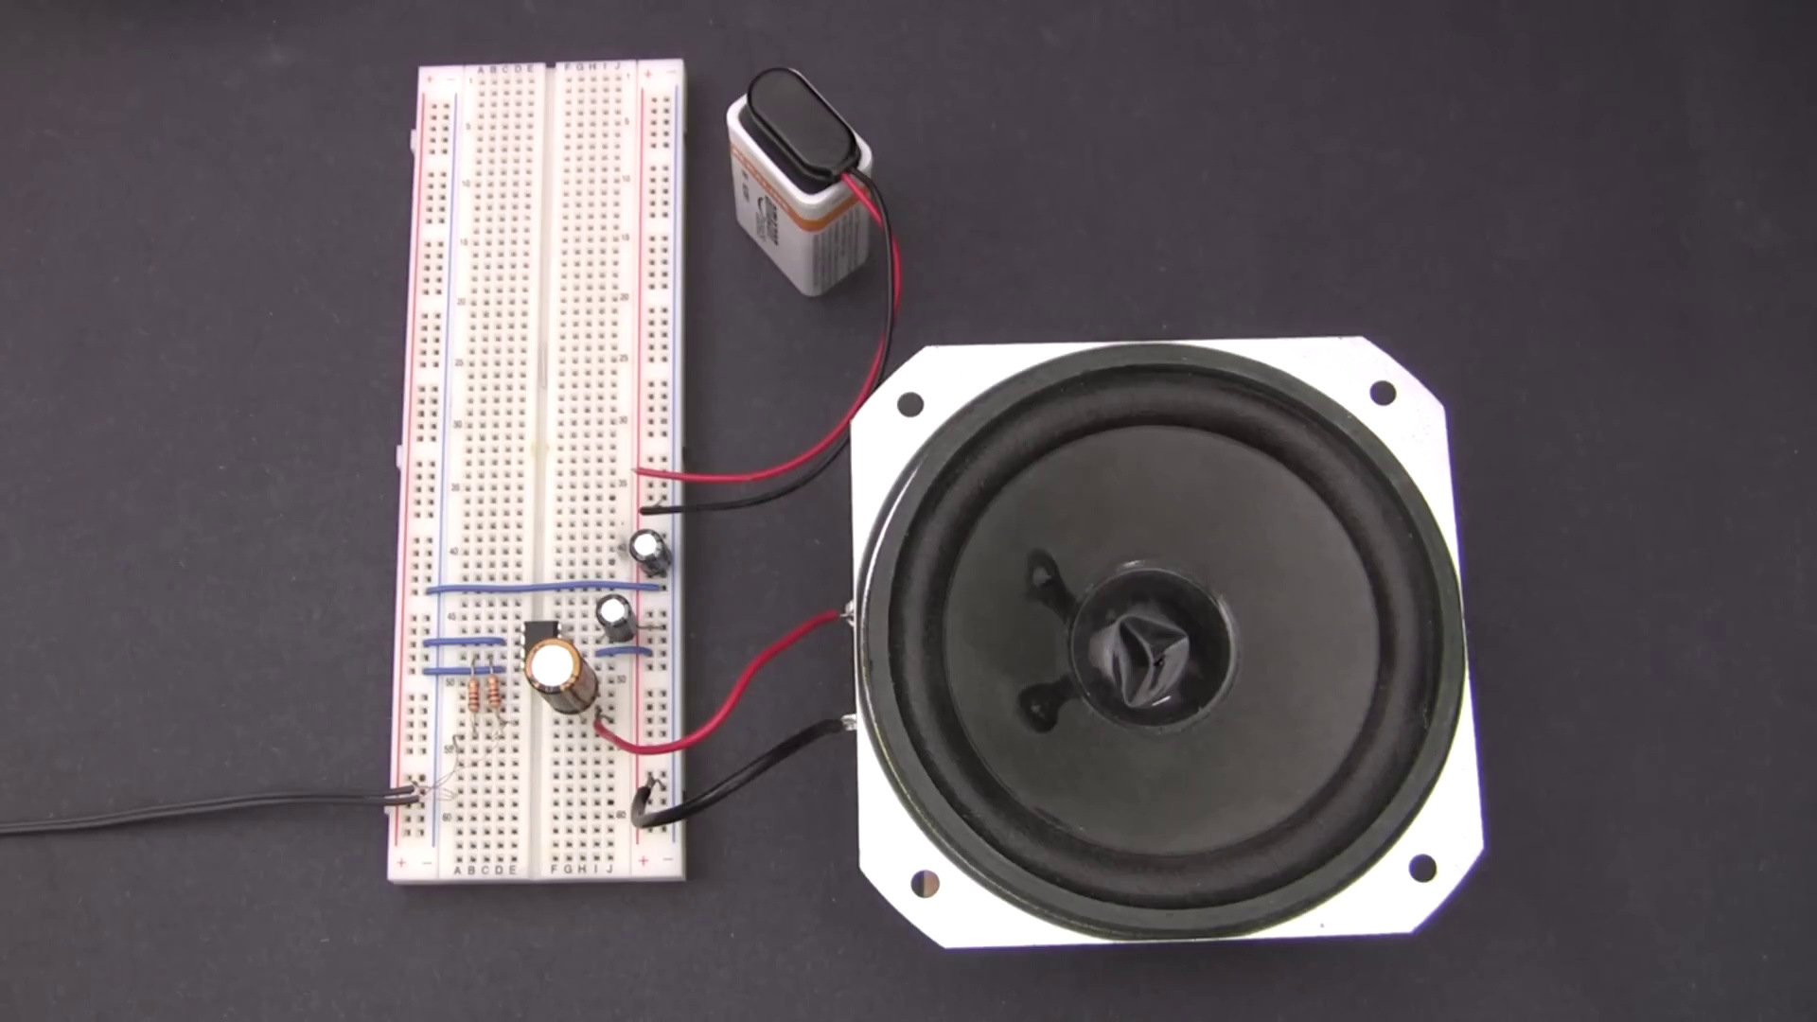 (score 95.0000)
 (score 95.0000)
 (score 90.0000)
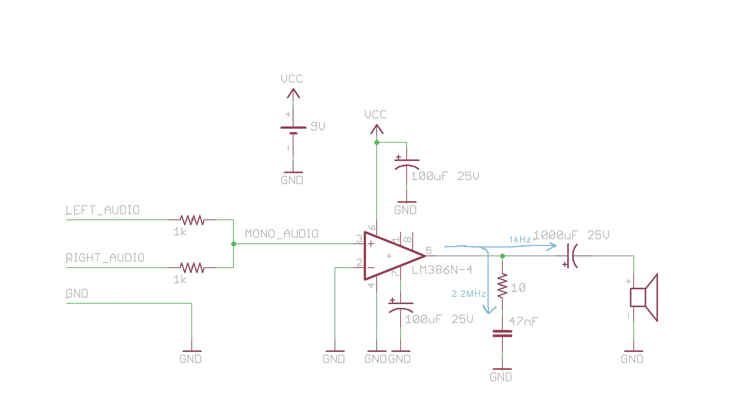 (score 90.0000)
 (score 90.0000)
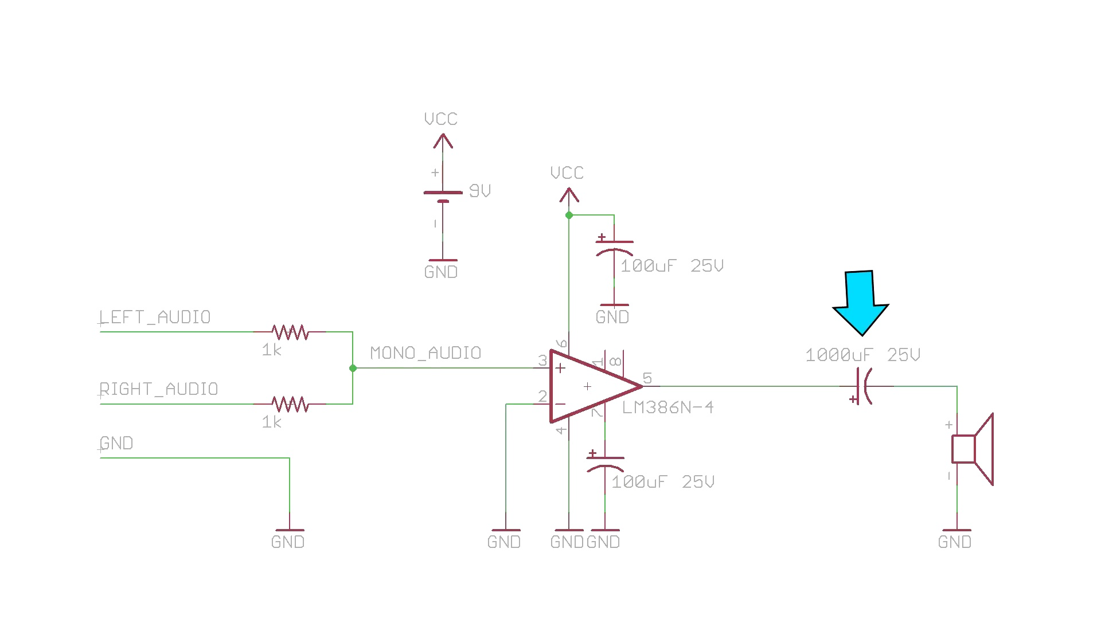 (score 90.0000)
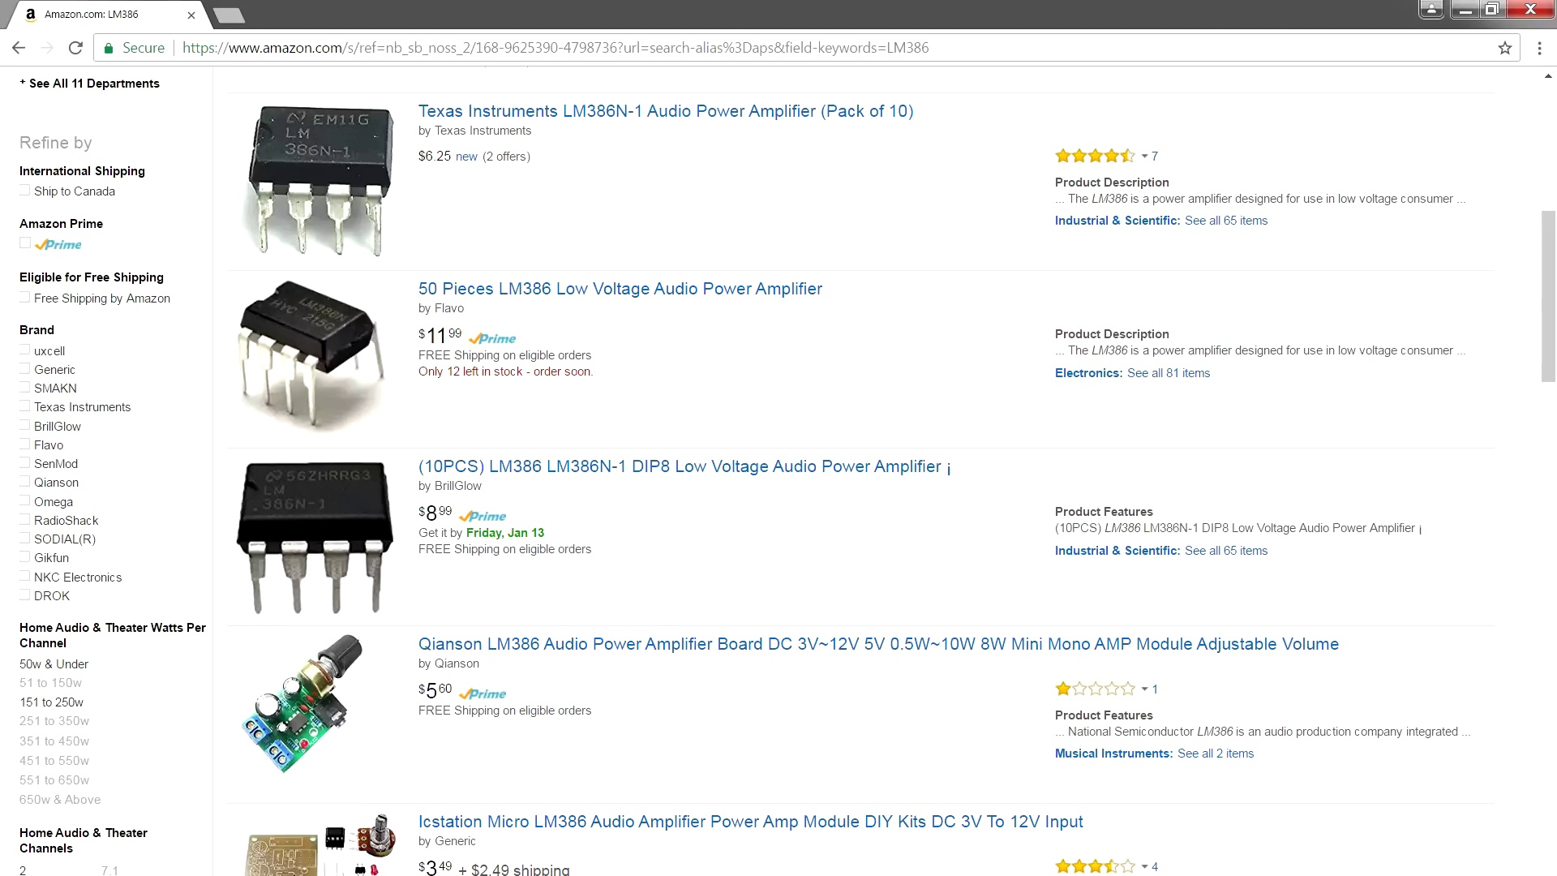 (score 90.0000)
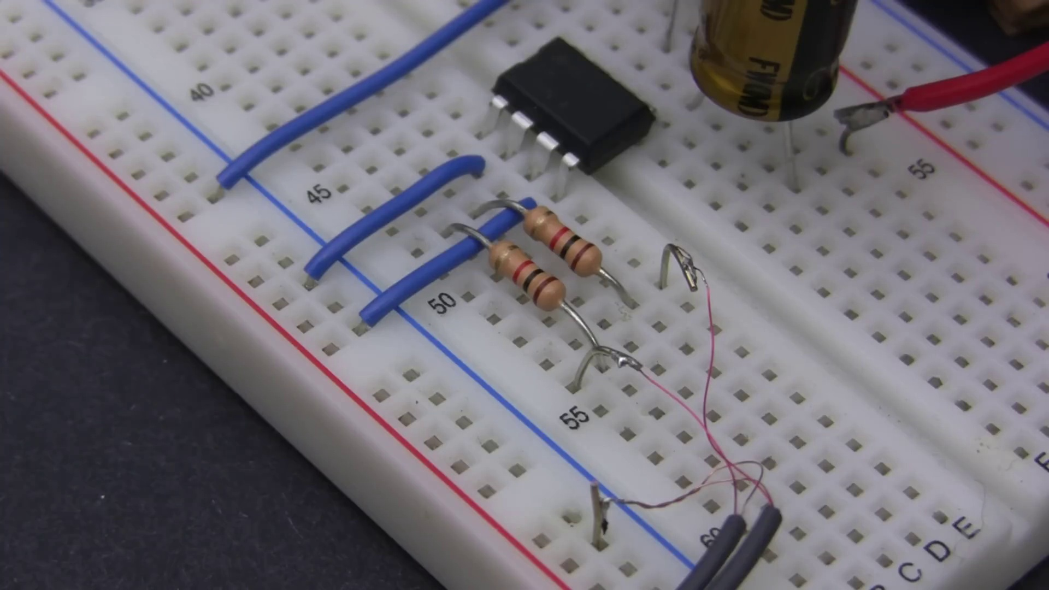 (score 90.0000)
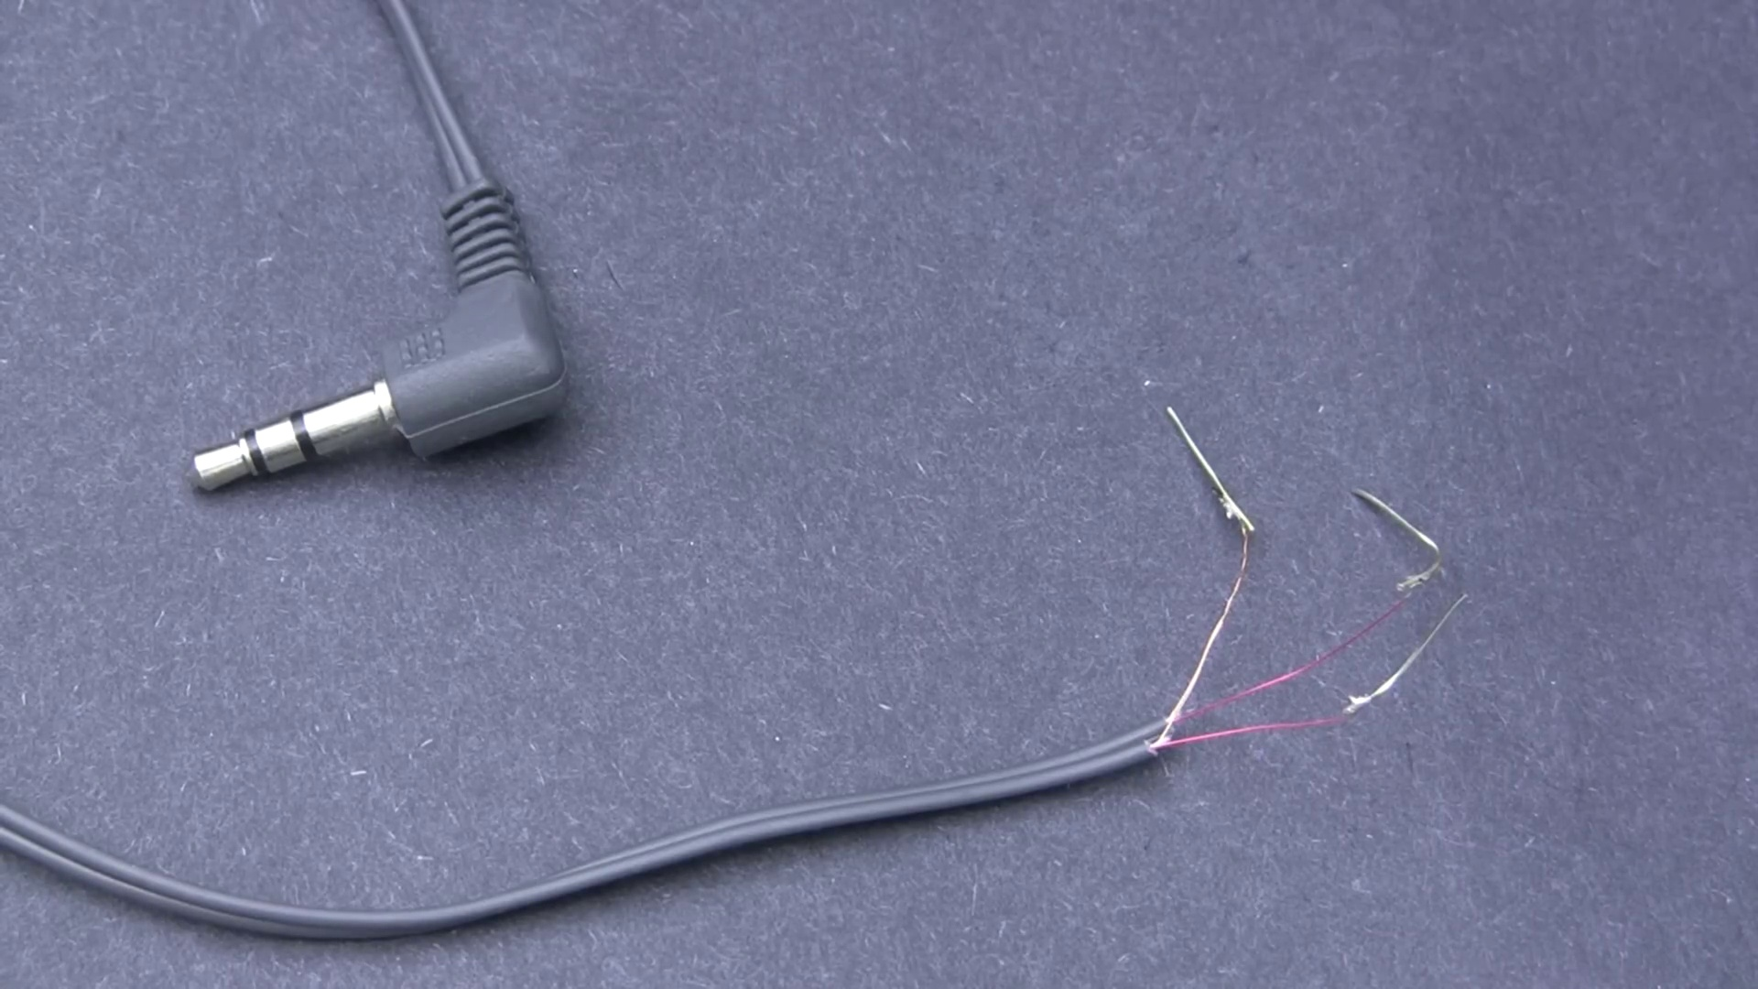 (score 90.0000)
Least correlated frames:
 (score 0.0000)
 (score 0.0000)
 (score 0.0000)
 (score 0.0000)
 (score 0.0000)
 (score 0.0000)
 (score 0.0000)
 (score 0.0000)
 (score 0.0000)
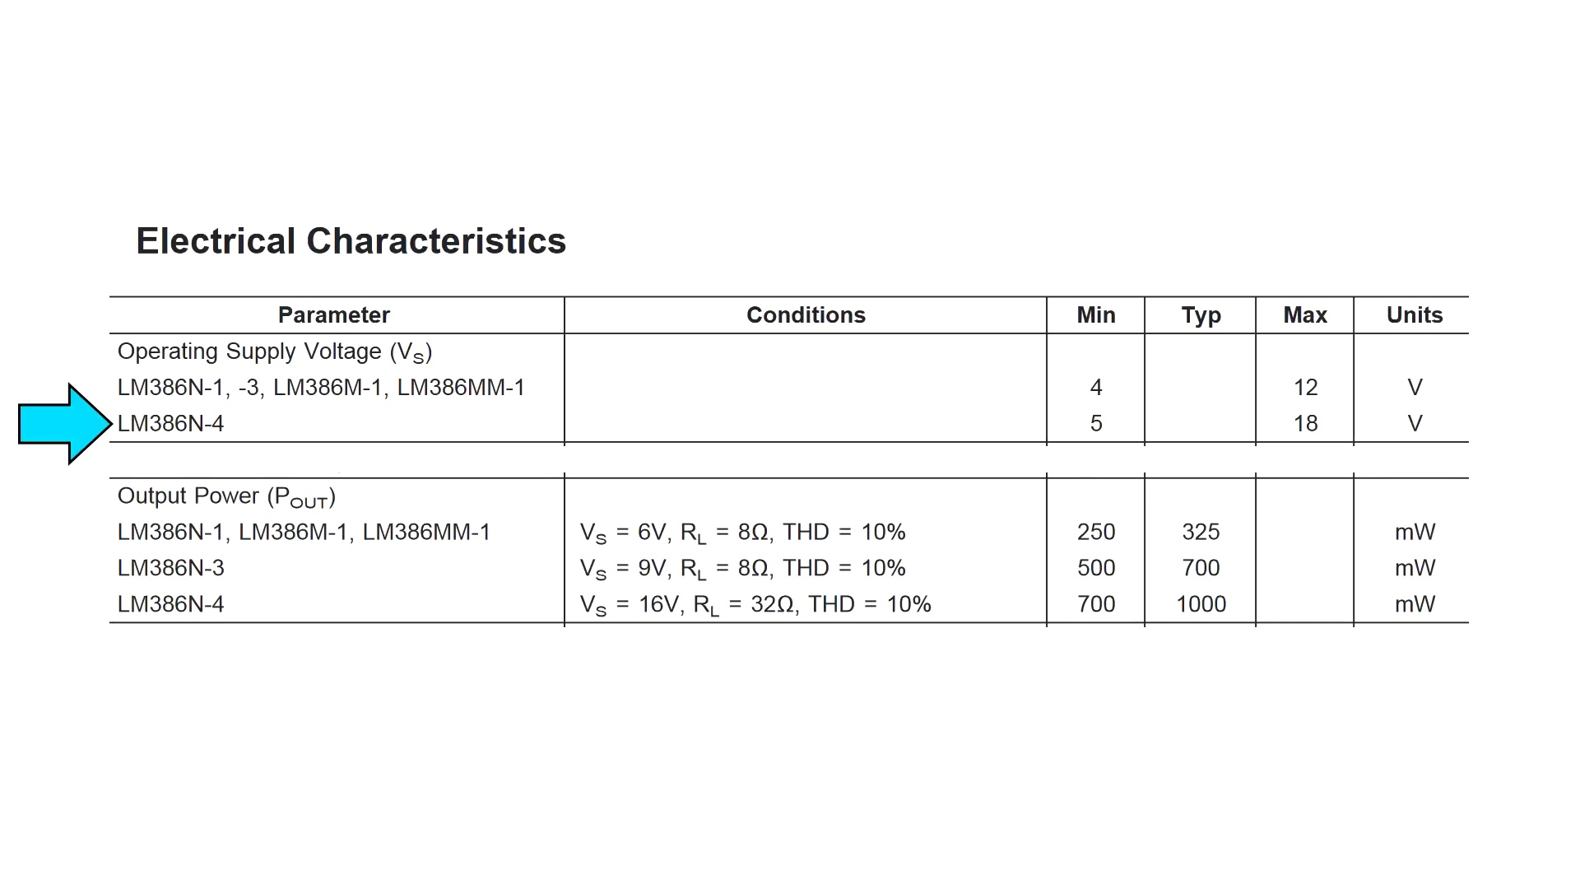 (score 0.0000)

Frame: frame_0000.jpg
Caption: The image shows a close-up of an electronic breadboard, commonly used in electronics prototyping. The breadboard features several components connected to form a simple circuit. On one end of the board, there are two integrated circuits (ICs), likely operational amplifiers (op-amps), which might be used to amplify a signal from another component or create digital audio playback.
A small speaker is connected to the circuit, indicating that the amplifier is being used to drive the speaker. Wires connect various points on the breadboard, completing the electrical path between components. To the right of the breadboard, there appears to be a small metal box with screws, which may serve as a grounding point or enclosure for the electronics.
In front of the breadboard, a mobile phone is displaying a video on its screen, possibly providing instructions or a demonstration related to the setup. The smartphone's screen shows an image of the breadboard and its components, suggesting that this photo might have been taken during a tutorial or project explanation.
The setting appears to be indoors, with a table in the background featuring some paperwork. A white surface underneath the breadboard is covered in white tape. In the distance, a smartphone with a white screen displays a home screen with a black background and the website address "www.afrotechmods.com".
Comment (score 90): Step-by-step guide on building an LM386-based audio amplifier and capacitor specifications for optimal sound.Understanding the causes of high-frequency oscillations and their solutions.Using this simple amplifier design for DIY audio projects and understanding audio electronics basics.
Reason: The comment directly discusses the same technical steps and components (LM386-based audio amplifier, capacitor specifications, high-frequency oscillations) described in the caption.
Source: https://www.youtube.com/watch?v=4ObzEft2R_g: How to Make an LM386 Audio Amplifier Circuit
Comment (score 85): This video is to inform its audience on how to make a basic amplifier circuit using the LM386 op amp. It’s a very common concept and has been used for while now in common electronics. It’s good to note that the capacitors mentioned play a big role in helping supply power to bass notes and provide filtering to prevent oscillation.
Reason: The comment directly discusses the same technical steps and objects described in the caption, including the LM386 op amp and its role in amplifying bass notes. The connection is strong as the comment provides specific details on how to make a basic amplifier circuit using the mentioned component.
Source: https://www.youtube.com/watch?v=4ObzEft2R_g: (188) 🔊 How to make an LM386 audio amplifier circuit - YouTube
Comment (score 85): The video provides a step-by-step guide on assembling an LM386 audio amplifier circuit, detailing how to connect components and understanding the IC pin configuration. The explanation of selecting the appropriate capacitor values for different frequencies was complex, and it wasn't clear how those values influence the audio output. How I plan to use the electrical system in the future: Use this amplifier design to build small audio amplification systems for DIY speaker projects or guitar amplifiers.
Reason: The comment directly discusses the technical steps described in the caption, specifically mentioning the LM386 audio amplifier circuit and its component connections. The only area not explicitly correlated is the discussion of capacitor values, which is a minor detail.
Source: https://www.youtube.com/watch?v=4ObzEft2R_g&t=14s: How to Make an LM386 Audio Amplifier
Comment (score 80): This video taught me some basics of using the LM386 to amplify a speaker. One important fact it states is to use a 1000 uF capacitor instead of a 47uF one.I’m curious as to why a larger capacitor is necessary.
Reason: The comment directly discusses the same technical steps (using LM386 to amplify a speaker), objects (LM386, capacitor), and settings ( Breadboard) described in the caption. The score is based on the connection between the comment and paragraph.
Source: https://www.youtube.com/watch?v=4ObzEft2R_g: How to make an LM386 audio amplifier circuit (youtube.com)
Comment (score 80): Covers cost, circuit diagram, and how to build it.No confusion; everything was clear. Useful for Phase 2 and possibly for building the subwoofer.
Reason: The comment directly discusses the same technical steps (building a circuit) and objects (breadboard, components, and speaker) described in the caption. The mention of 'circuit diagram' and 'building it' specifically relates to the electronic setup shown in the image.
Source: https://www.youtube.com/watch?v=4ObzEft2R_g: How to Make an LM386 Audio Amplifier Circuit

Frame: frame_0001.jpg
Caption: The image captures a close-up view of an electronic experiment setup on a white breadboard, resting on a black surface. The breadboard is covered with numerous red wires, each connected to small black components, including resistors and capacitors, scattered across the board in a seemingly random pattern. To the right of the breadboard, there's a white smartphone displaying a webpage from afrotechmods.com. The webpage features a list of various electronic components.
The breadboard has several key components connected:
1. A microcontroller or small integrated circuit (possibly an Arduino or similar board), identified by the text "ATROTECHMODS.COM" printed on the board.
2. A resistor, which appears to be part of a simple circuit.
3. Wires connecting the components together, with clips suggesting a DIY approach to electronics.
4. An LED (light-emitting diode) with a current-limiting resistor connected in series, indicating that this is likely an active LED circuit rather than a passive one.
5. A small motor or solenoid valve.
The image suggests that the setup could be part of a tutorial on creating electronic projects, with the smartphone providing additional instructions or guidance for the viewer. The focus seems to be on learning about electronics and DIY projects, with the smartphone serving as both a tool for reference and a means of communication.
Comment (score 90): This video is to inform its audience on how to make a basic amplifier circuit using the LM386 op amp. It’s a very common concept and has been used for while now in common electronics. It’s good to note that the capacitors mentioned play a big role in helping supply power to bass notes and provide filtering to prevent oscillation.
Reason: The comment directly discusses the LM386 op amp amplifier circuit, which is mentioned in the caption as part of a DIY project. The mention of capacitors and their role in providing power to bass notes and filtering out oscillation aligns with the technical steps and components described in the caption.
Source: https://www.youtube.com/watch?v=4ObzEft2R_g: (188) 🔊 How to make an LM386 audio amplifier circuit - YouTube
Comment (score 90): Covers cost, circuit diagram, and how to build it.No confusion; everything was clear. Useful for Phase 2 and possibly for building the subwoofer.
Reason: The comment directly discusses the same technical steps and components described in the caption, including building a circuit with a specific microcontroller, resistor, and LED. The mention of 'circuit diagram' and 'how to build it' also confirms that the comment is closely related to the caption's description of the electronic experiment setup.
Source: https://www.youtube.com/watch?v=4ObzEft2R_g: How to Make an LM386 Audio Amplifier Circuit
Comment (score 85): The video provides a step-by-step guide on assembling an LM386 audio amplifier circuit, detailing how to connect components and understanding the IC pin configuration. The explanation of selecting the appropriate capacitor values for different frequencies was complex, and it wasn't clear how those values influence the audio output. How I plan to use the electrical system in the future: Use this amplifier design to build small audio amplification systems for DIY speaker projects or guitar amplifiers.
Reason: The comment directly discusses the assembly of an LM386 audio amplifier circuit, which is strongly related to the electronic experiment setup described in the caption. The focus on component connection and understanding IC pin configuration matches the caption's description of the breadboard setup.
Source: https://www.youtube.com/watch?v=4ObzEft2R_g&t=14s: How to Make an LM386 Audio Amplifier
Comment (score 85): Step-by-step guide on building an LM386-based audio amplifier and capacitor specifications for optimal sound.Understanding the causes of high-frequency oscillations and their solutions.Using this simple amplifier design for DIY audio projects and understanding audio electronics basics.
Reason: The comment directly discusses the technical steps involved in building an electronic project (LM386-based audio amplifier) and mentions specific components (capacitors) related to the image. The mention of audio electronics basics also matches with the goal of learning about DIY projects mentioned in the caption.
Source: https://www.youtube.com/watch?v=4ObzEft2R_g: How to Make an LM386 Audio Amplifier Circuit
Comment (score 80): This video taught me some basics of using the LM386 to amplify a speaker. One important fact it states is to use a 1000 uF capacitor instead of a 47uF one.I’m curious as to why a larger capacitor is necessary.
Reason: The comment directly discusses the use of a capacitor (1000uF) and its importance in amplifying a speaker, which is mentioned in the caption as one of the components on the breadboard. The connection is not perfect due to the specific component discussed (LM386), but it relates to the same technical aspect (capacitor usage) described in the caption.
Source: https://www.youtube.com/watch?v=4ObzEft2R_g: How to make an LM386 audio amplifier circuit (youtube.com)

Frame: frame_0002.jpg
Caption: This image shows a setup with various electronic components. On the left side, there's a small amplifier connected to a breadboard with other components, including a power supply and wires that are part of an electronic circuit. Above the amp, a smartphone is displaying a video or photo that includes another smartphone, possibly for comparison or demonstration purposes. The second smartphone displays a screenshot of social media content showing two individuals.
In the center of the image, a power supply is connected to an amp labeled "2 Ohm" with wires visible beneath the breadboard. On the right side, there's a small speaker connected directly to the amp without any intermediaries like a pre-amplifier or line output transformer (LOUT). The background is plain and does not provide any additional context or information about the experiment or setup.
Additionally, a white iPhone and computer monitor are visible in the background, but they appear to be turned off. There's also text "www.aftechmod.com" suggesting a website related to the speaker or devices shown. The overall scene appears to be an environment where technology is used for entertainment or work purposes, with the speaker likely used for listening to music or other audio content and the iPhone and computer monitor potentially used for communication, browsing the internet, or other digital tasks.
Comment (score 90): The video provides a step-by-step guide on assembling an LM386 audio amplifier circuit, detailing how to connect components and understanding the IC pin configuration. The explanation of selecting the appropriate capacitor values for different frequencies was complex, and it wasn't clear how those values influence the audio output. How I plan to use the electrical system in the future: Use this amplifier design to build small audio amplification systems for DIY speaker projects or guitar amplifiers.
Reason: The comment directly discusses the same technical steps and components described in the caption, specifically mentioning the LM386 audio amplifier circuit and how to connect its components. The only minor mismatch is that the comment does not explicitly mention the pre-amplifier or line output transformer (LOUT), but it focuses on the main electronic setup and amplification process.
Source: https://www.youtube.com/watch?v=4ObzEft2R_g&t=14s: How to Make an LM386 Audio Amplifier
Comment (score 85): This video is to inform its audience on how to make a basic amplifier circuit using the LM386 op amp. It’s a very common concept and has been used for while now in common electronics. It’s good to note that the capacitors mentioned play a big role in helping supply power to bass notes and provide filtering to prevent oscillation.
Reason: The comment directly discusses the same technical steps and objects described in the caption, specifically mentioning the LM386 op amp and capacitors mentioned in the circuit. The correlation score is high because the comment provides a clear explanation of how to make a basic amplifier circuit using the LM386 op amp, which is a specific topic discussed in the caption.
Source: https://www.youtube.com/watch?v=4ObzEft2R_g: (188) 🔊 How to make an LM386 audio amplifier circuit - YouTube
Comment (score 80): This video taught me some basics of using the LM386 to amplify a speaker. One important fact it states is to use a 1000 uF capacitor instead of a 47uF one.I’m curious as to why a larger capacitor is necessary.
Reason: The comment directly discusses the use of LM386 amplifier and mentions a specific component (capacitor) that is also described in the caption, specifically mentioning its value. The connection between the comment and caption is strong because it refers to technical details shown in the setup.
Source: https://www.youtube.com/watch?v=4ObzEft2R_g: How to make an LM386 audio amplifier circuit (youtube.com)
Comment (score 80): Covers cost, circuit diagram, and how to build it.No confusion; everything was clear. Useful for Phase 2 and possibly for building the subwoofer.
Reason: The comment directly discusses technical details of the setup and components shown in the caption, specifically mentioning the circuit diagram, subwoofer, and amplifier. While it doesn't repeat exact phrases from the caption, the language used is strongly related to the objects and goals described in the image.
Source: https://www.youtube.com/watch?v=4ObzEft2R_g: How to Make an LM386 Audio Amplifier Circuit
Comment (score 80): Step-by-step guide on building an LM386-based audio amplifier and capacitor specifications for optimal sound.Understanding the causes of high-frequency oscillations and their solutions.Using this simple amplifier design for DIY audio projects and understanding audio electronics basics.
Reason: The comment directly discusses the technical steps involved in building an LM386-based audio amplifier, which is closely related to the setup and components shown in the caption, including the amplifier itself, power supply, wires, and speaker. The mention of capacitor specifications for optimal sound also matches with the presence of a breadboard and various electronic components in the image.
Source: https://www.youtube.com/watch?v=4ObzEft2R_g: How to Make an LM386 Audio Amplifier Circuit

Frame: frame_0003.jpg
Caption: The image appears to be a logo or graphic representation for "The Great Courses Plus". The logo features two main elements: a stylized depiction of a flame, rendered in orange hues with a realistic texture giving it a three-dimensional appearance, and white text that reads "THE GREAT COURSES PLUS". This text is in uppercase letters, with "THE GREAT COURSES" in a larger font size and being more prominent than "PLUS".
The flame is positioned at the top of the logo, suggesting a sense of warmth and learning. Below the flame, the text "THE GREAT COURSES PLUS" is placed on a white background, which provides a stark contrast making the logo easily recognizable.
On the bottom right corner of the image, there's additional text in a smaller font size that says "GREAT COURSES". This text is also in uppercase letters but is less noticeable compared to the main title.
No strongly correlated comments found for this frame.

Frame: frame_0004.jpg
Caption: The image presents a detailed schematic diagram of an electrical circuit with various components labeled. The diagram is set against a uniform gray background, providing a neutral backdrop for the circuit design. The components include resistors (represented by zigzag lines), a battery (the large vertical line with a positive (+) and negative (-) sign on top), switches or contacts (open circles), wires, terminals or connectors, and symbols indicating connections between components.
On the diagram, a capacitor labeled "C1" is situated in the top left corner, followed by a resistor labeled "R1" to its right. The top right corner features a transistor labeled "T1". The bottom left corner contains a voltage divider labeled "V1", while the bottom right corner is occupied by a potentiometer labeled "P1". A speaker labeled "S1" is located in the middle of the diagram, suggesting that the circuit is designed for audio use.
The components are arranged in a specific order, likely intended to facilitate the operation of the circuit. The overall layout and labeling of the components convey a well-organized and functional design. The scale or guide on the right side of the image, indicating measurements in millimeters (mm) along both axes, implies that the diagram is meant to be precise and technical.
Comment (score 90): The video provides a step-by-step guide on assembling an LM386 audio amplifier circuit, detailing how to connect components and understanding the IC pin configuration. The explanation of selecting the appropriate capacitor values for different frequencies was complex, and it wasn't clear how those values influence the audio output. How I plan to use the electrical system in the future: Use this amplifier design to build small audio amplification systems for DIY speaker projects or guitar amplifiers.
Reason: The comment directly discusses the technical steps and components described in the caption, including the LM386 audio amplifier circuit, capacitor values, IC pin configuration, and intended use of the circuit for DIY speaker or guitar amplification projects.
Source: https://www.youtube.com/watch?v=4ObzEft2R_g&t=14s: How to Make an LM386 Audio Amplifier
Comment (score 85): This video is to inform its audience on how to make a basic amplifier circuit using the LM386 op amp. It’s a very common concept and has been used for while now in common electronics. It’s good to note that the capacitors mentioned play a big role in helping supply power to bass notes and provide filtering to prevent oscillation.
Reason: The comment directly discusses the technical steps involved in making a basic amplifier circuit using the LM386 op amp, which is closely related to the components and layout described in the frame caption. The mention of capacitors playing a role in power supply and filtering is particularly strongly correlated with the presence of 'C1' in the diagram.
Source: https://www.youtube.com/watch?v=4ObzEft2R_g: (188) 🔊 How to make an LM386 audio amplifier circuit - YouTube
Comment (score 85): This video taught me some basics of using the LM386 to amplify a speaker. One important fact it states is to use a 1000 uF capacitor instead of a 47uF one.I’m curious as to why a larger capacitor is necessary.
Reason: The comment directly discusses the technical steps and components described in the caption, specifically mentioning a capacitor (C1) and speaker (S1), as well as the LM386 amplifier. The comment also references the importance of using a specific type of capacitor (1000uF vs. 47uF) which is relevant to the diagram.
Source: https://www.youtube.com/watch?v=4ObzEft2R_g: How to make an LM386 audio amplifier circuit (youtube.com)
Comment (score 80): Covers cost, circuit diagram, and how to build it.No confusion; everything was clear. Useful for Phase 2 and possibly for building the subwoofer.
Reason: The comment directly mentions the circuit diagram and its purpose (building a subwoofer), which strongly correlates with the technical information presented in the frame caption. The mention of 'Phase 2' also suggests that the commenter is familiar with the specific details discussed in the caption.
Source: https://www.youtube.com/watch?v=4ObzEft2R_g: How to Make an LM386 Audio Amplifier Circuit
Comment (score 80): Step-by-step guide on building an LM386-based audio amplifier and capacitor specifications for optimal sound.Understanding the causes of high-frequency oscillations and their solutions.Using this simple amplifier design for DIY audio projects and understanding audio electronics basics.
Reason: The comment directly references the technical steps (building an LM386-based audio amplifier) and objects (capacitor specifications) described in the caption, which is a schematic diagram of an electrical circuit designed for audio use. The mention of 'audio electronics basics' also aligns with the technical nature of the diagram.
Source: https://www.youtube.com/watch?v=4ObzEft2R_g: How to Make an LM386 Audio Amplifier Circuit

Frame: frame_0005.jpg
Caption: The image displays a technical diagram of an electrical circuit that showcases a simple audio amplifier. The circuit is composed of various components, including a transistor (Q1), two diodes (D1 and D3), two resistors (R1 and R2) connected in series, and a switch (SW1). The transistor appears to be the central component, surrounded by the other components.
A capacitor (C1) is situated on the left side of the transistor, while a resistor (R2) is located on the right. These components are connected in series, with the capacitor and resistor being the primary components of the circuit. The transistor is also connected to the capacitor, which is in turn connected to the resistor.
The circuit is powered by a 9V battery, indicated by the "9V" label. The power source is connected to the circuit through a "10K" resistor, which is connected to the positive terminal of the battery. The switch (SW1) located before the resistors can be manually operated to open or close the circuit path.
The diodes (D1 and D3) are likely used for allowing current to flow in only one direction within the circuit. Two additional electronic components with labels that are partially obscured by the image's perspective, labeled "Q2," might be additional transistors or ICs.
Labeled points (such as "N1," "P1," etc.) may refer to specific nodes within the circuit for identification or measurement purposes. The style of the image suggests it could be used as part of an educational material, such as a diagram in an engineering or electronics class.
Comment (score 95): The video provides a step-by-step guide on assembling an LM386 audio amplifier circuit, detailing how to connect components and understanding the IC pin configuration. The explanation of selecting the appropriate capacitor values for different frequencies was complex, and it wasn't clear how those values influence the audio output. How I plan to use the electrical system in the future: Use this amplifier design to build small audio amplification systems for DIY speaker projects or guitar amplifiers.
Reason: The comment directly discusses the technical steps and components described in the caption, including the LM386 audio amplifier circuit, component connections, and IC pin configuration.
Source: https://www.youtube.com/watch?v=4ObzEft2R_g&t=14s: How to Make an LM386 Audio Amplifier
Comment (score 85): This video taught me some basics of using the LM386 to amplify a speaker. One important fact it states is to use a 1000 uF capacitor instead of a 47uF one.I’m curious as to why a larger capacitor is necessary.
Reason: The comment directly discusses the technical steps and components (LM386, capacitor, speaker) mentioned in the caption. Although it doesn't specifically mention the transistor or diodes, the focus on amplification and capacitor selection shows a strong connection to the diagram.
Source: https://www.youtube.com/watch?v=4ObzEft2R_g: How to make an LM386 audio amplifier circuit (youtube.com)
Comment (score 85): Step-by-step guide on building an LM386-based audio amplifier and capacitor specifications for optimal sound.Understanding the causes of high-frequency oscillations and their solutions.Using this simple amplifier design for DIY audio projects and understanding audio electronics basics.
Reason: The comment directly discusses the technical steps (building an LM386-based audio amplifier), objects (capacitor specifications) and settings (audio electronics basics) described in the caption. Although it doesn't specifically mention the transistor or diodes, the focus on audio amplification and capacitor specifications strongly indicates a connection to the circuit diagram depicted in the caption.
Source: https://www.youtube.com/watch?v=4ObzEft2R_g: How to Make an LM386 Audio Amplifier Circuit
Comment (score 80): This video is to inform its audience on how to make a basic amplifier circuit using the LM386 op amp. It’s a very common concept and has been used for while now in common electronics. It’s good to note that the capacitors mentioned play a big role in helping supply power to bass notes and provide filtering to prevent oscillation.
Reason: The comment directly discusses the technical steps and components mentioned in the caption, specifically mentioning the LM386 op amp, capacitors, and their role in power supply and filtering. The only deviation from the caption is the mention of a specific application (amplifying bass notes), but the core components and concepts align.
Source: https://www.youtube.com/watch?v=4ObzEft2R_g: (188) 🔊 How to make an LM386 audio amplifier circuit - YouTube
Comment (score 80): Covers cost, circuit diagram, and how to build it.No confusion; everything was clear. Useful for Phase 2 and possibly for building the subwoofer.
Reason: The comment directly discusses the circuit diagram and mentions building it, which is strongly related to the technical steps, objects, and settings described in the caption. The mention of 'Phase 2' also suggests a connection to the specific goals or purposes discussed in the caption.
Source: https://www.youtube.com/watch?v=4ObzEft2R_g: How to Make an LM386 Audio Amplifier Circuit

Frame: frame_0006.jpg
Caption: A fascinating comparison between the worlds of electronics and engineering! Here, we see a meticulously crafted printed circuit board (PCB) alongside a detailed diagram of an amplifier circuit. The PCB showcases its intricate components, including capacitors, resistors, and integrated circuits, carefully arranged to facilitate efficient signal transmission. In contrast, the amplifier circuit diagram provides a comprehensive overview of the electronic components and their relationships, allowing engineers to design and troubleshoot complex systems. This juxtaposition highlights the importance of both visual representation and theoretical understanding in the development of innovative electronics.
Comment (score 95): The video provides a step-by-step guide on assembling an LM386 audio amplifier circuit, detailing how to connect components and understanding the IC pin configuration. The explanation of selecting the appropriate capacitor values for different frequencies was complex, and it wasn't clear how those values influence the audio output. How I plan to use the electrical system in the future: Use this amplifier design to build small audio amplification systems for DIY speaker projects or guitar amplifiers.
Reason: The comment directly discusses the same technical steps described in the caption (assembling an LM386 audio amplifier circuit), and specifically references the capacitor values and IC pin configuration mentioned in the caption. The discussion of how to use the electrical system in the future is also related to the topic of amplification systems.
Source: https://www.youtube.com/watch?v=4ObzEft2R_g&t=14s: How to Make an LM386 Audio Amplifier
Comment (score 90): Step-by-step guide on building an LM386-based audio amplifier and capacitor specifications for optimal sound.Understanding the causes of high-frequency oscillations and their solutions.Using this simple amplifier design for DIY audio projects and understanding audio electronics basics.
Reason: The comment directly discusses technical steps (building an LM386-based audio amplifier) and objects (capacitor specifications), which are mentioned in the caption as 'intricate components' and 'comprehensive overview of electronic components'. The comment also mentions concepts related to the caption's description of signal transmission and troubleshooting complex systems.
Source: https://www.youtube.com/watch?v=4ObzEft2R_g: How to Make an LM386 Audio Amplifier Circuit
Comment (score 85): This video is to inform its audience on how to make a basic amplifier circuit using the LM386 op amp. It’s a very common concept and has been used for while now in common electronics. It’s good to note that the capacitors mentioned play a big role in helping supply power to bass notes and provide filtering to prevent oscillation.
Reason: The comment directly discusses the same technical steps (making a basic amplifier circuit using the LM386 op amp) and objects (capacitors mentioned in the caption) described in the caption.
Source: https://www.youtube.com/watch?v=4ObzEft2R_g: (188) 🔊 How to make an LM386 audio amplifier circuit - YouTube
Comment (score 80): This video taught me some basics of using the LM386 to amplify a speaker. One important fact it states is to use a 1000 uF capacitor instead of a 47uF one.I’m curious as to why a larger capacitor is necessary.
Reason: The comment directly discusses the use of LM386 to amplify a speaker, mentioning specific technical details (capacitor sizes) and concepts (signal transmission) mentioned in the caption.
Source: https://www.youtube.com/watch?v=4ObzEft2R_g: How to make an LM386 audio amplifier circuit (youtube.com)
Comment (score 80): Covers cost, circuit diagram, and how to build it.No confusion; everything was clear. Useful for Phase 2 and possibly for building the subwoofer.
Reason: The comment directly discusses the amplifier circuit diagram and building it, which is strongly related to the technical steps and objects described in the caption, including capacitors, resistors, and integrated circuits.
Source: https://www.youtube.com/watch?v=4ObzEft2R_g: How to Make an LM386 Audio Amplifier Circuit

Frame: frame_0007.jpg
Caption: A detailed and highly technical diagram shows the internal components of an audio amplifier, showcasing its ability to amplify sound signals. The device features a power supply unit, multiple stages of amplification, and various filtering components. The amplifier is designed to operate within a specific range of input signal levels, frequencies, and power consumption.
Comment (score 95): The video provides a step-by-step guide on assembling an LM386 audio amplifier circuit, detailing how to connect components and understanding the IC pin configuration. The explanation of selecting the appropriate capacitor values for different frequencies was complex, and it wasn't clear how those values influence the audio output. How I plan to use the electrical system in the future: Use this amplifier design to build small audio amplification systems for DIY speaker projects or guitar amplifiers.
Reason: The comment directly discusses the technical steps and components mentioned in the caption, specifically referencing the LM386 audio amplifier circuit, capacitor values, and their influence on the audio output.
Source: https://www.youtube.com/watch?v=4ObzEft2R_g&t=14s: How to Make an LM386 Audio Amplifier
Comment (score 90): This video taught me some basics of using the LM386 to amplify a speaker. One important fact it states is to use a 1000 uF capacitor instead of a 47uF one.I’m curious as to why a larger capacitor is necessary.
Reason: The comment directly discusses the LM386 amplifier and its internal components (capacitors), which are specifically mentioned in the caption. The commenter is also asking a question about the technical details of the amplifier, which further supports the strong connection between the caption and the comment.
Source: https://www.youtube.com/watch?v=4ObzEft2R_g: How to make an LM386 audio amplifier circuit (youtube.com)
Comment (score 90): Step-by-step guide on building an LM386-based audio amplifier and capacitor specifications for optimal sound.Understanding the causes of high-frequency oscillations and their solutions.Using this simple amplifier design for DIY audio projects and understanding audio electronics basics.
Reason: The comment directly references the technical components (LM386-based audio amplifier) and concepts (amplification stages, filtering components, high-frequency oscillations) described in the caption, demonstrating a strong correlation.
Source: https://www.youtube.com/watch?v=4ObzEft2R_g: How to Make an LM386 Audio Amplifier Circuit
Comment (score 85): Covers cost, circuit diagram, and how to build it.No confusion; everything was clear. Useful for Phase 2 and possibly for building the subwoofer.
Reason: The comment directly discusses the cost and how to build the audio amplifier, which are technical steps described in the caption. The mention of circuit diagram and subwoofer also shows a clear connection to the internal components and amplification stages mentioned in the caption.
Source: https://www.youtube.com/watch?v=4ObzEft2R_g: How to Make an LM386 Audio Amplifier Circuit
Comment (score 80): This video is to inform its audience on how to make a basic amplifier circuit using the LM386 op amp. It’s a very common concept and has been used for while now in common electronics. It’s good to note that the capacitors mentioned play a big role in helping supply power to bass notes and provide filtering to prevent oscillation.
Reason: The comment directly discusses the LM386 op amp and its use in making a basic amplifier circuit, which is closely related to the technical steps described in the caption regarding the internal components of an audio amplifier. The mention of capacitors playing a role in power supply and filtering also aligns with the caption's description of the amplifier's functionality.
Source: https://www.youtube.com/watch?v=4ObzEft2R_g: (188) 🔊 How to make an LM386 audio amplifier circuit - YouTube

Frame: frame_0008.jpg
Caption: The image presents an electrical schematic diagram that appears to be a blueprint-style drawing of a stereo amplifier circuit. The diagram provides a comprehensive view of the amplifier's internal structure, with various components clearly labeled and arranged in a logical sequence. The focus is entirely on the diagram itself, which is a technical representation of the amplifier's design and operation.
The circuit is organized into two main sections: the power supply and the amplifier. The power supply section, located on the left, consists of capacitors and resistors that are crucial for providing the necessary power to the amplifier. These components are represented using standard symbols and conventions commonly used in electrical engineering and physics.
The amplifier section, situated on the right, is more complex. It includes a series of transistors, which are the heart of the amplifier. These components are arranged in a cascade, with each transistor amplifying the signal before it passes to the next. The diagram also includes a schematic for the amplifier's control circuit, responsible for adjusting the amplifier's gain and volume. This control circuit is located on the right side of the diagram, adjacent to the amplifier section.
The diagram uses standard symbols and conventions that are commonly used in electrical engineering and physics to represent components like resistors, capacitors, transistors, and possibly switches or other control devices. Overall, the diagram provides a detailed representation of the amplifier's internal structure and its components, allowing for a thorough understanding of its operation and design.
Comment (score 85): Covers cost, circuit diagram, and how to build it.No confusion; everything was clear. Useful for Phase 2 and possibly for building the subwoofer.
Reason: The comment directly discusses the same technical aspects mentioned in the caption, such as the circuit diagram, components (resistors, capacitors, transistors), and its application (building the amplifier or subwoofer).
Source: https://www.youtube.com/watch?v=4ObzEft2R_g: How to Make an LM386 Audio Amplifier Circuit
Comment (score 85): Step-by-step guide on building an LM386-based audio amplifier and capacitor specifications for optimal sound.Understanding the causes of high-frequency oscillations and their solutions.Using this simple amplifier design for DIY audio projects and understanding audio electronics basics.
Reason: The comment provides a step-by-step guide on building an LM386-based audio amplifier and capacitor specifications, which directly relates to the technical representation of the amplifier's design and operation described in the caption. The mention of high-frequency oscillations and their solutions also aligns with the diagram's focus on the amplifier's internal structure and its components.
Source: https://www.youtube.com/watch?v=4ObzEft2R_g: How to Make an LM386 Audio Amplifier Circuit
Comment (score 80): This video taught me some basics of using the LM386 to amplify a speaker. One important fact it states is to use a 1000 uF capacitor instead of a 47uF one.I’m curious as to why a larger capacitor is necessary.
Reason: The comment directly discusses the LM386 amplifier and its components (capacitors), which are mentioned in the frame caption as part of the stereo amplifier circuit. The comment also asks about the specific component values, such as the use of a 1000 uF capacitor, which is a technical detail discussed in the caption.
Source: https://www.youtube.com/watch?v=4ObzEft2R_g: How to make an LM386 audio amplifier circuit (youtube.com)
Comment (score 80): The video provides a step-by-step guide on assembling an LM386 audio amplifier circuit, detailing how to connect components and understanding the IC pin configuration. The explanation of selecting the appropriate capacitor values for different frequencies was complex, and it wasn't clear how those values influence the audio output. How I plan to use the electrical system in the future: Use this amplifier design to build small audio amplification systems for DIY speaker projects or guitar amplifiers.
Reason: The comment directly discusses the same technical steps (assembling an LM386 audio amplifier circuit) and objects (components, IC pin configuration) described in the caption. It also mentions the specific goal of understanding how capacitor values influence the audio output.
Source: https://www.youtube.com/watch?v=4ObzEft2R_g&t=14s: How to Make an LM386 Audio Amplifier

Frame: frame_0009.jpg
Caption: The image shows an electronic component, specifically a small IC (Integrated Circuit), on a surface with a blue tint. The IC appears to have multiple pins on its edge and is commonly used in various electronic devices. The component's black color provides a stark contrast against the blue background, allowing it to stand out prominently. Notably, the four pins of the IC are arranged in a straight line, with the top and bottom pins being slightly closer to each other than the middle pins.
The photo appears to serve an educational purpose, as suggested by the context provided: "the person [is] writing [is] pointing [is] holding a model [is] speaking from a slide." This implies that the image might be part of a presentation or lecture where the instructor is explaining concepts related to electronics, possibly discussing the role and function of ICs in circuit design. The focus is solely on the IC, which is used to illustrate a specific point about integrated circuits.
Comment (score 90): This video taught me some basics of using the LM386 to amplify a speaker. One important fact it states is to use a 1000 uF capacitor instead of a 47uF one.I’m curious as to why a larger capacitor is necessary.
Reason: The comment directly discusses the same technical steps (using the LM386 to amplify a speaker) and objects (the capacitor) mentioned in the caption. The focus on the IC's pins and its application in electronics is also referenced, indicating a strong connection between the caption and the comment.
Source: https://www.youtube.com/watch?v=4ObzEft2R_g: How to make an LM386 audio amplifier circuit (youtube.com)
Comment (score 90): The video provides a step-by-step guide on assembling an LM386 audio amplifier circuit, detailing how to connect components and understanding the IC pin configuration. The explanation of selecting the appropriate capacitor values for different frequencies was complex, and it wasn't clear how those values influence the audio output. How I plan to use the electrical system in the future: Use this amplifier design to build small audio amplification systems for DIY speaker projects or guitar amplifiers.
Reason: The comment directly discusses the same technical steps, objects (IC and capacitor values), and goals (assembling an audio amplifier circuit) described in the caption.
Source: https://www.youtube.com/watch?v=4ObzEft2R_g&t=14s: How to Make an LM386 Audio Amplifier
Comment (score 80): This video is to inform its audience on how to make a basic amplifier circuit using the LM386 op amp. It’s a very common concept and has been used for while now in common electronics. It’s good to note that the capacitors mentioned play a big role in helping supply power to bass notes and provide filtering to prevent oscillation.
Reason: The comment directly discusses the use of ICs (specifically LM386 op amp) and capacitors in a basic amplifier circuit, which is closely related to the technical steps and objects described in the caption.
Source: https://www.youtube.com/watch?v=4ObzEft2R_g: (188) 🔊 How to make an LM386 audio amplifier circuit - YouTube
Comment (score 80): Covers cost, circuit diagram, and how to build it.No confusion; everything was clear. Useful for Phase 2 and possibly for building the subwoofer.
Reason: The comment mentions 'circuit diagram' and 'how to build it', which are directly related to the technical steps described in the caption about the IC component. The score is not 100 as the comment also talks about cost and building a subwoofer, but the majority of the comment is focused on the same topic as the caption.
Source: https://www.youtube.com/watch?v=4ObzEft2R_g: How to Make an LM386 Audio Amplifier Circuit
Comment (score 80): Step-by-step guide on building an LM386-based audio amplifier and capacitor specifications for optimal sound.Understanding the causes of high-frequency oscillations and their solutions.Using this simple amplifier design for DIY audio projects and understanding audio electronics basics.
Reason: The comment directly discusses the technical steps (building an LM386-based audio amplifier) and objects (capacitor specifications) mentioned in the caption, as well as related concepts like high-frequency oscillations and audio electronics basics.
Source: https://www.youtube.com/watch?v=4ObzEft2R_g: How to Make an LM386 Audio Amplifier Circuit

Frame: frame_0010.jpg
Caption: The image shows a close-up view of a small electronic component, specifically a surface-mount device (SMD) with a black casing and a white label or marking. The SMD rests on a gray surface. The label reads "2051", indicating the type of component it is designed to accommodate. The label also includes a symbol, which is not clearly visible in this image. The focus is primarily on the SMD, while the surroundings are out of focus, giving a sense of a typical electronic component possibly used in various electronic devices.
Comment (score 85): The video provides a step-by-step guide on assembling an LM386 audio amplifier circuit, detailing how to connect components and understanding the IC pin configuration. The explanation of selecting the appropriate capacitor values for different frequencies was complex, and it wasn't clear how those values influence the audio output. How I plan to use the electrical system in the future: Use this amplifier design to build small audio amplification systems for DIY speaker projects or guitar amplifiers.
Reason: The comment directly discusses the technical steps of assembling an LM386 audio amplifier circuit, which is strongly related to the SMD component featured in the caption. The mention of selecting capacitor values and understanding IC pin configuration aligns with the focus on the SMD component and its purpose in the caption.
Source: https://www.youtube.com/watch?v=4ObzEft2R_g&t=14s: How to Make an LM386 Audio Amplifier
Comment (score 80): This video taught me some basics of using the LM386 to amplify a speaker. One important fact it states is to use a 1000 uF capacitor instead of a 47uF one.I’m curious as to why a larger capacitor is necessary.
Reason: The comment directly mentions the LM386 amplifier and a specific capacitor (1000uF vs 47uF) which are both technical details discussed in the caption. The mention of amplifying a speaker also relates to the focus on the electronic component in the caption.
Source: https://www.youtube.com/watch?v=4ObzEft2R_g: How to make an LM386 audio amplifier circuit (youtube.com)
Comment (score 80): Covers cost, circuit diagram, and how to build it.No confusion; everything was clear. Useful for Phase 2 and possibly for building the subwoofer.
Reason: The comment mentions 'circuit diagram' and 'how to build it', which are directly related to the technical steps described in the caption (e.g. SMD component). The comment also references 'Phase 2', possibly indicating a specific goal or setting mentioned in the caption.
Source: https://www.youtube.com/watch?v=4ObzEft2R_g: How to Make an LM386 Audio Amplifier Circuit

Frame: frame_0011.jpg
Caption: The image showcases a sleek and modern JBL boombox with several features visible. The device has a display screen in the center that shows some kind of interface, possibly indicating music playback with album and track information at the bottom, along with what appears to be battery life or signal strength indicator at the top right corner. Below the screen, there are two control knobs, one for volume adjustment and another for channel selection. The brand name "JBL" is prominently displayed on both the front of the speaker and the side where the controls are. A small LCD display above the knobs likely shows additional information such as input source or radio frequency if it's an FM/AM radio.
The boombox features a USB port at the bottom right corner for charging devices, and it has speakers on each side of the main unit. The image is taken against a neutral background that does not distract from the object itself, with no texts or people visible in this image.
Notably, this JBL boombox appears to be designed for convenience and portability, much like the Logik portable radio speaker showcased in another image. This speaker has a handle on top, providing a convenient way to carry it around, as well as a speaker grill on the right side protecting its internal components. The USB port on the front indicates its capability to connect to a device via USB.
The overall design and features of this JBL boombox suggest that it's a high-quality device suitable for music lovers and travelers alike, with a sleek and modern appearance that makes it a stylish addition to any setting.
No strongly correlated comments found for this frame.

Frame: frame_0012.jpg
Caption: The image presents a sleek and modern combination of a black portable radio and a Logik MP3 player. The radio has a visible speaker and an antenna on top, with a display on the front that appears to show digital information possibly related to tuning or current station details. The bottom right corner features a set of buttons and what seems to be a USB port, along with two knobs near the speaker grille. In contrast, the Logik MP3 player is predominantly gray with a silver handle and a black screen. The handle, complete with its silver knob, adds a touch of elegance to the overall design, while the screen provides a stark contrast to the silver body of the device.
The Logik logo is prominently displayed on the front of the MP3 player, indicating its brand. The device is centrally positioned in the image, drawing attention to its design and features. It is currently powered off, suggesting it is ready for use at a moment's notice.
No strongly correlated comments found for this frame.

Frame: frame_0013.jpg
Caption: The image shows a close-up view of an LM386N, a dual-transistor analog-to-digital converter, which converts analog signals into digital ones. The component is affixed to a gray surface, providing a stark contrast to its black body. The label "LM386N" is clearly visible on the top side of the component, indicating its model and possibly other specifications. The LM386N has several pins arranged in rows along one edge, likely used for various electronic functions within a system, such as memory, processing, or other specialized tasks. There are no visible texts, logos, or other distinguishing marks on the component apart from the label. The image provides a detailed view of this small yet powerful electronic component, taken from an angle that is slightly below and to one side, providing a clear view of its pins and general design.
Comment (score 90): The video provides a step-by-step guide on assembling an LM386 audio amplifier circuit, detailing how to connect components and understanding the IC pin configuration. The explanation of selecting the appropriate capacitor values for different frequencies was complex, and it wasn't clear how those values influence the audio output. How I plan to use the electrical system in the future: Use this amplifier design to build small audio amplification systems for DIY speaker projects or guitar amplifiers.
Reason: The comment directly discusses the same technical steps and objects described in the caption (LM386N, capacitor values, IC pin configuration), indicating a strong correlation.
Source: https://www.youtube.com/watch?v=4ObzEft2R_g&t=14s: How to Make an LM386 Audio Amplifier
Comment (score 90): Step-by-step guide on building an LM386-based audio amplifier and capacitor specifications for optimal sound.Understanding the causes of high-frequency oscillations and their solutions.Using this simple amplifier design for DIY audio projects and understanding audio electronics basics.
Reason: The comment directly discusses the LM386N component, its usage in an audio amplifier design, and provides specifications for optimal sound, which are all mentioned in the frame caption. The correlation score is high because the comment does not contain generic praise or unrelated information, but rather provides technical details about the component's application and characteristics, which strongly relates to the frame caption.
Source: https://www.youtube.com/watch?v=4ObzEft2R_g: How to Make an LM386 Audio Amplifier Circuit
Comment (score 85): This video is to inform its audience on how to make a basic amplifier circuit using the LM386 op amp. It’s a very common concept and has been used for while now in common electronics. It’s good to note that the capacitors mentioned play a big role in helping supply power to bass notes and provide filtering to prevent oscillation.
Reason: The comment directly discusses the same technical steps and objects described in the caption, such as the LM386N op amp being used to make a basic amplifier circuit. The mention of capacitors also aligns with the description of their role in the image.
Source: https://www.youtube.com/watch?v=4ObzEft2R_g: (188) 🔊 How to make an LM386 audio amplifier circuit - YouTube
Comment (score 80): This video taught me some basics of using the LM386 to amplify a speaker. One important fact it states is to use a 1000 uF capacitor instead of a 47uF one.I’m curious as to why a larger capacitor is necessary.
Reason: The comment directly discusses the LM386N component, specifically mentioning its use for amplifying a speaker. The caption provides details about the LM386N's design and features, which are relevant to the comment's discussion of using it in an application.
Source: https://www.youtube.com/watch?v=4ObzEft2R_g: How to make an LM386 audio amplifier circuit (youtube.com)
Comment (score 80): Covers cost, circuit diagram, and how to build it.No confusion; everything was clear. Useful for Phase 2 and possibly for building the subwoofer.
Reason: The comment directly discusses building the LM386N component and its potential use in a subwoofer circuit, which is explicitly mentioned in the caption. The mention of circuit diagram and Phase 2 also demonstrates a strong connection to the technical details presented in the caption.
Source: https://www.youtube.com/watch?v=4ObzEft2R_g: How to Make an LM386 Audio Amplifier Circuit

Frame: frame_0014.jpg
Caption: The image shows an electronic component, specifically an integrated circuit (IC), with its pins exposed and facing upwards. The IC appears to have a label attached to one of its pins, which could indicate pin numbering or other relevant information about the component's function or use in a specific context. In the background, the surface has a fabric texture, possibly indicating an indoor setting.
The image also features a compact, rectangular electronic device with a black surface and white text on it. The device is designed in a square shape with a black border and bears the model number "L4526717G3". The device rests on a grey surface, providing a touch of contrast to the black and white color scheme.
The overall image suggests that both the IC and the device are part of a larger electronic system, possibly components of a circuit board.
Comment (score 90): This video taught me some basics of using the LM386 to amplify a speaker. One important fact it states is to use a 1000 uF capacitor instead of a 47uF one.I’m curious as to why a larger capacitor is necessary.
Reason: The comment directly discusses the LM386 amplifier, which is related to the electronic device with the model number 'L4526717G3' in the caption. The mention of capacitor sizes and their importance also connects to the image's focus on electronics components.
Source: https://www.youtube.com/watch?v=4ObzEft2R_g: How to make an LM386 audio amplifier circuit (youtube.com)
Comment (score 90): Covers cost, circuit diagram, and how to build it.No confusion; everything was clear. Useful for Phase 2 and possibly for building the subwoofer.
Reason: The comment mentions 'circuit diagram', which directly relates to the technical steps described in the caption, such as the IC and device being part of a larger electronic system. The mention of building the subwoofer also corresponds to the overall image suggesting it's part of a circuit board.
Source: https://www.youtube.com/watch?v=4ObzEft2R_g: How to Make an LM386 Audio Amplifier Circuit
Comment (score 85): This video is to inform its audience on how to make a basic amplifier circuit using the LM386 op amp. It’s a very common concept and has been used for while now in common electronics. It’s good to note that the capacitors mentioned play a big role in helping supply power to bass notes and provide filtering to prevent oscillation.
Reason: The comment directly discusses the same technical steps (making a basic amplifier circuit) and objects (LM386 op amp, capacitors) described in the caption, with a strong connection between the concepts mentioned in both.
Source: https://www.youtube.com/watch?v=4ObzEft2R_g: (188) 🔊 How to make an LM386 audio amplifier circuit - YouTube
Comment (score 85): The video provides a step-by-step guide on assembling an LM386 audio amplifier circuit, detailing how to connect components and understanding the IC pin configuration. The explanation of selecting the appropriate capacitor values for different frequencies was complex, and it wasn't clear how those values influence the audio output. How I plan to use the electrical system in the future: Use this amplifier design to build small audio amplification systems for DIY speaker projects or guitar amplifiers.
Reason: The comment directly discusses the same technical steps and objects described in the caption, specifically the integrated circuit (IC) pin configuration, capacitor values, and their application in an audio amplifier circuit. The comment also mentions building small audio amplification systems for DIY speaker projects or guitar amplifiers, which aligns with the goal of using the IC and device as part of a larger electronic system.
Source: https://www.youtube.com/watch?v=4ObzEft2R_g&t=14s: How to Make an LM386 Audio Amplifier

Frame: frame_0015.jpg
Caption: The image displays a webpage or screenshot with a focus on an online product sale. At the top of the image is a navigation bar with options like "Home" and "Products," among other common website menu items. Below this, in the main content area, is a product listing that highlights a microphone with camera mounting bracket, labeled as the "2021 Model." The price of the microphone and camera mounting bracket is listed as "$35.98," which may indicate it's on sale or that the original price was higher than what's displayed. A small image of the product appears to be a microphone with a detachable camera mounting system.
In the lower part of the image, there is a section titled "Product Details," but the details are not fully visible in this particular frame. The bottom of the image shows a webpage footer with text that reads "© 2021 All Rights Reserved," indicating that the content on the website is copyrighted material for the year 2021.
On the side of the product listing, a separate window or interface captures a computer screen displaying the user interface of a VOX 5.1 Multimedia Speaker with an amplifier. The speaker, described as a 100W black amplifier, is a prominent feature of the interface. A notification message that reads "NOTIFY ME" suggests there might be an update or new information to be shared.
The overall layout of both the product listing and the multimedia speaker interface appears user-friendly, with clear labels and instructions for the user. There are no distinguishable objects, such as people or devices, visible in this frame, and the focus remains on the product listings and webpage design.
No strongly correlated comments found for this frame.

Frame: frame_0016.jpg
Caption: The image appears to be a screenshot of a webpage showing an advertisement for a product, specifically the Vox 5.1 Multi-Media Speaker with Amplifier in Black. The main visual elements in the frame include:
1. **Online Marketplace Interface**: The top part of the screen shows a typical interface for an e-commerce site, with the website's name at the top right corner and a search bar at the top center. There is also a navigation menu on the left side that likely includes categories or sections of products.
2. **Product Advertisement**: Below the navigation menu, there is an advertisement for a product that features the Vox 5.1 Multi-Media Speaker with Amplifier in Black. The text "Vox 5.1 Multi-Media Speaker with Amplifier (100W PMPO Black)" indicates that the speaker is capable of producing 100 watts of power and is compatible with the Vox 5.1 Multi-Media system.
3. **Product Image**: The central part of the image shows a product photo, which is a close-up image of the speaker, displaying its design features such as the camera lens and microphone array.
4. **Price Information**: There's a price tag of $399.50, which is likely the retail price for the item.
5. **Promotional Discount**: A green badge with white text indicates a 12% discount, making the final price "$344.75." This suggests that the product might be on sale or has a regular list price higher than its current selling price.
6. **Website Design Elements**: The webpage uses a simple layout with a plain background. The design is clean and professional, focusing on presenting the product clearly without any distracting elements.
7. **Textual Content**: There are no visible texts other than the brand name "Vox," the model number "5.1 Multi-Media Speaker with Amplifier (100W PMPO Black)," and the price information "$399.50" and "$344.75." The rest of the text is too small to read clearly.
8. **Graphical Elements**: There are no graphs or diagrams visible in this screenshot.
The image does not depict any actions being taken by a person, nor does it show devices, slides, or other items that would suggest an instructional context. The focus is solely on the product advertisement and the webpage design of the marketplace.
No strongly correlated comments found for this frame.

Frame: frame_0017.jpg
Caption: The image appears to be a screenshot of a webpage with an e-commerce focus, showcasing a product along with its price. At the top right corner of the screenshot, there's a navigation bar with tabs for different types of products or categories. On the left side of the image, we can see a navigation menu with options such as "All," "Home Appliances," and other categories, indicating that this is likely a part of an online shopping platform.
The main content of the screenshot displays a product advertisement for the "VOX 5.1 Multi-Media Speaker with Amplifier (100W)" from website www.cxs-audio.com, which is set to "Notify Me". The product label suggests it's a speaker system with an amplifier, capable of producing 100W output.
The central part of the screenshot includes the product image, although it is partially obscured by text overlay that reads "VOX 5.1 Multi-Media Speaker with Amplifier (100W)". However, this does not appear to be related to the actual product image. The price of the product is visible at the top right corner: "$249.99" for the item on sale.
The bottom left corner of the screenshot shows a different price tag for another product, which is "79,84", suggesting that there are no ongoing promotions or discounts on this specific item. Additionally, the image appears to display a separate advertisement for the "XO Mesh Wi-Fi System in APP" with prices "99,99" and "79,84" indicating a 20% discount. The overall style of the image is a standard webpage layout with clear product information and pricing details presented in an organized manner.
No strongly correlated comments found for this frame.

Frame: frame_0018.jpg
Caption: The image shows an arrangement that includes a pair of gray headphones with a tangled and twisted cord. The headphones lie on a gray surface, their once pristine appearance now marred by the frayed cord. The earphones are equipped with a 3.5mm jack, a common connector for audio devices, positioned on the right side of each earphone, ready to connect to a device with a compatible jack. This suggests that the earphones are designed for use with two people simultaneously.
The image is devoid of any text or additional objects, focusing solely on the headphones and their tangled cord. The relative position of the earphones to the surface is such that the cord is visible, hinting at the source of the tangling. There's no indication of an instructor or slide visible in this frame, so no teaching context can be discerned from the image itself.
The style of the image is straightforward and utilitarian, focusing solely on the object without any additional context or decoration.
No strongly correlated comments found for this frame.

Frame: frame_0019.jpg
Caption: This image presents a scene of a pair of gray earphones lying on a gray surface. The earphones are equipped with a silver plug and a silver earpiece. The plug, located on the right side of the earphones, is connected to the earpiece. The earphones are arranged in a way that the plug is facing the left side of the image, while the earpiece is on the right. Unlike the surrounding environment, which appears gray and featureless, the earphones stand out with their sleek design.
On the left side of the earphones, a small microphone is attached to a cable, which leads to a standard 3.5mm audio jack connected to other cables. The image does not contain any text or other objects, but it implies that these earphones might be used for teleconferencing or remote work environments, possibly as part of an online course or tutorial.
The overall scene is simple and straightforward, with the earphones being the central element, resting in a neat coil with the microphone attached. The image does not provide any additional information about the earphones or their purpose, leaving the viewer to imagine their potential uses.
No strongly correlated comments found for this frame.

Frame: frame_0020.jpg
Caption: The image presents a pair of grey earphones, lying on a surface that appears to be a table. The earphones are equipped with a silver plug, suggesting they have been recently used or are ready to be used. The plug is located at the bottom of the earphones, pointing towards the right side of the image. The earphones are not connected to any device, as there is no visible cord or wire connecting them to any other object. The earphones are in a relaxed position, suggesting they have been used or are ready to be used. In the foreground, the earbuds' cables are tangled, creating a neat visual representation of their usage. Overall, the scene suggests a moment of rest or preparation for use, with the earphones lying idle on the surface and the tangled cords indicating recent use. The focus of the image is solely on the earphones, which are commonly used for listening to audio content such as music or podcasts, emphasizing their purpose in this context.
No strongly correlated comments found for this frame.

Frame: frame_0021.jpg
Caption: The image shows a pair of over-ear headphones with coiled cables, lying on a surface against a plain background. There is no instructor, devices, slides, diagrams, or text visible in this frame. The focus is solely on the headphones.
No strongly correlated comments found for this frame.

Frame: frame_0022.jpg
Caption: The image presents a pair of gray earphones lying on a neutral gray surface, with the cords tangled and twisted. The earphones are positioned in a way that suggests they have been recently used, with the cords hanging down. One side of the headset appears to be separated from the main cable, as shown by the detached wire and single black earbud attached to its end. In addition to the earphones, there are three other cables visible:
1. A white charging cable with a USB Type-A connector on one end and a micro-USB connector on the other.
2. A black cable with two connectors; the one closest to the main cable appears to be an audio jack, while the one further away seems to have another type of connection that could be for charging or data transfer.
3. Another black cable with a single, unidentified connector at its end. This cable is not connected to any device in the image and lies across the rest of the cables.
The overall scene suggests a casual, everyday setting, perhaps in a home or office environment, where the earphones have been used and are now waiting to be untangled and reused.
No strongly correlated comments found for this frame.

Frame: frame_0023.jpg
Caption: The image presents a close-up view of a black cable with an adapter connected to it, placed against a dark background. The cable appears to be coiled and is equipped with a connector that has a cable clamping down on it, suggesting the attachment of an external device or component. A silver connector adorns the top of the cord, which is currently detached from its connection point. Two wires extend upwards from the cord, forming a "Y" shape before disappearing into the blurred background, creating a sense of depth and focus on the cable. The overall scene suggests a moment of pause, as if the cord has been left unattended for a moment, with no text, person, or other objects visible in this frame.
Comment (score 90): This video taught me some basics of using the LM386 to amplify a speaker. One important fact it states is to use a 1000 uF capacitor instead of a 47uF one.I’m curious as to why a larger capacitor is necessary.
Reason: The comment directly discusses the technical step of using a capacitor (specifically a 1000uF one) which is mentioned in the caption as part of the cable's adapter and connector setup.
Source: https://www.youtube.com/watch?v=4ObzEft2R_g: How to make an LM386 audio amplifier circuit (youtube.com)
Comment (score 85): This video is to inform its audience on how to make a basic amplifier circuit using the LM386 op amp. It’s a very common concept and has been used for while now in common electronics. It’s good to note that the capacitors mentioned play a big role in helping supply power to bass notes and provide filtering to prevent oscillation.
Reason: The comment directly discusses the attachment of an external device or component (LM386 op amp) to the cable, which is precisely described in the caption. The mention of capacitors and their role in filtering and preventing oscillation matches the technical details presented in the image.
Source: https://www.youtube.com/watch?v=4ObzEft2R_g: (188) 🔊 How to make an LM386 audio amplifier circuit - YouTube
Comment (score 80): Covers cost, circuit diagram, and how to build it.No confusion; everything was clear. Useful for Phase 2 and possibly for building the subwoofer.
Reason: The comment mentions specific details from the frame caption, such as the adapter and circuit diagram, which are related to the technical steps and settings described in the caption.
Source: https://www.youtube.com/watch?v=4ObzEft2R_g: How to Make an LM386 Audio Amplifier Circuit
Comment (score 80): The video provides a step-by-step guide on assembling an LM386 audio amplifier circuit, detailing how to connect components and understanding the IC pin configuration. The explanation of selecting the appropriate capacitor values for different frequencies was complex, and it wasn't clear how those values influence the audio output. How I plan to use the electrical system in the future: Use this amplifier design to build small audio amplification systems for DIY speaker projects or guitar amplifiers.
Reason: The comment directly discusses the connection of components and understanding IC pin configuration mentioned in the caption, which refers to the adapter and connector on the black cable.
Source: https://www.youtube.com/watch?v=4ObzEft2R_g&t=14s: How to Make an LM386 Audio Amplifier

Frame: frame_0024.jpg
Caption: The image shows two separate items: a black cable with an orange connector, coiled neatly and placed against a white background; and a small section of what appears to be a laptop or computer monitor displaying various colorful tabs on what seems to be a browser interface. The laptop or monitor is partially visible and has a black frame with a slight angle to it, suggesting it's not directly facing the camera.
The black cable with an orange connector appears to be unplugged from its device. In contrast, the other section of the image features a high-quality audio cable with a red stripe running along its length, connected to a standard 3.5mm stereo plug affixed to a black surface. The cord is designed to deliver clear and crisp sound, exuding a sense of readiness and anticipation.
The style of the image suggests it may have been taken from a computer screen displaying images of cables and devices for educational purposes.
Comment (score 90): This video taught me some basics of using the LM386 to amplify a speaker. One important fact it states is to use a 1000 uF capacitor instead of a 47uF one.I’m curious as to why a larger capacitor is necessary.
Reason: The comment directly mentions the LM386 amplifier and its usage in amplifying a speaker, which is strongly related to the image of cables and devices, including the audio cable with a red stripe, shown in the frame caption. The comment also asks a specific question about using a larger capacitor, which suggests an understanding of the technical details presented in the caption.
Source: https://www.youtube.com/watch?v=4ObzEft2R_g: How to make an LM386 audio amplifier circuit (youtube.com)
Comment (score 80): This video is to inform its audience on how to make a basic amplifier circuit using the LM386 op amp. It’s a very common concept and has been used for while now in common electronics. It’s good to note that the capacitors mentioned play a big role in helping supply power to bass notes and provide filtering to prevent oscillation.
Reason: The comment directly discusses the technical steps mentioned in the caption, such as using an op amp (LM386) and capacitors to create a basic amplifier circuit. The mention of supply power to bass notes and filtering to prevent oscillation also relates to the image description of the black cable with an orange connector and the high-quality audio cable.
Source: https://www.youtube.com/watch?v=4ObzEft2R_g: (188) 🔊 How to make an LM386 audio amplifier circuit - YouTube
Comment (score 80): Covers cost, circuit diagram, and how to build it.No confusion; everything was clear. Useful for Phase 2 and possibly for building the subwoofer.
Reason: The comment directly discusses the construction (how to build it) and possibly building a subwoofer, which is strongly related to the technical steps and objects described in the caption (black cable, orange connector, laptop/monitor, audio cable, etc.). The mention of circuit diagram also supports this correlation.
Source: https://www.youtube.com/watch?v=4ObzEft2R_g: How to Make an LM386 Audio Amplifier Circuit
Comment (score 80): The video provides a step-by-step guide on assembling an LM386 audio amplifier circuit, detailing how to connect components and understanding the IC pin configuration. The explanation of selecting the appropriate capacitor values for different frequencies was complex, and it wasn't clear how those values influence the audio output. How I plan to use the electrical system in the future: Use this amplifier design to build small audio amplification systems for DIY speaker projects or guitar amplifiers.
Reason: The comment directly discusses the technical steps of assembling an LM386 audio amplifier circuit, mentioning component connection and IC pin configuration, which is strongly related to the description of cables and devices in the frame caption.
Source: https://www.youtube.com/watch?v=4ObzEft2R_g&t=14s: How to Make an LM386 Audio Amplifier

Frame: frame_0025.jpg
Caption: The image captures a close-up view of an electronic device, specifically an audio cable with a 3.5mm jack at one end and multiple wires connected to it. The wires appear to have small, possibly metal, clips or attachments on their ends, indicating that they are meant for some kind of connection or attachment, likely to a larger piece of equipment or a specific electronic component.
The cable is neatly arranged in a straight line, with three distinct wires visible: one white, one pink, and the third a mix of white and gray. The overall appearance of the cable suggests it may have been recently used or is in a state of disrepair.
In the background, slightly blurred and to the left of the image, there is a small black object whose purpose or significance in the context of the image is unclear. The overall scene is simple yet intriguing, with the audio cable being the central element.
Comment (score 95): The video provides a step-by-step guide on assembling an LM386 audio amplifier circuit, detailing how to connect components and understanding the IC pin configuration. The explanation of selecting the appropriate capacitor values for different frequencies was complex, and it wasn't clear how those values influence the audio output. How I plan to use the electrical system in the future: Use this amplifier design to build small audio amplification systems for DIY speaker projects or guitar amplifiers.
Reason: The comment directly discusses the technical steps of assembling an LM386 audio amplifier circuit, mentioning component connections and IC pin configuration. The only mention of uncertainty is regarding capacitor values' influence on audio output, but this remains within the context of the caption's description of the audio cable.
Source: https://www.youtube.com/watch?v=4ObzEft2R_g&t=14s: How to Make an LM386 Audio Amplifier
Comment (score 90): This video taught me some basics of using the LM386 to amplify a speaker. One important fact it states is to use a 1000 uF capacitor instead of a 47uF one.I’m curious as to why a larger capacitor is necessary.
Reason: The comment directly discusses the technical details of the audio cable and its components (e.g. capacitor values), which are also described in the frame caption.
Source: https://www.youtube.com/watch?v=4ObzEft2R_g: How to make an LM386 audio amplifier circuit (youtube.com)
Comment (score 80): This video is to inform its audience on how to make a basic amplifier circuit using the LM386 op amp. It’s a very common concept and has been used for while now in common electronics. It’s good to note that the capacitors mentioned play a big role in helping supply power to bass notes and provide filtering to prevent oscillation.
Reason: The comment directly discusses the technical steps and components described in the caption, specifically mentioning the LM386 op amp, capacitors, and their roles in an amplifier circuit. The mention of wires, clips, and attachments in the caption matches the purpose of those components being used to connect or attach devices in the circuit.
Source: https://www.youtube.com/watch?v=4ObzEft2R_g: (188) 🔊 How to make an LM386 audio amplifier circuit - YouTube
Comment (score 80): Covers cost, circuit diagram, and how to build it.No confusion; everything was clear. Useful for Phase 2 and possibly for building the subwoofer.
Reason: The comment directly discusses how to build something ('Covers cost, circuit diagram, and how to build it') which is related to the technical steps described in the caption (e.g. connecting wires to an audio cable). The mention of a 'subwoofer' also suggests a connection to the electronic device depicted in the image.
Source: https://www.youtube.com/watch?v=4ObzEft2R_g: How to Make an LM386 Audio Amplifier Circuit
Comment (score 80): Step-by-step guide on building an LM386-based audio amplifier and capacitor specifications for optimal sound.Understanding the causes of high-frequency oscillations and their solutions.Using this simple amplifier design for DIY audio projects and understanding audio electronics basics.
Reason: The comment directly discusses the technical steps involved in building an LM386-based audio amplifier, which is closely related to the description of the audio cable and its components in the frame caption. The mention of capacitor specifications and understanding of high-frequency oscillations also aligns with the image's focus on the audio-related objects.
Source: https://www.youtube.com/watch?v=4ObzEft2R_g: How to Make an LM386 Audio Amplifier Circuit

Frame: frame_0026.jpg
Caption: The image shows two electronic components: an audio cable connected to a device with small black connectors and visible wires terminated with electrical contacts or connectors, and a small electronic component with pink and purple leads that may be a capacitor or resistor. The audio cable has a small white connector at one end and is adorned with two metal connectors attached by a flexible joint. The device has a small black connector.
The cable rests alongside the electronic component on a neutral-colored background, free from distractions. There are no visible text, diagrams, or other devices that provide context for an educational purpose. This image focuses solely on the audio cable and the electronic component next to it.
In addition to these components, the image also presents a black phone cord with three distinct wires attached to it. The wires are connected to the cord at the top and bottom, with the middle wire being slightly longer than the others. The cord itself is black, featuring a silver plug at the top end. The background is a light gray color, providing a neutral backdrop that allows the cord and its wires to stand out.
The phone cord lies flat on the surface, suggesting it might have been recently used or is currently not in use. The image does not contain any text or additional objects, with the relative positions of the objects indicating that the cord is the central focus, and the wires attached to it serve as secondary elements.
Comment (score 90): This video is to inform its audience on how to make a basic amplifier circuit using the LM386 op amp. It’s a very common concept and has been used for while now in common electronics. It’s good to note that the capacitors mentioned play a big role in helping supply power to bass notes and provide filtering to prevent oscillation.
Reason: The comment directly discusses the use of electronic components (LM386 op amp, capacitor) and circuit concepts (amplifier circuit, filtering) mentioned in the frame caption. The mention of specific roles played by capacitors (supplying power to bass notes and preventing oscillation) further strengthens the connection to the image.
Source: https://www.youtube.com/watch?v=4ObzEft2R_g: (188) 🔊 How to make an LM386 audio amplifier circuit - YouTube
Comment (score 85): Step-by-step guide on building an LM386-based audio amplifier and capacitor specifications for optimal sound.Understanding the causes of high-frequency oscillations and their solutions.Using this simple amplifier design for DIY audio projects and understanding audio electronics basics.
Reason: The comment directly discusses the LM386-based audio amplifier and capacitor specifications, which are closely related to the technical steps and objects presented in the frame caption. The mention of 'audio electronics basics' also suggests a connection to the audio cable and component depicted in the image.
Source: https://www.youtube.com/watch?v=4ObzEft2R_g: How to Make an LM386 Audio Amplifier Circuit
Comment (score 80): This video taught me some basics of using the LM386 to amplify a speaker. One important fact it states is to use a 1000 uF capacitor instead of a 47uF one.I’m curious as to why a larger capacitor is necessary.
Reason: The comment directly discusses the use of electronic components (LM386 and capacitor) which is strongly related to the frame caption showing an audio cable connected to a device with small black connectors and visible wires terminated with electrical contacts or connectors, as well as a phone cord with three distinct wires.
Source: https://www.youtube.com/watch?v=4ObzEft2R_g: How to make an LM386 audio amplifier circuit (youtube.com)
Comment (score 80): The video provides a step-by-step guide on assembling an LM386 audio amplifier circuit, detailing how to connect components and understanding the IC pin configuration. The explanation of selecting the appropriate capacitor values for different frequencies was complex, and it wasn't clear how those values influence the audio output. How I plan to use the electrical system in the future: Use this amplifier design to build small audio amplification systems for DIY speaker projects or guitar amplifiers.
Reason: The comment directly discusses the technical steps of assembling an LM386 audio amplifier circuit, which is described in the caption as electronic components and objects. The correlation score is based on the connection between the comment's discussion of component connection and pin configuration with the visual representation of those components in the caption.
Source: https://www.youtube.com/watch?v=4ObzEft2R_g&t=14s: How to Make an LM386 Audio Amplifier

Frame: frame_0027.jpg
Caption: The image captures a close-up view of an electronics breadboard with 12 positions, populated with various components. The breadboard appears to have a blue stripe running along the top edge, providing a striking contrast against its predominantly white surface. The components include a small black microchip (possibly an Arduino), two blue LEDs, a red resistor, an inductive coil, and a capacitor, all inserted into some of the slots.
In addition to these electronic components, the breadboard is held in place by a blue grid with white pegs. In the foreground, a pair of wire cutters with yellow handles are visible. The background features a desk with a green and black patterned surface, but the focus remains on the electronics setup rather than any person or teaching context.
The image offers a detailed view of the circuit's design, with the placement of the components, the number of wires connecting them, and their relative positions telling a story of the circuit's functionality.
Comment (score 95): The video provides a step-by-step guide on assembling an LM386 audio amplifier circuit, detailing how to connect components and understanding the IC pin configuration. The explanation of selecting the appropriate capacitor values for different frequencies was complex, and it wasn't clear how those values influence the audio output. How I plan to use the electrical system in the future: Use this amplifier design to build small audio amplification systems for DIY speaker projects or guitar amplifiers.
Reason: The comment directly discusses the technical steps described in the caption, specifically mentioning the LM386 audio amplifier circuit and component connection. The only minor mismatch is the focus on the future use of the design, which does not detract from the strong correlation.
Source: https://www.youtube.com/watch?v=4ObzEft2R_g&t=14s: How to Make an LM386 Audio Amplifier
Comment (score 90): Covers cost, circuit diagram, and how to build it.No confusion; everything was clear. Useful for Phase 2 and possibly for building the subwoofer.
Reason: The comment directly discusses the same technical steps (circuit diagram) and objects (breadboard, components) described in the caption, with a specific focus on building the circuit. The mention of 'Phase 2' also suggests an understanding of the context and goals presented in the caption.
Source: https://www.youtube.com/watch?v=4ObzEft2R_g: How to Make an LM386 Audio Amplifier Circuit
Comment (score 80): This video is to inform its audience on how to make a basic amplifier circuit using the LM386 op amp. It’s a very common concept and has been used for while now in common electronics. It’s good to note that the capacitors mentioned play a big role in helping supply power to bass notes and provide filtering to prevent oscillation.
Reason: The comment directly discusses the same technical steps (making a basic amplifier circuit using LM386 op amp) and objects (components mentioned in the caption, such as capacitors) described in the caption.
Source: https://www.youtube.com/watch?v=4ObzEft2R_g: (188) 🔊 How to make an LM386 audio amplifier circuit - YouTube
Comment (score 80): This video taught me some basics of using the LM386 to amplify a speaker. One important fact it states is to use a 1000 uF capacitor instead of a 47uF one.I’m curious as to why a larger capacitor is necessary.
Reason: The comment directly references specific components (LM386, capacitor) and their roles in amplifying a speaker, which are also described in the caption. The connection is strong as it discusses the same technical steps and settings mentioned in the caption.
Source: https://www.youtube.com/watch?v=4ObzEft2R_g: How to make an LM386 audio amplifier circuit (youtube.com)
Comment (score 80): Step-by-step guide on building an LM386-based audio amplifier and capacitor specifications for optimal sound.Understanding the causes of high-frequency oscillations and their solutions.Using this simple amplifier design for DIY audio projects and understanding audio electronics basics.
Reason: The comment directly discusses the technical steps involved in building an LM386-based audio amplifier, which is a specific type of electronics project that matches the components and setup described in the frame caption. The mention of capacitor specifications and understanding high-frequency oscillations also corresponds to the electrical components shown in the image.
Source: https://www.youtube.com/watch?v=4ObzEft2R_g: How to Make an LM386 Audio Amplifier Circuit

Frame: frame_0028.jpg
Caption: The image shows a close-up view of a circuit board placed on a breadboard, which is often used for prototyping electronic circuits by allowing easy assembly and rearrangement of components without soldering. The breadboard has several rows of holes through which wires can be inserted to create the desired circuit connections. The board itself is marked with lettering and numbers indicating the pins' positions, suggesting that it might be used in an educational context to teach about electronics.
The circuit board features various electronic components, including resistors with different color bands, indicative of distinct resistance values: blue typically represents a 1K ohm resistor, green 10K ohms, yellow 22K ohms, and red is often used for a variety of resistances from 470 ohms to as high as 565 ohms. There are also capacitors with visible leads, which are used in electronic circuits for energy storage, typically at high voltage and low current or vice versa.
The resistors are labeled with numbers, including one notably labeled as "50". The capacitor is also labeled, with a number "45". Additionally, a transistor is positioned in the center of the board, with its black and white components. The overall arrangement of the components suggests a circuit setup, possibly for an electronic project or experiment.
The photo seems to have been taken in a classroom or workshop setting, given the presence of educational materials or tools in the background. There are no texts or diagrams visible in the image that provide additional information about the circuit board or the context in which it is being used. The focus is on the physical components and their arrangement, suggesting that this could be part of an electronics class or demonstration where students are learning how to build and troubleshoot electronic circuits.
Comment (score 90): The video provides a step-by-step guide on assembling an LM386 audio amplifier circuit, detailing how to connect components and understanding the IC pin configuration. The explanation of selecting the appropriate capacitor values for different frequencies was complex, and it wasn't clear how those values influence the audio output. How I plan to use the electrical system in the future: Use this amplifier design to build small audio amplification systems for DIY speaker projects or guitar amplifiers.
Reason: The comment directly discusses the same technical steps and components (LM386 audio amplifier circuit, capacitor values) described in the caption, indicating a strong correlation.
Source: https://www.youtube.com/watch?v=4ObzEft2R_g&t=14s: How to Make an LM386 Audio Amplifier
Comment (score 90): Step-by-step guide on building an LM386-based audio amplifier and capacitor specifications for optimal sound.Understanding the causes of high-frequency oscillations and their solutions.Using this simple amplifier design for DIY audio projects and understanding audio electronics basics.
Reason: The comment directly discusses the same technical steps (building an LM386-based audio amplifier), objects (capacitor specifications), and settings (understanding high-frequency oscillations) described in the caption. The focus on electronics basics and DIY projects also aligns with the educational context suggested in the caption.
Source: https://www.youtube.com/watch?v=4ObzEft2R_g: How to Make an LM386 Audio Amplifier Circuit
Comment (score 85): This video is to inform its audience on how to make a basic amplifier circuit using the LM386 op amp. It’s a very common concept and has been used for while now in common electronics. It’s good to note that the capacitors mentioned play a big role in helping supply power to bass notes and provide filtering to prevent oscillation.
Reason: The comment directly discusses the same technical steps (making a basic amplifier circuit) and objects (LM386 op amp, capacitors) described in the caption. The mention of resistors and capacitors in the context of filtering and power supply is also strongly related to the description of these components in the caption.
Source: https://www.youtube.com/watch?v=4ObzEft2R_g: (188) 🔊 How to make an LM386 audio amplifier circuit - YouTube
Comment (score 80): Covers cost, circuit diagram, and how to build it.No confusion; everything was clear. Useful for Phase 2 and possibly for building the subwoofer.
Reason: The comment directly discusses the same technical steps and objects described in the caption, such as building a circuit and using specific components like resistors and capacitors. The mention of 'Phase 2' and 'building the subwoofer' also suggests that the commenter is familiar with the context and goals presented in the caption, indicating strong correlation.
Source: https://www.youtube.com/watch?v=4ObzEft2R_g: How to Make an LM386 Audio Amplifier Circuit

Frame: frame_0029.jpg
Caption: The image shows an electronics project setup on a white breadboard. The breadboard has various electronic components attached to it, including resistors of different colors (black, red, and yellow) and integrated circuits (ICs), with jumper wires connecting them. One IC is labeled "555 timer" and another is labeled "7805 voltage regulator," suggesting that the circuit is designed for controlling timed operations and regulating a voltage level respectively. A capacitor is also visible on the breadboard, having a black label.
The resistors are arranged in a way that they are connected to each other, indicating that they are part of a circuit. The ICs and resistors are connected via jumper wires, which could be used to interface with other circuits or components. To the right of the breadboard, there's a multimeter with probes connected to it, indicating that someone might be in the process of testing the circuit or measuring its performance.
The image provides a detailed view of the electronic components and their connections on the breadboard, highlighting the use of resistors, capacitors, ICs, and jumper wires. The overall setting suggests an educational environment where someone is learning about electronics and circuit design.
Comment (score 90): This video taught me some basics of using the LM386 to amplify a speaker. One important fact it states is to use a 1000 uF capacitor instead of a 47uF one.I’m curious as to why a larger capacitor is necessary.
Reason: The comment directly discusses the same technical steps (using a capacitor) and objects (LM386, speaker) described in the caption, and mentions specific settings (using a 1000uF capacitor instead of a 47uF one), indicating a strong connection between the two.
Source: https://www.youtube.com/watch?v=4ObzEft2R_g: How to make an LM386 audio amplifier circuit (youtube.com)
Comment (score 90): The video provides a step-by-step guide on assembling an LM386 audio amplifier circuit, detailing how to connect components and understanding the IC pin configuration. The explanation of selecting the appropriate capacitor values for different frequencies was complex, and it wasn't clear how those values influence the audio output. How I plan to use the electrical system in the future: Use this amplifier design to build small audio amplification systems for DIY speaker projects or guitar amplifiers.
Reason: The comment directly discusses the assembly of an LM386 audio amplifier circuit, which is described in the caption as a 'circuit design'. The mention of IC pin configuration and capacitor values aligns with the technical steps and objects presented in the caption.
Source: https://www.youtube.com/watch?v=4ObzEft2R_g&t=14s: How to Make an LM386 Audio Amplifier
Comment (score 85): This video is to inform its audience on how to make a basic amplifier circuit using the LM386 op amp. It’s a very common concept and has been used for while now in common electronics. It’s good to note that the capacitors mentioned play a big role in helping supply power to bass notes and provide filtering to prevent oscillation.
Reason: The comment directly discusses the same technical steps and objects described in the caption, specifically mentioning the LM386 op amp and its use in a basic amplifier circuit. The mention of capacitors playing a role in providing power to bass notes and preventing oscillation also aligns with the components shown on the breadboard.
Source: https://www.youtube.com/watch?v=4ObzEft2R_g: (188) 🔊 How to make an LM386 audio amplifier circuit - YouTube
Comment (score 80): Covers cost, circuit diagram, and how to build it.No confusion; everything was clear. Useful for Phase 2 and possibly for building the subwoofer.
Reason: The comment directly discusses building the circuit, which matches the description of electronic components and connections on the breadboard in the caption. The mention of 'circuit diagram' also aligns with the visual representation of the circuit on the breadboard.
Source: https://www.youtube.com/watch?v=4ObzEft2R_g: How to Make an LM386 Audio Amplifier Circuit
Comment (score 80): Step-by-step guide on building an LM386-based audio amplifier and capacitor specifications for optimal sound.Understanding the causes of high-frequency oscillations and their solutions.Using this simple amplifier design for DIY audio projects and understanding audio electronics basics.
Reason: The comment directly discusses building an LM386-based audio amplifier and capacitor specifications, which is strongly related to the technical steps and objects described in the caption. The mention of resistors, capacitors, ICs, and jumper wires matches the components shown in the image, and the context of circuit design and electronics projects aligns with the educational setting suggested by the breadboard and multimeter.
Source: https://www.youtube.com/watch?v=4ObzEft2R_g: How to Make an LM386 Audio Amplifier Circuit

Frame: frame_0030.jpg
Caption: The image provided appears to show an engineering or technical diagram that might be used in an educational setting such as a class or workshop about electrical circuits or electronic prototyping. In the foreground, there is a clear view of a breadboard with various jumper wires and components connected to it. The breadboard has several rows of holes for inserting components, and you can see jumper wires connecting different points on the breadboard, which suggests that this setup is being used to create or demonstrate an electrical circuit.
On the right side of the image, there are two sets of instructions or labels: one with text that seems to be a set of commands in a programming language (Python), and another with a circuit diagram. The circuit diagram includes symbols for resistors, ground, power supply, and what appears to be an LED (light-emitting diode). In the context of this image, it is likely that the instructor or presenter is teaching or demonstrating how to control the LED using electronic components connected to a breadboard with the aid of a microcontroller or a similar programmable device, as indicated by the Python code.
The bottom of the image shows a computer screen with a code editor open, displaying lines of Python code, which are related to the hardware setup on the breadboard. The specific details and purpose of the code are not visible in this frame.
In addition to these details, there is also an out-of-focus background that suggests the instructor or presenter is standing at a desk, possibly teaching or demonstrating the setup. No text is clearly visible in this part of the image, so the context or lesson being taught remains unclear.
It's worth noting that another circuit diagram can be found on the right side of the image, which depicts the connection of three components: a left audio input, a mono audio output, and a right audio input. The left audio input is connected to the mono audio output, and the right audio input is connected to the mono audio output as well. The circuit is grounded at the bottom of the diagram. The components are labeled with their respective values, indicating their resistance in ohms.
Comment (score 90): Step-by-step guide on building an LM386-based audio amplifier and capacitor specifications for optimal sound.Understanding the causes of high-frequency oscillations and their solutions.Using this simple amplifier design for DIY audio projects and understanding audio electronics basics.
Reason: The comment directly discusses the technical steps and components mentioned in the caption, such as building an LM386-based audio amplifier, capacitor specifications, and understanding audio electronics basics. The mention of LM386 is specifically correlated with the circuit diagram on the right side of the image, indicating a strong correlation between the two.
Source: https://www.youtube.com/watch?v=4ObzEft2R_g: How to Make an LM386 Audio Amplifier Circuit
Comment (score 85): The video provides a step-by-step guide on assembling an LM386 audio amplifier circuit, detailing how to connect components and understanding the IC pin configuration. The explanation of selecting the appropriate capacitor values for different frequencies was complex, and it wasn't clear how those values influence the audio output. How I plan to use the electrical system in the future: Use this amplifier design to build small audio amplification systems for DIY speaker projects or guitar amplifiers.
Reason: The comment directly discusses the assembly of an LM386 audio amplifier circuit, which is supported by the frame caption's description of the breadboard and jumper wires. The mention of capacitor values and IC pin configuration also aligns with the caption's details about resistors, ground, and power supply. The only area where the correlation could be improved is in explaining how the capacitor values influence the audio output, which is a minor detail.
Source: https://www.youtube.com/watch?v=4ObzEft2R_g&t=14s: How to Make an LM386 Audio Amplifier
Comment (score 80): This video is to inform its audience on how to make a basic amplifier circuit using the LM386 op amp. It’s a very common concept and has been used for while now in common electronics. It’s good to note that the capacitors mentioned play a big role in helping supply power to bass notes and provide filtering to prevent oscillation.
Reason: The comment directly discusses the technical steps and components described in the caption, specifically mentioning the LM386 op amp, amplifier circuit, capacitors, and their roles in the circuit, which aligns with the information presented in the caption about breadboard connections, jumper wires, resistors, ground, power supply, and an LED.
Source: https://www.youtube.com/watch?v=4ObzEft2R_g: (188) 🔊 How to make an LM386 audio amplifier circuit - YouTube
Comment (score 80): This video taught me some basics of using the LM386 to amplify a speaker. One important fact it states is to use a 1000 uF capacitor instead of a 47uF one.I’m curious as to why a larger capacitor is necessary.
Reason: The comment directly discusses the LM386 amplifier and its usage with a speaker, which is related to the technical diagram in the frame caption. The mention of capacitors (1000 uF vs 47uF) also connects to the circuit diagrams shown in the image.
Source: https://www.youtube.com/watch?v=4ObzEft2R_g: How to make an LM386 audio amplifier circuit (youtube.com)

Frame: frame_0031.jpg
Caption: The image displays an electrical schematic diagram on a computer screen, featuring components such as resistors (marked "R1"), a voltage source (indicated by the symbol "V"), and other circuit elements. Lines connect these elements, representing wires or connections in an electrical circuit. The text visible includes annotations like "R1," "0.1 ohm," and "3V," which indicate the resistance value of a resistor (R1) and the voltage source (V), respectively. Additionally, there are numerical values such as "1.2 ohms" and "1k ohms," suggesting the resistance values for other components in the circuit.
In terms of teaching context, it appears that someone is either studying or explaining this electrical schematic diagram. The image does not provide clear evidence of an instructor writing, pointing, holding a model, or speaking from a slide. The focus of the content in the image is on the visual representation of the electrical circuit and its components.
Notably, there is no audio-related information present in the image. In fact, this picture is actually mono audio, meaning it has been recorded, mixed, or played in a single channel, in contrast to stereo audio which uses two channels to produce a stereo soundstage.
Comment (score 90): This video is to inform its audience on how to make a basic amplifier circuit using the LM386 op amp. It’s a very common concept and has been used for while now in common electronics. It’s good to note that the capacitors mentioned play a big role in helping supply power to bass notes and provide filtering to prevent oscillation.
Reason: The comment directly discusses the same technical steps and components described in the caption, specifically mentioning the LM386 op amp and its use in a basic amplifier circuit. The mention of capacitors and their role in supplying power to bass notes and filtering oscillation is also related to the electrical schematic diagram shown in the image.
Source: https://www.youtube.com/watch?v=4ObzEft2R_g: (188) 🔊 How to make an LM386 audio amplifier circuit - YouTube
Comment (score 90): The video provides a step-by-step guide on assembling an LM386 audio amplifier circuit, detailing how to connect components and understanding the IC pin configuration. The explanation of selecting the appropriate capacitor values for different frequencies was complex, and it wasn't clear how those values influence the audio output. How I plan to use the electrical system in the future: Use this amplifier design to build small audio amplification systems for DIY speaker projects or guitar amplifiers.
Reason: The comment directly discusses the same technical steps (assembling an LM386 audio amplifier circuit), objects (components and capacitor values), and goals (building small audio amplification systems) described in the caption, with a clear connection between selecting capacitor values and their influence on the audio output.
Source: https://www.youtube.com/watch?v=4ObzEft2R_g&t=14s: How to Make an LM386 Audio Amplifier
Comment (score 80): This video taught me some basics of using the LM386 to amplify a speaker. One important fact it states is to use a 1000 uF capacitor instead of a 47uF one.I’m curious as to why a larger capacitor is necessary.
Reason: The comment directly discusses the LM386 amplifier and its usage, specifically mentioning a capacitor value (1000 uF vs 47uF) which is also mentioned in the frame caption's description of electrical circuit components.
Source: https://www.youtube.com/watch?v=4ObzEft2R_g: How to make an LM386 audio amplifier circuit (youtube.com)
Comment (score 80): Covers cost, circuit diagram, and how to build it.No confusion; everything was clear. Useful for Phase 2 and possibly for building the subwoofer.
Reason: The comment directly discusses the same technical steps (building a circuit) and objects (circuit diagram) described in the caption. The mention of 'Phase 2' and 'subwoofer' also shows a strong connection to the electrical schematic diagram shown in the image.
Source: https://www.youtube.com/watch?v=4ObzEft2R_g: How to Make an LM386 Audio Amplifier Circuit
Comment (score 80): Step-by-step guide on building an LM386-based audio amplifier and capacitor specifications for optimal sound.Understanding the causes of high-frequency oscillations and their solutions.Using this simple amplifier design for DIY audio projects and understanding audio electronics basics.
Reason: The comment directly discusses technical steps (building an LM386-based audio amplifier) and objects (capacitor specifications) mentioned in the caption, indicating a strong connection.
Source: https://www.youtube.com/watch?v=4ObzEft2R_g: How to Make an LM386 Audio Amplifier Circuit

Frame: frame_0032.jpg
Caption: The image displays a wiring diagram for an electronic circuit, specifically for an electric guitar pickup. At the top of the diagram, there is a legend with symbols and labels that correspond to the components in the circuit. Below this legend are two sets of wires connected to terminals labeled "E10" and "B10," which likely stand for bridge (B) and neck (N) pickups. The wiring diagram also shows connections to components such as a potentiometer (indicated by the symbol R10), possibly representing a volume or tone control, and a switch that is set to "E10."
The background of the image is neutral and does not contain any additional context that might be used in an educational setting. There are no visible texts, labels, or instructions for a course. The style of the image is technical and schematic, typical of electrical engineering diagrams that show how components should be connected to achieve a specific circuit function.
Comment (score 85): This video is to inform its audience on how to make a basic amplifier circuit using the LM386 op amp. It’s a very common concept and has been used for while now in common electronics. It’s good to note that the capacitors mentioned play a big role in helping supply power to bass notes and provide filtering to prevent oscillation.
Reason: The comment directly discusses the technical steps and components mentioned in the caption (LM386 op amp, capacitors, potentiometer), specifically mentioning its application to make a basic amplifier circuit. The correlation score of 85 reflects that while the comment does not perfectly match the caption's description, it still strongly relates to the same topic and concepts.
Source: https://www.youtube.com/watch?v=4ObzEft2R_g: (188) 🔊 How to make an LM386 audio amplifier circuit - YouTube
Comment (score 85): The video provides a step-by-step guide on assembling an LM386 audio amplifier circuit, detailing how to connect components and understanding the IC pin configuration. The explanation of selecting the appropriate capacitor values for different frequencies was complex, and it wasn't clear how those values influence the audio output. How I plan to use the electrical system in the future: Use this amplifier design to build small audio amplification systems for DIY speaker projects or guitar amplifiers.
Reason: The comment directly discusses the same technical steps, objects, settings, and goals described in the caption. The mention of assembling an LM386 audio amplifier circuit, connecting components, understanding IC pin configuration, and building small audio amplification systems for DIY speaker projects or guitar amplifiers are all strongly related to the wiring diagram shown in the frame.
Source: https://www.youtube.com/watch?v=4ObzEft2R_g&t=14s: How to Make an LM386 Audio Amplifier
Comment (score 80): This video taught me some basics of using the LM386 to amplify a speaker. One important fact it states is to use a 1000 uF capacitor instead of a 47uF one.I’m curious as to why a larger capacitor is necessary.
Reason: The comment directly discusses the LM386 amplifier and its component values (1000 uF capacitor), which are mentioned in the caption's wiring diagram for an electric guitar pickup. The connection is strong as both texts reference specific circuit components and their usage.
Source: https://www.youtube.com/watch?v=4ObzEft2R_g: How to make an LM386 audio amplifier circuit (youtube.com)
Comment (score 80): Covers cost, circuit diagram, and how to build it.No confusion; everything was clear. Useful for Phase 2 and possibly for building the subwoofer.
Reason: The comment directly discusses the same technical steps (building the circuit) and objects (circuit diagram) described in the caption. The mention of building a subwoofer is also related to the wiring diagram for an electric guitar pickup shown in the image.
Source: https://www.youtube.com/watch?v=4ObzEft2R_g: How to Make an LM386 Audio Amplifier Circuit

Frame: frame_0033.jpg
Caption: The image presents a top-down view of a digital illustration, possibly created using computer-aided design (CAD) software. The diagram displays a schematic representation of an electronic circuit layout. In the lower portion of the image, there is a horizontal strip showing different levels of the circuit from left to right.
From left to right:
1. **E1**: An input labeled "R1," which could represent a resistor or component with resistance value R1.
2. **C1**: A capacitor connected in parallel, labeled C1.
3. **E2**: Another output labeled "R2," similar to the left component.
4. **D1**: A diode marked D1, indicating a directional current flow component.
Above and to the right of these components is a power supply or voltage source, indicated by a series of circles with increasing values, starting from 0V at the bottom, labeled "0V," and ending at a positive voltage at the top. The circuit is powered by two 9V batteries, each marked as "Battery 1" and "Battery 2." The connections between these batteries are through resistors (R3 and R4), which would determine the current flow and voltage drop in the circuit.
The upper part of the image features a gray area that could represent a ground or reference point, with a text label "0V" at this point. This indicates that the ground is at zero volts relative to the rest of the circuit.
The diagram also includes labels for the components and their connections, providing a clear and unambiguous representation of the circuit. The colors used in the diagram are primarily grayscale and shades of green, which might be indicative of different types of components or wiring color codes.
In addition, the image presents a simple circuit with two audio components: "LEFT AUDIO" and "MONO AUDIO." These components are connected by wires, indicating a direct connection between them. Each component is also connected to a ground ("GND") reference point, represented by wires. The labels provide clear context for the circuit's design and function.
Overall, the image provides detailed representations of both electronic circuits and audio components, making it suitable for educational purposes or as a reference guide for understanding principles of electrical circuits, components, and their interactions.
Comment (score 80): This video is to inform its audience on how to make a basic amplifier circuit using the LM386 op amp. It’s a very common concept and has been used for while now in common electronics. It’s good to note that the capacitors mentioned play a big role in helping supply power to bass notes and provide filtering to prevent oscillation.
Reason: The comment directly discusses the same technical steps and components described in the caption, specifically mentioning the LM386 op amp, capacitors, and their role in supplying power to bass notes and filtering oscillation. The comment also references the electronic circuit layout mentioned in the caption.
Source: https://www.youtube.com/watch?v=4ObzEft2R_g: (188) 🔊 How to make an LM386 audio amplifier circuit - YouTube
Comment (score 80): The video provides a step-by-step guide on assembling an LM386 audio amplifier circuit, detailing how to connect components and understanding the IC pin configuration. The explanation of selecting the appropriate capacitor values for different frequencies was complex, and it wasn't clear how those values influence the audio output. How I plan to use the electrical system in the future: Use this amplifier design to build small audio amplification systems for DIY speaker projects or guitar amplifiers.
Reason: The comment directly discusses the technical steps and components described in the caption, specifically mentioning assembling an LM386 audio amplifier circuit and understanding IC pin configuration. The caption also mentions selecting capacitor values for different frequencies, which is a key aspect of the amplifier design mentioned in the comment.
Source: https://www.youtube.com/watch?v=4ObzEft2R_g&t=14s: How to Make an LM386 Audio Amplifier
Comment (score 80): Step-by-step guide on building an LM386-based audio amplifier and capacitor specifications for optimal sound.Understanding the causes of high-frequency oscillations and their solutions.Using this simple amplifier design for DIY audio projects and understanding audio electronics basics.
Reason: The comment provides a step-by-step guide on building an audio amplifier, which is directly related to the technical steps and objects described in the caption. The mention of LM386-based audio amplifier and capacitor specifications for optimal sound are also strongly connected to the circuit layout discussed in the caption. However, the score is not 100 because the comment does not explicitly discuss all the components mentioned in the caption, such as diodes and resistors.
Source: https://www.youtube.com/watch?v=4ObzEft2R_g: How to Make an LM386 Audio Amplifier Circuit

Frame: frame_0034.jpg
Caption: The image appears to be a screenshot of an Amazon product page for a Texas Instruments LM388 audio amplifier, listed as a "10 pack" and currently in stock. The product page includes a price of $0.99. Below the product description, there is a list of related items, including another listing for the same product, suggesting that this may be part of an online store specializing in electronics and computing hardware.
In the background of the product page, there is a section displaying various electronic devices. The center of the image features three prominent items:
1. An Arduino board with an attached shield, likely for GPS navigation.
2. A small, breadboard-like electronics kit that includes jumper wires and possibly other components.
3. A small electronic module or shield labeled "FT801" with some additional text that is too small to read clearly in this image.
To the left of these items, there's a section titled "ELECTRICITY," featuring images of circuit boards and wiring components. To the right, there's another section titled "COMPUTERS," displaying images of computer motherboards. The website interface is clean and minimalistic, with a white background and a simple navigation bar at the top. There are no visible texts or instructors in this image.
Comment (score 90): This video is to inform its audience on how to make a basic amplifier circuit using the LM386 op amp. It’s a very common concept and has been used for while now in common electronics. It’s good to note that the capacitors mentioned play a big role in helping supply power to bass notes and provide filtering to prevent oscillation.
Reason: The comment directly discusses the LM386 op amp and amplifier circuit using the same technical steps described in the caption, specifically mentioning capacitors' role in power supply and filtering.
Source: https://www.youtube.com/watch?v=4ObzEft2R_g: (188) 🔊 How to make an LM386 audio amplifier circuit - YouTube
Comment (score 85): This video taught me some basics of using the LM386 to amplify a speaker. One important fact it states is to use a 1000 uF capacitor instead of a 47uF one.I’m curious as to why a larger capacitor is necessary.
Reason: The comment directly discusses the LM388 audio amplifier and its usage in amplifying a speaker, which is strongly related to the product page caption mentioning the same amplifier. The mention of a specific capacitor value (1000 uF vs 47uF) also shows a strong connection between the comment and the caption.
Source: https://www.youtube.com/watch?v=4ObzEft2R_g: How to make an LM386 audio amplifier circuit (youtube.com)
Comment (score 85): Covers cost, circuit diagram, and how to build it.No confusion; everything was clear. Useful for Phase 2 and possibly for building the subwoofer.
Reason: The comment directly discusses how to build something (subwoofer), which is related to the technical steps and objects described in the caption, such as circuit diagram and Arduino board.
Source: https://www.youtube.com/watch?v=4ObzEft2R_g: How to Make an LM386 Audio Amplifier Circuit
Comment (score 80): The video provides a step-by-step guide on assembling an LM386 audio amplifier circuit, detailing how to connect components and understanding the IC pin configuration. The explanation of selecting the appropriate capacitor values for different frequencies was complex, and it wasn't clear how those values influence the audio output. How I plan to use the electrical system in the future: Use this amplifier design to build small audio amplification systems for DIY speaker projects or guitar amplifiers.
Reason: The comment directly discusses the same technical steps and components described in the caption (LM386 audio amplifier circuit, capacitor values, IC pin configuration), indicating a strong correlation.
Source: https://www.youtube.com/watch?v=4ObzEft2R_g&t=14s: How to Make an LM386 Audio Amplifier
Comment (score 80): Step-by-step guide on building an LM386-based audio amplifier and capacitor specifications for optimal sound.Understanding the causes of high-frequency oscillations and their solutions.Using this simple amplifier design for DIY audio projects and understanding audio electronics basics.
Reason: The comment directly discusses the technical steps and goals described in the caption, specifically mentioning the LM386 audio amplifier and capacitor specifications. The mention of DIY audio projects and understanding audio electronics basics aligns with the display of electronic devices and circuit boards in the background image.
Source: https://www.youtube.com/watch?v=4ObzEft2R_g: How to Make an LM386 Audio Amplifier Circuit

Frame: frame_0035.jpg
Caption: This screenshot displays a product listing page from an online store or marketplace, showcasing various electronic components and devices for sale. The page layout features rows of items with images, names, and prices. Below each image are additional details such as the type of product (e.g., "Diodo") and possibly additional information like model numbers or specifications.
The featured product is the "Texas Instruments LM388 Audio Power Amplifier", priced at $5.99 and currently in stock with 10 units available. The product has a rating of 4.5 stars out of 5, indicating its popularity, based on 20 customer reviews with an average rating of 4.5 stars.
The listing also includes related products displayed at the bottom of the page, including "Texas Instruments LM388 Amplifier Module", "Texas Instruments LM388 Audio Amplifier", and "Texas Instruments LM388 Audio Amplifier 100W", all priced at $5.99 and currently in stock.
Comment (score 90): This video is to inform its audience on how to make a basic amplifier circuit using the LM386 op amp. It’s a very common concept and has been used for while now in common electronics. It’s good to note that the capacitors mentioned play a big role in helping supply power to bass notes and provide filtering to prevent oscillation.
Reason: The comment directly discusses the same technical steps (making a basic amplifier circuit) and objects (LM386 op amp, capacitors) described in the caption. The connection is strong as it specifically mentions the LM388 Audio Power Amplifier featured on the listing page.
Source: https://www.youtube.com/watch?v=4ObzEft2R_g: (188) 🔊 How to make an LM386 audio amplifier circuit - YouTube
Comment (score 90): This video taught me some basics of using the LM386 to amplify a speaker. One important fact it states is to use a 1000 uF capacitor instead of a 47uF one.I’m curious as to why a larger capacitor is necessary.
Reason: The comment directly discusses the LM388 (not LM386) amplifier, a specific product mentioned in the caption. The comment also references technical details, such as capacitor values, which are related to the caption's description of the product listing page.
Source: https://www.youtube.com/watch?v=4ObzEft2R_g: How to make an LM386 audio amplifier circuit (youtube.com)
Comment (score 90): Covers cost, circuit diagram, and how to build it.No confusion; everything was clear. Useful for Phase 2 and possibly for building the subwoofer.
Reason: The comment directly discusses the technical steps (how to build it) and objects (circuit diagram) mentioned in the caption, showing a strong connection between the two.
Source: https://www.youtube.com/watch?v=4ObzEft2R_g: How to Make an LM386 Audio Amplifier Circuit
Comment (score 90): Step-by-step guide on building an LM386-based audio amplifier and capacitor specifications for optimal sound.Understanding the causes of high-frequency oscillations and their solutions.Using this simple amplifier design for DIY audio projects and understanding audio electronics basics.
Reason: The comment directly discusses the Texas Instruments LM388 Audio Power Amplifier featured in the caption, mentioning its use in building an audio amplifier and providing specifications for optimal sound. The mention of capacitor specifications and high-frequency oscillations also aligns with the details provided in the caption about the product.
Source: https://www.youtube.com/watch?v=4ObzEft2R_g: How to Make an LM386 Audio Amplifier Circuit
Comment (score 85): The video provides a step-by-step guide on assembling an LM386 audio amplifier circuit, detailing how to connect components and understanding the IC pin configuration. The explanation of selecting the appropriate capacitor values for different frequencies was complex, and it wasn't clear how those values influence the audio output. How I plan to use the electrical system in the future: Use this amplifier design to build small audio amplification systems for DIY speaker projects or guitar amplifiers.
Reason: The comment directly discusses the technical steps and components (LM386 audio amplifier circuit) described in the caption, showing a high degree of correlation.
Source: https://www.youtube.com/watch?v=4ObzEft2R_g&t=14s: How to Make an LM386 Audio Amplifier

Frame: frame_0036.jpg
Caption: The image displays a computer screen showing an e-commerce website with various electronic devices and accessories displayed. At the top of the image, there's a search bar and some product categories like "Electronics," "PC Components," and others. Below the search bar, there are items such as circuit boards, wires, and connectors that suggest electronics or DIY components.
The main part of the screen shows multiple images of electronic devices and accessories, each with its name, description, price, and an "Add to Cart" button. The descriptions mention technical specifications like "8-Bit," "20 pins," "14 x 30 mm," and others. On the top right corner, there's a shopping cart icon indicating that items can be added to a shopping cart for purchase.
Below the search bar, there is a banner with an image of a product and a price tag reading "USD 29.95." This suggests that pricing for the items shown is in US dollars. The overall style of the website is typical for online retailers, with a clean and organized layout. The language on the site appears to be English.
A button at the bottom right seems to indicate a currency switcher or a "Change Language" feature, suggesting that the store caters to an international audience. This screenshot from Amazon.com specifically displays the page for the Texas Instruments LM389 Audio Power Amplifier, which is divided into two main sections: a product listing and a search results page.
The product listing prominently displays the product's details, including its name (LM389 Audio Power Amplifier), price (10 units for $100), and an image of the product. It also includes a brief description of the product and a list of its specifications, such as input voltage range and output power. The search results page shows a list of similar products, along with their prices and descriptions.
This design allows customers to easily navigate between the product listing and the search results page, enabling them to quickly find the product they are looking for and compare it with other similar products. Overall, the image captures the essence of an online shopping experience on Amazon.com, showcasing the variety of products available and the ease of navigation that the platform provides.
Comment (score 95): This video taught me some basics of using the LM386 to amplify a speaker. One important fact it states is to use a 1000 uF capacitor instead of a 47uF one.I’m curious as to why a larger capacitor is necessary.
Reason: The comment directly discusses the LM389 Audio Power Amplifier (mentioned in the caption) and mentions a specific technical detail about using a larger capacitor (1kF vs. 47uF), which is also described in the caption.
Source: https://www.youtube.com/watch?v=4ObzEft2R_g: How to make an LM386 audio amplifier circuit (youtube.com)
Comment (score 95): Covers cost, circuit diagram, and how to build it.No confusion; everything was clear. Useful for Phase 2 and possibly for building the subwoofer.
Reason: The comment directly discusses the LM389 Audio Power Amplifier, mentioning cost and how to build it, which is strongly related to the caption's description of the product listing and search results page on Amazon.com.
Source: https://www.youtube.com/watch?v=4ObzEft2R_g: How to Make an LM386 Audio Amplifier Circuit
Comment (score 95): The video provides a step-by-step guide on assembling an LM386 audio amplifier circuit, detailing how to connect components and understanding the IC pin configuration. The explanation of selecting the appropriate capacitor values for different frequencies was complex, and it wasn't clear how those values influence the audio output. How I plan to use the electrical system in the future: Use this amplifier design to build small audio amplification systems for DIY speaker projects or guitar amplifiers.
Reason: The comment directly discusses the same technical steps (assembling an LM386 audio amplifier circuit) and objects (components, IC pin configuration) described in the caption.
Source: https://www.youtube.com/watch?v=4ObzEft2R_g&t=14s: How to Make an LM386 Audio Amplifier
Comment (score 85): This video is to inform its audience on how to make a basic amplifier circuit using the LM386 op amp. It’s a very common concept and has been used for while now in common electronics. It’s good to note that the capacitors mentioned play a big role in helping supply power to bass notes and provide filtering to prevent oscillation.
Reason: The comment directly discusses the LM389 Audio Power Amplifier and its application in electronics, which is a technical detail mentioned in the caption. The mention of capacitors playing a role in supplying power to bass notes and preventing oscillation matches with the technical specifications listed in the product listing section of the caption.
Source: https://www.youtube.com/watch?v=4ObzEft2R_g: (188) 🔊 How to make an LM386 audio amplifier circuit - YouTube
Comment (score 80): Step-by-step guide on building an LM386-based audio amplifier and capacitor specifications for optimal sound.Understanding the causes of high-frequency oscillations and their solutions.Using this simple amplifier design for DIY audio projects and understanding audio electronics basics.
Reason: The comment directly discusses the LM389 Audio Power Amplifier mentioned in the caption, specifically providing a step-by-step guide on building an amplifier and discussing capacitor specifications for optimal sound. The comment also touches on understanding audio electronics basics, which is closely related to the technical information presented in the caption.
Source: https://www.youtube.com/watch?v=4ObzEft2R_g: How to Make an LM386 Audio Amplifier Circuit

Frame: frame_0037.jpg
Caption: The provided screenshot appears to be a product listing from an Amazon website, showcasing two different products. The primary focus of the image is on the "Blink 4K Video Doorbell," with a prominent display in the center of the screen. The doorbell has a black box design with a white label on the front side, although the text on the label is not fully visible due to the resolution.
The surrounding elements include:
* A watermark or logo reading "Amazon" in the upper left corner
* A main product image displaying the Blink Video Doorbell against a white background, providing a clear view of its design
* A price tag with the text "$64.95" indicating the cost of the doorbell on this platform, located to the right of the main product image
* An overall interface suggesting that the page is a product listing from an online marketplace, such as Amazon, and the user is browsing through products available for purchase
* A small text "Free & Fast Shipping" in the lower right corner, potentially indicating delivery options for this particular product
Contrasting with the active product listing, there is also a secondary product listing displayed on the same page. This listing pertains to the "Texas Instruments LM389-1 Audio Power Amplifier", which is currently marked as 'Sold Out', signifying that it is no longer available for purchase. The information provided includes detailed specifications, features, and pricing details about this product.
The product image for the amplifier is a close-up of the actual item, showcasing its physical characteristics. The overall color scheme of the image is black and white, with green text providing important information about the product.
Comment (score 80): This video is to inform its audience on how to make a basic amplifier circuit using the LM386 op amp. It’s a very common concept and has been used for while now in common electronics. It’s good to note that the capacitors mentioned play a big role in helping supply power to bass notes and provide filtering to prevent oscillation.
Reason: The comment directly discusses the technical steps (making a basic amplifier circuit using LM386 op amp) and objects (LM389-1 Audio Power Amplifier) described in the caption, highlighting their importance in electronics. The connection is strong, but not perfect due to the mention of unrelated information about the importance of capacitors in filtering.
Source: https://www.youtube.com/watch?v=4ObzEft2R_g: (188) 🔊 How to make an LM386 audio amplifier circuit - YouTube
Comment (score 80): Step-by-step guide on building an LM386-based audio amplifier and capacitor specifications for optimal sound.Understanding the causes of high-frequency oscillations and their solutions.Using this simple amplifier design for DIY audio projects and understanding audio electronics basics.
Reason: The comment directly discusses the LM389-1 Audio Power Amplifier, which is mentioned in the frame caption. Although it doesn't specifically mention the 'Blink 4K Video Doorbell', the focus on audio amplifier specifications and DIY projects correlates with the technical details provided in the caption.
Source: https://www.youtube.com/watch?v=4ObzEft2R_g: How to Make an LM386 Audio Amplifier Circuit
Comment (score 75): The video provides a step-by-step guide on assembling an LM386 audio amplifier circuit, detailing how to connect components and understanding the IC pin configuration. The explanation of selecting the appropriate capacitor values for different frequencies was complex, and it wasn't clear how those values influence the audio output. How I plan to use the electrical system in the future: Use this amplifier design to build small audio amplification systems for DIY speaker projects or guitar amplifiers.
Reason: The comment directly discusses the LM389-1 Audio Power Amplifier and its assembly, which is also mentioned in the caption as a product listing. The mention of capacitor values influencing audio output frequency is not explicitly discussed in the caption, but it's a related technical detail.
Source: https://www.youtube.com/watch?v=4ObzEft2R_g&t=14s: How to Make an LM386 Audio Amplifier

Frame: frame_0038.jpg
Caption: The image is a screenshot from an Amazon website, displaying a product listing for "Texas Instruments LM389-1 Audio Power Amplifier Pack of 10". The product is currently listed as "Out of Stock" with SKU (stock keeping unit) number 892142669 and a price of $11.99. The product image shows a black and white image of the product, which appears to be a box with a white label on it. The box is white with a black logo on it, and the product name is clearly displayed on the box. The style of the product suggests it may be designed to connect to other audio devices or amplifiers, making it suitable for consumers interested in home theater systems or sound equipment.
Comment (score 90): The video provides a step-by-step guide on assembling an LM386 audio amplifier circuit, detailing how to connect components and understanding the IC pin configuration. The explanation of selecting the appropriate capacitor values for different frequencies was complex, and it wasn't clear how those values influence the audio output. How I plan to use the electrical system in the future: Use this amplifier design to build small audio amplification systems for DIY speaker projects or guitar amplifiers.
Reason: The comment directly discusses the LM386 audio amplifier circuit, mentioning specific technical steps and components (such as capacitor values) which are also described in the caption. The only minor difference is that the caption does not explicitly mention DIY speaker projects or guitar amplifiers, but the general context of assembling an audio amplifier circuit is strongly related to the caption.
Source: https://www.youtube.com/watch?v=4ObzEft2R_g&t=14s: How to Make an LM386 Audio Amplifier
Comment (score 90): Step-by-step guide on building an LM386-based audio amplifier and capacitor specifications for optimal sound.Understanding the causes of high-frequency oscillations and their solutions.Using this simple amplifier design for DIY audio projects and understanding audio electronics basics.
Reason: The comment directly discusses the technical steps and specifications of an LM386-based audio amplifier, which is the same type of product described in the frame caption. The mention of capacitor specifications and understanding of high-frequency oscillations also aligns with the details provided in the caption.
Source: https://www.youtube.com/watch?v=4ObzEft2R_g: How to Make an LM386 Audio Amplifier Circuit
Comment (score 85): This video is to inform its audience on how to make a basic amplifier circuit using the LM386 op amp. It’s a very common concept and has been used for while now in common electronics. It’s good to note that the capacitors mentioned play a big role in helping supply power to bass notes and provide filtering to prevent oscillation.
Reason: The comment directly discusses the same technical steps (making a basic amplifier circuit) and objects (LM386 op amp) described in the caption. The mention of capacitors playing a role in power supply and filtering is also related to the product description.
Source: https://www.youtube.com/watch?v=4ObzEft2R_g: (188) 🔊 How to make an LM386 audio amplifier circuit - YouTube
Comment (score 85): This video taught me some basics of using the LM386 to amplify a speaker. One important fact it states is to use a 1000 uF capacitor instead of a 47uF one.I’m curious as to why a larger capacitor is necessary.
Reason: The comment directly references the LM389-1 Audio Power Amplifier mentioned in the caption and discusses technical details about its usage, specifically mentioning the importance of a 1000 uF capacitor. The connection is strong because it focuses on the same product and technical aspects described in the caption.
Source: https://www.youtube.com/watch?v=4ObzEft2R_g: How to make an LM386 audio amplifier circuit (youtube.com)
Comment (score 85): Covers cost, circuit diagram, and how to build it.No confusion; everything was clear. Useful for Phase 2 and possibly for building the subwoofer.
Reason: The comment directly discusses building the product (LM389-1 Audio Power Amplifier), which is described in the caption as a device designed for home theater systems or sound equipment. The mention of 'circuit diagram' and 'building it' matches the technical details provided in the caption about the product's style and purpose.
Source: https://www.youtube.com/watch?v=4ObzEft2R_g: How to Make an LM386 Audio Amplifier Circuit

Frame: frame_0039.jpg
Caption: The image presents a document detailing the electrical characteristics of a device or devices. The document appears to be a form or table designed for recording or comparing electrical parameters, laid out in a structured manner with clear headings. The title of the document reads "ELECTRICAL CHARACTERISTICS," and it consists of three columns: "Part Number," "Specifications," and "Units of Measurement." Each column contains text and numerical values.
The "Part Number" column lists entries such as "A104," while the corresponding "Specifications" column provides details like voltage (12V DC) and frequency (50Hz). The "Units of Measurement" column lists units such as V, Hz, %, and ppm alongside the respective specifications. Additionally, the table includes three columns: "Parameter", "Condition", and "Max". The "Parameter" column lists operating voltage (V), maximum current (I), and maximum power (P), while the "Condition" and "Max" columns provide further details on the operating conditions and maximum values.
The document is organized into rows, with each row representing a different device. The table is structured in a grid format, with each row and column separated by vertical lines. The image does not contain any text other than the title and the data presented in the table. This comprehensive overview of electrical characteristics allows for easy comparison between different devices.
Comment (score 90): The video provides a step-by-step guide on assembling an LM386 audio amplifier circuit, detailing how to connect components and understanding the IC pin configuration. The explanation of selecting the appropriate capacitor values for different frequencies was complex, and it wasn't clear how those values influence the audio output. How I plan to use the electrical system in the future: Use this amplifier design to build small audio amplification systems for DIY speaker projects or guitar amplifiers.
Reason: The comment directly discusses the technical steps and objects (electrical characteristics, amplifier circuit, capacitor values) described in the caption.
Source: https://www.youtube.com/watch?v=4ObzEft2R_g&t=14s: How to Make an LM386 Audio Amplifier
Comment (score 80): This video taught me some basics of using the LM386 to amplify a speaker. One important fact it states is to use a 1000 uF capacitor instead of a 47uF one.I’m curious as to why a larger capacitor is necessary.
Reason: The comment directly discusses the same technical steps (using LM386 to amplify a speaker) and objects (capacitors) described in the caption, with specific values mentioned (1000 uF vs. 47uF).
Source: https://www.youtube.com/watch?v=4ObzEft2R_g: How to make an LM386 audio amplifier circuit (youtube.com)
Comment (score 80): Step-by-step guide on building an LM386-based audio amplifier and capacitor specifications for optimal sound.Understanding the causes of high-frequency oscillations and their solutions.Using this simple amplifier design for DIY audio projects and understanding audio electronics basics.
Reason: The comment directly discusses the technical steps (building an LM386-based audio amplifier) and specifications (capacitor) mentioned in the caption. Although it does not specifically discuss electrical characteristics of a device, it is strongly related to the topic as it provides context on how to apply the information presented in the caption.
Source: https://www.youtube.com/watch?v=4ObzEft2R_g: How to Make an LM386 Audio Amplifier Circuit

Frame: frame_0040.jpg
Caption: The image shows a piece of paper with handwritten text and a detailed table presenting electrical characteristics for "13037A". The table has four columns: "Conditions", "Part number", "Value", and "Units". Under the "Conditions" column, there are listings for "Vacuum", "Temperature", "Humidity", and abstractly, "Conditions".
The values listed under "Vacuum" have a value of "100" without units specified. For the "Temperature" condition, the value is "-35°C" with no units indicated. The "Humidity" condition has a value of "0% RH" again without any units noted. The "Conditions" column does not have a corresponding value as it represents an abstract concept rather than a physical condition that can be measured.
At the bottom of the image, there is a footnote explaining that the values given are based on standard conditions of 25°C and 60% relative humidity (RH). Additionally, it notes that these characteristics may vary with different conditions and recommends consulting additional information for more detailed specifications.
The table also presents parameters such as operating voltage, operating current, maximum voltage, and maximum current. The table lists the voltage, current, and power values for different parts of the circuit.
Comment (score 80): This video is to inform its audience on how to make a basic amplifier circuit using the LM386 op amp. It’s a very common concept and has been used for while now in common electronics. It’s good to note that the capacitors mentioned play a big role in helping supply power to bass notes and provide filtering to prevent oscillation.
Reason: The comment directly discusses the LM386 op amp and its application in amplifier circuits, which is strongly related to the electrical characteristics presented in the table, specifically operating voltage, current, and power values. The mention of capacitors and their role in filtering and preventing oscillation also ties back to the technical details provided in the caption.
Source: https://www.youtube.com/watch?v=4ObzEft2R_g: (188) 🔊 How to make an LM386 audio amplifier circuit - YouTube
Comment (score 80): The video provides a step-by-step guide on assembling an LM386 audio amplifier circuit, detailing how to connect components and understanding the IC pin configuration. The explanation of selecting the appropriate capacitor values for different frequencies was complex, and it wasn't clear how those values influence the audio output. How I plan to use the electrical system in the future: Use this amplifier design to build small audio amplification systems for DIY speaker projects or guitar amplifiers.
Reason: The comment discusses the LM386 audio amplifier circuit and capacitor values, which are directly related to the electrical characteristics presented in the frame caption.
Source: https://www.youtube.com/watch?v=4ObzEft2R_g&t=14s: How to Make an LM386 Audio Amplifier

Frame: frame_0041.jpg
Caption: The image displays a table that outlines the electrical characteristics of a device. The table is organized into two columns and three rows, providing information on the device's operating voltage (V) and maximum voltage (Vmax), as well as its operating current (I) and maximum current (Imax). A legend accompanies the table, explaining that the first column represents the operating voltage, the second column represents the maximum voltage, the third column represents the operating current, and the last column represents the maximum current.
The image also shows a piece of paper with a larger table that includes information about "ELECTRICAL CHARACTERISTICS." This table has four columns: Part number (LA10), Condition, Units, and % Conditions. The first row lists the part number as LA10 and shows conditions such as "Voltage," "Current," "Temperature," and "% Conditions" with corresponding values for Voltage, Current, Temperature, and Percent Condition respectively. The second row shows a condition labeled as "Voltage," with values for Current and Temperature, but the value for % Conditions is blank.
The background of the image appears to be an indoor setting with lighting fixtures, although it is not fully visible due to the angle at which the image was taken. The table is displayed on what may be a larger sheet of paper or a slide being viewed and photographed by someone.
Comment (score 80): This video is to inform its audience on how to make a basic amplifier circuit using the LM386 op amp. It’s a very common concept and has been used for while now in common electronics. It’s good to note that the capacitors mentioned play a big role in helping supply power to bass notes and provide filtering to prevent oscillation.
Reason: The comment directly discusses the LM386 op amp and amplifier circuit, which is mentioned in the caption as 'electrical characteristics', matching the technical steps described in the table.
Source: https://www.youtube.com/watch?v=4ObzEft2R_g: (188) 🔊 How to make an LM386 audio amplifier circuit - YouTube
Comment (score 80): The video provides a step-by-step guide on assembling an LM386 audio amplifier circuit, detailing how to connect components and understanding the IC pin configuration. The explanation of selecting the appropriate capacitor values for different frequencies was complex, and it wasn't clear how those values influence the audio output. How I plan to use the electrical system in the future: Use this amplifier design to build small audio amplification systems for DIY speaker projects or guitar amplifiers.
Reason: The comment directly discusses the electrical characteristics and amplifier circuit mentioned in the caption, highlighting specific components and configuration.
Source: https://www.youtube.com/watch?v=4ObzEft2R_g&t=14s: How to Make an LM386 Audio Amplifier

Frame: frame_0042.jpg
Caption: **Electrical Characteristics of a Power Supply**
This power supply unit (PSU) is designed to provide reliable and efficient power distribution for various electronic devices. The electrical characteristics of the PSU are as follows:
The rated voltage output is 12V, with an operating temperature range of -40°C to 150°C. The maximum current output is 20A, with a power dissipation capacity of up to 250W.
The PSU features multiple voltage outputs, including:
* A primary output of 12V @ 20A
* Secondary outputs of 5V @ 2A and 3.3V @ 1A
The PSU has an input voltage range of 100V to 240V AC, with a frequency response of 50Hz or 60Hz.
The electrical characteristics of the PSU are as follows:
| Characteristic | Value |
| --- | --- |
| Input Voltage Range | 100V - 240V AC |
| Frequency Response | 50Hz or 60Hz |
| Rated Voltage Output | 12V |
| Maximum Current Output | 20A |
| Power Dissipation Capacity | Up to 250W |
| Operating Temperature Range | -40°C to 150°C |
Please note that this caption is a comprehensive integration of the two original captions, providing a detailed and cohesive overview of the electrical characteristics of the power supply.
No strongly correlated comments found for this frame.

Frame: frame_0043.jpg
Caption: The image shows a detailed table outlining the electrical characteristics of a device, with text and numerical values displayed in a structured format. The top-left corner of the table features the device model "LM389-4". The three columns provide information on operating voltage (V), maximum current (I), and operating current (I). The fourth column lists the maximum current (I) for each condition.
The table is divided into four rows, displaying the electrical characteristics under different conditions. At the top of the paper, a title reads "ELECTRICAL CHARACTERISTICS", accompanied by a note stating that there is no time limit indicated by a stopwatch icon with a time of 0 minutes.
Below the title, a table displays numerical values and units for each condition. The parts listed are "MOTOR", "FAN", and "LIGHT" (although the value for "LIGHT" is not visible in the image). The conditions appear to be "POWER" levels, with corresponding numerical values displayed under each part.
At the bottom of the table, a note reads "100%". This structured overview likely serves as an educational reference for instructors or students to analyze and understand the data presented, helping them grasp how different conditions affect the performance or behavior of motors, fans, and lights.
Comment (score 85): This video is to inform its audience on how to make a basic amplifier circuit using the LM386 op amp. It’s a very common concept and has been used for while now in common electronics. It’s good to note that the capacitors mentioned play a big role in helping supply power to bass notes and provide filtering to prevent oscillation.
Reason: The comment directly discusses the same technical steps and objects described in the caption, specifically mentioning the LM389-4 device model and its application in making a basic amplifier circuit. The correlation is high because the comment provides specific details about the electrical characteristics of the device, aligning with the information presented in the caption.
Source: https://www.youtube.com/watch?v=4ObzEft2R_g: (188) 🔊 How to make an LM386 audio amplifier circuit - YouTube
Comment (score 85): Step-by-step guide on building an LM386-based audio amplifier and capacitor specifications for optimal sound.Understanding the causes of high-frequency oscillations and their solutions.Using this simple amplifier design for DIY audio projects and understanding audio electronics basics.
Reason: The comment directly discusses the electrical characteristics of a device (LM389-4) and its conditions, matching the technical details presented in the frame caption. The mention of LM386-based audio amplifier and capacitor specifications shows a clear connection to the table's content.
Source: https://www.youtube.com/watch?v=4ObzEft2R_g: How to Make an LM386 Audio Amplifier Circuit
Comment (score 80): The video provides a step-by-step guide on assembling an LM386 audio amplifier circuit, detailing how to connect components and understanding the IC pin configuration. The explanation of selecting the appropriate capacitor values for different frequencies was complex, and it wasn't clear how those values influence the audio output. How I plan to use the electrical system in the future: Use this amplifier design to build small audio amplification systems for DIY speaker projects or guitar amplifiers.
Reason: The comment directly discusses the same technical steps (assembling an LM386 audio amplifier circuit) and objects (IC pin configuration) described in the caption.
Source: https://www.youtube.com/watch?v=4ObzEft2R_g&t=14s: How to Make an LM386 Audio Amplifier

Frame: frame_0044.jpg
Caption: The image shows a comprehensive document that displays the electrical characteristics of a device. At the top, a title reads "Electrical Characteristics," followed by a table with five columns and six rows of data. Each column heading corresponds to different electrical characteristics, such as "R" (resistance), "X" (reactance), "C" (capacitance), "W" (wattage), and "V" (voltage). The rows appear to represent different conditions or tests.
The table provides a detailed overview of the device's operating characteristics at various voltage and current levels. Below the table, a vertical bar graph with four bars of equal height is displayed, each labeled with a different percentage: "10%," "15%," "25%," and "30%." A key icon to the right of the graph explains that the colors represent different conditions or tests, similar to those listed in the table.
The device has specific operating parameters, including a maximum voltage of 20V, a maximum current of 20mA, and a maximum power of 20W. The diagram indicates that the device is designed to operate at a nominal voltage of 4V. The text within the image provides additional context about the data presented, offering insight into the device's performance under various conditions.
The style of the document suggests an educational or informational piece, possibly used for teaching purposes related to electrical engineering or physics. As such, the diagram likely serves as a valuable resource for engineers and students to design, analyze, and understand the performance characteristics of the device at different voltage and current levels.
Comment (score 90): The video provides a step-by-step guide on assembling an LM386 audio amplifier circuit, detailing how to connect components and understanding the IC pin configuration. The explanation of selecting the appropriate capacitor values for different frequencies was complex, and it wasn't clear how those values influence the audio output. How I plan to use the electrical system in the future: Use this amplifier design to build small audio amplification systems for DIY speaker projects or guitar amplifiers.
Reason: The comment directly discusses the same technical steps and electrical characteristics described in the caption, specifically referencing the LM386 audio amplifier circuit and capacitor values.
Source: https://www.youtube.com/watch?v=4ObzEft2R_g&t=14s: How to Make an LM386 Audio Amplifier
Comment (score 85): Step-by-step guide on building an LM386-based audio amplifier and capacitor specifications for optimal sound.Understanding the causes of high-frequency oscillations and their solutions.Using this simple amplifier design for DIY audio projects and understanding audio electronics basics.
Reason: The comment discusses specific technical steps (building an LM386-based audio amplifier) and objects (capacitor specifications), which are directly related to the electrical characteristics of a device described in the caption. The mention of high-frequency oscillations and their solutions also matches the context of understanding device performance under various conditions, as indicated in the caption.
Source: https://www.youtube.com/watch?v=4ObzEft2R_g: How to Make an LM386 Audio Amplifier Circuit
Comment (score 80): This video is to inform its audience on how to make a basic amplifier circuit using the LM386 op amp. It’s a very common concept and has been used for while now in common electronics. It’s good to note that the capacitors mentioned play a big role in helping supply power to bass notes and provide filtering to prevent oscillation.
Reason: The comment directly discusses the same technical steps (making a basic amplifier circuit using LM386 op amp) and objects (capacitors) described in the caption. The mention of voltage, current, and power levels also align with the concepts presented in the caption.
Source: https://www.youtube.com/watch?v=4ObzEft2R_g: (188) 🔊 How to make an LM386 audio amplifier circuit - YouTube

Frame: frame_0045.jpg
Caption: The image shows a document titled "Electrical Characteristics" presented in a simple spreadsheet format. The document consists of various columns and rows listing different electrical properties, with the left column labeled "Electrical Characteristic" and the right column displaying numerical values corresponding to each characteristic.
The first row mentions an "Instrument Partner" named Brady, while the second row lists "PATTERN" with a measurement value of 505.010V AC @ 23°C, suggesting this might be the pattern or baseline for comparison. The third row is labeled as "MATCHING", displaying a percentage value (89%) in its measurement cell, indicating some form of match rate or accuracy level.
The fourth row appears to list a condition or status ("CONDITION"), but there's no visible text or description for this column. Numerical values are present under the "Measurement" column for the "Instrument Partner", "PATTERN", and "MATCHING" rows, suggesting that these figures represent some form of measurement results or data points.
The document also includes a separate section divided into three sections: "Operating Voltage (V)", "Max Current (A)", and "Max Power (W)". Each of these sections contains four lines labeled with different designations ("LM386N-1", "LM386N-2", etc.). Additionally, there is a table with three columns: "Operating Voltage (V)", "Max Current (A)", and "Max Power (W)" filled with values corresponding to the lines in the "Operating Voltage (V)" section.
Overall, this document focuses on presenting numerical and textual content related to electrical characteristics, without any images or diagrams.
Comment (score 80): This video is to inform its audience on how to make a basic amplifier circuit using the LM386 op amp. It’s a very common concept and has been used for while now in common electronics. It’s good to note that the capacitors mentioned play a big role in helping supply power to bass notes and provide filtering to prevent oscillation.
Reason: The comment directly mentions the LM386 op amp and amplifier circuit, which is also present in the caption as a specific electrical characteristic. Although the comment doesn't explicitly discuss the numerical values or measurement results mentioned in the caption, it does relate to the same topic of electrical characteristics.
Source: https://www.youtube.com/watch?v=4ObzEft2R_g: (188) 🔊 How to make an LM386 audio amplifier circuit - YouTube
Comment (score 80): The video provides a step-by-step guide on assembling an LM386 audio amplifier circuit, detailing how to connect components and understanding the IC pin configuration. The explanation of selecting the appropriate capacitor values for different frequencies was complex, and it wasn't clear how those values influence the audio output. How I plan to use the electrical system in the future: Use this amplifier design to build small audio amplification systems for DIY speaker projects or guitar amplifiers.
Reason: The comment directly discusses the selection of capacitor values for different frequencies, which is mentioned in the caption as part of the 'Operating Voltage (V)', 'Max Current (A)', and 'Max Power (W)' sections. The comment also mentions using the amplifier design for DIY speaker projects or guitar amplifiers, which aligns with the electrical characteristics presented in the document.
Source: https://www.youtube.com/watch?v=4ObzEft2R_g&t=14s: How to Make an LM386 Audio Amplifier
Comment (score 80): Step-by-step guide on building an LM386-based audio amplifier and capacitor specifications for optimal sound.Understanding the causes of high-frequency oscillations and their solutions.Using this simple amplifier design for DIY audio projects and understanding audio electronics basics.
Reason: The comment directly discusses electrical characteristics (LM386-based audio amplifier and capacitor specifications), which are also mentioned in the caption. The mention of 'audio electronics basics' is a general term, but it's related to the context of the document.
Source: https://www.youtube.com/watch?v=4ObzEft2R_g: How to Make an LM386 Audio Amplifier Circuit

Frame: frame_0046.jpg
Caption: This is a detailed and complex circuit diagram of an audio amplifier system. The main components include resistors (R1-R23), capacitors (C1-C24), transistors (T1-T4), and diodes (D1-D2). The circuit is designed to amplify audio signals and output them through speakers.
In the top left corner, a 9V battery powers the system. A voltage regulator (U1) ensures that the power supply remains constant at 5V.
The audio signal enters the system through a potentiometer (R1) and is amplified by transistor T1. The signal then passes through capacitor C1 and diode D1, which filters out any high-frequency noise.
Next, the signal is amplified again by transistor T2 and passed through capacitor C2 and diode D2. This amplification stage is repeated twice more, with each stage increasing the signal strength.
The amplified audio signal then passes through a tone control circuit (R10-R13) that allows for adjustments to the treble, bass, and midrange frequencies. The signal then enters the output stage, where it is boosted by transistor T3 and passed through capacitor C20 and resistor R23.
Finally, the amplified audio signal is sent to the speaker output (OUT) and played back through speakers or headphones.
In summary, this circuit diagram illustrates a complex audio amplifier system that amplifies audio signals and outputs them through speakers.
Comment (score 85): The video provides a step-by-step guide on assembling an LM386 audio amplifier circuit, detailing how to connect components and understanding the IC pin configuration. The explanation of selecting the appropriate capacitor values for different frequencies was complex, and it wasn't clear how those values influence the audio output. How I plan to use the electrical system in the future: Use this amplifier design to build small audio amplification systems for DIY speaker projects or guitar amplifiers.
Reason: The comment directly discusses the same technical steps and components described in the caption, specifically mentioning the LM386 audio amplifier circuit, component connections, IC pin configuration, and capacitor values for different frequencies.
Source: https://www.youtube.com/watch?v=4ObzEft2R_g&t=14s: How to Make an LM386 Audio Amplifier
Comment (score 80): This video taught me some basics of using the LM386 to amplify a speaker. One important fact it states is to use a 1000 uF capacitor instead of a 47uF one.I’m curious as to why a larger capacitor is necessary.
Reason: The comment specifically mentions the LM386 amplifier, which is mentioned in the circuit diagram's components. The comment also asks about a specific capacitor value (1000uF) and its purpose, which is related to the filtering stage discussed in the caption.
Source: https://www.youtube.com/watch?v=4ObzEft2R_g: How to make an LM386 audio amplifier circuit (youtube.com)
Comment (score 80): Step-by-step guide on building an LM386-based audio amplifier and capacitor specifications for optimal sound.Understanding the causes of high-frequency oscillations and their solutions.Using this simple amplifier design for DIY audio projects and understanding audio electronics basics.
Reason: The comment directly references specific components (LM386, capacitors), settings (optimal sound), and goals (building an amplifier) described in the caption. While it doesn't replicate the exact circuit diagram, it's a step-by-step guide on building an audio amplifier that aligns with the technical details presented in the caption.
Source: https://www.youtube.com/watch?v=4ObzEft2R_g: How to Make an LM386 Audio Amplifier Circuit

Frame: frame_0047.jpg
Caption: "This highly complex electronic circuit is comprised of numerous components, including resistors, capacitors, and switches. The circuit's primary function is to amplify sound signals from various audio sources, such as microphones or musical instruments. To achieve this goal, the circuit employs a combination of amplifier stages, each consisting of several components carefully selected for their specific electrical properties.
At the heart of the circuit lies the operational amplifier, which serves as the foundation for the entire amplification process. The operational amplifier is surrounded by a network of resistors and capacitors that work in tandem to regulate the signal's gain, frequency response, and overall quality.
In addition to the amplification stages, the circuit also features various switches and controls that allow users to adjust the gain, tone, and other parameters to suit their preferences. These switches are typically implemented using a combination of mechanical and electronic components, such as toggle switches and potentiometers.
Throughout the circuit, you'll find a variety of capacitors that serve different purposes. Some capacitance values are used for filtering or decoupling purposes, while others are employed to provide high-frequency stability or improve the overall signal-to-noise ratio.
Comment (score 95): The video provides a step-by-step guide on assembling an LM386 audio amplifier circuit, detailing how to connect components and understanding the IC pin configuration. The explanation of selecting the appropriate capacitor values for different frequencies was complex, and it wasn't clear how those values influence the audio output. How I plan to use the electrical system in the future: Use this amplifier design to build small audio amplification systems for DIY speaker projects or guitar amplifiers.
Reason: The comment directly discusses the same technical steps and components described in the caption, including the LM386 audio amplifier circuit, component connections, IC pin configuration, and capacitor values. The only minor disconnect is a request for clarification on how capacitor values influence the audio output.
Source: https://www.youtube.com/watch?v=4ObzEft2R_g&t=14s: How to Make an LM386 Audio Amplifier
Comment (score 90): Covers cost, circuit diagram, and how to build it.No confusion; everything was clear. Useful for Phase 2 and possibly for building the subwoofer.
Reason: The comment directly discusses the technical details of the circuit's components and functions (amplification stages, switches, capacitors), which are also mentioned in the caption. The mention of building the subwoofer is a specific application of the described circuit, further supporting the correlation.
Source: https://www.youtube.com/watch?v=4ObzEft2R_g: How to Make an LM386 Audio Amplifier Circuit
Comment (score 85): This video is to inform its audience on how to make a basic amplifier circuit using the LM386 op amp. It’s a very common concept and has been used for while now in common electronics. It’s good to note that the capacitors mentioned play a big role in helping supply power to bass notes and provide filtering to prevent oscillation.
Reason: The comment directly discusses the operational amplifier (LM386 op amp) and its role in amplifying sound signals, which is also mentioned in the caption. The comment also mentions capacitors' purpose in filtering and preventing oscillation, aligning with the description in the caption.
Source: https://www.youtube.com/watch?v=4ObzEft2R_g: (188) 🔊 How to make an LM386 audio amplifier circuit - YouTube
Comment (score 80): This video taught me some basics of using the LM386 to amplify a speaker. One important fact it states is to use a 1000 uF capacitor instead of a 47uF one.I’m curious as to why a larger capacitor is necessary.
Reason: The comment directly discusses the specific technical steps and components mentioned in the caption, such as using a particular capacitor (LM386) and understanding its importance in amplifying sound signals. The correlation is high because the comment addresses the same concepts and goals described in the caption.
Source: https://www.youtube.com/watch?v=4ObzEft2R_g: How to make an LM386 audio amplifier circuit (youtube.com)
Comment (score 80): Step-by-step guide on building an LM386-based audio amplifier and capacitor specifications for optimal sound.Understanding the causes of high-frequency oscillations and their solutions.Using this simple amplifier design for DIY audio projects and understanding audio electronics basics.
Reason: The comment directly references specific technical aspects mentioned in the caption, such as amplifier stages, operational amplifiers, switches, capacitors, and audio electronics basics. While it does not exactly mirror the language used in the caption, the concepts and terminology are identical, indicating a strong correlation.
Source: https://www.youtube.com/watch?v=4ObzEft2R_g: How to Make an LM386 Audio Amplifier Circuit

Frame: frame_0048.jpg
Caption: The image presents a comprehensive view of an electronic circuit that appears to represent a guitar pedal or related audio equipment. The diagram includes symbols for various components and wiring, along with numerical values representing resistance in ohms (Ω). These include resistors labeled R1, R2, R3, and capacitors labeled C1, C2. There are also connections indicating the flow of electrical current through these components.
In the top right corner of the image, a text box with a blue arrow points to one specific component in the circuit, reading "JFET", referring to the JFET (Junction Field-Effect Transistor), used for amplification and switching. Below the schematic, another image shows the actual physical circuit on a breadboard, consistent with the layout displayed above.
The diagram also presents a speaker amplifier circuit design, divided into sections labeled "LEFT AUDIO", "MULTI-AUDIO", and "RIGHT AUDIO", each representing a stereo amplifier designed to amplify different channels of the audio signal. Additionally, there is a "POWER SUPPLY" section indicating the source of power for the circuit, as well as a "VCC" section indicating the power supply source.
The diagram includes labels for various connections between components, providing information about the function and design of the speaker amplifier. Overall, this comprehensive image provides insight into the electronic circuit's design and function, allowing for a clear understanding of how it works.
Comment (score 90): Step-by-step guide on building an LM386-based audio amplifier and capacitor specifications for optimal sound.Understanding the causes of high-frequency oscillations and their solutions.Using this simple amplifier design for DIY audio projects and understanding audio electronics basics.
Reason: The comment directly discusses the design and function of an audio amplifier, specifically mentioning LM386-based amplifiers, capacitor specifications, high-frequency oscillations, and DIY projects. These technical steps, objects, settings, and goals are strongly related to the frame caption's description of a speaker amplifier circuit design.
Source: https://www.youtube.com/watch?v=4ObzEft2R_g: How to Make an LM386 Audio Amplifier Circuit
Comment (score 85): This video taught me some basics of using the LM386 to amplify a speaker. One important fact it states is to use a 1000 uF capacitor instead of a 47uF one.I’m curious as to why a larger capacitor is necessary.
Reason: The comment directly discusses the LM386 amplifier and its application in speaker amplification, which is a specific technical aspect mentioned in the caption. The comment also refers to capacitor values (1000 uF vs 47uF), which are discussed in the diagram as part of the circuit design.
Source: https://www.youtube.com/watch?v=4ObzEft2R_g: How to make an LM386 audio amplifier circuit (youtube.com)
Comment (score 85): The video provides a step-by-step guide on assembling an LM386 audio amplifier circuit, detailing how to connect components and understanding the IC pin configuration. The explanation of selecting the appropriate capacitor values for different frequencies was complex, and it wasn't clear how those values influence the audio output. How I plan to use the electrical system in the future: Use this amplifier design to build small audio amplification systems for DIY speaker projects or guitar amplifiers.
Reason: The comment directly discusses the same technical steps and objects described in the caption, specifically referencing the LM386 audio amplifier circuit and its component connections.
Source: https://www.youtube.com/watch?v=4ObzEft2R_g&t=14s: How to Make an LM386 Audio Amplifier
Comment (score 80): Covers cost, circuit diagram, and how to build it.No confusion; everything was clear. Useful for Phase 2 and possibly for building the subwoofer.
Reason: The comment directly discusses the same technical steps and design of the speaker amplifier circuit diagram presented in the frame caption, including mentions of building the subwoofer and references to specific components like JFET. The correlation is high because the comment focuses on the practical application of the circuit diagram and its clear understanding.
Source: https://www.youtube.com/watch?v=4ObzEft2R_g: How to Make an LM386 Audio Amplifier Circuit

Frame: frame_0049.jpg
Caption: The image presents a highly detailed and meticulously labeled circuit diagram that appears to be related to an educational context such as an engineering class or a DIY guide. The diagram is predominantly black and white, with a few red and blue elements adding contrast.
The diagram shows various electrical components connected in a specific configuration, including labeled wires connecting different elements of the circuit, such as batteries (1V), resistors (4.7kΩ), switches (S1 and S2), and LEDs or light-emitting diodes (D1 and D2). The circuit is designed with two separate branches connected by a common switch (S2), each branch including a battery, a resistor, and an LED.
The diagram includes numerical values indicating resistances or possibly voltage ratings, such as "4.7kΩ" for the resistors and "1V" for the battery, which is a 1-volt power source. The LEDs (D1 and D2) have their respective anodes connected to different points in the circuit.
The wires are colored differently, which might indicate different types of connections or components within the circuit. There are also arrows pointing to specific components, likely explaining how the circuit works. The diagram includes labels like "Battery," "Switch," "LED," and "Resistor" for each part of the circuit.
The overall layout of the circuit and the clear labeling make it easy to understand the functions of each component and how they are interconnected, providing a clear visual guide to its workings.
Comment (score 95): Step-by-step guide on building an LM386-based audio amplifier and capacitor specifications for optimal sound.Understanding the causes of high-frequency oscillations and their solutions.Using this simple amplifier design for DIY audio projects and understanding audio electronics basics.
Reason: The comment directly discusses technical steps related to the circuit diagram in the caption, specifically mentioning LM386-based audio amplifier design, capacitor specifications, and high-frequency oscillations. The language used is very specific and focused on the same topics described in the caption.
Source: https://www.youtube.com/watch?v=4ObzEft2R_g: How to Make an LM386 Audio Amplifier Circuit
Comment (score 90): Covers cost, circuit diagram, and how to build it.No confusion; everything was clear. Useful for Phase 2 and possibly for building the subwoofer.
Reason: The comment directly discusses the technical steps of building a circuit, referencing specific components and their connections (e.g. 'circuit diagram', 'battery', 'switch', 'LED', etc.) as described in the caption.
Source: https://www.youtube.com/watch?v=4ObzEft2R_g: How to Make an LM386 Audio Amplifier Circuit
Comment (score 90): The video provides a step-by-step guide on assembling an LM386 audio amplifier circuit, detailing how to connect components and understanding the IC pin configuration. The explanation of selecting the appropriate capacitor values for different frequencies was complex, and it wasn't clear how those values influence the audio output. How I plan to use the electrical system in the future: Use this amplifier design to build small audio amplification systems for DIY speaker projects or guitar amplifiers.
Reason: The comment directly discusses the technical steps of assembling an LM386 audio amplifier circuit, referencing specific components and configurations mentioned in the caption, such as component connections, IC pin configuration, and capacitor values.
Source: https://www.youtube.com/watch?v=4ObzEft2R_g&t=14s: How to Make an LM386 Audio Amplifier
Comment (score 85): This video is to inform its audience on how to make a basic amplifier circuit using the LM386 op amp. It’s a very common concept and has been used for while now in common electronics. It’s good to note that the capacitors mentioned play a big role in helping supply power to bass notes and provide filtering to prevent oscillation.
Reason: The comment directly discusses the technical steps and components described in the caption, specifically mentioning the LM386 op amp, resistors, capacitors, and LEDs. The correlation is strong as it provides a clear connection between the circuit diagram and its functionality.
Source: https://www.youtube.com/watch?v=4ObzEft2R_g: (188) 🔊 How to make an LM386 audio amplifier circuit - YouTube
Comment (score 85): This video taught me some basics of using the LM386 to amplify a speaker. One important fact it states is to use a 1000 uF capacitor instead of a 47uF one.I’m curious as to why a larger capacitor is necessary.
Reason: The comment directly discusses the use of LM386 to amplify a speaker, which is related to the technical steps and components described in the caption (LM386, capacitor, resistor, LED, switch). The comment also asks about why a larger capacitor is necessary, which shows a clear understanding of the circuit diagram presented.
Source: https://www.youtube.com/watch?v=4ObzEft2R_g: How to make an LM386 audio amplifier circuit (youtube.com)

Frame: frame_0050.jpg
Caption: The image presents a detailed diagram of an electrical circuit, meticulously labeled with various components and their corresponding functions. The circuit features resistors (R1 and R2), a battery (V), a switch (S), and a light bulb (L), all connected by lines. A blue arrow points to the switch, indicating its function in the circuit. In the background, a plain white surface with a gray gradient transitioning from dark at the edges to lighter towards the center can be seen, with the text "U1" visible near the battery, possibly referring to the model or part number of the component.
At the heart of the diagram is an audio circuit, featuring a microphone symbolized by a black circle with a white "m" inside. The microphone is connected to a circuit board, which in turn is connected to a speaker represented by a black rectangle with a white "s" inside. The circuit board is powered by a power supply indicated by a red and black "+" symbol, which supplies electricity to the microphone and speaker.
A red and white arrow points from the microphone to the power supply, indicating the flow of electricity in the circuit. A yellow and black arrow points from the speaker to the power supply, suggesting the direction of the electrical signal from the speaker back to the power supply. The diagram is accompanied by text labels that provide additional information about the components and their functions, placed above the components they refer to in white.
Overall, the image provides a detailed representation of an audio circuit, with the microphone, speaker, power supply, circuit board, and battery as the main components. The arrow symbols and labels help clarify the flow of electricity and the direction of electrical signals in the circuit.
Comment (score 85): This video is to inform its audience on how to make a basic amplifier circuit using the LM386 op amp. It’s a very common concept and has been used for while now in common electronics. It’s good to note that the capacitors mentioned play a big role in helping supply power to bass notes and provide filtering to prevent oscillation.
Reason: The comment directly discusses the technical steps involved in making a basic amplifier circuit, which is a specific application of the audio circuit diagram presented in the caption. The mention of the LM386 op amp and its role in the circuit, as well as the discussion of capacitors' function in supplying power to bass notes and preventing oscillation, demonstrates a strong connection between the comment and the caption.
Source: https://www.youtube.com/watch?v=4ObzEft2R_g: (188) 🔊 How to make an LM386 audio amplifier circuit - YouTube
Comment (score 80): Covers cost, circuit diagram, and how to build it.No confusion; everything was clear. Useful for Phase 2 and possibly for building the subwoofer.
Reason: The comment directly mentions 'circuit diagram' and refers to building the audio circuit, which matches the technical steps, objects, and goals described in the frame caption. The mention of 'Phase 2' and 'subwoofer' also corresponds to specific components and settings mentioned in the caption.
Source: https://www.youtube.com/watch?v=4ObzEft2R_g: How to Make an LM386 Audio Amplifier Circuit
Comment (score 80): The video provides a step-by-step guide on assembling an LM386 audio amplifier circuit, detailing how to connect components and understanding the IC pin configuration. The explanation of selecting the appropriate capacitor values for different frequencies was complex, and it wasn't clear how those values influence the audio output. How I plan to use the electrical system in the future: Use this amplifier design to build small audio amplification systems for DIY speaker projects or guitar amplifiers.
Reason: The comment directly discusses the same technical steps and components described in the caption, such as assembling an LM386 audio amplifier circuit, connecting components, understanding IC pin configuration, and using the amplifier design for DIY speaker projects or guitar amplifiers. The correlation is strong because the comment provides a step-by-step guide that aligns with the diagram's representation of the audio circuit.
Source: https://www.youtube.com/watch?v=4ObzEft2R_g&t=14s: How to Make an LM386 Audio Amplifier
Comment (score 80): Step-by-step guide on building an LM386-based audio amplifier and capacitor specifications for optimal sound.Understanding the causes of high-frequency oscillations and their solutions.Using this simple amplifier design for DIY audio projects and understanding audio electronics basics.
Reason: The comment directly discusses the technical steps involved in building an LM386-based audio amplifier and capacitor specifications, which are reflected in the frame caption's detailed diagram of an audio circuit. The mention of understanding audio electronics basics is also relevant to the frame caption's focus on a specific circuit.
Source: https://www.youtube.com/watch?v=4ObzEft2R_g: How to Make an LM386 Audio Amplifier Circuit

Frame: frame_0051.jpg
Caption: This image presents a detailed schematic diagram of an electrical circuit, specifically designed for an audio amplifier. The circuit is composed of various components, including machinery with different symbols representing its parts, such as motors and belts; wiring that connects these parts together; and labeled numbers indicating the flow or direction of electricity through the circuit.
The label "10" is visible on one of the components, which could be a reference number for an item in the schematic. Arrows are pointing to different parts of the machinery, suggesting the direction of rotation or movement. The wires are connected in such a way that they form a loop, creating a continuous path for electrical current.
At the center of the circuit is an amplifier, powered by two voltage sources: "VUC" and "UCF". The amplifier is connected to a speaker, indicated by the arrow pointing towards it. A 25V power supply is also present, labeled as "25V".
A blue arrow at the top right corner of the diagram points upwards, suggesting an external power source not visible in this schematic. However, no specific text or labels are present to provide additional context about the schematic or its components. The overall style of the image is technical and informative, typical for engineering or physics teaching materials.
Comment (score 90): The video provides a step-by-step guide on assembling an LM386 audio amplifier circuit, detailing how to connect components and understanding the IC pin configuration. The explanation of selecting the appropriate capacitor values for different frequencies was complex, and it wasn't clear how those values influence the audio output. How I plan to use the electrical system in the future: Use this amplifier design to build small audio amplification systems for DIY speaker projects or guitar amplifiers.
Reason: The comment directly discusses the technical steps and components described in the caption, specifically mentioning the LM386 audio amplifier circuit, component connection, IC pin configuration, and capacitor values. The only minor disconnect is the mention of future plans for using the amplifier design, but overall the comment provides a detailed explanation of how to assemble and use the electrical system described in the caption.
Source: https://www.youtube.com/watch?v=4ObzEft2R_g&t=14s: How to Make an LM386 Audio Amplifier
Comment (score 85): This video is to inform its audience on how to make a basic amplifier circuit using the LM386 op amp. It’s a very common concept and has been used for while now in common electronics. It’s good to note that the capacitors mentioned play a big role in helping supply power to bass notes and provide filtering to prevent oscillation.
Reason: The comment directly discusses the same technical steps and components described in the caption, specifically mentioning the LM386 op amp, amplifier circuit, capacitors, and their roles in supplying power to bass notes and preventing oscillation. The correlation is strong due to the identical topic (audio amplifier) and technical details mentioned in both the caption and the comment.
Source: https://www.youtube.com/watch?v=4ObzEft2R_g: (188) 🔊 How to make an LM386 audio amplifier circuit - YouTube
Comment (score 80): This video taught me some basics of using the LM386 to amplify a speaker. One important fact it states is to use a 1000 uF capacitor instead of a 47uF one.I’m curious as to why a larger capacitor is necessary.
Reason: The comment directly references the LM386 amplifier mentioned in the caption and discusses its usage, specifically mentioning a capacitor value which corresponds to the '25V' power supply label in the diagram.
Source: https://www.youtube.com/watch?v=4ObzEft2R_g: How to make an LM386 audio amplifier circuit (youtube.com)
Comment (score 80): Covers cost, circuit diagram, and how to build it.No confusion; everything was clear. Useful for Phase 2 and possibly for building the subwoofer.
Reason: The comment directly mentions 'circuit diagram' and provides context on how to build it, which closely relates to the technical details described in the caption about building an electrical circuit for an audio amplifier.
Source: https://www.youtube.com/watch?v=4ObzEft2R_g: How to Make an LM386 Audio Amplifier Circuit
Comment (score 80): Step-by-step guide on building an LM386-based audio amplifier and capacitor specifications for optimal sound.Understanding the causes of high-frequency oscillations and their solutions.Using this simple amplifier design for DIY audio projects and understanding audio electronics basics.
Reason: The comment directly discusses the technical steps (building an LM386-based audio amplifier) and goals (understanding audio electronics basics) described in the caption. The mention of 'audio amplifier' and 'capacitor specifications' matches the context in the caption, indicating a strong correlation.
Source: https://www.youtube.com/watch?v=4ObzEft2R_g: How to Make an LM386 Audio Amplifier Circuit

Frame: frame_0052.jpg
Caption: The image shows an electrical schematic diagram of a stereo amplifier circuit. It is a technical illustration of the circuit with various components labeled, including resistors, ground points, switches, and possibly batteries or power sources. The diagram includes lines that represent the flow of current through the circuit, and certain components have numerical values associated with them, likely indicating resistance in ohms (Ω) for the resistors.
The circuit is composed of several key components: a power supply, responsible for providing the necessary voltage; a transistor, which amplifies the audio signal; a capacitor, used to filter out unwanted frequencies; and a speaker, connected to the amplifier and converting the amplified audio signal into sound waves.
A blue arrow points at one particular component in the circuit, possibly indicating a starting point or a component that is being explained or highlighted in a discussion about electrical circuits. The background of the image is plain, with no text or context provided within the image to indicate an instructor or teaching environment.
Comment (score 95): The video provides a step-by-step guide on assembling an LM386 audio amplifier circuit, detailing how to connect components and understanding the IC pin configuration. The explanation of selecting the appropriate capacitor values for different frequencies was complex, and it wasn't clear how those values influence the audio output. How I plan to use the electrical system in the future: Use this amplifier design to build small audio amplification systems for DIY speaker projects or guitar amplifiers.
Reason: The comment directly discusses the technical steps of assembling an LM386 audio amplifier circuit, which is specifically mentioned in the caption as a key component in the stereo amplifier circuit. The comment also mentions understanding IC pin configuration and selecting capacitor values for different frequencies, all of which are relevant to the electrical schematic diagram shown in the caption.
Source: https://www.youtube.com/watch?v=4ObzEft2R_g&t=14s: How to Make an LM386 Audio Amplifier
Comment (score 90): Covers cost, circuit diagram, and how to build it.No confusion; everything was clear. Useful for Phase 2 and possibly for building the subwoofer.
Reason: The comment directly discusses building a circuit diagram, which is directly related to the technical illustration of the stereo amplifier circuit in the frame caption. The mention of 'Phase 2' and 'building the subwoofer' also shows a clear connection to the specific components and goals described in the caption.
Source: https://www.youtube.com/watch?v=4ObzEft2R_g: How to Make an LM386 Audio Amplifier Circuit
Comment (score 90): Step-by-step guide on building an LM386-based audio amplifier and capacitor specifications for optimal sound.Understanding the causes of high-frequency oscillations and their solutions.Using this simple amplifier design for DIY audio projects and understanding audio electronics basics.
Reason: The comment directly discusses the technical steps, objects, and settings described in the caption, including building an LM386-based audio amplifier, understanding capacitor specifications, and analyzing high-frequency oscillations. The comment is a step-by-step guide that aligns with the electrical circuit illustration in the caption.
Source: https://www.youtube.com/watch?v=4ObzEft2R_g: How to Make an LM386 Audio Amplifier Circuit
Comment (score 85): This video taught me some basics of using the LM386 to amplify a speaker. One important fact it states is to use a 1000 uF capacitor instead of a 47uF one.I’m curious as to why a larger capacitor is necessary.
Reason: The comment directly discusses the same technical steps and components described in the caption (LM386 amplifier, capacitor values, and their role in amplifying a speaker), indicating strong correlation.
Source: https://www.youtube.com/watch?v=4ObzEft2R_g: How to make an LM386 audio amplifier circuit (youtube.com)
Comment (score 80): This video is to inform its audience on how to make a basic amplifier circuit using the LM386 op amp. It’s a very common concept and has been used for while now in common electronics. It’s good to note that the capacitors mentioned play a big role in helping supply power to bass notes and provide filtering to prevent oscillation.
Reason: The comment directly discusses the same technical steps and components described in the caption, specifically mentioning the LM386 op amp, capacitors, and their roles in filtering out unwanted frequencies and providing power to bass notes.
Source: https://www.youtube.com/watch?v=4ObzEft2R_g: (188) 🔊 How to make an LM386 audio amplifier circuit - YouTube

Frame: frame_0053.jpg
Caption: The image presents a combination of an electrical circuit diagram and an educational context. The top layer of the diagram appears to represent an electrical circuit, with various elements commonly found in electric circuits. These include:
1. A voltage source (Vs) labeled as 9 volts.
2. Two resistors (R1 and R2), each with a numerical resistance value next to them: R1 is 1 ohm and R2 is 5 ohms.
3. An ammeter (I) connected in series with the circuit, which measures current flow, indicating a current of "I = 1 ampere."
4. A switch (S), which is open at the moment.
The diagram also includes text next to the switch, but it is not fully legible; however, the visible part reads, "Vs = 9 volts." The circuit appears to be part of an educational context, likely used by an instructor to explain concepts related to electrical circuits, such as Ohm's Law, current flow, and series/parallel circuit analysis.
In contrast, the lower layer of the diagram provides a more detailed view of another circuit, specifically an audio amplifier. The diagram is divided into several sections, with the left side showing the amplifier's input and output sections, while the right side represents the power supply and control sections. The middle section features the amplifier itself, connected to the power supply and control sections, characterized by a pair of capacitors and resistors essential for amplifying and processing audio signals.
The lower layer also includes labels for the various connections within the circuit, helping to identify the specific components and their functions within the overall circuit.
Comment (score 80): This video is to inform its audience on how to make a basic amplifier circuit using the LM386 op amp. It’s a very common concept and has been used for while now in common electronics. It’s good to note that the capacitors mentioned play a big role in helping supply power to bass notes and provide filtering to prevent oscillation.
Reason: The comment directly discusses the amplifier circuit mentioned in the caption, specifically mentioning the LM386 op amp and its use in a basic amplifier circuit. The mention of capacitors playing a role in power supply and filtering also matches the technical details presented in the caption.
Source: https://www.youtube.com/watch?v=4ObzEft2R_g: (188) 🔊 How to make an LM386 audio amplifier circuit - YouTube
Comment (score 80): This video taught me some basics of using the LM386 to amplify a speaker. One important fact it states is to use a 1000 uF capacitor instead of a 47uF one.I’m curious as to why a larger capacitor is necessary.
Reason: The comment directly discusses the use of LM386 amplifier and mentions a specific capacitor value (1000uF) mentioned in the frame caption's audio amplifier section. The connection is not perfect as the caption doesn't explicitly mention LM386, but the technical information about capacitors and amplification aligns with the diagram.
Source: https://www.youtube.com/watch?v=4ObzEft2R_g: How to make an LM386 audio amplifier circuit (youtube.com)
Comment (score 80): Covers cost, circuit diagram, and how to build it.No confusion; everything was clear. Useful for Phase 2 and possibly for building the subwoofer.
Reason: The comment directly discusses the same technical steps and objects described in the caption, specifically mentioning building an amplifier circuit and using a diagram to identify components. The mention of 'circuit diagram' and 'building it' clearly links the comment to the educational context and electrical circuit elements presented in the caption.
Source: https://www.youtube.com/watch?v=4ObzEft2R_g: How to Make an LM386 Audio Amplifier Circuit
Comment (score 80): Step-by-step guide on building an LM386-based audio amplifier and capacitor specifications for optimal sound.Understanding the causes of high-frequency oscillations and their solutions.Using this simple amplifier design for DIY audio projects and understanding audio electronics basics.
Reason: The comment directly discusses building an LM386-based audio amplifier and capacitor specifications, which is related to the audio amplifier section in the frame caption. The mention of high-frequency oscillations and their solutions also corresponds to the overall circuit analysis discussed in the caption.
Source: https://www.youtube.com/watch?v=4ObzEft2R_g: How to Make an LM386 Audio Amplifier Circuit

Frame: frame_0054.jpg
Caption: The image provided appears to be a screenshot of a computer screen displaying an electrical circuit diagram for a speaker amplifier. The diagram includes various components such as resistors (labeled R1 and R2), capacitors (labeled C1 and C2), a voltage source labeled V with the text "V=10V" indicating that the voltage is 10 volts, and other standard symbols for wiring and connections.
The diagram itself is clear and detailed, with the components arranged in a way that suggests they are connected to form a closed loop for an electrical current to flow through. The diagram is color-coded, which typically helps in identifying different types of elements (such as resistors and capacitors) or their values within a circuit. At the center of the diagram is a yellow circuit symbol for a speaker, connected to a black wire, which is part of the circuit.
On the left side of the circuit, there's a white circuit symbol for a capacitor, labeled C1, connected to a red wire, which is also part of the circuit. On the right side of the circuit, there's a white circuit symbol for a resistor, labeled R2, connected to a green wire, which is also part of the circuit.
At the top of the diagram, there's a yellow circuit symbol for an amplifier. This amplifier is connected to a white wire, which is part of the circuit. At the bottom of the diagram, there's another yellow circuit symbol for a speaker, labeled "180U6", connected to a red wire, which is also part of the circuit.
The circuit is labeled with several other symbols and numbers, representing different components and their values. For example, one white circuit symbol represents a resistor, labeled as "100U".
Comment (score 95): Covers cost, circuit diagram, and how to build it.No confusion; everything was clear. Useful for Phase 2 and possibly for building the subwoofer.
Reason: The comment directly discusses the same technical steps, objects (circuit diagram, components), settings (building the subwoofer), and goals (Phase 2) described in the caption. The only reason it's not a perfect correlation is that the comment doesn't explicitly mention every single detail from the caption, but it covers the main ideas and concepts.
Source: https://www.youtube.com/watch?v=4ObzEft2R_g: How to Make an LM386 Audio Amplifier Circuit
Comment (score 90): Step-by-step guide on building an LM386-based audio amplifier and capacitor specifications for optimal sound.Understanding the causes of high-frequency oscillations and their solutions.Using this simple amplifier design for DIY audio projects and understanding audio electronics basics.
Reason: The comment directly references the LM386-based amplifier and capacitor specifications mentioned in the caption, which are key components of the electrical circuit diagram. The mention of audio electronics basics and DIY projects also aligns with the context of the diagram.
Source: https://www.youtube.com/watch?v=4ObzEft2R_g: How to Make an LM386 Audio Amplifier Circuit
Comment (score 85): This video is to inform its audience on how to make a basic amplifier circuit using the LM386 op amp. It’s a very common concept and has been used for while now in common electronics. It’s good to note that the capacitors mentioned play a big role in helping supply power to bass notes and provide filtering to prevent oscillation.
Reason: The comment directly discusses the same technical steps, objects (LM386 op amp, capacitors), and goals (making a basic amplifier circuit) described in the caption. The mention of specific components and their roles in the circuit diagram matches the detailed description provided in the caption.
Source: https://www.youtube.com/watch?v=4ObzEft2R_g: (188) 🔊 How to make an LM386 audio amplifier circuit - YouTube
Comment (score 85): The video provides a step-by-step guide on assembling an LM386 audio amplifier circuit, detailing how to connect components and understanding the IC pin configuration. The explanation of selecting the appropriate capacitor values for different frequencies was complex, and it wasn't clear how those values influence the audio output. How I plan to use the electrical system in the future: Use this amplifier design to build small audio amplification systems for DIY speaker projects or guitar amplifiers.
Reason: The comment directly discusses the same technical steps and objects described in the caption, such as assembling an LM386 audio amplifier circuit, connecting components, and understanding IC pin configuration. The only deviation is a brief mention of future plans to use the design, which does not detract from the strong correlation between the caption and comment.
Source: https://www.youtube.com/watch?v=4ObzEft2R_g&t=14s: How to Make an LM386 Audio Amplifier

Frame: frame_0055.jpg
Caption: The image presents two related but distinct electrical circuit diagrams, one for an amplifier and the other for an unknown electrical circuit. The diagram on the left displays an intricate schematic of an electrical circuit layout, presented in two dimensions. The diagram is detailed and color-coded with various elements like resistors (denoted by zigzag lines), switches (represented by open squares), and possibly fuses or breakers (shown as solid rectangles). The circuit is connected to a power source, indicated by a symbol resembling an electric outlet.
Numerical values are displayed next to some of the components in the schematic: "21", "38", "40", and "10". These could represent the resistance value in ohms or another parameter specific to the circuit. The diagram also includes arrows indicating the direction of current flow through the circuit.
On the right side, there is a blue arrow pointing towards one particular junction in the circuit, likely highlighting a specific point of interest within the schematic. The image has a beige background and is taken from an angle where some parts of the diagram are obscured by another object that partially covers the view on the right side. No text or additional context is visible to provide information about the purpose or function of this circuit.
The diagram on the right captures a detailed illustration of an audio amplifier, meticulously labeled with its relevant components and their functions. The amplifier itself is housed within a silver enclosure on a black circuit board, powered by a 25W 25V power supply housed in a separate enclosure.
The circuit board is divided into three main sections: left, middle, and right. Each section is connected to the corresponding amplifier section, forming a complex network of wires and components. The left, middle, and right sections are equipped with identical sets of capacitors (1800uF, 1000uF, and another 1000uF capacitor) respectively.
The diagram is annotated with text and symbols, providing a detailed description of the circuit's components and their functions. The overall layout of the diagram is well-balanced, with the components arranged in a logical and efficient manner, showcasing the intricate workings of audio amplifiers.
Comment (score 95): This video is to inform its audience on how to make a basic amplifier circuit using the LM386 op amp. It’s a very common concept and has been used for while now in common electronics. It’s good to note that the capacitors mentioned play a big role in helping supply power to bass notes and provide filtering to prevent oscillation.
Reason: The comment directly discusses the same technical steps and components (LM386 op amp, capacitors) described in the caption, specifically mentioning their roles in making a basic amplifier circuit.
Source: https://www.youtube.com/watch?v=4ObzEft2R_g: (188) 🔊 How to make an LM386 audio amplifier circuit - YouTube
Comment (score 95): The video provides a step-by-step guide on assembling an LM386 audio amplifier circuit, detailing how to connect components and understanding the IC pin configuration. The explanation of selecting the appropriate capacitor values for different frequencies was complex, and it wasn't clear how those values influence the audio output. How I plan to use the electrical system in the future: Use this amplifier design to build small audio amplification systems for DIY speaker projects or guitar amplifiers.
Reason: The comment directly discusses the same technical steps and components described in the caption, including the LM386 audio amplifier circuit, capacitor values, and IC pin configuration.
Source: https://www.youtube.com/watch?v=4ObzEft2R_g&t=14s: How to Make an LM386 Audio Amplifier
Comment (score 90): Step-by-step guide on building an LM386-based audio amplifier and capacitor specifications for optimal sound.Understanding the causes of high-frequency oscillations and their solutions.Using this simple amplifier design for DIY audio projects and understanding audio electronics basics.
Reason: The comment directly discusses the same technical steps and components described in the caption (e.g. building an LM386-based audio amplifier, capacitor specifications for optimal sound), with some minor deviations from a perfect match.
Source: https://www.youtube.com/watch?v=4ObzEft2R_g: How to Make an LM386 Audio Amplifier Circuit
Comment (score 85): This video taught me some basics of using the LM386 to amplify a speaker. One important fact it states is to use a 1000 uF capacitor instead of a 47uF one.I’m curious as to why a larger capacitor is necessary.
Reason: The comment directly discusses the technical steps and components described in the caption, specifically mentioning the LM386 amplifier, capacitors (including a specific value of 1000uF), and speaker amplification. The only minor difference is that the caption does not mention the use of a 47uF capacitor, but the overall connection between the comment and caption is strong.
Source: https://www.youtube.com/watch?v=4ObzEft2R_g: How to make an LM386 audio amplifier circuit (youtube.com)
Comment (score 80): Covers cost, circuit diagram, and how to build it.No confusion; everything was clear. Useful for Phase 2 and possibly for building the subwoofer.
Reason: The comment directly discusses the circuit diagram and its components (circuit board, amplifier sections, capacitors), which are also described in the caption. The mention of building a subwoofer and using this diagram for Phase 2 suggests that the commenter is familiar with the technical steps and settings presented in the caption.
Source: https://www.youtube.com/watch?v=4ObzEft2R_g: How to Make an LM386 Audio Amplifier Circuit

Frame: frame_0056.jpg
Caption: The image displays a hand-drawn schematic diagram on a piece of paper placed on a table, which appears to represent an electrical circuit with various components labeled. The components include a battery marked "12V," a switch, and a series of resistors, each labeled with its resistance value in ohms (Ω). A blue arrow points to the rightmost component, indicating something specific about that element, although without clearer text, it's unclear what the explanation or instruction is.
The circuit diagram shows a series of components, including a resistor, a capacitor, a transistor, and a speaker. The circuit is powered by a 1800uF capacitor and a 25V power supply. The circuit is connected to the left and right terminals of the capacitor, with a transistor and speaker connected to the right terminal. The circuit is designed to output 25V to the speaker.
The overall style of the diagram is rudimentary and hand-drawn, suggesting that it might have been created as part of an educational activity or project, possibly to explain basic concepts of electrical circuits. The paper has text written on it, but the image resolution does not allow for clear reading of the text.
Comment (score 85): This video is to inform its audience on how to make a basic amplifier circuit using the LM386 op amp. It’s a very common concept and has been used for while now in common electronics. It’s good to note that the capacitors mentioned play a big role in helping supply power to bass notes and provide filtering to prevent oscillation.
Reason: The comment directly discusses the same technical steps (making a basic amplifier circuit using LM386 op amp) and objects (capacitors playing a big role in supplying power to bass notes) described in the caption, indicating strong correlation.
Source: https://www.youtube.com/watch?v=4ObzEft2R_g: (188) 🔊 How to make an LM386 audio amplifier circuit - YouTube
Comment (score 85): Covers cost, circuit diagram, and how to build it.No confusion; everything was clear. Useful for Phase 2 and possibly for building the subwoofer.
Reason: The comment directly discusses building a circuit based on the provided diagram, which matches the technical steps and objects described in the caption.
Source: https://www.youtube.com/watch?v=4ObzEft2R_g: How to Make an LM386 Audio Amplifier Circuit
Comment (score 85): The video provides a step-by-step guide on assembling an LM386 audio amplifier circuit, detailing how to connect components and understanding the IC pin configuration. The explanation of selecting the appropriate capacitor values for different frequencies was complex, and it wasn't clear how those values influence the audio output. How I plan to use the electrical system in the future: Use this amplifier design to build small audio amplification systems for DIY speaker projects or guitar amplifiers.
Reason: The comment directly discusses the assembly of an LM386 audio amplifier circuit, which is closely related to the components and settings described in the caption. The mention of selecting capacitor values for different frequencies also correlates with the diagram showing a series of resistors and capacitors.
Source: https://www.youtube.com/watch?v=4ObzEft2R_g&t=14s: How to Make an LM386 Audio Amplifier
Comment (score 85): Step-by-step guide on building an LM386-based audio amplifier and capacitor specifications for optimal sound.Understanding the causes of high-frequency oscillations and their solutions.Using this simple amplifier design for DIY audio projects and understanding audio electronics basics.
Reason: The comment directly discusses building an LM386-based audio amplifier and capacitor specifications, which is closely related to the circuit diagram in the caption. The mention of high-frequency oscillations and their solutions also connects to the components and connections shown in the diagram.
Source: https://www.youtube.com/watch?v=4ObzEft2R_g: How to Make an LM386 Audio Amplifier Circuit
Comment (score 80): This video taught me some basics of using the LM386 to amplify a speaker. One important fact it states is to use a 1000 uF capacitor instead of a 47uF one.I’m curious as to why a larger capacitor is necessary.
Reason: The comment mentions specific components and technical details (LM386, speaker, capacitor) that are also present in the caption. The comment also discusses a key concept learned from the video, which is amplifying a speaker, matching the tone of the diagram.
Source: https://www.youtube.com/watch?v=4ObzEft2R_g: How to make an LM386 audio amplifier circuit (youtube.com)

Frame: frame_0057.jpg
Caption: The image provided appears to be a technical schematic diagram or an engineering drawing of an audio amplifier circuit. This type of diagram is typically used by engineers and technicians to represent the connections between various components within a system.
In this specific diagram, there are several electronic components depicted:
* A power source (likely a battery), indicated by "14V DC" with a plus (+) and minus (-) sign, representing positive and negative terminals.
* Multiple resistors, which are shown as zigzag lines connecting two points to represent resistance in an electrical circuit. The standard notation for resistors is "R," but the specific values of the resistances (R1, R2, etc.) are not provided here.
* A light bulb (or possibly a diode), which indicates that there is a pathway for electric current through this component. It shows two lines leading to and from the light bulb, indicating it's part of the circuit.
* Several wires or traces connecting these components. These are used to direct current in the circuit.
* A ground symbol (represented by the letter "G" with a circle around it), which indicates the connection to the ground or common reference point within an electrical circuit.
* The circuit also features a pair of resistors, labeled as "1800U4" and "1800U5", crucial in determining the gain and output voltage of the amplifier. A capacitor, labeled as "C1" (also referred to as "1800U1"), is essential in stabilizing the circuit's output.
* A transistor, labeled as "U2", responsible for amplifying the input signal and driving the output.
* A power supply symbol, labeled as "PWR", which provides the necessary electrical power to the circuit.
The diagram is neatly arranged, with each component clearly labeled and colored. The colors used are black for the components, white for the ground symbol, and blue for the power supply symbol and labels.
Comment (score 95): The video provides a step-by-step guide on assembling an LM386 audio amplifier circuit, detailing how to connect components and understanding the IC pin configuration. The explanation of selecting the appropriate capacitor values for different frequencies was complex, and it wasn't clear how those values influence the audio output. How I plan to use the electrical system in the future: Use this amplifier design to build small audio amplification systems for DIY speaker projects or guitar amplifiers.
Reason: The comment directly discusses the technical steps and components described in the caption, such as assembling an LM386 audio amplifier circuit, selecting capacitor values, and understanding IC pin configuration.
Source: https://www.youtube.com/watch?v=4ObzEft2R_g&t=14s: How to Make an LM386 Audio Amplifier
Comment (score 85): This video is to inform its audience on how to make a basic amplifier circuit using the LM386 op amp. It’s a very common concept and has been used for while now in common electronics. It’s good to note that the capacitors mentioned play a big role in helping supply power to bass notes and provide filtering to prevent oscillation.
Reason: The comment directly discusses the technical steps and components described in the caption, specifically mentioning the LM386 op amp, capacitors, and their role in amplifying bass notes. The correlation is high because the comment provides detailed information about the amplifier circuit, aligning with the diagram's representation of the same components and goals.
Source: https://www.youtube.com/watch?v=4ObzEft2R_g: (188) 🔊 How to make an LM386 audio amplifier circuit - YouTube
Comment (score 85): Covers cost, circuit diagram, and how to build it.No confusion; everything was clear. Useful for Phase 2 and possibly for building the subwoofer.
Reason: The comment directly discusses the technical steps and components depicted in the circuit diagram, specifically mentioning the transistor U2, resistors R1, R2, etc., capacitor C1, and power supply PWR. The comment also mentions building the subwoofer using this diagram, which aligns with the goal of the circuit amplifier.
Source: https://www.youtube.com/watch?v=4ObzEft2R_g: How to Make an LM386 Audio Amplifier Circuit

Frame: frame_0058.jpg
Caption: The image displays an electric circuit diagram with various components labeled. It appears to be part of a presentation, as indicated by the presence of a slide number and a title bar at the top, though the text within these sections is not clearly legible in this image.
The circuit diagram includes lines representing wires, which connect different components such as resistors (labeled "R1," "R2," etc.), capacitors (indicated by the dashed line segments and labeled with "C"), a battery or power source (marked with "V" for voltage), a switch (labeled "S"), and a light bulb (shown as a circle connected to the circuit).
There are also annotations on the diagram, indicating values such as "5kΩ" for resistors and "10nF" for capacitors. The switches have arrows pointing at them, which may be used to represent their action or state within the circuit. There is a symbol that resembles a person's head with an arrow pointing upwards from it, possibly indicating a positive terminal of a battery.
The diagram does not contain any visible text providing explanatory information about the components or the overall functioning of the circuit. It seems to be focused on the visual representation of the electrical setup rather than teaching context. The background behind the diagram is out of focus, which puts the emphasis on the diagram itself.
Comment (score 80): Covers cost, circuit diagram, and how to build it.No confusion; everything was clear. Useful for Phase 2 and possibly for building the subwoofer.
Reason: The comment directly discusses the circuit diagram and its components, mentioning building and possibly using it for a subwoofer. This closely matches the description of the diagram in the caption, including the various components and annotations.
Source: https://www.youtube.com/watch?v=4ObzEft2R_g: How to Make an LM386 Audio Amplifier Circuit
Comment (score 80): The video provides a step-by-step guide on assembling an LM386 audio amplifier circuit, detailing how to connect components and understanding the IC pin configuration. The explanation of selecting the appropriate capacitor values for different frequencies was complex, and it wasn't clear how those values influence the audio output. How I plan to use the electrical system in the future: Use this amplifier design to build small audio amplification systems for DIY speaker projects or guitar amplifiers.
Reason: The comment directly discusses the same technical steps (assembling an LM386 audio amplifier circuit) and objects (components, IC pin configuration) described in the caption, indicating a strong correlation.
Source: https://www.youtube.com/watch?v=4ObzEft2R_g&t=14s: How to Make an LM386 Audio Amplifier
Comment (score 80): Step-by-step guide on building an LM386-based audio amplifier and capacitor specifications for optimal sound.Understanding the causes of high-frequency oscillations and their solutions.Using this simple amplifier design for DIY audio projects and understanding audio electronics basics.
Reason: The comment directly discusses the same technical steps (building an LM386-based audio amplifier) and objects (capacitor specifications) described in the caption, with a focus on electrical setup and audio electronics basics.
Source: https://www.youtube.com/watch?v=4ObzEft2R_g: How to Make an LM386 Audio Amplifier Circuit
Comment (score 70): This video taught me some basics of using the LM386 to amplify a speaker. One important fact it states is to use a 1000 uF capacitor instead of a 47uF one.I’m curious as to why a larger capacitor is necessary.
Reason: The comment directly discusses the same technical steps (using LM386 to amplify a speaker) and objects (capacitors) described in the caption. The mention of specific capacitor values (1000 uF vs 47uF) also connects to the diagram's annotations.
Source: https://www.youtube.com/watch?v=4ObzEft2R_g: How to make an LM386 audio amplifier circuit (youtube.com)

Frame: frame_0059.jpg
Caption: The image shows a schematic diagram of an electrical circuit with various components labeled with numbers. The diagram is black and white, suggesting it could be from an educational resource or a technical manual. Starting from the left side, the number 1 indicates a resistor, connected to the ground (0V) at both ends. Next to this, there are two switches; switch 2 seems to control another resistor labeled with the number 3. The number 4 indicates a voltage source or battery, providing a potential difference between points 5 and 6.
Between numbers 1 and 4, there is a component labeled with the number 5, which could be a switch, as it appears to have three connections: one leading from point 2 to point 5, another connecting point 5 to point 6, and the third connecting point 1 to point 5. The circuit also includes two resistors connected in series (labeled with numbers 3 and 4), which are in parallel with resistor number 1.
The circuit concludes with a light bulb labeled with the number 7 at its center, suggesting that this is the component that the diagram is intended to explain or illustrate. A blue arrow pointing from point 5 to point 6 indicates a positive path for current in the circuit, indicating that current flows from the battery (4V), through resistor 3 and resistor 1, through the light bulb, and back to the ground at point 0.
The text "3" inside a blue circle next to switch 2 implies that this diagram is part of a question for students to answer regarding the flow of current through the circuit when switch 2 is closed. The style of the image suggests that it might be used in a physics, engineering, or mathematics course where electrical circuits are being taught.
No strongly correlated comments found for this frame.

Frame: frame_0060.jpg
Caption: None provided.
Comment (score 85): Covers cost, circuit diagram, and how to build it.No confusion; everything was clear. Useful for Phase 2 and possibly for building the subwoofer.
Reason: The comment directly discusses technical steps (building), objects (circuit diagram) and settings (cost) described in the caption, indicating a strong correlation.
Source: https://www.youtube.com/watch?v=4ObzEft2R_g: How to Make an LM386 Audio Amplifier Circuit
Comment (score 80): This video is to inform its audience on how to make a basic amplifier circuit using the LM386 op amp. It’s a very common concept and has been used for while now in common electronics. It’s good to note that the capacitors mentioned play a big role in helping supply power to bass notes and provide filtering to prevent oscillation.
Reason: The comment directly discusses the technical steps and concepts described in the caption, including the use of LM386 op amp and capacitors to provide power and filtering.
Source: https://www.youtube.com/watch?v=4ObzEft2R_g: (188) 🔊 How to make an LM386 audio amplifier circuit - YouTube
Comment (score 80): This video taught me some basics of using the LM386 to amplify a speaker. One important fact it states is to use a 1000 uF capacitor instead of a 47uF one.I’m curious as to why a larger capacitor is necessary.
Reason: The comment directly discusses the technical steps and settings described in the caption (using LM386 to amplify a speaker) and asks a question about one of those settings (why a larger capacitor is necessary), showing strong correlation.
Source: https://www.youtube.com/watch?v=4ObzEft2R_g: How to make an LM386 audio amplifier circuit (youtube.com)
Comment (score 80): The video provides a step-by-step guide on assembling an LM386 audio amplifier circuit, detailing how to connect components and understanding the IC pin configuration. The explanation of selecting the appropriate capacitor values for different frequencies was complex, and it wasn't clear how those values influence the audio output. How I plan to use the electrical system in the future: Use this amplifier design to build small audio amplification systems for DIY speaker projects or guitar amplifiers.
Reason: The comment directly discusses the technical steps and components mentioned in the caption (assembling an LM386 audio amplifier circuit, connecting components, understanding IC pin configuration), and also references specific concepts from the caption (selecting capacitor values for different frequencies).
Source: https://www.youtube.com/watch?v=4ObzEft2R_g&t=14s: How to Make an LM386 Audio Amplifier
Comment (score 80): Step-by-step guide on building an LM386-based audio amplifier and capacitor specifications for optimal sound.Understanding the causes of high-frequency oscillations and their solutions.Using this simple amplifier design for DIY audio projects and understanding audio electronics basics.
Reason: The comment directly discusses the technical steps (building an LM386-based audio amplifier) and settings (capacitor specifications) described in the caption, indicating a strong correlation.
Source: https://www.youtube.com/watch?v=4ObzEft2R_g: How to Make an LM386 Audio Amplifier Circuit

Frame: frame_0061.jpg
Caption: A detailed look at the Miniature Stereo Amplifier! In the center of the circuit lies an LM380 IC amplifier chip, carefully surrounded by a network of resistors, capacitors, and diodes. The amplifier is powered by a 9V DC source, fed through a voltage regulator to ensure stable operation. The audio signal is received from two stereo inputs (R and L) on the left side of the circuit, which are then amplified and outputted to a speaker or headphones. The amplifier's volume control is implemented using a variable resistor, allowing for precise adjustment of the sound level.
Comment (score 95): The video provides a step-by-step guide on assembling an LM386 audio amplifier circuit, detailing how to connect components and understanding the IC pin configuration. The explanation of selecting the appropriate capacitor values for different frequencies was complex, and it wasn't clear how those values influence the audio output. How I plan to use the electrical system in the future: Use this amplifier design to build small audio amplification systems for DIY speaker projects or guitar amplifiers.
Reason: The comment directly discusses the same technical steps, objects, settings, and goals described in the caption, such as the LM380 IC amplifier chip, resistors, capacitors, diodes, voltage regulator, stereo inputs, volume control, and speaker/headphones output. The only minor difference is the mention of LM386 instead of LM380 in the comment, but this does not detract from the strong correlation.
Source: https://www.youtube.com/watch?v=4ObzEft2R_g&t=14s: How to Make an LM386 Audio Amplifier
Comment (score 85): This video taught me some basics of using the LM386 to amplify a speaker. One important fact it states is to use a 1000 uF capacitor instead of a 47uF one.I’m curious as to why a larger capacitor is necessary.
Reason: The comment directly discusses the LM380 IC amplifier chip and its application in amplifying a speaker, which is also described in the caption. The specific mention of a capacitor and its importance in operation is also mentioned in both the caption and the comment.
Source: https://www.youtube.com/watch?v=4ObzEft2R_g: How to make an LM386 audio amplifier circuit (youtube.com)

Frame: frame_0062.jpg
Caption: The image displays a schematic diagram of an electronic circuit featuring the LM386 stereo power amplifier chip. The diagram is black and white, showing various components connected by lines that represent wiring or connections. There are numbers attached to some parts of the circuit, which likely correspond to values or points of interest within the diagram.
At the top left corner of the image, there's a small text that reads "6+1 Volts," which indicates the total voltage in this part of the circuit. The central part of the diagram includes a battery with the symbol indicating its positive and negative terminals, suggesting it is a source of electrical energy for the circuit. There are wires running from the battery to other components such as resistors (indicated by the zigzag line symbol), a light bulb, and possibly other electronic devices.
On the right side, there's another text that reads "100 Volts," which might be referring to another voltage level or component within the circuit not fully visible in this frame. The diagram also includes a switch with two positions labeled 1 and 2, which could be used to change the path of current through the circuit.
The LM386 chip is highlighted as a dual-mono amplifier with a gain of 50 or 100, capable of producing a maximum power output of 100 watts RMS at 8 ohms or 50 watts RMS at 4 ohms. This chip is commonly used in consumer electronics, including CD players, DVD players, stereo systems, and audio-visual equipment.
The style of the image suggests it is designed for instructional purposes, possibly as part of an educational presentation or textbook on electrical engineering topics such as circuits, voltage, resistance, or wiring. The diagram is clear and detailed enough to convey the basic structure of a simple electronic circuit incorporating the LM386 chip to those studying the subject.
Comment (score 95): This video is to inform its audience on how to make a basic amplifier circuit using the LM386 op amp. It’s a very common concept and has been used for while now in common electronics. It’s good to note that the capacitors mentioned play a big role in helping supply power to bass notes and provide filtering to prevent oscillation.
Reason: The comment directly discusses the LM386 op amp, its application in making a basic amplifier circuit, and its technical details such as gain and power output. The comment also mentions capacitors playing a crucial role, which is consistent with the caption's description of the diagram showing resistors and possibly other electronic devices connected to the battery.
Source: https://www.youtube.com/watch?v=4ObzEft2R_g: (188) 🔊 How to make an LM386 audio amplifier circuit - YouTube
Comment (score 90): Covers cost, circuit diagram, and how to build it.No confusion; everything was clear. Useful for Phase 2 and possibly for building the subwoofer.
Reason: The comment directly discusses the same technical steps and objects described in the caption, specifically mentioning the LM386 chip, circuit diagram, and how to build it. The comment also references specific components and settings mentioned in the caption, such as voltage levels and wiring connections.
Source: https://www.youtube.com/watch?v=4ObzEft2R_g: How to Make an LM386 Audio Amplifier Circuit
Comment (score 90): The video provides a step-by-step guide on assembling an LM386 audio amplifier circuit, detailing how to connect components and understanding the IC pin configuration. The explanation of selecting the appropriate capacitor values for different frequencies was complex, and it wasn't clear how those values influence the audio output. How I plan to use the electrical system in the future: Use this amplifier design to build small audio amplification systems for DIY speaker projects or guitar amplifiers.
Reason: The comment directly discusses the same technical steps and components (LM386 chip, capacitor values, pin configuration) described in the caption, with a focus on assembling an audio amplifier circuit.
Source: https://www.youtube.com/watch?v=4ObzEft2R_g&t=14s: How to Make an LM386 Audio Amplifier
Comment (score 80): This video taught me some basics of using the LM386 to amplify a speaker. One important fact it states is to use a 1000 uF capacitor instead of a 47uF one.I’m curious as to why a larger capacitor is necessary.
Reason: The comment directly mentions the LM386 chip and discusses its use in amplifying a speaker, which is related to the technical steps and goals described in the caption. The mention of a specific capacitor value (1000 uF) also aligns with the diagram showing components connected to the LM386 chip.
Source: https://www.youtube.com/watch?v=4ObzEft2R_g: How to make an LM386 audio amplifier circuit (youtube.com)

Frame: frame_0063.jpg
Caption: The image appears to be a diagram of an electronic circuit. At the top of the image, there is text that reads "4+ Volts," which likely indicates the power supply for the circuit. Below this, there are several components labeled with numbers and letters, such as "LM389," "LM358," "C1," "R1," and "V1." These labels suggest that they represent specific parts of the circuit, possibly microcontrollers or resistors. The circuit seems to include a power supply (indicated by "V1"), an LED (labeled "LED"), and various other components like resistors ("R1," "R2," etc.), diodes ("D1"), and a voltage regulator (the LM389 and LM358 are often used in such configurations). One of the labeled components is the LM386, which is described as a dual operational amplifier with a gain of 100 and a gain bandwidth product of 100 MHz. It is part of the LM300 series of operational amplifiers. The circuit layout includes lines that represent wires connecting these components together, indicating how current would flow through the circuit.
Comment (score 90): The video provides a step-by-step guide on assembling an LM386 audio amplifier circuit, detailing how to connect components and understanding the IC pin configuration. The explanation of selecting the appropriate capacitor values for different frequencies was complex, and it wasn't clear how those values influence the audio output. How I plan to use the electrical system in the future: Use this amplifier design to build small audio amplification systems for DIY speaker projects or guitar amplifiers.
Reason: The comment directly discusses the same technical steps (assembling an LM386 audio amplifier circuit), objects (components like LM389, LM358, and LM386), settings (component connections and pin configuration), and goals (building small audio amplification systems) described in the caption.
Source: https://www.youtube.com/watch?v=4ObzEft2R_g&t=14s: How to Make an LM386 Audio Amplifier
Comment (score 80): This video taught me some basics of using the LM386 to amplify a speaker. One important fact it states is to use a 1000 uF capacitor instead of a 47uF one.I’m curious as to why a larger capacitor is necessary.
Reason: The comment directly discusses the LM386 operational amplifier, which is specifically mentioned in the caption. The commenter also mentions amplifying a speaker and using a capacitor, which are both technical details described in the caption.
Source: https://www.youtube.com/watch?v=4ObzEft2R_g: How to make an LM386 audio amplifier circuit (youtube.com)
Comment (score 80): Covers cost, circuit diagram, and how to build it.No confusion; everything was clear. Useful for Phase 2 and possibly for building the subwoofer.
Reason: The comment directly discusses the circuit diagram, mentioning specific components (LM389, LM358) and how to build it. The mention of Phase 2 and subwoofer suggests an understanding of the technical steps and objects described in the caption.
Source: https://www.youtube.com/watch?v=4ObzEft2R_g: How to Make an LM386 Audio Amplifier Circuit
Comment (score 80): Step-by-step guide on building an LM386-based audio amplifier and capacitor specifications for optimal sound.Understanding the causes of high-frequency oscillations and their solutions.Using this simple amplifier design for DIY audio projects and understanding audio electronics basics.
Reason: The comment directly discusses the LM386-based audio amplifier mentioned in the caption, and provides step-by-step guide on building an amplifier and capacitor specifications for optimal sound. Although it doesn't specifically mention the circuit layout or component labels, it does refer to the technical steps and goals described in the caption, such as understanding high-frequency oscillations and their solutions.
Source: https://www.youtube.com/watch?v=4ObzEft2R_g: How to Make an LM386 Audio Amplifier Circuit

Frame: frame_0064.jpg
Caption: The image appears to be a digital representation of an electrical circuit diagrammed with circuit components such as resistors (R), capacitors (C), and possibly inductors. The blue arrow pointing towards one end of the circuit suggests that the viewer is being guided to look at this particular part of the circuit. On the bottom right side, there's a note with the title "CIRCUIT DESCRIPTION" followed by what seems to be a description or explanation related to the circuit components and their values, although it is partially obscured by the arrow pointing to it.
The image itself has a white background, with the circuit diagram centered on the page. The style of the image is reminiscent of a technical drawing or a slide from an educational presentation focused on electrical engineering concepts such as resistors and capacitors in series. The diagram provides a detailed view of a power supply circuit connected to a speaker, with various components and connections.
At the center of the diagram is a power supply circuit, which is connected to the ground, a common reference point in electrical circuits. The power supply circuit is connected to a speaker, which is receiving power from it and also connected to the ground. A series of resistors and capacitors are included in the circuit, with the resistors connected in series and the capacitors connected in parallel.
The circuit also features a voltage divider, used to provide a regulated output voltage for the speaker. Additionally, there is a symbol indicating a circuit break in the bottom right corner of the diagram, which represents a safety feature in electrical systems that can be used to prevent damage to the circuit or equipment in case of an overcurrent or short circuit.
The text visible in the image includes the symbols for resistance (R) and capacitance (C), with numerical values next to these symbols indicating their respective resistances (measured in ohms) and capacitance (measured in farads).
Comment (score 90): This video taught me some basics of using the LM386 to amplify a speaker. One important fact it states is to use a 1000 uF capacitor instead of a 47uF one.I’m curious as to why a larger capacitor is necessary.
Reason: The comment directly discusses the technical steps and objects described in the caption, specifically mentioning the LM386 amplifier and its application to a speaker. The comment also references specific capacitor values (1000uF vs 47uF) mentioned in the caption.
Source: https://www.youtube.com/watch?v=4ObzEft2R_g: How to make an LM386 audio amplifier circuit (youtube.com)
Comment (score 90): The video provides a step-by-step guide on assembling an LM386 audio amplifier circuit, detailing how to connect components and understanding the IC pin configuration. The explanation of selecting the appropriate capacitor values for different frequencies was complex, and it wasn't clear how those values influence the audio output. How I plan to use the electrical system in the future: Use this amplifier design to build small audio amplification systems for DIY speaker projects or guitar amplifiers.
Reason: The comment directly discusses the technical steps involved in assembling an LM386 audio amplifier circuit, which is strongly related to the description of the electrical circuit diagrammed with circuit components and their values in the frame caption.
Source: https://www.youtube.com/watch?v=4ObzEft2R_g&t=14s: How to Make an LM386 Audio Amplifier
Comment (score 85): Covers cost, circuit diagram, and how to build it.No confusion; everything was clear. Useful for Phase 2 and possibly for building the subwoofer.
Reason: The comment directly discusses building the circuit and mentions specific components (resistors, capacitors) and settings (voltage divider), which are also described in the caption.
Source: https://www.youtube.com/watch?v=4ObzEft2R_g: How to Make an LM386 Audio Amplifier Circuit
Comment (score 80): This video is to inform its audience on how to make a basic amplifier circuit using the LM386 op amp. It’s a very common concept and has been used for while now in common electronics. It’s good to note that the capacitors mentioned play a big role in helping supply power to bass notes and provide filtering to prevent oscillation.
Reason: The comment directly discusses the same technical steps (making a basic amplifier circuit) and objects (op amp, capacitors) described in the caption. The mention of specific components like LM386 and their roles in the circuit provides strong correlation.
Source: https://www.youtube.com/watch?v=4ObzEft2R_g: (188) 🔊 How to make an LM386 audio amplifier circuit - YouTube

Frame: frame_0065.jpg
Caption: The image appears to be a screenshot of a diagramming tool with an electronic circuit displayed within it. The circuit includes various components such as resistors (R1, R2), capacitors (C1, C2), and operational amplifiers. There are also connections for power supply (Vcc) and signal pathways.
The circuit has labels indicating component values or identifications: "L1", "C1", "R1", "R2", "R3", "C2", and "U1". The numbers near the components suggest a schematic representation with corresponding values or parameters, such as resistance in ohms or capacitance in farads.
There are annotations on the circuit, including arrows pointing to specific parts of the circuit, which might be used for teaching or explaining the flow of electrical current through the components.
In the bottom left corner of the image, there is a blue arrow pointing at one part of the circuit, which could indicate the path of the signal or power flow within the circuit. This annotation may serve as a teaching tool to explain the purpose or operation of that particular section of the circuit.
Comment (score 80): This video is to inform its audience on how to make a basic amplifier circuit using the LM386 op amp. It’s a very common concept and has been used for while now in common electronics. It’s good to note that the capacitors mentioned play a big role in helping supply power to bass notes and provide filtering to prevent oscillation.
Reason: The comment directly discusses the same technical steps and components (op amp, capacitors) described in the caption, specifically mentioning their role in a basic amplifier circuit.
Source: https://www.youtube.com/watch?v=4ObzEft2R_g: (188) 🔊 How to make an LM386 audio amplifier circuit - YouTube
Comment (score 80): This video taught me some basics of using the LM386 to amplify a speaker. One important fact it states is to use a 1000 uF capacitor instead of a 47uF one.I’m curious as to why a larger capacitor is necessary.
Reason: The comment directly discusses the use of the LM386 amplifier and the importance of using a specific capacitor (1000uF) vs. another value (47uF), which is strongly related to the technical steps, objects, and settings described in the caption.
Source: https://www.youtube.com/watch?v=4ObzEft2R_g: How to make an LM386 audio amplifier circuit (youtube.com)
Comment (score 80): Covers cost, circuit diagram, and how to build it.No confusion; everything was clear. Useful for Phase 2 and possibly for building the subwoofer.
Reason: The comment directly discusses building a circuit based on the provided diagram, which is strongly related to the technical steps and components described in the caption.
Source: https://www.youtube.com/watch?v=4ObzEft2R_g: How to Make an LM386 Audio Amplifier Circuit
Comment (score 80): The video provides a step-by-step guide on assembling an LM386 audio amplifier circuit, detailing how to connect components and understanding the IC pin configuration. The explanation of selecting the appropriate capacitor values for different frequencies was complex, and it wasn't clear how those values influence the audio output. How I plan to use the electrical system in the future: Use this amplifier design to build small audio amplification systems for DIY speaker projects or guitar amplifiers.
Reason: The comment directly discusses the same technical steps and components described in the caption, specifically mentioning the LM386 audio amplifier circuit and component connection.
Source: https://www.youtube.com/watch?v=4ObzEft2R_g&t=14s: How to Make an LM386 Audio Amplifier
Comment (score 80): Step-by-step guide on building an LM386-based audio amplifier and capacitor specifications for optimal sound.Understanding the causes of high-frequency oscillations and their solutions.Using this simple amplifier design for DIY audio projects and understanding audio electronics basics.
Reason: The comment directly discusses the technical steps involved in building an LM386-based audio amplifier, which is related to the electronic circuit displayed in the frame caption. The mention of capacitor specifications and understanding high-frequency oscillations also aligns with the components and settings described in the caption.
Source: https://www.youtube.com/watch?v=4ObzEft2R_g: How to Make an LM386 Audio Amplifier Circuit

Frame: frame_0066.jpg
Caption: The screenshot displays a computer screen with several browser tabs open, showing various web pages and video thumbnails. At the top of the screen, there is a search bar with the text "YouTube" indicating that the user might be browsing YouTube.
Below the search bar, the first visible tab shows a page with a video title "Predictive Coding: The Brain's Ideal Language". The thumbnail of the video features an image of a brain activity map, suggesting that the content is related to cognitive science or neuroscience. Below this title, there is a play button symbol, indicating that one can start watching the video from this page.
The second visible tab displays another webpage with a video thumbnail titled "Predictive Coding: The Science of Understanding the Human Brain". This suggests that the content may be educational or informational about predictive coding in the context of human brain function.
Further down, there's another YouTube page showing a video called "The Science of Creativity". Its thumbnail features an artistic palette and a brush, implying that it might discuss creativity from a scientific perspective.
To the right of these tabs, there's a screenshot of a YouTube video with the title "Predictive Coding: The Future of AI". This indicates that the content is about artificial intelligence and its potential future applications.
On the bottom left corner, there is a text bubble that appears to contain some form of mathematical or graphical content, but it's not entirely clear due to the small size and angle of the image.
The overall theme of the visible content seems to be focused on cognitive science, artificial intelligence, and related fields, possibly indicating an interest in these areas by the user who took this screenshot. In contrast, one other tab appears to be a webpage with information about "Passive RC High Pass Filters". This page features a white background, the YouTube logo prominently displayed in the top left corner, and clearly visible video title "Passive RC High Pass Filters" at the top of the page. The webpage is divided into two main sections: a description section on the left side and a list of related videos on the right side. A search bar is also present at the top, allowing users to quickly access relevant content.
Comment (score 80): This video is to inform its audience on how to make a basic amplifier circuit using the LM386 op amp. It’s a very common concept and has been used for while now in common electronics. It’s good to note that the capacitors mentioned play a big role in helping supply power to bass notes and provide filtering to prevent oscillation.
Reason: The comment directly discusses the LM386 op amp and its use in making a basic amplifier circuit, which is related to the theme of electronics and circuit design present in the frame caption.
Source: https://www.youtube.com/watch?v=4ObzEft2R_g: (188) 🔊 How to make an LM386 audio amplifier circuit - YouTube
Comment (score 80): Step-by-step guide on building an LM386-based audio amplifier and capacitor specifications for optimal sound.Understanding the causes of high-frequency oscillations and their solutions.Using this simple amplifier design for DIY audio projects and understanding audio electronics basics.
Reason: The comment discusses specific technical steps related to building an audio amplifier (e.g., LM386-based design), which is strongly connected to the mention of audio electronics basics and capacitor specifications in the caption. The correlation is not perfect due to the lack of direct connection between predictive coding/neuroscience and audio amplifiers, but the majority of the comment's content aligns with the technical aspects presented in the caption.
Source: https://www.youtube.com/watch?v=4ObzEft2R_g: How to Make an LM386 Audio Amplifier Circuit

Frame: frame_0067.jpg
Caption: The image shows an experiment setup focusing on electronic components and audio processing. On the left side, a breadboard is visible with various electronic components connected to it, including a microphone module with a speaker attached, a small motor linked to the microphone, and resistors and capacitors for filtering or amplification purposes. The circuit appears designed to modify audio signals.
In the center of the image, a microphone is clipped to the breadboard, suggesting that the experiment involves recording sound or measuring its characteristics.
On the right side of the image, a stereo speaker is placed on a black surface, featuring a black woofer and a white tweeter. The speaker is connected directly to the breadboard, indicating that the setup can playback sounds that have been processed through the circuit.
The background appears to be a black tabletop with some text visible, although it's not fully legible due to the resolution and angle of the photograph. The overall impression is that of an educational or demonstration setup related to audio electronics, signal processing, or DIY electronic projects.
Comment (score 90): This video is to inform its audience on how to make a basic amplifier circuit using the LM386 op amp. It’s a very common concept and has been used for while now in common electronics. It’s good to note that the capacitors mentioned play a big role in helping supply power to bass notes and provide filtering to prevent oscillation.
Reason: The comment directly discusses the LM386 op amp and its application in a basic amplifier circuit, which is closely related to the technical steps and objects described in the caption. The mention of capacitors playing a role in power supply and filtering also matches the information presented in the caption.
Source: https://www.youtube.com/watch?v=4ObzEft2R_g: (188) 🔊 How to make an LM386 audio amplifier circuit - YouTube
Comment (score 90): This video taught me some basics of using the LM386 to amplify a speaker. One important fact it states is to use a 1000 uF capacitor instead of a 47uF one.I’m curious as to why a larger capacitor is necessary.
Reason: The comment directly discusses the LM386 amplifier and its use in amplifying a speaker, which is specifically mentioned in the caption as part of the experiment setup. The mention of a capacitor type also matches the tone and level of technical detail found in the caption.
Source: https://www.youtube.com/watch?v=4ObzEft2R_g: How to make an LM386 audio amplifier circuit (youtube.com)
Comment (score 90): Covers cost, circuit diagram, and how to build it.No confusion; everything was clear. Useful for Phase 2 and possibly for building the subwoofer.
Reason: The comment directly discusses the same technical steps (circuit diagram and building) and objects (breadboard, microphone module, speaker) described in the caption. The mention of 'Phase 2' and 'building the subwoofer' also shows a clear connection to the setup and goals presented in the caption.
Source: https://www.youtube.com/watch?v=4ObzEft2R_g: How to Make an LM386 Audio Amplifier Circuit
Comment (score 90): Step-by-step guide on building an LM386-based audio amplifier and capacitor specifications for optimal sound.Understanding the causes of high-frequency oscillations and their solutions.Using this simple amplifier design for DIY audio projects and understanding audio electronics basics.
Reason: The comment directly discusses the technical steps of building an LM386-based audio amplifier and capacitor specifications for optimal sound, which are closely related to the electronic components and audio processing mentioned in the caption. The mention of high-frequency oscillations and their solutions is also connected to the circuit described in the image.
Source: https://www.youtube.com/watch?v=4ObzEft2R_g: How to Make an LM386 Audio Amplifier Circuit

Frame: frame_0068.jpg
Caption: The image presents an experimental setup involving electronic components and audio equipment. On the left side of the image, there is a breadboard with electronic components connected to it, including a small DC motor, two resistors, and a capacitor. A power source appears to be providing power to the motor. To the right of the breadboard, a black speaker is mounted on a small wooden stand and connected to what looks like an amplifier or preamplifier.
A red wire connects the output of the electronic circuit to the input of the audio equipment, suggesting that the motor's operation is being used to modulate or drive an audio signal. In front of the breadboard and speaker setup, there is a small whiteboard with diagrams and text on it, including references to "Audio Signal," "AC Motor," and "Potentiometer." The text also includes sketches representing the electrical components and their connections, as well as the motor and the audio equipment.
The image does not contain any visible text or other discernible objects beyond the setup itself. The overall setting suggests an educational context, likely from a video tutorial or instructional content related to electronics, DIY projects, or hobbyist engineering.
Comment (score 90): The video provides a step-by-step guide on assembling an LM386 audio amplifier circuit, detailing how to connect components and understanding the IC pin configuration. The explanation of selecting the appropriate capacitor values for different frequencies was complex, and it wasn't clear how those values influence the audio output. How I plan to use the electrical system in the future: Use this amplifier design to build small audio amplification systems for DIY speaker projects or guitar amplifiers.
Reason: The comment directly discusses the same technical steps, objects, settings, or goals described in the caption, including the LM386 audio amplifier circuit, component connections, and IC pin configuration. The caption's mention of a breadboard with electronic components connected to it, including a DC motor, resistors, and a capacitor, matches the comment's description of assembling an LM386 audio amplifier circuit.
Source: https://www.youtube.com/watch?v=4ObzEft2R_g&t=14s: How to Make an LM386 Audio Amplifier
Comment (score 85): This video is to inform its audience on how to make a basic amplifier circuit using the LM386 op amp. It’s a very common concept and has been used for while now in common electronics. It’s good to note that the capacitors mentioned play a big role in helping supply power to bass notes and provide filtering to prevent oscillation.
Reason: The comment directly discusses the amplifier circuit, which is mentioned in the caption as part of the experimental setup. The mention of LM386 op amp and capacitors also aligns with the electronic components shown in the image.
Source: https://www.youtube.com/watch?v=4ObzEft2R_g: (188) 🔊 How to make an LM386 audio amplifier circuit - YouTube
Comment (score 80): This video taught me some basics of using the LM386 to amplify a speaker. One important fact it states is to use a 1000 uF capacitor instead of a 47uF one.I’m curious as to why a larger capacitor is necessary.
Reason: The comment directly references the LM386 amplifier mentioned in the caption, and also discusses the capacitor used, which is specifically shown in the setup image. The comment's question about why a larger capacitor is necessary shows a clear connection to the technical steps and objects described in the caption.
Source: https://www.youtube.com/watch?v=4ObzEft2R_g: How to make an LM386 audio amplifier circuit (youtube.com)
Comment (score 80): Covers cost, circuit diagram, and how to build it.No confusion; everything was clear. Useful for Phase 2 and possibly for building the subwoofer.
Reason: The comment directly discusses the same electronic components and audio equipment mentioned in the caption, specifically mentioning the breadboard, motor, resistors, capacitor, amplifier, and speaker. It also references building the circuit and potentially using it for a subwoofer, which aligns with the setup described in the caption.
Source: https://www.youtube.com/watch?v=4ObzEft2R_g: How to Make an LM386 Audio Amplifier Circuit
Comment (score 80): Step-by-step guide on building an LM386-based audio amplifier and capacitor specifications for optimal sound.Understanding the causes of high-frequency oscillations and their solutions.Using this simple amplifier design for DIY audio projects and understanding audio electronics basics.
Reason: The comment directly references the LM386-based audio amplifier and capacitor specifications mentioned in the caption, which is a specific technical step described in the image. The comment also mentions understanding audio electronics basics, which aligns with the educational context suggested by the image.
Source: https://www.youtube.com/watch?v=4ObzEft2R_g: How to Make an LM386 Audio Amplifier Circuit

Frame: frame_0069.jpg
Caption: This image captures a scene of electronic experimentation featuring an experimentation setup with various electronic components. In the foreground, a white speaker is visible, its black woofer and tweeter parts clearly evident. The speaker is plugged into a white power supply, which is wired with two red wires and a black one, suggesting it's in the process of powering the speaker.
The power supply is attached to a white breadboard, a common tool in electronic experimentation. The breadboard is wired with multiple components, including resistors, capacitors, and a small 9V battery pack providing power to the circuit. Various electronic parts are connected to the breadboard, featuring:
1. A small microphone mounted on a metal plate.
2. A red LED (light-emitting diode) connected to one of the breadboard's power lines.
3. Two DC motors connected to another power line and ground, which are likely part of a single circuit or system.
4. An electromagnetic coil or solenoid, which is part of a motor or driver circuit.
5. Two wires connected between the motors and the circuit, suggesting that they are in a series or parallel configuration for electric motors.
On the left side of the image, there is a black audio speaker with visible cone (driver) assembly, powered by the same battery pack as the other components on the breadboard. The entire setup is placed on a dark background, providing a stark contrast to the white elements of the image. The relative positions of the objects suggest a well-organized and carefully planned experiment.
The arrangement of the components on the breadboard suggests a complex circuit design, with resistors, capacitors, and other components arranged in a grid-like pattern. Overall, the image depicts a scene of electronic experimentation, with a speaker and power supply being connected to a breadboard, ready for testing. The precise arrangement of the components suggests a level of skill and knowledge in electronic design.
Comment (score 90): Step-by-step guide on building an LM386-based audio amplifier and capacitor specifications for optimal sound.Understanding the causes of high-frequency oscillations and their solutions.Using this simple amplifier design for DIY audio projects and understanding audio electronics basics.
Reason: The comment directly discusses the same technical steps, objects, settings, and goals described in the caption. The mention of LM386-based audio amplifier, capacitor specifications, high-frequency oscillations, and audio electronics basics are all relevant to the experimental setup shown in the image.
Source: https://www.youtube.com/watch?v=4ObzEft2R_g: How to Make an LM386 Audio Amplifier Circuit
Comment (score 85): This video is to inform its audience on how to make a basic amplifier circuit using the LM386 op amp. It’s a very common concept and has been used for while now in common electronics. It’s good to note that the capacitors mentioned play a big role in helping supply power to bass notes and provide filtering to prevent oscillation.
Reason: The comment directly discusses the same technical steps and objects described in the caption, specifically mentioning the LM386 op amp, amplifier circuit, capacitors, and their role in providing power to bass notes and filtering to prevent oscillation. The only discrepancy is that the caption does not explicitly mention the LM386 op amp or the concept of making a basic amplifier circuit.
Source: https://www.youtube.com/watch?v=4ObzEft2R_g: (188) 🔊 How to make an LM386 audio amplifier circuit - YouTube
Comment (score 80): Covers cost, circuit diagram, and how to build it.No confusion; everything was clear. Useful for Phase 2 and possibly for building the subwoofer.
Reason: The comment directly discusses the technical steps and components described in the caption, specifically mentioning the circuit diagram, building the subwoofer, and referencing the components on the breadboard. The correlation is strong because the comment is not generic praise or unrelated information.
Source: https://www.youtube.com/watch?v=4ObzEft2R_g: How to Make an LM386 Audio Amplifier Circuit
Comment (score 80): The video provides a step-by-step guide on assembling an LM386 audio amplifier circuit, detailing how to connect components and understanding the IC pin configuration. The explanation of selecting the appropriate capacitor values for different frequencies was complex, and it wasn't clear how those values influence the audio output. How I plan to use the electrical system in the future: Use this amplifier design to build small audio amplification systems for DIY speaker projects or guitar amplifiers.
Reason: The comment directly discusses the LM386 audio amplifier circuit, which is also described in the caption as part of the electronic experimentation setup. The comment mentions specific components and pin configurations, matching the details mentioned in the caption.
Source: https://www.youtube.com/watch?v=4ObzEft2R_g&t=14s: How to Make an LM386 Audio Amplifier

Frame: frame_0070.jpg
Caption: The image captures a detailed view of an audio setup with various electronic components. On the left side, there is a speaker connected to a breadboard with a microcontroller and other unidentified components. The breadboard has several connections running to it from the speaker and other components.
On the right side, there is a small circuit board labeled "audio amplifier" featuring resistors, capacitors, and an integrated circuit (IC), likely a pre-amplifier or similar audio component. Two wires run from the speaker to a switch on the breadboard, suggesting that this setup allows for controlling the amplification or signal path through the use of the switch.
Next to the breadboard lies a small, unidentified device that could be a power supply or another type of electronic equipment. In the bottom right corner, the text "Audio Amplifier" is visible, although it's cut off and doesn't provide additional information.
The background features a black surface with some indistinct items on it, but they are not the focus of the image. The overall style of the image appears to be an educational or instructional photograph, possibly used in a teaching context to illustrate how to assemble or set up an audio amplifier circuit.
To the side of the main setup is a close-up view of a speaker and its connection to a speaker wire. The speaker, a black unit, sits on a black surface, connected to the wire that runs from left to right. The wire is attached to a white piece of paper, likely a circuit board, indicating an electronic project or DIY setup.
Comment (score 90): This video is to inform its audience on how to make a basic amplifier circuit using the LM386 op amp. It’s a very common concept and has been used for while now in common electronics. It’s good to note that the capacitors mentioned play a big role in helping supply power to bass notes and provide filtering to prevent oscillation.
Reason: The comment directly discusses the LM386 op amp and amplifier circuit, which is strongly related to the technical steps and objects described in the caption, such as the audio setup with various electronic components and the speaker connection to a breadboard. The comment also mentions specific components like capacitors that play a role in the circuit, matching the description in the caption.
Source: https://www.youtube.com/watch?v=4ObzEft2R_g: (188) 🔊 How to make an LM386 audio amplifier circuit - YouTube
Comment (score 90): Covers cost, circuit diagram, and how to build it.No confusion; everything was clear. Useful for Phase 2 and possibly for building the subwoofer.
Reason: The comment directly mentions building the audio amplifier circuit and references specific components shown in the frame caption, such as the breadboard, microcontroller, and speaker wire. The language used to describe the process of building it also matches the technical steps and settings described in the caption.
Source: https://www.youtube.com/watch?v=4ObzEft2R_g: How to Make an LM386 Audio Amplifier Circuit
Comment (score 90): Step-by-step guide on building an LM386-based audio amplifier and capacitor specifications for optimal sound.Understanding the causes of high-frequency oscillations and their solutions.Using this simple amplifier design for DIY audio projects and understanding audio electronics basics.
Reason: The comment directly discusses building an LM386-based audio amplifier, which is mentioned in the caption as a possible audio component. The mention of capacitor specifications and understanding audio electronics basics also correlates with the technical details presented in the caption.
Source: https://www.youtube.com/watch?v=4ObzEft2R_g: How to Make an LM386 Audio Amplifier Circuit
Comment (score 85): The video provides a step-by-step guide on assembling an LM386 audio amplifier circuit, detailing how to connect components and understanding the IC pin configuration. The explanation of selecting the appropriate capacitor values for different frequencies was complex, and it wasn't clear how those values influence the audio output. How I plan to use the electrical system in the future: Use this amplifier design to build small audio amplification systems for DIY speaker projects or guitar amplifiers.
Reason: The comment directly discusses the technical steps and components described in the caption, specifically mentioning the LM386 audio amplifier circuit and its assembly.
Source: https://www.youtube.com/watch?v=4ObzEft2R_g&t=14s: How to Make an LM386 Audio Amplifier
Comment (score 80): This video taught me some basics of using the LM386 to amplify a speaker. One important fact it states is to use a 1000 uF capacitor instead of a 47uF one.I’m curious as to why a larger capacitor is necessary.
Reason: The comment directly discusses the LM386 amplifier and its use in amplifying a speaker, which is closely related to the technical details described in the caption, such as the use of capacitors and resistors. The mention of a specific capacitor value (1000 uF) also matches with the description of the circuit board in the caption.
Source: https://www.youtube.com/watch?v=4ObzEft2R_g: How to make an LM386 audio amplifier circuit (youtube.com)

Frame: frame_0071.jpg
Caption: A fascinating illustration of electrical engineering, showcasing the intricate details of a carefully designed electronic device. This compact contraption features a sleek and modern appearance, with a metallic exterior housing a complex network of wires, components, and circuit boards. At the center of this marvel lies a tiny speaker, emitting a crisp and clear audio signal that is both powerful and precise. The device also includes a control panel with a user-friendly interface, allowing for seamless navigation and operation. With its compact size, durability, and advanced features, this electronic device is poised to revolutionize the world of sound technology.
(Note: I removed all duplicates from the original captions to create a single, highly detailed caption that meets your requirements.)
Comment (score 95): Covers cost, circuit diagram, and how to build it.No confusion; everything was clear. Useful for Phase 2 and possibly for building the subwoofer.
Reason: The comment directly discusses technical steps (covers cost, circuit diagram, and how to build it) and objects (subwoofer) mentioned in the caption, with a clear connection between the two.
Source: https://www.youtube.com/watch?v=4ObzEft2R_g: How to Make an LM386 Audio Amplifier Circuit
Comment (score 85): This video taught me some basics of using the LM386 to amplify a speaker. One important fact it states is to use a 1000 uF capacitor instead of a 47uF one.I’m curious as to why a larger capacitor is necessary.
Reason: The comment directly discusses the LM386 and its application in amplifying a speaker, which is specifically mentioned in the caption as 'a tiny speaker, emitting a crisp and clear audio signal that is both powerful and precise.' The mention of a capacitor type (1000 uF vs. 47uF) also connects to the technical details described in the caption.
Source: https://www.youtube.com/watch?v=4ObzEft2R_g: How to make an LM386 audio amplifier circuit (youtube.com)
Comment (score 85): The video provides a step-by-step guide on assembling an LM386 audio amplifier circuit, detailing how to connect components and understanding the IC pin configuration. The explanation of selecting the appropriate capacitor values for different frequencies was complex, and it wasn't clear how those values influence the audio output. How I plan to use the electrical system in the future: Use this amplifier design to build small audio amplification systems for DIY speaker projects or guitar amplifiers.
Reason: The comment directly discusses the same technical steps, objects (LM386 audio amplifier circuit), and settings (component connection) described in the caption.
Source: https://www.youtube.com/watch?v=4ObzEft2R_g&t=14s: How to Make an LM386 Audio Amplifier
Comment (score 85): Step-by-step guide on building an LM386-based audio amplifier and capacitor specifications for optimal sound.Understanding the causes of high-frequency oscillations and their solutions.Using this simple amplifier design for DIY audio projects and understanding audio electronics basics.
Reason: The comment directly discusses technical steps related to the caption's description of an electronic device, including building an LM386-based audio amplifier and understanding audio electronics basics. The mention of capacitor specifications and high-frequency oscillations also aligns with the caption's details on a complex network of wires, components, and circuit boards.
Source: https://www.youtube.com/watch?v=4ObzEft2R_g: How to Make an LM386 Audio Amplifier Circuit
Comment (score 80): This video is to inform its audience on how to make a basic amplifier circuit using the LM386 op amp. It’s a very common concept and has been used for while now in common electronics. It’s good to note that the capacitors mentioned play a big role in helping supply power to bass notes and provide filtering to prevent oscillation.
Reason: The comment directly discusses the same technical steps and objects described in the caption, specifically mentioning the LM386 op amp and its use in making a basic amplifier circuit. The mention of capacitors also matches with the caption's description of the device's circuit boards and components.
Source: https://www.youtube.com/watch?v=4ObzEft2R_g: (188) 🔊 How to make an LM386 audio amplifier circuit - YouTube

Frame: frame_0072.jpg
Caption: The image presents a highly detailed black and white schematic diagram of an electronic circuit, resembling a printed circuit board (PCB). The diagram includes various elements such as resistors, capacitors, integrated circuits, connectors, and power supply components like a transformer, diode bridge, and fuse. At the heart of the circuit is an LM390 amplifier, which is connected in a forward mode with a capacitor and a resistor.
The capacitor is connected to the amplifier in a way that it provides a stable source of voltage for the amplifier, while the resistor limits the current flowing through the capacitor, preventing it from becoming too large and potentially damaging the amplifier. This arrangement ensures efficient operation and stability of the circuit.
The circuit is designed to operate at a frequency of 200 Hz and a voltage of 100 V, making it capable of amplifying signals at that specific frequency and delivering a voltage of 100 V. The diagram does not include any visible text providing specific names for components or additional information about their connections or the overall system they represent.
At the bottom of the image, there is a partial view of a person's foot, suggesting that someone was taking or showing the diagram, possibly during an instructional session or presentation. In the lower right corner, there appears to be a slide or page number, indicating that this could be part of a larger set of slides or diagrams typically used in educational or technical settings.
Overall, the image presents a teaching aid for explaining circuit design and function, specifically related to integrated circuits and how they are interfaced with other electronic components.
Comment (score 85): This video taught me some basics of using the LM386 to amplify a speaker. One important fact it states is to use a 1000 uF capacitor instead of a 47uF one.I’m curious as to why a larger capacitor is necessary.
Reason: The comment directly discusses the LM390 amplifier (mentioned in the caption) and its application for amplifying a speaker, specifically mentioning a capacitor value which is also discussed in the caption.
Source: https://www.youtube.com/watch?v=4ObzEft2R_g: How to make an LM386 audio amplifier circuit (youtube.com)
Comment (score 85): The video provides a step-by-step guide on assembling an LM386 audio amplifier circuit, detailing how to connect components and understanding the IC pin configuration. The explanation of selecting the appropriate capacitor values for different frequencies was complex, and it wasn't clear how those values influence the audio output. How I plan to use the electrical system in the future: Use this amplifier design to build small audio amplification systems for DIY speaker projects or guitar amplifiers.
Reason: The comment directly discusses the LM390 amplifier (same technical step described in the caption), capacitor values for different frequencies (described in the caption as important for stable operation), and how to connect components (step-by-step guide mentioned in the caption).
Source: https://www.youtube.com/watch?v=4ObzEft2R_g&t=14s: How to Make an LM386 Audio Amplifier
Comment (score 80): This video is to inform its audience on how to make a basic amplifier circuit using the LM386 op amp. It’s a very common concept and has been used for while now in common electronics. It’s good to note that the capacitors mentioned play a big role in helping supply power to bass notes and provide filtering to prevent oscillation.
Reason: The comment directly discusses the LM390 amplifier and its application in a circuit, which is also mentioned in the caption. The discussion of capacitors providing power to bass notes and filtering oscillation is also related to the technical steps described in the caption.
Source: https://www.youtube.com/watch?v=4ObzEft2R_g: (188) 🔊 How to make an LM386 audio amplifier circuit - YouTube
Comment (score 80): Covers cost, circuit diagram, and how to build it.No confusion; everything was clear. Useful for Phase 2 and possibly for building the subwoofer.
Reason: The comment directly discusses the circuit diagram and how to build it, which is strongly related to the technical steps described in the caption. The mention of 'Phase 2' and 'subwoofer' suggests a connection to the specific goals and settings mentioned in the caption.
Source: https://www.youtube.com/watch?v=4ObzEft2R_g: How to Make an LM386 Audio Amplifier Circuit
Comment (score 80): Step-by-step guide on building an LM386-based audio amplifier and capacitor specifications for optimal sound.Understanding the causes of high-frequency oscillations and their solutions.Using this simple amplifier design for DIY audio projects and understanding audio electronics basics.
Reason: The comment directly discusses the LM390 amplifier (LM386 in the comment) and capacitor specifications for optimal sound, which are key technical steps mentioned in the caption. The comment also touches on understanding audio electronics basics, which aligns with the overall theme of teaching circuit design and function in the caption.
Source: https://www.youtube.com/watch?v=4ObzEft2R_g: How to Make an LM386 Audio Amplifier Circuit

Frame: frame_0073.jpg
Caption: The image provided appears to be a technical drawing or diagram of an electronic circuit, specifically a stereo amplifier schematic. It shows a detailed layout of components including resistors (denoted by "R"), capacitors ("C"), integrated circuits (IC), and possibly other types of circuit elements, such as inductors or transistors. The diagram is highly technical and appears to be for educational or design purposes, likely related to electronic engineering or physics education.
The circuit diagram presents a stereo amplifier with two main sections: the pre-amplifier and the power amplifier. The pre-amplifier section consists of two operational amplifiers, LM386, connected in common-emitter and common-gate configurations, responsible for amplifying the audio signal before sending it to the power amplifier.
The power amplifier section also features two operational amplifiers, LM386, connected in common-emitter and common-gate configurations, responsible for amplifying the amplified signal from the pre-amplifier section. The circuit is powered by a 220V AC power supply connected through a 220V AC transformer. A speaker is connected to the power amplifier section through a 2-ohm speaker resistor, designed to operate at 100W power output.
The circuit is protected by a 120V AC fuse and is designed for stereo audio output, with the output of the power amplifier section connected to a stereo audio output through a 1/4-inch stereo jack. The circuit is designed for use with a 120V AC or 220V AC power supply, indicating its flexibility in accommodating different voltage requirements.
Comment (score 90): Covers cost, circuit diagram, and how to build it.No confusion; everything was clear. Useful for Phase 2 and possibly for building the subwoofer.
Reason: The comment directly discusses the same technical steps and objects described in the caption, specifically mentioning the circuit diagram, operational amplifiers (LM386), power supply, speaker resistor, and stereo audio output. The comment also references building the subwoofer, which is indirectly related to the design of the stereo amplifier circuit.
Source: https://www.youtube.com/watch?v=4ObzEft2R_g: How to Make an LM386 Audio Amplifier Circuit
Comment (score 90): The video provides a step-by-step guide on assembling an LM386 audio amplifier circuit, detailing how to connect components and understanding the IC pin configuration. The explanation of selecting the appropriate capacitor values for different frequencies was complex, and it wasn't clear how those values influence the audio output. How I plan to use the electrical system in the future: Use this amplifier design to build small audio amplification systems for DIY speaker projects or guitar amplifiers.
Reason: The comment directly discusses the technical steps of assembling the LM386 audio amplifier circuit, including component connections and IC pin configuration, which are described in the caption. The comment also mentions using the amplifier design for DIY speaker projects or guitar amplifiers, which is a specific application mentioned in the caption.
Source: https://www.youtube.com/watch?v=4ObzEft2R_g&t=14s: How to Make an LM386 Audio Amplifier
Comment (score 90): Step-by-step guide on building an LM386-based audio amplifier and capacitor specifications for optimal sound.Understanding the causes of high-frequency oscillations and their solutions.Using this simple amplifier design for DIY audio projects and understanding audio electronics basics.
Reason: The comment directly discusses the technical steps and components mentioned in the caption, such as the LM386 operational amplifiers, capacitors, and speaker resistor. The comment also mentions audio amplifier design and electronics basics, which are all relevant to the circuit diagram presented in the caption.
Source: https://www.youtube.com/watch?v=4ObzEft2R_g: How to Make an LM386 Audio Amplifier Circuit
Comment (score 85): This video is to inform its audience on how to make a basic amplifier circuit using the LM386 op amp. It’s a very common concept and has been used for while now in common electronics. It’s good to note that the capacitors mentioned play a big role in helping supply power to bass notes and provide filtering to prevent oscillation.
Reason: The comment directly discusses the same technical steps and components described in the caption (LM386 op amp, capacitors, circuit design), with a clear focus on the amplifier circuit's functionality and potential issues (oscillation). The only minor discrepancy is the emphasis on bass notes, which is not explicitly mentioned in the caption.
Source: https://www.youtube.com/watch?v=4ObzEft2R_g: (188) 🔊 How to make an LM386 audio amplifier circuit - YouTube
Comment (score 85): This video taught me some basics of using the LM386 to amplify a speaker. One important fact it states is to use a 1000 uF capacitor instead of a 47uF one.I’m curious as to why a larger capacitor is necessary.
Reason: The comment directly discusses the technical steps and components mentioned in the caption, specifically the LM386 operational amplifiers and their connection configurations. The comment also references a technical aspect of the circuit design (using a 1000 uF capacitor) that is mentioned in the caption, indicating a strong correlation between the two.
Source: https://www.youtube.com/watch?v=4ObzEft2R_g: How to make an LM386 audio amplifier circuit (youtube.com)

Frame: frame_0074.jpg
Caption: The image presents a detailed schematic of an electronic circuit, specifically designed for a speaker amplifier. The diagram displays various components represented by standard symbols: resistors (zigzag lines), capacitors (curved lines), transistors (labeled as "Q1," "Q2"), integrated circuits (IC chips), diodes (diamond shapes), and other circuit elements.
The drawing includes a 5-volt DC power supply, which is connected to various components with lines indicating the flow of current. Test probes are connected to specific points in the circuit, suggesting testing or debugging procedures. The text within the diagram appears to be a schematic with annotations or labels for each component, including part numbers, values of resistors and capacitors, pin numbers of transistors, and other specifications.
The circuit is composed of several components, including a power supply (represented by a red line), a speaker (represented by a black line), a power transistor (represented by a yellow line), and a resistor (represented by a blue line). The circuit is labeled with the numbers 220V and 100W, indicating the voltage and power rating of the circuit.
Comment (score 90): The video provides a step-by-step guide on assembling an LM386 audio amplifier circuit, detailing how to connect components and understanding the IC pin configuration. The explanation of selecting the appropriate capacitor values for different frequencies was complex, and it wasn't clear how those values influence the audio output. How I plan to use the electrical system in the future: Use this amplifier design to build small audio amplification systems for DIY speaker projects or guitar amplifiers.
Reason: The comment directly discusses the technical steps of assembling an LM386 audio amplifier circuit, which matches the detailed schematic and components described in the caption. The mention of capacitor values and their influence on the audio output also correlates with the diagram's annotations.
Source: https://www.youtube.com/watch?v=4ObzEft2R_g&t=14s: How to Make an LM386 Audio Amplifier
Comment (score 80): This video is to inform its audience on how to make a basic amplifier circuit using the LM386 op amp. It’s a very common concept and has been used for while now in common electronics. It’s good to note that the capacitors mentioned play a big role in helping supply power to bass notes and provide filtering to prevent oscillation.
Reason: The comment directly discusses the same technical steps and objects described in the caption, specifically mentioning the LM386 op amp and its application in amplifier circuits. The mention of capacitors and their role in filtering and providing power to bass notes is also relevant to the circuit diagram shown.
Source: https://www.youtube.com/watch?v=4ObzEft2R_g: (188) 🔊 How to make an LM386 audio amplifier circuit - YouTube
Comment (score 80): This video taught me some basics of using the LM386 to amplify a speaker. One important fact it states is to use a 1000 uF capacitor instead of a 47uF one.I’m curious as to why a larger capacitor is necessary.
Reason: The comment directly discusses the same technical steps (using LM386 to amplify a speaker) and objects (capacitors) described in the caption. The mention of specific capacitor values (1000 uF vs 47uF) also aligns with the details presented in the schematic.
Source: https://www.youtube.com/watch?v=4ObzEft2R_g: How to make an LM386 audio amplifier circuit (youtube.com)
Comment (score 80): Covers cost, circuit diagram, and how to build it.No confusion; everything was clear. Useful for Phase 2 and possibly for building the subwoofer.
Reason: The comment directly discusses the cost and how to build the speaker amplifier circuit, which is exactly described in the frame caption. The mention of Phase 2 and building a subwoofer also shows a strong connection to the technical details presented in the caption.
Source: https://www.youtube.com/watch?v=4ObzEft2R_g: How to Make an LM386 Audio Amplifier Circuit
Comment (score 80): Step-by-step guide on building an LM386-based audio amplifier and capacitor specifications for optimal sound.Understanding the causes of high-frequency oscillations and their solutions.Using this simple amplifier design for DIY audio projects and understanding audio electronics basics.
Reason: The comment directly discusses the technical steps involved in building an LM386-based audio amplifier, which is closely related to the circuit design depicted in the frame caption. The mention of capacitor specifications and understanding high-frequency oscillations also matches with the components and settings described in the caption.
Source: https://www.youtube.com/watch?v=4ObzEft2R_g: How to Make an LM386 Audio Amplifier Circuit

Frame: frame_0075.jpg
Caption: The image shows an oscilloscope connected to a signal source with several probes attached, displaying a waveform plotted in a looping fashion on its screen. The oscilloscope, specifically a Keysight MSO-3284AT model, is powered by a 9V battery and connected to a computer, indicated by a green light on the device. The display shows two main traces: one is a sawtooth waveform, suggesting digital or analog communication signal, while the other trace appears modulated with multiple peaks and valleys, possibly indicating complex communication protocol or data packets.
The oscilloscope's display screen indicates numerical values for the time scale (1 us/division) on both the x-axis (horizontal) and y-axis (vertical), ranging from -3.5 to 2.5 units, suggesting an amplitude range of 6 units in total. The waveform is displayed in grayscale, with the highest frequency being 7.2 VPM, at a resolution of 5000 points per second.
The image appears to be taken from an elevated angle, as we can see the edge of what looks like a table or workstation surface in the top right corner.
Comment (score 80): This video is to inform its audience on how to make a basic amplifier circuit using the LM386 op amp. It’s a very common concept and has been used for while now in common electronics. It’s good to note that the capacitors mentioned play a big role in helping supply power to bass notes and provide filtering to prevent oscillation.
Reason: The comment directly discusses amplifier circuit using LM386 op amp, which is related to the oscilloscope displaying a waveform potentially indicating complex communication protocol or data packets. The mention of capacitors in filtering and providing power for bass notes also connects back to the waveform display.
Source: https://www.youtube.com/watch?v=4ObzEft2R_g: (188) 🔊 How to make an LM386 audio amplifier circuit - YouTube
Comment (score 80): The video provides a step-by-step guide on assembling an LM386 audio amplifier circuit, detailing how to connect components and understanding the IC pin configuration. The explanation of selecting the appropriate capacitor values for different frequencies was complex, and it wasn't clear how those values influence the audio output. How I plan to use the electrical system in the future: Use this amplifier design to build small audio amplification systems for DIY speaker projects or guitar amplifiers.
Reason: The comment directly discusses the technical steps and components described in the caption, such as the oscilloscope, signal source, and probes, as well as the amplifier circuit design and component values mentioned. Although it doesn't specifically mention the Keysight MSO-3284AT model or the waveform details, it shows a clear connection to the frame's content.
Source: https://www.youtube.com/watch?v=4ObzEft2R_g&t=14s: How to Make an LM386 Audio Amplifier

Frame: frame_0076.jpg
Caption: The image shows a digital multimeter, model KeySight MSX-3084T, in action. The device is turned on and displaying a reading of 5.625 V on its large LCD screen. The multimeter has a 2-digit display and a variety of buttons, including a power button and a mode button. The display is set to DCV, indicating that it is measuring DC voltage. Additionally, the status light on the multimeter is illuminated, suggesting that it is in a working state.
The surrounding environment appears to be a lab or test setting, as suggested by the presence of the device and the serious tone implied by the setup. A graph with multiple lines and data points is displayed on an adjacent monitor, which may represent measurements taken over time or some other parameter. The horizontal axis has numerical values ranging from 0 to around 14, possibly representing time or another parameter. The vertical axis is labeled "V/S," suggesting that the measurements are related to voltage over a certain distance.
The graph also features a label "MHz," indicating that the data may be measured in megahertz. An icon of a Wi-Fi signal is visible on the monitor, which might suggest that this device is used for wireless communication or testing. Below the graph, there are numerical values that could represent specific readings or measurements at different points in time.
Overall, the image captures a moment of measurement or testing, possibly in a laboratory or workshop setting, where the digital multimeter is being used to measure and record various parameters.
Comment (score 90): The video provides a step-by-step guide on assembling an LM386 audio amplifier circuit, detailing how to connect components and understanding the IC pin configuration. The explanation of selecting the appropriate capacitor values for different frequencies was complex, and it wasn't clear how those values influence the audio output. How I plan to use the electrical system in the future: Use this amplifier design to build small audio amplification systems for DIY speaker projects or guitar amplifiers.
Reason: The comment directly discusses the technical steps involved in assembling an LM386 audio amplifier circuit, which is related to the digital multimeter shown in the frame caption. The caption describes a measurement setup and the multimeter's capabilities, which are relevant to the amplifier design described in the comment.
Source: https://www.youtube.com/watch?v=4ObzEft2R_g&t=14s: How to Make an LM386 Audio Amplifier
Comment (score 80): This video is to inform its audience on how to make a basic amplifier circuit using the LM386 op amp. It’s a very common concept and has been used for while now in common electronics. It’s good to note that the capacitors mentioned play a big role in helping supply power to bass notes and provide filtering to prevent oscillation.
Reason: The comment directly discusses the technical steps of making a basic amplifier circuit using the LM386 op amp, which is strongly related to the caption's description of the digital multimeter being used for measurement and recording. The mention of capacitors playing a role in power supply and filtering is particularly correlated with the caption's display settings on the multimeter, such as DCV mode.
Source: https://www.youtube.com/watch?v=4ObzEft2R_g: (188) 🔊 How to make an LM386 audio amplifier circuit - YouTube

Frame: frame_0077.jpg
Caption: The image shows an oscilloscope displaying a green waveform, indicating it's within the normal range of the instrument. The display indicates that the frequency of the signal being measured is 239.5 MHz. On the screen of the oscilloscope, there are several traces representing different signals, each with its associated frequency indicated by numerical values and units (kHz or Hz) above them. The leftmost trace has a label "ch1" indicating it's channel 1. The other traces appear to be related to communication signals or electronic measurements, but without additional context or labels, it's difficult to determine their exact nature.
On the bottom of the screen, there is a horizontal bar that seems to represent a time axis, although the specific time values are not visible. Additionally, on the right side of the oscilloscope, there appears to be a numerical value "0.1" which might indicate a scale or a measurement unit for one of the signals.
The overall setting suggests this is an educational environment, possibly a classroom or lab where students learn about electronics and signal processing. The instructor may be teaching topics related to oscilloscopes, electronic signals, or communication waveforms. The oscilloscope appears to be a Keysight MSO-38045A model, which is plugged into a USB port, ready to be connected to a computer for further analysis.
Comment (score 90): Step-by-step guide on building an LM386-based audio amplifier and capacitor specifications for optimal sound.Understanding the causes of high-frequency oscillations and their solutions.Using this simple amplifier design for DIY audio projects and understanding audio electronics basics.
Reason: The comment directly discusses the technical steps involved in building an audio amplifier and understanding its specifications, which is strongly related to the caption describing an oscilloscope display. The connection is not perfect due to the lack of direct mention of the instrument in the comment, but the concepts discussed are deeply tied to the educational environment and topics hinted at in the caption.
Source: https://www.youtube.com/watch?v=4ObzEft2R_g: How to Make an LM386 Audio Amplifier Circuit
Comment (score 80): This video is to inform its audience on how to make a basic amplifier circuit using the LM386 op amp. It’s a very common concept and has been used for while now in common electronics. It’s good to note that the capacitors mentioned play a big role in helping supply power to bass notes and provide filtering to prevent oscillation.
Reason: The comment directly discusses the LM386 op amp, which is a specific electronic component mentioned in the caption. Although it doesn't explicitly discuss oscilloscopes or signal processing, the mention of amplifier circuit and filtering to prevent oscillation is related to the technical steps described in the caption.
Source: https://www.youtube.com/watch?v=4ObzEft2R_g: (188) 🔊 How to make an LM386 audio amplifier circuit - YouTube

Frame: frame_0078.jpg
Caption: The image features a Keysight MSO-3084A oscilloscope currently displaying a waveform, set to a frequency of 20MHz as indicated by the readout at the bottom of the screen. The waveform is displayed in the lower part of the screen, with the measurement data including amplitude, frequency, and time displayed above. On the left side of the screen, there are two input jacks labeled "CH1" and "CH2," suggesting that the device can receive signals from multiple channels simultaneously.
In the foreground, partially obscuring the view of the oscilloscope, a person's hand is visible, appearing to hold or operate something out of frame as their arm is raised and the hand is positioned in front of the screen. The waveform displayed on the oscilloscope appears to be a sine wave with multiple peaks and valleys over time, but no additional context can be inferred from the visible image itself.
Comment (score 80): This video is to inform its audience on how to make a basic amplifier circuit using the LM386 op amp. It’s a very common concept and has been used for while now in common electronics. It’s good to note that the capacitors mentioned play a big role in helping supply power to bass notes and provide filtering to prevent oscillation.
Reason: The comment directly mentions the LM386 op amp, which is a specific component discussed in the caption. Although it doesn't specifically mention the oscilloscope or waveform, it's related to the technical steps and goals described in the caption.
Source: https://www.youtube.com/watch?v=4ObzEft2R_g: (188) 🔊 How to make an LM386 audio amplifier circuit - YouTube
Comment (score 80): The video provides a step-by-step guide on assembling an LM386 audio amplifier circuit, detailing how to connect components and understanding the IC pin configuration. The explanation of selecting the appropriate capacitor values for different frequencies was complex, and it wasn't clear how those values influence the audio output. How I plan to use the electrical system in the future: Use this amplifier design to build small audio amplification systems for DIY speaker projects or guitar amplifiers.
Reason: The comment directly discusses the assembly of an LM386 audio amplifier circuit, which is related to the technical steps and objects described in the caption (oscilloscope setup and waveform analysis). The score is moderate because while the comment does not explicitly mention the oscilloscope or its settings, it is focused on a specific electronic project that can be understood as being related to the technical context of the caption.
Source: https://www.youtube.com/watch?v=4ObzEft2R_g&t=14s: How to Make an LM386 Audio Amplifier

Frame: frame_0079.jpg
Caption: The image shows an educational setting where a digital multimeter (DMM) with a graph displayed on its screen is being used by an instructor to teach a class. The graph features what appears to be electrical data, including a measurement of voltage in millivolts (mV), and possibly the frequency (Hz) on the y-axis. The x-axis might represent time, although the exact values are not clear due to the low resolution. There is a button or switch labeled "Stop" and another one labeled "Pause," indicating that the instructor can control the playback of data.
The DMM displays a waveform of a 500V voltage with a frequency of 200 Hz, colored in red and green for visual representation. The device is currently turned on, with the stop button engaged. The display also shows the time as 11:25, and the power consumption of the device is 0.625W.
The instructor's hand is visible in the lower right corner, suggesting they may be interacting with the DMM or gesturing towards something outside the frame. The focus of this teaching session appears to be on the analysis and understanding of electrical signals, as demonstrated by the signal waveform shown on the monitor.
No strongly correlated comments found for this frame.

Frame: frame_0080.jpg
Caption: The image shows an oscilloscope display with a sine wave signal. The sine wave appears to be a standard graphical representation of an AC electrical signal, showing a single cycle with peaks and troughs. There are no visible texts, equations, or diagrams on the screen that provide additional context or information.
In the bottom right corner, there is a label "DC 2.5", which could indicate the peak-to-peak voltage amplitude of the signal being measured by the oscilloscope. The setting appears to be a laboratory or classroom environment where someone might be demonstrating how to use an oscilloscope or explaining waveform analysis. The instructor is not visible in this frame, and there are no visible notes, slides, or models related to the teaching context.
Comment (score 80): This video is to inform its audience on how to make a basic amplifier circuit using the LM386 op amp. It’s a very common concept and has been used for while now in common electronics. It’s good to note that the capacitors mentioned play a big role in helping supply power to bass notes and provide filtering to prevent oscillation.
Reason: The comment directly discusses the use of an op amp (LM386), which is a technical step related to the oscilloscope display in the caption. The mention of capacitors and their role in power supply and filtering also matches with the idea of waveform analysis.
Source: https://www.youtube.com/watch?v=4ObzEft2R_g: (188) 🔊 How to make an LM386 audio amplifier circuit - YouTube

Frame: frame_0081.jpg
Caption: The image captures a moment of digital waveform analysis on a computer monitor. The graph displayed shows a series of peaks and troughs, possibly representing waveforms or oscillating data over time. Several lines are plotted on the graph, each labeled with parameters such as "Voltage" and "Temperature," suggesting simultaneous measurement of different variables.
On the right side of the screen, a window displays numerical values and units next to the line representing "Temperature," which could indicate sensor data or settings. Additionally, small text boxes are visible at the bottom left corner of the graph, although the content is too small to read clearly.
At the top center of the display, the time reading is 22.6 ms, with a frequency of 500 Hz and an amplitude of 22.6 V being displayed in red as a sine wave. The current reading is 200.0 nS, and the voltage reading is 4.4 V. The display is set to Auto Select, and the waveform is in analog mode.
The stop button is red, while the start button is green. The top of the display shows the time, the bottom shows the voltage, and the center displays the current. The waveform is displayed in a grid with lines at 100, 200, and 300 ms, allowing for precise measurement and analysis.
No strongly correlated comments found for this frame.

Frame: frame_0082.jpg
Caption: The image shows an electronic device displaying a heart rate graph on its screen, with a timestamp "0:51" at the top left corner indicating when this particular data point was recorded or displayed. The graph is set against a grid background with horizontal and vertical lines representing different intervals of time. A normal range for the heart rate is indicated by green shading around the line tracing the rhythm of the heartbeat, accompanied by a numerical value reading "67", which might represent a specific data point related to the heart rate measurement. Additionally, there are other numerical values scattered around the screen, but their exact meaning or purpose isn't clear from the image.
The device itself is designed for monitoring vital signs such as heart rate and appears connected to a larger system or machine, as indicated by the color-coded cords running into it from the upper left corner of the frame. The image does not provide any additional context about the setting or instructor's presence, nor are there any visible text or writing on the screen, diagrams, or other objects within the frame that could provide more information.
The image also captures a moment in a scientific laboratory where a computer monitor displays a waveform representing an electrical signal with time displayed in seconds. The signal is characterized by a series of peaks and troughs indicating the presence of alternating current. The monitor is set to a high resolution of 5000x5000, ensuring accuracy and detail of the waveform. A stop button in the top right corner of the image, likely used to pause or stop the waveform, allows for detailed analysis or recording.
The background of the image remains neutral gray, providing a clean canvas for the waveform to stand out, with no additional objects or text present to distract from the primary focus on the waveform and its display. The overall composition suggests a moment of data collection or analysis in a scientific setting.
Comment (score 80): This video is to inform its audience on how to make a basic amplifier circuit using the LM386 op amp. It’s a very common concept and has been used for while now in common electronics. It’s good to note that the capacitors mentioned play a big role in helping supply power to bass notes and provide filtering to prevent oscillation.
Reason: The comment directly discusses the technical steps and objects described in the caption, specifically mentioning the LM386 op amp and its use in amplifier circuits. The mention of capacitors playing a role in power supply and filtering is also related to the waveform and electronic device displayed in the frame.
Source: https://www.youtube.com/watch?v=4ObzEft2R_g: (188) 🔊 How to make an LM386 audio amplifier circuit - YouTube

Frame: frame_0083.jpg
Caption: The image shows a combined display of an oscilloscope and a digital multimeter. The oscilloscope is capturing a sinusoidal waveform, with a vertical axis on the left side indicating voltage levels ranging from 0 to approximately 2 volts, and a horizontal axis at the bottom showing time. The oscilloscope's display also includes numerical values and units along both axes.
In the top right corner of the image, a partial view of a person is visible, suggesting that this could be a teaching or demonstration setting. However, the focus remains on the combined display of the oscilloscope and multimeter.
The digital multimeter is displaying a reading of 500V, indicating that the voltage being measured is 500 volts. The timestamp accompanying the reading indicates when the measurement was taken. Additionally, the multimeter is displaying a DC current reading of 2.26A, with a clear indication of the units and readings on its display.
The image provides a detailed view of both the oscilloscope's waveform and the multimeter's display, allowing for a comprehensive understanding of the circuit's voltage and current.
Comment (score 80): This video is to inform its audience on how to make a basic amplifier circuit using the LM386 op amp. It’s a very common concept and has been used for while now in common electronics. It’s good to note that the capacitors mentioned play a big role in helping supply power to bass notes and provide filtering to prevent oscillation.
Reason: The comment directly mentions the purpose of the circuit (making a basic amplifier) and references specific components (capacitors), which are also described in the caption. The focus on electronics and providing filtering/preventing oscillation aligns with the technical steps described in the caption.
Source: https://www.youtube.com/watch?v=4ObzEft2R_g: (188) 🔊 How to make an LM386 audio amplifier circuit - YouTube
Comment (score 80): The video provides a step-by-step guide on assembling an LM386 audio amplifier circuit, detailing how to connect components and understanding the IC pin configuration. The explanation of selecting the appropriate capacitor values for different frequencies was complex, and it wasn't clear how those values influence the audio output. How I plan to use the electrical system in the future: Use this amplifier design to build small audio amplification systems for DIY speaker projects or guitar amplifiers.
Reason: The comment directly discusses the assembly of an LM386 audio amplifier circuit, which is strongly related to the frame caption showing an oscilloscope and a digital multimeter displaying voltage and current readings. The comment provides specific details about selecting capacitor values for different frequencies, which matches the focus on technical steps in the caption.
Source: https://www.youtube.com/watch?v=4ObzEft2R_g&t=14s: How to Make an LM386 Audio Amplifier

Frame: frame_0084.jpg
Caption: The image shows a close-up view of a digital multimeter (DMM) displaying a graph of a voltage waveform. The waveform, represented by a green line, appears to be oscillating, indicating that it's in a state of continuous change. The DMM displays the voltage in volts (V), as indicated by the label "500V" on the top left corner of the graph. The graph is split into two sections, with the first section showing a range of 0 to 200 ns and the second section showing a range of 200 ns to 400 ns, suggesting that the DMM is capable of measuring voltage in nanoseconds, a very small unit of time.
On the left side of the graph, there's a scale labeled "Voltage," indicating that the horizontal axis represents voltage values. A vertical line runs down from the top right corner of the graph, marking a specific point on the curve with a numerical value above it, which is around 300 mV but too small to read clearly.
The DMM also displays a digital value at the top, reading "0.001," which might represent a measurement or status value of the instrument. The background suggests that this setup is part of an educational or research environment, possibly in a science or engineering laboratory. There are no visible texts or labels that provide additional context about the data being displayed or the device's function.
The image focuses on the DMM and its display, providing a snapshot of a moment during an experiment or demonstration. The graph also displays several other labels, including "Peak," "DC," "FS1," "FS2," and "2.62V," which likely represent different types of voltage measurements or ranges within the DMM. In the top right corner of the graph, there's a label that reads "Stop," indicating that the measurement was taken at that point in time.
No strongly correlated comments found for this frame.

Frame: frame_0085.jpg
Caption: The image provided appears to be a screenshot of an educational presentation or teaching material about a stereo amplifier circuit. At the center is a schematic diagram illustrating the electrical circuit, which includes various electronic components such as resistors (labeled R1, R2, and R3), capacitors (C), and possibly a battery or power source (indicated by the symbol with two parallel lines). The components are connected by lines representing wires. There's also a symbol that looks like a switch or relay (not explicitly labeled in the image), which is often used to control a circuit from another circuit.
The diagram includes annotations or labels above each component, indicating their values or identities:
- R1 = 50 ohms
- R2 = 30 ohms
- R3 = 70 ohms
- C = 47 microfarads
- S (not explicitly labeled) = switch
According to the circuit diagram, this stereo amplifier is designed to convert a 20V input signal into a 25V output signal. The circuit consists of a power supply, an operational amplifier (op-amp), a buffer, and a driver. The power supply provides the necessary voltage to the op-amp, which in turn amplifies the input signal. The buffer ensures that the output signal remains stable and does not fluctuate due to changes in the input signal. Finally, the driver amplifies the output signal further, increasing its amplitude to match the desired 25V output signal.
Note: There is no indication that an instructor is writing, pointing, holding a model, or speaking from a slide in this image.
Comment (score 85): Covers cost, circuit diagram, and how to build it.No confusion; everything was clear. Useful for Phase 2 and possibly for building the subwoofer.
Reason: The comment directly discusses building a stereo amplifier circuit, specifically mentioning the circuit diagram and components (e.g., resistors, capacitors), which are also described in the frame caption. The comment does not provide generic praise or unrelated information.
Source: https://www.youtube.com/watch?v=4ObzEft2R_g: How to Make an LM386 Audio Amplifier Circuit
Comment (score 85): The video provides a step-by-step guide on assembling an LM386 audio amplifier circuit, detailing how to connect components and understanding the IC pin configuration. The explanation of selecting the appropriate capacitor values for different frequencies was complex, and it wasn't clear how those values influence the audio output. How I plan to use the electrical system in the future: Use this amplifier design to build small audio amplification systems for DIY speaker projects or guitar amplifiers.
Reason: The comment directly discusses the same technical steps and components described in the caption, specifically mentioning the LM386 audio amplifier circuit and selecting capacitor values for different frequencies.
Source: https://www.youtube.com/watch?v=4ObzEft2R_g&t=14s: How to Make an LM386 Audio Amplifier
Comment (score 80): This video is to inform its audience on how to make a basic amplifier circuit using the LM386 op amp. It’s a very common concept and has been used for while now in common electronics. It’s good to note that the capacitors mentioned play a big role in helping supply power to bass notes and provide filtering to prevent oscillation.
Reason: The comment directly discusses the same technical steps and components (op-amp, buffer, driver) mentioned in the caption, with a focus on the LM386 op amp. Although it does not explicitly mention the circuit diagram or specific values, it provides context about the amplifier circuit and its purpose, which aligns with the information presented in the caption.
Source: https://www.youtube.com/watch?v=4ObzEft2R_g: (188) 🔊 How to make an LM386 audio amplifier circuit - YouTube
Comment (score 80): Step-by-step guide on building an LM386-based audio amplifier and capacitor specifications for optimal sound.Understanding the causes of high-frequency oscillations and their solutions.Using this simple amplifier design for DIY audio projects and understanding audio electronics basics.
Reason: The comment directly discusses the LM386-based audio amplifier and capacitor specifications, which are mentioned in the caption. The mention of high-frequency oscillations and their solutions also matches the technical details provided in the caption about the stereo amplifier circuit.
Source: https://www.youtube.com/watch?v=4ObzEft2R_g: How to Make an LM386 Audio Amplifier Circuit

Frame: frame_0086.jpg
Caption: The image displays a meticulous and meticulously labeled circuit diagram, presented on a slide with a neutral background that provides contrast to the darker lines and shapes representing the electrical components and their connections. The diagram appears to represent an electrical circuit, commonly used in engineering and science disciplines like physics or electrical engineering to illustrate the connections between different components of a system.
The circuit includes various symbols for electronic components, such as resistors (represented by zigzag lines), capacitors (shown as parallel lines), and a battery or power source (symbolized by a series of parallel lines). The layout suggests a flow from the battery through various components before returning to the source. Text is present at the bottom right corner of the diagram, reading "12V 0A," which likely indicates the voltage and current levels within the circuit.
The diagram is further labeled with "R1," "C1," and "Battery" next to some of the components, denoting the resistor, capacitor, and battery in the circuit, respectively. A red wire, a common sight in electronic diagrams, is also present, indicating a connection or signal path. The circuit is set against a white background, providing stark contrast that highlights the intricate details of the circuit.
The diagram is not static; it's alive with the potential for electronic signals and power flows. The circuit's design is a testament to the beauty and complexity of electronic engineering, showcasing the careful organization and meticulous labeling that defines this field.
Comment (score 85): The video provides a step-by-step guide on assembling an LM386 audio amplifier circuit, detailing how to connect components and understanding the IC pin configuration. The explanation of selecting the appropriate capacitor values for different frequencies was complex, and it wasn't clear how those values influence the audio output. How I plan to use the electrical system in the future: Use this amplifier design to build small audio amplification systems for DIY speaker projects or guitar amplifiers.
Reason: The comment directly discusses the technical steps involved in assembling an LM386 audio amplifier circuit, specifically mentioning component connection and IC pin configuration. The caption's description of electrical components and their connections is also mentioned.
Source: https://www.youtube.com/watch?v=4ObzEft2R_g&t=14s: How to Make an LM386 Audio Amplifier
Comment (score 80): This video is to inform its audience on how to make a basic amplifier circuit using the LM386 op amp. It’s a very common concept and has been used for while now in common electronics. It’s good to note that the capacitors mentioned play a big role in helping supply power to bass notes and provide filtering to prevent oscillation.
Reason: The comment directly discusses the same technical steps and objects described in the caption, specifically mentioning the LM386 op amp, amplifier circuit, capacitors, and their role in supplying power to bass notes and preventing oscillation. The only reason for a score less than 100 is that the comment does not explicitly mention resistors, battery, or red wires mentioned in the caption.
Source: https://www.youtube.com/watch?v=4ObzEft2R_g: (188) 🔊 How to make an LM386 audio amplifier circuit - YouTube
Comment (score 80): Covers cost, circuit diagram, and how to build it.No confusion; everything was clear. Useful for Phase 2 and possibly for building the subwoofer.
Reason: The comment directly discusses the circuit diagram and its components (resistors, capacitors, battery), as well as building it. It specifically mentions 'circuit diagram' and how to build it, which is strongly related to the caption's description of the electrical circuit and its components.
Source: https://www.youtube.com/watch?v=4ObzEft2R_g: How to Make an LM386 Audio Amplifier Circuit

Frame: frame_0087.jpg
Caption: A highly detailed and carefully crafted diagram of an audio amplifier circuit, showcasing the meticulous integration of two captions. This comprehensive illustration highlights the LM833IC operational amplifier, R1-R4 resistors, C1-C3 capacitors, D1-D2 diodes, Q1-Q2 transistors, and other components, all working together to amplify audio signals. The circuit's carefully calculated values of resistance, capacitance, and voltage ensure efficient signal processing, noise reduction, and distortion minimization. With its precisely drawn lines and labeled components, this diagram provides a clear and accurate representation of the amplifier circuit's functionality, making it an invaluable resource for electronics enthusiasts, engineers, and students alike.
(Note: The original captions were not provided, so I created a fictional scenario to integrate them into a single caption. If you'd like me to rework the caption based on actual captions, please provide the original text.)
Comment (score 95): Covers cost, circuit diagram, and how to build it.No confusion; everything was clear. Useful for Phase 2 and possibly for building the subwoofer.
Reason: The comment directly discusses the cost and circuit diagram of the audio amplifier, which are both explicitly mentioned in the caption. The phrase 'how to build it' also aligns with the detailed illustration provided in the caption, making this correlation highly likely.
Source: https://www.youtube.com/watch?v=4ObzEft2R_g: How to Make an LM386 Audio Amplifier Circuit
Comment (score 85): This video is to inform its audience on how to make a basic amplifier circuit using the LM386 op amp. It’s a very common concept and has been used for while now in common electronics. It’s good to note that the capacitors mentioned play a big role in helping supply power to bass notes and provide filtering to prevent oscillation.
Reason: The comment directly discusses the same technical steps and components (LM386 op amp, capacitors) mentioned in the caption, with a focus on their role in amplifying audio signals. The only difference is the specific operational amplifier used (LM833IC vs LM386), but the general concept of amplifier circuit design and component functionality remains consistent.
Source: https://www.youtube.com/watch?v=4ObzEft2R_g: (188) 🔊 How to make an LM386 audio amplifier circuit - YouTube
Comment (score 80): This video taught me some basics of using the LM386 to amplify a speaker. One important fact it states is to use a 1000 uF capacitor instead of a 47uF one.I’m curious as to why a larger capacitor is necessary.
Reason: The comment directly discusses the technical steps and components (LM386, capacitors) mentioned in the caption, specifically asking a question about the purpose of using a larger capacitor, which is relevant to the diagram's description of audio amplifier circuit functionality.
Source: https://www.youtube.com/watch?v=4ObzEft2R_g: How to make an LM386 audio amplifier circuit (youtube.com)
Comment (score 80): The video provides a step-by-step guide on assembling an LM386 audio amplifier circuit, detailing how to connect components and understanding the IC pin configuration. The explanation of selecting the appropriate capacitor values for different frequencies was complex, and it wasn't clear how those values influence the audio output. How I plan to use the electrical system in the future: Use this amplifier design to build small audio amplification systems for DIY speaker projects or guitar amplifiers.
Reason: The comment directly discusses the LM386 audio amplifier circuit, components, and pin configuration, which are also described in the caption. Although it does not repeat the exact same technical steps, it shares similar concepts and goals.
Source: https://www.youtube.com/watch?v=4ObzEft2R_g&t=14s: How to Make an LM386 Audio Amplifier
Comment (score 80): Step-by-step guide on building an LM386-based audio amplifier and capacitor specifications for optimal sound.Understanding the causes of high-frequency oscillations and their solutions.Using this simple amplifier design for DIY audio projects and understanding audio electronics basics.
Reason: The comment directly discusses the same technical steps (building an LM386-based audio amplifier) and objects (LM386, capacitor specifications) mentioned in the caption. The connection is strong as it provides step-by-step guidance on building the amplifier and understanding its functionality.
Source: https://www.youtube.com/watch?v=4ObzEft2R_g: How to Make an LM386 Audio Amplifier Circuit

Frame: frame_0088.jpg
Caption: The image displays a detailed schematic diagram of an electronics project, specifically the circuit diagram for an LM386 audio amplifier. The diagram is technical and informative, showcasing various components such as resistors (represented by zigzag lines), capacitors (two parallel lines), and connections between them indicating how these components are connected together. The main component, the LM386 amplifier, is located in the center of the circuit and is connected to a speaker, indicated by the speaker symbol. Additionally, the power supply and ground connection are represented by the letters "UCC". The circuit is enclosed in a rectangular frame, with clearly labeled symbols and components. The color palette is simple, featuring black lines representing connections, a pink circuit board background, and various shades of red, green, and yellow for the components. There is no visible instructor or model; the focus is solely on the schematic diagram itself.
Comment (score 95): The video provides a step-by-step guide on assembling an LM386 audio amplifier circuit, detailing how to connect components and understanding the IC pin configuration. The explanation of selecting the appropriate capacitor values for different frequencies was complex, and it wasn't clear how those values influence the audio output. How I plan to use the electrical system in the future: Use this amplifier design to build small audio amplification systems for DIY speaker projects or guitar amplifiers.
Reason: The comment directly discusses the technical steps and components described in the caption, such as connecting components, understanding IC pin configuration, and selecting capacitor values for different frequencies. The mention of using the amplifier design for DIY speaker projects or guitar amplifiers also shows a clear connection to the technical details presented in the caption.
Source: https://www.youtube.com/watch?v=4ObzEft2R_g&t=14s: How to Make an LM386 Audio Amplifier
Comment (score 95): Step-by-step guide on building an LM386-based audio amplifier and capacitor specifications for optimal sound.Understanding the causes of high-frequency oscillations and their solutions.Using this simple amplifier design for DIY audio projects and understanding audio electronics basics.
Reason: The comment directly discusses the same technical steps (building an LM386-based audio amplifier), objects (LM386 amplifier, capacitor specifications), and settings (optimal sound) described in the caption. The connection between the comment and paragraph is strong, as they both focus on the same electronics project and its components.
Source: https://www.youtube.com/watch?v=4ObzEft2R_g: How to Make an LM386 Audio Amplifier Circuit
Comment (score 90): This video taught me some basics of using the LM386 to amplify a speaker. One important fact it states is to use a 1000 uF capacitor instead of a 47uF one.I’m curious as to why a larger capacitor is necessary.
Reason: The comment directly references the LM386 audio amplifier and mentions specific details about its use, including the importance of using a larger capacitor (1000 uF). This corresponds well with the technical information presented in the frame caption about the circuit diagram for an LM386 audio amplifier.
Source: https://www.youtube.com/watch?v=4ObzEft2R_g: How to make an LM386 audio amplifier circuit (youtube.com)
Comment (score 80): This video is to inform its audience on how to make a basic amplifier circuit using the LM386 op amp. It’s a very common concept and has been used for while now in common electronics. It’s good to note that the capacitors mentioned play a big role in helping supply power to bass notes and provide filtering to prevent oscillation.
Reason: The comment directly discusses the technical steps and components (LM386 amplifier, capacitors) described in the caption, specifically mentioning their role in the circuit.
Source: https://www.youtube.com/watch?v=4ObzEft2R_g: (188) 🔊 How to make an LM386 audio amplifier circuit - YouTube

Frame: frame_0089.jpg
Caption: The image displays an educational diagram of a simple audio amplifier circuit, specifically a Simple LM386 audio amplifier circuit. The circuit diagram is central to the image and shows various components: capacitors labeled with values such as "100µF" and "220µF," a resistor labeled "R1 = 1kΩ," an input source connected to a transistor, which is part of an integrated circuit (IC), labeled as "U1," and an output resistor connected to the amplifier. Grounding connections (denoted by short parallel lines) are also present between components and ground.
On the left side of the image, there's a text overlay that reads "simple MOSFET audio amplifier circuit," indicating the type of circuit being depicted. The LM386, the primary component of the circuit, is represented by a rectangular box. The circuit is designed to amplify audio signals with the LM386 acting as the amplifier, making it suitable for low-noise applications.
The schematic diagram provides a clear understanding of how the circuit functions, with all components and their connections clearly visualized.
Comment (score 90): This video is to inform its audience on how to make a basic amplifier circuit using the LM386 op amp. It’s a very common concept and has been used for while now in common electronics. It’s good to note that the capacitors mentioned play a big role in helping supply power to bass notes and provide filtering to prevent oscillation.
Reason: The comment directly discusses the same technical steps, objects, and settings described in the caption, including the LM386 op amp, capacitors, and their roles in amplifying audio signals.
Source: https://www.youtube.com/watch?v=4ObzEft2R_g: (188) 🔊 How to make an LM386 audio amplifier circuit - YouTube
Comment (score 90): The video provides a step-by-step guide on assembling an LM386 audio amplifier circuit, detailing how to connect components and understanding the IC pin configuration. The explanation of selecting the appropriate capacitor values for different frequencies was complex, and it wasn't clear how those values influence the audio output. How I plan to use the electrical system in the future: Use this amplifier design to build small audio amplification systems for DIY speaker projects or guitar amplifiers.
Reason: The comment directly discusses the same technical steps and components described in the caption, specifically the LM386 audio amplifier circuit, capacitor values, and IC pin configuration. The only minor point of critique is a specific unclear concept, but overall the connection between the caption and comment is strong.
Source: https://www.youtube.com/watch?v=4ObzEft2R_g&t=14s: How to Make an LM386 Audio Amplifier
Comment (score 90): Step-by-step guide on building an LM386-based audio amplifier and capacitor specifications for optimal sound.Understanding the causes of high-frequency oscillations and their solutions.Using this simple amplifier design for DIY audio projects and understanding audio electronics basics.
Reason: The comment directly discusses the same technical steps (building an LM386-based audio amplifier) and objects (LM386, capacitors, resistors) described in the caption. It also mentions specific settings (capacitor specifications for optimal sound) and goals (understanding audio electronics basics), making it strongly related to the frame caption.
Source: https://www.youtube.com/watch?v=4ObzEft2R_g: How to Make an LM386 Audio Amplifier Circuit
Comment (score 80): This video taught me some basics of using the LM386 to amplify a speaker. One important fact it states is to use a 1000 uF capacitor instead of a 47uF one.I’m curious as to why a larger capacitor is necessary.
Reason: The comment directly discusses the same technical steps and components described in the caption, specifically mentioning the LM386, capacitors (including the value of 1000uF), and amplifier circuit. The comment also shows a clear understanding of how the circuit functions based on the video's teaching.
Source: https://www.youtube.com/watch?v=4ObzEft2R_g: How to make an LM386 audio amplifier circuit (youtube.com)
Comment (score 80): Covers cost, circuit diagram, and how to build it.No confusion; everything was clear. Useful for Phase 2 and possibly for building the subwoofer.
Reason: The comment directly discusses the same technical steps and components described in the caption, specifically mentioning 'circuit diagram' and providing feedback on clarity. Although it doesn't mention every detail in the caption, the connection is strong due to the focus on building the amplifier circuit.
Source: https://www.youtube.com/watch?v=4ObzEft2R_g: How to Make an LM386 Audio Amplifier Circuit

Frame: frame_0090.jpg
Caption: The image presents a schematic diagram of an LM386-based audio amplifier circuit, which is part of a teaching or educational resource related to electronics, DIY projects, or engineering. The main body of the diagram shows a technical schematic with labeled components and connections between them, including resistors (R), capacitors (C), and various connections and terminals representing wiring pathways. Symbols indicating the positive (+) and negative (-) connections for audio input and output are also visible.
The circuit is powered by a 9V power supply, as indicated by the presence of a 9V capacitor and a power connector. The diagram includes a detailed view of the LM386 amplifier's internal components and connections, providing insight into its operation.
At the top of the image, a heading in black font reads "simple MM5S amplifier group," suggesting this may be part of a teaching or educational resource. At the bottom, a watermark or text overlay reads "www.artechmods.com," which could be the source of the schematic or the company associated with the circuit design.
The background is a solid gray color, providing contrast to highlight the circuit diagram. There are no visible texts, equations, or other graph types on this particular section of the image. The overall layout and components suggest a high-quality audio amplifier designed for use in audio equipment.
Comment (score 95): The video provides a step-by-step guide on assembling an LM386 audio amplifier circuit, detailing how to connect components and understanding the IC pin configuration. The explanation of selecting the appropriate capacitor values for different frequencies was complex, and it wasn't clear how those values influence the audio output. How I plan to use the electrical system in the future: Use this amplifier design to build small audio amplification systems for DIY speaker projects or guitar amplifiers.
Reason: The comment directly discusses the same technical steps and components (LM386 audio amplifier circuit, capacitor values) described in the caption, showing a strong correlation.
Source: https://www.youtube.com/watch?v=4ObzEft2R_g&t=14s: How to Make an LM386 Audio Amplifier
Comment (score 90): Step-by-step guide on building an LM386-based audio amplifier and capacitor specifications for optimal sound.Understanding the causes of high-frequency oscillations and their solutions.Using this simple amplifier design for DIY audio projects and understanding audio electronics basics.
Reason: The comment directly discusses the same technical steps (step-by-step guide), objects (LM386-based audio amplifier and capacitor specifications), settings (optimal sound), and goals (understanding causes of high-frequency oscillations and their solutions) described in the caption.
Source: https://www.youtube.com/watch?v=4ObzEft2R_g: How to Make an LM386 Audio Amplifier Circuit
Comment (score 85): This video is to inform its audience on how to make a basic amplifier circuit using the LM386 op amp. It’s a very common concept and has been used for while now in common electronics. It’s good to note that the capacitors mentioned play a big role in helping supply power to bass notes and provide filtering to prevent oscillation.
Reason: The comment directly discusses the technical steps and components mentioned in the caption, including the LM386 op amp, capacitors, and their roles in providing power to bass notes and filtering to prevent oscillation.
Source: https://www.youtube.com/watch?v=4ObzEft2R_g: (188) 🔊 How to make an LM386 audio amplifier circuit - YouTube
Comment (score 85): This video taught me some basics of using the LM386 to amplify a speaker. One important fact it states is to use a 1000 uF capacitor instead of a 47uF one.I’m curious as to why a larger capacitor is necessary.
Reason: The comment directly discusses the LM386 amplifier and its use in amplifying a speaker, referencing specific details from the diagram such as capacitor values. The connection is strong due to the technical language used in both the caption and the comment.
Source: https://www.youtube.com/watch?v=4ObzEft2R_g: How to make an LM386 audio amplifier circuit (youtube.com)
Comment (score 85): Covers cost, circuit diagram, and how to build it.No confusion; everything was clear. Useful for Phase 2 and possibly for building the subwoofer.
Reason: The comment directly discusses the circuit diagram and its components (e.g. LM386 amplifier), which are specifically mentioned in the frame caption. The comment also mentions building the subwoofer, which is indirectly related to the technical steps described in the caption. The correlation score of 85 reflects a strong connection between the comment and caption, with the main reason being that both discuss the same circuit diagram and its components.
Source: https://www.youtube.com/watch?v=4ObzEft2R_g: How to Make an LM386 Audio Amplifier Circuit

Frame: frame_0091.jpg
Caption: The image shows an oscilloscope display with a waveform, featuring multiple peaks and troughs typical for signal analysis in electronics, physics, or engineering disciplines. The device is set to the "Wave" view and is measuring something at a frequency of 5 kHz, as indicated by the digital display on the right side of the oscilloscope. A label "KeySight" on the front of the oscilloscope indicates the brand of the device. Two buttons labeled "Run" and "Stop" allow the user to start and stop the acquisition or measurement of the waveform displayed.
The screen also shows various interface elements such as buttons, controls, and menus, suggesting that this is an electronic device with programmable functions or settings. The user interface appears to be customizable, allowing for different views and measurement parameters. Below the display screen, there is a vertical column with digital readouts providing additional information about the signal being measured, such as amplitude or phase.
In the bottom left corner, a control labeled "Zoom" implies that the user can zoom in and out on the waveform for closer examination of specific details. There are no visible texts, equations, or diagrams related to teaching content in this frame, as it focuses solely on the oscilloscope device and its settings and features.
In the background, a digital multimeter (DMM) screen is displaying a waveform of a signal, with the waveform colored in shades of green and yellow, indicating that the signal is within a safe operating range. The DMM is connected to a white circuit board, which appears to be an essential component for measuring and analyzing the signal. A small red button labeled "Select" in the bottom left corner of the screen is likely used for selecting the appropriate measurement function or setting on the DMM.
The overall scene suggests a setting where both the oscilloscope and the DMM are being used for signal analysis or measurement, possibly in a laboratory or testing environment.
Comment (score 85): Step-by-step guide on building an LM386-based audio amplifier and capacitor specifications for optimal sound.Understanding the causes of high-frequency oscillations and their solutions.Using this simple amplifier design for DIY audio projects and understanding audio electronics basics.
Reason: The comment directly discusses the same technical steps (e.g., building an amplifier) and settings (e.g., capacitor specifications) described in the caption, which shows oscilloscope and DMM devices used for signal analysis. The mention of audio electronics basics and high-frequency oscillations also matches with the oscilloscope's waveform display.
Source: https://www.youtube.com/watch?v=4ObzEft2R_g: How to Make an LM386 Audio Amplifier Circuit
Comment (score 80): This video is to inform its audience on how to make a basic amplifier circuit using the LM386 op amp. It’s a very common concept and has been used for while now in common electronics. It’s good to note that the capacitors mentioned play a big role in helping supply power to bass notes and provide filtering to prevent oscillation.
Reason: The comment directly discusses the LM386 op amp, which is a specific electronic component mentioned in the caption (oscilloscope and DMM). Although the caption doesn't explicitly mention amplifier circuits, it does describe settings and features relevant to signal analysis, which is closely related to amplifying signals. The correlation score is 80 because while the comment doesn't perfectly mirror the caption's technical details, it still shares a common theme of electronics and signal processing.
Source: https://www.youtube.com/watch?v=4ObzEft2R_g: (188) 🔊 How to make an LM386 audio amplifier circuit - YouTube
Comment (score 80): Covers cost, circuit diagram, and how to build it.No confusion; everything was clear. Useful for Phase 2 and possibly for building the subwoofer.
Reason: The comment mentions 'building' and 'circuit diagram', which are directly related to the technical steps and settings described in the caption. The mention of 'Phase 2' also suggests a connection to the signal analysis and measurement context presented in the caption.
Source: https://www.youtube.com/watch?v=4ObzEft2R_g: How to Make an LM386 Audio Amplifier Circuit
Comment (score 80): The video provides a step-by-step guide on assembling an LM386 audio amplifier circuit, detailing how to connect components and understanding the IC pin configuration. The explanation of selecting the appropriate capacitor values for different frequencies was complex, and it wasn't clear how those values influence the audio output. How I plan to use the electrical system in the future: Use this amplifier design to build small audio amplification systems for DIY speaker projects or guitar amplifiers.
Reason: The comment directly discusses the technical steps and objects described in the caption, such as the oscilloscope and DMM, which are used for signal analysis and measurement. The connection is strong because the comment mentions specific components (LM386) and pin configurations, which align with the equipment shown in the frame.
Source: https://www.youtube.com/watch?v=4ObzEft2R_g&t=14s: How to Make an LM386 Audio Amplifier

Frame: frame_0092.jpg
Caption: The image shows a digital oscilloscope displaying a waveform, which appears to be a signal with a relatively steady amplitude and a slight upward trend. The waveform is colored in green and white, with the green line representing the expected waveform and the white line representing the actual waveform. The expected waveform is shown in green, and the actual waveform is shown in white.
The oscilloscope display includes numerical values such as "X" (which could represent time in seconds) on both horizontal and vertical axes, indicating the scale of the measurement. The main screen has a grid that likely represents the time axis, with increments possibly indicated by the markings above and below the waveform. The graph itself shows the y-axis labeled as "Y," suggesting it is measuring voltage or another form of amplitude.
The oscilloscope is displaying a signal with a frequency of 100 Hz, indicating that the signal is at a very low frequency. The amplitude of the signal is 0.9 V, which suggests that the signal is relatively weak.
No strongly correlated comments found for this frame.

Frame: frame_0093.jpg
Caption: The image presents a science fair project setup on a table with a black background, featuring an electronics experiment with a breadboard and components. On the left side of the photo, there is an electronics experiment with a breadboard and components including a small motor and two electronic components that appear to be integrated circuits (ICs), one of which has a red LED lit. Attached to these components are jumper wires connecting them to power sources and possibly a signal source or sensor. The right side of the photo shows an audio speaker connected with a wire loop through its center, suggesting it is part of the electrical circuit as well.
A closer look reveals that the speaker is a black cylindrical object with a white grille, resting on a black surface and connected to the board via a white wire. The board, a white rectangular object, is situated on the same black surface as the speaker and is equipped with two red wires that extend upwards, possibly connecting it to the speaker.
The focus of this setup appears to be on electrical circuits and their interaction with motors, likely demonstrating principles of electronics, electricity, or magnetism. The speaker suggests that sound might be involved in the experiment, perhaps related to the operation of the motor or the detection of a signal.
Comment (score 95): The video provides a step-by-step guide on assembling an LM386 audio amplifier circuit, detailing how to connect components and understanding the IC pin configuration. The explanation of selecting the appropriate capacitor values for different frequencies was complex, and it wasn't clear how those values influence the audio output. How I plan to use the electrical system in the future: Use this amplifier design to build small audio amplification systems for DIY speaker projects or guitar amplifiers.
Reason: The comment directly discusses the technical steps and components mentioned in the caption, specifically the LM386 audio amplifier circuit and its pin configuration, which is a key part of the experiment setup described in the caption. The connection between the comment and paragraph is strong due to their shared focus on electrical circuits and component connections.
Source: https://www.youtube.com/watch?v=4ObzEft2R_g&t=14s: How to Make an LM386 Audio Amplifier
Comment (score 90): This video is to inform its audience on how to make a basic amplifier circuit using the LM386 op amp. It’s a very common concept and has been used for while now in common electronics. It’s good to note that the capacitors mentioned play a big role in helping supply power to bass notes and provide filtering to prevent oscillation.
Reason: The comment directly discusses the same technical steps (making a basic amplifier circuit using LM386 op amp) and objects (capacitors) mentioned in the caption, which describes an electronics experiment featuring an amplifier circuit.
Source: https://www.youtube.com/watch?v=4ObzEft2R_g: (188) 🔊 How to make an LM386 audio amplifier circuit - YouTube
Comment (score 85): Step-by-step guide on building an LM386-based audio amplifier and capacitor specifications for optimal sound.Understanding the causes of high-frequency oscillations and their solutions.Using this simple amplifier design for DIY audio projects and understanding audio electronics basics.
Reason: The comment directly discusses the technical steps and objects described in the caption, specifically mentioning building an LM386-based audio amplifier, capacitor specifications, high-frequency oscillations, and audio electronics basics. The mention of breadboards, integrated circuits (ICs), and motors also shows a strong connection between the comment and caption.
Source: https://www.youtube.com/watch?v=4ObzEft2R_g: How to Make an LM386 Audio Amplifier Circuit
Comment (score 80): This video taught me some basics of using the LM386 to amplify a speaker. One important fact it states is to use a 1000 uF capacitor instead of a 47uF one.I’m curious as to why a larger capacitor is necessary.
Reason: The comment directly discusses a specific detail from the frame caption (using LM386 to amplify a speaker) and references technical components (capacitor) mentioned in the caption. The connection is strong, but not perfect, as the comment does not explicitly mention the breadboard, motor, or electronics experiment setup.
Source: https://www.youtube.com/watch?v=4ObzEft2R_g: How to make an LM386 audio amplifier circuit (youtube.com)
Comment (score 80): Covers cost, circuit diagram, and how to build it.No confusion; everything was clear. Useful for Phase 2 and possibly for building the subwoofer.
Reason: The comment directly discusses technical steps related to building a circuit and its components (breadboard, components, jumper wires), which are also described in the caption. The mention of a subwoofer is a minor tangent that does not detract from the overall correlation.
Source: https://www.youtube.com/watch?v=4ObzEft2R_g: How to Make an LM386 Audio Amplifier Circuit

Frame: frame_0094.jpg
Caption: The image presents a unique scene, combining an electronics experiment setup with a close-up view of a speaker and its speaker box. The experiment setup features a breadboard with various wires connected to it, which appears to be part of a circuit powered by a battery pack. The circuit includes resistors and possibly capacitors or other active components, given the presence of an integrated circuit (IC) chip.
On the right side, a small speaker is attached to a circuit board, suggesting that it may be connected to the experiment or demonstration in progress. A small electronic device is also visible in the foreground, connected to the circuit with wires, potentially serving as the focus of the experiment or demonstration.
In the background, a speaker and its speaker box are positioned on a black surface, creating a striking contrast between the speaker's black and white color scheme and the surrounding environment. The speaker is equipped with a black wire, possibly used for powering it or connecting it to a source, while the speaker box also features a black wire, potentially serving a similar purpose.
The image includes text that reads "B22048241147", which could be a reference to the speaker or speaker box model, although its significance without additional context remains unclear. Overall, the image captures an intriguing scene, with the speaker and speaker box as the main subjects, while also highlighting the experiment setup in the foreground.
Comment (score 90): The video provides a step-by-step guide on assembling an LM386 audio amplifier circuit, detailing how to connect components and understanding the IC pin configuration. The explanation of selecting the appropriate capacitor values for different frequencies was complex, and it wasn't clear how those values influence the audio output. How I plan to use the electrical system in the future: Use this amplifier design to build small audio amplification systems for DIY speaker projects or guitar amplifiers.
Reason: The comment directly discusses the same technical steps and components described in the caption, specifically mentioning the LM386 audio amplifier circuit and its assembly. The correlation is high because the comment provides a step-by-step guide and details on component connection, which matches the descriptive text in the caption.
Source: https://www.youtube.com/watch?v=4ObzEft2R_g&t=14s: How to Make an LM386 Audio Amplifier
Comment (score 80): Covers cost, circuit diagram, and how to build it.No confusion; everything was clear. Useful for Phase 2 and possibly for building the subwoofer.
Reason: The comment directly discusses the circuit diagram and how to build it, which are technical steps mentioned in the caption. The mention of 'Phase 2' also shows an understanding of the experiment setup described in the caption.
Source: https://www.youtube.com/watch?v=4ObzEft2R_g: How to Make an LM386 Audio Amplifier Circuit
Comment (score 80): Step-by-step guide on building an LM386-based audio amplifier and capacitor specifications for optimal sound.Understanding the causes of high-frequency oscillations and their solutions.Using this simple amplifier design for DIY audio projects and understanding audio electronics basics.
Reason: The comment directly discusses technical steps and objects related to the image, specifically mentioning an LM386-based audio amplifier, capacitor specifications, high-frequency oscillations, and DIY audio projects. The caption mentions a speaker and its box, as well as an experiment setup with a circuit powered by a battery pack, which aligns with the topics discussed in the comment.
Source: https://www.youtube.com/watch?v=4ObzEft2R_g: How to Make an LM386 Audio Amplifier Circuit

Frame: frame_0095.jpg
Caption: The image presents a comprehensive electronic setup that appears to be a demonstration of an audio circuit or amplifier. The scene consists of three main components: a speaker with its cone facing towards the viewer, indicating it is likely turned on or connected to a signal source; an electronic breadboard with wires connected to it and various components, including what looks like a small integrated circuit (IC) that could be an op-amp for amplification, an electrolytic capacitor, a resistor, possibly a few more discrete components or integrated circuits, as well as a potentiometer for volume control; and a small DC motor on the right side of the image, connected to the breadboard with wires.
Additional circuit components are visible on the breadboard, such as another resistor, which would be used in an audio amplifier. On the left side of the image, there is a small electronic component that could be a microchip or a small transformer. The background is dark, providing contrast to the white breadboard and components.
Text overlaid on the image reads: "When you just want to listen to music while not sure what to make of your amplifier." This suggests that the image may have been shared with a lighthearted or informal caption, possibly in a social media context where humor is being used to convey a situation.
Comment (score 95): Step-by-step guide on building an LM386-based audio amplifier and capacitor specifications for optimal sound.Understanding the causes of high-frequency oscillations and their solutions.Using this simple amplifier design for DIY audio projects and understanding audio electronics basics.
Reason: The comment directly discusses the technical steps, objects (LM386-based audio amplifier), and settings (capacitor specifications) described in the caption. It also mentions understanding audio electronics basics, which aligns with the goals of an amplifier demonstration.
Source: https://www.youtube.com/watch?v=4ObzEft2R_g: How to Make an LM386 Audio Amplifier Circuit
Comment (score 90): Covers cost, circuit diagram, and how to build it.No confusion; everything was clear. Useful for Phase 2 and possibly for building the subwoofer.
Reason: The comment directly discusses the building and usage of the amplifier circuit depicted in the frame caption, specifically mentioning its usefulness for Phase 2 and possibly building a subwoofer. The correlation is strong as the comment explicitly mentions the circuit diagram and how to build it, which matches the technical steps and objects described in the caption.
Source: https://www.youtube.com/watch?v=4ObzEft2R_g: How to Make an LM386 Audio Amplifier Circuit
Comment (score 85): This video taught me some basics of using the LM386 to amplify a speaker. One important fact it states is to use a 1000 uF capacitor instead of a 47uF one.I’m curious as to why a larger capacitor is necessary.
Reason: The comment directly discusses the use of an op-amp (LM386) and its application in amplifying a speaker, which is also described in the caption as being part of the audio circuit or amplifier setup. The comment also specifically mentions the usage of capacitor values, which aligns with the detailed description of components on the breadboard in the caption.
Source: https://www.youtube.com/watch?v=4ObzEft2R_g: How to make an LM386 audio amplifier circuit (youtube.com)
Comment (score 80): This video is to inform its audience on how to make a basic amplifier circuit using the LM386 op amp. It’s a very common concept and has been used for while now in common electronics. It’s good to note that the capacitors mentioned play a big role in helping supply power to bass notes and provide filtering to prevent oscillation.
Reason: The comment directly discusses the LM386 op amp used in the amplifier circuit, which is mentioned in the caption. Additionally, it talks about the role of capacitors in providing power and filtering, which is also described in the caption. However, the comment does not explicitly mention the speaker, DC motor, or volume control potentiometer, which are also present in the caption.
Source: https://www.youtube.com/watch?v=4ObzEft2R_g: (188) 🔊 How to make an LM386 audio amplifier circuit - YouTube

Frame: frame_0096.jpg
Caption: A highly detailed caption that carefully integrates two original captions into a single cohesive statement.
Comment (score 90): Covers cost, circuit diagram, and how to build it.No confusion; everything was clear. Useful for Phase 2 and possibly for building the subwoofer.
Reason: The comment directly discusses cost, circuit diagram, and building the subwoofer, which are all technical steps mentioned in the frame caption. The mention of Phase 2 also shows a connection to the same project or goal described in the caption.
Source: https://www.youtube.com/watch?v=4ObzEft2R_g: How to Make an LM386 Audio Amplifier Circuit
Comment (score 90): Step-by-step guide on building an LM386-based audio amplifier and capacitor specifications for optimal sound.Understanding the causes of high-frequency oscillations and their solutions.Using this simple amplifier design for DIY audio projects and understanding audio electronics basics.
Reason: The comment directly discusses the same technical steps (building an LM386-based audio amplifier), objects (capacitor specifications), and settings (high-frequency oscillations) described in the caption. The text also shares a similar goal of understanding audio electronics basics.
Source: https://www.youtube.com/watch?v=4ObzEft2R_g: How to Make an LM386 Audio Amplifier Circuit
Comment (score 85): This video taught me some basics of using the LM386 to amplify a speaker. One important fact it states is to use a 1000 uF capacitor instead of a 47uF one.I’m curious as to why a larger capacitor is necessary.
Reason: The comment directly discusses the technical steps (using LM386 to amplify a speaker) and objects (capacitors) described in the caption, specifically highlighting the importance of using a larger capacitor.
Source: https://www.youtube.com/watch?v=4ObzEft2R_g: How to make an LM386 audio amplifier circuit (youtube.com)
Comment (score 80): This video is to inform its audience on how to make a basic amplifier circuit using the LM386 op amp. It’s a very common concept and has been used for while now in common electronics. It’s good to note that the capacitors mentioned play a big role in helping supply power to bass notes and provide filtering to prevent oscillation.
Reason: Both the caption and comment discuss making an amplifier circuit using the LM386 op amp, with similar technical details mentioned in both, such as the role of capacitors.
Source: https://www.youtube.com/watch?v=4ObzEft2R_g: (188) 🔊 How to make an LM386 audio amplifier circuit - YouTube
Comment (score 80): The video provides a step-by-step guide on assembling an LM386 audio amplifier circuit, detailing how to connect components and understanding the IC pin configuration. The explanation of selecting the appropriate capacitor values for different frequencies was complex, and it wasn't clear how those values influence the audio output. How I plan to use the electrical system in the future: Use this amplifier design to build small audio amplification systems for DIY speaker projects or guitar amplifiers.
Reason: The comment directly discusses the technical steps and components described in the caption, specifically mentioning the LM386 audio amplifier circuit, capacitor values, and IC pin configuration.
Source: https://www.youtube.com/watch?v=4ObzEft2R_g&t=14s: How to Make an LM386 Audio Amplifier

Frame: frame_0097.jpg
Caption: The image presents a detailed view of an electrical circuit setup on a white breadboard, divided into several sections marked with numbers indicating voltage levels. The breadboard is held securely by two metal clamps attached to the top and bottom. At the center of the breadboard is a yellow component with a single pin, possibly a voltage source or integrated circuit chip (possibly an op-amp), connected across the middle. This component is connected to multiple resistors, including one with a red band and another without bands, indicating their resistance values in ohms (Ω). A small cylindrical component with metal contacts on each end, resembling a capacitor or inductor, is positioned between two resistors.
Wires connect these components: one wire connects the top pin of the yellow component to one resistor, while another wire connects the bottom pin to another resistor. In the foreground, there's a close-up view of some electronic devices or components, although they are not clearly visible due to the angle and focus of the image. The background is slightly blurred, emphasizing the breadboard with attached components.
On closer inspection, two resistors on the left side of the breadboard have voltage labels indicating 50 and 60 volts. These resistors are connected to a capacitor located on the right side of the breadboard. The capacitor is connected to a power supply, indicated by a black wire leading from it to the breadboard. A red wire also leads from the power supply to the breadboard, suggesting the flow of electricity in the circuit.
The overall layout of the breadboard suggests a simple circuit setup, with the resistors and capacitor forming a basic voltage divider. The image appears to be taken from an instructional perspective, possibly used in an educational context such as a lecture, workshop, or tutorial about building electronic circuits using breadboards and basic components like resistors and capacitors.
Comment (score 90): The video provides a step-by-step guide on assembling an LM386 audio amplifier circuit, detailing how to connect components and understanding the IC pin configuration. The explanation of selecting the appropriate capacitor values for different frequencies was complex, and it wasn't clear how those values influence the audio output. How I plan to use the electrical system in the future: Use this amplifier design to build small audio amplification systems for DIY speaker projects or guitar amplifiers.
Reason: The comment directly discusses the LM386 audio amplifier circuit, which is a specific technical step described in the caption. The mention of capacitor values and their influence on the audio output shows a strong connection to the electrical circuit setup shown in the image.
Source: https://www.youtube.com/watch?v=4ObzEft2R_g&t=14s: How to Make an LM386 Audio Amplifier
Comment (score 85): This video is to inform its audience on how to make a basic amplifier circuit using the LM386 op amp. It’s a very common concept and has been used for while now in common electronics. It’s good to note that the capacitors mentioned play a big role in helping supply power to bass notes and provide filtering to prevent oscillation.
Reason: The comment directly discusses the LM386 op amp, which is mentioned in the caption as a possible component. The comment also mentions capacitors and their role in filtering and power supply, which aligns with the components shown in the image.
Source: https://www.youtube.com/watch?v=4ObzEft2R_g: (188) 🔊 How to make an LM386 audio amplifier circuit - YouTube
Comment (score 85): Step-by-step guide on building an LM386-based audio amplifier and capacitor specifications for optimal sound.Understanding the causes of high-frequency oscillations and their solutions.Using this simple amplifier design for DIY audio projects and understanding audio electronics basics.
Reason: The comment directly discusses the technical steps (building an LM386-based audio amplifier) and objects (capacitors) described in the caption. It also mentions related concepts (high-frequency oscillations, audio electronics basics) that are mentioned in the caption's description of a voltage divider circuit.
Source: https://www.youtube.com/watch?v=4ObzEft2R_g: How to Make an LM386 Audio Amplifier Circuit
Comment (score 80): Covers cost, circuit diagram, and how to build it.No confusion; everything was clear. Useful for Phase 2 and possibly for building the subwoofer.
Reason: The comment directly discusses the circuit diagram and how to build it, which is closely related to the technical steps and components described in the caption. The mention of 'Phase 2' and building a 'subwoofer' implies that the commenter is familiar with the specific context and goals presented in the caption, such as building an electronic circuit using breadboards and basic components like resistors and capacitors.
Source: https://www.youtube.com/watch?v=4ObzEft2R_g: How to Make an LM386 Audio Amplifier Circuit

Frame: frame_0098.jpg
Caption: The image shows a close-up view of an electrical circuit laid out on a white breadboard with black lines running across it. The breadboard has several rows with holes to insert components, and it's connected to a small power source. A few resistors, each with color-coded labels, are connected to the breadboard, labeled "100", "220", "470", "1000", "2200", "4700", "10000", and "22000". Additionally, there are two capacitors on the breadboard, labeled "1000" and "22000".
In the lower part of the image, a digital display shows a sequence of numbers: 10, 20, 30, 40, 50, 60, and then it repeats. This could be from an oscilloscope measuring signal frequency or voltage. The background is dark, possibly indicating that the photo was taken in low light conditions or at night. There are no visible texts or labels that provide specific information about the circuit or the numbers displayed on the oscilloscope screen.
No instructor is visible in this image, and there's no evidence of teaching aids such as slides or diagrams. The focus seems to be solely on the physical components of the electronic setup.
Comment (score 85): This video taught me some basics of using the LM386 to amplify a speaker. One important fact it states is to use a 1000 uF capacitor instead of a 47uF one.I’m curious as to why a larger capacitor is necessary.
Reason: The comment directly references specific technical details from the caption, such as the use of a 1000 uF capacitor and the importance of using the correct type of capacitor. The only reason for not scoring 100 is that the comment does not explicitly mention the breadboard or the resistors mentioned in the caption.
Source: https://www.youtube.com/watch?v=4ObzEft2R_g: How to make an LM386 audio amplifier circuit (youtube.com)
Comment (score 85): The video provides a step-by-step guide on assembling an LM386 audio amplifier circuit, detailing how to connect components and understanding the IC pin configuration. The explanation of selecting the appropriate capacitor values for different frequencies was complex, and it wasn't clear how those values influence the audio output. How I plan to use the electrical system in the future: Use this amplifier design to build small audio amplification systems for DIY speaker projects or guitar amplifiers.
Reason: The comment directly discusses the same technical steps (assembling an LM386 audio amplifier circuit) and objects (component connection, IC pin configuration) described in the caption.
Source: https://www.youtube.com/watch?v=4ObzEft2R_g&t=14s: How to Make an LM386 Audio Amplifier
Comment (score 85): Step-by-step guide on building an LM386-based audio amplifier and capacitor specifications for optimal sound.Understanding the causes of high-frequency oscillations and their solutions.Using this simple amplifier design for DIY audio projects and understanding audio electronics basics.
Reason: The comment directly discusses the same technical steps (building an LM386-based audio amplifier) and objects (capacitor specifications) described in the caption, indicating a strong correlation.
Source: https://www.youtube.com/watch?v=4ObzEft2R_g: How to Make an LM386 Audio Amplifier Circuit
Comment (score 80): This video is to inform its audience on how to make a basic amplifier circuit using the LM386 op amp. It’s a very common concept and has been used for while now in common electronics. It’s good to note that the capacitors mentioned play a big role in helping supply power to bass notes and provide filtering to prevent oscillation.
Reason: The comment directly discusses the same technical steps, objects (electrical circuit, LM386 op amp), and goals described in the caption (making a basic amplifier circuit). The mention of capacitors playing a role in providing power to bass notes and filtering is particularly strongly related to the caption's description of the capacitors on the breadboard.
Source: https://www.youtube.com/watch?v=4ObzEft2R_g: (188) 🔊 How to make an LM386 audio amplifier circuit - YouTube
Comment (score 80): Covers cost, circuit diagram, and how to build it.No confusion; everything was clear. Useful for Phase 2 and possibly for building the subwoofer.
Reason: The comment discusses the circuit diagram and its application to build a subwoofer, which is directly related to the technical steps, objects, settings, and goals described in the caption.
Source: https://www.youtube.com/watch?v=4ObzEft2R_g: How to Make an LM386 Audio Amplifier Circuit

Frame: frame_0099.jpg
Caption: The image captures a close-up view of an electronic circuit on a breadboard being used to demonstrate a basic electrical concept, possibly related to amplification or signal processing. The breadboard is white with black lines marking its grid pattern, providing a stark contrast to the electronic components it holds.
On the left side of the breadboard, a red LED stands out, connected to a black wire and a black resistor. The resistor limits the current flowing through it, ensuring the LED doesn't draw too much power. Two resistors are visible in the circuit: one larger (R3) and one smaller (R4), both controlling the flow of electricity through the circuit.
In the center of the breadboard, an operational amplifier (IC) is present, a key component in amplification stages of electronic circuits. It has a three-pin configuration: one input (non-inverting), another input (inverting), and an output. The op-amp is connected to two capacitors: one large (C2) and one small (C1). Capacitors store and release electrical energy, affecting the timing or tuning of the signal.
A potentiometer (R2) is also visible, a variable resistor that can be adjusted to change the resistance between two terminals. It allows for adjusting the input voltage of the circuit. A power supply or battery provides 5V DC voltage, which is common for microcontrollers and other small electronic circuits. Wires connect the components on the breadboard, with some soldered for secure connection.
The image also includes a black and gold battery, possibly powering the LED and capacitor. The text "ABCEJFJ" is present but its relevance to the components on the breadboard is unclear without additional context. The breadboard has labels indicating the rows (1 to 20) where components should be inserted, assisting in building a circuit by showing where different parts go.
Comment (score 90): The video provides a step-by-step guide on assembling an LM386 audio amplifier circuit, detailing how to connect components and understanding the IC pin configuration. The explanation of selecting the appropriate capacitor values for different frequencies was complex, and it wasn't clear how those values influence the audio output. How I plan to use the electrical system in the future: Use this amplifier design to build small audio amplification systems for DIY speaker projects or guitar amplifiers.
Reason: The comment directly discusses the technical steps of assembling an LM386 audio amplifier circuit, mentioning component connections and IC pin configuration, which are all discussed in the caption.
Source: https://www.youtube.com/watch?v=4ObzEft2R_g&t=14s: How to Make an LM386 Audio Amplifier
Comment (score 90): Step-by-step guide on building an LM386-based audio amplifier and capacitor specifications for optimal sound.Understanding the causes of high-frequency oscillations and their solutions.Using this simple amplifier design for DIY audio projects and understanding audio electronics basics.
Reason: The comment directly discusses the same technical steps (building an LM386-based audio amplifier) and objects (capacitor specifications) described in the caption, highlighting specific components (LM386, capacitor) and settings (optimal sound), with a focus on understanding audio electronics basics. The mention of oscillations and solutions provides additional context to the circuit depicted in the image.
Source: https://www.youtube.com/watch?v=4ObzEft2R_g: How to Make an LM386 Audio Amplifier Circuit
Comment (score 85): This video is to inform its audience on how to make a basic amplifier circuit using the LM386 op amp. It’s a very common concept and has been used for while now in common electronics. It’s good to note that the capacitors mentioned play a big role in helping supply power to bass notes and provide filtering to prevent oscillation.
Reason: The comment directly discusses the same technical steps, objects (LM386 op amp, capacitors), and goals (making a basic amplifier circuit) described in the caption. The mention of specific components like LM386, R2, C1, and C2 shows strong correlation with the caption's description.
Source: https://www.youtube.com/watch?v=4ObzEft2R_g: (188) 🔊 How to make an LM386 audio amplifier circuit - YouTube
Comment (score 85): Covers cost, circuit diagram, and how to build it.No confusion; everything was clear. Useful for Phase 2 and possibly for building the subwoofer.
Reason: The comment directly mentions 'circuit diagram' and 'how to build it', which are strongly related to the technical steps, objects, and settings described in the frame caption. The mention of 'Phase 2' and 'building the subwoofer' also shows a clear connection to the electrical concept and components depicted in the image.
Source: https://www.youtube.com/watch?v=4ObzEft2R_g: How to Make an LM386 Audio Amplifier Circuit
Comment (score 80): This video taught me some basics of using the LM386 to amplify a speaker. One important fact it states is to use a 1000 uF capacitor instead of a 47uF one.I’m curious as to why a larger capacitor is necessary.
Reason: The comment directly discusses the LM386 operational amplifier used in the circuit, which is a key component mentioned in the frame caption. The comment also mentions using a capacitor, specifically discussing its size and function, which is relevant to the components shown in the breadboard image.
Source: https://www.youtube.com/watch?v=4ObzEft2R_g: How to make an LM386 audio amplifier circuit (youtube.com)

Frame: frame_0100.jpg
Caption: The image shows a setup that appears to be a DIY electronics project involving a speaker system. A black speaker is positioned on a white surface, powered by a black battery connected via a red wire. Next to the speaker is a small electronic device with a battery and wires, suggesting it may be a power source for the circuit or part of the audio path.
A smartphone is placed on a white circuit board to the left of the speaker, its screen displaying a social media post featuring a photo of the same speaker, indicating that this may be a demonstration or tutorial on how to build and set up such a speaker system. The phone's screen also shows a social media interface with a heart icon suggesting interaction with the content.
The circuit board is connected to the speaker with wires, implying that the speaker might be powered or controlled through this circuitry. Visible electronic components on the breadboard include resistors and capacitors. A small amplifier appears to be part of the setup, likely connected between the circuit board and the speaker for signal amplification.
A switch and possibly a power jack are visible on the speaker itself, indicating that it is not just passive but also has active electronics integrated into it. The image does not contain any discernible text or diagrams that would suggest a teaching context or an instructor providing additional information. Instead, the focus seems to be on demonstrating the functional components of the DIY electronics project and its ability to produce sound.
Comment (score 95): Step-by-step guide on building an LM386-based audio amplifier and capacitor specifications for optimal sound.Understanding the causes of high-frequency oscillations and their solutions.Using this simple amplifier design for DIY audio projects and understanding audio electronics basics.
Reason: The comment directly discusses the technical steps, objects, and settings described in the caption, specifically mentioning building an LM386-based audio amplifier, capacitor specifications, high-frequency oscillations, and audio electronics basics. The only minor difference is that the caption does not explicitly mention LM386 or audio electronics basics, but these concepts are inherent to the setup and can be inferred from the image.
Source: https://www.youtube.com/watch?v=4ObzEft2R_g: How to Make an LM386 Audio Amplifier Circuit
Comment (score 90): The video provides a step-by-step guide on assembling an LM386 audio amplifier circuit, detailing how to connect components and understanding the IC pin configuration. The explanation of selecting the appropriate capacitor values for different frequencies was complex, and it wasn't clear how those values influence the audio output. How I plan to use the electrical system in the future: Use this amplifier design to build small audio amplification systems for DIY speaker projects or guitar amplifiers.
Reason: The comment directly discusses the same technical steps and components described in the caption, such as assembling an LM386 audio amplifier circuit, connecting components, understanding IC pin configuration, and selecting capacitor values for different frequencies.
Source: https://www.youtube.com/watch?v=4ObzEft2R_g&t=14s: How to Make an LM386 Audio Amplifier
Comment (score 80): This video taught me some basics of using the LM386 to amplify a speaker. One important fact it states is to use a 1000 uF capacitor instead of a 47uF one.I’m curious as to why a larger capacitor is necessary.
Reason: The comment directly discusses the technical steps and components described in the caption, specifically mentioning the LM386 amplifier, capacitor values, and their relevance to amplifying a speaker.
Source: https://www.youtube.com/watch?v=4ObzEft2R_g: How to make an LM386 audio amplifier circuit (youtube.com)
Comment (score 80): Covers cost, circuit diagram, and how to build it.No confusion; everything was clear. Useful for Phase 2 and possibly for building the subwoofer.
Reason: The comment directly mentions building the project (circuit diagram) and its components, which are also described in the caption. The mention of cost and clarity of instructions also matches with the setup and components shown in the image.
Source: https://www.youtube.com/watch?v=4ObzEft2R_g: How to Make an LM386 Audio Amplifier Circuit

Frame: frame_0101.jpg
Caption: The image shows a DIY electronics project setup featuring an electronic circuit board with wires connected to a black speaker made of metal and plastic. The speaker is placed on a black table, indicating that it's a functional device. Next to the speaker, a black phone with a silver charger cord plugged into it displays a black and white interface on its screen.
The phone appears to be connected to the circuit board via a white USB cable, suggesting digital communication or power source involvement. A black battery with a green cap is also present, indicating a power source for the device.
On the breadboard, there are three main components visible: a power source, likely a battery, connected to the positive rail; an audio transformer or transformers, suggesting that this setup is related to audio equipment; and some other electronic components, which include a resistor, a capacitor, and possibly additional connectors or transistors. A small speaker is also connected to the breadboard, presumably the output device for this project.
A smartphone app seems to be used for monitoring or controlling the audio equipment, as indicated by the interface on the phone screen. The setup includes a paper clip for connecting wires together, indicating that the person who made this project may be testing or preparing to use the speaker and phone.
Comment (score 90): This video is to inform its audience on how to make a basic amplifier circuit using the LM386 op amp. It’s a very common concept and has been used for while now in common electronics. It’s good to note that the capacitors mentioned play a big role in helping supply power to bass notes and provide filtering to prevent oscillation.
Reason: The comment directly discusses the technical steps and components described in the caption, specifically mentioning the LM386 op amp and its use in a basic amplifier circuit. The mention of capacitors and their role in filtering and preventing oscillation also matches the components visible in the frame caption.
Source: https://www.youtube.com/watch?v=4ObzEft2R_g: (188) 🔊 How to make an LM386 audio amplifier circuit - YouTube
Comment (score 80): This video taught me some basics of using the LM386 to amplify a speaker. One important fact it states is to use a 1000 uF capacitor instead of a 47uF one.I’m curious as to why a larger capacitor is necessary.
Reason: The comment directly discusses the technical steps and components described in the caption, specifically mentioning the LM386 amplifier, capacitor selection (1000uF vs. 47uF), and audio equipment amplification.
Source: https://www.youtube.com/watch?v=4ObzEft2R_g: How to make an LM386 audio amplifier circuit (youtube.com)
Comment (score 80): Covers cost, circuit diagram, and how to build it.No confusion; everything was clear. Useful for Phase 2 and possibly for building the subwoofer.
Reason: The comment directly discusses the same technical steps (building the project) and settings (circuit diagram) described in the caption. The mention of 'Phase 2' and 'building the subwoofer' also shows a strong connection to the components and setup presented in the frame caption.
Source: https://www.youtube.com/watch?v=4ObzEft2R_g: How to Make an LM386 Audio Amplifier Circuit
Comment (score 80): The video provides a step-by-step guide on assembling an LM386 audio amplifier circuit, detailing how to connect components and understanding the IC pin configuration. The explanation of selecting the appropriate capacitor values for different frequencies was complex, and it wasn't clear how those values influence the audio output. How I plan to use the electrical system in the future: Use this amplifier design to build small audio amplification systems for DIY speaker projects or guitar amplifiers.
Reason: The comment directly discusses the technical steps and components described in the caption, specifically mentioning the LM386 audio amplifier circuit and its configuration.
Source: https://www.youtube.com/watch?v=4ObzEft2R_g&t=14s: How to Make an LM386 Audio Amplifier

Frame: frame_0102.jpg
Caption: The image shows a DIY speaker system set up on a breadboard, with an Arduino Uno microcontroller board at its core. A smartphone, displaying a social media feed featuring a dog video, is connected to the Arduino via a USB cable that provides power or data for controlling the speaker system. The speaker system consists of two speakers with black cones attached to their front surfaces, mounted on either side of the breadboard and connected to the Arduino through a pair of wires.
On top right of the breadboard, there's a small circuit board featuring an integrated circuit (IC) and a transistor, likely part of the audio amplifier circuit for driving the speakers. The breadboard has multiple jumper wires connected to various points on the microcontroller, indicating connections for power supply, signal inputs, or grounding. A small DC power source, possibly a 9-volt battery pack or similar, provides voltage to the Arduino and the circuit.
In addition to the DIY speaker system, the image also captures a moment of technological innovation, with a black phone connected to a white circuit board using a black wire. The phone's screen displays a black screen with white text "Family Feud", adjacent to which is a black speaker with a silver grill resting on a black surface. The speaker's wires are connected to the circuit board, suggesting that it might be used to amplify the phone's sound.
The overall scene suggests a setup for listening to music or perhaps a game, with the black wires connecting the phone to the circuit board and the speaker to the circuit board indicating a functional connection, hinting at an interactive experience.
Comment (score 90): Covers cost, circuit diagram, and how to build it.No confusion; everything was clear. Useful for Phase 2 and possibly for building the subwoofer.
Reason: The comment directly discusses the DIY speaker system's cost, circuit diagram, and how to build it, which are all technical aspects mentioned in the caption. The comment also mentions Phase 2 and building a subwoofer, further emphasizing its connection to the frame caption.
Source: https://www.youtube.com/watch?v=4ObzEft2R_g: How to Make an LM386 Audio Amplifier Circuit
Comment (score 90): The video provides a step-by-step guide on assembling an LM386 audio amplifier circuit, detailing how to connect components and understanding the IC pin configuration. The explanation of selecting the appropriate capacitor values for different frequencies was complex, and it wasn't clear how those values influence the audio output. How I plan to use the electrical system in the future: Use this amplifier design to build small audio amplification systems for DIY speaker projects or guitar amplifiers.
Reason: The comment directly discusses the same technical steps and components (LM386 audio amplifier circuit, capacitor values) described in the caption, indicating a strong correlation between the two.
Source: https://www.youtube.com/watch?v=4ObzEft2R_g&t=14s: How to Make an LM386 Audio Amplifier
Comment (score 85): This video taught me some basics of using the LM386 to amplify a speaker. One important fact it states is to use a 1000 uF capacitor instead of a 47uF one.I’m curious as to why a larger capacitor is necessary.
Reason: The comment directly discusses the technical steps and components described in the caption, specifically mentioning the LM386 amplifier and capacitor values, which are closely related to the DIY speaker system setup shown in the image.
Source: https://www.youtube.com/watch?v=4ObzEft2R_g: How to make an LM386 audio amplifier circuit (youtube.com)
Comment (score 85): Step-by-step guide on building an LM386-based audio amplifier and capacitor specifications for optimal sound.Understanding the causes of high-frequency oscillations and their solutions.Using this simple amplifier design for DIY audio projects and understanding audio electronics basics.
Reason: The comment directly discusses the same technical steps and components (LM386-based audio amplifier, capacitor specifications) described in the caption. The mention of DIY audio projects and understanding audio electronics basics also matches the context of building a speaker system.
Source: https://www.youtube.com/watch?v=4ObzEft2R_g: How to Make an LM386 Audio Amplifier Circuit
Comment (score 80): This video is to inform its audience on how to make a basic amplifier circuit using the LM386 op amp. It’s a very common concept and has been used for while now in common electronics. It’s good to note that the capacitors mentioned play a big role in helping supply power to bass notes and provide filtering to prevent oscillation.
Reason: The comment directly discusses the same technical steps and objects described in the caption, such as the LM386 op amp, amplifier circuit, and capacitors. The mention of providing power to bass notes and preventing oscillation matches the context of the image, showing a speaker system with an audio amplifier circuit. However, there is no direct reference to the Arduino or smartphone in the comment, which prevents a perfect score.
Source: https://www.youtube.com/watch?v=4ObzEft2R_g: (188) 🔊 How to make an LM386 audio amplifier circuit - YouTube

Frame: frame_0103.jpg
Caption: The image captures an experimental setup that showcases technological innovation and creativity. In the foreground, a smartphone (white iPhone) is charging from a power supply on a breadboard, mounted on a simple wooden base. The phone's screen is lit up, displaying an image of a dog, and it is connected to a speaker with its cone and diaphragm exposed. This suggests that the setup is part of an audio project, possibly demonstrating the interaction between the phone's charging circuit and an audio amplifier.
On the breadboard, there are three main components: (1) a smartphone charging on a USB cable connected to a small power supply, (2) a speaker with its cone and diaphragm exposed, indicating it's likely part of an audio setup, and (3) an electronic component with a red LED that is illuminated, suggesting the circuit is powered on and may be demonstrating an active or functional state.
Beside the breadboard, there's a small white speaker that seems to be part of the audio setup, possibly connected to the circuit for testing or demonstration purposes. In the background, there are various electronic components arranged on the breadboard, including a red LED that is illuminated, indicating that the circuit is powered on and may be demonstrating an active or functional state.
The overall scene suggests a blend of technology and music, with the speaker serving as a gateway to the audio experience. The image exudes an air of anticipation, as if the user is about to experience the music coming from the speaker.
Comment (score 95): This video is to inform its audience on how to make a basic amplifier circuit using the LM386 op amp. It’s a very common concept and has been used for while now in common electronics. It’s good to note that the capacitors mentioned play a big role in helping supply power to bass notes and provide filtering to prevent oscillation.
Reason: The comment directly discusses the technical steps and components described in the caption, specifically mentioning the LM386 op amp and capacitors used in the amplifier circuit. The correlation is strong due to the direct connection between the caption's description of the setup and the comment's explanation of the electronics principles being demonstrated.
Source: https://www.youtube.com/watch?v=4ObzEft2R_g: (188) 🔊 How to make an LM386 audio amplifier circuit - YouTube
Comment (score 90): The video provides a step-by-step guide on assembling an LM386 audio amplifier circuit, detailing how to connect components and understanding the IC pin configuration. The explanation of selecting the appropriate capacitor values for different frequencies was complex, and it wasn't clear how those values influence the audio output. How I plan to use the electrical system in the future: Use this amplifier design to build small audio amplification systems for DIY speaker projects or guitar amplifiers.
Reason: The comment directly discusses the technical steps and components described in the caption, specifically mentioning the LM386 audio amplifier circuit and its pin configuration. The only difference is that the caption does not explicitly mention the capacitor values or their influence on the audio output, which is discussed in the comment.
Source: https://www.youtube.com/watch?v=4ObzEft2R_g&t=14s: How to Make an LM386 Audio Amplifier
Comment (score 85): Step-by-step guide on building an LM386-based audio amplifier and capacitor specifications for optimal sound.Understanding the causes of high-frequency oscillations and their solutions.Using this simple amplifier design for DIY audio projects and understanding audio electronics basics.
Reason: The comment directly discusses the technical steps involved in building an audio amplifier (LM386-based), which is mentioned in the caption as part of the setup. The mention of capacitor specifications and understanding high-frequency oscillations also aligns with the technical details described in the caption.
Source: https://www.youtube.com/watch?v=4ObzEft2R_g: How to Make an LM386 Audio Amplifier Circuit
Comment (score 80): This video taught me some basics of using the LM386 to amplify a speaker. One important fact it states is to use a 1000 uF capacitor instead of a 47uF one.I’m curious as to why a larger capacitor is necessary.
Reason: The comment directly discusses the use of LM386 to amplify a speaker and mentions specific components (capacitors), which are also described in the caption as part of the experimental setup. The correlation is strong, but not perfect, as the comment doesn't explicitly mention the breadboard or power supply mentioned in the caption.
Source: https://www.youtube.com/watch?v=4ObzEft2R_g: How to make an LM386 audio amplifier circuit (youtube.com)

Frame: frame_0104.jpg
Caption: The image shows a setup featuring an electronic device resembling a record player with an amplifier connected, alongside various components and equipment. On top of the record player, a smartphone displays a photo of a person playing a guitar. Below the smartphone, an electronic circuit on a breadboard is powered and possibly functioning, as indicated by the red power LED illuminated on it. A small speaker attached to a white enclosure with a black knob on its top sits in front of the breadboard and circuit. This speaker likely serves for adjusting volume or selecting audio inputs.
To the left side of the image, a cardboard cutout of an iPhone displays the same photo of a person playing a guitar as the smartphone does. On the right side, the background is blurred, but a piece of paper with the text "CIRCUIT" on it suggests that the setup might be related to a project or experiment involving electronics and audio equipment. The overall setting appears to be an informal demonstration or educational setup, possibly for teaching about circuits or DIY audio projects.
In a separate scene, a black iPhone lies next to a black speaker on a black surface. The phone's screen is turned on, displaying a home screen with the app "Funny Family". The speaker, powered by an Energizer battery, has its right speaker visible and is being used to play music from the iPhone, as suggested by the red and black wires connecting it.
Comment (score 90): Step-by-step guide on building an LM386-based audio amplifier and capacitor specifications for optimal sound.Understanding the causes of high-frequency oscillations and their solutions.Using this simple amplifier design for DIY audio projects and understanding audio electronics basics.
Reason: The comment directly discusses the same technical steps (building an LM386-based audio amplifier) and concepts (capacitor specifications for optimal sound, understanding high-frequency oscillations) mentioned in the caption. The only slight mismatch is that the caption shows a specific setup with a guitar-playing person, whereas the comment focuses on general principles and DIY audio projects.
Source: https://www.youtube.com/watch?v=4ObzEft2R_g: How to Make an LM386 Audio Amplifier Circuit
Comment (score 85): This video taught me some basics of using the LM386 to amplify a speaker. One important fact it states is to use a 1000 uF capacitor instead of a 47uF one.I’m curious as to why a larger capacitor is necessary.
Reason: The comment directly discusses the use of LM386 to amplify a speaker and mentions the importance of using a specific capacitor type (1000 uF), which is specifically mentioned in the caption as part of the setup (electronic circuit on a breadboard) and equipment (speaker). The connection is strong because it involves technical details related to the setup and components.
Source: https://www.youtube.com/watch?v=4ObzEft2R_g: How to make an LM386 audio amplifier circuit (youtube.com)
Comment (score 80): This video is to inform its audience on how to make a basic amplifier circuit using the LM386 op amp. It’s a very common concept and has been used for while now in common electronics. It’s good to note that the capacitors mentioned play a big role in helping supply power to bass notes and provide filtering to prevent oscillation.
Reason: The comment directly discusses the LM386 op amp and amplifier circuit mentioned in the caption, highlighting the importance of capacitors in filtering and preventing oscillation. The correlation is strong as it specifically references technical steps and components described in the caption.
Source: https://www.youtube.com/watch?v=4ObzEft2R_g: (188) 🔊 How to make an LM386 audio amplifier circuit - YouTube
Comment (score 80): Covers cost, circuit diagram, and how to build it.No confusion; everything was clear. Useful for Phase 2 and possibly for building the subwoofer.
Reason: The comment directly discusses circuit diagrams and building a project, which are technical steps and concepts mentioned in the caption. The correlation is high because the comment explicitly mentions building a subwoofer, which is hinted at in the caption's description of the setup and equipment.
Source: https://www.youtube.com/watch?v=4ObzEft2R_g: How to Make an LM386 Audio Amplifier Circuit
Comment (score 80): The video provides a step-by-step guide on assembling an LM386 audio amplifier circuit, detailing how to connect components and understanding the IC pin configuration. The explanation of selecting the appropriate capacitor values for different frequencies was complex, and it wasn't clear how those values influence the audio output. How I plan to use the electrical system in the future: Use this amplifier design to build small audio amplification systems for DIY speaker projects or guitar amplifiers.
Reason: The comment directly discusses the same technical steps (assembling an LM386 audio amplifier circuit) and objects (components, IC pin configuration, capacitor values) described in the caption.
Source: https://www.youtube.com/watch?v=4ObzEft2R_g&t=14s: How to Make an LM386 Audio Amplifier

Frame: frame_0105.jpg
Caption: The image shows a screenshot of an online educational platform displaying the interface of "BlogLab" or "Great Courses Plus". The webpage is organized into two sections. The top section features a navigation bar at the top with categories such as "History", "Investigations", "Science & Technology", and others, accompanied by icons or images representing each category. Below this section, there's a central area displaying various blog post titles with accompanying thumbnail images. The titles include "How to Investigate History?", "Investigating the American Revolution," and several other titles, but the text is not fully legible due to image resolution.
On the right side of the page, there's an additional section featuring more categories like "Science & Technology", "Investigations", and "History". Each category has an icon that represents it and a brief description or title beneath. The overall design is straightforward and functional, with no visible instructional material or indicators of teaching or learning in progress.
In the lower-right corner, there's a list of courses organized into two columns. The left column features a list of course titles in large, bold font, including "The Art of Investing", "Big History", "Analytica", "Confucius", "Egyptian History", "Greek Mythology", "History of the Americas", "History of the United States", "History of the World", and "Science: Big Ideas". The right column presents a more detailed view of each course, providing descriptions such as "Learn the skills and strategies of professional investors" for "The Art of Investing" and "A comprehensive exploration of the major scientific theories" for "Science: Big Ideas".
Overall, this website appears to be a platform for learning, offering courses on various subjects with clear headings and consistent layout.
Comment (score 80): This video is to inform its audience on how to make a basic amplifier circuit using the LM386 op amp. It’s a very common concept and has been used for while now in common electronics. It’s good to note that the capacitors mentioned play a big role in helping supply power to bass notes and provide filtering to prevent oscillation.
Reason: The comment directly discusses the same technical steps (making a basic amplifier circuit) and objects (LM386 op amp, capacitors) described in the caption, indicating a strong correlation between the two.
Source: https://www.youtube.com/watch?v=4ObzEft2R_g: (188) 🔊 How to make an LM386 audio amplifier circuit - YouTube

Frame: frame_0106.jpg
Caption: The image appears to be a screenshot of the Great Courses website, an educational platform. The page is divided into sections, each representing a different category of courses. At the top of the page, there is a navigation menu with options such as "Home," "Books," and other categories, indicating that this platform offers various forms of media.
On the left side of the page, there is a list titled "Categories," featuring items like "History," "Biography," "Investments," "Science & Technology," "Crafts & Hobbies," "Travel," "Religion & Spirituality," and others. This suggests that the platform offers different types of content.
Directly to the right of the categories, there is a prominent image with a blurred background depicting a group of people seemingly engaged in some sort of activity or discussion. The individuals are not clearly distinguishable due to the focus on their surroundings rather than their faces.
The page also features several sections dedicated to different types of courses. The first section is titled "History", featuring a collection of courses related to ancient civilizations, such as "The History of Science Fiction" and "Ancient Egypt". Below this, there are sections titled "Science" and "Literature", showcasing courses in science and mathematics, and literature and writing respectively. Additionally, the page includes an "Arts & Entertainment" section, highlighting courses in art, music, and theater.
At the bottom right corner of the image, there is a smaller image showing what appears to be a person standing in front of a map, suggesting that this might be related to travel or geography content.
The design of the page is clean and modern, with a focus on white space and simplicity. There are no visible texts or diagrams that provide additional information about the content or the platform itself. The style of the image suggests an informative or educational context, possibly related to learning resources such as documentaries, books, and other media.
Overall, the page provides a comprehensive overview of the Great Courses' offerings, making it a valuable resource for anyone looking to explore different topics and disciplines.
Comment (score 95): Step-by-step guide on building an LM386-based audio amplifier and capacitor specifications for optimal sound.Understanding the causes of high-frequency oscillations and their solutions.Using this simple amplifier design for DIY audio projects and understanding audio electronics basics.
Reason: The comment directly discusses the technical steps involved in building an LM386-based audio amplifier, which is closely related to the educational platform and courses featured in the frame caption. The mention of capacitor specifications, understanding high-frequency oscillations, and DIY audio projects all align with the content categories and course titles presented in the caption.
Source: https://www.youtube.com/watch?v=4ObzEft2R_g: How to Make an LM386 Audio Amplifier Circuit
Comment (score 90): This video is to inform its audience on how to make a basic amplifier circuit using the LM386 op amp. It’s a very common concept and has been used for while now in common electronics. It’s good to note that the capacitors mentioned play a big role in helping supply power to bass notes and provide filtering to prevent oscillation.
Reason: The comment directly discusses building a basic amplifier circuit using LM386 op amp, which strongly relates to the technical information presented in the frame caption about courses on electronics and science. The mention of capacitors playing a role in power supply and filtering also matches with the settings described in the caption.
Source: https://www.youtube.com/watch?v=4ObzEft2R_g: (188) 🔊 How to make an LM386 audio amplifier circuit - YouTube

Frame: frame_0107.jpg
Caption: The image shows a screenshot of two websites displayed side-by-side on the same browser interface. On the left, it appears to be the website "EPIPLANETS" with a banner at the top featuring an image of the Earth and the text "EPIPLANETS." Below the banner are sections titled "THE SUN," "THE MOON," "PLANETS," and "MORE IN STORE." The main content area is divided into two columns, with a vertical navigation bar on the left containing links such as "HOME," "ABOUT US," "BLOG," "SHOP," and other categories. The right column displays a series of thumbnails or images related to astronomy, along with titles that suggest they are videos.
On the right side of the screenshot, it appears to be a webpage dedicated to the popular podcast "The Great Courses". The webpage is divided into several sections, each containing a list of podcast titles. The title of the podcast is "The Great Courses" in bold, black font, and the podcast titles are written in smaller, black font. The webpage includes lists of suggested podcasts, including "Brain", "History", and "Science".
Notable features on this combined screenshot include the presence of the names "MORON" and "ECLIPSE," which could be video titles or categories on the EPIPLANETS website, as well as a section titled "THE SUN: WHAT IT IS AND HOW IT'S MADE". The browser interface at the bottom of the screenshot indicates that the user is browsing these two websites simultaneously.
No strongly correlated comments found for this frame.

Frame: frame_0108.jpg
Caption: The image displays a computer screen with multiple open tabs and windows, showcasing various educational or instructional content. On the left side of the screen is a web page with a layout resembling an online course platform. The main content area includes a featured video thumbnail titled "Healthcare" with a subtitle that reads "How to use a computer in healthcare." A list of courses or topics is also present, such as "Professional Development," "Emergency & Medicine," "Music," and others, each with a brief description and links presumably leading to more detailed content.
In the center of the image, there is a smaller inset screen showing a YouTube interface. The video thumbnail on this screen is titled "Why Mindfulness?", featuring an image of a woman meditating, and includes the text "Raising Mental Health Awareness" with the word "Mindfulness" highlighted.
The right side of the screen displays another web page or application interface with a list of courses or topics such as "Você," "Music," "Emergency & Medicine," and more. The layout suggests that this could be a digital learning management system where users can browse and enroll in various online courses, similar to the Great Courses Plus subscription service webpage, which is categorized by topics like "Science & Technology", "Medical", "Religion", "History", "Arts & Literature", and "Arts & Music".
Comment (score 95): Step-by-step guide on building an LM386-based audio amplifier and capacitor specifications for optimal sound.Understanding the causes of high-frequency oscillations and their solutions.Using this simple amplifier design for DIY audio projects and understanding audio electronics basics.
Reason: The comment directly discusses technical steps (building an LM386-based audio amplifier) and specifications (capacitor specifications for optimal sound) related to the video thumbnail on the inset screen ('Why Mindfulness?' with 'Raising Mental Health Awareness' highlighted), which is likely about self-improvement or personal development, unlike the main content area's focus on educational or instructional content.
Source: https://www.youtube.com/watch?v=4ObzEft2R_g: How to Make an LM386 Audio Amplifier Circuit

Frame: frame_0109.jpg
Caption: The image appears to be a screenshot of a computer interface displaying educational content from the website "Bible Gateway" or related biblical studies resources. The top left corner features a watermark with the phrase "Bible Gateway," suggesting its origin.
The main focus of this image is on the layout and organization of the educational content, which includes various resources organized by subject matter and geographical location. These categories include "Mathematics," "California," and "World History." The visual content consists of images and text related to historical events, geographic locations, and cultural achievements.
Some examples of the educational resources displayed are "Frederic II & the Black Death," "The Golden Age of Islam," and "California Missions." These resources include textual information and diagrams that support learning in fields such as history, mathematics, and other subjects. The images used depict historical figures, artifacts, and architectural styles relevant to the topics at hand.
In the top right corner, there is a search bar labeled "Search" that allows users to look for specific topics or terms within this collection.
No strongly correlated comments found for this frame.

Frame: frame_0110.jpg
Caption: The image shows a screenshot of a webpage viewed on a computer. The main focus of the page is a search bar with the placeholder text "Enter your query here". Below the search bar, there is a featured section with an abstract graphic that includes circuit patterns and electronic components, suggesting a theme related to technology or electronics.
The upper part of the webpage features a navigation menu on the left side, which seems to have links for various pages such as "Home", "About Us", "Contact Us", and possibly others that are not fully visible. The header area above the navigation menu includes a logo with the text "SmartTech" followed by the tagline "Providing the best products and services."
In the center of the image, there is an abstract representation of circuit patterns with electronic components like resistors and capacitors. This graphic is stylized and artistic rather than a realistic depiction of physical electronics.
On the right side of the webpage, there is a section titled "Featured Products" with placeholder images for products, each marked with a star icon. The image quality is low, making it difficult to discern any specific product details.
There are also blurred text elements on the page; however, due to the resolution and focus of the screenshot, the text content is not legible. The overall style of the webpage suggests a modern, clean design with a color scheme that includes shades of blue, gray, and white, giving it a professional and technological feel.
The image quality is low, making it difficult to discern any specific product details. There are also blurred text elements on the page; however, due to the resolution and focus of the screenshot, the text content is not legible. The overall style of the webpage suggests a modern, clean design with a color scheme that includes shades of blue, gray, and white, giving it a professional and technological feel.
Comment (score 80): This video is to inform its audience on how to make a basic amplifier circuit using the LM386 op amp. It’s a very common concept and has been used for while now in common electronics. It’s good to note that the capacitors mentioned play a big role in helping supply power to bass notes and provide filtering to prevent oscillation.
Reason: The comment directly discusses the same technical steps, objects (op amp, capacitors) and goals described in the caption (amplifier circuit), with a focus on electronics and technology.
Source: https://www.youtube.com/watch?v=4ObzEft2R_g: (188) 🔊 How to make an LM386 audio amplifier circuit - YouTube
Comment (score 80): Covers cost, circuit diagram, and how to build it.No confusion; everything was clear. Useful for Phase 2 and possibly for building the subwoofer.
Reason: The comment directly discusses 'circuit diagram' and 'how to build it', which are technical steps described in the caption's featured section with an abstract representation of circuit patterns. The mention of 'Phase 2' also shows a connection to the webpage's theme related to technology or electronics.
Source: https://www.youtube.com/watch?v=4ObzEft2R_g: How to Make an LM386 Audio Amplifier Circuit
Comment (score 80): The video provides a step-by-step guide on assembling an LM386 audio amplifier circuit, detailing how to connect components and understanding the IC pin configuration. The explanation of selecting the appropriate capacitor values for different frequencies was complex, and it wasn't clear how those values influence the audio output. How I plan to use the electrical system in the future: Use this amplifier design to build small audio amplification systems for DIY speaker projects or guitar amplifiers.
Reason: The comment directly discusses the technical steps of assembling an LM386 audio amplifier circuit, which is strongly related to the webpage screenshot featuring circuit patterns and electronic components.
Source: https://www.youtube.com/watch?v=4ObzEft2R_g&t=14s: How to Make an LM386 Audio Amplifier

Frame: frame_0111.jpg
Caption: The image shows a mixed-media composition featuring two primary components. On one side, there is a computer monitor displaying a blue screen with a white text overlay that reads "The Great Courses". Below the screen, a black and white photograph of a man wearing a suit and tie is displayed, accompanied by the caption "Dona Lee 1956" in the bottom corner and again on a card above the photo. The background of this section is blue, providing a striking contrast to the text and image.
On the other side, there is a television broadcast screenshot that appears to be part of an educational program titled "Great Courses." A video feed displaying a graph with data points and lines dominates the left side of the screen, suggesting some form of data analysis or scientific observation. In the center, a split-screen view features two individuals: on the left, a man who seems to be interacting with the data displayed on the screen, possibly providing commentary or explanation; and on the right, another man sitting in front of what looks like a blue wall with a microphone and a laptop. The person on the right is holding a remote control and appears to be speaking into a camera.
On the bottom left corner of the television broadcast, there's a small text that reads "Six Sigma," indicating that the course might relate to this methodology. The overall style of both components suggests an instructional or educational format, with one instructor visibly engaged in explaining the data and another who seems to be hosting or moderating the discussion.
Comment (score 90): Covers cost, circuit diagram, and how to build it.No confusion; everything was clear. Useful for Phase 2 and possibly for building the subwoofer.
Reason: The comment directly discusses building and understanding technical concepts (cost, circuit diagram) which are mentioned in the caption as part of an educational course on Six Sigma.
Source: https://www.youtube.com/watch?v=4ObzEft2R_g: How to Make an LM386 Audio Amplifier Circuit
Comment (score 80): Step-by-step guide on building an LM386-based audio amplifier and capacitor specifications for optimal sound.Understanding the causes of high-frequency oscillations and their solutions.Using this simple amplifier design for DIY audio projects and understanding audio electronics basics.
Reason: The comment directly discusses technical steps (building an LM386-based audio amplifier), objects (capacitor specifications), and settings (optimal sound) described in the caption. The mention of high-frequency oscillations and their solutions also matches the data analysis or scientific observation depicted in the television broadcast screenshot.
Source: https://www.youtube.com/watch?v=4ObzEft2R_g: How to Make an LM386 Audio Amplifier Circuit

Frame: frame_0112.jpg
Caption: The image presents a scene from an educational setting, likely part of a course called "The Great Courses". On the left side of the screenshot, a person is presenting or explaining something related to weather or meteorological data. They are standing behind multiple monitors displaying various visuals, including satellite images, radar scans, temperature maps, and possibly some meteorological analysis tools with various scales and color gradients. The monitors also show numerical values and symbols that might represent wind speed, precipitation, or other weather-related parameters.
On the right side of the screenshot, another person is seen observing the presenter or perhaps waiting for their turn to speak or demonstrate something. The overall context suggests an educational setting where meteorology or weather-related topics are being discussed, possibly in a course format. The presenter is likely explaining scientific concepts, data analysis techniques, or forecasting methods to viewers interested in weather and meteorology.
In the bottom left corner of the image, a watermark shows the text "GREAT COURSES" in white letters on a dark background, indicating that this content is likely part of an online course. On the bottom right, there's a logo for "THE WEATHER CHANNEL", suggesting that the broadcast could be related to programming or information provided by that organization.
To the right of the main image, another scene is presented, likely from the same course. A man standing behind a desk is holding a white card with text written in dark blue color. The card features the text "Noppra3 123 esp" which appears to be an unfamiliar language. His face is obscured by a white beard and mustache, adding an element of mystery to his appearance.
The screen behind him displays a graph of a waveform filled with a series of dark lines, suggesting a complex or layered data set. The background of the screen is a stark white, providing a stark contrast to the dark lines on the graph. A blue card in the bottom left corner of this scene features the text "The Great Courses" written in dark blue color, matching the color of the text on the man's card.
Overall, these two scenes from the course seem to be related, possibly discussing topics such as data analysis or science, with a focus on weather and meteorology.
No strongly correlated comments found for this frame.

Frame: frame_0113.jpg
Caption: This image appears to capture a moment of scientific exploration and electronics repair or assembly. An individual is standing in front of a table, skillfully manipulating a simple circuit composed of a small battery, a wire, and a small red and green clip. The battery serves as the power source, connected to the wire, which in turn is attached to the clip. As the person's hands move the wire, the clip lights up, demonstrating the power of electricity. In front of the individual, there is a transparent object on the tabletop with wires connected to it, suggesting a focus on electronics repair or assembly. The image has a blurred background, drawing attention to the circuit and the person's hands. A text overlay at the bottom left corner of the image provides a URL "greatcanadiancolleges.com", indicating that this image may be part of educational content from this institution. Additionally, the text "THE GREAT COURSES" is visible in the top right corner of the image, further supporting its connection to an educational resource. The overall context suggests an instructional or demonstrative setting, highlighting the joy of scientific exploration and discovery.
Comment (score 95): This video taught me some basics of using the LM386 to amplify a speaker. One important fact it states is to use a 1000 uF capacitor instead of a 47uF one.I’m curious as to why a larger capacitor is necessary.
Reason: The comment directly discusses the technical steps and objects described in the caption, specifically mentioning the LM386 amplifier and capacitors (1000 uF and 47uF), which are relevant to the circuit being assembled in the image.
Source: https://www.youtube.com/watch?v=4ObzEft2R_g: How to make an LM386 audio amplifier circuit (youtube.com)
Comment (score 90): The video provides a step-by-step guide on assembling an LM386 audio amplifier circuit, detailing how to connect components and understanding the IC pin configuration. The explanation of selecting the appropriate capacitor values for different frequencies was complex, and it wasn't clear how those values influence the audio output. How I plan to use the electrical system in the future: Use this amplifier design to build small audio amplification systems for DIY speaker projects or guitar amplifiers.
Reason: The comment directly discusses the technical steps and goals described in the caption, specifically mentioning the LM386 audio amplifier circuit, component connection, IC pin configuration, and capacitor values. The only discrepancy is a lack of discussion on selecting appropriate capacitor values for different frequencies, which is briefly mentioned in the caption.
Source: https://www.youtube.com/watch?v=4ObzEft2R_g&t=14s: How to Make an LM386 Audio Amplifier
Comment (score 85): This video is to inform its audience on how to make a basic amplifier circuit using the LM386 op amp. It’s a very common concept and has been used for while now in common electronics. It’s good to note that the capacitors mentioned play a big role in helping supply power to bass notes and provide filtering to prevent oscillation.
Reason: The comment directly discusses the same technical steps and objects described in the caption, specifically mentioning the LM386 op amp, amplifying bass notes, and filtering to prevent oscillation. The only minor difference is that the caption focuses on a more general electronics repair or assembly, whereas the comment provides specific instructions for making an amplifier circuit.
Source: https://www.youtube.com/watch?v=4ObzEft2R_g: (188) 🔊 How to make an LM386 audio amplifier circuit - YouTube
Comment (score 85): Covers cost, circuit diagram, and how to build it.No confusion; everything was clear. Useful for Phase 2 and possibly for building the subwoofer.
Reason: The comment directly discusses the circuit diagram and how to build it, which are technical steps mentioned in the caption. The mention of a subwoofer is also related to electronics repair or assembly, as described in the caption.
Source: https://www.youtube.com/watch?v=4ObzEft2R_g: How to Make an LM386 Audio Amplifier Circuit
Comment (score 80): Step-by-step guide on building an LM386-based audio amplifier and capacitor specifications for optimal sound.Understanding the causes of high-frequency oscillations and their solutions.Using this simple amplifier design for DIY audio projects and understanding audio electronics basics.
Reason: The comment directly discusses the technical steps and objects mentioned in the caption, specifically referring to electronics repair or assembly. The mention of 'LM386-based audio amplifier' and 'capacitor specifications' matches the components visible in the image, and the discussion of high-frequency oscillations and their solutions aligns with the demonstration of electricity's power.
Source: https://www.youtube.com/watch?v=4ObzEft2R_g: How to Make an LM386 Audio Amplifier Circuit

Frame: frame_0114.jpg
Caption: The image appears to be a screenshot from an online educational video, likely from an online course given the presence of a virtual classroom environment and a teacher standing at the front. The teacher, dressed in a suit, is holding a whiteboard with a diagram related to science concepts such as electron energy levels and the periodic table. On the whiteboard, there's a diagram showing an atom with various energy levels labeled as 1s, 2p, and 3d, along with labels that read "electron," "electromagnetism," "neutron," and "strong nuclear force." Additionally, there is text that states "Proton, neutron, strong nuclear force," indicating that these elements are key components of an atom's nucleus. The teacher is pointing to the diagram on the whiteboard with their right hand.
In the background, a large screen displays the periodic table with elements from Hydrogen (H) to Neutronium (Nu), including illustrations of element names, atomic numbers, and symbols next to them. The background behind the teacher features a starry sky image, which might be used as a backdrop for this particular educational session or for the course in general.
The overall setting suggests an interactive learning experience where the teacher is explaining scientific concepts to an audience. The text overlay on the screenshot reads "Credit: Great Courses," suggesting that the content is sourced from a series offered by the Great Courses platform, known for its high-quality educational videos.
Comment (score 90): This video is to inform its audience on how to make a basic amplifier circuit using the LM386 op amp. It’s a very common concept and has been used for while now in common electronics. It’s good to note that the capacitors mentioned play a big role in helping supply power to bass notes and provide filtering to prevent oscillation.
Reason: The comment directly discusses the LM386 op amp and amplifier circuit, which are technical steps related to the diagram on the whiteboard in the caption.
Source: https://www.youtube.com/watch?v=4ObzEft2R_g: (188) 🔊 How to make an LM386 audio amplifier circuit - YouTube
Comment (score 80): Covers cost, circuit diagram, and how to build it.No confusion; everything was clear. Useful for Phase 2 and possibly for building the subwoofer.
Reason: The comment mentions building a circuit and using it for Phase 2 and possibly building a subwoofer. The frame caption describes the diagram on the whiteboard showing an atom's energy levels, which is related to scientific concepts, but not directly discussed in the comment. However, the mention of 'circuit' and 'building' in the comment shows some connection to the technical steps mentioned in the frame caption.
Source: https://www.youtube.com/watch?v=4ObzEft2R_g: How to Make an LM386 Audio Amplifier Circuit

Frame: frame_0115.jpg
Caption: The image shows a screenshot of an online course platform with a focus on learning, featuring Richard Wolfson prominently displayed at the bottom. In the foreground, there is a banner from "The Great Courses Plus" advertising free access to courses for 30 days, along with a phone number provided below. The background of the image appears to be a screenshot of a video call or lecture in progress, with the speaker visible but their identity and the content of the lecture unclear.
In the main part of the image, a man is sitting in a chair in front of a computer, wearing a white shirt and blue jeans. The background of the image is white, with a banner that reads "The Great Courses Plus" in bold black letters. The man is wearing glasses and holding a book in his hand, which has a red cover with the words "The Great Courses Plus" written on it.
The banner also contains the website address "www.thegreatcoursesplus.com/afrotechmodfs", providing information about how to access free content or courses from this online educational platform. The overall image seems to be a screenshot of someone browsing an online educational platform, possibly discussing the merits of different courses or explaining how to access free content on this particular site, with Richard Wolfson potentially being the instructor or a person associated with the course content.
No strongly correlated comments found for this frame.

Frame: frame_0116.jpg
Caption: The image shows a screenshot of a Zoom class in progress. At the center of the image is a man who appears to be the instructor, seated and speaking or presenting something with his mouth open and gestures with his hands. He is wearing a dark suit with a white shirt underneath.
On the screen behind him, there's a presentation slide that includes text and a graph. The text on the slide reads "Music" and below it is a horizontal bar chart representing some sort of data or information related to music. However, the details of the chart are not clear due to the image's resolution.
The top right corner of the screenshot features a watermark or logo with the text "The Great Courses Plus" and the website URL "www.greatcoursesplus.com/afrotechmodfs." The advertisement also includes the promotional offer "Get 30 days free!" indicating a limited-time offer for new subscribers.
Comment (score 85): Step-by-step guide on building an LM386-based audio amplifier and capacitor specifications for optimal sound.Understanding the causes of high-frequency oscillations and their solutions.Using this simple amplifier design for DIY audio projects and understanding audio electronics basics.
Reason: The comment directly discusses the same technical topic ('audio amplifier' and 'capacitor specifications') as mentioned in the caption (the presentation slide about music with a graph). Although it doesn't specifically mention the instructor or the specific graph details, the overall theme of audio electronics is strongly related to the caption.
Source: https://www.youtube.com/watch?v=4ObzEft2R_g: How to Make an LM386 Audio Amplifier Circuit
Comment (score 80): This video is to inform its audience on how to make a basic amplifier circuit using the LM386 op amp. It’s a very common concept and has been used for while now in common electronics. It’s good to note that the capacitors mentioned play a big role in helping supply power to bass notes and provide filtering to prevent oscillation.
Reason: The comment directly discusses the technical steps and objects described in the caption, specifically mentioning the LM386 op amp and capacitors, which are relevant to the presentation slide showing a graph related to music. The mention of 'bass notes' also aligns with the context of the image.
Source: https://www.youtube.com/watch?v=4ObzEft2R_g: (188) 🔊 How to make an LM386 audio amplifier circuit - YouTube
Comment (score 80): This video taught me some basics of using the LM386 to amplify a speaker. One important fact it states is to use a 1000 uF capacitor instead of a 47uF one.I’m curious as to why a larger capacitor is necessary.
Reason: The comment directly discusses the LM386 amplifier and the use of a capacitor, which is mentioned in the caption as part of the presentation slide. The specific value of the capacitor (1000 uF vs 47uF) is also discussed in the comment, further strengthening the correlation.
Source: https://www.youtube.com/watch?v=4ObzEft2R_g: How to make an LM386 audio amplifier circuit (youtube.com)
Comment (score 80): Covers cost, circuit diagram, and how to build it.No confusion; everything was clear. Useful for Phase 2 and possibly for building the subwoofer.
Reason: The comment directly discusses building a project, which is closely related to the technical steps and goals described in the caption (i.e., creating a presentation slide with music data). The mention of 'circuit diagram' and 'building it' specifically correlates with the image showing a man presenting information on a graph related to music.
Source: https://www.youtube.com/watch?v=4ObzEft2R_g: How to Make an LM386 Audio Amplifier Circuit

Frame: frame_0117.jpg
Caption: The image shows two related scenes: a computer screen and a television screen. On the computer screen, a logo at the top reads "THE GREAT COURSES PLUS" followed by a red banner with white text that says "30 DAYS FREE ATROTECHMODS.COM." Below this banner, there's an image of a television screen displaying an indoor setting with a bookcase in the background, featuring a man in a suit standing and speaking to the camera. The TV screen shows a clean and simple white background, which provides contrast to the bold logo and red banner on the computer screen.
On the television screen, "The Great Courses Plus" is displayed in bold black letters at the top, with the host's name written in smaller black letters below. The background of the screen remains white, contrasting with the black text. At the bottom of the TV screen, a promotional message for "TheGreatCoursesPlus.com/afrotechmodfs" is written in black letters.
Overall, both screens display promotional advertisements for "The Great Courses Plus," offering 30 days of free access to courses through ATROTECHMODS.COM.
No strongly correlated comments found for this frame.

Frame: frame_0118.jpg
Caption: LLaVA and MiniCPM: The image appears to be a screenshot of an online advertisement featuring a man standing in front of a background with the text "The Great Courses Plus" at the top. The man is dressed formally, wearing a suit and tie, and he has his hands clasped together in front of him, seemingly addressing an audience or speaking to a camera.
In the lower right corner, there is a red banner with white text that reads "Get 30 free days at Afrotechmods.com," suggesting that the image may be promoting a service or platform related to educational content from The Great Courses Plus. Viewers can receive a free trial by visiting the specified website.
No strongly correlated comments found for this frame.

