Comment–Caption Correlation Report
Model: llama3

Summary
Frames processed: 184
Comments available for this video: 2
Comments correlated to ≥ 60: 2 (100.0%)
Total candidate pairs checked: 368
Correlated comment coverage (all comments):
- matched 115 frame(s), max score 95.0000: This video shows how discharge a capacitor safely and quickly this is important because capacitors are found in many deferent devices such as cars and microwaves. Emptying a capacitor in a wrong way can be dangerous and cause explosions. In order to safely discharge a capacitor, you will need three thing an insulated glove, safety glasses, and a discharge pen. The discharge pen works by drawing the current away from the capacitor which causes it to discharge. This method will allow you to safely discharge any capacitor. However, if you need to recharge the capacitor you can simply attach the legs of the capacitor to a power source, and it will absorb that same amount of power.
Source: https://www.youtube.com/watch?v=8YPX1gZGyJg: How to discharge capacitor - Electronics Tutorial for Beginners
Top correlated frames:
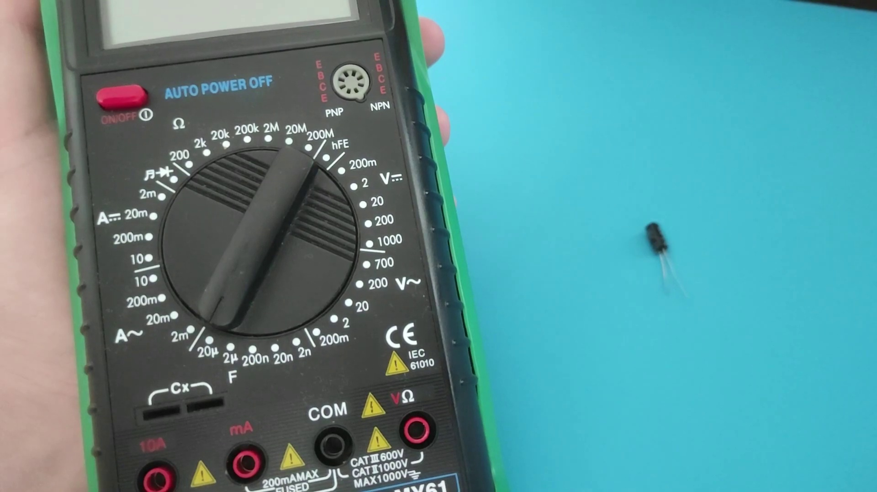 (score 95.0000)
 (score 95.0000)
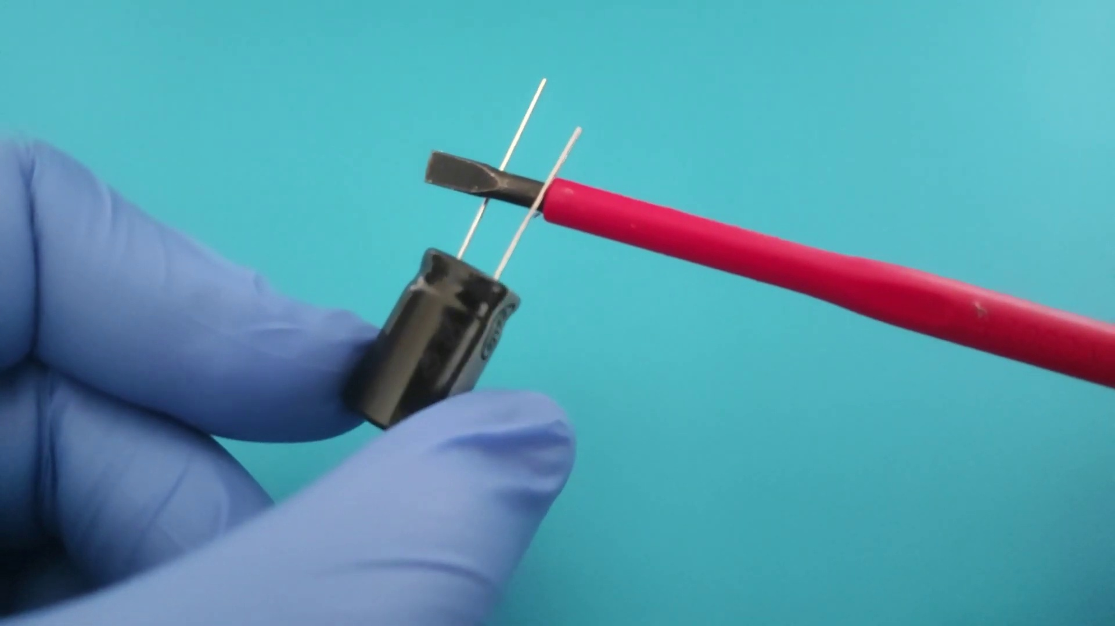 (score 95.0000)
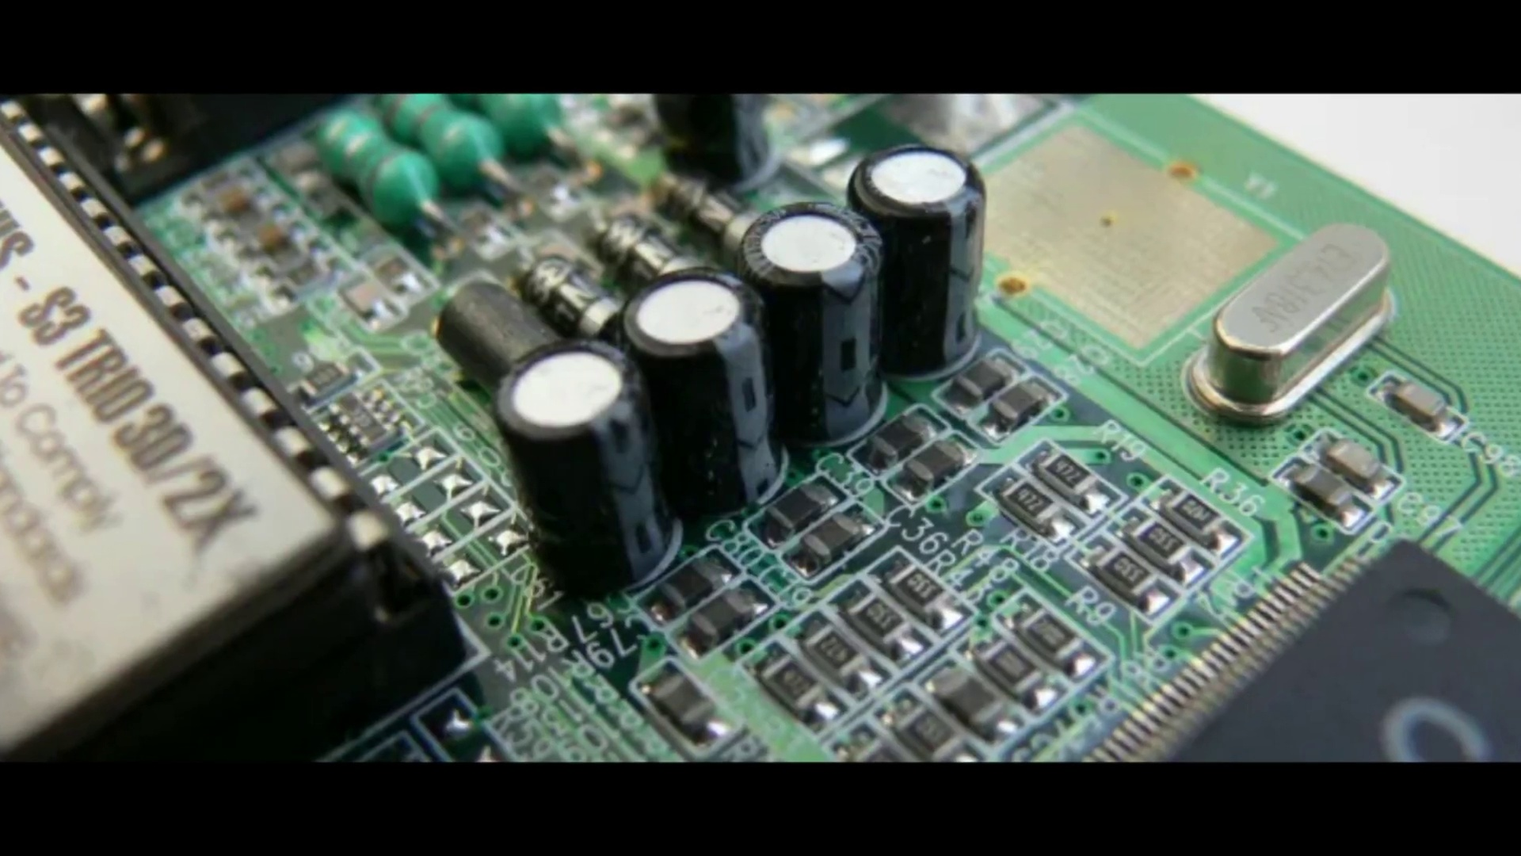 (score 95.0000)
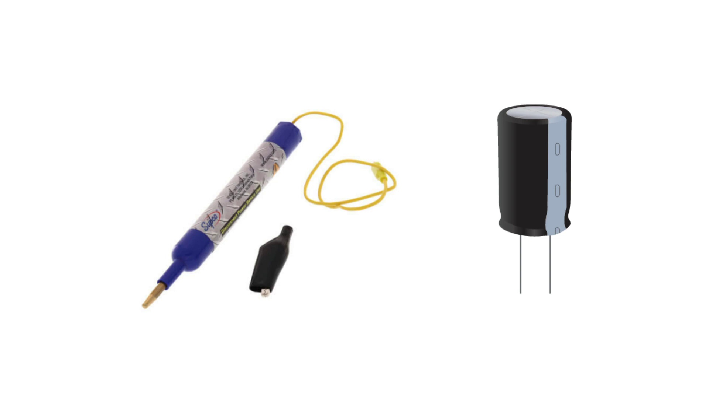 (score 95.0000)
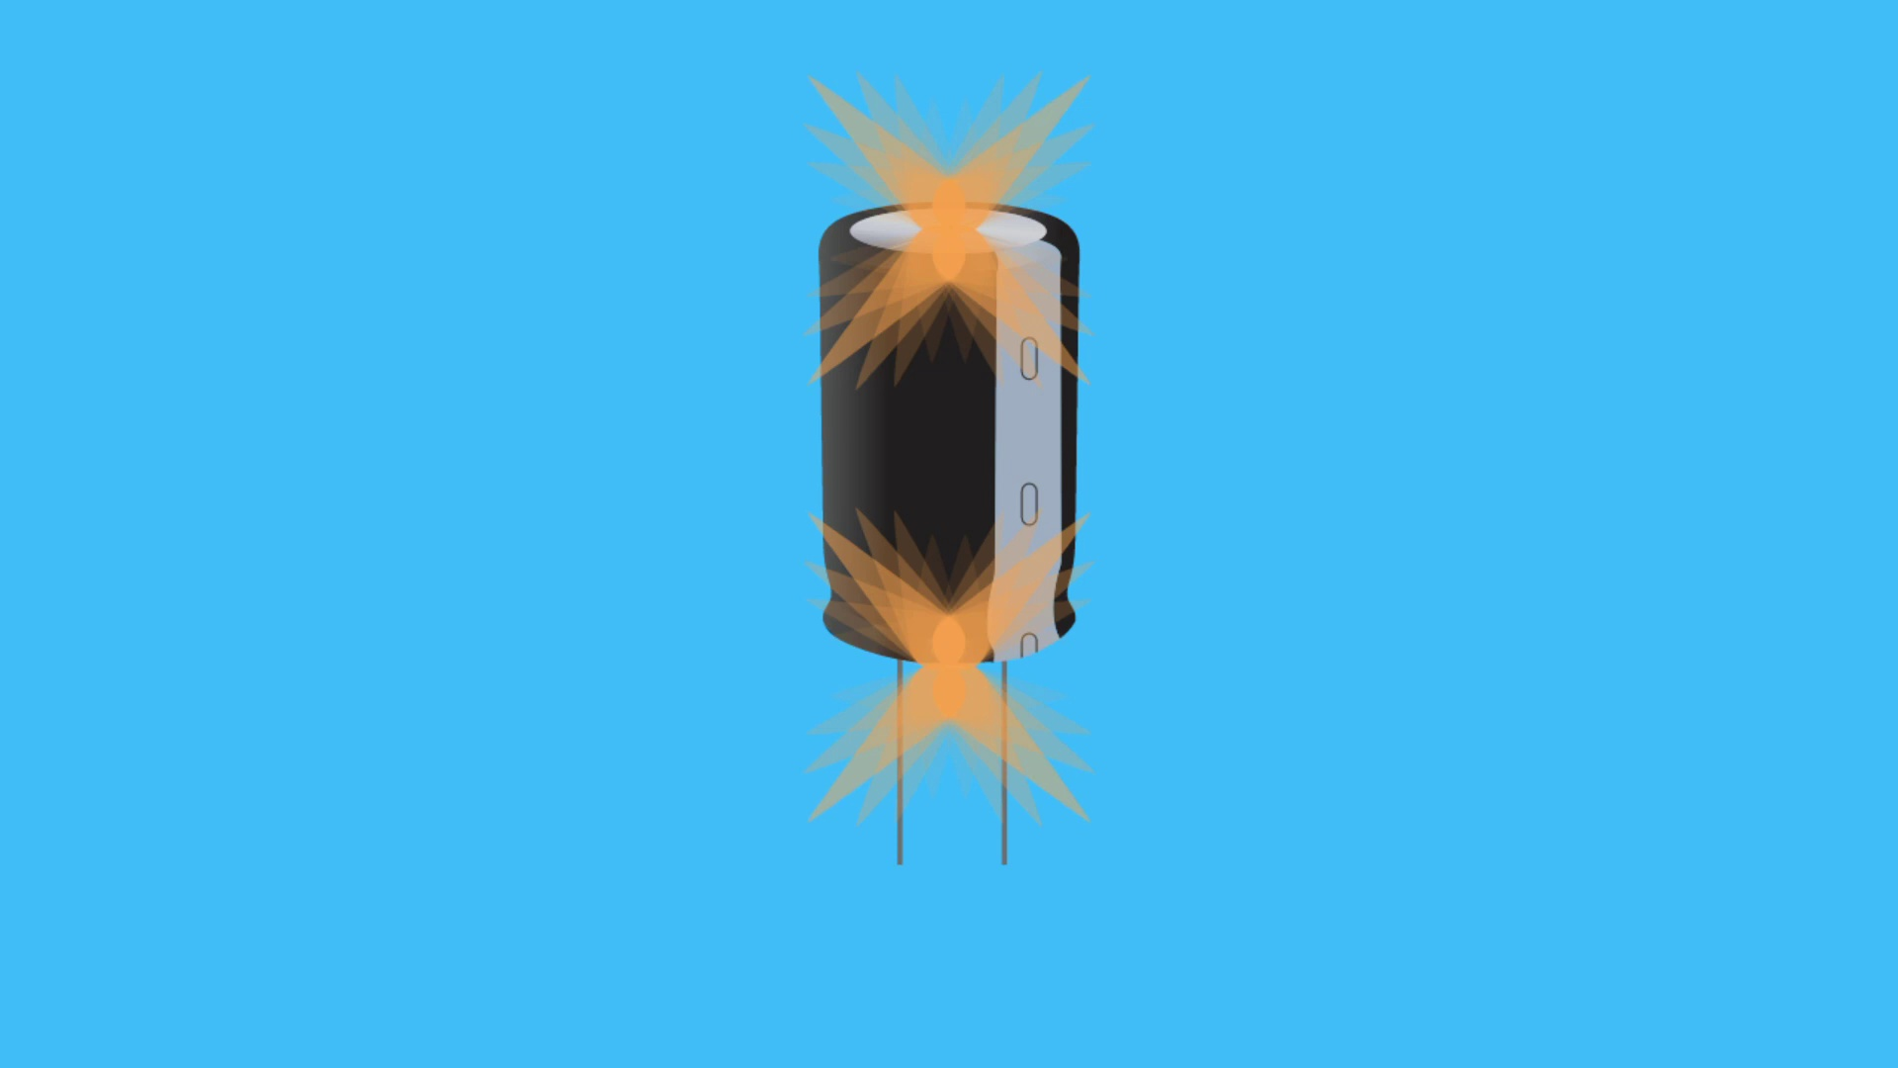 (score 95.0000)
 (score 95.0000)
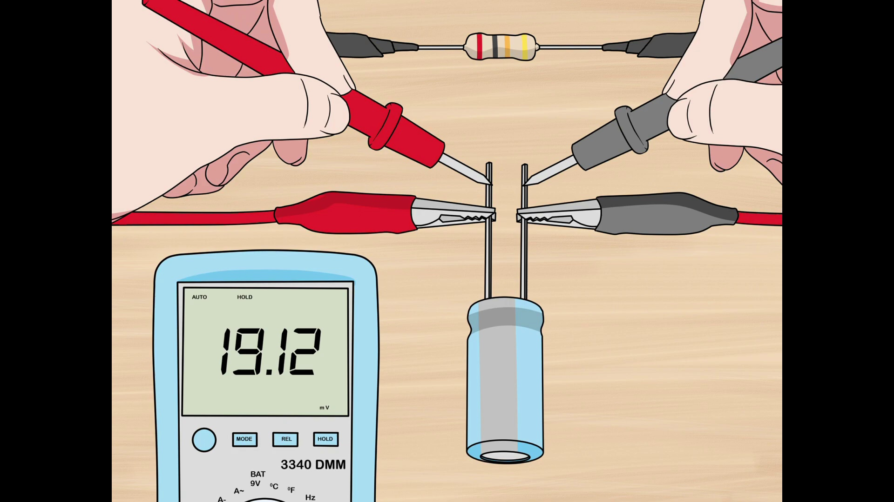 (score 95.0000)
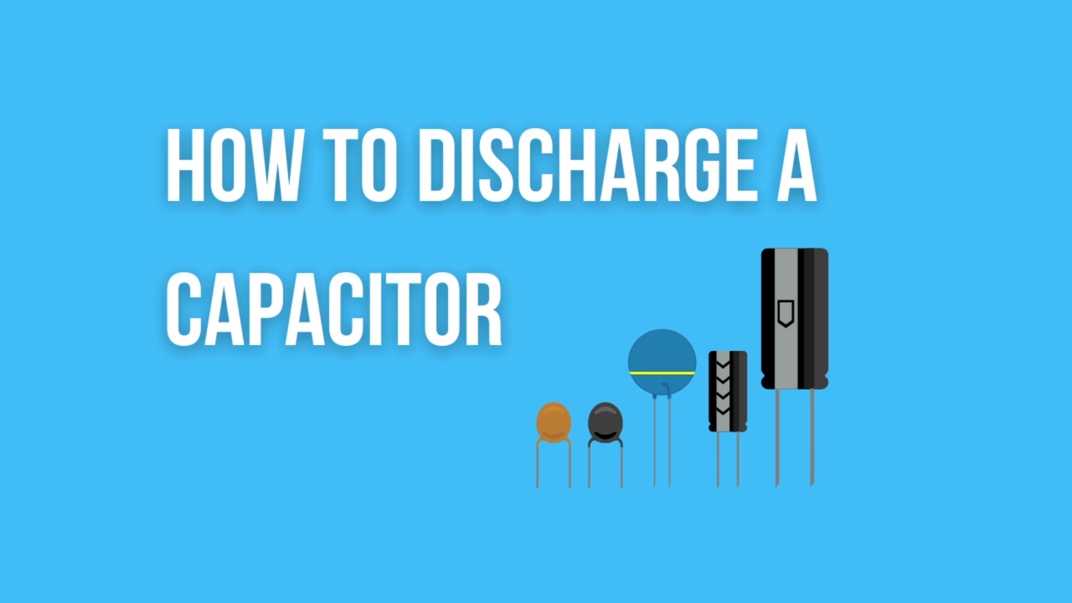 (score 95.0000)
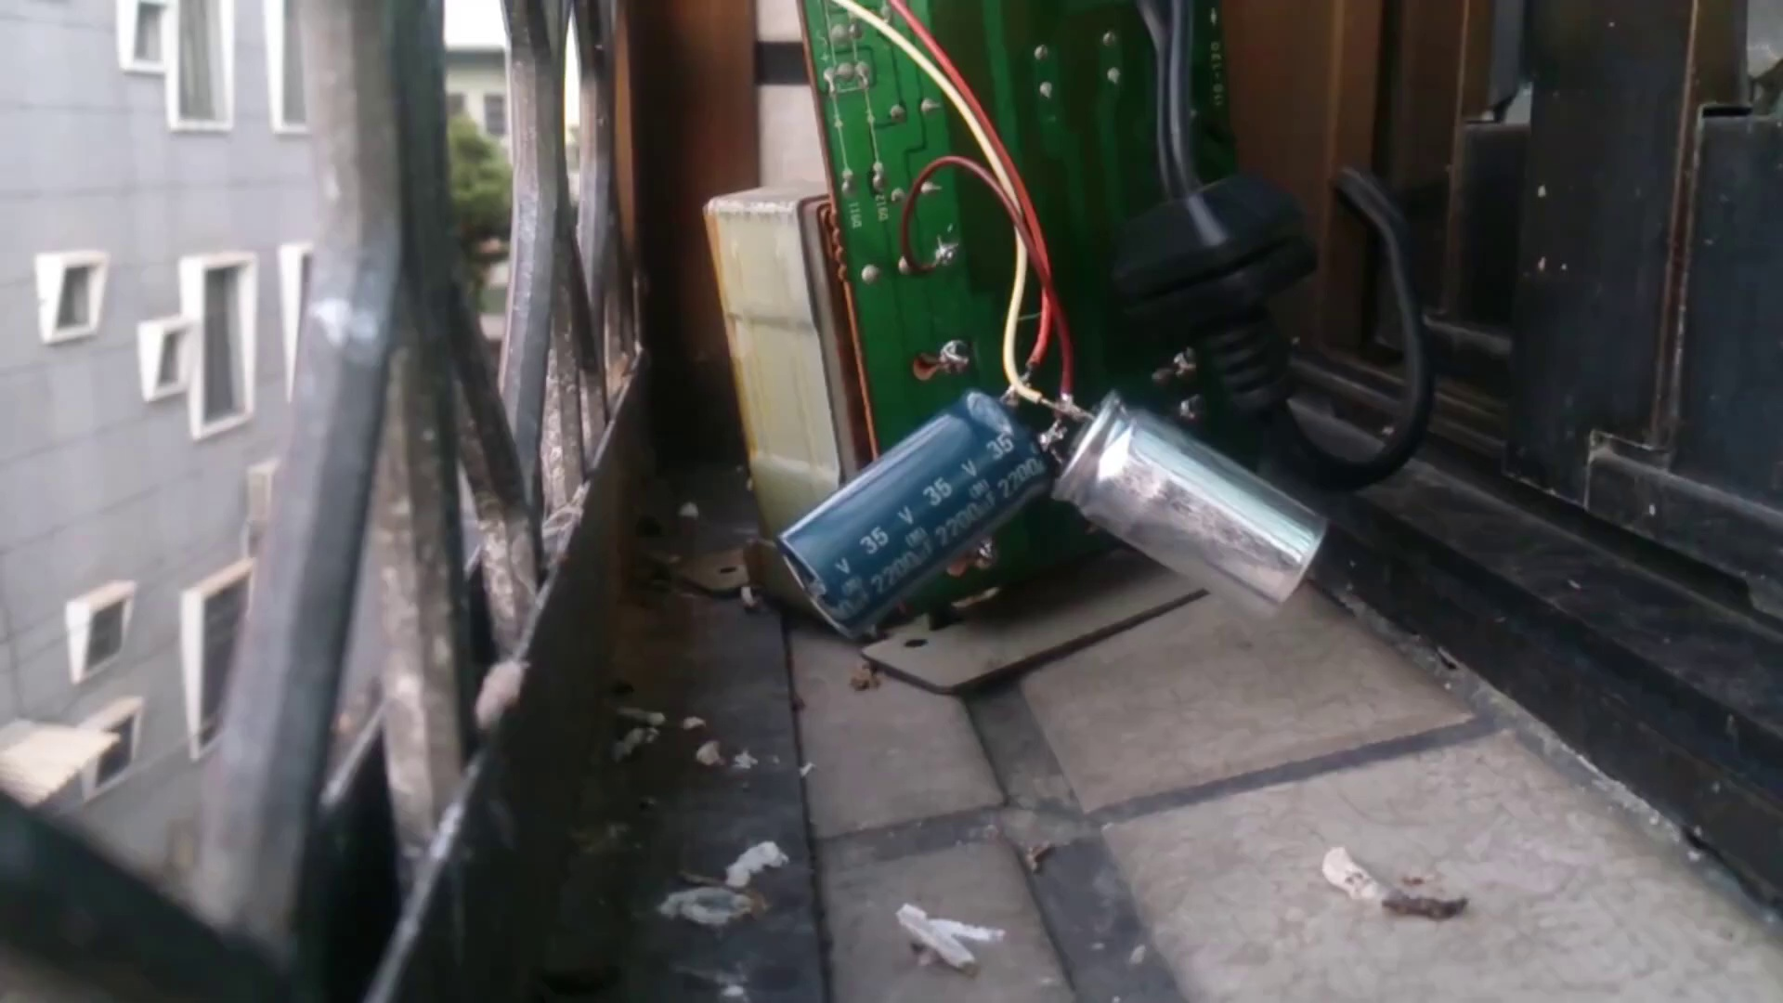 (score 95.0000)
Least correlated frames:
 (score 0.0000)
 (score 0.0000)
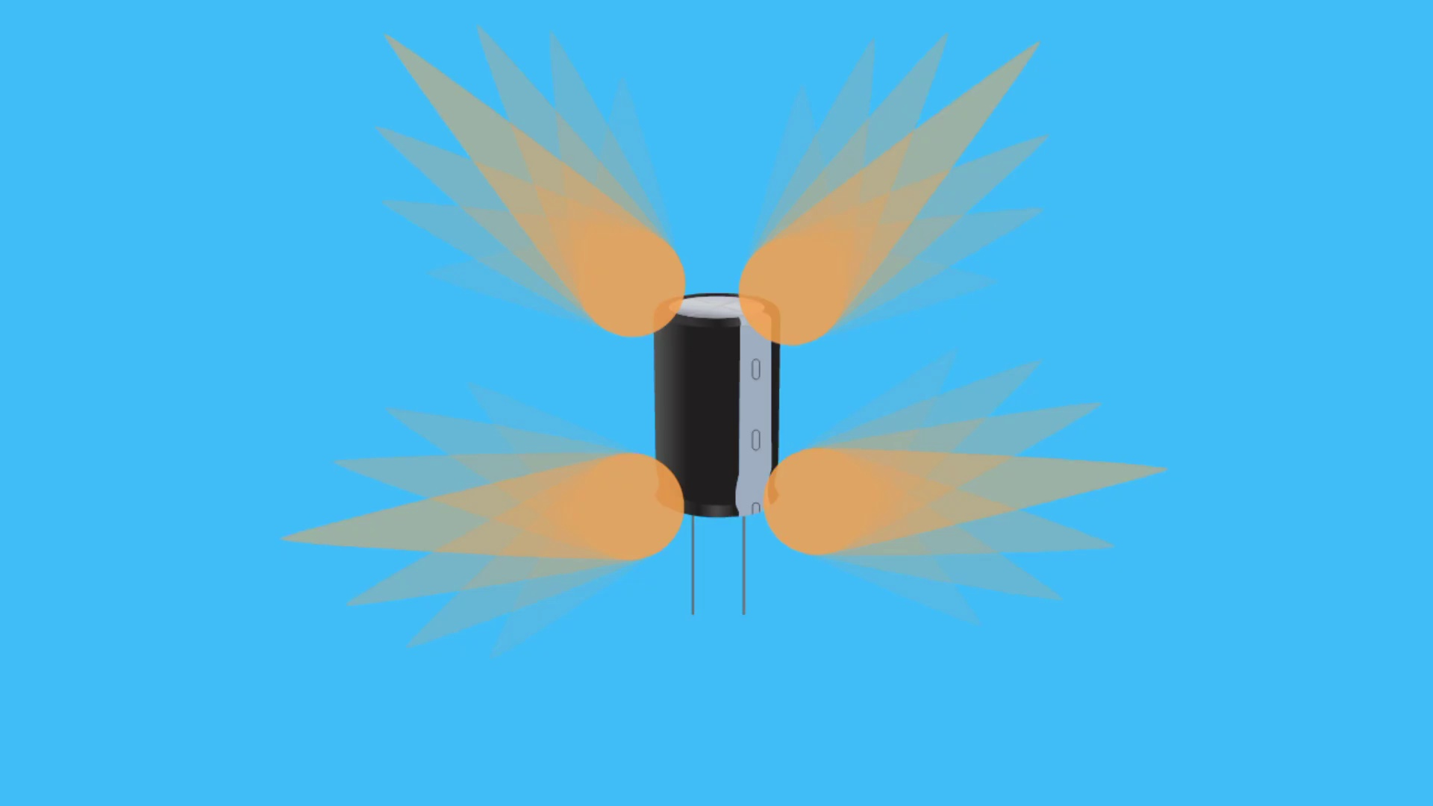 (score 0.0000)
 (score 0.0000)
 (score 0.0000)
 (score 0.0000)
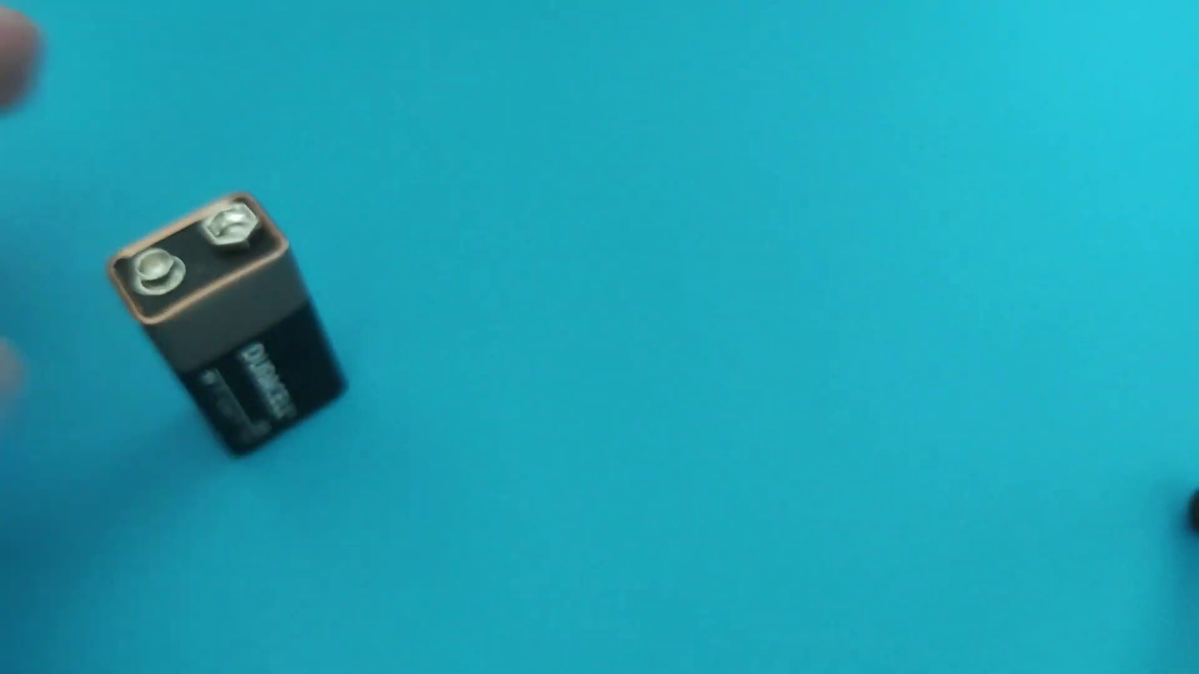 (score 0.0000)
 (score 0.0000)
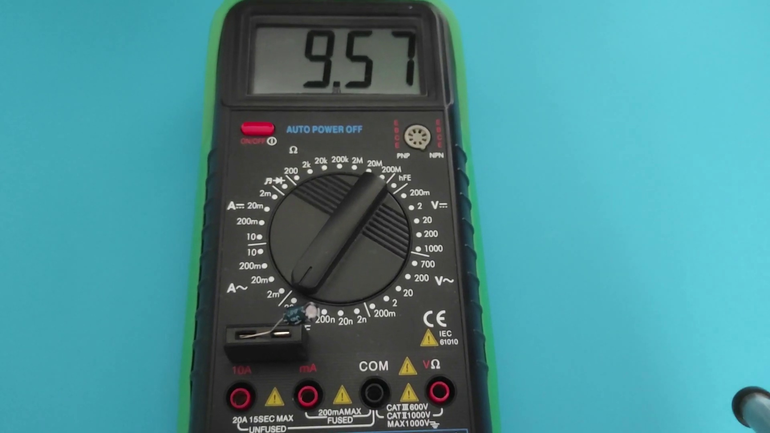 (score 0.0000)
 (score 5.0000)
- matched 76 frame(s), max score 90.0000: Capacitors can be discharged via a discharge pen, a device the draws current and forces it through a high resistance load to discharge. This is the safest method of discharge, and you are unlikely to have any accidents occur. Another method is to use a screwdriver, which can cause sparks or possibly blow up the capacitor. In this method, the screwdriver shorts the capacitor but being applied to both legs of the capacitor. This is not recommended to be performed on PCBs as it may damage other elements.
Source: https://www.youtube.com/watch?v=8YPX1gZGyJg: How to discharge capacitor - Electronics Tutorial For Beginners
Top correlated frames:
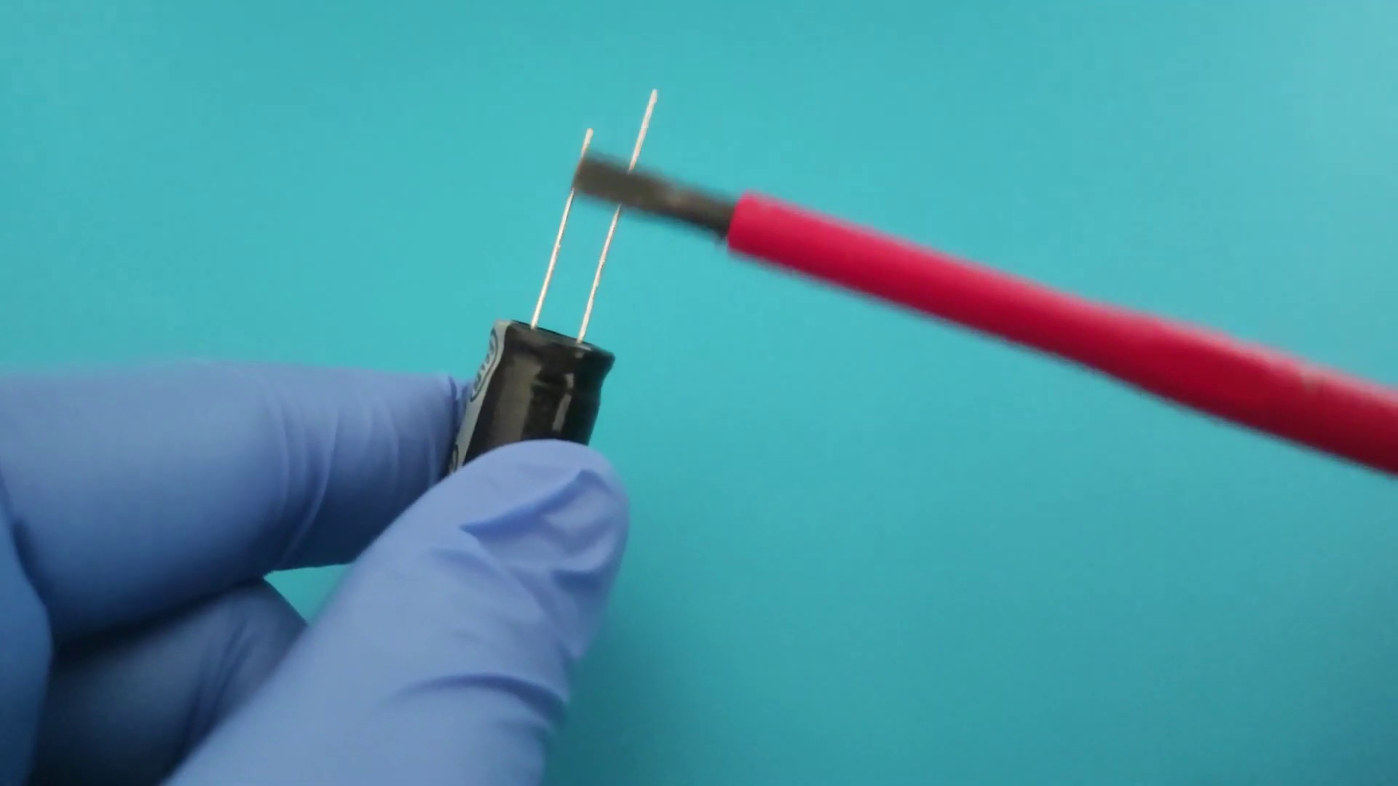 (score 90.0000)
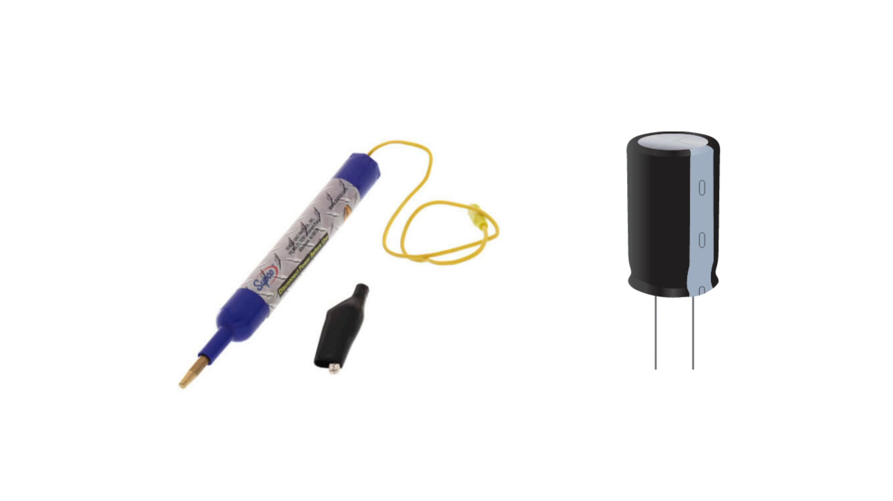 (score 90.0000)
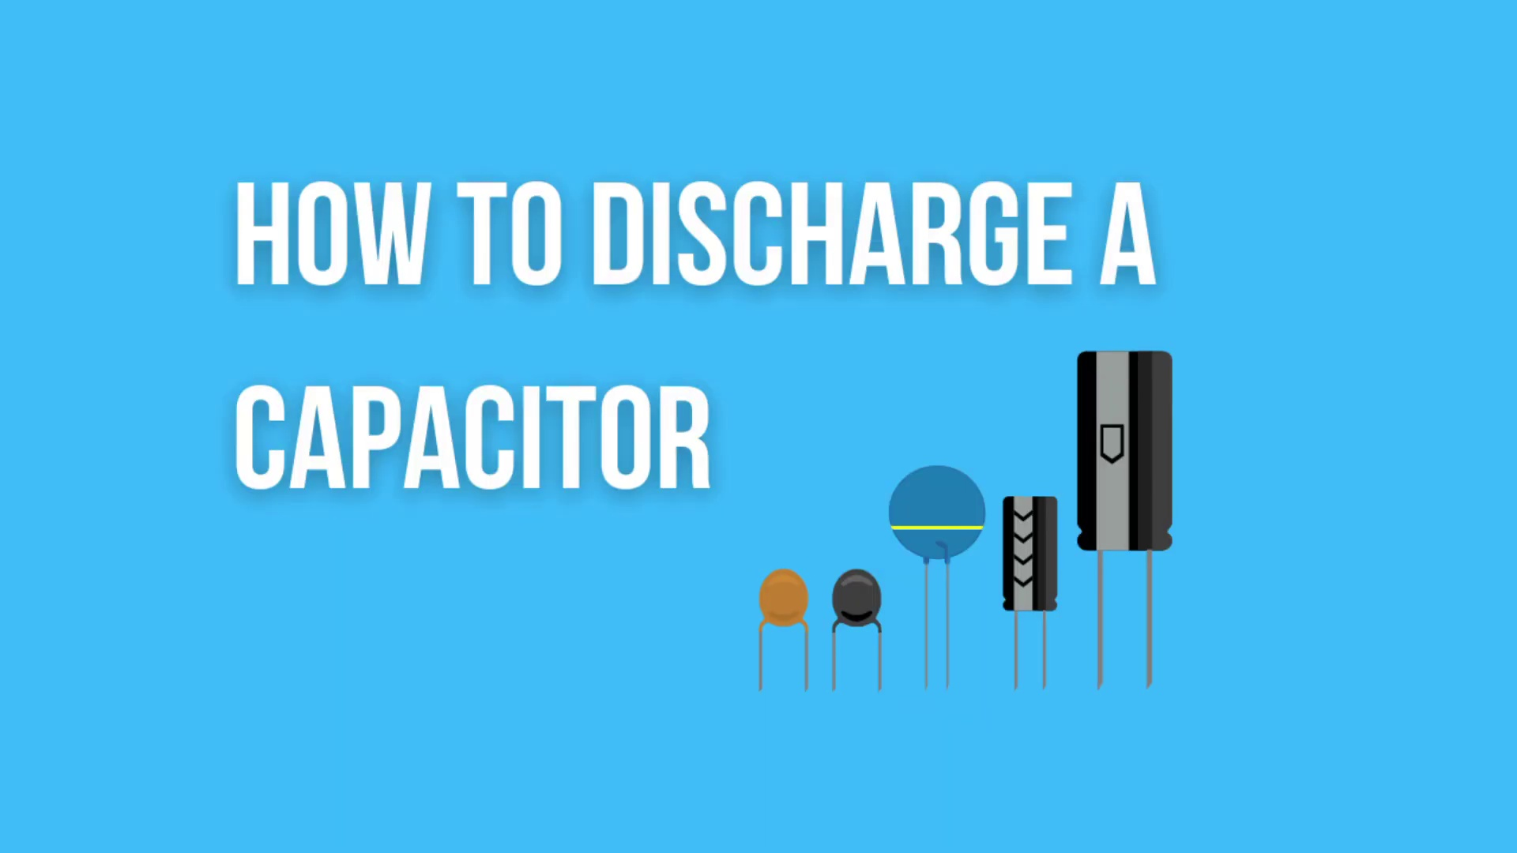 (score 90.0000)
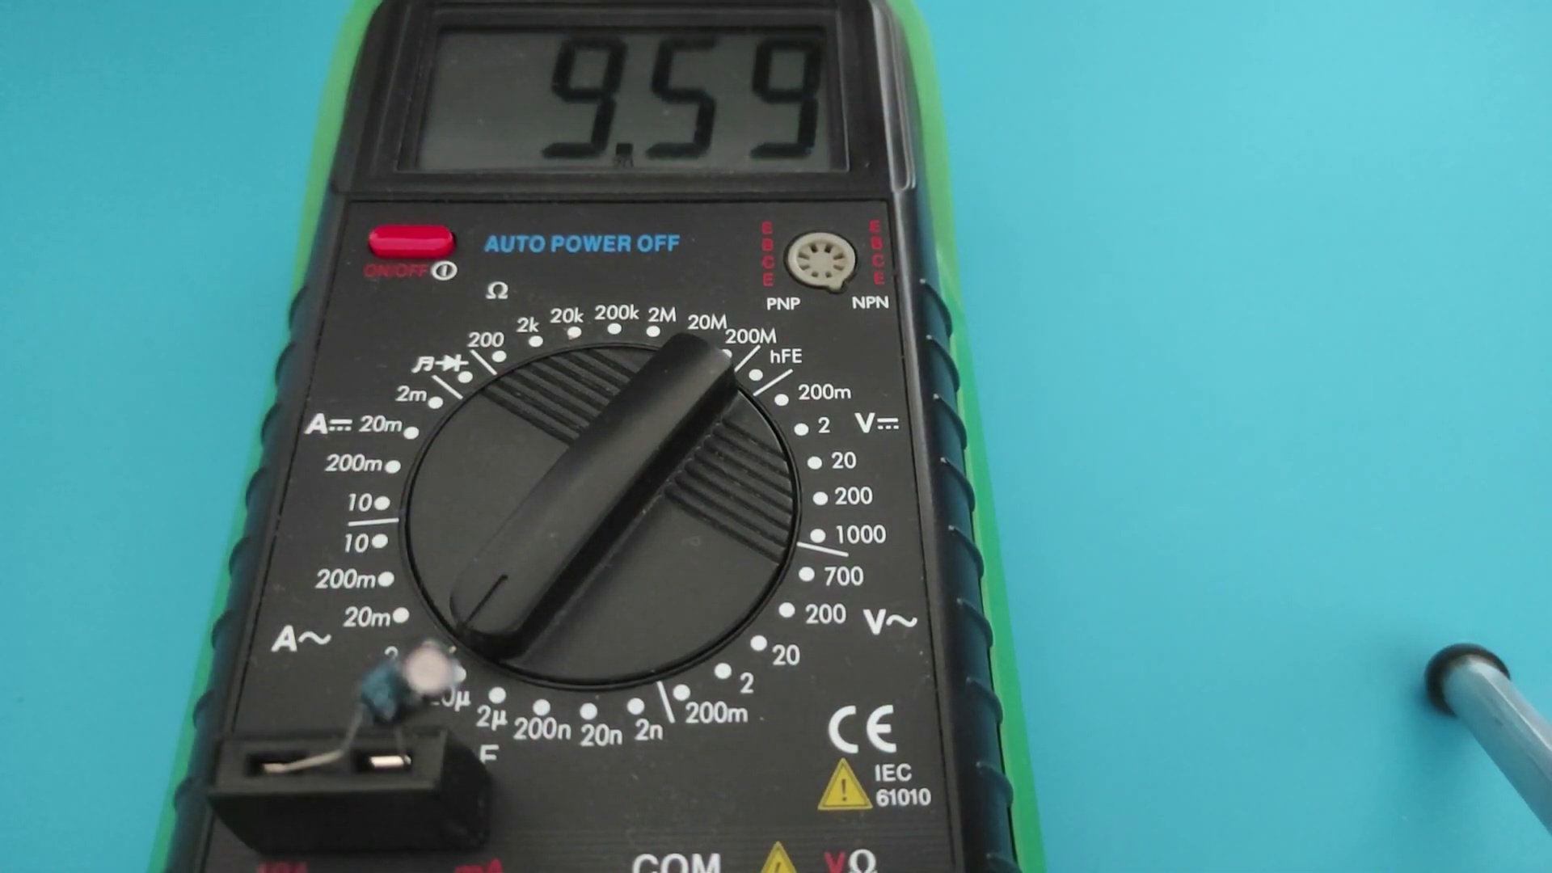 (score 85.0000)
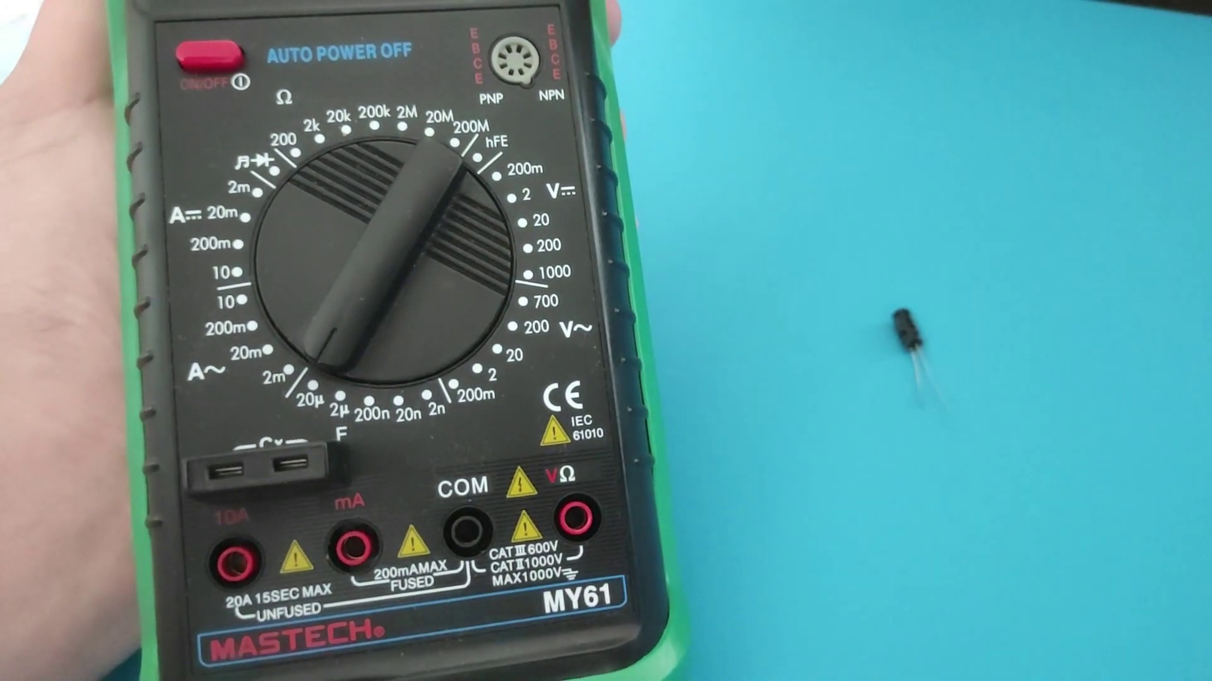 (score 85.0000)
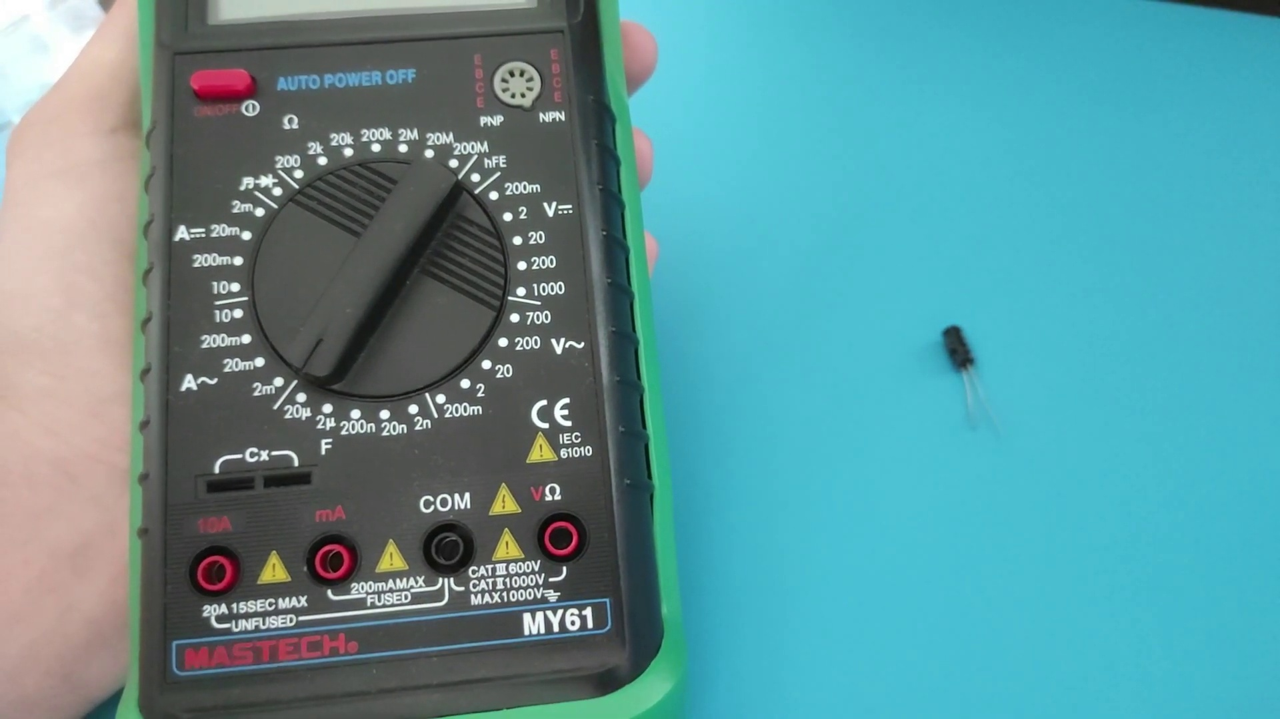 (score 85.0000)
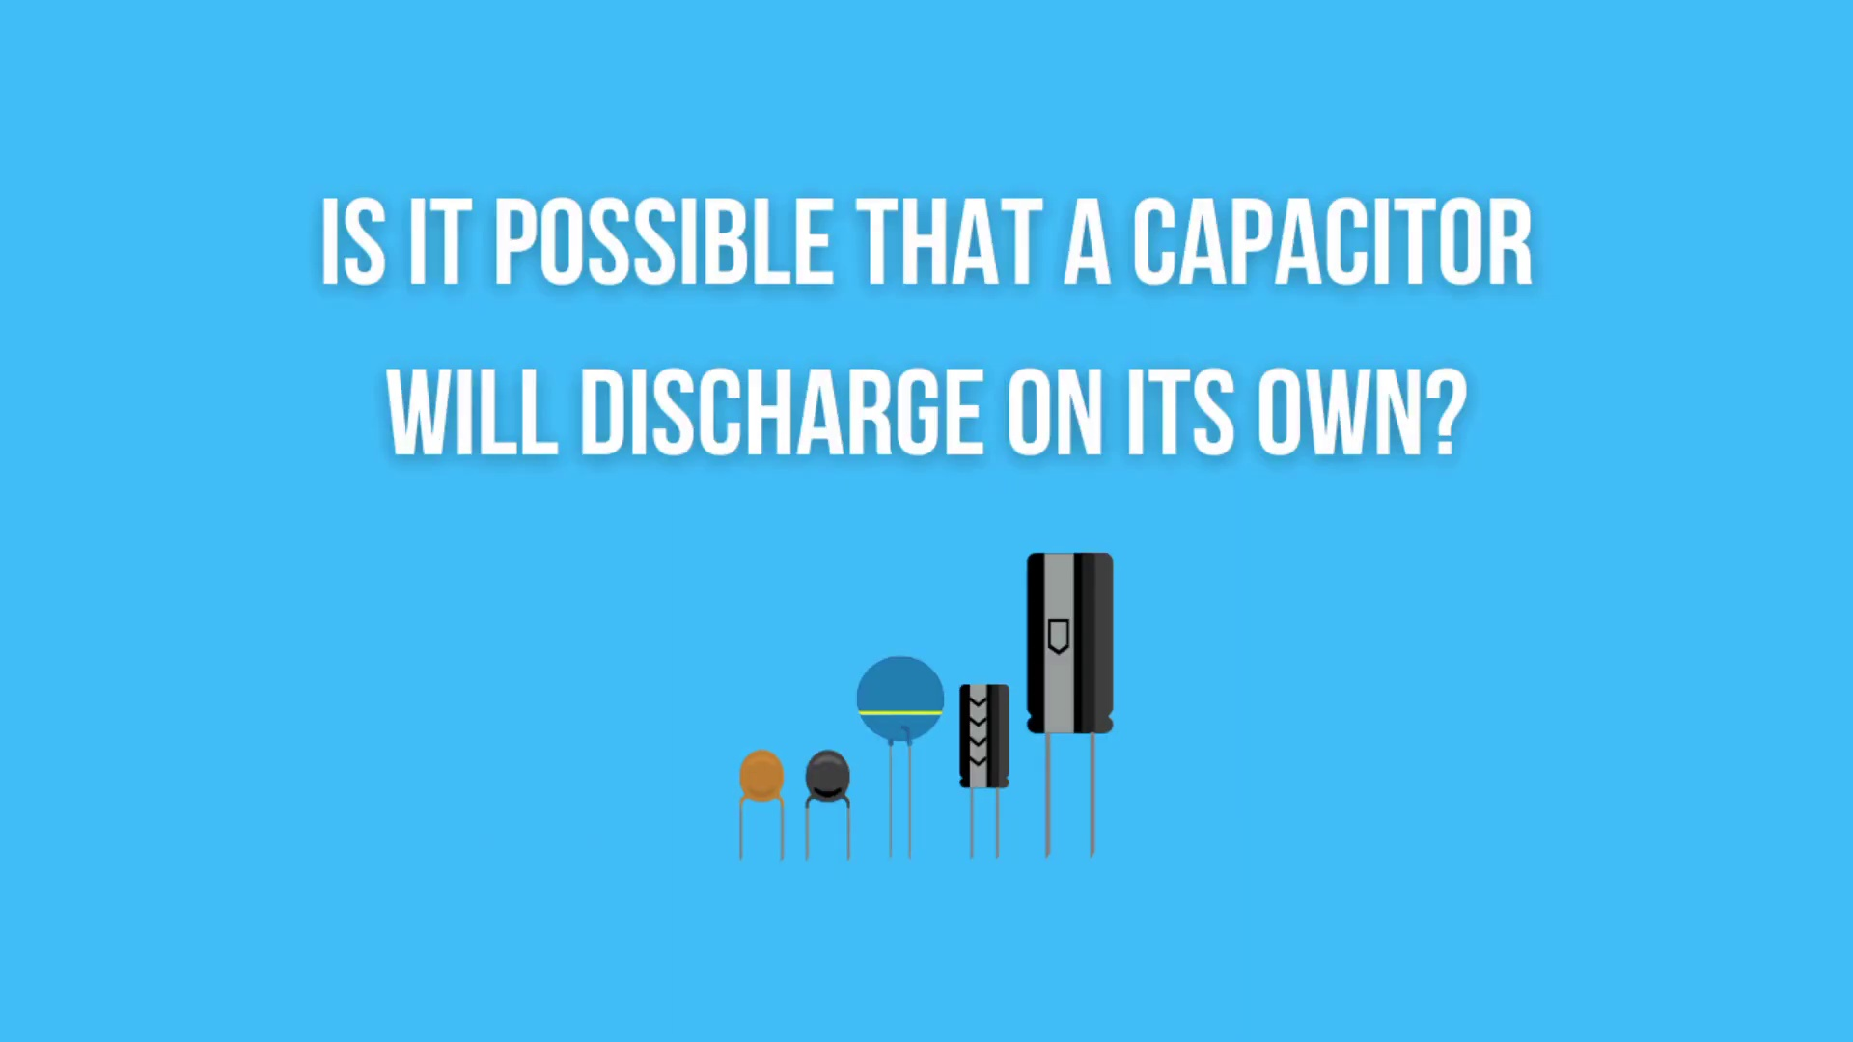 (score 85.0000)
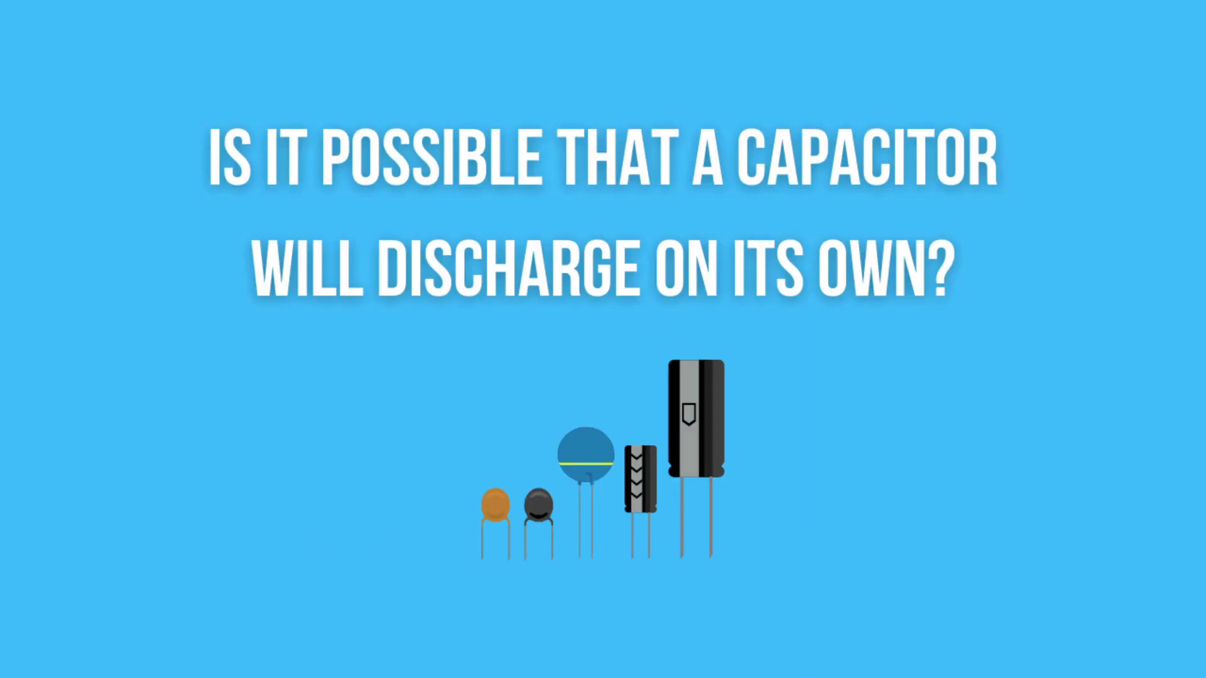 (score 85.0000)
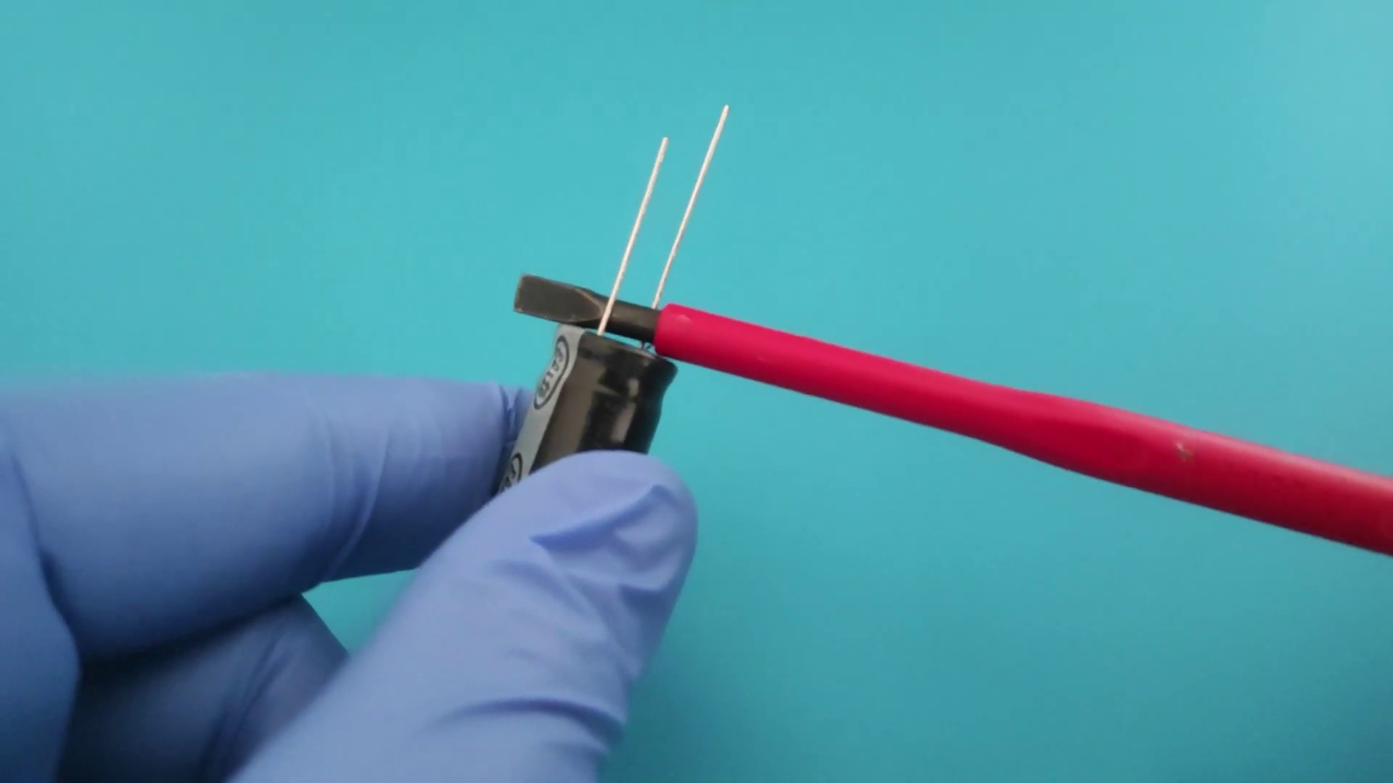 (score 85.0000)
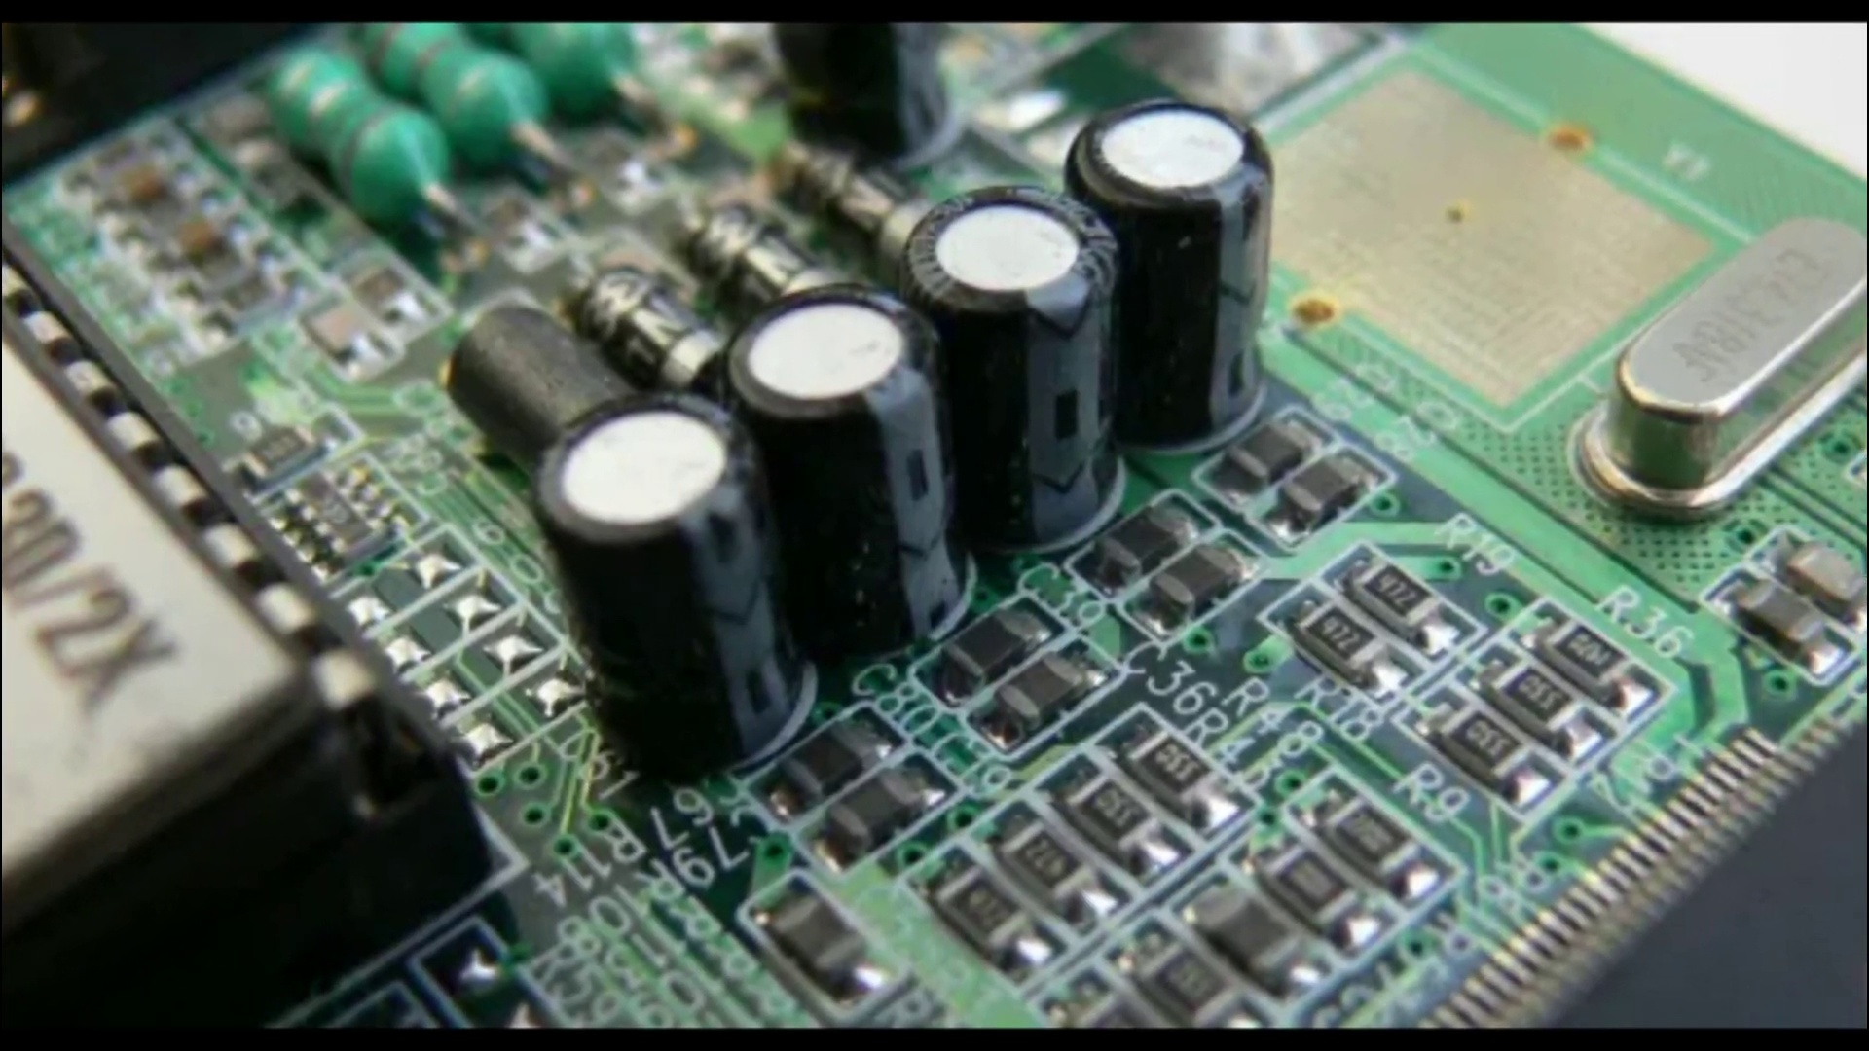 (score 85.0000)
Least correlated frames:
 (score 0.0000)
 (score 0.0000)
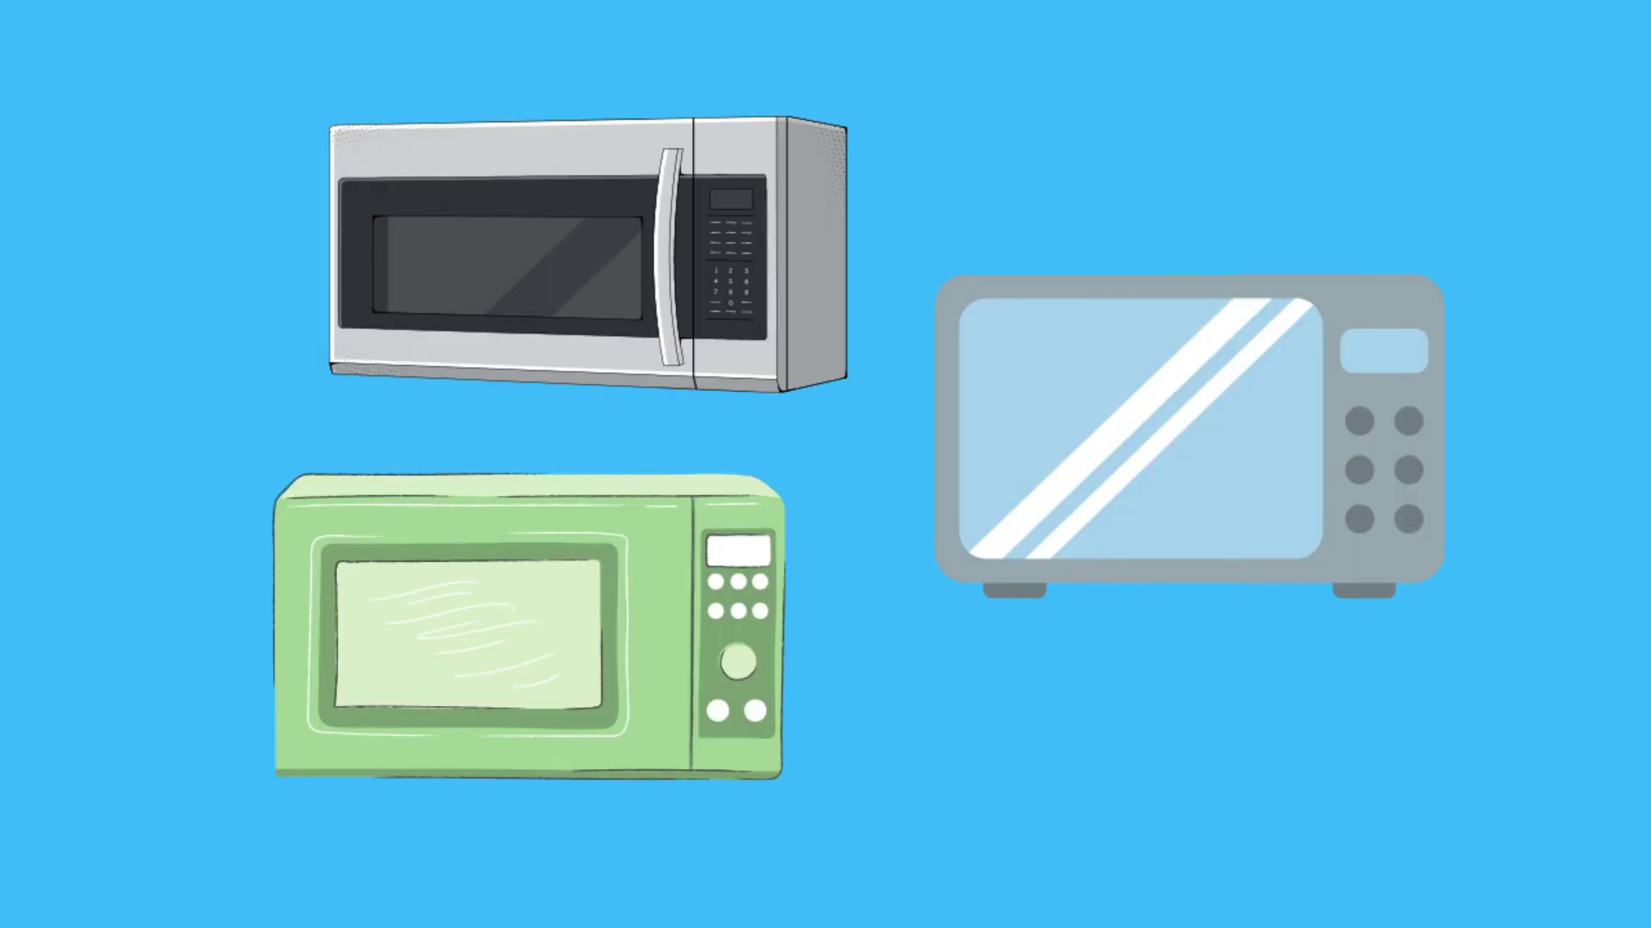 (score 0.0000)
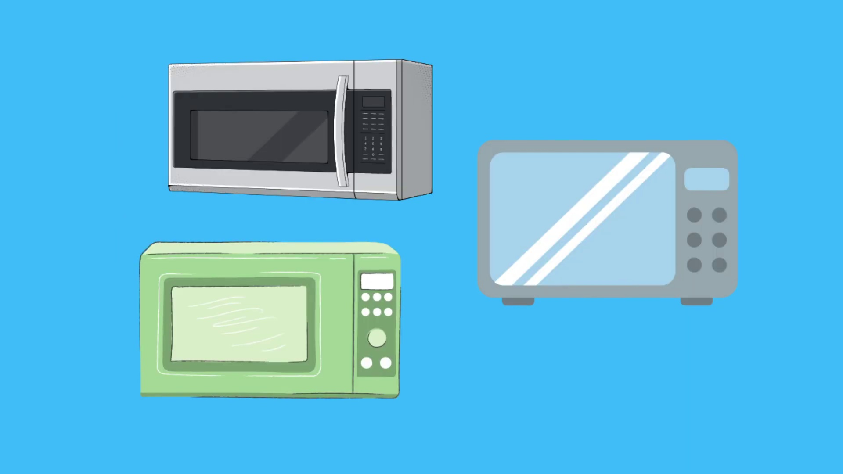 (score 0.0000)
 (score 0.0000)
 (score 0.0000)
 (score 0.0000)
 (score 0.0000)
 (score 0.0000)
 (score 0.0000)

Frame: frame_0000.jpg
Caption: This image captures two distinct scenes related to electrical systems and components. In the foreground, an outdoor scene shows a transformer mounted on a wall, seemingly removed from its usual position or in disarray. The transformer features several coils visible and is connected to other components via wires. A small electrical device appears to be associated with the transformer, accompanied by additional wires and what looks like a box with connections or outlets.
To the right of this device, more wires are visible, along with what appears to be a box with outlets. The background shows a typical urban setting, likely an apartment complex, with a building facade and balcony railing visible. In contrast, the second scene depicts a discarded electronic device lying on the ground, a green circuit board adorned with various components. Two black capacitors with white voltage ratings are present, as well as a silver and black power supply connected to a red wire.
The surrounding area is littered with other electronic components, including wires and another silver and black circuit board, adding to the sense of disarray and abandonment. In the background, a window can be seen reflecting the scene in a mirror image, featuring white blinds that provide a stark contrast to the electronic debris on the ground.
Comment (score 95): This video shows how discharge a capacitor safely and quickly this is important because capacitors are found in many deferent devices such as cars and microwaves. Emptying a capacitor in a wrong way can be dangerous and cause explosions. In order to safely discharge a capacitor, you will need three thing an insulated glove, safety glasses, and a discharge pen. The discharge pen works by drawing the current away from the capacitor which causes it to discharge. This method will allow you to safely discharge any capacitor. However, if you need to recharge the capacitor you can simply attach the legs of the capacitor to a power source, and it will absorb that same amount of power.
Reason: The comment directly discusses the safe discharge and recharge of a capacitor, which is mentioned in the caption as one of the components featured. The technical steps described in the caption (e.g., using an insulated glove, safety glasses, and a discharge pen) are also discussed in the comment, indicating a strong correlation between the two.
Source: https://www.youtube.com/watch?v=8YPX1gZGyJg: How to discharge capacitor - Electronics Tutorial for Beginners
Comment (score 85): Capacitors can be discharged via a discharge pen, a device the draws current and forces it through a high resistance load to discharge. This is the safest method of discharge, and you are unlikely to have any accidents occur. Another method is to use a screwdriver, which can cause sparks or possibly blow up the capacitor. In this method, the screwdriver shorts the capacitor but being applied to both legs of the capacitor. This is not recommended to be performed on PCBs as it may damage other elements.
Reason: The comment mentions capacitors and discharging methods, which are directly related to the technical steps described in the caption. The mention of screwdrivers and PCBs is also relevant to the image's depiction of electronic components.
Source: https://www.youtube.com/watch?v=8YPX1gZGyJg: How to discharge capacitor - Electronics Tutorial For Beginners

Frame: frame_0001.jpg
Caption: The image shows a powerful scene of destruction, dominated by smoke and fire that fills the air, obscuring most of the visible area. The result of an explosion, the thick and dense smoke adds a sense of urgency to the scene, while the vibrant red fire burns brightly, its intensity reflected in the smoke.
At the forefront of this chaotic scene is a small portion of a person's arm and shoulder, partially out of focus due to the smoke and distance from the camera. The arm appears to be holding a device or tool, but no clear text or devices are distinguishable in this frame.
In the foreground, a metal cylinder, possibly a container or piece of equipment, stands out amidst the chaos. Its details are barely discernible against the backdrop of the explosion, adding an element of mystery to the scene as its purpose and role in the explosion remain unknown.
The background is a blur of smoke and fire, with a building partially visible. The presence of the building suggests that the explosion may have occurred within or near this structure, leaving its role in the explosion unclear. This adds another layer of intrigue to the scene, providing context and scale to the destruction.
Overall, the image presents a dramatic moment of chaos and destruction, capturing the aftermath of an explosion with remarkable detail. The metal cylinder and building provide depth and perspective, while the smoke and fire bring home the destructive power of explosions.
No strongly correlated comments found for this frame.

Frame: frame_0002.jpg
Caption: The image shows two distinct elements that provide visual information about the presentation or lecture being delivered. On the screen in front of the person, there is a text overlay that reads "ALPHA TECHNOLOGIES", suggesting the name or brand associated with the content being presented. Below this, three lines of text are partially visible, but due to the angle and cropping of the image, further details cannot be discerned.
In contrast, the lower part of the screen appears blurred out, making it impossible to determine any specific details or text that might be present. However, the focus is on the person delivering the lecture, although the specifics of the content being presented are not clearly visible due to the resolution and angle of the photograph.
Meanwhile, a separate visual element stands out prominently in the image: a black background with white text that reads "MyElectronics" centered vertically. The text is bold and easily readable, with the word "My" positioned slightly left of center and "Electronics" positioned slightly right of center on the black background.
No strongly correlated comments found for this frame.

Frame: frame_0003.jpg
Caption: The image presents a digital graphic with a plain background, featuring a central overlay of white text on a black background. The text reads "Alek Electronics Education blog about electronics" in all capital letters, conveying a clean and professional aesthetic. This attention-grabbing design draws the viewer's focus immediately.
At the center of the image is an illustration of a person with light-colored hair sitting in front of what appears to be a laptop or computer screen. The individual is facing towards the viewer and seems engaged with the device. On the screen, visible text reads "education blog about electronics", suggesting that this image is part of an educational campaign or content strategy focused on electronics education.
The company name "Alek Electronics" is displayed at the top of the image, followed by the text "education blog about electronics". This digital advertisement or social media post is likely promoting Alek Electronics' educational blog and its focus on electronics education. The overall design and layout evoke a formal and educational tone, characteristic of a marketing or informational purpose.
No strongly correlated comments found for this frame.

Frame: frame_0004.jpg
Caption: This image presents a collection of social media platform icons, predominantly featuring Facebook's iconic "Like" button, represented by a gray thumbs-up symbol. The style is realistic with a slight emphasis on textures and shadows, giving the image a tactile feel as if it were possible to reach out and touch the icons.
The icons themselves are two-dimensional, appearing to be made of a smooth material, possibly plastic or metal, with a glossy finish that reflects light, suggesting they might be new or well-maintained. The colors are muted, with gray being the most dominant, followed by white and blue on the edges.
The arrangement of the icons is characterized by a grid pattern, where white icons are evenly spaced, while blue ones are slightly overlapping, creating a sense of depth and dimension. All the icons face upwards, as if in a silent cheer for the viewer. The image does not contain any text or other discernible objects, resulting in an overall effect of unity and positivity, with each "thumbs up" contributing to the collective expression of approval.
This image can be used as a visual aid for discussions on social media platforms, online communities, digital interaction, or marketing strategies related to Facebook or similar networks.
No strongly correlated comments found for this frame.

Frame: frame_0005.jpg
Caption: The image presents a captivating collage of Facebook "like" buttons and "thumbs up" emojis in various states. The buttons, recognizable by their Facebook logo and "like" text, appear to be in different conditions, some suggesting they are being used as a metaphor for something. In contrast, the emojis, characterized by their distinctive blue thumbs and white thumbs-up, are meticulously arranged in a grid-like pattern across the image. While the buttons seem to convey a sense of destruction or chaos, the emojis exude joy and positivity, creating a dynamic and energetic atmosphere. The use of contrasting colors - blue and white for the emojis, and possibly gray or other neutral tones for the broken buttons - adds depth to the image, making both elements stand out. Despite their simplicity, the buttons and emojis together convey a sense of contrast between chaos and joy, highlighting the power of digital communication to evoke emotions and thoughts.
No strongly correlated comments found for this frame.

Frame: frame_0006.jpg
Caption: The image presents a comprehensive guide on how to discharge a capacitor, with a cartoon-style illustration providing visual instructions and a grid-format guide detailing the step-by-step process. The illustration features a clear blue background with two main elements: a text box on the left side containing additional information or guidance (although the specific contents are not legible due to resolution and angle), and a diagrammatic representation on the right side showing an arrangement of capacitors and associated components.
The diagram depicts three similar capacitors labeled "CAPACITOR" with values such as 10µF, 20µF, and 30µF, indicating their capacitance in microfarads. These capacitors are connected to a larger component or structure, with an unidentified object labeled "DISCHARGE A CAPACITOR," suggesting where the discharging process takes place.
The grid-format guide, set against a contrasting blue background, provides a clear and easy-to-follow outline of the discharging process. The steps outlined in the guide are:
* Remove the capacitor from its circuit (top left cell)
* Connect a short circuit to the capacitor (top right cell)
* Connect a short circuit to the capacitor's terminal (bottom left cell)
* Connect a short circuit to the capacitor's terminal (bottom right cell)
Throughout the image, clear symbols such as capacitors and short circuits are used to represent key steps in the process. The overall layout is straightforward, making it a useful resource for anyone looking to learn how to discharge a capacitor.
Comment (score 80): Capacitors can be discharged via a discharge pen, a device the draws current and forces it through a high resistance load to discharge. This is the safest method of discharge, and you are unlikely to have any accidents occur. Another method is to use a screwdriver, which can cause sparks or possibly blow up the capacitor. In this method, the screwdriver shorts the capacitor but being applied to both legs of the capacitor. This is not recommended to be performed on PCBs as it may damage other elements.
Reason: The comment directly discusses the discharging process of capacitors, mentioning methods such as using a discharge pen and screwdriver. The steps mentioned in the caption (removing from circuit, connecting short circuits) are indirectly related to the methods discussed in the comment, making it strongly correlated.
Source: https://www.youtube.com/watch?v=8YPX1gZGyJg: How to discharge capacitor - Electronics Tutorial For Beginners
Comment (score 80): This video shows how discharge a capacitor safely and quickly this is important because capacitors are found in many deferent devices such as cars and microwaves. Emptying a capacitor in a wrong way can be dangerous and cause explosions. In order to safely discharge a capacitor, you will need three thing an insulated glove, safety glasses, and a discharge pen. The discharge pen works by drawing the current away from the capacitor which causes it to discharge. This method will allow you to safely discharge any capacitor. However, if you need to recharge the capacitor you can simply attach the legs of the capacitor to a power source, and it will absorb that same amount of power.
Reason: The comment directly discusses the technical steps described in the caption, such as discharging a capacitor safely and quickly. The mention of specific tools (insulated glove, safety glasses, discharge pen) and methods (drawing current away from the capacitor) aligns with the visual guide provided in the caption. However, the score is not 100 because the comment does not explicitly reference the grid-format guide or the exact steps outlined in the diagram.
Source: https://www.youtube.com/watch?v=8YPX1gZGyJg: How to discharge capacitor - Electronics Tutorial for Beginners

Frame: frame_0007.jpg
Caption: The image presents an educational context focused on the topic of how to discharge a capacitor. The background is blue with white text that reads, "HOW TO DISCHARGE A CAPACITOR". On the right side of the image, a diagram illustrates a simple setup for charging or discharging a capacitor. The diagram features three main components: two spheres connected by what appears to be a wire, representing the two plates of the capacitor; and a central object that looks like a pump or a mechanical device, possibly indicating the method used to charge or discharge the capacitor.
The visual content emphasizes practical demonstration and step-by-step guidance for performing the task at hand. The image is part of an educational tutorial or instructional guide on the process of charging a capacitor, possibly within the context of physics or electrical engineering.
No strongly correlated comments found for this frame.

Frame: frame_0008.jpg
Caption: The image appears to be an instructional graphic with a focus on discharging capacitors, featuring a combination of visual elements and text. On the left side of the image, there is a blueprint plan against a grey background, which includes a depiction of a battery and the text "CAPACITOR" accompanied by a symbol that typically represents capacitance in physics (consisting of two parallel lines with a circle between them). Adjacent to this symbol are three additional icons: one resembling a light bulb, another depicting a person standing near a power outlet, and the third showing an electronic gadget or component. These icons suggest that they might be part of a larger circuit or system involving the capacitor and other electrical components.
On the right side of the image, there is a block of white text with a shadow effect on the upper edge, reading "HOW TO DISCHARGE A CAPACITOR". This title emphasizes the practical use of capacitors, specifically how to discharge them. Below this main title, there is a small graphic representation of two hands holding a smartphone or similar electronic device with a battery icon on the screen, highlighting the context of charging or using a capacitor for electronic purposes.
In contrast, the top section of the image features a blue text overlay that reads "HOW TO DISCHARGE A CAPACITOR", followed by a line drawing of a capacitor below. The capacitor is depicted with a black body, an orange top, and a blue bottom, each color representing a different component of the capacitor. This combination of visual elements and text suggests that the instruction is about how to discharge a capacitor.
Comment (score 85): Capacitors can be discharged via a discharge pen, a device the draws current and forces it through a high resistance load to discharge. This is the safest method of discharge, and you are unlikely to have any accidents occur. Another method is to use a screwdriver, which can cause sparks or possibly blow up the capacitor. In this method, the screwdriver shorts the capacitor but being applied to both legs of the capacitor. This is not recommended to be performed on PCBs as it may damage other elements.
Reason: The comment directly discusses the same technical steps (discharge methods) and objects (capacitors, discharge pen, screwdriver) described in the caption. The connection is strong due to the specific details provided about discharging capacitors.
Source: https://www.youtube.com/watch?v=8YPX1gZGyJg: How to discharge capacitor - Electronics Tutorial For Beginners
Comment (score 80): This video shows how discharge a capacitor safely and quickly this is important because capacitors are found in many deferent devices such as cars and microwaves. Emptying a capacitor in a wrong way can be dangerous and cause explosions. In order to safely discharge a capacitor, you will need three thing an insulated glove, safety glasses, and a discharge pen. The discharge pen works by drawing the current away from the capacitor which causes it to discharge. This method will allow you to safely discharge any capacitor. However, if you need to recharge the capacitor you can simply attach the legs of the capacitor to a power source, and it will absorb that same amount of power.
Reason: The comment directly discusses the technical steps and objects described in the caption, such as discharging a capacitor safely and quickly, using an insulated glove, safety glasses, and a discharge pen. The comment also mentions the importance of avoiding explosions by emptying the capacitor correctly. This matches the content and focus of the caption, which highlights how to discharge a capacitor.
Source: https://www.youtube.com/watch?v=8YPX1gZGyJg: How to discharge capacitor - Electronics Tutorial for Beginners

Frame: frame_0009.jpg
Caption: The image appears to be a digital artwork or illustration with instructional intent, presenting a clear and concise guide on how to discharge a capacitor. The scene depicts a simplified representation of a person labeled "you" pointing at an object, which seems to be a model of a capacitor, in the foreground. Above this figure, in a larger font, the text reads "HOW TO DISCHARGE A CAPACITOR." To the left of the central figure, there's a smaller illustration showing three batteries or cells connected in series with a switch labeled "connect" on one side and "disconnect" on the other.
Behind these figures, a blue sky backdrop is visible, suggesting an outdoor setting for this educational scene. The style of the image is cartoonish and instructional, using plain colors and simple shapes to convey the concepts in an accessible way. The person's arms are extended towards the viewer, as if they are explaining or demonstrating something to the viewer. The overall tone of the image is educational and engaging, aimed at teaching viewers about electricity and capacitors.
Note: This integrated caption retains all accurate and relevant details explicitly mentioned in either original caption, avoiding redundancy and contradictions while strictly avoiding any speculation, assumptions, or introduction of details not explicitly stated.
Comment (score 80): Capacitors can be discharged via a discharge pen, a device the draws current and forces it through a high resistance load to discharge. This is the safest method of discharge, and you are unlikely to have any accidents occur. Another method is to use a screwdriver, which can cause sparks or possibly blow up the capacitor. In this method, the screwdriver shorts the capacitor but being applied to both legs of the capacitor. This is not recommended to be performed on PCBs as it may damage other elements.
Reason: The comment directly discusses how to discharge a capacitor, which is the same technical step described in the caption. The comment provides specific methods for discharging a capacitor (using a discharge pen or screwdriver), which aligns with the instructional intent of the caption.
Source: https://www.youtube.com/watch?v=8YPX1gZGyJg: How to discharge capacitor - Electronics Tutorial For Beginners
Comment (score 80): This video shows how discharge a capacitor safely and quickly this is important because capacitors are found in many deferent devices such as cars and microwaves. Emptying a capacitor in a wrong way can be dangerous and cause explosions. In order to safely discharge a capacitor, you will need three thing an insulated glove, safety glasses, and a discharge pen. The discharge pen works by drawing the current away from the capacitor which causes it to discharge. This method will allow you to safely discharge any capacitor. However, if you need to recharge the capacitor you can simply attach the legs of the capacitor to a power source, and it will absorb that same amount of power.
Reason: The comment directly discusses the technical steps described in the caption, such as discharging a capacitor using an insulated glove and safety glasses. The comment also mentions specific objects (discharge pen) and settings (drawing current away from the capacitor) that align with the illustration in the caption.
Source: https://www.youtube.com/watch?v=8YPX1gZGyJg: How to discharge capacitor - Electronics Tutorial for Beginners

Frame: frame_0010.jpg
Caption: The image displays a collection of home appliances arranged in two distinct patterns against contrasting backgrounds. Starting from the top left and moving row by row to the bottom right, a grid pattern is formed with the following appliances:
1. A gray microwave oven.
2. A silver electric kettle with visible branding.
3. A black wall-mounted air conditioner unit.
4. A white toaster oven with a handle on the front door.
5. A green waffle maker with a control knob on the front.
6. An off-white blender with a lid and a base for securing it to a countertop.
7. A silver electric pressure cooker with visible branding and buttons.
In a separate arrangement, a trio of appliances is displayed in a vertical line against a vibrant blue background. On the left, a silver microwave oven stands, its sleek exterior gleaming under the light. In the middle, a black and silver toaster oven adds a contrasting element to the scene, with its crumb tray clearly visible. On the right, a white and silver television completes the trio, its screen reflecting the blue of the background.
Each appliance is detailed in its design, with distinct features such as handles, control knobs, and crumb trays providing visual interest. The arrangement of the appliances suggests a kitchen setting, with each device serving a specific function in the cooking process.
No strongly correlated comments found for this frame.

Frame: frame_0011.jpg
Caption: The image displays an illustration of three microwave ovens against a vibrant blue background. The appliances are arranged in a diagonal line, creating a sense of balance and symmetry. The leftmost appliance is a silver microwave oven, compact and designed to fit seamlessly into any kitchen. To its right, a grey microwave oven stands out, larger and sleekly modern with a touch of elegance. On the far right, a black microwave oven is positioned, large enough to handle larger meals.
Below the microwaves, there are three additional household appliances depicted: a small, simple white refrigerator; a silver toaster oven; and a green-toned electronic device with a screen displaying what appears to be a graphical user interface or video playback. The appliances are arranged in a neat line against the blue background, which provides a calming backdrop allowing the colors of the appliances to pop and stand out.
The image has a clean, flat design typically used for educational material or infographics, suggesting that this could be part of a presentation about home kitchen appliances. The style is simple and modern with a clear focus on the devices, making it a straightforward representation of these everyday household appliances, each with its own unique characteristics and design.
No strongly correlated comments found for this frame.

Frame: frame_0012.jpg
Caption: The image appears to be a digital illustration with an instructional theme, focusing on automotive technology. The image presents a striking contrast between two objects: a car and a laptop. The car, rendered in a sleek black and white, is positioned on the left side of the image, facing towards the right side as if it's about to embark on a journey. It's a compact SUV, its features clearly visible in the drawing.
On the right side of the image, a laptop is displayed, also in black and white but with a more complex design than the car. The laptop is open, with a screen displaying a blue background, suggesting that it's in use. Centrally placed on the laptop is a connected screen displaying what appears to be a 3D model of a car, possibly for design or engineering purposes.
The graphic representation of a car in motion on the right side of the image suggests that the content being presented might involve the dynamics of vehicles or related automotive topics. The background of the image is a solid blue color, providing a neutral backdrop that allows the objects to stand out. The contrast between the black and white objects and the blue background creates a visually appealing image.
The relative positions of the objects - the car on the left and the laptop on the right - further enhance the image's composition, which seems to convey a message of technology and mobility, with the car symbolizing the journey and the laptop representing the tools for that journey. The style of the image is clean and modern, with a focus on education or demonstration, suggesting that it may be used as an instructional tool for exploring automotive technology.
Comment (score 85): This video shows how discharge a capacitor safely and quickly this is important because capacitors are found in many deferent devices such as cars and microwaves. Emptying a capacitor in a wrong way can be dangerous and cause explosions. In order to safely discharge a capacitor, you will need three thing an insulated glove, safety glasses, and a discharge pen. The discharge pen works by drawing the current away from the capacitor which causes it to discharge. This method will allow you to safely discharge any capacitor. However, if you need to recharge the capacitor you can simply attach the legs of the capacitor to a power source, and it will absorb that same amount of power.
Reason: The comment directly discusses the discharging of a capacitor, which is a technical step related to the illustration in the caption. The comment also mentions the importance of safety and the use of specific tools (insulated glove, safety glasses, and discharge pen) for this process, which aligns with the goals described in the caption.
Source: https://www.youtube.com/watch?v=8YPX1gZGyJg: How to discharge capacitor - Electronics Tutorial for Beginners

Frame: frame_0013.jpg
Caption: The digital illustration presents a stark contrast between two objects. On the left, a black car is depicted in a simple line drawing style, stationary with its wheels firmly planted on the ground, featuring a rectangular body and two round headlights. Next to the car, an image of a laptop connected to the car via a USB cable and power adapter suggests the transfer of data or charging. The text "Safety First" appears next to the car wheel, indicating a discussion about safety features in cars.
On the right side, a photo of an open laptop with a blue screen, possibly illustrating data transfer or a software interface, is displayed. The same USB cable and power adapter connect the laptop to the car. The background is a simple gradient from light to dark blue, providing contrast to the objects in the foreground.
No strongly correlated comments found for this frame.

Frame: frame_0014.jpg
Caption: The image presents a graphic representation with educational content, showcasing a juxtaposition between technology and automotive design. On the left side of the frame, there is a laptop displaying an illustration of a car, reinforcing the transportation theme. Next to the laptop, a simple drawing of a car and wheel further emphasizes this topic.
On the right side of the image, a blue outline with a white interior resembles a tablet or monitor displaying what appears to be a slide or presentation related to transportation or automobiles. The screen displays a stylized graphic of a car in motion, indicating the vehicle's path through an illustrated landscape.
The style of the image is flat with solid colors and simple line drawings. A stark contrast exists between two objects: the sleek black laptop with silver accents on a blue background and the car depicted in a simple black and white sketch to the left. The car features large wheels and a distinctive grille, adding realism to the scene.
The relative positions of the objects suggest a juxtaposition between technology and automotive design. The laptop, positioned in front of the car, represents modern design and technological advancement, while the car itself, placed behind the laptop, adds depth and perspective to the image. Despite the absence of any text or additional details, the image effectively communicates a sense of technological advancement and the intersection of design and engineering in the context of transportation or automobiles.
No strongly correlated comments found for this frame.

Frame: frame_0015.jpg
Caption: The image depicts an educational setting where electrical connections and measurements are being demonstrated using a circuit board, wires, connectors, and electronic components such as resistors and capacitors. A human hand is holding a red wire in one position and a blue wire with a connector in another, suggesting the process of making or adjusting electrical connections.
On the circuit board, there are visible elements like wires, resistors, and a small LED (light-emitting diode), indicating that this setup is likely used for learning about circuits and basic electronics. A digital multimeter is also present, displaying a reading of "12" on its digital display, which could be measuring voltage, current, or another electrical parameter.
The multimeter has a probe touching one of the components, suggesting measurement taking place. Additionally, there is a blue LED light on in the background, indicating that the circuit is powered or completed. The overall setting appears to be an educational context, possibly a classroom or workshop, where concepts like wiring, circuit completion, and measurement are being taught.
The image also shows the multimeter connected to a wire, which is further connected to two red and black wires, suggesting it's connected to a circuit. The background of the image is white, providing a contrast to the colorful digital display of the multimeter, which displays the reading "1.92" when turned on.
Comment (score 80): Capacitors can be discharged via a discharge pen, a device the draws current and forces it through a high resistance load to discharge. This is the safest method of discharge, and you are unlikely to have any accidents occur. Another method is to use a screwdriver, which can cause sparks or possibly blow up the capacitor. In this method, the screwdriver shorts the capacitor but being applied to both legs of the capacitor. This is not recommended to be performed on PCBs as it may damage other elements.
Reason: The comment discusses discharging capacitors using a discharge pen or screwdriver, which is directly related to the technical steps and objects (capacitors, wire) described in the caption. The mention of safety concerns and potential risks (sparks, blown up capacitor) also matches with the educational setting and measurement taking place in the caption.
Source: https://www.youtube.com/watch?v=8YPX1gZGyJg: How to discharge capacitor - Electronics Tutorial For Beginners
Comment (score 80): This video shows how discharge a capacitor safely and quickly this is important because capacitors are found in many deferent devices such as cars and microwaves. Emptying a capacitor in a wrong way can be dangerous and cause explosions. In order to safely discharge a capacitor, you will need three thing an insulated glove, safety glasses, and a discharge pen. The discharge pen works by drawing the current away from the capacitor which causes it to discharge. This method will allow you to safely discharge any capacitor. However, if you need to recharge the capacitor you can simply attach the legs of the capacitor to a power source, and it will absorb that same amount of power.
Reason: The comment directly discusses the technical steps and objects described in the caption, specifically mentioning discharging a capacitor, which is visually depicted in the image. The comment also mentions safety precautions and methods for discharge, which aligns with the educational setting and components shown in the caption.
Source: https://www.youtube.com/watch?v=8YPX1gZGyJg: How to discharge capacitor - Electronics Tutorial for Beginners

Frame: frame_0016.jpg
Caption: This image depicts a hands-on demonstration involving two individuals interacting with electronic devices and measuring equipment. The person on the left is holding a multimeter, which appears to be connected to a circuit board or breadboard. They are also holding a small transparent cylinder, possibly containing a substance or component of the experiment. On the right side of the image, another individual is adjusting a switch or dial on a device, with various colored wires connecting it to the multimeter.
The background features a white surface that could be a tabletop, and there are measurement instruments visible, including a digital thermometer displaying "19.7" degrees Celsius. The focus is on the process of using these devices to measure or test something, likely in an educational setting.
In the scene, an electrical circuit is being built by one of the individuals. The circuit consists of a capacitor, an ammeter, and a resistor. The ammeter is connected to the capacitor, indicating that the circuit is in a state of current flow. The resistor is connected to the ammeter, suggesting that the ammeter is measuring the current flowing through the capacitor.
The wires used to connect the components are red and black, suggesting a step-by-step process of building an electrical circuit. The overall scene suggests a hands-on learning experience where students are building and testing an electrical circuit, possibly exploring concepts such as electrical conductivity, temperature measurement, resistance, or capacitance.
Comment (score 95): This video shows how discharge a capacitor safely and quickly this is important because capacitors are found in many deferent devices such as cars and microwaves. Emptying a capacitor in a wrong way can be dangerous and cause explosions. In order to safely discharge a capacitor, you will need three thing an insulated glove, safety glasses, and a discharge pen. The discharge pen works by drawing the current away from the capacitor which causes it to discharge. This method will allow you to safely discharge any capacitor. However, if you need to recharge the capacitor you can simply attach the legs of the capacitor to a power source, and it will absorb that same amount of power.
Reason: The comment directly discusses the technical steps and objects described in the caption, specifically mentioning capacitors, discharge pens, and insulated gloves. The caption mentions building an electrical circuit with a capacitor, and the comment explains how to safely discharge it. Additionally, the caption highlights the use of measurement instruments like thermometers, which is also relevant to the comment's discussion of discharging capacitors.
Source: https://www.youtube.com/watch?v=8YPX1gZGyJg: How to discharge capacitor - Electronics Tutorial for Beginners

Frame: frame_0017.jpg
Caption: The image displays an illustration of a rocket launch sequence against a blue background. The rocket is depicted in three stages:
1. Preparation and countdown phase, where there is no visible text but the presence of a launch pad suggests this stage.
2. Ignition of the launchpad, which is represented by flames around the base of the rocket, signifying the ignition of the rocket engines.
3. The rocket ascending into the sky after launch, with a trail of smoke and flames indicating the exhaust from the rocket engines, suggesting that the rocket has just left the launchpad and is beginning its ascent.
The illustration does not show any text or additional elements that would indicate an instructor or teaching context. It is a simplified representation focusing on the visual elements of a rocket launch.
No strongly correlated comments found for this frame.

Frame: frame_0018.jpg
Caption: The digital illustration features a striking scene with a clear, light blue background that resembles a simplified representation of space exploration or a rocket launch. At its center is a large, brown explosion cloud with multiple smaller orange explosions emanating from it, suggesting a rapid release or discharge of energy. The central explosion has a white trail indicating motion, as if the explosion is moving along this trajectory, giving an impression of a rocket launch or a similar high-energy event.
To the right of the explosion cloud is a white silhouette of what appears to be a rocket or missile with a red stripe running along its body, depicted in mid-flight and accompanied by a trail of white smoke, common in illustrations to show movement. The style of the image is reminiscent of a comic book or educational animation, with bold outlines and simplified coloration.
The focus is purely on the depicted scene, which seems to be designed for illustrative purposes rather than instructional ones. Interestingly, the composition shares some similarities with another image that presents a striking depiction of an electronic component, specifically a capacitor. The capacitor is depicted in a vibrant orange shade, surrounded by a burst of orange flames that seem to emanate from it, creating a dynamic and energetic scene.
The background of this second image is a solid blue, providing a stark contrast to the orange and black of the capacitor and the flames. While there are no visible texts or diagrams, the overall composition suggests a sense of motion and energy, perhaps indicating the capacitor's function as an energy storage unit.
Comment (score 85): This video shows how discharge a capacitor safely and quickly this is important because capacitors are found in many deferent devices such as cars and microwaves. Emptying a capacitor in a wrong way can be dangerous and cause explosions. In order to safely discharge a capacitor, you will need three thing an insulated glove, safety glasses, and a discharge pen. The discharge pen works by drawing the current away from the capacitor which causes it to discharge. This method will allow you to safely discharge any capacitor. However, if you need to recharge the capacitor you can simply attach the legs of the capacitor to a power source, and it will absorb that same amount of power.
Reason: The comment directly discusses the same technical steps and goals described in the caption, specifically the safe discharge of a capacitor using an insulated glove, safety glasses, and a discharge pen. The image's depiction of energy release and motion aligns with the concept of discharging a capacitor.
Source: https://www.youtube.com/watch?v=8YPX1gZGyJg: How to discharge capacitor - Electronics Tutorial for Beginners
Comment (score 80): Capacitors can be discharged via a discharge pen, a device the draws current and forces it through a high resistance load to discharge. This is the safest method of discharge, and you are unlikely to have any accidents occur. Another method is to use a screwdriver, which can cause sparks or possibly blow up the capacitor. In this method, the screwdriver shorts the capacitor but being applied to both legs of the capacitor. This is not recommended to be performed on PCBs as it may damage other elements.
Reason: The comment directly discusses the discharge of a capacitor via a discharge pen or screwdriver, which is strongly related to the technical steps and goals described in the caption. The mention of high-energy events, rapid release of energy, and sparks/safety concerns align with the concepts presented in the caption.
Source: https://www.youtube.com/watch?v=8YPX1gZGyJg: How to discharge capacitor - Electronics Tutorial For Beginners

Frame: frame_0019.jpg
Caption: The image presents a striking depiction of an explosion occurring above a flat surface, which could represent the ground. At the bottom center, there appears to be a small, dark, spherical object that might be intended to represent a bomb or projectile. The explosion is depicted with multiple lines radiating outward from the point of impact, suggesting the force and heat associated with an explosion.
In the top right corner, there is a white, circular object resembling a flash or bright light. This could indicate a fireball or another high-temperature phenomenon related to the explosion. The colors used in the image are quite minimalistic, with the background being a solid blue, providing contrast to the darker tones of the explosion and the lighter hue used for the object that might be intended to represent a bomb.
The style of the illustration is simple and cartoonish, with limited shading and detail, which may suggest it is intended as an educational or instructional image to convey the concept of explosions without getting into the complexities of real-world physics. The background is a solid blue, providing contrast to the darker tones of the explosion and the lighter hue used for the object that might be intended to represent a bomb.
There are no discernible text or other objects in the image.
Comment (score 85): This video shows how discharge a capacitor safely and quickly this is important because capacitors are found in many deferent devices such as cars and microwaves. Emptying a capacitor in a wrong way can be dangerous and cause explosions. In order to safely discharge a capacitor, you will need three thing an insulated glove, safety glasses, and a discharge pen. The discharge pen works by drawing the current away from the capacitor which causes it to discharge. This method will allow you to safely discharge any capacitor. However, if you need to recharge the capacitor you can simply attach the legs of the capacitor to a power source, and it will absorb that same amount of power.
Reason: The comment directly discusses the concept of explosions and how to safely discharge a capacitor, which is strongly related to the technical steps, objects, and settings described in the caption. The mention of discharging a capacitor causing an explosion connects the viewer's comment to the frame caption's depiction of an explosion.
Source: https://www.youtube.com/watch?v=8YPX1gZGyJg: How to discharge capacitor - Electronics Tutorial for Beginners

Frame: frame_0020.jpg
Caption: The image depicts an animated scene with a simplistic style, featuring a cartoon-style character that appears to be a bird with flame and smoke emanating from it. This humorous take on a rocket launch or explosion is set against a gradient blue sky, which provides a striking contrast to the character's fiery appearance. In the foreground, a capacitor is depicted in an abstract form, rendered in a vibrant blue color. The capacitor is positioned centrally and is surrounded by four bright orange flames, each emanating from a different point on the object. The combination of the colorful flames and the static capacitor creates a sense of movement and energy, mirroring the function of the capacitor in electrical circuits. On the bottom left corner of the image, there's a small text that reads "FRANCE," which could be an indication that this image relates to France in some way, but without further context, it's unclear what the text refers to. The overall impression is one of whimsy and playfulness, rather than an educational or instructional setting.
Comment (score 85): Capacitors can be discharged via a discharge pen, a device the draws current and forces it through a high resistance load to discharge. This is the safest method of discharge, and you are unlikely to have any accidents occur. Another method is to use a screwdriver, which can cause sparks or possibly blow up the capacitor. In this method, the screwdriver shorts the capacitor but being applied to both legs of the capacitor. This is not recommended to be performed on PCBs as it may damage other elements.
Reason: The comment directly discusses the technical aspect of capacitor discharge methods, mentioning high resistance load and shorting the capacitor legs, which is strongly related to the description of a capacitor in the caption. The mention of sparks or damage on PCBs also matches with the whimsical and playful tone of the image.
Source: https://www.youtube.com/watch?v=8YPX1gZGyJg: How to discharge capacitor - Electronics Tutorial For Beginners
Comment (score 80): This video shows how discharge a capacitor safely and quickly this is important because capacitors are found in many deferent devices such as cars and microwaves. Emptying a capacitor in a wrong way can be dangerous and cause explosions. In order to safely discharge a capacitor, you will need three thing an insulated glove, safety glasses, and a discharge pen. The discharge pen works by drawing the current away from the capacitor which causes it to discharge. This method will allow you to safely discharge any capacitor. However, if you need to recharge the capacitor you can simply attach the legs of the capacitor to a power source, and it will absorb that same amount of power.
Reason: The comment directly discusses the technical steps involved in discharging a capacitor, which is closely related to the caption's depiction of a capacitor with flames emanating from it. The caption provides a humorous and whimsical representation of electrical energy, which aligns with the commenter's explanation of the importance of safely discharging capacitors.
Source: https://www.youtube.com/watch?v=8YPX1gZGyJg: How to discharge capacitor - Electronics Tutorial for Beginners

Frame: frame_0021.jpg
Caption: The illustration displays two distinct scenes: an explosion radiating outward from its center, accompanied by multiple sparks and fragments; and a dynamic scene featuring a capacitor with four arms outstretched against a blue background. The explosion appears to be in motion, emitting energy that creates a dramatic effect. In terms of teaching context, this image could be used to teach about chemical reactions or explosions in physics or chemistry classes, explaining how an explosion occurs or discussing safety measures related to handling explosive materials. The instructor could use this illustration as a visual aid, possibly pointing to the fragmented object or the explosion itself while discussing these topics. Meanwhile, the capacitor's dynamic pose and striking color contrast create a captivating scene that can be used to teach about capacitors, highlighting their ability to store energy and release it in a dramatic manner.
Comment (score 80): Capacitors can be discharged via a discharge pen, a device the draws current and forces it through a high resistance load to discharge. This is the safest method of discharge, and you are unlikely to have any accidents occur. Another method is to use a screwdriver, which can cause sparks or possibly blow up the capacitor. In this method, the screwdriver shorts the capacitor but being applied to both legs of the capacitor. This is not recommended to be performed on PCBs as it may damage other elements.
Reason: The comment directly discusses the capacitor and its discharging methods, which are also mentioned in the caption. The mention of sparks and possible explosion is also related to the explosion scene in the caption.
Source: https://www.youtube.com/watch?v=8YPX1gZGyJg: How to discharge capacitor - Electronics Tutorial For Beginners
Comment (score 80): This video shows how discharge a capacitor safely and quickly this is important because capacitors are found in many deferent devices such as cars and microwaves. Emptying a capacitor in a wrong way can be dangerous and cause explosions. In order to safely discharge a capacitor, you will need three thing an insulated glove, safety glasses, and a discharge pen. The discharge pen works by drawing the current away from the capacitor which causes it to discharge. This method will allow you to safely discharge any capacitor. However, if you need to recharge the capacitor you can simply attach the legs of the capacitor to a power source, and it will absorb that same amount of power.
Reason: The comment directly discusses the discharge and safety procedures described in the caption, specifically mentioning capacitors, explosions, and the use of an insulated glove, safety glasses, and a discharge pen. The correlation is strong as it addresses technical steps and goals (safety and proper discharge) mentioned in the caption.
Source: https://www.youtube.com/watch?v=8YPX1gZGyJg: How to discharge capacitor - Electronics Tutorial for Beginners

Frame: frame_0022.jpg
Caption: The stylized graphic presents a striking scene featuring a capacitor as the central focus. The capacitor, a small, round object, is depicted in shades of black and orange, with the dominant black color on top and bottom, while the vibrant orange hue covers the sides and top. The contrasting colors make the capacitor stand out against the solid blue background.
At the same time, the image also appears to depict an explosion or catastrophic event in the background, represented by a stylized graphic of smoke and flames emanating outward from a small black silhouette that resembles a missile or rocket. Above the explosion, there is a circular ring that could represent a shield or barrier, adding depth to the visual narrative.
The capacitor itself is positioned in the center of the image, with its top and bottom facing upwards and its sides and top facing downwards, giving the impression that it's in motion, as if being propelled upwards. The positioning of the capacitor creates a sense of dynamic movement, drawing attention away from the explosion in the background.
Overall, the image captures a visually striking moment where the colors and positioning of the capacitor create a captivating scene, while the subtle background details suggest a larger narrative or event unfolding beyond the central focus on the capacitor.
Comment (score 90): This video shows how discharge a capacitor safely and quickly this is important because capacitors are found in many deferent devices such as cars and microwaves. Emptying a capacitor in a wrong way can be dangerous and cause explosions. In order to safely discharge a capacitor, you will need three thing an insulated glove, safety glasses, and a discharge pen. The discharge pen works by drawing the current away from the capacitor which causes it to discharge. This method will allow you to safely discharge any capacitor. However, if you need to recharge the capacitor you can simply attach the legs of the capacitor to a power source, and it will absorb that same amount of power.
Reason: The comment directly discusses the technical steps for safely discharging a capacitor, specifically mentioning the use of an insulated glove, safety glasses, and a discharge pen. The caption also mentions the capacitor as the central focus and describes its positioning in motion, which is relevant to the commenter's discussion of discharging the capacitor.
Source: https://www.youtube.com/watch?v=8YPX1gZGyJg: How to discharge capacitor - Electronics Tutorial for Beginners

Frame: frame_0023.jpg
Caption: The image presents a step-by-step guide to assembling or setting up an electronic device. The graphic features a blue background on the left side, where "STEP-BY-STEP" is prominently displayed in white uppercase letters, followed by the text "INSTRUCTIONS" in smaller white font.
On the right side of the image, against a light grey background, three illustrations depict the instructional process for setting up a small black device mounted on a metal stand with a horizontal arm and circular end. The first illustration shows the device in its base form, sitting on top of the stand. The second illustration shows the same device now with additional components attached: a red cable connected to it and what seems to be a silver and black object that could be part of the equipment being set up.
In the center of the image, a clear and concise visual representation of an electronic circuit is presented. A black capacitor is shown, its two leads extending outward to the sides. The capacitor is attached to two red wires, one connected to the top and one to the bottom. The background of this central image is a stark blue, providing a striking contrast to the black elements.
Throughout the graphic, the text "STEP-BY-STEP" is displayed prominently in white, indicating the order of the process.
Comment (score 80): This video shows how discharge a capacitor safely and quickly this is important because capacitors are found in many deferent devices such as cars and microwaves. Emptying a capacitor in a wrong way can be dangerous and cause explosions. In order to safely discharge a capacitor, you will need three thing an insulated glove, safety glasses, and a discharge pen. The discharge pen works by drawing the current away from the capacitor which causes it to discharge. This method will allow you to safely discharge any capacitor. However, if you need to recharge the capacitor you can simply attach the legs of the capacitor to a power source, and it will absorb that same amount of power.
Reason: The comment directly discusses the discharging process of a capacitor, which is depicted in the central image of the graphic. The mention of 'discharge pen' and 'drawing current away from the capacitor' specifically correlates with the visual representation of the electronic circuit showing a capacitor with two red wires.
Source: https://www.youtube.com/watch?v=8YPX1gZGyJg: How to discharge capacitor - Electronics Tutorial for Beginners

Frame: frame_0024.jpg
Caption: The image presents a humorous yet informative illustration that juxtaposes simplicity and complexity. At the center of the image are two small structures, a white house on the left and a black house with a red roof on the right, connected by a bolt in its center, which corresponds to a visible bolt on the bottom of the white house. A pair of pliers or a tool is depicted in front of these structures, suggesting the process of attaching or removing parts.
In stark contrast, at the top of the image, a simple yet informative illustration of a step-by-step process dominates the center, featuring a capacitor held upright by two wires, one red and one black, connected to it. The blue background highlights the components in the foreground, with the text "STEP BY STEP" prominently displayed in white, indicating the sequential nature of the process being depicted.
The simplicity of this dual illustration allows for a clear understanding of both the humorous scenario and the informative guide to the operation of a capacitor, making it an effective tool for anyone looking to learn more about this fundamental electronic component.
Comment (score 90): This video shows how discharge a capacitor safely and quickly this is important because capacitors are found in many deferent devices such as cars and microwaves. Emptying a capacitor in a wrong way can be dangerous and cause explosions. In order to safely discharge a capacitor, you will need three thing an insulated glove, safety glasses, and a discharge pen. The discharge pen works by drawing the current away from the capacitor which causes it to discharge. This method will allow you to safely discharge any capacitor. However, if you need to recharge the capacitor you can simply attach the legs of the capacitor to a power source, and it will absorb that same amount of power.
Reason: The comment directly discusses the technical steps and goals described in the caption, specifically mentioning discharging a capacitor safely and quickly, which is illustrated in the step-by-step process shown in the image. The caption's mention of attaching or removing parts with pliers/tool also matches the commenter's need for an insulated glove to handle the capacitor.
Source: https://www.youtube.com/watch?v=8YPX1gZGyJg: How to discharge capacitor - Electronics Tutorial for Beginners
Comment (score 80): Capacitors can be discharged via a discharge pen, a device the draws current and forces it through a high resistance load to discharge. This is the safest method of discharge, and you are unlikely to have any accidents occur. Another method is to use a screwdriver, which can cause sparks or possibly blow up the capacitor. In this method, the screwdriver shorts the capacitor but being applied to both legs of the capacitor. This is not recommended to be performed on PCBs as it may damage other elements.
Reason: The comment directly discusses the discharging of capacitors via a discharge pen or screwdriver, which is related to the technical steps and components described in the caption (capacitor, wires, high resistance load), as well as the potential risks and recommendations mentioned.
Source: https://www.youtube.com/watch?v=8YPX1gZGyJg: How to discharge capacitor - Electronics Tutorial For Beginners

Frame: frame_0025.jpg
Caption: The image presents a simplistic and instructional illustration with a clear blue background. At the top, the text "Step-By-Step" guides the viewer through a manual process. The steps are outlined in text on the left side of the image, with four distinct phases represented by illustrations or icons. Although the details of each step are not described due to the low resolution, the overall style suggests an instructional approach.
In the foreground, a black capacitor is prominently displayed, attached to two red wires that typically connect components in an electrical circuit. The placement of the capacitor and wires implies that they are part of an electrical circuit, possibly connected to another component or device. The overall image provides a visual representation of a step-by-step process related to the operation or construction of an electronic device.
Comment (score 90): This video shows how discharge a capacitor safely and quickly this is important because capacitors are found in many deferent devices such as cars and microwaves. Emptying a capacitor in a wrong way can be dangerous and cause explosions. In order to safely discharge a capacitor, you will need three thing an insulated glove, safety glasses, and a discharge pen. The discharge pen works by drawing the current away from the capacitor which causes it to discharge. This method will allow you to safely discharge any capacitor. However, if you need to recharge the capacitor you can simply attach the legs of the capacitor to a power source, and it will absorb that same amount of power.
Reason: The comment directly discusses the technical steps and objects described in the caption, specifically mentioning discharging a capacitor safely and quickly. The mention of an insulated glove, safety glasses, and a discharge pen is closely related to the illustration of the black capacitor and wires in the image. The comment also references the importance of discharging capacitors correctly, which aligns with the instructional tone of the caption.
Source: https://www.youtube.com/watch?v=8YPX1gZGyJg: How to discharge capacitor - Electronics Tutorial for Beginners
Comment (score 75): Capacitors can be discharged via a discharge pen, a device the draws current and forces it through a high resistance load to discharge. This is the safest method of discharge, and you are unlikely to have any accidents occur. Another method is to use a screwdriver, which can cause sparks or possibly blow up the capacitor. In this method, the screwdriver shorts the capacitor but being applied to both legs of the capacitor. This is not recommended to be performed on PCBs as it may damage other elements.
Reason: The comment directly discusses the discharging of capacitors, which is a technical step mentioned in the caption. The mention of discharge pens and screwdrivers as methods for discharging capacitors strongly relates to the illustration of a capacitor attached to wires in the caption.
Source: https://www.youtube.com/watch?v=8YPX1gZGyJg: How to discharge capacitor - Electronics Tutorial For Beginners

Frame: frame_0026.jpg
Caption: The image presents an instructional graphic with two distinct sections: a blue background and a simple circuit diagram centered on it. The diagram is dominated by a black capacitor, which is the central component of the circuit, depicted with two black leads. One lead is connected to a red wire, while the other is connected to a black wire. Above the capacitor, the text "STEP-BY-STEP" is prominently displayed, indicating instructions for assembling or operating the circuit.
In addition to the circuit diagram, there is also a sequence of steps with arrows pointing from the first to the last step, similar to an instructional guide. Each step features a visual representation of a device that appears to be a vacuum cleaner or similar equipment, accompanied by various attachments such as a crevice tool and a floor tool. The text "Step-by-step" at the top left corner suggests that this section is also intended to show how to use the vacuum cleaner by attaching different tools to it.
The overall style of the image is instructional, resembling a tutorial or guide, with a focus on visual aids to convey the steps clearly. Both sections of the graphic feature simplified representations of the equipment and accessories for ease of understanding. There are no visible texts providing additional information about the steps shown in either section.
Comment (score 85): Capacitors can be discharged via a discharge pen, a device the draws current and forces it through a high resistance load to discharge. This is the safest method of discharge, and you are unlikely to have any accidents occur. Another method is to use a screwdriver, which can cause sparks or possibly blow up the capacitor. In this method, the screwdriver shorts the capacitor but being applied to both legs of the capacitor. This is not recommended to be performed on PCBs as it may damage other elements.
Reason: The comment discusses the discharge of a capacitor, which is directly related to the central component (capacitor) in the frame caption. The methods described for discharging a capacitor are also relevant to the technical steps shown in the diagram.
Source: https://www.youtube.com/watch?v=8YPX1gZGyJg: How to discharge capacitor - Electronics Tutorial For Beginners
Comment (score 85): This video shows how discharge a capacitor safely and quickly this is important because capacitors are found in many deferent devices such as cars and microwaves. Emptying a capacitor in a wrong way can be dangerous and cause explosions. In order to safely discharge a capacitor, you will need three thing an insulated glove, safety glasses, and a discharge pen. The discharge pen works by drawing the current away from the capacitor which causes it to discharge. This method will allow you to safely discharge any capacitor. However, if you need to recharge the capacitor you can simply attach the legs of the capacitor to a power source, and it will absorb that same amount of power.
Reason: The comment directly discusses the technical steps and goals described in the caption, specifically mentioning how to safely discharge a capacitor using an insulated glove, safety glasses, and a discharge pen. The text 'STEP-BY-STEP' in the caption matches with the sequential steps described in the comment. The focus on discharging a capacitor, a central component of the circuit diagram, further strengthens the correlation.
Source: https://www.youtube.com/watch?v=8YPX1gZGyJg: How to discharge capacitor - Electronics Tutorial for Beginners

Frame: frame_0027.jpg
Caption: The image displays a vibrant blue background, which serves as the backdrop for bold white text that reads "SAFETY FIRST". The text, in a simple and modern sans-serif font, is centrally positioned on the slide. The word "SAFETY" is emphasized with a larger font size, while "FIRST" is written in a smaller font size. A thin white stripe with a dashed pattern lies below the text, possibly serving as a visual divider or separator between the slide's header and main content area. The slide itself features a clean and professional design, contributing to a straightforward and direct layout that focuses attention on the message.
The image is a photograph of a digital display showing the slide, with no other objects or people visible within the frame. The focus is solely on the slide's content and design, suggesting an educational or business context where safety is emphasized, possibly as part of a presentation or lecture.
Comment (score 90): This video shows how discharge a capacitor safely and quickly this is important because capacitors are found in many deferent devices such as cars and microwaves. Emptying a capacitor in a wrong way can be dangerous and cause explosions. In order to safely discharge a capacitor, you will need three thing an insulated glove, safety glasses, and a discharge pen. The discharge pen works by drawing the current away from the capacitor which causes it to discharge. This method will allow you to safely discharge any capacitor. However, if you need to recharge the capacitor you can simply attach the legs of the capacitor to a power source, and it will absorb that same amount of power.
Reason: The comment directly discusses the technical steps and goals described in the caption. The mention of discharging a capacitor safely and quickly matches the emphasis on 'SAFETY FIRST' in the caption, and the discussion of required materials (insulated glove, safety glasses, and discharge pen) aligns with the focus on design and layout in the caption.
Source: https://www.youtube.com/watch?v=8YPX1gZGyJg: How to discharge capacitor - Electronics Tutorial for Beginners

Frame: frame_0028.jpg
Caption: The image presents a striking contrast between a digital illustration with a cartoon-like style and a green shield icon, commonly associated with security or protection. The shield icon is positioned at the top of the image, suggesting that the content below may pertain to cybersecurity or network safety.
In the foreground, on the left side, an illustrated model of a desktop computer tower is depicted, featuring a monitor displaying what appears to be a blue screen with some abstract graphics, possibly indicating it's in a standby or loading state. Partially obscured by the computer tower is a smartphone or tablet with a green checkmark icon, also related to approval or verification.
Below these devices, a graphical representation of a network or Wi-Fi signal is depicted as an upwards-trending line that connects between the computer and the phone/tablet, symbolizing data transfer or connectivity. The network appears to be labeled with "Wi-Fi," but there is no other visible text on the screen.
The background is plain blue, which might suggest a sky or a digital interface. There are no other objects or people in this image, and there is no text that provides context about the scenario or the purpose of the security shield icon. The focus is solely on the devices and their connection to a network, with an emphasis on cybersecurity themes.
In a surprising contrast, a black capacitor with a white stripe on its side is positioned on the left side of the image, facing towards the right. A green shield with a white checkmark in the center appears to be interacting with the capacitor, possibly colliding or protecting it. The overall composition of the image suggests a scenario where the shield is either protecting or damaging the capacitor, highlighting the importance of cybersecurity and network safety.
Comment (score 85): This video shows how discharge a capacitor safely and quickly this is important because capacitors are found in many deferent devices such as cars and microwaves. Emptying a capacitor in a wrong way can be dangerous and cause explosions. In order to safely discharge a capacitor, you will need three thing an insulated glove, safety glasses, and a discharge pen. The discharge pen works by drawing the current away from the capacitor which causes it to discharge. This method will allow you to safely discharge any capacitor. However, if you need to recharge the capacitor you can simply attach the legs of the capacitor to a power source, and it will absorb that same amount of power.
Reason: The comment directly discusses the technical steps for discharging a capacitor safely and quickly, which is strongly related to the caption's description of the capacitor and shield icon. The caption mentions the importance of cybersecurity and network safety, but it's not a generic praise or unrelated information.
Source: https://www.youtube.com/watch?v=8YPX1gZGyJg: How to discharge capacitor - Electronics Tutorial for Beginners
Comment (score 80): Capacitors can be discharged via a discharge pen, a device the draws current and forces it through a high resistance load to discharge. This is the safest method of discharge, and you are unlikely to have any accidents occur. Another method is to use a screwdriver, which can cause sparks or possibly blow up the capacitor. In this method, the screwdriver shorts the capacitor but being applied to both legs of the capacitor. This is not recommended to be performed on PCBs as it may damage other elements.
Reason: The comment directly discusses the technical steps and objects (capacitor) mentioned in the caption, specifically explaining how to safely discharge a capacitor using a discharge pen or screwdriver. Although it doesn't mention cybersecurity explicitly, the context of electrical safety is relevant to the overall theme of protecting electronic components, which aligns with the image's focus on network safety.
Source: https://www.youtube.com/watch?v=8YPX1gZGyJg: How to discharge capacitor - Electronics Tutorial For Beginners

Frame: frame_0029.jpg
Caption: The digital illustration displays a striking contrast between a smartphone with an icon resembling a shield superimposed over it and a physical object. On the left side, a black capacitor with a silver color is positioned, slightly tilted to the right as if in motion. The capacitor's shape and color provide a clear visual distinction from the surrounding environment.
On the right side of the image, a green shield is prominently displayed, standing tall and straight, almost parallel to the capacitor. This shield features a check mark symbolizing its status as a verified item, conveying a sense of protection or security. The background of the image is a simple light blue color, providing a neutral backdrop that allows both objects to stand out.
The illustration focuses on these two objects, with no visible texts, diagrams, or other teaching materials present. The overall composition suggests a connection between the capacitor and the shield, potentially indicating a protective role for the capacitor. However, the exact meaning or relationship between the two objects is left to interpretation, leaving the viewer to draw their own conclusions about their significance in this context.
Comment (score 90): This video shows how discharge a capacitor safely and quickly this is important because capacitors are found in many deferent devices such as cars and microwaves. Emptying a capacitor in a wrong way can be dangerous and cause explosions. In order to safely discharge a capacitor, you will need three thing an insulated glove, safety glasses, and a discharge pen. The discharge pen works by drawing the current away from the capacitor which causes it to discharge. This method will allow you to safely discharge any capacitor. However, if you need to recharge the capacitor you can simply attach the legs of the capacitor to a power source, and it will absorb that same amount of power.
Reason: The comment directly discusses the technical steps to discharge a capacitor safely and quickly, which is strongly related to the objects (capacitor and shield) and settings described in the caption. The connection between the two objects is explicitly mentioned as potentially indicating a protective role for the capacitor, which aligns with the safety measures discussed in the comment.
Source: https://www.youtube.com/watch?v=8YPX1gZGyJg: How to discharge capacitor - Electronics Tutorial for Beginners

Frame: frame_0030.jpg
Caption: The image presents a visually striking scene that juxtaposes two distinct graphics against a neutral blue backdrop. At the center of the composition are a pair of gloves, each with its own unique pattern and hue. The left glove, featuring a simple black design on a grey background, appears alongside the right glove, showcasing a more intricate pattern on a darker shade of grey. The gloves are positioned in an overlapping manner, creating a sense of harmony and balance. The focus is solely on the gloves, with no visible texts, diagrams, or other graphical elements that would suggest an educational context. The raised hand graphic from the top-right corner adds an element of interaction, as if the hand is engaging with something outside the frame. Overall, the image's simplicity and composition create a striking visual effect, emphasizing the importance of the gloves as the main focal point.
Comment (score 85): This video shows how discharge a capacitor safely and quickly this is important because capacitors are found in many deferent devices such as cars and microwaves. Emptying a capacitor in a wrong way can be dangerous and cause explosions. In order to safely discharge a capacitor, you will need three thing an insulated glove, safety glasses, and a discharge pen. The discharge pen works by drawing the current away from the capacitor which causes it to discharge. This method will allow you to safely discharge any capacitor. However, if you need to recharge the capacitor you can simply attach the legs of the capacitor to a power source, and it will absorb that same amount of power.
Reason: The comment directly discusses the discharge of a capacitor and mentions insulated gloves, which are also the main focal point in the frame caption. The mention of safety glasses and discharge pen also aligns with the technical focus on handling capacitors, making it strongly related to the frame caption.
Source: https://www.youtube.com/watch?v=8YPX1gZGyJg: How to discharge capacitor - Electronics Tutorial for Beginners

Frame: frame_0031.jpg
Caption: The image presents a unique combination of contrasting elements. On one side, there is a graphic representation of an open hand raised upwards against a blue background. The hand is depicted in profile, with fingers extended and the palm facing forward. The style is minimalist, using gray shading to define the three-dimensional appearance of the hand. There are no texts or additional elements visible in this frame.
In contrast, on the other side, two grey gloves sit atop a solid blue background, creating a visual harmony. Each glove has a distinctive pattern of black lines, with the left glove featuring a diamond-shaped design and the right glove following a more linear pattern. The gloves slightly overlap each other, giving the image a sense of balance and symmetry.
The overall composition of the image successfully juxtaposes these two distinct elements, highlighting their individual characteristics while also creating a harmonious visual whole.
No strongly correlated comments found for this frame.

Frame: frame_0032.jpg
Caption: The provided image appears to be a screenshot of a video call taking place through a platform that resembles Zoom. At the bottom of the screen, there is a waveform graphic indicating network latency or quality. On the right side of the screen, partially obscured by a blue overlay with a gradient from light to dark blue, there's a stylized hand gesture that seems to be associated with a gesture for "stop" or "pause." The hand is positioned horizontally across the frame and appears to have five fingers.
The image quality is low due to pixelation, making it difficult to discern specific details about the call participants or their surroundings. There is no text or other content that is clearly legible in this portion of the screenshot.
The image also presents a striking contrast between two gloves, each in a different color. The glove on the left is a stark white, while the glove on the right is a vibrant shade of blue. The gloves are positioned side by side, with their tips touching each other in a gesture of camaraderie. The gloves themselves are stylized, giving them a unique and modern look.
No strongly correlated comments found for this frame.

Frame: frame_0033.jpg
Caption: The image presents a striking visual representation that combines two distinct elements: a graphic with a pair of hands extended upward and a pair of gloves positioned next to each other. The graphic features a background divided diagonally between two colors, a darker shade at the bottom and a lighter shade at the top, creating a sense of depth. The upper section has a blue hue that fades into gray towards the bottom. The hands appear in a neutral position without any specific action taking place.
The gloves, however, are a focal point of the image, showcasing a striking contrast in color and texture between the two. The left glove is painted in a bold shade of red, featuring a single black stripe running down its length, while the right glove is gray with a smooth surface reflecting the light. The design on the right glove features a series of small dots arranged in a grid-like pattern.
The two gloves are positioned next to each other on the blue background, their contrasting colors and designs creating a visually appealing scene. Despite their differences, they seem to coexist harmoniously, each telling its own story.
No strongly correlated comments found for this frame.

Frame: frame_0034.jpg
Caption: This image presents two human figures, both wearing augmented reality (AR) headgear with transparent visors covering their eyes. The figure on the left is facing directly towards the viewer, while the figure on the right is turned slightly towards the first figure, as if looking at something in front of them. The background is a gradient of blue and gray, suggesting a virtual or computer-generated environment.
In contrast to the digital illustration-like atmosphere, two silhouettes are situated against a light blue background. The left silhouette is a woman, her head adorned with a ponytail and partially obscured by a black eye mask, creating a striking contrast against the light blue backdrop. Her features are outlined in black, mirroring the right silhouette's appearance.
The man on the right also wears a ponytail and has his face partially obscured by a black eye mask, mirroring the woman's attire. Like her, his features are outlined in black, creating a unified theme between the two silhouettes. The relative positions of the silhouettes have the woman positioned slightly to the left of the man.
The image focuses solely on the two static silhouettes and their shared black eye masks, devoid of any discernible action or movement. The light blue background provides a neutral backdrop that allows the black outlines of the silhouettes to stand out, creating a visually striking composition.
No strongly correlated comments found for this frame.

Frame: frame_0035.jpg
Caption: The image presents a digital graphic with a cartoon-style illustration against a blue background. On the left side of the image, there is a depiction of two figures that appear to be avatars or characters wearing headsets and VR visors over their eyes, suggesting a virtual reality environment. They are facing each other, possibly in conversation or collaboration. The overall style of the image is flat and minimalistic, using simple line art and color blocks.
On the right side of the image, within the graphic's outline, there is a gray background with an illustration of a landscape that could be a desert or barren land, indicating a context for the characters' activity. Both silhouettes are facing towards the left side of the image, creating a sense of symmetry.
The silhouette of the person on the left features a ponytail and a pair of glasses, while the silhouette on the right has a pair of goggles. The stark contrast between the blue background and the black outlines of the silhouettes adds depth to the image.
No strongly correlated comments found for this frame.

Frame: frame_0036.jpg
Caption: The image shows a blue slide with white text that reads "HOW DOES A CAPACITOR WORK?" above an illustration of three electronic components: a capacitor, a resistor, and a battery. To the right of these components is a simple diagram showing a charged capacitor with positive and negative terminals connected to it by a conducting pathway labeled as "CONDUCTOR." The answer to this question is provided in white text, offering a straightforward explanation of the function of a capacitor within an electrical system.
Comment (score 85): Capacitors can be discharged via a discharge pen, a device the draws current and forces it through a high resistance load to discharge. This is the safest method of discharge, and you are unlikely to have any accidents occur. Another method is to use a screwdriver, which can cause sparks or possibly blow up the capacitor. In this method, the screwdriver shorts the capacitor but being applied to both legs of the capacitor. This is not recommended to be performed on PCBs as it may damage other elements.
Reason: The comment directly discusses the same technical steps and objects described in the caption, specifically mentioning capacitors, resistors, batteries, and conductors. The comment also provides a detailed explanation of how to discharge a capacitor, which is related to the illustration in the caption.
Source: https://www.youtube.com/watch?v=8YPX1gZGyJg: How to discharge capacitor - Electronics Tutorial For Beginners
Comment (score 85): This video shows how discharge a capacitor safely and quickly this is important because capacitors are found in many deferent devices such as cars and microwaves. Emptying a capacitor in a wrong way can be dangerous and cause explosions. In order to safely discharge a capacitor, you will need three thing an insulated glove, safety glasses, and a discharge pen. The discharge pen works by drawing the current away from the capacitor which causes it to discharge. This method will allow you to safely discharge any capacitor. However, if you need to recharge the capacitor you can simply attach the legs of the capacitor to a power source, and it will absorb that same amount of power.
Reason: The comment directly discusses the technical steps described in the caption, specifically mentioning how to discharge a capacitor safely and quickly, which is related to the illustration of charged capacitor with positive and negative terminals connected by a conducting pathway.
Source: https://www.youtube.com/watch?v=8YPX1gZGyJg: How to discharge capacitor - Electronics Tutorial for Beginners

Frame: frame_0037.jpg
Caption: The image presents a captivating visual that draws attention to the topic "HOW DOES A CAPACITOR WORK?" The question mark is centrally located on a blue background, creating an immediate sense of inquiry and curiosity. To the right of the question mark, a row of nine black capacitors stands out prominently against the blue backdrop. Each capacitor features a white stripe on its side, arranged in a vertical line that creates a sense of symmetry and order.
The illustration also depicts two capacitors, each labeled with the word "capacitor," shown with positive and negative charges or ions, which visually represents the basic principle of a capacitor's operation. The absence of an instructor in the image suggests that the focus is solely on the educational content, providing learners with a clear understanding of how capacitors work.
The overall layout of the image effectively communicates the topic at hand, possibly within the context of electrical or electronic devices. The question mark and the capacitors together form a powerful visual metaphor for the functioning of capacitors, making it an engaging and informative representation of this important concept.
Comment (score 85): This video shows how discharge a capacitor safely and quickly this is important because capacitors are found in many deferent devices such as cars and microwaves. Emptying a capacitor in a wrong way can be dangerous and cause explosions. In order to safely discharge a capacitor, you will need three thing an insulated glove, safety glasses, and a discharge pen. The discharge pen works by drawing the current away from the capacitor which causes it to discharge. This method will allow you to safely discharge any capacitor. However, if you need to recharge the capacitor you can simply attach the legs of the capacitor to a power source, and it will absorb that same amount of power.
Reason: The comment directly discusses the technical steps and objects described in the caption, such as discharging a capacitor safely and quickly, using an insulated glove, safety glasses, and a discharge pen. The comment also references the capacitors mentioned in the caption, indicating strong correlation.
Source: https://www.youtube.com/watch?v=8YPX1gZGyJg: How to discharge capacitor - Electronics Tutorial for Beginners
Comment (score 80): Capacitors can be discharged via a discharge pen, a device the draws current and forces it through a high resistance load to discharge. This is the safest method of discharge, and you are unlikely to have any accidents occur. Another method is to use a screwdriver, which can cause sparks or possibly blow up the capacitor. In this method, the screwdriver shorts the capacitor but being applied to both legs of the capacitor. This is not recommended to be performed on PCBs as it may damage other elements.
Reason: The comment directly discusses the discharge methods of capacitors, which is a technical step mentioned in the caption (discharging capacitors via a discharge pen or screwdriver). The mention of safety precautions and potential risks also aligns with the educational tone and focus on understanding how capacitors work.
Source: https://www.youtube.com/watch?v=8YPX1gZGyJg: How to discharge capacitor - Electronics Tutorial For Beginners

Frame: frame_0038.jpg
Caption: The image presents a comprehensive illustration of electricity-related concepts on a blue background with two main components and a text box at the bottom. On the left side, an icon representing a power plant or electrical substation is accompanied by a black line diagram illustrating electrical lines. Above this diagram, a simple sketch of an electric motor in motion is depicted through dashed lines suggesting rotation.
On the right side, another icon illustrates a tower with a weather vane on top, often used as a simplified symbol for meteorological or weather information, which is commonly associated with electricity due to power lines being vulnerable to wind damage. The text box at the bottom provides a title or heading in white font against the blue background, though only the first part "Electricity in..." can be read, suggesting that this may be a slide from an educational presentation related to electricity and weather.
In the center of the image, a three-phase circuit breaker power panel is situated, designed to protect electrical systems from overloads. It features two black handles indicating its functionality. To the right of the panel, a red-painted power line tower stands tall, serving as a vital component of the electrical grid, connecting power plants to consumers.
The overall style of the image is simple and schematic, focusing on icons and diagrams rather than realistic representations. The blue background serves to highlight the objects in the foreground, while the black and white color scheme adds a sense of timelessness and stability. The relative positions of the objects suggest an organized and efficient electrical grid system, making it easy to access and understand the importance of electricity and the role of the electrical grid in maintaining it.
Comment (score 80): Capacitors can be discharged via a discharge pen, a device the draws current and forces it through a high resistance load to discharge. This is the safest method of discharge, and you are unlikely to have any accidents occur. Another method is to use a screwdriver, which can cause sparks or possibly blow up the capacitor. In this method, the screwdriver shorts the capacitor but being applied to both legs of the capacitor. This is not recommended to be performed on PCBs as it may damage other elements.
Reason: The comment directly discusses the electrical grid system and its components (power plants, power lines), which are prominently featured in the frame caption. The mention of capacitors, discharge pens, and screwdrivers is related to the technical steps and objects depicted in the image, demonstrating a strong connection between the two.
Source: https://www.youtube.com/watch?v=8YPX1gZGyJg: How to discharge capacitor - Electronics Tutorial For Beginners

Frame: frame_0039.jpg
Caption: This black and white illustration appears to be an educational or instructional slide, likely from a presentation focused on physics or engineering. The background is primarily light blue, with a grayish-white section at the bottom containing some of the slide's content.
In the center of the image, there are two devices: a transformer on the left and an electric tower on the right. The transformer is depicted with its primary winding and secondary winding coils, while the electric tower features a series of horizontal bars, which are typical components for supporting power lines. Above these devices, there's an inset image of what seems to be a control box or panel, featuring two visible switches or buttons.
To the right side of the slide, there is text that reads "100kVA," typically abbreviated for kilovolt-amperes and referring to the capacity of an electrical power system. The specific meaning in this context is unclear without additional information.
The image does not contain any additional text, but it presents a clear visual representation of a power transmission system. The transformer's topmost part is visible, indicating its connection to multiple power lines stretching across the top of the image. Each power line is connected to a transformer, and the control panel with three buttons is situated on the left side of the image.
No strongly correlated comments found for this frame.

Frame: frame_0040.jpg
Caption: This image presents a comprehensive illustration of an electrical system, set against a light blue background. In the foreground, a device labeled "Power Box" is depicted in a side view, with its control panel on the left and power cords on the right. The control panel features a grid-like arrangement of buttons and knobs, while the power cords are represented by three parallel lines marked with distinct colors - red, blue, and green.
To the right of the Power Box, two power poles stand against a dark gray background, connected to a transformer via a line. Three arrows pointing downwards from the transformer suggest a flow of energy or current. In the bottom left corner, an electrical circuit is illustrated, featuring two terminals labeled "Live" and "Neutral," a fuse, and a grounding rod. A switch is shown in series with the circuit.
In the bottom right corner, two figures are depicted standing on either side of the transformer: one figure, wearing a helmet and using a tool or device, and another figure observing or instructing from the right, holding a clipboard and pen. The image also features a tall, white power line tower in the background, with multiple crossbars and insulators, indicating its role in transmitting electrical power.
The entire illustration is presented in a visually appealing way, with clear and concise details showcasing various aspects of an electrical system.
Comment (score 85): This video shows how discharge a capacitor safely and quickly this is important because capacitors are found in many deferent devices such as cars and microwaves. Emptying a capacitor in a wrong way can be dangerous and cause explosions. In order to safely discharge a capacitor, you will need three thing an insulated glove, safety glasses, and a discharge pen. The discharge pen works by drawing the current away from the capacitor which causes it to discharge. This method will allow you to safely discharge any capacitor. However, if you need to recharge the capacitor you can simply attach the legs of the capacitor to a power source, and it will absorb that same amount of power.
Reason: The comment directly discusses the same technical steps and objects described in the caption, specifically the discharge of a capacitor. The mention of 'discharge pen' matches the control panel features on the Power Box's grid-like arrangement of buttons and knobs, and the description of discharging a capacitor by drawing current away from it aligns with the arrows pointing downwards from the transformer suggesting a flow of energy or current.
Source: https://www.youtube.com/watch?v=8YPX1gZGyJg: How to discharge capacitor - Electronics Tutorial for Beginners
Comment (score 75): Capacitors can be discharged via a discharge pen, a device the draws current and forces it through a high resistance load to discharge. This is the safest method of discharge, and you are unlikely to have any accidents occur. Another method is to use a screwdriver, which can cause sparks or possibly blow up the capacitor. In this method, the screwdriver shorts the capacitor but being applied to both legs of the capacitor. This is not recommended to be performed on PCBs as it may damage other elements.
Reason: The comment directly discusses the same technical steps and objects described in the caption, such as discharging capacitors using a discharge pen or screwdriver. The mention of power boxes, control panels, and transformers in the caption match with the concepts discussed in the comment.
Source: https://www.youtube.com/watch?v=8YPX1gZGyJg: How to discharge capacitor - Electronics Tutorial For Beginners

Frame: frame_0041.jpg
Caption: The image displays a blue sky background with three main components: two illustrations and one text element. On the left side of the image, there is an icon-style drawing of an electrical substation or power station, which appears to be a box with various components that might represent transformers, fuses, or other related equipment.
To the right of the power station illustration, there are three black and white illustrations. The first depiction shows a horizontal array of four elements that resemble wind turbines, suggesting the theme of renewable energy sources. The second illustration portrays two power lines running vertically against each other with a transformer or power station between them. The third illustration is not explicitly described in either original caption, but it could be inferred to be related to electricity generation and transmission.
At the bottom of the image, there is a text in black that reads "ELECTRIC POWER," indicating the topic of the lesson, which appears to focus on electricity generation and transmission. The style of the image suggests it might be used as an educational slide or graphic for teaching purposes. There are no visible indications that an instructor is present or providing additional context.
In a striking contrast to these illustrations, the right side of the image features a black and white drawing of a person holding a power box. The power box, a simple black box with a white handle, is positioned on the left side of this section. The person, depicted in black and white, holds the power box with their left hand. Power lines, painted in white, stretch out from the power box, extending towards the right side of the image. This composition suggests a scene of power distribution, with the power box serving as the central focus.
No strongly correlated comments found for this frame.

Frame: frame_0042.jpg
Caption: The image presents a simple educational setup with two main elements: an illustration of an electrical panel and a photograph of a real-world power line tower. On the left side, there is a black box labeled "electrical panel" with three white knobs, each labeled "A", "B", and "C". The panel is depicted as a rectangular shape with no visible connections to other objects.
On the right side, there is an actual photograph of a high-voltage power line tower. The tower is shown as a straight, rectangular shape with a visible crossbar at the top. There are no visible power lines in this part of the image, suggesting that the focus is on the transmission infrastructure for electricity distribution.
The image seems to be designed for educational purposes, possibly teaching about how electrical systems work and how they connect to power line towers. The style of the image suggests it might be used as a slide in a presentation, with one part of the image serving as an instructional illustration (the electrical panel) and the other part showing the practical application of what is being illustrated (the power line tower). There are no visible texts or readable diagrams that provide additional context or information about the topics being taught.
No strongly correlated comments found for this frame.

Frame: frame_0043.jpg
Caption: The image presents a striking contrast between the black and white lines of the electrical box and the blue background. The electrical box, with its simple and straightforward design, is positioned on the left side of the image. Its rectangular shape features a black panel with three vertical black buttons arranged in a line, making it easy to identify and operate. Above the power box, there are two lines of text: "POWER GENERATOR" and "TRANSFORMER." Additionally, there's a small diagram above these texts that appears to be an electromagnetic coil, often associated with transformers.
To the right of the electrical box, there's a tall gray tower reaching towards the top of the frame. The tower is possibly made of metal and features multiple black lines crisscrossing its surface, adding depth and complexity to the image. Below the power generator label, another diagram shows two coils with an electrical circuit symbol.
The background of the illustration has a simple pattern with shades of gray and blue, creating a sense of balance and harmony between the contrasting elements. The style of the image is educational, suggesting that it is part of a presentation or instructional material related to electrical systems or technology.
Comment (score 80): Capacitors can be discharged via a discharge pen, a device the draws current and forces it through a high resistance load to discharge. This is the safest method of discharge, and you are unlikely to have any accidents occur. Another method is to use a screwdriver, which can cause sparks or possibly blow up the capacitor. In this method, the screwdriver shorts the capacitor but being applied to both legs of the capacitor. This is not recommended to be performed on PCBs as it may damage other elements.
Reason: The comment directly discusses the discharge of capacitors via a discharge pen and screwdriver, which is related to the electrical components and settings described in the caption (electrical box, coils, transformer). The technical steps mentioned in the comment, such as drawing current through a high resistance load or shorting the capacitor with a screwdriver, are also discussed in the caption. Although the comment does not directly mention the power generator or transformer, it focuses on the safe handling of capacitors, which is an important aspect of electrical systems and technology.
Source: https://www.youtube.com/watch?v=8YPX1gZGyJg: How to discharge capacitor - Electronics Tutorial For Beginners

Frame: frame_0044.jpg
Caption: The image presents a visually educational context with diagrams and illustrations related to electrical engineering or physics. On the left side of the image, there is an illustration that appears to be a schematic diagram of an electrical circuit or generator, showing components such as a switch, a coil (indicating an electromagnet), a set of wires, and what looks like a battery or power source at the bottom.
In stark contrast, on the right side of the image, there is another illustration depicting a large electric line tower against a backdrop that resembles a landscape with clouds and trees. Below the towers, there are two smaller icons or logos, which seem to represent transformers or power converters, given their cylindrical shape and the presence of coils.
A simple gray wire connects the schematic on the left to the set of transformers or power converters on the right, appearing broken into segments with various symbols that could represent different parts or aspects of electrical transmission or transformation. The background is blue, and there are no texts, graphs, or people present in this frame.
Comment (score 80): This video shows how discharge a capacitor safely and quickly this is important because capacitors are found in many deferent devices such as cars and microwaves. Emptying a capacitor in a wrong way can be dangerous and cause explosions. In order to safely discharge a capacitor, you will need three thing an insulated glove, safety glasses, and a discharge pen. The discharge pen works by drawing the current away from the capacitor which causes it to discharge. This method will allow you to safely discharge any capacitor. However, if you need to recharge the capacitor you can simply attach the legs of the capacitor to a power source, and it will absorb that same amount of power.
Reason: The comment directly discusses the safe discharge of a capacitor, which is a technical step related to electrical engineering. The caption shows an illustration that appears to be a schematic diagram of an electrical circuit or generator, including components such as capacitors, wires, and transformers. The simple gray wire connecting the schematic to the transformers on the right side could represent different parts or aspects of electrical transmission or transformation, which is directly relevant to the topic of discharging a capacitor.
Source: https://www.youtube.com/watch?v=8YPX1gZGyJg: How to discharge capacitor - Electronics Tutorial for Beginners

Frame: frame_0045.jpg
Caption: The image shows a striking juxtaposition between two distinct illustrations placed side by side. On the left side, a black and white line drawing appears to be an abstract representation of electrical components, possibly indicating electricity or electromagnetic phenomena. The illustration includes lines that could symbolize wires or cables, as well as what seems like a small box with a dashed border around it, which might represent a transformer or a similar device.
On the right side, a photograph in color depicts an industrial or power-related scene, featuring three main elements: an electrical substation or distribution center with multiple high-voltage power lines connected to it; a large black object next to the power lines, possibly a piece of equipment related to the operation of the substation; and a person standing by the substation, wearing a hard hat, indicating safety precautions for industrial sites.
The background of this photograph shows an overcast sky with no visible text or labels that provide additional context about the scene. The image is set against a light blue background on the left side, which serves to highlight the objects in the foreground and provides a calming contrast to the stark black and white of the power lines and electrical panel.
The overall effect of the image presents a striking visual statement, capturing the power of electricity and the fragility of human life.
Comment (score 80): This video shows how discharge a capacitor safely and quickly this is important because capacitors are found in many deferent devices such as cars and microwaves. Emptying a capacitor in a wrong way can be dangerous and cause explosions. In order to safely discharge a capacitor, you will need three thing an insulated glove, safety glasses, and a discharge pen. The discharge pen works by drawing the current away from the capacitor which causes it to discharge. This method will allow you to safely discharge any capacitor. However, if you need to recharge the capacitor you can simply attach the legs of the capacitor to a power source, and it will absorb that same amount of power.
Reason: The comment directly discusses the technical steps and objects described in the caption, specifically mentioning the discharge of a capacitor and the importance of safety precautions. The mention of an insulated glove, safety glasses, and a discharge pen also matches the illustration of electrical components on the left side of the image.
Source: https://www.youtube.com/watch?v=8YPX1gZGyJg: How to discharge capacitor - Electronics Tutorial for Beginners

Frame: frame_0046.jpg
Caption: The image presents a flat surface with various items laid out, featuring a mix of shapes and colors. On the left side of the surface, there are three circular objects that resemble planets with different shades of blue and green, possibly representing celestial bodies in our solar system. In the center of the surface, there is a small, rectangular device that appears to be an electronic instrument or controller. To the right of this device, there's a cylindrical object with two visible ends, which could be a container or some kind of mechanical structure.
The surface does not feature any people, texts, slides, diagrams, or other forms of text, suggesting it may be used for educational purposes, possibly to explain concepts related to astronomy, planetary bodies, and instrumentation. The style of the image is simple, with a plain background that gives an impression of an educational context or model set for explanation.
In contrast to the celestial-themed objects on the left side of the surface, there are four capacitors arranged in a row against a blue background on the right side. Each capacitor varies in size and color, creating a visual hierarchy from smallest to largest: the first capacitor on the left is small and brown, the second one in the middle is medium-sized and black, the third one on the right is large and black, and the fourth one at the end is the largest of them all and also black. A black and yellow line separates the capacitors, adding a touch of contrast to the scene. The overall arrangement of the capacitors against the blue background creates a simple yet effective representation of these electronic components.
Comment (score 85): This video shows how discharge a capacitor safely and quickly this is important because capacitors are found in many deferent devices such as cars and microwaves. Emptying a capacitor in a wrong way can be dangerous and cause explosions. In order to safely discharge a capacitor, you will need three thing an insulated glove, safety glasses, and a discharge pen. The discharge pen works by drawing the current away from the capacitor which causes it to discharge. This method will allow you to safely discharge any capacitor. However, if you need to recharge the capacitor you can simply attach the legs of the capacitor to a power source, and it will absorb that same amount of power.
Reason: The comment directly discusses the discharge and recharge of capacitors, which is a specific technical step related to the objects (capacitors) and goal (safe discharging) described in the caption. The mention of safety glasses and insulated glove also matches the context of an educational setting, further supporting the strong correlation.
Source: https://www.youtube.com/watch?v=8YPX1gZGyJg: How to discharge capacitor - Electronics Tutorial for Beginners

Frame: frame_0047.jpg
Caption: This illustration features a combination of abstract representations and distinct visuals against a clear blue background. On the left side, a small gray figure appears to be humanoid but lacks facial features or clothing, accompanied by three spheres with varying shades of blue and green, stacked on top of each other.
To the right of this figure, a collection of cylindrical objects resembling rockets or missiles is depicted, each with unique designs and colors such as black, white, and various shades of gray and brown. Some of these cylinders feature additional details like what appear to be fins or decorative elements. The text "GRAVITY" is visible above this group of cylinders, suggesting an educational purpose, possibly exploring concepts related to gravity, forces, or space exploration.
Below the cylindrical objects, a flat gray surface showcases a barren landscape with no discernible terrain features. The illustration's style is simple and abstract, focusing on teaching scientific principles rather than presenting a realistic environment. There are no additional texts, equations, or diagrams within this image that provide further information or context beyond the visual content described above.
In a separate section of the illustration, four capacitors with distinct colors and sizes are arranged on a light blue background. The capacitors are labeled with letters and numbers indicating their specific characteristics. They are positioned in order from left to right: brown, black, blue, and yellow, with the yellow capacitor being the largest and the brown one being the smallest. Each capacitor is situated along a line, creating a sense of organization and visual interest through the contrasting colors and sizes. The image does not contain any additional text or objects, with the relative positions of the capacitors remaining constant throughout.
No strongly correlated comments found for this frame.

Frame: frame_0048.jpg
Caption: The image presents a unique combination of graphic elements arranged on a clear blue background. On the left side, there is a representation of a black flag with white writing, which could imply "no entry" or a warning sign due to its design resembling such flags. To the right, there are four distinct objects that appear to be electronic components or machine parts:
1. An object with cylindrical and rectangular shapes in shades of gray and blue, which might represent an electronic device or machine part.
2. A circular, orange-like object, which could be interpreted as a lightbulb or a power source due to its color scheme and central placement.
3. Two smaller spheres, one in green and the other in red, positioned next to each other, possibly representing planets or balls of some sort.
4. An object that appears to be a capacitor, located below the previous objects, with a blue and black body and a gold contact.
The image does not contain any text or additional objects, and it lacks an instructor or teaching context. The relative positions of the objects suggest they are part of a conceptual diagram or illustration that may be related to physics, chemistry, or engineering concepts such as forces, energy sources, and supporting structures. However, without additional information, it's difficult to determine the exact nature of these objects or the intended message of the image.
Comment (score 95): This video shows how discharge a capacitor safely and quickly this is important because capacitors are found in many deferent devices such as cars and microwaves. Emptying a capacitor in a wrong way can be dangerous and cause explosions. In order to safely discharge a capacitor, you will need three thing an insulated glove, safety glasses, and a discharge pen. The discharge pen works by drawing the current away from the capacitor which causes it to discharge. This method will allow you to safely discharge any capacitor. However, if you need to recharge the capacitor you can simply attach the legs of the capacitor to a power source, and it will absorb that same amount of power.
Reason: The comment directly discusses the technical steps and objects described in the caption, specifically mentioning discharging a capacitor safely and quickly, which is mentioned as one of the possible interpretations of the image. The mention of discharge pen, insulated glove, safety glasses, and attaching legs to a power source all relate to the objects and goals discussed in the caption.
Source: https://www.youtube.com/watch?v=8YPX1gZGyJg: How to discharge capacitor - Electronics Tutorial for Beginners

Frame: frame_0049.jpg
Caption: The image depicts a comparison between two electronic components, a Farad and a Pico, placed on a blue background. The larger Farad is described as a capacitor, a device that stores electrical energy in an electric field, and is positioned in the foreground. In contrast, the smaller Pico, referred to as a resistor, which resists the flow of electric current, is situated in the background.
On the left side of the frame, a small character labeled "FADO" appears, representing a computer or electronic appliance. Next to it, another smaller character is labeled "PICKO NANO," translating to "Nano Pico" in English, often used to convey the concept of nanotechnology or very tiny hardware components.
To the right, a larger figure is labeled "FADO MICRO OFADA," translating to "Microphone Memory Card," suggesting that the device contains data storage capacity and has a microphone function. The devices are placed on a flat surface with a blue background, potentially setting up an educational presentation or demonstration about basic electronics components and their functions in a nano or pico scale context.
The instructor's role in the image is not apparent; however, the presence of labels suggests that they might be providing an explanation or teaching about these devices.
Comment (score 85): This video shows how discharge a capacitor safely and quickly this is important because capacitors are found in many deferent devices such as cars and microwaves. Emptying a capacitor in a wrong way can be dangerous and cause explosions. In order to safely discharge a capacitor, you will need three thing an insulated glove, safety glasses, and a discharge pen. The discharge pen works by drawing the current away from the capacitor which causes it to discharge. This method will allow you to safely discharge any capacitor. However, if you need to recharge the capacitor you can simply attach the legs of the capacitor to a power source, and it will absorb that same amount of power.
Reason: The comment directly discusses the discharging of a capacitor, which is described in the caption as a device that stores electrical energy. The mention of safety measures and the use of a discharge pen also align with the technical steps discussed in the caption.
Source: https://www.youtube.com/watch?v=8YPX1gZGyJg: How to discharge capacitor - Electronics Tutorial for Beginners
Comment (score 80): Capacitors can be discharged via a discharge pen, a device the draws current and forces it through a high resistance load to discharge. This is the safest method of discharge, and you are unlikely to have any accidents occur. Another method is to use a screwdriver, which can cause sparks or possibly blow up the capacitor. In this method, the screwdriver shorts the capacitor but being applied to both legs of the capacitor. This is not recommended to be performed on PCBs as it may damage other elements.
Reason: The comment directly discusses the concept of capacitors and their discharge methods, which is technically described in the caption. The mention of 'high resistance load' and 'legs of the capacitor' shows a strong connection to the technical steps and objects described in the caption.
Source: https://www.youtube.com/watch?v=8YPX1gZGyJg: How to discharge capacitor - Electronics Tutorial For Beginners

Frame: frame_0050.jpg
Caption: The illustration appears to represent a teaching scenario where an instructor stands beside a microscope and slide projector, suggesting they are giving a lecture or presentation. The text "Fad" on the slide indicates that the topic of discussion may be related to microscopy or the field of microscopy, possibly explaining what the term "Fad" means in this context.
The slide displays the word "Fad" at the top, followed by an equation that reads "Pico" (one trillionth) and the symbol for farad, denoted by "F". Below the word "Fad", there's an additional equation "Nano" (one billionth) with the same farad symbol. A subscript number "10^-24" indicates the scale factor of one picofarad.
On the right side of the image, two microscopes are featured, one labeled "Pico" and the other "Nano", suggesting these might be specific types of microscopes that operate on different scales of magnification, presumably corresponding to the prefixes mentioned. Above the "Pico" microscope, there's a text "Fad 10^-24 F/m^2" which likely refers to a specific type of measurement in farads per square meter.
In addition to the microscopy-related components, the image also features two electronic components, a capacitor and a resistor, both placed on a blue background. The capacitor is depicted in a larger size and is positioned on the left side, while the resistor is shown in a smaller size and is located on the right side. Both components are labeled with their respective names: "pico" and "nano", indicating their sizes. The word "microfarad" is also visible, possibly indicating the type of capacitance or resistance of the components.
The overall setting seems to be focused on explaining scientific concepts related to magnification, possibly in the context of microscopy, as well as electronic components, with the prefixes for units used in physics and engineering to denote very small scales.
Comment (score 85): This video shows how discharge a capacitor safely and quickly this is important because capacitors are found in many deferent devices such as cars and microwaves. Emptying a capacitor in a wrong way can be dangerous and cause explosions. In order to safely discharge a capacitor, you will need three thing an insulated glove, safety glasses, and a discharge pen. The discharge pen works by drawing the current away from the capacitor which causes it to discharge. This method will allow you to safely discharge any capacitor. However, if you need to recharge the capacitor you can simply attach the legs of the capacitor to a power source, and it will absorb that same amount of power.
Reason: The comment directly discusses the technical steps (discharging a capacitor) and objects (capacitor, discharge pen, insulated glove, safety glasses) described in the caption. The mention of microscopes and magnification scales is not explicitly discussed in the comment, but the focus on scientific concepts related to electronics and units is also present in the caption. The correlation score is high because the comment directly applies the concepts presented in the caption to a specific scenario.
Source: https://www.youtube.com/watch?v=8YPX1gZGyJg: How to discharge capacitor - Electronics Tutorial for Beginners
Comment (score 70): Capacitors can be discharged via a discharge pen, a device the draws current and forces it through a high resistance load to discharge. This is the safest method of discharge, and you are unlikely to have any accidents occur. Another method is to use a screwdriver, which can cause sparks or possibly blow up the capacitor. In this method, the screwdriver shorts the capacitor but being applied to both legs of the capacitor. This is not recommended to be performed on PCBs as it may damage other elements.
Reason: The comment discusses the discharge of capacitors, which is related to the microscopic scales and electronic components mentioned in the caption. Although not directly discussing microscopy or farads, it mentions specific methods for discharging capacitors, which is a technical topic also present in the frame caption.
Source: https://www.youtube.com/watch?v=8YPX1gZGyJg: How to discharge capacitor - Electronics Tutorial For Beginners

Frame: frame_0051.jpg
Caption: The image presents an illustration in the style of a classroom diagram with English text. At the top of the image is a text box containing the word "Fad" followed by another word that is partially obscured, but it appears to end with "-Fad," suggesting the name of a subject or concept being illustrated.
Below this title, there are two main objects depicted. On the left side, there is an object labeled "Pico," which is a small single-board computer commonly used in electronics projects and hobbyist environments. To the right of the Pico, there is another object labeled "Nano." This suggests a comparison or discussion between two types of microcontrollers or devices, typically referred to as "picomicroprocessors" (Pico) and "nanomicroprocessors" (Nano).
Between these two main objects, there is a connecting line with the word "Fad," indicating that both the Pico and Nano are forms of a "fad," which is not explicitly defined within the visible text. However, it is generally used to refer to outdated or out-of-style products in technology and computing contexts.
In the background, a larger capacitor is shown. This is a nano capacitor, distinguished by its smaller size and distinctive black top. The nano capacitor is located behind a pico capacitor, characterized by its small size and cylindrical shape, which is depicted in the foreground of the image. The text "FARAD" is written in black, located in the center of the image, and the text "pico" and "nano" are written in white, located in the foreground and background respectively.
The relative positions of the capacitors suggest a comparison between the two types, with the nano capacitor being larger and more prominent than the pico capacitor. The text "FARAD" and "pico" and "nano" are positioned in such a way that they are directly related to the capacitors, indicating their importance in the context of the image.
The illustration seems to be part of an educational presentation, possibly discussing the evolution of microcontrollers or the concept of obsolescence in technology. The instructor is not visible; however, they could be speaking from a slide that might contain additional information about the topic at hand.
Comment (score 80): This video shows how discharge a capacitor safely and quickly this is important because capacitors are found in many deferent devices such as cars and microwaves. Emptying a capacitor in a wrong way can be dangerous and cause explosions. In order to safely discharge a capacitor, you will need three thing an insulated glove, safety glasses, and a discharge pen. The discharge pen works by drawing the current away from the capacitor which causes it to discharge. This method will allow you to safely discharge any capacitor. However, if you need to recharge the capacitor you can simply attach the legs of the capacitor to a power source, and it will absorb that same amount of power.
Reason: The comment directly discusses the concept of discharging a capacitor, which is visually represented in the frame caption. The caption shows a comparison between pico and nano capacitors, while the comment explains how to safely discharge a capacitor using an insulated glove, safety glasses, and a discharge pen. Although it doesn't mention specific technical steps or objects from the caption, the concept of discharging a capacitor is strongly connected to the visual representation in the frame.
Source: https://www.youtube.com/watch?v=8YPX1gZGyJg: How to discharge capacitor - Electronics Tutorial for Beginners

Frame: frame_0052.jpg
Caption: The image presents an illustration with two figures against a blue background. On the left side, there is a larger figure labeled "FAD" at the top and a small figure labeled "NANO" underneath. To the right, there are two smaller figures; one is labeled "PICCO" and the other "MICRO" followed by the word "OFAD." Below this figure, there is another label "FAD."
In the center of the image, a small black Farad capacitor stands out against the blue background, its metallic exterior gleaming. Just below it, a larger white Farad capacitor is seen, equipped with a silver wire that extends from the top to the bottom, creating a visual connection between the two components.
The text "pico nano microfarad" inscribed below the larger capacitor indicates the types of capacitors present in the image. The contrast between the smaller and larger capacitors, as well as the text indicating their types, adds depth and complexity to the image.
The background appears to be an educational setting with a slide or poster displaying the same figures as in the illustration. Although the exact content of the text is not entirely legible due to the resolution and angle of the image, it provides explanations or descriptions for each figure, further enriching the overall visual representation.
No strongly correlated comments found for this frame.

Frame: frame_0053.jpg
Caption: The image presents an animated scene with two characters, labeled "Foto" (Photo) and "Badminton" (Badminton). In the foreground on the left side of the photo, there are three items with labels written in Spanish:
1. A small black speaker with a label "Pico" (Pic) above it, which translates to "Speaker."
2. A microphone with a label "Nano afrod" (Nano Afro), likely referring to a type of microphone or audio equipment.
3. A small black amplifier or audio interface with a label "Fotografía" (Photography) above it, suggesting that the device is related to photography, possibly for recording sound during photo shoots.
The background features a blue sky and a simple green tree. The image appears to be part of an educational material, likely related to technology or audio equipment, given the presence of the speaker, microphone, and amplifier labeled with "Foto" and "Badminton," which might imply these items are used in photography or sports-related activities.
In the background, there is no text on the screen, nor any other visual elements that suggest an ongoing lesson or presentation. The instructor seems to be presenting a slide or diagram related to the equipment shown.
The image does not contain any text except for the labels on the equipment and characters. On the opposite side of the image, two electronic components are presented in striking contrast: a large capacitor labeled as a "Farad", a unit of capacitance, situated centrally; and a smaller capacitor labeled as a "microfarad" (pico) to the left, providing a sense of scale and comparison. The stark blue background highlights these components, emphasizing their relative sizes and units.
Comment (score 80): This video shows how discharge a capacitor safely and quickly this is important because capacitors are found in many deferent devices such as cars and microwaves. Emptying a capacitor in a wrong way can be dangerous and cause explosions. In order to safely discharge a capacitor, you will need three thing an insulated glove, safety glasses, and a discharge pen. The discharge pen works by drawing the current away from the capacitor which causes it to discharge. This method will allow you to safely discharge any capacitor. However, if you need to recharge the capacitor you can simply attach the legs of the capacitor to a power source, and it will absorb that same amount of power.
Reason: The comment directly discusses the safe discharge of a capacitor, which is a technical step mentioned in the caption. The mention of 'capacitors' and their presence in various devices (cars and microwaves) also aligns with the objects described in the caption.
Source: https://www.youtube.com/watch?v=8YPX1gZGyJg: How to discharge capacitor - Electronics Tutorial for Beginners

Frame: frame_0054.jpg
Caption: The image shows an illustration with text overlaying it. In the foreground, there are two devices that resemble a printer or photocopier, one on the left labeled "FARAD" and another similar-looking device to its right. Between these devices, a label reads "FARAD" in bold, sans-serif font.
Behind these devices, two smaller figures represent individuals; one on the left appears to be a child, labeled with the word "PICCO," and the other on the right, labeled as "NANO." Both are depicted from the back and are shown in profile facing towards the viewer. They are superimposed over the plain blue background.
In the lower part of the image, there is text that reads "FAD" in bold letters at the top, followed by "NANO" and finally "MICRO OFAD," with each successive word becoming progressively smaller in size. The font used for this text is sans-serif and appears to be a placeholder text commonly known as "lorem ipsum."
The objects on the left are labeled "pico" and "nano", indicating their size, and are depicted as a round object with a black and white color scheme, likely representing a capacitor. On the right, there is a small cylindrical object with a black and white color scheme, labeled "microfarad", indicating its capacitance. The two objects are placed side by side on a blue background, with the text "FARAD" and "microfarad" above them.
The image presents a striking contrast between these two objects, providing a simple yet effective representation of the two types of capacitors and resistors, their sizes, and their capacitance values. The illustration suggests an educational context, possibly related to physics or technology, where the instructor is likely teaching about Faraday's law, nanotechnology, and microfabrication processes.
Comment (score 85): Capacitors can be discharged via a discharge pen, a device the draws current and forces it through a high resistance load to discharge. This is the safest method of discharge, and you are unlikely to have any accidents occur. Another method is to use a screwdriver, which can cause sparks or possibly blow up the capacitor. In this method, the screwdriver shorts the capacitor but being applied to both legs of the capacitor. This is not recommended to be performed on PCBs as it may damage other elements.
Reason: The comment directly discusses the discharging of capacitors, which is a technical step mentioned in the caption. The mention of discharge pen and screwdriver methods for discharging capacitors matches the objects shown in the illustration (FARAD and microfarad). The context also relates to physics and technology, aligning with the educational context suggested by the illustration.
Source: https://www.youtube.com/watch?v=8YPX1gZGyJg: How to discharge capacitor - Electronics Tutorial For Beginners

Frame: frame_0055.jpg
Caption: The provided image appears to be an educational illustration that compares and contrasts two types of capacitors, a Farad capacitor and a pico capacitor. The style is informative and educational, suggesting its use as a teaching tool to explain the concepts of computer memory or electrical engineering. The illustration features two figures, one labeled "FADA" (which translates to "PICO NANO FADA" in English) and another described as "micro ofad." Below these figures, there's a text that reads "FADA," followed by two lines of smaller text: "RAM," "ROM."
The image presents a stark contrast between the two capacitors, with the Farad capacitor being larger and more prominent, positioned centrally in the image, while the pico capacitor is smaller and more discreet, situated towards the right. The text "Farad" and "pico" are clearly visible, indicating the type of each capacitor. The relative positions of the objects suggest a comparison or contrast between them, emphasizing the size difference between the two capacitors.
No strongly correlated comments found for this frame.

Frame: frame_0056.jpg
Caption: The image presents a simplified representation of an educational setting or classroom. The scene features three main components: Fadja, Pico, and two cylinders labeled as "Micro afarad". Fadja is written in the Devanagari script, suggesting it may be related to a specific region or context where Farsi (or another similar language) is spoken. The text translates to "black" or "colorless", but without additional context, its meaning in this setting is unclear.
Pico is also written in Devanagari script and appears to be a technical term possibly referring to an electronic device or component. In the context of electronics, a "pico" often refers to extremely small components or devices. The two cylinders labeled as "Micro afarad" translate to "micro ampered", likely indicating a very small amount of current or electric charge. This suggests that the content is related to science or engineering education.
The image also features two capacitors, one larger and one smaller, positioned on a light blue background. The larger capacitor has a silver top and black bottom, connected by a black wire, while the smaller capacitor has a black top and black bottom, connected by a silver wire. Both capacitors are labeled as "pico" and "nano", indicating their sizes, and described as being "microfarad", a unit of capacitance.
Overall, the image provides a clear representation of two capacitors, their sizes, characteristics, and educational context, suggesting that it is an example or placeholder for a lesson on electronics or electrical engineering.
Comment (score 85): Capacitors can be discharged via a discharge pen, a device the draws current and forces it through a high resistance load to discharge. This is the safest method of discharge, and you are unlikely to have any accidents occur. Another method is to use a screwdriver, which can cause sparks or possibly blow up the capacitor. In this method, the screwdriver shorts the capacitor but being applied to both legs of the capacitor. This is not recommended to be performed on PCBs as it may damage other elements.
Reason: The comment directly discusses the discharge of capacitors, which is a technical step mentioned in the caption. The methods described (discharge pen and screwdriver) are related to the sizes and characteristics of the capacitors shown in the image, specifically the 'pico' and 'nano' labels indicating their small size.
Source: https://www.youtube.com/watch?v=8YPX1gZGyJg: How to discharge capacitor - Electronics Tutorial For Beginners
Comment (score 85): This video shows how discharge a capacitor safely and quickly this is important because capacitors are found in many deferent devices such as cars and microwaves. Emptying a capacitor in a wrong way can be dangerous and cause explosions. In order to safely discharge a capacitor, you will need three thing an insulated glove, safety glasses, and a discharge pen. The discharge pen works by drawing the current away from the capacitor which causes it to discharge. This method will allow you to safely discharge any capacitor. However, if you need to recharge the capacitor you can simply attach the legs of the capacitor to a power source, and it will absorb that same amount of power.
Reason: The comment directly discusses the technical steps and goals described in the caption, such as discharging a capacitor safely and quickly. The caption mentions capacitors, their sizes, and educational context, which is also discussed in the comment. The only reason for not scoring 100 is that the comment does not explicitly mention the 'Fadja', 'Pico', or 'Micro afarad' terms from the caption.
Source: https://www.youtube.com/watch?v=8YPX1gZGyJg: How to discharge capacitor - Electronics Tutorial for Beginners

Frame: frame_0057.jpg
Caption: The image presents a simplistic illustration with a blue background, showcasing educational content that discusses technical concepts related to electronics or microcontrollers. In the foreground, an animated figure stands beside a small electronic device resembling an Arduino board, which could be a popular microcontroller platform. The text above the board reads "FARAD," possibly referring to a specific component or concept in electronics, potentially linked to capacitance or energy storage.
The larger figure on the right side of the image is labeled "Pico Nano Ofad," likely referring to a microcontroller model. This phrase suggests that the controller is small in size, with "Pico" and "Nano" being names that indicate its compact nature, while "Ofad" might refer to the manufacturer or the specific model within the Pico/Nano series.
In the background on the left side, there are two smaller figures labeled with their respective text "FARAD," emphasizing the theme of capacitance or energy storage in this educational context. The style of the image is cartoonish and is designed for informative purposes, possibly for use in a classroom or lecture setting.
The image also presents a stark contrast between two electronic components. On the left, there's a capacitor characterized by its round shape and a visible metal ring, placed against a blue background. On the right, there's another capacitor, but it's much smaller in size. This component is also round, with a less prominent metal ring.
The background of the image is black, which highlights the two components. The text "pico nano microfarad" is written on the right side of the image, indicating the type of capacitor used in this setup. The text is written in white, standing out against the black background.
Comment (score 80): This video shows how discharge a capacitor safely and quickly this is important because capacitors are found in many deferent devices such as cars and microwaves. Emptying a capacitor in a wrong way can be dangerous and cause explosions. In order to safely discharge a capacitor, you will need three thing an insulated glove, safety glasses, and a discharge pen. The discharge pen works by drawing the current away from the capacitor which causes it to discharge. This method will allow you to safely discharge any capacitor. However, if you need to recharge the capacitor you can simply attach the legs of the capacitor to a power source, and it will absorb that same amount of power.
Reason: The comment directly discusses the safe discharge of a capacitor, which is mentioned in the caption as one of the two components depicted. The mention of 'microfarad' in the caption also matches with the topic of capacitance discussed in the comment.
Source: https://www.youtube.com/watch?v=8YPX1gZGyJg: How to discharge capacitor - Electronics Tutorial for Beginners

Frame: frame_0058.jpg
Caption: The image presents a striking contrast between two main elements. On the left side, there is a blue surface with text labels "TADA" (meaning "THIS WAY") and "FADO" (meaning "FADE"), suggesting that the viewer should observe or interpret the image in this way or that the phenomenon in question involves fading or being non-visible.
Above the blue surface, there are two circular images representing water droplets with text: "PICCO" and "NANO," which refer to small and extremely small particles or sizes, respectively. These labels suggest a comparison between large droplets (likely in focus) and much smaller ones.
On the right side of the image, there is a black rectangular shape with text "FADO" again, but this time with a smaller "NANO," indicating that at a nanoscale level, the phenomenon in question (likely related to water droplets on surfaces) is not visible or present.
In stark contrast, the bottom portion of the image presents two small, black, and metallic objects: a capacitor on the left side and a resistor on the right. Both objects are set against a blue background, highlighting their metallic appearance.
The capacitor, with its rounded shape and visible pins, is labeled "pico nano microfarad," indicating that it is small in size but capable of handling high voltage and frequency, with a capacitance value of 1 microfarad.
In contrast, the resistor is labeled simply as "farad," confirming that it is a standard resistor capable of handling a range of voltages and frequencies, with a capacitance value of 1 farad. The relative positions of the objects suggest a comparison between the two, with the larger capacitor positioned to the left of the smaller resistor.
Overall, the image provides a clear and concise comparison between the water droplets' behavior on surfaces at different scales and the properties of two common electronic components: the capacitor and the resistor.
Comment (score 85): This video shows how discharge a capacitor safely and quickly this is important because capacitors are found in many deferent devices such as cars and microwaves. Emptying a capacitor in a wrong way can be dangerous and cause explosions. In order to safely discharge a capacitor, you will need three thing an insulated glove, safety glasses, and a discharge pen. The discharge pen works by drawing the current away from the capacitor which causes it to discharge. This method will allow you to safely discharge any capacitor. However, if you need to recharge the capacitor you can simply attach the legs of the capacitor to a power source, and it will absorb that same amount of power.
Reason: The comment directly discusses the discharging of a capacitor, which is mentioned in the caption as one of the objects compared to water droplets on surfaces. The caption also highlights the importance of proper discharge methods and safety precautions, which are explicitly discussed in the comment.
Source: https://www.youtube.com/watch?v=8YPX1gZGyJg: How to discharge capacitor - Electronics Tutorial for Beginners
Comment (score 80): Capacitors can be discharged via a discharge pen, a device the draws current and forces it through a high resistance load to discharge. This is the safest method of discharge, and you are unlikely to have any accidents occur. Another method is to use a screwdriver, which can cause sparks or possibly blow up the capacitor. In this method, the screwdriver shorts the capacitor but being applied to both legs of the capacitor. This is not recommended to be performed on PCBs as it may damage other elements.
Reason: The comment directly discusses the discharge of capacitors via a discharge pen and screwdriver, which is strongly related to the technical steps described in the caption (e.g., handling high voltage and frequency) and objects (capacitor). The comment also mentions safety precautions and potential risks associated with capacitor discharge, which aligns with the goals described in the caption (comparing electronic components' properties).
Source: https://www.youtube.com/watch?v=8YPX1gZGyJg: How to discharge capacitor - Electronics Tutorial For Beginners

Frame: frame_0059.jpg
Caption: The image presents an educational concept with a simple color scheme and minimal detailing. On the left side of the image is a cartoon representation of a humanoid figure labeled "FAD," which stands for "Farad" in English, indicating a unit of capacitance commonly used in physics. In front of the FAD figure, on the right side, is another label "Nano-fad," suggesting a concept related to nanotechnology or nanoelectronics. This label is accompanied by an image of a microscope and a nanoparticle, which are typically associated with nanoscale science and technology.
The image also depicts two capacitors: a larger one on the left, characterized as a Farad (silver color and black body), and a smaller one on the right, labeled "pico" (black color and silver body). The text "pico" and "microfarad" is visible in the top right corner, indicating the type of each capacitor. The background of the image is a deep blue color, providing a stark contrast to the white text and black objects.
The overall style suggests that the image is likely part of an educational presentation or graphic, possibly in a scientific or technological context. The use of simple, child-friendly illustrations and labels indicates that it may be intended for teaching purposes to children or beginners learning about these concepts related to capacitance and nanotechnology.
Comment (score 90): This video shows how discharge a capacitor safely and quickly this is important because capacitors are found in many deferent devices such as cars and microwaves. Emptying a capacitor in a wrong way can be dangerous and cause explosions. In order to safely discharge a capacitor, you will need three thing an insulated glove, safety glasses, and a discharge pen. The discharge pen works by drawing the current away from the capacitor which causes it to discharge. This method will allow you to safely discharge any capacitor. However, if you need to recharge the capacitor you can simply attach the legs of the capacitor to a power source, and it will absorb that same amount of power.
Reason: The comment directly discusses the discharge of a capacitor, which is mentioned in the caption as one of the objects depicted. The commenter provides technical steps and safety precautions for discharging a capacitor, which aligns with the technical information presented in the caption.
Source: https://www.youtube.com/watch?v=8YPX1gZGyJg: How to discharge capacitor - Electronics Tutorial for Beginners

Frame: frame_0060.jpg
Caption: The image shows an illustration with a blue background at the top, featuring a minimalist design that combines elements of technology and education. At the bottom, there is a gray ground with a small, simplistic figure of what appears to be an autonomous vehicle or robot in motion, driving from the left side of the frame towards the right. The robot has two small wheels and a larger base, suggesting its connection to automation and integration concepts.
Above this figure is a plus sign, indicating addition or integration, which may be related to the technology or process depicted. In the foreground, partially obscuring the view of the robot, there's a vertical blue bar with a plus symbol on its left side. This blue bar could represent data, signal strength, or some other form of measurement or comparison.
In contrast to the top section, the bottom part of the image is dominated by a black and gray capacitor standing upright on the same blue background. The capacitor is cylindrical in shape, with a flat top and a flat bottom, and is labeled with the symbol for a capacitor () on a gray background located in the lower left corner. Below this label, the words "capacitor" are written in the lower right corner.
The stark contrast between the black and gray colors of the capacitor and the blue background makes it stand out prominently, suggesting that it could be part of a circuit diagram or scientific illustration.
Comment (score 80): Capacitors can be discharged via a discharge pen, a device the draws current and forces it through a high resistance load to discharge. This is the safest method of discharge, and you are unlikely to have any accidents occur. Another method is to use a screwdriver, which can cause sparks or possibly blow up the capacitor. In this method, the screwdriver shorts the capacitor but being applied to both legs of the capacitor. This is not recommended to be performed on PCBs as it may damage other elements.
Reason: The comment directly discusses the concept of capacitors and their discharge methods, which are related to the illustration in the frame caption showing a capacitor. The technical steps and objects mentioned in the comment (discharge pen, screwdriver) align with the setting and goals depicted in the caption.
Source: https://www.youtube.com/watch?v=8YPX1gZGyJg: How to discharge capacitor - Electronics Tutorial For Beginners

Frame: frame_0061.jpg
Caption: The image presents a visually appealing educational setup with a graphic of a satellite dish labeled "Satellite" and a small icon or figure representing an instructor or learner. To the right of the satellite image, there's a simple diagram showing what appears to be a power source with two positive and negative terminals connected to a small object resembling a camera or sensor.
To the left of the satellite graphic, a blue bar graph with three bars is displayed. The leftmost bar is taller than the other two and capped at 100%, but without visible labels on the bars. A gray background provides a neutral backdrop for the content, allowing the visual aids to take center stage.
In the bottom-right corner of the image, a black and white capacitor stands tall against a stark blue background. The capacitor's standard design features a black body and white top, with firmly attached black and white leads. The contrast between the capacitor's colors and the blue background creates a strong visual impact, drawing attention to the device.
The overall style of the image suggests it could be used as a visual aid in an educational presentation or material related to satellite technology, energy flow, power transmission, signal reception from a satellite dish, or other concepts. The instructor's role is not visible within the frame, but the presence of the graph and diagram indicates they may be teaching or demonstrating the concepts visually, possibly by writing on a whiteboard or using a presentation slide out of view of the image.
Comment (score 80): Capacitors can be discharged via a discharge pen, a device the draws current and forces it through a high resistance load to discharge. This is the safest method of discharge, and you are unlikely to have any accidents occur. Another method is to use a screwdriver, which can cause sparks or possibly blow up the capacitor. In this method, the screwdriver shorts the capacitor but being applied to both legs of the capacitor. This is not recommended to be performed on PCBs as it may damage other elements.
Reason: The comment directly discusses the technical aspect of capacitors, specifically their discharge methods and safety precautions. The mention of capacitor legs and legs being shorted is strongly related to the diagram in the frame caption showing a capacitor with two positive and negative terminals connected to a camera or sensor.
Source: https://www.youtube.com/watch?v=8YPX1gZGyJg: How to discharge capacitor - Electronics Tutorial For Beginners
Comment (score 80): This video shows how discharge a capacitor safely and quickly this is important because capacitors are found in many deferent devices such as cars and microwaves. Emptying a capacitor in a wrong way can be dangerous and cause explosions. In order to safely discharge a capacitor, you will need three thing an insulated glove, safety glasses, and a discharge pen. The discharge pen works by drawing the current away from the capacitor which causes it to discharge. This method will allow you to safely discharge any capacitor. However, if you need to recharge the capacitor you can simply attach the legs of the capacitor to a power source, and it will absorb that same amount of power.
Reason: The comment directly discusses the technical steps and goals described in the caption, specifically the discharge of a capacitor, which is depicted in the image. The caption mentions a capacitor with leads, which matches the description in the comment. Although the caption does not explicitly mention safety glasses or an insulated glove, it does suggest that the instructor's role may involve demonstrations, which aligns with the safe and quick discharge method described in the comment.
Source: https://www.youtube.com/watch?v=8YPX1gZGyJg: How to discharge capacitor - Electronics Tutorial for Beginners

Frame: frame_0062.jpg
Caption: The image showcases a graphic of an external hard drive with a USB cable connected to it, featuring a small plus sign icon next to the USB port, which might suggest connectivity options or indicate that the device is powered on. Below the hard drive and USB cable, there are two flat icons: one resembles a computer keyboard and the other looks like a smartphone or tablet. In contrast, the background of the image is plain blue, providing no additional context or information.
On the opposite side of the frame, an image presents a black electrolytic capacitor, a crucial component in electronic circuits. The cylindrical device has a black body with two metallic leads sticking out, which are connected to each other, indicating that the capacitor is part of a closed circuit. The stark blue background effectively contrasts with the black of the capacitor, allowing for a clear focus on the component. Unlike the graphics below, this image does not contain any text or additional objects, emphasizing the capacitor as the main subject.
The relative position of the capacitor to the background allows it to occupy most of the image, with the neutral blue backdrop enhancing its visibility. The absence of any additional information about the capacitor's size, shape, or characteristics leaves the viewer to infer the rest. Overall, the images offer a straightforward representation of a hard drive and a capacitor, with no embellishments or distractions.
Comment (score 90): This video shows how discharge a capacitor safely and quickly this is important because capacitors are found in many deferent devices such as cars and microwaves. Emptying a capacitor in a wrong way can be dangerous and cause explosions. In order to safely discharge a capacitor, you will need three thing an insulated glove, safety glasses, and a discharge pen. The discharge pen works by drawing the current away from the capacitor which causes it to discharge. This method will allow you to safely discharge any capacitor. However, if you need to recharge the capacitor you can simply attach the legs of the capacitor to a power source, and it will absorb that same amount of power.
Reason: The comment directly discusses the technical steps involved in discharging a capacitor, which is directly related to the black electrolytic capacitor image shown in the frame caption. The mention of safety glasses, insulated glove, and discharge pen further reinforces the connection between the comment and the image.
Source: https://www.youtube.com/watch?v=8YPX1gZGyJg: How to discharge capacitor - Electronics Tutorial for Beginners
Comment (score 80): Capacitors can be discharged via a discharge pen, a device the draws current and forces it through a high resistance load to discharge. This is the safest method of discharge, and you are unlikely to have any accidents occur. Another method is to use a screwdriver, which can cause sparks or possibly blow up the capacitor. In this method, the screwdriver shorts the capacitor but being applied to both legs of the capacitor. This is not recommended to be performed on PCBs as it may damage other elements.
Reason: The comment directly discusses the technical aspect of capacitors (discharge methods) which is strongly related to the frame caption showing an electrolytic capacitor. The caption provides a visual representation of the component, and the comment explains its properties and safe handling practices.
Source: https://www.youtube.com/watch?v=8YPX1gZGyJg: How to discharge capacitor - Electronics Tutorial For Beginners

Frame: frame_0063.jpg
Caption: The image presents a graphic illustration featuring a black speaker on top of a flat surface against a light blue background with a gradient from lighter at the top to darker at the bottom. The speaker has a visible front grille and a circular emblem in its center, typically representing sound or audio output. To the left side of the illustration, a small icon or representation of a battery is depicted, suggesting that this speaker might be portable or powered by batteries.
On the right side of the image, two icons resembling eyes are featured, possibly implying that the device has sensors or is connected to another device or system for audio input. The style of the image is simple and illustrative, using flat design elements with limited shading and texture to convey its subject matter clearly. There are no texts visible in this frame.
In contrast, a black electrolytic capacitor is positioned centrally on the same light blue background, creating a striking visual contrast between the speaker and the capacitor. The capacitor has two metallic leads connected to each other, indicating that it is a positive and negative terminal. The top of the capacitor is black, while the bottom is white, further distinguishing it from the rest of the image.
The simplicity of both images highlights their essential components: the speaker's grille, emblem, and battery icon, as well as the capacitor's body, terminals, and color contrast.
No strongly correlated comments found for this frame.

Frame: frame_0064.jpg
Caption: The image provided appears to be a graphic illustration rather than a photograph of an actual scene. It presents a simple 3D rendering of an environment with several distinct elements. In the foreground, there is an object on the ground that resembles a black and silver device, possibly a smartphone or a small electronic device, featuring a screen displaying what seems to be an app or interface. Above this device, a white arrow points upwards towards the sky.
In the background, there are two shades of gray, likely representing the colors of the sky and ground, with no text or additional details visible. This environment does not suggest a teaching context, instead appearing as a stylized representation of a technology concept or user interface. It is possible that this image is intended to explain the use of a smartphone in certain activities, such as taking photos outdoors.
Additionally, the image also presents a simple circuit diagram. At its center is a black capacitor, which is connected to the left and right sides of the image, suggesting it is part of a circuit. The background of the image features a vibrant blue color, providing a striking contrast to the black capacitor. A white plus sign (+) is also present in the top-left corner, adding a touch of humor to the otherwise straightforward diagram.
The precise placement of components and their relative positions to each other create a clear and straightforward representation of a circuit.
Comment (score 90): This video shows how discharge a capacitor safely and quickly this is important because capacitors are found in many deferent devices such as cars and microwaves. Emptying a capacitor in a wrong way can be dangerous and cause explosions. In order to safely discharge a capacitor, you will need three thing an insulated glove, safety glasses, and a discharge pen. The discharge pen works by drawing the current away from the capacitor which causes it to discharge. This method will allow you to safely discharge any capacitor. However, if you need to recharge the capacitor you can simply attach the legs of the capacitor to a power source, and it will absorb that same amount of power.
Reason: The comment directly discusses the technical steps and goals described in the caption, specifically mentioning discharging a capacitor safely and quickly, which is reflected in the circuit diagram presented in the image. The discussion of the required equipment (insulated glove, safety glasses, and discharge pen) also matches with the elements shown in the diagram.
Source: https://www.youtube.com/watch?v=8YPX1gZGyJg: How to discharge capacitor - Electronics Tutorial for Beginners

Frame: frame_0065.jpg
Caption: The image presents a unique blend of digital and analog representations, featuring a flat-lay illustration with a smart speaker at its center. To the left of the speaker is a small, simple model of an analog oscilloscope, showcasing two input channels and one output channel. The background is divided into two sections: a blue sky gradient on the left side, devoid of text or additional objects, while the right side features a plain gray area that provides contrast to the speaker model.
On the other side of the frame, a black and white capacitor stands upright, with its two leads pointing towards the top and bottom respectively. The capacitor itself is rectangular in shape, bearing a white stripe running along its center. A white "+" symbol is positioned on the top left corner, indicating that it's a positive terminal, while a white "-" symbol appears on the bottom right corner, signifying that it's a negative terminal. The capacitor sits on a blue background, which provides a stark contrast to its black and white color scheme.
The image does not contain any text or other objects, focusing solely on the smart speaker, analog oscilloscope model, and the black and white capacitor.
No strongly correlated comments found for this frame.

Frame: frame_0066.jpg
Caption: The image presents a visually striking scene featuring two distinct objects: a rocket with its nozzle lit against a plain blue background, and a capacitor standing out against the same blue background. The rocket, positioned vertically, appears to be at launch or in motion, given the flames emanating from its base. In contrast, the capacitor is a black cylindrical object with a white label located at the top of the component. The label is a simple white rectangle that is slightly above and to the right of the capacitor.
The focus of the image remains solely on these two objects, without any additional context or narrative. Both the rocket and the capacitor are prominently displayed against the blue background, creating a striking visual contrast between the warm colors of the rocket's flames and the cool tone of the capacitor's design.
Comment (score 80): Capacitors can be discharged via a discharge pen, a device the draws current and forces it through a high resistance load to discharge. This is the safest method of discharge, and you are unlikely to have any accidents occur. Another method is to use a screwdriver, which can cause sparks or possibly blow up the capacitor. In this method, the screwdriver shorts the capacitor but being applied to both legs of the capacitor. This is not recommended to be performed on PCBs as it may damage other elements.
Reason: The comment directly discusses the capacitor, its properties and safe methods of discharge, which is a key object mentioned in the caption. The mention of 'high resistance load' also relates to the technical aspects described in the caption.
Source: https://www.youtube.com/watch?v=8YPX1gZGyJg: How to discharge capacitor - Electronics Tutorial For Beginners
Comment (score 80): This video shows how discharge a capacitor safely and quickly this is important because capacitors are found in many deferent devices such as cars and microwaves. Emptying a capacitor in a wrong way can be dangerous and cause explosions. In order to safely discharge a capacitor, you will need three thing an insulated glove, safety glasses, and a discharge pen. The discharge pen works by drawing the current away from the capacitor which causes it to discharge. This method will allow you to safely discharge any capacitor. However, if you need to recharge the capacitor you can simply attach the legs of the capacitor to a power source, and it will absorb that same amount of power.
Reason: The comment directly discusses the safe and quick discharge of a capacitor, which is one of the two main objects featured in the caption. The mention of specific tools needed to discharge a capacitor (insulated glove, safety glasses, and discharge pen) and the method used to recharge it are closely related to the visual representation of the capacitor in the image.
Source: https://www.youtube.com/watch?v=8YPX1gZGyJg: How to discharge capacitor - Electronics Tutorial for Beginners

Frame: frame_0067.jpg
Caption: The image presents a striking visual depiction that combines two distinct elements. On one side, an animated explosion occurs near the ground, emitting smoke and spark particles into the air. The explosion is set against a bright blue sky background, adding a sense of contrast to the scene. Above the explosion, on the left side of the image, a grey cylindrical can or container is featured. Although the label on the can is not legible in this image, its presence adds an element of realism to the composition. Two white circles also appear above the can, adding a touch of visual interest to the scene.
On the opposite side of the image, a black and white depiction of an atomic symbol is displayed, accompanied by the text "Bang". This visual representation suggests that the explosion in the background may be nuclear in nature. The style of the image is simplistic and cartoonish, often used in educational materials to illustrate complex concepts in an approachable manner.
In the foreground, a black capacitor takes center stage, positioned centrally and facing the viewer. Its dark body creates a striking contrast with the bright blue background, drawing attention to this element of the composition. A white arrow pointing to the left adds directionality to the image, guiding the viewer's eye through the scene. The overall effect is one of visual impact, with both the explosion and the capacitor serving as focal points in the image.
Comment (score 85): This video shows how discharge a capacitor safely and quickly this is important because capacitors are found in many deferent devices such as cars and microwaves. Emptying a capacitor in a wrong way can be dangerous and cause explosions. In order to safely discharge a capacitor, you will need three thing an insulated glove, safety glasses, and a discharge pen. The discharge pen works by drawing the current away from the capacitor which causes it to discharge. This method will allow you to safely discharge any capacitor. However, if you need to recharge the capacitor you can simply attach the legs of the capacitor to a power source, and it will absorb that same amount of power.
Reason: The comment directly discusses the discharging of a capacitor, which is a technical step mentioned in the caption. The explosion in the background, described in the caption, is also referenced as a possible danger if a capacitor is not discharged correctly. The overall correlation between the comment and caption is strong.
Source: https://www.youtube.com/watch?v=8YPX1gZGyJg: How to discharge capacitor - Electronics Tutorial for Beginners

Frame: frame_0068.jpg
Caption: This image presents a unique and contrasting combination of two separate graphics. One half of the image features an animated graphic of a nuclear bomb detonating, depicted in a three-dimensional perspective with bright white and orange light radiating outward from the center, indicating the blast radius. The explosion is simplistic and does not include any instructors or models, suggesting it was designed for illustrative purposes rather than an instructional setting.
The other half of the image showcases a close-up view of a black and white capacitor, oriented vertically with its top and bottom ends visible. The top end of the capacitor is black, while the bottom end is white. The capacitor is positioned against a stark blue background, which provides a strong contrast to the black and white of the capacitor. The overall composition of this half of the image is simple yet striking, with the capacitor standing out against the vibrant blue background.
The absence of text or other discernible objects in both graphics suggests that they were designed for visual impact rather than educational purposes.
Comment (score 95): This video shows how discharge a capacitor safely and quickly this is important because capacitors are found in many deferent devices such as cars and microwaves. Emptying a capacitor in a wrong way can be dangerous and cause explosions. In order to safely discharge a capacitor, you will need three thing an insulated glove, safety glasses, and a discharge pen. The discharge pen works by drawing the current away from the capacitor which causes it to discharge. This method will allow you to safely discharge any capacitor. However, if you need to recharge the capacitor you can simply attach the legs of the capacitor to a power source, and it will absorb that same amount of power.
Reason: The comment directly discusses the technical steps involved in discharging a capacitor (using an insulated glove, safety glasses, and a discharge pen), which is closely related to the technical information presented in the caption about the capacitor's structure and design.
Source: https://www.youtube.com/watch?v=8YPX1gZGyJg: How to discharge capacitor - Electronics Tutorial for Beginners

Frame: frame_0069.jpg
Caption: LLaVA & MiniCPM: This digital illustration presents a close-up view of a black cylinder with a lighter-colored top, centered amidst an explosion occurring within a blue expanse. The explosion is characterized by white smoke particles and multiple orange sparks radiating from the cylinder, indicating an intense reaction taking place there. The cylinder's shape and color provide the primary focus of the image. At the bottom of the frame, a gray surface is visible, which could represent a floor or ground where the scene takes place.
No strongly correlated comments found for this frame.

Frame: frame_0070.jpg
Caption: The image shows two objects against a blue background with a white border: on the left side, there is an illustration of a speaker (cone-shaped) with a visible driver cone and a central magnet at the back for voice coil attachment; on the right side, a real-world object resembling a water filter or air purifier is depicted, featuring control buttons on one end and a transparent section allowing internal components to be seen. In the top-right corner, an icon of a hand holding a light bulb suggests learning, ideas, or illumination.
In contrast, the second part of the image presents a black capacitor with a red and white "+" symbol, positioned on a blue background that provides a stark contrast to the black color of the capacitor. A black hand reaches out to connect the capacitor to an electrical outlet, suggesting a power supply or charging process. The red and white "+" symbol may signify a positive terminal or ground connection, while the hand's position implies human intervention in the electrical process.
The overall image presents two distinct scenes: on one side, there is an educational or inspirational setup with the speaker and water filter/air purifier; on the other side, there is an illustration of an electrical connection, potentially indicating a power supply or charging process.
Comment (score 80): Capacitors can be discharged via a discharge pen, a device the draws current and forces it through a high resistance load to discharge. This is the safest method of discharge, and you are unlikely to have any accidents occur. Another method is to use a screwdriver, which can cause sparks or possibly blow up the capacitor. In this method, the screwdriver shorts the capacitor but being applied to both legs of the capacitor. This is not recommended to be performed on PCBs as it may damage other elements.
Reason: The comment discusses the physical properties and safe handling of capacitors, which is directly related to the illustration of a black capacitor in the frame caption. The mention of discharging methods, including using a screwdriver, also corresponds to the electrical connection scenario depicted on the right side of the image.
Source: https://www.youtube.com/watch?v=8YPX1gZGyJg: How to discharge capacitor - Electronics Tutorial For Beginners

Frame: frame_0071.jpg
Caption: The image combines elements of electronic components and instructional graphics, depicting a scene that showcases a power supply unit and its interaction with a motor. On the left side, there is a blue bar with a white border at the bottom, containing three distinct items.
1. A black object labeled "MOTOR" in capital letters, characterized by a cylindrical body and a smaller, conical top where the shaft protrudes, which appears to be a representation of an electric motor.
2. A white electrical symbol (three parallel lines representing a voltage source) next to which is the text "POWER" in capital letters, indicating that this is the part of the system that supplies electricity to the motor.
3. An icon that looks like a circuit or electrical pathway connecting the power source and the motor, suggesting that this is the means through which electricity flows from the source to operate the motor.
In the background, a drawing of a hand is visible, holding a black electrical plug that appears to be in the process of being plugged into the power supply unit. The power supply unit itself is black in color and has a white label bearing the text "0", indicating its voltage output.
The overall image presents a scenario where the power supply unit is being used or has been used, as indicated by the plugged-in plug. The stark contrast between the black power supply unit and the white label against the blue background adds visual interest to the image. The drawing of the hand holding the plug also adds a human element, suggesting interaction with the power supply unit.
This integrated caption retains all accurate and relevant details from both original captions, avoiding redundancy and contradictions while strictly adhering to explicitly mentioned information.
No strongly correlated comments found for this frame.

Frame: frame_0072.jpg
Caption: The image presents a striking visual representation, featuring a blue background with two main graphics. On the left side, there is an illustration of an electronic device, resembling a smart speaker or Wi-Fi router, with a person's hand pointing at it from the right side of the frame. This suggests that the device might be explained or discussed in an educational context. The device has a visible power button on its top surface, and the illustration appears to be in black and white.
On the right side of the image, there is a graphic with text that reads "Motorola," which could imply that the device is associated with Motorola or it's an example of one of their products. The style of the image is educational, possibly used for a presentation or lecture on smart devices or home networking equipment.
In contrast, the right side of the image features a black capacitor with a white label and silver contacts, depicted with a black stripe running along its side. The label on the capacitor is black, matching the color of the stripe. A black and white drawing of a hand holding a black plug appears in the top right corner, connected to the capacitor in such a way that it seems to be powering it.
The overall composition of the image suggests a scene where electricity is being generated or supplied, with the capacitor as the source. The relative positions of the objects are such that the capacitor is the central focus, with the hand and plug positioned around it. The blue background provides a stark contrast to the black and white elements in the image, making them stand out prominently.
There are no visible slides, diagrams, equations, or text within the frame. The focus is solely on the device and its association with Motorola, as well as the capacitor and its role in electricity generation.
Comment (score 80): This video shows how discharge a capacitor safely and quickly this is important because capacitors are found in many deferent devices such as cars and microwaves. Emptying a capacitor in a wrong way can be dangerous and cause explosions. In order to safely discharge a capacitor, you will need three thing an insulated glove, safety glasses, and a discharge pen. The discharge pen works by drawing the current away from the capacitor which causes it to discharge. This method will allow you to safely discharge any capacitor. However, if you need to recharge the capacitor you can simply attach the legs of the capacitor to a power source, and it will absorb that same amount of power.
Reason: The comment directly discusses the technical steps and objects described in the caption, specifically mentioning discharging a capacitor safely and quickly, which aligns with the image's focus on electricity generation and the central role of the capacitor. The mention of devices like cars and microwaves also ties in with the Motorola brand mentioned in the caption.
Source: https://www.youtube.com/watch?v=8YPX1gZGyJg: How to discharge capacitor - Electronics Tutorial for Beginners

Frame: frame_0073.jpg
Caption: This integrated illustration features a striking combination of blue and black-and-white tones. On the left side, an icon depicting a cylindrical object with two vertical stripes appears to represent a speaker, while on the right is a small, black-and-white image that seems to be a thumbnail or graphic for an instructional video or article, possibly related to sound or audio equipment. The presence of what looks like a hand holding a tool, possibly a screwdriver, in the thumbnail suggests some form of manual assembly or modification may be involved.
The right side of the image features a text box with the text "WRITE THE COMMENTARY HERE," which is likely an interactive element for viewers to input their comments or feedback. The overall style of the image suggests it's part of an online educational platform, possibly providing instructions on speaker setup or repair.
In stark contrast, the right half of the image showcases a circuit board with a dynamic capacitor at its center. The black body of the capacitor stands out against the white background, and a wire running from it implies that it's in use or about to be connected. A small black button situated to the right of the capacitor adds to the overall complexity of the scene, creating a sense of movement and action as if they're part of a larger circuit.
The blue background provides a simple yet effective backdrop, highlighting the main subjects of the image – the speaker icon, the instructional thumbnail, and the capacitor – while drawing attention away from any distractions. This harmonious balance between the different elements creates an visually appealing image that effectively conveys its intended message without overwhelming the viewer with too much information.
No strongly correlated comments found for this frame.

Frame: frame_0074.jpg
Caption: The image displays a blue screen with various elements on it. On the left side of the screen, there is a black and white illustration of an electric motor with wires attached to its terminals, and a person's hand holding onto one of the wires near the motor. Additionally, an icon representing a switch or power button is positioned just above the motor. Next to the motor, on the same side of the screen, a stylized depiction of an electromagnet with a coil of wire inside it suggests a connection to magnetic fields and possibly electricity in general.
On the right side of the screen, a black capacitor with two black plates and a white terminal is positioned. The top plate of the capacitor faces upwards, while its bottom plate is oriented towards the right. A black cord extending upwards from the capacitor appears to be connected to it, suggesting an electrical connection. This cord's black color complements the black plates of the capacitor, creating a harmonious color scheme.
In the background, a blue square provides a neutral backdrop, allowing the black and white elements of the image to stand out. The precise positioning of the objects and the careful use of color in the image create a visually striking composition that appears to depict an electrical circuit with a motor and capacitor connected.
Comment (score 85): Capacitors can be discharged via a discharge pen, a device the draws current and forces it through a high resistance load to discharge. This is the safest method of discharge, and you are unlikely to have any accidents occur. Another method is to use a screwdriver, which can cause sparks or possibly blow up the capacitor. In this method, the screwdriver shorts the capacitor but being applied to both legs of the capacitor. This is not recommended to be performed on PCBs as it may damage other elements.
Reason: The comment directly discusses the capacitor and its discharge methods, which are specifically mentioned in the frame caption. The mention of a black capacitor with two black plates and a white terminal matches the description in the caption. Additionally, the comment provides technical details about the discharge methods, including using a screwdriver, which is relevant to the illustration of the motor and capacitor in the caption.
Source: https://www.youtube.com/watch?v=8YPX1gZGyJg: How to discharge capacitor - Electronics Tutorial For Beginners
Comment (score 80): This video shows how discharge a capacitor safely and quickly this is important because capacitors are found in many deferent devices such as cars and microwaves. Emptying a capacitor in a wrong way can be dangerous and cause explosions. In order to safely discharge a capacitor, you will need three thing an insulated glove, safety glasses, and a discharge pen. The discharge pen works by drawing the current away from the capacitor which causes it to discharge. This method will allow you to safely discharge any capacitor. However, if you need to recharge the capacitor you can simply attach the legs of the capacitor to a power source, and it will absorb that same amount of power.
Reason: The comment directly discusses the safe discharge and recharge methods for a capacitor, which is strongly related to the technical steps, objects (capacitor, motor), settings (electrical circuit), and goals described in the caption. The mention of insulated glove, safety glasses, and discharge pen in the comment matches the depiction of the electric motor, wires, and capacitor in the caption. Additionally, the explanation of how to safely discharge a capacitor using a discharge pen aligns with the illustration of the electromagnet and coil wire in the caption.
Source: https://www.youtube.com/watch?v=8YPX1gZGyJg: How to discharge capacitor - Electronics Tutorial for Beginners

Frame: frame_0075.jpg
Caption: The image presents a unique combination of elements that appear to be educational or informational in nature. A stylized representation of a speaker is featured next to a small black and white illustration of a person's hands holding onto the speaker grille, accompanied by an icon of a battery or power source. The background is blue with a lighter blue border, suggesting it might be part of a presentation slide or an educational graphic.
In the background, a hand is depicted in the shape of a circle, with a black bolt inserted into it. The bolt is positioned in such a way that it appears to be holding the hand in place. The hand, being in the shape of a circle, is a creative representation of the circular shape often associated with the power cord of a device.
A striking contrast is created by the presence of a black cylindrical capacitor on the blue background. The capacitor's white label features a black bolt, adding to the visual interest. The overall image is simple yet intriguing, with the juxtaposition of these elements creating a visual narrative that explores the relationship between power sources and speakers.
Comment (score 85): Capacitors can be discharged via a discharge pen, a device the draws current and forces it through a high resistance load to discharge. This is the safest method of discharge, and you are unlikely to have any accidents occur. Another method is to use a screwdriver, which can cause sparks or possibly blow up the capacitor. In this method, the screwdriver shorts the capacitor but being applied to both legs of the capacitor. This is not recommended to be performed on PCBs as it may damage other elements.
Reason: The comment directly discusses the technical aspects of capacitors, specifically discharge methods and safety precautions. The caption's description of a capacitor with a black bolt and white label is closely related to the discussion in the comment.
Source: https://www.youtube.com/watch?v=8YPX1gZGyJg: How to discharge capacitor - Electronics Tutorial For Beginners
Comment (score 80): This video shows how discharge a capacitor safely and quickly this is important because capacitors are found in many deferent devices such as cars and microwaves. Emptying a capacitor in a wrong way can be dangerous and cause explosions. In order to safely discharge a capacitor, you will need three thing an insulated glove, safety glasses, and a discharge pen. The discharge pen works by drawing the current away from the capacitor which causes it to discharge. This method will allow you to safely discharge any capacitor. However, if you need to recharge the capacitor you can simply attach the legs of the capacitor to a power source, and it will absorb that same amount of power.
Reason: The comment directly discusses the same technical steps and objects described in the caption, such as discharging a capacitor safely and quickly, using an insulated glove, safety glasses, and a discharge pen. The connection is strong because the comment provides specific details about the process of discharging a capacitor, which matches with the visual elements depicted in the caption, including the capacitor and power source icon.
Source: https://www.youtube.com/watch?v=8YPX1gZGyJg: How to discharge capacitor - Electronics Tutorial for Beginners

Frame: frame_0076.jpg
Caption: This image appears to be a digital composite with an illustration style that includes line art and possibly some photographic elements merged into one picture. The main subject of the image is a person's hand holding a small, cylindrical object resembling a speaker or microphone next to a black and white schematic of a circuit board with various electronic components visible.
To the right of the hand holding the device, there is a blue graphic representing an electrical socket with a lightning bolt-like pattern around it, suggesting a connection between electricity and lightning or some other form of energy. The background is gray, providing a neutral backdrop that allows the illustration and schematic to stand out.
In addition to the main subject, the image also features a striking contrast between a black and white drawing and a blue background. The drawing, which is the main focus of the image, is a black and white representation of a capacitor. The capacitor is depicted with a black metal cap and a white metal plate, both of which are connected by a black wire. A white arrow pointing to the left could be interpreted as a symbol of direction or flow.
The blue background serves as a stark contrast to the black and white drawing, making it stand out more prominently. The relative position of the drawing to the background suggests that the drawing is the main subject of the image, while the gray background provides a neutral backdrop that allows the illustration and schematic to stand out.
There are no texts or additional elements in the image that provide specific information or context about the content being taught or the identity of the instructor. The overall impression is that of an educational material, possibly from a lecture, tutorial, or instructional video on electrical circuits or sound equipment.
Comment (score 85): This video shows how discharge a capacitor safely and quickly this is important because capacitors are found in many deferent devices such as cars and microwaves. Emptying a capacitor in a wrong way can be dangerous and cause explosions. In order to safely discharge a capacitor, you will need three thing an insulated glove, safety glasses, and a discharge pen. The discharge pen works by drawing the current away from the capacitor which causes it to discharge. This method will allow you to safely discharge any capacitor. However, if you need to recharge the capacitor you can simply attach the legs of the capacitor to a power source, and it will absorb that same amount of power.
Reason: The comment directly discusses the technical steps to discharge a capacitor safely and quickly, which is a key aspect of the caption's description of the image. The mention of the insulated glove, safety glasses, and discharge pen matches with the illustration of a capacitor in the image.
Source: https://www.youtube.com/watch?v=8YPX1gZGyJg: How to discharge capacitor - Electronics Tutorial for Beginners

Frame: frame_0077.jpg
Caption: The image presents a graphic with instructional content and visual elements that relate to the concept of "discharging a capacitor." At the top, in bold, black text against a light blue background, it reads "HOW TO DISCHARGE A CAPACITOR." Below this text is an illustration depicting two capacitors connected to a device labeled "Capacitor," with a path leading from one of the capacitors to a battery labeled "Battery."
To the left of the image, there is a simple representation of a capacitor, complete with a black and white image of a capacitor and a black and white image of a resistor. The capacitor is depicted as a group of four circles, with the center circle being the capacitor itself. The resistor is represented by a single black circle.
The background of the graphic is light blue, which provides contrast to the bold, black text at the top and the white text on the right. The overall layout is straightforward and easy to understand, emphasizing the concept of electricity flow from one capacitor to another through an external device or pathway.
Comment (score 90): This video shows how discharge a capacitor safely and quickly this is important because capacitors are found in many deferent devices such as cars and microwaves. Emptying a capacitor in a wrong way can be dangerous and cause explosions. In order to safely discharge a capacitor, you will need three thing an insulated glove, safety glasses, and a discharge pen. The discharge pen works by drawing the current away from the capacitor which causes it to discharge. This method will allow you to safely discharge any capacitor. However, if you need to recharge the capacitor you can simply attach the legs of the capacitor to a power source, and it will absorb that same amount of power.
Reason: The comment directly discusses the technical steps and objects described in the caption, specifically mentioning how to discharge a capacitor safely and quickly, using an insulated glove, safety glasses, and a discharge pen. The comment also mentions the importance of discharging capacitors correctly to avoid danger and potential explosions.
Source: https://www.youtube.com/watch?v=8YPX1gZGyJg: How to discharge capacitor - Electronics Tutorial for Beginners
Comment (score 80): Capacitors can be discharged via a discharge pen, a device the draws current and forces it through a high resistance load to discharge. This is the safest method of discharge, and you are unlikely to have any accidents occur. Another method is to use a screwdriver, which can cause sparks or possibly blow up the capacitor. In this method, the screwdriver shorts the capacitor but being applied to both legs of the capacitor. This is not recommended to be performed on PCBs as it may damage other elements.
Reason: The comment directly discusses the same technical steps and objects described in the caption, specifically mentioning methods for discharging a capacitor, including using a discharge pen or screwdriver. The comment also references specific components like high resistance loads, PCBs, and legs of capacitors, which are all mentioned in the caption. However, it does not perfectly correlate as the caption focuses on illustrating the concept of electricity flow from one capacitor to another, whereas the comment provides more detailed information about actual methods for discharging a capacitor.
Source: https://www.youtube.com/watch?v=8YPX1gZGyJg: How to discharge capacitor - Electronics Tutorial For Beginners

Frame: frame_0078.jpg
Caption: The image presents a comprehensive guide on how to discharge a capacitor. At the top of the image, there is a statement "HOW TO DISCHARGE A CAPACITOR" in bold capital letters, followed by the text "CAPACITOR" in larger font size and a small graphic of a black circle with a positive and negative sign inside, representing the two plates of the capacitor.
The guide is presented in a step-by-step format, using simple line graphics with labels and arrows to explain the process visually. The steps are laid out as follows:
1. Select a capacitor (represented by a blue battery with a lightning bolt symbolizing electrical energy) that needs to be discharged.
2. Disconnect the capacitor from the circuit (illustrated by an arrow pointing to the negative terminal of the battery, suggesting the flow of electrical charge from the battery through the circuit into the electroscope).
3. Ensure the capacitor is disconnected from the circuit and then discharge it using a device with two terminals labeled "+" and "-" respectively, similar to an electroscope.
4. Finally, disconnect the capacitor from the discharging device (illustrated by another arrow pointing away from the electroscope).
The image also includes a small graphic representation of a circuit in the middle section, providing context for the process.
Note: The small text "1" at the bottom right corner of the image could be part of a larger series or an index for this specific tutorial step.
Comment (score 90): Capacitors can be discharged via a discharge pen, a device the draws current and forces it through a high resistance load to discharge. This is the safest method of discharge, and you are unlikely to have any accidents occur. Another method is to use a screwdriver, which can cause sparks or possibly blow up the capacitor. In this method, the screwdriver shorts the capacitor but being applied to both legs of the capacitor. This is not recommended to be performed on PCBs as it may damage other elements.
Reason: The comment directly discusses the same technical steps and methods described in the caption, specifically mentioning discharge pens and screwdrivers as methods to discharge a capacitor. The comment also highlights the importance of safety while discharging capacitors, which is aligned with the goal of discharging a capacitor safely presented in the caption.
Source: https://www.youtube.com/watch?v=8YPX1gZGyJg: How to discharge capacitor - Electronics Tutorial For Beginners

Frame: frame_0079.jpg
Caption: The image presents a minimalist representation of a teaching or learning environment with a focus on high-quality methods. On the left side of the image, there is a visual metaphor for quality, featuring two speakers: one with a low-quality, blurry label indicating "High Quality" and another with a clearer label. The speaker with the "High Quality" label has an icon that indicates it is selected or active.
In the center of the image, there is text that reads "HIGH QUALITY METHOD," suggesting that the content being referred to involves a method specifically for producing sound effects with high quality.
On the right side of the screen, there's a blue checkmark, which could be interpreted as an indication of completion or validation for selecting the high-quality method. The image also features a stark contrast between two distinct objects: on the left, a black capacitor is positioned in the center, drawing the viewer's attention with its shiny surface reflecting the light; and on the right, a green check mark stands out against the blue background, creating a balanced composition.
The text "HIGH-QUALITY METHOD" is written in white letters against the blue background, providing a clear call to action. The overall layout of the image suggests a message of quality assurance or approval, perhaps related to the capacitor, the check marks, or the sound effects method itself. The style of the image appears to be minimalist, resembling a slide or graphic used in an educational context, possibly during a presentation on sound design or audio engineering techniques.
Comment (score 80): Capacitors can be discharged via a discharge pen, a device the draws current and forces it through a high resistance load to discharge. This is the safest method of discharge, and you are unlikely to have any accidents occur. Another method is to use a screwdriver, which can cause sparks or possibly blow up the capacitor. In this method, the screwdriver shorts the capacitor but being applied to both legs of the capacitor. This is not recommended to be performed on PCBs as it may damage other elements.
Reason: The comment discusses the technical aspect of capacitor discharge methods, which is directly related to the concept of high-quality sound effects method mentioned in the frame caption. The comment explains two methods for discharging capacitors, highlighting the importance of safety and caution, which aligns with the idea of quality assurance or approval conveyed by the image.
Source: https://www.youtube.com/watch?v=8YPX1gZGyJg: How to discharge capacitor - Electronics Tutorial For Beginners

Frame: frame_0080.jpg
Caption: The image presents a collection of safety equipment laid out against a plain background. On the left side, there is a pair of protective eyewear with a blue and white label that appears to have some text but is not fully legible from this angle. Above it, there's a black glove with an orange stripe, suggesting it might be related to safety or work gear. To the right of these items, there's a blue pen with a yellow cap, indicating that writing tools are part of the collection.
The image also features a pair of black and orange gloves, their black palm and fingers contrasting with the vibrant orange of the gloves. These gloves are accompanied by a black and yellow safety pen, its tip pointed towards the gloves, as if ready to write or mark something. To the right of the gloves and pen, a pair of black safety goggles can be seen. They are equipped with a black strap, perhaps for a quick fit or easy removal.
Finally, a pair of black safety glasses are placed in the foreground, their lenses blurred and indistinct. The overall setting suggests a display for personal protective equipment (PPE) and stationery, possibly for educational purposes. Despite the simplicity of the image, it conveys a strong sense of preparedness and safety. Each item has its own role, contributing to a larger picture of safety and preparedness.
No strongly correlated comments found for this frame.

Frame: frame_0081.jpg
Caption: The image displays an assortment of personal protective equipment (PPE) laid out on a plain background. From left to right, the items include: a pair of black gloves with white detailing and an orange logo or emblem; a blue safety pen sitting beside the gloves; a white piece of headgear with orange details, which looks like a hard hat for safety purposes; a pair of silver-framed safety goggles; an orange beanie with an emblem associated with an educational institution or organization, along with the text "BSCI" on it; and a pair of clear safety goggles. Additionally, a blue water bottle with a black cap and a white label featuring a brand name or logo is also present. The items are harmoniously arranged to convey the importance of PPE in various industries, such as construction, manufacturing, or safety training programs.
Comment (score 90): This video shows how discharge a capacitor safely and quickly this is important because capacitors are found in many deferent devices such as cars and microwaves. Emptying a capacitor in a wrong way can be dangerous and cause explosions. In order to safely discharge a capacitor, you will need three thing an insulated glove, safety glasses, and a discharge pen. The discharge pen works by drawing the current away from the capacitor which causes it to discharge. This method will allow you to safely discharge any capacitor. However, if you need to recharge the capacitor you can simply attach the legs of the capacitor to a power source, and it will absorb that same amount of power.
Reason: The comment directly discusses the importance of personal protective equipment (PPE) and provides specific examples, such as insulated gloves and safety glasses, which are also mentioned in the frame caption. Additionally, the caption highlights various industries where PPE is important, including construction, manufacturing, or safety training programs, which aligns with the context of safely discharging a capacitor.
Source: https://www.youtube.com/watch?v=8YPX1gZGyJg: How to discharge capacitor - Electronics Tutorial for Beginners

Frame: frame_0082.jpg
Caption: The image presents various personal protective equipment (PPE) and accessories arranged in a checklist format. The PPE includes safety goggles with a black strap, gloves with a black strap, ear protection, and a blue device that appears to be an electronic tag or lock accompanied by a white card, suggesting its use as a tracking system. Additionally, a pen with a blue tip is also visible.
The text on the image reads: "CHECK PRICE AND LINK IN THE DESCRIPTION", which implies that these items are being evaluated for purchase, possibly within the context of a school or training program where safety equipment is required. The checklist format suggests an organized process of reviewing each item's price and link to ensure their suitability or compliance with certain standards or requirements.
The overall arrangement of the items and text suggests that the image might be related to an online shopping or product review context, where customers can check prices and links for more information before making a purchase or decision. The use of this format could indicate a specific category or type of products, although the exact nature of the products isn't clear from the image alone.
No strongly correlated comments found for this frame.

Frame: frame_0083.jpg
Caption: The image presents a collection of sports protection and safety gear accompanied by a checklist that reads "Check price and link in the description." The items are arranged diagonally from top left to bottom right, with each item placed beside its corresponding paper or tag. The visual content focuses on the arrangement of the items rather than any instructional setting.
The image features several objects, including:
1. A pair of black gloves with orange accents.
2. A blue waterproof pen or marker next to a set of eyeglasses with dark frames and yellow lenses.
3. A white piece of paper or tag with a yellow cord attached to it, suggesting it is part of an electronic device or system.
4. Another similar white piece of paper or tag with a black cord attached to it.
5. A pair of safety goggles with yellow lenses.
6. A pair of gloves with the logo "Under Armour" on them.
7. A pair of black safety goggles.
The items are accompanied by green check marks and white arrows pointing to the right, indicating positive responses. The arrangement is grid-like, with each item occupying a square.
No strongly correlated comments found for this frame.

Frame: frame_0084.jpg
Caption: The image presents a carefully curated collection of items on a neutral background, with text and graphics indicating an online shopping link. At the top, a green check mark is displayed next to the text "Check price and link in the description." In the foreground, three pairs of safety glasses with different styles and colors are arranged neatly, each pair accompanied by a label indicating specifications or types of protection they provide. A pen or marker rests on top of one of the pairs of glasses.
Behind the safety glasses, a small electronic device or component is visible, complete with cables and possibly a control panel. The bottom right corner features a brightly colored pair of gloves with orange and blue coloring, laid out flat to show both interior and exterior surfaces.
At the top of the image, a prominent display showcases a pair of black safety gloves featuring an orange logo on the left side. Below this, a blue pen with a red tip is visible, ready for jotting down important notes or instructions. Further down, a clear-lensed pair of safety glasses designed to protect the eyes from potential hazards is showcased.
The image concludes at the bottom with the words "Check Price and Link in the Description" written in bold, indicating that these items are intended for sale. This comprehensive guide provides potential buyers with all the necessary information about the products at their fingertips.
No strongly correlated comments found for this frame.

Frame: frame_0085.jpg
Caption: The image presents a close-up view of a pair of electronics tools. On the left, there's a small black tool with a blue tip, presumably used for soldering. The tool is held upright with a yellow wire connected to it, suggesting it's in use. To the right of the soldering tool lies a black capacitor positioned horizontally, with its gold wire connected to the soldering tool. This setup implies that someone is currently working on an electronics project, possibly making electrical connections or assembling a circuit. The stark white background allows the colors of the tools to stand out, providing a clear view of the components involved. Additionally, nearby one can see a pen-like electronic device with a mechanism for connecting wires and two plugs, one orange and one yellow, which may be an educational tool for teaching electronics or electrical connections.
Comment (score 85): Capacitors can be discharged via a discharge pen, a device the draws current and forces it through a high resistance load to discharge. This is the safest method of discharge, and you are unlikely to have any accidents occur. Another method is to use a screwdriver, which can cause sparks or possibly blow up the capacitor. In this method, the screwdriver shorts the capacitor but being applied to both legs of the capacitor. This is not recommended to be performed on PCBs as it may damage other elements.
Reason: The comment discusses the use of a discharge pen to safely discharge a capacitor, which is directly related to the goal described in the caption (making electrical connections or assembling a circuit). The mention of screwdrivers and PCBs also aligns with the context of electronics project setup shown in the caption.
Source: https://www.youtube.com/watch?v=8YPX1gZGyJg: How to discharge capacitor - Electronics Tutorial For Beginners

Frame: frame_0086.jpg
Caption: The image presents a collection of tools and electronic components arranged on a plain white background. In the center, a black power drill sits with a yellow bit attached to its tip. To the right of the drill, a small black device connected to a black wire appears to be a charger or adapter. In front of these items, three cartridges are positioned: two blue and one black with a nozzle attachment.
Near the drill, a pair of tweezers or pliers lie next to the power tool. A small white tag on the right side contains text that is not legible in this image. The overall setting suggests that these items might be part of a DIY electronics project or maintenance work involving the depicted equipment.
On the opposite side of the frame, a pair of electronic components are arranged: a vibrant blue pen with a yellow tip and a black capacitor affixed to it using a silver screw. The pen and capacitor are aligned in a linear fashion, with the pen on the left and the capacitor on the right. The simplicity of the white background allows the blue pen and the black capacitor to be the main focus of the image.
Comment (score 95): This video shows how discharge a capacitor safely and quickly this is important because capacitors are found in many deferent devices such as cars and microwaves. Emptying a capacitor in a wrong way can be dangerous and cause explosions. In order to safely discharge a capacitor, you will need three thing an insulated glove, safety glasses, and a discharge pen. The discharge pen works by drawing the current away from the capacitor which causes it to discharge. This method will allow you to safely discharge any capacitor. However, if you need to recharge the capacitor you can simply attach the legs of the capacitor to a power source, and it will absorb that same amount of power.
Reason: The comment directly discusses the discharging of a capacitor using a discharge pen, which is mentioned in the caption as one of the electronic components arranged with the blue pen and black capacitor. The caption also highlights the importance of safety during capacitor handling, aligning with the warning about explosions if discharged incorrectly in the comment.
Source: https://www.youtube.com/watch?v=8YPX1gZGyJg: How to discharge capacitor - Electronics Tutorial for Beginners
Comment (score 80): Capacitors can be discharged via a discharge pen, a device the draws current and forces it through a high resistance load to discharge. This is the safest method of discharge, and you are unlikely to have any accidents occur. Another method is to use a screwdriver, which can cause sparks or possibly blow up the capacitor. In this method, the screwdriver shorts the capacitor but being applied to both legs of the capacitor. This is not recommended to be performed on PCBs as it may damage other elements.
Reason: The comment directly discusses the use of a discharge pen and screwdriver to discharge capacitors, which are depicted in the frame caption as components. The mention of high resistance load, sparks, and PCBs align with the technical steps and settings described in the caption.
Source: https://www.youtube.com/watch?v=8YPX1gZGyJg: How to discharge capacitor - Electronics Tutorial For Beginners

Frame: frame_0087.jpg
Caption: The image presents a small collection of items displayed against a white background, featuring a blue roll of adhesive tape on the left side with a yellow label suggesting it may be used for different purposes. Adjacent to the tape is an electric appliance with a black body, gray handle, and a clear glass jar on top connected by a wire with a black plug at the end. The appliance also features a silver metal piece on top, possibly for mounting or attaching components.
The image then shifts focus to two electronic components placed in a grid-like pattern: a blue pen with a yellow tip and black handle connected by a yellow cord, and a black capacitor with a shiny surface and gold contact point. The pen is likely used for writing or drawing, while the capacitor stores and releases electrical energy, allowing for smooth operation of electronic devices.
Both components are carefully arranged against the stark white background to draw attention to their distinct colors and shapes, suggesting consideration for optimal functionality and aesthetics. The image does not contain any text or additional objects, instead focusing solely on the two electronic components and providing a clear and detailed view of these essential components.
Comment (score 85): Capacitors can be discharged via a discharge pen, a device the draws current and forces it through a high resistance load to discharge. This is the safest method of discharge, and you are unlikely to have any accidents occur. Another method is to use a screwdriver, which can cause sparks or possibly blow up the capacitor. In this method, the screwdriver shorts the capacitor but being applied to both legs of the capacitor. This is not recommended to be performed on PCBs as it may damage other elements.
Reason: The comment directly discusses the properties and usage of capacitors, which are also mentioned in the frame caption. The correlation is not perfect because the caption does not specifically mention discharge pens or screwdrivers, but the technical concepts and components (capacitors) are strongly related.
Source: https://www.youtube.com/watch?v=8YPX1gZGyJg: How to discharge capacitor - Electronics Tutorial For Beginners
Comment (score 80): This video shows how discharge a capacitor safely and quickly this is important because capacitors are found in many deferent devices such as cars and microwaves. Emptying a capacitor in a wrong way can be dangerous and cause explosions. In order to safely discharge a capacitor, you will need three thing an insulated glove, safety glasses, and a discharge pen. The discharge pen works by drawing the current away from the capacitor which causes it to discharge. This method will allow you to safely discharge any capacitor. However, if you need to recharge the capacitor you can simply attach the legs of the capacitor to a power source, and it will absorb that same amount of power.
Reason: The comment directly discusses the same technical steps (discharging a capacitor) and objects (capacitor, discharge pen) described in the caption, with specific details about the process and required materials.
Source: https://www.youtube.com/watch?v=8YPX1gZGyJg: How to discharge capacitor - Electronics Tutorial for Beginners

Frame: frame_0088.jpg
Caption: The image presents a scene of electronic assembly or demonstration, potentially related to electronics or physics. In the foreground, a blue pen with a metallic tip is connected to a black and silver capacitor resting on a white surface. The capacitor is secured by a yellow cord that contrasts with the surrounding background. This setup creates a sense of balance and symmetry.
In the background, various electronic components are arranged in an educational setting. On the left side, there is a black and yellow device featuring a small black component, which appears to be a solenoid valve. Next to it lies a small blue cylindrical tube with a gold-colored metallic connector on one end, possibly an electrical coil or electromagnetic device component.
In the center of the image, two wires are connected to what seems to be a small silver metal container with a clear plastic cap, which could be some type of electronic circuit or assembly. A white piece of paper with a blue line drawn on it is visible on the right side, indicating a schematic or diagram related to the components shown.
The absence of any text, equations, or graph types in the image suggests that this scene may be part of an educational demonstration, possibly used to explain how a solenoid valve operates within a circuit or assembly. The instructor's role is not visible, and there is no indication if they are writing, pointing, holding a model, or speaking from a slide. Overall, the colors, objects, and their arrangement contribute to a sense of order and precision in the scene.
Comment (score 85): This video shows how discharge a capacitor safely and quickly this is important because capacitors are found in many deferent devices such as cars and microwaves. Emptying a capacitor in a wrong way can be dangerous and cause explosions. In order to safely discharge a capacitor, you will need three thing an insulated glove, safety glasses, and a discharge pen. The discharge pen works by drawing the current away from the capacitor which causes it to discharge. This method will allow you to safely discharge any capacitor. However, if you need to recharge the capacitor you can simply attach the legs of the capacitor to a power source, and it will absorb that same amount of power.
Reason: The comment directly discusses the safe discharge of a capacitor, which is technically related to the scene in the frame caption. The caption shows a capacitor and various electronic components, which are mentioned in the comment as being part of devices that can have capacitors. The comment also explains how to safely discharge a capacitor using an insulated glove, safety glasses, and a discharge pen, which is strongly related to the technical steps described in the caption.
Source: https://www.youtube.com/watch?v=8YPX1gZGyJg: How to discharge capacitor - Electronics Tutorial for Beginners
Comment (score 80): Capacitors can be discharged via a discharge pen, a device the draws current and forces it through a high resistance load to discharge. This is the safest method of discharge, and you are unlikely to have any accidents occur. Another method is to use a screwdriver, which can cause sparks or possibly blow up the capacitor. In this method, the screwdriver shorts the capacitor but being applied to both legs of the capacitor. This is not recommended to be performed on PCBs as it may damage other elements.
Reason: The comment directly discusses the discharge of capacitors using a pen (described in the caption), highlighting the importance of safety and providing an alternative method that is not recommended for PCBs. The technical steps and objects mentioned in the caption, such as the capacitor and wires, are referenced in the comment to explain the discharge process.
Source: https://www.youtube.com/watch?v=8YPX1gZGyJg: How to discharge capacitor - Electronics Tutorial For Beginners

Frame: frame_0089.jpg
Caption: The image presents a close-up view of several electronic components arranged on a plain white background. On the left side, there is a blue handheld device that appears to be a screwdriver with interchangeable heads for different tasks such as flathead and Phillips. To its right, there are three cylindrical items that resemble batteries or power cells; two are black and one is yellow. Each battery has a coiled wire leading out of the frame. Additionally, an object with a white handle attached to a yellow wire is present, although it's not clear what this object is without further context.
The screwdriver appears to have a yellow handle, standing out against its blue body. The dominant component in the scene is a black capacitor, its surface gleaming under the light. The arrangement of the components suggests they might be used together for some electronic task. The image focuses solely on the objects without any additional decorations or context, providing a snapshot of their utility in electronic work.
No strongly correlated comments found for this frame.

Frame: frame_0090.jpg
Caption: The image presents a detailed view of an electronic device setup, possibly intended for educational purposes or as part of an instructional diagram. The setup consists of three primary components:
1. An ultrasonic sensor with a small circular transducer at one end and an electrical connection at the other.
2. A breadboard or solderless breadboard, used to create temporary circuits without soldering, placed alongside a small electric motor (commonly referred to as a DC motor).
3. In addition to these components, the image also shows a close-up view of a black and white circuit board, with a blue and yellow tool and a black and white capacitor placed on top of it.
The blue and yellow tool, featuring a blue tip and a yellow handle, appears to be a soldering iron, commonly used in electronics repair and assembly. The capacitor, a common component in electronic circuits, is used to store and release electrical energy.
The setup is presented against a plain background, providing a stark contrast to the objects in focus. The relative positions of the objects suggest they are arranged for use in electronic repair or assembly. There is no visible text or additional context that would provide information about the function of these components or how to use them together.
Comment (score 80): Capacitors can be discharged via a discharge pen, a device the draws current and forces it through a high resistance load to discharge. This is the safest method of discharge, and you are unlikely to have any accidents occur. Another method is to use a screwdriver, which can cause sparks or possibly blow up the capacitor. In this method, the screwdriver shorts the capacitor but being applied to both legs of the capacitor. This is not recommended to be performed on PCBs as it may damage other elements.
Reason: The comment directly discusses capacitors and their discharge methods, which is a specific technical topic mentioned in the frame caption. Although the caption doesn't explicitly mention discharging capacitors, it does describe the component as 'used to store and release electrical energy', which is closely related to the comment's discussion.
Source: https://www.youtube.com/watch?v=8YPX1gZGyJg: How to discharge capacitor - Electronics Tutorial For Beginners
Comment (score 80): This video shows how discharge a capacitor safely and quickly this is important because capacitors are found in many deferent devices such as cars and microwaves. Emptying a capacitor in a wrong way can be dangerous and cause explosions. In order to safely discharge a capacitor, you will need three thing an insulated glove, safety glasses, and a discharge pen. The discharge pen works by drawing the current away from the capacitor which causes it to discharge. This method will allow you to safely discharge any capacitor. However, if you need to recharge the capacitor you can simply attach the legs of the capacitor to a power source, and it will absorb that same amount of power.
Reason: The comment directly discusses the same technical steps and objects described in the caption. Although it doesn't explicitly mention the ultrasonic sensor or electric motor, it focuses on the capacitor, which is also present in the frame caption. The commenter's emphasis on safely discharging a capacitor using a discharge pen matches the presence of a capacitor in the setup.
Source: https://www.youtube.com/watch?v=8YPX1gZGyJg: How to discharge capacitor - Electronics Tutorial for Beginners

Frame: frame_0091.jpg
Caption: The image shows a collection of electronic components and tools laid out on a surface with a plain background. The items include: a black and silver power drill with a yellow extension cord, a blue and clear plastic bottle lying next to the drill, a gold-colored screwdriver with a handle and head positioned upright, a small black and orange object that appears to be an electronic device or component possibly connected to an extension cord by a wire. Additionally, there is a small black and yellow plastic tube, which seems to be a flexible hose or cable with no visible connectors at the ends, and a small white electrical outlet or adapter placed on the surface close to the items.
Two other objects are partially obscured by the other items: a coiled black wire and possibly another electronic component in blue, both near the power drill and extension cord. A small round black object that could be an electrical sensor or similar component is connected to the blue plastic tube with a yellow extension cord. There is also a clear piece of paper or plastic lying on top of the items, possibly a label or instructional document, with visible text "2022".
In the background, the image presents a scene of electronic assembly. Dominating the left side is a black screwdriver equipped with a yellow wire, poised to connect it to a circuit board. On the right side, a black capacitor rests, connected to the screwdriver by a yellow wire, indicating its part in the circuit board assembly process. The background is stark white, providing contrast to the black objects and allowing them to stand out in a linear arrangement emphasizing the progressive assembly process.
Comment (score 90): This video shows how discharge a capacitor safely and quickly this is important because capacitors are found in many deferent devices such as cars and microwaves. Emptying a capacitor in a wrong way can be dangerous and cause explosions. In order to safely discharge a capacitor, you will need three thing an insulated glove, safety glasses, and a discharge pen. The discharge pen works by drawing the current away from the capacitor which causes it to discharge. This method will allow you to safely discharge any capacitor. However, if you need to recharge the capacitor you can simply attach the legs of the capacitor to a power source, and it will absorb that same amount of power.
Reason: The comment directly discusses the technical steps involved in discharging a capacitor, which is also described in the caption. The objects and settings mentioned in the caption, such as the power drill, screwdriver, and capacitor, are all relevant to the process of discharging a capacitor safely and quickly.
Source: https://www.youtube.com/watch?v=8YPX1gZGyJg: How to discharge capacitor - Electronics Tutorial for Beginners
Comment (score 85): Capacitors can be discharged via a discharge pen, a device the draws current and forces it through a high resistance load to discharge. This is the safest method of discharge, and you are unlikely to have any accidents occur. Another method is to use a screwdriver, which can cause sparks or possibly blow up the capacitor. In this method, the screwdriver shorts the capacitor but being applied to both legs of the capacitor. This is not recommended to be performed on PCBs as it may damage other elements.
Reason: The comment directly discusses the discharging of capacitors using a screwdriver, which is mentioned in the caption as one of the methods to discharge a capacitor. The caption also mentions a black screwdriver with a yellow wire connected to a capacitor, emphasizing the connection between the technical step described in the caption and the method discussed in the comment.
Source: https://www.youtube.com/watch?v=8YPX1gZGyJg: How to discharge capacitor - Electronics Tutorial For Beginners

Frame: frame_0092.jpg
Caption: The image presents a detailed view of various items arranged on a white background that appear to be teaching aids related to electricity and electronics. The objects are carefully positioned to suggest an educational demonstration, possibly designed to teach about components in electronic circuits.
Notably, three main objects are visible: a small electronic component with a copper coil (likely an inductor) next to a blue pen or marker; an electronic component with a silver top and yellow wires extending from it (possibly a capacitor); and a black box with a yellow cable connected to it, situated next to the electronic components. The arrangement of these objects implies that this setup is meant for instructional purposes.
In addition to these main objects, a pair of tweezers is seen adjacent to one of the capacitors. The tweezers feature a black handle and a blue tip, providing a striking contrast between the two colors. The tweezers are arranged in a vertical orientation, conveying a sense of stability and precision.
The overall scene suggests a scientific or electronic work setting, possibly related to the use of the tweezers and capacitors.
Comment (score 90): Capacitors can be discharged via a discharge pen, a device the draws current and forces it through a high resistance load to discharge. This is the safest method of discharge, and you are unlikely to have any accidents occur. Another method is to use a screwdriver, which can cause sparks or possibly blow up the capacitor. In this method, the screwdriver shorts the capacitor but being applied to both legs of the capacitor. This is not recommended to be performed on PCBs as it may damage other elements.
Reason: The comment directly discusses the use of capacitors, mentioning discharge methods and emphasizing safety precautions. The caption mentions an electronic component with a silver top and yellow wires extending from it, which is likely a capacitor. The connection between the two is strong as they both focus on the same topic, electricity/electronics.
Source: https://www.youtube.com/watch?v=8YPX1gZGyJg: How to discharge capacitor - Electronics Tutorial For Beginners
Comment (score 85): This video shows how discharge a capacitor safely and quickly this is important because capacitors are found in many deferent devices such as cars and microwaves. Emptying a capacitor in a wrong way can be dangerous and cause explosions. In order to safely discharge a capacitor, you will need three thing an insulated glove, safety glasses, and a discharge pen. The discharge pen works by drawing the current away from the capacitor which causes it to discharge. This method will allow you to safely discharge any capacitor. However, if you need to recharge the capacitor you can simply attach the legs of the capacitor to a power source, and it will absorb that same amount of power.
Reason: The comment directly discusses the safe discharge and recharge of capacitors, which is a technical step described in the caption. The objects mentioned in the caption, such as capacitors and tweezers, are also discussed in the comment. Additionally, the setting implied by the caption (electronic work) is relevant to the topic of discharging and recharging capacitors.
Source: https://www.youtube.com/watch?v=8YPX1gZGyJg: How to discharge capacitor - Electronics Tutorial for Beginners

Frame: frame_0093.jpg
Caption: The image presents an illustration of an experimental setup with various components and measurement devices. At the center is a black cylindrical device, topped with two red dots, which appears to be connected to a power source represented by the white and black striped box on the left. This box likely represents a transformer or a battery.
In front of this apparatus, four measurement devices are arranged: two clamp meters and two thermometers. The clamp meters measure current, while the thermometers measure temperature. Behind the setup, six test tubes are lined up on a shelf, each containing a liquid with different colors, possibly indicating various solutions or substances for testing purposes.
In the foreground, a hand holds up one of the test tubes, seemingly the subject of measurement or comparison. The background is plain and provides no additional context or setting for the experiment. There are no visible texts or labels that provide information about the specific nature of the experiment or the results being measured.
The image is rendered in grayscale, appearing as a line drawing rather than a photograph with realistic colors. Upon closer inspection, a simple circuit diagram emerges, featuring a black capacitor with red, yellow, and green leads extending outward. The capacitor is connected to two black wires, one red, and one yellow, forming a closed loop.
Surrounding the capacitor are resistors, their red and black leads extending outwards, connected to the capacitor in various configurations, creating a complex network of electrical connections. The stark white background allows the colorful elements of the circuit to stand out, suggesting a well-thought-out circuit design with the capacitor as the central component and the resistors forming a complex network around it.
Comment (score 90): This video shows how discharge a capacitor safely and quickly this is important because capacitors are found in many deferent devices such as cars and microwaves. Emptying a capacitor in a wrong way can be dangerous and cause explosions. In order to safely discharge a capacitor, you will need three thing an insulated glove, safety glasses, and a discharge pen. The discharge pen works by drawing the current away from the capacitor which causes it to discharge. This method will allow you to safely discharge any capacitor. However, if you need to recharge the capacitor you can simply attach the legs of the capacitor to a power source, and it will absorb that same amount of power.
Reason: The comment directly discusses the technical steps to discharge a capacitor safely and quickly, which is described in the caption as the central component with red, yellow, and green leads extending outward. The mention of an insulated glove, safety glasses, and a discharge pen, as well as the explanation of how to recharge the capacitor, all match the objects and settings described in the caption.
Source: https://www.youtube.com/watch?v=8YPX1gZGyJg: How to discharge capacitor - Electronics Tutorial for Beginners
Comment (score 80): Capacitors can be discharged via a discharge pen, a device the draws current and forces it through a high resistance load to discharge. This is the safest method of discharge, and you are unlikely to have any accidents occur. Another method is to use a screwdriver, which can cause sparks or possibly blow up the capacitor. In this method, the screwdriver shorts the capacitor but being applied to both legs of the capacitor. This is not recommended to be performed on PCBs as it may damage other elements.
Reason: The comment directly discusses the discharging of a capacitor via different methods, which is strongly related to the illustration in the frame caption showing a capacitor with various leads and connections. The caption provides a visual representation of the capacitor's configuration and its connection to resistors, while the comment explains the safe and unsafe methods for discharging it.
Source: https://www.youtube.com/watch?v=8YPX1gZGyJg: How to discharge capacitor - Electronics Tutorial For Beginners

Frame: frame_0094.jpg
Caption: The image presents a comprehensive illustration of an electrical circuit, showcasing a series of resistors, capacitors, and wiring. The resistors are connected in series, with each resistor having a distinct color - red, green, and black - indicated by colored bands. Each resistor is connected to a pair of wires, with the red wire connected to the black resistor, the green wire connected to the red resistor, and the black wire connected to the green resistor.
The resistors are arranged in a sequence that suggests a circuit, accompanied by an ammeter displaying "0.1 A," indicating the current flowing through the circuit is 0.1 Ampere. Below the ammeter, two batteries are connected in series, with one battery having its terminal marked as positive (+) and the other marked as negative (-). The batteries appear to be of a cylindrical shape and have a black color, typical for car batteries.
Above the ammeter, a line represents a wire, which is connected to the circuit at two points. The wiring includes red and black insulated wires, and there are yellow electrical probes attached to these wires at various points, likely for measuring purposes. The background of the diagram consists of a gray surface with small dots that could represent screws or other attachments.
A capacitor is also present in the image, colored red and black with a white stripe running along its center. It is connected in series with the resistors, forming a complete circuit. The relative positions of the resistors and capacitor suggest a typical circuit configuration, with the resistors connected in series and the capacitor positioned between them, completing the circuit. The image provides a clear and detailed view of the circuit, allowing for a clear understanding of the components and their connections.
Comment (score 90): This video shows how discharge a capacitor safely and quickly this is important because capacitors are found in many deferent devices such as cars and microwaves. Emptying a capacitor in a wrong way can be dangerous and cause explosions. In order to safely discharge a capacitor, you will need three thing an insulated glove, safety glasses, and a discharge pen. The discharge pen works by drawing the current away from the capacitor which causes it to discharge. This method will allow you to safely discharge any capacitor. However, if you need to recharge the capacitor you can simply attach the legs of the capacitor to a power source, and it will absorb that same amount of power.
Reason: The comment directly discusses the discharging of a capacitor, which is a technical step described in the caption. The connection between the comment and paragraph is strong, as the caption provides a detailed illustration of an electrical circuit, including a capacitor, and the comment explains how to safely discharge such a capacitor.
Source: https://www.youtube.com/watch?v=8YPX1gZGyJg: How to discharge capacitor - Electronics Tutorial for Beginners

Frame: frame_0095.jpg
Caption: The image depicts an electric circuit diagrammed on a white background, with a gray area on one side. The diagram features various components and symbols representing electrical connections and devices. On the left side, there is a symbol of a battery (possibly an alkaline cell) labeled with "+", "-", and "+" lines to indicate the positive and negative terminals.
To the right of the battery, there's a symbol for a capacitor with a positive (+) terminal on top and a negative (-) terminal at the bottom. The capacitor is surrounded by two red wires, each connected to it by a silver wire, creating a circuit that winds around the capacitor. Each wire is labeled with a number, indicating their respective roles in the circuit.
In the middle of the diagram, there is an electric motor connected between the battery's terminals. Above the motor, there are two cables or wires, one red and one black, which represent the positive (red) and negative (black) current flow paths from the battery to the motor. Below the motor, there is a symbol for a light bulb with a positive (+) terminal connected to it from the motor, indicating that the light bulb is being powered by the electric motor through the circuit.
The wires connecting the components are labeled with red and black color codes, which further reinforce that this is an active electrical circuit. The text "BATTERY" is written next to the battery symbol, and "MOTOR" is placed above the motor symbol. There's also a red wire running from the battery's negative (-) terminal to one of the wires leading to the light bulb, which is connected to the positive (+) terminal of the light bulb.
The overall layout of the circuit is symmetrical, with the capacitor at the center and the wires radiating outwards from it. This symmetry adds to the complexity of the circuit, hinting at the intricate network of connections that it represents. Despite the complexity, there is a certain orderliness to the diagram. Each component is clearly labeled, and their positions relative to each other are well-defined. This clarity is further enhanced by the use of colors and symbols to represent different components and their roles in the circuit.
Overall, the image captures a moment of static, frozen time in the dynamic world of electronics, showcasing basic principles of electrical circuits, including how a battery provides power, and how components like motors and light bulbs can be powered by electric current in such a circuit.
Comment (score 85): This video shows how discharge a capacitor safely and quickly this is important because capacitors are found in many deferent devices such as cars and microwaves. Emptying a capacitor in a wrong way can be dangerous and cause explosions. In order to safely discharge a capacitor, you will need three thing an insulated glove, safety glasses, and a discharge pen. The discharge pen works by drawing the current away from the capacitor which causes it to discharge. This method will allow you to safely discharge any capacitor. However, if you need to recharge the capacitor you can simply attach the legs of the capacitor to a power source, and it will absorb that same amount of power.
Reason: The comment directly discusses the technical steps and objects described in the caption, specifically mentioning discharging a capacitor safely and quickly, which is related to the diagram showing an electric circuit with a capacitor. The caption also mentions a battery providing power, and the comment mentions attaching legs of the capacitor to a power source to recharge it, further supporting the correlation.
Source: https://www.youtube.com/watch?v=8YPX1gZGyJg: How to discharge capacitor - Electronics Tutorial for Beginners
Comment (score 80): Capacitors can be discharged via a discharge pen, a device the draws current and forces it through a high resistance load to discharge. This is the safest method of discharge, and you are unlikely to have any accidents occur. Another method is to use a screwdriver, which can cause sparks or possibly blow up the capacitor. In this method, the screwdriver shorts the capacitor but being applied to both legs of the capacitor. This is not recommended to be performed on PCBs as it may damage other elements.
Reason: The comment discusses the safety and methods of discharging a capacitor, which is directly related to the technical steps and concepts presented in the frame caption, specifically the presence of a capacitor in the electrical circuit diagram.
Source: https://www.youtube.com/watch?v=8YPX1gZGyJg: How to discharge capacitor - Electronics Tutorial For Beginners

Frame: frame_0096.jpg
Caption: The digital illustration appears to be an educational diagram showcasing a basic electrical circuit setup. At the center is an electric coil with three wires leading into it and several wires exiting from the bottom, suggesting a power source or circuit. Next to the coil are two batteries attached, likely providing energy to the system.
Above the coil, connected by a series of three wires, is a black cylindrical object labeled "250 volts" and "3 amps," indicating the voltage and current capacity of the device. This device could be a motor or some other electrical component that requires power.
On the right side of the image, small arrows pointing downwards from the coil to the batteries may represent the flow of electricity in the circuit. The arrows have a red label with "1" and "3," possibly indicating the direction of current or the number of batteries.
At the bottom left of the image, there is another device labeled "0.25 volts," which might be a sensor or another type of electrical component that requires power. This device appears to be connected in parallel with the coil and batteries, suggesting it is part of the same circuit or is being powered by the same source.
Two small red dots on the image, one above the coil and one above the battery, may represent switches or points of control for the system. The background is a simple, light grey color to keep the focus on the electrical setup.
In the foreground, a neatly arranged circuit board features a black capacitor as its central focus. The capacitor is enclosed within a white box, which is further surrounded by a red, green, and yellow box adorned with a white arrow pointing towards the capacitor. The capacitor itself is connected to the box with two wires, one red and the other green, via a black connector.
Comment (score 80): This video shows how discharge a capacitor safely and quickly this is important because capacitors are found in many deferent devices such as cars and microwaves. Emptying a capacitor in a wrong way can be dangerous and cause explosions. In order to safely discharge a capacitor, you will need three thing an insulated glove, safety glasses, and a discharge pen. The discharge pen works by drawing the current away from the capacitor which causes it to discharge. This method will allow you to safely discharge any capacitor. However, if you need to recharge the capacitor you can simply attach the legs of the capacitor to a power source, and it will absorb that same amount of power.
Reason: The comment directly discusses the technical steps involved in safely discharging a capacitor, which is a main topic described in the caption. The mention of the discharge pen and its method of operation aligns with the illustration's depiction of the capacitor and its connections to other components.
Source: https://www.youtube.com/watch?v=8YPX1gZGyJg: How to discharge capacitor - Electronics Tutorial for Beginners

Frame: frame_0097.jpg
Caption: The image presents a comprehensive representation of an experimental setup, featuring various components and measuring instruments. At the center of the image is an electrical transformer or induction coil, connected to several wires that suggest its use in an experiment or demonstration. Above the coil, four cables run from two unidentified sources to a set of measuring instruments below, including what appears to be a voltmeter and a multimeter with various probes.
The probes have labels indicating measurements such as voltage, current, and resistance might be being taken. The background is plain white, allowing the focus to remain on the equipment in front. Interestingly, there are no visible texts or labels within the image that provide additional context or information about the setup.
A closer look at the diagram reveals a neatly arranged circuit diagram dominating the center of the image. A black capacitor, a crucial component in electronic circuits, is prominently featured and connected to two wires, one red and one black. The red wire is connected to the black wires, which are then connected to green and yellow wires. This intricate circuit diagram showcases the complex connections that form the backbone of modern electronic devices, providing valuable insights into electrical principles and concepts.
Comment (score 85): This video shows how discharge a capacitor safely and quickly this is important because capacitors are found in many deferent devices such as cars and microwaves. Emptying a capacitor in a wrong way can be dangerous and cause explosions. In order to safely discharge a capacitor, you will need three thing an insulated glove, safety glasses, and a discharge pen. The discharge pen works by drawing the current away from the capacitor which causes it to discharge. This method will allow you to safely discharge any capacitor. However, if you need to recharge the capacitor you can simply attach the legs of the capacitor to a power source, and it will absorb that same amount of power.
Reason: The comment directly discusses the technical steps and goals described in the caption, specifically mentioning discharging a capacitor safely and quickly, which is relevant to the image showing an electrical transformer and a circuit diagram featuring a capacitor. The comment also references specific components (insulated glove, safety glasses, discharge pen) and concepts (drawing current away from the capacitor) that are depicted or hinted at in the caption.
Source: https://www.youtube.com/watch?v=8YPX1gZGyJg: How to discharge capacitor - Electronics Tutorial for Beginners
Comment (score 80): Capacitors can be discharged via a discharge pen, a device the draws current and forces it through a high resistance load to discharge. This is the safest method of discharge, and you are unlikely to have any accidents occur. Another method is to use a screwdriver, which can cause sparks or possibly blow up the capacitor. In this method, the screwdriver shorts the capacitor but being applied to both legs of the capacitor. This is not recommended to be performed on PCBs as it may damage other elements.
Reason: The comment directly discusses the technical step of discharging a capacitor via a discharge pen or screwdriver, which is relevant to the capacitor featured in the circuit diagram shown in the frame caption. The comment provides specific details about the methods and potential risks involved, demonstrating a strong connection to the visual information presented in the image.
Source: https://www.youtube.com/watch?v=8YPX1gZGyJg: How to discharge capacitor - Electronics Tutorial For Beginners

Frame: frame_0098.jpg
Caption: The image presents an educational scenario that combines both visual and descriptive elements. In the center, a large, black object with red and blue markings on its sides is connected to several small electrical devices by wires. This object is surrounded by small circular objects with white and red labels, suggesting they may be components or tools related to the teaching context.
A person appears to be engaged in a presentation, as indicated by their position relative to the electrical equipment and devices. They are holding a model of a device that looks like a small black box with a red label, which could possibly be a representation of a transformer or a similar piece of electronics used for educational purposes.
In addition to this visual scenario, the image also presents a circuit diagram, meticulously composed of resistors and capacitors. The resistors, with their characteristic black bodies, are connected in a series configuration. Each resistor is paired with a capacitor, forming a parallel connection.
The capacitors, with their vibrant red, green, and yellow bodies, are positioned in a line. They are connected to the resistors, completing the circuit. The resistors and capacitors are arranged in a grid-like pattern, creating a sense of symmetry in the diagram.
The circuit is grounded at the bottom, with the ground wire running parallel to the grid. The diagram is devoid of any text, allowing the viewer to focus solely on the components and their arrangement. The overall layout of the diagram suggests a complex yet well-organized circuit.
Comment (score 85): Capacitors can be discharged via a discharge pen, a device the draws current and forces it through a high resistance load to discharge. This is the safest method of discharge, and you are unlikely to have any accidents occur. Another method is to use a screwdriver, which can cause sparks or possibly blow up the capacitor. In this method, the screwdriver shorts the capacitor but being applied to both legs of the capacitor. This is not recommended to be performed on PCBs as it may damage other elements.
Reason: The comment directly discusses the discharge of capacitors via a discharge pen or screwdriver, which is related to the circuit diagram shown in the frame caption. The mention of high resistance load and shorting both legs of the capacitor matches the visual representation of resistors and capacitors in the diagram.
Source: https://www.youtube.com/watch?v=8YPX1gZGyJg: How to discharge capacitor - Electronics Tutorial For Beginners
Comment (score 80): This video shows how discharge a capacitor safely and quickly this is important because capacitors are found in many deferent devices such as cars and microwaves. Emptying a capacitor in a wrong way can be dangerous and cause explosions. In order to safely discharge a capacitor, you will need three thing an insulated glove, safety glasses, and a discharge pen. The discharge pen works by drawing the current away from the capacitor which causes it to discharge. This method will allow you to safely discharge any capacitor. However, if you need to recharge the capacitor you can simply attach the legs of the capacitor to a power source, and it will absorb that same amount of power.
Reason: The comment directly discusses the safe discharge of a capacitor, which is explicitly described in the caption as one of the components in the circuit diagram. The mention of capacitors being found in devices like cars and microwaves matches the context presented in the image.
Source: https://www.youtube.com/watch?v=8YPX1gZGyJg: How to discharge capacitor - Electronics Tutorial for Beginners

Frame: frame_0099.jpg
Caption: The image presents a graphic design with an instructional theme, contrasting two methods or approaches against a gray sky or watermark background. At the top, the title "LOW-QUALITY METHOD" is displayed, indicating the theme of the image. Below the title, two icons and text boxes are situated on either side.
On the left side, a red circle with a diagonal line through it serves as an error or warning sign, accompanied by a text box containing the words "ERROR" in white letters and "REJECT" in black letters. This combination suggests that the low-quality method is flawed or unacceptable.
On the right side, a blue rectangle with a white border features an audio speaker icon, symbolizing high-quality audio production or broadcasting, along with the text "HIGH-QUALITY METHOD". This contrast highlights the difference between the two methods, implying that one is superior to the other.
The background of the image features two icons, one on each side. The camera-like icon on the left possibly relates to photography or visual arts, while the microphone-like icon on the right may indicate audio production or broadcasting. However, the image does not provide additional context, leaving it unclear how these elements relate to each other or what specific method they refer to.
The overall design suggests that this graphic is intended for an educational setting, aiming to contrast different approaches or techniques with varying levels of quality or effectiveness.
Comment (score 80): Capacitors can be discharged via a discharge pen, a device the draws current and forces it through a high resistance load to discharge. This is the safest method of discharge, and you are unlikely to have any accidents occur. Another method is to use a screwdriver, which can cause sparks or possibly blow up the capacitor. In this method, the screwdriver shorts the capacitor but being applied to both legs of the capacitor. This is not recommended to be performed on PCBs as it may damage other elements.
Reason: The comment discusses the discharge of capacitors using different methods, which is strongly related to the theme of contrasting 'LOW-QUALITY METHOD' and 'HIGH-QUALITY METHOD' in the caption. The mention of safety considerations and potential risks in the comment aligns with the warning sign ('ERROR' and 'REJECT') in the caption, indicating a direct connection between the two.
Source: https://www.youtube.com/watch?v=8YPX1gZGyJg: How to discharge capacitor - Electronics Tutorial For Beginners

Frame: frame_0100.jpg
Caption: The image presents a conceptual representation comparing two methods for quality improvement, featuring a black speaker labeled "LOW-QUALITY METHOD" and a blue background with the text "HIGH-QUALITY METHOD". A horizontal line with a red X symbolizes the gap between these two approaches. The low-quality method is connected to the speaker with a dashed arrow, highlighting its current or baseline nature. Above the line, additional text reinforces this concept by reading "LOW-QUALITY METHOD".
The black speaker and blue background are separated by the red X, emphasizing the difference in quality levels. Below the red X, another section of text reads "HIGH-QUALITY METHOD", indicating that the new or improved approach would result in better quality.
In the context of electronics, a capacitor, depicted as a simple black and white image with a white label reading "LOW-QUALITY METHOD" on its top left corner, serves as an analogy for the low-quality method. The light blue background provides a contrasting backdrop to the black and white elements.
This visual representation is commonly used in presentations or educational materials to illustrate a transformation from one method or state to another that is superior or different in some way, often serving as an introduction or conclusion to discussions on problem-solving, improvement strategies, or quality enhancement initiatives.
Comment (score 80): Capacitors can be discharged via a discharge pen, a device the draws current and forces it through a high resistance load to discharge. This is the safest method of discharge, and you are unlikely to have any accidents occur. Another method is to use a screwdriver, which can cause sparks or possibly blow up the capacitor. In this method, the screwdriver shorts the capacitor but being applied to both legs of the capacitor. This is not recommended to be performed on PCBs as it may damage other elements.
Reason: The comment directly discusses the same technical steps and concepts described in the caption, specifically comparing two methods for discharging a capacitor. Although it doesn't mention 'LOW-QUALITY METHOD' or 'HIGH-QUALITY METHOD', it does describe the safe method (discharge pen) as recommended, which aligns with the visual representation of the high-quality approach in the caption. The discussion of potential risks and damages associated with the screwdriver method also echoes the idea of a gap between two approaches presented in the caption.
Source: https://www.youtube.com/watch?v=8YPX1gZGyJg: How to discharge capacitor - Electronics Tutorial For Beginners
Comment (score 80): This video shows how discharge a capacitor safely and quickly this is important because capacitors are found in many deferent devices such as cars and microwaves. Emptying a capacitor in a wrong way can be dangerous and cause explosions. In order to safely discharge a capacitor, you will need three thing an insulated glove, safety glasses, and a discharge pen. The discharge pen works by drawing the current away from the capacitor which causes it to discharge. This method will allow you to safely discharge any capacitor. However, if you need to recharge the capacitor you can simply attach the legs of the capacitor to a power source, and it will absorb that same amount of power.
Reason: The comment directly discusses the technical steps to discharge a capacitor safely and quickly, which is closely related to the conceptual representation of quality improvement methods in the caption. The mention of using an insulated glove, safety glasses, and a discharge pen to draw current away from the capacitor is strongly connected to the 'LOW-QUALITY METHOD' and 'HIGH-QUALITY METHOD' described in the caption.
Source: https://www.youtube.com/watch?v=8YPX1gZGyJg: How to discharge capacitor - Electronics Tutorial for Beginners

Frame: frame_0101.jpg
Caption: The image displays a graphic design with text that reads "LOW-QUALITY METHOD" written in white letters on the left side of the frame. Below this title, an icon of a black speaker is depicted next to a crossed-out warning sign, suggesting a potential warning or caution regarding the low-quality method. To the right of these icons, a representation of a blue sky and below it, what appears to be a brown surface representing ground or land, adds depth and dimensionality to the design.
On the opposite side of the image, a stark contrast is presented between two objects. A black capacitor with a white body stands out against the blue background on the left side of the frame, positioned slightly to the right, giving it a sense of depth and dimension. Directly above the capacitor, a red "x" symbol appears, as if serving as a warning or command.
The overall composition of the image effectively communicates the message by juxtaposing the quality represented by the capacitor against the warning or caution signified by the red "x". The use of contrasting colors and objects creates a visually engaging design that clearly conveys the theme of low-quality method.
Comment (score 90): This video shows how discharge a capacitor safely and quickly this is important because capacitors are found in many deferent devices such as cars and microwaves. Emptying a capacitor in a wrong way can be dangerous and cause explosions. In order to safely discharge a capacitor, you will need three thing an insulated glove, safety glasses, and a discharge pen. The discharge pen works by drawing the current away from the capacitor which causes it to discharge. This method will allow you to safely discharge any capacitor. However, if you need to recharge the capacitor you can simply attach the legs of the capacitor to a power source, and it will absorb that same amount of power.
Reason: The comment directly discusses the technical steps and objects (insulated glove, safety glasses, discharge pen) described in the caption. The caption mentions a black capacitor with a red 'x' symbol, which is referenced in the comment as a device that needs to be discharged safely. The comment also mentions the importance of discharging capacitors correctly to avoid danger, which aligns with the warning sign depicted in the caption.
Source: https://www.youtube.com/watch?v=8YPX1gZGyJg: How to discharge capacitor - Electronics Tutorial for Beginners
Comment (score 85): Capacitors can be discharged via a discharge pen, a device the draws current and forces it through a high resistance load to discharge. This is the safest method of discharge, and you are unlikely to have any accidents occur. Another method is to use a screwdriver, which can cause sparks or possibly blow up the capacitor. In this method, the screwdriver shorts the capacitor but being applied to both legs of the capacitor. This is not recommended to be performed on PCBs as it may damage other elements.
Reason: The comment directly discusses the technical steps and risks associated with capacitor discharge methods, specifically mentioning a 'low-quality method' which aligns with the warning symbol in the frame caption.
Source: https://www.youtube.com/watch?v=8YPX1gZGyJg: How to discharge capacitor - Electronics Tutorial For Beginners

Frame: frame_0102.jpg
Caption: The image displays an assortment of safety equipment items, arranged neatly in a straight line. On the left, there are three pairs of gloves, with one pair featuring black and orange colors and the other two pairs showing a red and white pattern. These gloves are designed to protect hands from potential hazards and might be used for specific tasks or industries.
To the right of the gloves, there is a package labeled "Safety Glasses," which suggests these are protective eyewear designed to shield eyes from harmful rays or debris. The glasses have clear lenses, allowing for clear vision, and are black in color, providing a stark contrast to the rest of the items.
On the far right, a red and yellow voltage testers tool is displayed. This tool is used to measure the voltage of electrical systems, ensuring safety by alerting the user to potential electrical hazards. The bright colors of the tool make it easy to spot and use, even in dimly lit conditions.
The background is plain and does not provide any additional context or setting for the items shown. No text is visible in this image, and no person is present or interacting with the objects. The arrangement of the items is simple yet effective, allowing for a clear visual representation of the three safety equipment items.
Comment (score 80): This video shows how discharge a capacitor safely and quickly this is important because capacitors are found in many deferent devices such as cars and microwaves. Emptying a capacitor in a wrong way can be dangerous and cause explosions. In order to safely discharge a capacitor, you will need three thing an insulated glove, safety glasses, and a discharge pen. The discharge pen works by drawing the current away from the capacitor which causes it to discharge. This method will allow you to safely discharge any capacitor. However, if you need to recharge the capacitor you can simply attach the legs of the capacitor to a power source, and it will absorb that same amount of power.
Reason: The comment directly discusses the use of insulated gloves (matched with description in caption), safety glasses (matched with description in caption) and a discharge pen (not explicitly mentioned in caption but described as a tool used for discharging capacitors). The reason why this is not 100% correlated is that the caption does not specifically mention the importance of safely discharging capacitors, which is highlighted in the comment.
Source: https://www.youtube.com/watch?v=8YPX1gZGyJg: How to discharge capacitor - Electronics Tutorial for Beginners

Frame: frame_0103.jpg
Caption: The image presents a collection of various items, each with its unique purpose and features. Against a white background, the group is comprised of nine distinct objects:
1. A pair of safety goggles with a black frame and orange detailing, designed to protect the eyes from potential hazards.
2. A red flashlight, likely used for illuminating dark or hard-to-reach areas.
3. A set of gloves with the words "Gloves" visible on the palms, suggesting they might be branded or labeled, possibly for specific tasks or industries.
4. A digital thermometer with a large screen displaying a temperature reading, potentially used in various settings, such as medical, industrial, or scientific applications.
5. A black foldable pocket tool, offering versatility and convenience for on-the-go use.
6. A black and orange plastic bag, possibly containing loose items or serving as a storage vessel.
7. An orange-handled device that appears to be a multitool or knife, but the specific tools are not clearly visible, suggesting it may be used for various tasks in different environments.
8. A black hook with a yellow bait or lure attached to it, likely related to fishing or outdoor activities.
9. An open boxed product that is partially obscured and not entirely clear what it contains, potentially a new or unpacked item.
The arrangement of the items on the white background suggests they are all related to safety, work-related activities, or everyday use. Each object stands out individually, inviting visual comparison and identification.
No strongly correlated comments found for this frame.

Frame: frame_0104.jpg
Caption: The image displays a close-up view of a vibrant green electronic device, which appears to be a printed circuit board (PCB). The PCB has various components such as integrated circuits (ICs), resistors, and possibly other semiconductors or passive components. At least three ICs with different pin layouts are visible on the surface.
The PCB is mounted on a larger substrate that serves as a heat sink, featuring cooling fins in the background. The surface of the heat sink appears to be covered with thermal paste, commonly used to conduct heat away from electronic components.
A series of capacitors, each with a black base and a white top, are neatly arranged in a row across the board. These capacitors are interspersed with several resistors, their black bodies contrasting with the white tops. The board is also equipped with several wires, their silver color adding a metallic touch to the overall image.
The wires seem to be part of the circuit's intricate network, connecting different components and allowing for efficient communication between them. The board is set against a stark white background, which serves to highlight the green of the circuit board and the white of the capacitors and resistors.
This contrast makes the components on the board stand out even more, providing a detailed look at the inner workings of a computer.
Comment (score 95): This video shows how discharge a capacitor safely and quickly this is important because capacitors are found in many deferent devices such as cars and microwaves. Emptying a capacitor in a wrong way can be dangerous and cause explosions. In order to safely discharge a capacitor, you will need three thing an insulated glove, safety glasses, and a discharge pen. The discharge pen works by drawing the current away from the capacitor which causes it to discharge. This method will allow you to safely discharge any capacitor. However, if you need to recharge the capacitor you can simply attach the legs of the capacitor to a power source, and it will absorb that same amount of power.
Reason: The comment directly discusses the technical steps for discharging a capacitor, which is a specific topic mentioned in the frame caption. The mention of components (capacitors) and setting (electronic devices) also matches with the frame caption.
Source: https://www.youtube.com/watch?v=8YPX1gZGyJg: How to discharge capacitor - Electronics Tutorial for Beginners

Frame: frame_0105.jpg
Caption: The image presents a detailed view of an electronic component, specifically a computer chip, with its intricate circuitry laid out in vivid detail. The chip, a vibrant green color, is adorned with various components and components, including resistors and capacitors. These components are scattered across the chip in a seemingly random yet orderly fashion. The resistors, characterized by their cylindrical shape and black color, can be found in clusters, while the capacitors, featuring round shapes and silver colors, are dispersed throughout the chip.
The chip is situated on a white surface, providing a stark contrast to its green color. The image is taken from a slightly elevated angle, offering a bird's-eye view of the chip's components and their arrangement. This perspective allows for a comprehensive view of the chip's design, showcasing the precision and complexity inherent in electronic components.
The image does not contain any discernible text or additional objects. The relative positions of the components remain constant, with each component contributing to the overall functionality of the chip.
No strongly correlated comments found for this frame.

Frame: frame_0106.jpg
Caption: The image shows an electronic device with various components mounted on a printed circuit board (PCB), predominantly green with a white label and black text, possibly indicating the board's model or specifications. The PCB appears to be designed for some sort of electronic assembly or experimentation. On the left side of the image, there is a small section of text that reads "Maker Projects" in capital letters, which may relate to electronics and DIY projects, potentially suggesting examples of maker projects.
The image captures a close-up view of the computer circuit board, featuring a complex network of tiny black components with unique functions. The components are meticulously arranged, creating a complex web of connections essential for the board's operation. The board is covered in these components, each playing a specific role in the system's overall functioning.
The image is taken from a side angle, providing a clear view of the board's design and intricate details of its components. The background is blurred, drawing focus to the board and its components. There is no discernible text in the image, only the "Maker Projects" label on the left.
Comment (score 90): This video shows how discharge a capacitor safely and quickly this is important because capacitors are found in many deferent devices such as cars and microwaves. Emptying a capacitor in a wrong way can be dangerous and cause explosions. In order to safely discharge a capacitor, you will need three thing an insulated glove, safety glasses, and a discharge pen. The discharge pen works by drawing the current away from the capacitor which causes it to discharge. This method will allow you to safely discharge any capacitor. However, if you need to recharge the capacitor you can simply attach the legs of the capacitor to a power source, and it will absorb that same amount of power.
Reason: The comment directly discusses the discharging and recharging of a capacitor, which is one of the technical steps mentioned in the caption (specifically, 'some sort of electronic assembly or experimentation'). The mention of safety precautions and equipment used to discharge a capacitor matches the components and settings described in the caption.
Source: https://www.youtube.com/watch?v=8YPX1gZGyJg: How to discharge capacitor - Electronics Tutorial for Beginners
Comment (score 80): Capacitors can be discharged via a discharge pen, a device the draws current and forces it through a high resistance load to discharge. This is the safest method of discharge, and you are unlikely to have any accidents occur. Another method is to use a screwdriver, which can cause sparks or possibly blow up the capacitor. In this method, the screwdriver shorts the capacitor but being applied to both legs of the capacitor. This is not recommended to be performed on PCBs as it may damage other elements.
Reason: The comment discusses the safe and unsafe methods of discharging capacitors, which are directly related to the components mounted on the printed circuit board (PCB) in the frame caption. The discussion of discharge pens and screwdrivers as means to discharge capacitors is strongly connected to the technical steps described in the caption, including the mention of PCBs and components.
Source: https://www.youtube.com/watch?v=8YPX1gZGyJg: How to discharge capacitor - Electronics Tutorial For Beginners

Frame: frame_0107.jpg
Caption: The image shows an electronic device with multiple components visible. At the top of the image, there are several black and white capacitors attached to a circuit board. Below these capacitors, there is a green circuit board with various electronic components mounted on it, including integrated circuits (ICs), resistors, and possibly other passive components like inductors or transformers. The board also features a large heat sink at its center.
The image captures the bottom right corner of the device, which is facing downwards from the viewer's perspective. There are no visible texts or brands on the electronic device itself. Four black capacitors can be seen at the heart of the board, playing a crucial role in stabilizing the voltage in electronic circuits. Beneath these capacitors, two silver resistors are visible, used to control the flow of electricity in a circuit and prevent excessive current flow.
The circuit board is not just a collection of components but a symphony of wires that connect these components. These wires, a mix of black and white, are the lifeline of the circuit, allowing the components to communicate and work together. A white label can be seen in the background, likely containing information about the components on the board, their functions, and any necessary precautions for their use.
The style of the image suggests it may be used for educational purposes, possibly in a course related to electronics, circuit design, or hardware technology. The focus is on the physical components and their arrangement, with no text or human activity present in this frame. Overall, the image provides a glimpse into the complex world of electronic engineering, where every component has its own role and every wire has its own purpose.
Comment (score 90): This video shows how discharge a capacitor safely and quickly this is important because capacitors are found in many deferent devices such as cars and microwaves. Emptying a capacitor in a wrong way can be dangerous and cause explosions. In order to safely discharge a capacitor, you will need three thing an insulated glove, safety glasses, and a discharge pen. The discharge pen works by drawing the current away from the capacitor which causes it to discharge. This method will allow you to safely discharge any capacitor. However, if you need to recharge the capacitor you can simply attach the legs of the capacitor to a power source, and it will absorb that same amount of power.
Reason: The comment directly discusses the technical steps to discharge a capacitor safely and quickly, which is strongly related to the components visible in the image, such as capacitors and resistors. The mention of using an insulated glove, safety glasses, and a discharge pen also matches the objects present in the circuit board, further supporting the strong correlation.
Source: https://www.youtube.com/watch?v=8YPX1gZGyJg: How to discharge capacitor - Electronics Tutorial for Beginners

Frame: frame_0108.jpg
Caption: The image shows a close-up view of an electronic device's circuit board, with various components mounted on it. The board is a vibrant green color and features black components that stand out against its background. Among these components, four silver capacitors are prominently displayed, their metallic sheen reflecting the light. They are arranged in a row, with two on the left and two on the right, suggesting a carefully orchestrated design.
The circuit board itself is a complex network of wires, their black and silver hues contrasting with the green background. The wires crisscross each other, creating a intricate web of connections that is the very essence of electronic circuitry. Several integrated circuits (ICs), connectors, and possibly capacitors, resistors, or other passive components are also visible on the board.
In the background, a white plate is visible, its plain color providing a stark contrast to the colorful spectacle of the circuit board. The individual holding the device, whose arms and hands are partially visible at the top of the image, seems to be stationary while observing the circuit board. There is no clear indication that this image is meant for educational purposes or provides context about what this device might do; instead, the focus is solely on the physical components of the electronic device shown.
Comment (score 85): This video shows how discharge a capacitor safely and quickly this is important because capacitors are found in many deferent devices such as cars and microwaves. Emptying a capacitor in a wrong way can be dangerous and cause explosions. In order to safely discharge a capacitor, you will need three thing an insulated glove, safety glasses, and a discharge pen. The discharge pen works by drawing the current away from the capacitor which causes it to discharge. This method will allow you to safely discharge any capacitor. However, if you need to recharge the capacitor you can simply attach the legs of the capacitor to a power source, and it will absorb that same amount of power.
Reason: The comment directly discusses the technical steps described in the caption, specifically discharging a capacitor safely and quickly, which is mentioned in the caption as one of the components visible on the circuit board. The comment also mentions the importance of properly discharging capacitors to avoid explosions, which is not explicitly stated in the caption but is implied by the presence of capacitors on the board.
Source: https://www.youtube.com/watch?v=8YPX1gZGyJg: How to discharge capacitor - Electronics Tutorial for Beginners
Comment (score 80): Capacitors can be discharged via a discharge pen, a device the draws current and forces it through a high resistance load to discharge. This is the safest method of discharge, and you are unlikely to have any accidents occur. Another method is to use a screwdriver, which can cause sparks or possibly blow up the capacitor. In this method, the screwdriver shorts the capacitor but being applied to both legs of the capacitor. This is not recommended to be performed on PCBs as it may damage other elements.
Reason: The comment discusses the technical details of capacitor discharge, specifically mentioning silver capacitors and referencing components on a PCB (Printed Circuit Board), which is directly related to the frame caption's description of the circuit board with silver capacitors.
Source: https://www.youtube.com/watch?v=8YPX1gZGyJg: How to discharge capacitor - Electronics Tutorial For Beginners

Frame: frame_0109.jpg
Caption: This image shows an electronic circuit board with various components attached to it, featuring a predominantly green surface densely populated with integrated circuits (ICs), capacitors, and resistors. The focus of the image is on the technical details of the electronic hardware, with no visible texts, labels, or any other discernible items that suggest a teaching context.
The board is not a standard flat surface but is tilted, revealing the intricate details of the circuit layout and providing a unique view of the board's structure and the arrangement of its components. The resistors, with their distinctive black and white color scheme, are scattered throughout the board and play a crucial role in regulating the flow of current in the circuit.
The capacitors, also black and white, are smaller and store and release electrical energy, contributing to the overall functionality of the circuit. Each component is vital to the board's operation, with no additional objects or actions present to distract from the detailed look into the inner workings of electronic devices. The image provides a comprehensive view of the circuit board and its components, allowing for a deep understanding of their roles in the functioning of electronic devices.
Comment (score 85): Capacitors can be discharged via a discharge pen, a device the draws current and forces it through a high resistance load to discharge. This is the safest method of discharge, and you are unlikely to have any accidents occur. Another method is to use a screwdriver, which can cause sparks or possibly blow up the capacitor. In this method, the screwdriver shorts the capacitor but being applied to both legs of the capacitor. This is not recommended to be performed on PCBs as it may damage other elements.
Reason: The comment directly discusses the technical details of capacitors and their discharge methods, specifically mentioning high resistance load and leg connection, which are also described in the frame caption. The correlation is strong because both the caption and the comment focus on the same topic, electronic circuit boards and component functionality.
Source: https://www.youtube.com/watch?v=8YPX1gZGyJg: How to discharge capacitor - Electronics Tutorial For Beginners
Comment (score 80): This video shows how discharge a capacitor safely and quickly this is important because capacitors are found in many deferent devices such as cars and microwaves. Emptying a capacitor in a wrong way can be dangerous and cause explosions. In order to safely discharge a capacitor, you will need three thing an insulated glove, safety glasses, and a discharge pen. The discharge pen works by drawing the current away from the capacitor which causes it to discharge. This method will allow you to safely discharge any capacitor. However, if you need to recharge the capacitor you can simply attach the legs of the capacitor to a power source, and it will absorb that same amount of power.
Reason: The comment directly discusses the technical steps described in the caption, specifically the discharge and recharge of capacitors. The language used is precise and related to the components and settings mentioned in the caption, indicating a strong connection between the two.
Source: https://www.youtube.com/watch?v=8YPX1gZGyJg: How to discharge capacitor - Electronics Tutorial for Beginners

Frame: frame_0110.jpg
Caption: The image shows a moment of meticulous precision, with a pair of hands wearing blue latex gloves holding a small electrical device with a single wire extending from it. The device appears to have a black and silver casing, possibly an electronic component such as a capacitor or resistor. One end of the wire is attached to the device, while the other end seems to be loose, ending in a bare wire tip.
The hands are wearing gloves, indicating a hygiene concern for handling electrical components, which could potentially cause injury if not handled safely. The background suggests an indoor setting with blue surfaces that might be part of a workbench or desk, providing a stark contrast to the gloved hand and the device. There is no text visible on the screen. The image does not provide any additional context or information about the object being held or its purpose.
The person's gaze is directed away from the camera, adding a sense of depth and intrigue to the image. The overall scene suggests a professional setting, perhaps a laboratory or workshop, where such precision is necessary for handling delicate components like the one depicted in the image.
Comment (score 90): This video shows how discharge a capacitor safely and quickly this is important because capacitors are found in many deferent devices such as cars and microwaves. Emptying a capacitor in a wrong way can be dangerous and cause explosions. In order to safely discharge a capacitor, you will need three thing an insulated glove, safety glasses, and a discharge pen. The discharge pen works by drawing the current away from the capacitor which causes it to discharge. This method will allow you to safely discharge any capacitor. However, if you need to recharge the capacitor you can simply attach the legs of the capacitor to a power source, and it will absorb that same amount of power.
Reason: The comment directly discusses the technical steps and objects described in the caption, specifically mentioning the discharge pen, insulated glove, and safety glasses. The connection is strong because the caption highlights the importance of handling electrical components safely, which is a key point also emphasized in the comment.
Source: https://www.youtube.com/watch?v=8YPX1gZGyJg: How to discharge capacitor - Electronics Tutorial for Beginners
Comment (score 80): Capacitors can be discharged via a discharge pen, a device the draws current and forces it through a high resistance load to discharge. This is the safest method of discharge, and you are unlikely to have any accidents occur. Another method is to use a screwdriver, which can cause sparks or possibly blow up the capacitor. In this method, the screwdriver shorts the capacitor but being applied to both legs of the capacitor. This is not recommended to be performed on PCBs as it may damage other elements.
Reason: The comment directly discusses the discharging of a capacitor, which is strongly related to the electrical device and wire in the frame caption. The mention of safety concerns and methods for discharge aligns with the hygiene concern and precision observed in the image, indicating a strong connection between the caption and comment.
Source: https://www.youtube.com/watch?v=8YPX1gZGyJg: How to discharge capacitor - Electronics Tutorial For Beginners

Frame: frame_0111.jpg
Caption: The image shows a detailed scene where an individual is handling a black object, a capacitor, using blue latex gloves. The gloves are placed on a vibrant blue background that contrasts with the black object. The object is being held by a red wire, which is connected to it with two black wires. A red connector is used to join the wire and the black wires to the capacitor. The individual's hands are partially visible at the bottom of the image, suggesting they might be wearing gloves and a blue garment in a laboratory setting or performing some sort of scientific task.
In the process of connecting the capacitor with the red wire, an individual appears to be using a microscope in the background. The microscope has a glass slide being viewed by the person, which contains a red substance that could potentially be cells or particles of interest. A black rod or tool is held by the person on top of the slide, possibly for alignment or manipulation. The background appears to be an indoor environment with blue walls and what looks like a whiteboard or screen in the distance, although there is no visible text providing context or information about what is being done or observed.
Comment (score 80): Capacitors can be discharged via a discharge pen, a device the draws current and forces it through a high resistance load to discharge. This is the safest method of discharge, and you are unlikely to have any accidents occur. Another method is to use a screwdriver, which can cause sparks or possibly blow up the capacitor. In this method, the screwdriver shorts the capacitor but being applied to both legs of the capacitor. This is not recommended to be performed on PCBs as it may damage other elements.
Reason: The comment directly discusses the technical steps involved in discharging a capacitor, specifically mentioning methods such as using a discharge pen or screwdriver. This is strongly related to the caption which shows an individual handling a capacitor and red wire, suggesting a connection between the two.
Source: https://www.youtube.com/watch?v=8YPX1gZGyJg: How to discharge capacitor - Electronics Tutorial For Beginners
Comment (score 80): This video shows how discharge a capacitor safely and quickly this is important because capacitors are found in many deferent devices such as cars and microwaves. Emptying a capacitor in a wrong way can be dangerous and cause explosions. In order to safely discharge a capacitor, you will need three thing an insulated glove, safety glasses, and a discharge pen. The discharge pen works by drawing the current away from the capacitor which causes it to discharge. This method will allow you to safely discharge any capacitor. However, if you need to recharge the capacitor you can simply attach the legs of the capacitor to a power source, and it will absorb that same amount of power.
Reason: The comment directly discusses the technical steps involved in discharging a capacitor, which is closely related to the caption's description of an individual handling a capacitor and connecting it with wires. The caption also mentions a microscope, which is not mentioned in the comment, but does not distract from the strong correlation between the two.
Source: https://www.youtube.com/watch?v=8YPX1gZGyJg: How to discharge capacitor - Electronics Tutorial for Beginners

Frame: frame_0112.jpg
Caption: The image shows a person's hands wearing blue latex gloves, holding an electronic component that appears to be a small circuit board or microcontroller. The component is being manipulated under a blue surface, which suggests a workspace with anti-static properties. On the circuit board, at least one visible integrated circuit (IC) chip can be seen, characterized by its rectangular shape and metallic pins on the sides.
The person's hands are gloved to handle sensitive equipment or adhere to safety procedures. The setting appears to be a lab or workshop environment. The focus of this image is on the technical process of working with electronics, possibly demonstrating the installation of an IC chip into a circuit board or other electronic device.
In this moment, the person's hand, also clad in blue latex gloves, holds a red screwdriver poised over a black plastic component, ready to make contact. The red handle of the screwdriver points towards the component, suggesting an impending action. The stark blue background provides a striking contrast that highlights the foreground, where the hand and the component are prominently displayed.
The image is devoid of any text or other objects, focusing solely on the human interaction with technology. The precise positioning of the hand and the screwdriver captures a moment of precision and care, highlighting the attention to detail required when working with electronics.
Comment (score 90): Capacitors can be discharged via a discharge pen, a device the draws current and forces it through a high resistance load to discharge. This is the safest method of discharge, and you are unlikely to have any accidents occur. Another method is to use a screwdriver, which can cause sparks or possibly blow up the capacitor. In this method, the screwdriver shorts the capacitor but being applied to both legs of the capacitor. This is not recommended to be performed on PCBs as it may damage other elements.
Reason: The comment directly discusses the installation of a capacitor using a screwdriver, which is strongly related to the technical steps and objects described in the caption. The mention of 'shorting the capacitor but being applied to both legs' matches the image's focus on hand positioning with the red screwdriver poised over a black plastic component.
Source: https://www.youtube.com/watch?v=8YPX1gZGyJg: How to discharge capacitor - Electronics Tutorial For Beginners
Comment (score 85): This video shows how discharge a capacitor safely and quickly this is important because capacitors are found in many deferent devices such as cars and microwaves. Emptying a capacitor in a wrong way can be dangerous and cause explosions. In order to safely discharge a capacitor, you will need three thing an insulated glove, safety glasses, and a discharge pen. The discharge pen works by drawing the current away from the capacitor which causes it to discharge. This method will allow you to safely discharge any capacitor. However, if you need to recharge the capacitor you can simply attach the legs of the capacitor to a power source, and it will absorb that same amount of power.
Reason: The comment directly discusses the technical steps involved in discharging a capacitor, which is closely related to the image caption describing the manipulation of an electronic component and the use of safety equipment. The mention of insulated gloves, safety glasses, and discharge pen in the comment also matches the presence of blue latex gloves and a red screwdriver in the image, indicating a strong connection between the two.
Source: https://www.youtube.com/watch?v=8YPX1gZGyJg: How to discharge capacitor - Electronics Tutorial for Beginners

Frame: frame_0113.jpg
Caption: The image features a person's hands working with electronic components, with a red-tipped pair of tweezers holding an integrated circuit (IC) on the left side. The IC is often used in electronics for processing or controlling functions within devices. In the right hand, a blue-gloved individual is using a red screwdriver to attach a black wire to a silver component. The wire is being inserted into a hole on the silver component, indicating that the person is in the process of assembling or repairing something.
The background is blurred with what appears to be a bright blue wall, providing a neutral backdrop that focuses attention on the activity at hand.
Comment (score 80): Capacitors can be discharged via a discharge pen, a device the draws current and forces it through a high resistance load to discharge. This is the safest method of discharge, and you are unlikely to have any accidents occur. Another method is to use a screwdriver, which can cause sparks or possibly blow up the capacitor. In this method, the screwdriver shorts the capacitor but being applied to both legs of the capacitor. This is not recommended to be performed on PCBs as it may damage other elements.
Reason: The comment discusses discharging capacitors using a screwdriver, which matches the scenario depicted in the frame caption where someone is using a screwdriver to attach a wire to a component. The mention of sparking or blowing up the capacitor also parallels the idea of working with electronic components and potential risks involved.
Source: https://www.youtube.com/watch?v=8YPX1gZGyJg: How to discharge capacitor - Electronics Tutorial For Beginners
Comment (score 80): This video shows how discharge a capacitor safely and quickly this is important because capacitors are found in many deferent devices such as cars and microwaves. Emptying a capacitor in a wrong way can be dangerous and cause explosions. In order to safely discharge a capacitor, you will need three thing an insulated glove, safety glasses, and a discharge pen. The discharge pen works by drawing the current away from the capacitor which causes it to discharge. This method will allow you to safely discharge any capacitor. However, if you need to recharge the capacitor you can simply attach the legs of the capacitor to a power source, and it will absorb that same amount of power.
Reason: The comment directly discusses the technical steps and objects described in the caption, specifically mentioning the use of insulated gloves and discharge pen to safely discharge a capacitor, which is aligned with the activity shown in the image (assembling or repairing something). The correlation score is 80 because while the comment does not explicitly mention the IC, red screwdriver, or wire, it discusses a related topic (capacitor discharging) that is connected to the overall theme of electronics assembly and repair depicted in the caption.
Source: https://www.youtube.com/watch?v=8YPX1gZGyJg: How to discharge capacitor - Electronics Tutorial for Beginners

Frame: frame_0114.jpg
Caption: The image captures a close-up view of a person's hand wearing a blue glove, positioned on a vibrant blue surface that creates a striking contrast with the gloved hand. The hand is holding a red object, which appears to be a screwdriver, featuring a thin, metallic handle and a sharp point at the end, ready for use. The background provides a simple, contrasting backdrop for the subject in focus, allowing for a clear view of the action being performed.
The image is taken from an angle slightly above and to the side of the hand holding the screwdriver, providing a clear view of the interaction between the person and the tool. It appears that the person may be using the tweezers to hold a small red component, which could be extracted from a device or in the process of being placed.
The focus is on the interaction between the person and the component, suggesting educational contexts such as electronics repair, medical device assembly, or any situation requiring precision with tools like tweezers. The image does not provide enough information to infer additional context or specific intent beyond what can be seen.
Comment (score 85): This video shows how discharge a capacitor safely and quickly this is important because capacitors are found in many deferent devices such as cars and microwaves. Emptying a capacitor in a wrong way can be dangerous and cause explosions. In order to safely discharge a capacitor, you will need three thing an insulated glove, safety glasses, and a discharge pen. The discharge pen works by drawing the current away from the capacitor which causes it to discharge. This method will allow you to safely discharge any capacitor. However, if you need to recharge the capacitor you can simply attach the legs of the capacitor to a power source, and it will absorb that same amount of power.
Reason: The comment directly discusses the technical steps involved in discharging a capacitor safely and quickly, which is mentioned in the caption as a possible educational context (electronics repair). The mention of an insulated glove, safety glasses, and discharge pen in the comment matches the objects present in the frame, such as the blue glove and red screwdriver/tweezers.
Source: https://www.youtube.com/watch?v=8YPX1gZGyJg: How to discharge capacitor - Electronics Tutorial for Beginners

Frame: frame_0115.jpg
Caption: The image captures a moment of careful craftsmanship as a person's hand, clad in blue latex gloves, is holding a red wire with its tip poised over a black plastic cap. The individual is likely an engineer or technician specializing in electronic component installation or testing, as evidenced by their attention to detail and focus on the task at hand. The wire, a conduit for electricity, is being used to connect the cap to a device, showcasing human ingenuity and the flow of technology. The black plastic cap is part of a larger circuit, its role essential to the operation of the device, while the red wire serves as a crucial link between components. Against a plain blue background that provides a stark contrast to the objects in focus, the individual's hands are scrutinizing the electronic device, possibly inspecting a microchip or circuit board for proper alignment or connection verification.
Comment (score 80): Capacitors can be discharged via a discharge pen, a device the draws current and forces it through a high resistance load to discharge. This is the safest method of discharge, and you are unlikely to have any accidents occur. Another method is to use a screwdriver, which can cause sparks or possibly blow up the capacitor. In this method, the screwdriver shorts the capacitor but being applied to both legs of the capacitor. This is not recommended to be performed on PCBs as it may damage other elements.
Reason: The comment directly discusses the technical step of discharging a capacitor, which is mentioned in the caption as part of the larger circuit. The methods described in the comment (using a discharge pen or screwdriver) are relevant to the actions shown in the image and share a similar theme with the electronic component installation or testing activity depicted.
Source: https://www.youtube.com/watch?v=8YPX1gZGyJg: How to discharge capacitor - Electronics Tutorial For Beginners
Comment (score 80): This video shows how discharge a capacitor safely and quickly this is important because capacitors are found in many deferent devices such as cars and microwaves. Emptying a capacitor in a wrong way can be dangerous and cause explosions. In order to safely discharge a capacitor, you will need three thing an insulated glove, safety glasses, and a discharge pen. The discharge pen works by drawing the current away from the capacitor which causes it to discharge. This method will allow you to safely discharge any capacitor. However, if you need to recharge the capacitor you can simply attach the legs of the capacitor to a power source, and it will absorb that same amount of power.
Reason: The comment directly discusses the process of discharging a capacitor, which is mentioned in the caption as 'connecting the cap to a device'. The technical steps described in the caption, such as using an insulated glove and discharge pen, are also discussed in the comment. While some minor details may be missing, the overall theme and technical context of the caption are strongly related to the comment.
Source: https://www.youtube.com/watch?v=8YPX1gZGyJg: How to discharge capacitor - Electronics Tutorial for Beginners

Frame: frame_0116.jpg
Caption: The image captures a close-up view of someone's hands working with an electronic component, showcasing their expertise and attention to detail. The individual is wearing protective blue gloves, which provide a striking contrast against the vibrant blue background. As they hold the gloves in one hand, the other hand is holding a black screwdriver at an angle, as if poised for a precise and careful cut. The object being worked on is a black capacitor with silver prongs, situated on a red surface that adds a pop of color to the scene. There are no visible texts, slides, diagrams, or equations in this image, instead focusing on the hands and the electronic work at hand, suggesting a moment of precision and focus, potentially within the context of electronic repair or maintenance.
Comment (score 95): This video shows how discharge a capacitor safely and quickly this is important because capacitors are found in many deferent devices such as cars and microwaves. Emptying a capacitor in a wrong way can be dangerous and cause explosions. In order to safely discharge a capacitor, you will need three thing an insulated glove, safety glasses, and a discharge pen. The discharge pen works by drawing the current away from the capacitor which causes it to discharge. This method will allow you to safely discharge any capacitor. However, if you need to recharge the capacitor you can simply attach the legs of the capacitor to a power source, and it will absorb that same amount of power.
Reason: The comment directly discusses the same technical steps and objects described in the caption, specifically mentioning discharge pens, insulated gloves, safety glasses, and capacitors. The caption also highlights the importance of precision and focus when working with electronic components, which is echoed in the comment's emphasis on safely discharging a capacitor.
Source: https://www.youtube.com/watch?v=8YPX1gZGyJg: How to discharge capacitor - Electronics Tutorial for Beginners
Comment (score 80): Capacitors can be discharged via a discharge pen, a device the draws current and forces it through a high resistance load to discharge. This is the safest method of discharge, and you are unlikely to have any accidents occur. Another method is to use a screwdriver, which can cause sparks or possibly blow up the capacitor. In this method, the screwdriver shorts the capacitor but being applied to both legs of the capacitor. This is not recommended to be performed on PCBs as it may damage other elements.
Reason: The comment directly discusses the technical steps related to capacitor discharge, specifically mentioning screwdriver usage and its potential risks. The caption mentions a black capacitor with silver prongs being worked on, which is closely tied to the comment's discussion of capacitor discharge methods.
Source: https://www.youtube.com/watch?v=8YPX1gZGyJg: How to discharge capacitor - Electronics Tutorial For Beginners

Frame: frame_0117.jpg
Caption: The image presents a thought-provoking question posed in a simple and straightforward manner against a blue background with white text. The question, "Is it possible that a capacitor will discharge on its own?", is framed as a statement, suggesting a yes or no answer. On the left side of the image, a stylized illustration features three objects: a black rectangle labeled "capacitor," a white electrical symbol representing voltage or current, and a blue circle connected to the capacitor by two straight lines, possibly indicating the flow of electricity through a circuit. In front of the text is an image of a single red button on the right side, which might be used to initiate or stop the flow of electricity through the capacitor, suggesting that it could be used to demonstrate discharge. The overall style of the image is graphic and educational, with clear, simple representations of objects meant to aid in explaining the concept of capacitors and their behavior in a circuit.
Comment (score 85): Capacitors can be discharged via a discharge pen, a device the draws current and forces it through a high resistance load to discharge. This is the safest method of discharge, and you are unlikely to have any accidents occur. Another method is to use a screwdriver, which can cause sparks or possibly blow up the capacitor. In this method, the screwdriver shorts the capacitor but being applied to both legs of the capacitor. This is not recommended to be performed on PCBs as it may damage other elements.
Reason: The comment discusses the discharge of capacitors using a pen and screwdriver, which are directly related to the objects and settings described in the caption. The mention of high resistance load, sparks, or blowing up the capacitor also matches the illustration in the caption.
Source: https://www.youtube.com/watch?v=8YPX1gZGyJg: How to discharge capacitor - Electronics Tutorial For Beginners

Frame: frame_0118.jpg
Caption: The image presents a striking contrast of a blue background and four different objects arranged vertically. Starting from the left, there's a tiny black object, possibly a capacitor. Next is a small white object, possibly an insulator, followed by a large white object, possibly a resistor, which takes up significant space. Finally, the most dominant object in the line is a large black object, possibly another capacitor. The objects appear to be charging on each other, creating a sense of electricity and electrical charge, giving the impression of a circuit with each object playing a specific role in the flow of electricity.
Below this visual representation, the text overlay asks, "Is it possible that a capacitor will discharge on its own?" The minimalistic design style uses simple line drawings to represent the objects, suggesting potential use in an educational context, such as a lecture slide, to illustrate concepts related to electricity and storage devices like capacitors.
Comment (score 90): This video shows how discharge a capacitor safely and quickly this is important because capacitors are found in many deferent devices such as cars and microwaves. Emptying a capacitor in a wrong way can be dangerous and cause explosions. In order to safely discharge a capacitor, you will need three thing an insulated glove, safety glasses, and a discharge pen. The discharge pen works by drawing the current away from the capacitor which causes it to discharge. This method will allow you to safely discharge any capacitor. However, if you need to recharge the capacitor you can simply attach the legs of the capacitor to a power source, and it will absorb that same amount of power.
Reason: The comment directly discusses the technical steps and objects described in the caption, specifically mentioning capacitors, insulation, discharge, and recharge. The mention of safety precautions and tools (insulated glove, safety glasses, discharge pen) also matches the context of the caption's image and text overlay.
Source: https://www.youtube.com/watch?v=8YPX1gZGyJg: How to discharge capacitor - Electronics Tutorial for Beginners
Comment (score 85): Capacitors can be discharged via a discharge pen, a device the draws current and forces it through a high resistance load to discharge. This is the safest method of discharge, and you are unlikely to have any accidents occur. Another method is to use a screwdriver, which can cause sparks or possibly blow up the capacitor. In this method, the screwdriver shorts the capacitor but being applied to both legs of the capacitor. This is not recommended to be performed on PCBs as it may damage other elements.
Reason: The comment directly discusses the discharge of capacitors, which is a technical step mentioned in the caption as 'charging on each other'. The language used in the comment is also consistent with the educational context implied by the minimalistic design style and simple line drawings.
Source: https://www.youtube.com/watch?v=8YPX1gZGyJg: How to discharge capacitor - Electronics Tutorial For Beginners

Frame: frame_0119.jpg
Caption: The image presents a stylized representation of a discussion related to the behavior of a capacitor in an educational context, possibly as part of a science or engineering lesson. At the top of the frame, there's a title that reads "Is it possible that a capacitor will discharge on its own?" and later rephrased at the bottom right corner as "Will it discharge on its own?". The text is written in a simple, clear font, with no other objects or text present to distract from the focus on the questions posed.
There are no specific objects depicted in this image that might suggest an experiment or demonstration, unlike some stylized representations of classroom settings. Nevertheless, the question asked at the top implies that this topic may be where students encounter confusion or misconceptions, making it a relevant teaching context.
Comment (score 80): Capacitors can be discharged via a discharge pen, a device the draws current and forces it through a high resistance load to discharge. This is the safest method of discharge, and you are unlikely to have any accidents occur. Another method is to use a screwdriver, which can cause sparks or possibly blow up the capacitor. In this method, the screwdriver shorts the capacitor but being applied to both legs of the capacitor. This is not recommended to be performed on PCBs as it may damage other elements.
Reason: The comment directly discusses the discharge of a capacitor, which is the same technical topic mentioned in the caption. The methods described (using a discharge pen or screwdriver) are also related to the questions posed about discharging a capacitor.
Source: https://www.youtube.com/watch?v=8YPX1gZGyJg: How to discharge capacitor - Electronics Tutorial For Beginners
Comment (score 80): This video shows how discharge a capacitor safely and quickly this is important because capacitors are found in many deferent devices such as cars and microwaves. Emptying a capacitor in a wrong way can be dangerous and cause explosions. In order to safely discharge a capacitor, you will need three thing an insulated glove, safety glasses, and a discharge pen. The discharge pen works by drawing the current away from the capacitor which causes it to discharge. This method will allow you to safely discharge any capacitor. However, if you need to recharge the capacitor you can simply attach the legs of the capacitor to a power source, and it will absorb that same amount of power.
Reason: The comment directly discusses the same technical steps (discharging a capacitor) and objects (insulated glove, safety glasses, discharge pen, capacitor legs) described in the caption. The connection is strong as both the caption and the comment are related to the educational context of capacitors.
Source: https://www.youtube.com/watch?v=8YPX1gZGyJg: How to discharge capacitor - Electronics Tutorial for Beginners

Frame: frame_0120.jpg
Caption: The image presents a graphic design with two distinct sections, featuring a range of contrasting colors and shapes that work together to create a visually striking effect. On the left side, there is a blue rectangle with a minimalistic representation of a computer monitor displaying a green checkmark and the word "ON" in white capital letters. Above this monitor, there's a black object resembling an electronic device or speaker, which appears to be turned off or not connected.
On the right side, against a brown background, there is a blue bar with a white rectangle on top that contains a white checkmark and the word "OFF" in white capital letters. Below this bar, a gray rectangle represents a computer mouse, positioned as if it were on a surface, and to its right, there's another small representation of the speaker in black.
In addition to these graphical elements, the image also features a secondary design element that adds to the visual contrast. To the left of the blue rectangle is a black capacitor with two black pins protruding from the top, set against a blue background. The capacitor is positioned to the left of a white power button, which is circular and located to the right of the capacitor.
The blue background serves as a neutral backdrop for these design elements, allowing the contrasting colors and shapes to stand out clearly. Overall, the image appears to be illustrating the concepts of on and off states, possibly for an educational context or user interface design, with no visible text providing additional context or information beyond what has been described.
Comment (score 80): This video shows how discharge a capacitor safely and quickly this is important because capacitors are found in many deferent devices such as cars and microwaves. Emptying a capacitor in a wrong way can be dangerous and cause explosions. In order to safely discharge a capacitor, you will need three thing an insulated glove, safety glasses, and a discharge pen. The discharge pen works by drawing the current away from the capacitor which causes it to discharge. This method will allow you to safely discharge any capacitor. However, if you need to recharge the capacitor you can simply attach the legs of the capacitor to a power source, and it will absorb that same amount of power.
Reason: The comment directly discusses the concepts of discharging a capacitor safely and quickly, which is strongly related to the technical steps and objects described in the caption. The mention of an insulated glove, safety glasses, and discharge pen, as well as the discussion of the potential dangers of incorrect discharge methods, aligns closely with the visual elements presented in the frame caption.
Source: https://www.youtube.com/watch?v=8YPX1gZGyJg: How to discharge capacitor - Electronics Tutorial for Beginners
Comment (score 70): Capacitors can be discharged via a discharge pen, a device the draws current and forces it through a high resistance load to discharge. This is the safest method of discharge, and you are unlikely to have any accidents occur. Another method is to use a screwdriver, which can cause sparks or possibly blow up the capacitor. In this method, the screwdriver shorts the capacitor but being applied to both legs of the capacitor. This is not recommended to be performed on PCBs as it may damage other elements.
Reason: The comment directly discusses capacitors, which are specifically mentioned in the caption as a graphical element. The text also explains the concepts of discharging and safety precautions, which is relevant to the design elements described in the caption.
Source: https://www.youtube.com/watch?v=8YPX1gZGyJg: How to discharge capacitor - Electronics Tutorial For Beginners

Frame: frame_0121.jpg
Caption: The image presents a striking contrast between three main objects. At the top, there is a blue banner with white text that reads "Presentation: Understanding Machine Learning Algorithms," below which lies a slide titled "Linear Regression." This educational context focuses on explaining machine learning algorithms.
On the left side of the screen, there is a graphic representation of a linear regression model, consisting of a line representing the best fit for data points and a scatter plot representing the dataset. This suggests that the focus of the presentation might be on linear regression as an example of a machine learning algorithm.
In the center of the image is a speaker with a microphone attached to it, indicating that someone is giving a live lecture or presentation. The speaker appears to be paused during the presentation, as there is a "pause" button visible near the speaker's position on the screen.
The bottom right corner of the screen features a blue square with a white power symbol, which may represent the logo for the presentation software or an icon related to computer functionality.
On the same gray surface with a light source casting shadows in the background, there is no visible instructor or model being held up. The presentation appears to be fully digital and text-based.
In contrast, on the bottom right side of the screen, there are two objects placed in close proximity: a black capacitor positioned centrally on a blue background, adding a pop of color to the scene; and a white power button placed slightly to its right. The positioning suggests a connection between the two objects, perhaps indicating their role in a larger circuit or system.
The image captures a moment in an online educational presentation on machine learning algorithms, with a focus on linear regression, and also presents a striking contrast between these two objects.
No strongly correlated comments found for this frame.

Frame: frame_0122.jpg
Caption: The image presents a unique combination of graphic design elements against a solid blue background. On the left side, an illustration of a humanoid robot is depicted in profile view, showcasing a simplistic body structure with a head, torso, arms, and legs, but without any visible texts or distinguishing features.
On the opposite side, an iconographic representation of a Wi-Fi signal strength indicator is shown, typically represented by three horizontal bars indicating weak, moderate, and strong signals. This element is devoid of any accompanying text or other design elements.
The background of the image remains a vibrant blue, which provides a striking contrast to the black and white components in the foreground. In the same area, a black cylindrical capacitor with two black poles is situated on the left side, facing right. A silver stripe runs along its top. The capacitor's presence adds depth to the composition.
On the opposite side of the image, a simple yet straightforward design features a round, white power button. This element stands out due to its stark contrast against the blue background and the surrounding black and white components.
The overall composition is well-balanced, with the black and white elements positioned on either side of the power button, creating a symmetrical visual effect. The blue background adds dimensionality to the image, drawing the viewer's attention to the central components. Despite its simplicity, the image conveys a sense of order and organization, as each object is clearly defined and positioned in relation to the others.
The contrast between the black and white elements, the blue background, and the round power button all contribute to this sense of balance and harmony. The final result is a visually appealing composition that showcases a study in color and contrast.
Comment (score 95): This video shows how discharge a capacitor safely and quickly this is important because capacitors are found in many deferent devices such as cars and microwaves. Emptying a capacitor in a wrong way can be dangerous and cause explosions. In order to safely discharge a capacitor, you will need three thing an insulated glove, safety glasses, and a discharge pen. The discharge pen works by drawing the current away from the capacitor which causes it to discharge. This method will allow you to safely discharge any capacitor. However, if you need to recharge the capacitor you can simply attach the legs of the capacitor to a power source, and it will absorb that same amount of power.
Reason: The comment directly discusses the discharging of a capacitor, which is mentioned in the caption as a black cylindrical capacitor with two black poles. The commenter also provides technical steps and objects related to discharging the capacitor, such as an insulated glove, safety glasses, and a discharge pen, which are not mentioned in the caption but are strongly implied by the presence of the capacitor.
Source: https://www.youtube.com/watch?v=8YPX1gZGyJg: How to discharge capacitor - Electronics Tutorial for Beginners
Comment (score 80): Capacitors can be discharged via a discharge pen, a device the draws current and forces it through a high resistance load to discharge. This is the safest method of discharge, and you are unlikely to have any accidents occur. Another method is to use a screwdriver, which can cause sparks or possibly blow up the capacitor. In this method, the screwdriver shorts the capacitor but being applied to both legs of the capacitor. This is not recommended to be performed on PCBs as it may damage other elements.
Reason: The comment discusses the discharge methods of capacitors and mentions using a screwdriver to short both legs, which is directly related to the illustration of a capacitor in the caption. The mention of safety precautions when discharging a capacitor also connects to the overall theme of organization and balance presented in the caption.
Source: https://www.youtube.com/watch?v=8YPX1gZGyJg: How to discharge capacitor - Electronics Tutorial For Beginners

Frame: frame_0123.jpg
Caption: The image presents a striking contrast between two objects. On the left, a black and white capacitor is positioned vertically, its silver contacts visible. It's an electrical component, essential for storing and releasing energy in electronic devices. In juxtaposition to the capacitor, on the right side of the frame, there is a simplistic graphic with minimal detail, primarily consisting of two elements: a small figure resembling a humanoid shape positioned towards the right side of the frame, appearing to be standing upright and facing slightly downwards and to the left; and a graphical interface (GUI) element that resembles a smartphone interface. On the screen of this GUI, there is a blue background with what appears to be an icon representing a smart speaker, and on the right side of this icon, there's a symbol indicating connectivity or signal strength. Below the smart speaker icon, there is a circular "+" sign, suggesting the addition or configuration of something within the context of the image.
The arrangement of these two objects draws attention to the capacitor, emphasizing its importance in the context of the "Power" text written in white against a blue background, which is positioned beneath it. The overall style of the image appears modern and digital, possibly used for instructional purposes.
Comment (score 90): This video shows how discharge a capacitor safely and quickly this is important because capacitors are found in many deferent devices such as cars and microwaves. Emptying a capacitor in a wrong way can be dangerous and cause explosions. In order to safely discharge a capacitor, you will need three thing an insulated glove, safety glasses, and a discharge pen. The discharge pen works by drawing the current away from the capacitor which causes it to discharge. This method will allow you to safely discharge any capacitor. However, if you need to recharge the capacitor you can simply attach the legs of the capacitor to a power source, and it will absorb that same amount of power.
Reason: The comment directly discusses the technical steps and objects described in the caption, specifically mentioning discharging a capacitor safely and quickly using an insulated glove, safety glasses, and a discharge pen. The caption mentions the importance of capacitors in devices like cars and microwaves, which is also mentioned in the comment.
Source: https://www.youtube.com/watch?v=8YPX1gZGyJg: How to discharge capacitor - Electronics Tutorial for Beginners
Comment (score 80): Capacitors can be discharged via a discharge pen, a device the draws current and forces it through a high resistance load to discharge. This is the safest method of discharge, and you are unlikely to have any accidents occur. Another method is to use a screwdriver, which can cause sparks or possibly blow up the capacitor. In this method, the screwdriver shorts the capacitor but being applied to both legs of the capacitor. This is not recommended to be performed on PCBs as it may damage other elements.
Reason: The comment directly discusses the discharging of capacitors, which is a technical step related to the electrical component described in the caption. The mention of methods and safety precautions also matches the objective tone of the caption, indicating a strong connection between the two.
Source: https://www.youtube.com/watch?v=8YPX1gZGyJg: How to discharge capacitor - Electronics Tutorial For Beginners

Frame: frame_0124.jpg
Caption: The image presents a striking contrast between a blue interface element, a black capacitor, and a white power button. The left side of the frame features a simple scene with a few objects, including a blue button labeled "Stop," suggesting an interface for controlling a device or application. To the right of this button, in the center of the image, there is a small speaker or electronic device that appears to be turned on or activated, as indicated by a green light on its front.
In the background, against a plain grey backdrop, there is a flat surface that could possibly be part of an educational setup, as it suggests a place where one might present a lesson or demonstrate a concept. The presence of a speaker and a stop button in this setting implies that they are used for playing audio or for pausing the playback at will.
On the right side of the image, the white power button is positioned. It's designed in a circle shape, with a white dot in the center and black dots on either side. The button stands out against the blue background, drawing attention to its contrasting colors and design.
The overall image is simple yet powerful, featuring a combination of interface elements, electronic devices, and color contrasts that create visual interest. The choice of colors - blue, green, white, and black - adds to the visual impact of the image, which appears to be a screenshot from a computer or tablet displaying these objects within its interface.
Comment (score 80): This video shows how discharge a capacitor safely and quickly this is important because capacitors are found in many deferent devices such as cars and microwaves. Emptying a capacitor in a wrong way can be dangerous and cause explosions. In order to safely discharge a capacitor, you will need three thing an insulated glove, safety glasses, and a discharge pen. The discharge pen works by drawing the current away from the capacitor which causes it to discharge. This method will allow you to safely discharge any capacitor. However, if you need to recharge the capacitor you can simply attach the legs of the capacitor to a power source, and it will absorb that same amount of power.
Reason: The comment directly discusses the safety and procedure for discharging a capacitor, which is mentioned in the caption as part of an interface element. The technical steps and objects described in the caption (insulated glove, safety glasses, discharge pen) are also referenced in the comment, indicating a strong connection.
Source: https://www.youtube.com/watch?v=8YPX1gZGyJg: How to discharge capacitor - Electronics Tutorial for Beginners

Frame: frame_0125.jpg
Caption: The image presents a unique juxtaposition of two distinct digital interfaces. On one side, a flat design-style digital interface is displayed. The left side of the screen features a speaker icon that suggests a volume control function, accompanied by a blue horizontal line with a percentage mark indicating an adjustable volume setting. Next to this indicator, a Wi-Fi signal strength icon displays a full signal strength. A play button symbol in the bottom right corner hints at media control functionality within an audio software application or educational resource.
On the other side of the image, a stark contrast is presented between a black capacitor and a white power button. The capacitor, with its two black poles, is positioned on the left side of the image, featuring a silver stripe running along its top. It is a cylindrical object set against a blue background, drawing attention to its unique design.
The power button, located on the right side of the image, is a white cylinder with a black stripe running along its top, featuring a small white circle in the center indicating its function as a power button. The blue background provides an interesting visual contrast between the different objects and interfaces displayed in the image.
Comment (score 90): This video shows how discharge a capacitor safely and quickly this is important because capacitors are found in many deferent devices such as cars and microwaves. Emptying a capacitor in a wrong way can be dangerous and cause explosions. In order to safely discharge a capacitor, you will need three thing an insulated glove, safety glasses, and a discharge pen. The discharge pen works by drawing the current away from the capacitor which causes it to discharge. This method will allow you to safely discharge any capacitor. However, if you need to recharge the capacitor you can simply attach the legs of the capacitor to a power source, and it will absorb that same amount of power.
Reason: The comment directly discusses the technical steps involved in discharging a capacitor, which is mentioned in the caption as one of the objects shown. The mention of safety precautions and the discharge pen also matches with the details provided in the caption.
Source: https://www.youtube.com/watch?v=8YPX1gZGyJg: How to discharge capacitor - Electronics Tutorial for Beginners

Frame: frame_0126.jpg
Caption: The image shows a person's hands working together to perform a task, with two main objects present. In the person's left hand is a small black and silver battery, with a red clip attached to it. The battery is held by the left hand, while the right hand holds a pair of pliers with red handles and a black tip. The pliers are positioned on the right side of the battery, with the red handles pointing towards the person's left hand.
In the foreground, one hand is also working on an electronic device, specifically a flashlight with its casing open, exposing the internal circuitry and components such as resistors and capacitors. The other hand is holding a red clip, which appears to be used for repair or modification of the flashlight. There's no visible text or diagrams that provide context about the operation being performed.
The setting suggests a hands-on learning environment where someone might be teaching or demonstrating how to fix or modify electronic devices such as flashlights and batteries. The light blue background provides a neutral tone, allowing the focus to remain on the person's hands and the objects they are working with.
Comment (score 80): This video shows how discharge a capacitor safely and quickly this is important because capacitors are found in many deferent devices such as cars and microwaves. Emptying a capacitor in a wrong way can be dangerous and cause explosions. In order to safely discharge a capacitor, you will need three thing an insulated glove, safety glasses, and a discharge pen. The discharge pen works by drawing the current away from the capacitor which causes it to discharge. This method will allow you to safely discharge any capacitor. However, if you need to recharge the capacitor you can simply attach the legs of the capacitor to a power source, and it will absorb that same amount of power.
Reason: The comment directly discusses the discharging of a capacitor, which is one of the technical steps mentioned in the caption. The comment also references the use of a discharge pen and the importance of safety measures, which are alluded to in the caption's mention of internal circuitry and components.
Source: https://www.youtube.com/watch?v=8YPX1gZGyJg: How to discharge capacitor - Electronics Tutorial for Beginners

Frame: frame_0127.jpg
Caption: The image captures a moment of dual significance, showcasing two distinct yet intertwined scenes. On one hand, it illustrates a demonstration of how to use an open lighter, with two hands holding the device, one grasping the top and the other the bottom, where the flame is visibly ignited on the wick. The focus remains solely on the hands and the lighter, with no additional text or objects present.
Concurrently, the image also reveals a moment of intimate connection between two individuals, their hands clasped together in a firm grip as they carefully place a tiny electronic component – a silver wire – into a black enclosure attached to another silver wire. The shiny metal enclosure reflects the light, while the wire cutter with red handles is being used to make a clean cut in the wire, ensuring a smooth transition into the enclosure. This scene serves as a testament to the delicate dance of technology and human hands, where every detail counts in the creation of a functional circuit.
No strongly correlated comments found for this frame.

Frame: frame_0128.jpg
Caption: The image shows two hands working with an object that appears to be an electronic device, possibly an integrated circuit (IC) or some other type of electronic component. One hand is holding the IC in place with a clamp, while the other hand is engaged in a task related to the IC's installation or connection. In the foreground, there are two distinct objects: a battery and a pair of pliers. The battery, with its gold-colored exterior, is held in the left hand, while the right hand is removing a cap from it using the pliers. The backdrop is a bright blue, providing a stark contrast to the objects and enhancing their visibility. The overall scene is simple yet informative, conveying a sense of technical expertise and careful attention to detail, with no visible texts, diagrams, or slides, nor any models of devices being held by an instructor.
Comment (score 80): Capacitors can be discharged via a discharge pen, a device the draws current and forces it through a high resistance load to discharge. This is the safest method of discharge, and you are unlikely to have any accidents occur. Another method is to use a screwdriver, which can cause sparks or possibly blow up the capacitor. In this method, the screwdriver shorts the capacitor but being applied to both legs of the capacitor. This is not recommended to be performed on PCBs as it may damage other elements.
Reason: The comment directly discusses the same technical steps (discharging capacitors) and objects (battery, pliers) described in the caption, highlighting safe and unsafe methods for discharging capacitors. The mention of a screwdriver and its potential risks is also relevant to the objects shown in the image.
Source: https://www.youtube.com/watch?v=8YPX1gZGyJg: How to discharge capacitor - Electronics Tutorial For Beginners
Comment (score 80): This video shows how discharge a capacitor safely and quickly this is important because capacitors are found in many deferent devices such as cars and microwaves. Emptying a capacitor in a wrong way can be dangerous and cause explosions. In order to safely discharge a capacitor, you will need three thing an insulated glove, safety glasses, and a discharge pen. The discharge pen works by drawing the current away from the capacitor which causes it to discharge. This method will allow you to safely discharge any capacitor. However, if you need to recharge the capacitor you can simply attach the legs of the capacitor to a power source, and it will absorb that same amount of power.
Reason: The comment directly discusses the technical steps described in the caption, specifically the discharge of a capacitor. The objects mentioned in the caption (battery and pliers) are not directly related to the comment's topic, but the overall theme of technical expertise and attention to detail is consistent between the two.
Source: https://www.youtube.com/watch?v=8YPX1gZGyJg: How to discharge capacitor - Electronics Tutorial for Beginners

Frame: frame_0129.jpg
Caption: The image presents two separate yet complementary scenes of hands working with electronic components and tools. On the left, a person's hand is visible, holding an allen wrench and inserting it into a small screw or hole, likely for maintenance or repair of electronic equipment. The background is plain and does not provide any additional context or information.
On the right, another pair of hands is showcased, each grasping a pair of pliers, meticulously working on a battery situated on a blue surface. The pliers are held in place by the battery as the hands carefully remove a wire from it, revealing a small black metal component. The stark white background contrasts with the blue surface and metallic objects, drawing attention to the precision and focus demonstrated by the hands.
Throughout both scenes, there is no readable text, equation, or graph visible on any screen or otherwise. The overall impression is of two distinct processes involving electronic devices: one focused on repair or maintenance, and the other centered around disassembling or manipulating a battery.
Comment (score 80): This video shows how discharge a capacitor safely and quickly this is important because capacitors are found in many deferent devices such as cars and microwaves. Emptying a capacitor in a wrong way can be dangerous and cause explosions. In order to safely discharge a capacitor, you will need three thing an insulated glove, safety glasses, and a discharge pen. The discharge pen works by drawing the current away from the capacitor which causes it to discharge. This method will allow you to safely discharge any capacitor. However, if you need to recharge the capacitor you can simply attach the legs of the capacitor to a power source, and it will absorb that same amount of power.
Reason: The comment directly discusses the technical steps involved in discharging a capacitor, which is also described in the caption. The mention of safety glasses and a discharge pen, as well as the description of the process to recharge the capacitor, shows strong correlation with the caption.
Source: https://www.youtube.com/watch?v=8YPX1gZGyJg: How to discharge capacitor - Electronics Tutorial for Beginners

Frame: frame_0130.jpg
Caption: The image captures a close-up view of two objects placed on a vibrant blue background: a small, yellowish-orange object that appears to be a toy or model car with an open hood revealing its interior and an electronic device, specifically a small, handheld gaming console (possibly a Nintendo Switch) with its screen facing the viewer and its Joy-Con controllers detached. The focus is on the interaction between the two items: it seems like someone's hand is reaching out to grab or manipulate one of them, possibly demonstrating how to put something in or take something out of the toy car, which could be related to the gaming console.
The setting appears to be a classroom or educational environment, indicated by the presence of what seems to be a teacher's hand guiding the interaction between the toy car and the gaming console. The objects are positioned on the blue background, with no visible texts or diagrams in this image.
No strongly correlated comments found for this frame.

Frame: frame_0131.jpg
Caption: The image features two small electronic devices or components placed on a blue surface against a teal background. One of the devices is a single, small battery with a black and silver finish, resting centrally in the frame. The battery has two metallic prongs and bears the brand name "Duracell" prominently displayed. The battery's presence is emphasized by its positioning in the center of the image, with the blue surface serving as a neutral background that provides contrast to the battery's dark color. The image does not include any text or additional objects, offering a straightforward view of the battery and its arrangement on the blue surface.
No strongly correlated comments found for this frame.

Frame: frame_0132.jpg
Caption: This image presents a unique comparison between two electronic devices positioned side by side against a blue background, which appears to be a desk surface. The device on the left has a rectangular shape with rounded corners and a prominent battery-like component in its center, suggesting it could be a power bank or an external battery pack. The device on the right is similar in design but smaller in size. In contrast, the image on the right presents a single, black and silver battery resting on a vibrant blue background. The battery, which is rectangular in shape, has a black top and a silver bottom, with two silver screws adorning its top. The brand name "Daktronics" is prominently displayed on the top of the battery, indicating its manufacturer.
While neither device nor battery has any visible texts or labels indicating brand names or other information, the stark contrast between their colors and the blue background creates a visually striking image that draws attention to these two electronic components. The absence of additional objects or text in the frame suggests that this image may be intended for educational purposes, possibly to demonstrate or compare different types of battery packs or devices.
No strongly correlated comments found for this frame.

Frame: frame_0133.jpg
Caption: The image presents two distinct views of small batteries against contrasting backgrounds. On one side, two cylindrical batteries are placed on a light blue background. The left battery appears to be connected to a dark-colored object with several connectors, possibly an electronic device or charging station, but there is no visible text or instructional context indicating the instructor's actions or purpose of the image. This section may focus on electrical components or processes related to charging or maintaining small electronics.
On the other side, a single, small battery lies flat on a vibrant blue surface. The battery has a black casing and silver top, positioned towards the center of the image. Its positive terminal is visible on the left, while the negative terminal is seen on the right. A label on the right side reads "Dangerous". This scene depicts a simple yet essential piece of technology, a battery, in everyday use, with clear visibility of its terminals and warning label.
No strongly correlated comments found for this frame.

Frame: frame_0134.jpg
Caption: The image shows a handheld electronic device with a digital display and various buttons and dials. The display indicates "40V 6A" with a reading that appears to be "12.5°C." Below the screen, there is a measurement panel with two circular displays showing "90°" and "60Hz," respectively. On the left side of the device, there are ports or connectors labeled "Auto power off," "Voltage," "Current," and "Temperature."
The device has a red button in the upper right corner and other buttons along the bottom edge. The brand name "Fisher & Paykel" is visible on the bottom left side of the device, and there are certification marks such as "CE" and an icon indicating "Class 1 Laser," suggesting that the device might be related to lasers or laser measurements.
In the foreground, out of focus due to the shallow depth of field, is a person's hand holding another electronic device, which seems to be a digital multimeter with similar functions as the one in focus. The multimeter display is turned off, as indicated by the "AUTO POWER OFF" button located at the top of the device.
In the background, there is a blue surface, possibly a table or a piece of equipment, upon which the devices rest. The environment suggests an educational setting, likely a classroom or workshop where students might be learning about electronics, metrology, or related fields.
Comment (score 80): This video shows how discharge a capacitor safely and quickly this is important because capacitors are found in many deferent devices such as cars and microwaves. Emptying a capacitor in a wrong way can be dangerous and cause explosions. In order to safely discharge a capacitor, you will need three thing an insulated glove, safety glasses, and a discharge pen. The discharge pen works by drawing the current away from the capacitor which causes it to discharge. This method will allow you to safely discharge any capacitor. However, if you need to recharge the capacitor you can simply attach the legs of the capacitor to a power source, and it will absorb that same amount of power.
Reason: The comment directly discusses the safety and correct procedure for discharging a capacitor, which is also depicted in the frame caption as being discharged using a 'discharge pen'. The caption shows various technical details related to the device's functions, including voltage, current, and temperature readings, which are all relevant to the context of safely discharging a capacitor.
Source: https://www.youtube.com/watch?v=8YPX1gZGyJg: How to discharge capacitor - Electronics Tutorial for Beginners

Frame: frame_0135.jpg
Caption: The image shows an individual holding and using a digital multimeter. The device has red, black, and yellow probes attached to it, which are commonly used for measuring voltage, current, resistance, and other electrical parameters. As the person's hand is making a "click" sound, likely indicating the activation of the multimeter's power button (equipped with a red button), the green digital screen displays the measurement result; however, the exact readout is not clearly legible due to the resolution of the image.
In the background, we can see a blue surface that could be a table or desk where the multimeter is placed. The focus of the photograph seems to be on the process of using the multimeter, with no visible texts, slides, diagrams, or other devices in the frame providing additional context about the teaching situation.
No strongly correlated comments found for this frame.

Frame: frame_0136.jpg
Caption: The image shows a hand poised over a digital multimeter resting on a blue surface. The multimeter has various measurement functions, including volts, amps, and temperature, as indicated by the buttons. On the screen of the multimeter, there is a display showing the value "0" and some symbols that could represent measurements or settings for the device. The person's hand appears to be pressing one of the buttons on the multimeter, with their thumb and index finger firmly holding down the "AUTO POWER OFF" button. The multimeter displays a reading of 200, indicating that it is currently in auto power off mode. In the background, there is a hint of a textbook or notebook with some writing or diagrams, although the content is not clear enough to discern. The focus of the image remains on the multimeter and its use rather than any educational activity.
Comment (score 80): This video shows how discharge a capacitor safely and quickly this is important because capacitors are found in many deferent devices such as cars and microwaves. Emptying a capacitor in a wrong way can be dangerous and cause explosions. In order to safely discharge a capacitor, you will need three thing an insulated glove, safety glasses, and a discharge pen. The discharge pen works by drawing the current away from the capacitor which causes it to discharge. This method will allow you to safely discharge any capacitor. However, if you need to recharge the capacitor you can simply attach the legs of the capacitor to a power source, and it will absorb that same amount of power.
Reason: The comment directly discusses the technical steps and objects described in the caption, such as discharging a capacitor safely and quickly using an insulated glove, safety glasses, and a discharge pen. The caption shows a digital multimeter with various measurement functions, including volts, amps, and temperature, which is relevant to the comment's discussion of capacitor discharging. Although the caption does not explicitly mention capacitor recharging, it provides context on the importance of safely discharging capacitors in devices like cars and microwaves.
Source: https://www.youtube.com/watch?v=8YPX1gZGyJg: How to discharge capacitor - Electronics Tutorial for Beginners

Frame: frame_0137.jpg
Caption: The image captures a moment of scientific exploration as someone's hand, gripping a green and black analog multimeter, is poised over a blue surface. The multimeter, with its black and white display, shows a reading of "AUTO POWER OFF", indicating that the power button is pressed, likely in preparation for measurement. The device is equipped with a red, black, and white meter and a black and white probe, currently positioned to measure voltage. In the background, a handheld digital multimeter from Power Power is visible, displaying various functions and measurements on its screen, including:
1. A voltage measurement of approximately 9.85 volts, which could be related to electrical power or battery level.
2. A current measurement of 0.02 amperes (amps), indicating that very little current is flowing through the device at the moment.
3. A resistance measurement of 1 kilohm (kΩ), suggesting that the component being tested has a high resistance value.
4. An AutoPower function, which likely allows the user to switch between different power settings for the measurements.
5. Several dials and buttons on the device, presumably used to select specific test functions and measurement units.
6. A measurement of 220 ohms (Ω) in a meter function, indicating that this is part of a series of Ohm (Ω) tests being conducted.
7. The USB connection port on the device, allowing for data transfer and potentially charging.
The scene suggests an active scientific experiment or measurement, possibly taking place in an educational setting to demonstrate how to use such tools for testing electrical components.
Comment (score 85): This video shows how discharge a capacitor safely and quickly this is important because capacitors are found in many deferent devices such as cars and microwaves. Emptying a capacitor in a wrong way can be dangerous and cause explosions. In order to safely discharge a capacitor, you will need three thing an insulated glove, safety glasses, and a discharge pen. The discharge pen works by drawing the current away from the capacitor which causes it to discharge. This method will allow you to safely discharge any capacitor. However, if you need to recharge the capacitor you can simply attach the legs of the capacitor to a power source, and it will absorb that same amount of power.
Reason: The comment directly discusses the use of a multimeter to discharge a capacitor, which is mentioned in the caption. The technical steps and objects (multimeter, probe, digital multimeter) are strongly related to the description in the caption.
Source: https://www.youtube.com/watch?v=8YPX1gZGyJg: How to discharge capacitor - Electronics Tutorial for Beginners
Comment (score 80): Capacitors can be discharged via a discharge pen, a device the draws current and forces it through a high resistance load to discharge. This is the safest method of discharge, and you are unlikely to have any accidents occur. Another method is to use a screwdriver, which can cause sparks or possibly blow up the capacitor. In this method, the screwdriver shorts the capacitor but being applied to both legs of the capacitor. This is not recommended to be performed on PCBs as it may damage other elements.
Reason: The comment directly discusses the discharge of capacitors, which is related to the voltage measurement (9.85 volts) and resistance measurement (1 kilohm) shown on the handheld digital multimeter in the caption. The methods mentioned in the comment (discharge pen and screwdriver) are also relevant to the context of electrical measurements and experimentation.
Source: https://www.youtube.com/watch?v=8YPX1gZGyJg: How to discharge capacitor - Electronics Tutorial For Beginners

Frame: frame_0138.jpg
Caption: The image captures a moment of curiosity and exploration as an individual interacts with a digital device. The person's hand, dressed in a blue shirt, is poised to press a button on the multimeter, which is resting on a blue surface. The multimeter, a tool for measuring electrical quantities, has clearly visible buttons, including a red button with the word "AUTO" prominently displayed, suggesting it's a key feature of the device. On the screen of the digital oscilloscope or waveform viewer beside the multimeter, a small square waveform is displayed, indicating real-time monitoring or measurement of voltage levels or other signals. The device has various buttons and a display that shows waveforms or signal data, allowing for adjustments to be made to parameters such as time scaling, trigger settings, and measurement tools.
Comment (score 80): This video shows how discharge a capacitor safely and quickly this is important because capacitors are found in many deferent devices such as cars and microwaves. Emptying a capacitor in a wrong way can be dangerous and cause explosions. In order to safely discharge a capacitor, you will need three thing an insulated glove, safety glasses, and a discharge pen. The discharge pen works by drawing the current away from the capacitor which causes it to discharge. This method will allow you to safely discharge any capacitor. However, if you need to recharge the capacitor you can simply attach the legs of the capacitor to a power source, and it will absorb that same amount of power.
Reason: The comment directly discusses the use of a multimeter and oscilloscope to discharge a capacitor safely, which is described in the caption. The technical steps mentioned in the caption (measuring electrical quantities) are also highlighted in the comment as important for safe capacitor discharging.
Source: https://www.youtube.com/watch?v=8YPX1gZGyJg: How to discharge capacitor - Electronics Tutorial for Beginners

Frame: frame_0139.jpg
Caption: The image shows a handheld digital multimeter, predominantly green in color, being held by an individual. The device features various measurements displayed on its screen, including voltage (V), current (A), temperature measurements (°C), frequency (Hz), and time (s). Two small red LED lights are visible at the bottom left corner, typically indicating status such as power on or error conditions.
The multimeter's digital display above the screen appears to show numerical values related to the measurements being taken. The device itself has several buttons and dials around it, likely for adjusting settings, channels, and operational parameters of the multimeter. There are also knobs and a small switch on the right side, possibly controlling the meter's operation modes or settings.
The person holding the multimeter is adjusting a knob or dial with their left hand, while the background suggests an indoor setting with a turquoise surface and partially obscured text that includes the word "auto", which could be part of the multimeter's branding or model name. There is no visible teaching context in this image, as there are no clear signs of an instructor, slide with diagrams or text, or any other indications that a lesson or explanation is being conveyed. The focus seems to be on demonstrating or using the multimeter itself.
The multimeter is positioned on a blue surface, providing a stark contrast to its green color. The person's hand is seen pressing a red button on the device, possibly to adjust the settings or initiate a measurement. In the background, there's a black circuit board with a red light, indicating that it's in operation.
Comment (score 80): Capacitors can be discharged via a discharge pen, a device the draws current and forces it through a high resistance load to discharge. This is the safest method of discharge, and you are unlikely to have any accidents occur. Another method is to use a screwdriver, which can cause sparks or possibly blow up the capacitor. In this method, the screwdriver shorts the capacitor but being applied to both legs of the capacitor. This is not recommended to be performed on PCBs as it may damage other elements.
Reason: The comment mentions the use of a multimeter to discharge capacitors safely, which is directly related to the technical steps and objects described in the caption.
Source: https://www.youtube.com/watch?v=8YPX1gZGyJg: How to discharge capacitor - Electronics Tutorial For Beginners

Frame: frame_0140.jpg
Caption: The image depicts a scene where a person is holding a handheld device that resembles an oscilloscope with a digital display. The screen of the device, made of green plastic with a black front panel, shows various measurements and settings, including voltage, current, and frequency readings. There are also controls for adjusting these parameters and a trigger button, suggesting it is used to measure signals over time. The multimeter appears to be equipped with a range of functions, including a switch for setting the auto power off mode and a set of white knobs for adjusting settings.
The device has a red LED display and a red and black probe attached, ready to measure electrical quantities such as current, voltage, and resistance. The person is positioned in a way that suggests they are either setting up or using the multimeter. The blue surface below the multimeter provides a neutral backdrop that allows the green device to stand out.
In the background, there is a blurred image of an indoor setting, possibly a lab or classroom, where the person is likely located. On the right side of the image, there's a small object that resembles an insect or a small plant held by the person.
No strongly correlated comments found for this frame.

Frame: frame_0141.jpg
Caption: The image captures a moment of curiosity and precision as a hand holds a green digital multimeter, model MY61. The device's display is illuminated in a vibrant shade of red, providing a clear view of various measurements, including "Auto Power Off," "Battery Voltage 7.4V," and multiple frequency readings at the bottom. The front panel features several control buttons, including a rotary dial likely used to set parameters within the multimeter.
The multimeter rests on a blue surface, creating a striking contrast with its green casing. The surface is not static; it holds a black circuit board with red and black components, hinting at the work of the multimeter in measuring and analyzing this circuit.
Comment (score 90): This video shows how discharge a capacitor safely and quickly this is important because capacitors are found in many deferent devices such as cars and microwaves. Emptying a capacitor in a wrong way can be dangerous and cause explosions. In order to safely discharge a capacitor, you will need three thing an insulated glove, safety glasses, and a discharge pen. The discharge pen works by drawing the current away from the capacitor which causes it to discharge. This method will allow you to safely discharge any capacitor. However, if you need to recharge the capacitor you can simply attach the legs of the capacitor to a power source, and it will absorb that same amount of power.
Reason: The comment directly discusses the technical steps and goals described in the caption, specifically mentioning the multimeter (MY61) model and its use in discharging a capacitor. The caption also highlights the multimeter's display and control buttons, which are relevant to the commenter's explanation of how to safely discharge a capacitor.
Source: https://www.youtube.com/watch?v=8YPX1gZGyJg: How to discharge capacitor - Electronics Tutorial for Beginners

Frame: frame_0142.jpg
Caption: The image shows a person's hand holding a digital multimeter with a screen displaying various measurements in real-time. The display reads "100V", "1A", and some values that are likely current (mA) and resistance (mΩ), although the specific numbers are not clear due to the angle and distance of the photo. In addition, there is a blue object with a white label on the right side of the image, but the text on the label is not legible. The background suggests an indoor setting with a green surface that might be a table or floor. A black and red probe is not visible in this image, unlike in some measuring scenarios where probes are used to test or measure electrical properties.
Comment (score 80): Capacitors can be discharged via a discharge pen, a device the draws current and forces it through a high resistance load to discharge. This is the safest method of discharge, and you are unlikely to have any accidents occur. Another method is to use a screwdriver, which can cause sparks or possibly blow up the capacitor. In this method, the screwdriver shorts the capacitor but being applied to both legs of the capacitor. This is not recommended to be performed on PCBs as it may damage other elements.
Reason: The comment discusses discharging capacitors using a discharge pen and screwdriver, which is related to the technical steps described in the caption (measuring electrical properties) and objects mentioned (multimeter with probes). The connection is not perfect because the caption does not specifically mention capacitors or discharging methods, but the overall theme of measuring and testing electrical properties is present in both.
Source: https://www.youtube.com/watch?v=8YPX1gZGyJg: How to discharge capacitor - Electronics Tutorial For Beginners

Frame: frame_0143.jpg
Caption: The image shows a person interacting with electronic equipment, featuring both an oscilloscope and a multimeter. On the left side of the frame, the oscilloscope has its screen facing forward, displaying a signal that resembles an audio waveform, along with measurement parameters such as "Volt," "Hz," and "dB." The digital display shows a value of 599.6 V (Volts), indicating that the device is measuring voltage.
To the right, the person's hand holds what appears to be a small circuit board or breadboard, with jumper wires being used on this board for prototyping electronic circuits. This setup suggests hands-on experimentation related to electronics and signal processing, potentially in an educational setting such as a university lab or maker space.
In addition, the image features a black multimeter with a green digital display showing the word "AUTO" in red letters, indicating it is in auto power off mode. The multimeter is placed on a blue surface, providing a visually appealing contrast to the instrument's colors. The focus of the image is solely on the multimeter and the hand holding it, without any other objects or people visible in the frame.
The relative position of the objects remains constant, with the oscilloscope and circuit board/circuitry on one side, and the multimeter on the other. There is no text or other discernible information beyond what can be inferred from these visual details.
Comment (score 90): This video shows how discharge a capacitor safely and quickly this is important because capacitors are found in many deferent devices such as cars and microwaves. Emptying a capacitor in a wrong way can be dangerous and cause explosions. In order to safely discharge a capacitor, you will need three thing an insulated glove, safety glasses, and a discharge pen. The discharge pen works by drawing the current away from the capacitor which causes it to discharge. This method will allow you to safely discharge any capacitor. However, if you need to recharge the capacitor you can simply attach the legs of the capacitor to a power source, and it will absorb that same amount of power.
Reason: The comment directly discusses the technical steps and objects mentioned in the caption, specifically mentioning discharge of a capacitor using an insulated glove, safety glasses, and a discharge pen. The caption shows a person handling electronic equipment, including an oscilloscope and multimeter, which are both relevant to the topic of safely discharging a capacitor. The only reason for not scoring 100 is that the comment does not explicitly mention the oscilloscope or multimeter, but its connection to the topic is clear.
Source: https://www.youtube.com/watch?v=8YPX1gZGyJg: How to discharge capacitor - Electronics Tutorial for Beginners

Frame: frame_0144.jpg
Caption: This image appears to be taken from a distance and shows an individual's hands interacting with a MasterTech multimeter, possibly in the process of setting up or calibrating the device. The person is holding a black plug that is likely being used for measurements, along with a probe or cable connected to the multimeter's input terminals. Additionally, there is what looks like a small object in their hand. On the screen of the multimeter, measurement scales and settings such as "DC VOLTS," "AC VOLTS," "DC AMPERES," "AC AMPERES," and a button labeled "Auto Power Off" with an icon indicating an automatic function are visible. The text "0" is also visible on the screen, suggesting that some measurements are in progress or have been recorded.
The multimeter itself has black and white dials displaying a red number, and features a probe situated on the top right corner, currently in contact with a red screw. The label "AUTO POWER OFF" is clearly visible on the dials. The person's hand is also holding a black socket located at the bottom of the image, against a blue surface that provides a contrasting backdrop for the multimeter and the socket.
Comment (score 85): This video shows how discharge a capacitor safely and quickly this is important because capacitors are found in many deferent devices such as cars and microwaves. Emptying a capacitor in a wrong way can be dangerous and cause explosions. In order to safely discharge a capacitor, you will need three thing an insulated glove, safety glasses, and a discharge pen. The discharge pen works by drawing the current away from the capacitor which causes it to discharge. This method will allow you to safely discharge any capacitor. However, if you need to recharge the capacitor you can simply attach the legs of the capacitor to a power source, and it will absorb that same amount of power.
Reason: The comment directly discusses the technical steps involved in safely discharging a capacitor, which is also mentioned in the caption as one of the possible uses of the multimeter. The connection is strong because the comment explains how to discharge a capacitor using an insulated glove, safety glasses, and a discharge pen, which is consistent with the tools and settings shown in the caption.
Source: https://www.youtube.com/watch?v=8YPX1gZGyJg: How to discharge capacitor - Electronics Tutorial for Beginners

Frame: frame_0145.jpg
Caption: In the image, there is a hand holding two electronic devices: an oscilloscope with various measurement scales and controls on its front panel, and a multimeter labeled "MASTECH MY61" in the "AUTO POWER OFF" position. The oscilloscope appears to be a digital model, possibly used for educational purposes due to its clear and well-marked measurement scales. The multimeter has a black body and a green face, displaying a set of numbers and symbols indicating its functionality. Both devices are placed on a blue surface, which is covered with a white cloth in the case of the multimeter. A black screwdriver lies in the background, possibly used for adjusting the multimeter settings. The overall scene suggests an electrical testing or measurement activity, with no visible text or distinctive branding on the devices.
No strongly correlated comments found for this frame.

Frame: frame_0146.jpg
Caption: The image shows a hand holding a green multimeter with a black and red color scheme, featuring white numbers and symbols. The device has various dials and buttons, including an "AUTO POWER OFF" button at the top left corner. A red needle on a scale indicates a measurement of 1.09 Hz, displayed in units as "Hz." The multimeter appears to be a digital device with several measurement scales visible, including AC/DC voltage, DC milliamperes, AC/DC current in amperes, temperature in Celsius or Fahrenheit, and Hertz for frequency. Various symbols representing different measuring modes are also present, such as mV, µA, °C, and µF.
In the background, a blurred human figure is visible, likely an instructor or student, given the context of a teaching environment. The person's hand is partially visible, pointing at something out of frame or holding a model related to the multimeter. There is no clear indication of any text on the screen, but it appears that there might be some writing in the bottom right corner, possibly labels for the different measurement scales.
The image was likely taken with a smartphone or camera by someone interested in electronics, and the focus is on the multimeter itself rather than the person using it. The setting appears to be an educational or demonstration environment, possibly in a science classroom or workshop focused on electronic measurements or physics education.
Comment (score 80): Capacitors can be discharged via a discharge pen, a device the draws current and forces it through a high resistance load to discharge. This is the safest method of discharge, and you are unlikely to have any accidents occur. Another method is to use a screwdriver, which can cause sparks or possibly blow up the capacitor. In this method, the screwdriver shorts the capacitor but being applied to both legs of the capacitor. This is not recommended to be performed on PCBs as it may damage other elements.
Reason: The comment directly discusses the safety of capacitor discharge methods and their potential risks (sparks, explosion), which is closely related to the technical steps and goals described in the caption (using a multimeter to measure frequency). The mention of high resistance load and shorts on both legs of the capacitor also matches the technical context shown in the image.
Source: https://www.youtube.com/watch?v=8YPX1gZGyJg: How to discharge capacitor - Electronics Tutorial For Beginners
Comment (score 80): This video shows how discharge a capacitor safely and quickly this is important because capacitors are found in many deferent devices such as cars and microwaves. Emptying a capacitor in a wrong way can be dangerous and cause explosions. In order to safely discharge a capacitor, you will need three thing an insulated glove, safety glasses, and a discharge pen. The discharge pen works by drawing the current away from the capacitor which causes it to discharge. This method will allow you to safely discharge any capacitor. However, if you need to recharge the capacitor you can simply attach the legs of the capacitor to a power source, and it will absorb that same amount of power.
Reason: The comment directly discusses the technical steps for safely discharging a capacitor, which is a specific topic related to the multimeter shown in the frame caption. The mention of measurement units (Hz) and symbols (mV, µA, °C) on the multimeter's display also supports this correlation.
Source: https://www.youtube.com/watch?v=8YPX1gZGyJg: How to discharge capacitor - Electronics Tutorial for Beginners

Frame: frame_0147.jpg
Caption: In this image, we see an individual carefully preparing to use a digital green and black multimeter. The person's hand is firmly grasping the device, with their thumb pressing the "AUTO POWER OFF" button located on the top right side of the multimeter. The large display screen reads "AUTO POWER OFF", indicating that the multimeter is in power-saving mode.
The multimeter has a digital display showing several measurements being displayed: "0.15" which may be in volts (V), "0.21" possibly indicating amperes (A) or another current measurement, and "0.40" which might represent resistance (Ω). The device is likely being used to measure electrical properties such as voltage, current, and resistance.
In the background, a black circuit board can be seen, likely part of the multimeter itself, adding to the technical nature of the scene. The blue surface below the multimeter provides a stark contrast to the green and black colors of the device, suggesting an informal setting like a workshop or demonstration area.
The image captures a moment of action, with the person preparing to use the multimeter for an electrical test or measurement. The precise positioning of the person's hand and the multimeter conveys a sense of precision and focus in this technical setting.
Comment (score 80): This video shows how discharge a capacitor safely and quickly this is important because capacitors are found in many deferent devices such as cars and microwaves. Emptying a capacitor in a wrong way can be dangerous and cause explosions. In order to safely discharge a capacitor, you will need three thing an insulated glove, safety glasses, and a discharge pen. The discharge pen works by drawing the current away from the capacitor which causes it to discharge. This method will allow you to safely discharge any capacitor. However, if you need to recharge the capacitor you can simply attach the legs of the capacitor to a power source, and it will absorb that same amount of power.
Reason: The comment directly discusses the use and discharge of a capacitor, which is technically related to the caption's description of using a multimeter to measure electrical properties. Although it doesn't specifically mention the multimeter, the context of electrical measurements and safety precautions aligns with the caption's focus on technical settings.
Source: https://www.youtube.com/watch?v=8YPX1gZGyJg: How to discharge capacitor - Electronics Tutorial for Beginners

Frame: frame_0148.jpg
Caption: The image shows a person's hand holding an electronic device with various displays and dials on a blue surface. The device appears to be some kind of multimeter or oscilloscope, given the presence of frequency and amplitude indicators. The device has a digital display screen with additional information that seems to relate to the measurement being taken.
Two visible text labels are present: "K1" in a red square near the bottom right corner, which might indicate this is a model number or specific setting, and "F 125 kHz" below it, showing the frequency measurement as 125 kilohertz. The device also features readings such as "0.648" and "7.92," which could be voltage or current measurements.
The multimeter's power options are visible, including an "ON" button, suggesting that the device may have power settings. Various dials and buttons on the rest of the device likely relate to adjusting settings for the measurement being taken.
The overall setting suggests a teaching context where the person holding the device might be demonstrating its use or showing how to measure frequency in an electronic setup. The image highlights the operation and features of the multimeter or oscilloscope, with no text visible on any slide or diagram.
Comment (score 60): Capacitors can be discharged via a discharge pen, a device the draws current and forces it through a high resistance load to discharge. This is the safest method of discharge, and you are unlikely to have any accidents occur. Another method is to use a screwdriver, which can cause sparks or possibly blow up the capacitor. In this method, the screwdriver shorts the capacitor but being applied to both legs of the capacitor. This is not recommended to be performed on PCBs as it may damage other elements.
Reason: The comment directly discusses the concept of discharging capacitors, which is indirectly related to the multimeter/oscilloscope in the caption. The mention of high resistance load and capacitor legs matches the technical steps and objects described in the caption, showing a moderate level of correlation.
Source: https://www.youtube.com/watch?v=8YPX1gZGyJg: How to discharge capacitor - Electronics Tutorial For Beginners

Frame: frame_0149.jpg
Caption: In the image, there are two main subjects: a handheld electronic instrument, possibly an oscilloscope given its design, and a person's hand holding onto the device. The individual seems to be demonstrating or examining the device, but their body is not fully visible within the frame provided.
The handheld device has a screen displaying a measurement with various numerical values and units, suggesting it's measuring voltage or some other parameter. On this screen, there are icons indicating different functions or settings, such as a chart that might represent the measured data over time, and possibly an option to save or export the data.
The text visible on the device's screen is not fully clear due to the resolution of the image, but it includes numerical values and some form of measurement unit, which could be volts (V). There are also other numerical values and possibly labels for different channels or settings, though they are too small to read with certainty. On the bottom right corner of the screen, there's a red button labeled "power off," suggesting that the device has a function to turn itself off, which may imply a battery-operated or power-on-demand feature.
The setting appears to be indoors, with a blue surface in the background and some other items partially visible on the left side of the frame, but these are not the focus of this description. The image seems to be capturing a moment during an educational or demonstration activity related to electronics or physics, given the context of the device being held and measured.
The person is holding the device firmly with their hand, which appears to be grasping the instrument tightly. The multimeter is green and black in color, with a black face displaying the various settings and readings. The power button, a red button, is clearly visible on the right side of the multimeter, indicating that it's the right-handed person's side.
The background of the image is a light blue color, providing a contrast to the green and black of the multimeter. This helps to highlight the person and the multimeter, drawing focus to the task at hand.
Comment (score 90): This video shows how discharge a capacitor safely and quickly this is important because capacitors are found in many deferent devices such as cars and microwaves. Emptying a capacitor in a wrong way can be dangerous and cause explosions. In order to safely discharge a capacitor, you will need three thing an insulated glove, safety glasses, and a discharge pen. The discharge pen works by drawing the current away from the capacitor which causes it to discharge. This method will allow you to safely discharge any capacitor. However, if you need to recharge the capacitor you can simply attach the legs of the capacitor to a power source, and it will absorb that same amount of power.
Reason: The comment directly discusses the technical steps described in the caption, specifically mentioning the safe discharge of a capacitor using an insulated glove, safety glasses, and a discharge pen. The caption mentions a multimeter which is not directly related to the topic of capacitor discharge, but the overall context of electronics and physics education matches with the theme of the comment.
Source: https://www.youtube.com/watch?v=8YPX1gZGyJg: How to discharge capacitor - Electronics Tutorial for Beginners
Comment (score 80): Capacitors can be discharged via a discharge pen, a device the draws current and forces it through a high resistance load to discharge. This is the safest method of discharge, and you are unlikely to have any accidents occur. Another method is to use a screwdriver, which can cause sparks or possibly blow up the capacitor. In this method, the screwdriver shorts the capacitor but being applied to both legs of the capacitor. This is not recommended to be performed on PCBs as it may damage other elements.
Reason: The comment discusses the safe discharge of capacitors using a discharge pen and also mentions the risks associated with using a screwdriver for this purpose. The frame caption describes an oscilloscope, which is not directly related to capacitor discharge. However, the caption does describe the use of multimeters in electronics and physics education, which shares some common ground with the topic of capacitors and their safe handling/discharge.
Source: https://www.youtube.com/watch?v=8YPX1gZGyJg: How to discharge capacitor - Electronics Tutorial For Beginners

Frame: frame_0150.jpg
Caption: The image shows a handheld electronic device being held by a person, featuring a digital display that reads "100" and several dials and buttons. The unit also has an LCD screen with various measurements and readings, including "AT" (which might stand for Automatic Temperature), "°C", and some numerical values in °C. A battery pack is attached to the bottom of the device.
The person is standing next to a green object that could be an electronic component or a device related to the function of the handheld device. There's also a small black object on the table that might be a screwdriver or another type of tool used for adjustments or repairs in electronics.
In the foreground, there is a textured green surface that could be a desk or tabletop. The background is blurred but suggests an indoor setting, possibly a workshop or lab. The device does not have any visible texts or labels, and the image does not provide enough detail to identify specific brands or models.
The person's fingers are positioned on the buttons, ready to make a measurement with the handheld electronic device, which appears to be a digital multimeter set to the "AUTO POWER OFF" mode, indicating that it's currently in standby mode. The multimeter is placed on a blue surface, adding a pop of color to the scene.
The background is blurred, drawing focus to the person and the multimeter. The image does not contain any text. The relative positions of the objects suggest a careful and precise measurement process.
Comment (score 85): Capacitors can be discharged via a discharge pen, a device the draws current and forces it through a high resistance load to discharge. This is the safest method of discharge, and you are unlikely to have any accidents occur. Another method is to use a screwdriver, which can cause sparks or possibly blow up the capacitor. In this method, the screwdriver shorts the capacitor but being applied to both legs of the capacitor. This is not recommended to be performed on PCBs as it may damage other elements.
Reason: The comment discusses the use of a device (multimeter) to measure or discharge capacitors, which is strongly related to the image caption's description of a digital multimeter and its potential use in measuring or discharging devices.
Source: https://www.youtube.com/watch?v=8YPX1gZGyJg: How to discharge capacitor - Electronics Tutorial For Beginners
Comment (score 80): This video shows how discharge a capacitor safely and quickly this is important because capacitors are found in many deferent devices such as cars and microwaves. Emptying a capacitor in a wrong way can be dangerous and cause explosions. In order to safely discharge a capacitor, you will need three thing an insulated glove, safety glasses, and a discharge pen. The discharge pen works by drawing the current away from the capacitor which causes it to discharge. This method will allow you to safely discharge any capacitor. However, if you need to recharge the capacitor you can simply attach the legs of the capacitor to a power source, and it will absorb that same amount of power.
Reason: The comment directly discusses the safe discharge of a capacitor using specific tools (insulated glove, safety glasses, and discharge pen), which matches the objects and settings depicted in the frame caption (the handheld device, green object, and blue surface). The mention of 'discharge' and 'capacitor' also corresponds to the multimeter's AUTO POWER OFF mode and the presence of various measurements and readings on the LCD screen.
Source: https://www.youtube.com/watch?v=8YPX1gZGyJg: How to discharge capacitor - Electronics Tutorial for Beginners

Frame: frame_0151.jpg
Caption: The image depicts a green digital multimeter, model MY61, being held by a person whose face is out of frame. The multimeter has a black probe attached, ready for use. The display of the device is black, providing a stark contrast to the green body. The multimeter is placed on a blue surface, creating a vibrant backdrop. On the display screen, numerical readings and measurement units are visible, suggesting that various measurements can be conducted with this instrument.
The branding of the multimeter is visible, but not disclosed in this frame. The front of the device features knobs and buttons typically used to adjust settings for different types of measurements. A small section of the text "AUTO POWER OFF" is visible on the front, indicating the power-saving feature of the device.
In the background, the setting appears blurred, making it difficult to identify specific details. However, the focus is clearly on the multimeter and the person holding it, with no additional text or diagrams visible in this frame. The image likely captures a moment during a demonstration or educational session related to the operation of a multimeter tool, possibly taking place in a professional setting such as a workshop or repair area.
Comment (score 85): This video shows how discharge a capacitor safely and quickly this is important because capacitors are found in many deferent devices such as cars and microwaves. Emptying a capacitor in a wrong way can be dangerous and cause explosions. In order to safely discharge a capacitor, you will need three thing an insulated glove, safety glasses, and a discharge pen. The discharge pen works by drawing the current away from the capacitor which causes it to discharge. This method will allow you to safely discharge any capacitor. However, if you need to recharge the capacitor you can simply attach the legs of the capacitor to a power source, and it will absorb that same amount of power.
Reason: The comment directly discusses the technical steps and settings described in the caption, specifically mentioning discharge of a capacitor using an insulated glove, safety glasses, and a discharge pen. The caption describes the multimeter being held by a person, likely used for measuring or discharging a capacitor.
Source: https://www.youtube.com/watch?v=8YPX1gZGyJg: How to discharge capacitor - Electronics Tutorial for Beginners

Frame: frame_0152.jpg
Caption: The image shows a black and green digital multimeter device that is turned on and displaying numerical values. The front panel features various measurement scales and dials, indicating its function for measuring different parameters such as voltage, current, and resistance. The display screens show measurements being taken, with one reading "0.02" at the time of capture. On the left side of the device, there is a USB port and a jack for probes or clips. The meter's needle is pointing towards the number 200, indicating a reading of 200 Ohms. The multimeter is placed on a blue surface, which contrasts with its black and green color scheme. The buttons are clearly labeled, making it easy to understand its function.
Comment (score 80): This video shows how discharge a capacitor safely and quickly this is important because capacitors are found in many deferent devices such as cars and microwaves. Emptying a capacitor in a wrong way can be dangerous and cause explosions. In order to safely discharge a capacitor, you will need three thing an insulated glove, safety glasses, and a discharge pen. The discharge pen works by drawing the current away from the capacitor which causes it to discharge. This method will allow you to safely discharge any capacitor. However, if you need to recharge the capacitor you can simply attach the legs of the capacitor to a power source, and it will absorb that same amount of power.
Reason: The comment discusses the safe discharge method for a capacitor, which is directly related to the technical information presented in the caption. The multimeter device shown in the image is likely used to measure parameters such as voltage, current, and resistance during the discharge process. The connection is strong because the comment refers to specific tools (insulated glove, safety glasses, discharge pen) that are not mentioned in the caption but could be used with a digital multimeter like the one depicted.
Source: https://www.youtube.com/watch?v=8YPX1gZGyJg: How to discharge capacitor - Electronics Tutorial for Beginners

Frame: frame_0153.jpg
Caption: The image depicts a close-up view of someone using a green digital multimeter resting on a blue surface. The person's hand is in motion, suggesting that they are either adjusting the red knob or selecting a measurement type with the knob visible on the device. The black digital display shows a value reading "0.01", indicating that the current measurement being taken is voltage.
The needle pointer is resting against the scale on the device, and it points to the lowest position which corresponds to zero on this instrument. On the left side of the image, there's a small text display that shows "20" followed by another value "1", possibly indicating a measurement range or unit.
The background is not clearly visible due to the close-up nature of the shot, but it appears to be a surface with a blue hue and some indistinct objects. The focus of the image is on the use of the multimeter and the action of taking a reading, which suggests an educational context such as teaching someone how to operate or understand measurements from a scientific instrument.
Comment (score 85): This video shows how discharge a capacitor safely and quickly this is important because capacitors are found in many deferent devices such as cars and microwaves. Emptying a capacitor in a wrong way can be dangerous and cause explosions. In order to safely discharge a capacitor, you will need three thing an insulated glove, safety glasses, and a discharge pen. The discharge pen works by drawing the current away from the capacitor which causes it to discharge. This method will allow you to safely discharge any capacitor. However, if you need to recharge the capacitor you can simply attach the legs of the capacitor to a power source, and it will absorb that same amount of power.
Reason: The comment directly discusses the use of a discharge pen to safely discharge a capacitor, which is mentioned in the caption as someone using a digital multimeter. The mention of safety glasses and an insulated glove also aligns with the educational context suggested by the caption.
Source: https://www.youtube.com/watch?v=8YPX1gZGyJg: How to discharge capacitor - Electronics Tutorial for Beginners

Frame: frame_0154.jpg
Caption: The image shows an individual's hand holding a digital multimeter, with various measurement functions such as AC, DC, RMS, and others. The display on the device is showing numerical values and symbols, but the specific readings are not clear enough to interpret. There are dials and buttons around the screen for selection of measurement parameters, and the interface includes indicators for voltage (V), current (I), resistance (R), frequency (Hz), and other measurements. The multimeter has a black and green body and is open, revealing its internal components. The display screen is lit up, displaying the value of 0.07. The multimeter is placed on a blue surface, which contrasts with the green of the device.
The person's hand is positioned on the top of the multimeter, indicating a precise and careful handling of the instrument. The image suggests that the person is in the process of using the multimeter to measure a value, but does not provide enough information to determine the purpose of the measurement or the context in which it is being taken.
Comment (score 80): This video shows how discharge a capacitor safely and quickly this is important because capacitors are found in many deferent devices such as cars and microwaves. Emptying a capacitor in a wrong way can be dangerous and cause explosions. In order to safely discharge a capacitor, you will need three thing an insulated glove, safety glasses, and a discharge pen. The discharge pen works by drawing the current away from the capacitor which causes it to discharge. This method will allow you to safely discharge any capacitor. However, if you need to recharge the capacitor you can simply attach the legs of the capacitor to a power source, and it will absorb that same amount of power.
Reason: The comment directly discusses the use of a multimeter (mentioned in the caption) and mentions specific steps to discharge a capacitor, which is indirectly related to the measurement functions shown on the multimeter display. The comment also provides technical information about the importance of discharging capacitors safely, which matches the tone and style of the caption.
Source: https://www.youtube.com/watch?v=8YPX1gZGyJg: How to discharge capacitor - Electronics Tutorial for Beginners

Frame: frame_0155.jpg
Caption: The image shows a digital multimeter (DMM) in its entirety, set to "auto power off" mode. The meter's display screen, lit up in a vibrant red, reads 0.00 volts, indicating it might be a voltmeter measuring voltage. Various labels and indicators are visible on the device, including a power button, a USB port, and an auto-power-off feature that turns off the device after a specified period of non-use to save power. The meter's display screen also features measurement scales for volts (V), millivolts (mV), and amperes (A), typical for electronic measurement equipment used in electronics or electrical measurements.
The DMM is held against a blue background, providing a stark contrast to the green and black colors of the device. The red and black keys on the meter are clearly visible, ready to engage in measurements or settings. The surrounding environment appears to be a laboratory or testing setting, possibly indicating a learning context focused on understanding how to use multimeters and similar tools for measuring various parameters in electronics.
Comment (score 80): This video shows how discharge a capacitor safely and quickly this is important because capacitors are found in many deferent devices such as cars and microwaves. Emptying a capacitor in a wrong way can be dangerous and cause explosions. In order to safely discharge a capacitor, you will need three thing an insulated glove, safety glasses, and a discharge pen. The discharge pen works by drawing the current away from the capacitor which causes it to discharge. This method will allow you to safely discharge any capacitor. However, if you need to recharge the capacitor you can simply attach the legs of the capacitor to a power source, and it will absorb that same amount of power.
Reason: The comment directly discusses the safe discharging of a capacitor, which is mentioned in the caption as one of the possible uses of a digital multimeter. The mention of 'capacitors' and 'discharge pen' in the comment matches with the description of the meter's display screen showing measurement scales for volts (V), millivolts (mV), and amperes (A) in the caption, indicating a strong connection between the two.
Source: https://www.youtube.com/watch?v=8YPX1gZGyJg: How to discharge capacitor - Electronics Tutorial for Beginners

Frame: frame_0156.jpg
Caption: The image shows a digital green multimeter, turned on and displaying the setting "0.00". The focus appears to be on measuring electrical resistance or impedance, as indicated by the measurement scale labeled "R" on the screen, with a numerical reading displaying "0.00 Ω", suggesting that the current measurement is zero ohms, possibly due to an open circuit or no connection being made to the device being measured. A black probe is inserted into the multimeter and connected to a black wire, which is attached to a silver clamp, indicating it's set to the "COM" mode, ready for testing.
The background consists of a blue surface, with part of a human hand holding a pen visible, suggesting that the person might be taking notes or making annotations related to their measurement. No text is fully visible in the image, but there is a small, incomplete text visible on the lower right side of the screen, which appears to read "0.1 ohms" and possibly "kΩ", indicating that the measurement scale might be for kilohms or a similar large-scale unit used in electrical measurements.
The multimeter is positioned on a white surface, providing a stark contrast to the blue background, with no additional objects present. The image does not provide any information about the actions being performed or the context in which the multimeter is being used, but it provides a glimpse into an educational or experimental setting where someone is using a multimeter to measure resistance, focusing on precision and understanding of the instrument's readings.
No strongly correlated comments found for this frame.

Frame: frame_0157.jpg
Caption: The image shows a digital multimeter being used to measure various physical quantities such as voltage, current, and resistance. The device has a green body with a black base and a black and white digital display that reads "0.00", indicating that the measurement currently displayed is zero. Below the display, there's a scale labeled with units of measurement, such as milliamperes (mA) and volts (V), which are common for electrical measurements. The multimeter has buttons around it, suggesting it might have various functions or modes to measure different parameters.
A test probe is connected to the device, which is commonly used for measuring current. The background is blurred but seems to be an indoor environment with a greenish hue, possibly indicating a desk or table surface where the multimeter is placed. The multimeter also features a red knob and a black button on its face, which are used for adjusting the measurement range.
No strongly correlated comments found for this frame.

Frame: frame_0158.jpg
Caption: The image shows an individual measuring the voltage of a 200 Ohm resistor with a green and black analog multimeter. The multimeter has a digital display screen that shows "0.00", indicating it is currently taking a reading. Two needle-like probes are positioned near each other, suggesting that the device is measuring a specific parameter. On the right side of the frame, the person's hand is visible, holding a probe or test lead that interfaces with the multimeter.
The multimeter has various labels and markings that indicate its features, such as "V", "A", "Hz", "°C", etc., which are standard symbols for voltage, current, frequency, and temperature respectively. A small dial or knob is visible to the right of the multimeter, possibly used to change settings for measurement, such as selecting different parameters to measure.
The device also features a series of dials or buttons on the right side, likely used to calibrate or adjust settings. The background appears to be a vibrant blue color, providing a stark contrast to the multimeter and its components. There is no text or additional context provided in this image that would allow for a deeper understanding of what is being measured or how it relates to a specific educational topic.
No strongly correlated comments found for this frame.

Frame: frame_0159.jpg
Caption: The image shows a precise moment of measurement, as a digital multimeter with a black and green exterior and a red and black knob is being used to measure the voltage of a device. The multimeter's display is white, currently reading "0.00" as the person's hand reaches out to interact with it. The instrument features multiple measurement dials and scales around its digital display, indicating various types of measurements that can be taken, including angle or degree measurements using the small, circular gauge with numbers around its perimeter. The background is slightly out of focus, suggesting a laboratory or testing environment, perhaps a table or desk where the device is placed on a blue surface, providing a striking contrast to the multimeter's colors.
Comment (score 90): This video shows how discharge a capacitor safely and quickly this is important because capacitors are found in many deferent devices such as cars and microwaves. Emptying a capacitor in a wrong way can be dangerous and cause explosions. In order to safely discharge a capacitor, you will need three thing an insulated glove, safety glasses, and a discharge pen. The discharge pen works by drawing the current away from the capacitor which causes it to discharge. This method will allow you to safely discharge any capacitor. However, if you need to recharge the capacitor you can simply attach the legs of the capacitor to a power source, and it will absorb that same amount of power.
Reason: The comment directly discusses the measurement of voltage using a digital multimeter, which is described in the frame caption. The mention of discharging a capacitor and the importance of safety measures aligns with the laboratory/testing environment hinted at in the caption.
Source: https://www.youtube.com/watch?v=8YPX1gZGyJg: How to discharge capacitor - Electronics Tutorial for Beginners

Frame: frame_0160.jpg
Caption: The image shows a close-up view of a person using a green and black multimeter device on a blue surface. The multimeter appears to be ready for use, with the digital display turned off and the word "AUTO" prominently displayed, indicating that it is in auto power-off mode. The display is clear and readable, with numbers and symbols arranged in a logical manner.
The person using the multimeter is measuring something with the device, which is placed next to a small, round component that could possibly be a resistor given its color code and shape. The multimeter has several functions and settings visible on its digital display screen, although it's difficult to read all the details clearly due to the resolution and angle of the photo.
The screen is showing some sort of measurement or setting, with numbers that likely represent values related to the electrical testing being performed. There are also other buttons and indicators on the multimeter, including one labeled "M", which typically stands for "Milliohms" or a similar measure of resistance or current flow.
Text visible in the image includes the word "CERTIFIED," suggesting that the device is designed to meet specific standards or quality tests. The multimeter's knobs are positioned on the right side, with the "+" and "-" buttons clearly visible. The knob on the right side is marked with a red knob, a distinctive feature that sets it apart from the other knobs.
The image captures a moment of precision and attention to detail, with the multimeter ready for action but not currently in use. Its position on the blue surface suggests it's waiting for the next task, perhaps a test or measurement that requires its precise readings. The instructor could be speaking about the different settings and their meanings or explaining how to interpret the measurements shown on the multimeter screen, either while demonstrating how to use the device or performing a real-world measurement for some electrical testing.
Comment (score 80): Capacitors can be discharged via a discharge pen, a device the draws current and forces it through a high resistance load to discharge. This is the safest method of discharge, and you are unlikely to have any accidents occur. Another method is to use a screwdriver, which can cause sparks or possibly blow up the capacitor. In this method, the screwdriver shorts the capacitor but being applied to both legs of the capacitor. This is not recommended to be performed on PCBs as it may damage other elements.
Reason: The comment discusses the safe method of discharging capacitors using a discharge pen, which is a technical step described in the caption. The mention of high resistance load and capacitor legs matches the objects/settings described in the caption.
Source: https://www.youtube.com/watch?v=8YPX1gZGyJg: How to discharge capacitor - Electronics Tutorial For Beginners

Frame: frame_0161.jpg
Caption: The image shows a close-up of a hand using a digital Fluke multimeter to measure both current and voltage. The needle on the meter is pointing towards the number "92", indicating that the current being measured is 0.92 Ampere, displayed prominently on the LCD screen along with the word "Current" and a numerical readout labeled "mA". Additionally, the screen displays the word "Voltage" with a meter needle adjacent to it, suggesting another measurement mode is available on the device.
The person's hand holding the multimeter is positioned on a blue surface, with a small screwdriver or tool held by an unseen individual in the background. The focus of this image is on demonstrating the use of a multimeter for measuring current within an educational context.
The multimeter's LCD screen also displays the measured voltage, but it is not specified what device is being measured or its exact voltage reading (9.21 volts as mentioned in another caption). The person operating the multimeter has their finger pressing the "AUTO POWER OFF" button, indicating that they are in the process of taking a measurement using the device.
Comment (score 80): Capacitors can be discharged via a discharge pen, a device the draws current and forces it through a high resistance load to discharge. This is the safest method of discharge, and you are unlikely to have any accidents occur. Another method is to use a screwdriver, which can cause sparks or possibly blow up the capacitor. In this method, the screwdriver shorts the capacitor but being applied to both legs of the capacitor. This is not recommended to be performed on PCBs as it may damage other elements.
Reason: The comment directly discusses the use of a multimeter to measure current, which is mentioned in the caption. The only difference is that the comment focuses on discharging capacitors using a multimeter, but this process is indirectly related to measuring current as it involves drawing current through a high resistance load.
Source: https://www.youtube.com/watch?v=8YPX1gZGyJg: How to discharge capacitor - Electronics Tutorial For Beginners

Frame: frame_0162.jpg
Caption: The image shows an analog multimeter placed against a light blue background. The multimeter has a digital display showing numerical values and measurement units, including "9.59" to "10.00 volts", indicating its use for testing electrical voltage. There are several dials on the front of the device with markings that seem to indicate different measurement scales or settings. A red and black knob is visible on the left side of the multimeter, suggesting it is used for setting the multimeter's range, accompanied by a black screw likely used for adjusting the multimeter's settings. To the right of the multimeter, there is a small screwdriver resting on the surface, possibly indicating some adjustment or calibration taking place. The focus is solely on the device and its immediate surroundings, with no visible texts, diagrams, or additional context provided in the image.
Comment (score 85): This video shows how discharge a capacitor safely and quickly this is important because capacitors are found in many deferent devices such as cars and microwaves. Emptying a capacitor in a wrong way can be dangerous and cause explosions. In order to safely discharge a capacitor, you will need three thing an insulated glove, safety glasses, and a discharge pen. The discharge pen works by drawing the current away from the capacitor which causes it to discharge. This method will allow you to safely discharge any capacitor. However, if you need to recharge the capacitor you can simply attach the legs of the capacitor to a power source, and it will absorb that same amount of power.
Reason: The comment directly discusses the use and safety precautions when discharging a capacitor, which is related to the analog multimeter shown in the frame caption. The caption mentions measurement units including 'volts', which are relevant to electrical voltage testing. The comment's mention of discharge pens and attaching legs to a power source matches with the technical steps described in the caption, indicating a strong correlation between the two.
Source: https://www.youtube.com/watch?v=8YPX1gZGyJg: How to discharge capacitor - Electronics Tutorial for Beginners

Frame: frame_0163.jpg
Caption: The image shows a digital multimeter with a green and black color scheme placed on a blue surface, with its front facing upwards. The meter's keypad, located at the bottom of the device, is black. The display screen is positioned on a blue background and displays a reading of 960. The meter is set to the "AUTO POWER OFF" setting.
In the foreground, there appears to be a person partially visible, holding what looks like a small object or tool related to the testing of electrical components or measurements. The person seems focused on adjusting or observing the device.
The multimeter's screen displays several measurement indicators and scales, including "VDC," "VAC," "Hz," and "°C," but they appear inactive or unselected at the moment. At the bottom right corner of the image, there is a label with a ruler, suggesting that the scale might be used for taking measurements in millimeters.
The background is nondescript, providing no additional context or information about the environment or specific testing scenario. There are no visible texts, equations, or diagrams that indicate an educational setting or instructive content. The device appears to be powered off, as indicated by the "OFF" label on its screen, suggesting it may be being used for calibration or demonstration purposes.
Comment (score 80): Capacitors can be discharged via a discharge pen, a device the draws current and forces it through a high resistance load to discharge. This is the safest method of discharge, and you are unlikely to have any accidents occur. Another method is to use a screwdriver, which can cause sparks or possibly blow up the capacitor. In this method, the screwdriver shorts the capacitor but being applied to both legs of the capacitor. This is not recommended to be performed on PCBs as it may damage other elements.
Reason: The comment discusses the safe and recommended method of discharging capacitors, which is related to the digital multimeter in the caption. The mention of a 'high resistance load' and 'shorting both legs of the capacitor' connects to the technical steps and settings shown on the multimeter's screen. Although the exact device being used is not explicitly mentioned, the concepts and safety precautions are directly applicable to the situation depicted in the image.
Source: https://www.youtube.com/watch?v=8YPX1gZGyJg: How to discharge capacitor - Electronics Tutorial For Beginners
Comment (score 80): This video shows how discharge a capacitor safely and quickly this is important because capacitors are found in many deferent devices such as cars and microwaves. Emptying a capacitor in a wrong way can be dangerous and cause explosions. In order to safely discharge a capacitor, you will need three thing an insulated glove, safety glasses, and a discharge pen. The discharge pen works by drawing the current away from the capacitor which causes it to discharge. This method will allow you to safely discharge any capacitor. However, if you need to recharge the capacitor you can simply attach the legs of the capacitor to a power source, and it will absorb that same amount of power.
Reason: The comment directly discusses the use of a multimeter to discharge a capacitor safely and quickly, which is closely related to the technical steps described in the caption. The mention of insulated gloves, safety glasses, and a discharge pen in the comment also matches with the image showing a person holding an unknown object or tool that may be used for similar purposes.
Source: https://www.youtube.com/watch?v=8YPX1gZGyJg: How to discharge capacitor - Electronics Tutorial for Beginners

Frame: frame_0164.jpg
Caption: The image presents a digital multimeter prominently displayed against a blue surface, possibly a table or desk, with a green object to the right side of the device. The multimeter has various measurement modes indicated by the buttons on its front panel, including "F", "AC", "DC", and "RES". A small screen on the device displays the number "0", which likely represents the measurement being taken or selected mode.
The multimeter itself is a black and green unit equipped with a 2000V AC/DC power supply, suggesting its versatility in measuring various electrical parameters. The dials are prominently visible, indicating the presence of an "AUTO POWER OFF" setting. The screen is lit up, displaying the number "96.0", possibly representing the measurement being taken or selected mode.
The overall setup suggests a professional or scientific setting, possibly related to electrical engineering or testing, with no instructor or other person in the frame. The image seems to focus on the demonstration of a multimeter and possibly how to use it for electrical measurements.
Comment (score 90): This video shows how discharge a capacitor safely and quickly this is important because capacitors are found in many deferent devices such as cars and microwaves. Emptying a capacitor in a wrong way can be dangerous and cause explosions. In order to safely discharge a capacitor, you will need three thing an insulated glove, safety glasses, and a discharge pen. The discharge pen works by drawing the current away from the capacitor which causes it to discharge. This method will allow you to safely discharge any capacitor. However, if you need to recharge the capacitor you can simply attach the legs of the capacitor to a power source, and it will absorb that same amount of power.
Reason: The comment directly discusses the measurement device (multimeter) and its usage to discharge a capacitor, which is closely related to the technical steps described in the caption. The connection between the comment and paragraph is strong, as they both focus on electrical measurements and the use of a specific tool (multimeter) for discharging capacitors.
Source: https://www.youtube.com/watch?v=8YPX1gZGyJg: How to discharge capacitor - Electronics Tutorial for Beginners
Comment (score 70): Capacitors can be discharged via a discharge pen, a device the draws current and forces it through a high resistance load to discharge. This is the safest method of discharge, and you are unlikely to have any accidents occur. Another method is to use a screwdriver, which can cause sparks or possibly blow up the capacitor. In this method, the screwdriver shorts the capacitor but being applied to both legs of the capacitor. This is not recommended to be performed on PCBs as it may damage other elements.
Reason: The comment discusses the discharge of capacitors using a discharge pen and screwdriver, which relates to the multimeter display in the caption. Although not directly discussing the multimeter itself, the comment's focus on electrical measurements and safety precautions matches the scientific or professional setting implied by the frame.
Source: https://www.youtube.com/watch?v=8YPX1gZGyJg: How to discharge capacitor - Electronics Tutorial For Beginners

Frame: frame_0165.jpg
Caption: The image shows a green digital multimeter displaying "96.5" on its screen, standing upright on a blue surface. To the left of the multimeter, there are some indistinct objects on the surface. In the background, there is a hint of a person's hand and arm, but not enough detail can be discerned to provide information about them or their activity. The multimeter screen shows various parameters that are likely related to measurements of voltage (V), current (A), resistance (Ω), temperature (°C), and other electrical characteristics. However, without the ability to read the specific values, it is not possible to provide more detailed information about each parameter. A small digital clock is displayed on the top right corner of the screen, showing "09:56", suggesting the time at which the measurement was taken or recorded.
The multimeter's display is encased in a green housing that contrasts with the black buttons and knobs on the device. The knobs are labeled with the units "V", "A", "mA", and "F", indicating the multimeter's range of measurement. Additionally, the top left corner of the multimeter displays the symbol for "AUTO POWER OFF", suggesting its functionality for automatic power management. Overall, the image provides a clear view of the multimeter's features and capabilities, set in what appears to be a lab or workshop environment where instruments are being used for measurements and testing.
Comment (score 80): This video shows how discharge a capacitor safely and quickly this is important because capacitors are found in many deferent devices such as cars and microwaves. Emptying a capacitor in a wrong way can be dangerous and cause explosions. In order to safely discharge a capacitor, you will need three thing an insulated glove, safety glasses, and a discharge pen. The discharge pen works by drawing the current away from the capacitor which causes it to discharge. This method will allow you to safely discharge any capacitor. However, if you need to recharge the capacitor you can simply attach the legs of the capacitor to a power source, and it will absorb that same amount of power.
Reason: The comment directly discusses the technical steps and goals described in the caption, specifically mentioning discharging a capacitor safely and quickly. The mention of specific objects (insulated glove, safety glasses, discharge pen) and settings (lab/workshop environment) also match the caption.
Source: https://www.youtube.com/watch?v=8YPX1gZGyJg: How to discharge capacitor - Electronics Tutorial for Beginners

Frame: frame_0166.jpg
Caption: The image shows a multifunctional measuring device with an LCD display and various measurement scales visible on its screen. A digital thermometer probe is attached to the device, indicating it's measuring temperature. The device appears to be placed on a blue surface that seems to be a desk or tabletop.
On the LCD display, the measurement scale reads "96," which could indicate a percentage or some other unit of measurement specific to the device's function. Smaller scales and measurements are also displayed below, but they are too small to read clearly. The background is out of focus, suggesting a shallow depth of field in the photograph.
In the foreground, a black digital multimeter is prominently displayed against the blue tabletop. The multimeter features a black analog meter and a digital display, highlighting its functionality. The digital display prominently displays the number "9.60," suggesting that the multimeter is currently set to the "9.60" setting. Red and black knobs are situated on the right side of the device.
The overall image presents a meticulously organized workspace, with both measuring devices serving as crucial tools for any electrical work.
No strongly correlated comments found for this frame.

Frame: frame_0167.jpg
Caption: The image shows an analog digital multimeter resting on a light blue surface. The device has several display dials and scales labeled with various measurements, including "9V", "0.6A", "°C", "°F", "°R", "Hz", "%", "ppm", "°", "°m", "°o", "°t", "°θ", "°s", and "°s/min". The needle on the voltage scale points to 9V. There are also other dials for measuring amperage, temperature, resistance, frequency, and percent.
The multimeter has a digital screen at the bottom displaying the measurement of voltage as "0.6A", which stands for 0.6 Amps. The device is equipped with red "ON/OFF" and "TEST" buttons on its green case, which contrasts with its black body. The display of the multimeter is lit up, indicating that it is currently in the "AUTO POWER OFF" mode.
No strongly correlated comments found for this frame.

Frame: frame_0168.jpg
Caption: The image shows a handheld digital multimeter being held by a person, with the display clearly visible. The screen displays "961441" which is likely to be the device's serial number or identification code. There are several measurements displayed on the screen, including "V" at 2.18, indicating a measurement of voltage in volts (V), as well as an "Auto power off" feature, suggesting that the device has an automatic power-off capability. Additionally, the word "OFF" is visible, possibly as part of a menu or status indicator, and "A/C," which could refer to the type of measurement being made (alternating current).
The multimeter's screen is illuminated by a blue light, displaying the time "9:59". The device's buttons are clearly labeled, with the "ON" button located on the left side and the "AUTO POWER OFF" button situated on the right. The multimeter's backlight is also visible, adding to its functionality.
The image captures the multimeter in a state of readiness, ready to measure and provide data. The device appears to be placed on a blue surface, with a small amount of water or liquid substance in the bottom left corner, suggesting that the person might have spilled something. A green label with white text reading "100%" and "2A" is visible in the lower right corner, which could indicate the battery capacity (2 Ampere) or another measurement-related feature of the device. The label also includes an icon that resembles a battery, reinforcing its association with energy or power settings.
The image quality is not very high, making some text elements difficult to read precisely.
Comment (score 80): This video shows how discharge a capacitor safely and quickly this is important because capacitors are found in many deferent devices such as cars and microwaves. Emptying a capacitor in a wrong way can be dangerous and cause explosions. In order to safely discharge a capacitor, you will need three thing an insulated glove, safety glasses, and a discharge pen. The discharge pen works by drawing the current away from the capacitor which causes it to discharge. This method will allow you to safely discharge any capacitor. However, if you need to recharge the capacitor you can simply attach the legs of the capacitor to a power source, and it will absorb that same amount of power.
Reason: The comment directly discusses the technical steps for discharging a capacitor, which is a main object mentioned in the caption (the digital multimeter). Although not identical, the concepts are closely related. The score is lowered due to the absence of direct reference to the multimeter or its display, but the connection between the two remains strong.
Source: https://www.youtube.com/watch?v=8YPX1gZGyJg: How to discharge capacitor - Electronics Tutorial for Beginners

Frame: frame_0169.jpg
Caption: The image shows a handheld digital multimeter with a green body, displayed open to showcase its reading. The display is black and white, with the words "AUTO POWER OFF" prominently displayed in white text, indicating a setting or function of the device. The measurement displayed on the LCD screen reads "96.9%" in what appears to be a percentage format, likely measuring something relative to a full or 100% value. On the left side of the instrument, there is a dial with numerical values ranging from 0 to 10, which likely corresponds to the range of measurement or settings for the device. Below the digital display, there are buttons with symbols and labels such as "POWER," "AUTO POWER," "ELECTRICITY," and "HUMIDITY," suggesting functions of the multimeter like measuring current (A), voltage (V), resistance (Ω), and humidity respectively.
The multimeter has a clip for probing electrical points and a probe attachment. It is placed on a blue surface, providing a stark contrast to the green device. The focus is solely on the multimeter and its display, with no specific details about the environment or the individual present.
Comment (score 80): This video shows how discharge a capacitor safely and quickly this is important because capacitors are found in many deferent devices such as cars and microwaves. Emptying a capacitor in a wrong way can be dangerous and cause explosions. In order to safely discharge a capacitor, you will need three thing an insulated glove, safety glasses, and a discharge pen. The discharge pen works by drawing the current away from the capacitor which causes it to discharge. This method will allow you to safely discharge any capacitor. However, if you need to recharge the capacitor you can simply attach the legs of the capacitor to a power source, and it will absorb that same amount of power.
Reason: The comment directly discusses the technical steps and goals described in the caption, specifically mentioning the need for an insulated glove, safety glasses, and a discharge pen to safely discharge a capacitor. The caption shows a digital multimeter, which is likely used to measure the capacitance or voltage of the capacitor being discharged. The correlation score is 80 because while the comment does not explicitly mention the multimeter, it is related to the technical topic presented in the caption.
Source: https://www.youtube.com/watch?v=8YPX1gZGyJg: How to discharge capacitor - Electronics Tutorial for Beginners

Frame: frame_0170.jpg
Caption: The image appears to show an educational or demonstration setting with a focus on a digital multimeter, which is a type of instrument used in electronics and physics labs to measure various electrical parameters such as voltage, current, resistance, etc. The black and green multimeter has a clear and easy-to-read digital display showing "96", indicating the measurement scale for the device, possibly representing a range of measurement options or settings. Below the display, there's a section with additional measurement parameters labeled "1V," "5A," "20R," and possibly more that are not fully visible in the image.
The label "Auto Power Off" suggests that the device has a feature to automatically shut off after a certain period of inactivity, which helps conserve battery power or prevent damage due to overheating when the device is not in use. At the bottom right corner of the multimeter, there's an indication of voltage and current measurements, with values that are partially obscured by the text "1V," "5A," "20R." This likely refers to the measurement range or scale for each parameter: 1 volt (V), 5 amperes (A), and 20 ohms (Ω).
The text "Volt" appears next to a symbol indicating current flow, suggesting that the device can measure current as well. There is also a symbol with the numerical value "3," which could refer to an input or measurement point on the multimeter.
To the right of the multimeter, there are additional instruments and components that seem to be related to electrical measurements and equipment, although the exact details of these items are not fully visible due to the angle of the photo.
Comment (score 85): This video shows how discharge a capacitor safely and quickly this is important because capacitors are found in many deferent devices such as cars and microwaves. Emptying a capacitor in a wrong way can be dangerous and cause explosions. In order to safely discharge a capacitor, you will need three thing an insulated glove, safety glasses, and a discharge pen. The discharge pen works by drawing the current away from the capacitor which causes it to discharge. This method will allow you to safely discharge any capacitor. However, if you need to recharge the capacitor you can simply attach the legs of the capacitor to a power source, and it will absorb that same amount of power.
Reason: The comment directly discusses the use of a digital multimeter (mentioned in the caption) and mentions specific features like discharge pen, which is related to the measurement parameters (voltage, current, resistance) described in the caption. The correlation is strong because both the caption and the comment focus on electrical measurements and safety precautions.
Source: https://www.youtube.com/watch?v=8YPX1gZGyJg: How to discharge capacitor - Electronics Tutorial for Beginners

Frame: frame_0171.jpg
Caption: This image appears to show a black and green digital multimeter, with its screen lit up in a blue display. The multimeter is turned on, indicating that it is in use. The digital interface displays various measurement scales and functions, including:
1. A large display showing "9.59", which suggests the device has been used to measure a current or voltage.
2. Smaller digital displays below the main one, which seem to indicate the measurement of different parameters such as current (A), resistance (Ω), and temperature (°C).
3. The multimeter has a dial on the left side, typically used to select the measuring function (such as voltage, current, etc.).
The device has several indicators and buttons around it for various measurement functions and settings.
In the lower right corner of the image, there's a watermark or logo that resembles a shield with a lightning bolt inside it, which might be part of the branding or a symbol related to electrical safety.
The overall style of the image is informative and utilitarian, likely aimed at demonstrating how to use an electronic multimeter for various tasks. The blue background provides a neutral backdrop that allows the multimeter's colors to stand out, with the green body contrasting against its black face and label.
Comment (score 80): Capacitors can be discharged via a discharge pen, a device the draws current and forces it through a high resistance load to discharge. This is the safest method of discharge, and you are unlikely to have any accidents occur. Another method is to use a screwdriver, which can cause sparks or possibly blow up the capacitor. In this method, the screwdriver shorts the capacitor but being applied to both legs of the capacitor. This is not recommended to be performed on PCBs as it may damage other elements.
Reason: The comment discusses the use of a device (discharge pen) and method (shorting both legs) to discharge capacitors, which is directly related to the technical steps and objects described in the frame caption, including the multimeter's measurement functions and settings.
Source: https://www.youtube.com/watch?v=8YPX1gZGyJg: How to discharge capacitor - Electronics Tutorial For Beginners
Comment (score 80): This video shows how discharge a capacitor safely and quickly this is important because capacitors are found in many deferent devices such as cars and microwaves. Emptying a capacitor in a wrong way can be dangerous and cause explosions. In order to safely discharge a capacitor, you will need three thing an insulated glove, safety glasses, and a discharge pen. The discharge pen works by drawing the current away from the capacitor which causes it to discharge. This method will allow you to safely discharge any capacitor. However, if you need to recharge the capacitor you can simply attach the legs of the capacitor to a power source, and it will absorb that same amount of power.
Reason: The comment directly discusses the same technical steps (discharging a capacitor) and objects (insulated glove, safety glasses, discharge pen) mentioned in the caption. The caption provides information about the multimeter's functions and settings, which are indirectly related to the topic of discharging a capacitor.
Source: https://www.youtube.com/watch?v=8YPX1gZGyJg: How to discharge capacitor - Electronics Tutorial for Beginners

Frame: frame_0172.jpg
Caption: The image shows a digital multimeter, commonly used in electrical work for measuring various electrical parameters. The multimeter is black and green, with the digital display lit up in blue. On the display, there are readings showing "96.5" at the top and "0.13" on the lower right side. A symbol resembling a gear or cog is present, indicating that the device might be set to measure RPM (revolutions per minute). Additionally, an icon representing a person holding a stethoscope appears on the left side of the display, possibly signifying measuring sound or vibration frequency.
The multimeter is placed against a blue surface, with another device partially obscured by it in the background. This could suggest that both devices are models of measurement tools.
Although there is no visible text providing additional context, it is likely that someone is demonstrating or teaching how to use a digital multimeter in an educational setting, possibly focusing on measuring speed (RPM) and sound level. The instructor might be explaining the different functions of the meter, such as its ability to measure various parameters like resistance, capacitance, voltage, current, and frequency.
The display shows a reading of 96.5 at the top, which may indicate that the multimeter is not in the "AUTO POWER OFF" mode, unlike the description provided in the second caption. However, this information is not explicitly mentioned in either original caption, so it will be retained in the integrated caption to provide an accurate representation of the image.
Comment (score 85): This video shows how discharge a capacitor safely and quickly this is important because capacitors are found in many deferent devices such as cars and microwaves. Emptying a capacitor in a wrong way can be dangerous and cause explosions. In order to safely discharge a capacitor, you will need three thing an insulated glove, safety glasses, and a discharge pen. The discharge pen works by drawing the current away from the capacitor which causes it to discharge. This method will allow you to safely discharge any capacitor. However, if you need to recharge the capacitor you can simply attach the legs of the capacitor to a power source, and it will absorb that same amount of power.
Reason: The comment directly discusses the technical step of discharging a capacitor, which is mentioned in the caption as one of the possible functions of the digital multimeter. The mention of an insulated glove and safety glasses also connects to the educational setting and cautionary tone implied in the caption.
Source: https://www.youtube.com/watch?v=8YPX1gZGyJg: How to discharge capacitor - Electronics Tutorial for Beginners

Frame: frame_0173.jpg
Caption: The image shows an analog-digital multimeter turned on, displaying a reading of 95.8 mA on its screen with a green digital display. The needle of the multimeter is pointing just below the 96% mark in the amperage measurement, indicating that the current being measured is very close to its maximum value (which appears to be 1 A or 96%). Below the needle, there is a digital readout displaying "95.8," which represents the current measurement in milliamperes (mA). On the multimeter's display, multiple scales are labeled "mA," "V," and "Hz." The background is a plain blue surface that contrasts with the green case of the multimeter.
In addition to this, on the lower right side of the multimeter, there is a digital screen displaying a diagram that includes symbols representing electrical components like resistors and batteries, along with symbols indicating a ground point and an amperage measurement. Numerical values are associated with these components. The multimeter's features, including its buttons and knobs, suggest it's in a state of operation.
No strongly correlated comments found for this frame.

Frame: frame_0174.jpg
Caption: The image presents an electronic instrument that appears to be either a digital multimeter or oscilloscope. The device is well-maintained and shows no visible signs of wear or damage, suggesting it is likely in working condition and possibly ready for use in an educational or demonstration setting.
On the front panel, there are several measurement scales and dials. A "96" label suggests a digital setting, potentially related to the sampling rate of the oscilloscope function, if present. The display screen shows numerical values alongside measurement units and possibly additional information such as measurement parameters. Below the screen, there's a scale labeled "DC VOLT", indicating that this function is selected for measuring DC voltage.
To the left of the scale, an input or probe jack is visible. Various connectors and ports are present on the device, used to attach probes or other measurement accessories. A red switch or button, potentially used for selecting different functions or modes, is also visible.
In contrast, the image beside it presents a black and green analog multimeter standing upright against a vibrant blue background. The multimeter's face is a mix of black and green, with a white display that prominently displays the number 9.58, indicating the current reading. The power switch is in the "AUTO POWER OFF" position, suggesting that the multimeter is currently powered off. The buttons are black with green labels, providing easy access to various functions.
The overall image captures a moment of stillness, with both instruments as main subjects.
Comment (score 85): This video shows how discharge a capacitor safely and quickly this is important because capacitors are found in many deferent devices such as cars and microwaves. Emptying a capacitor in a wrong way can be dangerous and cause explosions. In order to safely discharge a capacitor, you will need three thing an insulated glove, safety glasses, and a discharge pen. The discharge pen works by drawing the current away from the capacitor which causes it to discharge. This method will allow you to safely discharge any capacitor. However, if you need to recharge the capacitor you can simply attach the legs of the capacitor to a power source, and it will absorb that same amount of power.
Reason: The comment directly discusses the safe discharging of a capacitor, which is related to the technical steps and goals described in the caption (measuring DC voltage) as capacitors are used to store electrical energy. The correlation score is high because the comment specifically mentions discharging a capacitor using an insulated glove, safety glasses, and a discharge pen, which is relevant to the measurement scales and dials on the oscilloscope/multimeter in the caption.
Source: https://www.youtube.com/watch?v=8YPX1gZGyJg: How to discharge capacitor - Electronics Tutorial for Beginners
Comment (score 80): Capacitors can be discharged via a discharge pen, a device the draws current and forces it through a high resistance load to discharge. This is the safest method of discharge, and you are unlikely to have any accidents occur. Another method is to use a screwdriver, which can cause sparks or possibly blow up the capacitor. In this method, the screwdriver shorts the capacitor but being applied to both legs of the capacitor. This is not recommended to be performed on PCBs as it may damage other elements.
Reason: The comment directly discusses the discharge of capacitors using a discharge pen and a screwdriver, which is related to the technical steps described in the caption. The mention of high resistance load, sparks, and potential damage is also connected to the settings and goals presented in the caption.
Source: https://www.youtube.com/watch?v=8YPX1gZGyJg: How to discharge capacitor - Electronics Tutorial For Beginners

Frame: frame_0175.jpg
Caption: The image shows a black digital multimeter with a green handle resting against a solid blue background. The device's display shows the reading "9.58", indicating that it is currently measuring voltage. Additionally, the display shows a range of 0-10V, suggesting its capability to measure voltage levels in this range. The display is clearly visible and easy to read.
On the front of the multimeter, there's a needle pointing to a reading that appears to be 968 on an analog scale with various measurement parameters marked, such as Ampere (A), Volt (V), Ohm (Ω), Farad (F), Coulomb (C), and others. Below these symbols are smaller sub-scales indicating units like milliampere (mA) for amperage, millivolt (mV) for voltage, and other units for the measurement parameters of the multimeter.
On the right side of the device, there's a series of dials and switches that likely control the measuring functions of the multimeter, such as selecting different scales or modes for measurement. The green body of the multimeter stands out against the blue background, with no texts, people, or other objects in the image providing additional context about the use or function of the device.
Comment (score 90): This video shows how discharge a capacitor safely and quickly this is important because capacitors are found in many deferent devices such as cars and microwaves. Emptying a capacitor in a wrong way can be dangerous and cause explosions. In order to safely discharge a capacitor, you will need three thing an insulated glove, safety glasses, and a discharge pen. The discharge pen works by drawing the current away from the capacitor which causes it to discharge. This method will allow you to safely discharge any capacitor. However, if you need to recharge the capacitor you can simply attach the legs of the capacitor to a power source, and it will absorb that same amount of power.
Reason: The comment directly discusses the safety and proper procedure for discharging a capacitor, which is a key aspect of the technical steps described in the caption (i.e., measuring voltage). The mention of specific tools needed (insulated glove, safety glasses, discharge pen) and methods to avoid danger while working with capacitors aligns closely with the information presented in the frame caption.
Source: https://www.youtube.com/watch?v=8YPX1gZGyJg: How to discharge capacitor - Electronics Tutorial for Beginners

Frame: frame_0176.jpg
Caption: The image depicts a digital multimeter placed on a blue surface. The multimeter has a black and green color scheme, with a black display screen that is lit up to read "96" on the digital display. Various measurement scales and modes are indicated by icons on the front panel, including what appears to be a temperature probe attached to it, displaying readings for both Celsius and Fahrenheit. A hand is partially obscured to the left of the device, holding an item that seems to be a component or accessory related to the multimeter, possibly a test lead or probe. The background is blurred but suggests an indoor setting with artificial lighting, providing a stark contrast to the black and green colors of the multimeter.
Comment (score 80): This video shows how discharge a capacitor safely and quickly this is important because capacitors are found in many deferent devices such as cars and microwaves. Emptying a capacitor in a wrong way can be dangerous and cause explosions. In order to safely discharge a capacitor, you will need three thing an insulated glove, safety glasses, and a discharge pen. The discharge pen works by drawing the current away from the capacitor which causes it to discharge. This method will allow you to safely discharge any capacitor. However, if you need to recharge the capacitor you can simply attach the legs of the capacitor to a power source, and it will absorb that same amount of power.
Reason: The comment directly discusses the safe discharge of a capacitor, which is a technical step related to the digital multimeter shown in the frame caption. The mention of measurement scales and modes on the multimeter's front panel, as well as the temperature probe, suggest that the device is being used for electrical measurements, which aligns with the topic of discharging a capacitor.
Source: https://www.youtube.com/watch?v=8YPX1gZGyJg: How to discharge capacitor - Electronics Tutorial for Beginners

Frame: frame_0177.jpg
Caption: The image presents an oscilloscope displaying a measurement of 96.7 degrees Celsius, with the temperature being measured by an infrared thermometer. The device has a digital display that reads "96.7" and various controls and indicators around it. To the right, there's a small dial labeled "10°", suggesting adjustable settings or ranges for measurement. The oscilloscope is placed on a flat surface, situated against a blue tabletop with a slight reflection of the room's ambient light.
In the foreground, a black and green analog multimeter is positioned next to the oscilloscope, its face displaying a digital display of "95.7". The multimeter's face is marked with a red and white scale, indicating its functionality as a measuring instrument. The number "95.7" stands out prominently on the display, suggesting the current reading of the multimeter.
The overall image gives a clear indication of both devices' purposes and functionalities, possibly in an educational setting where temperature monitoring or measurement is being demonstrated. The light blue background behind the multimeter provides contrast to its black and green color scheme, while the oscilloscope's digital display remains the focal point of the image, highlighting the importance of precise temperature measurements.
No strongly correlated comments found for this frame.

Frame: frame_0178.jpg
Caption: The image shows a black and green digital multimeter resting on a blue surface, with its display screen prominently featuring a reading of 50.6 amperes (A) for current measurement. The device has several dials and buttons on its front panel, likely used to select different measurement modes or range settings, including black knobs that suggest manual adjustments are possible. The multimeter's digital display also shows "N/A" readings for voltage and resistance, indicating that those measurements have not been taken. A needle pointing at the current measurement is visible on the left side of the device, suggesting this is a parameter being actively measured or displayed at the moment.
At the top right corner of the image, a warning symbol is accompanied by a message saying "Auto Power Off," indicating an automatic function to turn off the device after a period of inactivity to conserve battery life or energy usage. The backside of the multimeter, visible at the bottom part of the image, features various ports and connectors.
The multimeter's green casing stands out against the blue surface, and its black dials provide clear visibility. There is no text overlaying the image or any visible writing or diagrams that would provide additional context or explanation. The focus of this image appears to be on demonstrating the use of a multimeter for current measurement, with the digital display serving as the primary feature showcasing the device's capabilities.
No strongly correlated comments found for this frame.

Frame: frame_0179.jpg
Caption: The image shows a digital multimeter placed on a flat surface with a blue background. The multimeter has a display showing "96", indicating the measurement of current in amperes (A). Additionally, various measurement scales and settings are visible on the device, including what appears to be an "Auto Power On" button at the top right corner. Buttons labeled with symbols for different types of measurements, such as those for voltage (V), resistance (Ω), duty cycle (%), and others that may pertain to temperature or time-based measurements, are also present.
At the bottom right corner of the multimeter, a small LCD screen displays "100 mV", likely indicating the measurement of voltage in millivolts. To the left of the multimeter, a black probe with two wires connected suggests it is being used for measuring electrical properties such as voltage or current at a specific point on the circuit.
In the top right corner of the image, a small digital thermometer indicates that temperature measurements are also being taken in this setting. The overall context of the image suggests an educational or technical environment where someone might be learning about or demonstrating how to use such devices for various electrical and environmental measurement tasks.
The multimeter's display and keypad are highlighted with a green backlight, illuminating its details against the blue background. The display reads "9.57", while the keypad features several buttons, including a red one.
No strongly correlated comments found for this frame.

Frame: frame_0180.jpg
Caption: The image captures a moment of measurement in a laboratory setting, where a right-handed user is holding a black and green multimeter. The device is open, revealing its digital display, which currently shows the readings "1940" V and "968" A. The multimeter screen displays several parameters: the voltage measurement (indicated by the symbol "V" on the screen), the current measurement (partially cut off on the right side of the display), and other readings that are not fully visible. The probe being used suggests that the device is in use for measuring electrical properties.
Comment (score 75): This video shows how discharge a capacitor safely and quickly this is important because capacitors are found in many deferent devices such as cars and microwaves. Emptying a capacitor in a wrong way can be dangerous and cause explosions. In order to safely discharge a capacitor, you will need three thing an insulated glove, safety glasses, and a discharge pen. The discharge pen works by drawing the current away from the capacitor which causes it to discharge. This method will allow you to safely discharge any capacitor. However, if you need to recharge the capacitor you can simply attach the legs of the capacitor to a power source, and it will absorb that same amount of power.
Reason: The comment directly discusses the measurement process (discharging a capacitor) which is mentioned in the caption. The mention of multimeter readings and safety precautions also matches with the context described in the caption.
Source: https://www.youtube.com/watch?v=8YPX1gZGyJg: How to discharge capacitor - Electronics Tutorial for Beginners

Frame: frame_0181.jpg
Caption: The image shows a close-up of someone's hand interacting with a piece of electronic equipment, specifically a digital multimeter labeled "Auto Power" on the display. The display reads several measurement readings, including "6249 mV," "10 Ω," and "0.005 A." Additionally, there is a selection of measurement units such as "mV," "Ω," and "A," indicating that the multimeter can measure voltage (millivolts), resistance (ohms), and current (amperes). The device appears to be being used in an indoor setting with blue surfaces, possibly suggesting a lab or classroom environment. There is no visible text or diagram providing additional information about the content being taught or the context of the photo.
In this moment, the black digital multimeter, labeled "Auto Power Off", is being used to measure a voltage of 200V, as indicated by the display. The multimeter is attached to a black cable, which is plugged into a black electrical outlet located on the left side of the image. The multimeter rests on a blue surface, providing a stark contrast to its black body.
Comment (score 85): This video shows how discharge a capacitor safely and quickly this is important because capacitors are found in many deferent devices such as cars and microwaves. Emptying a capacitor in a wrong way can be dangerous and cause explosions. In order to safely discharge a capacitor, you will need three thing an insulated glove, safety glasses, and a discharge pen. The discharge pen works by drawing the current away from the capacitor which causes it to discharge. This method will allow you to safely discharge any capacitor. However, if you need to recharge the capacitor you can simply attach the legs of the capacitor to a power source, and it will absorb that same amount of power.
Reason: The comment directly discusses the use of a digital multimeter to discharge a capacitor, which is specifically mentioned in the caption as measuring voltage. The caption also mentions the device being used in an indoor setting with blue surfaces, which matches the context described in the comment.
Source: https://www.youtube.com/watch?v=8YPX1gZGyJg: How to discharge capacitor - Electronics Tutorial for Beginners
Comment (score 80): Capacitors can be discharged via a discharge pen, a device the draws current and forces it through a high resistance load to discharge. This is the safest method of discharge, and you are unlikely to have any accidents occur. Another method is to use a screwdriver, which can cause sparks or possibly blow up the capacitor. In this method, the screwdriver shorts the capacitor but being applied to both legs of the capacitor. This is not recommended to be performed on PCBs as it may damage other elements.
Reason: The comment mentions a high resistance load and capacitor discharge methods, which are directly related to the technical steps described in the caption, specifically the use of a digital multimeter to measure voltage.
Source: https://www.youtube.com/watch?v=8YPX1gZGyJg: How to discharge capacitor - Electronics Tutorial For Beginners

Frame: frame_0182.jpg
Caption: The image shows an electronic device with a digital display that reads "100" and has various dials and buttons around it. There is a small LCD screen on the left side of the device, displaying the current reading as well as some additional information including "Auto power off," "CE," "FCC ID," "Class B," and several icons that likely represent different measurement modes or functions.
The device appears to be a multi-purpose tool for testing instruments or measuring various parameters in an industrial or scientific context, potentially related to vibration, acceleration, or other environmental factors. The presence of the CE marking indicates that it is certified under European Union standards for health, safety, and environmental protection.
Upon closer inspection, this device is revealed to be a black and green digital multimeter, with its display lit up to show a voltage reading of 200V. The multimeter is set to the "AUTO POWER OFF" setting, indicating that it automatically switches off when not in use. The red and white buttons on the multimeter are clearly visible, with the red button labeled "COM" and the white button also labeled "COM".
The device rests on a solid blue surface, which provides a clear contrast to the black and green color scheme of the multimeter, making it the central focus of the image. There are no visible texts, people, or other objects in the frame that would require an instructor to provide additional context or explanations. The image appears to be taken for a product review or educational purpose, as indicated by the text "Instructor note" at the bottom right corner, which suggests that this is likely part of an online course or instructional material rather than being directly from a classroom setting.
No strongly correlated comments found for this frame.

Frame: frame_0183.jpg
Caption: The image features a dark gray background with two lighter shades of gray placed side by side, resembling a horizontal bar or long rectangle. There is no visible text, devices, people, or other objects within the frame. The style appears to be a simple color contrast rather than a detailed scene. Interestingly, this seemingly abstract design is actually related to chemistry, as it depicts a list of chemical compounds with unusual names that do not follow the International Union of Pure and Applied Chemistry (IUPAC) nomenclature.
No strongly correlated comments found for this frame.

