Comment–Caption Correlation Report
Model: llama3

Summary
Frames processed: 44
Comments available for this video: 1
Comments correlated to ≥ 60: 1 (100.0%)
Total candidate pairs checked: 44
Correlated comment coverage (all comments):
- matched 11 frame(s), max score 95.0000: This video talked about what a FlySky FS -iA6B is. FlySky FS -iA6B is a receiver that has three types of communication protocols which are the classic PWM, and the two serial protocols: PPM and ibus. Something learned from this video is that when this receiver is connected to a flight control one of the serial connections (PPM or ibus) is always used. Flight controllers have UART serial ports. One of the serial port lines receives information from the radio while the other sends information from the controller to the radio. The two serial port lines are called RX and TX line. Overall information is sent through the RX line by the PPM and information is received through the TX line by ibus. From this video, I learned that the radio sends information of the channel to the controller and radio receives information from sensors of the controller.
Source: https://www.youtube.com/watch?v=AmlmkTPqZrk: How to SETUP FlySky FS-iA6B with flight controller FC. Protocol IBUS y PPM. Telemetry. TX RX UART
Top correlated frames:
 (score 95.0000)
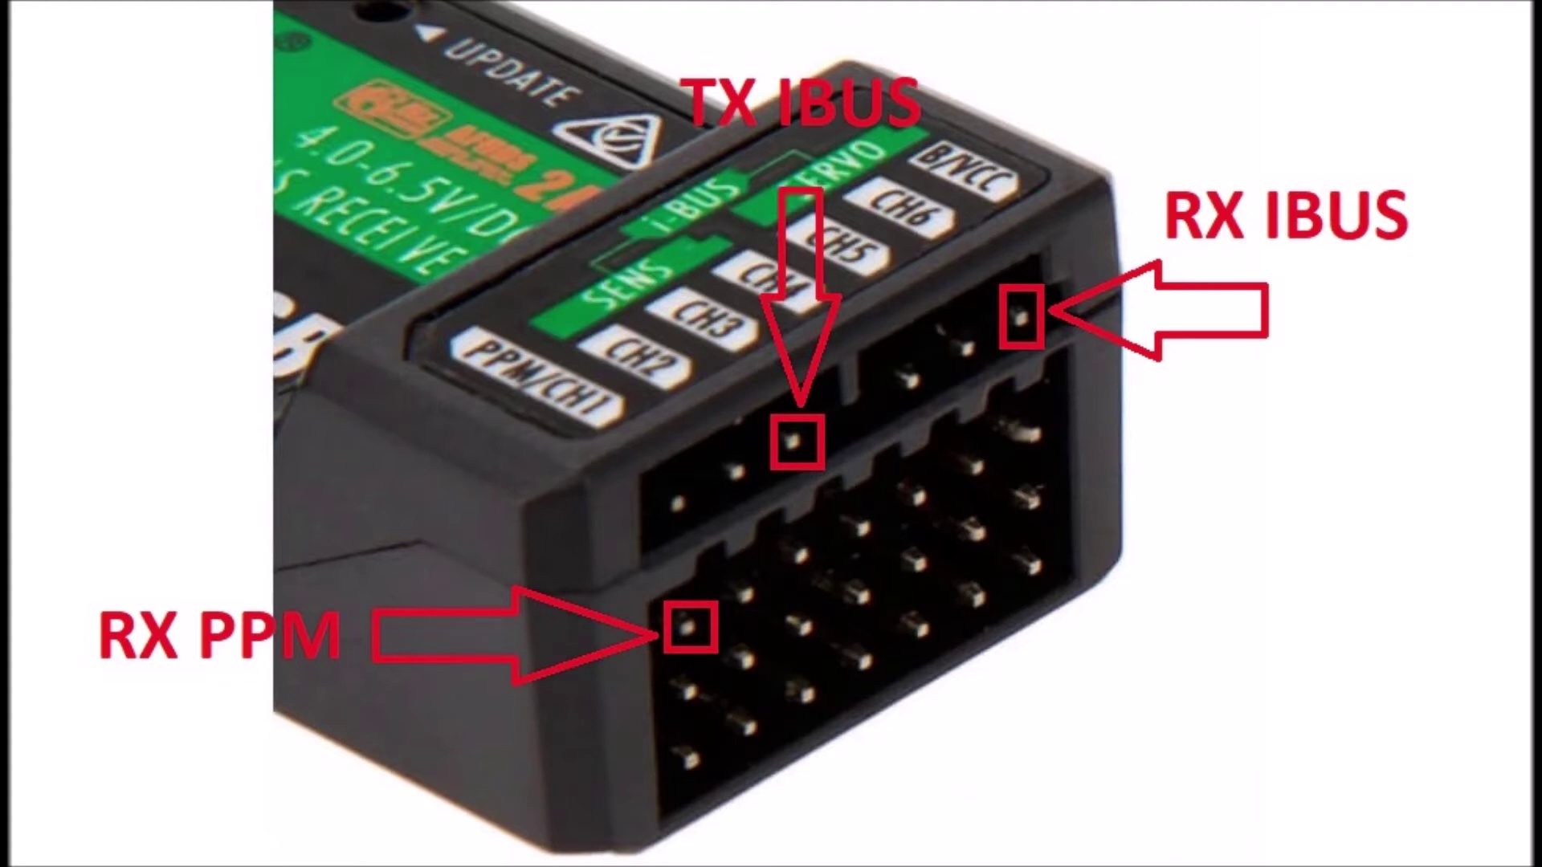 (score 95.0000)
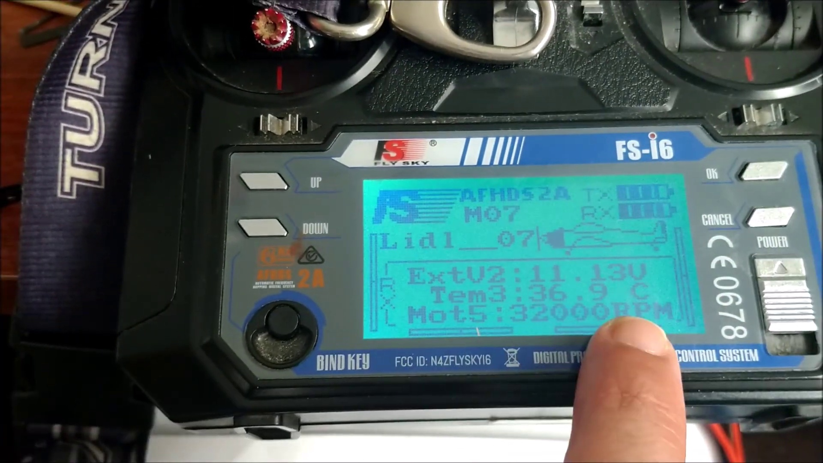 (score 90.0000)
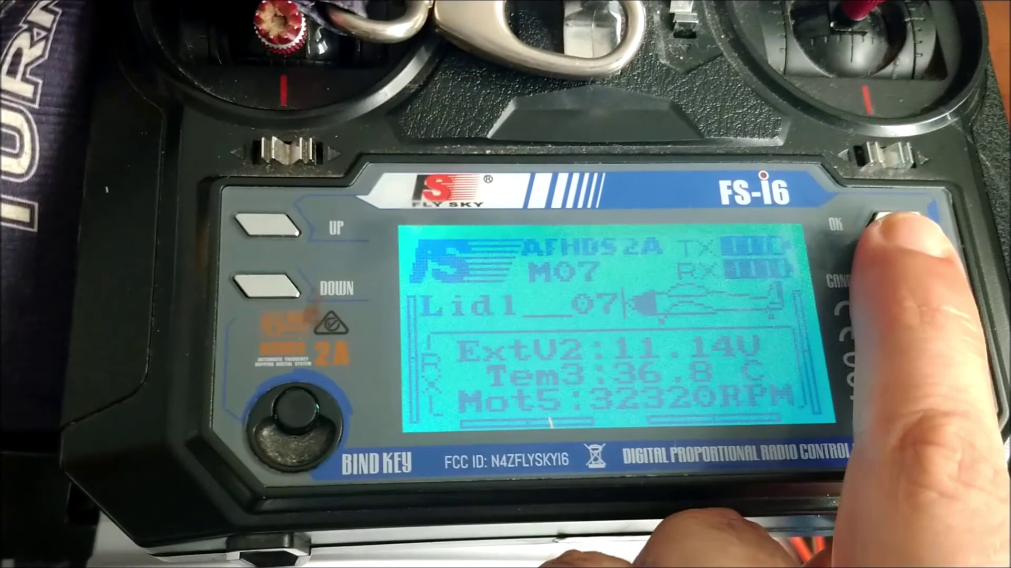 (score 90.0000)
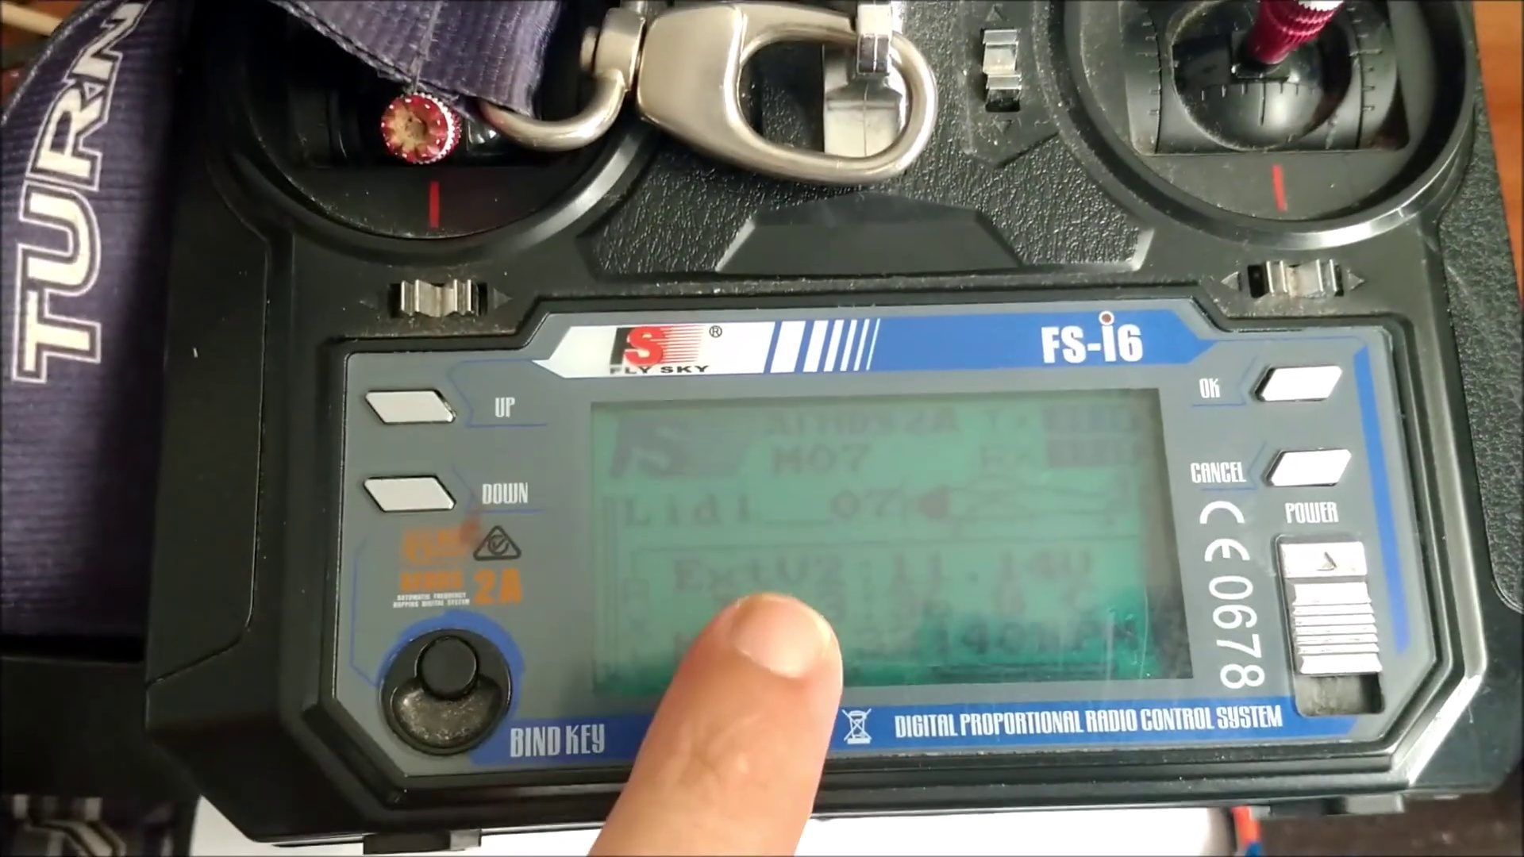 (score 90.0000)
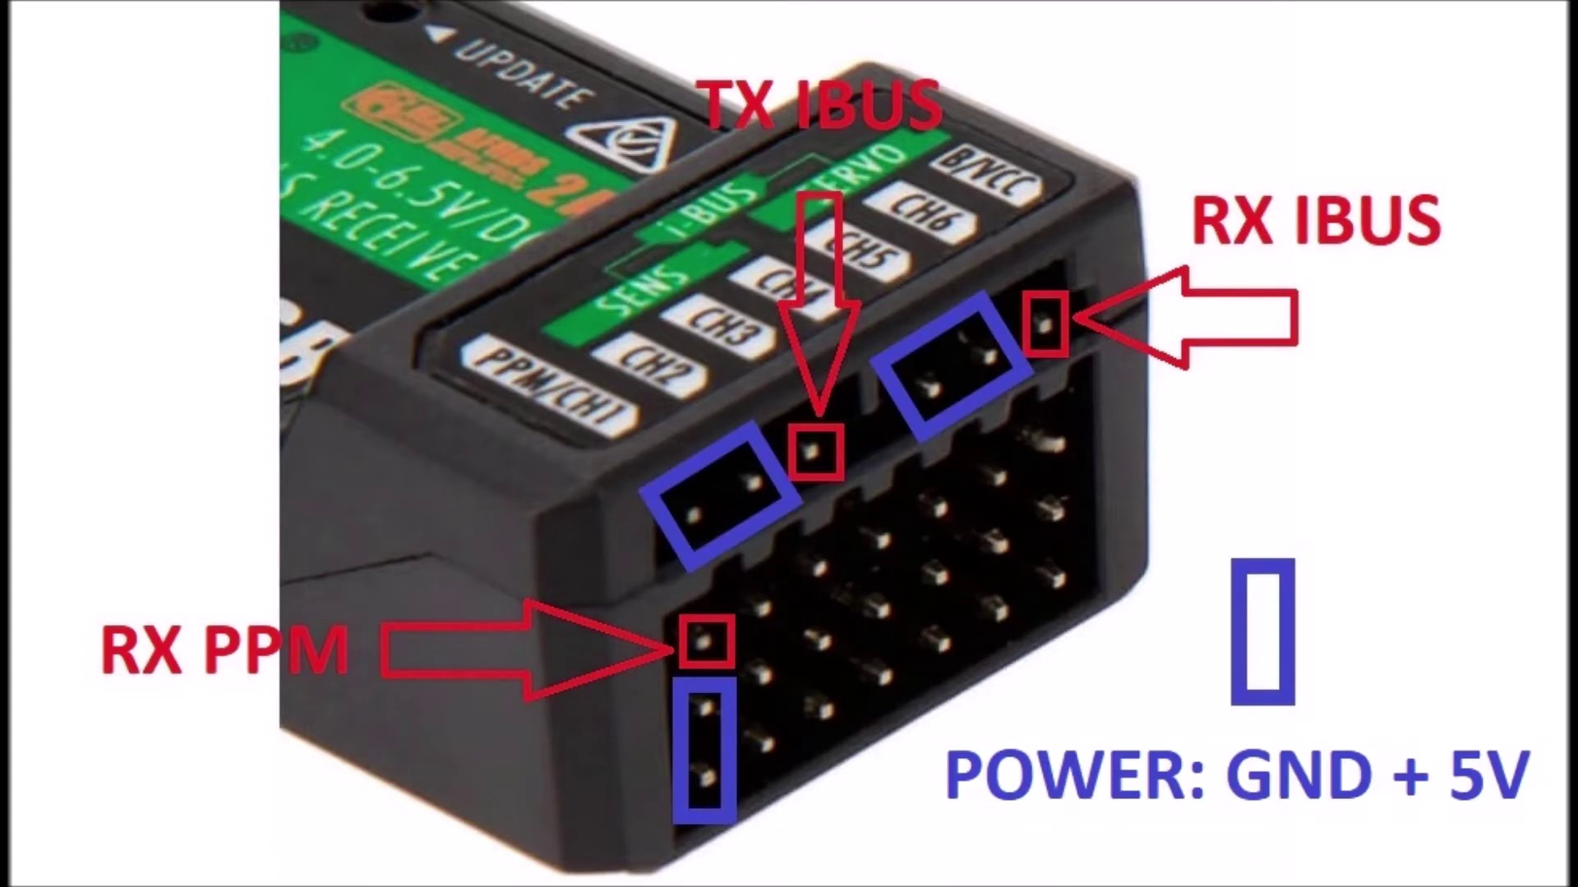 (score 90.0000)
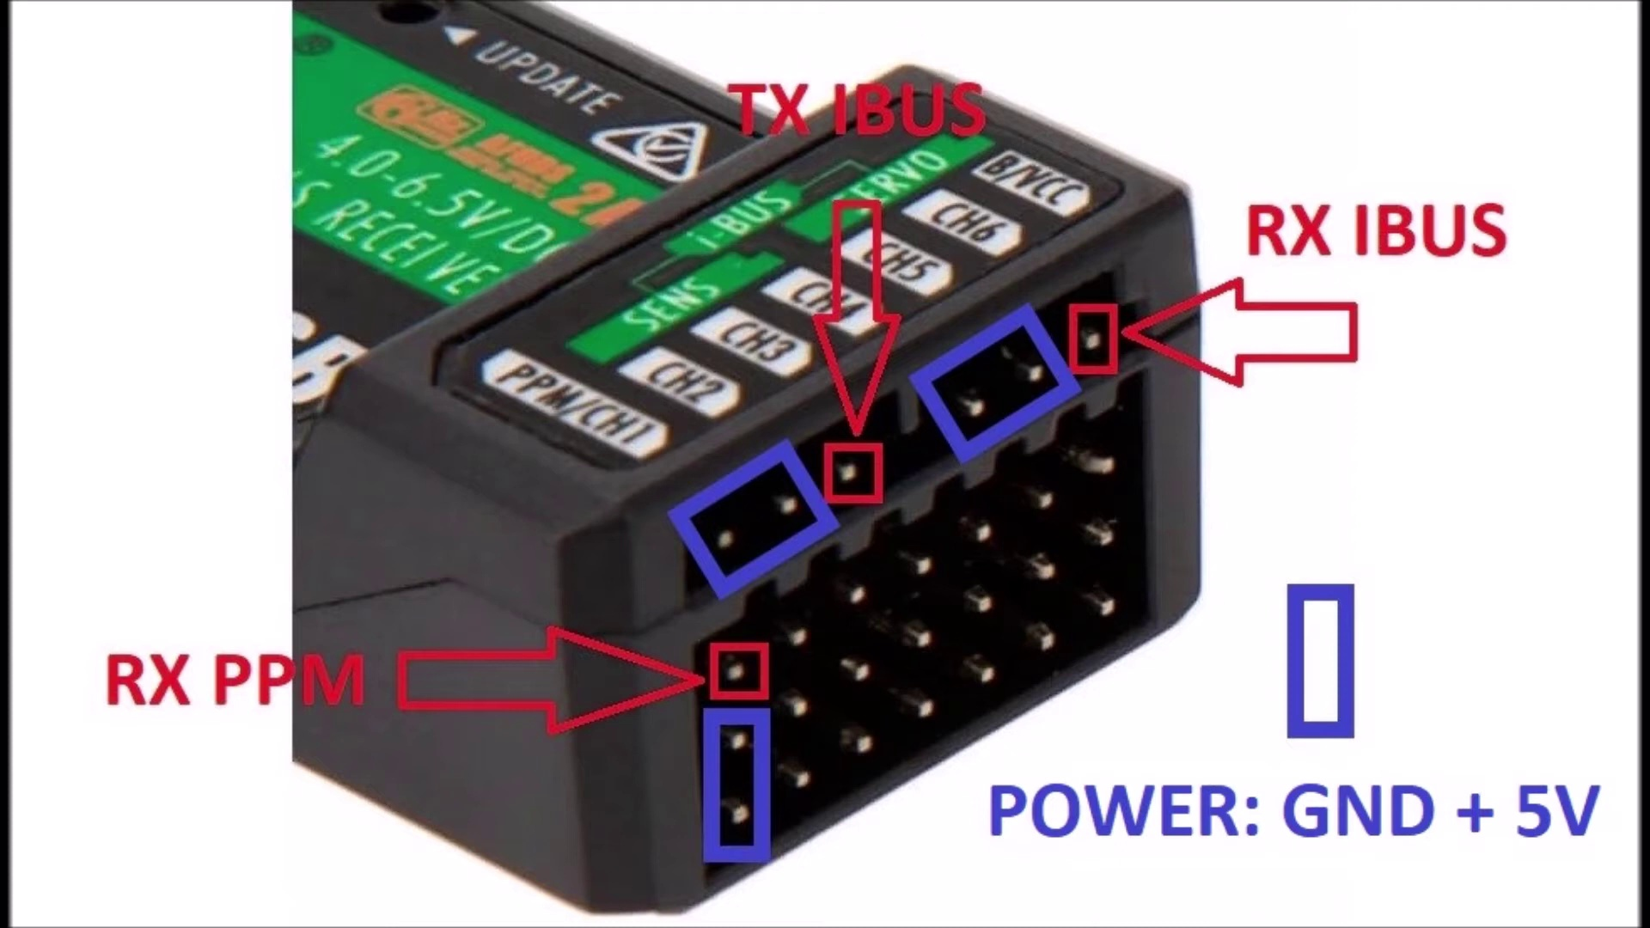 (score 85.0000)
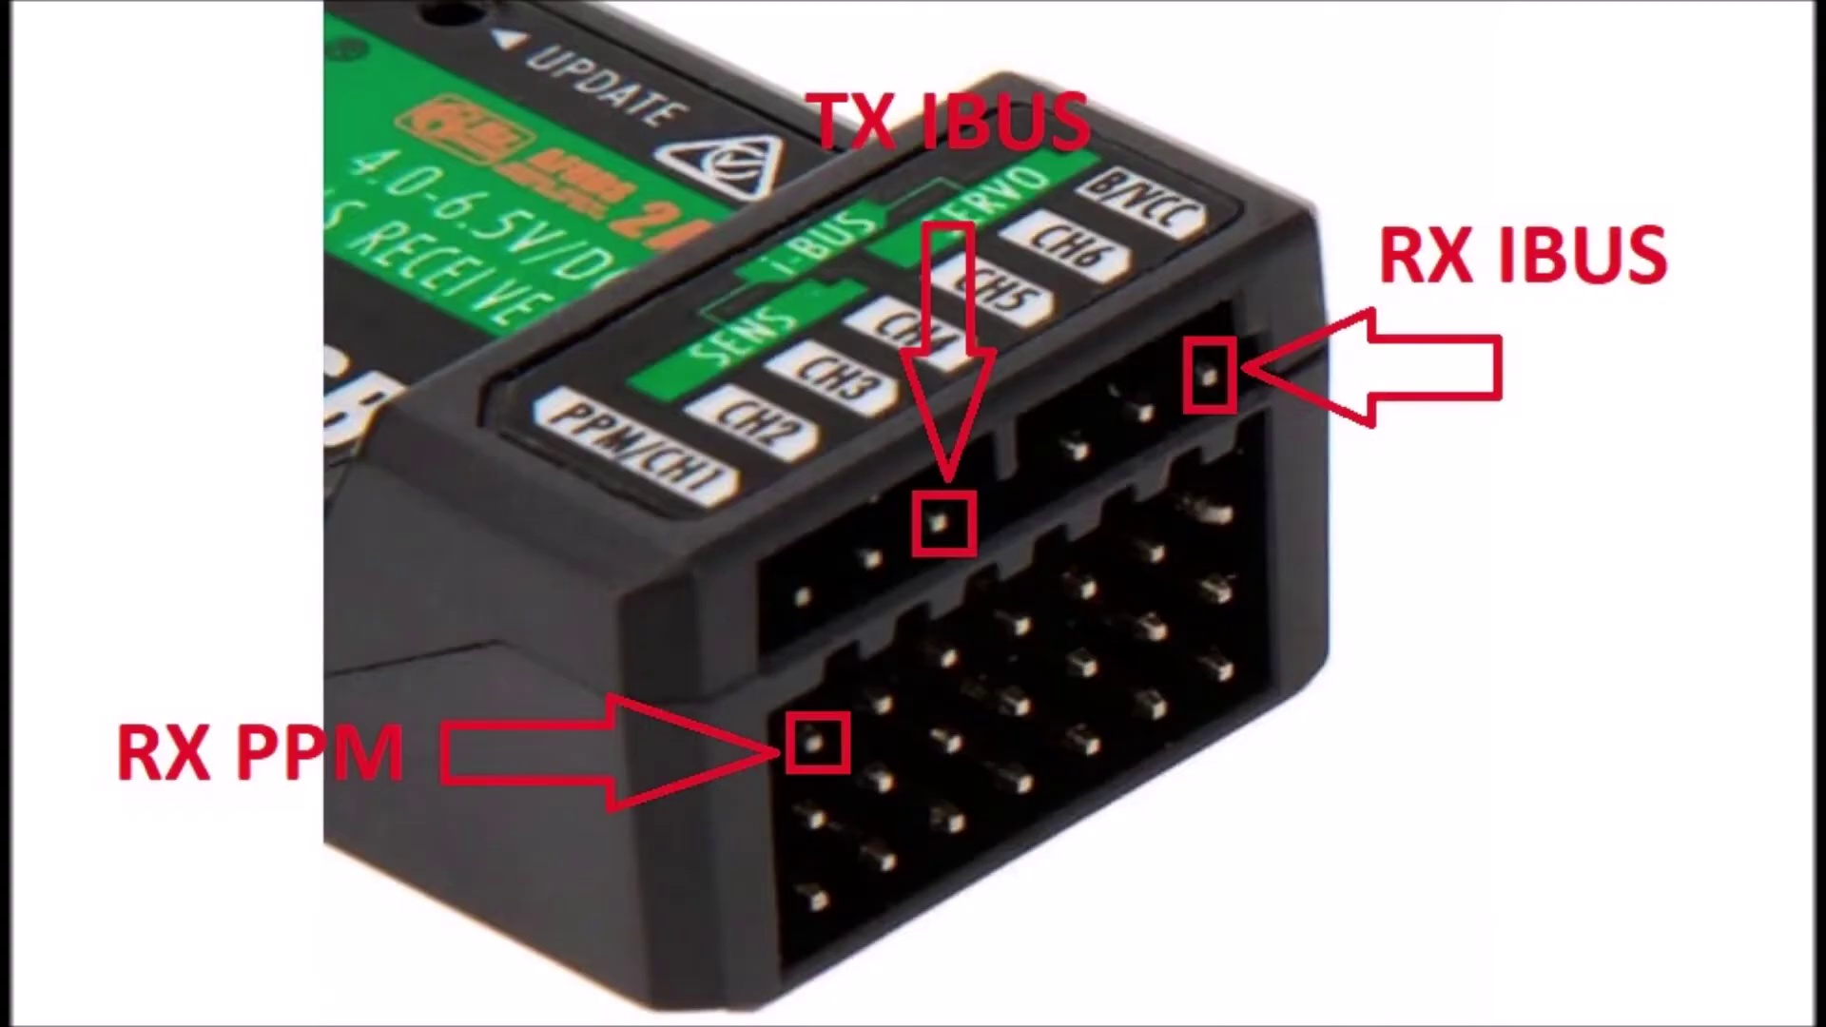 (score 85.0000)
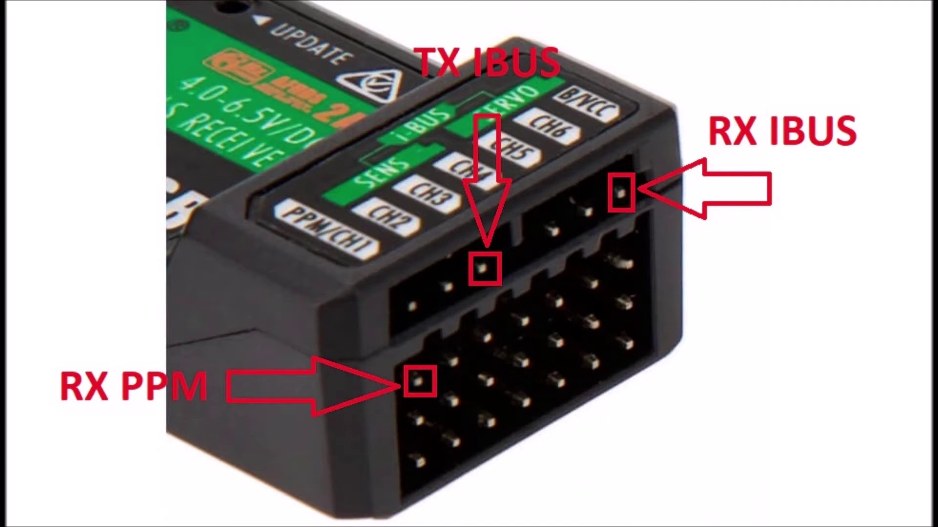 (score 85.0000)
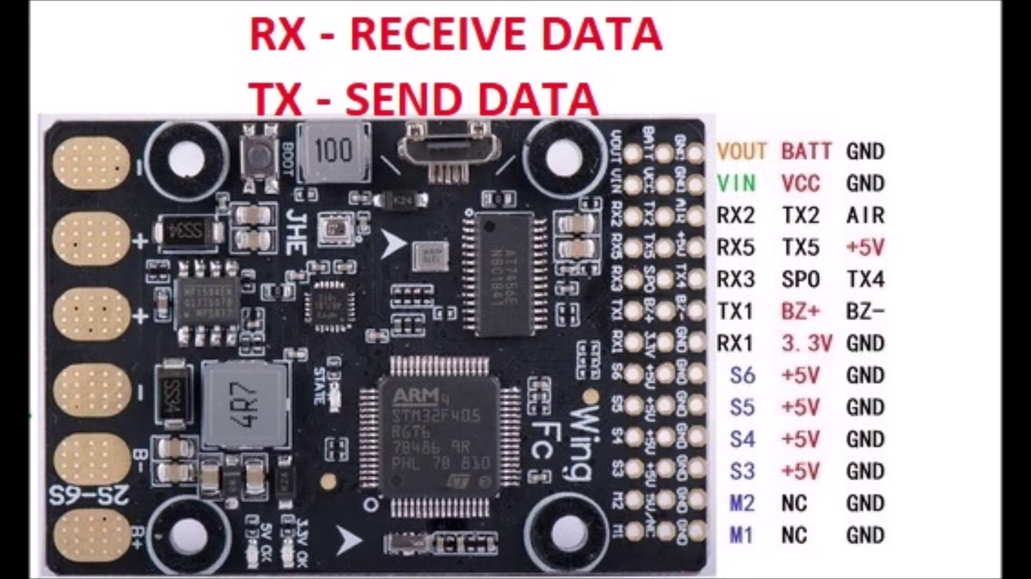 (score 85.0000)
Least correlated frames:
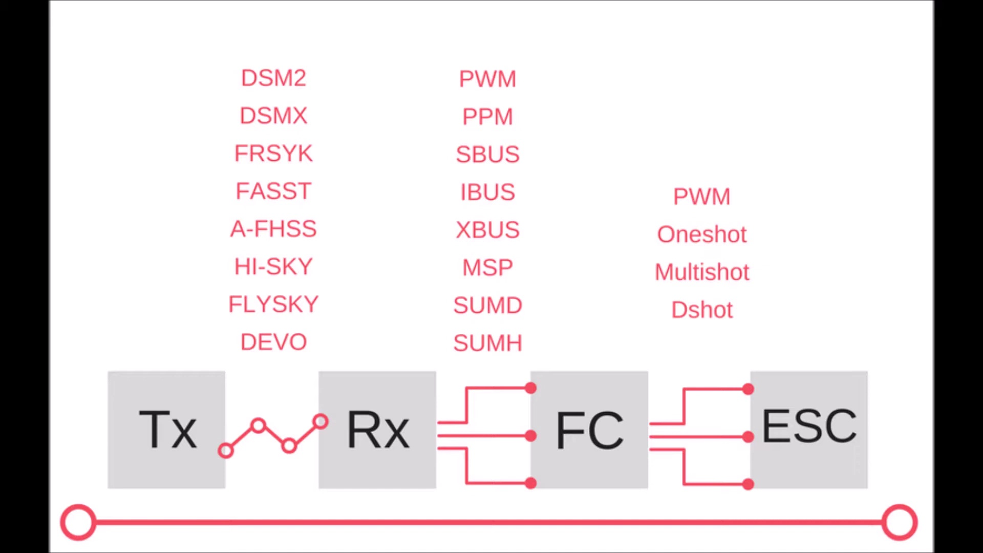 (score 0.0000)
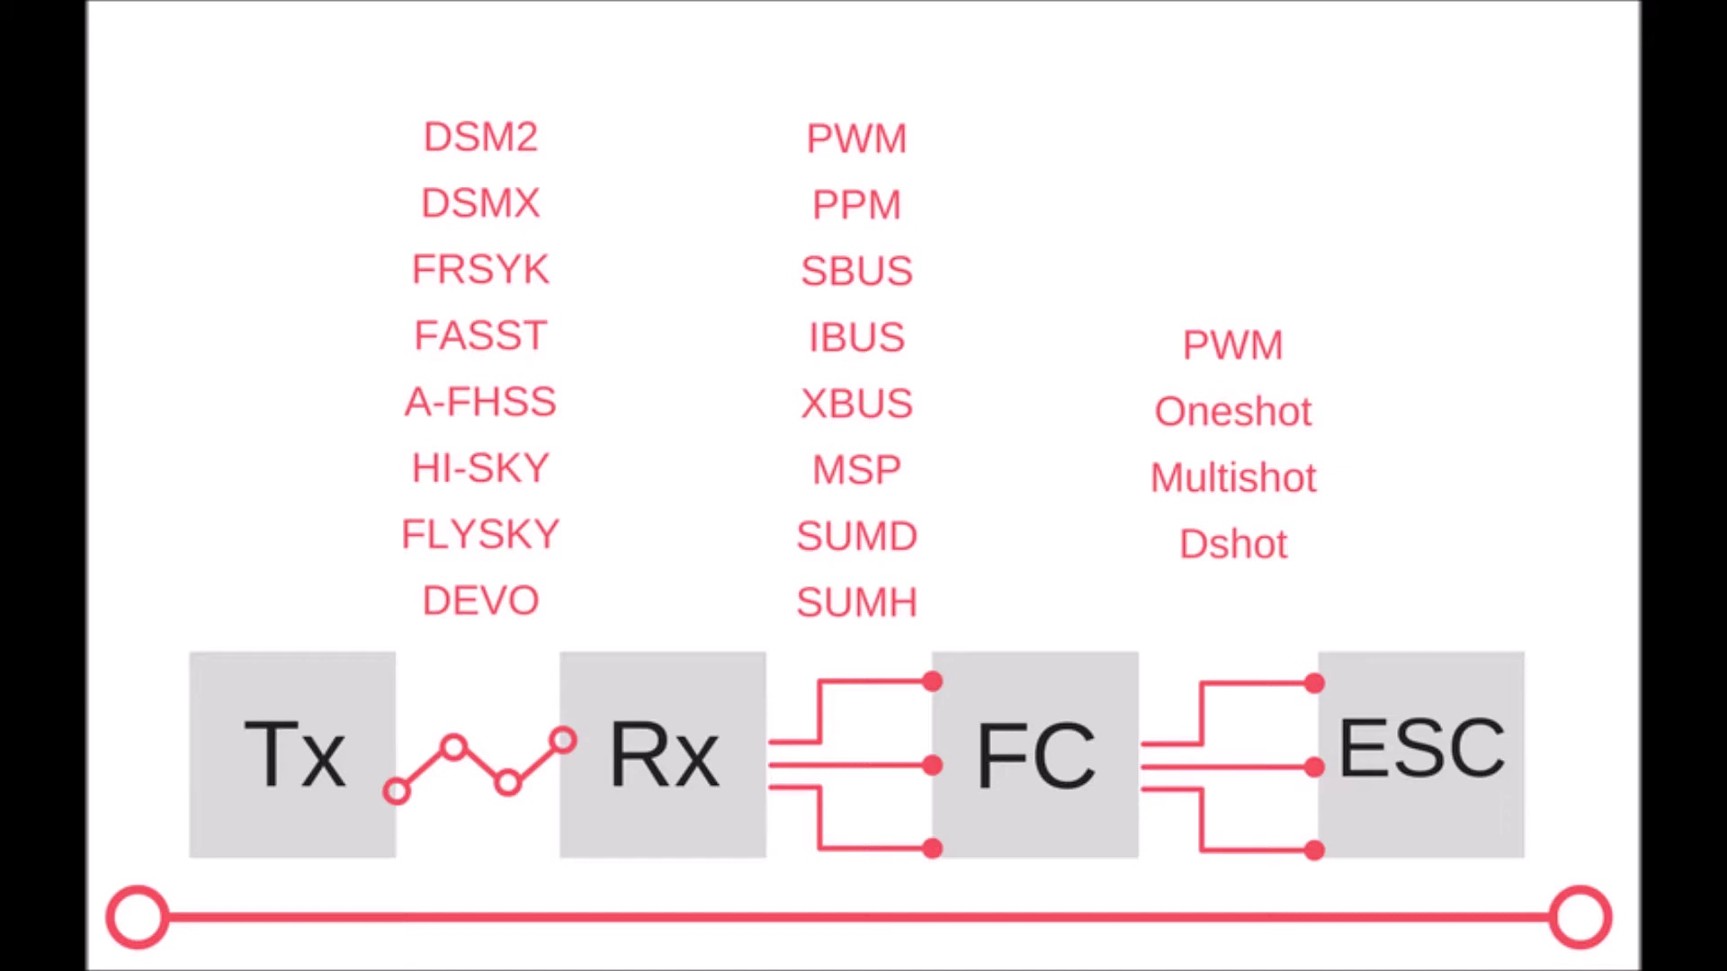 (score 0.0000)
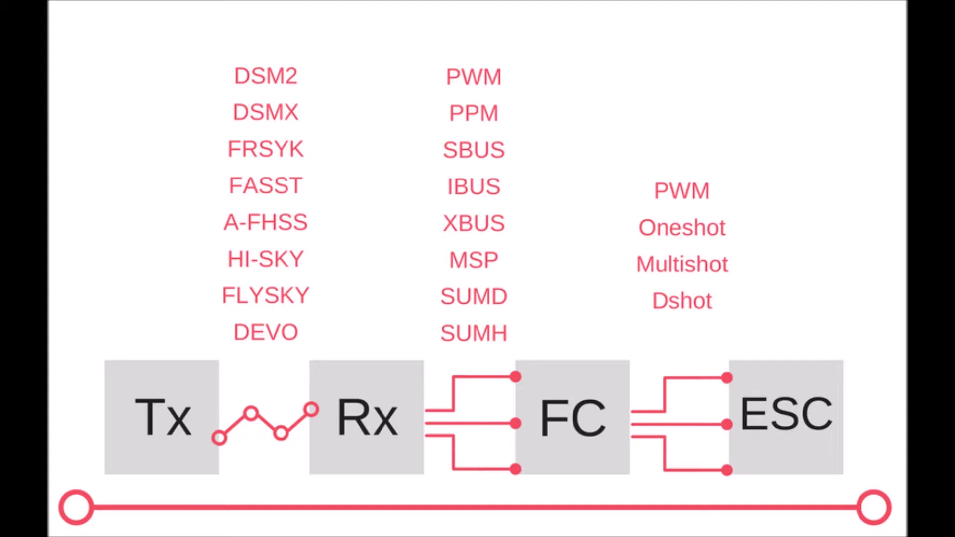 (score 0.0000)
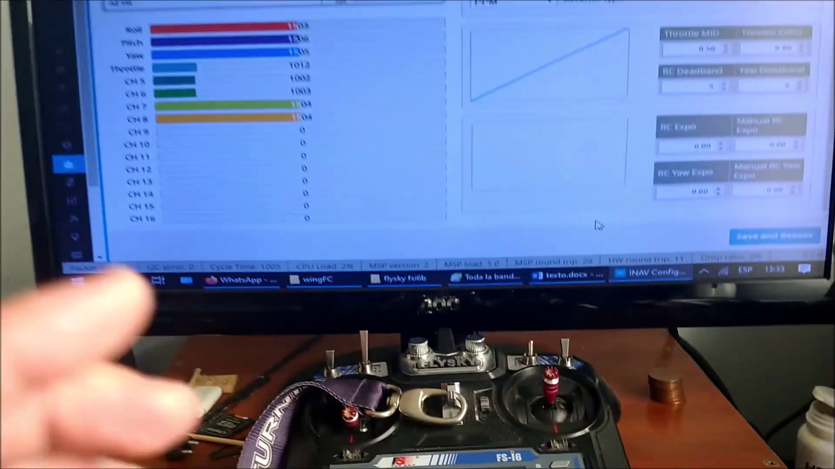 (score 0.0000)
 (score 0.0000)
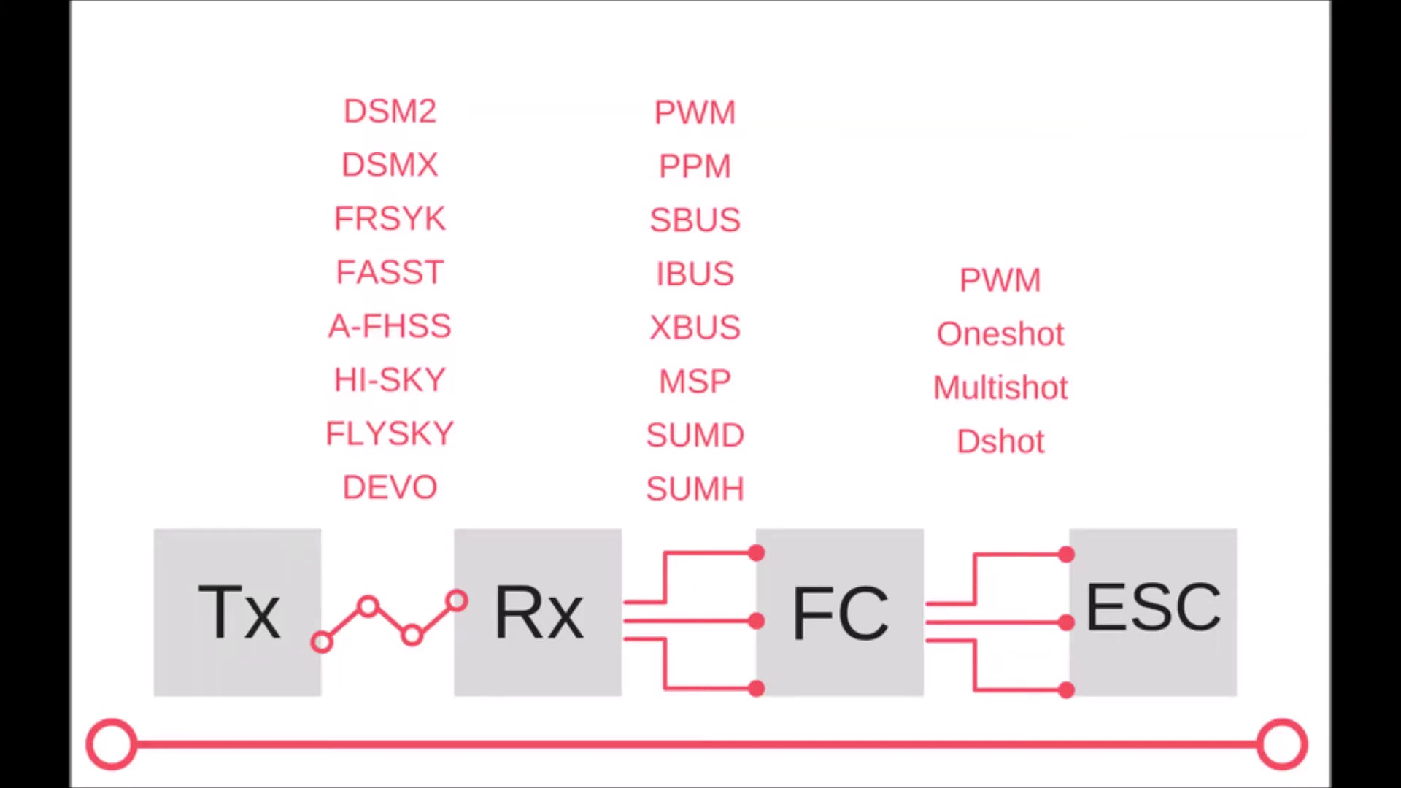 (score 5.0000)
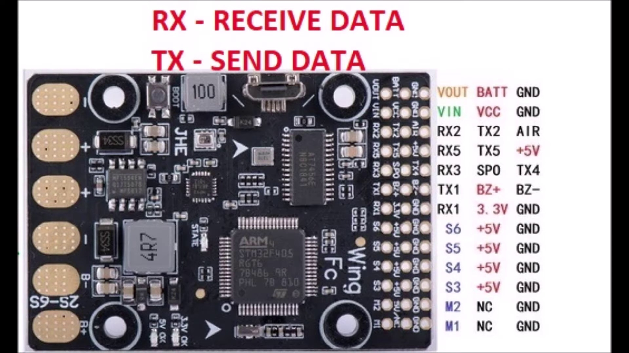 (score 5.0000)
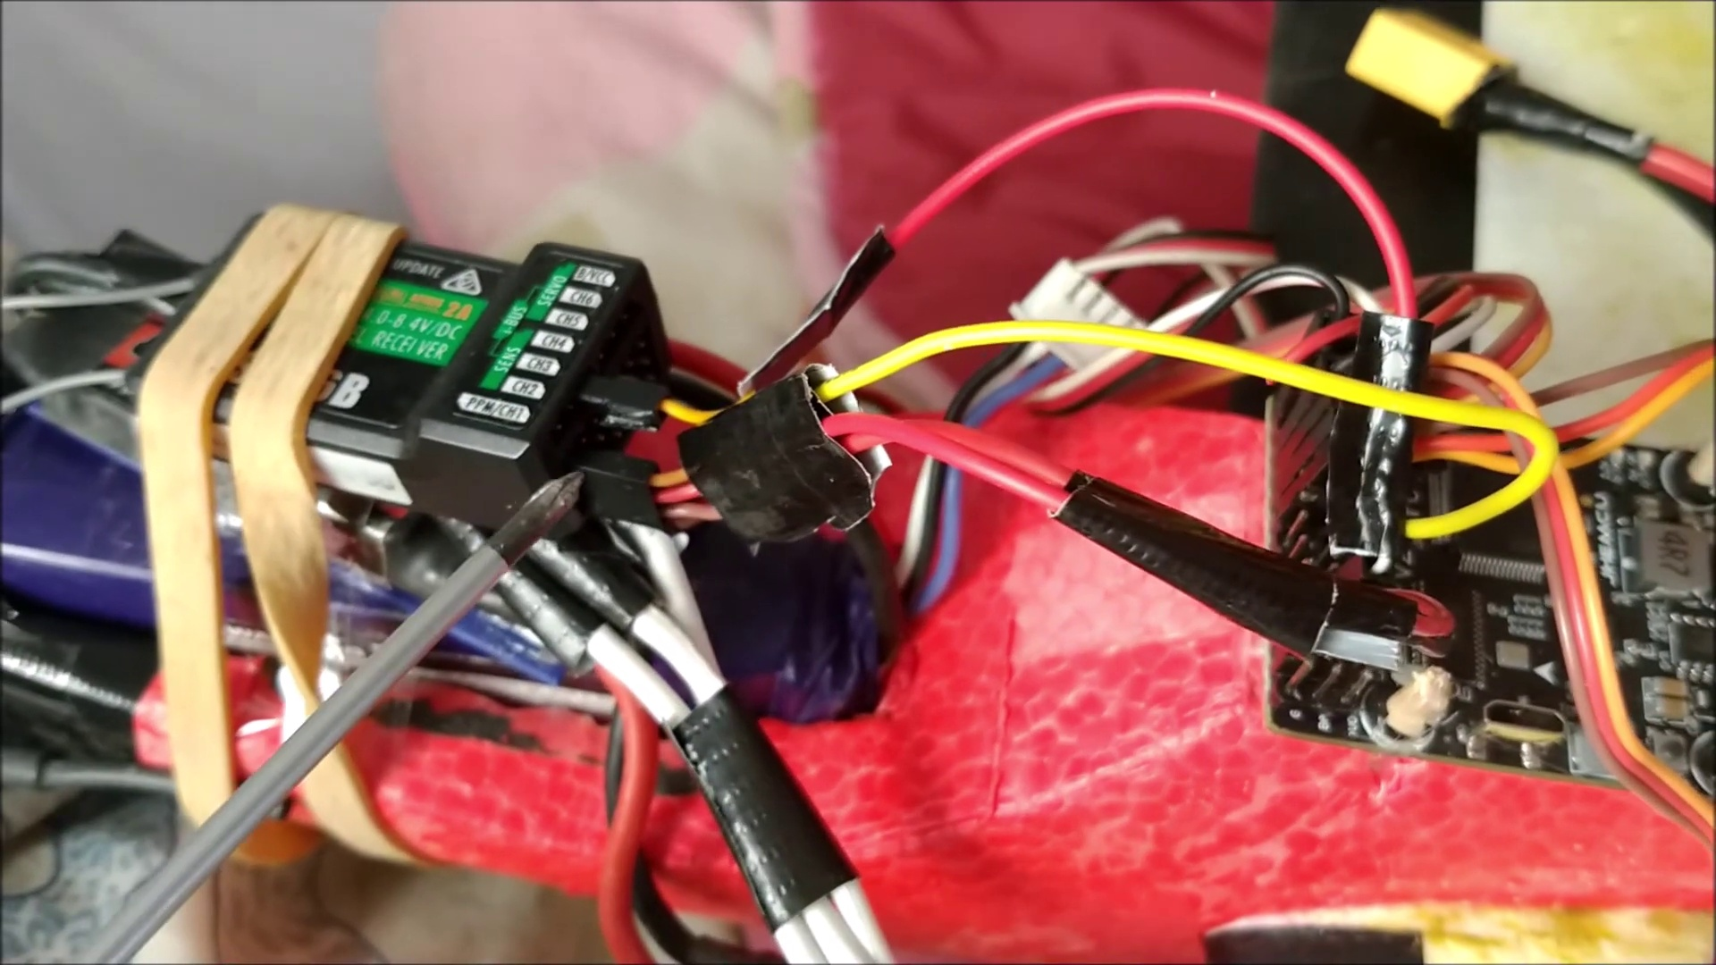 (score 5.0000)
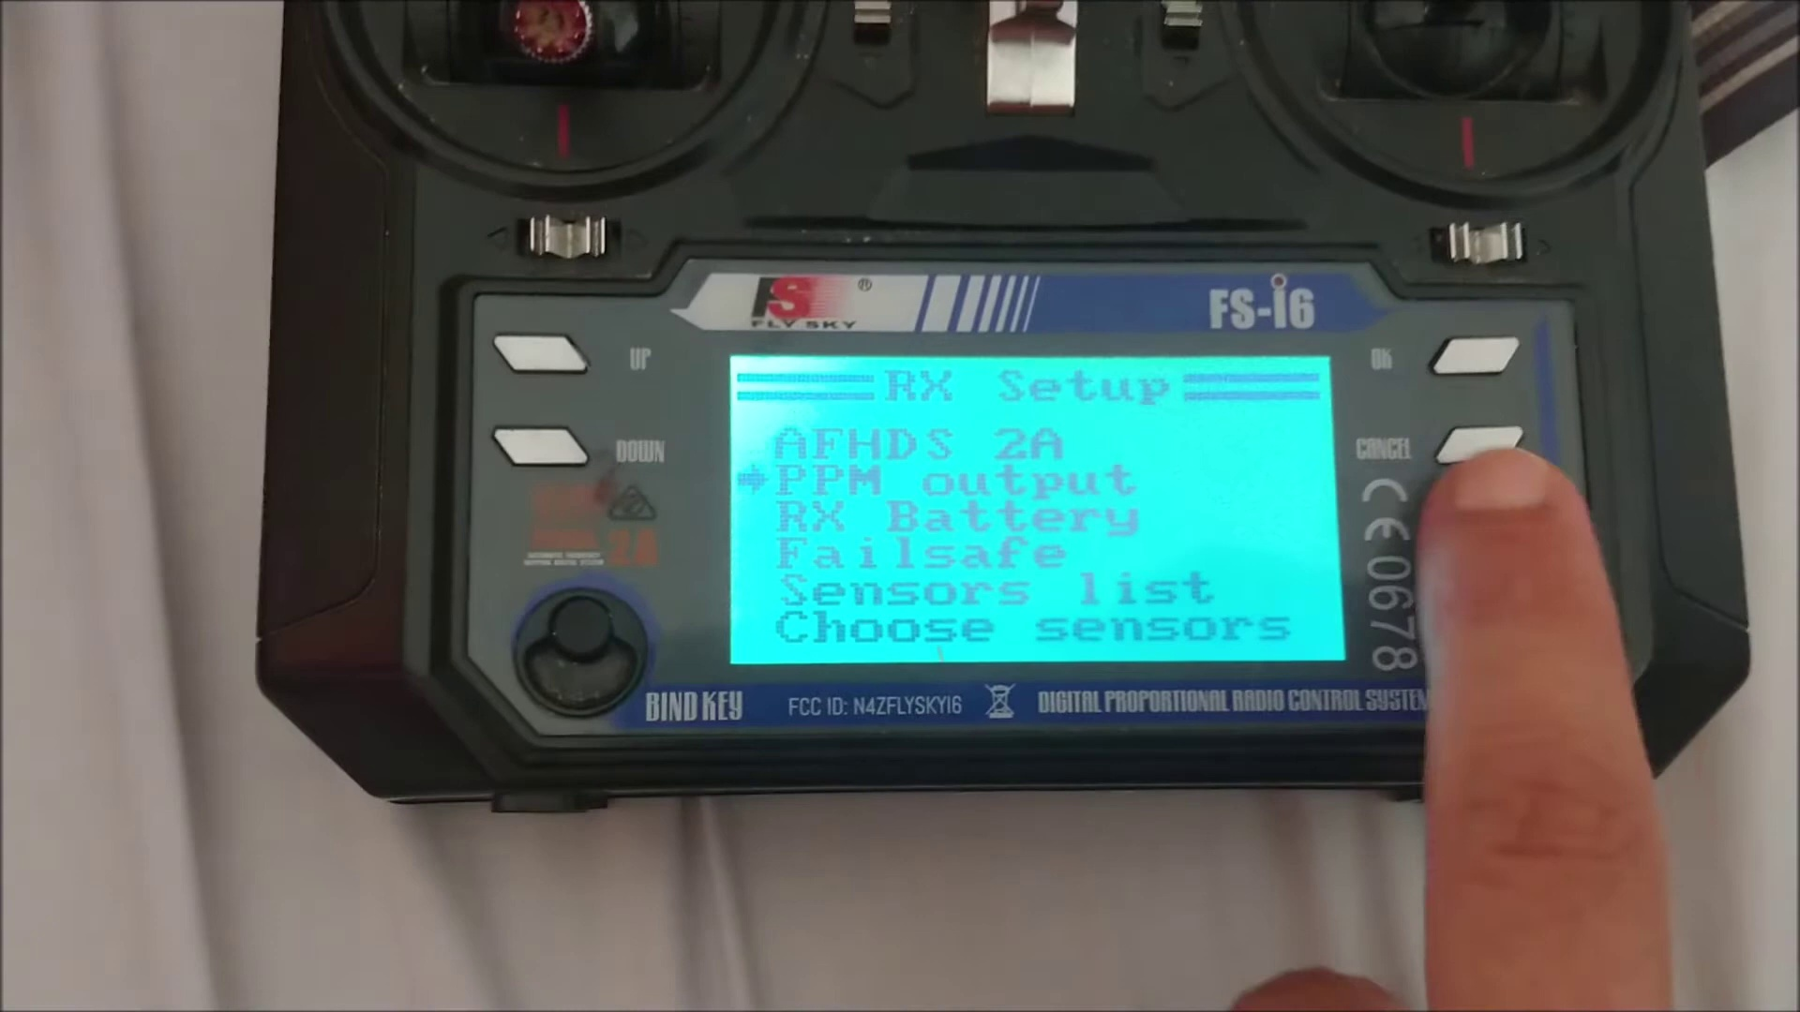 (score 10.0000)
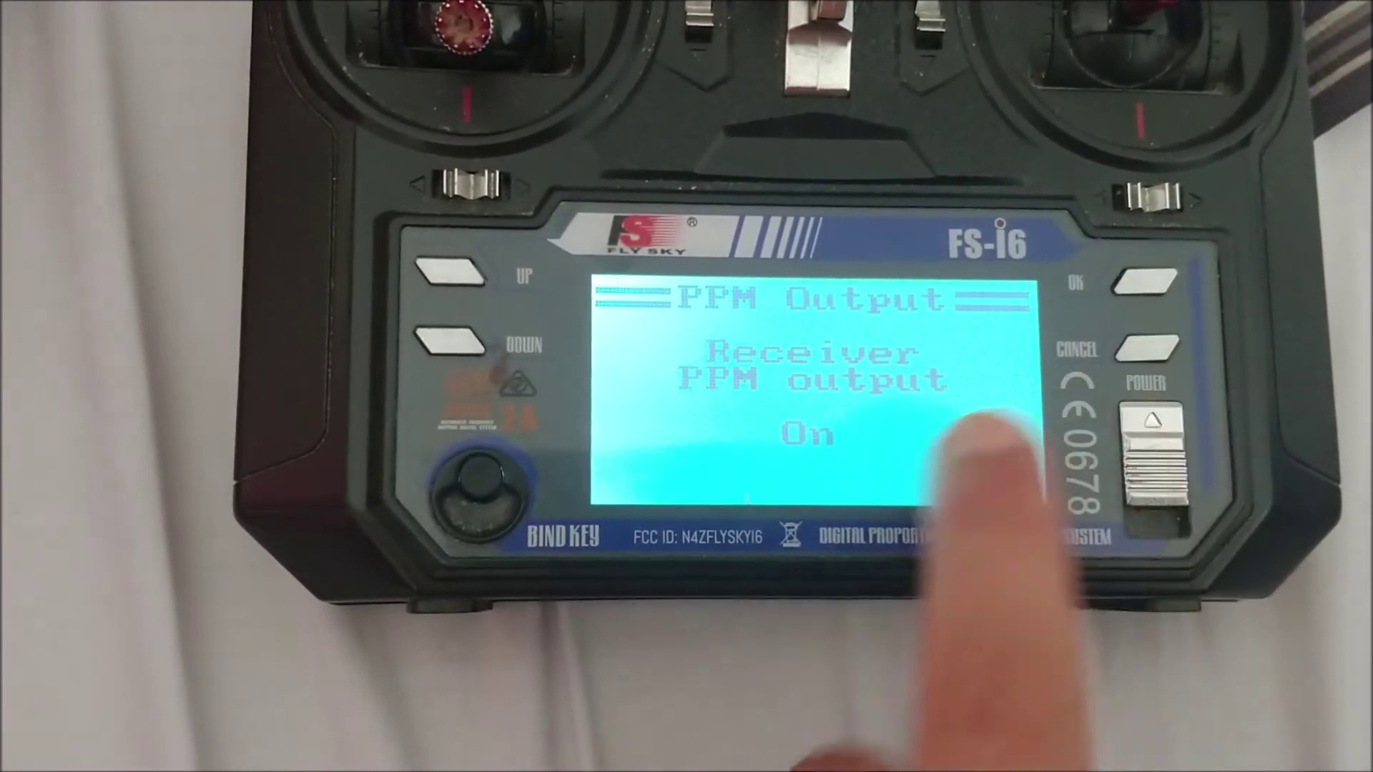 (score 10.0000)

Frame: frame_0000.jpg
Caption: The image appears to show a computer screen displaying an open Google Slides presentation. The presentation is in progress with various slides visible, showcasing a comprehensive overview of various communication protocols and their applications. At the top, there's a title slide that seems to say "BASICS" with subtitles like "DNS," "SSL," and "HTTP." Below this, there are several slides dedicated to explaining DNS (Domain Name System) servers, SSL/TLS certificates, and their importance in web security.
On one of the slides, titled "FTP," text explains the difference between FTP (File Transfer Protocol) and SFTP (Secure File Transfer Protocol), along with instructions on how to configure an SFTP server. A graphic representation of an FTP setup with fields for host, username, and password is also presented. Additionally, another slide compares FTP and SFTP protocols, providing users with information on how to secure their file transfers.
On the right side of the screen, there is a chat or comment box where users can interact with the presentation, presumably asking questions or providing feedback to the instructor. The user interface indicates that this session might be taking place in a video conferencing platform or an online classroom setting, as suggested by the "Live" label at the bottom right corner and the presence of a chat box for interaction.
In the background, there is a color-coded diagram that showcases a network of various communication protocols. The diagram is organized into sections dedicated to transmission protocols (represented by colored lines) and reception protocols (represented by colored circles), arranged in a grid-like pattern. A section at the bottom provides an overview of each protocol, offering users a comprehensive understanding of the different types of communication protocols.
The overall style of the image suggests it may have been taken during a live webinar or class session, as indicated by the presence of a chat box for interaction and the "Live" label at the bottom right corner.
No strongly correlated comments found for this frame.

Frame: frame_0001.jpg
Caption: The image shows a computer screen displaying a virtual whiteboard with several elements:
very large text that is partially obscured by other objects; smaller text boxes containing various acronyms and abbreviations such as "Wi-Fi," "ESC," "USB," "RJ45," "TX/RX," "NFS," and others, each within its own rectangle; a diagram with arrows pointing from one acronym to another, suggesting relationships or connections between the terms; and a small inset image showing a network of cables and hardware components with labels like "Ethernet," "Wi-Fi," and "VLAN." The whiteboard appears to be used for teaching or explaining technical concepts, possibly within the context of computer networking. There's no visible instructor in this frame.
No strongly correlated comments found for this frame.

Frame: frame_0002.jpg
Caption: The image shows a computer screen with various pieces of software open and visible, likely during an online tutorial or educational session focused on setting up a Raspberry Pi. On the left side of the screen is a web browser displaying a webpage that appears to be a tutorial or educational material, titled "How to Setup Your Raspberry Pi." Below this title, several steps are outlined in text form:
- Open your Raspberry Pi settings menu
- Go to "Interfaces"
- Connect to Wi-Fi or Ethernet
- Set up SSH
The webpage content also includes images of the Raspberry Pi hardware with labels such as "DS1," "HDMI," and "USB," which likely correspond to the steps listed above. The text is accompanied by bullet points, guiding the user through the setup process for a Raspberry Pi.
On the right side of the screen, another window shows a list of software or files in alphabetical order, including options like "AFS," "X11," and "RASPI-CONFIG." This window may be a file explorer or system information panel.
In addition to these details, there is also a list of telecommunications terms visible on the screen, which is labeled as such.
No strongly correlated comments found for this frame.

Frame: frame_0003.jpg
Caption: The image shows a computer screen displaying an application interface with various elements. The top section appears to be a command-line interface or input field where the user can enter commands, including "GET / HTTP/1.0", which is a request for a specific URL using the HTTP protocol, version 1.0. Below this, a sequence diagram represents a communication protocol between two entities, labeled as "Client" and "Server". The sequence of messages suggests a login process where the client sends an initial request (possibly a "GET" command), receives a response from the server, and then proceeds to send additional data packets and commands (such as "POST", "CONNECT", and "EASY_LOGIN"). A table is also present, which seems to be related to network traffic or system logs, with columns labeled "TIMESTAMP", "IP ADDRESS", "PORT NUMBER", "RESPONSE CODE", and other unreadable fields. Each row represents an entry in the log, including a timestamp, IP address, port number, HTTP response code (indicating the type of request), and possibly other data.
To the side, there is a list of items, possibly referring to software modules or functions: "FSM", "DMS", "PM", "SMS", "MMS", "SMTP", "POP3", "IMAP4", "SRP", "CRAM", and "TLS". Additionally, there are network switches labeled with their respective IP addresses and MAC addresses in the bottom left corner. The MAC addresses are shown in hexadecimal format.
In the bottom right corner, a section of a network topology diagram is visible, which includes various nodes representing devices on a network, connected by lines representing connections or communication paths. There is no visible instructor in this frame; it's solely focused on the content displayed on the screen.
No strongly correlated comments found for this frame.

Frame: frame_0004.jpg
Caption: The image appears to show a computer screen with multiple elements open. On the left side of the screen, there is a list of files or folders, although the specific names are not clear due to the image resolution.
The main area of the screen displays what looks like a text editor or code editor with syntax highlighting enabled for HTML and JavaScript. The code contains references to various elements such as `<button>`, `<a>`, `<img>`, `<input>`, and other HTML tags, along with inline JavaScript code. There are also references to CSS properties like `background-color` and `display`.
On the right side of the screen, there is a console or command-line interface with output that includes URLs (e.g., "http://localhost:8080"), network requests ("GET http://localhost:8080/..."), responses with HTTP status codes (like "HTTP/1.1 200 OK") and headers, and various log messages. The log messages include lines like "Docker 19.03.8", "dev", "root@79e4b50046c:~#", and "echo 'Hello, world!'".
The output suggests that there is a web application running on localhost, and the command prompt indicates that Docker might be involved in running this application. The overall context implies that someone is either working through a tutorial or debugging an application using Docker for development purposes.
In addition to these details, the image also shows a list of Sony Ericsson products on the top portion of the screen, displaying various mobile phone models released by the company.
No strongly correlated comments found for this frame.

Frame: frame_0005.jpg
Caption: The image shows a computer screen displaying a user interface with various menu options for a device or software application, likely related to radio equipment given the context. The screen is showing a list of items that are likely channels or frequencies, as indicated by the labels such as "106.7 MHz," "106.9 MHz," and so on. The device has a display screen in the upper left corner, where there's some sort of graphical representation with numerical values and symbols that seem to represent radio signals or frequency ranges, like "TX," which stands for "transmit," and various numerical frequencies and call signs. A Quality Management System (QMS) is also displayed on the interface, indicating its relevance in the field of quality management.
The bottom part of the screen displays several control knobs and a display showing what appears to be a signal strength indicator or a level meter for monitoring audio levels. The interface is designed with a digital, almost medical aesthetic, as suggested by the red "STOP" button in the upper right corner, indicating that the device can be controlled or operated. The background of the screen has a dark theme, which is common for software interfaces to reduce eye strain and improve contrast between elements.
On the bottom right corner of the image, there's a text overlay on the original photo that reads "106.7 MHz," which seems to be an incorrect or out-of-place piece of information overlaid onto the image itself. This is not part of the interface displayed on the screen. Overall, the image captures a moment where someone might be operating radio equipment for communications purposes, such as in broadcasting, radio control, or air traffic control.
No strongly correlated comments found for this frame.

Frame: frame_0006.jpg
Caption: The image appears to be a screenshot from a video frame showing a computer interface with a list of items on the left side and corresponding icons on the right side. The list includes various items such as "DSM1," "DSM2," "DSM3," "XFS," "USB," "Wi-Fi," "Bluetooth," and others, suggesting that these are possibly different types of sensors or data sources. Each item in the list has a corresponding icon, which seems to represent the physical aspect or connection point for each item.
The bottom right corner of the screen shows a diagram with labeled nodes connected by lines, indicating some form of system architecture or network configuration. The diagram includes icons representing different types of connections or devices, such as Ethernet cables and wireless signals. There are also labels on the connections indicating "TX," "RX," and "ECU," which could stand for transmit, receive, and engine control unit, respectively.
The overall context of the image is that of a technical demonstration or instructional video, possibly related to automotive electronics or vehicle diagnostics. The presence of the diagram and labeled nodes suggests that the instructor may be explaining how different components communicate within a system, or they might be guiding viewers on how to diagnose or troubleshoot issues with their vehicles.
In this context, telecommunications plays an essential role as it enables the exchange of information over long distances. This information can take various forms such as voice, text, or data. The history of telecommunications dates back to the 19th century, with pioneers like Samuel Morse, Alexander Graham Bell, and Nikola Tesla developing early telegraph and telephone technologies.
Today, telecommunications is an integral part of our daily lives, allowing us to communicate with people around the world, access information, and conduct business. It has also played a crucial role in the development of the internet and mobile communication. As the field continues to evolve, new technologies are being developed to improve the speed, reliability, and efficiency of communication.
The future of telecommunications looks bright, with new innovations on the horizon.
Comment (score 80): This video talked about what a FlySky FS -iA6B is. FlySky FS -iA6B is a receiver that has three types of communication protocols which are the classic PWM, and the two serial protocols: PPM and ibus. Something learned from this video is that when this receiver is connected to a flight control one of the serial connections (PPM or ibus) is always used. Flight controllers have UART serial ports. One of the serial port lines receives information from the radio while the other sends information from the controller to the radio. The two serial port lines are called RX and TX line. Overall information is sent through the RX line by the PPM and information is received through the TX line by ibus. From this video, I learned that the radio sends information of the channel to the controller and radio receives information from sensors of the controller.
Reason: The comment directly discusses the same technical steps and protocols (e.g. PPM, ibus) described in the caption, which are related to communication between a receiver and flight controller, matching the context of the image showing computer interfaces and system architecture.
Source: https://www.youtube.com/watch?v=AmlmkTPqZrk: How to SETUP FlySky FS-iA6B with flight controller FC. Protocol IBUS y PPM. Telemetry. TX RX UART

Frame: frame_0007.jpg
Caption: The image shows an electronic device that appears to be a circuit board with various components mounted on it, including resistors, capacitors, and chips. The board has multiple integrated circuits (ICs), connectors, and other electronic components, which are arranged in a grid pattern for a well-structured and organized circuit design.
On the board, there is a label "RX" pointing to a set of pins with "RECEIVE DATA" written above them, indicating these are likely input pins for receiving data. Below that, there is another label "TX," with "SEND DATA" pointing to the corresponding output pins, suggesting these are for sending data out.
The text on the image indicates that the device is programmed for handling RX/TX operations for data transmission or reception. It mentions it's an Arduino board, which is a popular platform based on ATmel microcontrollers (Microcontrollers with integrated circuitry and additional circuits).
The background image shows a computer screen displaying text that reads: "RX - Receive data | TX - Send data | RX/TX | Serial communications | Baud rate | 1200 | Data frame format: 8-bit | Start byte | Address byte | Checksum byte | End byte | Protocol version | 1.0 | Software | Arduino IDE | Hardware | Arduino board | 5v | 2A | USB | Ground | Power supply | 5V/2A |"
This text provides additional information about the device, including the baud rate for data transmission (1200 baud), the data frame format (8-bit), and details about the power supply and serial communication parameters. The software and hardware used are also mentioned: Arduino IDE for programming and the Arduino board itself, which is a type of microcontroller board based on the ATmega328P.
The image seems to be from an educational context, possibly teaching about how to program a device like this to handle serial communication, as the text and diagrams suggest that data transmission and reception are involved.
No strongly correlated comments found for this frame.

Frame: frame_0008.jpg
Caption: The image presents an electronic device with various components attached to it, including a microcontroller board (labeled "RX-TX") with a WiFi module and possibly other sensors or expansion boards. The device has multiple pins and headers, suggesting its designed for interfacing with various electronic systems. Labels on the device indicate that this is an RX-TX board for sending and receiving data, which is likely related to a project involving radio communication or sensor readings.
The image shows the circuit board as the central component of the RX-Receive Data TX-Send Data module, covered in a variety of components such as resistors, capacitors, and LEDs. Resistors are evenly distributed across the board, with some located near the center and others towards the edges. Capacitors are also present, positioned near the top and bottom of the board. LEDs are scattered throughout, with some near the center and others towards the edges.
The board is labeled with a series of numbers and letters, indicating the specific components and their respective functions. The overall layout of the board suggests a complex electronic system designed to receive and send data. The device can be programmed to send and receive data, likely as part of a project involving radio or sensor communication, using an RF transmitter.
The background of the image is not clearly visible, but it appears to be a typical workspace setting with various electronic components scattered around. There are no people or instructors in view, and the focus is solely on the device itself and its functionality as described by the text overlaying the image: "RX-TX receive/transmit DATA. TX-send DATA. send DATA with RF transmitter."
No strongly correlated comments found for this frame.

Frame: frame_0009.jpg
Caption: The image shows a small electronic device labeled as "RX - Receive Data" with an integrated circuit (IC) visible and various components such as capacitors, resistors, and possibly a microcontroller around it. The device has a blue label with the text "RX - Receive Data" in white lettering, indicating its function within a system. There is also a QR code present, which typically represents information that can be scanned for more details about the device or its context.
Above this device is an image of a printed circuit board (PCB) with a similar layout and components, suggesting the PCB serves as a blueprint for the physical construction of such a device. The PCB contains several pins or connections that are not fully visible in the image but appear to be for power supply, communication interfaces, and possibly signal processing functions based on their arrangement and standardization.
The background behind these devices has a table with text and graphics that likely provides information about the device's operation, components, or the manufacturing process. The table includes columns such as "RX - Receive Data," "TX - Send Data," "Send Data," and "Receive Data," which may be referring to the data transmission capabilities of the device. There are also rows with numerical values and icons that could represent different functionalities or data types.
The board, which is predominantly black with a few silver components, is a mix of electronic components and circuit boards, indicating a complex system. It's a multi-layer board, suggesting it's designed for various functionalities. The board has several connectors, including 5V and 3.3V connectors, indicating its ability to work with different power sources. Resistors are also present, possibly used in a circuit that requires precise voltage regulation.
A 5V LED is visible on the board, which could be used for indicating power status or other functions. The board is neatly organized, with components and circuit boards placed in a logical order. Circuit boards are stacked on top of each other, suggesting a well-designed and efficient layout.
The device appears to be designed to receive and process data in a complex electronic system, requiring a high level of technical expertise and attention to detail.
No strongly correlated comments found for this frame.

Frame: frame_0010.jpg
Caption: The image shows an electronic circuit board with various components and markings on a white background. The top layer of the board features a white rectangle with black text reading "RX - Receive Data", surrounded by integrated circuits (ICs), capacitors, resistors, and connectors. This suggests that the board is part of a communication system, likely for radio frequency (RF) transmissions given the antenna and connector visible.
The bottom layer of the board displays a red rectangle with black text reading "TX - Send Data", accompanied by components such as a microcontroller, a 5V battery, and a 5V power supply. The circuit board is connected to an antenna, which is also visible in the image.
Specifications listed alongside various pins of the board include:
* TX - Send Data
* RX - Receive Data
* Vcc - Voltage Supply
* GND - Ground
* Antenna
* Connector
The text "RX" and "TX" are written in black on the top and bottom layers of the board respectively, indicating the purpose of the board as capable of receiving and sending data over RF or similar wireless protocols. The focus is solely on the board and its components, suggesting an educational context for teaching about electronics, RF communication, or similar technical topics.
No strongly correlated comments found for this frame.

Frame: frame_0011.jpg
Caption: The image shows a small electronic device with various components visible, including an antenna, RF transmitter and receiver, multiple connectors, and integrated circuits. To the right of this device is a label indicating "RX - Receive Data," suggesting that this is part of a wireless communication system designed to receive data. A table on the right side of the image lists numbers and what appear to be channel frequencies, possibly an interface for configuring wireless communication parameters.
The device has a QR code sticker on it, which could potentially contain information about the device, such as its serial number or a link for further details. Below this label is text that says "Data 8MHz." The background of the image is plain and light-colored, with an overall style that appears informational and technical.
In addition to the device itself, the image also shows a circuit board, which is covered in various components, including resistors, capacitors, and LEDs. The resistors and capacitors are spread out across the board, with some being more towards the center and others towards the edges. The LEDs are located towards the right side of the board. The board is equipped with several wires, one red and one white, which appear to be used for data transfer. A battery is also visible at the top left corner of the board.
The circuit board is labeled as an RX - Receive Data, indicating its purpose for data reception. The overall layout of the components on the board suggests it might be a part of a larger electronic device or system.
No strongly correlated comments found for this frame.

Frame: frame_0012.jpg
Caption: The image presents a close-up view of an electronic component, specifically an integrated circuit (IC), labeled as "TX/RX USB." This suggests that the IC is designed for transmitting and receiving data via a USB interface. The background of the image contains text and diagrams that are likely explanatory in nature, although the focus is primarily on the IC itself. One section near the bottom right corner discusses "RX/USB" and mentions "MPU," "PMIC," and "PMU," which may be related to the functionality of the IC.
The IC does not show any connectors, but it appears to be a standalone component designed for use in devices that utilize USB technology. The image does not contain any text or additional objects, making the IC the sole focus of the picture.
No strongly correlated comments found for this frame.

Frame: frame_0013.jpg
Caption: The image presents a close-up view of a miniature electronic circuit board that appears to be part of an educational material explaining the components and their functions in an electronic device such as a network router or switch. The board is equipped with a variety of connectors and terminals, all neatly arranged in a grid pattern. A black electronic component, likely an RJ45 connector commonly used in data networking for Ethernet cables, is attached to the board via a ribbon cable. This connector has multiple gold-plated contacts and is labeled "TX/RX JUS" on its left side, indicating that it is a type of Ethernet connector where TX stands for transmit and RX stands for receive.
A red arrow with a magnifying glass icon points at the gold-plated contacts on the black component, suggesting their importance. Below the label "TX/RX JUS," there is a diagram showing how the pins might be arranged within the connector, with labels indicating the types of signals each pin carries: PIN1 - TX_ETHERNET, PIN2 - RX_GIGAETHERNET, PIN3 - GND, PIN4 - TP, PIN5 - RX, PIN6 - TX, and PIN7 - CROSSOVER.
The diagram also highlights specific pins designated for transmitting (TX) and receiving (RX) signals. The text "RX MPM" points to the pin labeled "TX," which is typical for the receive pair in an Ethernet cable, and "TX MPM" pointing at the transmit pair, indicating that the pins are standardized for Ethernet connectors.
The board also features various terminals and connectors color-coded to indicate their functions: black ones labeled "RX" and "IBUS", red ones labeled "PPM", green one labeled "TX", yellow one labeled "VCC", and a black one labeled "GND". The board is affixed to a metal surface, which contrasts with the light-colored board. The relative positions of the connectors and terminals suggest a well-designed and functional circuit board.
No strongly correlated comments found for this frame.

Frame: frame_0014.jpg
Caption: This image shows an electronic component known as the RXIBUS module, featuring multiple connectors and labels. The black device has multiple pins arranged in two rows, with color-coded labels indicating their function. The labels include terms like "GND," "5V," "RX," "TX," "PWM," "LED," "RX_EN," and others.
The RXIBUS module is equipped with various connectors, including two black and white connectors, which are connected to the device, as well as two red and two yellow connectors that are not currently linked. The module also features a white label reading "RXIBUS" and a red label reading "TXIBUS". A visible USB port and an additional port labeled as "RX" add to the device's connectivity options.
The informal setting of the image, without an instructor or teaching context in sight, suggests that this might be a personal project or educational setup. The focus is on the module itself, providing detailed information about the individual connections required for its proper functioning.
No strongly correlated comments found for this frame.

Frame: frame_0015.jpg
Caption: The image shows an electronic component, specifically a printed circuit board (PCB), with various components mounted on it. The PCB appears to be a product photo with annotations and labels added over it for educational or explanatory purposes. The focus is on teaching about electronic components and their arrangement on a PCB.
Several elements can be identified:
1. **IC chips**: Large rectangular components labeled "IC" in the image, which appear to be integrated circuits commonly used as microcontrollers or other types of processors.
2. **Capacitors**: Cylindrical components with positive and negative leads, used for storing and releasing electrical energy. One capacitor is labeled "C1."
3. **Resistor**: A smaller, rectangular component with color bands, used to control the flow of electric current in an electronic circuit.
4. **Connectors and traces**: Various connections on the PCB, including solder points for soldering components onto the board and signal traces that allow electrical signals to travel between different parts of the circuit.
5. **Text labels and annotations**: Text labels such as "IC," "C1," "TX," "RX," "USB," and others indicating specific parts of the PCB or their functions in the electronics, along with arrows pointing to different parts likely indicating connections or pathways on the board.
Additionally, a separate image captures a close-up view of a radio control unit, specifically the TXIBus and RXIBus connectors. The black and white connectors are connected to a vertical black wire, which runs from the top to the bottom of the image. The connectors are affixed to a black enclosure with a green label reading "RXIBus," indicating the type of connector it is.
No strongly correlated comments found for this frame.

Frame: frame_0016.jpg
Caption: The image shows a person's hand interacting with two devices, specifically an FPV (First Person View) quadcopter controller and display unit, alongside a black and white remote control. The FPV controller features an LCD screen displaying a user interface, which includes a battery icon at the top left corner indicating that the battery is full, and it has 0:07 minutes remaining on the timer, implying a flight duration setting. There are also text entries in the interface: "CAM ON" and "FAIL SAFE," suggesting that the fail-safe function is currently disabled or set to manual.
The remote control, labeled as "MiniCPM", displays a list of sensors colored blue, red, and green, with the blue sensors being the most prominent. The control also features a button labeled "RX setup", indicating its function as a remote control for a radio-controlled vehicle. A message in white text on the remote control reads "FPM output 2A, battery failure 16," suggesting a problem with the power source or battery. The time displayed on the remote control is "10:06".
The FPV controller itself has various buttons labeled with their functions, such as "START/STOP", "UP/DOWN", "LEFT/RIGHT", and "MENU." Additionally, there's a thumbwheel likely used for control input, though its specific purpose isn't clear from the image. A menu item labeled "MENU" with a downward arrow pointing to it suggests that the user can navigate through menus on this device.
The overall context of the image implies that someone may be preparing for a flight with their quadcopter or demonstrating how to set up or configure the controller and display unit, alongside troubleshooting issues with the remote control. The background is blurred, but it appears to be an indoor setting, with no visible text on any physical objects.
No strongly correlated comments found for this frame.

Frame: frame_0017.jpg
Caption: The image shows a person interacting with two electronic devices. The main device is a camera or similar gadget labeled "FUJIFILM X-T3," which appears to be an electronic camera. The individual is using their finger to point at something on the screen of the device, which displays a digital interface with icons and text that are not fully legible due to the angle and distance from the camera.
The interface suggests that the user can navigate through different menus or settings. The device also features several buttons and dials on its body, indicating manual control options. There is no visible writing, equations, or graph types on the screen; however, there are some icons that resemble a home button, menu button, playback, and possibly other camera-related functions.
On a separate surface, a small black remote control lies flat, with its screen lit up and displaying the text "PPM Output Receiver PPM Output On." The screen is blue in color, providing a stark contrast to the black remote control. The remote control is positioned to face upwards, with its screen facing the person who is interacting with it.
The person's hand is visible, with a finger gently touching the screen of both devices. In relation to the remote control, the finger appears to be pointing towards the "On" button, suggesting that the person might be about to press it. The overall scene suggests an interaction between the person and one or both electronic devices, possibly related to adjusting settings on either the camera or the remote control.
No strongly correlated comments found for this frame.

Frame: frame_0018.jpg
Caption: This image captures a close-up view of a black and white circuit board, meticulously labeled with the text "RXIBUS" and "TXIBUS". The board is adorned with a series of connectors, each with its own unique placement and color. Notably, one of these connectors appears to be an electronic component, specifically a multi-pin header or connector. This header has several pins arranged in two rows: one on top and one on bottom. Each row contains multiple pins that are typically used to interface with other electronic devices.
The pins on the header are labeled as follows:
- TX (Transmit)
- RX (Receive)
- GND (Ground)
- VCC (Voltage Common)
- Tx En (Transmit Enable)
- Rx En (Receive Enable)
- RX/TX
- VIO
- PM
To the left of the header, there is a green and white logo with some indistinct text. The logo could be that of the company that produces or sells this product.
The image also includes arrows pointing to specific pins on the header, indicating their function in the context of a device it's connected to. For example, there is an arrow pointing from "TX" on the top row to "RX/TX" on the bottom row, which likely means that the transmit and receive functions share the same physical connectors but may have different electrical connections or signals within the device.
In the lower right corner of the header, there are additional labels:
- Rx/TTx
- Vcc
- PM
These might represent the pins on a connected device. "PM" could stand for Power Management or another function depending on the specifics of the device.
The board's connectors are arranged in a grid pattern, with the "RXIBUS" connector located at the top right corner, and the "TXIBUS" connector situated at the bottom left corner. The precise placement of the connectors, the labeling of the text, and the overall layout all contribute to a clear understanding of the board's purpose and functionality.
This image likely serves as an educational resource, perhaps in the context of teaching about electrical interfaces and wiring in electronics. The focus seems to be on how to properly connect various components using this type of header, ensuring that signals are correctly routed for proper communication between devices.
No strongly correlated comments found for this frame.

Frame: frame_0019.jpg
Caption: The image shows an electronic device with multiple components and labels. A small form factor (SFF) network switch or modular chassis is visible, featuring multiple ports labeled with terms like "RJ45" indicating Ethernet connectivity, as well as other labels such as "TX+," "RX-," "TX-," "RX+," and "SFP," which likely refer to connection types. The device has SFP slots for inserting additional port options, including fiber optic connections.
Two SFP modules are also visible: one labeled with "RJ45" suggesting it's an RJ45 SFP, and another labeled with "RX/TX," indicating simultaneous receive and transmit functions. These modules would be inserted into the SFP slots to provide additional connectivity options.
The image is accompanied by text that illustrates how these modules are attached or plugged into the main unit, with arrows pointing from the labels on the switch to the corresponding ports and module sockets. The text "TX+," "RX-," "TX-," "RX+," and "SFP" reinforces the connection types.
In a separate section of the image, a close-up view shows a white and black circuit board labeled with the text "RX IBUS" and "TX IBUS." This suggests that the board is a radio control interface. The "RX IBUS" and "TX IBUS" labels are located at the top of the board, while the "TX IBUS" and "RX IBUS" labels are at the bottom. A white and black power supply with a red wire connects to the board, indicating that it is ready for use.
The overall scene suggests that this is a component of a larger electronic device, possibly a radio control system, or a network switch with modular expansion capabilities. The image appears to be instructional or illustrative in nature, providing visual and textual elements designed to educate viewers about the proper connections and usage of these components.
Comment (score 80): This video talked about what a FlySky FS -iA6B is. FlySky FS -iA6B is a receiver that has three types of communication protocols which are the classic PWM, and the two serial protocols: PPM and ibus. Something learned from this video is that when this receiver is connected to a flight control one of the serial connections (PPM or ibus) is always used. Flight controllers have UART serial ports. One of the serial port lines receives information from the radio while the other sends information from the controller to the radio. The two serial port lines are called RX and TX line. Overall information is sent through the RX line by the PPM and information is received through the TX line by ibus. From this video, I learned that the radio sends information of the channel to the controller and radio receives information from sensors of the controller.
Reason: The comment directly discusses the same technical concepts and labels mentioned in the caption, such as RX/TX lines, PPM, ibus, and serial protocols. The connection between the receiver (FlySky FS-iA6B) and flight controller is also described, which matches the components and settings discussed in the caption.
Source: https://www.youtube.com/watch?v=AmlmkTPqZrk: How to SETUP FlySky FS-iA6B with flight controller FC. Protocol IBUS y PPM. Telemetry. TX RX UART

Frame: frame_0020.jpg
Caption: The image shows an electronic device, specifically an RX (receiver) unit with various connectors and interfaces. The central focus is the RX unit itself, featuring a black casing with green and white labels indicating ports or connectors such as 'TX', 'BUS', 'Rx', 'Pm', etc., typical for radio communication equipment.
The device is equipped with several types of connectors, including a 5-pin DIN (Data Interface Network) connector, an RJ45 Ethernet jack, and a 9-pin RS-232 or similar serial port. Additionally, there are other connectors not clearly identifiable due to the image resolution and angle.
The RX unit has labels indicating specific interfaces or ports, such as "TX", "BUS", "Rx", "Pm", "Tx", "Rx", "Pm", "Tx", "Rx", and "Bus". These labels suggest that this is a modular system where different modules can be added or removed as needed.
A close-up view of one of the connectors, an RX IBUS connector, shows a well-organized design with 16 pins labeled with different functions. The pins are arranged in a grid pattern, with each row and column corresponding to a different function. This connector is black, with colored pins in a gradient of red, yellow, and green.
The image does not show any person or instructional slide; it is purely informative, detailing the components and interfaces present on the RX unit for those familiar with electronics and communications systems.
Comment (score 95): This video talked about what a FlySky FS -iA6B is. FlySky FS -iA6B is a receiver that has three types of communication protocols which are the classic PWM, and the two serial protocols: PPM and ibus. Something learned from this video is that when this receiver is connected to a flight control one of the serial connections (PPM or ibus) is always used. Flight controllers have UART serial ports. One of the serial port lines receives information from the radio while the other sends information from the controller to the radio. The two serial port lines are called RX and TX line. Overall information is sent through the RX line by the PPM and information is received through the TX line by ibus. From this video, I learned that the radio sends information of the channel to the controller and radio receives information from sensors of the controller.
Reason: The comment directly discusses the technical steps and objects described in the caption, specifically referencing the RX unit's connectors (IBUS) and serial protocols (PPM and ibus). The commenter also explains how these protocols interact with the flight controller's UART serial ports, which is a direct connection to the information presented in the caption.
Source: https://www.youtube.com/watch?v=AmlmkTPqZrk: How to SETUP FlySky FS-iA6B with flight controller FC. Protocol IBUS y PPM. Telemetry. TX RX UART

Frame: frame_0021.jpg
Caption: The image displays an electronic component in the foreground, which appears to be a semiconductor module with various connections, including multiple power (Vcc) pins and possibly RX (receive), TX (transmit), and other peripheral interfaces. In the background, there is a transparent overlay graphic that includes annotations pointing to different parts of the component. These annotations label "RX," "TX," "PWR" (power), "JTAG," "UART," "SPI," "USB," and "GPIO." The labels are in red and green text, and some of the pins are marked with their respective functions.
A specific pin is highlighted as the "RX PIN" with a red arrow pointing to it, indicating that this pin likely receives data input. The diagram also shows different power connections, indicating where various power sources would be connected to the device for operation.
The image appears to be in an educational or teaching context, possibly within an electronics class or tutorial, as someone might be explaining how to connect or configure the module based on its function in a system. The transparent overlay and annotations are designed to help visualize where each connection goes and what it's used for, making it easier for learners to understand the setup of the device.
Notably, the diagram highlights the RX input with voltage levels ranging from 0.45V to 0.55V, while the TX input is labeled as 4.5V. The diagram also includes the RX Bus and Power: GND symbols, suggesting the connection points for these components. This layout provides a clear understanding of the wiring setup for the RC transmitter.
No strongly correlated comments found for this frame.

Frame: frame_0022.jpg
Caption: The image presents a combination of two electronic devices. In the foreground, a close-up view of an electronic device appears to be a Wifi router or similar network appliance, with its bottom panel facing the viewer. The device has several labels pointing out various parts:
1. "TX/RX USB" – indicating the USB ports for transmitting and receiving data.
2. "POWER LED" – likely referring to a power indicator light-emitting diode (LED).
3. "RPM" with an arrow pointing to a small component, which could refer to a rotating part of the device but is not visible in this photo.
4. "RX/TX USB" – again, this indicates USB ports for receiving and transmitting data.
5. "POWER + 12V INPUT" – specifying the power source requirements.
6. "GND+, 12V INPUT" – indicating a ground connection and the voltage input.
7. "RX/TX LED" – which may refer to receive and transmit status lights.
8. "POWER" with an arrow pointing to the power switch.
9. "POWER LED" near the power button.
The image also contains a legend or key on the right side, which seems to correspond to the labeled parts of the device. The background is white and does not provide any additional context.
In addition, a digital display is visible in the background, which is part of a larger device. The display is rectangular and is colored in green and black. The top of the display features three rectangular buttons, each labeled with a different color - blue, yellow, and red. The bottom of the display is adorned with a series of small rectangular numbers, each marked with a different color - blue, yellow, and red.
On the left side of the display, there is a rectangular box labeled "TX IBUS", colored in green and white. On the right side of the display, there is another rectangular box labeled "RX IBUS", colored in green and black.
The display is placed on a rectangular platform, which is colored in white. The platform is located on the left side of the display.
In the background, there is a rectangular box labeled "Power: GND + 5V", colored in green and white. This box is located on the right side of the display.
Overall, the image depicts two electronic devices with various labels and colors, indicating different functionalities and settings of the device.
No strongly correlated comments found for this frame.

Frame: frame_0023.jpg
Caption: The image shows an electronic device with its internal circuitry partially exposed to reveal various components and connections. The labeling suggests that the photo is being used for educational purposes, perhaps to teach about electronics, circuits, or specific components within the device. Text and labels are overlaid on the image to explain the different parts.
The device features a TX/RX USB port, which could refer to a transmitter/receiver USB port for data transfer. Additionally, there is an RPM label, which might stand for revolutions per minute in this context, indicating a possible association with motor control or measurement. The power supply specifications are also noted as 5V / 300mA.
Furthermore, the image highlights the Rx/Tx PMM 16MHz, which could refer to a receiving and transmitting phase-locked modulator, possibly associated with communication or signal processing.
The TX-IBUS connector is featured prominently in the center of the image, adorned with a green label displaying the TX-IBUS logo. The label indicates that the connector is capable of receiving data from an RX-IBUS receiver and sending data to an RX-IBUS transmitter. The connector has two power inputs: one for the TX-IBUS receiver and another for the RX-IBUS transmitter, labeled as "Power: GND + 5V" respectively.
The overall image provides a detailed view of both the electronic device's internal components and the TX-IBUS connector, highlighting their functionality and compatibility with RX-IBUS devices. The image appears to be part of an educational material, such as a lecture slide, textbook page, or video screen, intended for reference purposes.
Comment (score 80): This video talked about what a FlySky FS -iA6B is. FlySky FS -iA6B is a receiver that has three types of communication protocols which are the classic PWM, and the two serial protocols: PPM and ibus. Something learned from this video is that when this receiver is connected to a flight control one of the serial connections (PPM or ibus) is always used. Flight controllers have UART serial ports. One of the serial port lines receives information from the radio while the other sends information from the controller to the radio. The two serial port lines are called RX and TX line. Overall information is sent through the RX line by the PPM and information is received through the TX line by ibus. From this video, I learned that the radio sends information of the channel to the controller and radio receives information from sensors of the controller.
Reason: The comment directly discusses the same technical steps and components described in the caption, specifically mentioning the iBUS protocol and its relationship with RX and TX lines, which is consistent with the information presented in the caption about the TX-IBUS connector.
Source: https://www.youtube.com/watch?v=AmlmkTPqZrk: How to SETUP FlySky FS-iA6B with flight controller FC. Protocol IBUS y PPM. Telemetry. TX RX UART

Frame: frame_0024.jpg
Caption: The image shows an electronic component, specifically a white and black RXIBUS transmitter module, which is plugged into a black connector as part of a larger electronic circuit. The module features a green and black power supply connector, marked with the symbol for GND + 5V, indicating its power requirements. Additionally, the module has a green and black power button, likely used to power on the module. A closer inspection reveals several connections labeled "TXBUS," "PWM," "GND," "POWER," "+5V," "5V," "GND+," "GND-," "VIN," and "12V." The labeling suggests that this may be a receiver for a JTAG interface, commonly used for debugging and programming integrated circuits. The RXIBUS module is designed to receive signals from a transmitter and operates within the parameters of its power supply. Its overall design indicates high-quality electronic component usage in radio-controlled aircraft and similar applications, with no people visible in the image.
Comment (score 85): This video talked about what a FlySky FS -iA6B is. FlySky FS -iA6B is a receiver that has three types of communication protocols which are the classic PWM, and the two serial protocols: PPM and ibus. Something learned from this video is that when this receiver is connected to a flight control one of the serial connections (PPM or ibus) is always used. Flight controllers have UART serial ports. One of the serial port lines receives information from the radio while the other sends information from the controller to the radio. The two serial port lines are called RX and TX line. Overall information is sent through the RX line by the PPM and information is received through the TX line by ibus. From this video, I learned that the radio sends information of the channel to the controller and radio receives information from sensors of the controller.
Reason: The comment directly discusses technical details about the RXIBUS transmitter module's functionality and communication protocols (PWM, PPM, ibus), which are closely related to the technical information presented in the frame caption. The mention of serial connections, UART ports, and TX/RX lines aligns with the labeling and purpose of the RXIBUS module shown in the image.
Source: https://www.youtube.com/watch?v=AmlmkTPqZrk: How to SETUP FlySky FS-iA6B with flight controller FC. Protocol IBUS y PPM. Telemetry. TX RX UART

Frame: frame_0025.jpg
Caption: The image presents a detailed close-up view of an electronic component labeled as "RX JUS" with multiple connectors and jumper terminals. The RX JUS module features several connection options, including RX USB, RX PMU (Power Management Unit), RX IBUS, and RX VBUS. Diagrams and annotations overlaid on the image provide explanations for the components and their connections, with arrows pointing to specific parts of the component.
Notably, a text label reads "PMU + VBUS 5V," indicating that the Power Management Unit (PMU) requires a voltage input of 5 volts. This suggests that the module has varying voltage requirements depending on its function or application. The image appears to be part of an educational or instructional material, possibly for a technology class or as a visual aid in an electronics project.
The focus is on teaching about the connections and use of this electronic component, with no people or additional contexts visible in the frame.
No strongly correlated comments found for this frame.

Frame: frame_0026.jpg
Caption: "Get ready to experience the ultimate thrill ride! Imagine soaring through the air, feeling the rush of adrenaline as you zip line across the treetops. With our expert guides and state-of-the-art equipment, you'll be safely suspended high above the ground, taking in breathtaking views of the lush canopy below. Whether you're an adventure-seeker or just looking for a unique experience, our guided ziplining tours are designed to deliver maximum excitement with minimal risk. So why wait? Book your tour today and get ready to take your breath away!"
No strongly correlated comments found for this frame.

Frame: frame_0027.jpg
Caption: The image shows a close-up view of a computer keyboard with a unique electronic component module, specifically an RX (or RJ45) module, attached to it. The RX module is labeled "RX_BUS," suggesting it's a bus interface for receiving data. The keyboard itself is a standard layout with black keys marked with white letters.
The RX module has various connectors and ports, including what appears to be a USB Type-A port at the top right corner, an RJ45 (which could imply Ethernet compatibility), and possibly other interfaces not clearly labeled or identifiable. There is also a row of screw terminals along the bottom edge of the module.
The handwritten annotations on the image indicate different parts of the device: "RX_BUS," "USB," "RJ45," "TX_BUS," "RX_PMM," and "TX_PMM." The RX_BUS is highlighted as the main area of interest, and it's noted that there are two TX buses. A note indicates where the power supply should be connected (to the USB port), suggesting that the device needs external power to function.
The image appears to be part of an educational or informational context, possibly related to electronics engineering or networking equipment setup. The handwritten labels and diagrams suggest that someone is in the process of explaining how this module works or how it can be integrated into a system.
In addition to the RX module and keyboard, the image also contains text: "Update" followed by "RXIBUS" at the top left corner, and "Power: GND + 5V" at the bottom right corner. These texts are clearly visible, suggesting that this image might be related to a computer or electronic device.
The focus is solely on the keyboard and the accompanying text, with no other objects or actions present in the image. The relative positions of the objects suggest that the keyboard is the main subject of the image, with the RX module attached to it.
No strongly correlated comments found for this frame.

Frame: frame_0028.jpg
Caption: The image shows a screenshot of a webpage from the e-Sky store, featuring an item for sale, specifically a "TROYK 340-2G" GPS module with an attached antenna. The price of the product is displayed as "3,99 €," with a discount option available for purchasing in quantities of more than one, bringing the price down to "2,98 €." Below the main product image, there is another smaller image comparing or showcasing a different model of the GPS device, suggesting it may be part of a family of products.
On the left side of the screenshot, the product image displays the GPS module, antenna, and wires, accompanied by texts in Spanish: "TROYK 340-2G," "ANTENA DE RECEPCIÓN," and "ANTENA DE TRANSMISIÓN," along with a barcode and various certification marks indicating compliance with industry standards.
On the right side of the screenshot, there is a shopping cart icon with a red "X" through it, allowing users to remove the item from their cart if selected. The price tag also displays the current price as "3,99 €" and offers a discount option for purchasing in quantities of more than one.
The overall style of the image is a digital screenshot with a focus on e-commerce, serving as a commercial platform for selling electronics equipment.
No strongly correlated comments found for this frame.

Frame: frame_0029.jpg
Caption: The image appears to be a screenshot of a product page on an e-commerce website, showcasing the Flysky FS-VC01D Receiver. The main part of the image displays the receiver's features and specifications, including a 3.5-inch display and a 2.4GHz receiver. The product is currently on sale, with a discounted price tag reading "3,9€" (note: this may be an incorrect or outdated price).
At the top left corner, there is a watermark or logo of a brand, although the text is not clearly legible due to the angle and quality of the image. Below the product information, there are texts on the image, including "CVTDH120" (which could be a model number or part number) and "3.8V" indicating the voltage rating of the device.
The product page also includes social media sharing options for Facebook and Twitter, as well as a shopping cart icon, which is typical for e-commerce websites. The interface elements suggest that this is likely a user profile page on an e-commerce site, with a navigation menu at the top right featuring categories such as "Electronics," "Gadgets," "Accessories," and more, indicating different product sections.
In addition to the product information, there are also some graphical elements like charts or graphs that seem to be related to electronics projects or tutorials. The overall style of the image suggests a commercial or marketing context, showcasing an item for sale with relevant information and options for potential buyers.
According to the product description, the Flysky FS-VC01D Receiver is compatible with various Flysky models, including the F-18, F-19, F-18B, F-19B, and the F-20. The product is manufactured in Spain and available for purchase in the United States. It is currently in stock and eligible for free shipping. Furthermore, the product is eligible for a 20% discount for a limited time, with the original price listed as "3.47€" (possibly an incorrect or outdated price).
No strongly correlated comments found for this frame.

Frame: frame_0030.jpg
Caption: The image shows a close-up view of a black circuit board covered in silver solder, indicating previous use. The board is rectangular in shape and equipped with various components arranged in a grid-like pattern, suggesting a well-designed circuit layout. Components visible include resistors, capacitors, and a small white LED.
In the top left corner, a red arrow points to the right, accompanied by the text "RX3 PPM" in red. This suggests that the board is designed for use with an RC car or drone, specifically for controlling speed and direction.
The board features a microcontroller chip (likely an Atmel AVR due to its shape and pin arrangement), an 8-pin header, a USB connector, various interfaces such as SPI, I2C, and possibly more, and a pair of test clips connected to a breadboard on the right side. These components are typical for development boards used in electronics hobbyism or prototyping small projects.
A text overlay at the bottom of the image reads "TX2 USB RX3 PM RX1 3PM", providing information about the pins on this development board, specifically mentioning their functions:
* TX2 (Transmit 2): Likely refers to UART pins for serial communication.
* USB RX3 (Universal Serial Bus Receive 3): Indicates a specific pin as an additional receiver for a USB connection.
* PM RX1 (Power Management Receive 1): This may refer to a dedicated receive pin for power management signals.
* 3PM (three-phase motor), which is likely referring to the type of connection or configuration for the pins mentioned.
The board also features labeling, including "Wing F-522" and "9-522", possibly indicating the model number or manufacturer's code. The "F" in "Wing F" could stand for "Flight", suggesting that this board is designed for use in flying devices like RC cars or drones.
Overall, the image appears to be a screenshot from an online tutorial or guide where someone is explaining how to use or program a development board like this one. The text overlay and component layout suggest that the user is discussing pin functions for a specific type of project, possibly related to power management or motor control given the reference to "3PM".
Comment (score 80): This video talked about what a FlySky FS -iA6B is. FlySky FS -iA6B is a receiver that has three types of communication protocols which are the classic PWM, and the two serial protocols: PPM and ibus. Something learned from this video is that when this receiver is connected to a flight control one of the serial connections (PPM or ibus) is always used. Flight controllers have UART serial ports. One of the serial port lines receives information from the radio while the other sends information from the controller to the radio. The two serial port lines are called RX and TX line. Overall information is sent through the RX line by the PPM and information is received through the TX line by ibus. From this video, I learned that the radio sends information of the channel to the controller and radio receives information from sensors of the controller.
Reason: The comment discusses the PPM protocol mentioned in the caption, specifically how it is used with a receiver and flight controller. The comment also mentions UART serial ports, which are mentioned in the caption as 'TX2' and potentially related to power management or motor control. The connection between the caption's discussion of pin functions and the comment's explanation of PPM protocol usage is strong.
Source: https://www.youtube.com/watch?v=AmlmkTPqZrk: How to SETUP FlySky FS-iA6B with flight controller FC. Protocol IBUS y PPM. Telemetry. TX RX UART

Frame: frame_0031.jpg
Caption: The image captures a complex electronics project with various components attached to a breadboard. The breadboard is connected to other circuit boards and cables, featuring jumper wires in different colors such as red, yellow, white, and black. In addition to the wiring, visible circuit components include resistors (brown), capacitors (pink), a transistor (black), and possibly a diode or other integrated circuits.
The project appears to be powered by a DC power supply, indicated by the red wire connected directly to a battery pack. The components are neatly organized, with resistors on one side of the breadboard and capacitors on another. A multimeter probe is clipped onto the circuit, suggesting measurements or testing are being performed.
In the foreground, a red object with tiny black dots is prominently displayed, surrounded by wires and other components. A black wire, tinged with yellow, connects this red object to a green object, which appears to be a servo. The servo's four wires control the movements of the red object, while a nearby battery (black) provides the necessary power.
The scene captures intense activity in a workshop, with multiple objects interacting and working together to achieve a specific purpose. The image does not contain any readable text or diagrams, focusing solely on the hardware components of the electronics project.
No strongly correlated comments found for this frame.

Frame: frame_0032.jpg
Caption: The image captures a close-up view of an electronics setup that appears to be a DIY robotics project. A small red circuit board, possibly being used as a control board or microcontroller, is attached to multiple wires and cables connected to various electronic components on the breadboard. The breadboard itself is a tool used in electronics for prototyping circuits by allowing individual components to be inserted and connected without soldering.
Several electronic components are visible, including resistors, capacitors, a transistor, and a diode, which form part of the circuitry on the breadboard. The wires and cables appear to be connected to these components, suggesting a complex and intricate process of assembly or repair is underway.
In the foreground, there is a green board with a black label featuring the word "BEC" on it. This board is connected to a yellow connector, which may indicate it serves as a power source or control unit for the project. The overall scene does not reveal any readable texts or diagrams that would suggest a teaching context or specific instructions for an instructor; instead, the focus remains on the electronics and the project being worked on.
No strongly correlated comments found for this frame.

Frame: frame_0033.jpg
Caption: This image captures a close-up view of an electronic device, possibly a drone or similar device, covered in various wires. The wires are predominantly red (likely VCC or 5V), black (possibly GND), yellow, and white, which are commonly used for data signals like digital pins. The wires appear to be connecting different parts of the object, suggesting that the device is being assembled or repaired.
The object is situated in a domestic setting, possibly a kitchen or DIY workshop, as indicated by the presence of what seems to be a countertop with red objects (nature unclear from this angle). A small DC motor with its connections visible and an Arduino Uno board connected to various components and wires are also present. The circuit appears to be powered on, as indicated by the LED light that is on near the Arduino board.
The background of the image features a white wall that provides a stark contrast to the red object, allowing it to remain the main subject. There are no texts, slides, diagrams, or any identifiable teaching context in this image; the focus remains on the physical components of the electronics project. The image is a still life, capturing a moment in time with the electronic device as the main subject, with no action or movement present.
No strongly correlated comments found for this frame.

Frame: frame_0034.jpg
Caption: The image shows a computer screen displaying two separate interfaces. The primary focus is on an application interface related to data management or inventory tracking, which includes a section titled "Inventory" with a table containing columns such as "Item ID," "Name," and "Quantity." The table has several rows, each representing an item with associated quantities.
Below the inventory table, there's a red text box that reads, "An error has occurred, please correct the following input: This field cannot be left blank," indicating that the system requires input in a specific field before it can proceed. The field in question is highlighted, and an asterisk-like symbol is placed next to it, emphasizing the issue.
In addition to the inventory tracking interface, the screen also displays another window with black borders, displaying a blue text message that reads "INAV Configuration". This suggests that the screen is likely part of the setup process for a device called "INAV", which is currently set to perform automatic actions ("Auto" mode).
The INAV configuration page displays several settings and buttons. The current focus is on the "MP" button, which is highlighted. To the right of this button, there's a checkbox labeled "Disable", which appears to be checked, indicating that the device is currently set to disable the "MP" button.
To the right of the "Bus" button, another checkbox labeled "Disable" is also checked, suggesting that the device is currently set to disable the "Bus" button. The "Auto" button is located to the right of the "MP" button and is highlighted, indicating that it is the next step in the configuration process.
The overall style of both interfaces appears to be standard screenshots from computer programs, likely taken by someone to document errors or issues they encountered while using the software.
No strongly correlated comments found for this frame.

Frame: frame_0035.jpg
Caption: The image displays a computer screen showing two distinct interfaces. On one side, an open web browser shows a login page for a software application named "Miro". The login page contains fields for username and password, as well as a button to log in. The interface is typical of web applications, with a clean and modern design. In the foreground, there's a red arrow pointing to two specific input fields on the login screen: one field is labeled "Username" and has the placeholder text "Enter your username", and another field is labeled "Password" with the placeholder text "Enter your password". Additionally, there are two icons next to each field: a lock for the password field, which likely represents security, and a user icon for the username field.
On the other side of the screen, an image captures a screenshot of the "InNav" configuration settings. The screen is dominated by a red and black color scheme. Dominating the top of the screen is a white header that reads "InNav Configuration". Below this header, a series of options are displayed in a horizontal row. These options include "Enable", "Disable", "Auto", "Bus", "IP", and "Serial". Each option is accompanied by a corresponding icon, such as a red circle for "Enable" and a blue square for "Bus". The screen also features a black text box at the bottom, which appears to be a text field for entering a specific value. The overall layout of the screen suggests a user-friendly interface for managing the InNav configuration.
Note: I have carefully integrated the two captions while retaining all accurate and relevant details explicitly mentioned in either original caption, avoiding redundancy and contradictions.
No strongly correlated comments found for this frame.

Frame: frame_0036.jpg
Caption: The image shows a computer screen displaying two distinct sections. On the left side of the screen, there is a dark background with light-colored icons that are likely part of the user interface of a software application, possibly representing different functionalities or tools within the software.
On the right side of the screen, there's a login form where two fields have been filled out. The first field, "username," contains the text "admin," and the second field, "password," shows the password as "Password123." Below these fields, there are options to select different authentication methods, such as SSO (Single Sign-On) or Captcha verification, though no specific selection has been made.
At the top right corner of the screen, a watermark reads "WATERMARK," indicating that this is a sample or demonstration image intended for educational purposes. The text "INSTRUCTOR" is visible in a red box overlaying the image, suggesting that an instructor is likely present but not visible in the photo.
In contrast to the login form section, the right side of the screen displays settings for the "InSNav" configuration, divided into two sections: GPS settings and vehicle settings. The GPS settings include the mode set to "Auto", the resolution set to "150m", and the altitude set to "0". The vehicle settings include the type set to "Bus" and the mode set to "Auto".
The overall impression is that this image is being used for educational purposes, likely in the context of teaching users how to navigate a login page within a software application or configuring settings for the "InSNav" system.
No strongly correlated comments found for this frame.

Frame: frame_0037.jpg
Caption: In the image, a person is engaged in two distinct activities, with one activity taking center stage. The majority of the frame shows a person interacting with a computer monitor displaying a spreadsheet-like interface with a tab labeled "Export_Data." An overlaid set of data points connected by a line suggests some form of analysis or visualization being performed on the spreadsheet data. To the right of the screen, the back of a desktop monitor and part of a keyboard are visible, indicating that this setup is likely for a single user. The room appears to be an office or home workspace, with a desk surface partially in view, but no other objects or details that could infer additional context about the setting or the person's task.
There is no text visible on the screen that provides information about the content of the spreadsheet or the specific actions being performed on the data. The focus seems to be on the visualization aspect rather than on any verbal or written instruction provided by an instructor.
In the background, a second activity is taking place. A person is sitting at a desk, engrossed in controlling a drone. The drone itself is positioned in front of the person, its controller held firmly in their hand. The controller is a black and white device with a prominent screen displaying various settings and options. The screen is alive with color, indicating the drone's various modes and settings, including a channel map, list of available channels, and receiver types, all highlighted in different colors. This suggests that the person is in the middle of a complex task, possibly adjusting the drone's settings or modes.
The background of the image is a light brown color, providing a neutral backdrop that allows the viewer to focus on the main subjects: the person working with the computer and controlling the drone. The overall scene conveys a sense of concentration and focus as the person works diligently on both tasks.
Comment (score 80): This video talked about what a FlySky FS -iA6B is. FlySky FS -iA6B is a receiver that has three types of communication protocols which are the classic PWM, and the two serial protocols: PPM and ibus. Something learned from this video is that when this receiver is connected to a flight control one of the serial connections (PPM or ibus) is always used. Flight controllers have UART serial ports. One of the serial port lines receives information from the radio while the other sends information from the controller to the radio. The two serial port lines are called RX and TX line. Overall information is sent through the RX line by the PPM and information is received through the TX line by ibus. From this video, I learned that the radio sends information of the channel to the controller and radio receives information from sensors of the controller.
Reason: The comment directly discusses the same technical settings and protocols described in the caption, specifically mentioning the FlySky FS-iA6B receiver, PPM, ibus, UART serial ports, RX and TX lines, and how they relate to the video's content.
Source: https://www.youtube.com/watch?v=AmlmkTPqZrk: How to SETUP FlySky FS-iA6B with flight controller FC. Protocol IBUS y PPM. Telemetry. TX RX UART

Frame: frame_0038.jpg
Caption: The image shows a person intensely focused on their work, seated at a desk with a simple brown background that allows for maximum concentration. Their hand firmly grasps a remote control, currently sending commands to the computer monitor situated before them. The monitor is a vibrant display of colors, filled with text and numbers indicating a complex data analysis process.
The numbers are arranged in a grid-like pattern, suggesting a mathematical or scientific calculation, while the letters scattered across the screen add to the complexity of the data being processed. The person's gaze is fixed on the monitor, their attention completely absorbed in the task at hand. Their posture conveys concentration and effort, a testament to the work being done.
On the computer monitor, a spreadsheet open with various rows and columns is displayed, containing numerical data and color-coded cells. The metrics shown include "Cost," "Time," "Performance," and others, suggesting a financial dashboard or project tracking sheet. The instructor's hands are visible, possibly explaining certain aspects of the spreadsheet or demonstrating how to use it.
The setting suggests an educational environment, likely a workshop, seminar, or presentation where the instructor is sharing knowledge about financial management, project tracking, or data analysis.
No strongly correlated comments found for this frame.

Frame: frame_0039.jpg
Caption: The image shows a close-up view of a Flysky FS-16 remote control device, resting on a white surface. The device is black and blue in color, with a silver power button prominently displayed on its front. The control system features a series of buttons, including a D-pad and a directional pad, indicating its functionality as a flight control system. A red and white LED light is also visible, suggesting the device's operational status. On the screen, various options are displayed, such as "Menu" and "Home", further supporting the device's purpose as a remote control or transceiver. In the background, a person is partially visible, possibly using or demonstrating the device, although no further details about the individual are visible in this frame. The overall scene suggests a setting where the device is being used or is about to be used, possibly for drone or radio-controlled vehicle operation.
Comment (score 90): This video talked about what a FlySky FS -iA6B is. FlySky FS -iA6B is a receiver that has three types of communication protocols which are the classic PWM, and the two serial protocols: PPM and ibus. Something learned from this video is that when this receiver is connected to a flight control one of the serial connections (PPM or ibus) is always used. Flight controllers have UART serial ports. One of the serial port lines receives information from the radio while the other sends information from the controller to the radio. The two serial port lines are called RX and TX line. Overall information is sent through the RX line by the PPM and information is received through the TX line by ibus. From this video, I learned that the radio sends information of the channel to the controller and radio receives information from sensors of the controller.
Reason: The comment directly discusses the same technical steps and objects described in the caption, such as the FlySky FS-iA6B receiver, communication protocols (PWM, PPM, ibus), flight control, UART serial ports, RX and TX lines. The comment also references the device's operational status indicated by the red and white LED light, and its purpose as a remote control or transceiver.
Source: https://www.youtube.com/watch?v=AmlmkTPqZrk: How to SETUP FlySky FS-iA6B with flight controller FC. Protocol IBUS y PPM. Telemetry. TX RX UART

Frame: frame_0040.jpg
Caption: The image shows a close-up of someone's hands interacting with the F-Sky FS-16 remote control. The person is operating the joystick on the right side of the tablet, which seems to be a control for the device they are working on. On the display screen of the tablet, there's a graphical user interface (GUI) that includes various icons and text, featuring numerical values possibly representing specifications or settings for the device. Additionally, a QR code is visible at the top right corner of the screen, suggesting that the tablet might be connected to or scanning a remote server or database.
The background is blurred, but it appears to be an indoor setting with some equipment visible. The focus of the image is on the hands and the device interface, so there are no legible texts or diagrams present in this view. The control itself has a black and silver color scheme and displays a variety of information on its screen, including the numbers 1 and 2, letters A and H, as well as X and Y, along with the numbers 1 and 2. The buttons, including the throttle, are clearly labeled, ready for use. Overall, the scene suggests an active engagement with the remote control, possibly in the midst of a flight or a programming session.
Comment (score 90): This video talked about what a FlySky FS -iA6B is. FlySky FS -iA6B is a receiver that has three types of communication protocols which are the classic PWM, and the two serial protocols: PPM and ibus. Something learned from this video is that when this receiver is connected to a flight control one of the serial connections (PPM or ibus) is always used. Flight controllers have UART serial ports. One of the serial port lines receives information from the radio while the other sends information from the controller to the radio. The two serial port lines are called RX and TX line. Overall information is sent through the RX line by the PPM and information is received through the TX line by ibus. From this video, I learned that the radio sends information of the channel to the controller and radio receives information from sensors of the controller.
Reason: The comment directly discusses the technical steps and objects described in the caption, specifically the FlySky FS-iA6B receiver, its communication protocols (PWM, PPM, ibus), and how it interacts with a flight controller. The comment also mentions the RX and TX lines, which are relevant to the tablet interface shown in the caption.
Source: https://www.youtube.com/watch?v=AmlmkTPqZrk: How to SETUP FlySky FS-iA6B with flight controller FC. Protocol IBUS y PPM. Telemetry. TX RX UART

Frame: frame_0041.jpg
Caption: The image shows a close-up of someone's hand operating an FS-16 model black and silver remote control. The controller, held by a finger, displays a series of letters and numbers on its screen, indicating the identification of the remote. Additionally, the screen is displaying a map, suggesting that the user is in the process of navigating or controlling an object or device. The controller has buttons and joysticks typical of RC controllers, designed to be manipulated by the user to control the movement and operation of the associated remote control vehicle (RCV), which is not visible in the image. The digital interface on the controller displays various numerical values and symbols, likely representing data such as distance, direction, or other telemetry for the vehicle.
Comment (score 90): This video talked about what a FlySky FS -iA6B is. FlySky FS -iA6B is a receiver that has three types of communication protocols which are the classic PWM, and the two serial protocols: PPM and ibus. Something learned from this video is that when this receiver is connected to a flight control one of the serial connections (PPM or ibus) is always used. Flight controllers have UART serial ports. One of the serial port lines receives information from the radio while the other sends information from the controller to the radio. The two serial port lines are called RX and TX line. Overall information is sent through the RX line by the PPM and information is received through the TX line by ibus. From this video, I learned that the radio sends information of the channel to the controller and radio receives information from sensors of the controller.
Reason: The comment directly discusses the technical steps and settings described in the caption, specifically mentioning the FlySky FS-iA6B receiver, its communication protocols (PWM, PPM, ibus), and how it interacts with a flight controller. The only minor mismatch is that the caption doesn't explicitly mention sensors on the controller.
Source: https://www.youtube.com/watch?v=AmlmkTPqZrk: How to SETUP FlySky FS-iA6B with flight controller FC. Protocol IBUS y PPM. Telemetry. TX RX UART

Frame: frame_0042.jpg
Caption: The image features a screenshot of a video being viewed on a computer screen with a blue border and text overlaid. The top part of the image displays "THANKS FOR WATCHING" in large white letters against a black background, accompanied by a plea for social interaction: "Please Like, Share and Subscribe." Below this, the screenshot includes a video player interface with a play button and some controls on the right side, indicating that the video is 36% complete. The bottom part of the image shows a gray screen with a partial view of text that says: "...and now I'm gonna tell you something really cool."
The overall style of the image is informative and casual, likely meant for an online tutorial or educational content. The text overlay suggests a friendly and interactive communication style from the creator of the video to the viewer.
Additionally, the image features a blue sign with a crown at the top, prominently displaying the phrase "Thanks for watching, please like, share and subscribe." The use of white text against a blue background creates a clean and professional look that conveys trust and reliability. The crown adds a touch of elegance to the design, emphasizing the sense of gratitude expressed in the message.
Comment (score 95): This video talked about what a FlySky FS -iA6B is. FlySky FS -iA6B is a receiver that has three types of communication protocols which are the classic PWM, and the two serial protocols: PPM and ibus. Something learned from this video is that when this receiver is connected to a flight control one of the serial connections (PPM or ibus) is always used. Flight controllers have UART serial ports. One of the serial port lines receives information from the radio while the other sends information from the controller to the radio. The two serial port lines are called RX and TX line. Overall information is sent through the RX line by the PPM and information is received through the TX line by ibus. From this video, I learned that the radio sends information of the channel to the controller and radio receives information from sensors of the controller.
Reason: The comment directly discusses the serial communication protocols and how they work with the FlySky FS-iA6B receiver, which is closely related to the technical steps, objects, and settings described in the caption. The mention of UART serial ports and RX/TX lines specifically relates to the video player interface controls shown in the caption.
Source: https://www.youtube.com/watch?v=AmlmkTPqZrk: How to SETUP FlySky FS-iA6B with flight controller FC. Protocol IBUS y PPM. Telemetry. TX RX UART

Frame: frame_0043.jpg
Caption: The image presents a screenshot with an overlaid message on it, featuring a blue and white color scheme that suggests the original post was from Instagram. On top of this is a clear text overlay with a black background. The text reads:
"THANKS FOR WATCHING. PLEASE LIKE AND SUBSCRIBE."
Below this message, there is a URL "share and subscribe", indicating that the poster is inviting viewers to like or share the post and to subscribe to a platform or channel. A prominent feature in the center of the image is a white crown on a blue background, likely intended to symbolize a crown of thorns, suggesting the end of a series or the conclusion of a video.
The text "Please like, share and subscribe" is written in a simple and clear font, emphasizing the importance of these actions for the creator of the video. The overall design of the image suggests a video that is coming to an end, and the creator is asking viewers to take action in order to continue the series or receive updates.
No strongly correlated comments found for this frame.

