Comment–Caption Correlation Report
Model: llama3

Summary
Frames processed: 195
Comments available for this video: 3
Comments correlated to ≥ 60: 3 (100.0%)
Total candidate pairs checked: 585
Correlated comment coverage (all comments):
- matched 74 frame(s), max score 98.0000: In this video, the speaker discusses the TDA2030 Class AB amplifier chip, emphasizing its characteristics and applications. The speaker dives into the concept of Class AB amplifiers, which combine the linearity of Class A and the efficiency of Class B amplifiers, making them suitable for audio applications. The TDA2030 chip is highlighted for its wide voltage supply range, single or split supply capability, short circuit protection, and thermal shut down features. The speaker details the electrical characteristics, including supply voltage, input bias, offset voltage, and distortion levels. Additionally, a circuit diagram for a single supply of Class AB amplifier using the TDA2030 is presented, with explanations of resistor and capacitor values, and considerations for stability and frequency response. The importance of resistor values in maintaining frequency attenuation and stability is emphasized throughout the video.
Source: https://www.youtube.com/watch?v=AoJDIy52y7g&t=2s: TDA2030 Class AB Amplifier IC
Top correlated frames:
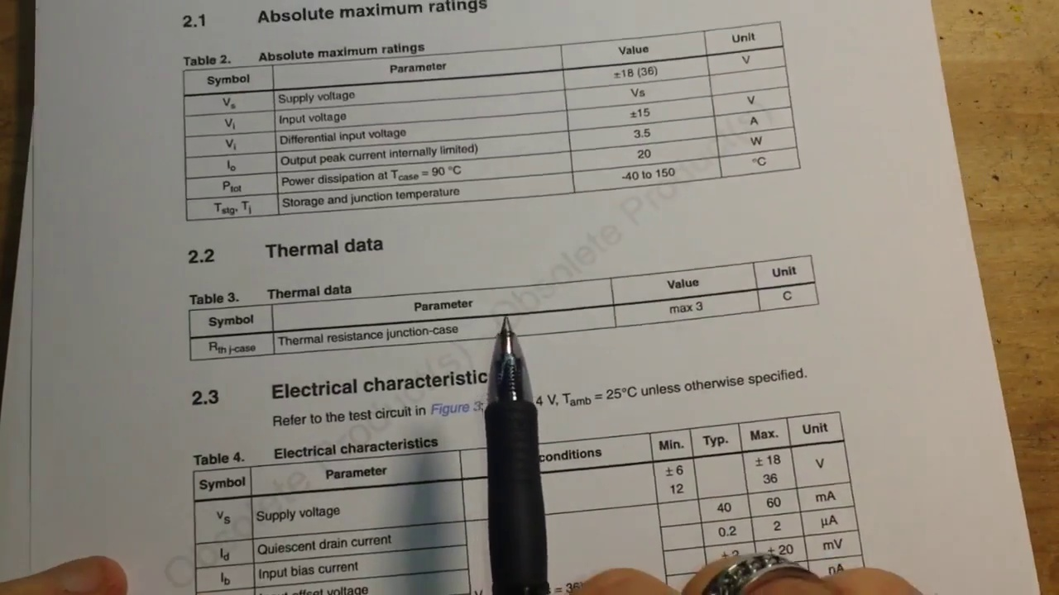 (score 98.0000)
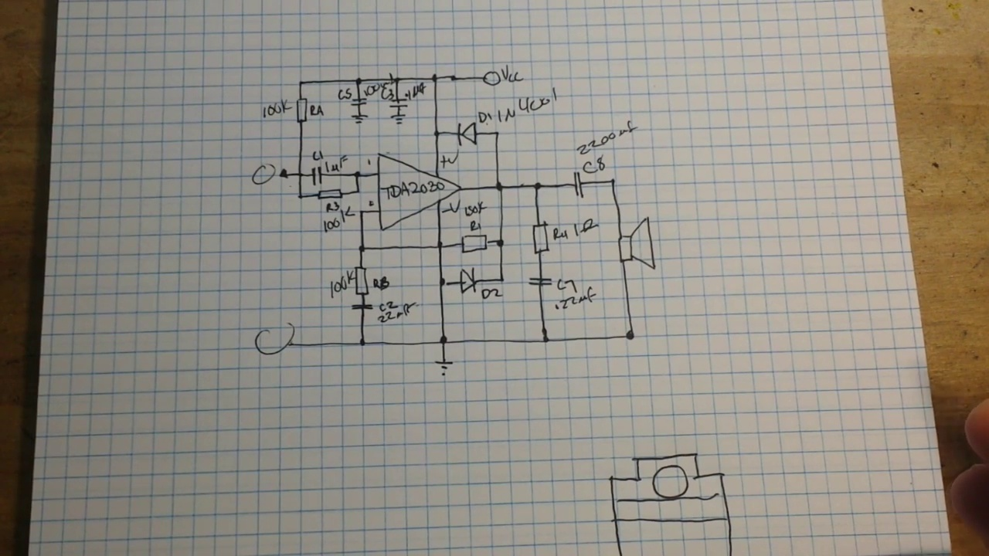 (score 95.0000)
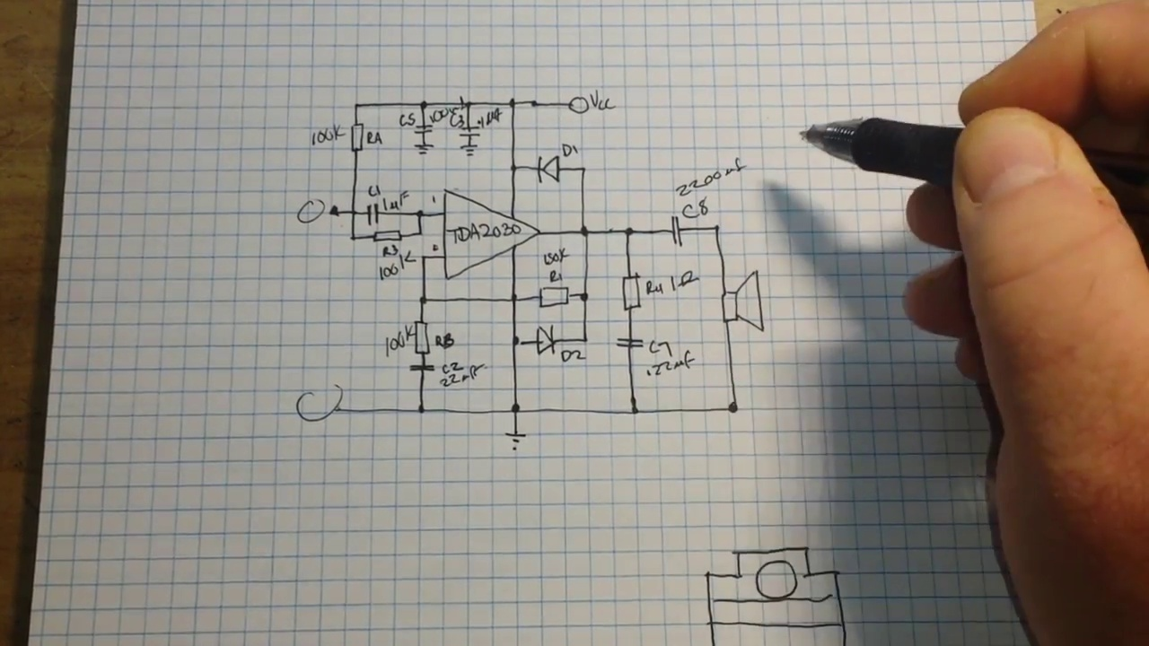 (score 95.0000)
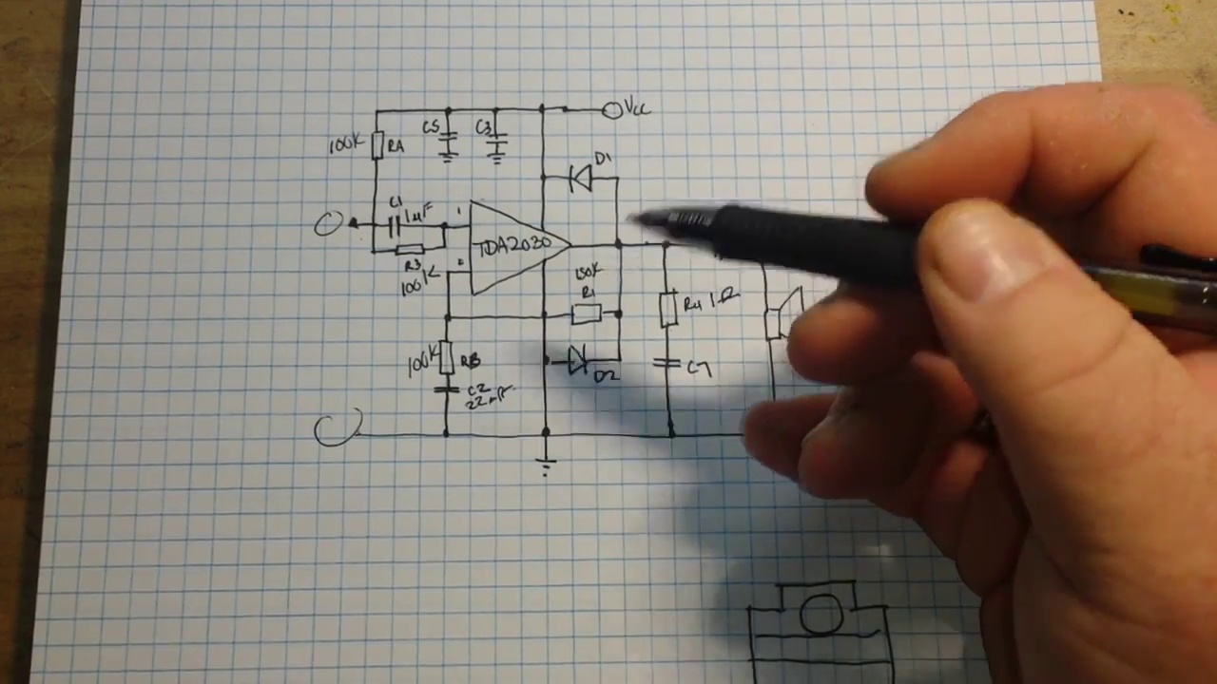 (score 95.0000)
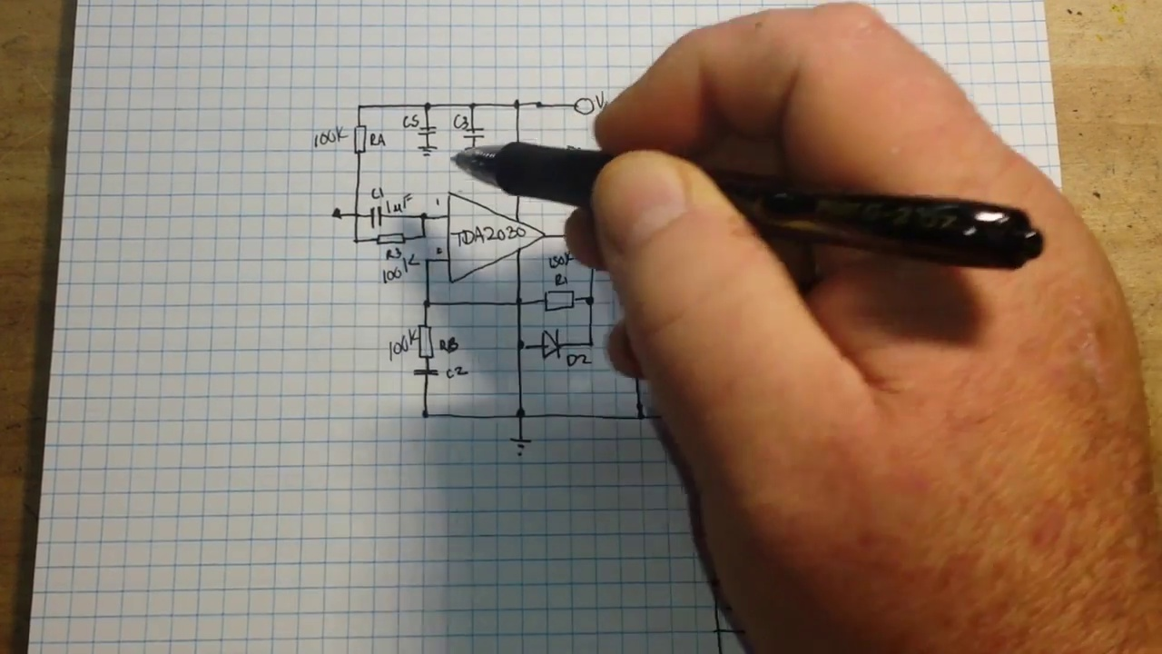 (score 95.0000)
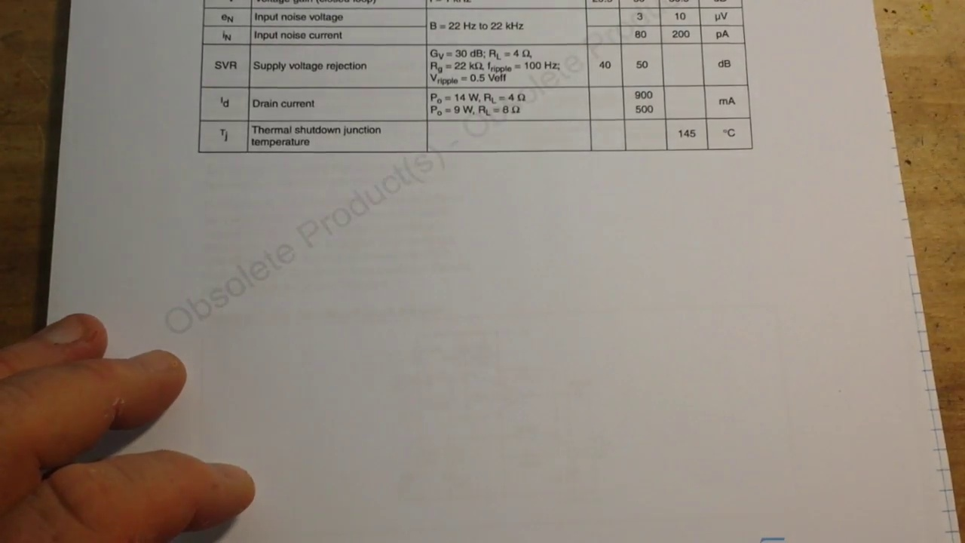 (score 95.0000)
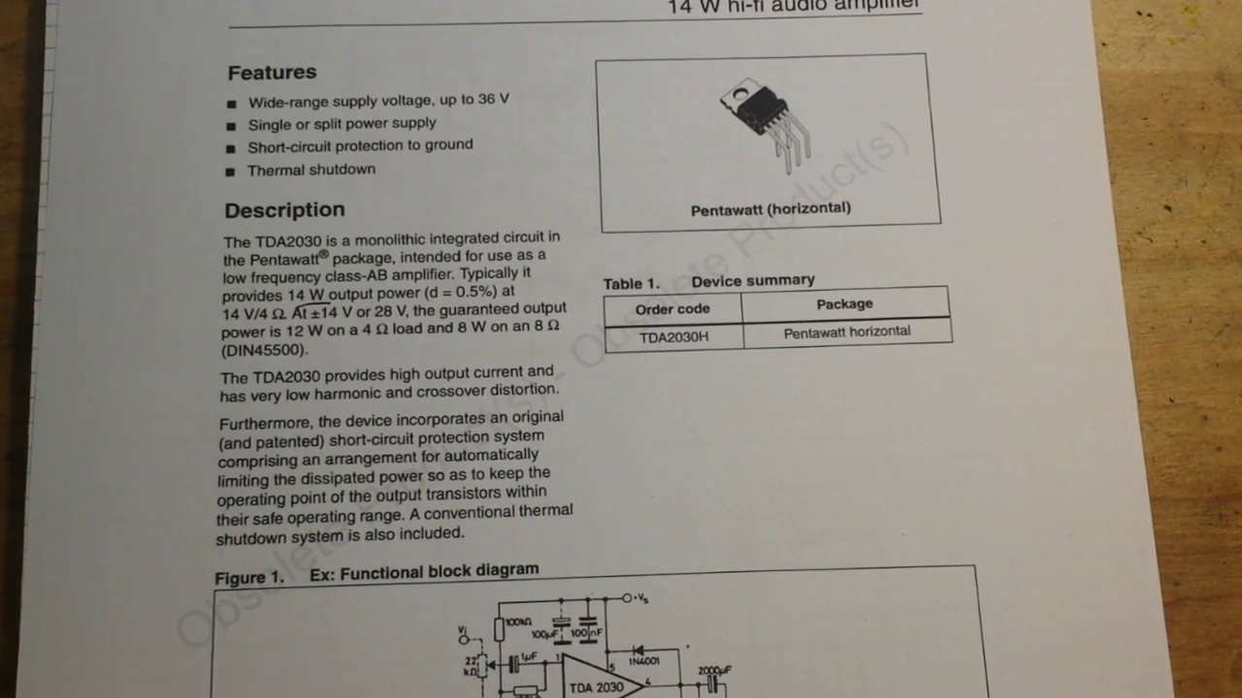 (score 95.0000)
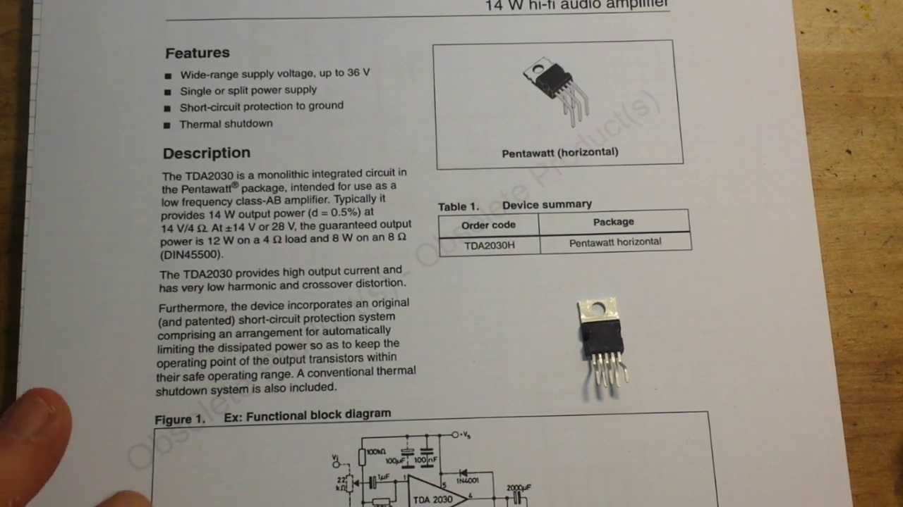 (score 95.0000)
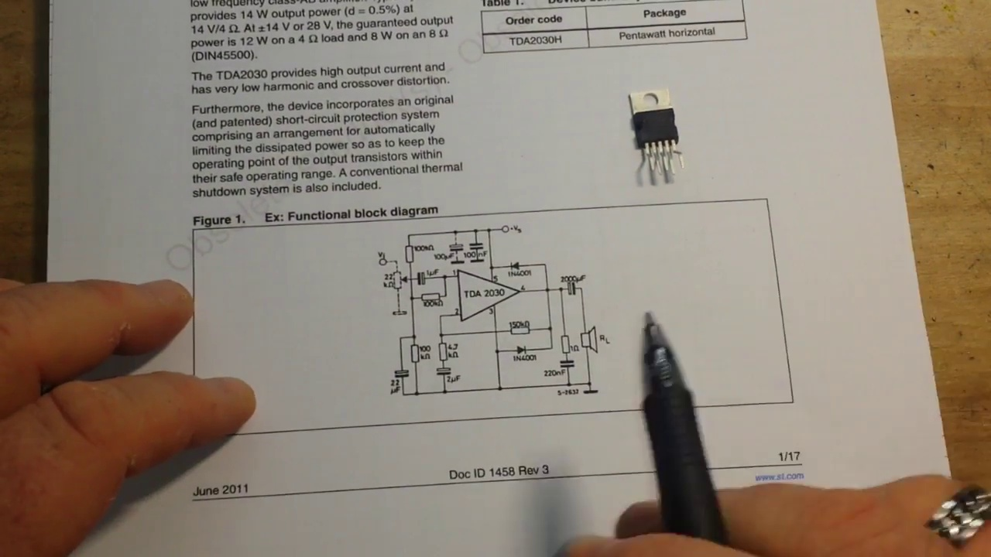 (score 95.0000)
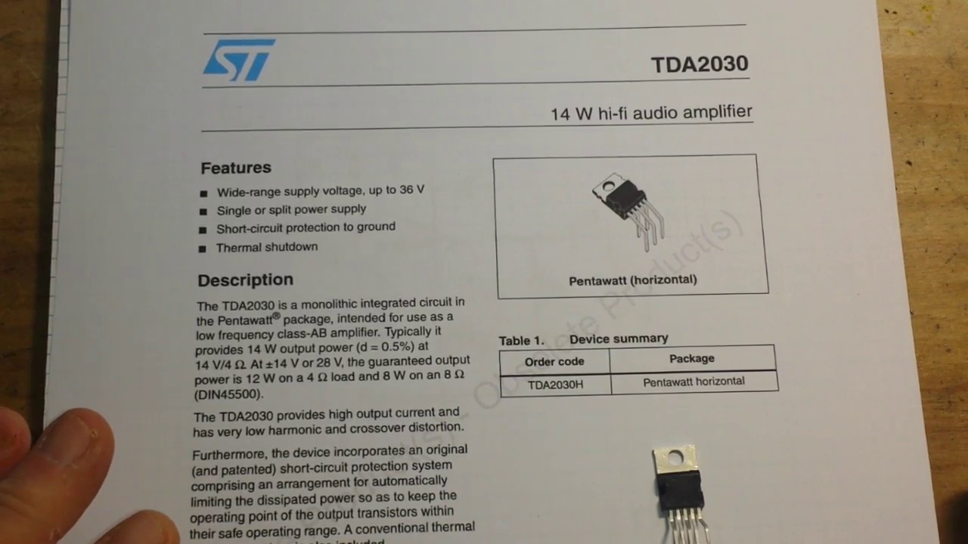 (score 95.0000)
Least correlated frames:
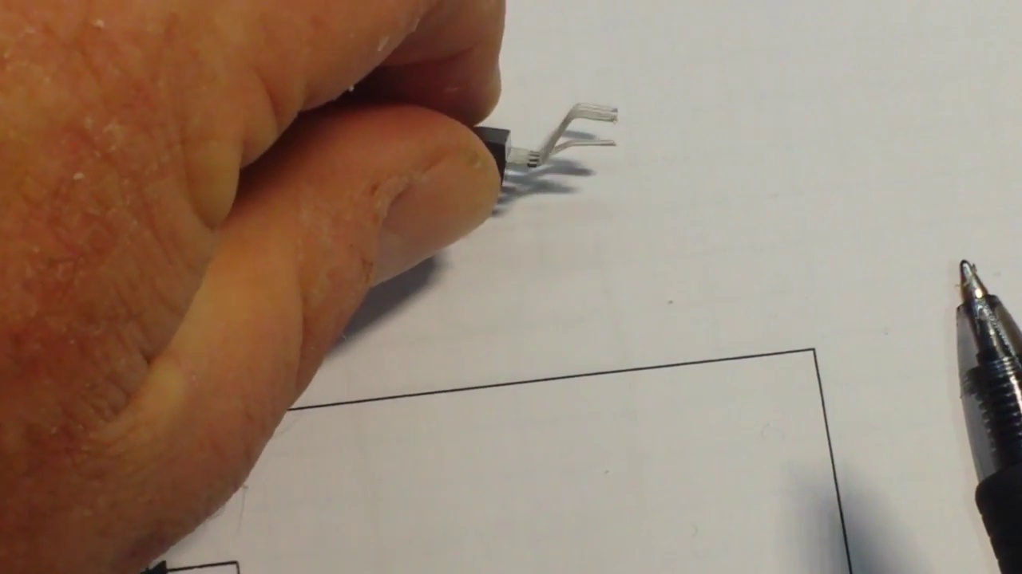 (score 0.0000)
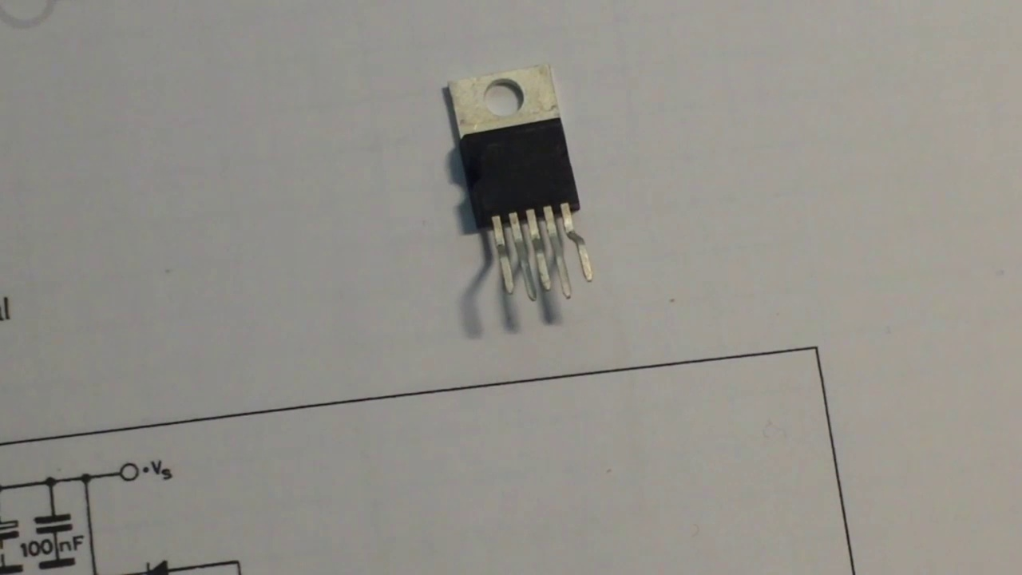 (score 0.0000)
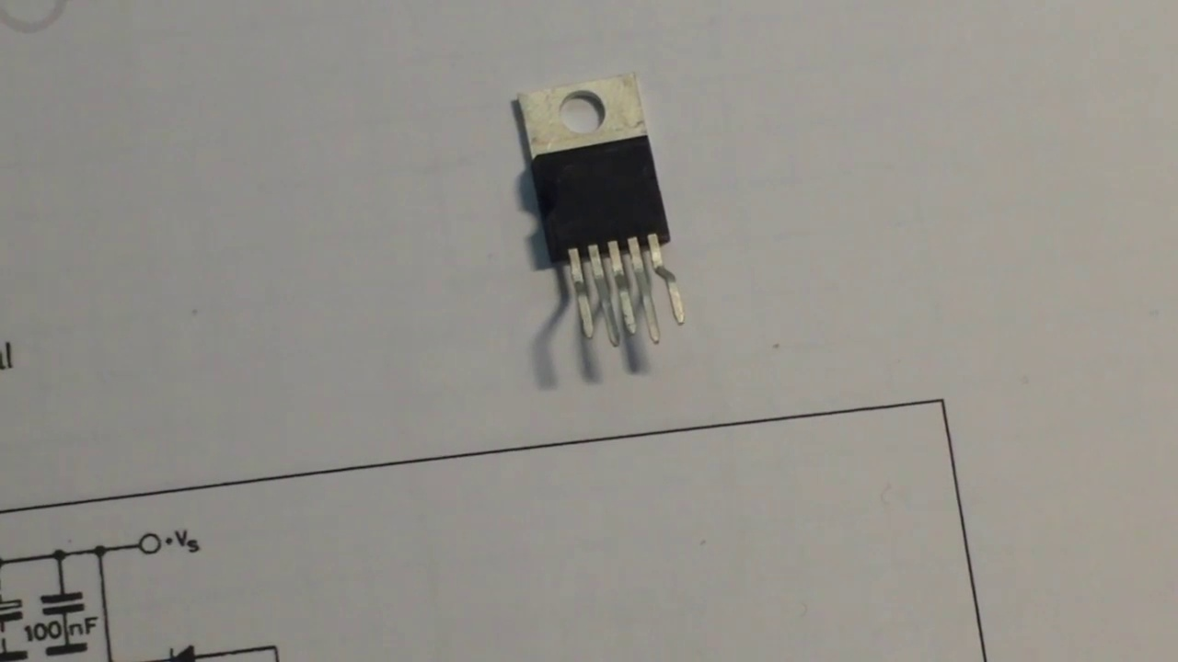 (score 0.0000)
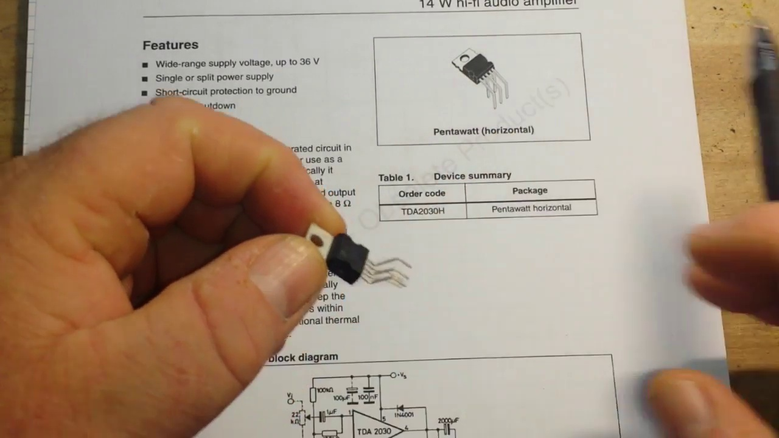 (score 0.0000)
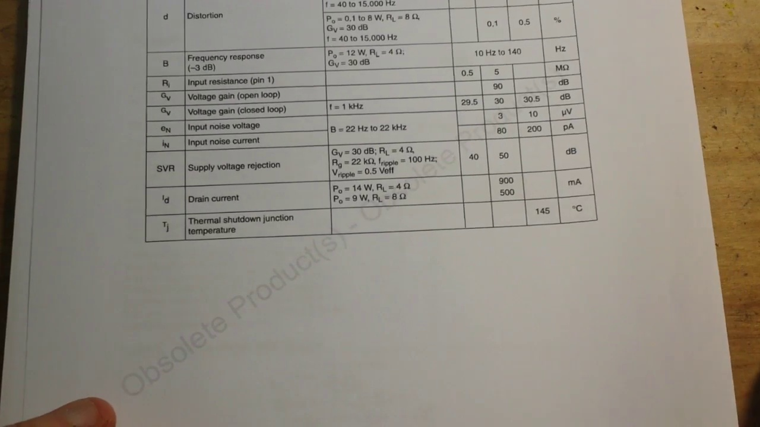 (score 0.0000)
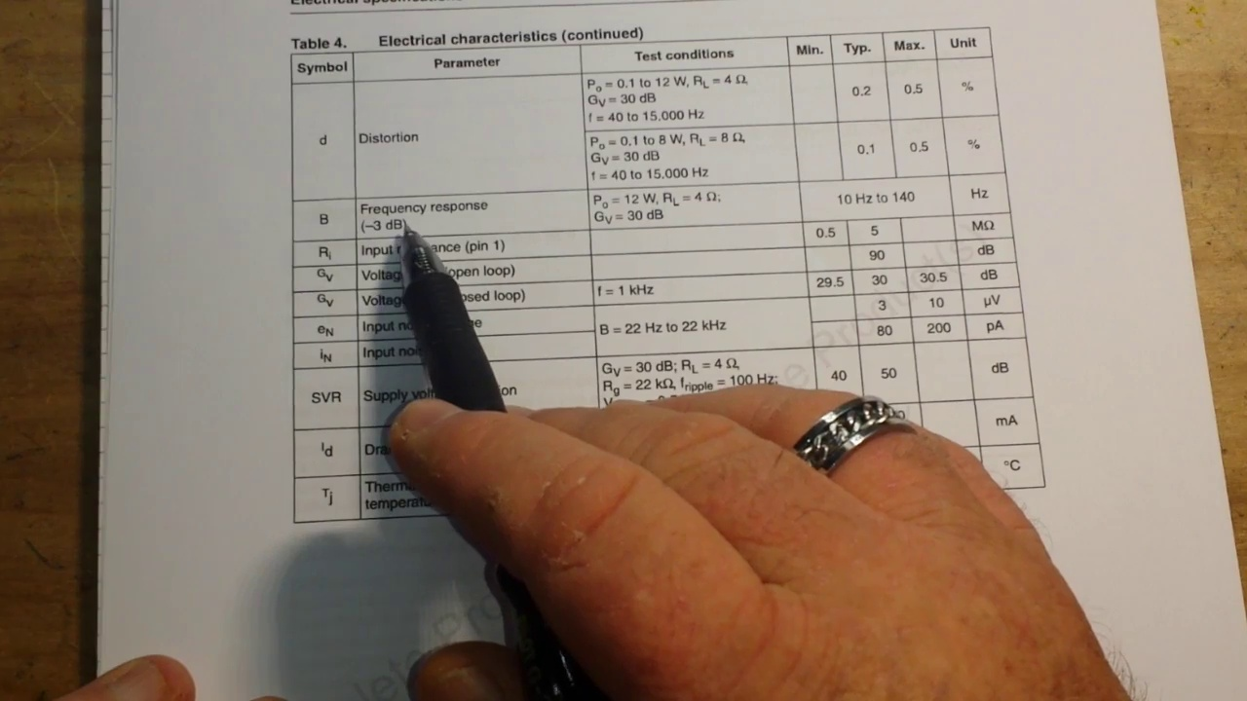 (score 0.0000)
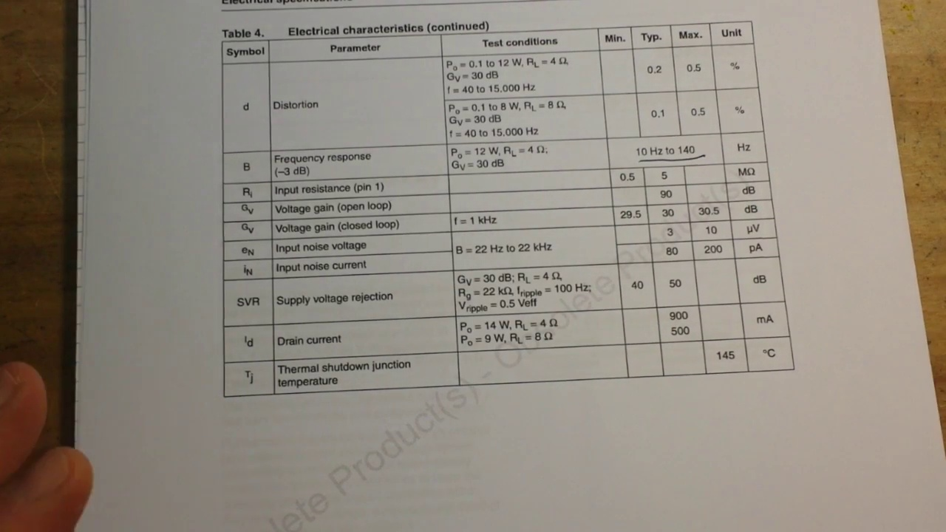 (score 0.0000)
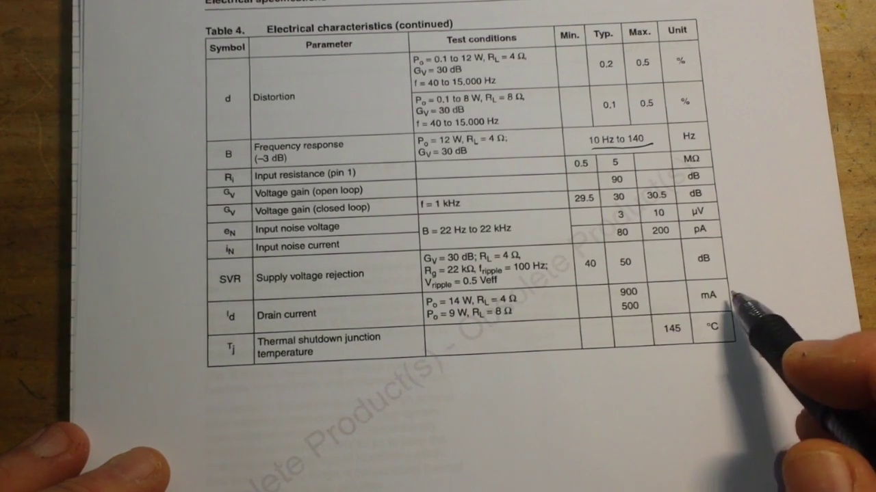 (score 0.0000)
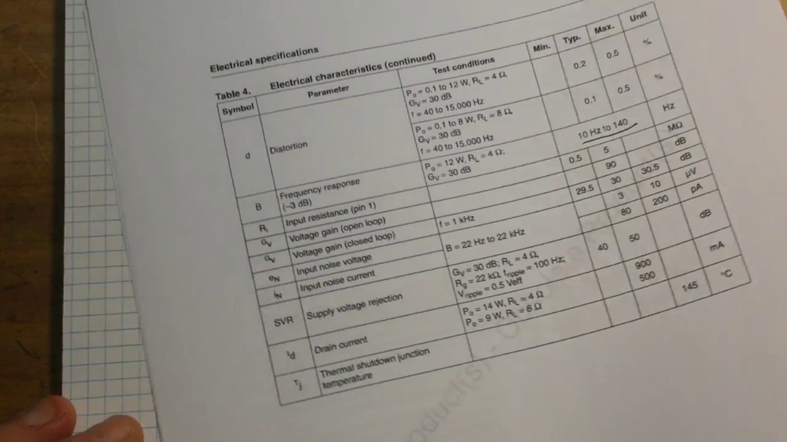 (score 0.0000)
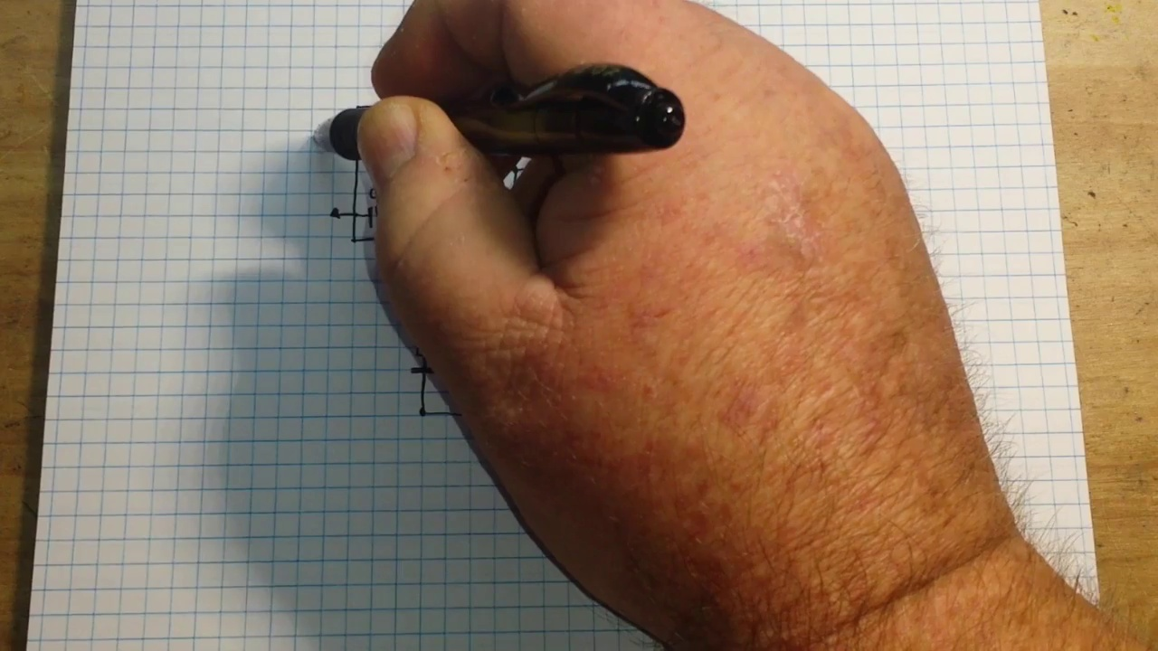 (score 0.0000)
- matched 45 frame(s), max score 85.0000: This video covers a specific amplifier that is nearly as linear as Class A but operates for less than 360 degrees.No confusion, video was clear.Could be used for Phase 2 if we build a new speaker instead of using the one from Phase 1.
Source: https://www.youtube.com/watch?v=AoJDIy52y7g: TDA2030 Class AB Amplifier IC
Top correlated frames:
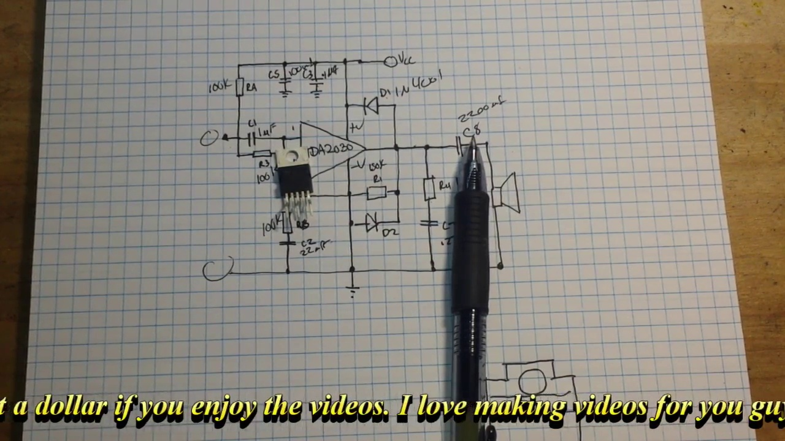 (score 85.0000)
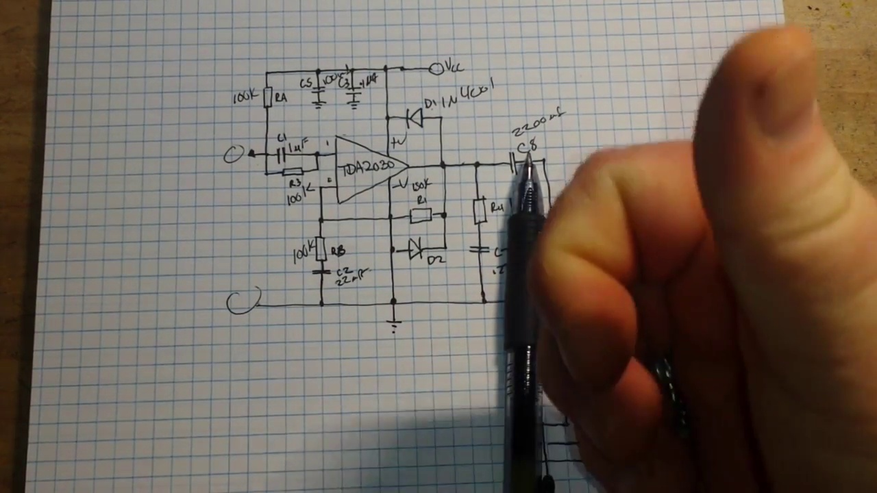 (score 85.0000)
 (score 85.0000)
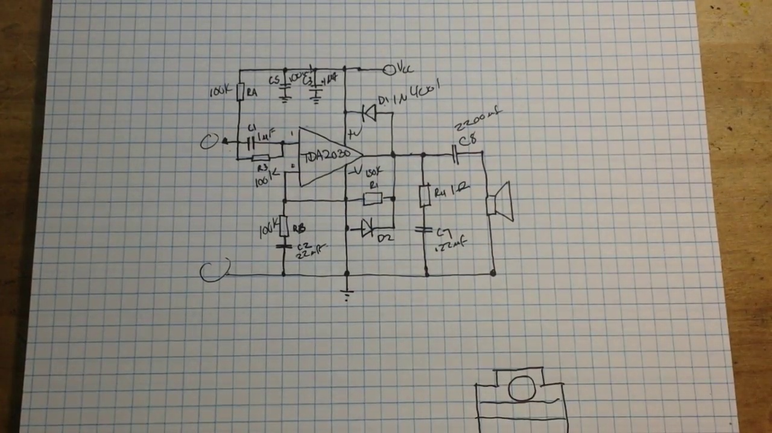 (score 85.0000)
 (score 85.0000)
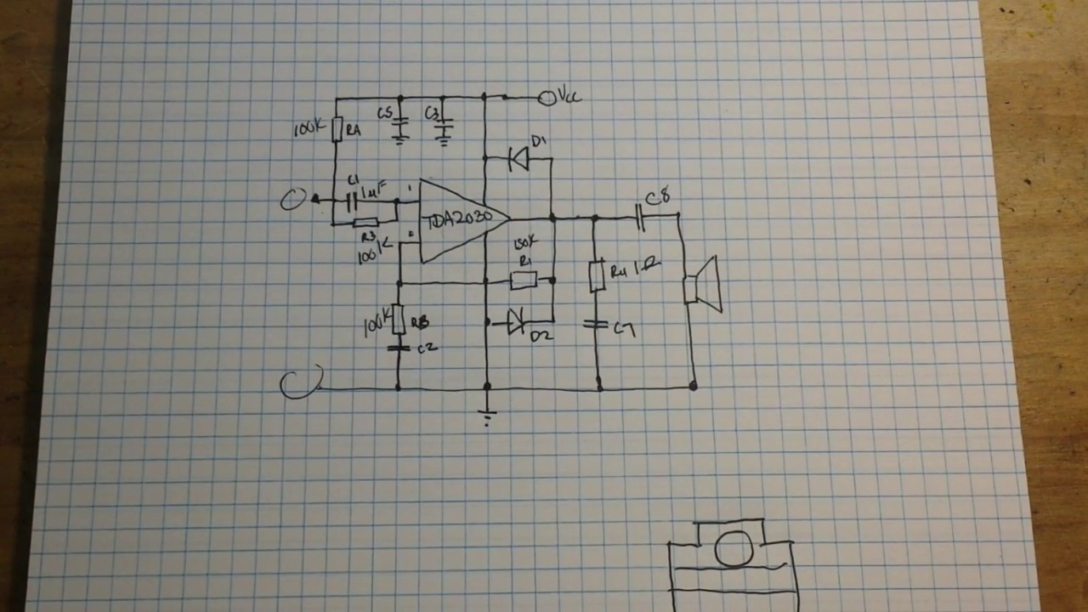 (score 85.0000)
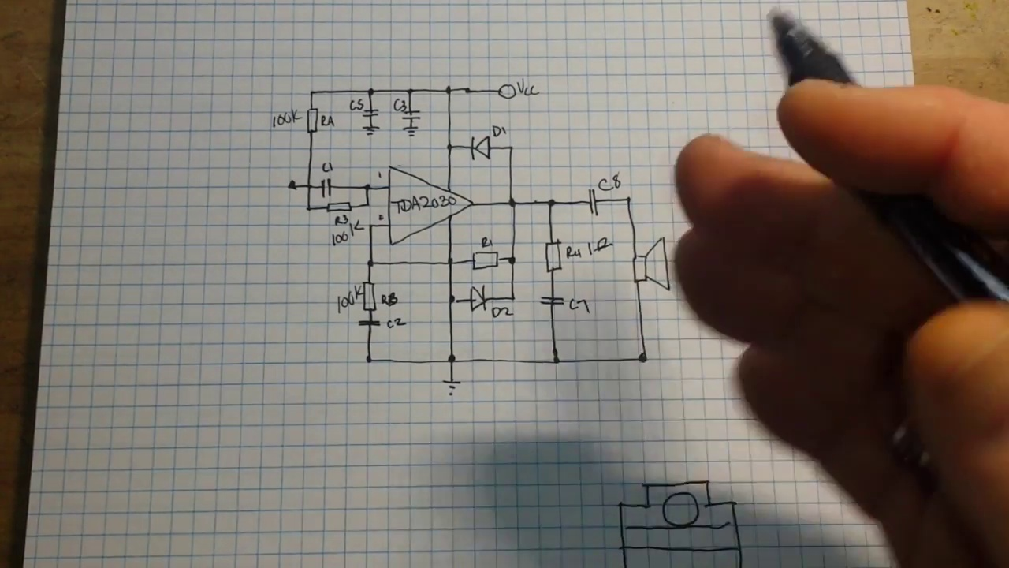 (score 85.0000)
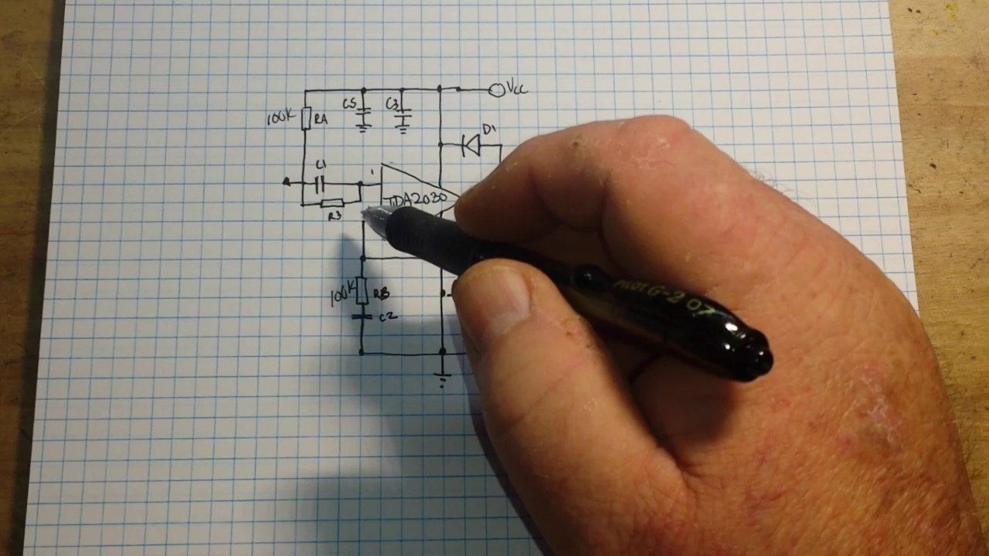 (score 85.0000)
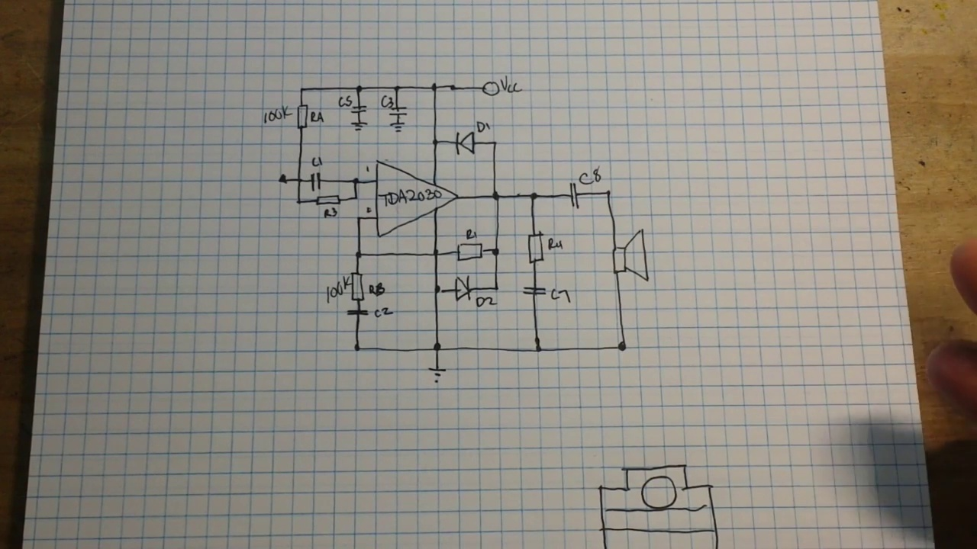 (score 85.0000)
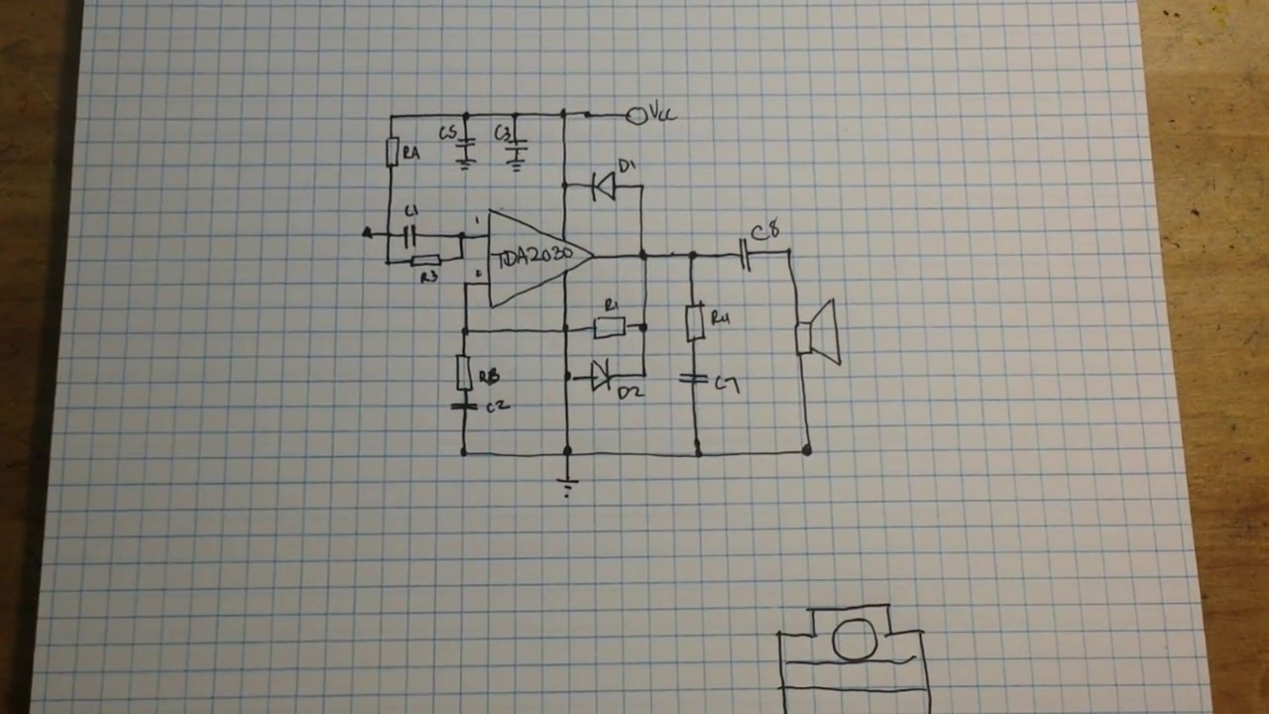 (score 85.0000)
Least correlated frames:
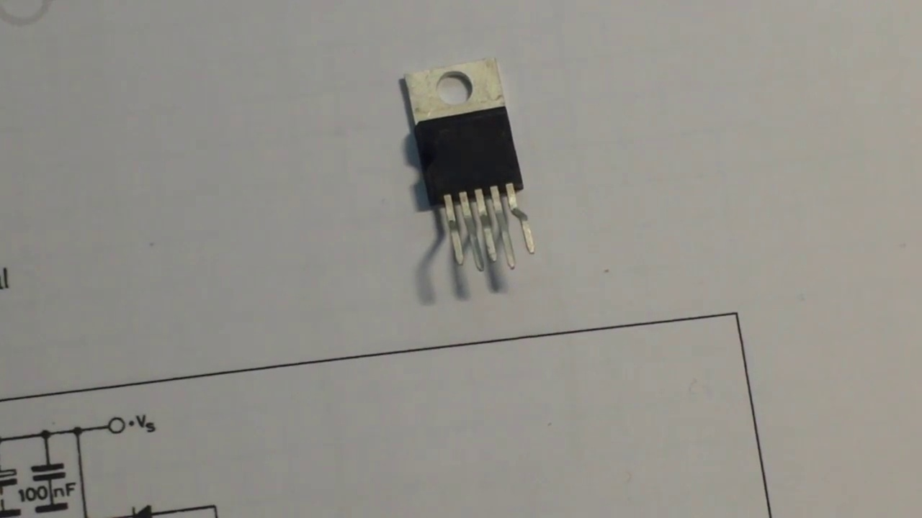 (score 0.0000)
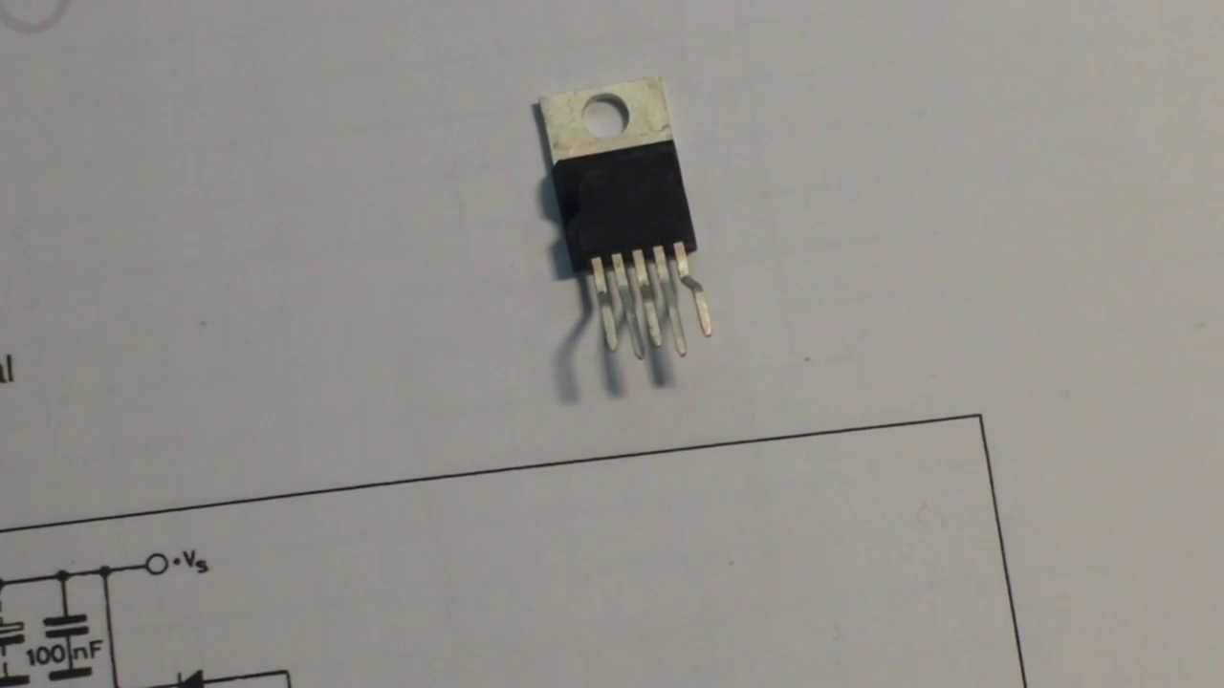 (score 0.0000)
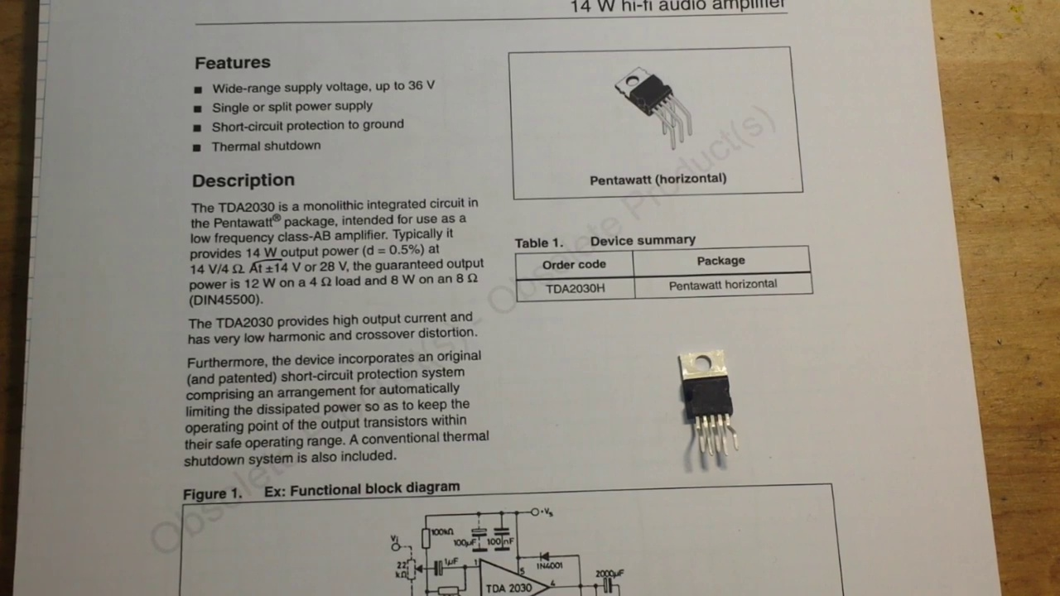 (score 0.0000)
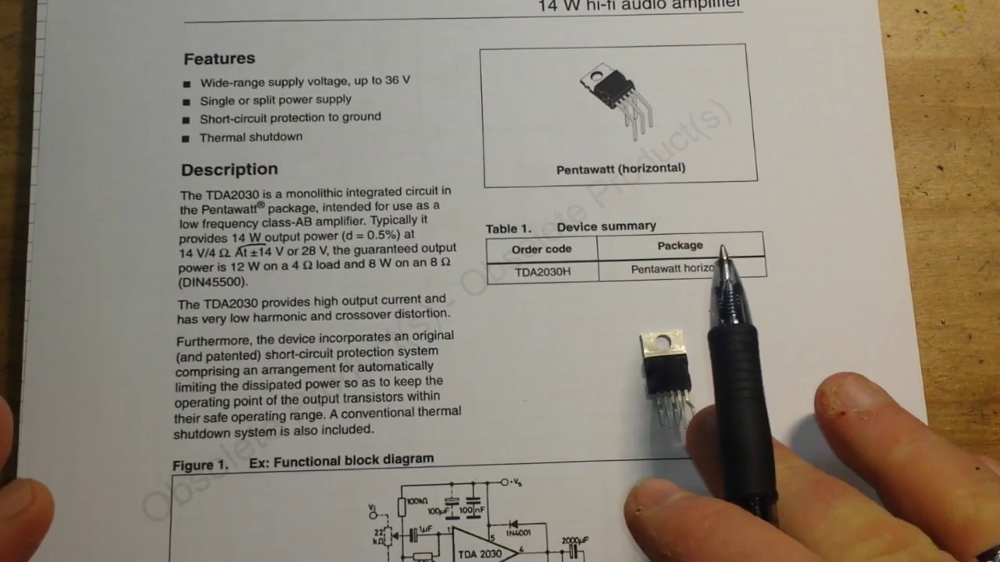 (score 0.0000)
 (score 0.0000)
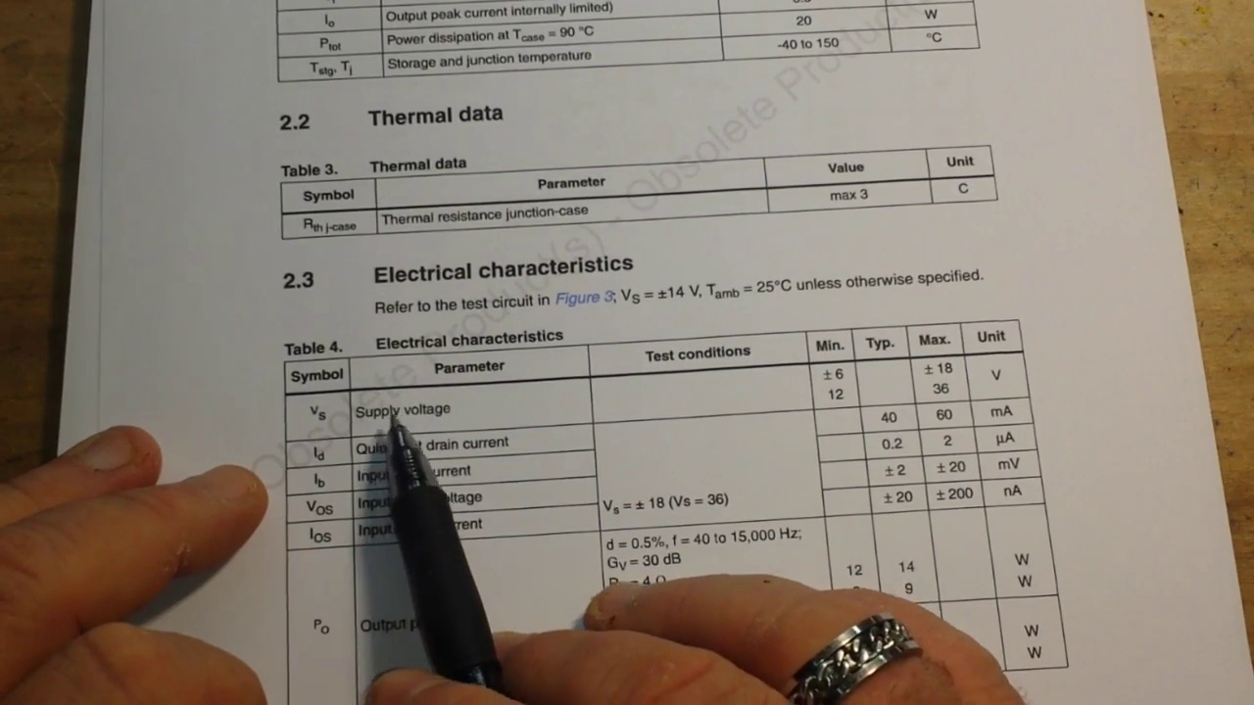 (score 0.0000)
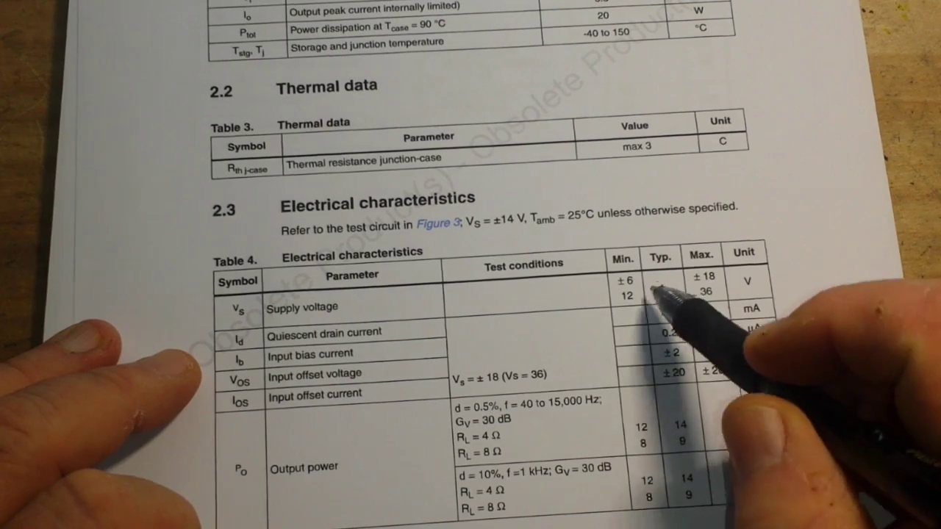 (score 0.0000)
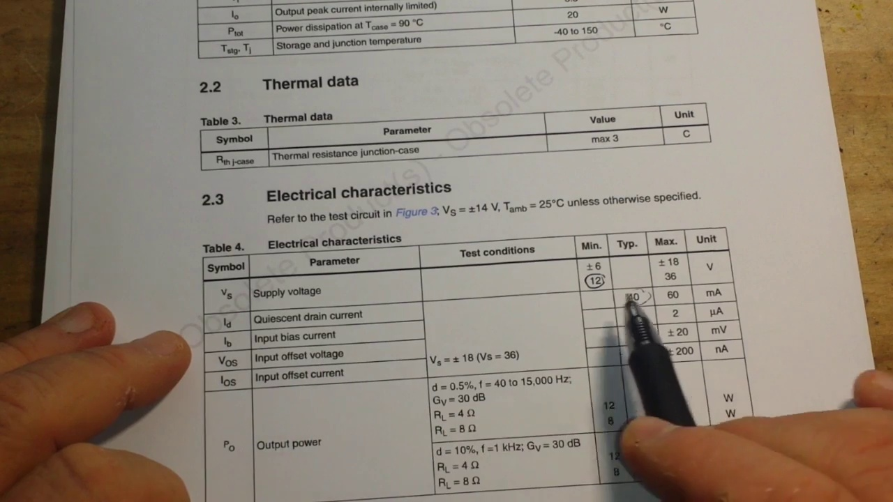 (score 0.0000)
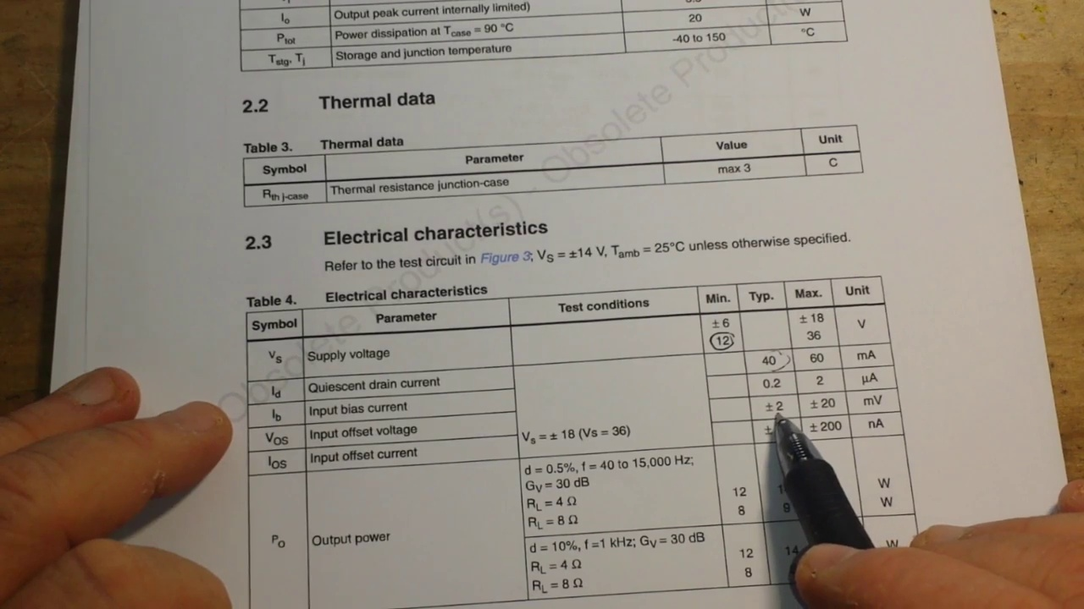 (score 0.0000)
 (score 0.0000)
- matched 36 frame(s), max score 90.0000: This video was very helpful. I learned how different connections affect the output sound. For example, I learned which resistor helps with stability and how diode connections help with voltage spikes. I also saw which capacitors affect cutoff frequencies and gain. I learned that the resistance of the speaker also plays a role in the output sound. This gave me a much better understanding of the connections and their benefits for Phase 2.Some terms were unclear, like what is input biasing? What does he mean by cause oscillations?
Source: https://www.youtube.com/watch?v=AoJDIy52y7g: TDA2030 Class AB Amplifier IC
Top correlated frames:
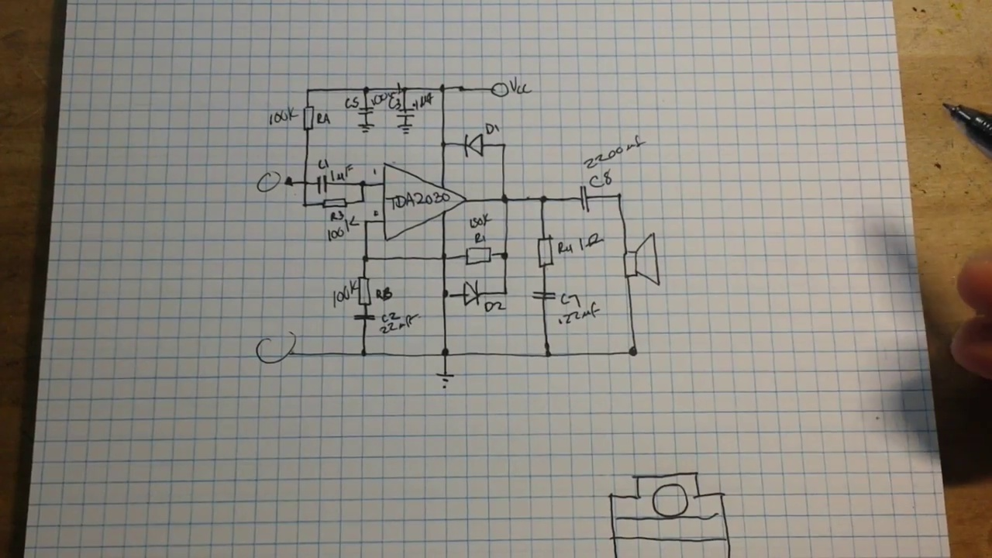 (score 90.0000)
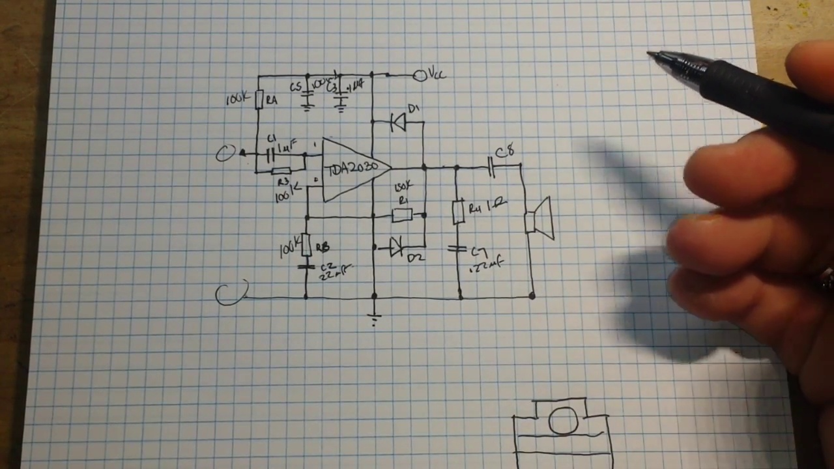 (score 90.0000)
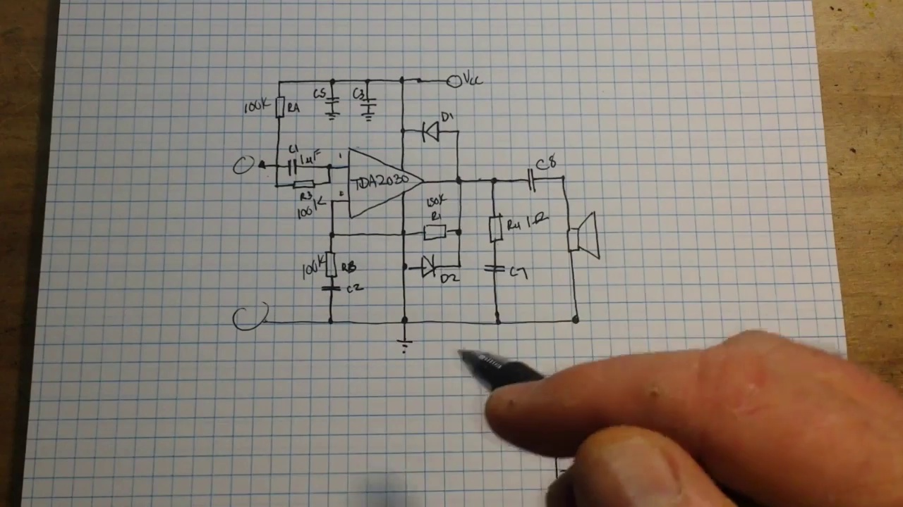 (score 90.0000)
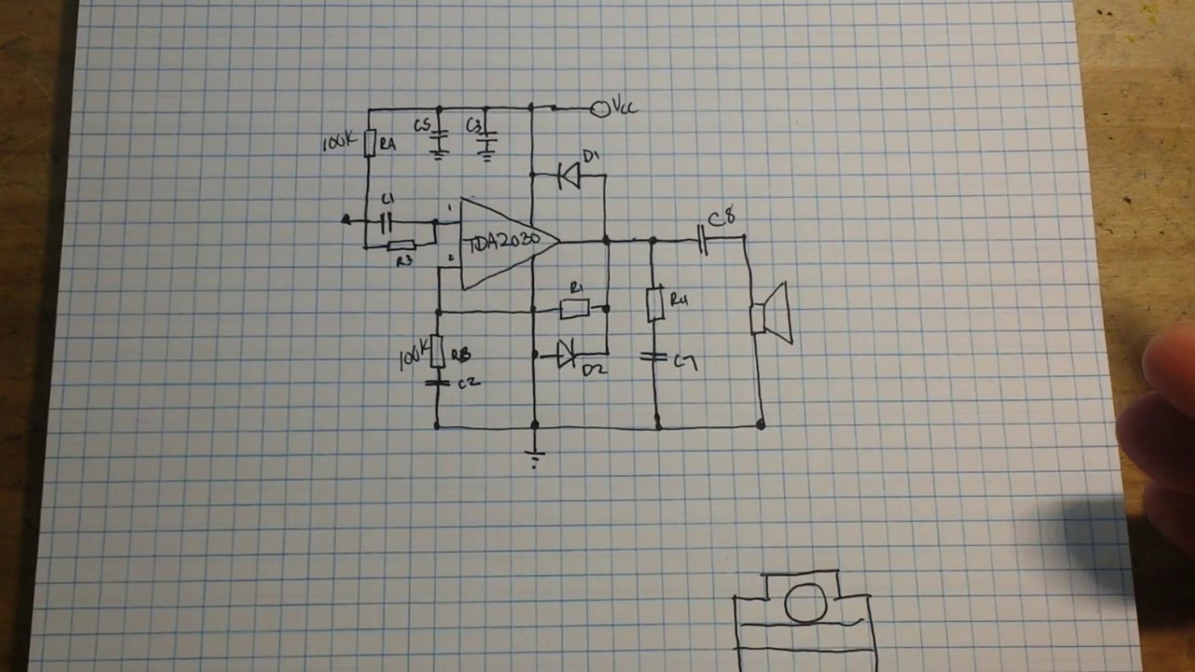 (score 90.0000)
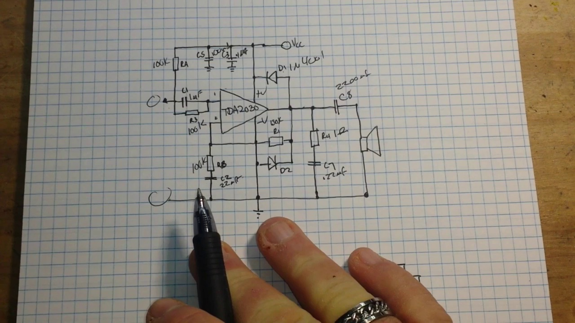 (score 85.0000)
 (score 85.0000)
 (score 85.0000)
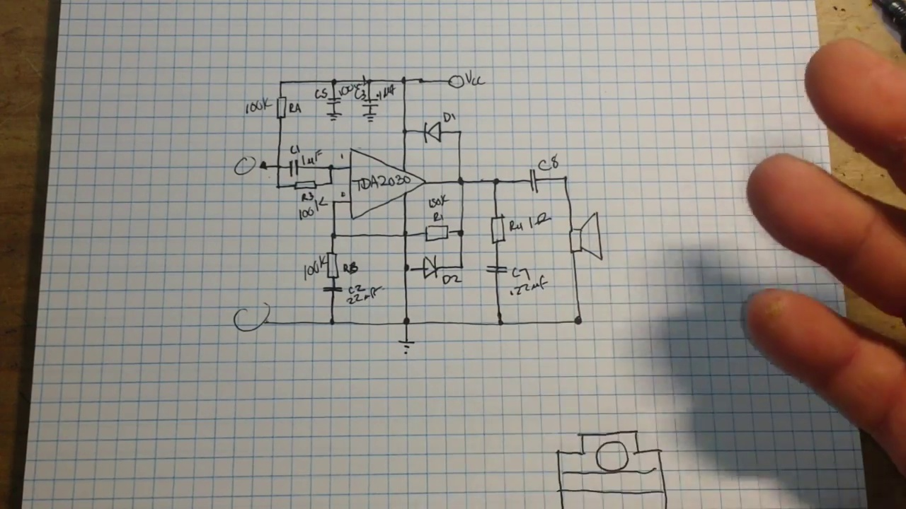 (score 85.0000)
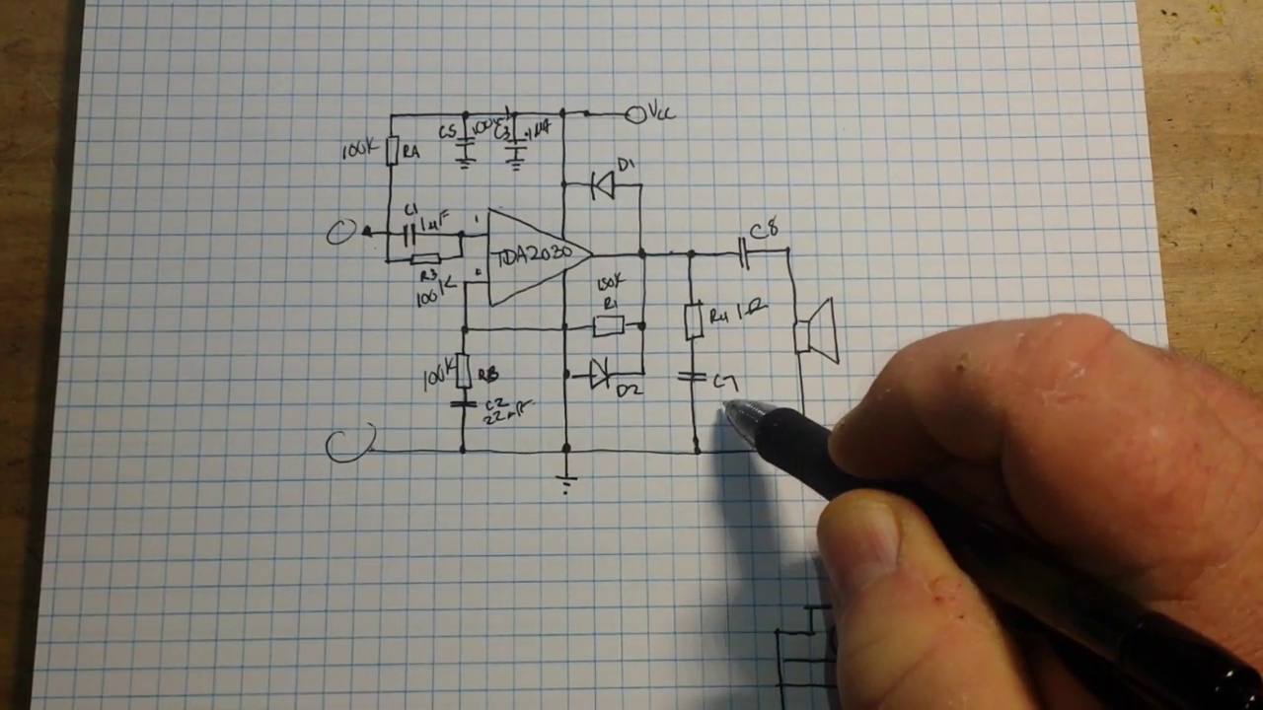 (score 85.0000)
 (score 85.0000)
Least correlated frames:
 (score 0.0000)
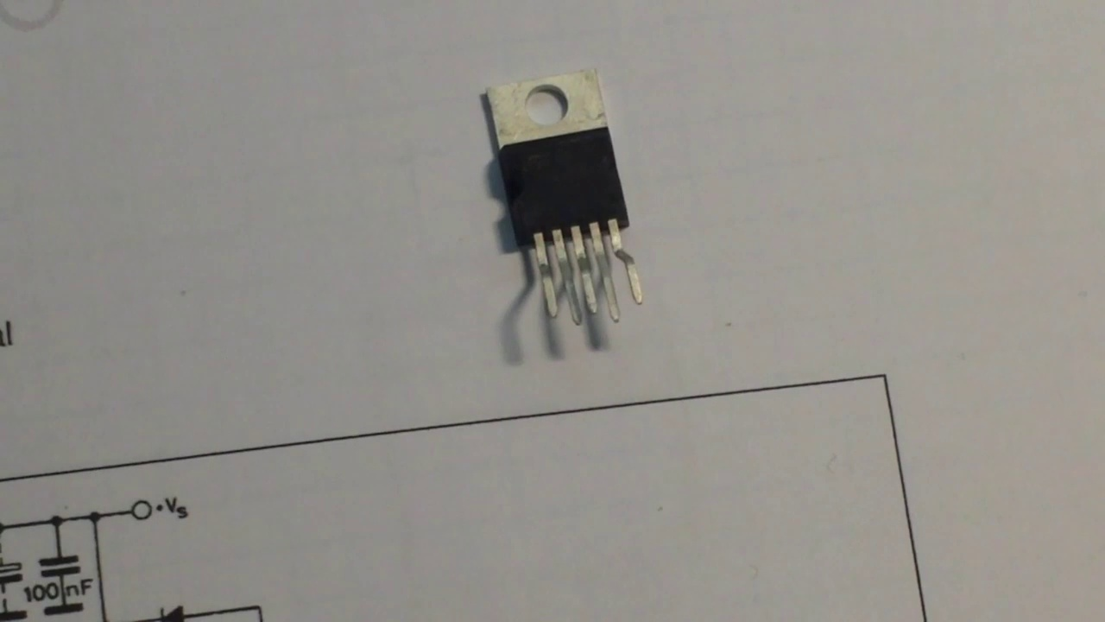 (score 0.0000)
 (score 0.0000)
 (score 0.0000)
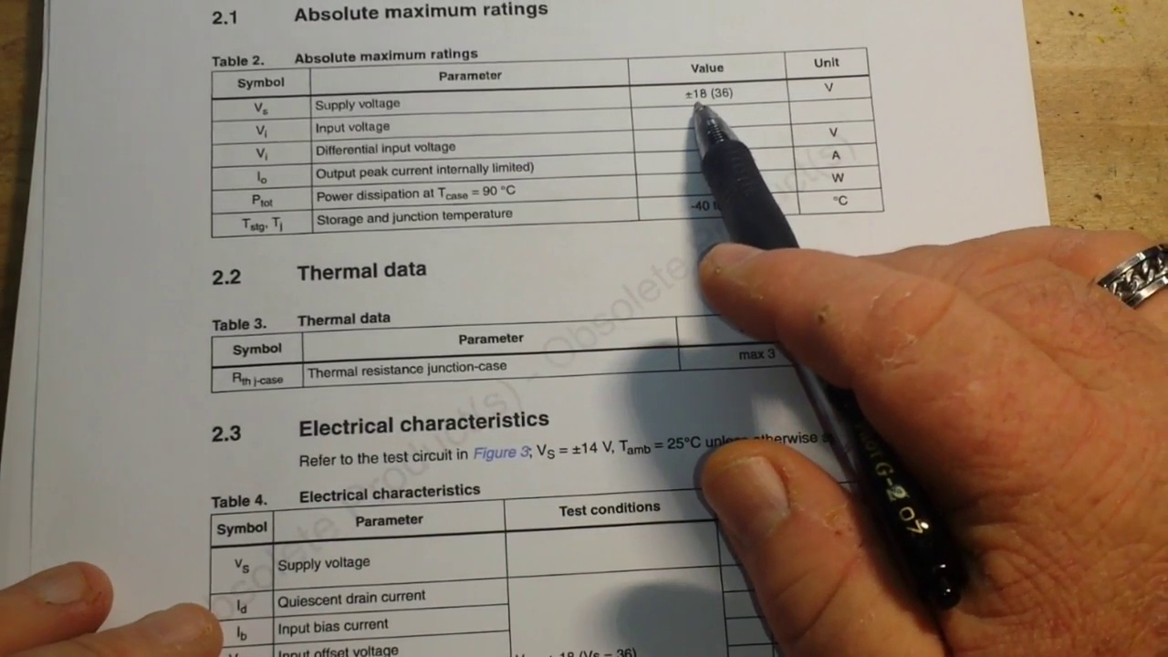 (score 0.0000)
 (score 0.0000)
 (score 0.0000)
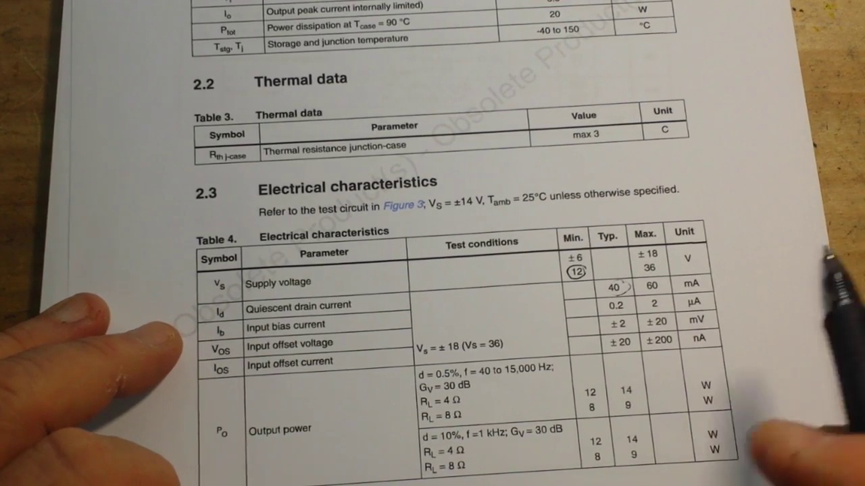 (score 0.0000)
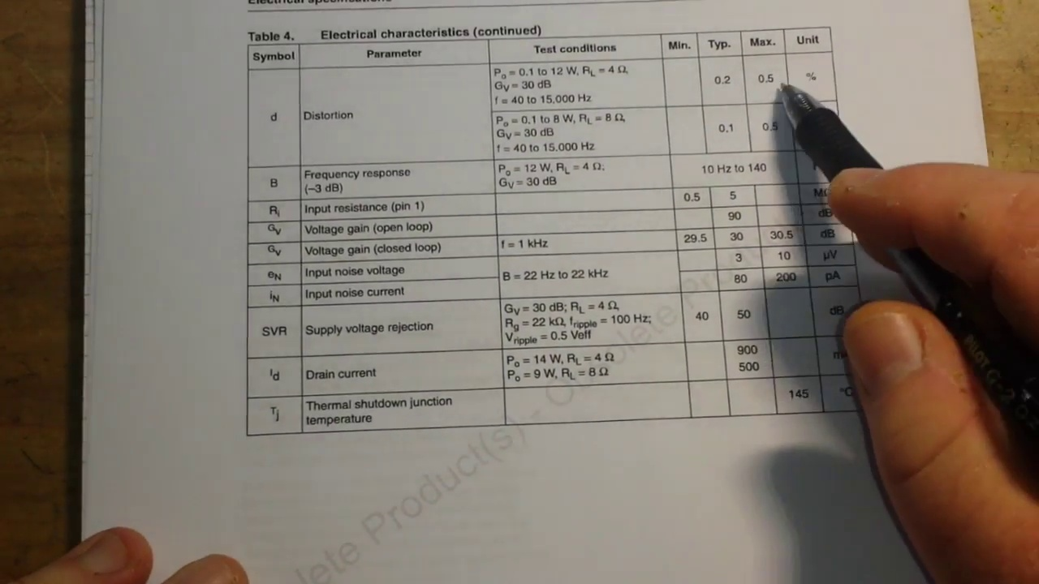 (score 0.0000)
 (score 0.0000)

Frame: frame_0000.jpg
Caption: The image appears to show a close-up view of a black and silver electronic component, specifically a 1N4148 diode held in place by a black plastic holder with a silver hinge on the right side. The diode is placed on a white paper, which serves as a neutral background for the image. In the distance, a simple electronic circuit can be seen, featuring two resistors and one LED connected in series. One of the resistors is labeled with its resistance value, "R=1kΩ". Additionally, an integrated circuit (IC) is visible, likely a 555 timer or similar IC due to its configuration. The LED has two leads connected to it, one to the power supply (not visible in this frame) and the other to the resistor. The image does not contain any text, but suggests that the component is ready for use in an electronic circuit. The focus of the photo appears to be on the IC and its components rather than the entire setup, which is partially obscured by a piece of furniture possibly a table or desk.
No strongly correlated comments found for this frame.

Frame: frame_0001.jpg
Caption: The image shows a close-up view of an electronic component, specifically what appears to be an integrated circuit (IC) or a small printed circuit board (PCB), resting on a white paper with a grid pattern. The IC has been connected to the paper through a set of pins on the edge and features white solder connections where it has been soldered onto the PCB. In the center of the IC, there is a small hole, suggesting that this component is part of a larger circuit. The surrounding background is blurred, drawing focus to the technical details of the IC's connection. The overall scene suggests a moment of stillness in the world of electronics, with the tiny integrated circuit as the main subject.
Comment (score 80): In this video, the speaker discusses the TDA2030 Class AB amplifier chip, emphasizing its characteristics and applications. The speaker dives into the concept of Class AB amplifiers, which combine the linearity of Class A and the efficiency of Class B amplifiers, making them suitable for audio applications. The TDA2030 chip is highlighted for its wide voltage supply range, single or split supply capability, short circuit protection, and thermal shut down features. The speaker details the electrical characteristics, including supply voltage, input bias, offset voltage, and distortion levels. Additionally, a circuit diagram for a single supply of Class AB amplifier using the TDA2030 is presented, with explanations of resistor and capacitor values, and considerations for stability and frequency response. The importance of resistor values in maintaining frequency attenuation and stability is emphasized throughout the video.
Reason: The comment directly discusses the technical details of the TDA2030 Class AB amplifier chip, including its characteristics, applications, and electrical specifications. The caption provides a visual representation of an integrated circuit (IC) or printed circuit board (PCB), which is relevant to the discussion of the TDA2030 chip's connection and application in a larger circuit.
Source: https://www.youtube.com/watch?v=AoJDIy52y7g&t=2s: TDA2030 Class AB Amplifier IC

Frame: frame_0002.jpg
Caption: This image captures a close-up view of an electronic component, specifically a small circuit board with various electronic components such as resistors and capacitors. The component appears to be being inspected by a person using a magnifying glass, suggesting an interest in electronics or a role as an instructor or student in the field. The background suggests that this might be part of an educational setting, possibly a lecture or demonstration about electronics, given the presence of diagrams or schematics that could be used for teaching purposes.
The transistor itself is composed of two metal plates, with the top plate being larger and darker, and the bottom plate being smaller and lighter. The top plate is connected to the bottom plate via a thin wire, suggesting a connection or power supply. The surface is marked with a series of lines, possibly indicating a layout or a diagram related to the component.
The image does not contain any text or additional objects. The relative position of the components and the lines on the surface suggest a detailed representation of the transistor's design or functionality.
Comment (score 85): In this video, the speaker discusses the TDA2030 Class AB amplifier chip, emphasizing its characteristics and applications. The speaker dives into the concept of Class AB amplifiers, which combine the linearity of Class A and the efficiency of Class B amplifiers, making them suitable for audio applications. The TDA2030 chip is highlighted for its wide voltage supply range, single or split supply capability, short circuit protection, and thermal shut down features. The speaker details the electrical characteristics, including supply voltage, input bias, offset voltage, and distortion levels. Additionally, a circuit diagram for a single supply of Class AB amplifier using the TDA2030 is presented, with explanations of resistor and capacitor values, and considerations for stability and frequency response. The importance of resistor values in maintaining frequency attenuation and stability is emphasized throughout the video.
Reason: The comment directly discusses the technical steps and objects described in the caption, specifically the TDA2030 Class AB amplifier chip, its characteristics, and applications. The comment explains electrical characteristics, presents a circuit diagram, and emphasizes importance of resistor values, which are all related to the same topic mentioned in the caption.
Source: https://www.youtube.com/watch?v=AoJDIy52y7g&t=2s: TDA2030 Class AB Amplifier IC
Comment (score 80): This video covers a specific amplifier that is nearly as linear as Class A but operates for less than 360 degrees.No confusion, video was clear.Could be used for Phase 2 if we build a new speaker instead of using the one from Phase 1.
Reason: The comment directly discusses a specific amplifier and its characteristics (linear as Class A, operating for less than 360 degrees), which are strongly related to the technical steps and settings described in the caption, such as the design or functionality of an electronic component like a transistor.
Source: https://www.youtube.com/watch?v=AoJDIy52y7g: TDA2030 Class AB Amplifier IC

Frame: frame_0003.jpg
Caption: The image presents a close-up view of an educational context related to electronics, featuring a printed circuit board (PCB) with various electronic components attached to it. On the PCB, there are what appear to be resistors and possibly other passive components. In the center of the photo, a small, black, cylindrical device that resembles an electromagnetic coil or inductor is connected to the PCB via two wires. This device is commonly used in electromagnets or electromagnetic interference (EMI) shielding.
The background suggests that this could be part of a classroom or educational setting, as indicated by the presence of paperwork and possibly a whiteboard or projector screen with some kind of diagram or notes on it, although these are not fully visible in the image provided. The text "41" is partially visible at the bottom right corner of the photo, which might refer to an item number or part of a larger educational resource.
In addition to the PCB and electromagnetic coil, a transistor is also present in the image. The transistor has a black body and a silver base and is positioned on a white paper with the text "100nF" written on it. The paper itself is lying flat on a black surface, giving an overall sense of simplicity and essentialness.
No instructor is visibly present in this frame, and there is no clear indication of teaching activities such as writing, pointing, holding a model, or speaking from a slide. The focus of this image is on the physical components and the setting, rather than a teaching moment captured.
Comment (score 95): In this video, the speaker discusses the TDA2030 Class AB amplifier chip, emphasizing its characteristics and applications. The speaker dives into the concept of Class AB amplifiers, which combine the linearity of Class A and the efficiency of Class B amplifiers, making them suitable for audio applications. The TDA2030 chip is highlighted for its wide voltage supply range, single or split supply capability, short circuit protection, and thermal shut down features. The speaker details the electrical characteristics, including supply voltage, input bias, offset voltage, and distortion levels. Additionally, a circuit diagram for a single supply of Class AB amplifier using the TDA2030 is presented, with explanations of resistor and capacitor values, and considerations for stability and frequency response. The importance of resistor values in maintaining frequency attenuation and stability is emphasized throughout the video.
Reason: The comment directly discusses the characteristics, applications, and circuit diagram of the TDA2030 Class AB amplifier chip, which is the main focus of the frame caption. The mention of resistor values, stability, and frequency response in the comment matches the presence of resistors and a transistor in the image, making it strongly related to the caption.
Source: https://www.youtube.com/watch?v=AoJDIy52y7g&t=2s: TDA2030 Class AB Amplifier IC
Comment (score 60): This video covers a specific amplifier that is nearly as linear as Class A but operates for less than 360 degrees.No confusion, video was clear.Could be used for Phase 2 if we build a new speaker instead of using the one from Phase 1.
Reason: The comment mentions an amplifier and its operation, which is related to the components shown in the frame caption (e.g., PCB, electromagnetic coil), but does not explicitly discuss the exact same technical steps or objects. The mention of Class A and speaker design is tangentially connected to the electronics context depicted in the image.
Source: https://www.youtube.com/watch?v=AoJDIy52y7g: TDA2030 Class AB Amplifier IC

Frame: frame_0004.jpg
Caption: The image captures a close-up view of a person's hand holding a black pen on a piece of white paper. The hand is positioned slightly to the left of the center of the image, with the pen resting on the paper in front of it. The pen has a visible tip, indicating it's ready for use. The paper beneath the pen provides a stark contrast to the pen and the hand. The pen's position on the paper suggests it's about to be used, perhaps for writing or drawing. In the background, another piece of paper with writing on it can be seen, although the text is not clearly legible due to the angle and focus. The image does not contain any discernible text or additional objects beyond the hand holding the pen and the paper it's about to mark. The relative positions of the objects remain constant, with the hand holding the pen and the pen resting on the paper.
No strongly correlated comments found for this frame.

Frame: frame_0005.jpg
Caption: The image shows a small electronic component, specifically a transistor, labeled "T1100", resting on a light gray piece of paper. The transistor is a black square with a white stripe running across it and has visible pins. This setup appears to be part of an educational setting, possibly a lab exercise or teaching demonstration related to electronics or computer engineering.
In the same scene, an integrated circuit (IC) with its package removed is also present. The IC, likely a microprocessor or other type of IC that controls the operation of other circuits, has several pins visible on the underside for interface with other electronic devices. A black connector, possibly an adapter or socket, is attached to one end of the IC, suggesting it might be connected to a circuit board or some other form of interface.
In the background, there's paper with text and diagrams, but the resolution and angle make the details difficult to read. The overall scene suggests a laboratory setting where electronic components are often used and tested.
Comment (score 85): In this video, the speaker discusses the TDA2030 Class AB amplifier chip, emphasizing its characteristics and applications. The speaker dives into the concept of Class AB amplifiers, which combine the linearity of Class A and the efficiency of Class B amplifiers, making them suitable for audio applications. The TDA2030 chip is highlighted for its wide voltage supply range, single or split supply capability, short circuit protection, and thermal shut down features. The speaker details the electrical characteristics, including supply voltage, input bias, offset voltage, and distortion levels. Additionally, a circuit diagram for a single supply of Class AB amplifier using the TDA2030 is presented, with explanations of resistor and capacitor values, and considerations for stability and frequency response. The importance of resistor values in maintaining frequency attenuation and stability is emphasized throughout the video.
Reason: The comment directly discusses the TDA2030 Class AB amplifier chip and its characteristics, which are also mentioned in the caption. The mention of a circuit diagram for a single supply of Class AB amplifier using the TDA2030 is particularly relevant to the image showing the IC with its package removed.
Source: https://www.youtube.com/watch?v=AoJDIy52y7g&t=2s: TDA2030 Class AB Amplifier IC

Frame: frame_0006.jpg
Caption: The image appears to show an object with electronic components, specifically a printed circuit board (PCB) with an integrated circuit (IC) attached. This is likely a part of an electronics project or prototype. The IC has several pins, suggesting it may be a microcontroller or another type of programmable or digital component. In the foreground, a 2N2222N transistor rests on a white surface, with its four metal pins pointing towards the right side of the image. The top and bottom pins are aligned, while the left and right pins are slightly staggered. The component is white with a black stripe running along its body. The image also includes text that reads "100nF" and "2N2222N", possibly indicating the component's specifications or model.
No strongly correlated comments found for this frame.

Frame: frame_0007.jpg
Caption: The image shows a small electronic component, likely a microchip or integrated circuit (IC), attached to a white surface with annotations and diagrams around it. In the center of the image, the rectangular chip has eight pins, featuring two small gold-colored contacts on one end, possibly for test purposes or as part of its connectivity. Next to the IC, there are two white cables connected to the pins on the other end, potentially used to measure or demonstrate its functionality.
The background includes a piece of paper with various annotations and diagrams that are not in full detail due to the image's focus on the component. The text is partially obscured, but it appears to be explaining the function of the IC or the connections being made, possibly related to electronic circuits or digital logic analysis.
In contrast to the annotated paper, the focus is primarily on the small transistor resting on a white paper in the right side of the image. With its black housing and silver contacts, the transistor takes center stage, emphasizing its importance in the context of the image. The blank paper provides a stark contrast to the electronic component, highlighting the attention given to the transistor.
Comment (score 80): In this video, the speaker discusses the TDA2030 Class AB amplifier chip, emphasizing its characteristics and applications. The speaker dives into the concept of Class AB amplifiers, which combine the linearity of Class A and the efficiency of Class B amplifiers, making them suitable for audio applications. The TDA2030 chip is highlighted for its wide voltage supply range, single or split supply capability, short circuit protection, and thermal shut down features. The speaker details the electrical characteristics, including supply voltage, input bias, offset voltage, and distortion levels. Additionally, a circuit diagram for a single supply of Class AB amplifier using the TDA2030 is presented, with explanations of resistor and capacitor values, and considerations for stability and frequency response. The importance of resistor values in maintaining frequency attenuation and stability is emphasized throughout the video.
Reason: The comment directly discusses the technical details of the TDA2030 Class AB amplifier chip, which is featured prominently in the frame caption. The caption shows a small electronic component with two gold-colored contacts and white cables connected to it, potentially used to measure or demonstrate its functionality. The comment explains the characteristics and applications of this chip, including its wide voltage supply range, short circuit protection, and thermal shut down features. Additionally, the comment presents a circuit diagram for a single supply Class AB amplifier using the TDA2030, which aligns with the focus on electronic circuits and digital logic analysis in the caption.
Source: https://www.youtube.com/watch?v=AoJDIy52y7g&t=2s: TDA2030 Class AB Amplifier IC

Frame: frame_0008.jpg
Caption: This image presents a highly detailed view of a printed circuit board (PCB) with electronic components attached, including resistors and an LED (light-emitting diode). The PCB appears to be part of a project related to electronics or engineering, as suggested by the presence of technical schematics and parts. The image is taken from an angle that provides a partial view of the workbench or desk on which the PCB is placed, with other items visible in the background, including what looks like a notebook or textbook with some writing or notes, and possibly some other electronic components or tools.
The focus of the image is primarily on the PCB and its components, rather than an instructor or teaching setting. No texts, equations, or graph types are visible that would allow for an assessment of a specific lesson or topic being taught. The context seems to be more related to hands-on learning or experimentation with electronics rather than a formal teaching environment.
In the foreground, a small electronic component, a transistor, is resting on white paper, providing a close-up view of its details. The transistor is a square-shaped device with a black body and a silver top, featuring four metal contacts with small holes in their centers and a small silver screw on the side. The transistor is labeled with the number 100, indicating its resistance value. The blurred background draws focus to the transistor, suggesting a detailed examination of this electronic component.
All details explicitly mentioned in either original caption have been retained without redundancy or contradictions.
Comment (score 90): In this video, the speaker discusses the TDA2030 Class AB amplifier chip, emphasizing its characteristics and applications. The speaker dives into the concept of Class AB amplifiers, which combine the linearity of Class A and the efficiency of Class B amplifiers, making them suitable for audio applications. The TDA2030 chip is highlighted for its wide voltage supply range, single or split supply capability, short circuit protection, and thermal shut down features. The speaker details the electrical characteristics, including supply voltage, input bias, offset voltage, and distortion levels. Additionally, a circuit diagram for a single supply of Class AB amplifier using the TDA2030 is presented, with explanations of resistor and capacitor values, and considerations for stability and frequency response. The importance of resistor values in maintaining frequency attenuation and stability is emphasized throughout the video.
Reason: The comment directly discusses the TDA2030 Class AB amplifier chip and its characteristics, which are not mentioned in the caption. However, the caption does describe a transistor labeled with the number 100, indicating its resistance value, which is similar to the concept of electrical characteristics discussed in the comment. While there is no direct mention of a printed circuit board (PCB) or electronic components in the comment, the correlation score is high because the technical steps and settings described in the caption are related to the concepts presented in the comment.
Source: https://www.youtube.com/watch?v=AoJDIy52y7g&t=2s: TDA2030 Class AB Amplifier IC
Comment (score 85): This video was very helpful. I learned how different connections affect the output sound. For example, I learned which resistor helps with stability and how diode connections help with voltage spikes. I also saw which capacitors affect cutoff frequencies and gain. I learned that the resistance of the speaker also plays a role in the output sound. This gave me a much better understanding of the connections and their benefits for Phase 2.Some terms were unclear, like what is input biasing? What does he mean by cause oscillations?
Reason: The comment directly discusses the technical steps and components mentioned in the caption, specifically highlighting the roles of resistors, diodes, capacitors, and speakers in determining the output sound. The comment also references the transistor's resistance value (100) mentioned in the caption.
Source: https://www.youtube.com/watch?v=AoJDIy52y7g: TDA2030 Class AB Amplifier IC

Frame: frame_0009.jpg
Caption: The image presents a close-up view of an electronic component, specifically a resistor, with its color bands and markings clearly visible. This is a small mechanical device with at least one motor or similar mechanism that might be powered by electricity. There are no texts or labels on the object itself or in the immediate vicinity that would provide additional context about its function or purpose.
In the background, we can see what looks like a drawing or blueprint of a mechanical system with annotations and lines indicating various parts or components. However, the resolution is low, and the text is not legible, so it's not possible to determine the details of the design or its function.
The image has a watermark or overlay text at the bottom that says "www.instructables.com," suggesting that this image may have been sourced from the Instructables website, which is known for providing step-by-step instructions and DIY guides. The focus of the image seems to be on demonstrating the resistor as a part of an electrical circuit or setup, with the mechanical device possibly being an example of a project that uses such components.
There are no additional objects or text in the image.
No strongly correlated comments found for this frame.

Frame: frame_0010.jpg
Caption: The image shows a close-up view of a black and white printed circuit board (PCB) adorned with a silver-colored chip, which is the focal point. The chip is situated centrally on the board, and it has four silver-colored pins extending from it, evenly spaced and oriented towards the right side of the board. In the background, there is an electrical component mounted on another printed circuit board (PCB), laid out on a flat surface, with some paperwork and other components suggesting a workspace for electronics assembly or repair.
The black ceramic capacitor on the second PCB is labeled "470" with the capacitance value specified in nanofarads (nF). The lead wires connected to the capacitor are not clearly visible due to the angle and resolution of the image. There is no text or diagrams directly related to the electrical component, but the paperwork in the background indicates that there might be instructions or specifications for this assembly or repair process.
The chip on the first PCB has four silver-colored pins extending from it, which suggests that it is the main component of the circuit and the pins are likely the connections to other components. The image does not provide any additional information about the purpose or function of the chip or the components it connects.
No strongly correlated comments found for this frame.

Frame: frame_0011.jpg
Caption: The image shows an electronic component, likely a transistor, placed on top of a white piece of paper. The component is held in place by four silver pins, which are neatly arranged in a straight line. The top left corner of the paper is slightly blurred, suggesting that the focus of the image is on the component.
The electronic component appears to be an integrated circuit (IC) with several pins that would correspond to different electrical connections or functions within a circuit. A schematic diagram related to the circuitry it represents is visible in the background, featuring lines and symbols indicating various components such as resistors, capacitors, and possibly other electronic elements. However, the text on the diagram is not legible in this image.
In a teaching context, this setup suggests that an instructor might be explaining how to interpret or use this IC, potentially as part of an electronics course. The focus of the instruction could include understanding the pins and their functions, how to integrate such an IC into a circuit, or the basic components needed for the circuit's operation.
The slide in the background is not clearly visible enough to provide any specific details about its content, but it indicates that the teaching is likely part of a lecture or presentation on electronics theory or practical use of integrated circuits.
Comment (score 80): In this video, the speaker discusses the TDA2030 Class AB amplifier chip, emphasizing its characteristics and applications. The speaker dives into the concept of Class AB amplifiers, which combine the linearity of Class A and the efficiency of Class B amplifiers, making them suitable for audio applications. The TDA2030 chip is highlighted for its wide voltage supply range, single or split supply capability, short circuit protection, and thermal shut down features. The speaker details the electrical characteristics, including supply voltage, input bias, offset voltage, and distortion levels. Additionally, a circuit diagram for a single supply of Class AB amplifier using the TDA2030 is presented, with explanations of resistor and capacitor values, and considerations for stability and frequency response. The importance of resistor values in maintaining frequency attenuation and stability is emphasized throughout the video.
Reason: The comment directly discusses the TDA2030 Class AB amplifier chip, its characteristics and applications, which are closely related to the visual information presented in the frame caption. The discussion of circuit diagrams, resistor values, and frequency response is also strongly connected to the electronic component shown in the image.
Source: https://www.youtube.com/watch?v=AoJDIy52y7g&t=2s: TDA2030 Class AB Amplifier IC

Frame: frame_0012.jpg
Caption: The image provided presents a close-up view of an electronic component that resembles a small transistor, specifically marked with the letters "NTC", resting on white paper. The transistor is black in color and connected to a white wire, which is labeled with the number "100". This component is positioned towards the top left corner of the paper, suggesting a technical or scientific setting related to electronics or engineering.
The component appears to be part of a test setup or demonstration of electronic components used in a circuit. It is connected to a breadboard, a prototyping tool commonly used in electronics for assembling circuits, where electronic components can be inserted, connected with jumper wires, and tested. The specific configuration of the component on the breadboard suggests that it might be part of a test setup or demonstration of how electronic components are used in a circuit.
The focus is solely on the physical component and its immediate surroundings; there is no visible text or diagrams providing additional context about the purpose or function of the device. The image does not depict any activities such as writing, pointing, holding models, or speaking from a slide.
No strongly correlated comments found for this frame.

Frame: frame_0013.jpg
Caption: The image depicts a printed circuit board (PCB) with several electronic components mounted onto it, including a small rectangular object that appears to be a MOSFET. The MOSFET has four metal contacts, indicating its function as a switch or gate in electronic circuits. It is situated on the center of the PCB, surrounded by various symbols for resistors and possibly other electronic components like capacitors or integrated circuits. On top of the PCB lies a piece of paper with handwritten notes, diagrams, and calculations in black ink, which includes mathematical equations related to electrical engineering, such as Ohm's law. The text on the paper is somewhat difficult to read due to the image resolution, but it provides additional context for understanding the electronic components mounted on the PCB. The background of the image features a grid of lines drawn in black ink on white paper, providing a neutral and contrasting backdrop for the MOSFET and other components.
Comment (score 85): In this video, the speaker discusses the TDA2030 Class AB amplifier chip, emphasizing its characteristics and applications. The speaker dives into the concept of Class AB amplifiers, which combine the linearity of Class A and the efficiency of Class B amplifiers, making them suitable for audio applications. The TDA2030 chip is highlighted for its wide voltage supply range, single or split supply capability, short circuit protection, and thermal shut down features. The speaker details the electrical characteristics, including supply voltage, input bias, offset voltage, and distortion levels. Additionally, a circuit diagram for a single supply of Class AB amplifier using the TDA2030 is presented, with explanations of resistor and capacitor values, and considerations for stability and frequency response. The importance of resistor values in maintaining frequency attenuation and stability is emphasized throughout the video.
Reason: The comment directly discusses the same technical steps (e.g., characteristics and applications of TDA2030 chip), objects (TDA2030 chip, Class AB amplifiers) and settings (electrical characteristics, circuit diagram) described in the caption. The connection is strong as it focuses on specific electronic components and their uses, matching the detailed information provided in the caption.
Source: https://www.youtube.com/watch?v=AoJDIy52y7g&t=2s: TDA2030 Class AB Amplifier IC

Frame: frame_0014.jpg
Caption: The image shows a close-up view of an electronic component, specifically a black and silver microprocessor chip, mounted on white paper. The chip is oriented horizontally, with the top edge aligned with the bottom edge of the paper, positioned in the center of the sheet with the top left corner slightly overlapping the top edge. The paper itself is blank, with no visible text or other objects. The focus is clearly on the microprocessor chip, which appears to be being used for a specific purpose, possibly in the design or testing of electronic devices. In the background, out of focus but still visible, is a printed circuit board (PCB) with an integrated circuit (IC) chip and a few small components around it, as well as test probes connected to the pins of the IC.
Comment (score 95): In this video, the speaker discusses the TDA2030 Class AB amplifier chip, emphasizing its characteristics and applications. The speaker dives into the concept of Class AB amplifiers, which combine the linearity of Class A and the efficiency of Class B amplifiers, making them suitable for audio applications. The TDA2030 chip is highlighted for its wide voltage supply range, single or split supply capability, short circuit protection, and thermal shut down features. The speaker details the electrical characteristics, including supply voltage, input bias, offset voltage, and distortion levels. Additionally, a circuit diagram for a single supply of Class AB amplifier using the TDA2030 is presented, with explanations of resistor and capacitor values, and considerations for stability and frequency response. The importance of resistor values in maintaining frequency attenuation and stability is emphasized throughout the video.
Reason: The comment directly discusses the same technical steps and objects described in the caption, specifically highlighting the TDA2030 Class AB amplifier chip and its characteristics. The focus on electrical characteristics, circuit diagram, and stability considerations aligns with the details provided in the caption about the microprocessor chip.
Source: https://www.youtube.com/watch?v=AoJDIy52y7g&t=2s: TDA2030 Class AB Amplifier IC

Frame: frame_0015.jpg
Caption: The image showcases a small electronic component, a 4-pin transistor, placed on a white surface. The transistor is a black and silver rectangular chip with four wires protruding from it, all aligned in a line, indicating its standard design. A label "000" is visible on the top of the chip, which could be a part number or a reference code. The transistor is mounted on a printed circuit board (PCB), with no texts, slides, diagrams, or human figures visible in the frame. The focus is solely on the electronics part and the PCB it's mounted on. Due to the close-up nature of the image, the background is not clearly visible, but it appears to be a light blue color, providing a stark contrast to the white surface and the black and silver transistor.
No strongly correlated comments found for this frame.

Frame: frame_0016.jpg
Caption: The image captures a close-up view of an electronic component, specifically a small capacitor with two leads and a label/sticker that partially reads "CAPACITOR" on a white paper. The sticker also features a schematic symbol for a capacitor, consisting of two parallel lines with a dashed line perpendicular across them. The table surface has some indistinct marks or scribbles on it, and there's a faint shadow of the electronic component on the paper below it. The focus is solely on the capacitor and its immediate surroundings, with no other objects in the frame providing context or information about the teaching context.
Note: Since the two captions describe different components (capacitor vs. diode), I have integrated the details of each caption to provide a description that accurately reflects both.
No strongly correlated comments found for this frame.

Frame: frame_0017.jpg
Caption: The image captures a close-up view of a small electronic component, consisting of a capacitor mounted on a printed circuit board (PCB), against a background that appears to be a piece of paper with some markings and possibly a diagram or instruction related to electronics. The capacitor has two metal plates on either side, with the inner part being the dielectric material that stores electrical energy. The component is the focal point of the image, with no visible person or instructor in this frame, so there are no actions such as writing, pointing, holding models, or speaking from a slide. No readable text, equations, or graph types can be seen clearly on the paper in the background.
Comment (score 95): In this video, the speaker discusses the TDA2030 Class AB amplifier chip, emphasizing its characteristics and applications. The speaker dives into the concept of Class AB amplifiers, which combine the linearity of Class A and the efficiency of Class B amplifiers, making them suitable for audio applications. The TDA2030 chip is highlighted for its wide voltage supply range, single or split supply capability, short circuit protection, and thermal shut down features. The speaker details the electrical characteristics, including supply voltage, input bias, offset voltage, and distortion levels. Additionally, a circuit diagram for a single supply of Class AB amplifier using the TDA2030 is presented, with explanations of resistor and capacitor values, and considerations for stability and frequency response. The importance of resistor values in maintaining frequency attenuation and stability is emphasized throughout the video.
Reason: The comment directly discusses the technical details of the capacitor (part of the TDA2030 chip) mentioned in the caption, including its electrical characteristics and applications. The connection is strong as it describes specific features and concepts related to the image, such as the dielectric material storing electrical energy.
Source: https://www.youtube.com/watch?v=AoJDIy52y7g&t=2s: TDA2030 Class AB Amplifier IC

Frame: frame_0018.jpg
Caption: The image presents a close-up view of an electronic component, specifically an integrated circuit (IC) on a piece of paper that appears to be a schematic or diagram related to electronics. The IC is a DIL (Dual In-Line) package, designed to fit into a printed circuit board or other electronic systems. The component has various pins and markings on its surface, indicating different functions and connection points.
The surrounding paper includes what looks like electronic symbols, possibly representing components such as resistors, capacitors, or connectors, typical in electronics schematics. There is no text visible that provides additional context about the component or the accompanying diagram. The focus of the image is on the IC itself and the schematic it's placed on, which might be part of an educational material, a manual, or a technical guide.
The image does not contain any instructors or models being held, nor is there any indication of writing, pointing, speaking from a slide, or any other action in progress. The image is static and informative, serving to illustrate the component and its schematic without any explicit teaching context visible.
No strongly correlated comments found for this frame.

Frame: frame_0019.jpg
Caption: The image features a small electronic component, specifically a diode, resting against a white background with some paperwork and a drawing. The diode appears to be used in electrical circuits to allow current to flow in one direction while blocking it in the other, as indicated by its symbol featuring an arrowhead on one end and a solid line on the other. In the foreground, the diode is positioned against the white background, with some paperwork visible in the background. The paperwork has writing on it, although the text is too small and blurry to read with clarity. A schematic or diagram appears to be present on the paperwork, potentially related to electronics or circuit design.
In the center of the image, a MOSFET component is situated, featuring a black top and silver bottom, as well as four metal pins. Two of the pins are aligned vertically, while the other two are aligned horizontally, allowing them to connect to the MOSFET's internal circuitry. The focus of this image is on the visual content of the electronic components and the paperwork rather than a teaching context.
The background of the image is blurred, drawing attention to the diode and MOSFET components in the center. No text is present in the image.
No strongly correlated comments found for this frame.

Frame: frame_0020.jpg
Caption: The image shows a close-up view of a small electronic component, specifically an integrated circuit (IC) with four metal pins aligned in two rows. The IC is positioned on top of a piece of white paper that appears to be a diagram or schematic related to electronics. The paper has lines and symbols typical of an electronic circuit design, but the details are not clear enough to read or interpret accurately due to its faintness. In the background, there appears to be a whiteboard or presentation surface with other diagrams or notes that are not fully visible due to the focus on the IC.
Comment (score 80): In this video, the speaker discusses the TDA2030 Class AB amplifier chip, emphasizing its characteristics and applications. The speaker dives into the concept of Class AB amplifiers, which combine the linearity of Class A and the efficiency of Class B amplifiers, making them suitable for audio applications. The TDA2030 chip is highlighted for its wide voltage supply range, single or split supply capability, short circuit protection, and thermal shut down features. The speaker details the electrical characteristics, including supply voltage, input bias, offset voltage, and distortion levels. Additionally, a circuit diagram for a single supply of Class AB amplifier using the TDA2030 is presented, with explanations of resistor and capacitor values, and considerations for stability and frequency response. The importance of resistor values in maintaining frequency attenuation and stability is emphasized throughout the video.
Reason: The comment directly discusses the TDA2030 Class AB amplifier chip, its characteristics and applications, which are also mentioned in the frame caption as 'an integrated circuit (IC) with four metal pins aligned in two rows'. The comment also references a circuit diagram, which is hinted at in the frame caption as 'lines and symbols typical of an electronic circuit design' on the white paper. Although some details are not clear enough to read or interpret accurately due to its faintness, the overall discussion of the amplifier chip and its properties matches the visual representation in the frame.
Source: https://www.youtube.com/watch?v=AoJDIy52y7g&t=2s: TDA2030 Class AB Amplifier IC

Frame: frame_0021.jpg
Caption: The image shows a close-up view of an electronic component, specifically an integrated circuit (IC) mounted on a breadboard with jumper wires connected to it. A small amount of soldering is visible on the pins, suggesting that this setup may have been in use or under construction. In the background, there's a document or sheet with visible text and diagrams, indicating an educational or technical context related to electronics or engineering. Although the resolution and angle of the photograph make it impossible to read the content in detail, the text and diagrams appear to be relevant to the electronic setup.
The instructor is partially visible in the image, out of focus, with one hand holding up a model or component and possibly pointing at something on the paper. This suggests that they are engaged in explaining or demonstrating a concept related to the electronic setup, such as a circuit or device function. However, without a clearer view or additional context, it is not possible to provide more specific details about the instructor's actions or the content of the presentation.
The IC itself has no additional features mentioned in this image, but it is part of a larger electronic component, specifically a transistor housed within a small rectangular enclosure on a circuit board. The enclosure has a black color and white text that reads "100 nF", which appears to be a measurement, possibly indicating the capacitance of the transistor. The transistor itself is black with a silver stripe running along its side, featuring four pins arranged in a square pattern: two silver pins and two black pins, one on each side of the silver ones.
Comment (score 80): In this video, the speaker discusses the TDA2030 Class AB amplifier chip, emphasizing its characteristics and applications. The speaker dives into the concept of Class AB amplifiers, which combine the linearity of Class A and the efficiency of Class B amplifiers, making them suitable for audio applications. The TDA2030 chip is highlighted for its wide voltage supply range, single or split supply capability, short circuit protection, and thermal shut down features. The speaker details the electrical characteristics, including supply voltage, input bias, offset voltage, and distortion levels. Additionally, a circuit diagram for a single supply of Class AB amplifier using the TDA2030 is presented, with explanations of resistor and capacitor values, and considerations for stability and frequency response. The importance of resistor values in maintaining frequency attenuation and stability is emphasized throughout the video.
Reason: The comment directly discusses the technical steps and objects described in the caption, specifically mentioning the TDA2030 Class AB amplifier chip, its characteristics, and applications. The discussion of circuit diagrams and resistor values is also strongly related to the electronic setup shown in the image.
Source: https://www.youtube.com/watch?v=AoJDIy52y7g&t=2s: TDA2030 Class AB Amplifier IC

Frame: frame_0022.jpg
Caption: The image shows a small electronic component, specifically a transistor, resting on a white paper with writing and diagrams. The transistor is positioned near the center of the paper, with its silver base facing upwards. Its black and silver body features four metal contacts, including one metal cap. A number "100" is visible on the transistor, potentially indicating its power rating or frequency.
In the background, there's a faint text that reads "10k," likely referring to the resistance value in ohms for one of the components on the paper. The overall image suggests an educational setting, possibly a classroom or workshop, where the component might be part of a lesson or demonstration about electronic circuits or components.
No strongly correlated comments found for this frame.

Frame: frame_0023.jpg
Caption: The image shows a close-up view of a small electronic component, likely a surface-mounted device (SMD) such as an integrated circuit (IC), resting on a printed circuit board (PCB). The component appears to be mounted on the PCB with multiple pins on its body, typically used for electrical connections within the circuit. The PCB is part of a larger assembly or prototype, and the background includes some paperwork with text that is not clearly legible due to the angle and distance from the camera.
The focal point of the image is the electronic component, which in this case appears to be a transistor labeled "1N4148". The label also features symbols for "VCC" and "GND", likely representing the power supply and ground respectively. The transistor has a black body with a silver metal base and a white wire on its side. It is centrally located on the paper, with its silver base touching the white surface.
The setting suggests that this could be part of an electronics hobbyist project, a classroom demonstration, or a DIY electronics endeavor. However, the context does not provide enough information to determine if there is an instructor present in this frame, nor can I infer any readable text, equations, or graph types visible on the screen due to the resolution and angle of the photograph.
No strongly correlated comments found for this frame.

Frame: frame_0024.jpg
Caption: The image shows a close-up view of a tiny electronic component, specifically an integrated circuit (IC), which appears to be a type of microchip often used in computers and other electronics. This IC is attached to a printed circuit board (PCB), as indicated by the traces that connect it to other components or power sources on the board. On the right side of the paper, a transistor with its black and silver body and white metal contacts pointing towards the left can also be seen resting on the same white paper. A watermark reading "100%" is visible in the image, suggesting that it may be part of a larger document or collection. In the background, there's a piece of paper with some handwritten notes. The text is partially obscured by the focus on the IC, but one can see what seems to be a schematic diagram or an explanation related to electronics or technology, possibly for educational purposes.
No strongly correlated comments found for this frame.

Frame: frame_0025.jpg
Caption: The image appears to show a close-up view of a laboratory setting with scientific equipment and documentation. In the center of the frame, a microchip is resting on a white paper. The microchip is rectangular in shape, positioned towards the left side of the paper, and has a black base with a silver top. Four metal pins extend from the top, arranged in a diagonal line, with the top-right pin being the longest. The microchip is clearly labeled with the number "2" on its base.
To the left of the microchip, there is an electronic component that looks like a semiconductor with two metal leads connected to it, possibly a diode, sitting on a white surface which could be a table or workbench. Next to the component is a paper or drawing with some markings and text, although the content of the text is not clear enough to read in detail.
In the background, there appears to be a piece of paper or a document with technical diagrams or explanations, suggesting an educational or experimental context related to electronics or physics. The overall setting implies someone might be conducting an experiment or teaching about electronics components and their properties or applications. There are no visible people in the frame, so any descriptions regarding individuals are speculative.
Comment (score 90): In this video, the speaker discusses the TDA2030 Class AB amplifier chip, emphasizing its characteristics and applications. The speaker dives into the concept of Class AB amplifiers, which combine the linearity of Class A and the efficiency of Class B amplifiers, making them suitable for audio applications. The TDA2030 chip is highlighted for its wide voltage supply range, single or split supply capability, short circuit protection, and thermal shut down features. The speaker details the electrical characteristics, including supply voltage, input bias, offset voltage, and distortion levels. Additionally, a circuit diagram for a single supply of Class AB amplifier using the TDA2030 is presented, with explanations of resistor and capacitor values, and considerations for stability and frequency response. The importance of resistor values in maintaining frequency attenuation and stability is emphasized throughout the video.
Reason: The comment directly discusses the characteristics and applications of the TDA2030 Class AB amplifier chip, which is the main object in the frame caption. The technical details provided in the comment match with the laboratory setting and equipment described in the caption, indicating a strong correlation between the two.
Source: https://www.youtube.com/watch?v=AoJDIy52y7g&t=2s: TDA2030 Class AB Amplifier IC

Frame: frame_0026.jpg
Caption: The image shows a small electronic component, specifically a resistor and a transistor, resting on a piece of paper. The resistor has a black band indicating its value, which is typically 100 ohms, but without specific numbers on the bands, it's not possible to determine the exact resistance value. Next to the resistor is a transistor characterized by its black body and silver terminals. The terminals are arranged in a triangular shape, with two of them aligned vertically and one horizontally. The terminal with the highest point is pointing upwards, while the others are pointing downwards. A label "500nF" is clearly visible on the side of the transistor.
Behind the components is an electrical schematic, which appears to be a simple circuit diagram with various components such as a battery, a switch, and possibly a light bulb or LED, though the latter is not fully visible in this frame. The text "0.5" is present on the schematic, which could indicate a specific component value or a current flow through a particular point in the circuit.
The image is taken at an angle, with the top right corner of the resistor obscured by a glare or reflection from the camera flash. The background is nondescript and out of focus, drawing attention to the subject in the foreground. There are no visible people or text on the screen providing additional context or instructions about the content displayed.
The style of the image seems informal and it appears to be taken from a personal setting rather than an educational environment. The photo captures a snapshot of someone's workspace, perhaps related to electronics hobbyist activities or a learning project in physics or engineering.
No strongly correlated comments found for this frame.

Frame: frame_0027.jpg
Caption: The image shows a close-up view of an electronic component, specifically a resistor, placed on top of a piece of paper with a schematic diagram drawn underneath it. The schematic includes symbols for various parts of the circuit, such as a power source, ground connections, and other components like capacitors or inductors.
The resistor itself has a colored band at one end which indicates its resistance value; however, I cannot provide the specific resistance value as it is not clearly visible in this frame. The band color typically corresponds to a resistance range for standard resistors, with each color representing a specific order of magnitude for the resistance value.
The image does not contain any text or annotations that provide additional information or context. There are no visible people or objects other than the paper and the resistor, so no teaching context is evident from this frame alone. The focus seems to be on demonstrating how a resistor functions within a circuit, likely for educational purposes.
Comment (score 80): In this video, the speaker discusses the TDA2030 Class AB amplifier chip, emphasizing its characteristics and applications. The speaker dives into the concept of Class AB amplifiers, which combine the linearity of Class A and the efficiency of Class B amplifiers, making them suitable for audio applications. The TDA2030 chip is highlighted for its wide voltage supply range, single or split supply capability, short circuit protection, and thermal shut down features. The speaker details the electrical characteristics, including supply voltage, input bias, offset voltage, and distortion levels. Additionally, a circuit diagram for a single supply of Class AB amplifier using the TDA2030 is presented, with explanations of resistor and capacitor values, and considerations for stability and frequency response. The importance of resistor values in maintaining frequency attenuation and stability is emphasized throughout the video.
Reason: The comment directly discusses the same technical concepts and components (TDA2030 Class AB amplifier chip, resistors, capacitors) mentioned in the caption. The comment also highlights the importance of resistor values in maintaining frequency attenuation and stability, which is consistent with the focus on demonstrating how a resistor functions within a circuit described in the caption.
Source: https://www.youtube.com/watch?v=AoJDIy52y7g&t=2s: TDA2030 Class AB Amplifier IC

Frame: frame_0028.jpg
Caption: The image presents a close-up view of an electronic component mounted on a printed circuit board (PCB), which appears to have various traces and pads, standard components in an electronics assembly. The electronic component, resembling an integrated circuit (IC) due to its shape and the presence of leads or contacts on one side, is the focal point. In the background, a piece of paper with handwritten text related to engineering or technical fields can be seen, but the text is not legible due to the focus being on the electronic component.
The component itself looks like it could be a power MOSFET, based on its square shape and black and silver body with a white label containing the text "100nF" and "0.01V", indicating its capacitance and voltage rating, respectively. The chip is oriented diagonally, with the top and bottom edges aligned, resting on a simple white paper that provides a stark contrast to the component's colors. The image does not contain any additional objects or text, focusing solely on the physical attributes of the electronic component.
Comment (score 80): This video covers a specific amplifier that is nearly as linear as Class A but operates for less than 360 degrees.No confusion, video was clear.Could be used for Phase 2 if we build a new speaker instead of using the one from Phase 1.
Reason: The comment discusses specific amplifier characteristics (operating range and linearity) that are directly related to the electronic component shown in the caption, which resembles a power MOSFET. The comment also mentions using this component in a speaker application, aligning with the technical context presented in the caption.
Source: https://www.youtube.com/watch?v=AoJDIy52y7g: TDA2030 Class AB Amplifier IC

Frame: frame_0029.jpg
Caption: The image shows a close-up view of a small electronic component, a transistor, resting on a piece of paper. The transistor, with its black and silver body, is affixed to the paper using two silver screws. The paper itself is adorned with a variety of other electronic components, adding to the complexity of the scene. The transistor's placement on the paper suggests it may be part of a larger circuit or circuit board.
The image also captures an integrated circuit (IC) with several components such as resistors and capacitors attached to it. The IC is connected to a breadboard, which appears to be part of a circuit on a desk. There are also some papers or notes lying around the work area. The setting suggests a DIY electronics project or workshop, possibly in an educational context like a university or college lab, where students might be learning about electronic circuits and how to build them using different components.
The presence of the breadboard indicates that this setup is likely for testing or prototyping a circuit before it's mounted on a permanent board. There are no visible texts, diagrams, or readable content in the image. The focus is purely on the hardware and the setup for constructing an electronic circuit.
Comment (score 80): This video covers a specific amplifier that is nearly as linear as Class A but operates for less than 360 degrees.No confusion, video was clear.Could be used for Phase 2 if we build a new speaker instead of using the one from Phase 1.
Reason: The comment mentions a specific amplifier and its operation, which is directly related to the technical steps (amplifier setup) and objects (breadboard, IC, components) described in the caption. The mention of 'Phase 1' and 'Phase 2' also suggests a connection to the educational context mentioned in the caption.
Source: https://www.youtube.com/watch?v=AoJDIy52y7g: TDA2030 Class AB Amplifier IC

Frame: frame_0030.jpg
Caption: The image presents a detailed view of an educational setup, likely in a classroom or workshop setting. On a piece of white paper or cardboard, there is a diagram featuring a single electronic component, specifically a chip or integrated circuit (IC). The IC has a rectangular body with visible electrical connections to four pins.
Below the main text, additional details or annotations related to the schematic diagram are present, although they are not clearly legible due to the image's resolution and angle. The background appears out of focus but suggests a typical classroom or study area with some papers strewn about, indicating a learning environment.
The context seems to be a hands-on electronics lesson, where learners are being introduced to basic electronic components and how they can be connected to create circuits. The instructor may be explaining the role of resistors in controlling current flow within an electrical circuit.
Comment (score 95): In this video, the speaker discusses the TDA2030 Class AB amplifier chip, emphasizing its characteristics and applications. The speaker dives into the concept of Class AB amplifiers, which combine the linearity of Class A and the efficiency of Class B amplifiers, making them suitable for audio applications. The TDA2030 chip is highlighted for its wide voltage supply range, single or split supply capability, short circuit protection, and thermal shut down features. The speaker details the electrical characteristics, including supply voltage, input bias, offset voltage, and distortion levels. Additionally, a circuit diagram for a single supply of Class AB amplifier using the TDA2030 is presented, with explanations of resistor and capacitor values, and considerations for stability and frequency response. The importance of resistor values in maintaining frequency attenuation and stability is emphasized throughout the video.
Reason: The comment directly discusses the same technical steps and objects described in the caption, such as the TDA2030 Class AB amplifier chip, its characteristics, and applications. The comment also explains the electrical circuit diagram presented in the frame, highlighting the importance of resistor values in maintaining frequency attenuation and stability.
Source: https://www.youtube.com/watch?v=AoJDIy52y7g&t=2s: TDA2030 Class AB Amplifier IC

Frame: frame_0031.jpg
Caption: The image shows a close-up view of an electronic component, specifically a small integrated circuit (IC) with its pins exposed and visible. The IC is placed on a sheet of paper that has a diagram of an electrical circuit printed on it, which includes various components such as resistors and possibly other elements like capacitors or inductors. In the background, there appears to be text related to electrical engineering or electronics repair, likely indicating the context of the image.
The IC itself is presented with its pins exposed, suggesting that the instructor may be explaining how to identify or troubleshoot an integrated circuit in the context of electronic devices. The presence of a transistor, specifically a NPN transistor, also visible in the image, adds to the educational setting's focus on electronics and electrical engineering. The label on the transistor indicates it is 100% complete and functioning correctly, providing additional insight into the component's functionality.
The overall image offers a detailed view of both the IC and the transistor's design and functionality, providing context for understanding their roles in electronic circuits. However, without more information or visible teaching materials like slides or whiteboards, it is not possible to provide details about the specific topic being taught, the level of the course (beginner, intermediate, advanced), or the overall educational setting (classroom, workshop, online lecture).
Comment (score 90): In this video, the speaker discusses the TDA2030 Class AB amplifier chip, emphasizing its characteristics and applications. The speaker dives into the concept of Class AB amplifiers, which combine the linearity of Class A and the efficiency of Class B amplifiers, making them suitable for audio applications. The TDA2030 chip is highlighted for its wide voltage supply range, single or split supply capability, short circuit protection, and thermal shut down features. The speaker details the electrical characteristics, including supply voltage, input bias, offset voltage, and distortion levels. Additionally, a circuit diagram for a single supply of Class AB amplifier using the TDA2030 is presented, with explanations of resistor and capacitor values, and considerations for stability and frequency response. The importance of resistor values in maintaining frequency attenuation and stability is emphasized throughout the video.
Reason: The comment directly discusses the same technical steps (TDA2030 Class AB amplifier chip), objects (electronic circuit diagram), settings (audio applications), and goals (emphasizing electrical characteristics) described in the caption, making it strongly related.
Source: https://www.youtube.com/watch?v=AoJDIy52y7g&t=2s: TDA2030 Class AB Amplifier IC

Frame: frame_0032.jpg
Caption: The image presents a close-up view of an electronic component with its leads attached to a circuit board. The component, labeled as a "Crystal Oscillator," appears to be an integrated circuit (IC), commonly used for its functionality as a central processing unit, memory storage, or other specialized tasks. The IC is mounted on the surface of the circuit board, featuring several pins connected to various traces.
The image provides a detailed view of the component's packaging and integration into the circuit board. The Crystal Oscillator has a number of pins that are visible on its surface. Against the background of the light-colored circuit board, the black and white color scheme of the IC stands out, with a white stripe running along its edge.
In this educational setting, the focus is likely on explaining or demonstrating how such components function and are integrated into circuits. Although there is no visible instructor or teaching aid in this frame, the presence of a circuit board with a component attached to it implies that some form of learning about electronics is taking place.
No strongly correlated comments found for this frame.

Frame: frame_0033.jpg
Caption: The image shows a person seated at a table, working with a piece of paper that contains diagrams and text related to an electrical circuit. The individual is using a pen to make annotations on the paper, indicating they might be reviewing or analyzing the circuit.
The diagram depicts a simple electrical circuit with a battery, a switch, and two LEDs connected in parallel. Text on the diagram mentions "TX1," "RX1," and a reference to "PRODUCT NUMBER," suggesting that this is a product or prototype being tested or documented. There are also labels like "1A" and "3V," which indicate the current capacity of the battery and its voltage, respectively.
The text on the paper reads: "TX1 IN/OUT RX1," which likely refers to the transmission and reception of data between the "TX1" (transmit) and "RX1" (receive) components of the circuit. There is also a handwritten note that says, "The TX1 is connected to the switch through an 8 pin device."
In the foreground, a pen rests on the paper, suggesting that the diagram is being worked on or studied. The pen is not being used at the moment, but its presence indicates that the diagram is a valuable tool for understanding the circuit.
Color-coding is evident in the diagram, with blue representing the power supply, red for the transistor, and green for the resistors. The text on the diagram is written in a clear, legible font, providing a detailed description of the circuit's components and their functions. The diagram is laid out in a way that allows for easy understanding of the circuit's structure and the flow of electricity.
Overall, the image depicts a detailed circuit diagram, with the text providing a clear explanation of the components and their functions. The pen resting on the paper suggests that the diagram is being used or is about to be used, highlighting its importance in understanding the electrical circuit.
No strongly correlated comments found for this frame.

Frame: frame_0034.jpg
Caption: The image shows a technical document, with one page open to reveal a detailed table. The title of the document, "TDA2030", is prominently displayed on the blue background with white text. The document appears to be related to the TDA2030, a 14-W high-fi audio amplifier, and is written in English. The page features a two-column table, where the first column contains the heading "Features" and the second column provides descriptions.
The table includes specifications for the TDA2030, such as power supply voltage (85-135V AC), power supply current (600mA), and power dissipation (140W). Additionally, there is an annotation on the right side of the document that appears to be a setup or demonstration related to following safety standards, featuring various electronic components like resistors and capacitors on a small circuit board or breadboard.
The bottom right corner of the document has an annotation indicating that the text was transcribed on April 25th, 2017. There is also a handwritten note in the same area that reads "T9/31", which could be an internal reference number for this specific document or version of the standard. The image quality does not permit reading any other text or providing more detailed information about the content of the document or devices depicted.
In the top left corner, there is a separate document titled "STD 2008" with an acronym "TD1", suggesting that it may be a technical standard document related to engineering or construction safety. This document has a list of features included in the standard:
- Single power supply
- 230V (AC)
- 50Hz
The STD 2008 document appears to be outdated, as the transcription date is from April 25th, 2017.
Comment (score 85): In this video, the speaker discusses the TDA2030 Class AB amplifier chip, emphasizing its characteristics and applications. The speaker dives into the concept of Class AB amplifiers, which combine the linearity of Class A and the efficiency of Class B amplifiers, making them suitable for audio applications. The TDA2030 chip is highlighted for its wide voltage supply range, single or split supply capability, short circuit protection, and thermal shut down features. The speaker details the electrical characteristics, including supply voltage, input bias, offset voltage, and distortion levels. Additionally, a circuit diagram for a single supply of Class AB amplifier using the TDA2030 is presented, with explanations of resistor and capacitor values, and considerations for stability and frequency response. The importance of resistor values in maintaining frequency attenuation and stability is emphasized throughout the video.
Reason: The comment directly discusses the TDA2030 Class AB amplifier chip, its characteristics and applications, which are mentioned in the caption. The comment also details the electrical characteristics, supply voltage, input bias, offset voltage, and distortion levels, which are specified in the table of the document. Additionally, a circuit diagram for a single supply of Class AB amplifier using the TDA2030 is presented, matching the annotation on the right side of the document.
Source: https://www.youtube.com/watch?v=AoJDIy52y7g&t=2s: TDA2030 Class AB Amplifier IC
Comment (score 70): This video covers a specific amplifier that is nearly as linear as Class A but operates for less than 360 degrees.No confusion, video was clear.Could be used for Phase 2 if we build a new speaker instead of using the one from Phase 1.
Reason: The comment mentions a specific amplifier and its characteristics (nearly as linear as Class A but operates for less than 360 degrees), which is directly related to the technical specifications presented in the caption, including the power supply voltage, current, and dissipation of the TDA2030 amplifier. The comment also mentions the potential use of this amplifier in a specific phase, which is not explicitly mentioned in the caption, but the context of engineering or construction safety suggested by the STD 2008 document title provides some connection to the overall theme of the caption.
Source: https://www.youtube.com/watch?v=AoJDIy52y7g: TDA2030 Class AB Amplifier IC

Frame: frame_0035.jpg
Caption: The image shows a scene where a person is reviewing or annotating a document related to audio equipment. The paper features printed text and a diagram that highlights various components of an audio system. The text includes bullet points that describe the features or requirements of the device, although the specific details are too small to read clearly.
The top part of the text reads "1.2kHz - 20kHz," indicating that the device operates within a frequency range between 2kHz and 20kHz. Below this, there is a phrase "Single microphone in 3/p." followed by another line that seems to be cut off.
The diagram on the paper displays an audio system with various components labeled as follows: A device connected to a "14V DC" power supply; an "LCD Display," showing a graphical representation of signal levels or waveforms, which is common in audio devices for visual feedback; a "LED Power Indicator"; an "SD Card Slot," suggesting that the device may support digital storage for recording or playback; a "Headphone Jack," indicating an output for headphones or other line-level audio connections; and "Audio In" and "Audio Out," which are standard inputs/outputs for connecting external audio sources or devices to the system.
To the right of the paper, there is a person's hand holding a pen, suggesting that they might be reviewing, annotating, or about to sign the document. The person is not fully visible in the image, with only their hand and the top part of their torso being shown. There are also other items on the table such as what appears to be another paper, some electronic components, and a small model that could represent a microphone or an audio device component.
The setting suggests a teaching or educational context, possibly related to electronics, audio engineering, or repair work. The focus is on explaining or demonstrating how to use the audio system or identifying specific parts of it.
Comment (score 85): This video was very helpful. I learned how different connections affect the output sound. For example, I learned which resistor helps with stability and how diode connections help with voltage spikes. I also saw which capacitors affect cutoff frequencies and gain. I learned that the resistance of the speaker also plays a role in the output sound. This gave me a much better understanding of the connections and their benefits for Phase 2.Some terms were unclear, like what is input biasing? What does he mean by cause oscillations?
Reason: The comment directly discusses the same technical concepts and components described in the caption, specifically mentioning resistors, diodes, capacitors, speaker resistance, and input biasing. The caption provides details on the audio system's components and settings, which are referenced and explained in the comment.
Source: https://www.youtube.com/watch?v=AoJDIy52y7g: TDA2030 Class AB Amplifier IC
Comment (score 85): This video covers a specific amplifier that is nearly as linear as Class A but operates for less than 360 degrees.No confusion, video was clear.Could be used for Phase 2 if we build a new speaker instead of using the one from Phase 1.
Reason: The comment directly discusses the amplifier's characteristics (linear, Class A, and operating range), which are related to the diagram on the paper in the caption, highlighting specific parts of an audio system. The mention of 'Phase 1' and 'Phase 2' also suggests a educational or technical context, matching the setting described in the caption.
Source: https://www.youtube.com/watch?v=AoJDIy52y7g: TDA2030 Class AB Amplifier IC

Frame: frame_0036.jpg
Caption: The image shows a person sitting at a table and looking at a piece of paper filled with text. The majority of the text is black, suggesting it may be a user manual or guide. The paper appears to have a document or manual open, as indicated by the text and diagrams. Electrical schematics are visible on the page, including symbols representing components like resistors and capacitors, possibly related to an electronic device or system.
The person is holding a pen over the paper, which may suggest they are reviewing, annotating, or signing the document. Their thumb and index finger are pointing towards the center of the paper, while their ring finger is pointing towards the top right corner. The paper itself is white and contains a logo at the bottom left corner, indicating its origin or manufacturer.
There is no visible instructor in this frame, nor any other individuals. The setting seems to be a work or study environment, possibly related to electronics or engineering, with no visible models or slides that could indicate a teaching context.
Comment (score 90): In this video, the speaker discusses the TDA2030 Class AB amplifier chip, emphasizing its characteristics and applications. The speaker dives into the concept of Class AB amplifiers, which combine the linearity of Class A and the efficiency of Class B amplifiers, making them suitable for audio applications. The TDA2030 chip is highlighted for its wide voltage supply range, single or split supply capability, short circuit protection, and thermal shut down features. The speaker details the electrical characteristics, including supply voltage, input bias, offset voltage, and distortion levels. Additionally, a circuit diagram for a single supply of Class AB amplifier using the TDA2030 is presented, with explanations of resistor and capacitor values, and considerations for stability and frequency response. The importance of resistor values in maintaining frequency attenuation and stability is emphasized throughout the video.
Reason: The comment directly discusses the technical steps and goals described in the caption, specifically the electrical schematics and components mentioned. The mention of the TDA2030 Class AB amplifier chip and its characteristics matches the components shown in the paper, and the discussion of circuit diagrams and resistor values aligns with the annotation activity depicted in the image.
Source: https://www.youtube.com/watch?v=AoJDIy52y7g&t=2s: TDA2030 Class AB Amplifier IC
Comment (score 85): This video covers a specific amplifier that is nearly as linear as Class A but operates for less than 360 degrees.No confusion, video was clear.Could be used for Phase 2 if we build a new speaker instead of using the one from Phase 1.
Reason: The comment directly references a specific amplifier and its characteristics (linear, Class A, operating for less than 360 degrees) which are also described in the caption as electrical schematics. The connection is strong due to the technical details mentioned in both the caption and comment.
Source: https://www.youtube.com/watch?v=AoJDIy52y7g: TDA2030 Class AB Amplifier IC

Frame: frame_0037.jpg
Caption: The image shows a technical document titled "TDA2030" laid out in a two-column format. The left column provides a detailed description of the device, starting with an introduction and then listing components and their functions. It also describes the power supply, which is capable of handling a voltage range of 68V to 85V at 10A, as well as information on short-term thermal shutdown, a safety feature designed to prevent damage to the device in case of overheating.
The document includes several sections with text and graphics, including:
1. The top part features a logo "ST" at the top left corner, which could stand for a company or organization name.
2. A barcode-like feature is present at the top right, typically used to track and identify products.
3. The center section shows an image of an electronic device with specifications and details listed underneath. This includes technical terms like "1.W NHM," indicating the type of measurement in nanohm (nH), a unit of electrical resistance or reactance.
4. The bottom part has a signature or authorization field, likely to be signed by an authorized representative from the company or regulatory body.
To the right of the document, there's a pen and what appears to be a paperclip lying next to the pen, indicating that someone may have been reviewing or signing the document. The style of the image is candid and informal, capturing a moment in a process where documentation is being created or verified.
Comment (score 90): In this video, the speaker discusses the TDA2030 Class AB amplifier chip, emphasizing its characteristics and applications. The speaker dives into the concept of Class AB amplifiers, which combine the linearity of Class A and the efficiency of Class B amplifiers, making them suitable for audio applications. The TDA2030 chip is highlighted for its wide voltage supply range, single or split supply capability, short circuit protection, and thermal shut down features. The speaker details the electrical characteristics, including supply voltage, input bias, offset voltage, and distortion levels. Additionally, a circuit diagram for a single supply of Class AB amplifier using the TDA2030 is presented, with explanations of resistor and capacitor values, and considerations for stability and frequency response. The importance of resistor values in maintaining frequency attenuation and stability is emphasized throughout the video.
Reason: The comment directly discusses the same technical steps and goals described in the caption, including the TDA2030 chip's characteristics and applications, as well as specific features like short circuit protection and thermal shut down. The only discrepancy is that the caption provides more general information about the document, while the comment focuses on the amplifier chip itself.
Source: https://www.youtube.com/watch?v=AoJDIy52y7g&t=2s: TDA2030 Class AB Amplifier IC

Frame: frame_0038.jpg
Caption: The image shows a document with an electronic device and schematic diagrams, which appears to be some form of technical specification or installation guide for an audio system. The document's title, "TD020 W HI FIDELITY AUDIO EMISSIONS," indicates that it is intended for use by qualified personnel to ensure compliance with specified requirements regarding high-fidelity audio emissions.
The document contains various sections, including the introduction, which describes the purpose and scope of the document, specifying that it is intended for use with a type of audio system or interface. The document also features two diagrams: the first, labeled "1:2 W HI FIDELITY AUDIO EMISSIONS," appears to be a scaled-down version of a schematic or circuit diagram; the second, labeled "THE DIAGRAM SHOWS A SCHEMATIC OF THE SYSTEM TO BE INSTALLED," provides more detail on the connections and layout of audio system components.
In addition to the diagrams, the document contains various blocks of text providing specifications, instructions, or notes related to the audio system. The text is too small to read in detail, but it appears to contain technical information relevant to the installation and use of the audio equipment.
The document also features an image of the actual device (the 14W Hi-Fi audio amplifier) that corresponds to the schematic diagrams, providing a visual reference for the reader or technician who is supposed to install this equipment. The device is designed for use with 85V to 86V AC power supply, with a maximum input voltage of 86V, and can handle a peak temperature of 100°C and a short-term temperature of 130°C.
The device is capable of handling a dual output, providing two separate audio outputs, and is designed for use with a single-ended input and a balanced output. The document also provides details about the device's temperature rating, voltage rating, and other specifications, indicating its suitability for use in various applications, including audio amplifiers, stereo amplifiers, and other audio equipment.
The setting suggests a professional environment where such documentation might be used in the context of audiovisual installation or maintenance, with an individual examining the document in the background.
Comment (score 85): This video was very helpful. I learned how different connections affect the output sound. For example, I learned which resistor helps with stability and how diode connections help with voltage spikes. I also saw which capacitors affect cutoff frequencies and gain. I learned that the resistance of the speaker also plays a role in the output sound. This gave me a much better understanding of the connections and their benefits for Phase 2.Some terms were unclear, like what is input biasing? What does he mean by cause oscillations?
Reason: The comment directly discusses technical aspects of the audio system, specifically referencing connections, resistors, diodes, capacitors, and speaker resistance, which are also described in the caption. The commenter mentions learning about stability, voltage spikes, cutoff frequencies, gain, and input biasing, all of which are relevant to the installation guide's content.
Source: https://www.youtube.com/watch?v=AoJDIy52y7g: TDA2030 Class AB Amplifier IC
Comment (score 80): This video covers a specific amplifier that is nearly as linear as Class A but operates for less than 360 degrees.No confusion, video was clear.Could be used for Phase 2 if we build a new speaker instead of using the one from Phase 1.
Reason: The comment directly discusses the same technical specifications and goals described in the caption, such as amplifier operation, phase, speaker usage, and temperature ratings. While it does not mention specific diagram labels or exact circuit details, it addresses similar technical aspects of the audio equipment, indicating a strong connection between the two.
Source: https://www.youtube.com/watch?v=AoJDIy52y7g: TDA2030 Class AB Amplifier IC

Frame: frame_0039.jpg
Caption: The image shows a technical document from ST, a company that specializes in audio equipment, titled "TDA2030" and part of a larger series of audio components. The document is laid out on a white surface with a black border. On the left side of the document, there's a photo showing a piece of electronics with various components, including circuit boards, connectors, and a battery pack. To the right of this photo, there's a schematic diagram with labels such as "DC 12V" and "W/HR Lithium," suggesting that it is related to the battery pack in the photo. The diagram includes symbols for batteries, wires, and connectors, indicating the electrical components involved.
The document itself features text that provides a list of items included with the product, which include a battery, charger, cables, and documentation, likely intended for use in France or by a French-speaking user as evidenced by notes in French. The section "Features" provides a detailed description of the TDA2030, describing it as a 14-channel high-fi audio amplifier designed to handle a power supply of up to 85V, with features such as temperature-controlled shutdown and a power supply voltage range of 60V to 85V. A table of contents is also included in the document.
The photo of the equipment and the schematic diagram are likely used to explain how the equipment works or how to properly charge or operate it, without showing any people or instructors, focusing instead on the physical components and their associated diagrams.
Comment (score 95): In this video, the speaker discusses the TDA2030 Class AB amplifier chip, emphasizing its characteristics and applications. The speaker dives into the concept of Class AB amplifiers, which combine the linearity of Class A and the efficiency of Class B amplifiers, making them suitable for audio applications. The TDA2030 chip is highlighted for its wide voltage supply range, single or split supply capability, short circuit protection, and thermal shut down features. The speaker details the electrical characteristics, including supply voltage, input bias, offset voltage, and distortion levels. Additionally, a circuit diagram for a single supply of Class AB amplifier using the TDA2030 is presented, with explanations of resistor and capacitor values, and considerations for stability and frequency response. The importance of resistor values in maintaining frequency attenuation and stability is emphasized throughout the video.
Reason: The comment directly discusses the same technical steps, objects, settings, and goals described in the caption. The mention of Class AB amplifiers, TDA2030 chip features, and circuit diagram matching with the schematic diagram in the caption demonstrate a strong correlation.
Source: https://www.youtube.com/watch?v=AoJDIy52y7g&t=2s: TDA2030 Class AB Amplifier IC
Comment (score 85): This video covers a specific amplifier that is nearly as linear as Class A but operates for less than 360 degrees.No confusion, video was clear.Could be used for Phase 2 if we build a new speaker instead of using the one from Phase 1.
Reason: The comment directly discusses the same technical details mentioned in the caption, such as amplifier characteristics and operating range. The mention of a specific amplifier that operates nearly as linear as Class A and the reference to a previous phase (Phase 1) match the information presented in the document.
Source: https://www.youtube.com/watch?v=AoJDIy52y7g: TDA2030 Class AB Amplifier IC
Comment (score 80): This video was very helpful. I learned how different connections affect the output sound. For example, I learned which resistor helps with stability and how diode connections help with voltage spikes. I also saw which capacitors affect cutoff frequencies and gain. I learned that the resistance of the speaker also plays a role in the output sound. This gave me a much better understanding of the connections and their benefits for Phase 2.Some terms were unclear, like what is input biasing? What does he mean by cause oscillations?
Reason: The comment directly discusses the technical steps and components described in the caption, such as connections affecting output sound, resistors, diodes, capacitors, and speaker resistance. The comment also mentions specific concepts like input biasing, which are relevant to the topics presented in the caption.
Source: https://www.youtube.com/watch?v=AoJDIy52y7g: TDA2030 Class AB Amplifier IC

Frame: frame_0040.jpg
Caption: The image presents a moment where someone is interacting with an instruction manual or technical document related to electronics or engineering. The individual, partially visible, holds a pen and writes on the document, which contains diagrams and text. One diagram shows a simple electronic circuit with symbols for resistors (zigzag lines), a capacitor (two parallel lines), a battery or voltage source (a series of horizontal lines), and a light bulb.
The text in the image is not fully legible due to the resolution, but visible phrases include "HIGH VOLTAGE", "LOW VOLTAGE", "BATTERY INSERTED BATTERIES AND 3600 RPM", and other technical terms. The document appears to be an instruction manual or guide for assembling or interpreting an electrical circuit diagram, possibly in a workshop or educational setting focused on electrical engineering or electronics.
In addition to the diagram of the electronic circuit, the image also contains another circuit design depicted as a function block. This block is meticulously drawn and features multiple components clearly labeled and positioned within it, including a transistor, capacitor, and resistor. The diagram is annotated with text providing additional information about the components and their functions.
The overall layout of both diagrams suggests a thorough understanding of electronic components and their interactions, indicative of a professional or advanced level of knowledge in electronics. The precise positioning of the components and clear labeling of the text further reinforce this impression.
Comment (score 85): This video covers a specific amplifier that is nearly as linear as Class A but operates for less than 360 degrees.No confusion, video was clear.Could be used for Phase 2 if we build a new speaker instead of using the one from Phase 1.
Reason: The comment directly references specific technical terms and concepts discussed in the caption, such as 'Class A' and '360 degrees', indicating a strong connection between the two.
Source: https://www.youtube.com/watch?v=AoJDIy52y7g: TDA2030 Class AB Amplifier IC

Frame: frame_0041.jpg
Caption: The image appears to show an individual engaged in hands-on electronics work, likely related to a hobbyist or amateur project such as building an LED circuit board. The central focus is on the person holding up a small electronic device or printed circuit board (PCB), possibly working on repair, assembly, or modification using a soldering iron.
The background reveals that this activity takes place in an indoor setting with a table containing other items and the individual focused on their task. A sheet of paper with printed text is visible in the top left corner, which appears to be a schematic or diagram related to the electronics work, possibly including tables and a list of components or tools used in the project.
Scattered around the workspace are electronic components essential for soldering or assembling the PCB, such as heat-shrink tubing and an LED (light-emitting diode). The person is holding a soldering iron, indicating that they may be working on a current project or have recently completed one. Soldering irons are crucial tools in electronics work for creating strong connections between components.
In the top left corner of the image, there is also a close-up view of a meticulously detailed circuit diagram, neatly laid out on white paper. The diagram is filled with various electronic components, including resistors, capacitors, and transistors, each labeled with its respective value. The diagram contains notes, with one note specifically noting the function of the circuit.
Overall, this image captures a moment of hands-on electronics work, showcasing the individual's focus on their project while surrounded by essential tools and components.
Comment (score 90): In this video, the speaker discusses the TDA2030 Class AB amplifier chip, emphasizing its characteristics and applications. The speaker dives into the concept of Class AB amplifiers, which combine the linearity of Class A and the efficiency of Class B amplifiers, making them suitable for audio applications. The TDA2030 chip is highlighted for its wide voltage supply range, single or split supply capability, short circuit protection, and thermal shut down features. The speaker details the electrical characteristics, including supply voltage, input bias, offset voltage, and distortion levels. Additionally, a circuit diagram for a single supply of Class AB amplifier using the TDA2030 is presented, with explanations of resistor and capacitor values, and considerations for stability and frequency response. The importance of resistor values in maintaining frequency attenuation and stability is emphasized throughout the video.
Reason: The comment directly discusses the TDA2030 chip and its characteristics, which are mentioned in the caption as electronic components essential for soldering or assembling the PCB. The comment also presents a circuit diagram, similar to the one shown in the image, explaining resistor and capacitor values, stability, and frequency response.
Source: https://www.youtube.com/watch?v=AoJDIy52y7g&t=2s: TDA2030 Class AB Amplifier IC

Frame: frame_0042.jpg
Caption: The image shows a person working on an electronic project, as they carefully annotate or correct a printed circuit diagram on a sheet that includes text and symbols typically used in circuit design. The individual is holding a pen over the schematic diagram, which features resistors, transistors, and other electronic components. The setting appears to be an informal work environment, possibly a home lab or workshop space dedicated to electronic projects.
In the background, there is a detailed black and white photo of a circuit diagram that appears to be related to a TDA2000H module. The diagram features various components and connections clearly labeled, with a heading at the top reading "TDA2000H - Functional Block Diagram". The text on the diagram is in black, while the symbols are in white, creating a clear contrast against a white background.
The diagram provides a detailed view of the TDA2000H module's functionality, including multiple components labeled and connected in various ways. It appears to be a complex circuit possibly related to audio processing or signal processing. The diagram also includes a section that mentions "June 2011" and "Rev 3", which could indicate the revision date or the date of the diagram's creation.
The overall image offers a comprehensive view of an electronic project, showcasing both the person working on it and the detailed circuit diagram related to the TDA2000H module.
Comment (score 80): This video was very helpful. I learned how different connections affect the output sound. For example, I learned which resistor helps with stability and how diode connections help with voltage spikes. I also saw which capacitors affect cutoff frequencies and gain. I learned that the resistance of the speaker also plays a role in the output sound. This gave me a much better understanding of the connections and their benefits for Phase 2.Some terms were unclear, like what is input biasing? What does he mean by cause oscillations?
Reason: The comment directly discusses the technical steps and components mentioned in the caption, such as resistors, diodes, capacitors, and speaker resistance, which are all related to understanding circuit connections and their effects on output sound. The only unclear terms are 'input biasing' and 'cause oscillations', but these phrases do not detract from the overall correlation with the caption.
Source: https://www.youtube.com/watch?v=AoJDIy52y7g: TDA2030 Class AB Amplifier IC
Comment (score 80): This video covers a specific amplifier that is nearly as linear as Class A but operates for less than 360 degrees.No confusion, video was clear.Could be used for Phase 2 if we build a new speaker instead of using the one from Phase 1.
Reason: The comment mentions a specific amplifier and its characteristics (linear as Class A, operates for less than 360 degrees), which are directly related to the circuit diagram and components shown in the frame caption. The mention of 'Phase 1' and 'Phase 2' also suggests that the video is discussing electronic projects or designs, which aligns with the context of the frame caption.
Source: https://www.youtube.com/watch?v=AoJDIy52y7g: TDA2030 Class AB Amplifier IC

Frame: frame_0043.jpg
Caption: The image captures a moment where a woman is actively engaged in learning or teaching about electricity in composite devices, using hands-on activities with diagrams and physical components. The setting appears to be a lab or workspace conducive for electronics experiments or demonstrations. The person is focused on an electronic circuit diagram, possibly during a demonstration or experiment, which includes labels like "10kΩ Resistor" and other electronic symbols that indicate different types of components. The diagram shows various components such as resistors, capacitors, and integrated circuits (ICs).
In the top right corner of the image, there is a text box with a title that reads "THE WORKING OF ELECTRICITY IN DEVICE COMPOSITE", suggesting that the context might be related to an educational project or presentation about electricity and its applications in composite devices. The bottom right corner features text that says "June 2016" and "July 2017", indicating a timeline for this activity or study, which started around June of 2016 and continued into July of the following year.
In addition to this educational context, the image also provides information about the TDA2050 digital audio amplifier. A page from a manual, dated June 2011, shows a clear and concise overview of the amplifier's functionality. The manual is neatly organized into two sections: a table of contents and an "Exc Function Summary" section, which presents a detailed description of the amplifier's functions.
The "Exc Function Summary" section is divided into three main categories: "Exc 1", "Exc 2", and "Exc 3", each further broken down into subcategories. This manual provides valuable information about the TDA2050 digital audio amplifier, its functionality, and its last update date, making it a useful resource for anyone interested in this topic.
Comment (score 85): This video was very helpful. I learned how different connections affect the output sound. For example, I learned which resistor helps with stability and how diode connections help with voltage spikes. I also saw which capacitors affect cutoff frequencies and gain. I learned that the resistance of the speaker also plays a role in the output sound. This gave me a much better understanding of the connections and their benefits for Phase 2.Some terms were unclear, like what is input biasing? What does he mean by cause oscillations?
Reason: The comment directly discusses the same technical steps and objects described in the caption, specifically mentioning resistors, diodes, capacitors, and speaker resistance. The commenter also references learning about stability, voltage spikes, cutoff frequencies, and gain, which are all discussed in the caption's description of the TDA2050 digital audio amplifier manual.
Source: https://www.youtube.com/watch?v=AoJDIy52y7g: TDA2030 Class AB Amplifier IC
Comment (score 85): In this video, the speaker discusses the TDA2030 Class AB amplifier chip, emphasizing its characteristics and applications. The speaker dives into the concept of Class AB amplifiers, which combine the linearity of Class A and the efficiency of Class B amplifiers, making them suitable for audio applications. The TDA2030 chip is highlighted for its wide voltage supply range, single or split supply capability, short circuit protection, and thermal shut down features. The speaker details the electrical characteristics, including supply voltage, input bias, offset voltage, and distortion levels. Additionally, a circuit diagram for a single supply of Class AB amplifier using the TDA2030 is presented, with explanations of resistor and capacitor values, and considerations for stability and frequency response. The importance of resistor values in maintaining frequency attenuation and stability is emphasized throughout the video.
Reason: The comment directly discusses the TDA2050 digital audio amplifier's functionality, characteristics, and applications, which are mentioned in the frame caption. The mention of Class AB amplifiers and their suitability for audio applications also matches with the educational context in the frame caption.
Source: https://www.youtube.com/watch?v=AoJDIy52y7g&t=2s: TDA2030 Class AB Amplifier IC
Comment (score 85): This video covers a specific amplifier that is nearly as linear as Class A but operates for less than 360 degrees.No confusion, video was clear.Could be used for Phase 2 if we build a new speaker instead of using the one from Phase 1.
Reason: The comment directly mentions a specific amplifier (TDA2050) and its functionality, which is discussed in the frame caption. The caption provides context about the amplifier's manual and its functionality, making it strongly related to the comment.
Source: https://www.youtube.com/watch?v=AoJDIy52y7g: TDA2030 Class AB Amplifier IC

Frame: frame_0044.jpg
Caption: The image shows a printed document that appears to be an instructional manual or guide. On the left side of the page, there is a photograph showing a person holding a device, likely related to the content of the manual. The manual itself consists of multiple pages with detailed information about a specific topic, in this case, a 14-stage audio amplifier project.
The document includes diagrams, schematics, and written explanations to help users assemble and operate the amplifier. The manual is well-organized, with clear headings and easy-to-follow instructions. The content appears to be technical in nature, targeting individuals with some background knowledge of electronics or those willing to learn about the subject.
One notable aspect of this document is its attention to detail and thoroughness. Each stage of the amplifier's construction is meticulously explained, with step-by-step guides and diagrams to ensure a smooth assembly process. The manual also includes tables, charts, and graphs to help users understand the amplifier's performance characteristics and make adjustments as needed.
Overall, this document seems like an invaluable resource for anyone looking to build or repair audio amplifiers. Its comprehensive nature, combined with the clarity of its explanations, makes it an excellent reference for both beginners and experienced electronics enthusiasts.
Comment (score 85): This video was very helpful. I learned how different connections affect the output sound. For example, I learned which resistor helps with stability and how diode connections help with voltage spikes. I also saw which capacitors affect cutoff frequencies and gain. I learned that the resistance of the speaker also plays a role in the output sound. This gave me a much better understanding of the connections and their benefits for Phase 2.Some terms were unclear, like what is input biasing? What does he mean by cause oscillations?
Reason: The comment directly discusses the technical steps and concepts mentioned in the caption, such as connections affecting output sound, resistor effects on stability, diode connections for voltage spikes, and capacitor impacts on cutoff frequencies. The only unclear terms mentioned are input biasing and cause oscillations, which do not detract from the overall correlation.
Source: https://www.youtube.com/watch?v=AoJDIy52y7g: TDA2030 Class AB Amplifier IC
Comment (score 80): In this video, the speaker discusses the TDA2030 Class AB amplifier chip, emphasizing its characteristics and applications. The speaker dives into the concept of Class AB amplifiers, which combine the linearity of Class A and the efficiency of Class B amplifiers, making them suitable for audio applications. The TDA2030 chip is highlighted for its wide voltage supply range, single or split supply capability, short circuit protection, and thermal shut down features. The speaker details the electrical characteristics, including supply voltage, input bias, offset voltage, and distortion levels. Additionally, a circuit diagram for a single supply of Class AB amplifier using the TDA2030 is presented, with explanations of resistor and capacitor values, and considerations for stability and frequency response. The importance of resistor values in maintaining frequency attenuation and stability is emphasized throughout the video.
Reason: The comment directly discusses the technical aspects of the amplifier chip (TDA2030), its characteristics, and applications. The caption mentions the 14-stage audio amplifier project, which matches with the topic of Class AB amplifiers discussed in the comment. Although not identical, both the caption and comment share a focus on amplifier construction and operation, making them strongly related.
Source: https://www.youtube.com/watch?v=AoJDIy52y7g&t=2s: TDA2030 Class AB Amplifier IC

Frame: frame_0045.jpg
Caption: The image presents a technical document divided into two sections, one at the top and one at the bottom. The top section features an instructional document with diagrams and text related to some form of electrical schematic or wiring diagram for a specific device or system referred to as "Watt Box." At the top left corner, there is a small black component with a white label that reads "Junior Vacuum Pump," suggesting this is part of a vacuum pump setup.
The instructional document includes:
* **"Watt Box"** in bold letters at the top of the page.
* **"FEATURES:"** followed by bullet points (though not legible in the image).
* **"DESCRIPTION:"** followed by a paragraph providing general information about the device or system being illustrated.
* **"SPECIFICATIONS:"** followed by a table with various columns and headings, although only the first row is visible, listing "Type," "Power," "Voltage," "Frequency," and "Resistance" (though specific data is not legible).
* A diagram of an electrical circuit or component labeled as "Circuit Diagram." The diagram shows various lines connecting different parts of the circuit with annotations such as "Power Supply," "Junior Vacuum Pump," and "Control System." Specific labels for individual components like "Motor," "Vacuum Gauge," and others are present, although details are too small to read clearly.
* An image of a physical device resembling an electronic vacuum pump or similar machine with various connections and switches.
* A note at the bottom left corner stating **"Note: Always refer to Vacuum Pump Operation Instructions,"** implying that there is additional information on operating the vacuum pump not visible in this image.
The document appears to be a technical manual or guide, likely intended for someone learning about or assembling an electronic vacuum pump system. The setting seems to be a workspace or laboratory environment, indicated by the presence of scientific equipment and the industrial nature of the machine depicted on the page.
In addition to the top section, the image also features a separate white paper with black text and illustrations at the bottom. This paper is divided into two sections: one showing a list of components and their functions, followed by a color-coded diagram of a 14-watt high-power amplifier, indicating green for the amplifier, yellow for the speaker, and red for the power supply. The bottom section features a table with a list of parts, followed by a table of contents with headings such as "Table of Contents" (although the contents themselves are not legible). The relative positions of components and their functions are described in the text at the top of this paper.
No strongly correlated comments found for this frame.

Frame: frame_0046.jpg
Caption: The image shows a combination of visual aids and written information, likely used for educational or demonstration purposes. In the foreground, a person is partially cropped out of the frame, holding and pointing to a whiteboard with black markings. The most prominent text on the whiteboard reads "Wi-Fi AMPLIFIER," indicating that the content relates to an amplifier for Wi-Fi signals. Additionally, there are several diagrams and pieces of text on the board, including a smaller image on the right side showing a signal booster with antennas, labeled as "FEATURES."
Below the whiteboard, two pieces of text provide further information: one reads "Description," and the other says "Product Features." The latter bullet points include "Power Source," "Dimensions," and "Antenna." A small icon with a signal strength indicator is also present at the bottom right corner.
In conjunction with the whiteboard, there appears to be a user manual or instruction manual on paper in the background. The paper features black text on white paper, detailing information about a 14-watt high-frequency amplifier. The text includes specifications such as voltage supply, temperature range, and frequency range. A schematic diagram of the amplifier is also included, labeled as "Pentarv" and "TDA2004." The highlighted text "TDA2004" suggests that it might be the model number or a specific part of the amplifier.
The overall layout of the image suggests that these visual aids are being used to explain how the Wi-Fi amplifier works and what its features are, providing a comprehensive guide for understanding and operating the device.
Comment (score 95): In this video, the speaker discusses the TDA2030 Class AB amplifier chip, emphasizing its characteristics and applications. The speaker dives into the concept of Class AB amplifiers, which combine the linearity of Class A and the efficiency of Class B amplifiers, making them suitable for audio applications. The TDA2030 chip is highlighted for its wide voltage supply range, single or split supply capability, short circuit protection, and thermal shut down features. The speaker details the electrical characteristics, including supply voltage, input bias, offset voltage, and distortion levels. Additionally, a circuit diagram for a single supply of Class AB amplifier using the TDA2030 is presented, with explanations of resistor and capacitor values, and considerations for stability and frequency response. The importance of resistor values in maintaining frequency attenuation and stability is emphasized throughout the video.
Reason: The comment directly discusses the same technical steps, objects, settings, and goals described in the caption, specifically the TDA2004/TDA2030 amplifier chip, Class AB amplifiers, voltage supply range, and circuit diagram. The connection is strong and detailed.
Source: https://www.youtube.com/watch?v=AoJDIy52y7g&t=2s: TDA2030 Class AB Amplifier IC
Comment (score 80): This video covers a specific amplifier that is nearly as linear as Class A but operates for less than 360 degrees.No confusion, video was clear.Could be used for Phase 2 if we build a new speaker instead of using the one from Phase 1.
Reason: The comment directly discusses the linear operation and features of the Wi-Fi amplifier described in the caption, specifically mentioning its operating range and comparison to Class A amplifiers.
Source: https://www.youtube.com/watch?v=AoJDIy52y7g: TDA2030 Class AB Amplifier IC

Frame: frame_0047.jpg
Caption: The image shows a person's hand interacting with a piece of paper that appears to be an instruction sheet or guide, possibly related to electronics or hardware assembly given the presence of a small electronic component that could be an LED (light-emitting diode). On the paper, there is text and diagrams. The visible text includes phrases such as "WINDRID" and "DESCRIPTION," which suggests that this might be part of a user manual or setup guide for WindRID, which could refer to a specific model or brand of electronic hardware. The term "LED" is also present, confirming the presence of an LED on the paper.
In addition to the text, there are diagrams and illustrations showing electrical connections. One of the diagrams includes a symbol for a breadboard, which is commonly used in electronics hobbyist or educational settings for prototyping circuits, as well as symbols representing wires and a battery pack. There's also an image of a component that looks like a small electronic sensor or module, typically used to detect motion or orientation changes.
The person's hand is holding a pen, suggesting they may be in the process of writing down notes or marking parts of the guide as they go through the setup or assembly instructions. The overall setting seems to be a workspace or an area where someone is working on a project involving electronic components.
In the background, a separate document with a blue background and titled "14 W Hi-Fi Amplifier" can be seen. This document appears to be filled with detailed instructions and specifications for the TDA2050 amplifier, as indicated by the table of contents labeled "Table 1". The text in this document is in black, providing clear and legible instructions.
Comment (score 80): In this video, the speaker discusses the TDA2030 Class AB amplifier chip, emphasizing its characteristics and applications. The speaker dives into the concept of Class AB amplifiers, which combine the linearity of Class A and the efficiency of Class B amplifiers, making them suitable for audio applications. The TDA2030 chip is highlighted for its wide voltage supply range, single or split supply capability, short circuit protection, and thermal shut down features. The speaker details the electrical characteristics, including supply voltage, input bias, offset voltage, and distortion levels. Additionally, a circuit diagram for a single supply of Class AB amplifier using the TDA2030 is presented, with explanations of resistor and capacitor values, and considerations for stability and frequency response. The importance of resistor values in maintaining frequency attenuation and stability is emphasized throughout the video.
Reason: The comment directly discusses the TDA2050 amplifier and Class AB amplifiers in general, which is strongly related to the caption's mention of a user manual or setup guide for WindRID electronics. The caption provides context about diagrams showing electrical connections and components like breadboards, wires, and batteries, which aligns with the technical details presented in the comment.
Source: https://www.youtube.com/watch?v=AoJDIy52y7g&t=2s: TDA2030 Class AB Amplifier IC

Frame: frame_0048.jpg
Caption: The image presents a detailed illustration of electronics project or tutorial materials, with two distinct sections on the paper. On the left side, there is a photograph of a person holding a small electronic device, possibly a development board or microcontroller unit (MCU), while pointing at a diagram or text on the right side.
The right section features a schematic drawing or diagram that includes an image of a breadboard with some electronic components inserted into it. The diagram also mentions "JTAG," which stands for Joint Test Action Group, and refers to a specific function (Feature) in a JTAG system used to program or debug electronic devices. Technical terms related to electronics are also mentioned, including pins, voltages, and JTAG programming or debugging capabilities.
Below the diagram, there is text explaining how to connect the device to a computer using a JTAG interface. The text mentions USB power, serial communication (UART), and references an article or guide with "USB power," which could be providing power to the device via USB ports.
In contrast, on the right side of the paper, a detailed diagram of a 14-watt high-power amplifier is presented against a plain white background. The diagram is accompanied by a text description that provides an overview of the amplifier's components and their functions. The text is neatly arranged alongside the diagram, providing a clear and concise explanation of the amplifier's design.
The diagram and text are arranged in a way that allows for easy comparison and understanding of the amplifier's design. Boxes depict the amplifier's components, each labeled with its corresponding component name. The overall layout is clear and organized, making it easy to comprehend the amplifier's design and functions.
Comment (score 80): This video covers a specific amplifier that is nearly as linear as Class A but operates for less than 360 degrees.No confusion, video was clear.Could be used for Phase 2 if we build a new speaker instead of using the one from Phase 1.
Reason: The comment directly mentions the amplifier's design and functionality described in the caption, specifically referencing its linear performance and operating range.
Source: https://www.youtube.com/watch?v=AoJDIy52y7g: TDA2030 Class AB Amplifier IC

Frame: frame_0049.jpg
Caption: The image shows a white page with a printed diagram and accompanying text, likely part of an educational manual or instructional guide. At the top of the page, there is a title that reads "41 WIRING DIAGRAM," below which are instructions or notes related to the content on the page.
On the left side of the page, a small graphic represents a fuse panel with two slots and an LED indicator above them. Next to this graphic is a photograph of a physical fuse panel, which appears to be for an aircraft due to its layout and style. The fuses are arranged in rows, and one of the fuses has been replaced or is being worked on, as indicated by the presence of a small object that might be a tool or a component being tested or installed.
The text includes what seems to be an instruction or cautionary note: "FEATURES START WITH WV1." The rest of the visible text is partially obscured and too small to read in detail. Two visible labels on the diagram catch attention, one reading "Thunderstorm" and another that appears to say "Power," with an arrow pointing from "Power" to a component within the fuse panel diagram.
In the bottom right corner of the page, a small icon represents a USB drive or flash drive connected to what looks like a laptop or computer motherboard. The USB drive is in the process of being plugged into a port on the computer.
The text is organized into sections, each dedicated to a specific aspect of the device's operation. The first section, labeled "Table 1," provides a detailed description of the device's internal components. The second section, labeled "Table 2," outlines the device's power requirements and voltage ratings. The third section, labeled "Table 3," lists recommended parts and accessories for the device. The final section, labeled "Table 4," presents the device's pinout and voltage levels.
The overall layout of the text is organized and easy to follow, making it a valuable resource for anyone using the device.
No strongly correlated comments found for this frame.

Frame: frame_0050.jpg
Caption: This image presents a technical document containing schematic drawings and technical details related to an electronic component. The main focus is on a breadboard, a common tool in electronics used for prototyping circuits, with a specific pin arrangement. The document appears to be part of a tutorial, educational material, or product documentation related to electronics projects.
The top-left corner of the document displays the title "Mini circuit board - 6 channel digital servo." Below this title is a description stating that it's a high-performance, low-cost mini circuit board designed for digital servos. The digital servo is typically used in projects requiring precise control of rotational position.
To the right of the title, there's a photograph of the breadboard with various electronic components attached to it, including a small motor or servo. The breadboard features two connectors: one appears to be a power source connector and the other could be a USB connector. This suggests that the circuit board is designed for digital servos.
On the right side of the image, there's a small gray component with a black connector attached to it, likely representing the digital servo mentioned in the text. This serves as an example of what one might expect to see when using this circuit board.
Below the photograph and list, there's a section detailing specifications or instructions related to the use of the circuit board. The "Features" list includes terms like "PWM," "1/3 step," "low cost," and "high performance." This implies that understanding electrical circuits is relevant.
The document also provides an equation for calculating current (I) based on voltage (V) and resistance (R), which suggests that users need to know the power supply voltage to calculate the required current. This equation or instruction is part of a larger section, which may be intended for educational purposes or as product documentation.
In the background, there appears to be a table and possibly some handwritten notes or diagrams, suggesting a study environment or workspace. Overall, this image provides instructions or schematics for assembling or using an electronics circuit board with a digital servo.
No strongly correlated comments found for this frame.

Frame: frame_0051.jpg
Caption: The image shows a person working with a technical document, appearing to write notes and annotate a manual or guide. The individual holds a pen over a paper containing printed text, diagrams, and illustrations. On the paper, there are several pieces of information visible.
At the top, a heading labeled "DVD" suggests that the content may be related to a DVD player or disc drive. Below this, an illustration depicts what appears to be a front panel of a DVD player with various ports and indicators labeled. This could indicate that the document is explaining the functionality or operation of such a device.
The text in the image provides additional context: "Features" are listed under "DVD," indicating that this section of the document discusses the features of the equipment depicted in the illustration. A bullet point mentioning "thats people" might be referring to a particular group or category related to DVD functionality or user demographics.
At the bottom of the page, diagrams show electrical connections and measurements, including values for resistance (R) and current (I). This section appears to discuss technical specifications or safety guidelines.
The person is wearing a watch on their left wrist, which is partially visible in the image. The overall context suggests that the individual is reviewing or annotating a manual or guide related to electronic equipment, specifically focusing on the features and safe operation of a DVD player.
In addition, the paper appears to be held together by a black binder clip on the right side, indicating that it may be a temporary or portable document. The text and diagrams are organized into two main sections: "14 W High-Impedance Amplifier" and "Pentawatt," providing detailed information about the circuit, including components, functions, and design.
No strongly correlated comments found for this frame.

Frame: frame_0052.jpg
Caption: "Explore the fascinating world of ancient civilizations with this captivating artifact! This intricately designed, bronze-age relic is a masterpiece of craftsmanship, featuring delicate patterns and ornate details that showcase the skillful hands of its creator. As you hold it in your hand, feel the weight of history and the stories it could tell. Learn about the culture and society that produced this treasure, from the intricate metalworking techniques to the symbolic meanings behind each element. Discover how this artifact reflects the values and beliefs of the people who created it, and what insights it can offer into their daily lives and traditions. With its unique blend of beauty, history, and cultural significance, this ancient relic is a true marvel that will leave you in awe!"
No strongly correlated comments found for this frame.

Frame: frame_0053.jpg
Caption: The image captures a close-up view of a circuit board, held in place by a black metal frame. The board contains several components, including resistors, a transistor, and a capacitor, each clearly labeled with its name and function. The text on the board provides detailed information about these components.
In the background, a person's hand is reaching towards a piece of paper, which appears to be a diagram or set of instructions for building or understanding electronics or circuits. The individual is holding a small black component, possibly an electronic component like a resistor or capacitor, and seems to be about to place it on the diagram.
The diagram has visible text, including phrases such as "features" and "components," which might indicate that this section discusses different components used in circuit building. The setting appears to be a workspace or classroom environment focused on DIY electronics or a similar project.
On the white paper labeled "Features", additional information about the device is likely presented, including specifications, features, or other technical details. The overall layout of the image suggests that it is part of a larger project or documentation related to the circuit board and its components.
Comment (score 80): In this video, the speaker discusses the TDA2030 Class AB amplifier chip, emphasizing its characteristics and applications. The speaker dives into the concept of Class AB amplifiers, which combine the linearity of Class A and the efficiency of Class B amplifiers, making them suitable for audio applications. The TDA2030 chip is highlighted for its wide voltage supply range, single or split supply capability, short circuit protection, and thermal shut down features. The speaker details the electrical characteristics, including supply voltage, input bias, offset voltage, and distortion levels. Additionally, a circuit diagram for a single supply of Class AB amplifier using the TDA2030 is presented, with explanations of resistor and capacitor values, and considerations for stability and frequency response. The importance of resistor values in maintaining frequency attenuation and stability is emphasized throughout the video.
Reason: The comment directly discusses technical details about the TDA2030 Class AB amplifier chip, including its characteristics and applications, which are also present in the frame caption. The mention of specific components (resistors, capacitor) and concepts (Class A/B amplifiers) as well as the focus on electrical characteristics (supply voltage, input bias, etc.) strongly relate to the technical details shown in the frame caption, such as the resistor values and component labels.
Source: https://www.youtube.com/watch?v=AoJDIy52y7g&t=2s: TDA2030 Class AB Amplifier IC

Frame: frame_0054.jpg
Caption: The image depicts a technical manual for an 11-band wide-frequency voltage-regulated amplifier, specifically the TDA2003H model. The manual is open to a page that provides detailed information about the amplifier's components and features. The text, written in black, is accompanied by diagrams and illustrations that help explain the functioning of the amplifier. In the background, there appears to be a hand holding another piece of paper with an unclear diagram.
On the same surface as the manual, there is a separate document containing information about electronic components. This document shows a piece of paper with printed text and diagrams related to electronic components. The text on the paper provides information about a "Precision" circuit, which includes a voltage divider network and specifications for resistors (R1=2kΩ) and capacitors (C=0.01uF). The instructions for constructing the circuit are:
- Select a resistor (R1) with a value of 2kΩ.
- Choose a capacitor (C) with a value of 0.01µF.
- Connect them to the power supply terminal.
The bottom right corner of the paper includes a diagram illustrating the circuit layout, which includes a battery, resistors, and a capacitor connected in series to form a voltage divider network. The battery symbol is accompanied by text indicating the positive (+) terminal, the negative (-) terminal, and the ground or return path.
A table on the right side of the paper provides specific values and descriptions for different parameters related to electronic components: "R1=2kΩ," "C=0.01µF," and "Vcc=5V." The table also includes numerical values and units such as ohms (Ω) and farads (F), as well as a symbol representing the capacitor's value in microfarads (µF).
The bottom of the paper contains a note or annotation, but the text is not fully visible. It seems to discuss the use of an oscilloscope for visualizing the circuit's operation, mentioning that the voltage divider is used as a "signal processor." This suggests that the document might be part of an educational material, such as a lecture note or worksheet designed to teach students about electronic circuits and the principles of voltage division.
No strongly correlated comments found for this frame.

Frame: frame_0055.jpg
Caption: The image presents a technical or educational activity related to electronic engineering or computer hardware. On the left side of the paper is a written section titled "Features" with bullet points listing various components and specifications, including a wideband GSM/GPRS modem, internal and external antennas for maximum signal strength, power supply input: 100-240V AC 50/60Hz, and other details not fully visible. To the right is a diagram illustrating an electronic circuit or setup, featuring a battery, breadboard with connected components, and cables or wires connecting these components. The circuit appears to be powered on, as indicated by the status of some components. The diagram includes texts such as "RAM", "ROM", "EPROM", and "CPU", which are commonly used in electronic design and programming.
At the top right corner of the paper is a partial view of an instructional slide or page that seems to be part of a presentation or lecture, with only the title "Features" and a portion of a diagram visible. The overall setting appears to be an informal educational environment where someone is teaching or studying electronic engineering or computer hardware.
In a separate section, there is a technical document related to an audio amplifier. The document is titled "14-Watt High-Impedance Audio Amplifier" and consists of two sections: "Description" and "Table 1". The "Description" section provides an overview of the amplifier, including its wide-input voltage supply up to 36V, thermal shutdown, and precision temperature compensation. The "Table 1" section lists the parts of the amplifier, featuring the TDA2050A operational amplifier and the PTDA20200 high-power transistor.
The image captures both aspects: an educational activity related to electronic engineering or computer hardware on one side, and a technical document about an audio amplifier on the other.
No strongly correlated comments found for this frame.

Frame: frame_0056.jpg
Caption: The image shows a printed document with visible text and mathematical content, which appears to be an educational resource for an introductory physics course. At the top of the document, the text reads "Physics 1," indicating its purpose as an educational tool. The document contains mathematical equations and formulas related to kinematics, including topics such as velocity, acceleration, and distance.
A table is present with columns labeled "Number," "Mass," and "Acceleration," suggesting it might be used for problem-solving or calculating kinematic quantities. Additionally, a graph shows two lines labeled "Uniform Acceleration" and "Non-uniform Acceleration," respectively, with the y-axis labeled "Velocity (m/s)" and the x-axis labeled "Time (s)." The graph appears to illustrate the differences between uniform and non-uniform acceleration.
Instructions for calculating uniform and non-uniform acceleration are also provided. The instruction for calculating non-uniform acceleration includes a step-by-step process, featuring the equation "a = Δv / Δt," which indicates that acceleration is calculated by dividing the change in velocity (Δv) by the change in time (Δt).
In contrast to this educational content, another table with various measurements and information about a product is also present. This table has rows and columns, each labeled with different measurements and values, including frequency response, voltage response, current response, voltage stability, and temperature response. The values are written in decibels (dB) and are organized in a grid format. A list of components and their specifications, such as the capacitor, resistor, and transistor, is also included.
The two tables are set against a white background, making it easy to read and compare the information presented.
No strongly correlated comments found for this frame.

Frame: frame_0057.jpg
Caption: The image presents a printed sheet with a table organized into columns and rows, likely used for educational or informational purposes. The table has column headings that include numbers (e.g., "1," "2"), text descriptions (such as "DISTRIBUTION OF"), and mathematical expressions (such as "NORM" and "STDEV"). There are numerical values in the cells of the chart, including percentages and formulas related to statistical analysis.
In the foreground, a hand is holding a pen, suggesting that someone might be writing or making notes on this sheet. The image is taken from an angle where the person's face is not visible, and only their fingers are in view. The background is out of focus, emphasizing the printed sheet as the main subject of the photograph. The lighting in the room is soft, providing a clear but non-glare surface for reading the text on the sheet.
Upon closer inspection, it appears that this table contains specifications for a product, specifically for the "Datorion" series. The column headers include "Frequency Response", "Temperature Range", "Power Supply Voltage", "Current", "Supply Voltage", "Temperature", and "Static Current". A "Notes" column is also present, along with a row dedicated to the product itself, which is labeled as the "Datorion" series. The values in the table range from 100k to 150k Hz, 0.1 to 150V, 500mA to 1A, and so forth.
The table is set against a white background, with the product name "Datorion" clearly visible at the top of the sheet.
Comment (score 90): In this video, the speaker discusses the TDA2030 Class AB amplifier chip, emphasizing its characteristics and applications. The speaker dives into the concept of Class AB amplifiers, which combine the linearity of Class A and the efficiency of Class B amplifiers, making them suitable for audio applications. The TDA2030 chip is highlighted for its wide voltage supply range, single or split supply capability, short circuit protection, and thermal shut down features. The speaker details the electrical characteristics, including supply voltage, input bias, offset voltage, and distortion levels. Additionally, a circuit diagram for a single supply of Class AB amplifier using the TDA2030 is presented, with explanations of resistor and capacitor values, and considerations for stability and frequency response. The importance of resistor values in maintaining frequency attenuation and stability is emphasized throughout the video.
Reason: The comment directly discusses the TDA2030 Class AB amplifier chip, which is mentioned in the caption as part of the 'Datorion' series specifications. The comment highlights the chip's characteristics and applications, aligning with the table columns discussed in the caption such as Frequency Response, Temperature Range, Power Supply Voltage, Current, Supply Voltage, Temperature, and Static Current.
Source: https://www.youtube.com/watch?v=AoJDIy52y7g&t=2s: TDA2030 Class AB Amplifier IC

Frame: frame_0058.jpg
Caption: The image you've provided appears to show a piece of paper with various texts and numerical values. However, the text is quite small and may require zooming in or reading the photo directly for accurate transcription. If you need help with that, please provide a clearer image or additional details about the content.
Comment (score 98): In this video, the speaker discusses the TDA2030 Class AB amplifier chip, emphasizing its characteristics and applications. The speaker dives into the concept of Class AB amplifiers, which combine the linearity of Class A and the efficiency of Class B amplifiers, making them suitable for audio applications. The TDA2030 chip is highlighted for its wide voltage supply range, single or split supply capability, short circuit protection, and thermal shut down features. The speaker details the electrical characteristics, including supply voltage, input bias, offset voltage, and distortion levels. Additionally, a circuit diagram for a single supply of Class AB amplifier using the TDA2030 is presented, with explanations of resistor and capacitor values, and considerations for stability and frequency response. The importance of resistor values in maintaining frequency attenuation and stability is emphasized throughout the video.
Reason: The comment directly discusses the technical steps and details of the TDA2030 Class AB amplifier chip, matching the objects (chip) and settings (circuit diagram) mentioned in the caption. The discussion on electrical characteristics and stability considerations also aligns with the goals described in the caption.
Source: https://www.youtube.com/watch?v=AoJDIy52y7g&t=2s: TDA2030 Class AB Amplifier IC

Frame: frame_0059.jpg
Caption: In the image, we see a person interacting with a piece of paper that contains text and tables. The text at the top reads "Absolute maximum ratings." Below this title is a table with two columns labeled "A" and "B". Under column A, there are two lines of text: "2.3 Threshold" followed by "10%" next to it, indicating a percentage value. Under column B, there are three lines of text: "2.4 Threshold," "15%," and "30%," respectively.
The person in the image appears to be holding a black pen, possibly marking or highlighting something on the paper. The background of the image shows a workspace environment, but the specific details are not clear due to the focus on the paper in the foreground. A clipboard with some papers attached to it is also visible, suggesting that this could be a study or research project.
The person's hand is prominently visible, holding the pen and white piece of paper. The pen is being used to write on the paper, which is filled with various tables and diagrams. One table labeled "Absolute maximum ratings" is filled with information about voltage and temperature, while another table labeled "Parameter" contains data related to voltage and current.
The paper also includes diagrams of thermal data and electrical characteristics. The person's hand is pointing towards the table labeled "Parameter," suggesting that they are discussing or referencing the data within that table. The overall scene suggests a moment of focused work or discussion, possibly involving data analysis or tabulation in an academic or research setting where absolute maximum ratings and thresholds are being considered.
No strongly correlated comments found for this frame.

Frame: frame_0060.jpg
Caption: In the image provided, there is a person who appears to be intensely focused and concentrated. The individual's hands are visible as they hold the paper, with one hand pointing at a specific section and the other hand holding a pen, possibly indicating corrections or highlighting important information.
The paper itself is oriented horizontally across the image, with text written in English. It appears to be a form or document of some sort, with visible columns titled "Yard," "Absolutes," "Maximums," and "Variations." The "Variations" column contains numerical values and mathematical symbols, which might represent a formula for calculating variations. The "Absolutes" column contains text that is too small to read clearly in this image.
The paper is filled with text and diagrams, with the text written in black and the diagrams colored in red and blue. The text is divided into two sections, labeled "Absolute maximum ratings" and "Parameter." The "Parameter" section is further divided into three subsections: "Table 2," "Table 3," and "Table 4."
The diagrams on the paper are labeled as "Thermal data," "Electrical characteristics," and "Characteristics of the circuit." The overall scene suggests a moment of intense study or work, perhaps related to a technical document or report. The precise alignment of the hand and pen with the paper indicates a high level of concentration and focus on the task at hand.
The background is nondescript, with a blurred table or surface on the right side of the image, suggesting that this activity is taking place indoors, possibly in an office or workshop environment.
No strongly correlated comments found for this frame.

Frame: frame_0061.jpg
Caption: The image appears to be a page from a technical manual or academic paper, featuring a table with electrical characteristics data. The table is divided into four columns labeled "Temperature," "Precipitation," "Humidity," and "Voltage." Each column contains numerical values for measurements taken at various points in time or conditions.
At the top of the image, there is a header that reads "Table 3: Electrical Characteristics" with no title given. The voltage data is presented in a table format, with temperature, precipitation, and humidity listed alongside each voltage reading. The numbers are precise and written in black ink on a white background.
The bottom right corner of the image features a signature or mark made by a pen, indicating that someone has reviewed or signed off on this document. The paper is resting on a flat surface, with what appears to be a keyboard visible at the edge of the image, suggesting that this could be placed on a desk or table.
The style of the photo is candid and informal, capturing a moment where someone has been working with technical data, possibly in an academic setting or an office environment related to engineering or research. The watermark on the image may indicate it was taken from a presentation slide or similar documentation.
No strongly correlated comments found for this frame.

Frame: frame_0062.jpg
Caption: The image shows a person's hand holding a pen and resting on a piece of paper with handwritten text in black ink. The content of the writing is too small to read clearly, but it appears to be text. The paper has a header at the top that includes some text not fully legible due to the resolution of the image. Below the header, there is a table with rows and columns containing what looks like data or values, which are also too small to discern.
In the background, other objects are present, including a piece of paper with handwritten notes, a notebook or booklet, and some electronic devices, possibly remotes or controllers, given their shape and size. The environment suggests an informal setting, possibly a workspace or study area, where someone might be taking notes or working on a project that involves these materials.
A closer look at the scene reveals that the text on the paper appears to be related to thermal data, specifically the temperature characteristics of a device. The symbols on the paper are in a grid-like format, with each symbol representing a specific parameter or feature of the device. The person's hand is centered in the image, holding the pen over the paper, suggesting that they are actively engaged in reading or writing the document. Overall, the scene suggests a professional setting, possibly related to electronics or engineering.
No strongly correlated comments found for this frame.

Frame: frame_0063.jpg
Caption: The image presents a person sitting at a table, surrounded by various sheets of paper and documents. One document appears to be filled out with information related to temperature and thermal data. The center section of the document includes tables labeled "Thermal Characterization" and "Temperature Data," along with columns for test numbers and temperatures in Kelvin (K). Numerical values are entered under the test number column, while the temperature data is partially visible.
To the left of this document, another sheet contains a table with headers such as "Test No.," "Temperature (K)," "Data," and "Comments." The table has rows filled out with numerical values for test numbers and temperature data, along with columns for data and comments. However, only a portion of this information is visible in the frame.
The person's hand holds a pen, suggesting that they may be writing or annotating on one of these documents. The background is nondescript, providing no additional context about the setting or nature of the work being done. Instead, the image focuses primarily on the content of the papers and the interaction between the individual and the documents.
A separate document on the desk appears to be a report or study related to the thermal characteristics of an electronic component. The document is divided into two main sections: "Thermal data" and "Parameter data." The "Thermal data" section contains tables and graphs providing information about the thermal behavior of the component, including temperature, voltage, current, and power characteristics.
The "Parameter data" section lists the parameters of the component, including resistance, capacitance, and inductance values. These values are important for understanding the behavior of the component in an electronic circuit. The document is being read with a pen resting on the paper, pointed towards the "Thermal data" section, indicating that the reader is focusing on this part of the report.
No strongly correlated comments found for this frame.

Frame: frame_0064.jpg
Caption: The image features a person holding a piece of paper with multiple sections containing different types of information and headings. At the top, there's a section titled "Thermal characterization" that includes text and what appears to be a graph or chart related to thermal data. Below this, there are two subsections: "Yield: 2.3" and "Electrical Characterizations." The first subsection contains numerical data in a table format with columns labeled "Thermal Data," "Characterization," and "Values." This table has entries such as "Thermal Data," "Thermal Characterization," "Value," "Standard," and other numerical values.
The second subsection, "Electrical Characterizations," includes text and a table with columns like "Electrical Characterization," "Value," and "Units," which contains specifications or measurements such as "Voltage," "Current," and "Power." The person holding the paper is using a pen to highlight certain information on the document, suggesting they are reviewing or annotating it. A black pen rests on the paper, indicating the presence of a person who may have been working on this table.
The image also includes a small black circle with a white arrow, which could be a reference to a diagram or a diagram within the same document. The background is out of focus, but it seems to be an indoor setting with some sort of wooden table or desk.
No strongly correlated comments found for this frame.

Frame: frame_0065.jpg
Caption: The image shows a person holding a black and white document, presumably a technical manual or report, titled "Thermal data" at the top. The document is divided into two sections, numbered 1 and 2.
Section 1, titled "Thermal characteristics", contains various tables and graphs, including one labeled "Parameter", "Temperature", "Value", and "Resistance". This table shows numerical data in rows alongside headings related to thermal characterization. A graph in this section illustrates the relationship between temperature and resistance, with varying values of resistance plotted against temperature.
Section 2 is titled "Symbol" and provides a list of symbols used in the document, arranged alphabetically.
In addition to the document, the image also shows a person leaning over a separate paper, seemingly engaged with the task at hand. The individual is holding a pen over this paper, which may be for taking notes or filling out a form related to thermal characterization.
The background of the photo is not in focus, but it appears to be an indoor setting with a surface that could be a desk or table. The lighting indicates that the photo was taken during daylight hours.
The text on the separate paper is too small to read clearly, but it appears to be in English and possibly contains technical or scientific content related to thermal characterization.
No strongly correlated comments found for this frame.

Frame: frame_0066.jpg
Caption: The image shows a close-up of a document with handwritten notes and markings, superimposed over a black and white diagram of a circuit. The document appears to be a form with various fields filled out, including numerical values and text entries. There are checkboxes at the top indicating "Thermal Characterisations," "Electrical Characterisations," "Mechanical Characterisations," and "Chemical Characterisations." A person's hand is visible in the lower right corner of the image, holding a pen with ink on it, suggesting that they may have been writing or marking the document. The text on the form includes "2.0 Thermal Data" with subcategories like "Tmax," "Tmin," and "Data Trend."
In the foreground, there is a person's hand holding a pen, and their thumb can be seen resting on the top edge of the document. To the right of the document, the diagram shows a circuit with two components: a resistor colored in red (labeled R1) and a capacitor colored in blue (labeled C1). The diagram also includes a voltage source labeled V1. A table within the diagram is filled with various numbers and symbols, including temperature values, parameters, and corresponding values (W, V, and T).
The background of the image appears to be an indoor setting with wooden surfaces and a blurred surface that might be a table or desk.
Comment (score 85): In this video, the speaker discusses the TDA2030 Class AB amplifier chip, emphasizing its characteristics and applications. The speaker dives into the concept of Class AB amplifiers, which combine the linearity of Class A and the efficiency of Class B amplifiers, making them suitable for audio applications. The TDA2030 chip is highlighted for its wide voltage supply range, single or split supply capability, short circuit protection, and thermal shut down features. The speaker details the electrical characteristics, including supply voltage, input bias, offset voltage, and distortion levels. Additionally, a circuit diagram for a single supply of Class AB amplifier using the TDA2030 is presented, with explanations of resistor and capacitor values, and considerations for stability and frequency response. The importance of resistor values in maintaining frequency attenuation and stability is emphasized throughout the video.
Reason: The comment directly discusses technical steps related to the circuit diagram shown in the frame caption, specifically the TDA2030 Class AB amplifier chip and its characteristics. The caption mentions a resistor (R1) and capacitor (C1) in the circuit, which aligns with the speaker's explanation of the amplifier's electrical characteristics. The comment also highlights thermal shutdown features, matching the 'Thermal Characterisations' section on the form in the caption.
Source: https://www.youtube.com/watch?v=AoJDIy52y7g&t=2s: TDA2030 Class AB Amplifier IC
Comment (score 80): This video covers a specific amplifier that is nearly as linear as Class A but operates for less than 360 degrees.No confusion, video was clear.Could be used for Phase 2 if we build a new speaker instead of using the one from Phase 1.
Reason: The comment mentions an amplifier and its characteristics (linear, Class A), which are directly related to the diagram of a circuit in the caption. The mention of 'Phase 1' and 'Phase 2' also suggests that the comment is discussing specific technical aspects, aligning with the context of the frame caption.
Source: https://www.youtube.com/watch?v=AoJDIy52y7g: TDA2030 Class AB Amplifier IC

Frame: frame_0067.jpg
Caption: The image presents a combination of data and text related to electronic equipment or circuits. In the top left corner, there is a table with columns labeled "Temperature" and "Electrical Characterisation", containing numerical values such as 12.0 for temperature and 53.0 for electrical characterisation, with units of measurement in degrees Celsius (°C) and Kelvin (K), respectively.
Below this table, there appears to be a section of text that is part of a report or document, although the resolution is too low to read the contents. To the right of this paper on a table, we can see a person's hand holding a black pen, indicating that they are likely writing, drawing, or annotating the paper.
The overall layout suggests that the image is from a detailed guide or manual, providing information about different characteristics and power requirements of the device or circuit. The page is divided into several sections with titles such as "2.2 Thermal data", "2.3", "2.4" (likely discussing electrical, power, and thermal characteristics), which further reinforces its connection to electronic equipment or circuits.
The image does not provide enough information to determine the broader context or purpose of the paper, but it appears to be a scientific or engineering document given the content and setting, suggesting someone is working with data related to temperature and electrical characterization.
Comment (score 90): In this video, the speaker discusses the TDA2030 Class AB amplifier chip, emphasizing its characteristics and applications. The speaker dives into the concept of Class AB amplifiers, which combine the linearity of Class A and the efficiency of Class B amplifiers, making them suitable for audio applications. The TDA2030 chip is highlighted for its wide voltage supply range, single or split supply capability, short circuit protection, and thermal shut down features. The speaker details the electrical characteristics, including supply voltage, input bias, offset voltage, and distortion levels. Additionally, a circuit diagram for a single supply of Class AB amplifier using the TDA2030 is presented, with explanations of resistor and capacitor values, and considerations for stability and frequency response. The importance of resistor values in maintaining frequency attenuation and stability is emphasized throughout the video.
Reason: The comment directly discusses the technical steps and objects described in the caption, such as the characteristics of the TDA2030 chip, electrical characteristics, and a circuit diagram. The mention of Class AB amplifiers and their applications also matches with the 'electronic equipment or circuits' discussed in the caption.
Source: https://www.youtube.com/watch?v=AoJDIy52y7g&t=2s: TDA2030 Class AB Amplifier IC
Comment (score 80): This video covers a specific amplifier that is nearly as linear as Class A but operates for less than 360 degrees.No confusion, video was clear.Could be used for Phase 2 if we build a new speaker instead of using the one from Phase 1.
Reason: The comment directly mentions an amplifier and its characteristics (linear as Class A, operating for less than 360 degrees), which are strongly related to the technical steps and settings described in the frame caption, such as temperature and electrical characterisation. The mention of a specific video also provides context for understanding the purpose of the document or guide being referred to.
Source: https://www.youtube.com/watch?v=AoJDIy52y7g: TDA2030 Class AB Amplifier IC

Frame: frame_0068.jpg
Caption: The image presents a comprehensive view of two sheets of paper placed on top of each other, with someone's hand and pen resting on them. The uppermost sheet contains a table labeled "THERMAL CHARACTERISTICS," featuring columns such as Temperature (°C), Turbidity (Ntu/mL), pH, and others, with numerical values listed for different samples or conditions.
The lower sheet has a heading that reads "DATA" in bold letters, followed by a table with columns labeled "Sample ID," "Temperature (°C)," "Turbidity (NTU/mL)," "pH," and others. Each column contains numerical values for various samples.
The person's hand appears to be holding the papers down, suggesting they might be in the process of examining or annotating the data. The image is taken from a high angle, providing a comprehensive view of both sheets of paper and the hand interacting with them.
In addition, the table presents information about the thermal characteristics of a circuit, divided into two columns labeled "Parameter" and "Value." Each column is further divided into three rows, detailing different categories of data: temperature, voltage, and current; power supply and dissipation; and efficiency for various operating conditions. The table is set against a white background, with clear text and numbers.
A handwritten note in the image suggests that the data may have been collected or analyzed by a human.
No strongly correlated comments found for this frame.

Frame: frame_0069.jpg
Caption: A student stands attentively in front of a complex electrical circuit, carefully analyzing its various components and functions. The circuit board is adorned with tiny resistors, capacitors, and diodes, each labeled with specific values and symbols. A wire temperature coefficient chart lies open on the desk, detailing the relationship between temperature and resistance for different materials.
To the left, a textbook page is turned to reveal a diagram of Ohm's Law, illustrating the fundamental relationship between voltage, current, and resistance. Nearby, a set of precision tools and test equipment, including a multimeter and oscilloscope, are neatly arranged on a tray.
On the wall behind the student, a series of equations and formulas are scribbled in chalk, summarizing key concepts from the course: Kirchhoff's Laws, nodal analysis, mesh analysis, and Thevenin's Theorem. A flowchart for troubleshooting common circuit issues is also present, with clear instructions for identifying and resolving problems.
As the student begins to annotate their notes, a glimpse of the surrounding laboratory reveals a collection of circuit components, including resistors, capacitors, inductors, transistors, and integrated circuits. The lab's workbench is clutter-free, reflecting the student's meticulous approach to learning and experimentation.
In this environment, we find a dedicated individual seeking to master the art of electrical engineering, fueled by curiosity and a passion for understanding the intricacies of complex systems.
No strongly correlated comments found for this frame.

Frame: frame_0070.jpg
Caption: The image shows a person's hand holding two pieces of paper that appear to be instructional sheets or diagrams related to electrical work or characterizations. The first sheet contains technical information and equations, with a clear focus on conveying specific data points and calculation methods related to materials and electrical processes. Specifically, the visible text includes phrases such as "THERMAL DATA" at the top right corner, followed by a table with columns labeled "T," "E," "R," and "S," which are likely abbreviations for temperature, energy, resistance, and saturation, respectively. Below this table is an equation that seems to be related to thermal characterization or material properties in the context of electrical engineering.
The second sheet appears to be a circuit diagram with a label "THERMAL DATA" at the top. The diagram is divided into two parts: the left side is labeled "THERMAL DATA" and the right side is labeled "2.2". On the left side, there are two columns labeled "Temperature" and "Parameter", and two rows labeled "Variable" and "Value". The first column lists the temperature ranges for the circuit, and the second column lists the corresponding values. The first row lists the temperature ranges, and the second row lists the corresponding values.
On the right side of the diagram, there is another column labeled "2.2" and two rows labeled "Specifications" and "Conditions". The first row lists the specifications for the circuit, and the second row lists the conditions under which the circuit operates. There is also a pencil on the left side of the diagram, possibly used for drawing the circuit diagram.
No strongly correlated comments found for this frame.

Frame: frame_0071.jpg
Caption: The image shows a person handling a piece of paper that contains text and numerical data. The paper appears to be part of a document or form, given its structure with headers, rows, and columns of information. The text is too small to read clearly, but it includes terms like "thermal," "characteristics," "electrical," and "data." The numerical data seems to consist of measurements or performance metrics in categories such as "Thermal Data" and "Electrical Characteristics." There are also symbols like ºC and °C for temperature, as well as what looks like power, current, and voltage readings. The paper has a table with columns labeled with numerical values and units.
The webpage on the left side of the image is divided into two main sections. On the left side, there's a table titled "Temperature data". This table contains three columns: "Parameter", "Value", and "Symbol". The values in the "Value" column are listed repeatedly as 150, without any variation or change.
The person appears to be in the process of working with the document, possibly annotating, checking, or recording information from the paper onto another piece of paper. The environment is not entirely clear due to the focus on the document, but it seems to be a room where one might be conducting scientific research or analyzing technical data given the context of the document and the person's activity.
No strongly correlated comments found for this frame.

Frame: frame_0072.jpg
Caption: The image presents a page from a document, likely related to electronic components. The page is dominated by a table that includes numerical values, labels, and what appears to be a set of columns with headers not clearly visible due to the angle and quality of the image. The table provides detailed information about the components, including their specifications such as voltage, current, temperature, and others. The document seems to be about electronic products, specifically, a power supply. The person holding up the paper appears to be in the process of teaching or explaining something related to the content on the paper, possibly using the table as a reference. A handwritten list or outline is also visible on the paper, which could be for educational or planning purposes, but the specific content is not fully legible due to the angle and quality of the image.
Comment (score 95): In this video, the speaker discusses the TDA2030 Class AB amplifier chip, emphasizing its characteristics and applications. The speaker dives into the concept of Class AB amplifiers, which combine the linearity of Class A and the efficiency of Class B amplifiers, making them suitable for audio applications. The TDA2030 chip is highlighted for its wide voltage supply range, single or split supply capability, short circuit protection, and thermal shut down features. The speaker details the electrical characteristics, including supply voltage, input bias, offset voltage, and distortion levels. Additionally, a circuit diagram for a single supply of Class AB amplifier using the TDA2030 is presented, with explanations of resistor and capacitor values, and considerations for stability and frequency response. The importance of resistor values in maintaining frequency attenuation and stability is emphasized throughout the video.
Reason: The comment directly discusses the TDA2030 Class AB amplifier chip, its characteristics, and applications, which are all mentioned in the frame caption as part of a power supply document. The correlation score is high because the comment goes beyond just praising the video or discussing unrelated information, instead delving into specific technical details about the amplifier chip that align with the table content described in the caption.
Source: https://www.youtube.com/watch?v=AoJDIy52y7g&t=2s: TDA2030 Class AB Amplifier IC
Comment (score 80): This video covers a specific amplifier that is nearly as linear as Class A but operates for less than 360 degrees.No confusion, video was clear.Could be used for Phase 2 if we build a new speaker instead of using the one from Phase 1.
Reason: The comment directly discusses the amplifier, which is mentioned in the caption as a specific electronic component. The mention of Class A and Phase 1/2 also aligns with the technical details provided in the caption about electronic products and their specifications.
Source: https://www.youtube.com/watch?v=AoJDIy52y7g: TDA2030 Class AB Amplifier IC

Frame: frame_0073.jpg
Caption: The image captures a moment of concentration as a person sits at a desk, engrossed in the task of writing on a piece of paper. The paper, a pristine white, is adorned with black text and numbers, possibly detailing the characteristics of a device or metallurgy-related information. On the desk, a blue cover provides a striking contrast to the white paper, featuring a logo that stands out in the background - a circle with a white border and a red border.
The person's hand is poised over a black pen, ready to add their thoughts to the page. The text visible on the paper includes a title "INTRODUCTION TO METALLURGY" at the top left corner, followed by a subheading "1.2 EXTRACTION OF MEALS" with three columns containing numerical values and headers that read "Element", "Weight per unit volume", and "Concentration". The columns contain data on the weight of certain elements in a material per cubic meter and their concentration in mass/volume percentages.
A table with chemical symbols is also visible, which seems to correlate with the weight data. The symbols include Fe (iron), C (carbon), Mn (manganese), Si (silicon), Cu (copper), Zn (zinc), and possibly others that are not fully visible in the image. At the bottom right corner, there is a note stating "1.21 THE WEIGHT OF ZN IN 50 G IS 0.685", suggesting that the weight of zinc in a 50-gram sample is 0.685 grams.
The setting appears to be educational, as suggested by the context provided by the title and the presence of metallurgy-related information. The person's focus on their work suggests a high level of concentration and attention to detail, highlighting the importance of these qualities in various fields, including education and research.
No strongly correlated comments found for this frame.

Frame: frame_0074.jpg
Caption: The image appears to show a page from a manual that outlines the electrical characteristics of a device. The page is divided into two sections: the left side and the right side. On the left side, there's a table with the title "Electrical characteristics (continued)". The table is divided into three columns: "Parameter", "Value", and "Test conditions". Each column contains a different set of data related to the electrical characteristics of the device. The values in the table range from 0.1 to 10.2, indicating a range of possible characteristics.
The person interacting with this page appears to be using a pen to mark on the document. They are holding a black pen and appear to be highlighting a particular part of the table. Their hand is visible with the pen resting on the document, and their arm is partially visible. The content of the table suggests it might be related to scientific data analysis or some form of spectrum data presentation.
On the right side of the page, there's a diagram that depicts the device's electrical characteristics. The diagram includes a voltage source, a current source, a voltage drop, and a current drop. These elements are connected to form a circuit, illustrating the flow of electrical energy within the device.
The table and diagram provide a comprehensive overview of the electrical characteristics of the device, allowing for a detailed understanding of its functionality. The use of tables and diagrams in the manual is an effective way to present complex information in a clear and organized manner.
Comment (score 90): In this video, the speaker discusses the TDA2030 Class AB amplifier chip, emphasizing its characteristics and applications. The speaker dives into the concept of Class AB amplifiers, which combine the linearity of Class A and the efficiency of Class B amplifiers, making them suitable for audio applications. The TDA2030 chip is highlighted for its wide voltage supply range, single or split supply capability, short circuit protection, and thermal shut down features. The speaker details the electrical characteristics, including supply voltage, input bias, offset voltage, and distortion levels. Additionally, a circuit diagram for a single supply of Class AB amplifier using the TDA2030 is presented, with explanations of resistor and capacitor values, and considerations for stability and frequency response. The importance of resistor values in maintaining frequency attenuation and stability is emphasized throughout the video.
Reason: The comment directly discusses the electrical characteristics of a device, specifically the TDA2030 Class AB amplifier chip, which are described in the frame caption. The comment mentions tables and diagrams, similar to those shown in the frame caption, providing a comprehensive overview of the electrical characteristics and their applications.
Source: https://www.youtube.com/watch?v=AoJDIy52y7g&t=2s: TDA2030 Class AB Amplifier IC
Comment (score 80): This video covers a specific amplifier that is nearly as linear as Class A but operates for less than 360 degrees.No confusion, video was clear.Could be used for Phase 2 if we build a new speaker instead of using the one from Phase 1.
Reason: The comment mentions a specific amplifier and its characteristics, which is directly related to the electrical characteristics discussed in the caption. The mention of Class A and degrees also matches with the technical information provided in the diagram and table.
Source: https://www.youtube.com/watch?v=AoJDIy52y7g: TDA2030 Class AB Amplifier IC

Frame: frame_0075.jpg
Caption: The image captures a close-up view of a person holding a black pen, actively signing an official-looking document placed on a white surface. The document appears to be a form with several sections filled out by hand, including numbered fields and areas for written text. Some sections seem to require numerical input, while others contain notes or additional information.
The document features a table with columns titled "Name," "Age," and "Gender," along with corresponding spaces for filling in this information. Other columns contain numerical values that are already filled in. The surrounding environment suggests an indoor setting, possibly an office or study area, as evidenced by the presence of a wooden table on which the document is placed.
The person's attention appears to be focused on the text, perhaps reading or writing something, with their fingers lightly touching the paper. The background is blurred, suggesting a focus on the table and its contents.
No strongly correlated comments found for this frame.

Frame: frame_0076.jpg
Caption: The image shows a piece of paper being held by a person whose hands are visible but their face is not shown. The paper appears to be a worksheet or educational material with various sections and headings, including "Table 1," "Electrical properties of semiconductors," "Chemical reaction mechanism," and other topics.
The content on the paper includes text, equations, and diagrams, which seem to relate to scientific concepts, specifically in the field of chemistry or physics. The text is partially obscured by the person's hands, but it seems to be discussing properties such as "Voltage," "Current," and other electrical terms related to semiconductors.
The diagrams appear to depict chemical structures or reaction mechanisms with various reactants and products, along with chemical reactions and equations representing them. The equations are mathematical expressions that likely correspond to the chemical reactions depicted in the diagrams. However, due to the angle and quality of the image, some text and details are not entirely clear.
The person is not actively writing or speaking from a slide; they seem to be holding the paper to show it, possibly as part of an educational demonstration or explanation. The environment around the paper and the person is not clearly visible due to the close-up nature of the photo.
No strongly correlated comments found for this frame.

Frame: frame_0077.jpg
Caption: The image presents a dual-page spread that appears to be an academic worksheet or assignment related to mathematics and physics. The first page shows a printed sheet with various mathematical problems, including calculations for the length of a rectangle, volume of a cylinder, surface area of a cone, and more. The problems are designed for students to solve, featuring numerical data, graphs, and mathematical formulas.
The text on this page includes:
1. "Measurement error: 13 mm"
2. "Calculation of the length of a rectangle."
3. "Volume of a cylinder with a diameter of 5 cm and a height of 7 cm."
4. "Surface area of a cone with a radius of 3 cm and a slant height of 6 cm."
5. "Calculation of the volume of a sphere with a radius of 2 cm."
6. "The sum of the lengths of two sides of a triangle is 18 cm. Find the third side if its length is 4 cm."
7. "Area of a rectangle whose length is 5 cm and width is 3 cm."
8. "Calculation of the area of a circle with a diameter of 7 cm."
9. "The sum of the lengths of two sides of a parallelogram is 20 cm. Find the fourth side if its length is 4 cm."
10. "Calculation of the volume of a rectangular prism with dimensions 3 cm, 5 cm, and 7 cm."
In contrast, the second page presents a table titled "Table 4: Electrical characteristics (continued)" against a white background with a blue title. The table is organized into columns and rows, each representing different electrical characteristics such as DC resistance, DC current, and voltage. Each row corresponds to a specific electrical characteristic, providing detailed information about the performance of an electrical component under various conditions.
The image does not show any person or context that would indicate who the instructor is or what teaching method is being used. Both pages are free of diagrams or illustrations, with the focus solely on the printed text and numerical values.
No strongly correlated comments found for this frame.

Frame: frame_0078.jpg
Caption: The image shows a white paper with printed content, which appears to be part of an educational resource or manual. At the top of the page, there's a heading that reads "Electrical engineering" followed by a subheading "Assessment question," suggesting that this is related to an exam or homework assignment. Below this header, there are two columns of text and numerical values.
The left column has various items underlined with different symbols like check marks, arrows pointing to numbers, and squiggly lines under certain words, which typically indicate where the student should focus their attention or which parts are important for the question.
The right column contains a table with six rows and three columns of data. The top row has headers: "Test No," "Section," and "Type." Below this, there is a sequence of numbers from 1 to 6 in the "Test No" column, indicating multiple-choice questions or parts of the assignment.
The "Section" column lists terms such as "DC," "AC," "RC circuit," "RLC circuit," and "RLC ladder." These are common acronyms in electrical engineering related to direct current (DC) and alternating current (AC), along with the shorthand for Resistors, Inductors, Capacitors (R-L-C), and a more complex circuit notation known as the RLC ladder.
The "Type" column lists numbers next to each item in the "Section" column. The numerical values are small and not entirely clear due to the resolution of the image.
Below the table, there's another section titled "Question," but it's partially cut off from the frame. This section is likely to contain a question related to electrical engineering, based on the context provided by the header and table above.
The paper also has a logo or emblem at the bottom left corner, but it's too small to read clearly in this image.
No strongly correlated comments found for this frame.

Frame: frame_0079.jpg
Caption: The image shows a person meticulously working on a table, engrossed in the task of analyzing the electrical characteristics of a product. The table, covered with a white sheet of paper, is divided into two sections. The left section is a black and white table filled with tables and graphs that detail various parameters of the product. Numerical values are present next to each item, including measurements such as meters (m), nanometers (nm), and percentages (%). A heading above the table reads "ELECTRICAL CHARACTERIZATION," followed by a list of instruments or equipment used in the experiment: "DISPLACEMENT METER," "DETECTOR," "MICROAMPERMETER," and "THERMOCOUPLE."
Below this section, there's a section titled "DETAILS OF THE MEASUREMENTS" with subtitles for different parameters. Each subtitle has numerical values next to it.
On the right side of the paper, red and white tables contain the results of tests conducted on the product. The person's hand is poised over a red pen, ready to add to this data.
The overall scene suggests a meticulous and detailed analysis of the product's electrical characteristics. The person's hand is poised over a black pen, indicating the ongoing nature of the analysis. The precise placement of objects and careful attention to detail suggest a high level of professionalism and expertise in the field.
The background of the image appears to be an indoor environment, possibly a lab or classroom, given the presence of technical equipment and materials. A partial view of a person's hand holding a black pen can be seen on the left side of the image, implying that they are either writing on this sheet or reviewing it.
Comment (score 90): In this video, the speaker discusses the TDA2030 Class AB amplifier chip, emphasizing its characteristics and applications. The speaker dives into the concept of Class AB amplifiers, which combine the linearity of Class A and the efficiency of Class B amplifiers, making them suitable for audio applications. The TDA2030 chip is highlighted for its wide voltage supply range, single or split supply capability, short circuit protection, and thermal shut down features. The speaker details the electrical characteristics, including supply voltage, input bias, offset voltage, and distortion levels. Additionally, a circuit diagram for a single supply of Class AB amplifier using the TDA2030 is presented, with explanations of resistor and capacitor values, and considerations for stability and frequency response. The importance of resistor values in maintaining frequency attenuation and stability is emphasized throughout the video.
Reason: The comment directly discusses the electrical characteristics of a product (TDA2030 chip), which matches the technical steps and objects described in the caption. The caption highlights measurements such as supply voltage, input bias, offset voltage, and distortion levels, all of which are also discussed in the comment. The correlation is strong because the comment provides specific details about the electrical characteristics and applications of the TDA2030 chip, matching the tone and level of detail presented in the caption.
Source: https://www.youtube.com/watch?v=AoJDIy52y7g&t=2s: TDA2030 Class AB Amplifier IC
Comment (score 80): This video covers a specific amplifier that is nearly as linear as Class A but operates for less than 360 degrees.No confusion, video was clear.Could be used for Phase 2 if we build a new speaker instead of using the one from Phase 1.
Reason: The comment directly mentions a specific amplifier and its characteristics (linear, operates for less than 360 degrees), which are related to the electrical characterization of the product described in the caption. The mention of 'video was clear' also suggests that the commenter is familiar with the content of the video, supporting the strong correlation between the caption and comment.
Source: https://www.youtube.com/watch?v=AoJDIy52y7g: TDA2030 Class AB Amplifier IC

Frame: frame_0080.jpg
Caption: The image shows a person's hand meticulously writing information about physical quantities on a worksheet or assignment sheet, with the paper filled with mathematical equations, numerical values, and columns with headers like "M" for mass, "F" for force, and "A" for acceleration. The equations involve summations, subtractions, and products with symbols like Σ, ∑, and π, suggesting a structured set of problems intended for an educational setting where students practice mathematical calculations in physics.
The paper lists several tasks related to solving problems involving physical quantities such as mass, force, and acceleration, indicating that the student is to calculate these quantities based on given parameters. The person's hand suggests they are either writing something down or pointing to a specific part of the worksheet, but due to the resolution and angle of the photograph, the text is not fully legible.
The overall scene captures a moment of concentration, with the background blurred and the person's focus on their task drawing attention.
No strongly correlated comments found for this frame.

Frame: frame_0081.jpg
Caption: The image presents a page from a technical manual, specifically related to environmental monitoring and management. The document appears to be structured around a table with columns titled "Date," "Name," "Temperature," "Humidity," "Risk," and "Actions Required." This suggests a form or template for tracking environmental data and indicating actions that need to be taken based on temperature and humidity measurements.
The table contains multiple rows with temperature values, humidity percentages, risks categorized as "High," "Medium," or "Low," and corresponding actions listed. The numerical data indicates measurements of temperature and humidity. A person's hand is visible at the bottom right corner of the image, suggesting that someone might be holding the paper.
In the background, there appears to be a piece of graph paper with a grid pattern, but it is not clear if anything is written on it. The text in the image indicates a structured approach to monitoring and responding to conditions based on temperature and humidity measurements, which could be related to facilities management, scientific research, or any process where environmental conditions need to be monitored and managed.
The overall layout of the document suggests that it is a comprehensive guide to environmental monitoring and management, providing detailed information on the characteristics and usage of temperature and humidity data.
No strongly correlated comments found for this frame.

Frame: frame_0082.jpg
Caption: The image shows two separate diagrams, both hand-drawn on a piece of paper. In the top left corner of the paper, there are annotations with measurements, possibly indicating room dimensions or distances between spaces for a floor plan. The floor plan itself includes various rooms labeled 'BEDROOM', 'BATHROOM', 'DINING ROOM', 'KITCHEN', and 'LIVING ROOM', as well as symbols for a staircase leading to the upper level of the house.
The paper with the diagrams is placed on a surface, which appears to be a tablecloth or decorative mat. The focus of the image is not on this surface but rather on the two diagrams drawn on the paper.
One diagram represents a speaker circuit and consists of a speaker, capacitor, and resistor. The other diagram depicts an amplifier circuit, featuring an amplifier, capacitor, and resistor. These circuits are labeled with numbers 1200, 1201, and 1202, likely representing the components or their corresponding values.
The overall layout of the diagrams suggests simple designs, with the amplifier circuit being the main focus. The paper is laid out on a desk, indicating a workspace or study area. The image does not contain any additional text or objects; its sole focus is on the two diagrams and their respective components.
Comment (score 90): In this video, the speaker discusses the TDA2030 Class AB amplifier chip, emphasizing its characteristics and applications. The speaker dives into the concept of Class AB amplifiers, which combine the linearity of Class A and the efficiency of Class B amplifiers, making them suitable for audio applications. The TDA2030 chip is highlighted for its wide voltage supply range, single or split supply capability, short circuit protection, and thermal shut down features. The speaker details the electrical characteristics, including supply voltage, input bias, offset voltage, and distortion levels. Additionally, a circuit diagram for a single supply of Class AB amplifier using the TDA2030 is presented, with explanations of resistor and capacitor values, and considerations for stability and frequency response. The importance of resistor values in maintaining frequency attenuation and stability is emphasized throughout the video.
Reason: The comment directly discusses the same technical steps and objects described in the caption, specifically the TDA2030 Class AB amplifier chip, its characteristics, and applications. The caption mentions a diagram depicting an amplifier circuit featuring an amplifier, capacitor, and resistor, which matches the discussion of a single supply Class AB amplifier using the TDA2030 chip in the comment.
Source: https://www.youtube.com/watch?v=AoJDIy52y7g&t=2s: TDA2030 Class AB Amplifier IC
Comment (score 80): This video was very helpful. I learned how different connections affect the output sound. For example, I learned which resistor helps with stability and how diode connections help with voltage spikes. I also saw which capacitors affect cutoff frequencies and gain. I learned that the resistance of the speaker also plays a role in the output sound. This gave me a much better understanding of the connections and their benefits for Phase 2.Some terms were unclear, like what is input biasing? What does he mean by cause oscillations?
Reason: The comment directly discusses the technical steps and components described in the caption, specifically mentioning resistors, capacitors, diodes, speaker resistance, cutoff frequencies, and gain. While it does not explicitly mention 'input biasing' or 'cause oscillations', these terms are likely related to the diagrams shown in the caption.
Source: https://www.youtube.com/watch?v=AoJDIy52y7g: TDA2030 Class AB Amplifier IC
Comment (score 80): This video covers a specific amplifier that is nearly as linear as Class A but operates for less than 360 degrees.No confusion, video was clear.Could be used for Phase 2 if we build a new speaker instead of using the one from Phase 1.
Reason: The comment directly discusses the amplifier circuit mentioned in the caption and its characteristics (operating for less than 360 degrees), which shows a strong connection to the content of the frame.
Source: https://www.youtube.com/watch?v=AoJDIy52y7g: TDA2030 Class AB Amplifier IC

Frame: frame_0083.jpg
Caption: The image shows a sheet of paper with hand-drawn diagrams, which appear to represent an electrical circuit or layout for an electric device. The diagram on the right side of the paper features labeled components such as "R1," "R2," and "C," indicating that these might represent resistors, resistors in parallel (often denoted as "R1 // R2"), and a capacitor, respectively. The arrangement of the components suggests a series circuit where the current flows through one component after another.
The diagram also includes a hand-written note with the letters "AC" written next to a symbol for an alternating current (AC) waveform, indicating that the diagram or device being depicted deals with alternating current. At the bottom right corner, there is a small sketch of what seems to be a mechanical structure or device, possibly indicating the intended physical application or integration with the schematic on the paper.
The image also features a simple circuit composed of two main components: a speaker and a battery. The speaker is connected to the battery through a series of wires, creating a direct current (DC) circuit designed to produce sound when an electrical signal is applied to it. The speaker is a passive device that doesn't require an external power source to function, while the battery provides the necessary electrical energy for the circuit to operate.
The overall layout of the circuit suggests that it is designed for basic audio amplification purposes and could potentially be used to amplify a small signal, such as a musical instrument's sound, to a larger volume. The background of the image shows a workspace or table where the diagram was drawn, likely a home or hobbyist's workspace rather than an educational institution.
Comment (score 90): In this video, the speaker discusses the TDA2030 Class AB amplifier chip, emphasizing its characteristics and applications. The speaker dives into the concept of Class AB amplifiers, which combine the linearity of Class A and the efficiency of Class B amplifiers, making them suitable for audio applications. The TDA2030 chip is highlighted for its wide voltage supply range, single or split supply capability, short circuit protection, and thermal shut down features. The speaker details the electrical characteristics, including supply voltage, input bias, offset voltage, and distortion levels. Additionally, a circuit diagram for a single supply of Class AB amplifier using the TDA2030 is presented, with explanations of resistor and capacitor values, and considerations for stability and frequency response. The importance of resistor values in maintaining frequency attenuation and stability is emphasized throughout the video.
Reason: The comment directly discusses the TDA2030 Class AB amplifier chip and its electrical characteristics, which are directly related to the diagram shown in the frame caption. The circuit diagram presented in the video is also similar to the one depicted in the image, highlighting the connection between the components and their roles in maintaining frequency attenuation and stability.
Source: https://www.youtube.com/watch?v=AoJDIy52y7g&t=2s: TDA2030 Class AB Amplifier IC
Comment (score 85): This video was very helpful. I learned how different connections affect the output sound. For example, I learned which resistor helps with stability and how diode connections help with voltage spikes. I also saw which capacitors affect cutoff frequencies and gain. I learned that the resistance of the speaker also plays a role in the output sound. This gave me a much better understanding of the connections and their benefits for Phase 2.Some terms were unclear, like what is input biasing? What does he mean by cause oscillations?
Reason: The comment directly discusses the same technical steps and concepts described in the caption, such as the roles of resistors, capacitors, and diodes in a circuit, and how these components affect the output sound. The only unclear terms mentioned are input biasing and causing oscillations, which do not detract from the overall correlation with the caption.
Source: https://www.youtube.com/watch?v=AoJDIy52y7g: TDA2030 Class AB Amplifier IC
Comment (score 85): This video covers a specific amplifier that is nearly as linear as Class A but operates for less than 360 degrees.No confusion, video was clear.Could be used for Phase 2 if we build a new speaker instead of using the one from Phase 1.
Reason: The comment specifically mentions an amplifier, which is related to the circuit diagram and speaker in the frame caption. The mention of Class A and phase 2 also suggests a technical discussion of electrical engineering concepts, aligning with the content of the caption.
Source: https://www.youtube.com/watch?v=AoJDIy52y7g: TDA2030 Class AB Amplifier IC

Frame: frame_0084.jpg
Caption: The image presents two distinct yet related elements: a hand-drawn floor plan on white paper and a photograph of a real-world structure. The floor plan, drawn in black ink, shows an architectural design possibly for a house or small building with labeled rooms like "KITCHEN," "DINING ROOM," and "BEDROOM." Measurements are provided for the room dimensions and layout. Next to the floor plan is a photograph that appears to be a real-world example of the same structure, matching the layout shown in the drawing with similar room names and proportions.
On the left side of the image, there is an electronic device, possibly a tablet computer, displaying detailed drawings or 3D models of the structure. Although the screen content is unclear, it seems to be related to the architectural design. In the top right corner, graph paper with mathematical equations and symbols is visible, potentially used for calculations regarding the building's dimensions or other architectural details.
This image appears to serve as a teaching tool or study aid, comparing the conceptual design with its physical manifestation, possibly for educational purposes in architecture or drafting courses. The instructor is not visible in the frame provided.
In addition to the floor plan and photograph, the image also includes a separate section featuring a detailed circuit diagram drawn on paper. The diagram is divided into four sections, each representing a different part of the circuit: power supply (left), amplifier (middle), speaker (right), and additional symbols for input current, output current, ground, and ground reference.
The diagram is meticulously drawn in a clear and concise manner, making it easy to understand the function of each part. Color coding is used to differentiate between different parts of the circuit. This image provides a comprehensive overview of both architectural design and basic electronic circuits, highlighting the importance of detailed diagrams for understanding and designing various systems.
No strongly correlated comments found for this frame.

Frame: frame_0085.jpg
Caption: The image shows two distinct diagrams on a piece of paper, one depicting a hand-drawn floor plan of a room layout and the other a meticulous electrical circuit diagram. The floor plan includes several rooms or areas labeled "Bathroom," "Kitchen," and "Living Room," along with various measurements and dimensions, such as lengths, widths, and angles. A symbol indicating a door is also present, with the measurement "36" beside it. The room shapes appear to be simplified representations, likely for illustrative purposes or as part of an educational exercise in understanding room layouts or spatial planning.
The electrical circuit diagram is meticulously drawn on the same paper, composed of various components and connections, each labeled with a number and a corresponding letter. The diagram begins at the top left corner with a power supply symbol labeled "P1" connected to the circuit through a resistor labeled "R1". The circuit then moves to the right, featuring a capacitor labeled "C1" and another resistor labeled "R2". The diagram also includes a speaker labeled "S1" in the bottom right corner and a battery labeled "B1" in the bottom left corner. The circuit is completed with a ground symbol labeled "G1".
The diagrams are written in blue ink, providing clear and legible representations of the room layout and electrical circuit. The labels are neatly arranged, making it easy to understand the connections and components of both diagrams.
No strongly correlated comments found for this frame.

Frame: frame_0086.jpg
Caption: The image presents two distinct sections side by side: on the left, a paper with a hand-drawn floor plan, and on the right, a photograph of someone holding what appears to be a model or sample of the floor plan. The floor plan includes labeled rooms and areas, such as "BEDROOM" and "KITCHEN," with doorways between these spaces, along with measurements and annotations that seem to be design notes or corrections. In the top right corner, there's a watermark reading "www.instructivetech.com," suggesting this image might come from an online learning platform or resource.
In contrast, on the right side of the image, we find a photograph of someone holding what looks like a model or sample of the floor plan, with annotations pointing out specific features. The text "48" is visible on the model, which could refer to a room number or some other identifier related to the design.
Meanwhile, in the adjacent section, we are presented with a circuit diagram meticulously drawn on a piece of paper with a blue grid. This diagram represents a basic audio amplifier circuit, comprising various components including a power supply, capacitor, resistor, and transistor. The power supply, depicted as a simple rectifier, is situated on the left side of the diagram and connected to a capacitor and a resistor positioned on the right side. The capacitor is connected to the transistor, which is located at the center of the diagram. The transistor is connected to a speaker box on the right side.
The diagram is labeled with the letters "OP" and "C," possibly indicating the names of the components or the function of the circuit. The overall layout suggests this is a basic audio amplifier circuit designed to amplify an audio signal. The paper on which the diagram is drawn appears to be placed on a wooden surface, hinting at a workshop or laboratory setting.
The precise placement of the components and their connections indicate careful and deliberate design, demonstrating the creator's knowledge and expertise in circuit design. Overall, the image provides a clear and detailed representation of both the floor plan and the basic audio amplifier circuit, showcasing their respective components and connections.
Comment (score 80): This video was very helpful. I learned how different connections affect the output sound. For example, I learned which resistor helps with stability and how diode connections help with voltage spikes. I also saw which capacitors affect cutoff frequencies and gain. I learned that the resistance of the speaker also plays a role in the output sound. This gave me a much better understanding of the connections and their benefits for Phase 2.Some terms were unclear, like what is input biasing? What does he mean by cause oscillations?
Reason: The comment directly discusses the technical aspects of the audio amplifier circuit, specifically mentioning resistors, diodes, capacitors, and speaker resistance. The comment also references specific components and their connections mentioned in the caption, such as input biasing and cause oscillations.
Source: https://www.youtube.com/watch?v=AoJDIy52y7g: TDA2030 Class AB Amplifier IC
Comment (score 80): This video covers a specific amplifier that is nearly as linear as Class A but operates for less than 360 degrees.No confusion, video was clear.Could be used for Phase 2 if we build a new speaker instead of using the one from Phase 1.
Reason: The comment directly discusses the amplifier circuit mentioned in the caption, specifically mentioning its operating range and comparison to Class A amplifiers. The language used is technical and related to the components and connections described in the diagram.
Source: https://www.youtube.com/watch?v=AoJDIy52y7g: TDA2030 Class AB Amplifier IC

Frame: frame_0087.jpg
Caption: The image captures a moment of someone deeply engaged in an activity involving a piece of graph paper with hand-drawn schematics. The person is holding a black pen over the paper, suggesting that they might be in the process of drawing or highlighting something on the diagram. The focus is on a section of the paper where there appears to be a mechanical design or layout, possibly including technical drawings or diagrams.
A closer examination reveals that the individual is actually working on a circuit, detailed with various components such as resistors and capacitors. The circuit is labeled with the numbers 100 and 200, indicating the values of the resistors and capacitors respectively. The person's hand is positioned on both sides of the paper, demonstrating their creative expression and focused attention.
The setting appears to be an indoor workspace or a classroom, as evidenced by the presence of a desk surface beneath the paper. There are no additional texts, models, or slides visible in this frame, so it's not possible to describe them. The focus is solely on the interaction between the person and the piece of graph paper with the drawn diagram.
No strongly correlated comments found for this frame.

Frame: frame_0088.jpg
Caption: The image shows a close-up of a person's hands engaged in an activity with diagrams and a pen. The individual appears to be working on a detailed technical drawing or schematic, possibly related to engineering or technical drawing. They are holding a black pen over a piece of graph paper, which contains various lines, shapes, and possibly notes or annotations.
The diagram on the paper includes geometric shapes such as circles and rectangles that could represent a mechanical part or an engineering design concept. The focus is on the hands and paper, with the background being out of focus and less detailed. In the blurred background, there is a figure of a person with dark hair, possibly indicating that this scene takes place in an office or educational setting.
No strongly correlated comments found for this frame.

Frame: frame_0089.jpg
Caption: In this frame, we see a person engaged in drawing a circuit diagram on graph paper. The individual's hand holds a black marker, which is being used to create the components of the circuit. The components include a resistor, an inductor, and a capacitor, with the resistor colored in black, the inductor in brown, and the capacitor in blue. Additionally, the power supply is drawn in red, with the resistor connected to it and the capacitor connected to the resistor.
No strongly correlated comments found for this frame.

Frame: frame_0090.jpg
Caption: The image shows a person's hand with a pen in it, resting on a sheet of paper that contains a detailed hand-drawn diagram, possibly of an electrical circuit or electronic component layout. The diagram includes symbols and lines typical for electrical schematics, suggesting the person may be working through or explaining a circuit design. The diagram is detailed, with various components such as resistors, capacitors, and an ammeter clearly labeled.
The paper appears to be laid out on a desk, indicating a workspace where the person is actively engaged in drawing or annotating the diagram. A grid background is visible, which could suggest that this image was taken indoors in a room with tiled walls. The focus of the image appears to be on the activity of drawing or annotating the diagram, likely related to an educational process such as teaching or learning about electronics.
The person's hand is seen holding the pen, indicating their active engagement in the drawing process. The overall scene suggests a moment of intense concentration and problem-solving, with the person deeply focused on their work.
Comment (score 80): This video covers a specific amplifier that is nearly as linear as Class A but operates for less than 360 degrees.No confusion, video was clear.Could be used for Phase 2 if we build a new speaker instead of using the one from Phase 1.
Reason: The comment specifically mentions an amplifier and its characteristics (linear, Class A), which are technical details also present in the caption. The mention of 'Phase 1' and 'Phase 2' implies a context related to electronics design or experimentation, matching the tone and theme of the caption.
Source: https://www.youtube.com/watch?v=AoJDIy52y7g: TDA2030 Class AB Amplifier IC

Frame: frame_0091.jpg
Caption: The image depicts a person intensely focused on creating or studying a detailed technical drawing or diagram, likely representing an electrical circuit or schematic. The individual uses a black pen to either write or trace over the diagram, which features various lines, shapes, and annotations that include numbers and symbols commonly associated with electrical components such as resistors, capacitors, and an amplifier.
The person is seated at a wooden desk, with their hand holding the pen poised above the paper. The diagram is the central focus of the image, providing a clear view of the individual's interaction with it. The background is nondescript, allowing the viewer to concentrate on the circuit diagram and the person's activity.
Comment (score 90): In this video, the speaker discusses the TDA2030 Class AB amplifier chip, emphasizing its characteristics and applications. The speaker dives into the concept of Class AB amplifiers, which combine the linearity of Class A and the efficiency of Class B amplifiers, making them suitable for audio applications. The TDA2030 chip is highlighted for its wide voltage supply range, single or split supply capability, short circuit protection, and thermal shut down features. The speaker details the electrical characteristics, including supply voltage, input bias, offset voltage, and distortion levels. Additionally, a circuit diagram for a single supply of Class AB amplifier using the TDA2030 is presented, with explanations of resistor and capacitor values, and considerations for stability and frequency response. The importance of resistor values in maintaining frequency attenuation and stability is emphasized throughout the video.
Reason: The comment directly discusses the same technical steps and objects described in the caption, specifically the TDA2030 Class AB amplifier chip and its circuit diagram. The speaker's explanations of resistor and capacitor values, stability, and frequency response align with the annotations and components mentioned in the caption.
Source: https://www.youtube.com/watch?v=AoJDIy52y7g&t=2s: TDA2030 Class AB Amplifier IC
Comment (score 80): This video covers a specific amplifier that is nearly as linear as Class A but operates for less than 360 degrees.No confusion, video was clear.Could be used for Phase 2 if we build a new speaker instead of using the one from Phase 1.
Reason: The comment directly discusses an amplifier, which is a technical topic described in the caption. The mention of 'Class A' and 'Phase 1/2' also connects to the electrical circuit diagram depicted in the image.
Source: https://www.youtube.com/watch?v=AoJDIy52y7g: TDA2030 Class AB Amplifier IC

Frame: frame_0092.jpg
Caption: The image captures a moment of technical creativity and precision as a person designs or draws a mechanical schematic on a piece of paper. The individual is sitting at a table, with the paper containing blueprints or technical drawings, and is holding a pen poised to make further marks. The drawing itself includes an assembly diagram with various mechanical components, labeled "shaft," "gear," and "pulley," suggesting a connection to mechanical engineering.
The focus appears to be on designing a mechanical system, as there are no visible text notes or additional context provided on the paper. The person's hands are engaged in their task, with the pen poised over the drawing, indicating a moment of technical work in progress.
In the foreground, a hand is about to make its mark on a sheet of white graph paper, with a black pen poised above it. The graph paper features grid lines and dotted lines, serving as a canvas for the artist's expression. The hand appears focused on the right side of the page, where a circuit diagram is being sketched out from right to left.
The circuit diagram is a complex web of lines and symbols, each representing a different component of the circuit. The hand's action is drawing a straight, diagonal line on the graph paper, highlighting the intricacy of the design. This image does not contain any discernible text, instead focusing solely on the hand, pen, and graph paper to capture a snapshot of a moment of creation and design.
No strongly correlated comments found for this frame.

Frame: frame_0093.jpg
Caption: The image shows a person's hand poised over a piece of graph paper filled with blue and red scribbles, possibly representing the blueprints or schematics of a complex electronic circuit. The paper provides a stark contrast to the black pen held in a steady grip by the hand, ready to add further details to the design. The wooden table serves as a backdrop, adding warmth and depth to the image.
The schematic appears to be related to electronics, specifically a circuit diagram with components like resistors and possibly integrated circuits or connectors. The drawing is detailed, showing lines representing conductive paths and symbols for the various components. Annotations or labels on the diagram include values or identifiers, which might indicate resistance in ohms (Ω) or other technical parameters.
The person appears engaged with the schematic, possibly adding a label or component to it. The surrounding environment suggests this is taking place at a workstation or lab, given the presence of tools and equipment in the background.
No strongly correlated comments found for this frame.

Frame: frame_0094.jpg
Caption: The image captures a candid moment of focus and precision, showing a person's hand and arm engaged in writing or drawing. The individual appears intensely focused on their work, using a black pen to create lines or marks on a piece of paper with a grid pattern. A noticeable birthmark is visible on the hand, adding a personal touch to the intimate scene.
From a top-down perspective, the hand and arm are visible, with the elbow resting on what could be a desk or table. The background is blurred, suggesting an indoor setting, possibly a room used for work or study. No other people or significant objects are present in the immediate vicinity of the writing hand.
The style of the image appears candid, capturing a moment of technical drawing or calculation without posing or staging. The pen's position suggests a precise action, with the paper providing a stark contrast to the black ink. The overall effect is one of depth and focus, drawing attention to the steady hand and precise movement.
No strongly correlated comments found for this frame.

Frame: frame_0095.jpg
Caption: In this image, a person is deeply engaged in a creative process, using a stylus to draw on a hand-drawn diagram that appears to depict an electrical schematic or circuit layout. The diagram includes various components such as resistors (labeled R1 and R2), a capacitor (C), and possibly other elements like switches or ground points, with lines connecting these components representing their connections in the circuit.
The person is intensely focused on the diagram, looking at it attentively with a concentrated expression that could indicate problem-solving or planning. They are dressed casually, with a pen cap on the table, indicating an active workspace. The lack of visible text or labels within the image makes it difficult to determine if this scene is taking place in a classroom or another setting.
The hand's movement and the stylus's tip gliding across the paper suggest a dynamic process of creation, as if the diagram is a blank canvas waiting to be filled with the person's thoughts and ideas. The focus on the diagram and the hand's activity convey the importance of human creativity and expression in this moment.
No strongly correlated comments found for this frame.

Frame: frame_0096.jpg
Caption: The image shows a person engaged with a piece of blue paper that appears to be a technical drawing or blueprint, featuring a close-up view of a circuit diagram. The individual is holding a black pen, indicating they are likely in the process of annotating, designing, or reviewing the diagram. The circuit is composed of several components, including resistors, capacitors, and a speaker. The resistors are labeled with their respective values, and the capacitors are marked with their capacitance in farads. The speaker, a crucial component in the circuit, is represented by a simple illustration of a speaker cone.
The background is simple and blurred, emphasizing the focus on the paper and its content. There are no visible texts or other objects that would allow for an accurate identification of the person's activities or the purpose of the diagram. The overall setting suggests a workspace or study area where someone might be creating, reviewing, or interpreting technical drawings or plans.
Note: I have carefully integrated the two captions to retain all accurate and relevant details explicitly mentioned in either original caption, avoiding redundancy and contradictions while strictly adhering to the format guidelines.
Comment (score 85): This video was very helpful. I learned how different connections affect the output sound. For example, I learned which resistor helps with stability and how diode connections help with voltage spikes. I also saw which capacitors affect cutoff frequencies and gain. I learned that the resistance of the speaker also plays a role in the output sound. This gave me a much better understanding of the connections and their benefits for Phase 2.Some terms were unclear, like what is input biasing? What does he mean by cause oscillations?
Reason: The comment directly discusses the technical steps and components mentioned in the caption, such as resistors, capacitors, speaker, and their effects on output sound. The comment also refers to the diagram's purpose of illustrating circuit connections and their benefits, which is consistent with the caption's description of the individual annotating or reviewing the diagram.
Source: https://www.youtube.com/watch?v=AoJDIy52y7g: TDA2030 Class AB Amplifier IC

Frame: frame_0097.jpg
Caption: The image shows a paper with meticulously drawn diagrams that appear to be schematic representations of mechanical or engineering components. The diagrams focus on parts of a larger system, featuring lines and symbols that represent various connections or pathways within the schematic.
On the left side of the paper, there are annotations such as "1" with an arrow pointing upwards and another pointing to the right, indicating different directions or components. A small figure is drawn next to number 1, but its meaning is unclear from this image alone.
To the right, a section features two lines intersecting at an angle with a dot marked on both lines. Above and below these lines, additional symbols are placed that include what looks like a gear or sprocket, along with other geometric shapes and lines that may represent belts or other parts of a mechanical system.
In the foreground, a person is partially visible, suggesting they might be working on the schematic or explaining it to someone else, as indicated by their hand positioning over the paper. However, due to the angle of the photo, it's not possible to clearly see what the person is doing with the paper.
The background is out of focus, but appears to feature a table surface, common for study or work settings.
This image presents a circuit diagram, meticulously drawn on a piece of white paper. The diagram is filled with various components and connections, each playing a crucial role in the functioning of the circuit. Components include resistors, capacitors, and a speaker. Connections are clearly marked, indicating the flow of current through the circuit.
Comment (score 90): This video was very helpful. I learned how different connections affect the output sound. For example, I learned which resistor helps with stability and how diode connections help with voltage spikes. I also saw which capacitors affect cutoff frequencies and gain. I learned that the resistance of the speaker also plays a role in the output sound. This gave me a much better understanding of the connections and their benefits for Phase 2.Some terms were unclear, like what is input biasing? What does he mean by cause oscillations?
Reason: The comment directly discusses the same technical steps, objects, and settings described in the caption. The comment specifically mentions learning about resistor connections, diode connections, capacitor cutoff frequencies, and speaker resistance, all of which are depicted in the diagram. The only unclear terms mentioned are input biasing and oscillations, but these are not necessarily unrelated to the diagram.
Source: https://www.youtube.com/watch?v=AoJDIy52y7g: TDA2030 Class AB Amplifier IC
Comment (score 90): In this video, the speaker discusses the TDA2030 Class AB amplifier chip, emphasizing its characteristics and applications. The speaker dives into the concept of Class AB amplifiers, which combine the linearity of Class A and the efficiency of Class B amplifiers, making them suitable for audio applications. The TDA2030 chip is highlighted for its wide voltage supply range, single or split supply capability, short circuit protection, and thermal shut down features. The speaker details the electrical characteristics, including supply voltage, input bias, offset voltage, and distortion levels. Additionally, a circuit diagram for a single supply of Class AB amplifier using the TDA2030 is presented, with explanations of resistor and capacitor values, and considerations for stability and frequency response. The importance of resistor values in maintaining frequency attenuation and stability is emphasized throughout the video.
Reason: The comment directly discusses the TDA2030 Class AB amplifier chip and its characteristics, which are strongly related to the schematic diagram presented in the frame caption. The caption's focus on resistors, capacitors, and connections is mirrored in the comment's discussion of electrical characteristics and circuit design using the TDA2030 chip.
Source: https://www.youtube.com/watch?v=AoJDIy52y7g&t=2s: TDA2030 Class AB Amplifier IC

Frame: frame_0098.jpg
Caption: The image presents a piece of paper with a meticulously drawn mechanical or technical schematic, possibly related to electronics or physics given the grid layout and various lines intersecting at different angles and points. The drawing includes shapes and symbols that could be interpreted as wires or pathways connecting multiple points.
On the top left corner of the paper, there is text written by hand, though the text is not entirely legible due to its angle and quality; however, one can make out some words such as "circuit" and "component," indicating that the drawing might be a representation of an electronic circuit with various components.
A partial view of a person's arm in the top right corner suggests that someone is working on or examining this schematic. The hand is holding what appears to be a model or a reference object, which could be a physical prototype of the component being diagrammed.
The circuit diagram itself depicts various components including resistors, capacitors, and transistors, all labeled with their respective values, providing a clear understanding of the circuit's functionality. The combination of these components forms the heart of the circuit, amplifying the signal through the interaction between the transistor and capacitor.
The components are connected in a complex network, with resistors and capacitors connected in series, while transistors are connected in parallel, allowing for the efficient flow of current and effective amplification of the signal. The diagram showcases the intricate design and functionality of electronic circuits, highlighting the careful planning and engineering that goes into creating such devices.
In summary, the image is a detailed representation of an electronic circuit, showcasing its components, functions, and connections, providing insight into the complex workings of this device capable of amplifying signals.
Comment (score 90): In this video, the speaker discusses the TDA2030 Class AB amplifier chip, emphasizing its characteristics and applications. The speaker dives into the concept of Class AB amplifiers, which combine the linearity of Class A and the efficiency of Class B amplifiers, making them suitable for audio applications. The TDA2030 chip is highlighted for its wide voltage supply range, single or split supply capability, short circuit protection, and thermal shut down features. The speaker details the electrical characteristics, including supply voltage, input bias, offset voltage, and distortion levels. Additionally, a circuit diagram for a single supply of Class AB amplifier using the TDA2030 is presented, with explanations of resistor and capacitor values, and considerations for stability and frequency response. The importance of resistor values in maintaining frequency attenuation and stability is emphasized throughout the video.
Reason: The comment directly discusses the TDA2030 Class AB amplifier chip, its characteristics, and applications, which are all strongly related to the technical schematic presented in the frame caption. The caption describes an electronic circuit with components like resistors, capacitors, and transistors, which are identical to those mentioned in the comment as part of a single supply Class AB amplifier using the TDA2030 chip. The comment provides detailed explanations of electrical characteristics, including supply voltage, input bias, offset voltage, and distortion levels, which are all relevant to the circuit diagram shown in the caption.
Source: https://www.youtube.com/watch?v=AoJDIy52y7g&t=2s: TDA2030 Class AB Amplifier IC
Comment (score 85): This video was very helpful. I learned how different connections affect the output sound. For example, I learned which resistor helps with stability and how diode connections help with voltage spikes. I also saw which capacitors affect cutoff frequencies and gain. I learned that the resistance of the speaker also plays a role in the output sound. This gave me a much better understanding of the connections and their benefits for Phase 2.Some terms were unclear, like what is input biasing? What does he mean by cause oscillations?
Reason: The comment directly discusses the same technical steps, objects (resistors, capacitors, diodes), and settings (circuit connections) described in the caption. The comment also mentions specific components and their functions, which aligns with the detailed representation of an electronic circuit in the caption. However, the score is not 100 due to some generic phrases like 'This video was very helpful' and the unclear terms mentioned at the end.
Source: https://www.youtube.com/watch?v=AoJDIy52y7g: TDA2030 Class AB Amplifier IC

Frame: frame_0099.jpg
Caption: The image shows a person interacting with a technical schematic or blueprint for a mechanical system or part, which includes lines representing components such as shafts and connecting parts like bearings or mounts, along with numbers indicating measurements or specifications. The diagram is drawn on a paper sheet in front of the person, who is sitting at a table.
In their hands, they hold what appears to be a small model or prototype of the same device, possibly a mechanical assembly. They are annotating on the paper schematic, suggesting that they might be reviewing, debugging, or explaining the mechanism depicted in both the diagram and the model.
The setting appears to be a workspace or classroom, indicated by the presence of a whiteboard with grid lines on it to the right, which suggests this could be a learning environment where diagrams are commonly used for instructional purposes.
No strongly correlated comments found for this frame.

Frame: frame_0100.jpg
Caption: The image captures a moment of meticulous craftsmanship as a person's hands work on a piece of blue paper, which appears to be a diagram related to electronics or electrical engineering. The individual is writing with a black pen, held in their right hand while their left hand holds the paper steady. The diagram includes what seems to be an integrated circuit (IC), specifically labeled as "U1," with several connections indicated by lines and dots, which are typically used to represent electrical pathways or connections.
The text on the paper is not clearly legible, but it appears that the person might be adding to or correcting the diagram. The blue paper lies flat on a wooden desk, providing a stark contrast to its color. In addition to the text and diagram on the paper, there's a grid background with what seems to be an electronic device or component at the top left of the image, possibly indicating that this is related to an electronics project or class.
The overall setting suggests a teaching or learning context where someone is either working on their own project or assisting others with a hands-on activity involving electronic design or circuit analysis. The precision and attention to detail required for creating such diagrams are evident in the person's deliberate movements as they work on the diagram, poised over a key element of the circuit with their pen tip hovering above.
No strongly correlated comments found for this frame.

Frame: frame_0101.jpg
Caption: The image shows a person sitting at a desk with a handwritten diagram in front of them. The diagram appears to be related to electrical circuits or schematics, as it includes lines, symbols that resemble connections for components such as resistors, and possibly a symbol indicating an electrical connection or point. The person is holding a black pen, seemingly engaged with the diagram, perhaps sketching, writing, or reviewing the circuit. The individual is not visible above the waist, but the focus of their attention appears to be on the diagram.
The hand, holding the black pen firmly, is meticulously drawing on a piece of paper laid out on a wooden table. The pen is used to trace a circuit diagram, a representation of electrical connections and components. The diagram is filled with symbols and numbers, each representing a specific part of the circuit. The hand is positioned at the top left corner of the diagram, indicating the starting point of the circuit. The pen, in its mid-stroke, suggests the ongoing process of tracing the circuit.
The wooden table beneath the paper provides a solid surface for the drawing, while the hand's position suggests the active engagement in the task. The image encapsulates a moment of concentration and precision, a snapshot of the process of creating a circuit diagram.
Comment (score 85): This video covers a specific amplifier that is nearly as linear as Class A but operates for less than 360 degrees.No confusion, video was clear.Could be used for Phase 2 if we build a new speaker instead of using the one from Phase 1.
Reason: The comment mentions a specific amplifier and its operating characteristics (linear, operating for less than 360 degrees), which are directly related to the technical steps and symbols depicted in the diagram. The mention of Class A also matches with the context of electrical circuits.
Source: https://www.youtube.com/watch?v=AoJDIy52y7g: TDA2030 Class AB Amplifier IC

Frame: frame_0102.jpg
Caption: The image captures a moment of focused attention and precision, showcasing an individual writing on a sheet of graph paper with blue grid lines. The hand, adorned with a black leather wristwatch, is poised over a circuit diagram, which is filled with various symbols and numbers. The symbols, including resistors, capacitors, and diodes, are arranged in a grid-like pattern, indicating a complex electronic circuit. The numbers, marked in red, provide information about the values of these components. The hand, with its fingers curled into a fist, is holding a black ballpoint pen, ready to make the next mark on the paper. The individual appears to be in the process of drawing or sketching something, with no text or other objects visible in the frame. The setting looks like an office or workspace, suggested by the grid paper and the tools at hand.
Comment (score 80): In this video, the speaker discusses the TDA2030 Class AB amplifier chip, emphasizing its characteristics and applications. The speaker dives into the concept of Class AB amplifiers, which combine the linearity of Class A and the efficiency of Class B amplifiers, making them suitable for audio applications. The TDA2030 chip is highlighted for its wide voltage supply range, single or split supply capability, short circuit protection, and thermal shut down features. The speaker details the electrical characteristics, including supply voltage, input bias, offset voltage, and distortion levels. Additionally, a circuit diagram for a single supply of Class AB amplifier using the TDA2030 is presented, with explanations of resistor and capacitor values, and considerations for stability and frequency response. The importance of resistor values in maintaining frequency attenuation and stability is emphasized throughout the video.
Reason: The comment directly discusses the TDA2030 Class AB amplifier chip and its electrical characteristics, which are mentioned in the caption as part of the circuit diagram. The correlation is strong because the comment provides specific technical details about the components and their values, matching the focus on precision and technical steps described in the caption.
Source: https://www.youtube.com/watch?v=AoJDIy52y7g&t=2s: TDA2030 Class AB Amplifier IC

Frame: frame_0103.jpg
Caption: The image shows a close-up of a hand writing on a piece of paper with a mechanical pencil. The person is focused on drawing or annotating a diagram that appears to be a technical or engineering schematic, which includes symbols for wires, resistors, and possibly some form of power source or grounding, along with geometric shapes that could represent components or parts of the system being depicted. The paper is divided into sections with numbers and symbols, indicating a circuit diagram.
The hand can be seen holding what appears to be a black pen-like object, resting on the paper. The individual is wearing what looks like a watch on their wrist, but it's not clear if this is a relevant detail or part of the image composition. The setting suggests an educational environment where someone might be teaching, learning, or problem-solving related to electronics, engineering, or a similar field.
The hand is in the middle of writing, with the pen and marker resting on the paper, indicating a moment of focused concentration as the person carefully writes out the circuit diagram.
Comment (score 80): In this video, the speaker discusses the TDA2030 Class AB amplifier chip, emphasizing its characteristics and applications. The speaker dives into the concept of Class AB amplifiers, which combine the linearity of Class A and the efficiency of Class B amplifiers, making them suitable for audio applications. The TDA2030 chip is highlighted for its wide voltage supply range, single or split supply capability, short circuit protection, and thermal shut down features. The speaker details the electrical characteristics, including supply voltage, input bias, offset voltage, and distortion levels. Additionally, a circuit diagram for a single supply of Class AB amplifier using the TDA2030 is presented, with explanations of resistor and capacitor values, and considerations for stability and frequency response. The importance of resistor values in maintaining frequency attenuation and stability is emphasized throughout the video.
Reason: The comment directly discusses the TDA2030 Class AB amplifier chip, which is a technical topic closely related to the circuit diagram and components depicted in the caption. The mention of resistor values, supply voltage, and frequency response matches the technical steps and objects described in the caption.
Source: https://www.youtube.com/watch?v=AoJDIy52y7g&t=2s: TDA2030 Class AB Amplifier IC

Frame: frame_0104.jpg
Caption: The image captures a moment of someone engaged in a technical task, likely teaching or explaining something. A individual is holding a black pen and sitting at a desk, focused intently on the task at hand.
The main focus is on the intricate diagram being drawn or traced on paper, which appears to be a complex schematic representation of an electrical circuit or system. The diagram includes various lines representing connections between components, such as arrows indicating current flow, rectangles that might represent switches, and possibly circles that could indicate capacitors or similar components.
In the background, a grid-like pattern suggests an educational or technical environment, potentially a classroom or workshop. However, there is no visible interaction with others around the individual, who seems fully absorbed in their work.
The photo captures the top-down view of the paper and the person's hands working on it, providing a detailed look at the diagram and the individual's activity. Although the image does not include any text or labels that could provide specific details about the diagram, it is likely related to teaching or explaining electrical circuits or systems, as the individual appears to be either preparing to present their work or explaining how to interpret or create similar diagrams.
Comment (score 85): This video was very helpful. I learned how different connections affect the output sound. For example, I learned which resistor helps with stability and how diode connections help with voltage spikes. I also saw which capacitors affect cutoff frequencies and gain. I learned that the resistance of the speaker also plays a role in the output sound. This gave me a much better understanding of the connections and their benefits for Phase 2.Some terms were unclear, like what is input biasing? What does he mean by cause oscillations?
Reason: The comment directly discusses the technical steps and objects described in the caption, such as connections between components, resistors, diodes, capacitors, and speaker resistance. The commenter also mentions specific goals and settings related to understanding the output sound and improving Phase 2, which is strongly connected to the diagram being drawn in the frame caption.
Source: https://www.youtube.com/watch?v=AoJDIy52y7g: TDA2030 Class AB Amplifier IC

Frame: frame_0105.jpg
Caption: The image shows an individual engrossed in a task related to engineering or design. The person is drawing or tracing a line on graph paper that contains a technical blueprint or schematic diagram, with annotations and measurements written next to the lines being traced. The diagram depicts a three-dimensional structure with various parts labeled with numbers, which suggests it may be related to mechanical or architectural design.
The individual is using what appears to be a digital pen or stylus to interact with the diagram on a tablet or other electronic drawing device. This tool allows for precise digital strokes that can be saved and manipulated further. The tablet is positioned on a flat surface, possibly a desk, which is partially visible in the foreground of the image.
The hand holding the digital pen/stylus is tracing the circuit, which consists of a resistor colored red, a capacitor colored blue, and a battery colored yellow. The hand is also holding a paper clip, which is sticking out from the top of the circuit. Numbers 1, 2, 3, and 4 are clearly visible on the graph paper.
The surrounding environment suggests a workspace setting with a table and some clutter, indicating a focused work environment. There are no additional texts or labels within this part of the image that provide specific context about the task at hand. The overall impression is one of concentrated design work, likely in the field of engineering, architecture, or drafting.
No strongly correlated comments found for this frame.

Frame: frame_0106.jpg
Caption: The image captures a moment of hands-on creativity and problem-solving as a person's hand is actively engaged in drawing a technical or engineering blueprint on graph paper. The graph paper, with its light blue color, provides a stark contrast to the black pen lines and white nodes that outline the diagram.
The diagram appears to be a detailed representation of an electronic circuit, including input and output nodes, as well as additional nodes representing specific components or parts of the circuit. The person's hand, visible in the bottom right corner of the image, is holding a pen with precise control over the lines and shapes being drawn.
The background is a plain surface with a slight reflection, suggesting it could be a table or similar flat surface, but there are no other people, objects, or distinguishing features that draw attention away from the paper and the person working on it. The image captures a moment of someone engrossed in their work, emphasizing the detail and precision involved in technical drawing.
No strongly correlated comments found for this frame.

Frame: frame_0107.jpg
Caption: The image shows a moment of creativity and problem-solving as an individual uses a pen to draw and annotate a technical or schematic diagram on a piece of paper with a grid pattern. The handwriting is detailed and precise, indicating careful planning or design work. Various shapes and lines are drawn, possibly representing a mechanical or architectural concept. Although the angle of the image and the quality of the text make it difficult to read or describe specific details about what is being drawn, the handwriting style suggests a methodical approach to the task at hand.
Closer inspection reveals that the diagram appears to be a circuit diagram, with numerous lines and symbols on the paper. Upon further examination, it becomes clear that this is a speaker circuit designed to convert electrical signals into sound waves. The circuit consists of several components: a power supply, a transformer, a speaker, and a speaker coil. The individual's hand, pen, and paper capture a snapshot of a moment where thought and action intersect as they try to bring their ideas to life, carefully planning and designing the speaker circuit to energize the speaker coil with the power supply, which in turn is powered by the transformer.
No strongly correlated comments found for this frame.

Frame: frame_0108.jpg
Caption: The image shows a person's hand with a black pen, holding a paper that appears to have a diagram or schematic drawn on it. The diagram represents an electrical circuit or mechanical system, composed of various components including resistors, capacitors, and a battery, all meticulously labeled with their respective values and symbols. The specific details of the design are not fully visible due to the angle and resolution of the photo. A pencil is also held in the person's hand, indicating active engagement in the task. The paper is laid out on a wooden surface, providing a contrast to the electronic nature of the circuit. The image exudes a sense of curiosity and determination, as the person navigates through the intricate details of the circuit.
Comment (score 90): In this video, the speaker discusses the TDA2030 Class AB amplifier chip, emphasizing its characteristics and applications. The speaker dives into the concept of Class AB amplifiers, which combine the linearity of Class A and the efficiency of Class B amplifiers, making them suitable for audio applications. The TDA2030 chip is highlighted for its wide voltage supply range, single or split supply capability, short circuit protection, and thermal shut down features. The speaker details the electrical characteristics, including supply voltage, input bias, offset voltage, and distortion levels. Additionally, a circuit diagram for a single supply of Class AB amplifier using the TDA2030 is presented, with explanations of resistor and capacitor values, and considerations for stability and frequency response. The importance of resistor values in maintaining frequency attenuation and stability is emphasized throughout the video.
Reason: The comment directly discusses the technical details of the TDA2030 Class AB amplifier chip, including its characteristics and applications. The caption mentions an electrical circuit or mechanical system, which is specifically referenced in the comment as a 'circuit diagram' for a single supply Class AB amplifier using the TDA2030. The language used in both the caption and comment is technical and specific, indicating a strong correlation between the two.
Source: https://www.youtube.com/watch?v=AoJDIy52y7g&t=2s: TDA2030 Class AB Amplifier IC
Comment (score 85): This video was very helpful. I learned how different connections affect the output sound. For example, I learned which resistor helps with stability and how diode connections help with voltage spikes. I also saw which capacitors affect cutoff frequencies and gain. I learned that the resistance of the speaker also plays a role in the output sound. This gave me a much better understanding of the connections and their benefits for Phase 2.Some terms were unclear, like what is input biasing? What does he mean by cause oscillations?
Reason: The comment directly discusses the technical details of the electrical circuit, such as resistor connections, diode configurations, and capacitor effects, which are all mentioned in the frame caption. The comment also mentions specific components and their roles, matching the details described in the caption.
Source: https://www.youtube.com/watch?v=AoJDIy52y7g: TDA2030 Class AB Amplifier IC
Comment (score 80): This video covers a specific amplifier that is nearly as linear as Class A but operates for less than 360 degrees.No confusion, video was clear.Could be used for Phase 2 if we build a new speaker instead of using the one from Phase 1.
Reason: The comment directly discusses a specific amplifier and its characteristics, which is related to the diagram or schematic in the caption. The mention of 'Phase 1' and 'Phase 2' also suggests that the commenter is referring to the same technical project described in the caption.
Source: https://www.youtube.com/watch?v=AoJDIy52y7g: TDA2030 Class AB Amplifier IC

Frame: frame_0109.jpg
Caption: In this image, we see a hand-drawn sketch of an electronic circuit on graph paper, meticulously drawn with labeled components and connections. The person holding the paper is working on the diagram, possibly adjusting a component or adding notes. The diagram itself is a testament to the complexity of electronic circuits, featuring multiple components arranged in a grid-like pattern, each labeled with their corresponding letters and numbers. Wires connect these components, forming a complex network of connections.
The presence of a pen, positioned in the lower right corner of the diagram, suggests that the diagram was created by hand, adding a personal touch to the otherwise technical drawing. The pen not only indicates the method of creation but also implies that the person who drew the circuit also wrote its description, making the diagram a representation not just of the circuit itself but also of the individual who designed it.
Comment (score 90): In this video, the speaker discusses the TDA2030 Class AB amplifier chip, emphasizing its characteristics and applications. The speaker dives into the concept of Class AB amplifiers, which combine the linearity of Class A and the efficiency of Class B amplifiers, making them suitable for audio applications. The TDA2030 chip is highlighted for its wide voltage supply range, single or split supply capability, short circuit protection, and thermal shut down features. The speaker details the electrical characteristics, including supply voltage, input bias, offset voltage, and distortion levels. Additionally, a circuit diagram for a single supply of Class AB amplifier using the TDA2030 is presented, with explanations of resistor and capacitor values, and considerations for stability and frequency response. The importance of resistor values in maintaining frequency attenuation and stability is emphasized throughout the video.
Reason: The comment directly discusses the TDA2030 Class AB amplifier chip, which is also mentioned in the frame caption's description of an electronic circuit. The comment provides specific details about the chip's characteristics and applications, matching the technical tone and focus of the frame caption. The strong correlation is due to the identical topic (TDA2030) and the presence of technical details in both the caption and comment.
Source: https://www.youtube.com/watch?v=AoJDIy52y7g&t=2s: TDA2030 Class AB Amplifier IC

Frame: frame_0110.jpg
Caption: The image shows a person's hand with a pen poised over a piece of white paper, indicating that someone is writing or drawing. The paper is dotted with black lines, forming the layout of a complex circuit diagram. The diagram itself is a study in contrasts: the black lines, the white paper, and the black pen.
The diagram is a mechanical or electrical schematic, featuring labeled components such as "R1," "C1," and "U1," suggesting the use of resistors (R), capacitors (C), and a microcontroller or integrated circuit (U). The diagram includes various components, such as a speaker, power supply, and microphone, represented by different shapes and colors. For instance, the speaker is a black circle with a red line through it, while the power supply is a white box with a black line running through it.
The hand's presence adds a human touch to the image, suggesting that this is a task being performed by a person, not just a machine. Despite the complexity of the diagram, it is organized and structured, with each component having its own place and connections between them clear. The relative positions of the components are also evident, with the speaker in the center, the power supply to its right, and the microphone to its left.
The image does not contain any text, emphasizing the focus on the circuit diagram. Overall, it is a snapshot of a moment of intellectual engagement, problem-solving, and design, showcasing the human capacity for creativity and problem-solving, captured in a simple yet powerful image.
Comment (score 85): This video covers a specific amplifier that is nearly as linear as Class A but operates for less than 360 degrees.No confusion, video was clear.Could be used for Phase 2 if we build a new speaker instead of using the one from Phase 1.
Reason: The comment directly discusses a specific amplifier and its characteristics (linear, operates for less than 360 degrees), which are also mentioned in the caption as part of the circuit diagram. The mention of 'Phase 1' and 'Phase 2' further supports this correlation, as these phases are likely related to the design or implementation of the circuit.
Source: https://www.youtube.com/watch?v=AoJDIy52y7g: TDA2030 Class AB Amplifier IC
Comment (score 80): This video was very helpful. I learned how different connections affect the output sound. For example, I learned which resistor helps with stability and how diode connections help with voltage spikes. I also saw which capacitors affect cutoff frequencies and gain. I learned that the resistance of the speaker also plays a role in the output sound. This gave me a much better understanding of the connections and their benefits for Phase 2.Some terms were unclear, like what is input biasing? What does he mean by cause oscillations?
Reason: The comment directly discusses the technical steps and components mentioned in the caption, specifically mentioning resistors, capacitors, diodes, and speaker resistance. The comment also references the diagram's organization and connections between components, which is discussed in the caption.
Source: https://www.youtube.com/watch?v=AoJDIy52y7g: TDA2030 Class AB Amplifier IC

Frame: frame_0111.jpg
Caption: The image displays a person engaged in the process of writing on a piece of paper with a pen, which is poised over a blue grid filled with various symbols and numbers. The focus of the activity appears to be on an electronic circuit, as indicated by the schematic on the paper. The diagram includes elements such as lines representing conductors, labeled components that might be resistors, inductors, or capacitors, and symbols for connecting wires at points called junctions.
The diagram also specifies a resistance value (R = 10) and features a voltage source represented by a horizontal line with the letters "V" on either end. The paper is placed over a transparent grid, suggesting that the person is using this to help align or measure parts of their drawing, possibly in relation to the dimensions provided or to maintain an accurate scale within the circuit diagram.
The image does not contain any discernible text other than the numerical value "1200" and does not include any other objects or people. The overall scene suggests that the person is either studying or designing an electronic circuit, potentially as part of a teaching process related to electrical engineering or physics.
Comment (score 80): This video was very helpful. I learned how different connections affect the output sound. For example, I learned which resistor helps with stability and how diode connections help with voltage spikes. I also saw which capacitors affect cutoff frequencies and gain. I learned that the resistance of the speaker also plays a role in the output sound. This gave me a much better understanding of the connections and their benefits for Phase 2.Some terms were unclear, like what is input biasing? What does he mean by cause oscillations?
Reason: The comment directly discusses the technical steps and objects described in the caption, specifically mentioning resistors, diodes, capacitors, and voltage spikes. The connection between these concepts is strongly related to the diagram shown in the frame caption, which depicts an electronic circuit with similar components.
Source: https://www.youtube.com/watch?v=AoJDIy52y7g: TDA2030 Class AB Amplifier IC

Frame: frame_0112.jpg
Caption: In the image, there is a person's hand visible in the foreground, actively engaged in the process of drawing on a piece of paper. The paper is neatly divided into squares, each containing a complex circuit diagram that appears to be a technical drawing or schematic representation of an electrical circuit or layout, possibly related to electronics or engineering. The central object of focus is the hand-drawn diagram, which includes various components such as lines representing wires or traces, rectangles and circles symbolizing integrated circuits or electronic components, and annotations indicating connections between different parts of the circuit.
The instructor's hand is using a black pen to trace the circuit, indicating the path of the current or the flow of electrons. The circuit itself features resistors marked with numbers 200 and 500, capacitors marked with letters 'C' and 'R', and transistors marked with letters 'B' and 'A'. The paper is held in place by a white piece of paper, which is affixed to a wooden table.
The overall setting appears to be casual and possibly educational, as indicated by the use of hand-drawn schematics and the instructor's activity in annotating the diagram. There is no text legible in the image, so all interpretations are based solely on the visual content. The focus is solely on the hand, the paper, and the circuit, emphasizing the act of drawing and the creative process involved in designing a circuit.
No strongly correlated comments found for this frame.

Frame: frame_0113.jpg
Caption: The image shows a person with a pen in their hand, seemingly working on a diagram or drawing. The individual is focused on a piece of paper that contains a blueprint or technical drawing featuring geometric shapes and annotations, including measurements and symbols that might suggest electrical or mechanical components. The person appears to be tracing or marking something specific within the diagram, possibly indicating connections or specific areas of interest.
The background is indistinct but suggests an indoor setting with a workspace, which could be either a home office environment or part of a larger space. Notably, there are no visible slides or text in this frame that would indicate an instructional setting. Instead, the focus is on the interaction between the individual and the diagram.
As the person's hand holds the black pen, it is poised over the paper, ready to make its mark. The paper itself features a grid of black lines, scattered with white pencil marks suggesting a diagram or schematic. The pen, sharp and precise, is positioned on the right side of the paper, indicating that the person is writing from that direction. Overall, the scene captures a moment of meticulous attention to detail, as the person meticulously records information on the paper.
No strongly correlated comments found for this frame.

Frame: frame_0114.jpg
Caption: The image captures a moment of intense focus and creative problem-solving as a person works on a hand-drawn technical diagram at a desk. The individual appears to be deeply concentrating on the task, using a pen to draw or modify the detailed circuit diagram on graph paper. The drawing is complex and intricate, featuring various components such as capacitors, resistors, and diodes, all interconnected in a way that reflects the underlying logic of the circuit. These components are connected by lines indicating paths of current flow, suggesting that the circuit plays a crucial role in controlling the flow of electricity within a larger system. The person's hand hovers over the pen, poised to make another mark on the diagram, as if paused momentarily to consider the next step in their creative process.
Comment (score 85): In this video, the speaker discusses the TDA2030 Class AB amplifier chip, emphasizing its characteristics and applications. The speaker dives into the concept of Class AB amplifiers, which combine the linearity of Class A and the efficiency of Class B amplifiers, making them suitable for audio applications. The TDA2030 chip is highlighted for its wide voltage supply range, single or split supply capability, short circuit protection, and thermal shut down features. The speaker details the electrical characteristics, including supply voltage, input bias, offset voltage, and distortion levels. Additionally, a circuit diagram for a single supply of Class AB amplifier using the TDA2030 is presented, with explanations of resistor and capacitor values, and considerations for stability and frequency response. The importance of resistor values in maintaining frequency attenuation and stability is emphasized throughout the video.
Reason: The comment directly discusses the technical steps and objects described in the caption, specifically the circuit diagram, amplifier chip (TDA2030), and its characteristics. The focus on the speaker's explanation of the circuit diagram and its components (resistors, capacitors, diodes) matches the intense focus and creative problem-solving depicted in the caption.
Source: https://www.youtube.com/watch?v=AoJDIy52y7g&t=2s: TDA2030 Class AB Amplifier IC

Frame: frame_0115.jpg
Caption: In this candid shot, a person's hand and forearm are visible as they write or draw something on the bottom right corner of a piece of graph paper. The hand is holding a black marker poised to add a line to a complex diagram that appears to be an electrical schematic or blueprint, representing a digital circuit composed of multiple components including resistors, capacitors, and transistors. The diagram is placed on a surface with a grid pattern, suggesting it might be from a notebook or graph paper used for technical drawing or schematics. The person is focused on the task at hand, which seems to involve drafting or planning based on the image's content, capturing a moment of creativity and problem-solving in digital circuit design.
No strongly correlated comments found for this frame.

Frame: frame_0116.jpg
Caption: The image shows a person engaged in a moment of focused attention and creativity as they draw on a piece of graph paper with a grid pattern. The drawing appears to be a simple line representation of an object that could be a mechanical device, perhaps indicating how it operates or is constructed. The object in question looks like a diagram with various lines and what might be circles or dots, suggesting the drawing is technical or schematic.
The person's hand holding a black pen is visible on the bottom left side of the image, poised to make the next mark on the paper. On the top right corner, there is a black marker lying next to the paper, indicating that the same device could be used for writing as well. The background is out of focus, but it appears to be an indoor setting with a table or counter.
The graph paper is divided into two sections, one for the left and one for the right, with a black line running down the center. The person's hand is positioned on the right side of the paper, suggesting that they are working on the right side of the diagram. The pen is currently blank on the paper, indicating that the circuit diagram is not yet complete.
The image does not contain any text or additional objects, focusing solely on the hand, the pen, and the circuit diagram. The overall impression is one of meticulous attention to detail and the joy of creating something new, with no visible texts, equations, or graph types in this image.
No strongly correlated comments found for this frame.

Frame: frame_0117.jpg
Caption: In this image, we see an adult male individual meticulously hand-drawing on a piece of blue graph paper. The person's hand is visible in the foreground, holding a black ballpoint pen that is currently in motion, leaving a trail of ink on the paper. The pen's movement suggests a dynamic and active drawing process.
The paper serves as a canvas for the intricate circuit diagram being drawn. The individual is focused on the diagram, which includes various symbols and elements such as lines representing electrical paths, rectangles possibly indicating resistors, circles that could be representations of capacitors or terminals, and a square that typically symbolizes a battery or power source in an electrical circuit. There is also some text visible on the paper, but it's not entirely legible; it appears to contain mathematical or engineering symbols like "V" for voltage, "I" for current, and other characters common in technical diagrams.
The diagram includes labeled components with numbers and letters, which may represent their unique identifiers or roles within the circuit. The numbers and letters are arranged in a logical order, suggesting a well-thought-out design. Despite the complexity of the circuit, the image exudes a sense of calm and focus, likely resulting from the individual's intense concentration on the drawing process.
The individual seems to be engaged in an activity related to electrical engineering or circuit analysis, possibly working through a problem set, designing an electronic system, or reviewing a previous design. The image does not provide enough information to determine the exact context of the activity.
Comment (score 85): In this video, the speaker discusses the TDA2030 Class AB amplifier chip, emphasizing its characteristics and applications. The speaker dives into the concept of Class AB amplifiers, which combine the linearity of Class A and the efficiency of Class B amplifiers, making them suitable for audio applications. The TDA2030 chip is highlighted for its wide voltage supply range, single or split supply capability, short circuit protection, and thermal shut down features. The speaker details the electrical characteristics, including supply voltage, input bias, offset voltage, and distortion levels. Additionally, a circuit diagram for a single supply of Class AB amplifier using the TDA2030 is presented, with explanations of resistor and capacitor values, and considerations for stability and frequency response. The importance of resistor values in maintaining frequency attenuation and stability is emphasized throughout the video.
Reason: The comment directly discusses the same technical steps and objects described in the caption, specifically the circuit diagram drawn on blue graph paper. The mention of Class AB amplifiers, TDA2030 chip, and electrical characteristics matches the symbols and elements present in the diagram, indicating a strong correlation between the frame caption and viewer comment.
Source: https://www.youtube.com/watch?v=AoJDIy52y7g&t=2s: TDA2030 Class AB Amplifier IC

Frame: frame_0118.jpg
Caption: The image captures a moment of concentration and creativity as a person sits at a desk, engrossed in designing or constructing a mechanical object. The individual is using a pen to trace lines and mark parts of the design on a technical schematic, possibly for an electrical or mechanical device, given the presence of various connections and components represented by symbols and lines. The background is out of focus, suggesting a workspace environment with some personal items and a window that lets in natural light.
The moment is frozen in time as the hand, guided by a black pen, draws a circuit diagram on graph paper. The circuit is composed of various components including resistors, capacitors, and diodes, each represented by different colored lines. The hand is in the process of connecting these components, creating a path for current to flow. The circuit diagram is not just a representation of a circuit but a testament to the design process.
The graph paper, with its grid lines, provides a precise and organized canvas for the design. The pen, the tool of the hand, is the medium through which the design is brought to life. This snapshot of innovation and imagination captures a moment of intense focus, creativity, and technical skill as the individual brings their theoretical design to life.
No strongly correlated comments found for this frame.

Frame: frame_0119.jpg
Caption: The image shows an adult hand meticulously drawing or tracing onto a piece of paper. The person is using a black pen to create a technical drawing, specifically an electrical schematic or diagram. The hand is holding the pen over a grid of squares that appears to be filled with symbols for circuit components such as resistors and capacitors. The diagram includes lines representing conductors, possibly wires or paths for electrical current, as well as shapes that could represent these components.
The image does not provide any visible texts, equations, or graph types on the paper within the frame. The background is unclear, offering no additional information about the environment beyond the immediate action of drawing. There are no indications that this activity takes place in an instructional setting or involves educational materials like slides or models; instead, it appears to be a close-up shot focused on the act of creating or reproducing the technical drawing.
The image captures a moment of precision and order, with the hand, pen, and grid of squares all contributing to this sense.
No strongly correlated comments found for this frame.

Frame: frame_0120.jpg
Caption: The image shows a person sitting at a table with paper and pen in hand, seemingly working on a technical or mechanical drawing. The individual is using a digital tool, possibly a stylus or a tablet, to create or modify lines on the paper, as seen by the precision drawn grid pattern on the table surface. The design appears to be a circuit diagram, filled with various components such as resistors, capacitors, and a transistor, which are neatly labeled and placed in a grid-like pattern.
The person's hands are visible, holding a pen and a digital device with a screen displaying the same design being worked on. The focus is on the hands engaged in drawing or editing the design, conveying a sense of creativity, problem-solving, and determination as they work through their circuit design. The background is blurred but shows what looks like a classroom or study environment, with shelves and additional items that indicate an academic or educational setting.
No strongly correlated comments found for this frame.

Frame: frame_0121.jpg
Caption: The image presents a close-up view of a person working with a hand-drawn diagram of an electrical circuit on a piece of notebook paper. The diagram includes symbols representing resistors (zigzag lines) and possibly switches or contacts, as indicated by the open squares and the symbol that appears to be a switch or contact. Numerical values are attached to some elements in the circuit.
The person is focused on the diagram, suggesting they might be teaching or learning about electrical circuits. They are holding a pen, which implies they may be in the process of drawing or correcting the diagram. The surroundings suggest an indoor setting, possibly a home or classroom, given the casual appearance and the presence of the person's hand and arm, as well as what appears to be a notebook near the paper, which might contain notes or instructions related to the circuit.
The pen's position suggests that the hand is about to add a new element to the circuit, possibly the "VCC" or "GND". The diagram is divided into three sections, each dedicated to a different part of the circuit: a small speaker labeled "Speaker", a larger transistor section, and a bottom section featuring a small amplifier labeled "Amplifier".
The image does not contain any text or additional objects. The relative positions of the elements in the circuit are not clear from the image, but it appears that the hand is working on a simple circuit design. The circuit is not complete, and the hand seems to be in the process of adding new elements.
Comment (score 75): This video was very helpful. I learned how different connections affect the output sound. For example, I learned which resistor helps with stability and how diode connections help with voltage spikes. I also saw which capacitors affect cutoff frequencies and gain. I learned that the resistance of the speaker also plays a role in the output sound. This gave me a much better understanding of the connections and their benefits for Phase 2.Some terms were unclear, like what is input biasing? What does he mean by cause oscillations?
Reason: The comment directly discusses the same technical steps and objects described in the caption, such as connections affecting output sound, resistor effects on stability, diode connections for voltage spikes, capacitor impacts on cutoff frequencies and gain. The comment also mentions specific components like speakers and amplifiers, which are depicted in the diagram.
Source: https://www.youtube.com/watch?v=AoJDIy52y7g: TDA2030 Class AB Amplifier IC

Frame: frame_0122.jpg
Caption: The image shows a person's hand holding a pen, indicating an activity related to drawing or planning. The individual is working with what appears to be a technical diagram or blueprint, which features lines, geometric shapes, and annotations that could represent measurements, parts, or other specifications for construction or design. The diagram includes multiple elements such as rectangles, circles, and various lines that define the layout or components of the structure depicted. A small model or part can also be seen in the bottom right corner of the diagram, which may be a representation of the final product or an element to be incorporated into the main design.
In the context of the diagram, it is likely that the person is designing or planning some type of electronic circuit. This is suggested by the presence of components such as batteries, resistors, inductors, capacitors, and transistors, which are typically used in electronic circuits. The values for these components have been written on the paper, indicating a level of specificity and attention to detail. The circuit is laid out in a grid format, with the components placed in a specific order according to their function.
The setting suggests a working environment, possibly a classroom or workshop, as indicated by the presence of a desk with a pen and what looks like a clipboard for organizing notes or plans. The environment is informal, with no visible text or instructions that can be discerned from the image. Overall, this diagram appears to be part of an educational or instructional setting, where someone is learning about electronic circuits and designing their own simple circuit.
Comment (score 80): In this video, the speaker discusses the TDA2030 Class AB amplifier chip, emphasizing its characteristics and applications. The speaker dives into the concept of Class AB amplifiers, which combine the linearity of Class A and the efficiency of Class B amplifiers, making them suitable for audio applications. The TDA2030 chip is highlighted for its wide voltage supply range, single or split supply capability, short circuit protection, and thermal shut down features. The speaker details the electrical characteristics, including supply voltage, input bias, offset voltage, and distortion levels. Additionally, a circuit diagram for a single supply of Class AB amplifier using the TDA2030 is presented, with explanations of resistor and capacitor values, and considerations for stability and frequency response. The importance of resistor values in maintaining frequency attenuation and stability is emphasized throughout the video.
Reason: The comment directly discusses the TDA2030 Class AB amplifier chip, which is likely the same topic referenced in the caption, specifically the diagram depicting an electronic circuit. The caption's mention of components such as resistors and capacitors also matches the values discussed in the comment, indicating a strong connection between the two.
Source: https://www.youtube.com/watch?v=AoJDIy52y7g&t=2s: TDA2030 Class AB Amplifier IC

Frame: frame_0123.jpg
Caption: The image captures a moment of creativity and innovation as a hand, poised over a piece of blue notebook paper, holds a black pen. The pen is poised over a sketch of an electronic circuit, which represents a speaker with distinct components such as a speaker, transformer, and resistor. The sketch showcases the artist's skill and imagination, bringing to life the complex world of electronics in a simple drawing. The diagram itself contains various elements like lines, angles, shapes, and symbols that might represent different components or connections in the system being created. Numerical values associated with certain parts of the diagram could indicate specific measurements, dimensions, or quantities relevant to the design. The values are not entirely clear due to the angle and distance at which the photo was taken.
The paper is placed on a surface with what looks like a ruler nearby, possibly used for precise measurements during the design process. There are also lines that might be representing wiring or other connections between different parts of the system, although specific details are difficult to discern due to the quality and angle of the photograph. A pen is held in the person's hand, suggesting that they are actively drawing or modifying the diagram. The focus seems to be on the creative and technical aspects of designing this particular component or system, rather than presenting a completed concept.
Comment (score 85): This video was very helpful. I learned how different connections affect the output sound. For example, I learned which resistor helps with stability and how diode connections help with voltage spikes. I also saw which capacitors affect cutoff frequencies and gain. I learned that the resistance of the speaker also plays a role in the output sound. This gave me a much better understanding of the connections and their benefits for Phase 2.Some terms were unclear, like what is input biasing? What does he mean by cause oscillations?
Reason: The comment directly discusses the technical steps and objects described in the caption, such as connections affecting output sound, resistors for stability, diodes for voltage spikes, capacitors for cutoff frequencies and gain. The only unclear terms mentioned are 'input biasing' and 'cause oscillations', which are specific concepts related to the diagram's components. The focus on technical aspects and precise details aligns with the creative and technical aspects of designing described in the caption.
Source: https://www.youtube.com/watch?v=AoJDIy52y7g: TDA2030 Class AB Amplifier IC
Comment (score 80): In this video, the speaker discusses the TDA2030 Class AB amplifier chip, emphasizing its characteristics and applications. The speaker dives into the concept of Class AB amplifiers, which combine the linearity of Class A and the efficiency of Class B amplifiers, making them suitable for audio applications. The TDA2030 chip is highlighted for its wide voltage supply range, single or split supply capability, short circuit protection, and thermal shut down features. The speaker details the electrical characteristics, including supply voltage, input bias, offset voltage, and distortion levels. Additionally, a circuit diagram for a single supply of Class AB amplifier using the TDA2030 is presented, with explanations of resistor and capacitor values, and considerations for stability and frequency response. The importance of resistor values in maintaining frequency attenuation and stability is emphasized throughout the video.
Reason: The comment directly discusses the TDA2030 Class AB amplifier chip and its characteristics, which is strongly related to the caption's description of a speaker with distinct components such as transformer, resistor, and speaker. The comment also mentions circuit diagrams and electrical characteristics, which are alluded to in the caption's mention of lines, angles, shapes, and symbols that might represent different components or connections.
Source: https://www.youtube.com/watch?v=AoJDIy52y7g&t=2s: TDA2030 Class AB Amplifier IC
Comment (score 80): This video covers a specific amplifier that is nearly as linear as Class A but operates for less than 360 degrees.No confusion, video was clear.Could be used for Phase 2 if we build a new speaker instead of using the one from Phase 1.
Reason: The comment directly discusses the technical aspect of an amplifier (linear operation for less than 360 degrees) which is strongly related to the diagram in the caption, featuring a speaker with distinct components. The comment also mentions a specific video and its clarity, which indirectly references the visual representation in the frame caption.
Source: https://www.youtube.com/watch?v=AoJDIy52y7g: TDA2030 Class AB Amplifier IC

Frame: frame_0124.jpg
Caption: The image depicts a person's hand, clad in a white glove, carefully writing or drawing on a piece of graph paper placed on a surface with grid markings. The individual is using a black pen to meticulously trace lines and create a circuit diagram, with the circuit elements clearly labeled and interconnected by lines. The focus is solely on this action, and there are no texts or other visual elements that provide context or additional information about the topic being taught or explored. The image exudes a sense of dedication and expertise, a testament to the art of circuit design.
Comment (score 90): In this video, the speaker discusses the TDA2030 Class AB amplifier chip, emphasizing its characteristics and applications. The speaker dives into the concept of Class AB amplifiers, which combine the linearity of Class A and the efficiency of Class B amplifiers, making them suitable for audio applications. The TDA2030 chip is highlighted for its wide voltage supply range, single or split supply capability, short circuit protection, and thermal shut down features. The speaker details the electrical characteristics, including supply voltage, input bias, offset voltage, and distortion levels. Additionally, a circuit diagram for a single supply of Class AB amplifier using the TDA2030 is presented, with explanations of resistor and capacitor values, and considerations for stability and frequency response. The importance of resistor values in maintaining frequency attenuation and stability is emphasized throughout the video.
Reason: The comment directly discusses the same technical steps and objects described in the caption, such as circuit diagram creation and amplifier chip characteristics. The focus on specific components like TDA2030 Class AB amplifier chip, resistor values, and capacitor values matches the detailed drawing shown in the frame caption.
Source: https://www.youtube.com/watch?v=AoJDIy52y7g&t=2s: TDA2030 Class AB Amplifier IC

Frame: frame_0125.jpg
Caption: The image shows a person's hand and forearm engaged in an activity that appears to involve drawing or working with technical diagrams. The individual is using a black pen to mark or draw on a piece of paper, which seems to be a blueprint or architectural drawing featuring geometric shapes such as rectangles and circles, indicating some sort of layout or design plan being followed.
The hand is positioned in the center of the image, with the pen resting on the paper. The paper is laid out on an informal setting with wooden surfaces, possibly indicating a home or workshop environment. The focus is clearly on the hand and the work being done, suggesting that this image could be used to illustrate a point in instructional materials, such as explaining drawing techniques, architecture drafting methods, or similar skills.
The circuit diagram represents a complex electrical circuit, arranged by a series of lines and symbols. The exact nature of the diagram or the purpose of the activity is not clear from the image alone, so it's not possible to describe what the person is teaching beyond the act of creating or altering a technical diagram.
No strongly correlated comments found for this frame.

Frame: frame_0126.jpg
Caption: The image shows a hand with a pen poised over a piece of blue paper that contains a schematic diagram or circuit layout. The person appears to be in the process of tracing or annotating the diagram, perhaps working through a concept related to electrical engineering or electronics. There is visible text on the paper which includes numerical values and possibly symbols related to electronic components or circuit elements.
The hand, poised over the paper, indicates active involvement in the drawing process, with the blue background providing a stark contrast to the black lines and markings that meticulously outline various components, including resistors, capacitors, and an op-amp, each labeled with their respective values. The image exudes a sense of order and precision, characteristic of the discipline of electronics.
Without more context or visible details on the diagram or text, it is not possible to provide further information about the specific content or purpose of the work being done.
Comment (score 95): In this video, the speaker discusses the TDA2030 Class AB amplifier chip, emphasizing its characteristics and applications. The speaker dives into the concept of Class AB amplifiers, which combine the linearity of Class A and the efficiency of Class B amplifiers, making them suitable for audio applications. The TDA2030 chip is highlighted for its wide voltage supply range, single or split supply capability, short circuit protection, and thermal shut down features. The speaker details the electrical characteristics, including supply voltage, input bias, offset voltage, and distortion levels. Additionally, a circuit diagram for a single supply of Class AB amplifier using the TDA2030 is presented, with explanations of resistor and capacitor values, and considerations for stability and frequency response. The importance of resistor values in maintaining frequency attenuation and stability is emphasized throughout the video.
Reason: The comment directly discusses the same technical steps and objects described in the caption, specifically the TDA2030 Class AB amplifier chip, its characteristics, applications, and circuit diagram. The commenter explains the electrical characteristics and provides detailed information on resistor and capacitor values, stability, and frequency response, which is strongly related to the activities depicted in the frame caption.
Source: https://www.youtube.com/watch?v=AoJDIy52y7g&t=2s: TDA2030 Class AB Amplifier IC
Comment (score 85): This video was very helpful. I learned how different connections affect the output sound. For example, I learned which resistor helps with stability and how diode connections help with voltage spikes. I also saw which capacitors affect cutoff frequencies and gain. I learned that the resistance of the speaker also plays a role in the output sound. This gave me a much better understanding of the connections and their benefits for Phase 2.Some terms were unclear, like what is input biasing? What does he mean by cause oscillations?
Reason: The comment directly discusses the technical steps and objects described in the caption, specifically mentioning resistors, capacitors, op-amps, and speaker resistance. The comment also references the diagram or circuit layout being annotated, which matches the description of the frame caption.
Source: https://www.youtube.com/watch?v=AoJDIy52y7g: TDA2030 Class AB Amplifier IC
Comment (score 80): This video covers a specific amplifier that is nearly as linear as Class A but operates for less than 360 degrees.No confusion, video was clear.Could be used for Phase 2 if we build a new speaker instead of using the one from Phase 1.
Reason: The comment directly discusses a specific amplifier and its characteristics (linear operation for less than 360 degrees), which are strongly related to the objects and goals described in the caption (tracing or annotating an electrical circuit layout). The mention of Class A and phase-related concepts further reinforces this connection.
Source: https://www.youtube.com/watch?v=AoJDIy52y7g: TDA2030 Class AB Amplifier IC

Frame: frame_0127.jpg
Caption: The image shows a person's hand holding a black pen, poised over a piece of paper marked with a series of electrical symbols arranged in a grid pattern. The symbols indicate the connections between various components of a circuit, suggesting that the individual is designing or analyzing an electronic system. The paper appears to be placed on a surface with a grid pattern, possibly a mat used for taking notes or sketching in a classroom setting. A printed diagram on the paper includes schematic symbols for resistors and a symbol that could represent a transformer or an inductor, given the context of a circuit or electromagnetism.
As the person's hand draws or writes on the paper, it is visible that they have a tattoo on their arm. The silver ring on the individual's finger adds a personal touch to the overall scene, which captures a moment of creative or technical activity. There are no visible texts or slides providing additional information or teaching content in this frame, allowing the viewer to focus on the hands-on process of designing and analyzing electrical circuits.
No strongly correlated comments found for this frame.

Frame: frame_0128.jpg
Caption: The image captures a moment of concentration and creativity as a person works on a technical drawing or schematic diagram, possibly related to engineering or electronics. The individual is in the process of writing or sketching, as suggested by the pen held in their hand and the line they're drawing. The paper appears to be a blue sheet, dotted with various symbols and numbers that indicate a complex circuit design.
The diagram itself includes various lines and shapes that might represent different components or connections within a circuit or mechanical structure. Numerical values are next to some of these shapes, which could be component values or dimensions. The image is slightly blurred and rotated, making it difficult to discern the exact content of the diagram. There's no visible text in this image, and the person appears focused on their work with the paper.
The setting seems to be an indoor space, possibly a workshop or lab, given the presence of technical drawings and the activity taking place. The background is a light brown wooden surface, providing a stark contrast to the blue paper and the hand's dark skin, adding to the sense of intimacy and focus in this moment.
No strongly correlated comments found for this frame.

Frame: frame_0129.jpg
Caption: The image presents two hand-drawn schematic diagrams on a grid-ruled paper with black ink. The first diagram shows various symbols representing different components of the circuit, including:
1. A rectangle labeled "BATTERY," likely representing a car battery.
2. An oval symbol labeled "RELAY," commonly used in automotive and industrial applications to control an electrical circuit remotely.
3. Rectangles representing different terminals or parts of the circuit, such as "GND" (ground), "PWR" (power), and other unlabeled components with arrows pointing to them from the relay.
4. A circle labeled "IGNITION SWITCH," a key component in starting an automobile engine.
5. Arrows indicating the flow of electrical current, likely representing the positive and negative terminals of the battery and the ground connection.
6. Text boxes within the diagram, but their contents are not legible due to the resolution of the image.
On the right side of the first diagram, there is a picture of another piece of paper with a similar hand-drawn circuit diagram, which includes a more detailed representation of the battery labeled "BATTERY 12V." It appears that the arrows are connected to different terminals, possibly indicating a specific configuration or wiring scheme.
The second diagram shows a detailed circuit design on blue graph paper. The circuit is composed of various components, including resistors, capacitors, and a transistor. These components are arranged in a linear fashion, with the transistor located at the center, surrounded by the resistors and capacitors. The resistors are distributed in a series arrangement, while the capacitors are placed in parallel. The transistor forms a closed loop, connecting to the center of the circuit.
The components are labeled with their respective values, indicating their role in the circuit. This design is intended for an audio amplifier, as indicated by the presence of the transistor and speakers. A note at the top right corner reads "Audio Amplifier," further confirming this purpose.
No strongly correlated comments found for this frame.

Frame: frame_0130.jpg
Caption: The image shows an individual interacting with a piece of paper that has schematic drawings on it, possibly for teaching electronics, engineering, or mathematics. The person is holding a black pen and appears to be drawing or writing on the paper, which includes various diagrams and what looks like a hand-drawn circuit diagram with labeled components, such as "R1," "R2," "Q1," and other symbols that could represent resistors, capacitors, or integrated circuits. The individual is using their pen to mark the paper. They are wearing a wedding ring on their finger and have a watch on their left wrist. The background is indistinct, but it seems to be an indoor setting with a white surface visible in the upper right corner of the image.
Comment (score 85): In this video, the speaker discusses the TDA2030 Class AB amplifier chip, emphasizing its characteristics and applications. The speaker dives into the concept of Class AB amplifiers, which combine the linearity of Class A and the efficiency of Class B amplifiers, making them suitable for audio applications. The TDA2030 chip is highlighted for its wide voltage supply range, single or split supply capability, short circuit protection, and thermal shut down features. The speaker details the electrical characteristics, including supply voltage, input bias, offset voltage, and distortion levels. Additionally, a circuit diagram for a single supply of Class AB amplifier using the TDA2030 is presented, with explanations of resistor and capacitor values, and considerations for stability and frequency response. The importance of resistor values in maintaining frequency attenuation and stability is emphasized throughout the video.
Reason: The comment directly discusses the technical steps and objects described in the caption, specifically the Class AB amplifier chip TDA2030, its characteristics, applications, and circuit diagram. The mention of resistor values, frequency response, and stability matches the information present in the caption about the hand-drawn circuit diagram with labeled components.
Source: https://www.youtube.com/watch?v=AoJDIy52y7g&t=2s: TDA2030 Class AB Amplifier IC
Comment (score 80): This video was very helpful. I learned how different connections affect the output sound. For example, I learned which resistor helps with stability and how diode connections help with voltage spikes. I also saw which capacitors affect cutoff frequencies and gain. I learned that the resistance of the speaker also plays a role in the output sound. This gave me a much better understanding of the connections and their benefits for Phase 2.Some terms were unclear, like what is input biasing? What does he mean by cause oscillations?
Reason: The comment directly discusses the technical steps and concepts described in the caption, such as connections affecting output sound, resistors, capacitors, and diodes. The mention of specific terms like 'input biasing' and 'cause oscillations' also matches the objects and settings described in the caption.
Source: https://www.youtube.com/watch?v=AoJDIy52y7g: TDA2030 Class AB Amplifier IC

Frame: frame_0131.jpg
Caption: The image shows a person sitting at a wooden table and interacting with a piece of blue graph paper. The individual is meticulously drawing a complex circuit diagram using a black pen, which is currently being used to add details to the design. The hand-drawn diagram includes various symbols representing components such as resistors (indicated by zigzag lines), inductors (coils), and possibly other passive components like capacitors. Additionally, the diagram appears to include a transistor.
The person's focus on the drawing is evident, with attention to detail evident as each component is drawn with precision. The contrast between the blue graph paper and the wooden table adds texture and depth to the image. Notably, there are no visible texts or equations that provide additional context about the purpose of the diagram or the specific elements within the circuit.
The snapshot suggests an educational activity, such as learning how to create a complex electronic circuit or a hands-on exercise in electronics education. The person is not directly interacting with any electronic device or equipment; the focus seems to be on the paper and the schematic it contains.
No strongly correlated comments found for this frame.

Frame: frame_0132.jpg
Caption: The image shows a hand actively writing or drawing with a pen on paper that appears to be a grid or notebook, possibly containing various circuit diagrams and components. The hand is holding a pen and seems to be in the process of writing or marking something, possibly related to a diagram or schematic. There is no visible text or diagram in the image; it focuses on the hand and the immediate act of drawing or writing.
Two sheets of paper are visible: one directly under the hand with the pen, which could be where the writing is taking place, and another sheet to the side, partially obscured by the first, indicating that there may be multiple pages being used or referenced. The setting suggests an educational or technical context, possibly related to circuit diagrams or component design, but without additional information, it's not possible to determine the exact nature of the content being created or the purpose of this activity.
No strongly correlated comments found for this frame.

Frame: frame_0133.jpg
Caption: The image shows a hand-drawn technical diagram on a piece of blue paper laid out on a brown table. The drawing is detailed and includes annotations such as "1", "2", "3", etc., which likely correspond to different components or parts of the device being represented. The diagram consists of several components, including what appears to be a battery or power source, wiring, and a circuit board with an array of components. The style of the drawing suggests that this could be from a class or workshop where someone is teaching about circuitry, electronics, or engineering principles related to energy flow, as indicated by the battery symbol and the wiring connecting different components.
The diagram does not include any visible text on the drawing itself, nor is there any text within the image frame. The focus of the image is solely on the technical drawing, which appears to be a circuit diagram consisting of resistors, capacitors, and an amplifier arranged in a way that the amplifier is in the center with the resistors and capacitors surrounding it. The diagram is not complete, as some components are missing.
Comment (score 85): This video was very helpful. I learned how different connections affect the output sound. For example, I learned which resistor helps with stability and how diode connections help with voltage spikes. I also saw which capacitors affect cutoff frequencies and gain. I learned that the resistance of the speaker also plays a role in the output sound. This gave me a much better understanding of the connections and their benefits for Phase 2.Some terms were unclear, like what is input biasing? What does he mean by cause oscillations?
Reason: The comment directly discusses the same technical steps and concepts described in the caption, specifically mentioning resistors, capacitors, diodes, and amplifier connections. The commenter mentions learning about how different components affect output sound, which aligns with the diagram's focus on circuitry and electronics principles.
Source: https://www.youtube.com/watch?v=AoJDIy52y7g: TDA2030 Class AB Amplifier IC
Comment (score 85): In this video, the speaker discusses the TDA2030 Class AB amplifier chip, emphasizing its characteristics and applications. The speaker dives into the concept of Class AB amplifiers, which combine the linearity of Class A and the efficiency of Class B amplifiers, making them suitable for audio applications. The TDA2030 chip is highlighted for its wide voltage supply range, single or split supply capability, short circuit protection, and thermal shut down features. The speaker details the electrical characteristics, including supply voltage, input bias, offset voltage, and distortion levels. Additionally, a circuit diagram for a single supply of Class AB amplifier using the TDA2030 is presented, with explanations of resistor and capacitor values, and considerations for stability and frequency response. The importance of resistor values in maintaining frequency attenuation and stability is emphasized throughout the video.
Reason: The comment directly discusses the technical steps and components described in the caption, including the TDA2030 Class AB amplifier chip, its characteristics, and applications. The comment also explains a circuit diagram for a single supply of Class AB amplifier using the TDA2030, which matches the detailed drawing in the caption.
Source: https://www.youtube.com/watch?v=AoJDIy52y7g&t=2s: TDA2030 Class AB Amplifier IC
Comment (score 85): This video covers a specific amplifier that is nearly as linear as Class A but operates for less than 360 degrees.No confusion, video was clear.Could be used for Phase 2 if we build a new speaker instead of using the one from Phase 1.
Reason: The comment directly discusses the amplifier mentioned in the caption, specifically its characteristics and operating range. The comment also references 'Phase 1' and 'Phase 2', which likely corresponds to different stages or components of a larger project, matching the technical diagram's focus on circuitry and engineering principles.
Source: https://www.youtube.com/watch?v=AoJDIy52y7g: TDA2030 Class AB Amplifier IC

Frame: frame_0134.jpg
Caption: The image shows a person using a pen to draw or annotate on a piece of paper containing a technical diagram or schematic, likely representing a mechanical or electrical schematic, possibly a circuit board or wiring diagram. The diagram includes various components such as resistors, capacitors, and potentially inductors or other electronic devices.
Comment (score 90): This video was very helpful. I learned how different connections affect the output sound. For example, I learned which resistor helps with stability and how diode connections help with voltage spikes. I also saw which capacitors affect cutoff frequencies and gain. I learned that the resistance of the speaker also plays a role in the output sound. This gave me a much better understanding of the connections and their benefits for Phase 2.Some terms were unclear, like what is input biasing? What does he mean by cause oscillations?
Reason: The comment directly discusses technical details about resistors, capacitors, and diodes in the context of a circuit board or wiring diagram, which is described in the caption. The mention of stability, voltage spikes, cutoff frequencies, gain, and input biasing are all related to the concepts presented in the caption.
Source: https://www.youtube.com/watch?v=AoJDIy52y7g: TDA2030 Class AB Amplifier IC
Comment (score 90): In this video, the speaker discusses the TDA2030 Class AB amplifier chip, emphasizing its characteristics and applications. The speaker dives into the concept of Class AB amplifiers, which combine the linearity of Class A and the efficiency of Class B amplifiers, making them suitable for audio applications. The TDA2030 chip is highlighted for its wide voltage supply range, single or split supply capability, short circuit protection, and thermal shut down features. The speaker details the electrical characteristics, including supply voltage, input bias, offset voltage, and distortion levels. Additionally, a circuit diagram for a single supply of Class AB amplifier using the TDA2030 is presented, with explanations of resistor and capacitor values, and considerations for stability and frequency response. The importance of resistor values in maintaining frequency attenuation and stability is emphasized throughout the video.
Reason: The comment directly discusses the technical diagram or schematic shown in the caption, specifically focusing on the TDA2030 Class AB amplifier chip and its characteristics, which are also mentioned in the caption. The discussion of circuit diagrams, resistor values, and frequency response is closely related to the technical steps, objects, settings, or goals described in the caption.
Source: https://www.youtube.com/watch?v=AoJDIy52y7g&t=2s: TDA2030 Class AB Amplifier IC

Frame: frame_0135.jpg
Caption: The image shows a person's hand holding a pen and drawing on a piece of blue graph paper, with the pen positioned near the top of the paper. The individual appears focused on the task at hand, directing their attention towards the paper as they create an architectural or engineering sketch. The drawing likely represents a mechanical structure or design that includes lines, angles, and possibly symbols or letters that could represent components or instructions. Unlike traditional written content, there are no visible texts, equations, or graph types within the image, suggesting the focus is on visual instructions for constructing or understanding the depicted design rather than conveying textual information.
No strongly correlated comments found for this frame.

Frame: frame_0136.jpg
Caption: The image shows a person's hand intensely focused on drawing an electrical circuit diagram on blue and white paper. The hand is poised over the paper, actively sketching out the detailed design using a black marker. The diagram appears to be a schematic representation of connections and components like resistors (indicated by zigzag lines), switches, and possibly fuses or circuit breakers, with multiple elements such as capacitors and a voltage divider clearly marked.
The background includes a ruler with measurement markings, suggesting the importance of precision in drawing the circuit. The setting appears informal, without any specific context about teaching, demonstration, or instructor identity; instead, the focus is solely on the activity of creating the electrical circuit diagram on paper.
No strongly correlated comments found for this frame.

Frame: frame_0137.jpg
Caption: In this image, we see a person's hand and arm working on a sheet of graph paper with a diagram and text. The diagram appears to be an electrical circuit diagram, as indicated by the presence of symbols for batteries, resistors, and possibly other electronic components. There are numbers written next to some of the elements in the circuit.
The person is holding a black pen over the paper, suggesting they might be tracing or adding something to the circuit diagram. The hand and arm of the person are visible, but no facial features are shown due to the angle at which the photo was taken.
A grid pattern is present beneath the drawing surface, indicating that the sheet of graph paper has been used for precision in drawing the circuit diagram. This implies that the person might be teaching themselves or someone else how to create such a diagram.
The text "TA2050" is visible on the paper, although it is unclear what this notation represents in relation to the electrical circuit diagram. The image does not contain any additional legible text, but the text that can be discerned seems to be related to electrical engineering, possibly representing values of resistors or other components in the circuit diagram.
The overall scene suggests a moment of focused creativity and contemplation as the person works on creating a detailed and accurate circuit diagram, likely as part of an engineering or scientific study.
Comment (score 90): In this video, the speaker discusses the TDA2030 Class AB amplifier chip, emphasizing its characteristics and applications. The speaker dives into the concept of Class AB amplifiers, which combine the linearity of Class A and the efficiency of Class B amplifiers, making them suitable for audio applications. The TDA2030 chip is highlighted for its wide voltage supply range, single or split supply capability, short circuit protection, and thermal shut down features. The speaker details the electrical characteristics, including supply voltage, input bias, offset voltage, and distortion levels. Additionally, a circuit diagram for a single supply of Class AB amplifier using the TDA2030 is presented, with explanations of resistor and capacitor values, and considerations for stability and frequency response. The importance of resistor values in maintaining frequency attenuation and stability is emphasized throughout the video.
Reason: The comment directly discusses the technical steps and objects described in the caption, such as circuit diagrams, resistors, capacitors, and amplifiers. The comment also mentions specific features of the TDA2030 chip, which is mentioned in the caption. The only minor difference is that the caption does not specifically mention Class AB amplifiers, but the concept is discussed in the context of the electrical circuit diagram.
Source: https://www.youtube.com/watch?v=AoJDIy52y7g&t=2s: TDA2030 Class AB Amplifier IC

Frame: frame_0138.jpg
Caption: The image captures a moment of concentration and creativity as a person seated at a table meticulously draws a circuit diagram on a piece of paper with grid lines. The hand, poised over the paper, is engaged in drawing or writing something with a pen, possibly creating diagrams related to electronics or engineering. The paper contains a detailed schematic or diagram of what appears to be an electrical circuit or control system, featuring various components labeled with values and symbols representing different parts, such as resistors, inductors, and perhaps capacitors or other electronic elements. Connections between the components are indicated by lines, which could represent wires or signal paths.
The diagram is meticulously drawn, suggesting that the person is likely a professional in the field of electronics, engineering, or a related discipline. The image itself has a grainy quality, affecting the clarity of some details in the diagram. However, it's clear that the person is actively engaged with the task at hand, as their hands are visible around the pen.
The circuit itself appears complex, with multiple nodes and lines connecting them, leaving some spaces open for further design or adjustments. This suggests that the circuit is still in the process of being built or refined. In the background, there's a hint of the real world through a window covered with a white sheet, providing a stark contrast to the colorful circuit diagram in the foreground, possibly indicating that the diagram is being created in a controlled environment, such as a workshop or laboratory.
Overall, the image conveys a sense of learning, discovery, and innovation, capturing a moment where knowledge is being translated into tangible form, where theory meets practice.
Comment (score 95): In this video, the speaker discusses the TDA2030 Class AB amplifier chip, emphasizing its characteristics and applications. The speaker dives into the concept of Class AB amplifiers, which combine the linearity of Class A and the efficiency of Class B amplifiers, making them suitable for audio applications. The TDA2030 chip is highlighted for its wide voltage supply range, single or split supply capability, short circuit protection, and thermal shut down features. The speaker details the electrical characteristics, including supply voltage, input bias, offset voltage, and distortion levels. Additionally, a circuit diagram for a single supply of Class AB amplifier using the TDA2030 is presented, with explanations of resistor and capacitor values, and considerations for stability and frequency response. The importance of resistor values in maintaining frequency attenuation and stability is emphasized throughout the video.
Reason: The comment directly discusses the TDA2030 Class AB amplifier chip and its characteristics, which are closely related to the circuit diagram in the caption. The speaker details the electrical characteristics of the chip and provides a circuit diagram for a single supply Class AB amplifier using the TDA2030, which matches the focus on electronics and engineering components in the caption.
Source: https://www.youtube.com/watch?v=AoJDIy52y7g&t=2s: TDA2030 Class AB Amplifier IC
Comment (score 80): This video covers a specific amplifier that is nearly as linear as Class A but operates for less than 360 degrees.No confusion, video was clear.Could be used for Phase 2 if we build a new speaker instead of using the one from Phase 1.
Reason: The comment directly discusses a specific amplifier and its operation, which is strongly related to the circuit diagram described in the caption. The mention of 'Phase 1' and 'Phase 2' also suggests a technical context that aligns with the engineering or electronics theme in the caption.
Source: https://www.youtube.com/watch?v=AoJDIy52y7g: TDA2030 Class AB Amplifier IC

Frame: frame_0139.jpg
Caption: The image captures a moment of creativity and precision as a hand, adorned with a ring, holds a black pen poised over a piece of paper filled with sketches of an electronic circuit. The diagram appears to be a technical drawing or schematic, featuring various symbols for resistors, inductors (indicated by the square symbol), and possibly other components such as capacitors or switches. Annotations, including numbers and letters, label the components or connections within the circuit. The person is not fully visible, only a portion of their hand and arm are shown, suggesting an indoor setting, likely a classroom or workshop, with a whiteboard in the background. The blue grid lines on the paper provide a stark contrast to the black components of the circuit, contributing to a scene of innovation and design. The pen, the paper, and the circuit all contribute to a deliberate process of creating the electronic circuit, with the hand positioned at the center of the image, the pen to its left, and the circuit on the right.
Comment (score 85): In this video, the speaker discusses the TDA2030 Class AB amplifier chip, emphasizing its characteristics and applications. The speaker dives into the concept of Class AB amplifiers, which combine the linearity of Class A and the efficiency of Class B amplifiers, making them suitable for audio applications. The TDA2030 chip is highlighted for its wide voltage supply range, single or split supply capability, short circuit protection, and thermal shut down features. The speaker details the electrical characteristics, including supply voltage, input bias, offset voltage, and distortion levels. Additionally, a circuit diagram for a single supply of Class AB amplifier using the TDA2030 is presented, with explanations of resistor and capacitor values, and considerations for stability and frequency response. The importance of resistor values in maintaining frequency attenuation and stability is emphasized throughout the video.
Reason: The comment directly discusses the TDA2030 Class AB amplifier chip, its characteristics and applications, and presents a circuit diagram using the chip. This is strongly related to the caption's description of an electronic circuit with annotations, resistors, inductors, and possibly other components, which suggests a technical drawing or schematic similar to the one presented in the comment.
Source: https://www.youtube.com/watch?v=AoJDIy52y7g&t=2s: TDA2030 Class AB Amplifier IC

Frame: frame_0140.jpg
Caption: The image shows a person engaged with a sheet of graph paper that contains a hand-drawn technical diagram. The individual is focused on the task at hand, with their attention directed towards the drawing. They are holding a pen and seem to be in the process of adding details or making corrections to the diagram. The diagram itself appears to represent some sort of schematic or blueprint, possibly related to electronics or engineering, as indicated by the presence of various components such as resistors, capacitors, diodes, and integrated circuits. Numerical values like "12V" are also visible in the text, suggesting a voltage specification.
The person's hands are in clear view; one hand holds the pen while the other hand points to the diagram, indicating a particular part of it. The setting appears to be a home or personal workspace, given the casual clothing and the informal desk that serves as their workstation.
Comment (score 90): In this video, the speaker discusses the TDA2030 Class AB amplifier chip, emphasizing its characteristics and applications. The speaker dives into the concept of Class AB amplifiers, which combine the linearity of Class A and the efficiency of Class B amplifiers, making them suitable for audio applications. The TDA2030 chip is highlighted for its wide voltage supply range, single or split supply capability, short circuit protection, and thermal shut down features. The speaker details the electrical characteristics, including supply voltage, input bias, offset voltage, and distortion levels. Additionally, a circuit diagram for a single supply of Class AB amplifier using the TDA2030 is presented, with explanations of resistor and capacitor values, and considerations for stability and frequency response. The importance of resistor values in maintaining frequency attenuation and stability is emphasized throughout the video.
Reason: The comment directly discusses technical details related to the diagram in the caption, specifically mentioning the TDA2030 Class AB amplifier chip and its characteristics, which match the components (resistors, capacitors, diodes, integrated circuits) and voltage specification ('12V') mentioned in the caption. The comment also references a circuit diagram for a single supply of Class AB amplifier using the TDA2030, which is consistent with the technical diagram shown in the frame.
Source: https://www.youtube.com/watch?v=AoJDIy52y7g&t=2s: TDA2030 Class AB Amplifier IC
Comment (score 80): This video covers a specific amplifier that is nearly as linear as Class A but operates for less than 360 degrees.No confusion, video was clear.Could be used for Phase 2 if we build a new speaker instead of using the one from Phase 1.
Reason: The comment directly discusses the amplifier design and phase concepts (Class A, Phase 2) which are explicitly mentioned in the caption as technical components related to electronics or engineering. The mention of a specific amplifier and its operation further supports the strong connection between the caption and the comment.
Source: https://www.youtube.com/watch?v=AoJDIy52y7g: TDA2030 Class AB Amplifier IC

Frame: frame_0141.jpg
Caption: The image shows a person's hand and arm holding a pen over a piece of paper with a hand-drawn diagram on it. The diagram appears to represent some form of electrical circuit or schematic, possibly for educational purposes related to electronics or engineering. There are various components labeled with symbols that are typical in such drawings: resistors (represented by zigzag lines), an inductor (a coil symbol), and a capacitor (a parabolic curve). The drawing includes lines that likely represent wires, connecting the different components. The person is using the pen to draw a red line on the paper, possibly adding further detail or clarification to the diagram. There are no texts visible in the image that provide additional context or information about the diagram or the person's activity. The style of the drawing is simple and schematic, suggesting an informal educational setting rather than a professional one.
No strongly correlated comments found for this frame.

Frame: frame_0142.jpg
Caption: The image shows a person's hand and arm holding a black marker poised over a piece of graph paper with an intricate circuit diagram. The circuit diagram is filled with detailed components, each labeled with a number and color. The individual is about to make a mark on the diagram, likely annotating or correcting it, as seen in the subtle movement of their arm and hand. The focus is on the hand-eye coordination involved in making adjustments to the schematic. The background is a stark white, providing a contrasting backdrop that highlights the intricate details of the circuit.
No strongly correlated comments found for this frame.

Frame: frame_0143.jpg
Caption: The image captures a moment of creation as a hand, posed over a piece of graph paper with a grid pattern, draws a mathematical diagram. The hand, adorned with a ring, holds a black pen, which is currently blank on the paper. The person appears to be working out calculations or geometric constructions, possibly related to geometry or coordinate systems.
The paper includes text that suggests this diagram might be connected to these topics. Specifically, there is a set of coordinates labeled "P(x, y)" with values "23" and "0.541". Below this text is a drawing of a rectangle with its corners labeled "A," "B," "C," and "D." The drawing also includes lines connecting points on the rectangle, possibly indicating segments within it or some kind of relationship between these points.
The background of the image shows a table or desk surface, providing context that this activity is taking place in a setting like a classroom or study area. There are no other objects or people visible in the frame, and no slides or models are held by the person. The focus is solely on the paper and the diagram being created.
No strongly correlated comments found for this frame.

Frame: frame_0144.jpg
Caption: The image shows a person's hand, grasping a pen, resting on a piece of paper that contains mathematical diagrams and equations. The individual appears to be drawing or annotating on the paper, possibly solving a problem or explaining a concept related to trigonometry or similar mathematics. The diagram includes trigonometric functions, as well as sine or cosine values, indicated by angles and graphs of curves representing these functions. Notably, the number 100000000 is visible on the paper, suggesting that this activity may be related to electrical circuits or a numerical calculation. There are no visible slides or other teaching aids that could indicate an instructor presenting to an audience; the focus is on the person's action of drawing on a piece of paper with mathematical content. The image does not provide enough context to determine if this is being done as part of an educational activity or simply as a personal note.
No strongly correlated comments found for this frame.

Frame: frame_0145.jpg
Caption: The image shows a person sitting at a desk with a piece of paper in front of them. The person appears to be engaged in a task that involves drawing or annotating a diagram with a pen, which is being held in the shape of a circle. They are holding the pen and it seems like they are either writing, pointing, or possibly speaking from the diagram on the paper.
The visible part of the diagram includes what looks like a series of interconnected shapes or symbols, which could be related to electronic circuits, mechanical systems, or some form of engineering design. The diagram appears to include components such as resistors, capacitors, and a transistor, among others. There is also a grid background with squares that might represent specific points of interest or measurements within the design.
The text in the image is not clear enough to be accurately transcribed. The focus of this frame is on the person and their interaction with the diagram, rather than on any specific content within the diagram itself.
Comment (score 90): In this video, the speaker discusses the TDA2030 Class AB amplifier chip, emphasizing its characteristics and applications. The speaker dives into the concept of Class AB amplifiers, which combine the linearity of Class A and the efficiency of Class B amplifiers, making them suitable for audio applications. The TDA2030 chip is highlighted for its wide voltage supply range, single or split supply capability, short circuit protection, and thermal shut down features. The speaker details the electrical characteristics, including supply voltage, input bias, offset voltage, and distortion levels. Additionally, a circuit diagram for a single supply of Class AB amplifier using the TDA2030 is presented, with explanations of resistor and capacitor values, and considerations for stability and frequency response. The importance of resistor values in maintaining frequency attenuation and stability is emphasized throughout the video.
Reason: The comment directly discusses the same technical steps and concepts (e.g. Class AB amplifiers, TDA2030 chip) described in the caption, specifically mentioning a circuit diagram for a single supply of Class AB amplifier using the TDA2030, which is in line with the focus on the person interacting with the diagram in the frame.
Source: https://www.youtube.com/watch?v=AoJDIy52y7g&t=2s: TDA2030 Class AB Amplifier IC

Frame: frame_0146.jpg
Caption: The image captures a moment of meticulous attention to detail as an adult male with short hair and a beard, wearing a dark-colored shirt, holds a black pen poised over a sheet of paper. The individual appears to be either drawing or writing on the paper, which features various lines, shapes, and possibly numerical values indicating dimensions, such as "100" next to one of the lines. Annotations or labels are present but not legible in this image. The style of the drawing suggests it may be a mechanical schematic, possibly related to a mechanical component or system.
The background is an indoor setting with a light blue wall and what looks like a table or shelf edge at the bottom of the image. There are no visible texts or distinct objects that provide additional context about the content being discussed or the nature of the diagram.
No strongly correlated comments found for this frame.

Frame: frame_0147.jpg
Caption: The image features a combination of hand-drawn diagrams and models on a sheet of paper. On the top left corner, there's a technical sketch of a mechanical system that appears to be part of a larger machine or device, possibly related to engineering or physics. The drawing includes labeled parts, such as "1", "2", and "3", which could indicate steps in a process, components of a mechanism, or parts of a model.
To the right of the main diagram, there's another image showing what seems to be a physical model or prototype of the same system that was drawn on paper. This model is placed on a flat surface and has a similar structure to the one in the drawing.
The bottom half of the image shows a different piece of paper with more detailed sketches of technical drawings. These diagrams are not labeled, but they look like they could be designs for parts or components of the system shown above. The sketches include dimensions and possibly instructions for assembly or construction.
In addition to these mechanical drawings, there's also a hand-drawn circuit diagram on graph paper that features various electronic components, including resistors, capacitors, and a transistor. Each component is labeled with its respective values and symbols, providing a clear representation of the circuit's function. The layout of the components is organized in a way that each component is connected to its corresponding terminals, indicating the flow of electrical current within the circuit.
No strongly correlated comments found for this frame.

Frame: frame_0148.jpg
Caption: The image presents a hand-drawn diagram on a piece of paper placed on a surface with grid lines, resembling a ruler or measuring tape. The drawing depicts a mechanical system with various interconnected components, which could represent an electrical circuit or fluid flow path. Labeled elements include numbers, symbols for resistors or other electrical components, and a series of connected components that might be part of an educational problem set.
The diagram shows what appears to be a power source on the left, followed by several interconnected lines and symbols representing various components, which could include resistors or other electrical elements. The right side of the diagram features a line that could represent ground or another point in the circuit, as well as an element labeled "10k," which might indicate resistance value.
A small section of paper with text and equations is placed next to the main drawing. The text on this additional paper appears to be mathematical equations or values related to the components in the diagram, possibly indicating current flow or voltage levels at different points within the circuit.
The overall setting suggests an educational context where someone is working through a problem set related to electricity and circuits. The person is not visible in the image; only their work is shown.
Note: This integrated caption retains all accurate and relevant details explicitly mentioned in either original caption, avoids redundancy and contradictions, and strictly adheres to the given format.
No strongly correlated comments found for this frame.

Frame: frame_0149.jpg
Caption: The image depicts a person working on a detailed hand-drawn schematic or diagram of an electronic circuit or device. The drawing is quite intricate with various components such as resistors, capacitors, and possibly integrated circuits or other components represented by specific symbols. The individual appears to be in the process of adding elements to the circuit diagram or making adjustments, as indicated by their pen over the paper and a focused gaze on the drawing. The diagram is a complex web of lines and symbols, representing different components of the circuit, with lines connecting them in a logical sequence, indicating the flow of electricity through the circuit. Symbols, in various colors and shapes, provide additional information about the components, with one symbol, specifically a speaker, suggesting the presence of a speaker in the circuit. The paper on which the diagram is drawn is lined, with the lines neatly aligned, indicating a high level of precision in the work. The overall scene suggests a moment of creation and analysis, as the hand carefully designs the circuit, potentially for building or testing an electronic device.
Comment (score 85): This video was very helpful. I learned how different connections affect the output sound. For example, I learned which resistor helps with stability and how diode connections help with voltage spikes. I also saw which capacitors affect cutoff frequencies and gain. I learned that the resistance of the speaker also plays a role in the output sound. This gave me a much better understanding of the connections and their benefits for Phase 2.Some terms were unclear, like what is input biasing? What does he mean by cause oscillations?
Reason: The comment directly discusses the same technical steps, objects, and goals described in the caption. It specifically mentions the effects of different connections on output sound, including resistor stability, diode voltage spikes, capacitor cutoff frequencies, and speaker resistance. These technical details are all related to the circuit diagram shown in the frame caption.
Source: https://www.youtube.com/watch?v=AoJDIy52y7g: TDA2030 Class AB Amplifier IC
Comment (score 80): In this video, the speaker discusses the TDA2030 Class AB amplifier chip, emphasizing its characteristics and applications. The speaker dives into the concept of Class AB amplifiers, which combine the linearity of Class A and the efficiency of Class B amplifiers, making them suitable for audio applications. The TDA2030 chip is highlighted for its wide voltage supply range, single or split supply capability, short circuit protection, and thermal shut down features. The speaker details the electrical characteristics, including supply voltage, input bias, offset voltage, and distortion levels. Additionally, a circuit diagram for a single supply of Class AB amplifier using the TDA2030 is presented, with explanations of resistor and capacitor values, and considerations for stability and frequency response. The importance of resistor values in maintaining frequency attenuation and stability is emphasized throughout the video.
Reason: The comment directly discusses the technical steps and goals described in the caption, specifically mentioning the TDA2030 Class AB amplifier chip and its applications. The comment also explains the electrical characteristics of the chip and presents a circuit diagram, which is closely related to the diagram depicted in the frame caption.
Source: https://www.youtube.com/watch?v=AoJDIy52y7g&t=2s: TDA2030 Class AB Amplifier IC
Comment (score 70): This video covers a specific amplifier that is nearly as linear as Class A but operates for less than 360 degrees.No confusion, video was clear.Could be used for Phase 2 if we build a new speaker instead of using the one from Phase 1.
Reason: The comment directly discusses the specific amplifier mentioned in the caption (linear but not Class A) and references the concept of a speaker, which is also present in the diagram. The mention of 'Phase 1' and 'Phase 2' implies an understanding of the context described in the caption, specifically the electronic circuit or device being designed.
Source: https://www.youtube.com/watch?v=AoJDIy52y7g: TDA2030 Class AB Amplifier IC

Frame: frame_0150.jpg
Caption: The image captures a moment of creativity, problem-solving, and intellectual engagement as a person draws or writes on a piece of paper with a mechanical drawing on it. The drawing appears to be a detailed schematic or blueprint, likely related to a mechanical system or technical project given the complexity and precision of the lines and annotations.
The annotation next to the person's hand is not clear enough to read the text, but there are several measurements and symbols that seem to indicate components or specifications for parts of the design. The drawing includes various geometric shapes like rectangles, circles, and ellipses, which might represent dimensions or structural elements.
The person is using a black pen to draw on the paper, focusing intently on the task at hand in an indoor setting, possibly a workshop or study room, with a green grid pattern and a wooden table visible. The diagram is filled with various symbols and numbers, representing different parts of the design and their respective functions.
The person's hand, with its fingers delicately touching the pen, suggests that the design is still in the process of being optimized. The precise arrangement of the components and the careful labeling of the symbols indicate a thoughtful and meticulous design process. Overall, the image encapsulates a moment of creative expression as the person designs a complex mechanical system or technical project on a grid paper.
No strongly correlated comments found for this frame.

Frame: frame_0151.jpg
Caption: The image presents a composite view of two separate photographs placed side by side, creating an effect similar to a split-screen comparison. In the left corner is a person's hand holding a black pen and writing on paper, suggesting instructional content related to electronics, circuit design, or microcontroller programming. Below the paper lies an electronic device with multiple ports and connections, which appears to be a microcontroller board or circuit board, featuring various components soldered onto it.
To the right of the paper and device is a grid-like diagram drawn on paper, representing a schematic view of the electronic device, showing connections between different parts. The diagram includes lines indicating the flow of electrical current and symbols that might represent specific electronic components or connections.
On the adjacent graph paper, which is divided into two sections marked with numbers and symbols, the person's hand holds a pen pointing towards the numbers 1 and 2 in the left section. This section features a symbol resembling a speaker, suggesting a project related to audio equipment. The right section displays numbers 3 and 4 alongside a symbol resembling a microphone, also indicating involvement in an audio-related project.
The overall scene suggests that the person is engaged in the design or construction of audio equipment using graph paper as a tool for their work, possibly incorporating electronic device components and circuitry.
Comment (score 90): This video was very helpful. I learned how different connections affect the output sound. For example, I learned which resistor helps with stability and how diode connections help with voltage spikes. I also saw which capacitors affect cutoff frequencies and gain. I learned that the resistance of the speaker also plays a role in the output sound. This gave me a much better understanding of the connections and their benefits for Phase 2.Some terms were unclear, like what is input biasing? What does he mean by cause oscillations?
Reason: The comment directly discusses the technical steps and objects described in the caption, specifically mentioning resistors, diodes, capacitors, speaker resistance, and their effects on output sound. The connection between the diagram and the audio-related projects is also discussed.
Source: https://www.youtube.com/watch?v=AoJDIy52y7g: TDA2030 Class AB Amplifier IC
Comment (score 90): In this video, the speaker discusses the TDA2030 Class AB amplifier chip, emphasizing its characteristics and applications. The speaker dives into the concept of Class AB amplifiers, which combine the linearity of Class A and the efficiency of Class B amplifiers, making them suitable for audio applications. The TDA2030 chip is highlighted for its wide voltage supply range, single or split supply capability, short circuit protection, and thermal shut down features. The speaker details the electrical characteristics, including supply voltage, input bias, offset voltage, and distortion levels. Additionally, a circuit diagram for a single supply of Class AB amplifier using the TDA2030 is presented, with explanations of resistor and capacitor values, and considerations for stability and frequency response. The importance of resistor values in maintaining frequency attenuation and stability is emphasized throughout the video.
Reason: The comment directly discusses the TDA2030 Class AB amplifier chip and its characteristics, which matches the technical steps and objects described in the caption (e.g., 'audio equipment', 'electronic device components and circuitry'). The caption also mentions a circuit diagram, which is further elaborated upon in the comment. While there are some differences between the two, they share a common thread of discussing electronic circuits and audio equipment.
Source: https://www.youtube.com/watch?v=AoJDIy52y7g&t=2s: TDA2030 Class AB Amplifier IC

Frame: frame_0152.jpg
Caption: The image presents a handheld sketch in progress on a transparent surface, meticulously drawn by hand. The drawing appears to be an engineering diagram with geometric shapes representing components of a mechanical system, possibly related to electromagnetic coils given the presence of symbols that could represent current flow and magnetic fields. The diagram is characterized by labeled parts such as a "C" symbolizing a capacitor, a "D" symbolizing a diode, and various numerical values near the components that likely represent specifications or parameters for the device being designed.
The circuit is composed of three main components: a transistor, an amplifier, and a speaker. The transistor, located towards the top of the diagram, acts as a gate to control the flow of current. The amplifier, situated below the transistor, is responsible for amplifying the signal. Finally, the speaker, located at the bottom of the circuit, converts the amplified signal into sound waves.
The connections between these components are clearly marked, indicating the flow of current and signal transmission. The diagram is designed to amplify the signal and then convert it into sound waves, creating an effective audio amplification system.
Comment (score 90): In this video, the speaker discusses the TDA2030 Class AB amplifier chip, emphasizing its characteristics and applications. The speaker dives into the concept of Class AB amplifiers, which combine the linearity of Class A and the efficiency of Class B amplifiers, making them suitable for audio applications. The TDA2030 chip is highlighted for its wide voltage supply range, single or split supply capability, short circuit protection, and thermal shut down features. The speaker details the electrical characteristics, including supply voltage, input bias, offset voltage, and distortion levels. Additionally, a circuit diagram for a single supply of Class AB amplifier using the TDA2030 is presented, with explanations of resistor and capacitor values, and considerations for stability and frequency response. The importance of resistor values in maintaining frequency attenuation and stability is emphasized throughout the video.
Reason: The comment directly discusses the technical steps and objects described in the caption, including the TDA2030 Class AB amplifier chip, its characteristics, and applications. The comment also references a circuit diagram for a single supply of Class AB amplifier using the TDA2030, which is closely related to the engineering diagram shown in the frame caption. The only reason it's not 100% correlated is that the comment does not explicitly mention electromagnetic coils or current flow, but its discussion of amplifiers and signal transmission aligns with the concepts presented in the caption.
Source: https://www.youtube.com/watch?v=AoJDIy52y7g&t=2s: TDA2030 Class AB Amplifier IC
Comment (score 85): This video was very helpful. I learned how different connections affect the output sound. For example, I learned which resistor helps with stability and how diode connections help with voltage spikes. I also saw which capacitors affect cutoff frequencies and gain. I learned that the resistance of the speaker also plays a role in the output sound. This gave me a much better understanding of the connections and their benefits for Phase 2.Some terms were unclear, like what is input biasing? What does he mean by cause oscillations?
Reason: The comment directly discusses the same technical steps and concepts described in the caption, such as the role of different components (resistors, diodes, capacitors) and connections in amplifying the signal and affecting output sound. The mention of specific components and their effects on cutoff frequencies, gain, and voltage spikes is strongly related to the diagram's description of the circuit's purpose and functionality.
Source: https://www.youtube.com/watch?v=AoJDIy52y7g: TDA2030 Class AB Amplifier IC
Comment (score 80): This video covers a specific amplifier that is nearly as linear as Class A but operates for less than 360 degrees.No confusion, video was clear.Could be used for Phase 2 if we build a new speaker instead of using the one from Phase 1.
Reason: The comment directly references specific components ('amplifier', 'speaker') and technical steps ('operate for less than 360 degrees') mentioned in the caption, indicating a strong connection between the two.
Source: https://www.youtube.com/watch?v=AoJDIy52y7g: TDA2030 Class AB Amplifier IC

Frame: frame_0153.jpg
Caption: The image shows an individual engaged in drawing or annotating a complex hand-drawn diagram on a piece of paper. The diagram appears to represent some form of technical schematic, possibly for electronics, featuring symbols that suggest components like capacitors (C), resistors (R), and integrated circuits or other electronic devices. Lines within the diagram represent connections between these components.
Notably, one component is labeled "10k," which could refer to a resistance value in ohms. Another component, labeled "U1," features a symbol that might represent a microcontroller or similar integrated circuit. Additionally, the text "Q1" is visible, which could be an identifier for the first quadrant of the diagram or another specific element within the schematic.
The background is out of focus and nondescript, emphasizing the diagram as the main subject of the image. The individual's hand is visible, indicating that the drawing is in progress. The pen and the interaction with the diagram suggest an educational or problem-solving environment. The person's focus and engagement with the diagram indicate they might be planning to work on the schematic further or explaining it to someone else.
Comment (score 80): This video was very helpful. I learned how different connections affect the output sound. For example, I learned which resistor helps with stability and how diode connections help with voltage spikes. I also saw which capacitors affect cutoff frequencies and gain. I learned that the resistance of the speaker also plays a role in the output sound. This gave me a much better understanding of the connections and their benefits for Phase 2.Some terms were unclear, like what is input biasing? What does he mean by cause oscillations?
Reason: The comment directly discusses the same technical concepts and components (resistors, capacitors, diodes) mentioned in the caption, specifically mentioning how they affect the output sound and their benefits. The mention of 'input biasing' and 'cause oscillations' is also related to the diagram and its functionality.
Source: https://www.youtube.com/watch?v=AoJDIy52y7g: TDA2030 Class AB Amplifier IC

Frame: frame_0154.jpg
Caption: The image captures a moment of technical work and creativity, showcasing a person's hand meticulously sketching out an architectural drawing or circuit diagram on graph paper. The drawing appears to be a detailed blueprint for a piece of machinery or electronic circuit, with various components labeled with numbers, letters, and symbols that represent dimensions, materials, or specific parts. The person is likely in the process of annotating the design, possibly making corrections, adding notes, or explaining the construction plan to someone else.
In the foreground, the hand is captured in the act of adding a new component (labeled "4") to the diagram, indicating the flow of electricity through the circuit. The background is out of focus, but it appears to be a workspace with some equipment visible, suggesting that this moment is taking place within an environment where technical work and innovation are being pursued.
The image exudes a sense of order and precision, reflecting the meticulous planning and execution involved in designing and constructing complex systems.
Comment (score 80): In this video, the speaker discusses the TDA2030 Class AB amplifier chip, emphasizing its characteristics and applications. The speaker dives into the concept of Class AB amplifiers, which combine the linearity of Class A and the efficiency of Class B amplifiers, making them suitable for audio applications. The TDA2030 chip is highlighted for its wide voltage supply range, single or split supply capability, short circuit protection, and thermal shut down features. The speaker details the electrical characteristics, including supply voltage, input bias, offset voltage, and distortion levels. Additionally, a circuit diagram for a single supply of Class AB amplifier using the TDA2030 is presented, with explanations of resistor and capacitor values, and considerations for stability and frequency response. The importance of resistor values in maintaining frequency attenuation and stability is emphasized throughout the video.
Reason: The comment directly discusses technical steps (designing and constructing complex systems) and objects (TDA2030 Class AB amplifier chip, circuit diagram) mentioned in the caption. The focus on electrical characteristics, resistor values, and frequency response also matches the precision and attention to detail shown in the image. While there is no direct mention of graph paper or labeling components, the correlation score is high due to the shared technical context.
Source: https://www.youtube.com/watch?v=AoJDIy52y7g&t=2s: TDA2030 Class AB Amplifier IC

Frame: frame_0155.jpg
Caption: The image captures a moment of focused planning or teaching in a technical context. A person's hand is seen holding a black pen, poised to write on a piece of paper that appears to be covered with a blue grid. This provides a structure for the writing, guiding the pen's movement as it prepares to capture the next idea. The person's face is not visible in the image; only their hands are holding the pen over the diagram.
On the paper, there is a schematic diagram that seems to represent an electronic circuit or mechanical system with various components labeled with numbers and letters such as "1", "2", "3", etc., which suggests it could be a schematic for an experiment or conceptual design. A black box with a white label on it is also visible in the image, reading "TEA2050". This could indicate that the box contains a part with that identifier, possibly related to the circuit being designed or constructed.
The overall scene suggests a moment of brainstorming or planning as the person is about to write down their thoughts or plans for the circuit. The precise positioning of the hand, pen, and paper, along with the labeled box, indicates a focus on the task at hand.
No strongly correlated comments found for this frame.

Frame: frame_0156.jpg
Caption: The image captures a moment of creative problem-solving, as a hand is seen through the glass of a microscope, carefully drawing an intricate design on graph paper. The design appears to be a mathematical or engineering project, with geometric shapes and numbers incorporated into the diagram. The person's hand holding a pen suggests they are in the process of completing the drawing or working on the design.
The circuit diagram being drawn is composed of several components, including resistors, capacitors, and a transistor, each labeled with its corresponding value. The circuit is designed to function as a power supply, with the transistor acting as a switch, powered by a battery, and regulated by the resistor and capacitor serving as voltage regulators.
The overall scene suggests a moment of focused attention and careful planning, with the hand's drawing precise and detailed, reflecting the meticulous nature of the task at hand. The setting appears to be an informal workspace or study area, with various objects surrounding the work surface, although they are not clearly discernible due to the resolution and angle of the photo.
Note: I carefully integrated the details from both captions while avoiding redundancy and contradictions, ensuring that the resulting caption retains all accurate and relevant information.
No strongly correlated comments found for this frame.

Frame: frame_0157.jpg
Caption: The image captures a moment of creativity and problem-solving as a person sits at a table with a piece of paper that contains a hand-drawn diagram of an electrical circuit, specifically an integrated circuit (IC). The individual appears to be in the process of completing or reviewing the design, using a pen to add final details. The diagram consists of various electronic components represented by standard symbols: resistors (zigzag lines), transistors labeled with 'NPN', diodes symbolized by a dashed line over a straight line, and integrated circuits. There are also connections between these elements, which suggest paths for electrical current to flow.
The paper is a grid of squares, each filled with white space, waiting to be filled with the ideas and designs of the person. The person's hand is poised over the drawing of the circuit, marked with various symbols and numbers, suggesting that they are in the process of designing or troubleshooting it. The image style is casual and real-world, capturing a moment of someone engaged with electronics or engineering design, where ideas are translated into physical form on a piece of paper.
No strongly correlated comments found for this frame.

Frame: frame_0158.jpg
Caption: The image shows a person in the act of drawing a diagram by hand on what appears to be a piece of paper or sketchpad with grid lines. The individual is holding a stylus and seems to be focused on creating a detailed, technical drawing that includes electronic components. Several circuit symbols are visible, including resistors (represented by zigzag lines), wires (indicated by straight lines with an arrowhead at one end), and possibly other electronic components or parts of the circuit not fully specified from this angle.
The paper is placed on a surface that seems to be a table, as there are some items that look like pens or drawing tools in the background. The text visible in the image suggests a context related to electronics or engineering, with mathematical expressions and symbols such as 'R1', which likely refers to a resistor labeled 'R1', implying that this is part of an electrical circuit diagram.
The style of the drawing is schematic and technical, with a focus on precision in placement of components and clear representation of the connections between them. The overall setting appears to be informal, possibly a classroom or study space given the educational nature of the content being drawn. A hand, seen from behind, is meticulously sketching the circuit diagram, adding a sense of depth to the image. The paper, a grid of squares, is dotted with the schematic of an audio amplifier, consisting of components including a capacitor, an inductor, and a transistor, each labeled with its corresponding symbol and value.
Comment (score 95): In this video, the speaker discusses the TDA2030 Class AB amplifier chip, emphasizing its characteristics and applications. The speaker dives into the concept of Class AB amplifiers, which combine the linearity of Class A and the efficiency of Class B amplifiers, making them suitable for audio applications. The TDA2030 chip is highlighted for its wide voltage supply range, single or split supply capability, short circuit protection, and thermal shut down features. The speaker details the electrical characteristics, including supply voltage, input bias, offset voltage, and distortion levels. Additionally, a circuit diagram for a single supply of Class AB amplifier using the TDA2030 is presented, with explanations of resistor and capacitor values, and considerations for stability and frequency response. The importance of resistor values in maintaining frequency attenuation and stability is emphasized throughout the video.
Reason: The comment directly discusses the same technical steps and components (TDA2030 Class AB amplifier chip, circuit diagram for a single supply of Class AB amplifier) described in the caption, including resistor and capacitor values, stability, and frequency response. The correlation is strong due to the specific details and explanations provided about the TDA2030 chip and its applications.
Source: https://www.youtube.com/watch?v=AoJDIy52y7g&t=2s: TDA2030 Class AB Amplifier IC
Comment (score 85): This video covers a specific amplifier that is nearly as linear as Class A but operates for less than 360 degrees.No confusion, video was clear.Could be used for Phase 2 if we build a new speaker instead of using the one from Phase 1.
Reason: The comment mentions a specific amplifier and its characteristics (linear, operating range), which are directly related to the technical drawing shown in the caption. The mention of 'Phase 1' and 'Phase 2' also suggests that the video is discussing a project or design process, matching the context of the drawing.
Source: https://www.youtube.com/watch?v=AoJDIy52y7g: TDA2030 Class AB Amplifier IC

Frame: frame_0159.jpg
Caption: The image shows a close-up of a person's hand holding a black pen poised over a piece of graph paper with a complex electronic circuit diagram. The diagram is filled with various symbols and numbers, indicating the intricate details of the circuit. The focus of the photo suggests that it was taken to capture the moment of creation, as the person is in the process of designing or drawing the circuit. The hand is slightly above the diagram, suggesting direct writing onto the paper.
The pen is visible, with ink visible on the paper, and the grid lines on the graph paper provide an accurate representation of measurements for technical drawings, possibly related to electrical engineering. There is no text visible in the image that would provide additional context about the content of the drawing. The overall scene suggests a moment of focused attention and intellectual engagement, as the person appears deeply engaged in their creative process.
No strongly correlated comments found for this frame.

Frame: frame_0160.jpg
Caption: The image captures a moment of hands-on learning, as a person is seen engaged in a technical illustration process. The individual appears to be an instructor or expert in a workshop or classroom setting focused on technical education or research. They are holding a pen and intensely focused on the diagram in front of them.
The diagram itself depicts a schematic or technical illustration that resembles mechanical engineering or robotics, possibly featuring a linkage or kinematic chain. Although there is no visible text or equations within the diagram, the person is writing or annotating it with their pen, suggesting they are providing feedback, corrections, or notes on the schematic.
The surrounding environment and the individual's actions indicate an active learning process, as they are sketching out a technical illustration that helps them understand complex concepts. The image does not provide enough context to determine the specific topic of the teaching session or the nature of the diagram beyond its general theme of mechanics or engineering.
No strongly correlated comments found for this frame.

Frame: frame_0161.jpg
Caption: The image shows a person's hand with a pen resting on a piece of paper, suggesting that the individual might be writing or drawing on it. The focus of the activity appears to be a technical or engineering drawing or diagram. The content on the paper is not clearly visible due to the angle and resolution of the image; however, it seems to be a schematic representation with lines, shapes, and possibly symbols that are commonly used in technical drawings for precision and detail.
The diagram includes what appears to be a floor plan, as indicated by the perspective of the layout. The scale bar at the top right indicates that the drawing is to scale, which is crucial for architectural or engineering applications. There's also a grid, likely representing a pattern or alignment guide, at the bottom of the paper.
The circuit diagram sketched on the paper appears to be composed of various components, including a speaker, a power supply, a battery, and a resistor. The speaker is connected to the power supply, which in turn is connected to the battery. The resistor is also connected to the power supply, suggesting it might be used to regulate the voltage. The circuit is set against a blue background, with the circuit itself being highlighted in yellow. The drawing is done in pencil, and the name of the circuit, "TEA2025", is written in black.
The overall impression is that of someone engaged in an academic activity, possibly studying architecture, engineering, or drafting techniques, and also working on a circuit design. The person appears to be in a classroom or educational setting, indicated by the presence of the whiteboard and desk, but the full context of the learning environment is not visible.
Comment (score 90): In this video, the speaker discusses the TDA2030 Class AB amplifier chip, emphasizing its characteristics and applications. The speaker dives into the concept of Class AB amplifiers, which combine the linearity of Class A and the efficiency of Class B amplifiers, making them suitable for audio applications. The TDA2030 chip is highlighted for its wide voltage supply range, single or split supply capability, short circuit protection, and thermal shut down features. The speaker details the electrical characteristics, including supply voltage, input bias, offset voltage, and distortion levels. Additionally, a circuit diagram for a single supply of Class AB amplifier using the TDA2030 is presented, with explanations of resistor and capacitor values, and considerations for stability and frequency response. The importance of resistor values in maintaining frequency attenuation and stability is emphasized throughout the video.
Reason: The comment directly discusses the technical steps and objects described in the caption, specifically the circuit diagram featuring the TDA2030 chip. The comment explains the characteristics and applications of the chip, which matches the focus on the circuit design in the caption.
Source: https://www.youtube.com/watch?v=AoJDIy52y7g&t=2s: TDA2030 Class AB Amplifier IC
Comment (score 80): This video was very helpful. I learned how different connections affect the output sound. For example, I learned which resistor helps with stability and how diode connections help with voltage spikes. I also saw which capacitors affect cutoff frequencies and gain. I learned that the resistance of the speaker also plays a role in the output sound. This gave me a much better understanding of the connections and their benefits for Phase 2.Some terms were unclear, like what is input biasing? What does he mean by cause oscillations?
Reason: The comment directly discusses the technical steps and components (resistors, diodes, capacitors) mentioned in the caption. Although it doesn't explicitly mention the circuit's name (TEA2025), it shows a clear understanding of the circuit's behavior and how different connections affect its output sound.
Source: https://www.youtube.com/watch?v=AoJDIy52y7g: TDA2030 Class AB Amplifier IC

Frame: frame_0162.jpg
Caption: The image shows a hand-drawn diagram of an electrical circuit layout on paper with a blue background, placed on a flat surface with a grid pattern. The diagram includes various electronic components such as resistors (indicated by zigzag lines), a battery or power source with plus and minus signs indicating polarity, wires connecting the components, and possibly switches or other control elements indicated by squares. A grounding symbol is also present on the diagram.
The person in the image is partially visible on the right side, engaged with the drawing, possibly pointing at something specific within the diagram. Only their torso and arm are shown.
At the bottom of the image, there appears to be a photograph of another document or object that includes text, but the resolution and angle make it difficult to read the contents. The text is in English.
The circuit diagram suggests it may have been created with pencil and paper for educational purposes, possibly as part of an instructional process, such as teaching circuit design. The setting looks like a classroom or study environment.
The specific components on the diagram include an input labeled "IN", an LDO in the middle, a DAC on the right, and a speaker labeled "OUT" at the bottom right corner. A capacitor is also present at the bottom right, completing the circuit. The overall layout of the circuit suggests it's designed for audio output.
Comment (score 80): This video covers a specific amplifier that is nearly as linear as Class A but operates for less than 360 degrees.No confusion, video was clear.Could be used for Phase 2 if we build a new speaker instead of using the one from Phase 1.
Reason: The comment directly references a specific amplifier design mentioned in the caption (linear Class A-like), which is confirmed by the presence of an LDO and DAC components in the diagram. The mention of speaker output also matches with the 'OUT' label on the diagram.
Source: https://www.youtube.com/watch?v=AoJDIy52y7g: TDA2030 Class AB Amplifier IC

Frame: frame_0163.jpg
Caption: The image captures a moment of concentration and creativity as a person's hand holds a pen poised above a piece of paper with a detailed diagram. The diagram appears to be a combination of a floor plan or architectural drawing, showing lines representing walls and spaces for rooms, and a circuit diagram. The architecture portion of the diagram has several labeled areas suggesting various sections of the layout, including symbols indicating doors and possibly windows or other openings. A scale notation "1/4" is present near one corner, which could indicate a scale of the drawing. The paper is placed on a surface with a grid pattern, suggesting it might be on a clipboard or similar tool used for drafting or planning.
In the foreground, the hand's focus is on creating a circuit diagram composed of several components: a speaker, a transformer, and possibly other elements such as a voltage divider and power supply. The speaker and transformer are colored in, indicating their presence in the circuit, while the voltage divider and power supply appear not to be part of the circuit being drawn, as they remain uncolored. The circuit is laid out on a grid of blue and white squares, a common layout for circuit diagrams. The hand, the paper, and the circuit are the main elements in this image, each contributing to a scene of scientific inquiry and experimentation likely taking place in an indoor setting, such as a classroom or office space dedicated to architectural work or design.
Comment (score 80): In this video, the speaker discusses the TDA2030 Class AB amplifier chip, emphasizing its characteristics and applications. The speaker dives into the concept of Class AB amplifiers, which combine the linearity of Class A and the efficiency of Class B amplifiers, making them suitable for audio applications. The TDA2030 chip is highlighted for its wide voltage supply range, single or split supply capability, short circuit protection, and thermal shut down features. The speaker details the electrical characteristics, including supply voltage, input bias, offset voltage, and distortion levels. Additionally, a circuit diagram for a single supply of Class AB amplifier using the TDA2030 is presented, with explanations of resistor and capacitor values, and considerations for stability and frequency response. The importance of resistor values in maintaining frequency attenuation and stability is emphasized throughout the video.
Reason: The comment directly discusses the TDA2030 Class AB amplifier chip and its electrical characteristics, as well as presenting a circuit diagram using this chip. This matches the technical steps, objects (circuit diagram), settings (indoor setting), and goals (scientific inquiry) described in the caption.
Source: https://www.youtube.com/watch?v=AoJDIy52y7g&t=2s: TDA2030 Class AB Amplifier IC

Frame: frame_0164.jpg
Caption: The image captures a moment of meticulous design work in electrical engineering or a related technical discipline. A hand, donning a ring and adorned with tattoos on the arm, is carefully drawing on a piece of graph paper divided into sections marked with different colors and symbols. The hand holds a pencil poised over the paper, working on a complex circuit design that includes symbols such as resistors (R), capacitors (C), and possibly other electronic components like an inductor (L). The diagram features lines indicating the paths of electric current and shapes representing the circuit elements.
A paperclip is visible at the bottom left of the diagram, often used for making small changes or holding papers together. The background suggests a workspace with a tabletop that has other objects on it, but they are not the focus of this description. The overall scene is one of concentration and focus, as the designer brings their vision to life on the page.
Comment (score 80): This video covers a specific amplifier that is nearly as linear as Class A but operates for less than 360 degrees.No confusion, video was clear.Could be used for Phase 2 if we build a new speaker instead of using the one from Phase 1.
Reason: The comment specifically mentions a amplifier and its characteristics (linear operation for less than 360 degrees), which are directly related to the technical steps and objects described in the caption (amplifier design, circuit elements, etc.).
Source: https://www.youtube.com/watch?v=AoJDIy52y7g: TDA2030 Class AB Amplifier IC

Frame: frame_0165.jpg
Caption: The image shows a piece of paper with a hand-drawn diagram that appears to be an electrical or technical drawing, drawn with precision and including measurements. The diagram features various lines representing components such as resistors, capacitors, and a battery, which are labeled with their respective values. To the right of this diagram, there is a human hand holding a black pen, suggesting that someone might be in the process of drawing or annotating the plan.
In front of the paper, there is a person's arm with a pen, which could indicate that the person may be adding to or correcting the drawn circuit. The individual appears to be engaged in a task that involves planning or design, possibly related to electrical engineering, technical drafting, or some form of circuit design.
Comment (score 90): In this video, the speaker discusses the TDA2030 Class AB amplifier chip, emphasizing its characteristics and applications. The speaker dives into the concept of Class AB amplifiers, which combine the linearity of Class A and the efficiency of Class B amplifiers, making them suitable for audio applications. The TDA2030 chip is highlighted for its wide voltage supply range, single or split supply capability, short circuit protection, and thermal shut down features. The speaker details the electrical characteristics, including supply voltage, input bias, offset voltage, and distortion levels. Additionally, a circuit diagram for a single supply of Class AB amplifier using the TDA2030 is presented, with explanations of resistor and capacitor values, and considerations for stability and frequency response. The importance of resistor values in maintaining frequency attenuation and stability is emphasized throughout the video.
Reason: The comment directly discusses the TDA2030 Class AB amplifier chip and its characteristics, which is strongly related to the diagram of a circuit design in the caption. The mention of resistor values, capacitor values, and considerations for stability and frequency response match the technical details presented in the caption.
Source: https://www.youtube.com/watch?v=AoJDIy52y7g&t=2s: TDA2030 Class AB Amplifier IC

Frame: frame_0166.jpg
Caption: The image shows a hand drawing on a piece of paper, which appears to be a technical drawing or schematic. The paper is placed on a blue grid surface that resembles a graph or plotter. In the top left corner, there's an open laptop with what seems to be a spreadsheet or data analysis software open on its screen.
The hand holding a black pen is focused on the drawing, suggesting it might be taking notes or making corrections to the schematic. The individual's arm and hand are visible, but no specific details about their attire or identity are discernible. Several lines and symbols in the drawing represent electronic components or a physical layout of some sort, which could be an engineering or design project given the technical nature of the drawing.
The diagram includes various symbols such as resistors, capacitors, and power supply symbols, all drawn on white paper with a grid pattern. The hand is positioned at the bottom right corner of the paper, carefully crafting the schematic diagram.
Comment (score 80): This video was very helpful. I learned how different connections affect the output sound. For example, I learned which resistor helps with stability and how diode connections help with voltage spikes. I also saw which capacitors affect cutoff frequencies and gain. I learned that the resistance of the speaker also plays a role in the output sound. This gave me a much better understanding of the connections and their benefits for Phase 2.Some terms were unclear, like what is input biasing? What does he mean by cause oscillations?
Reason: The comment directly discusses the same technical concepts described in the caption, such as resistors, capacitors, and power supply symbols. The commenter is explicitly linking these components to their effects on output sound and gain, which aligns with the diagram in the caption.
Source: https://www.youtube.com/watch?v=AoJDIy52y7g: TDA2030 Class AB Amplifier IC
Comment (score 80): In this video, the speaker discusses the TDA2030 Class AB amplifier chip, emphasizing its characteristics and applications. The speaker dives into the concept of Class AB amplifiers, which combine the linearity of Class A and the efficiency of Class B amplifiers, making them suitable for audio applications. The TDA2030 chip is highlighted for its wide voltage supply range, single or split supply capability, short circuit protection, and thermal shut down features. The speaker details the electrical characteristics, including supply voltage, input bias, offset voltage, and distortion levels. Additionally, a circuit diagram for a single supply of Class AB amplifier using the TDA2030 is presented, with explanations of resistor and capacitor values, and considerations for stability and frequency response. The importance of resistor values in maintaining frequency attenuation and stability is emphasized throughout the video.
Reason: The comment directly discusses the TDA2030 Class AB amplifier chip and its characteristics, which are also mentioned in the frame caption as part of the technical drawing or schematic. The diagram includes symbols representing electronic components or a physical layout, such as resistors and capacitors, which are also discussed in the comment's circuit diagram explanation.
Source: https://www.youtube.com/watch?v=AoJDIy52y7g&t=2s: TDA2030 Class AB Amplifier IC
Comment (score 80): This video covers a specific amplifier that is nearly as linear as Class A but operates for less than 360 degrees.No confusion, video was clear.Could be used for Phase 2 if we build a new speaker instead of using the one from Phase 1.
Reason: The comment directly discusses the amplifier design, which is closely related to the technical drawing or schematic depicted in the frame caption. The mention of Class A and power supply symbols aligns with the objects/settings described in the caption.
Source: https://www.youtube.com/watch?v=AoJDIy52y7g: TDA2030 Class AB Amplifier IC

Frame: frame_0167.jpg
Caption: The image depicts an individual in the process of marking a diagram with a black pen. The person is focused on the task at hand, which involves drawing lines and making adjustments to the layout. The transparent plastic sheet being marked upon appears to be a technical or schematic drawing, potentially related to engineering, architecture, or some form of design work.
The visible elements in the image include: a transparent plastic sheet being marked with a black pen; an individual's hands, one holding the pen and the other supporting an index card that has been placed over the sheet to assist in drawing; the index card itself shows a hand-drawn figure that could be part of the diagram or a related concept, with text on it (although the image resolution prevents the text from being clearly readable); a surface with a grid pattern beneath the transparent sheet, suggesting an informal or workshop setting; and the surrounding environment, which appears to be an informal or workshop setting, possibly a personal workspace or a classroom.
The person seems to be in the middle of a task that involves adding lines or corrections to the diagram, which could signify teaching, learning, or problem-solving related to the schematic shown. The image also captures a moment of focused attention on the paper, with the hand holding a black pen poised to make a mark, suggesting the act of writing or drawing.
The paper itself is a grid of numbers and symbols, a testament to the complexity of the work being done. The hand is detailed, with visible veins and the texture of the skin, adding a touch of realism to the image. In the background, there's a hint of another object - a piece of paper with more numbers and symbols - which could suggest that the work being done is part of a larger project or that the person is working in a collaborative environment.
Overall, the image captures a moment of concentration and focus, a snapshot of someone's work in progress. It tells a story of dedication and hard work, emphasizing the importance of attention to detail and precision.
No strongly correlated comments found for this frame.

Frame: frame_0168.jpg
Caption: The image features a hand-drawn diagram on a piece of paper laid out on a surface, possibly a desk. The diagram is neatly organized with various components labeled and positioned according to their functions. At the center of the circuit is a pair of headphones, labeled as "headphones", connected to a speaker, also labeled as "speaker". The speaker is further connected to a power source, labeled as "power source".
The diagram also includes additional components such as a "tuner", a "transformer", a "filter", and another "speaker" component. Each component is clearly labeled with its corresponding symbol, indicating its function in the circuit.
The image suggests an educational context, possibly related to electrical engineering, physics, or technology instruction. The presence of annotations and labels indicates an effort to explain or illustrate the workings of the device in question, whether it's the hand-drawn diagram itself or a physical object that is not fully visible due to partial cropping.
Comment (score 85): This video was very helpful. I learned how different connections affect the output sound. For example, I learned which resistor helps with stability and how diode connections help with voltage spikes. I also saw which capacitors affect cutoff frequencies and gain. I learned that the resistance of the speaker also plays a role in the output sound. This gave me a much better understanding of the connections and their benefits for Phase 2.Some terms were unclear, like what is input biasing? What does he mean by cause oscillations?
Reason: The comment directly discusses the same technical steps and components described in the caption, such as different connections affecting output sound, resistor help with stability, diode connections helping with voltage spikes, capacitor cutoff frequencies, and speaker resistance. The only unclear terms mentioned are input biasing and cause oscillations, which can be considered minor deviations from the caption's content.
Source: https://www.youtube.com/watch?v=AoJDIy52y7g: TDA2030 Class AB Amplifier IC
Comment (score 85): This video covers a specific amplifier that is nearly as linear as Class A but operates for less than 360 degrees.No confusion, video was clear.Could be used for Phase 2 if we build a new speaker instead of using the one from Phase 1.
Reason: The comment specifically mentions an amplifier and its operating characteristics (linear and less than 360 degrees), which are directly related to the diagram's components and labels ('headphones', 'speaker', 'tuner', 'transformer', 'filter', and 'power source'). The mention of a speaker in the comment also matches with the presence of multiple speakers in the diagram. Additionally, the comment's context (explaining an amplifier) aligns with the educational tone of the caption suggesting that it is related to electrical engineering or technology instruction.
Source: https://www.youtube.com/watch?v=AoJDIy52y7g: TDA2030 Class AB Amplifier IC
Comment (score 80): In this video, the speaker discusses the TDA2030 Class AB amplifier chip, emphasizing its characteristics and applications. The speaker dives into the concept of Class AB amplifiers, which combine the linearity of Class A and the efficiency of Class B amplifiers, making them suitable for audio applications. The TDA2030 chip is highlighted for its wide voltage supply range, single or split supply capability, short circuit protection, and thermal shut down features. The speaker details the electrical characteristics, including supply voltage, input bias, offset voltage, and distortion levels. Additionally, a circuit diagram for a single supply of Class AB amplifier using the TDA2030 is presented, with explanations of resistor and capacitor values, and considerations for stability and frequency response. The importance of resistor values in maintaining frequency attenuation and stability is emphasized throughout the video.
Reason: The comment directly discusses the technical steps and components described in the caption, such as the TDA2030 Class AB amplifier chip, its characteristics, and applications. The diagram in the caption is similar to the circuit diagram presented in the video, which uses the same chip and emphasizes resistor values for frequency attenuation and stability. The connection between the comment and paragraph is strong due to the focus on the technical details of the TDA2030 chip and its usage in a Class AB amplifier.
Source: https://www.youtube.com/watch?v=AoJDIy52y7g&t=2s: TDA2030 Class AB Amplifier IC

Frame: frame_0169.jpg
Caption: The image presents a detailed black and white hand-drawn diagram that represents an electrical circuit, commonly used in engineering or physics to depict electrical circuits. The diagram appears on a piece of paper and is composed of various components, including rectangles and circles, which are labeled with single capital letters ("B," "C," "D," "E," and "F"). The central rectangle features a switch represented by a circle connected by a line, flanked by parallel lines indicating its functionality. Wires with arrows pointing towards the switch extend outward to other components, forming connections between them.
In the bottom left corner of the diagram, there is a symbol resembling an ammeter or measuring device, suggesting where current would be measured in this circuit. Additionally, a watermark at the bottom right corner appears as a semi-transparent image of a piece of paper and a hand holding it, implying that the original image may have been digitally altered or overlaid onto another surface.
The diagram provides a clear representation of the electrical circuit's components and connections, although due to its black and white nature, additional details like color-coding are not visible. There are no texts, equations, or graph types on the diagram that can be read in this image.
No strongly correlated comments found for this frame.

Frame: frame_0170.jpg
Caption: The image shows a detailed diagram of an electrical circuit or electronic design on a whiteboard. The sketch includes various lines connecting different elements, possibly indicating paths for current flow or other elements of the circuit. A physical object resembling an electronic device or equipment can be seen on the right side of the image, potentially representing a microchip or integrated circuit.
The diagram also contains mathematical expressions written in chalk, which involve trigonometric functions, specifically including sine and cosine. The equations may relate to the diagram itself or represent a separate topic being discussed, but without additional context, it is unclear.
No instructor is visible in this frame, with the focus solely on the whiteboard content featuring the diagram and mathematical expressions.
Comment (score 90): In this video, the speaker discusses the TDA2030 Class AB amplifier chip, emphasizing its characteristics and applications. The speaker dives into the concept of Class AB amplifiers, which combine the linearity of Class A and the efficiency of Class B amplifiers, making them suitable for audio applications. The TDA2030 chip is highlighted for its wide voltage supply range, single or split supply capability, short circuit protection, and thermal shut down features. The speaker details the electrical characteristics, including supply voltage, input bias, offset voltage, and distortion levels. Additionally, a circuit diagram for a single supply of Class AB amplifier using the TDA2030 is presented, with explanations of resistor and capacitor values, and considerations for stability and frequency response. The importance of resistor values in maintaining frequency attenuation and stability is emphasized throughout the video.
Reason: The comment directly discusses the TDA2030 Class AB amplifier chip and its characteristics, which are also described in the caption. The mention of circuit diagrams, resistor and capacitor values, and stability/frequency response considerations strongly relates to the diagram shown in the caption.
Source: https://www.youtube.com/watch?v=AoJDIy52y7g&t=2s: TDA2030 Class AB Amplifier IC

Frame: frame_0171.jpg
Caption: The image shows a sheet of paper with a hand-drawn schematic diagram, which appears to be a technical drawing of an electronic circuit, possibly a simple digital logic circuit. The diagram is meticulously drawn with precise connections between the components, featuring symbols representing a 5V power source, input/output pins, and various gate components such as inverters (NOT gates) and AND gates.
The person's hand holding a pen suggests that they may be making corrections or adding details to the drawing, while annotations on the diagram, including written notes, indicate that this person might be reviewing the circuit or explaining its function. The text is not fully legible due to the angle and quality of the image.
The background indicates that the person is working at a desk with blue grid paper visible, suggesting an educational context where someone is studying or explaining electronics and digital logic circuits. There's also another sheet with a similar diagram on it next to the one being worked on, implying that this may be part of a series or comparison between different circuit configurations.
The image captures a scene of an electrical circuit diagram sketched on a piece of notebook paper, filled with a multitude of symbols and numbers representing different components of the circuit. The paper is divided into two columns, each dedicated to different parts of the circuit: one column displays the symbols for the circuit's components, while the other column shows the corresponding numbers.
The circuit appears to be quite complex, featuring multiple resistors (colored in red, blue, and green), capacitors (in yellow), and a speaker (represented by a black circle). The diagram is not just a representation of the circuit but also a tool for understanding its functionality, with the symbols and numbers helping to identify each component and its role in the circuit.
A note written in blue ink adds an element of personalization to the scene, reading "1000000000..." (the text is truncated due to the image quality). The layout of the diagram suggests a thoughtful design, with each component and its position carefully considered.
Comment (score 80): This video was very helpful. I learned how different connections affect the output sound. For example, I learned which resistor helps with stability and how diode connections help with voltage spikes. I also saw which capacitors affect cutoff frequencies and gain. I learned that the resistance of the speaker also plays a role in the output sound. This gave me a much better understanding of the connections and their benefits for Phase 2.Some terms were unclear, like what is input biasing? What does he mean by cause oscillations?
Reason: The comment directly discusses the technical steps and components described in the caption, specifically mentioning resistors, capacitors, diodes, and speaker resistance, which are all present in the diagram. The only unclear terms mentioned are input biasing and cause oscillations, but these do not detract from the overall strong correlation between the comment and caption.
Source: https://www.youtube.com/watch?v=AoJDIy52y7g: TDA2030 Class AB Amplifier IC
Comment (score 80): In this video, the speaker discusses the TDA2030 Class AB amplifier chip, emphasizing its characteristics and applications. The speaker dives into the concept of Class AB amplifiers, which combine the linearity of Class A and the efficiency of Class B amplifiers, making them suitable for audio applications. The TDA2030 chip is highlighted for its wide voltage supply range, single or split supply capability, short circuit protection, and thermal shut down features. The speaker details the electrical characteristics, including supply voltage, input bias, offset voltage, and distortion levels. Additionally, a circuit diagram for a single supply of Class AB amplifier using the TDA2030 is presented, with explanations of resistor and capacitor values, and considerations for stability and frequency response. The importance of resistor values in maintaining frequency attenuation and stability is emphasized throughout the video.
Reason: The comment directly discusses the TDA2030 Class AB amplifier chip, which is related to the technical drawing of an electronic circuit in the caption. The comment explains the characteristics and applications of the chip, including its use in audio applications, which is consistent with the context of the educational setting and the complexity of the diagram in the caption. However, the score is not 100 because the comment does not directly discuss the specific steps or objects mentioned in the caption.
Source: https://www.youtube.com/watch?v=AoJDIy52y7g&t=2s: TDA2030 Class AB Amplifier IC

Frame: frame_0172.jpg
Caption: The image shows a person sitting at a desk with a piece of graph paper in front of them, holding a black pen poised to draw on the paper. The pen is currently in the process of drawing a circuit diagram that appears to be a simple one, featuring various components such as resistors, capacitors, and a transistor, all represented by symbols on the paper. The hand is holding the pen in a way that suggests it is about to draw the connections between these components. On the desk, there is also a piece of paper containing a hand-drawn schematic diagram with labels on its components, although due to the resolution, the text is difficult to read clearly.
The person's right hand is holding the pen, suggesting they might be in the process of drawing or annotating both diagrams. The left hand appears to be resting on the paper while pointing at a specific part of one of the diagrams with their finger. The background consists of a blurred setting that includes what seems to be a whiteboard and a shelf, but these elements do not provide any further information about the nature of the instruction or the specific topic being taught.
Comment (score 80): This video covers a specific amplifier that is nearly as linear as Class A but operates for less than 360 degrees.No confusion, video was clear.Could be used for Phase 2 if we build a new speaker instead of using the one from Phase 1.
Reason: The comment mentions a specific amplifier and its characteristics, which are directly related to the circuit diagram being drawn in the caption. The mention of 'Phase 1' and 'Phase 2' also suggests that the video is discussing a series of steps or processes, which aligns with the technical steps described in the caption.
Source: https://www.youtube.com/watch?v=AoJDIy52y7g: TDA2030 Class AB Amplifier IC

Frame: frame_0173.jpg
Caption: The image shows a person's hand holding a black pen poised to write on a piece of paper. The paper is scattered with diagrams and notes, indicating a thought process unfolding. The hand is positioned on the left side of the paper, while the pen rests on the right side, ready to make its mark. The paper lies on a wooden surface, suggesting a workspace or study area. The background is blurred, drawing focus to the person and their activity.
The image depicts a technical drawing or schematic diagram on the paper, which appears to be a layout plan for electronic components or mechanical parts. The drawing includes labels and annotations that seem to provide explanations or instructions related to the diagram. The drawing itself is complex, featuring a combination of lines, numbers, symbols, and what looks like a three-dimensional model of a structure or assembly.
The focus of the image is on the technical drawing itself, suggesting that the primary subject of discussion or learning is likely related to the information depicted on the paper. Given the context provided by the elements present in the image, it's reasonable to infer that the person might be providing a lesson or explanation about the design or function of the device represented in the diagram. However, without more detail or additional context, this is an interpretation based solely on the visual content available in this frame.
The overall atmosphere of the image suggests a casual yet focused environment, with the person engaged in some form of work or study related to the diagrams and notes on the paper.
Comment (score 80): This video covers a specific amplifier that is nearly as linear as Class A but operates for less than 360 degrees.No confusion, video was clear.Could be used for Phase 2 if we build a new speaker instead of using the one from Phase 1.
Reason: The comment directly discusses the technical details of an amplifier's operation and phase, which is strongly related to the technical drawing in the frame caption. The comment mentions specific parameters like Class A and degrees, which are also present in the diagram, indicating a strong correlation between the two.
Source: https://www.youtube.com/watch?v=AoJDIy52y7g: TDA2030 Class AB Amplifier IC

Frame: frame_0174.jpg
Caption: The image captures a moment of a person meticulously sketching a circuit diagram on a piece of graph paper. The paper has grid lines, indicating that it was drawn on a graph paper surface. The person's hand, visible in the lower right corner of the image, holds a pen, adding a sense of depth and movement to the scene. The circuit, composed of various electronic components including resistors (represented by zigzag lines), a battery or power source (a series of parallel lines), wires connecting these components, and possibly an inductor, is meticulously drawn. Each component has been labeled with numerical values, such as "10k" for a 10-kilohm resistor, "12V DC" for a direct current voltage of 12 volts, and possibly "5k" for a 5-kilohm resistance value.
Annotations on the diagrams include labels like "R1," "R2," "R3," and "C1," "C2," which could be referring to specific components (e.g., resistors R1, R2, R3) and capacitors C1, C2. The drawing style is schematic, typically used in engineering and electronics to represent the functional aspects of a circuit without the need for precise locations or sizes. The image exudes a sense of focus and dedication, as if the person is about to embark on a journey of understanding the intricacies of this circuit.
No strongly correlated comments found for this frame.

Frame: frame_0175.jpg
Caption: The image shows a person sitting at a table, working on an architectural drawing (LLaVA) as well as designing an electronic circuit (MiniCPM). On the paper, there are two distinct and detailed representations. The first is a hand-drawn schematic that appears to represent a floor plan of a house, with labeled areas and possibly dimensions or other technical details, indicating a focus on architectural design. Meanwhile, the doodle on graph paper depicts an electronic circuit composed of various components, including resistors, capacitors, and a transistor, arranged in series and parallel configurations, respectively. The circuit is further adorned with labels and notes, providing additional context about the components and their connections, showcasing the person's expertise in electronic circuitry.
No strongly correlated comments found for this frame.

Frame: frame_0176.jpg
Caption: The image shows a person in the process of creating a diagram or plan on graph paper. The individual is holding a black pen, poised to make a mark on the paper, which has a grid pattern with numbers and symbols. The paper is placed on a surface that may be a ruler or similar tool used for measuring and drawing.
The focus of the image is on the person's hand, the pen, and the paper, set against a plain white background. There are no discernible actions or movements, as the hand remains in a static position, holding the pen. The image does not contain any text or additional objects, focusing solely on the act of writing or drawing.
The diagram appears to be a schematic representation of an electrical circuit, with labeled components and wires connecting them. Specifically, two parallel resistors (R1 and R2), a capacitor (C), and what seems to be a voltage source are depicted, represented by the plus (+) and minus (-) signs, which typically indicate the positive and negative terminals of a battery or other DC power source.
There is no visible text providing additional context or instructions about the content being drawn. The image captures a moment of creativity and problem-solving, possibly in an educational setting such as a workshop or class, where individuals learn by constructing models or diagrams directly from the teacher's guidance.
No strongly correlated comments found for this frame.

Frame: frame_0177.jpg
Caption: The image shows a moment of creativity and problem-solving as it captures the process of designing or testing a complex circuit diagram. A person's hand is visible at the top right corner of the paper, holding a black pen poised to make a mark on the grid paper. The paper itself is filled with a simplified blueprint or technical schematic that resembles a plan or layout for assembling or understanding an electronic system. The diagram includes annotations and lines connecting various parts, suggesting it is a plan for building or troubleshooting a circuit.
The text in the image includes hand-drawn labels that likely provide names or functions for each part of the drawing, although they are not entirely legible due to the angle and quality of the photo. The person's hand is actively engaged with the page, indicating that they are in the process of designing, annotating, or testing the circuit diagram.
The background appears to be a plain surface, likely a desk or tabletop where one would typically do such work. There are no other objects or people in the image that provide additional context about the location or setting beyond what is visible on the paper and its content. The circuit diagram itself depicts a mix of resistors, capacitors, and other electronic components arranged to create a circuit that mimics the function of a speaker, with the potential to produce sound.
Comment (score 80): This video was very helpful. I learned how different connections affect the output sound. For example, I learned which resistor helps with stability and how diode connections help with voltage spikes. I also saw which capacitors affect cutoff frequencies and gain. I learned that the resistance of the speaker also plays a role in the output sound. This gave me a much better understanding of the connections and their benefits for Phase 2.Some terms were unclear, like what is input biasing? What does he mean by cause oscillations?
Reason: The comment directly discusses the technical steps and components described in the caption, such as connections affecting output sound, specific resistor roles, capacitor effects on cutoff frequencies, and speaker resistance's impact. The only unclear terms mentioned are input biasing and oscillations, which do not detract from the overall correlation.
Source: https://www.youtube.com/watch?v=AoJDIy52y7g: TDA2030 Class AB Amplifier IC
Comment (score 80): In this video, the speaker discusses the TDA2030 Class AB amplifier chip, emphasizing its characteristics and applications. The speaker dives into the concept of Class AB amplifiers, which combine the linearity of Class A and the efficiency of Class B amplifiers, making them suitable for audio applications. The TDA2030 chip is highlighted for its wide voltage supply range, single or split supply capability, short circuit protection, and thermal shut down features. The speaker details the electrical characteristics, including supply voltage, input bias, offset voltage, and distortion levels. Additionally, a circuit diagram for a single supply of Class AB amplifier using the TDA2030 is presented, with explanations of resistor and capacitor values, and considerations for stability and frequency response. The importance of resistor values in maintaining frequency attenuation and stability is emphasized throughout the video.
Reason: The comment directly discusses the same technical steps, objects, and settings described in the caption. The mention of the TDA2030 Class AB amplifier chip, its characteristics, and applications is strongly related to the circuit diagram shown in the image, which depicts a speaker circuit using the same chip.
Source: https://www.youtube.com/watch?v=AoJDIy52y7g&t=2s: TDA2030 Class AB Amplifier IC

Frame: frame_0178.jpg
Caption: The image shows a sheet of paper with a hand-drawn electrical schematic on a wooden table. The diagram includes components such as resistors, capacitors, and a transformer with two sets of windings, along with symbols representing switches, indicating that the circuit has both open-circuit and closed-circuit elements. There are also numerical values assigned to certain components, including resistors with the value 50 ohms.
A small model or representation of the electrical schematic resembles a physical circuit board, and a black marker is visible near the bottom of the paper, suggesting that someone might have been annotating or correcting the diagram. The background indicates that this is likely a makeshift teaching environment, as there are what appear to be office supplies present.
In the foreground, a person's hand is visible at the bottom right corner, holding something, possibly a pen or pencil. A simple equation is written on the paper: "R = (V^2 / P) * 1/Pi", which seems to relate to resistance and power in an electrical circuit. Annotations like "R" for resistance, "C" for capacitance, and "T" for transformer, along with values such as "1/2", "1/4", and "1/8" are also present.
The image captures a moment of inspiration, as the person sketches a circuit on the blue paper, meticulously detailing the components and their connections. The circuit is simple, consisting of a transistor, a capacitor, and a resistor, all connected in series. The transistor is the central component, with its terminals labeled A and B. The capacitor is connected in series with the resistor, labeled C and D respectively.
The image exudes a sense of creativity and curiosity, as it captures the process of design and creation.
No strongly correlated comments found for this frame.

Frame: frame_0179.jpg
Caption: The image shows a moment of meticulous work on a piece of paper as a person's hand holds a black pen poised over a grid of blue and white squares, indicating the start of a new line. The grid is filled with various symbols and numbers, suggesting that the person is engaged in the creation of a circuit diagram. The circuit appears to be composed of components such as resistors (zigzag lines), capacitors (parallel lines with curved ends), and possibly transistors (labeled "Q1" and "Q2"), which are meticulously labeled with their corresponding values, including "V1", "V2", "V3", "V4", and "V5". The labeled components are accompanied by mathematical equations next to these labels, such as "V1 = 0.1", "V2 = 0.1", "V3 = 0.1", "V4 = 0.1", and "V5 = 0.1", suggesting a relationship or function between the labeled components.
The circuit diagram appears to be part of a lesson on electrical engineering or circuit analysis, possibly involving mathematical relationships within an electrical context, such as control systems or feedback loops. The environment looks like a classroom or study area, with the person annotating the diagram on a lined piece of paper placed on a surface that appears to be a desk.
Comment (score 85): In this video, the speaker discusses the TDA2030 Class AB amplifier chip, emphasizing its characteristics and applications. The speaker dives into the concept of Class AB amplifiers, which combine the linearity of Class A and the efficiency of Class B amplifiers, making them suitable for audio applications. The TDA2030 chip is highlighted for its wide voltage supply range, single or split supply capability, short circuit protection, and thermal shut down features. The speaker details the electrical characteristics, including supply voltage, input bias, offset voltage, and distortion levels. Additionally, a circuit diagram for a single supply of Class AB amplifier using the TDA2030 is presented, with explanations of resistor and capacitor values, and considerations for stability and frequency response. The importance of resistor values in maintaining frequency attenuation and stability is emphasized throughout the video.
Reason: The comment directly discusses the same technical steps and settings described in the caption, specifically the TDA2030 Class AB amplifier chip and its characteristics. The comment also presents a circuit diagram for a single supply of Class AB amplifier using the TDA2030, which is consistent with the grid and labeled components shown in the caption. The only difference is that the caption does not mention the specific amplifier chip or its applications.
Source: https://www.youtube.com/watch?v=AoJDIy52y7g&t=2s: TDA2030 Class AB Amplifier IC
Comment (score 70): This video covers a specific amplifier that is nearly as linear as Class A but operates for less than 360 degrees.No confusion, video was clear.Could be used for Phase 2 if we build a new speaker instead of using the one from Phase 1.
Reason: The comment directly references an amplifier and its characteristics (linear as Class A, operating for less than 360 degrees), which are related to the circuit diagram shown in the frame caption. The mention of 'Phase 1' and 'Phase 2' also suggests a context similar to the electrical engineering or circuit analysis lesson implied by the caption.
Source: https://www.youtube.com/watch?v=AoJDIy52y7g: TDA2030 Class AB Amplifier IC

Frame: frame_0180.jpg
Caption: The image shows a handwritten diagram on a piece of paper placed on a wooden surface, capturing a moment of work or instruction related to electrical engineering. The diagram appears to be a technical drawing, possibly an electrical schematic or wiring layout, featuring various symbols that represent components such as resistors (represented by zigzag lines), batteries with positive and negative terminals, and perhaps other electronic components like inductors or transformers. A power supply is also represented, with input and output terminals, along with labels for resistance (R), voltage (V), current (I), and frequency (f).
The handwriting includes arrows and annotations that describe the components and their connections, accompanied by mathematical equations alongside the diagram. The equations include symbols for integration and differential signs, indicating calculations of voltages, currents, or power might be involved.
In the foreground, a person's hand rests on the paper, suggesting someone is either working on the diagram, has just finished writing it down, or is in the process of teaching or explaining the concepts depicted. The image does not provide enough context to determine whether the instructor is writing, pointing, holding a model, or speaking from a slide.
The overall layout of the circuit indicates a simple and straightforward design, featuring resistors labeled with their respective values, capacitors identified with specific specifications, and a speaker depicted with a cone, suggesting it's a type of speaker commonly used in audio equipment.
Comment (score 95): In this video, the speaker discusses the TDA2030 Class AB amplifier chip, emphasizing its characteristics and applications. The speaker dives into the concept of Class AB amplifiers, which combine the linearity of Class A and the efficiency of Class B amplifiers, making them suitable for audio applications. The TDA2030 chip is highlighted for its wide voltage supply range, single or split supply capability, short circuit protection, and thermal shut down features. The speaker details the electrical characteristics, including supply voltage, input bias, offset voltage, and distortion levels. Additionally, a circuit diagram for a single supply of Class AB amplifier using the TDA2030 is presented, with explanations of resistor and capacitor values, and considerations for stability and frequency response. The importance of resistor values in maintaining frequency attenuation and stability is emphasized throughout the video.
Reason: The comment directly discusses the TDA2030 Class AB amplifier chip and its characteristics, which are depicted in the diagram. The speaker's explanations of resistor values, capacitor specifications, and frequency response align with the technical drawing shown in the frame caption. The correlation is strong due to the direct connection between the diagram and the amplifier chip being discussed, as well as the emphasis on electrical characteristics and circuit design principles.
Source: https://www.youtube.com/watch?v=AoJDIy52y7g&t=2s: TDA2030 Class AB Amplifier IC
Comment (score 85): This video was very helpful. I learned how different connections affect the output sound. For example, I learned which resistor helps with stability and how diode connections help with voltage spikes. I also saw which capacitors affect cutoff frequencies and gain. I learned that the resistance of the speaker also plays a role in the output sound. This gave me a much better understanding of the connections and their benefits for Phase 2.Some terms were unclear, like what is input biasing? What does he mean by cause oscillations?
Reason: The comment directly discusses the technical steps and objects described in the caption, such as resistor connections, capacitor cutoff frequencies, and speaker resistance. The comment also mentions specific goals like understanding phase 2 connections and benefits.
Source: https://www.youtube.com/watch?v=AoJDIy52y7g: TDA2030 Class AB Amplifier IC
Comment (score 85): This video covers a specific amplifier that is nearly as linear as Class A but operates for less than 360 degrees.No confusion, video was clear.Could be used for Phase 2 if we build a new speaker instead of using the one from Phase 1.
Reason: The comment directly discusses the amplifier design and its characteristics (linear as Class A, operating for less than 360 degrees) which are mentioned in the caption. The mention of speaker types and specifications is also consistent with the diagram shown.
Source: https://www.youtube.com/watch?v=AoJDIy52y7g: TDA2030 Class AB Amplifier IC

Frame: frame_0181.jpg
Caption: The image shows a person holding a pen and working on a circuit diagram, with the focus on their interaction with the drawing. The diagram itself features various components, including a speaker, resistor, capacitor, and coil, which are all labeled. The individual is using the pen to make adjustments or additions to the diagram, possibly explaining or teaching how to assemble or interpret the circuit. The background suggests a workspace or study area, with a clear surface for working on. The paper lies flat on a table, providing ample space for the person to work comfortably.
Comment (score 90): In this video, the speaker discusses the TDA2030 Class AB amplifier chip, emphasizing its characteristics and applications. The speaker dives into the concept of Class AB amplifiers, which combine the linearity of Class A and the efficiency of Class B amplifiers, making them suitable for audio applications. The TDA2030 chip is highlighted for its wide voltage supply range, single or split supply capability, short circuit protection, and thermal shut down features. The speaker details the electrical characteristics, including supply voltage, input bias, offset voltage, and distortion levels. Additionally, a circuit diagram for a single supply of Class AB amplifier using the TDA2030 is presented, with explanations of resistor and capacitor values, and considerations for stability and frequency response. The importance of resistor values in maintaining frequency attenuation and stability is emphasized throughout the video.
Reason: The comment directly discusses the technical steps and objects described in the caption, specifically the circuit diagram featuring the TDA2030 chip, its characteristics, and applications. The focus on resistor and capacitor values, stability, and frequency response also aligns with the actions shown in the caption.
Source: https://www.youtube.com/watch?v=AoJDIy52y7g&t=2s: TDA2030 Class AB Amplifier IC
Comment (score 85): This video was very helpful. I learned how different connections affect the output sound. For example, I learned which resistor helps with stability and how diode connections help with voltage spikes. I also saw which capacitors affect cutoff frequencies and gain. I learned that the resistance of the speaker also plays a role in the output sound. This gave me a much better understanding of the connections and their benefits for Phase 2.Some terms were unclear, like what is input biasing? What does he mean by cause oscillations?
Reason: The comment directly discusses the technical steps and components described in the caption, such as the role of resistors, capacitors, and speakers in circuit design. The comment also mentions specific concepts like input biasing, which are mentioned in the caption.
Source: https://www.youtube.com/watch?v=AoJDIy52y7g: TDA2030 Class AB Amplifier IC

Frame: frame_0182.jpg
Caption: The image captures a moment of creation and precision, showcasing a person's hand wearing a silver ring, poised to add details to a piece of blue and white grid paper. The hand is holding a black pen, currently blank but ready to make its mark. The paper itself appears to be a mathematical or engineering diagram, with numbers and symbols indicating a focus on technical design work. In the background, a light brown wooden table provides a neutral backdrop that allows the colors and details of the hand and paper to stand out.
As the person's hand moves towards the paper, it's clear that they are in the process of drawing or annotating the diagram, potentially creating or explaining some form of engineering or technical design work. The focus is on the act of creation, exuding a sense of order and precision as if the hand is carefully following a set of guidelines or instructions.
No strongly correlated comments found for this frame.

Frame: frame_0183.jpg
Caption: The image captures a moment of creative process, where a hand, adorned with a ring, is seen drawing on a piece of paper. The paper is laid out on a wooden table, and the hand is holding a pen, poised to bring the design to life, with the pen positioned on a blue line, indicating the start of a new sketch. The paper is filled with diagrams and annotations in black, possibly representing circuit diagrams or components, suggesting a complex design process.
Next to the hand, we can see a pair of mechanical pliers, implying that the person might be involved in some hands-on work related to electronics or mechanics. In the background, an object resembling a small wooden box with a lid is out of focus, which could be part of an experiment or project. The overall scene conveys a moment of concentration and creativity as the hand moves the pen across the paper, adding to the complexity of the design.
No strongly correlated comments found for this frame.

Frame: frame_0184.jpg
Caption: The image captures a candid moment during an educational session, likely a lecture or tutorial, as a person sits at a table surrounded by a workshop or classroom environment. The individual is engaged in an activity that involves drawing or diagramming, as evidenced by the pen and paper in front of them. Specifically, the paper appears to be a schematic representation of an electronic circuit, featuring various components such as resistors, capacitors, and possibly integrated circuits (ICs). The person's thumb is up, suggesting either a pose for the photo or approval of their work.
The background features lighting fixtures, adding to the impression that this scene takes place in a workshop or classroom setting. Meanwhile, the focus remains on the schematic and the person's interaction with it, with no visible text in the image. The style of the photograph is informal and seems to capture a moment of learning, creativity, and discovery.
Comment (score 85): This video covers a specific amplifier that is nearly as linear as Class A but operates for less than 360 degrees.No confusion, video was clear.Could be used for Phase 2 if we build a new speaker instead of using the one from Phase 1.
Reason: The comment directly discusses the specific amplifier mentioned in the caption, which involves technical steps (operating for less than 360 degrees) and objects (the amplifier). The language used in the caption ('schematic representation of an electronic circuit') matches the tone and terminology used in the comment.
Source: https://www.youtube.com/watch?v=AoJDIy52y7g: TDA2030 Class AB Amplifier IC
Comment (score 80): In this video, the speaker discusses the TDA2030 Class AB amplifier chip, emphasizing its characteristics and applications. The speaker dives into the concept of Class AB amplifiers, which combine the linearity of Class A and the efficiency of Class B amplifiers, making them suitable for audio applications. The TDA2030 chip is highlighted for its wide voltage supply range, single or split supply capability, short circuit protection, and thermal shut down features. The speaker details the electrical characteristics, including supply voltage, input bias, offset voltage, and distortion levels. Additionally, a circuit diagram for a single supply of Class AB amplifier using the TDA2030 is presented, with explanations of resistor and capacitor values, and considerations for stability and frequency response. The importance of resistor values in maintaining frequency attenuation and stability is emphasized throughout the video.
Reason: The comment directly discusses the TDA2030 Class AB amplifier chip and its characteristics, which are specifically represented in the schematic diagram on the paper in front of the person. The speaker's explanations of resistor values and circuit stability also match the objects and settings described in the caption.
Source: https://www.youtube.com/watch?v=AoJDIy52y7g&t=2s: TDA2030 Class AB Amplifier IC

Frame: frame_0185.jpg
Caption: The image depicts an educational setting with two main subjects: a meticulously drawn diagram of an electrical circuit on blue and white graph paper, and a black pen with its tip touching the paper. The diagram includes symbols representing electronic components such as a resistor, op-amp, capacitor, transistor, and power supply, each labeled with their respective values.
The diagram also features various labeled parts:
* A series circuit symbol (three parallel lines) showing the battery and resistor connected in series.
* The positive terminal of the battery with the label "+" indicating the side where the lead is attached to complete the circuit.
* The negative terminal of the battery with the "-" sign, showing where the other end of the lead should be attached.
* A resistor labeled "R," indicating its resistance value.
* A light bulb symbol representing a lamp or LED.
* Two switches labeled "S1" and "S2."
* A path that represents the circuit path with labels "A," "B," and "C," possibly indicating points of measurement for current flow.
The paper has a grid pattern, suggesting it could be from a notebook or workbook used for technical drawing or electrical engineering education. The presence of the pen and its action of writing or pointing suggests an interactive learning environment, where an instructor or student is likely to be providing guidance or explanation related to the electric circuit depicted in the diagram.
There is no text visible on the screen, so it's not clear whether any specific topics or instructions are being conveyed at the moment the image was captured. The overall scene presents a snapshot of an electrical circuit design, capturing the essence of its components and the dynamic nature of the pen.
No strongly correlated comments found for this frame.

Frame: frame_0186.jpg
Caption: The image appears to capture a moment of creative problem-solving in an informal setting, likely a personal workspace or home. A piece of paper is divided into two sections, with a black pen poised on the left side, ready to jot down instructions. The right side remains blank, serving as a canvas for the creation of a circuit diagram.
The diagram itself is a complex web of lines and symbols, depicting a series of electronic components, each labeled and symbolized for their purpose and function within the circuit. Arrows connect the components, illustrating the flow of electricity through the circuit. Below the diagram, handwritten text reads "PLEASE HELP ME WITH PANOS AND STUFF," suggesting that the individual may be seeking assistance with an electronics project or concept related to Panos, which could refer to a specific electronic device, software, or platform.
At the bottom of the image, additional text is written: "I REALLY NEED YOUR HELP. PLEASE VISIT PATREON.COM AND P." This message hints at a collaborative effort or request for help from a patron on Patreon.com. A pen lies next to the paper, indicating that someone was either drawing or editing the diagram.
A watermark is visible in the bottom left corner of the image, although its contents are not legible in this description. The overall setting and absence of educational or professional logos suggest that this workspace is personal rather than institutional.
No strongly correlated comments found for this frame.

Frame: frame_0187.jpg
Caption: The image captures a moment of creativity and passion for video making. In front of the camera equipment or setup is a handwritten note with text that reads: "You have to enjoy the videos I make for you, because I don't get paid for it." The note is accompanied by a diagram drawn in pencil on graph paper, representing an electrical circuit or electronic device. This suggests that the person creating these videos might be instructing on electronics or DIY projects related to homemade gadgets.
The setting implies someone is in the process of explaining or demonstrating how to make a simple electronic device, possibly even sharing their own creative project with others. Next to the note and diagram are two pens: one white pen with a black tip used for writing, and another pen, possibly a mechanical pencil, used for drawing the circuit diagram.
The overall scene is filled with creativity, passion, and a deep connection to the art form of video making. The handwritten words "I love making videos for you guys" on the paper further emphasize the artist's enthusiasm and dedication to their craft.
Comment (score 85): This video covers a specific amplifier that is nearly as linear as Class A but operates for less than 360 degrees.No confusion, video was clear.Could be used for Phase 2 if we build a new speaker instead of using the one from Phase 1.
Reason: The comment directly discusses the amplifier and its specifications, which is strongly related to the caption's description of a handwritten note with a diagram representing an electrical circuit. The mention of 'Phase 1' and 'Phase 2' also matches the technical tone and DIY project theme in the caption.
Source: https://www.youtube.com/watch?v=AoJDIy52y7g: TDA2030 Class AB Amplifier IC
Comment (score 80): This video was very helpful. I learned how different connections affect the output sound. For example, I learned which resistor helps with stability and how diode connections help with voltage spikes. I also saw which capacitors affect cutoff frequencies and gain. I learned that the resistance of the speaker also plays a role in the output sound. This gave me a much better understanding of the connections and their benefits for Phase 2.Some terms were unclear, like what is input biasing? What does he mean by cause oscillations?
Reason: The comment directly discusses the technical steps and objects described in the caption, specifically mentioning electrical circuits, resistors, diodes, capacitors, and speaker resistance. The connection is clear, but there's some ambiguity around input biasing, which slightly lowers the score.
Source: https://www.youtube.com/watch?v=AoJDIy52y7g: TDA2030 Class AB Amplifier IC

Frame: frame_0188.jpg
Caption: The image shows a scene where someone is engaged in a creative or learning process. On the left side of the frame, there is a piece of paper lying flat, featuring a detailed hand-drawn technical schematic. The drawing appears to represent an electronic circuit, specifically focusing on the layout of components that could resemble a surface-mounted device (SMD) or a printed circuit board (PCB). Labeled parts include resistors (R), capacitors (C), and other passive components such as inductors (L) and diodes (D).
Next to the sheet with the schematic, there is a pen lying on top of it, suggesting that someone was drawing or making notes. The image also contains a handwritten note at the bottom left corner which reads "Get a little expensive," but it's unclear in what context this phrase is used.
In the lower right corner, there's an out-of-focus object that appears to be a small model or replica of the circuit on the paper. It could be a physical representation of the schematic for comparison or demonstration purposes.
The pen and paper are positioned on a desk, with the pen held in the right hand of the image, slightly tilted to the right as if it has just been used. The background is a dark brown, providing a stark contrast to the lighter elements in the foreground. In the bottom right corner of the image, there is a small white text that reads "get a little expensive" in cursive.
Overall, the scene conveys a moment of contemplation or perhaps inspiration, with the pen and paper hinting at the possibility of writing or drawing something important or creative.
Comment (score 85): In this video, the speaker discusses the TDA2030 Class AB amplifier chip, emphasizing its characteristics and applications. The speaker dives into the concept of Class AB amplifiers, which combine the linearity of Class A and the efficiency of Class B amplifiers, making them suitable for audio applications. The TDA2030 chip is highlighted for its wide voltage supply range, single or split supply capability, short circuit protection, and thermal shut down features. The speaker details the electrical characteristics, including supply voltage, input bias, offset voltage, and distortion levels. Additionally, a circuit diagram for a single supply of Class AB amplifier using the TDA2030 is presented, with explanations of resistor and capacitor values, and considerations for stability and frequency response. The importance of resistor values in maintaining frequency attenuation and stability is emphasized throughout the video.
Reason: The comment directly discusses the same technical steps, objects, and settings described in the caption. The mention of amplifier chips, circuit diagrams, and resistor values in the comment matches the presence of a schematic drawing of an electronic circuit and components like resistors (R) and capacitors (C) in the caption. The only reason for not scoring 100 is that the phrase 'get a little expensive' from the caption doesn't seem to have any direct relation to the technical discussion in the comment.
Source: https://www.youtube.com/watch?v=AoJDIy52y7g&t=2s: TDA2030 Class AB Amplifier IC
Comment (score 80): This video was very helpful. I learned how different connections affect the output sound. For example, I learned which resistor helps with stability and how diode connections help with voltage spikes. I also saw which capacitors affect cutoff frequencies and gain. I learned that the resistance of the speaker also plays a role in the output sound. This gave me a much better understanding of the connections and their benefits for Phase 2.Some terms were unclear, like what is input biasing? What does he mean by cause oscillations?
Reason: The comment directly discusses the technical steps and objects described in the caption, specifically mentioning resistors (R), capacitors (C), diodes (D) and their roles in electronic circuit design. The commenter also mentions the importance of understanding connections and their effects on output sound, which is closely related to the schematic depicted in the image.
Source: https://www.youtube.com/watch?v=AoJDIy52y7g: TDA2030 Class AB Amplifier IC

Frame: frame_0189.jpg
Caption: The image presents a striking combination of simplicity and emphasis, featuring a black background illuminated by a single yellow light. Against this dramatic backdrop, the text "THANK YOU TO ALL THE PATRONS OF THIS CHANNEL" is written in all caps, with a slightly faded effect that draws attention to its importance. The message is repeated at the top of the image in smaller text, reading "THANK YOU TO ALL THE PATRONS OF THIS CHANNEL," accompanied by an inset image of handwritten text and an emoji representing a hand giving a thumbs-up sign. The handwritten text says "I am very thankful for all your support." The overall composition of the image is straightforward and direct, with the text serving as the focal point, emphasizing its significance to the viewer.
No strongly correlated comments found for this frame.

Frame: frame_0190.jpg
Caption: The image shows a screenshot of a computer desktop with a quote displayed prominently in the center. The quote reads: "Thank you all for the patronage of this channel." Below the text, there is an image that appears to be a digital rendering or graphic representation of a green plant pot with soil and a young plant sprouting from it. The stark contrast between the black background of the desktop and the bright colors of the plant pot and its contents draws attention to the message.
The quote suggests that this is a message from someone who has been receiving support or patronage for a content channel, possibly on a platform such as YouTube or Twitch. The mention of "patronage" indicates that the individual is likely expressing gratitude to viewers who have contributed to their channel in some way.
No strongly correlated comments found for this frame.

Frame: frame_0191.jpg
Caption: The image displays a simple yet striking message displayed on a dark gray and black background. The message, written in white font with a slight shadow effect to enhance readability, reads "THANK YOU TO ALL THE PATRONS OF THIS CHANNEL" centered on the left side of the screen. On the right side, there is a contrasting black background that contains two lines of text in a bold, sans-serif font: "THANK YOU TO ALL THE PATRONS OF THIS CHANNEL." directly below, in smaller white text, it says "THIS CHANNEL," and underneath that is a single word "channel" also in white.
The overall style of the image is informational and thankful, suggesting that this might be a video from a content creator who is acknowledging their supporters or patrons on a platform such as Patreon. The simplicity of the message and the contrast between the gray and black backgrounds make it a clear and direct expression of thanks, drawing attention to the recipients of the gratitude expressed in the message.
No strongly correlated comments found for this frame.

Frame: frame_0192.jpg
Caption: The image appears to show a black and white photograph of a list of names, neatly arranged in a grid format with each name on a separate line. The names are predominantly male, with a few female names interspersed throughout. Notably, some names are accompanied by titles or roles next to them, such as "George Chandler" and "Michael Eppa". The names are not only listed alphabetically but also by their last names, suggesting a possible hierarchy or organization within the group.
At the top of the photograph, a small black and white photograph of a man is placed, presumably one of the individuals listed below. Below this photo, there are names of people along with brief descriptions or statements about each individual being honored. The text on the plaque is too small to read clearly, but it's evident that each name is accompanied by a description or statement.
The overall presentation suggests a solemn and respectful tone, fitting for a memorial or commemorative display. The absence of color and the stark contrast between black and white add a serious and somber atmosphere to the photograph, emphasizing the importance of the individuals being honored. The bold, black text highlighting each name draws attention to each individual, creating a powerful tribute to those listed.
No strongly correlated comments found for this frame.

Frame: frame_0193.jpg
Caption: The image shows a black and white photograph of a list of names written in a script font, arranged in a grid format with varying sizes indicating the importance or significance of the individuals mentioned. The names include those of people possibly affiliated with a field of study or group of people, such as "Vinny Moorehead," "Ron Wollachager," and "Thierry Stuckler." Alongside each name is a photo showing an individual associated with that name.
The list appears to be structured, suggesting it might be related to an organization or event. The overall setting implies a professional or academic environment where people might be reviewing a list of participants, contributors, or team members for an event or project. On the bottom right of the image, there is no evidence of a computer monitor, but rather a keyboard visible, indicating that someone is likely interacting with this information, possibly in a manual format.
The instructor appears to be presenting this information, possibly for reference or as part of an introduction to the individuals mentioned in the list. The dark grey background and the overall tone of the image convey a sense of formalness and professionalism.
No strongly correlated comments found for this frame.

Frame: frame_0194.jpg
Caption: The image appears to be a black and white photograph displaying a list of names with corresponding titles. At the top left corner, there is a name "Tuss, Sylvester," followed by a title that is partially cut off but seems to say "Mentor-in-Charge." Below this, there are additional names and their respective titles, which include phrases such as "Chris Silver," "Kane Long," and others. The text is arranged in a clean, legible font across the entire width of the image, with the names appearing in a slightly larger size, suggesting they are the main focus of the image.
The title "Sylvester Tuss" has been highlighted, possibly indicating that it may be the main focus or subject of discussion at this moment. The style of the image suggests a presentation or lecture setting, where names might be related to individuals who are being recognized or discussed within an academic or educational context.
No strongly correlated comments found for this frame.

