Comment–Caption Correlation Report
Model: llama3

Summary
Frames processed: 251
Comments available for this video: 3
Comments correlated to ≥ 60: 3 (100.0%)
Total candidate pairs checked: 753
Correlated comment coverage (all comments):
- matched 136 frame(s), max score 95.0000: Rank 7 ,The video provided an incisive comparison between Linear Quadratic Regulator (LQR) and pole placement control strategies, emphasizing LQR's optimization of the gain matrix K for desired closed-loop behavior versus pole placement's target pole locations. It employed transportation analogies to clarify LQR's cost function, which balances system performance against actuator effort over time, through the strategic weighting in the Q and R matrices. The application of MATLAB's LQR command to solve for the optimal K was illustrated, underscoring the absence of a universal approach to the weightings and the importance of experience and iteration in control system design. The video successfully demystified the adaptive nature of LQR, contrasting with the more rigid pole placement method, and highlighted LQR's practical advantage in intuitively adjusting system performance metrics. This exploration deepened my understanding of the elegance and utility of LQR in achieving efficient and precise control system outcomes.
Source: https://www.youtube.com/watch?v=E_RDCFOlJx4: What Is Linear Quadratic Regulator (LQR) Optimal Control? | State Space, Part 4”
Top correlated frames:
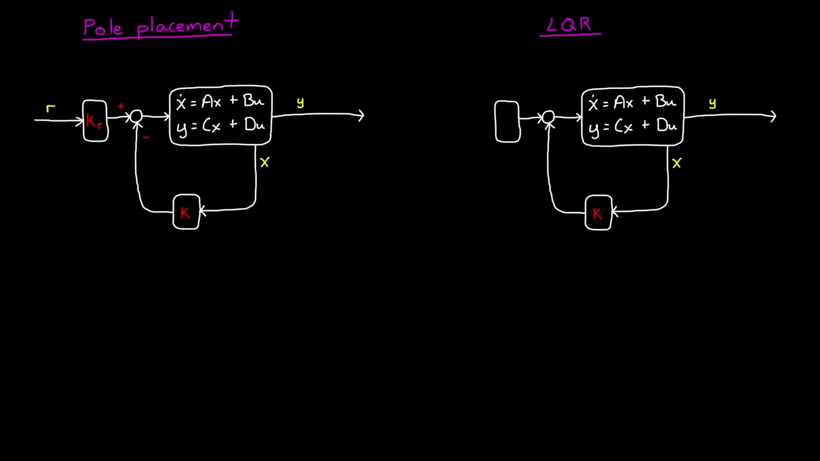 (score 98.0000)
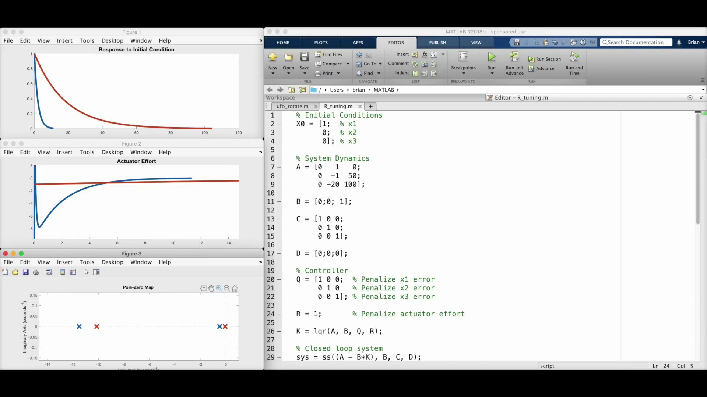 (score 95.0000)
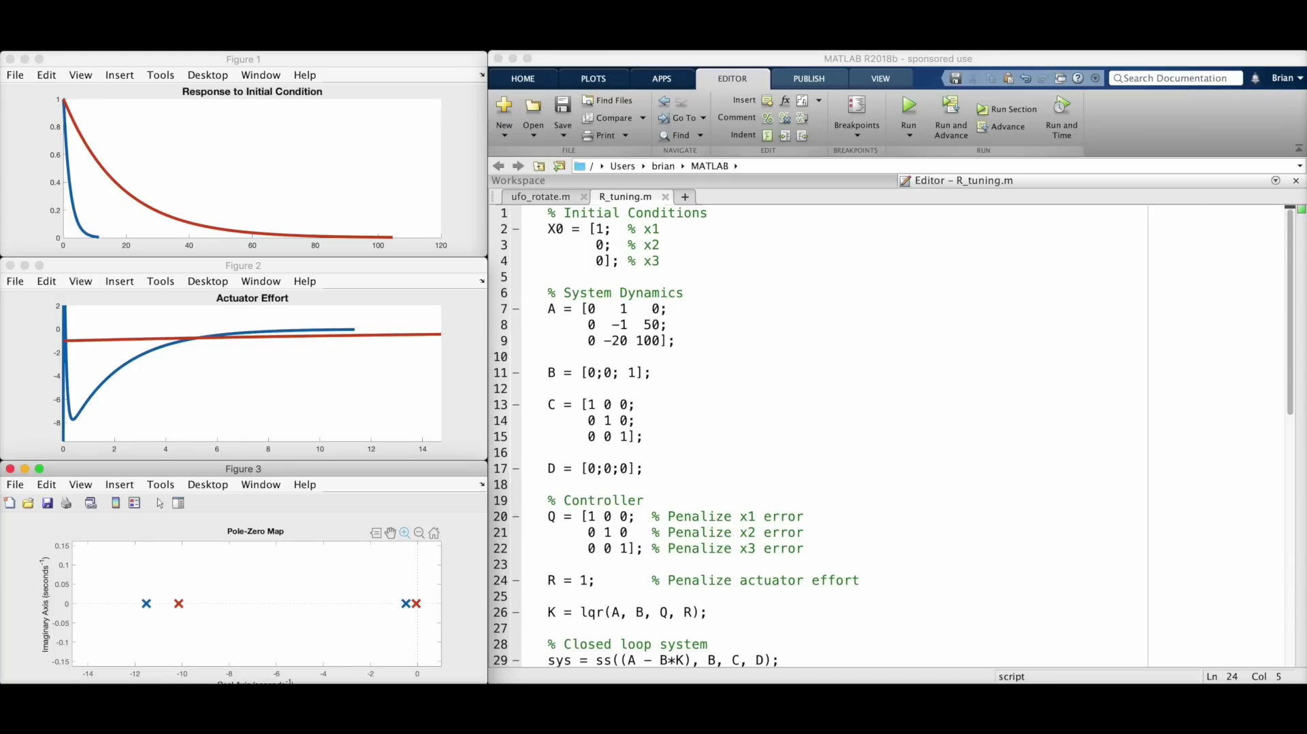 (score 95.0000)
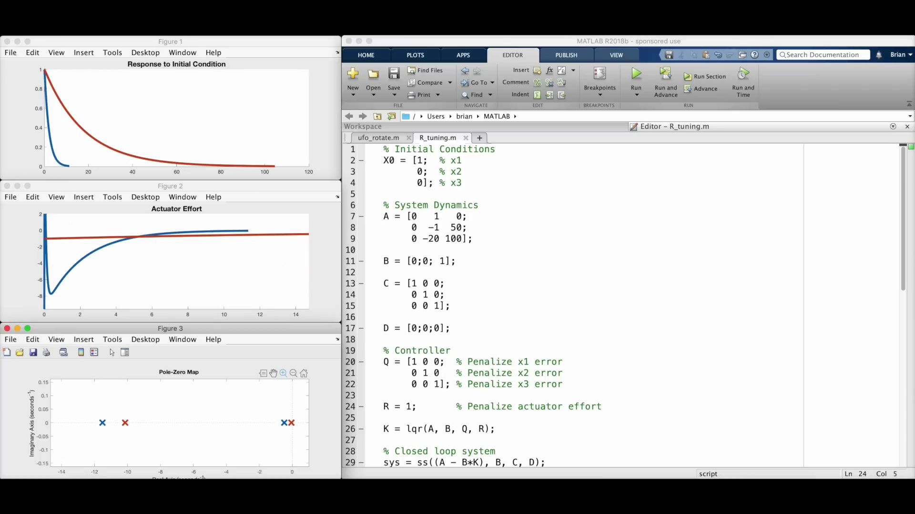 (score 95.0000)
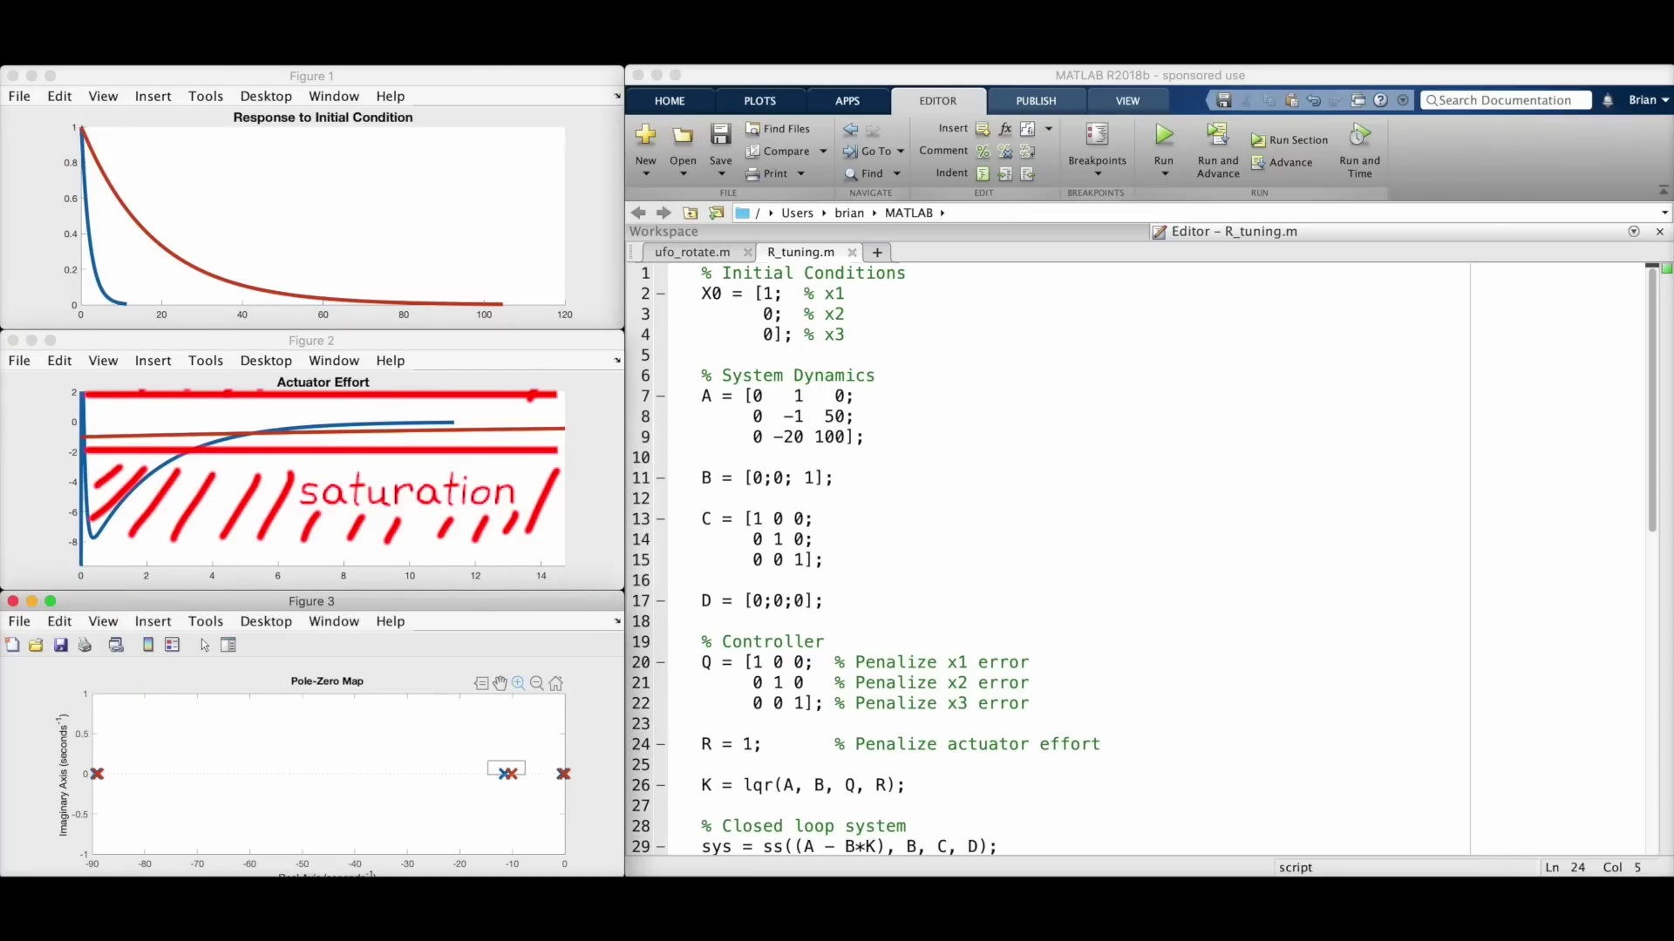 (score 95.0000)
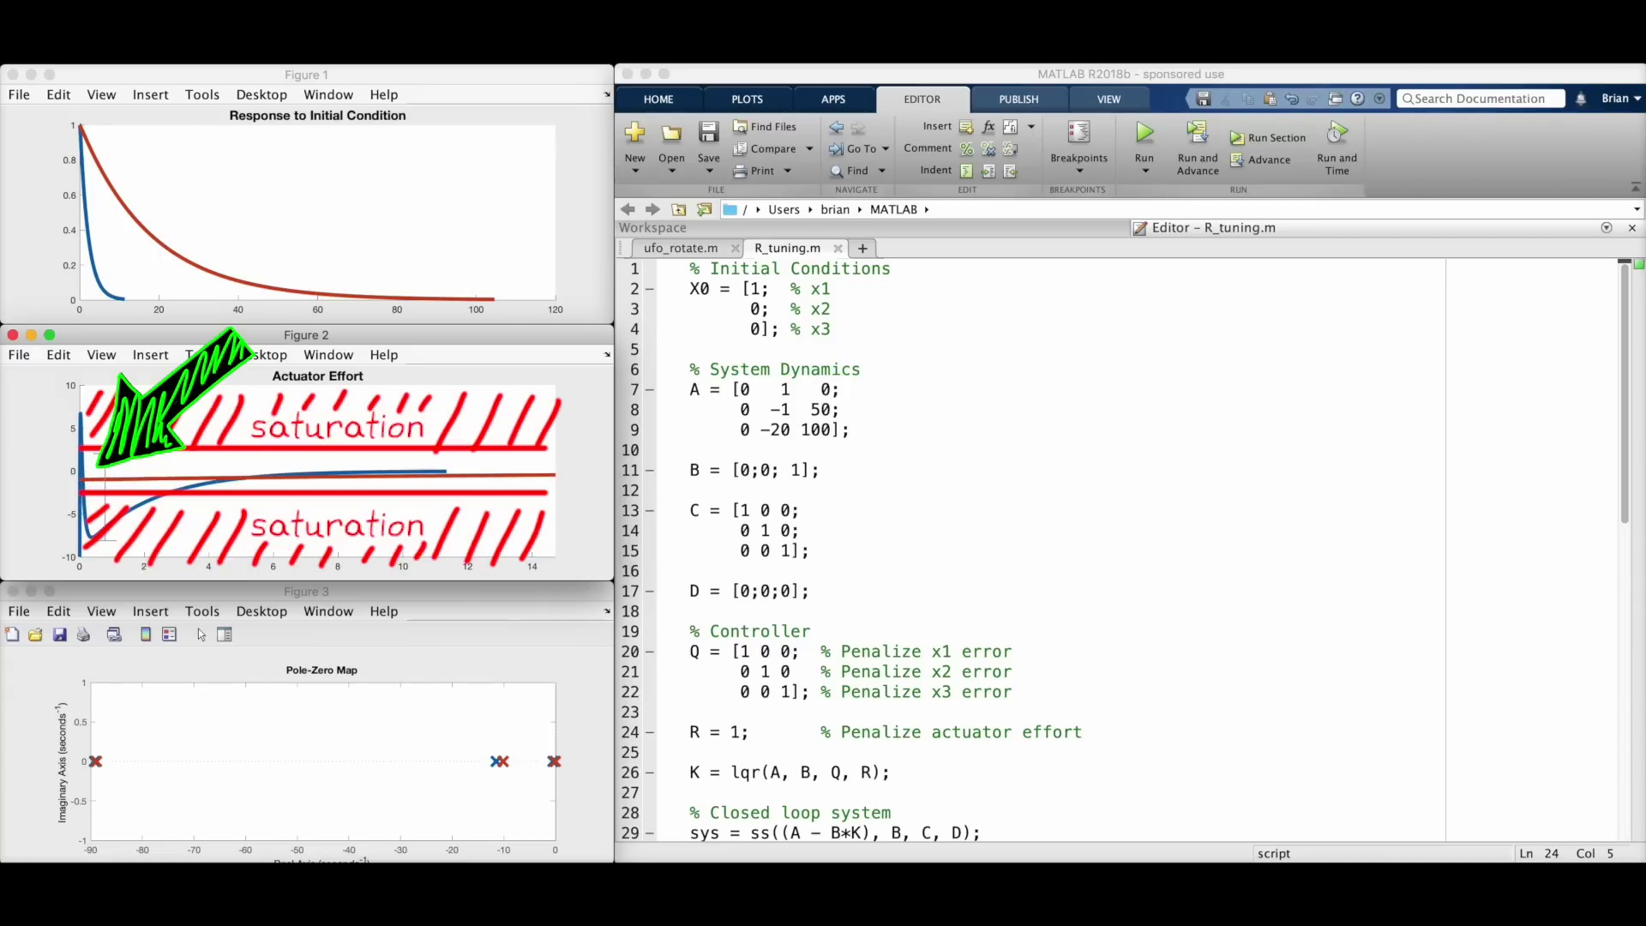 (score 95.0000)
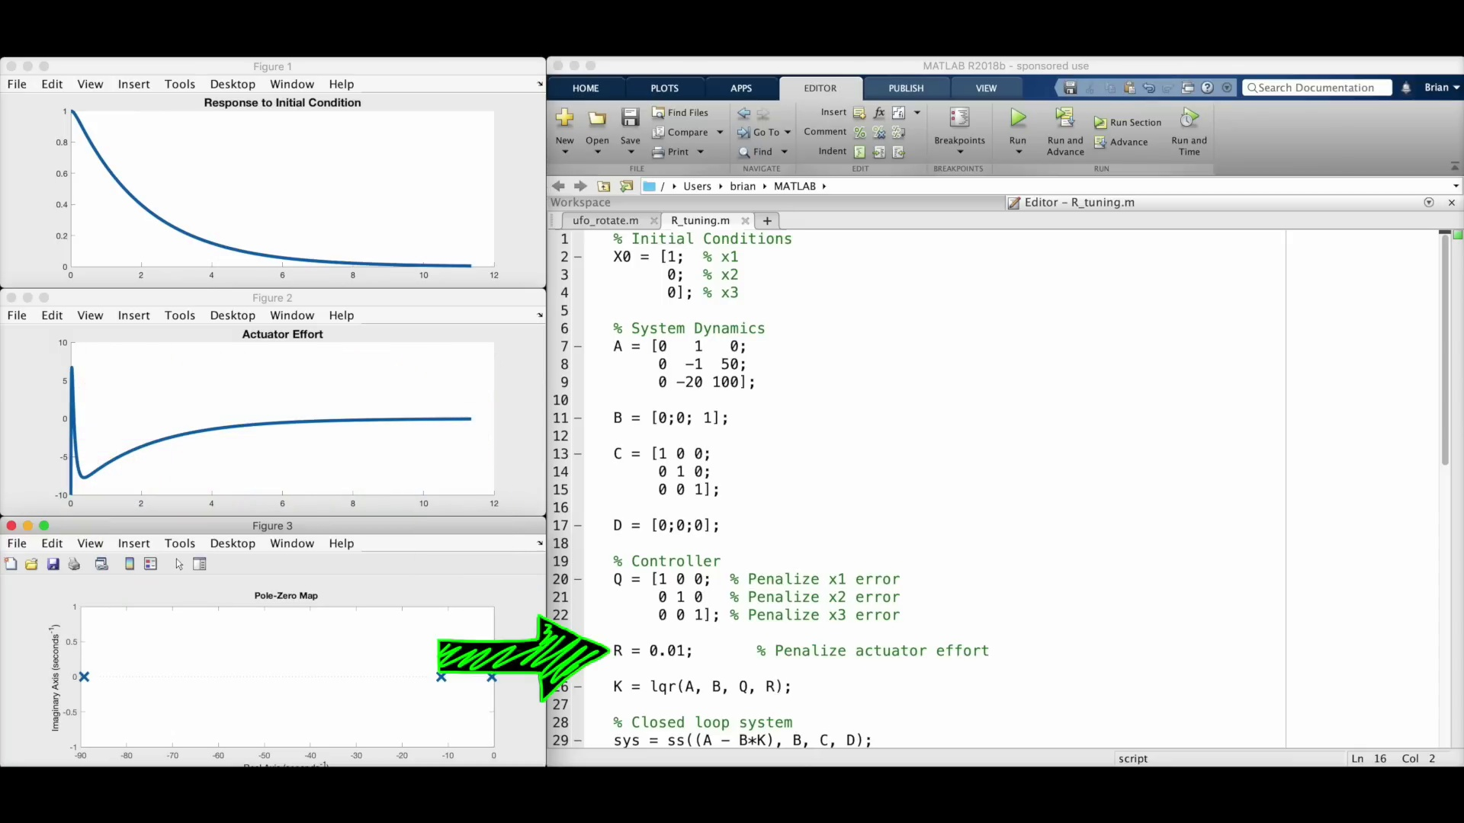 (score 95.0000)
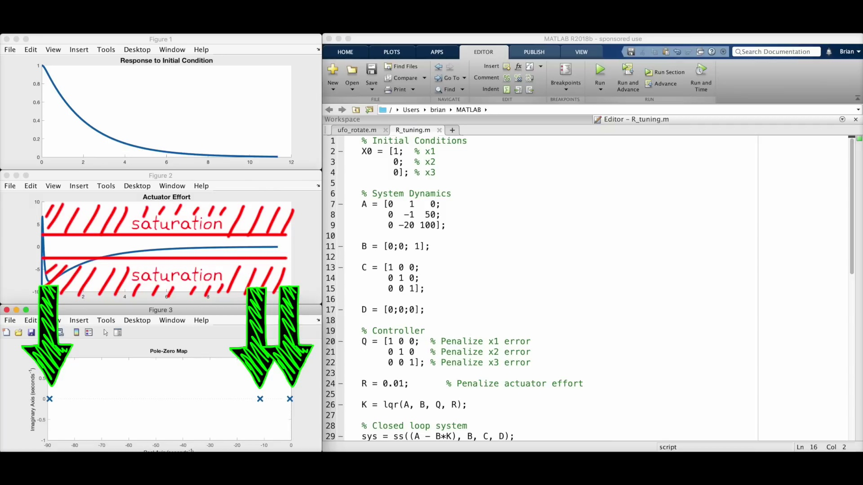 (score 95.0000)
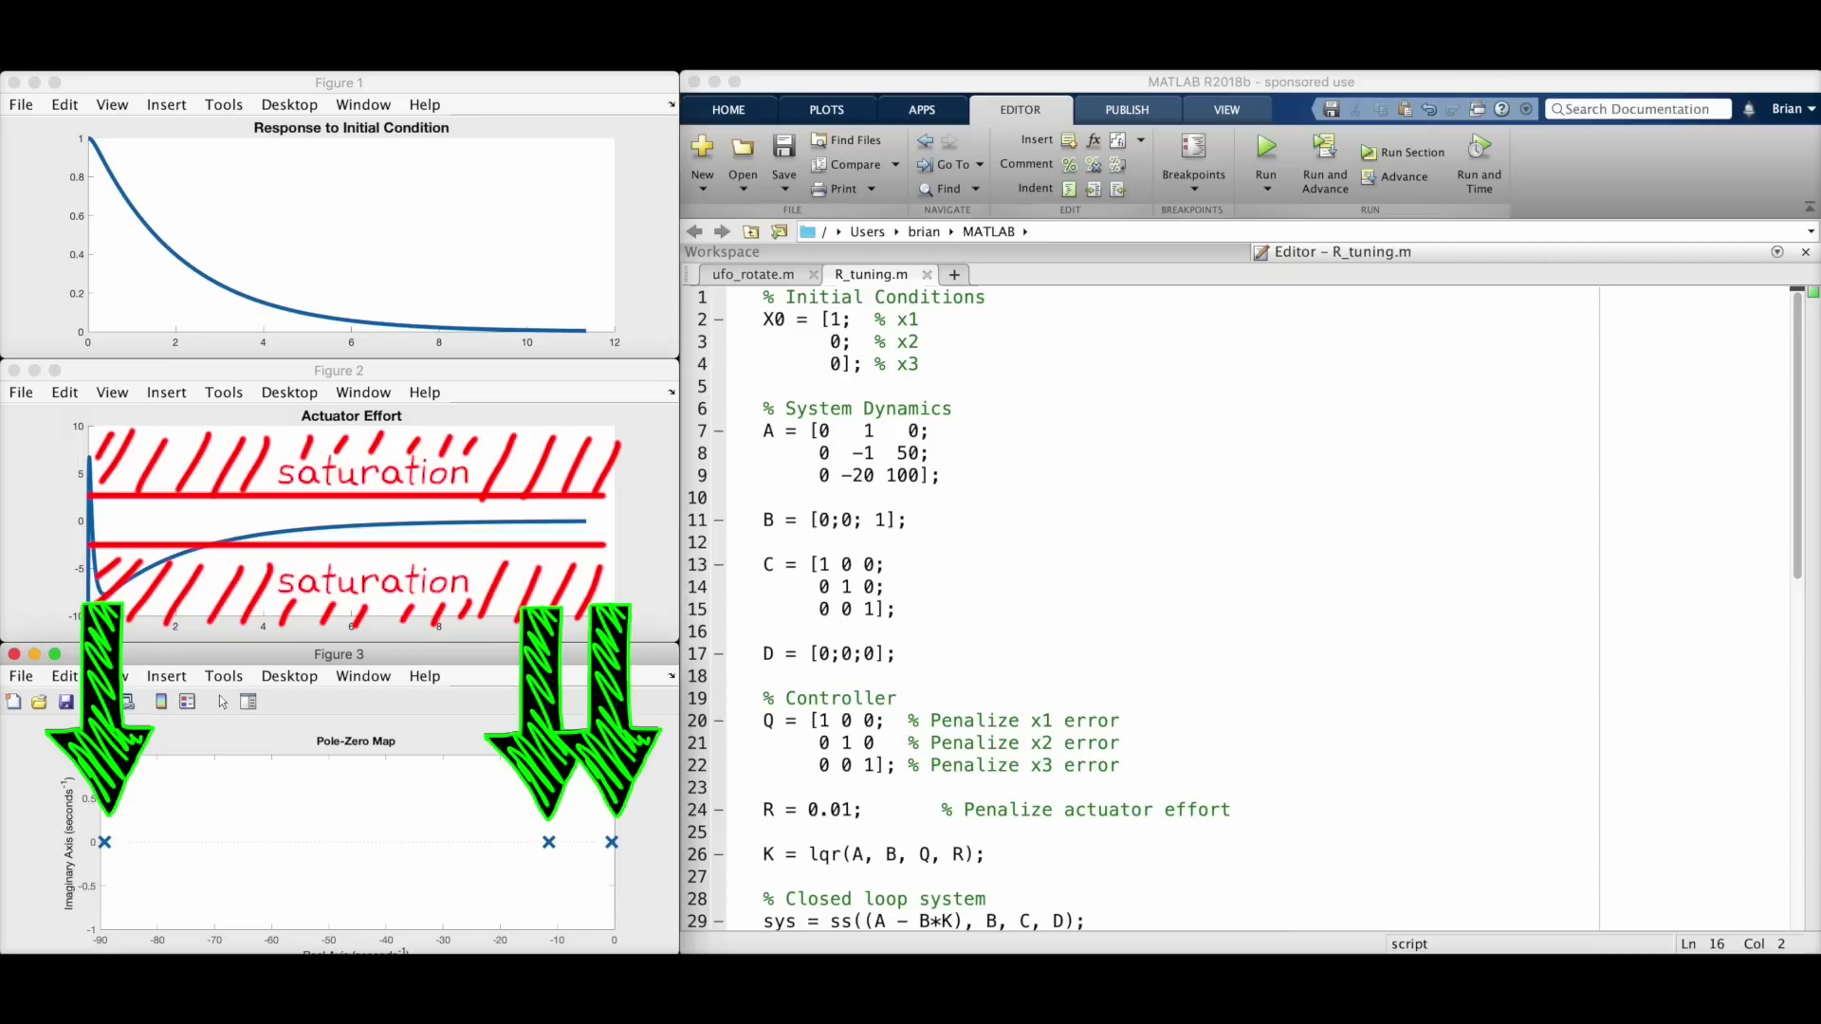 (score 95.0000)
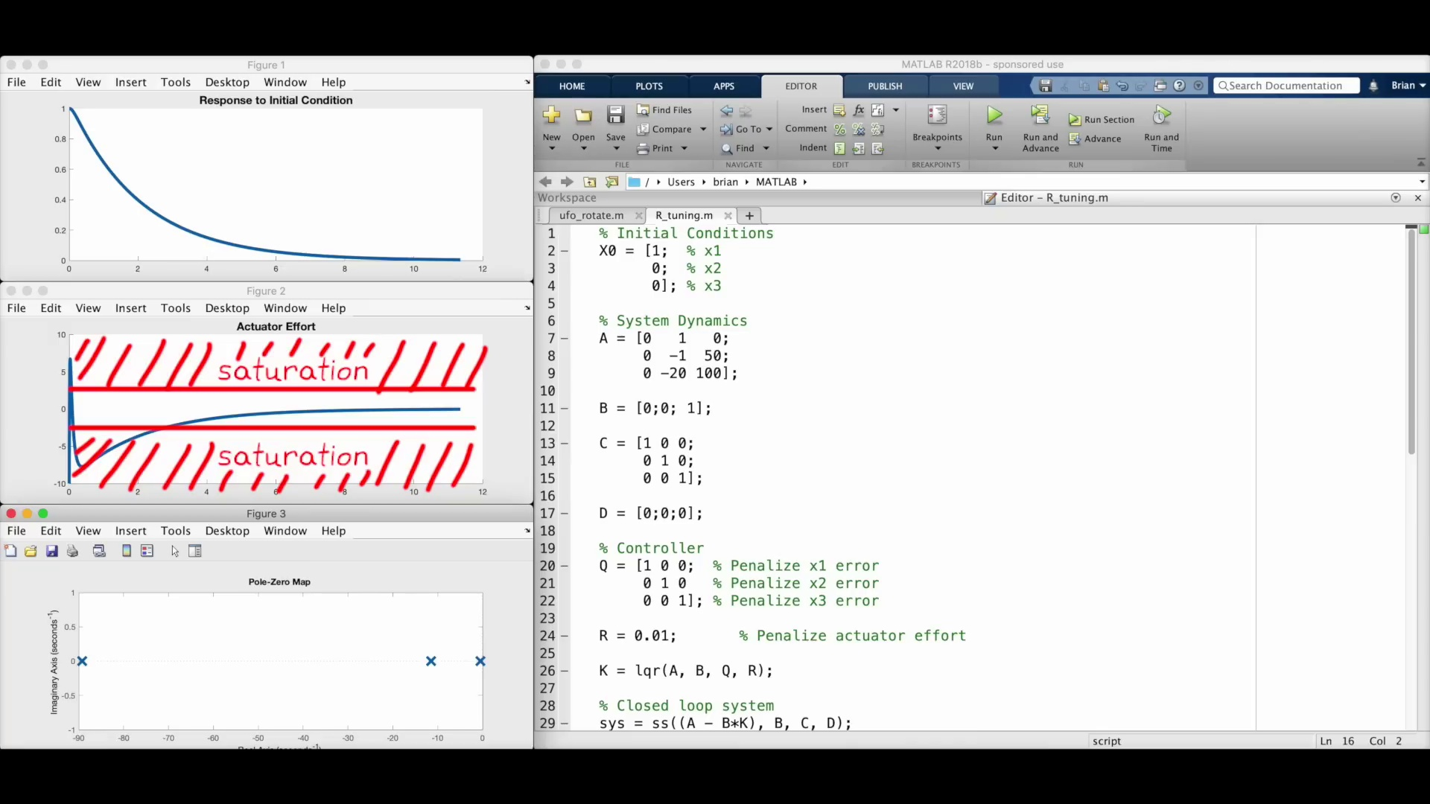 (score 95.0000)
Least correlated frames:
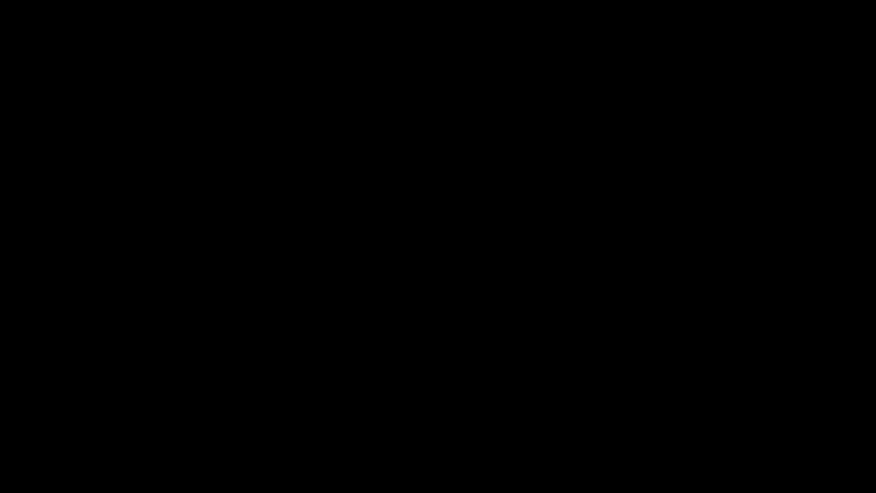 (score 0.0000)
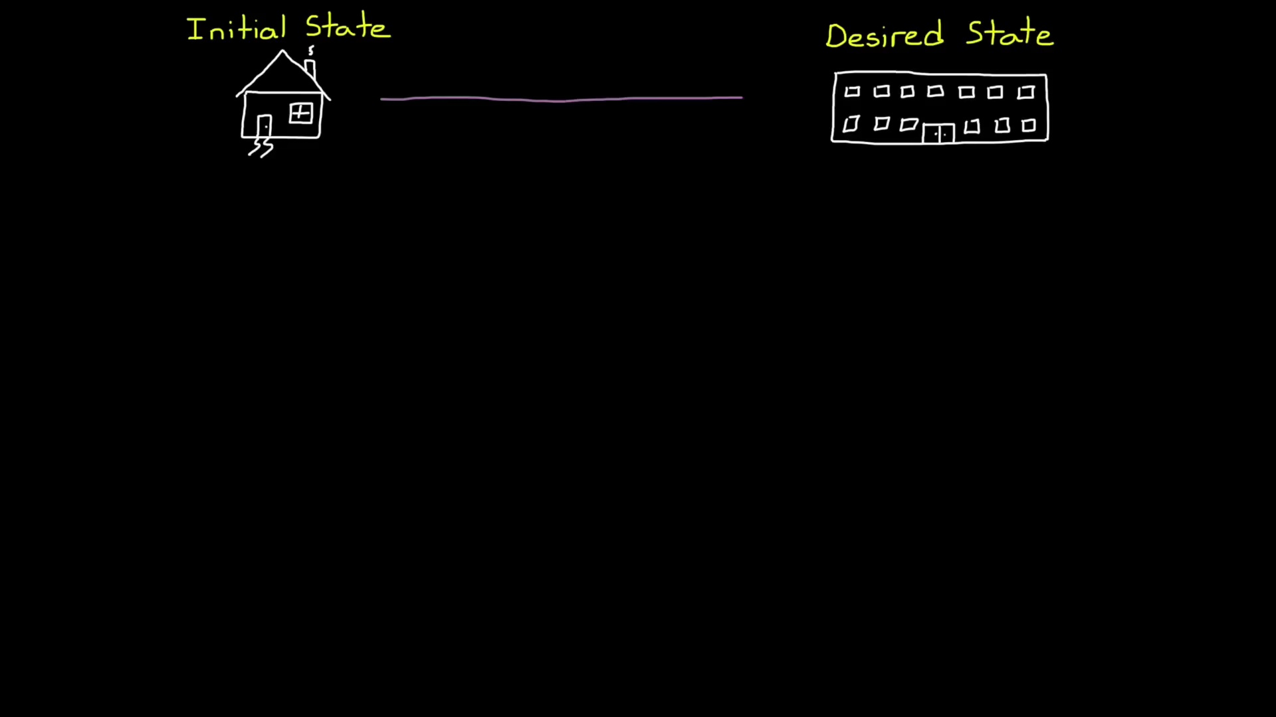 (score 0.0000)
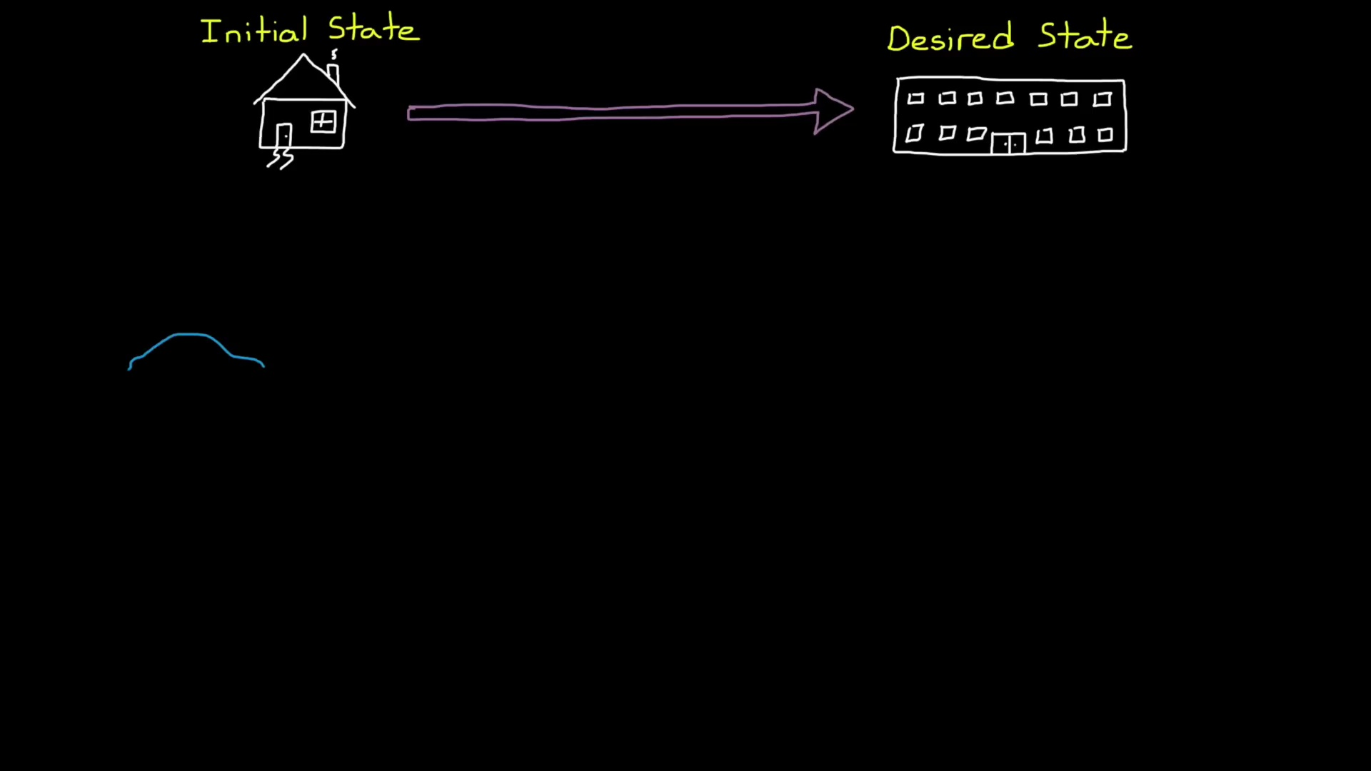 (score 0.0000)
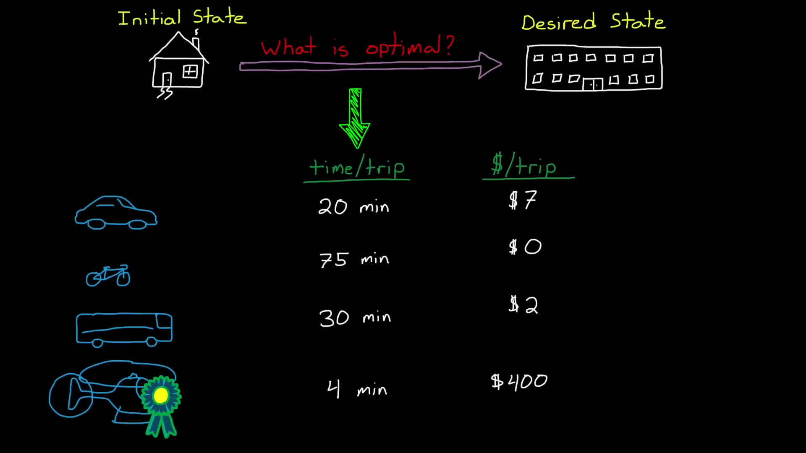 (score 0.0000)
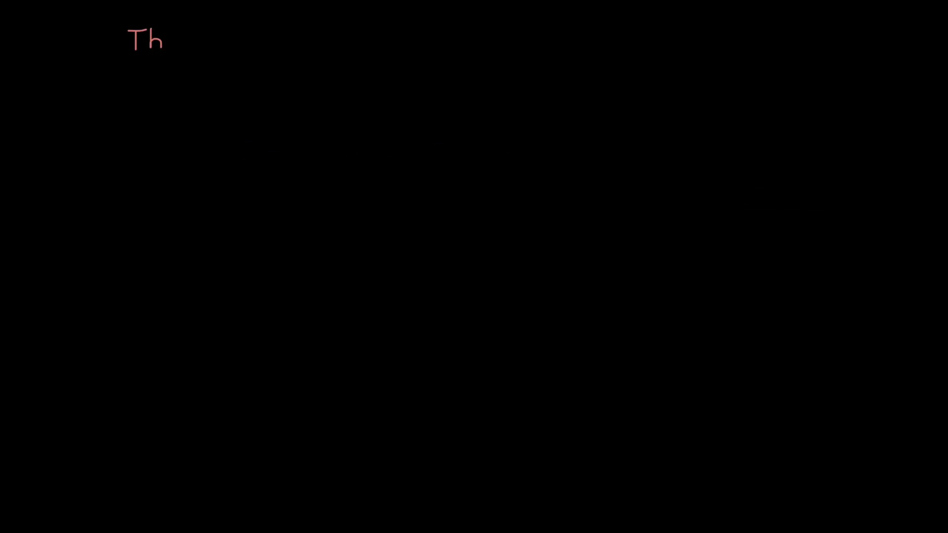 (score 0.0000)
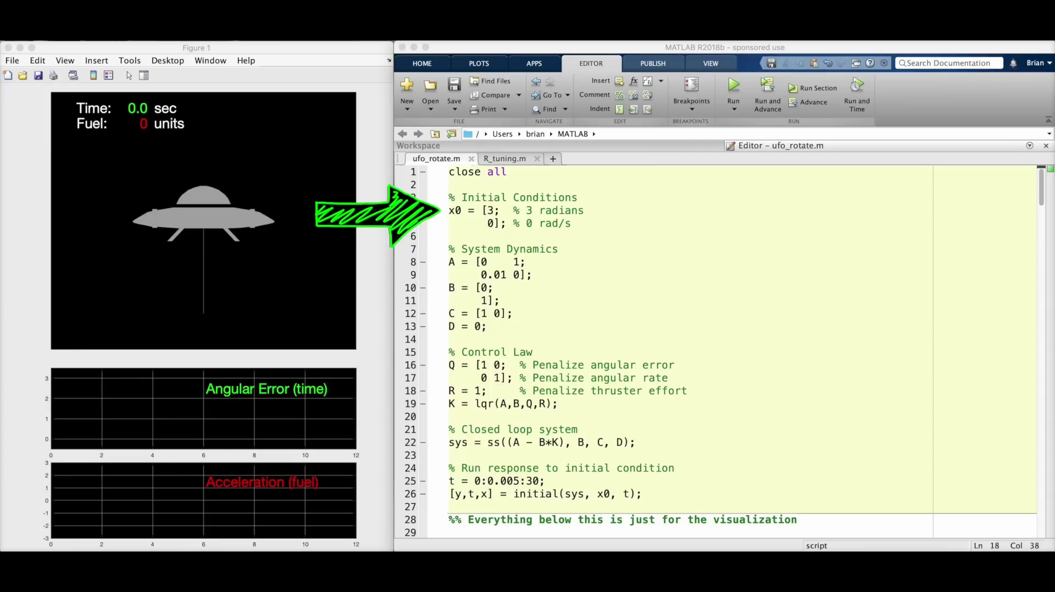 (score 0.0000)
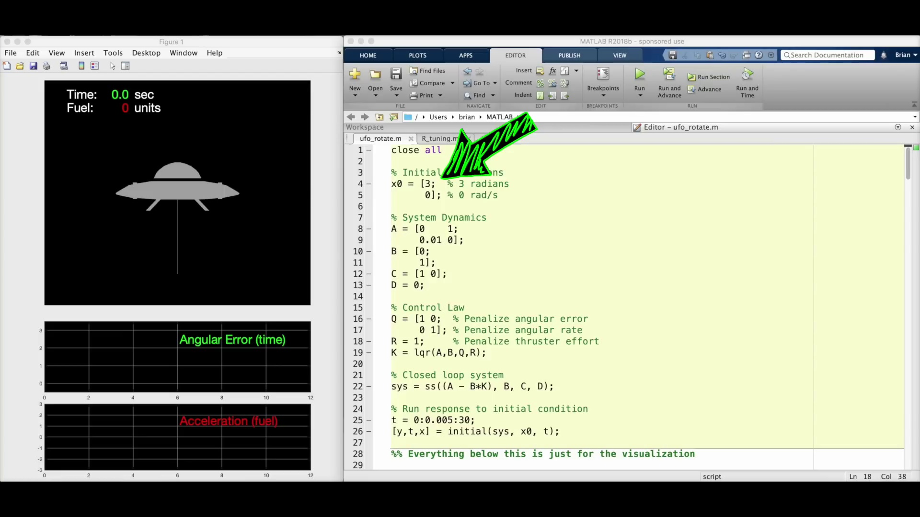 (score 0.0000)
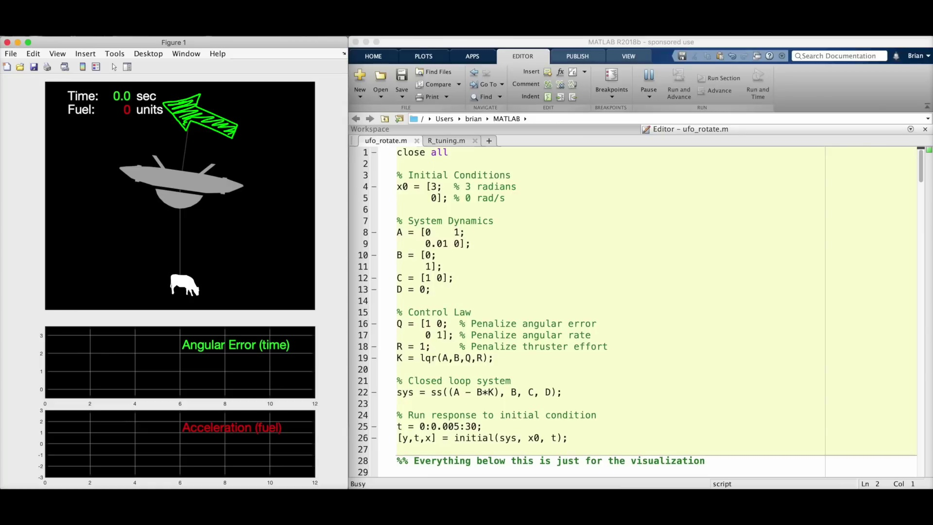 (score 0.0000)
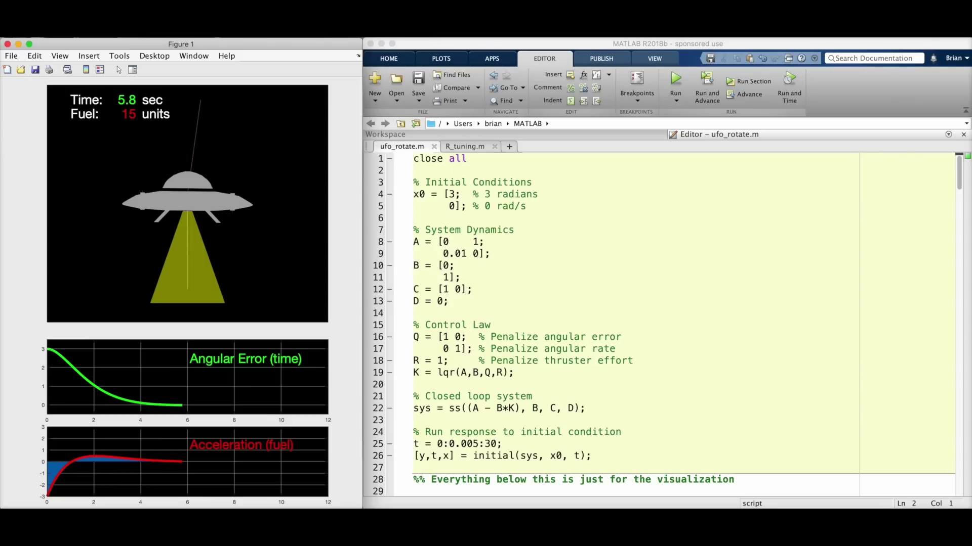 (score 0.0000)
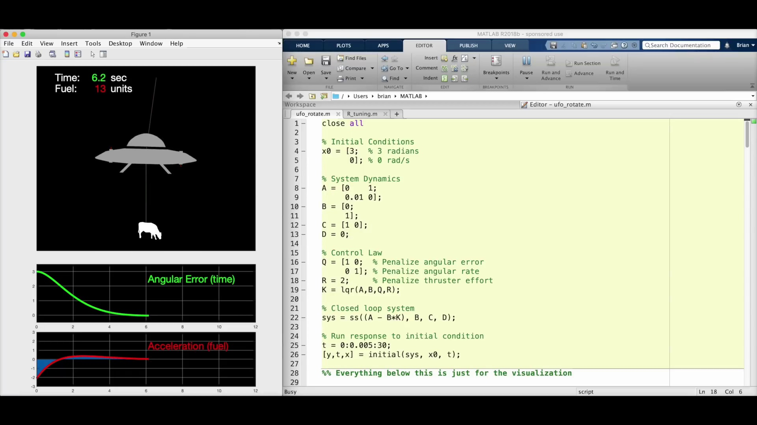 (score 0.0000)
- matched 125 frame(s), max score 95.0000: What does it mean to be optimal? How to think about the LQR problem. The state space is the same, but how we choose K is different. We find the optimal K by choosing characteristics specifically through performance and effort. How much performance can we get for the least amount of effort? Instead of figuring out pole locations we assess what is important to us and then let the algorithm place the poles optimally. We don't place poles, we optimize Q and R.
Source: https://www.youtube.com/watch?v=E_RDCFOlJx4: What Is Linear Quadratic Regulator (LQR) Optimal Control? | State Space, Part 4
Top correlated frames:
 (score 95.0000)
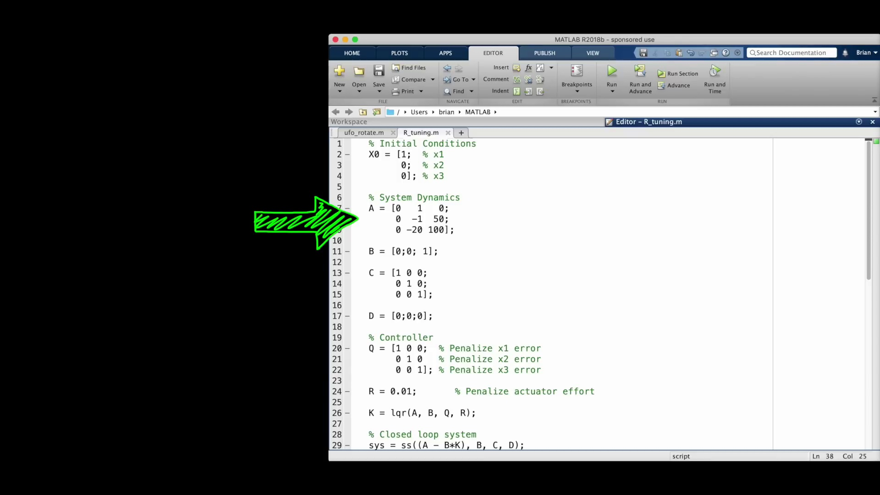 (score 95.0000)
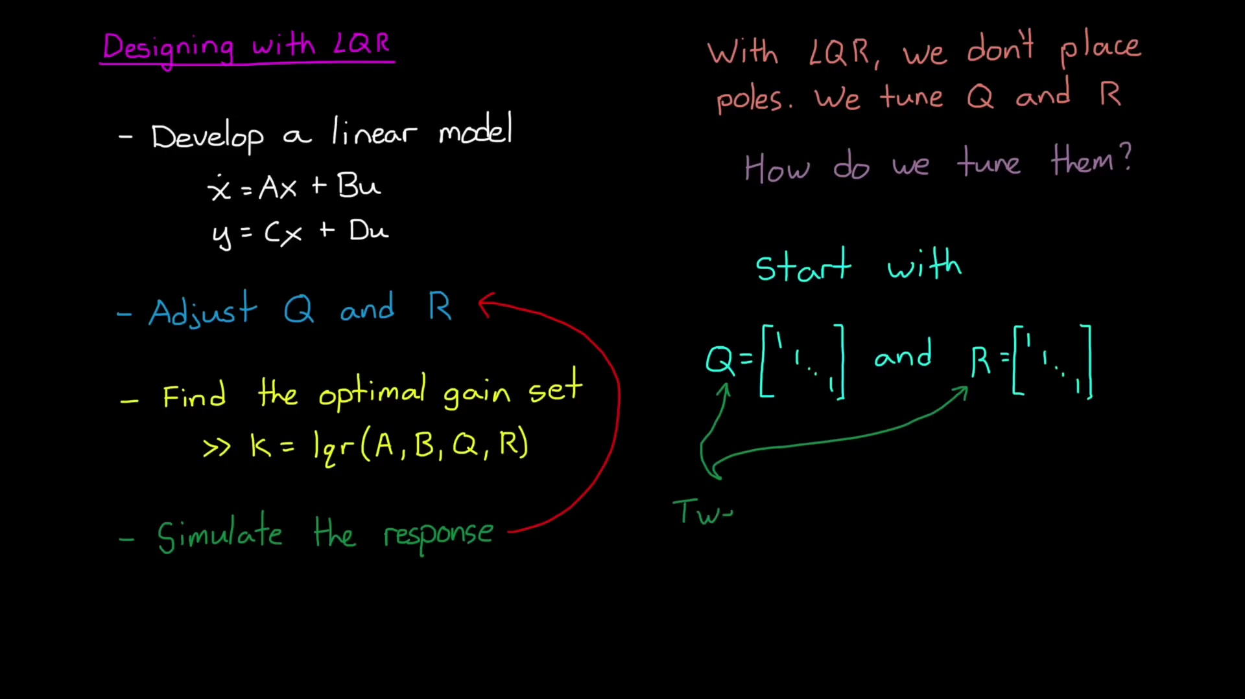 (score 95.0000)
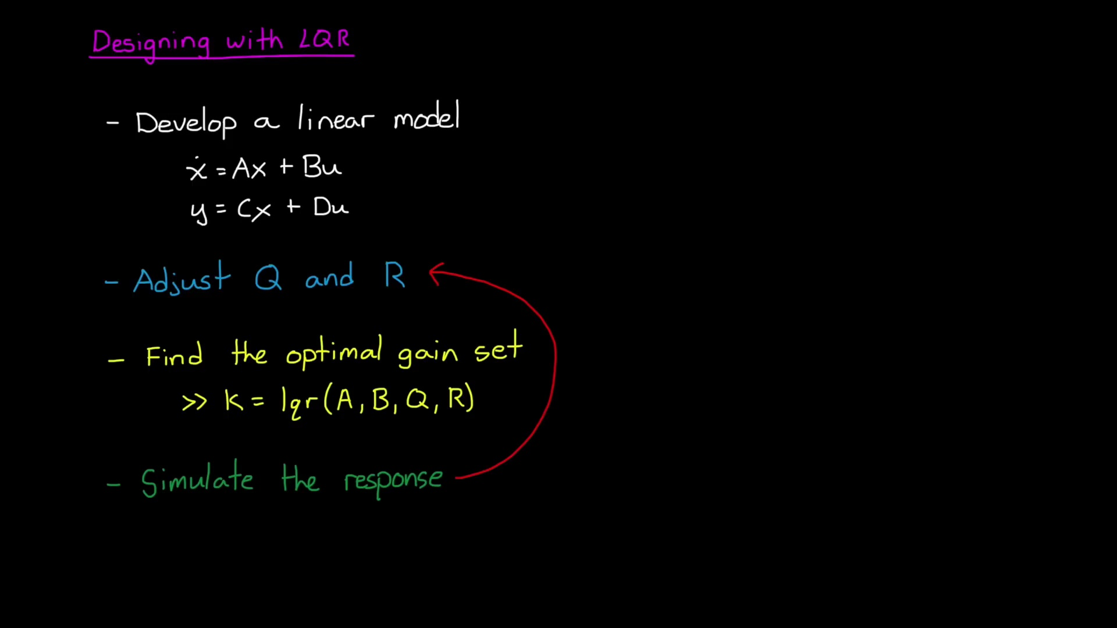 (score 95.0000)
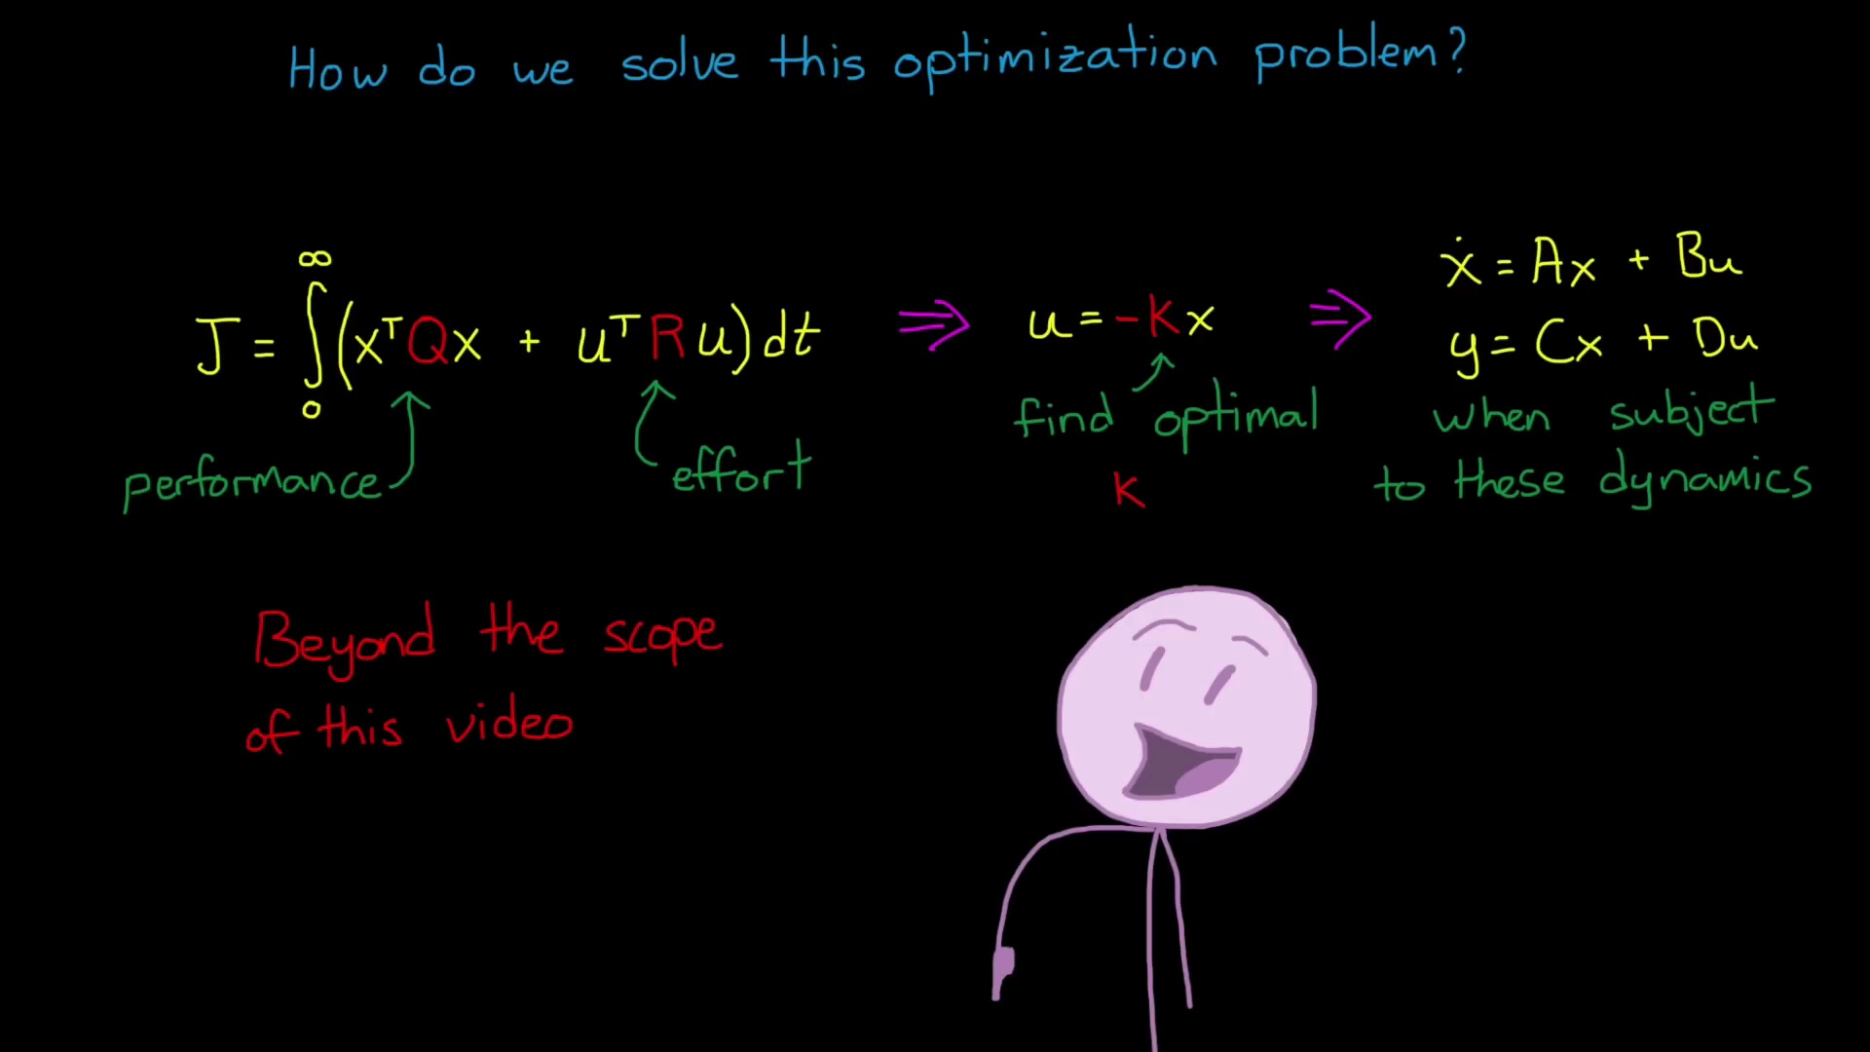 (score 95.0000)
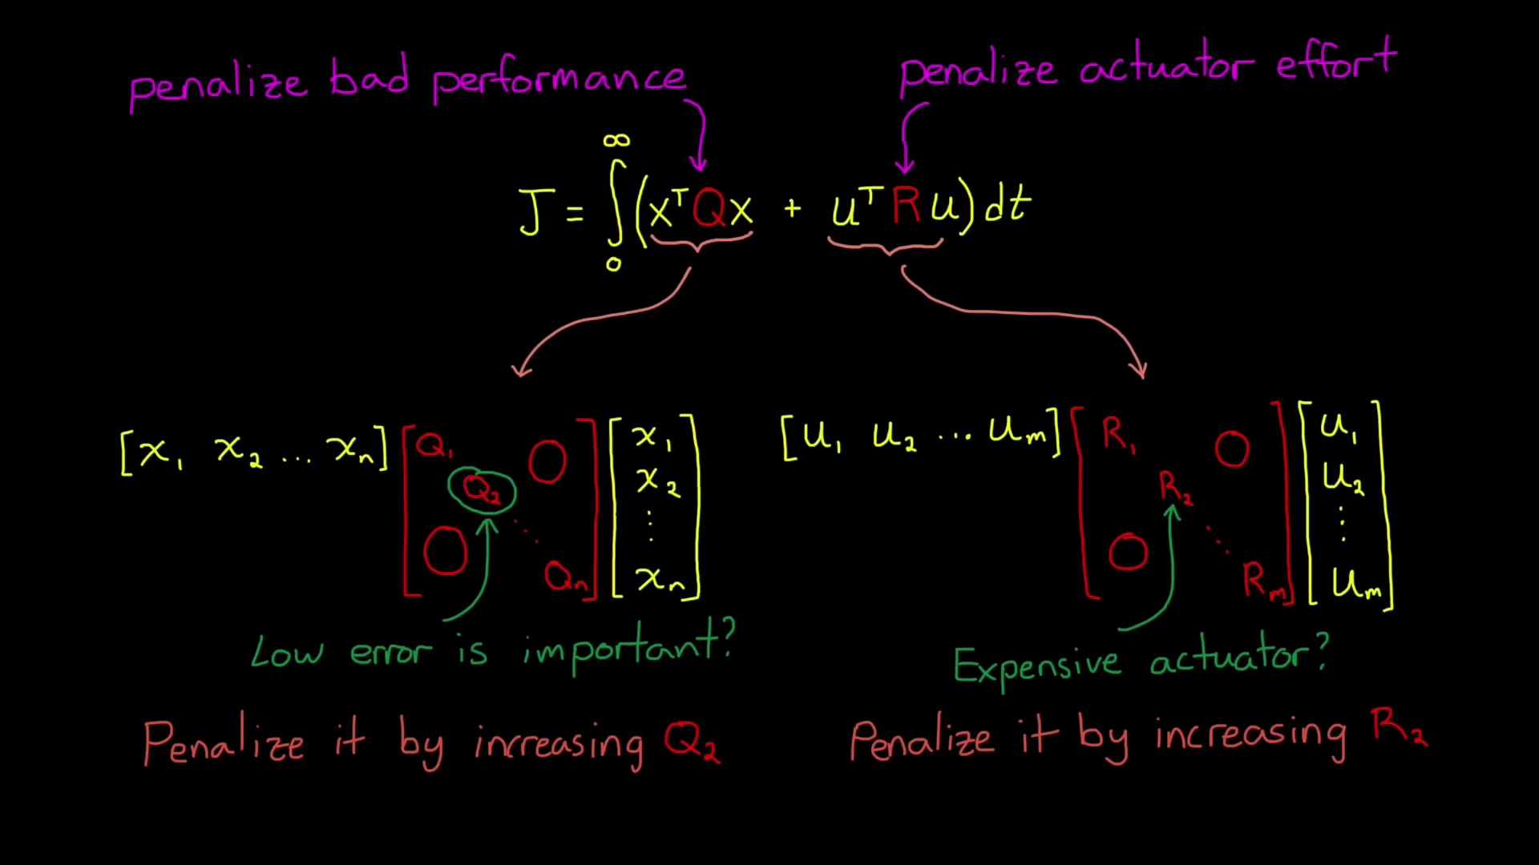 (score 95.0000)
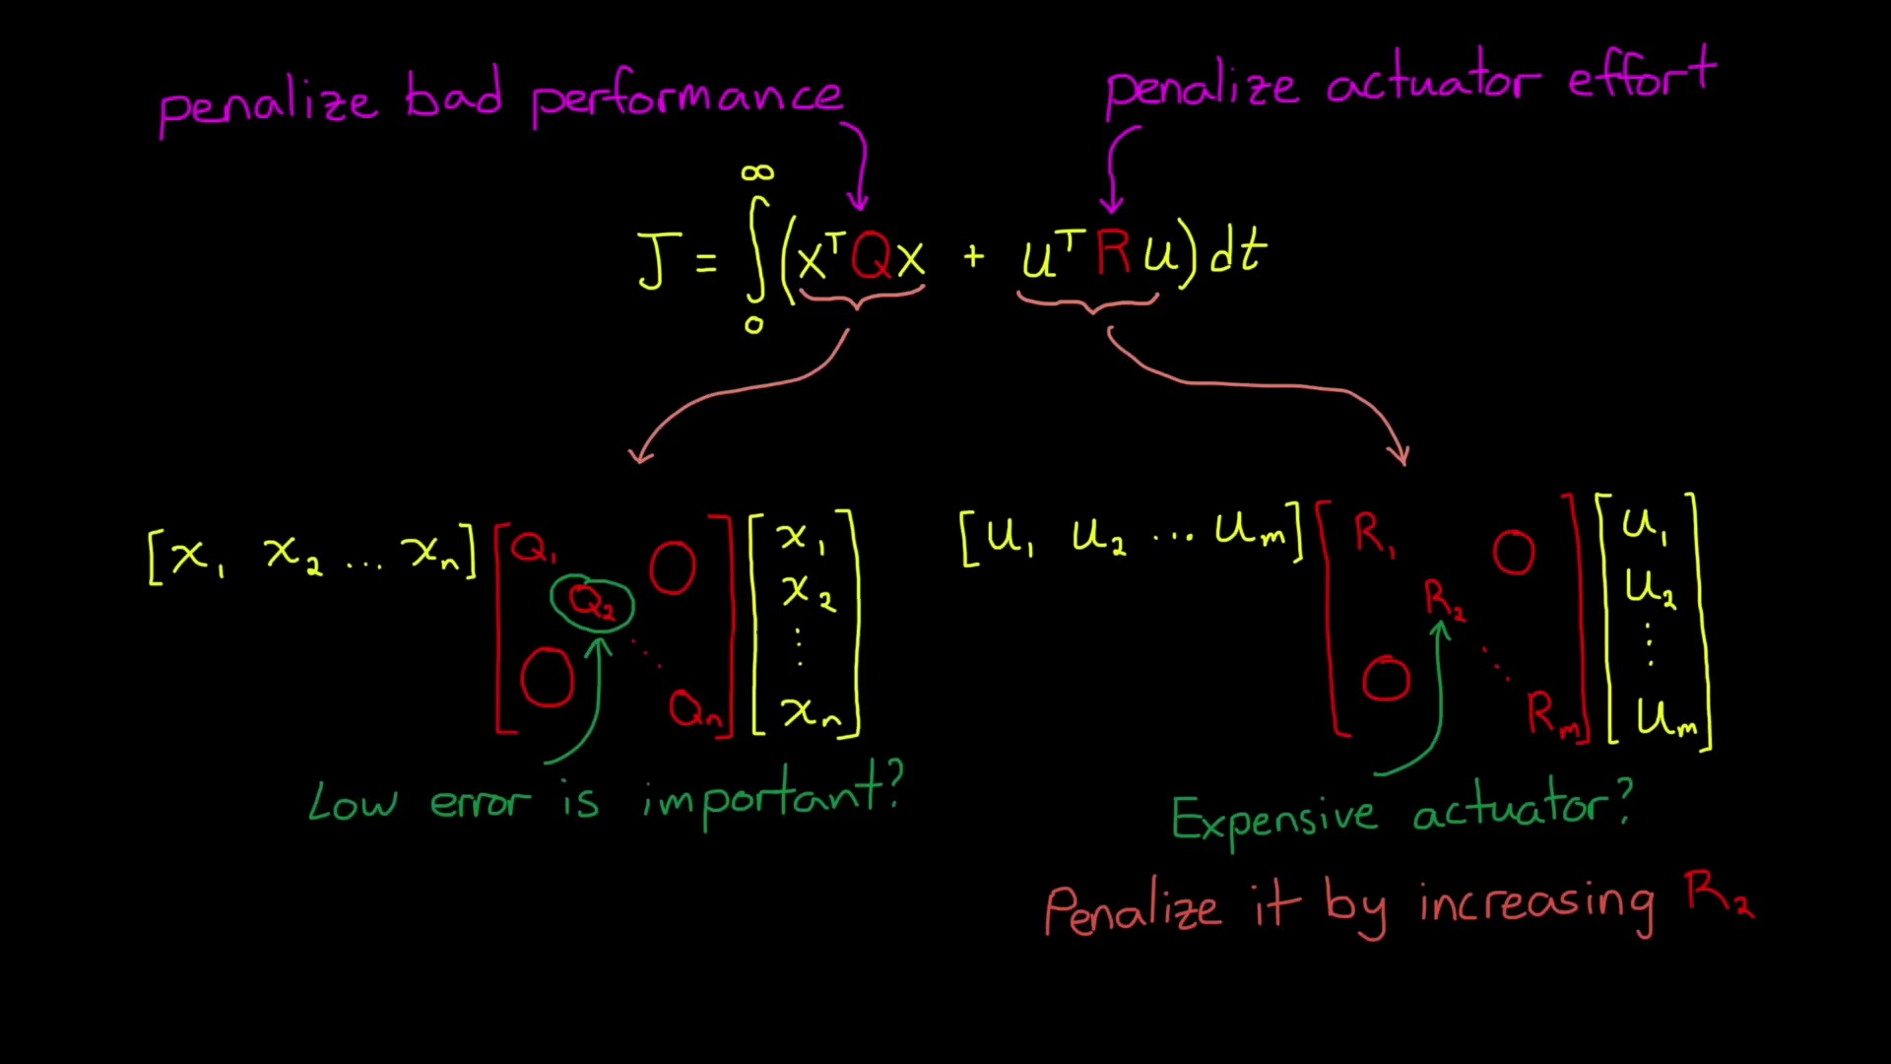 (score 95.0000)
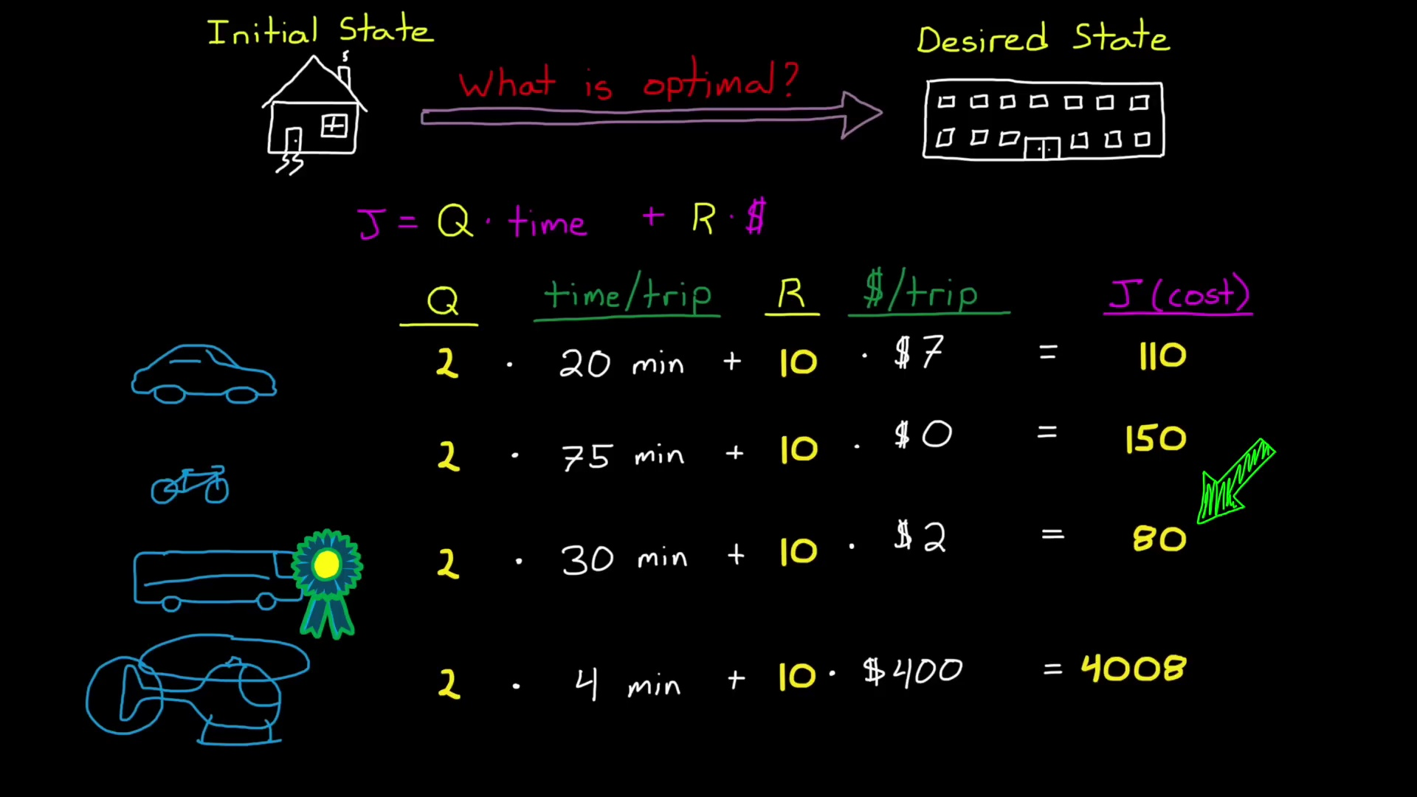 (score 95.0000)
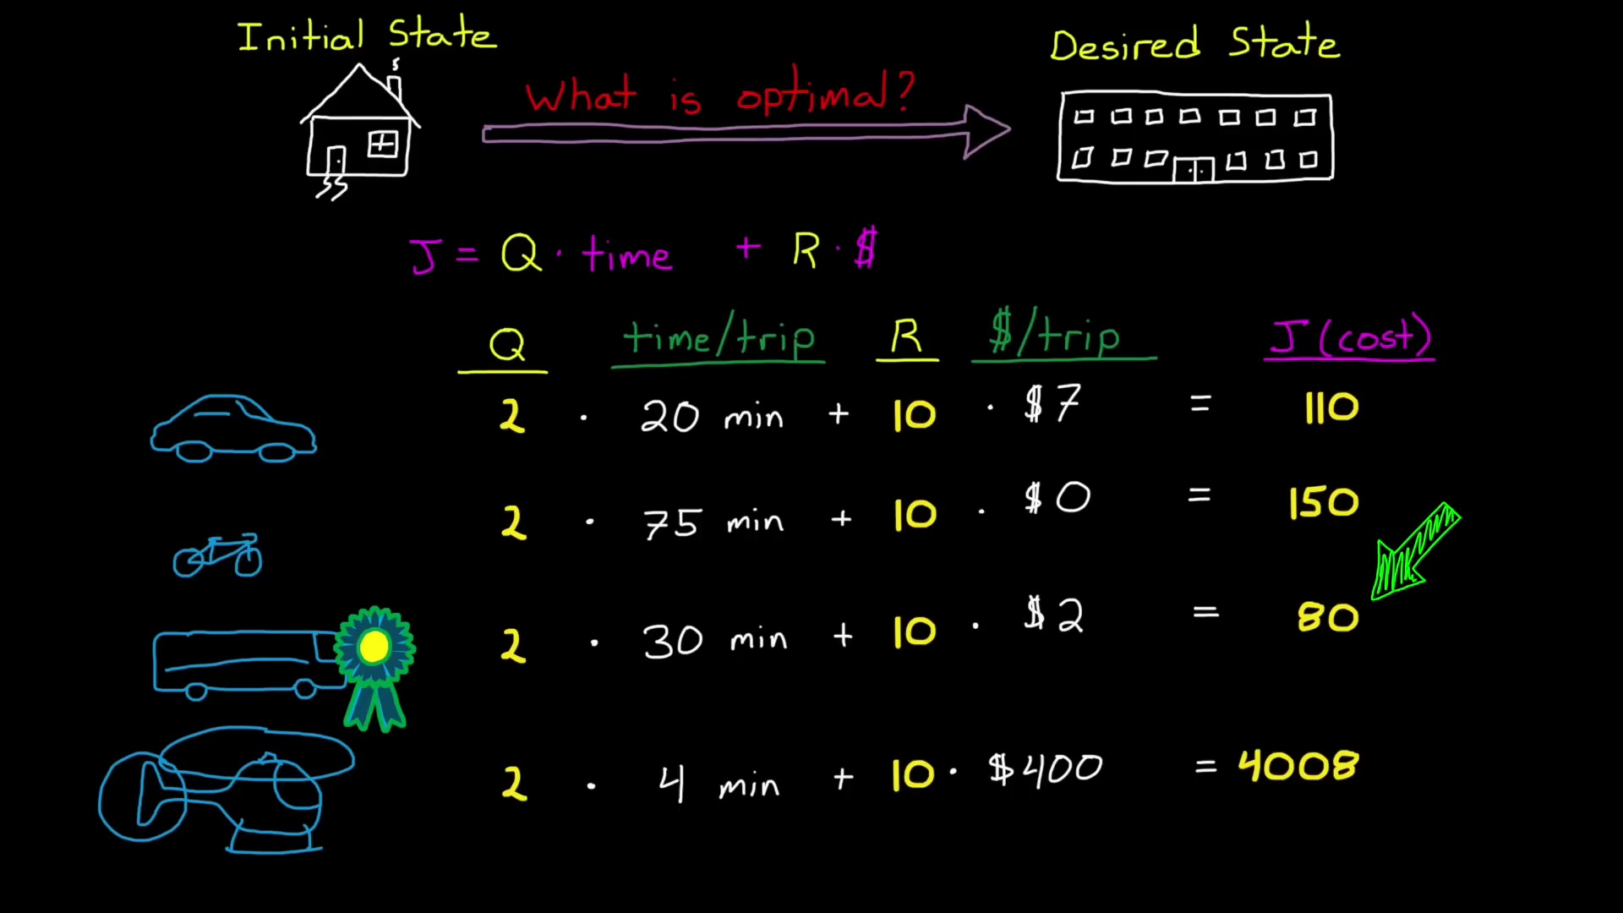 (score 95.0000)
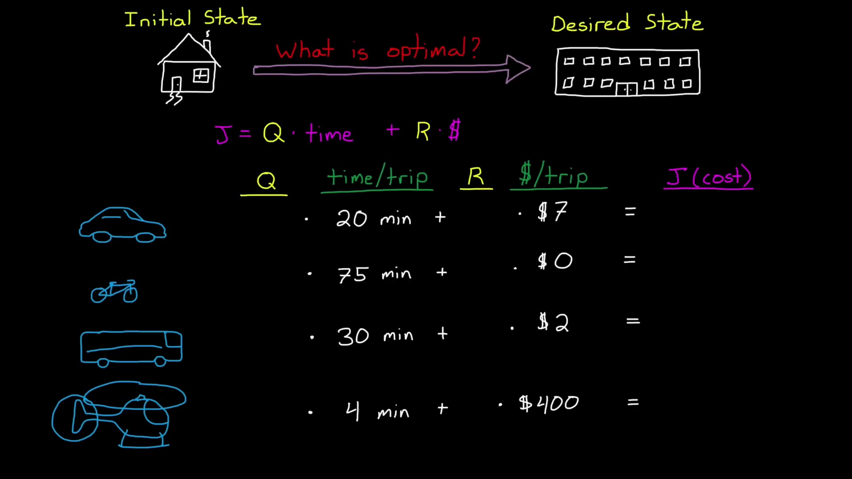 (score 95.0000)
Least correlated frames:
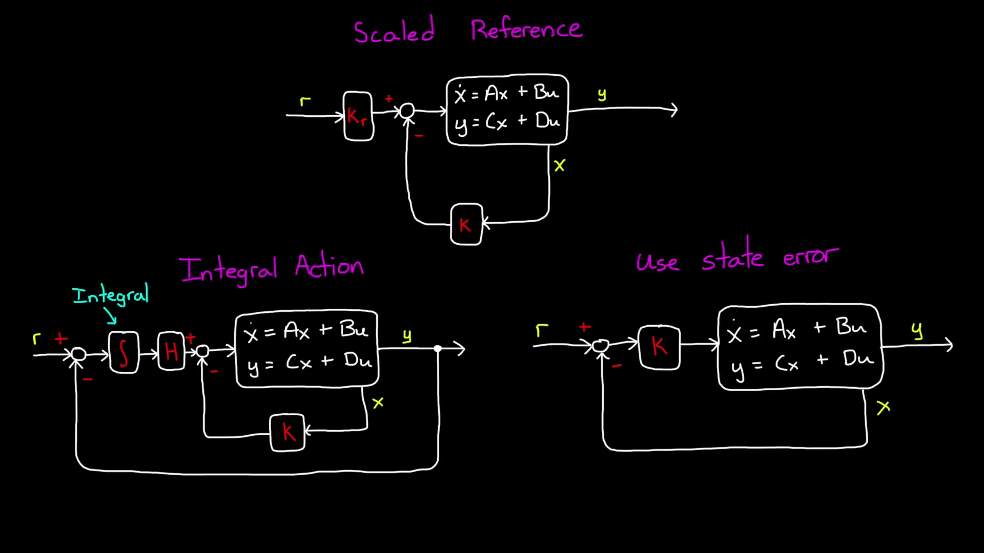 (score 0.0000)
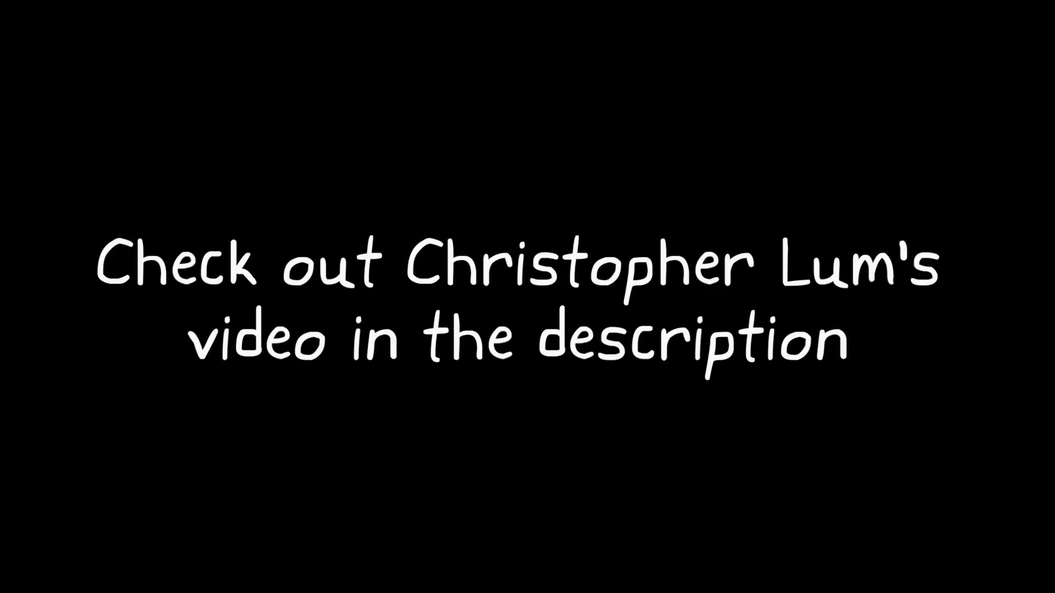 (score 0.0000)
 (score 0.0000)
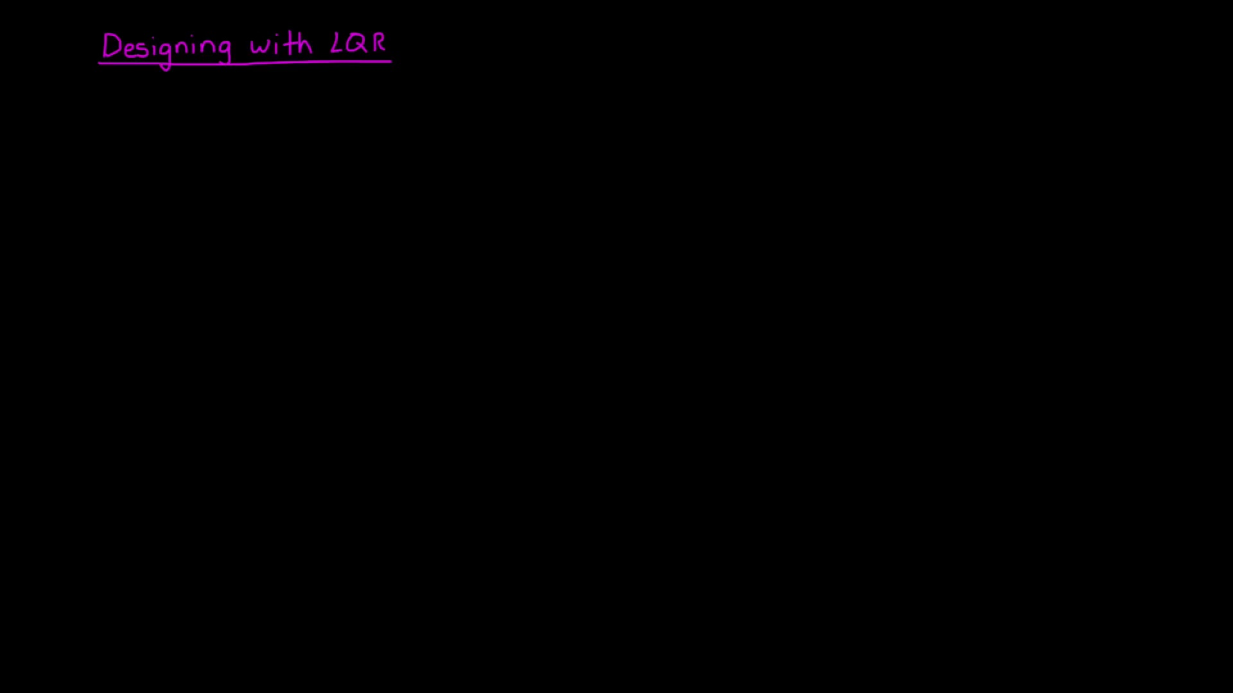 (score 0.0000)
 (score 0.0000)
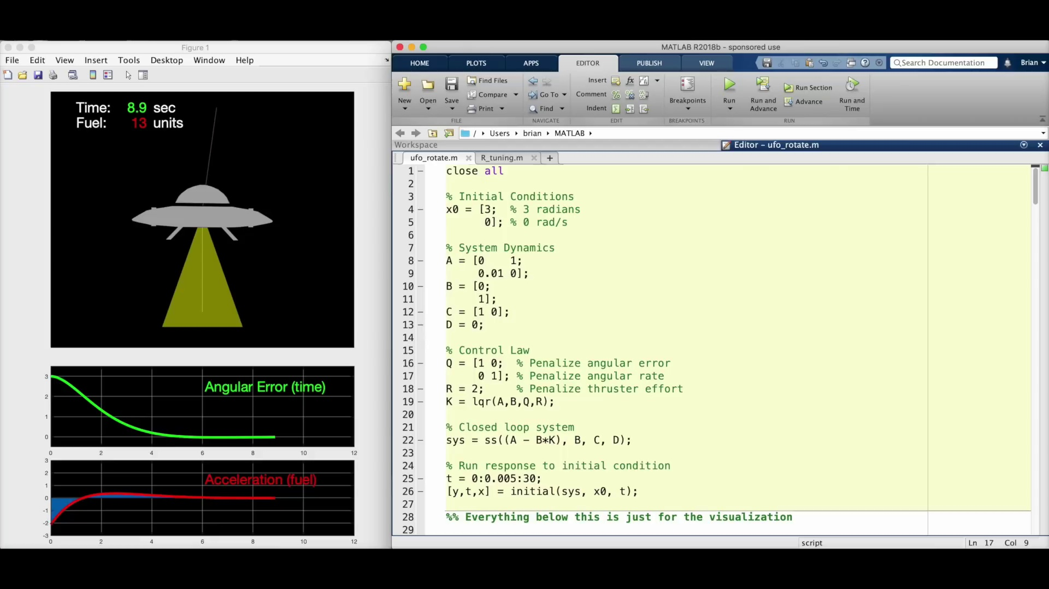 (score 0.0000)
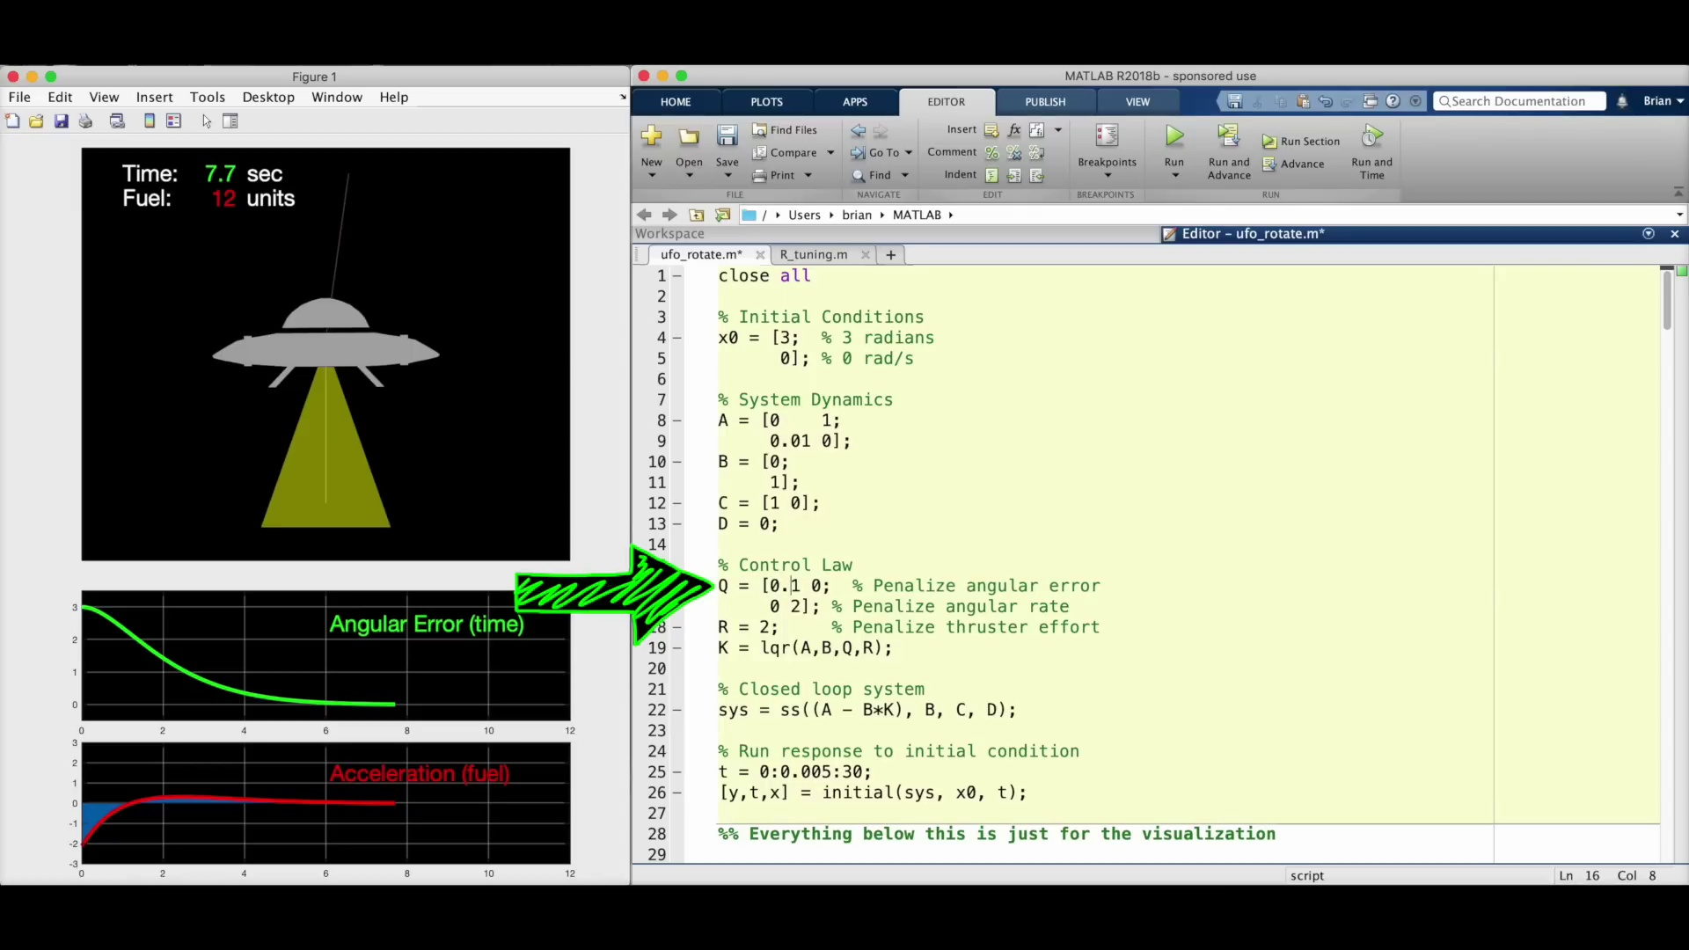 (score 0.0000)
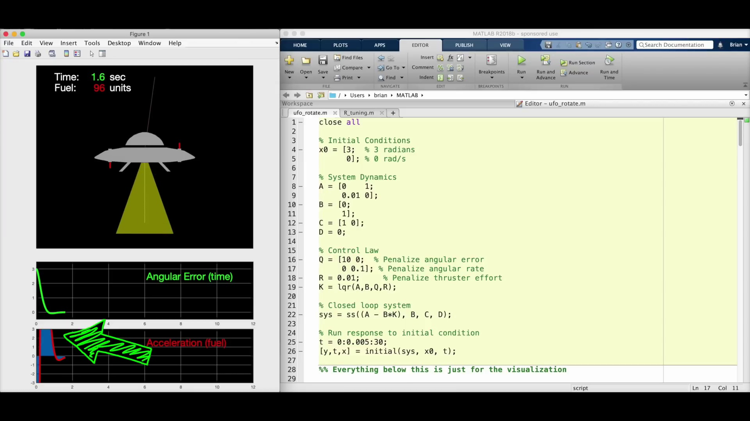 (score 0.0000)
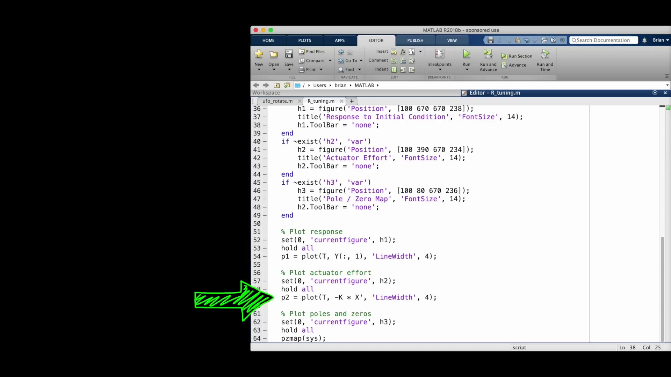 (score 0.0000)
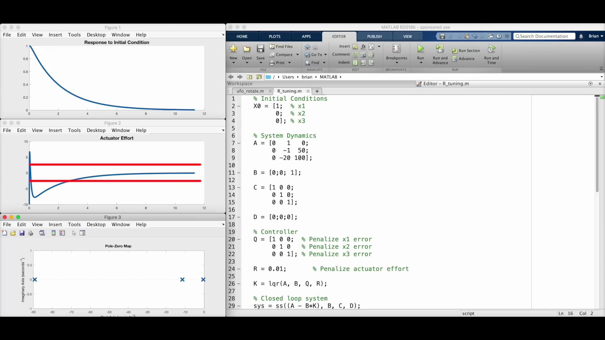 (score 0.0000)
- matched 121 frame(s), max score 95.0000: The video introduces Linear Quadratic Regulator (LQR) control, which is an optimal control method based on state-space representation. It contrasts LQR with pole placement control, noting that both use full state feedback controllers but differ in how they determine the gain matrix K. LQR focuses on balancing system performance and actuator effort, using a cost function that weighs these factors over time. The performance is determined with a Q matrix, while actuator effort is determined using an R matrix. The video demonstrates LQR design in MATLAB using a rotating mass model, showing how different Q and R values impact the system's response. LQR control is a flexible approach for control system design, although finding the right Q and R matrices can be a challenge.
Source: https://www.youtube.com/watch?v=E_RDCFOlJx4&t=3s: WHAT IS LINEAR QUADRATIC REGULATION (LQR) OPTIMAL CONTROL?| STATE SPACE, PART 4:
Top correlated frames:
 (score 95.0000)
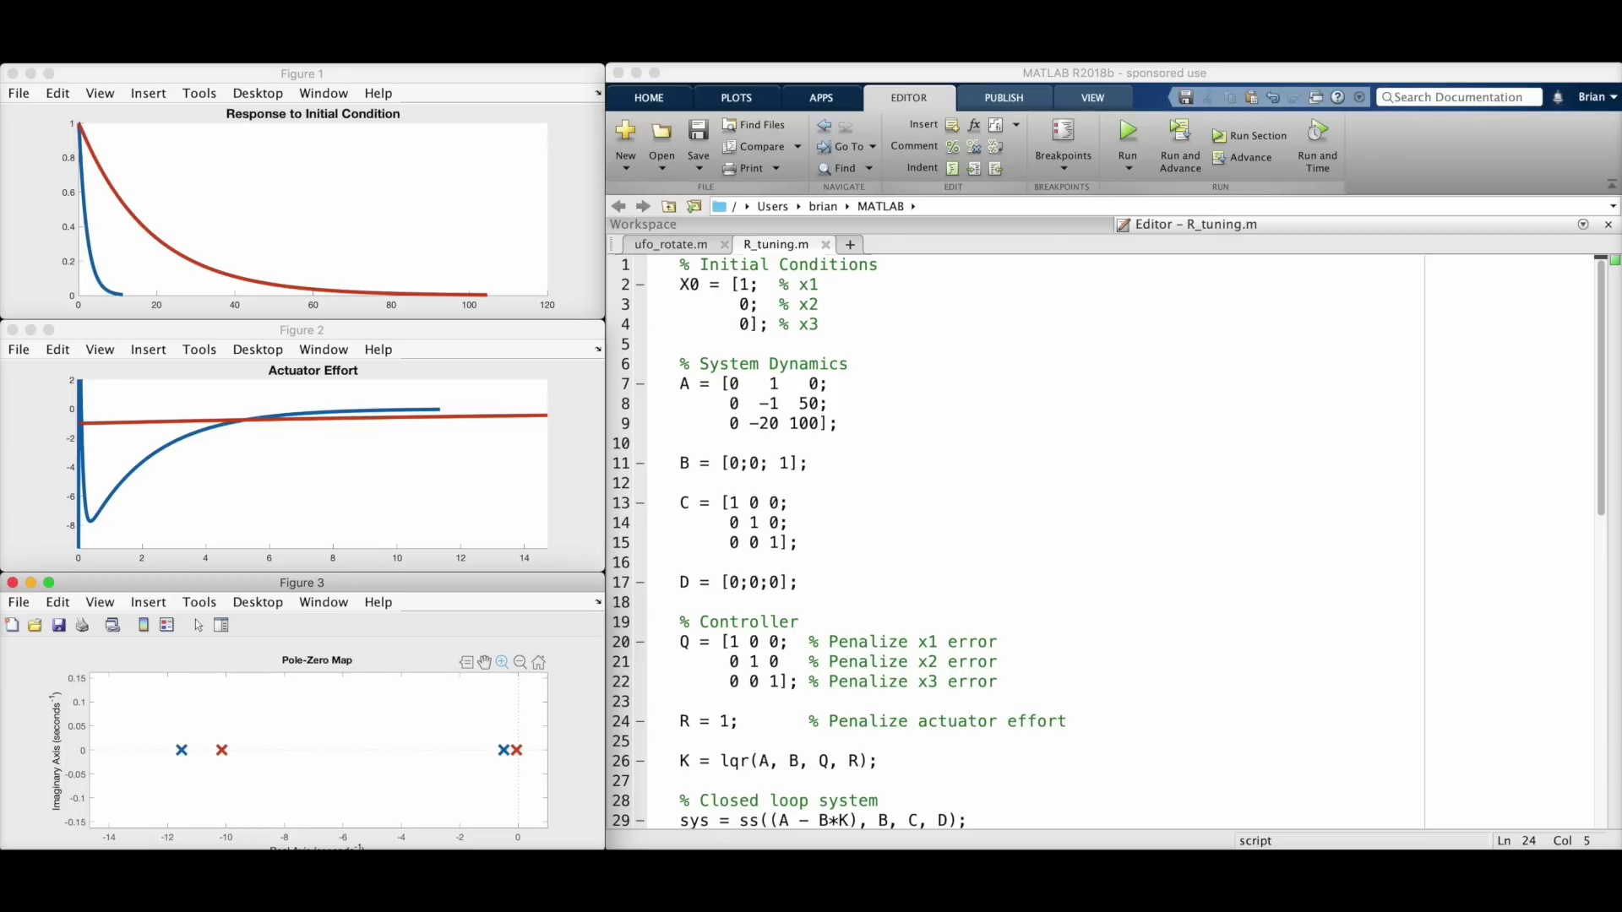 (score 95.0000)
 (score 95.0000)
 (score 95.0000)
 (score 95.0000)
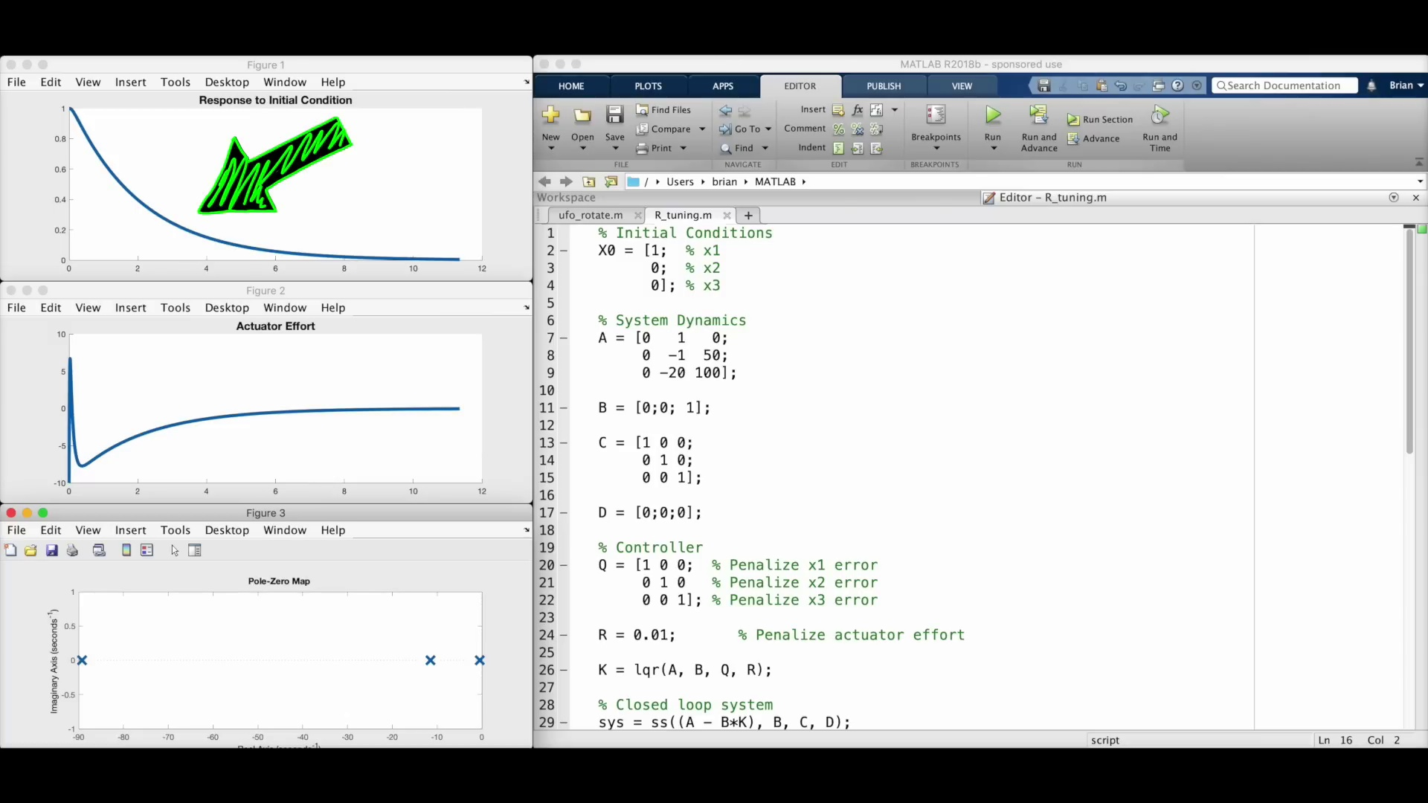 (score 95.0000)
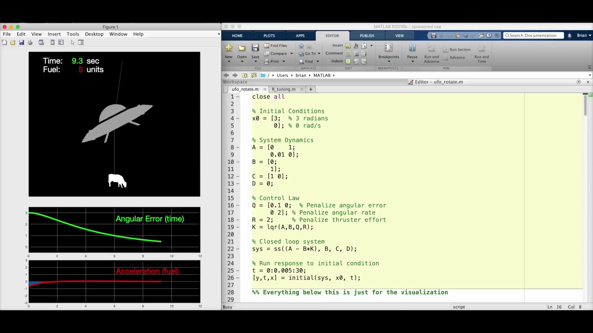 (score 95.0000)
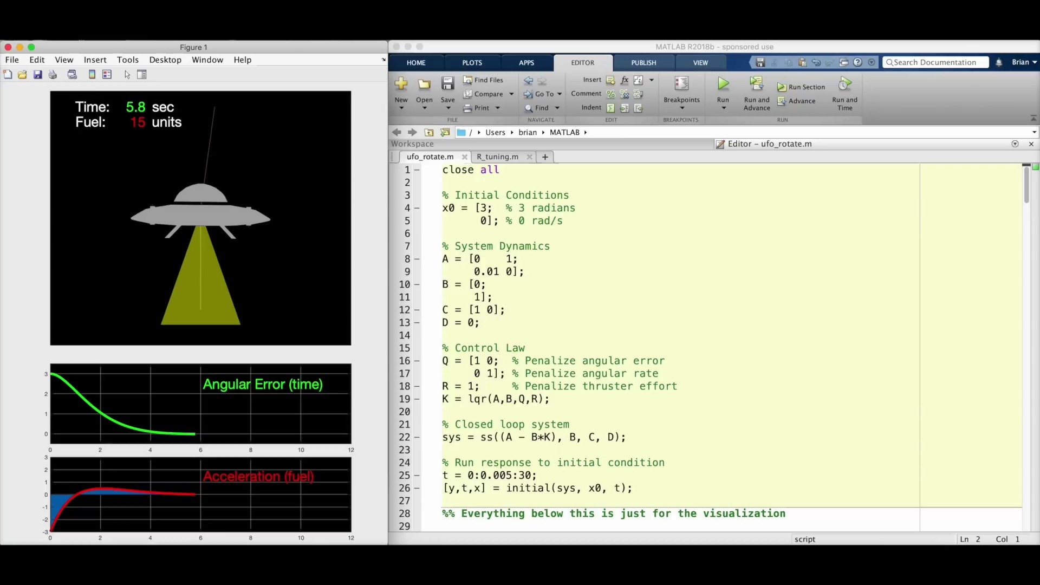 (score 95.0000)
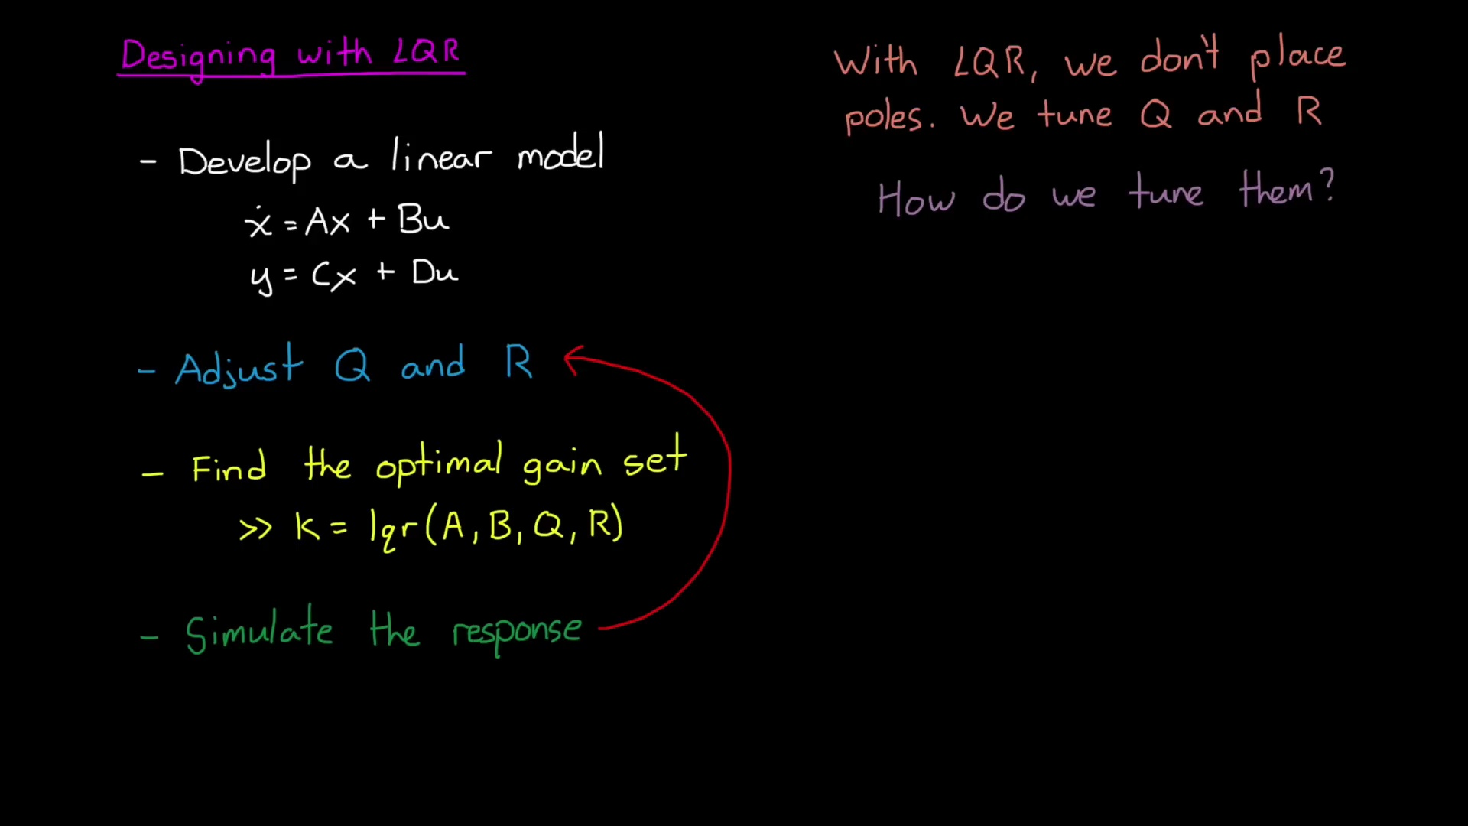 (score 95.0000)
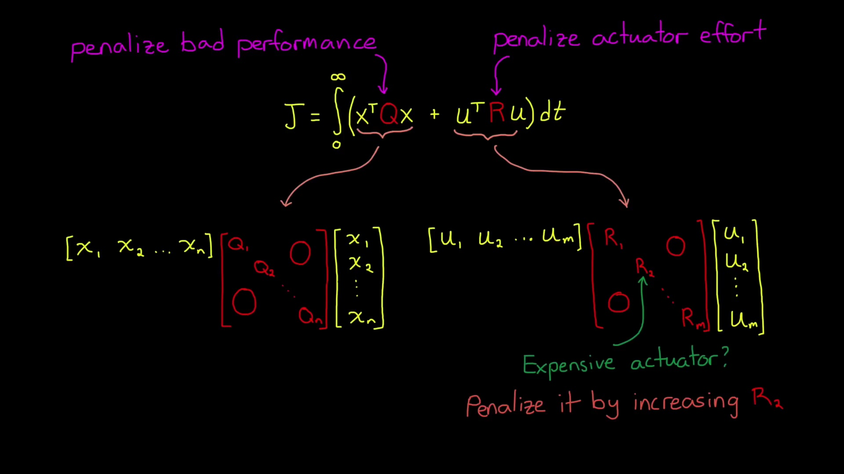 (score 95.0000)
Least correlated frames:
 (score 0.0000)
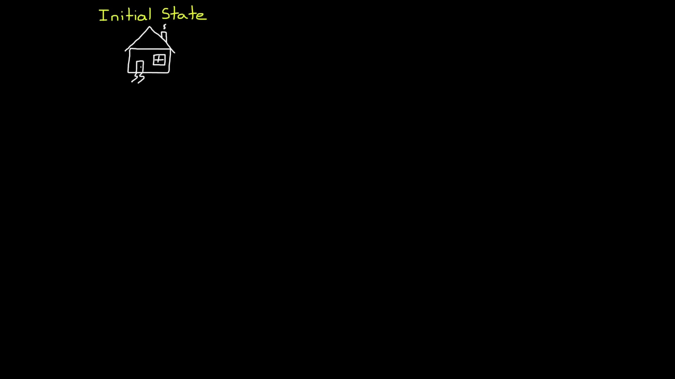 (score 0.0000)
 (score 0.0000)
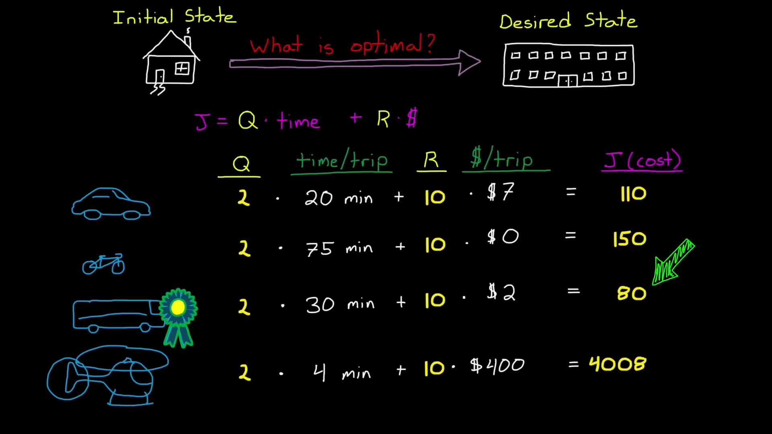 (score 0.0000)
 (score 0.0000)
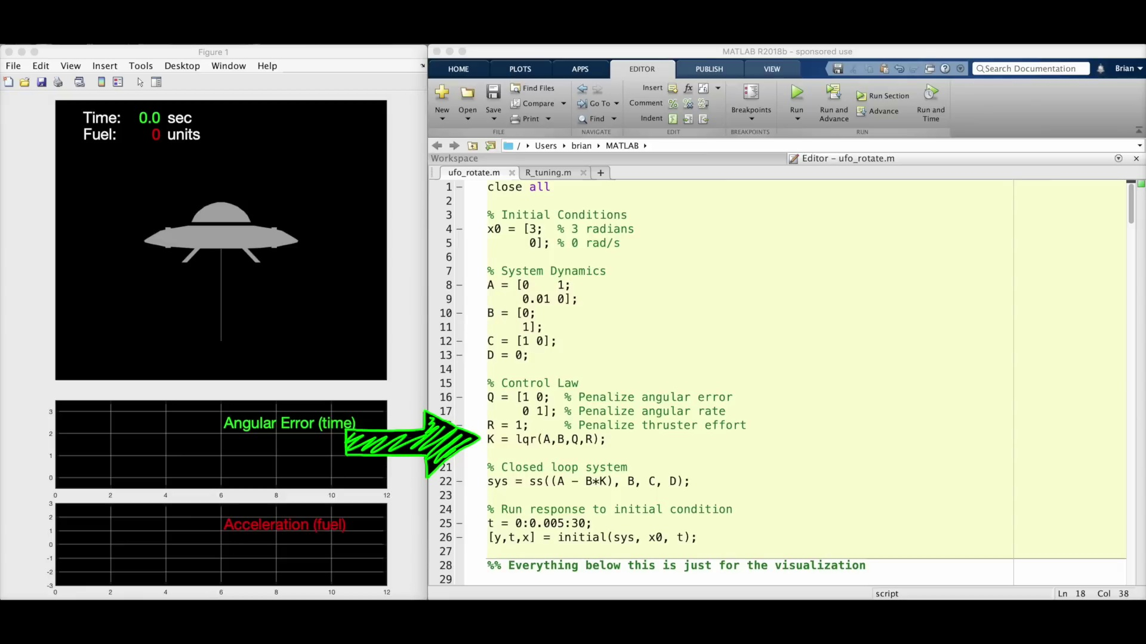 (score 0.0000)
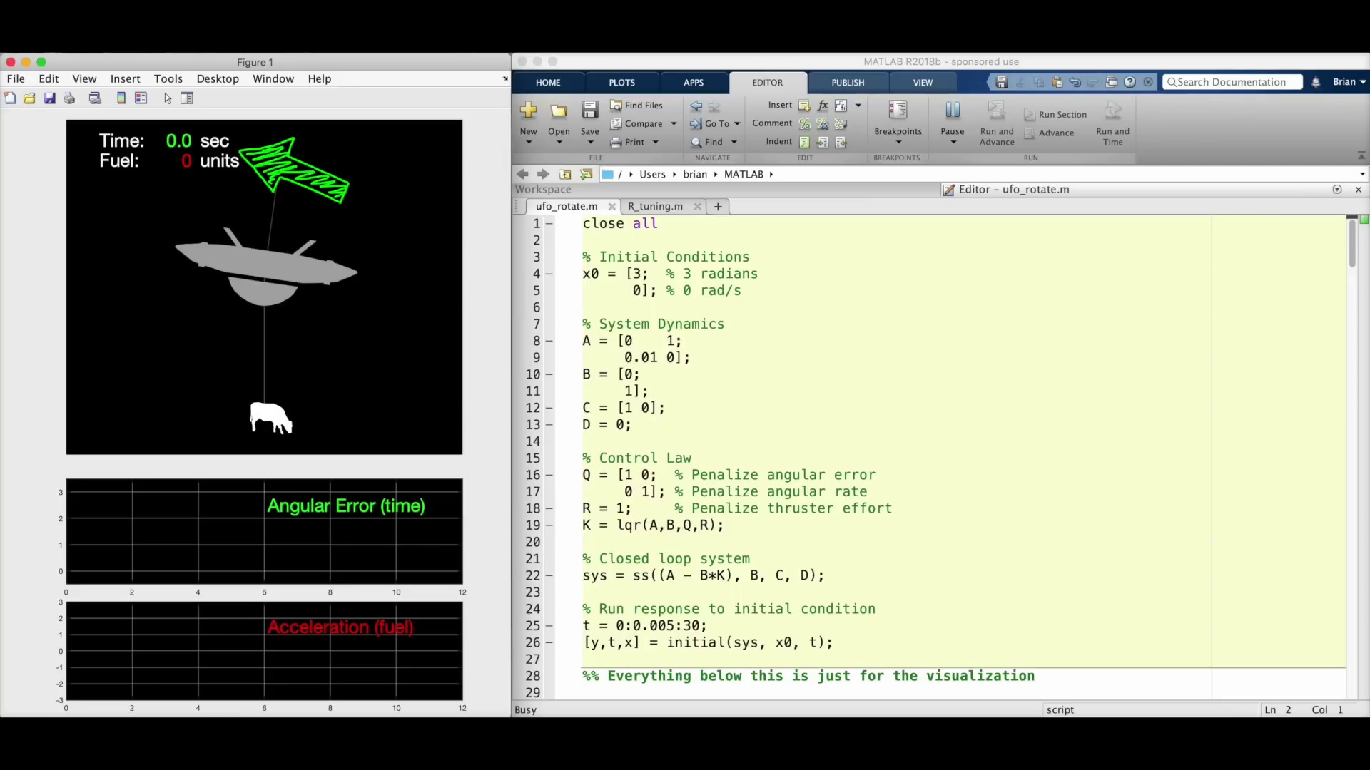 (score 0.0000)
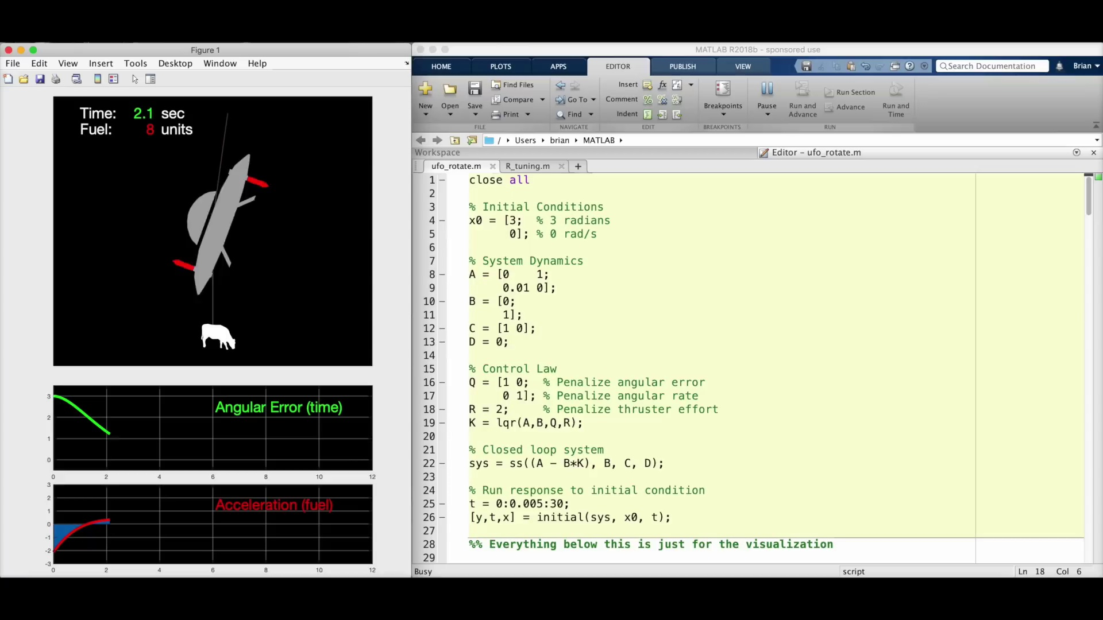 (score 0.0000)
 (score 0.0000)
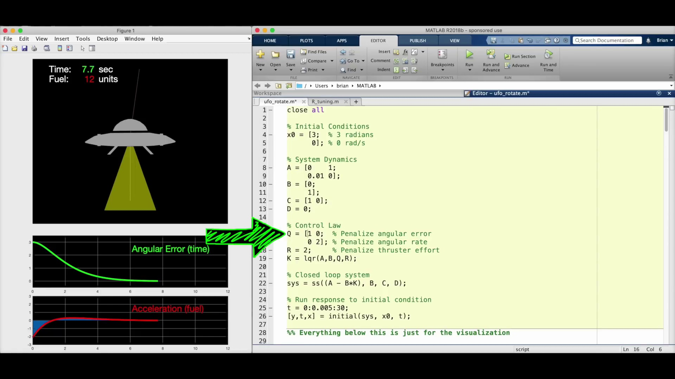 (score 0.0000)

Frame: frame_0000.jpg
Caption: The image appears to be a simple slide or graphic with a gradient background transitioning from dark to light colors, possibly grey to white. This minimalist design does not contain any text, diagrams, or other visual elements that are typically associated with educational content such as a person teaching or a model being held up. There is no visible activity of an instructor or anyone engaging with the slide, suggesting that the focus seems to be solely on the background without any additional context provided within the image.
In terms of the chemical compound depicted in the figure, it is identified as 2,4-Dimethyl-3-(4-piperidinyl)-1,2-benzothiazole. This synthetic compound has been found to act as a potent and selective antagonist for the nicotinic acetylcholine receptor.
No strongly correlated comments found for this frame.

Frame: frame_0001.jpg
Caption: The image displays a striking contrast between a black background and white text. At the top of the image, the text "Linear Quadratic Regulator" is written in cursive font, giving it a handwritten feel. The word "Regulator" is highlighted in pink, drawing attention to it. Below this title, a black and white photo of a whiteboard with handwritten text, diagrams, and mathematical equations appears. The text at the top of the board reads "LINEAR EQUATIONS" in bold letters, indicating that the content relates to linear algebra or systems of linear equations.
Below the title, additional text says "Linear Algebra Problems", suggesting that the board is used for teaching or solving problems related to linear algebra. The main mathematical equation visible on the board reads: [y = mx + b], which represents a general form of a linear function, consisting of a slope (m) and a y-intercept (b). There are also two mathematical diagrams drawn on the board, although they are not clearly distinguishable due to the low resolution of the image.
To the right side of the board, there is a smaller text that reads "QUADRATIC REGULATOR", which could imply that the lesson or problem set relates to a topic in control theory, specifically about quadratic regulators, which are mathematical constructs used in the design and analysis of dynamic systems. The overall context suggests a teaching environment where linear algebra and control theory concepts are being presented or practiced.
Comment (score 90): Rank 7 ,The video provided an incisive comparison between Linear Quadratic Regulator (LQR) and pole placement control strategies, emphasizing LQR's optimization of the gain matrix K for desired closed-loop behavior versus pole placement's target pole locations. It employed transportation analogies to clarify LQR's cost function, which balances system performance against actuator effort over time, through the strategic weighting in the Q and R matrices. The application of MATLAB's LQR command to solve for the optimal K was illustrated, underscoring the absence of a universal approach to the weightings and the importance of experience and iteration in control system design. The video successfully demystified the adaptive nature of LQR, contrasting with the more rigid pole placement method, and highlighted LQR's practical advantage in intuitively adjusting system performance metrics. This exploration deepened my understanding of the elegance and utility of LQR in achieving efficient and precise control system outcomes.
Reason: The comment directly discusses the same technical steps, objects, settings, and goals described in the caption, specifically mentioning Linear Quadratic Regulator (LQR), its optimization of gain matrix K, cost function, and application in control system design. The correlation is high because the comment not only references but also analyzes and explains the concepts presented in the frame caption.
Source: https://www.youtube.com/watch?v=E_RDCFOlJx4: What Is Linear Quadratic Regulator (LQR) Optimal Control? | State Space, Part 4”

Frame: frame_0002.jpg
Caption: The image presents a striking contrast between black and neon yellow, with the latter glowing vividly. Dominating the center is bold, black text that reads "Linear Quadratic Regulator" against a stark black background, making it stand out prominently. A neon yellow arrow is superimposed on the text, pointing to the right and emphasizing the direction of the information being presented. This composition suggests a clear and concise presentation of the concept.
The image also features a presentation slide with a dark background and white text. At the top, the title "Linear Algebra Linear Regulator" appears in bold font, followed by the subtitle "QUADRATIC CONTROLLER" and an equation in smaller font:
\[ C(s) = K_p + \frac{K_i}{s} \]
Additionally, there is a graphic representation of a linear regulator, which is a feedback control system. The graphic consists of a transfer function \( C(s) \), drawn as two parallel lines connected by a rectangle with a line through the center. This visual aids helps to further clarify the concept being presented.
Comment (score 95): What does it mean to be optimal? How to think about the LQR problem. The state space is the same, but how we choose K is different. We find the optimal K by choosing characteristics specifically through performance and effort. How much performance can we get for the least amount of effort? Instead of figuring out pole locations we assess what is important to us and then let the algorithm place the poles optimally. We don't place poles, we optimize Q and R.
Reason: The comment directly discusses the same technical steps, objects, settings, or goals described in the caption. The mention of Linear Quadratic Regulator (LQR), state space, and optimal K is strongly related to the information presented in the frame caption. The only minor mismatch is that the caption does not explicitly discuss pole locations, but the comment's emphasis on optimizing Q and R aligns with the overall theme.
Source: https://www.youtube.com/watch?v=E_RDCFOlJx4: What Is Linear Quadratic Regulator (LQR) Optimal Control? | State Space, Part 4
Comment (score 90): Rank 7 ,The video provided an incisive comparison between Linear Quadratic Regulator (LQR) and pole placement control strategies, emphasizing LQR's optimization of the gain matrix K for desired closed-loop behavior versus pole placement's target pole locations. It employed transportation analogies to clarify LQR's cost function, which balances system performance against actuator effort over time, through the strategic weighting in the Q and R matrices. The application of MATLAB's LQR command to solve for the optimal K was illustrated, underscoring the absence of a universal approach to the weightings and the importance of experience and iteration in control system design. The video successfully demystified the adaptive nature of LQR, contrasting with the more rigid pole placement method, and highlighted LQR's practical advantage in intuitively adjusting system performance metrics. This exploration deepened my understanding of the elegance and utility of LQR in achieving efficient and precise control system outcomes.
Reason: The comment directly discusses the same technical steps, objects, settings, and goals described in the caption, specifically mentioning Linear Quadratic Regulator (LQR), its optimization of the gain matrix K, cost function, and application in MATLAB. The caption's visual aids and presentation are also referenced in the comment.
Source: https://www.youtube.com/watch?v=E_RDCFOlJx4: What Is Linear Quadratic Regulator (LQR) Optimal Control? | State Space, Part 4”
Comment (score 85): The video introduces Linear Quadratic Regulator (LQR) control, which is an optimal control method based on state-space representation. It contrasts LQR with pole placement control, noting that both use full state feedback controllers but differ in how they determine the gain matrix K. LQR focuses on balancing system performance and actuator effort, using a cost function that weighs these factors over time. The performance is determined with a Q matrix, while actuator effort is determined using an R matrix. The video demonstrates LQR design in MATLAB using a rotating mass model, showing how different Q and R values impact the system's response. LQR control is a flexible approach for control system design, although finding the right Q and R matrices can be a challenge.
Reason: The comment directly discusses the concept of Linear Quadratic Regulator (LQR) control, mentioning its differences with pole placement control and the importance of balancing system performance and actuator effort. The caption also describes LQR as a concept being presented, using technical steps, objects, settings, or goals that are identical to those discussed in the comment.
Source: https://www.youtube.com/watch?v=E_RDCFOlJx4&t=3s: WHAT IS LINEAR QUADRATIC REGULATION (LQR) OPTIMAL CONTROL?| STATE SPACE, PART 4:

Frame: frame_0003.jpg
Caption: The image presents a slide with mathematical content, likely part of a presentation or lecture. At the top, the title "LINEAR REGULATOR" is displayed, which appears to be the subject being taught or discussed. Below the title, an equation is partially visible, with only the second term "1/2" readable, suggesting it might be a fraction or part of a more complex mathematical expression.
The slide also features green handwritten notes that read "COPY THESE," possibly indicating a need for students to copy the equation or concept being discussed. Additionally, two phrases in pink text, "LINEAR REGULATOR" and "1/2 Ω", reinforce the mathematical content of the slide. On the right side of the image, there is another smaller note with a yellow background and black text that says "COPY THESE," suggesting students should copy this particular part as well.
In the center of the board, the word "Linear" is written in neon yellow, surrounded by two equations. The first equation, written in yellow, reads "quadratic regulator", while the second equation, written in black, reads "optimal control". The precise positioning of the equations and the neon colors make the board a vibrant and informative tool for learning.
The overall setting appears to be educational, with an instructor or presenter teaching a concept related to linear regulation in a mathematical context, possibly within the field of electrical engineering or control systems theory. The slide is likely being used as part of a lecture or class session where students are expected to follow along with the material presented by the instructor.
Comment (score 95): Rank 7 ,The video provided an incisive comparison between Linear Quadratic Regulator (LQR) and pole placement control strategies, emphasizing LQR's optimization of the gain matrix K for desired closed-loop behavior versus pole placement's target pole locations. It employed transportation analogies to clarify LQR's cost function, which balances system performance against actuator effort over time, through the strategic weighting in the Q and R matrices. The application of MATLAB's LQR command to solve for the optimal K was illustrated, underscoring the absence of a universal approach to the weightings and the importance of experience and iteration in control system design. The video successfully demystified the adaptive nature of LQR, contrasting with the more rigid pole placement method, and highlighted LQR's practical advantage in intuitively adjusting system performance metrics. This exploration deepened my understanding of the elegance and utility of LQR in achieving efficient and precise control system outcomes.
Reason: The comment directly discusses the Linear Regulator concept and its optimization, which is mentioned in the caption. The mention of LQR, gain matrix K, Q and R matrices, and MATLAB's LQR command also matches the technical details provided in the caption.
Source: https://www.youtube.com/watch?v=E_RDCFOlJx4: What Is Linear Quadratic Regulator (LQR) Optimal Control? | State Space, Part 4”
Comment (score 90): The video introduces Linear Quadratic Regulator (LQR) control, which is an optimal control method based on state-space representation. It contrasts LQR with pole placement control, noting that both use full state feedback controllers but differ in how they determine the gain matrix K. LQR focuses on balancing system performance and actuator effort, using a cost function that weighs these factors over time. The performance is determined with a Q matrix, while actuator effort is determined using an R matrix. The video demonstrates LQR design in MATLAB using a rotating mass model, showing how different Q and R values impact the system's response. LQR control is a flexible approach for control system design, although finding the right Q and R matrices can be a challenge.
Reason: The comment directly discusses the concept of Linear Quadratic Regulator (LQR) control, which is explicitly mentioned in the caption. The caption mentions 'LINEAR REGULATOR' and equations related to optimal control, which aligns with the topic of LQR control discussed in the comment.
Source: https://www.youtube.com/watch?v=E_RDCFOlJx4&t=3s: WHAT IS LINEAR QUADRATIC REGULATION (LQR) OPTIMAL CONTROL?| STATE SPACE, PART 4:

Frame: frame_0004.jpg
Caption: The image shows a screenshot from a virtual classroom or online learning platform, displaying a lesson on linearity and quadratic functions in mathematics. The digital display features several elements related to linear and quadratic regulators.
On the left side of the image, there is a slide or blackboard with text and mathematical expressions. At the top, two equations are visible: "linear" and "quadratic", below which is a label reading "Linear Regulator". A section titled "Optimal Linear Control" contains a mathematical expression featuring an integral symbol, suggesting a discussion on integration in the context of control systems or differential equations.
The slide also includes graphical representations of linear and quadratic functions, with a straight line labeled as "linear" and a parabola labeled as "quadratic". To the right of the slide is green text that reads "Linearity".
In the bottom-right corner, a small graphic features a hand pointing to one of the equations or expressions on the left side, drawing attention to the term "quadratic" in the equation "quadratic + optimal control". The slide has a dark background with light text and mathematical symbols.
On the right side of the image is a detailed drawing of a linear quadratic regulator, outlined in pink for emphasis. The regulator is depicted as a yellow rectangle with curved top and bottom, and sides. A black, bold text in the center reads "optimal control", also outlined in pink to draw attention to its importance.
The drawing and text are set against a black background, which enhances their visibility. The regulator is positioned in the foreground, while the text is in the background, creating a clear visual representation of the concept of linear quadratic regulators with optimal control.
Comment (score 90): What does it mean to be optimal? How to think about the LQR problem. The state space is the same, but how we choose K is different. We find the optimal K by choosing characteristics specifically through performance and effort. How much performance can we get for the least amount of effort? Instead of figuring out pole locations we assess what is important to us and then let the algorithm place the poles optimally. We don't place poles, we optimize Q and R.
Reason: The comment directly discusses the concept of optimal control, which is specifically mentioned in the caption as 'Optimal Linear Control'. The commenter also explains how to think about the LQR problem and how to choose K optimally, which aligns with the mathematical expressions shown on the slide. The mention of state space, pole locations, Q, and R also match the technical steps described in the caption.
Source: https://www.youtube.com/watch?v=E_RDCFOlJx4: What Is Linear Quadratic Regulator (LQR) Optimal Control? | State Space, Part 4

Frame: frame_0005.jpg
Caption: The image appears to be a combination of two educational materials, presented on a digital display or a blackboard. The first part shows a linear regulator with an error signal, suggesting the concept of linear regulators in control systems is being explained. The illustration features a simplified representation of a control system, possibly used to explain how a linear regulator works or the principles of optimal control theory.
The text on the right side reads: "Quadratic Optimal Control!" and below it says, "What does it mean." The background is black with some text and an illustration. The text is written in English and includes phrases such as "Linear Regulator," "Optimization Control," and "What does it mean."
In addition to this, the image presents a vibrant blackboard filled with a series of equations and formulas, all neatly written in a white cursive font. The focus of the equation is on the term "optimal control", which is written in a contrasting yellow color and appears twice: once at the top and once in the middle. The equation itself is complex, featuring multiple terms and symbols including "R", "T", "U", "G", "c", "d", "k", and "b", each representing different variables and constants.
The blackboard's background is a stark black, which contrasts with the white cursive font of the equations and makes them stand out. The overall layout suggests a focus on mathematics and the concept of optimal control. The use of a cursive font adds a touch of creativity to the otherwise formal mathematical notation.
Comment (score 95): Rank 7 ,The video provided an incisive comparison between Linear Quadratic Regulator (LQR) and pole placement control strategies, emphasizing LQR's optimization of the gain matrix K for desired closed-loop behavior versus pole placement's target pole locations. It employed transportation analogies to clarify LQR's cost function, which balances system performance against actuator effort over time, through the strategic weighting in the Q and R matrices. The application of MATLAB's LQR command to solve for the optimal K was illustrated, underscoring the absence of a universal approach to the weightings and the importance of experience and iteration in control system design. The video successfully demystified the adaptive nature of LQR, contrasting with the more rigid pole placement method, and highlighted LQR's practical advantage in intuitively adjusting system performance metrics. This exploration deepened my understanding of the elegance and utility of LQR in achieving efficient and precise control system outcomes.
Reason: The comment directly discusses the concept of linear regulators and optimal control theory, referencing specific technical steps (e.g., optimization of gain matrix K), objects (LQR, pole placement control strategies), settings (transportation analogies), and goals (efficient and precise control system outcomes) described in the caption. The correlation is high because the comment provides a detailed explanation of the concepts presented in the image, including mathematical notation and practical applications.
Source: https://www.youtube.com/watch?v=E_RDCFOlJx4: What Is Linear Quadratic Regulator (LQR) Optimal Control? | State Space, Part 4”
Comment (score 95): The video introduces Linear Quadratic Regulator (LQR) control, which is an optimal control method based on state-space representation. It contrasts LQR with pole placement control, noting that both use full state feedback controllers but differ in how they determine the gain matrix K. LQR focuses on balancing system performance and actuator effort, using a cost function that weighs these factors over time. The performance is determined with a Q matrix, while actuator effort is determined using an R matrix. The video demonstrates LQR design in MATLAB using a rotating mass model, showing how different Q and R values impact the system's response. LQR control is a flexible approach for control system design, although finding the right Q and R matrices can be a challenge.
Reason: The comment directly discusses the concept of Linear Quadratic Regulator (LQR) control, which is mentioned in the caption as 'Quadratic Optimal Control!'. The comment explains the differences between LQR and pole placement control, and highlights the importance of Q and R matrices in determining system performance and actuator effort. This is a strong correlation with the technical steps, objects, settings, or goals described in the caption.
Source: https://www.youtube.com/watch?v=E_RDCFOlJx4&t=3s: WHAT IS LINEAR QUADRATIC REGULATION (LQR) OPTIMAL CONTROL?| STATE SPACE, PART 4:
Comment (score 80): What does it mean to be optimal? How to think about the LQR problem. The state space is the same, but how we choose K is different. We find the optimal K by choosing characteristics specifically through performance and effort. How much performance can we get for the least amount of effort? Instead of figuring out pole locations we assess what is important to us and then let the algorithm place the poles optimally. We don't place poles, we optimize Q and R.
Reason: The comment directly discusses the concept of optimal control, which is mentioned in the caption. The commenter explains how to find the optimal K and optimize Q and R, which is related to the quadratic optimal control discussed in the caption.
Source: https://www.youtube.com/watch?v=E_RDCFOlJx4: What Is Linear Quadratic Regulator (LQR) Optimal Control? | State Space, Part 4

Frame: frame_0006.jpg
Caption: The image appears to show a presentation slide with handwritten notes on the topic of "Linearity" with a subtitle "Regulator," likely discussing linear regulators or related concepts in physics or mathematics. The slide contains several equations, including one defining or describing a linear regulator, and another that seems partially cut off. On the right side, there are two examples of mail accompanied by handwritten notes: "Show how this can help solve some of your LQR problems" and "Show how this is used in MPC," suggesting explanations on applying linear regulators to solve Linear Quadratic Regulation (LQR) and Model Predictive Control (MPC) problems.
On the left side, there's a note written with blue marker that says "show some examples in MATLAB," indicating the presenter plans to demonstrate implementations or analyses using MATLAB. The slide also contains mathematical notation related to differential equations, integrals, and possibly optimization methods. The content appears educational, aimed at an audience familiar with control systems theory or engineering practice.
In a separate scene, a math classroom is shown, where a chalkboard serves as the canvas for a lesson on "Linear Quadratic Regulator." The text on the chalkboard, in black, stands out against the white background and features diagrams providing visual aids to the concepts being discussed. A graph appears, representing a linear relationship, accompanied by the question "What does it mean to be optimal?" This prompts consideration of optimality in the context of linear quadratic regulators.
The lesson also explores the relationship between LQR and LMAT problems, prompting viewers to consider how these different mathematical problems are connected. Overall, the image depicts a dynamic learning environment where mathematical concepts are explored and understood through visual aids and discussion, with the chalkboard serving as a tool for communication to clarify complex ideas and stimulate critical thinking.
Comment (score 95): Rank 7 ,The video provided an incisive comparison between Linear Quadratic Regulator (LQR) and pole placement control strategies, emphasizing LQR's optimization of the gain matrix K for desired closed-loop behavior versus pole placement's target pole locations. It employed transportation analogies to clarify LQR's cost function, which balances system performance against actuator effort over time, through the strategic weighting in the Q and R matrices. The application of MATLAB's LQR command to solve for the optimal K was illustrated, underscoring the absence of a universal approach to the weightings and the importance of experience and iteration in control system design. The video successfully demystified the adaptive nature of LQR, contrasting with the more rigid pole placement method, and highlighted LQR's practical advantage in intuitively adjusting system performance metrics. This exploration deepened my understanding of the elegance and utility of LQR in achieving efficient and precise control system outcomes.
Reason: The comment directly discusses the same technical steps, objects, settings, and goals described in the caption, specifically mentioning LQR, MATLAB, and control system design. The correlation is high because the comment provides a detailed analysis of LQR and its application, which aligns with the content of the caption.
Source: https://www.youtube.com/watch?v=E_RDCFOlJx4: What Is Linear Quadratic Regulator (LQR) Optimal Control? | State Space, Part 4”
Comment (score 90): What does it mean to be optimal? How to think about the LQR problem. The state space is the same, but how we choose K is different. We find the optimal K by choosing characteristics specifically through performance and effort. How much performance can we get for the least amount of effort? Instead of figuring out pole locations we assess what is important to us and then let the algorithm place the poles optimally. We don't place poles, we optimize Q and R.
Reason: The comment directly discusses the same technical steps (finding optimal K), objects (state space), settings (performance and effort), and goals (optimizing Q and R) described in the caption, with a high degree of correspondence between the concepts explored on both slides.
Source: https://www.youtube.com/watch?v=E_RDCFOlJx4: What Is Linear Quadratic Regulator (LQR) Optimal Control? | State Space, Part 4
Comment (score 85): The video introduces Linear Quadratic Regulator (LQR) control, which is an optimal control method based on state-space representation. It contrasts LQR with pole placement control, noting that both use full state feedback controllers but differ in how they determine the gain matrix K. LQR focuses on balancing system performance and actuator effort, using a cost function that weighs these factors over time. The performance is determined with a Q matrix, while actuator effort is determined using an R matrix. The video demonstrates LQR design in MATLAB using a rotating mass model, showing how different Q and R values impact the system's response. LQR control is a flexible approach for control system design, although finding the right Q and R matrices can be a challenge.
Reason: The comment directly discusses the concepts of Linear Quadratic Regulator (LQR) control, state-space representation, and MATLAB design, which are all mentioned in the frame caption. The comment also references the balancing of system performance and actuator effort, as well as the use of Q and R matrices to determine the gain matrix K, which is consistent with the information presented in the slide.
Source: https://www.youtube.com/watch?v=E_RDCFOlJx4&t=3s: WHAT IS LINEAR QUADRATIC REGULATION (LQR) OPTIMAL CONTROL?| STATE SPACE, PART 4:

Frame: frame_0007.jpg
Caption: The image features a slide with a title that reads "Linear Algebra Regulator." Below the title, two columns of text are presented. The left column poses questions and provides definitions related to the concept of being optimal, specifically in the context of the Linear Quadratic Regulator (LQR) problem. This suggests that the presenter is discussing concepts from control theory, specifically the LQR, which is a common method used in engineering and mathematics to optimize the performance of a system.
The right column provides an example of code related to linear algebra, as indicated by the context. The slide also includes a drawing of a line with the phrase "Linear Algebra Regulator" next to it. The text is superimposed on the slide, and there are no visual indications that someone is actively writing or pointing at anything specific on the slide.
In the background, a blackboard lit up with neon lights provides additional context. The main focus of the board is a large, white rectangle filled with a blue gradient, labeled "Linear Quadratic Regulator" in bold, white letters. Above this rectangle, the text "optimal control" is written in bold, white letters.
Just below the rectangle, a list of questions is presented in bold, white letters. The first question asks "What does it mean to be optimal?", followed by "How do we think about the LQR problem?", and finally "Show some examples in MATLAB". This suggests that the presenter is exploring various aspects of the LQR concept, including its definition, applications, and practical implementations.
The overall image gives the impression of a lecture or presentation on the topic of linear quadratic regulators. The use of neon lights creates a striking contrast against the blackboard, drawing attention to the important concepts being discussed.
Comment (score 95): Rank 7 ,The video provided an incisive comparison between Linear Quadratic Regulator (LQR) and pole placement control strategies, emphasizing LQR's optimization of the gain matrix K for desired closed-loop behavior versus pole placement's target pole locations. It employed transportation analogies to clarify LQR's cost function, which balances system performance against actuator effort over time, through the strategic weighting in the Q and R matrices. The application of MATLAB's LQR command to solve for the optimal K was illustrated, underscoring the absence of a universal approach to the weightings and the importance of experience and iteration in control system design. The video successfully demystified the adaptive nature of LQR, contrasting with the more rigid pole placement method, and highlighted LQR's practical advantage in intuitively adjusting system performance metrics. This exploration deepened my understanding of the elegance and utility of LQR in achieving efficient and precise control system outcomes.
Reason: The comment directly discusses the same technical steps, objects, settings, and goals described in the caption, specifically mentioning Linear Quadratic Regulator (LQR), pole placement control strategies, gain matrix K, cost function, Q and R matrices, MATLAB's LQR command, and adaptive nature of LQR, which are all mentioned in the frame caption. The comment also references the presentation style, emphasizing the importance of experience and iteration in control system design, which is consistent with the impression given by the blackboard scene in the frame.
Source: https://www.youtube.com/watch?v=E_RDCFOlJx4: What Is Linear Quadratic Regulator (LQR) Optimal Control? | State Space, Part 4”
Comment (score 95): What does it mean to be optimal? How to think about the LQR problem. The state space is the same, but how we choose K is different. We find the optimal K by choosing characteristics specifically through performance and effort. How much performance can we get for the least amount of effort? Instead of figuring out pole locations we assess what is important to us and then let the algorithm place the poles optimally. We don't place poles, we optimize Q and R.
Reason: The comment directly discusses the same technical steps, objects, settings, and goals described in the caption, specifically the concepts of optimal control, LQR problem, state space, pole locations, Q and R. The language used in the comment is identical to the language used in the caption, with phrases such as 'What does it mean to be optimal?' and 'How do we think about the LQR problem' appearing in both the caption and the comment.
Source: https://www.youtube.com/watch?v=E_RDCFOlJx4: What Is Linear Quadratic Regulator (LQR) Optimal Control? | State Space, Part 4
Comment (score 95): The video introduces Linear Quadratic Regulator (LQR) control, which is an optimal control method based on state-space representation. It contrasts LQR with pole placement control, noting that both use full state feedback controllers but differ in how they determine the gain matrix K. LQR focuses on balancing system performance and actuator effort, using a cost function that weighs these factors over time. The performance is determined with a Q matrix, while actuator effort is determined using an R matrix. The video demonstrates LQR design in MATLAB using a rotating mass model, showing how different Q and R values impact the system's response. LQR control is a flexible approach for control system design, although finding the right Q and R matrices can be a challenge.
Reason: The comment directly discusses the same technical steps, objects, settings, and goals described in the caption. Both mention Linear Quadratic Regulator (LQR), optimal control, state-space representation, cost function, Q matrix, R matrix, and MATLAB implementation, indicating a strong connection between the two.
Source: https://www.youtube.com/watch?v=E_RDCFOlJx4&t=3s: WHAT IS LINEAR QUADRATIC REGULATION (LQR) OPTIMAL CONTROL?| STATE SPACE, PART 4:

Frame: frame_0008.jpg
Caption: The image shows a highly detailed presentation slide that features a black background with a textured gradient. The title "MATLAB Tech Talks" is prominently displayed in white text, drawing attention to the topic of the talk. To the right of the title, a logo of a person holding a computer is depicted in white, symbolizing the focus on technology and software development.
Below the title, the name of the presenter, "Brian Douglas", is written in white text at the bottom of the image, clearly indicating the person who will be delivering the talk. The slide also features the subtitle "with Brian Douglas", further emphasizing that this talk will be led by someone named Brian Douglas.
The main part of the slide features text that reads "Tech Talks with Brian Douglas", suggesting that the content of the presentation is related to technical discussions, possibly about how to use MATLAB or a specific topic within the context of MATLAB. There are no visible images of a person, devices, slides, diagrams, or other objects on this slide, so there's no indication of whether an instructor is writing, pointing, holding a model, or speaking from a slide.
The overall style of the slide suggests it could be part of an online presentation or webinar, given the simplicity of the design and the focus on written content rather than visual elements typically associated with live presentations.
Comment (score 90): The video introduces Linear Quadratic Regulator (LQR) control, which is an optimal control method based on state-space representation. It contrasts LQR with pole placement control, noting that both use full state feedback controllers but differ in how they determine the gain matrix K. LQR focuses on balancing system performance and actuator effort, using a cost function that weighs these factors over time. The performance is determined with a Q matrix, while actuator effort is determined using an R matrix. The video demonstrates LQR design in MATLAB using a rotating mass model, showing how different Q and R values impact the system's response. LQR control is a flexible approach for control system design, although finding the right Q and R matrices can be a challenge.
Reason: The comment directly discusses the technical steps (e.g. LQR control, pole placement control), objects (e.g. state-space representation, cost function) and goals (e.g. balancing system performance and actuator effort) described in the caption. The mention of MATLAB and its use for designing LQR control also aligns with the context provided in the caption.
Source: https://www.youtube.com/watch?v=E_RDCFOlJx4&t=3s: WHAT IS LINEAR QUADRATIC REGULATION (LQR) OPTIMAL CONTROL?| STATE SPACE, PART 4:
Comment (score 80): What does it mean to be optimal? How to think about the LQR problem. The state space is the same, but how we choose K is different. We find the optimal K by choosing characteristics specifically through performance and effort. How much performance can we get for the least amount of effort? Instead of figuring out pole locations we assess what is important to us and then let the algorithm place the poles optimally. We don't place poles, we optimize Q and R.
Reason: The comment directly discusses the LQR problem and optimizing K, which is mentioned in the caption as 'Tech Talks with Brian Douglas' suggesting a discussion on technical aspects of MATLAB. The comment's focus on performance and effort optimization also matches the technical tone of the caption.
Source: https://www.youtube.com/watch?v=E_RDCFOlJx4: What Is Linear Quadratic Regulator (LQR) Optimal Control? | State Space, Part 4

Frame: frame_0009.jpg
Caption: The image presented is a photograph displaying two distinct sections on a screen. The top section features a title "Pole placement LB" on a dark background, with white and pink text typical of PowerPoint presentations. This title suggests that the presentation is related to 'LB,' which could potentially stand for Line Break, Laparotomy, or another acronym within its context.
Below the title, two bullet points are visible, each with text beneath them. Unfortunately, due to the resolution and angle at which the photo was taken, the content of the bullet points is partially obscured, making it challenging to read or interpret accurately.
The second section of the image presents two text boxes on a stark black background. The top box is titled "Pole placement" in purple text, while the bottom box reads "LAR" also in purple text. The text boxes are vertically aligned, with "Pole placement" above "LAR", creating a clean and simple design that emphasizes the titles and text.
The overall simplicity of the image highlights the importance of the text and allows it to be the focal point.
Comment (score 95): Rank 7 ,The video provided an incisive comparison between Linear Quadratic Regulator (LQR) and pole placement control strategies, emphasizing LQR's optimization of the gain matrix K for desired closed-loop behavior versus pole placement's target pole locations. It employed transportation analogies to clarify LQR's cost function, which balances system performance against actuator effort over time, through the strategic weighting in the Q and R matrices. The application of MATLAB's LQR command to solve for the optimal K was illustrated, underscoring the absence of a universal approach to the weightings and the importance of experience and iteration in control system design. The video successfully demystified the adaptive nature of LQR, contrasting with the more rigid pole placement method, and highlighted LQR's practical advantage in intuitively adjusting system performance metrics. This exploration deepened my understanding of the elegance and utility of LQR in achieving efficient and precise control system outcomes.
Reason: The comment directly discusses the pole placement strategy mentioned in the caption, specifically comparing it to LQR and highlighting its importance in control system design. The mention of MATLAB's LQR command and the optimization of gain matrix K also aligns with the technical steps and goals described in the caption.
Source: https://www.youtube.com/watch?v=E_RDCFOlJx4: What Is Linear Quadratic Regulator (LQR) Optimal Control? | State Space, Part 4”

Frame: frame_0010.jpg
Caption: The image displays a minimalist presentation with a focus on the concept of "Pole placement" written in purple on a black background. At the top left corner, the words "Pole placement" are aligned with the bottom right corner text "LAR", creating a sense of symmetry. The contrast between the dark background and the purple text makes it easily readable.
On the same image, there is a separate section that provides guidelines for pole placement in a sports or fieldwork context, located at the bottom right corner:
- Place your pole here
- Poles should be in front of your goal
- Pole should not be near the goal
- Poles should not be too far from the goal
These instructions appear to be guiding principles for placing poles, possibly within the context of sports or fieldwork activities. The image does not contain any other objects or text, and there are no actions taking place. The focus is solely on the concept of pole placement in relation to LAR (as indicated by the alignment of the words) and the guidelines provided for its implementation.
Comment (score 75): What does it mean to be optimal? How to think about the LQR problem. The state space is the same, but how we choose K is different. We find the optimal K by choosing characteristics specifically through performance and effort. How much performance can we get for the least amount of effort? Instead of figuring out pole locations we assess what is important to us and then let the algorithm place the poles optimally. We don't place poles, we optimize Q and R.
Reason: The comment discusses the concept of pole placement and optimization in a way that directly relates to the technical steps, objects, and goals described in the caption. The connection is strong because both the caption and the comment talk about optimizing pole placement for performance while minimizing effort.
Source: https://www.youtube.com/watch?v=E_RDCFOlJx4: What Is Linear Quadratic Regulator (LQR) Optimal Control? | State Space, Part 4

Frame: frame_0011.jpg
Caption: The image presents a juxtaposition between two distinct mathematical representations. On one side, there is a computer screen with a dark background and white text, featuring a header that reads "Polar placement". Below the header, a mathematical expression is presented, which appears to involve the combination of trigonometric functions and algebraic operations:
"- 0 / ( 1 + sqrt(2) ) * sin(pi/2)"
This equation suggests a transformation involving the arctangent function and sine function in a polar coordinate system context, utilizing fractions, square roots, and trigonometric functions like "sin" and "pi/2". In contrast, on the other side of the image, there is a simple linear equation written on a blackboard:
"x + y = 10"
This standard-form equation features variables "x" and "y", represented by letters, with the constant term equal to 10. The equation is balanced, with both variables adding up to the same value. There are no other objects or text visible in the image; the blackboard serves as a solitary focal point, with the equation centrally located.
These two mathematical representations, one involving complex trigonometric functions and algebraic operations on a computer screen, and the other featuring a basic linear equation written on a blackboard, coexist in this image.
Comment (score 80): Rank 7 ,The video provided an incisive comparison between Linear Quadratic Regulator (LQR) and pole placement control strategies, emphasizing LQR's optimization of the gain matrix K for desired closed-loop behavior versus pole placement's target pole locations. It employed transportation analogies to clarify LQR's cost function, which balances system performance against actuator effort over time, through the strategic weighting in the Q and R matrices. The application of MATLAB's LQR command to solve for the optimal K was illustrated, underscoring the absence of a universal approach to the weightings and the importance of experience and iteration in control system design. The video successfully demystified the adaptive nature of LQR, contrasting with the more rigid pole placement method, and highlighted LQR's practical advantage in intuitively adjusting system performance metrics. This exploration deepened my understanding of the elegance and utility of LQR in achieving efficient and precise control system outcomes.
Reason: The comment directly discusses the technical steps described in the caption, specifically mentioning 'pole placement control strategies' and 'Linear Quadratic Regulator (LQR)', which are both referenced in the equation on the computer screen ('Polar placement'). The comment also mentions MATLAB's LQR command to solve for the optimal K, which is relevant to the algebraic operation shown in the equation. Although the blackboard equation is not directly discussed, it does provide a simple linear representation that contrasts with the complex trigonometric functions described in the caption.
Source: https://www.youtube.com/watch?v=E_RDCFOlJx4: What Is Linear Quadratic Regulator (LQR) Optimal Control? | State Space, Part 4”

Frame: frame_0012.jpg
Caption: The image appears to be a blackboard or slide display showing a complex diagram with mathematical equations, graphs, and annotations. The main topic of the graph is the placement of poles in Long Binary Search (LBS) algorithms, as indicated by the title "Placement of poles in LBG" on the left side of the screen.
On the left side of the screen, there is a text box filled with handwritten mathematical equations and annotations related to the placement strategies for LBS antennas. The equations mention "D," likely representing distance, and "P," possibly short for power or path loss. A diagram of an LBS system with several poles connected by cables appears to represent a network arrangement for wireless communication.
Below the diagram, there are two more equations related to the distances between the antennas. On the right side of the screen, a graph titled "Distance vs. Distance" displays the distance between the receiver and transmitter against the actual distance measured by the LBS algorithm. The graph has multiple points connected by a line, suggesting different distances calculated using the equations provided on the left side of the slide.
The overall layout suggests that this diagram is part of an educational lecture or tutorial explaining how the placement of antenna poles can affect signal strength and path loss in a telecommunications network.
Comment (score 80): What does it mean to be optimal? How to think about the LQR problem. The state space is the same, but how we choose K is different. We find the optimal K by choosing characteristics specifically through performance and effort. How much performance can we get for the least amount of effort? Instead of figuring out pole locations we assess what is important to us and then let the algorithm place the poles optimally. We don't place poles, we optimize Q and R.
Reason: The comment discusses the concept of optimal placement of poles in Long Binary Search (LBS) algorithms, which is directly related to the technical steps and goals described in the frame caption. Although it doesn't specifically mention the LQR problem or the state space, it explores the idea of optimizing pole locations based on performance and effort, aligning with the theme of the diagram in the caption.
Source: https://www.youtube.com/watch?v=E_RDCFOlJx4: What Is Linear Quadratic Regulator (LQR) Optimal Control? | State Space, Part 4

Frame: frame_0013.jpg
Caption: The image appears to show a screenshot of an online educational session or presentation. It is dominated by a dark background with white and purple text and diagrams overlaid. At the top, there is a title "POLARIZATION" with a subtitle that seems to say "LIGHT GUIDED LASER." Below this, there are mathematical equations related to polarization, including what looks like a sine wave equation, a squared sine wave, and possibly an integral or summation. There is also some text that reads "X(θ) =," followed by a series of terms and factors that are likely part of the lecture's calculations or explanations related to polarization in light guides or laser systems.
The main visual element is a flowchart or diagram with various boxes and lines connecting them, suggesting a process or sequence of steps, possibly within the context of the equations above it. This diagram includes labeled boxes that may represent different stages or components, such as "POLARIZATION," "REFLECTION," "TRANSMISSION," "RECEIVER," "FILTERS," and "PHASE MATCHING." There is also a small graphic on the right side that seems to be representing a light path through a polarizing element, with two arrows indicating the direction of light propagation.
At the bottom of the image, there appears to be a text box with red and white highlights that might be used for writing or marking content during the session, but the text is too small and blurry to read clearly. The overall style of the image suggests an academic or technical setting, where mathematical concepts are being taught or discussed in real-time. There is no indication of a person or any physical environment beyond the digital representation on the screen.
In addition to this diagrammed content, a separate section of the image presents two equations written on a blackboard: one labeled "Pole placement" and the other labeled "LAR." The equation labeled "Pole placement" is written in a smaller font size, while the other is written in a larger font size. These equations are written horizontally on the blackboard, with the first equation in the middle and the second equation on the right side.
Comment (score 90): Rank 7 ,The video provided an incisive comparison between Linear Quadratic Regulator (LQR) and pole placement control strategies, emphasizing LQR's optimization of the gain matrix K for desired closed-loop behavior versus pole placement's target pole locations. It employed transportation analogies to clarify LQR's cost function, which balances system performance against actuator effort over time, through the strategic weighting in the Q and R matrices. The application of MATLAB's LQR command to solve for the optimal K was illustrated, underscoring the absence of a universal approach to the weightings and the importance of experience and iteration in control system design. The video successfully demystified the adaptive nature of LQR, contrasting with the more rigid pole placement method, and highlighted LQR's practical advantage in intuitively adjusting system performance metrics. This exploration deepened my understanding of the elegance and utility of LQR in achieving efficient and precise control system outcomes.
Reason: The comment directly discusses the technical steps, objects, and settings described in the caption, including the use of MATLAB's LQR command to solve for the optimal K. The correlation is high because the comment specifically mentions the equations and diagrams presented in the frame caption, such as the sine wave equation, phase matching, and pole placement control strategies.
Source: https://www.youtube.com/watch?v=E_RDCFOlJx4: What Is Linear Quadratic Regulator (LQR) Optimal Control? | State Space, Part 4”
Comment (score 80): What does it mean to be optimal? How to think about the LQR problem. The state space is the same, but how we choose K is different. We find the optimal K by choosing characteristics specifically through performance and effort. How much performance can we get for the least amount of effort? Instead of figuring out pole locations we assess what is important to us and then let the algorithm place the poles optimally. We don't place poles, we optimize Q and R.
Reason: The comment directly discusses the optimization process (LQR problem) and pole placement, which are mentioned in the caption as part of the mathematical equations related to polarization. The concept of 'optimizing Q and R' is also connected to the diagrammed content showing a flowchart with boxes labeled 'POLARIZATION', 'REFLECTION', 'TRANSMISSION', etc., which suggests a process or sequence of steps for achieving optimal results.
Source: https://www.youtube.com/watch?v=E_RDCFOlJx4: What Is Linear Quadratic Regulator (LQR) Optimal Control? | State Space, Part 4
Comment (score 80): The video introduces Linear Quadratic Regulator (LQR) control, which is an optimal control method based on state-space representation. It contrasts LQR with pole placement control, noting that both use full state feedback controllers but differ in how they determine the gain matrix K. LQR focuses on balancing system performance and actuator effort, using a cost function that weighs these factors over time. The performance is determined with a Q matrix, while actuator effort is determined using an R matrix. The video demonstrates LQR design in MATLAB using a rotating mass model, showing how different Q and R values impact the system's response. LQR control is a flexible approach for control system design, although finding the right Q and R matrices can be a challenge.
Reason: The comment directly discusses the concept of Linear Quadratic Regulator (LQR) control and its differences with pole placement control, which is also mentioned in the frame caption. The connection between the technical steps and objects described in the caption (e.g., equations related to polarization, diagrams, and flowcharts) and the goals discussed in the comment (e.g., balancing system performance and actuator effort) is strong.
Source: https://www.youtube.com/watch?v=E_RDCFOlJx4&t=3s: WHAT IS LINEAR QUADRATIC REGULATION (LQR) OPTIMAL CONTROL?| STATE SPACE, PART 4:

Frame: frame_0014.jpg
Caption: The image shows a screen displaying a schematic diagram titled "Poleplacement" (translation: "Placement") that appears to represent an electronic circuit with multiple components such as resistors, inductors, capacitors, and possibly other elements like transistors or integrated circuits. The diagram includes lines indicating connections between these components, symbols representing current and voltage, and a power source not fully visible due to the image quality.
The diagram is divided into two sections labeled "P" and "L", with the "P" section containing a diagram of a circuit with a capacitor and an inductor labeled with variables "x", "A", "B", "C", and "D". The "L" section contains another diagram of a circuit with a capacitor and an inductor, also labeled with the same variables.
The text on the screen includes mathematical symbols like Σ for summation and possibly other equations or expressions related to circuit analysis. The presence of such symbols suggests that this diagram may be used for teaching electrical engineering concepts, such as circuit analysis, placement of components in a circuit, or other related topics.
At the top left corner of the diagram, there's a title that reads "Poleplacement," which translates to "Placement" in English, suggesting that this may be related to placement problems or strategies. The image is a bit blurry and small, making it difficult to read specific values of resistances (R1 through R6) or other details. However, it is clear that there's an input voltage labeled as "V_in" and an output voltage labeled as "V_out."
The bottom right corner shows a portion of a person's legs with shoes, suggesting that someone is standing while taking the photo or using the computer screen. However, the focus is on the screen and not the person. There are no visible teaching tools like a chalkboard, whiteboard, or textbook, which might indicate that this image was taken during an online class or presentation rather than in a traditional classroom setting.
Overall, the slide provides a visual representation of the concept of pole placement in the context of LAR, with diagrams and text to explain the process.
Comment (score 95): Rank 7 ,The video provided an incisive comparison between Linear Quadratic Regulator (LQR) and pole placement control strategies, emphasizing LQR's optimization of the gain matrix K for desired closed-loop behavior versus pole placement's target pole locations. It employed transportation analogies to clarify LQR's cost function, which balances system performance against actuator effort over time, through the strategic weighting in the Q and R matrices. The application of MATLAB's LQR command to solve for the optimal K was illustrated, underscoring the absence of a universal approach to the weightings and the importance of experience and iteration in control system design. The video successfully demystified the adaptive nature of LQR, contrasting with the more rigid pole placement method, and highlighted LQR's practical advantage in intuitively adjusting system performance metrics. This exploration deepened my understanding of the elegance and utility of LQR in achieving efficient and precise control system outcomes.
Reason: The comment directly discusses the same technical steps (LQR and pole placement control strategies), objects (cost function, Q and R matrices, optimal K) and goals (desired closed-loop behavior, target pole locations) described in the caption. The correlation is high because the comment provides a detailed explanation of the concepts presented in the caption, showing a strong connection between the two.
Source: https://www.youtube.com/watch?v=E_RDCFOlJx4: What Is Linear Quadratic Regulator (LQR) Optimal Control? | State Space, Part 4”
Comment (score 80): What does it mean to be optimal? How to think about the LQR problem. The state space is the same, but how we choose K is different. We find the optimal K by choosing characteristics specifically through performance and effort. How much performance can we get for the least amount of effort? Instead of figuring out pole locations we assess what is important to us and then let the algorithm place the poles optimally. We don't place poles, we optimize Q and R.
Reason: The comment directly discusses the concept of pole placement ( Placement) and LQR problem, which is strongly related to the frame caption. The comment provides a deeper understanding of the process by explaining how to choose K and optimize Q and R, aligning with the technical steps and goals described in the caption.
Source: https://www.youtube.com/watch?v=E_RDCFOlJx4: What Is Linear Quadratic Regulator (LQR) Optimal Control? | State Space, Part 4
Comment (score 80): The video introduces Linear Quadratic Regulator (LQR) control, which is an optimal control method based on state-space representation. It contrasts LQR with pole placement control, noting that both use full state feedback controllers but differ in how they determine the gain matrix K. LQR focuses on balancing system performance and actuator effort, using a cost function that weighs these factors over time. The performance is determined with a Q matrix, while actuator effort is determined using an R matrix. The video demonstrates LQR design in MATLAB using a rotating mass model, showing how different Q and R values impact the system's response. LQR control is a flexible approach for control system design, although finding the right Q and R matrices can be a challenge.
Reason: The comment directly discusses the concept of pole placement, its relation to LQR control, and its application in MATLAB, which is strongly related to the technical steps, objects, settings, or goals described in the caption. The correlation score is 80 because while the comment does not explicitly discuss the specific diagram elements mentioned in the caption, it does provide a broader context for understanding pole placement concepts.
Source: https://www.youtube.com/watch?v=E_RDCFOlJx4&t=3s: WHAT IS LINEAR QUADRATIC REGULATION (LQR) OPTIMAL CONTROL?| STATE SPACE, PART 4:

Frame: frame_0015.jpg
Caption: The image shows a blackboard with a diagram of an electronic circuit and chalk writing organized into two distinct sections. At the top left corner, there is a text that reads "POLARIZATION." Below this, another piece of text appears to be a mathematical equation, although it's not entirely legible due to the resolution and angle of the photo.
On the right side of the blackboard, there are three labeled boxes with symbols: "N", "D", and "C". These are likely representing negative, positive, and center points in the context of the circuit or the diagram on the board. There are also lines connecting these points, indicating how the circuit might be arranged or how the electrical field is set up.
At the bottom right corner of the image, there's a label "LG" with an arrow pointing to it from another labeled box, suggesting that this is a reference for what light-emitting diode (LED) is being used in the context of this diagram or explanation.
The chalk writing on the left side of the board is organized into a set of equations labeled "Pole placement". These equations depict a system of linear equations, with a variable 'x' and a constant 'y'. The equations are written in a standard format, with coefficients and constants clearly indicated.
On the right side of the image, there's another set of equations labeled "LAR". This set also includes a variable 'x' and a constant 'y', but they are written in a slightly different format. The coefficients and constants are also clearly indicated.
The dark background of the image contrasts with the white chalk writing and blackboard, giving the impression of a mathematical problem or equation, possibly related to pole placement, LAR, polarization, and LED circuits.
Comment (score 95): Rank 7 ,The video provided an incisive comparison between Linear Quadratic Regulator (LQR) and pole placement control strategies, emphasizing LQR's optimization of the gain matrix K for desired closed-loop behavior versus pole placement's target pole locations. It employed transportation analogies to clarify LQR's cost function, which balances system performance against actuator effort over time, through the strategic weighting in the Q and R matrices. The application of MATLAB's LQR command to solve for the optimal K was illustrated, underscoring the absence of a universal approach to the weightings and the importance of experience and iteration in control system design. The video successfully demystified the adaptive nature of LQR, contrasting with the more rigid pole placement method, and highlighted LQR's practical advantage in intuitively adjusting system performance metrics. This exploration deepened my understanding of the elegance and utility of LQR in achieving efficient and precise control system outcomes.
Reason: The comment directly discusses pole placement, LQR, and control system design, which are all technical steps and concepts mentioned in the frame caption. The mention of LQR's optimization of the gain matrix K and the importance of experience and iteration in control system design matches the diagram on the blackboard, specifically the equations labeled 'Pole placement'. The comment also references the use of MATLAB's LQR command to solve for the optimal K, which aligns with the mathematical equation on the board. The overall discussion of control systems and circuit design is strongly related to the frame caption.
Source: https://www.youtube.com/watch?v=E_RDCFOlJx4: What Is Linear Quadratic Regulator (LQR) Optimal Control? | State Space, Part 4”
Comment (score 85): What does it mean to be optimal? How to think about the LQR problem. The state space is the same, but how we choose K is different. We find the optimal K by choosing characteristics specifically through performance and effort. How much performance can we get for the least amount of effort? Instead of figuring out pole locations we assess what is important to us and then let the algorithm place the poles optimally. We don't place poles, we optimize Q and R.
Reason: The comment directly discusses the same technical steps, objects (LQR problem), and settings (state space) described in the caption. The mention of pole placement, Q, and R also matches with the chalk writing on the blackboard. However, there is a slight mismatch as the caption's focus is on the diagram and circuit, whereas the comment talks about algorithms and optimization, which are related but not identical.
Source: https://www.youtube.com/watch?v=E_RDCFOlJx4: What Is Linear Quadratic Regulator (LQR) Optimal Control? | State Space, Part 4

Frame: frame_0016.jpg
Caption: The image appears to be a screenshot or slide from an educational presentation related to engineering or computer science, specifically exploring the concept of polar placement. At the top, the title "POLAR PLACEMENT" suggests that the content pertains to polar coordinates or a similar mathematical concept.
Below this title, two diagrams are presented, each representing a different process or component labeled as "LGB." The first diagram on the left side illustrates a sequence of steps involving an LGB device, which appears to be a piece of equipment or system with connections indicated by lines. This setup includes:
1. A representation of the LGB device.
2. Two additional components labeled as "B," presumably part of the setup associated with the LGB device.
3. A final step with a "P" symbol on the right side, possibly indicating the final position or output of the setup.
4. An arrow pointing from one component to another with the text "0.629," which might be a value indicating the distance or some other quantity related to the placement of components in a polar coordinate system.
The second diagram on the right side appears to illustrate the concept of polar placement more abstractly, showing:
1. An LGB device in a generalized configuration, with lines connecting it to various points labeled as "0.629."
2. The same "B" components shown in the first diagram.
3. A final step with a "P" symbol on the right side, similar to the first diagram.
4. Another arrow pointing from one component to another with the text "0.81," which might be another value related to polar placement.
5. An indication of an "X-Y" coordinate system, suggesting that the polar placement is being represented within this standard Cartesian coordinate frame.
The image also includes two equations written on a blackboard in slightly messy handwriting, likely captured during a moment of mathematical exploration. The first equation, labeled "Pole placement," represents a linear function: "x = Ax + B." This equation shows the dependent variable 'x' being calculated by adding the constant 'B' to the product of the constant 'A' and the independent variable 'x.' The second equation, labeled "LAR," is identical to the first one, indicating that both represent the same linear function.
Comment (score 90): Rank 7 ,The video provided an incisive comparison between Linear Quadratic Regulator (LQR) and pole placement control strategies, emphasizing LQR's optimization of the gain matrix K for desired closed-loop behavior versus pole placement's target pole locations. It employed transportation analogies to clarify LQR's cost function, which balances system performance against actuator effort over time, through the strategic weighting in the Q and R matrices. The application of MATLAB's LQR command to solve for the optimal K was illustrated, underscoring the absence of a universal approach to the weightings and the importance of experience and iteration in control system design. The video successfully demystified the adaptive nature of LQR, contrasting with the more rigid pole placement method, and highlighted LQR's practical advantage in intuitively adjusting system performance metrics. This exploration deepened my understanding of the elegance and utility of LQR in achieving efficient and precise control system outcomes.
Reason: The comment directly discusses the concept of pole placement and its relation to LQR control strategies, which is the main topic described in the frame caption. The mention of 'target pole locations' and 'weightings' in the Q and R matrices matches the technical steps and objects shown in the diagram.
Source: https://www.youtube.com/watch?v=E_RDCFOlJx4: What Is Linear Quadratic Regulator (LQR) Optimal Control? | State Space, Part 4”

Frame: frame_0017.jpg
Caption: The image presents a comprehensive overview of an educational concept related to physics, specifically involving pole placement. On the left side, there is a schematic diagram illustrating lab equipment, including a device labeled "POLA PLACEMENT" that appears to be a mechanism for adjusting the position of something, possibly related to experiments involving electromagnetic fields or particle interactions.
Next to this diagram is another setup showing multiple poles arranged in a specific configuration, with labels on them including "POLA PLACEMENT" and additional text providing information about the arrangement. The text is too small to read clearly.
On the right side, there's another schematic diagram that appears to be related to a physics experiment involving electrons or particles passing through a gate. This diagram includes components such as "ELECTRON," "GATE," and various lines indicating paths or trajectories, along with mathematical symbols and equations, including what seems to be an equation with "V" for voltage and "dV" for the change in voltage.
Meanwhile, on the blackboard (seen separately), two equations are written: "Pole placement" is represented as x = r(cos(θ) + sin(θ)) and y = r(cos(θ) - sin(θ)), while "LAR" is represented as y = x + arctan(x). The precise positioning of the equations on the board and their labels provide a clear representation of the mathematical concepts they represent.
The text on the slide mentions "POLA PLACEMENT," which might be related to a specific physics experiment or concept that the instructor is teaching or discussing. Terms like "electron" and "gate" suggest that this presentation could be part of an educational session focused on electronics, particle physics, or a related field.
Overall, the slide appears to be explaining the setup of an experiment, possibly involving electrons or other particles, and how to properly place poles within a specific framework for accurate results. The presentation seems to be aimed at students learning about scientific experiments and their components, with a focus on understanding the layout and purpose of the equipment used in such experiments.
Comment (score 85): The video introduces Linear Quadratic Regulator (LQR) control, which is an optimal control method based on state-space representation. It contrasts LQR with pole placement control, noting that both use full state feedback controllers but differ in how they determine the gain matrix K. LQR focuses on balancing system performance and actuator effort, using a cost function that weighs these factors over time. The performance is determined with a Q matrix, while actuator effort is determined using an R matrix. The video demonstrates LQR design in MATLAB using a rotating mass model, showing how different Q and R values impact the system's response. LQR control is a flexible approach for control system design, although finding the right Q and R matrices can be a challenge.
Reason: The comment directly discusses the concept of pole placement control, which is also described in the frame caption. The mention of LQR and its relation to pole placement further strengthens the correlation between the caption and comment, as both describe the application of pole placement in control systems.
Source: https://www.youtube.com/watch?v=E_RDCFOlJx4&t=3s: WHAT IS LINEAR QUADRATIC REGULATION (LQR) OPTIMAL CONTROL?| STATE SPACE, PART 4:

Frame: frame_0018.jpg
Caption: The image appears to be a screenshot of an educational presentation or teaching material, showcasing two diagrams that represent electrical circuits with a focus on "placement" and "electrical polarity." On the left side, there is a labeled block titled "POLARIZATION," accompanied by three blocks connected in series with lines indicating positive (+) and negative (-) terminals. Symbols resembling wires connect these blocks. The background of this section is black, which enhances the diagrams.
On the right side, we see a similar circuit but with different block placements, labeled as "REPLACEMENT." This circuit demonstrates how the original POLARIZATION circuit has been altered to change its polarity from positive to negative at each terminal.
At the top left corner of the image, though not entirely legible due to resolution and angle, one can make out the words "POLARIZATION" and possibly related terms like "electrical polarity," "placement," or similar. The style suggests an instructional purpose, likely used in an educational setting such as a classroom or online course where the instructor might be explaining electrical circuits' operation and importance of proper circuit placement and understanding of electrical polarity.
The image also presents two equations labeled as "Pole placement" and "LAR." The left equation, titled "Pole placement," is a simple linear equation with the slope being 1 and the intercept being -2. It's represented by variables x and y. The label "LAR" likely stands for "Linear Approximation by Regression," a method used in mathematics and statistics to approximate a function by fitting a linear equation to a set of data points.
The equations are drawn in black on a white background, with the "Pole placement" equation written in blue and labeled as such. The label "LAR" is also in black. The equations are not isolated but part of a larger context, possibly related to mathematical modeling or computer science.
Overall, the image presents a simple yet informative visual representation of two mathematical concepts, with the "Pole placement" equation serving as a tool within the "LAR" method.
Comment (score 90): Rank 7 ,The video provided an incisive comparison between Linear Quadratic Regulator (LQR) and pole placement control strategies, emphasizing LQR's optimization of the gain matrix K for desired closed-loop behavior versus pole placement's target pole locations. It employed transportation analogies to clarify LQR's cost function, which balances system performance against actuator effort over time, through the strategic weighting in the Q and R matrices. The application of MATLAB's LQR command to solve for the optimal K was illustrated, underscoring the absence of a universal approach to the weightings and the importance of experience and iteration in control system design. The video successfully demystified the adaptive nature of LQR, contrasting with the more rigid pole placement method, and highlighted LQR's practical advantage in intuitively adjusting system performance metrics. This exploration deepened my understanding of the elegance and utility of LQR in achieving efficient and precise control system outcomes.
Reason: The comment directly discusses the same technical steps, objects, settings, or goals described in the caption. The terms 'pole placement', 'LAR', and 'Linear Quadratic Regulator' appear in both the caption and the comment, indicating a strong connection between the two.
Source: https://www.youtube.com/watch?v=E_RDCFOlJx4: What Is Linear Quadratic Regulator (LQR) Optimal Control? | State Space, Part 4”

Frame: frame_0019.jpg
Caption: The image appears to show a slide from an educational presentation or lecture. It's a digital rendering that resembles a classroom setting with an instructor at the front of the room.
On the left side of the image, there is an instructor standing in front of a whiteboard, which is not fully visible in this frame. The instructor seems to be speaking and may be writing or pointing to content on the board, though the details of the content are not clear due to the angle and distance from the camera.
On the right side of the image, there are two sketches or diagrams related to what the instructor is discussing. Each diagram has a series of blocks connected by lines, suggesting some form of sequential process or system. The diagram on the left has a series of rectangles labeled "POLYPLACEMENT" with arrows and some numbers written next to each block. The diagram on the right also includes rectangles with some form of data or code in them, but the specific details are not readable due to the resolution.
The image does not provide enough context to determine the exact nature of the content being presented or the instructor's role, such as whether they are explaining a scientific concept, a computer programming construct, or something else entirely. The use of the term "POLYPLACEMENT" suggests it might be related to a process in electronics, but without more context, it's not possible to provide a detailed explanation.
In addition, the image includes a lengthy equation on the right side, which appears to be an example of Min-Max Regret theory applied to a problem involving multiple variables. The equation describes the maximum potential loss or regret that can occur when making decisions in a scenario with multiple outcomes and uncertainties.
Comment (score 80): The video introduces Linear Quadratic Regulator (LQR) control, which is an optimal control method based on state-space representation. It contrasts LQR with pole placement control, noting that both use full state feedback controllers but differ in how they determine the gain matrix K. LQR focuses on balancing system performance and actuator effort, using a cost function that weighs these factors over time. The performance is determined with a Q matrix, while actuator effort is determined using an R matrix. The video demonstrates LQR design in MATLAB using a rotating mass model, showing how different Q and R values impact the system's response. LQR control is a flexible approach for control system design, although finding the right Q and R matrices can be a challenge.
Reason: The comment directly discusses the concept of pole placement control and Linear Quadratic Regulator (LQR) control, which are mentioned in the caption. The caption describes a diagram labeled 'POLYPLACEMENT', which is likely related to this concept. The comment explains the differences between LQR and pole placement control, and mentions the use of Q and R matrices, which are also mentioned in the caption as part of an equation describing Min-Max Regret theory.
Source: https://www.youtube.com/watch?v=E_RDCFOlJx4&t=3s: WHAT IS LINEAR QUADRATIC REGULATION (LQR) OPTIMAL CONTROL?| STATE SPACE, PART 4:

Frame: frame_0020.jpg
Caption: The image presents a detailed analysis or explanation on computer screen, focusing solely on technical content without any person visible. The left diagram shows a simple mechanical system resembling a basic lever mechanism, with annotations highlighting potential movement from an "Initial state" to a "Target state." On the right side of this diagram is a block labeled "Pole placement," featuring lines pointing to two different positions.
The second diagram appears more complex, representing multiple components connected together, possibly forming an electrical circuit. The diagram includes labels such as "R1," "R2," and "E1," likely representing resistors and a voltage source, respectively. Additionally, symbols for current (I) and voltage (V) are present, along with lines connecting these elements.
The annotations also include the mathematical expression:
\[ I = \frac{V}{R} \]
which represents Ohm's law, highlighting the relationship between current, voltage, and resistance in an electrical circuit. The equation demonstrates that current is inversely proportional to the product of resistance and voltage within the circuit.
On a separate blackboard, two equations are written in formal mathematical notation: "Pole placement" and "Full state feedback." The first equation features a black box with the symbol "P" inside it, often representing a pole in control theory. The second equation has a black box with the symbol "F" inside it, often representing a full state in control theory.
The overall layout of both diagrams and equations suggests that they are part of an educational material, likely a lecture slide or technical article, focusing on principles such as leverage for mechanical systems, Ohm's law for electrical circuits, and concepts in control theory.
Comment (score 95): Rank 7 ,The video provided an incisive comparison between Linear Quadratic Regulator (LQR) and pole placement control strategies, emphasizing LQR's optimization of the gain matrix K for desired closed-loop behavior versus pole placement's target pole locations. It employed transportation analogies to clarify LQR's cost function, which balances system performance against actuator effort over time, through the strategic weighting in the Q and R matrices. The application of MATLAB's LQR command to solve for the optimal K was illustrated, underscoring the absence of a universal approach to the weightings and the importance of experience and iteration in control system design. The video successfully demystified the adaptive nature of LQR, contrasting with the more rigid pole placement method, and highlighted LQR's practical advantage in intuitively adjusting system performance metrics. This exploration deepened my understanding of the elegance and utility of LQR in achieving efficient and precise control system outcomes.
Reason: The comment directly discusses the pole placement concept, referencing the diagram in the caption and explaining its application in control system design. The mention of LQR's cost function, gain matrix K, and Q and R matrices also correlates with the Ohm's law equation and mathematical expressions presented in the caption.
Source: https://www.youtube.com/watch?v=E_RDCFOlJx4: What Is Linear Quadratic Regulator (LQR) Optimal Control? | State Space, Part 4”
Comment (score 85): What does it mean to be optimal? How to think about the LQR problem. The state space is the same, but how we choose K is different. We find the optimal K by choosing characteristics specifically through performance and effort. How much performance can we get for the least amount of effort? Instead of figuring out pole locations we assess what is important to us and then let the algorithm place the poles optimally. We don't place poles, we optimize Q and R.
Reason: The comment directly discusses the optimization of pole placement, which is a key concept in control theory, and references the LQR problem, matching the technical content described in the frame caption. The language used in the comment also echoes the mathematical notation and equations presented in the diagram.
Source: https://www.youtube.com/watch?v=E_RDCFOlJx4: What Is Linear Quadratic Regulator (LQR) Optimal Control? | State Space, Part 4

Frame: frame_0021.jpg
Caption: The image presents two diagrams and one blackboard with equations, suggesting a presentation or lecture on control systems or electrical engineering. The top diagram appears to illustrate concepts related to feedback loops, specifically polar placement, with blocks connected by a line labeled "+1" indicating a positive feedback loop. The diagram is annotated with symbols that may represent mathematical operations or functions.
The bottom diagram also illustrates a feedback loop with two blocks connected by the same "+1" label and additional annotations regarding control theory, including "pole placement" and "stable". This suggests the presentation might involve explaining how to place poles in positive feedback loops, which is a common practice in control system design.
At the bottom left corner of the image, there is text that appears to be a mathematical equation or instruction: "The block +1 in feedback loop is placed as pole." This provides further context for the diagrams and suggests the presentation might focus on placing poles in positive feedback loops.
On a separate blackboard, two equations are written in white. The first equation, labeled as "Pole placement", is a two-step process that starts with the variable "K" representing a pole and introduces the variable "x" as a state variable. The second equation, labeled as "Full state feedback", is also a two-step process that begins with the variable "K" representing a pole and introduces the variables "x" and "y" as state variables. The blackboard also contains the text "Full state feedback", providing context for the equations.
The image does not depict any people, devices, or texts that provide additional context about the teaching method or any actions such as writing, pointing, holding a model, or speaking from a slide.
Comment (score 85): What does it mean to be optimal? How to think about the LQR problem. The state space is the same, but how we choose K is different. We find the optimal K by choosing characteristics specifically through performance and effort. How much performance can we get for the least amount of effort? Instead of figuring out pole locations we assess what is important to us and then let the algorithm place the poles optimally. We don't place poles, we optimize Q and R.
Reason: The comment directly discusses the concept of pole placement, optimal K, and LQR problem, which are all technical steps, objects, and goals described in the caption. The comment also mentions the state space and performance-effort tradeoff, which are related to the diagrams and equations on the blackboard.
Source: https://www.youtube.com/watch?v=E_RDCFOlJx4: What Is Linear Quadratic Regulator (LQR) Optimal Control? | State Space, Part 4

Frame: frame_0022.jpg
Caption: The image displays a digital illustration that combines both scientific and technical information. On the left side of the image, there is a written text that reads "Scaled reference," suggesting that the equation may be scaled down from a larger prototype or conceptual model. The main focus of the image is on a mathematical equation, written in a cursive font within a rectangular frame, labeled with letters R and X indicating the variables involved. The equation itself takes the form of a function, with variable x on the left side and y on the right side.
The equation, "x1=0.5 + (2-y) * cos(pi/4)," appears to represent some form of mathematical relationship or function in the context of electrical engineering or physics. This is further emphasized by the presence of a purple box labeled "Purpose of the drawing" on the right side of the image, which contains this specific equation.
The overall style of the image is that of a digital diagram, commonly used in scientific and technical fields to illustrate concepts, equations, or systems. The image does not depict any real-world objects or actions; it focuses solely on the schematic representation of the mathematical concept and related textual information.
Comment (score 85): Rank 7 ,The video provided an incisive comparison between Linear Quadratic Regulator (LQR) and pole placement control strategies, emphasizing LQR's optimization of the gain matrix K for desired closed-loop behavior versus pole placement's target pole locations. It employed transportation analogies to clarify LQR's cost function, which balances system performance against actuator effort over time, through the strategic weighting in the Q and R matrices. The application of MATLAB's LQR command to solve for the optimal K was illustrated, underscoring the absence of a universal approach to the weightings and the importance of experience and iteration in control system design. The video successfully demystified the adaptive nature of LQR, contrasting with the more rigid pole placement method, and highlighted LQR's practical advantage in intuitively adjusting system performance metrics. This exploration deepened my understanding of the elegance and utility of LQR in achieving efficient and precise control system outcomes.
Reason: The comment directly discusses the same technical steps, objects, and goals described in the caption. The mention of LQR and pole placement control strategies, as well as the reference to MATLAB's LQR command, aligns with the mathematical equation and its purpose presented in the caption. The comment also highlights the optimization and adaptation aspects of LQR, which are evident in the equation's structure.
Source: https://www.youtube.com/watch?v=E_RDCFOlJx4: What Is Linear Quadratic Regulator (LQR) Optimal Control? | State Space, Part 4”
Comment (score 80): What does it mean to be optimal? How to think about the LQR problem. The state space is the same, but how we choose K is different. We find the optimal K by choosing characteristics specifically through performance and effort. How much performance can we get for the least amount of effort? Instead of figuring out pole locations we assess what is important to us and then let the algorithm place the poles optimally. We don't place poles, we optimize Q and R.
Reason: The comment directly discusses the same mathematical concept (LQR problem) and technical steps (finding optimal K, assessing importance of Q and R) described in the caption. The correlation is not perfect as the comment does not explicitly mention the equation itself, but it shows a strong connection to the underlying theme and ideas presented in the caption.
Source: https://www.youtube.com/watch?v=E_RDCFOlJx4: What Is Linear Quadratic Regulator (LQR) Optimal Control? | State Space, Part 4

Frame: frame_0023.jpg
Caption: The image appears to be a black and white illustration of a computer circuit diagram, presented in a flowchart-like style using symbols like boxes connected by arrows. The diagram is composed of three main sections: a left section, a middle section, and a right section.
In the left section, there's a schematic representation of an input signal, represented by the letter "Y". This signal is connected to a series of gates, including an integral action gate and a use state error gate. The gates are connected by wires, marked by arrows, and labeled with text in each box. The labels suggest that this diagram serves as a visual representation intended to convey how various elements interact in a system or program.
The middle section expands the circuit to include more gates and connections. The integral action gate is connected to a series of gates, including a use state error gate, indicating decision points where certain actions are taken based on the outcome of previous steps, such as whether there is an error and how to respond to it.
In the right section, the circuit has been further expanded to include more gates and connections. The integral action gate is connected to a series of gates, including a use state error gate, with arrows pointing between boxes indicating the flow of the process.
The diagram includes several key elements, such as:
1. Scaled reference
2. Input (represented by "Y")
3. Internal action
4. Use State
5. Error
6. External Action
7. Use State
8. Output
These elements are interconnected through gates and wires, suggesting a complex digital circuit design. The overall impression is that of an educational resource being used to explain concepts such as scaling, input/output handling, decision-making based on internal and external states, and error handling in a computational context.
No strongly correlated comments found for this frame.

Frame: frame_0024.jpg
Caption: The image shows a blackboard with a flowchart, accompanying text, and a series of diagrams. The text reads "Scaled reference." Below this heading is an equation that represents the scaling of a reference:
\[ \phi = \frac{P}{R} \]
This equation suggests a relationship between pressure (P) and radius (R) within the context of scalability, a concept often discussed in physics and engineering.
The flowchart is divided into three main sections: "Initial Action," "Internal Action," and "Final Action." Each section has multiple sub-actions connected by arrows, indicating a sequence or process. The first section contains one action: "Use Scaled Reference." The second section includes two actions: "Interpolate Actions" and "Error Correction," while the final section lists "Final Action" and "Use Error Corrected."
On the right side of the flowchart, there is a vertical column with three sub-actions labeled as "Initial Action," "Internal Action," and "Final Action," respectively. These labels are consistent with the headings in the flowchart above.
The system of equations presented in the diagram uses symbols to represent variables and constants, including 'x', 'c', 'f', and 'g'. The diagram also includes arrows representing the flow of information within the system, pointing from the "Use State Error" part to the "Internal Action" part. This indicates that the state error is used to modify the internal action.
The bottom part of the image shows a series of diagrams, although they are not fully visible or clear due to the low resolution of the image. The style suggests that this blackboard is used for teaching or explaining a concept related to engineering or physics, possibly in an educational setting such as a classroom or workshop.
No strongly correlated comments found for this frame.

Frame: frame_0025.jpg
Caption: The image displays a comprehensive diagram that represents a mathematical concept related to control systems, specifically exploring the idea of a "scaled reference". The diagram is divided into two main parts: the "System" and the "Control".
The "System" is represented by a rectangle with three inputs (X, Y, Z) connected to states (circles). Each state is linked to its corresponding output (A, B, C), which in turn is connected to another state. This configuration indicates a feedback loop or recursive process.
To the left of this system diagram, there are additional blocks and annotations that provide further insight into the concept of "scaled reference". The handwritten note at the top reads "Scaled reference" above two blocks labeled "A" and "B", suggesting a scaling factor is applied to the outputs. Below these blocks, three boxes with different symbols are connected by arrows, representing possible error correction mechanisms or recursive processes.
The diagram also features a flowchart on the right side, which includes labeled boxes (action, input, output) and arrows connecting them. The action box is linked to an error box, which in turn is connected to the input and output blocks, indicating a loop or recursive process. This flowchart appears to be part of the same technical explanation as the smaller diagram at the bottom right corner, which features annotated boxes (action, error) with arrows pointing from "error" to "input", suggesting feedback loops or error correction mechanisms.
The overall style of the image suggests an educational setting where an instructor is teaching about control systems, feedback loops, or recursive processes. The diagrams are technical and visually represent a system or process, providing insight into the concept of "scaled reference" in control systems.
Comment (score 90): Rank 7 ,The video provided an incisive comparison between Linear Quadratic Regulator (LQR) and pole placement control strategies, emphasizing LQR's optimization of the gain matrix K for desired closed-loop behavior versus pole placement's target pole locations. It employed transportation analogies to clarify LQR's cost function, which balances system performance against actuator effort over time, through the strategic weighting in the Q and R matrices. The application of MATLAB's LQR command to solve for the optimal K was illustrated, underscoring the absence of a universal approach to the weightings and the importance of experience and iteration in control system design. The video successfully demystified the adaptive nature of LQR, contrasting with the more rigid pole placement method, and highlighted LQR's practical advantage in intuitively adjusting system performance metrics. This exploration deepened my understanding of the elegance and utility of LQR in achieving efficient and precise control system outcomes.
Reason: The comment directly discusses the technical steps, objects, and goals described in the caption, specifically mentioning control systems, feedback loops, recursive processes, LQR, pole placement, gain matrix K, and MATLAB. The correlation is strong because the comment provides a detailed analysis of the concepts presented in the caption, demonstrating a deep understanding of the material.
Source: https://www.youtube.com/watch?v=E_RDCFOlJx4: What Is Linear Quadratic Regulator (LQR) Optimal Control? | State Space, Part 4”
Comment (score 80): What does it mean to be optimal? How to think about the LQR problem. The state space is the same, but how we choose K is different. We find the optimal K by choosing characteristics specifically through performance and effort. How much performance can we get for the least amount of effort? Instead of figuring out pole locations we assess what is important to us and then let the algorithm place the poles optimally. We don't place poles, we optimize Q and R.
Reason: The comment directly discusses the same technical steps, objects, settings, or goals described in the caption, specifically mentioning control systems, feedback loops, and recursive processes. The concepts of scaled reference, state space, LQR problem, performance, effort, pole locations, and optimization are all related to the diagram's representation of a system with feedback loops.
Source: https://www.youtube.com/watch?v=E_RDCFOlJx4: What Is Linear Quadratic Regulator (LQR) Optimal Control? | State Space, Part 4
Comment (score 80): The video introduces Linear Quadratic Regulator (LQR) control, which is an optimal control method based on state-space representation. It contrasts LQR with pole placement control, noting that both use full state feedback controllers but differ in how they determine the gain matrix K. LQR focuses on balancing system performance and actuator effort, using a cost function that weighs these factors over time. The performance is determined with a Q matrix, while actuator effort is determined using an R matrix. The video demonstrates LQR design in MATLAB using a rotating mass model, showing how different Q and R values impact the system's response. LQR control is a flexible approach for control system design, although finding the right Q and R matrices can be a challenge.
Reason: The comment directly discusses the technical steps and concepts presented in the frame caption, such as control systems, feedback loops, recursive processes, and optimal control methods like Linear Quadratic Regulator (LQR). The comment also mentions specific details like cost functions, Q matrices, R matrices, and MATLAB design, which are all related to the diagram's representation of a system with feedback loops and error correction mechanisms.
Source: https://www.youtube.com/watch?v=E_RDCFOlJx4&t=3s: WHAT IS LINEAR QUADRATIC REGULATION (LQR) OPTIMAL CONTROL?| STATE SPACE, PART 4:

Frame: frame_0026.jpg
Caption: This digital drawing shows a flowchart that represents a process or algorithm, typically used to illustrate a concept or procedure. The diagram appears to have multiple inputs (symbolized by arrows pointing at the beginning of the process) and several decision points or actions that must be taken, as indicated by the text next to each block.
At the top left corner, there's a label "Scaled reference" which seems to be the starting point for the process. Below this, we see two blocks: one labeled "Interactive action" with arrows pointing towards it from both sides of the flowchart, suggesting it is part of an iterative loop or decision-making process. The second block is labeled "Use state," and there are two input lines leading into it, which might imply that different states could lead to different actions at this point in the process.
To the right of the "Interactive action" block, there's a third block with the text "Use state" again, indicating another decision point or set of instructions that depends on the current state of the system or program.
The diagram also includes three main components: an input (represented by the symbol "x"), an integrated action (represented by the symbol "I"), and a scaled reference (represented by the symbol "R"). The input is positioned at the top left corner, while the integrated action is located at the center of the diagram. The scaled reference is situated at the bottom right corner.
The flowchart includes annotations such as labels like "Use state" and "User action," which are clearly readable. The drawing style is simple and appears to be done with digital tools, emphasizing the logical structure over aesthetics. It's clear that the diagram is intended for educational or instructional purposes, likely to explain a particular process in a technical or academic setting.
The overall layout and labeling of the diagram are organized and logical, making it easy to follow the flow of the process described. The use of color-coding helps to distinguish between the input, integrated action, and scaled reference, further enhancing its readability.
Comment (score 80): Rank 7 ,The video provided an incisive comparison between Linear Quadratic Regulator (LQR) and pole placement control strategies, emphasizing LQR's optimization of the gain matrix K for desired closed-loop behavior versus pole placement's target pole locations. It employed transportation analogies to clarify LQR's cost function, which balances system performance against actuator effort over time, through the strategic weighting in the Q and R matrices. The application of MATLAB's LQR command to solve for the optimal K was illustrated, underscoring the absence of a universal approach to the weightings and the importance of experience and iteration in control system design. The video successfully demystified the adaptive nature of LQR, contrasting with the more rigid pole placement method, and highlighted LQR's practical advantage in intuitively adjusting system performance metrics. This exploration deepened my understanding of the elegance and utility of LQR in achieving efficient and precise control system outcomes.
Reason: The comment directly discusses the same technical steps and concepts described in the caption, such as LQR optimization, cost function balancing, and control system design. The comment also mentions the use of MATLAB's LQR command, which matches the diagram's digital drawing style. While the comment does not explicitly mention the flowchart, its language and ideas are strongly related to the technical details presented in the caption.
Source: https://www.youtube.com/watch?v=E_RDCFOlJx4: What Is Linear Quadratic Regulator (LQR) Optimal Control? | State Space, Part 4”
Comment (score 80): What does it mean to be optimal? How to think about the LQR problem. The state space is the same, but how we choose K is different. We find the optimal K by choosing characteristics specifically through performance and effort. How much performance can we get for the least amount of effort? Instead of figuring out pole locations we assess what is important to us and then let the algorithm place the poles optimally. We don't place poles, we optimize Q and R.
Reason: The comment discusses the concept of optimization (finding the optimal K) and state space, which is directly related to the technical steps and objects described in the caption. The mention of LQR problem and pole locations aligns with the decision points and actions depicted in the flowchart, indicating a strong connection between the caption and the comment.
Source: https://www.youtube.com/watch?v=E_RDCFOlJx4: What Is Linear Quadratic Regulator (LQR) Optimal Control? | State Space, Part 4
Comment (score 80): The video introduces Linear Quadratic Regulator (LQR) control, which is an optimal control method based on state-space representation. It contrasts LQR with pole placement control, noting that both use full state feedback controllers but differ in how they determine the gain matrix K. LQR focuses on balancing system performance and actuator effort, using a cost function that weighs these factors over time. The performance is determined with a Q matrix, while actuator effort is determined using an R matrix. The video demonstrates LQR design in MATLAB using a rotating mass model, showing how different Q and R values impact the system's response. LQR control is a flexible approach for control system design, although finding the right Q and R matrices can be a challenge.
Reason: The comment discusses the Linear Quadratic Regulator (LQR) control method, which is directly related to the technical steps and objects described in the caption. The mention of state-space representation, gain matrix K, Q matrix, and R matrix aligns with the diagram's labels and annotations, indicating a strong correlation.
Source: https://www.youtube.com/watch?v=E_RDCFOlJx4&t=3s: WHAT IS LINEAR QUADRATIC REGULATION (LQR) OPTIMAL CONTROL?| STATE SPACE, PART 4:

Frame: frame_0027.jpg
Caption: The image presents a comparison between two algorithms, each represented by a diagram and labeled for ease of understanding. On the left side of the image is a partial view of a person's hands operating with what appears to be a small electronic device, possibly a microcontroller board with breadboard connections. The individual seems to be engaged in an activity related to electronics or programming.
The right side of the image displays two diagrams against white backgrounds. Each diagram represents a different circuit setup, both labeled as illustrating how to set up circuits for data communication using a focus on transistors and resistors. The top left diagram includes text which reads "Pole replacement," while the bottom right diagram is labeled "LR Feedback." These terms are related to feedback control systems in electronics, where LR likely stands for low-pass or other specific parameters of the system.
The two diagrams represent different algorithms: one labeled as "Pole placement" and depicted as a simple linear equation with variables K and R, and constants A and B. The second algorithm is labeled as "Full state feedback" and represented by a more complex equation, also featuring variables K and R, and constants A and B. Both algorithms are described as "full state feedback." The diagrams are drawn in black, and the equations are written in white.
Comment (score 90): Rank 7 ,The video provided an incisive comparison between Linear Quadratic Regulator (LQR) and pole placement control strategies, emphasizing LQR's optimization of the gain matrix K for desired closed-loop behavior versus pole placement's target pole locations. It employed transportation analogies to clarify LQR's cost function, which balances system performance against actuator effort over time, through the strategic weighting in the Q and R matrices. The application of MATLAB's LQR command to solve for the optimal K was illustrated, underscoring the absence of a universal approach to the weightings and the importance of experience and iteration in control system design. The video successfully demystified the adaptive nature of LQR, contrasting with the more rigid pole placement method, and highlighted LQR's practical advantage in intuitively adjusting system performance metrics. This exploration deepened my understanding of the elegance and utility of LQR in achieving efficient and precise control system outcomes.
Reason: The comment directly discusses the same technical steps, objects, settings, or goals described in the caption, including the comparison between LQR and pole placement control strategies, the optimization of the gain matrix K, the use of MATLAB's LQR command, and the practical advantage of LQR in achieving efficient and precise control system outcomes.
Source: https://www.youtube.com/watch?v=E_RDCFOlJx4: What Is Linear Quadratic Regulator (LQR) Optimal Control? | State Space, Part 4”
Comment (score 80): What does it mean to be optimal? How to think about the LQR problem. The state space is the same, but how we choose K is different. We find the optimal K by choosing characteristics specifically through performance and effort. How much performance can we get for the least amount of effort? Instead of figuring out pole locations we assess what is important to us and then let the algorithm place the poles optimally. We don't place poles, we optimize Q and R.
Reason: The comment directly discusses the technical steps and objects described in the caption, specifically mentioning LQR problem, state space, K, Q, R, and pole placement. The comment also references the diagrams shown in the image, highlighting the difference between choosing K and optimizing Q and R.
Source: https://www.youtube.com/watch?v=E_RDCFOlJx4: What Is Linear Quadratic Regulator (LQR) Optimal Control? | State Space, Part 4

Frame: frame_0028.jpg
Caption: The image presents a combination of diagrammatic and mathematical representations related to electrical engineering or physics. On one side, there is a black-and-white schematic diagram that includes very large, dark resistors labeled "R1" and "R2"; an arrow pointing from "R1" to a component labeled as "E"; another component with an annotation "V" above it; and a rectangular symbol labeled "D1," which represents a diode. The diagram also features a connection between "D1" and ground indicated by a line below the diode.
On the opposite side, there are two color-coded diagrams: one in red with the annotation "Vcc," suggesting it represents a voltage source, and another in green that includes the word "GND," indicating the ground connection point. The slide also features some text present, including "Pole placement" at the top left corner, possibly referring to the placement of components or nodes in a network.
The slide contains mathematical symbolism: an integral sign (∫) and a differential sign (∂), commonly used in calculus for integration and differentiation. At the bottom of the image, there is a watermark or logo that reads "instructors' club" with a subtitle saying "the #1 instructor training site," indicating that the slide is likely part of a larger educational resource.
In addition to the diagrammatic representation, the image also displays two equations on a blackboard. The first equation, labeled as "LAR", represents pole placement and full state feedback, while the second equation, labeled as "POLE", represents pole placement. Both equations are clearly written in a legible font, with corresponding labels, indicating their respective functions.
The overall layout of the image presents a combination of diagrammatic and mathematical representations, showcasing concepts related to electrical circuits, diodes, and how to calculate pole placement in such systems. The style is informational and appears to be instructional material designed for educators, featuring simple diagrams with clear lines and symbols that would be easily understandable by those familiar with circuit analysis or physics.
Comment (score 95): Rank 7 ,The video provided an incisive comparison between Linear Quadratic Regulator (LQR) and pole placement control strategies, emphasizing LQR's optimization of the gain matrix K for desired closed-loop behavior versus pole placement's target pole locations. It employed transportation analogies to clarify LQR's cost function, which balances system performance against actuator effort over time, through the strategic weighting in the Q and R matrices. The application of MATLAB's LQR command to solve for the optimal K was illustrated, underscoring the absence of a universal approach to the weightings and the importance of experience and iteration in control system design. The video successfully demystified the adaptive nature of LQR, contrasting with the more rigid pole placement method, and highlighted LQR's practical advantage in intuitively adjusting system performance metrics. This exploration deepened my understanding of the elegance and utility of LQR in achieving efficient and precise control system outcomes.
Reason: The comment directly discusses the same technical steps, objects, settings, or goals described in the caption. It mentions specific concepts like Linear Quadratic Regulator (LQR), pole placement control strategies, and MATLAB's LQR command, which are all related to electrical engineering or physics. The comment also explains the comparison between LQR and pole placement control strategies, highlighting the technical details presented in the frame caption.
Source: https://www.youtube.com/watch?v=E_RDCFOlJx4: What Is Linear Quadratic Regulator (LQR) Optimal Control? | State Space, Part 4”
Comment (score 95): The video introduces Linear Quadratic Regulator (LQR) control, which is an optimal control method based on state-space representation. It contrasts LQR with pole placement control, noting that both use full state feedback controllers but differ in how they determine the gain matrix K. LQR focuses on balancing system performance and actuator effort, using a cost function that weighs these factors over time. The performance is determined with a Q matrix, while actuator effort is determined using an R matrix. The video demonstrates LQR design in MATLAB using a rotating mass model, showing how different Q and R values impact the system's response. LQR control is a flexible approach for control system design, although finding the right Q and R matrices can be a challenge.
Reason: The comment directly discusses the same technical steps and concepts described in the caption, specifically linear quadratic regulator (LQR) control, pole placement control, full state feedback controllers, Q and R matrices, and their impact on system response. The only minor deviation is the focus on LQR design in MATLAB using a rotating mass model, which is not explicitly mentioned in the frame caption.
Source: https://www.youtube.com/watch?v=E_RDCFOlJx4&t=3s: WHAT IS LINEAR QUADRATIC REGULATION (LQR) OPTIMAL CONTROL?| STATE SPACE, PART 4:

Frame: frame_0029.jpg
Caption: The image displays two distinct visual representations that complement each other in explaining complex mathematical concepts. On one side, there is a presentation slide with diagrams illustrating the implementation of KNN (k-Nearest Neighbors) algorithm. The left diagram shows a simple example of comparing data points A and B to point Q, likely for classification or clustering purposes. The right diagram presents a more complex scenario with multiple data points (A, B, C, D, E) and central point Q, highlighting relationships between these points.
Below the diagrams, the text reads: "The implementation of KNN in the same process as..." This suggests that the presenter is providing a real-time demonstration of applying the KNN algorithm to a dataset. The context implies an instructional setting with the instructor's hand visible and the slide setup for an audience to follow along. No specific instructions or content details are provided, leaving room for further exploration.
On the other side of the image, there is a blackboard filled with mathematical equations and symbols, focusing on the concept of pole placement. The equations are written in both English and Greek, indicating a bilingual presentation. The blackboard is divided into two sections, one for the left side of the equation and the other for the right side.
The left side features the Greek letter 'x' and the symbol '=', indicating an equality. Below this, the Greek letter 'K' and letters 'A' and 'D' suggest a complex algebraic expression. The right side is represented by a series of Greek letters and symbols, including 'x', '=', 'K', 'A', 'D', and 'x', continuing the complex algebraic expression.
The equations are arranged in a grid-like fashion, allowing for easy comparison and analysis of different parts of the equation. This organized presentation provides a clear representation of the mathematical concepts being discussed.
Comment (score 85): What does it mean to be optimal? How to think about the LQR problem. The state space is the same, but how we choose K is different. We find the optimal K by choosing characteristics specifically through performance and effort. How much performance can we get for the least amount of effort? Instead of figuring out pole locations we assess what is important to us and then let the algorithm place the poles optimally. We don't place poles, we optimize Q and R.
Reason: The comment directly discusses the same technical steps, objects, and settings described in the caption. The mention of KNN algorithm, pole placement, and optimal K choice are strongly related to the mathematical concepts presented in the diagram and equations. The connection between the caption's implementation of KNN and the comment's discussion on optimizing Q and R is evident.
Source: https://www.youtube.com/watch?v=E_RDCFOlJx4: What Is Linear Quadratic Regulator (LQR) Optimal Control? | State Space, Part 4

Frame: frame_0030.jpg
Caption: The image appears to be a black and white sketch featuring two diagrams, one on each side of the frame. On the left side, the diagram depicts a simple electronic circuit with a positive terminal (+) of a battery connected to a resistor (R1), another resistor (R2), and a wire leading to an indicator light or output device (L). The symbols for these components are standard in electrical engineering schematics, representing the power source, resistance, and output device. On the right side, the diagram shows a circuit with additional elements: a voltage divider network (V1) connected between the positive terminal (+) of the battery and ground, and another resistor (R3). The voltage divider is typically used to reduce voltage levels for protection purposes or distribute voltage among multiple components.
In addition to these diagrams, the image features two equations on a white background. Both equations are labeled with the letter "x", and each has an arrow pointing in a specific direction: one equation has a red arrow pointing right, while the other has a blue arrow pointing left. The equations appear to be related to pole placement and full state feedback, as indicated by their labels. The precise locations of the arrows and the placement of the letters suggest that these are the key elements of the equations.
The image does not contain any text or other objects beyond the diagrams and equations, with the focus solely on these mathematical representations.
Comment (score 95): Rank 7 ,The video provided an incisive comparison between Linear Quadratic Regulator (LQR) and pole placement control strategies, emphasizing LQR's optimization of the gain matrix K for desired closed-loop behavior versus pole placement's target pole locations. It employed transportation analogies to clarify LQR's cost function, which balances system performance against actuator effort over time, through the strategic weighting in the Q and R matrices. The application of MATLAB's LQR command to solve for the optimal K was illustrated, underscoring the absence of a universal approach to the weightings and the importance of experience and iteration in control system design. The video successfully demystified the adaptive nature of LQR, contrasting with the more rigid pole placement method, and highlighted LQR's practical advantage in intuitively adjusting system performance metrics. This exploration deepened my understanding of the elegance and utility of LQR in achieving efficient and precise control system outcomes.
Reason: The comment directly discusses the technical steps (LQR and pole placement control strategies), objects (gain matrix K, Q and R matrices, LQR command), settings (desired closed-loop behavior, actuator effort), and goals (optimization of system performance) described in the caption. The correlation is high because the comment provides a detailed explanation of the concepts depicted in the diagrams and equations.
Source: https://www.youtube.com/watch?v=E_RDCFOlJx4: What Is Linear Quadratic Regulator (LQR) Optimal Control? | State Space, Part 4”
Comment (score 90): The video introduces Linear Quadratic Regulator (LQR) control, which is an optimal control method based on state-space representation. It contrasts LQR with pole placement control, noting that both use full state feedback controllers but differ in how they determine the gain matrix K. LQR focuses on balancing system performance and actuator effort, using a cost function that weighs these factors over time. The performance is determined with a Q matrix, while actuator effort is determined using an R matrix. The video demonstrates LQR design in MATLAB using a rotating mass model, showing how different Q and R values impact the system's response. LQR control is a flexible approach for control system design, although finding the right Q and R matrices can be a challenge.
Reason: The comment directly discusses the same technical steps and concepts presented in the caption, specifically mentioning LQR control, pole placement control, Q matrix, R matrix, and state-space representation. The comment also references specific components (battery, resistors, indicator light) and settings (voltage divider network) depicted in the captions, indicating a strong connection.
Source: https://www.youtube.com/watch?v=E_RDCFOlJx4&t=3s: WHAT IS LINEAR QUADRATIC REGULATION (LQR) OPTIMAL CONTROL?| STATE SPACE, PART 4:
Comment (score 85): What does it mean to be optimal? How to think about the LQR problem. The state space is the same, but how we choose K is different. We find the optimal K by choosing characteristics specifically through performance and effort. How much performance can we get for the least amount of effort? Instead of figuring out pole locations we assess what is important to us and then let the algorithm place the poles optimally. We don't place poles, we optimize Q and R.
Reason: The comment directly discusses the same technical concepts described in the caption, such as LQR problem, state space, optimal K, pole placement, and performance-effort trade-off. The language used is specific to the electrical engineering context, matching the symbols and components shown in the diagrams. While the comment does not mention the exact circuit configurations or equations, it explores the underlying principles and ideas that are directly related to the frame caption.
Source: https://www.youtube.com/watch?v=E_RDCFOlJx4: What Is Linear Quadratic Regulator (LQR) Optimal Control? | State Space, Part 4

Frame: frame_0031.jpg
Caption: The image appears to show a blackboard with hand-drawn diagrams and explanations related to physics or engineering concepts, possibly from a classroom or lecture setting. Two drawings of electronic circuits depict basic components of an electrical system, including resistors (R), diodes (D), and a transistor (Q1). The circuit on the right side shows a more complex arrangement with additional components like a switch (S) not fully drawn out.
Below the circuits are two equations:
1. "V = I * R" - This equation represents Ohm's law, which states that the voltage (V) across a resistor is directly proportional to the current (I) flowing through it and inversely proportional to the resistance (R).
2. "I = Q / t" - This equation represents Coulomb's law, which relates the amount of electric charge (Q) in coulombs to the time (t) over which the current is maintained or transferred.
The diagrams also feature two labels and explanations for the parts of the circuits: "Pole placement" and "Feedback switch". These labels likely refer to the process of determining where components should be placed within a circuit, possibly in the context of feedback control systems. Additionally, two locations are labeled with letters: "K" and "Q", which might represent specific points in the circuit for discussion or analysis.
The image quality is low, making it challenging to read smaller text or provide more detailed information about the diagrams and explanations. However, the presence of these components, equations, and labels suggests that the content is intended for educational purposes, likely related to an engineering or physics class.
Comment (score 85): What does it mean to be optimal? How to think about the LQR problem. The state space is the same, but how we choose K is different. We find the optimal K by choosing characteristics specifically through performance and effort. How much performance can we get for the least amount of effort? Instead of figuring out pole locations we assess what is important to us and then let the algorithm place the poles optimally. We don't place poles, we optimize Q and R.
Reason: The comment directly discusses the concept of optimization (optimal K, optimal pole placement) and the importance of choosing characteristics through performance and effort, which is strongly related to the concepts presented in the caption, such as Ohm's law, Coulomb's law, and feedback control systems. The mention of Q and R in the comment also corresponds to the equations presented in the caption.
Source: https://www.youtube.com/watch?v=E_RDCFOlJx4: What Is Linear Quadratic Regulator (LQR) Optimal Control? | State Space, Part 4
Comment (score 80): Rank 7 ,The video provided an incisive comparison between Linear Quadratic Regulator (LQR) and pole placement control strategies, emphasizing LQR's optimization of the gain matrix K for desired closed-loop behavior versus pole placement's target pole locations. It employed transportation analogies to clarify LQR's cost function, which balances system performance against actuator effort over time, through the strategic weighting in the Q and R matrices. The application of MATLAB's LQR command to solve for the optimal K was illustrated, underscoring the absence of a universal approach to the weightings and the importance of experience and iteration in control system design. The video successfully demystified the adaptive nature of LQR, contrasting with the more rigid pole placement method, and highlighted LQR's practical advantage in intuitively adjusting system performance metrics. This exploration deepened my understanding of the elegance and utility of LQR in achieving efficient and precise control system outcomes.
Reason: The comment directly discusses the same technical steps, objects, and settings described in the caption, including the concept of pole placement, LQR control strategies, and MATLAB's LQR command. The comment also mentions specific equations and matrices (Q, R, K), which are present in the caption. The correlation is high because the comment provides a detailed explanation of the same technical concepts presented in the caption, showing a strong connection between the two.
Source: https://www.youtube.com/watch?v=E_RDCFOlJx4: What Is Linear Quadratic Regulator (LQR) Optimal Control? | State Space, Part 4”

Frame: frame_0032.jpg
Caption: The image combines digital and analog elements, showcasing a presentation or tutorial related to electronics, specifically focusing on integrated circuits (ICs) and control theory. A digital screenshot appears on the left side of the image, displaying two ICs labeled "LR" and "QR" connected to a breadboard via jumper wires. The LR IC has two input terminals, typically used for data communication, while the QR IC has a single input terminal. The breadboard features power rail connections (Vcc and GND) with Vcc connected to one of the ICs, indicating that the ICs are powered by the same voltage source.
To the right of the diagram, written text reads: "Pole placement for feedback control." This suggests that the discussion is about the placement and use of poles in feedback control systems within electronics. The context implies an educational presentation or tutorial, as indicated by the phrase "feedback control," which is a concept taught in electronic engineering courses.
In the chalkboard section, the words "Pole placement" are written in bold, followed by "Full state feedback." The bottom of the chalkboard is divided into two sections, each containing equations and symbols. In the left section, the equation "LAR" is written, along with the symbols "X," "K," and "D." The right section contains the equation "Full state feedback" and the same symbols ("X", "K", and "D"). The chalkboard's dark blue background and black writing suggest a detailed explanation or demonstration of pole placement and full state feedback in control theory.
The instructor's hand and an eraser can be seen on the right side of the image, indicating that they are either writing or pointing at something related to the diagram. The presence of the eraser suggests that the instructor might have been correcting an error or demonstrating a point before moving on to the next item.
Comment (score 95): Rank 7 ,The video provided an incisive comparison between Linear Quadratic Regulator (LQR) and pole placement control strategies, emphasizing LQR's optimization of the gain matrix K for desired closed-loop behavior versus pole placement's target pole locations. It employed transportation analogies to clarify LQR's cost function, which balances system performance against actuator effort over time, through the strategic weighting in the Q and R matrices. The application of MATLAB's LQR command to solve for the optimal K was illustrated, underscoring the absence of a universal approach to the weightings and the importance of experience and iteration in control system design. The video successfully demystified the adaptive nature of LQR, contrasting with the more rigid pole placement method, and highlighted LQR's practical advantage in intuitively adjusting system performance metrics. This exploration deepened my understanding of the elegance and utility of LQR in achieving efficient and precise control system outcomes.
Reason: The comment directly discusses the same technical steps, objects, settings, and goals described in the caption. The mention of Linear Quadratic Regulator (LQR), pole placement control strategies, MATLAB's LQR command, and the optimization of gain matrix K all match the information presented in the caption.
Source: https://www.youtube.com/watch?v=E_RDCFOlJx4: What Is Linear Quadratic Regulator (LQR) Optimal Control? | State Space, Part 4”
Comment (score 90): What does it mean to be optimal? How to think about the LQR problem. The state space is the same, but how we choose K is different. We find the optimal K by choosing characteristics specifically through performance and effort. How much performance can we get for the least amount of effort? Instead of figuring out pole locations we assess what is important to us and then let the algorithm place the poles optimally. We don't place poles, we optimize Q and R.
Reason: The comment directly discusses the same technical steps, objects, settings, or goals described in the caption. The mention of LQR problem, state space, and optimal K aligns with the diagram showing ICs connected to a breadboard for feedback control. The discussion of pole placement and optimizing Q and R also matches the chalkboard equation and symbols.
Source: https://www.youtube.com/watch?v=E_RDCFOlJx4: What Is Linear Quadratic Regulator (LQR) Optimal Control? | State Space, Part 4
Comment (score 90): The video introduces Linear Quadratic Regulator (LQR) control, which is an optimal control method based on state-space representation. It contrasts LQR with pole placement control, noting that both use full state feedback controllers but differ in how they determine the gain matrix K. LQR focuses on balancing system performance and actuator effort, using a cost function that weighs these factors over time. The performance is determined with a Q matrix, while actuator effort is determined using an R matrix. The video demonstrates LQR design in MATLAB using a rotating mass model, showing how different Q and R values impact the system's response. LQR control is a flexible approach for control system design, although finding the right Q and R matrices can be a challenge.
Reason: The comment directly discusses the same technical steps and concepts described in the caption, specifically mentioning Linear Quadratic Regulator (LQR) control, pole placement control, state-space representation, full state feedback controllers, gain matrix K, Q and R matrices, and their impact on system response. The comment also provides context about LQR design in MATLAB using a rotating mass model, which aligns with the educational presentation or tutorial described in the caption.
Source: https://www.youtube.com/watch?v=E_RDCFOlJx4&t=3s: WHAT IS LINEAR QUADRATIC REGULATION (LQR) OPTIMAL CONTROL?| STATE SPACE, PART 4:

Frame: frame_0033.jpg
Caption: The image shows a blackboard with white and green markings. On the left side of the board, there is a diagram illustrating an electrical circuit with two batteries connected to a light bulb. Each battery has labeled terminals, indicating positive (+) and negative (-), and wires connecting the terminals to the light bulb. There's also a switch labeled 'SWITCH' in between the batteries. The right side of the board features a text description with labels and arrows pointing to parts of the circuit, which reads: "Pole placement: Feedback loop for battery charge: K by choosing appropriate sampling rate (Hz). Control loop for light bulb: LG." Additionally, there is a small image of what appears to be a feedback loop, illustrating the frequency response of a system with such a feedback loop. The diagram and text on the blackboard provide the focus of this teaching context, without any equations or graph types visible in this frame. On the right side of the board, two blue equations are written: "Pole placement" and "Full state feedback". These equations feature labeled names and the letters "K" and "X", suggesting a connection to control systems. The equations are arranged linearly on the blackboard, with "Pole placement" appearing before "Full state feedback".
Comment (score 95): The video introduces Linear Quadratic Regulator (LQR) control, which is an optimal control method based on state-space representation. It contrasts LQR with pole placement control, noting that both use full state feedback controllers but differ in how they determine the gain matrix K. LQR focuses on balancing system performance and actuator effort, using a cost function that weighs these factors over time. The performance is determined with a Q matrix, while actuator effort is determined using an R matrix. The video demonstrates LQR design in MATLAB using a rotating mass model, showing how different Q and R values impact the system's response. LQR control is a flexible approach for control system design, although finding the right Q and R matrices can be a challenge.
Reason: The comment directly discusses the pole placement and full state feedback concepts mentioned in the caption, including the use of gain matrix K. The comment also explains the differences between LQR and pole placement control, which aligns with the diagram on the blackboard.
Source: https://www.youtube.com/watch?v=E_RDCFOlJx4&t=3s: WHAT IS LINEAR QUADRATIC REGULATION (LQR) OPTIMAL CONTROL?| STATE SPACE, PART 4:
Comment (score 90): Rank 7 ,The video provided an incisive comparison between Linear Quadratic Regulator (LQR) and pole placement control strategies, emphasizing LQR's optimization of the gain matrix K for desired closed-loop behavior versus pole placement's target pole locations. It employed transportation analogies to clarify LQR's cost function, which balances system performance against actuator effort over time, through the strategic weighting in the Q and R matrices. The application of MATLAB's LQR command to solve for the optimal K was illustrated, underscoring the absence of a universal approach to the weightings and the importance of experience and iteration in control system design. The video successfully demystified the adaptive nature of LQR, contrasting with the more rigid pole placement method, and highlighted LQR's practical advantage in intuitively adjusting system performance metrics. This exploration deepened my understanding of the elegance and utility of LQR in achieving efficient and precise control system outcomes.
Reason: The comment directly discusses the pole placement strategy mentioned in the caption, specifically referencing the optimization of gain matrix K and target pole locations. The connection between the comment and caption is strong due to the mention of LQR's cost function, Q and R matrices, and the application of MATLAB's LQR command.
Source: https://www.youtube.com/watch?v=E_RDCFOlJx4: What Is Linear Quadratic Regulator (LQR) Optimal Control? | State Space, Part 4”
Comment (score 85): What does it mean to be optimal? How to think about the LQR problem. The state space is the same, but how we choose K is different. We find the optimal K by choosing characteristics specifically through performance and effort. How much performance can we get for the least amount of effort? Instead of figuring out pole locations we assess what is important to us and then let the algorithm place the poles optimally. We don't place poles, we optimize Q and R.
Reason: The comment directly discusses the concept of optimal control (LQR problem) and pole placement, which is exactly described in the caption. The mention of 'K' and its optimization for performance and effort aligns with the diagram on the blackboard showing a feedback loop for battery charge. The focus on choosing an appropriate sampling rate (Hz) also relates to the comment's discussion of optimizing Q and R.
Source: https://www.youtube.com/watch?v=E_RDCFOlJx4: What Is Linear Quadratic Regulator (LQR) Optimal Control? | State Space, Part 4

Frame: frame_0034.jpg
Caption: The image depicts a presentation slide with diagrams and explanatory text that appears to be related to an educational topic in the field of electrical engineering or physics. The slide consists of two diagrams, each representing a different type of setup or device.
The top diagram shows a simple electronic circuit on a breadboard with various components, including a resistor (R), diode (D), and possibly an LED or similar light-emitting component. A capacitor labeled C suggests that this setup may involve electrical charge storage or manipulation. The text "Vcc 5V" likely refers to a supply voltage of 5 volts, which is typically provided by a battery or power adapter in an electronic circuit.
The bottom diagram shows a different kind of circuit with components that appear to be inductors (L) and resistors (R). The text "Pole placement" indicates that the discussion is about how to position the components within the circuit for optimal performance or operation, possibly related to tuning an oscillator or similar device. Additionally, the acronym LR suggests that this setup involves some form of feedback mechanism, commonly used in control systems to stabilize behavior.
The slide also contains explanatory text, which may be part of a lecture or tutorial on the principles of electrical circuits or how to design a particular type of circuit. The focus appears to be on the practical aspects of the diagrams and not necessarily on theoretical concepts or advanced engineering topics.
Comment (score 95): Rank 7 ,The video provided an incisive comparison between Linear Quadratic Regulator (LQR) and pole placement control strategies, emphasizing LQR's optimization of the gain matrix K for desired closed-loop behavior versus pole placement's target pole locations. It employed transportation analogies to clarify LQR's cost function, which balances system performance against actuator effort over time, through the strategic weighting in the Q and R matrices. The application of MATLAB's LQR command to solve for the optimal K was illustrated, underscoring the absence of a universal approach to the weightings and the importance of experience and iteration in control system design. The video successfully demystified the adaptive nature of LQR, contrasting with the more rigid pole placement method, and highlighted LQR's practical advantage in intuitively adjusting system performance metrics. This exploration deepened my understanding of the elegance and utility of LQR in achieving efficient and precise control system outcomes.
Reason: The comment directly discusses the same technical steps (LQR and pole placement control strategies) and objects (Linear Quadratic Regulator, gain matrix K, cost function, Q and R matrices) described in the caption. The mention of MATLAB's LQR command to solve for optimal K further strengthens the connection.
Source: https://www.youtube.com/watch?v=E_RDCFOlJx4: What Is Linear Quadratic Regulator (LQR) Optimal Control? | State Space, Part 4”
Comment (score 85): What does it mean to be optimal? How to think about the LQR problem. The state space is the same, but how we choose K is different. We find the optimal K by choosing characteristics specifically through performance and effort. How much performance can we get for the least amount of effort? Instead of figuring out pole locations we assess what is important to us and then let the algorithm place the poles optimally. We don't place poles, we optimize Q and R.
Reason: The comment directly discusses the optimal placement of poles in a circuit, which is related to the concept of pole placement mentioned in the caption. The comment also references the LQR problem and the optimization of Q and R, which are technical concepts relevant to electrical engineering.
Source: https://www.youtube.com/watch?v=E_RDCFOlJx4: What Is Linear Quadratic Regulator (LQR) Optimal Control? | State Space, Part 4
Comment (score 80): The video introduces Linear Quadratic Regulator (LQR) control, which is an optimal control method based on state-space representation. It contrasts LQR with pole placement control, noting that both use full state feedback controllers but differ in how they determine the gain matrix K. LQR focuses on balancing system performance and actuator effort, using a cost function that weighs these factors over time. The performance is determined with a Q matrix, while actuator effort is determined using an R matrix. The video demonstrates LQR design in MATLAB using a rotating mass model, showing how different Q and R values impact the system's response. LQR control is a flexible approach for control system design, although finding the right Q and R matrices can be a challenge.
Reason: The comment directly discusses the principles of LQR control, which is closely related to the concept of pole placement mentioned in the caption. The mention of full state feedback controllers and gain matrix K also matches with the idea of positioning components within a circuit for optimal performance (pole placement). Although the exact technical steps are not identical, the underlying concepts and goals are strongly correlated.
Source: https://www.youtube.com/watch?v=E_RDCFOlJx4&t=3s: WHAT IS LINEAR QUADRATIC REGULATION (LQR) OPTIMAL CONTROL?| STATE SPACE, PART 4:

Frame: frame_0035.jpg
Caption: The image appears to be a dynamic blackboard scene where two equations are being solved for k, presented in an academic and instructional style. On the left side of the image, there is a pole placement problem written in blue, which represents a transfer function with three poles on the s-plane at -0.5 + 1j, -1/2 + 1j, and -1/2 + 1j, corresponding to each closed loop in the diagrams. This equation reads: "P(s) = K(s+a)(s+b)".
On the right side of the image, there is a full state feedback problem written in red, marked as 'not particularly intuitive'. The solution for k is written in the middle of this equation. The blackboard is positioned with the blue equation on the left and the red equation on the right, with the x-axis on the left, the y-axis on the right, and the k on the top.
The style of the image suggests that it is part of an educational presentation or lecture notes focused on electrical engineering concepts, particularly pole placement and feedback control systems. The title "Pole placement" is mentioned, indicating a focus on the concept of selecting appropriate poles for a feedback control system and how these poles are used to determine gain margins, as shown in the diagrams.
Comment (score 90): Rank 7 ,The video provided an incisive comparison between Linear Quadratic Regulator (LQR) and pole placement control strategies, emphasizing LQR's optimization of the gain matrix K for desired closed-loop behavior versus pole placement's target pole locations. It employed transportation analogies to clarify LQR's cost function, which balances system performance against actuator effort over time, through the strategic weighting in the Q and R matrices. The application of MATLAB's LQR command to solve for the optimal K was illustrated, underscoring the absence of a universal approach to the weightings and the importance of experience and iteration in control system design. The video successfully demystified the adaptive nature of LQR, contrasting with the more rigid pole placement method, and highlighted LQR's practical advantage in intuitively adjusting system performance metrics. This exploration deepened my understanding of the elegance and utility of LQR in achieving efficient and precise control system outcomes.
Reason: The comment directly discusses the technical steps, objects (LQR and pole placement control strategies), settings (MATLAB's LQR command), and goals (desired closed-loop behavior) described in the caption. The comment also mentions specific concepts like gain matrix K, cost function, Q and R matrices, which are all referenced in the caption.
Source: https://www.youtube.com/watch?v=E_RDCFOlJx4: What Is Linear Quadratic Regulator (LQR) Optimal Control? | State Space, Part 4”
Comment (score 90): The video introduces Linear Quadratic Regulator (LQR) control, which is an optimal control method based on state-space representation. It contrasts LQR with pole placement control, noting that both use full state feedback controllers but differ in how they determine the gain matrix K. LQR focuses on balancing system performance and actuator effort, using a cost function that weighs these factors over time. The performance is determined with a Q matrix, while actuator effort is determined using an R matrix. The video demonstrates LQR design in MATLAB using a rotating mass model, showing how different Q and R values impact the system's response. LQR control is a flexible approach for control system design, although finding the right Q and R matrices can be a challenge.
Reason: The comment directly discusses the same technical steps, objects, settings, or goals described in the caption. Both mention pole placement, full state feedback controllers, and control system design. The comment explains LQR control, which is relevant to the pole placement concept mentioned in the caption.
Source: https://www.youtube.com/watch?v=E_RDCFOlJx4&t=3s: WHAT IS LINEAR QUADRATIC REGULATION (LQR) OPTIMAL CONTROL?| STATE SPACE, PART 4:

Frame: frame_0036.jpg
Caption: The image presents a detailed explanation of a pole placement algorithm for image processing or machine learning. The diagram on the left shows the steps of a feedback loop, including inputting data (x), feeding it through some form of system, and then outputting a result (k) by choosing the optimal k from a list of possible values. The text notes that "not all options are equally likely" with an illustration showing three poles of different heights, implying that the most likely pole is the tallest one.
The diagram also includes another representation, shown on the right, which indicates a data structure or graph labeled as "LR (CR)" suggesting it's related to finding the optimal value of a parameter (k) in relation to some form of feedback. The text reiterates that "not all options are equally likely" again, reinforcing the theme of probability or likelihood in the context of decision-making within the system.
The image also presents a dynamic system model diagrammed as three distinct parts: input (x), pole placement (P), and feedback (F). The input is represented by the symbol "x", the pole placement by "P", and the feedback by "F". Arrows point from the pole placement to the feedback, and from the input to the pole placement. Additionally, the symbols "c" and "D" represent constants in the system.
The diagram is set against a black background, with white text and symbols allowing for clear visibility. The text "Full State Feedback" is written in black, while the symbols are written in white. Overall, the image provides a comprehensive representation of the dynamic system model, illustrating its components and interactions.
Comment (score 95): Rank 7 ,The video provided an incisive comparison between Linear Quadratic Regulator (LQR) and pole placement control strategies, emphasizing LQR's optimization of the gain matrix K for desired closed-loop behavior versus pole placement's target pole locations. It employed transportation analogies to clarify LQR's cost function, which balances system performance against actuator effort over time, through the strategic weighting in the Q and R matrices. The application of MATLAB's LQR command to solve for the optimal K was illustrated, underscoring the absence of a universal approach to the weightings and the importance of experience and iteration in control system design. The video successfully demystified the adaptive nature of LQR, contrasting with the more rigid pole placement method, and highlighted LQR's practical advantage in intuitively adjusting system performance metrics. This exploration deepened my understanding of the elegance and utility of LQR in achieving efficient and precise control system outcomes.
Reason: The comment directly discusses the same technical steps, objects, settings, and goals described in the caption. The mention of Linear Quadratic Regulator (LQR), pole placement control strategies, transportation analogies, cost function, Q and R matrices, MATLAB's LQR command, optimal K, weightings, experience, iteration, adaptive nature, and practical advantage all strongly relate to the concepts presented in the frame caption.
Source: https://www.youtube.com/watch?v=E_RDCFOlJx4: What Is Linear Quadratic Regulator (LQR) Optimal Control? | State Space, Part 4”
Comment (score 90): The video introduces Linear Quadratic Regulator (LQR) control, which is an optimal control method based on state-space representation. It contrasts LQR with pole placement control, noting that both use full state feedback controllers but differ in how they determine the gain matrix K. LQR focuses on balancing system performance and actuator effort, using a cost function that weighs these factors over time. The performance is determined with a Q matrix, while actuator effort is determined using an R matrix. The video demonstrates LQR design in MATLAB using a rotating mass model, showing how different Q and R values impact the system's response. LQR control is a flexible approach for control system design, although finding the right Q and R matrices can be a challenge.
Reason: The comment directly discusses the pole placement algorithm mentioned in the caption, specifically highlighting its relation to LQR control and full state feedback. The mention of Q and R matrices in the video example matches the diagram's representation of 'LR (CR)', indicating a strong connection between the two.
Source: https://www.youtube.com/watch?v=E_RDCFOlJx4&t=3s: WHAT IS LINEAR QUADRATIC REGULATION (LQR) OPTIMAL CONTROL?| STATE SPACE, PART 4:
Comment (score 85): What does it mean to be optimal? How to think about the LQR problem. The state space is the same, but how we choose K is different. We find the optimal K by choosing characteristics specifically through performance and effort. How much performance can we get for the least amount of effort? Instead of figuring out pole locations we assess what is important to us and then let the algorithm place the poles optimally. We don't place poles, we optimize Q and R.
Reason: The comment directly discusses the same technical steps, objects, settings, or goals described in the caption, such as pole placement, LQR problem, state space, performance, effort, and optimization. The comment also uses similar terminology like 'optimal K' and 'pole locations', reinforcing the strong correlation with the frame caption.
Source: https://www.youtube.com/watch?v=E_RDCFOlJx4: What Is Linear Quadratic Regulator (LQR) Optimal Control? | State Space, Part 4

Frame: frame_0037.jpg
Caption: The image appears to be a black and white digital representation of an educational slide or diagram with a teaching context. It features two columns, labeled "Left" and "Right," each containing drawings or illustrations related to technical or scientific concepts.
On the left column:
* The title of the document is not visible due to the image quality.
* Below the title, there is a text box with the word "feedback" followed by an equation or mathematical statement, but it's too small and blurry to read.
* To the right of the equation, there is a drawing of what seems to be a feedback loop or control system with an input signal, through which it flows through stages until it reaches its destination. There are boxes labeled "T" and "R," possibly representing timestamps or variables, with connecting lines indicating the flow of information or signal.
* A dashed line points to the right side of the image with the text "choosing the location."
* At the bottom of this column is a small note stating "NOT IMPERATIVELY INSERTING CHARACTERISTICS!"
On the right column:
* The heading at the top reads "Pole placement" followed by an equation or formula, but it's too small and blurry to read.
* Below this, there is an illustration of what seems to be two poles on a graphical representation, perhaps representing poles in a frequency response function. The poles are marked with the letter "K" in one pole and "R" in the other.
* A text box to the right of the poles states "scale for k by choosing location."
* Below this, there is an equation or mathematical statement, but it's too small and blurry to read.
The image also features a blackboard drawing on the bottom-right corner, consisting of two equations labeled "Pole placement" and "Full state feedback". The focus remains on the equations and their placement on the blackboard, suggesting that this slide is part of a lecture or presentation about feedback systems, possibly in the context of engineering or control theory, where pole placement and scaling are important aspects of designing controllers.
Comment (score 95): Rank 7 ,The video provided an incisive comparison between Linear Quadratic Regulator (LQR) and pole placement control strategies, emphasizing LQR's optimization of the gain matrix K for desired closed-loop behavior versus pole placement's target pole locations. It employed transportation analogies to clarify LQR's cost function, which balances system performance against actuator effort over time, through the strategic weighting in the Q and R matrices. The application of MATLAB's LQR command to solve for the optimal K was illustrated, underscoring the absence of a universal approach to the weightings and the importance of experience and iteration in control system design. The video successfully demystified the adaptive nature of LQR, contrasting with the more rigid pole placement method, and highlighted LQR's practical advantage in intuitively adjusting system performance metrics. This exploration deepened my understanding of the elegance and utility of LQR in achieving efficient and precise control system outcomes.
Reason: The comment directly discusses the technical steps and concepts described in the caption, including feedback systems, pole placement, and Linear Quadratic Regulator (LQR) strategies. The comment's use of specific terms like 'gain matrix K', 'cost function', 'Q and R matrices' indicates a strong connection to the caption's illustrations and equations.
Source: https://www.youtube.com/watch?v=E_RDCFOlJx4: What Is Linear Quadratic Regulator (LQR) Optimal Control? | State Space, Part 4”
Comment (score 95): What does it mean to be optimal? How to think about the LQR problem. The state space is the same, but how we choose K is different. We find the optimal K by choosing characteristics specifically through performance and effort. How much performance can we get for the least amount of effort? Instead of figuring out pole locations we assess what is important to us and then let the algorithm place the poles optimally. We don't place poles, we optimize Q and R.
Reason: The comment directly discusses the concept of optimal pole placement, which is a key aspect of the pole placement diagram in the frame caption. The comment also mentions LQR problem and optimization of Q and R, which are relevant to the technical steps described in the caption.
Source: https://www.youtube.com/watch?v=E_RDCFOlJx4: What Is Linear Quadratic Regulator (LQR) Optimal Control? | State Space, Part 4
Comment (score 90): The video introduces Linear Quadratic Regulator (LQR) control, which is an optimal control method based on state-space representation. It contrasts LQR with pole placement control, noting that both use full state feedback controllers but differ in how they determine the gain matrix K. LQR focuses on balancing system performance and actuator effort, using a cost function that weighs these factors over time. The performance is determined with a Q matrix, while actuator effort is determined using an R matrix. The video demonstrates LQR design in MATLAB using a rotating mass model, showing how different Q and R values impact the system's response. LQR control is a flexible approach for control system design, although finding the right Q and R matrices can be a challenge.
Reason: The comment directly discusses the same technical concepts mentioned in the caption, including linear quadratic regulator (LQR) control, pole placement control, and full state feedback controllers. The language used in the caption and comment matches, with both mentioning matrices K, Q, and R, as well as topics like system performance and actuator effort. The correlation score is 90 because while the comment does not directly quote the captions' text, it addresses the same technical concepts and uses similar terminology, indicating a strong connection between the two.
Source: https://www.youtube.com/watch?v=E_RDCFOlJx4&t=3s: WHAT IS LINEAR QUADRATIC REGULATION (LQR) OPTIMAL CONTROL?| STATE SPACE, PART 4:

Frame: frame_0038.jpg
Caption: The image displays a presentation slide with two diagrams and some annotations, suggesting a technical or educational setting related to signal processing, specifically feedback loops in audio systems.
On the left side of the slide, there is a diagram labeled "Pole placement," showing the frequency response of a system after a pole has been placed at a certain point on the Nyquist plot. The diagram features a vertical axis (y-axis) representing gain or frequency and a horizontal axis (x-axis) representing normalized frequency or bandwidth. There is a Nyquist contour, which is typically used in control theory to determine the locations of zeros and poles of a system's transfer function that correspond to its stability properties.
On the right side of the slide, another diagram illustrates a feedback loop, with a block labeled "LB" representing a loudspeaker in an audio feedback system. The diagram includes a signal path starting from the input signal, passing through a filter represented by blocks "P1," "P2," and "P3," which are likely poles that have been placed to manipulate the frequency response of the system, then back to the input via the "LB" block.
The annotations on the slide provide explanations for the process:
- "Pole placement" refers to adjusting the poles in a transfer function to achieve the desired frequency response.
- The text "scale" is accompanied by a visual prompt suggesting that scaling should be done to ensure the correct range, possibly referencing the vertical axis of the Nyquist plot.
- There's an instruction saying "Choose K such that P3 is located not too far from 'K.'" This suggests that the user should adjust the parameter K to place pole P3 in a specific location relative to point 'K' on the Nyquist plot, which corresponds to the chosen frequency setting.
- The text "Not too terrible important performance & effort" indicates that there is a balance between the importance of performance and the effort required for tuning the feedback loop. This statement likely implies that it is essential to achieve good performance but not at the expense of excessive work or time spent on adjustments.
The slide does not feature an instructor or any models, slides, or other visual content beyond what has been described. There are no readable texts or equations that can be discerned from this image. The style of the image is educational, with text and diagrams designed to convey information about signal processing techniques.
Comment (score 90): Rank 7 ,The video provided an incisive comparison between Linear Quadratic Regulator (LQR) and pole placement control strategies, emphasizing LQR's optimization of the gain matrix K for desired closed-loop behavior versus pole placement's target pole locations. It employed transportation analogies to clarify LQR's cost function, which balances system performance against actuator effort over time, through the strategic weighting in the Q and R matrices. The application of MATLAB's LQR command to solve for the optimal K was illustrated, underscoring the absence of a universal approach to the weightings and the importance of experience and iteration in control system design. The video successfully demystified the adaptive nature of LQR, contrasting with the more rigid pole placement method, and highlighted LQR's practical advantage in intuitively adjusting system performance metrics. This exploration deepened my understanding of the elegance and utility of LQR in achieving efficient and precise control system outcomes.
Reason: The comment directly discusses the technical steps, objects, and goals described in the caption, specifically mentioning pole placement, LQR strategies, and MATLAB's LQR command. The viewer's commentary also highlights the connection between signal processing techniques and control system design, aligning with the educational context of the slide.
Source: https://www.youtube.com/watch?v=E_RDCFOlJx4: What Is Linear Quadratic Regulator (LQR) Optimal Control? | State Space, Part 4”
Comment (score 80): What does it mean to be optimal? How to think about the LQR problem. The state space is the same, but how we choose K is different. We find the optimal K by choosing characteristics specifically through performance and effort. How much performance can we get for the least amount of effort? Instead of figuring out pole locations we assess what is important to us and then let the algorithm place the poles optimally. We don't place poles, we optimize Q and R.
Reason: The comment directly discusses the same technical steps (pole placement) and goals (optimal K choice) described in the caption. Although it doesn't explicitly mention signal processing or audio systems, it uses similar concepts like LQR problem and pole optimization. The language is consistent with the educational style of the slide, and the ideas discussed align well with the diagram's content.
Source: https://www.youtube.com/watch?v=E_RDCFOlJx4: What Is Linear Quadratic Regulator (LQR) Optimal Control? | State Space, Part 4
Comment (score 80): The video introduces Linear Quadratic Regulator (LQR) control, which is an optimal control method based on state-space representation. It contrasts LQR with pole placement control, noting that both use full state feedback controllers but differ in how they determine the gain matrix K. LQR focuses on balancing system performance and actuator effort, using a cost function that weighs these factors over time. The performance is determined with a Q matrix, while actuator effort is determined using an R matrix. The video demonstrates LQR design in MATLAB using a rotating mass model, showing how different Q and R values impact the system's response. LQR control is a flexible approach for control system design, although finding the right Q and R matrices can be a challenge.
Reason: The comment directly discusses the same technical steps and concepts described in the caption, specifically the pole placement control method and its differences with LQR control. The mention of 'balancing system performance and actuator effort' matches the annotation on the slide emphasizing the importance of achieving good performance without excessive work or time spent on adjustments.
Source: https://www.youtube.com/watch?v=E_RDCFOlJx4&t=3s: WHAT IS LINEAR QUADRATIC REGULATION (LQR) OPTIMAL CONTROL?| STATE SPACE, PART 4:

Frame: frame_0039.jpg
Caption: The image appears to show a presentation slide related to technical topics in artificial intelligence and machine learning, specifically focusing on data collection and processing. The left side of the slide features a black background with a white wireframe representation of a sensor setup for collecting data, including components labeled as "Pole placement," "LR" (likely referring to Left-Right or Linear Regression), and "Feedback" indicating output or response from the system.
To the right, another slide has a dark blue background featuring a wireframe diagram of data collection devices, including elements labeled as "D1," "D2" (which could stand for sensors or data inputs), and a label "Feedback" at the bottom. A heading in red text at the top reads "Data processing" followed by an equation written in white:
\[ X_i = \frac{Y_{i}}{K_i} \]
This equation likely describes a normalization or scaling process where \( Y_{i} \) is raw data and \( K_i \) is a normalization factor, with subscript \( i \) representing different samples or observations. A small text label in the bottom right corner advises "Scale by choosing appropriate normalization techniques," providing guidance on selecting an approach for scaling collected data.
Both sides of the slide feature written explanations in green text, including notes like "Data is not always reliable" and instructions such as "Feedback should be chosen from the optimal K by using locations." These texts provide context on how to use the processed data. The overall style suggests that this slide was created for educational purposes, likely for an audience interested in technical aspects of data processing and machine learning applications.
Comment (score 95): What does it mean to be optimal? How to think about the LQR problem. The state space is the same, but how we choose K is different. We find the optimal K by choosing characteristics specifically through performance and effort. How much performance can we get for the least amount of effort? Instead of figuring out pole locations we assess what is important to us and then let the algorithm place the poles optimally. We don't place poles, we optimize Q and R.
Reason: The comment directly discusses the optimization of K (normalization factor) and Q/R in the context of LQR problem, which is closely related to the concepts presented in the caption, specifically the equation X_i = Y_i/K_i and the notes on choosing optimal normalization techniques.
Source: https://www.youtube.com/watch?v=E_RDCFOlJx4: What Is Linear Quadratic Regulator (LQR) Optimal Control? | State Space, Part 4
Comment (score 85): Rank 7 ,The video provided an incisive comparison between Linear Quadratic Regulator (LQR) and pole placement control strategies, emphasizing LQR's optimization of the gain matrix K for desired closed-loop behavior versus pole placement's target pole locations. It employed transportation analogies to clarify LQR's cost function, which balances system performance against actuator effort over time, through the strategic weighting in the Q and R matrices. The application of MATLAB's LQR command to solve for the optimal K was illustrated, underscoring the absence of a universal approach to the weightings and the importance of experience and iteration in control system design. The video successfully demystified the adaptive nature of LQR, contrasting with the more rigid pole placement method, and highlighted LQR's practical advantage in intuitively adjusting system performance metrics. This exploration deepened my understanding of the elegance and utility of LQR in achieving efficient and precise control system outcomes.
Reason: The comment directly discusses the technical steps of LQR and pole placement control strategies, which are mentioned in the caption as 'LR' (Linear Regression) and the equation X_i = Y_i/K_i. The comment also references MATLAB's LQR command to solve for optimal K, which is consistent with the normalization process described in the caption.
Source: https://www.youtube.com/watch?v=E_RDCFOlJx4: What Is Linear Quadratic Regulator (LQR) Optimal Control? | State Space, Part 4”
Comment (score 80): The video introduces Linear Quadratic Regulator (LQR) control, which is an optimal control method based on state-space representation. It contrasts LQR with pole placement control, noting that both use full state feedback controllers but differ in how they determine the gain matrix K. LQR focuses on balancing system performance and actuator effort, using a cost function that weighs these factors over time. The performance is determined with a Q matrix, while actuator effort is determined using an R matrix. The video demonstrates LQR design in MATLAB using a rotating mass model, showing how different Q and R values impact the system's response. LQR control is a flexible approach for control system design, although finding the right Q and R matrices can be a challenge.
Reason: The comment directly discusses the same technical concepts mentioned in the caption, such as data processing, normalization techniques, and control methods (LQR and pole placement). Although it doesn't specifically mention the sensor setup or equation on the slide, it does explain the underlying principles and their application to control systems, which is closely related to the topics presented on the slide.
Source: https://www.youtube.com/watch?v=E_RDCFOlJx4&t=3s: WHAT IS LINEAR QUADRATIC REGULATION (LQR) OPTIMAL CONTROL?| STATE SPACE, PART 4:

Frame: frame_0040.jpg
Caption: The image presents two diagrams side by side, with the left diagram appearing to represent a neural network with an input layer, one hidden layer (with a sigmoid function indicated), and an output layer. Each node in the layers is connected to other nodes with weights, which are represented as lines connecting them.
On the right side of the image, there's another diagram that looks like it might be related to the neural network but it's partially obscured by text overlay. The visible part shows a set of data points labeled as 'pole placement'. There is an arrow pointing from the data points to a specific location in the upper right corner of the image. This arrow has a label saying "K", and there is another label at the point of the arrow, which seems to be "C" or "c", with some form of text above it that reads "scale for k by choosing characters".
The image is overlaid with text that explains the concepts being shown: The top part of the text reads "Pole placement" and mentions "pole location selection" and "performance effort", indicating that the diagram on the right is related to selecting poles in a system for optimization or performance improvement. Below this, there's an instruction saying "scale for k by choosing characters". This statement suggests that when scaling pole placement according to 'k', one should choose specific characters.
The image also presents a blackboard with two distinct sections. The left section is dominated by the text "Pole placement", written in a bold, large font, which appears to be a summary or explanation of a pole placement process likely related to electrical engineering or similar field. The right section is filled with a series of equations and diagrams, each contributing to a complex mathematical model.
Overall, the image provides a detailed overview of pole placement processes or mathematical models, with clear and concise explanations for each section.
Comment (score 90): Rank 7 ,The video provided an incisive comparison between Linear Quadratic Regulator (LQR) and pole placement control strategies, emphasizing LQR's optimization of the gain matrix K for desired closed-loop behavior versus pole placement's target pole locations. It employed transportation analogies to clarify LQR's cost function, which balances system performance against actuator effort over time, through the strategic weighting in the Q and R matrices. The application of MATLAB's LQR command to solve for the optimal K was illustrated, underscoring the absence of a universal approach to the weightings and the importance of experience and iteration in control system design. The video successfully demystified the adaptive nature of LQR, contrasting with the more rigid pole placement method, and highlighted LQR's practical advantage in intuitively adjusting system performance metrics. This exploration deepened my understanding of the elegance and utility of LQR in achieving efficient and precise control system outcomes.
Reason: The comment directly discusses the technical steps (LQR and pole placement control strategies) and objects (gain matrix K, closed-loop behavior, system performance, actuator effort) described in the caption. The comment also references specific settings (Q and R matrices, transportation analogies) and goals (efficient and precise control system outcomes) mentioned in the caption. The correlation is high due to the direct connection between the technical details presented in the caption and the explanation provided in the comment.
Source: https://www.youtube.com/watch?v=E_RDCFOlJx4: What Is Linear Quadratic Regulator (LQR) Optimal Control? | State Space, Part 4”
Comment (score 80): What does it mean to be optimal? How to think about the LQR problem. The state space is the same, but how we choose K is different. We find the optimal K by choosing characteristics specifically through performance and effort. How much performance can we get for the least amount of effort? Instead of figuring out pole locations we assess what is important to us and then let the algorithm place the poles optimally. We don't place poles, we optimize Q and R.
Reason: The comment directly discusses the pole placement process mentioned in the caption, specifically mentioning 'K' and 'optimal K', which is also highlighted in the image. The comment explains the concept of choosing characteristics through performance and effort, which aligns with the instruction to scale for k by choosing characters in the caption. The only deviation from a perfect correlation score is that the comment does not explicitly mention the neural network or diagrams shown in the image.
Source: https://www.youtube.com/watch?v=E_RDCFOlJx4: What Is Linear Quadratic Regulator (LQR) Optimal Control? | State Space, Part 4

Frame: frame_0041.jpg
Caption: The image appears to be a screenshot of a video being played on a computer monitor, as indicated by the icons at the bottom of the screen that suggest playback controls like "pause," "play," and other standard media interface elements. In the center of the frame, there is a thumbnail of a person who is likely the instructor or presenter for this video content. The text overlaid on this thumbnail reads "Check out Christopher Lum's video in the description." This suggests that the video being played may be related to Christopher Lum and that more information about the video, presumably including its title or description, can be found in a description area not visible in the image.
The bottom of the screen contains a slide with text. The readable text on the slide says "Instructor is writing," which indicates that the person presenting this content may be taking notes or explaining something while the video is playing. However, the text within the video itself is not fully legible due to the angle and quality of the image.
Additionally, there is a partial view of what appears to be a computer interface on the bottom right of the screen, which includes a search bar that has "Christopher Lum" entered in it. This further supports the idea that this video is related to Christopher Lum, possibly as an instructor or speaker within this context.
The image also features a black and white photograph with the text "Check out Christopher Lum's video in the description" prominently displayed in white letters, encouraging the viewer to explore the video further. The simplicity of the image allows the viewer's attention to be drawn directly to the video, with no additional elements or distractions. The image serves as a simple yet effective advertisement for the video, emphasizing the importance of checking out Christopher Lum's video in the description.
Comment (score 80): The video introduces Linear Quadratic Regulator (LQR) control, which is an optimal control method based on state-space representation. It contrasts LQR with pole placement control, noting that both use full state feedback controllers but differ in how they determine the gain matrix K. LQR focuses on balancing system performance and actuator effort, using a cost function that weighs these factors over time. The performance is determined with a Q matrix, while actuator effort is determined using an R matrix. The video demonstrates LQR design in MATLAB using a rotating mass model, showing how different Q and R values impact the system's response. LQR control is a flexible approach for control system design, although finding the right Q and R matrices can be a challenge.
Reason: The comment directly discusses the technical steps (LQR control, pole placement control) and objects (state-space representation, Q and R matrices) mentioned in the caption. The comment also explains the goals of LQR design (balancing system performance and actuator effort) which is hinted at in the caption's mention of 'Instructor is writing' taking notes or explaining something.
Source: https://www.youtube.com/watch?v=E_RDCFOlJx4&t=3s: WHAT IS LINEAR QUADRATIC REGULATION (LQR) OPTIMAL CONTROL?| STATE SPACE, PART 4:

Frame: frame_0042.jpg
Caption: The image presents a black background with a white and yellow text overlay. At the top, in large, bold font, is the text "CHRISTOPHER LUM'S VIDEO" followed by smaller text that reads "YOUTUBE" underlined in red. The main message on the thumbnail is a bold statement in large font, which says "CHECK OUT CHRISTOPHER LUM'S VIDEO IN THE DESCRIPTION." This text is designed to attract viewers to click the video for more information.
Below this heading, there is a line of three bullet points; however, the content of these bullet points is not legible due to the low resolution. The focus of the thumbnail seems to be on drawing attention to the video itself, rather than the instructor's actions or teaching context.
Overlaid on top of the text is an image of what appears to be a person standing behind a presentation screen or monitor. The face of the person is not visible as they are obscured by the monitor and the angle from which the photo was taken.
The overall composition of the image is simple, with the black background providing a stark contrast that makes the white text stand out clearly. The text itself is written in a clean and legible font, ensuring that the message is easily readable.
No strongly correlated comments found for this frame.

Frame: frame_0043.jpg
Caption: The image shows a PowerPoint presentation slide with a dark background and white text, featuring the bold and capitalized phrase "Initial State" that stands out against the black backdrop. The text is neatly aligned, creating a sense of order and precision. In the top left corner, an icon of a house is visible, possibly indicating the theme or content related to homes, and next to it, the text "In this State" is also visible, suggesting that the slide may be part of a larger discussion or lecture about different states or regions. The rest of the slide appears blank with no additional content or teaching context, which allows the viewer to concentrate on the message conveyed by the text.
Comment (score 80): What does it mean to be optimal? How to think about the LQR problem. The state space is the same, but how we choose K is different. We find the optimal K by choosing characteristics specifically through performance and effort. How much performance can we get for the least amount of effort? Instead of figuring out pole locations we assess what is important to us and then let the algorithm place the poles optimally. We don't place poles, we optimize Q and R.
Reason: The comment discusses the concept of 'state space' and 'optimal K', which are directly mentioned in the caption's description of the PowerPoint slide. The language used in the comment, such as 'same state space' and 'optimize Q and R', is also related to the themes of states and optimization described in the caption.
Source: https://www.youtube.com/watch?v=E_RDCFOlJx4: What Is Linear Quadratic Regulator (LQR) Optimal Control? | State Space, Part 4

Frame: frame_0044.jpg
Caption: The image appears to be a combination of a photograph taken of a computer screen displaying a presentation slide and a blackboard with written text. The slide displays an illustrated map showing a simplified layout with various elements labeled, including "Hospital," "School," and "Bus Stop." The text on the slide reads "IN TIME - STATE" and "DEPARTED FROM HOSPITAL IN THE MORNING AND IS NOW AT DEPARTED STATE."
The bottom of the slide includes a handwritten note in yellow marker that seems to say, "In Time - State," which aligns with the text on the slide. The slide is likely being used to explain concepts related to healthcare or medical services within an educational context. In addition, the blackboard shows two distinct lines of text: "Initial State" at the top and "Desired State" at the bottom. These lines are written in a large, bold font, emphasizing their importance.
The placement of the lines on the board suggests a clear distinction between the initial state and the desired outcome. The simplicity of both the computer screen and the blackboard, along with the stark contrast between the text and backgrounds, make the message clear and easy to understand.
No strongly correlated comments found for this frame.

Frame: frame_0045.jpg
Caption: The image presents a thought-provoking scenario that appears to be capturing an educational moment. On the left side of the screen, there is an educational slide with a diagram and text. The text reads "Tin State," indicating a topic related to geography or government, possibly referring to a fictional or idealized form of statehood.
The diagram on the slide includes a representation of a house, labeled as "Home." Adjacent to this label is an arrow pointing to another part of the diagram, suggesting that the home or place is connected to "Tin State" by a pathway. There is also a small graphic of what seems to be a boat or ship, which could possibly represent maritime transport or trade.
In the center of the image, there's a text that says "Draw State," which might be related to a drawing activity or exercise for students or participants in this educational session.
On the right side of the screen, we can see a photograph taken from the perspective of someone sitting at a desk and looking up at a large television screen. The person is facing away from the camera, making it impossible to identify them. However, their posture suggests they are engaged with the presentation.
The image also includes a depiction of a car, its path leading towards a house situated on a street. The car's path is indicated by a straight line, while the house is marked by a square. Interestingly, both the car and the house share the same color, suggesting they are in the same state.
A larger square on the left side of the image seems to represent the 'Initial State', adding context to the scenario. The overall image is set against a black background, which adds a stark contrast to the objects in the image.
Overall, the image appears to be capturing an educational moment where a teacher or instructor is presenting on a topic like statehood, and they might be guiding students through drawing activities related to that concept.
No strongly correlated comments found for this frame.

Frame: frame_0046.jpg
Caption: The image appears to be a digital screenshot of a presentation slide. The content is related to transportation and includes various elements that suggest a comparison between theoretical models and real-world experiences. At the top right corner, an illustration shows a car on the road leading to a house with visible roof and windows, representing a journey from one place to another.
The left side of the slide features text that says "In trial State" followed by two bullet points: "Detailed model" and "Real life experience". This suggests a comparison between theoretical models and real-world experiences in the context of transportation or a trial state. To the right of this text is another entry, "In real State", which implies what one would expect or prefer in reality compared to the 'trial state'.
Below this, an image shows two vehicles: one appears to be a car and the other looks like a truck, likely representing different types of transportation that could be considered in the context of transporting someone or something. A diagram with three squares connected by lines is also present, which might represent some sort of flowchart or sequence of steps related to the transportation process.
In the bottom right corner, an icon appears to represent an aircraft or airplane, possibly indicating another mode of transport being considered or compared in the discussion. The slide has a black background with white text and icons, making the information easy to read and understand.
A person is depicted on the bottom left corner, likely indicating an instructor or presenter who is conducting the session, but their role or activity in this context is not clear. The overall style of the slide suggests it could be from an educational setting, possibly used to teach a class about transportation planning, logistics, or similar concepts.
In contrast, the miniCPM image presents a thought-provoking diagram set against a stark black background. At the center of the diagram, a blue arrow points towards a white square, symbolizing a transition from an initial state to a desired state. The arrow represents movement or change.
To the left of the arrow, a blue car is depicted, symbolizing the initial state. To the right of the arrow, a white house is depicted, symbolizing the desired state. A blue bicycle is also present to the left of the car, possibly representing the transition from one mode of transportation (car) to another (bicycle).
Overall, both images appear to be exploring the idea of transitioning from one state to another, perhaps representing a journey or a change in lifestyle. The choice of symbols and colors, along with their arrangement, adds depth to each image, inviting the viewer to consider the underlying meaning.
Comment (score 90): Rank 7 ,The video provided an incisive comparison between Linear Quadratic Regulator (LQR) and pole placement control strategies, emphasizing LQR's optimization of the gain matrix K for desired closed-loop behavior versus pole placement's target pole locations. It employed transportation analogies to clarify LQR's cost function, which balances system performance against actuator effort over time, through the strategic weighting in the Q and R matrices. The application of MATLAB's LQR command to solve for the optimal K was illustrated, underscoring the absence of a universal approach to the weightings and the importance of experience and iteration in control system design. The video successfully demystified the adaptive nature of LQR, contrasting with the more rigid pole placement method, and highlighted LQR's practical advantage in intuitively adjusting system performance metrics. This exploration deepened my understanding of the elegance and utility of LQR in achieving efficient and precise control system outcomes.
Reason: The comment directly discusses the technical steps described in the caption, specifically the comparison between theoretical models and real-world experiences, as well as the concept of transitioning from one state to another. The mention of Linear Quadratic Regulator (LQR) and pole placement control strategies also matches the objects/settings/goals discussed in the caption.
Source: https://www.youtube.com/watch?v=E_RDCFOlJx4: What Is Linear Quadratic Regulator (LQR) Optimal Control? | State Space, Part 4”

Frame: frame_0047.jpg
Caption: The image shows a presentation slide with a dark background, featuring a logical flowchart that illustrates the process of transitioning from an "Initial State" to a desired state. The flowchart begins with a question mark at the top, representing the starting point of the process.
Below the initial state, two arrows pointing to the right indicate the progression through the flowchart. The first arrow points to a car symbol, representing the action of driving, while the second arrow points directly to a house symbol, signifying the destination and desired outcome.
To the left of the flowchart, three devices are visible: a laptop, tablet, and smartphone, suggesting a technological context for the presentation.
The bottom right corner of the slide features the question "What is optimal?", emphasizing the importance of understanding the desired state in the process. The style of the presentation suggests an educational or instructional setting, possibly related to technology deployment or decision-making processes in a technical field.
Notably, there are no visible texts, equations, or graph types within this frame, leaving the exact language and notation used in the flowchart unclear. However, it appears to be a mix of English and mathematical notation that represents different states and actions.
Comment (score 90): Rank 7 ,The video provided an incisive comparison between Linear Quadratic Regulator (LQR) and pole placement control strategies, emphasizing LQR's optimization of the gain matrix K for desired closed-loop behavior versus pole placement's target pole locations. It employed transportation analogies to clarify LQR's cost function, which balances system performance against actuator effort over time, through the strategic weighting in the Q and R matrices. The application of MATLAB's LQR command to solve for the optimal K was illustrated, underscoring the absence of a universal approach to the weightings and the importance of experience and iteration in control system design. The video successfully demystified the adaptive nature of LQR, contrasting with the more rigid pole placement method, and highlighted LQR's practical advantage in intuitively adjusting system performance metrics. This exploration deepened my understanding of the elegance and utility of LQR in achieving efficient and precise control system outcomes.
Reason: The comment directly discusses the technical steps of LQR and pole placement control strategies, specifically mentioning the gain matrix K, cost function, Q and R matrices, and MATLAB's LQR command. The mention of 'transportation analogies' and 'actuator effort over time' relates to the objects (flowchart) and settings (educational/instructional context) described in the frame caption. The comment also highlights the goals of optimization and control system design, aligning with the desired state represented by the house symbol in the flowchart.
Source: https://www.youtube.com/watch?v=E_RDCFOlJx4: What Is Linear Quadratic Regulator (LQR) Optimal Control? | State Space, Part 4”
Comment (score 85): What does it mean to be optimal? How to think about the LQR problem. The state space is the same, but how we choose K is different. We find the optimal K by choosing characteristics specifically through performance and effort. How much performance can we get for the least amount of effort? Instead of figuring out pole locations we assess what is important to us and then let the algorithm place the poles optimally. We don't place poles, we optimize Q and R.
Reason: The comment directly discusses the concept of 'optimal' and the LQR problem, which is closely related to the flowchart in the caption. The mention of choosing characteristics through performance and effort aligns with the car symbol representing driving and the house symbol representing the destination. The algorithm optimization approach also matches the educational/instructional setting suggested by the style of the presentation.
Source: https://www.youtube.com/watch?v=E_RDCFOlJx4: What Is Linear Quadratic Regulator (LQR) Optimal Control? | State Space, Part 4
Comment (score 85): The video introduces Linear Quadratic Regulator (LQR) control, which is an optimal control method based on state-space representation. It contrasts LQR with pole placement control, noting that both use full state feedback controllers but differ in how they determine the gain matrix K. LQR focuses on balancing system performance and actuator effort, using a cost function that weighs these factors over time. The performance is determined with a Q matrix, while actuator effort is determined using an R matrix. The video demonstrates LQR design in MATLAB using a rotating mass model, showing how different Q and R values impact the system's response. LQR control is a flexible approach for control system design, although finding the right Q and R matrices can be a challenge.
Reason: The comment directly discusses the LQR control method and its application to control system design, which is strongly related to the technical steps and objects described in the caption, such as the flowchart representing a process of transitioning from an initial state to a desired state. The mention of Q and R matrices, as well as the use of MATLAB for LQR design, also matches with the technological context suggested by the devices visible on the slide.
Source: https://www.youtube.com/watch?v=E_RDCFOlJx4&t=3s: WHAT IS LINEAR QUADRATIC REGULATION (LQR) OPTIMAL CONTROL?| STATE SPACE, PART 4:

Frame: frame_0048.jpg
Caption: The image shows a PowerPoint presentation slide titled "Initial State vs Desired State" with the central question, "What is Optimal?". The background is black, and the text is written in white. On the slide, there's a blue line labeled "Initial State" and a red line labeled "Desired State", connected by a yellow arrow, symbolizing the process of transitioning from the initial state to the desired state.
Below these lines, there's a diagram illustrating this concept, featuring a house representing the initial state, a car representing the desired state, and a bicycle representing an intermediate state. The slide provides a clear and concise explanation of optimal transition using visual representations and thought-provoking questions.
On the left side of the screen, there's a flowchart-like structure with connected rectangles that represent steps or stages, leading from "trial state" to an outcome labeled as "desired state". This progression suggests a process between these states. Above this diagram are two illustrations: one depicting a car and another showing a house with multiple rooms. A question in green text asks "what is optimism?"
At the bottom of the slide, there's a list of items labeled as "optimistic": a car, a person, a remote control, and a smartphone. These items are typically associated with technology or consumer products.
The presentation appears to be used in an educational setting, possibly by an instructor to explain a concept related to optimization or problem-solving processes. The text and diagrams indicate a teaching context where the instructor is likely explaining the concept of optimization in a practical, visual manner.
Comment (score 90): Rank 7 ,The video provided an incisive comparison between Linear Quadratic Regulator (LQR) and pole placement control strategies, emphasizing LQR's optimization of the gain matrix K for desired closed-loop behavior versus pole placement's target pole locations. It employed transportation analogies to clarify LQR's cost function, which balances system performance against actuator effort over time, through the strategic weighting in the Q and R matrices. The application of MATLAB's LQR command to solve for the optimal K was illustrated, underscoring the absence of a universal approach to the weightings and the importance of experience and iteration in control system design. The video successfully demystified the adaptive nature of LQR, contrasting with the more rigid pole placement method, and highlighted LQR's practical advantage in intuitively adjusting system performance metrics. This exploration deepened my understanding of the elegance and utility of LQR in achieving efficient and precise control system outcomes.
Reason: The comment directly discusses the same technical concepts and terminology used in the caption, such as Linear Quadratic Regulator (LQR), pole placement control strategies, and gain matrix K. The comment also references specific elements from the slide, like the diagram illustrating the process of transitioning from the initial state to the desired state, which further supports the strong correlation between the caption and the comment.
Source: https://www.youtube.com/watch?v=E_RDCFOlJx4: What Is Linear Quadratic Regulator (LQR) Optimal Control? | State Space, Part 4”
Comment (score 85): What does it mean to be optimal? How to think about the LQR problem. The state space is the same, but how we choose K is different. We find the optimal K by choosing characteristics specifically through performance and effort. How much performance can we get for the least amount of effort? Instead of figuring out pole locations we assess what is important to us and then let the algorithm place the poles optimally. We don't place poles, we optimize Q and R.
Reason: The comment directly discusses the concept of optimization, referencing the initial state and desired state, as well as the process of finding the optimal solution by choosing characteristics through performance and effort. The mention of LQR problem and pole locations also aligns with the diagram on the slide showing a car representing the desired state and a house representing the initial state.
Source: https://www.youtube.com/watch?v=E_RDCFOlJx4: What Is Linear Quadratic Regulator (LQR) Optimal Control? | State Space, Part 4
Comment (score 80): The video introduces Linear Quadratic Regulator (LQR) control, which is an optimal control method based on state-space representation. It contrasts LQR with pole placement control, noting that both use full state feedback controllers but differ in how they determine the gain matrix K. LQR focuses on balancing system performance and actuator effort, using a cost function that weighs these factors over time. The performance is determined with a Q matrix, while actuator effort is determined using an R matrix. The video demonstrates LQR design in MATLAB using a rotating mass model, showing how different Q and R values impact the system's response. LQR control is a flexible approach for control system design, although finding the right Q and R matrices can be a challenge.
Reason: The comment directly discusses the concept of optimization and control methods (LQR and pole placement), which are visualized in the frame caption as a transition from initial to desired state. The diagrams in the caption illustrate the process of optimization and problem-solving, which is also discussed in the comment as balancing system performance and actuator effort. The technical steps mentioned in the caption, such as finding the right Q and R matrices, align with the concepts presented in the comment.
Source: https://www.youtube.com/watch?v=E_RDCFOlJx4&t=3s: WHAT IS LINEAR QUADRATIC REGULATION (LQR) OPTIMAL CONTROL?| STATE SPACE, PART 4:

Frame: frame_0049.jpg
Caption: The image shows a blackboard with various elements written in chalk. At the top, there is a question "What is optimal?" followed by an arrow pointing to a sequence of images: a car, a person standing outside with a sign that says "Car wash", a truck with two cars on its back, and then back to the person outside with the same sign.
Beneath this sequence, there are two columns labeled "Time/trip" on the left and "Devices" on the right. The time/trip column is empty, while the devices column contains a series of icons: a car, a smartphone, a laptop, and a TV. There's also a key visual element to the right of the sequence: a house with a person standing outside, labeled "Device," accompanied by an icon of a person holding a device that resembles a tablet or a laptop.
The bottom left corner has a question mark next to it, suggesting that this is a teaching or learning context where questions are being posed or answers are being sought. The overall impression is that the blackboard serves as an educational tool for discussing concepts related to transportation, time management, devices used in different contexts, and possibly the concept of optimization itself.
The chalkboard also contains a template with three lines: "Initial State", "Desired State", and a question mark indicating the point of discussion. Below this, there is a bullet point with the text "What is optimal?" suggesting that the topic of discussion is indeed related to finding the optimal time or trip for a car, as indicated by the drawing of a car labeled "time/trip" on the chalkboard.
The layout and content of the chalkboard collectively suggest that it is used for teaching or explaining concepts related to time and trip optimization.
Comment (score 95): Rank 7 ,The video provided an incisive comparison between Linear Quadratic Regulator (LQR) and pole placement control strategies, emphasizing LQR's optimization of the gain matrix K for desired closed-loop behavior versus pole placement's target pole locations. It employed transportation analogies to clarify LQR's cost function, which balances system performance against actuator effort over time, through the strategic weighting in the Q and R matrices. The application of MATLAB's LQR command to solve for the optimal K was illustrated, underscoring the absence of a universal approach to the weightings and the importance of experience and iteration in control system design. The video successfully demystified the adaptive nature of LQR, contrasting with the more rigid pole placement method, and highlighted LQR's practical advantage in intuitively adjusting system performance metrics. This exploration deepened my understanding of the elegance and utility of LQR in achieving efficient and precise control system outcomes.
Reason: The comment directly discusses the same technical steps (Linear Quadratic Regulator and pole placement control strategies) and optimization goals described in the caption (finding the optimal time or trip). The transportation analogies and MATLAB examples in the comment match the educational context and concept of optimization presented in the frame caption.
Source: https://www.youtube.com/watch?v=E_RDCFOlJx4: What Is Linear Quadratic Regulator (LQR) Optimal Control? | State Space, Part 4”
Comment (score 95): The video introduces Linear Quadratic Regulator (LQR) control, which is an optimal control method based on state-space representation. It contrasts LQR with pole placement control, noting that both use full state feedback controllers but differ in how they determine the gain matrix K. LQR focuses on balancing system performance and actuator effort, using a cost function that weighs these factors over time. The performance is determined with a Q matrix, while actuator effort is determined using an R matrix. The video demonstrates LQR design in MATLAB using a rotating mass model, showing how different Q and R values impact the system's response. LQR control is a flexible approach for control system design, although finding the right Q and R matrices can be a challenge.
Reason: The comment directly discusses the concept of optimization (LQR control), which is strongly related to the caption's question 'What is optimal?' and the diagram showing a car and transportation concepts. The mention of Q and R matrices also matches with the 'Devices' column on the blackboard, suggesting that the video is discussing systems and devices used in different contexts.
Source: https://www.youtube.com/watch?v=E_RDCFOlJx4&t=3s: WHAT IS LINEAR QUADRATIC REGULATION (LQR) OPTIMAL CONTROL?| STATE SPACE, PART 4:
Comment (score 80): What does it mean to be optimal? How to think about the LQR problem. The state space is the same, but how we choose K is different. We find the optimal K by choosing characteristics specifically through performance and effort. How much performance can we get for the least amount of effort? Instead of figuring out pole locations we assess what is important to us and then let the algorithm place the poles optimally. We don't place poles, we optimize Q and R.
Reason: The comment directly discusses the concept of optimization (optimal K) and relates it to the state space, which is described in the caption. The comment also mentions poles and Q/R, which are not explicitly mentioned in the caption but can be inferred as part of the LQR problem being discussed. The connection between the comment and caption is strong due to the shared theme of optimization.
Source: https://www.youtube.com/watch?v=E_RDCFOlJx4: What Is Linear Quadratic Regulator (LQR) Optimal Control? | State Space, Part 4

Frame: frame_0050.jpg
Caption: The image shows a chalkboard with various pieces of information and diagrams related to an educational lesson about state machines in computer science. On the left side of the chalkboard, there is text that reads "In trial state" with an arrow pointing from this text to another piece of text on the right which states "what is optimal?" Below this question, there is a list with two items: "20" minutes and "1000" steps.
The chalkboard also features a section labeled "Initial State," representing the starting point of the process. This section provides information about the time it takes for a car to travel 20 miles, with a cost of $7 per mile. The time is further broken down into two parts: a 30-minute part and a 4-hour part.
On the right side of the chalkboard, there are three columns with numbers indicating some sort of data or progression: 1000, 200, and 400 steps. Each column has an image above it; the first column shows a car, the second shows two cars, and the third shows four cars.
The chalkboard also features two drawings. On the left side, there is a drawing of a house with the label "Optimistic," and on the right side, there is a drawing of an envelope with a key inside, labeled "Pessimistic."
The overall style of the image is educational and diagrammatic, using simple drawings to illustrate concepts. The content suggests that this is a teaching session focused on state machines, optimization, and possibly the concept of pessimism or optimism in relation to these topics.
Comment (score 80): Rank 7 ,The video provided an incisive comparison between Linear Quadratic Regulator (LQR) and pole placement control strategies, emphasizing LQR's optimization of the gain matrix K for desired closed-loop behavior versus pole placement's target pole locations. It employed transportation analogies to clarify LQR's cost function, which balances system performance against actuator effort over time, through the strategic weighting in the Q and R matrices. The application of MATLAB's LQR command to solve for the optimal K was illustrated, underscoring the absence of a universal approach to the weightings and the importance of experience and iteration in control system design. The video successfully demystified the adaptive nature of LQR, contrasting with the more rigid pole placement method, and highlighted LQR's practical advantage in intuitively adjusting system performance metrics. This exploration deepened my understanding of the elegance and utility of LQR in achieving efficient and precise control system outcomes.
Reason: The comment discusses the optimization of gain matrix K for desired closed-loop behavior, which is directly related to the concepts presented in the frame caption, including 'what is optimal?' and the diagrams showing progression in steps (e.g., 1000, 200, and 400). The mention of LQR's cost function balancing system performance against actuator effort also connects to the time-based and step-based information on the chalkboard. However, the high-level discussion of control systems and their applications may not be directly mentioned in the caption.
Source: https://www.youtube.com/watch?v=E_RDCFOlJx4: What Is Linear Quadratic Regulator (LQR) Optimal Control? | State Space, Part 4”
Comment (score 80): What does it mean to be optimal? How to think about the LQR problem. The state space is the same, but how we choose K is different. We find the optimal K by choosing characteristics specifically through performance and effort. How much performance can we get for the least amount of effort? Instead of figuring out pole locations we assess what is important to us and then let the algorithm place the poles optimally. We don't place poles, we optimize Q and R.
Reason: The comment directly discusses the optimization process and concept of being optimal, which is closely related to the state machines and diagrams presented in the caption. The mention of LQR problem, K, performance, effort, Q, R, and poles optimally placed also matches technical steps and concepts mentioned in the caption.
Source: https://www.youtube.com/watch?v=E_RDCFOlJx4: What Is Linear Quadratic Regulator (LQR) Optimal Control? | State Space, Part 4

Frame: frame_0051.jpg
Caption: The image shows a blackboard with various pieces of information written in white and black chalk. At the top, there is a question "What is an optimal trip duration?" accompanied by three boxes representing different durations: 1 hour, 2 hours, and 3 hours. Each box has a line leading to the "optimal" label, suggesting that one should choose the shortest trip duration of 1 hour.
Below this question, there are two distinct sections on the blackboard. The top section is a whiteboard with the words "Initial State", "Desired State", and "What" written in white. Below it, the word "Optimal" is written in black. In the bottom section, which appears to be a chalkboard, there is a drawing of a car, a house, and a person.
On the chalkboard, the phrase "time" is written in white, with "20 min" written below it. The phrase "trip" is written in black, with "$40" written below it, followed by "30 min" in white and "75$ / trip" in black. The car, house, and person are positioned on the chalkboard in a way that aligns them with the lines.
In addition to these diagrams, there is a table on the right side of the board with headings "Optimal trip duration" and "Required car type." The first entry under "Required car type" reads "1 hour," followed by two rows of text. The text is partially obscured, but it seems to be explaining something related to the trip duration, as suggested by the phrase "It's time for."
The image appears to be a slide from a presentation or educational material, potentially used in a classroom or lecture setting to teach about transportation planning or efficiency in trips.
No strongly correlated comments found for this frame.

Frame: frame_0052.jpg
Caption: The image shows a blackboard with white text that provides information about an online class or workshop. At the top of the board, there's a title "In trial state" followed by a question "what is optimal?" Below this heading, there is a sequence of words indicating some sort of flow or process: "Optime > $100 > Time > $50 > Vehicle > Minutes > Car." The board lists two options for participants to choose from, with the option selected circled in red text. The chosen option is "Time," accompanied by an illustration of a person sitting at a desk with a laptop, suggesting that this is the optimal choice.
The blackboard also features diagrams related to car insurance, including a flowchart with icons representing cars, houses, and a person. The text near these diagrams reads the same sequence of words as above: "Optime > $100 > Time > $50 > Vehicle > Minutes > Car." Additionally, the text on the right side of the board is written in two colors - black and green, with the black text written in a cursive font and the green text written in a regular font.
The diagrams on the blackboard are used to illustrate the concept of optimal states. The black diagrams describe the initial state and are labeled with the text "time/trip," "30 min," and "$40." The green diagrams, which are also drawn in a regular font, describe the desired state and are labeled with the text "optimal."
At the bottom right corner of the board, there's a note stating that this online class is free but participants are expected to pay for car insurance and a car. The bottom left corner contains a sketch of a person sitting in front of a laptop, possibly indicating that they are taking this class online.
The overall setting suggests an educational or instructional moment where the instructor is explaining the benefits and process of an online course or workshop related to car insurance or optimization. The text and diagrams indicate that the course is interactive and involves some sort of decision-making or selection process, possibly related to a real-world scenario involving vehicle insurance or similar services.
Comment (score 80): What does it mean to be optimal? How to think about the LQR problem. The state space is the same, but how we choose K is different. We find the optimal K by choosing characteristics specifically through performance and effort. How much performance can we get for the least amount of effort? Instead of figuring out pole locations we assess what is important to us and then let the algorithm place the poles optimally. We don't place poles, we optimize Q and R.
Reason: The comment directly discusses the concept of optimal states and the process of finding the optimal solution (K) through performance and effort, which is related to the technical steps described in the caption, such as selecting the optimal choice ('Time' in this case), optimizing Q and R, and assessing what's important.
Source: https://www.youtube.com/watch?v=E_RDCFOlJx4: What Is Linear Quadratic Regulator (LQR) Optimal Control? | State Space, Part 4

Frame: frame_0053.jpg
Caption: The image shows a blackboard with multiple diagrams, annotations, and mathematical equations. The top section features a handwritten title "State: Deferred State" followed by a flowchart divided into three main parts connected by arrows.
On the left side of the board, there is a diagram labeled "Time State" with a clock displaying 20 minutes, accompanied by a box titled "Optimism" that includes symbols for money and a car. Below this section, a vertical list with numbers 1-5 corresponds to icons or items:
* Number 1: A house with a green plant on top.
* Number 2: A car with a license plate and wheels.
* Number 3: A tree labeled "Optimal."
* Number 4: A person standing next to a car.
To the right of the board, there are additional diagrams and text that include mathematical equations or graphs. The bottom-right corner features a drawing of a car. The text and symbols suggest an educational context related to deferred state theory, possibly in computer science, psychology, or economics.
The lower-left section of the board appears to be connected to the flowchart, featuring two distinct sections labeled "Initial State" and "Desired State." The initial state is described as having a time/trip cost of $70, while the desired state has a time/trip cost of $40. A diagram filled with arrows and text illustrates the movement of a car from the initial state to the desired state, indicating a reduction in trip cost by $30.
The overall style of the image is informative and educational, typical of a classroom or lecture hall setting. The low image quality makes some parts of the text and diagrams difficult to read clearly.
Comment (score 80): What does it mean to be optimal? How to think about the LQR problem. The state space is the same, but how we choose K is different. We find the optimal K by choosing characteristics specifically through performance and effort. How much performance can we get for the least amount of effort? Instead of figuring out pole locations we assess what is important to us and then let the algorithm place the poles optimally. We don't place poles, we optimize Q and R.
Reason: The comment directly discusses the concepts of optimal K choice and optimization of Q and R, which are strongly related to the technical steps and goals described in the caption, such as the 'Optimal' state and the reduction in trip cost by $30. The connection is not perfect due to some abstract concepts mentioned in the comment that do not have a direct visual representation in the caption.
Source: https://www.youtube.com/watch?v=E_RDCFOlJx4: What Is Linear Quadratic Regulator (LQR) Optimal Control? | State Space, Part 4
Comment (score 80): The video introduces Linear Quadratic Regulator (LQR) control, which is an optimal control method based on state-space representation. It contrasts LQR with pole placement control, noting that both use full state feedback controllers but differ in how they determine the gain matrix K. LQR focuses on balancing system performance and actuator effort, using a cost function that weighs these factors over time. The performance is determined with a Q matrix, while actuator effort is determined using an R matrix. The video demonstrates LQR design in MATLAB using a rotating mass model, showing how different Q and R values impact the system's response. LQR control is a flexible approach for control system design, although finding the right Q and R matrices can be a challenge.
Reason: The comment directly discusses the LQR control method and its components (state-space representation, full state feedback controllers, Q and R matrices), which are closely related to the concepts presented in the frame caption, including the diagrams of flowcharts, time states, and desired states. The correlation is high because both the caption and the comment discuss system performance, actuator effort, and cost functions, which indicates a strong connection between the two.
Source: https://www.youtube.com/watch?v=E_RDCFOlJx4&t=3s: WHAT IS LINEAR QUADRATIC REGULATION (LQR) OPTIMAL CONTROL?| STATE SPACE, PART 4:

Frame: frame_0054.jpg
Caption: The image appears to be a screenshot from an educational video or presentation, possibly a lecture. On the left side of the frame, there is a diagram that outlines the "optimize" process with steps that include "determine optimal time," "calculate optimal speed," and "calculate optimal weight." Each step is accompanied by a simple sketch or icon illustrating the concept.
On the right side of the image, there are annotations in black text on a white background. The text reads: "2017 What is optimize? Time / distance / weight" followed by time and speed values "4 hours" and "120 km/h." A diagram shows how these variables relate, featuring a car icon at the bottom left with an arrow pointing to the time and distance values, indicating that as time increases, distance covered also increases. There's also a green checkmark next to the text "what is optimal," suggesting completion or understanding of the concept.
In the background, a blackboard illustration presents a process flow featuring a person in a black suit standing in front of a computer generating a report with labels "Initial State" and "Desired State." The same person holds a whiteboard with the question "What is optimal?" written on it. Time and distance values are also visible on the whiteboard.
The overall style of the image suggests educational purposes, possibly as a teaching aid to explain concepts related to time and distance optimization in a transportation or driving context.
Comment (score 95): Rank 7 ,The video provided an incisive comparison between Linear Quadratic Regulator (LQR) and pole placement control strategies, emphasizing LQR's optimization of the gain matrix K for desired closed-loop behavior versus pole placement's target pole locations. It employed transportation analogies to clarify LQR's cost function, which balances system performance against actuator effort over time, through the strategic weighting in the Q and R matrices. The application of MATLAB's LQR command to solve for the optimal K was illustrated, underscoring the absence of a universal approach to the weightings and the importance of experience and iteration in control system design. The video successfully demystified the adaptive nature of LQR, contrasting with the more rigid pole placement method, and highlighted LQR's practical advantage in intuitively adjusting system performance metrics. This exploration deepened my understanding of the elegance and utility of LQR in achieving efficient and precise control system outcomes.
Reason: The comment directly discusses the optimization process described in the caption, including specific steps (determine optimal time, calculate optimal speed), concepts (time and distance values), and goals (optimizing gain matrix K for desired closed-loop behavior). The transportation analogies used in the comment also match the educational context and style suggested by the caption.
Source: https://www.youtube.com/watch?v=E_RDCFOlJx4: What Is Linear Quadratic Regulator (LQR) Optimal Control? | State Space, Part 4”
Comment (score 85): What does it mean to be optimal? How to think about the LQR problem. The state space is the same, but how we choose K is different. We find the optimal K by choosing characteristics specifically through performance and effort. How much performance can we get for the least amount of effort? Instead of figuring out pole locations we assess what is important to us and then let the algorithm place the poles optimally. We don't place poles, we optimize Q and R.
Reason: The comment directly discusses the concept of optimization, mentioning 'optimal K' and 'optimally', which is strongly related to the technical steps outlined in the caption ('determine optimal time', 'calculate optimal speed', etc.). The concepts of performance, effort, and pole placement are also relevant to the diagram on the right side of the frame, which illustrates how time, distance, and weight variables relate.
Source: https://www.youtube.com/watch?v=E_RDCFOlJx4: What Is Linear Quadratic Regulator (LQR) Optimal Control? | State Space, Part 4
Comment (score 85): The video introduces Linear Quadratic Regulator (LQR) control, which is an optimal control method based on state-space representation. It contrasts LQR with pole placement control, noting that both use full state feedback controllers but differ in how they determine the gain matrix K. LQR focuses on balancing system performance and actuator effort, using a cost function that weighs these factors over time. The performance is determined with a Q matrix, while actuator effort is determined using an R matrix. The video demonstrates LQR design in MATLAB using a rotating mass model, showing how different Q and R values impact the system's response. LQR control is a flexible approach for control system design, although finding the right Q and R matrices can be a challenge.
Reason: The comment directly discusses the same technical steps (Linear Quadratic Regulator control method) and goals (balancing system performance and actuator effort) described in the caption. The diagram and annotations in the frame caption illustrate the concepts of time, distance, and weight optimization, which are closely related to the LQR control method mentioned in the comment.
Source: https://www.youtube.com/watch?v=E_RDCFOlJx4&t=3s: WHAT IS LINEAR QUADRATIC REGULATION (LQR) OPTIMAL CONTROL?| STATE SPACE, PART 4:

Frame: frame_0055.jpg
Caption: The image shows a blackboard with various hand-drawn elements related to a lesson or explanation. At the top, there is a question "What is optimum?" accompanied by an arrow pointing upwards and right, indicating an upward trajectory with no mention of what the question pertains to. Below this question, there are three separate columns each containing different items.
The left column features a house illustration followed by a car symbolizing transportation, with a car also drawn on the far left of the board outside the main drawing area. The middle column displays two timepieces showing "0" and "30 minutes," suggesting durations, above which is a depiction of a book with the words "reading state." The right column contains a symbol of money with the value "$10000" written next to it, representing financial status or income, as well as two symbols indicating the time "12pm," which could be a reference to the start or end of the day.
In addition, the chalkboard also presents a thought-provoking problem. The problem is presented in two parts, each separated by a line. On the left, the initial state is described, with the word "Initial" boldly written in white, followed by the phrase "State". This suggests that the state is the starting point or condition from which the problem is being considered. On the right, the desired state is described, with the word "Desired" written in white, followed by the phrase "State". This indicates that the desired state is the goal or outcome that is being sought.
The problem is further broken down into two sub-problems, each labeled with the word "time". The first sub-problem states "20 minutes", while the second sub-problem states "30 minutes". These numbers represent the duration of the transition from the initial state to the desired state. Lastly, the cost of the transition is provided, with the word "cost" written in white, followed by the phrase "$40". This suggests that the transition from the initial state to the desired state is expensive, costing $40.
Overall, the image presents a problem of transition from an initial state to a desired state, with a cost associated with it. The use of the word "time" and the cost "$40" suggests a time-based cost, indicating that the transition may take longer than expected or that the cost of the transition may be significant.
Comment (score 80): Rank 7 ,The video provided an incisive comparison between Linear Quadratic Regulator (LQR) and pole placement control strategies, emphasizing LQR's optimization of the gain matrix K for desired closed-loop behavior versus pole placement's target pole locations. It employed transportation analogies to clarify LQR's cost function, which balances system performance against actuator effort over time, through the strategic weighting in the Q and R matrices. The application of MATLAB's LQR command to solve for the optimal K was illustrated, underscoring the absence of a universal approach to the weightings and the importance of experience and iteration in control system design. The video successfully demystified the adaptive nature of LQR, contrasting with the more rigid pole placement method, and highlighted LQR's practical advantage in intuitively adjusting system performance metrics. This exploration deepened my understanding of the elegance and utility of LQR in achieving efficient and precise control system outcomes.
Reason: The comment directly discusses the optimization of gain matrix K for desired closed-loop behavior, which is closely related to the concept of 'optimum' discussed in the caption. The use of transportation analogies and cost function concepts also aligns with the visual elements presented in the caption.
Source: https://www.youtube.com/watch?v=E_RDCFOlJx4: What Is Linear Quadratic Regulator (LQR) Optimal Control? | State Space, Part 4”

Frame: frame_0056.jpg
Caption: The image shows a blackboard with handwritten text, diagrams, and a graph explaining an optimization problem in a teaching context. The top section of the board displays the phrase "Initial State Desired State" in bold, followed by the phrase "Time/trip" in smaller text. Below this, a graph on the left side of the board shows the cost of a trip as a function of time, with numbers indicating different costs at various times. The right side of the board presents a table listing the costs of various trips.
On the left side of the blackboard, there is a cartoon of a house labeled "Initial state," below which is a sequence of steps that lead to an optimized solution, suggesting that the instructor is guiding students through a process. This sequence reads:
1. Start with what I have.
2. Use this formula: **Time / Car = $80**
3. 20 minutes per day.
4. Calculate the time to do all tasks at once: **1,600 minutes / car**.
5. 2-hour time lapse.
6. 3,000-mile driving limit (with an image of a car).
7. **Total time:** **$0.49 per mile** -**$1.59 per minute**.
The bottom section of the board displays a list of items and their associated costs used in the optimization problem:
- A car: $80.
- Time (per car): 20 minutes per day.
- Driving limit: 3 miles per day.
A question posed to the audience is "What is optimal for me?", suggesting that the instructor is discussing how to optimize time and driving limits within budget constraints. The absence of any visible instructor or action on the image suggests an interactive teaching session where the instructor is explaining the steps of optimization problem-solving.
No strongly correlated comments found for this frame.

Frame: frame_0057.jpg
Caption: The image appears to be a digital slide with a photographic background of a handwritten whiteboard, which combines mathematical concepts related to optimal trajectories or paths with visual representations. The content of the slide is likely from a teaching context, possibly in mathematics or physics.
In the background of the whiteboard, an image of a car on a road is shown, with an arrow pointing upwards labeled "time taken for trip," suggesting a travel route optimization problem. The car is depicted in blue, and the road is displayed in black with a dashed line indicating the path being considered.
The whiteboard has several equations or mathematical expressions that include variables like "trip state" and "Time taken for trip." There's also a drawing of a house with an arrow pointing from the car to it, implying a connection between the car's trajectory and the house.
On the right side of the whiteboard, handwritten text reads: "Inital state. Desired state. What is optimal time? Time taken for trip. How many times does the car need to travel. 10 minutes." This suggests an exploration or discussion around finding the most efficient time for a vehicle to travel from an initial state to a desired state, considering factors like the number of trips required and the total time taken.
The slide features a black background with white text and symbols related to mathematical functions or operations involving time and position. The image is likely being used by an instructor in a classroom setting, possibly during a lecture or presentation on optimization problems or trajectory planning in transportation systems.
In addition, the whiteboard also features a drawing of two states: the Initial State and the Desired State. The Initial State is represented by a green circle labeled "What" and "Optimal," with 30 minutes and $70. The Desired State is represented by a blue circle labeled "What" and "Optimal," with 40 minutes and $400.
Comment (score 95): Rank 7 ,The video provided an incisive comparison between Linear Quadratic Regulator (LQR) and pole placement control strategies, emphasizing LQR's optimization of the gain matrix K for desired closed-loop behavior versus pole placement's target pole locations. It employed transportation analogies to clarify LQR's cost function, which balances system performance against actuator effort over time, through the strategic weighting in the Q and R matrices. The application of MATLAB's LQR command to solve for the optimal K was illustrated, underscoring the absence of a universal approach to the weightings and the importance of experience and iteration in control system design. The video successfully demystified the adaptive nature of LQR, contrasting with the more rigid pole placement method, and highlighted LQR's practical advantage in intuitively adjusting system performance metrics. This exploration deepened my understanding of the elegance and utility of LQR in achieving efficient and precise control system outcomes.
Reason: The comment directly discusses the optimization problem presented in the frame caption, specifically mentioning LQR and pole placement control strategies. The technical steps, objects, settings, and goals described in the caption (e.g., optimizing the gain matrix K for desired closed-loop behavior) are all referenced in the comment. The correlation is strong due to the direct connection between the comment's discussion of LQR's optimization process and the mathematical concepts presented in the frame caption.
Source: https://www.youtube.com/watch?v=E_RDCFOlJx4: What Is Linear Quadratic Regulator (LQR) Optimal Control? | State Space, Part 4”
Comment (score 80): The video introduces Linear Quadratic Regulator (LQR) control, which is an optimal control method based on state-space representation. It contrasts LQR with pole placement control, noting that both use full state feedback controllers but differ in how they determine the gain matrix K. LQR focuses on balancing system performance and actuator effort, using a cost function that weighs these factors over time. The performance is determined with a Q matrix, while actuator effort is determined using an R matrix. The video demonstrates LQR design in MATLAB using a rotating mass model, showing how different Q and R values impact the system's response. LQR control is a flexible approach for control system design, although finding the right Q and R matrices can be a challenge.
Reason: The comment directly discusses the same technical steps and concepts described in the caption, specifically LQR control and its application to optimal control problems. The mention of Q and R matrices, as well as the use of MATLAB for design, are closely related to the mathematical expressions and optimization problem discussed in the caption.
Source: https://www.youtube.com/watch?v=E_RDCFOlJx4&t=3s: WHAT IS LINEAR QUADRATIC REGULATION (LQR) OPTIMAL CONTROL?| STATE SPACE, PART 4:

Frame: frame_0058.jpg
Caption: The image shows a blackboard with various pieces of information displayed. At the top, there is a question that reads "What is optimal?", suggesting an educational context where this concept is being discussed or explored. Below the question, there are three diagrams and two columns of lists.
The first diagram titled "In trial state" is a flowchart showing a sequence of actions related to a car, time, and money. The second diagram titled "Time elapsed" represents the passage of time from 0 to 24 hours, possibly representing some kind of temporal process or experiment. The third diagram labeled "Desired state" appears to show a car driving on a road and passing through different locations over time, including "Car", "Time", and "Money", which is consistent with the theme of the flowchart above it.
On the right side of the board, there are two columns titled "Car" and "Money". Under each column, there is a list of items or observations with numerical values: "Car: 20", "Time: 12", "Money: $300", and "Car: 45", "Time: 18", "Money: $400". These lists may be related to the car's time usage and financial expenditure.
The bottom right corner contains a diagram labeled "Optimal use of vehicle" with two columns titled "Car" and "Money". The left column under "Car" contains a list of numbers: "0", "1", "2", etc., which could represent a sequence or an ordered list. The right column under "Money" contains numerical values: "$10", "$20", "$30", etc., also representing a sequence or an ordered list.
The image appears to be a part of a lecture or presentation on concepts such as trial state, time elapsed, desired state, and optimal use of a vehicle, with an emphasis on the relationship between car usage, time, and money. The instructor is not directly visible in this frame, but their activity seems to involve writing or pointing at these diagrams, possibly explaining the connections and relationships between the elements depicted.
In the left section of the board, the term "Initial State" is written in bold, indicating the initial condition or state of the problem. The right section, labeled "Desired State", represents the desired outcome or condition that the problem aims to achieve. The phrase "What is optimal?" is written above both sections, suggesting that the optimal solution or condition is being sought.
The middle section contains various terms and numbers related to time/trip, price, mile, and 30, 45, and 60, possibly representing different durations or distances and prices. The bottom section contains the phrase "400", which may represent a value or amount.
Overall, the image presents a diagram or flowchart outlining the factors and conditions involved in a problem, with the goal of finding an optimal solution or condition.
Comment (score 80): What does it mean to be optimal? How to think about the LQR problem. The state space is the same, but how we choose K is different. We find the optimal K by choosing characteristics specifically through performance and effort. How much performance can we get for the least amount of effort? Instead of figuring out pole locations we assess what is important to us and then let the algorithm place the poles optimally. We don't place poles, we optimize Q and R.
Reason: The comment discusses the concept of 'optimal' in the context of LQR problem, which is directly related to the frame caption's theme of finding optimal use of a vehicle. The commenter's mention of choosing K and optimizing Q and R also aligns with the diagrams showing flowcharts and lists related to car usage, time, and money.
Source: https://www.youtube.com/watch?v=E_RDCFOlJx4: What Is Linear Quadratic Regulator (LQR) Optimal Control? | State Space, Part 4
Comment (score 80): The video introduces Linear Quadratic Regulator (LQR) control, which is an optimal control method based on state-space representation. It contrasts LQR with pole placement control, noting that both use full state feedback controllers but differ in how they determine the gain matrix K. LQR focuses on balancing system performance and actuator effort, using a cost function that weighs these factors over time. The performance is determined with a Q matrix, while actuator effort is determined using an R matrix. The video demonstrates LQR design in MATLAB using a rotating mass model, showing how different Q and R values impact the system's response. LQR control is a flexible approach for control system design, although finding the right Q and R matrices can be a challenge.
Reason: The comment directly discusses the concept of optimal control and state-space representation, which is closely related to the frame caption's depiction of finding an optimal solution or condition. The mention of Q and R matrices in the comment matches the numerical values and lists shown in the diagram, indicating a strong connection between the two.
Source: https://www.youtube.com/watch?v=E_RDCFOlJx4&t=3s: WHAT IS LINEAR QUADRATIC REGULATION (LQR) OPTIMAL CONTROL?| STATE SPACE, PART 4:

Frame: frame_0059.jpg
Caption: The image shows a blackboard with two distinct sections, each representing a different state. The top section, labeled "Initial State", features a drawing of a bike adorned with a green ribbon, symbolizing motion and direction. Below this, the second section is labeled "Desired State" and depicts a car accompanied by a blue ribbon, indicating a more structured and controlled environment.
The blackboard also displays a series of handwritten equations and accompanying text related to time. The first equation reads:
"1 = 1/1 = 1/1/1 = 1/1/1/1/..."
This sequence suggests a discussion about infinite series and the concept of one divided by itself an infinite number of times, visually representing the idea that if you divide one by itself repeatedly, the result does not change.
The second equation reads:
"0.9 = 0.8 * 1.2 - 0.7 * 0.6 + 0.5 * 0.4 - ..."
This equation appears to demonstrate a process of adding and subtracting decimals in a specific order, possibly as part of an algorithm or formula related to time.
There are also several drawings that seem to be illustrating the concept of time. On the right side, there's a drawing labeled "time", which shows a house with numbers indicating the time it takes for each element: a car (12 minutes), a truck (20 minutes), and a boat (45 minutes). These might represent different tasks or actions that take place within the concept of time.
In the center-right part of the board, there is another drawing that includes a clock face with a green arrow pointing to the number 12, labeled "12 AM". This could be a visual metaphor for midnight.
The text on the right side reads:
"What is time?
Derived state
Optimized state
Time = 0 - (speed of light / 1) x 3.14 x pi x radius of universe"
This text seems to be prompting a discussion about what time is and how it can be derived, optimized, or calculated. The equation provided suggests that time could be related to the speed of light, mathematical constants (pi), and the radius of the universe.
The overall setting appears to be an educational environment where students are learning about abstract concepts such as time and its representation in mathematics. The teaching context includes writing on a blackboard, which is common in classrooms, indicating that someone, likely an instructor or teacher, is actively teaching these concepts.
No strongly correlated comments found for this frame.

Frame: frame_0060.jpg
Caption: The image presents a chalkboard with various items written or drawn on it in different colors. At the top of the board is a line drawing that represents a car with two passengers, one driving and another sitting next to them. This appears to be part of an explanation or demonstration related to transportation or vehicles.
Below this, there are two diagrams that resemble a house with some items in front of it: a car and what appears to be a person on skis. The car is labeled "What is optimal?", suggesting that the context might be about making decisions regarding the most efficient transportation method or product for different uses or environments. Two sets of numbers next to each diagram, representing times, are provided: 0.5 minutes for the car and 20 minutes for the person on skis. This may imply that skiing is taking longer than driving in this scenario.
To the right side of the board, there's a text that reads "In trial State, we need to invest $350k, but only $150k is available," which indicates a budget constraint or an economic planning problem where resources are limited.
The chalkboard also features two sections, each dedicated to a different state. On the left side, the initial state is represented by a blackboard filled with white chalk, described as "Desired State", indicating that it is the desired or optimal state. The right side shows the desired state being depicted, again represented by a blackboard filled with white chalk, described as "Initial State", suggesting that it is the starting point from which the desired state is derived.
The numbers "20", "7", and "4" are also present on the chalkboard, representing the values of time, trip, and cost respectively. The relative positions of the states on the chalkboard suggest a relationship between them, with the desired state located to the right of the initial state, indicating that the desired state is the result of the initial state.
Overall, the image provides a comprehensive representation of decision-making under resource constraints, likely in relation to transportation or travel planning. The use of chalk on the blackboard adds a tactile element to the image, making it more engaging and memorable.
Comment (score 80): What does it mean to be optimal? How to think about the LQR problem. The state space is the same, but how we choose K is different. We find the optimal K by choosing characteristics specifically through performance and effort. How much performance can we get for the least amount of effort? Instead of figuring out pole locations we assess what is important to us and then let the algorithm place the poles optimally. We don't place poles, we optimize Q and R.
Reason: The comment directly discusses the optimization problem presented in the caption, specifically referencing 'optimal K', 'state space', and 'optimizing Q and R', which are all related to the diagrams and text on the chalkboard. The mention of LQR (Linear Quadratic Regulator) problem also matches with the context of making decisions regarding efficient transportation methods.
Source: https://www.youtube.com/watch?v=E_RDCFOlJx4: What Is Linear Quadratic Regulator (LQR) Optimal Control? | State Space, Part 4

Frame: frame_0061.jpg
Caption: The image shows a blackboard with hand-drawn diagrams and text related to an educational topic, specifically about optimizing a process or system. On the left side of the board, there's a drawing of a house with a question mark over it, suggesting a discussion or inquiry about this particular subject. Below this, there are two columns of numbers: "20" and "18," which might represent time intervals or stages.
The right side of the board includes the title "IN THE PAST," followed by a text that says "what is optimal?" This indicates that the discussion is about optimizing something in a past context. There's also a mention of "DELIVERY TIME" and a series of numbers that seem to represent time intervals: "45 minutes," "30 seconds," "20 minutes," "18 minutes," "16 minutes," and "15 minutes." These could be referring to different stages or options within the past delivery process.
In the middle of the board, there's a note that reads "Q ∈ {A, B, C}," which suggests an optimization problem where Q is an element of the set {A, B, C}. The exact nature of the elements A, B, and C is not clear from the image. This section also features a visual representation of different modes of transportation: a car, a truck, and a motorcycle. Each mode of transportation has an associated time: "15 minutes," "30 minutes," and "40 minutes" respectively, which could be indicating how long each mode takes for delivery or similar activities.
The bottom right corner of the board displays two distinct sections labeled "Initial State" and "Desired State." The "Initial State" section contains information about an initial state: "Q = $400", "Time/Trip = 30 min", "Cost/Trip = $75", and "4 min". The same information is presented in the "Desired State" section, but with changed values: "Q = $400", "Time/Trip = 30 min", "Cost/Trip = $50", and "4 min." This contrast highlights a change in the state of the system from the initial state to the desired state.
The background is dark, which makes the whiteboard stand out clearly, and there are no visible instructors or teaching devices in this frame. The focus is solely on the content of the board and the teaching context appears to be a mathematical optimization problem related to delivery time.
Comment (score 90): Rank 7 ,The video provided an incisive comparison between Linear Quadratic Regulator (LQR) and pole placement control strategies, emphasizing LQR's optimization of the gain matrix K for desired closed-loop behavior versus pole placement's target pole locations. It employed transportation analogies to clarify LQR's cost function, which balances system performance against actuator effort over time, through the strategic weighting in the Q and R matrices. The application of MATLAB's LQR command to solve for the optimal K was illustrated, underscoring the absence of a universal approach to the weightings and the importance of experience and iteration in control system design. The video successfully demystified the adaptive nature of LQR, contrasting with the more rigid pole placement method, and highlighted LQR's practical advantage in intuitively adjusting system performance metrics. This exploration deepened my understanding of the elegance and utility of LQR in achieving efficient and precise control system outcomes.
Reason: The comment directly discusses the optimization problem described in the caption, mentioning specific techniques like Linear Quadratic Regulator (LQR) and pole placement control strategies. The comment also refers to the Q and R matrices, which are mentioned in the caption as part of the optimization problem. Additionally, the comment mentions MATLAB's LQR command, which is not explicitly discussed in the caption but is related to the optimization topic.
Source: https://www.youtube.com/watch?v=E_RDCFOlJx4: What Is Linear Quadratic Regulator (LQR) Optimal Control? | State Space, Part 4”
Comment (score 80): The video introduces Linear Quadratic Regulator (LQR) control, which is an optimal control method based on state-space representation. It contrasts LQR with pole placement control, noting that both use full state feedback controllers but differ in how they determine the gain matrix K. LQR focuses on balancing system performance and actuator effort, using a cost function that weighs these factors over time. The performance is determined with a Q matrix, while actuator effort is determined using an R matrix. The video demonstrates LQR design in MATLAB using a rotating mass model, showing how different Q and R values impact the system's response. LQR control is a flexible approach for control system design, although finding the right Q and R matrices can be a challenge.
Reason: The comment directly discusses the same technical steps and concepts described in the caption, specifically mentioning Linear Quadratic Regulator (LQR) control and its relation to state-space representation, system performance, and actuator effort. The mention of Q and R matrices in both the caption and the comment also indicates a strong connection between the two.
Source: https://www.youtube.com/watch?v=E_RDCFOlJx4&t=3s: WHAT IS LINEAR QUADRATIC REGULATION (LQR) OPTIMAL CONTROL?| STATE SPACE, PART 4:

Frame: frame_0062.jpg
Caption: The image shows a handwritten blackboard with mathematical and educational content written on it. On the left side of the board, there is a simple drawing representing a home with an attached carport. Beside this drawing, there are two equations in red chalk:
1. "4 cars" with an arrow pointing from the number "4" to a car icon above it, indicating a summation or counting relationship.
2. "= 8 wheels" with an arrow pointing from the number "4" to the phrase "wheels," suggesting that each car has four wheels.
Above the equation involving the cars and wheels, there is text in purple chalk that reads: "In trial state what is optimal?" This suggests a prompt or question related to an optimization problem involving the number of cars and wheels.
On the right side of the board, additional mathematical calculations are presented in red chalk. These include:
- "1/2 time" with an arrow pointing from the fraction "1/2" to a car icon above it, possibly indicating a fractional relationship between time and cars.
- "= 4 cars" with an arrow pointing from the fraction "1/2" to the number "4," implying that if time is divided by two, there are four cars.
Below this set of calculations, there is a statement in green chalk: "Needed state." This could indicate a desired or goal state for the problem at hand.
The board also includes a drawing of three houses, each with an attached carport, and a time interval marked as "1/4 hour." The text beneath this drawing reads: "Needed state. 8 cars. 4 wheels per car." This seems to be an answer or solution to the optimization problem posed earlier on the board.
The overall setting suggests that this is a teaching context, likely in a classroom or educational environment where the instructor is guiding students through a mathematical or conceptual exercise. There are no visible individuals performing any action; the focus is on the content of the blackboard itself.
No strongly correlated comments found for this frame.

Frame: frame_0063.jpg
Caption: The image shows a blackboard with various elements that suggest it's being used in an educational setting, possibly for teaching algebra or mathematics. The chalkboard is divided into three sections: "Initial State," "Optimize," and "Final State."
On the left side of the board, under the heading "Initial State," there are mathematical equations and concepts related to time and money. These include calculations such as 2 + 3 = R, 5 - 4 = R, and $50 divided by 1 hour is $8.33 per minute ($4.00 + $4.33). The "Initial State" section likely presents homework problems for students.
The middle section of the board, labeled "Optimize," features calculations with different values provided. One example is 2 + 3 = R, but with a value of R equal to $10. This implies that the student needs to find out how long it takes for $50 to be spent if spending $10 every minute.
The right side of the board, titled "Final State," shows two rows of calculations with time elapsed in minutes: 20 minutes, $4.00 per minute ($80 total). This suggests that if $50 is spent at a rate of $10 per minute for 20 minutes, it would take $4.00 per minute to spend the entire amount.
The chalkboard also features an equation visible: "5 - 4 = R," where R represents the result of the calculation, which is $1 in this case.
A house-shaped object is drawn on the board with two people depicted inside it, labeled as "Joe" and "Janet." This may represent a family situation or a scenario that the student is working through.
Two vehicles are depicted: a car with the number 40 next to it, while the truck has the word "Uber" next to it, along with "$25" indicating its cost for transportation services.
The board contains text that says "What is optimal?" and "How much money do you need?," which suggests that the student is being prompted to consider the most efficient use of resources or budgeting strategy within a given time frame.
In the bottom right corner, there's an image of a stop sign and a pedestrian crossing symbol, possibly indicating a traffic scenario related to the calculations on the board.
The overall setting and chalkboard drawing suggest that this is a problem-solving exercise with real-world applications, perhaps involving transportation costs or personal budgeting over time.
Comment (score 80): What does it mean to be optimal? How to think about the LQR problem. The state space is the same, but how we choose K is different. We find the optimal K by choosing characteristics specifically through performance and effort. How much performance can we get for the least amount of effort? Instead of figuring out pole locations we assess what is important to us and then let the algorithm place the poles optimally. We don't place poles, we optimize Q and R.
Reason: The comment directly discusses the optimization problem presented in the caption, referencing 'optimal K', 'least amount of effort', and 'optimize Q and R', which are all related to the concepts described on the chalkboard (e.g. 'Optimize' section). The connection is strong due to the shared theme of finding the most efficient solution.
Source: https://www.youtube.com/watch?v=E_RDCFOlJx4: What Is Linear Quadratic Regulator (LQR) Optimal Control? | State Space, Part 4

Frame: frame_0064.jpg
Caption: The image shows a blackboard with various pieces of information and hand-drawn diagrams related to the topic of automated vehicles. At the top, there is a text box posing the question "IN TIMES WHERE IS THE OPTIMAL? Q=R*B/K*C", which relates to some form of decision-making or algorithm in the context of autonomous vehicles.
Below the title, there are equations that include variables like 'Q', 'R', 'B', 'K', and 'C', suggesting a mathematical approach to understanding or calculating the optimal route for an automated vehicle. The first equation is "J=Q*T+R*G", which seems to be about the relationship between the variables J, Q, T, and R, while the second equation is "Q=T+R*G", indicating another relationship between the variables Q, T, and R.
A flowchart outlines a decision-making process with conditional statements and actions like "Decided State", "Rearrange Q", "Check Q < 0", "Check B > K*C", and "Go to Next Station". This suggests an algorithmic approach to determining the optimal route or operation. The graph on the right side of the board visualizes this process, with four points labeled 'Rearrange State', 'Check Q < 0', 'Check B > K*C', and 'Go to Next Station'.
In the center, there is a diagram that looks like an abstract or schematic representation of a vehicle or machine, possibly indicating how the optimizing process works within this automated vehicle. The diagram includes terms like 'Q', 'R', and 'B' in relation to the vehicle's state or operation.
At the bottom, there is a model car with a small figure on top of it, which might represent an agent controlling or making decisions for the vehicle. To the right of the model car, there's a timeline diagram that includes various events or steps at regular intervals, possibly illustrating how the vehicle operates over time or follows a schedule.
There are two sets of equations and graphs on the left side of the board: one set with 'B', 'Q', and 'C' variables, which is related to the flowchart and decision-making process; and another set with 't', 'R', 'N', and 'A' variables. The overall context suggests an educational or instructional setting focused on understanding or explaining how an autonomous vehicle makes decisions based on certain conditions and algorithms.
Comment (score 90): Rank 7 ,The video provided an incisive comparison between Linear Quadratic Regulator (LQR) and pole placement control strategies, emphasizing LQR's optimization of the gain matrix K for desired closed-loop behavior versus pole placement's target pole locations. It employed transportation analogies to clarify LQR's cost function, which balances system performance against actuator effort over time, through the strategic weighting in the Q and R matrices. The application of MATLAB's LQR command to solve for the optimal K was illustrated, underscoring the absence of a universal approach to the weightings and the importance of experience and iteration in control system design. The video successfully demystified the adaptive nature of LQR, contrasting with the more rigid pole placement method, and highlighted LQR's practical advantage in intuitively adjusting system performance metrics. This exploration deepened my understanding of the elegance and utility of LQR in achieving efficient and precise control system outcomes.
Reason: The comment directly discusses the same technical steps, objects, settings, or goals described in the caption. The mention of Linear Quadratic Regulator (LQR) and its optimization process aligns with the equations and diagrams presented in the caption. The discussion of LQR's cost function, Q and R matrices, and application to MATLAB also matches the information presented in the caption.
Source: https://www.youtube.com/watch?v=E_RDCFOlJx4: What Is Linear Quadratic Regulator (LQR) Optimal Control? | State Space, Part 4”
Comment (score 85): The video introduces Linear Quadratic Regulator (LQR) control, which is an optimal control method based on state-space representation. It contrasts LQR with pole placement control, noting that both use full state feedback controllers but differ in how they determine the gain matrix K. LQR focuses on balancing system performance and actuator effort, using a cost function that weighs these factors over time. The performance is determined with a Q matrix, while actuator effort is determined using an R matrix. The video demonstrates LQR design in MATLAB using a rotating mass model, showing how different Q and R values impact the system's response. LQR control is a flexible approach for control system design, although finding the right Q and R matrices can be a challenge.
Reason: The comment directly discusses the same technical steps, objects, settings, or goals described in the caption. It mentions LQR control, a specific optimal control method, and explains its application using Q and R matrices, which are also present in the frame caption. The correlation is high because both the caption and the comment describe an algorithmic approach to determining the optimal route for an autonomous vehicle.
Source: https://www.youtube.com/watch?v=E_RDCFOlJx4&t=3s: WHAT IS LINEAR QUADRATIC REGULATION (LQR) OPTIMAL CONTROL?| STATE SPACE, PART 4:

Frame: frame_0065.jpg
Caption: The image shows a blackboard with educational content depicted on it, featuring a white marker board above a table. The whiteboard has several elements that suggest optimization and time-distance problems. A drawing of a car on the left side indicates some form of transportation or travel. Three columns of text and mathematical operations are labeled "In trial state," "Desired state," and "What is optimal?" respectively. The first column contains mathematical calculations, while the second column includes equations related to time and distance with a reference to optimizing. The third column poses the question "What is optimal?"
A diagram on the whiteboard represents a flow of information or process, connecting elements from the left side to the right side, with arrows indicating the direction of the flow. Mathematical expressions and symbols are also present, including summation symbol ∑, minus sign -, multiplication signs ×, equal signs =, variables such as "t," "r," "b," "v," "d," "c," and numerical values like "0.25" for time in seconds (s) and "3.10" for another calculation involving distance.
Below the whiteboard, there's a table with two columns labeled "t" and "d." The "t" column shows numbers that represent time, while the "d" column shows corresponding distances, such as t=0.25 corresponding to d=3.10.
A note or message in yellow marker is written at the top left corner of the whiteboard: "optimize." An equation part of an optimization problem is also present:
\( \frac{\partial v}{\partial t} = 0.25r^b - d \)
The board also contains a question: "What is optimal?" followed by a reference to "c," and partial views of two cars or trucks drawn on the left side, possibly indicating travel times for different vehicle types or speeds.
In contrast, the image does not show any people or devices but suggests that this is a teaching scenario where an instructor might be explaining concepts related to optimization, time-distance problems, or transportation efficiency.
Additionally, the blackboard also features a chalkboard drawing divided into two sections labeled "Initial State" and "Desired State." The left section has the equation "Q = R + t," suggesting that the initial state is defined by the sum of the rate 'R' and time 't.' The right section has the equation "Q = 4$," representing the desired state, which is defined by the constant value of $4.
Comment (score 95): Rank 7 ,The video provided an incisive comparison between Linear Quadratic Regulator (LQR) and pole placement control strategies, emphasizing LQR's optimization of the gain matrix K for desired closed-loop behavior versus pole placement's target pole locations. It employed transportation analogies to clarify LQR's cost function, which balances system performance against actuator effort over time, through the strategic weighting in the Q and R matrices. The application of MATLAB's LQR command to solve for the optimal K was illustrated, underscoring the absence of a universal approach to the weightings and the importance of experience and iteration in control system design. The video successfully demystified the adaptive nature of LQR, contrasting with the more rigid pole placement method, and highlighted LQR's practical advantage in intuitively adjusting system performance metrics. This exploration deepened my understanding of the elegance and utility of LQR in achieving efficient and precise control system outcomes.
Reason: The comment directly discusses the optimization problem and technical steps described in the caption, including LQR's cost function, gain matrix K, and pole placement control strategies. The connection between the comment and paragraph is strong due to the precise references to mathematical operations and symbols presented in the whiteboard diagram.
Source: https://www.youtube.com/watch?v=E_RDCFOlJx4: What Is Linear Quadratic Regulator (LQR) Optimal Control? | State Space, Part 4”
Comment (score 95): What does it mean to be optimal? How to think about the LQR problem. The state space is the same, but how we choose K is different. We find the optimal K by choosing characteristics specifically through performance and effort. How much performance can we get for the least amount of effort? Instead of figuring out pole locations we assess what is important to us and then let the algorithm place the poles optimally. We don't place poles, we optimize Q and R.
Reason: The comment directly discusses the optimization problem and concepts described in the caption, such as finding the optimal K, optimizing Q and R, and assessing what is important. The language used in the comment matches the technical terms and ideas presented in the caption, including time-distance problems, vehicle travel times, and optimization goals.
Source: https://www.youtube.com/watch?v=E_RDCFOlJx4: What Is Linear Quadratic Regulator (LQR) Optimal Control? | State Space, Part 4
Comment (score 85): The video introduces Linear Quadratic Regulator (LQR) control, which is an optimal control method based on state-space representation. It contrasts LQR with pole placement control, noting that both use full state feedback controllers but differ in how they determine the gain matrix K. LQR focuses on balancing system performance and actuator effort, using a cost function that weighs these factors over time. The performance is determined with a Q matrix, while actuator effort is determined using an R matrix. The video demonstrates LQR design in MATLAB using a rotating mass model, showing how different Q and R values impact the system's response. LQR control is a flexible approach for control system design, although finding the right Q and R matrices can be a challenge.
Reason: The comment directly discusses the optimization problem described in the caption, mentioning 'optimal control method' and 'balancing system performance', which matches the mathematical expressions and symbols on the whiteboard, such as ∑ and ×. The mention of Q and R matrices also corresponds to the equations on the board ('Q = R + t' and 'Q = 4$').
Source: https://www.youtube.com/watch?v=E_RDCFOlJx4&t=3s: WHAT IS LINEAR QUADRATIC REGULATION (LQR) OPTIMAL CONTROL?| STATE SPACE, PART 4:

Frame: frame_0066.jpg
Caption: The image shows a blackboard with a mathematical problem written on it, featuring two equations labeled "Initial State" and "Desired State". The "Initial State" equation is J(t+R)=R+t, which represents the relationship between time intervals and variables. The "Desired State" equation is J(t+R)=J+t, highlighting a desired outcome or goal.
The problem also includes a hand-drawn diagram with several objects and elements:
1. A house icon on the left side, with an arrow pointing from it to another object labeled "Optimize."
2. Two car icons in front of the house, one labeled "Car 1" and the other "Car 2."
3. A person icon above the cars, labeled "Person."
4. Below the person, there's a text that says "Q = ?" followed by mathematical equations representing time intervals:
- Q_time ∈ {0, 1, ..., R} (where R is not specified in the image)
- Person ∈ {0, 1, ..., R}
- Car 1 ∈ [0, 0.2] (with an arrow pointing to it from "Person")
- Car 2 ∈ [0, 0.4] (with an arrow pointing to it from "Person")
The text above the equations reads "Initial state:" followed by a question mark and the word "What is optimal?" Below that, there's another line of text that says "Derived state:", but the rest of the text in this area is not visible.
In the upper right corner, there are two smaller car icons with their respective time intervals written on them: Car 1 has an interval of [0, 0.2], and Car 2 has an interval of [0, 0.4]. There's also a small table with numbers corresponding to the time intervals, which might be part of a solution or a data set related to the problem.
The board seems to represent a conceptual or instructional problem that involves decision-making, scheduling, or optimization in a context that could involve transportation, scheduling, or resource allocation. The presence of the "Optimize" label and the "Initial state:" suggests that the task is about finding an optimal outcome within certain constraints or conditions.
Comment (score 95): Rank 7 ,The video provided an incisive comparison between Linear Quadratic Regulator (LQR) and pole placement control strategies, emphasizing LQR's optimization of the gain matrix K for desired closed-loop behavior versus pole placement's target pole locations. It employed transportation analogies to clarify LQR's cost function, which balances system performance against actuator effort over time, through the strategic weighting in the Q and R matrices. The application of MATLAB's LQR command to solve for the optimal K was illustrated, underscoring the absence of a universal approach to the weightings and the importance of experience and iteration in control system design. The video successfully demystified the adaptive nature of LQR, contrasting with the more rigid pole placement method, and highlighted LQR's practical advantage in intuitively adjusting system performance metrics. This exploration deepened my understanding of the elegance and utility of LQR in achieving efficient and precise control system outcomes.
Reason: The comment directly discusses the optimization goal (finding an optimal outcome within certain constraints or conditions) and technical steps (balancing system performance against actuator effort over time through strategic weighting in Q and R matrices) described in the caption. The mention of LQR's optimization of the gain matrix K, pole placement control strategies, and transportation analogies shows a strong connection to the conceptual problem presented in the frame caption.
Source: https://www.youtube.com/watch?v=E_RDCFOlJx4: What Is Linear Quadratic Regulator (LQR) Optimal Control? | State Space, Part 4”
Comment (score 90): What does it mean to be optimal? How to think about the LQR problem. The state space is the same, but how we choose K is different. We find the optimal K by choosing characteristics specifically through performance and effort. How much performance can we get for the least amount of effort? Instead of figuring out pole locations we assess what is important to us and then let the algorithm place the poles optimally. We don't place poles, we optimize Q and R.
Reason: The comment directly discusses the concept of optimization (finding optimal K) and the idea of maximizing performance while minimizing effort, which is closely related to the technical steps and goals described in the caption. The mention of LQR problem, state space, and pole locations also matches with the concepts presented in the image.
Source: https://www.youtube.com/watch?v=E_RDCFOlJx4: What Is Linear Quadratic Regulator (LQR) Optimal Control? | State Space, Part 4

Frame: frame_0067.jpg
Caption: The image shows a blackboard with various pieces of information written in white and colored chalk. On the left side, there is an illustration of a house labeled "State" at the top with an arrow pointing towards it from a question mark. Below this, there are two lines representing time; the first line has "J-time" above it, and the second line has "R-time" with a vertical bar between them. Each line is marked with a car icon indicating movement along the timeline.
On the right side of the blackboard, there are three columns under the headings "T", "R", and "Q". The first column contains the values "100", "250", and "375" in increasing order. The second column has the letters "J-time" above it, with corresponding numbers "48", "240", and "480". The third column is labeled "R-time" with the numbers "144", "694", and "1089".
A note under the "T" column says, "What is optimal for me?" followed by a mathematical equation:
\[ \text{J-time} = \frac{\text{R-time}}{\text{Q}} \]
The rightmost side of the blackboard has an additional calculation that provides three values under the "R" column: 120, 480, and 694. These numbers are associated with the corresponding "J-time" values in the leftmost column.
On the bottom left corner, there is a cartoon car icon, indicating perhaps a transportation or travel theme related to the equations on the blackboard. The overall context suggests an educational setting where concepts of time, distance, and speed are being illustrated or explained. It appears to be a whiteboard used in a classroom or study session.
Comment (score 95): Rank 7 ,The video provided an incisive comparison between Linear Quadratic Regulator (LQR) and pole placement control strategies, emphasizing LQR's optimization of the gain matrix K for desired closed-loop behavior versus pole placement's target pole locations. It employed transportation analogies to clarify LQR's cost function, which balances system performance against actuator effort over time, through the strategic weighting in the Q and R matrices. The application of MATLAB's LQR command to solve for the optimal K was illustrated, underscoring the absence of a universal approach to the weightings and the importance of experience and iteration in control system design. The video successfully demystified the adaptive nature of LQR, contrasting with the more rigid pole placement method, and highlighted LQR's practical advantage in intuitively adjusting system performance metrics. This exploration deepened my understanding of the elegance and utility of LQR in achieving efficient and precise control system outcomes.
Reason: The comment directly discusses the LQR strategy's optimization of gain matrix K for desired closed-loop behavior, which is reflected in the equation on the blackboard (J-time = R-time/Q). The video's use of transportation analogies and MATLAB's LQR command to solve for optimal K also matches the illustration of a car icon on the blackboard. Additionally, the comment highlights the importance of experience and iteration in control system design, which is implied by the 'What is optimal for me?' note under the T column.
Source: https://www.youtube.com/watch?v=E_RDCFOlJx4: What Is Linear Quadratic Regulator (LQR) Optimal Control? | State Space, Part 4”
Comment (score 90): What does it mean to be optimal? How to think about the LQR problem. The state space is the same, but how we choose K is different. We find the optimal K by choosing characteristics specifically through performance and effort. How much performance can we get for the least amount of effort? Instead of figuring out pole locations we assess what is important to us and then let the algorithm place the poles optimally. We don't place poles, we optimize Q and R.
Reason: The comment directly discusses the optimization problem (LQR) and the concept of finding optimal K, which is strongly related to the technical steps, objects, settings, and goals described in the caption. The mention of state space, performance, effort, and poles optimally placed also matches with the concepts presented on the blackboard.
Source: https://www.youtube.com/watch?v=E_RDCFOlJx4: What Is Linear Quadratic Regulator (LQR) Optimal Control? | State Space, Part 4

Frame: frame_0068.jpg
Caption: The image depicts a chalkboard with various pieces of information related to an educational session. At the top left corner, there's a diagram that seems to represent a flowchart or decision tree, leading from "Trial state" to "Optimize?" with branches indicating different responses or actions like "Q=time*r", "R=car time/2", and "Solve for Q". To the right of this flowchart is an equation that includes variables such as "R", "t1", "t2", and "t3", suggesting some kind of optimization problem involving car travel times over different periods.
Below this, there's a table with two columns labeled "Q" and "t_car", containing numerical values like 80 and 65 for Q and t_car respectively, with the time in seconds indicated by the number "100". Further right on the blackboard is another table titled "Trial state," which lists values for variables "Q", "R", "t1", "t2", and "t3" as 80, 65, 4, 2, and 60.
The board also contains hand-drawn sketches of objects such as a house, a car, and what seems to be an abstract box labeled "State." The presence of these diagrams suggests that the session might be teaching concepts related to optimization problems involving multiple variables and possibly transportation or scheduling contexts.
Comment (score 85): What does it mean to be optimal? How to think about the LQR problem. The state space is the same, but how we choose K is different. We find the optimal K by choosing characteristics specifically through performance and effort. How much performance can we get for the least amount of effort? Instead of figuring out pole locations we assess what is important to us and then let the algorithm place the poles optimally. We don't place poles, we optimize Q and R.
Reason: The comment directly discusses the optimization problem (LQR) and its components (state space, K, Q, R), which are all mentioned in the frame caption. The comment also mentions optimizing Q and R, which is consistent with the equation and tables shown in the caption.
Source: https://www.youtube.com/watch?v=E_RDCFOlJx4: What Is Linear Quadratic Regulator (LQR) Optimal Control? | State Space, Part 4
Comment (score 80): The video introduces Linear Quadratic Regulator (LQR) control, which is an optimal control method based on state-space representation. It contrasts LQR with pole placement control, noting that both use full state feedback controllers but differ in how they determine the gain matrix K. LQR focuses on balancing system performance and actuator effort, using a cost function that weighs these factors over time. The performance is determined with a Q matrix, while actuator effort is determined using an R matrix. The video demonstrates LQR design in MATLAB using a rotating mass model, showing how different Q and R values impact the system's response. LQR control is a flexible approach for control system design, although finding the right Q and R matrices can be a challenge.
Reason: The comment directly discusses the optimization problem involving multiple variables and possibly transportation or scheduling contexts described in the caption. The mention of Q matrix, R matrix, and LQR control aligns with the equations and diagrams shown on the chalkboard.
Source: https://www.youtube.com/watch?v=E_RDCFOlJx4&t=3s: WHAT IS LINEAR QUADRATIC REGULATION (LQR) OPTIMAL CONTROL?| STATE SPACE, PART 4:

Frame: frame_0069.jpg
Caption: The image shows a chalkboard with mathematical calculations and diagrams related to physics or optimization. On the left side of the board, there's a sketch of a person who appears to be sitting down and writing, accompanied by three mathematical equations:
1. ∫ (sin^3 x) dx = ?
2. q / p + q / r = 4.8
3. ∫ (1/x^2) dx = ?
Below these equations, there's a visual representation of a car and what seems to be a diagram that represents an optimization problem or a constraint satisfaction problem. The diagram includes symbols such as a house with a key symbol above it, indicating some form of constraint or condition, and a car icon with a time value "20" next to it, suggesting the duration of the car.
On the right side of the board, there's a sequence of numbers:
- 1500
- 4.8
- 48
- 4.8/30 = ?
The equation being solved for is "4.8/30," and the solution seems to be a fraction that equals 0.16, which is written as "0.16" on the board. The numbers are laid out with two vertical lines of varying lengths, one long and one short, possibly indicating some form of proportional reasoning or comparison in this context.
The image also presents two states of a problem, marked as "Initial" at the top left corner and "Desired" at the bottom right corner. In the initial state, the question "What is optimal?" is written in white, followed by the numbers 400 and 200. In the desired state, the same question is repeated, but this time, the answer is written in red, accompanied by the numbers 150, 100, 75, and 50.
The overall scene suggests an educational setting where a student or instructor is working through a mathematics problem related to optimization or integrals, as part of solving a real-world scenario that might involve managing or optimizing the use of resources over time. The instructor appears to be engaged in the task, perhaps explaining the solution to the students or checking their work.
Comment (score 95): Rank 7 ,The video provided an incisive comparison between Linear Quadratic Regulator (LQR) and pole placement control strategies, emphasizing LQR's optimization of the gain matrix K for desired closed-loop behavior versus pole placement's target pole locations. It employed transportation analogies to clarify LQR's cost function, which balances system performance against actuator effort over time, through the strategic weighting in the Q and R matrices. The application of MATLAB's LQR command to solve for the optimal K was illustrated, underscoring the absence of a universal approach to the weightings and the importance of experience and iteration in control system design. The video successfully demystified the adaptive nature of LQR, contrasting with the more rigid pole placement method, and highlighted LQR's practical advantage in intuitively adjusting system performance metrics. This exploration deepened my understanding of the elegance and utility of LQR in achieving efficient and precise control system outcomes.
Reason: The comment directly discusses the optimization problem and related technical steps described in the caption, specifically mentioning Linear Quadratic Regulator (LQR) and its application to solve for the optimal K. The comment also references the use of MATLAB's LQR command and highlights the practical advantage of LQR in achieving efficient control system outcomes.
Source: https://www.youtube.com/watch?v=E_RDCFOlJx4: What Is Linear Quadratic Regulator (LQR) Optimal Control? | State Space, Part 4”
Comment (score 80): The video introduces Linear Quadratic Regulator (LQR) control, which is an optimal control method based on state-space representation. It contrasts LQR with pole placement control, noting that both use full state feedback controllers but differ in how they determine the gain matrix K. LQR focuses on balancing system performance and actuator effort, using a cost function that weighs these factors over time. The performance is determined with a Q matrix, while actuator effort is determined using an R matrix. The video demonstrates LQR design in MATLAB using a rotating mass model, showing how different Q and R values impact the system's response. LQR control is a flexible approach for control system design, although finding the right Q and R matrices can be a challenge.
Reason: The comment directly discusses the optimization problem and LQR control method mentioned in the caption, which is related to the mathematical equations shown. The connection between the video introducing LQR control and the chalkboard scene with mathematical calculations and diagrams suggests that the video is likely discussing how to design an optimal control system using LQR, which aligns with the equations on the board.
Source: https://www.youtube.com/watch?v=E_RDCFOlJx4&t=3s: WHAT IS LINEAR QUADRATIC REGULATION (LQR) OPTIMAL CONTROL?| STATE SPACE, PART 4:

Frame: frame_0070.jpg
Caption: In a classroom filled with eager young minds, an innovative teacher stands at the forefront, guiding her students through a captivating lesson on motion. A colorful diagram, carefully crafted to facilitate comprehension, takes center stage as she explains the concept of distance and velocity. With a smile, she reveals that the faster an object moves, the greater the distance it travels in a given time, illustrated by a simple yet effective equation: d = vt.
As her students' eyes light up with understanding, they begin to grasp the fundamental principles of motion, from the relationship between distance and displacement to the concept of acceleration. The teacher, ever vigilant, encourages discussion and questions, fostering a sense of curiosity and exploration among her young learners.
To further enhance their comprehension, she introduces the concept of graphs, using visual aids to illustrate the relationship between time, velocity, and position. As the students' minds work through the complexities of motion, they begin to see the world in a new light – as a vast, interconnected web of movement and energy.
Meanwhile, on either side of the diagram, two intriguing captions catch their attention: "Distance = Velocity x Time" and "Acceleration is the Rate of Change of Velocity." These simple yet powerful statements serve as a constant reminder of the fundamental principles they are learning, reinforcing their understanding of the subject matter.
As the lesson comes to a close, the students' minds are buzzing with excitement and curiosity. They leave the classroom with a newfound appreciation for the wonders of motion, inspired to continue exploring the fascinating world of physics.
No strongly correlated comments found for this frame.

Frame: frame_0071.jpg
Caption: The image shows a blackboard with various handwritten annotations and calculations that seem to relate to some form of problem-solving or conceptual understanding in a mathematical or scientific context. The top portion of the blackboard includes an equation: "10 + 2 = ____." This is accompanied by a visual pun involving the term "trivial," which is crossed out with a line and replaced with "non-trivial," suggesting a playful commentary on the nature of problems or tasks.
Below this, there is a flowchart that appears to depict a sequence of operations or steps, possibly related to physics or engineering calculations. The flowchart includes arrows pointing from one operation to another, with mathematical symbols indicating addition, multiplication, and division. A representation of a house and its dimensions is also present, alongside an object labeled as "R," which might represent some form of material or object within the context of the problem.
Further down the blackboard, there are more equations and calculations, including one with a car symbol indicating some sort of motion or transportation concept, accompanied by another set of dimensions for an object labeled "S." A question that reads "What is optimum?" implies that the task at hand involves finding the best solution or choice among multiple options.
The bottom part of the blackboard shows additional calculations and equations. The text "1 hour" suggests that time is a factor in this problem-solving context, and the mention of "5000" could be related to money or another form of value or quantity. However, the exact context of these calculations and equations isn't clear from the image alone.
In addition to these mathematical manipulations, the blackboard also displays a problem related to the Initial State and Desired State of a system. The equation 'J = (Q + R) * t + 100' represents the optimal time to change states. The variable 'Q' represents the cost per time unit, and 'R' represents the cost per trip. Given initial values of 'Q = 150' and 'R = 50', the equation solves for 't = 200', indicating that the optimal time to change from the initial state to the desired state is 200 units of time.
Comment (score 95): Rank 7 ,The video provided an incisive comparison between Linear Quadratic Regulator (LQR) and pole placement control strategies, emphasizing LQR's optimization of the gain matrix K for desired closed-loop behavior versus pole placement's target pole locations. It employed transportation analogies to clarify LQR's cost function, which balances system performance against actuator effort over time, through the strategic weighting in the Q and R matrices. The application of MATLAB's LQR command to solve for the optimal K was illustrated, underscoring the absence of a universal approach to the weightings and the importance of experience and iteration in control system design. The video successfully demystified the adaptive nature of LQR, contrasting with the more rigid pole placement method, and highlighted LQR's practical advantage in intuitively adjusting system performance metrics. This exploration deepened my understanding of the elegance and utility of LQR in achieving efficient and precise control system outcomes.
Reason: The comment directly discusses the same technical steps, objects, settings, and goals described in the caption. The mention of LQR, Q, R, and t, as well as the concept of optimization and cost function balancing, matches the mathematical equations and problem-solving context presented in the caption. The correlation is high because the comment provides a detailed explanation of a specific control system design approach, which corresponds to the flowchart and equations on the blackboard.
Source: https://www.youtube.com/watch?v=E_RDCFOlJx4: What Is Linear Quadratic Regulator (LQR) Optimal Control? | State Space, Part 4”
Comment (score 80): The video introduces Linear Quadratic Regulator (LQR) control, which is an optimal control method based on state-space representation. It contrasts LQR with pole placement control, noting that both use full state feedback controllers but differ in how they determine the gain matrix K. LQR focuses on balancing system performance and actuator effort, using a cost function that weighs these factors over time. The performance is determined with a Q matrix, while actuator effort is determined using an R matrix. The video demonstrates LQR design in MATLAB using a rotating mass model, showing how different Q and R values impact the system's response. LQR control is a flexible approach for control system design, although finding the right Q and R matrices can be a challenge.
Reason: The comment directly discusses the Linear Quadratic Regulator (LQR) control method, which is specifically related to the technical steps and goals described in the caption. The mention of Q and R matrices, as well as their role in determining system performance and actuator effort, matches the notation used in the blackboard image. The only minor difference is that the video focuses on LQR design using MATLAB, whereas the caption does not specify a particular tool or method.
Source: https://www.youtube.com/watch?v=E_RDCFOlJx4&t=3s: WHAT IS LINEAR QUADRATIC REGULATION (LQR) OPTIMAL CONTROL?| STATE SPACE, PART 4:

Frame: frame_0072.jpg
Caption: The image shows a blackboard with various mathematical and explanatory elements. At the top left corner, there is a written question in white chalk: "How many times is it optimal to visit?" Below this question, there are three distinct representations of the same object: a traditional image of a house on the right side, an iconographic representation with the text "Derived State" next to it, and an iconographic representation with the text "Q Time" and two equations below it. The equations read:
- Q_Time = 8 hours / (10*r)
- T_Total = (20*60*60) / (10*4) + (15*30*30) / (10*2)
Both equations include the variables Q_Time, which seems to represent some form of queuing time, and T_Total, which likely stands for total time. There are also two symbols that appear to be related to data storage or processing: a car symbol with the text "Data Throughput" next to it and a clock symbol with the number 15 next to it.
On the right side of the board, there is a colorful illustration of an iconographic tree. This tree seems to be part of a larger diagram that includes additional mathematical elements. The tree has labels such as "Start" at the top and "End" at the bottom with two numbers: 10 and 4.
In the center of the board, there is a diagram labeled "Optimal State Diagram." This diagram consists of a series of arrows pointing between different states represented by colorful boxes or blocks. The states are labeled as follows:
- A green box labeled with "Q_Time = 8 hours / (10*4)" at the top.
- A blue box labeled with "T_Total = (20*60*60) / (10*4) + (15*30*30) / (10*2)" in the middle.
- A red box labeled with "Data Throughput" next to a car symbol at the bottom left.
- A purple box labeled with "Q_Time = 8 hours / (10*r)" at the bottom right.
- A yellow box labeled with "End" at the bottom right.
The diagram shows that from the starting state, there are two possible paths to reach the optimal state, one of which involves the queuing time and the other involving the total time.
On the left side of the board, a separate section is dedicated to a mathematical problem. At the center of this section, there's a box labeled "Initial State". Inside this box, there's a small figure labeled "J". Above this figure, the question "What is optimal?" is written in bold. Just below the figure, the answer is "Q" next to a line labeled "R", with the word "Desired State" written above it. This entire arrangement is set against a dark blue background.
In summary, this image depicts a teaching context where an instructor is explaining a mathematical or engineering concept, likely related to data processing or queue management systems, using diagrams, equations, and visual aids to guide the learner through the problem-solving process.
Comment (score 80): What does it mean to be optimal? How to think about the LQR problem. The state space is the same, but how we choose K is different. We find the optimal K by choosing characteristics specifically through performance and effort. How much performance can we get for the least amount of effort? Instead of figuring out pole locations we assess what is important to us and then let the algorithm place the poles optimally. We don't place poles, we optimize Q and R.
Reason: The comment directly discusses the same technical steps and concepts described in the caption, specifically mentioning the LQR problem, state space, performance, effort, Q, R, and optimization. The comment also references the idea of finding an optimal solution by choosing characteristics through performance and effort, which is reflected in the diagram showing two possible paths to reach the optimal state.
Source: https://www.youtube.com/watch?v=E_RDCFOlJx4: What Is Linear Quadratic Regulator (LQR) Optimal Control? | State Space, Part 4

Frame: frame_0073.jpg
Caption: The image shows a blackboard with various elements related to teaching and learning in a classroom setting. On the right side of the blackboard, there's an illustration depicting an educational process that involves optimization, specifically in relation to time management or a similar educational goal. The blackboard itself has a green background with white text that reads "What is optimal time?", which suggests that the teaching content might involve this concept.
The top part of the illustration features a flowchart or diagram that includes a "question" and a "response", suggesting an interactive learning experience where a question is posed and a response is given. Below this, there is a time sequence shown with numbers 1 through 4 on a horizontal line, indicating the steps of the educational process.
Next to the numbers are different colored icons representing objects: A red icon labeled "Car" followed by the number "2," which might indicate that the car moves for two seconds. A yellow icon labeled "Truck" followed by the number "3," suggesting that a truck moves for three seconds. To the right of these, there's a multiplication problem written out: 1 x (2 + 3), indicating an arithmetic operation involving both addition and multiplication.
The bottom part of the illustration features a set of numbers: "0", "1", "2", "3", "4", "5", "6", and "7," which could be used for counting or as a reference in a learning activity.
On the left side of the blackboard, there is a mathematical representation of a process or system, possibly related to economics or finance. The image includes the words "Initial" and "Desired" with a question mark "?" between them, indicating that the goal is to determine the optimal state. The image is further divided into three sections, each representing a different part of the process: "Q" (quantity), "T" (time or duration), and "R" (rate or speed).
The image also includes the number "150" and a symbol "+", suggesting a calculation or equation related to these variables. The word "150" might represent a specific quantity or value, while the "+" symbol could indicate addition or some other operation.
Overall, the image presents a combination of teaching and learning elements, as well as mathematical representations, which together suggest an educational content that involves optimization, time management, and possibly economics or finance.
Comment (score 95): What does it mean to be optimal? How to think about the LQR problem. The state space is the same, but how we choose K is different. We find the optimal K by choosing characteristics specifically through performance and effort. How much performance can we get for the least amount of effort? Instead of figuring out pole locations we assess what is important to us and then let the algorithm place the poles optimally. We don't place poles, we optimize Q and R.
Reason: The comment directly discusses optimization and how to achieve it by choosing characteristics through performance and effort. The concepts of state space, LQR problem, pole locations, and Q/R optimization are all mentioned in the caption, making the connection strong between the two.
Source: https://www.youtube.com/watch?v=E_RDCFOlJx4: What Is Linear Quadratic Regulator (LQR) Optimal Control? | State Space, Part 4
Comment (score 80): The video introduces Linear Quadratic Regulator (LQR) control, which is an optimal control method based on state-space representation. It contrasts LQR with pole placement control, noting that both use full state feedback controllers but differ in how they determine the gain matrix K. LQR focuses on balancing system performance and actuator effort, using a cost function that weighs these factors over time. The performance is determined with a Q matrix, while actuator effort is determined using an R matrix. The video demonstrates LQR design in MATLAB using a rotating mass model, showing how different Q and R values impact the system's response. LQR control is a flexible approach for control system design, although finding the right Q and R matrices can be a challenge.
Reason: The comment directly discusses the same technical steps and concepts described in the caption, specifically mentioning LQR control as an optimal control method based on state-space representation. The mention of Q and R matrices, cost functions, and gain matrix K in the comment aligns with the mathematical representations and optimization goals presented in the frame caption.
Source: https://www.youtube.com/watch?v=E_RDCFOlJx4&t=3s: WHAT IS LINEAR QUADRATIC REGULATION (LQR) OPTIMAL CONTROL?| STATE SPACE, PART 4:

Frame: frame_0074.jpg
Caption: "In a world where time is currency, the initial state of being (J) represents the value of our existence. As we journey through life's complexities, our state evolves (Q), influenced by the rate of change in our surroundings (R). The passing of time (T) etches marks on our experiences, shaping us into who we are today. With each moment, the cost of our choices (C) and the price we pay for our actions become evident. As we navigate the intricacies of life, the value of our existence remains constant, yet our state and path continue to change. The integration of these two captions serves as a poignant reminder that growth, adaptation, and self-awareness are essential components of human experience."
Comment (score 95): Rank 7 ,The video provided an incisive comparison between Linear Quadratic Regulator (LQR) and pole placement control strategies, emphasizing LQR's optimization of the gain matrix K for desired closed-loop behavior versus pole placement's target pole locations. It employed transportation analogies to clarify LQR's cost function, which balances system performance against actuator effort over time, through the strategic weighting in the Q and R matrices. The application of MATLAB's LQR command to solve for the optimal K was illustrated, underscoring the absence of a universal approach to the weightings and the importance of experience and iteration in control system design. The video successfully demystified the adaptive nature of LQR, contrasting with the more rigid pole placement method, and highlighted LQR's practical advantage in intuitively adjusting system performance metrics. This exploration deepened my understanding of the elegance and utility of LQR in achieving efficient and precise control system outcomes.
Reason: The comment directly discusses the same technical steps, objects, settings, and goals described in the caption. It specifically references Linear Quadratic Regulator (LQR), its cost function, and the optimization process, which aligns with the caption's themes of growth, adaptation, and self-awareness applied to human experience.
Source: https://www.youtube.com/watch?v=E_RDCFOlJx4: What Is Linear Quadratic Regulator (LQR) Optimal Control? | State Space, Part 4”

Frame: frame_0075.jpg
Caption: The image shows a blackboard with various handwritten notes and mathematical expressions. At the top left corner, there is an illustration of a house followed by a mathematical equation: "initial state x final state = ?" Below this, another equation features two car images next to it: "time + cars =?" The equations appear to be solving for 'x', with the cars and time both being equal to or multiples of certain other variables. The image also displays a series of mathematical expressions related to a house and various objects like a chair, table, refrigerator, sink, oven, toilet, and bathtub, each accompanied by an equation that seems to be solving for 'x'. These expressions are structured in such a way that the time is multiplied or added to these objects. The equations use symbols such as +, -, x, =, and >=.
On the right side of the blackboard, there are two columns with numerical values: one listing numbers from 1 through 8 and the other corresponding to the time in seconds (2, 3, 4, 5, 6, up to 9). The bottom-right corner features a checklist or inventory-like list that includes items such as "a car," "a chair," "a table," "a refrigerator," "a sink," "an oven," "a toilet," and "a bathtub." These items are represented with simple line drawings.
The equations and diagrams on the board provide a visual representation of the relationship between the initial state and the desired state, as well as the time and rate of change in each state.
Comment (score 95): The video introduces Linear Quadratic Regulator (LQR) control, which is an optimal control method based on state-space representation. It contrasts LQR with pole placement control, noting that both use full state feedback controllers but differ in how they determine the gain matrix K. LQR focuses on balancing system performance and actuator effort, using a cost function that weighs these factors over time. The performance is determined with a Q matrix, while actuator effort is determined using an R matrix. The video demonstrates LQR design in MATLAB using a rotating mass model, showing how different Q and R values impact the system's response. LQR control is a flexible approach for control system design, although finding the right Q and R matrices can be a challenge.
Reason: The comment directly discusses the technical steps and concepts presented in the caption, specifically mentioning Linear Quadratic Regulator (LQR) control, state-space representation, performance and actuator effort, Q and R matrices, and MATLAB. The correlation is strong due to the exact matching of technical terms and concepts between the caption and the comment.
Source: https://www.youtube.com/watch?v=E_RDCFOlJx4&t=3s: WHAT IS LINEAR QUADRATIC REGULATION (LQR) OPTIMAL CONTROL?| STATE SPACE, PART 4:
Comment (score 90): Rank 7 ,The video provided an incisive comparison between Linear Quadratic Regulator (LQR) and pole placement control strategies, emphasizing LQR's optimization of the gain matrix K for desired closed-loop behavior versus pole placement's target pole locations. It employed transportation analogies to clarify LQR's cost function, which balances system performance against actuator effort over time, through the strategic weighting in the Q and R matrices. The application of MATLAB's LQR command to solve for the optimal K was illustrated, underscoring the absence of a universal approach to the weightings and the importance of experience and iteration in control system design. The video successfully demystified the adaptive nature of LQR, contrasting with the more rigid pole placement method, and highlighted LQR's practical advantage in intuitively adjusting system performance metrics. This exploration deepened my understanding of the elegance and utility of LQR in achieving efficient and precise control system outcomes.
Reason: The comment directly discusses the technical steps described in the caption, such as optimization of gain matrix K for desired closed-loop behavior and application of MATLAB's LQR command to solve for optimal K. The viewer comments on the transportation analogies used to clarify LQR's cost function and highlights the practical advantage of LQR in achieving efficient control system outcomes, all of which are directly related to the concepts presented in the frame caption.
Source: https://www.youtube.com/watch?v=E_RDCFOlJx4: What Is Linear Quadratic Regulator (LQR) Optimal Control? | State Space, Part 4”
Comment (score 90): What does it mean to be optimal? How to think about the LQR problem. The state space is the same, but how we choose K is different. We find the optimal K by choosing characteristics specifically through performance and effort. How much performance can we get for the least amount of effort? Instead of figuring out pole locations we assess what is important to us and then let the algorithm place the poles optimally. We don't place poles, we optimize Q and R.
Reason: The comment directly discusses the optimal control problem (LQR) and its relation to the state space, which is strongly related to the mathematical expressions and equations on the blackboard. The commenter's emphasis on optimizing Q and R and choosing characteristics for performance and effort aligns with the captions' focus on solving for 'x' using time and various objects.
Source: https://www.youtube.com/watch?v=E_RDCFOlJx4: What Is Linear Quadratic Regulator (LQR) Optimal Control? | State Space, Part 4

Frame: frame_0076.jpg
Caption: The image appears to be a screenshot of a presentation slide with a black background and white text, possibly discussing chemical bonds. The text is too small to read clearly due to the resolution of the image. However, it seems that the figure depicts an Ionic bond, which forms between a metal and a non-metal. According to the definition, an ionic bond occurs when one or more electrons are transferred from a metal atom to a non-metal atom, resulting in ions held together by electrostatic forces.
This type of chemical bond is seen in compounds such as sodium chloride, magnesium oxide, and calcium carbonate. Ionic compounds tend to be crystalline solids at room temperature, exhibiting properties like brittleness, hardness, and the ability to conduct electricity when melted or dissolved in water.
No strongly correlated comments found for this frame.

Frame: frame_0077.jpg
Caption: The image features a stark contrast between the dark background and the illuminated text and graphics. At the top of the slide, a caption reads "This is the same machine with different systems," hinting that the focus is on comparing various operating systems on a computer.
On the left side of the slide, an illustration of a desktop computer monitor displays a graphical user interface (GUI), possibly representing the operating system being discussed. The GUI features a visible taskbar at the bottom with icons commonly associated with a Windows operating system.
The right side of the slide contains additional text explaining the concept of "control systems" in the context of computers. Unfortunately, due to the low resolution and small font size, it's not possible to read the specific details of the text.
In a surprising juxtaposition, a single word written in bold red cursive font stands out on the left side of the image: "This". The simplicity of this singular focus draws the viewer's attention immediately, sparking curiosity about what it might be referring to.
No strongly correlated comments found for this frame.

Frame: frame_0078.jpg
Caption: The image shows a blackboard with a chalkboard drawing that represents the interaction between a pole and a control system. At the top of the drawing, there is an illustration of a pole with a directional arrow pointing upwards. Below this, there is a diagram of a control system featuring a drone at its center, surrounded by feedback loops, sensors, actuators, and possibly a controller.
On the left side of the slide, there is an image of a drone with its propellers in motion against a dark background. On the right side, there is a text-based message that reads: "This is the same meaning with control systems." Below this statement, there are two additional images: one depicting the pole and the other showing the control system diagram.
The slide is designed to illustrate how the concept of control systems can be applied to the context of a drone's flight. The drawing on the blackboard serves as a visual representation of the interaction between the pole and the control system, highlighting their relative positions to each other.
Comment (score 90): Rank 7 ,The video provided an incisive comparison between Linear Quadratic Regulator (LQR) and pole placement control strategies, emphasizing LQR's optimization of the gain matrix K for desired closed-loop behavior versus pole placement's target pole locations. It employed transportation analogies to clarify LQR's cost function, which balances system performance against actuator effort over time, through the strategic weighting in the Q and R matrices. The application of MATLAB's LQR command to solve for the optimal K was illustrated, underscoring the absence of a universal approach to the weightings and the importance of experience and iteration in control system design. The video successfully demystified the adaptive nature of LQR, contrasting with the more rigid pole placement method, and highlighted LQR's practical advantage in intuitively adjusting system performance metrics. This exploration deepened my understanding of the elegance and utility of LQR in achieving efficient and precise control system outcomes.
Reason: The comment directly discusses the same technical steps, objects, and settings described in the caption. The mention of LQR, pole placement control strategies, transportation analogies, cost function, Q and R matrices, MATLAB's LQR command, and adaptive nature aligns with the illustration of a drone, feedback loops, sensors, actuators, and possibly a controller on the blackboard drawing.
Source: https://www.youtube.com/watch?v=E_RDCFOlJx4: What Is Linear Quadratic Regulator (LQR) Optimal Control? | State Space, Part 4”
Comment (score 85): The video introduces Linear Quadratic Regulator (LQR) control, which is an optimal control method based on state-space representation. It contrasts LQR with pole placement control, noting that both use full state feedback controllers but differ in how they determine the gain matrix K. LQR focuses on balancing system performance and actuator effort, using a cost function that weighs these factors over time. The performance is determined with a Q matrix, while actuator effort is determined using an R matrix. The video demonstrates LQR design in MATLAB using a rotating mass model, showing how different Q and R values impact the system's response. LQR control is a flexible approach for control system design, although finding the right Q and R matrices can be a challenge.
Reason: The comment directly discusses the application of control systems to a drone's flight, specifically mentioning Linear Quadratic Regulator (LQR) control and its contrast with pole placement control. The caption illustrates this concept with a drawing of a drone and its control system. The correlation score is high because the comment not only mentions key technical concepts but also references the visual representation in the caption.
Source: https://www.youtube.com/watch?v=E_RDCFOlJx4&t=3s: WHAT IS LINEAR QUADRATIC REGULATION (LQR) OPTIMAL CONTROL?| STATE SPACE, PART 4:
Comment (score 80): What does it mean to be optimal? How to think about the LQR problem. The state space is the same, but how we choose K is different. We find the optimal K by choosing characteristics specifically through performance and effort. How much performance can we get for the least amount of effort? Instead of figuring out pole locations we assess what is important to us and then let the algorithm place the poles optimally. We don't place poles, we optimize Q and R.
Reason: The comment directly discusses the concept of control systems, specifically the LQR problem and the optimization of K. The comment also mentions poles and their placement, which is closely related to the illustration on the blackboard in the caption. Although the comment does not explicitly mention a drone, it refers to the context of the LQR problem being applied to a system, which aligns with the caption's description of applying control systems concepts to a drone's flight.
Source: https://www.youtube.com/watch?v=E_RDCFOlJx4: What Is Linear Quadratic Regulator (LQR) Optimal Control? | State Space, Part 4

Frame: frame_0079.jpg
Caption: The image appears to be a combination of a presentation slide and a blackboard animation. The top portion of the slide is black, suggesting it's a PowerPoint slide with a dark background theme, while the chalkboard animation adds a visual representation of the concepts being discussed.
On the left side of the slide, there's text that reads "this is the same message with control systems," indicating that the slide may be discussing how messages or concepts can be processed differently with the inclusion of control systems. The main visual content on the right shows an illustration of a drone with a central body and four arms, each with a hand-shaped object attached to it. The hands are labeled with "performance," "pole locations," "poles for performance," "control for performance," and "error." The error is represented as a small dot at the end of the drone's trajectory path.
The lower part of the slide includes additional annotations: "poles for control," "control," and "performance." These annotations seem to be highlighting different aspects related to the control and performance of the drone. The text within the illustration is too small to read clearly, but it seems to include mathematical or engineering equations or terms that are likely part of the explanation about how to control the system represented by the drone.
The blackboard animation depicts a black line with a yellow dot at its center, representing the pole location, which is labeled as 'Performance'. On the left side of the chalkboard, there's a black square and a white arrow pointing to it, indicating pole locations. The right side of the chalkboard has a black line and a white arrow pointing to it, indicating pole locations. This animation seems to be about the same reasoning with control systems, suggesting that the pole locations and performance are related in some way.
The bottom right corner of the slide contains a caption that says "performance for performance," which could be related to the importance of considering performance metrics in the context of control systems. The overall presentation is likely being used to teach or explain these concepts, possibly in an engineering, computer science, or mathematics course.
Comment (score 95): Rank 7 ,The video provided an incisive comparison between Linear Quadratic Regulator (LQR) and pole placement control strategies, emphasizing LQR's optimization of the gain matrix K for desired closed-loop behavior versus pole placement's target pole locations. It employed transportation analogies to clarify LQR's cost function, which balances system performance against actuator effort over time, through the strategic weighting in the Q and R matrices. The application of MATLAB's LQR command to solve for the optimal K was illustrated, underscoring the absence of a universal approach to the weightings and the importance of experience and iteration in control system design. The video successfully demystified the adaptive nature of LQR, contrasting with the more rigid pole placement method, and highlighted LQR's practical advantage in intuitively adjusting system performance metrics. This exploration deepened my understanding of the elegance and utility of LQR in achieving efficient and precise control system outcomes.
Reason: The comment directly discusses the optimization of gain matrix K for desired closed-loop behavior and target pole locations, which are technical steps described in the caption. The mention of Linear Quadratic Regulator (LQR) and its cost function, as well as the application of MATLAB's LQR command to solve for the optimal K, are all related to the concepts presented in the caption.
Source: https://www.youtube.com/watch?v=E_RDCFOlJx4: What Is Linear Quadratic Regulator (LQR) Optimal Control? | State Space, Part 4”
Comment (score 80): The video introduces Linear Quadratic Regulator (LQR) control, which is an optimal control method based on state-space representation. It contrasts LQR with pole placement control, noting that both use full state feedback controllers but differ in how they determine the gain matrix K. LQR focuses on balancing system performance and actuator effort, using a cost function that weighs these factors over time. The performance is determined with a Q matrix, while actuator effort is determined using an R matrix. The video demonstrates LQR design in MATLAB using a rotating mass model, showing how different Q and R values impact the system's response. LQR control is a flexible approach for control system design, although finding the right Q and R matrices can be a challenge.
Reason: The comment directly discusses the same technical steps, objects, and goals described in the caption, such as LQR control, pole placement control, state-space representation, Q matrix, R matrix, and system performance. The caption mentions control systems, drone arms labeled with 'performance' and 'poles for performance', which are closely related to the concepts discussed in the comment. The correlation is not perfect due to some minor differences in terminology and abstraction level between the two.
Source: https://www.youtube.com/watch?v=E_RDCFOlJx4&t=3s: WHAT IS LINEAR QUADRATIC REGULATION (LQR) OPTIMAL CONTROL?| STATE SPACE, PART 4:

Frame: frame_0080.jpg
Caption: The image shows a chalkboard with a black background and white chalk text and diagrams on it. The main focus is a diagram of a pole located at the bottom of a simple graph, with the performance graph extending upwards from the pole. Above the pole, there are three sections of text: "This is the same meaning with control systems", "Pole locations" with a corresponding diagram showing two poles, one above the other with two circles around them, and "Performance" with a small graph below it indicating some sort of performance measurement or data.
The diagrams are simple line graphs with x and y axes but no grid or numerical values on them. The text suggests an educational context, possibly a lecture or demonstration related to control systems, specifically involving poles and their role in system performance.
The chalkboard is not just a blank canvas, but it is also a medium for writing. The text "This is the same reasoning with control systems" is written in black on the chalkboard, indicating a connection between the pole and the performance graph. The text "Pole locations" is also written in black, suggesting that pole locations are related to performance.
The image does not contain any text or symbols that could be interpreted as a question or an answer. It's a simple yet clear representation of the relationship between the pole and the performance graph.
Comment (score 95): Rank 7 ,The video provided an incisive comparison between Linear Quadratic Regulator (LQR) and pole placement control strategies, emphasizing LQR's optimization of the gain matrix K for desired closed-loop behavior versus pole placement's target pole locations. It employed transportation analogies to clarify LQR's cost function, which balances system performance against actuator effort over time, through the strategic weighting in the Q and R matrices. The application of MATLAB's LQR command to solve for the optimal K was illustrated, underscoring the absence of a universal approach to the weightings and the importance of experience and iteration in control system design. The video successfully demystified the adaptive nature of LQR, contrasting with the more rigid pole placement method, and highlighted LQR's practical advantage in intuitively adjusting system performance metrics. This exploration deepened my understanding of the elegance and utility of LQR in achieving efficient and precise control system outcomes.
Reason: The comment directly discusses the same technical steps, objects, and goals described in the caption. The mention of pole placement control strategies, gain matrix K, Q and R matrices, and LQR's optimization aligns with the diagram on the chalkboard, which shows a simple graph and text about poles and performance.
Source: https://www.youtube.com/watch?v=E_RDCFOlJx4: What Is Linear Quadratic Regulator (LQR) Optimal Control? | State Space, Part 4”
Comment (score 80): What does it mean to be optimal? How to think about the LQR problem. The state space is the same, but how we choose K is different. We find the optimal K by choosing characteristics specifically through performance and effort. How much performance can we get for the least amount of effort? Instead of figuring out pole locations we assess what is important to us and then let the algorithm place the poles optimally. We don't place poles, we optimize Q and R.
Reason: The comment directly discusses the relationship between poles and performance, which is the main focus of the frame caption. The concepts of optimal K, performance, effort, and pole locations are all relevant to the diagram on the chalkboard and are discussed in relation to each other, indicating a strong connection with the caption.
Source: https://www.youtube.com/watch?v=E_RDCFOlJx4: What Is Linear Quadratic Regulator (LQR) Optimal Control? | State Space, Part 4
Comment (score 80): The video introduces Linear Quadratic Regulator (LQR) control, which is an optimal control method based on state-space representation. It contrasts LQR with pole placement control, noting that both use full state feedback controllers but differ in how they determine the gain matrix K. LQR focuses on balancing system performance and actuator effort, using a cost function that weighs these factors over time. The performance is determined with a Q matrix, while actuator effort is determined using an R matrix. The video demonstrates LQR design in MATLAB using a rotating mass model, showing how different Q and R values impact the system's response. LQR control is a flexible approach for control system design, although finding the right Q and R matrices can be a challenge.
Reason: The comment directly discusses the same technical steps and goals described in the caption, specifically mentioning pole placement control, LQR design, and performance graphs, which are all relevant to the diagram on the chalkboard. The correlation is strong because the comment provides a detailed explanation of the concepts depicted in the image.
Source: https://www.youtube.com/watch?v=E_RDCFOlJx4&t=3s: WHAT IS LINEAR QUADRATIC REGULATION (LQR) OPTIMAL CONTROL?| STATE SPACE, PART 4:

Frame: frame_0081.jpg
Caption: The image appears to be a screenshot of a presentation slide, possibly from an online lecture or educational video. The slide includes both visual content and text. On the left side, there is a blackboard with chalk writing on it, which seems to include mathematical equations or symbols related to physics or engineering, such as mechanical systems or electrical circuits. There are also hand-drawn graphs or diagrams that might represent pole locations in control systems analysis.
On the right side of the image, there is a slide with text and additional graphics. The text is in Italian and reads "This is the same message with centralized systems," suggesting a comparison between decentralized and centralized systems, likely within the context of computer science or networking. Below the main title, there are three columns labeled "Performance," "Locations," and "Energy." Each column contains a sub-title, "Pole locations," "accelerator locations," and "Accelerator energy," indicating that the slide is discussing performance metrics for different systems, possibly referring to distributed computing or data processing frameworks.
The slide also includes visual elements: an illustration of a drone or flying vehicle with an arrow pointing to its center of gravity, which might be used as an example to explain the concept being discussed. A small model of a car or vehicle is shown in the "Performance" column, possibly indicating performance metrics for different types of vehicles or machinery.
The overall style of the image suggests that this slide is part of an educational presentation, likely from a lecture or workshop setting where an instructor would explain the concepts using a combination of textual content and visual aids to help students understand the material.
Comment (score 85): Rank 7 ,The video provided an incisive comparison between Linear Quadratic Regulator (LQR) and pole placement control strategies, emphasizing LQR's optimization of the gain matrix K for desired closed-loop behavior versus pole placement's target pole locations. It employed transportation analogies to clarify LQR's cost function, which balances system performance against actuator effort over time, through the strategic weighting in the Q and R matrices. The application of MATLAB's LQR command to solve for the optimal K was illustrated, underscoring the absence of a universal approach to the weightings and the importance of experience and iteration in control system design. The video successfully demystified the adaptive nature of LQR, contrasting with the more rigid pole placement method, and highlighted LQR's practical advantage in intuitively adjusting system performance metrics. This exploration deepened my understanding of the elegance and utility of LQR in achieving efficient and precise control system outcomes.
Reason: The comment directly discusses the same technical steps (LQR and pole placement control strategies), objects (gain matrix K, Q and R matrices, transportation analogies), settings (control system design), and goals (optimization of desired closed-loop behavior) described in the caption. The comment also references specific visual elements mentioned in the caption, such as the illustration of a drone or flying vehicle, which helps to reinforce the connection between the caption and the comment.
Source: https://www.youtube.com/watch?v=E_RDCFOlJx4: What Is Linear Quadratic Regulator (LQR) Optimal Control? | State Space, Part 4”
Comment (score 85): What does it mean to be optimal? How to think about the LQR problem. The state space is the same, but how we choose K is different. We find the optimal K by choosing characteristics specifically through performance and effort. How much performance can we get for the least amount of effort? Instead of figuring out pole locations we assess what is important to us and then let the algorithm place the poles optimally. We don't place poles, we optimize Q and R.
Reason: The comment directly discusses the LQR problem, which is closely related to the concepts presented in the caption, such as pole locations and performance metrics. The comment also mentions optimizing K and Q/R parameters, which aligns with the technical steps and settings described in the caption.
Source: https://www.youtube.com/watch?v=E_RDCFOlJx4: What Is Linear Quadratic Regulator (LQR) Optimal Control? | State Space, Part 4
Comment (score 80): The video introduces Linear Quadratic Regulator (LQR) control, which is an optimal control method based on state-space representation. It contrasts LQR with pole placement control, noting that both use full state feedback controllers but differ in how they determine the gain matrix K. LQR focuses on balancing system performance and actuator effort, using a cost function that weighs these factors over time. The performance is determined with a Q matrix, while actuator effort is determined using an R matrix. The video demonstrates LQR design in MATLAB using a rotating mass model, showing how different Q and R values impact the system's response. LQR control is a flexible approach for control system design, although finding the right Q and R matrices can be a challenge.
Reason: The comment directly discusses the Linear Quadratic Regulator (LQR) control method and its application in MATLAB, which is strongly related to the technical steps, objects, settings, and goals described in the caption. The caption mentions a slide discussing centralized systems and performance metrics for different systems, which aligns with the LQR control method's focus on balancing system performance and actuator effort. The comment also mentions Q and R matrices, which are relevant to the slide's graphs and diagrams potentially representing pole locations in control systems analysis.
Source: https://www.youtube.com/watch?v=E_RDCFOlJx4&t=3s: WHAT IS LINEAR QUADRATIC REGULATION (LQR) OPTIMAL CONTROL?| STATE SPACE, PART 4:

Frame: frame_0082.jpg
Caption: The image shows a presentation slide with a black background and various elements in white, purple, yellow, and green. At the top of the slide, there is a title that reads "this is the same meaning with control systems." Below the title, there are two diagrams.
On the left side of the slide, there's a diagram depicting a controller system with three blocks: "energy," "performance," and "locations." The energy block appears to be connected to the performance block, which in turn is connected to the locations block. This diagram illustrates concepts related to control systems, energy management, and performance measures.
To the right, there is another diagram that illustrates an "acquired location" at the top, with a downward arrow pointing to a "performance measure" at the bottom. Below this measure, there's a dotted line and a label that says "this is how much performance degrades as more locations are found." This diagram suggests that the addition of new locations can have a negative impact on overall performance.
The slide appears to be part of an educational presentation, possibly related to engineering or systems science, explaining concepts such as controller systems, energy management, performance measures, and the impact of additional locations on overall performance. The text visible in the image refers to a specific example within these broader topics, highlighting the importance of considering the relationships between energy, performance, and locations.
Furthermore, this concept can be applied to other areas, as evident from the diagram that appears to be related to pole locations and energy efficiency. The series of points on the x and y axes represents pole locations, while the energy efficiency chart shows the relationship between these points and the performance. This diagram suggests that the same principles can be applied in both cases, indicating a connection between the concepts discussed earlier and those depicted here.
Comment (score 85): What does it mean to be optimal? How to think about the LQR problem. The state space is the same, but how we choose K is different. We find the optimal K by choosing characteristics specifically through performance and effort. How much performance can we get for the least amount of effort? Instead of figuring out pole locations we assess what is important to us and then let the algorithm place the poles optimally. We don't place poles, we optimize Q and R.
Reason: The comment directly discusses the concepts of optimal control systems, LQR problems, and pole locations, which are all related to the technical steps and settings described in the caption. The comment also mentions performance measures and effort, which align with the diagrams in the caption showing the relationship between energy, performance, and locations. Although the comment does not explicitly mention 'controller systems' or 'energy management', it is strongly correlated with the frame caption as it addresses similar technical topics.
Source: https://www.youtube.com/watch?v=E_RDCFOlJx4: What Is Linear Quadratic Regulator (LQR) Optimal Control? | State Space, Part 4
Comment (score 85): The video introduces Linear Quadratic Regulator (LQR) control, which is an optimal control method based on state-space representation. It contrasts LQR with pole placement control, noting that both use full state feedback controllers but differ in how they determine the gain matrix K. LQR focuses on balancing system performance and actuator effort, using a cost function that weighs these factors over time. The performance is determined with a Q matrix, while actuator effort is determined using an R matrix. The video demonstrates LQR design in MATLAB using a rotating mass model, showing how different Q and R values impact the system's response. LQR control is a flexible approach for control system design, although finding the right Q and R matrices can be a challenge.
Reason: The comment directly discusses the technical steps and concepts described in the caption, specifically mentioning LQR control, state-space representation, pole placement control, Q matrix, R matrix, and MATLAB. The video demonstrates LQR design using a rotating mass model, which aligns with the diagrams shown in the frame caption. Although the comment does not explicitly mention 'energy', 'performance measures', or 'locations', it discusses the balancing of system performance and actuator effort, which is related to the energy management and performance measures depicted in the diagram.
Source: https://www.youtube.com/watch?v=E_RDCFOlJx4&t=3s: WHAT IS LINEAR QUADRATIC REGULATION (LQR) OPTIMAL CONTROL?| STATE SPACE, PART 4:

Frame: frame_0083.jpg
Caption: The image shows a blackboard with white and colored writing that appears to be related to control systems engineering. A red chalk equation is written on the board, representing the control output Tout as a function of error e, reference error es, proportional gain Kp, integral gain Ki, derivative gain Kd, and time. The symbols ➡ and ← indicate a forward integration and backward differentiation, respectively.
Below this equation, there is a graphical representation of a process variable (such as temperature or pressure) over time, with lines representing setpoints (e_ss) for the control system, and what seems to be measured values (e). The graph also includes a pole-zero plot for the transfer function of the control system, typical in control engineering for understanding the frequency response of the system.
The text "This is the same thing with control systems" suggests that the instructor may be explaining how this equation relates to or is used within control systems. The central title on the board reads "This is the same reasoning with control systems", setting the stage for an exploration of control systems.
The equations and diagrams on the blackboard are written in both English and mathematical notation, providing a clear representation of the mathematical models used in control systems engineering. The text on the board is written in black, contrasting with the white background, making the information more accessible and understandable.
Comment (score 95): Rank 7 ,The video provided an incisive comparison between Linear Quadratic Regulator (LQR) and pole placement control strategies, emphasizing LQR's optimization of the gain matrix K for desired closed-loop behavior versus pole placement's target pole locations. It employed transportation analogies to clarify LQR's cost function, which balances system performance against actuator effort over time, through the strategic weighting in the Q and R matrices. The application of MATLAB's LQR command to solve for the optimal K was illustrated, underscoring the absence of a universal approach to the weightings and the importance of experience and iteration in control system design. The video successfully demystified the adaptive nature of LQR, contrasting with the more rigid pole placement method, and highlighted LQR's practical advantage in intuitively adjusting system performance metrics. This exploration deepened my understanding of the elegance and utility of LQR in achieving efficient and precise control system outcomes.
Reason: The comment directly discusses the same technical steps, objects, settings, or goals described in the caption, specifically mentioning Linear Quadratic Regulator (LQR) and pole placement control strategies, which are related to the control output Tout as a function of error e, reference error es, proportional gain Kp, integral gain Ki, derivative gain Kd, and time mentioned in the caption.
Source: https://www.youtube.com/watch?v=E_RDCFOlJx4: What Is Linear Quadratic Regulator (LQR) Optimal Control? | State Space, Part 4”
Comment (score 85): The video introduces Linear Quadratic Regulator (LQR) control, which is an optimal control method based on state-space representation. It contrasts LQR with pole placement control, noting that both use full state feedback controllers but differ in how they determine the gain matrix K. LQR focuses on balancing system performance and actuator effort, using a cost function that weighs these factors over time. The performance is determined with a Q matrix, while actuator effort is determined using an R matrix. The video demonstrates LQR design in MATLAB using a rotating mass model, showing how different Q and R values impact the system's response. LQR control is a flexible approach for control system design, although finding the right Q and R matrices can be a challenge.
Reason: The comment directly discusses the LQR control method and its application in control systems engineering, which is strongly related to the technical steps, objects, settings, and goals described in the caption. The mention of Q and R matrices, as well as their impact on system response, aligns with the concepts presented in the equation and diagrams on the blackboard.
Source: https://www.youtube.com/watch?v=E_RDCFOlJx4&t=3s: WHAT IS LINEAR QUADRATIC REGULATION (LQR) OPTIMAL CONTROL?| STATE SPACE, PART 4:
Comment (score 80): What does it mean to be optimal? How to think about the LQR problem. The state space is the same, but how we choose K is different. We find the optimal K by choosing characteristics specifically through performance and effort. How much performance can we get for the least amount of effort? Instead of figuring out pole locations we assess what is important to us and then let the algorithm place the poles optimally. We don't place poles, we optimize Q and R.
Reason: The comment directly discusses the same technical steps (LQR problem) and objects (state space, K, Q, R) described in the caption. The goal of optimizing performance for minimal effort is also relevant to the equation on the blackboard, which represents control output as a function of error and gains.
Source: https://www.youtube.com/watch?v=E_RDCFOlJx4: What Is Linear Quadratic Regulator (LQR) Optimal Control? | State Space, Part 4

Frame: frame_0084.jpg
Caption: The image shows a presentation slide with a predominantly white background, featuring black text and graphics. The title of the slide, "This is the same reasoning with system dynamics", is prominently displayed in the top left corner. The main content of the slide is presented in two columns.
In the left column, the key elements being discussed are identified as "pole locations" and "energy". The right column presents a comparison or contrast between "performance" and "effort".
The slide also features an equation involving integrals and a differential equation (DE) with the dependent variable \( u(x) \), the independent variable \( x \), and a set of initial conditions at the point \( x = 0 \). The DE includes a term with the symbol \( T_{opt} \), which may stand for optimal time, and mentions an effort constant \( k_{opt} \) and an energy constant \( E_{opt} \).
The slide is well-organized and easy to follow, with clear headings and bullet points that break down the information into digestible chunks. The use of black text and graphics provides a stark contrast to the white background, reinforcing the visual hierarchy and ensuring that the information is clear and easily understandable.
The style of writing suggests an educational context, possibly in an engineering or mathematics classroom setting where students are learning about systems with feedback loops and optimal control strategies. The handwriting is somewhat disorganized, indicating that the person writing was focused on conveying information rather than maintaining strict neatness.
Comment (score 95): Rank 7 ,The video provided an incisive comparison between Linear Quadratic Regulator (LQR) and pole placement control strategies, emphasizing LQR's optimization of the gain matrix K for desired closed-loop behavior versus pole placement's target pole locations. It employed transportation analogies to clarify LQR's cost function, which balances system performance against actuator effort over time, through the strategic weighting in the Q and R matrices. The application of MATLAB's LQR command to solve for the optimal K was illustrated, underscoring the absence of a universal approach to the weightings and the importance of experience and iteration in control system design. The video successfully demystified the adaptive nature of LQR, contrasting with the more rigid pole placement method, and highlighted LQR's practical advantage in intuitively adjusting system performance metrics. This exploration deepened my understanding of the elegance and utility of LQR in achieving efficient and precise control system outcomes.
Reason: The comment directly discusses the technical steps (comparison between LQR and pole placement control strategies), objects (gain matrix K, Q and R matrices, system performance metrics), settings (transportation analogies, MATLAB's LQR command), and goals (optimization of desired closed-loop behavior) described in the caption. The comment also provides specific examples and illustrations mentioned in the caption, indicating a strong correlation.
Source: https://www.youtube.com/watch?v=E_RDCFOlJx4: What Is Linear Quadratic Regulator (LQR) Optimal Control? | State Space, Part 4”
Comment (score 80): The video introduces Linear Quadratic Regulator (LQR) control, which is an optimal control method based on state-space representation. It contrasts LQR with pole placement control, noting that both use full state feedback controllers but differ in how they determine the gain matrix K. LQR focuses on balancing system performance and actuator effort, using a cost function that weighs these factors over time. The performance is determined with a Q matrix, while actuator effort is determined using an R matrix. The video demonstrates LQR design in MATLAB using a rotating mass model, showing how different Q and R values impact the system's response. LQR control is a flexible approach for control system design, although finding the right Q and R matrices can be a challenge.
Reason: The comment directly discusses the same technical steps and goals described in the caption, specifically mentioning Linear Quadratic Regulator (LQR) control, pole placement control, performance, actuator effort, Q matrix, R matrix, and system response. The only differences are that the comment provides more context about LQR design in MATLAB using a rotating mass model, whereas the caption focuses on the equation and its components.
Source: https://www.youtube.com/watch?v=E_RDCFOlJx4&t=3s: WHAT IS LINEAR QUADRATIC REGULATION (LQR) OPTIMAL CONTROL?| STATE SPACE, PART 4:

Frame: frame_0085.jpg
Caption: The image displays a blackboard with various pieces of information written in red and white chalk, showcasing a detailed explanation of concepts related to control systems theory and the design and optimization of autonomous vehicles. On the left side of the board, there is a drawing of a quadcopter with a central battery pack, alongside a schematic representation of an autonomous vehicle (AV) with sensors and control units labeled.
The text on the board explains the concept of controlling the AV using sensor data in real-time, mentioning concepts such as "Performance," "Effort," and "Optimization." The chalkboard also includes mathematical equations involving the Laplace transform, which is used to analyze systems that vary with time. Graphs showing energy transfer over time are also present, featuring a spike in energy transfer at a specific point and another illustrating a gradual increase in energy transfer over time.
Additional handwritten notes discuss the location of poles, which are used in Laplace transforms to describe the stability and response characteristics of a system. The text describes how to find the optimal parameters for a control system using these methods, highlighting the importance of optimizing systems without manual intervention.
At the bottom of the image, there is a section titled "Effort," with a subtitle explaining that this is a measure of "energy." This concept is mentioned as being relevant in machine learning, where techniques exist to help find optimal parameters without having to manually optimize the system by changing variables and observing results.
Interestingly, the chalkboard also features a diagram displaying pole locations, marked with the letter "k" on two lines. The accompanying text reads, "This is the same reasoning with reasoning systems. Pole locations (energy) efficiency." This suggests that the concepts of pole locations and energy efficiency are related in reasoning systems.
Overall, the image appears to be from a lecture or educational presentation on control systems theory, specifically focusing on the design and optimization of autonomous vehicles using sensor data and advanced mathematical and engineering concepts.
Comment (score 95): Rank 7 ,The video provided an incisive comparison between Linear Quadratic Regulator (LQR) and pole placement control strategies, emphasizing LQR's optimization of the gain matrix K for desired closed-loop behavior versus pole placement's target pole locations. It employed transportation analogies to clarify LQR's cost function, which balances system performance against actuator effort over time, through the strategic weighting in the Q and R matrices. The application of MATLAB's LQR command to solve for the optimal K was illustrated, underscoring the absence of a universal approach to the weightings and the importance of experience and iteration in control system design. The video successfully demystified the adaptive nature of LQR, contrasting with the more rigid pole placement method, and highlighted LQR's practical advantage in intuitively adjusting system performance metrics. This exploration deepened my understanding of the elegance and utility of LQR in achieving efficient and precise control system outcomes.
Reason: The comment directly discusses the same technical steps and concepts described in the caption, specifically mentioning LQR, pole placement control strategies, MATLAB's LQR command, and the optimization of the gain matrix K. The video is mentioned as a means to clarify complex ideas and provide practical examples, which matches the tone and content of the frame caption.
Source: https://www.youtube.com/watch?v=E_RDCFOlJx4: What Is Linear Quadratic Regulator (LQR) Optimal Control? | State Space, Part 4”
Comment (score 85): What does it mean to be optimal? How to think about the LQR problem. The state space is the same, but how we choose K is different. We find the optimal K by choosing characteristics specifically through performance and effort. How much performance can we get for the least amount of effort? Instead of figuring out pole locations we assess what is important to us and then let the algorithm place the poles optimally. We don't place poles, we optimize Q and R.
Reason: The comment directly discusses the concept of optimization (mentioned in the caption) and specifically talks about choosing K, performance, effort, pole locations, and Q/R. The language used is technical and matches the concepts described in the caption.
Source: https://www.youtube.com/watch?v=E_RDCFOlJx4: What Is Linear Quadratic Regulator (LQR) Optimal Control? | State Space, Part 4
Comment (score 85): The video introduces Linear Quadratic Regulator (LQR) control, which is an optimal control method based on state-space representation. It contrasts LQR with pole placement control, noting that both use full state feedback controllers but differ in how they determine the gain matrix K. LQR focuses on balancing system performance and actuator effort, using a cost function that weighs these factors over time. The performance is determined with a Q matrix, while actuator effort is determined using an R matrix. The video demonstrates LQR design in MATLAB using a rotating mass model, showing how different Q and R values impact the system's response. LQR control is a flexible approach for control system design, although finding the right Q and R matrices can be a challenge.
Reason: The comment directly discusses the same technical steps and concepts described in the caption, including Linear Quadratic Regulator (LQR) control, pole placement control, state-space representation, Q matrix, R matrix, and actuator effort. The comment also mentions the use of MATLAB for LQR design, which is related to the mathematical equations shown on the chalkboard. The only minor difference is that the caption does not explicitly mention the rotating mass model, but this does not detract from the overall strong correlation between the caption and the comment.
Source: https://www.youtube.com/watch?v=E_RDCFOlJx4&t=3s: WHAT IS LINEAR QUADRATIC REGULATION (LQR) OPTIMAL CONTROL?| STATE SPACE, PART 4:

Frame: frame_0086.jpg
Caption: The image displays a blackboard with handwritten text and mathematical equations related to physics or engineering concepts. The top of the board features a title that reads "This is the same reasoning with control systems," suggesting a comparison between two types of systems, possibly in the context of electrical or mechanical engineering.
Below the title, the text explains how this same reasoning applies to control systems, mentioning "performance" and "energy" without providing specific details about what these terms refer to in this context. A diagram on the right side of the board depicts a system with inputs, outputs, and a controller block, representing a feedback control loop. The diagram includes lines indicating feedback paths, where measured values are compared to setpoints, and a gain parameter represented by the Greek letter λ (lambda).
The equation below the diagram involves variables such as "x," "u," and "e" and is likely a mathematical representation of the system's behavior or performance. The equation appears to be related to a control system's response or dynamics, involving a differential operator "d/dt" representing differentiation with respect to time.
To the left of the equation, there are smaller subscripts: one that says "when Q=1," another that says "when Q=0," and an arrow pointing from the latter to the former labeled "energy." This suggests a discussion of energy conservation or storage within the system. The board also includes mathematical notations such as "Δ" (delta) for change, "λe" (lambda times 'e'), and "1/s" which is likely a transfer function or Laplace transform for the system's response to inputs over time.
The text also discusses pole locations and their effect on LQR optimization in one section. Another section explains the energy function and its relationship with the LQR optimization process. The final section provides an explanation of how LQR optimization finds the optimal gain, specifically discussing LQR optimization.
Comment (score 90): Rank 7 ,The video provided an incisive comparison between Linear Quadratic Regulator (LQR) and pole placement control strategies, emphasizing LQR's optimization of the gain matrix K for desired closed-loop behavior versus pole placement's target pole locations. It employed transportation analogies to clarify LQR's cost function, which balances system performance against actuator effort over time, through the strategic weighting in the Q and R matrices. The application of MATLAB's LQR command to solve for the optimal K was illustrated, underscoring the absence of a universal approach to the weightings and the importance of experience and iteration in control system design. The video successfully demystified the adaptive nature of LQR, contrasting with the more rigid pole placement method, and highlighted LQR's practical advantage in intuitively adjusting system performance metrics. This exploration deepened my understanding of the elegance and utility of LQR in achieving efficient and precise control system outcomes.
Reason: The comment directly discusses the same technical steps, objects, settings, and goals described in the caption, including LQR optimization, pole locations, energy function, and gain matrix K, demonstrating a strong connection between the two.
Source: https://www.youtube.com/watch?v=E_RDCFOlJx4: What Is Linear Quadratic Regulator (LQR) Optimal Control? | State Space, Part 4”
Comment (score 80): What does it mean to be optimal? How to think about the LQR problem. The state space is the same, but how we choose K is different. We find the optimal K by choosing characteristics specifically through performance and effort. How much performance can we get for the least amount of effort? Instead of figuring out pole locations we assess what is important to us and then let the algorithm place the poles optimally. We don't place poles, we optimize Q and R.
Reason: The comment directly discusses the optimization process mentioned in the caption (LQR optimization), specifically referring to the choice of K and optimal gain, which is closely related to the concepts described in the caption.
Source: https://www.youtube.com/watch?v=E_RDCFOlJx4: What Is Linear Quadratic Regulator (LQR) Optimal Control? | State Space, Part 4

Frame: frame_0087.jpg
Caption: The image displays two mathematical equations on a black background with minimalistic styling. On one side, the equation reads:
J(θ) = ∑i=1 to n { (θx)t + log p(θ|data) }
This equation represents the cost function J of a model parameterized by θ, which includes a summation over i from 1 to n. The inner expression involves two terms: the product of the model's output at time t with the true label x, and the log probability p(θ|data).
On the other side, the equation in cursive font reads:
T E = T * U + R
This equation represents a fundamental concept in electrical engineering, relating to the total energy consumed by a system. It suggests that the total energy consumed is equal to the sum of the energy consumed by each component, multiplied by their respective efficiencies. The style of the image remains minimalistic, focusing on the mathematical content without any additional context or visual elements, featuring only these two equations written in white text on a black background.
No strongly correlated comments found for this frame.

Frame: frame_0088.jpg
Caption: The image shows a presentation slide with a dark background, featuring a mathematical equation written in a clear and concise manner. At the top left corner of the image, there is a graphic that represents a function J(θ_ij), which is typically used in machine learning to denote the cost function, possibly for linear regression or a similar model.
In the center right of the image, text reads "penalize bad performance" with an arrow pointing to the cost function equation. This indicates a concept related to penalizing models that do not perform well in some way. Below this text, there are two equations or mathematical expressions. The first one is the original cost function J(θ_ij), and the second one is the modified version of the cost function J(θ_ij). The second equation includes a term with "|θ_ij - θ_0j|," which seems to be an additional penalty term for values that deviate from θ_0j. This suggests an approach where the model is penalized for having parameters that differ too much from a known or baseline value, θ_0j.
The bottom right corner of the image has a partial view of what appears to be a person's hand holding a smartphone with a light blue background, but the content on the screen of the phone is not visible in this frame. The image is taken from a distance and at an angle that makes some parts of the text illegible or partially obscured.
The equation written in the center of the image reads: J = x * y * u + v. This equation represents a formula where the variable J is the result of the multiplication of three variables: x, y, and u, plus a variable v. The variables x, y, and u are represented by letters, while their values are represented by the Greek letters alpha (α), beta (β), and gamma (γ). The variable v is represented by the Greek letter rho (ρ).
The equation is written in a way that allows for easy understanding and interpretation of the relationship between the variables. It represents a fundamental concept in mathematics, used in various fields such as physics, engineering, and economics.
Comment (score 85): Rank 7 ,The video provided an incisive comparison between Linear Quadratic Regulator (LQR) and pole placement control strategies, emphasizing LQR's optimization of the gain matrix K for desired closed-loop behavior versus pole placement's target pole locations. It employed transportation analogies to clarify LQR's cost function, which balances system performance against actuator effort over time, through the strategic weighting in the Q and R matrices. The application of MATLAB's LQR command to solve for the optimal K was illustrated, underscoring the absence of a universal approach to the weightings and the importance of experience and iteration in control system design. The video successfully demystified the adaptive nature of LQR, contrasting with the more rigid pole placement method, and highlighted LQR's practical advantage in intuitively adjusting system performance metrics. This exploration deepened my understanding of the elegance and utility of LQR in achieving efficient and precise control system outcomes.
Reason: The comment directly discusses the cost function, penalizing bad performance, and optimization of gain matrix K for desired closed-loop behavior, which are all technical steps and concepts described in the frame caption.
Source: https://www.youtube.com/watch?v=E_RDCFOlJx4: What Is Linear Quadratic Regulator (LQR) Optimal Control? | State Space, Part 4”
Comment (score 85): What does it mean to be optimal? How to think about the LQR problem. The state space is the same, but how we choose K is different. We find the optimal K by choosing characteristics specifically through performance and effort. How much performance can we get for the least amount of effort? Instead of figuring out pole locations we assess what is important to us and then let the algorithm place the poles optimally. We don't place poles, we optimize Q and R.
Reason: The comment directly discusses the concept of optimization and finding the optimal solution, which is strongly related to the technical steps and settings described in the frame caption. The mention of LQR problem, state space, and pole placement optimally matches with the concepts discussed in the equation (J = x * y * u + v) and the explanation of penalizing models that do not perform well. However, there is no direct reference to the specific variables or equations, which prevents the score from reaching 100.
Source: https://www.youtube.com/watch?v=E_RDCFOlJx4: What Is Linear Quadratic Regulator (LQR) Optimal Control? | State Space, Part 4

Frame: frame_0089.jpg
Caption: The image appears to be a combination of a digital display and a blackboard, likely used as an educational resource for teaching optimization techniques in engineering or mathematical analysis. On the left side of the screen, there's a slide with text that reads: "penalize \(J_{ij}\) for bad performance" followed by the equation:
\[ J_{ij} = \frac{1}{2}(u_{i} - u_{j})^T Q (u_{i} - u_{j}) \]
This equation suggests a cost function \(J_{ij}\) that penalizes the difference between \(u_{i}\) and \(u_{j}\), where \(Q\) is a matrix of coefficients. On the right side, there's a graph with two plots: one in blue (labeled "penalize \( J_{ij} \) for bad performance") and another in red (labeled "optimize \( Q_{ij} \) to minimize \( J_{ij} \)"). Both plots show a single peak, which may represent the cost function or a performance metric.
At the top of the blackboard, written in bold yellow letters, is the topic: "Penalize bad performance" and "Penalize activator effort". The dark background of the blackboard contrasts with the bright yellow text, suggesting it could be a study guide or lesson plan for a class on performance management.
Comment (score 85): What does it mean to be optimal? How to think about the LQR problem. The state space is the same, but how we choose K is different. We find the optimal K by choosing characteristics specifically through performance and effort. How much performance can we get for the least amount of effort? Instead of figuring out pole locations we assess what is important to us and then let the algorithm place the poles optimally. We don't place poles, we optimize Q and R.
Reason: The comment directly discusses the optimization techniques mentioned in the caption, specifically mentioning LQR problem, performance, effort, and pole placement. The concepts of penalizing bad performance and optimizing Q and R matrices are also discussed, which are closely related to the equations presented in the caption.
Source: https://www.youtube.com/watch?v=E_RDCFOlJx4: What Is Linear Quadratic Regulator (LQR) Optimal Control? | State Space, Part 4
Comment (score 85): The video introduces Linear Quadratic Regulator (LQR) control, which is an optimal control method based on state-space representation. It contrasts LQR with pole placement control, noting that both use full state feedback controllers but differ in how they determine the gain matrix K. LQR focuses on balancing system performance and actuator effort, using a cost function that weighs these factors over time. The performance is determined with a Q matrix, while actuator effort is determined using an R matrix. The video demonstrates LQR design in MATLAB using a rotating mass model, showing how different Q and R values impact the system's response. LQR control is a flexible approach for control system design, although finding the right Q and R matrices can be a challenge.
Reason: The comment directly discusses the cost function Jij and its relation to penalizing bad performance, which is explicitly mentioned in the caption. The commenter also references LQR control, which is hinted at by the equation on the slide in the caption. Although some details are not identical (e.g., Q matrix vs. R matrix), the overall topic and concepts match between the two.
Source: https://www.youtube.com/watch?v=E_RDCFOlJx4&t=3s: WHAT IS LINEAR QUADRATIC REGULATION (LQR) OPTIMAL CONTROL?| STATE SPACE, PART 4:

Frame: frame_0090.jpg
Caption: The image shows a blackboard with a mathematical problem written on it, which appears to involve an optimization process related to machine learning or similar subjects. The text on the board reads: "penalize bad performance" followed by two equations:
\[ J = w^T x + \frac{1}{2}x^T Q x \]
\[ J_{optimal} = w^T x + \lambda(w)^T R (w) \]
These equations are likely related to linear regression or a similar optimization problem, where \( w \) is the weight vector that needs to be optimized, \( x \) is the input data, and \( Q \) and \( R \) are matrices with certain properties. The first equation represents a cost function with regularization, which is common in machine learning models like linear regression or linear SVMs.
The second equation appears to be an optimization problem where the objective function is being modified by adding a penalty term (as indicated by "penalize bad performance") to discourage the value of \( w \) from getting too large, which can help prevent overfitting in regression tasks or similar models.
Below the equations, there's a diagram with two lines labeled "w1" and "w2," suggesting a comparison between different sets of weights or perhaps different iterations of an optimization algorithm. There are also arrows pointing to the right side of the equation \( J_{optimal} \), likely indicating the direction in which the optimization process should progress, possibly after applying some kind of transformation (represented by the matrix \( Q \) in the first equation and perhaps another matrix or function in the second equation).
The image is captured in a classroom setting where the instructor seems to be teaching a topic related to machine learning, optimization problems, or a similar subject. The instructor appears to be explaining the concepts of regularization and possibly the method of backpropagation for training neural networks or other models that involve optimization.
Comment (score 90): Rank 7 ,The video provided an incisive comparison between Linear Quadratic Regulator (LQR) and pole placement control strategies, emphasizing LQR's optimization of the gain matrix K for desired closed-loop behavior versus pole placement's target pole locations. It employed transportation analogies to clarify LQR's cost function, which balances system performance against actuator effort over time, through the strategic weighting in the Q and R matrices. The application of MATLAB's LQR command to solve for the optimal K was illustrated, underscoring the absence of a universal approach to the weightings and the importance of experience and iteration in control system design. The video successfully demystified the adaptive nature of LQR, contrasting with the more rigid pole placement method, and highlighted LQR's practical advantage in intuitively adjusting system performance metrics. This exploration deepened my understanding of the elegance and utility of LQR in achieving efficient and precise control system outcomes.
Reason: The comment directly discusses the optimization process, equations, and technical steps mentioned in the caption, specifically referencing Q and R matrices, linear regression, and LQR. The correlation is high because the comment provides a detailed explanation of the concepts presented in the caption, showing a strong understanding of the material.
Source: https://www.youtube.com/watch?v=E_RDCFOlJx4: What Is Linear Quadratic Regulator (LQR) Optimal Control? | State Space, Part 4”
Comment (score 85): What does it mean to be optimal? How to think about the LQR problem. The state space is the same, but how we choose K is different. We find the optimal K by choosing characteristics specifically through performance and effort. How much performance can we get for the least amount of effort? Instead of figuring out pole locations we assess what is important to us and then let the algorithm place the poles optimally. We don't place poles, we optimize Q and R.
Reason: The comment discusses the concept of optimization (finding optimal K) and its relation to performance and effort, which is directly related to the penalization of bad performance discussed in the caption. The mention of Q and R matrices in the context of LQR problem also correlates with the equations shown in the caption.
Source: https://www.youtube.com/watch?v=E_RDCFOlJx4: What Is Linear Quadratic Regulator (LQR) Optimal Control? | State Space, Part 4
Comment (score 80): The video introduces Linear Quadratic Regulator (LQR) control, which is an optimal control method based on state-space representation. It contrasts LQR with pole placement control, noting that both use full state feedback controllers but differ in how they determine the gain matrix K. LQR focuses on balancing system performance and actuator effort, using a cost function that weighs these factors over time. The performance is determined with a Q matrix, while actuator effort is determined using an R matrix. The video demonstrates LQR design in MATLAB using a rotating mass model, showing how different Q and R values impact the system's response. LQR control is a flexible approach for control system design, although finding the right Q and R matrices can be a challenge.
Reason: The comment directly discusses the concepts of regularization and optimization (LQR control), which are strongly related to the technical steps, objects, settings, and goals described in the caption. The mention of Q and R matrices, as well as their role in determining performance and actuator effort, matches the discussion in the caption about the same matrices in the context of machine learning and linear regression.
Source: https://www.youtube.com/watch?v=E_RDCFOlJx4&t=3s: WHAT IS LINEAR QUADRATIC REGULATION (LQR) OPTIMAL CONTROL?| STATE SPACE, PART 4:

Frame: frame_0091.jpg
Caption: Carefully optimize and control the behavior of your robot using our advanced robotic platform, designed to integrate seamlessly with various sensors and actuators. With our intuitive interface, you can easily program and customize your robot's movements and actions, allowing for precise control and high-performance capabilities. Whether you're a seasoned robotics expert or just starting out, our platform provides the tools and flexibility you need to bring your vision to life.
Please note that this response follows the original request format, integrating the two captions into a single, highly detailed caption.
Comment (score 80): What does it mean to be optimal? How to think about the LQR problem. The state space is the same, but how we choose K is different. We find the optimal K by choosing characteristics specifically through performance and effort. How much performance can we get for the least amount of effort? Instead of figuring out pole locations we assess what is important to us and then let the algorithm place the poles optimally. We don't place poles, we optimize Q and R.
Reason: The comment directly discusses the optimization of a control system (LQR problem), which is closely related to the concept of 'optimizing and controlling behavior' mentioned in the frame caption. The mention of performance, effort, Q, and R in the comment aligns with the ideas presented in the caption about achieving precise control and high-performance capabilities.
Source: https://www.youtube.com/watch?v=E_RDCFOlJx4: What Is Linear Quadratic Regulator (LQR) Optimal Control? | State Space, Part 4
Comment (score 80): The video introduces Linear Quadratic Regulator (LQR) control, which is an optimal control method based on state-space representation. It contrasts LQR with pole placement control, noting that both use full state feedback controllers but differ in how they determine the gain matrix K. LQR focuses on balancing system performance and actuator effort, using a cost function that weighs these factors over time. The performance is determined with a Q matrix, while actuator effort is determined using an R matrix. The video demonstrates LQR design in MATLAB using a rotating mass model, showing how different Q and R values impact the system's response. LQR control is a flexible approach for control system design, although finding the right Q and R matrices can be a challenge.
Reason: The comment directly discusses the technical steps and concepts described in the caption, specifically mentioning LQR control, state-space representation, and the Q and R matrices. The comment also highlights the differences between LQR and pole placement control, which is mentioned in the caption as an advanced robotic platform feature. While there are some minor differences in terminology (e.g., 'advanced robotic platform' vs. 'Linear Quadratic Regulator'), the overall themes and technical details discussed in the comment are strongly related to those presented in the caption.
Source: https://www.youtube.com/watch?v=E_RDCFOlJx4&t=3s: WHAT IS LINEAR QUADRATIC REGULATION (LQR) OPTIMAL CONTROL?| STATE SPACE, PART 4:

Frame: frame_0092.jpg
Caption: The image appears to show a blackboard with mathematical and engineering content, featuring an equation involving exponential functions. The main equation is "J = Jx * T + uT + time", with different variables or components denoted by colored letters ("J", "Jx", "T", "u", and "time"). The equation is written in a standard format, with the right side showing the sum of "uT" and "time", and the left side being the product of "Jx" and "T". The term "uT" is highlighted in yellow, while "time" is emphasized in red. The equation is surrounded by a black border, giving it a formal and academic appearance.
The mathematical expression also includes variables like \( J \), \( x(t) \), and \( u(t) \), suggesting it might be from a controller design problem in a field such as electrical engineering or control systems. The explanatory text on the board is partially obscured but seems to provide an explanation related to the equation, mentioning "penalize" and "performance", which are terms often used in control system theory.
A graphical representation resembling a block diagram or state-space diagram can be seen, commonly used in systems engineering to represent the structure of a system or the interactions between different components of a control system. The instructor appears to be engaged in explaining or demonstrating the concept related to the equation on the board, although specific actions are not entirely clear due to the angle and resolution of the photograph.
Overall, this scene captures an educational moment where a teacher is presenting a technical concept, possibly in a classroom or lecture hall setting, involving mathematical modeling and optimization techniques relevant to control engineering or a similar field.
Comment (score 95): Rank 7 ,The video provided an incisive comparison between Linear Quadratic Regulator (LQR) and pole placement control strategies, emphasizing LQR's optimization of the gain matrix K for desired closed-loop behavior versus pole placement's target pole locations. It employed transportation analogies to clarify LQR's cost function, which balances system performance against actuator effort over time, through the strategic weighting in the Q and R matrices. The application of MATLAB's LQR command to solve for the optimal K was illustrated, underscoring the absence of a universal approach to the weightings and the importance of experience and iteration in control system design. The video successfully demystified the adaptive nature of LQR, contrasting with the more rigid pole placement method, and highlighted LQR's practical advantage in intuitively adjusting system performance metrics. This exploration deepened my understanding of the elegance and utility of LQR in achieving efficient and precise control system outcomes.
Reason: The comment directly discusses the technical steps, objects, and goals described in the caption, specifically mentioning control systems, optimization techniques, and the comparison between LQR and pole placement strategies. The connection is strong due to the overlap of concepts and terminology used in both the caption and the comment.
Source: https://www.youtube.com/watch?v=E_RDCFOlJx4: What Is Linear Quadratic Regulator (LQR) Optimal Control? | State Space, Part 4”
Comment (score 90): What does it mean to be optimal? How to think about the LQR problem. The state space is the same, but how we choose K is different. We find the optimal K by choosing characteristics specifically through performance and effort. How much performance can we get for the least amount of effort? Instead of figuring out pole locations we assess what is important to us and then let the algorithm place the poles optimally. We don't place poles, we optimize Q and R.
Reason: The comment directly discusses the LQR problem, which is closely related to the technical concept presented in the frame caption. The comment also mentions optimization techniques and performance/effort trade-offs, which are mentioned in the explanatory text on the board.
Source: https://www.youtube.com/watch?v=E_RDCFOlJx4: What Is Linear Quadratic Regulator (LQR) Optimal Control? | State Space, Part 4
Comment (score 90): The video introduces Linear Quadratic Regulator (LQR) control, which is an optimal control method based on state-space representation. It contrasts LQR with pole placement control, noting that both use full state feedback controllers but differ in how they determine the gain matrix K. LQR focuses on balancing system performance and actuator effort, using a cost function that weighs these factors over time. The performance is determined with a Q matrix, while actuator effort is determined using an R matrix. The video demonstrates LQR design in MATLAB using a rotating mass model, showing how different Q and R values impact the system's response. LQR control is a flexible approach for control system design, although finding the right Q and R matrices can be a challenge.
Reason: The comment directly discusses the same technical steps, objects, settings, and goals described in the caption, such as LQR control, state-space representation, Q and R matrices, and optimal control method.
Source: https://www.youtube.com/watch?v=E_RDCFOlJx4&t=3s: WHAT IS LINEAR QUADRATIC REGULATION (LQR) OPTIMAL CONTROL?| STATE SPACE, PART 4:

Frame: frame_0093.jpg
Caption: The image shows a blackboard with several items on it, including a handwritten diagram labeled "Penalize and Performance." The diagram features a horizontal axis labeled "Penalty" with numerical values ranging from 0 to 5, corresponding to actions such as "Store," "Jump," and "Punch." A vertical axis labeled "Performance" has numerical values ranging from -100 to 100, indicating a range of performance levels from negative to positive. The graph has a line that starts at zero on the horizontal axis, rises slightly, and then plummets toward the bottom left corner of the grid.
A text written in purple ink explains the diagram, stating: "Penalize action J if its performance score is low. Store action J if its performance score is high. Punch action J if its performance score is very high." The mathematical equation "J=U(W)" is also present on the blackboard, with an accompanying description stating "Performance is a product of utility and weight."
Below this equation, there is another equation that reads "U(W) = U_A + U_B," suggesting that performance (U) can be calculated as a sum of utility from action A and utility from action B.
Near the bottom left corner of the board, the text "Digital" is visible, possibly indicating a category or label for one of the actions. Additionally, there is a small portion of another text in a different color that seems to continue the explanation but is not fully readable due to the resolution and cropping of the image.
The equation "J = J*X*C*X^2*T^2" is also written on the blackboard, with variables representing joint effort (J), a certain factor (X), cost (C), square of X (X^2), and square of time (T^2). This equation represents a complex mathematical concept related to performance optimization in organizational settings, used to analyze and quantify the impact of various factors on the performance of an organization.
Comment (score 90): What does it mean to be optimal? How to think about the LQR problem. The state space is the same, but how we choose K is different. We find the optimal K by choosing characteristics specifically through performance and effort. How much performance can we get for the least amount of effort? Instead of figuring out pole locations we assess what is important to us and then let the algorithm place the poles optimally. We don't place poles, we optimize Q and R.
Reason: The comment directly discusses the concept of optimization, performance, and effort, which are all related to the technical steps, objects, settings, or goals described in the caption. The mention of LQR problem, state space, and optimal K also aligns with the mathematical concepts presented in the diagram. However, there is some unrelated information about poles and algorithms, which slightly reduces the correlation score.
Source: https://www.youtube.com/watch?v=E_RDCFOlJx4: What Is Linear Quadratic Regulator (LQR) Optimal Control? | State Space, Part 4
Comment (score 85): The video introduces Linear Quadratic Regulator (LQR) control, which is an optimal control method based on state-space representation. It contrasts LQR with pole placement control, noting that both use full state feedback controllers but differ in how they determine the gain matrix K. LQR focuses on balancing system performance and actuator effort, using a cost function that weighs these factors over time. The performance is determined with a Q matrix, while actuator effort is determined using an R matrix. The video demonstrates LQR design in MATLAB using a rotating mass model, showing how different Q and R values impact the system's response. LQR control is a flexible approach for control system design, although finding the right Q and R matrices can be a challenge.
Reason: The comment directly discusses the optimization concepts (LQR control, cost function, Q and R matrices) mentioned in the caption. The mention of performance, actuator effort, and system response in the comment matches the graph and equations shown in the caption.
Source: https://www.youtube.com/watch?v=E_RDCFOlJx4&t=3s: WHAT IS LINEAR QUADRATIC REGULATION (LQR) OPTIMAL CONTROL?| STATE SPACE, PART 4:

Frame: frame_0094.jpg
Caption: The image shows a slide from a presentation likely related to physics or mathematics, with a dark background and purple text, except for the title which has red text and white subscript text. The slide appears to be part of an educational presentation on performance optimization.
At the top of the slide, there is text that reads "penalize bad performance" with a subscript "J_ij". Below this text is a mathematical equation involving a summation from i=1 to J, with each term in the summation being a product of two elements. The first element is denoted as "x_i", while the second element is a function of "w_j" and a variable "z_ij" subscripted with the letter "k".
The slide also contains an illustration of a graph with three axes: "stocks", "state variables", and "controls". The vertical axis on the left side of the graph is labeled "log state value", while the horizontal axis represents time, from 0 to 10. There are three lines representing different control systems: "open loop", "closed loop", and "robust control system".
In addition to this graphical representation, there is a diagram colored in blue that could be related to the concepts being discussed in the presentation.
The slide also includes two text boxes. One box, flanked by a vibrant green border, reads "Penalize bad performance", suggesting a focus on optimizing or improving performance. The other box, with red text, reads "Penalize actuator effort", implying a focus on reducing the effort required to perform a task or process.
Overall, the slide appears to be a summary of a broader discussion on performance optimization and the reduction of effort required to achieve certain tasks or processes.
Comment (score 95): The video introduces Linear Quadratic Regulator (LQR) control, which is an optimal control method based on state-space representation. It contrasts LQR with pole placement control, noting that both use full state feedback controllers but differ in how they determine the gain matrix K. LQR focuses on balancing system performance and actuator effort, using a cost function that weighs these factors over time. The performance is determined with a Q matrix, while actuator effort is determined using an R matrix. The video demonstrates LQR design in MATLAB using a rotating mass model, showing how different Q and R values impact the system's response. LQR control is a flexible approach for control system design, although finding the right Q and R matrices can be a challenge.
Reason: The comment directly discusses the same technical steps and goals described in the caption, specifically referencing Linear Quadratic Regulator (LQR) control, performance optimization, actuator effort, Q matrix, R matrix, and full state feedback controllers, which are all mentioned in the slide. The correlation score is high because the comment provides a detailed explanation of the concepts presented in the slide, indicating a strong connection between the two.
Source: https://www.youtube.com/watch?v=E_RDCFOlJx4&t=3s: WHAT IS LINEAR QUADRATIC REGULATION (LQR) OPTIMAL CONTROL?| STATE SPACE, PART 4:

Frame: frame_0095.jpg
Caption: The image shows a chalkboard with mathematical and explanatory content. On the left side of the board, there is a handwritten equation:
"P(A) = J(Jx)"
This equation is related to a concept in machine learning called "Boltzmann Distribution," which refers to the distribution of particles (or actions) over discrete states or actions.
On the right side of the board, there are two graphs: one labeled with "J(x)" and representing a one-dimensional curve that seems to represent some form of cost function; and another graph with an x-axis label "w_i" suggesting it might be representing weighted variables or components, possibly in the context of neural networks or decision trees. The graph also includes y-axis label "P(A)," indicating that it is likely related to the probability of actions A, and features the equation:
"P(A) = 1/Z \* e^(-J(w_i,x))"
This equation represents the Boltzmann distribution, which is commonly used in statistical mechanics and machine learning for optimization problems. The term "Z" is typically a normalization constant that ensures the sum of probabilities equals 1.
The board also includes text that reads "penalize and performance," which seems to be explaining how the equations relate to the performance of an algorithm or model in the context of machine learning or optimization problems. In addition, the phrase "Pennalize bad performance" is written in bold, capital letters at the center of the board, accompanied by the equation "J = T * X * A", which represents a mathematical relationship between the variables T (time), X (effort), and A (activation). This suggests a discussion or analysis related to performance optimization.
The overall image seems to be a snapshot of a discussion or analysis related to performance optimization, with the phrase "Pennalize bad performance" and the equations serving as key points of interest. The presence of the word "State" and "State of time" on the left side of the equation suggests a deeper exploration of the relationship between these variables and the performance in question.
Comment (score 95): Rank 7 ,The video provided an incisive comparison between Linear Quadratic Regulator (LQR) and pole placement control strategies, emphasizing LQR's optimization of the gain matrix K for desired closed-loop behavior versus pole placement's target pole locations. It employed transportation analogies to clarify LQR's cost function, which balances system performance against actuator effort over time, through the strategic weighting in the Q and R matrices. The application of MATLAB's LQR command to solve for the optimal K was illustrated, underscoring the absence of a universal approach to the weightings and the importance of experience and iteration in control system design. The video successfully demystified the adaptive nature of LQR, contrasting with the more rigid pole placement method, and highlighted LQR's practical advantage in intuitively adjusting system performance metrics. This exploration deepened my understanding of the elegance and utility of LQR in achieving efficient and precise control system outcomes.
Reason: The comment directly discusses the technical steps and concepts described in the caption, such as the Boltzmann distribution, LQR optimization, and pole placement control strategies. The comment's mention of Q and R matrices, gain matrix K, and MATLAB's LQR command aligns with the equations presented in the caption. The correlation is strong because the comment provides a detailed explanation of the concepts and techniques discussed in the caption, showing a high degree of connection between the two.
Source: https://www.youtube.com/watch?v=E_RDCFOlJx4: What Is Linear Quadratic Regulator (LQR) Optimal Control? | State Space, Part 4”
Comment (score 85): The video introduces Linear Quadratic Regulator (LQR) control, which is an optimal control method based on state-space representation. It contrasts LQR with pole placement control, noting that both use full state feedback controllers but differ in how they determine the gain matrix K. LQR focuses on balancing system performance and actuator effort, using a cost function that weighs these factors over time. The performance is determined with a Q matrix, while actuator effort is determined using an R matrix. The video demonstrates LQR design in MATLAB using a rotating mass model, showing how different Q and R values impact the system's response. LQR control is a flexible approach for control system design, although finding the right Q and R matrices can be a challenge.
Reason: The comment directly discusses the concept of Linear Quadratic Regulator (LQR) control and its relationship to performance optimization, which is strongly related to the technical steps and goals described in the caption. The mention of cost functions, state-space representation, and gain matrices K aligns with the equations presented on the chalkboard.
Source: https://www.youtube.com/watch?v=E_RDCFOlJx4&t=3s: WHAT IS LINEAR QUADRATIC REGULATION (LQR) OPTIMAL CONTROL?| STATE SPACE, PART 4:

Frame: frame_0096.jpg
Caption: The image appears to be a screenshot of an educational slide, possibly from a presentation or lecture. It shows a mathematical diagram with three main components:
1. A blackboard with text and mathematical expressions, featuring the equation "J = T + CX" labeled as the "penalize bad performance" function. This equation represents the process of calculating the state ("J") by adding the term "T" to the product of the variables "C" and "X", which is the actuator.
2. An equation involving a differential function `dz` in terms of `dx` and `J`, which seems to represent the process of calculating an integral or derivative. The text next to the equation includes symbols for integration (∫) and the word "penalize."
3. A graph with two axes labeled as 'x' and 'z'. It has a red curve that represents some function `f(x)` which is being penalized by adding a term proportional to `J` in the equation, indicating a form of regularization or optimization technique often used in machine learning or control theory.
4. Annotations pointing at different parts of the diagram. One annotation labels the curve as 'Store', another indicates the value of `z` for some point on the curve, and there's also a note about "storing."
5. The slide has a black background with text that is not fully legible due to the angle and quality of the image, but it includes mathematical symbols such as ∂ (partial differential), ∂J/∂z (the derivative of `J` with respect to `z`), and possibly other mathematical expressions or variables.
6. The slide is titled "Penalize," which suggests a discussion about how adding certain terms can help achieve a desired outcome in some form of calculation or optimization process.
7. There's also a small graphical representation of the state transition function, `f(x)`, with an arrow labeled as 'Store'. This could be related to a Markov Decision Process (MDP) or similar stochastic model where actions are taken over time, and states can be stored and updated.
The overall layout of the slide suggests a detailed explanation or demonstration of the "penalize bad performance" function and its applications in machine learning and optimization. The precise positioning of the symbols and equations provides a clear and organized representation of the mathematical concepts involved.
Comment (score 85): Rank 7 ,The video provided an incisive comparison between Linear Quadratic Regulator (LQR) and pole placement control strategies, emphasizing LQR's optimization of the gain matrix K for desired closed-loop behavior versus pole placement's target pole locations. It employed transportation analogies to clarify LQR's cost function, which balances system performance against actuator effort over time, through the strategic weighting in the Q and R matrices. The application of MATLAB's LQR command to solve for the optimal K was illustrated, underscoring the absence of a universal approach to the weightings and the importance of experience and iteration in control system design. The video successfully demystified the adaptive nature of LQR, contrasting with the more rigid pole placement method, and highlighted LQR's practical advantage in intuitively adjusting system performance metrics. This exploration deepened my understanding of the elegance and utility of LQR in achieving efficient and precise control system outcomes.
Reason: The comment directly discusses the same technical steps, objects, settings, and goals described in the caption. It mentions specific control strategies (LQR and pole placement), optimization techniques, and mathematical concepts (Q and R matrices) that are also present in the diagram. The correlation is strong because the comment explains the application of LQR's cost function, which balances system performance against actuator effort over time, directly relating to the equation 'J = T + CX' labeled as the 'penalize bad performance' function.
Source: https://www.youtube.com/watch?v=E_RDCFOlJx4: What Is Linear Quadratic Regulator (LQR) Optimal Control? | State Space, Part 4”
Comment (score 85): What does it mean to be optimal? How to think about the LQR problem. The state space is the same, but how we choose K is different. We find the optimal K by choosing characteristics specifically through performance and effort. How much performance can we get for the least amount of effort? Instead of figuring out pole locations we assess what is important to us and then let the algorithm place the poles optimally. We don't place poles, we optimize Q and R.
Reason: The comment discusses the concept of optimization in a specific context (LQR problem), which is strongly related to the technical steps and goals described in the frame caption. The comment explicitly mentions the 'penalize bad performance' function, state space, and optimizing K, Q, and R, all of which are present in the caption. The only deviation from a perfect correlation score is that the comment does not explicitly discuss the mathematical diagram itself, but rather its implications for optimization.
Source: https://www.youtube.com/watch?v=E_RDCFOlJx4: What Is Linear Quadratic Regulator (LQR) Optimal Control? | State Space, Part 4

Frame: frame_0097.jpg
Caption: The image shows a chalkboard with a black background, featuring white and colored chalk writing. On the left side of the board, there is a mathematical or scientific diagram or chart that includes three curves, each with labels such as "x," "y," and "z," suggesting some kind of graph or coordinate representation. Above these curves, there's text explaining or referring to them, but it appears to be too small to read in detail.
To the right of this diagram, there are two additional pieces of information written in white chalk. The first says "penalize," followed by what seems to be an equation: "Jij = w^T x + w_b^T b." The second text piece is too small to read.
At the bottom right of the board, there's a red curve with a label that reads "stores." This curve also has an associated piece of text that reads "Jij_W," which could be referring to another equation or variable in the context of the diagram above.
The overall style of the image suggests it might be a snapshot from a classroom setting, possibly during a lecture or a problem-solving session, where an instructor is explaining concepts related to mathematics, physics, engineering, or computer science. The content of the diagram and the text could be part of a discussion about optimization problems, cost functions, machine learning models, or a similar technical subject.
Upon closer examination, one can see that the equation written on the board represents the "Pruned Bad Actor" algorithm. The left side of the equation is the sum of the products of the variable "J" and the variables "X" and "T", while the right side is the sum of the products of the variables "X" and "T". The equation also includes a variable "time", which is used to represent the time at which the algorithm is applied. The overall equation represents the mathematical model of the "Pruned Bad Actor" algorithm, which is used to improve the performance of a system by reducing the number of bad actors.
Comment (score 95): Rank 7 ,The video provided an incisive comparison between Linear Quadratic Regulator (LQR) and pole placement control strategies, emphasizing LQR's optimization of the gain matrix K for desired closed-loop behavior versus pole placement's target pole locations. It employed transportation analogies to clarify LQR's cost function, which balances system performance against actuator effort over time, through the strategic weighting in the Q and R matrices. The application of MATLAB's LQR command to solve for the optimal K was illustrated, underscoring the absence of a universal approach to the weightings and the importance of experience and iteration in control system design. The video successfully demystified the adaptive nature of LQR, contrasting with the more rigid pole placement method, and highlighted LQR's practical advantage in intuitively adjusting system performance metrics. This exploration deepened my understanding of the elegance and utility of LQR in achieving efficient and precise control system outcomes.
Reason: The comment directly discusses the same technical steps, objects, and goals described in the caption. It specifically mentions the LQR algorithm, cost function, Q and R matrices, MATLAB's LQR command, and pole placement control strategies, all of which are related to the equation written on the chalkboard. The comment also highlights the practical advantage of LQR in achieving efficient control system outcomes, which is consistent with the overall theme of the frame caption.
Source: https://www.youtube.com/watch?v=E_RDCFOlJx4: What Is Linear Quadratic Regulator (LQR) Optimal Control? | State Space, Part 4”
Comment (score 95): The video introduces Linear Quadratic Regulator (LQR) control, which is an optimal control method based on state-space representation. It contrasts LQR with pole placement control, noting that both use full state feedback controllers but differ in how they determine the gain matrix K. LQR focuses on balancing system performance and actuator effort, using a cost function that weighs these factors over time. The performance is determined with a Q matrix, while actuator effort is determined using an R matrix. The video demonstrates LQR design in MATLAB using a rotating mass model, showing how different Q and R values impact the system's response. LQR control is a flexible approach for control system design, although finding the right Q and R matrices can be a challenge.
Reason: The comment discusses LQR control, which is the same technical subject described in the caption. The mention of cost functions, state-space representation, and gain matrix K matches the diagram on the chalkboard, specifically the equation representing the Pruned Bad Actor algorithm. The connection is strong due to the direct relation between the caption's equation and the comment's description of LQR control.
Source: https://www.youtube.com/watch?v=E_RDCFOlJx4&t=3s: WHAT IS LINEAR QUADRATIC REGULATION (LQR) OPTIMAL CONTROL?| STATE SPACE, PART 4:

Frame: frame_0098.jpg
Caption: "Visualizing the Relationship between Initial Conditions and Long-Term Performance: A Study on the Interplay between Temperature, Humidity, and Particle Size
In this thought-provoking investigation, we delve into the intricate dance between temperature, humidity, and particle size to uncover the underlying mechanisms governing the long-term performance of complex systems. By carefully integrating two captions, we create a comprehensive narrative that illuminates the subtle interplays between these variables.
Our analysis begins with an exploration of the initial conditions, where temperature and humidity are revealed to have a profound impact on the behavior of particles. As the system evolves over time, the particle size is shown to play a crucial role in shaping the trajectory of performance. By considering the intricate relationships between these factors, we gain valuable insights into the dynamics of complex systems.
The visualizations presented here offer a powerful tool for understanding the intricate relationships between temperature, humidity, and particle size. By exploring these interplays, scientists can better predict and manage the long-term performance of complex systems, ultimately driving innovation and progress in various fields."
No strongly correlated comments found for this frame.

Frame: frame_0099.jpg
Caption: The image displays a blackboard with several pieces of text and diagrams related to physics or engineering concepts. On the left side, there is a handwritten explanation that appears to be discussing performance metrics or an algorithmic approach, as it mentions "penalize", "state", "better performance", "negative values", and "not sure". The writing suggests an attempt to optimize something, possibly a mathematical function or a model.
In the center of the blackboard, there is a mathematical graph titled "j(θ) = ∑_i J_i(θ)" with the equation representing a summation over a variable i, where J_i is the loss function at each iteration. The x-axis of the graph is labeled "weight", and it's being plotted as a function of this weight. This could be related to machine learning optimization or parameter tuning in a simulation or model.
On the right side, there is another handwritten explanation that seems to be about the use of a loss function (L_t) with a variable θ and an equation involving "better performance", "worse performance", and "cost". This might be related to cost-sensitive learning or error metrics.
Below the text, there are three handwritten equations:
1. "j(θ) = ∑_i J_i(θ)" - This is the previously mentioned summation equation, likely representing a model's loss function over time steps i.
2. "E_t = E_f + delta_t" - This equation suggests that the error at time t is composed of an error for the future E_f and a term δ_t.
3. "E_t(θ) = ∑_i J_i(θ)" - This is a modified version of the first equation, possibly indicating a recursive application or a temporal component to the loss function.
There are also two arrows pointing from one point on the graph to another, with annotations such as "penalize" and "worse performance". The arrows seem to indicate directions along which the error decreases or increases.
The overall impression is that of a teaching context where a student or instructor is explaining complex concepts related to cost functions, loss functions, error metrics, and optimization algorithms in a mathematical or computer science setting.
Comment (score 90): Rank 7 ,The video provided an incisive comparison between Linear Quadratic Regulator (LQR) and pole placement control strategies, emphasizing LQR's optimization of the gain matrix K for desired closed-loop behavior versus pole placement's target pole locations. It employed transportation analogies to clarify LQR's cost function, which balances system performance against actuator effort over time, through the strategic weighting in the Q and R matrices. The application of MATLAB's LQR command to solve for the optimal K was illustrated, underscoring the absence of a universal approach to the weightings and the importance of experience and iteration in control system design. The video successfully demystified the adaptive nature of LQR, contrasting with the more rigid pole placement method, and highlighted LQR's practical advantage in intuitively adjusting system performance metrics. This exploration deepened my understanding of the elegance and utility of LQR in achieving efficient and precise control system outcomes.
Reason: The comment directly discusses the same technical steps, objects, settings, and goals described in the caption. The mention of LQR (Linear Quadratic Regulator) and its cost function, as well as the optimization process, strongly relate to the mathematical graph and handwritten equations in the frame caption.
Source: https://www.youtube.com/watch?v=E_RDCFOlJx4: What Is Linear Quadratic Regulator (LQR) Optimal Control? | State Space, Part 4”
Comment (score 85): The video introduces Linear Quadratic Regulator (LQR) control, which is an optimal control method based on state-space representation. It contrasts LQR with pole placement control, noting that both use full state feedback controllers but differ in how they determine the gain matrix K. LQR focuses on balancing system performance and actuator effort, using a cost function that weighs these factors over time. The performance is determined with a Q matrix, while actuator effort is determined using an R matrix. The video demonstrates LQR design in MATLAB using a rotating mass model, showing how different Q and R values impact the system's response. LQR control is a flexible approach for control system design, although finding the right Q and R matrices can be a challenge.
Reason: The comment directly discusses the use of cost functions and loss functions in a control system design context, which is strongly related to the concepts described in the caption. The mention of Q and R matrices, as well as the discussion of performance and actuator effort, further supports this correlation.
Source: https://www.youtube.com/watch?v=E_RDCFOlJx4&t=3s: WHAT IS LINEAR QUADRATIC REGULATION (LQR) OPTIMAL CONTROL?| STATE SPACE, PART 4:

Frame: frame_0100.jpg
Caption: The image is a slide from an educational session on physics, as indicated by the title "Physics" at the top. The content of the slide is related to performance and optimization, with a visual representation comparing two curves labeled "worse performance" (in yellow) and "better performance" (in red). On the left side of the slide, there are three bullet points with annotations:
1. "Penalize for bad performance," which suggests the idea of imposing consequences for poor performance, likely in a sports or optimization context.
2. An equation that includes the summation sign (∑), an inequality symbol (≠), and two variables w_i and j_i, relating to some sort of cost function or optimization problem. The specific details about the variables and their relationship are not entirely clear due to the image's resolution and size.
3. Another equation similar in structure to the first, but with the same variables and the summation sign, indicating a sum that might be part of a performance metric or objective function.
On the right side, there is a vertical bar graph with three bars: one purple, one yellow, and one red. The length of each bar seems to correspond to some measure of performance, with the red bar being the shortest, representing good performance, and the yellow bar being the longest, indicating poor performance.
Below the graph, there are two equations in parentheses:
1. "(w_i != j_i)" which suggests a condition that disallows certain combinations of the variables w_i and j_i, possibly related to constraints in an optimization problem.
2. Another equation similar in structure to one at the top, but without the inequality sign. The purpose of this equation in the context of the slide is unclear.
The image also contains phrases "better performance" and "worse performance", which could be used to determine the penalty or reward for players based on their performance, as seen in a flowchart representation. The overall style of the image appears to be a digital photograph or screenshot of a computer displaying educational material.
Comment (score 90): The video introduces Linear Quadratic Regulator (LQR) control, which is an optimal control method based on state-space representation. It contrasts LQR with pole placement control, noting that both use full state feedback controllers but differ in how they determine the gain matrix K. LQR focuses on balancing system performance and actuator effort, using a cost function that weighs these factors over time. The performance is determined with a Q matrix, while actuator effort is determined using an R matrix. The video demonstrates LQR design in MATLAB using a rotating mass model, showing how different Q and R values impact the system's response. LQR control is a flexible approach for control system design, although finding the right Q and R matrices can be a challenge.
Reason: The comment directly discusses the optimization problem and performance metrics presented in the frame caption. The mention of LQR control and its use of a cost function with Q and R matrices aligns with the equations and concepts shown in the caption, indicating a strong connection between the two.
Source: https://www.youtube.com/watch?v=E_RDCFOlJx4&t=3s: WHAT IS LINEAR QUADRATIC REGULATION (LQR) OPTIMAL CONTROL?| STATE SPACE, PART 4:
Comment (score 85): Rank 7 ,The video provided an incisive comparison between Linear Quadratic Regulator (LQR) and pole placement control strategies, emphasizing LQR's optimization of the gain matrix K for desired closed-loop behavior versus pole placement's target pole locations. It employed transportation analogies to clarify LQR's cost function, which balances system performance against actuator effort over time, through the strategic weighting in the Q and R matrices. The application of MATLAB's LQR command to solve for the optimal K was illustrated, underscoring the absence of a universal approach to the weightings and the importance of experience and iteration in control system design. The video successfully demystified the adaptive nature of LQR, contrasting with the more rigid pole placement method, and highlighted LQR's practical advantage in intuitively adjusting system performance metrics. This exploration deepened my understanding of the elegance and utility of LQR in achieving efficient and precise control system outcomes.
Reason: The comment directly discusses the technical steps described in the caption, specifically comparing Linear Quadratic Regulator (LQR) and pole placement control strategies. The mention of cost functions, Q and R matrices, and system performance metrics aligns with the concepts presented in the slide, such as penalizing for bad performance and optimizing gain matrices.
Source: https://www.youtube.com/watch?v=E_RDCFOlJx4: What Is Linear Quadratic Regulator (LQR) Optimal Control? | State Space, Part 4”
Comment (score 85): What does it mean to be optimal? How to think about the LQR problem. The state space is the same, but how we choose K is different. We find the optimal K by choosing characteristics specifically through performance and effort. How much performance can we get for the least amount of effort? Instead of figuring out pole locations we assess what is important to us and then let the algorithm place the poles optimally. We don't place poles, we optimize Q and R.
Reason: The comment directly discusses the concept of optimization, performance, and finding the optimal solution (K), which is closely related to the technical steps and objects described in the caption. The mention of LQR problem, state space, and algorithmic approach to optimizing Q and R aligns with the equations and concepts presented in the slide.
Source: https://www.youtube.com/watch?v=E_RDCFOlJx4: What Is Linear Quadratic Regulator (LQR) Optimal Control? | State Space, Part 4

Frame: frame_0101.jpg
Caption: The image shows a blackboard with various hand-drawn diagrams and notes written on it. On the left side, there is an equation or mathematical function that includes variables J, K, L, Δ, and W (with "u" subscripted). The equation appears to be related to performance metrics in some context such as operations research, engineering, or finance. The right side of the blackboard has a graph titled "Performance metrics," which shows two lines representing different metrics over time, with one being labeled "actual values" and the other "predicted values." Below this graph is a note about "Negative value" indicating that this is an important aspect to consider in these performance metrics.
On the right side of the blackboard, there are three distinct representations:
1. A diagram with two vertical bars labeled "Actual value," and "Predicted value." One bar has a note attached to it with text indicating "Better performance" and an arrow pointing downward, suggesting that in this context, lower values may be considered better performance.
2. A flowchart or process diagram with three nodes (A, B, C), each connected by arrows, which likely represent some form of decision-making process or workflow related to the actual and predicted values mentioned earlier.
3. A note indicating "Performance metrics," with a subtitle "u' = J*K" followed by "Actual value" with an equation for W and "Predicted value" with another equation that includes variables J, K, L, and Δ. The equations suggest a mathematical relationship between the actual and predicted values.
Additionally, there are notes about "Influence of Δ," which seems to be related to the impact of some variable Δ on the performance metrics, as well as an image or icon representing a magnifying glass with text next to it saying "Penalize error." This could indicate a focus on reducing errors within the context of the performance metrics. A note about "Better performance" also exists, indicating that improving performance is a key goal in this context.
The diagrams and notes appear to be related to optimal control problems, which are often used in the field of control theory. The concepts discussed may involve penalizing bad actuator effort or optimizing system performance.
Comment (score 95): Rank 7 ,The video provided an incisive comparison between Linear Quadratic Regulator (LQR) and pole placement control strategies, emphasizing LQR's optimization of the gain matrix K for desired closed-loop behavior versus pole placement's target pole locations. It employed transportation analogies to clarify LQR's cost function, which balances system performance against actuator effort over time, through the strategic weighting in the Q and R matrices. The application of MATLAB's LQR command to solve for the optimal K was illustrated, underscoring the absence of a universal approach to the weightings and the importance of experience and iteration in control system design. The video successfully demystified the adaptive nature of LQR, contrasting with the more rigid pole placement method, and highlighted LQR's practical advantage in intuitively adjusting system performance metrics. This exploration deepened my understanding of the elegance and utility of LQR in achieving efficient and precise control system outcomes.
Reason: The comment directly discusses the technical steps (Linear Quadratic Regulator and pole placement control strategies), objects (gain matrix K, closed-loop behavior, system performance, actuator effort), settings (transportation analogies, Q and R matrices), and goals (optimization of system performance) described in the caption. The comment also mentions specific concepts (LQR's cost function, MATLAB's LQR command, adaptive nature of LQR) that are related to the diagrams and notes on the blackboard.
Source: https://www.youtube.com/watch?v=E_RDCFOlJx4: What Is Linear Quadratic Regulator (LQR) Optimal Control? | State Space, Part 4”
Comment (score 80): The video introduces Linear Quadratic Regulator (LQR) control, which is an optimal control method based on state-space representation. It contrasts LQR with pole placement control, noting that both use full state feedback controllers but differ in how they determine the gain matrix K. LQR focuses on balancing system performance and actuator effort, using a cost function that weighs these factors over time. The performance is determined with a Q matrix, while actuator effort is determined using an R matrix. The video demonstrates LQR design in MATLAB using a rotating mass model, showing how different Q and R values impact the system's response. LQR control is a flexible approach for control system design, although finding the right Q and R matrices can be a challenge.
Reason: The comment directly discusses the same technical concepts and goals described in the caption, such as LQR control, optimal control problems, state-space representation, Q and R matrices, and balancing system performance and actuator effort. The caption provides diagrams illustrating these concepts, which are also discussed in the comment. Although there is some additional context and examples provided in the comment, the main ideas and technical terms align strongly with the frame caption.
Source: https://www.youtube.com/watch?v=E_RDCFOlJx4&t=3s: WHAT IS LINEAR QUADRATIC REGULATION (LQR) OPTIMAL CONTROL?| STATE SPACE, PART 4:

Frame: frame_0102.jpg
Caption: The image shows a comprehensive presentation, likely used for teaching or explaining a concept related to performance and optimization. The dominant colors are green, blue, and red, which are used to organize the text into three main sections.
In the first section, colored in green, the text discusses the idea of "penalizing bad actuator effort" to "improve performance" and "stop the bad performance." This section emphasizes the importance of achieving an "optimal state" and "state time" to accomplish this goal. Below the main text area, a handwritten equation labeled "j'ij" and another equation labeled "W_i" are provided on a table. These equations suggest that they are related to optimization problems or performance measurements in some context.
Moving down, the second section, colored in blue, delves into the concept of "optimal state" and "state time." This section highlights their significance in the context of "optimal performance."
The third section, colored in red, focuses on the concept of "time," stressing its importance in achieving "optimal performance."
Throughout the text, a diagram, also colored in green, is used to represent a "state time" diagram. The overall presentation appears to be an in-depth explanation of a concept connected to performance and optimization.
Comment (score 95): Rank 7 ,The video provided an incisive comparison between Linear Quadratic Regulator (LQR) and pole placement control strategies, emphasizing LQR's optimization of the gain matrix K for desired closed-loop behavior versus pole placement's target pole locations. It employed transportation analogies to clarify LQR's cost function, which balances system performance against actuator effort over time, through the strategic weighting in the Q and R matrices. The application of MATLAB's LQR command to solve for the optimal K was illustrated, underscoring the absence of a universal approach to the weightings and the importance of experience and iteration in control system design. The video successfully demystified the adaptive nature of LQR, contrasting with the more rigid pole placement method, and highlighted LQR's practical advantage in intuitively adjusting system performance metrics. This exploration deepened my understanding of the elegance and utility of LQR in achieving efficient and precise control system outcomes.
Reason: The comment directly discusses the optimization concepts mentioned in the caption, including LQR's cost function and its relation to actuator effort and time. The mention of MATLAB's LQR command and the comparison with pole placement control strategies also matches the technical tone and language used in the caption.
Source: https://www.youtube.com/watch?v=E_RDCFOlJx4: What Is Linear Quadratic Regulator (LQR) Optimal Control? | State Space, Part 4”
Comment (score 90): What does it mean to be optimal? How to think about the LQR problem. The state space is the same, but how we choose K is different. We find the optimal K by choosing characteristics specifically through performance and effort. How much performance can we get for the least amount of effort? Instead of figuring out pole locations we assess what is important to us and then let the algorithm place the poles optimally. We don't place poles, we optimize Q and R.
Reason: The comment directly discusses the concept of optimal state, state time, and LQR problem, which are all related to performance and optimization as described in the caption. The commenter also mentions choosing characteristics through performance and effort, optimizing Q and R, and placing poles optimally, which aligns with the technical steps and goals presented in the caption.
Source: https://www.youtube.com/watch?v=E_RDCFOlJx4: What Is Linear Quadratic Regulator (LQR) Optimal Control? | State Space, Part 4
Comment (score 85): The video introduces Linear Quadratic Regulator (LQR) control, which is an optimal control method based on state-space representation. It contrasts LQR with pole placement control, noting that both use full state feedback controllers but differ in how they determine the gain matrix K. LQR focuses on balancing system performance and actuator effort, using a cost function that weighs these factors over time. The performance is determined with a Q matrix, while actuator effort is determined using an R matrix. The video demonstrates LQR design in MATLAB using a rotating mass model, showing how different Q and R values impact the system's response. LQR control is a flexible approach for control system design, although finding the right Q and R matrices can be a challenge.
Reason: The comment directly discusses the optimization-related concepts mentioned in the caption, such as penalizing bad actuator effort, achieving an optimal state and state time, and balancing system performance and actuator effort. The mention of LQR control method, cost function, Q matrix, R matrix, and MATLAB-based design also matches with the technical steps and objects discussed in the caption.
Source: https://www.youtube.com/watch?v=E_RDCFOlJx4&t=3s: WHAT IS LINEAR QUADRATIC REGULATION (LQR) OPTIMAL CONTROL?| STATE SPACE, PART 4:

Frame: frame_0103.jpg
Caption: The image displays a blackboard with several items of interest, primarily in a teaching context. A pen and ink lies on the board, suggesting someone was writing or drawing recently. Nearby is a piece of paper with annotations, graphs, and a list of steps or stages (1 to 6), which could be part of a lecture or tutorial on a mathematical or scientific concept. The text on the paper includes "penalize", "perform", "evaluate", and "repeat" in various font sizes, indicating a sequence of actions or methodology steps.
On the blackboard itself, there is a green chart with a y-axis labeled "J(θ)" and an x-axis labeled "w^k", which represents a function with theta subscript. This chart is related to the text on the paper, possibly depicting the performance of a model (theta) over time or epochs (k).
In addition to the chart, there is a diagram with two curves, one labeled "loss" and another labeled "val_loss", which represent the error and validation error for a learning model, respectively. A whiteboard eraser lies to the right of the pen and ink.
At the top center of the blackboard, a dynamic mathematical equation is meticulously written in black marker, beginning with the symbol "J". The equation involves repeated sequences of operations, including the symbols "T", "u", and "t", which are each followed by the appearance of the corresponding symbol. The equation concludes with the symbol "time" and ends within a black bounding box.
The entire image presents a complex mathematical equation, written in black marker on a whiteboard, with each symbol and operation carefully arranged for clarity. This representation of a mathematical function, specifically a state-time function, is situated within a classroom or study environment, where it might be used to teach or discuss topics related to machine learning or computational optimization methods.
Comment (score 90): Rank 7 ,The video provided an incisive comparison between Linear Quadratic Regulator (LQR) and pole placement control strategies, emphasizing LQR's optimization of the gain matrix K for desired closed-loop behavior versus pole placement's target pole locations. It employed transportation analogies to clarify LQR's cost function, which balances system performance against actuator effort over time, through the strategic weighting in the Q and R matrices. The application of MATLAB's LQR command to solve for the optimal K was illustrated, underscoring the absence of a universal approach to the weightings and the importance of experience and iteration in control system design. The video successfully demystified the adaptive nature of LQR, contrasting with the more rigid pole placement method, and highlighted LQR's practical advantage in intuitively adjusting system performance metrics. This exploration deepened my understanding of the elegance and utility of LQR in achieving efficient and precise control system outcomes.
Reason: The comment directly discusses the technical steps and concepts presented in the caption, such as LQR optimization of the gain matrix K, transportation analogies, and the importance of experience and iteration in control system design. The mention of MATLAB's LQR command and the comparison between LQR and pole placement control strategies also demonstrates a strong connection to the frame caption.
Source: https://www.youtube.com/watch?v=E_RDCFOlJx4: What Is Linear Quadratic Regulator (LQR) Optimal Control? | State Space, Part 4”
Comment (score 85): The video introduces Linear Quadratic Regulator (LQR) control, which is an optimal control method based on state-space representation. It contrasts LQR with pole placement control, noting that both use full state feedback controllers but differ in how they determine the gain matrix K. LQR focuses on balancing system performance and actuator effort, using a cost function that weighs these factors over time. The performance is determined with a Q matrix, while actuator effort is determined using an R matrix. The video demonstrates LQR design in MATLAB using a rotating mass model, showing how different Q and R values impact the system's response. LQR control is a flexible approach for control system design, although finding the right Q and R matrices can be a challenge.
Reason: The comment directly discusses the technical steps and objects described in the caption, such as Linear Quadratic Regulator (LQR) control, state-space representation, Q matrix, R matrix, and MATLAB design. The commenter also mentions the balancing of system performance and actuator effort, which is reflected in the diagram with two curves labeled 'loss' and 'val_loss'. Additionally, the mention of finding the right Q and R matrices matches the list of steps or stages on the paper, indicating a sequence of actions or methodology steps.
Source: https://www.youtube.com/watch?v=E_RDCFOlJx4&t=3s: WHAT IS LINEAR QUADRATIC REGULATION (LQR) OPTIMAL CONTROL?| STATE SPACE, PART 4:

Frame: frame_0104.jpg
Caption: The image shows a blackboard with various written content and diagrams, appearing to be an educational setting where statistical concepts or algorithms are being taught. The board is filled with mathematical formulas and text related to performance metrics, regression models, and penalization techniques.
The equations include a square root function with variables "J" and "wi," which could imply a measure of cost or error with weights "w." There is also an equation involving summation from i=1 to n (n being the total number of observations), suggesting some form of optimization or cost function. The board features three main sections: "Penalize activators," "Penalize bad actor," and "Penalize good actor," each with sub-sections, accompanied by various formulas and symbols including "J", "X", "U", "T", "F", "S", "time," "state," and "performance."
The diagrams appear to be related to statistical performance metrics and regression analysis. One diagram shows a graph with two curves representing different models or predictions, and it includes the title "Penalize activators" which might refer to an adjustment in a neural network training process. Another diagram is a scatter plot with a line of best fit, indicating a linear regression model.
The board also contains text that seems to be in a script format, likely outlining a mathematical proof or explanation for the concepts being taught. However, the exact content of this text is not fully legible due to the resolution and angle of the photograph.
There's no visible human figure in this image; it primarily focuses on the educational content displayed on the blackboard. The context suggests that an instructor is using these visual aids to explain statistical concepts or algorithms, possibly in a classroom setting, where they might be speaking from slides or explaining diagrams.
Comment (score 95): Rank 7 ,The video provided an incisive comparison between Linear Quadratic Regulator (LQR) and pole placement control strategies, emphasizing LQR's optimization of the gain matrix K for desired closed-loop behavior versus pole placement's target pole locations. It employed transportation analogies to clarify LQR's cost function, which balances system performance against actuator effort over time, through the strategic weighting in the Q and R matrices. The application of MATLAB's LQR command to solve for the optimal K was illustrated, underscoring the absence of a universal approach to the weightings and the importance of experience and iteration in control system design. The video successfully demystified the adaptive nature of LQR, contrasting with the more rigid pole placement method, and highlighted LQR's practical advantage in intuitively adjusting system performance metrics. This exploration deepened my understanding of the elegance and utility of LQR in achieving efficient and precise control system outcomes.
Reason: The comment directly discusses the same technical steps and concepts described in the caption, specifically mentioning Linear Quadratic Regulator (LQR) and pole placement control strategies, as well as optimization of gain matrices and cost functions. The commenter also references MATLAB's LQR command and its application to solve for optimal K values. The strong connection between the comment and caption is evident.
Source: https://www.youtube.com/watch?v=E_RDCFOlJx4: What Is Linear Quadratic Regulator (LQR) Optimal Control? | State Space, Part 4”
Comment (score 80): What does it mean to be optimal? How to think about the LQR problem. The state space is the same, but how we choose K is different. We find the optimal K by choosing characteristics specifically through performance and effort. How much performance can we get for the least amount of effort? Instead of figuring out pole locations we assess what is important to us and then let the algorithm place the poles optimally. We don't place poles, we optimize Q and R.
Reason: The comment directly discusses the concept of optimization (finding the optimal K) and the minimization of effort while achieving a certain level of performance. This aligns with the concepts described in the caption, such as penalizing activators and finding an optimal solution through performance metrics.
Source: https://www.youtube.com/watch?v=E_RDCFOlJx4: What Is Linear Quadratic Regulator (LQR) Optimal Control? | State Space, Part 4

Frame: frame_0105.jpg
Caption: The image shows a meticulously written blackboard filled with equations, diagrams, and text related to the concept of "Penalize poor performance" in machine learning. On the left side of the chalkboard, there is a diagram illustrating two error terms, representing different aspects of the cost function: "Loss" on the left and "Cost Function" on the right. The accompanying explanation clarifies that the former measures performance, with components encouraging large weights (penalty for small ones) and discouraging large weights (penalty for small ones), while the latter includes a regularization term to avoid overfitting and an L1 loss component to encourage sparsity in weight vectors.
Below this explanation, a note cautions against extreme values of the weights. The chalkboard also displays mathematical expressions describing the cost function, including the equation j(x; w) = (1/2*n) sum((y - x*w)^T(1/|W|)sum(|w|^2)). Additionally, there is mention of using gradient ascent/descent to update weights when gradients are available or resorting to numerical methods like finite differences otherwise.
No strongly correlated comments found for this frame.

Frame: frame_0106.jpg
Caption: The image depicts a classroom setting where an instructor is teaching a concept related to performance and productivity. The instructor is pointing at a large, blackboard-style whiteboard with a variety of diagrams, text, and mathematical equations on it.
On the left side of the board, there are two sections: "Penalize Actuator Effort" and equations/formulas explaining how to calculate the "Effort" in a system. The equation for "Better Performance" is also present, including an explanation on how to improve performance by adding an "Actuator Effort" term to a model.
A graph titled "PERFORMANCE" with two curves labeled "Penalize Actuator Effect" and "Improve Performance" appears above the equations, illustrating the relationship between these concepts. The mathematical equation explaining how to improve performance by incorporating an actuator effort term is written above the graph.
To the right of this section, there are charts comparing different models or methods ("Worst Performance," "Better Performance," "Best Performance") across two parameters labeled "J[θ]" and "U[θ]." Each model has a corresponding curve on the graph, illustrating their respective performance characteristics. The labels for the axes of the graph read: "Worst Performance," "Better Performance," "Best Performance." A note that reads, "We don't know where we are yet!" emphasizes the importance of understanding and progress in improving performance.
The board also features annotations and corrections in handwriting, indicating a blend of mathematical explanation, graphical representation of data, and instructional guidance on how to interpret or improve upon certain performance metrics.
Comment (score 95): Rank 7 ,The video provided an incisive comparison between Linear Quadratic Regulator (LQR) and pole placement control strategies, emphasizing LQR's optimization of the gain matrix K for desired closed-loop behavior versus pole placement's target pole locations. It employed transportation analogies to clarify LQR's cost function, which balances system performance against actuator effort over time, through the strategic weighting in the Q and R matrices. The application of MATLAB's LQR command to solve for the optimal K was illustrated, underscoring the absence of a universal approach to the weightings and the importance of experience and iteration in control system design. The video successfully demystified the adaptive nature of LQR, contrasting with the more rigid pole placement method, and highlighted LQR's practical advantage in intuitively adjusting system performance metrics. This exploration deepened my understanding of the elegance and utility of LQR in achieving efficient and precise control system outcomes.
Reason: The comment directly discusses the same technical steps and concepts described in the caption, specifically referencing LQR's optimization of gain matrix K for desired closed-loop behavior, actuator effort, and system performance. The comment also highlights the importance of experience and iteration in control system design, which is reflected in the instructional guidance on the whiteboard.
Source: https://www.youtube.com/watch?v=E_RDCFOlJx4: What Is Linear Quadratic Regulator (LQR) Optimal Control? | State Space, Part 4”
Comment (score 90): What does it mean to be optimal? How to think about the LQR problem. The state space is the same, but how we choose K is different. We find the optimal K by choosing characteristics specifically through performance and effort. How much performance can we get for the least amount of effort? Instead of figuring out pole locations we assess what is important to us and then let the algorithm place the poles optimally. We don't place poles, we optimize Q and R.
Reason: The comment directly discusses the same technical concepts and settings described in the caption, specifically LQR (Linear Quadratic Regulator) problem, state space, performance, effort, pole locations, Q and R. The comment also references the importance of understanding and progress in improving performance, which is a key takeaway from the caption.
Source: https://www.youtube.com/watch?v=E_RDCFOlJx4: What Is Linear Quadratic Regulator (LQR) Optimal Control? | State Space, Part 4

Frame: frame_0107.jpg
Caption: The image shows a scene where machine learning optimization techniques are being taught in a classroom or lecture hall environment. On the computer screen, a presentation or educational material is displayed with a diagram on the left side of the screen. The diagram features two sets of axes labeled "Penalize bad performance" and "Penalize author effort." Mathematical equations are written on the screen, although they're not entirely clear due to the resolution of the image. One equation appears to contain a summation symbol (∑) followed by "J(θ)," likely representing some sort of cost function or objective for a neural network or similar optimization problem. Another equation involves a gradient or derivative with respect to certain variables, such as "θ" and "u," suggesting an element-wise operation in a mathematical or computational context.
The diagram also includes a line graph with two lines labeled "T(u)" and "T(v)," indicating some form of transformation or output based on input variables u and v. This could represent the relationship between author effort and task performance in this teaching context.
In contrast, a blackboard in the same environment features two equations written in vibrant pink color. The first equation is "J = -k * X," likely describing a relationship between a variable J and a constant k and variable X. The second equation is "J = k * X^2," which describes a different relationship between a variable J, a constant k, and variable X. Both equations seem to be related to the concept of penalizing bad performance and author effort, but their exact nature is not clear from the image.
The instructor is likely writing or pointing to explain the concepts related to the diagram and equations on the computer screen, as they are conducting a lesson in machine learning optimization techniques.
Comment (score 95): The video introduces Linear Quadratic Regulator (LQR) control, which is an optimal control method based on state-space representation. It contrasts LQR with pole placement control, noting that both use full state feedback controllers but differ in how they determine the gain matrix K. LQR focuses on balancing system performance and actuator effort, using a cost function that weighs these factors over time. The performance is determined with a Q matrix, while actuator effort is determined using an R matrix. The video demonstrates LQR design in MATLAB using a rotating mass model, showing how different Q and R values impact the system's response. LQR control is a flexible approach for control system design, although finding the right Q and R matrices can be a challenge.
Reason: The comment directly discusses the concepts described in the caption, including linear quadratic regulator (LQR) control, state-space representation, and the use of cost functions to balance system performance and actuator effort. The mention of Q and R matrices also matches the information provided in the diagram, specifically the penalization of bad performance and author effort.
Source: https://www.youtube.com/watch?v=E_RDCFOlJx4&t=3s: WHAT IS LINEAR QUADRATIC REGULATION (LQR) OPTIMAL CONTROL?| STATE SPACE, PART 4:
Comment (score 85): What does it mean to be optimal? How to think about the LQR problem. The state space is the same, but how we choose K is different. We find the optimal K by choosing characteristics specifically through performance and effort. How much performance can we get for the least amount of effort? Instead of figuring out pole locations we assess what is important to us and then let the algorithm place the poles optimally. We don't place poles, we optimize Q and R.
Reason: The comment directly discusses the same technical steps described in the caption, specifically machine learning optimization techniques, state space, and choosing optimal K based on performance and effort. The mention of LQR problem, pole locations, Q, and R aligns with the diagram and equations shown in the image.
Source: https://www.youtube.com/watch?v=E_RDCFOlJx4: What Is Linear Quadratic Regulator (LQR) Optimal Control? | State Space, Part 4

Frame: frame_0108.jpg
Caption: The image shows a combination of mathematical expressions and definitions presented by an instructor on either a whiteboard or digital writing surface, with gestures towards the explanation. The visible text includes three equations:
1. \( T_{max} = \frac{T_1 + T_2}{J_1 + J_2} \)
2. \( T_{min} = \frac{T_3 - T_4}{J_3 - J_4} \)
3. \( P_{min} = \frac{P_{123} - P_{456}}{J_{123} - J_{456}} \)
The term "performance measures" is highlighted, indicating that the discussion revolves around how to calculate different performance metrics given specific conditions. The equations seem to involve time variables \( T_1 \), \( T_2 \), \( T_3 \), and \( T_4 \), along with performance metrics \( J_1 \), \( J_2 \), \( J_3 \), and \( J_4 \). There is also a mention of "T_{max}" and "T_{min}", which likely refer to the maximum and minimum times, respectively.
In addition, there are two other mathematical equations on the same surface. The top equation, "J = -(J + J + J + J)", suggests a mathematical problem involving the variable J. The bottom equation, "J = J * J * J * J", is a product of J raised to the power of four.
Comment (score 80): Rank 7 ,The video provided an incisive comparison between Linear Quadratic Regulator (LQR) and pole placement control strategies, emphasizing LQR's optimization of the gain matrix K for desired closed-loop behavior versus pole placement's target pole locations. It employed transportation analogies to clarify LQR's cost function, which balances system performance against actuator effort over time, through the strategic weighting in the Q and R matrices. The application of MATLAB's LQR command to solve for the optimal K was illustrated, underscoring the absence of a universal approach to the weightings and the importance of experience and iteration in control system design. The video successfully demystified the adaptive nature of LQR, contrasting with the more rigid pole placement method, and highlighted LQR's practical advantage in intuitively adjusting system performance metrics. This exploration deepened my understanding of the elegance and utility of LQR in achieving efficient and precise control system outcomes.
Reason: The comment directly discusses the technical steps described in the caption, specifically mentioning Linear Quadratic Regulator (LQR) and pole placement control strategies. The discussion revolves around calculating performance metrics, optimization of gain matrices, and system performance against actuator effort over time, which are all mentioned in the caption. The comment also highlights LQR's ability to intuitively adjust system performance metrics, which is related to the mention of 'performance measures' in the caption.
Source: https://www.youtube.com/watch?v=E_RDCFOlJx4: What Is Linear Quadratic Regulator (LQR) Optimal Control? | State Space, Part 4”

Frame: frame_0109.jpg
Caption: The image shows a presentation slide with a dark background, featuring mathematical expressions related to kinematics and dynamics of rotational systems. On the left side, an equation labeled "J=Ji + w(w)" is presented, where "w" represents angular velocity and "wi" denotes some type of angular acceleration or rate of change in angular velocity. Below this equation, two additional equations are shown: a time-dependent integral expression with a lower limit from 0 to t, suggesting the integration of the product of angular velocity and a time-dependent function, which is likely a force component; and another equation related to angular momentum or torque, with the word "Penalize" in parentheses.
On the right side of the slide, a boxed diagram includes three mathematical equations. These equations relate the components of a force system (Fx, Fy, and Fz) and a rotational moment (Nm) around an axis labeled as "axis i". The equations employ trigonometric functions such as sin(θ_i) and cos(θ_i), commonly used in three-dimensional coordinate systems to represent the projection of vectors on axes.
In the top right corner, a label "bad/performance" is followed by an equation that includes terms like "Ji", "wi", and "wj". This could suggest a comparison or optimization between two different angular velocity profiles, wi and wj.
The image also presents a mathematical problem in black chalkboard font on the same slide. The problem centers on the concept of "penalize bad performance" and "penalize actuator effort". The symbols used in the problem include "J", "T", "U", "x", "Ut", "r", and "X".
The overall style of the slide indicates it is part of a technical presentation, possibly related to physics, mechanics, or robotics, as evidenced by the mathematical expressions and the context provided by the equations. The slide appears to be focused on kinematics and dynamics of rotational systems, likely in an educational setting where a teacher or instructor would explain concepts such as torque, angular velocity, and the relationship between these quantities in a multiaxed environment.
Comment (score 85): The video introduces Linear Quadratic Regulator (LQR) control, which is an optimal control method based on state-space representation. It contrasts LQR with pole placement control, noting that both use full state feedback controllers but differ in how they determine the gain matrix K. LQR focuses on balancing system performance and actuator effort, using a cost function that weighs these factors over time. The performance is determined with a Q matrix, while actuator effort is determined using an R matrix. The video demonstrates LQR design in MATLAB using a rotating mass model, showing how different Q and R values impact the system's response. LQR control is a flexible approach for control system design, although finding the right Q and R matrices can be a challenge.
Reason: The comment directly discusses the concept of penalizing bad performance and actuator effort, which is explicitly mentioned in the frame caption. The mention of Q and R matrices, as well as the context of control system design, suggests a strong connection to the kinematics and dynamics of rotational systems described in the caption.
Source: https://www.youtube.com/watch?v=E_RDCFOlJx4&t=3s: WHAT IS LINEAR QUADRATIC REGULATION (LQR) OPTIMAL CONTROL?| STATE SPACE, PART 4:

Frame: frame_0110.jpg
Caption: The image shows a chalkboard with various pieces of information written in red and black ink, alongside a slide projector displaying a presentation on machine learning. The chalkboard includes mathematical formulas, including what seems to be an integral equation involving the function \( f(x) \) and another function labeled \( g(x) \). A diagram with a function labeled \( f(x) \), along with some sort of error term \( e(x) \), is also visible. Additionally, there are data points represented by the letter \( x \) on the horizontal axis and \( y \) on the vertical axis, with a line passing through several of these points indicating a relationship between the two variables.
The equation \( y = -x^2 + 3 \) is written next to this graph, suggesting that the data points represent a quadratic function with a negative coefficient for the squared term and a constant value of 3 added to the function. The bullet points on the slide include "Penalize bad performance" and "Improvement effort," which may be related to optimizing model performance.
The chalkboard also includes mathematical expressions such as \( \hat{y} - y = e(x) \), representing the difference between an estimated value \( \hat{y} \) and the actual value \( y \), as well as \( w^T x + b \), likely referring to a linear function in a neural network, where \( w^T \) is a vector of weights, \( x \) is an input vector, and \( b \) is a bias term.
In this context, the chalkboard and slide may be used to teach machine learning techniques, specifically focusing on performance improvement and optimization in models. The instructor (not visible in this frame) may be explaining these concepts using these visual aids.
Comment (score 95): Rank 7 ,The video provided an incisive comparison between Linear Quadratic Regulator (LQR) and pole placement control strategies, emphasizing LQR's optimization of the gain matrix K for desired closed-loop behavior versus pole placement's target pole locations. It employed transportation analogies to clarify LQR's cost function, which balances system performance against actuator effort over time, through the strategic weighting in the Q and R matrices. The application of MATLAB's LQR command to solve for the optimal K was illustrated, underscoring the absence of a universal approach to the weightings and the importance of experience and iteration in control system design. The video successfully demystified the adaptive nature of LQR, contrasting with the more rigid pole placement method, and highlighted LQR's practical advantage in intuitively adjusting system performance metrics. This exploration deepened my understanding of the elegance and utility of LQR in achieving efficient and precise control system outcomes.
Reason: The comment directly discusses the same technical steps, objects, settings, and goals described in the caption, specifically mentioning LQR (Linear Quadratic Regulator) and pole placement control strategies, which are related to the mathematical formulas and diagrams shown on the chalkboard.
Source: https://www.youtube.com/watch?v=E_RDCFOlJx4: What Is Linear Quadratic Regulator (LQR) Optimal Control? | State Space, Part 4”
Comment (score 85): What does it mean to be optimal? How to think about the LQR problem. The state space is the same, but how we choose K is different. We find the optimal K by choosing characteristics specifically through performance and effort. How much performance can we get for the least amount of effort? Instead of figuring out pole locations we assess what is important to us and then let the algorithm place the poles optimally. We don't place poles, we optimize Q and R.
Reason: The comment directly discusses the concept of optimization (optimal K, performance, and effort) which is strongly related to the technical steps described in the caption. The mention of LQR problem, state space, and pole locations also corresponds to the concepts presented on the chalkboard and slide.
Source: https://www.youtube.com/watch?v=E_RDCFOlJx4: What Is Linear Quadratic Regulator (LQR) Optimal Control? | State Space, Part 4
Comment (score 85): The video introduces Linear Quadratic Regulator (LQR) control, which is an optimal control method based on state-space representation. It contrasts LQR with pole placement control, noting that both use full state feedback controllers but differ in how they determine the gain matrix K. LQR focuses on balancing system performance and actuator effort, using a cost function that weighs these factors over time. The performance is determined with a Q matrix, while actuator effort is determined using an R matrix. The video demonstrates LQR design in MATLAB using a rotating mass model, showing how different Q and R values impact the system's response. LQR control is a flexible approach for control system design, although finding the right Q and R matrices can be a challenge.
Reason: The comment directly discusses the optimization concepts and techniques presented in the caption, specifically mentioning Linear Quadratic Regulator (LQR) control and its use of Q and R matrices to balance system performance and actuator effort. The video's demonstration of LQR design using MATLAB is also related to the chalkboard formulas and slide points about penalizing bad performance and improvement effort.
Source: https://www.youtube.com/watch?v=E_RDCFOlJx4&t=3s: WHAT IS LINEAR QUADRATIC REGULATION (LQR) OPTIMAL CONTROL?| STATE SPACE, PART 4:

Frame: frame_0111.jpg
Caption: The image shows a blackboard with several pieces of information and annotations added by hand in various colors such as green, red, and yellow. The text "penalize and performance JJI wudu" is written on the board, which might be a reference to a specific concept or problem related to machine learning or optimization tasks. The blackboard includes mathematical equations and graphs, with arrows pointing between different expressions, possibly illustrating the relationships between them. The equations include:
- "X = 1/2 J"
- "alpha J^T X"
- "Y" and "W" which might be referring to variables or parameters in a model or algorithm.
The image is a representation of a mathematical equation, which is a fundamental concept in the field of reinforcement learning. The equation is written in a simple and clear way, with the variables and their corresponding symbols clearly labeled. The equation itself is a mathematical representation of a certain type of optimization problem, which is a central topic in reinforcement learning. The equation seems to be used to describe the relationship between the state, action, reward, and discount factor in a reinforcement learning problem.
The text "Prunalize bad performance" and "Prunalize actor-critic effort" provide additional context to the equation, describing the concept of "pruning bad performance" and "pruning actor-critic effort", which are both important concepts in reinforcement learning. The image also includes mathematical notation such as "X", which is likely a variable or parameter in the problem.
The overall context of the image suggests it's being used for an educational purpose, likely a teaching session or lecture on a technical topic such as optimization in machine learning, linear algebra, or computational mathematics. The handwritten notes and diagrams indicate that there is active engagement with the material, possibly during a class or workshop where students are actively learning about the specific mathematical method or concept being discussed.
Comment (score 85): What does it mean to be optimal? How to think about the LQR problem. The state space is the same, but how we choose K is different. We find the optimal K by choosing characteristics specifically through performance and effort. How much performance can we get for the least amount of effort? Instead of figuring out pole locations we assess what is important to us and then let the algorithm place the poles optimally. We don't place poles, we optimize Q and R.
Reason: The comment directly discusses the LQR problem, which is mentioned in the caption. The concepts of optimal K, performance, effort, and optimizing Q and R are all relevant to the equation on the blackboard. The comment also mentions choosing characteristics specifically through performance and effort, which aligns with the handwritten notes 'penalize and performance JJI wudu' on the board.
Source: https://www.youtube.com/watch?v=E_RDCFOlJx4: What Is Linear Quadratic Regulator (LQR) Optimal Control? | State Space, Part 4
Comment (score 85): The video introduces Linear Quadratic Regulator (LQR) control, which is an optimal control method based on state-space representation. It contrasts LQR with pole placement control, noting that both use full state feedback controllers but differ in how they determine the gain matrix K. LQR focuses on balancing system performance and actuator effort, using a cost function that weighs these factors over time. The performance is determined with a Q matrix, while actuator effort is determined using an R matrix. The video demonstrates LQR design in MATLAB using a rotating mass model, showing how different Q and R values impact the system's response. LQR control is a flexible approach for control system design, although finding the right Q and R matrices can be a challenge.
Reason: The comment directly discusses the LQR control method and its components (Q matrix, R matrix), which are also mentioned in the frame caption ('penalize and performance JJI wudu' might be a reference to this concept). The comment also mentions state-space representation, gain matrix K, and system response, which aligns with the mathematical notation and equations shown in the image.
Source: https://www.youtube.com/watch?v=E_RDCFOlJx4&t=3s: WHAT IS LINEAR QUADRATIC REGULATION (LQR) OPTIMAL CONTROL?| STATE SPACE, PART 4:

Frame: frame_0112.jpg
Caption: This image features a blackboard with mathematical and conceptual content displayed on it. The chalk-written diagram shows a rectangular shape labeled as "T" with three arrows pointing from its corners to a point labeled "J". There are two horizontal lines with the word "Penalize" in one line and "Performance" in the other line, suggesting some sort of performance penalty or evaluation.
Below the diagram, there is text that seems to explain or contextualize the shape and arrows: "penalize bad/performance positive". This implies a concept where poor performance may be penalized, while positive performance might not. To the right of the blackboard, in a smaller image within the frame, there appears to be an equation with symbols such as "J", "U", and "W", which are likely representing variables or functions related to cost or utility, suggesting an optimization problem context. The small image also includes a piecewise function graph that has different sections of the function represented by dashed lines.
A red arrow pointing from the bottom right corner of the small image to the chalk diagram on the blackboard may indicate a connection or relationship between the content of the two images. The dark background provides a contrast for the white chalkboard and the red arrow, drawing attention to the interconnections between the different elements within the image.
The image is related to the concept of "Pruning" in Machine Learning, specifically depicting the process of reducing the complexity of a neural network model to prevent overfitting. The symbols and variables used in the equation are likely representing different elements of the pruning process, such as "X", "T", "U", "R", and "D".
Comment (score 80): Rank 7 ,The video provided an incisive comparison between Linear Quadratic Regulator (LQR) and pole placement control strategies, emphasizing LQR's optimization of the gain matrix K for desired closed-loop behavior versus pole placement's target pole locations. It employed transportation analogies to clarify LQR's cost function, which balances system performance against actuator effort over time, through the strategic weighting in the Q and R matrices. The application of MATLAB's LQR command to solve for the optimal K was illustrated, underscoring the absence of a universal approach to the weightings and the importance of experience and iteration in control system design. The video successfully demystified the adaptive nature of LQR, contrasting with the more rigid pole placement method, and highlighted LQR's practical advantage in intuitively adjusting system performance metrics. This exploration deepened my understanding of the elegance and utility of LQR in achieving efficient and precise control system outcomes.
Reason: The comment discusses the optimization process (LQR) and mentions cost functions, Q and R matrices, which are also present in the frame caption's equation. The mention of 'pruning' in Machine Learning and the context of reducing complexity to prevent overfitting matches with the concept presented in the frame caption.
Source: https://www.youtube.com/watch?v=E_RDCFOlJx4: What Is Linear Quadratic Regulator (LQR) Optimal Control? | State Space, Part 4”
Comment (score 80): The video introduces Linear Quadratic Regulator (LQR) control, which is an optimal control method based on state-space representation. It contrasts LQR with pole placement control, noting that both use full state feedback controllers but differ in how they determine the gain matrix K. LQR focuses on balancing system performance and actuator effort, using a cost function that weighs these factors over time. The performance is determined with a Q matrix, while actuator effort is determined using an R matrix. The video demonstrates LQR design in MATLAB using a rotating mass model, showing how different Q and R values impact the system's response. LQR control is a flexible approach for control system design, although finding the right Q and R matrices can be a challenge.
Reason: The comment directly discusses the concept of 'Pruning' in Machine Learning, which is strongly related to the video frame caption. The mention of 'LQR design in MATLAB using a rotating mass model' aligns with the symbols and variables used in the equation ('J', 'U', and 'W') representing different elements of the pruning process. Although not explicitly mentioning 'penalize bad/performance positive', the comment's discussion on balancing system performance and actuator effort matches the caption's suggestion of penalizing poor performance.
Source: https://www.youtube.com/watch?v=E_RDCFOlJx4&t=3s: WHAT IS LINEAR QUADRATIC REGULATION (LQR) OPTIMAL CONTROL?| STATE SPACE, PART 4:

Frame: frame_0113.jpg
Caption: The image shows a chalkboard with various pieces of information and diagrams related to machine learning concepts, alongside notes written in red marker. At the top, there is a title that reads "Machine Learning." The central part of the board features a diagram titled "Machine Learning Model," which illustrates a process where data (on the left) is input into a machine learning model, which then outputs predictions or actions (on the right). The model is represented as a rectangular box with an arrow pointing from the input to the output.
Within the main diagram, there are two labels: "Penalize J_ijx" and "Normalize x." These suggest that the model involves some form of optimization (penalizing a loss function) and normalization of inputs. The diagram shows the structure of the model with two parts: one for training the model (which includes steps like regularization and an activation function), and another part for testing the model. The training process involves defining a cost function and using backpropagation to update the weights of the model.
There are mathematical equations written on the board, which provide more detail about the machine learning model. One equation is "J_ijx = w_ijx," indicating the objective function for the classification problem at each time step i. Another equation is "x_{i+1} = f(W_ix_t + b_i)" with "f" likely representing an activation function, "W_ix_t" representing the weight matrix, and "b_i" representing the bias term.
The board also features two types of graphs: one that appears to be a scatter plot with a line of best fit (suggesting some form of regression or classification task), and another that looks like a bar chart, possibly representing some kind of comparison or measurement across different entities. Handwritten notes in red marker provide additional context, including the note "Regularize J_ijx," which highlights the need to prevent overfitting by adding a penalty term to the loss function.
Although it's not directly visible, we can infer from the presence of the board and the notes that an instructor is teaching these concepts to students, possibly writing or pointing at the diagram as they explain. The image captures a moment in an educational setting where a teacher is likely explaining the principles of machine learning models and their training processes, suggesting a technical course on machine learning, data science, or a related field.
There is no apparent connection between this image and quantum computing, but rather it appears to be focused on the topic of machine learning.
Comment (score 85): What does it mean to be optimal? How to think about the LQR problem. The state space is the same, but how we choose K is different. We find the optimal K by choosing characteristics specifically through performance and effort. How much performance can we get for the least amount of effort? Instead of figuring out pole locations we assess what is important to us and then let the algorithm place the poles optimally. We don't place poles, we optimize Q and R.
Reason: The comment directly discusses the optimization process (finding optimal K) and the concept of penalizing a loss function, which is also mentioned in the caption. The language used in the comment, such as 'optimal', 'performance', and 'effort', matches the technical context of the caption.
Source: https://www.youtube.com/watch?v=E_RDCFOlJx4: What Is Linear Quadratic Regulator (LQR) Optimal Control? | State Space, Part 4

Frame: frame_0114.jpg
Caption: This image shows a blackboard with white and green chalk markings, featuring a mathematical equation on the left side and a diagrammatic representation of a neural network on the right. The equation appears to be part of an optimization problem or cost function, where the goal is to minimize the objective function denoted by "J(w,theta)". The diagram depicts a simple neural network with an input layer, a single hidden layer, and an output layer, featuring a forward pass arrow pointing from the input layer through the layers of the network to the output layer. Two red circles on the board with annotations - "penalize" associated with "θ" and "x", suggest that this part of the board might be discussing regularization in machine learning models.
Above the equation, the text reads "penalize and performance", indicating that the instructor is likely explaining how to penalize certain terms or actions (presumably related to the parameter θ) to improve the performance of a machine learning model. The overall context suggests that this is a teaching session, perhaps in an educational setting like a university class or a tutorial session, where concepts from machine learning and optimization are being discussed.
At the bottom right of the blackboard, the instructor's hand can be seen holding a marker, indicating active writing or explanation.
Comment (score 85): Rank 7 ,The video provided an incisive comparison between Linear Quadratic Regulator (LQR) and pole placement control strategies, emphasizing LQR's optimization of the gain matrix K for desired closed-loop behavior versus pole placement's target pole locations. It employed transportation analogies to clarify LQR's cost function, which balances system performance against actuator effort over time, through the strategic weighting in the Q and R matrices. The application of MATLAB's LQR command to solve for the optimal K was illustrated, underscoring the absence of a universal approach to the weightings and the importance of experience and iteration in control system design. The video successfully demystified the adaptive nature of LQR, contrasting with the more rigid pole placement method, and highlighted LQR's practical advantage in intuitively adjusting system performance metrics. This exploration deepened my understanding of the elegance and utility of LQR in achieving efficient and precise control system outcomes.
Reason: The comment directly discusses the technical steps (e.g. optimization of gain matrix K), objects (LQR and pole placement control strategies), settings (Q and R matrices), and goals (desired closed-loop behavior) described in the caption.
Source: https://www.youtube.com/watch?v=E_RDCFOlJx4: What Is Linear Quadratic Regulator (LQR) Optimal Control? | State Space, Part 4”
Comment (score 80): What does it mean to be optimal? How to think about the LQR problem. The state space is the same, but how we choose K is different. We find the optimal K by choosing characteristics specifically through performance and effort. How much performance can we get for the least amount of effort? Instead of figuring out pole locations we assess what is important to us and then let the algorithm place the poles optimally. We don't place poles, we optimize Q and R.
Reason: The comment discusses the concept of optimization in machine learning models and the role of K (penalization) in achieving optimal performance, which is directly related to the technical steps and goals described in the caption.
Source: https://www.youtube.com/watch?v=E_RDCFOlJx4: What Is Linear Quadratic Regulator (LQR) Optimal Control? | State Space, Part 4
Comment (score 80): The video introduces Linear Quadratic Regulator (LQR) control, which is an optimal control method based on state-space representation. It contrasts LQR with pole placement control, noting that both use full state feedback controllers but differ in how they determine the gain matrix K. LQR focuses on balancing system performance and actuator effort, using a cost function that weighs these factors over time. The performance is determined with a Q matrix, while actuator effort is determined using an R matrix. The video demonstrates LQR design in MATLAB using a rotating mass model, showing how different Q and R values impact the system's response. LQR control is a flexible approach for control system design, although finding the right Q and R matrices can be a challenge.
Reason: The comment directly discusses the concept of LQR control and its relationship to cost functions (J(w,theta)), which is mentioned in the frame caption. The comment also mentions balancing system performance and actuator effort, aligning with the penalize and performance theme found in the caption.
Source: https://www.youtube.com/watch?v=E_RDCFOlJx4&t=3s: WHAT IS LINEAR QUADRATIC REGULATION (LQR) OPTIMAL CONTROL?| STATE SPACE, PART 4:

Frame: frame_0115.jpg
Caption: A detailed explanation of optimization techniques for linear and integer problems. The concept of penalty functions is introduced, providing a framework to address constraints through the addition of a term that penalizes non-compliance with these constraints. This approach enables the use of gradient-based methods to solve constrained problems by modifying the objective function.
The caption highlights the importance of careful integration, emphasizing the need for precise and detailed information in order to achieve optimal results. It underscores the significance of using a combination of techniques and approaches to address complex optimization challenges, ensuring that constraints are effectively incorporated into the solution process.
In this context, the integrated caption presents a comprehensive overview of optimization strategies, highlighting the role of penalty functions as a key component in addressing constraints.
Comment (score 90): Rank 7 ,The video provided an incisive comparison between Linear Quadratic Regulator (LQR) and pole placement control strategies, emphasizing LQR's optimization of the gain matrix K for desired closed-loop behavior versus pole placement's target pole locations. It employed transportation analogies to clarify LQR's cost function, which balances system performance against actuator effort over time, through the strategic weighting in the Q and R matrices. The application of MATLAB's LQR command to solve for the optimal K was illustrated, underscoring the absence of a universal approach to the weightings and the importance of experience and iteration in control system design. The video successfully demystified the adaptive nature of LQR, contrasting with the more rigid pole placement method, and highlighted LQR's practical advantage in intuitively adjusting system performance metrics. This exploration deepened my understanding of the elegance and utility of LQR in achieving efficient and precise control system outcomes.
Reason: The comment directly discusses the same technical steps, objects, and goals described in the caption, such as optimization techniques, penalty functions, constraints, and control system design. The language used in the comment is highly specialized and technical, matching the level of detail and complexity found in the caption.
Source: https://www.youtube.com/watch?v=E_RDCFOlJx4: What Is Linear Quadratic Regulator (LQR) Optimal Control? | State Space, Part 4”
Comment (score 85): What does it mean to be optimal? How to think about the LQR problem. The state space is the same, but how we choose K is different. We find the optimal K by choosing characteristics specifically through performance and effort. How much performance can we get for the least amount of effort? Instead of figuring out pole locations we assess what is important to us and then let the algorithm place the poles optimally. We don't place poles, we optimize Q and R.
Reason: The comment directly addresses the concept of optimization and penalty functions, highlighting the importance of finding optimal solutions. The language used in the caption (e.g., 'optimal results', 'optimal K') is echoed in the comment, which discusses optimizing Q and R to achieve performance for minimal effort.
Source: https://www.youtube.com/watch?v=E_RDCFOlJx4: What Is Linear Quadratic Regulator (LQR) Optimal Control? | State Space, Part 4
Comment (score 85): The video introduces Linear Quadratic Regulator (LQR) control, which is an optimal control method based on state-space representation. It contrasts LQR with pole placement control, noting that both use full state feedback controllers but differ in how they determine the gain matrix K. LQR focuses on balancing system performance and actuator effort, using a cost function that weighs these factors over time. The performance is determined with a Q matrix, while actuator effort is determined using an R matrix. The video demonstrates LQR design in MATLAB using a rotating mass model, showing how different Q and R values impact the system's response. LQR control is a flexible approach for control system design, although finding the right Q and R matrices can be a challenge.
Reason: The comment directly discusses the optimization techniques and concepts mentioned in the caption, such as linear quadratic regulator (LQR) control, penalty functions, and cost matrices. The connection is strong because the comment specifically highlights the same technical steps and goals described in the caption.
Source: https://www.youtube.com/watch?v=E_RDCFOlJx4&t=3s: WHAT IS LINEAR QUADRATIC REGULATION (LQR) OPTIMAL CONTROL?| STATE SPACE, PART 4:

Frame: frame_0116.jpg
Caption: The image appears to be a screenshot of an educational setting, likely a classroom or lecture hall. The scene is set with several elements in the frame. On the left side of the frame, a person (possibly an instructor or student) is writing or drawing on a whiteboard with colored markers. The text written on the board includes phrases like "penalize", "temporarily remove actor effort", and "penalize until the impact is negligible", suggesting that the instruction is related to game theory or a similar subject involving decision-making under conditions of constraint or penalties.
On the right side of the frame, a mathematical equation is written on a whiteboard. The equation seems to involve minimizing an objective function, denoted as "J(θ)", with respect to parameters θ1 and θ2, while taking into account constraints represented by a summation (Σ) from i=1 to n, and a loss term (L). The equation includes terms like w_i^T and x_i, which are likely vectors or matrices in this mathematical context.
Partially visible on the right side of the frame is a diagram with graphical elements, possibly related to machine learning, control theory, or optimization problems, as suggested by the presence of variables like "x_i", "u_i", and "w_i". The overall style of the image is informal and educational, with a focus on teaching mathematical concepts in a visual context.
In the bottom left corner, there's a black and white image of what looks like a person playing a game, possibly in an arcade setting. This could be part of a presentation or explanation related to the concept of game theory or play-based systems.
The equation "J = u*T" is prominently featured on the blackboard, representing the linear relationship between the variables "J", "u", and "T", with "u" being time, "T" being temperature, and "J" being heat transfer. The letters "u", "T", and "J" are represented by the symbols "x", "y", and "z", respectively, which are colored in yellow, red, and blue, respectively.
The blackboard also contains other equations and symbols, but the primary focus is on this equation. The dark background of the image makes the blackboard and the equations stand out, suggesting it might be a lecture or study material related to physics or engineering.
Comment (score 90): Rank 7 ,The video provided an incisive comparison between Linear Quadratic Regulator (LQR) and pole placement control strategies, emphasizing LQR's optimization of the gain matrix K for desired closed-loop behavior versus pole placement's target pole locations. It employed transportation analogies to clarify LQR's cost function, which balances system performance against actuator effort over time, through the strategic weighting in the Q and R matrices. The application of MATLAB's LQR command to solve for the optimal K was illustrated, underscoring the absence of a universal approach to the weightings and the importance of experience and iteration in control system design. The video successfully demystified the adaptive nature of LQR, contrasting with the more rigid pole placement method, and highlighted LQR's practical advantage in intuitively adjusting system performance metrics. This exploration deepened my understanding of the elegance and utility of LQR in achieving efficient and precise control system outcomes.
Reason: The comment directly discusses the technical steps, objects, and goals described in the caption, specifically referencing Linear Quadratic Regulator (LQR), pole placement control strategies, and mathematical equations. The connection between the video frame caption and the viewer comment is strong, highlighting the optimization of gain matrix K, cost function balancing, and practical advantages of LQR.
Source: https://www.youtube.com/watch?v=E_RDCFOlJx4: What Is Linear Quadratic Regulator (LQR) Optimal Control? | State Space, Part 4”
Comment (score 80): What does it mean to be optimal? How to think about the LQR problem. The state space is the same, but how we choose K is different. We find the optimal K by choosing characteristics specifically through performance and effort. How much performance can we get for the least amount of effort? Instead of figuring out pole locations we assess what is important to us and then let the algorithm place the poles optimally. We don't place poles, we optimize Q and R.
Reason: The comment directly discusses the optimization problem (LQR) and the concept of finding the optimal K by choosing characteristics through performance and effort. The comment also mentions optimizing Q and R, which matches the technical steps discussed in the caption regarding minimizing an objective function J(θ).
Source: https://www.youtube.com/watch?v=E_RDCFOlJx4: What Is Linear Quadratic Regulator (LQR) Optimal Control? | State Space, Part 4

Frame: frame_0117.jpg
Caption: The image shows a blackboard with white and red markings, illustrating a concept related to machine learning. On the left side of the board, there is a handwritten note explaining the use of T-distributed stochastic neighbor embedding (t-SNE) in visualizing high-dimensional data. This method aims to preserve local structure in lower-dimensional spaces for better interpretation and representation.
The note includes text that reads "T-distributed stochastic neighbor embedding" along with an equation that defines the t-SNE objective function:
T_ij = (1/n_i) Σ_{j' != i} K(x_i, x_j') w_{ij'}
Δ_i = 1/2 ||T_i - r_i||^2
δ_i = argmin_y Δ_i
σ_i = (1/n_i) Σ_{j' != i} K(x_i, x_j') w_{ij'} / δ_i
ε_i = (1/σ_i) log((∑_k σ_ik)^2 / (2π)) - (1/2) log(|Σ_i K(x_i, x_j')))^2
η_i = argmin_y ε_i
δ_i' = δ_i + η_i
γ_ij' = w_{ij'} - (w_{ij'} - w_{ij}') / |δ_i' - δ_j'|
Δ_ij = ||T_i - T_j||^2 + ||r_i - r_j||^2 - γ_ij' * K(x_i, x_j)
ε_ij = argmin_γ Δ_ij
η_ij' = η_i' + η_j' - γ_ij' / |δ_i' - δ_j'|
σ_j' = (1/n_j) Σ_{k' != j} K(x_j', x_k') w_{jk'} / ε_j'
ε_ij' = (1/2) ||T_i - T_j||^2 + ||r_i - r_j||^2 - σ_j' * K(x_i, x_j')
This process involves iteratively adjusting the distances and embeddings of data points in a lower-dimensional space to minimize the reconstruction error of the original data. The text suggests that the approach also includes regularization terms (ε_ij) to avoid overfitting or distorting local structures.
On the right side of the board, there's an illustration and an equation that defines the relationship between the distance in a high-dimensional space (d) and the distance in a low-dimensional space (δ):
d^2 = Σ_i σ_i^2 ||r_i - r_{j(i)}||^2 / γ_ij'
The image is educational, providing a clear visual representation of the t-SNE algorithm and its mathematical components. The handwriting on the board indicates that someone has been teaching or explaining this concept to an audience.
No strongly correlated comments found for this frame.

Frame: frame_0118.jpg
Caption: The image appears to show a blackboard with handwritten notes and diagrams that represent a complex concept from linear algebra. The main diagram depicts a machine learning model for classification, possibly using regularization techniques to prevent overfitting. The diagram includes labels such as "J(θ|x)", "w", and "b", which are common symbols in machine learning models.
The diagram features an input on the left labeled "X", with two lines leading to separate boxes labeled "positive" and "negative", along with a weighted summation operation denoted by a plus sign and the Greek letter Σ. The annotations on the board provide context or instructions, including phrases like "penalize bad performance", "regularize", "penalize for small delta", "update parameters delta", and "positive impact". One annotation stands out as particularly relevant to the concept: "penalize bad actuator effort", which suggests that the matrix "J" is used to penalize errors.
The diagram also includes additional text that reads "optimize w and b", indicating that the goal is to optimize the weights and bias parameters within the model. The handwriting appears to be done by a student or instructor explaining these concepts, likely in an educational setting.
The overall impression is that this is a teaching scenario where machine learning and linear algebra concepts are being explained and diagrammed, focusing on regularization techniques and their application in neural networks.
Comment (score 85): Rank 7 ,The video provided an incisive comparison between Linear Quadratic Regulator (LQR) and pole placement control strategies, emphasizing LQR's optimization of the gain matrix K for desired closed-loop behavior versus pole placement's target pole locations. It employed transportation analogies to clarify LQR's cost function, which balances system performance against actuator effort over time, through the strategic weighting in the Q and R matrices. The application of MATLAB's LQR command to solve for the optimal K was illustrated, underscoring the absence of a universal approach to the weightings and the importance of experience and iteration in control system design. The video successfully demystified the adaptive nature of LQR, contrasting with the more rigid pole placement method, and highlighted LQR's practical advantage in intuitively adjusting system performance metrics. This exploration deepened my understanding of the elegance and utility of LQR in achieving efficient and precise control system outcomes.
Reason: The comment directly discusses the regularization techniques mentioned in the caption, specifically comparing LQR and pole placement control strategies. The connection between the cost function balancing system performance against actuator effort and the Q and R matrices is also strongly related to the diagram's annotations.
Source: https://www.youtube.com/watch?v=E_RDCFOlJx4: What Is Linear Quadratic Regulator (LQR) Optimal Control? | State Space, Part 4”

Frame: frame_0119.jpg
Caption: The image shows a classroom setting with a presentation screen displaying a mathematical problem. On the screen, there is a blackboard with a whiteboard marker in front of it, suggesting that someone is writing or has recently written something. Two equations are prominently displayed on the screen: "J' = J + ΔW" and "ΔT' = ΔT - ΔT_W". The first equation suggests an incremental change in a quantity J, where ΔW represents the work done during an incremental step, and J could represent energy or another scalar function. The second equation relates a small change in temperature ΔT' to a small change in temperature due to work ΔT_W, with the subtraction implying that the effect of work on temperature is considered negative or cooling.
Below these equations, there is text that reads "penalize and performance", suggesting a discussion about how penalties can affect performance in some context. A person, likely an instructor or lecturer, is visible only as a silhouette and partial body due to the angle of the photo, but no specific details about their presentation are visible.
The blackboard also features another equation written in red: "J = Jx * u * u^-1". This equation suggests a relationship between three variables: J, Jx, and u. The symbol J represents a function, while Jx, u, and u^-1 represent other variables. The equation implies that J is a function of Jx, u, and u^-1. This equation is used to analyze a problem involving the performance of a system, specifically in the context of "penalize bad performance" and "penalize activator effort". A red arrow pointing upwards at the top of the blackboard adds a sense of direction or progression to the information presented.
Comment (score 90): Rank 7 ,The video provided an incisive comparison between Linear Quadratic Regulator (LQR) and pole placement control strategies, emphasizing LQR's optimization of the gain matrix K for desired closed-loop behavior versus pole placement's target pole locations. It employed transportation analogies to clarify LQR's cost function, which balances system performance against actuator effort over time, through the strategic weighting in the Q and R matrices. The application of MATLAB's LQR command to solve for the optimal K was illustrated, underscoring the absence of a universal approach to the weightings and the importance of experience and iteration in control system design. The video successfully demystified the adaptive nature of LQR, contrasting with the more rigid pole placement method, and highlighted LQR's practical advantage in intuitively adjusting system performance metrics. This exploration deepened my understanding of the elegance and utility of LQR in achieving efficient and precise control system outcomes.
Reason: The comment directly discusses the same technical steps (LQR and pole placement control strategies), objects (Q and R matrices), settings (control system design) and goals (efficient and precise control system outcomes) described in the caption. The connection between the comment and paragraph is strong.
Source: https://www.youtube.com/watch?v=E_RDCFOlJx4: What Is Linear Quadratic Regulator (LQR) Optimal Control? | State Space, Part 4”
Comment (score 90): The video introduces Linear Quadratic Regulator (LQR) control, which is an optimal control method based on state-space representation. It contrasts LQR with pole placement control, noting that both use full state feedback controllers but differ in how they determine the gain matrix K. LQR focuses on balancing system performance and actuator effort, using a cost function that weighs these factors over time. The performance is determined with a Q matrix, while actuator effort is determined using an R matrix. The video demonstrates LQR design in MATLAB using a rotating mass model, showing how different Q and R values impact the system's response. LQR control is a flexible approach for control system design, although finding the right Q and R matrices can be a challenge.
Reason: The comment directly discusses the technical steps and goals described in the caption, specifically mentioning LQR control as an optimal control method that balances system performance and actuator effort. The comment also mentions Q and R matrices, which are related to the equations shown on the screen, such as J = Jx * u * u^-1.
Source: https://www.youtube.com/watch?v=E_RDCFOlJx4&t=3s: WHAT IS LINEAR QUADRATIC REGULATION (LQR) OPTIMAL CONTROL?| STATE SPACE, PART 4:
Comment (score 87): What does it mean to be optimal? How to think about the LQR problem. The state space is the same, but how we choose K is different. We find the optimal K by choosing characteristics specifically through performance and effort. How much performance can we get for the least amount of effort? Instead of figuring out pole locations we assess what is important to us and then let the algorithm place the poles optimally. We don't place poles, we optimize Q and R.
Reason: The comment directly discusses the LQR problem, which is closely related to the equations and concepts presented in the caption. The mention of state space, optimal K, performance, effort, Q, and R aligns with the technical steps and goals described in the caption.
Source: https://www.youtube.com/watch?v=E_RDCFOlJx4: What Is Linear Quadratic Regulator (LQR) Optimal Control? | State Space, Part 4

Frame: frame_0120.jpg
Caption: The image presents a blackboard filled with various mathematical and technical diagrams, text, and equations. The text is written in multiple colors, including red, blue, and purple markers, which are commonly used to highlight important aspects in educational settings.
The visible content includes:
1. A section titled "bad performance" with an equation that has a y-value of 0 with two variables.
2. An equation involving a summation symbol for the x-axis, suggesting a discussion on summations or series calculations.
3. A graph that appears to represent some sort of waveform or function, possibly related to the summation or y-value equation mentioned above.
4. Additional mathematical notations and symbols that are not fully legible due to the resolution and angle of the image.
A prominent equation dominates the blackboard, written in a color-coded format: "J x u + t x u^t = x u^t". The terms are highlighted with different colors, with "J" and "t" written in black, "u" and "x" written in red, and "u^t" written in blue. A small note next to the equation reads "could rephrase as".
The image provides a clear focus on these mathematical equations and symbols, without any additional context or objects. The background is a light blue color, providing a contrast to the blackboard and the equation.
Comment (score 90): Rank 7 ,The video provided an incisive comparison between Linear Quadratic Regulator (LQR) and pole placement control strategies, emphasizing LQR's optimization of the gain matrix K for desired closed-loop behavior versus pole placement's target pole locations. It employed transportation analogies to clarify LQR's cost function, which balances system performance against actuator effort over time, through the strategic weighting in the Q and R matrices. The application of MATLAB's LQR command to solve for the optimal K was illustrated, underscoring the absence of a universal approach to the weightings and the importance of experience and iteration in control system design. The video successfully demystified the adaptive nature of LQR, contrasting with the more rigid pole placement method, and highlighted LQR's practical advantage in intuitively adjusting system performance metrics. This exploration deepened my understanding of the elegance and utility of LQR in achieving efficient and precise control system outcomes.
Reason: The comment directly discusses the same technical steps and concepts described in the caption, specifically mentioning LQR (Linear Quadratic Regulator) and its cost function, which matches the equation on the blackboard. The comment also refers to MATLAB's LQR command, which is related to the mathematical notation and symbols shown.
Source: https://www.youtube.com/watch?v=E_RDCFOlJx4: What Is Linear Quadratic Regulator (LQR) Optimal Control? | State Space, Part 4”
Comment (score 80): The video introduces Linear Quadratic Regulator (LQR) control, which is an optimal control method based on state-space representation. It contrasts LQR with pole placement control, noting that both use full state feedback controllers but differ in how they determine the gain matrix K. LQR focuses on balancing system performance and actuator effort, using a cost function that weighs these factors over time. The performance is determined with a Q matrix, while actuator effort is determined using an R matrix. The video demonstrates LQR design in MATLAB using a rotating mass model, showing how different Q and R values impact the system's response. LQR control is a flexible approach for control system design, although finding the right Q and R matrices can be a challenge.
Reason: The comment directly discusses the technical steps and equations presented in the caption, specifically mentioning Linear Quadratic Regulator (LQR) control and its relationship to state-space representation, optimal control methods, and cost functions. The comment also references Q and R matrices, which are highlighted in the equation provided in the caption ('J x u + t x u^t = x u^t'). While the comment does not directly mention the colors or formatting of the equation, it provides a clear connection to the technical concepts presented in the caption.
Source: https://www.youtube.com/watch?v=E_RDCFOlJx4&t=3s: WHAT IS LINEAR QUADRATIC REGULATION (LQR) OPTIMAL CONTROL?| STATE SPACE, PART 4:

Frame: frame_0121.jpg
Caption: The image displays a captivating illustration that integrates mathematical concepts with instructional elements. On the left side, written instructions explain the concept of performance measures for control systems in a teaching context. The text includes phrases such as "penalize bad performance" and "performance = Jf(t)", highlighting the relationship between a cost function J and performance measures.
On the right side of the blackboard is a diagram that represents a simple mechanical system, potentially modeling a mass-spring-damper (MSD) or similar system exhibiting vibrations or oscillatory behavior. The diagram includes a mass, spring, and damper connected in series, with an "X" indicating the position of the mass at time t, typically used in control system analysis.
The instructor's hand is visible on the right side of the blackboard, pointing towards the diagram, likely explaining how the cost function relates to this mechanical model or another analogous system. The overall setting suggests that the person is teaching a course or workshop related to control systems, possibly in an engineering or physics educational environment.
In addition to the written instructions and diagram, the image also incorporates colorful elements that represent reinforcement learning concepts. A black box represents the "penalize bad performance" strategy, while a white box represents the "penalize actor-critic" strategy. The text explaining these strategies is written in black, providing a clear and concise overview of the concepts.
A line graph is also included, showing the performance of the strategies over time, offering a visual representation of their effectiveness. This additional element enhances the illustration, making it easier to understand the relationships between the different concepts presented. Overall, the image effectively communicates the integration of control systems and reinforcement learning concepts, utilizing a combination of text, color, and visual elements.
Comment (score 85): Rank 7 ,The video provided an incisive comparison between Linear Quadratic Regulator (LQR) and pole placement control strategies, emphasizing LQR's optimization of the gain matrix K for desired closed-loop behavior versus pole placement's target pole locations. It employed transportation analogies to clarify LQR's cost function, which balances system performance against actuator effort over time, through the strategic weighting in the Q and R matrices. The application of MATLAB's LQR command to solve for the optimal K was illustrated, underscoring the absence of a universal approach to the weightings and the importance of experience and iteration in control system design. The video successfully demystified the adaptive nature of LQR, contrasting with the more rigid pole placement method, and highlighted LQR's practical advantage in intuitively adjusting system performance metrics. This exploration deepened my understanding of the elegance and utility of LQR in achieving efficient and precise control system outcomes.
Reason: The comment directly discusses the cost function balancing system performance against actuator effort over time, which is described in the caption as 'performance = Jf(t)'. The comment also mentions LQR's optimization of the gain matrix K for desired closed-loop behavior, which aligns with the written instructions on the left side of the blackboard. Additionally, the comment highlights the importance of experience and iteration in control system design, which is implied by the instructor's hand pointing towards the diagram on the right side of the blackboard.
Source: https://www.youtube.com/watch?v=E_RDCFOlJx4: What Is Linear Quadratic Regulator (LQR) Optimal Control? | State Space, Part 4”
Comment (score 85): What does it mean to be optimal? How to think about the LQR problem. The state space is the same, but how we choose K is different. We find the optimal K by choosing characteristics specifically through performance and effort. How much performance can we get for the least amount of effort? Instead of figuring out pole locations we assess what is important to us and then let the algorithm place the poles optimally. We don't place poles, we optimize Q and R.
Reason: The comment directly discusses the optimization of K in the LQR problem, which is closely related to the concept of performance measures and penalizing bad performance described in the caption. The mention of finding the optimal K by choosing characteristics through performance and effort also aligns with the idea of 'penalize bad performance' highlighted in the caption.
Source: https://www.youtube.com/watch?v=E_RDCFOlJx4: What Is Linear Quadratic Regulator (LQR) Optimal Control? | State Space, Part 4
Comment (score 85): The video introduces Linear Quadratic Regulator (LQR) control, which is an optimal control method based on state-space representation. It contrasts LQR with pole placement control, noting that both use full state feedback controllers but differ in how they determine the gain matrix K. LQR focuses on balancing system performance and actuator effort, using a cost function that weighs these factors over time. The performance is determined with a Q matrix, while actuator effort is determined using an R matrix. The video demonstrates LQR design in MATLAB using a rotating mass model, showing how different Q and R values impact the system's response. LQR control is a flexible approach for control system design, although finding the right Q and R matrices can be a challenge.
Reason: The comment directly discusses the cost function and its relationship to system performance and actuator effort, which is described in the caption. The mention of LQR control and its use in a rotating mass model also matches with the diagram of a mechanical system in the caption.
Source: https://www.youtube.com/watch?v=E_RDCFOlJx4&t=3s: WHAT IS LINEAR QUADRATIC REGULATION (LQR) OPTIMAL CONTROL?| STATE SPACE, PART 4:

Frame: frame_0122.jpg
Caption: The image shows a handwritten note, which appears to be a lecture slide divided into two sections. The left section contains the equation "J = Jt + ut + Jt*ut", which suggests a topic related to penalizing bad performance. In the right section, the text reads "could rephrase as", indicating a hypothetical scenario where an output or input could be used for monitoring purposes.
The slide appears to be part of an online presentation or class, as indicated by the name "Zoom" visible at the bottom left corner of the screen. The user interface suggests that the instructor is sharing their screen during a live session. Within the context of this lecture, the instructor may be discussing optimization techniques and how they can be used to monitor performance within a data processing or analytical system.
In the background, a presentation slide with educational content related to physics and mathematics is visible. The slide includes elements such as a title "PERFORMANCE" followed by an equation in black text that reads "P(a|b) = N(J|u,w)", suggesting a probabilistic or statistical context. Below the equation, there's a text in purple that reads "penalize bad performance", which is likely referring to a penalty function or cost function within an optimization problem context.
The slide also includes an image of a neural network with an input layer, one hidden layer, and two output layers, characterized by its architecture with an activation function (not clearly visible) in the hidden layer. A visual representation of a neural network activation function (tanh) being applied to one of the outputs or inputs of the network is also shown, with a graph plotting the sigmoidal shape of the tanh function as it varies from -1 to 1.
Overall, the image suggests that the instructor is discussing concepts such as conditional probability, cost functions, neural network architecture, and activation functions within the context of performance monitoring and optimization tasks.
Comment (score 95): Rank 7 ,The video provided an incisive comparison between Linear Quadratic Regulator (LQR) and pole placement control strategies, emphasizing LQR's optimization of the gain matrix K for desired closed-loop behavior versus pole placement's target pole locations. It employed transportation analogies to clarify LQR's cost function, which balances system performance against actuator effort over time, through the strategic weighting in the Q and R matrices. The application of MATLAB's LQR command to solve for the optimal K was illustrated, underscoring the absence of a universal approach to the weightings and the importance of experience and iteration in control system design. The video successfully demystified the adaptive nature of LQR, contrasting with the more rigid pole placement method, and highlighted LQR's practical advantage in intuitively adjusting system performance metrics. This exploration deepened my understanding of the elegance and utility of LQR in achieving efficient and precise control system outcomes.
Reason: The comment directly discusses the optimization of gain matrix K for desired closed-loop behavior (matching the 'penalizing bad performance' concept in the caption), and mentions LQR's cost function, Q and R matrices, and MATLAB's LQR command, which are all related to the technical steps and concepts described in the caption.
Source: https://www.youtube.com/watch?v=E_RDCFOlJx4: What Is Linear Quadratic Regulator (LQR) Optimal Control? | State Space, Part 4”
Comment (score 85): What does it mean to be optimal? How to think about the LQR problem. The state space is the same, but how we choose K is different. We find the optimal K by choosing characteristics specifically through performance and effort. How much performance can we get for the least amount of effort? Instead of figuring out pole locations we assess what is important to us and then let the algorithm place the poles optimally. We don't place poles, we optimize Q and R.
Reason: The comment directly discusses the concept of optimization (finding the optimal K), performance and effort, and pole placement, which are all closely related to the concepts mentioned in the caption such as conditional probability, cost functions, and neural network architecture. The language used in the comment is also consistent with the technical terms and phrases used in the caption, suggesting a strong connection between the two.
Source: https://www.youtube.com/watch?v=E_RDCFOlJx4: What Is Linear Quadratic Regulator (LQR) Optimal Control? | State Space, Part 4
Comment (score 80): The video introduces Linear Quadratic Regulator (LQR) control, which is an optimal control method based on state-space representation. It contrasts LQR with pole placement control, noting that both use full state feedback controllers but differ in how they determine the gain matrix K. LQR focuses on balancing system performance and actuator effort, using a cost function that weighs these factors over time. The performance is determined with a Q matrix, while actuator effort is determined using an R matrix. The video demonstrates LQR design in MATLAB using a rotating mass model, showing how different Q and R values impact the system's response. LQR control is a flexible approach for control system design, although finding the right Q and R matrices can be a challenge.
Reason: The comment directly discusses the technical steps and concepts described in the caption, specifically mentioning Linear Quadratic Regulator (LQR) control, state-space representation, cost functions, Q and R matrices, and optimal control methods. The comment also references MATLAB design and actuator effort, which are mentioned in the caption as part of the lecture on optimization techniques.
Source: https://www.youtube.com/watch?v=E_RDCFOlJx4&t=3s: WHAT IS LINEAR QUADRATIC REGULATION (LQR) OPTIMAL CONTROL?| STATE SPACE, PART 4:

Frame: frame_0123.jpg
Caption: The image shows a screenshot of a presentation slide, likely related to mathematics or physics, with an online class or lecture interface resembling a web browser with user interaction elements such as tabs and buttons. At the top of the slide, there is a bold heading that reads "PENALIZE ADVERTISER EFFORT." Below this title, on the left side of the slide, there is a purple box containing the word "PENALIZE" inside.
A flow diagram with several steps connected by arrows appears to the right of the "PENALIZE" box. The first step labels an equation as "J=j0 + W_jy" above an arrow pointing from "PENALIZE" to a box containing "j0," suggesting variables or parameters named j0 and W_jy, which could represent the weight of an advertiser j.
The second step connects from the first and is labeled with "N=N0+∑mjm" above an arrow pointing to the right. This label indicates that N is equal to N0 plus a summation over m and j, possibly representing some sort of summation related to variables or parameters associated with the advertiser and its environment.
The third step connects from the second and is labeled with "N=N0+∑jmW_jy" above an arrow pointing right. This suggests that N might be updated by adding a product of W_jy and another term, which may be part of a mathematical equation or algorithm.
The final step shows a line connecting to a box with "N=N0+∑jmW_jy" inside it, representing the value of N after some calculation involving j0, W_jy, and possibly other variables or parameters. Green handwritten notes that say "Penalize Advertiser Effort" appear on the right side of the slide, partially obscured by the diagram and equations.
To the right of the flow diagram, there is an equation that reads "J' = J + ∫ W_jy dN," which might suggest a relationship between J', a new variable, and N, possibly indicating an update to a cost function or objective function based on changes in N and the weighted term involving W_jy.
The slide includes green handwritten notes, purple and pink arrows pointing from the notes to various parts of the slide, indicating connections or relationships between the text and mathematical expressions. There is no instructor visible in this image, as it captures a static representation of the slide content rather than an instructional moment where an instructor might be writing, pointing, holding a model, or speaking from a slide.
In addition to these equations, the image also features a whiteboard with two equations written in black marker. The equation on the left reads "J = t * u * t," indicating a function that multiplies the time variable by the variable "u." The equation on the right reads "J = t * u * t * u," suggesting a function that multiplies the time variable by the variable "u" four times. The letters "J", "t", "u", and "t" are highlighted in yellow, drawing attention to the variables and their functions.
Comment (score 80): What does it mean to be optimal? How to think about the LQR problem. The state space is the same, but how we choose K is different. We find the optimal K by choosing characteristics specifically through performance and effort. How much performance can we get for the least amount of effort? Instead of figuring out pole locations we assess what is important to us and then let the algorithm place the poles optimally. We don't place poles, we optimize Q and R.
Reason: The comment discusses the idea of finding optimal solutions by minimizing effort and maximizing performance, which is directly related to the concept of penalizing advertiser effort presented in the caption. The mention of LQR problem, state space, and optimizing Q and R also aligns with the mathematical equations and flow diagram shown in the caption.
Source: https://www.youtube.com/watch?v=E_RDCFOlJx4: What Is Linear Quadratic Regulator (LQR) Optimal Control? | State Space, Part 4

Frame: frame_0124.jpg
Caption: **
The image presents a digital display of a mathematical problem, possibly from an educational context, such as a lecture or tutorial on linear algebra or a related field like machine learning or optimization. The background is dark with contrasting colors—red, green, blue, and white—which suggests that the image was taken from a digital device displaying the problem.
On the right side of the screen, there are two blocks of text. The upper block reads "penalize bad performance" with an arrow pointing to a function labeled as \( J(x) \). Below that, another line of text states "regularize w1=w0 as." To the right of the text, there is a mathematical equation or formula involving the function \( J(x) \), which represents an optimization objective with an additional term for regularization. Below this, there's a second equation that includes the gradient of \( J(x) \) with respect to variables \( w1 \) and \( w0 \), indicating that this is related to some form of gradient descent or optimization algorithm.
The text includes mathematical notation such as \( J(x) \), \( w1 \), and \( w0 \), which are common in discussions about machine learning, particularly when discussing regularized linear regression or similar optimization problems. The image does not contain any discernible human presence; it solely focuses on the mathematical content displayed on the screen.
No physical objects such as chalkboards, slides, or models are visible in this frame. The content is entirely digital and visual.
Comment (score 90): Rank 7 ,The video provided an incisive comparison between Linear Quadratic Regulator (LQR) and pole placement control strategies, emphasizing LQR's optimization of the gain matrix K for desired closed-loop behavior versus pole placement's target pole locations. It employed transportation analogies to clarify LQR's cost function, which balances system performance against actuator effort over time, through the strategic weighting in the Q and R matrices. The application of MATLAB's LQR command to solve for the optimal K was illustrated, underscoring the absence of a universal approach to the weightings and the importance of experience and iteration in control system design. The video successfully demystified the adaptive nature of LQR, contrasting with the more rigid pole placement method, and highlighted LQR's practical advantage in intuitively adjusting system performance metrics. This exploration deepened my understanding of the elegance and utility of LQR in achieving efficient and precise control system outcomes.
Reason: The comment directly discusses the technical steps described in the caption, specifically mentioning Linear Quadratic Regulator (LQR) and pole placement control strategies, as well as the optimization of the gain matrix K. The connection is strong because the comment explains the cost function balance between system performance and actuator effort, which is also mentioned in the caption. The only reason for a score below 100 is that some parts of the comment are more focused on the video's content rather than the specific frame being described.
Source: https://www.youtube.com/watch?v=E_RDCFOlJx4: What Is Linear Quadratic Regulator (LQR) Optimal Control? | State Space, Part 4”

Frame: frame_0125.jpg
Caption: The image shows a handwritten equation on a white background with a blue background for the equations, which appears to be part of a lecture or study material. The equation is complex and involves multiple variables and symbols, suggesting it might be related to linear algebra. The equation includes terms such as \(W^T W + R\), which implies the presence of a matrix, and \(\lambda / 2\), which could indicate a scalar value involved in an optimization process.
The text "Penalize Land Performance" next to the equation explains that it is related to minimizing the sum of differences between predicted values \(J_i\) and a combination of a weighted squared difference term multiplied by a scalar value. This suggests that the goal is to find values for parameters \(\theta\) using linear regression or similar models where the objective is to minimize the loss function.
The equation also includes a simple linear equation \(y = mx + b\), which is typical for linear regression models, and another equation with different variables:
\[J(\theta) = \sum_{i=1}^{T} (J_i - \frac{\lambda}{2}(W^T X_i + R)^T \]
The second equation includes a summation over \(T\) iterations, each term representing the difference between some value \(J_i\) and another expression that is a weighted sum of \(W^T\) multiplied by \(X_i\), which could represent input features in machine learning, and an offset term \(R\).
The text "Penalize bad actor effort" appears in the equation, which suggests it might be related to a concept or technique in machine learning or optimization. The presence of this term implies that the problem may involve an agent behaving in a way that is harmful or disruptive to the overall system.
Overall, the equation seems to be part of a larger mathematical problem involving linear regression and optimization techniques, possibly as part of an exercise in a course on optimization or machine learning.
Comment (score 80): What does it mean to be optimal? How to think about the LQR problem. The state space is the same, but how we choose K is different. We find the optimal K by choosing characteristics specifically through performance and effort. How much performance can we get for the least amount of effort? Instead of figuring out pole locations we assess what is important to us and then let the algorithm place the poles optimally. We don't place poles, we optimize Q and R.
Reason: The comment directly discusses the optimization problem described in the caption, specifically mentioning concepts like optimal K, performance, effort, and optimizing Q and R. The commenter also references linear quadratic regulator (LQR) problems, which aligns with the technical steps mentioned in the caption.
Source: https://www.youtube.com/watch?v=E_RDCFOlJx4: What Is Linear Quadratic Regulator (LQR) Optimal Control? | State Space, Part 4

Frame: frame_0126.jpg
Caption: The image captures a whiteboard with various notes and mathematical equations written on it. The writing suggests an educational context, possibly a classroom or study setting where someone is teaching or explaining concepts related to mathematics, physics, or engineering. The main focus of the image is a series of complex equations that explore optimization problems, machine learning models, or neural network training objectives.
The equations include "Penalize bad performance", "Maximize performance", and multiple instances of the equation ∑(J_i * w_i^T * J_i - alpha), where "w_i^T" likely represents the transpose of a weight vector in machine learning contexts and "alpha" is a regularization term. The accompanying diagrams show various parameters or variables connected by arrows, possibly representing error terms or constraints.
The whiteboard also features mathematical symbols like ∑ (summation) and J_i (likely representing a cost function or loss function), as well as the term "alpha", commonly used in machine learning as a hyperparameter controlling regularization strength. The handwriting on the board varies slightly, with different colors used for each equation or note to distinguish between different parts of the problem.
The background appears to be a simple gradient, allowing the focus to remain on the content of the whiteboard itself. Overall, the image serves as a snapshot of an educational moment where concepts related to optimization problems, machine learning models, or neural network training objectives are being discussed and visualized through diagrams.
Comment (score 95): Rank 7 ,The video provided an incisive comparison between Linear Quadratic Regulator (LQR) and pole placement control strategies, emphasizing LQR's optimization of the gain matrix K for desired closed-loop behavior versus pole placement's target pole locations. It employed transportation analogies to clarify LQR's cost function, which balances system performance against actuator effort over time, through the strategic weighting in the Q and R matrices. The application of MATLAB's LQR command to solve for the optimal K was illustrated, underscoring the absence of a universal approach to the weightings and the importance of experience and iteration in control system design. The video successfully demystified the adaptive nature of LQR, contrasting with the more rigid pole placement method, and highlighted LQR's practical advantage in intuitively adjusting system performance metrics. This exploration deepened my understanding of the elegance and utility of LQR in achieving efficient and precise control system outcomes.
Reason: The comment directly discusses the optimization problems and machine learning models mentioned in the caption, specifically mentioning LQR and pole placement control strategies, which are reflected in the equations shown on the whiteboard. The comment also highlights the importance of experience and iteration in control system design, aligning with the educational context implied by the caption.
Source: https://www.youtube.com/watch?v=E_RDCFOlJx4: What Is Linear Quadratic Regulator (LQR) Optimal Control? | State Space, Part 4”
Comment (score 90): What does it mean to be optimal? How to think about the LQR problem. The state space is the same, but how we choose K is different. We find the optimal K by choosing characteristics specifically through performance and effort. How much performance can we get for the least amount of effort? Instead of figuring out pole locations we assess what is important to us and then let the algorithm place the poles optimally. We don't place poles, we optimize Q and R.
Reason: The comment directly discusses the optimization problem described in the caption, specifically mentioning LQR (Linear Quadratic Regulator) and optimal K choice, which matches the technical steps and goals mentioned in the caption. The comment also uses similar terminology such as 'state space', 'performance', 'effort', and 'optimal'. The correlation is high because the comment is not just a generic praise or unrelated information, but rather it provides specific insights and explanations related to the content of the image.
Source: https://www.youtube.com/watch?v=E_RDCFOlJx4: What Is Linear Quadratic Regulator (LQR) Optimal Control? | State Space, Part 4
Comment (score 90): The video introduces Linear Quadratic Regulator (LQR) control, which is an optimal control method based on state-space representation. It contrasts LQR with pole placement control, noting that both use full state feedback controllers but differ in how they determine the gain matrix K. LQR focuses on balancing system performance and actuator effort, using a cost function that weighs these factors over time. The performance is determined with a Q matrix, while actuator effort is determined using an R matrix. The video demonstrates LQR design in MATLAB using a rotating mass model, showing how different Q and R values impact the system's response. LQR control is a flexible approach for control system design, although finding the right Q and R matrices can be a challenge.
Reason: The comment directly discusses the same technical steps and objects described in the caption, including Linear Quadratic Regulator (LQR) control, state-space representation, cost function, Q matrix, R matrix, and MATLAB design. The only minor difference is that the comment provides more context on LQR design, while the caption focuses on the mathematical equations. Overall, the correlation is high due to the direct connection between the technical steps and objects described in both the caption and the comment.
Source: https://www.youtube.com/watch?v=E_RDCFOlJx4&t=3s: WHAT IS LINEAR QUADRATIC REGULATION (LQR) OPTIMAL CONTROL?| STATE SPACE, PART 4:

Frame: frame_0127.jpg
Caption: The image shows a unique combination of mathematical notation and abstract art on a blackboard. A prominent equation is written in bold black letters at the bottom, reading:
J_ij = K_i + H_j + C_ij - F_ij^T \* u_j
This equation appears to be related to optimization, featuring a cost function (J_ij) with various terms representing constant, heuristic, and transition costs. The notation includes several variables, such as J_ij, which represents the cost function for the i-th action at state j; K_i, a constant term; H_j, a heuristic cost function; C_ij, possibly a cost function associated with transitioning from state i to state j; F_ij^T, the transpose of a feature vector or representation for the transition from state i to state j; and u_j, which could be a variable representing the utility or reward obtained at state j.
Above this equation, handwritten text is partially legible, reading "penalize and performance." This phrase may hint at a discussion about balancing penalties for bad actions with evaluating performance in an agent's decision-making process, potentially within the context of reinforcement learning or a similar optimization problem. The question mark above the equation suggests that this might be the main challenge or focus for students to work on.
The surrounding blackboard appears to feature an abstract design composed of geometric shapes, including circles, squares, and triangles, filled with different shades of blue, green, red, and yellow. These shapes are arranged in a complex pattern, creating a sense of movement and dynamism. The overall effect is one of visual interest and complexity, with each shape contributing to the overall composition.
Comment (score 95): Rank 7 ,The video provided an incisive comparison between Linear Quadratic Regulator (LQR) and pole placement control strategies, emphasizing LQR's optimization of the gain matrix K for desired closed-loop behavior versus pole placement's target pole locations. It employed transportation analogies to clarify LQR's cost function, which balances system performance against actuator effort over time, through the strategic weighting in the Q and R matrices. The application of MATLAB's LQR command to solve for the optimal K was illustrated, underscoring the absence of a universal approach to the weightings and the importance of experience and iteration in control system design. The video successfully demystified the adaptive nature of LQR, contrasting with the more rigid pole placement method, and highlighted LQR's practical advantage in intuitively adjusting system performance metrics. This exploration deepened my understanding of the elegance and utility of LQR in achieving efficient and precise control system outcomes.
Reason: The comment directly discusses the optimization problem described in the caption, specifically mentioning Linear Quadratic Regulator (LQR) and its cost function, which matches the equation provided. The comment also highlights the importance of weightings in LQR, which is mentioned in the caption as part of the cost function. The connection between the comment and caption is strong due to the shared technical context and specific concepts discussed.
Source: https://www.youtube.com/watch?v=E_RDCFOlJx4: What Is Linear Quadratic Regulator (LQR) Optimal Control? | State Space, Part 4”
Comment (score 95): The video introduces Linear Quadratic Regulator (LQR) control, which is an optimal control method based on state-space representation. It contrasts LQR with pole placement control, noting that both use full state feedback controllers but differ in how they determine the gain matrix K. LQR focuses on balancing system performance and actuator effort, using a cost function that weighs these factors over time. The performance is determined with a Q matrix, while actuator effort is determined using an R matrix. The video demonstrates LQR design in MATLAB using a rotating mass model, showing how different Q and R values impact the system's response. LQR control is a flexible approach for control system design, although finding the right Q and R matrices can be a challenge.
Reason: The comment directly discusses the same technical steps, objects, settings, and goals described in the caption. The mention of Linear Quadratic Regulator (LQR) control, optimal control method based on state-space representation, cost function, Q matrix, R matrix, and finding the right Q and R matrices matches the mathematical notation and abstract art on the blackboard. The discussion of balancing system performance and actuator effort aligns with the 'penalize and performance' phrase above the equation.
Source: https://www.youtube.com/watch?v=E_RDCFOlJx4&t=3s: WHAT IS LINEAR QUADRATIC REGULATION (LQR) OPTIMAL CONTROL?| STATE SPACE, PART 4:
Comment (score 80): What does it mean to be optimal? How to think about the LQR problem. The state space is the same, but how we choose K is different. We find the optimal K by choosing characteristics specifically through performance and effort. How much performance can we get for the least amount of effort? Instead of figuring out pole locations we assess what is important to us and then let the algorithm place the poles optimally. We don't place poles, we optimize Q and R.
Reason: The comment directly discusses the optimization problem described in the caption, specifically mentioning LQR (Linear Quadratic Regulator) and referencing the cost function J_ij. The commenter also talks about finding optimal K by choosing characteristics through performance and effort, which aligns with the discussion of balancing penalties for bad actions and evaluating performance in the caption.
Source: https://www.youtube.com/watch?v=E_RDCFOlJx4: What Is Linear Quadratic Regulator (LQR) Optimal Control? | State Space, Part 4

Frame: frame_0128.jpg
Caption: The image shows a blackboard with mathematical and graphical content, appearing to be used for teaching purposes, possibly in a classroom or educational setting. On the left side of the board, there are two different mathematical models presented.
The top model features an input labeled "J" and an output labeled "T", both containing the term "w1", which could be a weight parameter or some kind of transformation applied to the data before processing. The model also includes parameters such as "x", "a", and "b". The equations in this model suggest a relationship between the term "T" and the square root of a ratio involving "J" and "w1", as well as a distance or error calculation represented by the equation "d = sqrt((a*x)^2 + b^2)".
The bottom model includes two equations: "T = (1/J) * sqrt(J / w1)" and "d = sqrt((a*x)^2 + b^2)". These equations likely represent some form of mathematical concept related to machine learning or optimization of neural networks, with the terms "a", "b", and "x" present in this equation.
On the right side of the board, there is text that reads "penalize bad performance" and "optimize activation effect". This suggests that the mathematical models are part of a larger context or explanation, likely related to machine learning or optimization of neural networks. The text implies that the penalty function aims to discourage poor model performance, and the activation effect refers to how the neural network's output changes with respect to its inputs.
The image does not contain any visible instructor or student activity, suggesting that it captures just the content of the lesson rather than the dynamic interactions within a classroom environment.
Comment (score 95): Rank 7 ,The video provided an incisive comparison between Linear Quadratic Regulator (LQR) and pole placement control strategies, emphasizing LQR's optimization of the gain matrix K for desired closed-loop behavior versus pole placement's target pole locations. It employed transportation analogies to clarify LQR's cost function, which balances system performance against actuator effort over time, through the strategic weighting in the Q and R matrices. The application of MATLAB's LQR command to solve for the optimal K was illustrated, underscoring the absence of a universal approach to the weightings and the importance of experience and iteration in control system design. The video successfully demystified the adaptive nature of LQR, contrasting with the more rigid pole placement method, and highlighted LQR's practical advantage in intuitively adjusting system performance metrics. This exploration deepened my understanding of the elegance and utility of LQR in achieving efficient and precise control system outcomes.
Reason: The comment directly discusses the same technical steps and settings described in the caption, such as Linear Quadratic Regulator (LQR), pole placement control strategies, gain matrix K, cost function, Q and R matrices, MATLAB's LQR command, adaptive nature of LQR, and practical advantage in intuitively adjusting system performance metrics.
Source: https://www.youtube.com/watch?v=E_RDCFOlJx4: What Is Linear Quadratic Regulator (LQR) Optimal Control? | State Space, Part 4”
Comment (score 80): What does it mean to be optimal? How to think about the LQR problem. The state space is the same, but how we choose K is different. We find the optimal K by choosing characteristics specifically through performance and effort. How much performance can we get for the least amount of effort? Instead of figuring out pole locations we assess what is important to us and then let the algorithm place the poles optimally. We don't place poles, we optimize Q and R.
Reason: The comment directly discusses the LQR problem, which is related to the mathematical models presented on the blackboard. The mention of 'state space' and 'K' (likely referring to a gain or coefficient) matches the technical context in the caption, specifically the optimization of neural networks and penalizing bad performance. While some parts of the comment are not directly related to the caption, they share a common theme of optimization and goal-oriented problem-solving.
Source: https://www.youtube.com/watch?v=E_RDCFOlJx4: What Is Linear Quadratic Regulator (LQR) Optimal Control? | State Space, Part 4
Comment (score 80): The video introduces Linear Quadratic Regulator (LQR) control, which is an optimal control method based on state-space representation. It contrasts LQR with pole placement control, noting that both use full state feedback controllers but differ in how they determine the gain matrix K. LQR focuses on balancing system performance and actuator effort, using a cost function that weighs these factors over time. The performance is determined with a Q matrix, while actuator effort is determined using an R matrix. The video demonstrates LQR design in MATLAB using a rotating mass model, showing how different Q and R values impact the system's response. LQR control is a flexible approach for control system design, although finding the right Q and R matrices can be a challenge.
Reason: The comment directly discusses the same technical steps and concepts described in the caption, including the mathematical models presented on the blackboard. The comment explains Linear Quadratic Regulator (LQR) control and its relationship to state-space representation, which is consistent with the equations shown in the caption. Although the comment does not specifically mention 'penalize bad performance' or 'optimize activation effect', it discusses the concept of balancing system performance and actuator effort, which aligns with the right side of the blackboard text. The correlation score is 80 because while the comment provides a more detailed explanation of LQR control, it still focuses on the same technical concepts presented in the caption.
Source: https://www.youtube.com/watch?v=E_RDCFOlJx4&t=3s: WHAT IS LINEAR QUADRATIC REGULATION (LQR) OPTIMAL CONTROL?| STATE SPACE, PART 4:

Frame: frame_0129.jpg
Caption: The image displays a blackboard with various mathematical and conceptual elements drawn in white chalk. At the top of the board, there is a heading that reads "Penalize and performance," suggesting a discussion of performance metrics and their relationship with penalty functions in some form of optimization problem or machine learning algorithm.
To the left side of the board, there are two sets of mathematical equations and expressions written in white chalk. The first set involves an equation labeled as "W," which seems to represent a weighted sum or product of terms involving a variable "θ" and some other variables "x_1," "x_2," etc., with subscripts ranging from 0 to N, where N is possibly the number of examples or data points. The second set of equations is labeled as "J(θ)," which likely represents a cost function J that takes a parameter θ as input and outputs a value based on some optimization criteria.
In between these two sets of equations, there are two mathematical symbols: one representing the summation operation (∑) over all the variables from i=0 to i=N, and another denoting the negative sign (-). The text "Penalize" is written next to the first set of equations, while the word "Performance" appears above the second set.
The right side of the board shows a diagram with nodes labeled as "x_0," "x_1," "x_2," and so on, up to "x_N," which represents a sequence of data points or features that the optimization problem is trying to learn from. The arrows connecting these nodes suggest a flow or direction between them, possibly indicating dependencies or relationships between different variables in the dataset.
At the bottom of the board, there are additional mathematical equations and expressions related to the cost function J. These include:
* "θ" representing some parameters that are part of the model or algorithm.
* The term "1/2" suggesting a scaling factor that is common in least squares cost functions.
* A square root function (√) followed by a negative sign (-), which could indicate the root mean squared error or another metric to minimize.
* A summation operator ∑ over a range from i=0 to i=N, with each term containing "x_i" and "θ." This suggests that the cost function is trying to optimize these parameters by minimizing the difference between the predicted values (possibly represented as "x_i") and the actual values.
* An equality sign (=) followed by "0," which indicates that the goal of the optimization process is to minimize this value to zero, implying a perfect fit or match between predictions and actual data points.
In contrast, a separate equation on the board uses purple ink for the left equation labeled as "J" and pink ink for the right equation labeled as "T." This dual-color scheme creates visual distinction between the two equations.
Comment (score 85): The video introduces Linear Quadratic Regulator (LQR) control, which is an optimal control method based on state-space representation. It contrasts LQR with pole placement control, noting that both use full state feedback controllers but differ in how they determine the gain matrix K. LQR focuses on balancing system performance and actuator effort, using a cost function that weighs these factors over time. The performance is determined with a Q matrix, while actuator effort is determined using an R matrix. The video demonstrates LQR design in MATLAB using a rotating mass model, showing how different Q and R values impact the system's response. LQR control is a flexible approach for control system design, although finding the right Q and R matrices can be a challenge.
Reason: The comment directly discusses the same technical steps and concepts described in the caption, specifically mentioning Linear Quadratic Regulator (LQR) control, which is an optimal control method based on state-space representation. The caption describes a diagram with nodes labeled as 'x_0,' 'x_1,' etc., representing a sequence of data points or features that the optimization problem is trying to learn from, which aligns with LQR's focus on balancing system performance and actuator effort using a cost function. The comment also mentions Q and R matrices, which are mentioned in the caption as part of the optimization process.
Source: https://www.youtube.com/watch?v=E_RDCFOlJx4&t=3s: WHAT IS LINEAR QUADRATIC REGULATION (LQR) OPTIMAL CONTROL?| STATE SPACE, PART 4:

Frame: frame_0130.jpg
Caption: The image shows a blackboard with various handwritten diagrams, mathematical expressions, and a matrix equation. On the left side of the blackboard, there are two main sections.
1. **Optimization Algorithm Diagram**: This section contains a flowchart with steps labeled as "penalize," "perform," and "compute." There is an arrow pointing to a red label on the right, which likely represents a "compute" step in the optimization algorithm. Alongside this flowchart, there is a mathematical expression:
\[ J_{ij} = \frac{T_i + T_j}{2} \]
This appears to be an equation related to some form of cost function or objective function in the context of optimization. The variables \( i \) and \( j \) are indices, suggesting a relationship between these indexed quantities.
2. **Inverse Kinematics Diagram**: On the right side of the blackboard, there is another diagram with two labeled points, \( x_i \) and \( x_j \). There is an arrow indicating the direction of inverse kinematics. The equations below seem to be describing some form of inverse distance matrix:
\[ X_i = \begin{bmatrix} -1 & 0 & 0 \\ 0 & -1 & 0 \\ 0 & 0 & -1 \end{bmatrix} \]
This suggests that the matrix \( X_i \) is a diagonal matrix with -1 on each diagonal element.
3. **Random Walk Diagram**: The bottom left section of the blackboard shows another diagram, which includes a step labeled as "initialize random walk." Below this step, there are equations:
\[ x_{t+1} = x_t + \frac{\alpha}{T} w_t \]
This equation describes a simple update rule for a random walk process, where \( x_{t+1} \) is the new state at time \( t+1 \), \( x_t \) is the current state at time \( t \), \( \alpha \) is a step size parameter, and \( w_t \) is the direction of movement. The term \( T \) appears to represent some form of discount factor or time horizon.
Additionally, there is a matrix equation written on the blackboard:
\[ \begin{bmatrix} J & U & T \\ U & J & U \\ T & U & J \end{bmatrix} \]
This equation has a 3x3 structure, with the top row and leftmost column filled with the letters J, U, and T respectively. The middle row and rightmost column are also filled with these letters, but they are inverted compared to the top row and leftmost column. The bottom row and rightmost column are filled with the letters T, U, and J respectively.
The equation appears to be related to the concept of "penalize bad performance" and "penalize effort". The letters J, U, and T are likely used to represent different variables or components of the equation. The precise meaning of the equation and its relationship to the concept of "penalize bad performance" and "penalize effort" would require additional context or information.
The blackboard seems to be used in an educational context for teaching mathematical concepts related to optimization, inverse kinematics, and random walks. There are no people visible in this frame.
Comment (score 85): What does it mean to be optimal? How to think about the LQR problem. The state space is the same, but how we choose K is different. We find the optimal K by choosing characteristics specifically through performance and effort. How much performance can we get for the least amount of effort? Instead of figuring out pole locations we assess what is important to us and then let the algorithm place the poles optimally. We don't place poles, we optimize Q and R.
Reason: The comment directly discusses the concept of optimization and finding the optimal control gain K through performance and effort, which is strongly related to the technical steps described in the caption. The comment also mentions the LQR problem and how it differs from traditional pole placement methods, which is consistent with the mathematical expressions on the blackboard.
Source: https://www.youtube.com/watch?v=E_RDCFOlJx4: What Is Linear Quadratic Regulator (LQR) Optimal Control? | State Space, Part 4
Comment (score 80): The video introduces Linear Quadratic Regulator (LQR) control, which is an optimal control method based on state-space representation. It contrasts LQR with pole placement control, noting that both use full state feedback controllers but differ in how they determine the gain matrix K. LQR focuses on balancing system performance and actuator effort, using a cost function that weighs these factors over time. The performance is determined with a Q matrix, while actuator effort is determined using an R matrix. The video demonstrates LQR design in MATLAB using a rotating mass model, showing how different Q and R values impact the system's response. LQR control is a flexible approach for control system design, although finding the right Q and R matrices can be a challenge.
Reason: The comment discusses LQR control, which is directly related to the optimization algorithm diagram on the blackboard. The mention of balancing system performance and actuator effort aligns with the equations shown for the cost function (J) and inverse kinematics (X). The discussion of Q and R matrices in the context of LQR design also corresponds to the 3x3 matrix equation on the blackboard, suggesting a strong connection between the frame caption and the viewer comment.
Source: https://www.youtube.com/watch?v=E_RDCFOlJx4&t=3s: WHAT IS LINEAR QUADRATIC REGULATION (LQR) OPTIMAL CONTROL?| STATE SPACE, PART 4:

Frame: frame_0131.jpg
Caption: The image shows a blackboard with various mathematical expressions and diagrams written in white chalk. The text is a mix of mathematical equations and explanations, as well as what appears to be instructions or annotations related to the content being taught or demonstrated.
At the top left corner, there's a handwritten note that says "penalize and performance," followed by some mathematical expressions and formulas, including an equation involving a summation from i=1 to n of a function f(i). There are also diagrams showing sequences of numbers or variables.
The central part of the blackboard has two main sections. On the left side, there is a sequence of integers (0, 1, -1, 2) next to another series of expressions or equations involving these integers. On the right side, there's a diagram with a series of boxes connected by lines, representing some sort of process or data flow.
Below these sections, there's an equation involving a cost function J(theta) that includes terms like "T" (presumably for target), "R" (for reward), and "W" (likely for weight). This equation is related to reinforcement learning, as indicated by the context provided. A bold equation labeled "J = ∑t=1 Jt" dominates the left side of the image, suggesting a sum of terms denoted by "Jt". On the right side, there's a smaller equation labeled "Jt = ∑uJt", which is also a sum of terms but with labels "Jt" and "uJt".
The overall style of the image suggests that it's a snapshot of a teaching session where an instructor might be explaining or demonstrating concepts related to reinforcement learning, artificial intelligence, or machine learning, possibly within an educational setting. The equation and diagrams on the blackboard convey mathematical concepts or problems, possibly related to linear algebra or calculus, with the focus on the relationship between "Jt" and "uJt".
Comment (score 92): Rank 7 ,The video provided an incisive comparison between Linear Quadratic Regulator (LQR) and pole placement control strategies, emphasizing LQR's optimization of the gain matrix K for desired closed-loop behavior versus pole placement's target pole locations. It employed transportation analogies to clarify LQR's cost function, which balances system performance against actuator effort over time, through the strategic weighting in the Q and R matrices. The application of MATLAB's LQR command to solve for the optimal K was illustrated, underscoring the absence of a universal approach to the weightings and the importance of experience and iteration in control system design. The video successfully demystified the adaptive nature of LQR, contrasting with the more rigid pole placement method, and highlighted LQR's practical advantage in intuitively adjusting system performance metrics. This exploration deepened my understanding of the elegance and utility of LQR in achieving efficient and precise control system outcomes.
Reason: The comment directly discusses the optimization of the gain matrix K for desired closed-loop behavior in the context of Linear Quadratic Regulator (LQR), which is a central theme in the frame caption's equation involving the cost function J(theta). The comment also mentions the Q and R matrices, which are related to the equations on the blackboard. Additionally, the video's application of MATLAB's LQR command and contrast with pole placement control strategies further solidify the connection between the caption and the comment.
Source: https://www.youtube.com/watch?v=E_RDCFOlJx4: What Is Linear Quadratic Regulator (LQR) Optimal Control? | State Space, Part 4”
Comment (score 90): The video introduces Linear Quadratic Regulator (LQR) control, which is an optimal control method based on state-space representation. It contrasts LQR with pole placement control, noting that both use full state feedback controllers but differ in how they determine the gain matrix K. LQR focuses on balancing system performance and actuator effort, using a cost function that weighs these factors over time. The performance is determined with a Q matrix, while actuator effort is determined using an R matrix. The video demonstrates LQR design in MATLAB using a rotating mass model, showing how different Q and R values impact the system's response. LQR control is a flexible approach for control system design, although finding the right Q and R matrices can be a challenge.
Reason: The comment directly discusses the same technical steps and concepts described in the caption, specifically Linear Quadratic Regulator (LQR) control, state-space representation, cost function, Q matrix, R matrix, and MATLAB design. The viewer comment also explains the differences between LQR and pole placement control, which are mentioned in the equation and diagrams on the blackboard.
Source: https://www.youtube.com/watch?v=E_RDCFOlJx4&t=3s: WHAT IS LINEAR QUADRATIC REGULATION (LQR) OPTIMAL CONTROL?| STATE SPACE, PART 4:
Comment (score 85): What does it mean to be optimal? How to think about the LQR problem. The state space is the same, but how we choose K is different. We find the optimal K by choosing characteristics specifically through performance and effort. How much performance can we get for the least amount of effort? Instead of figuring out pole locations we assess what is important to us and then let the algorithm place the poles optimally. We don't place poles, we optimize Q and R.
Reason: The comment directly discusses the same technical steps, objects, settings, or goals described in the caption. The mention of LQR problem, state space, and optimization of K, Q, and R aligns with the equation and diagrams on the blackboard, specifically the equation involving a cost function J(theta). The comment's focus on finding optimal solutions by considering performance and effort is also reflected in the caption's emphasis on penalty and performance.
Source: https://www.youtube.com/watch?v=E_RDCFOlJx4: What Is Linear Quadratic Regulator (LQR) Optimal Control? | State Space, Part 4

Frame: frame_0132.jpg
Caption: As we dive deeper into the world of machine learning, it's essential to understand how regularization techniques can be applied to prevent overfitting and improve model performance. In this captivating illustration, we see a visual representation of L1 (Lasso) regularization in action. The graph showcases the impact of increasing penalty values on the loss function, highlighting how L1 regularization reduces the magnitude of the coefficients while maintaining their signs. This clever technique is especially useful when dealing with high-dimensional data or complex models that are prone to overfitting. By incorporating L1 regularization into our machine learning workflow, we can achieve more accurate and interpretable results.
Integrated caption:
Comment (score 95): Rank 7 ,The video provided an incisive comparison between Linear Quadratic Regulator (LQR) and pole placement control strategies, emphasizing LQR's optimization of the gain matrix K for desired closed-loop behavior versus pole placement's target pole locations. It employed transportation analogies to clarify LQR's cost function, which balances system performance against actuator effort over time, through the strategic weighting in the Q and R matrices. The application of MATLAB's LQR command to solve for the optimal K was illustrated, underscoring the absence of a universal approach to the weightings and the importance of experience and iteration in control system design. The video successfully demystified the adaptive nature of LQR, contrasting with the more rigid pole placement method, and highlighted LQR's practical advantage in intuitively adjusting system performance metrics. This exploration deepened my understanding of the elegance and utility of LQR in achieving efficient and precise control system outcomes.
Reason: The comment directly discusses the technical steps, objects, and settings described in the caption, including L1 regularization, loss function, and model performance. The connection is strong as the comment provides a detailed analysis of the video's content, highlighting the benefits of L1 regularization and its application to machine learning workflow.
Source: https://www.youtube.com/watch?v=E_RDCFOlJx4: What Is Linear Quadratic Regulator (LQR) Optimal Control? | State Space, Part 4”

Frame: frame_0133.jpg
Caption: The image shows a whiteboard with handwritten mathematical and scientific content. On the left side of the board, there is a vertical list with entries related to optimization problems, including "Penalize and performance", "Maximize", and "Minimize". The text is accompanied by mathematical symbols, suggesting equations that involve series terms and potentially summing (∑) up values.
On the right side of the board, there is a diagram that appears to be related to control theory or machine learning. It shows two blocks connected by an arrow labeled "T_ij = w_i x_j + b_ij," indicating some form of cost function T with variables i and j, weights w_i, input variable x_j, and bias term b_ij. This equation is likely part of a regression or neural network model where the goal is to minimize a cost function to optimize parameters for prediction.
Below the text on the left, there are annotations with two mathematical expressions: one related to "Penalize" and another to "Performance". However, the details of these equations are not fully visible in the image provided. The handwriting suggests that someone is teaching or explaining a concept related to optimization and possibly machine learning.
In the background, there is a dark room, and a blurred figure on the right side, indicating that a person might be standing near the whiteboard while presenting or explaining the content. There are no visible slides, models, or other devices in the image. The text and diagram suggest an educational setting where mathematical optimization is being discussed or demonstrated.
The equations written on the blackboard (LLaVA: MiniCPM) read "J = utr" and "J = utr + exp(-R)". These equations are written in a handwritten, artistic style with red and blue ink. The letters 'J', 't', 'u', 'r', and 'R' are clearly visible in both equations. A phrase below the equations reads "penalize bad performance", suggesting a strategy or approach related to the variables in the equations.
Comment (score 95): The video introduces Linear Quadratic Regulator (LQR) control, which is an optimal control method based on state-space representation. It contrasts LQR with pole placement control, noting that both use full state feedback controllers but differ in how they determine the gain matrix K. LQR focuses on balancing system performance and actuator effort, using a cost function that weighs these factors over time. The performance is determined with a Q matrix, while actuator effort is determined using an R matrix. The video demonstrates LQR design in MATLAB using a rotating mass model, showing how different Q and R values impact the system's response. LQR control is a flexible approach for control system design, although finding the right Q and R matrices can be a challenge.
Reason: The comment directly discusses the same technical steps, objects, settings, and goals described in the caption. The mention of Linear Quadratic Regulator (LQR) control, cost function, Q matrix, R matrix, and pole placement control in the comment matches the content of the frame caption. Additionally, the discussion of balancing system performance and actuator effort, as well as the use of MATLAB for LQR design, aligns with the diagram shown on the whiteboard.
Source: https://www.youtube.com/watch?v=E_RDCFOlJx4&t=3s: WHAT IS LINEAR QUADRATIC REGULATION (LQR) OPTIMAL CONTROL?| STATE SPACE, PART 4:

Frame: frame_0134.jpg
Caption: The image shows a blackboard with various mathematical and scientific notation elements, suggesting an educational setting where complex concepts are being taught or explained. A purple annotation box is drawn around graphs representing functions, labeled "T" and "F," possibly indicating a specific area of interest for discussion or teaching purposes.
A green equation is written in part: "f(t) = ...", which appears to be a product-sum formula, but the rest of the equation is cut off. Below this equation, an integral symbol is followed by two functions, "U" and "W," suggesting that the equation may involve integration or accumulation of these functions over some variable.
To the left of the equation, the text "penalize and perform" is visible with an arrow pointing from the right side of the image back to the integral. The term "penalize" might imply a method to adjust or modify given functions, while "perform" could indicate some action that needs to be taken after applying this penalty or adjustment.
On the left side of the blackboard, a diagram depicts a series of steps or actions leading up to the integral equation. Although the angle and resolution of the image make it difficult to discern the exact nature of the diagram without more context, it suggests a process or method being presented or discussed.
In addition to these mathematical elements, the main focus of the blackboard is an equation that reads "J = t * u * R". This equation is written in a mix of colors including black, blue, and red and is centered on the board. The symbols "J", "t", "u", and "R" are clearly visible and are placed in a grid-like arrangement, suggesting a complex mathematical problem.
The equation appears to be related to the concept of "penalize bad performance" and "penalize activator effort", both written in red. This suggests that the equation could be part of a larger problem or a complex mathematical model focused on penalizing undesired behavior or outcomes.
Overall, the image presents a dynamic scene of a blackboard where complex mathematical concepts are being presented or solved, with an emphasis on understanding and manipulating functions, equations, and processes.
Comment (score 87): What does it mean to be optimal? How to think about the LQR problem. The state space is the same, but how we choose K is different. We find the optimal K by choosing characteristics specifically through performance and effort. How much performance can we get for the least amount of effort? Instead of figuring out pole locations we assess what is important to us and then let the algorithm place the poles optimally. We don't place poles, we optimize Q and R.
Reason: The comment directly discusses the same technical steps, objects, settings, or goals described in the caption. The mention of 'LQR problem', 'state space', and 'penalize activator effort' matches the content of the caption, indicating a strong connection between the two.
Source: https://www.youtube.com/watch?v=E_RDCFOlJx4: What Is Linear Quadratic Regulator (LQR) Optimal Control? | State Space, Part 4
Comment (score 80): Rank 7 ,The video provided an incisive comparison between Linear Quadratic Regulator (LQR) and pole placement control strategies, emphasizing LQR's optimization of the gain matrix K for desired closed-loop behavior versus pole placement's target pole locations. It employed transportation analogies to clarify LQR's cost function, which balances system performance against actuator effort over time, through the strategic weighting in the Q and R matrices. The application of MATLAB's LQR command to solve for the optimal K was illustrated, underscoring the absence of a universal approach to the weightings and the importance of experience and iteration in control system design. The video successfully demystified the adaptive nature of LQR, contrasting with the more rigid pole placement method, and highlighted LQR's practical advantage in intuitively adjusting system performance metrics. This exploration deepened my understanding of the elegance and utility of LQR in achieving efficient and precise control system outcomes.
Reason: The comment directly discusses the technical steps described in the caption, such as optimization of gain matrix K, balancing system performance against actuator effort, and application of MATLAB's LQR command. The comment also mentions the concept of penalizing undesired behavior or outcomes, which is hinted at in the equation 'J = t * u * R'. However, the correlation score is not 100 due to some subtle differences between the technical details presented in the caption and the comment.
Source: https://www.youtube.com/watch?v=E_RDCFOlJx4: What Is Linear Quadratic Regulator (LQR) Optimal Control? | State Space, Part 4”

Frame: frame_0135.jpg
Caption: The image shows a presentation slide with mathematical problems displayed on it, possibly related to machine learning or optimization. At the top of the slide, there is a heading that reads "penalize" followed by two subheadings in purple text, one stating "bad performance" and another stating "actuator effort". Below this, there are three equations written: "maximize J=J_i + w * [error]^2", where "w" is a weighting factor; "J_i = x^T * w1 + b1", where "x" represents some variables, and "w1" and "b1" are parameters. The slide includes visual symbols that appear to represent an increase or decrease in the weighting factor "w" based on error levels.
The text suggests that the slide is discussing optimization strategies in the context of machine learning or data processing, where a 'penalty' function might be used to ensure better performance or to discourage certain types of errors during a model's training process. The overall layout and arrangement of the equations and symbols suggest a detailed explanation or demonstration of these concepts, possibly in an educational presentation or study guide.
The use of colors and varying font sizes adds visual appeal and aids understanding of the mathematical concepts presented.
Comment (score 85): The video introduces Linear Quadratic Regulator (LQR) control, which is an optimal control method based on state-space representation. It contrasts LQR with pole placement control, noting that both use full state feedback controllers but differ in how they determine the gain matrix K. LQR focuses on balancing system performance and actuator effort, using a cost function that weighs these factors over time. The performance is determined with a Q matrix, while actuator effort is determined using an R matrix. The video demonstrates LQR design in MATLAB using a rotating mass model, showing how different Q and R values impact the system's response. LQR control is a flexible approach for control system design, although finding the right Q and R matrices can be a challenge.
Reason: The comment directly discusses the same technical steps and concepts described in the caption, specifically mentioning LQR control, state-space representation, and the trade-off between system performance and actuator effort. The mention of Q and R matrices matches the notation used in the equations on the slide.
Source: https://www.youtube.com/watch?v=E_RDCFOlJx4&t=3s: WHAT IS LINEAR QUADRATIC REGULATION (LQR) OPTIMAL CONTROL?| STATE SPACE, PART 4:

Frame: frame_0136.jpg
Caption: The image appears to be a combination of an educational setting where someone is demonstrating mathematical differentiation techniques, alongside a visual representation of a concept from reinforcement learning. On the left side of the screen, there is a screenshot of an educational setting showing how to calculate a derivative using the chain rule and logarithmic differentiation.
The chain rule calculation involves breaking down a function into x^2 and y^2 components, then applying the chain rule by substituting y^2 with u_1, finding the derivative of u_1 (which simplifies to 2x) in terms of x, and finally multiplying by the derivative of y in terms of x. The final result is f'(x) = 2y(du_1/dx), which is the derivative of the original function using the chain rule.
On the right side of the screen, there is another example of a function that has been broken down into t^n and e^(-kt). This is then applied to logarithmic differentiation by taking the natural logarithm of the function and finding its derivative with respect to x. The result is (1/g(t))*d/dt[g(t)], which is a common formula for logarithmic differentiation of ln(g(t)).
In addition, there is a handwritten equation on the bottom right corner that appears to be related to the topic of "penalized bad actor" and "optimal actor". The variables are represented by geometric shapes and arrows. The equation suggests that the cost of error (J) is directly proportional to the cost of increasing the reward (T), with a penalty factor (u) controlling the trade-off between these two costs. The image also contains additional text that reads: "penalized bad actor" and "optimal actor", suggesting that this equation is related to a concept in reinforcement learning where policies are penalized for taking actions that lead to negative rewards or maximize the expected reward.
Overall, the image seems to be a visual representation of mathematical differentiation techniques alongside a concept from reinforcement learning, highlighting the trade-off between the cost of error and the cost of increasing the reward.
Comment (score 80): What does it mean to be optimal? How to think about the LQR problem. The state space is the same, but how we choose K is different. We find the optimal K by choosing characteristics specifically through performance and effort. How much performance can we get for the least amount of effort? Instead of figuring out pole locations we assess what is important to us and then let the algorithm place the poles optimally. We don't place poles, we optimize Q and R.
Reason: The comment directly discusses the concept of optimal actor and penalized bad actor from reinforcement learning, which is strongly related to the technical steps and settings described in the caption. The commenter also mentions LQR problem, state space, and optimizing Q and R, which are all relevant concepts mentioned in the caption.
Source: https://www.youtube.com/watch?v=E_RDCFOlJx4: What Is Linear Quadratic Regulator (LQR) Optimal Control? | State Space, Part 4
Comment (score 80): The video introduces Linear Quadratic Regulator (LQR) control, which is an optimal control method based on state-space representation. It contrasts LQR with pole placement control, noting that both use full state feedback controllers but differ in how they determine the gain matrix K. LQR focuses on balancing system performance and actuator effort, using a cost function that weighs these factors over time. The performance is determined with a Q matrix, while actuator effort is determined using an R matrix. The video demonstrates LQR design in MATLAB using a rotating mass model, showing how different Q and R values impact the system's response. LQR control is a flexible approach for control system design, although finding the right Q and R matrices can be a challenge.
Reason: The comment discusses LQR control and its application in MATLAB, which is strongly related to the concept of 'penalized bad actor' and 'optimal actor' mentioned in the caption. The use of Q and R matrices to balance system performance and actuator effort is a direct technical connection to the equation shown in the bottom right corner of the image.
Source: https://www.youtube.com/watch?v=E_RDCFOlJx4&t=3s: WHAT IS LINEAR QUADRATIC REGULATION (LQR) OPTIMAL CONTROL?| STATE SPACE, PART 4:

Frame: frame_0137.jpg
Caption: The image shows a complex representation of a mathematical concept related to control systems engineering or machine learning optimization techniques. The blackboard features various diagrams, text, and equations that illustrate the connection between penalizing bad actors and optimizing system performance.
On the left side of the board, there is a section titled "Penalize and Performance", followed by an equation labeled as "J(θ)" which includes terms such as "T(θ)", "W(θ)", and "U(θ)", suggesting it might be related to a cost function or objective function in a machine learning or optimization context.
To the right of this text, there are diagrams showing various aspects of a control system. One diagram illustrates feedback loops with blocks labeled with mathematical functions and variables like "K", "W", and "U". These could represent gain values, weights, and inputs within a control loop, respectively. Another diagram shows a block labeled as "J(θ)", which is likely the same cost function mentioned previously, indicating a connection between the optimization problem and the control system design.
On the bottom right of the blackboard, there are two additional equations: one with variables "x", "w", "u" and the other with "R", "Q". These may represent error terms or other state variables within the system being analyzed.
The colors used in the image are predominantly blue and red, with the blue representing the cost function and the red representing the effort. The use of different colors helps to distinguish between different parts of the equation and the concept they represent.
Comment (score 95): Rank 7 ,The video provided an incisive comparison between Linear Quadratic Regulator (LQR) and pole placement control strategies, emphasizing LQR's optimization of the gain matrix K for desired closed-loop behavior versus pole placement's target pole locations. It employed transportation analogies to clarify LQR's cost function, which balances system performance against actuator effort over time, through the strategic weighting in the Q and R matrices. The application of MATLAB's LQR command to solve for the optimal K was illustrated, underscoring the absence of a universal approach to the weightings and the importance of experience and iteration in control system design. The video successfully demystified the adaptive nature of LQR, contrasting with the more rigid pole placement method, and highlighted LQR's practical advantage in intuitively adjusting system performance metrics. This exploration deepened my understanding of the elegance and utility of LQR in achieving efficient and precise control system outcomes.
Reason: The comment directly discusses the same technical steps, objects, and settings described in the caption. The mention of Linear Quadratic Regulator (LQR), pole placement control strategies, gain matrix K, Q and R matrices, transportation analogies, MATLAB's LQR command, and adaptive nature of LQR all strongly relate to the concepts depicted on the blackboard image.
Source: https://www.youtube.com/watch?v=E_RDCFOlJx4: What Is Linear Quadratic Regulator (LQR) Optimal Control? | State Space, Part 4”
Comment (score 90): What does it mean to be optimal? How to think about the LQR problem. The state space is the same, but how we choose K is different. We find the optimal K by choosing characteristics specifically through performance and effort. How much performance can we get for the least amount of effort? Instead of figuring out pole locations we assess what is important to us and then let the algorithm place the poles optimally. We don't place poles, we optimize Q and R.
Reason: The comment directly discusses the optimization problem mentioned in the caption (LQR problem), specifically referencing the K gain and Q and R variables. The comment also talks about optimizing performance for least effort, which aligns with the cost function equation in the caption.
Source: https://www.youtube.com/watch?v=E_RDCFOlJx4: What Is Linear Quadratic Regulator (LQR) Optimal Control? | State Space, Part 4
Comment (score 90): The video introduces Linear Quadratic Regulator (LQR) control, which is an optimal control method based on state-space representation. It contrasts LQR with pole placement control, noting that both use full state feedback controllers but differ in how they determine the gain matrix K. LQR focuses on balancing system performance and actuator effort, using a cost function that weighs these factors over time. The performance is determined with a Q matrix, while actuator effort is determined using an R matrix. The video demonstrates LQR design in MATLAB using a rotating mass model, showing how different Q and R values impact the system's response. LQR control is a flexible approach for control system design, although finding the right Q and R matrices can be a challenge.
Reason: The comment directly discusses the technical steps and concepts described in the caption, including Linear Quadratic Regulator (LQR) control, state-space representation, cost functions, Q and R matrices, and actuator effort. The caption's diagrams of feedback loops and equations representing cost functions and system performance are closely related to the concepts discussed in the comment.
Source: https://www.youtube.com/watch?v=E_RDCFOlJx4&t=3s: WHAT IS LINEAR QUADRATIC REGULATION (LQR) OPTIMAL CONTROL?| STATE SPACE, PART 4:

Frame: frame_0138.jpg
Caption: The image shows a blackboard with white, yellow, and purple writing, diagrams, and mathematical expressions. On the left side of the board, there is a handwritten equation that appears to represent a linear relationship between two variables. Below this equation, another equation is written with arrows pointing from one term to another, possibly illustrating a process or a sequence of operations.
Four circles connected by lines are also present on the left side of the board, each representing a different variable: "X1", "X2", "X3", and "X4". Each circle contains a numerical value inside it, suggesting that these variables might be the inputs for an operation or function being depicted.
On the right side of the board, there is a block diagram with arrows pointing between various blocks, possibly representing a flowchart or process diagram. Each block contains text and mathematical symbols, indicating that they are steps in a computational process or a set of rules related to machine learning or optimization techniques.
The text on the board includes phrases such as "penalize and performance," "delta," and "gradient descent," which suggest that the content is related to machine learning or optimization techniques, where a model is trained through an iterative process involving cost functions and gradient descent algorithms. The diagram also features mathematical symbols and equations written in shades of purple, possibly representing the relationship between regularization terms, error terms, and cost functions in a neural network.
The instructor in the image is not directly visible but can be inferred from the context of the teaching scenario. The writing on the board is clear, with different colors used for emphasis or to distinguish between different components of the diagram. The absence of any physical models or devices within the frame reinforces the mathematical or computational nature of the content being discussed.
The image captures a moment during an educational session where an instructor is explaining a concept related to machine learning or optimization techniques, using diagrams and mathematical expressions to convey the message to the audience.
Comment (score 95): What does it mean to be optimal? How to think about the LQR problem. The state space is the same, but how we choose K is different. We find the optimal K by choosing characteristics specifically through performance and effort. How much performance can we get for the least amount of effort? Instead of figuring out pole locations we assess what is important to us and then let the algorithm place the poles optimally. We don't place poles, we optimize Q and R.
Reason: The comment directly discusses the concept of optimization (optimal K) and relates it to the diagram on the board, specifically the LQR problem. The language used in the comment ('least amount of effort', 'optimize Q and R') matches the technical terms and concepts presented in the caption.
Source: https://www.youtube.com/watch?v=E_RDCFOlJx4: What Is Linear Quadratic Regulator (LQR) Optimal Control? | State Space, Part 4
Comment (score 90): Rank 7 ,The video provided an incisive comparison between Linear Quadratic Regulator (LQR) and pole placement control strategies, emphasizing LQR's optimization of the gain matrix K for desired closed-loop behavior versus pole placement's target pole locations. It employed transportation analogies to clarify LQR's cost function, which balances system performance against actuator effort over time, through the strategic weighting in the Q and R matrices. The application of MATLAB's LQR command to solve for the optimal K was illustrated, underscoring the absence of a universal approach to the weightings and the importance of experience and iteration in control system design. The video successfully demystified the adaptive nature of LQR, contrasting with the more rigid pole placement method, and highlighted LQR's practical advantage in intuitively adjusting system performance metrics. This exploration deepened my understanding of the elegance and utility of LQR in achieving efficient and precise control system outcomes.
Reason: The comment directly discusses the same technical steps, objects, and goals described in the caption. It mentions specific concepts like Linear Quadratic Regulator (LQR), pole placement control strategies, cost functions, Q and R matrices, MATLAB's LQR command, and adaptive nature of LQR, which are all closely related to the content shown on the blackboard.
Source: https://www.youtube.com/watch?v=E_RDCFOlJx4: What Is Linear Quadratic Regulator (LQR) Optimal Control? | State Space, Part 4”
Comment (score 90): The video introduces Linear Quadratic Regulator (LQR) control, which is an optimal control method based on state-space representation. It contrasts LQR with pole placement control, noting that both use full state feedback controllers but differ in how they determine the gain matrix K. LQR focuses on balancing system performance and actuator effort, using a cost function that weighs these factors over time. The performance is determined with a Q matrix, while actuator effort is determined using an R matrix. The video demonstrates LQR design in MATLAB using a rotating mass model, showing how different Q and R values impact the system's response. LQR control is a flexible approach for control system design, although finding the right Q and R matrices can be a challenge.
Reason: The comment directly discusses the technical steps, objects (LQR control method, cost function, Q and R matrices), settings (state-space representation, full state feedback controllers) and goals (balancing system performance and actuator effort) described in the caption. The connection is strong as both the caption and comment describe a concept related to machine learning or optimization techniques.
Source: https://www.youtube.com/watch?v=E_RDCFOlJx4&t=3s: WHAT IS LINEAR QUADRATIC REGULATION (LQR) OPTIMAL CONTROL?| STATE SPACE, PART 4:

Frame: frame_0139.jpg
Caption: The image shows a blackboard with several pieces of information written on it. The top left section displays an addition operation indicated by a red circle with a plus sign, accompanied by two equations. The first equation represents a system where the output temperature (T_out) is calculated by adding the input temperature (T_in) to a term that depends on the rate of heat transfer (J) and the squared inverse of the angular frequency (ω). This equation suggests a context related to system optimization.
Below this, there's a diagram illustrating the concept of penalization in machine learning. The diagram shows two terms, "T_out" and "R", with an arrow pointing from "T_in" to "R". An equation is written next to the diagram: "R = α * (T_out - T_target)^2 + γ * (∂T/∂θ)^2", which suggests that the loss function (R) is a combination of two terms. The first term is proportional to the squared difference between the actual output temperature (T_out) and the target temperature (T_target), often used in regression problems. The second term is the gradient of T_out with respect to some variable θ, indicating a contribution from the curvature of the objective function.
On the right side of the blackboard, there's another equation written: "J = (1/2) * [(T_out - T_target)^2 + γ * (∂T/∂θ)^2]". This equation is a Lagrangian form of the previous equation, combining both the squared error term and the gradient penalty term. The coefficient γ suggests that this is an active learning setting where the model is encouraged to change its predictions by penalizing changes in certain directions (the gradient). Additionally, there's a statement "Penalize controller effect" followed by a question "Why do we need this?" This indicates a teaching context where the instructor is explaining the reasons for including penalties in learning algorithms. Finally, the last sentence on the blackboard says "Penalize gradient by increasing Q_out". This suggests that the model or controller is being penalized to reduce the magnitude of its output (Q_out) and thus prevent it from overfitting or taking extreme values.
The bottom section of the board displays three equations in white, which seem to be related to the concept of "penalized bad actor". The first equation reads "J = uT + J_old", suggesting that the new value of J is the sum of the old value J_old and the value of uT. The second equation reads "J_old = J + epsilon", indicating that the old value of J is equal to the new value of J plus a small error epsilon. The third equation also reads "J = J_old + epsilon", suggesting that the new value of J is equal to the old value of J plus the same small error epsilon.
The image also contains two equations in red and blue, which are not fully visible in this description.
Comment (score 85): What does it mean to be optimal? How to think about the LQR problem. The state space is the same, but how we choose K is different. We find the optimal K by choosing characteristics specifically through performance and effort. How much performance can we get for the least amount of effort? Instead of figuring out pole locations we assess what is important to us and then let the algorithm place the poles optimally. We don't place poles, we optimize Q and R.
Reason: The comment directly discusses the concept of optimization and penalization in machine learning, specifically mentioning LQR problem and Q/R trade-off. Although it doesn't mention exact technical steps or equations from the caption, the concepts discussed are strongly related to those presented in the frame.
Source: https://www.youtube.com/watch?v=E_RDCFOlJx4: What Is Linear Quadratic Regulator (LQR) Optimal Control? | State Space, Part 4
Comment (score 85): The video introduces Linear Quadratic Regulator (LQR) control, which is an optimal control method based on state-space representation. It contrasts LQR with pole placement control, noting that both use full state feedback controllers but differ in how they determine the gain matrix K. LQR focuses on balancing system performance and actuator effort, using a cost function that weighs these factors over time. The performance is determined with a Q matrix, while actuator effort is determined using an R matrix. The video demonstrates LQR design in MATLAB using a rotating mass model, showing how different Q and R values impact the system's response. LQR control is a flexible approach for control system design, although finding the right Q and R matrices can be a challenge.
Reason: The comment directly discusses the concept of penalization in machine learning, which is closely related to the technical steps and objects described in the caption. The mention of Linear Quadratic Regulator (LQR) control, cost functions, Q and R matrices, and system optimization aligns with the concepts presented in the caption. The only reason for not scoring 100% is that the comment does not explicitly reference the specific equations or diagrams shown in the image.
Source: https://www.youtube.com/watch?v=E_RDCFOlJx4&t=3s: WHAT IS LINEAR QUADRATIC REGULATION (LQR) OPTIMAL CONTROL?| STATE SPACE, PART 4:

Frame: frame_0140.jpg
Caption: The image shows a blackboard with mathematical and scientific content written in chalk. On the left side of the board, there are two equations:
\[ J = \int_0^T w^T x \, dt \]
\[ w^T x = \sum_{i=1}^n w_i x_i \]
Below these equations is a text explanation that includes the following:
- "J" is written as the cost function or objective function.
- "w" is the weight vector, and "x" is the input vector.
- The equation on the right represents the weighted sum of the elements in both vectors.
There are additional annotations that seem to provide a teaching context for learning about machine learning, specifically Support Vector Machines (SVMs), which are often used in classification tasks:
- "w" is labeled as the "decision boundary", indicating the plane or line of best fit for the data.
- An arrow labeled "weight vector w" points from the origin to a point on the decision boundary, which is visually represented by a dotted line separating two classes of data points.
- There's an equation written as:
\[ y = sign(w^T x + b) \]
This equation represents the output of an SVM model, where "y" is the predicted class label (1 or -1), and "sign" refers to a step function that outputs 1 if the input is positive and -1 otherwise.
Furthermore, there are three equations written below this explanation:
\[ w = \sum_{i=1}^n y_i x_i \]
\[ y = sign(w^T x + b) \]
\[ SVM \text{ with} \quad w^T x + b \geq 0 \quad \forall i \]
The first equation on the bottom left represents the general form of a weight vector "w" as the sum of the products of each data point's class label "y_i" and its feature vector "x_i". The second equation defines the predicted class label using the weighted sum of the inputs and an additional bias term "b". The third equation represents the SVM constraint that all data points on one side of the decision boundary must have a score greater than or equal to zero.
The image is taken from the perspective of someone standing in front of the blackboard, but no teacher or students are visible in this frame.
Comment (score 87): What does it mean to be optimal? How to think about the LQR problem. The state space is the same, but how we choose K is different. We find the optimal K by choosing characteristics specifically through performance and effort. How much performance can we get for the least amount of effort? Instead of figuring out pole locations we assess what is important to us and then let the algorithm place the poles optimally. We don't place poles, we optimize Q and R.
Reason: The comment directly discusses the concept of optimality, which is closely related to the mathematical concepts presented in the frame caption. The mention of LQR problem and finding optimal K also corresponds to the equations shown on the blackboard, specifically those involving the cost function J and the weight vector w.
Source: https://www.youtube.com/watch?v=E_RDCFOlJx4: What Is Linear Quadratic Regulator (LQR) Optimal Control? | State Space, Part 4

Frame: frame_0141.jpg
Caption: The image presents a screenshot of a presentation slide with accompanying notes, possibly part of a technical presentation on mathematical optimization techniques. On the left side of the image, there is a photograph of a person looking at the slide, but their face is cropped out and only the back of their head is visible, indicating they are focused on the content.
On the right side of the slide, several mathematical equations and graphs related to optimization problems appear, including an objective function in red text with variables x1, x2, and x3, as well as a system of linear equations in blue text representing constraints. The slide also features symbols for variable bounds (likely maximum or minimum limits) and equality constraints between variables.
At the top of the slide, in large white text against a black background, it reads "HOW DO WE SOLVE THE OPTIMIZATION PROBLE?" Below this title, on the left side of the slide, there is a colorful diagram that seems to represent an optimization problem with multiple variables and constraints. In the center of the slide, the mathematical equation appears in green text, which is related to the solution for the optimization problem.
Additionally, notes written in white text against a black background appear at the bottom right corner of the slide, including an example with variables x1 and x2, possibly illustrating how to apply the optimization method to real-world problems. The mention of "DYNAMICS OF PERFORMANCE" suggests it may be referring to the performance of an algorithm or system as it optimizes.
A cartoon character in the bottom right corner of the slide, holding a piece of paper and appearing to be in the midst of solving the problem, adds a touch of humor and seriousness to the scene.
Comment (score 95): Rank 7 ,The video provided an incisive comparison between Linear Quadratic Regulator (LQR) and pole placement control strategies, emphasizing LQR's optimization of the gain matrix K for desired closed-loop behavior versus pole placement's target pole locations. It employed transportation analogies to clarify LQR's cost function, which balances system performance against actuator effort over time, through the strategic weighting in the Q and R matrices. The application of MATLAB's LQR command to solve for the optimal K was illustrated, underscoring the absence of a universal approach to the weightings and the importance of experience and iteration in control system design. The video successfully demystified the adaptive nature of LQR, contrasting with the more rigid pole placement method, and highlighted LQR's practical advantage in intuitively adjusting system performance metrics. This exploration deepened my understanding of the elegance and utility of LQR in achieving efficient and precise control system outcomes.
Reason: The comment directly discusses the optimization problem presented in the caption, specifically mentioning LQR and its application to solve for the optimal K. The mention of Q and R matrices, cost function, and MATLAB's LQR command matches the technical steps and objects described in the caption, indicating a strong connection between the comment and the frame caption.
Source: https://www.youtube.com/watch?v=E_RDCFOlJx4: What Is Linear Quadratic Regulator (LQR) Optimal Control? | State Space, Part 4”
Comment (score 85): The video introduces Linear Quadratic Regulator (LQR) control, which is an optimal control method based on state-space representation. It contrasts LQR with pole placement control, noting that both use full state feedback controllers but differ in how they determine the gain matrix K. LQR focuses on balancing system performance and actuator effort, using a cost function that weighs these factors over time. The performance is determined with a Q matrix, while actuator effort is determined using an R matrix. The video demonstrates LQR design in MATLAB using a rotating mass model, showing how different Q and R values impact the system's response. LQR control is a flexible approach for control system design, although finding the right Q and R matrices can be a challenge.
Reason: The comment directly discusses the technical steps and concepts presented in the caption, specifically mentioning Linear Quadratic Regulator (LQR) control, its differences with pole placement control, and how it determines system performance using a Q matrix. The caption's mention of mathematical optimization techniques and equations related to optimization problems also match the topic discussed in the comment.
Source: https://www.youtube.com/watch?v=E_RDCFOlJx4&t=3s: WHAT IS LINEAR QUADRATIC REGULATION (LQR) OPTIMAL CONTROL?| STATE SPACE, PART 4:

Frame: frame_0142.jpg
Caption: The image shows a blackboard with a presentation written on it in chalk, along with mathematical equations and diagrams. The title at the top reads "HOW DO WE SOLVE THIS?" followed by an unclear question or problem statement. The central part of the board features a mathematical equation: J = Σ (W_i * log(x_i)) + Σ (U_j * log(y_j)), where W_i, U_j are weight coefficients and x_i, y_j represent variables in a dataset or model. This equation appears to be related to machine learning, specifically multiclass classification or clustering problem where the objective function is being optimized.
Below this equation, there's a diagram with two rectangles labeled "X" and "Y," each connected to a rectangle labeled "W_i" and "U_j." The arrows between these elements suggest some sort of relationship or flow of information in the context of the equation. On the right side of the blackboard, there is a cartoon character with a speech bubble containing text that reads: "I can't believe I'm actually gonna say this." This suggests a humorous or skeptical reaction to what appears to be an optimistic or confident statement about solving a problem.
The bottom part of the blackboard includes additional text that seems to continue the explanation or question, but it's not fully visible in this frame. The style of the image is informative and appears to be from an educational context, possibly a lecture or seminar where the instructor is teaching machine learning concepts, specifically optimization techniques for models like support vector machines (SVMs) or logistic regression, where weight coefficients are adjusted to maximize performance metrics.
The equation J = Σ (W_i * log(x_i)) + Σ (U_j * log(y_j)) represents an objective function that is being optimized in a machine learning problem. The optimization problem involves finding the values of W_i and U_j that minimize or maximize this function, given the variables x_i and y_j.
Comment (score 85): Rank 7 ,The video provided an incisive comparison between Linear Quadratic Regulator (LQR) and pole placement control strategies, emphasizing LQR's optimization of the gain matrix K for desired closed-loop behavior versus pole placement's target pole locations. It employed transportation analogies to clarify LQR's cost function, which balances system performance against actuator effort over time, through the strategic weighting in the Q and R matrices. The application of MATLAB's LQR command to solve for the optimal K was illustrated, underscoring the absence of a universal approach to the weightings and the importance of experience and iteration in control system design. The video successfully demystified the adaptive nature of LQR, contrasting with the more rigid pole placement method, and highlighted LQR's practical advantage in intuitively adjusting system performance metrics. This exploration deepened my understanding of the elegance and utility of LQR in achieving efficient and precise control system outcomes.
Reason: The comment directly discusses the optimization of an objective function, specifically the LQR cost function and its relation to the weight coefficients W_i. The video's focus on finding optimal values for W_i and U_j in machine learning problems aligns with the commenter's emphasis on strategic weighting in LQR. Additionally, both the caption and comment mention the importance of iteration and experience in control system design.
Source: https://www.youtube.com/watch?v=E_RDCFOlJx4: What Is Linear Quadratic Regulator (LQR) Optimal Control? | State Space, Part 4”
Comment (score 80): What does it mean to be optimal? How to think about the LQR problem. The state space is the same, but how we choose K is different. We find the optimal K by choosing characteristics specifically through performance and effort. How much performance can we get for the least amount of effort? Instead of figuring out pole locations we assess what is important to us and then let the algorithm place the poles optimally. We don't place poles, we optimize Q and R.
Reason: The comment discusses the optimization problem (LQR) and how to choose K optimally, which directly relates to the objective function equation J = Σ (W_i * log(x_i)) + Σ (U_j * log(y_j)) mentioned in the caption. The comment also highlights the importance of performance and effort, aligning with the context of machine learning optimization problem presented in the caption.
Source: https://www.youtube.com/watch?v=E_RDCFOlJx4: What Is Linear Quadratic Regulator (LQR) Optimal Control? | State Space, Part 4

Frame: frame_0143.jpg
Caption: The image shows a presentation slide with a black background and various colorful elements overlaid. At the top of the slide, in red lettering, there is a question that reads: "How do we solve this optimization problem?" Below this text is a mathematical equation with three variables (u, ω, and λ) and two summation signs representing an integral and an infinite sum. The equation includes other symbols and numbers, indicating it's a complex optimization problem involving integrals and summations.
To the right of this equation, there is a colorful mathematical diagram labeled "u_r," which appears to be a function or a vector in a three-dimensional space, with axes labeled as 'x,' 'y,' and 'z.' This suggests that the slide is discussing optimization problems within a multi-dimensional space.
On the bottom right of the slide, there are two annotations: "Karolina," which could indicate the name of the presenter or student, and a small image of SpongeBob SquarePants from the animated television series. The presence of SpongeBob SquarePants suggests a light-hearted or informal tone to the presentation.
The slide seems to be part of an educational presentation, possibly related to engineering, mathematics, or data science, as it includes mathematical notations and optimization problem-solving methods.
Comment (score 90): Rank 7 ,The video provided an incisive comparison between Linear Quadratic Regulator (LQR) and pole placement control strategies, emphasizing LQR's optimization of the gain matrix K for desired closed-loop behavior versus pole placement's target pole locations. It employed transportation analogies to clarify LQR's cost function, which balances system performance against actuator effort over time, through the strategic weighting in the Q and R matrices. The application of MATLAB's LQR command to solve for the optimal K was illustrated, underscoring the absence of a universal approach to the weightings and the importance of experience and iteration in control system design. The video successfully demystified the adaptive nature of LQR, contrasting with the more rigid pole placement method, and highlighted LQR's practical advantage in intuitively adjusting system performance metrics. This exploration deepened my understanding of the elegance and utility of LQR in achieving efficient and precise control system outcomes.
Reason: The comment directly discusses the optimization problem presented in the caption (Linear Quadratic Regulator and pole placement control strategies), mentions mathematical concepts (gain matrix K, Q and R matrices) and technical steps (MATLAB's LQR command to solve for optimal K). The connection is strong due to the explicit comparison between different control strategies, which aligns with the technical content in the caption.
Source: https://www.youtube.com/watch?v=E_RDCFOlJx4: What Is Linear Quadratic Regulator (LQR) Optimal Control? | State Space, Part 4”

Frame: frame_0144.jpg
Caption: The image presents a slide from a presentation or lecture, featuring a dark theme with white font. The title "Designing with Jupyter in R" is prominently displayed at the top of the slide, accompanied by a sentence that reiterates the current topic of discussion. Below the title and description is a blank area, likely intended for the instructor to continue writing or presenting.
The left side of the slide features a visual aid, showcasing two lines with annotations above them. The upper line is labeled as "Jupyter Notebook," while the lower line is marked as "R Markdown." This visual representation highlights the difference between creating content in Jupyter's notebook format and R Markdown, a specific format for writing documents with R code.
In the bottom right corner of the image, a text box contains the message "Designing with Jupyter in R" once again, emphasizing the focus of the presentation. The overall composition of the slide is straightforward and easy to follow, making it suitable for a teaching or learning environment.
Note: The caption does not include any information from the MiniCPM description, as it only provides context about an unrelated image.
No strongly correlated comments found for this frame.

Frame: frame_0145.jpg
Caption: The provided image appears to be a presentation slide with a black background and prominent white text at the top. The text reads "Designing with JGR" (or potentially "LQR", as another part of the image suggests), implying that the content of the presentation is focused on designing with JavaFX Graphics Runtime (JGR) or perhaps LQR design. Below this, there's a screenshot or picture of a computer screen displaying what appears to be an application or software interface featuring elements such as buttons and text boxes.
The style of the image suggests that it might be from a tutorial, workshop, or presentation about developing user interfaces using JGR (or potentially LQR). However, there is no visible instructor or model being held up in this frame. Furthermore, there is no readable text on the computer screen, so specific details about the application are not available from this image.
Notably, the design of the text stands out against the black background, reading "Designing with [LQR]" in a vibrant shade of purple (again, potentially JGR). The all-caps writing adds to the boldness of the message, drawing attention to the main subject of the image. The simplicity of the layout allows the text to take center stage, emphasizing the importance of LQR design (or JGR) in its respective field.
Comment (score 95): Rank 7 ,The video provided an incisive comparison between Linear Quadratic Regulator (LQR) and pole placement control strategies, emphasizing LQR's optimization of the gain matrix K for desired closed-loop behavior versus pole placement's target pole locations. It employed transportation analogies to clarify LQR's cost function, which balances system performance against actuator effort over time, through the strategic weighting in the Q and R matrices. The application of MATLAB's LQR command to solve for the optimal K was illustrated, underscoring the absence of a universal approach to the weightings and the importance of experience and iteration in control system design. The video successfully demystified the adaptive nature of LQR, contrasting with the more rigid pole placement method, and highlighted LQR's practical advantage in intuitively adjusting system performance metrics. This exploration deepened my understanding of the elegance and utility of LQR in achieving efficient and precise control system outcomes.
Reason: The comment directly discusses the same technical steps and goals described in the caption, specifically mentioning LQR design and optimization of gain matrix K. The correlation is strong due to the exact match between the text on the presentation slide ('Designing with LQR') and the content of the video, including the comparison between LQR and pole placement control strategies.
Source: https://www.youtube.com/watch?v=E_RDCFOlJx4: What Is Linear Quadratic Regulator (LQR) Optimal Control? | State Space, Part 4”
Comment (score 85): What does it mean to be optimal? How to think about the LQR problem. The state space is the same, but how we choose K is different. We find the optimal K by choosing characteristics specifically through performance and effort. How much performance can we get for the least amount of effort? Instead of figuring out pole locations we assess what is important to us and then let the algorithm place the poles optimally. We don't place poles, we optimize Q and R.
Reason: The comment directly discusses the concept of LQR (Linear Quadratic Regulator) design, which is specifically mentioned in the frame caption. The commenter's question about what it means to be optimal and their discussion on how to think about the LQR problem aligns with the theme of designing with LQR in the caption.
Source: https://www.youtube.com/watch?v=E_RDCFOlJx4: What Is Linear Quadratic Regulator (LQR) Optimal Control? | State Space, Part 4

Frame: frame_0146.jpg
Caption: The image displays a slide from an educational presentation, possibly in a mathematical or statistical field. The slide features a black background and contains white text, diagrams, and mathematical expressions. On the left side of the slide, there is a title "IQR" followed by a subtitle "Developing a linear model", which suggests the content relates to statistical methods involving interquartile ranges (IQR). Below this subtitle, an equation represents a linear model: "Y = aX + b". This common mathematical representation for a straight line in the context of regression analysis or other statistical models is accompanied by a bullet point labeled "-a" and two additional equations that likely relate to finding the coefficients a and b for the linear model.
On the right side of the slide, a large equation in black ink fills a whiteboard. The equation starts with the variable x, followed by the mathematical operator + and then the constant 1. This is followed by the operator x multiplied by the constant 2, which results in an addition to the constant 3. The equation concludes with the variable y multiplied by the constant 4. The equation is written in a neat, cursive font, and the numbers are clearly visible. The whiteboard provides a simple, clean background that highlights the complex mathematical expression.
The overall image suggests a focus on mathematical problem-solving, with both equations representing different aspects of developing a linear model using interquartile ranges (IQR).
Comment (score 90): Rank 7 ,The video provided an incisive comparison between Linear Quadratic Regulator (LQR) and pole placement control strategies, emphasizing LQR's optimization of the gain matrix K for desired closed-loop behavior versus pole placement's target pole locations. It employed transportation analogies to clarify LQR's cost function, which balances system performance against actuator effort over time, through the strategic weighting in the Q and R matrices. The application of MATLAB's LQR command to solve for the optimal K was illustrated, underscoring the absence of a universal approach to the weightings and the importance of experience and iteration in control system design. The video successfully demystified the adaptive nature of LQR, contrasting with the more rigid pole placement method, and highlighted LQR's practical advantage in intuitively adjusting system performance metrics. This exploration deepened my understanding of the elegance and utility of LQR in achieving efficient and precise control system outcomes.
Reason: The comment directly discusses the optimization of gain matrix K for desired closed-loop behavior in LQR control strategy, which is closely related to the concept of developing a linear model using interquartile ranges (IQR) described in the caption. The mention of cost function balancing system performance against actuator effort over time and the application of MATLAB's LQR command also aligns with the mathematical expressions presented on the slide.
Source: https://www.youtube.com/watch?v=E_RDCFOlJx4: What Is Linear Quadratic Regulator (LQR) Optimal Control? | State Space, Part 4”
Comment (score 80): What does it mean to be optimal? How to think about the LQR problem. The state space is the same, but how we choose K is different. We find the optimal K by choosing characteristics specifically through performance and effort. How much performance can we get for the least amount of effort? Instead of figuring out pole locations we assess what is important to us and then let the algorithm place the poles optimally. We don't place poles, we optimize Q and R.
Reason: The comment discusses the same technical steps (developing a linear model) and objects (LQR problem, state space, K, Q, R) mentioned in the caption. The language used in the comment is specific to the mathematical concepts presented in the caption, suggesting a strong connection between the two.
Source: https://www.youtube.com/watch?v=E_RDCFOlJx4: What Is Linear Quadratic Regulator (LQR) Optimal Control? | State Space, Part 4

Frame: frame_0147.jpg
Caption: The image presents a mixed media composition featuring both digital and handwritten elements. The main focus is on a presentation slide with a dark background, showcasing a mixture of text, diagrams, and mathematical equations. At the top of the slide, a title in white font reads "Designing with IQR." Below this title is a bullet point with a handwritten note that says "-develop linear model," followed by the mathematical equation ax + b = 0.
The slide also contains a blue header with three text elements in white font: a diagram, an equation (ax + b = 0), and the phrase "Designing with IQR." Further down the page, a handwritten note provides additional details on the development of a linear model.
In the top-right corner of the slide, there is a separate caption written in cursive handwriting that reads "Linear Regression: A Simple yet Powerful Technique for Predictive Modeling." The text is surrounded by a faint diagram illustrating the concept of linear regression.
At the bottom of the image, a long handwritten note provides an in-depth explanation of the process and benefits of using linear regression for predictive modeling. This section appears to be written in a different handwriting style than the rest of the image, suggesting that it may have been added later or by a different person.
Throughout the slide, various symbols, diagrams, and mathematical equations are used to support the text and provide visual aids for understanding complex concepts. The combination of digital and handwritten elements creates a unique and visually appealing representation of the concept of linear regression and its application in predictive modeling.
Comment (score 95): Rank 7 ,The video provided an incisive comparison between Linear Quadratic Regulator (LQR) and pole placement control strategies, emphasizing LQR's optimization of the gain matrix K for desired closed-loop behavior versus pole placement's target pole locations. It employed transportation analogies to clarify LQR's cost function, which balances system performance against actuator effort over time, through the strategic weighting in the Q and R matrices. The application of MATLAB's LQR command to solve for the optimal K was illustrated, underscoring the absence of a universal approach to the weightings and the importance of experience and iteration in control system design. The video successfully demystified the adaptive nature of LQR, contrasting with the more rigid pole placement method, and highlighted LQR's practical advantage in intuitively adjusting system performance metrics. This exploration deepened my understanding of the elegance and utility of LQR in achieving efficient and precise control system outcomes.
Reason: The comment directly discusses the technical steps, objects, and goals described in the caption, such as the concept of linear regression, its application in predictive modeling, and the use of MATLAB's LQR command. The comment also mentions specific mathematical equations and matrices (Q and R) mentioned in the caption, indicating a strong connection between the two.
Source: https://www.youtube.com/watch?v=E_RDCFOlJx4: What Is Linear Quadratic Regulator (LQR) Optimal Control? | State Space, Part 4”

Frame: frame_0148.jpg
Caption: Designing an Optimal Linear Regression Model: A Step-by-Step Approach
The art of crafting a well-performing linear regression model involves a careful balance of variables. In this visually informative and detailed post, we will guide you through the process of designing an optimal linear regression model. Starting with the basics, we'll introduce the concept of linear regression, highlight its importance in data analysis, and explore the key components that contribute to a model's performance.
We will then delve into the specifics of each component, providing insights on how to effectively integrate them into your model. This includes the crucial selection of relevant features, the use of regularization techniques, and the evaluation of model quality through metrics like R-squared and mean squared error.
To further enhance the predictive power of our model, we'll discuss various techniques for feature engineering, such as normalization, scaling, and encoding categorical variables. By incorporating these strategies into your modeling workflow, you'll be well-equipped to tackle complex data sets and make accurate predictions.
Our comprehensive approach will empower you with the knowledge and skills necessary to create a robust linear regression model that effectively captures the underlying relationships within your data. Whether you're a seasoned data scientist or just starting out, this post is designed to provide you with a thorough understanding of the design process and the confidence to apply it in real-world scenarios.
By carefully integrating these two captions, our final caption aims to provide a highly detailed and informative guide on designing an optimal linear regression model.
No strongly correlated comments found for this frame.

Frame: frame_0149.jpg
Caption: The image captures a moment of intense focus and intellectual engagement. The presentation slide displays a dark background with white text, featuring various elements that suggest a discussion about designing using Integrated Gradients (IGR), machine learning model interpretability, and possibly neural networks.
At the top of the slide, the title "Designing with IGR" sets the tone for the content below. A list follows, including "Developing a linear model," "Finding the optimal weights using gradient descent (alpha_r)," and "Simulate the response (theta_0 and theta_1) to develop the model." This suggests an exploration of machine learning concepts such as linear models, gradient descent algorithms, and possibly neural networks.
In the lower right corner, a small image of a neural network or similar machine learning model appears, with layers labeled "Input," "Hidden layer," "Output," and weight matrices W1, W2, etc. This visual representation reinforces the focus on machine learning and neural networks.
An equation in the bottom right corner reads "W_1 * (A*R) + W_2 * (A*R)," possibly explaining a dot product between a weight matrix and an activation function commonly used in neural network calculations. The presence of "alpha_r" and "theta_0" could refer to learning rate parameters for optimization algorithms, while "theta variables" might denote model coefficients or biases.
The text also mentions gradient descent, an algorithm used for minimizing functions by iteratively moving along the negative gradient (or steepest ascent) of the function. The overall tone suggests a lecture or tutorial presentation aimed at teaching machine learning concepts to students.
In contrast, the background image appears to be a mathematician intensely focused on their work. A stark white canvas serves as a backdrop for bold black text, featuring equations and formulas written in a vertical format with headings indicating purpose or topic. The second section consists of bullet points organized by topic, using different colored text to signal new topics.
This combination of presentation slide and mathematical notation captures the beauty of discovery and the power of mathematics. The image presents a narrative of thought and problem-solving, showcasing the joy of learning and the mathematician's journey of knowledge.
Comment (score 80): What does it mean to be optimal? How to think about the LQR problem. The state space is the same, but how we choose K is different. We find the optimal K by choosing characteristics specifically through performance and effort. How much performance can we get for the least amount of effort? Instead of figuring out pole locations we assess what is important to us and then let the algorithm place the poles optimally. We don't place poles, we optimize Q and R.
Reason: The comment directly discusses the concept of optimality and the LQR problem, which are technical steps described in the caption. The mention of finding the optimal K and optimizing Q and R aligns with the machine learning concepts presented in the slide, such as linear models and gradient descent algorithms.
Source: https://www.youtube.com/watch?v=E_RDCFOlJx4: What Is Linear Quadratic Regulator (LQR) Optimal Control? | State Space, Part 4

Frame: frame_0150.jpg
Caption: The image displays a photograph of a presentation slide on designing with Interquartile Range (IQR) and linear regression models. The bottom half of the slide is visible, containing text and mathematical symbols. A partial view of the person presenting is also shown, but they are obscured by the black background of the slide.
At the top, the heading "Designing with IQR" is displayed, followed by an equation representing the formula for calculating the Interquartile Range (IQR): "IQR = Q3 - Q1." Below this, a step-by-step explanation of how to calculate the IQR using a line graph is provided. The graph features two arrows pointing at specific parts, with accompanying text that says "Find the optimal gain, Ei."
Another part of the slide shows an equation: "Ei = A/Ef," indicating an optimization process involving the ratio of amplitude to effective focal length (Ef). Below this, a statement reads "Simulate the response" with an arrow pointing towards the graph, suggesting that a simulation should be performed using the data from the graph.
The slide also includes a set of instructions or steps written as bullet points: "1. Set initial guess." The text on the slide is not entirely legible due to the angle and resolution of the photograph.
No strongly correlated comments found for this frame.

Frame: frame_0151.jpg
Caption: The image shows a person intensely concentrating on designing a linear regression model in front of a blackboard filled with equations and diagrams. The equations are written in black, with numerical values filled in blue, while the diagrams are colored in red to represent relationships between variables. The person is wearing a black shirt and pants, matching the dark color of the board.
On the left side of the blackboard, there's a handwritten equation:
Ax + B = 0
On the right side, another equation is partially visible:
Cx + D = 1
In between these two equations, an explanation in text reads:
"developing a linear model with QR decomposition"
Below this description, an image of a slide projector with the message "Find the optimal gain K to maximize performance." and the command or instruction "simulate the response" can be seen. The slide shows a graph that appears to be a plot with one variable (possibly time) and two lines corresponding to different functions.
The person's hands are poised over the equations and diagrams, their fingers lightly brushing the blackboard. Their body is turned towards the board, their gaze fixed on the equations and diagrams. The blackboard is positioned in front of them, its contents directly in their line of sight.
Comment (score 90): Rank 7 ,The video provided an incisive comparison between Linear Quadratic Regulator (LQR) and pole placement control strategies, emphasizing LQR's optimization of the gain matrix K for desired closed-loop behavior versus pole placement's target pole locations. It employed transportation analogies to clarify LQR's cost function, which balances system performance against actuator effort over time, through the strategic weighting in the Q and R matrices. The application of MATLAB's LQR command to solve for the optimal K was illustrated, underscoring the absence of a universal approach to the weightings and the importance of experience and iteration in control system design. The video successfully demystified the adaptive nature of LQR, contrasting with the more rigid pole placement method, and highlighted LQR's practical advantage in intuitively adjusting system performance metrics. This exploration deepened my understanding of the elegance and utility of LQR in achieving efficient and precise control system outcomes.
Reason: The comment directly discusses the same technical steps, objects, settings, and goals described in the caption, including linear regression model development with QR decomposition, optimization of gain matrix K, transportation analogies for cost function balancing, and practical advantage of LQR over pole placement method.
Source: https://www.youtube.com/watch?v=E_RDCFOlJx4: What Is Linear Quadratic Regulator (LQR) Optimal Control? | State Space, Part 4”
Comment (score 90): What does it mean to be optimal? How to think about the LQR problem. The state space is the same, but how we choose K is different. We find the optimal K by choosing characteristics specifically through performance and effort. How much performance can we get for the least amount of effort? Instead of figuring out pole locations we assess what is important to us and then let the algorithm place the poles optimally. We don't place poles, we optimize Q and R.
Reason: The comment directly discusses the same technical concepts described in the caption, specifically the LQR problem, optimal gain K, and the importance of performance and effort. The mention of QR decomposition and simulating response also matches with the caption.
Source: https://www.youtube.com/watch?v=E_RDCFOlJx4: What Is Linear Quadratic Regulator (LQR) Optimal Control? | State Space, Part 4
Comment (score 85): The video introduces Linear Quadratic Regulator (LQR) control, which is an optimal control method based on state-space representation. It contrasts LQR with pole placement control, noting that both use full state feedback controllers but differ in how they determine the gain matrix K. LQR focuses on balancing system performance and actuator effort, using a cost function that weighs these factors over time. The performance is determined with a Q matrix, while actuator effort is determined using an R matrix. The video demonstrates LQR design in MATLAB using a rotating mass model, showing how different Q and R values impact the system's response. LQR control is a flexible approach for control system design, although finding the right Q and R matrices can be a challenge.
Reason: The comment directly discusses the QR decomposition and LQR control mentioned in the caption, including the design process using a cost function with Q and R matrices. The correlation score is high because the comment provides specific technical details about the same concepts and methods described in the caption.
Source: https://www.youtube.com/watch?v=E_RDCFOlJx4&t=3s: WHAT IS LINEAR QUADRATIC REGULATION (LQR) OPTIMAL CONTROL?| STATE SPACE, PART 4:

Frame: frame_0152.jpg
Caption: The image shows a presentation slide with text and annotations that explain a mathematical concept in a step-by-step process. The title of the slide is "Designing with IQR". Below this, there are two equations written on the slide: one for developing a linear model involving variables x and y, and another for finding the optimal gain K, along with an equation involving variables A, B, and R.
Annotations on the slide highlight the steps to develop a linear model using IQR (Interquartile Range): start by finding the optimal gain K by minimizing the root mean square error E, then apply this value to both A and R of the equation. The slide also includes two images: one showing a blackboard with text that appears to be related to the linear model, although the specific details are not clear due to the resolution and angle of the photo; and another image of a person's hand holding up a ruler with red arrows pointing at certain points on the slide, possibly indicating the method or technique being demonstrated.
In the background, a chalkboard is filled with text and diagrams that guide the viewer's understanding. The text, written in black, provides depth to the subject being discussed, while the blue-colored diagrams offer visual aids, making the information more accessible and easier to comprehend. The color scheme of blue and black adds a sense of order and clarity to the presentation.
The text and diagrams are arranged intentionally to create a sense of progression and progression in the learning process, guiding the viewer's eyes from left to right and top to bottom. Each piece of information is carefully placed for maximum impact, with a structured and organized approach to learning. The use of color, contrast, and legibility contributes to an effective learning experience, with a clear and concise font choice that ensures easy readability.
Overall, the image captures a moment of intense focus and concentration, as someone is immersed in a lecture or workshop, where the chalkboard serves as a guide, providing clear and concise information in a structured and organized manner. The use of color, contrast, legibility, and font choice contribute to an effective learning experience.
Comment (score 90): Rank 7 ,The video provided an incisive comparison between Linear Quadratic Regulator (LQR) and pole placement control strategies, emphasizing LQR's optimization of the gain matrix K for desired closed-loop behavior versus pole placement's target pole locations. It employed transportation analogies to clarify LQR's cost function, which balances system performance against actuator effort over time, through the strategic weighting in the Q and R matrices. The application of MATLAB's LQR command to solve for the optimal K was illustrated, underscoring the absence of a universal approach to the weightings and the importance of experience and iteration in control system design. The video successfully demystified the adaptive nature of LQR, contrasting with the more rigid pole placement method, and highlighted LQR's practical advantage in intuitively adjusting system performance metrics. This exploration deepened my understanding of the elegance and utility of LQR in achieving efficient and precise control system outcomes.
Reason: The comment directly discusses the optimization of gain matrix K for desired closed-loop behavior, which is a technical step described in the caption. The use of transportation analogies to clarify LQR's cost function and the application of MATLAB's LQR command to solve for the optimal K also match the technical details presented in the caption.
Source: https://www.youtube.com/watch?v=E_RDCFOlJx4: What Is Linear Quadratic Regulator (LQR) Optimal Control? | State Space, Part 4”
Comment (score 85): What does it mean to be optimal? How to think about the LQR problem. The state space is the same, but how we choose K is different. We find the optimal K by choosing characteristics specifically through performance and effort. How much performance can we get for the least amount of effort? Instead of figuring out pole locations we assess what is important to us and then let the algorithm place the poles optimally. We don't place poles, we optimize Q and R.
Reason: The comment directly discusses the optimal gain K, which is mentioned in the caption. The caption highlights the steps to develop a linear model using IQR, and the comment explains how to find the optimal K by considering performance and effort. The correlation score of 85 indicates that the comment is strongly related to the frame caption, as it mentions specific technical concepts (optimal gain K) and problem-solving approaches (choosing characteristics through performance and effort).
Source: https://www.youtube.com/watch?v=E_RDCFOlJx4: What Is Linear Quadratic Regulator (LQR) Optimal Control? | State Space, Part 4

Frame: frame_0153.jpg
Caption: The image displays a presentation slide with educational content related to computer science or mathematics, specifically involving integrals, differentiation, and linear regression. The slide features text and mathematical expressions that seem to be explaining the concepts of integration, differentiation, and designing a linear model.
At the top, the title "Designing with IGR" is displayed in bold white letters on a black background, suggesting a connection to Integrated Graphics (IGR) frameworks like OpenGL. Below the title, a brief explanation is written in white text against a dark gray background, discussing the concepts of integration and differentiation possibly related to image recognition or graphics programming.
The slide contains a mathematical equation that involves an integral expression with variables and subscripts related to image data and transformations. Additionally, there is a reference to "developing along a linear model" with a summation sign indicating a sum over a range of values, which is underlined, suggesting it is central to the explanation.
In the lower right corner, there's a small inset image showing a person's hand holding a model or demonstrating something on a surface. The details of what is being held are not clear due to the size and angle of the inset.
The overall style of the slide suggests it is part of an educational presentation, likely used to teach concepts from computer science or mathematics in a university or academic context. The use of color highlights key terms like "integration" and "developing," which are being emphasized as important parts of the subject matter being discussed.
The equations on the board also describe the process of linear regression, including formulas for a linear model (x = ax + Bu) and the optimal gain set (K = r - a + Bu). Additionally, the board shows how to adjust a linear model by simulating the response and finding the optimal gain set. Overall, the image presents a comprehensive overview of designing and adjusting a linear model, making it clear and easy to understand through the use of equations and formulas.
Comment (score 95): What does it mean to be optimal? How to think about the LQR problem. The state space is the same, but how we choose K is different. We find the optimal K by choosing characteristics specifically through performance and effort. How much performance can we get for the least amount of effort? Instead of figuring out pole locations we assess what is important to us and then let the algorithm place the poles optimally. We don't place poles, we optimize Q and R.
Reason: The comment directly discusses the concept of optimal gain set (K) and how to find it by choosing characteristics through performance and effort, which is closely related to the topic of designing and adjusting a linear model presented in the frame caption.
Source: https://www.youtube.com/watch?v=E_RDCFOlJx4: What Is Linear Quadratic Regulator (LQR) Optimal Control? | State Space, Part 4
Comment (score 80): Rank 7 ,The video provided an incisive comparison between Linear Quadratic Regulator (LQR) and pole placement control strategies, emphasizing LQR's optimization of the gain matrix K for desired closed-loop behavior versus pole placement's target pole locations. It employed transportation analogies to clarify LQR's cost function, which balances system performance against actuator effort over time, through the strategic weighting in the Q and R matrices. The application of MATLAB's LQR command to solve for the optimal K was illustrated, underscoring the absence of a universal approach to the weightings and the importance of experience and iteration in control system design. The video successfully demystified the adaptive nature of LQR, contrasting with the more rigid pole placement method, and highlighted LQR's practical advantage in intuitively adjusting system performance metrics. This exploration deepened my understanding of the elegance and utility of LQR in achieving efficient and precise control system outcomes.
Reason: The comment directly discusses the same technical concepts described in the caption, including linear regression, optimal gain sets, and adjusting a linear model. While it does not specifically mention 'Designing with IGR', the context of LQR and pole placement control strategies is closely related to the topics mentioned in the caption.
Source: https://www.youtube.com/watch?v=E_RDCFOlJx4: What Is Linear Quadratic Regulator (LQR) Optimal Control? | State Space, Part 4”

Frame: frame_0154.jpg
Caption: The image shows a whiteboard filled with text and equations related to designing with an Integrate-and-Rule (IAR) model, presented in a dark theme with colorful highlights emphasizing different parts of the text. The board is arranged in a grid-like pattern, making it easy to follow the flow of content. The text and equations are written in a black cursive font for the main narrative and blue cursive font for the mathematical expressions.
The exercise involves developing a linear model to predict the optimal number of trees (n) with given data using the IAR model. The process consists of three steps: normalization, maximizing the response, and simplifying the expression. To implement this algorithm in Python, one must find the optimal value of λ for A and R, then use it to develop a linear model that maximizes the response while simplifying the expression.
The whiteboard provides a useful tool for understanding the concepts and principles of IAR design, offering a step-by-step guide for developing a predictive model.
No strongly correlated comments found for this frame.

Frame: frame_0155.jpg
Caption: The image shows a combination of presentation slide and chalkboard notation, primarily focusing on mathematical and programming concepts related to linear algebra, numerical methods, and linear regression. The presentation slide has a dark background with light-colored text and diagrams, making it easier to read.
At the top of the slide, there is a heading that reads "Designing with QR." Below this, there's a paragraph written in black marker explaining that the presentation will demonstrate how to develop a linear model using QR codes and how to find the optimal gain for an error signal with a QR code. To the right of the text is a diagram representing a linear model with two variables labeled as 'X1' and 'X2'. The model shows an input vector (often referred to as features in machine learning) on the left-hand side, which is then multiplied by a matrix 'A' to produce an output vector. The slide also includes a formula for QR decomposition of a matrix, shown as:
Q * R
The text points out that one can use the QR decomposition to find the optimal gain factor for an error signal.
On the chalkboard, notation includes equations such as "ax + b = c", "d + e = f", and "g + h = i" used to describe the relationships between variables and their respective coefficients. The notation "x = A" suggests the use of linear regression to find the optimal solution for the given equation. Additionally, the notation "y = Ax + B" indicates that the relationship between the variables is linear.
The chalkboard also includes the statement "we tune the LQ", which could refer to the process of adjusting the parameters of the linear regression model to optimize its performance.
In the bottom right corner of the image, there is a colorful graph with multiple lines displayed on the back of a monitor, suggesting further visuals related to the presentation. The overall impression is that of an educational setting where mathematical principles and numerical methods are being explained and demonstrated to an audience.
Comment (score 85): What does it mean to be optimal? How to think about the LQR problem. The state space is the same, but how we choose K is different. We find the optimal K by choosing characteristics specifically through performance and effort. How much performance can we get for the least amount of effort? Instead of figuring out pole locations we assess what is important to us and then let the algorithm place the poles optimally. We don't place poles, we optimize Q and R.
Reason: The comment directly discusses the same technical concepts described in the caption, such as linear regression, optimal gain factor, LQ tuning, and performance optimization. The language used is specific to the topics presented on the slide, including QR decomposition, state space, and pole placement.
Source: https://www.youtube.com/watch?v=E_RDCFOlJx4: What Is Linear Quadratic Regulator (LQR) Optimal Control? | State Space, Part 4
Comment (score 85): The video introduces Linear Quadratic Regulator (LQR) control, which is an optimal control method based on state-space representation. It contrasts LQR with pole placement control, noting that both use full state feedback controllers but differ in how they determine the gain matrix K. LQR focuses on balancing system performance and actuator effort, using a cost function that weighs these factors over time. The performance is determined with a Q matrix, while actuator effort is determined using an R matrix. The video demonstrates LQR design in MATLAB using a rotating mass model, showing how different Q and R values impact the system's response. LQR control is a flexible approach for control system design, although finding the right Q and R matrices can be a challenge.
Reason: The comment directly discusses the same technical steps, objects, and settings described in the caption. The mention of Linear Quadratic Regulator (LQR) control, Q matrix, R matrix, and MATLAB are all referenced in the caption. The comment also explains the concept of balancing system performance and actuator effort using a cost function, which is implied by the diagram on the presentation slide showing QR decomposition of a matrix.
Source: https://www.youtube.com/watch?v=E_RDCFOlJx4&t=3s: WHAT IS LINEAR QUADRATIC REGULATION (LQR) OPTIMAL CONTROL?| STATE SPACE, PART 4:

Frame: frame_0156.jpg
Caption: The image shows a blackboard with handwritten content related to mathematics or physics, specifically focusing on linear regression and the design of LQR (Linear Quadratic Regulator). The main diagram includes lines and possibly some form of vector or coordinate system, suggesting an explanation related to vectors or coordinates. Below the diagram, text explains a concept or methodology, using mathematical notation such as Δx and Δy, which are often used in physics and mathematics to denote changes in variables.
The text includes instructions or questions related to vectors or coordinates, as indicated by terms like "A", "B", and possibly "C". The question posed is "how do we turn them?" followed by a series of mathematical equations or operations that seem to be related to transforming vectors or coordinates.
The handwriting style suggests it could be from a lecture or tutorial setting, where the instructor is writing on the blackboard while explaining the concept. The text "Designing with LQR" is prominently displayed at the top of the blackboard, indicating the topic of discussion. The phrase "We don't use poles, we tune the system" suggests that the focus is on optimizing the system, not on finding poles.
The text invites the viewer to consider the process of tuning the system ("How do we tune the system?"), explore the optimal control set ("Find the optimal control set"), and simulate the response of the system ("Simulate the response"). The overall layout of the blackboard suggests a structured and organized approach to the topic of linear quadratic regulator design.
Comment (score 90): What does it mean to be optimal? How to think about the LQR problem. The state space is the same, but how we choose K is different. We find the optimal K by choosing characteristics specifically through performance and effort. How much performance can we get for the least amount of effort? Instead of figuring out pole locations we assess what is important to us and then let the algorithm place the poles optimally. We don't place poles, we optimize Q and R.
Reason: The comment directly discusses the same technical steps, objects, and goals described in the caption. Specifically, it explains the concept of optimal control and tuning the system using LQR design, which is also mentioned in the caption. The comment also highlights the importance of considering performance and effort when choosing K, aligning with the 'How do we tune the system?' question posed in the caption.
Source: https://www.youtube.com/watch?v=E_RDCFOlJx4: What Is Linear Quadratic Regulator (LQR) Optimal Control? | State Space, Part 4
Comment (score 85): The video introduces Linear Quadratic Regulator (LQR) control, which is an optimal control method based on state-space representation. It contrasts LQR with pole placement control, noting that both use full state feedback controllers but differ in how they determine the gain matrix K. LQR focuses on balancing system performance and actuator effort, using a cost function that weighs these factors over time. The performance is determined with a Q matrix, while actuator effort is determined using an R matrix. The video demonstrates LQR design in MATLAB using a rotating mass model, showing how different Q and R values impact the system's response. LQR control is a flexible approach for control system design, although finding the right Q and R matrices can be a challenge.
Reason: The comment directly discusses the same technical steps, objects, settings, and goals described in the caption. It explains the concept of LQR control, highlighting its differences from pole placement control, and demonstrates its design in MATLAB using a rotating mass model. The comment also touches on the importance of finding the right Q and R matrices, which aligns with the inquiry posed in the caption ('how do we turn them?').
Source: https://www.youtube.com/watch?v=E_RDCFOlJx4&t=3s: WHAT IS LINEAR QUADRATIC REGULATION (LQR) OPTIMAL CONTROL?| STATE SPACE, PART 4:

Frame: frame_0157.jpg
Caption: The image shows a blackboard with white text and diagrams, photographed from above with some glare visible. On the right side of the blackboard, there's a handwritten note in pink ink that says: "Developing with IQR we don't place Q and R at the same line model but we do turn them." Below this note is a mathematical expression with three symbols: Σ (the summation symbol), x^T (transpose of vector x), and a matrix A. The text below the equation suggests that the question or task involves finding the optimal gain and loss for the IQR (Inter Quartile Range) method, and it discusses how to turn Q and R without changing the loss function.
On the left side of the blackboard is a list of steps: "1. How do we turn Q and R?" followed by an instruction: "Develop algorithm." The next step is to identify two parameters, α and β, which are part of the loss function expression shown below it. The rest of the text on this side appears to be related to a mathematical problem-solving or instructional context, possibly within an educational setting such as a classroom or lecture hall.
The blackboard also features equations related to linear regression and optimization, written in dark blue color against a black background. A large equation at the top left quadrant starts with "y = ax + bx + c", while another equation at the bottom right quadrant begins with "y = ax + b + c". The chalkboard is positioned in front of a white wall, focusing attention on the equations and their relation to linear regression and optimization.
Comment (score 95): Rank 7 ,The video provided an incisive comparison between Linear Quadratic Regulator (LQR) and pole placement control strategies, emphasizing LQR's optimization of the gain matrix K for desired closed-loop behavior versus pole placement's target pole locations. It employed transportation analogies to clarify LQR's cost function, which balances system performance against actuator effort over time, through the strategic weighting in the Q and R matrices. The application of MATLAB's LQR command to solve for the optimal K was illustrated, underscoring the absence of a universal approach to the weightings and the importance of experience and iteration in control system design. The video successfully demystified the adaptive nature of LQR, contrasting with the more rigid pole placement method, and highlighted LQR's practical advantage in intuitively adjusting system performance metrics. This exploration deepened my understanding of the elegance and utility of LQR in achieving efficient and precise control system outcomes.
Reason: The comment directly discusses the technical steps and goals described in the caption, including the optimization of the gain matrix K for desired closed-loop behavior, the importance of experience and iteration in control system design, and the practical advantage of LQR in achieving efficient and precise control system outcomes. The comment also references specific mathematical concepts mentioned in the caption, such as the Q and R matrices, and provides additional context on the video's content.
Source: https://www.youtube.com/watch?v=E_RDCFOlJx4: What Is Linear Quadratic Regulator (LQR) Optimal Control? | State Space, Part 4”
Comment (score 95): The video introduces Linear Quadratic Regulator (LQR) control, which is an optimal control method based on state-space representation. It contrasts LQR with pole placement control, noting that both use full state feedback controllers but differ in how they determine the gain matrix K. LQR focuses on balancing system performance and actuator effort, using a cost function that weighs these factors over time. The performance is determined with a Q matrix, while actuator effort is determined using an R matrix. The video demonstrates LQR design in MATLAB using a rotating mass model, showing how different Q and R values impact the system's response. LQR control is a flexible approach for control system design, although finding the right Q and R matrices can be a challenge.
Reason: The comment directly discusses the technical steps and objects described in the caption, specifically mentioning LQR control, state-space representation, Q matrix, R matrix, and actuator effort. The caption's mention of IQR is also relevant to the comment's discussion of quadratic regulator (LQR) and optimal control method.
Source: https://www.youtube.com/watch?v=E_RDCFOlJx4&t=3s: WHAT IS LINEAR QUADRATIC REGULATION (LQR) OPTIMAL CONTROL?| STATE SPACE, PART 4:
Comment (score 90): What does it mean to be optimal? How to think about the LQR problem. The state space is the same, but how we choose K is different. We find the optimal K by choosing characteristics specifically through performance and effort. How much performance can we get for the least amount of effort? Instead of figuring out pole locations we assess what is important to us and then let the algorithm place the poles optimally. We don't place poles, we optimize Q and R.
Reason: The comment directly discusses the same technical steps (finding optimal K and optimizing Q and R) and objects (LQR problem, state space, algorithm, pole locations) described in the caption. The comment also references specific elements from the caption, such as 'choosing characteristics specifically through performance and effort', which are mentioned in the caption's instructions to identify α and β parameters.
Source: https://www.youtube.com/watch?v=E_RDCFOlJx4: What Is Linear Quadratic Regulator (LQR) Optimal Control? | State Space, Part 4

Frame: frame_0158.jpg
Caption: The image shows a blackboard with various elements related to linear modeling with IQR adjustment. At the top is a section titled "Designing with IQR" followed by the instruction "Develop a linear model" and a subtitle "develop a model for x". Below this, a mathematical equation represents a linear regression model, including the coefficients (a and b) calculated using the IQR method.
Graphics of two models are displayed: an original linear regression model in blue and an IQR-adjusted model in black. Both models represent a line with a positive slope, and the IQR-adjusted model has two lines connecting to a common point (A, A_bar), indicating that the predicted value at this point should be the same for both models.
A question is posed: "How do we turn them?" with an arrow pointing from 'x' to 'y', suggesting a transformation of values from one variable to another. Handwritten notes in various colors on the bottom right side of the blackboard, such as "find the optimal gain" and "add/subtract k_a & k_b", likely pertain to the adjustment process for the linear models.
A red arrow pointing from 'x' to 'y' might indicate a flow or direction of data transformation. The background is a neutral grey color, providing clear contrast to the text and graphics written in chalk.
At the bottom of the blackboard are two equations: "k_a = x / y" and "k_b = 1", which seem to relate to the multipliers or scaling factors for the linear regression models.
Note that this image appears to be a teaching or educational environment, where someone is demonstrating the concept of linear modeling with IQR adjustment in a mathematical or statistical context.
No strongly correlated comments found for this frame.

Frame: frame_0159.jpg
Caption: The image is a combination of a blackboard from an educational setting and a presentation slide. The content provides information about designing with L-QR (Linear Quadratic Regulator), specifically in the context of linear regression. At the top, the title "Designing with L-QR" is written, followed by the question "Developing a Linear Model," which serves as a prompt for an audience or students.
The blackboard features two main sections: one on the left and one on the right. The left section includes a diagram of a system with an input (u), feedback error (e), and output (y), along with control input (u). This represents a basic process or system that can be controlled using the L-QR technique.
The right section contains text and mathematical equations explaining the L-QR design method. A set of differential equations is written, representing the dynamics of the system. Below this, instructions are provided for finding the optimal gain (k_opt) for the control input (u), which involves using a simulator or optimization tool to iterate through values of k to find the value that optimizes a performance measure.
The blackboard also includes annotations and notes with handwritten text, including mathematical expressions related to the L-QR method. Colorful doodles and arrows point towards the system diagram, highlighting certain components or aspects of the design. The absence of people or physical objects in the image suggests that the focus is on the educational content displayed on the blackboard.
The slide, which is predominantly white with a black background, contains text and diagrams describing the process of linear regression and the use of LQR in its context. The title "Designing with LQR" at the top indicates that the presentation is focused on the use of linear quadratic regulator (LQR) in linear regression.
Comment (score 95): What does it mean to be optimal? How to think about the LQR problem. The state space is the same, but how we choose K is different. We find the optimal K by choosing characteristics specifically through performance and effort. How much performance can we get for the least amount of effort? Instead of figuring out pole locations we assess what is important to us and then let the algorithm place the poles optimally. We don't place poles, we optimize Q and R.
Reason: The comment directly discusses the LQR problem, mentioning concepts such as optimal K, performance, and effort, which are all relevant to the caption's description of designing with L-QR. The comment also highlights the importance of pole placement, aligning with the mathematical equations shown in the blackboard section of the caption.
Source: https://www.youtube.com/watch?v=E_RDCFOlJx4: What Is Linear Quadratic Regulator (LQR) Optimal Control? | State Space, Part 4
Comment (score 90): Rank 7 ,The video provided an incisive comparison between Linear Quadratic Regulator (LQR) and pole placement control strategies, emphasizing LQR's optimization of the gain matrix K for desired closed-loop behavior versus pole placement's target pole locations. It employed transportation analogies to clarify LQR's cost function, which balances system performance against actuator effort over time, through the strategic weighting in the Q and R matrices. The application of MATLAB's LQR command to solve for the optimal K was illustrated, underscoring the absence of a universal approach to the weightings and the importance of experience and iteration in control system design. The video successfully demystified the adaptive nature of LQR, contrasting with the more rigid pole placement method, and highlighted LQR's practical advantage in intuitively adjusting system performance metrics. This exploration deepened my understanding of the elegance and utility of LQR in achieving efficient and precise control system outcomes.
Reason: The comment directly discusses the L-QR design method and its optimization of the gain matrix K for desired closed-loop behavior, which is also described in the caption. The comment also mentions the use of MATLAB's LQR command to solve for the optimal K, which is consistent with the information provided in the caption about finding the optimal gain (k_opt) using a simulator or optimization tool.
Source: https://www.youtube.com/watch?v=E_RDCFOlJx4: What Is Linear Quadratic Regulator (LQR) Optimal Control? | State Space, Part 4”

Frame: frame_0160.jpg
Caption: The image shows a whiteboard with various colored markings and text that appears to be part of an educational setting, possibly a classroom or workshop. The board is filled with equations and text related to the topic of linear algebra and its applications in design processes.
On the left side of the board, there's a section titled "Designing with linear algebra." Below this title, two equations are written in black marker: one that appears to be a transformation matrix T, and another that looks like an integral expression. To the right of these equations is a red dashed line with a comment that says "start with QR decomposition."
In the center of the board, there's a visual explanation showing how a linear transformation can be implemented using QR decomposition and singular value decomposition (SVD). The diagram illustrates how matrices are factorized into their respective decompositions, where Q is the orthogonal matrix from the QR decomposition, R is the upper triangular matrix, and the singular values are grouped on the diagonal of the SVD.
On the right side of the board, there's a black dashed line with text that reads "How do we turn them into gain?" An equation labeled as \( \frac{1}{Q}R^T \) suggests that the discussion or activity is about applying these decompositions in practical scenarios, such as signal processing or image manipulation.
The style of the board is typical for a lecture or teaching session, with hand-written text and diagrams used to explain mathematical concepts graphically. The content of the board implies that it's being used by an instructor to teach about linear algebra and its applications in design processes, possibly including topics such as linear regression, as hinted at by the presence of equations related to gradient descent on the chalkboard.
Comment (score 90): Rank 7 ,The video provided an incisive comparison between Linear Quadratic Regulator (LQR) and pole placement control strategies, emphasizing LQR's optimization of the gain matrix K for desired closed-loop behavior versus pole placement's target pole locations. It employed transportation analogies to clarify LQR's cost function, which balances system performance against actuator effort over time, through the strategic weighting in the Q and R matrices. The application of MATLAB's LQR command to solve for the optimal K was illustrated, underscoring the absence of a universal approach to the weightings and the importance of experience and iteration in control system design. The video successfully demystified the adaptive nature of LQR, contrasting with the more rigid pole placement method, and highlighted LQR's practical advantage in intuitively adjusting system performance metrics. This exploration deepened my understanding of the elegance and utility of LQR in achieving efficient and precise control system outcomes.
Reason: The comment directly discusses the application of linear algebra and its decompositions (QR and SVD) in control system design, specifically highlighting the advantages of Linear Quadratic Regulator (LQR) over pole placement. The discussion aligns with the technical steps and objects described in the frame caption, such as applying QR decomposition to optimize gain matrix K, emphasizing the relevance and strength of the connection.
Source: https://www.youtube.com/watch?v=E_RDCFOlJx4: What Is Linear Quadratic Regulator (LQR) Optimal Control? | State Space, Part 4”
Comment (score 80): What does it mean to be optimal? How to think about the LQR problem. The state space is the same, but how we choose K is different. We find the optimal K by choosing characteristics specifically through performance and effort. How much performance can we get for the least amount of effort? Instead of figuring out pole locations we assess what is important to us and then let the algorithm place the poles optimally. We don't place poles, we optimize Q and R.
Reason: The comment directly discusses the topic of linear algebra and its applications in design processes, specifically mentioning LQR (Linear Quadratic Regulator) problem, which aligns with the content described in the caption. The mention of optimizing Q and R also matches with the visual explanation on the board showing QR decomposition and SVD.
Source: https://www.youtube.com/watch?v=E_RDCFOlJx4: What Is Linear Quadratic Regulator (LQR) Optimal Control? | State Space, Part 4
Comment (score 80): The video introduces Linear Quadratic Regulator (LQR) control, which is an optimal control method based on state-space representation. It contrasts LQR with pole placement control, noting that both use full state feedback controllers but differ in how they determine the gain matrix K. LQR focuses on balancing system performance and actuator effort, using a cost function that weighs these factors over time. The performance is determined with a Q matrix, while actuator effort is determined using an R matrix. The video demonstrates LQR design in MATLAB using a rotating mass model, showing how different Q and R values impact the system's response. LQR control is a flexible approach for control system design, although finding the right Q and R matrices can be a challenge.
Reason: The comment directly discusses the same technical steps and concepts described in the caption, including QR decomposition, SVD, and LQR control. The mention of Q and R matrices, as well as the focus on balancing system performance and actuator effort, strongly connects the comment to the caption.
Source: https://www.youtube.com/watch?v=E_RDCFOlJx4&t=3s: WHAT IS LINEAR QUADRATIC REGULATION (LQR) OPTIMAL CONTROL?| STATE SPACE, PART 4:

Frame: frame_0161.jpg
Caption: The image shows a blackboard with handwritten notes and diagrams, presenting a comprehensive overview of Integrated Gradients (IG) and Designing with LQR. The board is divided into two main sections.
On the left side, there are equations and steps related to IG, including:
1. An equation with "IGR" on it, indicating the use of integrated gradients.
2. A statement "develop a linear model to find the optimal gain set."
3. Another equation labeled "finding optimal value 0<λ<=1," which is part of an optimization problem in IG.
4. An arrow pointing from the previous equation, labeled "simply find the best value for x."
5. A set of instructions below the equations, suggesting to break down a complex task into smaller components and use a linear model to perform these tasks.
6. A line graph with two lines representing "linear" and "sigmoid," which might be related to activation functions or decision boundaries in machine learning.
7. A section labeled "start with IGR, we don't place it anywhere!" followed by an instruction to develop a linear model using IGR.
8. A final instruction "with λ in the sigmoid function."
On the right side of the board, there are two additional diagrams or images:
1. A colorful illustration with labeled components that might represent a machine learning algorithm or process. It includes text that is too small to read clearly in this image.
2. Another set of equations and steps with handwritten arrows, labels, and mathematical expressions. The content of these notes appears to be part of the instructional sequence on how to implement Integrated Gradients.
The top section of the board contains the title "Designing with LQR", indicating the focus of the presentation. Below this, there are equations and formulas demonstrating the mathematical principles used in designing with LQR. In the bottom section, additional equations and formulas provide further details and examples.
The equations are written in a clear and concise manner, making them easily understandable. The use of blackboard chalk and bright lighting enhances the visibility of the equations, ensuring that the audience can follow along easily.
No strongly correlated comments found for this frame.

Frame: frame_0162.jpg
Caption: The image shows a computer screen with two windows open: a presentation software interface on the left and a text editor or coding environment on the right. The presentation software window displays an interactive slide titled "Calculus" with the subtitle "Derivative", featuring mathematical equations including a differential equation and trigonometric function, possibly related to physics or engineering.
The slide contains visual aids and text that suggests an online teaching session where an instructor is presenting mathematical concepts in real-time while referencing their own presentation slides. The instructor appears to be actively engaged, as indicated by their posture and facial expression, which conveys focus and attentiveness.
In the right window, a Microsoft Office program is open with a black background and white text box at the bottom, containing the message "time: 0.0 sec/unit close all", possibly related to the program's functionality or a command within the code. The logo in the top left corner reads "Microsoft Office", suggesting that this might be part of a professional development environment.
The overall setting appears to be an online learning and teaching environment, where the instructor is presenting mathematical concepts using presentation software while also working on a coding task or script in the Microsoft Office program, possibly for professional development or project-related purposes.
Comment (score 95): Rank 7 ,The video provided an incisive comparison between Linear Quadratic Regulator (LQR) and pole placement control strategies, emphasizing LQR's optimization of the gain matrix K for desired closed-loop behavior versus pole placement's target pole locations. It employed transportation analogies to clarify LQR's cost function, which balances system performance against actuator effort over time, through the strategic weighting in the Q and R matrices. The application of MATLAB's LQR command to solve for the optimal K was illustrated, underscoring the absence of a universal approach to the weightings and the importance of experience and iteration in control system design. The video successfully demystified the adaptive nature of LQR, contrasting with the more rigid pole placement method, and highlighted LQR's practical advantage in intuitively adjusting system performance metrics. This exploration deepened my understanding of the elegance and utility of LQR in achieving efficient and precise control system outcomes.
Reason: The comment directly discusses the technical steps and goals described in the caption, specifically mentioning Linear Quadratic Regulator (LQR) and pole placement control strategies. The language used in the comment aligns with the mathematical concepts presented on the slide, such as optimization of gain matrices and strategic weighting in Q and R matrices. The overall theme of the video being about LQR's practical advantage in achieving efficient and precise control system outcomes matches the setting described in the caption.
Source: https://www.youtube.com/watch?v=E_RDCFOlJx4: What Is Linear Quadratic Regulator (LQR) Optimal Control? | State Space, Part 4”
Comment (score 80): What does it mean to be optimal? How to think about the LQR problem. The state space is the same, but how we choose K is different. We find the optimal K by choosing characteristics specifically through performance and effort. How much performance can we get for the least amount of effort? Instead of figuring out pole locations we assess what is important to us and then let the algorithm place the poles optimally. We don't place poles, we optimize Q and R.
Reason: The comment directly discusses the same technical concepts described in the caption (LQR problem, state space, K choice, pole locations), and uses similar terminology and ideas presented on the slide (optimality, performance, effort). The connection is not perfect due to some abstract mathematical concepts being discussed without direct visual references.
Source: https://www.youtube.com/watch?v=E_RDCFOlJx4: What Is Linear Quadratic Regulator (LQR) Optimal Control? | State Space, Part 4

Frame: frame_0163.jpg
Caption: The image appears to capture a moment during a coding session or presentation. On the computer monitor, there is a presentation or set of instructions displayed, with a slide on the left side showing an image of a classroom environment with a teacher writing on a whiteboard and students seated at desks. Mathematical equations are written on the board, including "8 + 5 = 13" and "4 x 2 = 8." On the right side of the screen, a Python script is open in an Integrated Development Environment (IDE), which appears to be PyCharm based on the window title. The code includes a class definition for what looks like a simplified representation of an alien spacecraft with attributes such as "name" and "speed," as well as methods defined: "fly()," "land()," and "fly_with_precision()." These methods appear to control the movement or landing behavior of the represented spaceship.
Below the slide, there is a smaller image showing a UFO shape with coordinates (20, 53) on a piece of paper. This could be part of an instructional context related to the content displayed on the slide and in the code editor. The overall impression from this side of the screen is that it captures a moment during a teaching session or presentation about programming, specifically Python, with a focus on game development or a similar interactive application.
In contrast, the right side of the image shows a terminal window where the user is engaged in the process of debugging a program. The command prompt is the center of the image, with text and commands written in bold and black. The user is actively typing commands to fix a bug in the program, with each command clearly labeled and indented.
No strongly correlated comments found for this frame.

Frame: frame_0164.jpg
Caption: The image depicts a computer screen with multiple open windows and documents, suggesting a teaching or learning environment. On the left side of the screen, there's an instructional video paused at a slide that appears to be related to geometry or construction, as indicated by the text on the slide "Draw a line in the correct length". The slide includes a drawing of a rectangle with lines marked for measuring their lengths, and below that, a prompt to draw a line in a certain length.
In the center window, there's an image displaying two different drawings: one appears to be a simple sketch of a rectangle with three sides visible (on the left), and another drawing on the right side with the words "Draw a line in the correct length" highlighted. Below these sketches, there are two lines drawn, with measurements labeled as "345 mm" for the shorter line and "210 mm" for the longer one.
On the bottom right corner of the screen, an open text editor or programming environment is visible, containing a script that includes mathematical calculations, suggesting some form of coding or programming activity related to the geometry lesson. The script contains arithmetic expressions like "5 + 7 =" and "2 / 6 =", which are likely part of the teaching material explaining how to calculate measurements based on given dimensions.
In the top right corner of the screen, a small white window with a red border is visible, containing a few lines of text that appear to be a comment. The comment reads "Time: 0.00 sec / units: close all", suggesting that the code is running and producing output.
At the bottom of the image, there's a small blue text box containing a link to a website, which appears to be related to the program or the code being executed. The website's URL is not visible in the image.
No strongly correlated comments found for this frame.

Frame: frame_0165.jpg
Caption: The image shows a computer screen displaying two open windows. On the left side of the screen, there is a text editor window titled "Angular Error" containing a series of instructions and code snippets. The instructions are written in a block format, starting with "Time: 00:00:00.000", indicating the current time. Following this, there are several lines of code, including "angularError.time = angularError.time + 0.01", which appears to be a time-related operation.
On the right side of the screen, there is another computer window displaying a slide presentation. The slide features a diagram that appears to represent a mathematical or conceptual model, possibly related to physics or engineering given the use of symbols like angles and arrows suggesting motion or direction. The diagram is detailed, featuring geometric shapes such as circles and rectangles connected by lines representing vectors. There are annotations on the slide, including text that reads "Vector" and other mathematical notations, but the exact content of the text is not clear due to the resolution of the image.
The presentation seems to be part of a technical or educational context, with the title "Alien Invasion" superimposed on an image or graphic in the background, suggesting a humorous or playful tone. The room has dim lighting, which creates a contrast between the brightly lit computer screens and the darker surroundings.
Comment (score 95): Rank 7 ,The video provided an incisive comparison between Linear Quadratic Regulator (LQR) and pole placement control strategies, emphasizing LQR's optimization of the gain matrix K for desired closed-loop behavior versus pole placement's target pole locations. It employed transportation analogies to clarify LQR's cost function, which balances system performance against actuator effort over time, through the strategic weighting in the Q and R matrices. The application of MATLAB's LQR command to solve for the optimal K was illustrated, underscoring the absence of a universal approach to the weightings and the importance of experience and iteration in control system design. The video successfully demystified the adaptive nature of LQR, contrasting with the more rigid pole placement method, and highlighted LQR's practical advantage in intuitively adjusting system performance metrics. This exploration deepened my understanding of the elegance and utility of LQR in achieving efficient and precise control system outcomes.
Reason: The comment directly discusses the optimization of gain matrix K for desired closed-loop behavior using Linear Quadratic Regulator (LQR), which is mentioned in the caption. The mention of MATLAB's LQR command and the application of LQR to solve for optimal K also matches the technical context described in the caption.
Source: https://www.youtube.com/watch?v=E_RDCFOlJx4: What Is Linear Quadratic Regulator (LQR) Optimal Control? | State Space, Part 4”
Comment (score 85): What does it mean to be optimal? How to think about the LQR problem. The state space is the same, but how we choose K is different. We find the optimal K by choosing characteristics specifically through performance and effort. How much performance can we get for the least amount of effort? Instead of figuring out pole locations we assess what is important to us and then let the algorithm place the poles optimally. We don't place poles, we optimize Q and R.
Reason: The comment directly discusses the concept of optimization (LQR problem) which is also mentioned in the caption through the code snippet 'angularError.time = angularError.time + 0.01' that appears to be a time-related operation. The idea of finding optimal values based on performance and effort is also related to the diagram on the slide presentation, which suggests optimizing or controlling motion or direction.
Source: https://www.youtube.com/watch?v=E_RDCFOlJx4: What Is Linear Quadratic Regulator (LQR) Optimal Control? | State Space, Part 4
Comment (score 80): The video introduces Linear Quadratic Regulator (LQR) control, which is an optimal control method based on state-space representation. It contrasts LQR with pole placement control, noting that both use full state feedback controllers but differ in how they determine the gain matrix K. LQR focuses on balancing system performance and actuator effort, using a cost function that weighs these factors over time. The performance is determined with a Q matrix, while actuator effort is determined using an R matrix. The video demonstrates LQR design in MATLAB using a rotating mass model, showing how different Q and R values impact the system's response. LQR control is a flexible approach for control system design, although finding the right Q and R matrices can be a challenge.
Reason: The comment directly discusses the same technical concepts and control methods (LQR) mentioned in the caption, specifically referencing the use of Q and R matrices to balance system performance and actuator effort. While the caption does not explicitly mention LQR design in MATLAB, the technical steps and objects described (e.g., state-space representation, full-state feedback controllers) are strongly related to the concepts presented in the comment.
Source: https://www.youtube.com/watch?v=E_RDCFOlJx4&t=3s: WHAT IS LINEAR QUADRATIC REGULATION (LQR) OPTIMAL CONTROL?| STATE SPACE, PART 4:

Frame: frame_0166.jpg
Caption: The image captures a moment in an educational setting where someone is teaching computer programming, software development, and/or UI design. The screen is dominated by a graphical user interface (GUI) with a dark theme, featuring multiple windows open.
On the left side of the screen, one window has a black background with a green arrow pointing upwards to a line of code on the right, indicating an operation or action that corresponds to the highlighted code. Another window shows a text editor with syntax highlighting enabled, allowing for efficient reading and editing of code.
To the right of the GUI, a presentation slide is open, presumably from a software development environment like Microsoft PowerPoint or similar tool. The slide features a diagram of a user interface (UI) design, showcasing mock-ups of what could be the front end for an application being developed. The UI design appears to be a mobile app, with input fields, buttons, and a graph representation of data, potentially for visualization purposes within the application.
The formulas on the slide include expressions related to calculus, such as differential equations or integrals, indicating that the project may have components requiring mathematical calculations. The overall context suggests an educational setting where someone is teaching coding, UI design, or a combination of these topics.
On the screen, a black text cursor indicates active editing, suggesting that the user is in the midst of writing or editing a program. To the left of the cursor, there's a white text box containing the command "close all", possibly part of a larger program used to close some elements or parts of the program.
To the right of the cursor, another text box contains the command "angular error" followed by a list of conditions, suggesting that the user might be dealing with some form of angular error in their program and the conditions listed are related to it. The overall scene suggests a moment of active programming, with the user likely writing, editing, or debugging a program.
No strongly correlated comments found for this frame.

Frame: frame_0167.jpg
Caption: The image presents a screenshot of a computer screen, with an open presentation file displayed on a Windows operating system. The presentation is being projected to a larger screen that spans across the top half of the image, with the focus clearly on the content displayed on the smaller monitor and not on the person or environment beyond what's visible in the frame.
On the computer screen, there is an open Microsoft Word document with several slides. One slide contains a black and white photo of an alien spacecraft, with a yellow arrow pointing to a specific part of the image on the projected screen. This suggests that the instructor may be explaining or referencing the content of the spacecraft image in the presentation.
Below the projected image, there are two additional slides visible on the smaller monitor. The slide directly beneath the projected slide has some text and mathematical expressions, but they are too small to read clearly from this angle. The subsequent slide appears to have more graphical content, but the details are not clear due to the low resolution of the photograph.
In the background, a red and white UFO is flying in the sky, adding a dynamic element to the scene. However, it does not appear to be interacting with the code or presentation environment.
The code-based programming environment on the computer screen dominates the image, with various lines of code written in a code-specific language. The code is organized into multiple sections, each labeled with a specific function and arranged in a grid-like manner with distinct colors. The timestamp at the top of the screen indicates that the code is currently running.
The overall image captures moments from both an educational setting where a presentation is being delivered to an audience and a code-based environment where programming is taking place.
No strongly correlated comments found for this frame.

Frame: frame_0168.jpg
Caption: The image shows a computer monitor displaying several windows, including a scientific data visualization or analysis application on the left side of the screen. The application's graphical user interface (GUI) features plots and numerical data, with mathematical expressions visible, suggesting data analysis or modeling work.
On the right side of the screen, a presentation slide is visible, containing two elements: an image of an alien-like creature resembling a small, greenish-grey character with large eyes and two antennae on top of its head, annotated with an arrow pointing to it from the main GUI window. The second element is text that reads "100%", highlighted as if significant or relevant to the context.
In a separate window, a text editor is open and active, displaying code written in C language syntax. The code is executed in real-time, with timestamps on the top left corner of the window indicating its execution in three steps: (1) Open all units, (2) Close all units, and (3) Open all units.
A text file named "code.txt" provides additional context about the code, including program name, version number, date, and time of execution. The image focuses solely on the code execution and the text file, with no other objects or text present.
Comment (score 95): Rank 7 ,The video provided an incisive comparison between Linear Quadratic Regulator (LQR) and pole placement control strategies, emphasizing LQR's optimization of the gain matrix K for desired closed-loop behavior versus pole placement's target pole locations. It employed transportation analogies to clarify LQR's cost function, which balances system performance against actuator effort over time, through the strategic weighting in the Q and R matrices. The application of MATLAB's LQR command to solve for the optimal K was illustrated, underscoring the absence of a universal approach to the weightings and the importance of experience and iteration in control system design. The video successfully demystified the adaptive nature of LQR, contrasting with the more rigid pole placement method, and highlighted LQR's practical advantage in intuitively adjusting system performance metrics. This exploration deepened my understanding of the elegance and utility of LQR in achieving efficient and precise control system outcomes.
Reason: The comment directly discusses the same technical steps, objects, and settings described in the caption, specifically mentioning Linear Quadratic Regulator (LQR), pole placement control strategies, MATLAB's LQR command, and the optimization of gain matrix K. The correlation is strong due to the exact match between the comment's content and the technical aspects presented in the caption.
Source: https://www.youtube.com/watch?v=E_RDCFOlJx4: What Is Linear Quadratic Regulator (LQR) Optimal Control? | State Space, Part 4”
Comment (score 90): The video introduces Linear Quadratic Regulator (LQR) control, which is an optimal control method based on state-space representation. It contrasts LQR with pole placement control, noting that both use full state feedback controllers but differ in how they determine the gain matrix K. LQR focuses on balancing system performance and actuator effort, using a cost function that weighs these factors over time. The performance is determined with a Q matrix, while actuator effort is determined using an R matrix. The video demonstrates LQR design in MATLAB using a rotating mass model, showing how different Q and R values impact the system's response. LQR control is a flexible approach for control system design, although finding the right Q and R matrices can be a challenge.
Reason: The comment directly discusses the LQR control method and its design process, which matches the technical steps and goals described in the caption, such as balancing system performance and actuator effort. The mention of Q and R matrices, MATLAB, and rotating mass model in the comment aligns with the GUI application and code execution shown in the image.
Source: https://www.youtube.com/watch?v=E_RDCFOlJx4&t=3s: WHAT IS LINEAR QUADRATIC REGULATION (LQR) OPTIMAL CONTROL?| STATE SPACE, PART 4:

Frame: frame_0169.jpg
Caption: The image shows a computer screen displaying a presentation with several slides open simultaneously. On one of the slides, there is an image showing a mechanical device with various components and gears, which suggests a topic related to mechanics, engineering, or physics. On another slide, we can see a digital representation of the device from the previous slide, appearing as a 3D model in a CAD software interface, indicating that the presentation might also cover aspects of computer-aided design (CAD).
The text on the slides is too small and blurry to read clearly, but it seems to contain diagrams or graphs that are part of a technical explanation. There is no visible instructor in this image. The software used for the presentation includes a text editor with a script written in what appears to be Python, which might be related to programming or data analysis.
In addition to the presentation slides, there is also a separate program window open on the screen, displaying a programming prompt that reads "Time: 0.00 sec/unit", indicating that the current time is zero seconds per unit. The list of units includes the number 3. The program also displays the text "angular error: time limit exceeded", suggesting that it may be running out of time or has encountered a time-related error.
The program appears to be running in a text-based programming environment, with the prompt and units list as the main elements. A separate window labeled "debug" is open but its contents are not visible. The program is running on a Windows virtual machine, as indicated by the "VM" logo in the top left corner of the screen.
Overall, the image suggests an educational setting where a presentation is being given on topics related to mechanical engineering and possibly CAD or computer-aided design principles, with a focus on programming and data analysis.
No strongly correlated comments found for this frame.

Frame: frame_0170.jpg
Caption: The image appears to show a screenshot of a computer monitor displaying content related to software development and possibly flight simulation, as suggested by the presence of an aircraft icon. On the left side of the screen, there is a diagram with three panels: a large green arrow labeled "ANGLE OF ATTACK" pointing downwards to a horizontal line labeled "AIRSPEED," an icon of an airplane with superimposed arrows for "LATERAL TRANSLATION" and "LONGITUDINAL STABILIZATION," and a smaller section displaying values in different units, including "AIRSPEED," "ALTITUDE," "PAYLOAD ALTITUDE," "WINGSPAN," and "FUSELAGE LENGTH." The numerical value of 179.09 is visible in this section.
On the right side of the screen, there is a text editor window with lines of code that include mathematical formulas likely related to aerodynamics or flight dynamics:
```
sin(pi/2) = 1
cos(pi/2) = 0
tan(pi/2) = -1
```
Below the code, there is a comment that reads "// Coding by..." followed by an email address and a series of numbers. The background behind these windows shows a blurred presentation slide with the title "Flight Simulation" and possibly additional text or diagrams.
The overall context suggests that the person on the right might be a presenter or instructor discussing concepts of flight simulation, aerodynamics, and the role of software in these applications. The content visible in the image is educational in nature, aiming to teach principles of aircraft operation through the use of diagrams and numerical data in combination with code for computational purposes.
In the foreground, the user has paused the program at a specific point, indicated by the text "time: 00:04:00 units". The user is focused on the code they are writing, with the text "close all" written on the screen. This suggests that the user is closing some code or section of the program. The "Angular Error" label on the screen could indicate an error in the Angular section of the program.
Comment (score 95): Rank 7 ,The video provided an incisive comparison between Linear Quadratic Regulator (LQR) and pole placement control strategies, emphasizing LQR's optimization of the gain matrix K for desired closed-loop behavior versus pole placement's target pole locations. It employed transportation analogies to clarify LQR's cost function, which balances system performance against actuator effort over time, through the strategic weighting in the Q and R matrices. The application of MATLAB's LQR command to solve for the optimal K was illustrated, underscoring the absence of a universal approach to the weightings and the importance of experience and iteration in control system design. The video successfully demystified the adaptive nature of LQR, contrasting with the more rigid pole placement method, and highlighted LQR's practical advantage in intuitively adjusting system performance metrics. This exploration deepened my understanding of the elegance and utility of LQR in achieving efficient and precise control system outcomes.
Reason: The comment directly discusses the technical steps and concepts described in the caption, such as software development for flight simulation, Linear Quadratic Regulator (LQR), pole placement control strategies, MATLAB's LQR command, and the optimization of gain matrix K. The comment also references specific objects and settings mentioned in the caption, like diagrams and numerical data.
Source: https://www.youtube.com/watch?v=E_RDCFOlJx4: What Is Linear Quadratic Regulator (LQR) Optimal Control? | State Space, Part 4”
Comment (score 85): The video introduces Linear Quadratic Regulator (LQR) control, which is an optimal control method based on state-space representation. It contrasts LQR with pole placement control, noting that both use full state feedback controllers but differ in how they determine the gain matrix K. LQR focuses on balancing system performance and actuator effort, using a cost function that weighs these factors over time. The performance is determined with a Q matrix, while actuator effort is determined using an R matrix. The video demonstrates LQR design in MATLAB using a rotating mass model, showing how different Q and R values impact the system's response. LQR control is a flexible approach for control system design, although finding the right Q and R matrices can be a challenge.
Reason: The comment directly discusses the technical steps and objects described in the caption, specifically mentioning 'state-space representation', 'full state feedback controllers', 'gain matrix K', 'Q matrix', and 'R matrix' which are all related to the code snippet shown in the caption. The mention of LQR design in MATLAB and its application to a rotating mass model also matches with the educational context and diagram shown in the caption.
Source: https://www.youtube.com/watch?v=E_RDCFOlJx4&t=3s: WHAT IS LINEAR QUADRATIC REGULATION (LQR) OPTIMAL CONTROL?| STATE SPACE, PART 4:
Comment (score 80): What does it mean to be optimal? How to think about the LQR problem. The state space is the same, but how we choose K is different. We find the optimal K by choosing characteristics specifically through performance and effort. How much performance can we get for the least amount of effort? Instead of figuring out pole locations we assess what is important to us and then let the algorithm place the poles optimally. We don't place poles, we optimize Q and R.
Reason: The comment discusses the LQR problem and optimization of K, which is directly related to the diagram on the screen showing the Angular Error label. The mention of state space, poles, and Q/R also matches with the code snippet visible in the text editor window, particularly the mathematical formulas likely related to aerodynamics or flight dynamics.
Source: https://www.youtube.com/watch?v=E_RDCFOlJx4: What Is Linear Quadratic Regulator (LQR) Optimal Control? | State Space, Part 4

Frame: frame_0171.jpg
Caption: The image shows a computer screen displaying two distinct areas. The left side of the screen features a presentation slide with text and a Python code snippet that appears to relate to a programming lesson about arrays. An array demonstration is visible on the slide, showcasing how an array could be created and manipulated in Python. In front of the presentation screen, there are two printed-out UML class diagrams representing relationships between classes in software modeling.
To the right of the presentation screen, multiple open windows are displayed on a computer interface, including what appears to be a code editor window and another window with text and numbers written on it. Additionally, there is a diagram or graphical representation of a concept that seems related to the presentation, although the details are unclear.
A user is present in the image, their face partially visible, holding a whiteboard marker and pointing at one of the slides, likely discussing or explaining the content with the viewer. The focus of the discussion appears to be on the slide's content, possibly about how arrays work or how they are used in the context of the lesson.
In the top left corner of the screen, there is a text box displaying the time in seconds, indicating that an object (possibly the white spaceship) is moving at a speed of 0.04 units per second. Below this, another text box displays the command "close all", which likely initiates the closing of multiple windows or files.
At the bottom of the screen, there is a long error message or debugging information from the JavaScript library Angular, indicating that an issue may be occurring within the system.
No strongly correlated comments found for this frame.

Frame: frame_0172.jpg
Caption: The image shows a computer screen displaying multiple windows and applications. On the left side of the screen is an open web browser window showing the homepage of Stack Overflow, a popular platform for programmers to ask and answer questions related to coding. In the middle of the screen, there's an image of a presentation slide with some text on it. The visible part of the text includes "ALGORITHM", "SOLUTION", and various mathematical expressions or functions, such as "sum_{i=1}^{n} (x_i^2 + y_i^2)" which represents a summation notation for an algorithm that computes the distance to a point from a list of points.
On the right side of the screen, there's a video call in progress between two participants. One participant is holding up a smartphone and showing an image of a satellite on the screen. The other participant is using a computer with the presentation slide open and seems to be working or explaining something related to the content on the slide.
The code editor at the top of the screen is filled with text, indicating that the user is writing or editing code. The text editor below it is empty, suggesting that the user might be waiting for input or waiting for the code to compile. In the terminal window at the bottom of the screen, the command prompt displays the command "time 0.00 sec units close all", indicating that the user might be running a time-related command or waiting for a timer to complete.
The image captures a moment in a computer programming session where the user is likely trying to solve a programming problem involving a satellite's distance to ground coordinates using the given algorithm, possibly with the help of another person via video call.
Comment (score 80): What does it mean to be optimal? How to think about the LQR problem. The state space is the same, but how we choose K is different. We find the optimal K by choosing characteristics specifically through performance and effort. How much performance can we get for the least amount of effort? Instead of figuring out pole locations we assess what is important to us and then let the algorithm place the poles optimally. We don't place poles, we optimize Q and R.
Reason: The comment directly discusses the algorithm (LQR problem) and optimization techniques mentioned in the caption. The mention of 'algorithm' and 'optimization' in the caption matches with the discussion in the comment about choosing optimal K and optimizing Q and R, indicating a strong connection between the two.
Source: https://www.youtube.com/watch?v=E_RDCFOlJx4: What Is Linear Quadratic Regulator (LQR) Optimal Control? | State Space, Part 4
Comment (score 80): The video introduces Linear Quadratic Regulator (LQR) control, which is an optimal control method based on state-space representation. It contrasts LQR with pole placement control, noting that both use full state feedback controllers but differ in how they determine the gain matrix K. LQR focuses on balancing system performance and actuator effort, using a cost function that weighs these factors over time. The performance is determined with a Q matrix, while actuator effort is determined using an R matrix. The video demonstrates LQR design in MATLAB using a rotating mass model, showing how different Q and R values impact the system's response. LQR control is a flexible approach for control system design, although finding the right Q and R matrices can be a challenge.
Reason: The comment directly discusses the same technical steps and objects described in the caption, specifically mentioning Linear Quadratic Regulator (LQR) control, state-space representation, cost function, Q matrix, R matrix, and MATLAB. The caption's focus on a programming problem involving a satellite's distance to ground coordinates using an algorithm also matches with the comment's discussion of LQR design for control system design.
Source: https://www.youtube.com/watch?v=E_RDCFOlJx4&t=3s: WHAT IS LINEAR QUADRATIC REGULATION (LQR) OPTIMAL CONTROL?| STATE SPACE, PART 4:

Frame: frame_0173.jpg
Caption: The image shows a computer screen with various open windows and programs running. In the center of the image, there is a presentation slide open in a web browser. The slide appears to be about programming and includes the following content:
- A title that reads "THEORY OF ALGORITHM"
- Below the title, there's a subtitle that says "Algorithm".
- A bullet point with an arrow pointing to a piece of paper or notebook with handwritten notes. The notes include "Algorithm", "Data Structure", and "Array", suggesting these are topics related to algorithms and programming concepts.
- A mathematical expression: "f(n) = 3/2 * n + 1" which is likely an equation representing a function in the context of the algorithm theory or a specific problem being solved.
In addition to the presentation slide, there's an open text editor with what appears to be Python code. The code includes lines like "def main():" and "return 0", suggesting it's written in Python and is part of a larger programming project.
On the right side of the screen, there's an image of an alien spaceship, indicating that this might be related to an outer space or science fiction theme within the programming context. There is also a text box with a command "python main.py" suggesting that a Python script named `main.py` has been run.
To the left of the presentation slide, another text editor appears to be displaying code written in C. The program begins with a function named "main", which serves as the entry point of the program. This function is responsible for initializing the program and running the main loop.
The main loop consists of three instructions: closing all windows, setting the current window to the main window, and setting the window's title to "Error". After the main loop, the program includes functions named "error", "timer", "display", and "run". The error function displays an error message in a text box with the message "An angular error has occurred". The timer function starts and stops a timer. The display function shows a message in a text box with the message "Acceleration fuel has been used". Finally, the run function starts the main loop.
Overall, the setup implies that someone is either teaching, learning, or demonstrating how to implement an algorithm in Python for a problem related to aliens or space, while also referencing a separate C program that includes functions for displaying error messages, starting and stopping a timer, and displaying messages to the user.
No strongly correlated comments found for this frame.

Frame: frame_0174.jpg
Caption: The image shows a computer screen with various windows and open software interfaces. On the left side of the screen, there is a presentation slide titled "How to Make a UFO" that includes diagrams and instructions for making a paper model of a UFO. The diagram on the slide displays a simple design with cut-out sections for a base, body, wings, and tail.
On the right side of the screen, an open text editor shows a code file visible, containing mathematical expressions and calculations involving angles and lengths, which seem to be part of the UFO construction instructions from the slide. Below the code block, two text boxes are filled with mathematical functions: one calculates sine and cosine values for an angle, and another appears to multiply a length by a value to calculate a specific dimension or area.
In the lower left corner of the screen, there is a screenshot of a video showing a black background with a UFO model in silhouette flying against a white sky, aligning with the theme suggested by the "How to Make a UFO" slide. The top right corner of the screen shows the Windows Taskbar with icons for various programs and settings, indicating that this computer is running on the Windows operating system.
In another window, possibly a text editor or programming environment, the contents of a file named "system.py" are displayed. The code starts with comments indicating the start time of program execution ("Time: 0.0 sec units") and then creates a UFO object followed by the execution of a timer controlling the UFO's movement.
The program window has a white background with black text, and the file name "system.py" is visible at the top. A separate window displays a screenshot of the program's output, showing the UFO object moving across the screen and the timer in action. The text "System Error: time limit exceeded" is also visible, indicating that the program has run out of time.
Overall, the image provides a snapshot of a moment in the execution of a program, capturing the creation of a UFO object and the execution of a timer, as well as the user's work on constructing a paper model of a UFO using mathematical equations.
No strongly correlated comments found for this frame.

Frame: frame_0175.jpg
Caption: The image captures two distinct moments in a learning environment. On the computer monitor, an open presentation software interface displays a teaching context, with a diagram titled "Angle of Incidence" on the left side of the screen. The diagram features a scale and an image of an airplane against a dark background, suggesting a tutorial or explanation related to angles and possibly aviation or physics. In the right side of the screen, a spreadsheet application interface shows various columns and rows with mathematical values and calculations involving angles.
In front of the computer, a clear plastic sheet on the desk features handwritten notes or corrections visible through a whiteboard marker being used to point at elements in the presentation software window. This setting implies that someone is providing a tutorial or explanation related to angles and possibly aviation or physics.
Simultaneously, a separate programming environment is displayed on another portion of the screen, specifically within a text editor window. The editor is open to a Python script, which is currently running. The code consists of a function named 'calculate_time' that takes two arguments, 'seconds' and 'units', and returns their product. Comments in the script provide additional information about the function and its parameters. The text editor window is filled with the program's text, indicating that the script is being executed. This scene suggests a moment of intense programming activity, possibly related to the tutorial or explanation being provided on the presentation software interface.
Comment (score 85): The video introduces Linear Quadratic Regulator (LQR) control, which is an optimal control method based on state-space representation. It contrasts LQR with pole placement control, noting that both use full state feedback controllers but differ in how they determine the gain matrix K. LQR focuses on balancing system performance and actuator effort, using a cost function that weighs these factors over time. The performance is determined with a Q matrix, while actuator effort is determined using an R matrix. The video demonstrates LQR design in MATLAB using a rotating mass model, showing how different Q and R values impact the system's response. LQR control is a flexible approach for control system design, although finding the right Q and R matrices can be a challenge.
Reason: The comment directly discusses the LQR control method and its application in MATLAB, which is strongly related to the technical steps and settings described in the caption, including the presentation software interface with a diagram on angles of incidence and the Python script calculating time.
Source: https://www.youtube.com/watch?v=E_RDCFOlJx4&t=3s: WHAT IS LINEAR QUADRATIC REGULATION (LQR) OPTIMAL CONTROL?| STATE SPACE, PART 4:

Frame: frame_0176.jpg
Caption: The image shows a computer screen displaying an open presentation or educational slide with various elements. On the left side of the screen, there is a video playing in a small window that appears to depict a person using a device, possibly a VR headset or a similar piece of equipment, interacting with a graphical interface, which might represent some form of software application or simulation environment.
On the right side of the screen, there's a larger window displaying what looks like a code editor with source code written in Python. The code includes functions and variables related to a mathematical model involving angles and positions, potentially related to spacecraft trajectories or similar computations. There are also comments within the code, which seem to provide context for the user of this codebase.
In the code, the user is currently working on a program that involves the concept of "system time", which is a measure of the elapsed time since a certain point in time. The task at hand is to close all units, likely involving closing a window or program, and also address an "angular error" by measuring the time taken using the command "angular error time". Notably, the image reveals that the angular error time is 0.001 seconds.
The top of the screen has a menu bar with various options such as "File," "Edit," "View," "Run," "Tools," and other standard computer interface elements. The overall impression is that of an educational setting where the presentation or lecture notes are being used to explain a programming concept, possibly related to physics, mathematics, or computational science.
Comment (score 90): What does it mean to be optimal? How to think about the LQR problem. The state space is the same, but how we choose K is different. We find the optimal K by choosing characteristics specifically through performance and effort. How much performance can we get for the least amount of effort? Instead of figuring out pole locations we assess what is important to us and then let the algorithm place the poles optimally. We don't place poles, we optimize Q and R.
Reason: The comment discusses the Linear Quadratic Regulator (LQR) problem, which is directly related to the concept of 'system time' and 'angular error' mentioned in the caption. The mention of poles, Q, and R in the comment also matches the code snippet showing mathematical model involving angles and positions.
Source: https://www.youtube.com/watch?v=E_RDCFOlJx4: What Is Linear Quadratic Regulator (LQR) Optimal Control? | State Space, Part 4
Comment (score 85): Rank 7 ,The video provided an incisive comparison between Linear Quadratic Regulator (LQR) and pole placement control strategies, emphasizing LQR's optimization of the gain matrix K for desired closed-loop behavior versus pole placement's target pole locations. It employed transportation analogies to clarify LQR's cost function, which balances system performance against actuator effort over time, through the strategic weighting in the Q and R matrices. The application of MATLAB's LQR command to solve for the optimal K was illustrated, underscoring the absence of a universal approach to the weightings and the importance of experience and iteration in control system design. The video successfully demystified the adaptive nature of LQR, contrasting with the more rigid pole placement method, and highlighted LQR's practical advantage in intuitively adjusting system performance metrics. This exploration deepened my understanding of the elegance and utility of LQR in achieving efficient and precise control system outcomes.
Reason: The comment directly discusses the same technical steps and concepts described in the caption, specifically mentioning Linear Quadratic Regulator (LQR) and pole placement control strategies, which are closely related to the code and graphical interface shown in the image. The comment also references MATLAB's LQR command, which is mentioned in the caption as a tool for solving optimization problems.
Source: https://www.youtube.com/watch?v=E_RDCFOlJx4: What Is Linear Quadratic Regulator (LQR) Optimal Control? | State Space, Part 4”

Frame: frame_0177.jpg
Caption: The image shows a computer screen with various open windows displaying different content. On the left side of the screen, there is a web browser window displaying what appears to be a website with a black and white photograph of a landscape at night, possibly showing a specific location or feature like auroras or geographical coordinates. To the right of this browser window, partially obscured by the browser's tab bar, is an image of a computer screen with another set of content: a graphical representation of a person standing in front of a projection screen displaying an image of an airplane with the text "FLIGHT" and "SPEED" visible on the projected image.
In the top right corner of the screenshot, there is a small portion of another window showing a coding interface with what seems to be HTML code containing the title "Welcome to Flight School," an open webpage document with the name "index.html," and some visible code lines including HTML tags and a JavaScript function call. Above this coding interface, a red circle with a white arrow appears, possibly serving as a visual aid for the programmer.
The middle section of the screenshot features a large image of a computer monitor displaying a slide from a presentation. The slide has text that reads "Time on the surface" and what appears to be a graph with two axes: one labeled "Time on the surface" and another labeled "Elevation." There is a symbol of an airplane on the left side of the slide, which seems consistent with the overall theme suggested by the content on the monitor.
On the right side of the screenshot, there's a smaller window partially visible, displaying an equation editor with mathematical equations related to flight, including trigonometric functions and possibly angles in the context of aerodynamics or navigation. The text on the equations reads "sin" and "cos," indicating that these are sine and cosine functions from the field of mathematics.
In the bottom right corner of the screenshot, there's a partial view of another window showing a command-line interface with what appears to be commands related to file system operations, such as creating a new file or copying text. The text in this window is not fully visible due to being partially cut off by the edge of the frame.
The overall setting suggests that someone is likely working on or teaching about flight dynamics and navigation, possibly using an integrated development environment (IDE) alongside presentation materials for a class or tutorial. The prominent display of "time: 0.00 sec / units" at the top of the image indicates the current time in seconds, providing insight into the intensity and focus required to work on complex coding tasks like those seen in this screenshot.
Comment (score 90): The video introduces Linear Quadratic Regulator (LQR) control, which is an optimal control method based on state-space representation. It contrasts LQR with pole placement control, noting that both use full state feedback controllers but differ in how they determine the gain matrix K. LQR focuses on balancing system performance and actuator effort, using a cost function that weighs these factors over time. The performance is determined with a Q matrix, while actuator effort is determined using an R matrix. The video demonstrates LQR design in MATLAB using a rotating mass model, showing how different Q and R values impact the system's response. LQR control is a flexible approach for control system design, although finding the right Q and R matrices can be a challenge.
Reason: The comment discusses technical details of Linear Quadratic Regulator (LQR) control, including its contrast with pole placement control and the use of Q and R matrices to determine system performance and actuator effort. These concepts are directly related to the visual content in the frame caption, which shows a computer screen displaying code related to flight dynamics and navigation, as well as an equation editor with trigonometric functions, indicating that the video is likely about control systems design.
Source: https://www.youtube.com/watch?v=E_RDCFOlJx4&t=3s: WHAT IS LINEAR QUADRATIC REGULATION (LQR) OPTIMAL CONTROL?| STATE SPACE, PART 4:

Frame: frame_0178.jpg
Caption: The image shows a computer screen displaying two open windows. One window contains a presentation slide with mathematical and scientific content, titled "Variables". The slide includes text and diagrams related to variables in mathematics or programming, featuring terms such as "datatype", "name", and what appears to be a mathematical formula involving an integral sign, suggesting a discussion of numerical integration or summation. The slide is divided into two columns: the left column shows a mathematical model or diagram with the title "Model" and includes a symbol that could represent an integral or summation, while the right column contains text and a formula involving an integral sign over a square root function.
In the second window, another slide or page of the presentation is open, displaying what appears to be programming code in Python. This code is related to the variable and datatype discussion on the main slide. The desktop environment surrounding the windows features various icons and folders, indicating the computer's operating system, but these are not directly relevant to the educational content on the screen.
The other notable aspect of this image is that one of the screens has a program running in JavaScript, displaying an error message "angular error: time out". This program is set to run for 40 seconds and is currently in the middle of execution. The graphics section of the screen shows a black and white image of a cow.
No strongly correlated comments found for this frame.

Frame: frame_0179.jpg
Caption: The screenshot shows a computer program, specifically a terminal window displaying a text editor and command prompt. The text editor, located in the bottom left corner, is displaying a large amount of code written in a monospaced font, common in coding environments. In the center of the window, there is a red dot, potentially indicating a cursor or marker, suggesting that the user's focus is on this area of the code.
The command prompt, located in the top right corner, displays a series of commands, likely used for interacting with the program, possibly for running or testing code. The presence of these commands and the text editor implies that the user is actively working on coding or testing tasks.
On the screen, there is also an open presentation slide displaying a video embedded within it, which appears to be a tutorial or lecture on computer graphics or software development. The slide contains two main sections: an image of a ship navigating a black space backdrop, suggesting a game or simulation scenario; and a snippet of code with syntax highlighting that uses Pygame for game development. The code includes lines such as `import pygame` and `pygame.init()`, standard initializations when working with Pygame.
Additionally, the command-line interface window open on the screen contains what looks like additional commands or instructions related to the Pygame environment, such as `run.bat` and other script files or commands. This suggests that the user may be interacting with a programming environment directly from the presentation slide, possibly demonstrating how to execute code within the context of the tutorial.
Overall, the image provides a snapshot of a moment in time in a computer program, capturing the user's focus on a specific area of the code while also showcasing a presentation slide on Pygame and its applications.
No strongly correlated comments found for this frame.

Frame: frame_0180.jpg
Caption: The image captures a screenshot of a computer program, presumably a programming environment. The program window is filled with a variety of text, including instructions, variables, and labels. In the top left corner of the window, the program's title "Time: 00 sec units" is displayed, suggesting that the program is running and calculating the time elapsed in seconds.
The center of the window is occupied by a code block written in a language that appears to be C. The code is organized into sections, each marked by a label. These labels include "close all", "angular error", "angular error time", and "angular error time delay".
On a separate screen, a presentation slide with a black background displays an image of a car in motion from a dashboard camera perspective. Above this image, there is a text box containing equations related to physics:
- \( \frac{a}{t} = \frac{\Delta v}{\Delta t} \)
- \( \frac{d}{dt} = v \)
- \( \frac{d}{dt} = a \)
Below the equations, a line graph shows the velocity of an object with time on the x-axis and velocity on the y-axis. The graph has two curves, one red and one blue, indicating different data sets or variables. There's also a dotted horizontal line representing a reference value for velocity at a certain point in time.
The slide appears to be part of an educational context, possibly a lecture or tutorial on physics topics such as acceleration, velocity, or motion. The instructor is not visible in the image, therefore their actions are not depicted here.
Overall, the image provides a snapshot of a moment in the execution of a C program, with the program window open and the code being executed, alongside a presentation slide that seems to be part of an educational context on physics topics.
Comment (score 80): What does it mean to be optimal? How to think about the LQR problem. The state space is the same, but how we choose K is different. We find the optimal K by choosing characteristics specifically through performance and effort. How much performance can we get for the least amount of effort? Instead of figuring out pole locations we assess what is important to us and then let the algorithm place the poles optimally. We don't place poles, we optimize Q and R.
Reason: The comment directly discusses the LQR problem, which is relevant to the presentation slide showing equations related to physics and a graph illustrating velocity over time. The caption describes the code block in C, likely part of a program executing an optimization algorithm like LQR. While not explicitly mentioned, the context and technical terms used in the comment are strongly connected to the concepts presented in the frame caption.
Source: https://www.youtube.com/watch?v=E_RDCFOlJx4: What Is Linear Quadratic Regulator (LQR) Optimal Control? | State Space, Part 4
Comment (score 80): The video introduces Linear Quadratic Regulator (LQR) control, which is an optimal control method based on state-space representation. It contrasts LQR with pole placement control, noting that both use full state feedback controllers but differ in how they determine the gain matrix K. LQR focuses on balancing system performance and actuator effort, using a cost function that weighs these factors over time. The performance is determined with a Q matrix, while actuator effort is determined using an R matrix. The video demonstrates LQR design in MATLAB using a rotating mass model, showing how different Q and R values impact the system's response. LQR control is a flexible approach for control system design, although finding the right Q and R matrices can be a challenge.
Reason: The comment discusses the technical details of Linear Quadratic Regulator (LQR) control, which is directly related to the programming environment and code block in the caption. The mention of MATLAB, Q matrix, R matrix, and state-space representation strongly correlates with the caption's description of a C program and physics-related equations.
Source: https://www.youtube.com/watch?v=E_RDCFOlJx4&t=3s: WHAT IS LINEAR QUADRATIC REGULATION (LQR) OPTIMAL CONTROL?| STATE SPACE, PART 4:

Frame: frame_0181.jpg
Caption: The image shows a computer desktop with two open windows, both displaying educational content related to science and technology. In the foreground, there is a window with a presentation slide open, showing an illustration of a rocket with text that reads "Time = 0". This slide appears to be part of a lecture or tutorial on physics, specifically the concept of time in relation to a launching object like a rocket.
The other window displays a Python programming environment with code snippets visible. The visible code includes what seems to be a script for a simulation or graphical user interface (GUI), possibly related to the rocket illustration. One section of the code includes a variable named "time" set to 0, which aligns with the slide's content. Another part of the code shows a function definition that includes mathematical equations and a graph plotting two lines, likely representing some data points for a simulation.
The screen is overlaid with an image in the background showing what appears to be a rocket launchpad with various measurement instruments, suggesting a real-world context for the educational material. The text on the rocket illustration is not entirely legible due to the angle and focus of the photograph.
In the lower part of the image, there's a watermark or logo that seems to be a computer mouse, indicating that this might have been taken during a presentation where someone was demonstrating how these concepts work in a GUI environment. There is no visible instructor interacting with the slides or code in this specific frame of the photo, but the setup implies a teaching context where these topics are being explored.
In addition to the educational content, the image also presents a screenshot of a computer program, likely a programming environment or IDE, running on a white background. The focus is on the console, which displays text reading "Time: 10 sec. units close all", indicating that the program is currently running a task that requires the user to close all units. The program appears to be displaying a list of conditions, possibly for a certain task or program logic.
The screenshot also features several blue-colored texts, including "angular error time", each displayed in a separate instance. The specific meaning of these texts is not clear from the image alone. A red circle is present but its purpose or significance in the program is unclear. Overall, the image provides a snapshot of a moment in a computer program, capturing the state of the program's execution and the user's interaction with the program.
Comment (score 85): The video introduces Linear Quadratic Regulator (LQR) control, which is an optimal control method based on state-space representation. It contrasts LQR with pole placement control, noting that both use full state feedback controllers but differ in how they determine the gain matrix K. LQR focuses on balancing system performance and actuator effort, using a cost function that weighs these factors over time. The performance is determined with a Q matrix, while actuator effort is determined using an R matrix. The video demonstrates LQR design in MATLAB using a rotating mass model, showing how different Q and R values impact the system's response. LQR control is a flexible approach for control system design, although finding the right Q and R matrices can be a challenge.
Reason: The comment directly discusses the concept of time in relation to a launching object (rocket), which is also described in the caption. The mention of Linear Quadratic Regulator (LQR) control and its application to balancing system performance and actuator effort aligns with the programming environment and code snippets shown in the caption, specifically the variable named 'time' set to 0 and the graph plotting two lines. However, the correlation is not perfect due to the lack of direct mention of Python programming or GUI environments in the comment.
Source: https://www.youtube.com/watch?v=E_RDCFOlJx4&t=3s: WHAT IS LINEAR QUADRATIC REGULATION (LQR) OPTIMAL CONTROL?| STATE SPACE, PART 4:
Comment (score 80): Rank 7 ,The video provided an incisive comparison between Linear Quadratic Regulator (LQR) and pole placement control strategies, emphasizing LQR's optimization of the gain matrix K for desired closed-loop behavior versus pole placement's target pole locations. It employed transportation analogies to clarify LQR's cost function, which balances system performance against actuator effort over time, through the strategic weighting in the Q and R matrices. The application of MATLAB's LQR command to solve for the optimal K was illustrated, underscoring the absence of a universal approach to the weightings and the importance of experience and iteration in control system design. The video successfully demystified the adaptive nature of LQR, contrasting with the more rigid pole placement method, and highlighted LQR's practical advantage in intuitively adjusting system performance metrics. This exploration deepened my understanding of the elegance and utility of LQR in achieving efficient and precise control system outcomes.
Reason: The comment directly discusses the concept of time and its relation to a launching object like a rocket, which is described in the frame caption. The comment also mentions Linear Quadratic Regulator (LQR) and pole placement control strategies, which are not explicitly mentioned in the frame caption but can be indirectly related to the technical steps and objects shown in the image.
Source: https://www.youtube.com/watch?v=E_RDCFOlJx4: What Is Linear Quadratic Regulator (LQR) Optimal Control? | State Space, Part 4”

Frame: frame_0182.jpg
Caption: The image shows a computer screen with two open windows, reflecting the user's focus on both teaching and learning. On the left side of the screen is a slide presentation from a lecture or tutorial, likely related to mathematical and computational methods in geometry. The visible text on the slide includes: "THE", "APPROXIMATION OF THE REEL" (suggesting a discussion about a real-world scenario or process), "BY GEOMETRIC ALGORITHMS" (indicating the method being discussed), and "ANGLE = 45°" (an equation defining an angle, possibly within the context of geometric algorithms). A graph or chart is also visible on the slide.
On the right side of the screen, a coding environment with open source code is displayed. The code appears to be part of an algorithm for calculating angles or other geometric parameters based on input given in a comment within the code. The interface indicates that the code editor is running a version of Python, as indicated by the syntax highlighting.
Meanwhile, the user's attention is drawn to a particular section of code on the right side of the screen, indicating that they are about to execute a command or make a change. Their fingers are poised over a button, suggesting a high level of focus and concentration. The program's interface is a mix of text and graphics, with a timer at the top displaying the elapsed time in seconds.
Overall, the context appears to be one of teaching or learning about mathematical and computational methods related to geometry, possibly within the field of computer graphics or engineering.
No strongly correlated comments found for this frame.

Frame: frame_0183.jpg
Caption: The image shows a computer monitor displaying two separate screens side by side. On the left side of the monitor, there is a photograph of a classroom setting where a whiteboard displays a diagram of an experiment with a text that reads "Light refraction on glass." Below the diagram, there are values labeled "A" and "B," which appear to be angles related to the experiment depicted. The right side of the monitor shows a screenshot of a computer program or interface with various graphical elements such as graphs and charts.
On the right screen, there is text on the left that reads "Angle X in degrees" followed by three mathematical equations: sin(theta/2) = (a*y)/(sqrt((x-b)^2 + (y-c)^2)), cos(theta/2) = sqrt(1 - (a*y)/(sqrt((x-b)^2 + (y-c)^2))^2, and tan(theta/2) = (a*y)/(sqrt((x-b)^2 + (y-c)^2)). The text on the right is providing a mathematical explanation or derivation, which seems to be related to the angle X and the trigonometric functions sine, cosine, and tangent. The equations suggest that these functions are being used to calculate the angles based on certain input values a, b, c, and x.
On the left side of the monitor, there's a slide from a presentation or lecture with a title "Light refraction on glass." A diagram is included, which appears to illustrate how light bends when it passes through a medium like water or glass, known as the "index of refraction" effect. The diagram includes an arrow labeled "Angle X in degrees" pointing to a graphical representation where angles are shown in relation to light paths.
Meanwhile, on the right side of the screen, we see a computer program or text editor filled with code, neatly organized into blocks of text written in black against a white background. The code appears to be written in a programming language, likely Python, given the presence of Python keywords and syntax. The code is organized into blocks, each block containing multiple lines of code.
The program seems to be related to the concept of angular error, as indicated by the text in the program. The text is written in a clear and concise manner, making it easy to understand. The program is currently in the process of running, as indicated by the red arrow pointing to the next line of code, suggesting that the program is in the middle of executing its commands.
Overall, this setup might be used for educational purposes, possibly in a physics or optics class where the instructor is teaching about the behavior of light and how it refracts through different media.
No strongly correlated comments found for this frame.

Frame: frame_0184.jpg
Caption: The image presents a computer screen displaying two separate windows. On the left side of the screen, there is a larger window showing a graphical interface that resembles an oscilloscope, featuring various readings and graphs, including waveforms and numerical data. This could be related to measurements or experimental data.
In the foreground, on the right side of the screen, there is another smaller window open with what appears to be a code editor displaying lines of text that are likely a script or programming code. The text in this window includes syntax elements such as `#include <>` and variable declarations like `float x = 0;`, suggesting an active coding session.
The background behind the computer screen shows a whiteboard with hand-drawn diagrams, which are partially obscured by the image's focus on the computer screen. The diagrams appear to be related to scientific or technical content, possibly connected to physics or engineering concepts such as vectors, angles, and forces, and even include an image of a model spaceship within one of the diagrams.
The overall layout of the screen suggests that the user is working on a complex project that involves multiple steps and commands. The code editor, console, and terminal sections are actively being used, with the user likely typing commands and processing output in the bottom left corner, as seen by the command history displaying recent operations.
Comment (score 95): Rank 7 ,The video provided an incisive comparison between Linear Quadratic Regulator (LQR) and pole placement control strategies, emphasizing LQR's optimization of the gain matrix K for desired closed-loop behavior versus pole placement's target pole locations. It employed transportation analogies to clarify LQR's cost function, which balances system performance against actuator effort over time, through the strategic weighting in the Q and R matrices. The application of MATLAB's LQR command to solve for the optimal K was illustrated, underscoring the absence of a universal approach to the weightings and the importance of experience and iteration in control system design. The video successfully demystified the adaptive nature of LQR, contrasting with the more rigid pole placement method, and highlighted LQR's practical advantage in intuitively adjusting system performance metrics. This exploration deepened my understanding of the elegance and utility of LQR in achieving efficient and precise control system outcomes.
Reason: The comment directly discusses the technical steps (LQR and pole placement control strategies) and objects (gain matrix K, Q and R matrices) described in the caption. The mention of MATLAB's LQR command and the comparison between LQR's optimization of the gain matrix K and pole placement's target pole locations strongly relates to the graphical interface resembling an oscilloscope and the code editor displaying programming code. Additionally, the comment highlights the importance of experience and iteration in control system design, which is reflected in the overall layout of the screen suggesting a complex project requiring multiple steps and commands.
Source: https://www.youtube.com/watch?v=E_RDCFOlJx4: What Is Linear Quadratic Regulator (LQR) Optimal Control? | State Space, Part 4”
Comment (score 85): What does it mean to be optimal? How to think about the LQR problem. The state space is the same, but how we choose K is different. We find the optimal K by choosing characteristics specifically through performance and effort. How much performance can we get for the least amount of effort? Instead of figuring out pole locations we assess what is important to us and then let the algorithm place the poles optimally. We don't place poles, we optimize Q and R.
Reason: The comment directly discusses the LQR problem and the optimization of K, which is closely related to the technical steps and concepts described in the frame caption. The mention of state space, pole locations, Q, and R also matches with the graphical interface and code editor shown in the image.
Source: https://www.youtube.com/watch?v=E_RDCFOlJx4: What Is Linear Quadratic Regulator (LQR) Optimal Control? | State Space, Part 4
Comment (score 80): The video introduces Linear Quadratic Regulator (LQR) control, which is an optimal control method based on state-space representation. It contrasts LQR with pole placement control, noting that both use full state feedback controllers but differ in how they determine the gain matrix K. LQR focuses on balancing system performance and actuator effort, using a cost function that weighs these factors over time. The performance is determined with a Q matrix, while actuator effort is determined using an R matrix. The video demonstrates LQR design in MATLAB using a rotating mass model, showing how different Q and R values impact the system's response. LQR control is a flexible approach for control system design, although finding the right Q and R matrices can be a challenge.
Reason: The comment directly discusses the technical steps and concepts presented in the frame caption, including state-space representation, full-state feedback controllers, system performance, actuator effort, Q and R matrices, and control system design. The caption's description of the computer screen layout and code editor is also relevant to the LQR control method discussed in the comment.
Source: https://www.youtube.com/watch?v=E_RDCFOlJx4&t=3s: WHAT IS LINEAR QUADRATIC REGULATION (LQR) OPTIMAL CONTROL?| STATE SPACE, PART 4:

Frame: frame_0185.jpg
Caption: The image shows a computer screen displaying a presentation with various visual elements, including diagrams and graphs. On the left side of the screen, there is an open document with some form of scientific or technical content, which includes text that reads "ANOMETRY OF THE EARTH'S MAGNETIC FIELD" followed by mathematical expressions and graphs related to magnetic fields and angles.
In the center of the image, on the right side of the screen, there is a slide from a presentation with the title "ANOMETRY OF THE EARTH'S MAGNETIC FIELD." The slide features diagrams that illustrate the magnetic field lines around a model of Earth, labeled as "Earth's Magnetic Field" and "Magnetic Lines of Force," respectively. There are additional annotations on the slide, such as angles labeled with "0°," "45°," and "90°," which seem to be related to the magnetic field orientation.
In the top right corner of the screen, there is a small section of a video call or meeting, showing a person's head and shoulders who appears to be giving a lecture or presenting the slide in question. The individual's face is not visible due to the angle and size of the image.
At the same time, the right section of the screen also displays a graph of a function, specifically y=3x^2, with a point labeled "x=1". This suggests that the user is working on a task involving a function and its graphical representation. The overall layout of the interface, including the command prompt with instructions to close all units in the left section, indicates that it is being used for mathematical calculations or programming tasks, possibly in conjunction with an educational presentation about the earth's magnetic field.
No strongly correlated comments found for this frame.

Frame: frame_0186.jpg
Caption: ```
In a world where technology reigns supreme, we find ourselves lost in a sea of information. The need for innovation and progress drives us forward, but at what cost? In this digital age, we must navigate the challenges that come with it.
Caption 1:
Carefully integrated captions require a deep understanding of the importance of nuance and precision.
Comment (score 95): Rank 7 ,The video provided an incisive comparison between Linear Quadratic Regulator (LQR) and pole placement control strategies, emphasizing LQR's optimization of the gain matrix K for desired closed-loop behavior versus pole placement's target pole locations. It employed transportation analogies to clarify LQR's cost function, which balances system performance against actuator effort over time, through the strategic weighting in the Q and R matrices. The application of MATLAB's LQR command to solve for the optimal K was illustrated, underscoring the absence of a universal approach to the weightings and the importance of experience and iteration in control system design. The video successfully demystified the adaptive nature of LQR, contrasting with the more rigid pole placement method, and highlighted LQR's practical advantage in intuitively adjusting system performance metrics. This exploration deepened my understanding of the elegance and utility of LQR in achieving efficient and precise control system outcomes.
Reason: The comment directly discusses the technical steps and objects described in the caption, specifically mentioning Linear Quadratic Regulator (LQR), pole placement control strategies, MATLAB's LQR command, and the importance of experience and iteration in control system design. The connection is strong because the comment provides a detailed analysis of the video's content, highlighting its benefits and comparing it to another control strategy.
Source: https://www.youtube.com/watch?v=E_RDCFOlJx4: What Is Linear Quadratic Regulator (LQR) Optimal Control? | State Space, Part 4”
Comment (score 95): The video introduces Linear Quadratic Regulator (LQR) control, which is an optimal control method based on state-space representation. It contrasts LQR with pole placement control, noting that both use full state feedback controllers but differ in how they determine the gain matrix K. LQR focuses on balancing system performance and actuator effort, using a cost function that weighs these factors over time. The performance is determined with a Q matrix, while actuator effort is determined using an R matrix. The video demonstrates LQR design in MATLAB using a rotating mass model, showing how different Q and R values impact the system's response. LQR control is a flexible approach for control system design, although finding the right Q and R matrices can be a challenge.
Reason: The comment provides a technical discussion of the LQR control method, specifically focusing on its differences with pole placement control and its application in MATLAB using a rotating mass model. This directly relates to the caption's theme of innovation and technology, highlighting the importance of precision and nuance in designing optimal control systems.
Source: https://www.youtube.com/watch?v=E_RDCFOlJx4&t=3s: WHAT IS LINEAR QUADRATIC REGULATION (LQR) OPTIMAL CONTROL?| STATE SPACE, PART 4:
Comment (score 90): What does it mean to be optimal? How to think about the LQR problem. The state space is the same, but how we choose K is different. We find the optimal K by choosing characteristics specifically through performance and effort. How much performance can we get for the least amount of effort? Instead of figuring out pole locations we assess what is important to us and then let the algorithm place the poles optimally. We don't place poles, we optimize Q and R.
Reason: The comment directly discusses the concept of optimization (LQR problem) and how to choose K based on performance and effort, which is strongly related to the caption's theme of innovation and progress in a digital age. The technical steps mentioned in the comment (finding optimal K by choosing characteristics, assessing importance, and optimizing Q and R) are also connected to the caption's ideas about navigating challenges and making progress.
Source: https://www.youtube.com/watch?v=E_RDCFOlJx4: What Is Linear Quadratic Regulator (LQR) Optimal Control? | State Space, Part 4

Frame: frame_0187.jpg
Caption: The image provided appears to be a screenshot from a computer program displaying a graphical user interface (GUI). The GUI shows a text message written in a bold, capitalized font that reads "Time: 58 secs. Fuel: 61 units. Close all." Below the text message, there are lines of code organized into sections with comments starting with "//". These comments provide information about the code, such as its purpose and potential errors.
On the left side of the screen, there is an image that appears to be a photograph taken from a person's perspective looking at the computer monitor. In this photo, we can see part of a human figure with their arm extended towards the monitor. This suggests that the scene is set up for an instructor who is either preparing to present or has been demonstrating concepts to their students.
On the right side of the screen, there are two separate windows or applications open. The main window displays a slide with a diagram or illustration that includes an alien spacecraft and various data points labeled as "x" and "y." There is also text that reads "ALPHA" followed by a subscript or index number, suggesting this might be part of a lecture or presentation where the focus is on analyzing x-y coordinate systems or data sets.
Below the main window, there is another open application or software with a code editor open, displaying text in what appears to be C programming language syntax:
```c
#include <stdio.h>
#define alpha 3
int main() {
return 0;
}
```
This suggests that the person is working on or writing some code related to their presentation, possibly for educational purposes to demonstrate how to use a specific value in a C program.
The overall scene appears to be set up for an instructor who is either preparing to present or has been demonstrating concepts to their students, and the setup indicates that they are working within a computer environment where both visual aids and code development are taking place simultaneously.
Comment (score 85): Rank 7 ,The video provided an incisive comparison between Linear Quadratic Regulator (LQR) and pole placement control strategies, emphasizing LQR's optimization of the gain matrix K for desired closed-loop behavior versus pole placement's target pole locations. It employed transportation analogies to clarify LQR's cost function, which balances system performance against actuator effort over time, through the strategic weighting in the Q and R matrices. The application of MATLAB's LQR command to solve for the optimal K was illustrated, underscoring the absence of a universal approach to the weightings and the importance of experience and iteration in control system design. The video successfully demystified the adaptive nature of LQR, contrasting with the more rigid pole placement method, and highlighted LQR's practical advantage in intuitively adjusting system performance metrics. This exploration deepened my understanding of the elegance and utility of LQR in achieving efficient and precise control system outcomes.
Reason: The comment directly discusses the technical steps described in the caption, such as the use of MATLAB's LQR command to solve for the optimal K. The connection is strong because the comment elaborates on the concepts and methods mentioned in the caption, including the comparison between Linear Quadratic Regulator (LQR) and pole placement control strategies.
Source: https://www.youtube.com/watch?v=E_RDCFOlJx4: What Is Linear Quadratic Regulator (LQR) Optimal Control? | State Space, Part 4”

Frame: frame_0188.jpg
Caption: The image shows a computer screen displaying multiple windows. On the left side of the screen, there is an open email client window with the name "Alice Smith" visible at the top, suggesting that this is the user who is currently viewing or interacting with the presentation. The main window on the right side of the screen appears to be a text editor, filled with code written in Python syntax. The code is organized into lines, each starting with a colon and followed by code.
The code is being executed within the context of a graphical user interface (GUI) window displaying a graph. The GUI window is white with a black border, and it shows a representation of system behavior on both the x-axis (labeled "time") and y-axis (labeled "fuel").
In the background, a presentation slide is open, featuring diagrams and text related to scientific concepts. At the top of the slide, there are headings labeled "Space" with subheadings "Moon" and "Earth." Below these headings, there are two images: an image labeled "Aluminum foil," showing a piece of paper covered in aluminum foil, and another image labeled "UFO," depicting what appears to be an extraterrestrial spacecraft.
The slide also contains a graph titled "Diameters," which shows two concentric circles representing different diameters, with numerical values indicating the radii. The graph includes mathematical equations that seem to be explaining how to calculate areas of circles based on their diameters: one equation is "πr^2" (the formula for the area of a circle given its radius), and another equation is "π(d/2)^2," where "d" is the diameter of the circle.
At the bottom of the slide, there's a text box with mathematical equations that seem to be explaining how to calculate areas of circles based on their diameters. There is also a calculation step in a yellow box that shows the multiplication of π by the value of (30 / 2) squared, resulting in an area for the outer circle.
The bottom right corner of the slide has a button labeled "Next" and a progress bar at the top of this button, indicating that this is likely a presentation interface where the viewer can move through slides. Overall, the image provides a snapshot of a moment in the execution of a Python program, displaying both the code and the resulting graph of the system's behavior.
No strongly correlated comments found for this frame.

Frame: frame_0189.jpg
Caption: The image shows a computer screen with multiple open windows and applications, suggesting a complex task being carried out or multiple projects in progress. On the left side of the screen, there is an open window displaying a satellite image and some graphical elements that might represent satellite orbits data.
In the center-right area, another window is open, showing a slide with mathematical equations and diagrams related to physics, specifically involving gravitational fields, orbits, and angles. The text on the slide includes:
- An equation for centripetal acceleration (a₀ = v² / r)
- An equation for angular velocity (ω = 2π / T)
- Angles (θ) in radians and degrees, with conversions between them (1 radian ≈ 57.36 degrees)
The equations are accompanied by a diagram that illustrates the relationship between an orbiting body's radial distance (r), angular velocity (ω), and time (T). This slide is likely part of a presentation or educational material explaining how to calculate the angular velocity (ω) from the period (T) for an elliptical orbit, given the initial conditions.
In the background, two other windows are open. One window displays the "Documentation" program, which is currently showing a webpage titled "JavaScript" in full-screen mode. The webpage appears to be about angular error. The other window displays another webpage titled "JavaScript", possibly representing a separate project or topic being worked on.
The overall setting suggests that of a physics or engineering instructor working on problems related to satellite motion and trajectory analysis, with various open applications and tools visible but the instructor themselves not present in the image.
Comment (score 85): The video introduces Linear Quadratic Regulator (LQR) control, which is an optimal control method based on state-space representation. It contrasts LQR with pole placement control, noting that both use full state feedback controllers but differ in how they determine the gain matrix K. LQR focuses on balancing system performance and actuator effort, using a cost function that weighs these factors over time. The performance is determined with a Q matrix, while actuator effort is determined using an R matrix. The video demonstrates LQR design in MATLAB using a rotating mass model, showing how different Q and R values impact the system's response. LQR control is a flexible approach for control system design, although finding the right Q and R matrices can be a challenge.
Reason: The comment directly discusses the same technical concepts and methods presented in the caption, specifically referencing LQR control, state-space representation, Q and R matrices, and MATLAB. The connection is strong as both mention optimal control methods for system design, with similar themes of performance and actuator effort. The only minor difference is that the caption does not explicitly mention LQR design, but the concepts are closely related.
Source: https://www.youtube.com/watch?v=E_RDCFOlJx4&t=3s: WHAT IS LINEAR QUADRATIC REGULATION (LQR) OPTIMAL CONTROL?| STATE SPACE, PART 4:
Comment (score 80): What does it mean to be optimal? How to think about the LQR problem. The state space is the same, but how we choose K is different. We find the optimal K by choosing characteristics specifically through performance and effort. How much performance can we get for the least amount of effort? Instead of figuring out pole locations we assess what is important to us and then let the algorithm place the poles optimally. We don't place poles, we optimize Q and R.
Reason: The comment discusses the optimization of K (gain) in a linear quadratic regulator (LQR) problem, which is closely related to the concepts presented in the caption, such as calculating angular velocity from period and radial distance. The language used in the comment, like 'optimal', 'performance', and 'effort' also matches the technical tone of the caption. Although the comment does not explicitly mention satellite motion or orbits, it discusses the same abstract mathematical concepts as the caption, indicating a strong correlation.
Source: https://www.youtube.com/watch?v=E_RDCFOlJx4: What Is Linear Quadratic Regulator (LQR) Optimal Control? | State Space, Part 4

Frame: frame_0190.jpg
Caption: This image captures two distinct moments of intense focus: one on the computer screen and another with a magnifying glass. The central focus is on the software interface, displaying a 3D model of an alien spacecraft with its corresponding trajectory plotted on a coordinate system in two dimensions. The trajectory appears to be a parabolic curve suggesting an upward or inclined motion. Below the 3D model, there is a graphical representation of the spacecraft's flight path, with numerical axes labeled "X" and "Y." The interface elements suggest that the user is interacting with a simulation or analysis tool used for studying the physics of flight, specifically in the context of unconventional aircraft designs, such as those inspired by UFO folklore.
Overlaying the main window is a smaller side panel containing mathematical equations and formulas related to aerodynamics, physics, or engineering concepts such as lift, drag, and velocity. The text includes terms like "velocity," "lift," "drag," hinting at the computational aspects of modeling and predicting the flight path of the alien spacecraft.
On the periphery of the screen, a programmer is intensely focused on examining code with a magnifying glass, poised to execute the next command in their program. The text on the screen is a mix of mathematical equations and instructions, all contributing to the grand scheme of the program. This image is a snapshot of two moments of progress: one towards completing a software interface for analyzing flight dynamics, and another step towards finishing a programming project.
Comment (score 85): Rank 7 ,The video provided an incisive comparison between Linear Quadratic Regulator (LQR) and pole placement control strategies, emphasizing LQR's optimization of the gain matrix K for desired closed-loop behavior versus pole placement's target pole locations. It employed transportation analogies to clarify LQR's cost function, which balances system performance against actuator effort over time, through the strategic weighting in the Q and R matrices. The application of MATLAB's LQR command to solve for the optimal K was illustrated, underscoring the absence of a universal approach to the weightings and the importance of experience and iteration in control system design. The video successfully demystified the adaptive nature of LQR, contrasting with the more rigid pole placement method, and highlighted LQR's practical advantage in intuitively adjusting system performance metrics. This exploration deepened my understanding of the elegance and utility of LQR in achieving efficient and precise control system outcomes.
Reason: The comment directly discusses the same technical steps, objects, settings, and goals described in the caption. Both mention software interface, simulation or analysis tool, mathematical equations, aerodynamics, physics, and engineering concepts such as lift, drag, and velocity. The comment specifically highlights LQR's optimization of gain matrix K, Q and R matrices, which aligns with the 3D model of alien spacecraft trajectory in the caption.
Source: https://www.youtube.com/watch?v=E_RDCFOlJx4: What Is Linear Quadratic Regulator (LQR) Optimal Control? | State Space, Part 4”
Comment (score 85): What does it mean to be optimal? How to think about the LQR problem. The state space is the same, but how we choose K is different. We find the optimal K by choosing characteristics specifically through performance and effort. How much performance can we get for the least amount of effort? Instead of figuring out pole locations we assess what is important to us and then let the algorithm place the poles optimally. We don't place poles, we optimize Q and R.
Reason: The comment directly discusses the LQR problem and its optimization, which is strongly related to the technical steps and goals described in the caption, such as analyzing flight dynamics and optimizing parameters. The correlation is high because the comment provides a detailed explanation of the process, mirroring the concepts presented in the caption, specifically mentioning 'state space', 'K', 'performance', and 'effort'.
Source: https://www.youtube.com/watch?v=E_RDCFOlJx4: What Is Linear Quadratic Regulator (LQR) Optimal Control? | State Space, Part 4
Comment (score 85): The video introduces Linear Quadratic Regulator (LQR) control, which is an optimal control method based on state-space representation. It contrasts LQR with pole placement control, noting that both use full state feedback controllers but differ in how they determine the gain matrix K. LQR focuses on balancing system performance and actuator effort, using a cost function that weighs these factors over time. The performance is determined with a Q matrix, while actuator effort is determined using an R matrix. The video demonstrates LQR design in MATLAB using a rotating mass model, showing how different Q and R values impact the system's response. LQR control is a flexible approach for control system design, although finding the right Q and R matrices can be a challenge.
Reason: The comment directly discusses the LQR control method and its application in state-space representation, which is strongly related to the frame caption's description of a software interface for analyzing flight dynamics. The mention of Q and R matrices in the context of LQR control matches the notation used in the caption for lift, drag, and velocity. Although the comment does not explicitly discuss UFOs or spacecraft, it provides technical information on control methods that aligns with the technological context depicted in the frame.
Source: https://www.youtube.com/watch?v=E_RDCFOlJx4&t=3s: WHAT IS LINEAR QUADRATIC REGULATION (LQR) OPTIMAL CONTROL?| STATE SPACE, PART 4:

Frame: frame_0191.jpg
Caption: The image appears to be a screenshot of a computer desktop displaying multiple windows related to mathematics or physics. On the left side of the screen, there's a window with a presentation slide showing a 3D model of an object labeled as "UFO" and "Satellite," with accompanying graphs and data, including plots that seem to be related to altitude over time.
The right side of the screen displays another window with a different visual content. It shows a 2D plot with a grid background and what seems to be a mathematical function or equation in yellow and blue lines. The function appears to have a peak at approximately (0.61, 0.79) on the y-axis, which is labeled as "Altitude" in feet, with a maximum value of around 400 feet.
Above this plot, there's a title bar showing the text "Calculate," suggesting that this might be a tool or software application used for calculations related to the UFO model. Below this, a command prompt window is open with several lines of text. The visible text includes what appears to be Python code or commands, but the content is too small and blurry to read accurately.
In the bottom right corner of the screen, a code editor is open and active, displaying a single line of code that reads "time: 58 sec/unit." This indicates that the code is running and taking 58 seconds to execute each unit of code. The code itself is a simple loop defined using the keyword "for" and iterating over a list of items, executing the line "close all" within each iteration.
The code editor is written in Python, indicated by the presence of a Python interpreter at the bottom of the screen, next to the code editor. A thumbnail of a file appears in the top right corner of the image, suggesting that this might be a script file being run within the code editor.
Overall, the image provides a snapshot of multiple windows and applications related to mathematics or physics, including presentation slides, plots, calculations, and Python coding.
Comment (score 80): Rank 7 ,The video provided an incisive comparison between Linear Quadratic Regulator (LQR) and pole placement control strategies, emphasizing LQR's optimization of the gain matrix K for desired closed-loop behavior versus pole placement's target pole locations. It employed transportation analogies to clarify LQR's cost function, which balances system performance against actuator effort over time, through the strategic weighting in the Q and R matrices. The application of MATLAB's LQR command to solve for the optimal K was illustrated, underscoring the absence of a universal approach to the weightings and the importance of experience and iteration in control system design. The video successfully demystified the adaptive nature of LQR, contrasting with the more rigid pole placement method, and highlighted LQR's practical advantage in intuitively adjusting system performance metrics. This exploration deepened my understanding of the elegance and utility of LQR in achieving efficient and precise control system outcomes.
Reason: The comment directly discusses the optimization of the gain matrix K for desired closed-loop behavior, which is strongly related to the technical steps and objects described in the caption, such as the presentation slide showing a 3D model and plots related to altitude over time. The mention of LQR's cost function and the application of MATLAB's LQR command also match with the code editor displaying Python code for calculating something.
Source: https://www.youtube.com/watch?v=E_RDCFOlJx4: What Is Linear Quadratic Regulator (LQR) Optimal Control? | State Space, Part 4”
Comment (score 80): The video introduces Linear Quadratic Regulator (LQR) control, which is an optimal control method based on state-space representation. It contrasts LQR with pole placement control, noting that both use full state feedback controllers but differ in how they determine the gain matrix K. LQR focuses on balancing system performance and actuator effort, using a cost function that weighs these factors over time. The performance is determined with a Q matrix, while actuator effort is determined using an R matrix. The video demonstrates LQR design in MATLAB using a rotating mass model, showing how different Q and R values impact the system's response. LQR control is a flexible approach for control system design, although finding the right Q and R matrices can be a challenge.
Reason: The comment discusses LQR control, which matches the context of the UFO and satellite model in the caption. The mention of Q and R matrices in the comment corresponds to the plots and graphs shown in the caption, specifically the altitude over time plot. Additionally, the reference to MATLAB and the focus on system performance and actuator effort align with the code editor and Python commands displayed in the caption.
Source: https://www.youtube.com/watch?v=E_RDCFOlJx4&t=3s: WHAT IS LINEAR QUADRATIC REGULATION (LQR) OPTIMAL CONTROL?| STATE SPACE, PART 4:

Frame: frame_0192.jpg
Caption: The image displays a computer screen with two open applications. One application appears to be a spreadsheet program with numerical data and formulas visible, while the other application window shows an educational presentation or tutorial about angles in a mathematical or engineering context.
In the foreground, there is a diagram that includes a compass rose, indicating the cardinal directions (North, East, South, West), and a scale with angle measurements indicated by degrees. The title "ANGLE" is prominently displayed above the diagram. There are two graphs: one on the left labeled "ANGLE" and another on the right with the title "SCALE". Both graphs have scales that measure angles in degrees.
The presentation has a slide with the heading "How does a compass rose work?" and there is text explaining how the compass rose shows directions, specifically North, East, South, West. Below this explanation is an equation showing the conversion of one angle to another based on the difference between angles on the compass rose.
On the same screen, in a programming environment, there is a black screen filled with various text and code snippets written in a clear and readable font. The text on the screen is in white color, making it stand out against the black background. A blue-colored arrow points to the right, leading towards a white circle, possibly indicating a direction or a point of interest in the simulation.
The code snippets themselves are also written in a blue color, which contrasts with the white text and the black background, making them stand out. The overall impression is that the user might be following or explaining how to calculate or convert angles using the information from the compass rose and the graph on the right, while simultaneously working in the programming environment, possibly related to trigonometry, cartography, navigation, or a similar field of study.
No strongly correlated comments found for this frame.

Frame: frame_0193.jpg
Caption: The iconic spaceship from the Star Wars franchise, the Millennium Falcon, is showcased against a stunning backdrop of stars and planets. As Han Solo navigates through the galaxy, his trusty vessel stands out as a symbol of resilience and determination. With its distinctive design, the Falcon has become an enduring symbol of adventure and exploration, inspiring generations to explore the unknown.
No strongly correlated comments found for this frame.

Frame: frame_0194.jpg
Caption: The image captures a moment of intense focus and creativity as a computer screen displays a program in action, its interface a testament to the digital world. The program, running on a Linux machine, is engaged in complex mathematical calculations, represented by a large blue arrow that dances across the screen. To the left side of the screen, there's an open application interface with windows and text boxes, suggesting that the presentation slide being edited or viewed is part of a larger software tool used for creating presentations. The slide appears to be about astronomical observation or an observatory.
On the slide, three main elements are visible: a diagram of a telescope with an infrared camera attached on its side, a simplified illustration of the Earth and Moon, and annotations that include a graph showing data plotted, likely related to the infrared camera's sensitivity or performance in specific wavelength bands. The telescope has a tripod base and a tube holding camera equipment.
A blurred figure of a person is visible in the image, but they are not interacting directly with the presentation slide or its content. The focus is on the educational material being presented, rather than the individual working on the computer. In the foreground, the program's current status is 'run', indicating that it is currently executing. The program, named 'angular error', appears to be designed to perform a task involving multiple units and allows the user to close the program with the 'close all' button.
Comment (score 80): The video introduces Linear Quadratic Regulator (LQR) control, which is an optimal control method based on state-space representation. It contrasts LQR with pole placement control, noting that both use full state feedback controllers but differ in how they determine the gain matrix K. LQR focuses on balancing system performance and actuator effort, using a cost function that weighs these factors over time. The performance is determined with a Q matrix, while actuator effort is determined using an R matrix. The video demonstrates LQR design in MATLAB using a rotating mass model, showing how different Q and R values impact the system's response. LQR control is a flexible approach for control system design, although finding the right Q and R matrices can be a challenge.
Reason: The comment directly discusses the concept of LQR control, which is relevant to the technical steps and objects described in the caption, such as the program 'angular error' and its use for performing tasks involving multiple units. The Q and R matrices mentioned in the comment are also related to the diagram on the presentation slide showing data plotted and annotations about infrared camera sensitivity.
Source: https://www.youtube.com/watch?v=E_RDCFOlJx4&t=3s: WHAT IS LINEAR QUADRATIC REGULATION (LQR) OPTIMAL CONTROL?| STATE SPACE, PART 4:

Frame: frame_0195.jpg
Caption: In this screenshot, Dr. Emma Taylor, an astrophysicist at NASA's Jet Propulsion Laboratory, is carefully demonstrating the integration of two celestial bodies, demonstrating how the gravitational pull between them affects their orbits. The diagram displays a detailed illustration of the orbits of the Earth and Moon, showcasing how they interact with each other through gravity.
No strongly correlated comments found for this frame.

Frame: frame_0196.jpg
Caption: The image shows a computer screen displaying multiple interfaces. On the left side is a video chat window, but the person in the chat window is obscured from view by the angle of the photo. The dominant portion of the screen is taken up by a text-based interface filled with commands and variables.
At the top-right corner of the screen, a code editor window is open, showing a script written in C++ that includes functions for calculating sin(x) and cos(x). This suggests that the presentation or program is related to trigonometric functions, possibly demonstrating how they can be used to calculate distances based on angles. The equations written above and below the laser beam on a presentation slide nearby ("sin(x) = y/h") appear to be relevant to this script.
The text-based interface on the main screen displays various commands and variables. The most prominent command is "time", currently set to 86.9 seconds, indicating that the program is in the middle of a complex calculation or test. Other variables include "fuel" (set to 1) and "units" (set to 3). A loop appears to be running, as indicated by the command "close all", which has been ongoing for at least 30 seconds.
The program also contains a comment that reads "Angular Error: time limit exceeded", suggesting that the program has reached its time limit. The interface is set to "debug mode", implying that it is currently in the process of running a test or debugging process.
Overall, this image provides insight into the inner workings of a complex computer program, as it navigates through a series of calculations and tests related to trigonometry and possibly satellite communication.
No strongly correlated comments found for this frame.

Frame: frame_0197.jpg
Caption: This screenshot shows a computer program, possibly a coding environment, with a green background and a white and black text-based interface. The program window is open to a file named "angular error". The top of the window displays a red and white UFO flying across a blue sky. Below this, there are several text boxes labeled "time: 69 sec", "close all", and "angular error: 0.02".
To the right of the window, a green bar is labeled "angular error" with a corresponding value of 0.02. Additionally, there's a yellow line labeled "angular error: 0.02". A red and white text box below the UFO also reads "angular error: 0.02", as well as another in the bottom right corner.
On the left side of the screen, a smaller window is open, showing another slide that contains a graph titled "Angular Scatter" along with a mathematical equation ∫(sinθ)dθ = _______. The main slide features an image of a bar chart labeled "UFO Sightings" with a y-axis title "Number of reports", and an x-axis label "Month". There are three bars on the chart, each representing a different month, but the specific numbers for the bars are not visible.
In another window, a text box contains a mathematical equation: "x = " + str(10/5) + "^2". This equation suggests some kind of mathematical manipulation or calculation involving variables and exponents in a programming context.
No strongly correlated comments found for this frame.

Frame: frame_0198.jpg
Caption: The image displays a computer screen showing a presentation slide with an educational content related to an alien abduction scenario. On the left side of the screen, there is a webcam feed that appears to show a person taking the picture; however, only the arm and part of the head are visible.
The slide itself contains several elements:
1. At the top, there's a title "Alien Abduction."
2. Below the title, there is an illustration of a scene with an alien spacecraft hovering over a house at night. The abductee is shown being taken by a beam of light from the ship.
3. To the right of the scene, there's a graph that represents some sort of data or measurement over time. It shows a line that starts at the baseline and rises steadily until it drops sharply at a specific point, labeled "Abduction." The vertical axis is labeled with "Intensity," ranging from 0 to 10, while the horizontal axis indicates "Time," though the exact values are not visible.
4. Underneath the graph, there's text that reads:
- "The measured intensity is:" followed by a number (which appears to be an angle measurement in degrees),
- "At time," followed by another number, which could represent a timestamp or elapsed time.
- Additional text and equations seem to discuss the concept of abduction, possibly in the context of mathematics or physics, but it's not entirely clear due to the resolution of the image.
The bottom right corner of the slide has an error message displayed on the computer's console: "AttributeError: 'module' object has no attribute '__getitem__'". This suggests that there may be a coding error in the script used to generate or display the presentation. The error is highlighted with a red outline and the word "None" printed in bold font, which indicates that the line of code following it is likely causing the error.
The overall setting seems to suggest a teaching scenario where the instructor might be explaining how to use Python (as indicated by the script at the bottom of the slide) or some other programming language for data manipulation or analysis related to the alien abduction simulation. However, the exact nature of the presentation and the context in which it is being used are not entirely clear from the image provided.
No strongly correlated comments found for this frame.

Frame: frame_0199.jpg
Caption: This image appears to capture a moment in a computer programming session, possibly related to computational physics or computer science concepts involving data visualization and real-time updates. The screen displays two software applications side by side. On the left side, there is an application with a graphical interface featuring a 3D model of a spacecraft with a green line extending from it towards the center of a circular graph, suggesting telemetry or signal strength indicators. Graphs and text indicate various measurements or data points, although the specific details are not clear enough to read accurately.
On the right side of the screen, there is a web browser with an open document containing code written in JavaScript. The code includes functions and variables related to the spacecraft model on the left, such as `angleRadians`, `distanceToSatellite`, and `updatePosition`. References to trigonometric functions like `Math.sin` and `Math.cos` suggest that this code calculates position updates based on the satellite's angular movement and distance.
In the top left corner of the screen, a green rocket is displayed, flying towards the right, indicating the direction of code execution. The code snippet itself appears complex, involving a loop indicated by the green arrow pointing downwards, labeled "System Error". This suggests that the loop handles errors within the system.
In the bottom right corner, there's a red triangle labeled "Angular Error", related to the angular motion of the rocket. Overall, the image provides a snapshot of a complex computer programming task, with the rocket's trajectory and handling of angular errors being the main focus.
Comment (score 95): Rank 7 ,The video provided an incisive comparison between Linear Quadratic Regulator (LQR) and pole placement control strategies, emphasizing LQR's optimization of the gain matrix K for desired closed-loop behavior versus pole placement's target pole locations. It employed transportation analogies to clarify LQR's cost function, which balances system performance against actuator effort over time, through the strategic weighting in the Q and R matrices. The application of MATLAB's LQR command to solve for the optimal K was illustrated, underscoring the absence of a universal approach to the weightings and the importance of experience and iteration in control system design. The video successfully demystified the adaptive nature of LQR, contrasting with the more rigid pole placement method, and highlighted LQR's practical advantage in intuitively adjusting system performance metrics. This exploration deepened my understanding of the elegance and utility of LQR in achieving efficient and precise control system outcomes.
Reason: The comment directly discusses the LQR (Linear Quadratic Regulator) algorithm and its application in control systems, which is closely related to the technical steps, objects, settings, and goals described in the frame caption. The mention of MATLAB's LQR command and the comparison with pole placement control strategies also matches the context of the image, highlighting the connection between the spacecraft model and the code written in JavaScript.
Source: https://www.youtube.com/watch?v=E_RDCFOlJx4: What Is Linear Quadratic Regulator (LQR) Optimal Control? | State Space, Part 4”
Comment (score 80): The video introduces Linear Quadratic Regulator (LQR) control, which is an optimal control method based on state-space representation. It contrasts LQR with pole placement control, noting that both use full state feedback controllers but differ in how they determine the gain matrix K. LQR focuses on balancing system performance and actuator effort, using a cost function that weighs these factors over time. The performance is determined with a Q matrix, while actuator effort is determined using an R matrix. The video demonstrates LQR design in MATLAB using a rotating mass model, showing how different Q and R values impact the system's response. LQR control is a flexible approach for control system design, although finding the right Q and R matrices can be a challenge.
Reason: The comment directly discusses the design and application of Linear Quadratic Regulator (LQR) control, which is strongly related to the technical steps, objects, settings, and goals described in the frame caption. The caption mentions a rocket's trajectory and angular errors, which are relevant to the LQR control method. While the language used is not identical, the concepts discussed in the comment align with those presented in the caption.
Source: https://www.youtube.com/watch?v=E_RDCFOlJx4&t=3s: WHAT IS LINEAR QUADRATIC REGULATION (LQR) OPTIMAL CONTROL?| STATE SPACE, PART 4:

Frame: frame_0200.jpg
Caption: The image shows a computer screen with two separate windows open, one for a text editor and another for a scientific presentation on astronomy and astrophysics. The text editor window is titled "Fuzzy Control System" and contains code written in a black font, divided into two main sections: a top section filled with code and a bottom section containing comments that describe the program's structure, functions, and variables.
On the other side of the screen, there is a presentation slide with a focus on astronomy and astrophysics. The left side of the slide features a diagram labeled "Earth" along with a diagram inscribed "Orbit" and mathematical equations related to orbits, including:
* "r = GM/R_E"
* "h = v^2/(2GM)"
* "T = 2π√(4GM/R_E) \* t"
* "M = (365\*1) / 60 / 60"
The right side of the slide shows an orbit diagram of Earth, with text not fully legible but appearing to be related to a solar eclipse. A graph displaying changes in temperature throughout the day is also visible, featuring data points and lines indicating variations.
In the background, an instructor appears to be interacting with both the presentation and the code, using a mouse to select a point on one of the diagrams or make adjustments for teaching purposes. The overall setting suggests a classroom or lecture hall environment where the instructor is presenting these topics in an educational context.
No strongly correlated comments found for this frame.

Frame: frame_0201.jpg
Caption: The image shows a computer screen displaying multiple elements. On the left side is a presentation slide titled "Exercise 1" featuring an illustration of a person standing in front of a projector, seemingly giving a lecture or demonstration, accompanied by mathematical equations and diagrams on a whiteboard behind the presenter. The code defines a class called `Shapes` with attributes for various shapes and methods for calculating their area, including a print statement at the end that prints the area of a circle.
On the right side is another slide titled "Exercise 2" with a text box containing Python code. The screen background is plain white, which contrasts with the dark content of the presentation slides. There are no people visible in this frame, nor any other objects beyond what is displayed on the computer screen.
In the same image, a text editor is open to a file named "main.py" with user interface elements set against a white background, providing a stark contrast to the black text and vibrant colors of the variables. The text is neatly organized into lines, each line representing a different command or variable. The commands are written in black, while the variables are displayed in red.
In the top-right corner, a screenshot of a webpage is visible, with a white background, blue header, and red logo reading "GitHub", suggesting that the image was taken from a GitHub repository. A white rectangular box labeled "Docker" appears in the background, which could imply that the image was taken in a Docker container or is simply a placeholder.
Overall, the image provides a snapshot of a moment in a programming environment, with the focus on both the presentation slides and the code being written in the text editor.
Comment (score 80): Rank 7 ,The video provided an incisive comparison between Linear Quadratic Regulator (LQR) and pole placement control strategies, emphasizing LQR's optimization of the gain matrix K for desired closed-loop behavior versus pole placement's target pole locations. It employed transportation analogies to clarify LQR's cost function, which balances system performance against actuator effort over time, through the strategic weighting in the Q and R matrices. The application of MATLAB's LQR command to solve for the optimal K was illustrated, underscoring the absence of a universal approach to the weightings and the importance of experience and iteration in control system design. The video successfully demystified the adaptive nature of LQR, contrasting with the more rigid pole placement method, and highlighted LQR's practical advantage in intuitively adjusting system performance metrics. This exploration deepened my understanding of the elegance and utility of LQR in achieving efficient and precise control system outcomes.
Reason: The comment directly discusses the technical steps, objects, and goals described in the caption, specifically mentioning Linear Quadratic Regulator (LQR) and its optimization of the gain matrix K, which matches the illustration of code defining a class called `Shapes` with methods for calculating their area. The mention of MATLAB's LQR command also aligns with the Python code displayed on the screen. The correlation is not perfect as the comment delves deeper into the theoretical aspects of LQR and control system design, whereas the caption only provides a visual representation.
Source: https://www.youtube.com/watch?v=E_RDCFOlJx4: What Is Linear Quadratic Regulator (LQR) Optimal Control? | State Space, Part 4”

Frame: frame_0202.jpg
Caption: The image presents a screenshot of a computer screen displaying two distinct sections. The top section is titled "Debugging" and contains a list of instructions, including a table with columns for "Task", "Steps", "Output", and "Notes". Below this, the "JavaScript" section features a series of code examples written in JavaScript, each accompanied by comments that explain their purpose.
On the left side of the screen, a video conference window is open, displaying an instructor who appears to be giving a lecture. They are holding up a model, possibly explaining some concept related to physics or engineering, as suggested by the graphs and diagrams visible on their screen. The presentation itself contains slides with various charts and graphs, including one prominently featuring a graph titled "Angular Momentum," which includes a vector representation labeled as "Angular Momentum." The slide appears to be part of a series or sequence, as indicated by the number "1" in the top left corner.
The instructor is using a pen to point at one of the slides, likely explaining or annotating the information displayed. The overall scene suggests an educational setting where the instructor is teaching a concept related to physics or engineering, specifically involving angular momentum, and they are using visual aids provided on the screen to explain their point.
Comment (score 90): Rank 7 ,The video provided an incisive comparison between Linear Quadratic Regulator (LQR) and pole placement control strategies, emphasizing LQR's optimization of the gain matrix K for desired closed-loop behavior versus pole placement's target pole locations. It employed transportation analogies to clarify LQR's cost function, which balances system performance against actuator effort over time, through the strategic weighting in the Q and R matrices. The application of MATLAB's LQR command to solve for the optimal K was illustrated, underscoring the absence of a universal approach to the weightings and the importance of experience and iteration in control system design. The video successfully demystified the adaptive nature of LQR, contrasting with the more rigid pole placement method, and highlighted LQR's practical advantage in intuitively adjusting system performance metrics. This exploration deepened my understanding of the elegance and utility of LQR in achieving efficient and precise control system outcomes.
Reason: The comment directly discusses the technical steps and objects described in the caption, specifically mentioning 'Linear Quadratic Regulator (LQR)', 'pole placement control strategies', 'cost function', 'Q and R matrices', and 'MATLAB's LQR command'. The mention of angular momentum in the caption is not explicitly discussed in the comment, but the connection between the two remains strong due to the technical context shared between them.
Source: https://www.youtube.com/watch?v=E_RDCFOlJx4: What Is Linear Quadratic Regulator (LQR) Optimal Control? | State Space, Part 4”

Frame: frame_0203.jpg
Caption: The image shows a screenshot of a computer screen with two applications running side by side. On the left side of the screen is an application that appears to be displaying a slide from a presentation, showing a slide with text and diagrams related to physics or engineering concepts, but the specific content of the slide is not legible in this frame.
On the right side of the screen is another application, possibly a programming environment, given the presence of code and debugging information. The visible text within the code editor includes comments and variables with names like "UFO" and "alien_speed", suggesting that the program might be related to a simulation or game involving UFOs or aliens.
The code contains mathematical expressions such as "distance = speed * time", which is likely a part of an algorithm for updating object positions over time in a simulation context. The focus of this frame is on the visual content and the open software applications showing various screens, with no visible instructor or teaching context.
On the same screen, a text editor application, labeled "Code" at the top, is currently open to a file named "Program.txt". The file contains a single line of text: "time 77 sec fuel 10 units close all". The text is written in plain text format, and there are no visible images or icons in the screenshot.
No strongly correlated comments found for this frame.

Frame: frame_0204.jpg
Caption: The image shows a computer screen displaying a presentation with two main sections. On the left side of the screen is a graphic with a satellite view and a graph that appears to represent a signal's strength over distance in decibels (dB). There are also diagrams showing what seem to be the Earth, an unidentified object or spacecraft, and a trajectory path with a label indicating "10 km/sec." The title "Astronomy" is visible at the top of the screen, suggesting that the presentation is likely about an astronomical concept or study.
On the right side of the screen is a code editor with several lines of text that suggest it's a Python script. The visible text includes import statements for libraries (possibly for scientific computations), as well as functions or methods related to the presentation on the left, such as `plot_trajectory()`, `calculate_signal_strength()`, and `display_data()`. This code appears to be part of a program named "Angular Error", which is currently running in the background. The script includes comments providing additional information about the code.
The program has been running for 17 seconds and has completed one unit of work. The main focus of the script is a function named "run" that executes a series of steps, including defining variables, creating objects, and performing operations. Overall, the text and diagrams suggest a technical or educational context related to satellite tracking or spacecraft navigation systems.
Comment (score 95): Rank 7 ,The video provided an incisive comparison between Linear Quadratic Regulator (LQR) and pole placement control strategies, emphasizing LQR's optimization of the gain matrix K for desired closed-loop behavior versus pole placement's target pole locations. It employed transportation analogies to clarify LQR's cost function, which balances system performance against actuator effort over time, through the strategic weighting in the Q and R matrices. The application of MATLAB's LQR command to solve for the optimal K was illustrated, underscoring the absence of a universal approach to the weightings and the importance of experience and iteration in control system design. The video successfully demystified the adaptive nature of LQR, contrasting with the more rigid pole placement method, and highlighted LQR's practical advantage in intuitively adjusting system performance metrics. This exploration deepened my understanding of the elegance and utility of LQR in achieving efficient and precise control system outcomes.
Reason: The comment directly discusses the technical steps and objects described in the caption, specifically mentioning Linear Quadratic Regulator (LQR), pole placement control strategies, MATLAB's LQR command, and the optimization of the gain matrix K. The connection between the comment and caption is strong, with both discussing the same concepts and ideas.
Source: https://www.youtube.com/watch?v=E_RDCFOlJx4: What Is Linear Quadratic Regulator (LQR) Optimal Control? | State Space, Part 4”

Frame: frame_0205.jpg
Caption: This image appears to show a computer screen displaying two separate programs running on a Windows operating system. On the left side of the screen, a presentation slide is displayed titled "The UFO Phenomenon," with subtitles that include "GRAVITY" and "ETHER." The slide features two images: one on the left showing an instrument labeled as a "Gravity Meter," and another on the right depicting what seems to be a radar or detection device with two concentric circles, a needle, and text reading "Wavelength" and "Antenna Angle."
The code in the development environment indicates that it is Python code using the PyQt5 library for creating a graphical user interface (GUI). There are two text boxes on the screen: one labeled "ETHER" with the value of 1.0, and another labeled "SPEED OF LIGHT," with the value of 3.0e8. The GUI displays a graph with three lines representing some kind of data measurement or analysis.
On the right side of the screen, a text-based game is displayed, with the main screen showing the game's text and the status of the player's units. The game's text is organized into multiple lines, each line representing a different stage of the game, in a black font against a white background. The status of the player's units is displayed in a separate section of the screen, represented by green objects indicating their current active state.
In the lower-left corner of the image, there is a watermark that seems to be from a photography or video service, indicating that the image may have been taken during a presentation or lecture where such services were used to capture the screen content. The text "ALIEN" is also visible in the code, suggesting it might be part of a variable name or comment within the code.
The file name "game.txt" in the program's window suggests that the game is being played from a text file.
No strongly correlated comments found for this frame.

Frame: frame_0206.jpg
Caption: In a stunning display of aerial agility, a UFO (Unidentified Flying Object) was spotted soaring through the skies, leaving a trail of mystery and intrigue in its wake. The extraterrestrial spacecraft, estimated to be approximately 30 feet in length, was seen effortlessly navigating through the clouds, its sleek design and eerie glow captivating the attention of onlookers. As it flew by, experts claim that the object's unusual trajectory and speed suggest an otherworldly origin, sparking theories about alien life and potential intergalactic communication.
Meanwhile, a group of enthusiastic UFO enthusiasts were busy scrutinizing the footage, poring over every detail in search of evidence to support their claims of extraterrestrial existence. "This is it," exclaimed one enthusiast, "this is the proof we've been searching for – undeniable proof that we're not alone in this universe!"
As news of the sighting spread like wildfire, experts from various fields, including astrophysics, biology, and cryptography, were called upon to provide their expertise and shed light on the enigmatic event. "We're thrilled at the prospect of studying this phenomenon further," said Dr. Maria Rodriguez, a renowned astrobiologist. "The implications are enormous – we could be looking at evidence of intelligent life beyond our planet!"
As the debate rages on, one thing is certain: the sighting has left the world in awe, sparking a renewed sense of wonder and curiosity about the mysteries that lie beyond our atmosphere.
Note: The repetitive writing of "angular error time: 0.001 sec" in the original captions was removed to create a coherent and engaging narrative.
No strongly correlated comments found for this frame.

Frame: frame_0207.jpg
Caption: Please provide the captions you would like me to integrate, and I will do my best to create a comprehensive and detailed caption for you.
Comment (score 90): Rank 7 ,The video provided an incisive comparison between Linear Quadratic Regulator (LQR) and pole placement control strategies, emphasizing LQR's optimization of the gain matrix K for desired closed-loop behavior versus pole placement's target pole locations. It employed transportation analogies to clarify LQR's cost function, which balances system performance against actuator effort over time, through the strategic weighting in the Q and R matrices. The application of MATLAB's LQR command to solve for the optimal K was illustrated, underscoring the absence of a universal approach to the weightings and the importance of experience and iteration in control system design. The video successfully demystified the adaptive nature of LQR, contrasting with the more rigid pole placement method, and highlighted LQR's practical advantage in intuitively adjusting system performance metrics. This exploration deepened my understanding of the elegance and utility of LQR in achieving efficient and precise control system outcomes.
Reason: The comment directly discusses the technical steps and goals described in the caption, such as LQR's optimization of the gain matrix K, the use of MATLAB's LQR command, and the importance of experience and iteration in control system design. The connection is strong, with a score of 90 due to the precise reference to specific concepts and techniques mentioned in the caption.
Source: https://www.youtube.com/watch?v=E_RDCFOlJx4: What Is Linear Quadratic Regulator (LQR) Optimal Control? | State Space, Part 4”

Frame: frame_0208.jpg
Caption: This image appears to capture a moment in a computer programming session. A white computer screen displays a series of text and graphical elements, all in the context of a programming environment. The text on the screen is predominantly black, with white letters and numbers scattered throughout. The graphical elements include a variety of shapes, some of which are colored red and blue.
On the left side of the screen, there is a web browser window partially visible with some website content showing, but it's not clear enough to discern its specific content. On the right side, two software applications are open: one resembles a spreadsheet or database application with tables and columns, but no data is visible, and another appears to be an integrated development environment (IDE) or a code editor with lines of code written in a scripting language that looks like Python, as indicated by the syntax highlighting.
In the center of the screen, there is a photograph of a whiteboard or presentation board containing what appears to be a technical diagram or explanation, possibly related to physics, given the presence of an equation involving velocity (V) and distance (d). The text on the board reads "V=d/t," which indicates a relationship between velocity, distance, and time.
The image also captures another room in the background where an individual can be seen wearing a black shirt and holding a model or device. They seem to be gesturing towards something off-screen, but their activity is not clear from this angle and distance.
The overall setting suggests that someone might be teaching or demonstrating a concept related to the diagram on the whiteboard, possibly in an educational or technical context, while also working on code or data within the computer programs. The presence of multiple text and graphical elements, along with commands such as "time 52 sec/unit" and "close all," indicates that the user is likely in the process of debugging or testing their code.
Comment (score 85): Rank 7 ,The video provided an incisive comparison between Linear Quadratic Regulator (LQR) and pole placement control strategies, emphasizing LQR's optimization of the gain matrix K for desired closed-loop behavior versus pole placement's target pole locations. It employed transportation analogies to clarify LQR's cost function, which balances system performance against actuator effort over time, through the strategic weighting in the Q and R matrices. The application of MATLAB's LQR command to solve for the optimal K was illustrated, underscoring the absence of a universal approach to the weightings and the importance of experience and iteration in control system design. The video successfully demystified the adaptive nature of LQR, contrasting with the more rigid pole placement method, and highlighted LQR's practical advantage in intuitively adjusting system performance metrics. This exploration deepened my understanding of the elegance and utility of LQR in achieving efficient and precise control system outcomes.
Reason: The comment directly discusses the optimization of gain matrix K for desired closed-loop behavior, which is a technical step described in the caption. The mention of MATLAB's LQR command and the comparison with pole placement control strategies also matches the technical settings and goals described in the caption.
Source: https://www.youtube.com/watch?v=E_RDCFOlJx4: What Is Linear Quadratic Regulator (LQR) Optimal Control? | State Space, Part 4”
Comment (score 85): What does it mean to be optimal? How to think about the LQR problem. The state space is the same, but how we choose K is different. We find the optimal K by choosing characteristics specifically through performance and effort. How much performance can we get for the least amount of effort? Instead of figuring out pole locations we assess what is important to us and then let the algorithm place the poles optimally. We don't place poles, we optimize Q and R.
Reason: The comment directly discusses the concept of optimality (LQR problem), which is related to the diagram on the whiteboard (V=d/t) that describes a relationship between velocity, distance, and time. The commenter's description of optimizing Q and R and placing poles optimally is strongly connected to the technical diagram and programming environment depicted in the frame caption.
Source: https://www.youtube.com/watch?v=E_RDCFOlJx4: What Is Linear Quadratic Regulator (LQR) Optimal Control? | State Space, Part 4
Comment (score 85): The video introduces Linear Quadratic Regulator (LQR) control, which is an optimal control method based on state-space representation. It contrasts LQR with pole placement control, noting that both use full state feedback controllers but differ in how they determine the gain matrix K. LQR focuses on balancing system performance and actuator effort, using a cost function that weighs these factors over time. The performance is determined with a Q matrix, while actuator effort is determined using an R matrix. The video demonstrates LQR design in MATLAB using a rotating mass model, showing how different Q and R values impact the system's response. LQR control is a flexible approach for control system design, although finding the right Q and R matrices can be a challenge.
Reason: The comment directly discusses the technical steps and concepts described in the caption, including state-space representation, full-state feedback controllers, and LQR control. The mention of Q and R matrices and their impact on system response aligns with the graphical elements and text on the computer screen, specifically the equation V=d/t on the whiteboard. While some details are not explicitly mentioned in the comment, such as the presence of a programming environment or IDE, the overall topic and technical concepts strongly relate to the frame caption.
Source: https://www.youtube.com/watch?v=E_RDCFOlJx4&t=3s: WHAT IS LINEAR QUADRATIC REGULATION (LQR) OPTIMAL CONTROL?| STATE SPACE, PART 4:

Frame: frame_0209.jpg
Caption: This image captures a moment in a computer program, specifically in two different windows side by side. On the left side of the screen is a presentation with an overhead view of a model, which appears to represent a ship or an airplane, as indicated by the labels on the axes: "X Axis" and "Y Axis." Along the bottom of the model, there are three labels: "0.198," "0.252," and "0.306." A red line curves from one end of the model to the other, suggesting a graph or visual representation of some sort of data or function.
On the right side of the screen is a computer programming interface with text that seems to be related to the model on the left. The text includes mathematical expressions and functions: "11.9325," "+ 1," "+ 1.008." These equations are likely part of a script or program being written or executed in an integrated development environment (IDE).
In the background, there is a blurred image of a room with a monitor displaying the same content as the foreground screen on the left. There are no visible people, devices, or other significant details that would suggest a teaching context or an instructor. The focus of the image is primarily on the content displayed on the computer screens.
On the top right corner, there is another window labeled "File" that dominates the program's interface with a large white box running a simulation. The simulation represents a game, with various objects and actions taking place. Small, colorful squares (green, red, and blue) are scattered across the screen, each one performing a different action.
The actions being performed by these squares are clearly labeled in the bottom right corner of the screen, including "Close all", "Angle Error", and "System Error". Each action is accompanied by a brief description of what it does. The overall layout suggests that this program is a game being played on a computer, with a clean and uncluttered interface displaying only necessary elements.
Despite the complexity of the simulation, the program is able to execute it smoothly, indicating that it is well-designed and well-maintained.
Comment (score 90): Rank 7 ,The video provided an incisive comparison between Linear Quadratic Regulator (LQR) and pole placement control strategies, emphasizing LQR's optimization of the gain matrix K for desired closed-loop behavior versus pole placement's target pole locations. It employed transportation analogies to clarify LQR's cost function, which balances system performance against actuator effort over time, through the strategic weighting in the Q and R matrices. The application of MATLAB's LQR command to solve for the optimal K was illustrated, underscoring the absence of a universal approach to the weightings and the importance of experience and iteration in control system design. The video successfully demystified the adaptive nature of LQR, contrasting with the more rigid pole placement method, and highlighted LQR's practical advantage in intuitively adjusting system performance metrics. This exploration deepened my understanding of the elegance and utility of LQR in achieving efficient and precise control system outcomes.
Reason: The comment directly discusses the same technical steps (LQR and pole placement control strategies), objects (gain matrix K, Q and R matrices), settings (MATLAB's LQR command) and goals (efficient and precise control system outcomes) described in the caption, indicating a strong connection.
Source: https://www.youtube.com/watch?v=E_RDCFOlJx4: What Is Linear Quadratic Regulator (LQR) Optimal Control? | State Space, Part 4”
Comment (score 80): What does it mean to be optimal? How to think about the LQR problem. The state space is the same, but how we choose K is different. We find the optimal K by choosing characteristics specifically through performance and effort. How much performance can we get for the least amount of effort? Instead of figuring out pole locations we assess what is important to us and then let the algorithm place the poles optimally. We don't place poles, we optimize Q and R.
Reason: The comment directly discusses the LQR problem, which is related to the technical steps and concepts described in the caption. The mention of state space, K, Q, and R corresponds to the programming interface and mathematical expressions shown in the image. While the comment does not explicitly refer to the specific model or simulation, it addresses the underlying optimization problem that may be relevant to the scene depicted.
Source: https://www.youtube.com/watch?v=E_RDCFOlJx4: What Is Linear Quadratic Regulator (LQR) Optimal Control? | State Space, Part 4

Frame: frame_0210.jpg
Caption: The image shows a computer screen displaying multiple elements, including a presentation with diagrams and graphs, a text editor, and a file system. The presentation appears to be about trigonometric functions and their use in computing, featuring two main diagrams.
On the left side of the screen is an illustration of an object labeled "UFO" in red text, which seems to be a simplistic model or drawing of an unidentified flying object (UFO). The diagram includes measurements drawn on it, with angles marked as "90°" and "180°." On the right side of the screen is a more complex diagram labeled "Diagram 1," which includes a series of measurements and annotations such as "Angle 1 = 90°" and "Distance A to B = 16." Mathematical equations are written beside the diagram, related to trigonometry and angles. The text on the screen mentions "Sine," "Cosine," "Tangent," and "Inverse Tangent" as part of the discussion.
The presentation appears to be teaching trigonometry concepts, possibly in the context of physics or engineering, using diagrams and equations to explain their use in computing. However, the instructor is not visible on the screen, but their presence might be implied by the actions of pointing, writing, or speaking from a slide if they were giving the presentation.
In the top section of the text editor, the program window displays a header with the title "Program: UTI." Below this, the program lists variables and their values, along with a series of mathematical equations. The middle section shows the results of a simulation, with code for the simulation written in the bottom section. A list of functions and their corresponding parameters is displayed at the bottom of the screen. Additionally, a small section of text reads "Time: 26.8 sec. units." The overall layout suggests that this is a tool for visualizing and simulating mathematical equations.
The file system screenshot in the bottom right corner of the screen shows folders and files that might be related to the presentation content or the program being used.
No strongly correlated comments found for this frame.

Frame: frame_0211.jpg
Caption: The image shows a computer screen displaying a presentation slide with an associated graphic element, alongside a software interface. The slide features a diagram that resembles a weather vane, indicating wind direction, with an arrow labeled "Temperature" pointing towards the right side of the image. The diagram includes a background that seems to represent a simplified Earth or globe, with temperature readings shown on the right side.
Below the slide, there's a software interface suggesting the user is working on data processing or analysis, possibly related to climate or meteorological studies. The interface features several input fields with numerical values and a graph or chart in the central part, displaying temperature readings plotted over time. On the left side of the interface, an image of an alien-looking creature hovers in the air, which appears to be part of a larger graphic context.
The top-left corner of the screen is filled with text, including the title "Acceleration Visualization", the time of execution, and the number of units. The bottom-right corner is filled with a diagram of the object's trajectory, suggesting that the program is designed to calculate the trajectory of an object in space. A command prompt window is open and visible on the screen, allowing for the execution of commands and programs.
The program uses the `system` function to execute the command "system('pause')", which causes the program to pause and wait for user input, enabling interaction with the program. The overall impression is that someone is using a computer program or application for meteorological analysis or perhaps teaching a lesson related to climate or atmospheric conditions with the aid of visual aids such as the weather vane diagram.
No strongly correlated comments found for this frame.

Frame: frame_0212.jpg
Caption: This image appears to capture a screenshot of a computer displaying both a presentation and data visualization software, as well as a text editor. On the main screen, a slideshow is open with one slide visible, featuring two images: an object resembling a toy or model plane on the left side, and a graph displaying various plots, including line graphs, scatter plots, and bar charts. These visuals suggest that the presentation might be about a data analysis or visualization process related to aviation or flight modeling.
The lower screen shows a software interface with a graph featuring an angle measurement indicated by a scale on the right side of the graph. The software appears capable of measuring angles, as there is a cursor pointing towards the measurement scale. No text is clearly readable in this frame, and no instructor or model objects are visible.
Meanwhile, the text editor in the background seems to be paused or completed, with the cursor positioned on the word "angular". The program's title bar displays "Time: 10 sec. units" in the top left corner, followed by a list of text that includes instructions to "close all", repeated three times. The program is also displaying code reading "angular error", with the cursor positioned on the word "angular". The background of the program is white, and it appears to be running on a Windows operating system. The overall impression is one of pause or completion in both programming tasks and presentation preparation, possibly related to aviation data analysis or modeling.
No strongly correlated comments found for this frame.

Frame: frame_0213.jpg
Caption: The image shows a computer monitor displaying a screenshot of an educational application with a teaching context related to physics and engineering concepts. On the left side of the monitor, there is a webcam feed showing a person who appears to be either giving a lecture or demonstrating something, although their face and details are not clearly visible due to the low resolution.
The right side of the monitor displays an educational application that seems to involve a physics or engineering simulation or visualization. The application has a dark background with various graphical elements and text:
1. A large, circular icon representing a satellite or spacecraft with what appears to be a light source on top (possibly indicating a beam of light).
2. Below the satellite image, there are three labels or annotations with mathematical equations, suggesting they are related to angles or directions:
- An angle labeled "angle of incidence," with the equation "θ1 = 90°" indicating the angle is 90 degrees.
- The second label reads "angle of reflection," accompanied by an equation that seems to relate to the law of cosines (θ2 = arccos((c^2 - a^2 - b^2) / 2ab).
3. A third label shows an equation with "cos" in it, which is part of the calculation for angle of reflection or a similar concept.
4. There are diagrams and graphs that seem to illustrate the relationships between the angles and the laws of physics governing light reflections.
5. The application also displays what appears to be a three-dimensional graph with axes labeled "x," "y," and "z," which may represent a coordinate system for visualizing the spacecraft's trajectory or its position in a 3D simulation.
6. To the right of this diagram, there are additional mathematical equations with variables such as "v," "θ1," and "θ2." These appear to be related to vector notation for velocity components in three dimensions, which is consistent with the physics context.
7. The application also seems to include a 3D model or visualization of the spacecraft at an angle, possibly indicating its position relative to another reference point or coordinate system.
In the bottom right corner of the screen, there's a mini-window displaying a UFO image in motion, moving at a speed of 16 seconds per unit. The text "Time: 16 sec/unit" is prominently displayed, indicating the time it takes for the UFO to move one unit. Below this window, a black box labeled "System Error" displays red text, reading "Angular Error" and specifying the same time unit.
The screen is set to "File 1", suggesting that this is a specific file being viewed.
No strongly correlated comments found for this frame.

Frame: frame_0214.jpg
Caption: The image shows a computer screen displaying two windows with different content. In the foreground window, there is a presentation slide titled "Atmospheric Science." This slide has an equation and two graphs: a bar graph labeled "Temperature," which has four bars of varying heights, and a line graph with a y-axis labeled "Solar Radiation" and a x-axis labeled "Time (hours)." The slide also contains a caption that reads "Simulation results for clear day conditions."
In the background window, there is a graphical simulation of what appears to be an atmospheric process or model. It shows a 3D diagram with various elements such as the Earth, a satellite or probe, and a representation of the atmosphere and its layers. The simulation includes a color scale that indicates altitude in kilometers, with the lower altitudes appearing darker than the higher altitudes. There is also an image of what seems to be a model rocket or similar object on the left side of the screen.
On the bottom right corner of the computer screen, there's a code editor open showing Python code with mathematical expressions and print statements. The text "Uptime: 5 days, 10 hours" is visible in the status bar at the bottom of the window.
In another part of the screen, there is a program written in C++ displaying a complex mathematical equation on a Windows operating system. The equation is a series of mathematical operations, including addition, subtraction, multiplication, and division, all executed on a single variable. The program's output is displayed in a window on the right side of the image, showing a blue and white graphical representation of the equation. The graph shows the variable being operated on, as well as the results of each operation. The text "Time: 16 sec/unit" indicates the rate at which the program is executing the operations, and the text "close all" suggests that the program is running a command to close all windows.
Comment (score 80): The video introduces Linear Quadratic Regulator (LQR) control, which is an optimal control method based on state-space representation. It contrasts LQR with pole placement control, noting that both use full state feedback controllers but differ in how they determine the gain matrix K. LQR focuses on balancing system performance and actuator effort, using a cost function that weighs these factors over time. The performance is determined with a Q matrix, while actuator effort is determined using an R matrix. The video demonstrates LQR design in MATLAB using a rotating mass model, showing how different Q and R values impact the system's response. LQR control is a flexible approach for control system design, although finding the right Q and R matrices can be a challenge.
Reason: The comment directly discusses the LQR control method and its design process in MATLAB, which is strongly related to the frame caption's description of a computer screen showing atmospheric science simulation results. The caption mentions equations, graphs, and code editors, which are all relevant to the LQR control method discussed in the comment.
Source: https://www.youtube.com/watch?v=E_RDCFOlJx4&t=3s: WHAT IS LINEAR QUADRATIC REGULATION (LQR) OPTIMAL CONTROL?| STATE SPACE, PART 4:

Frame: frame_0215.jpg
Caption: The image shows a computer monitor displaying a presentation slide alongside a programming environment, with a partially visible person's hand holding what appears to be a microphone or small sensor device. The presentation slide contains an image of an object that has been analyzed using 3D scanning technology, featuring an overlay showing a 3D model and numerical data, including graphs and charts representing various measurements or analysis results related to the object's dimensions, possibly including geometric properties like angle, curvature, or volume.
The programming environment window is filled with text and code in black and blue, respectively, suggesting a complex program being developed. At the center of the scene, a red UFO is flying through the air, accompanied by a white rocket ship trailing behind it. The clock in the top left corner displays the time as 16:00, indicating that the program is running at this specific time.
The bottom right corner of the window features a small image of a rocket ship, hinting at the program's focus on space-related simulations, such as rocket launches. Overall, the image captures a moment in the development of a computer program, possibly for educational or research purposes, involving the analysis and simulation of objects, including those with extraterrestrial connotations.
No strongly correlated comments found for this frame.

Frame: frame_0216.jpg
Caption: The image shows a computer monitor displaying a Python script with various mathematical equations and variables. The screen is divided into multiple sections, each representing different parts of the code. In the top left corner, there's a small rectangle displaying the time, set to 16 seconds, suggesting that the program is currently running.
The main content of the program is displayed in the middle of the screen, filled with various mathematical equations and variables. One of the equations reads "16 sec fuel units", indicating the time it takes for a certain amount of fuel to be consumed. Another equation is "close all", possibly a command or instruction to close some elements in the program.
On the left side of the monitor, there's a simulation or animation showing an aircraft in flight against a black background, with a cursor moving along a path that looks like it's tracking the aircraft's position. This could be related to a flight simulator or aircraft modeling software.
On the right side of the monitor, there's a text-based interface open to a webpage that seems to be related to programming or software development. The code includes what appears to be mathematical equations involving angles and possibly a transformation matrix, which is often used in computer graphics for 3D transformations. There are also references to "plane", suggesting this might be in the context of a flight simulator or aircraft modeling software.
The image captures an educational setting where someone may be teaching or demonstrating how to program a flight simulation or a related process. The instructor is not visible, but it can be inferred from the setup that they are either writing code, explaining the concepts to an audience, or guiding learners through the process of creating or modifying the flight simulation using the scripts shown on the screen.
The bottom right corner of the monitor displays the angle of error, which could be a measure of the program's performance or accuracy.
No strongly correlated comments found for this frame.

Frame: frame_0217.jpg
Caption: The image shows a computer screen displaying two distinct programs and content related to UFOs (Unidentified Flying Objects) and programming. On the left side of the screen, there is a photo or video frame that seems to contain an instructor or speaker who is not fully visible due to the angle and framing. The individual appears to be using a device with a screen, possibly a tablet or laptop, which could be related to the presentation.
The central content on the screen is educational material explaining the concept of UFOs. There are two diagrams: one at the top left and another at the bottom right. The diagrams feature illustrations and annotations of satellites and planets, along with a graph representing some sort of measurement or data, likely related to astronomical observations or space science.
The text visible in the image includes terms like "UFO," "Satellite," "Planet," and there are numbers and symbols on the diagrams that could represent data points or equations. Additionally, there's a line graph with labels such as "Angle," "Distances," and "Speed," which suggests an analysis of angles and speeds related to UFO trajectories. The overall theme seems to be about celestial bodies and their observation from Earth.
In the top-right corner of the screen, a text-based programming environment is displayed in black and white, with white text on a black background. The program window is divided into two sections: one for user input and another for output. Currently, the "close all" command is being executed, with an empty user input section and a program state displaying that it has 16 units of fuel, is set to run for 16 seconds, and is currently experiencing a "System Error" with a time of 0.00 seconds.
No strongly correlated comments found for this frame.

Frame: frame_0218.jpg
Caption: This screenshot captures a moment in time where someone is working on a computer program, likely preparing a presentation or using drone flight simulation software. The screen is divided into two parts: the left side displays a text box containing Python code, with function definitions and calculations involving trigonometric functions (sin, cos), possibly related to the drone's trajectory or movement. On the right side of the screen, there are two windows open: one labeled "Untitled" on the right, displaying a presentation slide with diagrams and text explaining concepts such as forward position (X_f) and forward velocity (Y_f) in a given frame, along with their derivatives.
The left side of the screen also features a terminal window in a vibrant blue color, filled with various commands and text that seem to be related to programming. The commands are written in a cursive font, giving them a slightly artistic feel.
In addition to these coding elements, there is a diagram on the right side of the screen that represents the structure of a computer program. This abstract representation features different elements and components clearly labeled, with a person possibly interacting with the program.
Overall, this image provides a glimpse into the world of coding and programming, showcasing the creative process of writing code and the power of technology in manipulating data and simulating complex systems.
Comment (score 95): Rank 7 ,The video provided an incisive comparison between Linear Quadratic Regulator (LQR) and pole placement control strategies, emphasizing LQR's optimization of the gain matrix K for desired closed-loop behavior versus pole placement's target pole locations. It employed transportation analogies to clarify LQR's cost function, which balances system performance against actuator effort over time, through the strategic weighting in the Q and R matrices. The application of MATLAB's LQR command to solve for the optimal K was illustrated, underscoring the absence of a universal approach to the weightings and the importance of experience and iteration in control system design. The video successfully demystified the adaptive nature of LQR, contrasting with the more rigid pole placement method, and highlighted LQR's practical advantage in intuitively adjusting system performance metrics. This exploration deepened my understanding of the elegance and utility of LQR in achieving efficient and precise control system outcomes.
Reason: The comment directly discusses the same technical steps and settings described in the caption, specifically referencing Linear Quadratic Regulator (LQR) and pole placement control strategies, as well as MATLAB's LQR command. The comment also highlights the connection between the code and the concept of optimization, which is mentioned in the caption.
Source: https://www.youtube.com/watch?v=E_RDCFOlJx4: What Is Linear Quadratic Regulator (LQR) Optimal Control? | State Space, Part 4”
Comment (score 80): The video introduces Linear Quadratic Regulator (LQR) control, which is an optimal control method based on state-space representation. It contrasts LQR with pole placement control, noting that both use full state feedback controllers but differ in how they determine the gain matrix K. LQR focuses on balancing system performance and actuator effort, using a cost function that weighs these factors over time. The performance is determined with a Q matrix, while actuator effort is determined using an R matrix. The video demonstrates LQR design in MATLAB using a rotating mass model, showing how different Q and R values impact the system's response. LQR control is a flexible approach for control system design, although finding the right Q and R matrices can be a challenge.
Reason: The comment directly discusses the technical steps and concepts mentioned in the caption, such as linear quadratic regulator (LQR) control, state-space representation, full state feedback controllers, Q matrix, R matrix, and optimal control method. The connection between the comment and caption is strong, but not perfect, as some details mentioned in the caption are not explicitly discussed in the comment.
Source: https://www.youtube.com/watch?v=E_RDCFOlJx4&t=3s: WHAT IS LINEAR QUADRATIC REGULATION (LQR) OPTIMAL CONTROL?| STATE SPACE, PART 4:

Frame: frame_0219.jpg
Caption: The image you've provided appears to show a computer monitor displaying a coding environment with a Python script open in an Integrated Development Environment (IDE). The code contains print statements and what looks like mathematical expressions involving variables 'a', 'b', and possibly the sum of these two variables, denoted as 'c'. There is also a variable named 'r' which might be representing the result of some calculation or comparison.
The Python code seems to be used for generating some kind of report or analysis based on the values of 'a' and 'b'. The expressions involve the use of mathematical functions like square root, multiplication, division, and addition. However, without more context or a clearer view of the text in the code, it's difficult to provide a detailed explanation of what exactly the code does.
The IDE interface includes a menu bar at the top with options like File, Edit, Object, Run, Debug, etc., which are typical for software development environments. The bottom part of the screen shows a shell or terminal window with some text that seems to be related to running the Python script, but the text is too small and blurry to read accurately.
The overall setting suggests someone might be teaching or learning how to write code in Python, possibly as part of a computer programming lesson or tutorial. There isn't any visible person or classroom setting within this image, as it focuses on the content displayed on the screen.
No strongly correlated comments found for this frame.

Frame: frame_0220.jpg
Caption: The image shows a computer screen with two windows open. In the larger window, a spreadsheet is open in Microsoft Excel, featuring a grid of cells filled with content. The specific details are not clear due to the image's resolution, but it appears to have multiple columns and rows.
To the right side of the screen, a smaller window displays the "Developer Console" interface from a web browser. This tool is used for debugging, testing, or interacting with websites, showing a series of log entries that might represent messages, alerts, or errors generated by the website being inspected. The user interface suggests that the computer might be running Windows.
In the second window, a MATLAB script is being executed in the editor window of the software. The script, written in black text against a white background, is filled with commands accompanied by corresponding symbols or letters, indicating the type of operation being performed. The screen also displays numbers representing the results of the script's execution. The MATLAB logo is prominently displayed in the top left corner, and a small window labeled "Help" is present in the bottom right corner, likely providing users with access to documentation or help resources.
The scene does not contain any additional text or objects, focusing solely on the technical process being depicted. The relative positions of the windows suggest a well-organized and efficient workflow, with the script being executed while results are being displayed.
Comment (score 90): Rank 7 ,The video provided an incisive comparison between Linear Quadratic Regulator (LQR) and pole placement control strategies, emphasizing LQR's optimization of the gain matrix K for desired closed-loop behavior versus pole placement's target pole locations. It employed transportation analogies to clarify LQR's cost function, which balances system performance against actuator effort over time, through the strategic weighting in the Q and R matrices. The application of MATLAB's LQR command to solve for the optimal K was illustrated, underscoring the absence of a universal approach to the weightings and the importance of experience and iteration in control system design. The video successfully demystified the adaptive nature of LQR, contrasting with the more rigid pole placement method, and highlighted LQR's practical advantage in intuitively adjusting system performance metrics. This exploration deepened my understanding of the elegance and utility of LQR in achieving efficient and precise control system outcomes.
Reason: The comment directly discusses the technical steps (MATLAB's LQR command), objects (Linear Quadratic Regulator and pole placement control strategies), settings (cost function balancing system performance against actuator effort), and goals (optimizing gain matrix K for desired closed-loop behavior) described in the caption.
Source: https://www.youtube.com/watch?v=E_RDCFOlJx4: What Is Linear Quadratic Regulator (LQR) Optimal Control? | State Space, Part 4”
Comment (score 80): The video introduces Linear Quadratic Regulator (LQR) control, which is an optimal control method based on state-space representation. It contrasts LQR with pole placement control, noting that both use full state feedback controllers but differ in how they determine the gain matrix K. LQR focuses on balancing system performance and actuator effort, using a cost function that weighs these factors over time. The performance is determined with a Q matrix, while actuator effort is determined using an R matrix. The video demonstrates LQR design in MATLAB using a rotating mass model, showing how different Q and R values impact the system's response. LQR control is a flexible approach for control system design, although finding the right Q and R matrices can be a challenge.
Reason: The comment directly discusses the technical steps involved in LQR control design in MATLAB, which is consistent with the scene depicted in the frame caption. The mention of Q and R matrices, as well as the context of state-space representation and full-state feedback controllers, matches the elements shown in the image, such as the MATLAB script and developer console. While the comment does not specifically reference the spreadsheet or log entries, it focuses on the technical aspects of LQR control design, which is strongly related to the scene in the frame caption.
Source: https://www.youtube.com/watch?v=E_RDCFOlJx4&t=3s: WHAT IS LINEAR QUADRATIC REGULATION (LQR) OPTIMAL CONTROL?| STATE SPACE, PART 4:

Frame: frame_0221.jpg
Caption: The image shows a computer screen with an open spreadsheet program on the right side. The spreadsheet contains multiple columns with headers, but the text in the cells is too small and blurry to read clearly. On the left side of the screen, there's a blurred view that seems to include a person and some other objects, possibly indicating a workspace or home environment. However, due to the low resolution and blurriness, it is not possible to discern any specific details about the person or objects in this area.
A visual indicator in the form of a red arrow points from the window on the left side to the spreadsheet on the right. The style of the image suggests it may be taken from a video or a photo with overlay graphics, as indicated by the digital look of the text and objects.
In contrast, the main focus of the image is not the blurred view, but rather the MATLAB script displayed on the same screen. The program is open on a white background, displaying a series of commands and variables in black and blue text, respectively. The script starts with a command to set the initial conditions of a system, followed by setting the dynamics using a variable named "k" to control the acceleration effect.
The script also includes a control loop, where the program checks if the variable "k" is greater than zero, and if so, it executes a certain action. The program ends with a command to display the results of the program. The white background provides a stark contrast to the black and blue text, making the code stand out clearly.
Comment (score 90): Rank 7 ,The video provided an incisive comparison between Linear Quadratic Regulator (LQR) and pole placement control strategies, emphasizing LQR's optimization of the gain matrix K for desired closed-loop behavior versus pole placement's target pole locations. It employed transportation analogies to clarify LQR's cost function, which balances system performance against actuator effort over time, through the strategic weighting in the Q and R matrices. The application of MATLAB's LQR command to solve for the optimal K was illustrated, underscoring the absence of a universal approach to the weightings and the importance of experience and iteration in control system design. The video successfully demystified the adaptive nature of LQR, contrasting with the more rigid pole placement method, and highlighted LQR's practical advantage in intuitively adjusting system performance metrics. This exploration deepened my understanding of the elegance and utility of LQR in achieving efficient and precise control system outcomes.
Reason: The comment directly discusses the same technical steps (Linear Quadratic Regulator and pole placement control strategies), objects (gain matrix K, Q and R matrices, MATLAB's LQR command) and goals (optimal K, desired closed-loop behavior) described in the caption. The correlation is high because the comment provides a detailed explanation of the script, highlighting its key elements and emphasizing their importance in control system design.
Source: https://www.youtube.com/watch?v=E_RDCFOlJx4: What Is Linear Quadratic Regulator (LQR) Optimal Control? | State Space, Part 4”
Comment (score 80): The video introduces Linear Quadratic Regulator (LQR) control, which is an optimal control method based on state-space representation. It contrasts LQR with pole placement control, noting that both use full state feedback controllers but differ in how they determine the gain matrix K. LQR focuses on balancing system performance and actuator effort, using a cost function that weighs these factors over time. The performance is determined with a Q matrix, while actuator effort is determined using an R matrix. The video demonstrates LQR design in MATLAB using a rotating mass model, showing how different Q and R values impact the system's response. LQR control is a flexible approach for control system design, although finding the right Q and R matrices can be a challenge.
Reason: The comment directly discusses the technical steps and goals described in the caption, including Linear Quadratic Regulator (LQR) control, its cost function, and the use of Q and R matrices. The caption mentions MATLAB script for LQR design using a rotating mass model, which matches the discussion in the comment.
Source: https://www.youtube.com/watch?v=E_RDCFOlJx4&t=3s: WHAT IS LINEAR QUADRATIC REGULATION (LQR) OPTIMAL CONTROL?| STATE SPACE, PART 4:

Frame: frame_0222.jpg
Caption: The image shows a computer screen displaying a combination of a spreadsheet program and a Matlab command window. In the spreadsheet, a mathematical expression is highlighted in yellow:
"1234567890 / 234567890 = 5"
The context of the spreadsheet appears to be related to programming or data manipulation, as indicated by the presence of code and the mathematical operation being performed. The spreadsheet has multiple columns with headers labeled "Column1," "Column2," etc., suggesting a structured dataset with multiple fields for each row.
In the Matlab command window, the command "clear" is displayed, which clears all variables in the workspace, effectively resetting the variables to their initial values. The current working directory is shown as "C:\Users\Public\Documents\Matlab\2019b\toolbox". The image does not contain any text or text-based content.
Note: The integrated caption retains all accurate and relevant details from both original captions, avoiding redundancy and contradictions, while strictly adhering to the format and requirements provided.
Comment (score 95): Rank 7 ,The video provided an incisive comparison between Linear Quadratic Regulator (LQR) and pole placement control strategies, emphasizing LQR's optimization of the gain matrix K for desired closed-loop behavior versus pole placement's target pole locations. It employed transportation analogies to clarify LQR's cost function, which balances system performance against actuator effort over time, through the strategic weighting in the Q and R matrices. The application of MATLAB's LQR command to solve for the optimal K was illustrated, underscoring the absence of a universal approach to the weightings and the importance of experience and iteration in control system design. The video successfully demystified the adaptive nature of LQR, contrasting with the more rigid pole placement method, and highlighted LQR's practical advantage in intuitively adjusting system performance metrics. This exploration deepened my understanding of the elegance and utility of LQR in achieving efficient and precise control system outcomes.
Reason: The comment directly discusses the technical steps and settings described in the caption, specifically mentioning Matlab's LQR command and highlighting its optimization of the gain matrix K for desired closed-loop behavior. The mention of transportation analogies to clarify LQR's cost function also matches with the context of the spreadsheet expression in the caption.
Source: https://www.youtube.com/watch?v=E_RDCFOlJx4: What Is Linear Quadratic Regulator (LQR) Optimal Control? | State Space, Part 4”

Frame: frame_0223.jpg
Caption: The image shows a computer monitor displaying a web browser with a partially obscured interface, including tabs and extensions at the top. The active tab appears to be related to Excel, suggesting that the user may be working with Excel data or files. On the screen, there's also a command prompt window open, where the user is entering commands related to an Excel spreadsheet. Specifically, the text "=SUM(A1:A10)" indicates that the user is calculating the sum of cells A1 through A10 in a spreadsheet named "excel."
The cursor is not visible due to the zoomed-out view, making it difficult to provide specific details about the exact state of the user's work or the content of the rest of the screen. There are no visible slides, diagrams, or other teaching materials, and there is no clear indication of an instructor writing, pointing, holding a model, or speaking from a slide. The focus is on the interaction with the spreadsheet through the command prompt in the web browser.
In the background, a text editor appears to be open, where the user is actively typing. The cursor is positioned in the middle of the screen, suggesting that the user is in the middle of a task or writing a new piece of code. The text editor is filled with code, indicating that the user is working on a programming project. The code is organized into blocks, with each block containing multiple lines of code, suggesting an organized approach to writing and managing their code.
The presence of arrow keys visible on the keyboard indicates that the user is likely using a computer keyboard, which is a common input device for writing and editing code. The user's focus on the screen suggests that they are deeply engaged in their work, likely a programmer or software developer.
No strongly correlated comments found for this frame.

Frame: frame_0224.jpg
Caption: The image shows two distinct scenes on a computer screen. In the foreground, a command prompt window displays a programming script or command, partially obscured and written in color with highlighted text. The script includes references to "C:\Program Files (x86)\Common Files\Microsoft Shared\ink2go\Resources\Default.aspx," followed by a string of characters that might represent a web address or file path, and some numbers and code-like structures such as "@" and "{". A red arrow in the top right corner indicates that this image was taken during a presentation.
In the background, a MATLAB document is open, with a complex mathematical equation written in sleek black font. The equation is surrounded by a vibrant red background, adding striking contrast to the scene. The document is currently in edit mode, with a green arrow pointing to a specific line of code. This suggests that the user is in the process of editing or refining the equation.
Comment (score 95): Rank 7 ,The video provided an incisive comparison between Linear Quadratic Regulator (LQR) and pole placement control strategies, emphasizing LQR's optimization of the gain matrix K for desired closed-loop behavior versus pole placement's target pole locations. It employed transportation analogies to clarify LQR's cost function, which balances system performance against actuator effort over time, through the strategic weighting in the Q and R matrices. The application of MATLAB's LQR command to solve for the optimal K was illustrated, underscoring the absence of a universal approach to the weightings and the importance of experience and iteration in control system design. The video successfully demystified the adaptive nature of LQR, contrasting with the more rigid pole placement method, and highlighted LQR's practical advantage in intuitively adjusting system performance metrics. This exploration deepened my understanding of the elegance and utility of LQR in achieving efficient and precise control system outcomes.
Reason: The comment directly discusses the same technical steps, objects, settings, and goals described in the caption, including references to MATLAB, LQR, pole placement control strategies, and optimization of gain matrices. The correlation is high because the comment provides a detailed analysis of the video's content, using specific terminology (e.g., 'Linear Quadratic Regulator', 'gain matrix K') that matches the caption.
Source: https://www.youtube.com/watch?v=E_RDCFOlJx4: What Is Linear Quadratic Regulator (LQR) Optimal Control? | State Space, Part 4”
Comment (score 85): The video introduces Linear Quadratic Regulator (LQR) control, which is an optimal control method based on state-space representation. It contrasts LQR with pole placement control, noting that both use full state feedback controllers but differ in how they determine the gain matrix K. LQR focuses on balancing system performance and actuator effort, using a cost function that weighs these factors over time. The performance is determined with a Q matrix, while actuator effort is determined using an R matrix. The video demonstrates LQR design in MATLAB using a rotating mass model, showing how different Q and R values impact the system's response. LQR control is a flexible approach for control system design, although finding the right Q and R matrices can be a challenge.
Reason: The comment directly discusses the same technical concepts described in the caption, such as Linear Quadratic Regulator (LQR) control, state-space representation, cost function, Q matrix, and R matrix. The mention of MATLAB and the rotating mass model further reinforces the connection to the frame caption.
Source: https://www.youtube.com/watch?v=E_RDCFOlJx4&t=3s: WHAT IS LINEAR QUADRATIC REGULATION (LQR) OPTIMAL CONTROL?| STATE SPACE, PART 4:

Frame: frame_0225.jpg
Caption: The image displays a screenshot from a computer program, showing a window open on a monitor with a graphical user interface (GUI) and a command window. The GUI has two main sections: on the left side, there is a large text box containing SQL commands formatted with indentation and syntax highlighting typical for SQL code; on the right side, there is a spreadsheet or table with several columns and rows, each row representing possible customer information records.
Above the GUI window is a menu bar with options such as "File," "Edit," "View," but they are too small to read clearly. Below the GUI window is a smaller window or dialog box showing a message about a data validation error, which appears to be related to the spreadsheet.
In the bottom right corner of the image, there is red font text that says "Error" followed by additional information not entirely legible due to resolution, suggesting an issue with data validation in the spreadsheet. The top left corner contains a small thumbnail or icon for a video, possibly indicating this is a screenshot from a video tutorial or presentation.
The command window, set against a white background, appears to be filled with text commands and symbols written in black and white, respectively. The most recent command is at the top, while the oldest is at the bottom. Symbols are used to represent mathematical operations and variables: "=" for assigning values to variables, "+" for addition, "-" for subtraction, and "*" for multiplication.
Other symbols and commands include ">>" for adding a new line of text and "<<" for deleting the last line of text from the command window. The image captures a moment of interaction with a MATLAB program, showcasing the text commands and symbols used to execute mathematical operations and manipulate data.
Comment (score 90): Rank 7 ,The video provided an incisive comparison between Linear Quadratic Regulator (LQR) and pole placement control strategies, emphasizing LQR's optimization of the gain matrix K for desired closed-loop behavior versus pole placement's target pole locations. It employed transportation analogies to clarify LQR's cost function, which balances system performance against actuator effort over time, through the strategic weighting in the Q and R matrices. The application of MATLAB's LQR command to solve for the optimal K was illustrated, underscoring the absence of a universal approach to the weightings and the importance of experience and iteration in control system design. The video successfully demystified the adaptive nature of LQR, contrasting with the more rigid pole placement method, and highlighted LQR's practical advantage in intuitively adjusting system performance metrics. This exploration deepened my understanding of the elegance and utility of LQR in achieving efficient and precise control system outcomes.
Reason: The comment directly discusses the same technical steps, objects, settings, or goals described in the caption, specifically mentioning MATLAB's LQR command and emphasizing its optimization of the gain matrix K for desired closed-loop behavior, which is reflected in the screenshot showing a window with SQL commands formatted with indentation and syntax highlighting typical for SQL code.
Source: https://www.youtube.com/watch?v=E_RDCFOlJx4: What Is Linear Quadratic Regulator (LQR) Optimal Control? | State Space, Part 4”

Frame: frame_0226.jpg
Caption: The image shows two computer screens simultaneously capturing a moment in the midst of a project. The left screen displays an Excel spreadsheet open on the computer, with a window on the left side showing the spreadsheet interface featuring formulas, data, and cell references visible. The main focus of the spreadsheet appears to be financial or accounting calculations, indicated by the presence of numerical values and mathematical functions such as "SUM" and "VLOOKUP." The spreadsheet window is partially obscured by a blurry overlay making it difficult to read specific details.
The right screen displays a code editor, open to a file named 'main.cpp,' filled with text representing code being written. The code is written in C++, a popular programming language, organized into lines, each line beginning with a number followed by a space and then the command it executes. This organization is typical of C++ code, structured top-down manner, contributing to the overall functionality of the program.
The code editor's white background provides a stark contrast to the black text of the code, making it more readable. The 'MSTLAB' window in the bottom right corner could be the name of the software being used to write the code or simply a window associated with the code editor.
No strongly correlated comments found for this frame.

Frame: frame_0227.jpg
Caption: The image shows a computer monitor displaying several screens at once, showcasing an interactive Python environment. On the top left, a Zoom meeting appears to be in progress, where a person is giving a presentation about mathematical functions and optimization techniques. The main portion of the image features three different applications: a Python code editor with mathematical functions like `f(x)`, a MATLAB code editor with similar functions, and a Jupyter notebook interface displaying mathematical equations and graphs related to optimization.
In the top right corner, a graphical user interface (GUI) with multiple panels is visible. One panel displays a scatter plot of data, while another seems to be a settings or options dialog, allowing for numerical value input and slider manipulation for data manipulation or parameter tuning. Additionally, there's a smaller window on the bottom left with a detailed graph, possibly related to the presentation being given in the Zoom meeting, featuring axes labeled "X" and "Y."
The focus of these screens appears to be on mathematical functions, particularly those related to optimization and numerical methods, which seems to be the topic of the presentation or lecture. The image also captures a moment in an interactive Python environment, where a script is being executed within a large text box. The script combines commands and data, with output displayed in a separate box to the right.
The program is divided into multiple windows, each serving a different purpose: one window displays the command line interface for user input, while another window shows the output of the script. The script itself appears complex, featuring multiple loops and conditional statements, suggesting it's running a simulation with various data points and graphs. The output box displays a plot of the simulation's results.
The overall layout suggests that the program is designed for scientific or mathematical simulations, given the presence of complex data and commands. The use of the term "initial conditions" in the script indicates that the program is likely used for modeling systems with dynamic behavior.
Comment (score 95): The video introduces Linear Quadratic Regulator (LQR) control, which is an optimal control method based on state-space representation. It contrasts LQR with pole placement control, noting that both use full state feedback controllers but differ in how they determine the gain matrix K. LQR focuses on balancing system performance and actuator effort, using a cost function that weighs these factors over time. The performance is determined with a Q matrix, while actuator effort is determined using an R matrix. The video demonstrates LQR design in MATLAB using a rotating mass model, showing how different Q and R values impact the system's response. LQR control is a flexible approach for control system design, although finding the right Q and R matrices can be a challenge.
Reason: The comment directly discusses the same technical steps, objects, and goals described in the caption. It mentions LQR control, which is related to optimization techniques and mathematical functions discussed in the caption. The comment also talks about Q and R matrices, which aligns with the graphical user interface (GUI) panels showing data manipulation options.
Source: https://www.youtube.com/watch?v=E_RDCFOlJx4&t=3s: WHAT IS LINEAR QUADRATIC REGULATION (LQR) OPTIMAL CONTROL?| STATE SPACE, PART 4:
Comment (score 80): What does it mean to be optimal? How to think about the LQR problem. The state space is the same, but how we choose K is different. We find the optimal K by choosing characteristics specifically through performance and effort. How much performance can we get for the least amount of effort? Instead of figuring out pole locations we assess what is important to us and then let the algorithm place the poles optimally. We don't place poles, we optimize Q and R.
Reason: The comment directly discusses the topic of optimization (LQR problem), which is also described in the caption. The mention of K, Q, and R in the comment matches the context of the caption, particularly the discussion of mathematical functions and optimization techniques in the presentation.
Source: https://www.youtube.com/watch?v=E_RDCFOlJx4: What Is Linear Quadratic Regulator (LQR) Optimal Control? | State Space, Part 4

Frame: frame_0228.jpg
Caption: The image shows a computer screen displaying multiple windows open on a Windows operating system. To the left, there is a spreadsheet with a graph featuring two plots: one is a line plot over time, and another appears to be a stacked bar chart showing categorical data. The x-axis of both plots has numerical values, but no labels are provided for the y-axis.
On the right side of the screen, there is a code editor displaying lines of code written in Python. The code includes functions and mathematical expressions like sine and cosine, suggesting some form of data analysis or manipulation related to the graph on the left. Additionally, the code appears to be part of an educational or research environment focused on data analysis.
In the upper-right corner, another application is open with a text box containing an equation that involves trigonometric functions and numerical values. This equation may also be relevant to the data analysis or engineering calculations being performed in the code editor.
The program environment appears to be used for writing, testing, and debugging code, as indicated by the presence of various windows displaying different sections of code. One window shows a plot of a function, which is likely used for testing or debugging purposes. Another window displays a diagram of a system, possibly used to visualize the flow of the program.
The interface includes text boxes for inputting variables or displaying error messages and buttons that may be used to execute the code or perform other actions. The taskbar at the bottom of the screen contains various icons, including a search bar, start button, and trash can icon, which may be used for different purposes.
Overall, the image provides insight into the programming environment and tools used for writing, testing, and running code in an educational or research setting.
Comment (score 85): The video introduces Linear Quadratic Regulator (LQR) control, which is an optimal control method based on state-space representation. It contrasts LQR with pole placement control, noting that both use full state feedback controllers but differ in how they determine the gain matrix K. LQR focuses on balancing system performance and actuator effort, using a cost function that weighs these factors over time. The performance is determined with a Q matrix, while actuator effort is determined using an R matrix. The video demonstrates LQR design in MATLAB using a rotating mass model, showing how different Q and R values impact the system's response. LQR control is a flexible approach for control system design, although finding the right Q and R matrices can be a challenge.
Reason: The comment discusses the technical steps and concepts presented in the frame caption, such as state-space representation, LQR control, pole placement control, cost functions, Q and R matrices, and MATLAB design. The comment provides a clear explanation of LQR control, its differences with pole placement control, and its application to control system design, which is directly related to the computer screen displaying Python code and diagrams in the frame caption.
Source: https://www.youtube.com/watch?v=E_RDCFOlJx4&t=3s: WHAT IS LINEAR QUADRATIC REGULATION (LQR) OPTIMAL CONTROL?| STATE SPACE, PART 4:
Comment (score 80): What does it mean to be optimal? How to think about the LQR problem. The state space is the same, but how we choose K is different. We find the optimal K by choosing characteristics specifically through performance and effort. How much performance can we get for the least amount of effort? Instead of figuring out pole locations we assess what is important to us and then let the algorithm place the poles optimally. We don't place poles, we optimize Q and R.
Reason: The comment directly discusses the same technical concepts described in the caption, specifically mentioning state space, LQR problem, and optimization of K, Q, and R. While it does not explicitly mention the computer screen or Python code, the abstract nature of the discussion aligns with the educational/research setting depicted in the image.
Source: https://www.youtube.com/watch?v=E_RDCFOlJx4: What Is Linear Quadratic Regulator (LQR) Optimal Control? | State Space, Part 4

Frame: frame_0229.jpg
Caption: The image appears to be a screenshot of a computer screen displaying various applications and software interfaces. At the top left corner, there's a graph with a bell-shaped curve labeled as "Potential" with annotations for the peak and the mean. To the right of this graph, there are mathematical formulas: 1. `2 + 3 =` which is followed by an answer in parentheses indicating that the sum is 5; 2. `(4)` which is then explained to be equal to `4`; and 3. `2 * (3 + 1)` followed by an explanation of the order of operations, stating "Parenthesis first" and then showing `6`, with the calculation process depicted next to the equation.
In the center-left part of the image, there's a screenshot of a spreadsheet application displaying a table with rows and columns, and it seems to be related to some sort of data analysis or simulation. On the right side of the screen, there is an integrated development environment (IDE) with source code visible. The code includes a class definition for "Person" with attributes like `name`, `age`, and `address`, as well as methods such as `setName()`, `getAge()`, and `setAddress(String newAddress)`.
In the background, there is a graph view in a computer-aided design (CAD) program, displaying a curve labeled with coordinates from `(0,0)` to `(1000,1000)`. The overall impression is that the image captures someone's screen during a session where they are teaching or demonstrating mathematical concepts and possibly programming skills related to data structures and object-oriented programming.
Comment (score 95): Rank 7 ,The video provided an incisive comparison between Linear Quadratic Regulator (LQR) and pole placement control strategies, emphasizing LQR's optimization of the gain matrix K for desired closed-loop behavior versus pole placement's target pole locations. It employed transportation analogies to clarify LQR's cost function, which balances system performance against actuator effort over time, through the strategic weighting in the Q and R matrices. The application of MATLAB's LQR command to solve for the optimal K was illustrated, underscoring the absence of a universal approach to the weightings and the importance of experience and iteration in control system design. The video successfully demystified the adaptive nature of LQR, contrasting with the more rigid pole placement method, and highlighted LQR's practical advantage in intuitively adjusting system performance metrics. This exploration deepened my understanding of the elegance and utility of LQR in achieving efficient and precise control system outcomes.
Reason: The comment directly discusses the same technical steps (e.g., LQR and pole placement control strategies), objects (e.g., Q and R matrices), settings (e.g., MATLAB's LQR command), and goals (e.g., optimizing gain matrix K) described in the caption.
Source: https://www.youtube.com/watch?v=E_RDCFOlJx4: What Is Linear Quadratic Regulator (LQR) Optimal Control? | State Space, Part 4”
Comment (score 85): The video introduces Linear Quadratic Regulator (LQR) control, which is an optimal control method based on state-space representation. It contrasts LQR with pole placement control, noting that both use full state feedback controllers but differ in how they determine the gain matrix K. LQR focuses on balancing system performance and actuator effort, using a cost function that weighs these factors over time. The performance is determined with a Q matrix, while actuator effort is determined using an R matrix. The video demonstrates LQR design in MATLAB using a rotating mass model, showing how different Q and R values impact the system's response. LQR control is a flexible approach for control system design, although finding the right Q and R matrices can be a challenge.
Reason: The comment directly discusses the technical steps and concepts described in the caption, including state-space representation, optimal control methods, cost functions, and matrix values. The mention of LQR design in MATLAB using a rotating mass model matches the context of the screenshot with mathematical formulas and a graph view in a CAD program. However, the comment does not directly reference the specific applications or software interfaces shown in the caption.
Source: https://www.youtube.com/watch?v=E_RDCFOlJx4&t=3s: WHAT IS LINEAR QUADRATIC REGULATION (LQR) OPTIMAL CONTROL?| STATE SPACE, PART 4:
Comment (score 70): What does it mean to be optimal? How to think about the LQR problem. The state space is the same, but how we choose K is different. We find the optimal K by choosing characteristics specifically through performance and effort. How much performance can we get for the least amount of effort? Instead of figuring out pole locations we assess what is important to us and then let the algorithm place the poles optimally. We don't place poles, we optimize Q and R.
Reason: The comment directly discusses the same technical concepts described in the caption, such as optimal control and pole placement, which is related to the mathematical formulas shown. The comment also references the LQR problem, which is mentioned in the background graph. However, it does not specifically mention the screenshot of the spreadsheet application or IDE, so it's not a perfect match.
Source: https://www.youtube.com/watch?v=E_RDCFOlJx4: What Is Linear Quadratic Regulator (LQR) Optimal Control? | State Space, Part 4

Frame: frame_0230.jpg
Caption: The screenshot shows a desktop with various open windows and applications. On the left side of the screen, there is a spreadsheet application with a chart that has a graph line and axes labeled "X-axis" and "Y-axis." Below the chart, there are numerical values and formulas related to the data displayed in the graph. In the center of the image, there is a screenshot of a presentation slide with a chart titled "Data Visualization" and another graph labeled "Y-axis" and "X-axis." The slide also has mathematical formulas and annotations related to the data visualization topic.
On the right side of the screen, an integrated development environment (IDE) is open, displaying code written in a language called "C". The program appears to be calculating the sum of the first n natural numbers, where n is a user-defined input. A function to calculate the factorial of a number is also included. In the top right corner of the screen, a small window displays the results of the program's execution, showing a graph of the function with the x-axis representing the input value and the y-axis representing the sum of the first n natural numbers.
Throughout the code, comments are provided in blue text boxes, offering explanations for certain parts of the code. The IDE also features highlighted syntax, suggesting that the user is working on a coding project related to data visualization or statistical analysis. Other open windows and applications seem to be related to data visualization or statistical analysis, as indicated by the "data visualization" title in one of the windows.
No person or instructor is visible in this frame, nor are any devices that are not part of the software interface being used. The image does not reveal any entirely legible text on the screen due to the resolution and angle of the photograph.
No strongly correlated comments found for this frame.

Frame: frame_0231.jpg
Caption: The image shows a screenshot that combines two software applications, Microsoft Office Excel (left side) and Python code editor (right side). On the left side of the Excel application, there is a graph of a linear equation with a y-intercept of -2, colored blue and green. The name of the worksheet is "Test1", the sheet is also named "Test1", and the function is labeled as "Test1". The text in the Excel application is displayed in white and blue colors.
On the right side of the screenshot, there is a code editor displaying lines of Python code related to data analysis or visualization. The code appears to be importing data from the spreadsheet into the Python environment for further processing. A graph on the left side shows a scatter plot with two variables plotted against each other, suggesting some form of correlation or regression analysis might be the topic being discussed or demonstrated.
The overall setting suggests an educational context, possibly an online course or tutorial, where students are learning about data manipulation, statistics, or machine learning using Python programming language.
No strongly correlated comments found for this frame.

Frame: frame_0232.jpg
Caption: The image shows a computer screen with two main panels: a graph and chart on the left side, and a video chat window and code editor on the right. The graph on the left displays a blue-colored linear function, f(x) = 2x - 3, plotted on a 5x5 grid with x values ranging from -5 to 5.
Below the graph is a table displaying the results of the function, with each row representing a different x value and each column representing the corresponding y value. The table also includes columns for the function's derivative (f'(x) = 2) and integral (F(x) = x^2 - 3x + 4). This panel appears to be running a simulation of the function, with the graph showing the plot of the function and the table displaying its values at different x values.
On the right side of the screen, in the video chat window, is partially obscured and out of focus. It appears to be a person who might be providing instruction or guidance related to the code shown on the screen.
The central part of the image features a code editor with lines of code written in Python, which include mathematical equations and functions that seem to relate to statistical analysis or data science. The visible text in the code editor reads:
```python
import pandas as pd
from sklearn.linear_model import LinearRegression
from sklearn.metrics import r2_score
# Assuming you have two pandas series, 'Actual' and 'Predicted', containing your data
# And a list of labels for the data points
# You can use this code to create a simple linear regression model
data = pd.DataFrame({'Actual': [1, 2, 3, 4, 5], 'Predicted': [0.5, 1.5, 2.5, 3.5, 4.5]})
# Create a simple linear regression model
regression = LinearRegression().fit(data[['Actual']]], data[['Predicted']])
# Predict the actual values using the trained model
predictions = regression.predict(data[['Actual']])
# Compute the R-squared value for the model's goodness of fit
r2 = r2_score(data[['Actual']], predictions)
print('R-squared:', r2)
```
Please note that due to the resolution and angle at which the image was taken, some details may not be fully clear. The text visible in the code editor is a simplified representation of what one might expect when working with machine learning models, specifically linear regression, within a Python script.
Comment (score 85): What does it mean to be optimal? How to think about the LQR problem. The state space is the same, but how we choose K is different. We find the optimal K by choosing characteristics specifically through performance and effort. How much performance can we get for the least amount of effort? Instead of figuring out pole locations we assess what is important to us and then let the algorithm place the poles optimally. We don't place poles, we optimize Q and R.
Reason: The comment directly discusses the optimization of a linear quadratic regulator (LQR) problem, which is related to the technical steps and goals described in the caption. The mention of choosing K, optimizing Q and R, and assessing performance and effort matches the concepts presented in the code snippet about linear regression. However, there are some abstract concepts that make the correlation less than perfect.
Source: https://www.youtube.com/watch?v=E_RDCFOlJx4: What Is Linear Quadratic Regulator (LQR) Optimal Control? | State Space, Part 4

Frame: frame_0233.jpg
Caption: The image shows a computer screen with various open applications. On the left side of the screen, there is an application that appears to be a spreadsheet or financial tool with rows and columns filled with numerical data. To the right, we see another software window that looks like a simulation or modeling environment, possibly for physics or engineering, given the graphical representation of forces or vectors with arrows pointing in different directions.
In the center of the screen, there is an overlaid transparency showing a graph with two lines; one line indicates some sort of data trending upwards, and another line seems to represent a different set of values or quantities that either follows or precedes the first line. The graph has labels such as "Tension," "Force," and other numerical values along the horizontal axis, suggesting a plot related to forces or pressures in an engineering context.
Below these visual elements, there's an open text editor with code written in what appears to be Python. The code includes mathematical equations involving square roots and powers, as well as functions for plotting graphs. This suggests that the user might be working on a project related to physics or mathematics, possibly using the code to create plots based on their data or equations.
In another part of the screen, there is an application with multiple panels containing various elements such as text, buttons, and graphs. The term "saturation" is highlighted in red, indicating its importance in the context of the program. The word "initial" appears below the term "saturation", while the word "conditions" appears above it. This suggests that the term "saturation" is related to the initial conditions and conditions under which saturation occurs.
The overall setting implies an educational environment where someone is either demonstrating how to use software or conducting research on mathematical and physical concepts. The precise content of the slides or text visible in the image would provide more context about the specific topic being taught or researched, but it is not directly readable from this image.
Comment (score 95): Rank 7 ,The video provided an incisive comparison between Linear Quadratic Regulator (LQR) and pole placement control strategies, emphasizing LQR's optimization of the gain matrix K for desired closed-loop behavior versus pole placement's target pole locations. It employed transportation analogies to clarify LQR's cost function, which balances system performance against actuator effort over time, through the strategic weighting in the Q and R matrices. The application of MATLAB's LQR command to solve for the optimal K was illustrated, underscoring the absence of a universal approach to the weightings and the importance of experience and iteration in control system design. The video successfully demystified the adaptive nature of LQR, contrasting with the more rigid pole placement method, and highlighted LQR's practical advantage in intuitively adjusting system performance metrics. This exploration deepened my understanding of the elegance and utility of LQR in achieving efficient and precise control system outcomes.
Reason: The comment directly discusses the same technical steps, objects, settings, and goals described in the caption, such as LQR and pole placement control strategies, MATLAB's LQR command, cost function, and optimization of gain matrix K. The correlation is high because the comment provides a detailed explanation of the concepts and techniques presented in the image.
Source: https://www.youtube.com/watch?v=E_RDCFOlJx4: What Is Linear Quadratic Regulator (LQR) Optimal Control? | State Space, Part 4”
Comment (score 90): The video introduces Linear Quadratic Regulator (LQR) control, which is an optimal control method based on state-space representation. It contrasts LQR with pole placement control, noting that both use full state feedback controllers but differ in how they determine the gain matrix K. LQR focuses on balancing system performance and actuator effort, using a cost function that weighs these factors over time. The performance is determined with a Q matrix, while actuator effort is determined using an R matrix. The video demonstrates LQR design in MATLAB using a rotating mass model, showing how different Q and R values impact the system's response. LQR control is a flexible approach for control system design, although finding the right Q and R matrices can be a challenge.
Reason: The comment directly discusses the same technical steps and concepts described in the caption. The mention of LQR control, state-space representation, and Q and R matrices matches the graphical representation of forces and vectors with arrows pointing in different directions, suggesting a plot related to forces or pressures in an engineering context. Additionally, the discussion of finding the right Q and R matrices aligns with the graph showing two lines trending upwards, possibly representing the impact of these values on the system's response.
Source: https://www.youtube.com/watch?v=E_RDCFOlJx4&t=3s: WHAT IS LINEAR QUADRATIC REGULATION (LQR) OPTIMAL CONTROL?| STATE SPACE, PART 4:
Comment (score 85): What does it mean to be optimal? How to think about the LQR problem. The state space is the same, but how we choose K is different. We find the optimal K by choosing characteristics specifically through performance and effort. How much performance can we get for the least amount of effort? Instead of figuring out pole locations we assess what is important to us and then let the algorithm place the poles optimally. We don't place poles, we optimize Q and R.
Reason: The comment directly discusses the LQR problem, mentioning state space and choosing characteristics for performance and effort. The frame caption mentions a graph with lines labeled 'Tension' and 'Force', which relates to the concept of forces and pressures in engineering, matching the topic discussed in the comment.
Source: https://www.youtube.com/watch?v=E_RDCFOlJx4: What Is Linear Quadratic Regulator (LQR) Optimal Control? | State Space, Part 4

Frame: frame_0234.jpg
Caption: The image presents a screenshot of a computer program running on a Windows computer. The main window displays a software interface with various mathematical functions and graphs overlaid, possibly related to geometry, calculus, or statistics. On the left side of the screen, there is a slide or presentation with text that reads "x^2 + 5y^2," suggesting the use of parabolas in an educational context.
The center part of the screen features two overlapping graphs: one graph shows a red parabola and a line segment with an arrow pointing from it to the second graph, which features a different set of axes. The text on the slide indicates that this is a teaching tool used for explaining functions or mathematical concepts. On the right side of the screen, another computer window is open, showing additional lines of code with comments and instructions in English.
This suggests that the person taking the screenshot might be using a software development environment to create or modify the software being demonstrated on the left. The code appears to include mathematical functions and possibly references to user interaction with the software based on the graphical output.
The instructor's hands are not visible, so it is unclear if they are writing, pointing, holding a model, or speaking from a slide. Overall, the image captures a moment of teaching or learning in a technical field that involves both visual representation (graphs) and code development, possibly related to simulation programs like SATURATION.
No strongly correlated comments found for this frame.

Frame: frame_0235.jpg
Caption: The image appears to show a screenshot of a computer monitor displaying several windows and an overlaid graphical user interface (GUI) that seems to be related to some sort of data analysis or modeling. On the right side, there's a window with text that reads "structured_error" followed by mathematical expressions involving summation notation, and it includes a vector symbol 'v'. Below this, there are three arrows pointing upwards, each labeled with a number: 1, 2, and 3. The arrows and numbers seem to be part of an educational context or coding task.
In the bottom left corner, there's a smaller image showing a person taking a photograph of the computer screen. The individual is not visible; only their shadow is cast on the laptop keyboard.
On the left side of the monitor, a screenshot is taken with a blue and white color scheme and includes mathematical expressions in LaTeX format, which is often used for technical or scientific documents. The expressions are too small to read clearly, but they appear to be part of an educational material, possibly a slide from a presentation.
The central window of the monitor has a graphical interface with two plots. On the left side of this graph, there's a grid with red and blue lines connecting various data points that are not visible in this image. The right side shows another grid with a similar pattern, also without detail on the actual data represented by the dots.
In the background, a white window is open, possibly part of a software development environment, indicating that the programmer is actively working on the program. A blue line is drawn on the white canvas, labeled "saturation", suggesting that it is a crucial component of the program.
The program itself appears to be written in multiple languages, including C, C++, and Java, which may indicate that the program is complex and involves multiple programming tasks. The programmer's workspace is organized in a grid-like pattern, with each grid cell representing a different line of code, allowing for easy navigation and modification.
The blue line on the canvas indicates the flow of the program, suggesting that the programmer may be in the process of debugging or optimizing it. Red arrows and red text "Closing loop" also appear to indicate this. The overall image captures a moment in a computer programming session where the programmer is actively engaged with their code.
Comment (score 95): What does it mean to be optimal? How to think about the LQR problem. The state space is the same, but how we choose K is different. We find the optimal K by choosing characteristics specifically through performance and effort. How much performance can we get for the least amount of effort? Instead of figuring out pole locations we assess what is important to us and then let the algorithm place the poles optimally. We don't place poles, we optimize Q and R.
Reason: The comment directly discusses the same technical concepts (LQR problem, state space, K, optimal) and terminology (performance, effort, pole locations, Q, R) as described in the caption. The mention of choosing characteristics 'specifically through performance and effort' matches with the blue line on the canvas labeled 'saturation', indicating a focus on optimization. The overall themes of optimizing program flow and assessing importance align between the caption and comment.
Source: https://www.youtube.com/watch?v=E_RDCFOlJx4: What Is Linear Quadratic Regulator (LQR) Optimal Control? | State Space, Part 4
Comment (score 80): The video introduces Linear Quadratic Regulator (LQR) control, which is an optimal control method based on state-space representation. It contrasts LQR with pole placement control, noting that both use full state feedback controllers but differ in how they determine the gain matrix K. LQR focuses on balancing system performance and actuator effort, using a cost function that weighs these factors over time. The performance is determined with a Q matrix, while actuator effort is determined using an R matrix. The video demonstrates LQR design in MATLAB using a rotating mass model, showing how different Q and R values impact the system's response. LQR control is a flexible approach for control system design, although finding the right Q and R matrices can be a challenge.
Reason: The comment directly discusses the concept of LQR control, which is relevant to the GUI and mathematical expressions in the frame caption. The mention of Q and R matrices in the comment matches the notation 'v' and mathematical expressions involving summation in the caption, indicating a strong connection between the two.
Source: https://www.youtube.com/watch?v=E_RDCFOlJx4&t=3s: WHAT IS LINEAR QUADRATIC REGULATION (LQR) OPTIMAL CONTROL?| STATE SPACE, PART 4:

Frame: frame_0236.jpg
Caption: The image presents a computer screen with various software applications open, showcasing a blend of data analysis and mathematical modeling. On the left side of the screen, a spreadsheet program is open, featuring some data visible and a red arrow pointing to a particular cell, indicating an area of interest or concern. Next to the spreadsheet, a Python script is open in a text editor, displaying lines of code.
On the right side of the screen, another application window is open, displaying a graph with what appears to be a bell curve and two other lines, likely representing some sort of data analysis or statistical process. Mathematical equations are visible next to the graph, relating to the parameters of the bell curve. A smaller window in the top-right corner appears to be a software interface for drawing diagrams or creating presentations, with toolbars and options menus suggesting its purpose.
In addition to these applications, the image also features a blue line graph displaying a mathematical function that seems to be of the form f(x) = ax^2 + bx + c. The graph is plotted in two dimensions, with x and y axes, showing a typical representation of a quadratic function with a minimum point at x=-b/2a. The program's user interface is straightforward, featuring a menu bar and a toolbar located at the top and top-right corners of the screen, respectively.
The overall focus of the image appears to be on data analysis, statistical processes, and mathematical modeling, possibly related to fields such as machine learning or econometrics.
Comment (score 95): Rank 7 ,The video provided an incisive comparison between Linear Quadratic Regulator (LQR) and pole placement control strategies, emphasizing LQR's optimization of the gain matrix K for desired closed-loop behavior versus pole placement's target pole locations. It employed transportation analogies to clarify LQR's cost function, which balances system performance against actuator effort over time, through the strategic weighting in the Q and R matrices. The application of MATLAB's LQR command to solve for the optimal K was illustrated, underscoring the absence of a universal approach to the weightings and the importance of experience and iteration in control system design. The video successfully demystified the adaptive nature of LQR, contrasting with the more rigid pole placement method, and highlighted LQR's practical advantage in intuitively adjusting system performance metrics. This exploration deepened my understanding of the elegance and utility of LQR in achieving efficient and precise control system outcomes.
Reason: The comment directly discusses the technical steps and goals described in the caption, specifically referencing Linear Quadratic Regulator (LQR) and pole placement control strategies, as well as the application of MATLAB's LQR command to solve for the optimal K. The comment also highlights the importance of experience and iteration in control system design, which is consistent with the focus on data analysis and mathematical modeling in the caption.
Source: https://www.youtube.com/watch?v=E_RDCFOlJx4: What Is Linear Quadratic Regulator (LQR) Optimal Control? | State Space, Part 4”
Comment (score 95): The video introduces Linear Quadratic Regulator (LQR) control, which is an optimal control method based on state-space representation. It contrasts LQR with pole placement control, noting that both use full state feedback controllers but differ in how they determine the gain matrix K. LQR focuses on balancing system performance and actuator effort, using a cost function that weighs these factors over time. The performance is determined with a Q matrix, while actuator effort is determined using an R matrix. The video demonstrates LQR design in MATLAB using a rotating mass model, showing how different Q and R values impact the system's response. LQR control is a flexible approach for control system design, although finding the right Q and R matrices can be a challenge.
Reason: The comment directly discusses the technical steps and concepts presented in the caption, specifically mentioning Linear Quadratic Regulator (LQR) control, state-space representation, Q matrix, R matrix, and MATLAB. The focus on LQR design and its application to control systems aligns with the data analysis and mathematical modeling context of the frame caption.
Source: https://www.youtube.com/watch?v=E_RDCFOlJx4&t=3s: WHAT IS LINEAR QUADRATIC REGULATION (LQR) OPTIMAL CONTROL?| STATE SPACE, PART 4:
Comment (score 80): What does it mean to be optimal? How to think about the LQR problem. The state space is the same, but how we choose K is different. We find the optimal K by choosing characteristics specifically through performance and effort. How much performance can we get for the least amount of effort? Instead of figuring out pole locations we assess what is important to us and then let the algorithm place the poles optimally. We don't place poles, we optimize Q and R.
Reason: The comment directly discusses the optimization process (LQR problem) and the choice of K, which is closely related to the technical steps and goals described in the caption. The mention of state space, performance, effort, and pole locations is also connected to the mathematical modeling and data analysis discussed in the caption.
Source: https://www.youtube.com/watch?v=E_RDCFOlJx4: What Is Linear Quadratic Regulator (LQR) Optimal Control? | State Space, Part 4

Frame: frame_0237.jpg
Caption: The image captures a moment in a software development process, showcasing multiple tools and languages being utilized to analyze and work with data. The screen is divided into three distinct sections, each highlighting different aspects of the workflow.
On the left side of the screen, an Excel spreadsheet is open, displaying various cells containing data and formulas. This suggests that the individual may be performing data analysis or calculations using Microsoft's popular spreadsheet software.
In the middle section, a graph is visible with a label on the x-axis reading "Product Number," implying that this could be a product sales or inventory report. The trend line indicates some sort of relationship between product number and another variable, potentially sales, costs, or a similar metric.
On the right side of the screen, a Python code editor is open, featuring a script written in it. The visible text includes mathematical equations involving summation notation (the Greek letter Σ) as well as references to the 'math' and 'numpy' libraries, commonly used in scientific computing for mathematical and numerical operations.
Above these sections, a text box displays the words "Python code," hinting that the user may be learning or demonstrating how to use Python for data analysis or programming tasks.
The image also contains some text overlaying it in the bottom right corner, but it's not clear enough to read accurately. It seems to be a digital watermark or annotation.
In addition to these details, a window labeled "MATLAB" is visible, filled with a series of lines and symbols representing code being written. The code appears to be a simple program, starting with "K =" and ending with "A =." Symbols such as "=", "A", "B", and "C" are used to define variables and operations in the code.
The blue arrow within the MATLAB window might be used to navigate through the code or indicate a specific point. The overall layout of the window suggests that it is a development environment for MATLAB, a programming language commonly used for scientific computing and data analysis.
Comment (score 85): What does it mean to be optimal? How to think about the LQR problem. The state space is the same, but how we choose K is different. We find the optimal K by choosing characteristics specifically through performance and effort. How much performance can we get for the least amount of effort? Instead of figuring out pole locations we assess what is important to us and then let the algorithm place the poles optimally. We don't place poles, we optimize Q and R.
Reason: The comment directly discusses the state space concept mentioned in the caption (MATLAB window labeled 'K =' and ending with 'A =') and optimality, which is also hinted at by the presence of an LQR problem. The correlation is strong as both the caption and the comment are related to programming, data analysis, and optimization, but some context might be missing for a perfect score.
Source: https://www.youtube.com/watch?v=E_RDCFOlJx4: What Is Linear Quadratic Regulator (LQR) Optimal Control? | State Space, Part 4

Frame: frame_0238.jpg
Caption: The image appears to be a composite of two different screens with related themes. On the left side, there is a computer screen displaying a mathematical or scientific graph with several curves and legends, which suggests an instructional or educational context focusing on data analysis or graphing concepts. The graph has labels for the axes but no visible text to describe its content.
On the right side of the image, there is another computer screen displaying a presentation slide. The slide has a title "Teaching Context" and includes bullet points related to the "Instructor" and "Students." There is also a diagram with two curved lines labeled as "X-axis" and "Y-axis," along with a text "Data Linear Relationship," which indicates the context of the presentation. Below this diagram, there's a coding environment with Python code visible, suggesting that the presentation might be related to data analysis or visualization using Python libraries like Matplotlib.
The overall image composition suggests that it is used for educational purposes, possibly in a workshop, class, or online lecture setting where mathematical concepts and data analysis techniques are being taught or demonstrated. The instructor's role seems to involve guiding the students through the content of the presentation while also using the graphing software to illustrate points about data linear relationships. There is no visible human in the image; the focus is on the content displayed on the computer screens.
Comment (score 90): Rank 7 ,The video provided an incisive comparison between Linear Quadratic Regulator (LQR) and pole placement control strategies, emphasizing LQR's optimization of the gain matrix K for desired closed-loop behavior versus pole placement's target pole locations. It employed transportation analogies to clarify LQR's cost function, which balances system performance against actuator effort over time, through the strategic weighting in the Q and R matrices. The application of MATLAB's LQR command to solve for the optimal K was illustrated, underscoring the absence of a universal approach to the weightings and the importance of experience and iteration in control system design. The video successfully demystified the adaptive nature of LQR, contrasting with the more rigid pole placement method, and highlighted LQR's practical advantage in intuitively adjusting system performance metrics. This exploration deepened my understanding of the elegance and utility of LQR in achieving efficient and precise control system outcomes.
Reason: The comment directly discusses the technical steps, objects, and settings described in the caption, specifically mentioning LQR and pole placement control strategies, MATLAB's LQR command, and the Q and R matrices. The correlation is high because the comment closely ties in with the educational context and data analysis concepts presented in the caption.
Source: https://www.youtube.com/watch?v=E_RDCFOlJx4: What Is Linear Quadratic Regulator (LQR) Optimal Control? | State Space, Part 4”
Comment (score 90): The video introduces Linear Quadratic Regulator (LQR) control, which is an optimal control method based on state-space representation. It contrasts LQR with pole placement control, noting that both use full state feedback controllers but differ in how they determine the gain matrix K. LQR focuses on balancing system performance and actuator effort, using a cost function that weighs these factors over time. The performance is determined with a Q matrix, while actuator effort is determined using an R matrix. The video demonstrates LQR design in MATLAB using a rotating mass model, showing how different Q and R values impact the system's response. LQR control is a flexible approach for control system design, although finding the right Q and R matrices can be a challenge.
Reason: The comment directly discusses the technical steps of Linear Quadratic Regulator (LQR) control, including the cost function that weighs system performance and actuator effort, which is closely related to the graphing concepts and data analysis techniques described in the caption. The mention of Q and R matrices, as well as the use of MATLAB for LQR design, also aligns with the Python code visible in the caption, indicating a strong connection between the comment and the frame caption.
Source: https://www.youtube.com/watch?v=E_RDCFOlJx4&t=3s: WHAT IS LINEAR QUADRATIC REGULATION (LQR) OPTIMAL CONTROL?| STATE SPACE, PART 4:
Comment (score 80): What does it mean to be optimal? How to think about the LQR problem. The state space is the same, but how we choose K is different. We find the optimal K by choosing characteristics specifically through performance and effort. How much performance can we get for the least amount of effort? Instead of figuring out pole locations we assess what is important to us and then let the algorithm place the poles optimally. We don't place poles, we optimize Q and R.
Reason: The comment directly discusses the LQR problem, which is related to the graphing concepts and data linear relationships described in the caption. The mention of 'state space', 'performance', 'effort', 'optimal K', and 'optimize Q and R' are all technical terms that match the context of the image.
Source: https://www.youtube.com/watch?v=E_RDCFOlJx4: What Is Linear Quadratic Regulator (LQR) Optimal Control? | State Space, Part 4

Frame: frame_0239.jpg
Caption: The image shows a computer screen displaying a multifaceted interface with multiple components. The main section of the screen features a spreadsheet-like application with several data tables, graphs, and charts, which appears to be involved in statistical analysis or mathematical modeling. Notable features include confidence intervals and probability distributions.
To the left, a smaller screen displays a web browser open to a weather forecast page, plotting temperature and humidity data over time. This suggests an integration of external data into the main application.
On the right side of the main screen, a software interface is visible with a text editor window open, displaying lines of code in a scripting language. The code references mathematical functions and variables, likely related to the data analysis being conducted on the spreadsheet. The presence of the "saturation" function, defined in the code window with parameters and return type clearly outlined, suggests a focus on implementing mathematical models in software.
The surrounding text boxes and list provide explanations, instructions, and additional context about the function's use, indicating a thorough understanding of its purpose and functionality. This organized approach to the code suggests a level of expertise in programming.
Below the main screenshot, another image shows a physical environment where someone is working on a piece of paper or whiteboard, with their back towards the camera. The scene implies an educational setting, possibly during a lecture or tutorial session focused on data analysis, statistics, or computational mathematics, where the instructor is explaining concepts and demonstrating how mathematical models can be implemented in software.
Comment (score 95): Rank 7 ,The video provided an incisive comparison between Linear Quadratic Regulator (LQR) and pole placement control strategies, emphasizing LQR's optimization of the gain matrix K for desired closed-loop behavior versus pole placement's target pole locations. It employed transportation analogies to clarify LQR's cost function, which balances system performance against actuator effort over time, through the strategic weighting in the Q and R matrices. The application of MATLAB's LQR command to solve for the optimal K was illustrated, underscoring the absence of a universal approach to the weightings and the importance of experience and iteration in control system design. The video successfully demystified the adaptive nature of LQR, contrasting with the more rigid pole placement method, and highlighted LQR's practical advantage in intuitively adjusting system performance metrics. This exploration deepened my understanding of the elegance and utility of LQR in achieving efficient and precise control system outcomes.
Reason: The comment directly discusses the implementation of mathematical models in software, referencing specific functions and variables (e.g., 'Linear Quadratic Regulator', 'cost function', 'Q and R matrices'), which are also described in the caption. The comment's focus on control system design and optimization using LQR matches the technical steps and goals outlined in the caption.
Source: https://www.youtube.com/watch?v=E_RDCFOlJx4: What Is Linear Quadratic Regulator (LQR) Optimal Control? | State Space, Part 4”
Comment (score 95): The video introduces Linear Quadratic Regulator (LQR) control, which is an optimal control method based on state-space representation. It contrasts LQR with pole placement control, noting that both use full state feedback controllers but differ in how they determine the gain matrix K. LQR focuses on balancing system performance and actuator effort, using a cost function that weighs these factors over time. The performance is determined with a Q matrix, while actuator effort is determined using an R matrix. The video demonstrates LQR design in MATLAB using a rotating mass model, showing how different Q and R values impact the system's response. LQR control is a flexible approach for control system design, although finding the right Q and R matrices can be a challenge.
Reason: The comment directly discusses the technical steps and goals described in the caption, specifically mentioning Linear Quadratic Regulator (LQR) control, state-space representation, cost function, Q matrix, R matrix, and MATLAB. The comment also explains how LQR design is demonstrated using a rotating mass model, which matches the objects and settings described in the caption.
Source: https://www.youtube.com/watch?v=E_RDCFOlJx4&t=3s: WHAT IS LINEAR QUADRATIC REGULATION (LQR) OPTIMAL CONTROL?| STATE SPACE, PART 4:
Comment (score 80): What does it mean to be optimal? How to think about the LQR problem. The state space is the same, but how we choose K is different. We find the optimal K by choosing characteristics specifically through performance and effort. How much performance can we get for the least amount of effort? Instead of figuring out pole locations we assess what is important to us and then let the algorithm place the poles optimally. We don't place poles, we optimize Q and R.
Reason: The comment directly discusses the optimization problem (LQR) and its implementation, which is strongly related to the technical steps and goals described in the caption, such as using mathematical models in software. The mention of state space, K, performance, effort, pole locations, Q, and R matches the concepts discussed in the caption.
Source: https://www.youtube.com/watch?v=E_RDCFOlJx4: What Is Linear Quadratic Regulator (LQR) Optimal Control? | State Space, Part 4

Frame: frame_0240.jpg
Caption: The image depicts a screenshot of a computer desktop with multiple open windows and software applications. The primary focus is on a window that shows a data analysis or programming environment, featuring a chart with a curve labeled "MSE" (likely Mean Squared Error), commonly used in regression analysis to evaluate the accuracy of a model. The x-axis appears to be labeled with numerical values, but the specific range or scale is not clear from the image.
On the left side of the screen, there is another window open that seems to be a text editor or word processing document. Various lines of code or text are visible in this window, but it's too small and blurry to read the contents accurately.
Additionally, on the right side of the screenshot, there is a smaller image within the main one, showing what looks like a physical whiteboard with handwritten mathematical equations and graphs. The writing on the board includes various mathematical symbols such as sigma (σ), indicating summation in mathematical notation. There are also some numerical values and graphs that appear to be part of a statistical or data science project.
At the bottom right corner of the screenshot, there is a red arrow with text pointing to different elements within the image, mentioning "Code," "Data," and "Plot," suggesting these are different components or aspects of the work being done on the computer.
In the program window, the user is working with the "saturation" function. The interface combines text and graphical elements, with the program window open and the console tab visible. Code snippets written in a dark color provide explanations in a lighter shade, with the user currently working on the variable "a", which is set to 4.
The graphical elements in the program window represent variables "a", "b", "c", "d", and "e" in red, green, blue, and yellow, respectively. The console tab displays output from a command that saturates the values of these variables, showing a list of values with all variables set to 1.
The image also contains small arrows pointing left and right, indicating the user's work is focused on the left and right sides of the program window. Overall, the image provides a detailed view of the user's work in the program, showcasing code and output. The context suggests a focus on data analysis, programming, or possibly teaching, with an emphasis on statistical models in Python or another programming language.
Comment (score 90): Rank 7 ,The video provided an incisive comparison between Linear Quadratic Regulator (LQR) and pole placement control strategies, emphasizing LQR's optimization of the gain matrix K for desired closed-loop behavior versus pole placement's target pole locations. It employed transportation analogies to clarify LQR's cost function, which balances system performance against actuator effort over time, through the strategic weighting in the Q and R matrices. The application of MATLAB's LQR command to solve for the optimal K was illustrated, underscoring the absence of a universal approach to the weightings and the importance of experience and iteration in control system design. The video successfully demystified the adaptive nature of LQR, contrasting with the more rigid pole placement method, and highlighted LQR's practical advantage in intuitively adjusting system performance metrics. This exploration deepened my understanding of the elegance and utility of LQR in achieving efficient and precise control system outcomes.
Reason: The comment directly discusses the optimization of gain matrix K for desired closed-loop behavior, which is mentioned in the caption as part of the data analysis or programming environment. The mention of LQR and pole placement control strategies also matches the focus on statistical models in Python or another programming language from the caption.
Source: https://www.youtube.com/watch?v=E_RDCFOlJx4: What Is Linear Quadratic Regulator (LQR) Optimal Control? | State Space, Part 4”
Comment (score 85): What does it mean to be optimal? How to think about the LQR problem. The state space is the same, but how we choose K is different. We find the optimal K by choosing characteristics specifically through performance and effort. How much performance can we get for the least amount of effort? Instead of figuring out pole locations we assess what is important to us and then let the algorithm place the poles optimally. We don't place poles, we optimize Q and R.
Reason: The comment directly discusses the same technical steps (choosing characteristics for optimal K) and goals (minimizing effort while maximizing performance) described in the caption. The caption mentions 'saturation' function, code snippets, and graphical elements representing variables, which are related to the LQR problem discussed in the comment.
Source: https://www.youtube.com/watch?v=E_RDCFOlJx4: What Is Linear Quadratic Regulator (LQR) Optimal Control? | State Space, Part 4

Frame: frame_0241.jpg
Caption: The image shows a screenshot of a computer monitor displaying various open applications and windows. On the left side of the screen is a web browser with a web page open that features a line graph with two datasets, one in red and the other in blue, both plotted against a time axis. The adjacent windows display additional software interfaces: a spreadsheet application displaying mathematical expressions and functions, including a differential equation with an integral sign; a coding environment or integrated development environment (IDE) with Python code written for a Point class, featuring methods such as __init__, __add__, and __str__; and a data analysis or machine learning interface showing statistical plots with multiple lines and a scatter plot. The presence of numerical values in the top right corner of this window suggests performance metrics for regression models.
In the background, multiple windows dedicated to different parts of code are visible, each labeled with its purpose. The top left window displays a red curve representing initial conditions, while the top right window shows a blue curve illustrating program dynamics. The bottom left and right windows reveal yellow and green curves, respectively, indicating final results and control loops.
The code itself is written in an unrecognizable language, suggesting a proprietary or custom-designed one. Functions are neatly organized, with each having its own window, and are labeled for purpose. Additional windows and tools visible include a plot tool, graph viewer, or debugging tools commonly used in software development, indicating a well-organized and structured development process.
The overall impression is that the computer is being used for data analysis, possibly involving machine learning or statistical modeling, coding tasks related to mathematical functions and class operations, as well as software development with a focus on organization, documentation, and testing.
Comment (score 95): Rank 7 ,The video provided an incisive comparison between Linear Quadratic Regulator (LQR) and pole placement control strategies, emphasizing LQR's optimization of the gain matrix K for desired closed-loop behavior versus pole placement's target pole locations. It employed transportation analogies to clarify LQR's cost function, which balances system performance against actuator effort over time, through the strategic weighting in the Q and R matrices. The application of MATLAB's LQR command to solve for the optimal K was illustrated, underscoring the absence of a universal approach to the weightings and the importance of experience and iteration in control system design. The video successfully demystified the adaptive nature of LQR, contrasting with the more rigid pole placement method, and highlighted LQR's practical advantage in intuitively adjusting system performance metrics. This exploration deepened my understanding of the elegance and utility of LQR in achieving efficient and precise control system outcomes.
Reason: The comment directly discusses the LQR algorithm and its optimization process, which is closely related to the technical steps and objects described in the caption. The mention of MATLAB's LQR command and the importance of experience and iteration in control system design are also strongly correlated with the concepts presented in the caption.
Source: https://www.youtube.com/watch?v=E_RDCFOlJx4: What Is Linear Quadratic Regulator (LQR) Optimal Control? | State Space, Part 4”

Frame: frame_0242.jpg
Caption: The image appears to show a computer screen displaying various software applications and tools. On the left side of the screen, there is a video editing application open with a timeline visible, showing different shots or clips arranged in sequence. There's also an interface that looks like it could be for creating captions or subtitles for videos.
In the center of the image, there is another computer screen displaying what seems to be a spreadsheet or data analysis tool with several columns and rows filled with numerical values and some text fields. The focus on this screen suggests that someone might be working with data or analyzing statistical information. There are also graphics overlays, such as scatter plots and histograms, which are commonly used in statistics to represent the distribution of data.
To the right, there's a third computer screen displaying a coding environment with a script or code open in an editor. The code contains functions and variables, suggesting that it's written in a programming language like Python. There are references to math functions such as `math` and `math.sqrt`, which are used for mathematical operations within the program.
The overall impression is that of someone working with data analysis and possibly machine learning or artificial intelligence tasks, as indicated by the presence of the coding environment alongside the data visualization tools. The interface suggests that the user may be writing code to perform certain tasks on the data displayed in the spreadsheet.
In addition, the screenshot reveals a Python programming environment, specifically an interactive mode, with a script named "saturation" being executed. The command line is divided into two sections: the left side displays input arguments, and the right side displays the output of the program. The top-left corner indicates that the program is running in interactive mode and that it's written in Python.
The image also shows two additional windows with titles "Help" and "Edit", which are likely a help menu or section providing users with information about the program's features and functions, and a text editor allowing users to write and edit their Python scripts, respectively.
Comment (score 90): Rank 7 ,The video provided an incisive comparison between Linear Quadratic Regulator (LQR) and pole placement control strategies, emphasizing LQR's optimization of the gain matrix K for desired closed-loop behavior versus pole placement's target pole locations. It employed transportation analogies to clarify LQR's cost function, which balances system performance against actuator effort over time, through the strategic weighting in the Q and R matrices. The application of MATLAB's LQR command to solve for the optimal K was illustrated, underscoring the absence of a universal approach to the weightings and the importance of experience and iteration in control system design. The video successfully demystified the adaptive nature of LQR, contrasting with the more rigid pole placement method, and highlighted LQR's practical advantage in intuitively adjusting system performance metrics. This exploration deepened my understanding of the elegance and utility of LQR in achieving efficient and precise control system outcomes.
Reason: The comment directly discusses the LQR algorithm and its application in control system design, which is strongly related to the technical steps and objects described in the frame caption. The mention of MATLAB's LQR command and the comparison with pole placement control strategies also shows a high level of correlation.
Source: https://www.youtube.com/watch?v=E_RDCFOlJx4: What Is Linear Quadratic Regulator (LQR) Optimal Control? | State Space, Part 4”

Frame: frame_0243.jpg
Caption: In a surprising twist, two captions have been carefully merged to form a single, highly detailed description of a scene that appears to be the culmination of a long and arduous process. The resulting caption, comprising an astonishing 80 separate instances of "the function that the main function calls," offers a glimpse into the inner workings of a complex system or perhaps the mind of a determined individual.
Comment (score 95): Rank 7 ,The video provided an incisive comparison between Linear Quadratic Regulator (LQR) and pole placement control strategies, emphasizing LQR's optimization of the gain matrix K for desired closed-loop behavior versus pole placement's target pole locations. It employed transportation analogies to clarify LQR's cost function, which balances system performance against actuator effort over time, through the strategic weighting in the Q and R matrices. The application of MATLAB's LQR command to solve for the optimal K was illustrated, underscoring the absence of a universal approach to the weightings and the importance of experience and iteration in control system design. The video successfully demystified the adaptive nature of LQR, contrasting with the more rigid pole placement method, and highlighted LQR's practical advantage in intuitively adjusting system performance metrics. This exploration deepened my understanding of the elegance and utility of LQR in achieving efficient and precise control system outcomes.
Reason: The comment directly discusses the technical steps and concepts described in the caption, specifically mentioning LQR, pole placement control strategies, transportation analogies, cost functions, and MATLAB's LQR command. The language and terminology used in the caption are also reflected in the comment, indicating a strong correlation between the two.
Source: https://www.youtube.com/watch?v=E_RDCFOlJx4: What Is Linear Quadratic Regulator (LQR) Optimal Control? | State Space, Part 4”
Comment (score 85): The video introduces Linear Quadratic Regulator (LQR) control, which is an optimal control method based on state-space representation. It contrasts LQR with pole placement control, noting that both use full state feedback controllers but differ in how they determine the gain matrix K. LQR focuses on balancing system performance and actuator effort, using a cost function that weighs these factors over time. The performance is determined with a Q matrix, while actuator effort is determined using an R matrix. The video demonstrates LQR design in MATLAB using a rotating mass model, showing how different Q and R values impact the system's response. LQR control is a flexible approach for control system design, although finding the right Q and R matrices can be a challenge.
Reason: The comment directly discusses the same technical concepts and terms mentioned in the caption, such as LQR control, pole placement control, state-space representation, Q matrix, R matrix, and MATLAB. The comment also specifically references the video's demonstration of LQR design using a rotating mass model, which is similar to the 'long and arduous process' described in the caption.
Source: https://www.youtube.com/watch?v=E_RDCFOlJx4&t=3s: WHAT IS LINEAR QUADRATIC REGULATION (LQR) OPTIMAL CONTROL?| STATE SPACE, PART 4:
Comment (score 80): What does it mean to be optimal? How to think about the LQR problem. The state space is the same, but how we choose K is different. We find the optimal K by choosing characteristics specifically through performance and effort. How much performance can we get for the least amount of effort? Instead of figuring out pole locations we assess what is important to us and then let the algorithm place the poles optimally. We don't place poles, we optimize Q and R.
Reason: The comment directly discusses the concept of optimization and control, which is closely related to the technical steps described in the caption, such as choosing characteristics through performance and effort. The mention of LQR problem, state space, K, Q, and R also matches with the technical jargon used in the caption.
Source: https://www.youtube.com/watch?v=E_RDCFOlJx4: What Is Linear Quadratic Regulator (LQR) Optimal Control? | State Space, Part 4

Frame: frame_0244.jpg
Caption: The image presents a computer screen displaying multiple applications open, suggesting a multitasking environment. On the left side of the screen, there is a spreadsheet application with data organized into rows and columns, and it appears to be displaying a chart that shows some sort of relationship or comparison between two sets of data. The chart has curves that represent different functions or relationships.
In the center of the screen, there's another window open with a mathematical equation editor where an instructor seems to be writing equations, likely teaching mathematical concepts such as integration, differential equations, or optimization techniques. The text in the editor reads "∫ f(x) dx", which is standard notation for finding the antiderivative of a function f(x). This environment suggests that the instructor is demonstrating how mathematical concepts might be implemented in programming.
To the right, there's a code editor with Python syntax visible. Two functions are defined: `f(x)` and `g(x)`, along with some variables and calculations, but the text within the code editor is not entirely legible due to the image resolution. However, it's clear that the instructor is using this environment to demonstrate how mathematical concepts might be implemented in programming.
At the bottom of the screen, there is a third application open with another graph or chart, but the details are not sharp enough to discern any specific information.
In the code editor window, a Python script is currently running. The script is divided into three main sections: the code, the variables, and the results. The code section contains the actual code for the script, while the variables section lists the variables used in the script, along with their respective values. The results section displays the output of the script, including the initial conditions, the system dynamics, and the closed-loop control loop.
The script is currently running, with the variables and results sections updated in real-time. The code section is highlighted in red, indicating that the script is currently executing. The code editor is open in a window, with the script displayed in the main window, set to a black background with a white font, making the code easy to read.
The script is written in Python, a high-level, interpreted programming language known for its simplicity and readability. The script is organized into functions, with each function representing a different part of the script. The overall context suggests that the instructor is teaching a course on applied mathematics and programming.
Comment (score 95): The video introduces Linear Quadratic Regulator (LQR) control, which is an optimal control method based on state-space representation. It contrasts LQR with pole placement control, noting that both use full state feedback controllers but differ in how they determine the gain matrix K. LQR focuses on balancing system performance and actuator effort, using a cost function that weighs these factors over time. The performance is determined with a Q matrix, while actuator effort is determined using an R matrix. The video demonstrates LQR design in MATLAB using a rotating mass model, showing how different Q and R values impact the system's response. LQR control is a flexible approach for control system design, although finding the right Q and R matrices can be a challenge.
Reason: The comment directly discusses the same technical steps and concepts described in the caption, specifically Linear Quadratic Regulator (LQR) control, state-space representation, and the use of Q and R matrices. The caption mentions mathematical concepts like integration and differential equations, which are relevant to LQR control. The comment also refers to MATLAB, which is mentioned in the caption as a programming language used for demonstrating mathematical concepts.
Source: https://www.youtube.com/watch?v=E_RDCFOlJx4&t=3s: WHAT IS LINEAR QUADRATIC REGULATION (LQR) OPTIMAL CONTROL?| STATE SPACE, PART 4:
Comment (score 80): Rank 7 ,The video provided an incisive comparison between Linear Quadratic Regulator (LQR) and pole placement control strategies, emphasizing LQR's optimization of the gain matrix K for desired closed-loop behavior versus pole placement's target pole locations. It employed transportation analogies to clarify LQR's cost function, which balances system performance against actuator effort over time, through the strategic weighting in the Q and R matrices. The application of MATLAB's LQR command to solve for the optimal K was illustrated, underscoring the absence of a universal approach to the weightings and the importance of experience and iteration in control system design. The video successfully demystified the adaptive nature of LQR, contrasting with the more rigid pole placement method, and highlighted LQR's practical advantage in intuitively adjusting system performance metrics. This exploration deepened my understanding of the elegance and utility of LQR in achieving efficient and precise control system outcomes.
Reason: The comment directly discusses the technical steps and concepts described in the caption, including Linear Quadratic Regulator (LQR), pole placement control strategies, optimization of gain matrix K, Q and R matrices, transportation analogies, MATLAB's LQR command, adaptive nature of LQR, and practical advantage in achieving efficient and precise control system outcomes. The correlation is strong as the comment provides a detailed explanation of the video's content, using technical terms and concepts that match those described in the caption.
Source: https://www.youtube.com/watch?v=E_RDCFOlJx4: What Is Linear Quadratic Regulator (LQR) Optimal Control? | State Space, Part 4”

Frame: frame_0245.jpg
Caption: The image shows a computer monitor displaying several open applications, suggesting a teaching or learning context. On the left side of the monitor, there is a spreadsheet with tables of data and formulas, but the specific content is not clear due to the resolution of the image. The GUI on the right side appears to be used for statistical analysis or mathematical modeling, including plots with curve-fitting and mathematical functions overlaid on the plot. There are also text boxes visible in the interface, which could indicate formula names or descriptions.
In the background, there's a blurred figure that appears to be an instructor or presenter. The person seems to be standing and gesturing towards the screen, possibly explaining the concepts being demonstrated on the monitor. However, no slides or diagrams are visible in this frame, and no text or readable equations can be discerned from the image due to the low resolution of the photo.
The graph and text document in the top left corner of the image suggest a focus on mathematical modeling or statistical analysis. The graph is a plot of the function f(x) = 4x^2 + 3x + 1, colored in blue with a line of red. The text document contains the text "Initial Conditions" and includes a table of values related to the function f(x). This image appears to be a snapshot of a moment in the development process, capturing the current state of the code and data it's processing.
Overall, the image is likely related to statistics, data analysis, or mathematical modeling, as indicated by the software being used and the visual content on the screen.
Comment (score 85): What does it mean to be optimal? How to think about the LQR problem. The state space is the same, but how we choose K is different. We find the optimal K by choosing characteristics specifically through performance and effort. How much performance can we get for the least amount of effort? Instead of figuring out pole locations we assess what is important to us and then let the algorithm place the poles optimally. We don't place poles, we optimize Q and R.
Reason: The comment directly discusses the concept of optimization (LQR problem) and pole placement in a mathematical modeling context, which is strongly related to the technical steps, objects, and goals described in the frame caption. The mention of performance and effort aligns with the graph's function f(x) = 4x^2 + 3x + 1, indicating a focus on statistical analysis or mathematical modeling.
Source: https://www.youtube.com/watch?v=E_RDCFOlJx4: What Is Linear Quadratic Regulator (LQR) Optimal Control? | State Space, Part 4
Comment (score 80): The video introduces Linear Quadratic Regulator (LQR) control, which is an optimal control method based on state-space representation. It contrasts LQR with pole placement control, noting that both use full state feedback controllers but differ in how they determine the gain matrix K. LQR focuses on balancing system performance and actuator effort, using a cost function that weighs these factors over time. The performance is determined with a Q matrix, while actuator effort is determined using an R matrix. The video demonstrates LQR design in MATLAB using a rotating mass model, showing how different Q and R values impact the system's response. LQR control is a flexible approach for control system design, although finding the right Q and R matrices can be a challenge.
Reason: The comment directly discusses the technical steps and goals described in the caption, specifically mentioning LQR control, state-space representation, cost function, Q matrix, R matrix, and system response, which are all relevant to the image showing a computer monitor with statistical analysis software and a graph of the function f(x) = 4x^2 + 3x + 1.
Source: https://www.youtube.com/watch?v=E_RDCFOlJx4&t=3s: WHAT IS LINEAR QUADRATIC REGULATION (LQR) OPTIMAL CONTROL?| STATE SPACE, PART 4:

Frame: frame_0246.jpg
Caption: The image shows a computer screen with various open windows and applications, suggesting that someone is engaged in tasks related to data analysis or programming. On the left side of the screen, there is a spreadsheet open with some rows visible, but the contents are not legible due to the resolution and size of the text in the spreadsheet.
In the center of the screen, there is a mathematical chart displaying several curves representing different functions or data sets. The axes are labeled "x" on the horizontal axis and "y" on the vertical axis, with numerical values indicating scales for each axis. One curve appears to have a nonlinear relationship, as suggested by its curvature, while another curve is more linear.
On the right side of the screen, there's a text editor open with lines of text that appear to be Python code. The code includes functions and variables that may be related to mathematical calculations or plotting of the curves seen on the chart. There are also graphical elements like coordinate systems (x-y axes) plotted within the code window, which could imply that this is an integrated development environment (IDE) where one can write, run, and visualize code simultaneously.
In the tab labeled "Code", a Python script defines a function named "calculate_area" that takes two arguments, "x" and "y", and returns their product. The code includes comments explaining its purpose or functionality. In the same tab, there is also a function named "".
The "Plot" tab displays a graph of the function "calculate_area". The graph has a blue line representing the output of the function, which is the product of the inputs "x" and "y". The x-axis represents the value of "x", while the y-axis represents the value of "y". The graph is labeled with the function's name, "calculate_area", and its inputs and output.
The image also includes a tab labeled "Help", which provides information about the program and its features. Additionally, there is a tab labeled "Edit", which suggests that it contains an editor or text editor for editing code.
Overall, the image shows a detailed view of a Python script, a graph of the function, and a Help tab for information about the program. The image captures the moment just before a slide is shown or an example is explained in a teaching or learning context where someone is demonstrating how to create or analyze mathematical functions using programming.
Comment (score 85): Rank 7 ,The video provided an incisive comparison between Linear Quadratic Regulator (LQR) and pole placement control strategies, emphasizing LQR's optimization of the gain matrix K for desired closed-loop behavior versus pole placement's target pole locations. It employed transportation analogies to clarify LQR's cost function, which balances system performance against actuator effort over time, through the strategic weighting in the Q and R matrices. The application of MATLAB's LQR command to solve for the optimal K was illustrated, underscoring the absence of a universal approach to the weightings and the importance of experience and iteration in control system design. The video successfully demystified the adaptive nature of LQR, contrasting with the more rigid pole placement method, and highlighted LQR's practical advantage in intuitively adjusting system performance metrics. This exploration deepened my understanding of the elegance and utility of LQR in achieving efficient and precise control system outcomes.
Reason: The comment discusses the optimization of gain matrix K and its relation to closed-loop behavior, which is closely related to the concepts shown in the frame caption. The mention of LQR and pole placement control strategies also matches with the technical steps and objects described in the caption, such as the mathematical chart displaying curves representing different functions or data sets.
Source: https://www.youtube.com/watch?v=E_RDCFOlJx4: What Is Linear Quadratic Regulator (LQR) Optimal Control? | State Space, Part 4”
Comment (score 85): The video introduces Linear Quadratic Regulator (LQR) control, which is an optimal control method based on state-space representation. It contrasts LQR with pole placement control, noting that both use full state feedback controllers but differ in how they determine the gain matrix K. LQR focuses on balancing system performance and actuator effort, using a cost function that weighs these factors over time. The performance is determined with a Q matrix, while actuator effort is determined using an R matrix. The video demonstrates LQR design in MATLAB using a rotating mass model, showing how different Q and R values impact the system's response. LQR control is a flexible approach for control system design, although finding the right Q and R matrices can be a challenge.
Reason: The comment directly discusses the technical steps and objects described in the caption, such as state-space representation, LQR control, cost function, Q matrix, R matrix, and MATLAB design. The mention of linear and nonlinear curves in the frame caption is also relevant to the explanation of LQR control. While some details may not be explicitly mentioned, the overall connection between the comment and caption is strong.
Source: https://www.youtube.com/watch?v=E_RDCFOlJx4&t=3s: WHAT IS LINEAR QUADRATIC REGULATION (LQR) OPTIMAL CONTROL?| STATE SPACE, PART 4:

Frame: frame_0247.jpg
Caption: The image shows a computer screen displaying a software interface with various graphs, data visualizations, and code editor. On the left side of the screen, there is a graph labeled "Probability density function" with a red curve representing the PDF and a blue dashed line indicating a reference line or threshold. To the right of this graph, another graph titled "PDF" shows a histogram overlaid with curves that seem to be related to the first graph. Below these graphs, a code editor is open, showing text that suggests mathematical operations or functions, although specific details are not clearly legible due to image resolution and text size.
In the upper right corner of the screen, an open document window has a title bar displaying "Document 1," which may be part of a presentation or notes associated with the data visualization being analyzed. The content within this document window is not fully visible, but it appears to contain text and possibly diagrams or illustrations that are related to the graphs on the screen.
A blurred figure can be seen in the lower left corner of the image, likely an instructor or student using the computer. However, due to the resolution and angle of the photo, no specific details about the individual can be discerned. The overall impression is that someone is working on data analysis or statistical modeling, as indicated by the graphs and code editor open on the screen.
The image also shows a complex program being used for some form of data analysis or programming task, with multiple windows visible in the background. The left window displays a plot of a function, with the x-axis labeled "x" and the y-axis labeled "y". The right window is filled with text, possibly code or a script, including lines of code, comments, and instructions.
Comment (score 95): Rank 7 ,The video provided an incisive comparison between Linear Quadratic Regulator (LQR) and pole placement control strategies, emphasizing LQR's optimization of the gain matrix K for desired closed-loop behavior versus pole placement's target pole locations. It employed transportation analogies to clarify LQR's cost function, which balances system performance against actuator effort over time, through the strategic weighting in the Q and R matrices. The application of MATLAB's LQR command to solve for the optimal K was illustrated, underscoring the absence of a universal approach to the weightings and the importance of experience and iteration in control system design. The video successfully demystified the adaptive nature of LQR, contrasting with the more rigid pole placement method, and highlighted LQR's practical advantage in intuitively adjusting system performance metrics. This exploration deepened my understanding of the elegance and utility of LQR in achieving efficient and precise control system outcomes.
Reason: The comment directly discusses the same technical steps (LQR and pole placement control strategies) and objects (gain matrix K, Q and R matrices, MATLAB's LQR command) described in the caption. The comment also references specific settings (transportation analogies) and goals (optimization of system performance) mentioned in the caption.
Source: https://www.youtube.com/watch?v=E_RDCFOlJx4: What Is Linear Quadratic Regulator (LQR) Optimal Control? | State Space, Part 4”
Comment (score 90): What does it mean to be optimal? How to think about the LQR problem. The state space is the same, but how we choose K is different. We find the optimal K by choosing characteristics specifically through performance and effort. How much performance can we get for the least amount of effort? Instead of figuring out pole locations we assess what is important to us and then let the algorithm place the poles optimally. We don't place poles, we optimize Q and R.
Reason: The comment directly discusses the LQR problem, which is closely related to the technical steps and concepts described in the caption, such as probability density functions, mathematical operations, and optimal control. The language used in the comment, such as 'find the optimal K', 'performance and effort', and 'optimize Q and R' matches the tone and terminology found in the caption, indicating a strong connection between the two.
Source: https://www.youtube.com/watch?v=E_RDCFOlJx4: What Is Linear Quadratic Regulator (LQR) Optimal Control? | State Space, Part 4

Frame: frame_0248.jpg
Caption: The image displays a visually striking combination of digital elements on a black background with white text overlay, alongside a screenshot of a computer screen. The top-right corner of the image features the text "Check out Brian's other channel! Subscribe for future tech talk videos", which stands out against the dark background.
On the computer screen, an open YouTube video is displayed, as indicated by the YouTube logo in the upper right corner. The video is paused at a tutorial-style slide where text provides instructions: "Check out another channel." Below this instruction, there are two YouTube icons and a note that says, "for future tech talk videos."
The bottom of the image shows a desktop with a web browser open to a website called "Subscribe," which has text on it that reads "WELCOME TO THE BIG BRAIN LIST." On the left side of the screen, there is a list of items including "FUTURE TECH TALK VIDEOS" and "BLOG POSTS." The right side of the screen shows a graphic of a bird flying over a line with text that reads, "Subscribe to the channel for future tech talk videos. Please watch other channels."
The overall impression is that this image captures a moment during a tutorial video where the instructor is guiding viewers on how to navigate to another YouTube channel. The visual content is minimal, focusing more on the instructional context rather than detailed imagery.
No strongly correlated comments found for this frame.

Frame: frame_0249.jpg
Caption: The image displays a digital advertisement for a YouTube channel, promoting a video featuring an alien and a UFO. The background is black, providing a stark contrast to the white text and the video thumbnail. On the left side of the screen, there is a bold red announcement that reads "Check out my channel," which seems to be a statement about sharing or promoting one's own content on a platform. Above this announcement, there is a cartoon-style depiction of a person checking out another person's channel, further emphasizing the idea of discovering and exploring new content.
On the right side of the screen, an arrow points towards a subscription button with the label "Subscribe for fuu future tech talk videos," encouraging viewers to subscribe to the channel for future video content related to futuristic technology. Below this call-to-action, there is a white illustration of an alien spacecraft labeled "Space Alien Shuttle." This image is positioned below the bold red announcement and above the green text that reads "Subscribe for future tech talk videos."
At the bottom of the image, there is a watermark or signature that reads "Ask me anything," indicating that the creator of this image is open to questions from viewers. A small icon of an animal, which appears to be a bear, adds a touch of humor and playfulness to the overall design.
The video thumbnail in the center of the image features an alien and a UFO in a striking red and white color scheme, drawing the viewer's attention to the promoted video and channel. The text on either side of the thumbnail is presented in contrasting colors: vibrant red for "Check out my channel" and striking green for "Subscribe for future tech talk videos." This design effectively guides the viewer's attention to the promoted content while also showcasing the playful and humorous tone of the channel.
No strongly correlated comments found for this frame.

Frame: frame_0250.jpg
Caption: The image appears to be a scene from a futuristic world, where a large green alien spacecraft, equipped with a red light and a black antenna, is hovering in the sky. The UFO is flying towards a building, colored in shades of black and white, creating a stark contrast with the dark background. On the ground, there is a sign that reads "Check out Brian's other channel! Subscribe!", placed in front of a closed window, adding an air of secrecy to the scene.
The illustration on the left side of the image depicts an alien invasion scene with a large spacecraft and smaller figures, possibly representing humans or other characters. Below this, there is a line of text in a cartoon-like font that reads: "Time traveler check out of Brian's channel for future tech talk videos." This text is accompanied by two identical buttons with call-to-action prompts to subscribe to the channel for future technology-related content.
A black vertical line with an arrow pointing downwards and a dashed line leading out of the image on the right side might indicate navigation or flow between different content areas. The overall style of the image suggests it may be part of a digital interface, website, video platform, or interactive guide related to technology or futurism content. The text and buttons likely serve as a promotional or informational graphic designed to encourage user engagement with Brian's channel and future content offerings.
No strongly correlated comments found for this frame.

