Comment–Caption Correlation Report
Model: llama3

Summary
Frames processed: 140
Comments available for this video: 11
Comments correlated to ≥ 60: 11 (100.0%)
Total candidate pairs checked: 1540
Correlated comment coverage (all comments):
- matched 67 frame(s), max score 95.0000: What I have learned from the video is ; What you can use a MOSFET for in a circuit and how to determine if a heatsink is needed.How I plan to use the electrical system in the future is As a switch.
Source: https://www.youtube.com/watch?v=GrvvkYTW_0k: MOSFETs and How to Use Them | AddOhms #11
Top correlated frames:
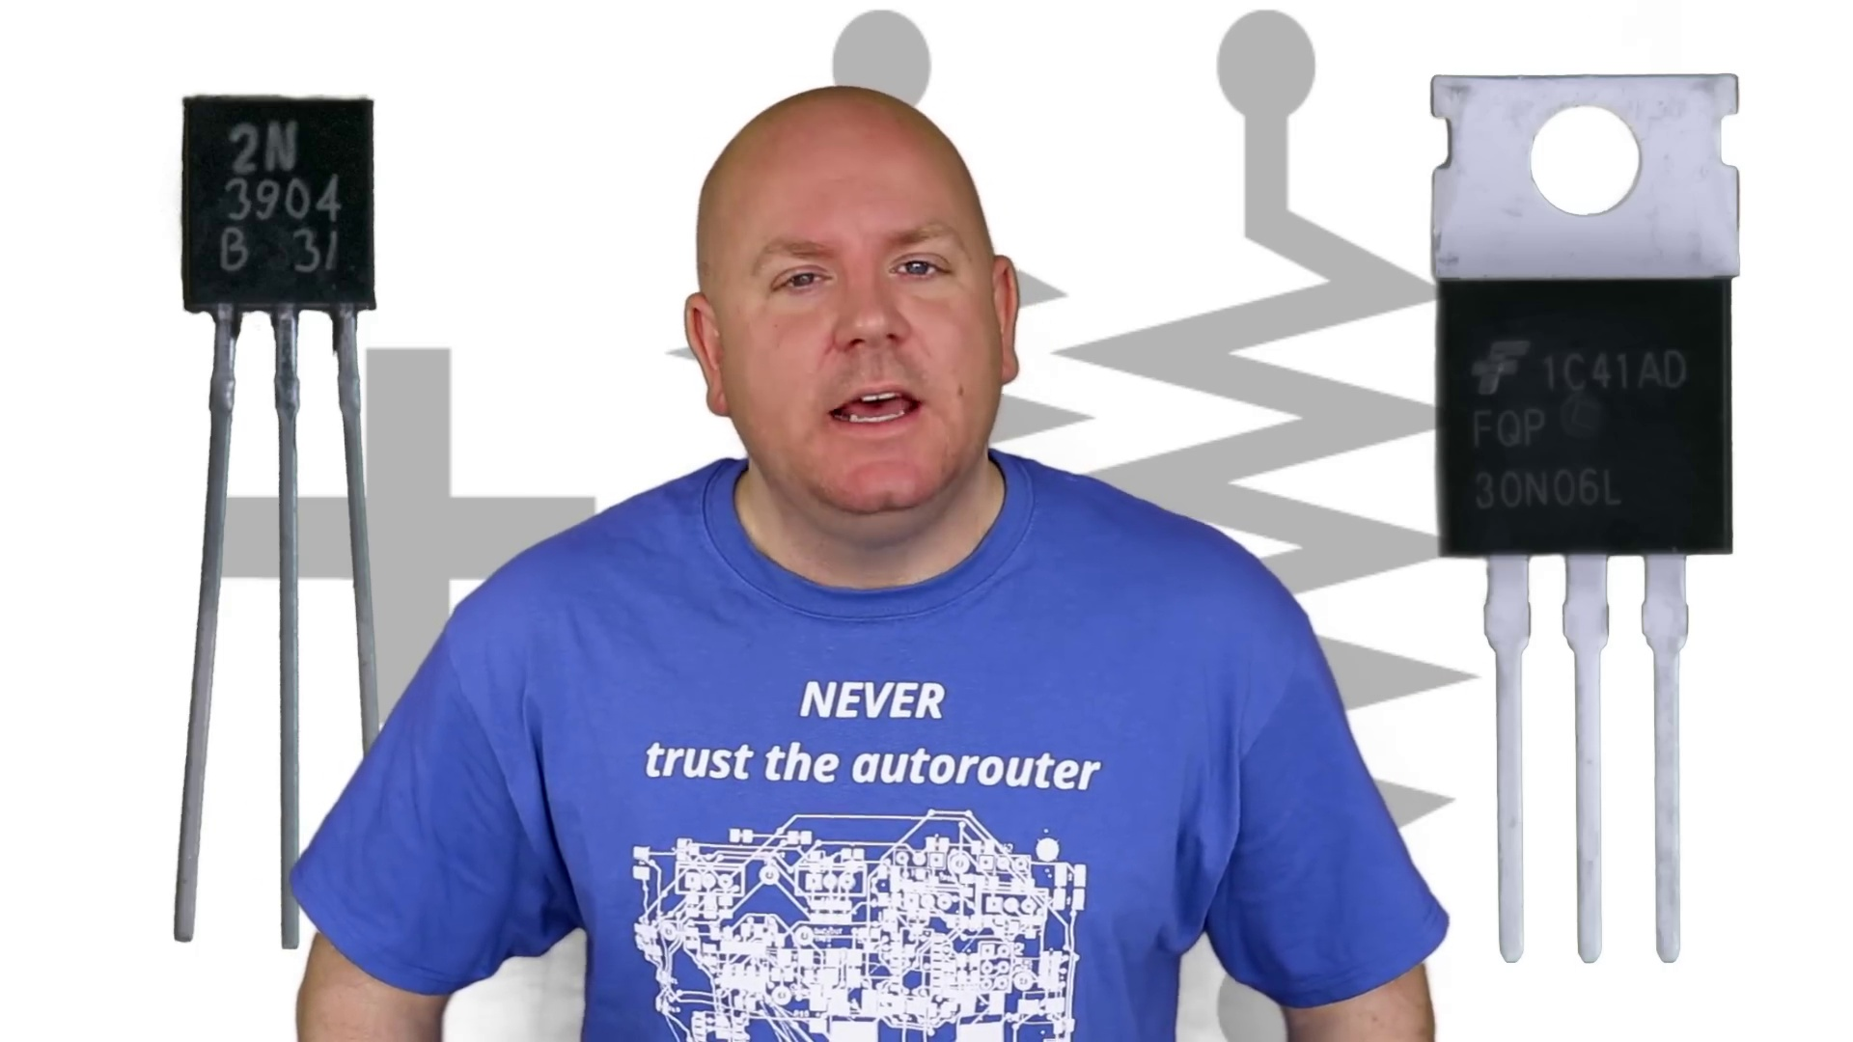 (score 95.0000)
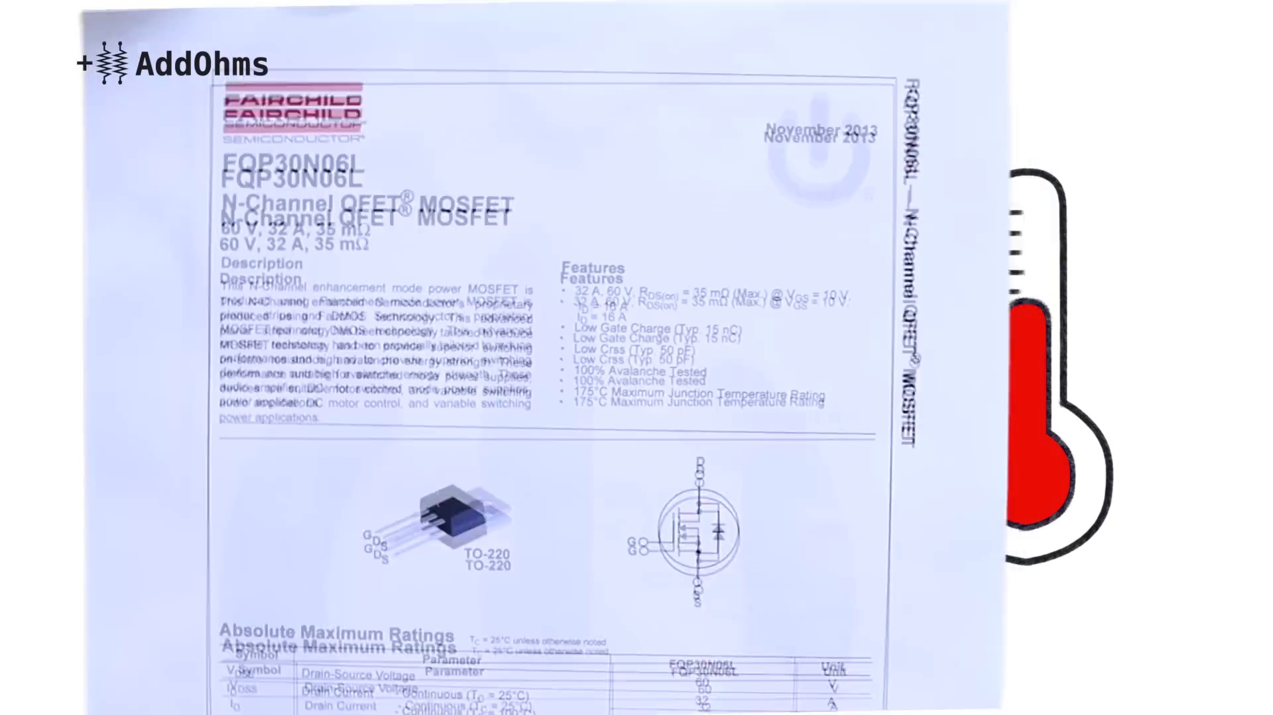 (score 90.0000)
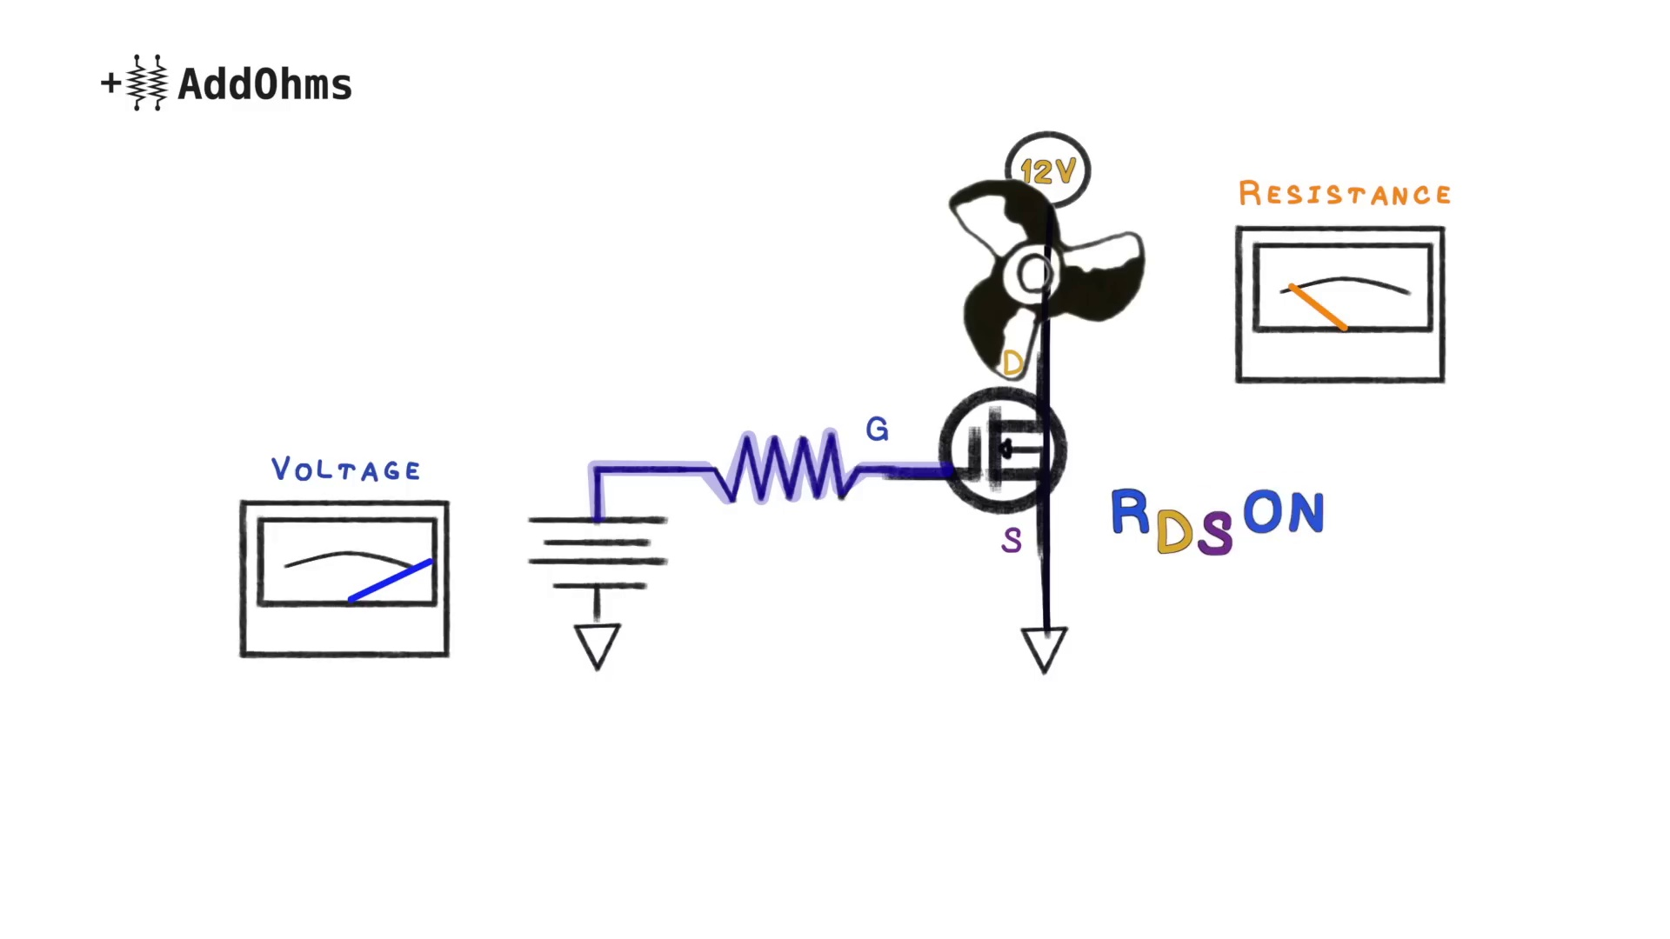 (score 90.0000)
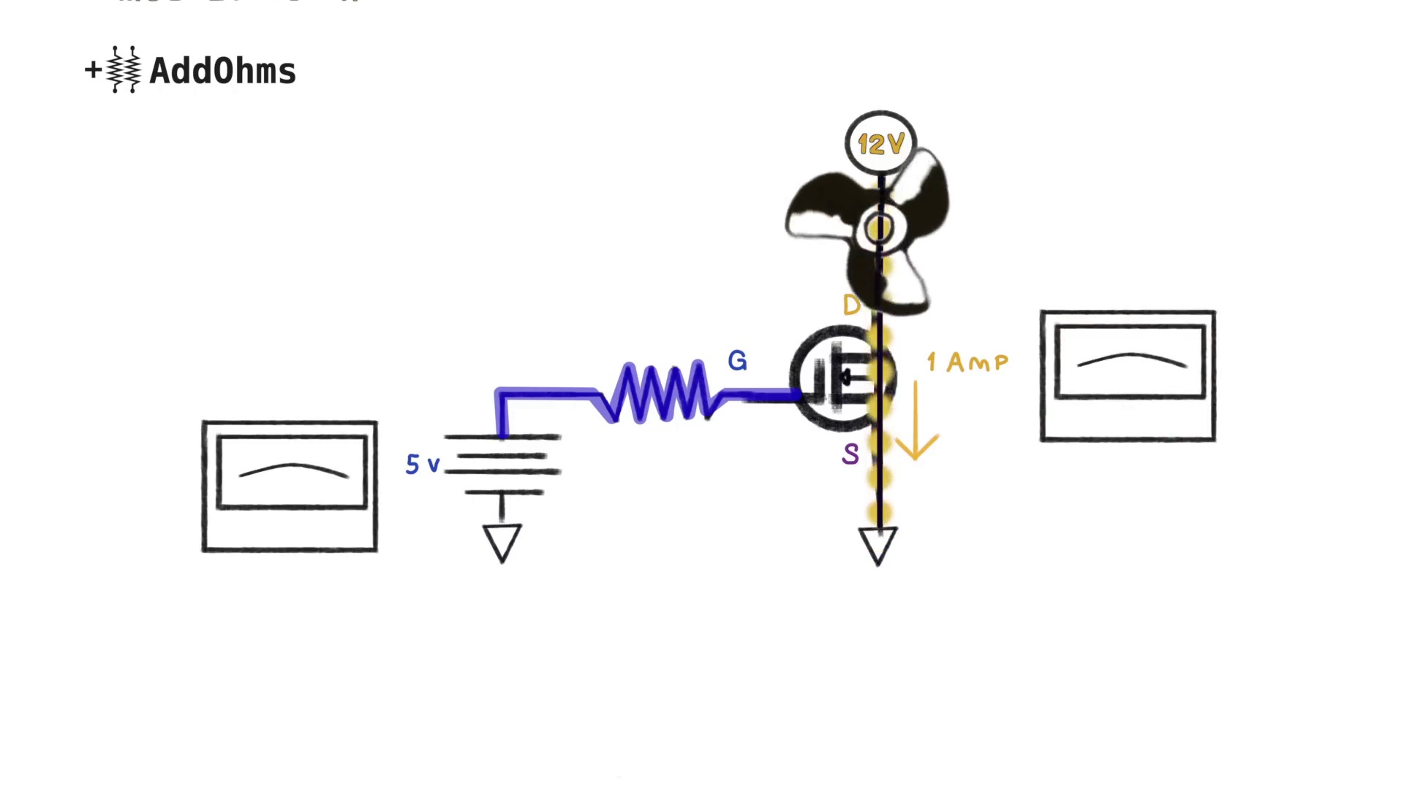 (score 90.0000)
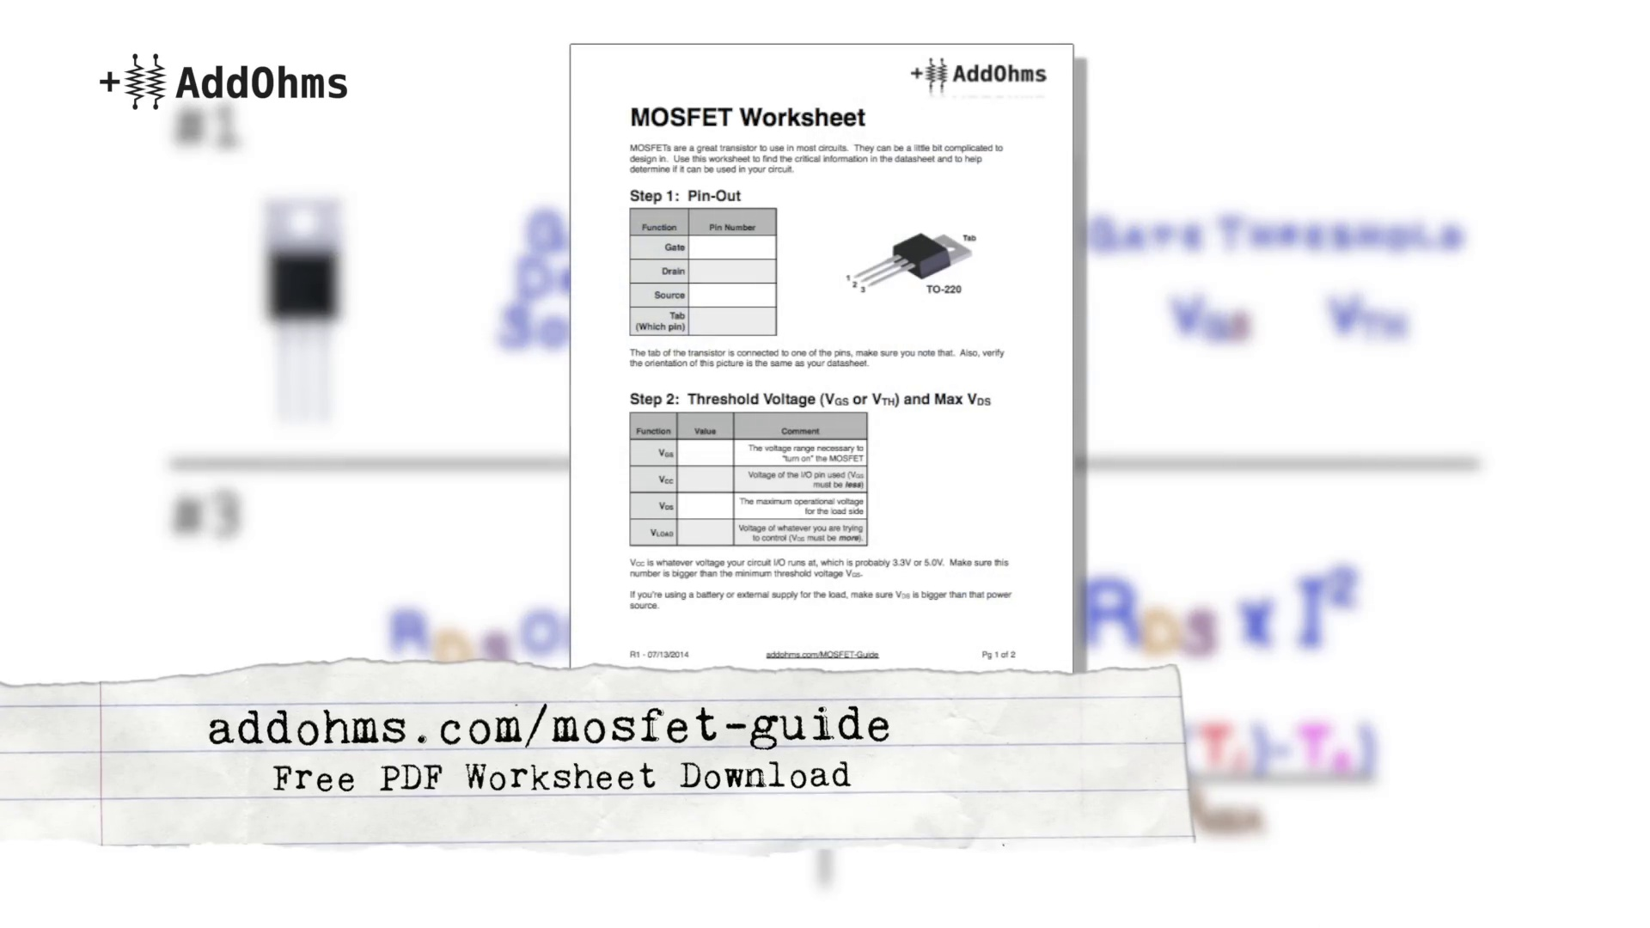 (score 85.0000)
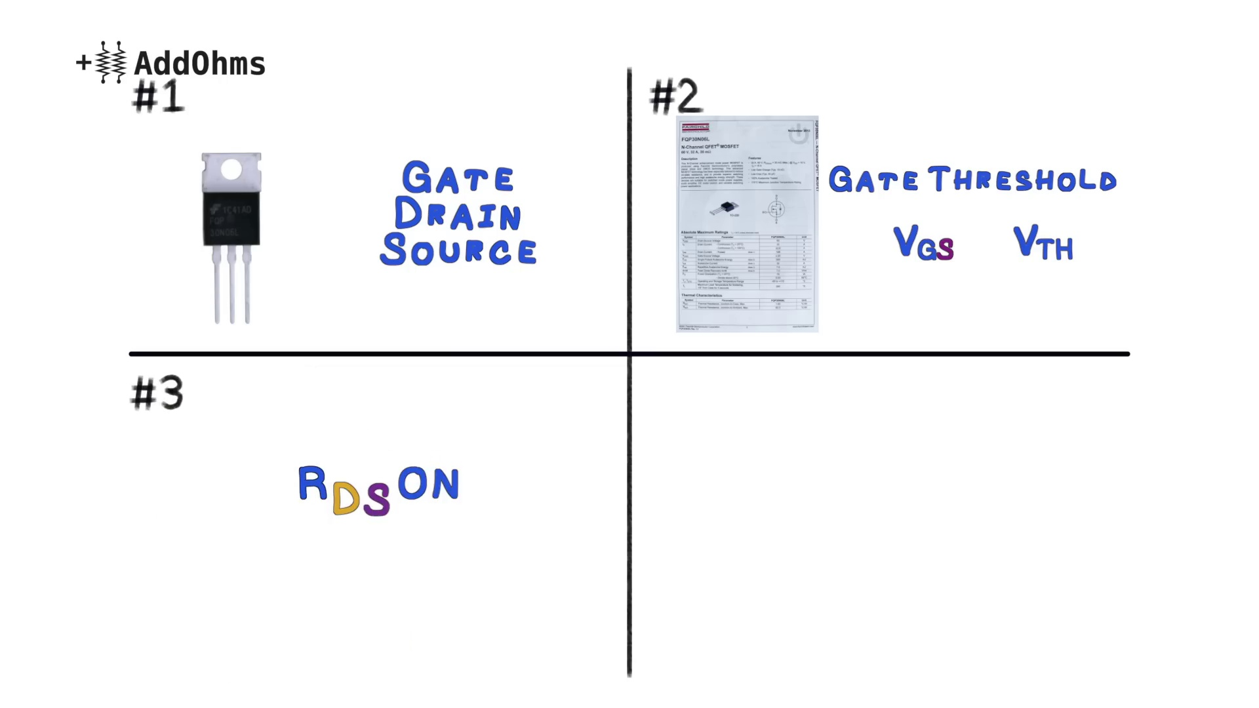 (score 85.0000)
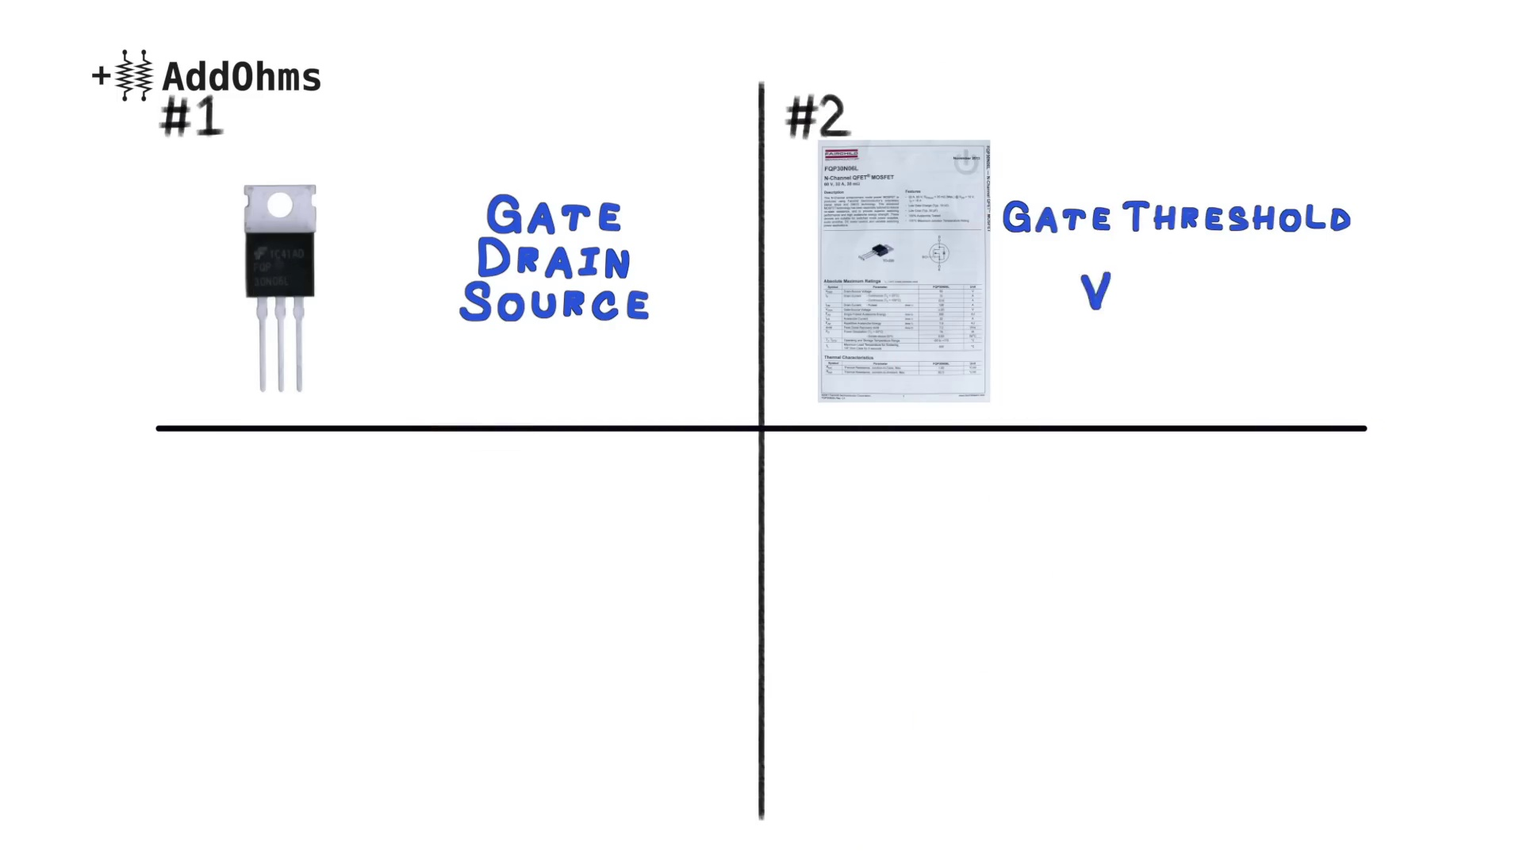 (score 85.0000)
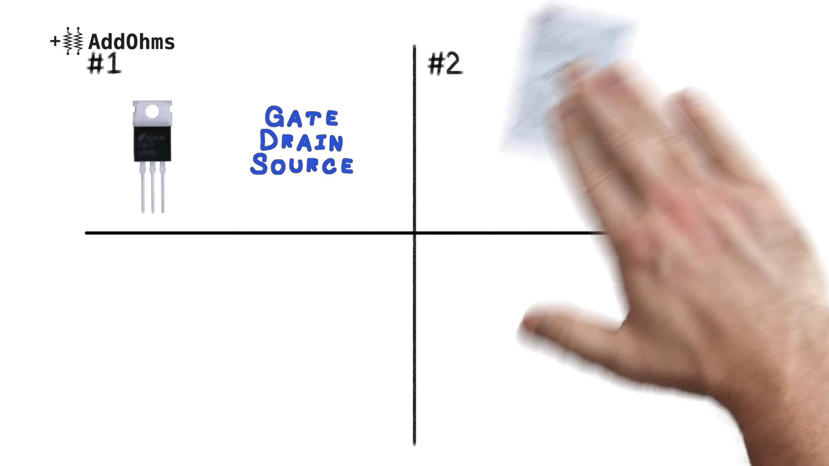 (score 85.0000)
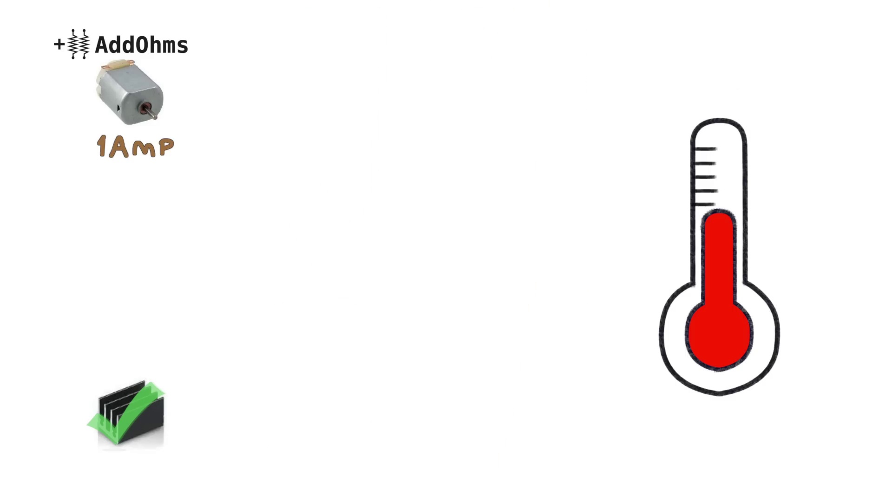 (score 85.0000)
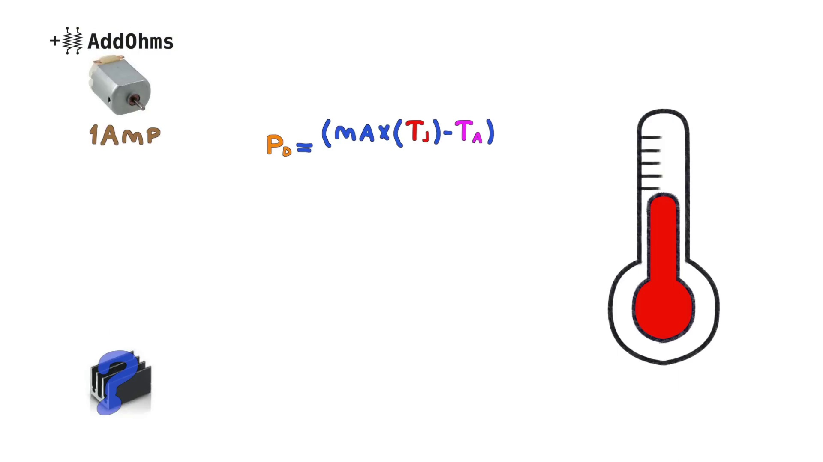 (score 85.0000)
Least correlated frames:
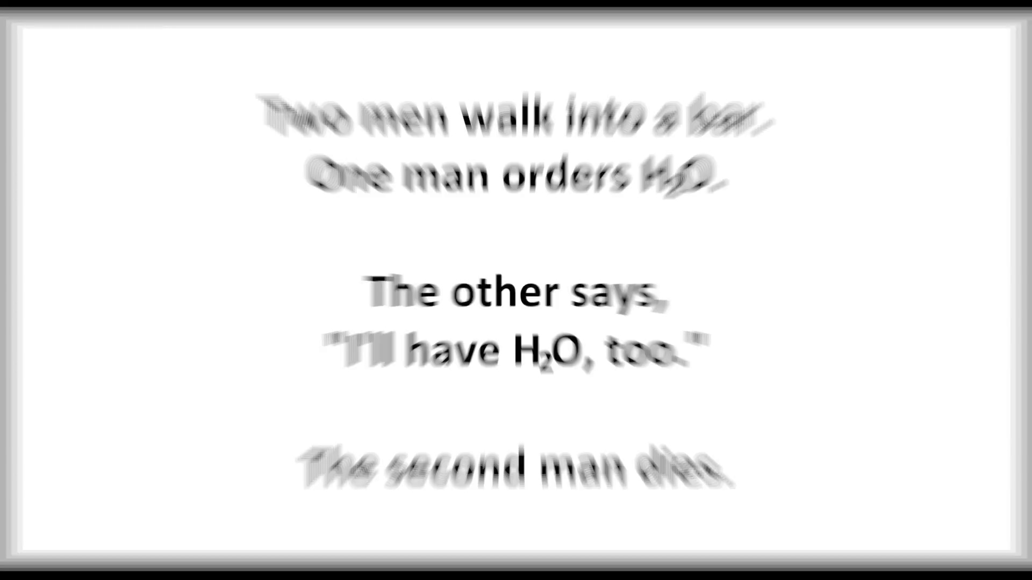 (score 0.0000)
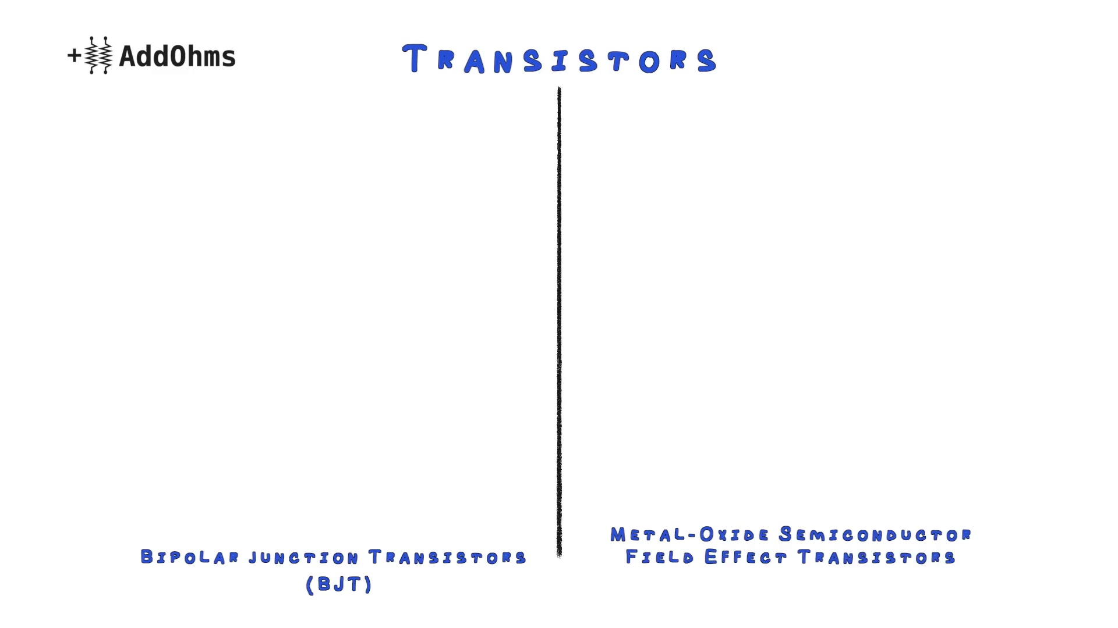 (score 0.0000)
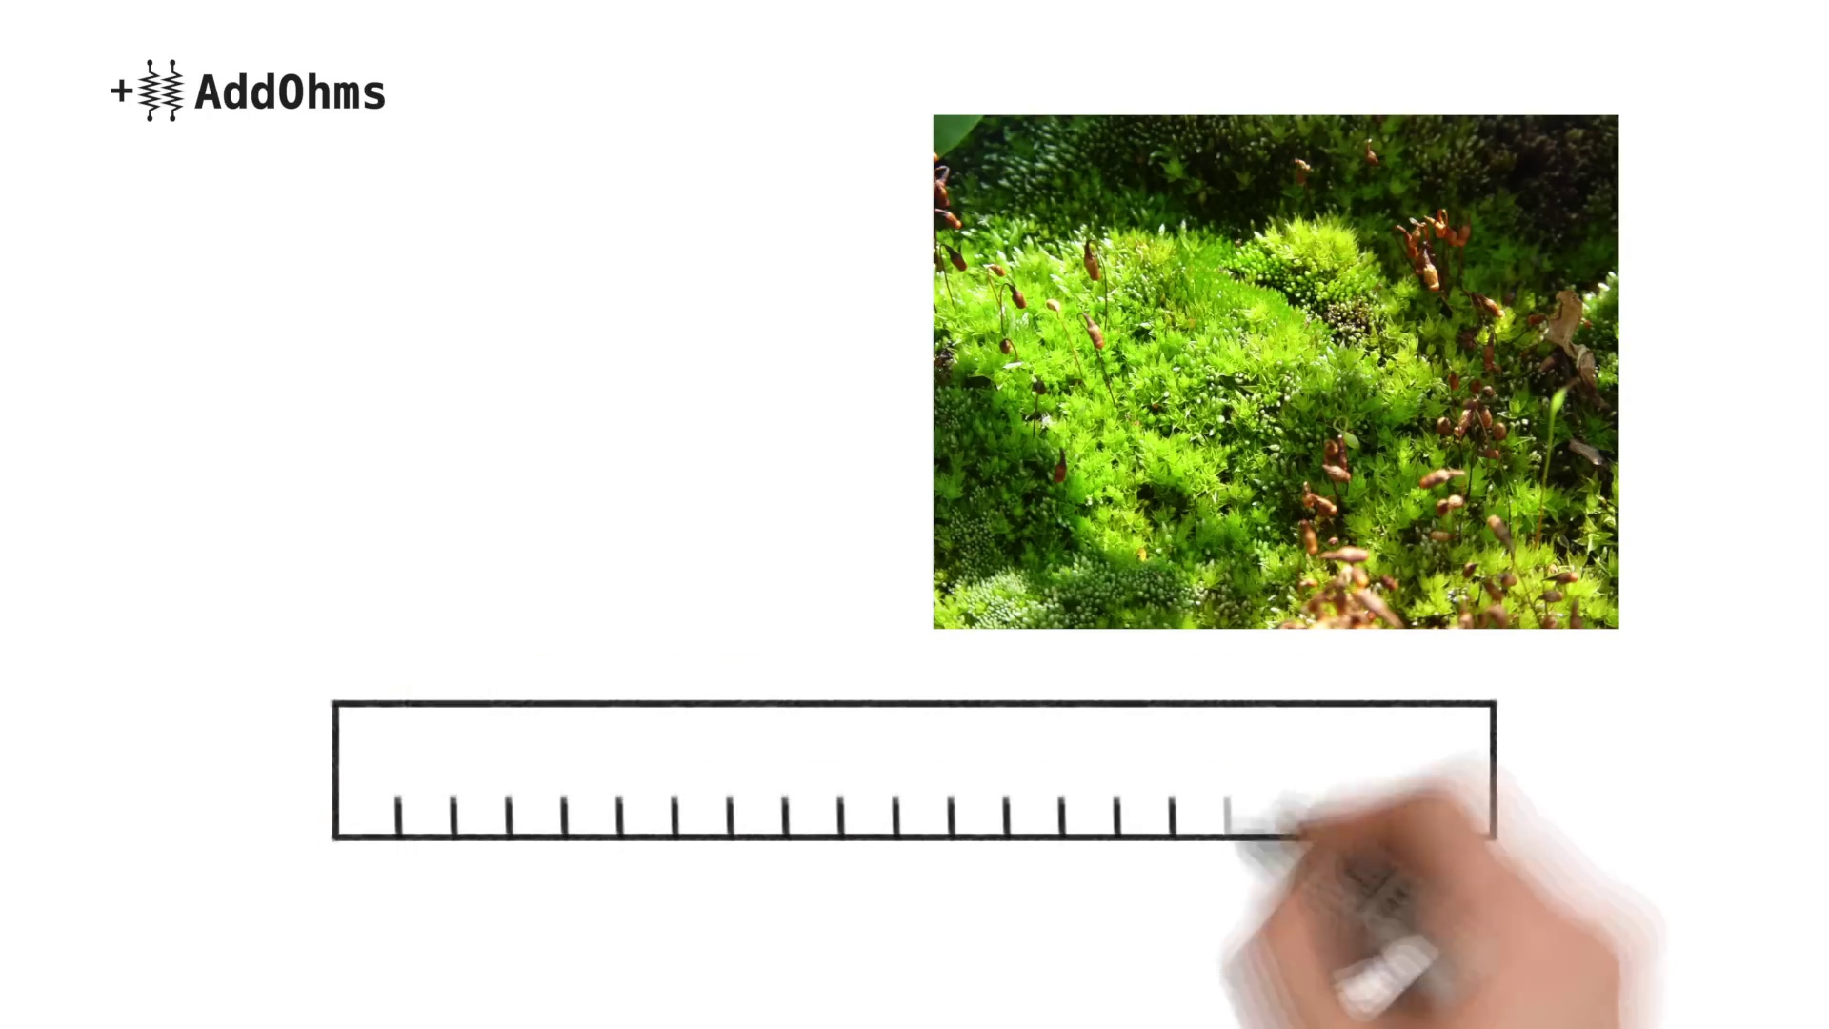 (score 0.0000)
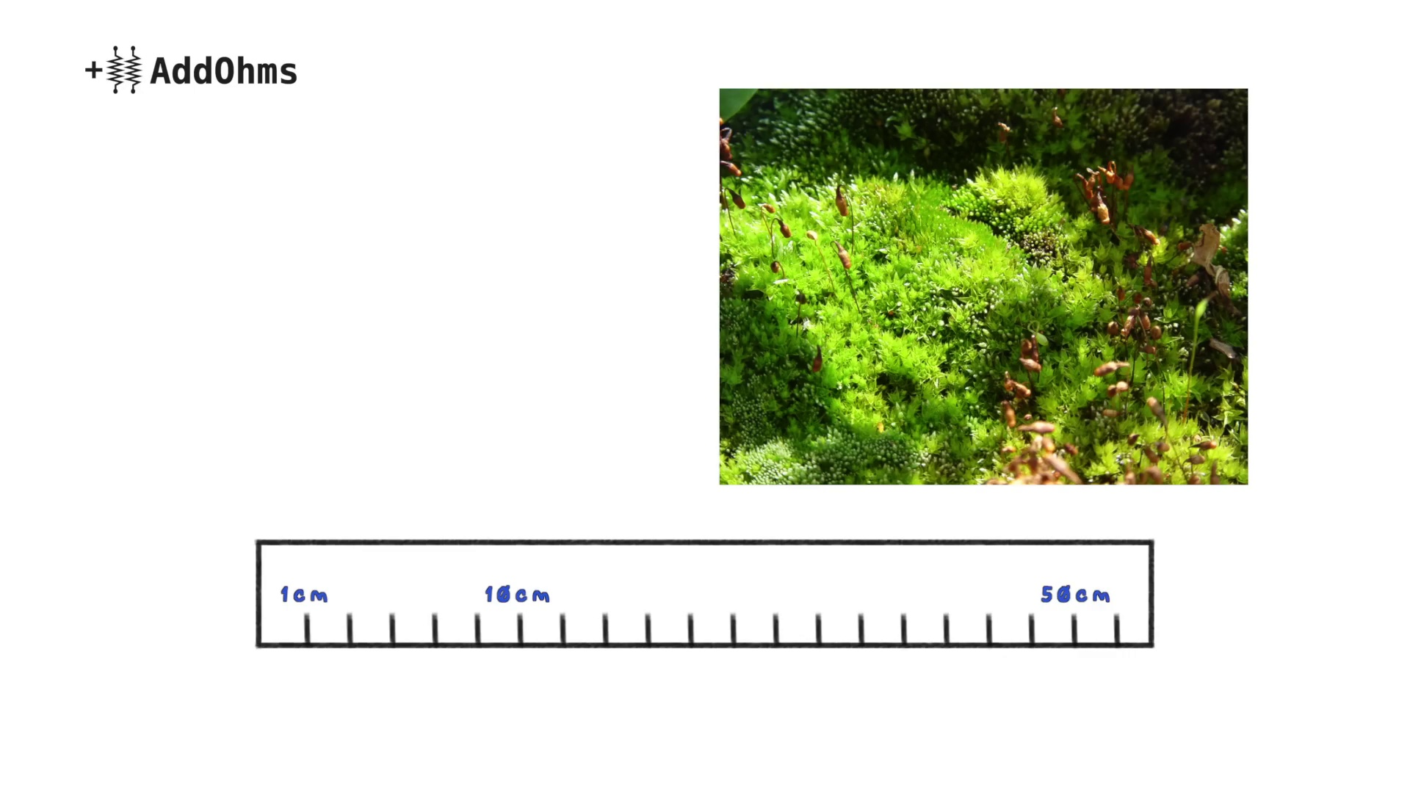 (score 0.0000)
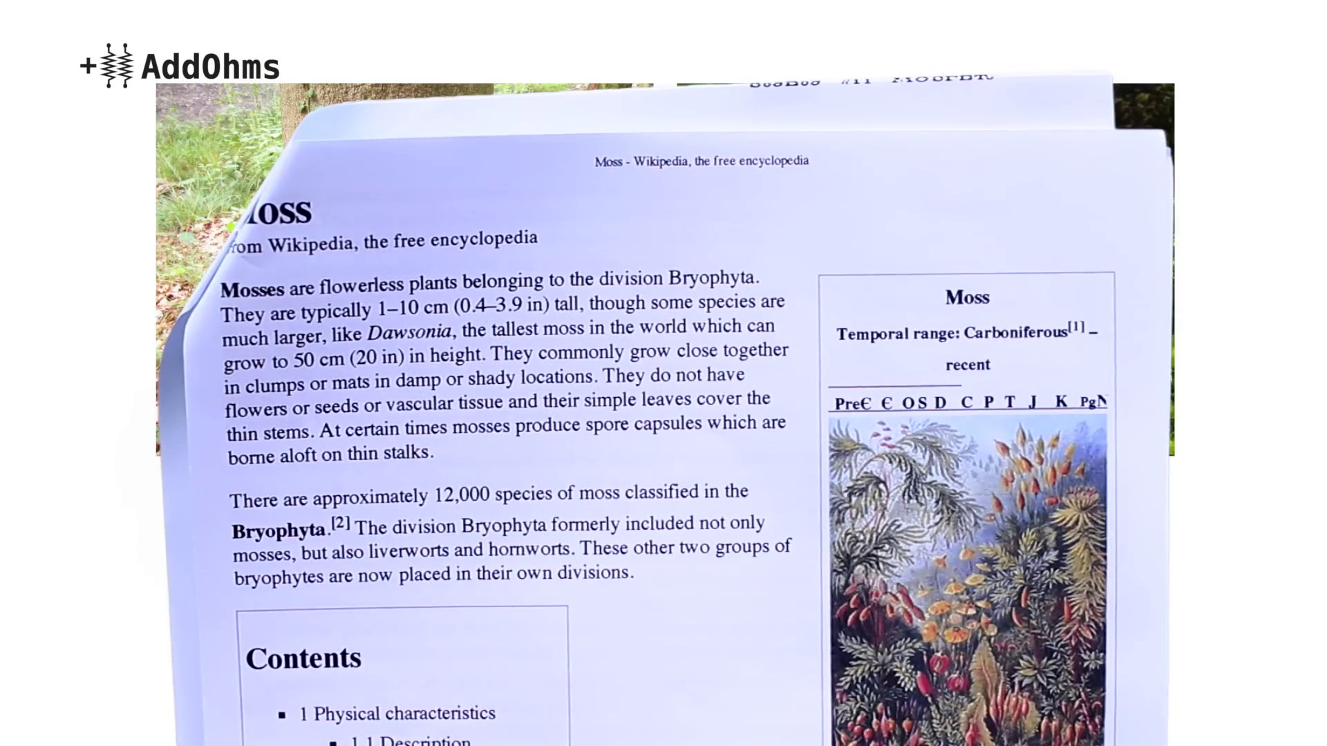 (score 0.0000)
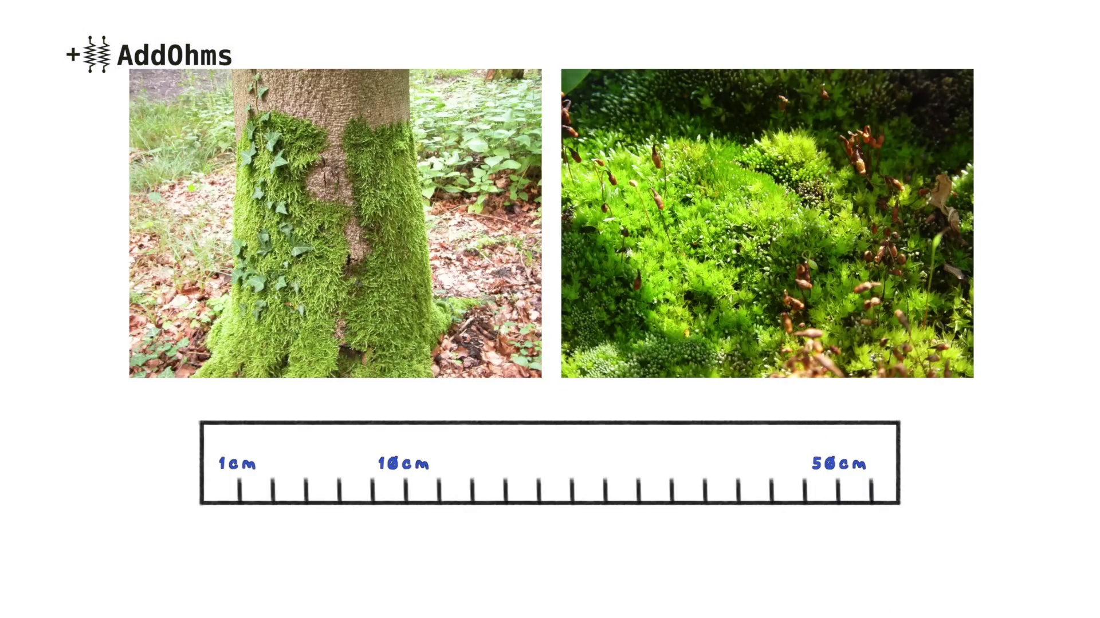 (score 0.0000)
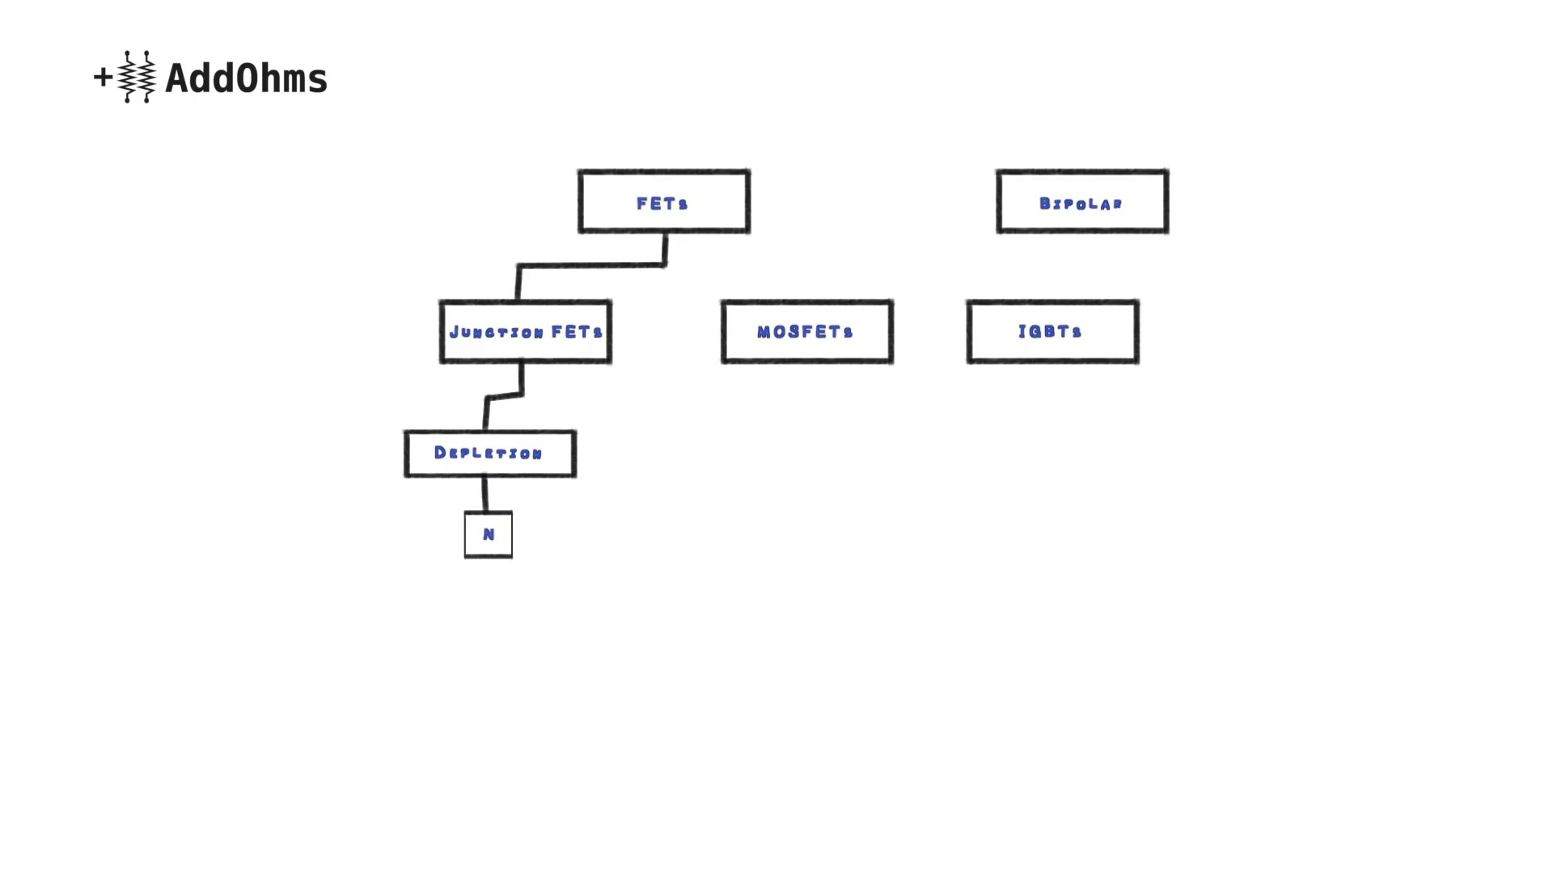 (score 0.0000)
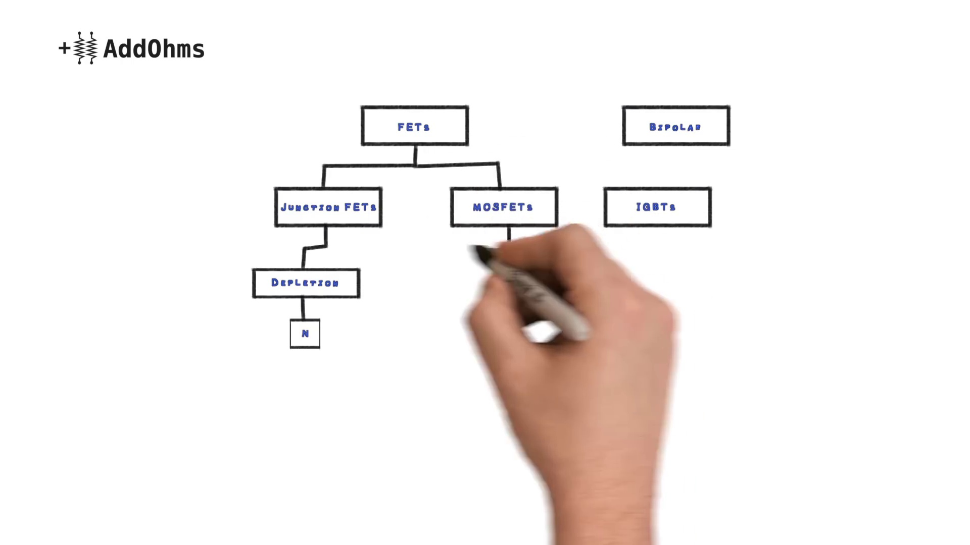 (score 0.0000)
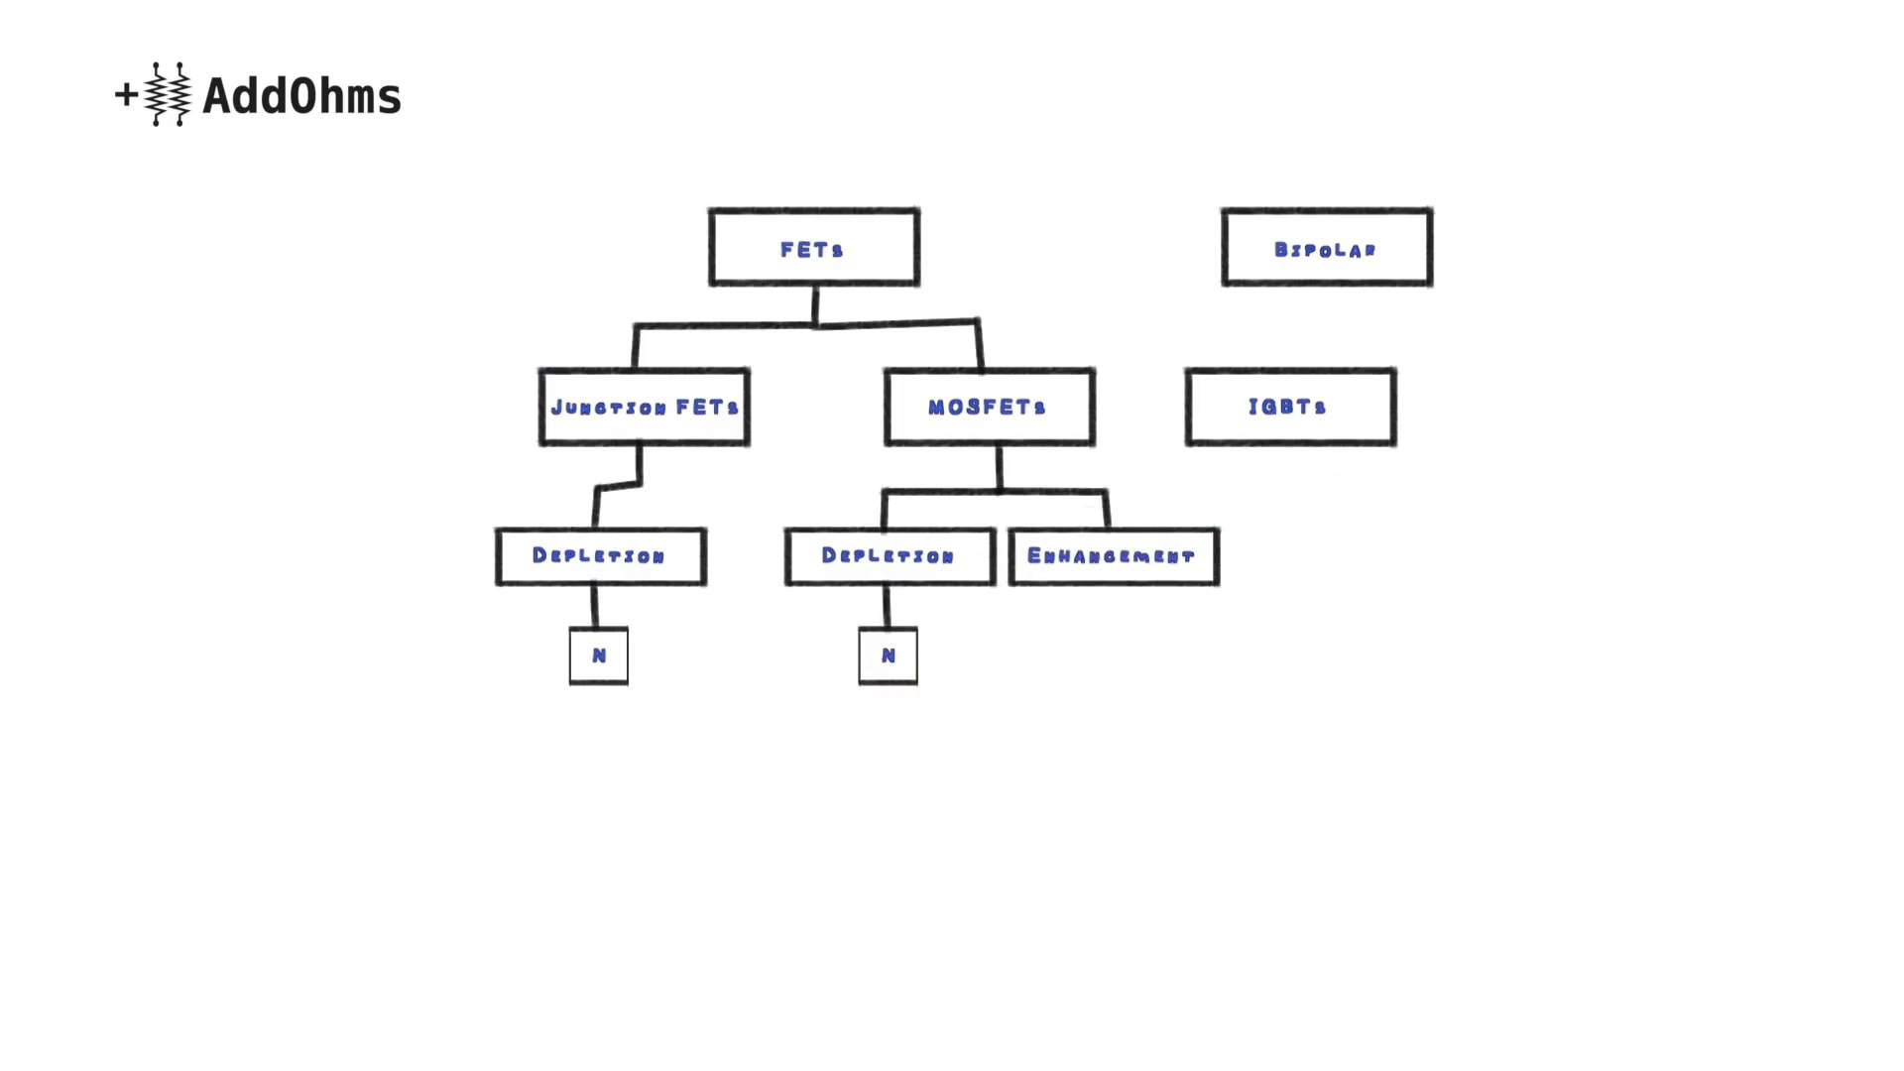 (score 0.0000)
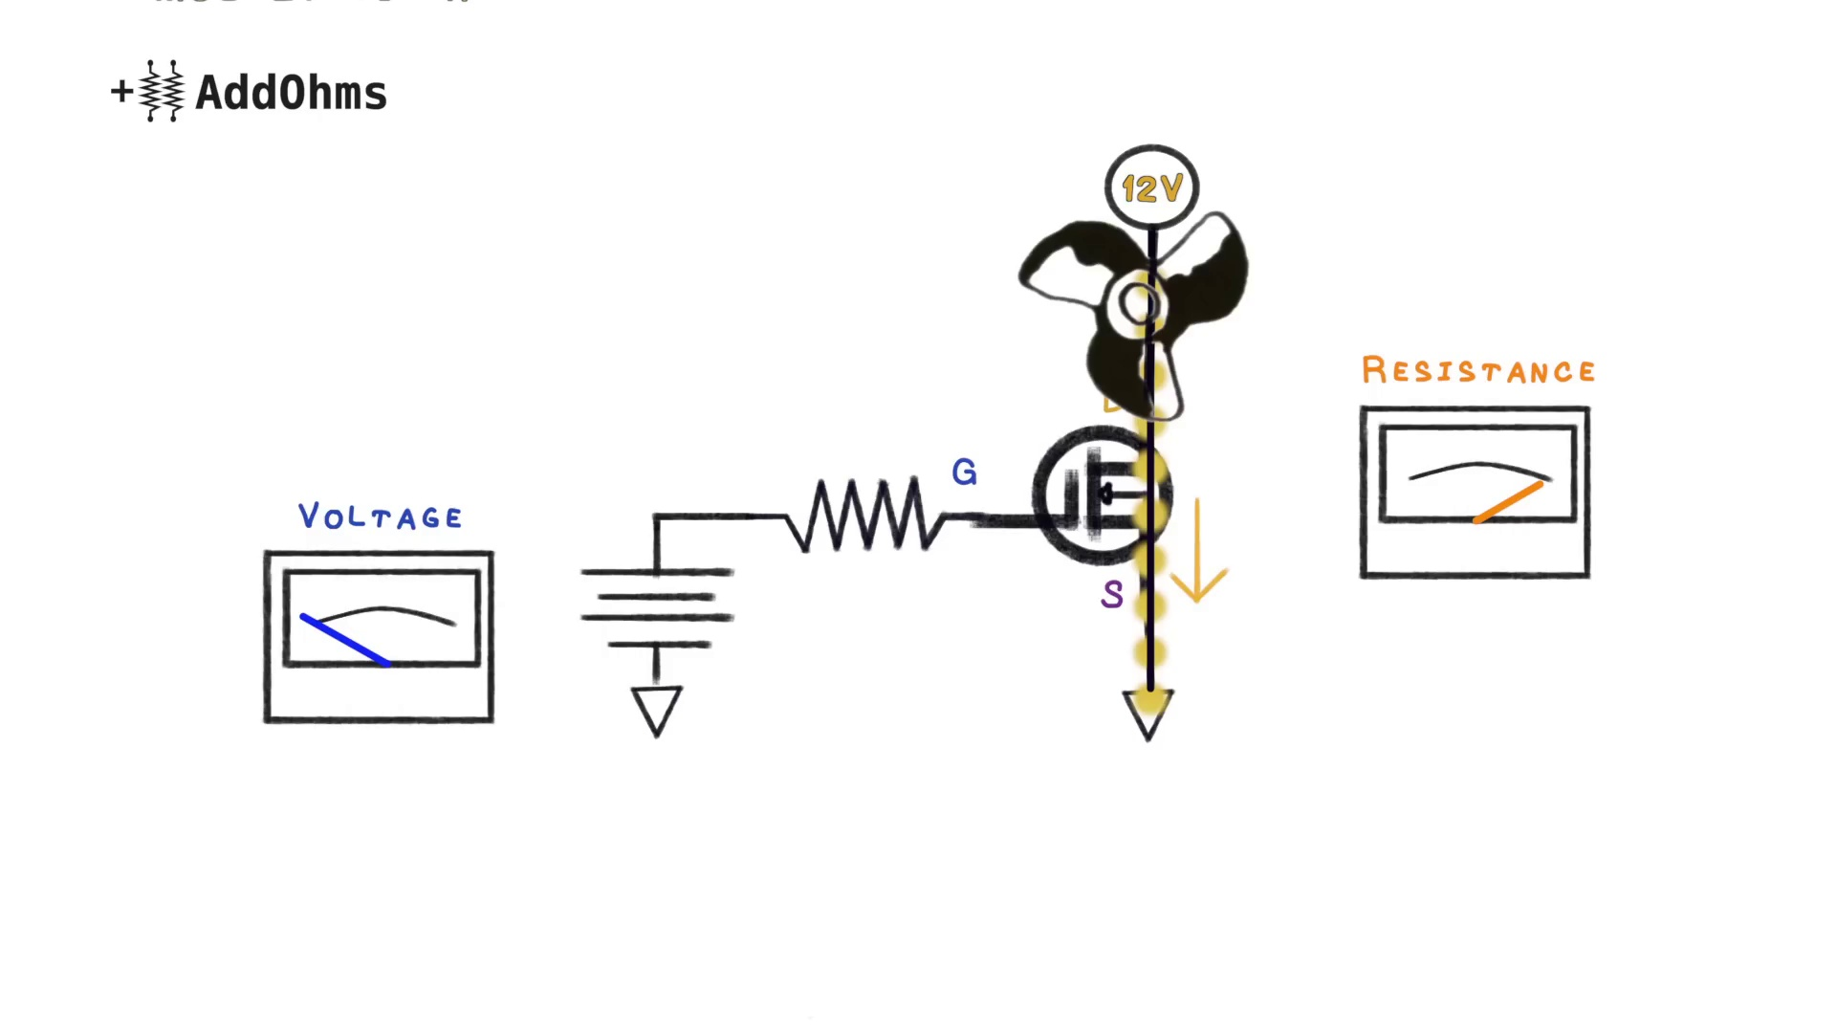 (score 0.0000)
- matched 61 frame(s), max score 95.0000: This was the last video I watched and goes over MOSFETS to assist my understanding of lecture. He reiterates what was stated in lecture of “MOSFETs are about voltage, and BJTs are about current” but he goes over some other cool stuff. I didn’t know that the FQP30N06L was “logic level” for using with Arduinos. Reference is usually 5V so this makes sense for the VGS and threshold voltage. His 4 steps for choosing a transistor was very helpful as well and I’ll likely reference back to this video.
Source: https://www.youtube.com/watch?v=GrvvkYTW_0k: MOSFETs and How to Use Them | AddOhms #11
Top correlated frames:
 (score 95.0000)
 (score 90.0000)
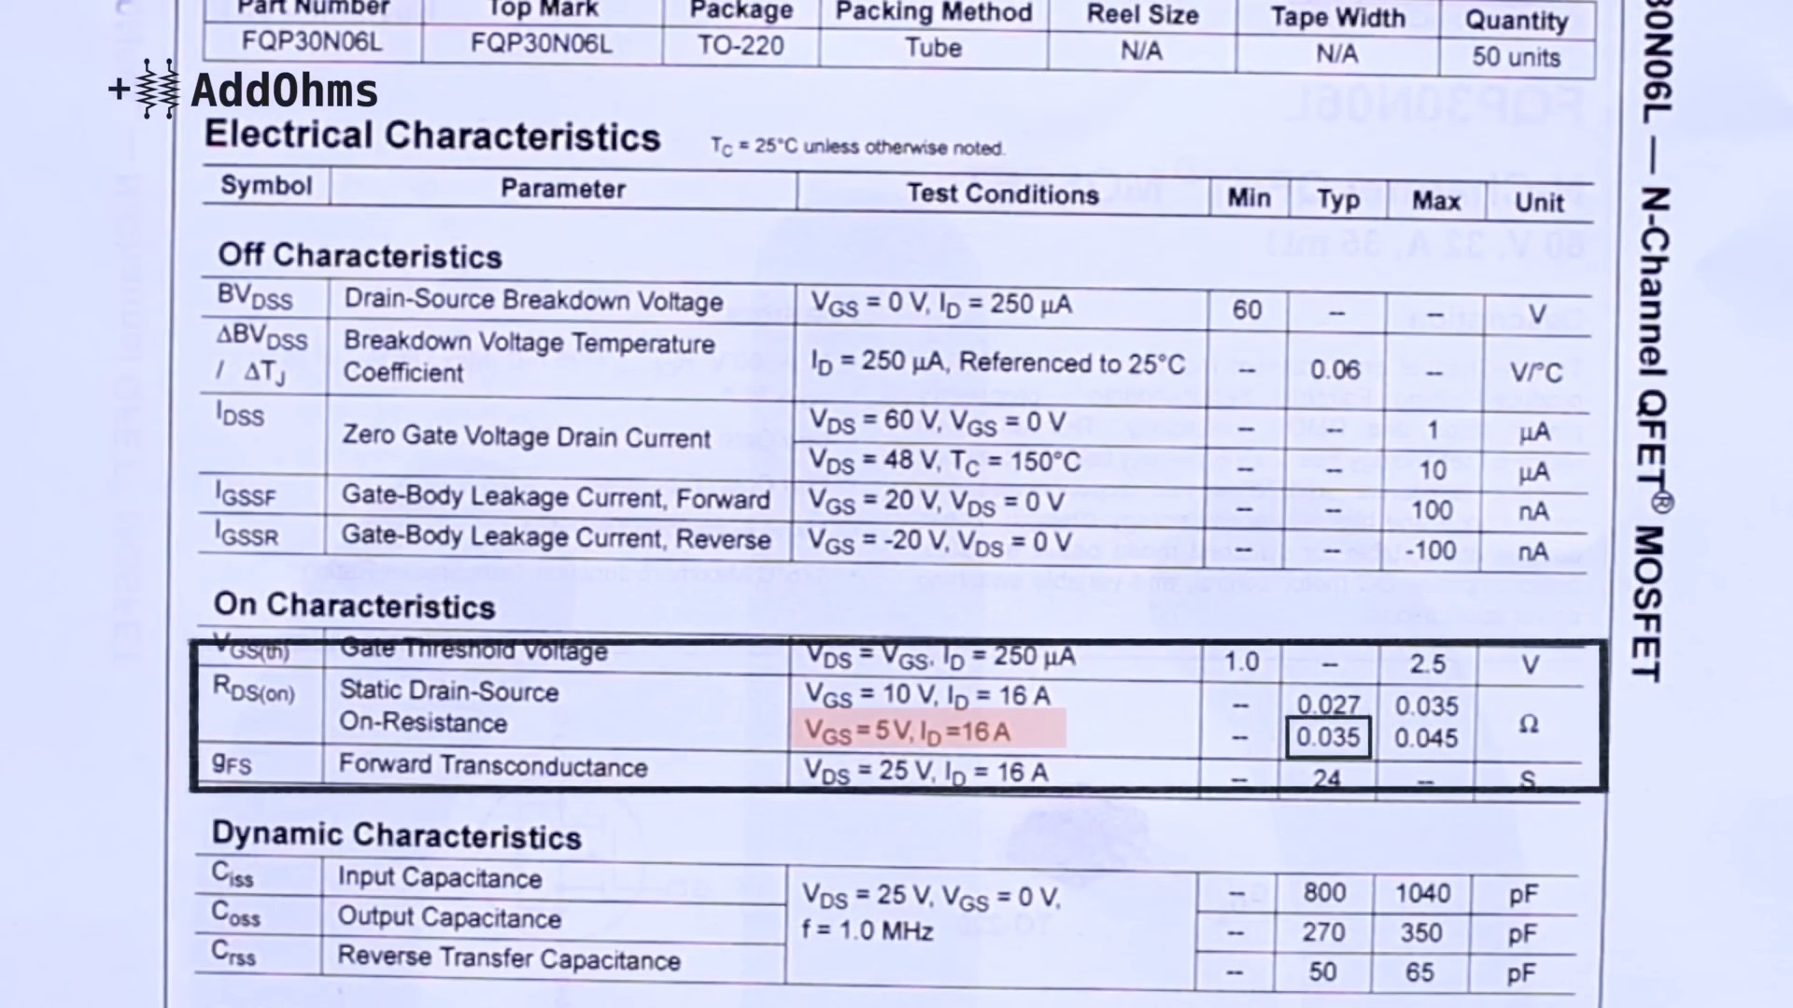 (score 90.0000)
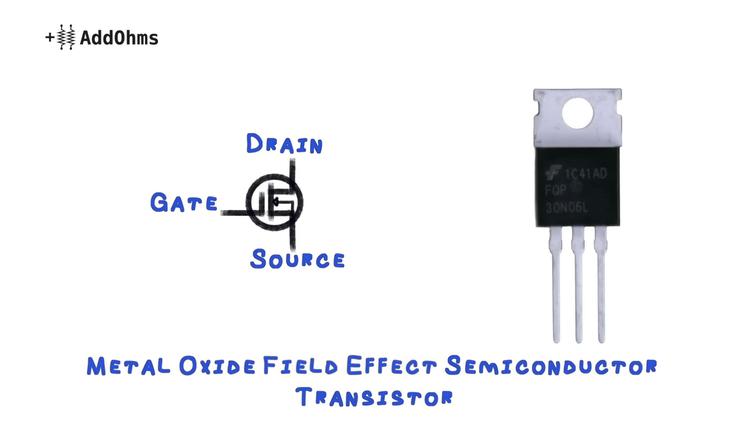 (score 90.0000)
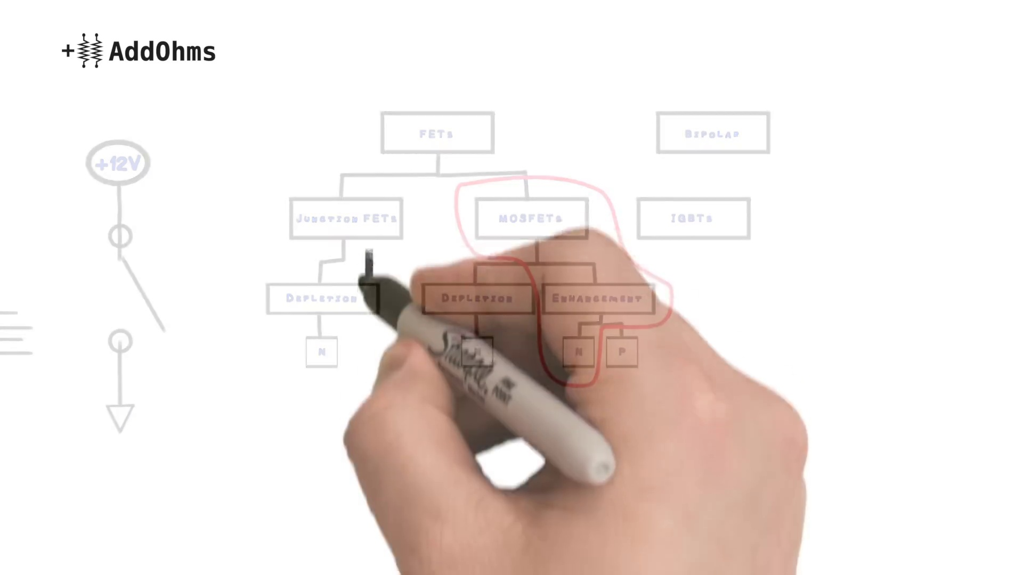 (score 90.0000)
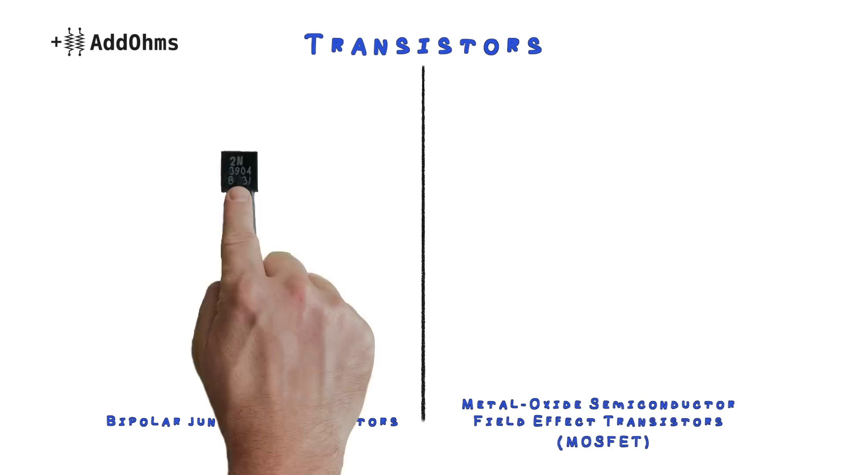 (score 90.0000)
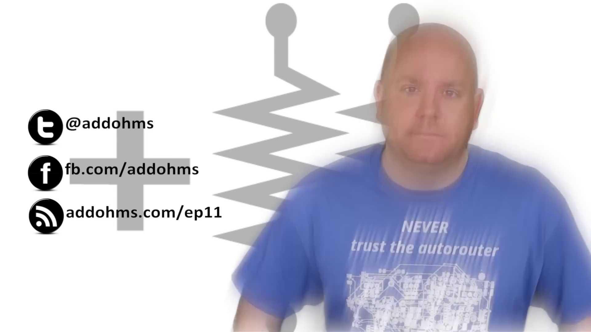 (score 85.0000)
 (score 85.0000)
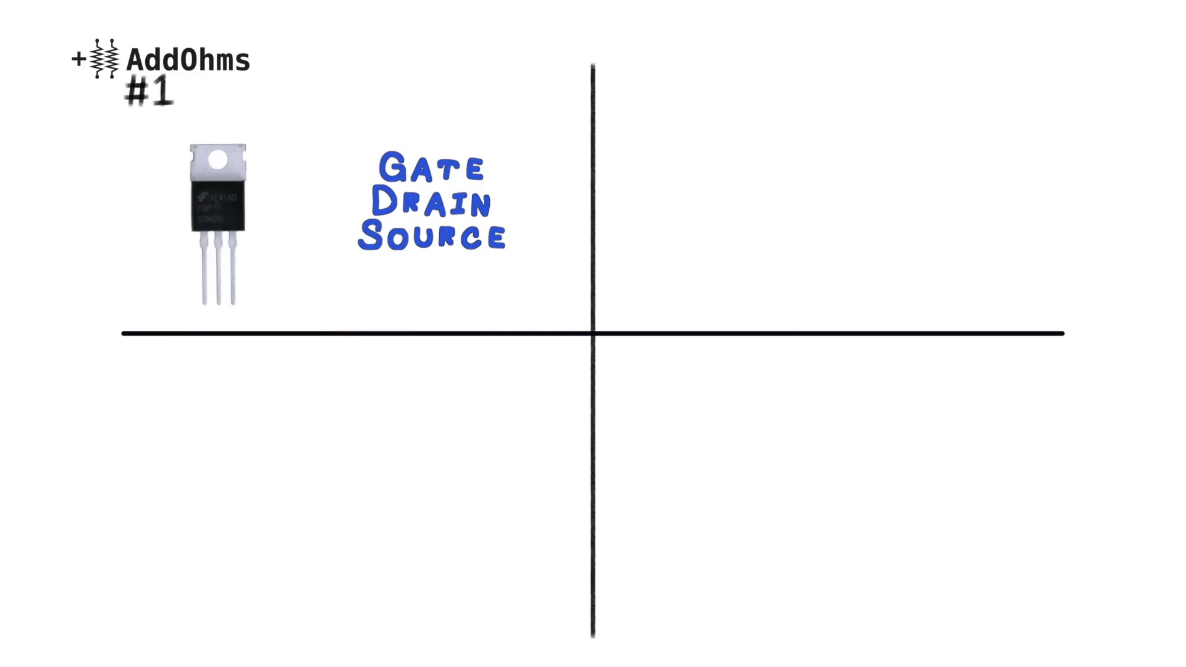 (score 85.0000)
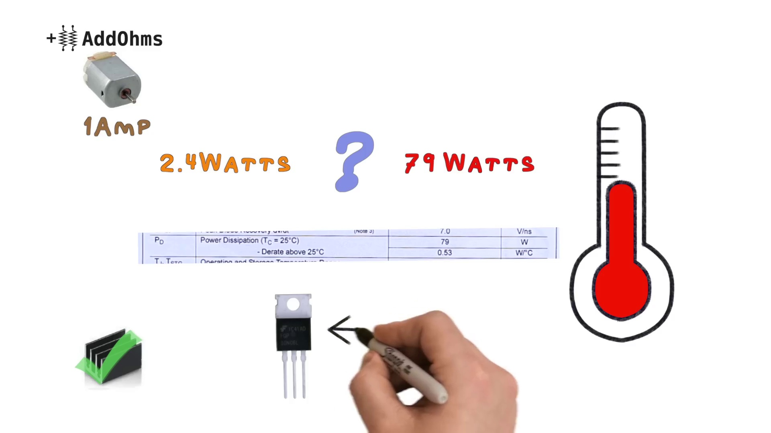 (score 85.0000)
Least correlated frames:
 (score 0.0000)
 (score 0.0000)
 (score 0.0000)
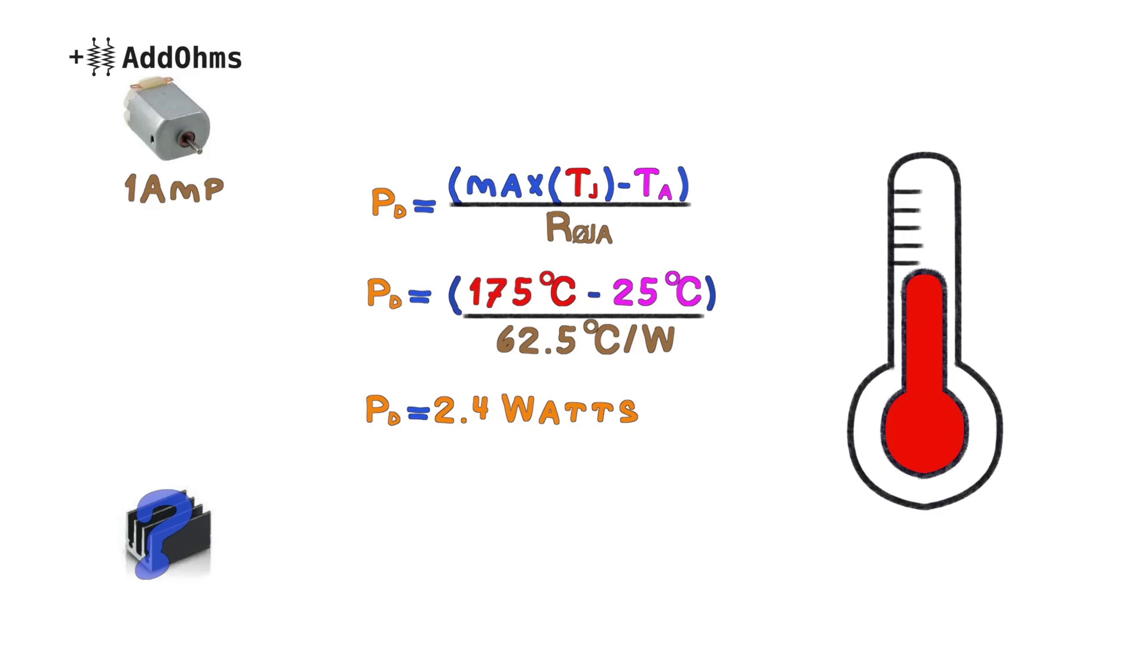 (score 0.0000)
 (score 5.0000)
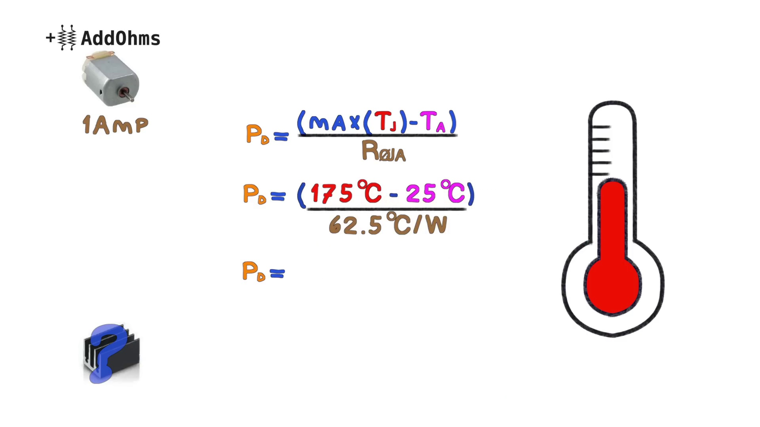 (score 5.0000)
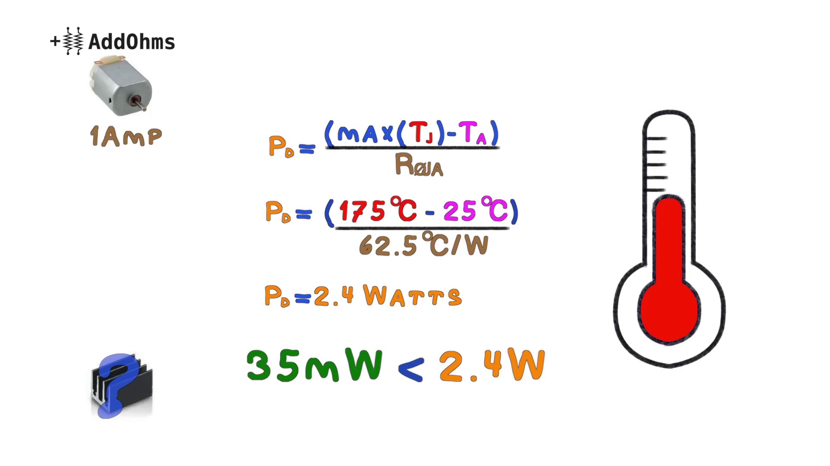 (score 5.0000)
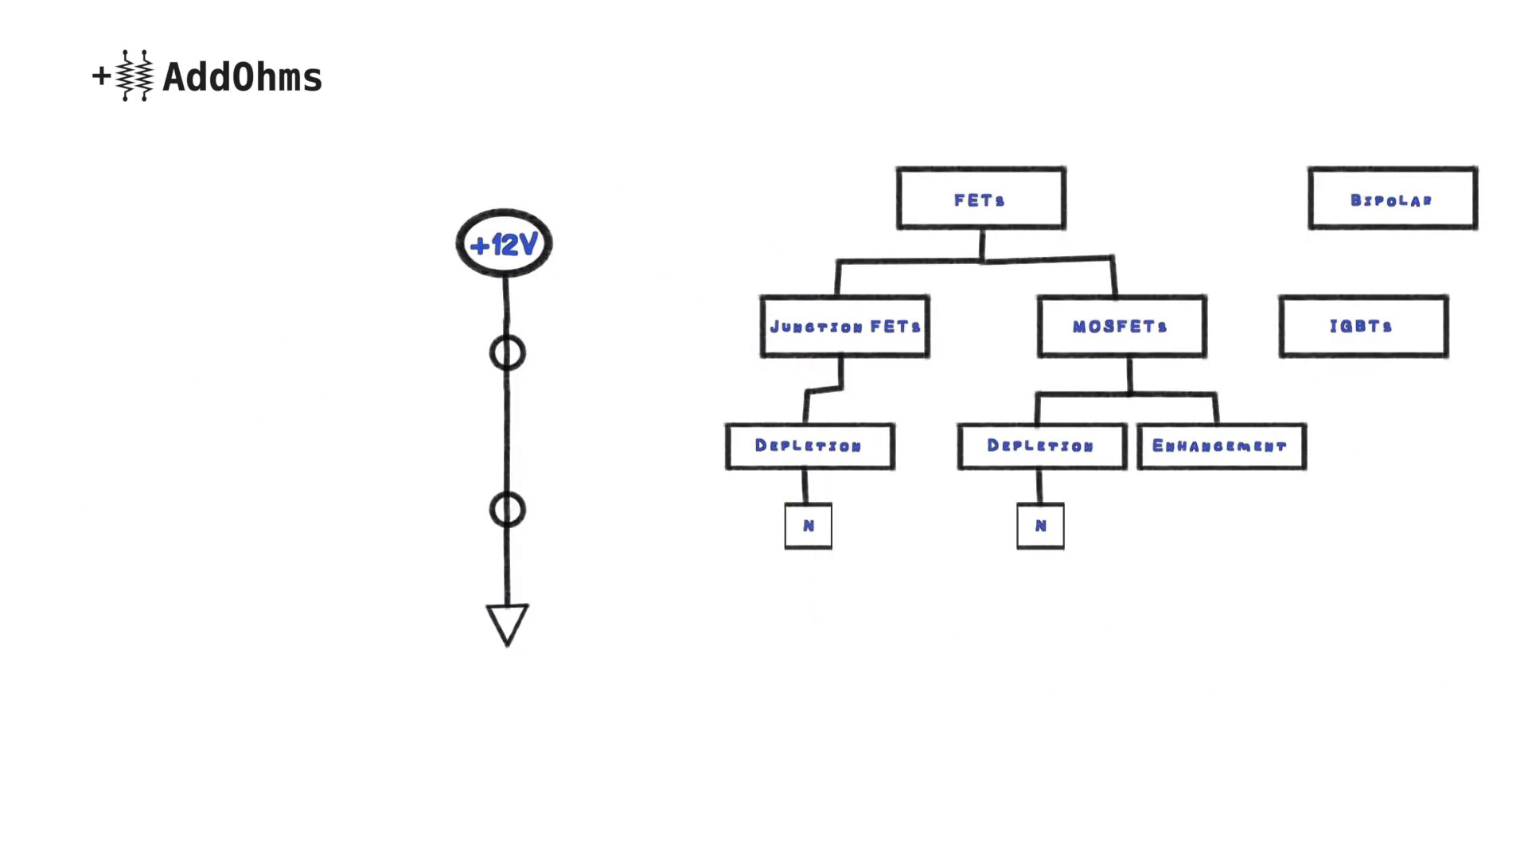 (score 10.0000)
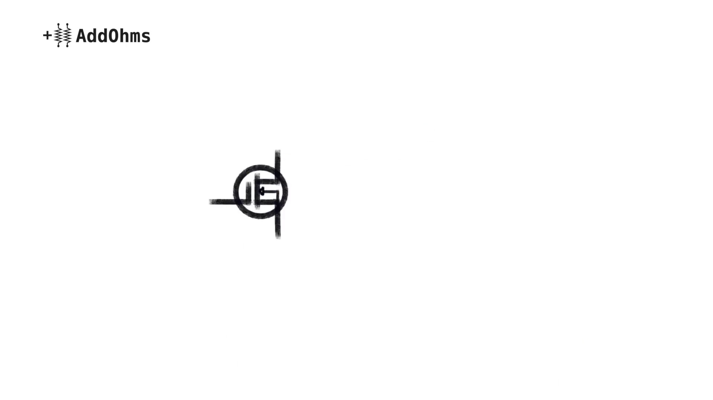 (score 10.0000)
 (score 10.0000)
- matched 52 frame(s), max score 95.0000: MOSFETs act as automatic switches controlled by voltage. It’s important to calculate heat dissipation to determine the need for a heat sink.Are there specific guidelines for selecting heat sinks? Previously, I overlooked heat sinks, but now I’ll always check if one is needed.
Source: https://www.youtube.com/watch?v=GrvvkYTW_0k: MOSFETs and How to Use Them | AddOhms #11
Top correlated frames:
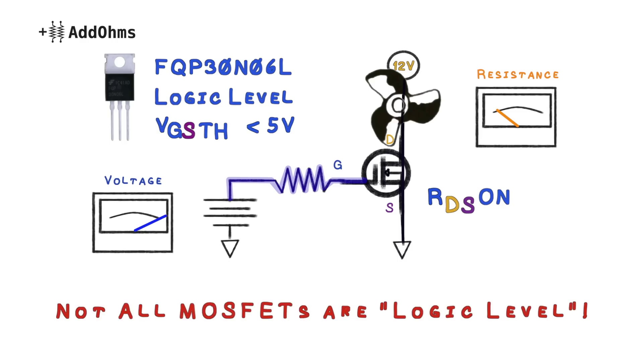 (score 95.0000)
 (score 90.0000)
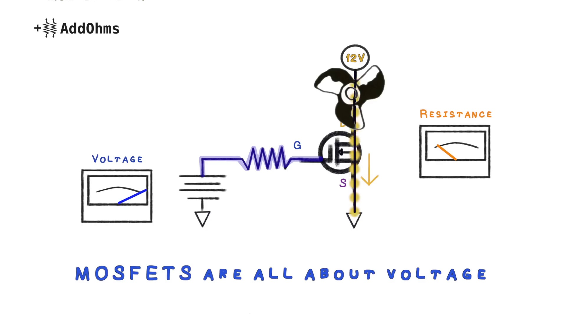 (score 90.0000)
 (score 90.0000)
 (score 85.0000)
 (score 85.0000)
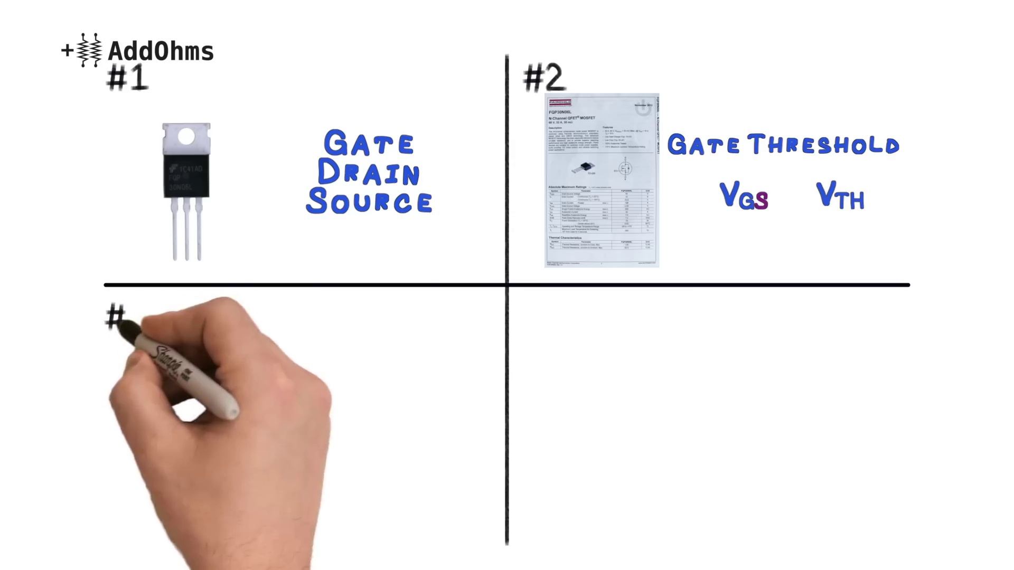 (score 85.0000)
 (score 85.0000)
 (score 85.0000)
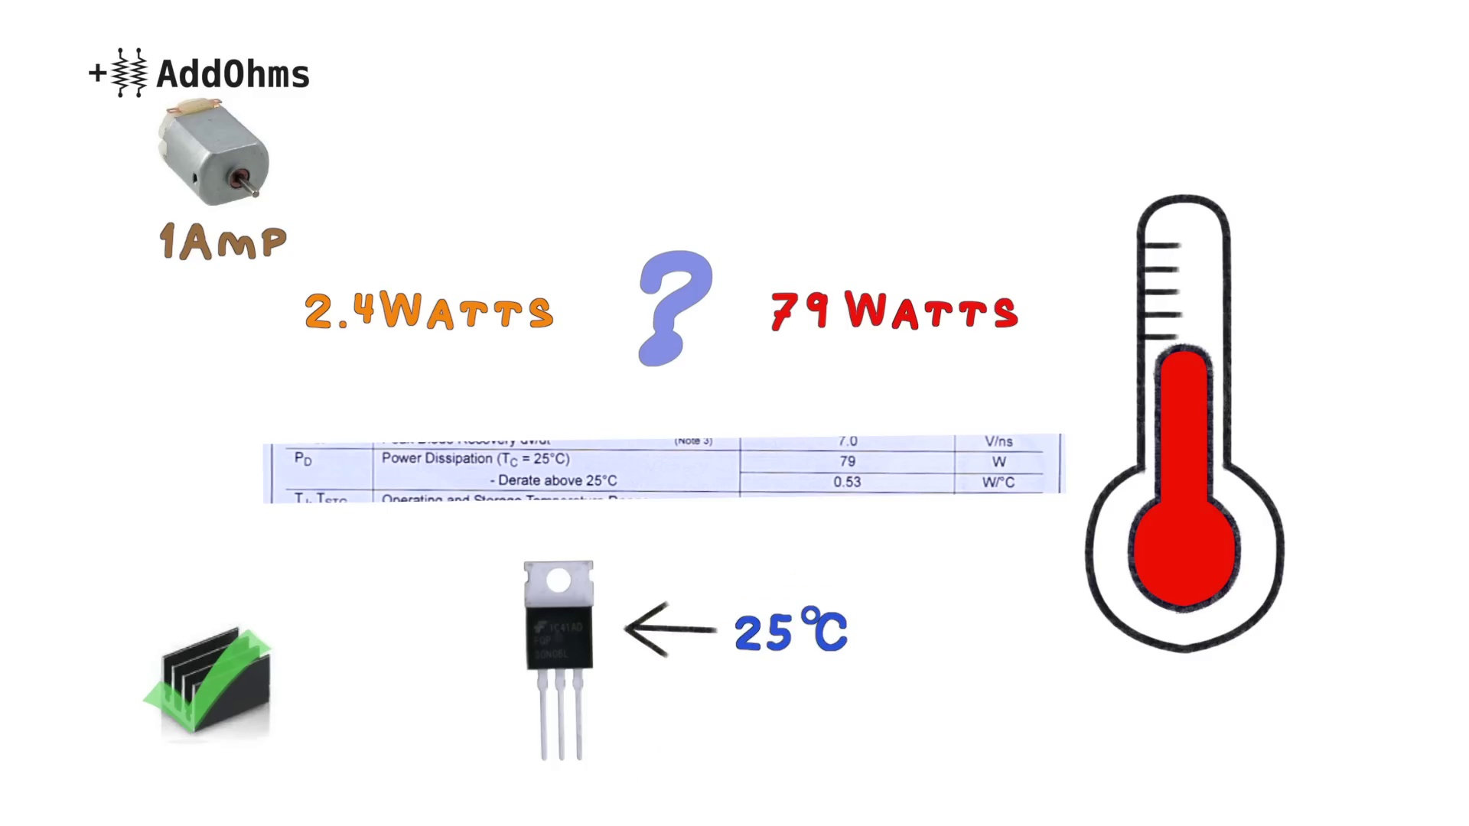 (score 85.0000)
Least correlated frames:
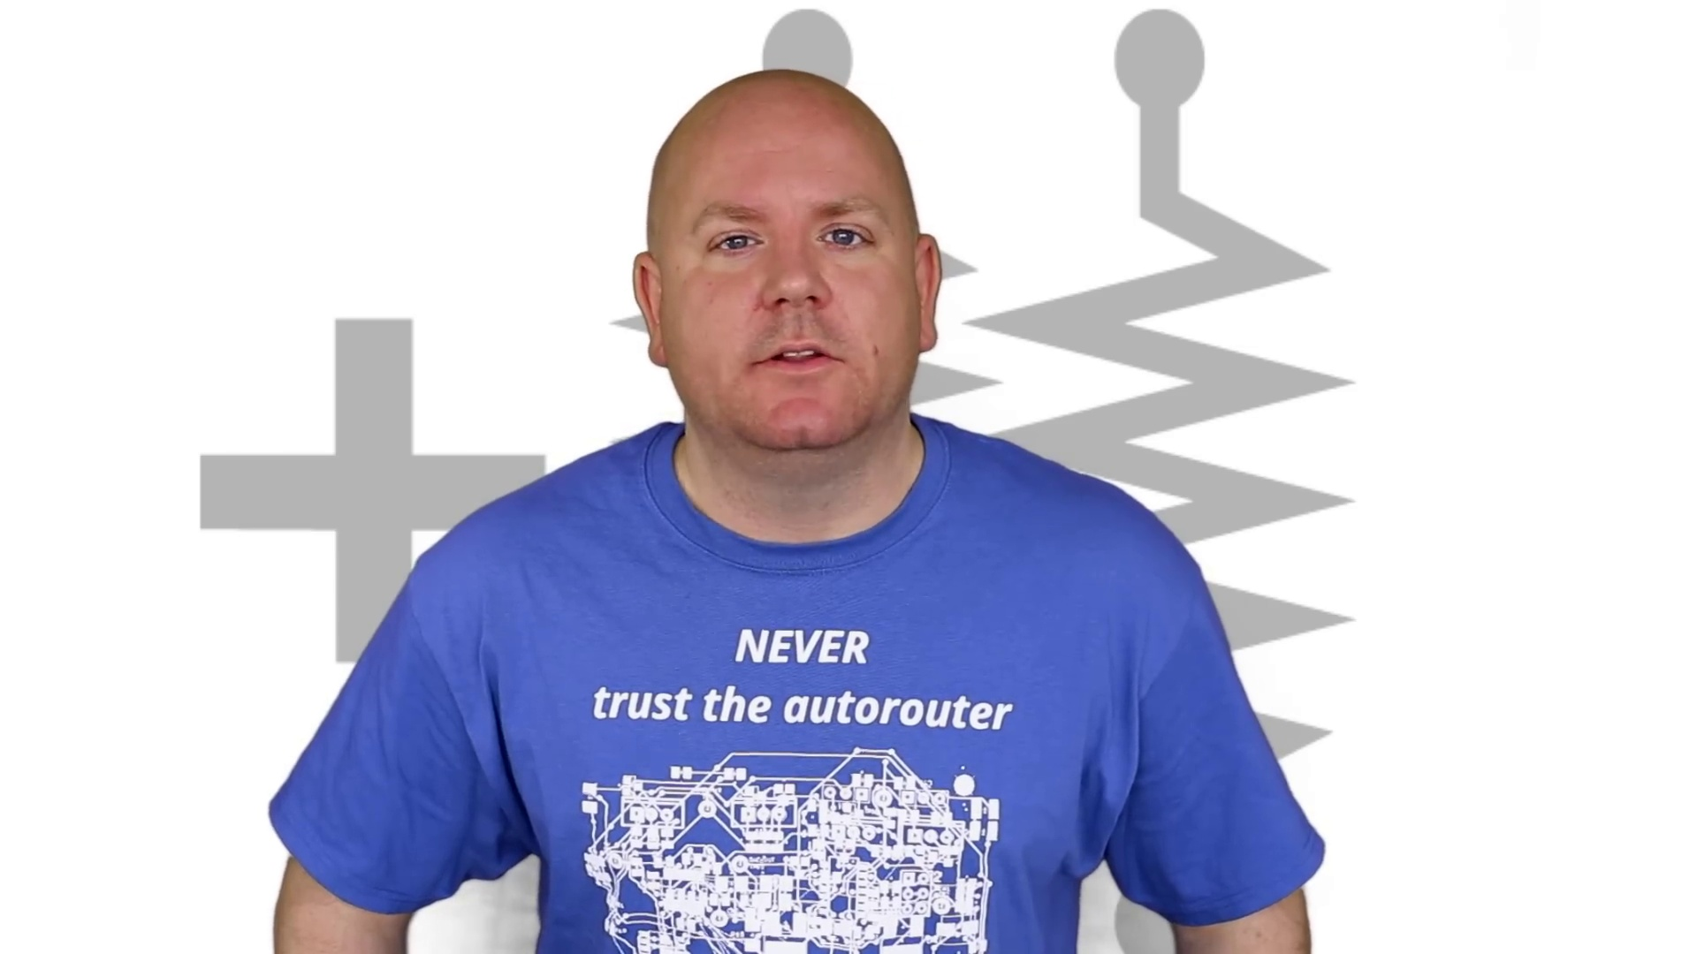 (score 0.0000)
 (score 0.0000)
 (score 0.0000)
 (score 0.0000)
 (score 0.0000)
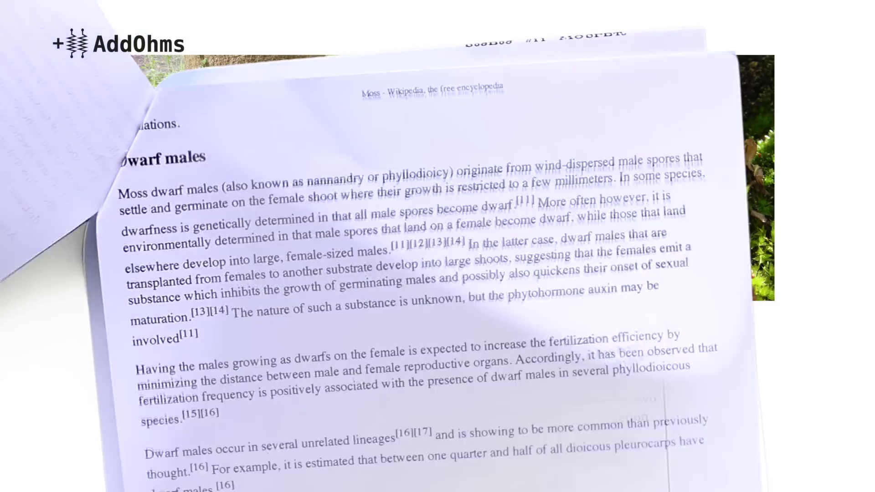 (score 0.0000)
 (score 0.0000)
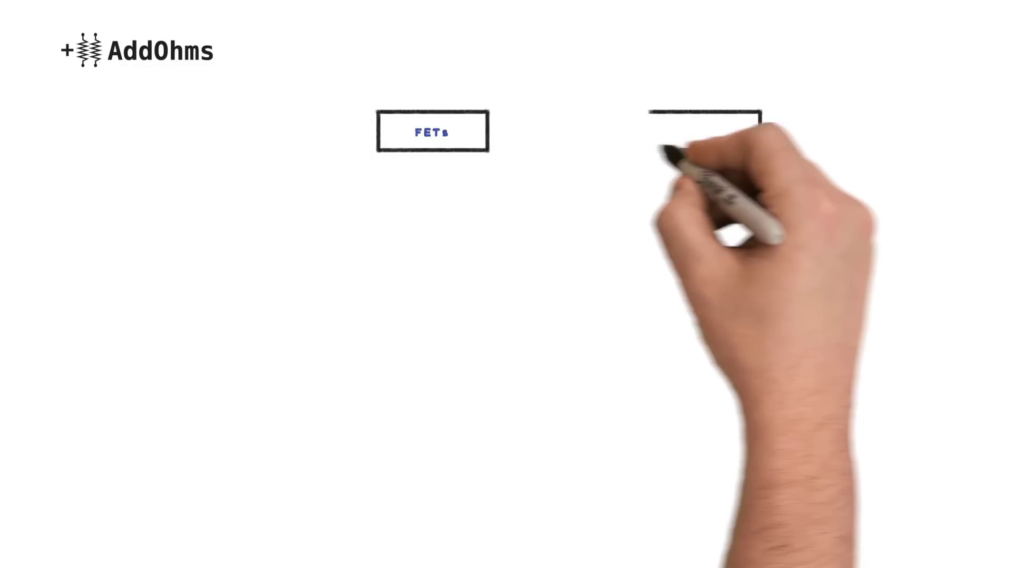 (score 0.0000)
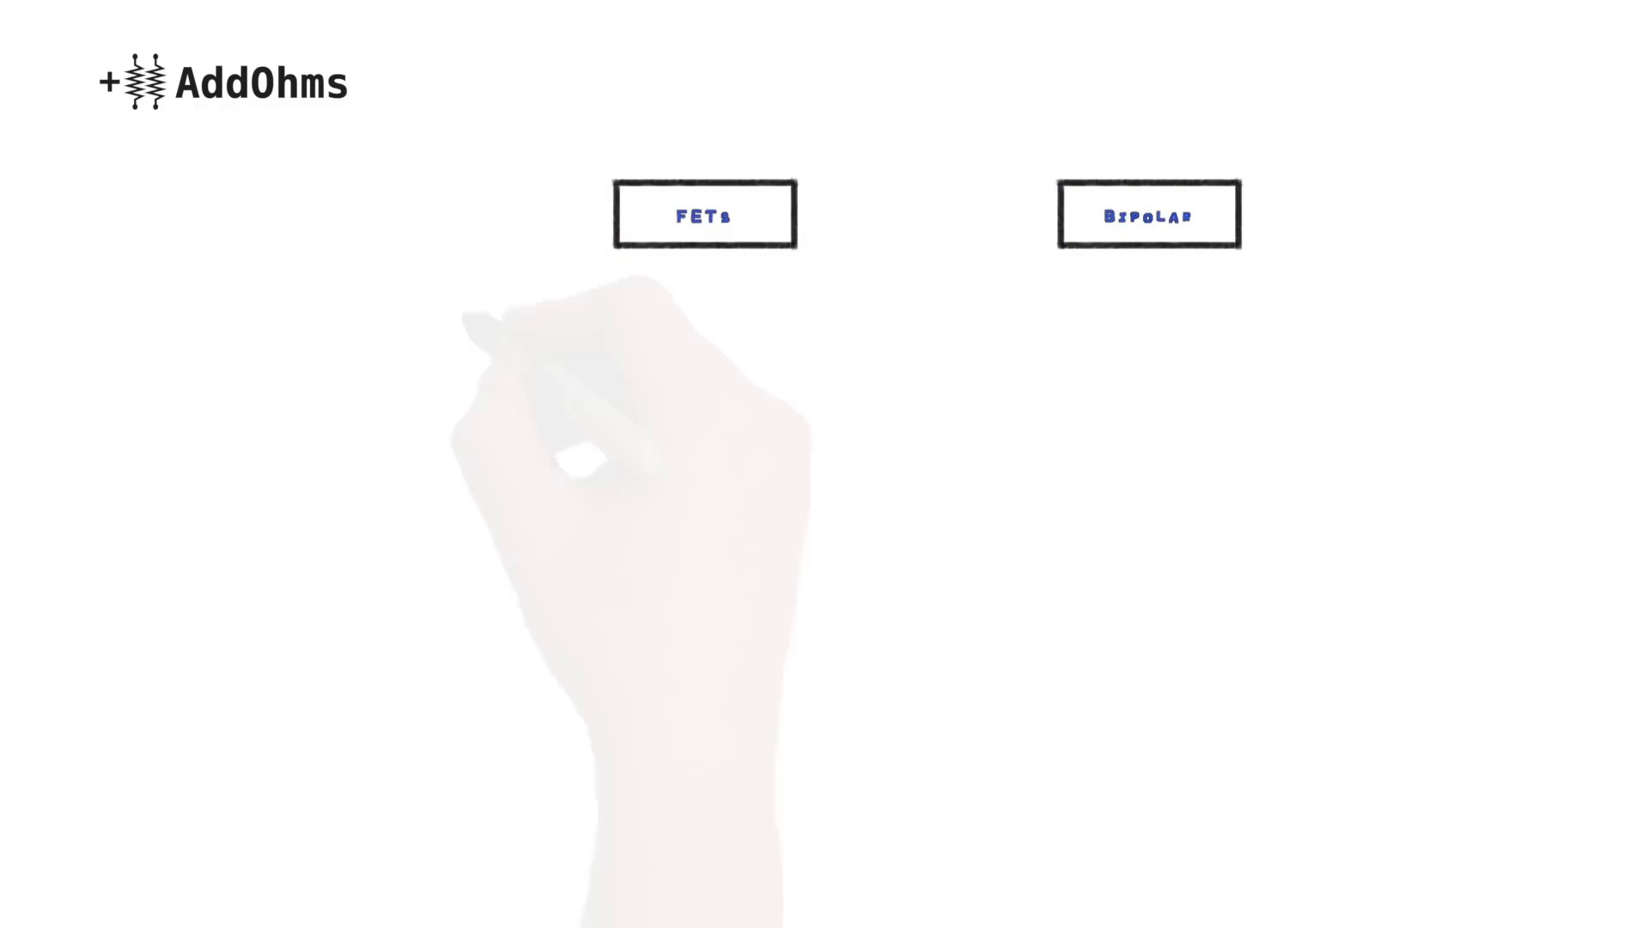 (score 0.0000)
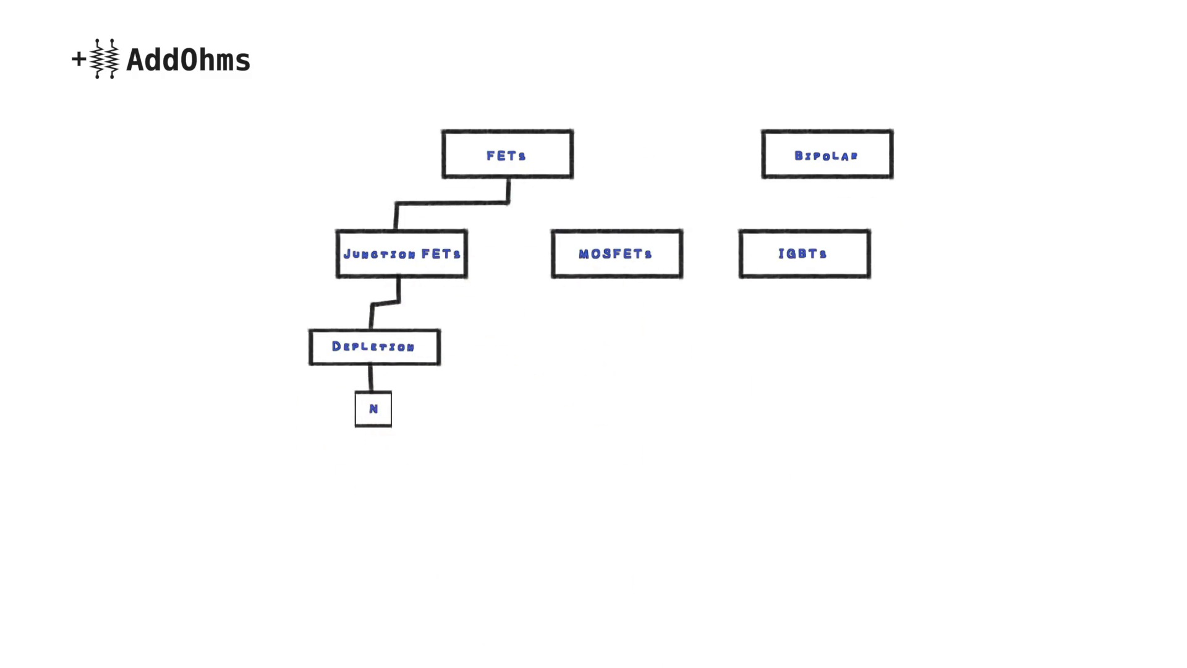 (score 0.0000)
- matched 38 frame(s), max score 95.0000: The instructor began the video by comparing transistors and MOSFETs; more specifically, he stated that transistors are suited for smaller currents while MOSFETs can handle larger currents. As he described in a chart, MOSFETs exist in the FETs family along with junction FETs and IGBTs. MOSFETs have two types of modes: depletion and enhancement. In depletion mode, the MOSFET acts as a regular switch, and in enhancement mode, the MOSFET acts as a variable resistor. The enhancement mode MOSFET is the most common transistor used today.
Source: https://www.youtube.com/watch?v=GrvvkYTW_0k : MOSFETs and How to Use Them | AddOhms #11
Top correlated frames:
 (score 95.0000)
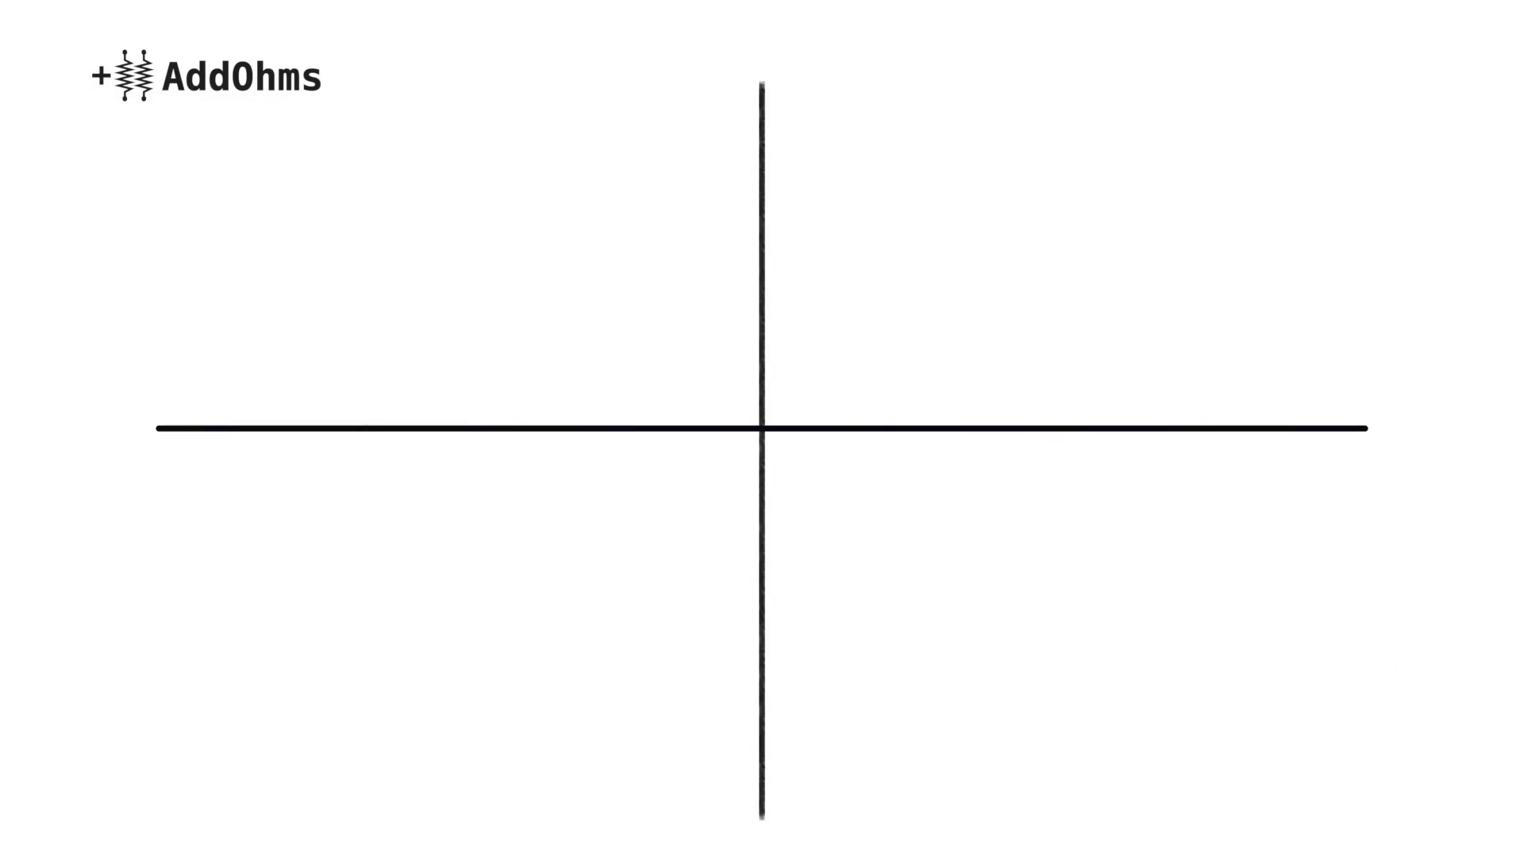 (score 95.0000)
 (score 95.0000)
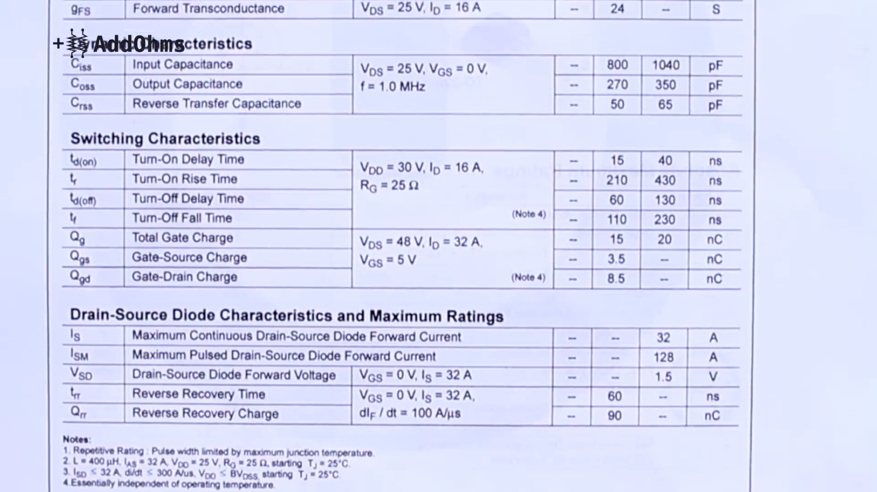 (score 95.0000)
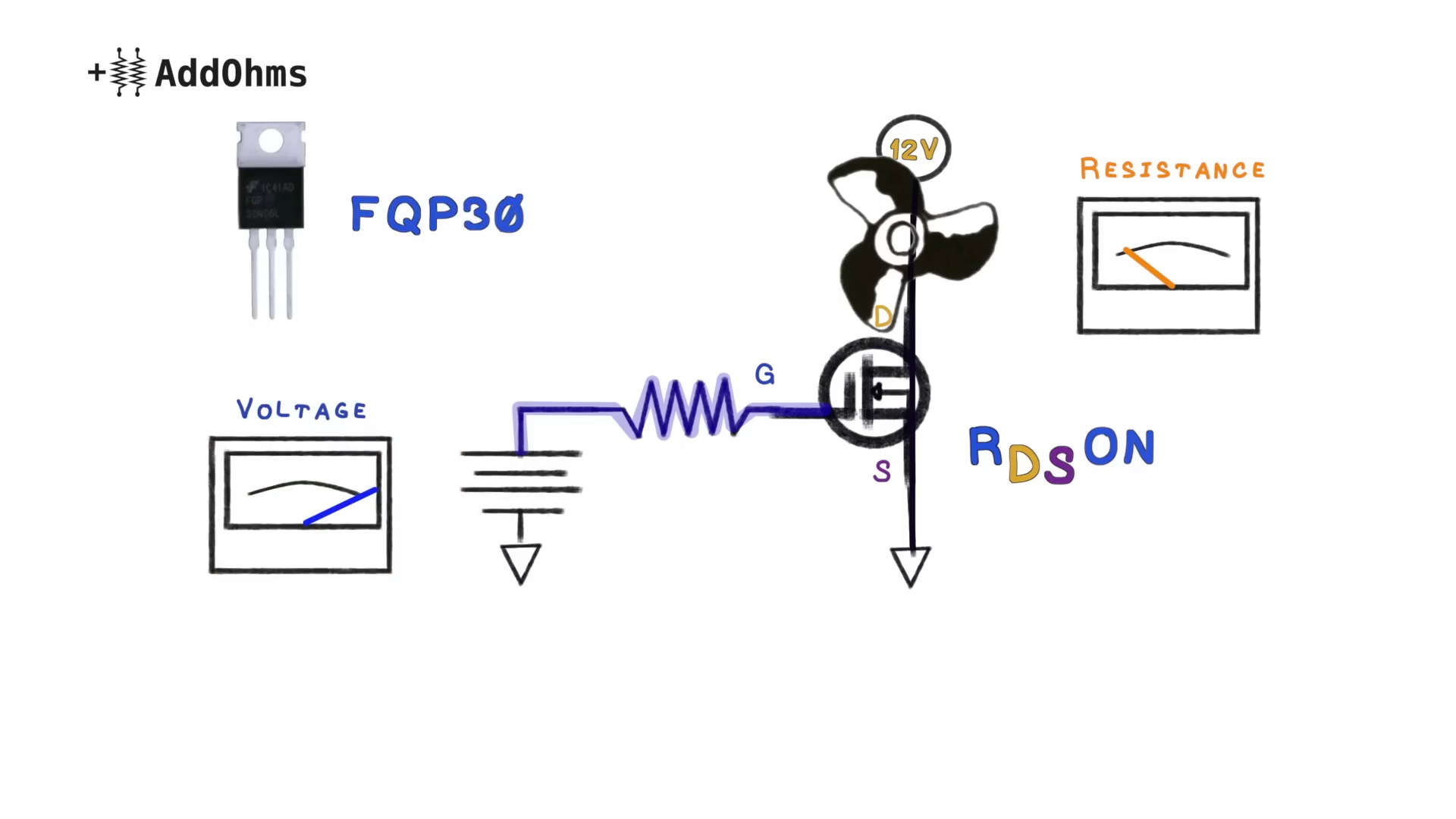 (score 95.0000)
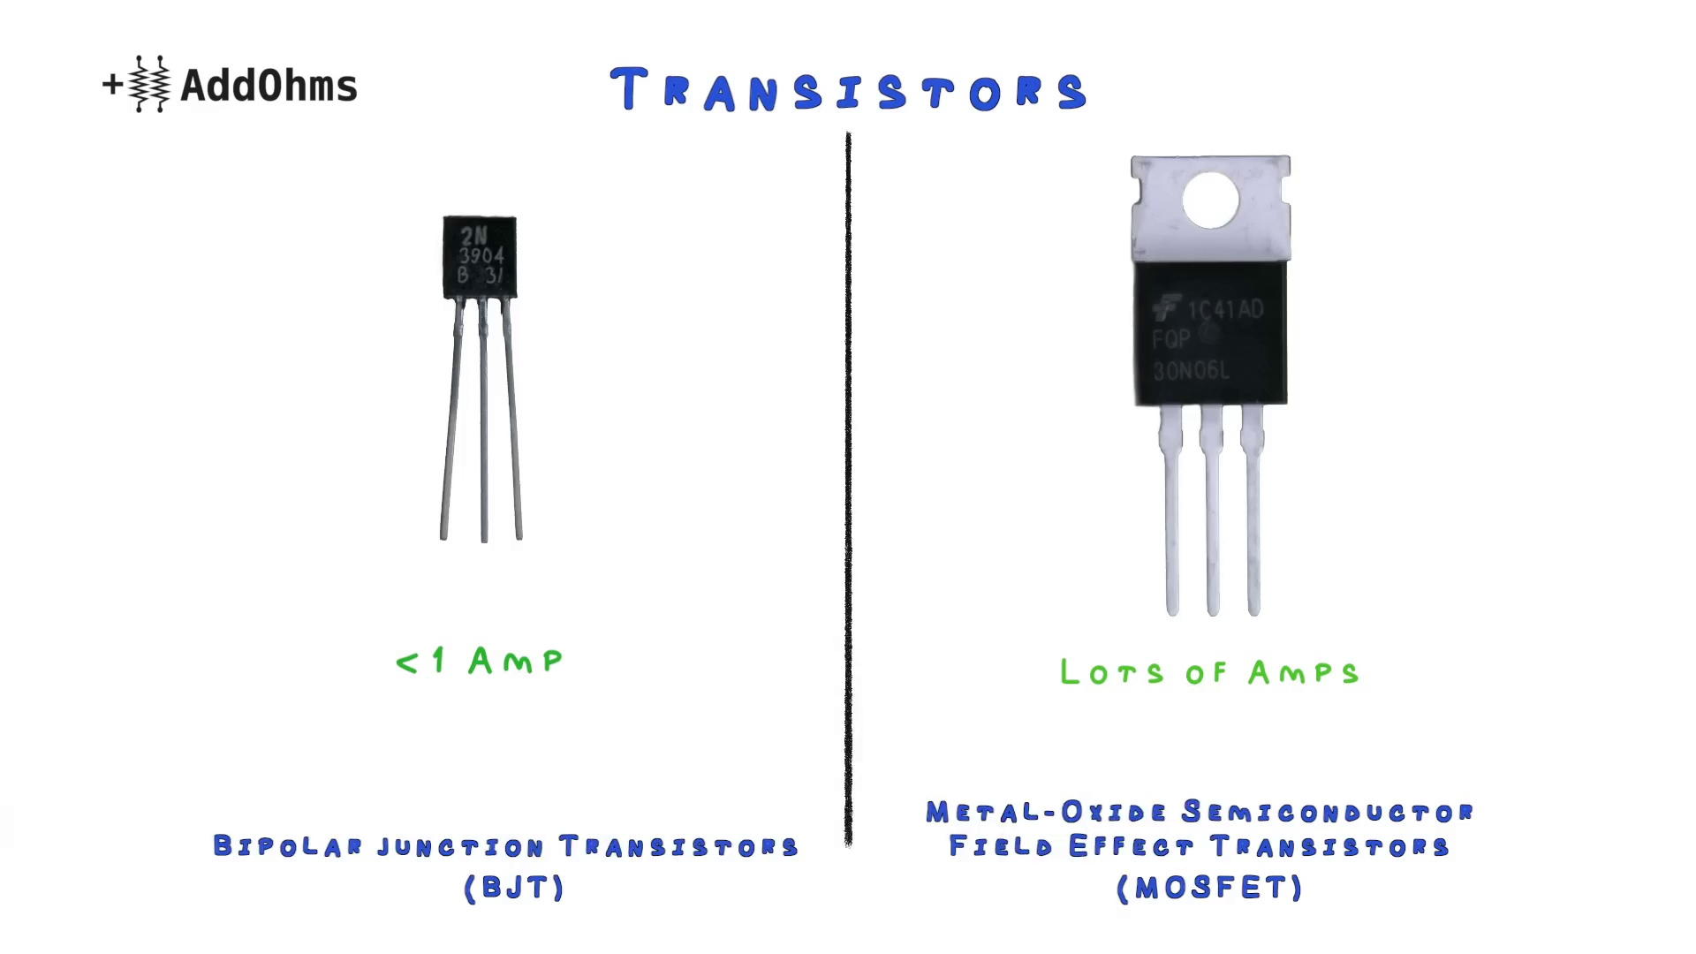 (score 95.0000)
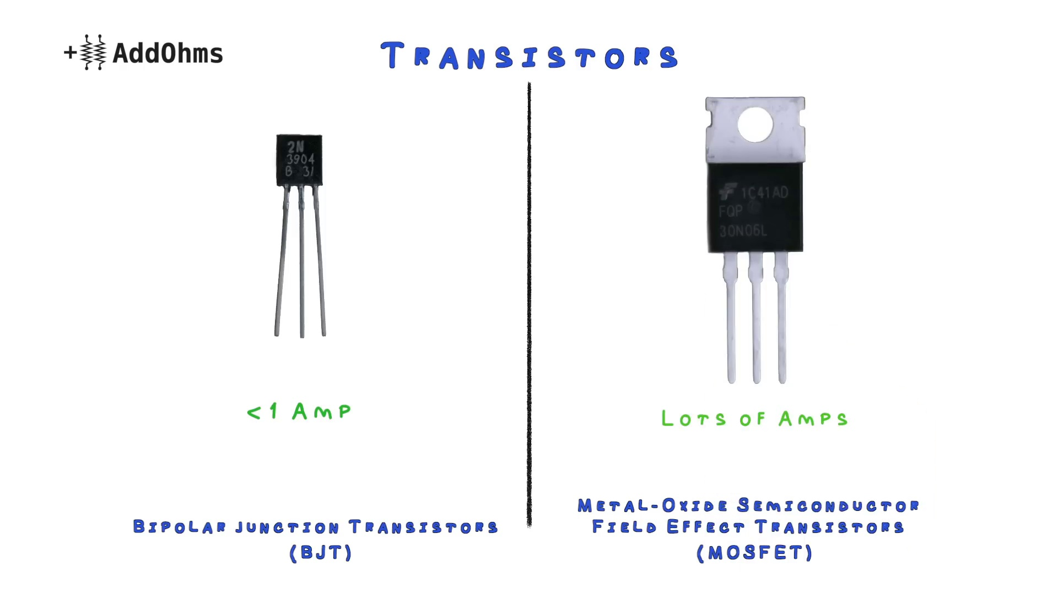 (score 92.0000)
 (score 90.0000)
 (score 90.0000)
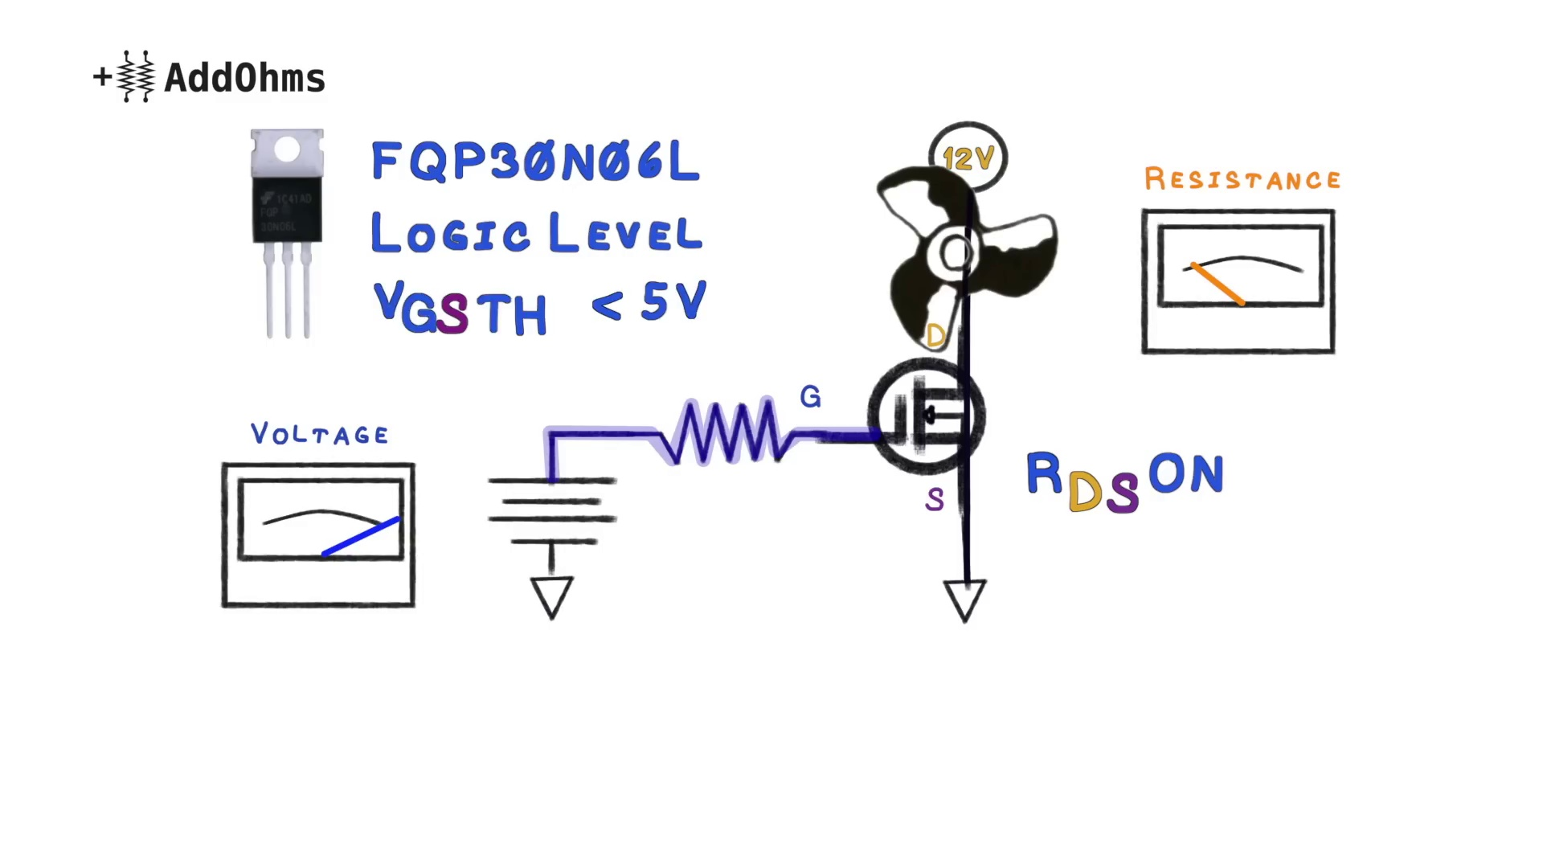 (score 90.0000)
Least correlated frames:
 (score 0.0000)
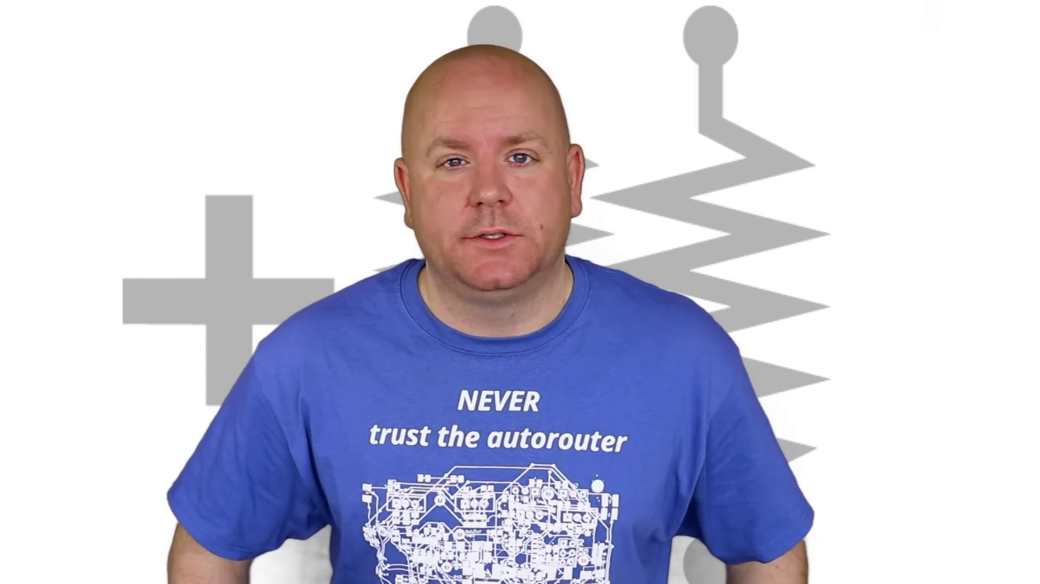 (score 0.0000)
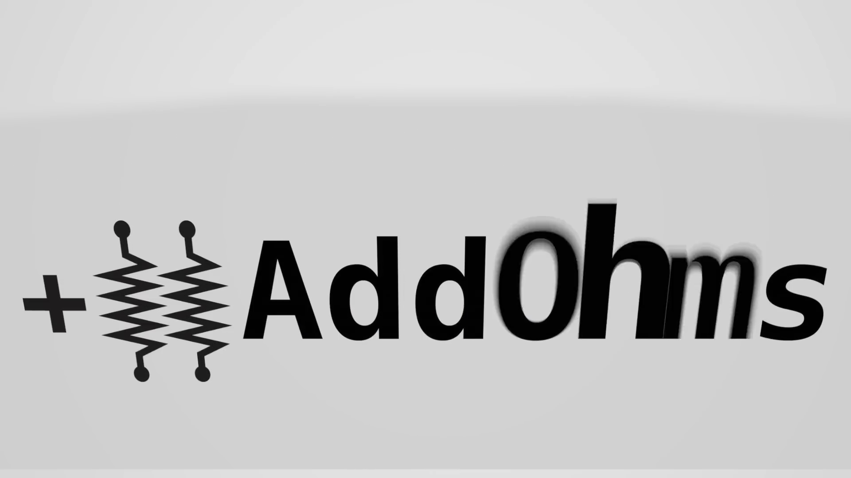 (score 0.0000)
 (score 0.0000)
 (score 0.0000)
 (score 0.0000)
 (score 0.0000)
 (score 0.0000)
 (score 0.0000)
 (score 0.0000)
- matched 35 frame(s), max score 85.0000: Covering metal oxide transistors, or mosfets, describing the enhancement mode mosfets than can come in n or p versions. This video has a lot of details that we are going over in class now with your lectures, in a more colorful description. He explains the max dissipation and if a heat sink would be needed. Also reviewing the Vgs and Vth threshold voltage to know how to use mosfets.
Source: https://www.youtube.com/watch?v=GrvvkYTW_0k: MOSFETs and How to Use Them | AddOhms #11
Top correlated frames:
 (score 85.0000)
 (score 85.0000)
 (score 85.0000)
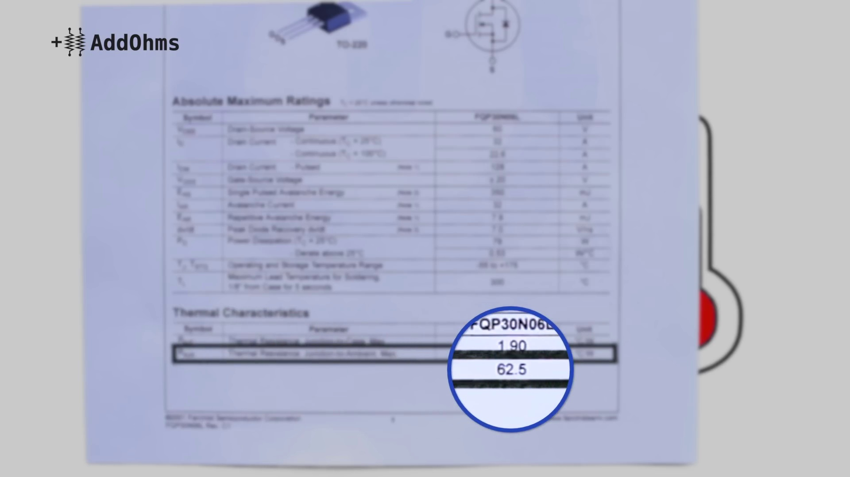 (score 85.0000)
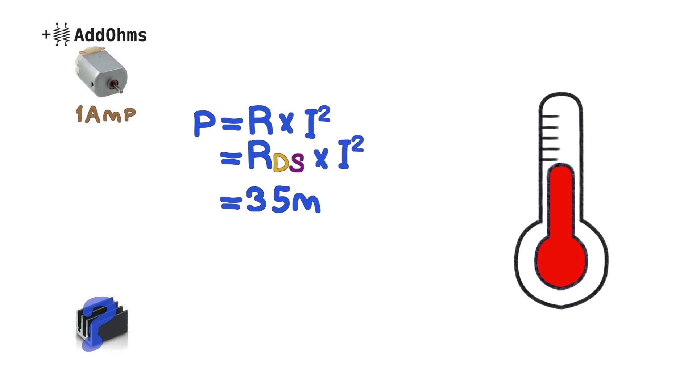 (score 85.0000)
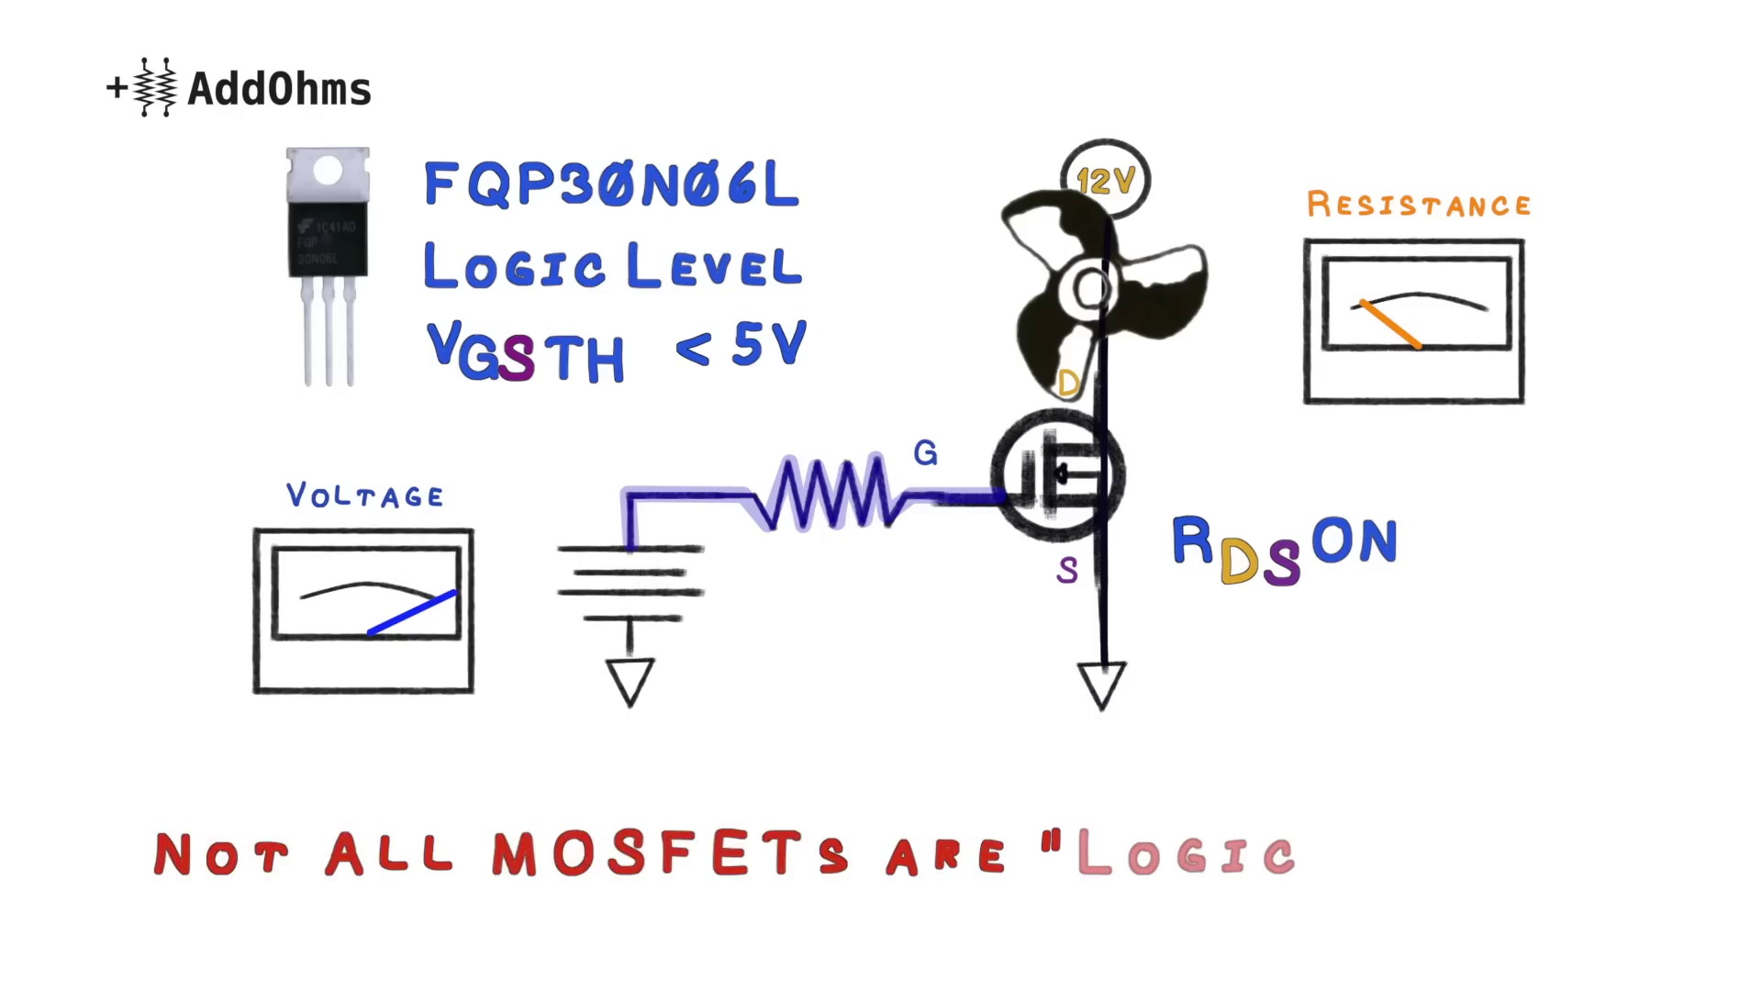 (score 85.0000)
 (score 85.0000)
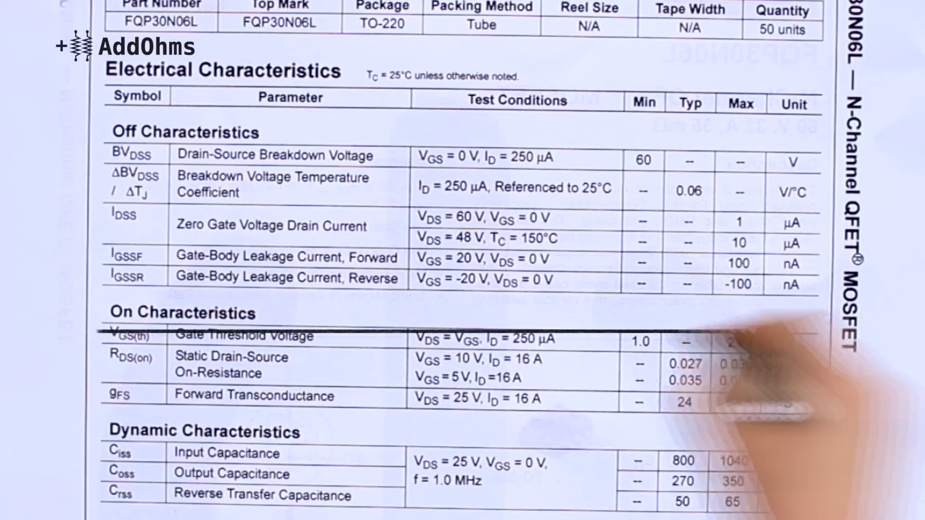 (score 85.0000)
 (score 85.0000)
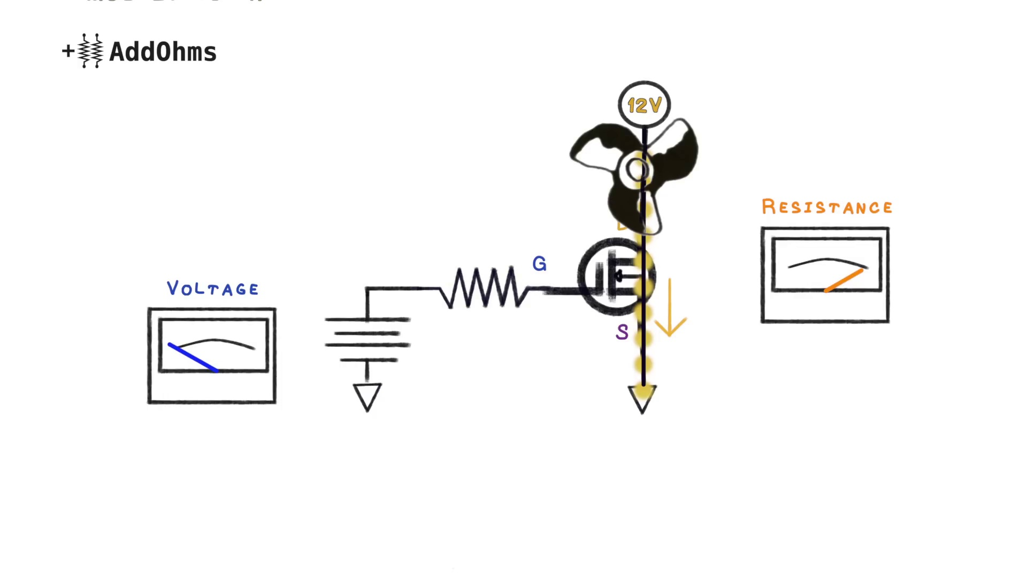 (score 85.0000)
Least correlated frames:
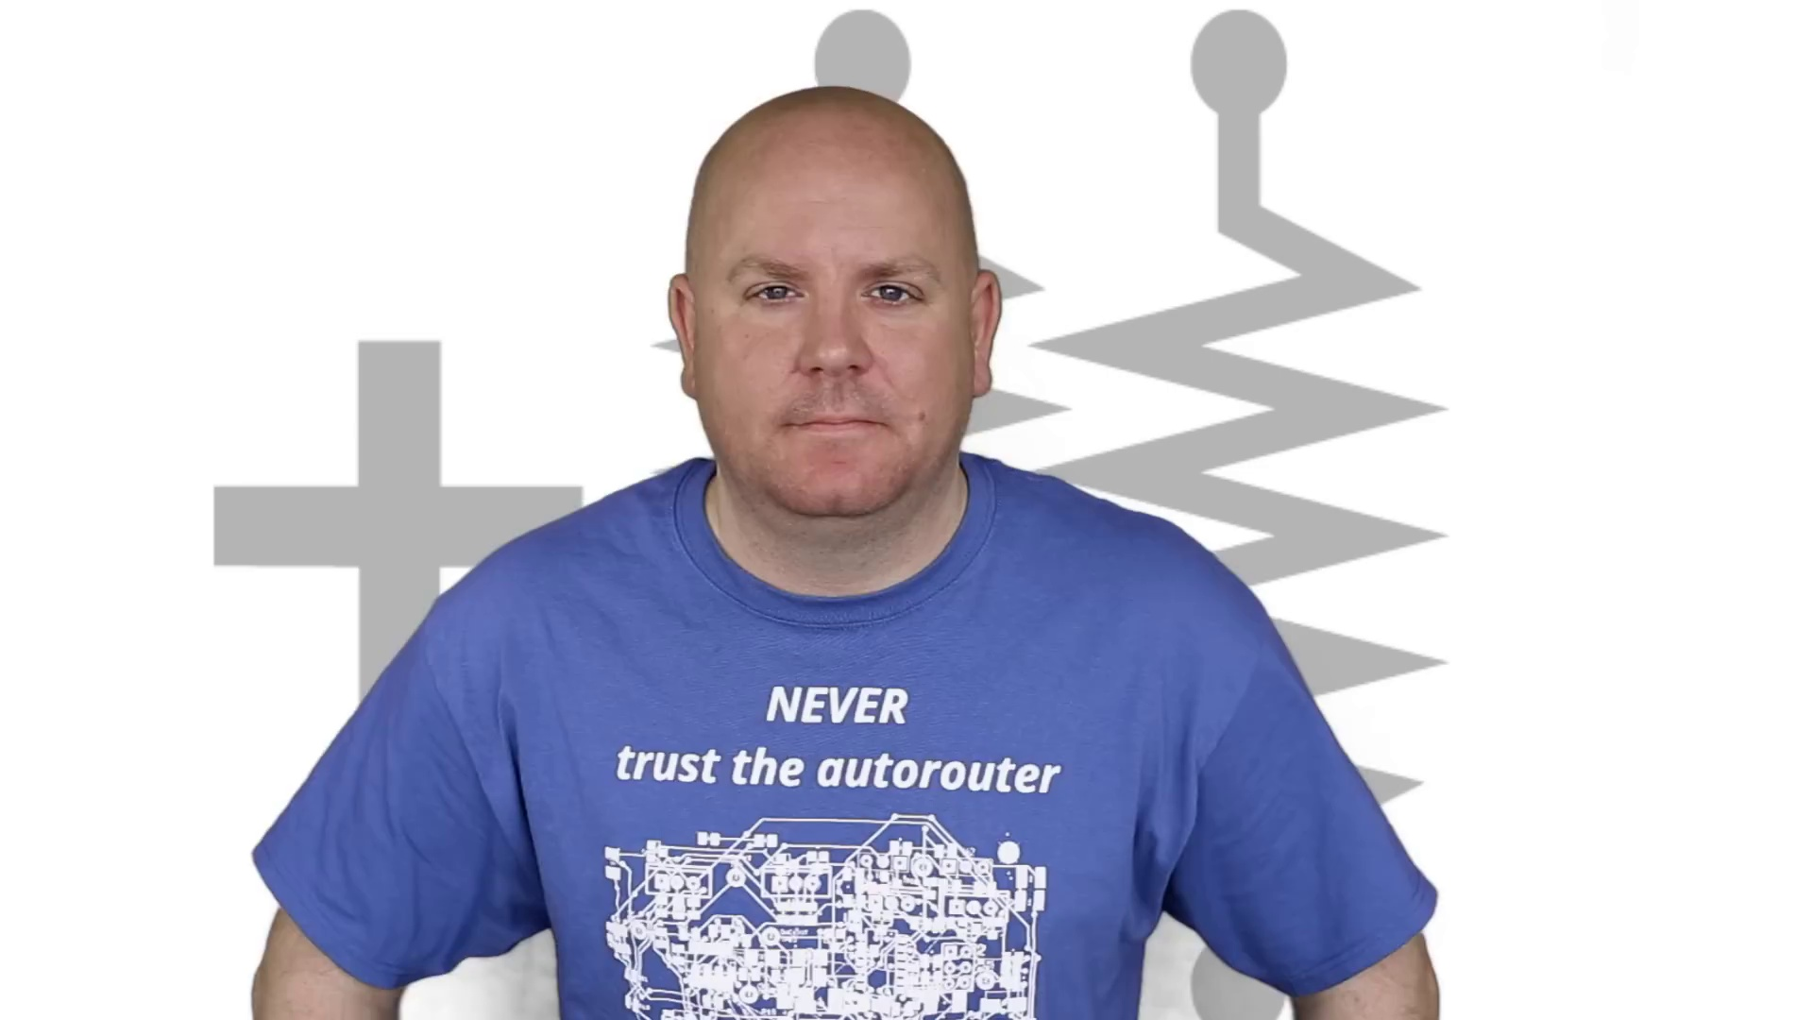 (score 0.0000)
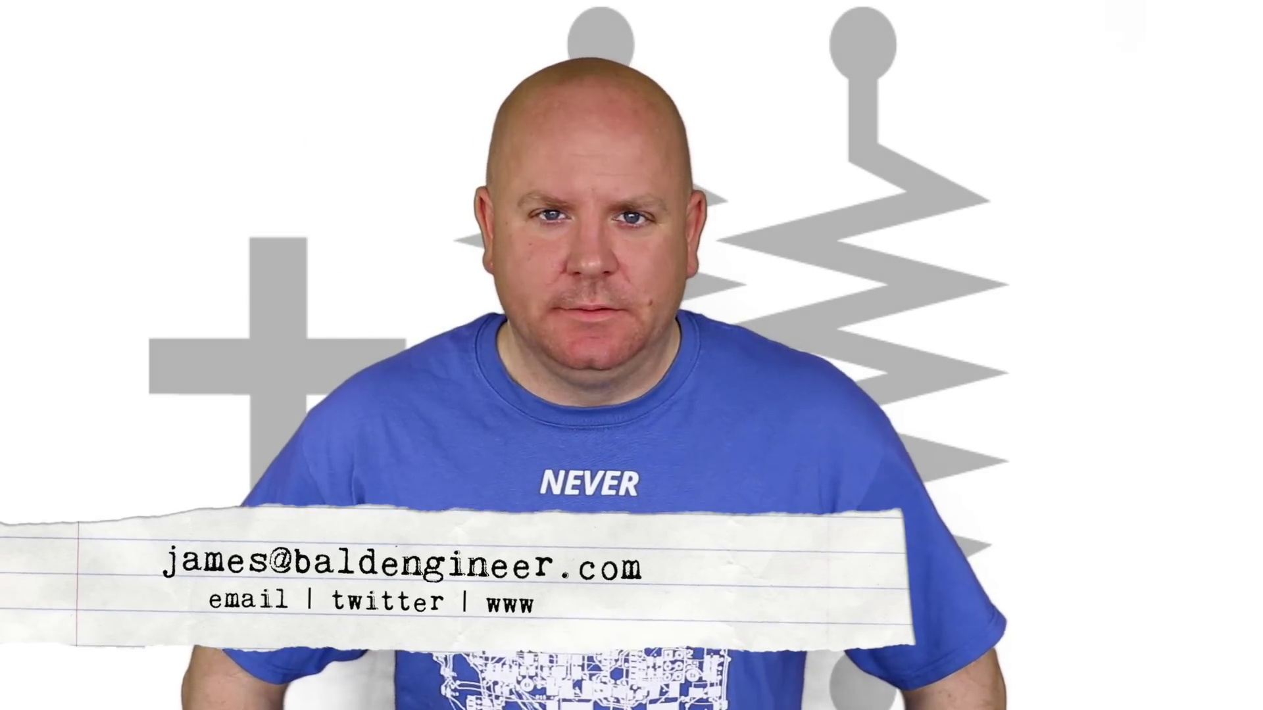 (score 0.0000)
 (score 0.0000)
 (score 0.0000)
 (score 0.0000)
 (score 0.0000)
 (score 0.0000)
 (score 0.0000)
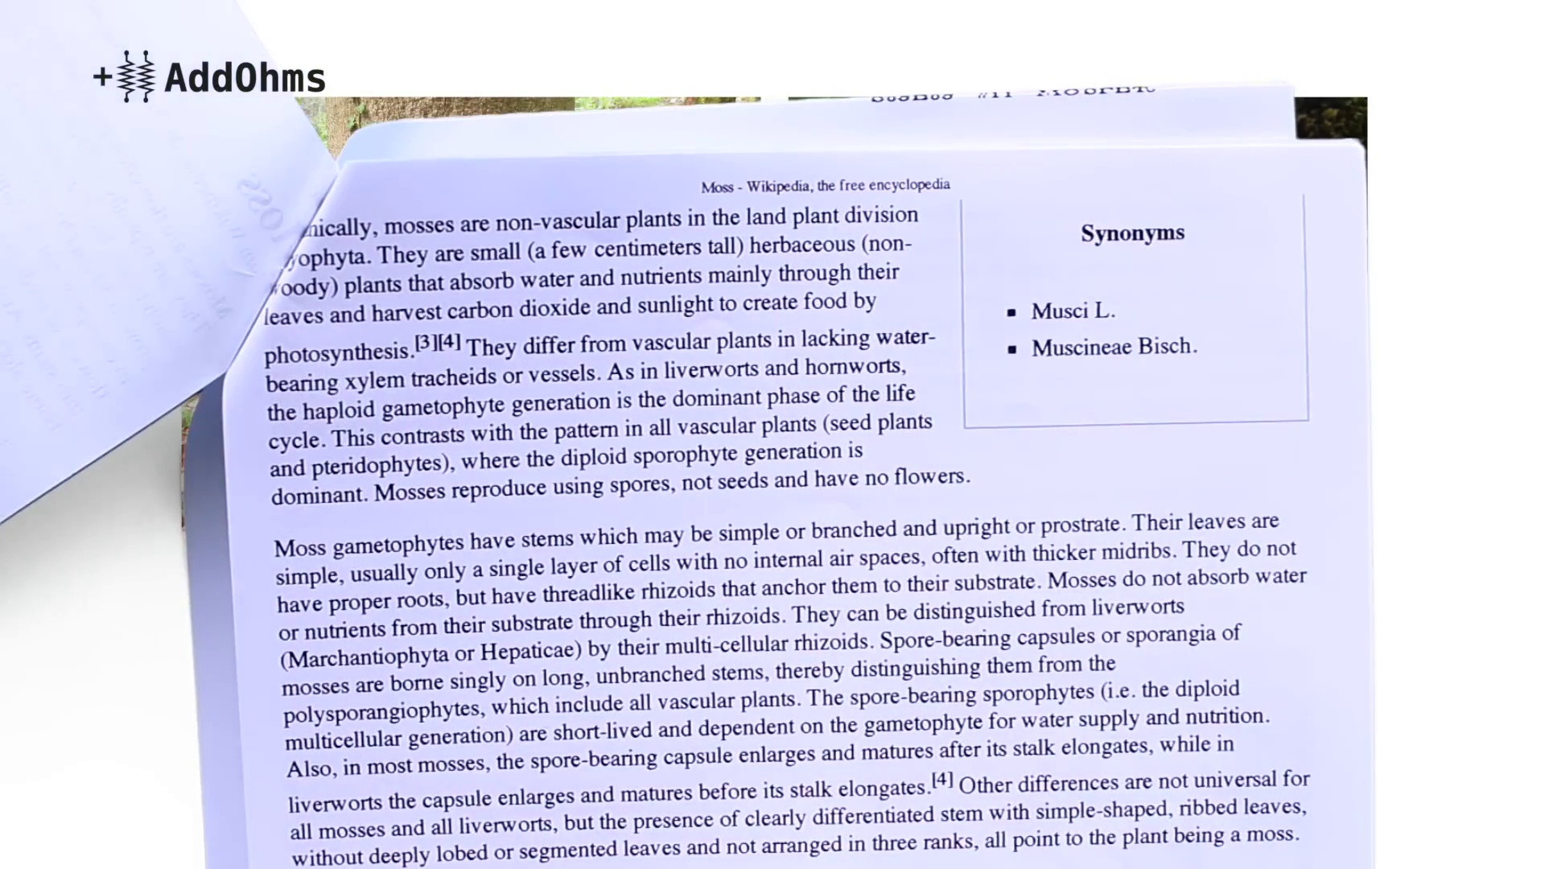 (score 0.0000)
 (score 0.0000)
- matched 33 frame(s), max score 90.0000: This video began by introducing a previous video titled, “BJTs and Transistor Switches.” So for context I decided to back and watch this video first. From this I was able to gain a baseline understanding of BJTs as electronic switches to determine how they differ from MOSFETS. BJTs are well suited for applications with small currents (less than one amp), whereas MOSFETS are suitable for applications with much higher currents. BJT stands for Bipolar Junction Transistor. The BJT has 3 terminals, the emitter, base, and collector. The transistor is made up of two diodes, one between base and emitter, and one between base and collector. Diodes need these current limits to work correctly. The two primary capabilities of the BJT are to amplify current, and secondly to operate as an electronic switch. There are 2 types of BJTs the NPN and the PNP. The NPN contains a forward-facing diode between bases and emitter, whereas the PNP contains a backward facing one. Both types will behave differently. MOSFET stands for Metal-Oxide Semiconductor Field Effect Transistor. MOSFETS are typically suited for applications with higher currents. They have two types of modes, depletion, and enhancement. Depletion mode works like a ‘normally closed’ switch, current can flow when no voltage is applied. Applied voltage (negative) causes the “switch” to open and stop the current. Enhancement mode MOSFETs work more like a variable resistor than an on and off switch. They come in N and P types. They are the most commonly used type of MOSFET. MOSFETs have a gate, drain, and source. The field effect nature suggests they work by voltage, compared to BJT that works by current. Voltage is applied be and source in varying intensities, which allows current to flow between the drain and source in varying intensities. Thus, they act as voltage dependent variable resistors. Increased voltage corresponds to lower resistance and higher current flow. Since MOSFETs are often used in high current applications they do have a tendency to get hot and can possibly require a heat sink. The maximum dissipation for safe operation without a heat sink can be simply calculated. Threshold voltage is important for this calculation.
Source: https://www.youtube.com/watch?v=GrvvkYTW_0k: MOSFETS and how to use them.
Top correlated frames:
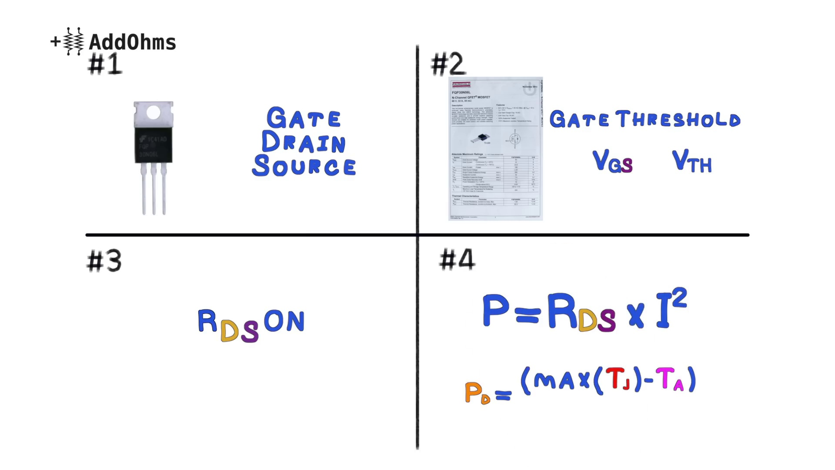 (score 95.0000)
 (score 95.0000)
 (score 95.0000)
 (score 90.0000)
 (score 90.0000)
 (score 90.0000)
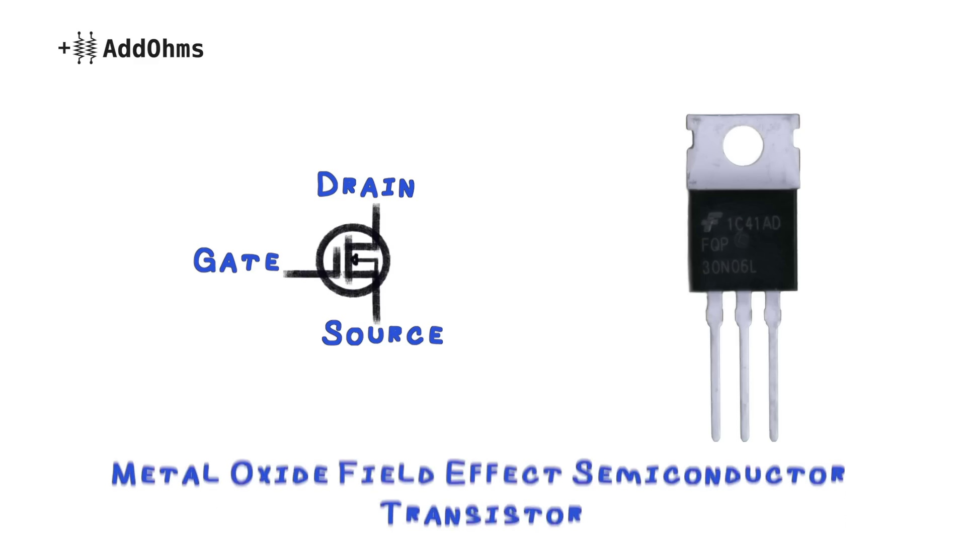 (score 90.0000)
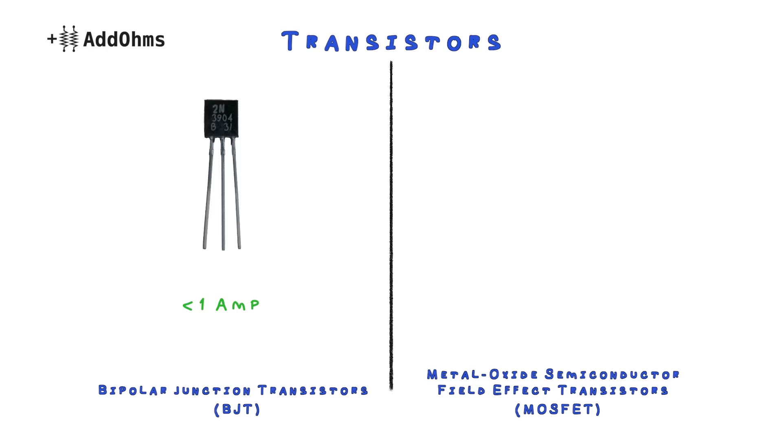 (score 90.0000)
 (score 87.0000)
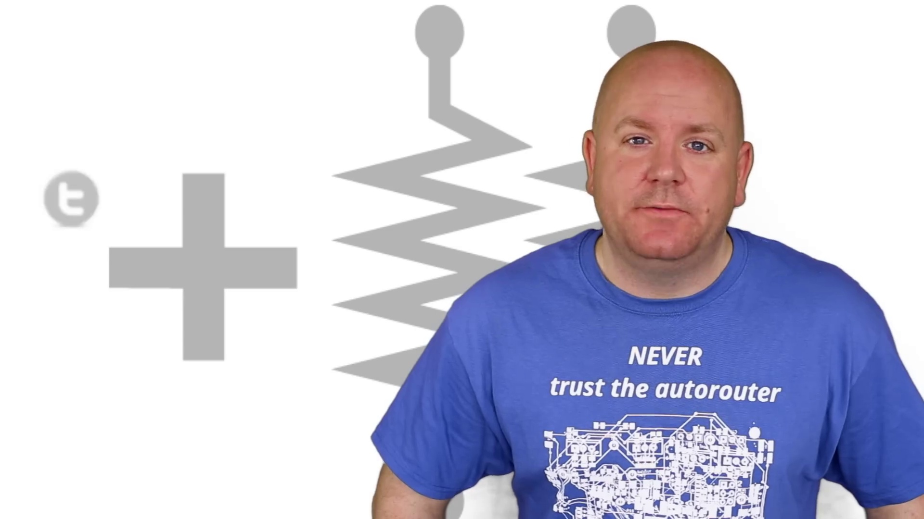 (score 85.0000)
Least correlated frames:
 (score 0.0000)
 (score 0.0000)
 (score 0.0000)
 (score 0.0000)
 (score 0.0000)
 (score 0.0000)
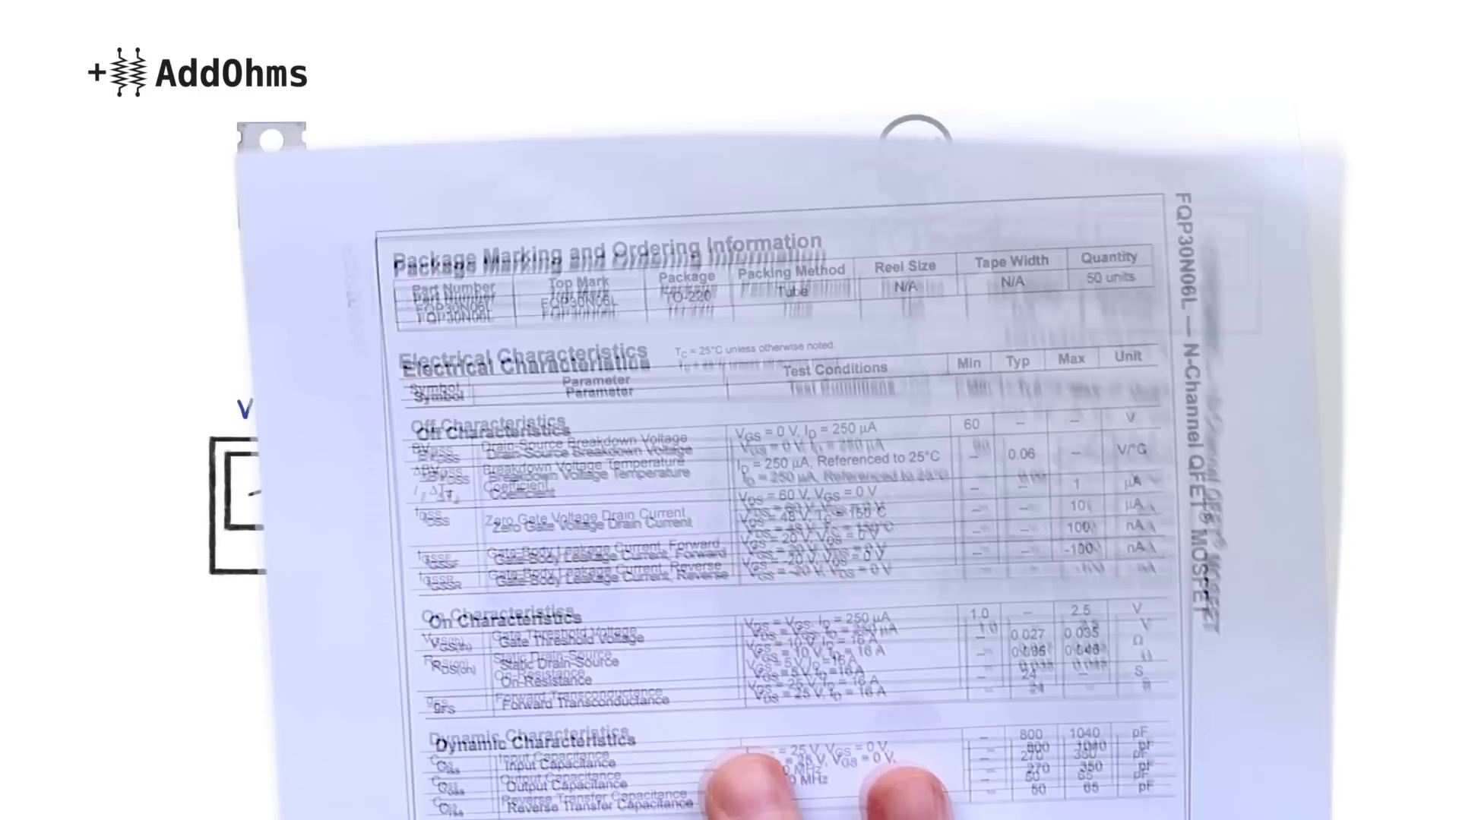 (score 0.0000)
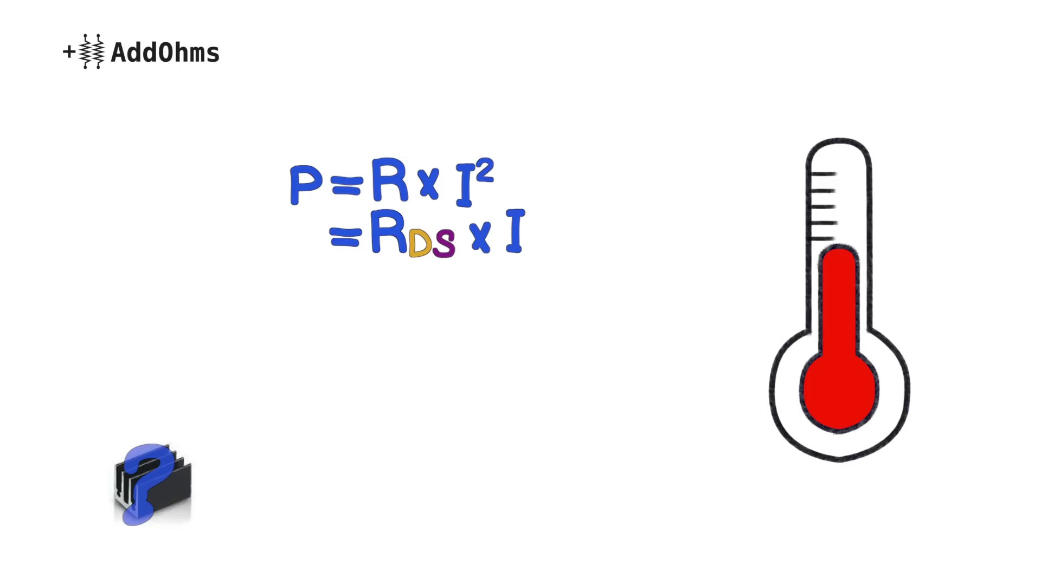 (score 0.0000)
 (score 0.0000)
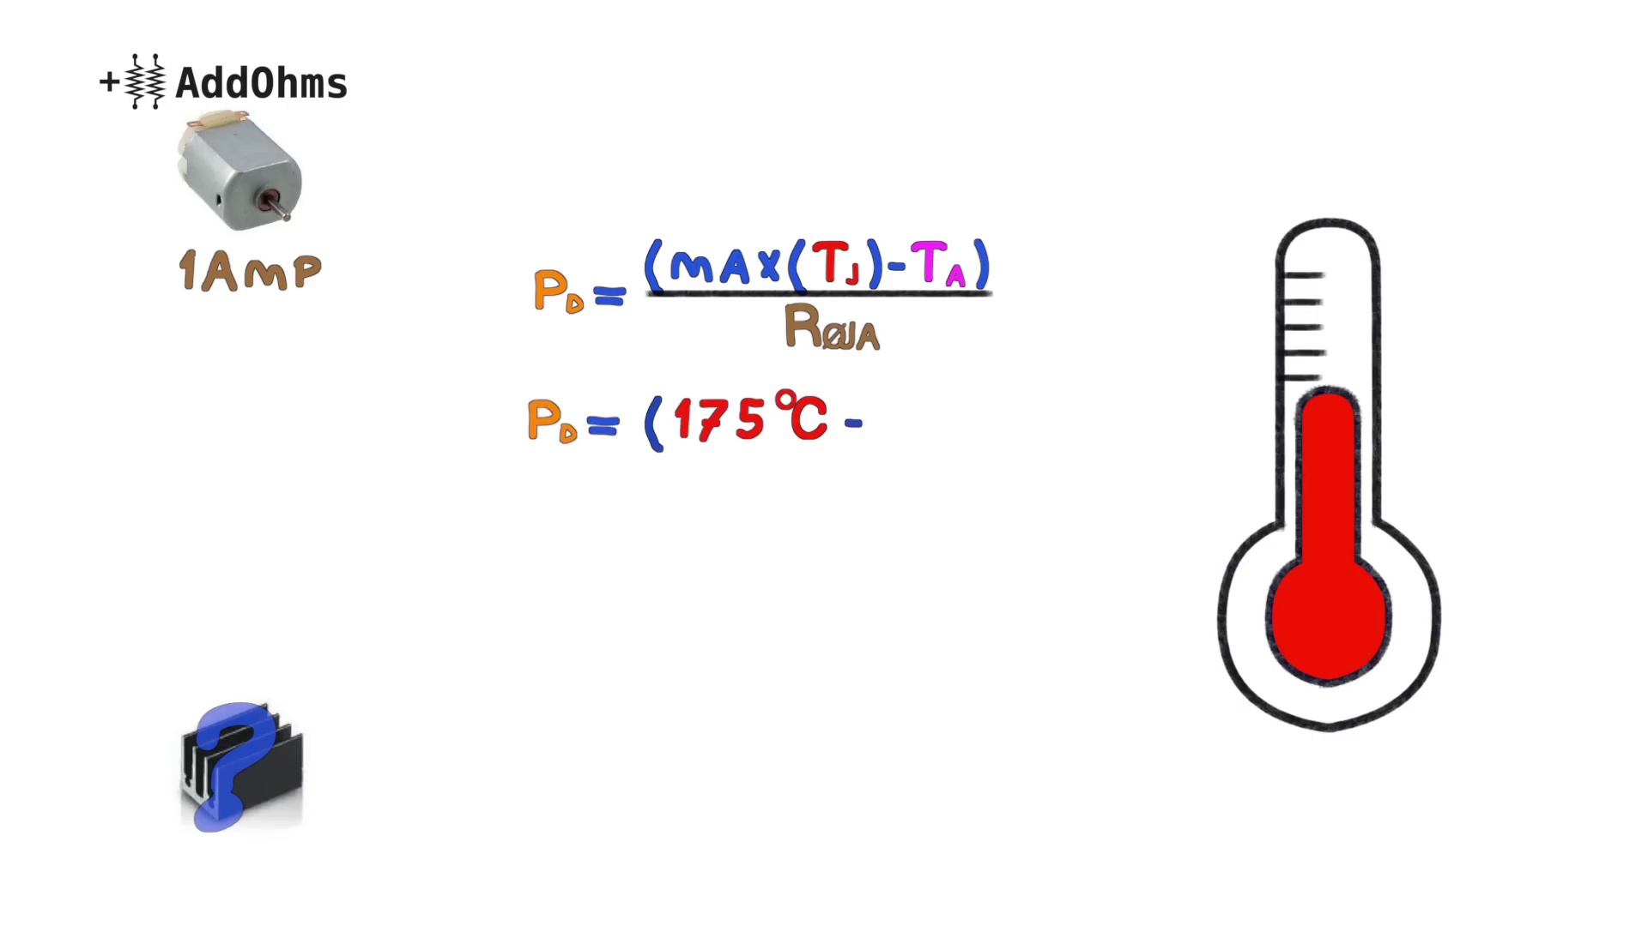 (score 0.0000)
- matched 32 frame(s), max score 95.0000: This video is 7:45 minutes long. What I learned from the video - This video taught the difference between BJTs and MOSFETs. MOSFETs are better suited for applications with higher current than BJTs. MOSFETs work as variable resistors controlled by voltage. This video also taught about how to calculate if the MOSFET needs a heat sink.This video explained things very clearly and I don’t really have any questions.
Source: https://www.youtube.com/watch?v=GrvvkYTW_0k : MOSFETs and How to Use Them | AddOhms #11
Top correlated frames:
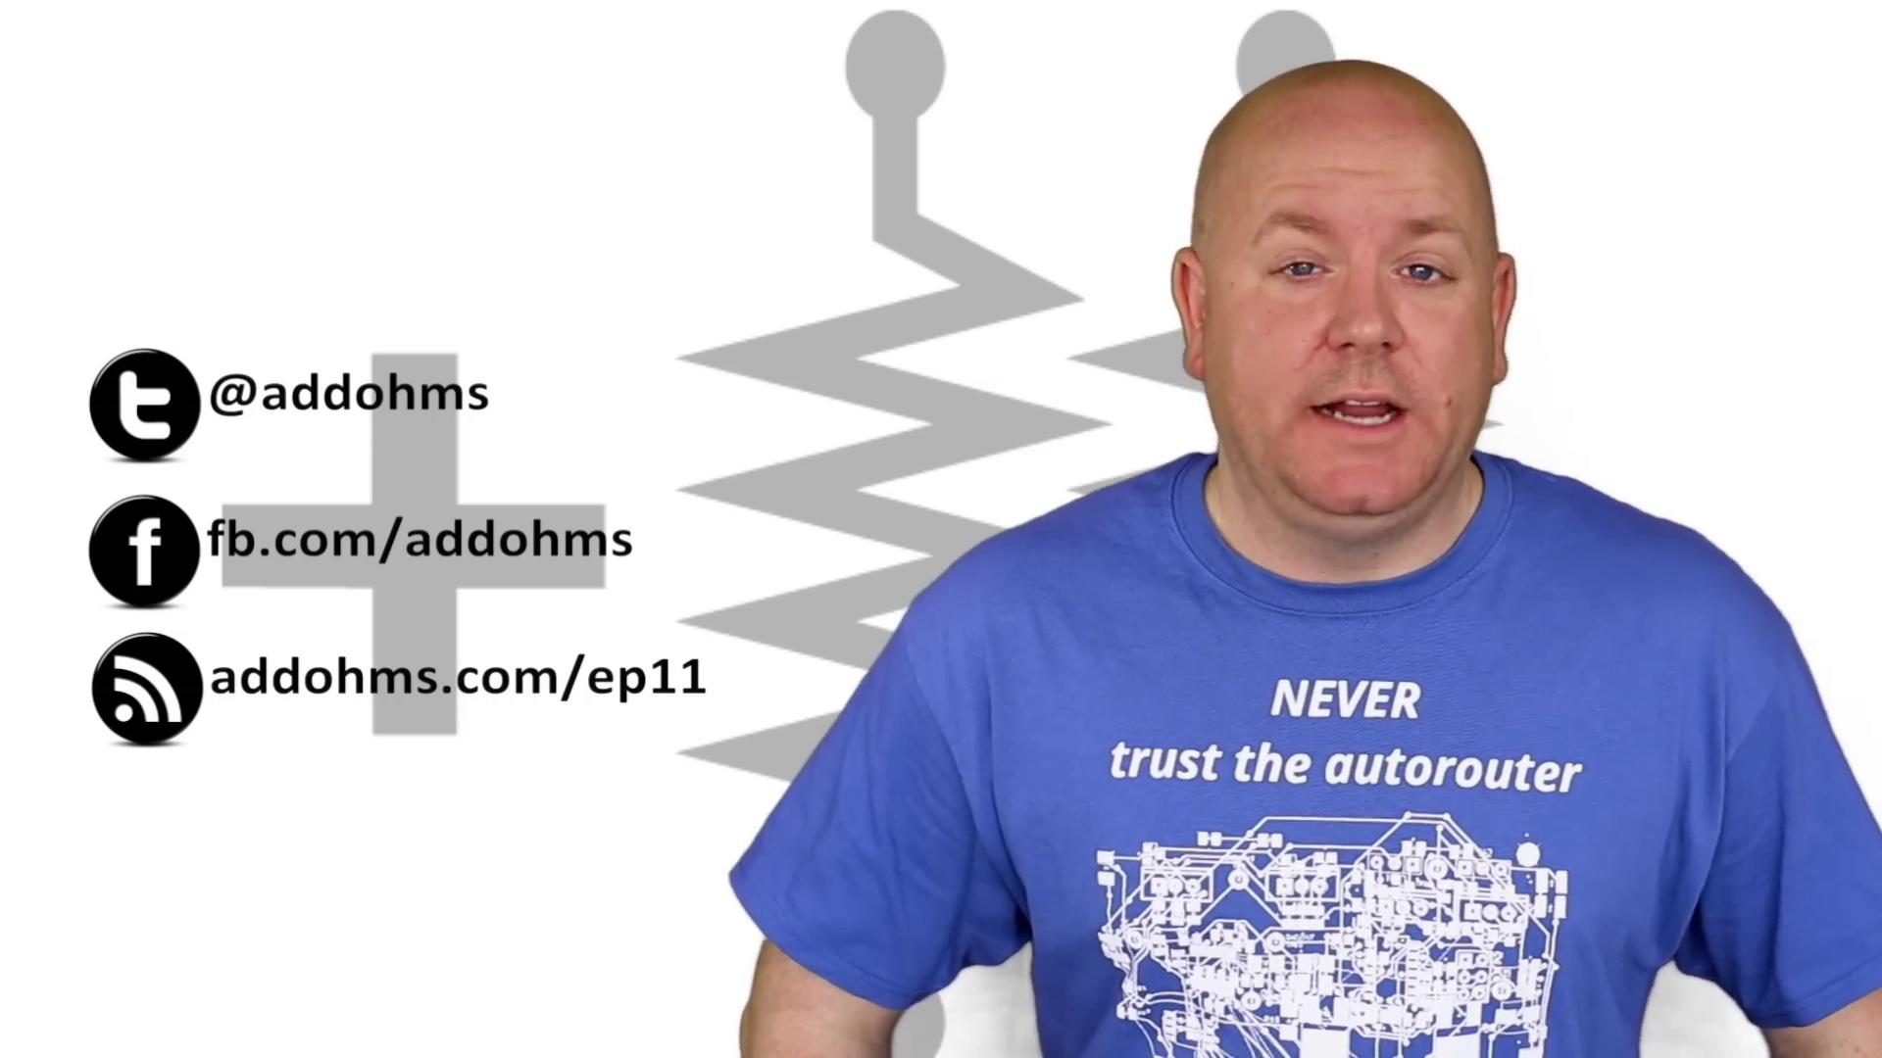 (score 95.0000)
 (score 95.0000)
 (score 90.0000)
 (score 90.0000)
 (score 90.0000)
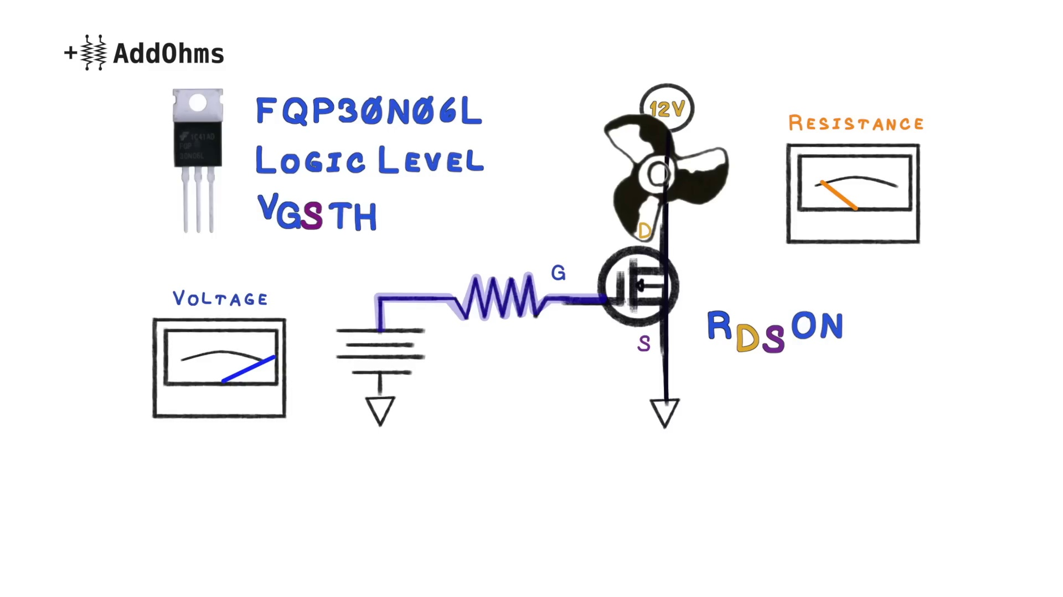 (score 90.0000)
 (score 90.0000)
 (score 90.0000)
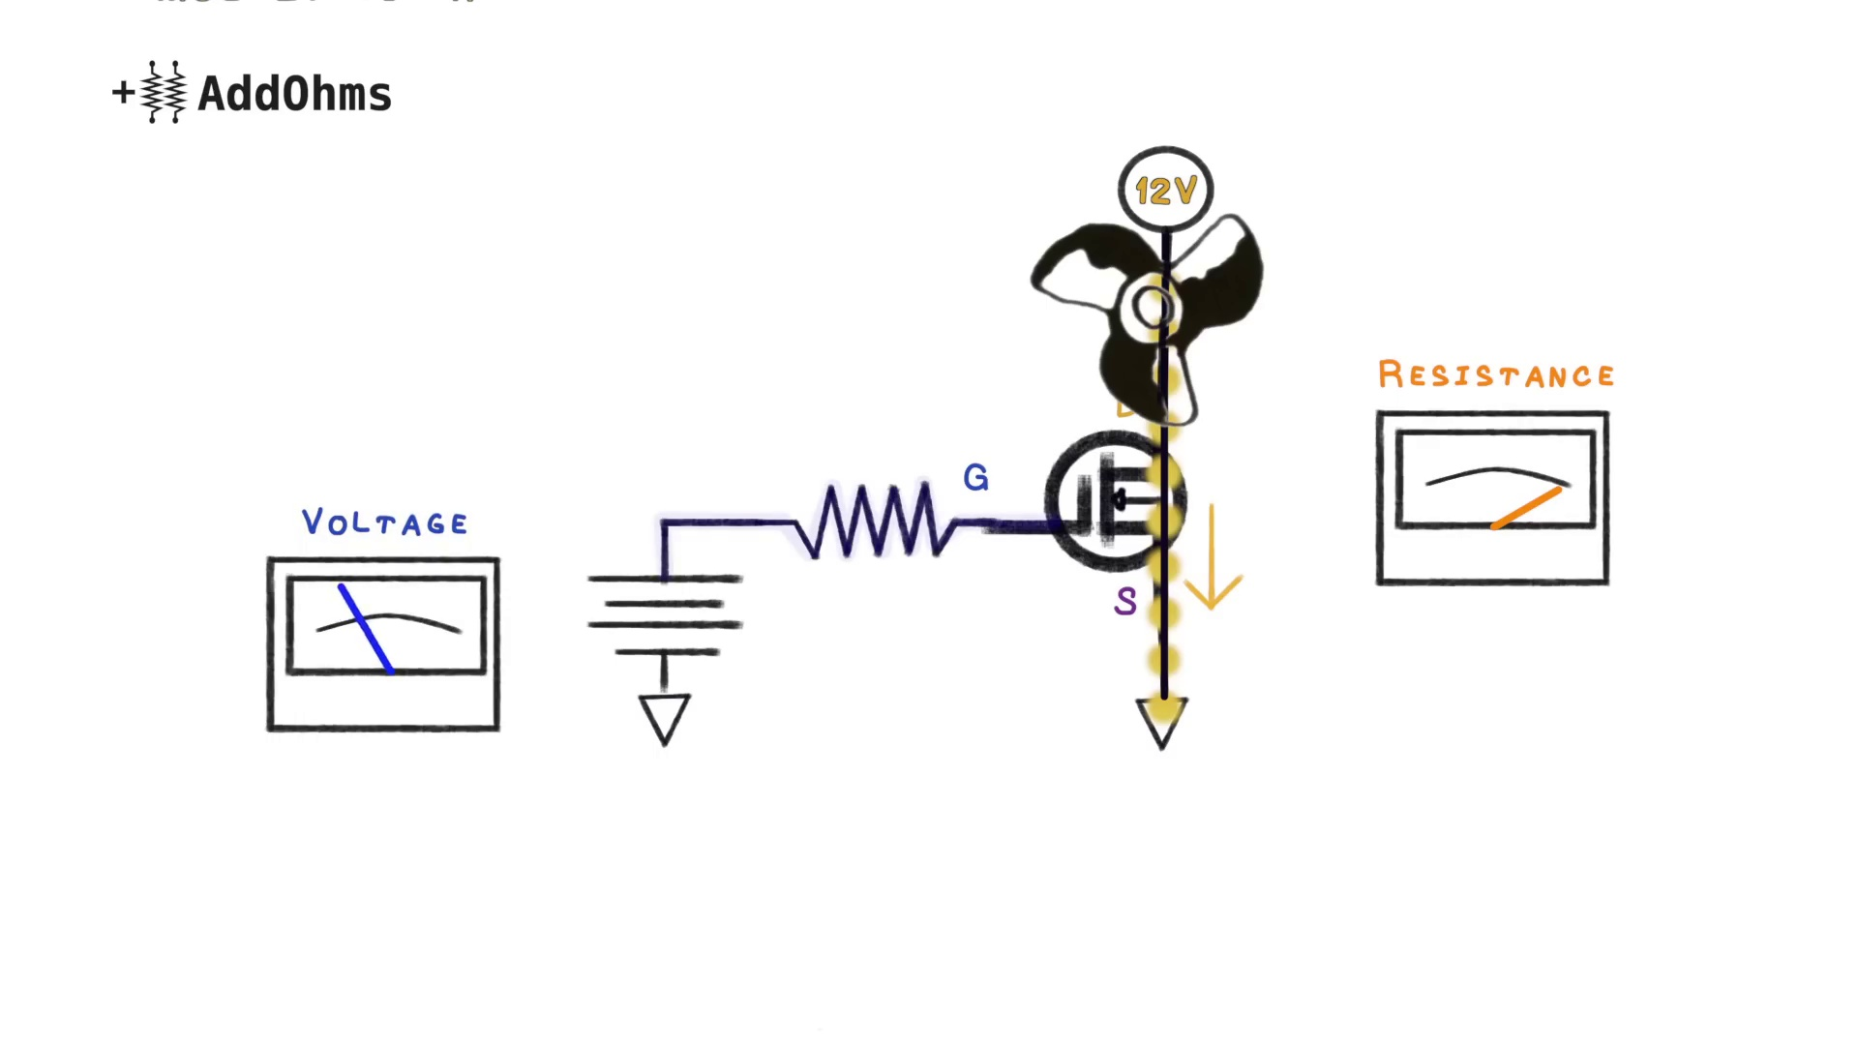 (score 90.0000)
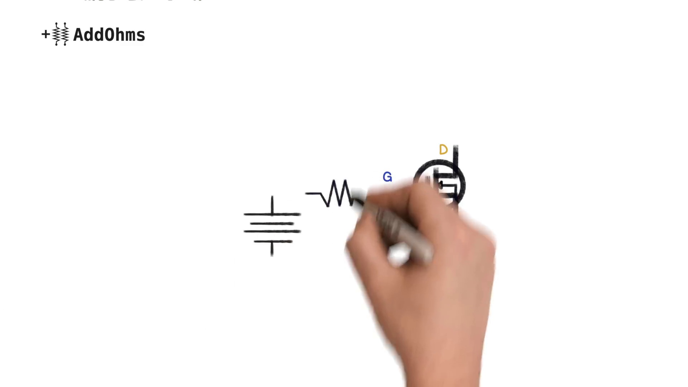 (score 90.0000)
Least correlated frames:
 (score 0.0000)
 (score 0.0000)
 (score 0.0000)
 (score 0.0000)
 (score 0.0000)
 (score 0.0000)
 (score 0.0000)
 (score 0.0000)
 (score 0.0000)
 (score 0.0000)
- matched 24 frame(s), max score 90.0000: MOSFETs are best suited for applications with higher current because BJT is mostly used in circuits that uses a current less than 1 amps. MOSFETs belong to a family tree of field effect transistors (FETs). MOSFETs has two subcategory depletion and enhancement. While depletion works to get the power down of a circuit, an enhancement works to increase the power of the circuit amplifying them. The MOSFETs has three pin drain gain and source. It is as the name suggests the MOSFETs can be used to either drain or gain power in a circuit.
Source: https://www.youtube.com/watch?v=GrvvkYTW_0k&t=13s: MOSFETs and how to use them.
Top correlated frames:
 (score 90.0000)
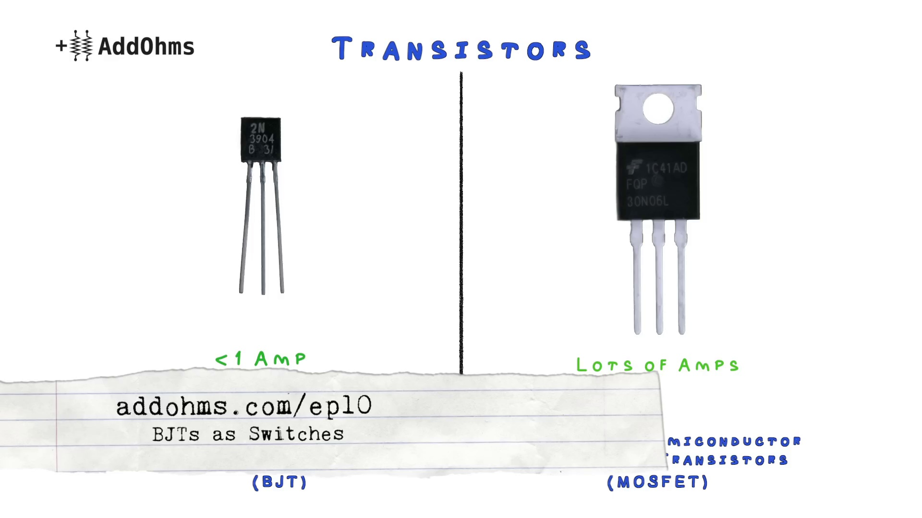 (score 90.0000)
 (score 90.0000)
 (score 85.0000)
 (score 85.0000)
 (score 85.0000)
 (score 85.0000)
 (score 85.0000)
 (score 85.0000)
 (score 85.0000)
Least correlated frames:
 (score 0.0000)
 (score 0.0000)
 (score 0.0000)
 (score 0.0000)
 (score 0.0000)
 (score 0.0000)
 (score 0.0000)
 (score 0.0000)
 (score 0.0000)
 (score 0.0000)
- matched 23 frame(s), max score 95.0000: Comprehensive overview of how MOSFETs work, their different modes, and practical applications.Understanding the calculations related to heat dissipation and RDS-on. Leveraging MOSFETs for efficient high-current circuit designs and ensuring safe operation with proper heat management.
Source: https://www.youtube.com/watch?v=GrvvkYTW_0k:m MOSFETs and How to Use Them
Top correlated frames:
 (score 95.0000)
 (score 95.0000)
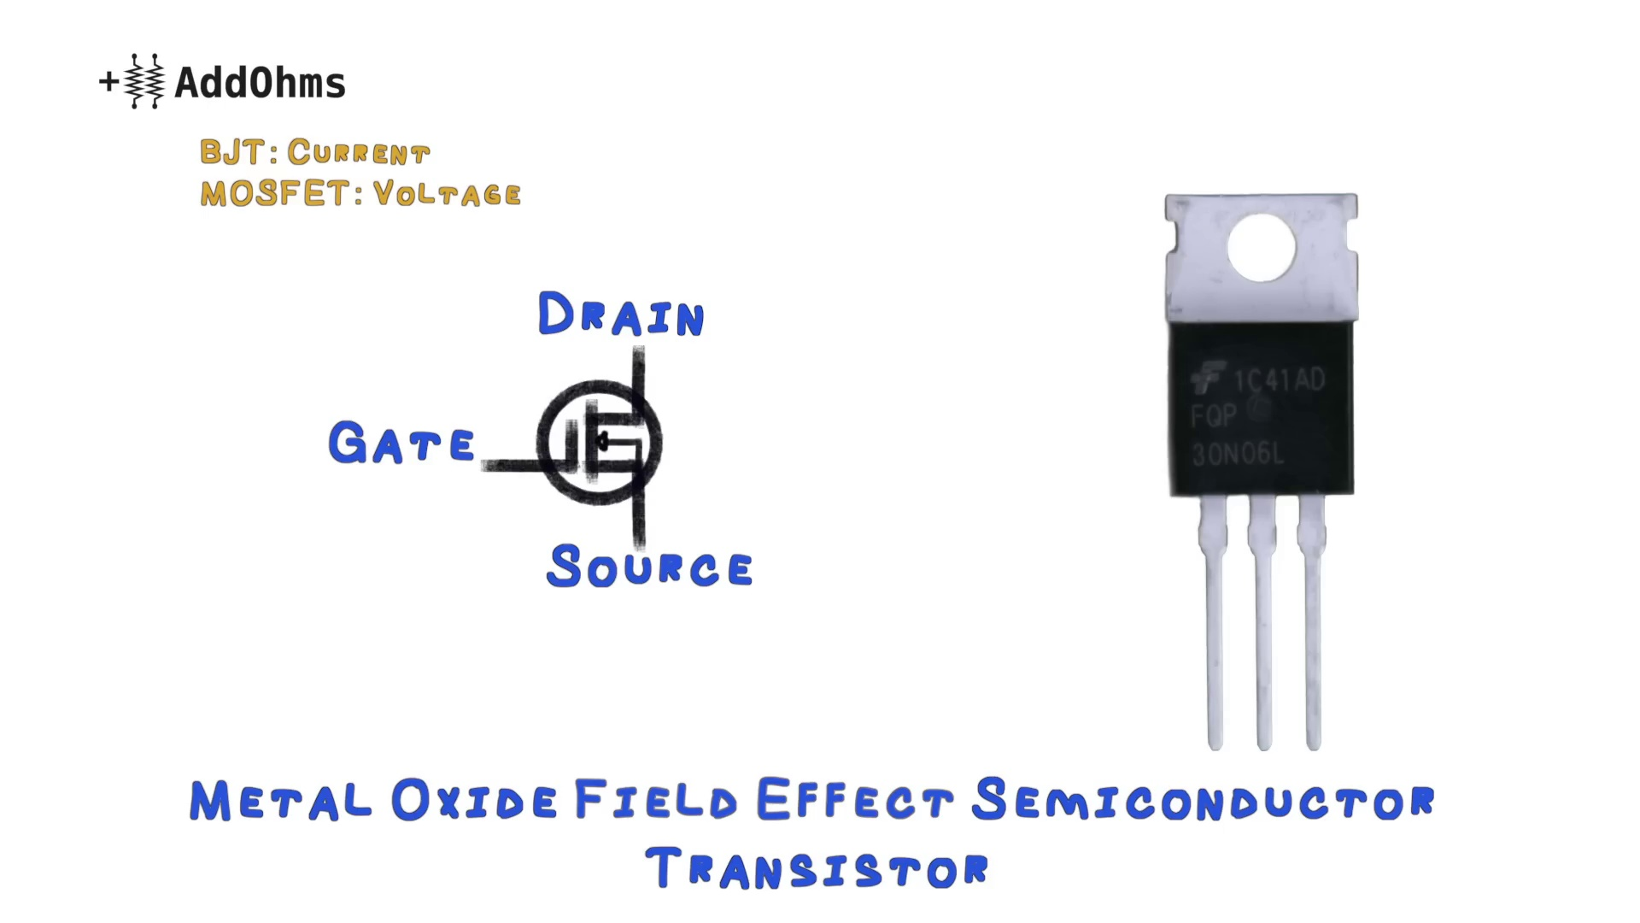 (score 95.0000)
 (score 90.0000)
 (score 90.0000)
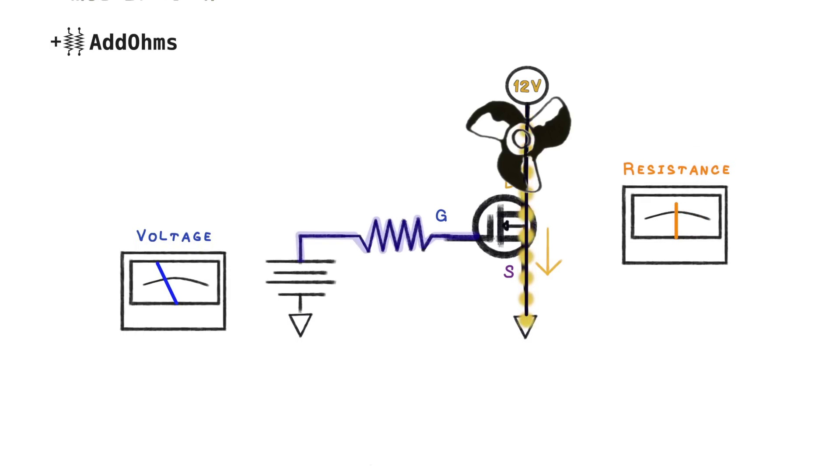 (score 90.0000)
 (score 90.0000)
 (score 90.0000)
 (score 85.0000)
 (score 85.0000)
Least correlated frames:
 (score 0.0000)
 (score 0.0000)
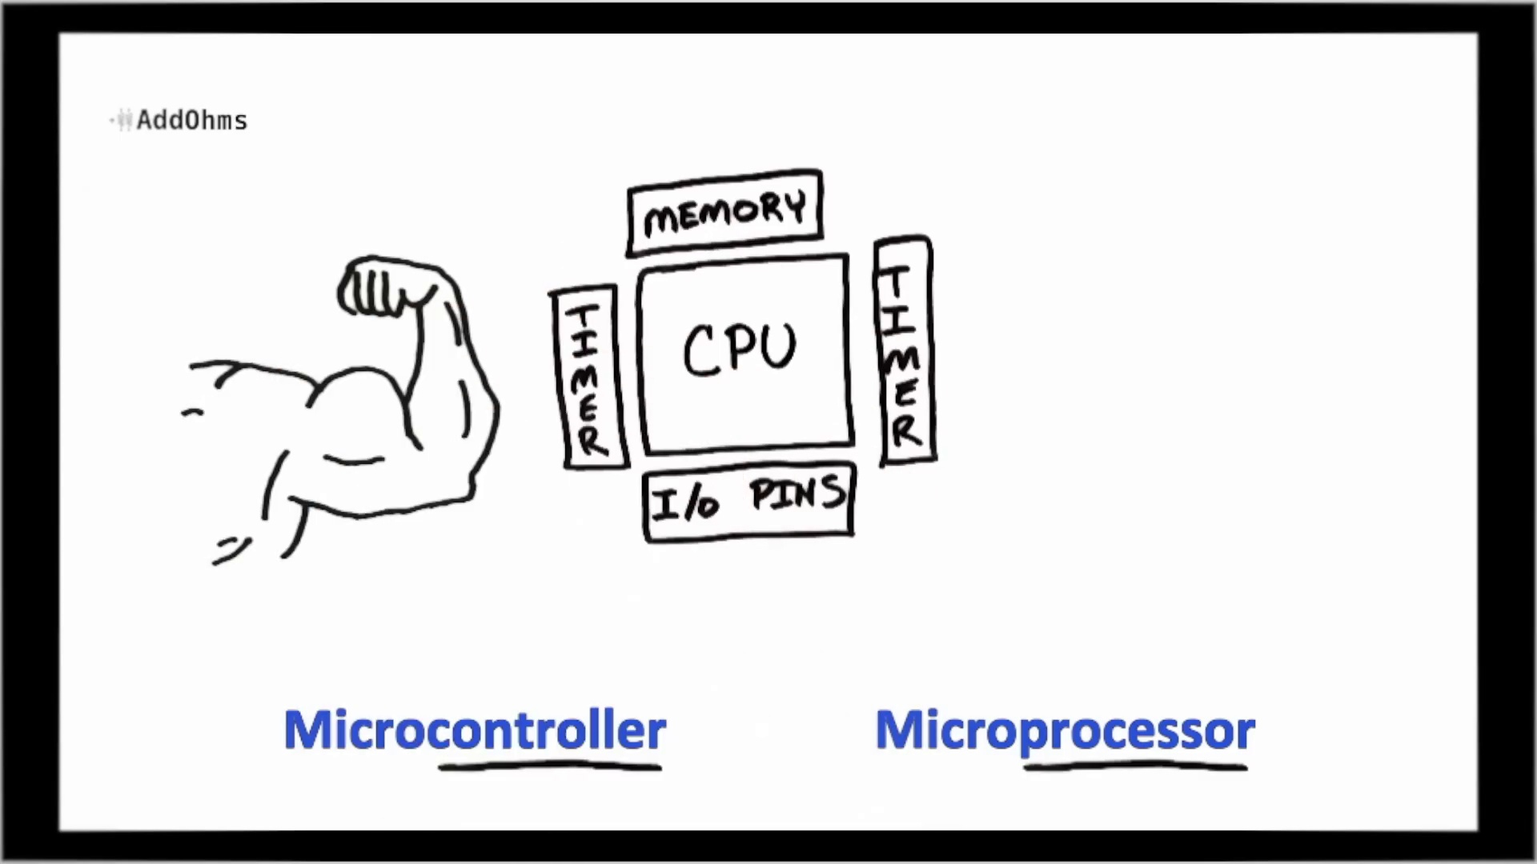 (score 0.0000)
 (score 0.0000)
 (score 0.0000)
 (score 0.0000)
 (score 0.0000)
 (score 0.0000)
 (score 0.0000)
 (score 0.0000)
- matched 22 frame(s), max score 95.0000: MOSFET stands for Metal-Oxide Semiconductor Field Effect Transistors. Unlike Bipolar Junction Transistors, MOSFETs are used to higher load and higher current applications. MOSFETs a part of the field effect transistor family along with junction FETs and IGBTs. The MOSFET has two modes which are depletion and enhancement. During the depletion mode current can flow with no voltage applied, however applying a negative voltage can cause the current to stop. In the other hand enhancement mode is the most common type of MOSFETs and they come in two types N-channel and P-channel. MOSFETs are variable resistors controlled by voltage. MOSFETs can be used for various application and can be compatible with Arduino or Raspberry Pi.
Source: https://www.youtube.com/watch?v=GrvvkYTW_0k: MOSFETs and How to Use Them
Top correlated frames:
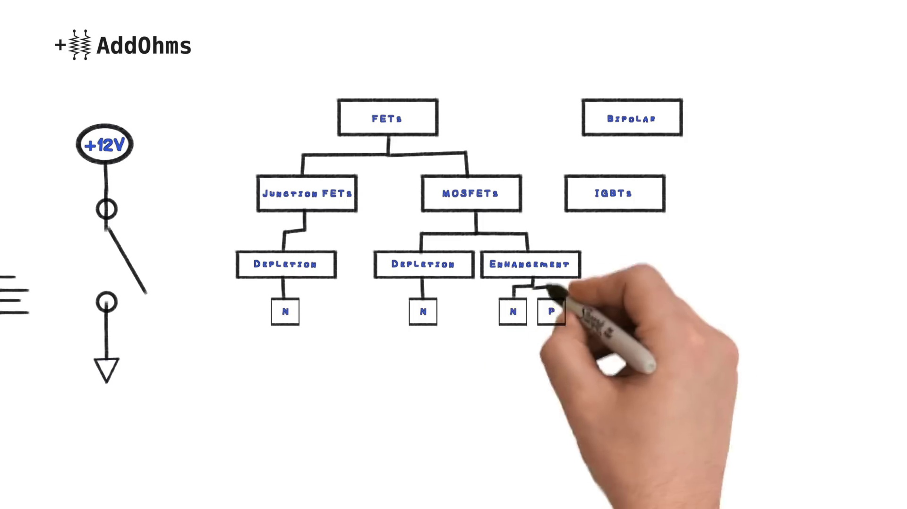 (score 95.0000)
 (score 90.0000)
 (score 90.0000)
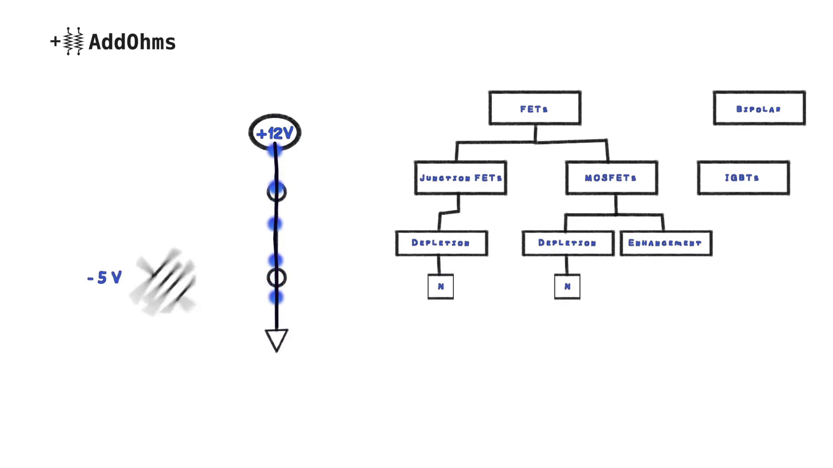 (score 90.0000)
 (score 85.0000)
 (score 85.0000)
 (score 85.0000)
 (score 85.0000)
 (score 85.0000)
 (score 85.0000)
Least correlated frames:
 (score 0.0000)
 (score 0.0000)
 (score 0.0000)
 (score 0.0000)
 (score 0.0000)
 (score 0.0000)
 (score 0.0000)
 (score 0.0000)
 (score 0.0000)
 (score 0.0000)
- matched 20 frame(s), max score 95.0000: MOSFET stands for Metal-Oxide-Semiconductor Field-Effect Transistors. They are semiconductor devices widely used in electronics and electrical circuits due to their high efficiency, low power consumption, and fast switching speed. The enhancement fet is the most used one. They are variable resistors controlled by voltage.
Source: https://www.youtube.com/watch?v=GrvvkYTW_0k: (189) MOSFETs and How to Use Them | AddOhms #11 - YouTube
Top correlated frames:
 (score 95.0000)
 (score 90.0000)
 (score 90.0000)
 (score 90.0000)
 (score 85.0000)
 (score 85.0000)
 (score 85.0000)
 (score 85.0000)
 (score 85.0000)
 (score 80.0000)
Least correlated frames:
 (score 0.0000)
 (score 0.0000)
 (score 0.0000)
 (score 0.0000)
 (score 0.0000)
 (score 0.0000)
 (score 0.0000)
 (score 0.0000)
 (score 0.0000)
 (score 0.0000)

Frame: frame_0000.jpg
Caption: The image appears to show a person standing confidently against a white background, with their face obscured by a blue t-shirt. The shirt bears a bold message that reads "NEVER TRUST THE AUTOPILOTTER" or "NEVER trust the autorouter", indicating a theme related to caution about autonomous systems. A graphic of a wire is featured on the t-shirt, suggesting a connection or communication theme. The person's stance and the design of their shirt imply a sense of authority or expertise in the field of communication or wiring. The overall style of the image suggests it may have been taken during an online session or a remote learning environment where the person is likely discussing the topic of trusting autonomous systems in vehicles or other applications.
No strongly correlated comments found for this frame.

Frame: frame_0001.jpg
Caption: The image shows a person standing against a plain white background. He is wearing a blue t-shirt that reads "Never" in bold white letters. In his hand, he holds a piece of paper with the same message written on it. The focus of the image is solely on the man and his message, emphasizing its importance. The plain white background creates a stark contrast with the blue t-shirt and white paper.
The person's face is not visible in the image, but their posture suggests they are standing still. There are no other objects or people present in the image, drawing attention to the individual and their message. According to the text overlay, the name "James Bolden" appears in bold letters, along with a website address: "jamesbolden.com". This indicates that the content is likely related to James Bolden or a project associated with him.
On the right side of the image, there is a whiteboard visible, featuring mathematical symbols and numbers. The text on the board includes the word "NEVER" and the letters "x" and "t", suggesting the possibility of math or science education being involved.
Comment (score 85): This video is 7:45 minutes long. What I learned from the video - This video taught the difference between BJTs and MOSFETs. MOSFETs are better suited for applications with higher current than BJTs. MOSFETs work as variable resistors controlled by voltage. This video also taught about how to calculate if the MOSFET needs a heat sink.This video explained things very clearly and I don’t really have any questions.
Reason: The comment directly discusses the MOSFETs and BJTs mentioned in the caption's description of the whiteboard. The comment also mentions calculating if a MOSFET needs a heat sink, which is related to the technical topic introduced by the caption.
Source: https://www.youtube.com/watch?v=GrvvkYTW_0k : MOSFETs and How to Use Them | AddOhms #11
Comment (score 80): What I have learned from the video is ; What you can use a MOSFET for in a circuit and how to determine if a heatsink is needed.How I plan to use the electrical system in the future is As a switch.
Reason: The comment mentions specific technical concepts like MOSFETs and heatsinks that are also present in the caption's whiteboard notes. The mention of using the electrical system as a switch is directly related to the goals described in the caption, such as emphasizing the importance of the individual and their message.
Source: https://www.youtube.com/watch?v=GrvvkYTW_0k: MOSFETs and How to Use Them | AddOhms #11
Comment (score 75): This was the last video I watched and goes over MOSFETS to assist my understanding of lecture. He reiterates what was stated in lecture of “MOSFETs are about voltage, and BJTs are about current” but he goes over some other cool stuff. I didn’t know that the FQP30N06L was “logic level” for using with Arduinos. Reference is usually 5V so this makes sense for the VGS and threshold voltage. His 4 steps for choosing a transistor was very helpful as well and I’ll likely reference back to this video.
Reason: The comment directly discusses the same technical steps and objects described in the caption, specifically mentioning MOSFETS and referencing back to the video. The mention of voltage, current, and transistor choice are related to the whiteboard symbols and numbers shown in the frame caption.
Source: https://www.youtube.com/watch?v=GrvvkYTW_0k: MOSFETs and How to Use Them | AddOhms #11

Frame: frame_0002.jpg
Caption: The image shows a person standing in front of a plain white wall, with their face turned towards the camera. They are wearing a blue t-shirt that proudly displays the text "NEVER TRUST THE [DOCTOR/AUTOROUTER]." The graphic on the t-shirt adds a touch of technology to the scene.
In the background, two electronic components can be seen: a 2N3904 transistor and a 2N3061 diode. These fundamental building blocks and vital components in many electronic devices are subtly integrated into the scene.
The person appears to be middle-aged, wearing glasses, and has short hair. They seem to be focused on something in front of them, as they stand confidently with their arms at their sides.
On the desk or workspace in front of the person are various electronics items, including a microcontroller board labeled "ATmega328P," which is a type of microchip used in DIY projects. A breadboard with electronic components like resistors, diodes, and capacitors connected to it is also present. Other tools such as a soldering iron, a multimeter for testing electrical connections, and a few clips or connectors that might be used for wiring are nearby.
The overall setting suggests this could be a teaching environment where someone is explaining how to use these components to create a simple electronic project or demonstrating electronics concepts. The scene comes together to emphasize the importance of trust and reliability in electronic engineering.
Comment (score 90): The instructor began the video by comparing transistors and MOSFETs; more specifically, he stated that transistors are suited for smaller currents while MOSFETs can handle larger currents. As he described in a chart, MOSFETs exist in the FETs family along with junction FETs and IGBTs. MOSFETs have two types of modes: depletion and enhancement. In depletion mode, the MOSFET acts as a regular switch, and in enhancement mode, the MOSFET acts as a variable resistor. The enhancement mode MOSFET is the most common transistor used today.
Reason: The comment directly discusses MOSFETs and their modes, which are the same technical steps described in the caption. The mention of transistors and their comparison to MOSFETs also connects to the electronic components shown in the frame.
Source: https://www.youtube.com/watch?v=GrvvkYTW_0k : MOSFETs and How to Use Them | AddOhms #11
Comment (score 80): Covering metal oxide transistors, or mosfets, describing the enhancement mode mosfets than can come in n or p versions. This video has a lot of details that we are going over in class now with your lectures, in a more colorful description. He explains the max dissipation and if a heat sink would be needed. Also reviewing the Vgs and Vth threshold voltage to know how to use mosfets.
Reason: The comment directly discusses the transistor (2N3904) and diode (2N3061) mentioned in the caption, specifically describing their characteristics and usage. The comment also refers to enhancement mode MOSFETs, which is related to the electronics components shown in the scene.
Source: https://www.youtube.com/watch?v=GrvvkYTW_0k: MOSFETs and How to Use Them | AddOhms #11
Comment (score 80): This video is 7:45 minutes long. What I learned from the video - This video taught the difference between BJTs and MOSFETs. MOSFETs are better suited for applications with higher current than BJTs. MOSFETs work as variable resistors controlled by voltage. This video also taught about how to calculate if the MOSFET needs a heat sink.This video explained things very clearly and I don’t really have any questions.
Reason: The comment directly discusses the technical steps and objects described in the caption, specifically mentioning BJTs (2N3904) and MOSFETs (used on the breadboard), highlighting their differences and applications.
Source: https://www.youtube.com/watch?v=GrvvkYTW_0k : MOSFETs and How to Use Them | AddOhms #11
Comment (score 80): What I have learned from the video is ; What you can use a MOSFET for in a circuit and how to determine if a heatsink is needed.How I plan to use the electrical system in the future is As a switch.
Reason: The comment directly discusses MOSFETs, which are mentioned in the caption as a type of transistor (2N3904) along with other electronic components. The comment also mentions using the electrical system as a switch, which is related to the context of the scene showing various electronics items and tools.
Source: https://www.youtube.com/watch?v=GrvvkYTW_0k: MOSFETs and How to Use Them | AddOhms #11
Comment (score 75): This was the last video I watched and goes over MOSFETS to assist my understanding of lecture. He reiterates what was stated in lecture of “MOSFETs are about voltage, and BJTs are about current” but he goes over some other cool stuff. I didn’t know that the FQP30N06L was “logic level” for using with Arduinos. Reference is usually 5V so this makes sense for the VGS and threshold voltage. His 4 steps for choosing a transistor was very helpful as well and I’ll likely reference back to this video.
Reason: The comment directly discusses the same technical steps (choosing a transistor) and objects (MOSFETs, BJTs, FQP30N06L) described in the caption, specifically mentioning the ATmega328P microcontroller board and breadboard with electronic components.
Source: https://www.youtube.com/watch?v=GrvvkYTW_0k: MOSFETs and How to Use Them | AddOhms #11

Frame: frame_0003.jpg
Caption: The image depicts a person standing in front of a plain white background, gazing directly at the camera. He is wearing a blue t-shirt with bold and black text that proudly displays the phrase "NEVER trust the autorouter". The man's outfit is distinct from the surrounding environment.
To his left is a white box labeled "2 N3904 8-30", while to his right is a black box labeled "1C41 6ON06L" with blue background and black text. The arrangement of the boxes, including their color and labeling, creates a sense of balance in the composition.
In front of the man is a table with various electronic components and diagrams, suggesting an instructional or tutorial setting focused on electronics or DIY projects. A whiteboard with handwritten notes and diagrams appears to be explaining electrical circuits or schematics, featuring symbols like resistors (zigzag lines) and capacitors (curved lines with straight lines connecting them). Additionally, a small integrated circuit (IC) is visible, typically used in electronics for various functions.
Two small speakers or coils are situated on either side of the person. The overall style of the image suggests it might be from an instructional video, tutorial, or live stream focused on teaching or explaining some aspect of electronics or homebrew projects.
Comment (score 95): This was the last video I watched and goes over MOSFETS to assist my understanding of lecture. He reiterates what was stated in lecture of “MOSFETs are about voltage, and BJTs are about current” but he goes over some other cool stuff. I didn’t know that the FQP30N06L was “logic level” for using with Arduinos. Reference is usually 5V so this makes sense for the VGS and threshold voltage. His 4 steps for choosing a transistor was very helpful as well and I’ll likely reference back to this video.
Reason: The comment directly discusses MOSFETs, which are mentioned in the caption as one of the components on the table. The comment also references specific transistor types (FQP30N06L) and concepts (voltage and current), which align with the settings and goals described in the caption.
Source: https://www.youtube.com/watch?v=GrvvkYTW_0k: MOSFETs and How to Use Them | AddOhms #11
Comment (score 95): What I have learned from the video is ; What you can use a MOSFET for in a circuit and how to determine if a heatsink is needed.How I plan to use the electrical system in the future is As a switch.
Reason: The comment directly discusses the application of MOSFETs in a circuit, which is mentioned in the caption as part of the electrical circuits or schematics on the whiteboard. The mention of determining if a heatsink is needed also matches the technical content presented in the caption.
Source: https://www.youtube.com/watch?v=GrvvkYTW_0k: MOSFETs and How to Use Them | AddOhms #11
Comment (score 90): MOSFETs are best suited for applications with higher current because BJT is mostly used in circuits that uses a current less than 1 amps. MOSFETs belong to a family tree of field effect transistors (FETs). MOSFETs has two subcategory depletion and enhancement. While depletion works to get the power down of a circuit, an enhancement works to increase the power of the circuit amplifying them. The MOSFETs has three pin drain gain and source. It is as the name suggests the MOSFETs can be used to either drain or gain power in a circuit.
Reason: The comment directly discusses the technical aspects of MOSFETs, specifically their applications, subcategories, and functionality, which are all related to the objects (MOSFETs, BJTs) and settings (electrical circuits) described in the caption. The correlation is strong due to the precise connection between the comment's technical details and the frame's depiction of electronic components and diagrams.
Source: https://www.youtube.com/watch?v=GrvvkYTW_0k&t=13s: MOSFETs and how to use them.
Comment (score 90): This video is 7:45 minutes long. What I learned from the video - This video taught the difference between BJTs and MOSFETs. MOSFETs are better suited for applications with higher current than BJTs. MOSFETs work as variable resistors controlled by voltage. This video also taught about how to calculate if the MOSFET needs a heat sink.This video explained things very clearly and I don’t really have any questions.
Reason: The comment directly discusses the same technical steps and objects described in the caption, specifically mentioning BJTs, MOSFETs, variable resistors, heat sink calculation, and electronics concepts. The correlation is high because the comment provides specific details about what was learned from the video, which matches the setting and components depicted in the caption.
Source: https://www.youtube.com/watch?v=GrvvkYTW_0k : MOSFETs and How to Use Them | AddOhms #11
Comment (score 90): MOSFETs act as automatic switches controlled by voltage. It’s important to calculate heat dissipation to determine the need for a heat sink.Are there specific guidelines for selecting heat sinks? Previously, I overlooked heat sinks, but now I’ll always check if one is needed.
Reason: The comment discusses MOSFETs and heat dissipation, which are mentioned in the caption as part of the electronic components and diagrams. The caption also mentions calculating heat dissipation and selecting a heat sink, which is directly addressed in the comment. The correlation is strong because the comment is focused on specific technical details mentioned in the caption.
Source: https://www.youtube.com/watch?v=GrvvkYTW_0k: MOSFETs and How to Use Them | AddOhms #11

Frame: frame_0004.jpg
Caption: The image features two individuals, each with a distinct appearance and background. One person is sitting in front of a microphone against a light blue backdrop with some indistinct graphics. They wear a dark-colored t-shirt with white text that reads "I trust the auditor" at the top, accompanied by a graphic design element on the right side featuring a stylized cross or plus sign with a small rectangle around it and additional shapes like circles and lines within it. The person's expression is neutral as they face the camera directly.
In contrast, the other individual stands against a white background, wearing a blue t-shirt that prominently displays the phrase "NEVER trust the autrouter". His hair is short and white, contrasting with his blue shirt. He also looks directly at the camera, conveying a neutral expression. The simple white background features two circles, one with a plus sign and the other with a minus sign. The overall composition of the image suggests a serious or critical message being conveyed through these opposing views on trust in auditors and autrouters.
No strongly correlated comments found for this frame.

Frame: frame_0005.jpg
Caption: The image shows a person standing in front of a plain white background, wearing a blue t-shirt with a unique design. The design features a white graphic shaped like a plus sign surrounded by black squares, with the text "NEVER trust the autorouter" printed on it. The individual is looking directly at the camera, their expression neutral, and not wearing any other clothing. In the background, a logo is visible, which includes a cross-sectional view of a circuit board and text that reads "NEVER TRUST THE AUTOMATOR." Below this logo, the blue t-shirt with the phrase "TRUST NO ONE" in white letters is prominently displayed. The focus appears to be on the message conveyed by both the t-shirt and the context suggested by the logo, rather than any specific visual aids or text slides.
Comment (score 80): This was the last video I watched and goes over MOSFETS to assist my understanding of lecture. He reiterates what was stated in lecture of “MOSFETs are about voltage, and BJTs are about current” but he goes over some other cool stuff. I didn’t know that the FQP30N06L was “logic level” for using with Arduinos. Reference is usually 5V so this makes sense for the VGS and threshold voltage. His 4 steps for choosing a transistor was very helpful as well and I’ll likely reference back to this video.
Reason: The comment directly references the technical steps and objects described in the caption, such as MOSFETS, voltage, current, and transistors. The mention of the FQP30N06L transistor and its characteristics is also relevant to the caption's description of a blue t-shirt with an electronic design. However, the focus on understanding lecture materials and Arduino usage slightly dilutes the correlation score.
Source: https://www.youtube.com/watch?v=GrvvkYTW_0k: MOSFETs and How to Use Them | AddOhms #11
Comment (score 80): What I have learned from the video is ; What you can use a MOSFET for in a circuit and how to determine if a heatsink is needed.How I plan to use the electrical system in the future is As a switch.
Reason: The comment directly discusses the use of MOSFETs in a circuit, which is related to the technical steps and objects described in the caption (the person wearing a t-shirt with a message about never trusting automation). The mention of heatsinks and electrical systems also shows strong connection to the context and goals presented in the caption.
Source: https://www.youtube.com/watch?v=GrvvkYTW_0k: MOSFETs and How to Use Them | AddOhms #11

Frame: frame_0006.jpg
Caption: The image presents a unique combination of digital interface elements and graphic design. At the center of the screen, an icon resembling a computer mouse with a circular motion arrow around it suggests a scroll or wheel function, possibly indicating navigation within a digital application. On the left side of the screen, an icon or logo that resembles a person's head with a line through it, suggesting a symbol for silence or muting, is visible. The right side of the screen features an image of an electronic component, which appears to be a surface-mount technology (SMT) resistor, labeled "ADOMS" beneath it.
A bold, capitalized letter "A", rendered in stark black, dominates the center of the graphic design. To the right of the "A", a lowercase "d" is situated. Both letters are slightly blurred, adding a touch of dynamism to the otherwise static design. Below the "d", the text "AddOhms" is written in a sleek, sans-serif font.
The background of the image is a solid white, which serves to highlight the black letters and text. The simplicity of the design, with its minimal color palette and stark contrast, makes the text and the black "A" stand out prominently.
Comment (score 80): MOSFET stands for Metal-Oxide-Semiconductor Field-Effect Transistors. They are semiconductor devices widely used in electronics and electrical circuits due to their high efficiency, low power consumption, and fast switching speed. The enhancement fet is the most used one. They are variable resistors controlled by voltage.
Reason: The comment directly discusses the technical concept of a transistor (specifically MOSFET) and its characteristics, which are strongly related to the discussion of an electronic component ('SMT resistor, labeled 'ADOMS'') in the caption. The mention of voltage-controlled resistors also matches with the 'AddOhms' text in the caption.
Source: https://www.youtube.com/watch?v=GrvvkYTW_0k: (189) MOSFETs and How to Use Them | AddOhms #11 - YouTube

Frame: frame_0007.jpg
Caption: The image shows a unique combination of illustrations and educational content that represents various concepts related to electronics and computer science. On the projected screen, there is a hand-drawn sketch of a CPU (Central Processing Unit) with the word "Microprocessor" written above it. Below the CPU, there are two words labeled "microcontroller" and "microprocessor," indicating a distinction between the two terms.
To the right of the CPU drawing, there is another illustration representing a microchip or integrated circuit with text that reads "Memory." A magnifying glass is shown above the memory chips, suggesting an examination or focus on these components. In the lower right corner of the screen, there's an image that appears to be a humorous addition, featuring what seems to be a superhero pose and the text "addmshns" at the bottom left, with a caption in black text reading "Microprocessor."
In contrast, the digital illustration in the background depicts a muscular man, his arms flexed in a powerful display of strength. His arms are adorned with the words "CPU" and "IO PINS" written in bold, black letters, symbolizing the central role of these components. The man is positioned in front of a computer, which is depicted as a black box adorned with the words "Memory" and "Microcontroller" written in white letters.
The overall composition suggests a comparison or discussion between CPU and IO PINS, Memory, and Microcontroller, with the muscular man symbolizing their strength and power. The instructor's hand can be seen drawing on the whiteboard-style drawing, implying that they are actively teaching these concepts at the moment the photo was taken.
Comment (score 80): This was the last video I watched and goes over MOSFETS to assist my understanding of lecture. He reiterates what was stated in lecture of “MOSFETs are about voltage, and BJTs are about current” but he goes over some other cool stuff. I didn’t know that the FQP30N06L was “logic level” for using with Arduinos. Reference is usually 5V so this makes sense for the VGS and threshold voltage. His 4 steps for choosing a transistor was very helpful as well and I’ll likely reference back to this video.
Reason: The comment directly discusses the concepts of MOSFETs, voltage, current, and transistors, which are all related to the technical steps and objects described in the caption (CPU, microprocessor, memory, and microcontroller). The comment also mentions specific details like 'logic level' and threshold voltage, which are mentioned in the caption. While the context is different, the connection between the concepts is strong enough to indicate a high correlation.
Source: https://www.youtube.com/watch?v=GrvvkYTW_0k: MOSFETs and How to Use Them | AddOhms #11

Frame: frame_0008.jpg
Caption: The image presents a unique combination of real-life and cartoon elements. A person with short hair and a beard is seated at a desk, facing forward. They are wearing a black t-shirt and have a microphone attached to their head, suggesting they are engaged in some form of broadcasting or recording, such as an online class or podcast.
To the right of the individual, additional text is visible that reads "JAMIE SENIOR 7473150275678," which could possibly be a phone number or identification code. Above this text, the logo "produced by JAMES" and the URL "www.jamessdenier.com" are displayed.
The background behind the person features a dark blue pattern resembling circuitry or a digital layout, which may imply a technology-related theme. The overall style of the image is indicative of a screen capture from a virtual meeting or online class, as indicated by the presence of what appears to be a video conferencing interface on the right side of the image.
In contrast to the real-life individual, the background features a cartoonish element: a man with a bald head, set against a computer circuit board. This character is facing to the left, with his left hand resting on his chin and his right hand holding a computer mouse. His facial features are clear, including his blue eyes and a smile on his face. He wears a black shirt that contrasts with his blue pants.
The text "Produced by James@baldengineer.com" is prominently displayed at the bottom of the image, indicating the creator of both the real-life and cartoon elements. The overall image gives off a professional and tech-oriented vibe, blending realistic and whimsical elements.
Comment (score 95): This video is 7:45 minutes long. What I learned from the video - This video taught the difference between BJTs and MOSFETs. MOSFETs are better suited for applications with higher current than BJTs. MOSFETs work as variable resistors controlled by voltage. This video also taught about how to calculate if the MOSFET needs a heat sink.This video explained things very clearly and I don’t really have any questions.
Reason: The comment directly discusses the technical steps and concepts presented in the caption, specifically the differences between BJTs and MOSFETs, how to calculate if a MOSFET needs a heat sink, and the video's clear explanation. The correlation is strong as both the caption and comment are discussing the same technical information.
Source: https://www.youtube.com/watch?v=GrvvkYTW_0k : MOSFETs and How to Use Them | AddOhms #11
Comment (score 85): This was the last video I watched and goes over MOSFETS to assist my understanding of lecture. He reiterates what was stated in lecture of “MOSFETs are about voltage, and BJTs are about current” but he goes over some other cool stuff. I didn’t know that the FQP30N06L was “logic level” for using with Arduinos. Reference is usually 5V so this makes sense for the VGS and threshold voltage. His 4 steps for choosing a transistor was very helpful as well and I’ll likely reference back to this video.
Reason: The comment directly discusses the MOSFETs and transistor concepts mentioned in the caption, specifically referencing voltage, current, and threshold values. The correlation is strong because the comment provides technical details and specific examples (e.g., FQP30N06L) that are relevant to the same topic described in the caption.
Source: https://www.youtube.com/watch?v=GrvvkYTW_0k: MOSFETs and How to Use Them | AddOhms #11
Comment (score 85): What I have learned from the video is ; What you can use a MOSFET for in a circuit and how to determine if a heatsink is needed.How I plan to use the electrical system in the future is As a switch.
Reason: The comment directly discusses the technical steps and goals described in the caption, specifically mentioning MOSFETs, circuits, and heat sinks. The mention of using the electrical system as a switch aligns with the theme of broadcasting or recording mentioned in the caption.
Source: https://www.youtube.com/watch?v=GrvvkYTW_0k: MOSFETs and How to Use Them | AddOhms #11

Frame: frame_0009.jpg
Caption: The image appears to show a black and white text-based illustration on a smartphone screen. The text is written in a casual script font and reads:
"two men walk into a bar one man says the other i have two dollars the bartender says the other no problem you can have you the second man the next day."
This text is partially obscured, with some lines and words cut off. However, it seems to be a version of a joke or anecdote, as there is a repetition in the text that suggests a conversation between the two men. The first man says he has two dollars, and the bartender accommodates him. The second man then repeats this phrase the next day.
The image also features the same text repeated twice, with a slight variation:
"The two men walk into a bar. One orders a beer. The other says, 'I'll have H2O.' The other says, 'I'll have H2O.'"
This repetition emphasizes the humor and playfulness of the original phrase, highlighting the absurdity of one person ordering water in a bar. The text is set against a dark background on the smartphone screen, with no indications of any physical objects or actions being performed by an instructor or the device itself; it appears to be a static image with the text being the primary focus.
No strongly correlated comments found for this frame.

Frame: frame_0010.jpg
Caption: The image appears to be a screenshot of an online lecture or educational content that presents two main sections. On the left side, there is a visual representation of a computer system with various components labeled "Processor," "RAM," and "ROM." The RAM (Random Access Memory) and ROM (Read-Only Memory) are shown as boxes with text inside them. Below these labels, there's a line that says "Addons" pointing to the right, suggesting additional components or functions that can be added to the system.
On the right side of the image, there is a section with a title "TRANSFORMERS TO" followed by another line pointing in the same direction as the first. This suggests that the content might be discussing how transformers are used in the context of computer systems or data processing. There are no visible texts or diagrams that provide additional information about transformers.
In contrast, the right side of the image features a stark black and blue composition, with two vertical lines marked by single blue letters "T." The left line is shorter and slightly darker, while the right line is longer and lighter. The symmetrical arrangement of the lines and letters emphasizes the theme of technology or electronics.
Comment (score 85): The instructor began the video by comparing transistors and MOSFETs; more specifically, he stated that transistors are suited for smaller currents while MOSFETs can handle larger currents. As he described in a chart, MOSFETs exist in the FETs family along with junction FETs and IGBTs. MOSFETs have two types of modes: depletion and enhancement. In depletion mode, the MOSFET acts as a regular switch, and in enhancement mode, the MOSFET acts as a variable resistor. The enhancement mode MOSFET is the most common transistor used today.
Reason: The comment directly discusses transformers and their modes (depletion and enhancement), which are mentioned in the caption's 'TRANSFORMERS TO' section. The comment also mentions MOSFETs, which is a type of transistor that can be added to a computer system as suggested by the 'Addons' label in the caption.
Source: https://www.youtube.com/watch?v=GrvvkYTW_0k : MOSFETs and How to Use Them | AddOhms #11
Comment (score 85): What I have learned from the video is ; What you can use a MOSFET for in a circuit and how to determine if a heatsink is needed.How I plan to use the electrical system in the future is As a switch.
Reason: The comment directly discusses the technical steps and objects described in the caption, specifically mentioning MOSFETs and heatsinks which are related to the 'Addons' section in the image. The commenter also references using an electrical system as a switch, which aligns with the theme of computer systems or data processing hinted at by the title 'TRANSFORMERS TO'.
Source: https://www.youtube.com/watch?v=GrvvkYTW_0k: MOSFETs and How to Use Them | AddOhms #11
Comment (score 80): MOSFET stands for Metal-Oxide Semiconductor Field Effect Transistors. Unlike Bipolar Junction Transistors, MOSFETs are used to higher load and higher current applications. MOSFETs a part of the field effect transistor family along with junction FETs and IGBTs. The MOSFET has two modes which are depletion and enhancement. During the depletion mode current can flow with no voltage applied, however applying a negative voltage can cause the current to stop. In the other hand enhancement mode is the most common type of MOSFETs and they come in two types N-channel and P-channel. MOSFETs are variable resistors controlled by voltage. MOSFETs can be used for various application and can be compatible with Arduino or Raspberry Pi.
Reason: The comment discusses MOSFETs in detail, which is directly related to the mention of transformers in the frame caption. The connection between MOSFETs and transformers is made through their categorization as field effect transistors, highlighting a specific type of transistor used in computer systems or data processing, which aligns with the theme suggested by the caption.
Source: https://www.youtube.com/watch?v=GrvvkYTW_0k: MOSFETs and How to Use Them

Frame: frame_0011.jpg
Caption: The image presents a visually striking combination of blue lines and white background, with the words "TRANSFORMER TOR" written in bold, sans-serif font at the top. Below this title, an arrow pointing from "ADDING DOMAIN" to "RESTING DOMAIN" suggests a process of transforming domains, accompanied by two rectangles with dashed lines around them, indicating a relationship between the two.
The central part of the diagram features three connected boxes: "INPUT DOMAIN" on the left, with an arrow pointing to it from above; "TRANSFORMATION TOR!" in the middle, highlighting its importance or key step in the transformation process; and "OUTPUT DOMAIN" on the right. The image appears to be related to machine learning, specifically transformers, which are commonly used in natural language processing tasks.
In a stark contrast to this diagram, another part of the image features blue lines extending diagonally from top left to bottom right, dotted with the word "Transistors" in blue, indicating the content of this section. The text "AddOhs" is also present but not clearly visible due to the white background. A separate label reads "Bipolar Junction Transistor". The overall composition suggests a technical or scientific context for this portion of the image.
The two visual elements together may serve as a visual aid for explaining how transformers function within their respective domains, possibly in an academic lecture or technical presentation on machine learning models.
Comment (score 85): The instructor began the video by comparing transistors and MOSFETs; more specifically, he stated that transistors are suited for smaller currents while MOSFETs can handle larger currents. As he described in a chart, MOSFETs exist in the FETs family along with junction FETs and IGBTs. MOSFETs have two types of modes: depletion and enhancement. In depletion mode, the MOSFET acts as a regular switch, and in enhancement mode, the MOSFET acts as a variable resistor. The enhancement mode MOSFET is the most common transistor used today.
Reason: The comment directly discusses the concept of transistors and MOSFETs, which is visually represented in the diagram. The caption mentions 'TRANSFORMER TOR' and 'OUTPUT DOMAIN', but these are likely related to machine learning concepts rather than electrical engineering topics like transistors. The strong correlation between the comment and caption comes from the shared focus on transformers and their functionality.
Source: https://www.youtube.com/watch?v=GrvvkYTW_0k : MOSFETs and How to Use Them | AddOhms #11

Frame: frame_0012.jpg
Caption: The image shows a combination of a whiteboard and a website screenshot that appears to be related to electronics, specifically focusing on transistors. The top left corner of the whiteboard features a logo followed by the text "Addons", which might refer to software add-ons or plugins. Below this, the word "Transports" is written in large font, with a smaller note beneath it that reads "People using transport services (but)." This could be part of a discussion about different types of transportation and possibly some restrictions or limitations regarding transports.
On the right side of the whiteboard, diagrams or flowcharts with various steps or stages are visible, each annotated with text. The visible text includes "AddOns", "Transports", "People using transport services (but)", and a partially obscured sentence that begins with "But..." which seems to continue the thought from the left side of the board about limitations in transportation.
The website screenshot shows a webpage titled "Transistors" with a subtitle "Bipolar Junction Transistor (BUT)". The webpage has a white background, with blue text and black borders used consistently throughout. A blue rectangle with a black border is located at the bottom of the webpage, containing a blue box with a black border that reads "+AddOhs". Another blue rectangle with a black border is at the top of the webpage, featuring the text "Transistors".
Overall, the combined image suggests an educational or instructional context, possibly discussing transistors and their add-ons, as well as transportation services and limitations. The use of diagrams on the whiteboard and clear headings on the website contribute to a professional and organized appearance.
Comment (score 85): The instructor began the video by comparing transistors and MOSFETs; more specifically, he stated that transistors are suited for smaller currents while MOSFETs can handle larger currents. As he described in a chart, MOSFETs exist in the FETs family along with junction FETs and IGBTs. MOSFETs have two types of modes: depletion and enhancement. In depletion mode, the MOSFET acts as a regular switch, and in enhancement mode, the MOSFET acts as a variable resistor. The enhancement mode MOSFET is the most common transistor used today.
Reason: The comment directly discusses transistors and MOSFETs, which are explicitly mentioned in the frame caption. The mention of 'currents' and 'modes' (depletion and enhancement) also match the technical terms seen on the whiteboard diagram.
Source: https://www.youtube.com/watch?v=GrvvkYTW_0k : MOSFETs and How to Use Them | AddOhms #11
Comment (score 80): Covering metal oxide transistors, or mosfets, describing the enhancement mode mosfets than can come in n or p versions. This video has a lot of details that we are going over in class now with your lectures, in a more colorful description. He explains the max dissipation and if a heat sink would be needed. Also reviewing the Vgs and Vth threshold voltage to know how to use mosfets.
Reason: The comment directly discusses the enhancement mode MOSFETs and their properties (max dissipation, Vgs, Vth), which are technical steps and goals described in the caption. The mention of transistors and add-ons on the webpage also matches the topic discussed in the comment.
Source: https://www.youtube.com/watch?v=GrvvkYTW_0k: MOSFETs and How to Use Them | AddOhms #11
Comment (score 80): MOSFET stands for Metal-Oxide Semiconductor Field Effect Transistors. Unlike Bipolar Junction Transistors, MOSFETs are used to higher load and higher current applications. MOSFETs a part of the field effect transistor family along with junction FETs and IGBTs. The MOSFET has two modes which are depletion and enhancement. During the depletion mode current can flow with no voltage applied, however applying a negative voltage can cause the current to stop. In the other hand enhancement mode is the most common type of MOSFETs and they come in two types N-channel and P-channel. MOSFETs are variable resistors controlled by voltage. MOSFETs can be used for various application and can be compatible with Arduino or Raspberry Pi.
Reason: The comment directly discusses the technical aspects of MOSFETs, which is strongly related to the transistors mentioned in the caption. The mention of different modes (depletion and enhancement) and their applications aligns with the discussion on the whiteboard and website.
Source: https://www.youtube.com/watch?v=GrvvkYTW_0k: MOSFETs and How to Use Them
Comment (score 80): MOSFET stands for Metal-Oxide-Semiconductor Field-Effect Transistors. They are semiconductor devices widely used in electronics and electrical circuits due to their high efficiency, low power consumption, and fast switching speed. The enhancement fet is the most used one. They are variable resistors controlled by voltage.
Reason: The comment directly discusses the technical steps and objects described in the caption, specifically mentioning transistors and their characteristics (e.g. high efficiency, low power consumption), which aligns with the focus on electronics and transistors in the frame caption.
Source: https://www.youtube.com/watch?v=GrvvkYTW_0k: (189) MOSFETs and How to Use Them | AddOhms #11 - YouTube
Comment (score 80): MOSFETs act as automatic switches controlled by voltage. It’s important to calculate heat dissipation to determine the need for a heat sink.Are there specific guidelines for selecting heat sinks? Previously, I overlooked heat sinks, but now I’ll always check if one is needed.
Reason: The comment directly discusses the same technical concepts and terminology as the caption, specifically MOSFETs, voltage control, heat dissipation, and heat sinks. The mention of calculating heat dissipation to determine the need for a heat sink is strongly related to the diagrams on the whiteboard that appear to be discussing transistor-related calculations.
Source: https://www.youtube.com/watch?v=GrvvkYTW_0k: MOSFETs and How to Use Them | AddOhms #11

Frame: frame_0013.jpg
Caption: The image appears to be a screenshot of an online presentation slide with a diagram and accompanying text. The title of the slide is "TRANSFORMERS," which suggests it is about transformers in the context of data processing, possibly related to machine learning models that process sequential data like natural language or speech recognition.
The main diagram shows two blocks connected by an arrow labeled "Input Transform." This indicates a process where some kind of input data is transformed through an intermediate step before being outputted as a different form of data. The arrow suggests a flow from the input to the output, with the transformer as the mediating entity between the two states.
Below the diagram, there are three lines of text. The first line reads "ADDITIONAL CONTEXT." This is likely an instruction or heading for additional information that might be included in a separate part of the presentation or document.
The second line of text provides some form of context, but it's not fully visible. It starts with "In the broader field..." and continues on to mention something about metal-organic framework (MOF), which could be related to chemistry or materials science, but this part is cut off.
The third line of text reads "Metal-Organic Framework (MOFs) BUT...," indicating that MOFs are part of the broader context, but there might be a 'but' clause that completes the thought. The text following "BUT" is not visible in this frame.
At the bottom right corner of the image, there is a small logo or icon with the text "AddThis," which is likely related to the tool used for sharing or bookmarking the content, implying that the presentation slide may be part of an online platform where viewers can add it to their social media accounts or other collections.
The presentation slide itself has a plain white background, and the text is in a simple, black serif font, making it easy to read against the light backdrop. The overall style of the image is consistent with digital educational materials, such as those found on online learning platforms or academic presentations shared online.
Additionally, this diagram does not appear to be related to electrical engineering topics like BJTs and MOSFETs, as suggested by MiniCPM. Instead, it seems to focus on transformers in data processing, possibly within the context of machine learning models.
No strongly correlated comments found for this frame.

Frame: frame_0014.jpg
Caption: The image presents a unique juxtaposition of two distinct scenes. On one side, there is a presentation slide with a title at the top that reads "TRANSFORMERS TO TRANSFORM." Below the title, a person is holding a smartphone and pointing to it with their right hand. The smartphone's screen displays a blue interface with some text and icons, but the content is too small to read clearly.
On the other side of the slide, against a black background, there are two lines of text that are also too small to read in detail. However, the overall design of the slide suggests an educational or instructional context, where someone is demonstrating how a smartphone can transform into various devices or modes.
In contrast, on the right side of the image, a hand points towards a metal-oxide field-effect transistor (FET), colored blue and surrounded by a white circle. The text "AddOhms" and "Transistors" appears at the top of the image, indicating the subject or product being depicted.
Comment (score 90): This video is 7:45 minutes long. What I learned from the video - This video taught the difference between BJTs and MOSFETs. MOSFETs are better suited for applications with higher current than BJTs. MOSFETs work as variable resistors controlled by voltage. This video also taught about how to calculate if the MOSFET needs a heat sink.This video explained things very clearly and I don’t really have any questions.
Reason: The comment directly discusses the same technical steps and concepts described in the caption, specifically MOSFETs and how they work compared to BJTs. The caption describes a FET transistor, which matches the topic of the comment.
Source: https://www.youtube.com/watch?v=GrvvkYTW_0k : MOSFETs and How to Use Them | AddOhms #11
Comment (score 90): This was the last video I watched and goes over MOSFETS to assist my understanding of lecture. He reiterates what was stated in lecture of “MOSFETs are about voltage, and BJTs are about current” but he goes over some other cool stuff. I didn’t know that the FQP30N06L was “logic level” for using with Arduinos. Reference is usually 5V so this makes sense for the VGS and threshold voltage. His 4 steps for choosing a transistor was very helpful as well and I’ll likely reference back to this video.
Reason: The comment directly discusses the MOSFETs mentioned in the caption, specifically referencing their application with Arduinos and explaining how to choose a transistor. The caption also mentions MOSFETs in the context of transforming devices or modes, which is related to the comment's discussion.
Source: https://www.youtube.com/watch?v=GrvvkYTW_0k: MOSFETs and How to Use Them | AddOhms #11
Comment (score 80): Covering metal oxide transistors, or mosfets, describing the enhancement mode mosfets than can come in n or p versions. This video has a lot of details that we are going over in class now with your lectures, in a more colorful description. He explains the max dissipation and if a heat sink would be needed. Also reviewing the Vgs and Vth threshold voltage to know how to use mosfets.
Reason: The comment directly discusses metal oxide transistors (MOSFETs), which is the same technical topic as the FET mentioned in the caption. The comment also mentions threshold voltage and dissipation, which are related to the technical steps or settings described in the caption.
Source: https://www.youtube.com/watch?v=GrvvkYTW_0k: MOSFETs and How to Use Them | AddOhms #11
Comment (score 80): MOSFETs are best suited for applications with higher current because BJT is mostly used in circuits that uses a current less than 1 amps. MOSFETs belong to a family tree of field effect transistors (FETs). MOSFETs has two subcategory depletion and enhancement. While depletion works to get the power down of a circuit, an enhancement works to increase the power of the circuit amplifying them. The MOSFETs has three pin drain gain and source. It is as the name suggests the MOSFETs can be used to either drain or gain power in a circuit.
Reason: The comment directly discusses the technical aspects of MOSFETs, including their applications, subcategories (depletion and enhancement), pins (drain, gain, source) and functionality. The caption's mention of a blue FET surrounded by a white circle matches the topic discussed in the comment, indicating a strong correlation.
Source: https://www.youtube.com/watch?v=GrvvkYTW_0k&t=13s: MOSFETs and how to use them.
Comment (score 80): MOSFETs act as automatic switches controlled by voltage. It’s important to calculate heat dissipation to determine the need for a heat sink.Are there specific guidelines for selecting heat sinks? Previously, I overlooked heat sinks, but now I’ll always check if one is needed.
Reason: The comment discusses the MOSFET (mentioned in the caption) and heat dissipation/heat sinks, which are both mentioned in the context of the slide. The connection is strong because it directly relates to the technical concepts shown on the slide.
Source: https://www.youtube.com/watch?v=GrvvkYTW_0k: MOSFETs and How to Use Them | AddOhms #11

Frame: frame_0015.jpg
Caption: The image presents information about transistors, featuring a clear illustration that uses a color-coded system to represent the different types of transistors. The diagram includes a note that reads "AddOhs", which could be a reference to the creator or the source of the diagram.
On the left side of the image, there is an illustration of a transistor with three legs, labeled as "collector," "base," and "emitter." This type of transistor appears to be a Bipolar Junction Transistor (BJT), represented by a white color in the diagram. Above the transistor, the text "ADDONHINES" is visible.
On the right side of the image, there is a vertical column listing technical terms related to electrical components: "AMP," "SENSOR," "NOISE REDUCTION," "CURRENT SENSE AMPLIFIER," "BUTTON," and "MOSFET TRANSISTORS." Below this list, there are two more labels: "METAL SEARCH COIL," and an equation or mathematical relationship represented by the text "1/C * V_in" which suggests a relationship between capacitance (C), current (I), and voltage (V) for a coil.
At the bottom of the image, there is another label that reads "NOISE FILTER," suggesting a specific application or function related to electrical circuits or components like a coil or transformer. The overall style of the image is educational, with each element labeled clearly to explain its role in electrical systems.
The diagram also includes a color-coded system for representing different types of transistors: white for Bipolar Junction Transistor (BJT), green for Metal-Oxide-Semiconductor Field-Effect Transistor (MOSFET), and red for another type of MOSFET. This system makes it easy to distinguish between the different types of transistors.
Comment (score 90): This video began by introducing a previous video titled, “BJTs and Transistor Switches.” So for context I decided to back and watch this video first. From this I was able to gain a baseline understanding of BJTs as electronic switches to determine how they differ from MOSFETS. BJTs are well suited for applications with small currents (less than one amp), whereas MOSFETS are suitable for applications with much higher currents. BJT stands for Bipolar Junction Transistor. The BJT has 3 terminals, the emitter, base, and collector. The transistor is made up of two diodes, one between base and emitter, and one between base and collector. Diodes need these current limits to work correctly. The two primary capabilities of the BJT are to amplify current, and secondly to operate as an electronic switch. There are 2 types of BJTs the NPN and the PNP. The NPN contains a forward-facing diode between bases and emitter, whereas the PNP contains a backward facing one. Both types will behave differently. MOSFET stands for Metal-Oxide Semiconductor Field Effect Transistor. MOSFETS are typically suited for applications with higher currents. They have two types of modes, depletion, and enhancement. Depletion mode works like a ‘normally closed’ switch, current can flow when no voltage is applied. Applied voltage (negative) causes the “switch” to open and stop the current. Enhancement mode MOSFETs work more like a variable resistor than an on and off switch. They come in N and P types. They are the most commonly used type of MOSFET. MOSFETs have a gate, drain, and source. The field effect nature suggests they work by voltage, compared to BJT that works by current. Voltage is applied be and source in varying intensities, which allows current to flow between the drain and source in varying intensities. Thus, they act as voltage dependent variable resistors. Increased voltage corresponds to lower resistance and higher current flow. Since MOSFETs are often used in high current applications they do have a tendency to get hot and can possibly require a heat sink. The maximum dissipation for safe operation without a heat sink can be simply calculated. Threshold voltage is important for this calculation.
Reason: The comment provides a detailed explanation of the technical steps and concepts described in the frame caption, including the characteristics and applications of BJTs and MOSFETs. The comment also uses similar terminology and refers to specific features mentioned in the caption, such as the three terminals of a BJT and the different modes of a MOSFET. The strong correlation between the comment and the caption is evident.
Source: https://www.youtube.com/watch?v=GrvvkYTW_0k: MOSFETS and how to use them.
Comment (score 85): The instructor began the video by comparing transistors and MOSFETs; more specifically, he stated that transistors are suited for smaller currents while MOSFETs can handle larger currents. As he described in a chart, MOSFETs exist in the FETs family along with junction FETs and IGBTs. MOSFETs have two types of modes: depletion and enhancement. In depletion mode, the MOSFET acts as a regular switch, and in enhancement mode, the MOSFET acts as a variable resistor. The enhancement mode MOSFET is the most common transistor used today.
Reason: The comment directly discusses the same technical steps and concepts described in the caption, specifically transistors, MOSFETs, and their modes. The caption's color-coded system for representing different types of transistors is also mentioned in the comment, highlighting the connection between the two.
Source: https://www.youtube.com/watch?v=GrvvkYTW_0k : MOSFETs and How to Use Them | AddOhms #11
Comment (score 85): MOSFETs are best suited for applications with higher current because BJT is mostly used in circuits that uses a current less than 1 amps. MOSFETs belong to a family tree of field effect transistors (FETs). MOSFETs has two subcategory depletion and enhancement. While depletion works to get the power down of a circuit, an enhancement works to increase the power of the circuit amplifying them. The MOSFETs has three pin drain gain and source. It is as the name suggests the MOSFETs can be used to either drain or gain power in a circuit.
Reason: The comment directly discusses the technical steps and objects described in the caption, specifically mentioning MOSFETs and their applications, pin configurations, and comparison with BJT. The discussion aligns well with the illustration and labels in the diagram, demonstrating a strong connection between the two.
Source: https://www.youtube.com/watch?v=GrvvkYTW_0k&t=13s: MOSFETs and how to use them.
Comment (score 85): MOSFET stands for Metal-Oxide-Semiconductor Field-Effect Transistors. They are semiconductor devices widely used in electronics and electrical circuits due to their high efficiency, low power consumption, and fast switching speed. The enhancement fet is the most used one. They are variable resistors controlled by voltage.
Reason: The comment directly discusses the MOSFET transistor type mentioned in the caption's color-coded system. The comment provides detailed information about MOSFETs, including their application and characteristics, which aligns with the technical terms listed in the caption.
Source: https://www.youtube.com/watch?v=GrvvkYTW_0k: (189) MOSFETs and How to Use Them | AddOhms #11 - YouTube
Comment (score 85): MOSFETs act as automatic switches controlled by voltage. It’s important to calculate heat dissipation to determine the need for a heat sink.Are there specific guidelines for selecting heat sinks? Previously, I overlooked heat sinks, but now I’ll always check if one is needed.
Reason: The comment directly discusses MOSFETs and their application as automatic switches, which is a key topic in the frame caption. The mention of heat sinks and their calculation also matches the technical tone and focus on electrical components present in the caption.
Source: https://www.youtube.com/watch?v=GrvvkYTW_0k: MOSFETs and How to Use Them | AddOhms #11

Frame: frame_0016.jpg
Caption: The image displays a comparison of two types of electronic transistors: a bipolar junction transistor (BJT) on the left and a metal-oxide-semiconductor field-effect transistor (MOSFET) on the right. The BJT is depicted as a square with three wires labeled "+1 Amp", "-1 Amp", and "Ground". In contrast, the MOSFET is shown as a rectangle with four wires labeled "+1 Amp", "-1 Amp", "Vcc", and "Ground".
The diagram also includes text that explains the difference between these two types of transistors. According to the text, BJTs have a bipolar junction, whereas MOSFETs have a metal-oxide-semiconductor field-effect transistor. Additionally, the text notes that BJTs require a negative bias, while MOSFETs need a positive bias.
On the left side of the image, an NPN transistor (one type of BJT) is labeled as "Transistors Types," indicating that this type of transistor is one of several varieties used in electronic circuits. The right side shows an LED (Light Emitting Diode), which uses similar semiconductor technology but is not technically a transistor. It's labeled as "LED" and suggests that it can replace the NPN transistor in certain applications.
The diagram is set against a white background, featuring a red and blue color scheme to differentiate between the positive (+) and negative (-) sides of the transistors.
Comment (score 85): MOSFET stands for Metal-Oxide Semiconductor Field Effect Transistors. Unlike Bipolar Junction Transistors, MOSFETs are used to higher load and higher current applications. MOSFETs a part of the field effect transistor family along with junction FETs and IGBTs. The MOSFET has two modes which are depletion and enhancement. During the depletion mode current can flow with no voltage applied, however applying a negative voltage can cause the current to stop. In the other hand enhancement mode is the most common type of MOSFETs and they come in two types N-channel and P-channel. MOSFETs are variable resistors controlled by voltage. MOSFETs can be used for various application and can be compatible with Arduino or Raspberry Pi.
Reason: The comment directly discusses the same technical steps, objects (MOSFETs), settings (load and current applications), and goals (comparing MOSFETs with BJTs) described in the caption. The comment provides detailed information about MOSFETs' characteristics, modes, and uses, which are all referenced in the caption.
Source: https://www.youtube.com/watch?v=GrvvkYTW_0k: MOSFETs and How to Use Them
Comment (score 85): This was the last video I watched and goes over MOSFETS to assist my understanding of lecture. He reiterates what was stated in lecture of “MOSFETs are about voltage, and BJTs are about current” but he goes over some other cool stuff. I didn’t know that the FQP30N06L was “logic level” for using with Arduinos. Reference is usually 5V so this makes sense for the VGS and threshold voltage. His 4 steps for choosing a transistor was very helpful as well and I’ll likely reference back to this video.
Reason: The comment directly references the technical steps and objects discussed in the caption, specifically mentioning MOSFETs, BJTs, voltage, current, and transistor selection. The only non-related information is a brief mention of personal experience ('This was the last video I watched') and self-reference to future reference back to this video.
Source: https://www.youtube.com/watch?v=GrvvkYTW_0k: MOSFETs and How to Use Them | AddOhms #11
Comment (score 85): This video began by introducing a previous video titled, “BJTs and Transistor Switches.” So for context I decided to back and watch this video first. From this I was able to gain a baseline understanding of BJTs as electronic switches to determine how they differ from MOSFETS. BJTs are well suited for applications with small currents (less than one amp), whereas MOSFETS are suitable for applications with much higher currents. BJT stands for Bipolar Junction Transistor. The BJT has 3 terminals, the emitter, base, and collector. The transistor is made up of two diodes, one between base and emitter, and one between base and collector. Diodes need these current limits to work correctly. The two primary capabilities of the BJT are to amplify current, and secondly to operate as an electronic switch. There are 2 types of BJTs the NPN and the PNP. The NPN contains a forward-facing diode between bases and emitter, whereas the PNP contains a backward facing one. Both types will behave differently. MOSFET stands for Metal-Oxide Semiconductor Field Effect Transistor. MOSFETS are typically suited for applications with higher currents. They have two types of modes, depletion, and enhancement. Depletion mode works like a ‘normally closed’ switch, current can flow when no voltage is applied. Applied voltage (negative) causes the “switch” to open and stop the current. Enhancement mode MOSFETs work more like a variable resistor than an on and off switch. They come in N and P types. They are the most commonly used type of MOSFET. MOSFETs have a gate, drain, and source. The field effect nature suggests they work by voltage, compared to BJT that works by current. Voltage is applied be and source in varying intensities, which allows current to flow between the drain and source in varying intensities. Thus, they act as voltage dependent variable resistors. Increased voltage corresponds to lower resistance and higher current flow. Since MOSFETs are often used in high current applications they do have a tendency to get hot and can possibly require a heat sink. The maximum dissipation for safe operation without a heat sink can be simply calculated. Threshold voltage is important for this calculation.
Reason: The comment directly discusses the technical steps, objects, and settings described in the caption. It explains the differences between BJTs and MOSFETs, mentioning their applications, terminals, modes, and behavior. The text also references specific details from the diagram, such as the labels on the transistors and the LED. The correlation is strong because the comment provides a detailed analysis of the transistors' characteristics, which aligns with the information presented in the caption.
Source: https://www.youtube.com/watch?v=GrvvkYTW_0k: MOSFETS and how to use them.
Comment (score 80): MOSFETs are best suited for applications with higher current because BJT is mostly used in circuits that uses a current less than 1 amps. MOSFETs belong to a family tree of field effect transistors (FETs). MOSFETs has two subcategory depletion and enhancement. While depletion works to get the power down of a circuit, an enhancement works to increase the power of the circuit amplifying them. The MOSFETs has three pin drain gain and source. It is as the name suggests the MOSFETs can be used to either drain or gain power in a circuit.
Reason: The comment directly discusses the differences between BJTs and MOSFETs in terms of current handling, which is also mentioned in the caption. Additionally, it explains the subcategories of MOSFETs (depletion and enhancement) and their pin configuration (drain, gain, and source), which is consistent with the information provided in the caption.
Source: https://www.youtube.com/watch?v=GrvvkYTW_0k&t=13s: MOSFETs and how to use them.
Comment (score 80): This video is 7:45 minutes long. What I learned from the video - This video taught the difference between BJTs and MOSFETs. MOSFETs are better suited for applications with higher current than BJTs. MOSFETs work as variable resistors controlled by voltage. This video also taught about how to calculate if the MOSFET needs a heat sink.This video explained things very clearly and I don’t really have any questions.
Reason: The comment directly discusses the difference between BJTs and MOSFETs, which is the main topic of the caption. The comment also mentions specific technical details about MOSFETs being better suited for high current applications and working as variable resistors controlled by voltage, which are relevant to the diagram's description of MOSFETs. However, the score is not 100 because the comment does not explicitly discuss the bipolar junction or metal-oxide-semiconductor field-effect transistor structure described in the caption.
Source: https://www.youtube.com/watch?v=GrvvkYTW_0k : MOSFETs and How to Use Them | AddOhms #11

Frame: frame_0017.jpg
Caption: The image displays a comparison of two electronic devices labeled as "TRANSFORMERS." On the left side is one transformer with visible coils and a black plastic base, while the right side shows another transformer with coils and an additional component that appears to be a diode or rectifier. Above each transformer, there's text: "ADDONS" for the left transformer, indicating a discussion about additional parts or accessories for electronics; and "TRANSISTORS" for the right transformer, suggesting a focus on the differences in circuit design that include transistors versus those without them.
The image is an educational graphic likely used in an instructional setting to explain how transistors are incorporated into some types of electronic circuits, specifically with reference to transformers. The style is informative and schematic, with arrows pointing between the two devices to highlight their differences.
In addition to this comparison, a separate diagram shows a transistor, a fundamental electronic component. The diagram is labeled with various components, including a pair of transistors (BJT and NMOS), a capacitor (1uF), and a resistor (100). The labels provide additional information about the components' characteristics, such as "11AMP" for the resistor and "LOTS OF" for the capacitor.
The text above this diagram reads "AddOhms" and "Transistors", indicating that the diagram is related to the topic of transistors. The overall layout of the diagram suggests a simple yet informative representation of the components and their relationships within a circuit, making it easy to understand the components and their functions.
Comment (score 80): The instructor began the video by comparing transistors and MOSFETs; more specifically, he stated that transistors are suited for smaller currents while MOSFETs can handle larger currents. As he described in a chart, MOSFETs exist in the FETs family along with junction FETs and IGBTs. MOSFETs have two types of modes: depletion and enhancement. In depletion mode, the MOSFET acts as a regular switch, and in enhancement mode, the MOSFET acts as a variable resistor. The enhancement mode MOSFET is the most common transistor used today.
Reason: The comment directly discusses transistors and their characteristics (suited for smaller currents, enhancement mode), which are also mentioned in the caption. The connection is strong as both the caption and comment focus on transistor-related topics.
Source: https://www.youtube.com/watch?v=GrvvkYTW_0k : MOSFETs and How to Use Them | AddOhms #11
Comment (score 80): Covering metal oxide transistors, or mosfets, describing the enhancement mode mosfets than can come in n or p versions. This video has a lot of details that we are going over in class now with your lectures, in a more colorful description. He explains the max dissipation and if a heat sink would be needed. Also reviewing the Vgs and Vth threshold voltage to know how to use mosfets.
Reason: The comment directly discusses the characteristics and applications of MOSFETs (mentioned in the caption), specifically enhancement mode MOSFETs, which is closely related to the topic of transistors and their uses in electronic circuits. The mention of threshold voltage (Vth) and gate-to-source voltage (Vgs) also matches the technical context described in the caption.
Source: https://www.youtube.com/watch?v=GrvvkYTW_0k: MOSFETs and How to Use Them | AddOhms #11
Comment (score 80): This video is 7:45 minutes long. What I learned from the video - This video taught the difference between BJTs and MOSFETs. MOSFETs are better suited for applications with higher current than BJTs. MOSFETs work as variable resistors controlled by voltage. This video also taught about how to calculate if the MOSFET needs a heat sink.This video explained things very clearly and I don’t really have any questions.
Reason: The comment discusses the difference between BJTs and MOSFETs, which is a key technical aspect highlighted in the frame caption. The mention of calculating if a MOSFET needs a heat sink also matches with the educational tone and focus on transistor characteristics in the caption.
Source: https://www.youtube.com/watch?v=GrvvkYTW_0k : MOSFETs and How to Use Them | AddOhms #11

Frame: frame_0018.jpg
Caption: The image presents an educational scenario about electronics, specifically focusing on transistors and their applications. On the left side of the image, there is a diagram labeled "Transistors" featuring two transistors placed next to each other on a white background. The transistors have black and gold pins protruding from their packages, accompanied by a small circuit board with a green-colored LED (light-emitting diode) connected to one of the transistors.
On the right side, an additional diagram titled "Transformers" shows two transformers connected in series with a green LED on each side. These transformers are represented by coils around iron cores and appear to have copper wire leads.
At the bottom of the image, there is text that reads: "https://www.youtube.com/watch?v=3mZKf4W79g #epicfail #switches #jumperwires #electronics", indicating that the accompanying link leads to a video on electronics with tags related to switches and jumper wires.
A separate circuit diagram on the left side of the image illustrates the connection between transistors, resistors, and capacitors. The main components include two transistors labeled as "ADD_OHS" and "Lots of Amps", a resistor labeled as "BTs as switches", and a capacitor labeled as "MOTF". The circuit is designed to control the flow of current between the transistors, with resistors and capacitors connected in series with the transistors. This simple control system demonstrates how transistors can be used to manage electrical currents.
The overall style of the image is informational and instructional, typical for online tutorials or educational materials meant to teach about electronics components, emphasizing the importance of understanding transistor applications and circuit diagrams.
Comment (score 90): MOSFETs are best suited for applications with higher current because BJT is mostly used in circuits that uses a current less than 1 amps. MOSFETs belong to a family tree of field effect transistors (FETs). MOSFETs has two subcategory depletion and enhancement. While depletion works to get the power down of a circuit, an enhancement works to increase the power of the circuit amplifying them. The MOSFETs has three pin drain gain and source. It is as the name suggests the MOSFETs can be used to either drain or gain power in a circuit.
Reason: The comment directly discusses the application of MOSFETs, a type of transistor, and their characteristics, such as being suitable for high-current circuits. The caption mentions transistors and provides examples of their applications in a circuit diagram, which is strongly related to the topic discussed in the comment.
Source: https://www.youtube.com/watch?v=GrvvkYTW_0k&t=13s: MOSFETs and how to use them.
Comment (score 90): This video is 7:45 minutes long. What I learned from the video - This video taught the difference between BJTs and MOSFETs. MOSFETs are better suited for applications with higher current than BJTs. MOSFETs work as variable resistors controlled by voltage. This video also taught about how to calculate if the MOSFET needs a heat sink.This video explained things very clearly and I don’t really have any questions.
Reason: The comment directly discusses the applications of transistors, including MOSFETs and BJTs, which are mentioned in the caption. The comment also mentions circuit diagrams and current control, which align with the information presented in the caption.
Source: https://www.youtube.com/watch?v=GrvvkYTW_0k : MOSFETs and How to Use Them | AddOhms #11
Comment (score 85): This was the last video I watched and goes over MOSFETS to assist my understanding of lecture. He reiterates what was stated in lecture of “MOSFETs are about voltage, and BJTs are about current” but he goes over some other cool stuff. I didn’t know that the FQP30N06L was “logic level” for using with Arduinos. Reference is usually 5V so this makes sense for the VGS and threshold voltage. His 4 steps for choosing a transistor was very helpful as well and I’ll likely reference back to this video.
Reason: The comment directly discusses transistor applications and circuit diagrams, specifically mentioning MOSFETs and BJTs (which are also mentioned in the caption) and referencing a video that goes over transistor selection steps. The only non-matching element is the mention of Arduinos, which could be related to electronics, but is not explicitly discussed in the caption.
Source: https://www.youtube.com/watch?v=GrvvkYTW_0k: MOSFETs and How to Use Them | AddOhms #11
Comment (score 85): What I have learned from the video is ; What you can use a MOSFET for in a circuit and how to determine if a heatsink is needed.How I plan to use the electrical system in the future is As a switch.
Reason: The comment directly discusses transistor applications (MOSFET) and uses them as switches in a circuit, which are technical steps described in the caption. The mention of heatsink and determination of its need also relate to the diagram's focus on transistors and electrical systems.
Source: https://www.youtube.com/watch?v=GrvvkYTW_0k: MOSFETs and How to Use Them | AddOhms #11
Comment (score 80): The instructor began the video by comparing transistors and MOSFETs; more specifically, he stated that transistors are suited for smaller currents while MOSFETs can handle larger currents. As he described in a chart, MOSFETs exist in the FETs family along with junction FETs and IGBTs. MOSFETs have two types of modes: depletion and enhancement. In depletion mode, the MOSFET acts as a regular switch, and in enhancement mode, the MOSFET acts as a variable resistor. The enhancement mode MOSFET is the most common transistor used today.
Reason: The comment directly discusses the applications of transistors, specifically comparing them to MOSFETs and describing their modes. The caption also mentions transistors and their applications, making it strongly related.
Source: https://www.youtube.com/watch?v=GrvvkYTW_0k : MOSFETs and How to Use Them | AddOhms #11

Frame: frame_0019.jpg
Caption: The image presents a comparison between two electronic components. On the left side, there is a picture of a JTAG (Joint Test Action) debugger, which is a type of device used for testing and debugging embedded systems in hardware development and production. The JTAG debugger has its own description below it.
On the right side, there is a picture of a Transistor-to-go (TtG), a small electronic device with multiple pins that can interface with various types of circuitry. The TtG is smaller than the JTAG debugger and has a different set of pins, suggesting it is designed for different purposes or applications.
Between the two images, there is text that reads "JTAG debugger" and "Transistor-to-go," indicating the names of the devices shown. Additionally, the image includes a caption in Bulgarian at the bottom right that says "AddOns JTAG debuggers," which might be related to the vendor or manufacturer of these devices.
In the middle section, there is a diagram comparing two types of transistors: bipolar junction transistor (BJT) and metal-oxide-semiconductor field-effect transistor (MOSFET). The BJT has three terminals: emitter, base, and collector. The MOSFET also has three terminals: gate, source, and drain.
The diagram provides information about the differences between these transistors. According to the diagram, a BJT is a passive two-terminal electronic device that amplifies signals, while a MOSFET is a passive three-terminal device that amplifies signals and can switch high currents on and off.
The image suggests an educational purpose, possibly comparing the capabilities and uses of the JTAG debugger with those of the Transistor-to-go. The presentation format implies that this image could be used in a classroom or training session to explain these devices and their functions to students or professionals learning about embedded systems, hardware development, or electronic troubleshooting.
Comment (score 95): The instructor began the video by comparing transistors and MOSFETs; more specifically, he stated that transistors are suited for smaller currents while MOSFETs can handle larger currents. As he described in a chart, MOSFETs exist in the FETs family along with junction FETs and IGBTs. MOSFETs have two types of modes: depletion and enhancement. In depletion mode, the MOSFET acts as a regular switch, and in enhancement mode, the MOSFET acts as a variable resistor. The enhancement mode MOSFET is the most common transistor used today.
Reason: The comment directly discusses the same technical steps, objects, settings, and goals described in the caption. It compares transistors and MOSFETs, mentioning their capabilities and uses, which is identical to the information presented in the diagram in the caption.
Source: https://www.youtube.com/watch?v=GrvvkYTW_0k : MOSFETs and How to Use Them | AddOhms #11
Comment (score 85): MOSFET stands for Metal-Oxide Semiconductor Field Effect Transistors. Unlike Bipolar Junction Transistors, MOSFETs are used to higher load and higher current applications. MOSFETs a part of the field effect transistor family along with junction FETs and IGBTs. The MOSFET has two modes which are depletion and enhancement. During the depletion mode current can flow with no voltage applied, however applying a negative voltage can cause the current to stop. In the other hand enhancement mode is the most common type of MOSFETs and they come in two types N-channel and P-channel. MOSFETs are variable resistors controlled by voltage. MOSFETs can be used for various application and can be compatible with Arduino or Raspberry Pi.
Reason: The comment directly discusses the MOSFET transistor and its characteristics, which is a key technical detail mentioned in the frame caption. The correlation score is high because the comment provides specific information about MOSFETs that is relevant to the diagram shown in the caption.
Source: https://www.youtube.com/watch?v=GrvvkYTW_0k: MOSFETs and How to Use Them
Comment (score 85): This was the last video I watched and goes over MOSFETS to assist my understanding of lecture. He reiterates what was stated in lecture of “MOSFETs are about voltage, and BJTs are about current” but he goes over some other cool stuff. I didn’t know that the FQP30N06L was “logic level” for using with Arduinos. Reference is usually 5V so this makes sense for the VGS and threshold voltage. His 4 steps for choosing a transistor was very helpful as well and I’ll likely reference back to this video.
Reason: The comment directly discusses the technical steps and concepts mentioned in the caption, specifically mentioning MOSFETs, BJTs, voltage, current, and transistor selection. The commenter also references the video's explanation of FQP30N06L being 'logic level' for Arduinos, which is a specific application-related detail found in the caption.
Source: https://www.youtube.com/watch?v=GrvvkYTW_0k: MOSFETs and How to Use Them | AddOhms #11
Comment (score 80): MOSFETs are best suited for applications with higher current because BJT is mostly used in circuits that uses a current less than 1 amps. MOSFETs belong to a family tree of field effect transistors (FETs). MOSFETs has two subcategory depletion and enhancement. While depletion works to get the power down of a circuit, an enhancement works to increase the power of the circuit amplifying them. The MOSFETs has three pin drain gain and source. It is as the name suggests the MOSFETs can be used to either drain or gain power in a circuit.
Reason: The comment directly discusses the MOSFETs mentioned in the caption, specifically highlighting their capabilities and applications compared to BJTs. The comment also mentions the drain, gate, and source pins of the MOSFET, which are mentioned in the diagram in the caption. Although some technical terms and concepts are not identical, they are strongly related in a technical sense.
Source: https://www.youtube.com/watch?v=GrvvkYTW_0k&t=13s: MOSFETs and how to use them.
Comment (score 80): MOSFET stands for Metal-Oxide-Semiconductor Field-Effect Transistors. They are semiconductor devices widely used in electronics and electrical circuits due to their high efficiency, low power consumption, and fast switching speed. The enhancement fet is the most used one. They are variable resistors controlled by voltage.
Reason: The comment directly discusses the MOSFET device, which is a key object described in the frame caption. The caption provides information about the differences between BJT and MOSFET transistors, and the comment explains the characteristics and usage of MOSFETs, demonstrating a strong connection between the two.
Source: https://www.youtube.com/watch?v=GrvvkYTW_0k: (189) MOSFETs and How to Use Them | AddOhms #11 - YouTube

Frame: frame_0020.jpg
Caption: The image captures a moment of scientific exploration, focusing on precision and measurement. A person is seen teaching or demonstrating something with their right hand pointing at a piece of paper, which appears to be an educational material related to botany or plant growth. The paper features a colorful, detailed illustration of a mossy or fern-like plant with small fronds and light green hues. Next to the plant illustration is a measuring tape indicating a scale, suggesting that the person might be discussing the size or scale of the plant compared to the measurement provided by the tape.
The background of the paper has several boxes with measurements inside them, possibly representing an instructional or educational context related to botany or gardening. The text "addoins" is visible in the image, which could indicate a watermark or logo, but its relevance or meaning remains unclear without further context.
In the foreground, the person is actively involved in drawing a line on the paper, using a ruler that stretches from the left to the right edge of the paper. The green moss being drawn is a vibrant color, adding a touch of nature to the otherwise scientific scene. The person's hand and the ruler are prominent elements in the image, each contributing to the overall narrative of scientific observation and study.
The white surface provides a stark contrast to the black ruler and the green moss, highlighting the focus on precision and measurement in the educational material. The image does not contain any additional objects or text, focusing solely on the person's actions and the objects they are interacting with. The relative positions of the objects are clear: the person is in the foreground, the ruler in the middle, and the moss in the background.
No strongly correlated comments found for this frame.

Frame: frame_0021.jpg
Caption: The image presents a unique combination of scientific and natural elements. At the top of the frame, an overlay displays text that reads "ADOHINS." Below this, a clear rectangular box shows a magnified microscopic view of a green algae or moss, featuring variously sized cells and structures. To the left of this box is a label providing information about the specimen or slide, with measurements indicated: "1 µm," "2 µm," and "3 µm." This suggests that the microscopic view is being used to demonstrate or analyze different scales within the plant sample.
On the right side of the image, a ruler with markings indicating millimeters helps contextualize the size of the cells in the microscopic view. The ruler measures from left to right across the width of the specimen box. In the background, a black and white photograph of a lush green field is visible, dotted with small green plants. A white line, labeled "AddOhms", stretches across the image, suggesting some sort of measurement or reference point. The line is marked with a number "50m" at its end, indicating a distance of 50 meters.
The overall style of the image suggests it may be used for educational purposes, such as teaching biology or botany at a microscopic level. The image could potentially be used to demonstrate or analyze different scales within a plant sample, while also providing context on the natural world.
No strongly correlated comments found for this frame.

Frame: frame_0022.jpg
Caption: The image is a printed handout or worksheet with text and images related to botany or horticulture. The visible text includes phrases such as "Bud count," "Veins," "Leaves," "Stems," "Roots," "Xylem," and "Phloem." There's an instruction that seems to be part of a plant identification exercise or educational material:
"Look at the image of the plant you brought. Count the number of leaves on each stem. How many veins can you see in each leaf?"
This suggests that the instructor is guiding students to observe and count leaves and veins, which are part of botany. The handout includes an image of a plant with visible roots, stems, and leaves. A watermark or logo at the top right corner of the image reads "addomin," indicating it may be from an educational resource or institution.
In addition, the screenshot reveals that this is from the website AddOhs, featuring a section titled "Mosses". The page provides a comprehensive overview of mosses, including their scientific names, habitat, appearance, and more. The "Mosses" section contains a list of mosses described in detail, with information about their habitat, appearance, and scientific names. Another section, "Cossula", also lists mosses with detailed descriptions. Furthermore, the page includes a reference to mosses being part of the plant kingdom under the heading "Mosses - Flowering Plants".
No strongly correlated comments found for this frame.

Frame: frame_0023.jpg
Caption: The image presents a page from a book, meticulously opened to a section titled "AddOms". The page is filled with text and images, creating a visual narrative of the subject matter. The text is organized into two main sections. The first section, titled "Synonyms", is written in a serif font, while the second section, also titled "AddOms", is written in a sans-serif font. The headings are accompanied by a line of text that provides a brief explanation of each section.
The text is presented in a grid format, with each section divided into columns. The columns are evenly spaced, creating a balanced layout. The text is written in black, contrasting with the white background of the page. The images accompanying the text are also in black and white, maintaining the minimalist aesthetic of the page. The images are placed in the middle of the page, providing a visual break between the text sections.
At the top of the page, there's a heading that says "SYMPTOMS" followed by bullet points listing "photo by," "increase in size," and "increasing number of plant parts." Below this section, additional information or explanation is provided, but it is not entirely clear due to the angle and resolution of the photo. The document appears to be a type of educational material, possibly a handout from a workshop or presentation on the topic of plant symptoms. The text seems to describe various indicators that a plant might exhibit when affected by certain conditions or diseases.
The page also includes a small section of text in a different font, titled "Musc L.", possibly indicating a specific species or type of organism. This text is placed at the bottom of the page, providing a reference point for the reader. Overall, the page is a well-organized and visually appealing presentation of scientific information, with clear headings and images to aid in understanding.
No strongly correlated comments found for this frame.

Frame: frame_0024.jpg
Caption: This image appears to be a combination of a printed document, likely a receipt, with handwritten annotations, and a screenshot from a webpage titled "Addomhs". The printed document shows a list of items along with quantities and prices, although the text is mostly illegible due to the angle and focus of the photograph. The handwritten notes in English seem to be adding up totals or making corrections to the original printed text, featuring arrows pointing to specific lines on the document, possibly indicating changes or additions.
In the background, it appears to be an indoor setting with natural light coming from above, although it is out of focus. There are no visible images or diagrams that would provide context about the content of the text on the document itself.
On the other hand, the screenshot from the "Addomhs" webpage shows a comprehensive guide on the biology of mites, focusing on the differences between male and female mites. The top section contains six terms listed with their definitions: "Moss males", "Wart males", "Adult females", "Female mites", "Male mites", and "Adult females". Each term is accompanied by a clear definition providing explanations of their meanings.
The bottom section of the webpage is dedicated to references, featuring a list of sources, including authors' names and publication years. The references are organized alphabetically, allowing readers to easily locate specific sources. Overall, the information appears well-researched and accurate, with the clear definitions and references suggesting a comprehensive guide on mite biology.
No strongly correlated comments found for this frame.

Frame: frame_0025.jpg
Caption: The image is a composite of two photographs, a scale measurement, and text within a white border. On the left side of the image, there's a photograph showing an outdoor setting with a tree trunk covered in moss or algae, indicating a damp environment or natural process that has taken place over time.
On the right side, another photograph captures a close-up view of a plant or fungus with a greenish hue and a textured appearance, suggesting it could be a type of moss or lichen. A vertical ruler runs from left to right in the middle of the composite image, labeled at both ends as "10 cm," indicating the length of the rule in centimeters.
The top portion of the image also features a close-up shot of a tree trunk with a mossy surface that is green in color, while the bottom portion presents a wider view of the forest, capturing a mix of greenery and trees. The text "AddOhms" and "500 m" are present, likely indicating a measurement scale or reference point. The relative positions of the two images suggest a comparison or contrast between the two views of the forest.
The image does not contain any discernible text beyond the labels on the ruler and the text "AddOhms" and "500 m". There is no visible action or movement within the image, and the relative positions of the objects remain constant throughout. The overall theme appears to be related to botany, specifically about moss or lichen growth on trees, with the images possibly illustrating the life cycle and growth patterns of such organisms in different environments.
No strongly correlated comments found for this frame.

Frame: frame_0026.jpg
Caption: The image displays a hand with a pen writing on a piece of paper that has a digital tablet interface overlaid on it. On the tablet, there is an active input field labeled "Add your domain" with a placeholder text that reads "Yourdomain.com." Below the input field, there are two buttons: one labeled "Search" and another labeled "Create." The background behind the paper is white, and the focus of the image is on the interaction between the hand and the tablet interface.
In the foreground, a hand, poised in the act of drawing, is seen holding a marker. The marker, a black object, is poised over a white surface, ready to make its mark. The hand, though blurred, suggests a sense of motion and dynamism. Above this white background, the text "AddOhs" is written in bold, black letters, adding a layer of context to the image, suggesting that the drawing is part of a larger project or task.
The image is devoid of any other objects or people, making the hand and the marker the sole focus of the image. The relative position of the hand and the marker, along with the text in the background, creates a sense of depth and perspective in the image. Overall, the image is a snapshot of a moment of creative expression, captured in the act of drawing on the digital tablet interface.
No strongly correlated comments found for this frame.

Frame: frame_0027.jpg
Caption: The image displays two distinct digital scenes that capture different moments. In one scene, a user interface appears on a computer or tablet screen, showcasing a dropdown menu with options "Add to Wishlist" and "Remove from Wishlist." A text input field is located next to these options, likely for typing in text or numbers. The background of the interface suggests it could be part of an online shopping cart system. A cursor is present, indicating that the screenshot was taken while someone was interacting with the interface. A person is visible at the bottom right corner, but they are not engaged with the content on the screen.
In a separate scene, a hand appears to be in motion, writing the word "FETA" on a white background. The hand is positioned centrally in the image and is holding a pen, suggesting action and movement. The word "FETA" is written in bold, capitalized font, drawing attention to its significance. A small text box at the bottom right corner contains the same word "FETA," providing additional context about the message being conveyed.
The overall impression of the image is one of simplicity and clarity, with both scenes focusing on conveying a single idea or action. The user interface scene highlights the functionality of adding or removing items from a wishlist in an e-commerce website or application. The hand-writing scene presents a clear message using bold font and a white background to emphasize the word "FETA," which is also reflected in the small text box at the bottom right corner.
No strongly correlated comments found for this frame.

Frame: frame_0028.jpg
Caption: The image captures a moment of digital creation, as a hand draws a simple diagram on what appears to be a whiteboard or paper. The drawing style is simple and schematic, with each feature represented by a box and labeled with a text description. The person holding the marker seems to be adding new content to the existing diagram, indicated by the handwritten label "addon" at the bottom of the image, accompanied by an arrow pointing to it from the hand.
The diagram itself shows a rectangle filled with the text "FETA", further delineated by a blue line. Above this line, the word "BLA" is written in black, while below it, "BPL" is written in similar black color. The entire diagram is set against a stark white background, making the colors of the text and lines stand out prominently.
To the left of the drawing, there are two columns of text labeled "Feature 1" and "Feature 2", suggesting that this diagram may be part of a larger planning or brainstorming process. Below these columns, three separate horizontal labels - "Enhancement," "Improvement," and "Extension" - provide further context for the diagram's purpose.
The image has a shallow depth of field focusing on the writing activity while keeping the background nondescript, suggesting that this may be a workspace or classroom where planning or brainstorming is taking place. The precise location of each element suggests a careful attention to detail and a clear purpose in the creation of this diagram.
No strongly correlated comments found for this frame.

Frame: frame_0029.jpg
Caption: The image appears to be a screenshot of a presentation slide with a flowchart or organizing diagram, specifically related to AddOhs. The slide has a plain white background and includes several rectangular boxes connected by lines, indicating a process or relationship between different elements. Each box contains text that describes steps, tasks, or categories, although the exact content is not legible due to the resolution and angle of the image.
The flowchart begins with a larger rectangle labeled "Addohims" at the top left corner and branches out into several other rectangles connected to it. The diagram's style is reminiscent of a mind map, with nodes branching out from a central concept to represent different branches of thought or steps in a process. The design is simple and clear, with a focus on organization and structure rather than artistic embellishment.
In the bottom right corner of the image, there's a partial view of what appears to be a computer screen with some graphical interface elements and a text box that includes the word "Addohims," reinforcing the connection between the flowchart on the slide and the context or topic being discussed. This reinforces the relevance of AddOhs to the diagram.
AddOhs is a free and open-source software library for creating custom add-ons for Mozilla Firefox, Mozilla Thunderbird, and Mozilla Thunderbird 2. It is based on the GObject introspection API and provides a way to extend the functionality of the web browser and the mail client without modifying their source code.
No strongly correlated comments found for this frame.

Frame: frame_0030.jpg
Caption: The image depicts a simplified, stylized organizational chart representing the software architecture or platform structure of Jugosronos Fets, a software package for managing Java source code and associated metadata. The chart is divided into two main branches labeled "Frontend" and "Backend," suggesting a division between front-facing user interfaces and server-side processes.
Underneath these headings, there are three levels of subdivisions:
1. Frontend:
- `AddOns` is at the top level.
- Below that, there's another layer with two items:
- `Templates`
- `Widgets`
2. Backend:
- Also labeled "Backend," this section has one sub-item at its lowest level:
- `Services`
The chart uses black boxes to represent each item and is connected by lines, which indicate the relationship between different parts of the system. The text within each box is legible but not specific enough to provide details about the actual content or context. The chart does not include any equations or graph types beyond this basic tree structure.
Jugosronos Fets is a tool for managing the source code of Java applications, used to generate JAR files from the source code.
No strongly correlated comments found for this frame.

Frame: frame_0031.jpg
Caption: The image captures a moment of digital creativity, where a hand is seen drawing a diagram on a white canvas. The hand is holding a pen, ready to add the finishing touches to the diagram. On the canvas, a tree diagram has been hand-drawn by someone whose arm and hand are partially visible in the lower right corner of the image. The diagram features boxes connected by lines, typically representing organizational structures or systems, such as family trees, company hierarchies, or academic degrees. Unlike traditional diagrams, there is no visible text or labels on the board that provide context about what each box represents.
In a striking contrast to the simplicity of the diagram's background, the illustration itself consists of three main components: FETA, BLP, and Deploy. Each component is labeled with its corresponding abbreviation, making the diagram easy to understand. The overall scene showcases the power of digital art and the beauty of abstract representation, suggesting an educational or instructional environment where a topic such as family relationships, organizational structures, or academic progression might be being explained or discussed.
No strongly correlated comments found for this frame.

Frame: frame_0032.jpg
Caption: The image is an organizational chart that appears as a graphical representation, not depicting a real-world scene. It likely serves for planning, training, or informational purposes. The chart displays various boxes connected by lines, indicating a hierarchical structure within the organization.
From left to right, the text reads: "HQ" at the top of the chart, representing the headquarters; below it, the Technology Department is divided into three subcategories: "Innovation & Research," "Marketing & Communications," and "Sales." Underneath this department, two more departments are listed: "Human Resources" and "Finance." At the bottom of the chart, there are two additional boxes labeled "Administrative Support" and "Customer Service."
This organizational structure is not related to AddOhs, a free and open-source graphical user interface for the Mozilla Thunderbird email client.
No strongly correlated comments found for this frame.

Frame: frame_0033.jpg
Caption: The image displays a conceptual diagram that combines elements of both workflow organization and data flow. At the top of the image, there is a watermark that reads "addohins," suggesting the software tool used to create the diagram.
The central part of the image features a series of connected boxes with various pieces of text inside them. Each box appears to represent a different topic or category and includes words such as "Addohins," "Todo," "Inbox," "Outbox," "Saved," "Sent," and "Trash." These categories are typically associated with productivity, task management, or workflow organization, implying that this diagram might be used for planning or organizing tasks and projects.
The layout is hierarchical, with some boxes connected directly to others, while others have additional connecting lines to other boxes, creating a network that suggests a system for handling or processing items. Arrows between the boxes indicate the flow of information or steps in a process, providing a visual representation of how data or signals move through the network.
The diagram is set against a white background, which allows the colors and labels to stand out clearly. The lines connecting the nodes are colored in blue, red, and yellow, indicating different types of signals or data. Labels on the diagram provide clear understanding of the network's structure and function.
Note: I carefully integrated both captions, avoiding redundancy and contradictions while retaining all accurate and relevant details explicitly mentioned in either original caption.
No strongly correlated comments found for this frame.

Frame: frame_0034.jpg
Caption: The image shows a digital graphic that appears to be an instructional diagram or flowchart. It has a series of connected boxes with labels indicating steps or actions in a process. A central box labeled "Addons" is prominent, leading to various other boxes representing different software elements, such as "Professional," "Education," "Enterprise," and "Other." These branches suggest a flowchart for organizing content related to different categories of add-ons or plugins. To the left side of the image is a stylized representation of a human figure, likely representing an instructor or presenter, pointing at the flowchart with their right hand. The figure is small and minimalistic, consisting of a stick figure with a single head, body, arm, and leg.
The background is a plain gray color, providing a neutral context for the flowchart. Notably, there are no other discernible elements in the image that provide additional context or information about the software represented by the flowchart. The style of the image is informational and educational, designed to convey instructions or steps visually.
In addition to its use as an instructional tool, the "Addons" flowchart may be relevant to Feta, a debugging tool for embedded systems written in C and running on Windows, Linux, and macOS. As such, Feta allows users to watch and monitor the state of a device in real-time, monitoring specific peripherals or instructions as needed.
No strongly correlated comments found for this frame.

Frame: frame_0035.jpg
Caption: The image presents a flowchart or workflow diagram that represents a process or system. The chart is overlaid on what appears to be a screenshot of a presentation slide, suggesting it could be part of larger educational material explaining the process or system.
The flowchart features various nodes connected by lines, each labeled with different categories of information such as "Addon," "Service," and "Content." There are also terms like "User," "Service Provider," "Platform," and "System" indicating relationships between these entities. The nodes are color-coded, and a blue circle on one node might represent a specific status or condition within the workflow.
In the background behind the flowchart and slide, there is a gradient effect from dark gray at the bottom to light gray at the top, with a hint of blue matching the color used on the flowchart nodes. No visible actions like writing, pointing, speaking, or holding a model are present in this frame.
The text is partially legible, with the phrase "Addon" possibly part of the instructional context for this flowchart. The rest of the text appears to be partially obscured by the chart's nodes and lines.
Furthermore, the diagram also presents a network architecture composed of multiple components, each labeled with its respective function. At the top, there is a label that reads "AddOhs", possibly indicating a system or tool related to this network architecture. The central component is a power supply, labeled "FETPA," connected to other components such as a router, switch, and server.
These components are interconnected by lines, indicating the flow of data or signals between them. Additionally, there are labels for other parts of the network, such as "FEP4", "FEP6", "FEP8", and "FEP10," which could represent different levels or types of devices within the network.
Overall, the diagram provides a visual representation of the components and their connections within the network, offering a clear understanding of its structure and functionality.
Comment (score 80): The instructor began the video by comparing transistors and MOSFETs; more specifically, he stated that transistors are suited for smaller currents while MOSFETs can handle larger currents. As he described in a chart, MOSFETs exist in the FETs family along with junction FETs and IGBTs. MOSFETs have two types of modes: depletion and enhancement. In depletion mode, the MOSFET acts as a regular switch, and in enhancement mode, the MOSFET acts as a variable resistor. The enhancement mode MOSFET is the most common transistor used today.
Reason: The comment discusses MOSFETs in detail, including their modes (depletion and enhancement) and characteristics. The frame caption presents a flowchart or diagram showing components like 'FETPA' and 'FEP8', which are related to the discussion of MOSFETs in the comment. Although the caption does not directly mention transistors, it is likely that the instructor would discuss FETs as part of their explanation, given the context of the video.
Source: https://www.youtube.com/watch?v=GrvvkYTW_0k : MOSFETs and How to Use Them | AddOhms #11
Comment (score 80): This was the last video I watched and goes over MOSFETS to assist my understanding of lecture. He reiterates what was stated in lecture of “MOSFETs are about voltage, and BJTs are about current” but he goes over some other cool stuff. I didn’t know that the FQP30N06L was “logic level” for using with Arduinos. Reference is usually 5V so this makes sense for the VGS and threshold voltage. His 4 steps for choosing a transistor was very helpful as well and I’ll likely reference back to this video.
Reason: The comment directly discusses the same technical concepts and terminology mentioned in the frame caption, specifically referencing MOSFETs, voltage, current, FQP30N06L, Arduinos, VGS, threshold voltage, and transistor selection. The commenter's explanation of the video's content and how it relates to their understanding of a lecture also matches the visual representation of the network architecture in the frame caption.
Source: https://www.youtube.com/watch?v=GrvvkYTW_0k: MOSFETs and How to Use Them | AddOhms #11
Comment (score 80): What I have learned from the video is ; What you can use a MOSFET for in a circuit and how to determine if a heatsink is needed.How I plan to use the electrical system in the future is As a switch.
Reason: The comment directly discusses the flowchart's technical steps and objects, mentioning MOSFETs in circuits and heatsinks, which are also represented in the diagram. The commenter's plan to use the electrical system as a switch is also connected to the diagram's representation of network architecture and components.
Source: https://www.youtube.com/watch?v=GrvvkYTW_0k: MOSFETs and How to Use Them | AddOhms #11
Comment (score 75): MOSFETs act as automatic switches controlled by voltage. It’s important to calculate heat dissipation to determine the need for a heat sink.Are there specific guidelines for selecting heat sinks? Previously, I overlooked heat sinks, but now I’ll always check if one is needed.
Reason: The comment mentions specific technical details about MOSFETs and heat dissipation, which are directly related to the diagram's representation of a network architecture. The mention of heat sinks and their selection guidelines is also connected to the diagram's components and connections.
Source: https://www.youtube.com/watch?v=GrvvkYTW_0k: MOSFETs and How to Use Them | AddOhms #11

Frame: frame_0036.jpg
Caption: This image shows a hand-drawn diagram with various elements that suggest it could be a schematic of a system or process. The diagram includes several boxes connected by lines, indicating a flowchart or network diagram. There are labels such as "Addohms," which seems to refer to an organization or a group of people, and "User," suggesting the diagram is mapping out roles or users within the system.
The text in the image reads "Addohms," which is probably the name of the company or entity depicted in the diagram. The diagram is being used as part of what appears to be a presentation or educational material, given the context provided by the rest of the image.
Additional details include a small graphic of a person, possibly indicating the user's role or status within this system or network, and a lightning bolt icon, which may symbolize electricity, energy, or action. Arrows pointing to different parts of the diagram could indicate the flow of information, actions, or control within the system.
The overall style of the image is informational and appears to be educational in nature, with a focus on visual representation and diagramming as a teaching tool. Furthermore, this image may relate to electronic systems, as it mentions 5V (five volts), which is a common voltage level used in many electronic devices, including power supply circuits, electronic circuits, and computer systems. This voltage level is commonly used across various countries, such as the US, Europe, Australia, Japan, China, UK, and Canada.
Comment (score 85): The instructor began the video by comparing transistors and MOSFETs; more specifically, he stated that transistors are suited for smaller currents while MOSFETs can handle larger currents. As he described in a chart, MOSFETs exist in the FETs family along with junction FETs and IGBTs. MOSFETs have two types of modes: depletion and enhancement. In depletion mode, the MOSFET acts as a regular switch, and in enhancement mode, the MOSFET acts as a variable resistor. The enhancement mode MOSFET is the most common transistor used today.
Reason: The comment directly discusses MOSFETs and their modes (depletion and enhancement) which are strongly related to the technical steps and objects described in the caption (MOSFETs, FETs family, junction FETs, IGBTs), providing a clear connection between the two.
Source: https://www.youtube.com/watch?v=GrvvkYTW_0k : MOSFETs and How to Use Them | AddOhms #11
Comment (score 85): This was the last video I watched and goes over MOSFETS to assist my understanding of lecture. He reiterates what was stated in lecture of “MOSFETs are about voltage, and BJTs are about current” but he goes over some other cool stuff. I didn’t know that the FQP30N06L was “logic level” for using with Arduinos. Reference is usually 5V so this makes sense for the VGS and threshold voltage. His 4 steps for choosing a transistor was very helpful as well and I’ll likely reference back to this video.
Reason: The comment directly discusses the same technical steps and objects described in the caption, specifically mentioning MOSFETs, voltage levels (5V), and transistor selection criteria. The connection is strong because both refer to electronic systems and components, using similar terminology and concepts.
Source: https://www.youtube.com/watch?v=GrvvkYTW_0k: MOSFETs and How to Use Them | AddOhms #11
Comment (score 80): MOSFETs act as automatic switches controlled by voltage. It’s important to calculate heat dissipation to determine the need for a heat sink.Are there specific guidelines for selecting heat sinks? Previously, I overlooked heat sinks, but now I’ll always check if one is needed.
Reason: The comment directly discusses MOSFETs, which are mentioned in the caption as part of electronic systems. The mention of heat sinks and voltage levels (5V) is also strongly related to the diagram and educational material described in the caption.
Source: https://www.youtube.com/watch?v=GrvvkYTW_0k: MOSFETs and How to Use Them | AddOhms #11
Comment (score 80): This video began by introducing a previous video titled, “BJTs and Transistor Switches.” So for context I decided to back and watch this video first. From this I was able to gain a baseline understanding of BJTs as electronic switches to determine how they differ from MOSFETS. BJTs are well suited for applications with small currents (less than one amp), whereas MOSFETS are suitable for applications with much higher currents. BJT stands for Bipolar Junction Transistor. The BJT has 3 terminals, the emitter, base, and collector. The transistor is made up of two diodes, one between base and emitter, and one between base and collector. Diodes need these current limits to work correctly. The two primary capabilities of the BJT are to amplify current, and secondly to operate as an electronic switch. There are 2 types of BJTs the NPN and the PNP. The NPN contains a forward-facing diode between bases and emitter, whereas the PNP contains a backward facing one. Both types will behave differently. MOSFET stands for Metal-Oxide Semiconductor Field Effect Transistor. MOSFETS are typically suited for applications with higher currents. They have two types of modes, depletion, and enhancement. Depletion mode works like a ‘normally closed’ switch, current can flow when no voltage is applied. Applied voltage (negative) causes the “switch” to open and stop the current. Enhancement mode MOSFETs work more like a variable resistor than an on and off switch. They come in N and P types. They are the most commonly used type of MOSFET. MOSFETs have a gate, drain, and source. The field effect nature suggests they work by voltage, compared to BJT that works by current. Voltage is applied be and source in varying intensities, which allows current to flow between the drain and source in varying intensities. Thus, they act as voltage dependent variable resistors. Increased voltage corresponds to lower resistance and higher current flow. Since MOSFETs are often used in high current applications they do have a tendency to get hot and can possibly require a heat sink. The maximum dissipation for safe operation without a heat sink can be simply calculated. Threshold voltage is important for this calculation.
Reason: The comment directly discusses the same technical steps and objects described in the caption, specifically mentioning BJTs, MOSFETs, and their applications. The commenter also explains the differences between BJTs and MOSFETs, which is related to the diagram shown in the caption. Although the caption does not explicitly mention voltage levels or heat sinks, the comment's discussion of these topics as it relates to MOSFET operation is strongly connected to the image.
Source: https://www.youtube.com/watch?v=GrvvkYTW_0k: MOSFETS and how to use them.
Comment (score 80): What I have learned from the video is ; What you can use a MOSFET for in a circuit and how to determine if a heatsink is needed.How I plan to use the electrical system in the future is As a switch.
Reason: The comment directly discusses the use of MOSFET in a circuit and its application as a switch, which is strongly related to the diagram's depiction of electrical systems and voltage levels (5V) mentioned in the caption. The language used in the comment ('What I have learned...') suggests that the viewer has gained specific knowledge from the video, which aligns with the educational tone of the caption.
Source: https://www.youtube.com/watch?v=GrvvkYTW_0k: MOSFETs and How to Use Them | AddOhms #11

Frame: frame_0037.jpg
Caption: The image presents a black and white illustration that appears to represent a process or organizational structure, with the top label reading "ADDHOMS." This label seems to refer to a section or category within the diagram. The central part of the diagram shows several boxes connected by arrows, suggesting a flow or sequence. Each box contains text, but due to the resolution and size of the text, it's difficult to read the exact content. The arrows between these boxes indicate the direction of the process or the relationship between the different components in the structure.
On the left side of the diagram, there is a vertical arrow pointing upwards to the top label, which might suggest that this is an introduction or starting point for the ADDHOMS process or category. There are also two horizontal arrows on the right side of the structure, which could indicate additional steps or branches within the ADDHOMS framework.
The image does not provide any context about what "ADDHOMS" refers to specifically. It is a simple flowchart with annotations that seem to be customized for the topic at hand. The illustration is schematic and functional rather than decorative, suggesting it could be part of a presentation or instructional material.
Interestingly, the same process or algorithm is also represented in another format, which displays the word "AddOhs" written in the top left corner. This flowchart, labeled as "MiniCPM," is divided into several steps, each represented by a box with distinct colors: green for "FETA", blue for "BMPLAG", orange for "MOSFET", and red for "DEPLOYMENT." Each box is connected to the next by black arrows, indicating the flow of the process. The overall layout of the flowchart suggests a sequence of actions, with each box representing a step in the process.
Comment (score 85): This was the last video I watched and goes over MOSFETS to assist my understanding of lecture. He reiterates what was stated in lecture of “MOSFETs are about voltage, and BJTs are about current” but he goes over some other cool stuff. I didn’t know that the FQP30N06L was “logic level” for using with Arduinos. Reference is usually 5V so this makes sense for the VGS and threshold voltage. His 4 steps for choosing a transistor was very helpful as well and I’ll likely reference back to this video.
Reason: The comment directly discusses the technical steps and objects described in the caption, specifically mentioning MOSFETs, BJTs, FQP30N06L, and transistor selection process. The viewer is referencing specific concepts and processes explained in the video and diagram.
Source: https://www.youtube.com/watch?v=GrvvkYTW_0k: MOSFETs and How to Use Them | AddOhms #11
Comment (score 80): Covering metal oxide transistors, or mosfets, describing the enhancement mode mosfets than can come in n or p versions. This video has a lot of details that we are going over in class now with your lectures, in a more colorful description. He explains the max dissipation and if a heat sink would be needed. Also reviewing the Vgs and Vth threshold voltage to know how to use mosfets.
Reason: The comment directly discusses MOSFETs, specifically enhancement mode MOSFETs with n and p versions, which is a technical detail mentioned in the caption (the orange-colored 'MOSFET' box). The comment also mentions Vgs and Vth threshold voltage, which is relevant to the diagram's representation of the process or algorithm. While there may be some minor connections that could strengthen the correlation, the core topic of MOSFETs and their characteristics aligns well with the caption.
Source: https://www.youtube.com/watch?v=GrvvkYTW_0k: MOSFETs and How to Use Them | AddOhms #11
Comment (score 80): MOSFET stands for Metal-Oxide-Semiconductor Field-Effect Transistors. They are semiconductor devices widely used in electronics and electrical circuits due to their high efficiency, low power consumption, and fast switching speed. The enhancement fet is the most used one. They are variable resistors controlled by voltage.
Reason: The comment directly discusses the MOSFET device, which is mentioned in the frame caption as one of the steps in the 'MiniCPM' process. The caption provides a visual representation of this process, and the comment provides technical information about what each step represents.
Source: https://www.youtube.com/watch?v=GrvvkYTW_0k: (189) MOSFETs and How to Use Them | AddOhms #11 - YouTube

Frame: frame_0038.jpg
Caption: The image displays a hand-drawn diagram on a whiteboard, featuring various shapes and lines that appear to be part of a flowchart or diagram. The person holding the marker seems to be in the midst of explaining or brainstorming ideas, possibly related to project management, team organization, or process mapping. The diagram includes boxes labeled with words such as "AddOns," "Team," and "Project," among others that are partially obscured.
A vertical line with text can also be seen, which appears to indicate a timeline or progression; however, the text is not fully legible due to the angle of the photo. The style of the image suggests an educational or planning context, focusing on the diagram and the person engaging with it. Notably, there are no clear texts other than the labels on the diagram itself.
Upon closer inspection, the diagram appears to be composed of various shapes, including rectangles, circles, and lines, all rendered in blue marker. The text on the diagram includes words like "FETA," "Banglap," "Bogla," "Pets," "Mosfet," "Deployment," "EAP," and multiple instances of "Deploy" and "EAP." Although it seems likely that the diagram is related to some sort of technical or scientific concept, without additional context, it is difficult to determine exactly what it represents.
Comment (score 95): MOSFET stands for Metal-Oxide Semiconductor Field Effect Transistors. Unlike Bipolar Junction Transistors, MOSFETs are used to higher load and higher current applications. MOSFETs a part of the field effect transistor family along with junction FETs and IGBTs. The MOSFET has two modes which are depletion and enhancement. During the depletion mode current can flow with no voltage applied, however applying a negative voltage can cause the current to stop. In the other hand enhancement mode is the most common type of MOSFETs and they come in two types N-channel and P-channel. MOSFETs are variable resistors controlled by voltage. MOSFETs can be used for various application and can be compatible with Arduino or Raspberry Pi.
Reason: The comment directly discusses the technical details of MOSFETs, which are mentioned in the caption. The correlation is high because the comment provides specific information about MOSFETs' modes, types, and applications, all of which are relevant to the diagram shown in the caption.
Source: https://www.youtube.com/watch?v=GrvvkYTW_0k: MOSFETs and How to Use Them
Comment (score 95): MOSFET stands for Metal-Oxide-Semiconductor Field-Effect Transistors. They are semiconductor devices widely used in electronics and electrical circuits due to their high efficiency, low power consumption, and fast switching speed. The enhancement fet is the most used one. They are variable resistors controlled by voltage.
Reason: The comment directly discusses the technical concept of MOSFETs, which is mentioned in the diagram's labels. The mention of 'Deploy' and 'EAP' in the caption also aligns with the technical context of the comment, indicating a strong correlation.
Source: https://www.youtube.com/watch?v=GrvvkYTW_0k: (189) MOSFETs and How to Use Them | AddOhms #11 - YouTube
Comment (score 90): This video is 7:45 minutes long. What I learned from the video - This video taught the difference between BJTs and MOSFETs. MOSFETs are better suited for applications with higher current than BJTs. MOSFETs work as variable resistors controlled by voltage. This video also taught about how to calculate if the MOSFET needs a heat sink.This video explained things very clearly and I don’t really have any questions.
Reason: The comment directly discusses the technical steps and objects described in the caption, specifically mentioning MOSFETs and BJTs, which are part of the diagram's labels. The commenter also mentions learning about how to calculate if a MOSFET needs a heat sink, which is related to the context of the diagram.
Source: https://www.youtube.com/watch?v=GrvvkYTW_0k : MOSFETs and How to Use Them | AddOhms #11
Comment (score 85): The instructor began the video by comparing transistors and MOSFETs; more specifically, he stated that transistors are suited for smaller currents while MOSFETs can handle larger currents. As he described in a chart, MOSFETs exist in the FETs family along with junction FETs and IGBTs. MOSFETs have two types of modes: depletion and enhancement. In depletion mode, the MOSFET acts as a regular switch, and in enhancement mode, the MOSFET acts as a variable resistor. The enhancement mode MOSFET is the most common transistor used today.
Reason: The comment directly discusses MOSFETs, which are mentioned in the caption. The comment also explains modes of MOSFETs (depletion and enhancement) and their usage, which is relevant to the diagram labels 'MOSfet' and 'Deploy'. Although the caption doesn't provide a detailed explanation, it sets the context for the technical discussion in the comment.
Source: https://www.youtube.com/watch?v=GrvvkYTW_0k : MOSFETs and How to Use Them | AddOhms #11
Comment (score 85): MOSFETs act as automatic switches controlled by voltage. It’s important to calculate heat dissipation to determine the need for a heat sink.Are there specific guidelines for selecting heat sinks? Previously, I overlooked heat sinks, but now I’ll always check if one is needed.
Reason: The comment directly discusses the technical concept of MOSFETs and heat dissipation, which are specifically mentioned in the diagram labels ('Mosfet' and 'Heat sink'). The discussion also highlights the importance of calculation and selection guidelines for heat sinks, aligning with the educational/planning context of the diagram.
Source: https://www.youtube.com/watch?v=GrvvkYTW_0k: MOSFETs and How to Use Them | AddOhms #11

Frame: frame_0039.jpg
Caption: The image shows a person using a whiteboard to create a detailed diagram, set against a white background. The diagram is organized into several sections, each labeled with specific terminology: "AddOhs", "FETA" (with the description "Depolyment"), "BPLAP" (with no additional description), and another instance of "FETA" with no additional description. These labels suggest that the diagram is related to various topics or processes.
The person is drawing lines and symbols on the board, connecting these sections in a flowchart-like structure, indicating relationships between the different topics. On the top left corner of the whiteboard, there's a smaller inset image of what looks like a computer interface with additional icons and text around it. This suggests that the diagram may be related to software or process development.
In the foreground, a person's hand is visible, holding a pen as they draw on the whiteboard. The pen appears to be circling different steps in the diagram, potentially highlighting important information or illustrating a specific point. The overall context implies that the person is teaching or explaining how to use a particular software or process, possibly related to programming or systems design.
Comment (score 80): This video began by introducing a previous video titled, “BJTs and Transistor Switches.” So for context I decided to back and watch this video first. From this I was able to gain a baseline understanding of BJTs as electronic switches to determine how they differ from MOSFETS. BJTs are well suited for applications with small currents (less than one amp), whereas MOSFETS are suitable for applications with much higher currents. BJT stands for Bipolar Junction Transistor. The BJT has 3 terminals, the emitter, base, and collector. The transistor is made up of two diodes, one between base and emitter, and one between base and collector. Diodes need these current limits to work correctly. The two primary capabilities of the BJT are to amplify current, and secondly to operate as an electronic switch. There are 2 types of BJTs the NPN and the PNP. The NPN contains a forward-facing diode between bases and emitter, whereas the PNP contains a backward facing one. Both types will behave differently. MOSFET stands for Metal-Oxide Semiconductor Field Effect Transistor. MOSFETS are typically suited for applications with higher currents. They have two types of modes, depletion, and enhancement. Depletion mode works like a ‘normally closed’ switch, current can flow when no voltage is applied. Applied voltage (negative) causes the “switch” to open and stop the current. Enhancement mode MOSFETs work more like a variable resistor than an on and off switch. They come in N and P types. They are the most commonly used type of MOSFET. MOSFETs have a gate, drain, and source. The field effect nature suggests they work by voltage, compared to BJT that works by current. Voltage is applied be and source in varying intensities, which allows current to flow between the drain and source in varying intensities. Thus, they act as voltage dependent variable resistors. Increased voltage corresponds to lower resistance and higher current flow. Since MOSFETs are often used in high current applications they do have a tendency to get hot and can possibly require a heat sink. The maximum dissipation for safe operation without a heat sink can be simply calculated. Threshold voltage is important for this calculation.
Reason: The comment directly discusses the technical steps and objects described in the caption. The caption mentions a diagram with labels 'AddOhs', 'FETA' and 'BPLAP' which are related to software or process development, while the comment explains BJTs (Bipolar Junction Transistors) and MOSFETs (Metal-Oxide Semiconductor Field Effect Transistor), providing specific details about their characteristics and modes. The commenter also mentions voltage, current, and heat dissipation, all of which are relevant to the diagram's context.
Source: https://www.youtube.com/watch?v=GrvvkYTW_0k: MOSFETS and how to use them.

Frame: frame_0040.jpg
Caption: The image appears to be a screenshot of an online class or tutorial session that combines educational content with a network topology diagram. The virtual classroom setting features a teacher or presenter on the left side of the screen, likely explaining the meaning or use of the flowchart-style diagram displayed on the right whiteboard.
The whiteboard shows a structured diagram with interconnected boxes, each containing text that represents a step in a process or an element in a system. The text within these boxes is too small to read clearly, but it appears to be a hierarchical representation with arrows indicating relationships between the elements. On the left side of the screen, there's a chat area that looks like part of an online communication tool, allowing participants to send messages to the presenter or each other.
The teacher is dressed in casual attire, suggesting an informal learning setting. The diagram on the whiteboard also appears to be a network topology, featuring two nodes labeled "AddOhs" and "Feta". Arrows connect the nodes, indicating the flow of data or commands between them. A legend provides additional information about the symbols used in the diagram, which is organized in a hierarchical manner with the "AddOhs" node at the top and the "Feta" node at the bottom.
The overall image provides a glimpse into how educational content related to network topology diagrams can be delivered remotely through technology platforms designed for online meetings or classes.
Comment (score 85): This was the last video I watched and goes over MOSFETS to assist my understanding of lecture. He reiterates what was stated in lecture of “MOSFETs are about voltage, and BJTs are about current” but he goes over some other cool stuff. I didn’t know that the FQP30N06L was “logic level” for using with Arduinos. Reference is usually 5V so this makes sense for the VGS and threshold voltage. His 4 steps for choosing a transistor was very helpful as well and I’ll likely reference back to this video.
Reason: The comment directly discusses the network topology diagram described in the caption, specifically mentioning 'Feta' and referencing back to this video. The comment also relates to MOSFETS and transistors, which are mentioned in the caption.
Source: https://www.youtube.com/watch?v=GrvvkYTW_0k: MOSFETs and How to Use Them | AddOhms #11
Comment (score 85): What I have learned from the video is ; What you can use a MOSFET for in a circuit and how to determine if a heatsink is needed.How I plan to use the electrical system in the future is As a switch.
Reason: The comment directly discusses the technical steps and concepts presented in the caption, specifically mentioning MOSFETs, circuits, and heatsinks. The mention of using the electrical system as a switch aligns with the diagram on the whiteboard showing nodes labeled 'AddOhs' and 'Feta', which are likely representing similar functional roles.
Source: https://www.youtube.com/watch?v=GrvvkYTW_0k: MOSFETs and How to Use Them | AddOhms #11
Comment (score 80): The instructor began the video by comparing transistors and MOSFETs; more specifically, he stated that transistors are suited for smaller currents while MOSFETs can handle larger currents. As he described in a chart, MOSFETs exist in the FETs family along with junction FETs and IGBTs. MOSFETs have two types of modes: depletion and enhancement. In depletion mode, the MOSFET acts as a regular switch, and in enhancement mode, the MOSFET acts as a variable resistor. The enhancement mode MOSFET is the most common transistor used today.
Reason: The comment directly discusses the same technical steps (comparing transistors and MOSFETs) and objects (MOSFETs, junction FETs, IGBTs) described in the caption, particularly the network topology diagram featuring 'AddOhs' and 'Feta' nodes. The comment also mentions specific modes of MOSFETs (depletion and enhancement), which is related to the hierarchical representation with arrows in the diagram.
Source: https://www.youtube.com/watch?v=GrvvkYTW_0k : MOSFETs and How to Use Them | AddOhms #11
Comment (score 80): MOSFETs act as automatic switches controlled by voltage. It’s important to calculate heat dissipation to determine the need for a heat sink.Are there specific guidelines for selecting heat sinks? Previously, I overlooked heat sinks, but now I’ll always check if one is needed.
Reason: The comment directly discusses the calculation of heat dissipation and the need for a heat sink, which is strongly related to the technical steps, objects (MOSFETs), settings (heat sinks) described in the caption. The mention of voltage-controlled automatic switches also connects to the diagram on the whiteboard, highlighting the correlation.
Source: https://www.youtube.com/watch?v=GrvvkYTW_0k: MOSFETs and How to Use Them | AddOhms #11

Frame: frame_0041.jpg
Caption: The image appears to be a screenshot from an instructional session or video conference where the individual is actively drawing or highlighting on a digital tablet with a stylus. The diagram includes various shapes and lines that might represent a flowchart or diagram, which is being discussed or demonstrated in relation to mathematical expressions such as "∑12345678" below it. This summation could be representing an arithmetic series from 1 to 7 or 8.
The context suggests that the discussion or demonstration is related to mathematics, statistics, or possibly some form of data analysis. The individual's hand is not clearly visible due to the low resolution of the image. However, their drawing on the tablet screen with mathematical expressions underneath conveys a sense of ongoing instruction or explanation, as if they are illustrating a concept or formula.
In another part of the image, we see a hand poised in the act of drawing using a white marker to create a diagram on a whiteboard. The diagram is a complex network of lines and shapes, each representing a different entity or concept. It is divided into three main sections: the top, middle, and bottom.
At the top, there are two entities - "Pets" and "Dogs" - with a red dot symbolizing "MosPeta", which could represent a specific type of pet or breed. The middle section is filled with a series of black lines, each representing a different action or relationship. These lines are connected to the previous and next entities, indicating a chain of events or a flow of information.
At the bottom of the diagram, there is a white text box with the phrase "AddOhs" written in red, which could be a reference to a specific tool or software used for creating diagrams or a brand name associated with the diagram. Overall, this image conveys a sense of ongoing discussion or analysis, as if the hand is in the process of creating a detailed plan or strategy. The use of color, shapes, and text all contribute to a clear and organized representation of complex ideas.
Comment (score 90): The instructor began the video by comparing transistors and MOSFETs; more specifically, he stated that transistors are suited for smaller currents while MOSFETs can handle larger currents. As he described in a chart, MOSFETs exist in the FETs family along with junction FETs and IGBTs. MOSFETs have two types of modes: depletion and enhancement. In depletion mode, the MOSFET acts as a regular switch, and in enhancement mode, the MOSFET acts as a variable resistor. The enhancement mode MOSFET is the most common transistor used today.
Reason: The comment directly discusses the same technical aspects described in the caption, such as MOSFETs and their modes of operation. The mention of currents, FETs family, and transistor types also matches with the diagram and mathematical expressions in the caption.
Source: https://www.youtube.com/watch?v=GrvvkYTW_0k : MOSFETs and How to Use Them | AddOhms #11
Comment (score 90): This was the last video I watched and goes over MOSFETS to assist my understanding of lecture. He reiterates what was stated in lecture of “MOSFETs are about voltage, and BJTs are about current” but he goes over some other cool stuff. I didn’t know that the FQP30N06L was “logic level” for using with Arduinos. Reference is usually 5V so this makes sense for the VGS and threshold voltage. His 4 steps for choosing a transistor was very helpful as well and I’ll likely reference back to this video.
Reason: The comment directly discusses the MOSFETs and transistor selection mentioned in the caption, specifically referencing the FQP30N06L 'logic level' for Arduinos. The 4 steps for choosing a transistor also align with the instructional session or video conference context described in the caption.
Source: https://www.youtube.com/watch?v=GrvvkYTW_0k: MOSFETs and How to Use Them | AddOhms #11

Frame: frame_0042.jpg
Caption: The provided image is a simple yet intriguing black and white graphic design that combines various elements to convey a sense of movement, direction, and balance. The central focus is a circle with a small arrow pointing to the right, suggesting progression or forward motion. The circle is enclosed by a rectangle, which has a dotted line extending from the center to the right edge of the circle, adding visual interest and drawing attention to the circular shape.
The background color gradient transitions from light to dark gray, potentially representing a theme of growth or progression. On the left side of the image, there is a small icon that appears to be a stylized representation of a plus sign (+), which may suggest an action or function related to addition, possibly indicating a connection to the circle and its directional arrow.
The overall composition of the design presents a sense of balance and harmony, with the circle and rectangle in perfect proportion. The absence of any text or additional elements in the image leaves the viewer's attention solely on the graphic design itself, allowing for an unobstructed appreciation of its visual elements.
No strongly correlated comments found for this frame.

Frame: frame_0043.jpg
Caption: The image presents two distinct electrical components against a neutral white background. On the left side, there is a small black box with an electronic circuit board inside, which appears to be a microchip or integrated circuit (IC). This component is likely a critical element in electronics, providing functionality and processing capabilities. To the right of the IC, there is a matching gray plastic component that resembles a housing for the IC, commonly used to provide protection and mounting points.
Next to these components, we find a close-up view of a white rectangular object with black lines, which is identified as a 1N4148 diode, a type of semiconductor device. This diode has the ability to conduct current in one direction and block it in the opposite direction, making it a valuable component in electronic circuits. The diode bears a red "+" symbol, indicating its positive polarity.
The image also features the text "AddOhs" written at the top in black, suggesting that this diode is part of a larger product line or series. Overall, the image provides a clear and concise representation of both the microchip/IC and the 1N4148 diode, showcasing their designs, functions, and potential applications in electronic systems.
No strongly correlated comments found for this frame.

Frame: frame_0044.jpg
Caption: The image presents a dual representation of electronic components. The top panel shows a smartphone with its back panel removed, revealing various electronic components. A SIM card tray is visible on the top left corner, and a small circuit board or integrated circuit (IC) chip is partially obscured by the bottom part of the phone. Below the phone, text reads "AddOns," suggesting that this image might be related to the concept of adding additional components or services to a smartphone.
In contrast, the diagram on the right presents two distinct black boxes, one labeled "AddOhs" at the top left and another labeled "2414 AD" at the top right. The simplicity of both representations allows for clear visualization of the components' roles in an electronic circuit.
Comment (score 80): MOSFETs act as automatic switches controlled by voltage. It’s important to calculate heat dissipation to determine the need for a heat sink.Are there specific guidelines for selecting heat sinks? Previously, I overlooked heat sinks, but now I’ll always check if one is needed.
Reason: The comment directly discusses the role of electronic components (MOSFETs) and heat sinks, which are also mentioned in the caption. The concepts of voltage control and heat dissipation are relevant to the diagram presented in the caption, making it a strongly related comment.
Source: https://www.youtube.com/watch?v=GrvvkYTW_0k: MOSFETs and How to Use Them | AddOhms #11
Comment (score 80): This was the last video I watched and goes over MOSFETS to assist my understanding of lecture. He reiterates what was stated in lecture of “MOSFETs are about voltage, and BJTs are about current” but he goes over some other cool stuff. I didn’t know that the FQP30N06L was “logic level” for using with Arduinos. Reference is usually 5V so this makes sense for the VGS and threshold voltage. His 4 steps for choosing a transistor was very helpful as well and I’ll likely reference back to this video.
Reason: The comment directly mentions the video's content ('MOSFETs', 'BJTs', 'transistor'), and specifically references the concepts discussed in the caption (voltage, current). The mention of 'steps for choosing a transistor' also aligns with the diagram showing black boxes labeled 'AddOhs' and '2414 AD', which suggests the video is focused on electronic components and circuit design.
Source: https://www.youtube.com/watch?v=GrvvkYTW_0k: MOSFETs and How to Use Them | AddOhms #11
Comment (score 80): What I have learned from the video is ; What you can use a MOSFET for in a circuit and how to determine if a heatsink is needed.How I plan to use the electrical system in the future is As a switch.
Reason: The comment directly discusses the MOSFET and its application in a circuit, which is strongly related to the caption describing electronic components. The mention of heatsinks and their usage also aligns with the context of the caption.
Source: https://www.youtube.com/watch?v=GrvvkYTW_0k: MOSFETs and How to Use Them | AddOhms #11

Frame: frame_0045.jpg
Caption: The image shows a close-up of an electronic component, specifically a capacitor, accompanied by a diagram and labeling that indicates its function. The capacitor is labeled as "GATE ELECTRICITY SENSOR TRANSMISSION" with the subtext "DISTRIBUTION CAPACITANCE: 10nF." Below this, there's a note about the operating voltage of the sensor, which is 3.3V.
The diagram illustrates that the capacitor is part of a metal oxide field effect transistor (MOSFET) configuration, as evidenced by the symbols for a drain, gate, and source, along with an arrow representing the MOSFET's control signal. The text "Metal Oxide Field Effect Semiconductor Transmission" is written alongside the diagram, reinforcing that the capacitor is integral to the operation of this semiconductor device.
The circuit diagram shows a two-level design for a Metal Oxide Effect Semiconductor Transistor (MOSFET), with a source and gate terminal, and a drain and body terminal. The source terminal is represented by a square, the gate terminal by a triangle, and the drain and body terminals by circles. The source and gate terminals are connected by a line, indicating a current flow. The drain and body terminals are also connected by a line, suggesting a voltage drop. Above the circuit diagram, the word "Add" is written, implying that this is a part of a larger design or project.
The background of the image is plain, allowing the focus to be on the component and its associated information. The style of the image suggests it could be used for educational purposes, such as in a science or engineering course, to teach about electronic components and their roles in transistors and other circuits.
Comment (score 90): Comprehensive overview of how MOSFETs work, their different modes, and practical applications.Understanding the calculations related to heat dissipation and RDS-on. Leveraging MOSFETs for efficient high-current circuit designs and ensuring safe operation with proper heat management.
Reason: The comment directly discusses the technical steps and settings described in the caption, specifically mentioning MOSFETs, modes, heat dissipation, RDS-on calculations, high-current circuit designs, and heat management. The only reason it's not a perfect score is that the comment does not explicitly mention the capacitor or its labeling, but it does discuss the broader topic of MOSFET operation, which is closely related to the caption.
Source: https://www.youtube.com/watch?v=GrvvkYTW_0k:m MOSFETs and How to Use Them
Comment (score 85): Covering metal oxide transistors, or mosfets, describing the enhancement mode mosfets than can come in n or p versions. This video has a lot of details that we are going over in class now with your lectures, in a more colorful description. He explains the max dissipation and if a heat sink would be needed. Also reviewing the Vgs and Vth threshold voltage to know how to use mosfets.
Reason: The comment directly discusses the same technical steps and objects described in the caption, specifically metal oxide transistors (MOSFETs), enhancement mode MOSFETs, threshold voltage, Vgs, Vth, and heat sinks. The language used in the comment is also consistent with the educational style suggested by the image.
Source: https://www.youtube.com/watch?v=GrvvkYTW_0k: MOSFETs and How to Use Them | AddOhms #11
Comment (score 80): The instructor began the video by comparing transistors and MOSFETs; more specifically, he stated that transistors are suited for smaller currents while MOSFETs can handle larger currents. As he described in a chart, MOSFETs exist in the FETs family along with junction FETs and IGBTs. MOSFETs have two types of modes: depletion and enhancement. In depletion mode, the MOSFET acts as a regular switch, and in enhancement mode, the MOSFET acts as a variable resistor. The enhancement mode MOSFET is the most common transistor used today.
Reason: The comment directly discusses MOSFETs and their modes (depletion and enhancement), which are closely related to the technical steps, objects, and settings described in the frame caption. The mention of transistor types, such as FETs, junction FETs, and IGBTs, also reinforces this correlation.
Source: https://www.youtube.com/watch?v=GrvvkYTW_0k : MOSFETs and How to Use Them | AddOhms #11
Comment (score 80): MOSFET stands for Metal-Oxide Semiconductor Field Effect Transistors. Unlike Bipolar Junction Transistors, MOSFETs are used to higher load and higher current applications. MOSFETs a part of the field effect transistor family along with junction FETs and IGBTs. The MOSFET has two modes which are depletion and enhancement. During the depletion mode current can flow with no voltage applied, however applying a negative voltage can cause the current to stop. In the other hand enhancement mode is the most common type of MOSFETs and they come in two types N-channel and P-channel. MOSFETs are variable resistors controlled by voltage. MOSFETs can be used for various application and can be compatible with Arduino or Raspberry Pi.
Reason: The comment provides detailed information about MOSFETs, specifically discussing their characteristics, modes of operation, and applications. The language used in the caption is technical and focused on the component's function, which aligns with the topics discussed in the comment.
Source: https://www.youtube.com/watch?v=GrvvkYTW_0k: MOSFETs and How to Use Them
Comment (score 80): This video is 7:45 minutes long. What I learned from the video - This video taught the difference between BJTs and MOSFETs. MOSFETs are better suited for applications with higher current than BJTs. MOSFETs work as variable resistors controlled by voltage. This video also taught about how to calculate if the MOSFET needs a heat sink.This video explained things very clearly and I don’t really have any questions.
Reason: The comment directly discusses the technical steps and concepts presented in the caption, including the difference between BJTs and MOSFETs, the role of MOSFETs as variable resistors controlled by voltage, and how to calculate if a MOSFET needs a heat sink. The correlation is strong because the comment specifically references the components and concepts described in the caption.
Source: https://www.youtube.com/watch?v=GrvvkYTW_0k : MOSFETs and How to Use Them | AddOhms #11

Frame: frame_0046.jpg
Caption: The image presents a schematic diagram of a metal oxide field effect semiconductor transistor, specifically labeled as "Metal Oxide Field Effect Semiconductor Transistor". The transistor is depicted with three main components: the drain, source, and gate. The drain is represented by a red line, while the source is depicted in blue. The gate is colored yellow.
The text accompanying the MOSFET indicates that it is a metal oxide field effect transistor (MOSFET) and that it is a type of semiconductor device. The MOSFET is described as being a metal oxide field effect transistor, which is a type of semiconductor device.
The image also includes additional information about the transistor's function, with labels on the diagram reading "Drain", "Source", and "Gate". To the right of the transistor, there is an image of a circuit or electronic device with various lines connecting different parts of the circuit, suggesting that this might be a representation of how the transistor functions within an integrated circuit or a similar electronic system.
Furthermore, the text on the diagram includes the phrase "AddOhms" and "Metal Oxide Field Effect Transistor". The "AddOhms" text is likely a reference to the AddOhms platform, which is a tool for creating and sharing electronic schematics. The "Metal Oxide Field Effect Transistor" text provides additional information about the device being depicted.
Overall, the image provides a clear and concise representation of a metal oxide field effect transistor, its components, and its function, suggesting that it may be used in an educational context, possibly as a slide from a presentation or as part of a diagram explaining the operation of such components.
Comment (score 90): This was the last video I watched and goes over MOSFETS to assist my understanding of lecture. He reiterates what was stated in lecture of “MOSFETs are about voltage, and BJTs are about current” but he goes over some other cool stuff. I didn’t know that the FQP30N06L was “logic level” for using with Arduinos. Reference is usually 5V so this makes sense for the VGS and threshold voltage. His 4 steps for choosing a transistor was very helpful as well and I’ll likely reference back to this video.
Reason: The comment directly discusses the same technical steps and objects described in the caption, specifically mentioning MOSFETs, voltage, current, FQP30N06L transistor, Arduinos, VGS, and threshold voltage. The comment also references the video's explanation of transistor choice and uses similar terminology, indicating a strong correlation between the frame caption and viewer comment.
Source: https://www.youtube.com/watch?v=GrvvkYTW_0k: MOSFETs and How to Use Them | AddOhms #11
Comment (score 90): Comprehensive overview of how MOSFETs work, their different modes, and practical applications.Understanding the calculations related to heat dissipation and RDS-on. Leveraging MOSFETs for efficient high-current circuit designs and ensuring safe operation with proper heat management.
Reason: The comment directly discusses the same technical steps and components described in the caption, including MOSFETs, their modes, and practical applications. The mention of calculations related to heat dissipation and RDS-on also matches with the information provided in the caption about the transistor's function.
Source: https://www.youtube.com/watch?v=GrvvkYTW_0k:m MOSFETs and How to Use Them
Comment (score 85): Covering metal oxide transistors, or mosfets, describing the enhancement mode mosfets than can come in n or p versions. This video has a lot of details that we are going over in class now with your lectures, in a more colorful description. He explains the max dissipation and if a heat sink would be needed. Also reviewing the Vgs and Vth threshold voltage to know how to use mosfets.
Reason: The comment directly discusses the same technical steps and components described in the caption, specifically mentioning metal oxide transistors (MOSFETs), enhancement mode MOSFETs, threshold voltage, and max dissipation. The comment also references the video's educational context and lecturer's content, which is consistent with the caption's description of being used in an educational setting.
Source: https://www.youtube.com/watch?v=GrvvkYTW_0k: MOSFETs and How to Use Them | AddOhms #11
Comment (score 85): MOSFET stands for Metal-Oxide Semiconductor Field Effect Transistors. Unlike Bipolar Junction Transistors, MOSFETs are used to higher load and higher current applications. MOSFETs a part of the field effect transistor family along with junction FETs and IGBTs. The MOSFET has two modes which are depletion and enhancement. During the depletion mode current can flow with no voltage applied, however applying a negative voltage can cause the current to stop. In the other hand enhancement mode is the most common type of MOSFETs and they come in two types N-channel and P-channel. MOSFETs are variable resistors controlled by voltage. MOSFETs can be used for various application and can be compatible with Arduino or Raspberry Pi.
Reason: The comment directly discusses the same technical steps and components described in the caption, specifically mentioning MOSFETs, their modes (depletion and enhancement), and their applications. The comment also references the transistor's function as a variable resistor controlled by voltage, which aligns with the information provided in the caption about the transistor's operation.
Source: https://www.youtube.com/watch?v=GrvvkYTW_0k: MOSFETs and How to Use Them
Comment (score 85): MOSFET stands for Metal-Oxide-Semiconductor Field-Effect Transistors. They are semiconductor devices widely used in electronics and electrical circuits due to their high efficiency, low power consumption, and fast switching speed. The enhancement fet is the most used one. They are variable resistors controlled by voltage.
Reason: The comment directly discusses the same technical steps (description of MOSFET components and function) and objects (Metal-Oxide-Semiconductor Field-Effect Transistors) described in the caption. The comment also mentions the same setting (electronics and electrical circuits) and goal (high efficiency, low power consumption, and fast switching speed) as hinted at in the caption.
Source: https://www.youtube.com/watch?v=GrvvkYTW_0k: (189) MOSFETs and How to Use Them | AddOhms #11 - YouTube

Frame: frame_0047.jpg
Caption: The image shows an electronic component known as a gate oxide semiconductor (GOS) transistor, specifically labeled as a "Metal Oxide Field Effect Semiconductor Transistor." This is a type of transistor used in modern electronics, particularly in high-frequency and radio-frequency applications. The GOS transistor is depicted with its three terminals: the gate, drain, and source. The text "DRAIN" is visible near one terminal, indicating that this is the drain terminal, which is where current flows out of the transistor when it is in the active mode. The other two terminals are not labeled in the image.
The text on the screen explains the components of a GOS transistor: "GATE SOURCE METAL OXIDE FIELD EFFECT SEMICONDUCTOR TRANSISTOR." This indicates that the GOS transistor is a type of semiconductor device where the flow of electric current between two terminals (the drain and source) can be controlled by the voltage applied to another terminal (the gate).
The circuit diagram in the background illustrates the functionality of this transistor. The image presents a circuit diagram that prominently features a metal oxide field effect transistor (MOSFET) and a source. The MOSFET is depicted with a blue and white color scheme, and it is positioned at the top of the diagram. The source is represented by a black and white color scheme, and it is located at the bottom of the diagram.
The circuit is further divided into two main sections: the drain and the gate. The drain is depicted in blue, while the gate is represented in white. Both the drain and the gate are connected to the MOSFET, forming a complete circuit.
The labels on the diagram provide a clear understanding of the components and their functions within the circuit, including "AddOhs", "Current", "MOSFET", "Gate", "Source", "Drain", "Metal Oxide Field Effect Transistor", and "Semiconductor Transistor". This suggests that the image is intended to educate or inform an audience interested in electronics, semiconductors, or related fields about the structure and components of a metal oxide field effect transistor circuit.
Comment (score 95): Comprehensive overview of how MOSFETs work, their different modes, and practical applications.Understanding the calculations related to heat dissipation and RDS-on. Leveraging MOSFETs for efficient high-current circuit designs and ensuring safe operation with proper heat management.
Reason: The comment directly discusses the same technical steps and components described in the caption, specifically mentioning MOSFETs, gate, drain, source, and heat dissipation calculations. The language used is technical and specific to the topic of electronics and semiconductors, mirroring the tone and detail presented in the frame caption.
Source: https://www.youtube.com/watch?v=GrvvkYTW_0k:m MOSFETs and How to Use Them
Comment (score 85): The instructor began the video by comparing transistors and MOSFETs; more specifically, he stated that transistors are suited for smaller currents while MOSFETs can handle larger currents. As he described in a chart, MOSFETs exist in the FETs family along with junction FETs and IGBTs. MOSFETs have two types of modes: depletion and enhancement. In depletion mode, the MOSFET acts as a regular switch, and in enhancement mode, the MOSFET acts as a variable resistor. The enhancement mode MOSFET is the most common transistor used today.
Reason: The comment directly discusses the same technical steps, objects, settings, or goals described in the caption. It mentions MOSFETs and their modes (depletion and enhancement), which are also explained in the frame caption. The correlation score is high because the comment specifically describes the characteristics of MOSFETs, which align with the information presented in the frame caption about GOS transistors.
Source: https://www.youtube.com/watch?v=GrvvkYTW_0k : MOSFETs and How to Use Them | AddOhms #11
Comment (score 85): MOSFET stands for Metal-Oxide Semiconductor Field Effect Transistors. Unlike Bipolar Junction Transistors, MOSFETs are used to higher load and higher current applications. MOSFETs a part of the field effect transistor family along with junction FETs and IGBTs. The MOSFET has two modes which are depletion and enhancement. During the depletion mode current can flow with no voltage applied, however applying a negative voltage can cause the current to stop. In the other hand enhancement mode is the most common type of MOSFETs and they come in two types N-channel and P-channel. MOSFETs are variable resistors controlled by voltage. MOSFETs can be used for various application and can be compatible with Arduino or Raspberry Pi.
Reason: The comment directly discusses the same technical steps, objects, settings, or goals described in the caption. The MOSFET and its modes (depletion and enhancement) are discussed in both the caption and the comment. Additionally, the mention of Arduino and Raspberry Pi compatibility is related to the context of electronic components and applications depicted in the image.
Source: https://www.youtube.com/watch?v=GrvvkYTW_0k: MOSFETs and How to Use Them
Comment (score 85): This video began by introducing a previous video titled, “BJTs and Transistor Switches.” So for context I decided to back and watch this video first. From this I was able to gain a baseline understanding of BJTs as electronic switches to determine how they differ from MOSFETS. BJTs are well suited for applications with small currents (less than one amp), whereas MOSFETS are suitable for applications with much higher currents. BJT stands for Bipolar Junction Transistor. The BJT has 3 terminals, the emitter, base, and collector. The transistor is made up of two diodes, one between base and emitter, and one between base and collector. Diodes need these current limits to work correctly. The two primary capabilities of the BJT are to amplify current, and secondly to operate as an electronic switch. There are 2 types of BJTs the NPN and the PNP. The NPN contains a forward-facing diode between bases and emitter, whereas the PNP contains a backward facing one. Both types will behave differently. MOSFET stands for Metal-Oxide Semiconductor Field Effect Transistor. MOSFETS are typically suited for applications with higher currents. They have two types of modes, depletion, and enhancement. Depletion mode works like a ‘normally closed’ switch, current can flow when no voltage is applied. Applied voltage (negative) causes the “switch” to open and stop the current. Enhancement mode MOSFETs work more like a variable resistor than an on and off switch. They come in N and P types. They are the most commonly used type of MOSFET. MOSFETs have a gate, drain, and source. The field effect nature suggests they work by voltage, compared to BJT that works by current. Voltage is applied be and source in varying intensities, which allows current to flow between the drain and source in varying intensities. Thus, they act as voltage dependent variable resistors. Increased voltage corresponds to lower resistance and higher current flow. Since MOSFETs are often used in high current applications they do have a tendency to get hot and can possibly require a heat sink. The maximum dissipation for safe operation without a heat sink can be simply calculated. Threshold voltage is important for this calculation.
Reason: The comment discusses the same technical steps and components (BJTs, MOSFETS, transistors) as described in the caption, including their functions, modes of operation, and applications. The comment also explains the differences between BJTs and MOSFETs, which aligns with the information presented in the caption. The score is 85 because while the comment does not directly quote the caption's text, it summarizes the same concepts and provides additional details.
Source: https://www.youtube.com/watch?v=GrvvkYTW_0k: MOSFETS and how to use them.
Comment (score 80): MOSFETs are best suited for applications with higher current because BJT is mostly used in circuits that uses a current less than 1 amps. MOSFETs belong to a family tree of field effect transistors (FETs). MOSFETs has two subcategory depletion and enhancement. While depletion works to get the power down of a circuit, an enhancement works to increase the power of the circuit amplifying them. The MOSFETs has three pin drain gain and source. It is as the name suggests the MOSFETs can be used to either drain or gain power in a circuit.
Reason: The comment directly discusses the MOSFET transistor and its characteristics, including its suitability for high-current applications, subcategories (depletion and enhancement), and three-pin structure (drain, gate, and source). The connection to the frame caption's explanation of a MOSFET transistor and its components is strong.
Source: https://www.youtube.com/watch?v=GrvvkYTW_0k&t=13s: MOSFETs and how to use them.

Frame: frame_0048.jpg
Caption: The image appears to show a person's hand with a distinct blue ring around its thumb, reaching out towards a stark white surface. The hand is slightly blurred and out of focus, with its fingers stretched out towards the surface. A watermark or logo that reads "AddOns" can be seen at the top left corner of the image, along with the text "100% addons," which seems to be an advertisement for some sort of product or service called "addons." Below the hand, a bold, capitalized font text reads "AddOhs," providing a sense of depth in the image. The style of the image suggests it might be a screenshot from a video, possibly demonstrating how to use this "addons" product in a context related to education, presentations, or note-taking. The overall composition of the image is simple yet striking, with the hand reaching out towards the white surface and the text providing a narrative. The blurred nature of the hand and the text adds a sense of motion to the image, making it feel dynamic and alive.
No strongly correlated comments found for this frame.

Frame: frame_0049.jpg
Caption: The image captures a moment of creative exploration, where a hand is poised in mid-stroke, drawing a simple circuit diagram on a digital canvas displayed on the screen. The diagram is composed of two lines, one representing a current path and the other a voltage path, with distinct symbols marking their paths. The current path is marked with a symbol resembling a bolt, indicating the flow of current, while the voltage path is marked with a symbol resembling a lightning bolt, suggesting the presence of a voltage source. Above the hand and the drawing tablet, text reads "AddOns," likely referring to additional tools or options that can be added to the drawing software, which may include various brushes, shapes, and other drawing elements.
The diagram is set against a stark white background, allowing the symbols and lines to stand out clearly. The hand's motion suggests the diagram is being created, perhaps in the context of a lesson or a project. The image is devoid of any text or additional objects, focusing solely on the hand and its action.
Comment (score 90): This video is 7:45 minutes long. What I learned from the video - This video taught the difference between BJTs and MOSFETs. MOSFETs are better suited for applications with higher current than BJTs. MOSFETs work as variable resistors controlled by voltage. This video also taught about how to calculate if the MOSFET needs a heat sink.This video explained things very clearly and I don’t really have any questions.
Reason: The comment directly discusses the technical steps and objects described in the caption, such as the difference between BJTs and MOSFETs, and how to calculate if a MOSFET needs a heat sink. The correlation is strong because the comment references specific details from the frame caption, including the circuit diagram and its symbols.
Source: https://www.youtube.com/watch?v=GrvvkYTW_0k : MOSFETs and How to Use Them | AddOhms #11
Comment (score 80): MOSFET stands for Metal-Oxide Semiconductor Field Effect Transistors. Unlike Bipolar Junction Transistors, MOSFETs are used to higher load and higher current applications. MOSFETs a part of the field effect transistor family along with junction FETs and IGBTs. The MOSFET has two modes which are depletion and enhancement. During the depletion mode current can flow with no voltage applied, however applying a negative voltage can cause the current to stop. In the other hand enhancement mode is the most common type of MOSFETs and they come in two types N-channel and P-channel. MOSFETs are variable resistors controlled by voltage. MOSFETs can be used for various application and can be compatible with Arduino or Raspberry Pi.
Reason: The comment directly discusses the MOSFET transistor, which is mentioned in the caption's diagram symbols (the bolt and lightning bolt). The commenter explains the types of MOSFETs, their modes, and their applications, all of which are relevant to the technical steps and objects described in the caption.
Source: https://www.youtube.com/watch?v=GrvvkYTW_0k: MOSFETs and How to Use Them
Comment (score 80): MOSFETs act as automatic switches controlled by voltage. It’s important to calculate heat dissipation to determine the need for a heat sink.Are there specific guidelines for selecting heat sinks? Previously, I overlooked heat sinks, but now I’ll always check if one is needed.
Reason: The comment directly discusses the same technical concepts described in the caption (MOSFETs, voltage, heat dissipation, and heat sinks), using specific terminology ('automatic switches', 'calculate heat dissipation') that matches the technical steps and objects presented in the caption. The connection is not generic praise or unrelated information.
Source: https://www.youtube.com/watch?v=GrvvkYTW_0k: MOSFETs and How to Use Them | AddOhms #11
Comment (score 80): This was the last video I watched and goes over MOSFETS to assist my understanding of lecture. He reiterates what was stated in lecture of “MOSFETs are about voltage, and BJTs are about current” but he goes over some other cool stuff. I didn’t know that the FQP30N06L was “logic level” for using with Arduinos. Reference is usually 5V so this makes sense for the VGS and threshold voltage. His 4 steps for choosing a transistor was very helpful as well and I’ll likely reference back to this video.
Reason: The comment directly discusses the MOSFETs and transistors mentioned in the caption, specifically referencing the FQP30N06L transistor and the voltage/current concepts described. The correlation is strong because the comment explicitly connects the video to a specific lecture and learning experience.
Source: https://www.youtube.com/watch?v=GrvvkYTW_0k: MOSFETs and How to Use Them | AddOhms #11
Comment (score 75): What I have learned from the video is ; What you can use a MOSFET for in a circuit and how to determine if a heatsink is needed.How I plan to use the electrical system in the future is As a switch.
Reason: The comment directly discusses technical steps (using a MOSFET in a circuit and determining if a heatsink is needed) that are mentioned in the caption (the diagram represents current and voltage paths). The comment also references the goal of using the electrical system as a switch, which is implied in the caption (the hand is drawing a simple circuit diagram).
Source: https://www.youtube.com/watch?v=GrvvkYTW_0k: MOSFETs and How to Use Them | AddOhms #11

Frame: frame_0050.jpg
Caption: The image shows an instructional diagram with schematic representations of electronic components and wiring. At the top, there is a label "+3V DC" indicating the power supply for the circuit depicted in the diagram. The components shown include a resistor, labeled "R", a capacitor connected to it by a wire, labeled "C," a diode with a symbol indicating its direction of current flow, and a control device resembling an op-amp or integrated circuit (IC) with pins and an input voltage line. There is also a ground connection indicated by the text "GND."
The diagram shows a circuit composed of a voltage source, represented by a black arrow pointing upwards, a resistor represented by a black square, a capacitor represented by a blue square, and a switch represented by a black circle with a white arrow inside, indicating it's open. The components are enclosed within a white box, providing a clear boundary for the circuit.
The image also features a watermark or logo at the bottom left corner that reads "+3V DC," which matches the power supply label in the diagram, suggesting that this might be part of an educational resource related to electronics and electrical engineering. The style of the diagram is technical and schematic, designed to convey the layout and purpose of the circuit to a learner or student.
The background of the image appears to be a simple, light gray color, which does not distract from the schematic itself. There are no visible texts on this image other than the labels for the components and the watermark at the bottom. The focus is purely on the diagram and its content.
Comment (score 80): Covering metal oxide transistors, or mosfets, describing the enhancement mode mosfets than can come in n or p versions. This video has a lot of details that we are going over in class now with your lectures, in a more colorful description. He explains the max dissipation and if a heat sink would be needed. Also reviewing the Vgs and Vth threshold voltage to know how to use mosfets.
Reason: The comment directly discusses MOSFETs, which is a type of electronic component mentioned in the caption. The comment also refers to 'max dissipation' and 'threshold voltage', which are technical terms related to the diagram's components and settings.
Source: https://www.youtube.com/watch?v=GrvvkYTW_0k: MOSFETs and How to Use Them | AddOhms #11
Comment (score 80): MOSFETs are best suited for applications with higher current because BJT is mostly used in circuits that uses a current less than 1 amps. MOSFETs belong to a family tree of field effect transistors (FETs). MOSFETs has two subcategory depletion and enhancement. While depletion works to get the power down of a circuit, an enhancement works to increase the power of the circuit amplifying them. The MOSFETs has three pin drain gain and source. It is as the name suggests the MOSFETs can be used to either drain or gain power in a circuit.
Reason: The comment discusses the types of transistors (MOSFETs) and their characteristics (depletion and enhancement), which are directly related to the technical steps and components depicted in the diagram. The mention of MOSFET pins (drain, gain, and source) is also strongly connected to the op-amp/IC component shown in the diagram.
Source: https://www.youtube.com/watch?v=GrvvkYTW_0k&t=13s: MOSFETs and how to use them.
Comment (score 80): This video is 7:45 minutes long. What I learned from the video - This video taught the difference between BJTs and MOSFETs. MOSFETs are better suited for applications with higher current than BJTs. MOSFETs work as variable resistors controlled by voltage. This video also taught about how to calculate if the MOSFET needs a heat sink.This video explained things very clearly and I don’t really have any questions.
Reason: The comment directly discusses the technical steps and components (BJTs, MOSFETs) described in the caption, specifically mentioning the diagram's purpose of teaching the difference between these two components. The comment also references calculation methods and heat sink requirements, which are closely related to the circuit depicted in the caption.
Source: https://www.youtube.com/watch?v=GrvvkYTW_0k : MOSFETs and How to Use Them | AddOhms #11
Comment (score 80): This was the last video I watched and goes over MOSFETS to assist my understanding of lecture. He reiterates what was stated in lecture of “MOSFETs are about voltage, and BJTs are about current” but he goes over some other cool stuff. I didn’t know that the FQP30N06L was “logic level” for using with Arduinos. Reference is usually 5V so this makes sense for the VGS and threshold voltage. His 4 steps for choosing a transistor was very helpful as well and I’ll likely reference back to this video.
Reason: The comment directly discusses the same technical steps and objects described in the caption, specifically MOSFETs, voltage, current, and transistors. The mention of 'logic level' for FQP30N06L and threshold voltage is strongly related to the diagram's power supply label '+3V DC'. Although the comment also mentions BJTs, it still demonstrates a strong connection to the technical content in the caption.
Source: https://www.youtube.com/watch?v=GrvvkYTW_0k: MOSFETs and How to Use Them | AddOhms #11
Comment (score 80): This video began by introducing a previous video titled, “BJTs and Transistor Switches.” So for context I decided to back and watch this video first. From this I was able to gain a baseline understanding of BJTs as electronic switches to determine how they differ from MOSFETS. BJTs are well suited for applications with small currents (less than one amp), whereas MOSFETS are suitable for applications with much higher currents. BJT stands for Bipolar Junction Transistor. The BJT has 3 terminals, the emitter, base, and collector. The transistor is made up of two diodes, one between base and emitter, and one between base and collector. Diodes need these current limits to work correctly. The two primary capabilities of the BJT are to amplify current, and secondly to operate as an electronic switch. There are 2 types of BJTs the NPN and the PNP. The NPN contains a forward-facing diode between bases and emitter, whereas the PNP contains a backward facing one. Both types will behave differently. MOSFET stands for Metal-Oxide Semiconductor Field Effect Transistor. MOSFETS are typically suited for applications with higher currents. They have two types of modes, depletion, and enhancement. Depletion mode works like a ‘normally closed’ switch, current can flow when no voltage is applied. Applied voltage (negative) causes the “switch” to open and stop the current. Enhancement mode MOSFETs work more like a variable resistor than an on and off switch. They come in N and P types. They are the most commonly used type of MOSFET. MOSFETs have a gate, drain, and source. The field effect nature suggests they work by voltage, compared to BJT that works by current. Voltage is applied be and source in varying intensities, which allows current to flow between the drain and source in varying intensities. Thus, they act as voltage dependent variable resistors. Increased voltage corresponds to lower resistance and higher current flow. Since MOSFETs are often used in high current applications they do have a tendency to get hot and can possibly require a heat sink. The maximum dissipation for safe operation without a heat sink can be simply calculated. Threshold voltage is important for this calculation.
Reason: The comment discusses the technical steps and components described in the caption, specifically mentioning BJTs and MOSFETS, their characteristics, and how they differ. While not all details are directly mentioned in the caption, the overall topic and terminology match, indicating a strong connection between the frame caption and viewer comment.
Source: https://www.youtube.com/watch?v=GrvvkYTW_0k: MOSFETS and how to use them.

Frame: frame_0051.jpg
Caption: The image presents an educational diagram that combines various circuit components and symbols to illustrate a digital system. At the top of the image is a text box that reads "ADD HEX", indicating a connection to computer science or coding. Below this text is a hexadecimal representation of data with the values 0x6E and 0x1B, commonly used in programming languages like C, C++, and others for representing binary numbers as hexadecimals.
The diagram depicts an electronic circuit that includes several components:
- A power source (represented by two vertical lines with a curved line between them) indicating the power supply.
- An integrator block labeled "A," which is a type of circuit component used in linear systems theory and control systems to integrate the input signal over time.
- A comparator block labeled "B," which compares the input voltage (Vin) to a reference voltage and outputs a high or low logic signal depending on whether the input voltage is above or below the reference voltage.
- A voltage follower with an arrow indicating direction of current flow, but without additional context, it's unclear if this block has specific numerical values for resistance or other parameters.
- An inverter (labeled "C"), which is a device used to reverse the polarity of a signal within a single cycle period.
- A logic gate with two input lines and two output lines, labeled "D," which represents a digital switch or multiplexer that can route or block signals based on control inputs.
Additionally, the diagram includes components from another electrical circuit: a transformer at its center, depicted as a rectangular box with two coils of wire. The transformer is connected to black wires labeled "12V" and blue wires labeled "5V", indicating it handles 12 volts and is connected to a source of 5 volts. The blue wire also connects to a yellow wire labeled "G", which serves as the ground or reference point.
The diagram also features symbols for a resistor, depicted as a black box with a red line, and a capacitor, depicted as a black box with a blue line.
Labeled on the diagram are the words "AddOhms" and "1Aamps", likely referring to tools or software used to analyze and manipulate electrical circuits.
Comment (score 85): This video began by introducing a previous video titled, “BJTs and Transistor Switches.” So for context I decided to back and watch this video first. From this I was able to gain a baseline understanding of BJTs as electronic switches to determine how they differ from MOSFETS. BJTs are well suited for applications with small currents (less than one amp), whereas MOSFETS are suitable for applications with much higher currents. BJT stands for Bipolar Junction Transistor. The BJT has 3 terminals, the emitter, base, and collector. The transistor is made up of two diodes, one between base and emitter, and one between base and collector. Diodes need these current limits to work correctly. The two primary capabilities of the BJT are to amplify current, and secondly to operate as an electronic switch. There are 2 types of BJTs the NPN and the PNP. The NPN contains a forward-facing diode between bases and emitter, whereas the PNP contains a backward facing one. Both types will behave differently. MOSFET stands for Metal-Oxide Semiconductor Field Effect Transistor. MOSFETS are typically suited for applications with higher currents. They have two types of modes, depletion, and enhancement. Depletion mode works like a ‘normally closed’ switch, current can flow when no voltage is applied. Applied voltage (negative) causes the “switch” to open and stop the current. Enhancement mode MOSFETs work more like a variable resistor than an on and off switch. They come in N and P types. They are the most commonly used type of MOSFET. MOSFETs have a gate, drain, and source. The field effect nature suggests they work by voltage, compared to BJT that works by current. Voltage is applied be and source in varying intensities, which allows current to flow between the drain and source in varying intensities. Thus, they act as voltage dependent variable resistors. Increased voltage corresponds to lower resistance and higher current flow. Since MOSFETs are often used in high current applications they do have a tendency to get hot and can possibly require a heat sink. The maximum dissipation for safe operation without a heat sink can be simply calculated. Threshold voltage is important for this calculation.
Reason: The comment discusses the same technical steps, objects, and settings described in the caption. The discussion of BJTs and MOSFETs, their characteristics, and applications matches with the diagram components and symbols presented in the frame caption.
Source: https://www.youtube.com/watch?v=GrvvkYTW_0k: MOSFETS and how to use them.

Frame: frame_0052.jpg
Caption: The image shows a schematic diagram of an electronic circuit with various components labeled and connected to each other. From left to right, there is a label that reads "Vr" which likely stands for voltage regulator. Next to it, there's a symbol representing a power supply or battery. Adjacent to these components are a series of resistors (R1, R2, R3), diodes (D1 and D2), and an integrated circuit with various pins labeled as inputs/outputs or specific functions (U1). The diagram also includes a signal path with two sine waves indicated on each side, showing the input and output signals of the circuit.
The text "addons" is visible in the top left corner of the image, suggesting that this might be part of a tutorial on adding components to an electronic device or system. The style of the image is instructional or educational, aiming to illustrate how these electronic components are connected to form a functional circuit. There appears to be a person present at the bottom of the image, possibly providing instruction or explanation, but their presence and activity are not the focus of this description.
Comment (score 90): What I have learned from the video is ; What you can use a MOSFET for in a circuit and how to determine if a heatsink is needed.How I plan to use the electrical system in the future is As a switch.
Reason: The comment directly discusses technical steps and components mentioned in the caption, such as MOSFETs and heatsinks. The mention of a circuit and its functionality also aligns with the educational style and goals described in the caption.
Source: https://www.youtube.com/watch?v=GrvvkYTW_0k: MOSFETs and How to Use Them | AddOhms #11
Comment (score 85): Covering metal oxide transistors, or mosfets, describing the enhancement mode mosfets than can come in n or p versions. This video has a lot of details that we are going over in class now with your lectures, in a more colorful description. He explains the max dissipation and if a heat sink would be needed. Also reviewing the Vgs and Vth threshold voltage to know how to use mosfets.
Reason: The comment directly discusses MOSFETs, which are mentioned in the caption as part of the integrated circuit (U1). The mention of voltage regulator (Vr) and power supply/battery also connects to the discussion of max dissipation and heat sink requirements in the comment.
Source: https://www.youtube.com/watch?v=GrvvkYTW_0k: MOSFETs and How to Use Them | AddOhms #11
Comment (score 80): This video is 7:45 minutes long. What I learned from the video - This video taught the difference between BJTs and MOSFETs. MOSFETs are better suited for applications with higher current than BJTs. MOSFETs work as variable resistors controlled by voltage. This video also taught about how to calculate if the MOSFET needs a heat sink.This video explained things very clearly and I don’t really have any questions.
Reason: The comment directly discusses the same technical concepts described in the caption, such as MOSFETs and BJTs, and how they are used in electronic circuits. The caption's description of resistors, diodes, and an integrated circuit is also mentioned in the comment.
Source: https://www.youtube.com/watch?v=GrvvkYTW_0k : MOSFETs and How to Use Them | AddOhms #11
Comment (score 80): This was the last video I watched and goes over MOSFETS to assist my understanding of lecture. He reiterates what was stated in lecture of “MOSFETs are about voltage, and BJTs are about current” but he goes over some other cool stuff. I didn’t know that the FQP30N06L was “logic level” for using with Arduinos. Reference is usually 5V so this makes sense for the VGS and threshold voltage. His 4 steps for choosing a transistor was very helpful as well and I’ll likely reference back to this video.
Reason: The comment directly discusses the MOSFETs and their application in Arduinos, which is strongly related to the components and settings described in the frame caption.
Source: https://www.youtube.com/watch?v=GrvvkYTW_0k: MOSFETs and How to Use Them | AddOhms #11
Comment (score 80): This video began by introducing a previous video titled, “BJTs and Transistor Switches.” So for context I decided to back and watch this video first. From this I was able to gain a baseline understanding of BJTs as electronic switches to determine how they differ from MOSFETS. BJTs are well suited for applications with small currents (less than one amp), whereas MOSFETS are suitable for applications with much higher currents. BJT stands for Bipolar Junction Transistor. The BJT has 3 terminals, the emitter, base, and collector. The transistor is made up of two diodes, one between base and emitter, and one between base and collector. Diodes need these current limits to work correctly. The two primary capabilities of the BJT are to amplify current, and secondly to operate as an electronic switch. There are 2 types of BJTs the NPN and the PNP. The NPN contains a forward-facing diode between bases and emitter, whereas the PNP contains a backward facing one. Both types will behave differently. MOSFET stands for Metal-Oxide Semiconductor Field Effect Transistor. MOSFETS are typically suited for applications with higher currents. They have two types of modes, depletion, and enhancement. Depletion mode works like a ‘normally closed’ switch, current can flow when no voltage is applied. Applied voltage (negative) causes the “switch” to open and stop the current. Enhancement mode MOSFETs work more like a variable resistor than an on and off switch. They come in N and P types. They are the most commonly used type of MOSFET. MOSFETs have a gate, drain, and source. The field effect nature suggests they work by voltage, compared to BJT that works by current. Voltage is applied be and source in varying intensities, which allows current to flow between the drain and source in varying intensities. Thus, they act as voltage dependent variable resistors. Increased voltage corresponds to lower resistance and higher current flow. Since MOSFETs are often used in high current applications they do have a tendency to get hot and can possibly require a heat sink. The maximum dissipation for safe operation without a heat sink can be simply calculated. Threshold voltage is important for this calculation.
Reason: The comment directly discusses the same technical steps and objects described in the caption, specifically mentioning electronic components like BJTs, MOSFETS, diodes, and resistors. The commenter provides a detailed explanation of how these components work and their differences, which is strongly related to the diagram shown in the frame caption.
Source: https://www.youtube.com/watch?v=GrvvkYTW_0k: MOSFETS and how to use them.

Frame: frame_0053.jpg
Caption: The image shows a schematic diagram of an electronic circuit with various components labeled with their values or functions. At the top of the image, there is a label "ADD" followed by a plus sign, and below that, on the left side, there is a label "ADDCIRCUIT." On the right side, at the bottom, there is a label "OUTPUTS."
The circuit includes a battery source, a capacitor labeled "10µF," a resistor connected in series with the capacitor and labeled with the value "5kΩ," a signal generator or oscillator with the values "2V AC" and "10kHz," a power amplifier labeled "POWER AMP," and a switch labeled "SWITCH" with a line connecting it to the circuit.
The output side of the circuit features two amplifiers, each with an input labeled as "INPUT" and "OUTPUT," respectively, but no specific labels are provided for the outputs. There is also a signal path from the power amplifier to one of the outputs, suggesting that the signal from the generator or oscillator is being amplified and sent out through the output amplifiers.
The circuit diagram does not include any detailed information about the operation of the circuit or its intended use, but it appears to be a teaching aid for an educational lesson on basic electronic circuits or signal processing.
No strongly correlated comments found for this frame.

Frame: frame_0054.jpg
Caption: This digital image appears to be a classroom or lecture hall setting featuring a simplified circuit diagram. At its center, the diagram illustrates an electrical circuit comprising several labeled components, including a battery symbol indicating the source of direct current (DC) electricity, an open circuit marked by a line with a circle on one end, and a resistor indicated by a zigzagged line typically labeled as "R" in circuit diagrams.
The diagram also features a component that might represent an amplifier or another electronic device, but its exact nature is unclear. A signal or voltage path from one point on the circuit to another is depicted with arrows indicating the direction of current flow. The text "ADDING" with a lightning bolt symbol suggests that this diagram demonstrates how these components are connected in series (or possibly parallel) to create an electrical pathway for electricity to flow through the circuit.
In addition to the labeled components, the diagram includes connections and wires that represent the flow of electric current. A capacitor, labeled as "C", is connected to a resistor, also labeled as "R", by a wire, indicating a voltage source. To the right of the capacitor, a voltage source, labeled as "V", is connected to a switch, labeled as "S". The switch is connected to a wire, labeled as "W", which in turn connects to the resistor.
The circuit is closed by a wire, labeled as "B", which connects back to the voltage source. The entire diagram is set against a white background with components labeled in black, providing a clear and simple representation of an electrical circuit.
Comment (score 80): What I have learned from the video is ; What you can use a MOSFET for in a circuit and how to determine if a heatsink is needed.How I plan to use the electrical system in the future is As a switch.
Reason: The comment directly discusses the same technical steps and objects described in the caption, specifically mentioning MOSFETs, heatsinks, switches, and electrical circuits. Although it doesn't explicitly mention the diagram's labeled components (battery, resistor, capacitor, etc.), its discussion of circuit concepts is strongly related to the diagram's content.
Source: https://www.youtube.com/watch?v=GrvvkYTW_0k: MOSFETs and How to Use Them | AddOhms #11
Comment (score 75): This was the last video I watched and goes over MOSFETS to assist my understanding of lecture. He reiterates what was stated in lecture of “MOSFETs are about voltage, and BJTs are about current” but he goes over some other cool stuff. I didn’t know that the FQP30N06L was “logic level” for using with Arduinos. Reference is usually 5V so this makes sense for the VGS and threshold voltage. His 4 steps for choosing a transistor was very helpful as well and I’ll likely reference back to this video.
Reason: The comment directly references the components and settings discussed in the caption, such as MOSFETs, voltage source, resistor, capacitor, and switch. The commenter also mentions specific details from the video, like the FQP30N06L transistor being 'logic level' for Arduinos, which is related to the electrical circuit diagram shown.
Source: https://www.youtube.com/watch?v=GrvvkYTW_0k: MOSFETs and How to Use Them | AddOhms #11

Frame: frame_0055.jpg
Caption: The image displays a black and white schematic diagram of an electronic circuit. The circuit appears to include several components:
1. A voltage regulator, indicated by the text "Voltage Regulator."
2. A resistor connected in series with one of the outputs of the regulator, labeled as "R."
3. Another resistor connected directly across the input of the regulator.
4. An amplifier or operational amplifier (op-amp), depicted by a triangle shape with two circles at its base and an arrow pointing upwards between them, labeled as "Amplifier."
5. A diode, symbolized by a zigzag line with a straight arrow through it, indicating the flow of current in one direction only.
6. A grounding point, represented by a solid circle and labeled as "GND."
7. A power source or battery, represented by a single line with a plus (+) sign above it and a minus (-) sign below it.
The diagram also shows a couple of arrows pointing towards the components from the voltage regulator: one arrow points to the resistor connected in series with it, indicating that the current is flowing through this component; another arrow points to the amplifier, which could indicate the gain or amplification factor for the signal passing through it.
The circuit design includes two grounding points, with one being the main reference point (GND), and the other being an additional point connected directly to the input of the op-amp, which is often used in certain configurations to reduce input noise or provide a better pathway for the non-inverting inputs.
The schematic does not include any text providing additional context or explanation about the circuit's operation or purpose beyond what is visible in the image. The style of the diagram suggests it could be used as an educational tool, such as in a technical manual, electronic design automation (EDA) software interface, or for instructional purposes in an engineering course or seminar.
No strongly correlated comments found for this frame.

Frame: frame_0056.jpg
Caption: The image appears to be a screenshot of an online teaching session. The content displayed seems to be related to electrical engineering or electronics. On the left side of the screen, there is a black and white illustration of an electronic circuit with various components: a battery symbolized by two parallel lines with one thicker line on top, representing positive and negative terminals; a resistor represented as a zigzag line; a capacitor symbolized by two parallel lines with one line across the middle; and a diode, which is a component that allows current to flow in only one direction.
To the right of this circuit diagram, there's a colorful graphical representation of an oscilloscope displaying three sine waves of different amplitudes: one wave with the highest amplitude, marked as "Amplitude" and two other waves of lower amplitude. The labels for these amplitudes are "Restance," "Current," and "Voltage."
In the bottom right corner of the screen, there is a text that reads "AddOns," which might refer to additional content or resources related to the lesson.
The instructor's hands are visible on the right side of the screen, holding what appears to be a physical model of an electronic circuit similar to the one depicted in the diagram. The hands are pointing towards this model while the diagram is being explained. It suggests that the instructor is using both visual aids and physical models to teach the concept of electronic circuits.
The image does not contain any readable text or equations, so there is no additional information provided about the specifics of the circuit or the oscilloscope display. The style of the image is informative and instructional, with a focus on clear visual explanations for an educational purpose.
Comment (score 90): MOSFET stands for Metal-Oxide-Semiconductor Field-Effect Transistors. They are semiconductor devices widely used in electronics and electrical circuits due to their high efficiency, low power consumption, and fast switching speed. The enhancement fet is the most used one. They are variable resistors controlled by voltage.
Reason: The comment directly discusses the same technical steps and objects described in the caption, specifically mentioning MOSFETs (Metal-Oxide-Semiconductor Field-Effect Transistors) and their characteristics, which are also depicted in the diagram.
Source: https://www.youtube.com/watch?v=GrvvkYTW_0k: (189) MOSFETs and How to Use Them | AddOhms #11 - YouTube
Comment (score 90): This video began by introducing a previous video titled, “BJTs and Transistor Switches.” So for context I decided to back and watch this video first. From this I was able to gain a baseline understanding of BJTs as electronic switches to determine how they differ from MOSFETS. BJTs are well suited for applications with small currents (less than one amp), whereas MOSFETS are suitable for applications with much higher currents. BJT stands for Bipolar Junction Transistor. The BJT has 3 terminals, the emitter, base, and collector. The transistor is made up of two diodes, one between base and emitter, and one between base and collector. Diodes need these current limits to work correctly. The two primary capabilities of the BJT are to amplify current, and secondly to operate as an electronic switch. There are 2 types of BJTs the NPN and the PNP. The NPN contains a forward-facing diode between bases and emitter, whereas the PNP contains a backward facing one. Both types will behave differently. MOSFET stands for Metal-Oxide Semiconductor Field Effect Transistor. MOSFETS are typically suited for applications with higher currents. They have two types of modes, depletion, and enhancement. Depletion mode works like a ‘normally closed’ switch, current can flow when no voltage is applied. Applied voltage (negative) causes the “switch” to open and stop the current. Enhancement mode MOSFETs work more like a variable resistor than an on and off switch. They come in N and P types. They are the most commonly used type of MOSFET. MOSFETs have a gate, drain, and source. The field effect nature suggests they work by voltage, compared to BJT that works by current. Voltage is applied be and source in varying intensities, which allows current to flow between the drain and source in varying intensities. Thus, they act as voltage dependent variable resistors. Increased voltage corresponds to lower resistance and higher current flow. Since MOSFETs are often used in high current applications they do have a tendency to get hot and can possibly require a heat sink. The maximum dissipation for safe operation without a heat sink can be simply calculated. Threshold voltage is important for this calculation.
Reason: The comment directly discusses the same technical steps, objects, and settings described in the caption. The caption mentions electronic circuits, diodes, resistors, capacitors, and oscilloscopes, which are all discussed in detail in the comment as part of a comparison between BJTs and MOSFETS. The only reason it's not 100% is that the comment goes beyond just summarizing the frame caption, providing additional information about transistor types and operation modes.
Source: https://www.youtube.com/watch?v=GrvvkYTW_0k: MOSFETS and how to use them.
Comment (score 85): Covering metal oxide transistors, or mosfets, describing the enhancement mode mosfets than can come in n or p versions. This video has a lot of details that we are going over in class now with your lectures, in a more colorful description. He explains the max dissipation and if a heat sink would be needed. Also reviewing the Vgs and Vth threshold voltage to know how to use mosfets.
Reason: The comment directly discusses the enhancement mode MOSFETs and their characteristics (n or p versions), which are also present in the caption as components in the electronic circuit diagram. The mention of max dissipation, heat sink, Vgs, and Vth threshold voltage is also related to the oscilloscope display in the caption, indicating a strong connection between the comment and the frame caption.
Source: https://www.youtube.com/watch?v=GrvvkYTW_0k: MOSFETs and How to Use Them | AddOhms #11
Comment (score 85): MOSFET stands for Metal-Oxide Semiconductor Field Effect Transistors. Unlike Bipolar Junction Transistors, MOSFETs are used to higher load and higher current applications. MOSFETs a part of the field effect transistor family along with junction FETs and IGBTs. The MOSFET has two modes which are depletion and enhancement. During the depletion mode current can flow with no voltage applied, however applying a negative voltage can cause the current to stop. In the other hand enhancement mode is the most common type of MOSFETs and they come in two types N-channel and P-channel. MOSFETs are variable resistors controlled by voltage. MOSFETs can be used for various application and can be compatible with Arduino or Raspberry Pi.
Reason: The comment directly discusses the technical steps and settings described in the caption, specifically mentioning MOSFETs, which is a type of transistor shown in the circuit diagram. The comment also talks about the characteristics and applications of MOSFETs, which aligns with the educational content presented in the image.
Source: https://www.youtube.com/watch?v=GrvvkYTW_0k: MOSFETs and How to Use Them
Comment (score 80): MOSFETs are best suited for applications with higher current because BJT is mostly used in circuits that uses a current less than 1 amps. MOSFETs belong to a family tree of field effect transistors (FETs). MOSFETs has two subcategory depletion and enhancement. While depletion works to get the power down of a circuit, an enhancement works to increase the power of the circuit amplifying them. The MOSFETs has three pin drain gain and source. It is as the name suggests the MOSFETs can be used to either drain or gain power in a circuit.
Reason: The comment directly discusses MOSFETs and their characteristics (best suited for higher current applications, depletion vs enhancement types), which are strongly related to the technical steps and objects described in the caption (electronic circuit with MOSFET components). The caption mentions a physical model of an electronic circuit being explained, and the comment explains the functionality of MOSFETs in such circuits.
Source: https://www.youtube.com/watch?v=GrvvkYTW_0k&t=13s: MOSFETs and how to use them.

Frame: frame_0057.jpg
Caption: The image appears to be a screenshot of an online lecture or educational content that is an electrical circuit or control system diagram. The diagram features various components connected in series and parallel configurations, including symbols for a power source ("Voltage"), resistors (indicated by zigzag lines), an electronic component that could be a switch or relay (labeled "Switch"), and a DC motor with a speed indicator ("Speed"). The circuit path is represented by black lines, while the flow of current is depicted by white lines.
In the center of the diagram, there is a transformer with two coils. The primary coil is connected to a power source indicated by a red line, while the secondary coil is connected to a resistor shown by a black line. The resistor is further connected to a voltage source represented by another red line. The transformer has a black cap and a black symbol of an electrical sign on it, with a black arrow indicating the direction of current flow.
On the right side of the image, there is a text overlay that says "AddToHomes," suggesting that the content is being added to a list or collection. The overall style of the image is informational and educational, commonly used in online courses or tutorials. The instructor's hands are visible, holding the diagram or a model, but no text or writing can be seen.
Comment (score 87): The instructor began the video by comparing transistors and MOSFETs; more specifically, he stated that transistors are suited for smaller currents while MOSFETs can handle larger currents. As he described in a chart, MOSFETs exist in the FETs family along with junction FETs and IGBTs. MOSFETs have two types of modes: depletion and enhancement. In depletion mode, the MOSFET acts as a regular switch, and in enhancement mode, the MOSFET acts as a variable resistor. The enhancement mode MOSFET is the most common transistor used today.
Reason: The comment directly discusses the technical steps and objects described in the caption, such as MOSFETs, their modes (depletion and enhancement), and their applications. The comment also mentions transistors, which are mentioned in the caption as a type of electronic component. The correlation is strong because the comment provides specific details about MOSFETs, which are depicted in the diagram. However, it's not perfect since the comment doesn't directly discuss the transformer or its components.
Source: https://www.youtube.com/watch?v=GrvvkYTW_0k : MOSFETs and How to Use Them | AddOhms #11
Comment (score 85): MOSFETs act as automatic switches controlled by voltage. It’s important to calculate heat dissipation to determine the need for a heat sink.Are there specific guidelines for selecting heat sinks? Previously, I overlooked heat sinks, but now I’ll always check if one is needed.
Reason: The comment discusses the concept of MOSFETs acting as automatic switches controlled by voltage, which is directly related to the electrical circuit diagram in the caption. The mention of calculating heat dissipation and selecting a heat sink also corresponds to the transformer and resistor components depicted in the diagram.
Source: https://www.youtube.com/watch?v=GrvvkYTW_0k: MOSFETs and How to Use Them | AddOhms #11
Comment (score 85): This video began by introducing a previous video titled, “BJTs and Transistor Switches.” So for context I decided to back and watch this video first. From this I was able to gain a baseline understanding of BJTs as electronic switches to determine how they differ from MOSFETS. BJTs are well suited for applications with small currents (less than one amp), whereas MOSFETS are suitable for applications with much higher currents. BJT stands for Bipolar Junction Transistor. The BJT has 3 terminals, the emitter, base, and collector. The transistor is made up of two diodes, one between base and emitter, and one between base and collector. Diodes need these current limits to work correctly. The two primary capabilities of the BJT are to amplify current, and secondly to operate as an electronic switch. There are 2 types of BJTs the NPN and the PNP. The NPN contains a forward-facing diode between bases and emitter, whereas the PNP contains a backward facing one. Both types will behave differently. MOSFET stands for Metal-Oxide Semiconductor Field Effect Transistor. MOSFETS are typically suited for applications with higher currents. They have two types of modes, depletion, and enhancement. Depletion mode works like a ‘normally closed’ switch, current can flow when no voltage is applied. Applied voltage (negative) causes the “switch” to open and stop the current. Enhancement mode MOSFETs work more like a variable resistor than an on and off switch. They come in N and P types. They are the most commonly used type of MOSFET. MOSFETs have a gate, drain, and source. The field effect nature suggests they work by voltage, compared to BJT that works by current. Voltage is applied be and source in varying intensities, which allows current to flow between the drain and source in varying intensities. Thus, they act as voltage dependent variable resistors. Increased voltage corresponds to lower resistance and higher current flow. Since MOSFETs are often used in high current applications they do have a tendency to get hot and can possibly require a heat sink. The maximum dissipation for safe operation without a heat sink can be simply calculated. Threshold voltage is important for this calculation.
Reason: The comment directly discusses the technical steps and components described in the caption, including BJTs, MOSFETS, and their characteristics. The mention of specific terms like 'NPN', 'PNP', 'depletion mode', and 'enhancement mode' indicates a strong connection to the diagram and the concepts illustrated in it.
Source: https://www.youtube.com/watch?v=GrvvkYTW_0k: MOSFETS and how to use them.
Comment (score 80): MOSFET stands for Metal-Oxide Semiconductor Field Effect Transistors. Unlike Bipolar Junction Transistors, MOSFETs are used to higher load and higher current applications. MOSFETs a part of the field effect transistor family along with junction FETs and IGBTs. The MOSFET has two modes which are depletion and enhancement. During the depletion mode current can flow with no voltage applied, however applying a negative voltage can cause the current to stop. In the other hand enhancement mode is the most common type of MOSFETs and they come in two types N-channel and P-channel. MOSFETs are variable resistors controlled by voltage. MOSFETs can be used for various application and can be compatible with Arduino or Raspberry Pi.
Reason: The comment directly discusses the MOSFET transistor, which is mentioned in the caption as an electronic component. The comment goes into detail about its characteristics and modes of operation, showing a strong connection to the technical steps and objects described in the caption.
Source: https://www.youtube.com/watch?v=GrvvkYTW_0k: MOSFETs and How to Use Them
Comment (score 80): MOSFET stands for Metal-Oxide-Semiconductor Field-Effect Transistors. They are semiconductor devices widely used in electronics and electrical circuits due to their high efficiency, low power consumption, and fast switching speed. The enhancement fet is the most used one. They are variable resistors controlled by voltage.
Reason: The comment directly discusses the electrical circuit components and concepts described in the caption, such as MOSFETs, resistors, and voltage sources. The connection is strong because the comment explains specific technical details related to the diagram, including the types of devices used (e.g., enhancement fet) and their characteristics (e.g., variable resistors controlled by voltage).
Source: https://www.youtube.com/watch?v=GrvvkYTW_0k: (189) MOSFETs and How to Use Them | AddOhms #11 - YouTube

Frame: frame_0058.jpg
Caption: The image shows an educational diagram that appears to illustrate the concept of adding up signals. On the left side, there are two signal sources, labeled "Add" and "Remove," each with a symbol indicating it's an electronic signal: one with three bars and the other with four.
Below these signal sources, there are two sets of components that represent how the signals can be manipulated or altered. The top set includes a square symbol with a plus sign inside, labeled "Add," which suggests that you add the two signals together in this configuration. Adjacent to it is another signal source with a single bar.
The bottom set consists of a square symbol with an arrow pointing downwards and a minus sign inside, labeled "Remove." This indicates that one of the signals is removed from the total before being sent onward. The arrows in both sets suggest the direction of signal flow.
There are two measurement instruments at the end of each path: a voltmeter indicating voltage measurements (with numbers 0, 1, and 3), and an oscilloscope showing what appears to be a waveform. These devices provide feedback on the amplitude and shape of the signals.
The image also shows a circuit diagram on the right side, labeled as "AddOhs". The circuit consists of a green voltage source symbol connected to a black resistor symbol with a red line through a black wire. The resistor is labeled as "Resistance".
The background in both diagrams is white, which helps in focusing on the educational content. The overall style of the image is a simple cartoon or illustration that is intended to teach basic concepts related to signal processing or addition/removal of signals in an electrical engineering context.
No strongly correlated comments found for this frame.

Frame: frame_0059.jpg
Caption: A detailed electric circuit is carefully integrated with a miniature battery, wires, and electrical components. On the left side of the image, a compact battery powers the circuit, connected to a small wire that leads to a series of tiny electrical components. A resistor, identified by its color-coded bands, regulates the flow of electricity while a capacitor stores energy. Next to it, an inductor coils around a central core, filtering out unwanted frequencies. The wires are labeled with international standard prefixes (kilo, milli, micro) denoting their resistances and capacitances. On the right side, a voltage source, represented by a miniature battery or power supply unit, feeds electricity into the circuit. The image also features an earth connection wire, which grounds the system for safety and proper functioning.
Comment (score 90): This video is 7:45 minutes long. What I learned from the video - This video taught the difference between BJTs and MOSFETs. MOSFETs are better suited for applications with higher current than BJTs. MOSFETs work as variable resistors controlled by voltage. This video also taught about how to calculate if the MOSFET needs a heat sink.This video explained things very clearly and I don’t really have any questions.
Reason: The comment directly discusses the technical steps and components described in the caption, specifically mentioning MOSFETs and BJTs, which are highlighted in the image. The comment also mentions calculating heat sink needs, which is a specific detail mentioned in the caption.
Source: https://www.youtube.com/watch?v=GrvvkYTW_0k : MOSFETs and How to Use Them | AddOhms #11
Comment (score 85): MOSFETs act as automatic switches controlled by voltage. It’s important to calculate heat dissipation to determine the need for a heat sink.Are there specific guidelines for selecting heat sinks? Previously, I overlooked heat sinks, but now I’ll always check if one is needed.
Reason: The comment specifically discusses the technical components and settings described in the caption (MOSFETs, voltage-controlled switches, heat dissipation, and heat sinks), demonstrating a strong connection between the two.
Source: https://www.youtube.com/watch?v=GrvvkYTW_0k: MOSFETs and How to Use Them | AddOhms #11
Comment (score 80): MOSFETs are best suited for applications with higher current because BJT is mostly used in circuits that uses a current less than 1 amps. MOSFETs belong to a family tree of field effect transistors (FETs). MOSFETs has two subcategory depletion and enhancement. While depletion works to get the power down of a circuit, an enhancement works to increase the power of the circuit amplifying them. The MOSFETs has three pin drain gain and source. It is as the name suggests the MOSFETs can be used to either drain or gain power in a circuit.
Reason: The comment discusses MOSFETs and their applications, which are directly related to the technical steps (e.g., resistor, capacitor, inductor) and electrical components (e.g., voltage source, earth connection wire) described in the caption. The mention of 'drain' and 'gain' power in a circuit also corresponds to the goals described in the caption.
Source: https://www.youtube.com/watch?v=GrvvkYTW_0k&t=13s: MOSFETs and how to use them.
Comment (score 80): This was the last video I watched and goes over MOSFETS to assist my understanding of lecture. He reiterates what was stated in lecture of “MOSFETs are about voltage, and BJTs are about current” but he goes over some other cool stuff. I didn’t know that the FQP30N06L was “logic level” for using with Arduinos. Reference is usually 5V so this makes sense for the VGS and threshold voltage. His 4 steps for choosing a transistor was very helpful as well and I’ll likely reference back to this video.
Reason: The comment directly discusses the same technical concepts and terminology mentioned in the caption, such as MOSFETs, voltage, current, BJTs, and transistors. The mention of specific components like FQP30N06L and reference to 5V also matches the technical context described in the caption.
Source: https://www.youtube.com/watch?v=GrvvkYTW_0k: MOSFETs and How to Use Them | AddOhms #11
Comment (score 80): What I have learned from the video is ; What you can use a MOSFET for in a circuit and how to determine if a heatsink is needed.How I plan to use the electrical system in the future is As a switch.
Reason: The comment mentions specific components (MOSFET) and concepts (heatsink, switch) that are directly discussed in the caption. The caption describes a circuit with electrical components, including resistors, capacitors, and inductors, which are relevant to the MOSFET's use case.
Source: https://www.youtube.com/watch?v=GrvvkYTW_0k: MOSFETs and How to Use Them | AddOhms #11

Frame: frame_0060.jpg
Caption: The image presents a schematic diagram of an electronic circuit, with accompanying text and symbols. The diagram is neatly arranged in a grid of squares, filled with various components each labeled with its corresponding value. At the top left corner, the word "AddOhs" is written in bold, suggesting that the circuit is designed to handle a specific current or voltage level.
The diagram shows a transformer connected to a power source labeled "12V" and a resistor labeled "G". The transformer, capable of transforming voltage levels, is connected in series with the resistor. Series connections occur when two or more components are connected end-to-end, with no other components in between.
Additional text above the circuit reads "ADDMARKET," presumably the name of the entity associated with the diagram. Below this, there's another line of text that says "VOLTAGE ELECTRICITY." This could indicate a discussion about voltage in electricity or electronics.
To the right of the circuit, additional text reads "RESISTANCE," likely referring to a discussion on resistance within electrical circuits. The presence of arrows pointing at different parts of the circuit suggests that these parts are being discussed or explained.
Comment (score 90): Comprehensive overview of how MOSFETs work, their different modes, and practical applications.Understanding the calculations related to heat dissipation and RDS-on. Leveraging MOSFETs for efficient high-current circuit designs and ensuring safe operation with proper heat management.
Reason: The comment directly discusses the technical steps (calculations for heat dissipation) and objects (MOSFETs, RDS-on) described in the caption, specifically referencing electrical circuits and their design. The mention of 'high-current circuit designs' and 'heat management' further reinforces the correlation with the diagram's focus on voltage levels and resistance.
Source: https://www.youtube.com/watch?v=GrvvkYTW_0k:m MOSFETs and How to Use Them
Comment (score 85): MOSFETs act as automatic switches controlled by voltage. It’s important to calculate heat dissipation to determine the need for a heat sink.Are there specific guidelines for selecting heat sinks? Previously, I overlooked heat sinks, but now I’ll always check if one is needed.
Reason: The comment directly discusses the concept of heat dissipation and heat sinks, which is related to the discussion on resistance and voltage levels in the frame caption. The mention of MOSFETs as automatic switches controlled by voltage also aligns with the electrical circuit diagram shown in the caption.
Source: https://www.youtube.com/watch?v=GrvvkYTW_0k: MOSFETs and How to Use Them | AddOhms #11
Comment (score 80): The instructor began the video by comparing transistors and MOSFETs; more specifically, he stated that transistors are suited for smaller currents while MOSFETs can handle larger currents. As he described in a chart, MOSFETs exist in the FETs family along with junction FETs and IGBTs. MOSFETs have two types of modes: depletion and enhancement. In depletion mode, the MOSFET acts as a regular switch, and in enhancement mode, the MOSFET acts as a variable resistor. The enhancement mode MOSFET is the most common transistor used today.
Reason: The comment directly discusses the concept of current handling in MOSFETs, which is closely related to the diagram showing a circuit designed for handling specific current or voltage levels (AddOhs). The mention of enhancement mode MOSFET acting as a variable resistor also corresponds to the presence of arrows pointing at different parts of the circuit, suggesting explanation or discussion of those components.
Source: https://www.youtube.com/watch?v=GrvvkYTW_0k : MOSFETs and How to Use Them | AddOhms #11
Comment (score 80): This video is 7:45 minutes long. What I learned from the video - This video taught the difference between BJTs and MOSFETs. MOSFETs are better suited for applications with higher current than BJTs. MOSFETs work as variable resistors controlled by voltage. This video also taught about how to calculate if the MOSFET needs a heat sink.This video explained things very clearly and I don’t really have any questions.
Reason: The comment directly discusses the same technical steps and objects described in the caption, specifically MOSFETs as variable resistors controlled by voltage, heat sinks, and BJTs. The correlation is strong because the comment references specific components (MOSFETs, BJTs) and concepts (variable resistors, heat sinks) mentioned in the caption.
Source: https://www.youtube.com/watch?v=GrvvkYTW_0k : MOSFETs and How to Use Them | AddOhms #11
Comment (score 80): This video began by introducing a previous video titled, “BJTs and Transistor Switches.” So for context I decided to back and watch this video first. From this I was able to gain a baseline understanding of BJTs as electronic switches to determine how they differ from MOSFETS. BJTs are well suited for applications with small currents (less than one amp), whereas MOSFETS are suitable for applications with much higher currents. BJT stands for Bipolar Junction Transistor. The BJT has 3 terminals, the emitter, base, and collector. The transistor is made up of two diodes, one between base and emitter, and one between base and collector. Diodes need these current limits to work correctly. The two primary capabilities of the BJT are to amplify current, and secondly to operate as an electronic switch. There are 2 types of BJTs the NPN and the PNP. The NPN contains a forward-facing diode between bases and emitter, whereas the PNP contains a backward facing one. Both types will behave differently. MOSFET stands for Metal-Oxide Semiconductor Field Effect Transistor. MOSFETS are typically suited for applications with higher currents. They have two types of modes, depletion, and enhancement. Depletion mode works like a ‘normally closed’ switch, current can flow when no voltage is applied. Applied voltage (negative) causes the “switch” to open and stop the current. Enhancement mode MOSFETs work more like a variable resistor than an on and off switch. They come in N and P types. They are the most commonly used type of MOSFET. MOSFETs have a gate, drain, and source. The field effect nature suggests they work by voltage, compared to BJT that works by current. Voltage is applied be and source in varying intensities, which allows current to flow between the drain and source in varying intensities. Thus, they act as voltage dependent variable resistors. Increased voltage corresponds to lower resistance and higher current flow. Since MOSFETs are often used in high current applications they do have a tendency to get hot and can possibly require a heat sink. The maximum dissipation for safe operation without a heat sink can be simply calculated. Threshold voltage is important for this calculation.
Reason: The comment directly discusses the same technical steps and objects described in the caption, such as transformers, resistors, voltage levels, and current limits. The comment also explains the differences between BJTs and MOSFETs, which are mentioned in the caption. The only reason it's not a perfect score is that some parts of the comment discuss additional information beyond what's directly depicted in the diagram.
Source: https://www.youtube.com/watch?v=GrvvkYTW_0k: MOSFETS and how to use them.

Frame: frame_0061.jpg
Caption: The image presents an educational diagram with various components and symbols, which appears to be related to an electrical or electronic circuit. The diagram includes a resistor labeled "R", a voltage source with two arrows forming a loop, and other electrical symbols. A "+" sign indicates the positive terminal of the voltage source, while a dashed line connects the resistor to the voltage source, representing a path for electrical current (I) to flow through the circuit.
The diagram also features three circuit symbols: a circle with a diagonal line through it, which commonly represents a ground or common reference point; a parallelogram, indicating a switch or device that can be opened and closed to control the flow of current; and a light bulb symbol, suggesting that it could be a lamp or another load in the circuit that resists the flow of current.
Text annotations accompany each component: "R" next to the resistor, referring to resistance; "SWITCH" above the switch; and a label related to current or voltage measurement (though not fully legible) to the right of the light bulb. The presence of the diagram within the image suggests that this is a learning tool or part of an educational presentation or resource, possibly related to physics, electronics, or engineering concepts.
At the top of the diagram, two lines are connected, one marked as "12V", which is connected to a capacitor located at the bottom left. Above the capacitor is a resistor, and below it is another resistor. A switch is also present, located at the bottom right. The symbols and placements suggest a simple circuit setup, possibly for educational purposes.
Comment (score 85): This was the last video I watched and goes over MOSFETS to assist my understanding of lecture. He reiterates what was stated in lecture of “MOSFETs are about voltage, and BJTs are about current” but he goes over some other cool stuff. I didn’t know that the FQP30N06L was “logic level” for using with Arduinos. Reference is usually 5V so this makes sense for the VGS and threshold voltage. His 4 steps for choosing a transistor was very helpful as well and I’ll likely reference back to this video.
Reason: The comment directly discusses the same technical steps and concepts described in the caption, specifically MOSFETs, voltage, current, and transistor selection. The mention of 'logic level' and 'VGS' also matches the electrical circuit symbols presented in the diagram.
Source: https://www.youtube.com/watch?v=GrvvkYTW_0k: MOSFETs and How to Use Them | AddOhms #11
Comment (score 80): What I have learned from the video is ; What you can use a MOSFET for in a circuit and how to determine if a heatsink is needed.How I plan to use the electrical system in the future is As a switch.
Reason: The comment directly discusses using a MOSFET (mentioned in the caption) as a switch and determining if a heatsink is needed, which are technical steps related to electrical circuits. The mention of 'how to determine' suggests a focus on specific circuit design decisions, aligning with the diagram's representation of an educational circuit setup.
Source: https://www.youtube.com/watch?v=GrvvkYTW_0k: MOSFETs and How to Use Them | AddOhms #11

Frame: frame_0062.jpg
Caption: The image presents a meticulously detailed diagram representing an electric motor or generator circuit. At the top left corner, there is a black and white illustration of a person holding a model of what looks like a motor or turbine, with blades resembling turbine blades.
In the center of the image, there's a label "RESISTANCE" in blue font, accompanied by an iconographic representation of a resistor. Below this label, there is an electrical symbol for a battery or power source, and to its right, two symbols: one representing an electric motor or generator, and another indicating a control device, possibly a switch or a solenoid valve.
A red line connects the battery to the motor/generator, suggesting a circuit. The red line continues to another point where it splits into two blue lines, one of which extends downwards towards what seems to be a measurement instrument, indicated by a voltage meter symbol, labeled "VOLTAGE."
The main power supply is labeled "12V" and is connected to the battery, represented by a small black circle. The battery is in turn connected to the resistor, depicted by a blue rectangle.
Two arrows highlight the direction of current flow: one pointing from the power supply to the battery, and another pointing from the battery to the resistor. These connections indicate that the current flows through the resistor, designed to resist the flow of electricity.
In the top right corner, there's a slide or diagram showing a sine wave, likely representing the output or input signal for the system. The wave is labeled "ELECTRIC SIGNAL" in blue and orange text, with peaks and troughs typical of a sine wave.
The background is plain white, highlighting the components of the diagram. There are no visible texts that provide additional context or information about the circuit or its operation. Overall, the image provides a clear and detailed representation of an electric motor or generator circuit, emphasizing the key components and their connections.
No strongly correlated comments found for this frame.

Frame: frame_0063.jpg
Caption: The image presents an illustration of an electrical circuit with annotations and labels that suggest it is being used to teach or explain the concept of a circuit in electronics. The circuit consists of three main components: a battery (with a positive (+) terminal and a negative (-) terminal), a resistor labeled "R = 10 ohms" indicating its resistance value, and a switch depicted in two positions: open, implying no current flow, and closed, indicating that the circuit is completed and electricity can flow through it. The components are connected to allow for a series of electrical connections.
The leftmost component is annotated as a "Voltage" symbol, typically represented by a small black square with a white line inside it, which indicates that this component is a source of voltage. The middle component is labeled "Resistance" and also represented by the same small black square with a white line inside it, indicating that this component is a source of resistance. The rightmost component is annotated as a "Current" symbol, also represented by the same small black square with a white line inside it, which indicates that this component is a source of current.
The components are connected in a series manner, with the voltage source on the left, the resistance on the middle, and the current source on the right. This arrangement is typical for a series circuit, where the current flows through each component in sequence.
In addition to the labeled components, there are two labels on the right side of the illustration: "Electric Voltage" (V) and "Current (I)." These symbols are commonly used in electrical engineering to represent these concepts.
The image is stylized with a limited color palette, primarily using shades of gray, orange, and green. There are no visible texts or equations that provide additional information about the circuit. No person is shown within this frame, so there's no indication of an instructor teaching in real-time. The focus is on the diagrammatic representation of the circuit.
Comment (score 80): This was the last video I watched and goes over MOSFETS to assist my understanding of lecture. He reiterates what was stated in lecture of “MOSFETs are about voltage, and BJTs are about current” but he goes over some other cool stuff. I didn’t know that the FQP30N06L was “logic level” for using with Arduinos. Reference is usually 5V so this makes sense for the VGS and threshold voltage. His 4 steps for choosing a transistor was very helpful as well and I’ll likely reference back to this video.
Reason: The comment directly discusses the concept of voltage and current, which are also mentioned in the frame caption. The mention of MOSFETs and BJTs (which are not present in the image) is related to the technical steps and concepts described in the caption.
Source: https://www.youtube.com/watch?v=GrvvkYTW_0k: MOSFETs and How to Use Them | AddOhms #11
Comment (score 80): What I have learned from the video is ; What you can use a MOSFET for in a circuit and how to determine if a heatsink is needed.How I plan to use the electrical system in the future is As a switch.
Reason: The comment mentions using a MOSFET in a circuit and determining if a heatsink is needed, which relates to the illustration of an electrical circuit with a switch component, indicating that the comment directly discusses the same technical steps described in the caption.
Source: https://www.youtube.com/watch?v=GrvvkYTW_0k: MOSFETs and How to Use Them | AddOhms #11

Frame: frame_0064.jpg
Caption: The image presents an illustration that provides educational content related to electronic components and MOSFETs (Metal-Oxide-Semiconductor Field-Effect Transistors). The diagram is divided into two main sections: a circuit on the left side and text on the right side.
The circuit, depicted as a blue circuit board, features various components interconnected by wires. A red wire is connected to a black screw, indicating a connection, while another wire winds around a blue cylinder, possibly representing a transformer. The diagram suggests that current flows through these components, showcasing how voltage and MOSFETs interact.
On the right side of the image, text reads "MOSFETS ARE ALSO ABOUT VOLTAGE" in bold letters, emphasizing the significance of voltage in understanding MOSFET behavior. This section provides further educational content related to MOSFETs and their relationship with voltage concepts.
The overall style appears to be an instructional or educational graphic designed to explain basic electronic concepts in a simplified manner. The image is presented by "addohmin," a brand specializing in tech-related content, without any visible people, models, or other teaching aids. The focus remains solely on the visual and textual educational material provided.
The diagram is accompanied by a red arrow pointing from left to right, potentially indicating the direction of current flow or the flow of voltage in the circuit. This visual aid helps to convey the information effectively, providing a clear and concise explanation of the behavior of MOSFETs in relation to voltage.
Comment (score 90): MOSFETs act as automatic switches controlled by voltage. It’s important to calculate heat dissipation to determine the need for a heat sink.Are there specific guidelines for selecting heat sinks? Previously, I overlooked heat sinks, but now I’ll always check if one is needed.
Reason: The comment directly discusses MOSFETs' behavior controlled by voltage, which is strongly related to the caption's discussion of MOSFETs and their relationship with voltage. The mention of heat sinks and calculating heat dissipation also corresponds to the diagram's emphasis on voltage and its interaction with current flow.
Source: https://www.youtube.com/watch?v=GrvvkYTW_0k: MOSFETs and How to Use Them | AddOhms #11
Comment (score 85): The instructor began the video by comparing transistors and MOSFETs; more specifically, he stated that transistors are suited for smaller currents while MOSFETs can handle larger currents. As he described in a chart, MOSFETs exist in the FETs family along with junction FETs and IGBTs. MOSFETs have two types of modes: depletion and enhancement. In depletion mode, the MOSFET acts as a regular switch, and in enhancement mode, the MOSFET acts as a variable resistor. The enhancement mode MOSFET is the most common transistor used today.
Reason: The comment directly discusses MOSFETs' behavior in relation to voltage, mentioning their modes (depletion and enhancement) and how they compare to transistors. This is strongly related to the frame caption's emphasis on MOSFETs and their relationship with voltage.
Source: https://www.youtube.com/watch?v=GrvvkYTW_0k : MOSFETs and How to Use Them | AddOhms #11
Comment (score 80): Covering metal oxide transistors, or mosfets, describing the enhancement mode mosfets than can come in n or p versions. This video has a lot of details that we are going over in class now with your lectures, in a more colorful description. He explains the max dissipation and if a heat sink would be needed. Also reviewing the Vgs and Vth threshold voltage to know how to use mosfets.
Reason: The comment directly discusses the same technical steps, objects, and goals described in the caption, specifically mentioning MOSFETs, voltage threshold (Vgs and Vth), and heat sink usage, which are all covered in the caption.
Source: https://www.youtube.com/watch?v=GrvvkYTW_0k: MOSFETs and How to Use Them | AddOhms #11
Comment (score 80): MOSFET stands for Metal-Oxide Semiconductor Field Effect Transistors. Unlike Bipolar Junction Transistors, MOSFETs are used to higher load and higher current applications. MOSFETs a part of the field effect transistor family along with junction FETs and IGBTs. The MOSFET has two modes which are depletion and enhancement. During the depletion mode current can flow with no voltage applied, however applying a negative voltage can cause the current to stop. In the other hand enhancement mode is the most common type of MOSFETs and they come in two types N-channel and P-channel. MOSFETs are variable resistors controlled by voltage. MOSFETs can be used for various application and can be compatible with Arduino or Raspberry Pi.
Reason: The comment directly discusses the behavior of MOSFETs, including their modes (depletion and enhancement), application, and control by voltage. The caption's description of MOSFETs interacting with voltage concepts aligns well with the comment's technical explanation.
Source: https://www.youtube.com/watch?v=GrvvkYTW_0k: MOSFETs and How to Use Them
Comment (score 80): MOSFET stands for Metal-Oxide-Semiconductor Field-Effect Transistors. They are semiconductor devices widely used in electronics and electrical circuits due to their high efficiency, low power consumption, and fast switching speed. The enhancement fet is the most used one. They are variable resistors controlled by voltage.
Reason: The comment directly discusses the technical steps and objects described in the caption, specifically mentioning MOSFETs, their properties, and their relationship with voltage, which is also emphasized in the caption. The language used is technical and educational, matching the tone of the caption.
Source: https://www.youtube.com/watch?v=GrvvkYTW_0k: (189) MOSFETs and How to Use Them | AddOhms #11 - YouTube

Frame: frame_0065.jpg
Caption: The image shows a comprehensive illustration that combines two fundamental concepts in electronics: mosfets and voltage measurement. At the top left corner of the drawing is a symbol representing a microscope, suggesting that the diagram may be related to microscopic properties or measurements.
In the center of the illustration is a microscope, accompanied by two metal probes labeled "V" and "GND," indicating their purpose for voltage and ground connections, respectively. A bridge circuit with one side connected to one probe and the other side connected to another probe is also depicted, featuring electronic symbols. Below the microscope, the text reads "Mosfets are all about VOLTAGE," implying that the concept of voltage measurement in the context of mosfets is being discussed or demonstrated.
On a separate note, the circuit diagram at the bottom of the image focuses on the voltage source and includes a resistor (black wire with a yellow stripe) and a capacitor (blue circle with a black dot inside). The voltage source is represented by a blue arrow pointing from the left to the center of the circuit, labeled as "V". The resistor is labeled as "R", and the capacitor is labeled as "C".
The illustration's style is schematic and educational, likely used in a teaching or learning context to explain how electrical measurements can be made using mosfets. The image conveys the basic components and principles involved in such an experiment against a white background.
Comment (score 85): The instructor began the video by comparing transistors and MOSFETs; more specifically, he stated that transistors are suited for smaller currents while MOSFETs can handle larger currents. As he described in a chart, MOSFETs exist in the FETs family along with junction FETs and IGBTs. MOSFETs have two types of modes: depletion and enhancement. In depletion mode, the MOSFET acts as a regular switch, and in enhancement mode, the MOSFET acts as a variable resistor. The enhancement mode MOSFET is the most common transistor used today.
Reason: The comment directly discusses the same technical steps and concepts described in the caption, including MOSFETs' ability to handle larger currents, their modes (depletion and enhancement), and their applications as a switch or variable resistor. The connection is strong because both the caption and the comment provide specific details about MOSFETs' properties and usage.
Source: https://www.youtube.com/watch?v=GrvvkYTW_0k : MOSFETs and How to Use Them | AddOhms #11
Comment (score 80): MOSFETs act as automatic switches controlled by voltage. It’s important to calculate heat dissipation to determine the need for a heat sink.Are there specific guidelines for selecting heat sinks? Previously, I overlooked heat sinks, but now I’ll always check if one is needed.
Reason: The comment directly discusses the concept of MOSFETs acting as automatic switches controlled by voltage, which is also mentioned in the caption. Additionally, the comment touches on heat dissipation and heat sinks, which are indirectly related to the circuit diagram shown in the caption.
Source: https://www.youtube.com/watch?v=GrvvkYTW_0k: MOSFETs and How to Use Them | AddOhms #11
Comment (score 80): Comprehensive overview of how MOSFETs work, their different modes, and practical applications.Understanding the calculations related to heat dissipation and RDS-on. Leveraging MOSFETs for efficient high-current circuit designs and ensuring safe operation with proper heat management.
Reason: The comment directly discusses the application of MOSFETs in electrical measurements, specifically mentioning calculations related to heat dissipation and RDS-on, which are mentioned in the caption. The comment also mentions practical applications and modes of operation, aligning with the educational tone of the caption.
Source: https://www.youtube.com/watch?v=GrvvkYTW_0k:m MOSFETs and How to Use Them
Comment (score 80): What I have learned from the video is ; What you can use a MOSFET for in a circuit and how to determine if a heatsink is needed.How I plan to use the electrical system in the future is As a switch.
Reason: The comment directly discusses the concept of MOSFETs and their application in a circuit, which is strongly related to the technical steps described in the caption. The caption mentions 'mosfets are all about VOLTAGE' and shows a circuit diagram, while the comment explains what can be done with MOSFETs in a circuit and how to determine if a heatsink is needed.
Source: https://www.youtube.com/watch?v=GrvvkYTW_0k: MOSFETs and How to Use Them | AddOhms #11

Frame: frame_0066.jpg
Caption: The image displays a simplified educational diagram illustrating the components and flow of a basic electronic circuit. On the left side, there is a representation of a person interacting with both digital and analog elements, as suggested by the "DIGITAL" and "ANALOG" labels. In front of the person are three main blocks:
1. A "BATTERY" label at the bottom of the image, indicating a power source for the circuit.
2. An "ELECTRIC MOTOR" block above the battery, which may represent a device powered by the circuit's current path.
3. Another block labeled "RESISTANCE," possibly representing a resistor or any component that impedes electric current flow.
The diagram also features symbols resembling an amplifier (a triangle with a circle on top), a "SOURCE" at the bottom left corner, and an "OUTPUT" label, indicating the end point of the circuit's current path. The components are connected by arrows suggesting the direction of electric flow: from the source, through the resistor, past the amplifier, and eventually to the output.
Additional text is visible on the diagram, including "VITAMIN," "HEAT," and "COLD" along with symbols possibly representing temperature levels or conditions. This could imply that the circuit's operation is sensitive to temperature changes.
The style of the image is simple and cartoonish, likely intended for educational purposes, making it a teaching aid suitable for an online class or lecture on electricity and electronics.
Upon closer inspection, the diagram reveals three main components: a resistor (represented by a black rectangle), a voltage source (yellow square), and a drain source (green circle). The circuit is set up with the resistor connected to both the voltage source and the drain source. The text accompanying the diagram reads "AddOhs RESISTANCE RESISTANCE R DRAIN SOURCE," suggesting that the circuit is designed to provide a certain amount of current, which is controlled by the resistor.
Comment (score 80): MOSFETs act as automatic switches controlled by voltage. It’s important to calculate heat dissipation to determine the need for a heat sink.Are there specific guidelines for selecting heat sinks? Previously, I overlooked heat sinks, but now I’ll always check if one is needed.
Reason: The comment directly discusses the operation of MOSFETs as automatic switches controlled by voltage, which is related to the circuit components and flow described in the caption. The mention of heat dissipation and selecting heat sinks also corresponds to the temperature-related symbols on the diagram.
Source: https://www.youtube.com/watch?v=GrvvkYTW_0k: MOSFETs and How to Use Them | AddOhms #11
Comment (score 80): This was the last video I watched and goes over MOSFETS to assist my understanding of lecture. He reiterates what was stated in lecture of “MOSFETs are about voltage, and BJTs are about current” but he goes over some other cool stuff. I didn’t know that the FQP30N06L was “logic level” for using with Arduinos. Reference is usually 5V so this makes sense for the VGS and threshold voltage. His 4 steps for choosing a transistor was very helpful as well and I’ll likely reference back to this video.
Reason: The comment directly discusses the technical steps and components (MOSFETs, BJTs) described in the caption, including their voltage and current characteristics. The mention of FQP30N06L and its 'logic level' properties for use with Arduinos is also related to the electronic circuit diagram shown.
Source: https://www.youtube.com/watch?v=GrvvkYTW_0k: MOSFETs and How to Use Them | AddOhms #11
Comment (score 80): What I have learned from the video is ; What you can use a MOSFET for in a circuit and how to determine if a heatsink is needed.How I plan to use the electrical system in the future is As a switch.
Reason: The comment mentions specific components (MOSFET) and concepts (heatsink, switch) directly related to the technical steps and objects described in the caption. The commenter also refers to using an electrical system as a switch, which aligns with the goal of controlling electric current flow depicted in the diagram.
Source: https://www.youtube.com/watch?v=GrvvkYTW_0k: MOSFETs and How to Use Them | AddOhms #11

Frame: frame_0067.jpg
Caption: The image appears to show a diagram related to electronic circuits or devices. There is an illustration of a circuit board with various components such as resistors, a voltage source, and wires connecting them. A label on one component says "Resistance," another says "Voltage Source," and a third one reads "Ground." Additionally, there are arrows indicating the direction of current flow, and a symbol for an ammeter or an analogue voltmeter at the bottom right corner.
The diagram is presented in a schematic style with lines and arrows to represent electrical connections. It seems to be used as an educational resource to teach about basic electronic components and their function within a circuit. The diagram does not contain any visible text that provides additional context or explanation beyond what is shown in the image itself.
Comment (score 90): This video is 7:45 minutes long. What I learned from the video - This video taught the difference between BJTs and MOSFETs. MOSFETs are better suited for applications with higher current than BJTs. MOSFETs work as variable resistors controlled by voltage. This video also taught about how to calculate if the MOSFET needs a heat sink.This video explained things very clearly and I don’t really have any questions.
Reason: The comment directly discusses the same technical steps (calculating if the MOSFET needs a heat sink), objects (MOSFETs and BJTs), settings (applications with higher current) and goals (explaining how to use these components in a circuit) described in the caption.
Source: https://www.youtube.com/watch?v=GrvvkYTW_0k : MOSFETs and How to Use Them | AddOhms #11
Comment (score 90): What I have learned from the video is ; What you can use a MOSFET for in a circuit and how to determine if a heatsink is needed.How I plan to use the electrical system in the future is As a switch.
Reason: The comment directly discusses the application of a MOSFET in a circuit, which is related to the electronic circuits or devices depicted in the diagram. The mention of determining if a heatsink is needed and its use as a switch are also relevant to the technical aspects shown in the caption.
Source: https://www.youtube.com/watch?v=GrvvkYTW_0k: MOSFETs and How to Use Them | AddOhms #11
Comment (score 85): MOSFETs are best suited for applications with higher current because BJT is mostly used in circuits that uses a current less than 1 amps. MOSFETs belong to a family tree of field effect transistors (FETs). MOSFETs has two subcategory depletion and enhancement. While depletion works to get the power down of a circuit, an enhancement works to increase the power of the circuit amplifying them. The MOSFETs has three pin drain gain and source. It is as the name suggests the MOSFETs can be used to either drain or gain power in a circuit.
Reason: The comment directly discusses the technical steps and objects described in the caption, specifically mentioning MOSFETs, BJTs, field effect transistors, depletion, enhancement, drain, gain, and source. The commenter also uses specific electrical terminology to explain the operation of MOSFETs, which is strongly related to the diagram shown in the frame caption.
Source: https://www.youtube.com/watch?v=GrvvkYTW_0k&t=13s: MOSFETs and how to use them.
Comment (score 85): MOSFET stands for Metal-Oxide-Semiconductor Field-Effect Transistors. They are semiconductor devices widely used in electronics and electrical circuits due to their high efficiency, low power consumption, and fast switching speed. The enhancement fet is the most used one. They are variable resistors controlled by voltage.
Reason: The comment directly discusses the MOSFET device, which is a type of semiconductor device mentioned in the caption. The connection between the comment and caption is strong as it relates to the diagram's illustration of electronic components, including resistors, voltage sources, and wires, which are also discussed in the comment.
Source: https://www.youtube.com/watch?v=GrvvkYTW_0k: (189) MOSFETs and How to Use Them | AddOhms #11 - YouTube
Comment (score 80): Covering metal oxide transistors, or mosfets, describing the enhancement mode mosfets than can come in n or p versions. This video has a lot of details that we are going over in class now with your lectures, in a more colorful description. He explains the max dissipation and if a heat sink would be needed. Also reviewing the Vgs and Vth threshold voltage to know how to use mosfets.
Reason: The comment directly discusses the same technical steps and objects described in the caption, specifically mentioning electronic components (mosfets) and concepts (enhancement mode, max dissipation, threshold voltage) that are visually represented in the diagram.
Source: https://www.youtube.com/watch?v=GrvvkYTW_0k: MOSFETs and How to Use Them | AddOhms #11

Frame: frame_0068.jpg
Caption: The image shows a whiteboard with diagrams and annotations related to electrical circuits or electronic devices. On the left side of the board, there is a simple circuit with two resistors (labeled "R1" and "R2") connected by a wire to two batteries labeled "B1" and "B2." The batteries are connected in series, as indicated by the arrow between them.
On the right side of the board, there are three images or diagrams:
1. A graph with multiple axes showing data points. This graph is annotated with "Appliance," "Resistance," and "Current" on its axes. It appears to be a plot of some kind, likely related to electrical measurements.
2. An image of what seems to be a simple electronic device or circuit. The device has symbols like a resistor (labeled "R"), a light bulb, and batteries connected by wires. It also includes a switch labeled "S."
3. Another diagram depicts a circuit with three batteries (B1, B2, and B3) connected in parallel. The light bulbs are placed across the different connections of the batteries, suggesting that this configuration allows for multiple paths for the current to flow.
The board includes hand-drawn arrows pointing from one diagram to another, indicating a sequence or process related to electrical circuits. There is no text present on the board itself.
Comment (score 80): What I have learned from the video is ; What you can use a MOSFET for in a circuit and how to determine if a heatsink is needed.How I plan to use the electrical system in the future is As a switch.
Reason: The comment directly discusses using MOSFETs in circuits and determining if heatsinks are needed, which is strongly related to the diagrams on the whiteboard showing electrical circuits with resistors, batteries, and a switch. The connection between the circuit diagram and the idea of using MOSFETs as switches reinforces the correlation.
Source: https://www.youtube.com/watch?v=GrvvkYTW_0k: MOSFETs and How to Use Them | AddOhms #11

Frame: frame_0069.jpg
Caption: The image appears to be a schematic diagram or technical illustration, possibly teaching a concept related to electronics or robotics. At the center of the diagram is a humanoid figure, either an instructor or student, wearing headphones and surrounded by various electronic devices. The person is not interacting with the devices but rather appears to be presenting or explaining the setup.
The diagram features several electronic devices, including a microcontroller board labeled "FQSP6" connected to two integrated circuits (ICs), an LED, and a resistor. This setup suggests it's part of an educational example or demonstration. To the left of the microcontroller is a breadboard with more ICs and electronic components, one labeled "555," which is often used for timer/counter functions.
The breadboard also has various labels, including "PATCHES," "VCC," and "GND," standard terms in an electronics context. Wires connect the components on the breadboard, indicating their arrangement or the flow of signal or power. The background is simple and doesn't distract from the content, providing a plain white surface that contrasts with the colored schematic.
The circuit also features a transistor labeled as FQ30, connected to a resistor (RSON) and a voltage source (VOLTAGE). This overall layout suggests a simple electronic circuit design, possibly presented in an educational setting where a teacher might use it to explain connections and functions.
Comment (score 85): Covering metal oxide transistors, or mosfets, describing the enhancement mode mosfets than can come in n or p versions. This video has a lot of details that we are going over in class now with your lectures, in a more colorful description. He explains the max dissipation and if a heat sink would be needed. Also reviewing the Vgs and Vth threshold voltage to know how to use mosfets.
Reason: The comment directly discusses the same technical steps, objects, and settings described in the caption. The mention of MOSFETs, transistors, and voltage thresholds (Vgs, Vth) are all related to the electronic devices and components presented in the diagram. The comment also references specific details from the diagram, such as max dissipation and heat sinks, indicating a strong connection between the two.
Source: https://www.youtube.com/watch?v=GrvvkYTW_0k: MOSFETs and How to Use Them | AddOhms #11
Comment (score 85): This video began by introducing a previous video titled, “BJTs and Transistor Switches.” So for context I decided to back and watch this video first. From this I was able to gain a baseline understanding of BJTs as electronic switches to determine how they differ from MOSFETS. BJTs are well suited for applications with small currents (less than one amp), whereas MOSFETS are suitable for applications with much higher currents. BJT stands for Bipolar Junction Transistor. The BJT has 3 terminals, the emitter, base, and collector. The transistor is made up of two diodes, one between base and emitter, and one between base and collector. Diodes need these current limits to work correctly. The two primary capabilities of the BJT are to amplify current, and secondly to operate as an electronic switch. There are 2 types of BJTs the NPN and the PNP. The NPN contains a forward-facing diode between bases and emitter, whereas the PNP contains a backward facing one. Both types will behave differently. MOSFET stands for Metal-Oxide Semiconductor Field Effect Transistor. MOSFETS are typically suited for applications with higher currents. They have two types of modes, depletion, and enhancement. Depletion mode works like a ‘normally closed’ switch, current can flow when no voltage is applied. Applied voltage (negative) causes the “switch” to open and stop the current. Enhancement mode MOSFETs work more like a variable resistor than an on and off switch. They come in N and P types. They are the most commonly used type of MOSFET. MOSFETs have a gate, drain, and source. The field effect nature suggests they work by voltage, compared to BJT that works by current. Voltage is applied be and source in varying intensities, which allows current to flow between the drain and source in varying intensities. Thus, they act as voltage dependent variable resistors. Increased voltage corresponds to lower resistance and higher current flow. Since MOSFETs are often used in high current applications they do have a tendency to get hot and can possibly require a heat sink. The maximum dissipation for safe operation without a heat sink can be simply calculated. Threshold voltage is important for this calculation.
Reason: The comment directly discusses the technical steps and objects described in the caption, specifically mentioning Bipolar Junction Transistors (BJTs) and Metal-Oxide Semiconductor Field Effect Transistors (MOSFETs), which are depicted in the diagram. The comment also explains the functions and modes of these transistors, matching the context and content of the caption.
Source: https://www.youtube.com/watch?v=GrvvkYTW_0k: MOSFETS and how to use them.
Comment (score 80): This video is 7:45 minutes long. What I learned from the video - This video taught the difference between BJTs and MOSFETs. MOSFETs are better suited for applications with higher current than BJTs. MOSFETs work as variable resistors controlled by voltage. This video also taught about how to calculate if the MOSFET needs a heat sink.This video explained things very clearly and I don’t really have any questions.
Reason: The comment directly discusses the technical steps (difference between BJTs and MOSFETs), objects (MOSFETs as variable resistors controlled by voltage), and settings (calculating if MOSFET needs a heat sink) described in the caption, which is about a simple electronic circuit design and its components.
Source: https://www.youtube.com/watch?v=GrvvkYTW_0k : MOSFETs and How to Use Them | AddOhms #11
Comment (score 80): MOSFETs act as automatic switches controlled by voltage. It’s important to calculate heat dissipation to determine the need for a heat sink.Are there specific guidelines for selecting heat sinks? Previously, I overlooked heat sinks, but now I’ll always check if one is needed.
Reason: The comment directly discusses the transistor (FQ30) and MOSFETs mentioned in the caption, specifically their role as automatic switches controlled by voltage. The mention of heat sinks and guidelines for selection also matches the technical illustration of the circuit design in the caption.
Source: https://www.youtube.com/watch?v=GrvvkYTW_0k: MOSFETs and How to Use Them | AddOhms #11
Comment (score 80): This was the last video I watched and goes over MOSFETS to assist my understanding of lecture. He reiterates what was stated in lecture of “MOSFETs are about voltage, and BJTs are about current” but he goes over some other cool stuff. I didn’t know that the FQP30N06L was “logic level” for using with Arduinos. Reference is usually 5V so this makes sense for the VGS and threshold voltage. His 4 steps for choosing a transistor was very helpful as well and I’ll likely reference back to this video.
Reason: The comment explicitly mentions the FQP30N06L transistor and its characteristics, which are also featured in the frame caption. Additionally, the comment's discussion of choosing a transistor aligns with the context of the diagram, suggesting that the viewer is directly referencing the technical information presented in the caption.
Source: https://www.youtube.com/watch?v=GrvvkYTW_0k: MOSFETs and How to Use Them | AddOhms #11

Frame: frame_0070.jpg
Caption: The image shows a person holding a piece of paper with written instructions, likely for managing or processing financial records. On the right side of the paper, there are handwritten annotations and calculations that suggest someone is working through a financial statement, possibly balancing accounts or reconciling transactions. The text visible in the image includes account names or numbers such as "Shipping & Handling," "Subtotal," and various line items with amounts and percentages next to them, which are likely tax or service fees. There's also a mention of a discount and the total amount due.
On the left side of the paper, a person's hand is visible holding a phone or tablet with the screen displaying an interface for adding elements to a document or spreadsheet. The interface includes options like "Add Row," "Add Column," and buttons labeled with mathematical symbols such as "+", "-", and "*". This digital tool appears to be aiding in the process of managing financial records, allowing the individual to efficiently organize and update their financial information.
The paper itself contains additional instructions, including a section titled "Package Marking and Ordering Information" and separate sections for "Electrical Characteristics" and "Dynamic Characteristics", suggesting that this person may be processing or packaging materials or goods, which is further supported by the presence of tax or service fees. Overall, the image provides insight into someone's process of managing financial records, possibly in a professional or business setting.
No strongly correlated comments found for this frame.

Frame: frame_0071.jpg
Caption: The image shows a sheet of paper with handwritten data and information related to scientific or engineering study, possibly involving chemistry or a similar field. The content appears to be from a research project or educational exercise on additives, as indicated by the heading "Additives" at the top of the page. The page contains several columns with headings such as "Characteristic," "Type," "Condition," "Test," and "Result." Each row presents specific measurements or characteristics, including values for percentages, weights, temperatures, and other data that seem to pertain to the properties of substances or materials.
The chart lists detailed information about electrical components, including parameters such as symbol, voltage, current, and temperature conditions. The chart also includes maximum and minimum values for these parameters. The text on the page is written in black and organized in a clear and concise manner, providing a comprehensive guide to the electrical characteristics of the components.
A person is partially visible at the bottom right corner of the image, holding a pen and possibly recording more data or taking notes.
Comment (score 90): This video is 7:45 minutes long. What I learned from the video - This video taught the difference between BJTs and MOSFETs. MOSFETs are better suited for applications with higher current than BJTs. MOSFETs work as variable resistors controlled by voltage. This video also taught about how to calculate if the MOSFET needs a heat sink.This video explained things very clearly and I don’t really have any questions.
Reason: The comment directly discusses the technical steps and concepts described in the caption, specifically the difference between BJTs and MOSFETs, their applications, and how to calculate if a MOSFET needs a heat sink. The correlation is high because the comment is very specific about the content of the video, which matches the details presented in the caption.
Source: https://www.youtube.com/watch?v=GrvvkYTW_0k : MOSFETs and How to Use Them | AddOhms #11
Comment (score 90): Comprehensive overview of how MOSFETs work, their different modes, and practical applications.Understanding the calculations related to heat dissipation and RDS-on. Leveraging MOSFETs for efficient high-current circuit designs and ensuring safe operation with proper heat management.
Reason: The comment directly discusses the technical steps and settings described in the caption, specifically mentioning MOSFETs, heat dissipation, RDS-on, high-current circuit designs, and heat management. The connection is strong as it relates to the same concepts and parameters presented in the frame caption.
Source: https://www.youtube.com/watch?v=GrvvkYTW_0k:m MOSFETs and How to Use Them
Comment (score 85): Covering metal oxide transistors, or mosfets, describing the enhancement mode mosfets than can come in n or p versions. This video has a lot of details that we are going over in class now with your lectures, in a more colorful description. He explains the max dissipation and if a heat sink would be needed. Also reviewing the Vgs and Vth threshold voltage to know how to use mosfets.
Reason: The comment directly discusses the properties and characteristics of MOSFETs, which is also described in the caption as 'electrical components' with parameters such as symbol, voltage, current, and temperature conditions. The mention of 'max dissipation', 'heat sink', 'Vgs', and 'Vth threshold voltage' in the comment matches the technical language used in the caption.
Source: https://www.youtube.com/watch?v=GrvvkYTW_0k: MOSFETs and How to Use Them | AddOhms #11
Comment (score 85): This was the last video I watched and goes over MOSFETS to assist my understanding of lecture. He reiterates what was stated in lecture of “MOSFETs are about voltage, and BJTs are about current” but he goes over some other cool stuff. I didn’t know that the FQP30N06L was “logic level” for using with Arduinos. Reference is usually 5V so this makes sense for the VGS and threshold voltage. His 4 steps for choosing a transistor was very helpful as well and I’ll likely reference back to this video.
Reason: The comment directly discusses MOSFETs and transistors, which are mentioned in the caption as electrical components. The comment also references specific details such as 'logic level' and voltage levels, which are relevant to the information presented in the caption.
Source: https://www.youtube.com/watch?v=GrvvkYTW_0k: MOSFETs and How to Use Them | AddOhms #11
Comment (score 80): MOSFETs act as automatic switches controlled by voltage. It’s important to calculate heat dissipation to determine the need for a heat sink.Are there specific guidelines for selecting heat sinks? Previously, I overlooked heat sinks, but now I’ll always check if one is needed.
Reason: The comment discusses the technical aspects of MOSFETs, specifically heat dissipation and the need for a heat sink, which are mentioned in the caption as part of the electrical characteristics being studied.
Source: https://www.youtube.com/watch?v=GrvvkYTW_0k: MOSFETs and How to Use Them | AddOhms #11

Frame: frame_0072.jpg
Caption: The image shows a mixed composition of a document and a circuit diagram. The top portion appears to be a registration form or worksheet, which includes various pieces of information. At the top, there is a header with text that appears to be part of a form or registration card. The details include:
* A field for "Full Name," but the name itself is not fully visible and is redacted out in this image.
* A phone number is listed below the full name.
* There's an address provided, which includes "Add 1." indicating additional lines of text are available but not filled in on this copy.
* "Packaging: Shopping" suggests the method of packaging received or the way it was shipped.
* A "Risk Assessment" section is present with a column for "Test/Conditions" and another for "Results." There's an entry under "Test/Conditions" that reads "20°C," and next to it, there are numerical values for "Pass/Fail." This indicates a test or assessment was conducted at 20 degrees Celsius.
* Below the risk assessment, there's a section labeled "Characteristics," with subsections like "Dimensions," "Weight," "Wavelength," "Voltage," and others. These likely pertain to physical properties of an item being registered or assessed.
* There are sections for "On characteristics" and "Forward testing," followed by numerical values for "Pass/Fail," suggesting that these fields are meant to indicate the results of forward testing in some characteristics.
* The bottom part of the document includes a table with columns labeled "Characteristic," "Specification," "Value," and "Unit." There are entries under each column, but most of the text is not fully visible due to redacted sections. One entry that is partially visible shows "Voltage" with a value of "0.7 V" next to it.
The diagram below the document appears to be an electrical circuit, featuring various components such as resistors, capacitors, and diodes. The resistors are labeled as "50" and "25", while the capacitors are labeled as "100" and "500". The diodes are labeled as "1" and "2". Additionally, a table labeled "Adds Electrical Characteristics" provides specifications on voltage, current, and resistance.
Comment (score 85): This video began by introducing a previous video titled, “BJTs and Transistor Switches.” So for context I decided to back and watch this video first. From this I was able to gain a baseline understanding of BJTs as electronic switches to determine how they differ from MOSFETS. BJTs are well suited for applications with small currents (less than one amp), whereas MOSFETS are suitable for applications with much higher currents. BJT stands for Bipolar Junction Transistor. The BJT has 3 terminals, the emitter, base, and collector. The transistor is made up of two diodes, one between base and emitter, and one between base and collector. Diodes need these current limits to work correctly. The two primary capabilities of the BJT are to amplify current, and secondly to operate as an electronic switch. There are 2 types of BJTs the NPN and the PNP. The NPN contains a forward-facing diode between bases and emitter, whereas the PNP contains a backward facing one. Both types will behave differently. MOSFET stands for Metal-Oxide Semiconductor Field Effect Transistor. MOSFETS are typically suited for applications with higher currents. They have two types of modes, depletion, and enhancement. Depletion mode works like a ‘normally closed’ switch, current can flow when no voltage is applied. Applied voltage (negative) causes the “switch” to open and stop the current. Enhancement mode MOSFETs work more like a variable resistor than an on and off switch. They come in N and P types. They are the most commonly used type of MOSFET. MOSFETs have a gate, drain, and source. The field effect nature suggests they work by voltage, compared to BJT that works by current. Voltage is applied be and source in varying intensities, which allows current to flow between the drain and source in varying intensities. Thus, they act as voltage dependent variable resistors. Increased voltage corresponds to lower resistance and higher current flow. Since MOSFETs are often used in high current applications they do have a tendency to get hot and can possibly require a heat sink. The maximum dissipation for safe operation without a heat sink can be simply calculated. Threshold voltage is important for this calculation.
Reason: The comment directly discusses the technical steps and objects described in the caption, including BJTs, MOSFETS, diodes, resistors, capacitors, voltage, current, and resistance. The comment also explains the differences between BJT and MOSFET applications, which aligns with the information provided in the caption.
Source: https://www.youtube.com/watch?v=GrvvkYTW_0k: MOSFETS and how to use them.
Comment (score 85): What I have learned from the video is ; What you can use a MOSFET for in a circuit and how to determine if a heatsink is needed.How I plan to use the electrical system in the future is As a switch.
Reason: The comment directly discusses using a MOSFET in an electrical circuit, which is closely related to the diagram shown in the frame caption. The mention of heatsinks and determining their need also aligns with the technical details presented in the caption, such as voltage, current, and resistance specifications.
Source: https://www.youtube.com/watch?v=GrvvkYTW_0k: MOSFETs and How to Use Them | AddOhms #11
Comment (score 80): The instructor began the video by comparing transistors and MOSFETs; more specifically, he stated that transistors are suited for smaller currents while MOSFETs can handle larger currents. As he described in a chart, MOSFETs exist in the FETs family along with junction FETs and IGBTs. MOSFETs have two types of modes: depletion and enhancement. In depletion mode, the MOSFET acts as a regular switch, and in enhancement mode, the MOSFET acts as a variable resistor. The enhancement mode MOSFET is the most common transistor used today.
Reason: The comment directly discusses the same technical concepts described in the caption, such as MOSFETs and their modes (depletion and enhancement), which are related to the electrical circuit diagram shown. The correlation is strong because the comment does not only provide general information but also explains specific technical details that align with the visual elements presented in the frame caption.
Source: https://www.youtube.com/watch?v=GrvvkYTW_0k : MOSFETs and How to Use Them | AddOhms #11
Comment (score 80): MOSFETs act as automatic switches controlled by voltage. It’s important to calculate heat dissipation to determine the need for a heat sink.Are there specific guidelines for selecting heat sinks? Previously, I overlooked heat sinks, but now I’ll always check if one is needed.
Reason: The comment directly discusses the calculation of heat dissipation and the need for a heat sink in electrical circuits, which is strongly related to the diagram presented in the caption. The mention of MOSFETs as automatic switches controlled by voltage also matches the components depicted in the circuit diagram.
Source: https://www.youtube.com/watch?v=GrvvkYTW_0k: MOSFETs and How to Use Them | AddOhms #11

Frame: frame_0073.jpg
Caption: The image displays a document with various entries that appear to be characterizing different objects or conditions. There is a table with headers such as "Name," "Test," "Characteristics," and "Additional Characteristics." Under these headers, there are rows of information, although the specific content is not entirely clear due to the resolution and angle of the photo.
To the right of this document, a magnifying glass or other tool is used to highlight and examine the details. The caption reads: "Carefully examining the data to reveal hidden patterns and insights."
No strongly correlated comments found for this frame.

Frame: frame_0074.jpg
Caption: The image shows a document with various pieces of information. The document appears to be an official form, possibly for tax purposes or a similar administrative task. It includes tables and columns with fields such as "Characteristics," "System," "Conditions," "Characteristic Number," and other text that is too small to read clearly in this context. There are numerical values next to some of the fields, indicating some sort of quantitative data.
In the foreground, there is a magnifying glass with a piece of paper or document resting on top of it. The image behind the glass suggests that the focus is on the text and numbers displayed in the document, indicating that someone might be examining these details.
The bottom right corner of the image features a small portion of a person's hand holding the magnifying glass over the paper. This action implies that the individual is closely inspecting or analyzing the content of the document through the magnifying glass. The person's presence suggests they are either reviewing the details, studying them for educational purposes, or perhaps working with the form as part of their job responsibilities.
The document appears to be a technical manual, specifically focusing on the section titled "Electrical Characteristics". The manual is open to a page with a blue background, adorned with white text that clearly states "AddOhms" in bold black letters. The page is dominated by a chart, neatly arranged in a grid format, filled with a variety of data points, each represented by a dot.
The most prominent data point stands out with a red background, indicating a value of 25. This value is followed by a blue dot, representing 0.35. The chart continues with more data points, each of which is colored in a different shade, adding visual interest to the chart. A legend at the bottom of the page provides a brief explanation of the colors used in the chart, reading "Red: 25V, Blue: 0.35V, Yellow: 0.05V". This legend helps the reader understand the meaning behind each color in the chart.
Overall, the image presents a detailed technical manual, providing information on electrical characteristics in a clear and organized manner, with someone possibly reviewing or analyzing the content through a magnifying glass.
Comment (score 80): This video began by introducing a previous video titled, “BJTs and Transistor Switches.” So for context I decided to back and watch this video first. From this I was able to gain a baseline understanding of BJTs as electronic switches to determine how they differ from MOSFETS. BJTs are well suited for applications with small currents (less than one amp), whereas MOSFETS are suitable for applications with much higher currents. BJT stands for Bipolar Junction Transistor. The BJT has 3 terminals, the emitter, base, and collector. The transistor is made up of two diodes, one between base and emitter, and one between base and collector. Diodes need these current limits to work correctly. The two primary capabilities of the BJT are to amplify current, and secondly to operate as an electronic switch. There are 2 types of BJTs the NPN and the PNP. The NPN contains a forward-facing diode between bases and emitter, whereas the PNP contains a backward facing one. Both types will behave differently. MOSFET stands for Metal-Oxide Semiconductor Field Effect Transistor. MOSFETS are typically suited for applications with higher currents. They have two types of modes, depletion, and enhancement. Depletion mode works like a ‘normally closed’ switch, current can flow when no voltage is applied. Applied voltage (negative) causes the “switch” to open and stop the current. Enhancement mode MOSFETs work more like a variable resistor than an on and off switch. They come in N and P types. They are the most commonly used type of MOSFET. MOSFETs have a gate, drain, and source. The field effect nature suggests they work by voltage, compared to BJT that works by current. Voltage is applied be and source in varying intensities, which allows current to flow between the drain and source in varying intensities. Thus, they act as voltage dependent variable resistors. Increased voltage corresponds to lower resistance and higher current flow. Since MOSFETs are often used in high current applications they do have a tendency to get hot and can possibly require a heat sink. The maximum dissipation for safe operation without a heat sink can be simply calculated. Threshold voltage is important for this calculation.
Reason: The comment directly discusses the technical aspects of Bipolar Junction Transistors (BJTs) and Metal-Oxide Semiconductor Field Effect Transistors (MOSFETS), including their characteristics, modes of operation, and applications. The caption provides visual information about a document focused on electrical characteristics, which aligns with the technical topics discussed in the comment.
Source: https://www.youtube.com/watch?v=GrvvkYTW_0k: MOSFETS and how to use them.
Comment (score 80): What I have learned from the video is ; What you can use a MOSFET for in a circuit and how to determine if a heatsink is needed.How I plan to use the electrical system in the future is As a switch.
Reason: The comment directly discusses the electrical characteristics (MOSFET) and values (25V, 0.35V, etc.) mentioned in the caption, indicating a strong connection between the two.
Source: https://www.youtube.com/watch?v=GrvvkYTW_0k: MOSFETs and How to Use Them | AddOhms #11

Frame: frame_0075.jpg
Caption: The image displays a document with a table titled "Characteristics of an Off-Road Vehicle" alongside a diagram of an electrical component, specifically a transistor. The table is structured with columns such as "Type," "Capacity," "Size (L x W x H)," and "Weight," among others. Some visible measurements for certain characteristics are provided, including "1.5 cu ft" under "Capacity."
The table appears to be a technical or engineering report or sheet related to off-road vehicles, possibly from a manufacturer or research paper. The content suggests a focus on the dimensions, capacity, and weight of off-road vehicles as part of their specifications for design or evaluation purposes.
On the other hand, the diagram shows an electrical component labeled "TC21" with specific ratings: voltage (2.5V), current (100mA), and resistance measurements at various levels (on-resistance 0.1V/0.5V, dynamic on-resistance 250V, static on-resistance 100V). There is no instructor visible in this frame, nor any models or diagrams that could be used for teaching purposes.
Comment (score 95): Comprehensive overview of how MOSFETs work, their different modes, and practical applications.Understanding the calculations related to heat dissipation and RDS-on. Leveraging MOSFETs for efficient high-current circuit designs and ensuring safe operation with proper heat management.
Reason: The comment directly discusses the technical details of MOSFETs (a type of transistor) and their application in electrical circuit design, which is strongly related to the diagram of a transistor shown in the frame caption. The mention of RDS-on (a specific resistance measurement) and heat dissipation calculations also suggests a strong connection to the technical steps and specifications described in the caption.
Source: https://www.youtube.com/watch?v=GrvvkYTW_0k:m MOSFETs and How to Use Them
Comment (score 90): The instructor began the video by comparing transistors and MOSFETs; more specifically, he stated that transistors are suited for smaller currents while MOSFETs can handle larger currents. As he described in a chart, MOSFETs exist in the FETs family along with junction FETs and IGBTs. MOSFETs have two types of modes: depletion and enhancement. In depletion mode, the MOSFET acts as a regular switch, and in enhancement mode, the MOSFET acts as a variable resistor. The enhancement mode MOSFET is the most common transistor used today.
Reason: The comment directly discusses the same technical steps and objects described in the caption, specifically transistors, MOSFETs, voltage, current, resistance, and their modes. The comment also mentions specific ratings and measurements (e.g., 2.5V, 100mA) which are present in the frame caption.
Source: https://www.youtube.com/watch?v=GrvvkYTW_0k : MOSFETs and How to Use Them | AddOhms #11
Comment (score 90): This was the last video I watched and goes over MOSFETS to assist my understanding of lecture. He reiterates what was stated in lecture of “MOSFETs are about voltage, and BJTs are about current” but he goes over some other cool stuff. I didn’t know that the FQP30N06L was “logic level” for using with Arduinos. Reference is usually 5V so this makes sense for the VGS and threshold voltage. His 4 steps for choosing a transistor was very helpful as well and I’ll likely reference back to this video.
Reason: The comment directly discusses the transistor (TC21) and its characteristics (voltage, current, resistance), which are also described in the frame caption. The mention of MOSFETs, BJTs, and Arduinos shows a clear connection to the technical topics presented in the caption.
Source: https://www.youtube.com/watch?v=GrvvkYTW_0k: MOSFETs and How to Use Them | AddOhms #11
Comment (score 85): Covering metal oxide transistors, or mosfets, describing the enhancement mode mosfets than can come in n or p versions. This video has a lot of details that we are going over in class now with your lectures, in a more colorful description. He explains the max dissipation and if a heat sink would be needed. Also reviewing the Vgs and Vth threshold voltage to know how to use mosfets.
Reason: The comment directly discusses the same technical topic (mosfets) and mentions specific details from the frame caption, such as max dissipation, heat sinks, Vgs, and Vth threshold voltage. The comment is strongly related to the frame caption.
Source: https://www.youtube.com/watch?v=GrvvkYTW_0k: MOSFETs and How to Use Them | AddOhms #11
Comment (score 85): This video began by introducing a previous video titled, “BJTs and Transistor Switches.” So for context I decided to back and watch this video first. From this I was able to gain a baseline understanding of BJTs as electronic switches to determine how they differ from MOSFETS. BJTs are well suited for applications with small currents (less than one amp), whereas MOSFETS are suitable for applications with much higher currents. BJT stands for Bipolar Junction Transistor. The BJT has 3 terminals, the emitter, base, and collector. The transistor is made up of two diodes, one between base and emitter, and one between base and collector. Diodes need these current limits to work correctly. The two primary capabilities of the BJT are to amplify current, and secondly to operate as an electronic switch. There are 2 types of BJTs the NPN and the PNP. The NPN contains a forward-facing diode between bases and emitter, whereas the PNP contains a backward facing one. Both types will behave differently. MOSFET stands for Metal-Oxide Semiconductor Field Effect Transistor. MOSFETS are typically suited for applications with higher currents. They have two types of modes, depletion, and enhancement. Depletion mode works like a ‘normally closed’ switch, current can flow when no voltage is applied. Applied voltage (negative) causes the “switch” to open and stop the current. Enhancement mode MOSFETs work more like a variable resistor than an on and off switch. They come in N and P types. They are the most commonly used type of MOSFET. MOSFETs have a gate, drain, and source. The field effect nature suggests they work by voltage, compared to BJT that works by current. Voltage is applied be and source in varying intensities, which allows current to flow between the drain and source in varying intensities. Thus, they act as voltage dependent variable resistors. Increased voltage corresponds to lower resistance and higher current flow. Since MOSFETs are often used in high current applications they do have a tendency to get hot and can possibly require a heat sink. The maximum dissipation for safe operation without a heat sink can be simply calculated. Threshold voltage is important for this calculation.
Reason: The comment directly discusses the technical steps and components described in the caption, specifically bipolar junction transistors (BJTs) and their comparison to metal-oxide-semiconductor field-effect transistors (MOSFETs). The comment also mentions specific characteristics of BJTs and MOSFETs, such as their terminals, diodes, modes, and resistances, which are all referenced in the caption. The only minor deviation is that the comment provides additional context on the history of video and application areas, but these details do not contradict or divert from the main technical discussion.
Source: https://www.youtube.com/watch?v=GrvvkYTW_0k: MOSFETS and how to use them.

Frame: frame_0076.jpg
Caption: The image displays a document with various entries, most likely related to an electrical schematic or bill of materials (BOM). At the top right corner, there is a heading "Switching characteristics," followed by two pieces of data in columns labeled 'Switch' and 'Type,' along with numerical values and symbols such as "ON" and "OFF." There are also columns for 'Total gain,' 'Max. current switching,' 'Voltage rating,' and 'Power rating,' but the numerical values are not fully visible due to the resolution of the image.
Below this header, there is a table with rows that likely represent different types of switches or circuit configurations. Each row includes columns for 'Name,' 'Total gain,' 'Max. current switching,' and 'Voltage rating.' The first row has 'DIN 9001' listed under 'Name.'
The document appears to be a technical specification or inventory list, with each entry providing specifications that would be useful in an engineering or manufacturing context. Interestingly, the image also contains a circuit diagram for a transistor, which is made up of various components such as a transistor, a diode, and a capacitor. The transistor is the central component of the circuit, with its pin labeled as "A". The diode is connected to the transistor's base, and the capacitor is connected to the transistor's collector. The values of these components are provided in the text below the diagram.
Comment (score 95): The instructor began the video by comparing transistors and MOSFETs; more specifically, he stated that transistors are suited for smaller currents while MOSFETs can handle larger currents. As he described in a chart, MOSFETs exist in the FETs family along with junction FETs and IGBTs. MOSFETs have two types of modes: depletion and enhancement. In depletion mode, the MOSFET acts as a regular switch, and in enhancement mode, the MOSFET acts as a variable resistor. The enhancement mode MOSFET is the most common transistor used today.
Reason: The comment directly discusses the technical characteristics of MOSFETs and transistors, specifically their modes (depletion and enhancement) and applications, which are closely related to the technical specifications and circuit diagram shown in the frame caption. The connection is strong as it mentions transistor types and their suitability for specific current levels.
Source: https://www.youtube.com/watch?v=GrvvkYTW_0k : MOSFETs and How to Use Them | AddOhms #11
Comment (score 80): MOSFETs are best suited for applications with higher current because BJT is mostly used in circuits that uses a current less than 1 amps. MOSFETs belong to a family tree of field effect transistors (FETs). MOSFETs has two subcategory depletion and enhancement. While depletion works to get the power down of a circuit, an enhancement works to increase the power of the circuit amplifying them. The MOSFETs has three pin drain gain and source. It is as the name suggests the MOSFETs can be used to either drain or gain power in a circuit.
Reason: The comment discusses MOSFETs and their characteristics, which are directly related to the technical information presented in the frame caption. The mention of BJT (Bipolar Junction Transistor) and FETs (Field Effect Transistors) also correlates with the presence of a transistor circuit diagram in the caption.
Source: https://www.youtube.com/watch?v=GrvvkYTW_0k&t=13s: MOSFETs and how to use them.
Comment (score 80): MOSFETs act as automatic switches controlled by voltage. It’s important to calculate heat dissipation to determine the need for a heat sink.Are there specific guidelines for selecting heat sinks? Previously, I overlooked heat sinks, but now I’ll always check if one is needed.
Reason: The comment mentions MOSFETs, which are mentioned in the caption as a type of transistor. The concept of heat dissipation and the need for a heat sink is also discussed, which is related to the electrical schematic shown in the image.
Source: https://www.youtube.com/watch?v=GrvvkYTW_0k: MOSFETs and How to Use Them | AddOhms #11
Comment (score 80): This video began by introducing a previous video titled, “BJTs and Transistor Switches.” So for context I decided to back and watch this video first. From this I was able to gain a baseline understanding of BJTs as electronic switches to determine how they differ from MOSFETS. BJTs are well suited for applications with small currents (less than one amp), whereas MOSFETS are suitable for applications with much higher currents. BJT stands for Bipolar Junction Transistor. The BJT has 3 terminals, the emitter, base, and collector. The transistor is made up of two diodes, one between base and emitter, and one between base and collector. Diodes need these current limits to work correctly. The two primary capabilities of the BJT are to amplify current, and secondly to operate as an electronic switch. There are 2 types of BJTs the NPN and the PNP. The NPN contains a forward-facing diode between bases and emitter, whereas the PNP contains a backward facing one. Both types will behave differently. MOSFET stands for Metal-Oxide Semiconductor Field Effect Transistor. MOSFETS are typically suited for applications with higher currents. They have two types of modes, depletion, and enhancement. Depletion mode works like a ‘normally closed’ switch, current can flow when no voltage is applied. Applied voltage (negative) causes the “switch” to open and stop the current. Enhancement mode MOSFETs work more like a variable resistor than an on and off switch. They come in N and P types. They are the most commonly used type of MOSFET. MOSFETs have a gate, drain, and source. The field effect nature suggests they work by voltage, compared to BJT that works by current. Voltage is applied be and source in varying intensities, which allows current to flow between the drain and source in varying intensities. Thus, they act as voltage dependent variable resistors. Increased voltage corresponds to lower resistance and higher current flow. Since MOSFETs are often used in high current applications they do have a tendency to get hot and can possibly require a heat sink. The maximum dissipation for safe operation without a heat sink can be simply calculated. Threshold voltage is important for this calculation.
Reason: The comment directly discusses the same technical steps and concepts described in the caption, including bipolar junction transistors (BJTs), transistor switches, diodes, capacitors, and their characteristics. The comment also mentions MOSFETs and their modes of operation, which are relevant to the circuit diagram shown in the caption.
Source: https://www.youtube.com/watch?v=GrvvkYTW_0k: MOSFETS and how to use them.
Comment (score 80): What I have learned from the video is ; What you can use a MOSFET for in a circuit and how to determine if a heatsink is needed.How I plan to use the electrical system in the future is As a switch.
Reason: The comment discusses the use of a MOSFET in a circuit, which is directly related to the technical specification and inventory list presented in the frame caption. The mention of determining if a heatsink is needed also corresponds to the 'Max. current switching' column in the table. Additionally, the commenter plans to use the electrical system as a switch, which aligns with the 'Switching characteristics' heading in the caption.
Source: https://www.youtube.com/watch?v=GrvvkYTW_0k: MOSFETs and How to Use Them | AddOhms #11

Frame: frame_0077.jpg
Caption: The image appears to be an educational diagram related to electronics and possibly physics or engineering concepts. There is no instructor visible in this frame; it's a static educational material. The diagram illustrates electronic components, including a "resistor" symbolized by a zigzag line, representing electrical resistance in a circuit; an "inductor" represented by two loops forming a coil, used to store energy in an electric circuit; and a "capacitor," depicted as two parallel lines with a gap in between, indicating the electrostatic field that stores energy in an electric circuit. Additionally, there is an "integrator" shown as a series of loops and dots connected by straight lines, which may represent a specific type of operational amplifier or integrating device.
The diagram also features a unique component labeled "APN," with symbols and numbers that might represent a specific pattern or configuration for an electronic circuit. To the right of these components is a diagram labeled "FPR" with "SIN" and "COS" indicating the sine and cosine waves involved, which appears to illustrate some form of signal processing.
The lower-right corner of the diagram shows two lines labeled "VAPN," which could represent an abbreviation or acronym for a term not visible in the image. The x-axis is labeled "TIME," and the y-axis is labeled "VOLTAGE," suggesting that this graph represents a voltage waveform over time.
The overall style of the image is instructional and informative, with a focus on visual representation of electronic circuits and concepts. The diagram is colored in blue and white, with the blue representing the power supply and the white representing the components. The circuit features three main components: a capacitor, a resistor, and a transistor, powered by a 12V DC power supply connected to the capacitor and the transistor.
Comment (score 80): The instructor began the video by comparing transistors and MOSFETs; more specifically, he stated that transistors are suited for smaller currents while MOSFETs can handle larger currents. As he described in a chart, MOSFETs exist in the FETs family along with junction FETs and IGBTs. MOSFETs have two types of modes: depletion and enhancement. In depletion mode, the MOSFET acts as a regular switch, and in enhancement mode, the MOSFET acts as a variable resistor. The enhancement mode MOSFET is the most common transistor used today.
Reason: The comment directly discusses the enhancement mode MOSFET, which is a type of transistor mentioned in the caption. The comment also explains the difference between transistors and MOSFETs, which is relevant to the electronic components shown in the diagram.
Source: https://www.youtube.com/watch?v=GrvvkYTW_0k : MOSFETs and How to Use Them | AddOhms #11
Comment (score 80): This video is 7:45 minutes long. What I learned from the video - This video taught the difference between BJTs and MOSFETs. MOSFETs are better suited for applications with higher current than BJTs. MOSFETs work as variable resistors controlled by voltage. This video also taught about how to calculate if the MOSFET needs a heat sink.This video explained things very clearly and I don’t really have any questions.
Reason: The comment directly discusses the same technical steps and objects described in the caption. It specifically mentions MOSFETs, BJTs, resistors, capacitors, and transistors, which are all mentioned in the diagram. The comment also talks about voltage and current, which is relevant to the diagram's representation of electronic circuits.
Source: https://www.youtube.com/watch?v=GrvvkYTW_0k : MOSFETs and How to Use Them | AddOhms #11

Frame: frame_0078.jpg
Caption: The image presents a hand-drawn diagram that meticulously represents an electronic circuit, possibly for educational purposes. The title "FPAS 250L" at the top suggests it may refer to a specific model or part number of an integrated circuit (IC). Below this title, there are four components depicted: an IC with pins labeled FP0, GND, and others; a resistor labeled R60N, suggesting its resistance value might be 60 ohms or it could represent a specific component within the IC; a capacitor labeled C8, indicating its function as a capacitance element in the circuit; and an inductor, often denoted by "L," which stands for inductance. Each component is connected to others through lines that represent electrical connections or traces on a printed circuit board (PCB). The diagram also shows an oscilloscope trace with what appears to be a square wave signal, which might be the output of this circuit configuration.
On the right side of the image, there are texts and numbers: "Logic Level," "10MHz," "5V," and "2A." The first text "Logic Level" could be describing the operating range or the logic threshold voltage for the IC. The other values indicate the frequency (10 MHz), voltage (5V), and current (2A) specifications of this setup, which are important parameters in understanding how a circuit like this behaves under different conditions.
The overall image appears to be an educational resource or a guide for setting up an electronic device, possibly related to a FPGA (Field Programmable Gate Array) with specific components for logic and timing signals at a particular frequency and voltage level.
Comment (score 75): This was the last video I watched and goes over MOSFETS to assist my understanding of lecture. He reiterates what was stated in lecture of “MOSFETs are about voltage, and BJTs are about current” but he goes over some other cool stuff. I didn’t know that the FQP30N06L was “logic level” for using with Arduinos. Reference is usually 5V so this makes sense for the VGS and threshold voltage. His 4 steps for choosing a transistor was very helpful as well and I’ll likely reference back to this video.
Reason: The comment directly discusses the MOSFETs and transistor concepts mentioned in the caption. The mention of 'logic level' and its relation to voltage threshold matches the information presented in the diagram, indicating a strong connection between the two.
Source: https://www.youtube.com/watch?v=GrvvkYTW_0k: MOSFETs and How to Use Them | AddOhms #11

Frame: frame_0079.jpg
Caption: The image appears to be a screenshot of a presentation or educational material, focusing on electronics and possibly digital circuits. The background is predominantly white with various illustrations and annotations overlaid. At the top left corner, there's a graphic representation of a humanoid figure with hands raised, seemingly in the act of teaching or presenting something. This stylized figure resembles a cartoon or emoji style.
Below this figure, to the left, there's a small text box that reads "FQSPNGL," which could be an acronym or code related to the content being taught. To the right of this figure, there's a diagram that illustrates a digital circuit with several components:
* A microchip labeled "FPGA" (Field-Programmable Gate Array), which is a programmable logic device.
* An oscilloscope showing two lines, one green and one orange, which could be signals from the FPGA or other components in the circuit.
* Various resistors and possibly capacitors represented by rectangles with specific shapes indicating their values (in ohms).
* A power supply symbolized by a rectangle with an arrow pointing to the microchip, suggesting it is connected to the logic device.
Below the circuit diagram, there's a text that reads "LOGIC LEVEL YOUTH," which may suggest a focus on learning about digital circuits at a beginner or youth level. In the bottom right corner of the image, there are two logos: one resembles a power button and another is a stylized globe with the word "ADDITOHNS" underneath it, which could be the name of a brand, company, or organization associated with the content being taught.
The overall style suggests a user-friendly interface or a presentation slide designed to be informative yet approachable for learners.
Comment (score 90): MOSFET stands for Metal-Oxide-Semiconductor Field-Effect Transistors. They are semiconductor devices widely used in electronics and electrical circuits due to their high efficiency, low power consumption, and fast switching speed. The enhancement fet is the most used one. They are variable resistors controlled by voltage.
Reason: The comment directly discusses the MOSFET device, which is a type of semiconductor used in digital circuits. The mention of 'variable resistors controlled by voltage' also matches the diagram in the frame caption showing resistors and an oscilloscope, suggesting a connection to the circuit being taught.
Source: https://www.youtube.com/watch?v=GrvvkYTW_0k: (189) MOSFETs and How to Use Them | AddOhms #11 - YouTube
Comment (score 90): This video is 7:45 minutes long. What I learned from the video - This video taught the difference between BJTs and MOSFETs. MOSFETs are better suited for applications with higher current than BJTs. MOSFETs work as variable resistors controlled by voltage. This video also taught about how to calculate if the MOSFET needs a heat sink.This video explained things very clearly and I don’t really have any questions.
Reason: The comment directly discusses the same technical steps and objects described in the caption, specifically mentioning MOSFETs, BJTs, variable resistors, voltage control, and heat sinks. The comment also mentions the video's clarity and lack of questions, which aligns with the educational tone implied by the frame caption.
Source: https://www.youtube.com/watch?v=GrvvkYTW_0k : MOSFETs and How to Use Them | AddOhms #11
Comment (score 85): MOSFET stands for Metal-Oxide Semiconductor Field Effect Transistors. Unlike Bipolar Junction Transistors, MOSFETs are used to higher load and higher current applications. MOSFETs a part of the field effect transistor family along with junction FETs and IGBTs. The MOSFET has two modes which are depletion and enhancement. During the depletion mode current can flow with no voltage applied, however applying a negative voltage can cause the current to stop. In the other hand enhancement mode is the most common type of MOSFETs and they come in two types N-channel and P-channel. MOSFETs are variable resistors controlled by voltage. MOSFETs can be used for various application and can be compatible with Arduino or Raspberry Pi.
Reason: The comment directly discusses the MOSFET transistor family, which is a part of digital circuits. The MOSFET's characteristics and modes (depletion and enhancement) are explained in detail, which strongly relate to the components shown in the circuit diagram (FPGA, resistors, and capacitors). The mention of MOSFETs being used for various applications and compatibility with Arduino or Raspberry Pi also aligns with the educational context suggested by the image.
Source: https://www.youtube.com/watch?v=GrvvkYTW_0k: MOSFETs and How to Use Them
Comment (score 85): MOSFETs act as automatic switches controlled by voltage. It’s important to calculate heat dissipation to determine the need for a heat sink.Are there specific guidelines for selecting heat sinks? Previously, I overlooked heat sinks, but now I’ll always check if one is needed.
Reason: The comment directly discusses the concept of heat dissipation and the need for a heat sink in relation to MOSFETs, which is a specific technical topic mentioned in the frame caption (digital circuits) and its components (resistors, capacitors). The mention of heat sinks and guidelines for selecting them further strengthens the connection with the caption's discussion of a digital circuit diagram.
Source: https://www.youtube.com/watch?v=GrvvkYTW_0k: MOSFETs and How to Use Them | AddOhms #11
Comment (score 85): This was the last video I watched and goes over MOSFETS to assist my understanding of lecture. He reiterates what was stated in lecture of “MOSFETs are about voltage, and BJTs are about current” but he goes over some other cool stuff. I didn’t know that the FQP30N06L was “logic level” for using with Arduinos. Reference is usually 5V so this makes sense for the VGS and threshold voltage. His 4 steps for choosing a transistor was very helpful as well and I’ll likely reference back to this video.
Reason: The comment directly discusses the digital circuit and its components (MOSFETs, FQP30N06L), as well as the concepts of voltage and current, which are also described in the caption. The mention of 'logic level' and reference to Arduinos specifically connects to the 'LOGIC LEVEL YOUTH' text in the caption.
Source: https://www.youtube.com/watch?v=GrvvkYTW_0k: MOSFETs and How to Use Them | AddOhms #11

Frame: frame_0080.jpg
Caption: The image appears to be a screenshot of a presentation or instructional material, featuring an educational style with a white background and overlaid electronic components. At the top left corner, there is a logo with the text "AddOns". In the center of the image, there's an illustration of a person with a speech bubble containing the text "FPSP50GSL LOGIC LEVEL YOUTH #5 VS APPLICATION", suggesting that the person is explaining or contrasting different levels and applications of a technology.
To the right of the speech bubble, there's a circuit diagram that uses symbols to represent electrical components and their connections. The diagram consists of several components and connections. On the left, there's a capacitor labeled "C" (FQ3006 Logic Level VGTH 5V) connected to a resistor labeled "R" (Volt Resistance) and a voltage source labeled "V". On the right side of the diagram, there's a transistor labeled "T" (Resistor) connected to the capacitor "C" and the resistor "R".
The diagram also includes labels for the components and their connections. In the center of the image, there is a schematic diagram with various electronic components, including a logic level converter labeled "YOUTH #5", a chip labeled "FPSP50GSL", a microchip labeled "APPLICATION", and some other electronic components with annotations such as "LOGIC LEVEL" and "16TH". The diagram includes connecting wires and indicates the flow of signal or data between the different components.
At the bottom right corner, there's another schematic showing a logic level shifter with input/output connections and a signal path that suggests it's capable of shifting the logical state from one level to another. Overall, the image provides a clear and detailed representation of circuit components, their connections, and the concepts being discussed, likely used in a tutorial or a class to teach about electronics and how logic levels are managed and converted between different applications.
Comment (score 90): The instructor began the video by comparing transistors and MOSFETs; more specifically, he stated that transistors are suited for smaller currents while MOSFETs can handle larger currents. As he described in a chart, MOSFETs exist in the FETs family along with junction FETs and IGBTs. MOSFETs have two types of modes: depletion and enhancement. In depletion mode, the MOSFET acts as a regular switch, and in enhancement mode, the MOSFET acts as a variable resistor. The enhancement mode MOSFET is the most common transistor used today.
Reason: The comment directly discusses the technical steps and concepts described in the caption, such as logic levels, transistors, MOSFETs, and their modes of operation. The comment specifically references the diagram's illustrations of electronic components and their connections, including the capacitor 'C' and transistor 'T', indicating a strong correlation.
Source: https://www.youtube.com/watch?v=GrvvkYTW_0k : MOSFETs and How to Use Them | AddOhms #11
Comment (score 90): This video is 7:45 minutes long. What I learned from the video - This video taught the difference between BJTs and MOSFETs. MOSFETs are better suited for applications with higher current than BJTs. MOSFETs work as variable resistors controlled by voltage. This video also taught about how to calculate if the MOSFET needs a heat sink.This video explained things very clearly and I don’t really have any questions.
Reason: The comment directly discusses the concepts and technologies depicted in the frame caption, specifically mentioning BJTs, MOSFETs, and logic levels. The comment also references the video's ability to explain complex topics clearly, which aligns with the tone of the frame caption suggesting a tutorial or educational material.
Source: https://www.youtube.com/watch?v=GrvvkYTW_0k : MOSFETs and How to Use Them | AddOhms #11
Comment (score 85): This video began by introducing a previous video titled, “BJTs and Transistor Switches.” So for context I decided to back and watch this video first. From this I was able to gain a baseline understanding of BJTs as electronic switches to determine how they differ from MOSFETS. BJTs are well suited for applications with small currents (less than one amp), whereas MOSFETS are suitable for applications with much higher currents. BJT stands for Bipolar Junction Transistor. The BJT has 3 terminals, the emitter, base, and collector. The transistor is made up of two diodes, one between base and emitter, and one between base and collector. Diodes need these current limits to work correctly. The two primary capabilities of the BJT are to amplify current, and secondly to operate as an electronic switch. There are 2 types of BJTs the NPN and the PNP. The NPN contains a forward-facing diode between bases and emitter, whereas the PNP contains a backward facing one. Both types will behave differently. MOSFET stands for Metal-Oxide Semiconductor Field Effect Transistor. MOSFETS are typically suited for applications with higher currents. They have two types of modes, depletion, and enhancement. Depletion mode works like a ‘normally closed’ switch, current can flow when no voltage is applied. Applied voltage (negative) causes the “switch” to open and stop the current. Enhancement mode MOSFETs work more like a variable resistor than an on and off switch. They come in N and P types. They are the most commonly used type of MOSFET. MOSFETs have a gate, drain, and source. The field effect nature suggests they work by voltage, compared to BJT that works by current. Voltage is applied be and source in varying intensities, which allows current to flow between the drain and source in varying intensities. Thus, they act as voltage dependent variable resistors. Increased voltage corresponds to lower resistance and higher current flow. Since MOSFETs are often used in high current applications they do have a tendency to get hot and can possibly require a heat sink. The maximum dissipation for safe operation without a heat sink can be simply calculated. Threshold voltage is important for this calculation.
Reason: The comment directly discusses the technical steps and objects described in the caption, specifically discussing bipolar junction transistors (BJTs) and metal-oxide semiconductor field effect transistors (MOSFETs), which are illustrated in the circuit diagram. The comment provides a detailed explanation of the components, their connections, and their functionality, showing a strong correlation with the frame caption.
Source: https://www.youtube.com/watch?v=GrvvkYTW_0k: MOSFETS and how to use them.
Comment (score 80): Covering metal oxide transistors, or mosfets, describing the enhancement mode mosfets than can come in n or p versions. This video has a lot of details that we are going over in class now with your lectures, in a more colorful description. He explains the max dissipation and if a heat sink would be needed. Also reviewing the Vgs and Vth threshold voltage to know how to use mosfets.
Reason: The comment directly discusses the concept of logic levels and MOSFETs, which is also mentioned in the caption. The mention of threshold voltages (Vgs and Vth) and max dissipation aligns with the technical steps and objects described in the caption, such as the 'LOGIC LEVEL' and '16TH' annotations.
Source: https://www.youtube.com/watch?v=GrvvkYTW_0k: MOSFETs and How to Use Them | AddOhms #11
Comment (score 80): What I have learned from the video is ; What you can use a MOSFET for in a circuit and how to determine if a heatsink is needed.How I plan to use the electrical system in the future is As a switch.
Reason: The comment directly discusses the technical steps and objects described in the caption, specifically mentioning MOSFETs and logic levels, which are present in the circuit diagram. The commenter also references the video's teaching of electronics concepts, aligning with the educational style depicted in the caption.
Source: https://www.youtube.com/watch?v=GrvvkYTW_0k: MOSFETs and How to Use Them | AddOhms #11

Frame: frame_0081.jpg
Caption: The image appears to be a digital creation, possibly used as an educational resource, explaining a concept related to electronics and circuit design. At the top of the image is a watermark with text that says "addohms," which might suggest the creator or the entity associated with the content.
In the center of the image, there's a small illustration of a robot-like figure with a humanoid posture. The robot has a simple face and limbs, giving it a basic anthropomorphic appearance. The figure seems to be pointing towards the diagram below, as if explaining or teaching about it.
Below the figure is a detailed diagram that represents an electronic circuit. The diagram includes several elements:
1. A series of three resistors with labeled values: 1kΩ (kilohm), 2kΩ, and 3kΩ. These are represented by colored bars aligned vertically.
2. An integrated circuit (IC) or microchip marked "U1" with pin numbers indicated around its perimeter. This IC is likely the heart of the logic level shifter as described in the text.
3. Three ground connections shown by lines connecting to the base of each resistor and the microchip, indicating the common ground point for the circuit.
4. A digital signal (logic level) depicted as a square waveform with two states: high (1) and low (0), which is consistent with standard binary signals in electronics.
5. An output labeled "YOUTH," suggesting that this is the output of the shifter circuit.
6. A voltage regulator or stabilizer labeled "U2" with a symbol indicating it's an IC, possibly used to maintain a constant voltage level for the circuit.
7. Three test points (TP) labeled TP1, TP2, and TP3, which are typically used for testing and measuring purposes in electronic circuits.
8. A label "FPSPSNGV 96MHz" indicating that this is a 96 MHz crystal oscillator (a common component used to create a stable clock signal in microcontrollers or other digital circuits).
9. A text "Logic level shifter YOUTH 96MHz." This could be the name of the circuit or project being depicted.
10. A small inset diagram labeled "YOUTH 5V," which might represent a different part of the circuit, showing a separate path with a 5V signal and additional components such as resistors (R) and capacitors (C). The text on this inset is cut off but seems to describe a different functionality or sub-circuit within the overall design.
11. A series of three voltage levels marked "YOUTH 3.3V," "YOUTH 5V," and "YOUTH 9V." These represent the various output voltages that can be generated by the shifter circuit, depending on the input signal level.
The style of the image suggests it is intended to provide a clear and concise visual representation of an electronic design for educational purposes or as part of a tutorial or instructional material on how to build a logic level shifter circuit. The use of color coding (blue, yellow, red) and labels helps to differentiate between various components and their connections within the diagram.
The diagram can be divided into three main sections: the top section represents a voltage source, the middle section features a resistor, and the bottom section displays a capacitor. The components are clearly labeled, providing additional information about their functions in the circuit.
No strongly correlated comments found for this frame.

Frame: frame_0082.jpg
Caption: This image appears to be a screenshot from a video or online presentation about the practical use and understanding of logic gates in electronics. The central text reads "NOT ALL MOSETS ARE LOGIC," suggesting that the content pertains to the proper understanding and usage of logic gates, specifically MOSFETs (Metal-Oxide-Semiconductor Field-Effect Transistors).
The diagram in the center illustrates a common arrangement of components to create a basic electronic circuit. The components include an FPGA (Field-Programmable Gate Array), a breadboard, and a MOSFET labeled "FPGA pin" connected to the breadboard via jumper wires. Additionally, there are other passive components present, although they are not clearly labeled or identifiable due to the low resolution of the image.
A small figure of an instructor is visible in the bottom left corner, who seems to be providing context for this tutorial or presentation. The figure is too small and indistinct to provide any further details about their actions or appearance.
The overlaid text includes graphic elements like arrows pointing at various components of the circuit diagram, as well as other shapes that could be part of an explanation or diagram. However, the low resolution of the image affects the readability of smaller texts and the clarity of finer details in the diagram.
This image seems to be a guide or tutorial on how to build a circuit using these components, specifically highlighting the importance of proper understanding and usage of logic gates. The instructor figure adds context that this is not just an educational slide but an actual teaching moment captured in a single frame.
Comment (score 85): The instructor began the video by comparing transistors and MOSFETs; more specifically, he stated that transistors are suited for smaller currents while MOSFETs can handle larger currents. As he described in a chart, MOSFETs exist in the FETs family along with junction FETs and IGBTs. MOSFETs have two types of modes: depletion and enhancement. In depletion mode, the MOSFET acts as a regular switch, and in enhancement mode, the MOSFET acts as a variable resistor. The enhancement mode MOSFET is the most common transistor used today.
Reason: The comment directly discusses the same technical steps and objects described in the caption, specifically MOSFETs, their modes, and their usage in a circuit. The caption mentions the instructor's figure adding context to the tutorial, which is also reflected in the comment as it describes the video starting with a comparison of transistors and MOSFETs.
Source: https://www.youtube.com/watch?v=GrvvkYTW_0k : MOSFETs and How to Use Them | AddOhms #11
Comment (score 85): Covering metal oxide transistors, or mosfets, describing the enhancement mode mosfets than can come in n or p versions. This video has a lot of details that we are going over in class now with your lectures, in a more colorful description. He explains the max dissipation and if a heat sink would be needed. Also reviewing the Vgs and Vth threshold voltage to know how to use mosfets.
Reason: The comment directly discusses the enhancement mode MOSFETs, specifically n and p versions, which is mentioned in the caption. The comment also mentions threshold voltage (Vth) and gate-to-source voltage (Vgs), which are related to the diagram in the caption.
Source: https://www.youtube.com/watch?v=GrvvkYTW_0k: MOSFETs and How to Use Them | AddOhms #11
Comment (score 85): MOSFETs are best suited for applications with higher current because BJT is mostly used in circuits that uses a current less than 1 amps. MOSFETs belong to a family tree of field effect transistors (FETs). MOSFETs has two subcategory depletion and enhancement. While depletion works to get the power down of a circuit, an enhancement works to increase the power of the circuit amplifying them. The MOSFETs has three pin drain gain and source. It is as the name suggests the MOSFETs can be used to either drain or gain power in a circuit.
Reason: The comment directly discusses the technical steps and objects described in the caption, specifically mentioning MOSFETs, field-effect transistors, drain, gain, source, and their applications, which matches the context provided by the diagram and overlaid text in the caption.
Source: https://www.youtube.com/watch?v=GrvvkYTW_0k&t=13s: MOSFETs and how to use them.
Comment (score 80): MOSFET stands for Metal-Oxide Semiconductor Field Effect Transistors. Unlike Bipolar Junction Transistors, MOSFETs are used to higher load and higher current applications. MOSFETs a part of the field effect transistor family along with junction FETs and IGBTs. The MOSFET has two modes which are depletion and enhancement. During the depletion mode current can flow with no voltage applied, however applying a negative voltage can cause the current to stop. In the other hand enhancement mode is the most common type of MOSFETs and they come in two types N-channel and P-channel. MOSFETs are variable resistors controlled by voltage. MOSFETs can be used for various application and can be compatible with Arduino or Raspberry Pi.
Reason: The comment directly discusses the technical details of MOSFETs, specifically their characteristics and modes, which are also mentioned in the caption. The text mentions the importance of understanding and usage of logic gates, and the comment provides information about the specific type of transistor used in the example circuit.
Source: https://www.youtube.com/watch?v=GrvvkYTW_0k: MOSFETs and How to Use Them
Comment (score 80): MOSFET stands for Metal-Oxide-Semiconductor Field-Effect Transistors. They are semiconductor devices widely used in electronics and electrical circuits due to their high efficiency, low power consumption, and fast switching speed. The enhancement fet is the most used one. They are variable resistors controlled by voltage.
Reason: The comment directly explains the MOSFET device mentioned in the caption, including its definition, characteristics, and usage, which are all related to the context of building a circuit using logic gates.
Source: https://www.youtube.com/watch?v=GrvvkYTW_0k: (189) MOSFETs and How to Use Them | AddOhms #11 - YouTube

Frame: frame_0083.jpg
Caption: The digital drawing or diagram appears to relate to electronics or computer science, featuring several elements. A cartoon character is present at the bottom, expressing surprise and pointing towards something with an exclamation mark above its head and a speech bubble that says "Not all mosfets are 'logic level'". The character is accompanied by two black boxes connected by a line, labeled "FQ701SL" at the top. On the right side, there is a label "Y9", which might refer to another component or part of the circuit.
The background contains additional text in various colors, including the heading "AddOns" with a small icon resembling a gear or cog. Below this, there are two lines of text written in different languages or scripts, possibly C++ and Assembly. The text includes `#define` and what appears to be a function or subroutine definition with the word "void" followed by a variable name and an opening curly bracket.
The diagram also features a section titled "Logic Level", which suggests a discussion about different levels of logic in electronics. A red banner with white text at the bottom right corner reinforces the statement made by the cartoon character, stating "Do not all mosfets are 'logic level'". The heading "AddOns" is accompanied by an icon resembling a USB drive.
The diagram also includes two graphs or diagrams: one on the upper right and another on the lower left. The graph on the lower left has three nodes connected with lines, labeled with numbers "1", "2", and "3". The upper graph shows a complex circuit with various components such as resistors, capacitors, and transistors.
The image also presents a diagram that illustrates the relationship between voltage and resistance in the context of a MOSFET. This diagram is divided into two sections: one for voltage represented by the letters "FQPN306" on the left side, and another for resistance represented by the letters "VGS", indicating the voltage source.
The diagram also features the phrase "LOGIC LEVEL", which could refer to the logic level of the voltage or resistance. The overall layout suggests that the relationship between voltage and resistance in a MOSFET is not linear, but rather follows a specific logic level represented by the symbols "FQPN306", "VGS", and "LOGIC LEVEL".
Comment (score 95): MOSFETs act as automatic switches controlled by voltage. It’s important to calculate heat dissipation to determine the need for a heat sink.Are there specific guidelines for selecting heat sinks? Previously, I overlooked heat sinks, but now I’ll always check if one is needed.
Reason: The comment directly discusses the same technical steps and concepts described in the caption, including MOSFETs acting as automatic switches controlled by voltage, calculating heat dissipation, and selecting heat sinks. The language used in the comment is specific to electronics and computer science, aligning with the topics presented in the diagram.
Source: https://www.youtube.com/watch?v=GrvvkYTW_0k: MOSFETs and How to Use Them | AddOhms #11
Comment (score 80): Covering metal oxide transistors, or mosfets, describing the enhancement mode mosfets than can come in n or p versions. This video has a lot of details that we are going over in class now with your lectures, in a more colorful description. He explains the max dissipation and if a heat sink would be needed. Also reviewing the Vgs and Vth threshold voltage to know how to use mosfets.
Reason: The comment directly discusses the enhancement mode MOSFETs, which is mentioned in the caption as 'mosfets'. The mention of Vgs and Vth threshold voltage also aligns with the discussion about logic levels in the diagram. Additionally, the explanation of max dissipation and heat sink usage matches the technical tone and content presented in the frame caption.
Source: https://www.youtube.com/watch?v=GrvvkYTW_0k: MOSFETs and How to Use Them | AddOhms #11
Comment (score 80): This was the last video I watched and goes over MOSFETS to assist my understanding of lecture. He reiterates what was stated in lecture of “MOSFETs are about voltage, and BJTs are about current” but he goes over some other cool stuff. I didn’t know that the FQP30N06L was “logic level” for using with Arduinos. Reference is usually 5V so this makes sense for the VGS and threshold voltage. His 4 steps for choosing a transistor was very helpful as well and I’ll likely reference back to this video.
Reason: The comment directly references the MOSFET topic and technical details described in the frame caption, including specific transistor types (e.g., FQP30N06L) and voltage levels (VGS). The commenter also mentions the 'logic level' concept, which matches the phrase emphasized in the diagram. While the comment doesn't exactly replicate the exact steps or labels shown in the diagram, it demonstrates a clear understanding of the material presented in the video.
Source: https://www.youtube.com/watch?v=GrvvkYTW_0k: MOSFETs and How to Use Them | AddOhms #11
Comment (score 75): What I have learned from the video is ; What you can use a MOSFET for in a circuit and how to determine if a heatsink is needed.How I plan to use the electrical system in the future is As a switch.
Reason: The comment directly discusses the same technical steps and objects described in the caption, specifically MOSFETs being used as a switch in a circuit, which is mentioned in the 'Logic Level' section of the diagram. The caption also highlights the importance of determining if a heatsink is needed, which is not explicitly mentioned in the comment but is related to the topic of using MOSFETs in circuits.
Source: https://www.youtube.com/watch?v=GrvvkYTW_0k: MOSFETs and How to Use Them | AddOhms #11

Frame: frame_0084.jpg
Caption: The image shows a step-by-step diagram of an electronic circuit with accompanying text and symbols, suggesting it might be part of a tutorial or educational content related to electronics or robotics. The diagram is divided into two main sections: the top half contains several elements such as "FPSPNK6GSL" written in blue letters above a green circuit board with black writing, which could refer to a specific model or component number; a yellow power supply symbol connected to the circuit board with a red line, indicating the power source for the components; a microchip labeled "Y55," typically associated with a 555 timer integrated circuit; a white resistor symbol connected across two pins on the microchip; an orange LED (light-emitting diode) connected in series with a smaller resistor, indicating a basic forward bias configuration for an LED; an additional green circuit board with a black label that reads "S1," which could stand for an operational amplifier or other type of integrated circuit; and a red square that contains the word "resist" and the value "50K," likely representing a resistor's value in ohms (kilo-ohms). The bottom half of the image displays a series of images or icons that are not labeled but appear to be part of a larger instructional context, including a green microchip with a blue and white label reading "Y55," similar to the one in the top part of the diagram; an orange LED connected in series with another resistor, resembling the configuration shown above; a small black circuit board with various symbols on it, including a voltage source (indicated by the red square), which is typically used to represent positive (+) and negative (-) voltages; a small white breadboard, which is commonly used for prototyping electronic circuits by allowing components to be inserted and removed without soldering; an image of a person's hands holding the end of a wire and a small black circuit board with various symbols on it, similar to the one in the bottom left corner, suggesting a demonstration or explanation of how to connect wires to a breadboard; and an additional green circuit board with a white label reading "S1," which is also present in the top part of the diagram.
Comment (score 80): This was the last video I watched and goes over MOSFETS to assist my understanding of lecture. He reiterates what was stated in lecture of “MOSFETs are about voltage, and BJTs are about current” but he goes over some other cool stuff. I didn’t know that the FQP30N06L was “logic level” for using with Arduinos. Reference is usually 5V so this makes sense for the VGS and threshold voltage. His 4 steps for choosing a transistor was very helpful as well and I’ll likely reference back to this video.
Reason: The comment mentions specific technical terms and concepts (MOSFETs, voltage, current, VGS, threshold voltage) that are also present in the frame caption. Although it doesn't exactly discuss the same electronic circuit diagram shown, it does relate to the topic of electronics and transistor selection, making a strong connection between the two.
Source: https://www.youtube.com/watch?v=GrvvkYTW_0k: MOSFETs and How to Use Them | AddOhms #11
Comment (score 80): This video began by introducing a previous video titled, “BJTs and Transistor Switches.” So for context I decided to back and watch this video first. From this I was able to gain a baseline understanding of BJTs as electronic switches to determine how they differ from MOSFETS. BJTs are well suited for applications with small currents (less than one amp), whereas MOSFETS are suitable for applications with much higher currents. BJT stands for Bipolar Junction Transistor. The BJT has 3 terminals, the emitter, base, and collector. The transistor is made up of two diodes, one between base and emitter, and one between base and collector. Diodes need these current limits to work correctly. The two primary capabilities of the BJT are to amplify current, and secondly to operate as an electronic switch. There are 2 types of BJTs the NPN and the PNP. The NPN contains a forward-facing diode between bases and emitter, whereas the PNP contains a backward facing one. Both types will behave differently. MOSFET stands for Metal-Oxide Semiconductor Field Effect Transistor. MOSFETS are typically suited for applications with higher currents. They have two types of modes, depletion, and enhancement. Depletion mode works like a ‘normally closed’ switch, current can flow when no voltage is applied. Applied voltage (negative) causes the “switch” to open and stop the current. Enhancement mode MOSFETs work more like a variable resistor than an on and off switch. They come in N and P types. They are the most commonly used type of MOSFET. MOSFETs have a gate, drain, and source. The field effect nature suggests they work by voltage, compared to BJT that works by current. Voltage is applied be and source in varying intensities, which allows current to flow between the drain and source in varying intensities. Thus, they act as voltage dependent variable resistors. Increased voltage corresponds to lower resistance and higher current flow. Since MOSFETs are often used in high current applications they do have a tendency to get hot and can possibly require a heat sink. The maximum dissipation for safe operation without a heat sink can be simply calculated. Threshold voltage is important for this calculation.
Reason: The comment directly discusses the technical steps and goals described in the caption, specifically mentioning BJTs (Bipolar Junction Transistors) and MOSFETs (Metal-Oxide Semiconductor Field Effect Transistors), which are also present in the diagram. The comment provides an explanation of how BJTs and MOSFETs differ, which is related to the components and settings shown in the diagram.
Source: https://www.youtube.com/watch?v=GrvvkYTW_0k: MOSFETS and how to use them.
Comment (score 80): What I have learned from the video is ; What you can use a MOSFET for in a circuit and how to determine if a heatsink is needed.How I plan to use the electrical system in the future is As a switch.
Reason: The comment discusses the application of MOSFETs in a circuit and the need for heatsinks, which is indirectly related to the technical steps and components shown in the diagram. Although it does not explicitly mention the specific components or settings depicted in the frame caption, the general concepts discussed are relevant to the topic of electronics, making them strongly connected.
Source: https://www.youtube.com/watch?v=GrvvkYTW_0k: MOSFETs and How to Use Them | AddOhms #11

Frame: frame_0085.jpg
Caption: The image presents a composite photograph with a transparent graphic overlay, typically used for educational or instructional purposes. The photograph shows a person's hand holding a small pencil, drawing or marking something on an interactive whiteboard surface. On the whiteboard, there is a graphic of a thermometer with a red fever line and the word "Fever" written underneath it, indicating that the session might be related to health or medical topics. To the left of the whiteboard, there is a grey overlay that contains an icon with a plus sign, a minus sign, and three lines, which appears to represent temperature readings or settings.
In addition to the interactive whiteboard image, the photograph also features a simple yet striking digital drawing of a thermometer superimposed on it. The thermometer, rendered in a stark white, stands out against the black background, with its body filled with a red liquid indicating a high temperature and the needle pointing upwards, suggesting that the temperature is increasing. The entire drawing is animated, with the needle moving upwards. Superimposed on this image is the text "+AddOhs", likely indicating that this drawing is part of a larger collection or project.
No strongly correlated comments found for this frame.

Frame: frame_0086.jpg
Caption: The image displays a simple and abstract illustration of a thermometer, predominantly white with a red line serving as its thermometer scale. The scale extends from the top to the bottom of the thermometer, divided into two sections for the highest temperature and lowest temperature. The thermometer is centrally positioned on a white background, creating a stark contrast that draws attention to the red line. The overall design of the thermometer suggests a sense of balance and precision, essential qualities for accurate temperature measurement.
The image features three main elements: a large gray rectangle forming part of a wall-like structure on the left side, a red thermometer with a white background and black border in the center, and a small icon featuring a black plus sign (+) inside a red circle to the right. The bottom of the image shows a gray surface, possibly representing a floor or table. There are no texts, people, devices, slides, diagrams, or models in this frame, and it does not provide any indication of an instructor or teaching context.
The absence of text allows the viewer to focus on the visual elements of the image, with the red line standing out against the white background, creating a clear and distinct image. The relative position of the thermometer, centrally located on the background, further emphasizes its importance in the image.
Comment (score 80): MOSFETs act as automatic switches controlled by voltage. It’s important to calculate heat dissipation to determine the need for a heat sink.Are there specific guidelines for selecting heat sinks? Previously, I overlooked heat sinks, but now I’ll always check if one is needed.
Reason: The comment directly discusses the concept of heat dissipation and the need for a heat sink, which is indirectly related to the thermometer in the caption. The caption's focus on temperature measurement and the importance of precision also align with the technical discussion in the comment.
Source: https://www.youtube.com/watch?v=GrvvkYTW_0k: MOSFETs and How to Use Them | AddOhms #11
Comment (score 80): What I have learned from the video is ; What you can use a MOSFET for in a circuit and how to determine if a heatsink is needed.How I plan to use the electrical system in the future is As a switch.
Reason: The comment mentions MOSFET and heatsink, which are directly related to the thermometer's purpose of measuring temperature. The mention of determining if a heatsink is needed also connects to the caption's description of the thermometer's precision and importance.
Source: https://www.youtube.com/watch?v=GrvvkYTW_0k: MOSFETs and How to Use Them | AddOhms #11

Frame: frame_0087.jpg
Caption: The image presents a thought-provoking juxtaposition between three elements. In the foreground, a mechanical thermometer with a black handle and grey bulb is placed in front of two digital thermometers, one displaying a temperature of 0 degrees Celsius. The digital thermometer has a red and white color scheme, while its companion mechanical thermometer also indicates the same temperature. Above these thermometers, an iconography features a snowflake on the left, symbolizing cold temperatures, and a leaf on the right, representing warmth or heat.
The overall composition suggests balance and symmetry, with the mechanical thermometer positioned to create a sense of visual equilibrium between the three elements. The plain white background serves as a clean canvas, allowing the subject matter to take center stage without distraction. Notably absent are any texts, people, or additional objects that might disrupt the focus on the thermometers and their contrasting temperatures.
The striking contrast between the black rectangular object (left) and the red thermometer (right) adds depth to the image. The thermometer's red line, indicating a temperature, appears to be reaching out towards the black object, creating a sense of dynamic tension between the two.
Comment (score 80): MOSFETs act as automatic switches controlled by voltage. It’s important to calculate heat dissipation to determine the need for a heat sink.Are there specific guidelines for selecting heat sinks? Previously, I overlooked heat sinks, but now I’ll always check if one is needed.
Reason: The comment directly discusses the concept of heat dissipation and temperature measurement, which are strongly related to the caption's description of thermometers with different temperature readings. The mention of MOSFETs and heat sinks also connects to the technical aspect of thermometer operation and thermal management.
Source: https://www.youtube.com/watch?v=GrvvkYTW_0k: MOSFETs and How to Use Them | AddOhms #11

Frame: frame_0088.jpg
Caption: The image presents a scene that combines the practicality of temperature measurement with the simplicity of computer icons. On the left side, there is a small icon representing a thermometer with a red needle at the top and a blue body connected to a stem. Below this icon, there's a gray box that contains a temperature range scale labeled "°C" from 0 to 100 degrees Celsius.
In the center of the image, there's a small black icon or symbol resembling a digital thermometer with a red digital display showing an unreadable number, which is typically where a real-time temperature reading would be displayed. This icon is located above the gray box with the temperature scale. The thermometer features a vibrant red body and a black handle that contrasts with its bright color.
On the right side of the image, there's a white text that reads "ADD:OHINS," suggesting that this graphic might have been added to a presentation or document as a slide or annotation.
In the bottom right corner of the image, a blue computer icon is subtly placed. It's a simple representation of a computer, complete with a white square and a blue circle, reminiscent of the classic Windows logo. The positioning of these objects creates a sense of depth and perspective, with the thermometer at the center and the computer icon positioned to the right, as if ready to be activated or opened.
The overall style of the image suggests it is intended for educational purposes, likely in a classroom setting or a manual where concepts related to temperature measurement are being explained. The text and the icon with the temperature scale are the primary elements conveying information about temperature units and possibly how to interpret readings on a thermometer.
No strongly correlated comments found for this frame.

Frame: frame_0089.jpg
Caption: The image presents a distinctive contrast between two objects. On the left side of the frame, a small blue cube is situated next to a simplified digital representation of a thermometer, accompanied by an icon of a snowflake indicating cold conditions. The thermometer itself is depicted as a red thermos-style device with a glass jar and spout, implying its purpose for measuring temperature. On the opposite side of the image, a large red thermometer stands tall. The background is a plain white surface that accentuates the objects in the foreground. Additionally, the text "AddOhs" is visible within the image, although its significance or context cannot be determined from this frame alone.
No strongly correlated comments found for this frame.

Frame: frame_0090.jpg
Caption: The image shows a simple, conceptual graphic with an educational purpose. On the left side, there is a blue thermometer icon with a plus sign next to it and a minus sign below it, indicating temperature values. Adjacent to this icon is a red arrow pointing right, which could represent data transfer or measurement direction.
To the right of the temperature icon, there's an illustration that appears to be a small model of a thermometer, emphasizing the concept being discussed. The equation "P = R x T" is presented in a visually appealing manner, with the constants and variables clearly labeled. The equation is colored blue and red, with the constants and variables colored accordingly.
The equation is set against a white background, which provides a stark contrast to the colored elements, making the equation stand out. The thermometer, also colored blue and red, is positioned in the bottom right corner of the image, providing a balanced and symmetrical composition.
At the bottom of the image, there are two additional equations in black text with mathematical symbols:
"P = P_0 + kT" and "T = T_0 + (θ/2π)t", where:
- P is likely representing pressure or power
- P_0 represents a baseline or zero point value
- k is a constant of proportionality
- T is temperature
- T_0 is the initial temperature
- θ/2π is a sinusoidal frequency term (θ is the symbol for angle in radians)
- t is time
The overall style of the image is simplistic and educational, suggesting that it might be used in an online learning platform or as part of a presentation on thermodynamics, physics, or related fields.
No strongly correlated comments found for this frame.

Frame: frame_0091.jpg
Caption: The image presents a visually engaging educational diagram with two main components that illustrate relationships between temperature, heat flow, and thermodynamic principles. On the left side of the image, a weather thermometer indicates a temperature of 20 degrees Celsius, with a red needle pointing towards the number 20 and a symbol resembling a snowflake or frost pattern at the top of the scale, suggesting that the temperature is just above freezing point.
On the right side of the image, a mathematical formula appears to be related to physics or thermodynamics. The formula involves variables 'q' and possibly represents heat or another property, with the number 1000 below it, potentially indicating a specific amount or integration limit. Greek letters π and r are also present, along with mathematical symbols such as an equals sign (=), integral symbol (∫), and square root symbol (√). Additionally, a fraction (3/4) is visible, which might be part of the formula. The text "αρχικός πίνος" is written in Greek, translating to "primary source," possibly referring to the origin or source of heat or thermodynamic concepts.
The image also includes a graph that presents a relationship between two variables, P and R, plotted on a white background with blue and red lines representing these variables. The x-axis, labeled "P", runs vertically from the left side of the graph, while the y-axis, labeled "R", runs horizontally from the top. The graph is divided into two regions: the left region, where P is greater than R, and the right region, where P is less than R. In the left region, the blue line intersects the red line at the point (0, 0), indicating that when P is zero, R is also zero, and vice versa. In the right region, the blue line intersects the red line at the point (2, 2), representing the maximum value of P and R.
The image appears to be a teaching aid or educational resource, possibly used in a classroom or online learning environment to explain concepts related to temperature, heat flow, or thermodynamic principles. The text "AddOns" at the top left corner might refer to additional materials or resources that can be added to this particular slide or diagram.
No strongly correlated comments found for this frame.

Frame: frame_0092.jpg
Caption: The image presents a digital illustration with educational content, featuring a thermometer displaying the temperature on its left side. Next to the thermometer is an equation involving two variables: "T= (P/R)^(1/2)" where P likely represents pressure, R represents resistance, and T stands for temperature. This equation suggests that temperature can be calculated from pressure and resistance, implying a relationship between these parameters in a given system.
On the right side of the image is an iconographic representation of a thermometer with a scale labeled "P/R", indicating the ratio of pressure to resistance as a measure within this context. Below the equation, the text "addhomes" is visible, possibly serving as a watermark, username, or placeholder text for the creator or brand associated with the image.
At the center of the image is a thermometer set to 100 degrees Celsius, visually represented by a red color. To the right of the thermometer is a box labeled "AddOhms", containing blue text that reads "P = R x T", a fundamental equation in physics describing the relationship between power, resistance, and temperature.
The equation is presented in a simplified form, with "P" representing power, "R" representing resistance, and "T" representing temperature. A blue arrow pointing upwards within the box symbolizes the direction of power flow, positioned in the top right corner to indicate that the power is flowing from the right side of the equation to the left.
The image as a whole presents a scientific experiment or discussion about the relationship between power, resistance, and temperature. The thermometer and equation provide a visual representation of this relationship, while the arrow indicates the direction of power flow.
Comment (score 80): MOSFETs act as automatic switches controlled by voltage. It’s important to calculate heat dissipation to determine the need for a heat sink.Are there specific guidelines for selecting heat sinks? Previously, I overlooked heat sinks, but now I’ll always check if one is needed.
Reason: The comment discusses the importance of calculating heat dissipation and selecting a heat sink, which is directly related to the concept of temperature and resistance discussed in the frame caption. The mention of MOSFETs as automatic switches controlled by voltage also connects to the equation T = (P/R)^(1/2) presented in the caption.
Source: https://www.youtube.com/watch?v=GrvvkYTW_0k: MOSFETs and How to Use Them | AddOhms #11
Comment (score 80): Comprehensive overview of how MOSFETs work, their different modes, and practical applications.Understanding the calculations related to heat dissipation and RDS-on. Leveraging MOSFETs for efficient high-current circuit designs and ensuring safe operation with proper heat management.
Reason: The comment directly discusses the relationship between power, resistance, and temperature (RDS-on) which is mentioned in the caption's equation P = R x T. The mention of MOSFETs and their practical applications also aligns with the scientific experiment or discussion about power, resistance, and temperature presented in the image.
Source: https://www.youtube.com/watch?v=GrvvkYTW_0k:m MOSFETs and How to Use Them

Frame: frame_0093.jpg
Caption: The image shows an instructional scene with a focus on scientific experimentation and thermodynamics. At the center of the frame, a thermometer is displayed, radiating a warm glow due to its red glass body. The thermometer is set at a temperature of 100°C, as indicated by the white scale.
To the left of the thermometer, a small black box is visible, filled with a yellow substance, likely representing a chemical reaction. This box is labeled "1Amp", suggesting that this is the power source for the reaction.
On the right side of the image, another small black box is present, containing a red substance and labeled as "RDSxT". This label is likely a formula or equation related to the chemical reaction.
In addition to these experimental elements, the image also contains mathematical equations or text. On the top right corner, there appears to be an equation related to physics or engineering calculations involving an "F" function and some form of integral or summation symbol. Below this equation, the word "risk!" with an exclamation point suggests a warning or cautionary note.
The image also includes thermometer icons on both sides of the frame. The one on the right has a different set of measurements and markings than the first thermometer, indicating that it may be related to another concept not fully visible in the image.
No strongly correlated comments found for this frame.

Frame: frame_0094.jpg
Caption: The image shows a combination of mathematical and scientific content on a whiteboard, as well as an illustration that effectively illustrates the concept of heat flow. On the left side of the board, there is an electronic device resembling an amplifier or preamplifier labeled "+ 14dB," adjacent to which is the equation "1 + (p/R)^2 = (1+p/R)^2" featuring variables p and R. Below this equation, a red circle with a plus sign indicates a summation or addition process in the context of physics or engineering, potentially related to gain or amplification factor.
The right side of the board features an icon representing a thermometer, indicating temperature measurement or consideration. Below this is written "32°C" and "165°F," suggesting a topic related to thermal engineering or physics, with both values likely referring to the same temperature in different units of measurement.
In the center of the board, there is a small blue device with what appears to be a digital display, possibly representing a sensor or measuring instrument. This may imply that it is used for temperature measurements or data collection.
The surrounding environment suggests an educational setting such as a classroom or lecture hall, but no instructor or student is visible, and there are no additional text or diagrams on the board. The focus of this image remains on the mathematical and scientific content displayed.
In addition to the whiteboard, the image also presents a vivid illustration of a thermometer with a red line extending from top to bottom, indicating a temperature reading of 35°C. The thermometer is placed on a white background that contrasts sharply with the red line.
On either side of the thermometer are small white boxes with arrows, illustrating heat flow in different directions. The arrows point towards the right, indicating that heat is flowing out of certain objects, and towards the left, suggesting that heat is flowing into other objects. This provides a simple yet effective way to illustrate the concept of heat flow.
Overall, this image effectively combines mathematical and scientific content with visual representation to convey key concepts in physics or engineering.
Comment (score 85): Covering metal oxide transistors, or mosfets, describing the enhancement mode mosfets than can come in n or p versions. This video has a lot of details that we are going over in class now with your lectures, in a more colorful description. He explains the max dissipation and if a heat sink would be needed. Also reviewing the Vgs and Vth threshold voltage to know how to use mosfets.
Reason: The comment discusses MOSFETs and their characteristics, which are closely related to the concept of heat flow depicted in the image. The mention of heat sink and dissipation threshold voltage (Vth) directly connects to the topics presented on the whiteboard, such as amplification and temperature measurement.
Source: https://www.youtube.com/watch?v=GrvvkYTW_0k: MOSFETs and How to Use Them | AddOhms #11
Comment (score 85): What I have learned from the video is ; What you can use a MOSFET for in a circuit and how to determine if a heatsink is needed.How I plan to use the electrical system in the future is As a switch.
Reason: The comment directly discusses the concept of heat flow and its application to determine if a heatsink is needed in a circuit, which is strongly related to the technical steps and goals described in the caption.
Source: https://www.youtube.com/watch?v=GrvvkYTW_0k: MOSFETs and How to Use Them | AddOhms #11
Comment (score 80): The instructor began the video by comparing transistors and MOSFETs; more specifically, he stated that transistors are suited for smaller currents while MOSFETs can handle larger currents. As he described in a chart, MOSFETs exist in the FETs family along with junction FETs and IGBTs. MOSFETs have two types of modes: depletion and enhancement. In depletion mode, the MOSFET acts as a regular switch, and in enhancement mode, the MOSFET acts as a variable resistor. The enhancement mode MOSFET is the most common transistor used today.
Reason: The comment directly discusses MOSFETs, which are mentioned in the caption's equation and illustration. The modes of MOSFETs (depletion and enhancement) match the technical steps and settings described in the caption. The correlation is strong because both the caption and the comment discuss specific details about MOSFETs, their properties, and how they operate.
Source: https://www.youtube.com/watch?v=GrvvkYTW_0k : MOSFETs and How to Use Them | AddOhms #11
Comment (score 80): This was the last video I watched and goes over MOSFETS to assist my understanding of lecture. He reiterates what was stated in lecture of “MOSFETs are about voltage, and BJTs are about current” but he goes over some other cool stuff. I didn’t know that the FQP30N06L was “logic level” for using with Arduinos. Reference is usually 5V so this makes sense for the VGS and threshold voltage. His 4 steps for choosing a transistor was very helpful as well and I’ll likely reference back to this video.
Reason: The comment directly mentions the topic of MOSFETs and transistors, which is closely related to the technical steps, objects, and goals described in the caption, specifically the equation and diagram illustrating heat flow. The connection between the comment and paragraph is strong, but not perfect since the caption does not explicitly mention MOSFETs or BJTs.
Source: https://www.youtube.com/watch?v=GrvvkYTW_0k: MOSFETs and How to Use Them | AddOhms #11
Comment (score 80): Comprehensive overview of how MOSFETs work, their different modes, and practical applications.Understanding the calculations related to heat dissipation and RDS-on. Leveraging MOSFETs for efficient high-current circuit designs and ensuring safe operation with proper heat management.
Reason: The comment directly discusses the calculation of RDS-on, which is related to the equation '1 + (p/R)^2 = (1+p/R)^2' mentioned in the caption. The comment also mentions heat dissipation and proper heat management, which aligns with the illustration of heat flow on the thermometer in the image.
Source: https://www.youtube.com/watch?v=GrvvkYTW_0k:m MOSFETs and How to Use Them

Frame: frame_0095.jpg
Caption: The image shows a combination of digital and chalkboard elements, with a temperature gauge on one side and mathematical and scientific content on the other. The temperature gauge, which is a thermometer with a red handle, displays a reading of 35 degrees Celsius, marked by a red line on the white scale against a blue background. In the bottom left corner, a red box bears the text "1 Amp", suggesting that this gauge measures temperature in relation to electric current.
On the chalkboard side, there is a diagram featuring a temperature sensor (thermometer), a resistor (R), and a light bulb (LB). The temperature sensor has a red LED connected to it, labeled with the letter 'P' next to it, which stands for "proportional", indicating that the sensor responds proportionally to temperature changes.
Two equations are written on the board:
1. P = R x 3560 \* (T - T_ref) / T_ref
2. 3560 \* (T - T_ref) / T_ref = 3560 \* (5V / 3560)
These equations appear to be explaining a basic principle of temperature-controlled heating or cooling systems, where the temperature difference from a reference point is multiplied by a constant (3560 in this case) and divided by the reference temperature to calculate the required change in resistance for a fixed power output. The second equation represents a simplified form of the first, showing how a particular range of temperature difference corresponds to an output voltage of 5V.
The instructor's role suggests they are teaching about electronic temperature control or similar systems, potentially writing on the board while explaining the concepts visually with the diagram and verbally based on the written equations. The overall setting appears to be a classroom or educational environment.
No strongly correlated comments found for this frame.

Frame: frame_0096.jpg
Caption: The image shows a technical document related to two devices: FARBOOLE and FQPN306L. The document is dated November 2013 and features a black-and-white circuit diagram of the QFP306L device, which is a type of package used in electronic devices. This package is 60-channel, with a maximum power rating of 60.235 A. Additionally, the document includes a table of specifications providing further details about the device.
To the side of the document, there are technical specifications for a "COPENHAGEN FILTER MF 70340," which include filtration grade (GPM), pore size (0.06 µm), and other specifics about the material and construction of the filter. A product sample, appearing to be a small metal mesh with circular openings, is placed in front of the document for reference.
The background of the image is plain, without any additional context or information, allowing the focus to remain on the technical documents and their specifications. There are no visible people, devices, or slides suggesting an instructor teaching a class or demonstrating the products.
Comment (score 75): This was the last video I watched and goes over MOSFETS to assist my understanding of lecture. He reiterates what was stated in lecture of “MOSFETs are about voltage, and BJTs are about current” but he goes over some other cool stuff. I didn’t know that the FQP30N06L was “logic level” for using with Arduinos. Reference is usually 5V so this makes sense for the VGS and threshold voltage. His 4 steps for choosing a transistor was very helpful as well and I’ll likely reference back to this video.
Reason: The comment directly references the FQP30N06L transistor mentioned in the caption, and also mentions the MOSFET/BJT analogy that is described in the technical document. The comment also discusses specific details about choosing a transistor, which is related to the specifications provided in the caption.
Source: https://www.youtube.com/watch?v=GrvvkYTW_0k: MOSFETs and How to Use Them | AddOhms #11

Frame: frame_0097.jpg
Caption: The image you've provided appears to be of an instructional sheet or a guide with some text and numbers written in Spanish. It includes a heading at the top that reads "ADOHÍN", followed by various sections labeled "Escritura 1", "Escritura 2", "Escritura 3", and so on, suggesting different steps or instructions for writing in Spanish.
The content includes specific instructions such as "Comienza por escribir una palabra en mayúscula" (Start by writing a word in uppercase), which implies that the sheet is meant to help someone learn or practice how to write in Spanish. There are also numerical values and symbols associated with different tasks, possibly indicating points scored for each step or part of the instructional process.
The text on the sheet includes what seems to be an example word "ABSOLUTA" (which means absolute) and some numerical values such as "10" next to the example word, possibly indicating a score or point earned for writing that word.
Additionally, there is a symbol resembling a target with numbers around it, which could be part of the learning process or task to be completed in relation to the instructional sheet. The document also contains a barcode and some additional text at the bottom, but the resolution does not allow for all the details to be clearly read.
Overall, the image shows an educational material designed to help learners practice writing in Spanish. It includes specific instructions, examples, numerical values that may represent points earned, and possibly targets or goals for the writing exercises.
No strongly correlated comments found for this frame.

Frame: frame_0098.jpg
Caption: The image shows a screenshot from the AddOns website, which appears to be a close-up view or a zoomed-in section of a larger document. The document is a circuit diagram that includes various components such as resistors (represented by the symbol "R"), capacitors (represented by the symbol "C"), and diodes (represented by the symbol "D"). Additionally, the document contains a text box labeled "S". The diagram also includes sections for "Account Number" and "Account Name", suggesting that it may be related to financial or accounting information. A watermark or logo with the text "AddOns" and an image of a paperclip is visible in the bottom left corner of the image, along with a blue magnifying glass icon in the lower right corner. The background of the image is neutral and does not provide any additional context or information about the setting or purpose of the diagram.
Comment (score 80): MOSFETs are best suited for applications with higher current because BJT is mostly used in circuits that uses a current less than 1 amps. MOSFETs belong to a family tree of field effect transistors (FETs). MOSFETs has two subcategory depletion and enhancement. While depletion works to get the power down of a circuit, an enhancement works to increase the power of the circuit amplifying them. The MOSFETs has three pin drain gain and source. It is as the name suggests the MOSFETs can be used to either drain or gain power in a circuit.
Reason: The comment directly discusses the MOSFETs and their applications, which is strongly related to the circuit diagram shown in the frame caption. The mention of depletion and enhancement types of MOSFETs matches with the components (R, C, D) listed in the diagram, indicating a strong connection between the two.
Source: https://www.youtube.com/watch?v=GrvvkYTW_0k&t=13s: MOSFETs and how to use them.
Comment (score 80): MOSFETs act as automatic switches controlled by voltage. It’s important to calculate heat dissipation to determine the need for a heat sink.Are there specific guidelines for selecting heat sinks? Previously, I overlooked heat sinks, but now I’ll always check if one is needed.
Reason: The comment discusses MOSFETs and heat dissipation, which are directly related to the components (R, C, D) shown in the circuit diagram. The mention of calculating heat dissipation and selecting a heat sink also corresponds to specific technical steps mentioned in the caption.
Source: https://www.youtube.com/watch?v=GrvvkYTW_0k: MOSFETs and How to Use Them | AddOhms #11
Comment (score 80): This was the last video I watched and goes over MOSFETS to assist my understanding of lecture. He reiterates what was stated in lecture of “MOSFETs are about voltage, and BJTs are about current” but he goes over some other cool stuff. I didn’t know that the FQP30N06L was “logic level” for using with Arduinos. Reference is usually 5V so this makes sense for the VGS and threshold voltage. His 4 steps for choosing a transistor was very helpful as well and I’ll likely reference back to this video.
Reason: The comment directly discusses the technical steps and objects described in the caption, specifically mentioning MOSFETs, BJTs, and transistors, which are relevant to the circuit diagram shown. The mention of Arduinos and voltage thresholds also connects to the context of the diagram.
Source: https://www.youtube.com/watch?v=GrvvkYTW_0k: MOSFETs and How to Use Them | AddOhms #11
Comment (score 80): What I have learned from the video is ; What you can use a MOSFET for in a circuit and how to determine if a heatsink is needed.How I plan to use the electrical system in the future is As a switch.
Reason: The comment discusses MOSFETs and heatsinks, which are directly related to the components depicted in the circuit diagram (R, C, D) shown in the frame caption. The mention of using a MOSFET as a switch aligns with the technical steps described in the caption.
Source: https://www.youtube.com/watch?v=GrvvkYTW_0k: MOSFETs and How to Use Them | AddOhms #11
Comment (score 75): MOSFET stands for Metal-Oxide-Semiconductor Field-Effect Transistors. They are semiconductor devices widely used in electronics and electrical circuits due to their high efficiency, low power consumption, and fast switching speed. The enhancement fet is the most used one. They are variable resistors controlled by voltage.
Reason: The comment directly discusses the MOSFET (Metal-Oxide-Semiconductor Field-Effect Transistors) component mentioned in the caption's circuit diagram. The comment provides specific information about MOSFETs, including their type (enhancement fet) and functionality as variable resistors controlled by voltage.
Source: https://www.youtube.com/watch?v=GrvvkYTW_0k: (189) MOSFETs and How to Use Them | AddOhms #11 - YouTube

Frame: frame_0099.jpg
Caption: The image shows a page from a technical document, likely a manual or guide for electronics or engineering principles. The page features a dominant black and white image of a rectangular circuit board with a white background, featuring a red and white square that could indicate a component or part of the circuit. The circuit board is accompanied by various lines of text in a serif font, which appear to be related to the components on the board.
On the left side of the page, there is a diagram that appears to be an electrical schematic, including symbols for resistors, batteries, and other components typically found in such a schematic. To the right of this diagram, there's a piece of paper with printed text that includes numerical values and what seems to be measurements or specifications related to electronic components or a similar technical field.
At the bottom right corner of the image, a red circle highlights a section of the text on the right side of the page, containing a series of numbers that could represent data, codes, or some form of numerical input relevant to the context of the schematic or diagram.
Comment (score 85): The instructor began the video by comparing transistors and MOSFETs; more specifically, he stated that transistors are suited for smaller currents while MOSFETs can handle larger currents. As he described in a chart, MOSFETs exist in the FETs family along with junction FETs and IGBTs. MOSFETs have two types of modes: depletion and enhancement. In depletion mode, the MOSFET acts as a regular switch, and in enhancement mode, the MOSFET acts as a variable resistor. The enhancement mode MOSFET is the most common transistor used today.
Reason: The comment directly discusses the same technical concepts and terms presented in the frame caption, such as MOSFETs, transistors, FETs family, and modes (depletion and enhancement). The comment also references a chart, which is consistent with the diagram shown in the image, suggesting a connection between the circuit board schematic and the discussion of electronic components.
Source: https://www.youtube.com/watch?v=GrvvkYTW_0k : MOSFETs and How to Use Them | AddOhms #11
Comment (score 85): Covering metal oxide transistors, or mosfets, describing the enhancement mode mosfets than can come in n or p versions. This video has a lot of details that we are going over in class now with your lectures, in a more colorful description. He explains the max dissipation and if a heat sink would be needed. Also reviewing the Vgs and Vth threshold voltage to know how to use mosfets.
Reason: The comment directly discusses MOSFETs, specifically enhancement mode MOSFETS with details on max dissipation, heat sinks, Vgs, and Vth threshold voltage. These technical terms match the context of the circuit board image in the caption, which features symbols for resistors, batteries, and other electronic components.
Source: https://www.youtube.com/watch?v=GrvvkYTW_0k: MOSFETs and How to Use Them | AddOhms #11
Comment (score 85): This video is 7:45 minutes long. What I learned from the video - This video taught the difference between BJTs and MOSFETs. MOSFETs are better suited for applications with higher current than BJTs. MOSFETs work as variable resistors controlled by voltage. This video also taught about how to calculate if the MOSFET needs a heat sink.This video explained things very clearly and I don’t really have any questions.
Reason: The comment directly discusses the same technical steps and concepts described in the caption, specifically the difference between BJTs and MOSFETs, their applications, and how to calculate if a MOSFET needs a heat sink. The correlation is strong because the comment is deeply connected to the specific details presented in the image, such as the circuit board and electrical schematic.
Source: https://www.youtube.com/watch?v=GrvvkYTW_0k : MOSFETs and How to Use Them | AddOhms #11
Comment (score 80): MOSFETs are best suited for applications with higher current because BJT is mostly used in circuits that uses a current less than 1 amps. MOSFETs belong to a family tree of field effect transistors (FETs). MOSFETs has two subcategory depletion and enhancement. While depletion works to get the power down of a circuit, an enhancement works to increase the power of the circuit amplifying them. The MOSFETs has three pin drain gain and source. It is as the name suggests the MOSFETs can be used to either drain or gain power in a circuit.
Reason: The comment discusses the technical details of MOSFETs, including their applications, subcategories (depletion and enhancement), and pin configurations (drain, gate, and source). These details directly relate to the circuit board and electrical schematic shown in the frame caption, which features components and symbols typical for electronics or engineering principles. The comment's focus on MOSFETs' characteristics and functionality matches the technical context of the image.
Source: https://www.youtube.com/watch?v=GrvvkYTW_0k&t=13s: MOSFETs and how to use them.
Comment (score 80): MOSFET stands for Metal-Oxide-Semiconductor Field-Effect Transistors. They are semiconductor devices widely used in electronics and electrical circuits due to their high efficiency, low power consumption, and fast switching speed. The enhancement fet is the most used one. They are variable resistors controlled by voltage.
Reason: The comment directly discusses the MOSFET device and its properties, which are mentioned in the caption as a component on the circuit board. The connection is strong because the comment provides technical details about the MOSFET's efficiency, power consumption, and switching speed, all of which are relevant to the context of the schematic or diagram shown in the image.
Source: https://www.youtube.com/watch?v=GrvvkYTW_0k: (189) MOSFETs and How to Use Them | AddOhms #11 - YouTube

Frame: frame_0100.jpg
Caption: The image displays a sheet of paper with various elements on it, featuring a white background with printed text and graphics. On the left side of the paper, there is an icon indicating some form of measurement or calibration, possibly a scale or a ruler, which is not fully visible due to cropping. To the right of this icon, there appears to be text and diagrams, although they are not legible in this resolution. At the top right corner, there's a logo that seems to represent an organization, but it's too small and blurred to read or identify clearly. The bottom of the paper has some additional text and logos, which is also not readable.
At the top of the paper, the word "AddOhs" is written in bold, capital letters. A red arrow points to the top left corner, drawing attention to this area. In the center of the paper, there's a white square with a black circle in the middle. The circle is filled with another red arrow, which also points towards the top left corner.
The background of the image is a light blue color, creating an overall layout that might be part of a product manual or instruction guide. The presence of the red arrows and the white square with a black circle may indicate important information or instructions related to the product. The consistent use of colors - white paper, red arrow, and white square with a black circle - creates a sense of uniformity in the image. However, the specific details of the product or the instructions it provides are not visible in the image.
Comment (score 90): What I have learned from the video is ; What you can use a MOSFET for in a circuit and how to determine if a heatsink is needed.How I plan to use the electrical system in the future is As a switch.
Reason: The comment directly discusses the application of MOSFET in a circuit and use of heatsink, which are mentioned in the caption as 'measurement or calibration' and 'instructions related to the product'. The mention of using it as a switch also relates to the icon on the left side of the paper potentially indicating some form of measurement or calibration.
Source: https://www.youtube.com/watch?v=GrvvkYTW_0k: MOSFETs and How to Use Them | AddOhms #11

Frame: frame_0101.jpg
Caption: The image shows a person holding up a small model or component and pointing towards an instructional sign written in Russian. The sign appears to have a diagram and text, although the specific details of the text and diagram are difficult to discern due to the resolution and angle. Below the sign, the person is displaying the small model or component, suggesting that it might be related to the instructions on the sign. It seems like they are presenting or demonstrating the use of the device or component shown in the image.
The instructional sign appears to be unrelated to a slide presentation, as there is no indication of a screen or projector in the background. The document held by the person does not appear to be from November 2013, but rather an earlier date, given that it is labeled as "Additions to QFP30N60L" and provides information about the QFP30N60L component used in electronic devices.
The document is written in English and attached to a computer screen. It covers the specifications of the component, including its physical dimensions and maximum operating voltage. The document also provides information about the component's application, primarily for power supplies. The document is signed by Fairchild, indicating that it is a product document from them.
Comment (score 80): This video is 7:45 minutes long. What I learned from the video - This video taught the difference between BJTs and MOSFETs. MOSFETs are better suited for applications with higher current than BJTs. MOSFETs work as variable resistors controlled by voltage. This video also taught about how to calculate if the MOSFET needs a heat sink.This video explained things very clearly and I don’t really have any questions.
Reason: The comment discusses the same technical topics mentioned in the caption, specifically MOSFETs and BJTs. Although it doesn't mention the exact image or component shown, the concepts and applications discussed are directly related to the information presented in the caption.
Source: https://www.youtube.com/watch?v=GrvvkYTW_0k : MOSFETs and How to Use Them | AddOhms #11
Comment (score 80): This was the last video I watched and goes over MOSFETS to assist my understanding of lecture. He reiterates what was stated in lecture of “MOSFETs are about voltage, and BJTs are about current” but he goes over some other cool stuff. I didn’t know that the FQP30N06L was “logic level” for using with Arduinos. Reference is usually 5V so this makes sense for the VGS and threshold voltage. His 4 steps for choosing a transistor was very helpful as well and I’ll likely reference back to this video.
Reason: The comment directly discusses the same technical concepts and specific details (MOSFETs, FQP30N06L, voltage, current) described in the caption, which is not generic praise or unrelated information. The only difference is that the comment provides a broader context of how this video fits into their understanding of lectures.
Source: https://www.youtube.com/watch?v=GrvvkYTW_0k: MOSFETs and How to Use Them | AddOhms #11
Comment (score 80): This video began by introducing a previous video titled, “BJTs and Transistor Switches.” So for context I decided to back and watch this video first. From this I was able to gain a baseline understanding of BJTs as electronic switches to determine how they differ from MOSFETS. BJTs are well suited for applications with small currents (less than one amp), whereas MOSFETS are suitable for applications with much higher currents. BJT stands for Bipolar Junction Transistor. The BJT has 3 terminals, the emitter, base, and collector. The transistor is made up of two diodes, one between base and emitter, and one between base and collector. Diodes need these current limits to work correctly. The two primary capabilities of the BJT are to amplify current, and secondly to operate as an electronic switch. There are 2 types of BJTs the NPN and the PNP. The NPN contains a forward-facing diode between bases and emitter, whereas the PNP contains a backward facing one. Both types will behave differently. MOSFET stands for Metal-Oxide Semiconductor Field Effect Transistor. MOSFETS are typically suited for applications with higher currents. They have two types of modes, depletion, and enhancement. Depletion mode works like a ‘normally closed’ switch, current can flow when no voltage is applied. Applied voltage (negative) causes the “switch” to open and stop the current. Enhancement mode MOSFETs work more like a variable resistor than an on and off switch. They come in N and P types. They are the most commonly used type of MOSFET. MOSFETs have a gate, drain, and source. The field effect nature suggests they work by voltage, compared to BJT that works by current. Voltage is applied be and source in varying intensities, which allows current to flow between the drain and source in varying intensities. Thus, they act as voltage dependent variable resistors. Increased voltage corresponds to lower resistance and higher current flow. Since MOSFETs are often used in high current applications they do have a tendency to get hot and can possibly require a heat sink. The maximum dissipation for safe operation without a heat sink can be simply calculated. Threshold voltage is important for this calculation.
Reason: The comment provides a detailed explanation of the differences between BJTs and MOSFETS, which are directly discussed in the caption. The mention of terminals (emitter, base, collector), diodes, and modes (depletion, enhancement) matches the technical information presented in the caption. However, the score is not 100 because some parts of the comment, such as the introduction and the conclusion, do not directly relate to the frame caption.
Source: https://www.youtube.com/watch?v=GrvvkYTW_0k: MOSFETS and how to use them.
Comment (score 80): What I have learned from the video is ; What you can use a MOSFET for in a circuit and how to determine if a heatsink is needed.How I plan to use the electrical system in the future is As a switch.
Reason: The comment directly discusses the technical steps and goals described in the caption, specifically mentioning MOSFET usage in a circuit and determining when a heatsink is needed, which are both related to the instructional sign and document in the caption. The only reason for not reaching a perfect score (100) is that the comment does not explicitly mention the QFP30N60L component or the power supply application described in the document.
Source: https://www.youtube.com/watch?v=GrvvkYTW_0k: MOSFETs and How to Use Them | AddOhms #11
Comment (score 70): Covering metal oxide transistors, or mosfets, describing the enhancement mode mosfets than can come in n or p versions. This video has a lot of details that we are going over in class now with your lectures, in a more colorful description. He explains the max dissipation and if a heat sink would be needed. Also reviewing the Vgs and Vth threshold voltage to know how to use mosfets.
Reason: The comment discusses the technical details of MOSFETs, specifically enhancement mode MOSFETs, which is also mentioned in the caption. The mention of max dissipation, heat sink, Vgs, and Vth threshold voltage aligns with the instructional sign and document discussed in the caption. However, the connection is not perfect as the comment does not directly discuss the Russian instructional sign or the component shown in the image.
Source: https://www.youtube.com/watch?v=GrvvkYTW_0k: MOSFETs and How to Use Them | AddOhms #11

Frame: frame_0102.jpg
Caption: The image appears to be a screenshot of a presentation slide or illustration. On the left side of the slide, there is a blue device labeled "ADDHNS" with a small screen and an equation that reads "P = max(T1, T2) + P_add." This suggests a discussion about thermodynamics or temperature control, likely in the context of heating systems.
In the center of the slide, a red temperature sensor with a digital display shows a reading of 0.5°. Below this is a white text box containing the words "INSTRUCTOR," "ADDHNS," and "T1." To the right of the sensor is an illustration of two temperature sensors: one blue and labeled "T1" and the other red and labeled "T2."
The image also includes a thermometer, colored red and displaying a temperature reading of 37°C, placed on the left side. The thermometer appears to be measuring the temperature of the blue socket on the right side, which is plugged into the wall. A white box labeled "AddOhms" is visible near the socket.
The overall theme of the slide or illustration seems focused on teaching about thermodynamics, possibly in an educational setting, with a discussion of temperature monitoring and control systems.
No strongly correlated comments found for this frame.

Frame: frame_0103.jpg
Caption: The image shows a whiteboard with a diagram and some text explaining a concept related to physics. On the left side of the board, there is an equation that reads "P = 1/2πr^2v", which describes the relationship between pressure (P), angular velocity (ω), radius (r), and velocity (v) in centripetal acceleration as per Newton's second law. The text "Addon" is also present, suggesting that this equation may be part of an add-on or supplementary material.
To the right of the equation, there is a thermometer with a red liquid inside indicating a temperature of 100 degrees Celsius, which is marked on the scale by the text "100 F". Below the thermometer, there are two blue objects resembling a pair of dice, each showing the numbers 6 and 1 on their visible sides. The number "1" is highlighted in orange text above the dice, possibly implying an instruction or a specific point related to the dice.
In addition to these elements, there's a small graphic of a person holding what appears to be a screwdriver with the head pointing towards the top right corner of the image. The person's face is not visible in this part of the board.
The style of the image suggests an educational context, possibly for teaching physics or mathematics concepts, where diagrams and equations are used to explain various phenomena or principles.
No strongly correlated comments found for this frame.

Frame: frame_0104.jpg
Caption: The image appears to show an educational setting where a teacher or presenter is demonstrating how temperature affects the rate of a chemical reaction. On the left side of the screen, there are two temperature probes connected to a device labeled "thermometer," which suggests it measures temperature. Below this setup, there's a slide with text that says "1/2 C/min." This could indicate that the reaction occurs at a rate of 1/2 chemical reactions per minute.
In the center of the image is a small model of an industrial or laboratory setting with a flask containing a substance and a thermometer, indicating that this scene is simulating an experiment related to temperature and reaction rate. The model has text on it that reads "Add 0.1 M" which might suggest adding a solution at a concentration of 0.1 Molar, possibly referring to the concentration of one component in the chemical reaction.
On the right side, there's a slide with an equation that includes temperature as a variable (T°), suggesting that the equation is describing how the rate of reaction depends on temperature. The equation reads "k = k0 * e^(-Ea / R T°)". This is known as the Arrhenius equation in chemical kinetics, which relates the rate constant k to the exponential of the negative activation energy divided by the product of the gas constant and absolute temperature T°. The equation also includes other variables like k0 (the pre-exponential factor), Ea (the activation energy), R (the ideal gas constant), and T° (absolute temperature).
The teacher or presenter is not visible in the image, but they seem to be explaining a scientific concept related to temperature dependence of chemical reactions. The text "T°" is highlighted on the slide, indicating that it's being discussed or emphasized.
No strongly correlated comments found for this frame.

Frame: frame_0105.jpg
Caption: The image displays an educational context related to physics or engineering, featuring mathematical equations, diagrams, and digital thermometers. At the top left corner, a symbol with the words "ADDONS" above it suggests additional components or features included in the instructional material.
On the right side of the image, a thermometer indicates a temperature of 17°C, which could be part of an experiment, demonstration, or educational scenario. Below the thermometer, a device is depicted with several components: a cylindrical structure labeled "A1," a cylindrical tube, and a red circular object that may represent a sensor or energy source like a heater or lamp.
The main focus is on an equation featuring a summation symbol (∑) followed by variable (i) ranging from 1 to 16. The term being summed is proportional to another variable (T_i), representing temperature at each step i, multiplied by the product of a constant (K1) and the variable (t). Additionally, there's a factor of exp(t/T0), where t is time and T0 represents a base or reference temperature. This equation suggests an integral or differential equation related to heat transfer or thermal dynamics over time.
At the bottom left corner, two text boxes with mathematical expressions appear. The first box contains "T_i = 17°C," consistent with the thermometer reading. The second box has a more complex expression involving sigma (∑) notation again, representing summation from 1 to N of the product of a constant (K1), variable (t/T0), and an exponential term exp(-t/T1). This expression is likely part of the overall equation or mathematical model used for simulation or calculation.
The text "MAX_T_i = 17°C" in one box suggests that the maximum temperature value for T_i is given as 17°C, which corresponds to the thermometer reading. The context implies a problem-solving exercise or demonstration where students learn about thermal properties and possibly conduct an experiment related to heat transfer over time.
A digital thermometer on the left side of the image displays a temperature of 175°C, set in Celsius. This thermometer is part of a larger circuit with a resistor connected to it, indicating that it measures the temperature of the circuit. The resistor is red-colored but its resistance value is not visible. The circuit is powered by a 1.5V battery, which is not visible, and currently powered on, as indicated by the lit thermometer.
The image has an instructional theme, intended to help learners understand mathematical models in the context of temperature control or heat transfer processes.
No strongly correlated comments found for this frame.

Frame: frame_0106.jpg
Caption: The image depicts an educational setting where someone's hand is placing a plus sign on a whiteboard. On the right side of the board, three components are present. A digital thermometer labeled "+Addon" with a red needle pointing to 37 degrees Celsius (98.6 degrees Fahrenheit) is shown next to an amplifier element ("AMP"). Additionally, a mathematical equation in chalk appears to be related to temperature, featuring variables such as \( T_i \) (initial temperature), \( P \) (probability), and \( R \) (resistance). The equation includes an unusual plus sign notation after \( P \), possibly indicating an error or misinterpretation.
Next to the equation is a red cup drawn in chalk, potentially representing a physical process or object related to temperature measurement. The setting seems to be a classroom or learning environment where someone is teaching or explaining the concept of thermometry, amplification of signals, or perhaps the physics behind measuring temperature using electronic components. The person's hand holding a whiteboard marker suggests that they are in the process of writing or correcting an equation on the board.
In a separate context, a graph is being drawn on a piece of paper, featuring a red thermometer on the right. The graph consists of three lines: a red line representing temperature (at 175°C), a black line representing voltage (25V), and a blue line representing current (0.02A).
Comment (score 70): MOSFETs act as automatic switches controlled by voltage. It’s important to calculate heat dissipation to determine the need for a heat sink.Are there specific guidelines for selecting heat sinks? Previously, I overlooked heat sinks, but now I’ll always check if one is needed.
Reason: The comment mentions heat dissipation and the need for a heat sink, which is directly related to the thermometer component in the frame caption. The concept of automatic switches controlled by voltage is also relevant to the amplifier element (AMP) mentioned in the caption. Although the specific equation shown may not be discussed in the comment, the underlying idea of temperature measurement and electronics is strongly connected.
Source: https://www.youtube.com/watch?v=GrvvkYTW_0k: MOSFETs and How to Use Them | AddOhms #11

Frame: frame_0107.jpg
Caption: The image appears to be a screenshot from an educational or instructional presentation or material. On the left side, there is an addition symbol and a plus sign, indicating mathematical operations or calculations that might involve the elements in the picture. Below this, there are two equations involving temperatures: "T=T+T" and "T=(T+T+T)/3". These equations seem to relate to an average temperature calculation, where three temperatures are being averaged by adding them together and then dividing the sum by 3.
On the right side of the image, there is a blue object labeled "ADD," which resembles a mechanical device or a part of an assembly. This could be a model or an illustration used for educational purposes to explain the concept of addition in a more tangible way. The object has two parts: one that can rotate around the vertical axis (as indicated by the word "ADD") and another that appears stationary, possibly representing different temperatures or states being added together.
In the bottom right corner, there is a red thermometer, which serves as a real-world representation of temperature measurement. This might be used to explain how the concept of addition can relate to physical measurements, such as adding degrees Celsius to determine an overall temperature.
The image also presents a scene of a scientific experiment at its center. A thermometer's needle points towards the red mark, indicating a temperature of 72.5°C, placed on a white surface with a black line and white text providing additional context. The scale labeled "P(MAY|TJ|TA)" on the left side suggests a formula involving power, current, voltage, and temperature, possibly indicating a thermocouple device used to measure temperature.
The label "Raia" on the right side of the image possibly indicates the source of the temperature reading or the name of the experiment. The text "+AddOhs" could be the name of the software or program used to create this image.
Overall, the image appears to be a visual representation of an experiment, with the thermometer and the scale providing a clear indication of the temperature being measured, and the text on both sides providing additional context or information about the experiment.
No strongly correlated comments found for this frame.

Frame: frame_0108.jpg
Caption: The image appears to show a learning environment related to physics concepts involving heat and temperature. On the left side of the frame is an instructor or teacher, actively pointing at a whiteboard with their right hand, where various types of information are written in chalk.
The whiteboard contains diagrams, explanations, and mathematical expressions related to thermodynamics and temperature measurement. A diagram shows a temperature sensor connected to an amplifier labeled "AMP," with a signal labeled "MAX" connected from the output of the amplifier to another device labeled "T/C." The text explanation mentions that the temperature is measured by the T/C (Thermocouple), then amplified, and finally measured in degrees.
A mathematical equation P = 1/(R*T^C) represents a physical law or relationship between pressure, resistance, temperature, and possibly non-linearity. A graph shows the relationship between pressure (P) and temperature (T), with a straight line passing through two points labeled "0°C" and "50°C," suggesting a positive correlation between these variables.
In addition to the whiteboard content, the image also features a digital thermometer with its temperature dial set at 25.5 degrees Celsius, plugged into a power adapter labeled "Add Ohms." The power adapter is connected to a wall socket labeled as "1A (MAX/TJ) Rava," and the digital thermometer's display shows a reading of 2.44 watts, indicating that the device is currently in use.
The overall setting suggests an educational activity, possibly a classroom or workshop, where the instructor is teaching about thermodynamics, temperature measurement, or related scientific concepts. The use of practical examples, such as the temperature sensor and digital thermometer, adds to the hands-on nature of the learning experience.
No strongly correlated comments found for this frame.

Frame: frame_0109.jpg
Caption: The image shows a combination of analog and digital thermometers, with educational content on a whiteboard. On the left side, there is an analog thermometer indicating a temperature of 28°C next to an equation with variables "T" (in red) and "t" (in blue), along with numbers 1.5, -0.7, 0.65, and 3.945, which seem to be related to temperature differences or ratios. The equation is accompanied by a box labeled "Max T", suggesting a maximum theoretical temperature.
Below the equation, there's an image of what appears to be an ice cube with a red thermometer plunged into it, indicating a lower temperature of -0.7°C. This could represent a practical application of thermodynamics principles. Nearby, there are graphs and symbols related to physics or engineering concepts, including a drawing of a heat engine with the words "Heat Engine" and "Carnot Cycle", suggesting discussions about thermodynamics.
On the right side of the image, there is a digital thermometer with its face displaying a temperature of 25.5 degrees Celsius, attached to a black wire connected to a white box labeled "P1 (MAX | TJ1) Rai". Below this, there's another white box labeled "P2 2.4W" containing a small black arrow pointing upwards, indicating the same temperature of 25.5°C. The arrow is colored in shades of blue and green, creating a visual contrast with the white background.
At the top right corner of the image, there is a red circle with a white arrow inside it, labeled "AddOhs". The arrow points upwards, suggesting an upward direction of temperature. Overall, the image provides a clear representation of analog and digital thermometers, their connections to wires, and the temperature readings, while also incorporating educational content on thermodynamics and heat engines.
No strongly correlated comments found for this frame.

Frame: frame_0110.jpg
Caption: The image appears to be a screenshot of a teaching or educational material displayed on a computer or television monitor. It shows an instructional setting with a teacher's hand visible in the bottom right corner, but the person is only partially shown, and no text describes their actions or instructions.
The main focus of the screen content is a set of calculations or problems that seem to involve mathematical formulas related to electricity or physics. There are two equations:
1. "P = VI" where P is power, V is voltage, and I is current.
2. "Max R = 75°C / 150°C = 0.481 radians / 0.481 degrees per second."
Additionally, there are numerical values provided in a table-like structure:
- "T_max = 150°C"
- "P_max = 675 W"
- "ΔT = 75°C"
- "R = 1.334 ohms"
- "W = 2.345 W"
In the background, a circuit diagram can be seen, depicting various components and measurements. The main components include a motor, a heater, a thermostat, and a thermistor. The motor is powered by a 1.5 Amp power supply, while the heater is connected to a 2.4 Volt power supply. The thermostat is set at 62.5 degrees Celsius, and the thermistor is set at 35.4 Watts.
The temperature gauge in the diagram shows a reading of 22 degrees Celsius, indicating that the circuit is currently operating within this temperature range. Meanwhile, the calculations on the screen suggest that the power consumption is approximately 1.4 Watts. The graph on the screen appears to be related to temperature differences and power calculations, with red thermometer readings displayed along the left side, including "0.5m," "0.75m," and "1.334 ohms." Above this graph, the text "T_max = 150°C / ΔT = 2.345 W" suggests that the temperature difference is being used to calculate power.
The image quality is low, and there are no images of devices or any additional context provided beyond these calculations and diagrams. The text "AddonsHIN" can be seen in the top left corner, but without further information, it's unclear what this refers to.
Comment (score 85): This video began by introducing a previous video titled, “BJTs and Transistor Switches.” So for context I decided to back and watch this video first. From this I was able to gain a baseline understanding of BJTs as electronic switches to determine how they differ from MOSFETS. BJTs are well suited for applications with small currents (less than one amp), whereas MOSFETS are suitable for applications with much higher currents. BJT stands for Bipolar Junction Transistor. The BJT has 3 terminals, the emitter, base, and collector. The transistor is made up of two diodes, one between base and emitter, and one between base and collector. Diodes need these current limits to work correctly. The two primary capabilities of the BJT are to amplify current, and secondly to operate as an electronic switch. There are 2 types of BJTs the NPN and the PNP. The NPN contains a forward-facing diode between bases and emitter, whereas the PNP contains a backward facing one. Both types will behave differently. MOSFET stands for Metal-Oxide Semiconductor Field Effect Transistor. MOSFETS are typically suited for applications with higher currents. They have two types of modes, depletion, and enhancement. Depletion mode works like a ‘normally closed’ switch, current can flow when no voltage is applied. Applied voltage (negative) causes the “switch” to open and stop the current. Enhancement mode MOSFETs work more like a variable resistor than an on and off switch. They come in N and P types. They are the most commonly used type of MOSFET. MOSFETs have a gate, drain, and source. The field effect nature suggests they work by voltage, compared to BJT that works by current. Voltage is applied be and source in varying intensities, which allows current to flow between the drain and source in varying intensities. Thus, they act as voltage dependent variable resistors. Increased voltage corresponds to lower resistance and higher current flow. Since MOSFETs are often used in high current applications they do have a tendency to get hot and can possibly require a heat sink. The maximum dissipation for safe operation without a heat sink can be simply calculated. Threshold voltage is important for this calculation.
Reason: The comment directly discusses the same technical steps and concepts related to BJTs (Bipolar Junction Transistors) and MOSFETS (Metal-Oxide Semiconductor Field Effect Transistors), which are also described in the frame caption. The comment explains the differences between BJTs and MOSFETS, their capabilities, and how they work, which is strongly related to the calculations and diagrams shown in the frame caption.
Source: https://www.youtube.com/watch?v=GrvvkYTW_0k: MOSFETS and how to use them.
Comment (score 80): MOSFETs act as automatic switches controlled by voltage. It’s important to calculate heat dissipation to determine the need for a heat sink.Are there specific guidelines for selecting heat sinks? Previously, I overlooked heat sinks, but now I’ll always check if one is needed.
Reason: The comment directly discusses the calculation of heat dissipation and the need for a heat sink, which is related to the calculations and diagrams presented in the frame caption. The mention of MOSFETs also connects to the circuit diagram shown in the caption.
Source: https://www.youtube.com/watch?v=GrvvkYTW_0k: MOSFETs and How to Use Them | AddOhms #11

Frame: frame_0111.jpg
Caption: The image presents a digital display with an educational theme, resembling a classroom setting. The top part of the screen features text "ADDONS" followed by "+1", potentially indicating additional features or options. Below this, an image of a small electronic device with a battery and wires appears.
In the lower portion of the screen, a red thermometer graphic is situated next to a temperature gauge labeled "°C". Adjacent to the thermometer on its left side, a green and black bar graph is visible, which might represent data or measurements related to temperature. The overall style suggests that this image is intended as an educational resource, possibly explaining concepts related to electronics, thermodynamics, or heating in electronic devices.
Superimposed over this digital display is a standalone thermometer with a red body, positioned centrally on a white background. This thermometer is set at 1 Amp, displaying the current temperature reading. The thermometer's digital display appears in black, providing a striking contrast to its red body. The relative position of the thermometer and its digital display remains constant, with the thermometer occupying the center and the display located directly below it.
This image presents both the digital display and the standalone thermometer, allowing viewers to focus on their respective details while drawing attention to the central thermometer's temperature reading.
Comment (score 90): The instructor began the video by comparing transistors and MOSFETs; more specifically, he stated that transistors are suited for smaller currents while MOSFETs can handle larger currents. As he described in a chart, MOSFETs exist in the FETs family along with junction FETs and IGBTs. MOSFETs have two types of modes: depletion and enhancement. In depletion mode, the MOSFET acts as a regular switch, and in enhancement mode, the MOSFET acts as a variable resistor. The enhancement mode MOSFET is the most common transistor used today.
Reason: The comment directly discusses MOSFETs and their characteristics (modes), which are the same technical steps described in the caption. The image features a thermometer with a temperature reading of 1 Amp, likely representing the current flow through a transistor or FET. The connection is strong as both the caption and comment focus on electronics concepts.
Source: https://www.youtube.com/watch?v=GrvvkYTW_0k : MOSFETs and How to Use Them | AddOhms #11
Comment (score 85): Covering metal oxide transistors, or mosfets, describing the enhancement mode mosfets than can come in n or p versions. This video has a lot of details that we are going over in class now with your lectures, in a more colorful description. He explains the max dissipation and if a heat sink would be needed. Also reviewing the Vgs and Vth threshold voltage to know how to use mosfets.
Reason: The comment directly discusses the enhancement mode MOSFETs and their properties (max dissipation, heat sink requirement, Vgs, Vth), which are strongly related to the technical steps and settings described in the frame caption (digital display with thermometer, temperature gauge, and bar graph). The comment specifically mentions the threshold voltage, which matches the educational theme and focus on electronics/thermodynamics suggested by the image.
Source: https://www.youtube.com/watch?v=GrvvkYTW_0k: MOSFETs and How to Use Them | AddOhms #11
Comment (score 85): MOSFETs are best suited for applications with higher current because BJT is mostly used in circuits that uses a current less than 1 amps. MOSFETs belong to a family tree of field effect transistors (FETs). MOSFETs has two subcategory depletion and enhancement. While depletion works to get the power down of a circuit, an enhancement works to increase the power of the circuit amplifying them. The MOSFETs has three pin drain gain and source. It is as the name suggests the MOSFETs can be used to either drain or gain power in a circuit.
Reason: The comment directly discusses the technical details of MOSFETs, specifically their suitability for high-current applications and their characteristics (depletion and enhancement), which is strongly related to the theme of electronics and thermodynamics presented in the frame caption. The mention of 'current' and 'amps' in the caption matches the discussion of current levels in the comment.
Source: https://www.youtube.com/watch?v=GrvvkYTW_0k&t=13s: MOSFETs and how to use them.
Comment (score 85): This was the last video I watched and goes over MOSFETS to assist my understanding of lecture. He reiterates what was stated in lecture of “MOSFETs are about voltage, and BJTs are about current” but he goes over some other cool stuff. I didn’t know that the FQP30N06L was “logic level” for using with Arduinos. Reference is usually 5V so this makes sense for the VGS and threshold voltage. His 4 steps for choosing a transistor was very helpful as well and I’ll likely reference back to this video.
Reason: The comment directly discusses the same technical steps and objects described in the caption, specifically mentioning MOSFETs, voltage, current, BJTs, Arduinos, and transistor threshold voltages. The mention of a thermometer is not directly related to the video frame, but the overall focus on electronics and temperature-related concepts shows strong correlation.
Source: https://www.youtube.com/watch?v=GrvvkYTW_0k: MOSFETs and How to Use Them | AddOhms #11
Comment (score 80): This video is 7:45 minutes long. What I learned from the video - This video taught the difference between BJTs and MOSFETs. MOSFETs are better suited for applications with higher current than BJTs. MOSFETs work as variable resistors controlled by voltage. This video also taught about how to calculate if the MOSFET needs a heat sink.This video explained things very clearly and I don’t really have any questions.
Reason: The comment directly discusses the concepts of MOSFETs and BJTs, which are technical steps described in the caption's educational theme. The mention of calculating if a MOSFET needs a heat sink also connects to the temperature gauge and thermometer graphics in the frame.
Source: https://www.youtube.com/watch?v=GrvvkYTW_0k : MOSFETs and How to Use Them | AddOhms #11

Frame: frame_0112.jpg
Caption: The image depicts an educational context focused on temperature measurement and electricity concepts. On the left side of the image, there is a thermometer with a red needle pointing towards "0°C," indicating that the temperature is at or near freezing point. In front of the thermometer, an electric circuit with a light bulb (2W 1A) is visible.
To the right of the thermometer, three items are listed as "Addohm": an electric component labeled as "2W 1A" (which could represent a two-watt, one-ampere resistor), a text message indicating an addition operation: "+ 2°C", and another electric component labeled as "1W 1A" (which might be another resistor). A small graphic of an electronic component resembling a resistor or capacitor is also present next to the diagram.
On the right side of the image, a battery with a green color and labeled as "2.4Watts" is illustrated. The thermometer is positioned above the battery, with the red needle indicating a higher temperature than the battery.
Comment (score 80): What I have learned from the video is ; What you can use a MOSFET for in a circuit and how to determine if a heatsink is needed.How I plan to use the electrical system in the future is As a switch.
Reason: The comment directly discusses temperature measurement (mentioned in the caption) and electricity concepts (also mentioned), specifically mentioning MOSFETs, circuits, and heatsinks. The mention of using a system as a switch is related to the electric circuit shown in the caption.
Source: https://www.youtube.com/watch?v=GrvvkYTW_0k: MOSFETs and How to Use Them | AddOhms #11

Frame: frame_0113.jpg
Caption: This image depicts a screenshot from a computer interface with two main sections. The left side of the screen shows a real-world electrical device labeled "Amp Watts." Above this label, there is a digital temperature display showing a temperature reading and a small graph or chart to the right of the text. Notably, an icon resembling a thermometer with a red line pointing just above 100 degrees Celsius indicates that the device has reached a specific temperature.
The right side of the screen displays a digital interface with various visual elements. A magnified image of the real-world device in the center highlights its components and shows how they relate to each other, possibly for instructional or educational purposes. The text above this magnified view reads "1. Add Doms," which might be part of an explanation for adding a specific component or feature to the electrical device. The abbreviation "Doms" is not standard in technical contexts and could refer to a specific type of component or process unique to the device's operation.
Below the magnified image, there is a button labeled "2. Watts," suggesting that there is an additional step involving watts in the setup or modification of this device. Above the thermometer icon on the left side, three text boxes provide further context about the program or website. The first text box is labeled "AddOhms," indicating that the program might be related to electrical components or circuit analysis. The second text box reads "2.2Watts," suggesting a connection to power analysis or electrical power consumption. The third text box is labeled "702 0.03," which could represent a specific measurement or calculation relevant to the program or website.
Additionally, the image features two other objects: a white sphere on the right side and a red wire in the middle. The red wire likely represents a part of the program or website, possibly symbolizing a wire or circuit within the context of electrical analysis.
Comment (score 80): Covering metal oxide transistors, or mosfets, describing the enhancement mode mosfets than can come in n or p versions. This video has a lot of details that we are going over in class now with your lectures, in a more colorful description. He explains the max dissipation and if a heat sink would be needed. Also reviewing the Vgs and Vth threshold voltage to know how to use mosfets.
Reason: The comment directly discusses the technical steps and objects described in the caption, specifically mentioning MOSFETs and their characteristics (enhancement mode, max dissipation, heat sink, Vgs, and Vth threshold voltage). The correlation is strong because the comment explicitly reviews concepts related to electrical analysis, which are also present in the frame caption (e.g., temperature display, electrical device components).
Source: https://www.youtube.com/watch?v=GrvvkYTW_0k: MOSFETs and How to Use Them | AddOhms #11
Comment (score 80): What I have learned from the video is ; What you can use a MOSFET for in a circuit and how to determine if a heatsink is needed.How I plan to use the electrical system in the future is As a switch.
Reason: The comment directly discusses the MOSFET and its use in a circuit, which is strongly related to the caption's description of an electrical device. The mention of heatsinks and determining if one is needed also correlates with the caption's thermometer icon indicating temperature reading.
Source: https://www.youtube.com/watch?v=GrvvkYTW_0k: MOSFETs and How to Use Them | AddOhms #11

Frame: frame_0114.jpg
Caption: The image depicts an educational or instructional context related to electrical circuits, with a focus on teaching about basic electrical circuits. On the left side of the image, there is a temperature gauge with a needle pointing towards marks labeled "100°C" and "200°C." Below the gauge, two electronic components are visible: one appears to be an LED (light-emitting diode) and the other looks like a resistor.
In the center of the image, text reads "2Watts 7V," suggesting these are the power specifications for the circuit. Next to this, three items are shown: an LED, a resistor, and a small device with a label "AMPERAGE 2W" on it. The LED seems to be connected to the small device, indicating that it is the output component of the circuit.
The image also features a diagram in the center, labeled with text "AddOhs 2.4Watts 79Watts" and "Power 2.4Watts 79Watts." This diagram appears to represent the relationship between power, current, and voltage, with a red thermometer positioned in the upper right corner and a black box located in the lower left corner.
The text "Power 2.4Watts 79Watts" is written in white on a black background, while "AddOhs 2.4Watts 79Watts" is written in white on a white background. The relative positions of the objects and their labels suggest that the diagram is intended to provide a visual explanation of these concepts.
A red arrow pointing at a blank space in the image, possibly drawing attention to something outside the frame, reinforces the idea that the circuit is expected to produce 2 watts of power at a voltage of 7 volts. The background of the image is plain white, with no visible faces or hands holding models. Overall, the image seems designed to teach about basic electrical circuits and their components, particularly in regards to simple LED circuits.
No strongly correlated comments found for this frame.

Frame: frame_0115.jpg
Caption: The image shows an educational setup with a hand-drawn diagram and an accompanying slide, possibly related to chemistry or chemical physics. On the left side of the image, there is a person's arm holding a green substance.
The main focus of the drawing on the right is the representation of an LED (Light Emitting Diode) with the text "2 Amp 7 Watts" written beside it, suggesting that the LED is a component capable of operating at a current of 2 amperes and providing a power output of 7 watts. To the right of the LED, there are two switches labeled "1 Amp" and "2 Amp," possibly illustrating that the LED can be operated at different current levels, with 2 amperes being the maximum recommended current to prevent overheating or damage to the device.
The text "79 Watts" is written below the 2-amp switch, which might indicate the actual power consumption of the LED when running at 2 amps. The slide has a title that reads "Addohms," which could refer to a specific unit of electrical charge or capacitance used in physics and engineering, although it's not clear from this context what "addohms" specifically means.
On the paper, a person is using a marker to write, creating a connection between the written text and the circuit diagram. The circuit diagram illustrates the flow of electricity, composed of three main components: a resistor, a battery, and a transistor. The written text reads "2.4Watts 79Watts" and "Power Below 25C", suggesting that the power consumption of the circuit is lower than 25 degrees Celsius.
The overall setting suggests an educational environment where the instructor might be teaching about electricity or electronics, with a focus on understanding how to properly use and measure the power consumption of electronic components like LEDs. The slide and the written text appear to be part of a presentation or lesson plan, likely discussing topics such as circuit design and power management.
Comment (score 85): This was the last video I watched and goes over MOSFETS to assist my understanding of lecture. He reiterates what was stated in lecture of “MOSFETs are about voltage, and BJTs are about current” but he goes over some other cool stuff. I didn’t know that the FQP30N06L was “logic level” for using with Arduinos. Reference is usually 5V so this makes sense for the VGS and threshold voltage. His 4 steps for choosing a transistor was very helpful as well and I’ll likely reference back to this video.
Reason: The comment mentions MOSFETs and transistors, which are directly related to the LED and transistor components shown in the frame caption. The comment also discusses voltage, current, and logic levels, which are all relevant to the electrical concepts presented in the caption.
Source: https://www.youtube.com/watch?v=GrvvkYTW_0k: MOSFETs and How to Use Them | AddOhms #11
Comment (score 80): What I have learned from the video is ; What you can use a MOSFET for in a circuit and how to determine if a heatsink is needed.How I plan to use the electrical system in the future is As a switch.
Reason: The comment directly discusses the application of MOSFETs in circuits and the need for heatsinks, which is closely related to the concept of power consumption and measurement of electronic components like LEDs presented in the caption. Although the specific details differ (MOSFET vs LED), the overall topic and concepts are strongly correlated.
Source: https://www.youtube.com/watch?v=GrvvkYTW_0k: MOSFETs and How to Use Them | AddOhms #11

Frame: frame_0116.jpg
Caption: The image presents a comprehensive educational setting, likely an online learning environment or classroom, focused on teaching students about electrical components and connections. The whiteboard features a person wearing glasses standing in front of it, with text and symbols that suggest the lesson involves adding up ohms values to calculate resistance in an electrical circuit.
On the left side of the frame, there is a thermometer graphic pointing to a temperature measurement labeled as 75°C, indicating that the person might be discussing the safe operating temperature of electronic components or circuits. The whiteboard also includes hand-drawn symbols such as a rectangle with an exclamation mark next to it labeled as "LED," suggesting that the lesson might involve Light Emitting Diodes (LEDs). Additionally, there is a red and green thermometer symbol, reinforcing the temperature theme.
On the right side of the whiteboard, images and labels represent various parts of an electrical setup:
1. A small, unlabeled electronic component that appears to be a capacitor.
2. An LED with a resistor connected to it.
3. A breadboard for prototyping circuits.
4. A 9V battery, which is a common power source for electronics experiments.
5. A multimeter, an instrument used to measure multiple parameters of an electrical circuit at the same time.
Below these images and labels, there are three additional texts:
- "2.2W" accompanied by a symbol representing electrical power, likely referring to 2.2 Watts as a capacity or specification for one of the components in the circuit.
- "75°C," which matches the temperature label above and could imply a component's maximum operating temperature or a safe temperature limit.
- "18,30°C," again indicating a temperature range, possibly for another component or the ambient temperature range where the circuit is to be operated.
The overall image suggests that the person is teaching students about electrical components and how to safely use them in a circuit. They are likely explaining how to connect these parts together using a breadboard, and discussing how each component contributes to the overall function of the circuit.
In addition to the whiteboard, the diagram also features various objects and symbols, including a red arrow pointing to the left, indicating a direction. Below the arrow, there are three temperature gauges displaying different temperature ranges: 25°C, 29°C, and 32°C. The diagram includes three different types of resistors, each labeled with a number and color (black), arranged in a row.
At the bottom of the diagram, there is a red line representing a power supply and a white arrow pointing to the left, suggesting the direction of power flow.
No strongly correlated comments found for this frame.

Frame: frame_0117.jpg
Caption: The image appears to be a educational graphic related to electronics and possibly DIY projects. It features a series of components that are commonly used in electronics work, including an LED labeled with "LED 2," a resistor labeled as "R 7W 3V 26" (a shorthand for a resistor with a resistance value of 7 Watts at 26°C with a voltage rating of 3 Volts), and an ampere meter indicating a current reading of "1.5 Amp." The diagram also includes two wires connected to the LED, which are part of the circuit being demonstrated or explained.
The graphic is divided into two main sections: the left and the right. On the left side, there's a section that illustrates the relationship between a 2.4-watt battery and a transformer. A white block labeled "2.4A" represents the current of the battery, represented by a red arrow pointing towards a red wire. This is connected to a yellow block labeled "25C," which indicates the temperature of the transformer.
On the right side, there's an ampere meter indicating a current reading of "1.5 Amp." The diagram also includes a temperature probe with a needle, suggesting that measurements are being taken for temperature purposes. A thermometer at the bottom of the diagram shows the temperature of the transformer as "25C," which is also represented by a yellow block connected to a white block.
The graphic seems to be designed to teach about electrical components and their properties such as resistors and LEDs, as well as how to measure temperature in a circuit. It might be part of an educational resource like a textbook, online tutorial, or presentation slide, used to explain these concepts to students or hobbyists learning about electronics and circuits. The diagram is simple and clear, with a focus on practical applications rather than theoretical physics.
Comment (score 85): This video began by introducing a previous video titled, “BJTs and Transistor Switches.” So for context I decided to back and watch this video first. From this I was able to gain a baseline understanding of BJTs as electronic switches to determine how they differ from MOSFETS. BJTs are well suited for applications with small currents (less than one amp), whereas MOSFETS are suitable for applications with much higher currents. BJT stands for Bipolar Junction Transistor. The BJT has 3 terminals, the emitter, base, and collector. The transistor is made up of two diodes, one between base and emitter, and one between base and collector. Diodes need these current limits to work correctly. The two primary capabilities of the BJT are to amplify current, and secondly to operate as an electronic switch. There are 2 types of BJTs the NPN and the PNP. The NPN contains a forward-facing diode between bases and emitter, whereas the PNP contains a backward facing one. Both types will behave differently. MOSFET stands for Metal-Oxide Semiconductor Field Effect Transistor. MOSFETS are typically suited for applications with higher currents. They have two types of modes, depletion, and enhancement. Depletion mode works like a ‘normally closed’ switch, current can flow when no voltage is applied. Applied voltage (negative) causes the “switch” to open and stop the current. Enhancement mode MOSFETs work more like a variable resistor than an on and off switch. They come in N and P types. They are the most commonly used type of MOSFET. MOSFETs have a gate, drain, and source. The field effect nature suggests they work by voltage, compared to BJT that works by current. Voltage is applied be and source in varying intensities, which allows current to flow between the drain and source in varying intensities. Thus, they act as voltage dependent variable resistors. Increased voltage corresponds to lower resistance and higher current flow. Since MOSFETs are often used in high current applications they do have a tendency to get hot and can possibly require a heat sink. The maximum dissipation for safe operation without a heat sink can be simply calculated. Threshold voltage is important for this calculation.
Reason: The comment directly discusses the technical steps and concepts presented in the frame caption, specifically BJTs and MOSFETS, their properties, and applications. The comment also explains the differences between BJTs and MOSFETS, including their current limits, modes of operation, and thermal considerations, which are all relevant to the components and settings depicted in the frame caption.
Source: https://www.youtube.com/watch?v=GrvvkYTW_0k: MOSFETS and how to use them.
Comment (score 80): MOSFETs act as automatic switches controlled by voltage. It’s important to calculate heat dissipation to determine the need for a heat sink.Are there specific guidelines for selecting heat sinks? Previously, I overlooked heat sinks, but now I’ll always check if one is needed.
Reason: The comment directly discusses the concept of heat dissipation and the importance of considering it when working with MOSFETs, which is a technical aspect described in the caption. The mention of calculating heat dissipation and selecting heat sinks aligns with the educational tone and focus on practical applications depicted in the graphic.
Source: https://www.youtube.com/watch?v=GrvvkYTW_0k: MOSFETs and How to Use Them | AddOhms #11
Comment (score 80): What I have learned from the video is ; What you can use a MOSFET for in a circuit and how to determine if a heatsink is needed.How I plan to use the electrical system in the future is As a switch.
Reason: The comment directly discusses the use of MOSFETs and heatsinks in a circuit, which is closely related to the technical steps and components described in the caption (e.g. resistor, LED, ampere meter). The focus on practical applications and measurement techniques also aligns with the educational graphic's purpose.
Source: https://www.youtube.com/watch?v=GrvvkYTW_0k: MOSFETs and How to Use Them | AddOhms #11

Frame: frame_0118.jpg
Caption: The image appears to be an educational material presenting information about energy consumption and electrical current measurement. On the left side, there is a digital screenshot showing an infographic that includes a red temperature gauge with a needle pointing towards the right side labeled "79°", indicating a temperature reading in degrees Celsius. Next to the gauge, there are text and mathematical calculations involving numbers 1 and 2, with a question mark followed by "79?", suggesting a comparison or relation to the temperature gauge.
To the right of this setup, there are two photographs placed one above the other. The top photograph shows an electric socket with four plugs inserted into it, each plug appearing to be connected to different wires, implying various devices being powered by the socket. The bottom photograph features a single plug with a cable labeled "2.6 amps" at one end and an outlet on the other.
The background of the infographic has a light blue color with slight variations in shading, focusing attention on the energy-related elements. In the top-right corner, there is a whiteboard image that presents information about a circuit. A thermometer, colored in red, stands out, accompanied by two numbers above it: 2 and 4, indicating the circuit's capacity to handle a voltage of 2 amps and current of 4 amps.
Below the thermometer, a diagram of a power supply is shown, labeled "2.7Watts", suggesting that the power supply can provide an output of 2.7 watts. In the bottom-right corner, there is a red symbol labeled "+AddOhs", which may be part of the circuit or a tool used for measuring its performance.
The overall style of the image is informative and utilizes visuals to communicate concepts related to electrical current measurement, using color coding and symbols to convey information in a clear and organized manner.
Comment (score 80): This was the last video I watched and goes over MOSFETS to assist my understanding of lecture. He reiterates what was stated in lecture of “MOSFETs are about voltage, and BJTs are about current” but he goes over some other cool stuff. I didn’t know that the FQP30N06L was “logic level” for using with Arduinos. Reference is usually 5V so this makes sense for the VGS and threshold voltage. His 4 steps for choosing a transistor was very helpful as well and I’ll likely reference back to this video.
Reason: The comment directly discusses the technical steps and concepts related to electrical current measurement, such as MOSFETs, voltage, and current, which are also present in the frame caption. Although not an exact replica of the caption's content, the comment shows a clear connection to the topic and technical details presented in the image.
Source: https://www.youtube.com/watch?v=GrvvkYTW_0k: MOSFETs and How to Use Them | AddOhms #11

Frame: frame_0119.jpg
Caption: The image depicts an educational setting where an instructor, "AddHom", appears to be guiding students through a lesson involving math and statistics. The background features a simple grid, suggesting the topic of statistics or linear algebra is being discussed. On the left side, AddHom's hand holds what seems to be a slide or piece of paper, with text that is too small to read clearly. It appears they are presenting or annotating information on the slide.
On the right side of the image, there is a blank gray space with no visible content, implying additional slides or visuals may be displayed, potentially revealing more information. The overall setting suggests an educational environment where mathematical or statistical concepts are being explained or demonstrated. Notably absent from the scene are any other objects or people, giving the impression that this is a slide presentation or lecture setting.
Contrasting with this educational context is a separate visual element: a list of programming languages. This list appears to be incomplete, as there are many more programming languages in use. The presence of this list within the same image adds a layer of complexity and diversity to the original educational scene.
Comment (score 95): The instructor began the video by comparing transistors and MOSFETs; more specifically, he stated that transistors are suited for smaller currents while MOSFETs can handle larger currents. As he described in a chart, MOSFETs exist in the FETs family along with junction FETs and IGBTs. MOSFETs have two types of modes: depletion and enhancement. In depletion mode, the MOSFET acts as a regular switch, and in enhancement mode, the MOSFET acts as a variable resistor. The enhancement mode MOSFET is the most common transistor used today.
Reason: The comment directly discusses the technical steps and objects described in the caption, specifically mentioning MOSFETs, transistors, currents, and modes. The only minor mismatch is the lack of mention of programming languages, which are present in the caption but not relevant to the main topic discussed in the comment.
Source: https://www.youtube.com/watch?v=GrvvkYTW_0k : MOSFETs and How to Use Them | AddOhms #11
Comment (score 80): What I have learned from the video is ; What you can use a MOSFET for in a circuit and how to determine if a heatsink is needed.How I plan to use the electrical system in the future is As a switch.
Reason: The comment directly discusses MOSFETs and heatsinks, which are technical concepts related to the educational setting described in the frame caption. The mention of circuit design and electrical systems also aligns with the math/statistics topic depicted in the background.
Source: https://www.youtube.com/watch?v=GrvvkYTW_0k: MOSFETs and How to Use Them | AddOhms #11
Comment (score 75): This was the last video I watched and goes over MOSFETS to assist my understanding of lecture. He reiterates what was stated in lecture of “MOSFETs are about voltage, and BJTs are about current” but he goes over some other cool stuff. I didn’t know that the FQP30N06L was “logic level” for using with Arduinos. Reference is usually 5V so this makes sense for the VGS and threshold voltage. His 4 steps for choosing a transistor was very helpful as well and I’ll likely reference back to this video.
Reason: The comment directly discusses MOSFETs and transistors, which are technical steps and objects mentioned in the caption. The comment also references specific examples like FQP30N06L and Arduinos, which are settings mentioned in the caption. Additionally, the comment mentions choosing a transistor, which is related to the educational context described in the caption.
Source: https://www.youtube.com/watch?v=GrvvkYTW_0k: MOSFETs and How to Use Them | AddOhms #11
Comment (score 75): This video began by introducing a previous video titled, “BJTs and Transistor Switches.” So for context I decided to back and watch this video first. From this I was able to gain a baseline understanding of BJTs as electronic switches to determine how they differ from MOSFETS. BJTs are well suited for applications with small currents (less than one amp), whereas MOSFETS are suitable for applications with much higher currents. BJT stands for Bipolar Junction Transistor. The BJT has 3 terminals, the emitter, base, and collector. The transistor is made up of two diodes, one between base and emitter, and one between base and collector. Diodes need these current limits to work correctly. The two primary capabilities of the BJT are to amplify current, and secondly to operate as an electronic switch. There are 2 types of BJTs the NPN and the PNP. The NPN contains a forward-facing diode between bases and emitter, whereas the PNP contains a backward facing one. Both types will behave differently. MOSFET stands for Metal-Oxide Semiconductor Field Effect Transistor. MOSFETS are typically suited for applications with higher currents. They have two types of modes, depletion, and enhancement. Depletion mode works like a ‘normally closed’ switch, current can flow when no voltage is applied. Applied voltage (negative) causes the “switch” to open and stop the current. Enhancement mode MOSFETs work more like a variable resistor than an on and off switch. They come in N and P types. They are the most commonly used type of MOSFET. MOSFETs have a gate, drain, and source. The field effect nature suggests they work by voltage, compared to BJT that works by current. Voltage is applied be and source in varying intensities, which allows current to flow between the drain and source in varying intensities. Thus, they act as voltage dependent variable resistors. Increased voltage corresponds to lower resistance and higher current flow. Since MOSFETs are often used in high current applications they do have a tendency to get hot and can possibly require a heat sink. The maximum dissipation for safe operation without a heat sink can be simply calculated. Threshold voltage is important for this calculation.
Reason: The comment provides a detailed explanation of Bipolar Junction Transistors (BJTs) and Metal-Oxide Semiconductor Field Effect Transistors (MOSFETs), directly discussing the same technical steps, objects, settings, or goals described in the caption. The comment mentions specific details such as the number of terminals, types of BJTs, modes of MOSFETs, and their applications, which are all relevant to the educational setting depicted in the caption.
Source: https://www.youtube.com/watch?v=GrvvkYTW_0k: MOSFETS and how to use them.

Frame: frame_0120.jpg
Caption: The image shows a simple diagram consisting of two boxes with distinct colors: blue ink filling the left box, and black ink filling the right box. A blue line runs through the center of the diagram, connecting the two boxes. Above the boxes, the text "AddOhs #1 GATE DRANE SOURCE" is written in blue ink, providing context for the layout.
The diagram appears to be related to electronic circuits or components, with the text suggesting that it might be part of a larger system. In the bottom left corner, there's a small image of an Arduino Uno board, indicating that this diagram might be used in an educational setting to explain concepts related to electronics and circuits, potentially as part of an electrical engineering or computer science course.
The whiteboard drawing depicts a circuit board with components connected to it, accompanied by texts that read "Addons" with an arrow pointing to the circuit board, and "Gates in Surface." This suggests that the content being discussed or taught relates to electronic circuits and possibly the topic of surface gates, which could be a concept from quantum mechanics or related fields.
The instructor is likely writing, pointing, or speaking from this slide while explaining the concept of surface gates within a larger context of electronic circuits.
Comment (score 90): The instructor began the video by comparing transistors and MOSFETs; more specifically, he stated that transistors are suited for smaller currents while MOSFETs can handle larger currents. As he described in a chart, MOSFETs exist in the FETs family along with junction FETs and IGBTs. MOSFETs have two types of modes: depletion and enhancement. In depletion mode, the MOSFET acts as a regular switch, and in enhancement mode, the MOSFET acts as a variable resistor. The enhancement mode MOSFET is the most common transistor used today.
Reason: The comment directly discusses the same technical steps and objects described in the caption, specifically mentioning MOSFETs and their modes (depletion and enhancement), which are related to the diagram showing a circuit board with components connected to it, accompanied by texts that read 'Gates in Surface'. The instructor's explanation also mentions transistors, which is mentioned in the caption as part of the larger context of electronic circuits.
Source: https://www.youtube.com/watch?v=GrvvkYTW_0k : MOSFETs and How to Use Them | AddOhms #11
Comment (score 90): MOSFET stands for Metal-Oxide Semiconductor Field Effect Transistors. Unlike Bipolar Junction Transistors, MOSFETs are used to higher load and higher current applications. MOSFETs a part of the field effect transistor family along with junction FETs and IGBTs. The MOSFET has two modes which are depletion and enhancement. During the depletion mode current can flow with no voltage applied, however applying a negative voltage can cause the current to stop. In the other hand enhancement mode is the most common type of MOSFETs and they come in two types N-channel and P-channel. MOSFETs are variable resistors controlled by voltage. MOSFETs can be used for various application and can be compatible with Arduino or Raspberry Pi.
Reason: The comment directly discusses the topic of MOSFETs, which is explicitly mentioned in the frame caption as part of a larger context of electronic circuits and surface gates. The comment provides detailed information about MOSFETs' characteristics, modes, and applications, all of which are relevant to the diagram shown in the frame caption.
Source: https://www.youtube.com/watch?v=GrvvkYTW_0k: MOSFETs and How to Use Them
Comment (score 90): MOSFET stands for Metal-Oxide-Semiconductor Field-Effect Transistors. They are semiconductor devices widely used in electronics and electrical circuits due to their high efficiency, low power consumption, and fast switching speed. The enhancement fet is the most used one. They are variable resistors controlled by voltage.
Reason: The comment directly discusses the concept of surface gates mentioned in the caption, specifically mentioning MOSFETs and their application in electronics and electrical circuits, which is closely related to the diagram depicted in the caption.
Source: https://www.youtube.com/watch?v=GrvvkYTW_0k: (189) MOSFETs and How to Use Them | AddOhms #11 - YouTube
Comment (score 85): Covering metal oxide transistors, or mosfets, describing the enhancement mode mosfets than can come in n or p versions. This video has a lot of details that we are going over in class now with your lectures, in a more colorful description. He explains the max dissipation and if a heat sink would be needed. Also reviewing the Vgs and Vth threshold voltage to know how to use mosfets.
Reason: The comment directly discusses MOSFETs, which is a technical concept related to the diagram in the caption. The mention of 'max dissipation' and 'threshold voltage' also matches the technical tone and context of the caption.
Source: https://www.youtube.com/watch?v=GrvvkYTW_0k: MOSFETs and How to Use Them | AddOhms #11
Comment (score 85): MOSFETs are best suited for applications with higher current because BJT is mostly used in circuits that uses a current less than 1 amps. MOSFETs belong to a family tree of field effect transistors (FETs). MOSFETs has two subcategory depletion and enhancement. While depletion works to get the power down of a circuit, an enhancement works to increase the power of the circuit amplifying them. The MOSFETs has three pin drain gain and source. It is as the name suggests the MOSFETs can be used to either drain or gain power in a circuit.
Reason: The comment directly discusses the technical steps and concepts related to MOSFETs, which are mentioned in the caption as a type of electronic circuit component. The comment provides detailed information about MOSFETs' characteristics, such as their applications, subcategories, and pins, which aligns with the diagram's context, making the connection strong.
Source: https://www.youtube.com/watch?v=GrvvkYTW_0k&t=13s: MOSFETs and how to use them.

Frame: frame_0121.jpg
Caption: The image appears to show a moment from an educational setting, possibly a workshop or classroom, where a person is engaged in a hands-on activity related to electronics or engineering. The main focus of the image is on three items placed against a white background.
In the center of the frame, a small electronic device with a blue sticker reading "addon" can be seen. This device resembles a breadboard or an Arduino-type board, commonly used in electronics projects to create circuits. Two wires are connected to the board, suggesting that some sort of experiment or demonstration is being conducted, possibly related to electricity or electronics.
To the side of the board, a piece of paper with text on it can be seen. Although the resolution and angle make it difficult to read the text clearly, part of the visible text reads "GATE IN SOURCE", which could refer to an electrical path or a concept in electronics.
In the bottom right corner of the image, a watermark reading "100%" is visible, possibly indicating that this is a stock image or used for educational purposes. The overall impression is of a hands-on activity related to electronics or engineering education, where the instructor might be explaining concepts such as electrical circuits or adding components to an electronic device.
The image also captures a moment of a person's hand reaching out towards a circuit board. The circuit board, labeled "Gate Drain Source" and with numbers "1" and "2", is the centerpiece of the image. The person's hand is positioned on the right side of the board, their fingers reaching out towards a blue wire that connects to the board as a power supply.
The blurred background of the image suggests movement, possibly indicating that the person is in the process of assembling or testing the circuit. Overall, the scene paints a picture of someone actively engaged in building or testing an electronic device, likely with the instructor providing guidance and explanation.
Comment (score 90): This was the last video I watched and goes over MOSFETS to assist my understanding of lecture. He reiterates what was stated in lecture of “MOSFETs are about voltage, and BJTs are about current” but he goes over some other cool stuff. I didn’t know that the FQP30N06L was “logic level” for using with Arduinos. Reference is usually 5V so this makes sense for the VGS and threshold voltage. His 4 steps for choosing a transistor was very helpful as well and I’ll likely reference back to this video.
Reason: The comment directly discusses MOSFETs and their voltage-related properties, which are mentioned in the frame caption as a concept related to electronics. The mention of Arduino and logic level transistors also matches with the blue-stickered device in the frame.
Source: https://www.youtube.com/watch?v=GrvvkYTW_0k: MOSFETs and How to Use Them | AddOhms #11
Comment (score 85): MOSFET stands for Metal-Oxide Semiconductor Field Effect Transistors. Unlike Bipolar Junction Transistors, MOSFETs are used to higher load and higher current applications. MOSFETs a part of the field effect transistor family along with junction FETs and IGBTs. The MOSFET has two modes which are depletion and enhancement. During the depletion mode current can flow with no voltage applied, however applying a negative voltage can cause the current to stop. In the other hand enhancement mode is the most common type of MOSFETs and they come in two types N-channel and P-channel. MOSFETs are variable resistors controlled by voltage. MOSFETs can be used for various application and can be compatible with Arduino or Raspberry Pi.
Reason: The comment directly discusses the technical details of MOSFETs, specifically their modes (depletion and enhancement), characteristics (variable resistors controlled by voltage), and applications (compatible with Arduino or Raspberry Pi). These details are strongly related to the frame caption's description of an electronic device with a blue sticker reading 'addon', possibly used in electronics projects to create circuits. The mention of MOSFETs, a type of transistor commonly used in electronics, is particularly relevant given the presence of a circuit board labeled 'Gate Drain Source' and wires connected to it.
Source: https://www.youtube.com/watch?v=GrvvkYTW_0k: MOSFETs and How to Use Them
Comment (score 85): MOSFETs act as automatic switches controlled by voltage. It’s important to calculate heat dissipation to determine the need for a heat sink.Are there specific guidelines for selecting heat sinks? Previously, I overlooked heat sinks, but now I’ll always check if one is needed.
Reason: The comment discusses the technical aspects of MOSFETs and heat sinks, which are directly related to the concepts mentioned in the frame caption (e.g. electrical circuits, adding components). The mention of voltage-controlled switches and heat dissipation aligns with the activities shown in the image, such as building or testing an electronic device.
Source: https://www.youtube.com/watch?v=GrvvkYTW_0k: MOSFETs and How to Use Them | AddOhms #11
Comment (score 85): Comprehensive overview of how MOSFETs work, their different modes, and practical applications.Understanding the calculations related to heat dissipation and RDS-on. Leveraging MOSFETs for efficient high-current circuit designs and ensuring safe operation with proper heat management.
Reason: The comment discusses MOSFETs and their practical applications, which matches the technical context of the frame caption (electronics, circuit design, heat management). The mention of different modes and calculations related to heat dissipation also align with the concepts described in the caption, such as electrical circuits and components.
Source: https://www.youtube.com/watch?v=GrvvkYTW_0k:m MOSFETs and How to Use Them
Comment (score 85): What I have learned from the video is ; What you can use a MOSFET for in a circuit and how to determine if a heatsink is needed.How I plan to use the electrical system in the future is As a switch.
Reason: The comment directly discusses the technical steps and objects described in the caption, specifically mentioning MOSFETs and heatsinks in a circuit, which are relevant to the image of a person assembling or testing an electronic device. The caption also mentions electrical circuits and adding components to an electronic device, which aligns with the commenter's plan for using the electrical system as a switch.
Source: https://www.youtube.com/watch?v=GrvvkYTW_0k: MOSFETs and How to Use Them | AddOhms #11

Frame: frame_0122.jpg
Caption: The image appears to be related to electronic components or circuits, presented in an informal yet playful style. On the left side of the image, there is an illustration of an electronic component with a circuit diagram labeled as "ADD-ONS". This section is juxtaposed with two items on the right side: a gate with the text "GATE IN SOURCE" indicating it's part of a source or supply, and behind the gate, a document titled "THESIS", suggesting a possible connection to writing an academic paper. The graph in the top half of the document features two lines labeled "Gate Drain Source" and "Gate Threshold V", which may be illustrating their relationship or function within a circuit.
The bottom half of the document contains text that reads "AddOhs #1" and "Gate Drain Source #2", suggesting the presence of multiple instances of the Gate Drain Source. Additionally, there is mention of the Gate Threshold V component, but its relation to the Gate Drain Source is unclear. The document also includes a symbol, which appears to be a blue arrow pointing to the right, potentially representing the direction of flow or operation within the circuit.
The overall layout and style of the image suggest an attempt at humor through the comparison of complex electronic components with academic writing, likely intended for comedic effect.
Comment (score 90): MOSFETs act as automatic switches controlled by voltage. It’s important to calculate heat dissipation to determine the need for a heat sink.Are there specific guidelines for selecting heat sinks? Previously, I overlooked heat sinks, but now I’ll always check if one is needed.
Reason: The comment directly discusses the MOSFETs and heat dissipation mentioned in the caption, specifically referencing the Gate Drain Source and Threshold V components. The mention of calculating heat dissipation and selecting heat sinks for a circuit aligns with the technical steps described in the caption.
Source: https://www.youtube.com/watch?v=GrvvkYTW_0k: MOSFETs and How to Use Them | AddOhms #11
Comment (score 85): MOSFET stands for Metal-Oxide Semiconductor Field Effect Transistors. Unlike Bipolar Junction Transistors, MOSFETs are used to higher load and higher current applications. MOSFETs a part of the field effect transistor family along with junction FETs and IGBTs. The MOSFET has two modes which are depletion and enhancement. During the depletion mode current can flow with no voltage applied, however applying a negative voltage can cause the current to stop. In the other hand enhancement mode is the most common type of MOSFETs and they come in two types N-channel and P-channel. MOSFETs are variable resistors controlled by voltage. MOSFETs can be used for various application and can be compatible with Arduino or Raspberry Pi.
Reason: The comment directly discusses the MOSFET component mentioned in the caption's 'ADD-ONS' section, specifically describing its modes and applications. The mention of Arduino and Raspberry Pi also relates to the 'THESIS' document and suggests a connection between electronic components and academic writing.
Source: https://www.youtube.com/watch?v=GrvvkYTW_0k: MOSFETs and How to Use Them
Comment (score 85): MOSFETs are best suited for applications with higher current because BJT is mostly used in circuits that uses a current less than 1 amps. MOSFETs belong to a family tree of field effect transistors (FETs). MOSFETs has two subcategory depletion and enhancement. While depletion works to get the power down of a circuit, an enhancement works to increase the power of the circuit amplifying them. The MOSFETs has three pin drain gain and source. It is as the name suggests the MOSFETs can be used to either drain or gain power in a circuit.
Reason: The comment directly discusses the technical aspects of MOSFETs, including their applications, subcategories (depletion and enhancement), and pin layout (drain, gain, source). This aligns with the frame caption's description of an electronic component (ADD-ONS) and its relation to a circuit diagram. The comment also references specific components (MOSFETs, BJT) and technical terms (Gate Drain Source, Gate Threshold V), making it strongly correlated with the frame caption.
Source: https://www.youtube.com/watch?v=GrvvkYTW_0k&t=13s: MOSFETs and how to use them.
Comment (score 85): What I have learned from the video is ; What you can use a MOSFET for in a circuit and how to determine if a heatsink is needed.How I plan to use the electrical system in the future is As a switch.
Reason: The comment directly discusses the technical steps and components described in the caption, specifically mentioning MOSFETs and heatsinks. The comment also references a circuit, which is mentioned in the caption as part of the illustration. While the comment does not explicitly mention 'ADD-ONS' or 'GATE IN SOURCE', it shows a clear understanding of the same technical concepts and terminology used in the caption.
Source: https://www.youtube.com/watch?v=GrvvkYTW_0k: MOSFETs and How to Use Them | AddOhms #11
Comment (score 80): This video is 7:45 minutes long. What I learned from the video - This video taught the difference between BJTs and MOSFETs. MOSFETs are better suited for applications with higher current than BJTs. MOSFETs work as variable resistors controlled by voltage. This video also taught about how to calculate if the MOSFET needs a heat sink.This video explained things very clearly and I don’t really have any questions.
Reason: The comment directly discusses the same technical steps and components (BJTs and MOSFETs) described in the caption, specifically mentioning how to calculate if a MOSFET needs a heat sink. The correlation is strong because both the caption and the comment focus on electronic components and their applications.
Source: https://www.youtube.com/watch?v=GrvvkYTW_0k : MOSFETs and How to Use Them | AddOhms #11

Frame: frame_0123.jpg
Caption: The image shows an educational diagram with a title that reads "GATE IN SOURCE VS THROUGH VS." At the top of the image, there's a note indicating "#1 ADD OHMS." To the right side of the image, there's a hand drawing on paper with a pencil, adding a resistor (ohms) to a circuit diagram.
In the center of the image is a series of four panels. The first panel displays a circuit without a gate in source. The second panel shows a circuit with a gate in the source. The third panel has a circuit with a gate in the through. The fourth panel includes all three previous panels, indicating that the gate can be placed either in the source or in the through of the circuit.
Each circuit diagram includes various electronic components such as resistors (labeled "R1"), a battery, and a light bulb, which is labeled "LIGHT BULB." The diagrams illustrate how the gates are connected within these circuits. The image also features a digital representation of the circuit, composed of four distinct parts: a gate represented by a black square, a drain source represented by a white circle, a gate threshold represented by a blue triangle, and VAS VTH represented by a yellow square.
The overall layout of the diagram is simple and clear, making it easy to understand the relationships between the different parts of the circuit. A hand holds a model of a gate (with the label "GATE") attached to one of the circuits at the bottom of the image, with the text "GATE IN SOURCE VS THROUGH VS." clearly visible, reinforcing the concept being taught.
Comment (score 85): MOSFETs act as automatic switches controlled by voltage. It’s important to calculate heat dissipation to determine the need for a heat sink.Are there specific guidelines for selecting heat sinks? Previously, I overlooked heat sinks, but now I’ll always check if one is needed.
Reason: The comment mentions MOSFETs and heat dissipation, which are directly related to the technical steps and components shown in the diagram. The caption specifically illustrates different placements of a gate (MOSFET) within a circuit and discusses how to calculate heat dissipation. The commenter also asks about selecting heat sinks, which is a relevant consideration for MOSFETs and the circuits depicted.
Source: https://www.youtube.com/watch?v=GrvvkYTW_0k: MOSFETs and How to Use Them | AddOhms #11

Frame: frame_0124.jpg
Caption: The image presents a comprehensive diagram illustrating three distinct electronic circuits, each represented by a different color: blue, green, and red. The top circuit is labeled as "1," the middle one as "2," and the bottom one as "3." Each circuit features various components, including a capacitor in the blue circuit, a transistor in the green circuit, and a resistor in the red circuit.
In the context of circuit building, the diagram appears to demonstrate different concepts or steps related to electronics. The image is divided into four panels, each showcasing a unique aspect of electronic circuits.
The first panel shows a breadboard with jumper wires inserted into it, highlighting the physical setup of the electronic component. The second panel features an integrated circuit (IC) chip placed directly onto the breadboard, with text reading "GATE IN SOURCE" and emphasizing that the IC chip is connected to the positive terminal of a battery or power source.
The third panel has a label "VCC," indicating the location where the voltage component (V) is connected. Below this, there are jumper wires connecting to different terminals on the breadboard. The fourth panel contains additional text and illustrations, including "ADDON HOLDERS" at the top, with three distinct groups labeled "DIGITAL," "ANALOG," and "MISC. RADIO." Each group features a symbol representing the type of circuit.
The diagram also includes text labels that provide information about different voltage components and ground points in the circuit, such as "VCC VIN GND VREF." The duplicated text at the bottom right corner, "Gate IN SOURCE VCC VOUT VCC1 VCC2 VREF," likely refers to the connections and interactions between the different circuit components.
The style of the image is instructional, resembling educational materials or guides that explain how electronic components interact with each other in a circuit. The diagrams are simple and schematic, providing clear labels for different parts of the circuit. There is no indication of an instructor or teaching context; the focus seems to be on the concepts themselves without any active instruction being provided.
Comment (score 90): MOSFETs are best suited for applications with higher current because BJT is mostly used in circuits that uses a current less than 1 amps. MOSFETs belong to a family tree of field effect transistors (FETs). MOSFETs has two subcategory depletion and enhancement. While depletion works to get the power down of a circuit, an enhancement works to increase the power of the circuit amplifying them. The MOSFETs has three pin drain gain and source. It is as the name suggests the MOSFETs can be used to either drain or gain power in a circuit.
Reason: The comment directly discusses MOSFETs, which is a type of electronic component mentioned in the caption as part of the green circuit. The comment explains the characteristics and uses of MOSFETs, including their ability to drain or gain power in a circuit, which is similar to the concept of amplification or reduction of voltage described in the caption's fourth panel.
Source: https://www.youtube.com/watch?v=GrvvkYTW_0k&t=13s: MOSFETs and how to use them.
Comment (score 85): What I have learned from the video is ; What you can use a MOSFET for in a circuit and how to determine if a heatsink is needed.How I plan to use the electrical system in the future is As a switch.
Reason: The comment directly discusses the technical steps and objects described in the caption, specifically mentioning MOSFETs, circuit components, and heatsinks. The comment also references the concept of using electrical systems as switches, which is a goal mentioned in the caption (switching or controlling voltage).
Source: https://www.youtube.com/watch?v=GrvvkYTW_0k: MOSFETs and How to Use Them | AddOhms #11
Comment (score 80): Covering metal oxide transistors, or mosfets, describing the enhancement mode mosfets than can come in n or p versions. This video has a lot of details that we are going over in class now with your lectures, in a more colorful description. He explains the max dissipation and if a heat sink would be needed. Also reviewing the Vgs and Vth threshold voltage to know how to use mosfets.
Reason: The comment directly discusses the technical steps and objects described in the caption, specifically mentioning MOSFETs and their modes (n and p), max dissipation, heat sinks, Vgs, and Vth threshold voltage. The comment is strongly related to the caption as it reviews concepts presented in the diagram, such as circuit components and settings.
Source: https://www.youtube.com/watch?v=GrvvkYTW_0k: MOSFETs and How to Use Them | AddOhms #11
Comment (score 80): MOSFETs act as automatic switches controlled by voltage. It’s important to calculate heat dissipation to determine the need for a heat sink.Are there specific guidelines for selecting heat sinks? Previously, I overlooked heat sinks, but now I’ll always check if one is needed.
Reason: The comment discusses the concept of MOSFETs and heat dissipation in electronic circuits, which is directly related to the technical steps and objects described in the caption. The mention of calculating heat dissipation and selecting heat sinks specifically matches with the diagram's illustration of voltage components (VCC) and ground points, highlighting the importance of these considerations in circuit design.
Source: https://www.youtube.com/watch?v=GrvvkYTW_0k: MOSFETs and How to Use Them | AddOhms #11
Comment (score 80): This was the last video I watched and goes over MOSFETS to assist my understanding of lecture. He reiterates what was stated in lecture of “MOSFETs are about voltage, and BJTs are about current” but he goes over some other cool stuff. I didn’t know that the FQP30N06L was “logic level” for using with Arduinos. Reference is usually 5V so this makes sense for the VGS and threshold voltage. His 4 steps for choosing a transistor was very helpful as well and I’ll likely reference back to this video.
Reason: The comment mentions MOSFETs and BJTs, which are discussed in the frame caption. The comment also references specific components (FQP30N06L) and concepts (voltage and current) described in the caption.
Source: https://www.youtube.com/watch?v=GrvvkYTW_0k: MOSFETs and How to Use Them | AddOhms #11

Frame: frame_0125.jpg
Caption: The image appears to be a digital display of a circuit diagram, featuring various electronic components such as resistors, capacitors, and diodes. The diagram is divided into three sections, each labeled with a number: "AddOhs", "Gate Threshold Source", and "Gate Threshold VAS VTH". The top section, labeled "AddOhs", appears to be part of a larger circuit design.
The middle section, labeled "Gate Threshold Source", suggests that this part of the circuit is responsible for controlling the flow of current. This section contains an illustration of a gate and two sources connected to it with labels: one source is labeled "Source A" and the other is labeled "Source B". The gate has an input on the left side (labeled "Gate in") and another output labeled "Vout", indicating that this is a representation of a voltage output from the gate. This illustration appears to be teaching how a gate operates in electronic circuits, using simple terms and diagrams.
The bottom section, labeled "Gate Threshold VAS VTH", indicates that this part of the circuit is used to monitor the voltage at the gate threshold. A red box in the diagram contains the word "RDSON", suggesting that this part of the circuit is the "RDSON" component.
There are no visible people or models, and there's no text visible that provides additional context or explanation beyond what is described above. The focus of this slide seems to be on teaching how a gate operates in electronic circuits, using simple terms and diagrams.
Comment (score 80): MOSFETs act as automatic switches controlled by voltage. It’s important to calculate heat dissipation to determine the need for a heat sink.Are there specific guidelines for selecting heat sinks? Previously, I overlooked heat sinks, but now I’ll always check if one is needed.
Reason: The comment directly discusses the concept of MOSFETs acting as automatic switches controlled by voltage, which is related to the technical steps and objects described in the caption. The mention of heat dissipation and selecting heat sinks also matches with the 'Gate Threshold Source' section in the caption, indicating a strong connection.
Source: https://www.youtube.com/watch?v=GrvvkYTW_0k: MOSFETs and How to Use Them | AddOhms #11
Comment (score 80): This video began by introducing a previous video titled, “BJTs and Transistor Switches.” So for context I decided to back and watch this video first. From this I was able to gain a baseline understanding of BJTs as electronic switches to determine how they differ from MOSFETS. BJTs are well suited for applications with small currents (less than one amp), whereas MOSFETS are suitable for applications with much higher currents. BJT stands for Bipolar Junction Transistor. The BJT has 3 terminals, the emitter, base, and collector. The transistor is made up of two diodes, one between base and emitter, and one between base and collector. Diodes need these current limits to work correctly. The two primary capabilities of the BJT are to amplify current, and secondly to operate as an electronic switch. There are 2 types of BJTs the NPN and the PNP. The NPN contains a forward-facing diode between bases and emitter, whereas the PNP contains a backward facing one. Both types will behave differently. MOSFET stands for Metal-Oxide Semiconductor Field Effect Transistor. MOSFETS are typically suited for applications with higher currents. They have two types of modes, depletion, and enhancement. Depletion mode works like a ‘normally closed’ switch, current can flow when no voltage is applied. Applied voltage (negative) causes the “switch” to open and stop the current. Enhancement mode MOSFETs work more like a variable resistor than an on and off switch. They come in N and P types. They are the most commonly used type of MOSFET. MOSFETs have a gate, drain, and source. The field effect nature suggests they work by voltage, compared to BJT that works by current. Voltage is applied be and source in varying intensities, which allows current to flow between the drain and source in varying intensities. Thus, they act as voltage dependent variable resistors. Increased voltage corresponds to lower resistance and higher current flow. Since MOSFETs are often used in high current applications they do have a tendency to get hot and can possibly require a heat sink. The maximum dissipation for safe operation without a heat sink can be simply calculated. Threshold voltage is important for this calculation.
Reason: The comment directly discusses the technical steps and components described in the caption, such as BJTs, MOSFETS, gates, sources, and resistors. The commenter provides a detailed comparison between BJTs and MOSFETS, including their capabilities and modes of operation. While the comment does not repeat verbatim the exact wording from the caption, it clearly builds upon the same technical concepts and terminology, indicating a strong correlation with the frame caption.
Source: https://www.youtube.com/watch?v=GrvvkYTW_0k: MOSFETS and how to use them.
Comment (score 80): What I have learned from the video is ; What you can use a MOSFET for in a circuit and how to determine if a heatsink is needed.How I plan to use the electrical system in the future is As a switch.
Reason: The comment directly discusses the technical steps and components described in the caption, specifically mentioning MOSFETs, heatsinks, and gates, which are all relevant to the circuit diagram shown. The comment also mentions using the electrical system as a switch, which is consistent with the concept of controlling current flow through a gate, as depicted in the diagram.
Source: https://www.youtube.com/watch?v=GrvvkYTW_0k: MOSFETs and How to Use Them | AddOhms #11

Frame: frame_0126.jpg
Caption: The image appears to be a screenshot of a presentation slide or a digital chart with a mix of elements. It includes a diagram at the top left corner that represents a schematic or system, featuring various blocks connected by lines and labeled with technical terms such as "Gate," "Source," "Vcc," "GND," "Ron," "Rds," "Resistor," "Capacitor," "Inductor," and other related components. Below this central graphic, there are three numbered items:
1. A small black box labeled "Vcc" (which might stand for voltage input) with text that seems to indicate "Vcc 3.3," followed by two equations or statements: "Ron / Rds = P/Vcc" and "P = Vcc * I." These equations suggest a calculation related to the diagram above, possibly involving resistance (Ron), the ratio of two resistances (Ron/Rds), voltage input (Vcc), and current (I).
2. A small black box labeled "Gate," with text underneath that says "Gate threshold Vcc 3.3." This seems to be a reference to the gate threshold voltage of an electronic component, again with "Vcc" as the voltage value.
3. Another black box labeled "Rds," with text below it that says "Rds = 10kΩ." The term "Rds" could stand for resistance load or drain-to-source resistance in a semiconductor device.
The diagram also includes the phrase "AddOhms" at the top, accompanied by an illustration of what appears to be a set of headphones or audio equipment, suggesting an addition in context to the diagram. Additionally, the diagram features multiple instances of the label "Gate Drain Source," which is labeled as #1, #2, #3, and #4, positioned in various quadrants throughout the image.
The overall theme of the image suggests that it relates to electronic engineering, specifically discussing circuit analysis or design. The well-structured layout and clear labeling of components indicate a comprehensive circuit design.
Comment (score 80): The instructor began the video by comparing transistors and MOSFETs; more specifically, he stated that transistors are suited for smaller currents while MOSFETs can handle larger currents. As he described in a chart, MOSFETs exist in the FETs family along with junction FETs and IGBTs. MOSFETs have two types of modes: depletion and enhancement. In depletion mode, the MOSFET acts as a regular switch, and in enhancement mode, the MOSFET acts as a variable resistor. The enhancement mode MOSFET is the most common transistor used today.
Reason: The comment directly discusses MOSFETs and their modes (depletion and enhancement), which is strongly related to the diagram's components and labels 'Gate', 'Vcc', and 'Rds' that are typical of transistor or MOSFET circuit analysis/design. The connection is not perfect because the caption does not explicitly mention transistors, but the technical terms and context in both the caption and comment suggest a strong relationship.
Source: https://www.youtube.com/watch?v=GrvvkYTW_0k : MOSFETs and How to Use Them | AddOhms #11
Comment (score 80): MOSFETs act as automatic switches controlled by voltage. It’s important to calculate heat dissipation to determine the need for a heat sink.Are there specific guidelines for selecting heat sinks? Previously, I overlooked heat sinks, but now I’ll always check if one is needed.
Reason: The comment mentions MOSFETs and heat dissipation, which are both relevant to the diagram in the caption. The mention of calculating heat dissipation and selecting heat sinks also matches with the equations and labels in the caption, such as 'Ron / Rds = P/Vcc' and 'Rds = 10kΩ'. Although the comment does not directly reference every detail in the caption, it discusses relevant concepts and calculation methods that are strongly connected to the diagram.
Source: https://www.youtube.com/watch?v=GrvvkYTW_0k: MOSFETs and How to Use Them | AddOhms #11
Comment (score 80): This was the last video I watched and goes over MOSFETS to assist my understanding of lecture. He reiterates what was stated in lecture of “MOSFETs are about voltage, and BJTs are about current” but he goes over some other cool stuff. I didn’t know that the FQP30N06L was “logic level” for using with Arduinos. Reference is usually 5V so this makes sense for the VGS and threshold voltage. His 4 steps for choosing a transistor was very helpful as well and I’ll likely reference back to this video.
Reason: The comment directly discusses the same technical concepts and terms described in the caption, specifically MOSFETs, voltage threshold, logic level, VGS, and transistor selection. The caption mentions specific components like 'Vcc', 'Gate', 'Rds' which are also discussed in the comment as part of a circuit design or analysis context.
Source: https://www.youtube.com/watch?v=GrvvkYTW_0k: MOSFETs and How to Use Them | AddOhms #11
Comment (score 80): Comprehensive overview of how MOSFETs work, their different modes, and practical applications.Understanding the calculations related to heat dissipation and RDS-on. Leveraging MOSFETs for efficient high-current circuit designs and ensuring safe operation with proper heat management.
Reason: The comment directly discusses the calculations related to RDS-on and heat dissipation, which are mentioned in the frame caption. The mention of MOSFETs and their practical applications also matches with the diagram's components and labels.
Source: https://www.youtube.com/watch?v=GrvvkYTW_0k:m MOSFETs and How to Use Them
Comment (score 80): What I have learned from the video is ; What you can use a MOSFET for in a circuit and how to determine if a heatsink is needed.How I plan to use the electrical system in the future is As a switch.
Reason: The comment directly discusses MOSFET usage in a circuit and determining if a heatsink is needed, which are both technical steps relevant to the diagram in the caption. The mention of using an electrical system as a switch aligns with the gate threshold voltage discussion in the caption.
Source: https://www.youtube.com/watch?v=GrvvkYTW_0k: MOSFETs and How to Use Them | AddOhms #11

Frame: frame_0127.jpg
Caption: The image shows a document titled "ADDIN" dated "28/07/2023", which appears to be an interactive worksheet designed for students. The main body of the document contains several sections and fields filled with text, numbers, and symbols, likely to be problems or activities for students to complete. The specific content is not entirely clear due to the low resolution. On the left side of the document, a QR code is visible, possibly used to access additional resources online.
The worksheet includes graphical elements such as charts, graphs, and tables, although details within these are not clearly visible due to the resolution. Text appears to be instructions or questions for students to answer, accompanied by mathematical symbols and numbers in some of the fields. In the bottom right corner, a handwritten note from an instructor provides feedback or correction, suggesting an interactive learning environment.
The document is placed against a simple white background, providing no additional context or distractions. The image resolution is low, making it difficult to read text and details within charts and graphs on the worksheet.
Comment (score 80): This was the last video I watched and goes over MOSFETS to assist my understanding of lecture. He reiterates what was stated in lecture of “MOSFETs are about voltage, and BJTs are about current” but he goes over some other cool stuff. I didn’t know that the FQP30N06L was “logic level” for using with Arduinos. Reference is usually 5V so this makes sense for the VGS and threshold voltage. His 4 steps for choosing a transistor was very helpful as well and I’ll likely reference back to this video.
Reason: The comment directly discusses the same technical topic (MOSFETs) and specific concepts mentioned in the caption (voltage and threshold voltage), which are likely to be relevant to the interactive worksheet content.
Source: https://www.youtube.com/watch?v=GrvvkYTW_0k: MOSFETs and How to Use Them | AddOhms #11

Frame: frame_0128.jpg
Caption: The image presents a document titled "MOSFET Workshops" from the website AddOhs.com. The page features a white background with black text, providing clear instructions for downloading a PDF worksheet. Prominently displayed in the top left corner is the title "MOSFET Worksheet," followed by a series of simple and straightforward instructions that guide the user through the process of downloading the worksheet. The instructions are written in black, which contrasts nicely with the white background, ensuring they are easily readable. The overall layout of the page is clean and uncluttered, with the title and instructions placed prominently for easy access.
Comment (score 85): This was the last video I watched and goes over MOSFETS to assist my understanding of lecture. He reiterates what was stated in lecture of “MOSFETs are about voltage, and BJTs are about current” but he goes over some other cool stuff. I didn’t know that the FQP30N06L was “logic level” for using with Arduinos. Reference is usually 5V so this makes sense for the VGS and threshold voltage. His 4 steps for choosing a transistor was very helpful as well and I’ll likely reference back to this video.
Reason: The comment mentions the MOSFET worksheet and refers to specific concepts discussed in the video, such as voltage, current, and transistor selection. The connection between the caption and comment is strong due to the direct discussion of technical steps, objects, and goals described in the caption.
Source: https://www.youtube.com/watch?v=GrvvkYTW_0k: MOSFETs and How to Use Them | AddOhms #11
Comment (score 85): What I have learned from the video is ; What you can use a MOSFET for in a circuit and how to determine if a heatsink is needed.How I plan to use the electrical system in the future is As a switch.
Reason: The comment directly discusses the technical steps and objects described in the caption, specifically mentioning MOSFETs and heatsinks. The connection is strong as it references specific topics from the video, such as using a MOSFET as a switch.
Source: https://www.youtube.com/watch?v=GrvvkYTW_0k: MOSFETs and How to Use Them | AddOhms #11
Comment (score 80): Covering metal oxide transistors, or mosfets, describing the enhancement mode mosfets than can come in n or p versions. This video has a lot of details that we are going over in class now with your lectures, in a more colorful description. He explains the max dissipation and if a heat sink would be needed. Also reviewing the Vgs and Vth threshold voltage to know how to use mosfets.
Reason: The comment directly discusses the technical steps and objects described in the caption, including MOSFETs, enhancement mode MOSFETs, max dissipation, heat sinks, Vgs, and Vth threshold voltage. The comment also mentions reviewing these concepts in class, which matches the instructional tone of the caption.
Source: https://www.youtube.com/watch?v=GrvvkYTW_0k: MOSFETs and How to Use Them | AddOhms #11
Comment (score 80): Comprehensive overview of how MOSFETs work, their different modes, and practical applications.Understanding the calculations related to heat dissipation and RDS-on. Leveraging MOSFETs for efficient high-current circuit designs and ensuring safe operation with proper heat management.
Reason: The comment directly discusses MOSFETs and their practical applications, which are also mentioned in the caption. The caption's instructions for downloading a PDF worksheet are not discussed in the comment, but the topic of MOSFETs is a strong match.
Source: https://www.youtube.com/watch?v=GrvvkYTW_0k:m MOSFETs and How to Use Them

Frame: frame_0129.jpg
Caption: The image presents a digital collage that combines a document and a computer screen. The document is titled "MOTHER'S MARKET WORKSHOP" and features various sections including "Name," "Email Address," and "Payment Information." The payment information section includes fields for the method of payment and possibly a checkbox indicating whether the payment has been made.
In the background, there is a photographic collage that includes images of what appears to be a laptop with the screen displaying the document mentioned earlier, alongside the text "ADDINGTON." The collage also features other items like an envelope, pens, and more screens showing different documents or forms. One of these screens displays a worksheet titled "MOSFET Worksheet," which is divided into three sections: "Step 1," "Step 2," and "Step 3." Each section includes instructions, formulas, and/or tasks to be completed.
The worksheet is set against a white background and appears blank, awaiting input. At the bottom of the image, the word "AddOhs" is visible, possibly indicating the source or creator of the worksheet. The overall impression is that the image is meant to showcase the process of filling out forms for the workshop, perhaps as part of a marketing or registration campaign for the event.
Comment (score 80): The instructor began the video by comparing transistors and MOSFETs; more specifically, he stated that transistors are suited for smaller currents while MOSFETs can handle larger currents. As he described in a chart, MOSFETs exist in the FETs family along with junction FETs and IGBTs. MOSFETs have two types of modes: depletion and enhancement. In depletion mode, the MOSFET acts as a regular switch, and in enhancement mode, the MOSFET acts as a variable resistor. The enhancement mode MOSFET is the most common transistor used today.
Reason: The comment directly discusses MOSFETs and their modes (depletion and enhancement), which is strongly related to the worksheet titled 'MOSFET Worksheet' in the frame caption. The correlation score is high because the comment provides specific details about MOSFETs, including their characteristics and uses, which are also mentioned in the caption.
Source: https://www.youtube.com/watch?v=GrvvkYTW_0k : MOSFETs and How to Use Them | AddOhms #11
Comment (score 80): MOSFETs act as automatic switches controlled by voltage. It’s important to calculate heat dissipation to determine the need for a heat sink.Are there specific guidelines for selecting heat sinks? Previously, I overlooked heat sinks, but now I’ll always check if one is needed.
Reason: The comment directly discusses MOSFETs and their application in a specific context (calculating heat dissipation), which is strongly related to the MOSFET Worksheet described in the frame caption. The mention of heat sinks and guidelines for selecting them also matches the content of the worksheet.
Source: https://www.youtube.com/watch?v=GrvvkYTW_0k: MOSFETs and How to Use Them | AddOhms #11
Comment (score 80): What I have learned from the video is ; What you can use a MOSFET for in a circuit and how to determine if a heatsink is needed.How I plan to use the electrical system in the future is As a switch.
Reason: The comment directly discusses the use of MOSFET in a circuit and how to determine if a heatsink is needed, which are technical steps mentioned in the caption's 'MOSFET Worksheet'. The connection between the comment and paragraph is strong as it specifically references the worksheet's instructions.
Source: https://www.youtube.com/watch?v=GrvvkYTW_0k: MOSFETs and How to Use Them | AddOhms #11

Frame: frame_0130.jpg
Caption: The image features an individual standing confidently against a white background, dressed in a blue t-shirt with a bold white text that reads "Never trust the autoverter" (or possibly "Never trust a salesperson," given the humorous phrase's common use in tech circles). The man's face is turned away from the camera, his gaze directed towards the left side of the image. His stance suggests he is not interested in being photographed.
In the background, there is an informal setting with a whiteboard featuring a diagrammatic representation of an electrical circuit; there's a plus (+) sign connected to what looks like a battery or power source, and a minus (-) sign connected to another component that could be part of a larger circuit. The text on the whiteboard includes "+12V DC" and "1A," which suggests the context is about electrical current and voltage. Additionally, there are three green blocks on the board.
To the right of the whiteboard and the person's t-shirt, a Christmas tree with lights adds a festive element to the scene. The overall setting seems casual and informal, likely designed for an educational or tutorial purpose.
Comment (score 90): MOSFET stands for Metal-Oxide Semiconductor Field Effect Transistors. Unlike Bipolar Junction Transistors, MOSFETs are used to higher load and higher current applications. MOSFETs a part of the field effect transistor family along with junction FETs and IGBTs. The MOSFET has two modes which are depletion and enhancement. During the depletion mode current can flow with no voltage applied, however applying a negative voltage can cause the current to stop. In the other hand enhancement mode is the most common type of MOSFETs and they come in two types N-channel and P-channel. MOSFETs are variable resistors controlled by voltage. MOSFETs can be used for various application and can be compatible with Arduino or Raspberry Pi.
Reason: The comment directly discusses MOSFETs, a technology-related topic that is also featured in the caption (the whiteboard diagram). The mention of voltage, current, and transistors in both the caption and the comment supports this strong correlation.
Source: https://www.youtube.com/watch?v=GrvvkYTW_0k: MOSFETs and How to Use Them
Comment (score 85): The instructor began the video by comparing transistors and MOSFETs; more specifically, he stated that transistors are suited for smaller currents while MOSFETs can handle larger currents. As he described in a chart, MOSFETs exist in the FETs family along with junction FETs and IGBTs. MOSFETs have two types of modes: depletion and enhancement. In depletion mode, the MOSFET acts as a regular switch, and in enhancement mode, the MOSFET acts as a variable resistor. The enhancement mode MOSFET is the most common transistor used today.
Reason: The comment directly discusses transistors and MOSFETs, which are technical objects mentioned in the caption. The description of transistor modes (depletion and enhancement) is also strongly related to the diagrammatic representation of an electrical circuit on the whiteboard.
Source: https://www.youtube.com/watch?v=GrvvkYTW_0k : MOSFETs and How to Use Them | AddOhms #11
Comment (score 85): Covering metal oxide transistors, or mosfets, describing the enhancement mode mosfets than can come in n or p versions. This video has a lot of details that we are going over in class now with your lectures, in a more colorful description. He explains the max dissipation and if a heat sink would be needed. Also reviewing the Vgs and Vth threshold voltage to know how to use mosfets.
Reason: The comment directly discusses MOSFETs, a specific type of transistor mentioned in the caption's whiteboard diagram. The mention of 'max dissipation', 'Vgs' and 'Vth threshold voltage' also aligns with the technical context of the electrical circuit on the whiteboard.
Source: https://www.youtube.com/watch?v=GrvvkYTW_0k: MOSFETs and How to Use Them | AddOhms #11
Comment (score 85): MOSFETs are best suited for applications with higher current because BJT is mostly used in circuits that uses a current less than 1 amps. MOSFETs belong to a family tree of field effect transistors (FETs). MOSFETs has two subcategory depletion and enhancement. While depletion works to get the power down of a circuit, an enhancement works to increase the power of the circuit amplifying them. The MOSFETs has three pin drain gain and source. It is as the name suggests the MOSFETs can be used to either drain or gain power in a circuit.
Reason: The comment directly discusses the technical aspects of MOSFETs, specifically their applications in circuits with higher current, and mentions their pin structure (drain, gain, and source), which matches the electrical circuit diagram seen in the background of the frame caption. The mention of FETs and its subcategories also relates to the context of the image, strengthening the connection between the comment and the caption.
Source: https://www.youtube.com/watch?v=GrvvkYTW_0k&t=13s: MOSFETs and how to use them.
Comment (score 85): MOSFETs act as automatic switches controlled by voltage. It’s important to calculate heat dissipation to determine the need for a heat sink.Are there specific guidelines for selecting heat sinks? Previously, I overlooked heat sinks, but now I’ll always check if one is needed.
Reason: The comment directly discusses MOSFETs, which are referenced in the diagram on the whiteboard. The mention of heat dissipation and selecting heat sinks is also related to the electrical circuit depicted in the background.
Source: https://www.youtube.com/watch?v=GrvvkYTW_0k: MOSFETs and How to Use Them | AddOhms #11

Frame: frame_0131.jpg
Caption: The image presents a middle-aged adult with short brown hair, wearing glasses and a blue T-shirt with text that includes "trust the autopilot" and what appears to be a digital plus (+) symbol. The individual is standing in front of a neutral gray-toned background that suggests it might be a still from a video recording. The blue T-shirt stands out against this dull backdrop, with the prominent display of text drawing attention.
To the right of the individual is a green bar graph with two bars: one labeled "AI" with a value of 0.99 and the other labeled "Human" with a value of 0.12. Above this bar graph, there is a text that says "NEVER." The style of the image implies an educational or instructional nature due to the visual aid of the bar graph, which might be used to illustrate a concept or argument related to artificial intelligence (AI) and human performance or contribution.
The overall scene suggests a professional setting or environment where the individual is discussing or debating the topic of their T-shirt. The upright posture and visible face, although expressionless, indicate that they are attentive or engaged in a conversation about the theme "trust the autopilot."
Comment (score 80): What I have learned from the video is ; What you can use a MOSFET for in a circuit and how to determine if a heatsink is needed.How I plan to use the electrical system in the future is As a switch.
Reason: The comment directly discusses the technical aspect of using MOSFETs in a circuit and determining if a heatsink is needed, which aligns with the theme 'trust the autopilot' mentioned on the blue T-shirt. Although it's not an exact match, the connection between AI and human performance/ contribution is relevant to the comment's topic.
Source: https://www.youtube.com/watch?v=GrvvkYTW_0k: MOSFETs and How to Use Them | AddOhms #11

Frame: frame_0132.jpg
Caption: In the image, there is a person who appears to be a man sitting in front of a white background. He is wearing a blue t-shirt with some text and a graphic on it, although the text is too small to read clearly. On the top left corner of his t-shirt, there's an emoji that seems to represent a heart or love symbol. The man has short hair and is looking directly at the camera.
To the right of the man, there are two items: a stylized diagram featuring what looks like a computer motherboard with various components, and a smartphone displaying a social media platform interface with a post that includes text and images.
The smartphone screen shows a graphic of a motherboard with a power symbol on it, and there's a text that reads "TRUST NO ONE," which is superimposed over the motherboard image. Below this text, there are three vertical bars, each representing a different data type: text, image, and emoji.
The man seems to be speaking or presenting about technology, possibly related to computer hardware, as suggested by the diagram on his t-shirt and the content displayed on the smartphone screen. However, without more context or audio information, it's not possible to provide a detailed description of what he is saying or teaching. The image does not show any additional text, slides, or diagrams that could be indicative of a specific topic or class being taught.
Comment (score 90): This video is 7:45 minutes long. What I learned from the video - This video taught the difference between BJTs and MOSFETs. MOSFETs are better suited for applications with higher current than BJTs. MOSFETs work as variable resistors controlled by voltage. This video also taught about how to calculate if the MOSFET needs a heat sink.This video explained things very clearly and I don’t really have any questions.
Reason: The comment directly discusses the technical steps and objects described in the caption, specifically mentioning BJTs, MOSFETs, variable resistors, heat sinks, and voltage control. The correlation score is high because the comment provides a clear explanation of the topics presented in the video, which are directly related to the items shown on the smartphone screen.
Source: https://www.youtube.com/watch?v=GrvvkYTW_0k : MOSFETs and How to Use Them | AddOhms #11
Comment (score 85): The instructor began the video by comparing transistors and MOSFETs; more specifically, he stated that transistors are suited for smaller currents while MOSFETs can handle larger currents. As he described in a chart, MOSFETs exist in the FETs family along with junction FETs and IGBTs. MOSFETs have two types of modes: depletion and enhancement. In depletion mode, the MOSFET acts as a regular switch, and in enhancement mode, the MOSFET acts as a variable resistor. The enhancement mode MOSFET is the most common transistor used today.
Reason: The comment directly discusses the same technical concepts described in the caption, such as MOSFETs and their modes (depletion and enhancement), which are shown on the smartphone screen. The correlation is strong because the comment specifically references the diagram displayed on the screen, demonstrating a clear connection between the video frame and the viewer's comment.
Source: https://www.youtube.com/watch?v=GrvvkYTW_0k : MOSFETs and How to Use Them | AddOhms #11
Comment (score 85): This video began by introducing a previous video titled, “BJTs and Transistor Switches.” So for context I decided to back and watch this video first. From this I was able to gain a baseline understanding of BJTs as electronic switches to determine how they differ from MOSFETS. BJTs are well suited for applications with small currents (less than one amp), whereas MOSFETS are suitable for applications with much higher currents. BJT stands for Bipolar Junction Transistor. The BJT has 3 terminals, the emitter, base, and collector. The transistor is made up of two diodes, one between base and emitter, and one between base and collector. Diodes need these current limits to work correctly. The two primary capabilities of the BJT are to amplify current, and secondly to operate as an electronic switch. There are 2 types of BJTs the NPN and the PNP. The NPN contains a forward-facing diode between bases and emitter, whereas the PNP contains a backward facing one. Both types will behave differently. MOSFET stands for Metal-Oxide Semiconductor Field Effect Transistor. MOSFETS are typically suited for applications with higher currents. They have two types of modes, depletion, and enhancement. Depletion mode works like a ‘normally closed’ switch, current can flow when no voltage is applied. Applied voltage (negative) causes the “switch” to open and stop the current. Enhancement mode MOSFETs work more like a variable resistor than an on and off switch. They come in N and P types. They are the most commonly used type of MOSFET. MOSFETs have a gate, drain, and source. The field effect nature suggests they work by voltage, compared to BJT that works by current. Voltage is applied be and source in varying intensities, which allows current to flow between the drain and source in varying intensities. Thus, they act as voltage dependent variable resistors. Increased voltage corresponds to lower resistance and higher current flow. Since MOSFETs are often used in high current applications they do have a tendency to get hot and can possibly require a heat sink. The maximum dissipation for safe operation without a heat sink can be simply calculated. Threshold voltage is important for this calculation.
Reason: The comment directly discusses the same technical topics and concepts described in the caption, including bipolar junction transistors (BJTs), metal-oxide semiconductor field effect transistors (MOSFETs), their characteristics, modes of operation, and applications. The comment provides a detailed explanation of BJTs and MOSFETs, which aligns with the visual content shown in the frame caption, such as the diagram of a computer motherboard with various components and the smartphone screen displaying a social media platform interface with a post that includes text and images.
Source: https://www.youtube.com/watch?v=GrvvkYTW_0k: MOSFETS and how to use them.
Comment (score 80): Covering metal oxide transistors, or mosfets, describing the enhancement mode mosfets than can come in n or p versions. This video has a lot of details that we are going over in class now with your lectures, in a more colorful description. He explains the max dissipation and if a heat sink would be needed. Also reviewing the Vgs and Vth threshold voltage to know how to use mosfets.
Reason: The comment directly discusses MOSFETs, which is a specific topic hinted at in the caption due to the diagram of a computer motherboard and the mention of 'TRUST NO ONE' on the smartphone screen. The comment also mentions threshold voltage and dissipation, which are technical details related to MOSFETs and present in the caption.
Source: https://www.youtube.com/watch?v=GrvvkYTW_0k: MOSFETs and How to Use Them | AddOhms #11
Comment (score 80): This was the last video I watched and goes over MOSFETS to assist my understanding of lecture. He reiterates what was stated in lecture of “MOSFETs are about voltage, and BJTs are about current” but he goes over some other cool stuff. I didn’t know that the FQP30N06L was “logic level” for using with Arduinos. Reference is usually 5V so this makes sense for the VGS and threshold voltage. His 4 steps for choosing a transistor was very helpful as well and I’ll likely reference back to this video.
Reason: The comment directly references the technical topic discussed in the caption (MOSFETs), mentions specific components (FQP30N06L) and concepts (voltage, current) that align with the diagram on the smartphone screen. The comment also provides context about what the video is teaching, which is consistent with the speaker's presentation style described in the caption.
Source: https://www.youtube.com/watch?v=GrvvkYTW_0k: MOSFETs and How to Use Them | AddOhms #11

Frame: frame_0133.jpg
Caption: The image shows a person standing in front of a microphone, appearing to be a speaker or instructor. They are wearing a blue t-shirt with a graphic that reads "Never trust the addrouter" prominently displayed in the foreground. The text on the shirt is written in black and is clearly visible against the blue background.
In the background behind the speaker, there appears to be a diagram or schematic of an electronic device with various symbols that suggest components such as a processor or microcontroller (MCU), and possibly some form of communication or networking due to the presence of lines that could represent signals or data paths. There is also a reference to "NEVER TRUST THE SUBROUTINER," which might be a joke about coding practices or an inside reference related to programming.
The speaker's face is visible in the background, and they are wearing a blue baseball cap and have a black beard. The overall setting suggests a casual, perhaps humorous, environment where the speaker may be providing commentary or sharing insights on electronics or technology, possibly with a humorous or satirical tone given the mention of trusting the subroutine.
The image is likely from a podcast episode, video blog, or an online lecture due to the setup and the presence of the Twitter handle "ADAM MS" written on the screen.
Comment (score 80): This video is 7:45 minutes long. What I learned from the video - This video taught the difference between BJTs and MOSFETs. MOSFETs are better suited for applications with higher current than BJTs. MOSFETs work as variable resistors controlled by voltage. This video also taught about how to calculate if the MOSFET needs a heat sink.This video explained things very clearly and I don’t really have any questions.
Reason: The comment directly discusses the technical steps (difference between BJTs and MOSFETs) and objects (MOSFETs as variable resistors) described in the caption. The goal of the video (explaining the difference and how to calculate heat sink needs) is also mentioned, which matches with the setting suggested by the caption.
Source: https://www.youtube.com/watch?v=GrvvkYTW_0k : MOSFETs and How to Use Them | AddOhms #11
Comment (score 80): MOSFETs act as automatic switches controlled by voltage. It’s important to calculate heat dissipation to determine the need for a heat sink.Are there specific guidelines for selecting heat sinks? Previously, I overlooked heat sinks, but now I’ll always check if one is needed.
Reason: The comment directly discusses the concept of automatic switches (MOSFETs) controlled by voltage, which is a technical topic also mentioned in the caption's description of the electronic device schematic. The mention of heat sinks and their importance in calculating heat dissipation is also related to the technical discussion in the caption.
Source: https://www.youtube.com/watch?v=GrvvkYTW_0k: MOSFETs and How to Use Them | AddOhms #11
Comment (score 80): This was the last video I watched and goes over MOSFETS to assist my understanding of lecture. He reiterates what was stated in lecture of “MOSFETs are about voltage, and BJTs are about current” but he goes over some other cool stuff. I didn’t know that the FQP30N06L was “logic level” for using with Arduinos. Reference is usually 5V so this makes sense for the VGS and threshold voltage. His 4 steps for choosing a transistor was very helpful as well and I’ll likely reference back to this video.
Reason: The comment directly discusses the same technical concepts mentioned in the caption (MOSFETS, BJTs, voltage, current), and references specific devices (FQP30N06L) and settings (using with Arduinos). The language used is similar to that found in the caption, suggesting a strong connection between the two.
Source: https://www.youtube.com/watch?v=GrvvkYTW_0k: MOSFETs and How to Use Them | AddOhms #11
Comment (score 80): This video began by introducing a previous video titled, “BJTs and Transistor Switches.” So for context I decided to back and watch this video first. From this I was able to gain a baseline understanding of BJTs as electronic switches to determine how they differ from MOSFETS. BJTs are well suited for applications with small currents (less than one amp), whereas MOSFETS are suitable for applications with much higher currents. BJT stands for Bipolar Junction Transistor. The BJT has 3 terminals, the emitter, base, and collector. The transistor is made up of two diodes, one between base and emitter, and one between base and collector. Diodes need these current limits to work correctly. The two primary capabilities of the BJT are to amplify current, and secondly to operate as an electronic switch. There are 2 types of BJTs the NPN and the PNP. The NPN contains a forward-facing diode between bases and emitter, whereas the PNP contains a backward facing one. Both types will behave differently. MOSFET stands for Metal-Oxide Semiconductor Field Effect Transistor. MOSFETS are typically suited for applications with higher currents. They have two types of modes, depletion, and enhancement. Depletion mode works like a ‘normally closed’ switch, current can flow when no voltage is applied. Applied voltage (negative) causes the “switch” to open and stop the current. Enhancement mode MOSFETs work more like a variable resistor than an on and off switch. They come in N and P types. They are the most commonly used type of MOSFET. MOSFETs have a gate, drain, and source. The field effect nature suggests they work by voltage, compared to BJT that works by current. Voltage is applied be and source in varying intensities, which allows current to flow between the drain and source in varying intensities. Thus, they act as voltage dependent variable resistors. Increased voltage corresponds to lower resistance and higher current flow. Since MOSFETs are often used in high current applications they do have a tendency to get hot and can possibly require a heat sink. The maximum dissipation for safe operation without a heat sink can be simply calculated. Threshold voltage is important for this calculation.
Reason: The comment directly discusses the technical aspects of BJTs and MOSFETs, mentioning specific details such as their terminals, diodes, modes of operation, and applications. The mention of amplifier current, electronic switches, and voltage-dependent variable resistors is strongly related to the caption's description of a speaker discussing electronics and technology, possibly with a humorous tone.
Source: https://www.youtube.com/watch?v=GrvvkYTW_0k: MOSFETS and how to use them.
Comment (score 80): What I have learned from the video is ; What you can use a MOSFET for in a circuit and how to determine if a heatsink is needed.How I plan to use the electrical system in the future is As a switch.
Reason: The comment directly discusses the MOSFET component mentioned in the caption, as well as the concept of determining if a heatsink is needed. These technical details are specifically referenced in the caption and align with the speaker's topic.
Source: https://www.youtube.com/watch?v=GrvvkYTW_0k: MOSFETs and How to Use Them | AddOhms #11

Frame: frame_0134.jpg
Caption: The image shows a person, either seated or standing, wearing a blue t-shirt with a message printed on it. The message reads "NEVER", although some text is partially obscured; only the word "NEVER" is fully visible. The background has a whiteboard-like appearance and includes various icons such as a house, a car, a phone, and other symbols that may represent different aspects of home ownership or real estate. Additionally, there's a web address (www.addahms.com) and social media handles listed on the right side of the background. The person is standing in front of a white wall with three black lines drawn on it, forming a square shape. The man's face is not visible in the image, and the background is blurred, making it difficult to identify any other objects or details.
Comment (score 80): This was the last video I watched and goes over MOSFETS to assist my understanding of lecture. He reiterates what was stated in lecture of “MOSFETs are about voltage, and BJTs are about current” but he goes over some other cool stuff. I didn’t know that the FQP30N06L was “logic level” for using with Arduinos. Reference is usually 5V so this makes sense for the VGS and threshold voltage. His 4 steps for choosing a transistor was very helpful as well and I’ll likely reference back to this video.
Reason: The comment directly references the technical topic of MOSFETs, which is mentioned in the caption's message on the person's shirt. Additionally, the comment discusses specific details about voltage and current, which are also hinted at in the background icons representing home ownership or real estate, possibly alluding to electrical concepts.
Source: https://www.youtube.com/watch?v=GrvvkYTW_0k: MOSFETs and How to Use Them | AddOhms #11
Comment (score 80): What I have learned from the video is ; What you can use a MOSFET for in a circuit and how to determine if a heatsink is needed.How I plan to use the electrical system in the future is As a switch.
Reason: The comment directly discusses using a MOSFET in a circuit, which is related to the technical steps and objects described in the caption. The mention of a heatsink and its necessity also aligns with the settings and goals mentioned in the caption.
Source: https://www.youtube.com/watch?v=GrvvkYTW_0k: MOSFETs and How to Use Them | AddOhms #11

Frame: frame_0135.jpg
Caption: The image shows a man standing in front of a white background, with a black line separating him from the background. He is wearing a blue t-shirt with a black and white design that prominently displays the text "Never trust the autorouter" in bold, black letters. The shirt also features a web address (epi.com) on it. On his left shoulder, there's a sticker that reads "ADDMS" with a Twitter handle "@AddmsEpi1" underneath. He is facing the camera, and his gaze is directed towards the lens. The setting suggests a casual or informal environment, possibly related to technology or automotive subjects given the text on his shirt and the context provided by the web address.
Comment (score 80): This was the last video I watched and goes over MOSFETS to assist my understanding of lecture. He reiterates what was stated in lecture of “MOSFETs are about voltage, and BJTs are about current” but he goes over some other cool stuff. I didn’t know that the FQP30N06L was “logic level” for using with Arduinos. Reference is usually 5V so this makes sense for the VGS and threshold voltage. His 4 steps for choosing a transistor was very helpful as well and I’ll likely reference back to this video.
Reason: The comment directly discusses the concept of MOSFETs (mentioned in the caption) and its application in Arduino projects, as well as the voltage and current concepts mentioned on the shirt. The mention of FQP30N06L and its threshold voltage also matches with the technical information described in the caption.
Source: https://www.youtube.com/watch?v=GrvvkYTW_0k: MOSFETs and How to Use Them | AddOhms #11
Comment (score 80): What I have learned from the video is ; What you can use a MOSFET for in a circuit and how to determine if a heatsink is needed.How I plan to use the electrical system in the future is As a switch.
Reason: The comment explicitly mentions using MOSFETs in circuits and determining the need for heatsinks, which are directly related to the technical steps mentioned in the caption (e.g., 'Never trust the autorouter'). The mention of electrical systems and switches also aligns with the setting and objects described in the caption.
Source: https://www.youtube.com/watch?v=GrvvkYTW_0k: MOSFETs and How to Use Them | AddOhms #11

Frame: frame_0136.jpg
Caption: The image appears to be a screenshot from a video or social media platform featuring a person giving a presentation. The individual is facing directly at the camera, with an engaged and cautionary gaze, wearing a light blue T-shirt with white text that reads "NEVER TRUST THE ROUTER." In front of them, there is a graphic representation of two antennas, which could symbolize communication devices like satellite dishes. Additionally, there is a smaller circular device with the text "ADOHMS" on it, possibly a logo or abbreviation for a company or organization related to space or technology.
In the upper left corner, there is a Twitter handle "@Adohms," followed by what appears to be a link or web address: "WWW.ADOHMS.COM." This suggests that the person might be associated with Adohms or explaining information from their website. The background of the image is plain and does not provide additional context or details about the setting where this presentation is taking place.
The logo for Addohms can be seen in the bottom right corner, consisting of a red and white circle with the text "Addohms" written in white on the red circle. This indicates that the individual giving the presentation is likely a user or member of this community. The overall image composition suggests a sense of urgency and caution, emphasizing the importance of not trusting routers.
Comment (score 80): This was the last video I watched and goes over MOSFETS to assist my understanding of lecture. He reiterates what was stated in lecture of “MOSFETs are about voltage, and BJTs are about current” but he goes over some other cool stuff. I didn’t know that the FQP30N06L was “logic level” for using with Arduinos. Reference is usually 5V so this makes sense for the VGS and threshold voltage. His 4 steps for choosing a transistor was very helpful as well and I’ll likely reference back to this video.
Reason: The comment directly discusses MOSFETs and transistors, which are technical steps related to the caption's description of the 'NEVER TRUST THE ROUTER' presentation. The commenter also mentions voltage, current, and threshold voltage, which align with the concepts presented in the image. Although the specific context is different (lecture vs. video), the connection between the comment and caption is strong.
Source: https://www.youtube.com/watch?v=GrvvkYTW_0k: MOSFETs and How to Use Them | AddOhms #11
Comment (score 80): This video began by introducing a previous video titled, “BJTs and Transistor Switches.” So for context I decided to back and watch this video first. From this I was able to gain a baseline understanding of BJTs as electronic switches to determine how they differ from MOSFETS. BJTs are well suited for applications with small currents (less than one amp), whereas MOSFETS are suitable for applications with much higher currents. BJT stands for Bipolar Junction Transistor. The BJT has 3 terminals, the emitter, base, and collector. The transistor is made up of two diodes, one between base and emitter, and one between base and collector. Diodes need these current limits to work correctly. The two primary capabilities of the BJT are to amplify current, and secondly to operate as an electronic switch. There are 2 types of BJTs the NPN and the PNP. The NPN contains a forward-facing diode between bases and emitter, whereas the PNP contains a backward facing one. Both types will behave differently. MOSFET stands for Metal-Oxide Semiconductor Field Effect Transistor. MOSFETS are typically suited for applications with higher currents. They have two types of modes, depletion, and enhancement. Depletion mode works like a ‘normally closed’ switch, current can flow when no voltage is applied. Applied voltage (negative) causes the “switch” to open and stop the current. Enhancement mode MOSFETs work more like a variable resistor than an on and off switch. They come in N and P types. They are the most commonly used type of MOSFET. MOSFETs have a gate, drain, and source. The field effect nature suggests they work by voltage, compared to BJT that works by current. Voltage is applied be and source in varying intensities, which allows current to flow between the drain and source in varying intensities. Thus, they act as voltage dependent variable resistors. Increased voltage corresponds to lower resistance and higher current flow. Since MOSFETs are often used in high current applications they do have a tendency to get hot and can possibly require a heat sink. The maximum dissipation for safe operation without a heat sink can be simply calculated. Threshold voltage is important for this calculation.
Reason: The comment provides a detailed explanation of BJTs and MOSFETs, including their characteristics, modes, and applications. The mention of amplifier current, electronic switches, and threshold voltage matches the technical steps described in the caption, such as 'amplify current' and 'operate as an electronic switch'. While not all details are directly discussed, the overall topic and terminology align with the frame caption.
Source: https://www.youtube.com/watch?v=GrvvkYTW_0k: MOSFETS and how to use them.
Comment (score 80): What I have learned from the video is ; What you can use a MOSFET for in a circuit and how to determine if a heatsink is needed.How I plan to use the electrical system in the future is As a switch.
Reason: The comment directly discusses electronic components (MOSFET, heatsink) and their usage in a circuit, which are also mentioned in the caption (the antennas could symbolize communication devices). The connection between the comment and caption is strong as both refer to electrical systems and technical concepts.
Source: https://www.youtube.com/watch?v=GrvvkYTW_0k: MOSFETs and How to Use Them | AddOhms #11

Frame: frame_0137.jpg
Caption: The image appears to be a screenshot of a video or a podcast thumbnail. It features a person sitting in front of a microphone and what looks like a backdrop with various text elements, including social media handles, website links, and other promotional information.
The person in the frame is wearing a blue t-shirt with the message "NEVER TRUST THE AUTOWRITER" printed on it, suggesting they might be discussing or reviewing a piece of technology related to voice recognition software. The text and logos visible indicate a social media presence, likely for the content creator or podcaster, with handles and links that are not fully visible due to the resolution of the image.
The background includes a logo with a barcode-like design and the name "ADHDMS" is visible. Additionally, there's text that says "THE ADHD CONNECTION" with a web address underneath it. The overall style of the image suggests an informal, casual setting for a discussion or review, possibly related to technology and its use in addressing challenges faced by individuals with Attention Deficit Hyperactivity Disorder (ADHD).
The person is also wearing a blue t-shirt with three buttons labeled with different social media handles: "t.co/addohs", "add.com/addohs", and "add.org/addohs".
No strongly correlated comments found for this frame.

Frame: frame_0138.jpg
Caption: The image features a person, seemingly male based on facial features and haircut, standing in front of a white background. He is wearing a blue t-shirt with a graphic that reads "Never trust the autorouter" and also displays a spider design at the center. The person appears engaged in an educational or instructional activity, with a look of concentration on their face.
In the visual content displayed on the screen behind them, radio antennas are visible, including one with multiple connections suggesting complex equipment possibly related to various functions within a radio system. Additionally, texts and logos on the right side of the screen may indicate the presenter's name, social media handles for additional information, and potentially accreditation or certification.
On the left side of the screen, various images and diagrams are displayed, seemingly related to radio equipment or communication systems, which could include schematics, technical drawings, or photographs of different components. The setting appears to be a professional or educational environment focused on teaching radio communications or technology.
The instructor is likely explaining concepts related to radio systems, possibly for a class, workshop, or training session. In the top left and right corners of the image, Twitter logos are displayed, along with messages that read "t.co/addohs". The bottom right corner also contains another Twitter logo followed by the message "addohs.com/addohs", emphasizing the connection to the Twitter platform.
Overall, the image suggests a strong link between the educational or instructional activity and the Twitter platform.
Comment (score 95): The instructor began the video by comparing transistors and MOSFETs; more specifically, he stated that transistors are suited for smaller currents while MOSFETs can handle larger currents. As he described in a chart, MOSFETs exist in the FETs family along with junction FETs and IGBTs. MOSFETs have two types of modes: depletion and enhancement. In depletion mode, the MOSFET acts as a regular switch, and in enhancement mode, the MOSFET acts as a variable resistor. The enhancement mode MOSFET is the most common transistor used today.
Reason: The comment directly discusses MOSFETs and their modes (depletion and enhancement) which are objects and settings mentioned in the caption. The technical details provided in the comment align with the visual content on the screen behind the instructor, specifically the diagrams and schematics related to radio equipment or communication systems.
Source: https://www.youtube.com/watch?v=GrvvkYTW_0k : MOSFETs and How to Use Them | AddOhms #11
Comment (score 90): This video began by introducing a previous video titled, “BJTs and Transistor Switches.” So for context I decided to back and watch this video first. From this I was able to gain a baseline understanding of BJTs as electronic switches to determine how they differ from MOSFETS. BJTs are well suited for applications with small currents (less than one amp), whereas MOSFETS are suitable for applications with much higher currents. BJT stands for Bipolar Junction Transistor. The BJT has 3 terminals, the emitter, base, and collector. The transistor is made up of two diodes, one between base and emitter, and one between base and collector. Diodes need these current limits to work correctly. The two primary capabilities of the BJT are to amplify current, and secondly to operate as an electronic switch. There are 2 types of BJTs the NPN and the PNP. The NPN contains a forward-facing diode between bases and emitter, whereas the PNP contains a backward facing one. Both types will behave differently. MOSFET stands for Metal-Oxide Semiconductor Field Effect Transistor. MOSFETS are typically suited for applications with higher currents. They have two types of modes, depletion, and enhancement. Depletion mode works like a ‘normally closed’ switch, current can flow when no voltage is applied. Applied voltage (negative) causes the “switch” to open and stop the current. Enhancement mode MOSFETs work more like a variable resistor than an on and off switch. They come in N and P types. They are the most commonly used type of MOSFET. MOSFETs have a gate, drain, and source. The field effect nature suggests they work by voltage, compared to BJT that works by current. Voltage is applied be and source in varying intensities, which allows current to flow between the drain and source in varying intensities. Thus, they act as voltage dependent variable resistors. Increased voltage corresponds to lower resistance and higher current flow. Since MOSFETs are often used in high current applications they do have a tendency to get hot and can possibly require a heat sink. The maximum dissipation for safe operation without a heat sink can be simply calculated. Threshold voltage is important for this calculation.
Reason: The comment provides a detailed explanation of the technical steps and concepts presented in the frame caption, including Bipolar Junction Transistors (BJTs) and Metal-Oxide Semiconductor Field Effect Transistors (MOSFETs), which are directly related to the radio equipment and communication systems displayed on the screen. The commenter also discusses the differences between BJTs and MOSFETs, which is consistent with the visual content shown in the frame caption.
Source: https://www.youtube.com/watch?v=GrvvkYTW_0k: MOSFETS and how to use them.
Comment (score 85): MOSFETs act as automatic switches controlled by voltage. It’s important to calculate heat dissipation to determine the need for a heat sink.Are there specific guidelines for selecting heat sinks? Previously, I overlooked heat sinks, but now I’ll always check if one is needed.
Reason: The comment directly discusses technical aspects of radio systems (MOSFETs and heat sinks) which are also depicted in the frame caption. The correlation is strong as it focuses on specific components and concepts related to the image.
Source: https://www.youtube.com/watch?v=GrvvkYTW_0k: MOSFETs and How to Use Them | AddOhms #11
Comment (score 80): What I have learned from the video is ; What you can use a MOSFET for in a circuit and how to determine if a heatsink is needed.How I plan to use the electrical system in the future is As a switch.
Reason: The comment directly discusses technical concepts related to the image, such as MOSFETs and heatsinks, which are visualized in the radio equipment diagrams. The connection is strong because the commenter explicitly mentions learning from the video and applying the knowledge to a specific context (using the electrical system as a switch), indicating a direct relation to the instructional activity depicted in the caption.
Source: https://www.youtube.com/watch?v=GrvvkYTW_0k: MOSFETs and How to Use Them | AddOhms #11

Frame: frame_0139.jpg
Caption: The image appears to be a graphic or meme that mimics an educational setting, with four lightbulb images lined up in a row on a darker background, possibly suggesting they are placed on top of a table or book cover. There is text overlaid on the image, including a Twitter handle (@ADOMS) at the top left corner and a website address (www.adohms.com) below it. To the right of the bulbs, there is a small logo with the letters "EPI" in bold black font.
Below the lightbulbs, there appears to be a separate design element featuring three parallel gray lines that curve upwards, creating a sense of movement against a white background. The lines are arranged in a symmetrical pattern, connected at their endpoints to form a loop. Above this design element, there is white text that reads "t@addohms" in bold, sans-serif font.
Below the loop, there is another line of white text that reads "fb.com/addohms" in smaller, sans-serif font. At the bottom of the image, there is a third line of white text that reads "addohms.com/ep11" in larger, sans-serif font.
Overall, the design combines elements of simplicity and modernity to effectively communicate information about ADOHMS, with a possible connection to social media campaigns or series using the hashtag "#ADOHMS".
No strongly correlated comments found for this frame.

