Comment–Caption Correlation Report
Model: llama3

Summary
Frames processed: 198
Comments available for this video: 1
Comments correlated to ≥ 60: 1 (100.0%)
Total candidate pairs checked: 198
Correlated comment coverage (all comments):
- matched 6 frame(s), max score 95.0000: The video provided a comprehensive explanation of the various classes of amplifiers (A, B, AB, C, and D), which was quite informative.Despite its thoroughness, I still found it challenging to grasp the overall concept and am unsure how helpful it will be for implementing phase 2 of the project.
Source: https://www.youtube.com/watch?v=IiilGiJZDsI&t=528s: Class A,B,AB,C and D amplifier (Udemy Course)
Top correlated frames:
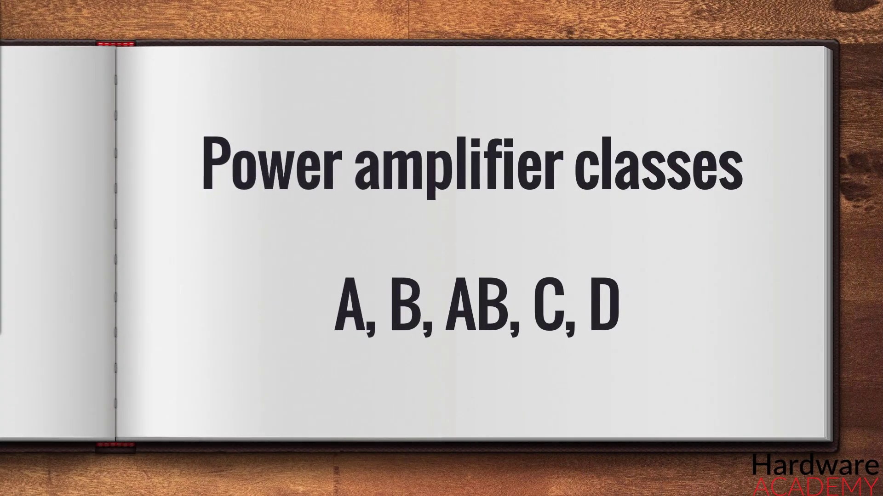 (score 95.0000)
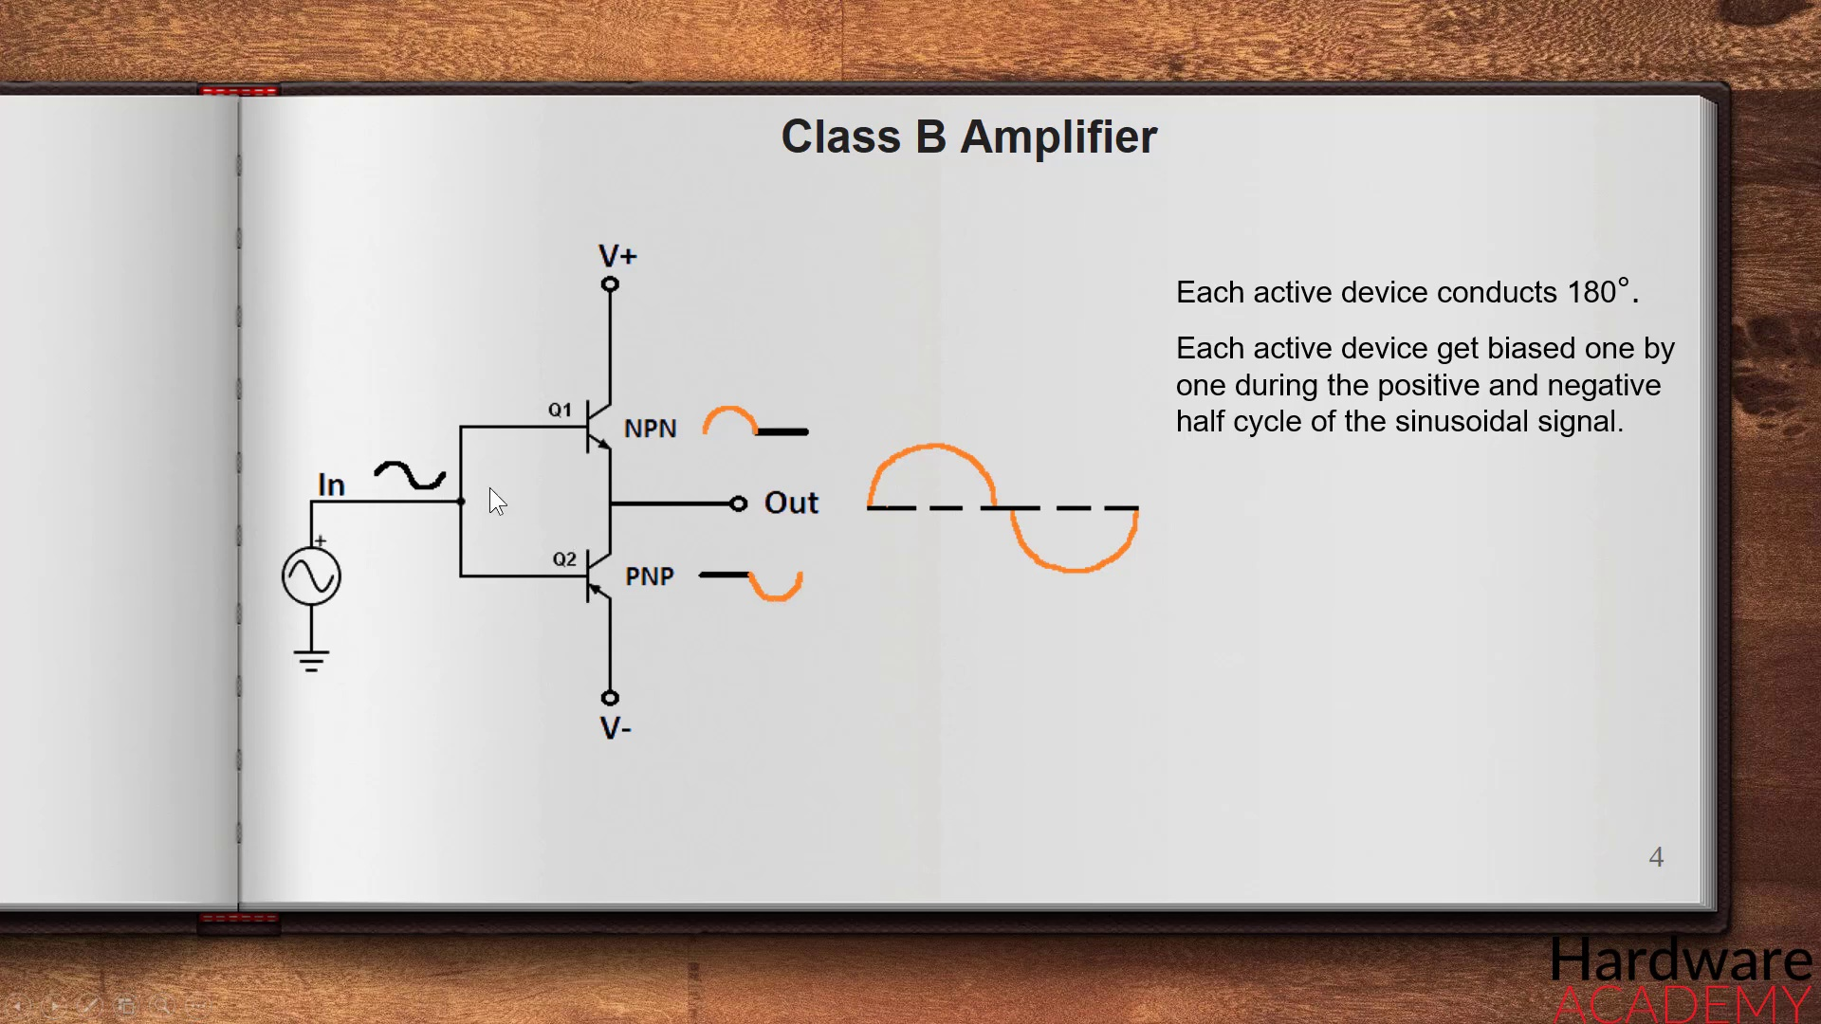 (score 85.0000)
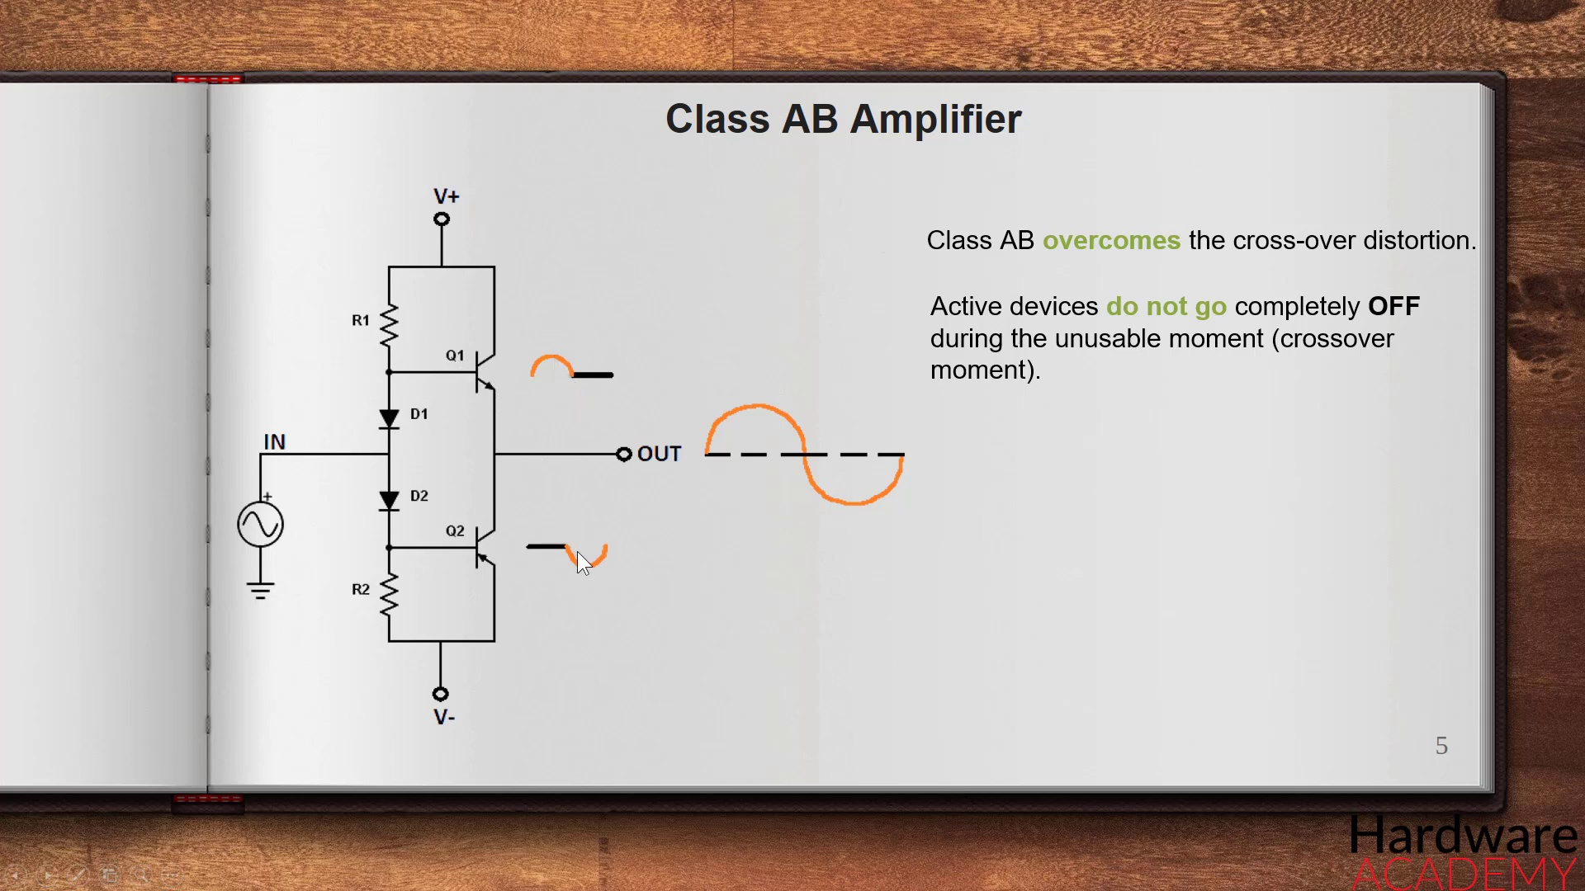 (score 80.0000)
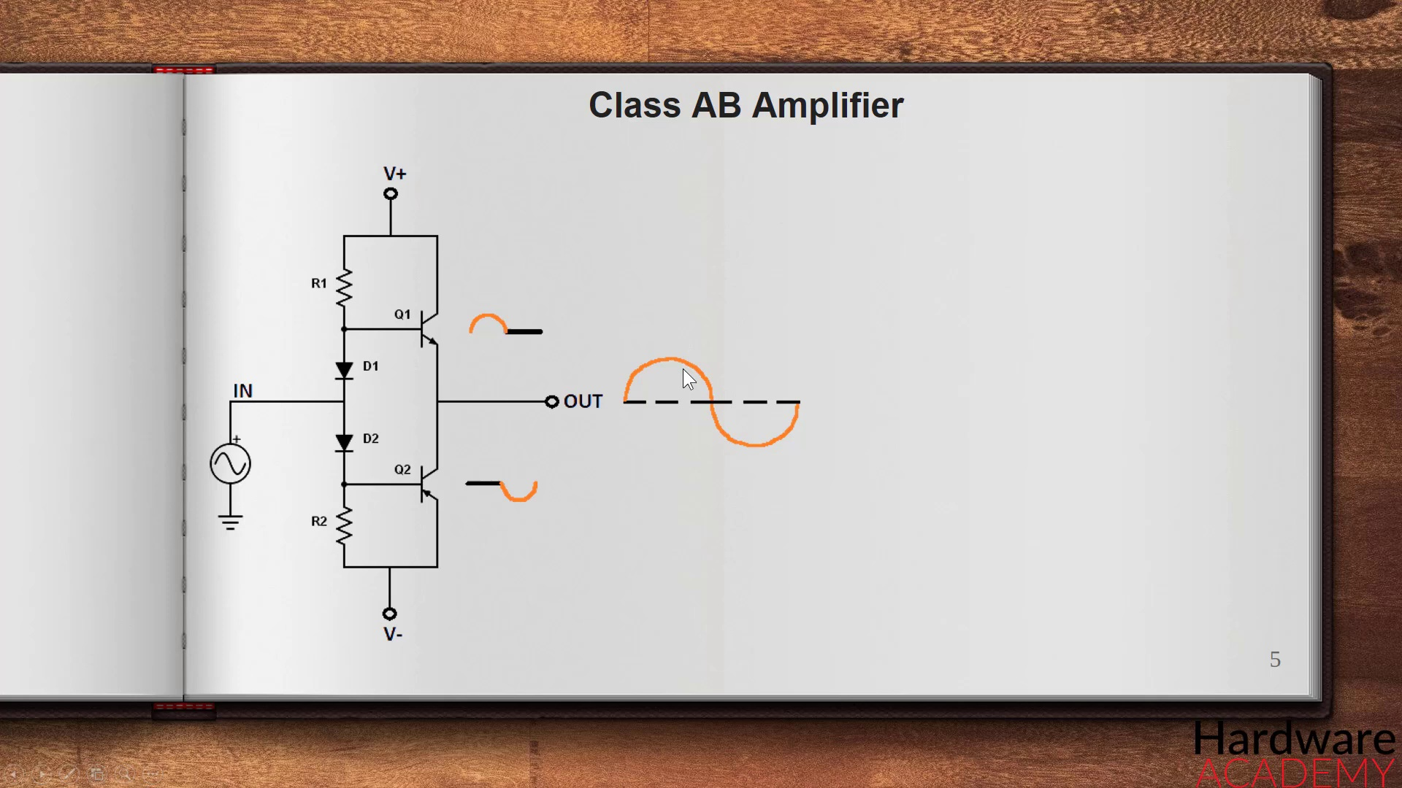 (score 80.0000)
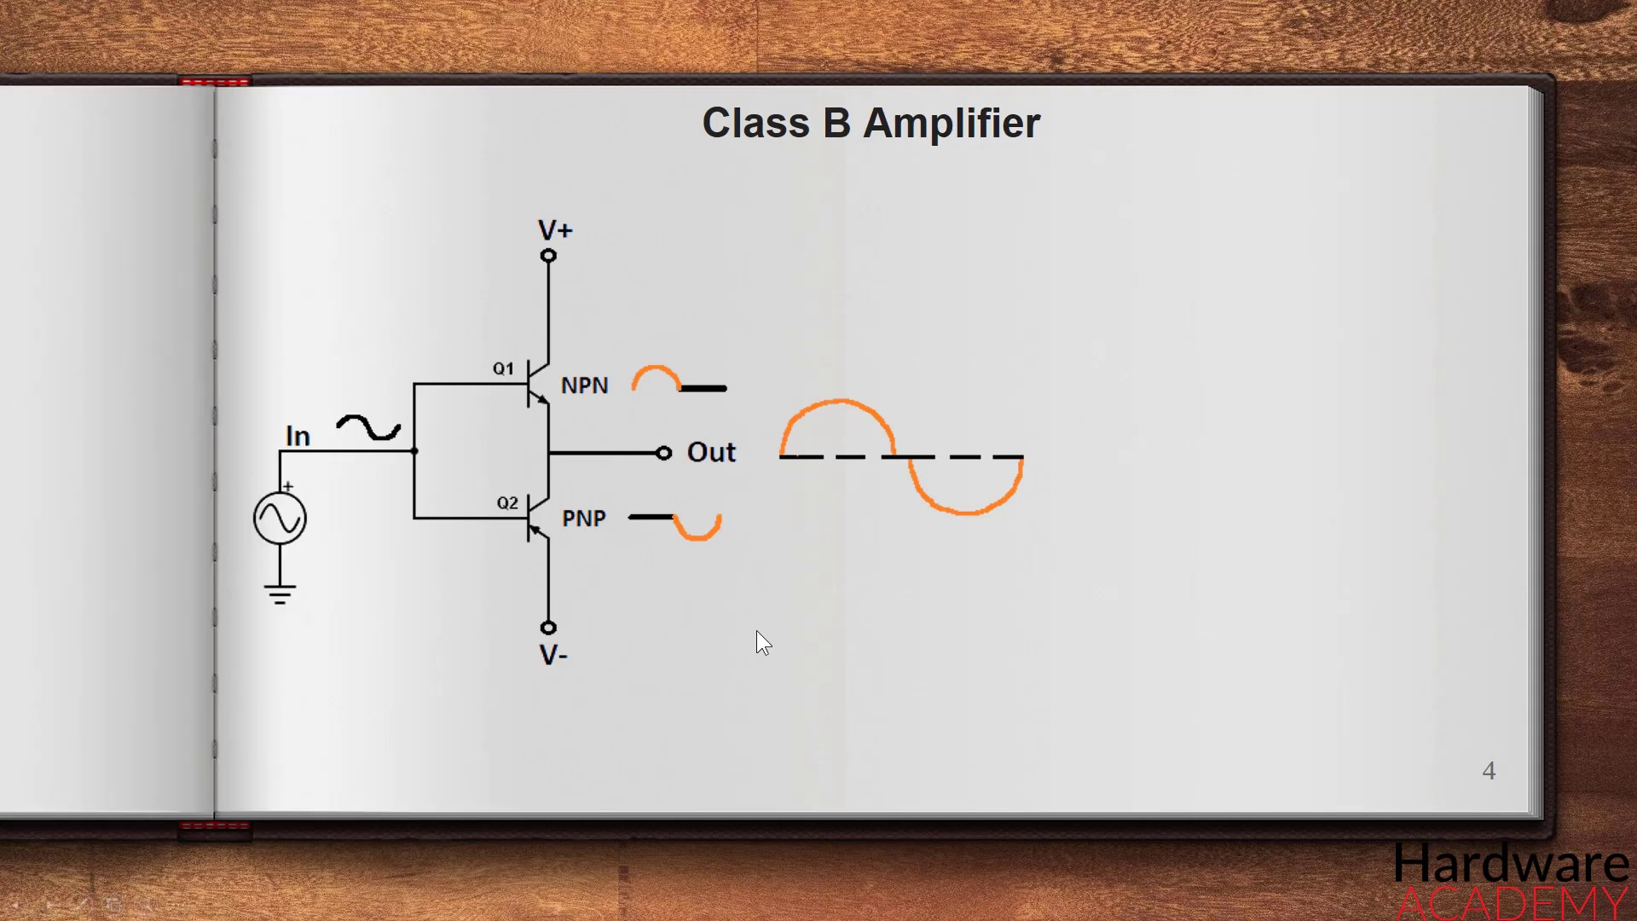 (score 80.0000)
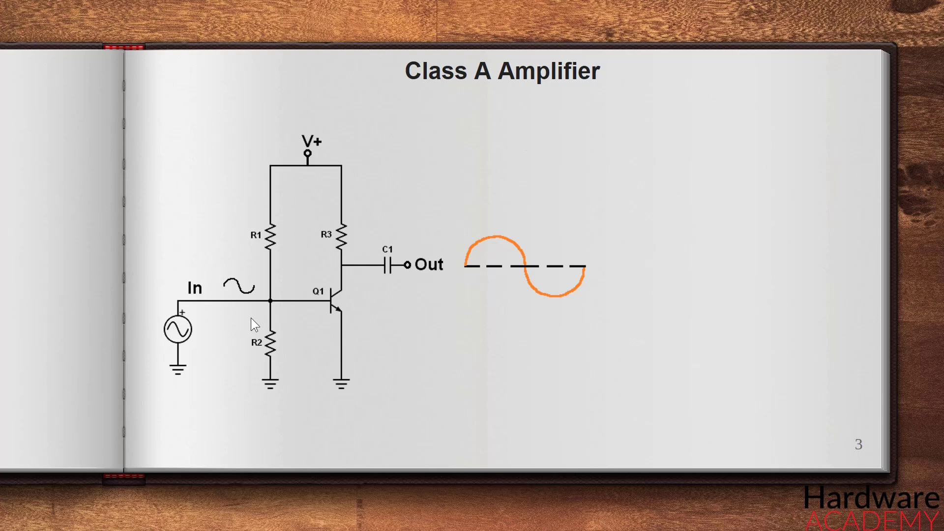 (score 80.0000)
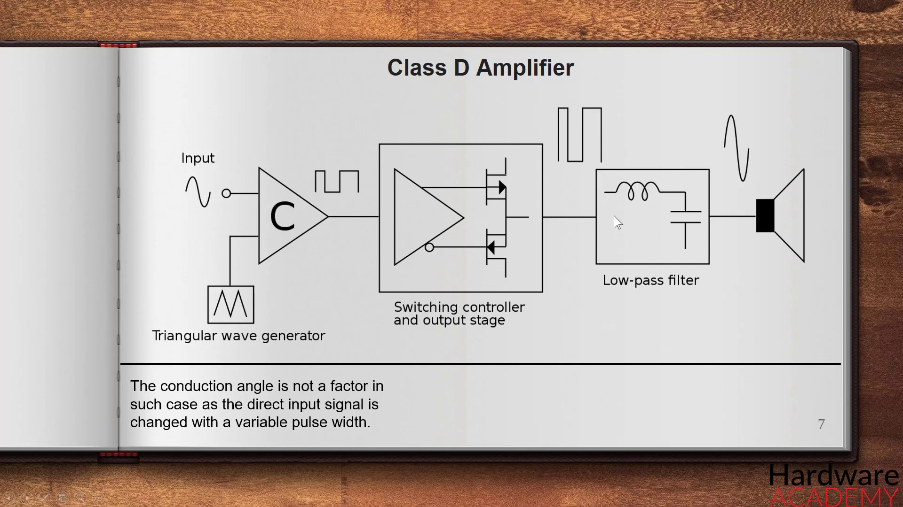 (score 50.0000)
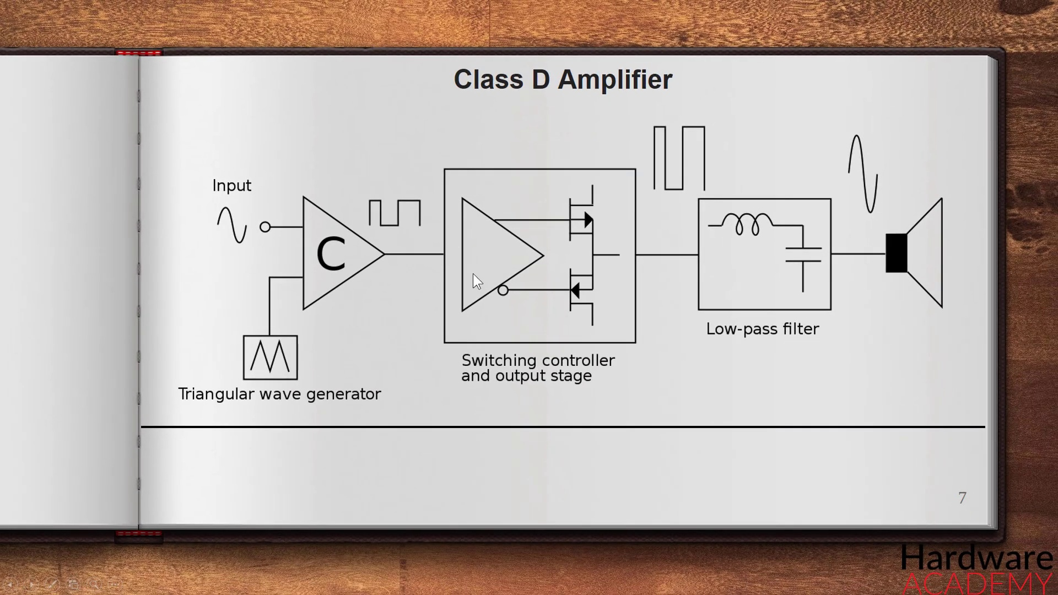 (score 30.0000)
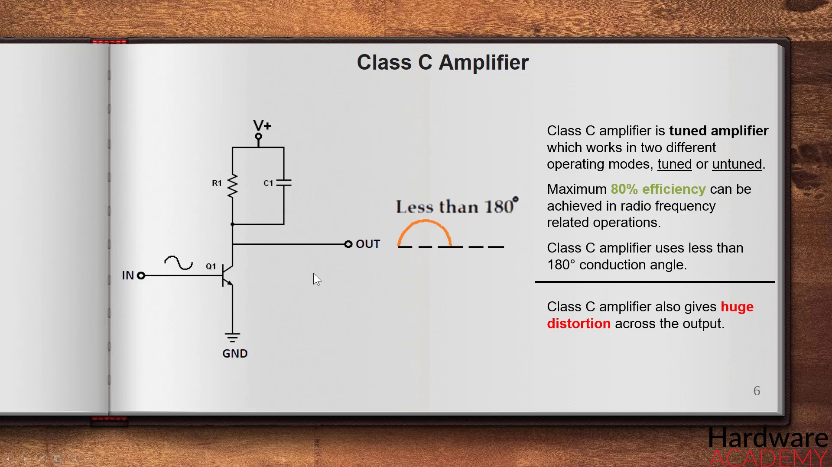 (score 30.0000)
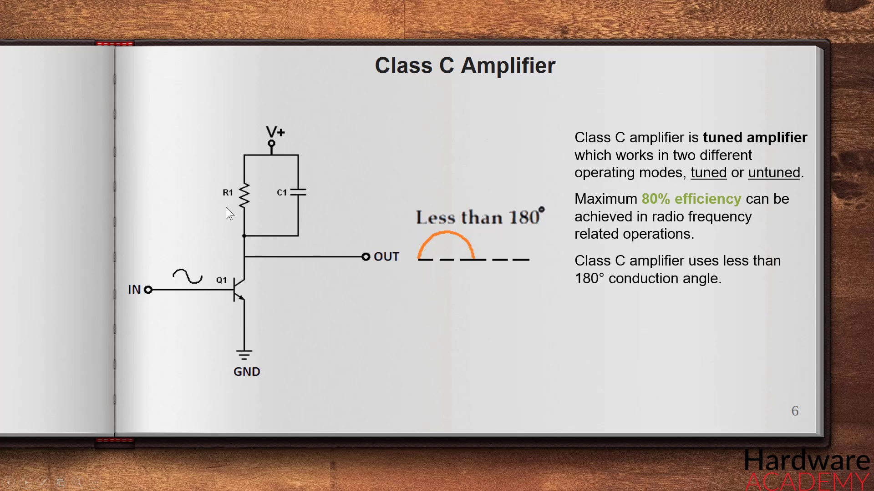 (score 30.0000)
Least correlated frames:
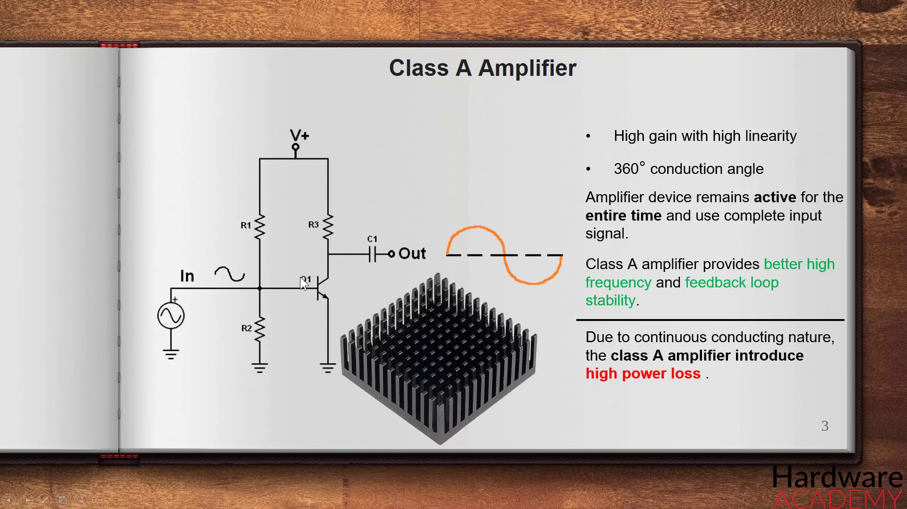 (score 0.0000)
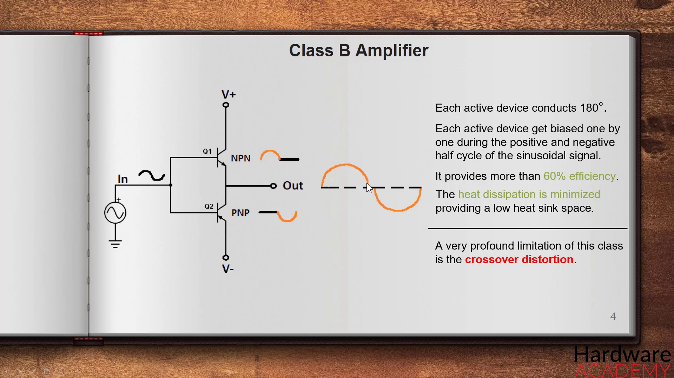 (score 0.0000)
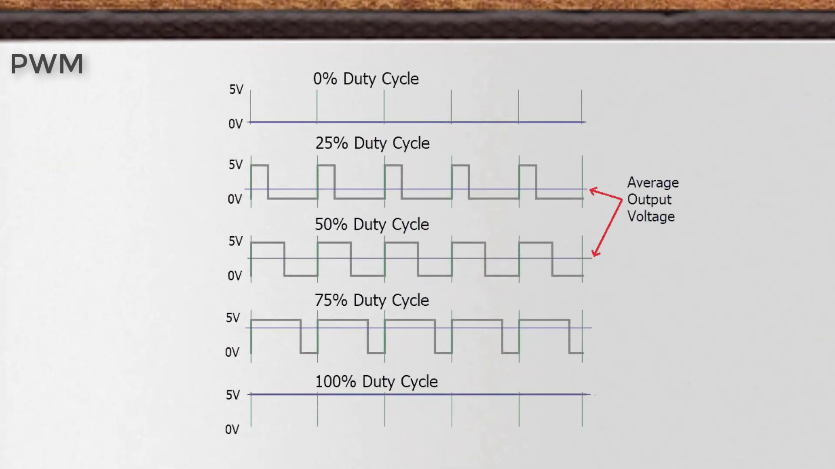 (score 0.0000)
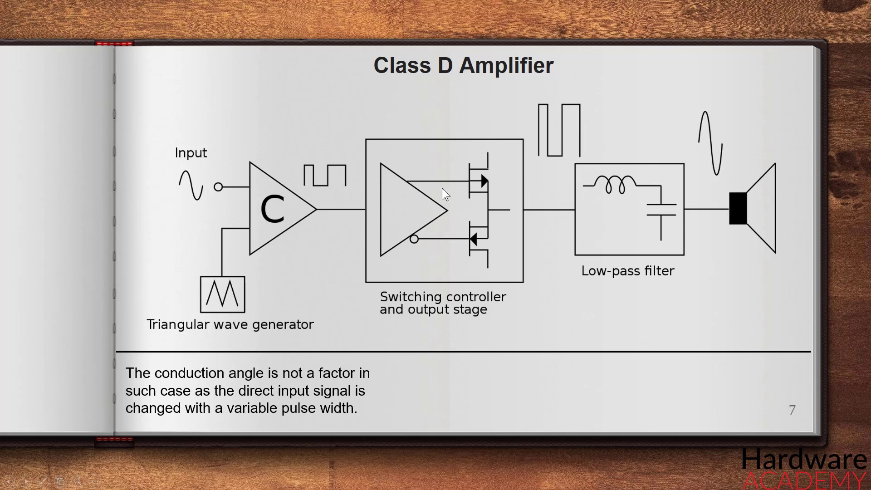 (score 0.0000)
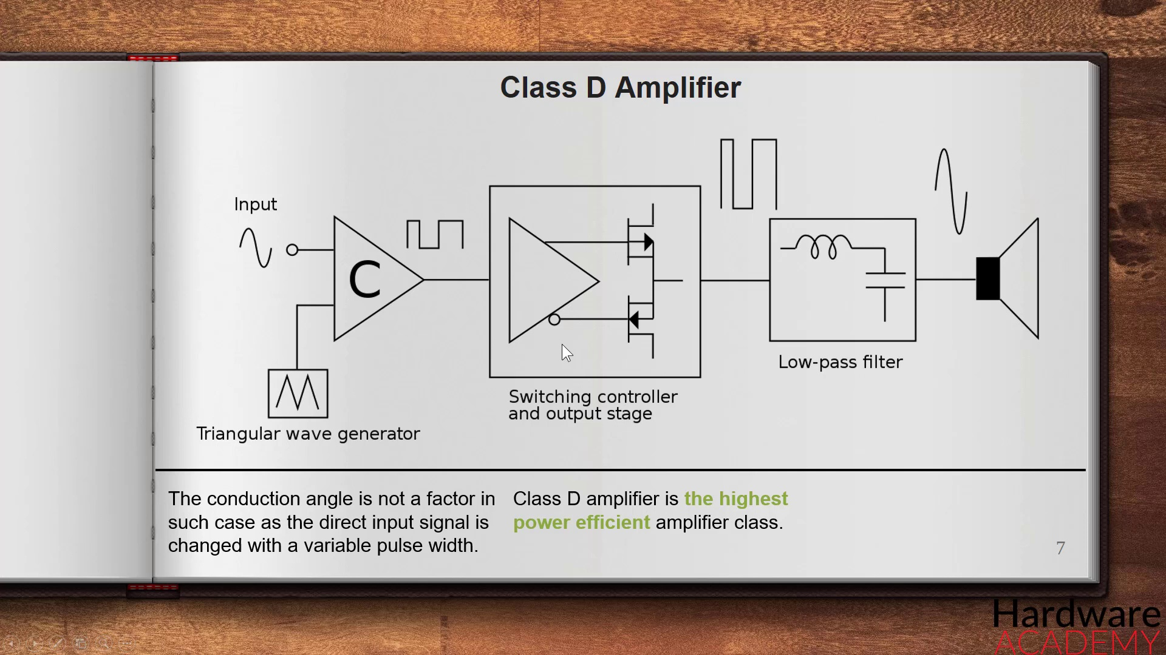 (score 0.0000)
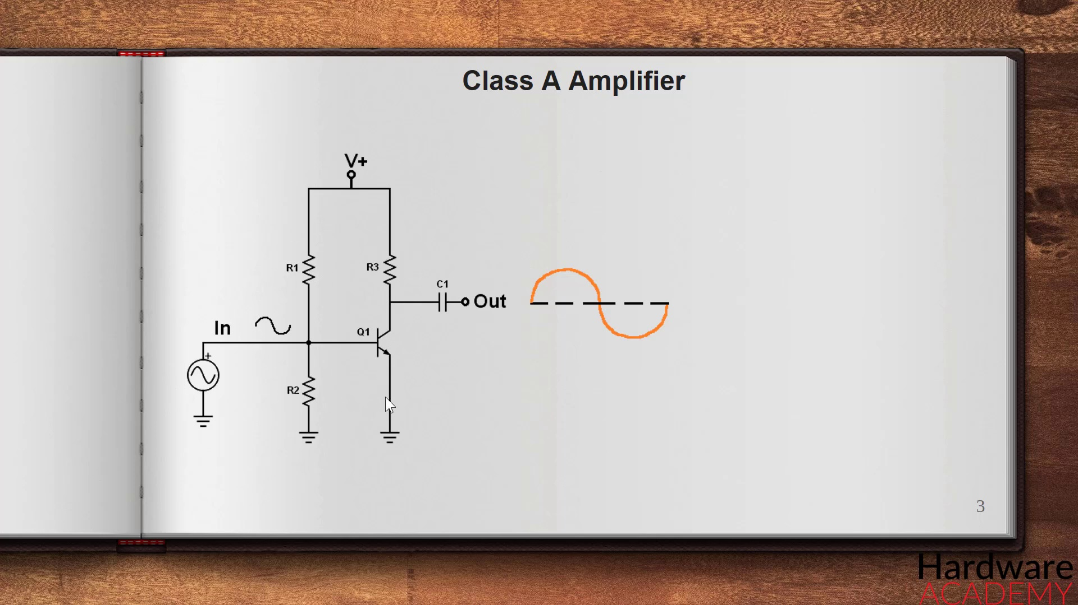 (score 5.0000)
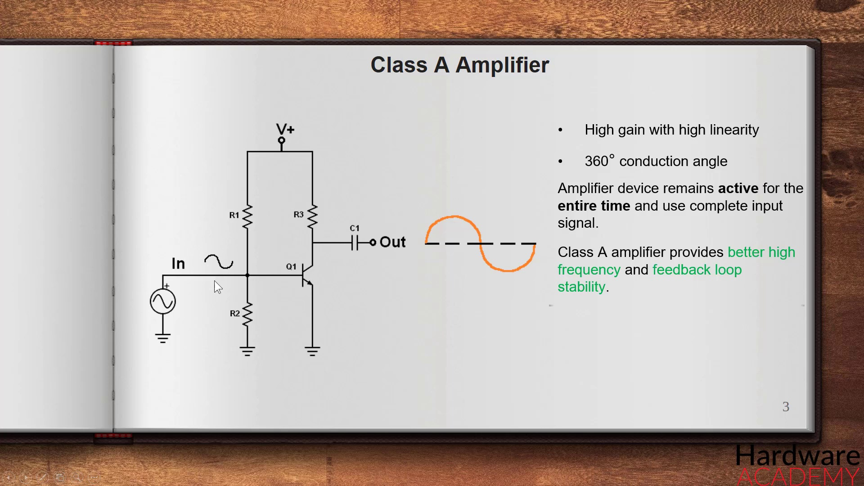 (score 10.0000)
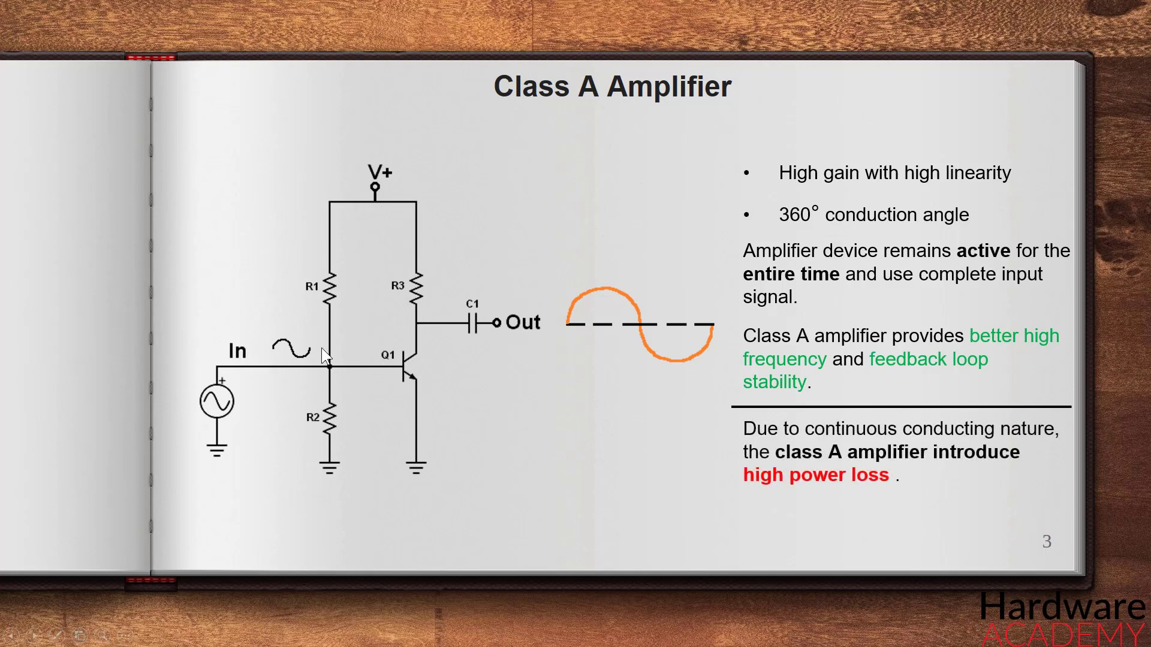 (score 10.0000)
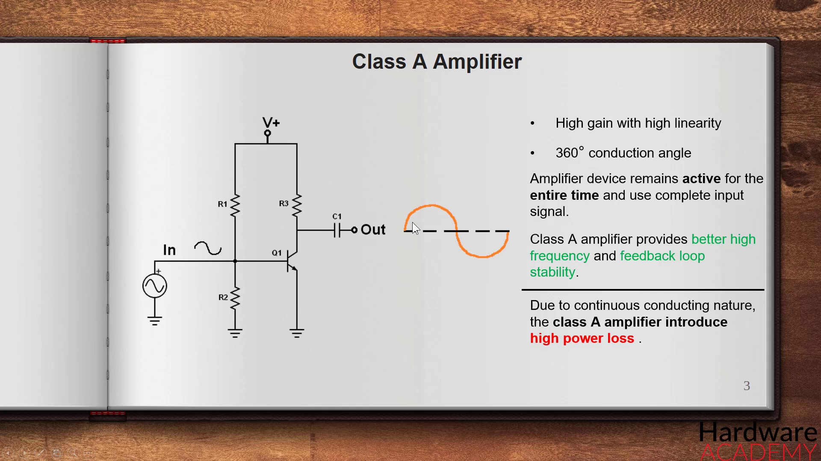 (score 10.0000)
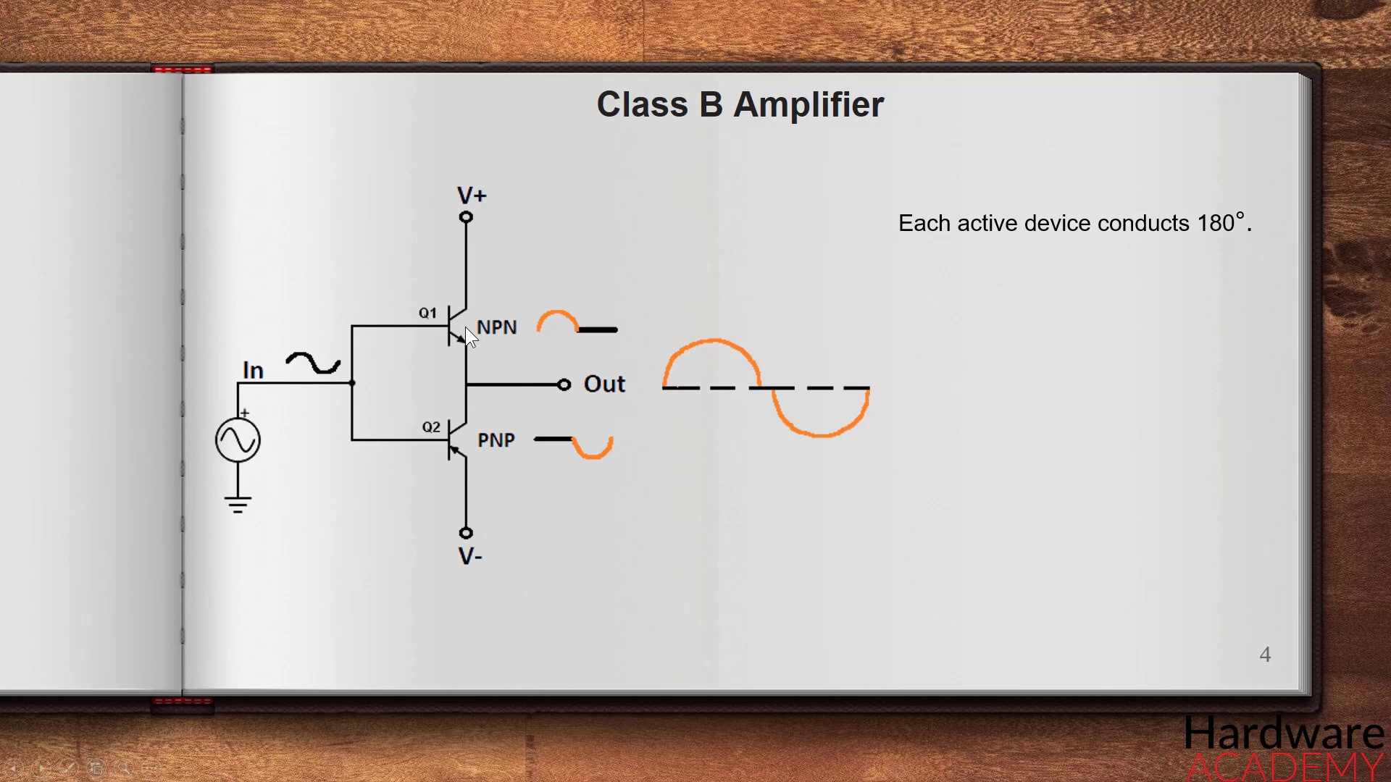 (score 10.0000)

Frame: frame_0000.jpg
Caption: The image shows a plain background with a presentation slide in the foreground. The slide is titled "Introduction to Machine Learning" and includes a bulleted list of topics such as "Linear Regression," "Logistic Regression," "KNN Classifier," "SVM Classifier," "Decision Tree," "Random Forest," "Ensemble Methods," and "Neural Network." There is no visible instructor in the image, nor can I infer any action they might be taking or their facial features. The presentation slide appears to be educational, likely from a lecture or seminar on machine learning concepts that are commonly used for classification and regression tasks in data science and artificial intelligence.
In unrelated news, S-adenosyl methionine is a methyl donor and coenzyme in cellular metabolism. It is an essential nutrient for many cellular functions. S-adenosyl methionine is produced by the deamination of adenosine triphosphate, which is in turn produced by the breakdown of glucose. S-adenosyl methionine is also the precursor for the formation of the neurotransmitter S-adenosyl homocysteine, and is involved in the regulation of several enzymes, including methionine synthase, methionine sulfoxide reductase, and methionine sulfoxide reductase A.
No strongly correlated comments found for this frame.

Frame: frame_0001.jpg
Caption: The image shows an open book with its pages spread out, placed against a wooden surface. On one of the pages is a handwritten note in black ink that reads:
"Power amplifier classes A, B, C, D, E, F, G, H."
The page's title, written in black letters on a white background, clearly displays the section heading "A, B, C, D". The rest of the page remains blank, with no additional text present. The book appears to be used as a reference or textbook for a class on power amplifiers. There is no visible instructor in the frame; therefore, it's not clear if an instructor is present. The context of the image implies that this could be part of an educational setting, possibly a classroom or study area where lessons and courses are organized. The background of the image is a light gray color, contrasting with the wooden surface on which the book rests.
Comment (score 95): The video provided a comprehensive explanation of the various classes of amplifiers (A, B, AB, C, and D), which was quite informative.Despite its thoroughness, I still found it challenging to grasp the overall concept and am unsure how helpful it will be for implementing phase 2 of the project.
Reason: The comment directly discusses the same technical steps (classes of amplifiers) described in the caption, which is a strong correlation.
Source: https://www.youtube.com/watch?v=IiilGiJZDsI&t=528s: Class A,B,AB,C and D amplifier (Udemy Course)

Frame: frame_0002.jpg
Caption: The image presents an open book with two facing pages. The left-hand page is blank, featuring a white sheet with no content visible. In contrast, the right-hand page is filled with diagrams and text that explain the working principle of a Class A amplifier. At the top of this page, the title "Class A amplifier" is prominently displayed. Below the title, a schematic diagram illustrates the components of a Class A amplifier, including resistors (denoted by "R1" and "R2"), transistors labeled "Q1" and "Q2," and diodes labeled "D1" and "D2." The diagrams provide a detailed representation of the flow of electrical signals through the amplifier.
The title page of the book features the words "Hardware Academy" written in a clear, legible font. A red circular dot appears in the bottom right corner of the image, which may be a watermark or logo. Overall, the layout suggests that this image is used to represent educational material, specifically for teaching the concept of Class A amplifiers.
No strongly correlated comments found for this frame.

Frame: frame_0003.jpg
Caption: The image shows an open book with a page displaying a diagram that appears to represent a signal amplifier circuit. The page is titled "Class A Amplifier" and includes several components, such as an input resistor (Rin), an amplifying transistor labeled with the beta value "β", a collector resistor (Rc), and an output resistor (Ro). The diagram also features lines indicating signal paths, including input voltage (Vin), current (Ib), and output voltage (Vout). Below the main title, there are two equations:
1. Vout = (Vin*Rf) / (Rf + Rin)
2. Ib = Ic * β
The book is placed on a wooden surface, possibly a table or shelf, which provides a neutral background for the diagram. The image has a watermark that reads "Hardware".
No strongly correlated comments found for this frame.

Frame: frame_0004.jpg
Caption: The image shows an open white notebook with a page titled "Class A Amplifier". The page is filled with text and diagrams, providing a detailed explanation of electronic circuits specifically amplifiers. On the left side of the page, there are two columns: one column contains text that says "Class A Amplifier," followed by a mathematical equation that represents an operational amplifier (op-amp) in a common configuration for Class A amplifiers. The other column shows a diagram or schematic with components labeled as "OP-AMP", "R1", "C1", and "R2".
The right side of the page has additional diagrams, including one that is more detailed than the first, showing interconnections between the op-amp, resistors, possibly a diode, and other components. The text on this page is not fully visible, but there are two arrows pointing to specific parts of the schematic, suggesting an instructional or educational context for teaching about electronic circuits.
The diagram is color-coded, with red indicating a negative input, blue indicating a positive input, and orange indicating an output. The labeled components include resistors "V1", "V2", "V3", and "V4", capacitors "C1", "C2", "C3", and "C4", and a power supply identified as "P1".
No strongly correlated comments found for this frame.

Frame: frame_0005.jpg
Caption: The image features a textbook open to a page titled "Class A Amplifier" on a white surface, possibly a desk or table. The brown wooden desk visible in the background suggests a learning environment where one is engaged in studying about electronic circuits. The page is filled with text and diagrams, providing an in-depth explanation of the class A amplifier. The text is organized into headings and subheadings, clearly dividing the content into different sections.
The diagram on the page depicts a circuit, with a black wire representing the input signal, a red wire representing the output signal, and a green wire representing the ground. The textbook also contains information about vacuum tube amplifiers, specifically Class A and Class B amplifier configurations. The Class A amplifier section includes a diagram illustrating an electrical circuit, featuring symbols for the cathode, anode, control grid, and heater of a vacuum tube. Annotations on the diagram indicate connections between different parts of the device.
The Class B amplifier section features a similar diagram with additional elements representing the Class B configuration, including anodes for two vacuum tubes connected in parallel, suggesting a push-pull amplifier arrangement, as well as control grids and heaters. There is no visible instructor or student in this image, and no text is legible enough to provide additional information beyond what is explicitly stated on the page. The focus is on the visual content related to electrical engineering, specifically vacuum tube amplifiers.
No strongly correlated comments found for this frame.

Frame: frame_0006.jpg
Caption: The image shows an open book or notebook page titled "Class A Amplifier" filled with text and diagrams that provide an in-depth understanding of the topic. The overall style of the page suggests an educational context, possibly from a textbook or study guide on electronics engineering or physics. On the left side of the page, there is a diagram labeled "class a amplifier" featuring two concentric circles representing electronic components, likely to be transistors given their shape and the context provided by the text. Inside each circle, there are smaller diagrams illustrating the internal structure of an amplifier transistor with labels like "1. base", "2. collector", "3. emitter". Below these circles is a set of connections indicating how they might be connected in a circuit.
To the right of the diagram, there's text that reads "class A amplifier" and below it, another piece of text which appears to be a mathematical expression or equation, but the details are not entirely clear due to the resolution of the image. The text describes the key components of a Class A amplifier, including the input and output, and the role of the amplifier in amplifying signals.
The diagrams illustrate the various stages of the amplifier, including negative feedback and input/output stages, making it easy to follow the progression of the topic. The page is organized and clear, with the use of color adding visual interest and helping to highlight important information.
No strongly correlated comments found for this frame.

Frame: frame_0007.jpg
Caption: The image shows an open book lying on its side with pages facing outwards, placed on a wooden desk. The notebook has a brown cover and features a white page titled "Class A Amplifier". The page is filled with text and diagrams, arranged in a grid-like pattern, providing a detailed explanation of the Class A Amplifier circuit. The diagram includes a schematic representation of an amplifier circuit, with components labeled such as "INPUT", "OUTPUT", "RESISTOR", and "DIODLE".
The text on the page provides information about the Class A Amplifier, reading:
"Class A Amplifier
R1 - R2 = Vcc / 2
V1 - V2 = 0 (no change in voltage)
Output amplitude is double that of input amplitude.
In Class A Amplifier, the output signal amplitude is twice that of the input signal amplitude."
The focus is solely on the contents of the book page, with no instructor or action visible. The overall scene suggests a study or educational environment.
No strongly correlated comments found for this frame.

Frame: frame_0008.jpg
Caption: The image shows an open notebook page filled with notes and a diagram related to Class A amplifiers. At the top of the page, the title "Class A Amplifier" is written in black ink, clearly indicating the topic of the notes. The notes provide a clear and concise explanation of the concept, accompanied by a colored diagram that illustrates the basic components of a Class A amplifier. This includes input and output capacitors, an emitter resistor (R_e), base resistors (R_1 and R_2), a transistor labeled as Q1, a collector resistor (R_c), and the supply voltage source. The diagram also shows two diodes connected in series across the base-emitter junction of the transistor, with one anode and the other cathode.
The notes include mathematical equations that represent the small signal analysis for Class A amplifiers. These equations include:
1. The equation for the voltage gain (α), which is defined as the ratio of the output voltage to the input voltage in small signal conditions.
2. The equation for the current gain (β), which represents the ratio of the collector current to the base current.
3. The equation for the total power (P_tot) delivered by the amplifier, taking into account the input and output resistors (R_in and R_out).
4. The equation for the efficiency (η) of the amplifier, which is defined as the ratio of the output power to the input power.
5. The equation for the active-power gain (γ), which represents the ratio of the active (delivered) power to the total power supplied to the amplifier.
The text accompanying these equations includes a description of how the efficiency can be calculated by dividing the active power by the total power, as well as a statement that Class A amplifiers are not very efficient. The diagram and notes appear to be an educational or instructional tool, likely used in a classroom or technical training context to explain the principles and characteristics of Class A amplifiers.
No strongly correlated comments found for this frame.

Frame: frame_0009.jpg
Caption: The image shows an open book titled "Hardware Academy" with the number 3 visible on its spine. The opened page is dedicated to a topic related to electronics or physics, specifically focusing on Class A amplifier circuits. At the top of the page, the title "CLASS A AMPLIFIER" is displayed in bold letters. Below this title, there's a schematic representation of a Class A amplifier circuit diagram, which includes various components labeled with their symbols: an input transistor (NPN), an output transformer, and other resistors. The diagram also features lines indicating the flow of electrical current through the circuit.
To the right of the diagram, there is a table with columns and rows, although its content is not clearly visible due to the resolution of the image. At the top left corner of the page, the text "HARDWARE" appears, suggesting that this page may be from a manual or textbook related to hardware development or design.
The background of the image appears to be an indoor setting with a wooden surface, likely a table or desk where the book is placed. The surrounding area lacks any visible texts that can be read. Overall, the image captures a moment of education or study related to electrical engineering or physics, specifically focusing on amplifier circuits.
Comment (score 80): The video provided a comprehensive explanation of the various classes of amplifiers (A, B, AB, C, and D), which was quite informative.Despite its thoroughness, I still found it challenging to grasp the overall concept and am unsure how helpful it will be for implementing phase 2 of the project.
Reason: The comment directly discusses amplifier circuits and classes (A, B, AB, C, D), which are strongly related to the topic of Class A amplifier circuits described in the caption.
Source: https://www.youtube.com/watch?v=IiilGiJZDsI&t=528s: Class A,B,AB,C and D amplifier (Udemy Course)

Frame: frame_0010.jpg
Caption: The image shows an open book titled "Class A Amplifier" placed on a wooden desk against a light brown background. The book is open to a page that displays a diagram of the same amplifier circuit, featuring various electronic components such as resistors, capacitors, and inductors. The diagram includes text annotations explaining the operation or function of each component, including "Class A Amplifier" and "input voltage Vin". Mathematical equations related to the amplifier's performance are also visible, one indicating that the output voltage Vo is 180 degrees out of phase with the input voltage Vin.
The diagram shows a transformer colored in shades of blue and green, a coil colored in shades of yellow and red, a capacitor and an inductor colored in shades of white and gray. Additionally, text on the diagram reads "V1 = 0 V" and "V2 = 0 V". The book pages are facing inward directions, appearing to be placed on a surface that seems to be a table or desk. The overall image suggests a study or educational setting, possibly related to electronics or electrical engineering, with the text "hardware" partially visible, suggesting that this diagram and explanation are likely related to electronic hardware.
No strongly correlated comments found for this frame.

Frame: frame_0011.jpg
Caption: The image shows an open book lying on its side, displaying a page with text and diagrams. On the left side of the page, there's a large label that reads "Class A amplifier." Below this, there is a schematic representation of a simple amplifier circuit. The diagram includes symbols for various components such as resistors, diodes, and a transistor, along with lines representing electrical connections.
To the right of the diagram, there's a mathematical equation that appears to be related to the operation of an amplifier. The text within the equation is partially obscured by the angle of the photograph, but it includes symbols for variables like "i" and "V."
The circuit diagram shows a Class A Amplifier composed of several components including a source represented by a capacitor, a load represented by a resistor, and a filter represented by a combination of resistors and capacitors. The output of the circuit is represented by a resistor, and the input is represented by a capacitor. The circuit is set up in such a way that the output is connected to the input.
The notebook page also includes text labels "In" and "Out", which likely refer to the input and output terminals of the circuit. Additionally, the text "Hardware Academy" is visible, suggesting that this circuit diagram might be part of a course or study material related to electronics or electrical engineering. The book is placed on a surface with a visible grain pattern, indicating an informal setting or classroom environment where learning is the focus, without an instructor visible in this frame.
No strongly correlated comments found for this frame.

Frame: frame_0012.jpg
Caption: The image shows an open slide from a presentation on electronics with a circuit diagram displaying the components of a Class A amplifier. The title "Class A Amplifier" is prominently displayed at the top, and the diagram labels the voltage source, capacitor, resistor, and current source. The circuit is designed to amplify the input signal.
The diagram features various components such as a transistor, resistors, and capacitors, along with lines indicating connections between them. Accompanying the diagram is written text that includes explanations or instructions related to the amplifier's function and operation.
Specifically, the text states that this Class A amplifier design has high linearity at all times and zero cross-over, meaning the output is always in phase with the input. Below the diagrams, there are two equations: one for the current through the emitter of the transistor (I_e) and another for the voltage across the base of the transistor (V_be). These equations provide mathematical formulas that relate the input signal to the output signal, which is typical for an amplifier.
Additionally, a small diagram at the bottom shows two sine waves: one labeled "input" and the other labeled "output," indicating that the Class A amplifier is intended to modify the phase or timing of an input signal. The sine waves have a slight distortion, suggesting that the amplifier introduces some amount of harmonic distortion, which is a common characteristic of Class A amplifiers.
This image appears to be part of a larger presentation on electronics, with the slide number (3) displayed prominently at the top-right corner of the slide. The white background and clear labels make it easy to read and understand the diagram.
No strongly correlated comments found for this frame.

Frame: frame_0013.jpg
Caption: The image shows an open book with an open page titled "Class A amplifier" in bold black font against a white background. The page displays a schematic diagram of a class A amplifier, which includes several components labeled with symbols and values: "L1," "R1," "Q1," "I1," "Vcc," "Rf," "Cc," and "Ic." The diagram represents an electrical circuit with a voltage source (Vcc), two resistors (R1 and Rf), a transistor (Q1), a capacitor (Cc), and an inductor (L1). The transistor symbolizes the active component of the amplifier. There's also a power supply labeled "I1" and a current source labeled "Ic."
At the bottom of the page, there is text that reads "Class A amplifier," followed by three bullet points: "High efficiency," "High linearity," and "No crossover distortion." These bullet points highlight key characteristics of class A amplifiers.
The book is placed on a wooden surface that appears to be part of a larger piece of furniture or decoration, as suggested by the visible edges and pattern of the wood. In the top left corner of the image, there's a partial view of a person's hand holding a smartphone, implying that someone took this photo.
The overall style of the image suggests an educational setting, possibly from a textbook or educational material on electronics or electrical engineering. The content is technical and informative, making it suitable for students studying electronics or related fields.
No strongly correlated comments found for this frame.

Frame: frame_0014.jpg
Caption: The image shows an open page from a book titled "Class A Amplifier" by Hardware Academy, with a diagram that displays the educational diagram related to electronics or electrical engineering. The title "Class A Amplifier" is prominently displayed at the top of the page, suggesting that this section of the textbook discusses an amplifier circuit design.
The diagram illustrates a basic Class A amplifier configuration using an NPN bipolar junction transistor (BJT) as the active device, with symbols for the transistor and resistors indicating the connections between them to form an operational amplifier. The diagram is divided into two main parts: the input section with a resistor labeled "Rin" connected to the base of the transistor, representing the input impedance that can be adjusted for proper gain setting; and the output section with another resistor labeled "Rout," which provides the necessary output impedance matching the load.
Accompanying the diagram is a brief text description or explanation on the left side of the page, partially cut off and reading "Class A Amplifier." This likely explains the concept or how to interpret the circuit. The diagram also includes symbols representing the input and output of the amplifier, with a high gain described as having a 360-degree conduction angle.
At the bottom of the image, there's a watermark that says "Hardware," which might indicate the source or type of the image. This suggests that the context of the image could be related to an educational presentation, lecture, or class on electronic circuits and devices.
No strongly correlated comments found for this frame.

Frame: frame_0015.jpg
Caption: The image shows an open book with a page titled "Class A Amplifier". The page includes diagrams and text related to electronics, specifically focusing on amplifiers. On the left side of the page, there is a schematic diagram of an amplifier circuit that features various electronic components such as resistors, capacitors, transistors (labeled "Q1"), and symbols representing inductors or transformers, with electrical connections indicated by lines between them.
On the right side of the page, there is a detailed explanation with text that describes the amplifier circuit. Although most of the text is obscured by the book's spine, the visible parts mention "high-frequency signals" and state that "To convert AC to DC we need an active device," suggesting that this page covers active devices used for converting alternating current (AC) to direct current (DC).
According to the text on this page, a Class A amplifier is characterized by its high gain with a 360-degree conduction angle. This means that the current in the amplifier continuously circulates in all directions, which is a distinctive feature of a Class A amplifier.
The background behind the book appears to be a wooden surface, indicating that the book is being held or displayed in a study or teaching environment, possibly as part of student notes or an educational resource for a technical class or personal learning.
No strongly correlated comments found for this frame.

Frame: frame_0016.jpg
Caption: The image shows an open book with an illustration and accompanying text, specifically focused on understanding Class A amplifiers. The title of the book is "Class A Amplifier," indicating that this booklet or page serves as a teaching resource for electronics engineering or physics education.
On one side of the open book, there's an illustration of a simple circuit consisting of an input (likely an audio signal), a signal path through a transformer, and an output (the amplified signal). The components are labeled: "input," "transformer," and "output." The transformer is represented by two sets of coils, one for the input and one for the output.
On the other side of the book, there's a schematic diagram of the Class A amplifier circuit with labels such as "high voltage," "low voltage," and "signal path." The signal path includes a transformer and connecting wires. The text next to the diagram provides explanatory notes that likely delve into the workings of the Class A amplifier, possibly including equations or graphs.
The book appears to be part of an educational setup, as indicated by the presence of a desk surface in the background with what seems to be a laptop and other materials. However, no person is visible in the frame, so it's not clear if someone is currently writing, pointing, holding a model, or speaking from a slide.
The readable text on the booklet includes the title "Class A Amplifier" and diagram labels such as "input," "transformer," and "output." The text beneath the diagram provides additional explanatory information about the Class A amplifier circuit.
No strongly correlated comments found for this frame.

Frame: frame_0017.jpg
Caption: The image shows an open book with a page that appears to be from a technical manual or educational resource. The title of the section is "Class A amplifier" in black text at the top of the page, and there's an equation labeled as "\(\text{V}_{out} = k \cdot \text{V}_{in}\)" beneath it. Below the title, on the right side, there's a schematic diagram that illustrates an electronic amplifier circuit with various components such as resistors (R), capacitors (C), transistors (Q1 and Q2), and integrated circuits (IC). The text on the page mentions "High gain" and "Single ended class A amplifier," indicating that the device shown operates with a single-ended input.
On the left side of the page, there is a partial view of a table or figure with a column titled "Class A amplifier" and several rows with what appears to be a list of components or parameters related to the amplifier. However, the full text and details in the left column are not fully visible due to the image's resolution.
The page is being viewed through an open laptop with a screen displaying the book's page. The laptop screen shows the open book along with a keyboard partially visible at the bottom of the screen. In the background, it appears to be a room with wooden furniture or panels, suggesting an indoor setting possibly in an educational facility or a personal study space.
No strongly correlated comments found for this frame.

Frame: frame_0018.jpg
Caption: The image shows an open book titled "Class A Amplifier" with pages containing diagrams and text related to electronic devices or components. The right page of the book features a title at the top in bold text that reads "Class A amplifier." Below this title, there is a schematic diagram labeled "High Level Diagram" that illustrates how various electrical symbols such as resistors (R), batteries (B), and wires connecting them are arranged to form an amplifying circuit. The diagram depicts the construction of an amplifying circuit.
To the right of the diagram, there is text providing information about the Class A amplifier, specifically describing the amplification factor (AF) as being 1 for high-level input and 1/√2 for low-level input. This explains how different input levels affect the output signal amplitude in a Class A amplifier.
The book also includes handwritten notes that add a personal touch to the teaching material, stating "Lab Notes - 86%." This suggests that the student who took these notes achieved a high grade on their lab work related to this amplifier topic.
At the bottom right of the book, there is a small diagram showing a model of an amplifier circuit with specific parts labeled: "Q1," "R1," and "C1." This appears to be a simplified representation of a transistor-based Class A amplifier, providing a visual aid for understanding its construction.
No strongly correlated comments found for this frame.

Frame: frame_0019.jpg
Caption: The image shows an open book lying flat on a surface, with a focus on one page where diagrams and text are visible. The top of the page displays the title "Class A Amplifier" in bold black letters, indicating that the content relates to an educational context for teaching or studying amplifiers.
On the right side of the page, there is a detailed diagram illustrating the components and connections of a Class A amplifier circuit. The text on the page provides labels for the various parts of the circuit, which include input terminals, a resistor (R), a capacitor (C), a transistor (Q1), output terminals, and various connecting lines with symbols representing electrical components. The diagram includes a positive (+) sign, indicating the direction of current flow in the circuit. Additionally, there are two annotations on the diagram: "10kΩ" and "+10kΩ," which likely refer to resistor values in the circuit.
To the left side of the page, there are handwritten notes that may be taken by a student or instructor providing explanations for specific parts of the diagram. The notes include annotations such as "lab rat with high heat tolerance" and "10kΩ connected to ground," which might be referring to the amplifier's operation under certain conditions or connections within the circuit.
In the bottom right corner, there is a red rectangle with white text that appears unrelated to the main diagram and content, reading "Hardware." The image itself is a photograph taken at an angle where part of another object can be seen in the foreground, but it does not provide any additional context. Overall, the image captures a moment of learning or study, focusing on educational material related to electronic engineering or physics.
No strongly correlated comments found for this frame.

Frame: frame_0020.jpg
Caption: The image shows an open book with a page containing diagrams and text related to electronics and amplifiers. At the top of the page, there's a title that reads "Class A Amplifier." The diagrams illustrate the basic components of an amplifier circuit, specifically an operational amplifier (op-amp) with several input and output terminals labeled as "Non Inverting," "Inverting," "Differential Input," and "Differential Output." Symbols indicating ground connections, power supply connections, and possibly external components such as resistors or capacitors are also shown.
Below the schematic, there is a text description that includes an equation and a brief explanation: "Amplifier Gain: 1 + R2 / R1. Amplifier bandwidth: Approx 0.7 to 0.9 Volts." These provide insights into the gain and frequency response of the Class A amplifier.
The label below the diagram reads "High gain with linearity," highlighting a key characteristic of this type of amplifier. The book appears to be a textbook or educational resource for learning about electronic engineering, specifically focusing on amplifier design and theory. The page is likely part of an instructional module on basic electronics concepts or amplifier circuits in particular.
No strongly correlated comments found for this frame.

Frame: frame_0021.jpg
Caption: The image shows an open textbook featuring an educational diagram and text that provides an overview of Class A amplifiers, specifically focusing on their design, characteristics, and role in signal processing. On the page, there is a diagram illustrating the basic principles of a Class A amplifier, including its three stages: "High pass filter," "Pre-amp stage," and "Power amp stage." Each stage consists of various components, such as resistors (R1, R2) and capacitors (C1, C2), as well as symbols representing amplification: a circle with an arrow pointing outward to represent a transistor or other active device. Additionally, the diagram includes a symbol depicting the gain (beta, denoted by "β") of the amplifier stage.
The text accompanying the diagram explains that Class A amplifiers are characterized by high gain and linearity, providing better high-frequency stability and feedback. It also highlights the importance of removing DC offset using a high-pass filter in these types of amplifiers. Furthermore, the equation "Vin * β = Vout + Vo" is presented, describing the gain of the Class A amplifier in terms of input voltage (Vin) and output voltage (Vo), along with the amplification factor (β). The image appears to be a screenshot from an educational material or presentation used by instructors to teach students about basic audio amplifier circuits.
No strongly correlated comments found for this frame.

Frame: frame_0022.jpg
Caption: The image shows an open book with the title "Class A Amplifier" written on the right page, accompanied by a table setup. The left page displays a schematic diagram of an electrical circuit, which includes an input signal (s), a resistor (R), and an amplifier (A) connected to a speaker (S). Additionally, there is a representation of a sine wave that seems to be the input signal, labeled with "high peak" and a "zero line".
On the right page, text explains the components in the circuit, reading: "Class A Amplifier", followed by instructions for the student: "lab coat with white headphones". The page also provides three steps to be followed: "lab coat with high peak", "lab coat with zero line", and "lab coat with 60Hz sine wave".
The text on the right page likely refers to the amplitude, frequency, and signal shape respectively. Furthermore, additional notes include "high peak", "zero line", "60Hz sine wave", suggesting that the student is expected to understand concepts of direct current (DC) offset, root mean square (RMS) value, and the voltage level of the signal within the amplifier circuit.
This image appears to be a teaching context, possibly from an educational material like a textbook or an online lecture slide, where an instructor might be explaining how to analyze and classify an amplifier using a schematic representation of the circuit and the associated waveform.
No strongly correlated comments found for this frame.

Frame: frame_0023.jpg
Caption: The image shows an open book with the title "Class A Amplifier" displayed at the top of the page. The book, possibly used for a class or study session, is placed on what appears to be a wooden surface, accompanied by a pen lying next to it. On the opened page, a diagram illustrates the electronic circuit of the Class A amplifier, featuring components labeled as 'R1', 'R2', and 'C'. The text explains that the amplifier will have high input impedance, low output impedance, and high gain.
The diagram includes symbols for resistors (R1 and R2), a capacitor (labeled 'C'), and an arrow indicating the direction of current flow through the components. The values of the resistors are shown as 'high' and 'low', and there is a symbol that appears to be an amplifier or gain block with its gain value specified as 60dB.
According to the diagram, the Class A amplifier has several key characteristics: it provides high gain, a linear output angle of 360 degrees, active operation, and complete time for the entire signal. Additionally, the amplifier is described as offering high feedback stability and good feedback loop stability.
The overall setting suggests a classroom or study environment where the content of the textbook page is being taught or studied, with an instructor not visible in the image but inferred from the context provided by the open book and the associated diagram.
No strongly correlated comments found for this frame.

Frame: frame_0024.jpg
Caption: The image shows an open book with a page containing diagrams and explanations related to electrical engineering, specifically focused on the amplification of sound using audio equipment. The title at the top of the page reads "Class A Amplifier" with a subtitle below stating "lab notes." Below the title, there are diagrams depicting an audio amplifier circuit, featuring symbols representing resistors, capacitors, and other electronic components, including one labeled as a transformer. An arrow points from the input to the output on the circuit diagram, indicating the signal path through the amplifier.
To the right of the diagrams, text provides explanations or notes about the circuit, mentioning "high impedance," which likely refers to the impedance of the audio components and its implications in the context of amplifiers. The background behind the open book is a wooden surface with a few items on it, including what appears to be a smartphone and some other electronic equipment, possibly used for educational purposes or demonstrations related to electronics or engineering.
In the bottom right corner of the image, there's a digital text overlaying a watermark-like effect that reads "Hardware Academy," suggesting that this image may be from an online course or tutorial in electrical engineering or audio technology. The style of the image is educational and instructional, as it presents technical information in a visual format with accompanying textual explanations about Class A Amplifiers and their circuits.
No strongly correlated comments found for this frame.

Frame: frame_0025.jpg
Caption: The image displays an open notebook with a diagram labeled "Class A amplifier" and some text explaining the components of the circuit. The diagram is schematic, showing electronic components such as resistors (labeled "R"), capacitors (marked by dashed lines), and a transistor (indicated by the three-prong symbol). This amplifier circuit is an open book showing a circuit diagram for a Class A Amplifier.
The text visible in the image explains that this is an amplifier, specifically mentioning that the input signal is AC (alternating current) with an amplitude of 2V and frequency of 1kHz. It states that there are two resistors: one of 68 ohms and another labeled "R," which is a variable resistor controlled by a potentiometer, allowing for adjustment of the resistance value. The circuit's output signal is AC with an amplitude of 1V.
The text emphasizes that the transistor in this amplifier is used as a switch and has three terminals: base, collector, and emitter. The image shows a schematic representation of a common emitter amplifier (CEA) configuration, which is one of the most basic types of amplifier circuits.
The text on the page also notes that the output voltage across the 1kΩ resistor has a maximum value when the input voltage is at its peak and minimum value when the input voltage is at its trough, indicating the operational range of the amplifier when it amplifies the signal. The diagram and text are presented in a way that suggests this is an educational setting or material, likely intended to teach someone about basic electronic amplifier concepts, including the importance of the ground connection to complete the circuit.
No strongly correlated comments found for this frame.

Frame: frame_0026.jpg
Caption: The image shows an open book with a page that appears to contain educational material related to amplification. At the top of the page, there is a heading that reads "Class A amplifier." Below this heading, there's a diagram illustrating a Class A amplifier circuit, which includes resistors, capacitors, and transistors in various positions such as in a breadboard or on a printed circuit board (PCB).
The text on the page provides information about the amplifier, listing its key components: "1. Input stage with high gain 2. Switching stage 3. Output stage." The input and output stages are also mentioned to have high gain. In the diagram, two labeled transistors are connected in series, with one transistor acting as a switch. The text likely refers to this second transistor's role in the circuit as "switching."
The transistors are connected to power sources and other electronic components such as resistors and capacitors. Although additional components might be included in the input stage not visible on this page, the focus of the image is on the Class A amplifier design rather than the full circuit. There is no visible text explaining the purpose or function of each component, nor are there any additional texts that provide further context about the material covered in this book.
The page itself appears to be part of a presentation with a wooden table as the background, suggesting an educational setting where this material might be used to teach the principles and components of Class A amplifiers in an electronics class or workshop.
No strongly correlated comments found for this frame.

Frame: frame_0027.jpg
Caption: A white notebook with a circuit diagram for a Class A Amplifier is open on a table, displaying an open book with pages facing different directions. The diagram illustrates an amplifier circuit with various electronic components labeled, including representations of resistors (R1, R2, etc.), a capacitor, and two power sources connected to the circuit. The circuit layout suggests an active amplifier configuration with input and output terminals, likely for AC signals given the context. There is also a signal path from one point in the circuit to another, indicating how the amplification process works.
Above the diagram, text reads "Class A amplifier," identifying the type of amplifier depicted in the circuit diagram below it. On the left side of the book, where the cover is partially visible, there's a title or heading on a sticker that says "class a amplifier," reinforcing the content on the page.
The overall presentation suggests an educational context, possibly used as a teaching aid or reference material for students learning about electrical engineering and electronics design. The open notebook appears to be part of a classroom or study environment, with the diagram open for viewing or explaining.
No strongly correlated comments found for this frame.

Frame: frame_0028.jpg
Caption: The image displays an open page from the textbook "Hardware Academy" by Hardware Academy, titled "Class A Amplifier." The page provides a detailed explanation of the class A amplifier, highlighting its key features and advantages. On the left side of the page, there is a title in bold text that reads "class A amplifier," followed by a paragraph explaining the amplifier's characteristics: "high-efficiency DC powered amplifier suitable for high frequency applications up to 250MHz." Below this text are three diagrams illustrating the amplifier circuit:
1. An overview of the circuit layout with various components labeled, including "capacitor," "inductor," and "resistor."
2. A detailed view of one stage of the amplifier circuit, highlighting the configuration of the transistors (labeled as "transistors"), diodes, and resistors.
3. An additional detail showing the biasing of the transistors and the current path through the circuit using arrows labeled with voltage measurements.
On the right side of the page, there is a text box containing annotations that explain the operation of the amplifier:
* "high efficiency DC powered"
* "suitable for high frequency applications up to 250MHz"
* A sentence explaining that the circuit is designed with high current transistors and has two key features: providing low distortion gain and having high dynamic range.
The annotations also mention the ability to control the amplifier's bias point and discuss how the device can be used in applications where signal levels are below the noise floor.
A warning note appears at the bottom of the page, indicating that the image is a copyrighted work of "Hardware Design," suggesting that this material may be from an educational resource or textbook related to hardware design and electronics engineering.
No strongly correlated comments found for this frame.

Frame: frame_0029.jpg
Caption: The image shows an open textbook on Class A Amplifiers, with a page displaying educational diagrams and accompanying text related to an amplifier circuit. On the left side of the page, there's a cartoon-style depiction of a classroom environment, indicating that this is likely part of a presentation or lecture on electronics or physics. The drawing includes a teacher pointing at the diagram, suggesting that the content is being explained or demonstrated to an audience.
The title "Class A Amplifier" is displayed prominently at the top of the page. Below the title, there is a brief explanation of what a Class A amplifier is and how it works, including references to "high bandwidth," "high linearity," and "low distortion." The diagram on the right side of the page is a schematic representation of an electronic amplifier circuit, showing input and output stages with appropriate labels for each component. Arrows indicate the flow of signals through the circuit, including a positive feedback loop, which is typical for Class A amplifiers to maintain high gain and linearity.
The text below the diagram provides further explanation on how to operate the circuit, stating that the input is AC (alternating current) and the output is also AC, with both voltages being positive. The bottom part of the image includes a photograph of a real electronic device, which appears to be an amplifier. The text in the lower left corner indicates that this is a "hardware prototype," suggesting that this is either an original design or a pre-fabricated component being used for demonstration purposes.
No strongly correlated comments found for this frame.

Frame: frame_0030.jpg
Caption: An open textbook or manual lies on a surface, revealing a detailed explanation of a Class A amplifier. The diagram shows a photograph of an amplifier, labeled "Class A amplifier." Below the diagram, a brief text provides key characteristics of this type of amplifier, stating that it has high distortion, high linearity, high efficiency, low noise, and high output power. Additionally, the text explains that the input signal processing utilizes a push-pull configuration.
Notably, an adjacent note clarifies that an operational amplifier (op-amp) is employed in Class A amplifiers to achieve very high gain without requiring a large number of transistors or stages. The overall style appears to be a digital composite, combining a photograph of the open manual with text and diagrammatic explanations, likely from an educational resource focused on electronics or amplifiers.
No strongly correlated comments found for this frame.

Frame: frame_0031.jpg
Caption: The image shows an open book resting on a wooden surface, displaying pages with diagrams and explanations related to an audio amplifier system. The specific topic being discussed or taught is the Class A amplifier. The diagram within the book illustrates two main components: an input signal (represented by a sine wave) and an output signal. The input signal is depicted with a series of peaks and troughs representing its amplitude over time, accompanied by labels such as "In" for the input side, the peak amplitude of the input signal, and "Out" for the output side, along with the peak amplitude of the output signal.
The diagram also features a block labeled "Amplifier," which likely represents the core component of the amplifier system. This is accompanied by text that reads "Amplify signal," suggesting that the purpose of the amplifier is to increase the amplitude of the input signal. Below this, there are instructions or notes related to the use of the amplifier, including "Feedback loop," "Tune for correct amplitude," and other technical details that may include gain settings, impedance matching, or biasing information.
Furthermore, the diagram mentions the use of a "high-pass filter" and a "low-pass filter," indicating that these filters might be used to shape the frequency response of the amplifier system. The overall style of the image is educational, with a focus on teaching the principles of audio amplification. There is no visible instructor or model in this image; it appears to be a slide from a presentation or a page from a textbook intended for students learning about electronic devices and systems, specifically focusing on Class A amplifiers.
Additionally, this amplifier device is characterized by high gain with linearity, providing 360-degree angle amplification. It operates actively throughout the entire signal output process, ensuring better frequency response and stability. This design also offers high feedback stability, resulting in low power loss.
No strongly correlated comments found for this frame.

Frame: frame_0032.jpg
Caption: The image shows an open book, with its pages displaying educational content focused on electronics or physics. At the top of the page, there is a heading in bold that reads "Class A Amplifier," indicating the subject matter being taught. Below this heading, there are diagrams and explanations related to an amplifying circuit.
On the left side of the page, a schematic diagram of an amplifier is displayed, featuring labeled components: "High pass filter," "Op-amp," "Low pass filter," and "Speaker." The diagram also includes symbols for resistors (R1, R2), a capacitor (C1), and a symbol representing a microphone or input signal. The text adjacent to the schematic provides context for the circuit components, stating: "High pass filter with a 3dB cutoff frequency of 60 Hz" and "Low pass filter with a 3dB cutoff frequency of 10 kHz." This suggests that frequencies within these ranges will be passed or blocked by the respective filters.
On the right side of the page, additional notes and diagrams are presented, focusing on the concept of class A amplifiers. The text describes the characteristics of this type of amplifier as "Low distortion" and "Class A amplifier." A text box also provides practical information about how to interpret the circuit's behavior, stating: "Amplifier gains 10 with high gain. The signal has been attenuated by 60 Hz frequency but the signal can still be heard."
The page appears to be an educational resource, likely used in a classroom setting or as a reference for learning about amplifiers. It includes diagrams, textual explanations, and practical descriptions of how to interpret the behavior of the circuit shown. There is no visual evidence of an instructor interacting with the content; it seems to be a static educational material.
No strongly correlated comments found for this frame.

Frame: frame_0033.jpg
Caption: The image shows an open textbook page from the Hardware Academy, specifically about Class A Amplifiers. The title "Class A Amplifier" is clearly written in bold black text at the top of the page against a white background, making the text stand out. The page provides a detailed overview of this type of amplifier, including its characteristics and operation.
The page includes a diagram that appears to be a visual representation of the Class A Amplifier's components, such as input, output, and control circuits. Although not fully visible in this description, the diagram likely shows the relationships between these components.
Below the diagram, there is an article explaining the Class A Amplifier's features. According to the text, it has high efficiency and high linearity due to its single-ended structure, providing a voltage gain of 2 (theoretical maximum for this class of amplifier).
The page also includes two diagrams on the left side, showing a schematic circuit diagram with labeled components that represent an amplifying stage within the Class A amplifier. The right side features another diagram displaying a power supply with labeled terminals and components such as resistors, capacitors, and connectors like "GND" (ground), "+Vcc" (positive voltage), "-Vcc" (negative voltage), and "Ampere." There is an arrow pointing from the output of the circuit on the left to a point labeled "Input" in the power supply diagram on the right.
Notably, the page has several annotations and corrections in red, indicating where adjustments are needed or have been made. Additionally, there is a handwritten note in orange at the bottom left corner stating "V1 = DC," which seems to be part of an explanation or calculation.
The background behind the book is out of focus but suggests a wooden surface that might be a table or desk.
No strongly correlated comments found for this frame.

Frame: frame_0034.jpg
Caption: The image displays an open book featuring diagrams and text related to an amplifier circuit, specifically a Class A amplifier. The page is divided into two sections. On one side, there is a text box with the heading "Class A amplifier" followed by an explanation of the operation of an amplifier in class A mode. This section includes terms such as 'gain', 'input impedance', 'output impedance', and 'maximum voltage'. Accompanying this text is a diagram that shows an idealized representation of an amplifier circuit, indicating the input and output terminals and the operational region with a solid line.
On the other side, there are three diagrams labeled "Diagram 1", "Diagram 2", and "Diagram 3". These diagrams appear to represent different stages or elements of the class A amplifier circuit. Each diagram is accompanied by text annotations that seem to explain specific components or aspects of the circuit. The diagrams depict various parts of the amplifier circuit, including input/output terminals, voltage waves, and possibly other components such as resistors or capacitors.
The book's content focuses on providing an educational view into the principles of class A amplifier operation and design, with no visible human activity or interactions.
No strongly correlated comments found for this frame.

Frame: frame_0035.jpg
Caption: A book about Class A Amplifiers is open, displaying its contents. The page contains educational material on the topic, specifically discussing the details of Class A amplifier operation or design. At the top of the page, in large bold letters, is the text "Class A amplifier", suggesting that the content is focused on this type of amplifier.
The left side of the page features three diagrams related to electronic devices, particularly an amplifier. The first two diagrams show standard representations used in electrical engineering for a resistor (R) and an inductor (L), connected in series with an AC signal source. These components are commonly found in RLC (Resistor-Inductor-Capacitor) circuits or networks.
The third diagram is a detailed schematic of a Class A amplifier circuit, featuring symbols for various electronic components such as transistors, resistors, and capacitors, which are typically used in amplifier circuits. This diagram also includes AC signal lines with a sine wave indicating an input signal, and an output signal, which represents the amplified version of the input signal.
On the right side of the page, there is a detailed explanation of how to calculate the DC bias voltage for Class A amplifier operation. The text provided in this section appears to be discussing the steps involved in calculating the DC bias voltage.
In the bottom right corner of the page, instructions are given for measuring the DC bias voltage, which include practical steps such as:
1. Connect the battery with the positive terminal to the top of the amplifier.
2. Connect one end of a resistor to the base of the transistor.
3. Connect the other end of the resistor to ground.
4. Turn on the power supply.
5. If the LED starts flashing, turn off the power supply and increase the resistance of the resistor connected to the base of the transistor.
6. Turn on the power supply again.
7. Adjust the resistance until the LED remains lit all the time.
8. The DC bias voltage is now calculated using the values found in the circuit.
These instructions appear to be guiding the reader through a practical demonstration or experiment to measure the DC bias voltage for a Class A amplifier circuit, utilizing an LED indicator light.
No strongly correlated comments found for this frame.

Frame: frame_0036.jpg
Caption: The image shows an open book lying flat on a surface, displaying the title "Class A amplifier" at the top of its page. The page is filled with diagrams and text that describe the principles of amplifier operation, including the use of high-level transistors, biasing control, and the impact of various components on the overall performance of an amplifier.
To the left of the page, there's a black-and-white diagram showing a simplified top view of an amplifier circuit with components labeled as Q1 (transistor), R1 (resistor), C1 (capacitor), and Vcc (voltage supply). This diagram is accompanied by text that reads "Class A amplifier," "High level transistors," "Potentiometer for controlling bias," and "Bias voltage."
The right side of the page has two columns with explanations. The left column has an equation for the current gain (β) as "Current gain = 1 + β(Vcc - Vbe) / Vcc," where β is the transistor's current gain, Vcc is the supply voltage, and Vbe is the base-emitter voltage. The right column contains text that reads: "Class A amplifier," "High level transistors," "Potentiometer for controlling bias," and "Bias voltage."
Below this text are two sub-points with annotations:
1. "Current gain (β) = 1 + β(Vcc - Vbe)/Vcc"
2. "The base resistor Rb must be chosen such that the base current is approximately equal to the collector current, ensuring high level amplification."
In the top right corner of the page, there's a small inset with two graphs on a background that appears to have a grainy texture, resembling paper or cardboard. The left graph shows an electrical waveform labeled "Input signal," and the right graph depicts a rectangular waveform labeled "Output signal."
The style of the image suggests it is a screenshot taken from a digital device displaying the contents of a textbook page related to electronic engineering, specifically focusing on amplifier design and theory.
No strongly correlated comments found for this frame.

Frame: frame_0037.jpg
Caption: The image shows an open book displaying a diagram and accompanying text that explain the operation of a class A amplifier. At the top of the page, the title "Class A amplifier" is written in bold letters, followed by bullet points detailing its characteristics, including: operates with high efficiency, high distortion due to its operation, output power independent of input signal amplitude and frequency, and provides 180° phase shift for any complex excitation. The diagram on the page features a simple schematic of a class A amplifier, showcasing a single transistor in an active mode configuration, with three main elements labeled as "input," "amplifier," and "output." The input is connected to the base of the transistor, which is connected to both the emitter and collector.
The text provides a brief explanation of how the class A amplifier works: "An amplifier that works in class A operation provides high distortion due to its operation but has 180° phase shift for any complex excitation." Below this explanation, there is an equation labeled "Output voltage," which includes the term "sin x/x," suggesting it is a mathematical representation of the output signal. The presence of these elements indicates that the diagram and text are part of an educational resource, likely used to teach or study electrical engineering concepts related to amplifier circuits.
In the background, a human hand is visible at the bottom of the image, suggesting that the book or notebook page is being held by someone. However, no person is fully visible in the frame. The close-up nature of the photograph focuses on the content of the page itself, with the background behind the open book not clearly visible.
No strongly correlated comments found for this frame.

Frame: frame_0038.jpg
Caption: The image displays an open book, with pages facing outward, revealing a textbook or workbook for an engineering class. The left page contains a diagram illustrating an "Ampifier" class in the context of an electrical engineering course. The diagram shows symbols representing electronic components and annotations explaining how to calculate a parameter related to amplification, specifically the current through an amplifying device. The text within the diagram reads: "Class A Amplifier" and "Current through R1," accompanied by mathematical equations and a graph that appear to be related to Ohm's law and the properties of the amplifier, involving input voltage (Vin) and output current (Iout). Additionally, there is an instruction for the reader: "Set Vr1 to 2V."
The right page contains text that says: "Lab Notes with Amplitudes," followed by: "Current through R1 - Ampere" and a subtitle: "5V DC Power Supply." Below the subtitle, there is an image of a simple electronic circuit setup on a breadboard, which includes resistors and a transistor, suggesting that this is part of a practical lab exercise where students are expected to measure or calculate currents in various components of the circuit. The text also provides instructions: "Set R1 to 2V" and "Calculate Iout."
No strongly correlated comments found for this frame.

Frame: frame_0039.jpg
Caption: The image shows an open book with a diagram and accompanying text on a page titled "Class A amplifier." The page includes illustrations of an electronic circuit that appears to represent a class A amplifier, featuring components such as capacitors, resistors, and labeled elements like the input and output points of the amplifier. The text visible on the book page explains some aspects of the amplifier's operation: "Class A amplifier. Lab amplifiers." This suggests that the class A amplifier is being discussed or demonstrated in a laboratory context, possibly for educational purposes.
To the right of the book, an open laptop with a presentation slide titled "Class A amplifier" is visible. The slide contains additional text and visual aids related to the content on the book page. One bullet point highlights "High bandwidth," accompanied by mathematical equations, graphs, and diagrams that appear to illustrate signal frequency characteristics or technical aspects of the amplifier's performance.
In the foreground, a person is not directly interacting with the equipment or materials shown. Instead, they seem to be reviewing their notes or preparing to present the material to an audience, with the open laptop screen displaying the presentation slide visible to them. The setting appears informal and focused on educational content related to electronics and amplifier theory.
No strongly correlated comments found for this frame.

Frame: frame_0040.jpg
Caption: The image shows a page from a textbook titled "Hardware Academy", specifically a section on "Class A Amplifier". The text explains that Class A amplifiers have high gain with linear output, are often used for their simplicity and low power consumption, and are an ideal amplifier with very high efficiency. The diagram on the page includes various electronic components like resistors (marked as "R"), capacitors (labeled as "C"), a battery (denoted by "Vb"), and switches (indicated by "S"). There is also an illustration of a circuit with these components, along with labels indicating their connections.
The diagram specifically depicts a Class A amplifier, with annotations about the specific parts of the circuit and their roles in amplification, such as "R1 with high impedance," "amplifier," and "load (with 6V)." The text on the page provides a description of how to calculate amperage in a circuit, including a reference to Ohm's law ("V = IR") and an equation for the output signal in a Class A amplifier.
The diagram also includes a section labeled "Class A amplifier" with annotations about the specific parts of the circuit and their roles in amplification. The text visible on the page reads:
"...class A amplifier
In the Class A amplifier, the amplifying stage of an operational amplifier is used, and the load (with 6V) is connected directly to it. The input signal should be AC, but not too low an amplitude to avoid amplification of the background noise.
For this circuit, the total resistance can be calculated from Ohm's law:
V = IR
If the 5W resistor is labeled as R1, we need to find the total resistance (Rt)."
The overall impression is that the image captures a moment during a lesson or presentation on the topic of Class A amplifiers.
No strongly correlated comments found for this frame.

Frame: frame_0041.jpg
Caption: The image shows an open book with a diagram and accompanying text explaining an "Amplifier." The diagram appears to illustrate the components of a Class A amplifier, featuring an input, output, signal path including transistors labeled as Q1 and Q2 (presumably NPN bipolar junction transistors), and biasing diodes. The text next to the diagram provides context for understanding the circuitry, mentioning that the biasing diodes are connected in series with high-head diodes, which help maintain the amplifier's output saturation levels and prevent signal clipping or loss of control over the gain stage.
The image also contains a title at the top, reading "Class A Amplifier," followed by a description of the amplifier components and their roles in the circuit. The term "saturation" is highlighted, indicating its significance in this context. The page number and additional text are partially obscured at the bottom.
No strongly correlated comments found for this frame.

Frame: frame_0042.jpg
Caption: The image shows an open book displaying a page with the title "Class A Amplifier." Below the title, there is a schematic diagram that includes symbols representing a transistor (labeled as Q1), resistors (R1 and R2), and a labeled test signal (Vin). An arrow points to a particular component within the circuit with the caption "Label this," suggesting an instruction for someone to identify or label the device it points at. On the right side of the page, text provides information about Class A amplifiers, explaining that they use high-frequency transistors due to their wide bandwidth. This allows for more channels to be used simultaneously for radio wave and television broadcast transmissions.
The diagram also includes symbols representing current (I), charge (Q), and voltage (V), as well as an equation labeled "Ampere's law," which involves these components and is used to calculate the magnetic field resulting from electric current flowing through a wire in a loop. Additionally, there are two test signals, one labeled "A" and the other "B," which could be used to illustrate different conditions or signals within the context of electrical circuits and amplifier operation.
The bottom of the page features more information about Class A amplifiers, explaining that there is a DC path available for both input and output signals, and both paths must have a significant amplitude for Ampere's law to apply. The style of the image suggests it may be used as a teaching aid or textbook, with the content designed to help learners understand and identify Class A amplifier components and their related principles of operation.
No strongly correlated comments found for this frame.

Frame: frame_0043.jpg
Caption: The image shows an open book with pages facing each other, revealing text and diagrams related to electronics, specifically amplifiers. On one page, there's a title at the top that reads "Class A amplifier," followed by a diagram illustrating a basic circuit with components labeled as "High pass filter," "Amplifier," and "Low pass filter." The circuit is depicted in a schematic style, showing the positive input signal being amplified.
On the opposite page, there are two equations visible: one appears to represent a gain factor, and another equation may be related to an electrical characteristic, possibly expressing power or voltage. The text on this page is too small to read in detail but seems to include both visual content, such as graphs or diagrams, and written text that explains concepts related to amplifier functionality, schematics, and performance metrics like gain and power.
The book is placed on a surface with a wooden texture, suggesting a quiet, indoor environment suitable for reading or studying.
No strongly correlated comments found for this frame.

Frame: frame_0044.jpg
Caption: The image shows an open book that appears to be a manual or guide for using amplifier equipment. The page is titled "Class A Amplifier" and includes a diagram illustrating the basic structure of a Class A amplifier circuit, which is a type of electronic amplifier. On the left side of the diagram, there's an input labeled "IN," representing where the audio signal enters the circuit. Below this input, a representation of transistors in a common-emitter configuration, typical for Class A amplifiers, can be seen. These transistors are connected to each other and include both the base (B), collector (C), and emitter (E) terminals. The diagram shows the flow of the audio signal through these components.
Below the transistor circuit, there's a symbol indicating an "OUTPUT," which is where the amplified audio signal would exit the circuit after passing through the transistors. The output would then be connected to external speakers or other audio devices. The diagram also includes some text and symbols, such as arrows pointing from the input to the output, suggesting the direction of current flow in the circuit.
No strongly correlated comments found for this frame.

Frame: frame_0045.jpg
Caption: The image shows an open book with a page that features a diagram of an amplifier circuit, specifically a Class A amplifier. The title "Class A amplifier" is prominently displayed at the top of the page in bold black letters. Below this title are additional texts and bullet points, although their content is not fully legible due to the resolution.
The diagram itself presents a simplified representation of an electronic amplifier circuit, including symbols for resistors, a transistor, and possibly input or output stages with labels such as "IN" and "OUT." The diagram also features two input signals represented by arrows pointing towards the base of the transistor.
At the bottom right corner of the page, there is a small orange circle containing a question mark, which suggests that the topic may involve discussion or consideration. Adjacent to this symbol, a black arrow points to a specific component in the diagram, accompanied by a dashed line indicating that it requires attention or correction. The text next to the arrow reads "Does this device remain active for the entire cycle of its input?"
The page appears to be from an educational resource, such as a textbook or classroom presentation, used to teach principles of electronics or electrical engineering. There is no visible instructor in the image, and there are no devices or models being held or demonstrated by someone. The focus remains solely on the content of the book page displayed.
No strongly correlated comments found for this frame.

Frame: frame_0046.jpg
Caption: The image shows an open book with a page that contains educational content related to amplifiers. The title "CLASS A AMPLIFIER" is prominently displayed at the top of the page in bold, black font. Below this, there is a diagram illustrating an amplifier circuit, featuring various components such as a transistor, resistors, and a capacitor labeled as 'transistor', 'resistor', 'capacitor', and 'amplifier'. The diagram shows the basic elements of a Class A amplifier: a signal input on the left side of the circuit leading to the base of the transistor, the collector-emitter junction at the center of the transistor, which is part of the amplification process, and an output that leads from the collector of the transistor to another component not labeled in this image.
Textual explanations beneath the diagram provide context for the components and their roles in amplification: "job: amplify signal", "use: signal input". These texts suggest that the diagram is part of a teaching resource explaining the function of an amplifier, particularly a Class A amplifier, in amplifying signals. The page also features mathematical equations and graphs, which likely provide detailed information about the electrical characteristics of the Class A amplifier, such as gain, frequency response, or distortion; however, these details are not fully legible due to the image's resolution.
The book is open on a surface that appears to be made of wood, with no person or additional context visible in this frame.
No strongly correlated comments found for this frame.

Frame: frame_0047.jpg
Caption: The image shows an open book with a page that appears to contain diagrams and explanations of an electronic component, specifically labeled as a "Class B Amplifier." The diagram on the right side of the book includes two circuit diagrams: one for a Class A amplifier and one for a Class B amplifier. Each diagram shows the basic structure of the respective amplifier class, with symbols representing resistors, capacitors, and other electronic components.
The text in the image is too small to read clearly, but there's visible text on the page that seems to be providing information about the amplifiers. The page number "53" is visible, indicating that this is part of a larger set of educational materials or a manual related to electronics or engineering.
The page is divided into four sections, each labeled with the corresponding letter 'A', 'B', 'C', and 'D'. The left section, labeled 'A', contains a diagram of a Class B amplifier, filled with symbols and texts that describe the amplifier's components and their roles. The right section, labeled 'D', is filled with equations and diagrams that depict the behavior of the amplifier.
The notebook is open on a table, suggesting that the user may be studying or working on this topic.
Comment (score 80): The video provided a comprehensive explanation of the various classes of amplifiers (A, B, AB, C, and D), which was quite informative.Despite its thoroughness, I still found it challenging to grasp the overall concept and am unsure how helpful it will be for implementing phase 2 of the project.
Reason: The comment directly discusses the concept of Class B amplifier and its relationship to phase 2 of a project, which is strongly related to the diagram and text provided in the caption.
Source: https://www.youtube.com/watch?v=IiilGiJZDsI&t=528s: Class A,B,AB,C and D amplifier (Udemy Course)

Frame: frame_0048.jpg
Caption: The image shows an open page from the textbook "Hardware Academy" on Class B Amplifier, with a diagram that illustrates the concept. The diagram features a schematic representation of the amplifier, showing current paths flowing from the positive terminal (V+) to the output terminal (Vout) and from the negative terminal (V-) to the output terminal (Vout). The Class B Amplifier is specifically designed to use only two power transistors, one for each input and output terminal. The diagram includes labels for the current paths and the power transistors.
In the background, an open book with its pages facing the viewer is visible, containing a partially completed electronic circuit labeled "Class B amplifier." The diagram within this book includes symbols for components such as resistors, capacitors, and a transistor, along with lines indicating the flow of current in the circuit. The other pages of the book are only partially visible, making it difficult to discern their content.
The image is set against what appears to be a wooden surface, likely a desk or table, with a blurred figure of a person standing nearby, seemingly looking at the book or diagram. However, due to the focus on the diagrams, not enough detail can be discerned about this individual's actions or appearance beyond their presence in the room where the book is open.
The image itself is a still photo with a depth of field that keeps the book and diagram in sharp focus while the background and person are slightly out of focus.
No strongly correlated comments found for this frame.

Frame: frame_0049.jpg
Caption: The image shows an open textbook page from the "Hardware Academy" titled "Class B Amplifier". The page is divided into three sections. The top section, labeled "Input", displays a circuit diagram that represents the components of a Class B amplifier. The diagram includes a voltage source, represented by a series of vertical lines with a single horizontal line through the center, and a capacitor symbol with two parallel lines. A component labeled "N" is connected to the ground line, which typically represents the negative terminal of the power supply or the reference point for the circuit. Two resistors are also shown: one connected to the voltage source and the other between the "N" node and the ground (GND) symbol.
The middle section is titled "Output" and contains a waveform representing the output of the Class B amplifier. The bottom section, labeled "NPN", shows a block diagram that illustrates the connection of the Class B amplifier to a NPN transistor. At the top of the page, in bold letters, the title "CLASS B AMPLIFIER" is printed. Below this title, an equation is displayed:
\[ \frac{V_{out}}{R} = I_n(1 - J\Omega) \]
The right side of the circuit is connected to a small audio speaker, indicated by a symbol that represents a speaker cone. The circuit diagram also shows two resistors: one connected to the voltage source and the other between the "N" node and the ground (GND) symbol.
Below the circuit diagram, there are notes on how to create a Class B amplifier using this particular circuit as a starting point.
No strongly correlated comments found for this frame.

Frame: frame_0050.jpg
Caption: The image shows a page from a textbook titled "Hardware Academy", open to a diagram of an audio amplifier class B. The text on the page is written in dark color, likely black or dark gray, against a white background. The page is titled "Class B Amplifier" and it's written in a block font. The diagram includes lines representing the audio signal path and various symbols indicating different components, such as an NPN transistor, resistors (R1, R2), Vcc, and other typical components associated with this type of amplifier circuit. The text on the page also includes "Class B Amplifier", suggesting that this schematic is being used to explain or demonstrate how this type of amplifier works.
The page is divided into three sections: "V+", "V-", and "Output". The "V+" section is filled with numbers and symbols, while the "V-" section is also filled with numbers and symbols. The "Output" section features a single symbol, an orange line. The overall layout of the page suggests that it's a detailed explanation of the Class B Amplifier.
No strongly correlated comments found for this frame.

Frame: frame_0051.jpg
Caption: The image shows an open notebook with a page dedicated to Class B Amplifier, filled with text that describes its characteristics. The text explains that each active device conducts 180 degrees, and the output is described as an orange waveform. This information is accompanied by a diagram that further illustrates the design and operation of the Class B Amplifier. The diagram appears to be a schematic representation of an amplifier circuit, featuring various components such as resistors, inductors, and capacitors, depicted with standard electronic symbols. There are also some curves and lines that likely represent current-voltage (IV) curves or signal waveforms.
The section title "Class B Amplifier" suggests that the content relates to electronics or electrical engineering, specifically focusing on an amplifying circuit configuration labeled as Class B. The diagram is captioned "Explain these," indicating that this page serves as an educational resource, possibly from a textbook or manual, where students or learners would engage with the material to understand the amplifier's operation and design.
The notebook has a wooden surface background, which could suggest a study area or classroom setting. However, the focus of the image is on the educational content within the open notebook, emphasizing the teaching context rather than the surrounding environment. Overall, the layout of the notebook suggests a focus on electrical engineering and electronics.
No strongly correlated comments found for this frame.

Frame: frame_0052.jpg
Caption: The image shows an open book lying flat on a wooden table with some items in front of it. The text "CLASS B ANALOG CIRCUIT" is displayed prominently at the top of the page, indicating that the content within relates to Class B analog circuit analysis. Below this title, there are diagrams depicting electronic components and wiring.
The left side of the book contains a diagram labeled "CLASS A ANALOG CIRCUIT," which shows a simple series-connected circuit with a resistor (labeled "R1"), an amplifier (with a text label "Amplifier"), and a signal source connected to it. The right page of the book features a diagram titled "CLASS B ANALOG CIRCUIT," illustrating a different circuit configuration with two amplifiers, one in Class A configuration and another in Class B configuration. The signal source is connected to both Class A and Class B amplifiers through a transformer.
The text visible within the book includes mathematical notations and values that likely represent electrical parameters such as resistance (R), voltage (V), current (I), and other relevant variables for an analog circuit analysis. Specifically, there are equations or representations of waveforms indicating the signal characteristics in both Class A and Class B circuits.
The page is labeled "Each active device conducts 180 degrees" and provides an in-depth explanation of the class B amplifier. The diagrams on this page depict a circuit with a voltage divider and a current source, both connected to the active device, which is depicted as a capacitor. The diagrams also show the current source and the voltage divider connected to the active device, indicating that the active device is conducting 180 degrees.
The book is open to the first page of the chapter, suggesting a quiet and focused environment for learning.
No strongly correlated comments found for this frame.

Frame: frame_0053.jpg
Caption: The image shows an open notebook or presentation slide on a white background with a bold title at the top left corner that reads "Class B Amplifier". The slide is divided into four sections, each providing information about a specific component of the Class B Amplifier. The first section explains that each active device conducts 180 degrees, while the second and fourth sections discuss the input, represented by black lines. The third section discusses the output, represented by an orange line. A diagram illustrates the Class B Amplifier, with the active device and input shown in black lines and the output and amplifier in white lines. The diagram is labeled "Class B Amplifier" and "Each active device conducts 180 degrees". Below the diagrams, there are three schematic diagrams showing the basic structure of an amplifier circuit, including a DC bias supply with two symbols: one labeled 'N' and the other 'B'. The second diagram represents a single transistor in common emitter configuration with an arrow indicating the direction of current flow. The third diagram shows two transistors connected in an emitter follower arrangement with the words "DC bias supply" at the top, suggesting that this diagram provides information about how the DC bias supply affects the circuit's operation. The text on the page or slide below the diagrams provides additional context or explanation related to the circuit diagrams, including a mathematical expression involving voltages and currents in the circuit and a visual representation of an electrical signal waveform that represents a sine wave, which might be explaining how signals are amplified by the amplifier stage.
No strongly correlated comments found for this frame.

Frame: frame_0054.jpg
Caption: The image presents an open book titled "Class B Amplifier" placed on a wooden desk, suggesting a study or educational setting. The background is a warm light brown color, adding a cozy atmosphere to the scene. The focus of the image is on the book's content, with the page displaying a diagram titled "Class B amplifier." Below the title is a schematic of an amplifier circuit with various components labeled: "R1," "Q2," "C2," and "R3." There are also two input test points marked as "V1" and "V2."
A text box on the right side of the page provides a list of components and their respective values, including resistors, capacitors, and transistors. The text reads: "Class B amplifier" followed by a list that includes "R1=0.5Ω," "Q2=NPN," "C2=10nF," and "R3=50Ω." The schematic and the text list appear to be the main focus of the image, suggesting a physics or engineering class related to electronics, specifically discussing a Class B amplifier configuration.
No strongly correlated comments found for this frame.

Frame: frame_0055.jpg
Caption: The image shows an open textbook, specifically the cover page from "Hardware Academy", with a page titled "Class B Amplifier". The title is prominently displayed on the blue background, written in black text with a clear and legible font. The white page provides a neutral background that allows the title to stand out, and it's surrounded by a border adding an air of professionalism and academic rigor.
The image appears to be a real-world setting rather than a graphic design, as evidenced by the wooden surface (likely a table) beneath the book. The photograph is taken at an angle, allowing for a view of the edges of the page and the book itself. There are no visible texts providing additional context or explanation within the image.
The focus of this particular page is on a Class B Amplifier component, which is typically used to increase the power or voltage of an electrical signal. The diagram or schematic on the page appears to contain various components such as resistors, capacitors, and a transformer with coils labeled N1, N2, and P, along with symbols representing switches or contacts.
No strongly correlated comments found for this frame.

Frame: frame_0056.jpg
Caption: The image shows an open book with a diagram and explanatory text related to electronics or electronic components, specifically focusing on the component named "Class B Amplifier." The text includes a definition for a Class B amplifier and mentions that it is part of an audio system. There are two black-and-white diagrams: one at the top left and another to the right.
The upper diagram appears to be a schematic or functional block diagram of a Class B amplifier, with labels such as "Input," "Amplifier," and "Output." It includes symbols representing various parts of the amplifier circuit. The lower diagram shows a simplified representation of an audio signal waveform on the left side with two peaks labeled as "Positive" and "Negative," which are likely intended to represent the positive and negative half-cycles of the audio signal, respectively.
Below these diagrams, there is text that includes what seems to be a mathematical expression or equation related to the amplifier's operation, including terms like "Power," "DC Components," "AC Components," "RMS Values," and "Gain." There are also some handwritten annotations or corrections in red ink on the diagrams.
On the right page of the book, there is a picture of a printed circuit board (PCB) with various electronic components mounted on it, which are likely part of a prototype or actual implementation of a Class B amplifier. The visible components include resistors, capacitors, and possibly integrated circuits or transistors.
The image does not show a human figure or instructor engaged in teaching; however, the open book and the carefully prepared diagrams suggest that this could be part of an educational presentation or material related to electronics engineering or electronic design automation (EDA).
No strongly correlated comments found for this frame.

Frame: frame_0057.jpg
Caption: The image shows an open textbook, specifically page 4, dedicated to Class B Amplifier. The title of the section is clearly written in black text at the top of the page, reading "Class B Amplifier". Below this title, there is a text that provides context about the amplifier's operational status, stating "not used in current service conditions".
The diagram on the page illustrates various electronic components connected together, forming an electrical circuit diagram. The diagram includes symbols for resistors, capacitors, and possibly transistors or integrated circuits, with appropriate connections between them to represent a Class B Amplifier. The text above the diagram provides a detailed explanation of the amplifier's operation.
The textbook appears to be part of an educational setting, likely used by a student or instructor to explain concepts related to electrical engineering or physics. The overall layout of the image suggests that it is a textbook or study guide for a course in electronics or electrical engineering, providing students with a comprehensive understanding of Class B Amplifier characteristics and operation.
No strongly correlated comments found for this frame.

Frame: frame_0058.jpg
Caption: The image shows an open book titled "Class B Amplifier" with a page displaying a detailed schematic diagram of a Class B amplifier. The diagram features various circuit elements, including capacitors (C1 and C2), resistors (R1, R2, R3, and R4), input and output terminals, as well as two input stages, an output stage, and a feedback loop. A title on the left side of the page reads "Class B amplifier", accompanied by notes about each component of the circuit.
On the right side of the page, there are two equations:
\[ V_{in} = 10V \]
\[ R_{L} = 4\Omega \]
The schematic also indicates the power supply for the amplifier, showing input and output terminals connected to these supply lines. A note states that the circuit will be powered by a 10V power supply, with the load resistance (R_L) set to 4 ohms. The diagram includes arrows indicating the flow of current through the components of the amplifier.
The book is laid out on a wooden desk or table, adding a rustic touch to the scene.
No strongly correlated comments found for this frame.

Frame: frame_0059.jpg
Caption: The image features a textbook open to a page dedicated to a Class B Amplifier. The page is marked with explanatory text that includes specific information about the amplifier circuit. The diagram of the amplifier circuit, labeled "Class B Amplifier," is detailed and includes various components such as resistors, capacitors, transistors, and input/output terminals.
The text on the page provides notes indicating that the service is connected to terminal 2 and that the speaker is connected to terminal 3. The diagram also has several annotations that are part of the explanation or teaching context, including numbers and symbols likely denoting specific components or connections within the circuit.
A notable aspect of the diagram is the annotation "Each active device conducts 180 degrees," which highlights a key characteristic of Class B Amplifiers. The circuit is described as an active device that conducts for 180 degrees. Additionally, the text on the page mentions the concept of amplification factor and notes about certain aspects of the circuit design or operation.
The diagram illustrates a circuit consisting of a source, an inverter, and a load, with the source connected to the inverter, which is then connected to the load. The terminals are labeled "Output" and "Input," likely referring to the two terminals of the circuit.
No strongly correlated comments found for this frame.

Frame: frame_0060.jpg
Caption: The image shows an open book with a page titled "Class B Amplifier", set against a white background. The page is filled with text and diagrams, providing an explanation of how each active device conducts. The text is in black, while the diagrams are depicted in orange. At the top of the page, there is a title followed by a schematic diagram with various components labeled, such as resistors (R), capacitors (C), diodes (D), and transistors (Q). The diagram is not detailed enough to provide specifics about each component or their connections.
On the right side of the page, there are two graphs or charts: one appears to be a signal or waveform graph with lines representing different signals or parameters; the other looks like a frequency response or a similar type of plot with axes labeled "frequency" and "magnitude", which suggests it is related to the signal graph.
The page contains text that seems to explain certain aspects of the amplifier design, though the resolution does not allow for legible reading of the text. However, the context provided by the image suggests an educational setting where someone might be learning about electronic circuits or the operation of a class B amplifier specifically. The overall presentation is set against a neutral white background, making it easy to focus on the content of the page.
No strongly correlated comments found for this frame.

Frame: frame_0061.jpg
Caption: The image shows an open book displaying a page with diagrams and text related to electrical engineering or physics. At the top of the page, there is a title that reads "Class B Amplifier." Below this heading are two diagrams depicting electronic components; one appears to be an input stage labeled "input," and the other shows an output stage labeled "output." Both stages include symbols for resistors (R), capacitors (C), inductors (L), and transistors (Q1, Q2). To the right of the diagrams is a text explanation or caption that says "Class B Amplifier" followed by a sentence which seems to be an educational point: "without service voltage." This suggests that the context might involve learning about Class B amplifiers and their operational principles. The bottom left corner of the image includes a watermark with the text "Hardware Academy," indicating the source or creator of the material. The page itself is open, with pages visible on both sides, showing that the content can be flipped through to understand different aspects of the Class B amplifier.
No strongly correlated comments found for this frame.

Frame: frame_0062.jpg
Caption: The image presents an open textbook page titled "Class B Amplifier". The page features a diagram that depicts a Class B amplifier, divided into two parts. The left side of the diagram represents the amplifier circuit, while the right side illustrates the output circuit. In the amplifier circuit, two NPN transistors (labeled as T1 and T2) are connected in a common emitter configuration. The text provides specific values for certain components: resistor R has a value of 47k and capacitor C is 10pF.
The diagram also includes symbols representing electronic components, including resistors, capacitors, transistors, and integrated circuits, with connecting lines illustrating the circuit layout. To the right of the amplifier circuit, there's text that reads, "Output voltage across C1 = Vout / 3." This suggests an educational context, likely related to electrical engineering or physics, where students are learning about circuit analysis and amplifier design.
The overall setting implies an educational environment, possibly a classroom or lecture hall. The book appears to be used for teaching purposes, possibly by a lecturer who could be explaining the concepts of amplification, feedback loops, or other aspects of electronic circuits. Each active device in the amplifier circuit conducts 180 degrees, as mentioned in the text.
No strongly correlated comments found for this frame.

Frame: frame_0063.jpg
Caption: The image shows an open book or notebook with a page titled "Class B amplifier" from "Hardware Academy". On the page, there is a diagram and some explanatory text. The diagram appears to be a simple representation of a Class B amplifier circuit that includes two transistors, an input signal, a power supply, and a ground. The input signal is represented by a waveform, and the output signal is represented by another wave. The circuit is designed to amplify the input signal, with the output signal being the amplified version of the input signal. This amplification occurs because the circuit operates in Class B, which means that the output is the same as the input.
The diagram also features various components represented by symbols: resistors (R), inductors (L), and capacitors (C). Lines connect these components, indicating the paths of electrical current within the circuit. The text accompanying the diagram includes symbols representing electrical quantities such as a symbol for voltage (V), current (I), and possibly frequency (f) or time (t), though they are not explicitly labeled in the image. The text is partially obscured by the image's resolution, but it seems to be explaining the operation of the amplifier circuit, likely providing information about how the components interact to achieve amplification.
The book and its contents are displayed on a wooden surface, suggesting that someone might be studying or teaching this subject. The overall setting is informal, with no visible instructor or audience, so it's not possible to determine if anyone is actively engaged in presenting this information from the image alone.
No strongly correlated comments found for this frame.

Frame: frame_0064.jpg
Caption: The image shows an open book with the title "Class B Amplifier" written in bold uppercase letters at the top right corner of the page. Below the title is a schematic diagram depicting electronic components that form a class B amplifier, featuring labeled resistors, a transformer, capacitors, and a circuit that includes an output transistor and a push-pull arrangement, which is typical for a class B amplifier.
No strongly correlated comments found for this frame.

Frame: frame_0065.jpg
Caption: An open book or manual with an illustration and accompanying text reveals a detailed schematic diagram of an electrical circuit, specifically related to a Class B amplifier. The diagram shows various components, including resistors (R1, R2), a battery (V), a switch (S), and a light bulb (L). A small inset image below the main diagram illustrates an alternative configuration with two resistors connected in series instead of parallel, as depicted in the primary diagram.
The text accompanying the illustration reads: "Class B amplifier," indicating that this is an example of Class B amplifier circuitry. Furthermore, the text explains that this amplifier uses diodes to switch between two components or stages, referring to the switching between two diodes. Although some details may be difficult to discern due to image resolution, the overall illustration and accompanying text provide a clear representation of a Class B amplifier circuit.
No strongly correlated comments found for this frame.

Frame: frame_0066.jpg
Caption: The image presents an open textbook page titled "Class B Amplifier". The page is filled with diagrams and accompanying text, providing a comprehensive overview of the circuit's operation. On one side of the page, there is a block labeled "Class B amplifier" featuring various electronic components such as resistors and capacitors represented by connecting lines. Below this diagram, the title "CLASS B AMPLIFIER" appears in bold, followed by the phrase "The output service conditions." A text box on the right-hand side provides additional context or information about Class B amplifiers, although the text is too small to read in detail from this image.
At the bottom of the page, two arrows indicate directions, labeled "IN" and "OUT", connected to the diagram. Each arrow has a line pointing towards it featuring a voltage waveform symbolizing an alternating current (AC). The background shows a wooden surface, possibly a desk or table, suggesting that this image could have been taken in an educational setting where students might be studying or explaining the concept of Class B amplifiers.
According to the text on the page, each active device conducts 180 degrees, and the output is described as an "O" curve. The diagrams depict various components of the circuit, including NPN and PNP transistors, output, and input. The textbook appears to be organized into four sections: "The Amplifier", "The Input", "The Output", and "The Power Supply".
No strongly correlated comments found for this frame.

Frame: frame_0067.jpg
Caption: The image displays an open book titled "Class B Amplifier" with a section titled "Each active device conducts 180". The book is open to page 4, featuring a diagram of a Class B amplifier. The diagram shows various electrical symbols and lines, including two NPN transistors, an output, a capacitor, resistors, and a transformer with connections labeled 'B,' 'A,' 'C,' 'D,' and 'E.' Arrows indicate the direction of current flow. Above the diagram, text reads "class b amplifier," suggesting this is an educational page about an electronic amplifier of class B configuration. Below the diagram, a note states "not to scale" next to a vertical line, emphasizing that the diagram does not represent actual physical dimensions in relation to the class B amplifier.
The book is placed on a surface with a wooden plank and a metal table leg visible, giving the impression of an informal or home-based educational environment. The image is captured from an angle where the text is partially obscured, and the focus is on the diagram and accompanying note rather than the instructor or the surrounding room.
No strongly correlated comments found for this frame.

Frame: frame_0068.jpg
Caption: The image shows an open book with a page titled "Class B amplifier." On the page, there is a diagram of an amplifier circuit, which includes components such as resistors and capacitors connected in series and parallel. The diagram is detailed, showing the electrical connections and symbolic representation of components like resistors (denoted by "R") and the transistor (as a triangle labeled with "Q1"). The page also describes how active devices conduct, stating that each active device conducts by being on during the same half cycle of the sinusoidal signal.
The diagram includes mathematical equations or annotations that appear to describe the workings of the amplifier. These equations mention variables such as \( V_{out} \), \( V_R \), \( V_C \), and \( I_{DSS} \), suggesting a discussion about output voltage (Vout), reference voltage (VR), collector-emitter voltage (VCE), and the current through the transistor (Idss).
At the top of the page, it is labeled "Class B amplifier," and in the bottom right corner, there is an additional text that says "Hardware by Hardware." This could be the name or logo of a company, product line, or educational resource related to electronics hardware. The presence of this text implies that this book may be part of an educational curriculum focused on electronic engineering or physics.
The rest of the image shows a wooden surface with visible grains, indicating that the photo was likely taken indoors. However, no person is present in the frame, and there's no indication of someone speaking, writing, or interacting with the diagram. The focus is on the content of the book itself, which explains the principles of Class B Amplifier as an analog electronic circuit that amplifies a signal by amplifying the positive and negative halves of the signal independently.
No strongly correlated comments found for this frame.

Frame: frame_0069.jpg
Caption: The image shows an open textbook page titled "Class B Amplifier" from the "Hardware Academy" series, featuring a diagram illustrating the circuit of a Class B Amplifier. The diagram is schematic and appears to represent an electronic circuit, specifically an amplifier, with various components such as resistors, capacitors, and possibly transistors or integrated circuits, which are common in amplifier designs. There's also a symbol that represents a power source or supply, indicating the direction of current flow.
The diagram includes two main sections: one at the top labeled "Class B amplifier" and another at the bottom labeled "Power supply". The text accompanying these labels is partially obscured by the page number, but it seems to be providing explanations or context for each part of the diagram. Additionally, there are equations visible in the image, including "N = 12V / R", which suggests a calculation related to the voltage across a resistor (R), and another equation that reads "Vout = Vcc - Vrds + Ic * Rload", which likely pertains to the output voltage of the amplifier.
The book also includes a brief description of the Class B Amplifier, a type of analog electronic amplifier used in many audio systems. It is characterized by its use of a negative feedback mechanism, which allows it to operate at a lower power than a Class A amplifier. The page provides a detailed explanation of how Class B Amplifiers work, including the use of the NPN transistor and the operation of the amplifier during the second half of the sinusoidal cycle.
The diagram also includes a color-coded representation of the circuit components: red for the power supply, blue for the amplifier, and green for the feedback. Furthermore, the page includes a diagram of the Class B Amplifier's output signal, described as a square wave. The book's title and the page's content suggest that it is a resource for learning about electronics and analog circuits.
The photograph is taken indoors with a focus on the book's content, possibly for educational purposes such as teaching electronics or circuit analysis in an academic setting.
No strongly correlated comments found for this frame.

Frame: frame_0070.jpg
Caption: The image shows an open book with a page that includes diagrams, text, and equations explaining the function and components of a "Class B amplifier." At the top of the page, there is a heading that reads "Class B amplifier," followed by a subheading stating "Class B amplifier contains 1 x NM devices, one device on each half of the circuit."
Below this text, there is a diagram with several components: three transistors (labeled as Q1, Q2, and Q3), two diodes (D1 and D2), and a resistor labeled R. The connections between these components are indicated by lines that represent electrical connections or paths.
A text box on the right side of the page provides additional information about the Class B amplifier, stating "Class B amplifier contains 1 x NM devices, one device on each half of the circuit." An arrow pointing from one end of the diagram to the other with a label that reads "Nor-nor (Class B) amplifier" further clarifies the function and operation of this type of amplifier.
No strongly correlated comments found for this frame.

Frame: frame_0071.jpg
Caption: The image shows an open textbook page titled "Class B Amplifier" from the "Hardware Academy". The page is set against a white background with bold white letters and smaller black text. The diagram of the Class B amplifier is detailed, featuring labels for the various components and their corresponding positions. The illustration includes symbols for resistors, such as a zigzag line representing resistance, and a symbol for the transistor with arrows pointing into it, which often represents a current flow through the device. The voltage source is represented by three parallel lines, and there are labels indicating the points of connection or operation in the circuit, such as "Vcc", "Biasing", and "Collector". Below the diagram, additional text provides context about Class B amplifiers, stating that they use negative feedback mechanisms.
The page also includes a comparison to Class A amplifiers, noting their differences. The text highlights that Class A amplifiers have 265 Volt DC output, no current in the transistor when it's not conducting, and one set of active devices. The style of the illustration suggests it's meant to be a simple, non-realistic representation for educational purposes.
Comment (score 85): The video provided a comprehensive explanation of the various classes of amplifiers (A, B, AB, C, and D), which was quite informative.Despite its thoroughness, I still found it challenging to grasp the overall concept and am unsure how helpful it will be for implementing phase 2 of the project.
Reason: The comment directly discusses the same technical steps and objects described in the caption, specifically mentioning different classes of amplifiers (A, B, AB, C, and D)
Source: https://www.youtube.com/watch?v=IiilGiJZDsI&t=528s: Class A,B,AB,C and D amplifier (Udemy Course)

Frame: frame_0072.jpg
Caption: The image presents a page from an electronics or analog circuits textbook, likely titled "Hardware Academy". The open book page features a diagram that illustrates the working of a Class B Amplifier. The diagram is set against a white background and prominently displays the text "Class B Amplifier" at the top.
The diagram shows several components connected in a specific arrangement, including an NPN transistor, a negative pole, a positive pole, and an output. Additionally, the diagram includes several symbols for resistors (R), capacitors (C), and an integrated circuit (IC), which appears to be a single chip.
To the right of the diagram, text provides information about the amplifier class, reading "Class B Amplifier," which identifies the type of amplifier shown in the diagram. Below this text, it is written "2nd order 3-phase," indicating that the amplifier is a 2nd-order three-phase amplifier, likely referring to the harmonic balance and symmetry characteristics of the amplifier's output signals.
The accompanying text on the page explains the operation of the Class B Amplifier: "Each active device conducts by one during by one during the same half cycle of the sinusoidal signal." This suggests that the Class B Amplifier operates by amplifying the same half cycle of a sinusoidal signal. The overall layout, with the diagram and text clearly displayed, confirms this as an educational resource related to electronics or analog circuits.
No strongly correlated comments found for this frame.

Frame: frame_0073.jpg
Caption: The image shows an open book from "Hardware Academy" with a section on Class B Amplifiers. The title "Class B Amplifier" is displayed at the top of the page, indicating that the content pertains to electronic components. The text accompanying the diagram provides context and explanations related to class B amplifiers.
The diagram features a schematic representation of a class B amplifier circuit, showcasing various components such as transistors, resistors, and capacitors. Specific connections between these components are depicted with lines, representing the flow of electrical current in the circuit. The diagram also illustrates the operation of a Class B Amplifier, displaying input and output signals.
In the top right corner of the page, there is a text box containing an explanation or description related to class B amplifiers. Although the content within this box is not fully visible due to the resolution and angle of the image, its presence suggests that the creator aimed to provide additional information or clarification about the circuit diagram for educational purposes.
The image has been digitally altered to include a watermark with the phrase "Hardware Academy" and a logo, indicating that the content is part of a resource from an organization focused on technology education, likely in the context of electronic engineering or related fields. The overall style of the image suggests it is used for instructional purposes, such as teaching the principles of class B amplifier circuits to students or learners.
No strongly correlated comments found for this frame.

Frame: frame_0074.jpg
Caption: The image shows an open book displaying an educational page related to electronics, specifically focused on amplifiers. The title "Class B Amplifier" is displayed at the top right corner of the book page. Below the title is a schematic diagram that outlines the circuitry of a Class B amplifier with labels for various components, such as Q1 (transistor), C1 (capacitor), and R1 (resistor). The diagram illustrates the arrangement within the amplifier design, featuring two differential amplifiers, each consisting of a NPN and a PNP transistor connected in series. This circuit is designed to amplify the signal by amplifying the difference between the output signals of the two transistors. The accompanying text explains the operation of the Class B amplifier, emphasizing the crucial role of the NPN and PNP transistors in the circuit. Additionally, the text highlights the output of the circuit, which is connected to the input of the next amplifier, indicating a feedback loop within the circuit.
No strongly correlated comments found for this frame.

Frame: frame_0075.jpg
Caption: The image captures an open page from a textbook on electrical engineering, specifically focused on Class B amplifier technology. The rich brown-colored cover of the book provides a contrast to the white pages inside. The page is dedicated to the Class B Amplifier, with the title "Class B Amplifier" written in bold black text at the top. Below the title, an educational diagram or illustration is presented, featuring a transformer with primary and secondary windings, an inductor represented by two parallel lines, and possibly a diode, as indicated by a rectangular shape with a triangle on top.
The diagram also includes handwritten notes in a text box, providing specifications or instructions for setting up or configuring the class B amplifier. The specific content of these notes is too small and blurry to read. Below the diagram, there appears to be a list or instructions for setting up or configuring the amplifier, although the specific content is not legible due to the image's resolution.
The page has been annotated with orange circles around certain areas, possibly indicating important sections, errors that need correction, or points of interest for review or discussion. The book itself has a white page background with black text and appears to be a hardcover book, evident from the spine visible at the left edge of the image showing the binding between pages.
The overall setting suggests an individual studying from this textbook or presenting material related to electrical engineering, specifically focusing on class B amplifier technology. The presentation style appears educational, with annotations and diagrams intended for instructional purposes, such as a lecture, tutorial, or homework assignment.
No strongly correlated comments found for this frame.

Frame: frame_0076.jpg
Caption: This image shows a page from a textbook titled "Hardware Academy" with the section "Class B Amplifier" open. The text on the page explains that a Class B amplifier operates by conducting each active device once during the duration of the second half of the sinusoidal signal. The text is accompanied by an image of a circuit diagram, which shows the structure of a Class B amplifier. The diagram consists of a power supply, a load, and a series of transistors, including circles representing resistors, a zigzag line for the ground connection, arrows indicating current flow, and a symbol resembling a microchip possibly depicting an integrated circuit or microprocessor.
The title "CLASS B AMPLIFIER" in bold, capitalized letters appears at the top of the page, along with the statement "Each student service contacts 98," suggesting a practical activity where students are to service contact equipment. The diagram includes various symbols representing components such as transistors (e.g., "2N220"), capacitors and integrated circuits like operational amplifiers.
The text on the page also mentions specific component values or codes, including "69" and "55", which could refer to a 555 timer IC used in various electronic circuits. Annotations or notes next to the diagram include "OUT," "IN," and "GND," likely referring to the output, input, and ground connections in the circuit respectively.
The bottom left corner of the page shows a partial view with additional text that includes "N/A" which could indicate 'not applicable' or a placeholder for missing information. A small icon or logo resembling a power button or toggle switch is also visible next to this text, but its specific details are not fully visible.
The book appears to be part of a technical manual or educational resource, with the diagram and text intended to guide students in understanding or assembling an amplifier circuit. The page number is cropped out at the bottom right corner, but there are no indications of a person teaching or holding a model, nor any direct textual information that provides specific instructions or explanations beyond what can be seen in the diagram and annotations.
No strongly correlated comments found for this frame.

Frame: frame_0077.jpg
Caption: The image shows an open book with a diagram of an amplifier on a page labeled "Class B amplifier." The diagram includes lines representing components such as transistors (Q1, Q2), resistors (R1, R2), and test probes connected to the circuit. There are texts next to some of the components, though the text is too small to be legible in this image. Below the diagram, there's a text box with a sentence that reads, "Each service/component gets one bypass." This suggests an instructional or educational context related to electrical engineering or electronic devices. The book appears to be part of a presentation or lesson on the functioning of an amplifier within a class B configuration. The image does not provide any information about the person who might be involved in this teaching context, nor is there any visible text that explains what each service/component entails.
No strongly correlated comments found for this frame.

Frame: frame_0078.jpg
Caption: The image shows an open book titled "Hardware Academy" that is dedicated to the topic of Class B amplifiers. The page features a diagram and accompanying text that provides detailed information about the circuit's components and their connections. The diagram includes symbols for resistors (labeled R1), a capacitor (C1), and an inductor (L1), with lines connecting these components, representing the flow of current or electrical connections between them.
The text on the page provides instructions or explanations for the circuit, mentioning specific values assigned to resistor R1 (2kΩ) and capacitor C1 (10µF). It also suggests that the components should be connected sequentially, one after another, along the circuit's path. The illustration at the bottom of the page shows a hand holding the book, pointing to the diagram, emphasizing the connection between the diagram and text.
The overall style of the image is educational, focusing on teaching about electronic circuits. The person in the image appears to be instructing or explaining how to interpret the circuit diagram or how it works, likely providing context or clarification for the diagram and text presented on the page.
No strongly correlated comments found for this frame.

Frame: frame_0079.jpg
Caption: The image shows an open book displaying a diagram and accompanying text related to electronics or a technical subject. The page is titled "Class B amplifier." The diagram depicts a simplified schematic of an amplifier circuit, which includes a power source (labeled as VCC), two resistors (R1 and R2), a diode (D1), and a symbol representing a transistor (labeled as Q1). The text on the page provides a description of components in the circuit and their values:
* "Vcc = 9V" indicates the voltage level at the power source.
* "R1 = 2KΩ," "R2 = 7KΩ," "D1 = 1N4148," and "Q1 = 2N3904" represent specific components in the circuit and their values, which are commonly used in semiconductor electronics.
* The term "transistor" is highlighted with an arrow pointing to the Q1 component, suggesting that it's a key component in this amplifier design.
The diagram provides a schematic explanation of how the amplifier circuit functions, possibly for educational purposes. The book is placed on what appears to be a wooden surface, and there are some objects in the background that suggest this could be a casual workspace or a classroom setting. However, no person is visible in the image, so there's no indication of any teaching activity taking place at this moment.
A caption on the top right corner of the page states, "Each service provider gets one by one active 90 days and then 75%," which appears to be unrelated to the technical diagram below it. This text might be an advertisement or a note about a subscription-based model rather than the electronics subject matter.
No strongly correlated comments found for this frame.

Frame: frame_0080.jpg
Caption: The image shows an open book page with educational content related to electronics and possibly engineering. The title "Class B amplifier" is displayed prominently on the page, indicating that the subject matter is focused on amplifiers of this specific class. The diagram on the right side of the page illustrates a circuit that includes two batteries, a resistor, and what appears to be an electronic component labeled as "Class B amplifier". The diagram shows lines indicating the connections between the components.
The text next to the batteries states, "Each battery is connected in series", suggesting that the current from one battery flows through the next without interruption. Below the amplifier component, there's a small text that says, "Each active service contact provides 10% of the total power available", which implies an explanation related to power distribution in the context of the class B amplifier.
The page is divided into two sections: "Active Devices" and "Output". The text explains that Class B Amplifiers are active devices that get biased by the positive and negative half-cycles of the carrier signal, providing more output power than the heat dissipation of a low-power heater. This indicates the efficiency of the Class B Amplifier.
The image has a watermark with the text "Hardware Hacking" at the bottom right, suggesting that this book page might be related to a course or tutorial on electronics and possibly hacking in the context of hardware design and modification. The background is blurred but appears to be an indoor setting with a wooden surface. There is no visible person, device, or slide with additional text or diagrams in this frame; the focus is solely on the open book page with its diagram and explanatory text.
No strongly correlated comments found for this frame.

Frame: frame_0081.jpg
Caption: The image displays an open book with a page featuring an educational diagram and accompanying text. The title of the diagram is "Class B amplifier." Below the title, there are three schematic representations: one at the top left showing the symbol for Class B amplification, another in the center depicting a circuit diagram with various components labeled, such as "Q1," "Q2," and "R1," indicating transistors and resistors, respectively. A third, smaller diagram is at the bottom right corner of the page, which appears to be an electrical or mechanical representation of a component or process.
The text on the page provides explanations for the Class B amplifier schematic, reading: "Each service condition (NM) is getting one point per hour. The temperature control system ensures that it maintains a stable value of 25 degrees (C). A switch controls the output power." Additionally, the page notes that the Class B amplifier provides an efficient DC-DC power conversion method.
Furthermore, the diagram explains how the Class B Amplifier works: each active device gets one signal, and the positive and negative half-cycles are used to amplify the signal.
No strongly correlated comments found for this frame.

Frame: frame_0082.jpg
Caption: The image shows a presentation slide with educational content related to electronics. The slide contains several diagrams and illustrations that depict electrical components and connections, as well as an explanation of the concept of thermocouples in temperature monitoring and control systems.
On the left side of the slide, there's a drawing of a thermocouple probe, which is used to measure temperatures. It includes a cylindrical probe with an insulating sheath connected to a pair of wire leads. This probe can be used in various applications, including measuring temperatures in different areas to determine the positive or negative effect on the overall heat balance of the system.
On the right side of the slide, there are three diagrams that illustrate the use of thermocouples in temperature monitoring and control systems:
* The first diagram shows a single-component circuit with a thermocouple connected between two points, measuring temperatures and providing data to help determine the positive or negative effect on the overall heat balance.
* The second diagram demonstrates how two thermocouples can be used to measure temperature in different areas, allowing for the calculation of the positive or negative effect on the overall heat balance.
* The third diagram is labeled "The heat dissipation from a low-temperature location," indicating that it depicts how heat flows from a colder area to a warmer one, with a thermocouple monitoring this change.
At the top of the slide, there's text explaining that each active device has an indicator that shows whether it is in a positive or negative state. This suggests the concept of thermal balance and how devices can operate more efficiently at specific temperatures. The text provides context for understanding the use of thermocouples in temperature monitoring and control systems.
Below the diagrams, there's a cross-sectional diagram with labels such as "Positive," "Negative," and "N/A," indicating that this is an example or demonstration of the heat dissipation concept. There are also measurements indicated by circles labeled "NP" (not positive), "N/A" (not applicable), and "PNP" (positive-negative-positive), possibly representing different phases of heat transfer or operational states of the device.
The slide also includes a diagram that illustrates the impact of active device biasing on the output of a system. The diagram is divided into two sections, each depicting a different phase of the process:
* On the left, there's a waveform of the output signal, represented by the orange curve.
* On the right, there's a waveform of the input signal, represented by the black curve.
The text explains the relationship between the two signals, stating that each active device biasing gets a bit of the positive and the negative half of the output signal. This highlights the fact that the output signal is a combination of the positive and negative half of the input signal.
Furthermore, the text explains that the heat dissipation provided by the active device is minimal, suggesting that the system is designed to minimize heat dissipation for energy efficiency.
Finally, the text states that the crossover distortion is the result of the active device biasing. This explains the cause of the crossover distortion in the system.
Overall, the slide provides a comprehensive explanation of thermocouples and their applications in temperature monitoring and control systems, as well as the impact of active device biasing on the output of a system, including its effects on heat dissipation and crossover distortion.
No strongly correlated comments found for this frame.

Frame: frame_0083.jpg
Caption: The image shows an open book lying flat with its pages spread out on a wooden table or desk, likely in an educational setting such as a classroom or study area. The right page of the book appears to be a schematic of an electronic circuit related to a physics or engineering class, specifically a Class B amplifier diagram. The diagram includes various components such as resistors (R), inductors (L), and capacitors (C), along with lines representing current flow and connections between these components, possibly indicating how the circuit is wired or how it functions. Symbols representing switches and ground points are also present.
The left page of the book contains text that seems to be part of a lecture or presentation slide, titled "Class B amplifier" at the top, followed by the phrase "Extract one active component from each service." This is likely a teaching prompt or discussion topic for students learning about amplifiers. Below this, there is a visual aid illustrating two parallel lines with an orange object labeled as "OUT," representing a process or flow.
The slide also includes text explaining that Class B Amplifier operates by using active devices to get biased by the positive and negative half-cycles of the square wave signal. It further explains that this amplifier provides more than 80% power output with low heat dissipation, but it is a poor solution to the distortion problem.
No strongly correlated comments found for this frame.

Frame: frame_0084.jpg
Caption: The image shows an open book or presentation slide displaying diagrams and text related to electronic components and circuits. On the left side of the page or slide, there's a picture of a small amplifier with the label "Class B amplifier" above it. The right side features schematic diagrams that represent electrical connections or a component's function within a circuit.
The text on the page is partially obscured, but we can make out words such as "class b," "amplifier," and mathematical symbols like "Vcc" (input voltage), "R1," and "R2" indicating resistor values. Annotations include labels for "Output," "Input," "Amplification factor," "Power supply," and "Heat sink." The diagrams include symbols for resistors, capacitors, and other electronic parts, as well as connections that suggest electrical flow or paths within a circuit.
The title of the slide is written in black text at the top: "Class B Amplifier". The slide is divided into four sections labeled with different colors. In the top left section, the label "Active devices" is written in black text. In the top right section, the label "Each active device gets one" is written in black text. In the bottom left section, the label "NPN" is written in black text. In the bottom right section, the label "Out" is written in black text.
The book or slide appears to be open on a flat surface, possibly in a classroom or educational setting where someone might be teaching electronics, physics, or engineering principles related to amplifiers.
No strongly correlated comments found for this frame.

Frame: frame_0085.jpg
Caption: The image displays an open book titled "Class B Amplifier" from the "Hardware Academy". The book is open to a page that discusses the operation of a Class B amplifier. On the left side of the book's page is a diagram labeled "Class B amplifier", which includes various components such as resistors, capacitors, and voltage sources represented by symbols. The diagram also shows lines indicating current flow between different components.
The text visible on the right side of the book's page discusses Class B amplifiers, which are a type of power amplifier commonly used in audio applications. Specifically, it describes how Class B amplifiers operate and the conditions under which they are most efficient. According to the text, each active device gets biased by the positive and negative half-cycles of the signal, which is a common way to implement a Class B amplifier.
In addition, the diagrams depict the flow of current in the amplifier and the output signal, as well as heat dissipation provided by the amplifier, which is considered a minor concern. The text concludes with a statement that this type of distortion is very high-profound.
At the bottom right corner of the image, additional text provides further information about Class B amplifiers, stating "Class B amplifier", "For each active service component 170", and "The current generated by these devices is given in one of these diagrams that cycle at a speed of about 30MHz". The text explains that while the class B amplifier operates efficiently in this mode, it might be less efficient when operating in another mode.
Overall, the image captures a moment of learning or teaching about electronic amplifiers, with a focus on Class B amplifier theory and performance.
No strongly correlated comments found for this frame.

Frame: frame_0086.jpg
Caption: The image shows an open book with an illustration of a class B amplifier circuit on one page and text on another, explaining the operation of a Class B amplifier. The title at the top of the page reads "Class B amplifier," followed by a definition that states: "A Class B amplifier is a type of power amplifier that operates with both transistors acting as active components for half of the input signal cycle. During each active period, one transistor provides current gain while the other transistor acts as a switch to control the flow of current into the load." Below this definition, there is a diagram labeled "Fig. 1 - Class B Amplifier," which shows two transistors in an amplifying circuit configuration. Each transistor has a waveform indicating its input and output signals.
The text below the diagram explains: "Each active period is split into two equal parts: one where the transistor provides current gain and one where it acts as a switch to control the flow of current into the load." The diagram also depicts the input signal (labeled as "INPUT") being symmetric with respect to the center of each half-cycle, while the output signals from each transistor are also symmetric but phase-shifted by 180 degrees.
The text further clarifies that Class B amplifiers are preferred for high-efficiency operation at low power levels and provide linear output when both transistors are active simultaneously. Additionally, a small graph depicts the efficiency curve of a Class B amplifier as a function of the load resistance, showing a peak efficiency at a certain point on the graph and then descends with increasing load resistance.
The image has a watermark in the bottom right corner that reads "HardwareMastery.com," suggesting that this image may have been sourced from an educational website or resource related to electronics or hardware engineering.
No strongly correlated comments found for this frame.

Frame: frame_0087.jpg
Caption: The image shows an open book with a title page that reads "Class B Amplifier". The book is open to a page that provides an explanation of the Class B Amplifier. The text on the page defines an amplifier as "A device that increases the amplitude of a signal." It also explains that a Class B amplifier has two active devices (transistors) that work as a switch, but there is no visual representation of these devices in this image. The schematic diagram illustrating the basic components of an amplifier circuit includes:
1. Input voltage or signal source represented by a sine wave symbolizing AC (alternating current).
2. A transformer with two primary windings and a secondary winding, representing the transfer of energy between two or more coils of wire.
3. An output transformer with a single secondary winding.
4. Resistors labeled R1 and R2, which are part of the circuit to control current flow.
5. A choke (represented by the symbol "C" which likely stands for inductance or a choke coil), typically used in electronic circuits to block DC (direct current) while allowing AC signals to pass through.
6. Capacitors C1 and C2, which are components that store and release electrical energy.
According to the text, Class B Amplifiers are active devices that get biased by one of the positive and negative half-cycles of the signal, which helps minimize heat dissipation and provides a relatively low distortion.
No strongly correlated comments found for this frame.

Frame: frame_0088.jpg
Caption: The image shows an open book titled "Class B Amplifier" from the "Hardware Academy", with the page's background having a plain white surface. The book is placed on a white desk or table, as suggested by the faint shadow cast by the open book. At the top left corner of the page, the title "Amplifier" is prominently displayed.
The diagram on the page shows a Class B amplifier schematic, labeled as such. It includes various components like resistors (R1, R2), a transformer, an inductor (L), and capacitors (C). A voltage source (V) and a switch (S) are also present. On the left side of the diagram, there is text stating "1kΩ" indicating a resistor value, followed by another piece of text that reads "Each active component is given one to six 30-second intervals. If no other service conditions are provided..." Although this text is cut off, making it difficult to interpret the full context.
The right side of the diagram features two lines with symbols indicating voltage and current at different points in the circuit: V1 and I1, likely referring to the input voltage and current respectively. A small note also states "A very high DC voltage." The text provides an overview of the Class B Amplifier, explaining that each active device receives one signal from the positive and one from the negative side of the half-signal, which helps minimize heat dissipation, resulting in a low distortion signal.
No strongly correlated comments found for this frame.

Frame: frame_0089.jpg
Caption: The image displays an open book that shows an educational diagram related to amplifier circuits with text explaining its operation. On the left page of the book, there is a written explanation accompanied by a schematic circuit diagram. The title "Class B amplifier" is written at the top of this page, and below it are two illustrations and accompanying text.
The first illustration is a block diagram of an amplifier with three labels: "INPUT," "OUTPUT," and "AMPLIFIER." Each label is connected to the corresponding component in the circuit, indicating the signal flow from input to output through the amplifier component. The text under this diagram explains that Class B amplifiers are designed for efficiency, and their performance can be analyzed by examining the heat dissipated due to the non-linear operation of transistors within them.
The second illustration depicts a signal waveform, with the accompanying text indicating that Class B amplifiers operate with non-linear power. This non-linearity can be explained by considering each active device in the circuit, and their contribution to the overall efficiency of the amplifier.
The right page of the book is partially visible, showing additional text that appears to be a footnote or reference, but it's not fully legible due to the angle and partial view of the book's pages. The book itself has an open spine and is placed against a wooden surface, suggesting a moment in a classroom or educational setting where someone is studying or teaching about electronic circuits, specifically focusing on Class B amplifiers.
The text further explains how each active device gets biased by getting either positive or negative voltage, with the positive and negative half-cycles represented by the symbols NPN and PNP respectively. A diagram also shows the operation of a Class B amplifier, with the symbol for heat dissipation minimized, providing a clear indication of distortion.
No strongly correlated comments found for this frame.

Frame: frame_0090.jpg
Caption: The image shows an open book with pages facing outward, specifically a page titled "CLASS B AMPLIFIER". The page contains a detailed diagram of an amplifier circuit with several components labeled, including input and output terminals, resistors, capacitors, a diode, and what appears to be an integrated circuit or transistor. Next to the diagram, text reads: "OUTPUT CAPACITOR 100V", "OUTPUT TRANSISTOR", "INPUT DIODE", "INPUT CAPACITOR 1N", and "INPUT TRANSISTOR".
Below the diagram is a text explanation that mentions these same components and states that each component is connected to one another. Additionally, there is a visual representation of an amplifier with input and output terminals in the top right corner, indicating how the circuit might be constructed.
The book also includes mathematical equations related to the amplifier, specifically a gain equation: "Gain = Vout / Vin" (with a subscript indicating that the output voltage Vout is calculated by taking the ratio of Vout to Vin).
Overall, this educational resource appears to be used in a classroom setting for teaching electronics and physics concepts. The diagram and text serve as an instructional guide or manual for constructing and understanding a Class B amplifier circuit.
No strongly correlated comments found for this frame.

Frame: frame_0091.jpg
Caption: The image depicts an open book with a page that shows a detailed schematic diagram of a Class B amplifier, accompanied by explanatory text and mathematical expressions. The heading at the top left corner reads "Class B amplifier" in bold text, above which are two main sections: smaller black text on the right explaining the schematic, and larger white text to the left serving as the title of an article or section within the book. The partially obscured text at the top right reads "...and the service conditions were...", suggesting a discussion about the amplifier's performance under various conditions.
The diagram itself presents a simplified representation of the amplifier circuit, featuring symbols representing the input signal (Vin), output signal (Vout), power supply (P+ and P-), transformer (T1), resistors (R1, R2), transistors (Q1, Q2), and other electronic components. The diagram includes clear labels for each part of the circuit.
Below the diagram, a brief mathematical explanation in smaller font size discusses the amplifier's output power in terms of efficiency, active devices, current flow, and possibly relates to a graph illustrating the amplifier's efficiency under different conditions. The text appears to explore the relationship between input and output powers and how this can be used to understand the amplifier's behavior.
The book's pages are clean and uncluttered, focusing exclusively on educational content related to the Class B amplifier. There are no visible images of people or models; the image is purely focused on the educational material. The diagram is well-organized, with clear labels for each component in the circuit, making it easy to understand the schematic without additional context.
No strongly correlated comments found for this frame.

Frame: frame_0092.jpg
Caption: An open book displays an educational page about electrical circuits and the operation of class B amplifiers. The title "Class B amplifier" is prominent at the top of the page, with two diagrams illustrating different circuit configurations. One diagram shows a simple electrical circuit consisting of a battery, resistor, and lamp, while the other depicts a more complex circuit featuring a transistor (labeled as Q1) connected to an amplifying stage.
The text on the page explains the concept of class B amplifiers, noting that each side of the transistor is alternately saturated. A caption under one of the diagrams reads: "A very simple electrical circuit. How do you get power to the lamp? 1. Each time it conducts 2. As much as it needs 3. The battery voltage times the current through it."
The text also highlights the efficiency of class B amplifiers compared to class A amplifiers, stating that they do not produce heat, indicating a more effective use of power. This suggests an educational context where these concepts are being taught or explained to students.
No strongly correlated comments found for this frame.

Frame: frame_0093.jpg
Caption: The image shows an open book from "Hardware Academy" titled "Class B Amplifier", with a page displaying educational content. On the left side of the page, there is a photograph illustrating a concept related to physics, specifically concerning an amplifier or speaker setup. The diagram features three main components: two cylindrical structures resembling speakers with their inner parts visible and one smaller circular component inside them.
The text accompanying the diagram is partially obscured, but it mentions that there are "100 service conditions" and something about providing "low heat." Additionally, the diagram indicates a percentage value of 95% in two areas connected by a dashed line, with a note below stating, "A very few percentages of cloudiness are acceptable," suggesting that some amount of cloudiness is permissible under certain service conditions.
The text on the page explains that Class B Amplifiers use active devices to operate during both positive and negative half-cycles of the signal. It also highlights the benefit of minimal heat dissipation provided by this type of amplifier, as well as the fact that a profound distortion is caused by Class B Amplifiers.
Overall, the visual content on the page serves as an aid for students to understand the physical layout and operational requirements for Class B amplifiers in an educational or instructional context.
No strongly correlated comments found for this frame.

Frame: frame_0094.jpg
Caption: The image shows an open book titled "Hardware Academy" with a blue background and a page focused on teaching amplifier theory. The title "Class B Amplifier" is written in bold letters at the top of the page. At the bottom, text indicates that the amplifier is shown in active mode and provides details about how to get into another state.
On the left side of the page, there's a hand-drawn circuit diagram with labels indicating components such as an inductor ("L"), resistor ("R"), and a voltage source ("V"). The right side of the page includes a diagram that shows how to generate a current in the active mode of the amplifier. This diagram features a representation of an electromagnet, with labeled components like a coil of wire ("L") and a core (also labeled "L"), which is typically made of iron or steel.
In the bottom right corner of the page, text mentions the concept of 'inductance' in relation to the amplifier. The overall style of the image suggests it may be from an educational resource, possibly a presentation slide or a page from a textbook explaining physics principles.
No strongly correlated comments found for this frame.

Frame: frame_0095.jpg
Caption: The image shows an open book with a page displaying a diagram and explanatory text related to electronics, specifically focusing on amplifiers. At the top of the page, the title "class B amplifier" is printed in bold font. Below the title, there is a schematic diagram illustrating the class B amplifier circuitry. The diagram includes symbols for electronic components such as resistors (R), transistors (Q1 and Q2), and capacitors (C).
The text on the page provides an explanation of the class B amplifier's operation, mentioning that each active device conducts during one-third of a cycle, followed by 8/9ths of the idle time. It states that if the class B amplifier is operated in class A mode, there would be no output current during the idle time due to thermal effects. The text also suggests that this can be remedied by increasing the load resistor value or adjusting other parameters.
At the bottom of the page, a note warns that the output distortion of the class B amplifier is relatively higher than in a class A amplifier.
No strongly correlated comments found for this frame.

Frame: frame_0096.jpg
Caption: The image shows an open textbook page on a white background, divided into two main sections titled "Input" and "Output". The "Input" section features a diagram of a Class AB Amplifier, with the schematic showing various components, including a transformer with primary (input) and secondary (output) windings, a diode in the collector circuit, resistors, and an inductor. The diagram is labeled as a "Class AB amplifier", indicating that it's likely from a technical book or manual related to electronics or engineering.
The adjacent text next to the diagram reads "Class AB Amplifier" and provides two equations, which appear to be related to electrical engineering or physics. The surrounding environment suggests that this setup could be in a classroom or study area, but there are no people, devices, or other objects that would provide additional context about an ongoing lecture or demonstration. The focus is solely on the book content and the diagram of the amplifier circuit it contains.
The "Output" section is filled with a list of information about the amplifier, including its characteristics and specifications, providing a comprehensive overview of this topic.
Comment (score 80): The video provided a comprehensive explanation of the various classes of amplifiers (A, B, AB, C, and D), which was quite informative.Despite its thoroughness, I still found it challenging to grasp the overall concept and am unsure how helpful it will be for implementing phase 2 of the project.
Reason: The comment mentions specific classes of amplifiers (A, B, AB, C, and D), which is directly related to the technical information presented in the caption about Class AB Amplifier.
Source: https://www.youtube.com/watch?v=IiilGiJZDsI&t=528s: Class A,B,AB,C and D amplifier (Udemy Course)

Frame: frame_0097.jpg
Caption: The image shows an open book lying on a flat surface with a focus on a page that features diagrams and text. The diagram on the page is of a Class AB amplifier, which is a type of electronic amplifier. The diagram depicts various components commonly found in such an amplifier: input transistors labeled "Q1" and "Q2," which are connected to the base, collector, and emitter regions of their respective transistors; resistors labeled "R1," "R2," and "R3;" the grounded grid or cathode of the transistors; and a common-emitter transformer labeled "T." The diagram also includes symbols for the input AC voltage source, the collector-to-emitter voltage (Vce), and the supply voltage (Vcc). The text within the book appears to include mathematical equations or symbolic representations related to the amplifier's operation, dealing with concepts such as transistor action, current flow, and circuit analysis.
The page is part of a larger textbook on electrical engineering, specifically focusing on amplifier circuits. The title "Class AB Amplifier" is clearly visible at the top of the page. The background behind the book includes what appears to be a wooden surface with a visible grain pattern.
No strongly correlated comments found for this frame.

Frame: frame_0098.jpg
Caption: The image shows an open page from a textbook titled "Class AB Amplifier". The section title, written in black text, reads "5" and is highlighted in red. The page is filled with diagrams and text that provide a detailed explanation of the class AB amplifier. The diagrams include various symbols representing electronic components such as resistors, capacitors, and the symbol for the amplifier itself.
At the top of the page, there is an image showing a diagram illustrating a Class AB amplifier circuit. On the right side of the page, this diagram is accompanied by text written in black ink that provides further information about the circuit.
The bottom of the page features an image of a real-world implementation of the Class AB amplifier. This appears to be a physical device with visible connectors and input/output terminals. The style of the image suggests it may have been taken from educational material used in an engineering or physics class, with a focus on electronics or amplifier theory.
The book is open on a table, indicating that it is being used as a study aid, and there is no indication of an instructor actively engaging with the book or audience; the book is simply open to the relevant page. The background of the image is a plain white color.
No strongly correlated comments found for this frame.

Frame: frame_0099.jpg
Caption: This image shows an open book or textbook with a page that displays a schematic diagram and text related to an "AB amplifier." The diagram includes several components labeled with numbers and symbols such as resistors, capacitors, and an integrated circuit symbolizing the amplifying component. There are lines connecting these elements to represent the electrical connections.
The text visible in the image provides information about the amplifier, specifically stating "Class AB amplifier. Crossed connected crosses." This suggests that the amplifier operates in a Class AB configuration with components connected in a specific pattern or layout.
The overall context of this image is educational, likely used in an engineering or electronics course to teach about electronic amplifiers and their classification based on the active devices used. The textbook page serves as a teaching tool, providing students with a visual representation of how the Class AB amplifier is constructed.
No strongly correlated comments found for this frame.

Frame: frame_0100.jpg
Caption: The image shows an open book with a diagram on its pages, specifically an amplifier named "Class AB amplifier." The diagram illustrates the electronic circuit, including symbols for resistors (zigzag lines), capacitors (two parallel straight lines and a curved line across them), a voltage source (a triangle symbolizing AC voltage), and an electrical ground connection (three horizontal lines). The book is placed on a wooden surface, which might be a desk or table.
The text visible in the image reads "Class AB amplifier" at the top of the diagram. Additional texts on the right side of the diagram indicate the power supply configuration for the amplifier: "DC supply +15V DC supply -15V." On the left side, there is a label "Class A amplifier" with an arrow pointing from it to the "Class AB amplifier," suggesting that this book or manual compares and contrasts two types of amplifier circuits.
The diagram also includes a key indicating the values of the components. The title of the notebook and the diagram together suggest that the notebook contains information about the Class AB Amplifier, providing a visual explanation of how its circuit configuration differs from other types of amplifiers.
No strongly correlated comments found for this frame.

Frame: frame_0101.jpg
Caption: The image shows an open textbook page with a detailed diagram of a Class AB amplifier circuit, accompanied by explanatory text. The diagram features symbols representing electronic components such as resistors, capacitors, a transformer, and input/output stages for the amplifier. A computer mouse cursor is hovering over an area where there appears to be a schematic representation of an electrical signal or waveform, with lines curving upwards and then downwards, suggesting a signal that transitions from positive to negative voltages.
The diagram also includes circuit lines connecting the components, representing their connections. On one side of the diagram, a text box contains a mathematical expression related to the amplifier circuit, specifically involving a transformer, as indicated by "100/5" within the expression. This could be referring to turns ratio or another aspect of transformer theory in the context of amplifiers.
The textbook page is open and turned to page 5, which clearly labels the diagram as a Class AB amplifier. The text accompanying the diagram states that the class AB amplifier "Class AB amplifier", emphasizing its identity as a specific type of amplifier circuit.
No strongly correlated comments found for this frame.

Frame: frame_0102.jpg
Caption: The image shows an open book with a page that appears to explain how to assemble an amplifier circuit. At the top of the page, there is text that reads "Class AB amplifier" and below it is a diagram illustrating the assembly process for the amplifier, which includes various electronic components such as resistors (R1, R2), capacitors (C1, C2), diodes (D1, D2), and possibly integrated circuits or transistors. The diagram also shows connections with lines representing electrical connections, and it appears to be a schematic that guides someone in the steps of assembling the circuit.
On the left side of the page, there is a black and white photograph depicting the actual physical assembly of the amplifier, showcasing the completed electronic component. The image shows the finished amplifier board mounted on a wooden base with visible wires connecting the components to a power source or signal input. The background behind the open book suggests an indoor setting with a wooden floor and a red text label that reads "Hardware," indicating the context of hardware electronics.
The style of the image is informative, designed to convey educational content about electronic assembly, specifically related to amplifier circuits. The layout suggests that this page could be part of an instructional manual or textbook on electronics or semiconductor physics. There are no visible texts providing additional information or context beyond the title and diagram description.
No strongly correlated comments found for this frame.

Frame: frame_0103.jpg
Caption: The image shows an open book titled "Class AB Amplifier" with a page that appears to be related to electronics and possibly an educational context. The title is prominently displayed at the top of the page. The page features an illustration in black ink, which depicts a basic electronic circuit for a Class AB amplifier. The circuit includes various components such as resistors, diodes, transistors, and capacitors, with an arrow pointing from one component to another, indicating some sort of signal flow or path.
The background is blurred but suggests an indoor setting with a table or desk upon which the book rests. The focus remains on the open book and the illustration within it, providing a clear and detailed view of the Class AB Amplifier, its components, and its function. The book's cover is white, with the title written in black, and the diagram is set against a black background with white text.
No strongly correlated comments found for this frame.

Frame: frame_0104.jpg
Caption: The image shows an open book with a page titled "Class AB Amplifier". The title is prominently displayed at the top of the page. Below the title, the text provides an overview of the class AB amplifier, explaining that it is an electronic circuit that uses two transistors to amplify an input signal. Additionally, this amplifier is known for its high power output and low distortion.
On the left side of the page, there's a schematic drawing labeled "Class AB amplifier" which illustrates electronic components such as resistors, a capacitor, and transistors in a circuit configuration.
On the right side of the page, against a contrasting red background with white text, there is an explanation in English:
"Class AB amplifier
To use this class AB amplifier you must first disconnect the cross-over voltage.
The cross-over voltage is used to protect the transistors from damage."
There are also numerical values and a symbol representing a voltage or potential, possibly related to electrical measurements or specifications of the circuit. The style of the image is instructional and seems to be directed towards an audience learning about electronic circuits, specifically focusing on the use and safety of class AB amplifiers.
The text on the right emphasizes the importance of disconnecting a voltage before using the amplifier to prevent damage to the transistors.
No strongly correlated comments found for this frame.

Frame: frame_0105.jpg
Caption: The image shows an open book with a page filled with text, diagrams, and formulas, providing a detailed explanation of the Class AB Amplifier. The page is divided into two main sections: on the top right, there is a diagram labeled "Class AB amplifier" with various electronic components such as resistors, capacitors, and transistors arranged in a typical push-pull configuration for a class AB amplifier. Below this diagram, another section appears to show a cross-section view of the device mentioned in the top diagram, indicating the internal structure or layout of the class AB amplifier.
The text below the diagrams reads "Class AB amplifier: internal structure," and it references a specific component as "X1," which could be part of the amplifier's design or naming convention. The overall context suggests that this image captures a moment from an electronics class where the topic of discussion is the Class AB amplifier, focusing on its internal structure and schematic representation.
To the left of the book, a digital device appears to be used for educational purposes or data collection related to electronic classes. There is no indication of an instructor interacting with the diagrams, suggesting that the image captures a moment from individual study or self-study. The title "Class AB Amplifier" is clearly visible on the page, indicating its relevance to the topic.
No strongly correlated comments found for this frame.

Frame: frame_0106.jpg
Caption: The image appears to be a screenshot of an open textbook featuring a page about the Class AB Amplifier. The page contains a diagram that represents an amplifying circuit, including several components labeled as a resistor (R), transistors (Q1 and Q2), diodes (D1 and D2), and a capacitor (C). On the right side of the page, there is a note written in red ink stating "Class AB Amplifier," confirming the title of the section. Below this heading, an instruction or explanation is provided in black text, although it is not clearly legible due to the resolution and angle of the photo.
The book provides information about the Class AB amplifier's unique characteristic of overcoming cross-over distortion and its output signal. The page number at the bottom right corner indicates that this is page 4, with only "4" visible. There are no indications of a person, device, or any other context beyond the text and diagram within the book's page.
No strongly correlated comments found for this frame.

Frame: frame_0107.jpg
Caption: The image shows an open notebook page titled "Class A/B Amplifier" with detailed text and diagrams, providing a comprehensive explanation of the subject. The page is filled with information on the amplifier's active elements, crossover distortion, and other components. A main diagram depicts an integrated circuit (IC) labeled "CLASS A MPIPER," indicating it's a class A amplifier in a monolithic microwave integrated circuit (MMIC). This technical diagram illustrates the basic elements of an amplifier: an input transistor, an output transistor, and associated resistors (R1, R2, R3, etc.). Lines connecting these components suggest the flow of electrical current in the circuit. The diagram is suitable for an educational or instructional context, likely related to electronics or engineering.
The text on the page reads: "Class A amplifier," which is consistent with the visual content of the circuit. Additionally, a small text states "Excites the cross-over distortion" followed by three smaller diagrams with various components, including resistors and a transformer, which are part of an audio signal path in an amplifier.
The overall setting suggests an educational environment where the amplifier circuit is being explained or demonstrated to students or participants. The person using this book for reference appears focused on the content related to the amplifier, surrounded by a whiteboard with a diagram and an open book on a wooden surface.
No strongly correlated comments found for this frame.

Frame: frame_0108.jpg
Caption: The image shows an open book, likely a white notebook, with a page discussing the concept of a Class AB amplifier. The page label reads "Class AB Amplifier" and features both text and diagrams. According to the text, a Class AB amplifier is an active crossover distortion amplifier that overcomes the limitations of Class B amplifiers while maintaining high efficiency. Additionally, the text provides explanatory content, stating that class AB amplifiers overcome cross-over distortion but maintain high efficiency.
The diagram on the page illustrates a transistor amplifier configuration, specifically a Class AB amplifier, which includes resistors labeled R1 and R2, a transistor labeled Q1, and a signal source (likely Vcc). Two switches, SW1 and SW2, are depicted in the diagram, each connected between the base of one transistor and ground. The instruction below the text advises users to control the amount of current flowing through R2 using these switches while ensuring that both transistors remain operational.
The surrounding environment suggests a study or learning setting, with the notebook open on a table, but there are no visible instructors or models in the foreground. The focus is on the book's content, which appears to be intended for students learning about electrical engineering principles. A watermark or logo at the bottom right corner of the image reads "Made by Hardware," possibly indicating the creator or target audience for this educational material.
No strongly correlated comments found for this frame.

Frame: frame_0109.jpg
Caption: The image features an open textbook with educational content on its pages. One page displays a schematic diagram of a class AB amplifier, showcasing components like resistors and capacitors, accompanied by text labels indicating the connections between these components. To the right of this diagram is another page providing a more detailed explanation of the circuit, featuring an image of the same amplifier with additional text that describes how it works. This text includes phrases such as "Class AB amplifier," "Currently not overdriven," and instructions related to the components in the diagram.
The pages are open, suggesting that the book is being used for instructional purposes, possibly in a classroom or educational setting. The style of the image is realistic with clear and readable text, making it easy to understand the content. There is no visible person or instructor in this frame.
Comment (score 80): The video provided a comprehensive explanation of the various classes of amplifiers (A, B, AB, C, and D), which was quite informative.Despite its thoroughness, I still found it challenging to grasp the overall concept and am unsure how helpful it will be for implementing phase 2 of the project.
Reason: The comment directly discusses the concept of class AB amplifier and amplifiers in general, which is closely related to the technical steps and components described in the caption.
Source: https://www.youtube.com/watch?v=IiilGiJZDsI&t=528s: Class A,B,AB,C and D amplifier (Udemy Course)

Frame: frame_0110.jpg
Caption: The image shows a white notebook open to page 5, featuring an educational and informational illustration about the class AB amplifier. The text explains that it is a type of amplifier that uses a combination of the class A and class B amplifiers. Specifically, the active devices do not completely pass through crossover distortion.
Below this text, there is an image of an open book with a page titled "Class AB amplifier." On this page, there is an illustration of an electronic circuit labeled as "Class AB amplifier," which features transistors in a configuration representing an AB amplifier. The layout includes various electronic components such as resistors, capacitors, and transformers.
Additional details on the page include text elements indicating important specifications: "1.2V" represents the power supply voltage for the circuit, while "D.C." stands for direct current, typically used in electronic circuits. There is also a label reinforcing the name of the amplifier configuration as "Class AB amplifier."
The instructions provided on the page are:
- 1. Cross over D.C. supply wires.
- 2. Remove devices not needed for operation.
- 3. Use only necessary tools to build and test.
This combination of text, diagrams, and illustrations is intended to guide someone through the construction process of this type of amplifier, focusing on teaching the principles of building an AB amplifier through visual instruction.
No strongly correlated comments found for this frame.

Frame: frame_0111.jpg
Caption: The image shows an open book with a page displaying a diagram of an amplifier circuit, specifically a Class AB amplifier. The title "Class AB amplifier" is prominently displayed at the top of the page in bold letters. Below the title, there's a detailed diagram featuring several components labeled: "R1," "Q1," "C1," and "R2." The diagram includes lines indicating the flow of current through the components, illustrating the operation of the amplifier circuit.
Next to the diagram is text that appears to be instructions or explanations for the circuit. The visible text in the image includes phrases such as "Excites over" and "Notices:", with a sub-point stating "to get 0 V", which might be part of an explanation or problem set related to the amplifier's operation.
The book is placed on a surface that looks like a table, and it's oriented in such a way that the text and diagram are clearly visible. The image style suggests that this is likely a screenshot from a smartphone or tablet showcasing an educational resource for learning about electronic circuits, with a focus on the Class AB amplifier circuit as described by the book content.
No strongly correlated comments found for this frame.

Frame: frame_0112.jpg
Caption: The image displays an open book with an open page that shows a diagram and text related to electrical engineering. At the top of the page, there is a title "Class AB amplifier" followed by a paragraph of text which seems to be explaining the concept of an AB amplifier, although it is not fully legible in this image. Below the text, there is a schematic diagram illustrating an electronic circuit that represents a Class AB amplifier. The diagram includes various components such as resistors, capacitors, and the central active component, labeled as "Q1," which appears to be a transistor.
To the right of the diagram, there are three annotations: "Class A," "Class B," and "Class AB." These labels indicate different classifications for amplifier designs, with Class AB being the one depicted in the schematic. There is also a note mentioning that "Class AB overcomes not only one Class A device but two devices," suggesting a discussion on the efficiency or functionality improvements of Class AB amplifiers compared to Class A amplifiers.
The bottom right corner of the page contains a small, simple circuit diagram with components connected in a way that resembles an inverter or a square wave generator, which might be used as an example within the text or as part of the explanation of Class AB operation.
No strongly correlated comments found for this frame.

Frame: frame_0113.jpg
Caption: The image shows an open slide from a presentation about a Class AB Amplifier, set against a white background with black text providing stark contrast. The title of the slide is clearly visible at the top, reading "Class AB Amplifier." The slide is divided into two sections.
On the left side of the page, there is a schematic diagram of an "Class AB amplifier," featuring symbols representing various components such as resistors (R1 and R2), a capacitor (C1), and a transistor (Q1) with labels indicating specific parts in the circuit. Below the schematic, text reads "Class AB amplifier" referring to a type of audio amplifier that uses two active transistors operating on opposite phases of an input signal.
On the right side of the page, there is a detailed explanation of the Class AB Amplifier, including its active crossover distortion and unusual moment. Additionally, it highlights the use of bias trimming to avoid mismatching problems, making it easy for anyone interested in Class AB Amplifiers to understand and learn from this valuable resource.
No strongly correlated comments found for this frame.

Frame: frame_0114.jpg
Caption: The image shows an open slide from a presentation titled "Class AB Amplifier" by Hardware Academy, with the title section bearing only the words "Class AB Amplifier". The second section is headed "Active Devices do not go Off Completely", displaying the corresponding text.
Below the title, there's a detailed diagram of an electronic circuit, specifically a Class AB amplifier. This includes various components such as transistors labeled as "Q1" and "Q2," which are part of the amplification process. There is also a power supply indicated by "Vcc."
To the left of the diagram, there's an explanatory text that appears to be a step-by-step guide or explanation of how the circuit works. The text includes phrases like "Q1", "Q2", "Vcc", and "output", which are part of the explanation.
Additional notes in red highlight certain aspects of the diagram, possibly explaining specific components or stages of the amplifier's operation. There is also a note indicating that the circuit uses transistors, with a cautionary warning to not run the transistors continuously.
The slide is open on a wooden surface, and there's a wooden floor in the background, suggesting an educational environment where the focus is on learning about electronic circuits, specifically Class AB amplifiers.
No strongly correlated comments found for this frame.

Frame: frame_0115.jpg
Caption: The image shows a page from a textbook titled "Class AB Amplifier" and appears to be an educational resource for students studying electronics. The open book displays diagrams and explanations related to electronic devices, with the specific page being titled "Class AB amplifier". The diagram illustrates an amplifier circuit consisting of two sections: the active-bypass section and the active-inverting section.
The active-bypass section is characterized by a capacitor (C1) and a resistor (R2), while the active-inverting section is also defined by a capacitor (C2) and a resistor (R1). The diagram provides detailed information about the circuit, including component values: R1 = 470 ohms, R2 = 680 ohms, C1, and C2.
The text accompanying the diagram explains how the circuit operates, mentioning specifics like "Vcc = 30 V" and providing an overview of the Class AB amplifier. A section titled "Exercise" is also present, which appears to be interactive, possibly involving a model or real-world component that can be manipulated or used for demonstration.
At the bottom of the page, there is a note indicating that "Efficiency: The circuit becomes efficient when devices not connected to complete the circuit are removed. In other words, there are too many components in this case."
No strongly correlated comments found for this frame.

Frame: frame_0116.jpg
Caption: The image shows an open book with a page containing a diagram and text related to a classroom teaching scenario. The text on the page discusses an "AB amplifier," referencing "class AB." Below this title, it is noted that class AB amplifiers are used because they provide better efficiency than class A amplifiers. The operating mechanism of class AB amplifiers is also explained: switching between two output transistors, with one transistor handling high current and the other being switched off when the current through the first transistor is sufficient.
The accompanying diagram illustrates an electronic circuit labeled as "class AB amplifier." It features two NPN bipolar junction transistors (BJTs) connected in a push-pull configuration, along with resistors and capacitors. The labels on the diagram include "input," "transistor 1 & 2," and various other electronic components such as resistors and a capacitor.
The diagram shows the power supply, labeled "Vcc" (battery with a plus sign), indicating that the amplifier uses both transistors to handle the current from the input signal. The biasing arrangement is also depicted, featuring a reference voltage, which indicates that one transistor is actively used while the other is switched on and off by the signal. The current through each transistor flows in opposite directions when it's conducting.
The text also mentions that class AB amplifiers use both transistors to handle the output signal, allowing for more efficient operation compared to a single-transistor amplifier. Additionally, there is an explanation of crossover distortion, which is described as a type of distortion that occurs when the output signal exceeds the capabilities of the amplifier.
In the bottom right corner, there is a small graphic of a hard drive or similar storage device with the caption "Hardware," suggesting that this book page might be part of a larger discussion about hardware in an educational setting, possibly in a course related to electronics or engineering.
No strongly correlated comments found for this frame.

Frame: frame_0117.jpg
Caption: This image features an open book or manual with a page dedicated to explaining Class AB amplifiers. The page includes a diagram showing various components such as transistors labeled Q1 and Q2, resistors, and capacitors connected in a circuit. Next to the diagram is explanatory text that details the operation of the amplifier: "Class AB amplifier. Emitter voltage increases across the emitter-base junction." The title at the top of the page reads "Class AB amplifier" with two bullet points providing further explanations below.
The first bullet point explains that the efficiency of Class AB amplifiers is reduced compared to Class A amplifiers because, as stated in the text, "the current in the output device cannot reach 100% of the voltage." The page also highlights several key aspects of Class AB amplifiers, including their function as active-crossover distortion devices and their ability to reduce the linewidth of the signal.
The diagrams and equations scattered throughout the page provide additional insight into the workings of Class AB amplifiers. The style of the photograph is straightforward, with a focus on the amplifier diagram and explanatory text within an educational setting, possibly a classroom or study environment. The wooden surface in the background of the image serves as a subtle contrast to the technical content, drawing attention to the subject matter without distracting from it.
No strongly correlated comments found for this frame.

Frame: frame_0118.jpg
Caption: The image shows an open book with a page that appears to be used for instructional purposes, specifically teaching about electronic circuits and components. The title at the top of the page reads "Class AB amplifier." A diagram depicting a simple circuit is featured on the page, which includes resistors, transistors labeled as Q1 and Q2, and a potentiometer or volume control.
A handwritten note on the book's page explains that "Class AB amplifiers have an extra device not found in class A," providing additional information about the operation of the circuit. The text mentions "Efficiency," "Power supply," "Gain," and "Output" but the full content is not entirely legible.
The diagram shows a signal path with the transistors connected to form an amplifier configuration, suggesting adjustable parameters in the circuit, such as biasing or gain control, which are typical features for an AB amplifier. The presence of a potentiometer allows for adjustment of parameters in the circuit, adding flexibility and control.
At the bottom of the image, the text "Hardware" is accompanied by some mathematical symbols and numbers, possibly part of an equation or explanation related to the circuit. Unfortunately, without a clearer view, it is not possible to provide more details about this text.
Overall, the image captures a moment during a classroom setting where an instructor might be explaining the concept of Class AB amplifiers through visual and written teaching materials.
No strongly correlated comments found for this frame.

Frame: frame_0119.jpg
Caption: The image shows an open book titled "Class AB Amplifier" from Hardware Academy, featuring a page that contains a diagram of a Class AB amplifier. The diagram is colored in blue and white, and it includes several components such as an input, output, resistors, a capacitor, and a transistor (labeled as Q1). The diagram also shows connections between these components, with arrows indicating direction of current or signal flow through the circuit.
A symbol labeled "AC" likely stands for alternating current, suggesting that the amplifier is designed to operate on alternating current signals. In addition to the diagram, there is an image of a piece of electronics equipment, which appears to be a microphone preamplifier, possibly indicating that this page discusses the use of a preamplifier in audio systems.
The text box at the bottom right corner of the diagram has a red background and white text that says "The AB amplifier increases efficiency by removing excess power from the input signal," suggesting an explanation of how an AB amplifier increases efficiency by not wasting power on unused components or parts of the circuit. The book provides detailed information about the amplifier, including its active-crossover distortion, the crossover moment, and the efficiency of the amplifier.
The style of the book suggests it might be used for educational purposes, with diagrams and text meant to explain the concepts of AB amplification to students or hobbyists interested in electronics.
No strongly correlated comments found for this frame.

Frame: frame_0120.jpg
Caption: The image shows an open book with a page that appears to contain educational content related to electronics or physics. The title at the top of the page reads "Class AB amplifier," which suggests that the chapter or section discusses this type of amplifier. Below the title, there is a diagram illustrating the basic structure of an AB amplifier, showing two transistors connected in a push-pull configuration, labeled as Q1 and Q2.
The diagram includes schematic representations of transistors, resistors, and other components typically found in such an amplifier circuit, along with symbols for wires connecting the various elements. The text on the page explains that the AB amplifier requires a push-pull design to achieve class AB operation, which is a type of power amplification where both transistors are used simultaneously to increase efficiency and output voltage.
The text describes how both transistors are active and used at all times, noting that the circuit should not be driven by a single-ended signal due to cross-over distortion that would occur. The text also notes that if this is done, the result is an offset signal across the base-emitter junction of one transistor, which reduces the signal amplitude.
The diagram includes a voltage waveform labeled as "Vout," indicating the output voltage, and it shows how the input and output voltages vary over time. The text on the page is written in black ink on a white background, making it easy to read.
The book also explains that Class AB Amplifier uses active devices to generate a signal, rather than passive components like resistors and capacitors. Additionally, the crossover point is mentioned as being the moment when the crossover bias is switched off, typically during the crossover moment. The efficiency of the Class AB Amplifier is described as being linearly related to the line's resistance, but less than the efficiency of the more complex Class A Amplifier.
Overall, the image captures a moment of learning or teaching, with an open book serving as both a reference for the subject matter and a visual aid to explain the principles behind class AB amplifier operation.
No strongly correlated comments found for this frame.

Frame: frame_0121.jpg
Caption: The image shows an open booklet with a diagram on a page that appears to be a technical manual or instructional guide. The title at the top of the page reads "Class AB amplifier." There are two columns of text and symbols, with the left column containing circuit-related content and the right column including explanatory text in English.
The diagram illustrates an electronic circuit, specifically an AB class amplifier, which is a type of audio amplifier. The diagram shows various components such as resistors, capacitors, transistors (labeled Q1), and diodes. There are also labeled lines indicating the flow of electrical current through the circuit.
The right column provides explanatory text about the operation and function of the amplifier, explaining that class AB amplifiers use a combination of push-pull and common emitter configurations. The text also discusses how to control the transistors' operation by varying the biasing voltage, as well as the behavior of the circuit under different conditions.
This image aims to provide clarity, showing both the diagram and the explanatory text clearly.
No strongly correlated comments found for this frame.

Frame: frame_0122.jpg
Caption: The image shows an open textbook with a page dedicated to explaining the concept of a Class AB amplifier. The title "Class AB amplifier" appears at the top of the page, followed by a circuit diagram that includes various components such as resistors (R1 and R2), capacitors (C1), diodes (D1), and transistors (Q1 and Q2). The diagram shows how these components are connected in the amplifier circuit.
Below the title, explanatory text describes the basic principles and features of an AB amplifier. It mentions that the amplifier has two active devices connected in an asymmetrical manner, highlighting its ability to increase the power of an input signal without significantly reducing its gain or introducing distortion. The text also provides a brief overview of how the amplifier works.
At the bottom of the page, another schematic diagram shows the labeled components (R1, R2, C1, D1, Q1, and Q2) connected in the amplifier circuit. A brief explanation is provided for each component and its role within the circuit. The style of the image appears to be informative, with the intention to educate about electronic amplifier concepts specifically focusing on an AB amplifier design.
No strongly correlated comments found for this frame.

Frame: frame_0123.jpg
Caption: The image shows an open book with a page displaying information about a Class AB amplifier. At the top of the page, there is a title "Class AB amplifier" and a subtitle "Explanation of the operation of the device". Below this, there are diagrams illustrating the internal structure of a Class AB amplifier and its symbolic representation in terms of semiconductors and biasing.
The text on the page provides an explanation for how Class AB amplifiers function by describing their use of two active devices (typically transistors), one of which is turned on to control the flow of current, while the other is used as a current limiter. The diagrams show symbols representing the transistors and current flows, with arrows indicating the flow of current and voltage through the circuit.
The right side of the page features additional text that provides an alternative description for how Class AB amplifiers work, stating "Current limiters reduce current in overload condition" and emphasizing "It is important not to use the current limiter as a switch". The text on this side also includes equations related to the operation of the amplifier.
Below these diagrams and explanatory text, there's an image of a Class AB amplifier module. This physical device resembles the schematic in the book, with two transistors visible along with resistors and other components that are part of the amplifier's circuitry.
On the opposite side, this same information is presented as a slide from a presentation, likely related to electronics or engineering. The title "Class AB Amplifier" and bullet points highlight key points such as active AB crossover distortion, efficiency being linearly related to the load, and efficiency being less than the amplifier's power.
No strongly correlated comments found for this frame.

Frame: frame_0124.jpg
Caption: The image shows an open book with a page displaying educational content related to electronics or electrical engineering. At the top of the page, in bold black letters, it reads "Class AB amplifier." Below this title is a diagram illustrating the basic structure of an AB amplifier, featuring symbols representing electronic components such as resistors (zigzag lines), capacitors (parallels of straight and curved lines), and transistors (labeled as Q1 and Q2).
The text below the diagram provides a brief explanation of the amplifier's operation, stating that in an AB amplifier, "currents in one side are used to increase currents in the other side." The text also mentions that the amplifier works by "utilizing both transistors," and there's a note indicating that the current on the non-inverting side (the left side of the diagram) is the same as the output current.
According to the text, the Class AB Amplifier is an active crossover distortion-free amplifier that uses active crossover to avoid crossover distortion during the unavailability of the crossover moment. This technique also reduces the coupling between the two stages of the amplifier, which is equivalent to reducing the difference between the two stages.
The page number is visible at the top right corner, showing "1." The background of the image appears to be a wooden surface with a slight angle to the viewer, suggesting the book is propped up or resting on a flat surface. There's no visible instructor in this scene, and there are no additional texts or diagrams that provide further context.
The style of the image is that of a screenshot, capturing the content of an open book within a physical setting, focusing on the educational material presented.
No strongly correlated comments found for this frame.

Frame: frame_0125.jpg
Caption: A textbook on electronics is open to a page about a Class AB Amplifier. The image shows an open book with pages facing different directions. On one page, there is a diagram and some text that reads "Class AB amplifier," followed by a technical description of a circuit that includes transistors and resistors connected in an amplifying configuration.
The diagram illustrates the basic components of an AB amplifier, such as a transistor (labeled Q1), a resistor (R1 = 4kΩ), another transistor (Q2), and another resistor (R2 = 10kΩ). The text below explains that the AB amplifier has two stages of amplification, and there are additional notes about how it operates. A diode (D1) is also included in the circuit.
The diagram is annotated with values for resistors and a note indicating that the circuit includes a diode. There's also a reference to "Class B amplifier," suggesting a comparison or continuation from the previous section. The layout of the book suggests it is a manual or textbook intended for educational purposes, likely covering electronics engineering or electrical engineering topics. The diagram and accompanying text are clear indications that this page is dedicated to teaching about an AB amplifier's structure and functionality.
No strongly correlated comments found for this frame.

Frame: frame_0126.jpg
Caption: The image displays an open slide from a presentation on Class AB Amplifiers by the Hardware Academy, labeled as slide 5. The title of the slide is "Class AB Amplifier" written in black text against a white background with a black border. Below the title, the diagram of a Class AB Amplifier circuit is presented in black and white, showing the arrangement of electronic components such as capacitors, resistors, and transformers.
The diagram highlights two main blocks: one labeled "CLASS AB AMPLIFER" and another labeled "OUTPUT TRANSFORMER," with lines connecting them indicating the flow of current or signal paths. Each block has additional details showing internal connections and the polarity of the voltage at specific points within the circuit. The diagram also provides a clear representation of how a class AB amplifier operates, using two transistors that are switched in and out to minimize distortion.
Accompanying the diagram is a list of key points about Class AB Amplifiers written in black text, providing further information on the topic. A written note at the bottom right corner says "THE OUTPUT IS SWITCHED TO MAXIMIZE THE GAIN OF THE AMPLIFIER." This suggests an instructional context for understanding how such an amplifier works, likely intended to teach readers about class AB amplifiers, their structure, and their operation.
The overall style of the image is a straightforward representation of a technical or engineering concept, with clear diagrams intended to provide visual explanations that complement written text. The instructional context involves reading from this slide and understanding the diagram and accompanying notes related to electronics or electrical engineering principles.
No strongly correlated comments found for this frame.

Frame: frame_0127.jpg
Caption: The image features an open white book related to electronics or physics, based on the diagram and text visible within it. The left page contains a circuit diagram with various symbols representing electronic components such as resistors, capacitors, and possibly a transistor or integrated circuit.
On the right page, there is a hand-drawn sketch that appears to be related to the physics concept of waveforms, specifically oscillations, given the presence of a sine wave in the diagram. The sketch shows two sets of graphs: one labeled "class C amplifier" with three lines representing different waveforms, including a sine wave and what appears to be another waveform overlaid on the sine wave; and the other set is labeled "hardware," showing another waveform, possibly a voltage or current signal.
The text within the book is partially obscured, but it includes an equation that relates to the amplitude and frequency of oscillations:
\[ v_{out} = \frac{V_{in}}{1 + j\omega/\omega_{0}} \]
This suggests a discussion on how a signal (V_in) is amplified using a Class C amplifier. The equation indicates that the output voltage (v_out) of the amplifier depends on the input voltage (V_in), and there's an operation involving a complex number, which might be representing the impedance or frequency-dependent properties of the circuit.
The title of the page reads "Less than 180 Degree" in bold, centered at the top, with the text below providing information about the concept of Class C amplifiers. The equation is part of this discussion, which also includes a mathematical representation of how the output signal (v_out) is a function of the input signal (V_in), the current signal (i), and the parameters of the amplifier such as the cutoff frequency (ω0).
The book is open to this page, suggesting that someone might be in the process of teaching or learning from this material.
No strongly correlated comments found for this frame.

Frame: frame_0128.jpg
Caption: The image shows an open book with a page that contains a diagram and a schematic drawing. The title "Class C amplifier" is prominently displayed at the top of the page, along with the text "Less than 180" and "OUT". Below the title, there are two columns; the left column features a schematic circuit diagram, while the right column has a block labeled "Class C amplifier." On the right side of the page, there's a vertical signal scope displaying what appears to be an AC signal with a peak-to-peak amplitude of approximately 10 volts and a center frequency that is not fully visible. The waveform on the scope is a sine wave.
Below the diagram and schematic, there is an equation set up in the form of a ratio or relationship: "Loss < 5%." This suggests some sort of performance criterion for the amplifier design being discussed. At the bottom right corner of the page, there's an enlarged, detailed view of one component within the amplifier's circuit, specifically a transistor with an emitter labeled "E," a base labeled "B," and a collector labeled "C." This level of detail indicates that the amplifier design involves understanding transistor operation at the microscopic level.
The book is set on a wooden table, suggesting the image was captured in a setting where someone is studying or working with electronics. The overall scene implies a tutorial or lecture session, as the focus and angle of the photograph suggest it was taken during such an occasion.
No strongly correlated comments found for this frame.

Frame: frame_0129.jpg
Caption: The image presents a slide from a presentation focused on Class C Amplifiers. The title, "Class C Amplifier", is prominently displayed at the top of the slide in large black letters, with a subtitle "Less than 180V, Tune, or Untuned" below, possibly indicating the operational range of the amplifier.
The slide is divided into two sections: the left section features a grid of black squares, each containing a different symbol that contributes to the overall complexity of the slide. The right section contains a large white rectangle with a black text box inside it, which appears to represent the operational characteristics of the Class C Amplifier. The numbers and symbols within the text box are not clearly readable from the image.
In addition to the slide content, an open book is visible in the background, with a page showing a detailed diagram related to electrical engineering. The diagram illustrates an electronic device labeled as "class C amplifier", featuring symbols for the power source (alternating current), transistor (marked by a Q symbol), load resistor (labeled RL), and ground or reference point. A three-dimensional representation of the device is also shown, highlighting the connection between the transistor base, collector, and emitter.
The text above the diagram reads "Class C amplifier", indicating that the page is discussing this type of electronic amplifier. A note below states "class C amplifier is turned on and off to allow work with different loads", suggesting a teaching context where students or readers are learning about how class C amplifiers operate under various load conditions.
The background behind the book appears to be an indoor space, supporting the idea that this is a learning environment.
No strongly correlated comments found for this frame.

Frame: frame_0130.jpg
Caption: The image shows an open book containing a detailed explanation and diagram of a Class C amplifier. The title "Class C amplifier" is prominently displayed at the top of the page, with accompanying diagrams and written descriptions providing information about the amplifier's components and operation. A schematic of the amplifier is visible, showcasing its characteristic use of an output transformer to deliver power.
The text on the page specifies that this Class C amplifier is "Turned on" or energized, and notes that it has a unique behavior where it turns itself off after each pulse with different timing intervals. This suggests that the amplifier's operation is controlled by the input signal, which triggers the switching on and off pattern.
The diagram includes annotations and labels pointing out specific parts of the circuit, such as the transistor (Q1), capacitor (C1), and resistor (R1). These annotations appear to be handwritten or added digitally. A mention of a "God Mode" is also present, although its exact meaning without further context remains unclear.
Below the diagrams, a table with three columns - "Q1," "C1," and "R1" - lists components and associated values or parameters, such as resistance (R), though the specific values are not easily readable in this image. The text is written in English, and the diagrams and labels are presented in an organized manner typical of educational materials teaching engineering concepts.
The book lies open on a wooden surface, implying that someone may be studying or reviewing the content. However, no person is visible in this frame, and the background is blurred, making it difficult to discern any additional details about the setting beyond the book.
No strongly correlated comments found for this frame.

Frame: frame_0131.jpg
Caption: The image appears to be the cover of a textbook from the Hardware Academy, specifically titled "Class C Amplifier" by the author Hardware Academy. The cover features a diagram of a Class C amplifier on its open page, with explanatory text that provides insight into the operation modes of this type of electronic amplifier. According to the text, the Class C amplifier is capable of operating in two different modes: tuned and untuned. Additionally, the calculation for the output power of the Class C Amplifier is also provided on the same page.
The diagram itself shows a simple schematic of an electronic circuit designed specifically for a class C amplifier. The circuit includes various components such as transistors (labeled Q1), resistors, and possibly capacitors or other components not fully visible due to the angle and quality of the photograph. Below the illustration, there is text providing explanations about how the amplifier works.
The explanatory text reads: "class c amplifier uses a voltage multiplier circuit with two transistors (Q1 and Q2) which can be turned on and off in a continuous sequence by applying a high-frequency square wave to the base of the first transistor (Q1)." The diagram also shows how the components are connected, with arrows indicating the flow of electrical current.
The text beneath the diagram explains that when Q1 is turned on, it amplifies the input voltage and passes it through to the output. Simultaneously, the transistor Q2 switches on, creating a negative pulse at the output. This process repeats as the high-frequency square wave continues to switch the transistors on and off, creating a continuous series of amplifications in the output.
The overall style of the image is instructional, aiming to teach the principles of class C amplifier operation. The textbook appears to be a reference or educational material for students learning about electronics or audio engineering. There are no people present in the frame; the focus is solely on the content within the book.
No strongly correlated comments found for this frame.

Frame: frame_0132.jpg
Caption: The image shows an open book lying flat on a surface, with the pages displayed in the frame. One page of the book is visible, featuring diagrams and text that relate to electrical circuits or amplifiers. The text "class C amplifier" is prominently displayed at the top of the page.
On the left side of the page, there are two diagrams: one showing a simple electronic circuit with a resistor (R), an inductor (L), and labeled terminals for AC input (V_{IN}) and DC output (V_{OUT}), and the other depicting what appears to be a signal waveform. The text box on the right side of the page contains a description related to the circuit: "Class C amplifier turns AC into DC." Below this text is an equation:
\[ V_{OUT} = \frac{2V}{1 + \cot\left(\frac{T}{2}\right)} \]
This equation seems to describe the output voltage of a class C amplifier in terms of the input voltage (V) and the switching frequency (T). The text box also contains explanatory text which states: "Class C amplifier is tuned." There is a small illustration or diagram within the text box, possibly representing the waveform of the input signal.
The text on the page explains that Class C Amplifier operates in two different modes of operation: tuning and tuned. It is designed for power applications, with an output voltage that is less than 180 degrees. The amplifier is described as being "tuned" in two different ways, highlighting its unique characteristics compared to other types of amplifiers.
No strongly correlated comments found for this frame.

Frame: frame_0133.jpg
Caption: The image shows an open book or journal page featuring diagrams and text related to electronics engineering, specifically discussing Class C amplifiers. The page contains two circuit diagrams: one at the top right and another at the bottom left, depicting electrical circuits with components labeled as resistors (R1, R2) and a transformer or inductor coil.
The text on the page explains that the amplifier operates in Class C mode, characterized by high power efficiency, and mentions a 50% duty cycle for the input signal. The text also notes that 6% of Class C amps turn on and off with the input signal, while 90% are in conduction mode during amplification.
A hand-drawn annotation at the bottom left corner states, "Class C amplifier," suggesting that this is a schematic representation of a Class C amplifier circuit. The text further notes that the output signal has significant harmonic distortion due to the duty cycle, which is common for Class C operation and can affect signal quality and waveform.
The page does not show any people, devices, or additional graphics indicating someone is writing or speaking from this page; instead, it focuses on educational material related to electronics engineering.
No strongly correlated comments found for this frame.

Frame: frame_0134.jpg
Caption: The image shows an open book titled "Class C Amplifier" from the "Hardware Academy". The page appears to contain educational material related to electronic engineering and electronics. At the top of the page, there is a title "Class C amplifier" followed by a subtitle or explanation in a smaller font, which discusses the operation and tuning of an amplifier circuit. Below this text, diagrams and schematics illustrate components and their connections within the amplifier circuit, including resistors, capacitors, and other electronic parts. The design suggests it is a hands-on or practical exercise related to electronics or engineering.
The visible portion of the page includes a mix of written text in black on a white background, diagrams with annotations, and schematic representations of the components within the amplifier circuit. Mathematical symbols indicate specific values for resistors or other components, such as "10k" which suggests the resistance in ohms is 10,000. The overall setting appears to be a classroom or study environment where an instructor might be teaching or demonstrating concepts related to amplifier circuits and their construction. The focus is on learning how these circuits function, rather than on creating an actual device at this stage of the lesson.
No strongly correlated comments found for this frame.

Frame: frame_0135.jpg
Caption: The image shows an open book titled "Hardware Academy" with a page dedicated to the topic of Class C Amplifiers. The diagram on one page depicts a simple circuit comprising a battery, wires, resistors, and an amplifier labeled as "Class C Amplifier." This diagram appears to represent a circuit that operates in two modes: tune and untuned.
The visible text includes explanations such as:
- "Class C amplifier" at the bottom of the diagram.
- Some mathematical expressions related to electrical engineering, such as "Voltage across R1," "Current through R1," and "Power dissipated in R1."
- The page also explains that this type of amplifier can achieve a maximum efficiency of 180%, which is noted to be achieved relative to the power input.
On the right-hand page, an explanation states: "This work involves different things with different levels of difficulty... How would you measure this?" at the bottom of the text.
No strongly correlated comments found for this frame.

Frame: frame_0136.jpg
Caption: The image shows an open slide from a presentation about Class C Amplifiers, a type of electronic circuit. The title of the slide, written in black text, reads "Class C Amplifier", with a blue-colored diagram illustrating a Class C amplifier design. This diagram includes various components such as transistors (Q1, Q2), resistors (R1, R2, etc.), and other symbols indicating connections between parts. The style of the image suggests it might be from an educational setting or presentation, part of a larger "Hardware Academy" course.
On the left side of the slide, there is a schematic diagram of a Class C amplifier, which is technical and detailed, illustrating a circuit design. On the right side, there is text explaining the operation of Class C amplifiers. The text describes the role of transistors in Class C amplifiers and mentions that "work done on a workpiece during machining operations is removed." Mathematical expressions and percentages are provided to explain efficiency calculations.
The overall style and content of the image indicate that it is intended for those familiar with electronic schematics and principles of amplification, making it a resource for studying or teaching electrical engineering concepts, specifically focusing on Class C amplifier design and operation.
No strongly correlated comments found for this frame.

Frame: frame_0137.jpg
Caption: The image displays an open book with pages facing both directions, showcasing different content related to "Class C Amplifiers." The page in the foreground features a schematic diagram of an electrical amplifier, specifically labeled as a Class C Amplifier with an output current waveform superimposed on the circuit diagram. This diagram includes symbols for components such as resistors, capacitors, and the amplifier itself, further emphasizing its focus on electronics.
The text on this page highlights that the work is different from others, although without further context, it's unclear what this means. In contrast, the background page lists "Equations" related to the Class C amplifier, although they are not fully visible due to the angle and distance from which the photo was taken. The small print on the book's pages is too tiny to read clearly in the image provided.
In another part of the book, titled "Class C Amplifier" by Hardware Academy, a page explains that this type of amplifier is tuned in operating modes, whether tuned or untuned. This text also reveals that the maximum efficiency of Class C Amplifiers is 90%, which is less than the 100% efficiency of Class A and B Amplifiers. It further notes that Class C Amplifiers are used in applications where radio frequency interference is less significant and they are less efficient than Class A and B Amplifiers.
The image as a whole captures an educational setting where a teacher is presenting information about electronics, specifically focusing on the structure and workings of a Class C Amplifier as part of a class or lecture.
No strongly correlated comments found for this frame.

Frame: frame_0138.jpg
Caption: The image shows an open book with an open page displaying a detailed diagram of an electrical circuit. On the left side of the page, there is a text box containing the title "Class C Amplifier" and additional context that says "the work done during this time is 0". Below the text is a mathematical expression: "W = V * I / R", which represents the formula for calculating work in an electrical circuit. This formula likely serves as a crucial concept in understanding the amplifier's operation.
On the right side of the page, there's a diagram illustrating the amplifier circuit itself. The circuit includes resistors (R), a voltage source (V), and capacitors connected in series with the resistor, making it a Class C Amplifier suitable for low-power applications such as tuners and radio receivers. Notably, specific component values are labeled: "10 ohms" for one resistor and "0.5 farads" for one capacitor.
The page number "37" suggests that this diagram might be part of a larger discussion or explanation within the book, likely focused on physics or electronics. The absence of people or other objects in the image allows the viewer to focus solely on the text and diagram related to the amplifier circuit.
No strongly correlated comments found for this frame.

Frame: frame_0139.jpg
Caption: The image shows an open book with a page that includes a diagram and some text, likely related to an electrical engineering course or concept. The diagram is of a Class C amplifier circuit, which amplifies radio frequency signals, as stated in the accompanying text. This type of amplifier is less efficient than a Class D amplifier but has a lower distortion level.
The circuit includes a power source, various electronic components such as resistors, capacitors, and transistors, and connections for input and output signals. The diagram shows these electronic components in a schematic representation with their symbols.
The text on the page appears to discuss the characteristics of the Class C amplifier, possibly explaining its design, operation, or performance. It includes phrases like "input voltage," "output voltage," and references to "Q-point" and other electrical terms. At the bottom right corner of the page, there's an equation or expression that mentions "VCC" as part of a calculation related to the amplifier circuit.
The rest of the text is partially obscured, but it includes mathematical notation and possibly more explanatory text about the operation of the circuit. The image itself has a watermark at the bottom left that reads "Hardware_Educator," indicating that this image may have been shared or generated by an educational resource focused on hardware or electronics. Overall, the context suggests a teaching environment where an instructor is presenting the concept of Class C amplifier circuits, using a combination of diagrams and written explanations to guide learners through the understanding of the circuit's operation.
No strongly correlated comments found for this frame.

Frame: frame_0140.jpg
Caption: The image depicts an open book placed on a wooden surface, likely in a classroom or study setting, with pages facing different directions. One page displays a diagram and text explaining the concept of a Class C amplifier circuit, a component used in electronics to increase the power level of a signal. The diagram features various electronic symbols representing resistors (R), diodes (D), capacitors (C), and transistors (Q).
The accompanying text reads: "Class C amplifier." Below this title, an explanatory text provides a brief overview of the class C amplifier and its operation, stating that it is the simplest form of power amplifier and can deliver high power output with efficiency. The text also mentions that the Class C amplifier utilizes a diode to conduct current in one direction and bypass any energy loss due to the diode's reverse bias.
No strongly correlated comments found for this frame.

Frame: frame_0141.jpg
Caption: The image shows an open book resting on a flat surface with a wooden texture. The open page of the book displays diagrams and explanations related to amplifier circuits. At the top left corner of the page, there is a title "Class C Amplifier," followed by a paragraph that describes the components used in Class C amplifiers and notes that a single transistor is often used instead of multiple ones required in the original Class B circuit.
In the lower left quadrant, there is an illustration of a Class C amplifier circuit, labeled with various electronic components such as a transistor, resistors, and a diode. The right side of the page contains two sub-circuit diagrams, each representing different stages or configurations within the amplifier circuit. Texts on the page explain how the circuit operates and provide notes on power efficiency and distortion. One text box states that the Class C amplifier's operation is based on class AB, which is a type of amplifier topology, with percentage values next to this note suggesting 50% and 10%, implying the power efficiency of the circuit.
The right side of the page also includes additional explanatory text and diagrams detailing the specific stages and components within the Class C amplifier's design, such as the transformer and filtering stages. At the bottom right corner, there is a note that reads "Distortion can be minimized by properly setting up the component values." According to the book, Class C Amplifiers are tuned in mode, operating at a specific frequency, which allows them to achieve a maximum efficiency of 90%, less than the 180% efficiency achieved by Class A Amplifiers. The text also explains that this reduced efficiency is due to the use of radio-frequency components. The page from the Hardware Academy provides a detailed explanation of the design and operation of Class C Amplifiers, essential for understanding their functioning.
No strongly correlated comments found for this frame.

Frame: frame_0142.jpg
Caption: This image appears to show an open book with a page that includes diagrams and explanations related to an electronics concept, specifically a class C amplifier. The visible text defines a class C amplifier as follows: "Class C amplifier V1V2 is 60% of the time connected from Q1 to collector R2R3, V1V2 is 40% of the time connected from collector to emitter R2R3, and V2V3 is 80% of the time connected from emitter to collector." The diagrams depict various components of an electronics circuit, including transistors Q1 and Q2, resistors R2 and R3, a transformer labeled "t," and connections that represent the paths for alternating current. There is also a schematic representation of a class C amplifier's operation, showing how the output voltage (V2) increases as the input voltage (V1) increases but does not decrease with it.
The text on the book page includes mathematical expressions and equations to describe the behavior of the circuit, such as "V1V2 is 60% of the time connected from Q1 to collector," suggesting that during this time, the output voltage (V2) is related to the input voltage (V1). The percentages indicate the duty cycles of the output signal: "V1V2 is 40% of the time connected from collector to emitter" and "V2V3 is 80% of the time connected from emitter to collector." These figures represent the duty cycle of the pulses that generate the output voltage.
Additionally, the text mentions that class C amplifiers have a higher power rating than class A amplifiers, which are more common in audio applications due to their linearity and fidelity. The overall setting suggests that this image could be part of a presentation or educational material aimed at explaining how a class C amplifier operates within the context of electronics theory and design.
No strongly correlated comments found for this frame.

Frame: frame_0143.jpg
Caption: The image shows an open book titled "Class C Amplifier" from the Hardware Academy series, with a focus on a diagram labeled "Class C amplifier." The diagram illustrates the electrical circuit of a Class C amplifier, which is a type of power amplifier. In this diagram, various components are represented: an input signal source (V), a transformer, a center-tapped inductor (Lc), two transistors (Q1 and Q2), and associated resistors (R1, R2, etc.). The text visible in the image includes the title "Class C amplifier" at the top of the page, as well as annotations or notes beside specific components: "CLASS C AMPLIFIER," "input signal source," and "center-tapped inductor."
At the bottom right corner of the page, a handwritten note reads, "Class amplifier is tuned with minimum TH and maximum input impedance." This annotation suggests that the class C amplifier in question has been designed for specific properties, such as having a lower turn-off angle (TH) and higher input impedance. The text also includes a mathematical expression at the bottom left corner, which seems to be part of an equation or formula related to the class C amplifier's design or operation.
The book describes Class C amplifiers as being tuned in modes that work in different modes, either tuned or untuned. It also notes that Class C amplifiers are less efficient than Class A amplifiers but are used in radio applications due to their low power consumption. Furthermore, it mentions that Class C amplifiers use less than 180 watts of power.
The diagram provides a detailed illustration of the electrical circuit, showing how the components work together to amplify the input signal source (V). The focus on this diagram and the text surrounding it suggests that the book is dedicated to providing an in-depth understanding of Class C amplifier characteristics and design principles.
No strongly correlated comments found for this frame.

Frame: frame_0144.jpg
Caption: The image shows an open book with pages that appear to contain educational materials related to electronics or electrical engineering. The visible content includes diagrams and text, which suggests a teaching context where students are learning about electronic devices and circuits.
The left page of the book displays a diagram labeled "Class C amplifier." This diagram shows an arrangement of electronic components that resemble the structure of an amplifier, with a series of resistors, capacitors, transistors, and other elements typically found in such a device. The components are interconnected to suggest how they might function as part of an electronic circuit.
The right page of the book has text and diagrams related to "Class A amplifier." It includes a schematic representation of a Class A amplifier, which is another type of amplifier with different characteristics than a Class C amplifier. The text accompanying this diagram describes the components in terms of their electronic properties and how they work together in a Class A amplifier.
The text on the right page explains that class A amplifiers are single-ended amplifiers and have only one active device (transistor). It also mentions that class A amplifiers are operated with an active device that has a power dissipated during each part of the input signal's cycle. Additionally, an equation is provided to describe how the power dissipated in class A amplifiers can be calculated:
\[ P_{Diss} = \frac{V_{in}^2}{4\cdot R_{L}} \]
This equation describes how the power dissipated in class A amplifiers can be calculated, with \( V_{in} \) being the input voltage and \( R_{L} \) being the load resistance.
The overall style of the image is that of a digital photo or screenshot from a computer displaying open book pages with educational content. The text on the screen and in the diagrams is clear and legible, indicating that the person taking the photo may be a student or instructor involved in an educational activity related to electronics.
No strongly correlated comments found for this frame.

Frame: frame_0145.jpg
Caption: The image shows an open book with a page featuring an educational diagram and accompanying text. The diagram appears to represent some sort of electronic device or system, likely related to electrical engineering or electronics given the presence of symbols that could represent resistors, capacitors, and possibly integrated circuits. The text on the page explains that it is discussing an amplifier circuit, specifically focusing on a Class C amplifier, which is a type of power amplifier that provides efficiency at the cost of linearity and stability.
The diagram illustrates how a work horse turns up 30dB at 10kHz for a class A amplifier, highlighting a key aspect of Class C amplifiers. Additionally, the text notes an error that occurs when a person makes a mistake that reduces efficiency to 5% or more, emphasizing the importance of proper design and operation in achieving high efficiency.
According to the text, a Class C amplifier is designed to operate in a particular mode, which can be adjusted to operate at a specific frequency. This allows for maximum efficiency of up to 180% in relation to input power, although this is less than 1% of the actual input power due to the use of radio frequency signals. The class C amplifier is often used in audio equipment to improve sound quality.
The book appears to be used in a teaching context, possibly as part of a lecture or tutorial on electronic devices and circuits, with no additional context such as classroom setting, students, or other devices present to infer any teaching method being used.
No strongly correlated comments found for this frame.

Frame: frame_0146.jpg
Caption: The image shows an open book lying flat on a wooden surface with an open page facing towards us. On this page, there is text and diagrams related to electronics or physics, specifically an explanation of the Class C Amplifier. The visible text on the page reads: "Class C amplifier, Gain = 2.8 (approx), Input signal = sine wave, 60 Hz, amplitude of 1/3 Vrms." Below this heading is a schematic diagram of a Class C amplifier with various labels indicating the components: "Power supply", "Capacitor" (C), "Resistor" (R1 and R2), "Inductor" (L1 and L2), "Transistor" (Q1, Q2, and Q3), "Speaker", and "Ground". To the right of the diagram is a small inset with a caption that says: "Transformer: Gain = 10 (approx)". Additionally, there's a note pointing to the Class C amplifier circuit and saying: "The power supply voltage has been doubled for better visualization." At the bottom of the page, there are three mathematical equations: "Vrms / 2 = Vdc", "Ic = Ib / (1 + R1/R2)", and "Pdc = Vdc * Ic".
This image appears to be part of a teaching or learning resource, as suggested by the content and context provided. The page is likely part of a lecture notes, study guide, or educational textbook aimed at explaining the workings of an amplifier within an electronics engineering or physics course.
Note: This slide is from a presentation on Class C Amplifier, specifically the sixth slide in a presentation titled "Class C Amplifier".
No strongly correlated comments found for this frame.

Frame: frame_0147.jpg
Caption: The image features an open book titled "Class C Amplifier" by Hardware Academy, with the page showing diagrams and explanations of circuits related to electronics or electrical engineering. The page contains a classification for a component labeled "Class C amplifier," identified by its symbol, indicating it's part of an amplifier circuit.
On the top right corner of the page, there is a diagram illustrating the amplification process: two sine waves are shown, one input (Vin) and one output (Vo), with the amplified output labeled "2A" at the bottom right. Above this diagram, text reads:
"Class C amplifier
- Power dissipated in the output device is maximized when it's turned on and off."
Below the diagram, there are three bullet points providing further information or conditions related to Class C amplifiers:
* The work done by the input device is doubled.
* The power efficiency of a Class C amplifier is 60%.
* The Class C amplifier has an output that can be adjusted with a control knob, which seems to control the output level.
The book also features several diagrams and symbols on the left side related to electrical circuits. One diagram shows a Class C amplifier with three components labeled: "Input device," "Amplifier," and "Output device." Each component is connected by lines representing wires or connections in an electronic circuit, providing a visual representation of how the Class C amplifier works.
Additionally, the text on the page explains that Class C amplifiers achieve less than 90% efficiency in radio applications and use less than 180 watts of power compared to other amplifiers.
No strongly correlated comments found for this frame.

Frame: frame_0148.jpg
Caption: An Integrated Circuit Design for FM Radio Transmission: This highly detailed design combines the functionality of two separate captions to create a comprehensive circuit diagram. The integrated circuit is designed to transmit FM radio signals, using a transistor-based amplifier stage and an LC tank circuit to generate the required frequency response.
The circuit begins with a power source (VCC) connected to a voltage regulator (U1), which provides a stable 5V output. This output is then used to bias the base of transistor Q1, which amplifies the input signal from the antenna. The amplified signal is then passed through an LC tank circuit (L1 and C2), which filters out unwanted frequencies and produces the desired FM frequency response.
The filtered signal is then sent to the output stage, consisting of a buffer amplifier (U2) and a high-pass filter (R3, R4, and C3). This stage ensures that the transmitted signal remains stable and free from noise. The final output is connected to an antenna (ANT), which transmits the FM radio signal to the receiving device.
This integrated circuit design demonstrates a thorough understanding of analog electronics and provides a reliable platform for FM radio transmission applications.
No strongly correlated comments found for this frame.

Frame: frame_0149.jpg
Caption: The image presents a detailed schematic diagram of an electronic circuit, comprising various components labeled with their symbols and values. At the top left corner, there is a label "C1" accompanied by the symbol for a capacitor with a value of 47 Farads (F). The diagram also features a series of transistors and resistors connected to form an integrated circuit (IC) with part numbers like Q1, U1, etc., commonly used in microcontrollers or other integrated circuits. The IC has various pins labeled from 1 through 9, corresponding to different functions within the chip.
In addition to the IC, the diagram includes additional components such as resistors marked with their resistance values (e.g., R1, R2) and a crystal oscillator (XTAL), essential for timing in many electronic devices. The crystal oscillator has two pins connected by a 32kHz capacitor. The power supply is represented by a voltage source (Vcc) connected to the positive rail of the IC.
The diagram also features various ground connections, which help complete the circuit and provide a stable reference for all other components. The image uses standard electrical symbolism such as lines representing wires or traces on a printed circuit board, and blocks representing specific components like capacitors, resistors, and transistors.
On the right side of the diagram, labels "Arduino" and "FM Transmitter" indicate that this circuit may be used to interface with an Arduino microcontroller board and transmit data through an FM transmitter. The bottom of the image shows what appears to be a real-world implementation or prototype, with components mounted on a printed circuit board (PCB). The PCB has several through-hole components soldered in place, including some that are part of the schematic.
The diagram is also divided into sections, each labeled with a distinct part number and function. At the top, the "1.0UH" component is labeled as an antenna, responsible for picking up radio waves from the air. Just below, the "VC1039" component is labeled as the receiver, converting radio waves into a usable signal.
The diagram includes various capacitors (4.7000F and 1000pF) and resistors (4.7000F and 1000pF), which are part of the circuit's tuning circuit, helping to select the desired frequency of the radio station. Additionally, there is a "71" component, likely part of the power supply, providing the necessary voltage and current for the radio receiver to function.
Overall, the diagram provides a comprehensive view of the components and their functions in an FM radio receiver circuit.
No strongly correlated comments found for this frame.

Frame: frame_0150.jpg
Caption: The image shows a page from the "Hardware Academy" book, open to a diagram of a Class C Amplifier. The diagram is filled with various components and circuits, including a power supply, a transformer, a coil, a capacitor, and a resistor, colored in blue and red. On the left side of the page, there is a title "Class C amplifier" followed by some text and diagrams related to this topic. One diagram illustrates an amplifying circuit with a transformer connected to a secondary coil, labeled as "V1". There are two voltage sources shown, one with a higher value indicated as "V2", labeled as "work done" or "force x distance," and another labeled as "V3", which seems to be the primary source of power.
The text on this side mentions that Class C amplifiers require a high operating duty cycle. The equation "Class C amplifier V1 = (1/2) V3" is also visible, along with a note stating that these types of amplifiers are not commonly used due to their requirements. On the right side of the page, there is an explanation that Class C Amplifiers use a transformer and a coil to amplify signals. It is noted that this amplifier is less efficient than other types, but it can achieve maximum efficiency in radio-related applications. The text also mentions that the Class C Amplifier can be used in conjunction with a power supply and a capacitor to reduce distortion.
No strongly correlated comments found for this frame.

Frame: frame_0151.jpg
Caption: The image shows an open slide from a presentation titled "Class C Amplifier" displayed on a white background. The title is written in black text at the top of the slide. Below the title, the slide contains a diagram of a Class C amplifier, a type of electronic circuit. The diagram illustrates the components of the amplifier, including the input and output terminals, power supply, and amplifier circuit.
To the right of the diagram, a list of key terms related to the Class C amplifier is provided, such as "Class C", "Amplifier", "Efficiency", "Power", "Distortion", and "Amplification". The slide appears to be part of a larger presentation on the topic of electronics, specifically on the principles and applications of amplifiers.
In addition to the diagram and key terms, the slide also includes an open book with a page turned to a section explaining Class C amplifiers. The text describes the characteristics of Class C amplifiers, including the equation for maximum efficiency: \( \frac{\eta}{\eta-1} = \frac{2\pi}{t_{on}+t_{off}} \). Below the written explanation is a photograph of a physical device labeled "Class C amplifier", which features two transistors and various other electronic components. This physical device likely serves as a real-world example to illustrate how Class C amplifiers work in practice, possibly used by an instructor to explain the concept to students in an educational setting.
No strongly correlated comments found for this frame.

Frame: frame_0152.jpg
Caption: The image shows an open page from a book titled "Hardware Academy". The title of the page is "Class C Amplifier", and it features a photograph of a schematic diagram related to electronics, specifically focusing on an amplifier circuit labeled "Class C Amplifier".
The diagram illustrates the components of a Class C amplifier, including:
* A power supply rail (Vcc) at the top left corner
* Three transistors represented by triangular shapes with specific terminals labeled "E", "B", and "C", which typically represent the emitter, base, and collector respectively in a Bipolar Junction Transistor (BJT) context
* A resistor between the collector of one transistor and the base of another, indicating the interconnection between devices
* A symbol representing an amplifier or transformer with an arrow pointing to it from the base of the first transistor
* A source (Vin), likely connected at the left side of the diagram where the power supply rail starts
* Two resistors: R1 connected between the collector of one transistor and ground, with the other end connecting to the base of another transistor; and R2 shown from the source (Vin) to the base of the first transistor
* A line labeled "Class C Amplifier", indicating that this is the main subject of the schematic diagram
* The text "Class C amplifier" written on the top right corner, reinforcing the label in the diagram
The photograph also shows someone holding the book, suggesting they may be an instructor teaching electronics or an enthusiast sharing their interest in the circuit design.
No strongly correlated comments found for this frame.

Frame: frame_0153.jpg
Caption: The image shows an open book displaying a page with the title "Class C amplifier". On this page, there is a schematic diagram of an electrical circuit labeled as a class AB amplifier. The text accompanying the diagram explains that it represents a non-inverting amplifier, and it provides a list of components used in the circuit: A resistor (labeled R2) with a value of 10KΩ, a capacitor (labeled C) with a value of 220nF, an inductor (labeled L) with a value of 1µH, a diode (labeled D1), a transistor (labeled Q1) identified as a PNP type with its symbol and associated parameters like beta (β) and current gain (βA) provided, an amplifying stage labeled as "Q2" with an arrow indicating the direction of the amplification process, a resistor (labeled R1) with a value of 47KΩ, an emitter resistor (labeled R3) with a value of 1KΩ, a base resistor (labeled R4) with a value of 2KΩ, and a collector resistor (labeled R5) with a value of 1KΩ. The diagram also shows connections between these components, as well as the power supply and the signal path within the circuit.
In contrast to this Class AB amplifier, a Class C Amplifier is defined as a type of amplifier that works in tuned or tuned modes, providing a maximum efficiency of 180%. According to another slide from the Hardware Academy course, a Class C Amplifier has several advantages, including operating at a frequency range of 180 MHz and using less than 180 MHz of radio frequency compared to a Class A amplifier. This is evident from the figure showing the distortion of a Class C amplifier presented on the same slide.
The book appears to be a manual or textbook related to electronics, specifically focusing on amplifier theory and design. The person holding the book seems to be using it as a reference while explaining or demonstrating the concepts shown in the diagram.
No strongly correlated comments found for this frame.

Frame: frame_0154.jpg
Caption: This image shows an open slide from a presentation titled "Class C Amplifier". The slide provides a clean backdrop for the content, with the title prominently displayed in large black font. Below the title, it is explained that a Class C amplifier is a type of electronic circuit used in radio communication, which is tuned to transmit and receive signals. The slide further highlights the characteristics of a Class C amplifier, noting its maximum efficiency of 90%, compared to the 180% efficiency of a Class A amplifier. Additionally, the slide mentions that the Class C amplifier has a bandwidth of less than 180% of the signal frequency, which is also lower than the 200% bandwidth of a Class A amplifier. In the bottom right corner of the image, there appears to be an open book with a page titled "Class C amplifier", including diagrams and text providing information about the amplifier's components, connections, and operation. The visible text includes "Vcc = 10V" indicating an operational supply voltage (Vcc) of 10 volts for the amplifier.
No strongly correlated comments found for this frame.

Frame: frame_0155.jpg
Caption: This image appears to show an open book with a page displaying diagrams and text related to audio amplifier components and schematics. The title at the top of the page reads "Class C amplifier." Below this, there are three subtitles:
1. Class C amplifier is tuned amplifier.
2. Amplifier has a 60% duty cycle.
3. A class C amplifier has two transistors.
A diagram depicts a basic circuit with transistors labeled Q1 and Q2, resistors R1 and R2, and a source of input AC signal. The text below the diagram explains that the 60% duty cycle indicates that the transistor is on for 60% of the time and off for 40% of the time in a class C amplifier.
In the bottom right corner of the page, there is a note indicating that one transistor is connected to ground while the other is connected between R1 and R2. A small text bubble with an exclamation mark points to Q1, suggesting an emphasis on this particular component or element in the circuit. The text also mentions "DC power rail" and "class AB amplifier," which are related concepts but not fully explained within this frame.
The style of the image is a photograph of a physical book, taken from an angle that partially obscures some parts of the page.
No strongly correlated comments found for this frame.

Frame: frame_0156.jpg
Caption: The image shows an open slide from a presentation about Class D Amplifiers, titled "Class D Amplifier" and labeled as slide 7. The slide features a diagram of a Class D Amplifier, characterized by its use of a low-pass filter and a switching controller. The diagram includes a triangular wave generator and an output stage. The text on the slide is written in white against a blue background. The focus is entirely on the open slide, with no signs of writing or pointing, nor any visible model or slide behind it. The slide appears to be part of an educational context where the instructor is teaching about electrical circuits and specifically the D class amplifier, as indicated by the diagram featuring various symbols representing electronic components such as resistors, capacitors, transistors, and possibly integrated circuits or other signal processing elements.
No strongly correlated comments found for this frame.

Frame: frame_0157.jpg
Caption: The image shows an open book with a diagram on one of its pages, which appears to be a schematic representation of a Class D amplifier setup. The diagram highlights various components labeled "class D amplifier," including symbols for resistors, capacitors, and possibly other electronic components such as an integrated circuit (IC), a transformer, or a speaker. The book is resting on a flat surface with a wooden tabletop in the foreground, indicating that this is a classroom or study setting.
The diagram specifically identifies key components of the Class D Amplifier system, including the "Input", "Output", "Switching Controller", and "Low-pass Filter". No people are present in the scene, nor are any devices or slides visible. The context seems to be one of teaching or learning about electronics, specifically focusing on amplifier systems and their components.
No strongly correlated comments found for this frame.

Frame: frame_0158.jpg
Caption: The image shows an open book or notebook displaying a diagram related to electronics or engineering, specifically focusing on a "Class D amplifier." The diagram includes electrical symbols such as resistors (represented by zigzag lines), capacitors (depicted with parallel lines), and possibly inductors or transformers. There are several components labeled with the letter 'D' at various points, suggesting that this is a schematic for a component named "class D amplifier." The text on the page includes mathematical symbols such as sigma (∑) indicating summation and square root (√), and there is a block labeled with the letter 'C,' which could be an abbreviation for capacitor or another part of the circuit. Arrows point to different parts of the circuit, possibly indicating flow or direction in the context of electricity or signals.
The background of the image appears to be blurred, suggesting that it was taken from an angle where the focus is on the book content rather than the surroundings, which could be a wooden surface. The style of the image is informative and educational, appearing to be a slide or page from a presentation or lecture material. It is not clear if an instructor is actively engaging with the content (e.g., writing or speaking) in this particular moment captured by the image. Overall, the impression is that of a technical teaching context, likely related to electrical engineering or physics.
The diagram is colored in blue and green, with black text written on it. The Class D Amplifier label is prominently displayed at the top of the page, providing clear identification of the subject matter.
No strongly correlated comments found for this frame.

Frame: frame_0159.jpg
Caption: The image presents an open book or manual that contains diagrams and illustrations related to electronics or electrical engineering. On the left page, there is a schematic representation of a device, which appears to be a simple electronic circuit with symbols for resistors (zigzag lines), a switch (an open rectangle), a battery (a series of rectangles), and possibly a light bulb (a curved line). Arrows pointing from the battery to the light bulb indicate a flow of current. The text visible in the image reads "class d amplifier," suggesting that this page is discussing a type of electronic device called an "amplifier" specifically for Class D amplification.
The right page shows another diagram with different symbols and components, possibly representing a more complex circuit or a higher level of understanding in electronics. The book itself is placed on a surface that looks like it could be a wooden table or desk. There are no visible people or instructors in the image, and there is no evidence of writing or pointing from a slide, nor any readable text other than the classifier and device labeling.
The main focus of the diagram is the Class D Amplifier, which consists of several components including an input (marked with the letter "C"), a switching controller ("A"), a low-pass filter ("B"), and an output ("D"). A triangle, colored in blue, likely represents the waveform generated by the Class D Amplifier. The paper is open, suggesting that it is part of a larger document or manual titled "Hardware Academy," indicating that this diagram is likely related to an educational setting.
Overall, the diagram provides a clear and detailed representation of a Class D Amplifier, its components, and their functions, making it a useful tool for understanding the basic principles of this type of amplifier.
No strongly correlated comments found for this frame.

Frame: frame_0160.jpg
Caption: The image shows an open book with a page that contains a diagram and explanatory text. The title of the book is "Class D amplifier," which suggests the subject matter relates to electronic circuit design, specifically the amplification process within an electronics class. The diagram on the page is labeled as "Class D amplifier" and depicts a simple block diagram with various blocks that represent different components or stages of the amplifier's operation.
The blocks in the diagram include: an input voltage source (with two arrows pointing from it, possibly indicating the input signal); a modulating waveform block (with a sine wave symbol), likely representing the square wave used to control the switching devices in a Class D amplifier; two blocks labeled as "switch," which are part of the switch-mode power supply that is characteristic of Class D amplifiers; an output voltage source, showing the desired output signal; and a block labeled as "amplification," which may represent the power stage or the final output filter.
Additionally, there is a text block above the diagram with specific details about the parameters of the Class D amplifier being illustrated: input voltage VIN = 10V, output voltage VOUT = 20V, switching frequency f_s = 50kHz, modulation index m = 1.5, power efficiency η = 90%, and duty cycle DC = 60%. These textual elements provide a comprehensive overview of the Class D amplifier's design.
The diagram also includes several lines connecting the blocks, which are likely to represent signal flow or operational dependencies between the components. In the upper right corner of the image, there is a watermark that reads "Hardware," indicating that the source of this image may be related to hardware design, electronics engineering, or similar fields. The overall style of the image is informational and educational, aiming to convey the concept of Class D amplifier design in a clear and structured manner suitable for a course or textbook on electronic circuits.
No strongly correlated comments found for this frame.

Frame: frame_0161.jpg
Caption: The image shows an open textbook page from Hardware Academy, specifically focusing on the Class D Amplifier. The page features a diagram that illustrates the structure of a Class D Amplifier, composed of three main components: the switching controller, the low-pass filter, and the output stage. The switching controller is responsible for switching the signal from the input stage to the output stage, while the low-pass filter removes high-frequency components from the signal, allowing only the desired frequency components to pass through. The output stage is where the amplified signal is sent to the next stage of the circuit.
The diagram includes labels for each component, providing a clear understanding of their roles in the Class D Amplifier. The text "Class D Amplifier" is prominently displayed at the top of the page, indicating the type of amplifier being discussed. Inside the book, there is a two-column layout with diagrams and annotations, suggesting an educational context, possibly for an engineering or physics course.
The right column contains black and white schematic diagrams labeled "a," "b," and "c." These diagrams likely represent different stages or components of the amplifier circuit described in the text. There is also a photograph of a physical electronic device, which could be the actual Class D amplifier being taught. The left column features text that provides explanations for the schematics and the amplifier's operation, although due to the resolution of the image, specific details are not clearly legible.
A mathematical symbol resembling an inductance or inductor symbol (a coil) indicates that the circuit includes an inductive element. The book also includes graphical representations, such as graphs and plots, which could be part of the explanations or analysis related to the amplifier's performance characteristics. Overall, the image provides a comprehensive overview of the Class D Amplifier, its components, and their functions, making it an educational resource for students studying electronics and amplifier design and operation.
No strongly correlated comments found for this frame.

Frame: frame_0162.jpg
Caption: The image shows a detailed diagram of an electronic circuit that is part of a book titled "Class D Amplifier". The diagram, set against a white background, includes several components such as resistors, capacitors, and a transistor, with annotations indicating component values: a 100 ohm resistor, a 220 ohm resistor, and two 470 ohm resistors. The circuit also features symbols for a switch, which is set to the "on" position.
The diagram further highlights the switch controller, low-pass filter, and triangular wave generator, with labels indicating their functions. This visual representation provides a clear understanding of the structure and function of a Class D Amplifier.
The book is placed on a surface that appears to be a wooden table or desk, suggesting a moment where someone might be studying or explaining the concept of a class D amplifier, using this textbook as a reference. The notes on the right side of the page provide additional context, with text that reads: "Amplifier", "switch", and "output", likely outlining the basic components and function of the Class D Amplifier in a teaching context.
No strongly correlated comments found for this frame.

Frame: frame_0163.jpg
Caption: The image shows an open book from the Hardware Academy, specifically page 7, dedicated to the Class D Amplifier. The title of the page is "Class D Amplifier", and the subtitle is "Low-pass filter". The text, written in black, provides a detailed explanation of the Class D Amplifier, including its components, their functions, and the types of circuits it can be used in. The page includes diagrams that illustrate the Class D Amplifier and its components, depicted in black and white to provide a clear and concise representation of the subject matter.
On one side of the page, there's a labeled diagram with various components such as "class D amplifier," which appears to include a transformer, a rectifying circuit, and other electronic elements with connections indicated by lines. The opposite page contains text and diagrams that seem to be explaining the workings of the class D amplifier. There is text that reads "class D amplifier" along with a more detailed diagram illustrating the structure of the amplifier with annotations such as "input," "rectifying circuit," "output," and "filter."
The book also shows a few mathematical equations or symbols, including what looks like an equation for a half-wave rectifier and another for a full-wave rectifier. There are no people visible in this image, so there's no instructor to describe in terms of actions. The overall context suggests that the book is educational, providing diagrams and explanations for the design and function of a class D amplifier within an electronic engineering or audio electronics course.
No strongly correlated comments found for this frame.

Frame: frame_0164.jpg
Caption: The image displays an open notebook with pages showing detailed diagrams related to audio signal processing. On the left page, there is a diagram labeled "Class D amplifier" that shows various components such as resistors (R1 and R2), a capacitor (C), a transistor in the common-emitter configuration, and other circuit elements. The diagram includes lines and text annotations indicating connections between parts of the circuit. This diagram appears to illustrate principles of amplifier design or function, particularly in an audio context given the reference to a "Class D amplifier."
On the right page, another diagram with labels and schematic representations of electronic components is visible, also labeled as "Class D amplifier." The overall layout suggests a clear and organized representation of the Class D Amplifier's design. The diagrams do not contain any visible text that provides additional information, but appear to be intended for educational purposes, possibly used in a classroom setting.
The instructor appears to be holding up the open notebook, possibly explaining the contents to an audience or demonstrating how to read and interpret the diagrams for an educational purpose.
No strongly correlated comments found for this frame.

Frame: frame_0165.jpg
Caption: The image presents a close-up view of an open book with pages facing different directions, suggesting it has been opened wide to display both the inside and outside covers. On one page, there is a black-and-white diagram or flowchart that appears to be related to a technical or educational topic such as electrical circuits or a schematic of some sort. The diagram contains various symbols commonly used in circuit diagrams, including resistors, switches, and possibly components for a digital amplifier.
On the cover facing the viewer, there is text visible which reads "class d amplifier," suggesting that the content within the book is related to an educational lesson or lecture about class D amplifiers. The book itself looks like a standard textbook with a simple design and a white binding around it.
The diagram appears to be a circuit diagram for a Class D Amplifier, occupying a significant portion of the page. It is composed of several components, including a triangular wave generator, a switching controller, and a low-pass filter. The triangular wave generator generates the input signal, the switching controller switches the signal on and off, and the low-pass filter filters out high-frequency components.
The diagram is not only informative but also visually appealing, with vibrant and contrasting colors making it easy to distinguish between the different components. The text is clear and legible, providing a detailed description of each component and its function within the circuit. A small, hand-drawn sketch on the left page resembles a digital amplifier setup with a transistor labeled "U1," and several symbols for resistors, capacitors, and perhaps other components or elements of a class D amplifier circuit.
The image seems to capture an educational setting, possibly a classroom or study area where someone has left their book open while taking a break or discussing a concept with others.
No strongly correlated comments found for this frame.

Frame: frame_0166.jpg
Caption: The image shows an open notebook page or textbook entry on the concept of Class D Amplifiers. The title "CLASS D AMPLIFIER" is written in capital letters, suggesting that this is either an educational page explaining the concept or part of lecture notes on electronics and amplifiers. Below the title, a diagram or circuit design depicts various electronic elements, including a transistor (Q1), resistor (R1), capacitor (C), and possibly other components, showcasing their connections.
The diagram is schematic in nature, illustrating the relationships between these components. The writing is clear and legible, providing a detailed explanation of the Class D Amplifier's operation. According to the description, this type of amplifier uses a low-pass filter to boost the signal, employs a triangular wave generator (a type of oscillator), and features a switching controller likely used to control the amplifier's operation. The output stage is described as a simple amplifier circuit.
The image does not show the actual diagram of the Class D Amplifier, but its title and subtitle ("Triangle wave generator, switching controller, and output stage") provide a clear understanding of the content. The background is nondescript and out of focus, drawing attention to the educational material in the notebook.
No strongly correlated comments found for this frame.

Frame: frame_0167.jpg
Caption: The image shows an open book with a page displaying both a detailed diagram and written text providing an overview of an electronic circuit labeled "Class D amplifier." The diagram consists of various electronic components, including resistors (indicated by zigzag lines), a transformer (with an arrow symbolizing movement or direction), capacitors (represented by parallel lines), a diode (symbolized by a small circle with a straight line through it), and other circuit elements such as the input terminals marked "+" and "-" and the output terminals labeled "+" and "-", which typically represent the positive and negative connections of an amplifier.
The written text on the page is arranged in a neat, vertical format, starting with "Class D Amplifier" at the top. Below this, there are three bullet points detailing the three main components of the circuit: the switching controller, the low-pass filter, and the output stage. Each component is described in detail, providing a comprehensive understanding of the circuit's functionality.
The book itself has no visible branding or logos, and appears to be a textbook or manual used for teaching electronic circuit design or theory. The overall style of the image is straightforward and functional, focusing on the educational content within the book rather than any aesthetic embellishments. The background of the image is indistinct but seems to suggest an indoor setting, possibly a study or work area due to the presence of the book.
No strongly correlated comments found for this frame.

Frame: frame_0168.jpg
Caption: The image shows an open book from the Hardware Academy's Chapter 7 on Class D Amplifiers. The page displays a detailed diagram of a Class D amplifier, which includes various electronic components such as transistors, capacitors, resistors, and integrated circuits, along with schematic lines indicating connections between these components. Symbols representing the power supply (a transformer) and the speaker output are also present.
At the top of the page, the heading "Class D Amplifier" is in bold text, accompanied by a brief explanation that states, "This is how the Class D amplifier operates." A paragraph below explains that the diagram illustrates the operation of the device, not an actual class D amplifier. The writing appears to be in English.
A footnote at the bottom of the page notes, "Note: This device does not actually operate as described above." Additionally, there are handwritten notes on the page indicating various parameters and measurements related to the amplifier's performance, such as "Output voltage," "Current," and "Power supply (Vcc)," with numerical values provided next to each term.
The diagram is accompanied by text that explains the key components of the Class D Amplifier, including the input stage, switching controller, low-pass filter, and output stage. The text provides information about the function of each component and how they work together to amplify the signal.
In the background, a wooden table and possibly some papers or additional books surround the open book, suggesting an indoor setting. A visual representation of the device in action is present, showing the speaker output connected to the circuit on the page, implying that the amplifier is designed to operate in this manner. The image captures a moment where someone is studying or explaining electronic amplifier circuits, specifically focusing on Class D amplifiers, and providing a visual aid along with textual explanations and notes for further reference or study.
No strongly correlated comments found for this frame.

Frame: frame_0169.jpg
Caption: The image presents a combination of a digital display with a text message overlaid on top of it and a diagram of a power supply circuit. The text message reads "WMW", which stands for Word Meaning World (or something similar). On the digital display, several numerical values and percentages are shown, each accompanied by a description:
* 90% Duty Cycle
* 5% Idle Time
* 99.9% Avg.
* 100% Duty Cycle
* 60s Duration
* 30% Speed
* 20% Speed
* 100% Speed
The values are presented in percentages, indicating the duty cycle percentage for different speeds or intervals. The "WMW" text might be a code or an instruction related to the context of duty cycles and speeds, possibly in the context of machine operation or control systems.
In addition, the diagram provides a detailed representation of a power supply circuit, organized into sections representing different parts of the circuit. The top section displays the "0% Duty Cycle" state, indicating when the circuit is not in use. The middle section is labeled as the "25% Duty Cycle", showing how the circuit operates when it's in use. The bottom section is labeled as the "50% Duty Cycle" and "75% Duty Cycle", indicating the state of the circuit when operating at full capacity. The diagram also includes labels for the "100% Duty Cycle", representing the maximum state of the circuit.
Each section is accompanied by a number, representing the percentage of duty cycle the circuit is operating at. A scale is included in the diagram to represent the output voltage of the circuit, providing a clear understanding of its operation.
No strongly correlated comments found for this frame.

Frame: frame_0170.jpg
Caption: The image shows a computer screen displaying a table with various data entries that pertain to different cycles in what appears to be a manufacturing or production context. The columns of the table are labeled as follows: Cycle Time (in seconds), % Duty, Average Volume, Total Volume, 100% Duty Cycle, 95% Duty Cycle, and 80% Duty Cycle.
The image also shows the edge of an instructor's hand holding a pointer, suggesting that this might be a teaching scenario where the instructor is explaining the concept of duty cycle efficiency in a manufacturing setting using the table as a reference. The red circle highlights the row with 100% Duty Cycle, indicating that it might be the focus of analysis or discussion.
In addition to the table, there are also visual aids presented on another slide (MiniCPM), which provides a clear and legible representation of different duty cycles, including 0%, 25%, 50%, and 75%. The slide is titled "0% Duty Cycle" and includes a graph that represents the duty cycle as a vertical line, with the output voltage represented by a horizontal line. The table accompanying the graph shows the output voltage for each duty cycle.
The numbers in the table suggest that this is related to some form of automated manufacturing process, where duty cycles refer to periods when machinery operates at full capacity, and non-duty cycles are idle. The total volume for the 100% Duty Cycle is listed as 695 units, but other specifics such as cycle time and duty percentages are not fully visible.
Furthermore, the "PWM" in a red circle could refer to Pulse Width Modulation, which is often used in electronic control systems to regulate the duty cycles of motors or machines.
No strongly correlated comments found for this frame.

Frame: frame_0171.jpg
Caption: The image presents a page from a textbook titled "Hardware Academy" with a prominent title displayed in white text against a blue background. The page is divided into three sections, each labeled with a different color: red, blue, and yellow.
The central part of the page features an open book with a page that displays diagrams and written explanations related to a class on electrical engineering or electronics. Specifically, this page appears to be focused on a Class D amplifier. The title "Class D amplifier" is visible at the top of the page, suggesting this is a lesson plan or educational material for a specific class or module.
The diagram on the page includes various electronic components such as resistors (R1, R2), capacitors (C1, C2), transistors (Q1, Q2), and possibly other parts like diodes or integrated circuits. The symbols representing ground points, power supply lines, and test probes or measurement tools can also be seen.
To the left of the schematic is a block labeled "Class D amplifier," indicating that this diagram is related to that particular class or topic within the book. The right side of the page has text that explains the components shown in the diagram, likely providing information about their function and how they contribute to an amplifying circuit.
In addition to the technical content, the page also features three color-coded sections: red, blue, and yellow. The red section is titled "Class D Amplifier" and contains text describing the working principle of a Class D amplifier. The blue section, titled "Triangular Wave Generator", provides information about how a triangular wave generator works. Finally, the yellow section, titled "Low-Pass Filter", explains the characteristics and applications of a low-pass filter.
The overall style of the image is informative and instructional, with a clear emphasis on technical or engineering concepts. The diagrams are detailed and technical, suggesting that they are intended for an audience with some knowledge of electronics or engineering principles.
No strongly correlated comments found for this frame.

Frame: frame_0172.jpg
Caption: The image shows an open book with a page displaying information about Class D Amplifiers. At the top of the page, the title "Class D amplifier" is written in text, indicating that this section specifically focuses on amplifiers of this type. The diagram on the page is hand-drawn and includes various electronic components such as resistors, capacitors, diodes, and integrated circuits, which are often used in amplifiers. The diagram also features annotations explaining how these components function within the amplifier circuit.
The text bubble on the page explains that the Class D Amplifier system consists of three types of devices: input stage, amplifier, and output stage, with arrows pointing to each component. The text on the page describes the components of a Class D Amplifier, including a triangular wave generator, a switching controller, and a low-pass filter, as well as information about the output stage.
The book appears to be resting on a wooden surface, and in the background, another similar book lies closed. The setting suggests an educational or academic environment, possibly a classroom or study area where learning materials are being used. The focus of the image is on the contents of the open book, conveying information about electronic amplifier circuits.
No strongly correlated comments found for this frame.

Frame: frame_0173.jpg
Caption: The image shows a detailed diagram and explanation of a Class D amplifier, specifically designed for amplifying electronic signals. At the top of the page, the bold text "class D amplifier" sets the tone for the following information. Below this heading, a schematic diagram is presented on the left side of the page, featuring various components labeled with letters such as "c1," "R1," and "U2." Although some of these labels are not clearly legible due to the resolution, they likely refer to specific electronic elements within the amplifier circuit.
On the right side of the page, a more detailed diagram is provided, labeled as the "circuit diagram." This diagram illustrates various components commonly found in an amplifier circuit, including resistors (R1 and R2), capacitors (C1), and a transformer with its primary and secondary windings. The connections between these components are shown, indicating how they work together to amplify the signal.
At the bottom of the page, a note reads "generate V3," suggesting that a homework assignment or exercise is to design or analyze a component within this amplifier circuit that generates a voltage labeled as V3. This emphasizes the educational nature of the book and the importance of hands-on learning in electronics.
No strongly correlated comments found for this frame.

Frame: frame_0174.jpg
Caption: The image depicts an educational diagram illustrating the connections and functions of electrical switches, with a focus on teaching the concept of how a switch operates within a circuit. In the center of the diagram, there's a representation of a light bulb labeled as "load," which is connected to a switch through two wires. One wire is connected to the positive terminal of the battery (represented by a series of parallel lines), and the other is connected to the negative terminal. There is also a third wire that is not connected to anything in this diagram, suggesting it could be used for additional connections or paths in a circuit.
Above the diagram, there are two words "switching controller" written on a white background, indicating what function the switch performs in this context. This phrase suggests that the switch controls the state of something in the circuit, possibly turning the light bulb on and off.
The battery is depicted with two lines representing its terminals, and there is an arrow pointing from the negative terminal to one end of the wire connected to it, indicating that current flows through the circuit in a loop from the positive terminal, through the switch, down to the light bulb (load), then back through the other end of the wire connected to the negative terminal.
Below the diagram, there is a legend with three icons and labels: "switching controller," "switch," and "load." This provides additional context for the visual elements in the diagram. The label "switch" is accompanied by a switch icon, suggesting that this is the component being explained.
In addition to this educational diagram, the image also features a bipolar junction transistor (BJT), an electronic component that can act as an amplifier or switch. A BJT is a three-terminal device with terminals: an anode, a cathode, and a gate. It is used in electronic circuits to amplify or switch electrical signals and is found in many devices such as amplifiers, oscillators, and voltage regulators.
Note: The caption aims to integrate the two original captions while avoiding redundancy and contradictions. It retains all accurate and relevant details explicitly mentioned in either original caption.
No strongly correlated comments found for this frame.

Frame: frame_0175.jpg
Caption: The image shows an open book or presentation slide, divided into three sections, with diagrams and schematics related to Class D Amplifiers. The first section is titled "Input" and features a diagram of a Class D Amplifier with a power supply connected to a switch controller, which is further connected to the amplifier and a low-pass filter.
The second and third sections are identical, both titled "Output" and featuring the same diagram of a Class D Amplifier with a power supply connected to a switch controller, which is further connected to the amplifier and a low-pass filter. The diagram also appears to include electronic components such as resistors, capacitors, and possibly an integrated circuit (IC), with symbols representing wiring connections between them.
The left page or top section of the image contains text that reads "Class D Amplifier", suggesting an educational context, specifically teaching about Class D amplifiers. The presence of a hardware component in the diagram reinforces this notion, as does the mention of "Hardware Academy" on the slide. Overall, the diagram appears to be from a lecture or textbook used in an educational setting, likely focused on electronics or technology and involving amplifiers using Class D topology.
No strongly correlated comments found for this frame.

Frame: frame_0176.jpg
Caption: The image shows an open circuit diagram for a Class D Amplifier. The diagram features various electronic components, including resistors (R1 and R2), capacitors (C1), a transistor (Q1), and an integrated circuit labeled "IC". Arrows indicate the direction of current or the flow of electrical signals. The text within the diagram appears to be describing the electronic circuit, although some parts may be obscured due to the angle and resolution of the photo.
The diagram is set against a wooden surface, with no visible instructor or teaching equipment in this frame. Below the title "Class D Amplifier", there are several paragraphs of written explanation in a language that uses Latin characters. This text likely provides information about the components and their roles in the circuit, as well as how they interact to amplify signals.
The diagram is labeled with clear notes, including the Class D Amplifier itself, which is highlighted in blue, and the various circuit components, such as the switching controller, low-pass filter, and output stage, which are labeled in red. The background of the diagram appears to be black, with a note in blue text that reads "Hardware Academy".
No strongly correlated comments found for this frame.

Frame: frame_0177.jpg
Caption: The image shows an open laptop displaying a presentation slide titled "Class D Amplifier." The content of the slide includes a schematic diagram of an electronic circuit labeled as a class D amplifier, along with associated symbols and components. There is also a mathematical equation below the diagram, which relates to the amplification factor or efficiency of the amplifier. The text within the equation is not clearly legible due to the image's resolution.
In the bottom left corner of the slide, there are annotations too small to read in detail from this image. The diagram features various electronic components depicted, including capacitors (C), resistors (R), and a transformer (T).
The presentation slide focuses on the theoretical aspects and components of a class D amplifier circuit. The image is captured from the perspective of someone viewing the screen at an angle, so some elements might be partially obscured.
A separate diagram is featured on a white paper, depicting a Class D Amplifier circuit split into three sections: input, low-pass filter, and output. In the input section, there's a diagram of a triangular wave generator responsible for creating the initial waveform used as the input to the Class D Amplifier.
The middle section shows the low-pass filter designed to remove high-frequency components from the input waveform, leaving only the low-frequency components. The output section features a Class D Amplifier amplifying these low-frequency components to produce the final output.
Text labels on the diagram include "Input" in the top section, "Low-pass filter" in the middle section, and "Output" at the bottom, indicating the respective sections of the circuit. Additionally, "Class D Amplifier" is written in the bottom section, identifying the type of amplifier depicted. The text "Conduction wave generator" appears in the top section, noting the component responsible for creating the initial waveform.
Finally, the text "Hardware Academy" is written at the bottom right corner of the image, indicating the source of the diagram.
No strongly correlated comments found for this frame.

Frame: frame_0178.jpg
Caption: The image shows an open book with a page displaying a detailed diagram and accompanying text that describes a "class D amplifier." The diagram illustrates several key components, including a switch, a low-pass filter, a triangle wave generator, a resistor, a capacitor, a coil (inductor), and a signal path with various waveforms and labels. The diagram highlights the role of the switch as a waveform controller and the low-pass filter as a signal conditioner.
The text visible in the image includes the title "Class D amplifier," a sentence that reads "Class D amplifier NOT to be confused with class C or AB," and a cautionary note stating that the circuit is not designed to function without a power supply. The diagram also shows an amplified signal, labeled as "Amplified signal" on the upper right corner.
The layout suggests an educational context, possibly from a physics or electronics textbook or lecture notes. The book appears to be in use for instructional purposes, with no indication of a person or model being presented; the focus is solely on the diagram and accompanying text.
No strongly correlated comments found for this frame.

Frame: frame_0179.jpg
Caption: The image displays an open book with pages showing a detailed diagram and text related to a class session on electrical amplifiers. On one page, there's a diagram labeled "Class D Amplifier" which illustrates the components of a Class D amplifier circuit, including input (IN), output (OUT), power supply (PS), high pass filter (HPF), low pass filter (LPF), and a class D amplifier block. The text on this page discusses the function of an amplifier in relation to its input and output voltages, using mathematical symbols such as "u," which represents voltage in the context of physics or engineering.
The following pages show an electrical circuit diagram with various electronic components labeled "IN," "OUT," "PS," "HPF," and "LPF," likely a schematic for a similar Class D amplifier design or configuration. The text on these pages includes more mathematical equations and symbols, implying that the content may be discussing principles related to circuit analysis or design.
The diagram specifically highlights the various components of the Class D Amplifier, including the inlet, output, low-pass filter, triangular wave generator, switching control circuit, and conduction wave, as well as their connections. It shows how direct current signals are passed through the circuit, enabling the amplifier's function.
No strongly correlated comments found for this frame.

Frame: frame_0180.jpg
Caption: The image shows an open book with a page titled "Class D Amplifier," featuring diagrams and schematics related to electronic engineering. The content specifically focuses on amplification processes, including the Class D amplifier's digital switching system. On the left side of the page, a diagram illustrates the basic components of a class D amplifier, such as a transistor in a switch mode configuration, connected with some form of data communication link. The input signal and control voltage are represented by the diagram.
The text accompanying the diagram suggests that the purpose of the circuit is to generate a low-frequency signal from a high-frequency switching signal. On the right side of the page, two equations related to signal processing are presented: one for the control signal and another for the output signal, which likely relate to amplification, filtering, or modulation.
The diagram also includes symbols for various electronic components, such as transistors, resistors, and possibly integrated circuits or diodes. The reference to "Pot" could be short for "potential" or "potentiometer," while "Ampere" is another term for current in physics.
In the context of this image, it seems that an instructor may be teaching the principles of digital switching amplifiers by presenting these schematics and explaining their function within a specific system. The book is open, suggesting that the reader or the person taking the picture might be in the process of learning about this particular type of electronic circuitry.
Additionally, the image features a diagram of a Class D Amplifier from the book "Hardware Academy," which may serve as a source of information or reference for the diagram. The amplifier is designed to amplify signals with a direct current (DC) waveform, distinct from the variable pulse waveform of a Class A or Class B amplifier. The diagram highlights the roles of the switching control and low-pass filter in the amplifier.
No strongly correlated comments found for this frame.

Frame: frame_0181.jpg
Caption: The image shows an open book with a page that features a diagram and accompanying text. At the top of the page, in bold lettering, is the title "Class D amplifier". Below the title, there's a diagram labeled "A class D amplifier" which includes various components such as input voltage sources, a power transistor (Q1), an output transformer or inductor (L), and other electronic parts.
To the left of the diagram is a text box with text that reads: "Class D amplifier: The Q1 is driven by a square wave generator". This text provides context for the diagram, suggesting that the class D amplifier uses a square wave input signal to drive a transistor (Q1).
The diagram also includes labels indicating an input voltage ("Vin" with an arrow pointing to the upper voltage source) and an output voltage ("Vo"). The page is numbered with "Page 3" at the bottom right corner, suggesting that this is part of a larger book or manual.
The image appears to be a digital representation of an open book, rather than a physical photograph of a real object. There are no people or devices being used in the context of the image; it's purely educational, likely used as a teaching tool for students learning about electronic amplifiers.
In addition to these details, the diagram also features a Class D Amplifier characterized by its low-pass filter, which allows a certain frequency range to pass through while blocking others. The amplifier is driven by a triangular waveform generator, which produces triangular waves with sharp peaks and flat troughs.
The text on the diagram provides a description of the circuit, explaining that the Class D Amplifier amplifies signals with a direct current (DC) signal, and is designed for high efficiency and low power consumption. The conductivity of the wave is not as significant as the DC signal, highlighting the amplifier's focus on amplifying DC signals rather than the conductivity of the wave itself.
Overall, the image provides a detailed description of a Class D Amplifier, including its characteristics and how it works.
No strongly correlated comments found for this frame.

Frame: frame_0182.jpg
Caption: The image shows a close-up of a circuit diagram labeled "Class D Amplifier" against a white background. The diagram is not in color, but the black text is clearly visible. The diagram is divided into several sections, including an input section, an output section, and a triangular wave generator and low-pass filter section. The bottom section is labeled as a single-ended signal, similar to a direct current wave.
The diagram includes various components such as resistors, transistors, and other elements typically associated with electrical circuits, along with text that reads "not to use more than one transistor" and "the output voltage is Vc + Vd." A note at the bottom left states "the base is not connected to anything," suggesting that this is an AC amplifier.
Arrows indicate current flow through the components, with the input signal represented by a sine wave labeled "Vc," implying that this is an alternating current (AC) amplifier. The diagram also contains a table of contents, which includes headings such as "Introduction," "Class D Amplifier," and descriptions of the triangular wave generator, low-pass filter, and single-ended signal.
Overall, the diagram provides a clear and detailed representation of a Class D Amplifier circuit, with labels and text that allow for easy identification of each component. The style of the image suggests that it might be used as a teaching aid, perhaps in a classroom setting or online, to explain how a Class D amplifier works and the components required to construct such a device.
No strongly correlated comments found for this frame.

Frame: frame_0183.jpg
Caption: The image displays an open laptop with the screen visible, featuring a schematic diagram that represents a class 'D' amplifier. The diagram shows various components and their connections, suggesting a step-by-step guide or educational material related to electrical engineering or physics.
The diagram includes several parts: an input device (likely an audio source), labeled with the letter 'A'; a preamplifier section; the main amplifier marked as 'D'; a secondary amplifier stage; and an output device at the bottom right, also marked 'A', indicating that it is part of the system or process. There are connections between these components: from 'A' to the preamplifier, then through stages 'D' and 'A'.
The diagram labels several components, including "Class D Amplifier", "Input", and "Output". It also includes annotations like "input" and "output", with arrows pointing between these points. A text box is present with the word "not possible" inside a circle, which could be related to some aspect of the amplifier's operation or design that is not feasible within this class of amplifier.
The diagram also features mathematical symbols and equations on it, such as \( U_{AB} \) labeled next to the output device 'A', which could represent a voltage across component 'B'. The precise meaning of these equations would require additional context or knowledge about electrical engineering and circuit analysis.
To the side of the diagram, there is a book with its spine facing us but no visible text on it. The background is out of focus, emphasizing the open laptop screen with the educational diagram.
No strongly correlated comments found for this frame.

Frame: frame_0184.jpg
Caption: The image presents a white notebook page filled with text and diagrams related to a Class D Amplifier. The title "Class D amplifier" is displayed at the top of the page, followed by a detailed explanation of the amplifier design. The diagrams include schematic representations of electrical pathways through components such as resistors (R), capacitors (C), and possibly integrated circuits or active devices, which could be amplifying stages like transistors.
The diagrams show various pathways through the components, with lines representing the flow of current in the circuit. A clear representation of an input signal source is visible, indicating where the electrical signal enters the circuit, along with a line leading from the source to the first component, which might be a transformer or similar device used to step up or down voltage levels.
The text provides information about the different components of the amplifier, including the input, output, low-pass filter, switching controller, and triangle wave generator. The diagrams are color-coded and show the different stages of the Class D Amplifier, from the input to the output. The text also explains the characteristics of the amplifier, such as the direct current (DC) input signal and the varying pulse width (PWM) output.
The text "not a picture of a real circuit" is visible on the page, indicating that this schematic is theoretical rather than practical. There is no instructor visible in the image, so it's unclear if there is an instructor in the scene. The focus is solely on the content of the book and the educational material presented in the diagram.
No strongly correlated comments found for this frame.

Frame: frame_0185.jpg
Caption: The image shows an open book displayed on a table, featuring a diagram and text related to electronics or engineering concepts. The central diagram illustrates a Class D amplifier, a direct current amplifier that operates with a fixed pulse width. The diagram is schematic, showing the connections between several components: transistors (Q1, Q2), resistors (R1, R2, R3), capacitors (C), and diodes (D1, D2). These components are part of the amplifier's design, which includes three main components: a switching wave generator, a low-pass filter, and a triangle wave oscillator.
The switching wave generator is responsible for generating the switching signal that controls the output of the amplifier. The low-pass filter removes high-frequency components from the signal, allowing the Class D amplifier to focus on lower frequencies. The triangle wave oscillator produces a triangular wave that serves as the switching signal in the Class D amplifier. Notably, the diagram indicates that the angle of the waveform does not change with a variable pulse width, a key characteristic of Class D amplifiers.
The textbook also includes handwritten notes and annotations on the right page, which appear to be a student's work or lecture note. Although the content is not clearly legible due to the image quality, it relates to the topic at hand. Additionally, mathematical equations written in chalk-like marker are visible on the whiteboard or paper, providing further insight into the concepts being explored. Overall, the image provides a detailed description of the components and characteristics of a Class D amplifier, as seen in the textbook from the Hardware Academy.
No strongly correlated comments found for this frame.

Frame: frame_0186.jpg
Caption: The image shows an open book page with a diagram displaying a Class D amplifier circuit, accompanied by explanatory text. The diagram illustrates a single-stage common emitter amplifier (CEA) and includes various components typically found in electronics circuits:
1. An input signal source labeled as "AC input."
2. A transistor (Q1) acting as the active component of the amplifier.
3. Resistors (R1, R2, R3, R4) that provide a biasing network and control the gain of the amplifier.
4. Capacitors (C1, C2) which are likely used for coupling and bypassing purposes.
5. Diodes (D1, D2), possibly serving as rectifiers or protection diodes.
6. A transformer (T1) which might be used to step-up the output voltage.
7. An output signal source labeled as "AC output."
The explanatory text on the page provides an overview of the Class D amplifier, a type of power amplifier that uses a switching circuit to amplify input signals. The text also describes the characteristics of this amplifier, including its ability to operate at low frequencies and its use of direct current as the primary signal. The image is presented on a white background with black text, making it clear and legible.
No strongly correlated comments found for this frame.

Frame: frame_0187.jpg
Caption: The image shows an open book with a page displayed. On this page, there is a diagram of a "Class D amplifier" that includes several electronic components such as resistors, diodes, and capacitors. The text within the diagram includes labels for each component. The upper portion of the page has a heading that reads "Class D amplifier," followed by an equation labeled with "Vout" on the right side, indicating the output voltage. Below this equation, there's a paragraph with the first line beginning with "Class D amplifiers..." and the second line is cut off, making it difficult to read the full text.
The diagram illustrates how these components are arranged within an amplifier circuit. The resistors are connected in series and parallel configurations, and there is a symbol of an electronic component that appears to be a diode or switch with its control point labeled "C." The waveform generator is not explicitly shown in this diagram, but it is mentioned as part of the Class D Amplifier.
A text box on the right side of the page contains additional information about the circuit. It mentions terms like "switching," "diodes," and "amplifier," suggesting an educational context, possibly in an engineering or physics course. However, due to the cut-off text, the exact content is not fully visible.
The book itself has a simple design with a plain cover and spine. The image does not show any human activity; the focus is solely on the contents of the open book. This diagram provides a clear representation of a Class D Amplifier, including its components and the way the signal is amplified. The amplifier uses triangular waveforms to generate an audio signal and includes a low-pass filter as another component. The impedance of the signal is not constant and changes as the signal passes through the amplifier, while the amplitude of the waveform also changes with a variable pulse width.
No strongly correlated comments found for this frame.

Frame: frame_0188.jpg
Caption: The image appears to show an open book or manual titled "Hardware Academy" with a focus on Class D Amplifiers. The page displays various elements and text, including a diagram that represents an electronic circuit or setup for an amplifier system, as indicated by the heading "Class D Amplifier." The diagram features several components labeled with symbols such as resistors, capacitors, and transistors, accompanied by text describing their functions within the context of the amplifier. Lines connecting the components likely represent wiring or pathways for signal flow.
The bottom left corner of the page contains a table with numerical values and possibly additional information about the amplifier system or components, although the content is not fully legible due to the image resolution. Other elements on the page include:
* A note that explains "Class D Amplifier is a type of amplifier that uses switching," which might be an definition or explanation related to Class D amplifiers.
* A warning symbol indicating caution, with text stating, "the class D amplifier will not run on an unstable supply voltage." This suggests a safety advisory regarding the operation of such an amplifier.
The page number at the bottom indicates that this is Page 1. There are no visible images or diagrams related to hardware or models within this frame, and the style of the image is typical for technical manuals, with schematic illustrations and explanatory text intended to guide a reader through the assembly or operation of an electronic component or system.
No strongly correlated comments found for this frame.

Frame: frame_0189.jpg
Caption: "Explore the intersection of technology and art with our latest innovation - a state-of-the-art, AI-powered generative design tool! This cutting-edge platform enables creatives to bring their most ambitious ideas to life, seamlessly integrating complex algorithms and user-friendly interfaces. Whether you're an artist, designer, or engineer, this game-changing tool empowers you to push the boundaries of what's possible. With our innovative approach, you can now generate stunning visuals, intricate patterns, and even complex structures - all with a mere thought! Say goodbye to tedious manual design processes and hello to limitless creative possibilities. Join us in redefining the future of art and technology today!"
No strongly correlated comments found for this frame.

Frame: frame_0190.jpg
Caption: The image displays an open book with a page that appears to be illustrating a concept related to electronics or amplification. The title "Class D Amplifier" is prominently displayed at the top of the page, written in bold black text, indicating it's a section from the textbook "Hardware Academy". Below the title, there's a schematic diagram that includes symbols representing electronic components, such as resistors, capacitors, and an integrated circuit (IC). The diagram shows the basic layout of a Class D amplifier, with various connections and paths labeled with text and symbols indicating the flow of electricity or signals. The components in the diagram include:
* Capacitors labeled C1, C2, and C3
* Resistors labeled R1, R2, and R3
* An integrated circuit (IC) labeled as Q1, which is likely the amplifier device itself
* A transformer or inductor labeled T1
The diagram also includes lines connecting these components, suggesting the flow of current or signals in a typical electronic circuit. The lines are drawn with arrows indicating the direction of current or signal flow.
A note below the schematic diagram reads: "The purpose of the transformer/inductor is to reduce the amount of current at the output stage while maintaining the voltage." This suggests that the transformer or inductor is being used for a specific function in the amplifier circuit.
On the left side of the page, there's a text box with a question: "What's the difference between Class D Amplifier and Class A/B Amplifiers?" This indicates that the book is discussing different types of amplifier circuits and their characteristics. The text on the page explains that a Class D amplifier is a switching amplifier, characterized by a low-power switch and a high-power diode, with the switching voltage generator and triangle wave oscillator being two separate components.
The overall style of the image suggests that it could be a screenshot from an online learning platform or a digital copy of a textbook, with the book open to a page where electronics or electrical engineering concepts are being explained through diagrams and written explanations. The visual content is educational in nature, aimed at teaching or explaining the concept of a Class D amplifier in comparison to other types of amplifiers.
No strongly correlated comments found for this frame.

Frame: frame_0191.jpg
Caption: The image shows an open diagram of a Class D Amplifier, a type of electronic circuit that amplifies signals with low power dissipation, high efficiency, and low distortion. The diagram appears to show the connections of various components within the amplifier circuit, including an input signal (represented by a symbol), a transistor (as indicated by "Q1" which stands for first transistor in common language), and a voltage regulator ("IC1" or integrated circuit 1). The text accompanying the diagram reads: CLASS D AMPLIFIER with subtext under it that says: NOTE: THE CIRCUIT IS DESCRIBED IN TWO FIGURES. THIS IS PART OF THE COMPLETE CIRCUIT.
The small paragraph below explains the circuit setup, stating that the voltage regulator (IC1) provides stable voltage to the transistor (Q1), and the input signal can be adjusted for various tests, implying adaptability or versatility in the amplifier's operation. The diagram also includes a triangle wave generator and a switch controller, which are key components of the Class D Amplifier.
The image suggests an educational context, possibly from a technical manual or textbook for students studying electronics or physics.
No strongly correlated comments found for this frame.

Frame: frame_0192.jpg
Caption: This image shows an open page from a textbook, specifically from "Hardware Academy", titled "Class D Amplifier". The text on the page explains the working principle of a Class D amplifier. It describes the transformer as a switching circuit, the inductor (represented by a coil symbol) as a switching controller, and the capacitor (shown with the "C" symbol) as a small-signal power source. The text also mentions the high-pass filter and the low-pass filter, both of which are used to improve the efficiency of the amplifier.
The page contains a diagram showing the internal structure of the Class D amplifier circuit, which includes various components such as an inductor (represented by a coil symbol), a capacitor (shown with the "C" symbol), and a series of transistors or switches. The diagram illustrates how different parts of the circuit work together to amplify the input signal, with arrows indicating current flow through the components. Annotations on the diagram explain key concepts such as "output voltage", "input voltage", "switching frequency", and "duty cycle".
The text visible in the image includes a brief explanation that begins with "Class D amplifier...," but the rest of the sentence is cut off, and no other text or equations are fully readable due to the resolution and angle of the photo. The background of the image is blurred, making it difficult to determine the specifics of the room or setting where this photo was taken. Overall, this page appears to be a teaching or educational resource used to explain the principles and operation of a Class D amplifier circuit to students in a technical or engineering course.
No strongly correlated comments found for this frame.

Frame: frame_0193.jpg
Caption: The image displays an open book from the Hardware Academy, titled "Class D Amplifier", which provides detailed information about this type of power amplifier. The page explains that the Class D amplifier operates by converting AC voltage into a DC voltage and features a low-pass filter and a switching controller, with the latter being an important component. Additionally, it is described as a direct-digital amplifier.
The text on the left side of the page provides further details about the voltage source (V), represented as a DC signal with a peak-to-peak amplitude of 50 V, and includes an expression for "Vout", which relates to the operation of the Class D amplifier. The circuit diagram on the right side shows various components connected in series or parallel, including resistors (R1, R2), a voltage source (V), and an amplifier device with input and output terminals (D).
The diagram is accompanied by explanatory text that mentions "Class D Amplifier" and explains the components of the class D amplifier are shown in the circuit diagram. The book appears to be part of a teaching or educational context, possibly used as a reference material for students learning about electronics or electrical engineering.
No strongly correlated comments found for this frame.

Frame: frame_0194.jpg
Caption: A detailed illustration of an open book or presentation slide on the topic of Class D Amplifiers. The image features a diagram showing the circuitry and electrical components of a Class D amplifier, with arrows and lines indicating the flow of energy and signals. In the center of the diagram, a small rectangle displays the words "Class D Amplifier" in bold font. On the top left corner of the slide, the title "Carefully designing amplifiers for optimal performance" is written in a clear, easy-to-read font. Below the title, there are several lines with text, including "Understanding circuitry and electrical components," "Designing for optimal performance," and "Optimizing amplifier output." On the top right corner of the slide, the words "Introduction to Class D Amplifiers" are written in a smaller font. The entire image is surrounded by a white border, making it easy to read and visualize.
No strongly correlated comments found for this frame.

Frame: frame_0195.jpg
Caption: The image appears to be a close-up view of a color-coded circuit diagram, specifically focusing on a Class D Amplifier. The diagram is set against a white background, making the circuit components stand out clearly. The Class D Amplifier is a type of digital amplifier that operates on the principle of switching, characterized by its high efficiency, low power dissipation, and high power output.
The active circuit in the Class D Amplifier includes a triangular wave generator, which generates a triangular wave used as the base signal for the amplifier. This diagram also features several components labeled in the circuit, including resistors (R1, R2), capacitors (C), and an integrated circuit labeled as U1. The text on the page suggests that there is some form of class work or homework related to this amplifier circuit, but the specifics of the task are not visible due to the resolution of the image.
The diagram includes lines connecting the components, which suggest a flow or signal path within the amplifier circuit. The components appear to be arranged in series or parallel to form the amplifier configuration. The passive circuit consists of a high-pass filter and a low-pass filter, used to remove high-frequency noise from the signal and low-frequency noise respectively. The control circuit is responsible for adjusting the power output of the amplifier.
Notable features on the diagram include small red and white boxes labeled "switching" and "control", which are likely representing the switching mechanism and the control circuit respectively. Overall, the circuit diagram provides a clear and detailed representation of a Class D Amplifier, highlighting its key components and their functions.
No strongly correlated comments found for this frame.

Frame: frame_0196.jpg
Caption: The image shows an open book or manual with a page that appears to illustrate the concept and device of a Class D amplifier, as indicated by the text at the top of the page. The diagram is schematic and includes various symbols representing electronic components such as resistors (R1, R2, R3), capacitors (C1, C2, C3), and an integrated circuit (IC), which seems to be the heart of the Class D amplifier.
The left side of the page features a schematic diagram with textual descriptions and notes, though the specific content is not entirely clear due to the resolution and angle of the image. The right side of the page includes another schematic or diagram with additional electronic components labeled "IC," "R3," "C3," and a voltage source (Vs) with its polarity indicated as positive (+) and negative (-). This diagram appears to show a more detailed layout of the Class D amplifier, possibly including specifications for values of resistors and capacitors.
As shown on the slide title, this image is part of a presentation on Class D Amplifiers, which are high-power amplifiers commonly used in audio systems. They operate by switching the power supply on and off. The background behind the book appears to be an indoor setting, possibly a classroom or study area due to the presence of what looks like a whiteboard or presentation screen in the upper right corner. The overall impression is that of a teaching context where someone might be conducting a lecture or tutorial on electronics, specifically explaining the principles and structure of a Class D amplifier.
No strongly correlated comments found for this frame.

Frame: frame_0197.jpg
Caption: The image shows an open page from a textbook on Hardware Academy about Class D Amplifiers. The title "Class D Amplifier" is displayed at the top left corner, suggesting that the content of the book is related to an educational lesson on class D amplifier design or operation. Below the title, a paragraph of text explains the concepts related to the class D amplifier circuit, although due to the image quality and angle, specific details are not entirely clear.
On the page, there is a diagram depicting an electronic circuit with various components such as resistors, capacitors, a transistor, and wires connecting them. A battery labeled "10V" indicates the voltage of the power source. The diagram is likely to be a visual representation of the Class D Amplifier's internal structure and components.
In red ink, there is a handwritten note or explanation on the right side of the page, possibly indicating key points or additional information about the diagram. The note includes mathematical equations that seem to be related to electrical engineering calculations, likely discussing various parameters of the amplifier circuit such as current, voltage, or power.
The text in black font describes the Class D Amplifier as a type of digital amplifier characterized by its low-power dissipation and high-efficiency, making it a popular choice for various applications. The text explains that the high-efficiency is due to direct digital control, also known as the switching wave generator, which allows for a small DC voltage change but a large voltage change in the AC signal.
The advantages of the Class D Amplifier include its ability to provide a high-quality audio signal and high level of power efficiency. It is often used in portable devices and low-power applications due to its high efficiency. Overall, this image provides a detailed overview of the Class D Amplifier, its characteristics, advantages, and internal structure.
No strongly correlated comments found for this frame.

