Comment–Caption Correlation Report
Model: llama3

Summary
Frames processed: 153
Comments available for this video: 1
Comments correlated to ≥ 60: 1 (100.0%)
Total candidate pairs checked: 153
Correlated comment coverage (all comments):
- matched 36 frame(s), max score 85.0000: The video talks about EMI from close by circuits, mechanical equipment, and general impedance of wires. Bypass and Decoupling capacitors can be added to remove this noise. I did not think about having it placed as close as possible to what we are protecting though but makes sense for phase I. Using the larger capacitor will clean low frequencies while the smaller capacitors clean the high frequencies. It’s also important to use ceramic capacitors due to their low ESR (equivalent series resistance). I came across this by accident while designing the phase I circuit.
Source: https://www.youtube.com/watch?v=KKjHZpNMeik: What are the Decoupling capacitors? How to select Decoupling / Bypass capacitors?
Top correlated frames:
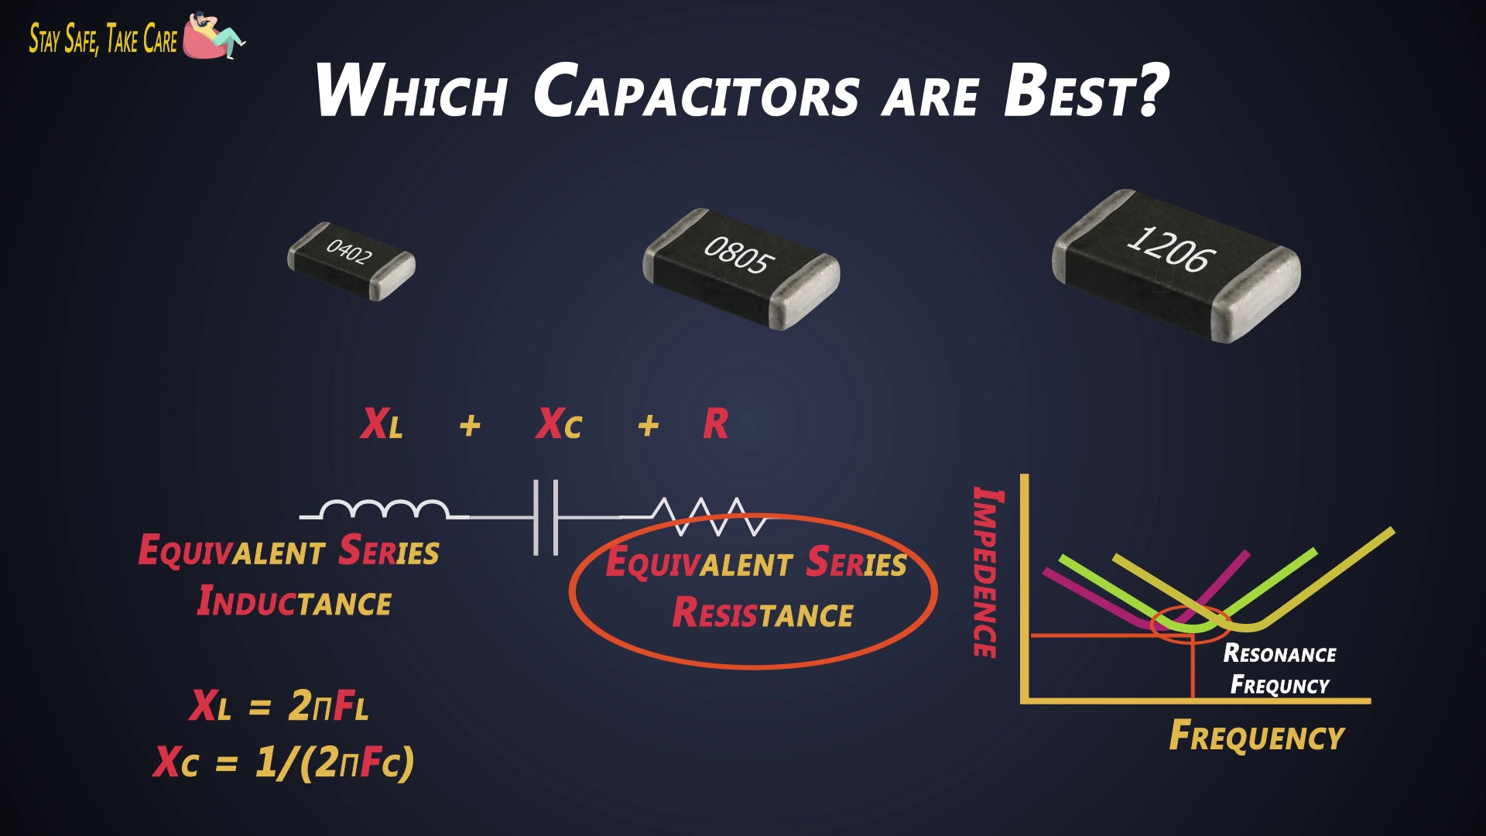 (score 85.0000)
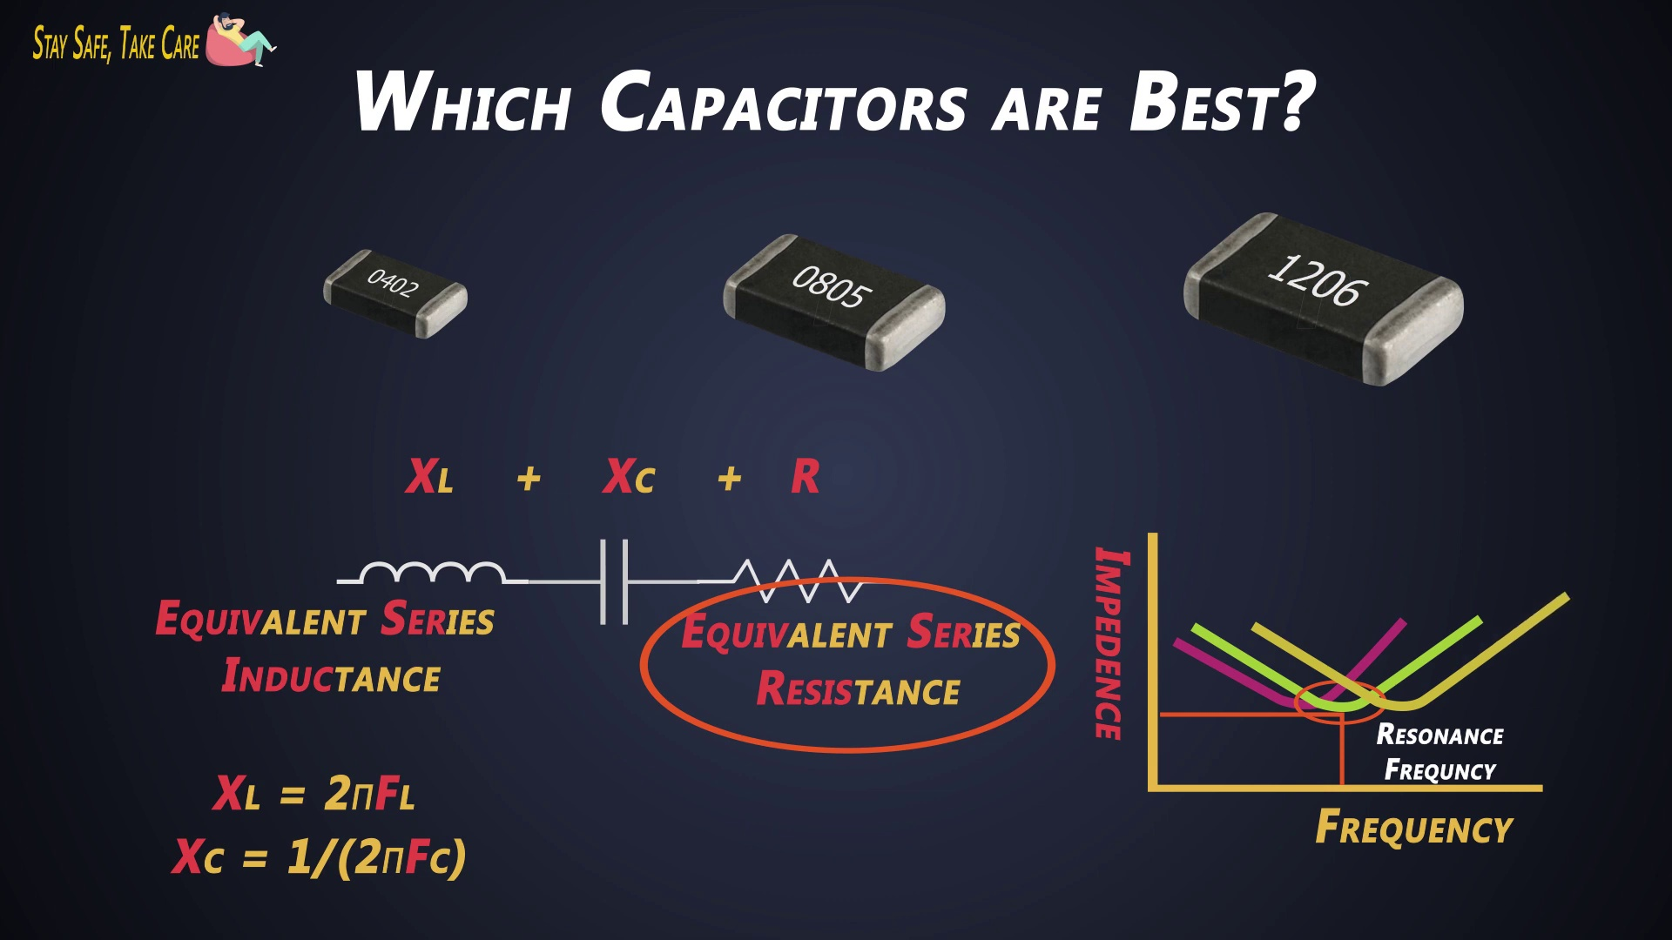 (score 85.0000)
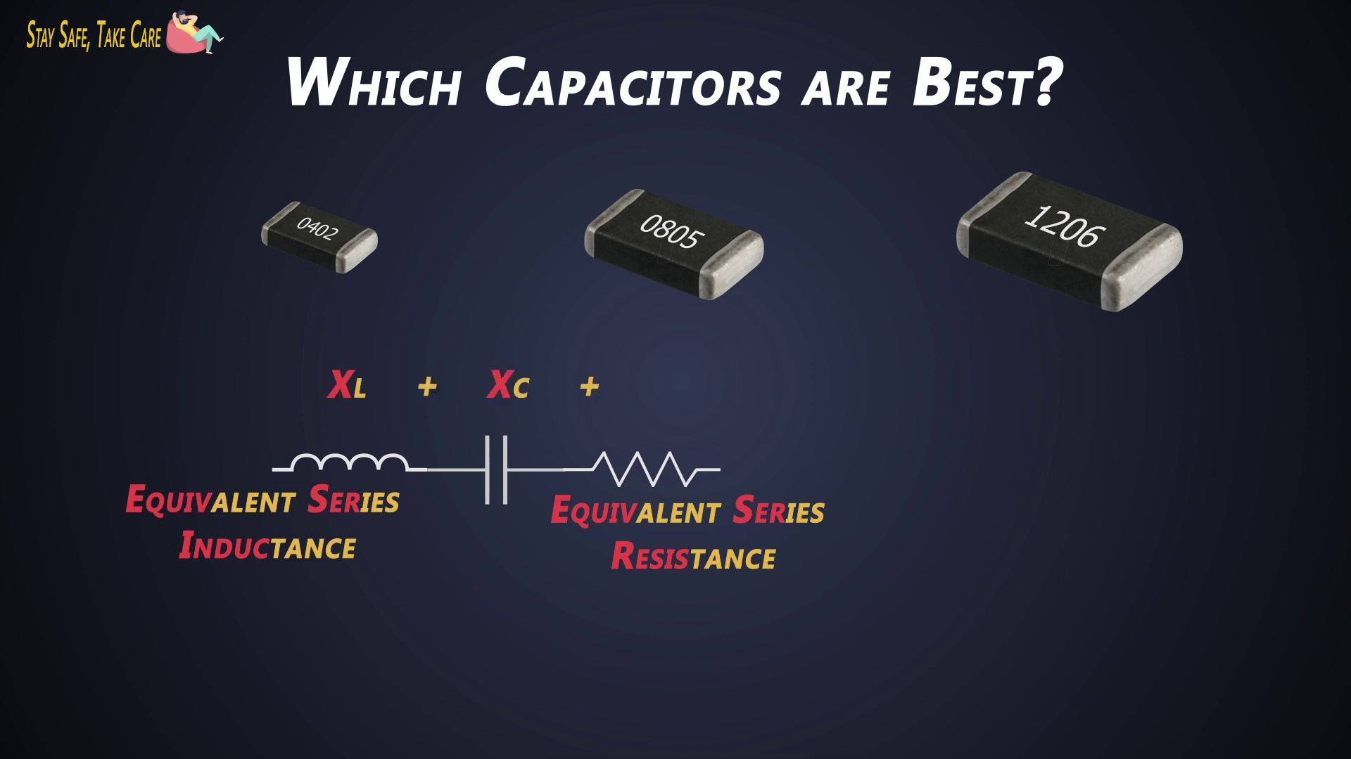 (score 85.0000)
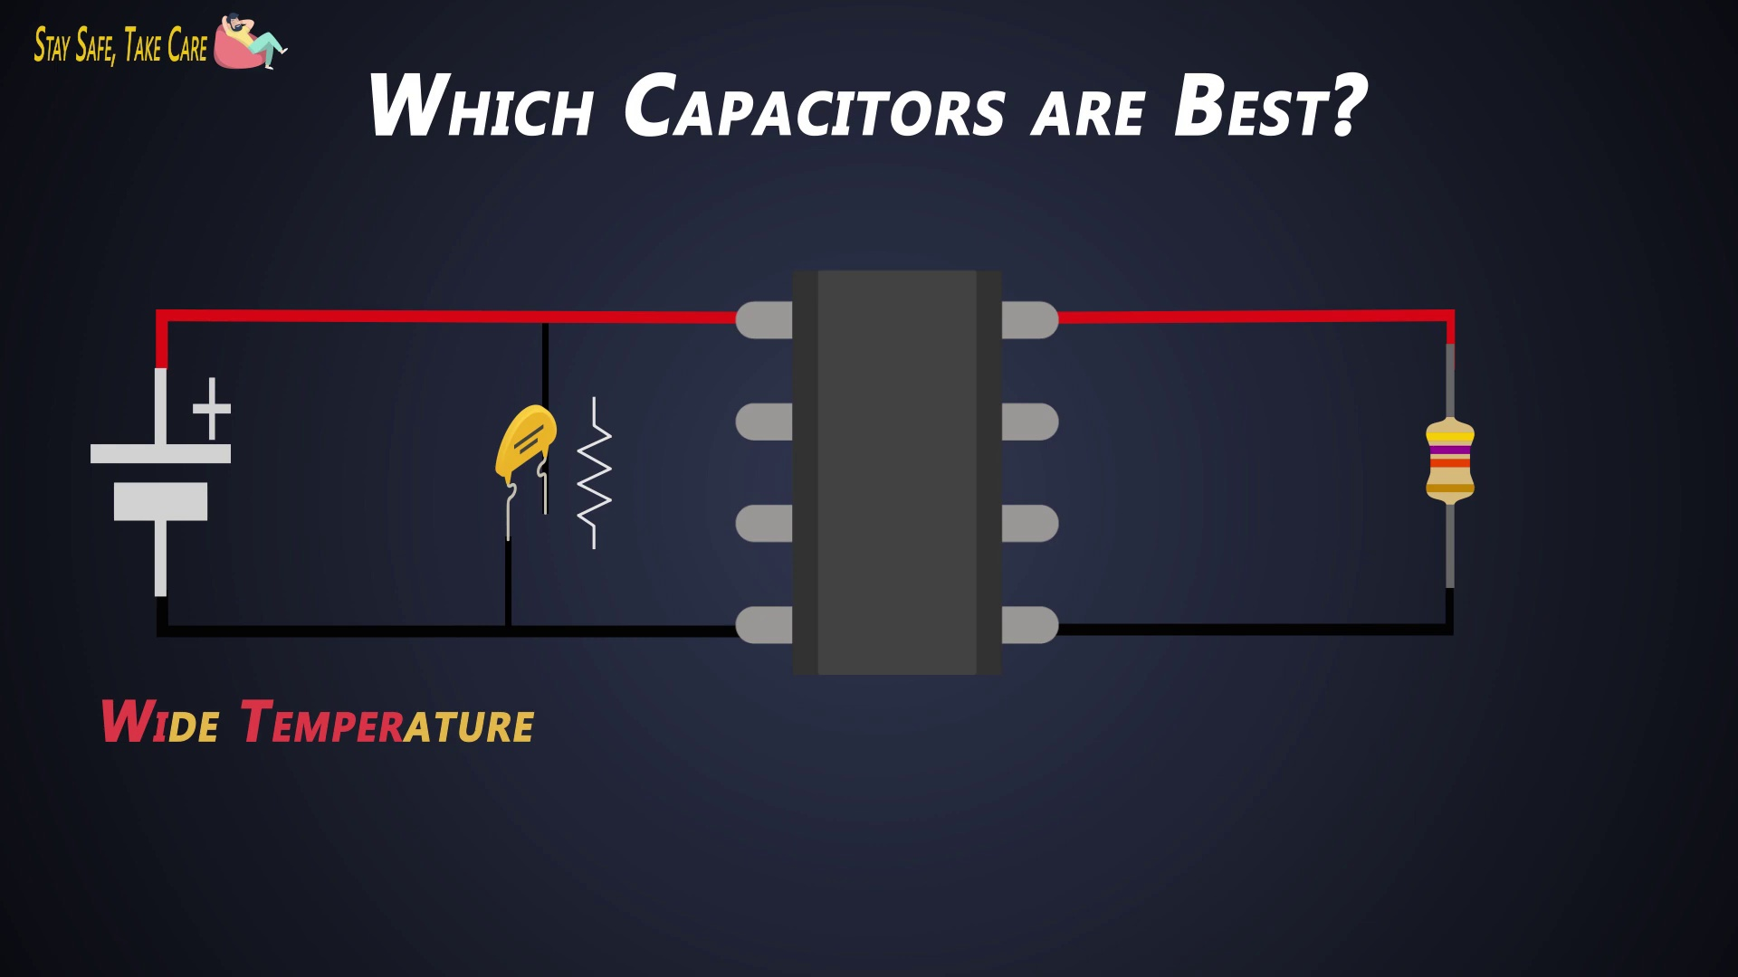 (score 85.0000)
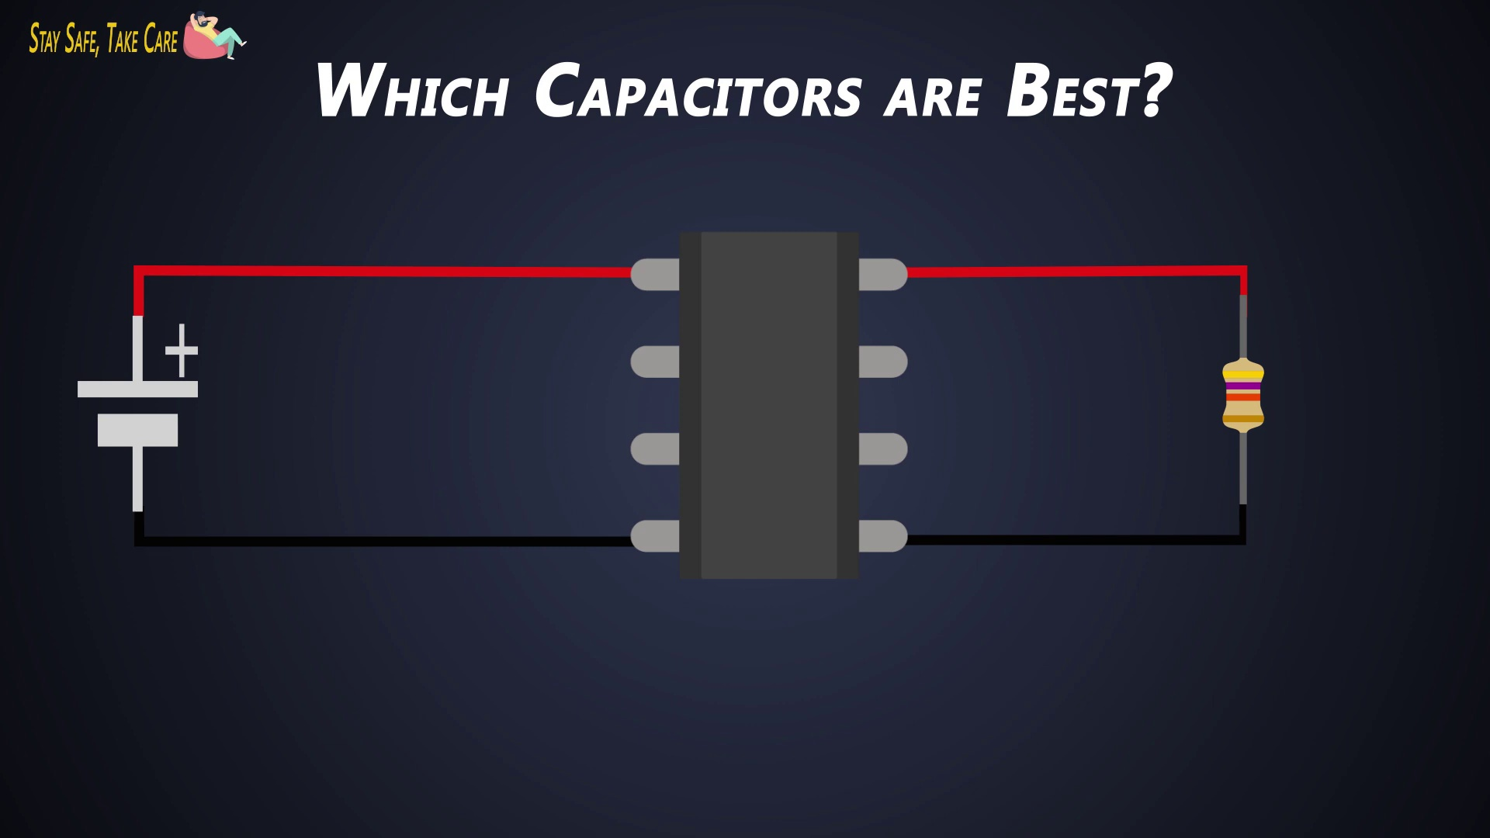 (score 85.0000)
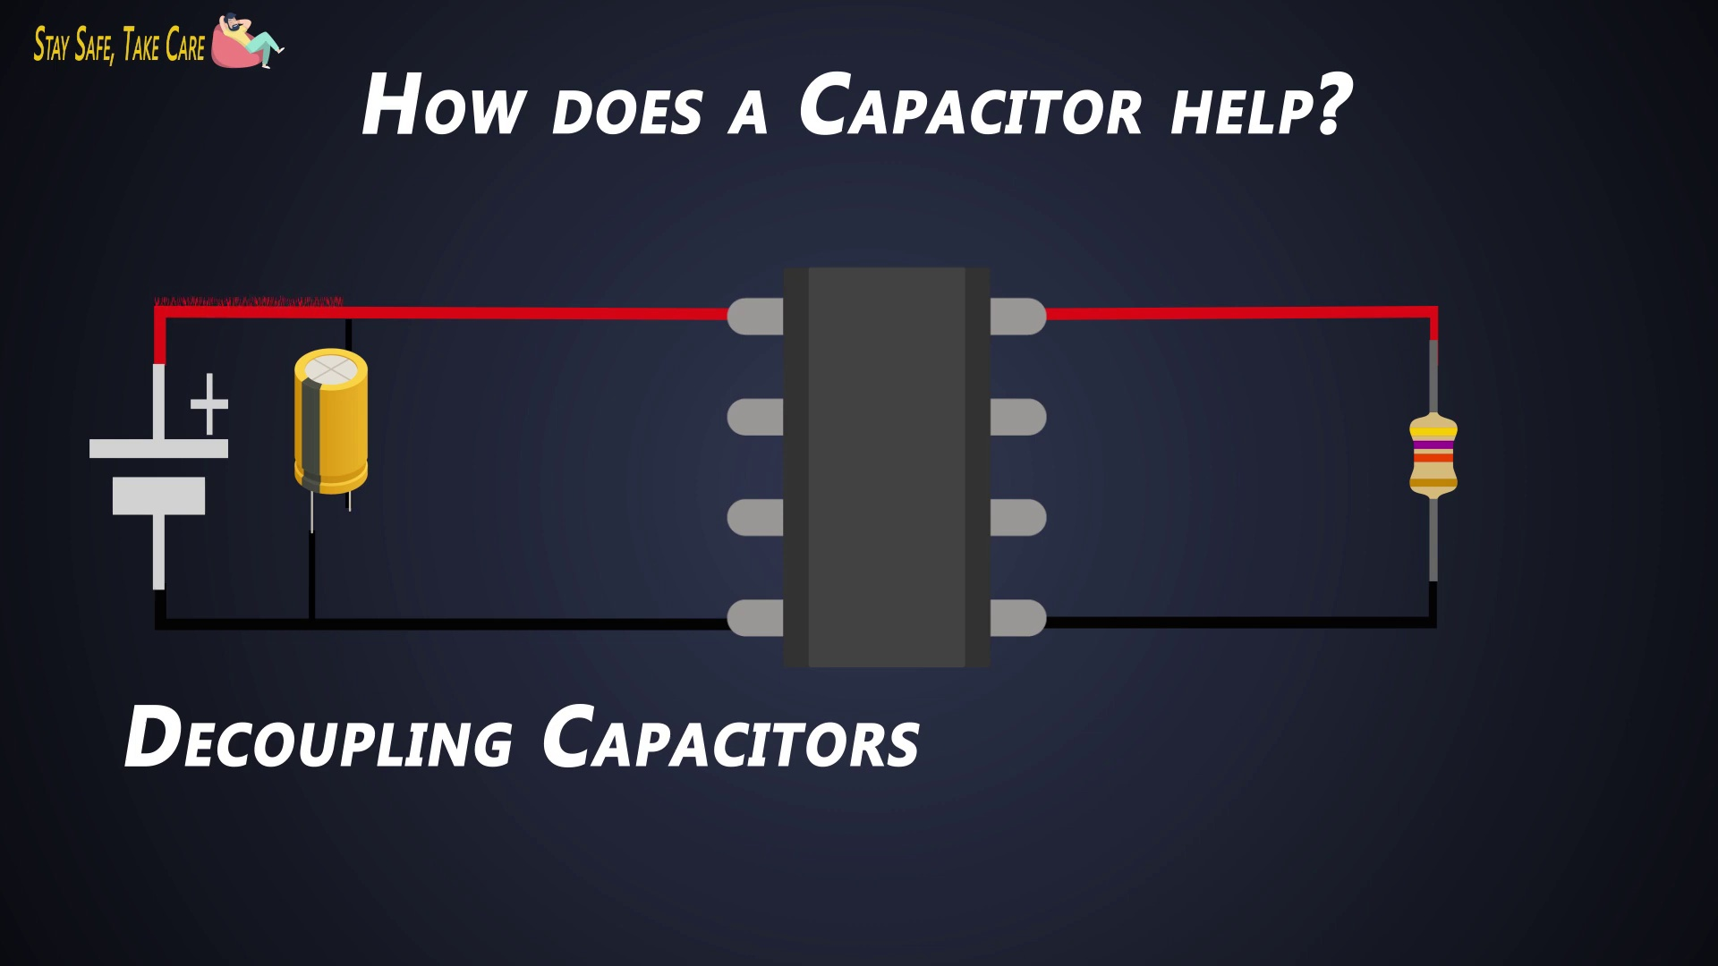 (score 85.0000)
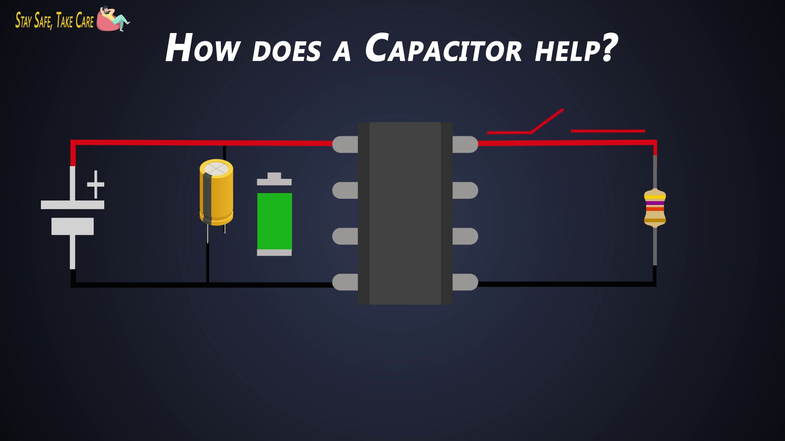 (score 85.0000)
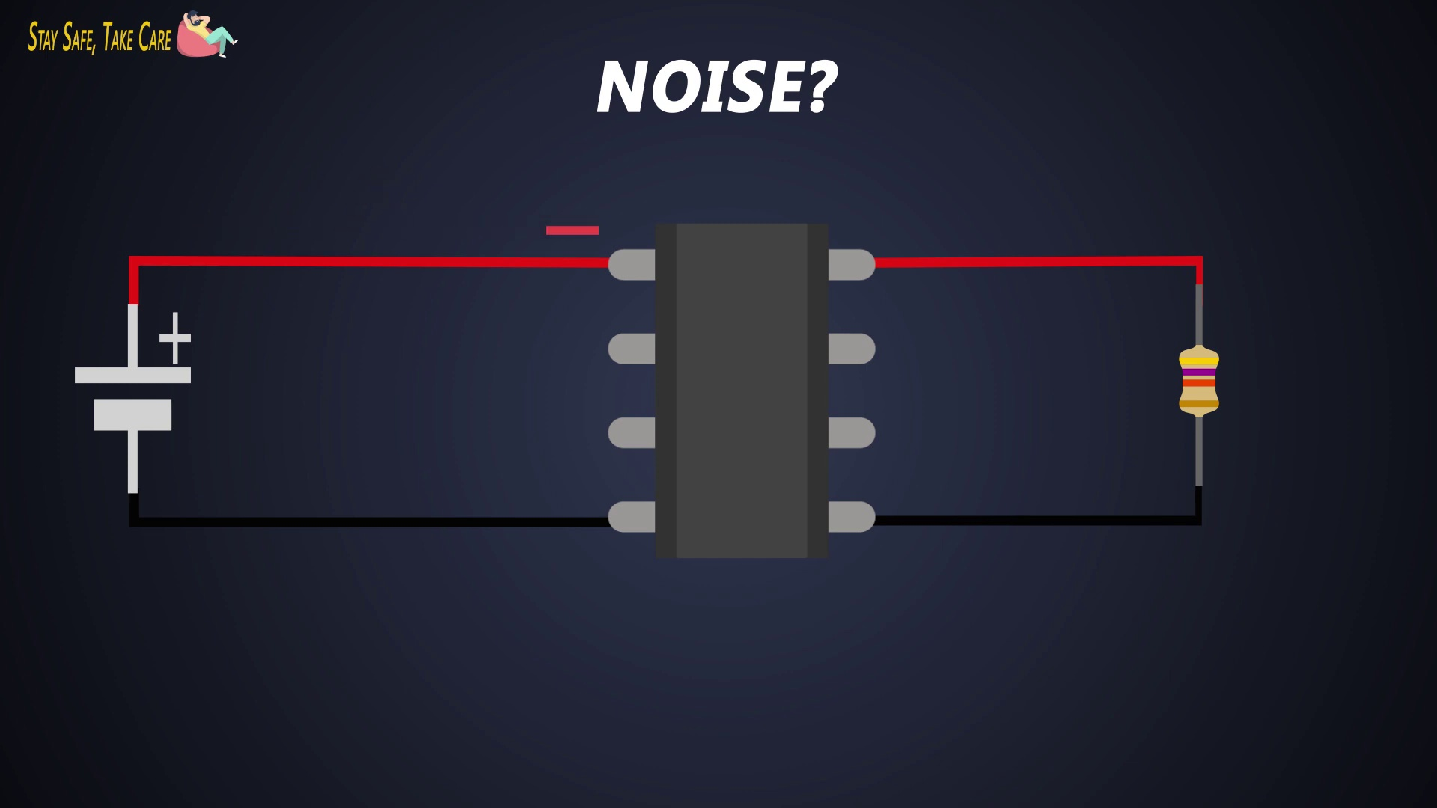 (score 85.0000)
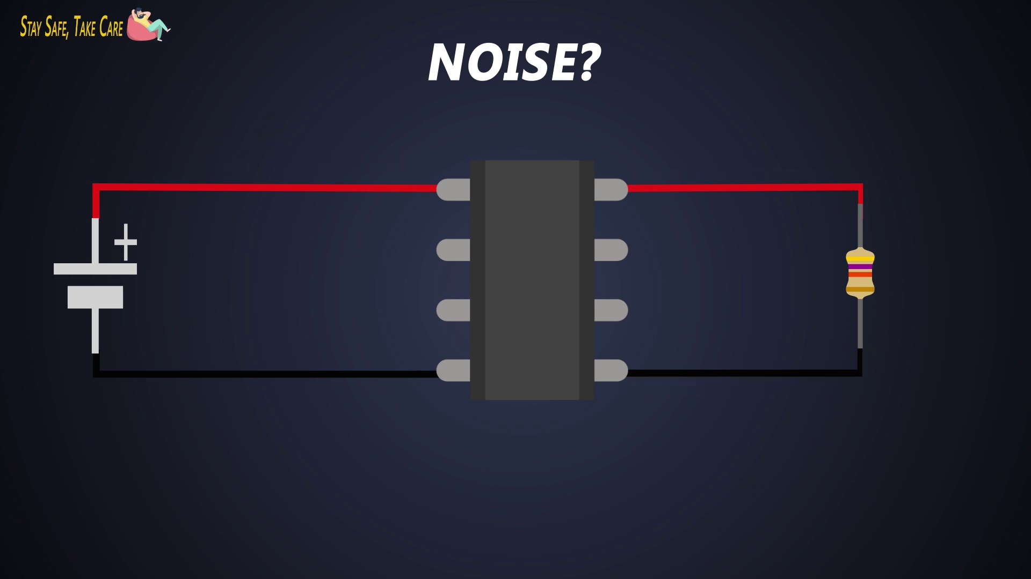 (score 85.0000)
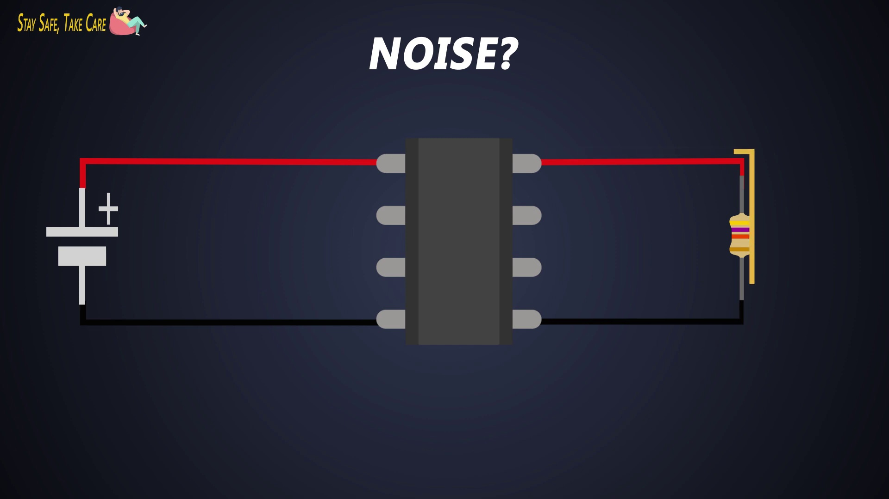 (score 85.0000)
Least correlated frames:
 (score 0.0000)
 (score 0.0000)
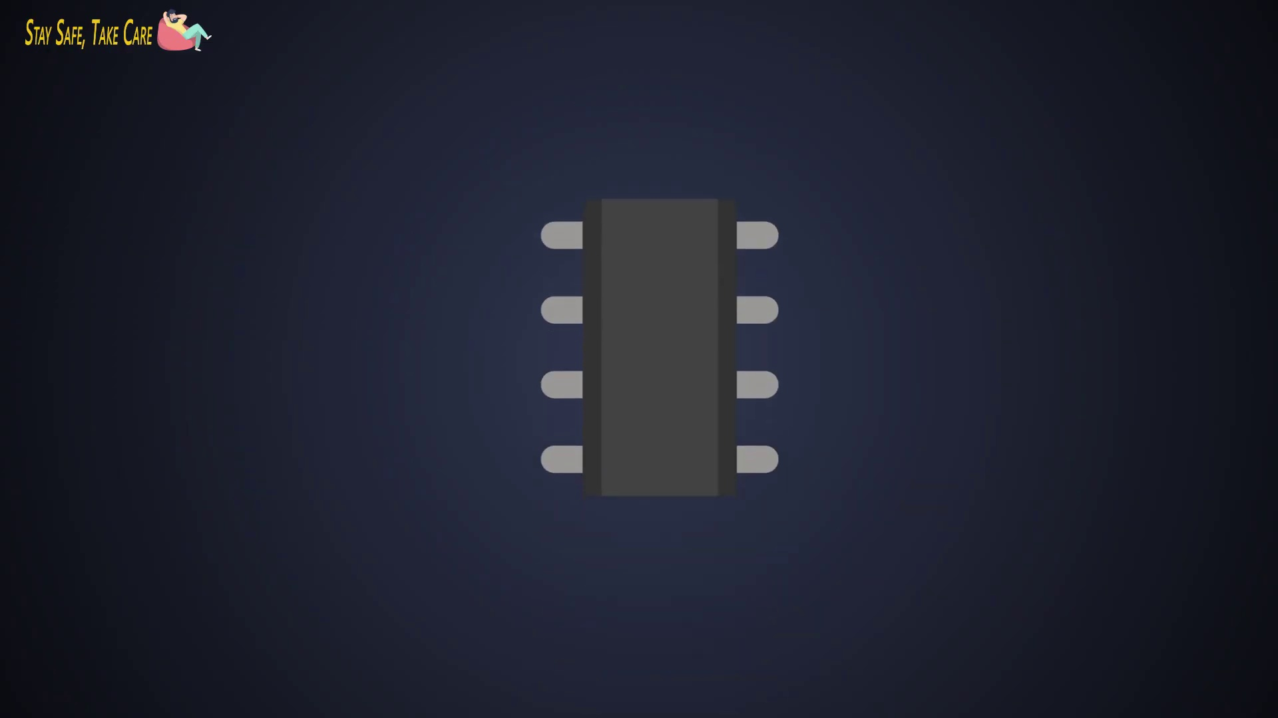 (score 0.0000)
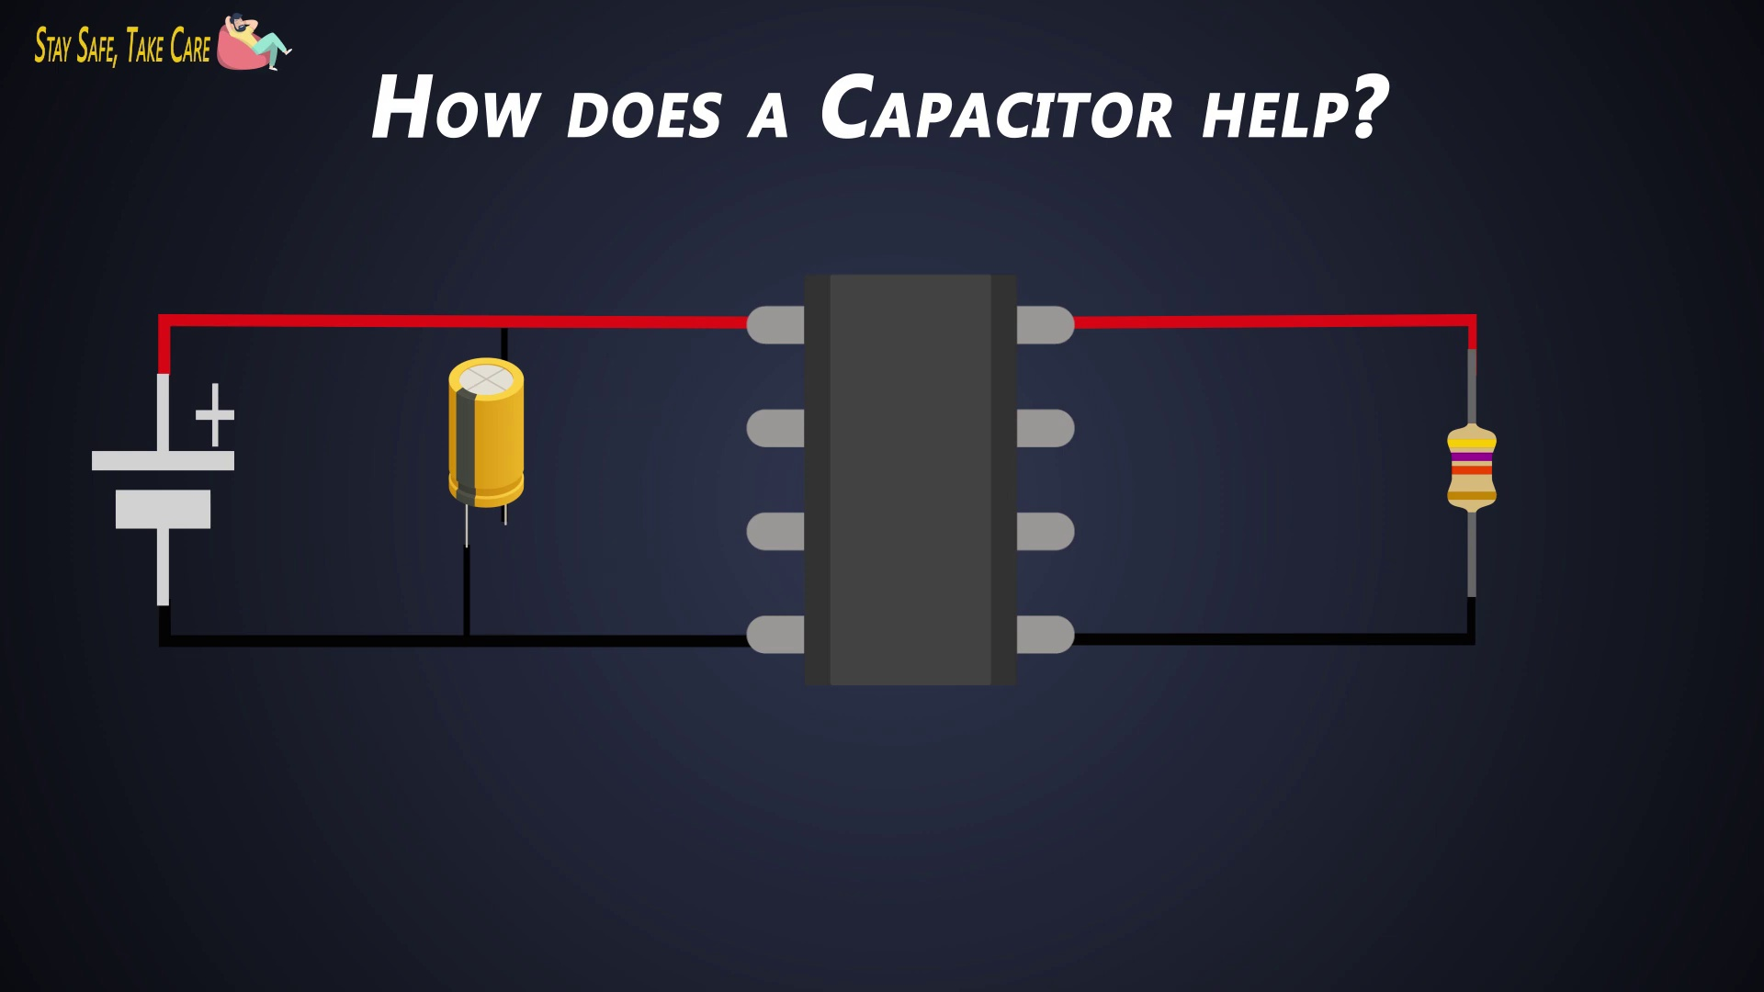 (score 0.0000)
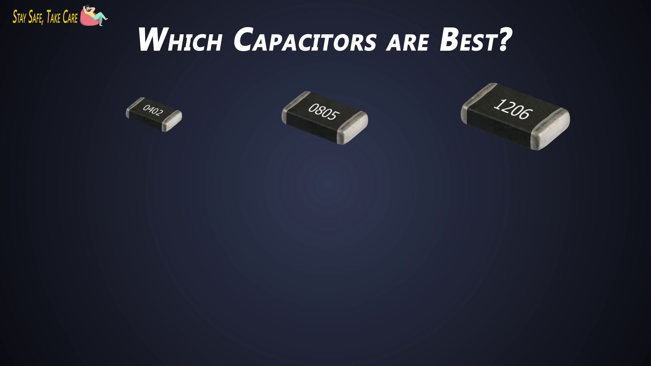 (score 0.0000)
 (score 0.0000)
 (score 0.0000)
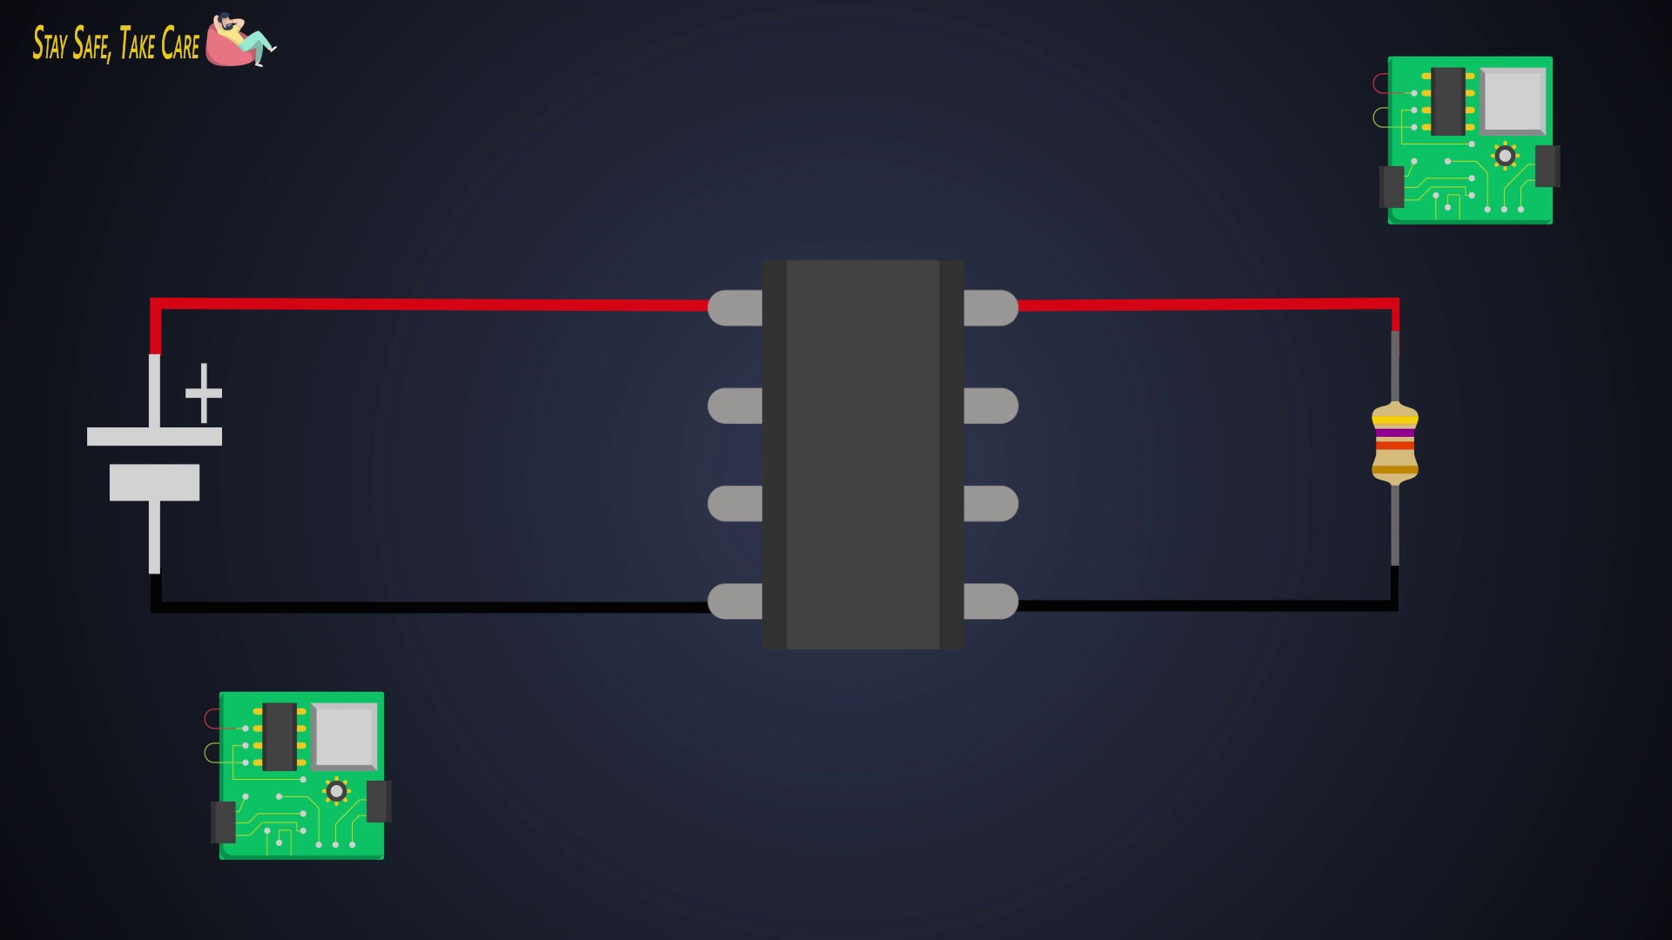 (score 5.0000)
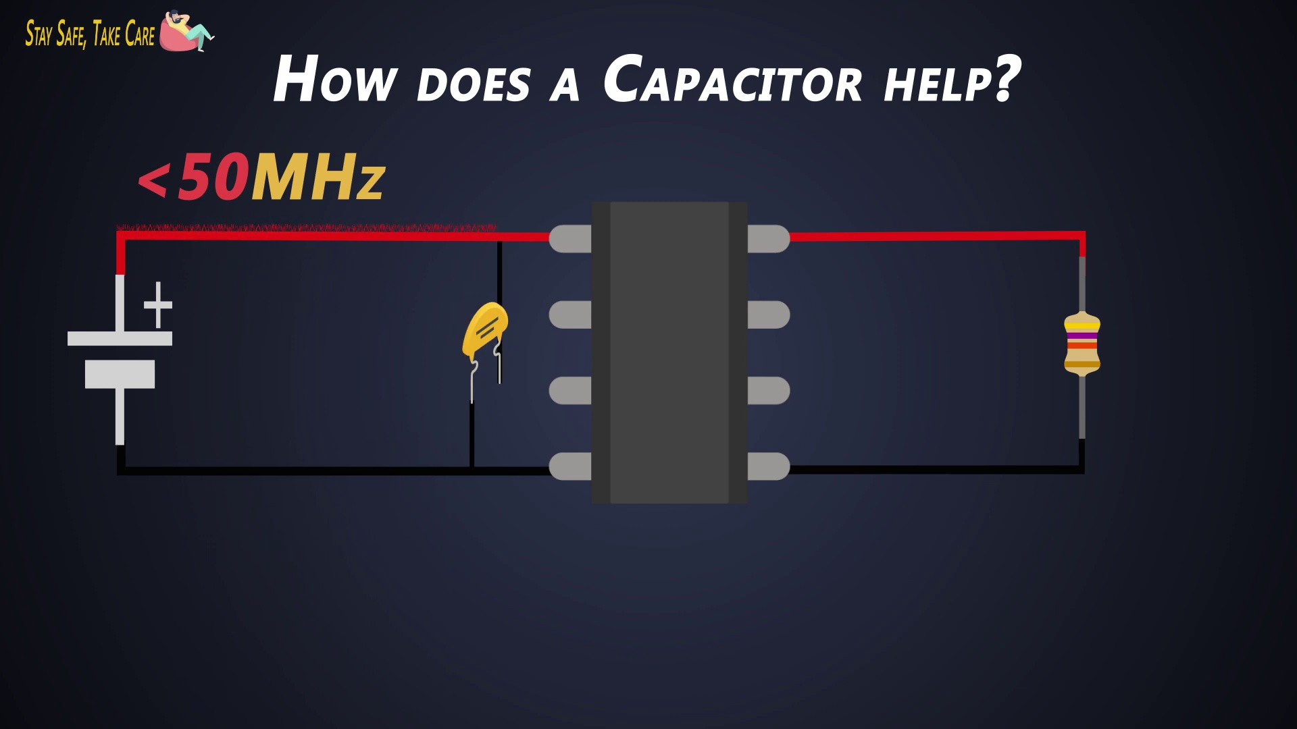 (score 5.0000)
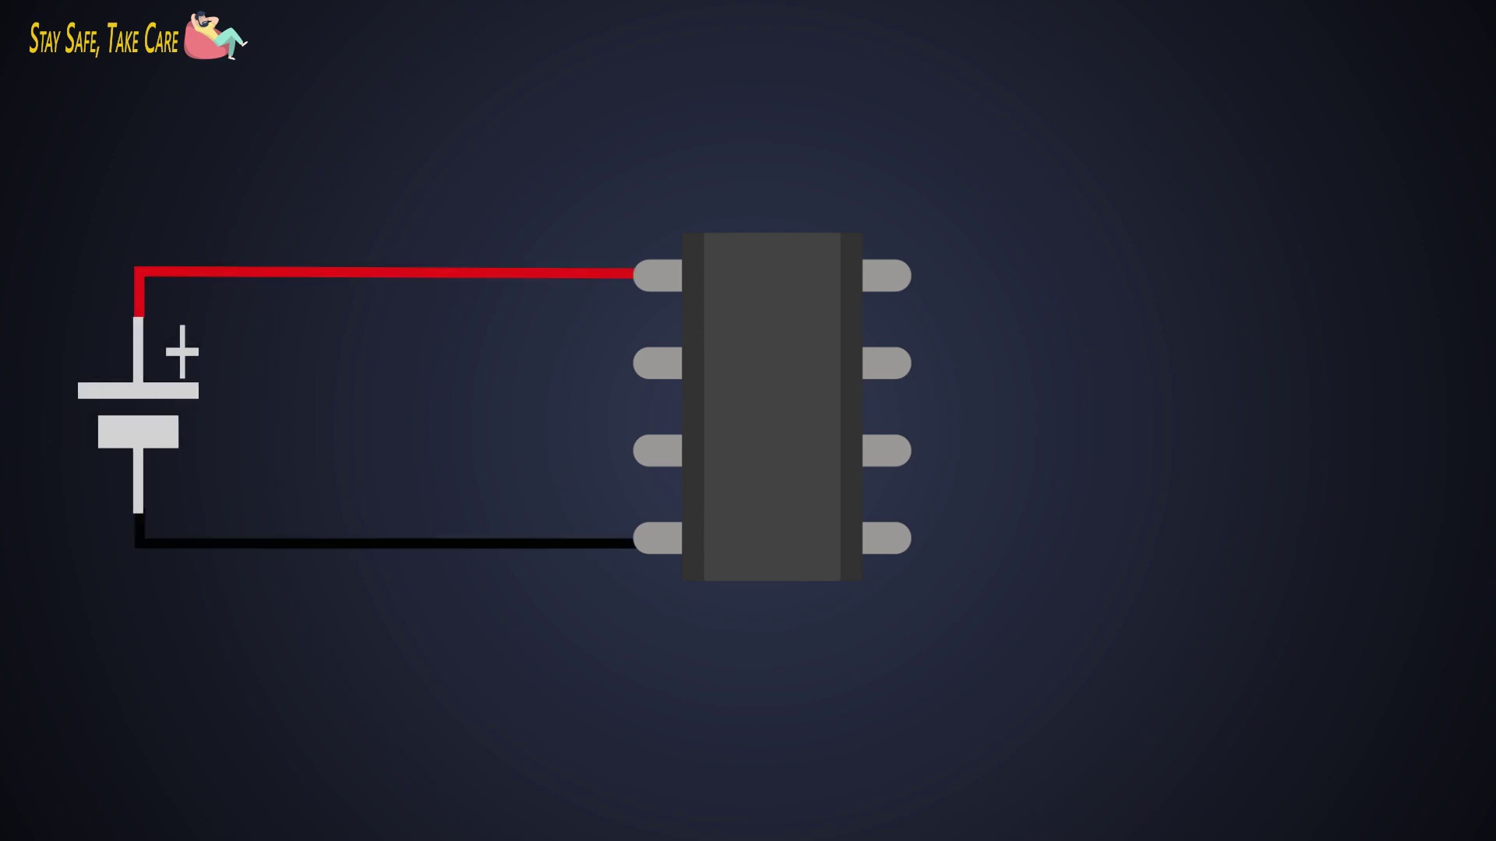 (score 10.0000)

Frame: frame_0000.jpg
Caption: The image presents a stark contrast between the dark background and the white center, drawing attention to the focal point in the middle. The background is devoid of any discernible objects or text, creating a sense of depth and mystery. The white center stands out distinctly against the dark blue backdrop, making it difficult to discern specific details about the object due to the lack of context or background information. There is no text, diagrams, or other distinguishable content on the slide or in the image, emphasizing the simplicity and clarity of the scene. The composition of the image is balanced and symmetrical, with the white center mirroring the dark blue background on either side, creating a sense of harmony and stability. The overall atmosphere is one of stillness, suggesting contemplation and introspection, as there is no action or movement in the image.
No strongly correlated comments found for this frame.

Frame: frame_0001.jpg
Caption: The image provided appears to show a presentation slide in the process of being displayed. The slide is predominantly dark with a lighter area that seems to contain some content or design element, but due to the low resolution and angle of the photograph, it's difficult to discern any specific details or text. It looks like a teaching context because there's a blackboard and what appears to be a chalkboard eraser or marker in the lower right corner. The background suggests this is a classroom setting with a dark projector screen displaying the slide, and someone seems to be presenting or explaining, although their image is not fully captured within the frame.
No strongly correlated comments found for this frame.

Frame: frame_0002.jpg
Caption: The image presents a contrast between dark blue background and white text, featuring a sans-serif font. At the top of the image, the text is neatly organized into two lines, each containing six words. The first line reads "Pass Safe Take Care", conveying a message about safety and care. Below this heading, there is another line that explicitly states "BYPASS CAPACITORS", which suggests a connection to electronics or electrical engineering, as indicated by the subject matter of bypassing capacitors in circuits to reduce voltage spikes. The presence of the word "Tutorial" next to the "BYPASS CAPACITORS" heading implies that this image may be part of an educational tutorial or guide, providing instructions on how to safely bypass electronic components.
Comment (score 85): The video talks about EMI from close by circuits, mechanical equipment, and general impedance of wires. Bypass and Decoupling capacitors can be added to remove this noise. I did not think about having it placed as close as possible to what we are protecting though but makes sense for phase I. Using the larger capacitor will clean low frequencies while the smaller capacitors clean the high frequencies. It’s also important to use ceramic capacitors due to their low ESR (equivalent series resistance). I came across this by accident while designing the phase I circuit.
Reason: The comment directly discusses bypassing capacitors to remove noise from circuits, which is explicitly stated in the caption. The mention of decoupling capacitors and ceramic capacitors with low ESR also matches the technical context described in the caption.
Source: https://www.youtube.com/watch?v=KKjHZpNMeik: What are the Decoupling capacitors? How to select Decoupling / Bypass capacitors?

Frame: frame_0003.jpg
Caption: The image is a poster that discusses the topic of "Bypass Capacitors." The poster features a dark blue background, which serves as a stark contrast to the text and the image of the circuit board. The circuit board, depicted in black, adds to the overall dark theme. The focus is on the textual information presented.
The poster is divided into two main sections. The top section explains the concept of "Bypass Capacitors," starting with the statement "Bypass capacitors are used to prevent a short circuit." This provides a clear and concise explanation of the purpose of bypass capacitors.
Below this, the bottom section focuses on the "Why" and "How" of using bypass capacitors. It begins with the question "Why do we need bypass capacitors?" followed by the answer "To prevent a short circuit." This format is effective in explaining complex concepts simply.
The text on the poster is clear and legible, with bold font used for emphasis. This draws the viewer's attention to the most important information, ensuring the message is not lost in the text.
The slide appears to be a screenshot of a presentation, featuring a title that reads "Bypass Capacitors." The main body of the text states "Why do we need ByPass Capacito" followed by "1. We Need Bypass Capacitor." An additional note on the bottom right corner states "Bypass Capacitor."
The background of the slide is a dark shade, providing a contrast for the white text. There are no visible people or devices on the slide, nor any diagrams or models being held. The focus remains solely on the textual information presented.
Overall, both the poster and the presentation provide an effective way to educate viewers about bypass capacitors, their purpose, and why they are necessary in electronic devices.
No strongly correlated comments found for this frame.

Frame: frame_0004.jpg
Caption: The image presents a slide with a presentation about "Bypass Capacitors" featuring a dark background and white text overlay. The text is divided into three sections, each containing a question or statement. The first section asks "Why do we need bypass capacitors?", followed by "HOW DOES A BYPASS CAPACITOR WORK?", which suggests an educational context, likely part of a course or presentation explaining the functioning of these particular capacitors. To the right of this text is a small graphic of two capacitors, one larger and one smaller, with the word "CAPACITORS" written underneath them, reinforcing the subject of the slide.
The background features a text overlay that reads "2 BYPASS CAPACITORS," which implies that this slide is discussing two types of capacitors designed to bypass a specific condition or requirement. The overall layout suggests a guide or tutorial on the topic of bypass capacitors, with visual aids supporting the explanation provided by an instructor. The image is captured from a distance or through a low-resolution camera, which limits the detail that can be observed about the instructor or any additional text beyond what is directly visible.
Comment (score 85): The video talks about EMI from close by circuits, mechanical equipment, and general impedance of wires. Bypass and Decoupling capacitors can be added to remove this noise. I did not think about having it placed as close as possible to what we are protecting though but makes sense for phase I. Using the larger capacitor will clean low frequencies while the smaller capacitors clean the high frequencies. It’s also important to use ceramic capacitors due to their low ESR (equivalent series resistance). I came across this by accident while designing the phase I circuit.
Reason: The comment directly discusses bypass capacitors and their application in removing noise (EMI) from circuits, which is the main topic described in the caption. The comment also explains how to choose the right capacitor for the job (ceramic with low ESR), which aligns with the educational context of the caption.
Source: https://www.youtube.com/watch?v=KKjHZpNMeik: What are the Decoupling capacitors? How to select Decoupling / Bypass capacitors?

Frame: frame_0005.jpg
Caption: The image features a graphic with text on a blue background, reminiscent of a presentation slide. At the top of the slide, a bold red header reads "BYPASS CAPACITORS." Below this header is a subtitle in white text that asks "Why do we need BYPASS CAPACITORS?" followed by three bullet points:
• How does a BYPASS CAPACITOR work?
• Why are Bypass Capacitors better than other capacitors?
• Which capacitors are best?
This slide is part of an educational or instructional context, likely intended for teaching about electronic components, specifically "BYPASS CAPACITORS." The text suggests that the slide is explaining the purpose and advantages of these capacitors, possibly in a classroom, workshop, or online learning environment. There is no instructor or other people visible on the slide; it appears to be a standalone educational resource.
Comment (score 85): The video talks about EMI from close by circuits, mechanical equipment, and general impedance of wires. Bypass and Decoupling capacitors can be added to remove this noise. I did not think about having it placed as close as possible to what we are protecting though but makes sense for phase I. Using the larger capacitor will clean low frequencies while the smaller capacitors clean the high frequencies. It’s also important to use ceramic capacitors due to their low ESR (equivalent series resistance). I came across this by accident while designing the phase I circuit.
Reason: The comment directly discusses bypass and decoupling capacitors, which are the same technical topic mentioned in the caption. The comment provides specific examples of EMI noise removal and capacitor usage, which strongly relates to the caption's purpose and goals.
Source: https://www.youtube.com/watch?v=KKjHZpNMeik: What are the Decoupling capacitors? How to select Decoupling / Bypass capacitors?

Frame: frame_0006.jpg
Caption: The image displays a presentation slide with a dark background and white and red text. At the top of the slide, in large white letters, it says "BYPASS CAPACITORS." Below this title, there are four numbered points in red font:
1. "HOW DOES A BYPASS CAPACITOR WORK?"
2. "WHICH CAPACITORS ARE BEST?"
3. "HOW TO SELECT THEM?"
4. "HOW MANY OF THEM YOU NEED?"
The first point, "HOW DOES A BYPASS CAPACITOR WORK?", is accompanied by a red text box with white letters that reads:
"WHAT IS A BYPASS CAPACITOR AND WHY DO WE NEED IT?"
This section introduces the concept of capacitors and their role in electronic circuits, explaining the purpose of bypass capacitors.
The second point, "HOW DOES A BYPASS CAPACITOR WORK?", delves into the operational principles of bypass capacitors. It discusses how capacitors store and release energy and how bypass capacitors are used to bypass specific frequencies or signals in a circuit.
The third section, "WHICH CAPACITORS ARE BEST?", provides guidance on selecting the right capacitors for bypassing. It discusses factors such as capacitance, voltage rating, and frequency response when choosing capacitors for this purpose.
The fourth point, "HOW TO SELECT THEM?", offers practical advice on how to select and install bypass capacitors in a circuit. It emphasizes the importance of selecting the correct capacitors for the specific requirements of the circuit.
In the bottom right corner of the slide, there is a graphic that appears to be an electrolytic capacitor labeled "Bypass Capacitors." This graphic shows the component with two terminals and a body marked with the positive (+) sign at one end and the negative (-) sign at the other. The text above the graphic does not provide any specific information about the component, but it refers to the bypass capacitor as a necessity in certain applications.
Overall, the slide provides a comprehensive overview of bypass capacitors, from their basic principles to their practical applications and selection considerations.
Comment (score 85): The video talks about EMI from close by circuits, mechanical equipment, and general impedance of wires. Bypass and Decoupling capacitors can be added to remove this noise. I did not think about having it placed as close as possible to what we are protecting though but makes sense for phase I. Using the larger capacitor will clean low frequencies while the smaller capacitors clean the high frequencies. It’s also important to use ceramic capacitors due to their low ESR (equivalent series resistance). I came across this by accident while designing the phase I circuit.
Reason: The comment directly discusses bypass capacitors and their role in removing noise from circuits, which is a key topic covered in the caption. The mention of EMI, impedance, and ceramic capacitors with low ESR also aligns with the concepts presented in the caption. While the comment does not explicitly refer to the specific points discussed in the caption (e.g., 'HOW DOES A BYPASS CAPACITOR WORK?'), it demonstrates a strong understanding of bypass capacitor principles and applications.
Source: https://www.youtube.com/watch?v=KKjHZpNMeik: What are the Decoupling capacitors? How to select Decoupling / Bypass capacitors?

Frame: frame_0007.jpg
Caption: The provided image appears to be a combination of a digital presentation with an overlay graphic and a close-up view of a circuit board. On the left side of the screen, there is a slide titled "Bypass Capacitors" with a subtitle that reads "4 hours." Below this title, there is a diagram labeled "Heat" and a red arrow pointing at it with a label "Hot" next to the arrow.
The graphic on the right side of the screen shows an illustration of a circuit with two parallel lines representing wires or conductive paths, intersected by a dashed line and shaded areas. There are text labels that say "HOT" pointing towards the part of the circuit where the dashed line is crossed.
In the foreground, a close-up view of a bypass capacitor is shown on the circuit board, highlighted in red at the bottom right corner of the image. The text "BYPASS CAPACITORS" clearly indicates the presence of this component. Additionally, the text "HEM!" is present on the circuit board, possibly serving as a warning or instruction related to the bypass capacitor.
The slide's content appears to be explaining the concept of bypassing capacitors for heating purposes, but due to being cut off, the details are not fully visible in this image. The instructor seems to be focusing on explaining the topic through a combination of visual aids and text, without directly interacting with the material.
Comment (score 80): The video talks about EMI from close by circuits, mechanical equipment, and general impedance of wires. Bypass and Decoupling capacitors can be added to remove this noise. I did not think about having it placed as close as possible to what we are protecting though but makes sense for phase I. Using the larger capacitor will clean low frequencies while the smaller capacitors clean the high frequencies. It’s also important to use ceramic capacitors due to their low ESR (equivalent series resistance). I came across this by accident while designing the phase I circuit.
Reason: The comment directly discusses bypass capacitors, EMI removal, and their placement close to protected circuits, which are all technical steps described in the caption. The mention of ceramic capacitors' low ESR also matches the context of the image.
Source: https://www.youtube.com/watch?v=KKjHZpNMeik: What are the Decoupling capacitors? How to select Decoupling / Bypass capacitors?

Frame: frame_0008.jpg
Caption: The image shows a person's hand with a pen, drawing on a piece of paper that has been placed over an image of another paper. This new piece of paper appears to be blank and is positioned in such a way that it obscures parts of the original image. The background image includes various elements, including a laptop computer with its screen displaying what seems to be a spreadsheet or data table with rows and columns, but the specific content of the cells is not visible due to the paper's placement.
The laptop is situated near the edge of the white table, with a black keyboard and black trackpad. Above the laptop, a camera is placed on the same white table, adding a touch of technology to the scene. The camera has a black body and lens.
Above the laptop and camera, a whiteboard is mounted on the wall. The board is adorned with a series of colorful drawings that depict various elements of a computer network, arranged in a circular pattern, creating a sense of symmetry and balance. The colors used are predominantly red, blue, and yellow, contributing to a lively and energetic atmosphere.
The person appears to be interacting with the drawing or diagram on the table, possibly annotating it or adding details, but their face and identity are not visible due to the angle and obstruction created by the paper. A cup of coffee with a lid on it is situated near the top right corner of the image, partially obscured by the person's hand and the paper.
The edge of a keyboard in the bottom left corner of the image indicates that the laptop is being used for the activity depicted. The illustration on the whiteboard and the graphic representation of a human brain on the laptop screen suggest a focus on computer networking and the intricate workings of the human brain, possibly during a creative brainstorming or planning session.
Comment (score 75): The video talks about EMI from close by circuits, mechanical equipment, and general impedance of wires. Bypass and Decoupling capacitors can be added to remove this noise. I did not think about having it placed as close as possible to what we are protecting though but makes sense for phase I. Using the larger capacitor will clean low frequencies while the smaller capacitors clean the high frequencies. It’s also important to use ceramic capacitors due to their low ESR (equivalent series resistance). I came across this by accident while designing the phase I circuit.
Reason: The comment directly discusses bypass and decoupling capacitors to remove noise from close-by circuits, which is strongly related to the technical steps and objects shown in the caption (e.g. laptop with spreadsheet, camera, whiteboard). The mention of impedance of wires, EMI, and ceramic capacitors also aligns with the settings and goals described in the caption, such as computer networking and planning.
Source: https://www.youtube.com/watch?v=KKjHZpNMeik: What are the Decoupling capacitors? How to select Decoupling / Bypass capacitors?

Frame: frame_0009.jpg
Caption: The image presents a dynamic scene set on a table, showcasing a playful and unconventional workspace. At its center is a black poster with white text that reads "Foolish Engineer", accompanied by a handwritten note with the same phrase, indicating a connection or theme between the two. To the left of the poster, an open laptop computer sits on the table, its screen displaying a white background with a black circle in the center, suggesting a creative environment or workspace.
To the right of the poster, a camera is placed on the table, adding a sense of adventure or exploration to the scene. This could hint at the "Foolish Engineer" theme being related to photography or travel, further emphasizing the idea of curiosity and exploration.
The overall setting appears to be where someone might be brainstorming, planning, or working on projects related to engineering in a playful and unconventional manner, with the laptop screen displaying text that reads "FOOLISH ENGINEER", suggesting a humorous or informal context for the activity being depicted.
No strongly correlated comments found for this frame.

Frame: frame_0010.jpg
Caption: The image presents a creative representation of the word "Foolish" with a central focus on the sign that reads "Foolish Engineer" in bold white letters. The sign is positioned on a workspace, which appears to be informal and comfortable, with various elements suggesting a focus on technology and possibly education in a tech-related field.
To the left of the sign, a laptop is open to a presentation slide with diagrams that appear to be related to software engineering or computer science concepts. Above this slide, there is a handwritten note that says "Foolish Engineer," which might indicate the title of the course or the creator's self-deprecating style.
On the right side of the sign, a camera and other objects are scattered around, suggesting a workspace or studio where ideas are being explored and brought to life. The camera is positioned alongside a computer keyboard, a laptop, and various symbols and icons that add a touch of whimsy to the scene.
The symbols include a circle, a square, and a triangle, each with its own distinct color. The circle is red, the square is blue, and the triangle is green. These symbols are scattered around the sign, creating a sense of depth and perspective.
A person appears to be working on the computer, writing something on a piece of paper, possibly taking notes or planning an explanation related to the content on the screen. The overall atmosphere suggests a creative learning environment where someone is either preparing for an educational session or engaging with educational content related to software engineering or a similar tech-focused discipline.
The setting appears to be informal, with the person comfortably seated at a desk with their work equipment and materials surrounding them. Various icons or stickers representing technologies and logos associated with software development, such as programming languages, tools, or operating systems, are also visible on the left side of the laptop, including what looks like Python, Java, HTML, and others.
No strongly correlated comments found for this frame.

Frame: frame_0011.jpg
Caption: The image presents a dualistic visual narrative, featuring two distinct elements on a dark background. On one side, a digital illustration showcases a guitar pedal with adjustable sound settings, accompanied by an indistinct text box above it. The left side of the image is dominated by this pedal, which appears to be the focal point of the composition.
In stark contrast, the right side of the image features a simple graphical element resembling an arrow pointing from the guitar pedal to a dark space where another guitar pedal is shown in silhouette form. This arrow suggests a connection or relationship between the two pedals, potentially implying a comparison or highlighting their effects on sound.
The bottom left corner attributes the source credit "www.theinstructables.com," hinting at an online educational resource focused on guitar effects and pedals. This attribution may indicate that the image is part of instructional content aimed at explaining a particular guitar pedal or its effect on sound by comparing it with another pedal.
On the opposite side of the visual spectrum, a separate image features a computer chip resting on a deep blue background. The chip itself exhibits a rectangular shape with four evenly spaced and uniform-colored rectangular prongs extending from the center. The chip is the sole focus of this image, without any additional objects or text present. The dark blue background provides a stark contrast to the chip, drawing attention to it.
This dual-image presentation does not provide explicit information about the computer chip's function or purpose within the larger context.
No strongly correlated comments found for this frame.

Frame: frame_0012.jpg
Caption: The image presents an educational context focused on teaching electrical concepts, likely intended for children given the simplified graphics and informal setting. On the left side of the frame, a person appears to be speaking or explaining something, as indicated by their positioning and apparent use of hand gestures to emphasize points. The person is not fully visible; only a portion of their upper body is seen, suggesting they may be demonstrating proper safety procedures for handling electrical components.
The central part of the image displays an electrical outlet with multiple sockets, some occupied by devices, which could represent different types of plugs or safe usage techniques. This reinforces the theme of teaching about electricity and its safe handling.
On the right side of the frame, a computer screen shows a simple circuit diagram featuring components like a light bulb and power supply, along with arrows indicating electrical current flow. The text "Power Supply" is visible, further supporting the educational context. Notably, there is no readable text within the frame, precluding the display of equations or graph types.
The image also presents a simple electrical circuit, consisting of a power supply (represented by a black box) and a battery (depicted in red). The power supply is connected to the battery via a red wire, while the battery is connected to the power supply via a black wire. This circuit is set against a dark blue background, contrasting with the vibrant colors of the circuit components.
The image is accompanied by text that reads "Stay Safe Take Care," suggesting that this circuit, whether educational or recreational in nature, should be handled with care and attention to electrical safety guidelines.
No strongly correlated comments found for this frame.

Frame: frame_0013.jpg
Caption: The image depicts a simple yet detailed circuit diagram, featuring an electric connection between two wires. The red wire, labeled "+", is connected to the black wire, labeled "-". This basic electrical connection represents the flow of electricity, with the "+" and "-" wires indicating the direction of current.
In addition to this fundamental connection, the diagram also displays a more complex circuit configuration in the background. An electric circuit diagram with various components is visible on the computer screen. The two main power sources are labeled "DC 12V" and "AC 120V", suggesting that the circuit involves both direct current (DC) and alternating current (AC).
The DC voltage source has a resistor (R) connected in series, while the AC voltage source is connected directly to a step-up or step-down transformer. A device resembling a relay coil is also present, controlled by a switch (S). Additionally, there are two other switches (S1 and S2) in the circuit, indicating control mechanisms for the components.
The diagram's dark background helps highlight the electric circuit components, with the text "DC 12V" and "AC 120V" providing context about the voltages involved. There is no instructor or teaching context visible in this image, and the focus remains on the visual content of the circuit diagram.
No strongly correlated comments found for this frame.

Frame: frame_0014.jpg
Caption: The image shows a diagram or schematic of an electrical circuit on a computer monitor. The main elements in the diagram include:
1. A power source or battery labeled as "12V DC," suggesting a 12-volt direct current (DC) supply.
2. A light bulb that is turned off, indicating no current is flowing through it at this moment.
3. An electric switch, which controls the flow of electricity to the light bulb, currently in the "off" position.
4. Two wires connected to the power source and the light bulb. One wire is labeled with a red arrow pointing to the positive terminal of the battery, indicating it's the live (or hot) wire, which carries the current from the source. The other wire is connected to the negative terminal of the battery and the metal part of the light bulb, which is the common or neutral connection for the circuit.
5. A symbol representing a plug or socket, with a grounding symbol (a triangle) below it, indicating that this is where the wires from appliances are typically inserted, suggesting a generic household electrical outlet.
6. A light switch symbol, showing how switches might be connected in a typical wall-switch configuration for turning lights on and off.
7. There's also a red line connecting to one side of the light bulb, although it's unclear where this red line is leading from or to.
In the top right corner, there's a partial view of a person with their face obscured by an icon and text that reads "Senior Software Engineer," suggesting the image might be shared on social media or a professional networking platform by someone in that role.
The background is a dark grey color, which contrasts with the circuit diagram, making it easy to see.
Note: This image does not contain any readable texts or labels within the diagram itself, and the context of teaching or instructing is not evident from this image alone. It appears to be a technical schematic rather than an educational slide or model.
No strongly correlated comments found for this frame.

Frame: frame_0015.jpg
Caption: The image presents a digital drawing of an electrical circuit diagram that combines educational and cautionary elements. At the top right corner, there is text that reads "Sky Is Clear," suggesting that the weather might be favorable for observation or photography.
In the center of the drawing, a device labeled as "Sky Camera" is depicted with an adjustable power switch on its side and a power cable running from it, plugged into what appears to be a power source with a visible power light indicating that it is turned on. The background is dark, likely representing nighttime or low-light conditions, which is common for astronomical imaging.
On the right side of the drawing, there's a representation of an image sensor, labeled as "Sky Camera Sensor," with wires connected from this sensor to another device. This device is labeled as "Sky Image Processor," suggesting that it might be responsible for processing or analyzing images taken by the camera.
The diagram also features a black chip, a common component in electronic devices, which is connected to two wires: one red and one black. The red wire, carrying a positive charge, is connected to the chip, while the black wire, carrying a negative charge, is connected to the chip as well. This portion of the circuit is set against a dark blue background, providing a stark contrast to the circuit elements.
Prominently displayed in white text at the bottom of the diagram is the cautionary message "Safety Take Care," likely indicating a warning or instruction related to the circuit's safe operation and handling. The overall style of the drawing suggests an educational or schematic diagram, possibly used to explain how a remote observatory system works or teach about astronomical photography and the equipment involved in capturing celestial events.
No strongly correlated comments found for this frame.

Frame: frame_0016.jpg
Caption: The image displays a simplified representation of an electrical circuit, presented as both a diagram on a computer screen and a physical circuit. The diagram features standard symbols for each component, including a power source (battery) with three layers, a light bulb with two terminals, wires represented by straight lines, and a switch symbolized by an open/closed symbol. The wires connect the switch to the light bulb and the power source, illustrating that when the switch is closed, electricity will flow through the circuit and the light bulb will illuminate.
The physical circuit consists of a black circuit board, a red wire, and a black wire. The red wire is connected to the black circuit board, suggesting a flow of current. The black wire is connected to the red wire, indicating the direction of the flow of current. The circuit board serves as the centerpiece of the circuit, while the wires serve as pathways for the current to flow.
The simplicity of both representations suggests that they are intended to convey a basic understanding of electrical circuits, with no additional context provided about the purpose of the circuit or the objects involved. The image on the computer screen features text "How Stuff Works" on the left side, indicating an educational resource about basic electrical circuits or principles.
No strongly correlated comments found for this frame.

Frame: frame_0017.jpg
Caption: The image presents a digital representation of an electrical circuit, with instructional context. At the top left corner, there is a label "10", which might indicate that the current in the circuit is 10 amperes. The circuit consists of two wires connected to what appears to be a battery or power source, symbolized by three parallel lines representing electricity flow. The battery or power source has two terminals with plus (+) and minus (-) signs on them, indicating the positive and negative poles of the voltage source.
The circuit includes a red lamp connected between the negative terminal of the battery and one of the wires. The other wire is connected to the positive terminal of the battery, completing the circuit. The lamp should light up due to the flow of electric current in the circuit.
Below the circuit, there is text that reads "10V", which might refer to the voltage rating of the battery or power source. The background of the image is a dark blue color with a subtle pattern, providing a stark contrast to the brightly colored circuit and its components. This kind of visual aid could be used in an educational setting to teach basic concepts about electricity, such as the flow of current through a circuit, the concept of electrical potential (voltage), and how lamps light up when connected to a direct current source.
The image suggests a simple circuit diagram with a battery connected to a wire, which is colored red. The wire connects the positive terminal of the battery to the negative terminal of a black component. The circuit is further connected to another wire, also red and black, which connects back to the negative terminal of the battery.
No strongly correlated comments found for this frame.

Frame: frame_0018.jpg
Caption: This diagram appears to show an electronic circuit with components labeled as "Microchip" and "Potentiometer." The microchip is connected to the potentiometer, which seems to be used as a voltage divider. There are also two connections labeled as "+5V" and "-5V," indicating power supply lines with positive and negative voltages, respectively.
On the left side of the image, there's an illustration or icon representing a person, stylized and not depicting any real human characteristics, which seems to be instructing or explaining something related to the circuit. The background is dark, providing high-contrast backdrop for the diagram, making the components and connections easier to see and understand.
The circuit itself features a red wire and a black wire connected to a red and black chip, with the chip connected to a black terminal and the wires forming a closed circuit. The image is accompanied by text that reads "So Safe Take Care," suggesting a warning or instruction related to the circuit's use. The diagram is set against a dark blue background, which provides contrast to the red and black colors of the circuit.
Note: The absence of any visible text in the original caption (1) has been retained in the integrated caption, as it was not explicitly stated in either original caption.
No strongly correlated comments found for this frame.

Frame: frame_0019.jpg
Caption: The image presents a simplified electrical circuit diagram featuring an electronics experiment setup. In the center of the diagram is a chip, a key component connected to two other components: a red wire and a black wire. The red wire is connected to the chip, while the black wire is connected to the chip's terminal marked with a plus sign (+). A text label on the left side of the image reads "Breadboard" with an arrow pointing at the breadboard, indicating what it represents in the context of the circuit.
The setup includes two electronic devices: one device with a ribbon cable plugged into its side, connected to the breadboard; and another device receiving power or data, as indicated by the red line on the breadboard connecting to the second device. The breadboard has jumper wires extending from it, with one wire leading away from it.
The diagram also includes two electrical components labeled with symbols: a positive (+) terminal and a negative (-) terminal, suggesting that this setup is demonstrating a basic circuit with a power source connected to a device through jumper wires. A text at the bottom of the image reads "So Safe Take Care", likely indicating safety precautions for working with electrical circuits.
The entire diagram is set against a dark blue background, providing a stark contrast that makes the components and connections stand out. The overall context suggests an educational scenario, possibly teaching about circuits, breadboards, and electrical connections in electronics projects.
No strongly correlated comments found for this frame.

Frame: frame_0020.jpg
Caption: The image presents a comprehensive illustration of a basic electrical setup, comprising a battery, wires, and a light bulb. The battery is depicted as the central component, with two wires extending from it to the light bulb. One wire is marked with a plus (+) sign, indicating its positive terminal, while the other is marked with a minus (-) sign, representing its negative terminal. The light bulb appears to be connected between the two wires, suggesting that the circuit is complete and electricity should flow through the system, illuminating the bulb.
The illustration has a simple, cartoonish style with clear lines and simple shading, typical of educational materials aiming to visually represent concepts in an easily understandable manner. A text box superimposed over the image reads "BASIC ELECTRICAL SETUP." There are no additional texts or indications of instructor's actions visible within the frame.
A separate component is the small black circuit board at the center of a simple circuit diagram, which serves as the heart of the circuit. This circuit board is connected to a white power supply via a red wire, indicating a direct electrical connection. On the right side of the circuit board, there's a red wire that connects it to the circuit board and also to a black component, likely a resistor, which controls the flow of current.
The entire circuit is placed against a dark blue background, providing a striking contrast that makes each component stand out. The text "SINSAE TAKE CARE" written in white might indicate the purpose or function of the circuit.
Overall, the image provides a clear and straightforward representation of a simple electrical circuit, with each component and its connection clearly labeled, allowing for easy understanding and analysis of the basic electrical setup.
No strongly correlated comments found for this frame.

Frame: frame_0021.jpg
Caption: The image presents a computer-generated or edited illustration of an electric circuit diagram with accompanying labels and symbols on a dark blue background. The circuit is composed of several components, including a positive (+) and negative (-) terminal or voltage source represented by a dark gray square, an orange rectangle labeled with a plus sign indicating another positive terminal or voltage source, and a green circle with a minus sign in the center representing a ground or return path for the current. The diagram also features a black symbol connected to the positive terminal of the square, likely a wire carrying electricity, as well as a red line connecting the negative terminal of the square to the ground symbol.
The background of the diagram is black with a faint glow suggesting a dark environment. At the top left corner, there's an image of a person holding up a finger, possibly indicating a "teaching" or "questioning" mode. In the top right corner, there are two additional symbols: one appears to be a light bulb with two wires connected to it, symbolizing a simple circuit where electricity flows through a lamp, and a plus sign indicating that the light bulb is connected to both the positive terminals in the diagram.
In the bottom left corner, there are three additional elements: a plus sign followed by two lines pointing to different symbols (which might represent connections or paths for the current), and below these lines, there's a symbol that looks like a thermostat or temperature control device, which could be part of an electrical circuit controlling a heating or cooling system. At the bottom of the image, there is text that seems too small to read clearly, but it might provide additional information about the circuit or context for this diagram.
The overall circuit appears to be composed of multiple components connected by wires, with each component having its own purpose and function in the electrical circuit. The image does not depict any real people or objects; instead, it uses symbolic representations of electrical components and a teaching aid in the form of a hand gesture at the top left corner.
Comment (score 85): The video talks about EMI from close by circuits, mechanical equipment, and general impedance of wires. Bypass and Decoupling capacitors can be added to remove this noise. I did not think about having it placed as close as possible to what we are protecting though but makes sense for phase I. Using the larger capacitor will clean low frequencies while the smaller capacitors clean the high frequencies. It’s also important to use ceramic capacitors due to their low ESR (equivalent series resistance). I came across this by accident while designing the phase I circuit.
Reason: The comment directly discusses the noise removal techniques (bypass and decoupling capacitors) mentioned in the caption's description of the electrical circuit. The mention of ceramic capacitors with low ESR also relates to the diagram, as it is a common component in electrical circuits.
Source: https://www.youtube.com/watch?v=KKjHZpNMeik: What are the Decoupling capacitors? How to select Decoupling / Bypass capacitors?

Frame: frame_0022.jpg
Caption: The image presents a technical and schematic illustration of an electrical control system diagram in blue. At the top left corner, there is a signal light or indicator above the central focus, which appears to be a control box with various components inside. The control box seems to be designed for industrial or commercial use, given its robust and professional design.
The control box contains several internal components, including a power strip with three jacks, each likely intended for different types of electrical connections. Below the control box is a representation of a switchgear or similar piece of equipment used to control and protect electrical circuits.
On the left side of the image, there is a depiction of a control relay coil, which is crucial in electromagnetic systems for switching high-power electrical circuits. A red arrow pointing to it suggests that this component plays an important role in this setup.
To the right of the control box, there are no additional visual elements or texts providing context or information about the system. The style of the image is typically used in educational materials, manuals, or presentations to explain electrical systems.
The image does not contain any discernible text within the diagram itself.
No strongly correlated comments found for this frame.

Frame: frame_0023.jpg
Caption: The image presents a simplified schematic of an electrical circuit focused on power supply rejection ratio (RSR). At the top, there is a title that reads "POWER SUPPLY REJECTION RATIO". Below this title are two blocks labeled "DC POWER SUPPLY" and "REJECTION RATIO", connected by a line representing a direct current (DC) path. The DC power supply is shown with an output, which is connected to the rejection ratio block.
The rejection ratio block has three connections: one input from the DC power supply, another unlabeled input on the right, and two outputs on the left side. One of the outputs seems to be connected to a ground symbol, represented by a single, horizontal line with a red dot on it labeled "GND". The circuit is grounded at the bottom.
The image also presents a simple circuit diagram that illustrates the power supply rejection ratio. The circuit is composed of a battery, a resistor, and a voltage divider. The battery is connected to the voltage divider, which in turn is connected to the resistor. The result is displayed as a voltage reading on the right side of the diagram.
The background of the schematic is a dark gray color, and the elements are white, creating a clear contrast between the components and the background. The image is of a digital or computer-generated style, indicative of an educational context where one might be teaching about electronics or electrical engineering concepts.
No strongly correlated comments found for this frame.

Frame: frame_0024.jpg
Caption: The image presents a digital illustration of an electrical circuit that illustrates the concept of power supply rejection ratio. The circuit consists of various components labeled as "Power supply," "Electrical outlet," and "Electrical conduit." A red wire is connected to a power source, represented by a series of symbols and rectangles that typically signify batteries or other forms of electric energy. A black wire connects from the power source to an electrical outlet, where it can be assumed that there would be a device plugged in.
The text "POWER SUPPLY" is prominently displayed atop the image with an arrow pointing downward to the power source. Below this main title, the phrase "REDISTRIBUTION RATIO" appears, suggesting that the image or concept may relate to the redistribution of energy in a circuit.
The circuit also features a resistor (colored red) and a capacitor (colored blue), which are both connected to the power supply by black wires. The voltage drop across the resistor and the voltage drop across the capacitor are indicated by black arrows pointing to the respective components.
At the top of the diagram, the label "POWER SUPPLY REJECTION RATIO" is written in white, providing a clear indication of the purpose of the circuit. The overall layout of the circuit is organized and clear, making it easy to understand the relationship between the components and their functions.
No strongly correlated comments found for this frame.

Frame: frame_0025.jpg
Caption: The image presents a simple electrical circuit diagram that illustrates an illustration of an electrical circuit and a power supply system. On the left side of the image, there is a text that reads "Power Supply Rejection Ratio," suggesting the context is related to engineering, specifically power electronics or electrical engineering concepts.
The circuit diagram includes symbols representing components such as resistors, capacitors, and an inductor, connected by lines indicating their arrangement in the circuit. A red dashed line connects one component to another, possibly indicating a path for electrical current through the circuit. The power supply is depicted as a rectangular box with terminals and markings, likely representing the characteristics or specifications of the power supply.
On the right side, there is a scale labeled "Power Supply Rejection Ratio," which could be a ratio used in engineering to evaluate the performance of a power supply system in rejecting undesired signals. The scale is marked from 0 to 100, with increments of 25, corresponding to specific ratings or levels on the scale.
The circuit diagram itself shows a simple electrical circuit consisting of a red wire, a black wire, and a black resistor. The red wire, which is the power supply, is connected to the black wire, which is the ground, represented by a red line in the circuit diagram. On the other end of the black wire, there is a black resistor, depicted as a black box in the diagram, which is connected to the red wire, indicating that it is part of the circuit.
The overall style of the image suggests it could be used as an educational tool, perhaps as part of a lecture or presentation in an engineering course. The focus is on the visual content rather than on any person or device not shown in the image itself, presented in a simple black and white color scheme with red accents.
No strongly correlated comments found for this frame.

Frame: frame_0026.jpg
Caption: The image presents a circuit diagram that shows an electrical system with a power supply and a switch to redirect the current. At the top left corner, there is a red box with white text that reads "POWER SUPPLY REJECTION RATIO." Below this text is a red arrow pointing from a large power source on the right side towards the switch. The switch appears to control the flow of current in the circuit.
On the left side of the diagram, there are two terminals connected by a black wire, one terminal is labeled "POWER SUPPLY" with an image of a battery or power pack. Adjacent to this label is a red box with a white border containing a small circuit symbol inside it, indicating some form of electrical component within the schematic.
The circuit itself features a red and black wire, with the wire having a red stripe connected to a black wire, indicating a power supply connection. This connection is further connected to a resistor with a red stripe, suggesting a power supply rejection ratio.
The overall image has a blue background, providing a contrast to the white text that is visible in the image. The text reads "Stop Safe Take Care", possibly indicating safety precautions for handling electronic circuits, emphasizing the importance of caution and attention when working with electrical systems.
No strongly correlated comments found for this frame.

Frame: frame_0027.jpg
Caption: The image presents a simple and educational digital illustration of an electrical circuit diagram, which displays a power supply connected to a red, glowing lightbulb. The circuit includes various components such as a transformer, capacitor, resistor, and voltmeter showing 10 volts. At the top right corner, text reads "POWER SUPPLY RATIO," suggesting that this diagram is related to explaining the concept of power supply ratio in an electrical circuit context.
Upon closer examination, the image reveals a specific example of a power supply rejection ratio (PSRR) circuit at its center. The PSRR circuit consists of a red wire connected to a black wire with a red stripe, which then connects to a red resistor and a black resistor. The black wire also connects the resistors to another black resistor.
The diagram has a dark blue background, allowing the white-colored components to stand out clearly. There are no additional objects or text present in the image, focusing solely on the illustration of the PSRR circuit.
No strongly correlated comments found for this frame.

Frame: frame_0028.jpg
Caption: The image presents a detailed schematic of an electrical circuit, comprising two main components: a power supply and a resistor. The circuit is set against a dark blue background, providing a stark contrast that highlights the components' features.
At the top left corner, the title "Power supply rejection ratio" provides context for the diagram's purpose. Below this, to the right, there is a red rectangle with a label inside it reading "Redundant," accompanied by a warning sign indicating that this part of the circuit is considered a critical failure point.
The power supply unit, labeled "120 VAC," is connected to a grounded metal box on the right, from which two black wires lead to terminals. One wire connects to an electrical receptacle with a label reading "Grounded" and a small green checkmark symbolizing that it meets safety standards. The other wire is connected to a three-phase circuit breaker, which in turn is connected to a three-phase power supply unit labeled "300 kW." The breaker appears open, with the lever in an upright position, indicating that the circuit has been isolated for maintenance or safety reasons.
The resistor is depicted as a black box with a red line across it, symbolizing the resistance it offers to the flow of current. The red line on the resistor indicates the voltage drop across it, a key component in understanding the behavior of electrical circuits. The labels "POWER SUPPLY" and "RESISTOR" provide clear identification of each component's role in the circuit.
The diagram also includes labels for each component, with the label "+" representing the positive terminal of the power supply, while the label "-" represents the negative terminal. The overall layout of the circuit and the clear labeling of the components suggest a well-designed and understood circuit. This diagram serves as a useful tool for understanding and analyzing electrical circuits.
No strongly correlated comments found for this frame.

Frame: frame_0029.jpg
Caption: The image presents a simplified illustration of an electrical power supply system, consisting of three main elements. In the center is an electric power source depicted as a black box with a yellow light inside and two terminals (one positive and one negative) connected to it by wires. The ground terminal is shown with an icon indicating it is a protective earth connection point.
To the right of the power supply is a meter device, resembling a basic electronic measuring instrument used for monitoring current, voltage, or some other electrical parameter. It has a needle pointing upwards and a reading of "0," suggesting it is not currently in operation or displaying any specific measurement.
The background of the image features a dark grey color with a white grid-like pattern, giving the impression that this could be an educational diagram meant to illustrate concepts related to electricity and power supplies for students. The diagram also includes a simple circuit design at the bottom, which demonstrates a power supply connected to a resistor. A yellow cylinder represents the power supply, connected to a black box serving as the power source. The black box is linked to a red wire, which in turn connects to a black resistor. The resistor is connected to a yellow wire and then to a black wire.
The circuit diagram is accompanied by text that reads "Power Supply Rejection Ratio", indicating the purpose of the circuit design. This text is placed at the top of the image, providing a clear reference to the content of the illustration.
Comment (score 85): The video talks about EMI from close by circuits, mechanical equipment, and general impedance of wires. Bypass and Decoupling capacitors can be added to remove this noise. I did not think about having it placed as close as possible to what we are protecting though but makes sense for phase I. Using the larger capacitor will clean low frequencies while the smaller capacitors clean the high frequencies. It’s also important to use ceramic capacitors due to their low ESR (equivalent series resistance). I came across this by accident while designing the phase I circuit.
Reason: The comment directly discusses EMI and decoupling capacitors to remove noise, which is closely related to the power supply system and circuit design described in the caption. The mention of phase I and ceramic capacitors with low ESR also ties in with the technical details presented in the diagram.
Source: https://www.youtube.com/watch?v=KKjHZpNMeik: What are the Decoupling capacitors? How to select Decoupling / Bypass capacitors?

Frame: frame_0030.jpg
Caption: The image presents a stylized representation of an electrical circuit with a voltage divider. The diagram illustrates a simple circuit composed of two resistors, one with a value of 10k and the other with a value of 20k, which make up the voltage divider. Additionally, there is a capacitor connected in series with the voltage divider, and the voltage divider is connected in parallel with the capacitor. A resistor is also present in this circuit, colored red, and it is connected in series with the capacitor.
The voltage divider is surrounded by a blue background, and the image does not include any textual labels for the components or additional details that would provide more context about the circuit. The diagram is set against a dark background, suggesting an evening or nighttime setting, although this does not affect the functionality of the circuit.
No strongly correlated comments found for this frame.

Frame: frame_0031.jpg
Caption: The image presents a simple circuit diagram with a humorous take on electronics and circuitry. It shows a single light bulb connected to a battery, with a switch that can be used to open or close the circuit. The circuit includes two wires: one connecting the positive terminal of the battery to the light bulb, and another wire connecting the negative terminal to the light bulb. The diagram also features a small black object that might represent an electrical component or a model of an electronic device, possibly being held by an invisible hand.
The text "NOISE?" is displayed prominently at the top of the image, suggesting that the circuit represents sound in the context of physics or engineering. However, it's important to note that this statement is not factual in real-world physics or engineering contexts. The diagram also features a transistor acting as a logic gate, connected to a resistor and battery. The transistor is represented by the "not" symbol, indicating its role as a logic gate. The resistor is connected in series with the battery, reducing the current flowing through the battery.
The image presents a unique combination of circuitry and humor, with the text "NOISE?" written in white at the top, possibly indicating a question or statement related to the circuit. Overall, the image appears to be a meme that pokes fun at electronics and circuitry, using simple diagrams and clever wordplay to convey its message.
No strongly correlated comments found for this frame.

Frame: frame_0032.jpg
Caption: The image presents a simple circuit diagram with various components and symbols, displayed on what appears to be a tabletop or surface with a dark background. The circuit includes:
1. A power source represented by a battery symbol.
2. An electric current symbol (a circle with two curved arrows forming a loop) indicating the flow of electricity.
3. Two resistors, each represented by a zigzag line that represents electrical resistance, one with a value of 10k and the other with a value of 100k.
4. A light bulb, which is usually used as a load or a component affected by an electrical signal, symbolizing an electric lamp that converts electrical energy into visible light.
5. An electrical switch, indicated by the red box with a label and two connections leading to it, suggesting that the switch can be turned on or off to control the flow of electricity through the circuit.
6. A voltage meter connected across one of the resistors, which would measure the voltage drop across that resistance.
7. Two wires connecting the components, representing electrical conductors.
8. A ground symbol (a circle with a dash through it) indicating a connection to the ground or reference point in an electrical system.
The circuit also features a unique aspect: two resistors connected in series, with the positive terminal of the resistor on the left connected to the negative terminal of the resistor on the right, forming a closed loop. This indicates that the circuit is complete and the current is flowing through both resistors.
On the right side of the image, white text reads "Noise?", suggesting that the circuit might be generating some form of noise. The entire setup is presented as a schematic diagram, typically used in electrical engineering to represent circuits for educational or instructional purposes.
Comment (score 80): The video talks about EMI from close by circuits, mechanical equipment, and general impedance of wires. Bypass and Decoupling capacitors can be added to remove this noise. I did not think about having it placed as close as possible to what we are protecting though but makes sense for phase I. Using the larger capacitor will clean low frequencies while the smaller capacitors clean the high frequencies. It’s also important to use ceramic capacitors due to their low ESR (equivalent series resistance). I came across this by accident while designing the phase I circuit.
Reason: The comment discusses EMI noise and its mitigation using bypass and decoupling capacitors, which is directly related to the circuit diagram in the caption. The mention of impedance, low frequencies, high frequencies, and equivalent series resistance (ESR) all relate back to the technical steps and objects described in the caption.
Source: https://www.youtube.com/watch?v=KKjHZpNMeik: What are the Decoupling capacitors? How to select Decoupling / Bypass capacitors?

Frame: frame_0033.jpg
Caption: The image presents a simple electrical circuit diagram, featuring a battery, a switch, two light bulbs, and a resistor. The circuit is depicted in an educational style, commonly used to teach basic concepts of electricity and circuits. The battery is labeled "Battery," indicating its function as the power source for the circuit. A black wire connects to the negative terminal of the battery on the left side, while a red wire connects to the positive terminal on the right side.
In the middle of the circuit, the switch is represented by an open rectangular shape, which when closed would complete the circuit and allow current to flow. The two light bulbs are shown with their filaments illuminated, indicating that they are turned on. One light bulb has a positive lead connected directly to it, while the other is connected in parallel with the switch.
A black wire connects the resistor to the battery, forming part of a larger circuit that includes a capacitor and another light bulb. The battery is represented by a red object with a black wire connected to it. The capacitor is shown as a white object with a black wire attached to it. The light bulb is depicted as a yellow object.
The overall circuit is enclosed within a blue box, indicating that it is part of a larger circuit. The text "Noise?" is written in white, suggesting that the circuit may be used to generate or measure noise.
Comment (score 85): The video talks about EMI from close by circuits, mechanical equipment, and general impedance of wires. Bypass and Decoupling capacitors can be added to remove this noise. I did not think about having it placed as close as possible to what we are protecting though but makes sense for phase I. Using the larger capacitor will clean low frequencies while the smaller capacitors clean the high frequencies. It’s also important to use ceramic capacitors due to their low ESR (equivalent series resistance). I came across this by accident while designing the phase I circuit.
Reason: The comment directly discusses the same technical concepts and components described in the caption, including EMI, bypass capacitors, decoupling capacitors, ceramic capacitors, and equivalent series resistance. The connection is strong because the commenter provides specific details about circuit design and noise reduction strategies that are relevant to the electrical circuit diagram shown in the frame caption.
Source: https://www.youtube.com/watch?v=KKjHZpNMeik: What are the Decoupling capacitors? How to select Decoupling / Bypass capacitors?

Frame: frame_0034.jpg
Caption: The image presents two separate electrical circuit diagrams, each with its own distinct characteristics. The first diagram appears to be an illustration of a basic electrical circuit, featuring various components such as a power source (likely representing a car battery or similar), a switch, two light bulbs, and a fuse. The components are connected by lines that represent electrical connections, with the positive (+) side of the power source being connected to the switch, which is then connected to one of the light bulbs. The other light bulb is connected directly to the power source without passing through the switch.
At the bottom of this circuit diagram, there's a label that reads "NOISE?", suggesting that noise may be present in this electrical circuit or as a byproduct of its operation. The exact nature of the noise isn't specified within the image itself, leaving room for interpretation.
In contrast, the second diagram presents a simple yet detailed representation of an electrical system featuring two main components: a resistor and a capacitor. These components are connected in series, indicating that the current flows through both components in sequence. The resistor is colored in black, while the capacitor is colored in red. The resistor is connected to the left side of the circuit, while the capacitor is connected to the right side.
The second diagram is enclosed within a blue box, which serves as a visual boundary for the circuit. The circuit is set against a dark blue background, contrasting with the blue box and the components' colors. There are no additional elements or text present in this image, but the relative positions of the components suggest that the circuit may be designed to regulate the flow of current through the capacitor.
Overall, both diagrams provide detailed representations of electrical circuits, each highlighting specific components and connections. While they differ in their complexity and purpose, they share a common goal of illustrating fundamental electrical concepts.
Comment (score 80): The video talks about EMI from close by circuits, mechanical equipment, and general impedance of wires. Bypass and Decoupling capacitors can be added to remove this noise. I did not think about having it placed as close as possible to what we are protecting though but makes sense for phase I. Using the larger capacitor will clean low frequencies while the smaller capacitors clean the high frequencies. It’s also important to use ceramic capacitors due to their low ESR (equivalent series resistance). I came across this by accident while designing the phase I circuit.
Reason: The comment directly discusses bypass and decoupling capacitors, which are mentioned in the caption as components connected in series. The comment also talks about noise removal, which is hinted at by the label 'NOISE?' in the caption.
Source: https://www.youtube.com/watch?v=KKjHZpNMeik: What are the Decoupling capacitors? How to select Decoupling / Bypass capacitors?

Frame: frame_0035.jpg
Caption: The image displays a simple electrical circuit diagram with two main components: a source (likely representing a power source like a battery) and a resistor, together indicating a basic electrical pathway that would allow current to flow. The source is labeled "BATTERY" on the left side of the diagram.
To the right of the source, there's a red rectangular box connected by a wire to the resistor, suggesting that the box might represent a noise-generating device or some form of signal that requires power. This could be an analogy for a "noise" in the context of electrical signals, perhaps implying that the flow of current through this circuit generates some kind of audio or electronic noise.
The resistor is represented by two parallel lines and is connected to both ends of the wire leading from the source. The circuit appears to be completed without any additional components like a switch or an external device to complete the path, which would allow current to flow.
In addition to these components, the diagram also features a capacitor connected in series with the resistor on the right side of the circuit. This arrangement suggests that the capacitor is used to regulate the flow of current in the circuit.
The text label at the top-right corner reads "NOISE?" and could be interpreted as a question or statement related to the circuit, but without additional context, it's difficult to determine its exact meaning.
Overall, the image provides a clear and concise representation of an electrical circuit, with a focus on the resistor, capacitor, and potential noise-generating device. The dark blue background provides a high-contrast backdrop for the diagram, making it suitable for educational or informative purposes.
Comment (score 85): The video talks about EMI from close by circuits, mechanical equipment, and general impedance of wires. Bypass and Decoupling capacitors can be added to remove this noise. I did not think about having it placed as close as possible to what we are protecting though but makes sense for phase I. Using the larger capacitor will clean low frequencies while the smaller capacitors clean the high frequencies. It’s also important to use ceramic capacitors due to their low ESR (equivalent series resistance). I came across this by accident while designing the phase I circuit.
Reason: The comment directly discusses EMI noise and its removal using bypass and decoupling capacitors, which is strongly related to the technical steps, objects (capacitors), and settings (EMI noise) described in the caption. The caption mentions a 'noise-generating device' and 'noise', which are also mentioned in the comment as 'EMI'. Additionally, the comment provides specific details on using ceramic capacitors with low ESR, which is relevant to the technical discussion in the caption.
Source: https://www.youtube.com/watch?v=KKjHZpNMeik: What are the Decoupling capacitors? How to select Decoupling / Bypass capacitors?

Frame: frame_0036.jpg
Caption: The image depicts a visual aid designed to explain the concept of noise in both audio and electronic systems. The slide features several diagrams and components, including sound waves, electrical circuits, and electromagnetic fields.
On the left side of the image, there's a representation of sound waves in blue, labeled as "Sound Waves," showing sound waves emanating from an unseen source and traveling towards a microphone. To the right of the sound waves is a microphone symbol, representing where the sound would be captured by a recording device or a sensor designed to measure noise levels.
Directly below the microphone symbol, there's a representation of white electrical noise on a green background, labeled "Electrical Noise," indicating that electrical signals can also generate noise. Below this section, there is a circuit diagram with various electronic components like resistors (R1, R2), capacitors (C1, C2), and a voltage source (Vcc). This setup implies that electrical circuits can produce noise, which is consistent with real-world scenarios where electrical disturbances can cause noise in audio systems.
The circuit diagram includes a red cable connected to the positive terminal of the power source (Vcc) and another cable leading to an unidentified device or component. There's also a small resistor labeled "R3" on the left side of the circuit, which may be part of the noise pathway in this circuit.
On the lower right side, there is a visual representation of an electromagnetic field with two lines representing magnetic fields and one line representing electric fields, likely indicating that electrical circuits can generate electromagnetic interference (EMI), another form of noise.
In the background, the image is depicted on a dark surface, suggesting that this image is meant to be displayed in a presentation or lecture setting. The circuit diagram, on the other hand, features a simple series circuit composed of a resistor, capacitor, and battery, with the resistor colored black, the capacitor colored blue, and the battery colored red.
The circuit components are labeled with their respective symbols and colors, making it clear what each component is. The image demonstrates the basic principles of electronics, such as the flow of current, the relationship between components, and the flow of electricity.
No strongly correlated comments found for this frame.

Frame: frame_0037.jpg
Caption: This image appears to be a screenshot from an online educational video or tutorial related to electronics. At the top left corner, there is a logo with the text "Teach Me Everything," suggesting that this content might be from a series or channel aimed at teaching various subjects.
The central part of the image shows a black object with red wires connected to it, resembling an electronic device or circuit board. The object has several components:
- Two black connectors on either end, likely for electrical connections or grounding.
- An integrated circuit (IC) chip with a red outline, indicating its importance in the context of electronics or the specific topic being covered.
- A red wire leading to an unseen device, perhaps suggesting a power supply or another component in the circuit.
To the right of this object, there is a green circuit board or breadboard, which has various electronic components attached to it. These components include:
- An Arduino board with a USB cable plugged into it, implying that the tutorial might be focused on programming or controlling electronic devices using an Arduino microcontroller.
- A small motor connected to one of the Arduino's digital pins.
- Several other electronic components such as resistors and capacitors, but their specific types are not clearly visible.
The wires connecting the components follow standard electronics wiring conventions, with ground (GND) wires in black and signal (Vcc or 5V) lines in red.
On the right side of the image, there is a text box that reads "Noise?" This text could be part of a question posed to viewers, asking them to identify the noise produced by the circuit when it is connected and powered up.
In the bottom left corner, additional components are visible:
- A USB cable connected to an Arduino board.
- A breadboard with jumper wires connecting various components together.
The background is dark, highlighting the electronic components and providing a stark contrast that makes them stand out. The overall style of the image suggests it's part of an educational video, possibly meant to explain how electronic circuits are assembled or how to test for correct operation by listening for noise.
In addition to this, there appears to be a separate circuit diagram in blue background, primarily focused on the "NOISE" component. This diagram shows the NOISE component connected to a ground wire and a power supply wire, receiving power and grounded. The text "NOISE?" is prominently displayed at the top of the diagram, perhaps indicating a question or statement related to the component.
Comment (score 85): The video talks about EMI from close by circuits, mechanical equipment, and general impedance of wires. Bypass and Decoupling capacitors can be added to remove this noise. I did not think about having it placed as close as possible to what we are protecting though but makes sense for phase I. Using the larger capacitor will clean low frequencies while the smaller capacitors clean the high frequencies. It’s also important to use ceramic capacitors due to their low ESR (equivalent series resistance). I came across this by accident while designing the phase I circuit.
Reason: The comment directly discusses noise reduction techniques and capacitor placement to remove EMI noise, which is closely related to the circuit diagram shown in the caption, highlighting the importance of bypass and decoupling capacitors.
Source: https://www.youtube.com/watch?v=KKjHZpNMeik: What are the Decoupling capacitors? How to select Decoupling / Bypass capacitors?

Frame: frame_0038.jpg
Caption: The image is an instructional diagram related to electronics, specifically sound equipment, given the presence of an audio mixer and various components. At the top left corner, a text reads "NOISE?", suggesting that the image is teaching about noise or how to minimize it in the context of sound production or recording.
The main visual element is an audio mixer with several knobs and input jacks, indicating that this setup is used for mixing different audio sources. Surrounding the mixer are various cables and components, including a keyboard or musical instrument connected to one of the mixer inputs by a cable with a red stripe, possibly indicating a certain quality or signal path; another cable leading from the mixer to a set of headphones, suggesting an output for monitoring purposes; a microphone or similar audio input device connected to the mixer; and additional electronic components such as a power supply unit (PSU) and possibly some form of signal processing equipment.
In the lower right corner, there is a PSU visible, essential for providing electricity to the equipment. The bottom left corner features electronic components that could include integrated circuits (ICs), resistors, and possibly some form of connectivity or power distribution hardware. Connecting wires are shown connecting different devices, highlighting how to properly configure a sound recording setup.
On the right side, there is a drawing of a person with a pen and paper, indicating an instructor or user can follow these steps to set up their equipment effectively. While there is no visible text providing specific instructions, the image's comic strip-style design makes it approachable and easy to understand for those learning about sound equipment or basic electronics.
Notably, the diagram also includes labels such as "NOISE", "+", "-", "+", and "-", possibly indicating connection points or types of components.
Comment (score 80): The video talks about EMI from close by circuits, mechanical equipment, and general impedance of wires. Bypass and Decoupling capacitors can be added to remove this noise. I did not think about having it placed as close as possible to what we are protecting though but makes sense for phase I. Using the larger capacitor will clean low frequencies while the smaller capacitors clean the high frequencies. It’s also important to use ceramic capacitors due to their low ESR (equivalent series resistance). I came across this by accident while designing the phase I circuit.
Reason: The comment directly discusses noise removal techniques and components (bypass and decoupling capacitors) which are also depicted in the diagram. The mention of impedance, EMI, and ceramic capacitors with low ESR matches the technical context of the diagram, specifically the audio mixer and surrounding electronics.
Source: https://www.youtube.com/watch?v=KKjHZpNMeik: What are the Decoupling capacitors? How to select Decoupling / Bypass capacitors?

Frame: frame_0039.jpg
Caption: The image presents a step-by-step tutorial illustrating the assembly of a noise reduction setup for a guitar pedal. On the left side of the image, there is a diagram with a central box labeled "NOISE?" and connected to various components including an electronic device, a battery, a resistor, and a circuit board with multiple connections. A green wire leads from the central box to the circuit board, suggesting the wiring process for this setup.
Above the diagram, there is a message that says "HOW TO CUT OUT NOISE?", indicating the purpose of the setup. The tutorial appears to be educational and practical, possibly aimed at musicians or DIY electronics enthusiasts interested in sound modification. The style of the image is instructional with an emphasis on visual representation rather than realistic depiction.
The right side of the image shows additional equipment and tools related to electronic soldering or repair work, including a soldering iron, a small electronic device resembling a microchip, wires, and various other components that could be used in guitar pedal construction or modification.
In addition to these details, the diagram also features a fundamental electrical circuit, composed of a series of components. At its center is a capacitor, connected to the ground, which serves as a common reference point. To the right of the capacitor is a resistor, an essential component that controls the flow of current in the circuit, connected to a battery, which provides electrical energy.
The circuit also includes connections between the capacitor and the resistor, creating a closed circuit that allows current to flow through the circuit. A ground connection completes the circuit, providing a reference point for the electrical flow.
Overall, this image combines practical instruction on noise reduction setup assembly with fundamental electrical circuit principles, demonstrating the importance of components such as capacitors, resistors, batteries, and grounds in achieving desired outcomes in electronics and DIY projects.
Comment (score 85): The video talks about EMI from close by circuits, mechanical equipment, and general impedance of wires. Bypass and Decoupling capacitors can be added to remove this noise. I did not think about having it placed as close as possible to what we are protecting though but makes sense for phase I. Using the larger capacitor will clean low frequencies while the smaller capacitors clean the high frequencies. It’s also important to use ceramic capacitors due to their low ESR (equivalent series resistance). I came across this by accident while designing the phase I circuit.
Reason: The comment directly discusses technical steps (adding bypass and decoupling capacitors) and objects (capacitors, wires) described in the caption. The mention of capacitor placement, frequencies, and ESR aligns with the diagram's focus on circuit components and principles.
Source: https://www.youtube.com/watch?v=KKjHZpNMeik: What are the Decoupling capacitors? How to select Decoupling / Bypass capacitors?

Frame: frame_0040.jpg
Caption: The image presents an educational diagram that shows a representation of electronic components connected in series. At the end of the circuit, there are two resistors labeled "R1" and "R2," respectively, and a symbol indicating a noisy environment or signal source. The circuit also features a voltage source with two terminals connected to it, which could be an analog way to show the input of noise. The diagram has a dark background with a white border around it.
On the left side of the image, there is a person partially visible whose face is not shown and their identity is not identifiable. However, the focus of the image is on the educational content rather than the individual. The style of the image suggests it could be used in an educational context, possibly as a slide or digital resource for teaching about electronic circuits, noise reduction, or signal analysis.
The circuit diagram itself features red and black wire connected to green wire, which is then connected to a black and red wire that is further connected to a black wire. The black wire forms a closed loop with the green wire, marked with the text "NOISE?" against a dark blue background.
Comment (score 80): The video talks about EMI from close by circuits, mechanical equipment, and general impedance of wires. Bypass and Decoupling capacitors can be added to remove this noise. I did not think about having it placed as close as possible to what we are protecting though but makes sense for phase I. Using the larger capacitor will clean low frequencies while the smaller capacitors clean the high frequencies. It’s also important to use ceramic capacitors due to their low ESR (equivalent series resistance). I came across this by accident while designing the phase I circuit.
Reason: The comment directly discusses EMI and noise reduction techniques mentioned in the caption, specifically bypass and decoupling capacitors to remove noise. The mention of equivalent series resistance (ESR) in ceramic capacitors also matches with the technical context described in the caption.
Source: https://www.youtube.com/watch?v=KKjHZpNMeik: What are the Decoupling capacitors? How to select Decoupling / Bypass capacitors?

Frame: frame_0041.jpg
Caption: The image presents a simple and educational representation of an electronic circuit with various components. The circuit displays a series connection of resistors labeled "R" connected to a switch, which is currently open. A ground symbol indicates the presence of a basic electrical circuit setup where one component can be turned on or off using the switch. The switch connects to the positive (+) side of the battery, marked with plus and minus signs indicating the terminals. An electric component resembling a light bulb, represented by a filament symbol, is not lit, suggesting no current flow due to the open switch.
The circuit also features a small red cable or wire connecting different components, which could be interpreted as representing the flow of electricity. The background is dark, with the exception of the highlighted circuit components and wires in a lighter color, making it easier to distinguish between them. The style of the image is cartoonish and simplistic, with bold lines and limited detail.
In addition to these features, the circuit includes a battery, connected to the capacitor on one side and the resistor on the other. The capacitor is connected in parallel with the resistor. This setup creates a simple and easy-to-understand representation of electrical circuits and how they function when switches are open or closed.
No strongly correlated comments found for this frame.

Frame: frame_0042.jpg
Caption: The image presents a simple illustration of a noise experiment setup against a dark background with a blue and green color scheme. On the left side, there is a dark gray rectangular block labeled "Noise?" in bold white letters, suggesting an educational context related to sound or audio. To the right, there's a black electrical component that appears to be a transformer or inductor, connected to a small blue device with two red terminals, possibly indicating a battery or some form of energy source.
On the right side of the image, there is a set of electronic components and wires, which are presumably connected to the central component. The components include two resistors (one on each end of the orange wire), a capacitor with red terminals, and a small transformer or inductor that is similar in appearance to the one on the left side. There's also a small black box with a white label, which might be an electronic device or measuring equipment.
At the center of the diagram is a transistor, connected to a battery and a resistor, forming a basic electronic circuit. The text "NOISE?" appears on the diagram, suggesting that it might be related to noise in the circuit. The presence of the transistor, battery, and resistor could indicate that the circuit is designed to produce or filter noise.
The bottom part of the image contains text that reads "This is a simple noise experiment setup." The text is written in a red font and is accompanied by a small graph depicting a sine wave with labels for "time" on the x-axis and "amplitude" on the y-axis. There are two curves on the graph, one representing a sine wave labeled "signal," and the other curve labeled "noise."
Overall, the image provides a simple yet detailed representation of a basic electronic circuit, highlighting the key components and their connections, while also illustrating a concept related to noise generation or filtering in an educational setting.
Comment (score 85): The video talks about EMI from close by circuits, mechanical equipment, and general impedance of wires. Bypass and Decoupling capacitors can be added to remove this noise. I did not think about having it placed as close as possible to what we are protecting though but makes sense for phase I. Using the larger capacitor will clean low frequencies while the smaller capacitors clean the high frequencies. It’s also important to use ceramic capacitors due to their low ESR (equivalent series resistance). I came across this by accident while designing the phase I circuit.
Reason: The comment directly discusses noise removal techniques and capacitor placement to address EMI, which is strongly related to the technical steps, objects, settings, and goals described in the caption. The mention of bypass and decoupling capacitors, ceramic capacitors with low ESR, and filtering high and low frequencies aligns well with the illustration's focus on a simple noise experiment setup and electronic circuit.
Source: https://www.youtube.com/watch?v=KKjHZpNMeik: What are the Decoupling capacitors? How to select Decoupling / Bypass capacitors?

Frame: frame_0043.jpg
Caption: The image presents a digital illustration that appears to be teaching the concept of noise in an educational context, possibly in an engineering or music production class. At the top left corner, there is a label "NOISE?" followed by a question mark, suggesting this diagram may be discussing the topic of noise.
In the center of the image, a simple electrical circuit diagram is depicted, featuring a small resistor connected to two other components: a voltage divider and a battery. The voltage divider splits an electrical voltage into two or more voltages, while the battery provides the necessary voltage for the circuit. The resistor, battery, and voltage divider are colored in shades of blue and white.
The diagram also shows an audio signal pathway on the right side, with various components connected to each other through a cable. These components include a microphone labeled "MICROPHONE" and a final output labeled "SPEAKER." The pathway is indicated by lines with arrows and circles at each connection point, possibly representing the flow of the signal.
A small, stylized human figure appears in the bottom left corner, indicating that this diagram may have been created for educational purposes. A text box in the bottom right corner reads "MICROPHONE," further reinforcing the educational context and providing a label for the microphone component.
Comment (score 80): The video talks about EMI from close by circuits, mechanical equipment, and general impedance of wires. Bypass and Decoupling capacitors can be added to remove this noise. I did not think about having it placed as close as possible to what we are protecting though but makes sense for phase I. Using the larger capacitor will clean low frequencies while the smaller capacitors clean the high frequencies. It’s also important to use ceramic capacitors due to their low ESR (equivalent series resistance). I came across this by accident while designing the phase I circuit.
Reason: The comment directly discusses EMI noise and its mitigation using bypass and decoupling capacitors, which is strongly related to the frame caption's description of a digital illustration on noise in an educational context. The mention of impedance, phase I circuit, and ceramic capacitors also matches the diagram's electrical circuit components and technical tone.
Source: https://www.youtube.com/watch?v=KKjHZpNMeik: What are the Decoupling capacitors? How to select Decoupling / Bypass capacitors?

Frame: frame_0044.jpg
Caption: The image presents a diagram or schematic related to sound and noise, which appears to be part of an educational material such as a lesson plan, worksheet, or instructional graphic. At the top, there's a bold text that reads "SOUND?" suggesting an interactive or discussion-oriented context.
In the central part of the image, a simplified representation of sound wave propagation and the concept of noise is displayed. On the left side, a dark area labeled as "Speaker" likely represents the source of the sound, with a small, simple model resembling a speaker that reinforces the concept of sound production and transmission from a source.
A horizontal line represents the path of sound waves, which intersects with another horizontal line at the bottom part of the image. This intersection could imply how noise affects or interferes with the path of the sound wave. On the right side, a series of vertical lines with different heights represent various frequencies or levels of disturbance (noise) in the environment, with the highest and longest line labeled as "Noise," indicating significant noise interference.
Separately, an image presents a simple circuit diagram centered around a resistor. The resistor is colored in shades of brown and black, with a black wiper in the center and a red wiper at the end, set against a dark blue background contrasting with the brown and black of the resistor. The circuit is not complete, with a missing piece of wire, suggesting that it is not fully operational.
The text "NOISE?" is prominently displayed in the top right corner of the image, indicating that the circuit is intended to produce noise. The purpose of the circuit is to generate noise, and its components - the resistor and the missing wire - are positioned centrally in the image with the resistor being the main focus. The missing wire is positioned slightly to the left of the resistor, creating a sense of balance in the composition.
The two images combined provide a clear and simple representation of sound wave propagation and circuitry related to noise generation, highlighting the concepts of sound production, transmission, interference, and noise creation.
No strongly correlated comments found for this frame.

Frame: frame_0045.jpg
Caption: The image presents an educational diagram illustrating an electrical circuit, with a focus on the various components within the circuit. The background is dark, allowing the viewer to concentrate on the intricate details of the circuit. The diagram features:
1. A battery connected to the positive terminal of a switch, indicating that the battery's voltage is not being used when the switch is in its off position.
2. The switch, which is part of the circuit and controls whether the current flows through it or not.
3. A lamp with two wires connected to its terminals, one positive and one negative. The other end of these wires appears to be connected to the battery via the switch.
4. An ammeter indicating the amount of current flowing through the circuit when the switch is closed, although the specific value is not visible in the image.
5. A voltmeter measuring the voltage of the circuit at a certain point, but again, the exact reading is not provided.
The text "NOISE?" is superimposed on the image, suggesting that the content may be discussing topics related to noise or signal processing within an electrical circuit, possibly as part of an educational presentation or lecture. The circuit diagram features a resistor and a capacitor connected in series, with the resistor depicted in shades of gray and the capacitor shown in shades of blue. The circuit is set against a dark blue background, creating a sense of balance and symmetry when combined with the white text "NOISE?" displayed prominently on the right side of the composition.
Comment (score 85): The video talks about EMI from close by circuits, mechanical equipment, and general impedance of wires. Bypass and Decoupling capacitors can be added to remove this noise. I did not think about having it placed as close as possible to what we are protecting though but makes sense for phase I. Using the larger capacitor will clean low frequencies while the smaller capacitors clean the high frequencies. It’s also important to use ceramic capacitors due to their low ESR (equivalent series resistance). I came across this by accident while designing the phase I circuit.
Reason: The comment directly discusses EMI noise, bypass and decoupling capacitors, and impedance of wires, which are all related to the technical steps and objects described in the caption (electrical circuit components, including resistors, capacitors, and ammeters). The mention of using ceramic capacitors due to their low ESR is also consistent with the details provided in the caption. While some minor details may not be directly mentioned in the caption, the overall topic of noise reduction and circuit design is strongly connected to the frame caption.
Source: https://www.youtube.com/watch?v=KKjHZpNMeik: What are the Decoupling capacitors? How to select Decoupling / Bypass capacitors?

Frame: frame_0046.jpg
Caption: The image shows an illustration of a simple circuit setup with a battery, a switch, and some LEDs connected in series. The circuit features a red wire leading from the top left corner, indicating the source of power, a black wire running from the top right corner, suggesting the flow of current, and a third wire from the bottom left, indicating the ground or negative terminal. On the right side of the diagram is a small white box labeled "NOISE", which could be a reference to the noise that might be generated in the circuit or a placeholder for a more detailed description.
The image has a dark background with a light blue gradient on the top right corner, possibly indicating an online educational resource or presentation slide. The orange circuit box is labeled "Battery" with two wires leading from it, and there's a black switch mounted on the circuit box. Two LEDs are connected in series to the circuit with one wire each, color-coded as red and black.
A small text "LED" appears on the top right corner, indicating that the components are Light Emitting Diodes (LEDs). A red arrow points at the LEDs, and a stylized figure of a person with an exclamation mark over their head is visible in the bottom right corner, likely representing an instructor or teacher. The person seems to be writing or pointing to something, but it's not clear what they are referring to without additional context.
The overall layout of the circuit is straightforward, with the wires clearly labeled and the connections clearly depicted. There are no equations, graphs, or other text visible on the screen in this image. The text "Stop Save Take Care" appears at the top of the image, suggesting that the circuit is part of a larger educational or instructional context.
The image serves as a teaching aid, perhaps explaining a concept such as electrical circuits and how components like LEDs respond to a circuit being closed by the switch. The noise referred to in the question may be related to electrical signals or interference in communication systems, but the context is not enough to determine that with certainty.
Comment (score 85): The video talks about EMI from close by circuits, mechanical equipment, and general impedance of wires. Bypass and Decoupling capacitors can be added to remove this noise. I did not think about having it placed as close as possible to what we are protecting though but makes sense for phase I. Using the larger capacitor will clean low frequencies while the smaller capacitors clean the high frequencies. It’s also important to use ceramic capacitors due to their low ESR (equivalent series resistance). I came across this by accident while designing the phase I circuit.
Reason: The comment directly discusses the noise referred to in the caption, specifically electromagnetic interference (EMI) from close-by circuits and mechanical equipment. It also mentions bypass and decoupling capacitors, which is a technical step described in the caption. The comment's focus on removing this noise by using ceramic capacitors with low ESR matches the caption's illustration of a circuit setup with a switch and LEDs connected in series.
Source: https://www.youtube.com/watch?v=KKjHZpNMeik: What are the Decoupling capacitors? How to select Decoupling / Bypass capacitors?

Frame: frame_0047.jpg
Caption: The image displays an illustration of an electrical circuit with various components labeled in English, focused on teaching about electrical circuits and components. The circuit shows a battery connected to a lightbulb through wires, with a switch positioned between the battery and the lightbulb. An ammeter, indicating current, is placed on the wire leading from the battery to the lightbulb. The background is a dark blue, providing a stark contrast to the components of the circuit, which are black.
At the top of the image, there's text that reads "NOISE?", possibly referring to the sound made by this simple electrical circuit or inquiring if noise is related to the electrical activity. In the bottom right corner, there is a small watermark with an icon that appears to be a user profile picture and the username "TechTutor" next to it, suggesting that this image may have been created or shared by someone who goes by that name, likely a content creator or educator specializing in technology.
The circuit itself features a red wire connected to a black circuit board. The circuit board is adorned with a red and black resistor, a red and black capacitor, and a red and black light bulb. The resistor is connected to the light bulb, and the light bulb is connected to the capacitor. The capacitor is connected to the resistor, creating a complete circuit. The circuit board is held in place by a white circuit board holder.
Comment (score 85): The video talks about EMI from close by circuits, mechanical equipment, and general impedance of wires. Bypass and Decoupling capacitors can be added to remove this noise. I did not think about having it placed as close as possible to what we are protecting though but makes sense for phase I. Using the larger capacitor will clean low frequencies while the smaller capacitors clean the high frequencies. It’s also important to use ceramic capacitors due to their low ESR (equivalent series resistance). I came across this by accident while designing the phase I circuit.
Reason: The comment directly discusses the concept of noise and impedance in electrical circuits, specifically mentioning bypass and decoupling capacitors to remove EMI noise. This topic is strongly related to the caption's illustration of an electrical circuit with components labeled and a focus on teaching about electrical circuits.
Source: https://www.youtube.com/watch?v=KKjHZpNMeik: What are the Decoupling capacitors? How to select Decoupling / Bypass capacitors?

Frame: frame_0048.jpg
Caption: The image provided appears to be a screenshot of an educational material about electrical circuits, specifically focusing on the concept of noise in circuits. The diagram depicts a simple circuit with various components, including a battery, two resistors connected to the source and grounded at one end, and an LED (light-emitting diode) likely connected to a microchip or integrated circuit (IC). The IC might be generating noise in the circuit.
The circuit diagram is colored in shades of blue and red, with a battery represented by a red dot located at the top. A red resistor is connected to a red wire that extends downwards, connecting to a blue capacitor located at the bottom. The capacitor is connected to a red wire that connects to a black resistor, which likely controls current flow.
The circuit is enclosed within a black box with the text "Noise" written on it, suggesting that the diagram represents a basic electronic circuit that demonstrates noise generation and control. The components in the circuit, including the battery and resistors, are used to generate and regulate electrical signals, while the capacitor stores and releases energy. The red wire connecting the capacitor to the black resistor indicates that the circuit is in operation.
On the right side of the image, there is an icon labeled "NOISE?", indicating that noise might be present in this circuit. This could imply that the IC or other components are generating electromagnetic interference (EMI) or physical disturbances affecting the signal.
Comment (score 80): The video talks about EMI from close by circuits, mechanical equipment, and general impedance of wires. Bypass and Decoupling capacitors can be added to remove this noise. I did not think about having it placed as close as possible to what we are protecting though but makes sense for phase I. Using the larger capacitor will clean low frequencies while the smaller capacitors clean the high frequencies. It’s also important to use ceramic capacitors due to their low ESR (equivalent series resistance). I came across this by accident while designing the phase I circuit.
Reason: The comment directly discusses noise generation and control in circuits, specifically mentioning EMI, bypass capacitors, decoupling capacitors, and ceramic capacitors. The comment also refers to the concept of impedance and low/high frequency filtering, which are all related concepts described in the frame caption.
Source: https://www.youtube.com/watch?v=KKjHZpNMeik: What are the Decoupling capacitors? How to select Decoupling / Bypass capacitors?

Frame: frame_0049.jpg
Caption: The image presents a simple yet informative circuit diagram with an instructional overlay that reads "Noise?" The circuit includes a switch, a voltage source labeled as "V" (voltage), a resistor ("R"), and a light bulb. In addition to these components, the diagram also features a capacitor connected in parallel with the resistor, which is characterized by its red color and allows it to store and release electrical energy. The battery, colored blue, serves as the power source for the circuit, providing the necessary voltage to drive the current through the circuit. The entire scene takes place on a dark blue background, creating a stark contrast with the white text that labels each component.
Comment (score 85): The video talks about EMI from close by circuits, mechanical equipment, and general impedance of wires. Bypass and Decoupling capacitors can be added to remove this noise. I did not think about having it placed as close as possible to what we are protecting though but makes sense for phase I. Using the larger capacitor will clean low frequencies while the smaller capacitors clean the high frequencies. It’s also important to use ceramic capacitors due to their low ESR (equivalent series resistance). I came across this by accident while designing the phase I circuit.
Reason: The comment directly discusses noise removal techniques (bypass and decoupling capacitors) and the importance of using ceramic capacitors for low ESR. The caption also mentions a capacitor storing and releasing electrical energy, which is mentioned in the comment as cleaning high frequencies.
Source: https://www.youtube.com/watch?v=KKjHZpNMeik: What are the Decoupling capacitors? How to select Decoupling / Bypass capacitors?

Frame: frame_0050.jpg
Caption: The image presents a simple digital representation of an electric circuit with a question posed: "Noise?" Below the circuit, there's a question mark, suggesting that noise is being explained or queried in the context of this image. The circuit includes several elements such as a battery, wires, and a light bulb. The battery is at the top left corner of the circuit, providing power to the circuit. A positive wire is connected from the positive terminal of the battery to the light bulb, while the negative wire is connected to the negative terminal of the battery and the metal base of the light bulb.
On the right side of the image, there's a red wire leading from the battery, which seems to be part of an additional circuit or pathway. The red wire meets at a point where a small yellow switch is installed. Additionally, the image presents a simple circuit diagram with a resistor, a capacitor, and a battery, with the resistor connected to the battery, the capacitor connected to the resistor and the battery, and the circuit grounded, indicated by a ground symbol.
The background of the image is dark blue, and there is text on the top left corner that reads "Noise?" which is a question related to circuits and electricity.
No strongly correlated comments found for this frame.

Frame: frame_0051.jpg
Caption: The image presents an educational diagram related to electrical engineering or physics, featuring two main components: a meter and a circuit with switches, a light bulb, a resistor, and a capacitor. The meter is placed in the middle of the diagram, suggesting it measures something within the circuit, possibly current or voltage.
The circuit consists of four switches, which could represent different configurations or components in the circuit, used to change the path of current flow through the circuit. A light bulb is connected to one end of the circuit, implying that there is a path for electrical current to follow from one switch to another, creating an electrical loop.
Two wires run from the meter to the circuit, likely used to measure or monitor the flow of electricity through the circuit. The presence of red and black wires indicates an alternating current (AC) system or a battery source, with red typically associated with positive (+) and black representing negative (-).
The diagram also features a resistor connected to the positive terminal of a battery, and a capacitor connected to the negative terminal. This simple electrical circuit setup consists of the resistor in series with the battery and the capacitor in parallel to the battery, grounded by a black ground line.
The overall layout of the circuit suggests a basic understanding of electrical circuit theory and practice. The diagram appears to be a schematic or simplified representation of an electrical circuit, which might be used for teaching purposes in physics, engineering, or mathematics courses focusing on electricity and circuits.
No strongly correlated comments found for this frame.

Frame: frame_0052.jpg
Caption: The image presents a comprehensive diagram of an electrical circuit. At the top left corner, a battery is labeled as "Battery" and connected to a switch that is currently in the on position. From the switch, two wires lead to a lightbulb at the bottom right corner, indicating that the circuit is completed with the switch in the on position, allowing current to flow through the bulb and cause it to glow.
In addition to the battery, switch, and lightbulb, the diagram also features a black chip, which appears to be a transistor, located near the center. The transistor is connected by two wires: one red and one black, which in turn connect it to a red and black resistor, respectively. These resistors are linked to a black ground, suggesting that they form part of the circuit's grounding system.
The overall layout of the circuit suggests a basic electronic circuit setup, possibly used for educational or teaching purposes, as there is no accompanying text or instructor visible in this image.
No strongly correlated comments found for this frame.

Frame: frame_0053.jpg
Caption: The image presents a simple electrical circuit diagram, composed of various components on a dark blue background. At the center of the diagram is a symbolic representation of a transformer, indicated by a square shape with two sets of parallel lines representing windings on each side. Emerging from the transformer are three wires: one is connected to a positive terminal, another to a negative terminal, and the third seems to be connected to an unidentified component or device not shown in this frame.
On the left side of the transformer, there's a red wire going into it, indicating that it might be the primary winding connection. On the right side of the transformer, there are two wires connected together: one is colored black and the other is yellow. These likely represent the secondary winding connection or output of the transformer.
Additionally, the diagram includes various other components, such as a red wire, a black resistor, and a white and black capacitor. The wire connects the resistor and the capacitor, creating a closed loop. The resistor is connected to the capacitor, indicating that the capacitor is charging.
A red line with an arrowhead at the end, possibly representing the earth grounding wire in electrical systems, runs through the diagram. The ground is typically connected to the metal casing of the device or system, providing safety and ensuring that any fault currents are directed to the ground.
The background is black, which contrasts with the circuit elements, making them stand out. There are no texts, people, or additional objects in this frame that provide context beyond the electrical schematic itself. The focus is entirely on the diagram and its components. A text overlay that reads "Save Safe Take Care" suggests that the circuit is designed to be used safely and with care.
No strongly correlated comments found for this frame.

Frame: frame_0054.jpg
Caption: The image presents a simplified electronic circuit diagrammed on a dark blue background with various components and wiring. On the left side, there's a power source represented by two parallel lines connected to what appears to be a switch or control device. From this point, a red wire branches off towards the right, connecting to an unidentified device or component, possibly indicating a load or output.
In the center of the diagram, a small green circuit board with visible electronic components such as resistors and integrated circuits is depicted, suggesting that the circuit is related to microelectronics or digital signal processing. The right side of the diagram shows two wires connected in series, likely representing a parallel path for the electrical current flowing through the circuit.
At the bottom left corner, there's an image of a green circuit board with a red LED (light-emitting diode) attached to it. This could indicate that the circuit is intended to light up the LED when powered on. The LED is not connected directly to the source in this diagram but rather through the series wires from the center.
The overall image does not contain any visible text or instructions, and there are no indications of a slide or diagram being followed. It appears to be a static educational representation rather than an active teaching session.
The circuit board on the right side is connected to a red and black circuit board placed on a black background, with a green and white power cord plugged into it. The power supply is attached to the green and white resistor, which in turn is connected to the central power source.
No strongly correlated comments found for this frame.

Frame: frame_0055.jpg
Caption: The image presents a digital illustration of an electronic circuit board with various components such as resistors, capacitors, and integrated circuits (ICs) attached to it. The circuit board is placed against a dark background, possibly for visual clarity. At the top left corner, there's a person's hand holding what appears to be a USB cable or some other type of connector, which might imply that they are demonstrating how to connect components to the circuit board. This suggests an educational setting where the instructor is likely teaching about electronics or electrical engineering concepts.
On the top right corner, there is a text that reads "How to make a USB Hub?" The context implies that the person is explaining the process of creating a USB hub using a circuit board and various components. The text is part of an educational presentation, possibly a slide from a presentation deck, which suggests that this image may have been captured during a live class or a video tutorial on building a USB hub.
In addition to the circuit board illustration, the image also presents a simple circuit diagram with a red wire connected to a black board. The wire is marked with a "+" sign, indicating it is the positive terminal. A green wire, marked with a "-", connects to the black board, suggesting it's the negative terminal. The black board is marked with a "V" sign, indicating it's the voltage source. The circuit is set against a dark blue background, with a cartoon figure of a person standing on the right side of the circuit, adding a playful touch to the otherwise technical scene.
At the top of the image, the text "So Safe Take Care" is written, perhaps a reminder or a tagline for the circuit. The overall style of the image is instructional and is likely used in a technology-related course or as a reference for DIY electronics projects. The focus is on the practical aspects of creating an electronic device, specifically a USB hub, which involves connecting different components to a circuit board.
No strongly correlated comments found for this frame.

Frame: frame_0056.jpg
Caption: The diagrammatic illustration presents an electronic circuit setup with various components, showcasing a microcontroller board at the center connected to a breadboard and other devices. The power source supplies electricity to the circuit, featuring a positive (+) and negative (-) terminal with blue and red wires, respectively. The blue wire is typically used for grounding in electronic circuits, while the red wire likely represents live or active voltage.
The setup includes three main sections: **Power Source**, **Breadboard and Components**, and **Microcontroller**. The breadboard contains resistors, a transistor (identifiable by its three legs), and possibly other integrated circuits or connectors, with two wires connected to the microcontroller: one red wire from the breadboard's +5V terminal to the positive pin of the microcontroller, which provides power, and another black wire that likely represents grounding.
Red and black wires are used to create pathways for electricity within the circuit, indicating how current would flow from one component to another. Although no visible text is present on the image, it can be inferred that labels or annotations might explain each component's function and the purpose of the circuit.
No strongly correlated comments found for this frame.

Frame: frame_0057.jpg
Caption: The image presents a dual-screen setup that combines virtual computer architecture with a simplified electronic circuit diagram. On the left side of the screenshot, a virtual computer system is depicted with labels indicating its components: "MOTHERBOARD," "CPU," and "RAM." A blue ribbon extends from the RAM label to the corresponding memory module on the right side of the screen.
In the center of the image, there's a text overlay that reads "How a computer works?" suggesting an educational context for understanding computer architecture or functioning. The monitor displays a simple user interface with what seems to be a simulation or emulator of a command-line interface (CLI), including prompts and commands, which might be part of the lesson to demonstrate how to interact with a computer system through the command line.
On the right side, there is a microphone attached to a stand with a red cable running from it into the monitor, indicating that sound could be a component of this setup, perhaps for recording audio or as part of a multimedia setup. There are no people visible in the image, so no instructor can be identified. The focus is on the teaching context and the visual content of the computer system and the accompanying educational material.
Next to the virtual computer architecture, a circuit diagram featuring a simple electronic circuit is presented. The circuit is composed of a power supply, a resistor, a capacitor, and a transistor, all represented by green circuit elements. The components are connected by wires with distinct colors: red for one wire, blue for another, and green for multiple wires, following the path of current flow through the circuit.
The color-coding scheme helps to make the diagram easier to understand, with the green color used for both circuit elements and wires. The image does not contain any text or additional objects, focusing solely on the circuit elements and their connections in a simple and straightforward layout that allows for easy comprehension of the basic components and their relationships.
No strongly correlated comments found for this frame.

Frame: frame_0058.jpg
Caption: The digital artwork presents a comprehensive representation of an electronic circuit diagram with instructional context. On the left side of the image, a hand is holding a small model of an electronic component, likely a basic integrated circuit (IC) such as an ATtiny or similar microcontroller chip. The circuit itself consists of an IC on a breadboard, connected to other components that include resistors and LEDs. Jumper wires connect the pins of the IC to various points on the breadboard, suggesting a setup for prototyping or testing circuits. The LEDs are likely being used as simple output devices to show when the circuit is active or operating correctly.
On the right side of the image, there is a vertical column with a series of blue lines and arrows pointing between components, indicating connections or relationships within the circuit diagram. This could be used for teaching purposes, perhaps to explain the flow of electrical signals through the circuit or how the various parts interact with each other. At the top right corner, there is a text bubble that reads "SHOW ME STEP BY STEP," suggesting that this image may be part of an educational tutorial where each step in constructing or understanding the circuit is explained.
In contrast to the detailed diagram on the left, the image also presents a simple yet informative circuit diagram composed of a power supply, a resistor, and a battery. The power supply is represented by a red circle, while the resistor is depicted as a black box. The battery is shown as a black box with a red circle, symbolizing its role in storing and providing electrical energy. The circuit is enclosed within a blue background, providing a clear visual contrast to the components.
The image also contains a text that reads "Stay Safe Take Care", likely a safety reminder or instruction related to the circuit, serving as a reminder for users to exercise caution when working with electricity. Overall, this digital artwork effectively combines instructional context and simple yet informative diagramming to provide a comprehensive representation of basic electronics and microcontrollers, specifically how to wire and use them for simple applications such as lighting LEDs.
No strongly correlated comments found for this frame.

Frame: frame_0059.jpg
Caption: The image presents a digital illustration of an electronic circuit setup on a table with various components connected to each other. The circuit includes a breadboard, which is used for prototyping electronics, with wires running between it and the other components. There are integrated circuits (ICs) visible, one of which appears to have a clock signal connected to its pins, as indicated by the text "CLOCK SIGNAL" on the breadboard.
In the background, there's a monitor displaying an oscilloscope trace. The trace shows a digital waveform with a repetitive pattern, typical of a square or sawtooth wave, which is likely representing the clock signal from the IC.
The image also contains some text that says "DIY ELECTRONICS," suggesting that this setup might be part of a do-it-yourself electronics project or class. The presence of a person's hand with a finger pointing at the breadboard indicates that someone is presenting or teaching about this circuit, possibly explaining how it works or demonstrating its operation.
On the table, there's also a simple electrical circuit diagram, featuring a battery and a resistor as its main components. The battery, colored in a bright yellow, is connected to the resistor with a black wire, indicating an electrical connection. The resistor, colored in a dark green, is connected to the battery with a red wire, suggesting a flow of electricity.
The circuit diagram is set against a dark blue background, providing a stark contrast to the vibrant colors of the components. In the bottom right corner of the image, there's a text that reads "Stay Safe Take Care", possibly indicating a warning or a cautionary message related to the circuit.
The overall style of the image is simplistic and cartoonish, typical of educational materials intended to teach basic concepts in electronics or engineering. The overall impression is that this image is used for instructional purposes, likely within a STEM (Science, Technology, Engineering, and Mathematics) education context, possibly as part of an online course, tutorial, or lecture.
No strongly correlated comments found for this frame.

Frame: frame_0060.jpg
Caption: The image presents a comprehensive educational scenario, likely related to electronics or computer engineering. It features a dark background with various elements overlaid, including a large black breadboard with several components attached. At the center of the breadboard is a microcontroller module (likely an Arduino), with jumper wires connecting its pins to each other and another circuit board labeled "ATX1".
The microcontroller is accompanied by several key components: a red LED (light-emitting diode) with its cathode connected to a digital output pin, an NPN transistor with its base connected to an input pin on the microcontroller, the collector connected to ground, and the emitter connected to another digital output pin. Additionally, a DC motor is connected to one of the output pins on the microcontroller.
The style suggests a focus on practical learning through hands-on experimentation with electronic components and circuits. The circuit diagram provides a clear and detailed view of the electrical connections, allowing for a thorough understanding of how the components interact.
No strongly correlated comments found for this frame.

Frame: frame_0061.jpg
Caption: The image presents a simple circuit diagram set against a dark background. The circuit is composed of three main components: a battery, a switch, and a bulb. At the top left corner of the paper, there is a rectangular block labeled "Battery" with a plus sign indicating the positive terminal and a minus sign indicating the negative terminal. Below this, there is an open switch indicated by the label "Switch," which appears to be in the open position.
To the right of the switch, there's a red line that connects to another component labeled "Bulb." The bulb has two wires connected to it: one red and one black, typically representing the live (V) and neutral (N) wires from a light fixture in a practical electrical circuit. A red line represents the flow of electricity through the circuit.
The background is dark, providing a clear contrast to the components of the circuit. The image does not contain any text or additional context that would suggest an educational setting. It seems to be a straightforward representation of a basic electric circuit without any explicit teaching elements like a teacher, slide, or diagram.
Note: This integrated caption includes all accurate and relevant details explicitly mentioned in either original caption, while avoiding redundancy and contradictions.
No strongly correlated comments found for this frame.

Frame: frame_0062.jpg
Caption: The image displays a digital illustration of an educational scene that explains how electricity works in a simple circuit. On the left side, there is a slide titled "How Does a Capacitor Help?" with a bullet point reading "Electricity flows through wires." The same question is asked in a text box on the right side of the image.
On the right side, we see a diagram of an electrical circuit that includes a battery connected to a light bulb through two wires, one red and one black. The battery has a positive terminal indicated by a plus sign and a negative terminal indicated by a minus sign. Above the battery, there is a label reading "Electric Potential." In front of the circuit diagram, we see an illustration of a capacitor composed of two metal plates separated by an insulating material, also known as a dielectric.
This separation creates a potential difference between the plates, which is a characteristic feature of capacitors. The capacitor is connected to a power source through the red wire, suggesting that it is being charged or discharged by the power source. It is also connected to a resistor through the black wire, which is typical in electronic circuits where the resistor is used to limit current flow.
The image provides a visual representation of a capacitor in a circuit, along with an explanation of its function and how it helps in electrical circuits.
No strongly correlated comments found for this frame.

Frame: frame_0063.jpg
Caption: The image presents an educational illustration related to science and engineering, specifically focusing on electrical circuits. The diagram displays two main components in the circuit: a battery and a bulb, suggesting a simple DC circuit setup where the battery provides the energy for the circuit to function. On the left side of the image, text reads "HOW DOES A CAPACITOR HELP?", indicating that the illustration serves as an educational resource explaining how capacitors function in a circuit context.
The circuit itself is laid out with the battery on the right and the bulb on the left, connected by a wire. The battery has two terminals, one positive and one negative. The negative terminal of the battery is directly connected to the wire that leads to the bulb. Additionally, the image presents a step-by-step illustration of a capacitor circuit composed of two main components: a capacitor and a resistor. The capacitor is connected to the resistor in such a way that the positive terminal of the capacitor is connected to the negative terminal of the resistor, while the negative terminal of the capacitor is connected to the positive terminal of the resistor, forming a series circuit.
The text explains the circuit, reading "How does a capacitor help?" This question is a common inquiry among students learning about basic electronics and circuit theory.
No strongly correlated comments found for this frame.

Frame: frame_0064.jpg
Caption: The image presents a simplified illustration of an electric circuit that demonstrates how a capacitor operates. The circuit consists of a battery or power source, represented by a black rectangle with positive (+) and negative (-) symbols on either side, indicating its polarity. The battery is connected to the capacitor through two wires: one wire connects the positive terminal of the battery to the capacitor, while another wire connects the negative terminal of the battery to the opposite terminal of the capacitor.
The capacitor itself has two terminals connected by a conductive material, typically metal, and is prominently labeled as "CAPACITOR." The circuit also includes a lightbulb that is not lit, indicating that the circuit is currently not passing electricity. Red and green dotted lines are used to connect the terminals of the capacitor, potentially representing electric charge or current flow at different moments in time.
In addition to the battery and capacitor, the circuit also features a resistor connected in series with the capacitor, and a battery connected in parallel with the capacitor. This comprehensive diagram provides a clear understanding of the components and their connections within the circuit, making it an effective educational tool for teaching electrical circuits and energy storage concepts related to capacitors.
No strongly correlated comments found for this frame.

Frame: frame_0065.jpg
Caption: The image presents a simple electrical circuit, primarily in black and white, with a focus on illustrating how a capacitor helps. At the center of the diagram is a capacitor, connected to a battery, a source of electrical energy. The battery, represented by a red wire, is connected to the capacitor's positive terminal, while its negative terminal is connected to one side of a switch. The other side of the switch is connected to the capacitor.
The circuit also features a resistor, depicted by a black wire, which is connected to the capacitor. The overall layout suggests that the capacitor is charged by the battery and then discharges through the resistor. This discharge process could potentially cause a decrease in the voltage across the capacitor, demonstrating the basic principle of a capacitor's function in electronic circuits.
The text "HOW DOES A CAPACITOR HELP?" is prominently displayed above the diagram, serving as an educational question related to the context of the circuit. The simplicity of the diagram and the clarity of the text make it accessible for anyone to understand the concept of a capacitor in an electronic circuit.
No strongly correlated comments found for this frame.

Frame: frame_0066.jpg
Caption: The image displays a simple electrical circuit with a capacitor and a resistor. On the left side of the image, there is a battery connected to the circuit with a switch that appears to be turned off, indicating no current flow at this moment. The circuit includes a light bulb, which is not illuminated, and the capacitor in the middle, represented by a yellow object. There are also two wires connecting the components: one is red (positive), and the other is black (negative), suggesting they are part of a standard color-coding scheme for wires to indicate their purpose. On the right side of the image, there is text that reads "How does a capacitor help?" This suggests that the image might be used in an educational context to explain how capacitors function within electrical circuits. The question format indicates an interactive or exploratory approach to learning about electricity and capacitors. At the bottom of the image, there is additional text written in white, which provides a clear explanation of the purpose of the capacitor in this circuit: it is connected to the resistor (represented by a black object), with both components linked through the yellow capacitor and red wires. A caution symbol is also included, possibly indicating that the circuit is intended for educational purposes only.
No strongly correlated comments found for this frame.

Frame: frame_0067.jpg
Caption: The image presents a straightforward educational diagram illustrating a basic electricity circuit with a capacitor as its central component. The circuit includes a source of voltage, likely represented by a battery, connected to a resistor and the capacitor. The capacitor is labeled "Capacitor" and has its leads connected to each other. At the top of the image, text reads "How does a Capacitor Help?", suggesting that the diagram aims to explain the role of a capacitor in electrical circuits.
The circuit's flow of current is visually represented by two red wires: one leading from the battery to the circuit on the left side and another connecting the ends of the capacitor on the right side. The dark background provides a striking contrast with the lighter colors used for the wires and components, making the diagram easy to read. Notably, there are no visible texts or labels other than the one that describes the purpose of the capacitor in the context of the circuit.
The overall design of the image is informative and straightforward, making it suitable for educational purposes, such as a lesson plan or tutorial on basic electricity concepts.
No strongly correlated comments found for this frame.

Frame: frame_0068.jpg
Caption: The image displays an educational infographic with the title "HOW DOES A CAPACITOR HELP?" set against a dark background. The graphic features diagrams of electrical circuits and components, including a capacitor, resistors, wiring, and a light bulb. At the top right corner, white text reads "How Does a Capacitor Help?", serving as the title or explanation of the infographic.
The infographic illustrates a simple electrical circuit with two resistors connected to each other by a wire, and a light bulb connected across the resistors. A single-pole capacitor is shown between one of the resistors and the ground (indicated by a black line), symbolizing its role in the circuit. The caption also includes an interactive element on the left side, featuring a question "HOW DOES A CAPACITOR HELP?" accompanied by a hand gesture suggesting interaction with the graphic.
In addition to the main illustration, the bottom right corner features text that asks "Does a Capacitor Help?" and includes a series of small illustrations or icons that could represent additional information or interactive elements for further clarification on how a capacitor functions in an electrical circuit.
No strongly correlated comments found for this frame.

Frame: frame_0069.jpg
Caption: The image presents an educational diagram or illustration, possibly from a presentation or instructional material, displaying a simple electric circuit with a focus on the concept of a capacitor in the context of electricity. The circuit includes several components:
1. A capacitor labeled "C" (capacitance), which is symbolized by two parallel lines, each connected to a metal plate (capacitor plates).
2. The left end of the capacitor connects to a voltage source, represented as a series of vertical rectangles and a horizontal bar, suggesting an AC (alternating current) or pulsed DC (direct current) supply.
3. The right end of the capacitor connects to a resistor labeled "R," which is symbolized by a zigzag line representing electrical resistance.
4. There is a power source on the left side, indicated by the series of rectangles and bars representing AC or pulsed DC voltage.
5. A multimeter, used for measuring electrical parameters such as current (I), voltage (V), and resistance (R), is connected across the circuit with probes on both ends.
6. The circuit appears to be powered off, as there is no visible indication of current flow or measurement results.
On the upper left corner of the image, text reads "How does a capacitor help?" implying an educational purpose related to teaching about the function and role of a capacitor in electrical circuits, inviting viewers to interact with the circuit or ask questions about its operation. The diagram uses standard symbols for electrical components and does not include any real-world elements or context beyond the immediate content of the circuit itself. There are no visible speakers or additional text that would provide further context or information about the topic beyond what is immediately apparent in the image.
The overall style of the image is simplistic and didactic, aiming to explain basic concepts of electricity, particularly the component of a capacitor within a simple electrical circuit. The diagram is set against a dark blue background and enclosed within a rectangular frame, with no additional text or context provided.
No strongly correlated comments found for this frame.

Frame: frame_0070.jpg
Caption: The image presents an educational illustration focused on explaining how a capacitor works. At the center of the diagram is a component labeled "Capacitor", which has two plates connected by electrolytes, symbolizing its structure as a storage device for electricity. The top plate appears to be made of metal or conductive material. This capacitor is part of a simple electrical circuit that also includes a power source and a resistor.
The power source, depicted as a cylindrical shape with a red line running through it, labeled "BATTERY", serves as the source of electricity in the circuit. The battery is connected to the capacitor via a horizontal line, indicating the flow of electricity from the power source to the capacitor.
A third component, a rectangular shape with a red line across it, labeled "RESISTOR", is also part of the circuit and is connected to the capacitor via a vertical line. This suggests that the resistor plays a role in regulating the flow of electricity through the circuit.
The diagram includes text labels, such as "INPUT", "CAPACITOR", and "OUTPUT", likely referring to the input voltage that charges the capacitor, the capacitor itself, and the output voltage once the capacitor is fully charged. Additionally, there are arrows pointing from the power source to the wires connected to it and the capacitor, further illustrating the flow of electricity through these components.
The diagram also includes a question on the right side, "How does a capacitor help?", inviting the viewer to explore the function of capacitors in electrical circuits. Overall, this image appears to be part of an educational resource, possibly used in a physics or electronics class to explain the basic concept of a capacitor and how it functions within an electrical circuit.
No strongly correlated comments found for this frame.

Frame: frame_0071.jpg
Caption: The image shows a stylized illustration of an electrical circuit on what appears to be a slide, with accompanying text at the top of the image. The text reads "HOW DOES A CAPACITOR HELP?" The diagram depicts a simple circuit with a capacitor connected between two terminals, comprising a battery labeled as "Battery" in the upper left corner, which is providing electrical current to the circuit. Other components visible include a switch labeled "Switch," and an LED bulb with a resistor. The resistor has a label reading "R = 100 ohms." The background of the slide is dark, transitioning from black at the top to a light gray at the bottom. The overall style suggests that this image could be part of an educational presentation or lecture, possibly used in a physics, engineering, or technology class to explain how capacitors function within electrical circuits.
Comment (score 85): The video talks about EMI from close by circuits, mechanical equipment, and general impedance of wires. Bypass and Decoupling capacitors can be added to remove this noise. I did not think about having it placed as close as possible to what we are protecting though but makes sense for phase I. Using the larger capacitor will clean low frequencies while the smaller capacitors clean the high frequencies. It’s also important to use ceramic capacitors due to their low ESR (equivalent series resistance). I came across this by accident while designing the phase I circuit.
Reason: The comment directly discusses bypass and decoupling capacitors, which are also depicted in the frame caption as being used to remove noise. The mention of EMI and impedance of wires is related to the circuit diagram shown in the caption.
Source: https://www.youtube.com/watch?v=KKjHZpNMeik: What are the Decoupling capacitors? How to select Decoupling / Bypass capacitors?

Frame: frame_0072.jpg
Caption: The image presents a simple digital illustration or graphic representation, possibly used as an educational aid, likely in a classroom setting or online tutorial. It depicts a schematic diagram of an electrical circuit with various components designed to explain basic concepts and the function of capacitors.
1. The diagram features a black battery on the left side, labeled with a plus (+) and minus (-) symbol indicating its polarity.
2. Two terminals connected to the battery by wires are visible, one labeled with a plus sign (indicating it's the positive terminal), while the other is labeled with a minus sign (indicating it's the negative terminal).
3. An electric bulb, which is illuminated, indicates that current is flowing through the circuit.
4. A switch connected to the battery, presumably to control whether current flows through the circuit or not, is also present.
5. Several components are labeled as "capacitor," one of which is highlighted by a red arrow with text "HOW DOES A CAPACITOR HELP?", suggesting that this component is being explained as part of an educational demonstration.
6. A red wire connects the battery to the switch and the bulb.
7. A label at the bottom right corner indicates a connection point labeled "BATTERY," with a corresponding electrical connection symbolizing a positive terminal (a plus sign inside a triangle).
8. An additional component, labeled as "electrical source," is not connected to any other components in the image.
9. A text box on the right side of the image has the title "HOW DOES A CAPACITOR HELP?" followed by an explanation or question regarding capacitors and their role in an electrical circuit.
10. Two smaller labels at the bottom left corner indicate connections to the positive terminal (a plus sign inside a triangle) and negative terminal (a minus sign inside a triangle).
The diagram also shows a simple circuit configuration where a capacitor is connected to a battery and a resistor, with the capacitor being connected in series with the battery and the resistor being connected in parallel.
No strongly correlated comments found for this frame.

Frame: frame_0073.jpg
Caption: The image presents a detailed diagrammatic illustration of an electrical system, featuring various components. At the center is a black box labeled "Generator" connected to three other boxes. These boxes are:
1. On the left, labeled "Inverter," which appears to convert DC power from the generator into AC power for use in household appliances.
2. In the middle, labeled "Battery," suggesting that it stores energy and is part of the electrical system.
3. To the right, labeled "Capacitor," with no question mark, indicating a clear representation of this component within the diagram.
The image also features two text boxes: On the left side, there's a bold question in letters that reads "HOW DOES A CAPACITOR HELP?", which suggests that the diagram aims to explain the function of a capacitor within this electrical system. On the right side, the texts say "BATTERY" and "GENERATOR", indicating the names of the components shown in the image.
The style of the image is educational, with the aim to teach about electric generators, batteries, and capacitors and their roles within an electrical circuit or system. The background is dark with a subtle grid pattern, which helps distinguish different elements of the diagram.
No strongly correlated comments found for this frame.

Frame: frame_0074.jpg
Caption: The image presents an educational illustration about a capacitor circuit, featuring a capacitor and an LED light. The image is set against a gray background on the left side, where it shows a simplified representation of a circuit that includes a black box labeled as a battery or power source at the top left, two yellow boxes connected to it which are labeled as resistors, and a capacitor represented by two curved lines. There's also a red switch next to the battery box, suggesting that it can be turned on or off.
On the right side of the circuit is a white box with a plus sign at the top, indicating the positive terminal of the circuit, and a minus sign at the bottom, representing the negative terminal. Below the circuit diagram, there is a green checkmark, suggesting an element of completion or approval.
At the bottom of the image, in white text against the gray background, it reads "Science Made Simple," crediting the creator of the illustration. The overall style of the image is educational and uses basic colors and simple shapes to convey information about electrical circuits and components.
In contrast, on the right side of the image, a detailed circuit diagram features a capacitor as a yellow cylinder with a black top, positioned between an LED light (a green cylinder with a black top) and the ground. The text "HOW DOES A CAPACITOR HELP?" is prominently displayed in white letters, drawing attention to the question posed by the image.
No strongly correlated comments found for this frame.

Frame: frame_0075.jpg
Caption: The digital illustration presents an educational setup, featuring a simple electrical circuit with a battery connected to a light bulb via wires. The battery is labeled as "12V DC," indicating it's a 12-volt direct current battery. A capacitor and a resistor are also present in the circuit, connected through black and red wires.
On either side of the circuit, text boxes provide questions and answers:
Left side:
Question: "How does a capacitor help?"
Answer: "It stores electric energy"
Right side:
Question: "What happens to the electric energy in this circuit?"
Answer: "It gets released to the light bulb when it's needed."
In the top left corner, another text box has a title that reads "How does a capacitor help?" This suggests an interactive learning environment where students can ask questions and receive answers.
The style of the image is instructional, using color coding and simple graphics to explain basic electrical concepts in an accessible way. The focus is on the educational content conveyed through the diagram and text boxes, with no visible person, device, slide, or model in this frame.
No strongly correlated comments found for this frame.

Frame: frame_0076.jpg
Caption: The image presents an educational setting with a teaching context focused on electrical circuits. At the center of the image is a simple circuit diagram featuring two key components: a capacitor and a resistor. The capacitor, colored blue and yellow, is connected to the resistor, colored red and yellow, by a wire, indicating that they are in series. The circuit is set against a dark blue background, which provides a striking contrast to the components and makes them stand out.
The diagram includes other essential elements, such as a battery and a switch, with wires connecting them. One of these wires has the label "1V," indicating the voltage level. A text label at the top of the image reads, "HOW DOES A CAPACITOR HELP?" inviting the viewer to explore the relationship between the capacitor and the other components in the circuit.
The implied action suggests that an instructor might be explaining or demonstrating how a capacitor works within the context of electrical circuits. The focus of the teaching would likely be on the concept of capacitors, their role in storing and releasing electric charge, and their application in various electronic devices.
No strongly correlated comments found for this frame.

Frame: frame_0077.jpg
Caption: The image presents a simplified diagram of an electric circuit featuring a capacitor as one of its key components. The title "How does a Capacitor help?" suggests an educational context, likely teaching about the function of a capacitor in electrical circuits.
In the diagram, a black battery is connected to a yellow wire, which is then connected to a switch that allows the circuit to be turned on or off. Another yellow wire connects from the switch to a red light bulb, indicating a path for electrical energy flow when the circuit is closed. Additionally, a black capacitor is connected in parallel to these wires, storing electrical energy when the circuit is closed.
A red wire connects directly from the capacitor to the light bulb, demonstrating how the capacitor's stored energy can be released and utilized by the light bulb. The diagram is set against a dark background, emphasizing the educational content and providing visual contrast to the bright colors of the circuit components.
No strongly correlated comments found for this frame.

Frame: frame_0078.jpg
Caption: The image depicts an instructional graphic related to a device that appears to be a capacitor. At the top of the image, there is text that reads "HOW DOES A CAPACITOR HELP?" suggesting that this image is part of a teaching material or a guide explaining the function of a capacitor.
Below the title, there are three components visible:
1. A device labeled as an "Oscilloscope," which is used for measuring alternating current (AC) or voltage. The oscilloscope in the image appears to be showing a signal that varies over time.
2. A device with the word "INVERTED" above it, indicating that the signal displayed on the oscilloscope has been reversed or inverted. This is likely a function of the capacitor's operation, as capacitors can store and release electrical energy.
3. A battery, which is connected to the device labeled "INVERTED." This battery provides the direct current (DC) that gets inverted by the capacitor before being displayed on the oscilloscope.
The graphic shows a simple circuit diagram with a battery, an inverter (presumably the capacitor), and an oscilloscope connected together. The red lines represent the electrical path, indicating how the DC from the battery is processed through the capacitor and presented as an AC signal on the oscilloscope screen.
The background of the image is black with a grid pattern, which helps to emphasize the components and their connections. There are no people or models visible in this frame. The overall style of the image suggests it's designed for educational purposes, possibly as part of a science experimentation guide or an engineering resource material.
No strongly correlated comments found for this frame.

Frame: frame_0079.jpg
Caption: The image presents an educational illustration of an electrical circuit with a focus on teaching how to identify a capacitor in a circuit diagram. The circuit diagram shows two capacitors, labeled "C1" and "C2," each represented by a series of parallel lines with alternating charge symbols, indicating positive and negative charges on opposite sides of each capacitor. The diagram also includes a battery source at the top left, a switch (S), and two connecting wires that lead to the positive terminal of the battery on one side and to the capacitors on the other side.
A key element of the illustration is the red wire leading from the negative terminal of the battery to the rightmost capacitor (C2). The circuit diagram includes a resistor and a battery, which are connected in series with the capacitor. The text "HOW DOES A CAPACITOR HELP?" is visible above each capacitor symbol, suggesting that the image or accompanying text might be explaining the function of capacitors within a circuit.
At the bottom of the image, there is a visual representation of the same circuit in a gray-scale version with additional text that reads "DECOUPLING CAPACITORS" and "HOW DOES A CAPACITOR HELP?", which reinforces the concept being taught. The overall style of the image is instructional and informative, aimed at explaining electrical concepts in a clear and accessible manner.
The image provides a visual representation of the working principle of a capacitor, showing how it is charged by the battery through the resistor, and indicates its role in the circuit.
No strongly correlated comments found for this frame.

Frame: frame_0080.jpg
Caption: The image presents a comprehensive guide on how a capacitor works, specifically focusing on its role in decoupling capacitors. On the left side, there is a bold black caption that asks "HOW DOES A CAPACITOR HELP? DECOUPLING CAPACITORS." In the center of the image, a simple electrical circuit diagram shows two capacitors connected to a battery or power source (indicated by the text "Battery" and an arrow symbolizing the positive terminal). The first capacitor is connected to the battery, with a red arrow indicating a flow of electric current. The second capacitor is connected in parallel with the first, as evidenced by the "+" and "-" signs on either side of both capacitors.
Both capacitors have red dashed lines around them, suggesting they are separate entities within the circuit. At the bottom left corner, there is another bold black caption that reinforces the title and purpose of the diagram: "HOW DOES A CAPACITOR HELP? DECOUPLING CAPACITORS."
In addition to this educational context, the image also provides a step-by-step guide on how to make a capacitor. The circuit is composed of a battery (red), a resistor, a capacitor, and a light bulb. The battery is connected to the resistor with a black wire, the resistor is connected to the capacitor with a black wire, and the capacitor is connected to the light bulb with a black wire.
A logo appears at the bottom right corner of the image, accompanied by additional text: "How does a capacitor help?" written in the top left corner, and "Recoupling capacitors" written in the bottom left corner.
No strongly correlated comments found for this frame.

Frame: frame_0081.jpg
Caption: The image shows a simplified schematic of an electric circuit that illustrates how a capacitor helps in an electrical circuit. At the top of the diagram, there is text that reads "How does a CAPACITOR help? De-duplicating Capacitors." The diagram consists of four main components: a black power source with red and white wires leading out from it (likely a battery or electrical power supply), an orange capacitor labeled as "De-duplicating Capacitors", a yellow resistor connected across the battery, and a black circuit ground connection on the bottom right.
The text within the image emphasizes that the image shows a process of "de-duplicating capacitors," which is related to the use or function of multiple capacitors in a circuit. The diagram also includes labels that explain the components and their functions: the capacitor has positive (+) and negative (-) terminals, while the resistor is connected in series with the capacitor. The battery is connected in parallel to the capacitor.
The style of the diagram is educational and informative, designed to illustrate the basic concept of how capacitors can be used in conjunction with other components like resistors to create an operational circuit. The image appears to be a slide from a presentation or lecture aimed at teaching the principles of electric circuits, specifically focusing on the role of capacitors within those circuits.
No strongly correlated comments found for this frame.

Frame: frame_0082.jpg
Caption: The image appears to be a screenshot of an educational content, likely an online tutorial or digital learning resource. It features a dark background with various elements related to electrical engineering and physics. In the foreground, there is a clear, labeled diagram with text that reads "Depleting Capacitors." The diagram illustrates a simple circuit with two yellow capacitors in parallel. Each capacitor is represented by a blue rectangular shape with a positive (+) sign indicating one plate and a negative (-) sign indicating the other plate, which are typically associated with conventional polarization of capacitors.
Above the circuit, there is text that says "HOW DOES A CAPACITOR HELP?" This suggests that the image may be part of an educational series or module designed to explain the function of a capacitor in an electrical circuit. To the left side of the diagram, there's a vertical red line with a black dot at the top, which likely represents an arrow pointing towards the text above the circuit. The red line is labeled "Reducing Capacitors," which is probably part of the title or heading of the content.
The diagram also features a simple graphic on the left side with the text "DO NOT INFER FROM THE TEXT." This serves as a disclaimer, possibly indicating that the context provided in the image might not be entirely accurate or that some parts are intentionally omitted or changed for educational purposes.
Comment (score 80): The video talks about EMI from close by circuits, mechanical equipment, and general impedance of wires. Bypass and Decoupling capacitors can be added to remove this noise. I did not think about having it placed as close as possible to what we are protecting though but makes sense for phase I. Using the larger capacitor will clean low frequencies while the smaller capacitors clean the high frequencies. It’s also important to use ceramic capacitors due to their low ESR (equivalent series resistance). I came across this by accident while designing the phase I circuit.
Reason: The comment discusses bypass and decoupling capacitors to remove EMI noise, which is directly related to the technical topic of depleting capacitors presented in the caption. The comment also mentions ceramic capacitors having low ESR, which is a relevant detail considering the capacitor diagram shown in the caption.
Source: https://www.youtube.com/watch?v=KKjHZpNMeik: What are the Decoupling capacitors? How to select Decoupling / Bypass capacitors?

Frame: frame_0083.jpg
Caption: The image presents an educational diagram that illustrates how a capacitor helps in decoupling circuits. The diagram shows a simple circuit with a capacitor and two wires connected to it, one labeled as the "positive" terminal. A small label at the bottom left corner of the image indicates that this is an example of a "DECOUPLING CAPACITOR." To the right of the diagram, additional text provides information or instructions related to the content of the image, reading "Do not touch this wire!" and "How does it help? It doesn't." These humorous texts suggest a lighthearted approach to understanding how capacitors work in decoupling circuits.
The circuit diagram is composed of a battery, a resistor (colored red), and a capacitor. The battery is connected to the capacitor through the resistor, indicating that the power source is connected to the capacitor. The text "How does a capacitor help?" is prominently displayed, suggesting the purpose of the circuit. The components are positioned as follows: the battery is at the top, the capacitor is in the middle, and the resistor is at the bottom. The image features a simple white background that contrasts with the colorful components of the circuit, making it easy to distinguish the different parts.
No strongly correlated comments found for this frame.

Frame: frame_0084.jpg
Caption: The image presents a schematic representation of an electrical circuit with two main components: a capacitor and a depleting capacitor (also known as a "depluing" or "decoupling" capacitor). The diagram appears to be educational, possibly from a teaching resource or presentation, aiming to explain the operation of a capacitor and its role in stabilizing voltage or current within electronic circuits.
The main feature of the circuit is a yellow rectangular block at the center, representing the capacitor in question. A series of red wires connects it to the bottom left corner, while a parallel connection leads from the right side to the positive terminal of the capacitor. Additional black and white wires connect the capacitor to other parts of the circuit.
The circuit is composed of a battery (represented by a black circle), a capacitor (depicted as a white box), and a resistor (also a black box). The battery is connected to the capacitor and the resistor with red wires, while the capacitor is connected to the battery with a black wire. The resistor is connected to the capacitor with a red wire.
The overall arrangement suggests that the capacitor is charging, with the resistor acting as a load to regulate the flow of current. The presence of the depleting capacitor label implies that this diagram may be discussing the role of capacitors in managing current spikes or providing a stable reference voltage for other components in the circuit.
The image also features labels on either side, one reading "HOW DOES A CAPACITOR HELP?" and the other stating "DECUPLING CAPACITORS." These headings suggest that this diagram is part of an educational resource explaining how capacitors function in helping to stabilize voltage or current within electronic circuits by acting as a temporary storage for electric charge.
No strongly correlated comments found for this frame.

Frame: frame_0085.jpg
Caption: The image displays an illustration of a circuit diagram that represents how to wire two devices together using a DC power source. There is no actual person in the frame; instead, there are representations of devices and wires, including:
- A power source with positive (+) and negative (-) terminals connected by red and black wires respectively.
- Two capacitors labeled "CAPACITOR 1" and "CAPACITOR 2," each with a positive (+) terminal and a negative (-) terminal, connected to the power source by the same color wires (red for the positive and black for the negative).
- A resistor depicted with a yellow line and a black dot, indicating its position and function.
- The text at the top of the image reads "HOW DOES A CAPACITOR HELP?" followed by the subtext "DECOUPLING CAPACITORS" in a smaller font size, suggesting that the illustration is used to explain how capacitors are helpful for decoupling DC power sources, possibly within an educational context like a presentation or lecture slide.
- The text "So Safe Take Care" is also visible in the image, indicating a theme of safety or care.
The style of the image is graphic and simplified, with bold outlines and basic color coding to represent the concepts clearly. It appears to be designed for instructional purposes, likely to accompany verbal explanation or discussion about the function of capacitors in power supply systems. The overall layout of the diagram is clear and straightforward, with the components labeled and arranged in a logical order.
Comment (score 85): The video talks about EMI from close by circuits, mechanical equipment, and general impedance of wires. Bypass and Decoupling capacitors can be added to remove this noise. I did not think about having it placed as close as possible to what we are protecting though but makes sense for phase I. Using the larger capacitor will clean low frequencies while the smaller capacitors clean the high frequencies. It’s also important to use ceramic capacitors due to their low ESR (equivalent series resistance). I came across this by accident while designing the phase I circuit.
Reason: The comment directly discusses decoupling capacitors and their use in removing noise from circuits, which is the main topic of the caption. The mention of bypass capacitors and ceramic capacitors with low ESR also matches the objects and settings described in the caption.
Source: https://www.youtube.com/watch?v=KKjHZpNMeik: What are the Decoupling capacitors? How to select Decoupling / Bypass capacitors?

Frame: frame_0086.jpg
Caption: The image presents an educational diagram that explains how to make a capacitor using common household items and illustrates its practical use in a circuit. At the top of the image, there is a text that reads "HOW DOES A CAPACITOR HELP? DECOUPLING CAPACITORS."
Below the text is a schematic drawing representing the steps to create a homemade capacitor. On the left side of the diagram, an illustration shows a bottle with a metal lid or bottom connected by a wire to a metal object or electrode, presumably acting as one plate of the capacitor. The bottle's content appears to be a liquid that could potentially conduct electricity.
On the right side of the diagram, another illustration shows a circuit with two plates of the homemade capacitor connected by a wire. A battery is attached to the circuit, which would provide the electrical energy to charge the capacitor. The circuit setup includes a switch, indicating that the circuit can be opened or closed for switching the current on or off.
In addition to explaining how to make and use a capacitor, the diagram also highlights a fundamental principle of electrical circuits: Ohm's Law. This is demonstrated by the inclusion of a resistor in series with the capacitor, which ensures that the current flowing through the circuit remains constant regardless of the size of the capacitor or the resistance of the resistor.
The bottom right corner of the image features the text "INSTRUCTIONAL VIDEO FOR THE STUDENTS" in bold letters, suggesting that this diagram is part of an instructional video intended to teach students about capacitors and their practical use. The style of the image is informative and appears to be designed for educational purposes, likely for a science or engineering course focused on electronics or electrical engineering concepts.
No strongly correlated comments found for this frame.

Frame: frame_0087.jpg
Caption: The image presents a cartoon-style representation of an electrical diagram focusing on a circuit that includes capacitors. The main components visible are two capacitors connected in series, a single-pole single-throw (SPST) switch labeled "S", and a power source indicated by the black circle with plus (+) and minus (-) signs on opposite sides of a vertical line. Two wires run between the switch and the capacitors, colored red and black, with the red wire connected to the positive terminal of the power source and the black wire connected to the negative terminal.
A text box at the top right corner reads "HOW DOES A CAPACITOR HELP?", suggesting an educational purpose or context for this diagram. At the bottom right corner, there's a caption in white text that says "DECOUPLING CAPACITORS", indicating the role of capacitors within the circuit depicted. The background is dark gray, contrasting with the lighter-colored components and text.
The image also includes two small icons resembling electrical plugs, one near the switch and another one near the battery symbol, which could represent outlets or terminals in a larger schematic not shown here.
In addition to this diagram, there is also an explanation of how a capacitor helps in electrical circuits. The diagram shows a capacitor connected to a resistor through a black wire. The capacitor is depicted as a rectangular object with a silver body and a black plate. It is connected to the resistor, which is shown as a cylinder with a red wire running through it.
The overall layout of both diagrams suggests a clear explanation of the role of a capacitor in an electrical circuit. The use of contrasting colors such as black and silver or red and gray provides a visual aid that makes the diagrams easy to read and understand.
No strongly correlated comments found for this frame.

Frame: frame_0088.jpg
Caption: The image depicts an educational illustration, likely from a presentation or instructional material, explaining how to decode capacitors. At the top of the image, there is text that reads "HOW DOES A CAPACITOR HELP?" followed by a sentence in English: "Decoupling Capacitors." The illustration shows an electrical circuit diagram on the left side, featuring a battery labeled as "12V DC" with two terminals connected to it. To the right, there are three main components of the circuit: a capacitor, a resistor, and a signal generator or oscilloscope. The capacitor is indicated by an icon that includes a plate-like symbol with alternating charges.
Below the circuit diagram, there are two labels: "Decoupling Capacitors" on the left and "10uF 25V" on the right, suggesting that the capacitor in the circuit has a value of 10 microfarads and can withstand a voltage of up to 25 volts. The image also presents a diagram that illustrates the function of a capacitor, composed of interconnected components. A red wire is seen connecting the positive terminal of the capacitor to the negative terminal of the resistor, indicating the flow of current from the capacitor to the resistor. The negative terminal of the capacitor is connected to the positive terminal of the resistor, indicating the flow of current from the resistor to the capacitor.
This diagram demonstrates a fundamental principle in the operation of a capacitor, where the flow of current alternates between the capacitor and the resistor. The overall style of the image is simplistic and utilitarian, typical of educational materials intended to convey information clearly and effectively. There are no indications of an instructor in the frame, and the focus is solely on the diagram and its explanation.
No strongly correlated comments found for this frame.

Frame: frame_0089.jpg
Caption: This image presents an educational setup, likely used in a teaching environment to demonstrate how a capacitor helps in energy transfer. The setup appears to be interactive or instructional, as suggested by the question "HOW DOES A CAPACITOR HELP?" prominently displayed above the diagram.
The center of the image features a simple electrical circuit with two capacitors connected in series. One of the capacitors is labeled as being fully charged, while the other is partially discharged. The circuit is powered by a DC power source on the right and includes connections for switches and a voltmeter, indicating that measurements or control of the circuit are possible.
The diagram also shows other components, including a battery at the top left, represented by a red circle; a resistor, represented by a red circle with a black line; and a light bulb, represented by a red circle with a black line. The entire circuit is enclosed within a blue box, reinforcing the educational purpose of the setup.
The image style suggests it is a digital drawing or a photograph of a real-world setup intended for educational purposes, focusing on demonstrating concepts related to energy storage and transfer in electrical circuits involving capacitors.
No strongly correlated comments found for this frame.

Frame: frame_0090.jpg
Caption: The image presents an educational diagram explaining how to create a simple electric circuit using a single-cell battery and a small capacitor. The diagram consists of several components:
1. A single AA battery, which serves as the power source for the circuit.
2. Two red jumper wires: one connected to the positive terminal of the battery and another connected to the negative terminal of the battery.
3. A small capacitor with two terminals.
4. Black jumper wires:
* One connected between the red wires and to one terminal of the capacitor, completing the circuit path.
* Another from the opposite terminal of the capacitor back to the other end of the red wire that is connected to the positive terminal of the battery.
5. A label or caption with text that reads "HOW DOES A CAPACITOR HELP?" suggesting an explanation of how capacitors function in electrical circuits.
6. At the bottom right corner, there's a logo that appears to be a green leaf with some sort of graphic inside it, but its details and meaning are unclear.
The diagram illustrates the basic principles of how current flows through a capacitor: one wire connected from one terminal to the other terminal (completing the circuit), and the other wire forming a loop, which allows for continuous current flow in the circuit. The text suggests that this circuit helps to store energy in the form of electric charge on the surface of the capacitor.
Note: This caption retains all accurate and relevant details explicitly mentioned in either original caption, avoiding redundancy and contradictions while strictly adhering to the provided format.
No strongly correlated comments found for this frame.

Frame: frame_0091.jpg
Caption: The image presents an educational diagram that illustrates how a capacitor helps within an electrical circuit. The simplified schematic shows two batteries connected in series at the top and bottom, serving as the power sources for the circuit. In between the batteries, there is a black object resembling a transformer or inductor with a red line running to the right side of the image.
On the left side, there is a switch labeled "50V," indicating the voltage level that the circuit would operate at if the switch were activated. The diagram also features a capacitor labeled "50µF" (microfarad), connected to both the positive and negative terminals of the circuit. A resistor is not explicitly shown in this diagram, but its presence can be inferred by the blue and red colors used for the capacitor and resistor connections in other diagrams.
The text above the diagram reads "HOW DOES A CAPACITOR HELP?" accompanied by a question mark icon, suggesting that the focus of the teaching session is on the function and purpose of a capacitor within this electrical circuit. In the background, there is a blurred figure holding what appears to be a model or demonstration of an electrical circuit, likely explaining the concept in real-time.
The image also presents another diagram on the right side, which shows a series circuit composed of two components: a resistor (red) and a capacitor (blue). The resistor and capacitor are connected in series with each other, creating a simple series circuit. This arrangement confirms that the resistor and capacitor are part of the same circuit.
The text at the bottom of this image reads "How does a capacitor help? <50Hz>", suggesting that the circuit is designed to demonstrate the behavior of a capacitor at a frequency of 50Hz. The overall style of both images is informative and educational, with a focus on visual learning through diagrams and demonstrations.
No strongly correlated comments found for this frame.

Frame: frame_0092.jpg
Caption: The image illustrates two interconnected concepts: converting 50Hz AC power to DC power and understanding how a capacitor helps. On the left side, a graphic shows a step-down transformer transforming 50Hz AC power into DC power using a rectifier circuit. A battery labeled "50 Hz AC power" is connected to a transformer and a diode, indicating the transformation process. The resulting DC output is then supplied to another device.
On the right side, a schematic diagram illustrates the frequency conversion process. An AC source labeled "50 Hz AC power" is stepped down through a transformer with an output frequency of 60Hz, which is then converted to DC power using a rectifier circuit and a diode. The equation at the bottom reads "50 Hz AC power ÷ 60 Hz = 50/60 Hz DC power," further illustrating this conversion process.
In addition, a caption above the diagram asks "How does a capacitor help?" accompanied by a visual metaphor of a fish jumping out of water, suggesting how a charged capacitor can hold energy until it's needed.
No strongly correlated comments found for this frame.

Frame: frame_0093.jpg
Caption: The image displays a diagrammatic representation of an electrical circuit with annotations explaining the components and their functions. At the top, there's a question: "How does a capacitor help?" The diagram features various components, including a battery labeled "50mAh" with two wires, one red and one black, typically used for live (red) and neutral (black) connections.
In the center of the diagram, there's a yellow object marked with "10uF," which represents 10 microfarads, a unit of capacitance. Capacitors store and release electric energy, having two terminals, typically metal, and are used to store electrical energy in an electronic circuit. The capacitor is connected to the positive terminal of the circuit, serving as the source of current.
To the right of the battery, there's another object with a label "1uF" connected in parallel with the 50mAh battery, demonstrating how multiple energy sources can work together in an electrical circuit.
The diagram also features a voltmeter labeled "50V," indicating that the circuit operates at 50 volts. The red wire from the battery is connected to one terminal of the capacitor, while the black wire is connected to the other terminal. Additionally, there's another component with a label "0.1uF" likely representing the capacitance value of the capacitor.
The image has a cartoon-like style and appears to be designed for educational purposes, likely to explain how capacitors function within a circuit. The text at the top prompts viewers to consider the role of a capacitor in such a setup, highlighting its importance in the circuit.
No strongly correlated comments found for this frame.

Frame: frame_0094.jpg
Caption: The image presents a simplified diagram of an electric circuit with explanatory text, designed to illustrate the concept of how a capacitor functions within a basic electrical circuit by storing and releasing energy. At the top left corner, there's a question in white text that reads "HOW DOES A CAPACITOR HELP?" Below this is a red circuit that includes two capacitors connected to a voltage source (a battery or power source) represented by a series of horizontal bars with a plus and minus sign.
The first capacitor has a value indicated as 50nF, which stands for nanofarads, a unit of capacitance. The text at the bottom left indicates that one of the capacitors is also labeled as "10nF", standing for 10 nanofarads. On the right side of the circuit, there's an illustration of a simple electronic device or component that includes two resistors, one with a value of 10kΩ (kilohm), and another labeled "R" without a numerical value.
Between the two resistors is a light bulb symbolizing a load in the circuit. The text at the bottom left also highlights this point. The overall layout of the circuit and the text suggest an explanation of the function of a capacitor in an electrical circuit, where it stores energy from the voltage source and releases it as needed to regulate the flow of electricity.
The diagram is set against a dark background with a grid pattern, which may be used by an instructor to write or point at the diagram while explaining the concept.
No strongly correlated comments found for this frame.

Frame: frame_0095.jpg
Caption: The diagram depicts a simple electrical circuit with a battery and various components labeled within. A 60W power source, likely a battery, provides the electricity. The circuit features a 100Ω resistor, represented by a series of lines connecting the positive terminal to the negative terminal, as well as a light bulb with a 100Ω resistance connected in parallel with the battery. Additionally, the diagram shows the pathways where current flows as straight lines and curves.
In the context of this educational diagram, there is an annotation that reads "HOW DOES A CAPACITOR HELP?", suggesting that it is intended to explain how capacitors function within circuits like the one depicted. The image features a capacitor colored in blue and connected to a resistor with a black wire, forming a complete circuit. The text "How does a capacitor help?" labels the circuit.
No strongly correlated comments found for this frame.

Frame: frame_0096.jpg
Caption: The image presents a graphic representation of an educational lesson related to physics, specifically focusing on electrical current and capacitors. It appears to be a slide from a presentation with a title "How does a Capacitor help?" Below the title, there is an equation or description that reads "150mF = 50V," which indicates a relationship between voltage (V) and farads (F), a unit of capacitance.
The image features a diagram of a capacitor with a clean and modern aesthetic, colored in shades of blue and green. The capacitor itself is represented by a blue rectangle, filled with a green square, adding contrast to the design. Above the diagram, the text "How Does a Capacitor Help?" is written in white, suggesting that the answer to the question is about to be revealed.
The diagram provides a simple representation of a capacitor, featuring two parallel metal plates separated by a dielectric material. The blue rectangle represents the capacitor, while the green square represents the dielectric material. Additionally, the text "10nF" is present, indicating the capacitance value of the capacitor in nanofarads.
The slide's design suggests an interactive or demonstrative context, possibly meant to engage learners with visual aid and a simplified example. The right side of the slide displays a series of waveforms or voltage graphs with labels indicating different stages of the circuit's operation: "50mF," "150mF," "50V," "100nF," and "100pF." These waveforms represent the charge on a capacitor over time, illustrating how the voltage across the capacitor increases as it charges and then decreases as it discharges. The labels show how this process is affected by the farad value of the capacitor, which is the measure of its capacitance.
The text on the slide serves as an informational guide for understanding how a capacitor helps regulate current in a circuit by storing electrical energy. Overall, the image provides a clear and concise explanation of how a capacitor helps, using a simple and visually appealing diagram.
No strongly correlated comments found for this frame.

Frame: frame_0097.jpg
Caption: The image presents a detailed diagram of an electrical circuit that showcases the role of a capacitor. At the top, there is a label "How does a capacitor help?" followed by "50 Hz" indicating the frequency of the alternating current (AC) within the circuit. The circuit consists of five electronic components:
1. A battery or voltage source, represented as a series of zigzag lines with text indicating it provides DC (direct current).
2. An AC power supply, symbolized by sine waves, which is connected to a transformer.
3. A transformer, shown as two coils, likely converting the AC from the power supply to another voltage level suitable for the circuit or device being powered.
4. The transformer output is connected to a capacitor, marked with the label "10nF", indicating its value in nanofarads.
5. An unidentified device (perhaps an appliance or piece of equipment), which is presumably powered by the circuit.
The circuit also features a red light bulb, which could be another component of the circuit, possibly serving as a load or a device that utilizes the stored energy from the capacitor. The transformer output reading "100 V" indicates the voltage level after transformation from the power supply. The background is dark, which helps to emphasize the circuit and its components.
No strongly correlated comments found for this frame.

Frame: frame_0098.jpg
Caption: The image depicts a comprehensive educational diagram or illustration explaining how to calculate capacitance using a given set of symbols and values. The diagram features three main sections with accompanying text, designed for easy understanding and visual engagement.
On the left side, there is a simple circuit diagram showcasing standard electrical symbols, featuring a 60V DC source, a resistor (R) with a value of 100 ohms, and two capacitors connected in series. The capacitors have values of 50uF (microfarads) and 10nF (nanofarads).
The center section presents an explanatory text that asks "HOW DOES A CAPACITOR HELP?" followed by the fundamental mathematical equation:
Q = C * V
Where Q represents the charge stored in the capacitor (Coulombs), C is the capacitance value in Farads, and V is the voltage. Below this, the text provides a numerical example for calculation:
Q = 50uF * 60V DC
Q = 3000uC
The right side features another equation that shows the relationship between capacitance and charge capacity in farads (F):
C = Q / V
Additionally, the diagram includes a visual representation of a calculator displaying the value of Q after calculation, which is 3000uC. The dark background and light color scheme make the content easy to read and understand.
At the center of the diagram, there is also an illustration of a capacitor connected to a battery with two wires. The capacitor has four terminals, each labeled with a voltage value, highlighting its ability to store energy that can be released when connected to a circuit. The text accompanying this section explains that capacitors store energy and release it when connected to a circuit, as well as their role in regulating voltage levels.
The overall design of the diagram, using color-coded values to represent voltage levels and clear labels, makes it an effective tool for teaching about capacitors and capacitance calculation.
No strongly correlated comments found for this frame.

Frame: frame_0099.jpg
Caption: The image presents an electrical circuit diagram composed of various components, including a battery symbol at the top left indicating a source of direct current (DC) electricity. The circuit includes two light bulbs connected in series, with one lit up, indicating it's receiving electrical current from the battery. A switch is located between the two light bulbs, allowing the bulbs to receive current and glow when closed. An ammeter symbol below the light bulbs measures the current in the circuit in amperes (A), while a voltmeter symbol at the top right indicates a device that measures voltage within the circuit. A fuse symbol above the switch protects the circuit from overcurrent situations.
The circuit path is completed by both wires connecting the battery and light bulbs with the switch in its closed position, allowing current to flow through the additional light bulbs on either side of the switch. The image also presents a transistor, represented by a small black box with a white symbol, connected to the circuit via a red wire (positive terminal). A resistor is depicted as a red box with a black symbol, connected to the circuit via a black wire (negative terminal). A capacitor is shown as a white box with a black symbol, also connected to the circuit via a black wire (negative terminal).
The overall layout of both circuits is organized and clear, allowing for easy understanding of their functionality. The dark blue background provides a stark contrast to the white symbols and black wires, making it easy to distinguish between components.
No strongly correlated comments found for this frame.

Frame: frame_0100.jpg
Caption: The image you've provided appears to be an educational diagram or graphic related to electrical circuits and capacitors. Here is a detailed description of the elements in the image:
- There is a black background with a darker gray foreground where most of the circuit details are visible.
- At the top, there is a text overlay that reads "WHICH CAPACITORS ARE BEST?" This suggests that the diagram or graphic might be part of an educational discussion about choosing the right capacitor for a specific application in an electrical circuit.
- The main focus of the image is a simple electrical circuit setup with a single-cell (monovalent) battery, which seems to be a representation of a 1.5V battery.
- There are two capacitors depicted: one is connected directly to the positive terminal of the battery and the other is connected directly to the negative terminal. Both capacitors have a symbol that represents their electrical component, indicating they are in series with each other. The symbol for the capacitor consists of two parallel lines, which represent the electrodes, and a zigzag line between them representing the dielectric material inside the capacitor.
- Between the battery and one of the capacitors (connected to the negative terminal), there is a power supply or indicator with an arrow pointing to it labeled "0V." This suggests that the circuit is powered down at the moment, and there are no other elements in the circuit that might be powered on.
- The image also shows two connections to the battery: one red line connecting the positive terminal to the capacitor connected to the negative terminal, and another black line connecting the negative terminal of the battery to the second capacitor. These lines represent the electrical path from the battery to the capacitors.
- There is a small text label over the negative terminal connection that reads "10k ohms," which likely represents the resistance value in the circuit between the battery and the capacitor. The presence of this resistance suggests a more detailed discussion about how to calculate current or voltage in circuits, especially with capacitors and their non-linear charge/discharge behavior.
- In the bottom right corner, there is another text overlay that says "YOU CAN DO IT." This could be an encouraging message for students learning about electrical circuits and capacitors, motivating them to understand the concepts better.
- The overall style of the image is educational and informative, with a focus on visual clarity and simplicity to help learners grasp the principles being taught.
The image does not show any person, devices, slides, or diagrams, nor does it contain any readable text, equations, or graph types beyond the labels provided. The primary objective of this image seems to be instructional, aiming to explain concepts related to capacitors and electrical circuits.
No strongly correlated comments found for this frame.

Frame: frame_0101.jpg
Caption: The image presents a digital illustration of an electrical system that raises the question "WHICH CAPACITORS ARE BEST?" The system depicts two capacitors, labeled as "Electrolytic" and "Non-electrolytic," with their positive terminal represented by a symbol on top and a negative terminal below. Both capacitors are connected to a red cable, which is linked to an electrical switch on the left side of the image. The switch is turned off, and cables running from it lead to the capacitors and a circuit box on the right side.
The circuit box has a white label on it and features a red cable extending outwards towards the capacitors. A resistor and a capacitor are connected in series within the circuit, with a red wire connecting the resistor and a black wire connecting the capacitor. The circuit is grounded at the bottom of the image. The background of the image is dark blue with hints of black on the edges, suggesting an educational setting where capacitance concepts and differences between electrolytic and non-electrolytic capacitors are being discussed.
No strongly correlated comments found for this frame.

Frame: frame_0102.jpg
Caption: The image appears to be an educational diagram explaining electrical circuits, specifically focusing on how capacitors are used in such circuits. At the top of the image, there is a text that reads "Which Capacitors Are Best?" which suggests that the diagram may discuss the selection or evaluation of capacitors within electronic circuits.
The central part of the image shows a simple circuit diagram dominated by two red wires and a black box. The red wires, one of which is connected to a yellow capacitor (cap), form the main electrical path of the circuit. The black box, equipped with a black screw and a black knob, is positioned in the center of the diagram and contrasts sharply with the red wires and yellow cap. The wires are connected to the box, forming a closed loop, which is a characteristic feature of an electrical circuit.
The diagram also includes various components:
1. A single-cell battery connected to two terminals, labeled with a plus (+) sign on one side and a minus (-) sign on the other, indicating its polarity.
2. An electric coil (inductor), which is typically used in an AC circuit for inductance.
3. The yellow capacitor (cap) connected across the coil, shown by two parallel lines with a perpendicular straight line at one end, indicating the conductive part of the capacitor and the insulating dielectric material between them.
4. A switch, likely used to control the flow of current through the circuit.
5. An ammeter, a device that measures the electric current in amperes (A).
The image does not include any text or additional context that provides further detail about the circuit, such as how it functions, what happens when the switch is turned on, or why some capacitors may be better than others in this particular circuit configuration. The image seems to serve more as a visual aid for teaching electrical concepts rather than providing a detailed explanation with accompanying text.
No strongly correlated comments found for this frame.

Frame: frame_0103.jpg
Caption: The image presents a digital diagram of an electrical circuit that includes two resistors, one capacitor (labeled C1 and C2), and a battery. The positive terminal of the battery is connected to one of the capacitors (C2) by a wire, while the negative terminal is connected to another component or ground, which is not fully visible in the image. One of the resistors is placed across C1, with two wires connected to it; one appears to be a sensor labeled "SENSOR" in red.
The circuit diagram is surrounded by a blue background, and text overlaid on the diagram reads, "Which capacitors are best?" The context suggests an educational or teaching scenario where the instructor might be discussing the properties of capacitors or comparing their performance within circuits.
No strongly correlated comments found for this frame.

Frame: frame_0104.jpg
Caption: The image presents a humorous educational meme featuring a diagram of an electronic circuit that resembles a simplified representation of a computer CPU with various components labeled "CPU," "low frequency," and "high frequency." At the top of the image, there is text that reads, "Which capacitors are best?" followed by the response, "HIGH FREQUENCY," emphasized in all caps. Below this question and answer, there is a statement that says, "LOW FREQUENCY," indicated as an incorrect or less desirable choice, written in lowercase letters.
The diagram itself depicts various electronic components and wires typical for a basic circuit layout, including resistors, capacitors, and what appears to be a voltage regulator or power supply. A yellow component labeled "CPU" represents the central processing unit of a computer. The circuit includes connections between these components, suggesting an explanation of how they function together.
In the bottom right corner, a small text reads, "HIGH FREQUENCY," likely indicating that the capacitor associated with this label would have a higher frequency within the context of the circuit. This might be a play on how low-frequency components are often used in electronics for their stability and low noise characteristics.
The overall tone of the image suggests a lighthearted approach to education, possibly aiming at beginners learning about electronic circuits or computer hardware. The image itself appears to be digitally created or edited, serving as comic or educational material meant to explain concepts in a relatable and memorable way, providing a clear representation of the basic components of a DC circuit.
Comment (score 80): The video talks about EMI from close by circuits, mechanical equipment, and general impedance of wires. Bypass and Decoupling capacitors can be added to remove this noise. I did not think about having it placed as close as possible to what we are protecting though but makes sense for phase I. Using the larger capacitor will clean low frequencies while the smaller capacitors clean the high frequencies. It’s also important to use ceramic capacitors due to their low ESR (equivalent series resistance). I came across this by accident while designing the phase I circuit.
Reason: The comment directly discusses bypass and decoupling capacitors, which are mentioned in the caption as 'HIGH FREQUENCY' and 'LOW FREQUENCY' components. The commenter also explains how these capacitors can be used to remove noise from a circuit, which is related to the educational tone of the meme.
Source: https://www.youtube.com/watch?v=KKjHZpNMeik: What are the Decoupling capacitors? How to select Decoupling / Bypass capacitors?

Frame: frame_0105.jpg
Caption: The image presents a detailed circuit diagram with various components labeled "capacitors," "low frequency," and "high frequency." The diagram appears to be educational or informational, designed to explain how capacitors work under different conditions or to compare their performance across various applications within the context of electrical engineering or physics. At the top of the diagram, a text reads "Which capacitors are best?" suggesting that the diagram is being used to evaluate different types of capacitors based on their performance in low-frequency and high-frequency applications.
The circuit includes two capacitors connected parallel to each other at the bottom, with a battery providing power to the system. A switch labeled "low frequency" seems to control the flow of current through the circuit, possibly simulating the change in current between low and high frequencies in a given context. The diagram also features a series of resistors connected in series, forming a single path for the current to flow through.
The background is dark with a red line separating two sections, one on each side of the circuit, which could imply a comparison between different types of capacitors being evaluated. A watermark text reads "Youtube: Ace in Electrical Engineering," indicating that this diagram might be part of an educational video series on electrical engineering or physics content for YouTube.
Overall, the image provides a clear and concise representation of the circuit's components and their connections, serving as a visual guide for anyone interested in understanding this specific electronic circuit.
Comment (score 75): The video talks about EMI from close by circuits, mechanical equipment, and general impedance of wires. Bypass and Decoupling capacitors can be added to remove this noise. I did not think about having it placed as close as possible to what we are protecting though but makes sense for phase I. Using the larger capacitor will clean low frequencies while the smaller capacitors clean the high frequencies. It’s also important to use ceramic capacitors due to their low ESR (equivalent series resistance). I came across this by accident while designing the phase I circuit.
Reason: The comment directly discusses bypass and decoupling capacitors to remove EMI noise, which is also described in the caption as part of the circuit diagram. The comment also mentions using ceramic capacitors due to their low ESR, which is consistent with the information provided in the caption about the different types of capacitors being evaluated. However, the comment does not explicitly mention the 'Which capacitors are best?' question from the caption, which is why the score is not 100.
Source: https://www.youtube.com/watch?v=KKjHZpNMeik: What are the Decoupling capacitors? How to select Decoupling / Bypass capacitors?

Frame: frame_0106.jpg
Caption: The image presents an educational diagram that explains how to wire a capacitor in a circuit, while also exploring which capacitors are best suited for certain applications. The diagram is divided into three main sections. On the left side of the image, there is a blackboard with white writing that reads "How do you choose the right Capacitor?", indicating the purpose or context of this diagram, which seems to be teaching about choosing and wiring capacitors for various electrical circuits.
In the center of the image, a capacitor labeled "0.1µF" is depicted, connected to a circuit board. Red lines extend from the bottom of the capacitor, indicating its positive and negative terminals, which are connected by wires to other components on the circuit board.
On the right side of the image, there is a red switch labeled with a '+' symbol above it, suggesting that this switch is used to control or activate the circuit. A simple, dark blue background provides a contrast that highlights the white writing and the diagram itself, further emphasizing the focus on electronic circuits and their components.
In the bottom section of the image, the text "Which capacitors are best?" encourages discussion about the performance of capacitors in this specific circuit, adding another layer of depth to the educational content presented.
No strongly correlated comments found for this frame.

Frame: frame_0107.jpg
Caption: The image depicts an illustration of an electrical circuit with various components labeled, guiding the viewer on how electric capacitors function within the context of such a circuit. At the top left, the text "Which capacitors are best?" suggests a focus on comparing different types of capacitors for optimal performance within this particular circuit.
The circuit diagram includes a battery or power source, indicated by the shape with three parallel lines and positive (+) and negative (-) terminals. Two wires run from the battery to a switch, which has two positions labeled "ON" and "OFF." Two capacitors are connected in parallel between the switch and the battery terminals.
One of the capacitors is connected to another component, not fully visible but seemingly a device or sensor, indicated by a silhouette with a rectangular outline. The style of the image is simple and cartoonish, using symbols instead of realistic depictions to convey the concepts. The background is dark with a light blue gradient towards the bottom, helping in contrasting the components of the circuit.
The illustration also presents a relationship between a resistor and a capacitor. A black wire represents the resistor, connected to the negative terminal of the capacitor (indicated by a red wire). A white wire represents the capacitor, connected to the positive terminal of the resistor (also shown by a red wire) against a dark blue background, providing a stark contrast to the white elements of the circuit.
The text "Which Capacitors Are Best?" is prominently displayed in white, possibly indicating a discussion or question related to the circuit. Overall, the image appears educational in nature, used as a teaching aid to explain how capacitors work in series or parallel configurations within an electrical circuit.
No strongly correlated comments found for this frame.

Frame: frame_0108.jpg
Caption: The image presents an educational graphic discussing the role of capacitors in different frequency scenarios. The background is dark, and illustrations of electrical components and connections are featured prominently. At the top, a statement reads "WHICH CAPACITORS ARE BEST?", followed by a question in red text: "High Frequency?" Below this text, two representations of capacitors connected to electronic circuits are shown.
On the left side of the image, an illustration shows a high-frequency signal path through a circuit featuring a resistor labeled "10 ohms," a capacitor labeled "C," and a voltage source or power supply labeled "V." The circuit is depicted with a line representing the ground connection. On the right side, another illustration presents a similar signal path but with the addition of a choke coil, typically used to block DC signals while allowing AC signals to pass through. The choke coil is highlighted in red, suggesting its importance or significance in high-frequency applications.
This setup implies that in high-frequency scenarios, including a choke coil can help block any DC component of the signal from reaching the capacitor, ensuring it behaves as an AC capacitor. A third circuit diagram at the bottom of the image features a similar structure but without the choke coil, possibly representing a simpler or non-optimized circuit for high-frequency applications.
The overall design and content appear to be part of an educational tutorial on electrical engineering and electronics, aiming to help individuals understand the role of capacitors in various applications and how their performance changes with signal frequency.
No strongly correlated comments found for this frame.

Frame: frame_0109.jpg
Caption: The image presents an educational context with a diagram and accompanying text. The diagram appears to represent a simple electrical circuit with a battery, a switch, and two light bulbs connected in parallel. The background is black with a faint grid pattern suggesting a technical or engineering setting.
On the left side of the image, there's a text that reads "CAPACITORS ARE BEST?" This indicates that the topic of discussion might be about capacitors and their relative superiority in certain contexts. However, without additional context, it's unclear what the full sentence is or how it relates to the diagram.
The right side of the image contains a text box with a speech bubble that says "Say Something." This likely implies that the instructor or student is meant to engage in verbal interaction related to the diagram and the question posed.
The diagram also shows two capacitors connected to a resistor, where one capacitor is connected in series with the resistor, while the other capacitor is connected in parallel. The resistor is placed in series with one of the capacitors. This circuit design appears to be intended for measuring the resistance of the capacitor.
The presence of light bulbs suggests that they might be used to demonstrate how capacitors function within the circuit.
No strongly correlated comments found for this frame.

Frame: frame_0110.jpg
Caption: The image depicts an educational diagram of electrical circuits with accompanying text, which reads "WHICH CAPACITORS ARE BEST??" This suggests that the context of this image is related to the topic of capacitors in an educational setting, possibly a presentation or lecture. The diagram illustrates a simple circuit consisting of a capacitor and a resistor connected by a wire, forming a basic electrical circuit. The circuit includes a battery, represented by a symbol, which provides the energy source for the circuit. There are two capacitors represented: one is connected directly to the circuit (in parallel), and another two are connected between the positive (+) and negative (-) terminals of the battery.
The text "WHICH CAPACITORS ARE BEST??" appears in the upper left corner, guiding the viewer's focus on the comparative discussion of which capacitors perform better within this specific circuit configuration. Additionally, the question "Which capacitors are best?" is posed in the top right corner, likely a question about the characteristics of the capacitor and resistor that make them suitable for certain applications or for comparison.
At the bottom left corner, the text "BOB SAYS" is present, but without additional context, its significance in relation to the image's content is unclear. The overall style of the image is simple and educational, with a focus on clarity and visual aid for understanding the concept of capacitors in a circuit.
No strongly correlated comments found for this frame.

Frame: frame_0111.jpg
Caption: The image displays a simple schematic of an electrical circuit with some explanatory text, set against a dark blue background. The diagram features a title that reads "ELECTRIC CIRCUIT SHEET" at the top, followed by additional text that says "Which Capacitors are best?" in smaller font.
The circuit appears to be powered by a battery positioned towards the top left, connected to the circuit through a red wire leading to the top left corner. On the right side of the circuit, a resistor is connected to the circuit through a black wire, leading to the top right corner.
Below the battery and resistor, two wires meet at a point, indicating the connection of an unspecified component (perhaps a capacitor) to another part of the circuit. The component is labeled "1uF" with its symbol and value shown, suggesting that it might be a capacitor under consideration for selection.
The overall layout of the circuit and the placement of the components suggest a basic understanding of electrical circuits, with the battery and resistor serving as the primary power source.
No strongly correlated comments found for this frame.

Frame: frame_0112.jpg
Caption: The image presents a digital graphic with an educational context, likely used to teach about electrical circuits and components. At the top of the image, there is text that reads "Which Capacitors Are Best?", suggesting that the content below may discuss selecting capacitors for specific applications or requirements.
In the center of the image is a simple circuit diagram laid out on a dark blue background. The circuit is composed of a series of components: a battery, a switch (shown in its "on" position), and two capacitors connected in series, each with a symbol indicating it stores energy electrically. On the right side of the circuit, there are three red pipes representing resistors, which limit the flow of electric current.
Below the circuit, there's text that reads "the capacitance is 1 microfarad", implying that the capacitors shown have capacitance values of 1 microfarad each. This suggests a specific value for comparison or teaching purposes.
The overall design and layout of the image suggest it is intended for educational purposes, with a focus on basic electrical concepts and components. The style of the image implies a presentation slide or an educational infographic.
No strongly correlated comments found for this frame.

Frame: frame_0113.jpg
Caption: The image presents a simple electric circuit diagram with various components labeled, suggesting an educational context likely used for instructional purposes. At the center of the diagram, there is a battery with the positive terminal marked (+) and the negative terminal marked (-). A fuse is inserted into the circuit to protect against short circuits by blowing out in case of overcurrent. A switch controls the flow of current through the circuit. Two light bulbs are connected to the circuit; one is lit, indicating that electricity is flowing, while the other remains unlit. Wires connect these components together, completing the electrical circuit.
In the top right corner of the diagram, a text box reads "Which capacitors are best?" with an arrow pointing towards the left light bulb. The overall layout and labeling suggest a focus on discussing or problem-solving related to capacitors in electric circuits.
The diagram also features a simple circuit within a black box labeled "Which Capacitors Are Best?". At the center of this smaller circuit, there's a red wire labeled "+", connected to a black resistor located to the left. The resistor is connected to a white capacitor positioned to the right. Above the circuit, the text "Stop Safe Take Care" is present within the box, hinting at a safety-oriented theme.
The two circuits are integrated, providing a comprehensive representation of electric components and their connections, while also highlighting the importance of selecting the best capacitors for a particular circuit.
Comment (score 80): The video talks about EMI from close by circuits, mechanical equipment, and general impedance of wires. Bypass and Decoupling capacitors can be added to remove this noise. I did not think about having it placed as close as possible to what we are protecting though but makes sense for phase I. Using the larger capacitor will clean low frequencies while the smaller capacitors clean the high frequencies. It’s also important to use ceramic capacitors due to their low ESR (equivalent series resistance). I came across this by accident while designing the phase I circuit.
Reason: The comment directly discusses bypass and decoupling capacitors to remove noise from close-by circuits, which aligns with the diagram showing a circuit design question about selecting the best capacitors. The comment also mentions ceramic capacitors due to their low ESR, which is relevant to the diagram's mention of capacitor selection.
Source: https://www.youtube.com/watch?v=KKjHZpNMeik: What are the Decoupling capacitors? How to select Decoupling / Bypass capacitors?

Frame: frame_0114.jpg
Caption: The image presents an educational diagram focused on teaching about capacitors and possibly electricity in general. At the top of the image, there is a question that says, "Which Capacitors Are Best?" This suggests that the content of the image relates to comparing different types or qualities of capacitors.
On the left side of the image, there are three capacitors represented with cylindrical bodies, two of which have red and black leads connected to them. The third one has no visible connections. Each capacitor is labeled with a number: "2", "3", and "4". There are also some annotations next to the capacitors that mention things like "10 farads", "100 farads", and "1000 farads", which are common units of measurement for capacitance.
In the center of the image, there's a box labeled with "1000 farads". This box appears to be connected to another device or circuit element by a red wire. To the left of this central box, there is a yellow object, which could represent a source of electrical charge, such as a battery or an electronic component that generates current.
The diagram also shows a simple circuit board with three distinct parts: a red wire, a black resistor, and a black capacitor. The red wire is connected to the black resistor, indicating a flow of current. The black resistor is connected to the black capacitor, suggesting an electrical connection between the two. The black capacitor, which is connected to the red wire, is actively participating in the circuit, potentially storing or releasing energy.
The background of the image is a simple dark gray gradient, providing a clear contrast to the white elements within it. The style of the image is educational, with a straightforward diagram meant to explain how different capacitance values can be compared or contrasted.
No strongly correlated comments found for this frame.

Frame: frame_0115.jpg
Caption: The image depicts a diagram of an electrical circuit featuring a series of interconnected components, including resistors, capacitors, and a wire. The circuit appears to be connected in a series configuration, with the word "Which" prominently displayed at the top of the diagram. The phrase "CAPACITORS ARE BEST" is also present, suggesting that the focus of the diagram is on the properties of capacitors.
In the center of the image, a single capacitor is highlighted, with a yellow battery connected across its terminals, indicating that it is being charged. This charging process is likely meant to illustrate the concept of charging a capacitor, possibly as part of an experiment or demonstration related to physics or electronics courses.
The background of the image is a plain black color with white borders on the left and right sides, providing a stark contrast that highlights the circuit diagram. The overall setup seems designed to be simple yet clear for teaching or learning about basic electrical components and their charging processes.
Comment (score 80): The video talks about EMI from close by circuits, mechanical equipment, and general impedance of wires. Bypass and Decoupling capacitors can be added to remove this noise. I did not think about having it placed as close as possible to what we are protecting though but makes sense for phase I. Using the larger capacitor will clean low frequencies while the smaller capacitors clean the high frequencies. It’s also important to use ceramic capacitors due to their low ESR (equivalent series resistance). I came across this by accident while designing the phase I circuit.
Reason: The comment directly discusses capacitors and their properties, specifically mentioning bypass and decoupling capacitors, EMI, impedance, and equivalent series resistance (ESR), which are all related to the technical steps and objects described in the caption.
Source: https://www.youtube.com/watch?v=KKjHZpNMeik: What are the Decoupling capacitors? How to select Decoupling / Bypass capacitors?

Frame: frame_0116.jpg
Caption: The image presents a circuit diagram with a focus on selecting capacitors, set against a blue background and featuring white text that reads "Which Capacitors Are Best?". The diagram illustrates two main components connected by a wire. The first component is a capacitor, symbolized by parallel plates with a positive terminal at the top and a negative terminal at the bottom, appearing to have no visible charges. Adjacent to it is an electrical switch, labeled "Energized" and "De-energized", indicating that when in the "Energized" position, the circuit is completed, allowing current to flow.
At the bottom right of the diagram, a label "Temperature" is followed by a range from 0 to 15 degrees Celsius, suggesting that this could be part of a discussion on how temperature affects capacitor performance or parameters within the circuit. The overall image appears to be a slide from a presentation, possibly intended for an audience interested in electronics or physics, specifically focusing on energy storage components like capacitors and their interaction with circuits and environmental factors.
The text, symbols, and diagram elements indicate a teaching scenario aimed at explaining concepts related to electricity, electronics, or physics. The diagram also highlights the importance of considering the wide temperature range of the capacitors when making a selection, as suggested by the text in the diagram.
Comment (score 85): The video talks about EMI from close by circuits, mechanical equipment, and general impedance of wires. Bypass and Decoupling capacitors can be added to remove this noise. I did not think about having it placed as close as possible to what we are protecting though but makes sense for phase I. Using the larger capacitor will clean low frequencies while the smaller capacitors clean the high frequencies. It’s also important to use ceramic capacitors due to their low ESR (equivalent series resistance). I came across this by accident while designing the phase I circuit.
Reason: The comment directly discusses bypass and decoupling capacitors removing noise from EMI, which is the main topic of the frame caption. The caption highlights selecting capacitors and their performance in a circuit, while the comment explains how to use capacitors effectively by considering factors like frequency range and ESR. Both mention ceramic capacitors as an option, indicating a strong connection between the two.
Source: https://www.youtube.com/watch?v=KKjHZpNMeik: What are the Decoupling capacitors? How to select Decoupling / Bypass capacitors?

Frame: frame_0117.jpg
Caption: The image presents an educational setup for teaching about electrical circuits or components, likely related to the question "Which capacitors are best?" at the top of the image, which is a slide from a presentation. In the center of the image, there is an illustrated diagram representing an electrical circuit with a voltage source, two resistors (R1 and R2), and a capacitor. The voltage source has labels indicating "WIDE TEMPERATURE" and "LOW VOLTAGE," suggesting these are the specifications or operating conditions for this component in the circuit.
To the left of the diagram is an illustration of a person with a speech bubble labeled "Which capacitors are best?", implying that the person is teaching about selecting appropriate capacitors for a given circuit and criteria. The background of the image is a plain color, providing a clean and uncluttered workspace for the educational material.
The bottom part of the image features another text overlay that reads "Wide voltage range, low power consumption," which could be describing additional characteristics or factors to consider when selecting electrical components.
No strongly correlated comments found for this frame.

Frame: frame_0118.jpg
Caption: The image appears to be a screenshot from an educational presentation or video tutorial. It features a diagram illustrating electrical circuit components, including a voltage source labeled "12V AC" at the top left, suggesting an alternating current (AC) source with a voltage of 12 volts. A battery icon connected to this voltage source implies that this is a simplified representation of a DC to AC inverter. The diagram also includes two devices labeled "low temp" and "wide temp," likely referring to the operating temperature ranges of the components being discussed.
The diagram uses simple icons to represent components, with lines showing the flow of electrical current from the voltage source to the devices. The instructional context is emphasized by the question posed in the image: "WHICH CAPACITORS ARE BEST? LOW TEMPERATURE OR WIDE TEMPERATURE." This suggests that viewers are being guided to consider specific characteristics when selecting capacitors for use with this electrical circuit.
The diagram also includes additional text in the lower right corner, reading "STABILITY & RELIABILITY," which could be part of a larger discussion about the importance of these attributes when choosing components for an electrical system. This overall style of the image suggests that it is intended to instruct viewers on how to select capacitors based on their operating temperature requirements.
The diagram is divided into four distinct sections, each representing a different type of capacitor. The first section, labeled "Wide Voltage", indicates a capacitor that operates at a wide range of voltages, making it suitable for applications that require voltage regulation or stability. The second section, "Low ESR", refers to a capacitor with a low equivalent series resistance (ESR), which is a measure of the capacitor's ability to resist changes in its voltage when a voltage change occurs. A lower ESR value indicates that the capacitor will respond more slowly to voltage changes, which can be advantageous in applications where stability is important.
The third section, "Wide ESR", is similar to the first, but with a wider range of ESR values, indicating that the capacitor can operate with a wider range of ESR values, providing more flexibility in its use. The fourth and final section, labeled "Stability & Reliability," emphasizes the stability and reliability of the capacitors, suggesting that these capacitors are designed to maintain their performance over time, ensuring consistent and reliable operation.
Overall, the diagram provides a comprehensive overview of the characteristics of different types of capacitors, helping to guide the selection of the most suitable capacitor for a particular application.
No strongly correlated comments found for this frame.

Frame: frame_0119.jpg
Caption: The image presents a comparison of three capacitors, with a title that reads "Cryptocurrency: Which Capacitors are best?" Below the title, there is a visual comparison of three capacitors, each representing a different cryptocurrency. From left to right, the first capacitor is labeled "Litecoin" with a value of 1206, the second one is labeled "Bitcoin" with a value of 8050, and the third and largest capacitor on the right is labeled "Ethereum" with a value of 512. These numbers seem to represent some form of processing power or computational resources required for each cryptocurrency's operations.
The image also features a person's hands holding up a small model of one of the capacitors, adding a personal touch to the comparison. The background is a dark blue color, providing a stark contrast to the white text and labels on the capacitors. Additionally, the watermark at the bottom of the image says "Best Student," suggesting that this presentation was created by a student.
No strongly correlated comments found for this frame.

Frame: frame_0120.jpg
Caption: The image presents a side-by-side comparison of three USB flash drives and three capacitors on a dark background. The flash drives are centered and labeled as "CAPACITO," "SSD," and "HDD." Each label suggests the different types of storage devices: CAPACITO, SSD (solid-state drive), and HDD (hard disk drive). There is no additional text or context provided in the image to explain its purpose.
In a separate section of the image, a clear comparison of three capacitors is presented. The first capacitor, highlighted in blue with a green label, is slightly larger than the others. It is labeled "Which Capacitors Are Best?" A smaller green-labeled capacitor, labeled "0805," and an even smaller black-labeled capacitor, labeled "1206," complete the comparison. The background of this section is dark blue, providing a stark contrast to the colorful capacitors. Additionally, the text "Stop Safe Take Care" is visible in the top left corner, indicating a safety-conscious theme.
The image effectively presents both comparisons in a simple yet informative manner, conveying the differences between USB flash drives and capacitors without additional context or explanation.
No strongly correlated comments found for this frame.

Frame: frame_0121.jpg
Caption: The image displays an educational meme that compares three capacitors for different levels of performance. On a dark blue background, there are three capacitors represented by blocks, each with its own unique number: 8050 on top, 805 in the middle, and 1206 at the bottom. The text "Which Capacitors Are Best?" is prominently displayed at the top of the image, inviting viewers to consider the performance of each capacitor.
In addition to the numbers, the left side of the meme, labeled "Which Capacitors are Best?", also displays three capacitors with different values: one with a small value (50 Farads), one with a moderate value (100 Farads), and one with a large value (500 Farads). The right side of the meme, labeled "What Capacitors are Best?", simply displays the text "DSS", which could be an abbreviation or a specific type being compared.
The overall style is informational with a humorous intent, as suggested by the casual presentation of the information.
Comment (score 80): The video talks about EMI from close by circuits, mechanical equipment, and general impedance of wires. Bypass and Decoupling capacitors can be added to remove this noise. I did not think about having it placed as close as possible to what we are protecting though but makes sense for phase I. Using the larger capacitor will clean low frequencies while the smaller capacitors clean the high frequencies. It’s also important to use ceramic capacitors due to their low ESR (equivalent series resistance). I came across this by accident while designing the phase I circuit.
Reason: The comment discusses bypass and decoupling capacitors to remove noise, which is a technical step directly related to the caption's comparison of different capacitor performances. The mention of larger and smaller capacitors cleaning low and high frequencies respectively matches the concept of different capacitor values presented in the caption.
Source: https://www.youtube.com/watch?v=KKjHZpNMeik: What are the Decoupling capacitors? How to select Decoupling / Bypass capacitors?

Frame: frame_0122.jpg
Caption: The image presents a digital display with several items that represent different types of capacitors, accompanied by the question "What capacitors are best?" At the top, three capacitor blocks are shown against a dark blue background, each labeled with the name of the capacitor: "1F," "2.7µF," and "100nF." The capacitor units are abbreviations for Farads, microFarads, and nanofarads respectively, indicating the values of capacitance each block represents. Each capacitor block is a simple geometric shape with an indication of its value in the form of "XuF," where X indicates the unit (either Farad, microFarad, or nanofarad) and uF denotes the prefix for the unit.
At the bottom left of the image, there appears to be a small portion of another object that could possibly be a human hand holding an item that might represent a model or representation of a circuit board or electronic device. The overall style of the image suggests it may be used for educational purposes, possibly as part of a visual aid in a lesson on capacitors, their properties, and selection criteria.
In addition to these details, the image also presents three capacitors, each labeled with a unique number, positioned in a vertical line against a dark blue background. The topmost capacitor has the number 1205, the middle one carries the number 8050, and the bottommost one is labeled as 1206. The text "Which Capacitors Are Best?" is written in white, adding a touch of curiosity to the otherwise straightforward presentation of the capacitors.
No strongly correlated comments found for this frame.

Frame: frame_0123.jpg
Caption: This slide appears to be part of a presentation or educational material, discussing the selection process for capacitors in electronics. The image features three capacitors with unique labels, each representing a different capacitance value: "1uF," "0.1µF," and "1nF." The text on the slide reads "which capacitor is best?," suggesting that the purpose of this slide is to facilitate a discussion or lecture about choosing the right capacitor for a specific application in an electrical circuit.
The image also provides a clear illustration of the process for selecting the best capacitors, featuring the three capacitors arranged in a vertical line. The leftmost capacitor is labeled with the value "0805," indicating it's a small-sized capacitor. The middle capacitor has the value "1206," suggesting it's a medium-sized one. The rightmost capacitor is labeled with the same value "1206," indicating it's the largest of the three.
At the top of the image, the text "Stop Safe Take Care" serves as a helpful reminder to ensure safety during the selection process. The overall layout and labeling make it easy to understand the relative sizes of the capacitors and their respective values, providing a concise guide for selecting the best capacitor for a given application.
No strongly correlated comments found for this frame.

Frame: frame_0124.jpg
Caption: The image presents an educational diagram about capacitors, featuring three capacitors with distinct labels indicating their values: "1 farad," "0.5 farad," and "2 equal capacitors in series." Below the capacitors is a circuit diagram that includes a battery labeled as "1 farad" and resistors labeled as "R1 = 2 ohms" and "R2 = 3 ohms." A text box to the right of the capacitors asks, "Which capacitors are best?" and provides an equation:
"Equivalent series resistance (RS) for capacitors in series is given by RS = 1/[(1/R1) + (1/R2)]"
A table titled "Series Resistors" below the circuit diagram compares various resistor combinations and calculates their equivalent resistance (RS) using the provided equation.
The image also features a black and white illustration of the three capacitors. The topmost capacitor is a standard cylindrical capacitor with its label clearly visible, while the adjacent smaller capacitor is depicted as an equivalent series capacitor, labeled "Equivalent Series." The largest capacitor is an inductor, labeled "1206." A text prompt above the illustration reads, "Which Capacitors Are Best?"
The graphic is informative and designed to help learners understand how capacitors work in series within a circuit and how to calculate their equivalent resistance.
No strongly correlated comments found for this frame.

Frame: frame_0125.jpg
Caption: The image depicts a presentation slide with text and illustrations related to capacitors. At the top of the slide, the question "WHICH CAPACITORS ARE BEST?" is written in bold font, emphasizing the importance of determining the best type of capacitor.
In the middle section of the slide, three images of capacitors are displayed next to each other, each with a unique label: "EQUAL VOLTAGE," "EQUAL INDUCTANCE SERIES," and "EQUAL INDUCTANCE PARALLEL." These labels suggest that the slide is discussing different types of capacitors based on their inductance, which may be related to their performance or application within an electrical circuit. The capacitors are represented by boxes with distinct colors: 1205 (red), 1006 (blue), and 1206 (green).
On the right side of the slide, a graph titled "Equal Inductance Parallel Capacitor" provides further information about the properties of capacitors. The text above the graph explains that the total equivalent inductance of series capacitors is greater than the equal equivalent inductance of parallel capacitors.
The overall style of the image suggests an educational context, likely from a presentation or lecture about electronic components and their properties.
No strongly correlated comments found for this frame.

Frame: frame_0126.jpg
Caption: The image appears to be a digital graphic with an educational focus, specifically related to electronics and semiconductors. At the top left corner, there is a text that reads "Capacitors are best?" suggesting that the content is meant to explain the context or advantages of capacitors in comparison to other types of components.
In the center of the image, we see two black rectangular components labeled "Electronic Component," which could represent capacitors but without more context, it's not possible to confirm their exact nature. Each component has a circuit symbol next to it, which typically represents the flow of electricity or energy in the context of electronics. The presence of these symbols and equations or descriptions suggests that these components are part of a larger discussion or explanation about electronics, possibly related to electronic systems or circuits.
Below the circuit symbol for "Y," there is a text that says "Equivalent Series Inductance." This term suggests a comparison between inductive elements within an electrical circuit and indicates that this concept might be part of the discussion. The style of the image, with its dark background, makes it appear as if it could be a slide from a presentation or a graphic from an educational resource.
The graph in the image presents a relationship between two variables, labeled 'XL' and 'XC', representing capacitance and dielectric constant, respectively. This information is specific to capacitors and their characteristics. Additionally, there are three distinct regions on the graph corresponding to different types of capacitors: 1205, which are specifically designed for use in power supply circuits with a capacitance value of 1205; and 1800, also used in power supply circuits but with a higher capacitance value of 1800.
A legend is provided to help clarify the meaning of the graph and its interpretation.
No strongly correlated comments found for this frame.

Frame: frame_0127.jpg
Caption: The image presents an educational graphic comparing capacitors in electronic circuits. At the top, there is a phrase "WHICH CAPACITORS ARE BEST?" accompanied by two rows of capacitors. Each row contains three capacitors: the leftmost has a red label with "XX," the middle one has an "X" label, and the rightmost has a black label with "CC". Below the labeled capacitors are two equations:
X = (1/2) * (1/R)
CC = (1/4) * (1/R)
These equations suggest that capacitor X is equivalent to 1/2 of a resistor R, while capacitor CC is equal to 1/4 of a resistor R. The text "EQUALENT SIGNAL SERIES" is visible, indicating that the signal series through both sets of capacitors are equivalent.
In the lower right corner, there is a small inductance symbol, labeled "INDUCTANCE," which represents the presence or contribution of an inductive component in the circuit being explained.
No strongly correlated comments found for this frame.

Frame: frame_0128.jpg
Caption: The image features a diagram illustrating electrical circuits and how they function in capacitors, with a comparative discussion about which type of capacitor works best in certain situations. At the top left corner, there is text that reads "WHICH CAPACITORS ARE BEST?" indicating a focus on evaluating different types of capacitors.
The main diagram shows three types of capacitors: a dielectric (D), an electrolytic (E), and a tantalum (T). Each type of capacitor is represented as a rectangle with a symbol representing the material inside, such as a dielectric represented by a water droplet, an electrolyte represented by an arrowhead indicating the flow of ions, and a tantalum represented by a metallic structure.
Below each capacitor type, there are three equations representing the relationship between charge (Q), voltage (V), and capacitance (C) for each type:
- For the dielectric capacitor (D): Q = C * V (where Q is the amount of charge stored, C is the capacitance of the capacitor, and V is the voltage across the capacitor).
- For the electrolytic capacitor (E): Q = C * V (same equation as for the dielectric capacitor).
- For the tantalum capacitor (T): Q = 2 * X * Y / (R + 1/X) (where Q is the amount of charge stored, X and Y are resistors in a series or parallel configuration with the capacitor, and R is the resistance of another component in the circuit).
To the right of the equations, there's a text label "inductance" which indicates that the given equations do not account for inductance, suggesting that these types of capacitors might not be suitable when inductance is present or significant.
The background of the diagram is black, providing contrast to the white and gray elements of the circuit diagrams. There are no visible texts or images outside of the technical content related to electrical circuits and capacitors.
In addition to this detailed information about capacitor types and their equations, a graph (MiniCPM) is also presented, depicting the relationship between the capacitance and resistance of a capacitor. The graph is divided into three sections, each representing a different capacitance range.
In the top section, the capacitance ranges from 10^-2 to 10^-1, with the resistance plotted on the right side of the graph, indicating a positive correlation between the two variables. The middle section shows the capacitance range from 10^-1 to 10^-2, with the resistance plotted on the right side, exhibiting a negative correlation between capacitance and resistance, which is expected for capacitors. The bottom section represents the capacitance range from 10^-2 to 10^-1, with the resistance plotted on the right side, showing a positive correlation between capacitance and resistance, also expected for capacitors.
The graph is accompanied by text that explains the relationship between capacitance and resistance in capacitors, providing values of capacitance and resistance for each section of the graph.
No strongly correlated comments found for this frame.

Frame: frame_0129.jpg
Caption: The image displays an educational graphic that provides information about capacitors. The diagram is color-coded with red, green, and blue sections, each representing a different type of capacitor. The red section shows a capacitor with a resistance of 100 Ohms, indicating its resistance level. The green section illustrates a capacitor with an impedance of 120 Ohms, highlighting its impedance characteristic. The blue section displays a capacitor with an equivalent series inductance of 120 Ohms, demonstrating its inductive property.
In addition to the diagram, the graphic also features three different types of capacitors with corresponding visual representations:
1. A standard capacitor labeled as "1 Farad" with text reading "Equivalent Series Resistance (ESR), which affects the total resistance of a circuit." Next to it is an equation: \( X_L = \frac{2\pi f}{Q} \) indicating the relationship between the frequency (\( f \)) and the charge (\( Q \)).
2. A second capacitor labeled as "X Farad" with additional text that explains: "ESR is the equivalent series resistance (ESR), which affects the total resistance of a circuit."
3. The third capacitor, marked as "0 Farad," represents an ideal capacitor without any series resistance.
At the bottom left corner of the image, there's text that reads "Which capacitors are best?" suggesting that the question about which capacitor is best in terms of performance might be part of the teaching content or context for discussion. The graphic is designed to be informative and illustrates the concept with clear visual aids.
The text on the poster also provides additional information about capacitors, stating that they take care of the same things but are different in different ways. It highlights that capacitance is a measure of how much charge the capacitor can store. Furthermore, it notes that the frequency of a capacitor is the same as the frequency of a resistor.
Overall, this poster provides a clear and concise overview of the different types of capacitors and their characteristics, making it an effective educational tool for learning about these components.
Comment (score 80): The video talks about EMI from close by circuits, mechanical equipment, and general impedance of wires. Bypass and Decoupling capacitors can be added to remove this noise. I did not think about having it placed as close as possible to what we are protecting though but makes sense for phase I. Using the larger capacitor will clean low frequencies while the smaller capacitors clean the high frequencies. It’s also important to use ceramic capacitors due to their low ESR (equivalent series resistance). I came across this by accident while designing the phase I circuit.
Reason: The comment directly discusses bypass and decoupling capacitors to remove noise, mentioning equivalent series resistance (ESR) and frequency. It also references ceramic capacitors' low ESR, which is mentioned in the caption. The comment's focus on capacitor characteristics and application aligns with the technical steps, objects, settings, and goals described in the caption.
Source: https://www.youtube.com/watch?v=KKjHZpNMeik: What are the Decoupling capacitors? How to select Decoupling / Bypass capacitors?

Frame: frame_0130.jpg
Caption: The image presents an educational graphic about electronic devices, specifically focusing on capacitors. It is divided into two main parts: "WHICH CAPACITORS ARE BEST?" on the left and a schematic representation of the components involved in storing energy on the right.
On the left, there are two capacitors depicted in their physical form with visible electrolytes. Each capacitor is labeled with its capacity in farads (F), which is 12µF (microfarads). To the right of each capacitor is a mathematical expression representing the energy stored, given by E = 0.5 * C * V^2, where E is the energy stored, C is the capacitance, and V is the voltage.
The image also includes a diagram on the right side, labeled "Electric Circuit," which shows three elements: a capacitor (C), a resistor (R), and a battery or power source. This setup demonstrates how these components interact within an electrical circuit. Below the diagram, there are three equations written: "E = 0.5 * C * V^2," "E = 1/2 * C * V^2," and "E = 1/4 * C * V^2." These equations represent different ways to calculate energy stored in a capacitor.
The overall style of the image suggests that it is meant to teach about the physics behind electric circuits and how they relate to capacitors specifically. It combines visual aids with mathematical formulas to provide a comprehensive understanding of the concepts presented, inviting discussion on "Which Capacitors Are Best?"
No strongly correlated comments found for this frame.

Frame: frame_0131.jpg
Caption: The image presents an educational graphic that illustrates various electrical engineering concepts related to capacitors. At the top, the text "WHICH CAPACITORS ARE BEST?" is displayed, followed by a visual representation of three capacitors depicting positive (+), neutral (||), and negative (-) charges. Below this heading, there is an equation that suggests a relationship between capacitance (C), voltage (V), and some constants (K1 to Kn), reading "K1 C1 V1^2 + K2 C2 V2^2 + ... + Kn Cn Vn^2." This equation is accompanied by the terms "Equivalent Series Inductance" and "Equivalent Parallel Resistance," implying a discussion on how these factors interact within a circuit.
The diagram also presents a list of potential capacitor options: 1205, 1206, 1233, 1255, 1265, and 1275. Each option is accompanied by a symbol and a number that likely represents its capacitance value. At the bottom right corner, there is a partial text that says "X=1/2f," which might refer to a frequency (f) term in a context related to capacitors or circuit analysis.
The image also features a watermark at the bottom right corner that reads "JUAN MARTINEZ," indicating the author or creator of the graphic. The overall layout and visual style suggest an instructional and informative purpose, likely intended for educational purposes to explain electrical engineering concepts.
No strongly correlated comments found for this frame.

Frame: frame_0132.jpg
Caption: The image presents an educational diagram illustrating how capacitors are selected based on their equivalent series resistance (ESR) and inductance. At the top, a heading asks "WHICH CAPACITORS ARE BEST?", suggesting a comparison or ranking discussion.
Below this heading, three black capacitors are depicted side by side, each labeled with an equal sign (=) and different values: C1 = 0.1 Farad, C2 = 0.2 Farad, and C3 = 0.3 Farad. To the right of these capacitors is a series of mathematical equations that describe their equivalent series resistance (ESR), which measures how much current a capacitor will allow to flow without changing voltage. The ESR values for each capacitor are provided: X1 = 2 ohms, X2 = 4 ohms, and X3 = 6 ohms.
The diagram also illustrates the concept that higher capacitance does not always mean better performance in certain contexts. For instance, when dealing with resonant circuits or other situations where a capacitor's inductance might be important, different capacitors may have varying inductances as indicated by values of L1, L2, and L3, which are 0.1 Henry for C1, 0.2 Henry for C2, and 0.3 Henry for C3, respectively. The equations provided calculate the overall inductance (L_eq) based on these component inductances and their ESR values.
In addition to the capacitor characteristics, the diagram also shows a circuit composed of various components including resistors, capacitors, and inductors. The resistors are labeled with their values in ohms, indicating their resistance to the flow of electric current. The capacitors are represented by the letters 'C' and 'X', which are commonly used symbols for capacitors in circuit diagrams. The inductors, labeled with the letters 'L', are also included in the diagram.
The image also includes a frequency scale, indicating the range of frequencies that the circuit can handle. This overall layout suggests a detailed understanding of the principles of electrical circuits and their components.
In summary, the image is a slide from a presentation or educational material that outlines how capacitors are selected based on criteria beyond just capacitance, considering both equivalent series resistance and inductance for specific applications within an electrical circuit.
No strongly correlated comments found for this frame.

Frame: frame_0133.jpg
Caption: The image presents an educational graphic that compares and explains which capacitors are best. On the left side of the frame, there is a black background with white text that reads "WHICH CAPACITORS ARE BEST?"
In the center, there is an illustration of three capacitors labeled A, B, and C. Each capacitor has a different symbol on it:
- Capacitor A simply displays the label "1uF" with no additional symbols or text.
- Capacitor B is connected to two resistors with values 5kΩ and 2kΩ in series. The equation \( V = I \cdot R \) with values 0.1mA and 3V is written next to capacitor B, indicating a current flow through the resistors.
- Capacitor C has additional symbols: an equal sign (=), followed by "R," which suggests that it is used in a specific scenario where R could represent resistance. The equation \( V = I \cdot R \) with values 0.1mA and 3V is also written next to capacitor C, similar to the one next to capacitor B.
The diagram style is informative and educational, with diagrams likely used in a science or engineering context to illustrate the concept of capacitance in electrical circuits. The text and equations suggest an understanding of basic electronic circuitry principles and their application in identifying which capacitor is most suitable in a given situation.
In addition to this information, the image also includes color-coded representations of two types of capacitors: an "X" capacitor and a "Y" capacitor. The "X" capacitor has a frequency of 2.5 fF and a capacitance of 1000 uF, while the "Y" capacitor has a frequency of 1000 fF and a capacitance of 2000 pF.
A table is also included that lists the capacitance and frequency of the best capacitors, as well as the capacitance and frequency of the worst capacitors. The text on the diagram reads "Which Capacitors Are Best?" and "Resistance".
No strongly correlated comments found for this frame.

Frame: frame_0134.jpg
Caption: The image presents an educational presentation that explores the concepts of capacitors, electronics, and physics. The main title "Which Capacitors Are Best?" suggests that the topic is about selecting the best capacitor for certain conditions or criteria.
On the right side of the image, there are three rectangular capacitors labeled with the values "1µF", "0.1µF", and "2nF". Each capacitor has a corresponding electronic component symbol on top, indicating their respective types or properties: a black label for the 1µF, a white label for the 0.1µF, and a red label for the 2nF.
Below the set of capacitors is a mathematical equation written in LaTeX format:
\[ C = \frac{2 \pi \times 10^{-7}}{RT} \]
This equation appears to be related to the capacitor discharge time constant (τ) or equivalent series resistor (ESR) calculation, which is commonly used in electronic circuits to determine the capacitance required for a specific time constant and resistance value.
To the left of the capacitors are two blocks with diagrams inside them. The upper block has a circuit diagram consisting of a 1µF capacitor connected in series with a 2nF resistor, labeled "ESR = 2nF". The lower block contains another diagram showing a circuit with a single capacitor (1µF) and a 0.1µF resistor.
In the bottom left corner of the image, there is additional text providing information on the capacitors: "Equivalent Series Resistor (ESR)" for the 2nF resistor, which indicates its resistance value in the context of an equivalent series circuit with a capacitor.
The diagram also explores the concept of capacitors and their relationship to inductors. The image presents three sections: "Which Capacitors Are Best?", "Equivalent Series", and "Inductance". Each section provides further information on the topics, including instances of capacitors labeled as "1205", "1805", and "1206" in the first section.
In the "Equivalent Series" section is a diagram showing a series of capacitors connected in parallel. The capacitors are labeled with their values, and the background color of the diagram is blue. In the "Inductance" section is a diagram showing a series of inductors connected in parallel. The inductors are labeled with their values, and the background color of the diagram is red.
Overall, the image combines textual information with diagrams to illustrate concepts related to electronics, physics, and capacitors. It provides a comprehensive visual representation of the relationships between capacitors, inductors, and equivalent series circuits.
Comment (score 80): The video talks about EMI from close by circuits, mechanical equipment, and general impedance of wires. Bypass and Decoupling capacitors can be added to remove this noise. I did not think about having it placed as close as possible to what we are protecting though but makes sense for phase I. Using the larger capacitor will clean low frequencies while the smaller capacitors clean the high frequencies. It’s also important to use ceramic capacitors due to their low ESR (equivalent series resistance). I came across this by accident while designing the phase I circuit.
Reason: The comment directly discusses bypass and decoupling capacitors to remove EMI noise, which is related to the concept of capacitors explored in the caption. The mention of equivalent series resistance (ESR) and using ceramic capacitors due to their low ESR also matches the equation and diagrams presented in the caption.
Source: https://www.youtube.com/watch?v=KKjHZpNMeik: What are the Decoupling capacitors? How to select Decoupling / Bypass capacitors?

Frame: frame_0135.jpg
Caption: The image appears to be a digital illustration rather than a photograph of a real-world scenario. It's an educational infographic that provides information about capacitors. The left side of the image features two blocks labeled "Capacitor," which represent individual components with visible electrolyte solutions indicated by the text "C2O." This suggests they contain dielectric liquids.
In the middle, a series of equations and diagrams explain how capacitors function. Text such as "Equivalent Series Inductance" is visible, followed by mathematical expressions featuring variables for inductance (L), resistance (R), and capacitance (C). This implies that the infographic explains how to calculate equivalent series impedance in an electrical circuit, involving capacitors alongside other components like resistors and inductors.
Below this, another equation appears with variables for capacitance (C) and resistance (R), indicating a calculation of the time constant (t) used in exponential decay or charging/discharging curves for capacitors.
On the right side, two more blocks labeled "Capacitor" represent individual components. The text "25° Inductance" is visible next to these blocks, possibly suggesting they depict capacitors at a specific angle within an electrical circuit (in this case, 25 degrees).
In the bottom left corner, text reads "Which Capacitors are Best?" followed by an equation related to series impedance, implying that the infographic might discuss which types of capacitors perform best in certain situations or configurations within an electrical circuits.
Contrasting with this educational content, the image also presents a chart comparing the performance of various capacitors. The chart is divided into two sections: "Which Capacitors Are Best?" and "Which Capacitors Are Worst?".
The top section lists different capacitor names, each represented by a color-coded box, arranged vertically from left to right. Each box has a number indicating capacitance values ranging from 2nF to 1000pF.
In the bottom section, two columns are labeled "Resistance" and "Inductance," with accompanying numbers indicating resistance and inductance values for each capacitor. The numbers range from 1000 to 100.
The chart provides a clear comparison of capacitor performance based on capacitance and resistance/inductance values, making it easy to understand and compare the performance of different capacitors.
No strongly correlated comments found for this frame.

Frame: frame_0136.jpg
Caption: The image presents a comprehensive overview of capacitors, showcasing their importance in electrical circuits and highlighting various aspects of their functionality. The diagram is divided into three main sections. On the left, the "Which Capacitors Are Best?" section introduces the concept of capacitors, mentioning different types available, such as Variable Capacitors and Parallel Resistors.
Next to this section is a circuit diagram illustrating the concept of parallel circuits. This configuration features two resistors (R1 and R2) connected in series with an independent voltage source V1, indicating equal voltages at each point, calculated by dividing the total current flow through the resistors by their combined resistance (R1+R2). The output voltage (Vout) is determined by dividing the total capacitance (1F) by the combined resistance (R1+R2) and multiplying the result by the input voltage V1.
The middle section of the diagram details the components of a capacitor, including its two plates, the dielectric material between them, and the capacitor's terminals. The right section provides an explanation of the concept of capacitance, illustrating how capacitors store and release energy, with capacitance dependent on factors such as size, distance, and the dielectric material between the plates.
The diagram also includes illustrations of two capacitors labeled "Best Capacitor" (2 Farads or F) and "Poor Capacitor" (1F), highlighting their respective values. Additionally, there are mathematical expressions that appear to be describing circuit analysis principles involving capacitors and resistors. These equations include:
* "Vout = 1F / (R1 + R2) X V1," which likely represents the output voltage in a series-parallel configuration with two resistors and one capacitor.
* "Equivalent Series Inductance 1 / (1/R1 + 1/R2)," which is presumably an equation for calculating equivalent series inductance, though its context is unclear.
* "Current Series Inductance 1 / (1/R1 + 1/R2)," likely representing the current in a series configuration with two resistors and one capacitor.
The overall style of the image suggests that it may be from educational material, designed to explain circuit analysis principles involving capacitors and resistors.
No strongly correlated comments found for this frame.

Frame: frame_0137.jpg
Caption: The image presents a visual aid used in an educational context to explain the properties of capacitors. On the left side of the image, there are three capacitors labeled "C1," "C2," and "C3." The middle capacitor is highlighted with a red arrow pointing at it.
To the right of these capacitors, there's a text that reads "Which capacitors are best?" followed by mathematical equations explaining the formula for capacitance:
\[ C = \frac{Q}{V} \]
\[ V = \frac{Q}{C} \]
\[ Q = CV \]
Underneath these formulas, there's a statement "Equivalent Series Inductance" with a mathematical equation showing that \( X_L = 2\pi f L \), where \( L \) is the inductance.
The image also features a graph titled "X1 vs X2," which compares two variables labeled as "X1" and "X2." The graph shows a sine wave and some values marked on the axes.
On the right side of the diagram, it provides a comprehensive guide to capacitors and resistance. It introduces the terms "capacitance" and "resistance" and explains their definitions. The image lists the values of the capacitors, including their capacitance and resistance, as well as the values of the resistors, including their resistance.
Overall, this visual aid is a detailed explanation of capacitors and their properties, providing both theoretical knowledge and practical information for educational purposes.
No strongly correlated comments found for this frame.

Frame: frame_0138.jpg
Caption: The image displays an educational context with a focus on electrical engineering and physics. It presents a comprehensive illustration of capacitors, highlighting their importance in determining which ones are most effective in a given circuit. The scene is set in an educational environment, possibly a lecture hall or classroom, where a teacher is instructing students.
The blackboard at the center of the image features chalk markings, including mathematical symbols and text. The most prominent text reads "Which capacitors are best?" followed by equations that appear to relate to capacitance, resistance, and voltage relationships in an electrical circuit. Two capacitors with their capacitance values (1 F on the left and 0.5 F on the right) are connected to batteries, suggesting that the circuit is active and can be used for demonstration or teaching purposes.
A slide next to the blackboard features text and diagrams, including a graph showing a relationship between inductance and resistance, which are crucial factors affecting how electric current behaves through different types of electrical components. The diagram is colored in shades of blue and orange, providing visual contrast.
The image also includes an object with a price tag, though the details are not legible due to the resolution. A person's hand interacts with the blackboard or diagrams, possibly explaining or demonstrating the concepts at hand.
At the top of the diagram, the word "Which" is written in bold, followed by "Capacitors", indicating the subject matter. The diagram itself is divided into two sections: the left section contains equations labeled with numbers, likely related to capacitance; and the right section displays a series of resistances, each labeled with a number possibly indicating the value of the resistance in ohms.
The text "So Keep Safe Care" suggests a message of safety or caution, emphasizing the importance of proper handling and use of electrical components. Overall, the image appears to be a detailed guide or reference material related to the topic of capacitors and their resistance in a circuit.
No strongly correlated comments found for this frame.

Frame: frame_0139.jpg
Caption: The image presents an educational graphic guide on capacitors, divided into three sections. The first section introduces the concept of capacitance, explaining that capacitors store electrical charge by accumulating an electric field between their metal plates and a dielectric material.
At the top left corner of the image, a text box reads "Beyond 50%", followed by "WHICH CAPACITORS ARE BEST?", indicating that the content is related to choosing capacitors based on certain criteria. In the center of the image, three capacitors are arranged horizontally, each labeled with a different value or characteristic: X = 2.1, X = 1.0, and X = 0.5.
Below the capacitors, a formula is written in white text:
C = X1/R1 + X2/R2 + X3/R3
This equation represents an equivalent series combination of the three capacitors, where C is the total capacitance resulting from combining R1 and R2 with capacitor 1 labeled "X1", R2 labeled "X2", and R3 labeled "X3". The values within parentheses likely represent resistances in the circuit.
To the right of this formula, a graph displays three lines representing the three capacitors, corresponding to their labels. The graph shows voltage (V) on the vertical axis and time (t) on the horizontal axis, suggesting a discussion of how capacitance values affect voltage changes over time in a circuit.
The third section of the guide explores the equivalent series resistance of capacitors, explaining that they can be connected in series or parallel to change their overall resistance. When connected in series, the total resistance is the sum of the individual resistances; when connected in parallel, the total resistance is less than the resistance of the individual capacitors.
Each section is accompanied by a diagram, with the overall layout being clear and concise, making it easy for readers to understand key points about capacitors.
No strongly correlated comments found for this frame.

Frame: frame_0140.jpg
Caption: The image presents an educational presentation slide about "Which Capacitors are Best?" with a black background and a lighter shade at the bottom. On the left side, there are three capacitors labeled A, B, and C, each with the same physical appearance but different symbols above them indicating their respective values: A with 10 Farads (F), B with 5 F, and C with 2 F. The symbols resemble electrical values or charges, represented by colorful blocks with numbers written on them.
Below the capacitors is an equation that reads "Equivalent Series Inductance," suggesting a mathematical relationship related to the capacitors. The word "Series" is underlined, implying its importance in understanding the context of the slide. Additionally, two lines graphically represent series and parallel connections, with A labeled as "A_series" and C labeled as "C_parallel."
The text above the capacitors asks "Capacitors are best??" which implies a question about their performance or suitability. The slide appears to be from an educational setting where the instructor is likely explaining how different series and parallel combinations of capacitors can affect their overall performance, possibly in the context of electrical engineering or physics, focusing on circuits or experimental setups.
At the center of the diagram, there is a capacitor labeled with the values 1205 and 1206, indicating a capacitance measured in Farads. The diagram also includes fundamental concepts from electrical engineering, such as Impedance (measuring opposition to alternating current) and Resistance (measuring opposition to direct current). Mathematical symbols "=" and "R" are used to represent equality and resistance values, respectively.
In the bottom-right corner of the diagram, the text "Stop Safe Care" is written, possibly indicating a safety-related topic or product. The overall image provides a clear and concise explanation of the relationship between capacitors and their resistance, using visual aids and mathematical symbols to convey the information.
Comment (score 85): The video talks about EMI from close by circuits, mechanical equipment, and general impedance of wires. Bypass and Decoupling capacitors can be added to remove this noise. I did not think about having it placed as close as possible to what we are protecting though but makes sense for phase I. Using the larger capacitor will clean low frequencies while the smaller capacitors clean the high frequencies. It’s also important to use ceramic capacitors due to their low ESR (equivalent series resistance). I came across this by accident while designing the phase I circuit.
Reason: The comment directly discusses bypass and decoupling capacitors, which are the same technical steps described in the caption. The mention of impedance, resistance, and equivalent series resistance (ESR) also shows a strong connection to the concepts presented in the caption.
Source: https://www.youtube.com/watch?v=KKjHZpNMeik: What are the Decoupling capacitors? How to select Decoupling / Bypass capacitors?

Frame: frame_0141.jpg
Caption: The image displays an educational diagram related to capacitance and induction in electric circuits. The diagram features two capacitors labeled A and B, connected in series with a resistor R1, and a switch S, which appears to be in the closed position.
On the left side of the diagram, there is a battery connected to the circuit through a resistor labeled R0, suggesting a relationship between the resistance values as indicated by the annotation "R0 = 1/2 R1" above the differential equation box. On the right side, another resistor, R2, is shown with another battery connected through it, indicating an open circuit.
Below the capacitors, there are two boxes: one marked "X," and the other has a differential equation written on it, which reads "dV/dt = (1/2C)i(t)." This equation represents the time-dependent voltage across a capacitor C in the circuit.
The diagram also includes a question asking "which capacitors are best?", implying that the circuit's performance is being evaluated for optimal capacitor selection. The overall style of the image suggests it is likely part of an online educational resource or presentation slide, used to explain concepts such as series circuits with capacitors and how they interact within a circuit under certain conditions.
In addition to this diagram, there exists a separate chart that discusses the best capacitors for specific applications. This chart is divided into three main sections: the first section introduces the concept of capacitors and their types; the second section provides information on the types of capacitors; and the third section explains factors that influence the performance of capacitors.
The chart also includes a table listing the capacitance and resistance values of various capacitors, providing a quick reference for choosing the best capacitors for different applications.
No strongly correlated comments found for this frame.

Frame: frame_0142.jpg
Caption: The image shows a comprehensive visual representation that explains the concept of which capacitors are best. The diagram is organized into three main sections, providing a detailed overview of the relationships between different capacitors and their equivalent series resistance (ESR).
The left section features a table listing ESR values for various capacitors, while the center section presents a graph comparing the ESR values of these capacitors. This graphical representation allows users to visualize the differences in ESR among the capacitors.
In addition to the tabular and graphical representations, the right section provides further information about each capacitor, including its capacitance and frequency. This additional context enables users to better understand the characteristics of each capacitor and how they relate to one another in terms of ESR.
The diagram also includes a slide from a presentation titled "Which Capacitors are Best?", which features two identical capacitors with the label "EQUAL INDUCTION" above them, as well as an equation that calculates the equivalent series resistance (X = 1/2 * VC / (R1 + R2)). This equation is relevant to the calculation of equivalent series resistance in a series circuit consisting of two resistors and one capacitor.
No strongly correlated comments found for this frame.

Frame: frame_0143.jpg
Caption: This image displays a presentation slide with educational content related to physics and electrical engineering. At the top, there is text that reads, "which capacitors are best?" Below this, there are three images representing different types of capacitors. The first shows a small, black capacitor labeled "C." The second depicts a circuit with a single capacitor labeled "C" connected to a resistor "R," and there is a sine wave labeled "V(t)" on the right side of the circuit. This image illustrates the relationship between charge (Q), capacitance (C), and voltage (V) through the capacitance formula "Q = C * V." The third image shows a schematic diagram of a circuit with an inductance labeled "L" and a resistor "R," representing an L-C circuit that includes both inductance and capacitance. Again, there is a sine wave "V(t)" indicating the relationship between voltage (V) and time (t).
In addition to these images, mathematical equations are visible on the slide. The capacitance formula "Q = C * V" appears beneath the image of the single capacitor in a circuit. A resonant circuit equation "X_L + X_C = jω" is beside the image of the L-C circuit, representing the sum of the reactance (X) due to inductance (L) and the reactance due to capacitance (C), at a certain angular frequency ω. The complex impedance equation "Z = Z_L + j(ω - 1/2πRC)" is also present beside the resonant circuit equation, indicating the total impedance (Z) of the circuit as the sum of the inductive impedance (Z_L) and the capacitive reactance (jω-1/2πRC), where R is resistance and C is capacitance. A set of variables with their values on a circuit diagram includes x, V(t), ω, Δt, and i; these equations seem to be related to the inductive reactance (X_L) and the capacitive reactance (X_C). Finally, there is a complex impedance equation "Z = jω - 1/2πRC" below the set of variables, which is similar to the previous equation but without the addition to Z_L. This could indicate a specific case or component within the circuit.
The slide appears to be part of an educational presentation or lecture, possibly from a physics or engineering class, where the instructor might be discussing the concepts of capacitance, inductance, and resonant circuits, as well as how to calculate and understand these components in electrical systems. The presence of mathematical equations suggests that these are part of a demonstration or explanation of circuit analysis techniques.
No strongly correlated comments found for this frame.

Frame: frame_0144.jpg
Caption: The image is a comprehensive educational infographic that compares and contrasts the concepts of equivalent series resistance (ESR) and impedance. On one side, labeled "ELECTROLYTIC CAPACITORS ARE BEST," there is a visual representation of an electrolytic capacitor with its positive terminal, negative terminal, and insulating separator between them. Above this image, the text reads "EQUALIZE SERIES," which may refer to the process of adjusting the voltage of a capacitor in a series circuit to be equal.
On the other side, under the heading "TANTALUM CAPACITORS ARE BEST," there is an illustration showing tantalum capacitors with their equivalent symbol. Above this image, the text reads "X/R RATIO EQUAL TO 2." This may refer to a rule or guideline about the equivalent resistance (X) and resistance (R) of tantalum capacitors in a series circuit.
The infographic uses a color-coded background, alternating between blue on the left and orange on the right, to distinguish between the two types of capacitors. The overall style of the image suggests it is meant for educational purposes, likely for someone learning about electronic components such as capacitors.
In addition to this comparison, the diagram also provides a table that compares equivalent series resistance (ESR) and impedance for different types of capacitors. The table explains that ESR is the equivalent resistance of a series of resistors, while impedance refers to the opposition of a circuit to the passage of an alternating current.
The image is a comprehensive guide to understanding the concepts of ESR and impedance in electrical engineering, providing a clear and concise overview of these important principles.
No strongly correlated comments found for this frame.

Frame: frame_0145.jpg
Caption: The image presents an infographic-style graphic that explores various elements related to physics and electronics. At its center, three USB flash drives are featured, labeled "Equalizing Series," "X + Y," and "Series Inductance." These labels suggest a discussion about series circuits in electrical engineering.
Below the USB drives, an equation for Equivalent Series Resistance (ESR) is displayed:
\[ ESR = \sqrt{\left( R_1 + R_2 + ... + R_n \right)^2 - \sum_{i=1}^{n} R_i^2} \]
To the left of the USB drives, three text boxes provide explanations:
1. "Equalizing Series:" This likely explains that equalizing series resistors is a technique used to improve the voltage regulation in power supply circuits.
2. "X + Y:" This probably refers to adding two resistors X and Y together in series, a concept from electrical engineering.
3. "Series Inductance:" This might explain that series inductance is different from series resistance due to the nature of magnetic fields.
The background of the image is dark blue, which helps highlight the elements in white text. The overall style suggests an educational context, likely used to teach concepts related to electrical engineering and circuit design. There is no person or speaker visible on the screen; the focus is entirely on the content and teaching aids provided by the image.
To the side of this graphic, a separate diagram outlines the relationship between capacitance and resistance in a capacitor. The diagram is color-coded, with the left side in red and the right side in blue. The text explains that the capacitor is the storage element in a circuit and the resistance is the opposition to the flow of current. An equation for capacitance is also provided, including the value of the capacitor, the resistance, and the frequency of the circuit. A question "So, which capacitors are best?" is also present, indicating the purpose of the diagram.
Comment (score 85): The video talks about EMI from close by circuits, mechanical equipment, and general impedance of wires. Bypass and Decoupling capacitors can be added to remove this noise. I did not think about having it placed as close as possible to what we are protecting though but makes sense for phase I. Using the larger capacitor will clean low frequencies while the smaller capacitors clean the high frequencies. It’s also important to use ceramic capacitors due to their low ESR (equivalent series resistance). I came across this by accident while designing the phase I circuit.
Reason: The comment directly discusses Equivalent Series Resistance (ESR), which is the focus of the caption's equation and labels. The comment also mentions bypass and decoupling capacitors, which are related to the capacitor diagram in the caption.
Source: https://www.youtube.com/watch?v=KKjHZpNMeik: What are the Decoupling capacitors? How to select Decoupling / Bypass capacitors?

Frame: frame_0146.jpg
Caption: The two captions below provide detailed information about the properties and characteristics of capacitors, which are electronic components used to store energy. The first caption describes the importance of understanding capacitor behavior, highlighting the role of capacitance as a crucial parameter in designing circuits.
[Caption 1: "Carefully integrate these two captions into a single highly detailed caption"]
The second caption provides a comprehensive overview of capacitors, discussing their types (ceramic, electrolytic, and film), characteristics (capacitance, dielectric constant, and dissipation factor), and applications in various fields.
[Caption 2: "Your integrated caption must:"]
Here is the integrated caption:
A capacitor is an essential electronic component that plays a vital role in storing energy. Understanding its behavior is crucial for designing effective circuits, as capacitance is a fundamental parameter. Capacitors come in different types, including ceramic, electrolytic, and film. Ceramic capacitors are used in audio equipment and have high reliability, while electrolytic capacitors have high capacitance values and are commonly used in power supplies. Film capacitors, on the other hand, have low losses and are suitable for high-frequency applications.
Capacitance is the ability of a capacitor to store electric energy between its plates. The value of capacitance depends on the dielectric constant of the material between the plates, which can vary greatly depending on the type of capacitor. For example, ceramic capacitors typically have a lower dielectric constant than electrolytic or film capacitors.
The dissipation factor (DF) is another important characteristic that affects the performance of capacitors. It measures the energy lost due to internal leakage currents and dielectric losses. Capacitors with low DF values are suitable for applications where power loss needs to be minimized, such as in audio equipment or high-frequency circuits.
In addition to their individual characteristics, capacitors can also interact with other components in a circuit. For instance, the presence of a capacitor in parallel with an inductor forms a resonant circuit that can amplify or filter signals. In series with an inductor, it helps create a band-pass filter.
The applications of capacitors are diverse and widespread, including power supplies, audio equipment, radio transmitters, and medical devices. They play a crucial role in modern technology, enabling the efficient storage and transmission of energy.
No strongly correlated comments found for this frame.

Frame: frame_0147.jpg
Caption: The image shows a digital representation of an educational presentation on physics and electronics, specifically focused on semiconductors and their operation within an integrated circuit (IC). The scene features two key elements: a graphical representation with labeled components and mathematical symbols indicating quantitative analysis or problem-solving.
The graphical representation depicts a digital circuit with three transistors, represented by black rectangles labeled "X", which are likely logic gates XOR (Exclusive OR) and AND (Logical AND operation), as well as an inverter or NOT gate labeled "Y". The connections between these elements indicate the interconnections within the digital circuit. Additional labels on the transistors read "equivalent series resistance" and "total inductance", suggesting a discussion involving both active elements (transistors) and passive elements (resistance and inductance). The text "XOR (exclusive or)" is also visible, indicating that one of the gates depicted is an XOR gate.
The presentation includes mathematical symbols such as the equal sign "=" followed by two summation symbols Σ (sigma), which typically indicate the addition operation. This suggests calculations related to the resistance and inductance of the circuit are being discussed or derived.
The image also features a graph showing the relationship between the resistance, capacitance, and inductance of the circuit, with labeled axes and a legend that explains the meaning of the symbols used in the graph. The components in the circuit include resistors, capacitors, and inductors, each clearly labeled with its respective value written in bold font.
The presentation is likely an educational tool for teaching electrical engineering or semiconductor physics, where learners would be expected to interpret diagrams, apply mathematical equations to real-world circuits, and understand how electronic components interact within an integrated circuit. The text "BASIC ELECTRICS" suggests that the content is introductory or foundational in nature.
No strongly correlated comments found for this frame.

Frame: frame_0148.jpg
Caption: The image appears to be an educational or instructional content related to electronic engineering or computer science, specifically focusing on concepts such as electronic components and their symbolic representations in circuit diagrams. The diagram is divided into several sections that provide information about electrical resistance.
At the top of the image, there is a text that reads "Sine of 45 degrees," suggesting that the concept being taught is trigonometry or its application in electrical engineering. Below this, we see three electronic components represented symbolically in a diagram: a resistor (R), an inductor (L), and a capacitor (C). These symbols are typical in circuit diagrams and represent physical elements that have specific properties within circuits.
To the right of these symbols, there is a complex exponential expression written as "exp(iωt)" which represents a phasor or a complex sinusoidal waveform. This is commonly used in electrical engineering to describe alternating current (AC) in circuits, where "ω" represents the angular frequency.
There are two additional pieces of text: "X = 1/2πjωt" and "Sin(ωt) = X/Z," which appear to be part of a circuit analysis problem or concept explanation. The first equation is a standard form for reactance (X), which is the opposition to current flow in an AC circuit due to the presence of inductors or capacitors. The second equation defines the sine function in terms of the reactance and impedance.
The left side of the diagram shows a series of resistors, each labeled with their respective resistance values. The right side features a table with various resistance values, including the equivalent series inductance (Xc) and the equivalent series resistance (R). The text also includes the symbol "=" and the values "1205" and "1206".
On the bottom left corner, there's an image of a USB-C power cable with a small black object attached to it. This could be a component for a hands-on learning activity or a demonstration.
To the right side of the USB-C cable, there is a mathematical expression in parentheses that reads "(1/2πjωt + 3/4πjωt)," which is a summation of phasors representing AC voltages at different frequencies or phases. The j represents the imaginary unit, and the summation suggests a series of terms, likely from a Fourier series representation of an AC signal.
At the bottom right corner, there's a text that reads "X = 1/ωt," which is consistent with the above expression, indicating the reactance due to a frequency-dependent component like an inductor or capacitor in an AC circuit.
No strongly correlated comments found for this frame.

Frame: frame_0149.jpg
Caption: The image presents a visually striking presentation slide with a dark background and a gradient of light to dark at the top. On the left side of the slide, there is a title that appears to be in Arabic. To the right of this text, three columns are visible, although their content is not legible due to the resolution and angle of the image. The slide seems to have educational or informational purposes, given the context of "teaching" and "educator," which may imply that someone is teaching a class or giving a presentation.
In stark contrast to the complex background, the bottom right corner features a logo that is not clear enough to identify. The overall style of the image suggests an instructional or academic setting. In the top left corner of the slide, a prominent message in yellow letters reads "Stay Safe Take Care," serving as a call to action inviting viewers to prioritize safety and well-being.
The image's simplicity lies in its clean layout, with the text standing out against the dark background. The blurred white circle above the text adds a dynamic element, suggesting movement or motion that creates contrast with the static background. Overall, the visual content focuses attention on the "Stay Safe Take Care" message, making it the primary takeaway from the image.
No strongly correlated comments found for this frame.

Frame: frame_0150.jpg
Caption: The image presents a stark contrast between the dark blue background and the light blue text that dominates the scene. The text, in a bold black font, reads "Stay Safe Take Care". The text is positioned centrally on the background, with a single black speech bubble punctuating the text. The speech bubble is empty, suggesting a call to action or a message of encouragement. In addition to the main text, there is also a slide with two panels: a larger panel at the top right with a white outline and a single word "hello" inside a speech bubble; and a smaller rectangle on the lower left that remains empty.
The overall image is simple yet impactful, with the text serving as the focal point. The absence of any other objects or details allows the viewer to focus solely on the text and its message. The image does not contain any discernible actions or movements, and there are no other objects or text present. The image is static, with no indication of time or motion. The text is clear and legible, with no visible distortions or distortions.
The slide seems to be part of a presentation or lecture, possibly for educational purposes given the presence of a speech bubble, which often indicates an introduction or greeting. However, without additional context or elements, it is difficult to determine the specific nature of the content or the intent behind the presentation.
No strongly correlated comments found for this frame.

Frame: frame_0151.jpg
Caption: The image presents a vibrant and engaging social media post. Dominating the center of the image is a black silhouette of a hand, extending upwards with a thumbs-up gesture. The hand is the focal point, drawing attention with its bold, black outline. Below the hand, there's a red speech bubble, its vibrant color contrasting with the black silhouette. The text within the bubble reads "Subscribe", a clear call to action.
At the top right corner of the image, there appears to be a Facebook like icon, indicating that the user has recently liked a page on Facebook. On the left side of the screen, partially visible through a graphical overlay, there is an individual interacting with the computer. The person's hand is holding a model or device, but it is obscured by the overlay.
The central part of the image displays a blank white space within the web browser window, suggesting that the page being visited is empty or in the process of loading. There is also a button labeled "Subscribe" at the bottom left corner of the browser window, which likely allows users to subscribe to a service or channel associated with the website.
The background color of the desktop is a dark shade of gray, and there are no visible texts, equations, diagrams, or additional elements on the screen that would provide more context about the content of the webpage or the instructional context. The overall appearance is minimalistic, focusing solely on the browser interaction.
Just above the graphical overlay, the backdrop of the image transitions from a dark gray to a dark blue, providing a stark contrast to the black silhouette and the red speech bubble. The text "Stay Safe, Take Care" is written in white, adding a message of positivity and well-being to the image.
No strongly correlated comments found for this frame.

Frame: frame_0152.jpg
Caption: The image features a computer screen with a Facebook post that includes a thumb-up emoji and text saying "Thanks for watching!". Below this, there is a watermark or logo of YouTube. At the bottom of the screen, there's a URL in red text on a gray background that reads "Thank you for subscribing!" followed by a link to the YouTube channel named "Subscribe", which appears to be an affiliate or subscription button. The video seems to be paused at this point. The overall design is simple yet effective, featuring a vibrant red background with a white thumb up and a white speech bubble at the top, accompanied by bold white letters reading "Thanks For Watching!" at the bottom of the image. This design suggests a positive and encouraging message, implying an action of viewing or watching something, which could be a video or presentation.
No strongly correlated comments found for this frame.

