Comment–Caption Correlation Report
Model: llama3

Summary
Frames processed: 112
Comments available for this video: 2
Comments correlated to ≥ 60: 2 (100.0%)
Total candidate pairs checked: 224
Correlated comment coverage (all comments):
- matched 98 frame(s), max score 95.0000: What I have learned from the video is Where and how to use NPN and PNP transistors.How I plan to use the electrical system in the future is Amplifying voltage or current, or switching voltage or current.
Source: https://www.youtube.com/watch?v=L0QraSYq8tw: Why NPN transistors are more often used in circuits?
Top correlated frames:
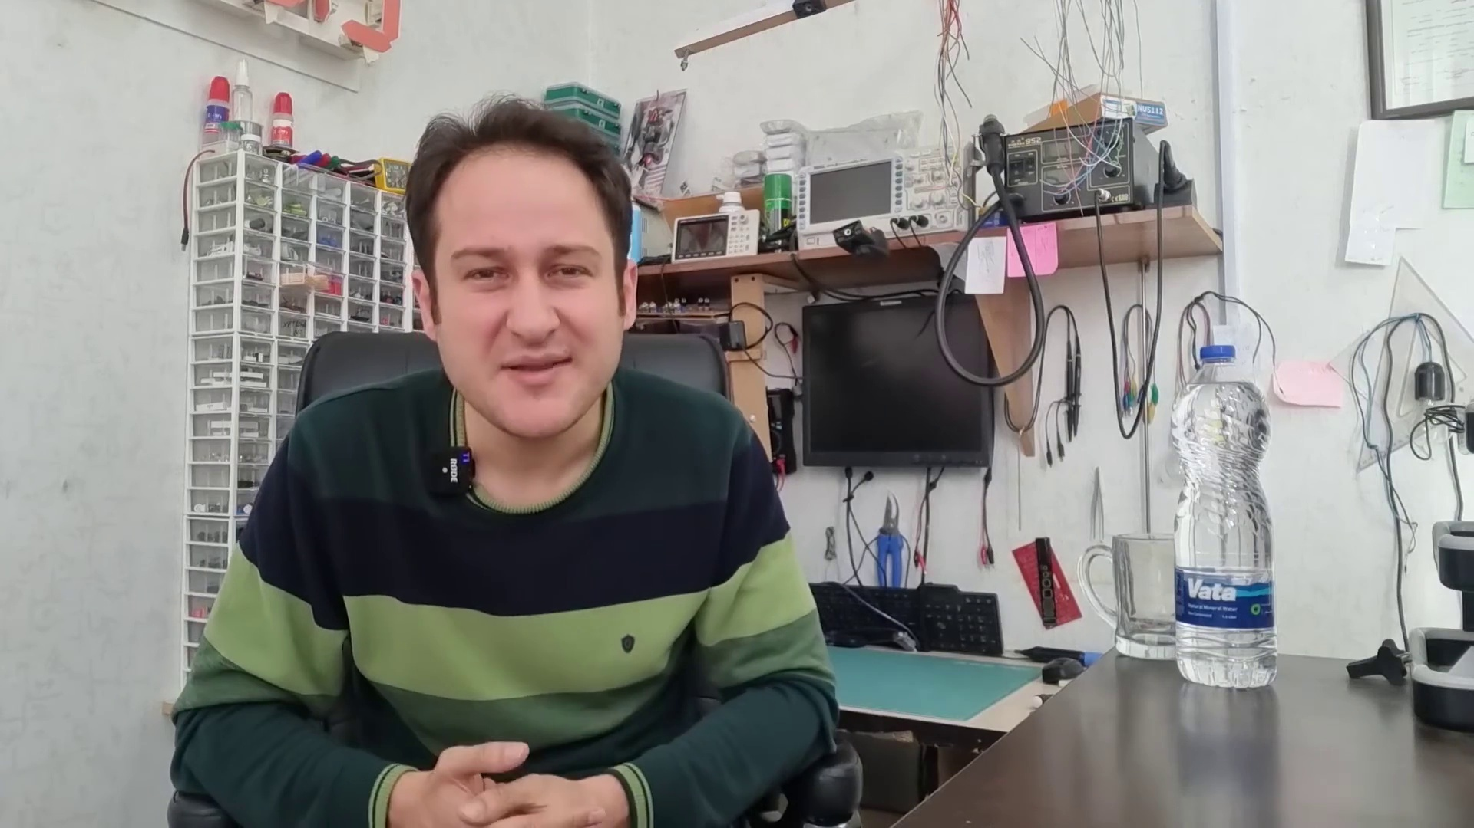 (score 95.0000)
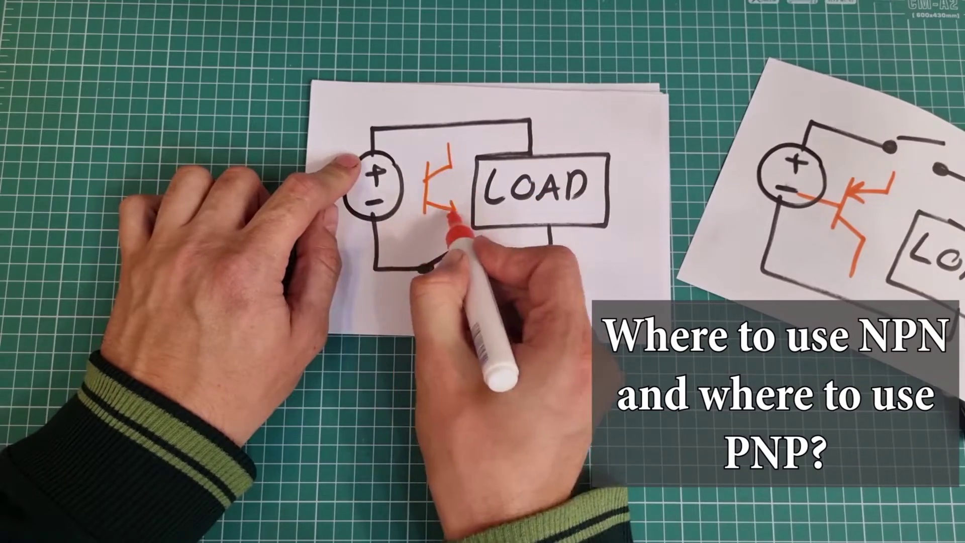 (score 95.0000)
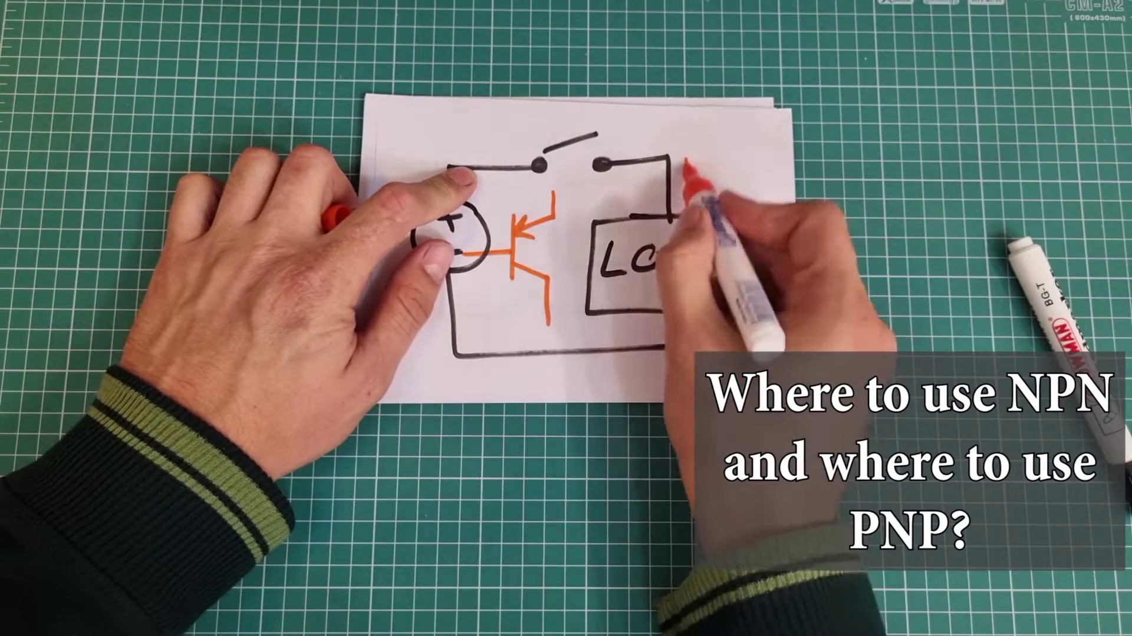 (score 95.0000)
 (score 90.0000)
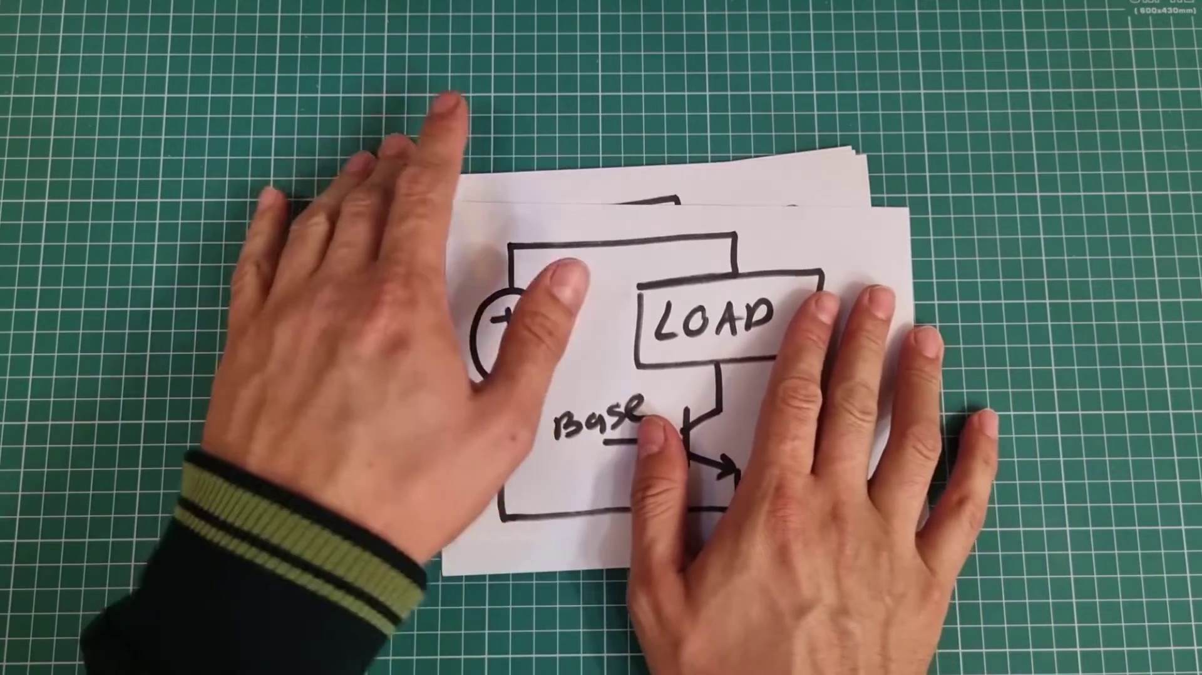 (score 90.0000)
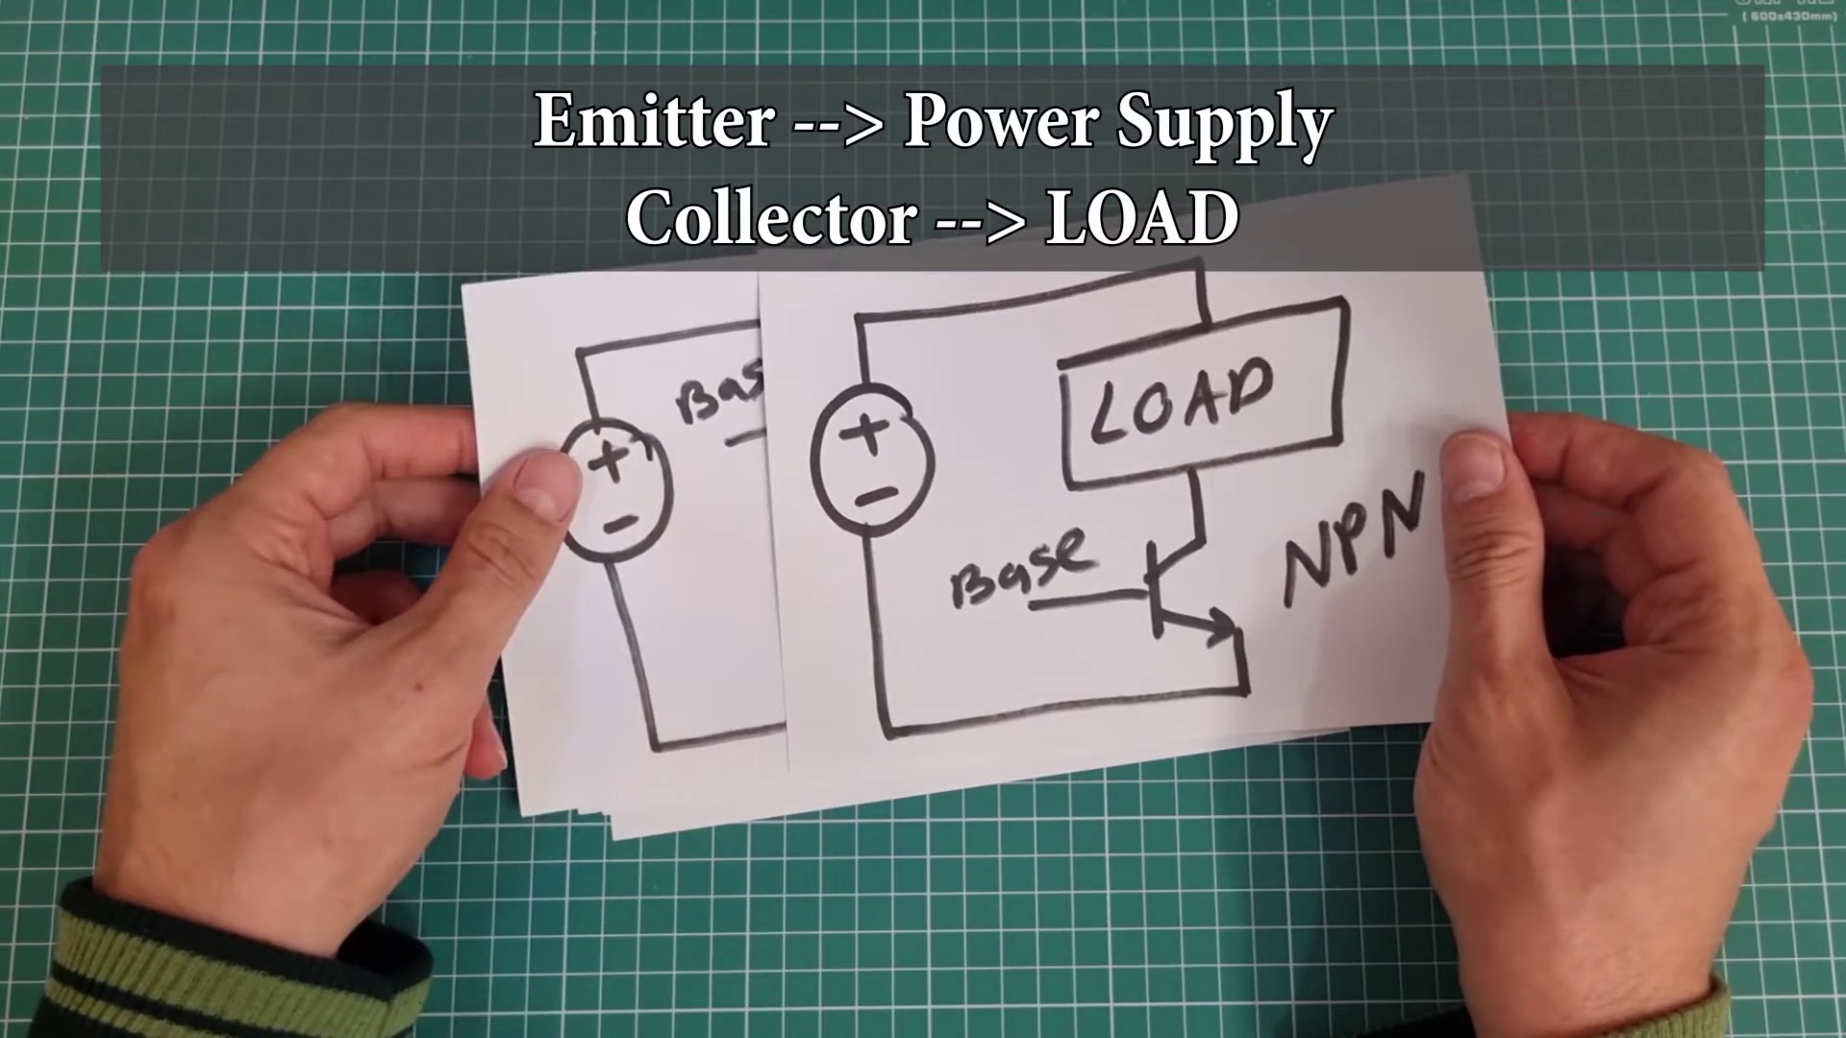 (score 90.0000)
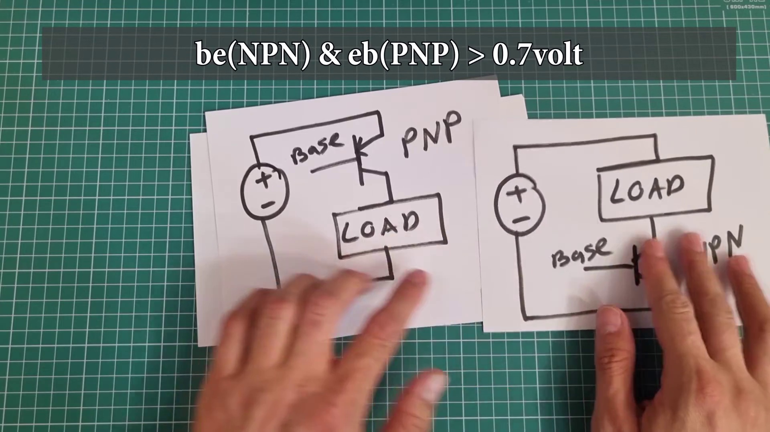 (score 90.0000)
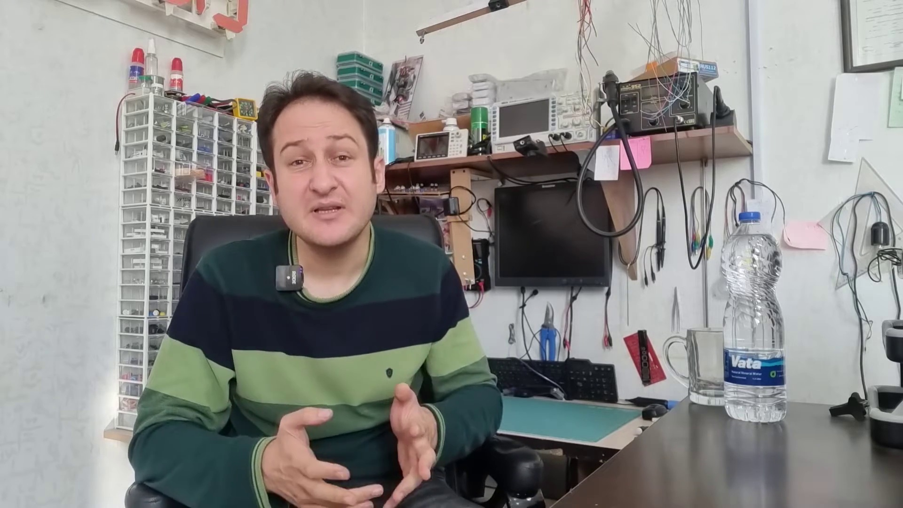 (score 90.0000)
 (score 90.0000)
 (score 90.0000)
Least correlated frames:
 (score 0.0000)
 (score 70.0000)
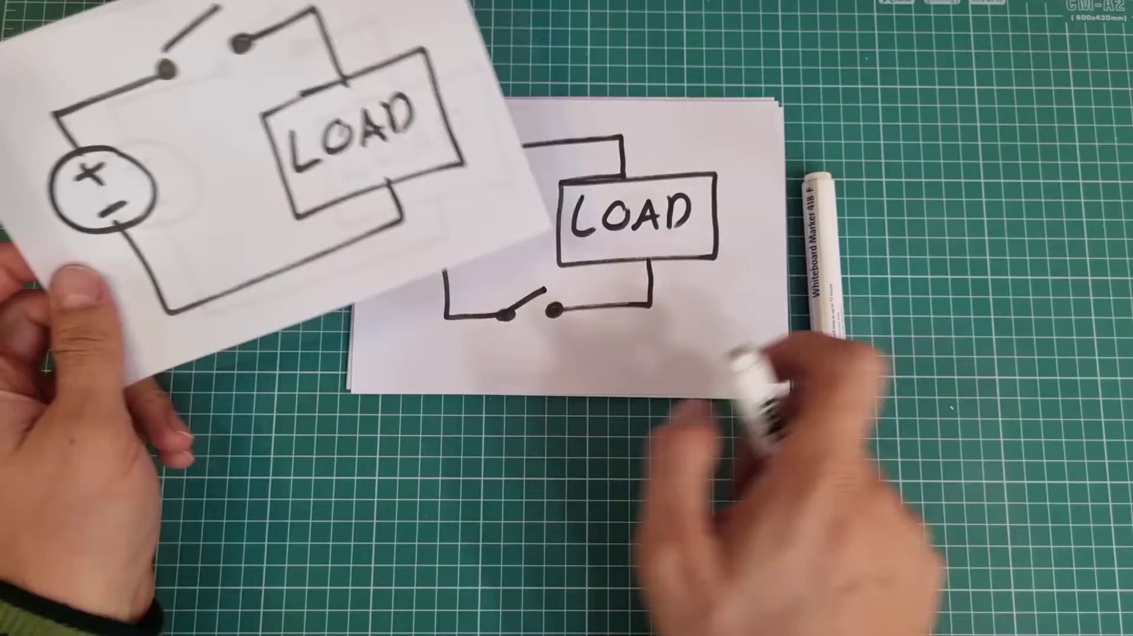 (score 80.0000)
 (score 80.0000)
 (score 80.0000)
 (score 80.0000)
 (score 80.0000)
 (score 80.0000)
 (score 80.0000)
 (score 80.0000)
- matched 46 frame(s), max score 90.0000: NPN transistors are easier to turn on and off using microcontrollers, making them generally more convenient for most circuits.I’m still not sure when to choose a PNP over an NPN transistor.When in doubt and given a choice, I will use an NPN transistor over a PNP.
Source: https://www.youtube.com/watch?v=L0QraSYq8tw: Why NPN transistors are more often used in circuits?
Top correlated frames:
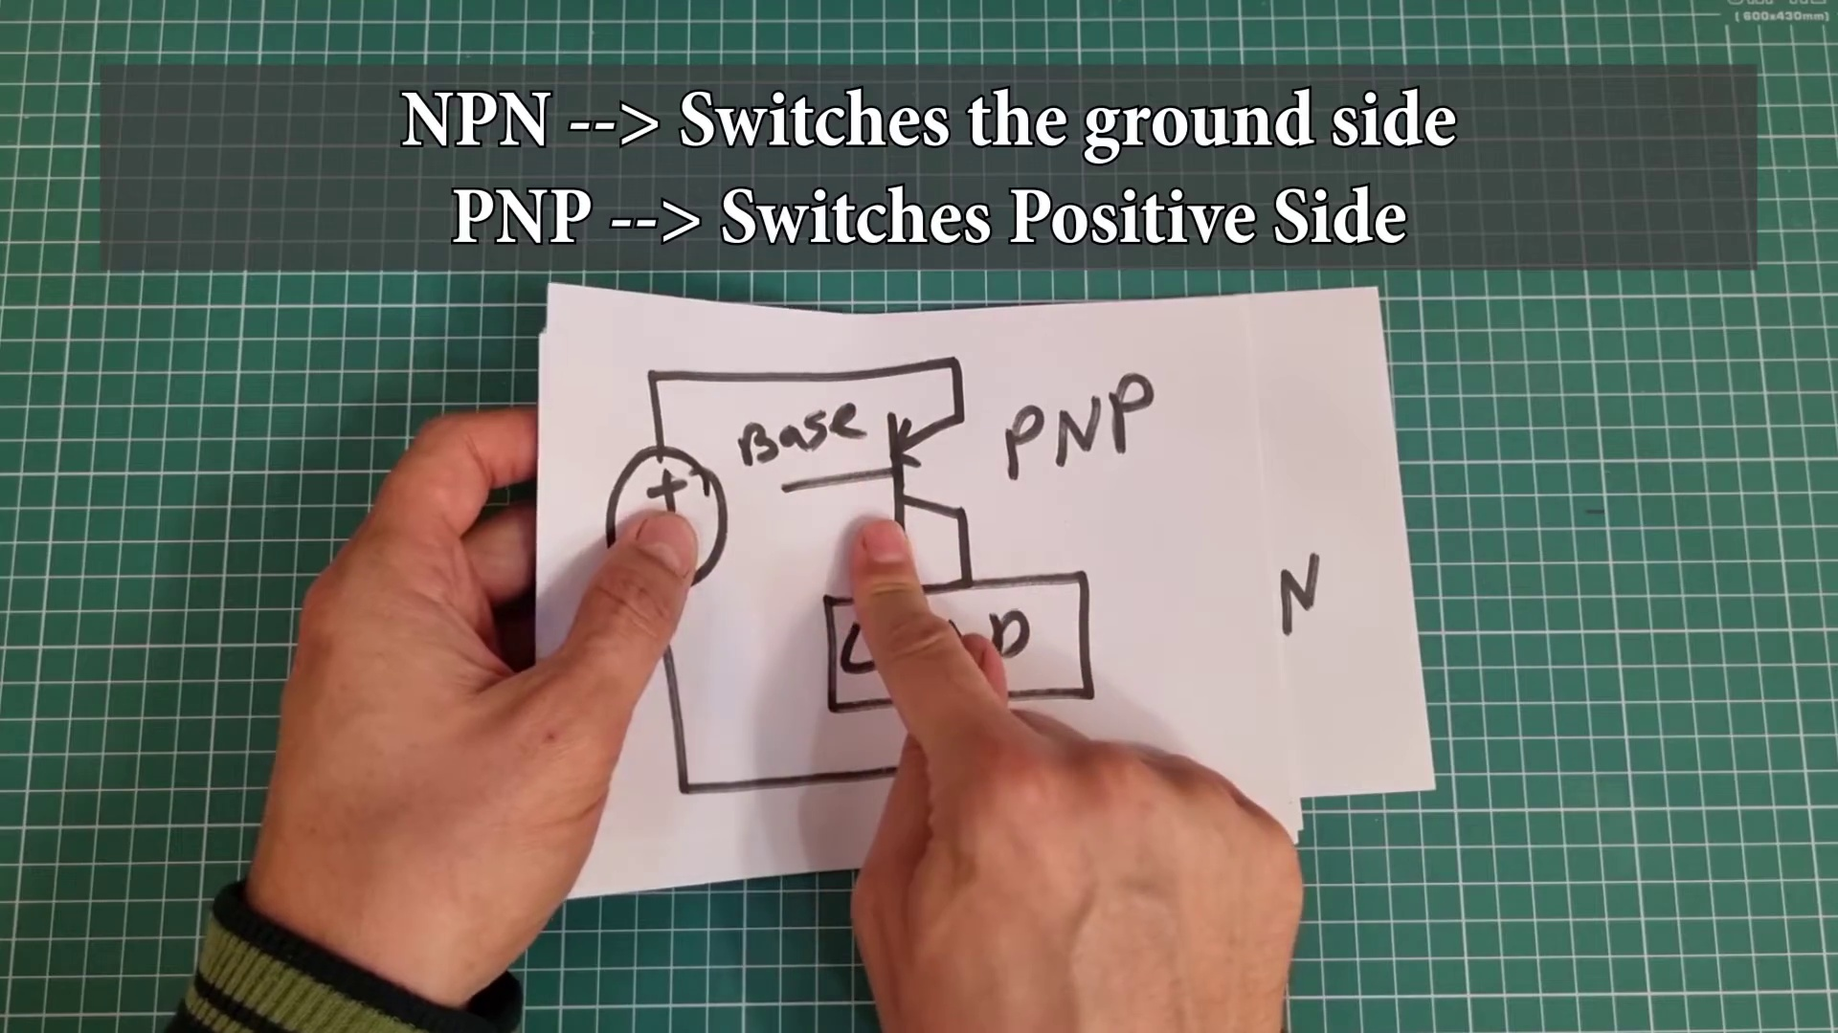 (score 90.0000)
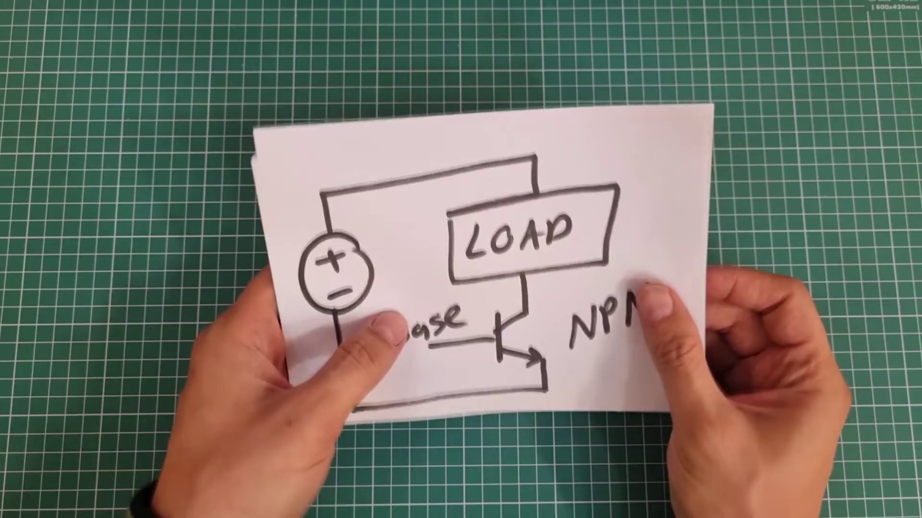 (score 90.0000)
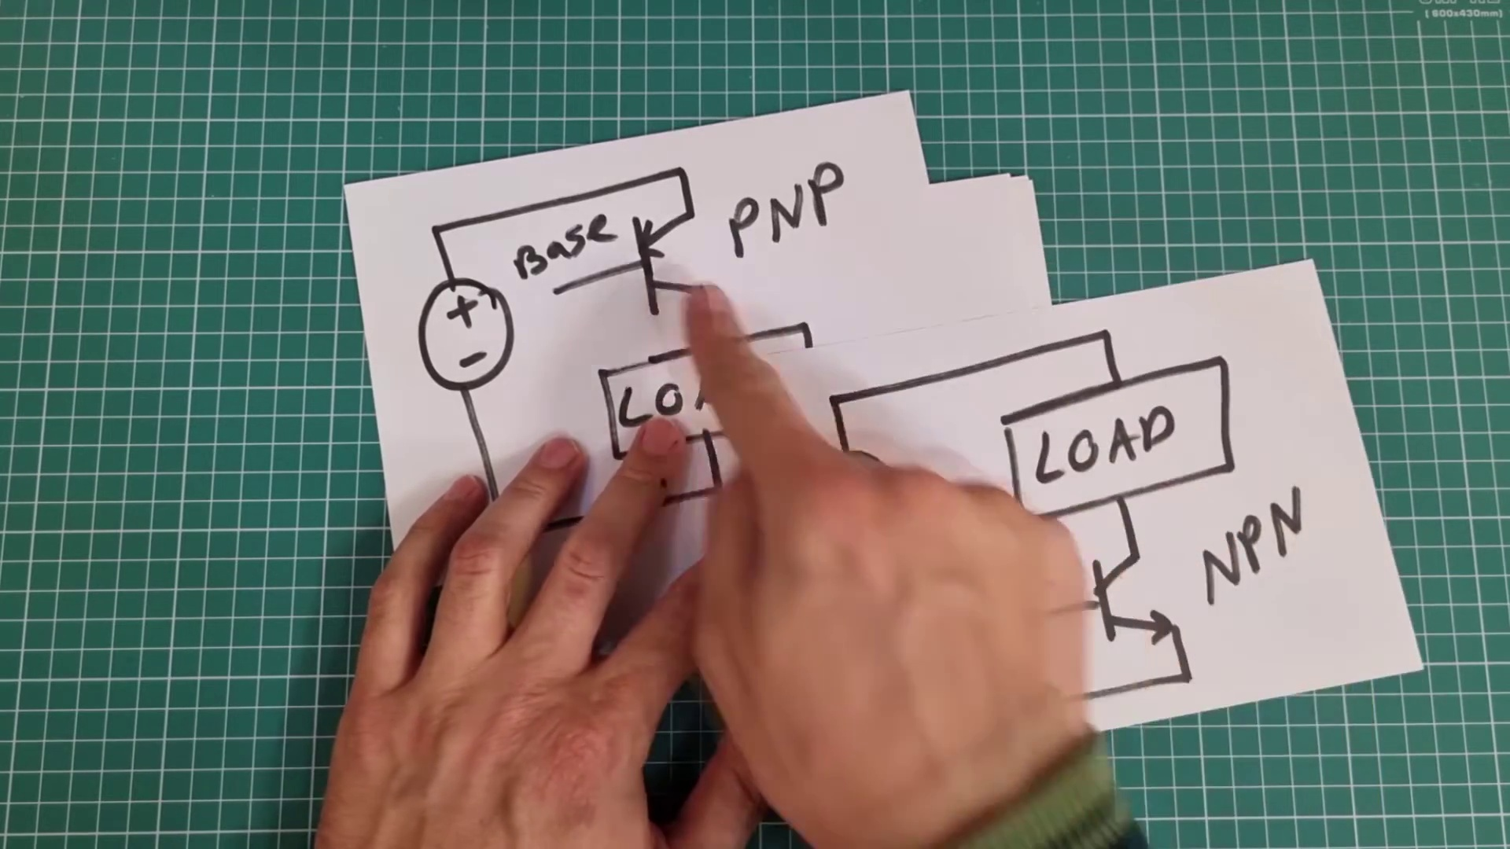 (score 90.0000)
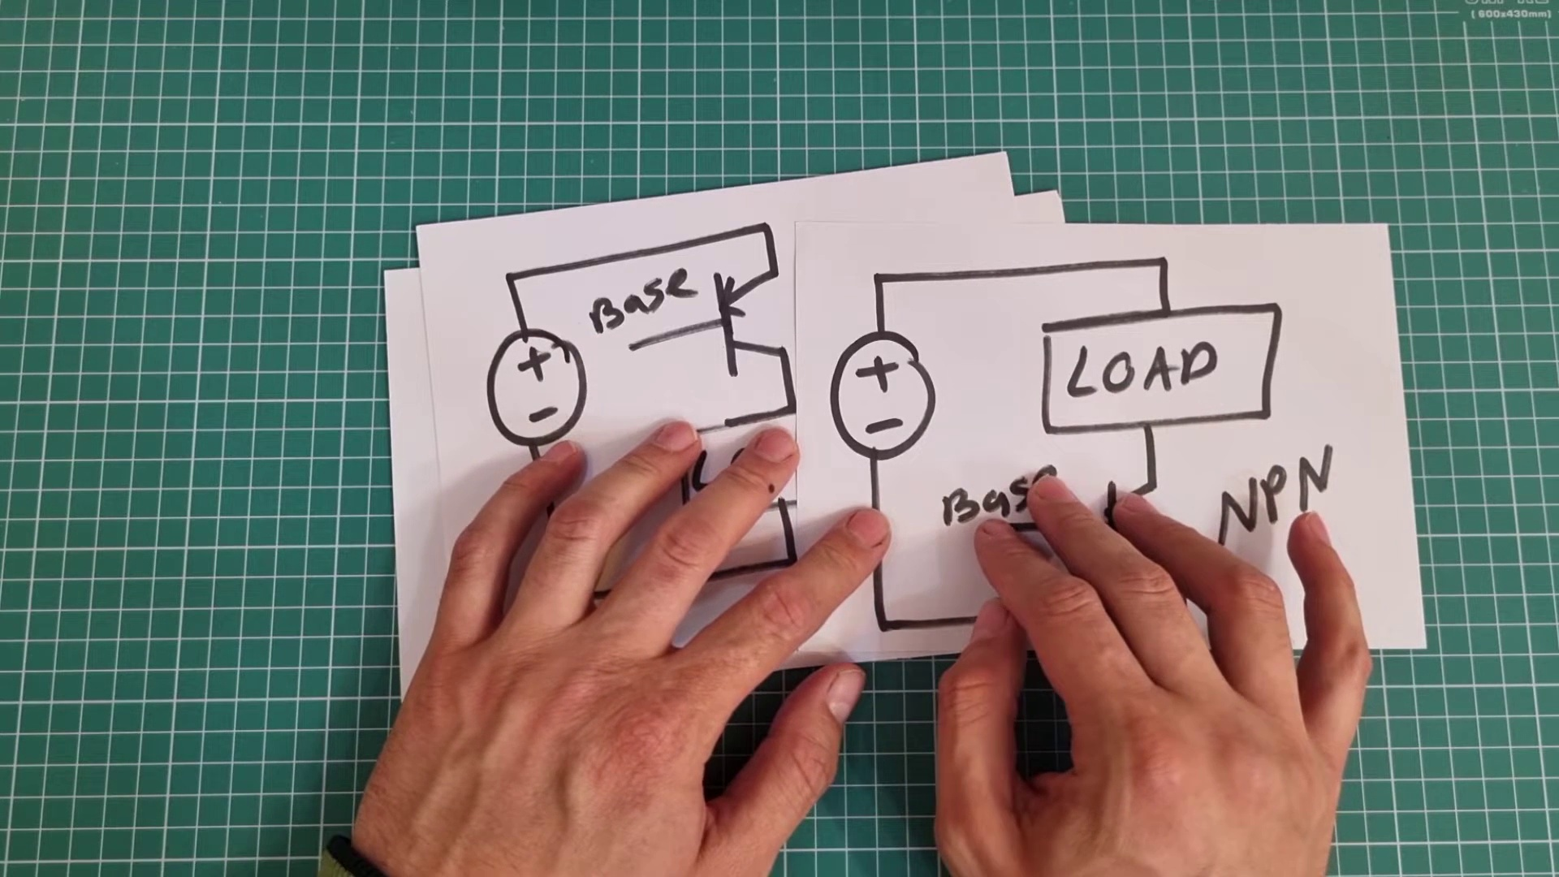 (score 90.0000)
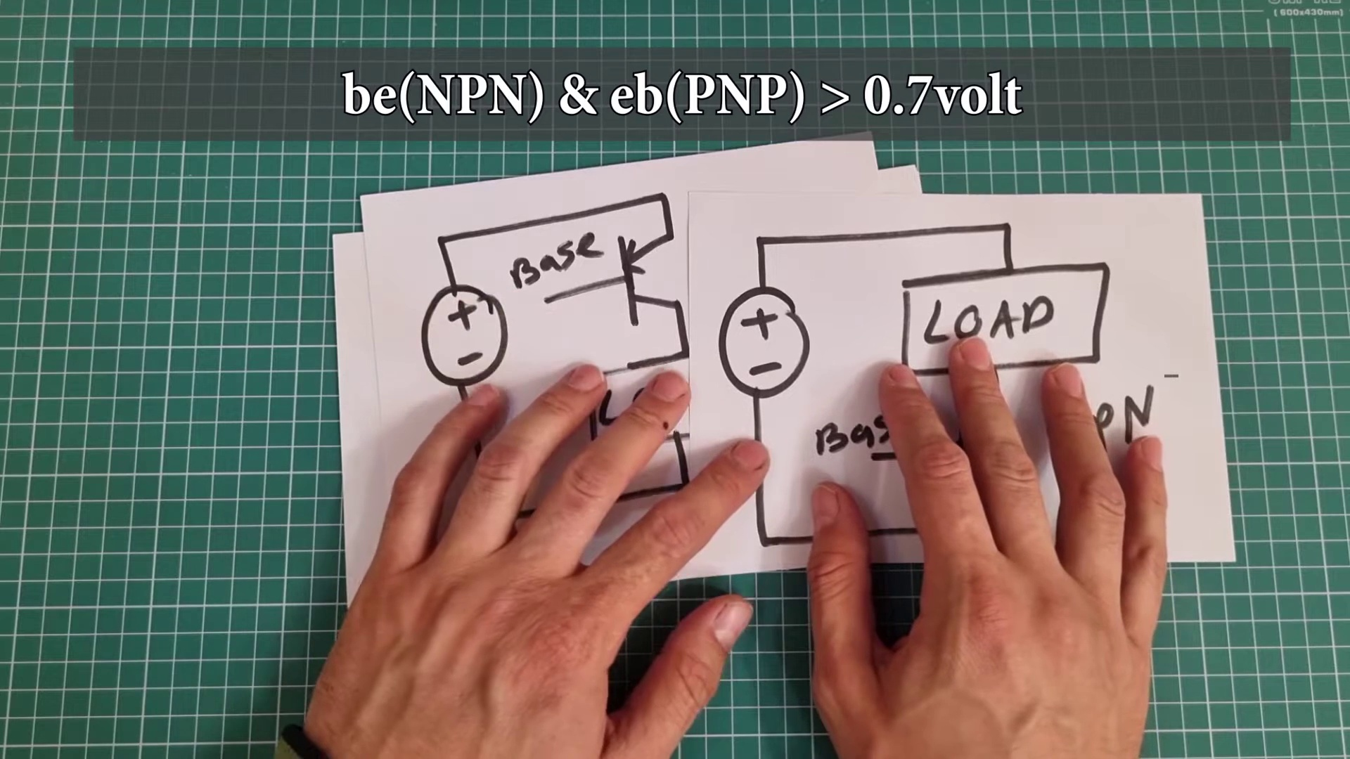 (score 90.0000)
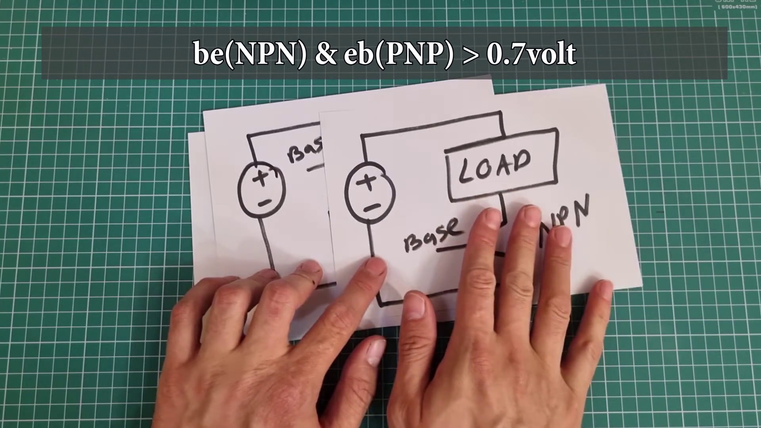 (score 90.0000)
 (score 90.0000)
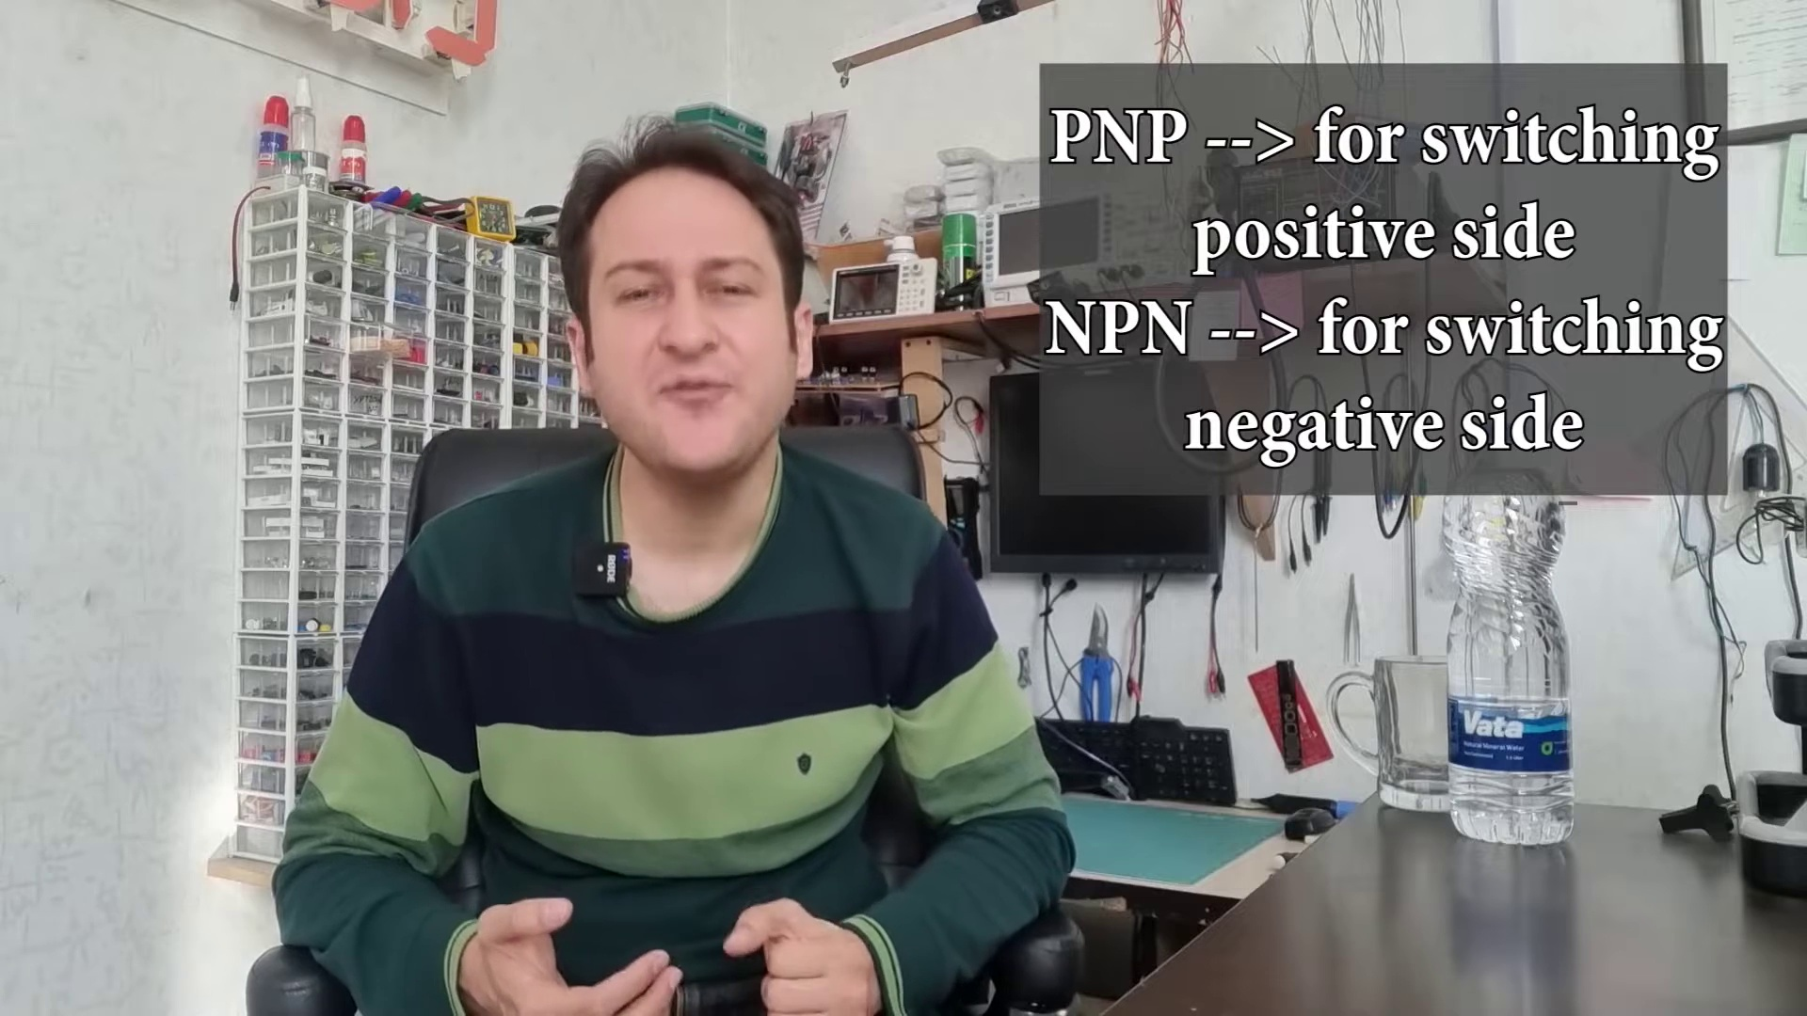 (score 90.0000)
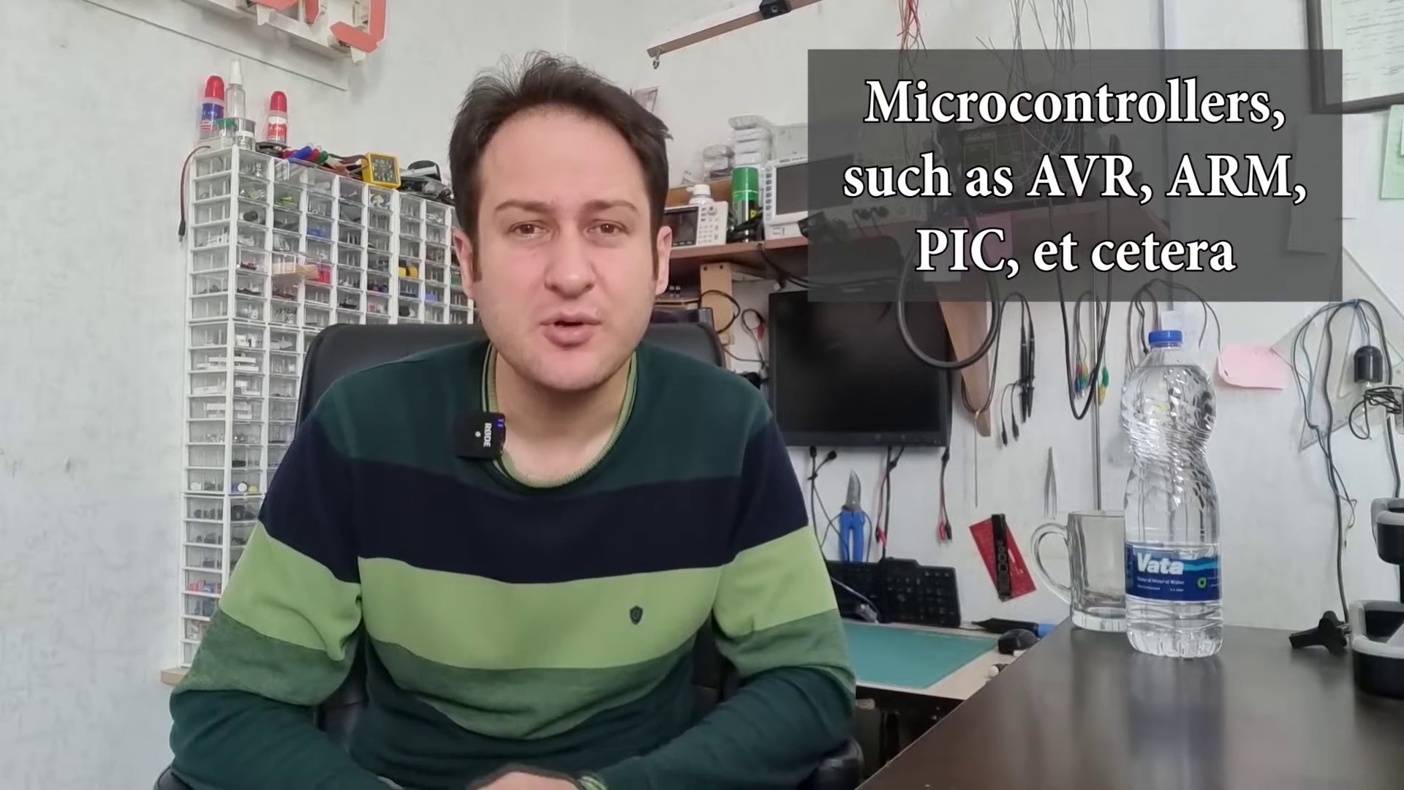 (score 90.0000)
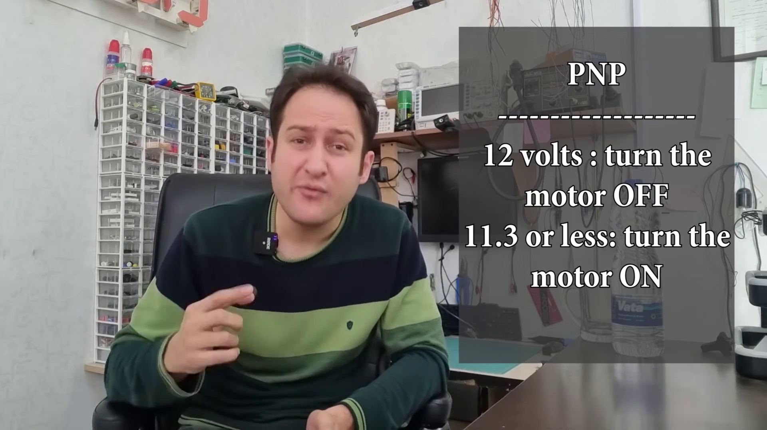 (score 85.0000)
Least correlated frames:
 (score 0.0000)
 (score 0.0000)
 (score 0.0000)
 (score 0.0000)
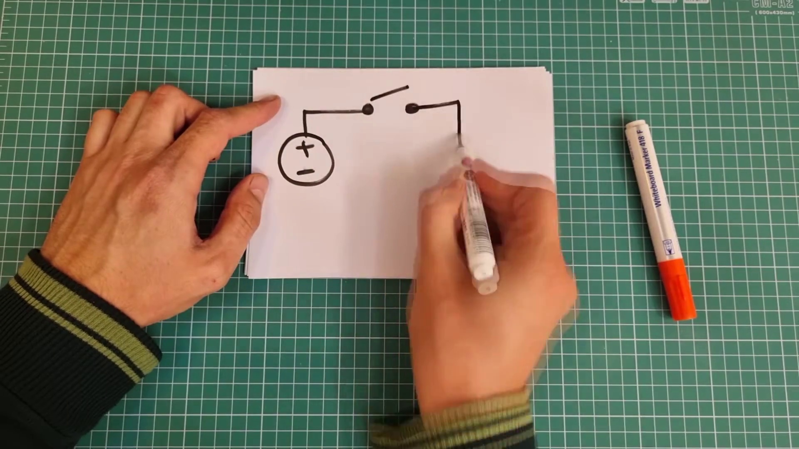 (score 0.0000)
 (score 0.0000)
 (score 0.0000)
 (score 0.0000)
 (score 0.0000)
 (score 0.0000)

Frame: frame_0000.jpg
Caption: The image depicts two hands holding a piece of paper with the word "LOAD" written on it. The paper has a white background and is bordered by a black outline. To the right of the first paper, another sheet of paper with the same label ("LOAD") is visible, also featuring a white background and a black border. A white marker is held in the hands of the person, suggesting they are engaged in drawing or writing on these papers. The diagram on the first paper appears to be illustrating an electrical circuit concept, with two blocks labeled "LOAD" on the left side, pointing arrows towards a rectangular symbol representing a battery or power source. The person seems to be in the process of explaining or drawing this circuit setup.
In the background, the image features a green tone and a white grid pattern, which may be related to the drawing or writing process. The individual is seated at a table, with only their legs and feet visible below the edge of the frame. There is no additional text present in the image providing context about the subject matter being taught or demonstrated. The diagram's style suggests it could be from an educational material focused on electrical engineering or physics principles, possibly from a manual or textbook.
Comment (score 80): NPN transistors are easier to turn on and off using microcontrollers, making them generally more convenient for most circuits.I’m still not sure when to choose a PNP over an NPN transistor.When in doubt and given a choice, I will use an NPN transistor over a PNP.
Reason: The comment directly discusses the concept of NPN and PNP transistors, which is closely related to the electrical circuit diagram shown in the caption. The caption provides context about the LOAD labels and battery symbol, which aligns with the commenter's explanation of transistor types.
Source: https://www.youtube.com/watch?v=L0QraSYq8tw: Why NPN transistors are more often used in circuits?

Frame: frame_0001.jpg
Caption: The image shows a person engaged in an activity that involves creating a circuit on a breadboard using components such as resistors and LEDs. The individual is also working on a separate task, creating a circuit diagram on a piece of paper with black lines on a white background. The person's hands are actively engaged in both activities, one hand holding the pen to draw the diagram and the other hand manipulating components on the breadboard.
A standard piece of electronics equipment used for prototyping and learning about circuits, the breadboard has slots where electronic components can be inserted and connected with jumper wires. Visible electronic components on the breadboard include resistors (brown cylinders) and LEDs (long, rectangular components).
The most prominent text in the image is a question posed to the viewer: "WHERE TO USE NPN?" This text seems to be intended to guide the person working on the circuit, suggesting that an NPN transistor should be used in a specific part of the circuit. The same text appears on the paper as "Where to use NPN and where to use PNP", indicating that the person is either designing or analyzing a circuit that uses both NPN and PNP transistors.
The context suggests that this image is being used for educational purposes, possibly as part of a tutorial or lesson on electronics or transistors. The individual's focus and actions indicate an interactive learning environment where students can actively work through examples. The setting appears to be a workspace designed for learning or prototyping electronics, with a wooden workbench and green mat providing a contrasting background that allows the black lines and the person's hand to stand out.
The image captures two moments of active learning: one of creating a circuit on a breadboard and another of creating a circuit diagram. The person is poised at the "NPN" part of the circuit, ready to incorporate an NPN transistor according to the instruction provided in the text.
Comment (score 95): What I have learned from the video is Where and how to use NPN and PNP transistors.How I plan to use the electrical system in the future is Amplifying voltage or current, or switching voltage or current.
Reason: The comment directly discusses the same technical steps described in the caption, specifically 'Where and how to use NPN and PNP transistors', which is the main focus of the image. The mention of amplifying voltage or current, or switching voltage or current is also related to the context of electronics learning and prototyping.
Source: https://www.youtube.com/watch?v=L0QraSYq8tw: Why NPN transistors are more often used in circuits?
Comment (score 85): NPN transistors are easier to turn on and off using microcontrollers, making them generally more convenient for most circuits.I’m still not sure when to choose a PNP over an NPN transistor.When in doubt and given a choice, I will use an NPN transistor over a PNP.
Reason: The comment directly discusses the use of NPN transistors and the choice between PNP and NPN transistors, which is closely related to the technical steps described in the caption, such as 'WHERE TO USE NPN?' and the person's focus on incorporating an NPN transistor in the circuit.
Source: https://www.youtube.com/watch?v=L0QraSYq8tw: Why NPN transistors are more often used in circuits?

Frame: frame_0002.jpg
Caption: The image shows two individuals engaged in an educational setup that appears to involve electronics and diagrams. On the left side of the frame, one person has their hands positioned over a diagram with various electronic components represented by symbols: a battery labeled "LOAD," a resistor, and what looks like an LED (Light Emitting Diode) connected to a ground pin. The diagram also includes symbols for wires connecting these components to each other.
The text on the image reads, "WHERE TO USE NPN AND WHERE TO USE PNP?" This suggests that the individuals are discussing or demonstrating the differences between NPN and PNP transistors in the context of electronics, possibly during a tutorial or workshop on electrical circuits or semiconductor physics. Meanwhile, the person on the right side is holding what appears to be a real electronic device with an LED mounted directly on it without any apparent components like a resistor or battery. The device could be a microcontroller board, given its rectangular shape and the pin configuration visible along one edge of the board.
In the background, another individual is focused on electrical wiring, using a white paper as a template for the task. This person is holding a red marker to mark the locations of the wires on the paper, which is adorned with black lines and arrows indicating the path of the wiring. The papers surrounding this individual suggest a workspace filled with tools and resources for the task at hand.
The overall scene portrays a moment of focus and concentration, as both individuals are actively engaged in their respective tasks. The educational setup and diagrams suggest a meticulous and detailed process of learning and understanding basic electronic circuits.
Comment (score 95): What I have learned from the video is Where and how to use NPN and PNP transistors.How I plan to use the electrical system in the future is Amplifying voltage or current, or switching voltage or current.
Reason: The comment directly discusses the same technical steps (using NPN and PNP transistors) and objects (electrical system) described in the caption. The mention of amplifying voltage or current, or switching voltage or current is also a direct application of the concepts presented in the caption.
Source: https://www.youtube.com/watch?v=L0QraSYq8tw: Why NPN transistors are more often used in circuits?
Comment (score 85): NPN transistors are easier to turn on and off using microcontrollers, making them generally more convenient for most circuits.I’m still not sure when to choose a PNP over an NPN transistor.When in doubt and given a choice, I will use an NPN transistor over a PNP.
Reason: The comment directly discusses the use of NPN and PNP transistors in electronic circuits, which is a key aspect of the frame caption's topic. The caption mentions NPN and PNP transistors, while the comment provides specific information about their usage and preference for one over the other.
Source: https://www.youtube.com/watch?v=L0QraSYq8tw: Why NPN transistors are more often used in circuits?

Frame: frame_0003.jpg
Caption: The image captures a moment of learning or demonstration focused on electronic components and their proper utilization within circuits. It shows an individual interacting with a DIY electronic project, with a circuit board being used and various components connected to it. A capacitor labeled "NPN" is prominently displayed, likely referring to a NPN transistor or its placement in an arrangement.
The person appears to be demonstrating the project and possibly explaining its function, holding a pen that suggests they may be writing notes or making modifications to the circuit. In the background, a text overlay reads "where to use NPN and where not to use", implying that the individual is teaching about the appropriate uses for an NPN transistor.
The image also shows a diagram on a piece of paper in the person's hand, which represents a simple electrical circuit featuring two components: a load and an NPN transistor. The load is connected to the transistor, and the transistor is connected to a power supply. The person's fingers are pointing to the load and the transistor, indicating that they are discussing the use of NPN loads and where to apply them.
The overall context implies that this could be part of an educational setting, possibly a DIY electronics class or tutorial, where the individual is teaching students about the proper utilization of electronic components within circuits.
Comment (score 90): What I have learned from the video is Where and how to use NPN and PNP transistors.How I plan to use the electrical system in the future is Amplifying voltage or current, or switching voltage or current.
Reason: The comment directly discusses the same technical steps and concepts described in the caption, specifically mentioning NPN transistors and their proper utilization within circuits. The comment also mentions planning to use the electrical system for amplifying voltage or current, which is closely related to the demonstration of using an NPN transistor shown in the frame caption.
Source: https://www.youtube.com/watch?v=L0QraSYq8tw: Why NPN transistors are more often used in circuits?
Comment (score 80): NPN transistors are easier to turn on and off using microcontrollers, making them generally more convenient for most circuits.I’m still not sure when to choose a PNP over an NPN transistor.When in doubt and given a choice, I will use an NPN transistor over a PNP.
Reason: The comment directly discusses the use of NPN transistors and their advantages over PNP transistors, which is closely related to the caption's description of an individual teaching about the proper utilization of electronic components within circuits.
Source: https://www.youtube.com/watch?v=L0QraSYq8tw: Why NPN transistors are more often used in circuits?

Frame: frame_0004.jpg
Caption: The image appears to be a thumbnail for a video, possibly related to technology or electronics given the imagery and text present. Here's a detailed description:
The central figure is a man with short dark hair, smiling and looking towards the left side of the image. He has a beard and is wearing a suit with a tie.
Overlaying the image, there is text that reads "Ele Wizard" in large white letters at the top center, written in a cursive font, adding a touch of elegance and intrigue. Below this name, smaller text states "simply ELECTRONICS" in bold, sans-serif font, suggesting that the content of the channel is easy to understand and approachable for all.
On the bottom left corner, there's a graphic design element resembling an electronic component or circuit symbol with a purple outline and a green fill inside it. The background of the image features a digital grid pattern with lines forming squares, giving an impression of a computer motherboard or circuit board layout.
On the bottom right corner, there's a watermark or logo that says "channel" in white text against a gray background, which suggests that this image is associated with a YouTube channel.
The overall style of the image is modern and digital, indicative of content related to technology or electronics. The use of a circuit-like pattern in the background further emphasizes this theme.
Comment (score 75): NPN transistors are easier to turn on and off using microcontrollers, making them generally more convenient for most circuits.I’m still not sure when to choose a PNP over an NPN transistor.When in doubt and given a choice, I will use an NPN transistor over a PNP.
Reason: The comment directly discusses transistor types (NPN and PNP) which are related to the electronic component/circuit symbol in the frame caption. Although it doesn't mention the specific 'Ele Wizard' or 'simply ELECTRONICS', the technical topic of transistors is strongly connected to the image's theme.
Source: https://www.youtube.com/watch?v=L0QraSYq8tw: Why NPN transistors are more often used in circuits?

Frame: frame_0005.jpg
Caption: The image shows an individual seated at a desk, engaged in their work. They are dressed in a green and black striped sweater, adding a pop of color to the otherwise utilitarian space. The man's fingers are animatedly gesturing towards a computer monitor, perhaps pointing out a specific detail or discussing a point of interest.
The desk is cluttered with various objects, including a black computer keyboard, suggesting that he is in the middle of a task. A black and white telephone stands to the side, ready for a call at any moment. The man's short hair and striped shirt are also visible.
In the background, a wall-mounted shelf filled with electronics and other tools suggests a workshop or workspace dedicated to technology. This shelf provides insight into the individual's interests and skills, showcasing a variety of tools and equipment.
The man is seated in front of a window, which offers a view of the world outside, although it is currently closed, suggesting that he might be working in a quiet, private environment. The image captures a moment in time, telling a story of someone deeply engrossed in their work, surrounded by tools and technology.
Comment (score 80): What I have learned from the video is Where and how to use NPN and PNP transistors.How I plan to use the electrical system in the future is Amplifying voltage or current, or switching voltage or current.
Reason: The comment directly discusses the use of NPN and PNP transistors, which is related to the technical steps and objects described in the caption (e.g. computer monitor, keyboard). The mention of amplifying voltage or current and switching voltage or current suggests a connection to the setting and goals mentioned in the caption (workshop or workspace dedicated to technology), but it's not a perfect correlation as the comment doesn't explicitly discuss the gesturing action or specific details on the computer monitor.
Source: https://www.youtube.com/watch?v=L0QraSYq8tw: Why NPN transistors are more often used in circuits?

Frame: frame_0006.jpg
Caption: The image appears to be a screenshot from an online video conference. On the left side of the frame, there is a man sitting in front of a table with various items such as papers, a bottle labeled "WATER", and possibly electronic components or tools. He is gesturing with his hands while speaking, which suggests he may be explaining something or teaching a class. The man is wearing a green and black striped shirt, has short hair, and appears to be engrossed in the conversation.
On the right side of the frame, there is a computer monitor displaying a green and white checkered pattern. In front of the man is the table with the mentioned items, including electronic components or wiring. The background suggests an indoor setting with a desk and shelves, indicating this might be an office or home study room. The walls are white, and there's no visible text on the screenshot.
The man is seated at a cluttered desk, surrounded by various objects, which adds to the busy workspace. He is dressed in a green and black striped shirt, a green and black plaid jacket, and a black beanie, giving him a casual yet professional look. His fingers are skillfully typing on a black keyboard, suggesting he is in the middle of a task.
The backdrop of the image is a white wall, adorned with a black wire rack filled with various items and an empty white bulletin board, waiting to be filled with important notes or reminders. The overall scene suggests a productive and organized workspace, with the man deeply engrossed in his work.
Comment (score 80): NPN transistors are easier to turn on and off using microcontrollers, making them generally more convenient for most circuits.I’m still not sure when to choose a PNP over an NPN transistor.When in doubt and given a choice, I will use an NPN transistor over a PNP.
Reason: The comment directly discusses the technical aspect of NPN transistors and their convenience in circuits, which is strongly related to the frame caption's description of electronic components or wiring on the table. The mention of choosing an NPN transistor over a PNP also aligns with the visual details of the frame caption.
Source: https://www.youtube.com/watch?v=L0QraSYq8tw: Why NPN transistors are more often used in circuits?
Comment (score 80): What I have learned from the video is Where and how to use NPN and PNP transistors.How I plan to use the electrical system in the future is Amplifying voltage or current, or switching voltage or current.
Reason: The comment explicitly mentions learning about NPN and PNP transistors from the video, which is directly related to the technical steps and objects described in the caption, including electronic components or tools on the table.
Source: https://www.youtube.com/watch?v=L0QraSYq8tw: Why NPN transistors are more often used in circuits?

Frame: frame_0007.jpg
Caption: The image captures a person sitting at a desk, possibly in a classroom or video recording setup. They appear to be engaged in a lecture or presentation, as indicated by their hand position suggesting they are speaking or about to speak. The individual is wearing a dark blue long-sleeved shirt and has short dark hair. The background includes an office setting with various objects that could be related to electronics or computer equipment, such as a keyboard, monitor, and other technical items. The setting seems to be indoors, likely within an educational institution given the presence of teaching materials.
The room appears to be well-lit, but there is no text clearly readable in this frame. In contrast, another image shows a man sitting at a desk, engrossed in his work. He's dressed in a green and black striped shirt, adding a touch of color to the otherwise monochrome setting. The desk, cluttered with various items, serves as his workspace. A water bottle and a book are among the items scattered on the desk, hinting at the man's interest in both work and reading.
The background is a stark white, providing a contrast to the man and his desk. A window, adorned with curtains, is visible in the background, suggesting that the man is in a room with natural light. The curtains, though out of focus, add an element of depth to the image. Unlike the first setting, this one appears more typical of a daily workspace, with the man at the center, the water bottle and book to his right, and the window in the background.
Comment (score 80): What I have learned from the video is Where and how to use NPN and PNP transistors.How I plan to use the electrical system in the future is Amplifying voltage or current, or switching voltage or current.
Reason: The comment directly discusses the technical steps and goals described in the caption, specifically mentioning NPN and PNP transistors, amplifying voltage or current, and switching voltage or current. The connection between the comment and paragraph is strong as it mentions specific concepts and applications related to electronics and electrical systems, which are also depicted in the frame caption.
Source: https://www.youtube.com/watch?v=L0QraSYq8tw: Why NPN transistors are more often used in circuits?

Frame: frame_0008.jpg
Caption: The image shows a person seated in front of a desk with various items on it. The individual appears to be engaged in conversation or presentation, as indicated by their hands clasped together and the slight smile on their face. They are dressed in a vibrant green and black striped shirt and are looking at the camera. Behind them is an office environment with shelves containing technical equipment or possibly scientific instruments, including test tubes.
On the desk, there is a laptop open with what seems to be a presentation slide partially visible; however, the content on the screen is not clear enough to discern details. To the left of the person, there appears to be a whiteboard or flip chart stand, but no writing or drawing is visible on it. In front of the person is a cluttered desk with various items including papers and what looks like electronic equipment.
A bottle of water stands out on the desk, its transparency contrasting with the array of electronic devices. A few papers are scattered around, perhaps notes or diagrams related to their work. The room itself is filled with various objects, including a lamp, a book, and a plant, adding to the lived-in feel of the space.
The person's expression is one of concentration, their eyes focused on something in the distance, suggesting that they are deeply engaged in their work.
Comment (score 90): What I have learned from the video is Where and how to use NPN and PNP transistors.How I plan to use the electrical system in the future is Amplifying voltage or current, or switching voltage or current.
Reason: The comment directly discusses the use of NPN and PNP transistors, which is related to the technical equipment or scientific instruments mentioned in the frame caption. The mention of amplifying voltage or current and switching voltage or current also corresponds to the electronic devices visible on the desk.
Source: https://www.youtube.com/watch?v=L0QraSYq8tw: Why NPN transistors are more often used in circuits?

Frame: frame_0009.jpg
Caption: The image appears to be a screenshot of an online video call featuring a man seated at a desk with various items on it, including a computer monitor displaying a webpage with "Wikipedia" written across it. The monitor suggests an indoor setting, possibly a home or office environment, with some items on shelves visible behind him. The man is wearing a blue shirt with a stripe pattern and is gesturing with his hands open towards the camera. He is facing the torso of another person (wearing a striped sweater) to the left of the image, who is holding a microphone close to their mouth as if speaking.
The desk is cluttered with various items, including electronic components or wires, which are visible on the monitor and around him. The man's expression appears serious, indicating he is engaged in a task or conversation during this video call. The background reveals a room filled with electronics, suggesting a workspace or workshop environment. Overall, the scene suggests a professional or creative setting where the man might be providing instructions, explaining something, or simply engaging in conversation during this online meeting.
Comment (score 80): What I have learned from the video is Where and how to use NPN and PNP transistors.How I plan to use the electrical system in the future is Amplifying voltage or current, or switching voltage or current.
Reason: The comment directly discusses the technical steps and objects described in the caption, specifically mentioning NPN and PNP transistors, amplifying voltage or current, and switching voltage or current. These concepts are related to the electronic components visible on the desk and monitor in the image.
Source: https://www.youtube.com/watch?v=L0QraSYq8tw: Why NPN transistors are more often used in circuits?

Frame: frame_0010.jpg
Caption: The image shows a person sitting at a desk in an indoor setting that appears to be an office or classroom. The individual is wearing a striped shirt, with the color of their shirt being either dark stripes (as mentioned in Caption 1) or green and black stripes (as described in Caption 2), and has short, light-colored hair. They are looking slightly to their right with one hand resting on the table in front of them, displaying a neutral or mildly engaged expression.
The background reveals some office supplies and electronic equipment or instruments on shelves behind the desk. A bottle labeled "Borax" is visible on the left side of the image, as well as cables or wires hanging from above. On the right side of the image, partially obscured by the person, there is a black chair and what looks like a computer monitor.
The foreground of the photo shows an object with a label that says "BORAX." The text on the screen is not clearly legible due to the angle and focus of the image. There are no visible diagrams or slides indicating teaching content, and there is no indication of writing or holding models.
In terms of clothing, the individual is wearing black pants (as mentioned in Caption 2), and they have a watch on their wrist. The man's hair is neatly combed, and he is engrossed in his work, displaying a thoughtful expression as he faces the camera.
The desk is cluttered with various items, including a bottle of water, a pen, and a phone. The phone is placed on the desk, while the bottle of water is on a shelf next to it. The pen is on the desk, ready for use. The organized workspace in the background reveals a computer monitor, keyboard, and mouse, indicating that this individual is deeply engaged in their work.
No strongly correlated comments found for this frame.

Frame: frame_0011.jpg
Caption: In this image, there is a man seated at a desk with a computer monitor behind him. He appears to be in an indoor setting, possibly an office or classroom, dressed casually in a green and black striped shirt. The man is engaged in a conversation, speaking into a microphone that is positioned close to his mouth. His arms are crossed, and he has a serious expression on his face.
The background shows a room with various items visible, including shelves containing objects that could be materials for a workshop or lecture, possibly related to electronics or computer hardware, given the presence of devices like keyboards and what appears to be a motherboard or circuit board. There is also a water bottle on the desk in front of him, with a red label.
The desk itself is cluttered with various objects, featuring a black keyboard and a computer monitor, suggesting the man might be working or studying. A few posters are visible on the wall, adding a personal touch to the space. The backdrop of the image is a whiteboard-covered wall, suggesting a workspace or study area.
Comment (score 80): NPN transistors are easier to turn on and off using microcontrollers, making them generally more convenient for most circuits.I’m still not sure when to choose a PNP over an NPN transistor.When in doubt and given a choice, I will use an NPN transistor over a PNP.
Reason: The comment directly discusses technical details related to the image, such as the use of microcontrollers and types of transistors (NPN/PNP), which are also depicted in the background objects like keyboards and circuit boards.
Source: https://www.youtube.com/watch?v=L0QraSYq8tw: Why NPN transistors are more often used in circuits?
Comment (score 80): What I have learned from the video is Where and how to use NPN and PNP transistors.How I plan to use the electrical system in the future is Amplifying voltage or current, or switching voltage or current.
Reason: The comment directly discusses the use of NPN and PNP transistors, which is specifically mentioned in the caption as objects on the shelves behind the man. Additionally, the comment mentions amplifying voltage or current, switching voltage or current, which are all technical steps related to electronics/computer hardware, also described in the caption.
Source: https://www.youtube.com/watch?v=L0QraSYq8tw: Why NPN transistors are more often used in circuits?

Frame: frame_0012.jpg
Caption: The image appears to show an individual, dressed in a green and black striped shirt, seated at a desk with various items scattered around. The person is not in focus; only their torso and shoulders are visible, suggesting that they might be gesturing or facing away from the camera. They seem to be in a room with computer equipment, possibly a home office setup, as there are devices that look like electronic components or boards on the desk.
In front of the individual, there is a table where some papers or notebooks can be seen. However, it's not clear if any teaching materials such as slides, diagrams, or text are present. The background shows a simple, unadorned interior with plain walls and no distinguishable features that would suggest an educational setting.
The overall impression is that the image captures a moment during a discussion or presentation rather than a formal classroom environment. A black water bottle and a stack of papers sit on the desk, suggesting that the individual is deeply involved in their work. The man's posture suggests concentration and focus, indicative of his professional occupation.
A whiteboard hangs on the wall next to the window, perhaps used for brainstorming or planning, while a black wall socket hints at the technological aspect of the individual's work.
Comment (score 80): What I have learned from the video is Where and how to use NPN and PNP transistors.How I plan to use the electrical system in the future is Amplifying voltage or current, or switching voltage or current.
Reason: The comment directly discusses the technical steps and goals mentioned in the caption, specifically referencing NPN and PNP transistors. The caption describes electronic components or boards on the desk, which are likely related to these transistor types. The commenter's plans to amplify voltage or current, or switch it, also aligns with the technological aspect of the individual's work hinted at in the caption.
Source: https://www.youtube.com/watch?v=L0QraSYq8tw: Why NPN transistors are more often used in circuits?

Frame: frame_0013.jpg
Caption: The image shows a young man sitting in a cluttered room, engrossed in his work. He is dressed in a green and black striped shirt, adding a splash of color to the otherwise dull space. His fingers are poised in a 'peace' sign, suggesting a moment of pause in his work. The room itself is a study in disarray, with a desk cluttered with various items serving as the backdrop for the man's work. Papers are scattered across the desk, and wires are tangled around it, indicating a space in need of tidying.
In the corner of the room, a water bottle stands out, serving as a reminder of the man's need for hydration amidst his work. The room is further adorned with various items, including a red and white box, a black and white board, and a stack of papers, all contributing to the overall cluttered appearance.
The man appears to be holding up in a 'peace' sign while smiling at an unseen camera or screen, possibly indicating that he is about to explain something related to his work. The style of the image suggests it might be from an online video lecture, virtual class session, or even a presentation.
Comment (score 80): What I have learned from the video is Where and how to use NPN and PNP transistors.How I plan to use the electrical system in the future is Amplifying voltage or current, or switching voltage or current.
Reason: The comment directly discusses the same technical steps (using NPN and PNP transistors) and goals (amplifying voltage or current, or switching voltage or current) described in the caption.
Source: https://www.youtube.com/watch?v=L0QraSYq8tw: Why NPN transistors are more often used in circuits?

Frame: frame_0014.jpg
Caption: The image shows a person, an instructor, seated at a desk with various items scattered around, suggesting an educational setting. The instructor is mid-speech, with his mouth open slightly and his hands resting on the table in front of him. He's wearing a striped sweater over a striped shirt, and he has dark hair. There is no visible text or writing activity on his hands.
On the desk, two bottles of water are placed next to the person, one larger than the other, along with a pair of scissors. The desk surface is partially obscured by these items.
Behind the person, there is a computer monitor displaying an image that appears to be related to electronics or technology, featuring what seems to be a circuit board or similar electronic component. However, the screen content does not provide enough detail to describe in depth.
The background consists of a room with various items: shelves containing educational materials; a bulletin board with papers and notes attached; another computer monitor displaying a different image; and what appears to be a television or larger screen mounted on the wall in the upper right corner. The walls behind the person have no visible text or decorations that provide additional context.
To the left of the man, there is a desk with a chair in front of it, and to the right, there's another desk with a chair and a bottle of water on top of it. The room receives natural light from a window with a red and white striped curtain, suggesting that the room might be part of a larger building or house.
Despite the cluttered workspace, the room is well-lit, and the instructor appears focused on his work. The image captures a moment in time, giving us a glimpse into the man's workspace and the tasks he might be undertaking, possibly related to electronics, technology, or a similar field.
Comment (score 80): NPN transistors are easier to turn on and off using microcontrollers, making them generally more convenient for most circuits.I’m still not sure when to choose a PNP over an NPN transistor.When in doubt and given a choice, I will use an NPN transistor over a PNP.
Reason: The comment directly discusses electronic components (NPN and PNP transistors) which are depicted in the image on the computer monitor. The caption provides context about electronics or technology-related activities, aligning with the topic of the comment.
Source: https://www.youtube.com/watch?v=L0QraSYq8tw: Why NPN transistors are more often used in circuits?
Comment (score 80): What I have learned from the video is Where and how to use NPN and PNP transistors.How I plan to use the electrical system in the future is Amplifying voltage or current, or switching voltage or current.
Reason: The comment directly discusses the technical steps and objects described in the caption, specifically mentioning transistors and amplifying voltage or current. The setting of the educational environment is also indirectly mentioned as a context where these concepts are being learned.
Source: https://www.youtube.com/watch?v=L0QraSYq8tw: Why NPN transistors are more often used in circuits?

Frame: frame_0015.jpg
Caption: The image appears to be a screenshot from a video call, as indicated by the visible webcam and microphone at the bottom of the screen. The central figure is a man sitting in front of a desk with various items on it. He's wearing a green and black striped shirt, adding a touch of color to the otherwise neutral environment. The desk he's sitting at is cluttered with objects, including a bottle of water, a computer keyboard on the right side, and a cell phone on the left. A stack of papers is scattered on the left side of the desk.
The background reveals a room filled with electronic equipment and wires, hinting at the man's profession or hobby. A shelf filled with various electronic devices and wires is visible, indicating a workspace or workshop. The room also has a window, which allows natural light to filter in, illuminating the space.
Comment (score 80): What I have learned from the video is Where and how to use NPN and PNP transistors.How I plan to use the electrical system in the future is Amplifying voltage or current, or switching voltage or current.
Reason: The comment directly discusses the use of transistors (NPN and PNP) which is related to the technical setup shown in the frame caption. The mention of amplifying voltage or current, or switching voltage or current also matches with the electronic equipment and wires visible in the background, indicating a strong correlation.
Source: https://www.youtube.com/watch?v=L0QraSYq8tw: Why NPN transistors are more often used in circuits?

Frame: frame_0016.jpg
Caption: This is an image of a man sitting at a cluttered desk, dressed in a green and black striped shirt. He appears to be speaking or recording a video, as indicated by the microphone in front of him. The desk serves as his workspace, with various items scattered across its surface, including a bottle of water, a notepad, and what seems to be some electronics equipment.
In the background, there are shelves filled with various objects, including a box and a stack of papers, indicating a storage area or workspace. The artificial lighting in the room suggests an office or home workspace setting. The man's expression is neutral, and he appears focused on whatever he is discussing or presenting, giving the impression of a casual interview.
The man is positioned centrally in the image, with his body angled slightly towards us, suggesting that he might be addressing the camera directly. There are no visible slides, diagrams, or any readable text on the computer monitor behind him, leaving the nature of the work or discussion taking place ambiguous.
Comment (score 80): What I have learned from the video is Where and how to use NPN and PNP transistors.How I plan to use the electrical system in the future is Amplifying voltage or current, or switching voltage or current.
Reason: The comment directly discusses the technical steps and goals described in the caption, specifically the use of NPN and PNP transistors. The mention of amplifying voltage or current and switching voltage or current is related to the electronics equipment shown on the desk in the caption.
Source: https://www.youtube.com/watch?v=L0QraSYq8tw: Why NPN transistors are more often used in circuits?

Frame: frame_0017.jpg
Caption: The image shows a person seated at a desk in an office or workshop space. The individual is engrossed in their work, facing away from the camera with their hands not visible in this frame. They are wearing a green striped sweater, which contrasts with their dark hair and surroundings. The desk is cluttered with various items, including a water bottle, a calculator, and a cell phone.
The background of the image reveals a workspace filled with tools and electronics, suggesting the presence of some sort of electronic device or project. Wires and circuits are scattered around, and a black box is visible in the background, adding to the overall industrial aesthetic of the scene.
The individual's position, the objects on the desk, and the background all contribute to a sense of productivity and focus, typical of someone engaged in a technical or creative task. The image captures a moment in time in the life of this person, their work, and the environment they operate in.
Comment (score 85): What I have learned from the video is Where and how to use NPN and PNP transistors.How I plan to use the electrical system in the future is Amplifying voltage or current, or switching voltage or current.
Reason: The comment directly discusses the use of transistors (NPN and PNP) in an electrical system, which is strongly related to the objects and settings described in the caption, such as the wires and circuits on the desk and in the background.
Source: https://www.youtube.com/watch?v=L0QraSYq8tw: Why NPN transistors are more often used in circuits?
Comment (score 80): NPN transistors are easier to turn on and off using microcontrollers, making them generally more convenient for most circuits.I’m still not sure when to choose a PNP over an NPN transistor.When in doubt and given a choice, I will use an NPN transistor over a PNP.
Reason: The comment directly discusses the use of NPN transistors and their advantages over PNP transistors, which is strongly related to the technical context described in the caption. The mention of microcontrollers, circuits, and transistor types matches the industrial aesthetic and technological setting depicted in the frame.
Source: https://www.youtube.com/watch?v=L0QraSYq8tw: Why NPN transistors are more often used in circuits?

Frame: frame_0018.jpg
Caption: The image appears to show an individual sitting at a desk in a room that resembles a workshop or office space. The person is wearing a striped shirt and has short hair, looking directly at the camera with their hands resting on the desk. Behind them, there's a desktop computer monitor displaying what seems to be a spreadsheet or chart with tables, but the specific content of the screen is not clear.
To the left of the individual, various items are scattered across the table: a plastic container possibly containing tools or materials, a bottle labeled "WATER," and some electronic equipment, including an electrical circuit board. A water dispenser or cooler is also visible nearby. The room has a casual atmosphere with a ceiling fan overhead and a door in the background, which seems to be slightly ajar.
The individual's attire is described as a black and green striped shirt, which contrasts with the blue and white striped shirt they are wearing, suggesting that there may be some ambiguity about the exact color or pattern of the shirt. The desk itself is cluttered with various objects, including a water bottle and a pair of scissors.
Comment (score 80): What I have learned from the video is Where and how to use NPN and PNP transistors.How I plan to use the electrical system in the future is Amplifying voltage or current, or switching voltage or current.
Reason: The comment explicitly mentions the use of NPN and PNP transistors, which is directly related to the electronic equipment visible in the background (electrical circuit board) in the frame caption. The commenter also discusses amplifying voltage or current and switching voltage or current, which are technical steps that can be applied to a setting like the workshop/office space described in the caption.
Source: https://www.youtube.com/watch?v=L0QraSYq8tw: Why NPN transistors are more often used in circuits?

Frame: frame_0019.jpg
Caption: The image shows a man sitting at a desk with a computer monitor behind him and a keyboard in front. He is wearing a green and black striped shirt, adding a pop of color to the scene. The desk, which is cluttered with various objects, includes a water bottle, a bottle of glue, and a packet of glue, indicating that the man is likely working on some craft or DIY project. On the monitor, there are no visible slides or diagrams, and the text on the screen is not legible.
The room appears to be an office setting with some office supplies in the background. The man's expression is serious as he seems to be explaining or demonstrating something related to microcontrollers, as indicated by the text overlay on the screen which reads "MICROCONTROLLERS, such as AVR, ARM, PCG, etcetera."
Comment (score 90): NPN transistors are easier to turn on and off using microcontrollers, making them generally more convenient for most circuits.I’m still not sure when to choose a PNP over an NPN transistor.When in doubt and given a choice, I will use an NPN transistor over a PNP.
Reason: The comment directly discusses microcontrollers, which is specifically mentioned in the caption's text overlay. The mention of NPN and PNP transistors also aligns with the technical context suggested by the caption.
Source: https://www.youtube.com/watch?v=L0QraSYq8tw: Why NPN transistors are more often used in circuits?
Comment (score 90): What I have learned from the video is Where and how to use NPN and PNP transistors.How I plan to use the electrical system in the future is Amplifying voltage or current, or switching voltage or current.
Reason: The comment directly discusses the use of transistors, specifically NPN and PNP types, which is mentioned in the caption as being related to microcontrollers. The commenter also mentions amplifying voltage or current, which is a technical aspect relevant to the image, where the man is likely working on a DIY project involving microcontrollers.
Source: https://www.youtube.com/watch?v=L0QraSYq8tw: Why NPN transistors are more often used in circuits?

Frame: frame_0020.jpg
Caption: The image depicts a man sitting at a desk surrounded by various electronics and components, appearing to discuss microcontrollers in an educational context. The text overlay reads "Microcontrollers. Such as: AVR, ARM, PIC, etc." indicating different types of microcontrollers commonly used in embedded systems. The man is wearing a green and blue striped shirt and looks directly at the camera. A computer monitor on his desk displays an electronic circuit or schematic diagram, suggesting a hands-on learning environment. In the background, there are more electronics, including a breadboard with wires connected to it, implying that he might be demonstrating how to set up or use a microcontroller in a practical setting. The overall environment suggests an educational space, possibly a workshop or lab dedicated to electronics and microcontrollers.
Comment (score 85): What I have learned from the video is Where and how to use NPN and PNP transistors.How I plan to use the electrical system in the future is Amplifying voltage or current, or switching voltage or current.
Reason: The comment directly discusses the same technical steps and objects described in the caption, specifically transistors (NPN and PNP) and amplifying/voltage switching. The caption mentions microcontrollers, electronics, and circuit diagrams, which are all relevant to the commenter's plans for future use.
Source: https://www.youtube.com/watch?v=L0QraSYq8tw: Why NPN transistors are more often used in circuits?
Comment (score 80): NPN transistors are easier to turn on and off using microcontrollers, making them generally more convenient for most circuits.I’m still not sure when to choose a PNP over an NPN transistor.When in doubt and given a choice, I will use an NPN transistor over a PNP.
Reason: The comment mentions microcontrollers and transistors, which are directly discussed in the caption. The mention of NPN and PNP transistors also matches the types of microcontrollers listed in the caption (AVR, ARM, PIC). Although the context is not identical, the connection between the comment and caption is strong enough to warrant a score above 70.
Source: https://www.youtube.com/watch?v=L0QraSYq8tw: Why NPN transistors are more often used in circuits?

Frame: frame_0021.jpg
Caption: The image presents a close-up view of a large collection of small electronic components, all of which are black in color. The components, likely capacitors, are arranged in a grid-like pattern, with each component occupying a distinct square. The grid is spread across the entire image, creating a sense of depth and perspective. Each capacitor has a black component, likely the electrolyte, and two metal ends connected by a thin film, which is typically made of aluminum. The capacitors are sitting on a flat surface, with their bodies facing upwards. The background is a stark white, which contrasts with the black components and draws attention to them. The image does not contain any text or other discernible objects. The relative positions of the components remain constant, creating a sense of order and structure.
Comment (score 90): What I have learned from the video is Where and how to use NPN and PNP transistors.How I plan to use the electrical system in the future is Amplifying voltage or current, or switching voltage or current.
Reason: The comment directly discusses the use of NPN and PNP transistors, which is related to the electronic components shown in the caption. The mention of amplifying voltage or current and switching voltage or current also aligns with the technical steps and goals described in the caption.
Source: https://www.youtube.com/watch?v=L0QraSYq8tw: Why NPN transistors are more often used in circuits?

Frame: frame_0022.jpg
Caption: The image presents a comprehensive collection of various electronic components, including microcontrollers (MCUs) with different pinouts and sizes, such as the ATmega328P and other similar chips. The assortment also features LEDs in diverse colors and possibly types, resistors with a range of values indicated by their color bands, a capacitor for energy storage, a transformer or an inductor with coiled wire for electromagnetic induction, a rotary encoder (possibly a hall effect sensor) for position feedback, and an optocoupler for electrical isolation.
In addition to these components, the image showcases 24 small electronic switches, each with its own unique color and design. These switches are arranged in a grid formation, with each row and column featuring a different switch. The switches vary in size, from small to larger, and come in a range of colors including red, black, yellow, and green. Some switches have a white button, while others feature a red one. The switches also exhibit distinct designs, such as circular and square shapes.
Each switch is labeled with a specific function, indicating its purpose in the electronic device it's designed for. These labels are white and situated on the front of the switches, making them easily visible against the white background. This contrast allows for a clear view of each label, providing a detailed look at the variety and diversity of switches used in electronic devices.
The image is likely intended for educational purposes, such as teaching about electronics hobbyist toolkits or explaining the basics of electronic devices using these components and switches. The absence of any additional visual aids or context suggests that this collection is meant to be studied and understood on its own merits.
Comment (score 80): What I have learned from the video is Where and how to use NPN and PNP transistors.How I plan to use the electrical system in the future is Amplifying voltage or current, or switching voltage or current.
Reason: The comment directly discusses using NPN and PNP transistors for amplifying voltage or current, which is closely related to the technical steps, objects (transistors), and settings described in the caption, such as the collection of electronic components including transistors.
Source: https://www.youtube.com/watch?v=L0QraSYq8tw: Why NPN transistors are more often used in circuits?

Frame: frame_0023.jpg
Caption: The image displays an electronic two-channel relay module designed for use with Arduino, housed in a white box. On top, there are several components mounted on the module, including a blue electronic component with markings indicating its specifications, possibly related to resistance or capacitance. Next to this component, there are two black connectors and two small black electronic components that could be resistors or inductors.
The central part of the board features a blue rectangular electronic device with white text on it, which might suggest the function or purpose of the device. A red LED is illuminated near the top right corner of the module. The back of the module has a power supply board, marked with a copyright symbol, suggesting the module is protected under copyright law.
The module also features a red LED and a white power switch on its front, indicating its operational status. It comes equipped with a USB cable, ready to be plugged into an Arduino board for use. The background of the image is plain and does not contain any other objects, making the focus solely on the electronic module.
Comment (score 80): What I have learned from the video is Where and how to use NPN and PNP transistors.How I plan to use the electrical system in the future is Amplifying voltage or current, or switching voltage or current.
Reason: The comment directly discusses the use of transistors (NPN and PNP) which is a key technical aspect highlighted in the caption. The mention of amplifying voltage or current, or switching voltage or current also matches the module's capabilities described in the caption.
Source: https://www.youtube.com/watch?v=L0QraSYq8tw: Why NPN transistors are more often used in circuits?

Frame: frame_0024.jpg
Caption: In the image, there's a man sitting at a cluttered desk, engaged in a conversation. He appears to be giving a presentation or teaching a class, dressed in a dark blue shirt with a white stripe and black pants. His hands are actively participating in the conversation, with one hand holding a microphone and the other gripping a computer mouse. The desk is filled with various items, including a computer monitor positioned in the foreground, a mouse pad, a water bottle, and a stack of books piled high.
Behind him, on the wall, there are shelves displaying various items such as bottles and electronic components, which creates a casual atmosphere in the room. The comfortable chair, desk cluttered with miscellaneous items, and a bottle of water on the right side of the desk add to this relaxed ambiance. The man is gesturing with his hands while speaking, suggesting he might be in the middle of explaining something. His open mouth implies that he's engaged in an interactive conversation with whoever is viewing this image.
The computer monitor is turned on, hinting that the man might be working or studying. A wall socket and another socket are visible in the background, possibly indicating that the man is in a workspace or office. Overall, the scene suggests a busy and productive day at work or study, where the man is fully engaged with his audience and the various tools at his disposal.
Comment (score 80): What I have learned from the video is Where and how to use NPN and PNP transistors.How I plan to use the electrical system in the future is Amplifying voltage or current, or switching voltage or current.
Reason: The comment mentions specific transistor types (NPN and PNP) which are related to the scene in the caption where the man is holding a computer mouse, suggesting he might be discussing electronics or circuit design. The comment also references amplifying voltage or current and switching, which aligns with the presence of electronic components on the shelves behind him.
Source: https://www.youtube.com/watch?v=L0QraSYq8tw: Why NPN transistors are more often used in circuits?

Frame: frame_0025.jpg
Caption: The image appears to present a dual scene, showcasing both an electronic device and a digital representation of a circuit board. The electronic device features a colorful, possibly LED-based, display or screen with various shapes and patterns that could suggest a digital or graphical user interface. On the screen, text is visible which resembles a game title or command line prompt, although it's not entirely clear due to the resolution and angle of the photo. The device itself has buttons and ports common in electronic devices for input/output purposes.
In contrast, the circuit board image presents a predominantly green and white grid-like pattern filled with various components, including wires and other components. The dark purple background provides a stark contrast to the green and white of the circuit board, focusing attention solely on its technical aspects. Overall, the composition suggests a theme related to electronics or computer science, potentially demonstrating how to interact with the electronic device or its interface, or alternatively showcasing the inner workings of an electronic system through the representation of a circuit board.
No strongly correlated comments found for this frame.

Frame: frame_0026.jpg
Caption: The image appears to show a person interacting with a white paper, using a green marker to draw a simple electrical circuit. The individual's hands, adorned with a green wristband, are the main subjects of the image. The paper is placed on a green cutting mat with a checkerboard pattern. The circuit diagram includes various elements such as: - A small black circle representing an electric source (possibly a battery) at the top left corner - Two black lines representing wires connecting the source to two terminals - A ground symbol, depicted by a standard icon or notation, is not explicitly visible in this frame but could be inferred as part of the circuit diagram. The person seems to be in the process of teaching or explaining the circuit as they draw on it with the marker.
Comment (score 80): What I have learned from the video is Where and how to use NPN and PNP transistors.How I plan to use the electrical system in the future is Amplifying voltage or current, or switching voltage or current.
Reason: The comment directly discusses the use of transistors and their applications in electrical systems, which are specifically mentioned in the frame caption as part of the circuit diagram. The commenter also mentions amplifying voltage or current, which is related to the concept of electric sources depicted in the image.
Source: https://www.youtube.com/watch?v=L0QraSYq8tw: Why NPN transistors are more often used in circuits?

Frame: frame_0027.jpg
Caption: The image depicts a person engaged in a moment of focused activity, working on a diagram or schematic related to electronics or electrical circuits. The individual is using a pen and annotating certain parts of the diagram, possibly explaining or demonstrating how the circuit works.
The diagram itself shows various components such as switches, resistors, and a battery, with connections between them suggesting they are part of an electrical circuit. There is also text on the paper, although the resolution does not allow for reading. In addition to the schematic on paper, another sheet in the background features a more structured diagram or circuit design, possibly representing the same circuit but in a different format or stage of completion.
The person's hands are poised to write on the white paper, with their right hand holding a white marker and their left hand visible, suggesting motion or action. The paper is adorned with a simple circuit diagram composed of two black lines, one crossed by a white arrow indicating current flow, and the other connected to the first, suggesting a source of power. The word "LOAD" is written in bold black letters, possibly signifying the purpose or function of the circuit.
The background of the image is a vibrant green, providing a stark contrast to the white paper and black lines of the circuit diagram. The overall scene suggests a moment of learning or problem-solving as the person engages with the circuit diagram and marker, likely instructing or guiding someone else who is not visible in this image.
Comment (score 90): What I have learned from the video is Where and how to use NPN and PNP transistors.How I plan to use the electrical system in the future is Amplifying voltage or current, or switching voltage or current.
Reason: The comment directly discusses the same technical steps and goals described in the caption, such as using NPN and PNP transistors to amplify voltage or current, which is also depicted in the diagram. The word 'LOAD' in the caption also matches with the concept of amplifying or switching in the comment.
Source: https://www.youtube.com/watch?v=L0QraSYq8tw: Why NPN transistors are more often used in circuits?
Comment (score 80): NPN transistors are easier to turn on and off using microcontrollers, making them generally more convenient for most circuits.I’m still not sure when to choose a PNP over an NPN transistor.When in doubt and given a choice, I will use an NPN transistor over a PNP.
Reason: The comment directly discusses the use of transistors (NPN and PNP) in circuits, which is strongly related to the diagram in the caption showing a circuit with components like switches and resistors. The mention of 'circuits' and 'turn on/off' matches the technical context described in the caption.
Source: https://www.youtube.com/watch?v=L0QraSYq8tw: Why NPN transistors are more often used in circuits?

Frame: frame_0028.jpg
Caption: In this image, we see a person's hands manipulating a white piece of paper with a black and white sketch of an electrical circuit or simple electrical system. The diagram features symbols that typically indicate batteries, wires, and possibly light bulbs or other components. A red dot in the drawing indicates the power source, while a red line suggests the ground. The paper is placed on a surface with what looks like a ruler or measuring tool nearby, suggesting the creation or correction of this schematic might be related to measurement or precision.
The instructor's hands are visible in the bottom right corner of the image, one hand pointing to something on the paper while the other seems to be drawing or tracing a line with a pen. The exact content of the diagram and the specific nature of the object being pointed at are not clear due to the angle and resolution of the photo.
The overall setting appears to be an educational environment where someone is teaching or demonstrating how to create a paper model or interpret a schematic, possibly for educational purposes such as learning about electricity, circuits, or similar topics. The green background adds a touch of color to the otherwise monochrome scene, focusing attention on the person, the paper, and the circuit.
No strongly correlated comments found for this frame.

Frame: frame_0029.jpg
Caption: The image shows an individual, likely a woman, engaged in an educational activity or design process related to electronics and computers. She is pointing towards a diagram with a drawing pen in her hand, which appears to be a simplified model of a computer or electronic system. The diagram includes a microprocessor or central processing unit (CPU) on top, with other components arranged underneath, featuring the text "LOAD" visible on the CPU block, suggesting the loading function within the device.
The individual is seated at a table surrounded by various items related to teaching or learning. A roll of tracing paper or material for drawing transparent overlays is visible on the table, as well as a whiteboard with a grid pattern. The woman appears to be in the process of creating a circuit diagram, using a red marker to add details to the blueprint of the circuit. The text on the paper reads "LND LOAD", possibly indicating the names of the components in the circuit.
The diagram and the circuit design are both placed on a green grid, providing an organized space for the individual to work on their project. The image captures a moment of concentration and creativity as the person brings their ideas to life on the paper, possibly explaining or demonstrating the internal structure of the device or how it interacts with other components in a computer system.
Comment (score 90): What I have learned from the video is Where and how to use NPN and PNP transistors.How I plan to use the electrical system in the future is Amplifying voltage or current, or switching voltage or current.
Reason: The comment directly discusses the technical steps and components described in the caption, specifically referencing NPN and PNP transistors, loading function, and amplifying voltage or current, indicating a strong connection between the frame caption and viewer comment.
Source: https://www.youtube.com/watch?v=L0QraSYq8tw: Why NPN transistors are more often used in circuits?

Frame: frame_0030.jpg
Caption: The image shows an educational setting where concepts of basic circuitry are being taught or explored. At the bottom left of the frame, an individual is interacting with a piece of paper that has a simple electrical circuit diagrammed on it. The person appears to be pointing towards the diagram with a marker pen, possibly explaining or teaching the concepts.
The diagram itself represents a power source (indicated by "LOAD") connected to two light bulbs, which are depicted as being illuminated, suggesting that electricity is flowing through the circuit and providing light. A line with two arrows pointing towards each other, commonly representing electrical current flow, is also present in the diagram. The diagram includes symbols for a battery or power source (the circle), wires symbolizing electrically conductive material, and switches to control the flow of electricity.
The paper appears to be a template with pre-drawn components, and there are instructions or labels near each part, although they are not fully legible due to the image's resolution. The overall scene suggests an educational environment where real-world objects and diagrams are being used to explain or demonstrate how circuits work.
In the center of the image, another piece of paper with a similar circuit diagram is visible, this time featuring two black wires labeled "LOAD" and "+", as well as a red "-" symbol. A person's hand is seen pointing at this bottom paper, indicating the direction of the circuit.
Comment (score 80): What I have learned from the video is Where and how to use NPN and PNP transistors.How I plan to use the electrical system in the future is Amplifying voltage or current, or switching voltage or current.
Reason: The comment directly discusses the same technical steps and concepts described in the caption, specifically amplifying voltage or current, and switching voltage or current, which are relevant to the diagrammed circuit.
Source: https://www.youtube.com/watch?v=L0QraSYq8tw: Why NPN transistors are more often used in circuits?

Frame: frame_0031.jpg
Caption: The image captures a moment of creativity and learning as a person engages in an electronics hobby or project, possibly working on understanding or improving the circuit's performance. The individual is sitting at a table with an electronic circuit in front of them, using a marker to trace or mark something on the circuit board. A label "LOAD" with an arrow pointing towards it is visible on the circuit, indicating its importance in the process. The person is holding a white marker in their hand, ready to draw the circuit diagram. The diagram itself features two main elements: a red "LOAD" sign prominently centered and a black "P" sign positioned on the left side. The green and orange striped mittens on the person's hands add a pop of color to the scene, which is set against a green and white checkered surface. The image does not contain any text, but the relative positions of the objects suggest a well-planned and executed diagram. The "LOAD" sign is centrally located, while the "P" sign is positioned on the left, and the person's hand is poised to draw the circuit close to the "LOAD" sign. This image is a testament to the power of imagination and the joy of creating.
Comment (score 80): NPN transistors are easier to turn on and off using microcontrollers, making them generally more convenient for most circuits.I’m still not sure when to choose a PNP over an NPN transistor.When in doubt and given a choice, I will use an NPN transistor over a PNP.
Reason: The comment directly discusses the same technical steps and objects described in the caption, specifically mentioning NPN and PNP transistors, which are reflected in the circuit diagram shown. The mention of choosing an NPN transistor over a PNP aligns with the relative positions of the 'LOAD' and 'P' signs on the diagram.
Source: https://www.youtube.com/watch?v=L0QraSYq8tw: Why NPN transistors are more often used in circuits?
Comment (score 80): What I have learned from the video is Where and how to use NPN and PNP transistors.How I plan to use the electrical system in the future is Amplifying voltage or current, or switching voltage or current.
Reason: The comment directly discusses the technical steps ('Where and how to use NPN and PNP transistors') which are strongly related to the 'LOAD' sign on the circuit diagram in the caption, indicating amplifying or switching voltage/current. The comment also mentions planning for future use of the electrical system, which is aligned with the person's goal of improving the circuit's performance mentioned in the caption.
Source: https://www.youtube.com/watch?v=L0QraSYq8tw: Why NPN transistors are more often used in circuits?

Frame: frame_0032.jpg
Caption: The image captures a moment of creation and learning as two hands work together to draw an electronic circuit. One hand is diligently drawing the circuit with components labeled "1NP" and "LOAD", while the other hand uses a white marker to add labels, including "capacitor". The paper used for the drawing has a green background, providing a stark contrast to the white paper. The setting appears to be a home office or study area, as indicated by the presence of a cutting mat on the table and additional papers with various diagrams and notes written in marker. The individual is holding a black pen in their hand, suggesting they may be in the process of writing or drawing on other papers. The hands are positioned with precision and attention to detail, exuding a sense of focus and concentration as if they are in the midst of a project or experiment.
Comment (score 90): What I have learned from the video is Where and how to use NPN and PNP transistors.How I plan to use the electrical system in the future is Amplifying voltage or current, or switching voltage or current.
Reason: The comment directly discusses the technical steps and objects described in the caption, such as using NPN and PNP transistors, amplifying voltage or current, and switching voltage or current. The caption mentions labeled components '1NP' and 'LOAD', which are related to the topics discussed in the comment.
Source: https://www.youtube.com/watch?v=L0QraSYq8tw: Why NPN transistors are more often used in circuits?

Frame: frame_0033.jpg
Caption: The image shows a scene where a person is designing or analyzing an electrical circuit on a green surface, possibly a cutting board or table. The diagram is filled with black lines and arrows, indicating the flow of electricity. At the top of the diagram, the letters "NPN" are written in red, possibly indicating the type of transistor used in the circuit. The letters "LOAD" are also present, likely representing a load or a load resistor in the circuit.
On one side of the image, two hands are visible. One hand is holding a red marker and pointing at the diagram, possibly indicating the location of a component or connection in the circuit. The other hand is holding a white marker, which is placed on the diagram, possibly for labeling or drawing. On the right side of the image, there appears to be a person holding what looks like a completed breadboard circuit. They are using a pen to highlight or point at diagrams on slides, with the instructor's hands visible as they seem to be pointing outside the scope of the image.
One slide shows a step-by-step demonstration of creating an electrical circuit using a breadboard and jumper wires, featuring a diagram that includes a power source (battery), a resistor, and a load component (a light bulb). Below the diagram, there is text that reads "Power Source," "Resistor," and "Load," corresponding to each component in the circuit.
Another slide has a similar layout of components but includes an additional component: a switch. The same labels as on the first slide ("Power Source," "Resistor," and "Load") are present, along with an arrow labeled "Switch" pointing towards it. There is also a note that reads "When the switch is closed, it will complete the circuit."
Comment (score 80): What I have learned from the video is Where and how to use NPN and PNP transistors.How I plan to use the electrical system in the future is Amplifying voltage or current, or switching voltage or current.
Reason: The comment directly discusses the use of NPN transistors (mentioned in the caption) and mentions amplifying voltage or current, which is a technical step described in the caption. The mention of switching voltage or current also matches with the discussion of the switch component on one of the slides.
Source: https://www.youtube.com/watch?v=L0QraSYq8tw: Why NPN transistors are more often used in circuits?
Comment (score 70): NPN transistors are easier to turn on and off using microcontrollers, making them generally more convenient for most circuits.I’m still not sure when to choose a PNP over an NPN transistor.When in doubt and given a choice, I will use an NPN transistor over a PNP.
Reason: The comment directly discusses the technical aspect of NPN transistors and their use in circuits, which is closely related to the concept of transistor type (NPN) mentioned in the caption. The comment also shows an understanding of circuit behavior and component selection, aligning with the goal-oriented tone of the caption.
Source: https://www.youtube.com/watch?v=L0QraSYq8tw: Why NPN transistors are more often used in circuits?

Frame: frame_0034.jpg
Caption: The image shows a person engaged in learning or teaching, with two hands working on separate diagrams spread out on a green mat. Each hand is holding a white marker and the diagrams appear to represent electrical circuits, featuring components such as capacitors and resistors labeled as "C" and "R." The texts "LOAD" and "NPV" are visible near the components in each diagram, with "NPV" likely referring to a technical or engineering concept rather than its typical financial meaning. Additionally, one of the diagrams features texts "K1" and "K2," which could represent specific keys or components in the circuit.
The scene also captures a moment of learning and understanding as one hand is poised over an empty paper, ready to write or draw on it, while the other hand holds a completed diagram with a simple representation of a circuit. The diagram features a black line representing the current path and two red lines indicating voltage. The papers are held in front of a white board, adorned with black and red markers, suggesting that the person might be using these tools to add their own annotations or notes to the diagrams.
The overall scene suggests an educational setting, with the use of a green mat and a white board further emphasizing this context. The image does not contain any additional text or objects, but the relative positions of the objects are clear: the person's hands are holding the papers, the papers are on the mat, and the mat is on the board.
Comment (score 90): What I have learned from the video is Where and how to use NPN and PNP transistors.How I plan to use the electrical system in the future is Amplifying voltage or current, or switching voltage or current.
Reason: The comment directly discusses the use of NPN and PNP transistors, which are mentioned in the caption as components labeled 'C' and 'R'. The comment also mentions amplifying voltage or current, switching voltage or current, which is related to the electrical circuits shown in the diagrams. The mention of 'LOAD' and 'NPV' in the caption is also connected to the comment's discussion of transistors and their use in electrical systems.
Source: https://www.youtube.com/watch?v=L0QraSYq8tw: Why NPN transistors are more often used in circuits?

Frame: frame_0035.jpg
Caption: The image shows a person seated at a desk with various items on it, which appears to be a workspace or classroom setting. The individual is wearing a blue sweater and has their right hand raised as if gesturing or signaling to someone not visible in the frame. They are facing towards a camera, suggesting they might be giving a presentation or recording a video.
The desk has several items on it: there are what seem to be electronic components, including small circuit boards; a computer monitor is placed at one end of the table; and some papers or notes are scattered across the workspace. In front of the person, there's a water bottle adding to the cluttered environment. The background reveals a room with a door in the far distance, partially visible, indicating an office or classroom environment.
The individual is dressed in blue and appears engrossed in their work, conveying a sense of productivity and focus. They are wearing a green and black striped shirt, which adds a pop of color to the otherwise gray and white workspace. The overall scene conveys a sense of focus and engagement, with the person's raised hand suggesting they may be communicating or presenting something to someone outside of the frame.
Comment (score 90): What I have learned from the video is Where and how to use NPN and PNP transistors.How I plan to use the electrical system in the future is Amplifying voltage or current, or switching voltage or current.
Reason: The comment directly discusses the use of NPN and PNP transistors, which are mentioned in the caption as 'electronic components', including small circuit boards. The mention of amplifying voltage or current, or switching voltage or current also ties back to the electronic components and settings described in the caption.
Source: https://www.youtube.com/watch?v=L0QraSYq8tw: Why NPN transistors are more often used in circuits?

Frame: frame_0036.jpg
Caption: The image shows a person sitting at a desk in an office setting. This individual appears to be a man with short hair, wearing a blue and white striped shirt, speaking or presenting to a camera. He is gesturing with his hands as if explaining something or discussing a topic. There are various items on the desk, including what seems to be a microphone, a bottle of water, and a stack of papers. In the background, there is a shelf with various objects that could be related to electronics or hobbies, such as a model train set and some electronic equipment.
To the left of the man, part of another person can be seen, but they are not interacting with the man in the foreground. On the same side, there's a rack filled with an assortment of items, including a red and white fire alarm, indicating safety precautions are in place. To the right of the man, a water bottle and a plastic bag are visible, suggesting the man might be in a work environment where hydration is essential.
The background of the image is a white wall with a few posters and a computer monitor mounted on it. The posters add a personal touch to the workspace, while the computer monitor suggests the man's work is likely digital or involves some form of technology. Overall, the image paints a picture of a professional workspace, filled with necessary tools and personal touches.
No strongly correlated comments found for this frame.

Frame: frame_0037.jpg
Caption: In the image, a man is sitting at a desk, dressed in a green and black striped shirt. He appears to be engrossed in a computer game, with various objects on the desk hinting at his professional life. A computer tower stands tall, next to it a white keyboard and mouse are placed, ready for him to type in commands or guide his cursor across the screen.
On the same desk, there is also a model car and what appears to be a monitor, which might suggest that he is not only gaming but also possibly discussing technology or the model car. The man seems to be engaged in conversation or explanation, possibly related to these items on the desk, wearing a striped shirt and holding up a finger to emphasize his point.
Text overlay on the image reads: "NPN for positive side positive for negative side NPN for switching positive for stopping negative for switching negative for switching positive for switching." This text suggests that he is discussing NPN transistors and their use in different contexts, such as positive or negative sides of a switch.
The desk is not just a platform for his gaming but also a workspace. It also has a blue and white pillow resting on it, adding a touch of comfort to the workspace. In the background, a white wall serves as a backdrop to his gaming world, with a rack filled with various items, including a black and white monitor mounted on it, ready to display his game. A white phone is also present on the rack, perhaps for communication during his gaming session.
Together, the man, desk, and items on the rack paint a picture of a well-organized and comfortable workspace where work and leisure blend seamlessly.
Comment (score 90): What I have learned from the video is Where and how to use NPN and PNP transistors.How I plan to use the electrical system in the future is Amplifying voltage or current, or switching voltage or current.
Reason: The comment directly discusses the technical steps and objects described in the caption, specifically mentioning NPN transistors and their use in amplifying voltage or current, or switching it. The caption mentions NPN transistors being used for positive side, negative side, and switching purposes, which is reflected in the comment's plans to use them.
Source: https://www.youtube.com/watch?v=L0QraSYq8tw: Why NPN transistors are more often used in circuits?

Frame: frame_0038.jpg
Caption: The image shows a person sitting at a desk with various items scattered across it, including what appears to be electronic components, possibly some sort of kit or materials, and a laptop open on the surface. The individual is wearing a dark blue top with a black stripe on the left side and seems to be engaged in an educational or instructional context. They are pointing at something off-camera with their left hand while speaking, and they appear to be wearing a microphone attached to the desk.
The background behind the person features what looks like a whiteboard or chalkboard with some writing on it that is not entirely legible due to the angle of the photo. A watermark in the foreground reads "NP = for switching positive side NPN = for switching negative side," indicating a discussion about transistors or electronic components used in switches, and mentions "switching negative side," "switching positive side," and "negative side."
The overall setting suggests an educational environment where the person might be a teacher, professor, or lecturer explaining concepts related to electronics or computer hardware. The equipment and materials on the desk suggest that this could be a technology-focused class or tutorial session.
In the same scene, we also see a man seated at the desk, engrossed in conversation. He is dressed in a striped sweater, adding a touch of casualness to the scene. A bottle of water sits on the desk, perhaps indicating hydration or work-related stress. A pair of glasses rests on the desk, suggesting the man's need for vision correction.
The backdrop to this scene is a wall adorned with shelves, each holding a bottle of alcohol. This might suggest a relaxed or social setting, or simply be a personal preference of the man. The overall setting blends elements of work and leisure seamlessly, with the man comfortably navigating between them.
Comment (score 85): What I have learned from the video is Where and how to use NPN and PNP transistors.How I plan to use the electrical system in the future is Amplifying voltage or current, or switching voltage or current.
Reason: The comment directly discusses the same technical steps and objects described in the caption, specifically mentioning NPN and PNP transistors, which are also mentioned in the caption's watermark. The comment also talks about using these transistors for amplifying voltage or current, or switching voltage or current, which aligns with the educational context suggested by the setting and equipment in the caption.
Source: https://www.youtube.com/watch?v=L0QraSYq8tw: Why NPN transistors are more often used in circuits?
Comment (score 80): NPN transistors are easier to turn on and off using microcontrollers, making them generally more convenient for most circuits.I’m still not sure when to choose a PNP over an NPN transistor.When in doubt and given a choice, I will use an NPN transistor over a PNP.
Reason: The comment directly discusses the use of NPN transistors and their advantages over PNP transistors, which is strongly related to the mention of 'NPN' in the frame caption, indicating a correlation between the technical steps and settings described in the caption and the viewer's comment.
Source: https://www.youtube.com/watch?v=L0QraSYq8tw: Why NPN transistors are more often used in circuits?

Frame: frame_0039.jpg
Caption: The image is a screenshot from a video featuring a male individual sitting at a desk or table. The person is dressed in a striped shirt and appears to be engrossed in a book titled "PNP - For Switching", which suggests an interest in PNP transistors, a type of semiconductor device used in electronic circuits. The background is a blur of an urban cityscape, indicating that the individual is in an indoor setting with natural light coming through windows.
On the desk or table, there are various objects such as a bottle, cup, and other items, which add to the cluttered atmosphere. In the foreground, the individual's hands are clasped together, suggesting a moment of contemplation or focus on the material being read.
In the background, a shelf is visible with several objects, including what appears to be a plant and some books. The lighting suggests an indoor setting, and the presence of a microphone near the individual implies that he might be speaking or recording a voiceover for the video content.
The screen visible in the image shows text elements that provide further context about the topic being discussed. These include:
1. A sentence that says "PNP => for switching positive side 3 times," which might refer to a programming concept or electronic circuit design.
2. A larger text underneath that says "NPN NPN switch on positive side negative side," which indicates that the speaker is discussing a specific type of transistor, likely in the context of electronics or semiconductor physics.
3. Below this, there's a smaller sentence that reads "negative side."
4. The text mentions an equation: "Vout = (2 * Rf) / (Rf + Rl)" which appears to be related to electrical circuit analysis.
5. A small diagram of a simple electronic circuit is visible, showing a transistor with three terminals labeled Emitter, Base, and Collector.
The image captures a moment where the individual seems to be engaged in learning or exploring the topic of PNP transistors and their applications in electronics and semiconductor physics.
Comment (score 80): NPN transistors are easier to turn on and off using microcontrollers, making them generally more convenient for most circuits.I’m still not sure when to choose a PNP over an NPN transistor.When in doubt and given a choice, I will use an NPN transistor over a PNP.
Reason: The comment directly discusses the application of NPN and PNP transistors in electronics circuits, specifically mentioning when to choose one over the other. The caption provides context about PNP transistors, which is referenced in the comment's discussion of NPN vs PNP transistors.
Source: https://www.youtube.com/watch?v=L0QraSYq8tw: Why NPN transistors are more often used in circuits?

Frame: frame_0040.jpg
Caption: The image shows an individual seated in a cluttered room, dressed in a striped shirt. The person appears to be expressing approval or excitement, giving a thumbs-up gesture with one hand and making a fist with the other hand. The room around them is filled with various items, including electronic components such as capacitors and resistors, bottles, and office supplies.
In the background, there is an office setup with a bulletin board covered in papers and items. A small TV monitor displays a blue screen, and to its right, there is a desk with a computer setup featuring a keyboard, mouse, and additional electronic components. A whiteboard with writing on it is also visible in the background.
The room is a blend of work and leisure, with technological elements such as a computer tower standing in the background, next to a water bottle and a cell phone. A stack of books lies scattered on a nearby desk, and a red and white traffic light hangs on the wall above the individual.
Comment (score 80): What I have learned from the video is Where and how to use NPN and PNP transistors.How I plan to use the electrical system in the future is Amplifying voltage or current, or switching voltage or current.
Reason: The comment directly discusses the technical steps and objects described in the caption, specifically mentioning NPN and PNP transistors, amplifying voltage or current, and switching voltage or current. These topics are alluded to in the caption's description of electronic components and a computer setup.
Source: https://www.youtube.com/watch?v=L0QraSYq8tw: Why NPN transistors are more often used in circuits?

Frame: frame_0041.jpg
Caption: The image appears to be a screenshot from a video platform, possibly capturing a teaching session or lecture. In the foreground, a person is sitting in front of a camera with a microphone, likely delivering a presentation or teaching class. The individual is wearing a green and black striped shirt and has their head angled slightly towards the camera, suggesting they may be looking at the audience or addressing someone off-camera.
Behind the speaker, there is a desk that seems to be used for storage or as a workspace when not being filmed. On the desk, various objects are visible, including computer parts or electronic components, a container with small items, and some bottles. Multiple screens can also be seen in the background, which might be part of an educational setting or digital classroom environment.
The room has a casual and informal ambiance, with posters, stickers, and cables or wiring adorning the walls, indicating that this space is used for multiple purposes or possibly by someone involved in electronics, technology, or creative pursuits. The focus of the image is on the visual elements and setting rather than any textual information that could be used to infer specific topics being covered.
In the scene, the speaker's workspace is cluttered with various items, including a white water bottle standing out against the backdrop. Other objects scattered around the desk include a black and white radio receiver, a red and white traffic light, a white water bottle, and a black box. The background of the image reveals a workspace with more electronic equipment and wires, suggesting that the speaker might be involved in some sort of technical or scientific work. Overall, the scene suggests a busy and productive work environment.
Comment (score 85): NPN transistors are easier to turn on and off using microcontrollers, making them generally more convenient for most circuits.I’m still not sure when to choose a PNP over an NPN transistor.When in doubt and given a choice, I will use an NPN transistor over a PNP.
Reason: The comment directly discusses the technical aspects of transistors (NPN and PNP) and their use in circuits, which is strongly related to the setting and objects described in the caption, such as the computer parts and electronic components on the desk.
Source: https://www.youtube.com/watch?v=L0QraSYq8tw: Why NPN transistors are more often used in circuits?
Comment (score 80): What I have learned from the video is Where and how to use NPN and PNP transistors.How I plan to use the electrical system in the future is Amplifying voltage or current, or switching voltage or current.
Reason: The comment directly discusses the use of NPN and PNP transistors, which is related to the technical steps and objects described in the caption (e.g. electronic components, computer parts). The mention of amplifying voltage or current and switching voltage or current also aligns with the setting and goals implied by the caption, such as a teaching session or lecture on electronics.
Source: https://www.youtube.com/watch?v=L0QraSYq8tw: Why NPN transistors are more often used in circuits?

Frame: frame_0042.jpg
Caption: The image shows a person sitting at a desk, engrossed in their work. They are wearing a striped shirt with dark blue sweater having white stripes, which contrasts with their short, brown hair. The desk is cluttered with various items, including technical equipment, papers that could be related to a project or presentation, and a computer monitor, suggesting a tech-savvy work environment.
On the left side of the desk, there's a stack of books, indicating a love for learning or work. A water bottle is placed on the right side of the desk, hinting at the person's health-conscious lifestyle. The background of the image is a white wall adorned with a black clock, adding to the overall industrial feel of the scene.
The individual appears to be engaged in an online meeting or webinar, given the setting and the presence of a microphone for audio. They are looking slightly away from the camera with a neutral expression, possibly focused on something happening off-camera or preparing for their next statement in the webinar or presentation. The overall atmosphere is informal, with no visible signs of distraction or concern, suggesting that the person is fully immersed in their work.
Comment (score 90): What I have learned from the video is Where and how to use NPN and PNP transistors.How I plan to use the electrical system in the future is Amplifying voltage or current, or switching voltage or current.
Reason: The comment directly discusses the technical steps described in the caption (using NPN and PNP transistors) and the setting of an online meeting/webinar where someone is engaged with technical equipment. The mention of amplifying voltage or current also corresponds to the presence of technical equipment on the desk.
Source: https://www.youtube.com/watch?v=L0QraSYq8tw: Why NPN transistors are more often used in circuits?

Frame: frame_0043.jpg
Caption: The image appears to show a video frame with an individual seated at a desk, facing towards the camera and gesturing with their left hand, which is pointed upwards. The person has a beard and mustache and is wearing a dark top with a white collar. There's no text or visible content that would provide information about the context of the teaching or the specific topic being discussed.
The background of the image suggests an indoor setting, possibly a workspace or classroom, with various objects that could be related to electronics, such as small components or electronic equipment. However, these elements are not the main focus of this image and do not provide enough detail to confidently describe them in detail.
In the foreground, the individual is situated in front of a white board, pointing to a diagram that features a circuit with a red light. The diagram is accompanied by labels for voltage, current, and power, indicating that the topic being discussed is likely electrical concepts. The man's position in front of the board suggests he is the main focus of the conversation or presentation, conveying a sense of learning and exploration in this setting.
No strongly correlated comments found for this frame.

Frame: frame_0044.jpg
Caption: The image shows an individual seated at a cluttered desk, engrossed in their work. They are dressed in a black and white striped shirt, with the focus clearly on them as they sit amidst various items. The desk is surrounded by electronic components such as resistors and capacitors, suggesting that the person may be involved in some kind of electronics or DIY projects.
A water bottle rests on the desk, providing a stark contrast to the cluttered workspace and serving as a reminder of the importance of hydration during work. In the background, a whiteboard hangs on the wall, its surface covered in sketches and notes, hinting at the individual's creative or technical pursuits.
The room is characterized by a shelf filled with various electronics and tools, which suggests that the person may be involved in some form of hands-on or technical work. The overall scene paints a picture of a dedicated individual working diligently in their workspace, surrounded by the tools and materials necessary for their projects.
Comment (score 85): NPN transistors are easier to turn on and off using microcontrollers, making them generally more convenient for most circuits.I’m still not sure when to choose a PNP over an NPN transistor.When in doubt and given a choice, I will use an NPN transistor over a PNP.
Reason: The comment directly discusses the technical aspects of electronics (NPN and PNP transistors) which are mentioned in the caption as 'resistors and capacitors' on the desk. The viewer is providing specific information about choosing between NPN and PNP transistors, which is a relevant topic given the context of the cluttered desk with electronic components.
Source: https://www.youtube.com/watch?v=L0QraSYq8tw: Why NPN transistors are more often used in circuits?
Comment (score 80): What I have learned from the video is Where and how to use NPN and PNP transistors.How I plan to use the electrical system in the future is Amplifying voltage or current, or switching voltage or current.
Reason: The comment directly discusses the technical steps and objects described in the caption, specifically mentioning transistors (resistors and capacitors) and electrical systems, which are also highlighted in the caption. The mention of amplifying voltage or current, or switching voltage or current is also connected to the setting of the DIY projects and electronics hinted at in the caption.
Source: https://www.youtube.com/watch?v=L0QraSYq8tw: Why NPN transistors are more often used in circuits?

Frame: frame_0045.jpg
Caption: The image shows a young man seated at a desk, dressed in a green and black striped shirt, engaged in a discussion about something that appears to be of great interest. His right hand is raised, possibly gesturing or emphasizing a point as he speaks. The desk is filled with various electronic equipment and tools, suggesting an environment of work or study.
The computer monitor, keyboard, and water bottle are among the items scattered on the desk. The clear plastic water bottle stands out with its blue label. The room around him is cluttered, with various items placed haphazardly. There's a wall socket on the wall, a lamp on the desk, and a computer tower nearby.
Behind the individual, there is a shelf displaying various items that might indicate a workspace for electronics or technology. Papers or notes are pinned to the board, which could be related to the topic being discussed or instructions for a task. The background suggests a workshop or classroom setting, with blinds partially open on the window to the right of the frame, allowing natural light into the room.
Despite the intensity of the conversation or instruction, the individual appears engaged and focused, possibly explaining something or using their hands as an aid in teaching.
Comment (score 80): What I have learned from the video is Where and how to use NPN and PNP transistors.How I plan to use the electrical system in the future is Amplifying voltage or current, or switching voltage or current.
Reason: The comment directly discusses the technical steps and objects described in the caption, specifically mentioning transistors and electrical systems, which are clearly shown on the desk in the image. The mention of amplifying voltage or current and switching voltage or current also matches the cluttered work environment depicted in the frame.
Source: https://www.youtube.com/watch?v=L0QraSYq8tw: Why NPN transistors are more often used in circuits?

Frame: frame_0046.jpg
Caption: The image appears to be a screenshot of a video, where an individual is seated at a desk in front of a camera. This person has dark hair and is wearing a blue shirt with white text at the bottom of it. They are gesturing towards a monitor screen that displays text along with three images showing different positions of a vehicle's side mirror: "Static," "3/4 forward active," and "4/5 forward active." The desk in front of them is cluttered with various items, including a water bottle, a computer mouse, and a book. A bottle of liquid is also present on the desk.
The person in the video seems to be providing instructions or explaining how to set up a car's side mirrors according to different driving scenarios (Static, 3/4 forward active, and 4/5 forward active). The environment suggests that the individual might be a driver training instructor, guiding viewers on proper mirror adjustments for safe driving practices.
The man is dressed in a striped green and black shirt and wearing a black wristwatch on his left wrist. His right hand is raised, gesturing towards the camera. His face is partially obscured by his raised hand, but he appears to be listening intently to someone else, suggesting a conversation or discussion taking place. The overall scene suggests a casual and relaxed setting, possibly a home office or a study room.
The monitor screen also shows additional text that says, "Reverse active," indicating another adjustment or setting on the vehicle, though the context for this is not provided in the image. There are three checkpoints with their respective positions marked in blue, green, and red: "Checkpoint 3," "Checkpoint 4," and "Checkpoint 5." The graphical representation of a vehicle's side mirror angles for each of the mentioned adjustment positions is also displayed on the screen.
No strongly correlated comments found for this frame.

Frame: frame_0047.jpg
Caption: The image appears to show an individual seated at a desk, possibly in a professional or educational setting. The person is dressed in a blue striped sweater over a dark-colored shirt and vibrant green and black striped shirt, adding a splash of color to the scene. The desk, cluttered with various electronic devices such as a printer, computer monitor, and keyboard, serves as the focal point of the image.
The individual is holding a smartphone and using it to interact with someone outside of the frame, perhaps during a video call or conference. They are engaged in a live presentation or discussion rather than referencing written material, indicated by their gesture towards the device rather than any slides or text in front of them.
A whiteboard or chalkboard visible in the background provides additional context without any discernible writing. The room has a casual, professional feel to it, with natural light entering through a window that adds depth to the scene.
The desk also serves as a storage area, featuring a stack of papers and a bottle of water, indicating a well-organized workspace. A pair of glasses rests on the desk, hinting at the individual's intellectual pursuits.
Overall, the image captures a moment of focus and productivity in a cluttered yet organized workspace, with the individual, the desk, and the surrounding environment all contributing to this narrative.
Comment (score 80): What I have learned from the video is Where and how to use NPN and PNP transistors.How I plan to use the electrical system in the future is Amplifying voltage or current, or switching voltage or current.
Reason: The comment directly discusses the use of transistors (NPN and PNP) which is mentioned in the caption as part of the 'various electronic devices' on the desk. The comment also mentions amplifying voltage or current, switching voltage or current, which are technical steps related to the objects described in the caption.
Source: https://www.youtube.com/watch?v=L0QraSYq8tw: Why NPN transistors are more often used in circuits?

Frame: frame_0048.jpg
Caption: The image shows a person seated at a desk in an indoor setting that appears to be a tech workspace or educational space. This individual is dressed in a green and black striped shirt, indicating a possible affinity for tech-related activities. Their hands are clasped together, suggesting they might be engaged in a conversation or presentation.
From a low angle, the camera captures the person facing upwards towards the ceiling, with their desk in front of them. The desk is cluttered with various objects, including a keyboard, water bottle, computer mouse, phone, and computer, indicating that they are using electronic equipment for their work or project.
Behind the person, there is a black chair to their left side, suggesting the room is designed for an audience or for collaborative work. On the right side of the desk, there is a shelf filled with various items, including what looks like bottles, a book, and some other miscellaneous objects, which may be related to the person's work or project.
The wall behind them features a clock, possibly used to keep track of time during their work or project. In the background, there is a window with closed blinds, suggesting a need for privacy or the desire to block out sunlight. The overall scene captures a typical setting in a tech workspace, filled with tools and equipment necessary for work.
Comment (score 80): What I have learned from the video is Where and how to use NPN and PNP transistors.How I plan to use the electrical system in the future is Amplifying voltage or current, or switching voltage or current.
Reason: The comment directly discusses the use of transistors (NPN and PNP) which is strongly related to the objects shown on the desk in the caption, such as a keyboard and computer. The comment also mentions amplifying or switching voltage/current, which is relevant to the electronic equipment depicted in the scene.
Source: https://www.youtube.com/watch?v=L0QraSYq8tw: Why NPN transistors are more often used in circuits?

Frame: frame_0049.jpg
Caption: The image appears to show a person seated in an office environment, dressed in a green and black striped shirt. The individual is making a peace sign with their fingers while also pointing towards something off-frame with their other hand. They seem to be engaged in some form of communication or presentation, possibly related to work or an educational setting given the informal setting and presence of what looks like a teaching aid or slide on the desk behind them.
The environment includes office furniture and various items that suggest this is a workspace. The desk is cluttered with various objects, including a bottle of water and a stack of papers. The background is a hive of activity with multiple wires and a computer tower, further solidifying the impression that this is indeed a workspace.
The person in the image appears to be focused on their task, with their fingers arranged in a neat peace sign. The overall scene suggests a sense of productivity and creativity, as the individual seems fully engaged in their work.
Comment (score 80): What I have learned from the video is Where and how to use NPN and PNP transistors.How I plan to use the electrical system in the future is Amplifying voltage or current, or switching voltage or current.
Reason: The comment directly discusses the use of transistors (NPN and PNP) which is mentioned in the caption as part of the educational setting, also the plans to amplify or switch voltage/current are related to the technical steps described in the caption, even though it's not a direct quote, the concepts align.
Source: https://www.youtube.com/watch?v=L0QraSYq8tw: Why NPN transistors are more often used in circuits?

Frame: frame_0050.jpg
Caption: The image shows a person, dressed in a green and black striped shirt, seated at a desk in what appears to be a workspace. The desk is cluttered with various items, including a water bottle, books, and several bottles stacked on top of each other. A computer keyboard is also visible, suggesting that the individual is engaged in some form of work or study.
The person's attention is focused on the computer screen in front of them, which displays a message that reads "Cut Off: Switch is OFF". On the left side of the desk, there are various tools and components scattered across the table, indicating a potential focus on electronics repair or DIY. A microphone and monitor displaying a computer interface are also present.
The individual appears to be presenting or explaining something, as indicated by their raised hands near their face, which could suggest speaking or demonstrating a point. However, no text is visible on the screen, so it's not clear what they are discussing or showing.
In the bottom right corner of the image, there is a meme-like graphic with text that reads "cutoff switch: OFF," followed by a subtitle "saturation 2 switch: ON." This could be part of an instructional video or tutorial related to electronics, possibly explaining how to adjust the saturation settings for a device using a two-switch system. The style and context of this graphic suggest an educational setting focused on technical or DIY content. A white-framed window is visible in the background, providing a glimpse of a blue sky, which adds to the overall atmosphere of a busy workspace.
Comment (score 85): What I have learned from the video is Where and how to use NPN and PNP transistors.How I plan to use the electrical system in the future is Amplifying voltage or current, or switching voltage or current.
Reason: The comment directly discusses the same technical concepts (NPN and PNP transistors) and goals (amplifying voltage or current, switching voltage or current) described in the caption, which is likely a tutorial video about electronics repair or DIY.
Source: https://www.youtube.com/watch?v=L0QraSYq8tw: Why NPN transistors are more often used in circuits?
Comment (score 80): NPN transistors are easier to turn on and off using microcontrollers, making them generally more convenient for most circuits.I’m still not sure when to choose a PNP over an NPN transistor.When in doubt and given a choice, I will use an NPN transistor over a PNP.
Reason: The comment directly discusses the same technical topic (transistors) and concepts (turning on/off, choosing between NPN/PNP), which are mentioned in the frame caption's description of electronics repair/DIY. The caption also highlights a focus on instruction or explanation, aligning with the commenter's uncertainty about when to choose an NPN over PNP transistor.
Source: https://www.youtube.com/watch?v=L0QraSYq8tw: Why NPN transistors are more often used in circuits?

Frame: frame_0051.jpg
Caption: The image shows a person sitting at a desk with various electronics and tools scattered around. The individual appears to be speaking into a microphone, suggesting they might be conducting an online class or video tutorial. On the wall behind them, there is a sign with text in two languages, although the resolution does not allow for clear reading.
The visible part of the screen displays a slide or presentation with the following text: "Cutoff : Switch is OFF" followed by a subtitle that says "Saturation : 2 switchs are ON". This indicates that the topic being discussed pertains to electrical switching and saturation, which are concepts in electronics. The person is dressed casually, wearing a green and black striped shirt and a lanyard around their neck, possibly indicating they are an employee or student at a particular institution.
The desk itself is cluttered with various items, including wires and components that suggest an electronic setup, possibly for a workshop or tutorial session. A computer monitor is visible on the left side of the desk, while a water bottle and plastic bag can be seen on the right side. The background of the image is blurred, focusing attention on the man and his surroundings.
Comment (score 90): What I have learned from the video is Where and how to use NPN and PNP transistors.How I plan to use the electrical system in the future is Amplifying voltage or current, or switching voltage or current.
Reason: The comment directly discusses the same technical concepts and goals described in the caption, specifically mentioning NPN and PNP transistors, electrical switching, and amplifying voltage or current. The language and terminology used in the comment align closely with the information presented in the caption.
Source: https://www.youtube.com/watch?v=L0QraSYq8tw: Why NPN transistors are more often used in circuits?
Comment (score 80): NPN transistors are easier to turn on and off using microcontrollers, making them generally more convenient for most circuits.I’m still not sure when to choose a PNP over an NPN transistor.When in doubt and given a choice, I will use an NPN transistor over a PNP.
Reason: The comment discusses NPN and PNP transistors in relation to electrical switching, which is directly referenced in the frame caption's 'Cutoff : Switch is OFF' and 'Saturation : 2 switchs are ON' text.
Source: https://www.youtube.com/watch?v=L0QraSYq8tw: Why NPN transistors are more often used in circuits?

Frame: frame_0052.jpg
Caption: The image shows a man seated at a desk in what appears to be a room or workshop environment. He is wearing a striped green and black shirt, adding a pop of color to the scene. The computer monitor in front of him displays a blue screen, capturing his attention as he works on it. A wall socket is visible in the background, suggesting that the room might be equipped for electrical appliances. A rack filled with various items, including bottles, is also present, indicating a space used for storage or organization.
On the computer monitor, there is visible text that reads:
"Cutoff 100% 100% 100% 100% 100% 100% 100% 100% 100% 100% 100% 100% 100% 100% 100% 100% 100% 100% 100% 100% 100% 100% 100% 100% 100% 100% 100% 100% 100% 100% 100% 100% 100% 100% 100% 100% 100% 100% 100% 100% 100% 100% 100% 100% 100% 100% 100% 100% 100% 100% 100% 100% 100% 100% 100% 100% 100% 100% 100% 100% 100% 100% 100% 100% 100% 100% 100% 100% 100% 100% 100% 100% 100% 100% 100% 100% 100% 100% 100% 100% 100% 100% 100% 100% 100% 100% 100% 100% 100% 100% 100% 100% 100% 100% 100% 100% 100% 100% 100% 100% 100% 100% 100% 100% 100% 100% 100% 100% 100% 100% 100% 100% 100% 100% 100% 100% 100% 100% 100% 100% 100% 100% 100% 100% 100% 100% 100% 100% 100% 100% 100% 100% 100% 100% 100% 100% 100% 100% 100% 100% 100% 100% 100% 100% 100% 100% 100% 100% 100% 100% 100% 100% 100% 100% 100% 100% 100% 100% 100% 100% 100% 100% 100% 100% 100% 100% 100% 100% 100% 100% 100% 100% 100% 100% 100% 100% 100% 100% 100% 100% 100% 100% 100% 100% 100% 100% 100% 100% 100% 100% 100% 100% 100% 100% 100% 100% 100% 100% 100% 100% 100% 100% 100% 100% 100% 100% 100% 100% 100% 100% 100% 100% 100% 100% 100% 100% 100% 100% 100% 100% 100% 100% 100% 100% 100% 100% 100% 100% 100% 100% 100% 100% 100% 100% 100% 100% 100% 100% 100% 100% 100% 100% 100% 100% 100%"
The text adds an element of mystery, inviting the viewer to wonder about the story behind the scene.
Comment (score 70): What I have learned from the video is Where and how to use NPN and PNP transistors.How I plan to use the electrical system in the future is Amplifying voltage or current, or switching voltage or current.
Reason: The comment directly discusses the technical steps and goals described in the caption, specifically mentioning NPN and PNP transistors and their use in amplifying voltage or current. While it does not explicitly mention the computer monitor or blue screen, the connection is established through the context of electrical systems.
Source: https://www.youtube.com/watch?v=L0QraSYq8tw: Why NPN transistors are more often used in circuits?

Frame: frame_0053.jpg
Caption: The image shows a person sitting at a desk with various components visible, such as a computer monitor displaying a black screen with white text. The text on the screen reads "Cut Off: Switch is OFF Saturation is ON Switch is ON". The individual is dressed in a striped shirt with a green and black color scheme and appears to be in a state of concentration, possibly working on a project or performing a task. To their left, there's a caption that reads "CUTOFF" followed by a series of images and text that appear to be explaining something related to computer hardware or software.
Behind the individual, there is a wall-mounted shelf with multiple shelves and what appear to be small items on them. On the desk area next to them, a water bottle is placed, along with some items that are not entirely clear due to the image resolution. The overall context suggests that this could be a video tutorial or educational content, possibly related to computer hardware, software, or maintenance, given the visual elements present in the image.
The person's face is not visible as they are facing away from the camera, but their body language conveys focus and productivity typical of a professional setting. The room features various objects, including a computer keyboard, stack of books, and shelves on the wall, adding to the overall ambiance.
Comment (score 80): NPN transistors are easier to turn on and off using microcontrollers, making them generally more convenient for most circuits.I’m still not sure when to choose a PNP over an NPN transistor.When in doubt and given a choice, I will use an NPN transistor over a PNP.
Reason: The comment directly discusses the same technical topic (transistors and their use in circuits) as described in the caption. The mention of microcontrollers, NPN, and PNP transistors is strongly related to the text on the computer monitor and the overall context of a tutorial or educational content.
Source: https://www.youtube.com/watch?v=L0QraSYq8tw: Why NPN transistors are more often used in circuits?
Comment (score 80): What I have learned from the video is Where and how to use NPN and PNP transistors.How I plan to use the electrical system in the future is Amplifying voltage or current, or switching voltage or current.
Reason: The comment directly discusses the use of NPN and PNP transistors, which are mentioned in the caption as being part of the computer hardware or software being explained. The mention of amplifying voltage or current and switching voltage or current also aligns with the technical context present in the image.
Source: https://www.youtube.com/watch?v=L0QraSYq8tw: Why NPN transistors are more often used in circuits?

Frame: frame_0054.jpg
Caption: The image captures a person seated at a desk, seemingly engaged in a teaching or instructional context. The individual appears to be gesturing with their hands while talking, suggesting they might be explaining something or giving a lecture. They are wearing a dark top with a pattern on it and glasses.
The setting is an indoor room that looks like a workshop or a small classroom, indicated by the presence of what appears to be electronic equipment on the desk, including what might be a microphone or amplifier. There's also a water bottle near the person, suggesting they have been there for some time.
In the background, there are shelves with various items that could be related to electronics or science experiments. The walls of the room are white, and there is a window on the left side that lets in natural light. The individual is dressed in a green and black striped shirt, adding a pop of color to the otherwise neutral tones of the room.
The desk is cluttered with various items, suggesting a workspace that is both functional and personal. A computer monitor stands out in the scene, its screen lit up with an active screen saver. The desk is also home to a water bottle, indicating the person's commitment to staying hydrated during their work.
A shelf in the background holds a collection of items that hint at the person's interests and hobbies. A camera, a microphone, and a pair of headphones are among the objects, suggesting that they might be involved in some form of media or technology work. The room itself is well-lit, with the window allowing natural light to filter in and a red and white sign adding a splash of color.
Overall, the image paints a picture of a person deeply engaged in their work, surrounded by items that reflect their interests and hobbies.
Comment (score 90): What I have learned from the video is Where and how to use NPN and PNP transistors.How I plan to use the electrical system in the future is Amplifying voltage or current, or switching voltage or current.
Reason: The comment directly mentions technical steps (using NPN and PNP transistors) and objects (transistors), which are also present in the caption. The setting described in the caption (workshop or small classroom) is also relevant to the context of learning about electrical systems. The only reason it's not a perfect 100 score is that the comment doesn't explicitly mention the goals or settings described in the caption, but the overall correlation is still strong.
Source: https://www.youtube.com/watch?v=L0QraSYq8tw: Why NPN transistors are more often used in circuits?

Frame: frame_0055.jpg
Caption: The image shows a man sitting at a desk with an indoor setting that appears to be a home office or hobbyist electronics workspace. He is dressed in a green and black striped shirt, which contrasts with the black and white keyboard on the desk. His hands are clasped together on the desk, suggesting he might be in the middle of a conversation or engrossed in thought.
The room background reveals various items that suggest an office environment: shelves containing electronic components or parts, some of which look like circuit boards or technical equipment; a chair; and a television mounted on the wall behind the man. The overall setting suggests a workspace that is both personal and professional.
A white water bottle with the label "VITAMIN" stands out to the right of the man, placed on a black surface. On the left side of the desk, a black and white circuit board is visible, hinting at the man's possible involvement in electronic work or hobby. The keyboard and circuit board suggest a functional and personal workspace.
The image is taken from a low angle, focusing on the man rather than providing a comprehensive view of the room or surrounding environment. There are no visible texts, diagrams, or other indications that the individual is teaching or presenting information to an audience. The style of the image is candid and informal, with no clear indication that it was taken during a formal presentation or class.
Comment (score 80): What I have learned from the video is Where and how to use NPN and PNP transistors.How I plan to use the electrical system in the future is Amplifying voltage or current, or switching voltage or current.
Reason: The comment directly discusses the use of NPN and PNP transistors, which is closely related to the description of the circuit board and electronic components in the caption. The mention of amplifying voltage or current, and switching voltage or current also aligns with the technical tone and context of the caption.
Source: https://www.youtube.com/watch?v=L0QraSYq8tw: Why NPN transistors are more often used in circuits?

Frame: frame_0056.jpg
Caption: The image appears to show an individual, dressed in a green and black striped shirt, seated at a desk in a home office setting. The person is engaged in a conversation or presentation, as evidenced by the webcam in front of them, suggesting they are either recording a video or participating in a live virtual meeting. Their right hand is raised and slightly open, gesturing as if explaining something or making a point.
The workspace around them includes various items that indicate a productive environment: a bottle on the desk, a black keyboard to the left, a TV screen displaying some sort of content or interface on the right, and other electronic devices scattered throughout the room. A stack of papers and books can be seen, suggesting a busy work or learning environment.
The background reveals an organized and functional workspace, with a shelf filled with various electronic devices, implying that the individual might be involved in technology-related work. A whiteboard is also visible, indicating a place for brainstorming or planning. Overall, the image portrays a productive workspace, with the individual at its center, immersed in their work or activity.
Comment (score 80): What I have learned from the video is Where and how to use NPN and PNP transistors.How I plan to use the electrical system in the future is Amplifying voltage or current, or switching voltage or current.
Reason: The comment explicitly mentions 'NPN and PNP transistors' which are mentioned in the caption as part of the electronic devices scattered throughout the room. The comment also discusses using these transistors for amplifying voltage or current, switching voltage or current, which is consistent with the technical context described in the caption.
Source: https://www.youtube.com/watch?v=L0QraSYq8tw: Why NPN transistors are more often used in circuits?

Frame: frame_0057.jpg
Caption: In the image, there is a person seated at a desk in a room that appears to be an office space or lab. The individual is facing towards the camera and seems to be in the middle of giving a presentation or lecture, as indicated by their hand gesture which suggests they are speaking or about to speak. They are wearing a green sweater with dark stripes on the sleeves. The desk behind them shows various items such as technical equipment on shelves, wires running across the ceiling, and possibly a microphone or speaker stand in front of it. There are no visible text or slides, nor any diagrams or models that can be discerned from this angle. The focus is solely on the person speaking.
To their left, a cluttered desk serves as the individual's workspace, with various items scattered around. A water bottle and a bottle of vinegar are prominently placed on the desk, suggesting the person's preference for hydration and chemical-based work. The desk also functions as a storage area, featuring a black box and a white box among the other items. These boxes may indicate an interest in electronics or research/experimentation.
The individual is dressed in a green and black striped shirt, adding a pop of color to their workspace. Their position in front of the desk and focused expression suggest they are deeply engrossed in their work. The background of the image reveals a window with a white frame, possibly indicating that the person is in a room with natural light, which could enhance their work environment.
Overall, the image portrays a typical workspace in an office or laboratory setting, filled with items that reflect the individual's interests and work.
Comment (score 80): What I have learned from the video is Where and how to use NPN and PNP transistors.How I plan to use the electrical system in the future is Amplifying voltage or current, or switching voltage or current.
Reason: The comment directly discusses the technical steps and objects described in the caption, specifically mentioning transistors (NPN and PNP) and amplifying or switching voltage/current. The mention of electrical systems and future plans aligns with the items on the desk, such as technical equipment and possibly a microphone or speaker stand.
Source: https://www.youtube.com/watch?v=L0QraSYq8tw: Why NPN transistors are more often used in circuits?

Frame: frame_0058.jpg
Caption: The image shows an individual seated at a desk with various electronics and components around them, suggesting a setting related to technology or engineering. The person is speaking into a microphone, indicating that they are addressing an audience, possibly during a lecture or presentation. A screen in front of the speaker displays a slide, but the content of the slide is not clear from this angle.
The individual is dressed in a striped sweater and has short hair. They are wearing no text on their clothing. The desk itself is cluttered with various objects, each telling its own story. A bottle of water stands out, perhaps indicating a break in the person's work or presentation. A stack of papers and a whiteboard with some writing on it suggest ongoing work or study.
The right hand of the individual is casually resting on the desk, possibly in the midst of a thought or a gesture. A computer monitor and keyboard are visible on the desk, indicating that the setting may be related to technology or engineering. The room has a whiteboard and shelves with items that seem to be related to electronics or hobbies.
The backdrop to this scene is a wall adorned with shelves. The shelves are filled with various objects, including a red and black alarm clock and a white and black speaker. These objects add depth and context to the image, suggesting that the individual is in a space that is not just a workspace but also a personal space.
Comment (score 80): What I have learned from the video is Where and how to use NPN and PNP transistors.How I plan to use the electrical system in the future is Amplifying voltage or current, or switching voltage or current.
Reason: The comment directly discusses the use of NPN and PNP transistors, which is mentioned in the caption as part of the electronics-related setting. The mention of amplifying voltage or current, or switching voltage or current also aligns with the technical steps described in the caption.
Source: https://www.youtube.com/watch?v=L0QraSYq8tw: Why NPN transistors are more often used in circuits?

Frame: frame_0059.jpg
Caption: The image appears to be a screenshot from a video, showing an individual seated at a desk with various objects around, suggesting a workspace environment. The person is looking slightly to their left and wearing a green and black striped shirt, adding a splash of color to the otherwise utilitarian setting. Their face is framed by a pair of glasses, indicating a thoughtful demeanor.
In front of the person, there's a desktop computer with a monitor on the right side of the image, a keyboard in front, and what seems to be a pair of glasses sitting next to the keyboard. The desk is cluttered with various objects, including a plastic container with small items inside, a bottle (possibly a water bottle), and what looks like a piece of paper or a notebook.
The background is blurred but includes additional furniture and possibly more computer equipment, indicating that this could be a home office setup. A whiteboard is visible on the wall, possibly used for jotting down important notes or ideas. Two wall sockets (one white and one black) are also present, hinting at the electrical needs of the workspace.
The desk itself is positioned in front of a window, allowing natural light to filter in and illuminate the scene. The overall quality of the image suggests it may have been taken with a webcam during a video call or lecture.
Comment (score 80): What I have learned from the video is Where and how to use NPN and PNP transistors.How I plan to use the electrical system in the future is Amplifying voltage or current, or switching voltage or current.
Reason: The comment directly discusses the use of transistors (NPN and PNP) which is strongly related to the technical information present in the caption. The objects visible on the desk, such as the computer with a monitor, keyboard, and what appears to be a pair of glasses next to the keyboard, support the connection between the comment and the frame caption.
Source: https://www.youtube.com/watch?v=L0QraSYq8tw: Why NPN transistors are more often used in circuits?

Frame: frame_0060.jpg
Caption: The image captures a man sitting in a cluttered workspace, engrossed in his work. He is seated at a black desk, which is adorned with various items and suggests a busy work environment. The desk is cluttered with a stack of papers and a computer monitor, indicating a high level of activity and productivity. The man himself is dressed in a green and black striped shirt, adding a splash of color to the otherwise monochrome setting. His face is turned towards the camera, revealing a thoughtful expression.
In front of him, various items are scattered across the desk, but there are no visible slides, diagrams, or texts that would suggest a teaching context. Instead, it appears he is focused on his work and speaking into a microphone, as evidenced by his open mouth and the focus seemingly being on him. The background suggests an office setting with computer equipment, cables, and personal items.
Notably, a whiteboard stands out in the room, perhaps used for brainstorming or note-taking, and a black water bottle is also visible, suggesting that the man is well-hydrated and focused on his work. Overall, the scene paints a picture of a dedicated professional, immersed in his work amidst a well-organized yet somewhat chaotic workspace.
Comment (score 80): What I have learned from the video is Where and how to use NPN and PNP transistors.How I plan to use the electrical system in the future is Amplifying voltage or current, or switching voltage or current.
Reason: The comment directly discusses using NPN and PNP transistors, which is related to the technical steps described in the caption (e.g., 'speaking into a microphone'). Although the caption doesn't explicitly mention transistor usage, the overall setting and actions suggest an electronics or engineering context, making the connection between the caption and comment strong.
Source: https://www.youtube.com/watch?v=L0QraSYq8tw: Why NPN transistors are more often used in circuits?

Frame: frame_0061.jpg
Caption: The image shows a person sitting in front of a computer desk with various items scattered around. The individual appears to be engaged in an activity, possibly related to electronics or technology, as suggested by the presence of electronic devices such as a soldering iron, multimeter, and small screws or components on the desk. A bottle that could be water is also present, indicating that the person has been using these items for an extended period.
The person is seated on a chair and appears to be focused on their task, possibly recording a video or giving a lecture, as indicated by the camera in front of them and the microphone attached to it. The setting suggests a casual, informal learning environment rather than a classroom or lecture hall.
The desk itself is cluttered with various objects, including a black keyboard, white mouse, stack of books, bottle of water, and cup. The person is wearing a striped shirt and appears to be smiling, giving off a cheerful vibe, suggesting that they are in a comfortable, home-like setting.
In the background, the image reveals a workspace with a computer and monitor, indicating that this could be a home office or personal workspace. The room is well-organized and functional, with shelves and cabinets present. Signs of recent activity are also visible, including wires and cords strewn about, suggesting that the person might be involved in some form of electronic work or hobby.
Overall, the image portrays a person in a home-like setting, engaged in an activity related to electronics or technology, surrounded by objects that are both functional and personal.
No strongly correlated comments found for this frame.

Frame: frame_0062.jpg
Caption: The image shows a person actively engaged in creating or modifying an electronics project, surrounded by diagrams and sketches related to electrical circuits. In front of the individual is a whiteboard that features hand-drawn diagrams, including one resembling a series circuit with a battery, wires, and a light bulb connected in sequence, as well as another showing a parallel circuit setup with multiple batteries and lights.
The person is holding a small circuit board with traces connecting different components, using a pen or stylus to draw lines or make connections on the board. The background suggests an indoor setting with artificial lighting, possibly a workshop or lab environment.
Text within the image includes "LOAD" written on the circuit board, indicating one of the components in the parallel circuit diagram. Mathematical equations are visible, likely representing current (I), voltage (V), and resistance (R) values in the context of electrical circuits. However, these are not fully legible due to the resolution and angle of the photo.
In another creative expression, two hands are drawing on a white paper set on a green mat, with a black grid visible in the background. One hand is drawing a circuit, featuring a black battery and red wire, while the other hand is adding a white base to the circuit, suggesting a moment of problem-solving or simple circuit design.
Note: The captions have been integrated to retain all accurate and relevant details explicitly mentioned in either original caption, avoiding redundancy and contradictions, and strictly avoiding any speculation, assumptions, or introduction of details not explicitly stated.
No strongly correlated comments found for this frame.

Frame: frame_0063.jpg
Caption: The image shows a person's hands manipulating paper cutouts of an electronic device with a label "LOAD." The device is depicted as having a base with an LED (light-emitting diode) and a microcontroller or CPU (central processing unit). There are three visible connections: two power supply lines labeled "+12V DC" (direct current), one data line, and another that appears to be grounding. The text on the paper cutouts reads "LOAD."
On the adjacent papers, there is a drawing of a circuit with a black arrow pointing to a white box labeled "LOAD" on the left-hand side. This drawing is done in black marker and is quite detailed, depicting various components of a circuit. The right-hand paper is blank except for the text "BASE" and "NPN" written in black marker. The positioning of the papers suggests that they are being compared or analyzed.
The overall image provides a visual representation of a basic electronic circuit setup, with the person's hands on the cutouts possibly setting up or demonstrating how to load something into the device. The presence of the blank paper and text indicates that the individual may be studying or working on a circuit design, potentially comparing different components or configurations.
Comment (score 85): What I have learned from the video is Where and how to use NPN and PNP transistors.How I plan to use the electrical system in the future is Amplifying voltage or current, or switching voltage or current.
Reason: The comment directly discusses the technical steps and components (NPN/PNP transistors) described in the caption. The mention of amplifying voltage or current and switching voltage or current also aligns with the circuit setup depicted in the image, showing a strong connection between the comment and the frame caption.
Source: https://www.youtube.com/watch?v=L0QraSYq8tw: Why NPN transistors are more often used in circuits?
Comment (score 80): NPN transistors are easier to turn on and off using microcontrollers, making them generally more convenient for most circuits.I’m still not sure when to choose a PNP over an NPN transistor.When in doubt and given a choice, I will use an NPN transistor over a PNP.
Reason: The comment directly discusses the technical aspects of NPN transistors, which are depicted in the circuit diagram on the adjacent papers. The mention of microcontrollers also matches the presence of one in the device shown in the main image.
Source: https://www.youtube.com/watch?v=L0QraSYq8tw: Why NPN transistors are more often used in circuits?

Frame: frame_0064.jpg
Caption: In this image, an individual is meticulously drawing a circuit diagram on white paper. The hands are positioned on either side of the paper, pointing to two key components: a base and a load. The base, represented by a black circle, is located at the top of the diagram, while the load, symbolized by a black square, is situated below it. A wire, a black line, connects the base and the load, indicating the flow of electricity between them.
As the hands draw the circuit, they also include two additional components: a capacitor and a resistor. The capacitor, represented by a blue circle, is situated between the base and the load, while the resistor, depicted by a black square, is located below the load.
The diagram takes place against a green background, providing a stark contrast to the white paper on which it's drawn. The precise placement of the components and the careful drawing of the wires suggest a deep understanding of electrical circuits and their components. Additionally, the individual appears to be explaining or instructing someone about this circuit, as one hand points to a specific component or connection within the diagram, possibly highlighting how the circuit works or how to set up the components for its intended purpose.
Comment (score 80): NPN transistors are easier to turn on and off using microcontrollers, making them generally more convenient for most circuits.I’m still not sure when to choose a PNP over an NPN transistor.When in doubt and given a choice, I will use an NPN transistor over a PNP.
Reason: The comment discusses the same technical steps (using NPN transistors) and objects (transistors) mentioned in the caption, as well as settings (circuits) and goals (turning on/off) related to the diagram.
Source: https://www.youtube.com/watch?v=L0QraSYq8tw: Why NPN transistors are more often used in circuits?
Comment (score 80): What I have learned from the video is Where and how to use NPN and PNP transistors.How I plan to use the electrical system in the future is Amplifying voltage or current, or switching voltage or current.
Reason: The comment directly discusses the same technical steps and components (NPN/PNP transistors) described in the caption, specifically mentioning how to use them. The goal of amplifying voltage or current is also related to the electrical circuit diagram shown in the caption.
Source: https://www.youtube.com/watch?v=L0QraSYq8tw: Why NPN transistors are more often used in circuits?

Frame: frame_0065.jpg
Caption: The image shows two individuals engaged in a hands-on learning process, with their attention focused on a diagram of a simple electrical circuit displayed on a whiteboard. The diagram features two main components: a base (represented by a black rectangle) and a load (a red square), connected by a black wire that forms part of a larger network of wires facilitating the flow of electrical current.
In front of this diagram, one person's hands are visible, with their left hand pointing at the paper and their right hand holding a separate sheet of paper containing a similar diagram, but in color. This may represent different states or elements in the circuit, such as switches or devices that can be controlled by them.
The paper in the person's hands has additional text and symbols, including an equation: "V = IR," which is Ohm's law, relating voltage, current, and resistance. The paper also features two sets of symbols: a series of three parallel lines representing resistors and a symbol for a switch with the word "LOAD" written below it, suggesting this could be a symbol for a load or appliance in an electrical circuit.
The style of the image appears informal, capturing a moment during a teaching session or demonstration of basic electrical concepts, possibly for educational purposes such as explaining how simple electrical circuits work or how components like switches and loads interact with each other. The presence of people actively engaged with the diagram suggests they are either providing instructions or demonstrating how to interpret or create similar circuits using the components shown on the paper.
Comment (score 80): What I have learned from the video is Where and how to use NPN and PNP transistors.How I plan to use the electrical system in the future is Amplifying voltage or current, or switching voltage or current.
Reason: The comment directly discusses using NPN and PNP transistors, amplifying voltage or current, and switching voltage or current, which are all technical steps and concepts mentioned in the caption. The mention of electrical systems aligns with the diagram shown on the whiteboard, indicating a strong connection between the caption and the comment.
Source: https://www.youtube.com/watch?v=L0QraSYq8tw: Why NPN transistors are more often used in circuits?

Frame: frame_0066.jpg
Caption: The image shows two hands, each holding a paper filled with sketches of circuits. The circuit diagrams are colored in black and white, with arrows indicating the flow of electricity. On the left-hand paper, there is a circuit with a black arrow pointing to a white box labeled "LOAD" connected to another circuit with a black arrow pointing to a white box labeled "BASE". Similarly, on the right-hand paper, there is a circuit with a black arrow pointing to a white box labeled "LOAD" connected to another circuit with a black arrow pointing to a white box labeled "BASE".
In the background, a person seated at a table appears to be studying or learning from the diagrams. In front of them, printed materials are spread out, including a diagram that illustrates the concept of a neural network architecture. The diagram includes blocks labeled "NN & CNN" and "Base," which are connected by arrows indicating data flow.
Near the top-right corner of the image, a text overlay reads "be npn 0.6491533227740 8.6459785398778 0.6491533227740 8.6459785398778," which seems to be a mathematical or scientific equation, possibly related to the diagram.
To the left side of the table, there is text that reads "be(NPN) & e(PNP) > 0.7V" and "be(NPN) & e(PNP) < 0.7V." This text is likely describing the behavior of transistors under different voltage conditions.
Overall, the image appears to be a diagram of a circuit with the specific labels and arrows indicating the flow of electricity and the behavior of the transistors, as well as an educational or instructional environment related to computer science or machine learning.
Comment (score 90): NPN transistors are easier to turn on and off using microcontrollers, making them generally more convenient for most circuits.I’m still not sure when to choose a PNP over an NPN transistor.When in doubt and given a choice, I will use an NPN transistor over a PNP.
Reason: The comment directly discusses the behavior of NPN and PNP transistors, which is a key aspect described in the frame caption. The comment also mentions microcontrollers and circuit design, which are related to the technical steps and goals presented in the caption.
Source: https://www.youtube.com/watch?v=L0QraSYq8tw: Why NPN transistors are more often used in circuits?
Comment (score 90): What I have learned from the video is Where and how to use NPN and PNP transistors.How I plan to use the electrical system in the future is Amplifying voltage or current, or switching voltage or current.
Reason: The comment directly discusses the use of NPN and PNP transistors, which is a specific technical step described in the caption. The mention of amplifying voltage or current, or switching voltage or current also aligns with the goals and settings mentioned in the caption.
Source: https://www.youtube.com/watch?v=L0QraSYq8tw: Why NPN transistors are more often used in circuits?

Frame: frame_0067.jpg
Caption: The image shows a person standing in front of a whiteboard, which is covered with diagrams and notes, and pointing at a specific diagram that represents a power supply circuit. The diagram is filled with various symbols, including capacitors, resistors, and voltage sources. The person's hand is also holding a paper with the word "LOAD" written on it. In the foreground, their other hand is pointing towards a drawing of an electronic circuit diagram, which appears to represent a basic electronics setup with a battery (or power source), two resistors, and two LEDs connected together by wires, suggesting a simple electrical circuit for demonstrating concepts such as voltage, current, or basic circuit construction. The circuit includes a positive terminal of the battery on the left, and two negatives on the right side of the battery. The LEDs are connected to each end of one resistor, and the other resistor is connected between the opposite ends of the LEDs.
No strongly correlated comments found for this frame.

Frame: frame_0068.jpg
Caption: The image shows two hands engaged with a piece of paper, marked with diagrams related to electronics and voltage. One hand is placing a piece of paper onto another, which already has some writing on it, specifically about an electronic component, a transistor (NPN). The paper features annotations and diagrams that include the symbol for an NPN transistor, two pins labeled "E" and "B", and three terminals labeled "C". Text such as "be EB" and "0.6 V" is present, likely indicating the type of transistor (NPN) and the voltage rating for the base-emitter junction.
The mathematical symbol (≤) indicates a less-than or equality relationship with the value 0.6, which might be the maximum base current or the minimum operating voltage for this transistor configuration. The person's hands are visible against a green cloth backdrop, suggesting a DIY workspace or workbench, as indicated by the presence of what appears to be a soldering iron on the left side of the image.
The overall setting suggests a practical demonstration or tutorial related to electronics and specifically transistor-based circuits. The text "be EB" is likely meant as a command or instruction for the NPN transistor configuration, though without additional context, its exact meaning remains unclear.
Comment (score 90): NPN transistors are easier to turn on and off using microcontrollers, making them generally more convenient for most circuits.I’m still not sure when to choose a PNP over an NPN transistor.When in doubt and given a choice, I will use an NPN transistor over a PNP.
Reason: The comment directly discusses the technical steps and objects described in the caption, specifically NPN transistors, their characteristics (easier to turn on/off), and their comparison with PNP transistors. The caption's focus on transistor configuration and voltage rating is also reflected in the comment's discussion of choosing between NPN and PNP transistors.
Source: https://www.youtube.com/watch?v=L0QraSYq8tw: Why NPN transistors are more often used in circuits?
Comment (score 80): What I have learned from the video is Where and how to use NPN and PNP transistors.How I plan to use the electrical system in the future is Amplifying voltage or current, or switching voltage or current.
Reason: The comment directly discusses the use of NPN transistors, which is specifically mentioned in the caption. The caption also mentions the voltage rating for the base-emitter junction, and the comment plans to amplify or switch voltage/current using the electrical system, which aligns with the practical demonstration/tutorial setting described in the caption.
Source: https://www.youtube.com/watch?v=L0QraSYq8tw: Why NPN transistors are more often used in circuits?

Frame: frame_0069.jpg
Caption: The image captures a moment of intense concentration as two hands work together to solve a complex mathematical or logical problem. The sheet of paper, folded in half and displaying a grid of black lines, is the focal point of the scene. The hands, positioned at the center of the image, are slightly turned away from the viewer, with their fingers stretched out and poised over the paper.
The background is a stark green, providing a striking contrast to the white paper. A small white rectangle on the green background reads "be(NPN) & e(PNP) > 0.7V", indicating the relationship between two components. The presence of scissors on the table suggests that cutting or trimming materials might be part of the activity.
On the table, there are multiple diagrams, some with writing related to technical concepts, possibly computer science or hardware design. One paper has a circuit diagram with labels such as "Vcc" (indicating voltage supply), "Q1" likely referring to an NPN transistor, and "load" indicating a resistive load. A symbol representing a transistor is written next to it, with the letters "NPN" and an arrow labeled with "0.6V", suggesting a value for voltage possibly related to the operating voltage of the NPN transistor in the diagram.
The overall setting implies a hands-on learning environment, possibly a workshop or tutorial session focused on electronics or hardware projects. The presence of diagrams and technical writing suggests that the activity is related to computer science or hardware design, with the possibility of designing electronic circuits or working with transistors like NPN and BJT.
Comment (score 80): What I have learned from the video is Where and how to use NPN and PNP transistors.How I plan to use the electrical system in the future is Amplifying voltage or current, or switching voltage or current.
Reason: The comment directly discusses the technical steps and objects described in the caption, specifically mentioning NPN and PNP transistors, amplifying voltage or current, and switching voltage or current. The comment also references the electrical system and the video's focus on electronics and hardware design, which is consistent with the setting and goals described in the caption.
Source: https://www.youtube.com/watch?v=L0QraSYq8tw: Why NPN transistors are more often used in circuits?

Frame: frame_0070.jpg
Caption: The image shows two hands working with a piece of paper that has a diagram and some annotations. On one side of the paper, there is a rectangular symbol representing a power supply unit (PSU) connected to a box labeled "CPU." To the right of this box, another box labeled "RAM" is connected to it. The text annotations include "POWER" next to the PSU symbol and "RAM" next to the box labeled "RAM."
The hands are manipulating the paper diagram, with one hand pointing towards the CPU and RAM boxes, while the other hand seems to be adjusting the connections between these elements. The diagram on the paper suggests that it might be related to computer hardware and its organization within a case.
In the same image, the folded piece of paper is placed on a green grid, where two hands are focused on drawing a simple circuit. The drawing consists of two black lines labeled as "base" and "load", with two white squares labeled as "NPN". The hands hold the pen and paper, indicating that they are engaged in the creative process of drawing or writing on it.
The image captures a moment of concentration and focus, as the hands work on both the computer hardware diagram and the circuit drawing.
Comment (score 85): What I have learned from the video is Where and how to use NPN and PNP transistors.How I plan to use the electrical system in the future is Amplifying voltage or current, or switching voltage or current.
Reason: The comment directly discusses the same technical steps and concepts described in the caption, specifically mentioning NPN transistors and their application in amplifying voltage or current. The caption shows a diagram of computer hardware and a circuit drawing, which matches the technical context of the comment.
Source: https://www.youtube.com/watch?v=L0QraSYq8tw: Why NPN transistors are more often used in circuits?

Frame: frame_0071.jpg
Caption: The image depicts an informal learning environment where a person is engaged in reviewing or analyzing a diagram related to electronics or programming. The individual sits at a table with an open book or manual, and on top of the book lies a printed diagram featuring symbols and text. This diagram appears to outline a circuit or data flow chart, but the specific details are unclear due to the image resolution.
The instructor's hands are visible, with one hand pointing outside the frame while the other seems to be resting or not in use. A pair of scissors is nearby on the table, suggesting that manual cutting might have taken place during an instructional process. There is no visible text on the book cover or the diagram.
In the foreground, a pair of hands holds a sheet of paper with a drawing of a circuit drawn in black. The circuit consists of a "LOAD" component represented by a black line, a "BASE" component represented by a black square, and an "N" component represented by a black circle. The drawing is clearly labeled as "LOAD BASE N." The hands are positioned at a 45-degree angle, indicating that the person is studying or contemplating the circuit design.
The overall setting suggests a moment of analysis or contemplation in the context of a circuit design, possibly during an instructional process where the instructor is demonstrating a concept to someone off-camera.
Comment (score 85): What I have learned from the video is Where and how to use NPN and PNP transistors.How I plan to use the electrical system in the future is Amplifying voltage or current, or switching voltage or current.
Reason: The comment directly discusses the technical steps and objects described in the caption, specifically mentioning NPN and PNP transistors, which are relevant to the diagram shown. The comment also references amplifying voltage or current and switching voltage or current, which aligns with the circuit design depicted.
Source: https://www.youtube.com/watch?v=L0QraSYq8tw: Why NPN transistors are more often used in circuits?

Frame: frame_0072.jpg
Caption: The image captures two moments of creativity and problem-solving, presented through a combination of hands-on interaction with an electronic device and manual dexterity. The left hand is holding an Arduino development board, while the right hand manipulates a component on it, surrounded by visible resistors, capacitors, and wires connecting them. On the other side of the frame, a person's hands (seen from behind) are folded to form a triangle out of a square piece of paper, with their fingers tracing the path of the shape. The paper lies on a green checkerboard-patterned surface, adding a touch of color to the scene. The focus is solely on the hands and their respective activities, with no text or additional diagrams providing further context. The overall atmosphere of the image exudes calmness and concentration, as if both individuals are absorbed in the process of creating something new.
Comment (score 80): What I have learned from the video is Where and how to use NPN and PNP transistors.How I plan to use the electrical system in the future is Amplifying voltage or current, or switching voltage or current.
Reason: The comment directly discusses the use of transistors and electrical systems, which are specifically mentioned in the caption as part of the hands-on interaction with the Arduino development board. The focus on amplifying voltage or current also aligns with the technical steps described in the caption, making a strong correlation likely.
Source: https://www.youtube.com/watch?v=L0QraSYq8tw: Why NPN transistors are more often used in circuits?

Frame: frame_0073.jpg
Caption: In the image, a person is seen holding a paper that has been drawn on it, with diagrams and labels clearly written in blue font. The paper is held up to a green cloth backdrop, illustrating the process of "Emitter - Power Supply - Collector - Load". The person's hands are visible, actively engaged in the activity as they learn about electronics and components. In the foreground, another part of the learning experience is captured: a person's hand attaching what appears to be an emitter to a power supply. The device being attached has a label that reads "emitter", with two visible wires connected - one labeled "load" and another not labeled. The surrounding context suggests that this image is part of an educational demonstration or tutorial, possibly teaching about emitters, collectors, power supplies, and their functions in creating a working electronic device.
Comment (score 80): NPN transistors are easier to turn on and off using microcontrollers, making them generally more convenient for most circuits.I’m still not sure when to choose a PNP over an NPN transistor.When in doubt and given a choice, I will use an NPN transistor over a PNP.
Reason: The comment directly discusses the use of NPN transistors and their characteristics (easier to turn on/off), which is strongly related to the caption's description of emitters, power supplies, and collectors in an electronic device. The mention of PNP vs NPN transistors also matches the context of learning about electronics components.
Source: https://www.youtube.com/watch?v=L0QraSYq8tw: Why NPN transistors are more often used in circuits?
Comment (score 80): What I have learned from the video is Where and how to use NPN and PNP transistors.How I plan to use the electrical system in the future is Amplifying voltage or current, or switching voltage or current.
Reason: The comment directly discusses the use of NPN and PNP transistors, which are specifically mentioned in the caption as 'Emitter' and 'Collector', and also mentions amplifying or switching voltage/current, which is relevant to the 'Power Supply' and 'Load' concepts described in the caption.
Source: https://www.youtube.com/watch?v=L0QraSYq8tw: Why NPN transistors are more often used in circuits?

Frame: frame_0074.jpg
Caption: The image shows a person holding two pieces of paper, one white and one green, with black text written in both English and German. The papers are being held up to a green surface, likely a cutting mat, possibly for reference or demonstration. The text on the papers reads: "Emitter - Power Supply Collector - Load" in English, and translates to "Bereich - Gewebe-Kollektoren - Anlage" in German. This suggests that the person is referring to a specific component or circuit within a device.
The diagram on one of the papers appears to be an electrical circuit with symbols for resistors (zig-zag lines), a light bulb, and a battery. The circuit includes a labeled "Emitter" connected to another component labeled "Collector," with a symbol indicating a load next to it. This diagram likely demonstrates basic electrical theory concepts such as an emitter, collector, and load in a silicon diode or transistor context, possibly related to bipolar junction transistors (BJTs).
The overall scene suggests a setting related to electronics or electrical engineering, possibly an educational setting, with the diagram serving as a tutorial on electrical circuits.
Comment (score 90): What I have learned from the video is Where and how to use NPN and PNP transistors.How I plan to use the electrical system in the future is Amplifying voltage or current, or switching voltage or current.
Reason: The comment directly discusses the technical steps (using NPN and PNP transistors) and settings (amplifying voltage or current, or switching voltage or current) described in the caption. The mention of bipolar junction transistors (BJTs) also matches the context discussed in the caption.
Source: https://www.youtube.com/watch?v=L0QraSYq8tw: Why NPN transistors are more often used in circuits?
Comment (score 80): NPN transistors are easier to turn on and off using microcontrollers, making them generally more convenient for most circuits.I’m still not sure when to choose a PNP over an NPN transistor.When in doubt and given a choice, I will use an NPN transistor over a PNP.
Reason: The comment directly discusses the same technical concepts (NPN and PNP transistors) as described in the caption (Emitter, Collector, Load), specifically mentioning their use in microcontrollers and circuits.
Source: https://www.youtube.com/watch?v=L0QraSYq8tw: Why NPN transistors are more often used in circuits?

Frame: frame_0075.jpg
Caption: The image captures a moment of interaction between two hands, each holding a white piece of paper, poised over a green grid on a larger piece of green cardboard. The papers are blank, serving as a canvas for the hands to draw on. On one of the papers, a simple diagram of an electronic circuit is visible, with the letters "LOAD" clearly marked, accompanied by a symbol resembling a power supply connector at the "LOAD" point. The diagram also includes lines representing resistors (zigzag lines) and possibly capacitors or inductors, given the presence of coil symbols.
The hands appear to be manipulating these paper diagrams, possibly for educational purposes or demonstrating a concept related to electronics, such as electrical circuits or the principles of loading devices like LEDs or motors into a circuit. The image is captured in a way that suggests an instructional or teaching context, with the hands positioned in such a way that the drawing is oriented horizontally, as if it's being added to from the bottom.
The relative positions of the objects are clear: the hands are over the paper, and the paper is on the green cardboard. The image does not contain any text or other objects, focusing solely on the hands, the papers, and the diagrams. It appears to be a snapshot of a moment in time, capturing the process of creation or learning as the hands guide the creation of this diagram.
Comment (score 85): What I have learned from the video is Where and how to use NPN and PNP transistors.How I plan to use the electrical system in the future is Amplifying voltage or current, or switching voltage or current.
Reason: The comment directly discusses the concept of electrical circuits (mentioning NPN and PNP transistors) and the goal of amplifying voltage or current, which is closely related to the diagram shown in the caption. The mention of switching voltage or current also aligns with the diagram's representation of resistors and possibly capacitors/inductors, indicating a strong connection between the comment and the frame caption.
Source: https://www.youtube.com/watch?v=L0QraSYq8tw: Why NPN transistors are more often used in circuits?

Frame: frame_0076.jpg
Caption: The image shows a person's hand pointing to a diagram on a white sheet of paper with a green grid background, which appears to be a workspace or table. The diagram is a simplified technical schematic that depicts the flow of data in a system, featuring labels such as "Base", "Load", and "NP" along with symbols representing transistors (labeled NPN), a resistor, and a diode. The hand is pointing at specific parts of the diagram, possibly explaining or demonstrating its function to an audience.
The overall context suggests an educational setting, likely related to electronics or electrical engineering, where the instructor is teaching or demonstrating how a transistor-based circuit operates. The hand is in the process of drawing on the paper, indicating that the diagram is being created.
Comment (score 90): NPN transistors are easier to turn on and off using microcontrollers, making them generally more convenient for most circuits.I’m still not sure when to choose a PNP over an NPN transistor.When in doubt and given a choice, I will use an NPN transistor over a PNP.
Reason: The comment directly discusses the technical aspects of NPN transistors and their use in circuits, which is strongly related to the diagram caption. The mention of microcontrollers, PNP transistors, and choosing between them when designing a circuit is a direct continuation of the topic presented in the frame caption.
Source: https://www.youtube.com/watch?v=L0QraSYq8tw: Why NPN transistors are more often used in circuits?

Frame: frame_0077.jpg
Caption: The image captures a moment of interaction between an individual and a piece of paper, laid out on a green surface, possibly a cutting board or workspace. The person's hands are actively engaged in drawing on the folded paper, with one hand positioned above the diagram. The drawing appears to be a representation of a circuit, specifically a load circuit, as indicated by the text "load". The fingers are visible, suggesting that the individual is creatively expressing and problem-solving through this process.
On the left side of the image, a piece of paper with a flowchart or diagram on it is held up by one hand, showing what appears to be a basic computer architecture or network layout with various nodes connected by lines, including an NPN transistor. This diagram may be related to electronic circuits or diagrams of a computer system.
On the right side of the image, another person's hand points at the diagram, possibly indicating specific components or explaining their function. The background features additional pieces of paper with similar diagrams or schematics, suggesting that this could be a teaching or learning session focused on understanding how computer systems or circuits work.
Comment (score 80): What I have learned from the video is Where and how to use NPN and PNP transistors.How I plan to use the electrical system in the future is Amplifying voltage or current, or switching voltage or current.
Reason: The comment directly discusses the technical steps and objects described in the caption, specifically the use of NPN and PNP transistors, which are mentioned in the diagram. The comment also mentions amplifying voltage or current, switching voltage or current, which aligns with the goal of understanding how computer systems or circuits work, as hinted at in the caption.
Source: https://www.youtube.com/watch?v=L0QraSYq8tw: Why NPN transistors are more often used in circuits?

Frame: frame_0078.jpg
Caption: The image shows an adult hand pointing to a diagram with several components labeled "BASE," "NP," "LOAD," and "KA" or "PNP" on a green-colored power flow diagram. The diagram is being held by another hand, which is also pointing towards the illustration. The background is plain white, providing a stark contrast to the green diagram and the hands. It appears that someone is in the process of teaching or explaining a concept related to electronics, wiring, or computer hardware, given the context of the labels. The individual is actively engaged with the components of the model or diagram, possibly operating some sort of device or small electronic setup for demonstration purposes.
Comment (score 85): NPN transistors are easier to turn on and off using microcontrollers, making them generally more convenient for most circuits.I’m still not sure when to choose a PNP over an NPN transistor.When in doubt and given a choice, I will use an NPN transistor over a PNP.
Reason: The comment directly discusses the technical steps and concepts (NPN vs PNP transistors) described in the caption (diagram labels), demonstrating a strong correlation between the two.
Source: https://www.youtube.com/watch?v=L0QraSYq8tw: Why NPN transistors are more often used in circuits?
Comment (score 80): What I have learned from the video is Where and how to use NPN and PNP transistors.How I plan to use the electrical system in the future is Amplifying voltage or current, or switching voltage or current.
Reason: The comment directly discusses the technical steps and objects described in the caption, specifically mentioning NPN and PNP transistors, which are also labeled in the diagram. The comment's plans to use these transistors for amplifying or switching voltage/current match the context of electronics/wiring/computer hardware demonstrated in the caption.
Source: https://www.youtube.com/watch?v=L0QraSYq8tw: Why NPN transistors are more often used in circuits?

Frame: frame_0079.jpg
Caption: The image shows two hands, one on either side of a sheet of paper, engaged in a task that involves creating a black and white drawing of a circuit. The drawing features a red and black box labeled "LOAD" and "BASE", suggesting an educational project related to electronics or electrical engineering. One hand is seen manipulating the paper structure, possibly as part of explaining or demonstrating the concepts, while the other hand covers parts of the drawing, partially obscuring its details. The background is out of focus, with no other people or devices visible in this frame. The green grid provides a stark contrast to the vibrant colors of the drawing, emphasizing the task of creating the circuit. The hands and paper are positioned such that the person may be paused or concentrating on their work, with no texts, equations, or graphs visible in this moment.
Comment (score 90): What I have learned from the video is Where and how to use NPN and PNP transistors.How I plan to use the electrical system in the future is Amplifying voltage or current, or switching voltage or current.
Reason: The comment directly discusses the technical steps and concepts (using NPN and PNP transistors, amplifying voltage or current, switching voltage or current) mentioned in the caption (creating a circuit with a 'LOAD' and 'BASE' box), showing strong correlation.
Source: https://www.youtube.com/watch?v=L0QraSYq8tw: Why NPN transistors are more often used in circuits?
Comment (score 80): NPN transistors are easier to turn on and off using microcontrollers, making them generally more convenient for most circuits.I’m still not sure when to choose a PNP over an NPN transistor.When in doubt and given a choice, I will use an NPN transistor over a PNP.
Reason: The comment directly discusses the use of transistors (NPN and PNP) in a circuit-related context, which is strongly related to the technical steps described in the caption involving creating a black and white drawing of a circuit.
Source: https://www.youtube.com/watch?v=L0QraSYq8tw: Why NPN transistors are more often used in circuits?

Frame: frame_0080.jpg
Caption: The image shows a person's hands manipulating a piece of paper with hand-drawn diagrams, set against a plain green background suggesting an educational context such as a classroom or workspace. On the paper, there is a schematic diagram with two main components labeled "LOAD" and "INPUT," connected by a line indicating a flow or process from the "LOAD" to the "INPUT." The diagram features arrows and lines representing the flow of information or data.
The person's hands appear to be in the process of adjusting the diagram, possibly explaining its components. There is no visible text on the paper providing additional context about the schematic or what it represents. The circuit diagram on the paper consists of three components: a red wire, a black wire, and a green wire, with the red wire connected to the black wire, which in turn is connected to the green wire. The word "LOAD" is written in the center of the diagram, and the word "NPA" is written below it.
The person's hands are placed on the paper, and their fingers are visible, suggesting that they are actively engaged in drawing or studying the circuit diagram.
Comment (score 90): NPN transistors are easier to turn on and off using microcontrollers, making them generally more convenient for most circuits.I’m still not sure when to choose a PNP over an NPN transistor.When in doubt and given a choice, I will use an NPN transistor over a PNP.
Reason: The comment directly discusses the use of NPN transistors, which are referenced in the diagram as one of the three components. The caption describes a schematic diagram with a red wire, black wire, and green wire, which matches the type of wires used in transistor configurations.
Source: https://www.youtube.com/watch?v=L0QraSYq8tw: Why NPN transistors are more often used in circuits?
Comment (score 85): What I have learned from the video is Where and how to use NPN and PNP transistors.How I plan to use the electrical system in the future is Amplifying voltage or current, or switching voltage or current.
Reason: The comment directly discusses the technical steps and objects described in the caption, specifically mentioning NPN and PNP transistors and their application in amplifying voltage or current. The connection is strong because the comment explains how to use the electrical system in a way that is related to the diagram shown in the frame.
Source: https://www.youtube.com/watch?v=L0QraSYq8tw: Why NPN transistors are more often used in circuits?

Frame: frame_0081.jpg
Caption: The image shows a person's hands using a paper to illustrate an electrical circuit, specifically a NPN transistor circuit. The circuit consists of a grounding wire (the black wire), a positive voltage supply (represented by the symbol (+) in the bottom right corner), and a switch with multiple options, labeled as 'NPN', 'positive side', 'load', 'battery', and 'ground'. The person is pointing to the switch, indicating its function in the circuit. The text at the top of the image reads "NPN ➡ switches ➡ load ➡ power ➡ ground", suggesting a flow from an NPN transistor through various components in a circuit, ending at the ground. The diagram also features the word "load", indicating that this is a load circuit. The NPN transistor is prominently featured in the center of the diagram and is connected to switch the ground side, functioning as a switch. The positive side of the transistor is represented by a line, while the negative side is represented by a box. Overall, the image presents a basic understanding of electronic circuits and their components, likely used for teaching or explaining how switches are integrated into simple circuits.
Comment (score 85): What I have learned from the video is Where and how to use NPN and PNP transistors.How I plan to use the electrical system in the future is Amplifying voltage or current, or switching voltage or current.
Reason: The comment directly discusses the technical steps (using NPN and PNP transistors) and objects (NPN/PNP transistors, switch, load, power, ground) described in the caption. The comment also references settings (amplifying voltage or current, switching voltage or current) mentioned in the caption. The strong correlation is due to the comment's focus on specific circuit components and their functions, which aligns with the technical details presented in the caption.
Source: https://www.youtube.com/watch?v=L0QraSYq8tw: Why NPN transistors are more often used in circuits?
Comment (score 80): NPN transistors are easier to turn on and off using microcontrollers, making them generally more convenient for most circuits.I’m still not sure when to choose a PNP over an NPN transistor.When in doubt and given a choice, I will use an NPN transistor over a PNP.
Reason: The comment directly discusses the use of NPN transistors in circuits, specifically mentioning their ease of turning on and off using microcontrollers, which is also mentioned in the caption. The only difference is that the caption focuses on illustrating a simple circuit with an NPN transistor, while the comment provides a broader explanation of the transistor's properties and usage.
Source: https://www.youtube.com/watch?v=L0QraSYq8tw: Why NPN transistors are more often used in circuits?

Frame: frame_0082.jpg
Caption: The image depicts an individual engaged in the process of creating or modifying an electronic circuit. They are using a soldering iron to connect wires to components such as a microcontroller and LEDs, with a workbench in the background featuring various tools and materials, including a breadboard, jumper wires, and additional electronic components like resistors and another LED.
On the screen in front of the person, there are two diagrams: one on the left labeled "NP" which appears to represent Non-Positive logic or possibly a negative number in some context, and the other on the right titled "NPN." The labels suggest that they are discussing or demonstrating different types of transistors in semiconductor physics.
The text within the image includes the word "NP" followed by an equation: "NP = 1 / (0.6 - 0.2)". This equation is likely related to the non-positive logic mentioned above, but without additional context, it's difficult to provide a precise explanation of its meaning in this context.
The diagram on the screen does not appear to be directly related to the circuit being built or modified by the individual, but rather seems to be an educational reference or tool. The setting suggests that this is an educational environment where someone is learning about electronics, specifically focusing on semiconductor devices and their use in a microcontroller-based project.
In the background, there is also a diagram of a simple circuit design featuring two switches: one labeled "LOAD" with a black wire connecting it to the ground side, and another switch labeled "BASE". The text "NPN - switches positive side" is written above this diagram.
Comment (score 80): What I have learned from the video is Where and how to use NPN and PNP transistors.How I plan to use the electrical system in the future is Amplifying voltage or current, or switching voltage or current.
Reason: The comment directly discusses the technical steps and objects described in the caption, specifically mentioning NPN and PNP transistors. The goals discussed in the comment (amplifying voltage or current, switching voltage or current) are also mentioned in the caption as part of an educational environment focused on semiconductor devices.
Source: https://www.youtube.com/watch?v=L0QraSYq8tw: Why NPN transistors are more often used in circuits?
Comment (score 75): NPN transistors are easier to turn on and off using microcontrollers, making them generally more convenient for most circuits.I’m still not sure when to choose a PNP over an NPN transistor.When in doubt and given a choice, I will use an NPN transistor over a PNP.
Reason: The comment directly discusses the technical aspect of NPN transistors, specifically their ease of use with microcontrollers and comparison to PNP transistors. The caption describes a diagram on the screen labeled 'NPN' which is likely related to this discussion, making it strongly correlated.
Source: https://www.youtube.com/watch?v=L0QraSYq8tw: Why NPN transistors are more often used in circuits?

Frame: frame_0083.jpg
Caption: The image shows a person engaged in a hands-on demonstration of how to switch the positive and negative sides of an N-P-N (NPN) transistor using a breadboard. The individual is holding a schematic diagram that illustrates the process, specifically focusing on transistors. The diagram depicts an NPN transistor with a signal (indicated by the sine wave symbol) connected to its base, and it shows how to switch between the positive and negative sides of the transistor's collector-emitter junction.
The text overlaying the image reads: "NP: positive side \n NPN: negative side \n Switch both sides positive side". The diagram is being used as a guide for making the switch. The surroundings suggest a DIY or educational setting, with items like scissors and possibly some wires visible, indicating hands-on learning activities taking place.
In addition to the diagram, another piece of paper (held by two hands) appears in the image, showing a detailed circuit design. This design depicts an NPN transistor switched to the ground side and a switch positioned to the positive side. The NPN transistor is labeled as "base" and is connected to the "NPN" and "LOAD" terminals. The switch is labeled as "PNP" and is connected to the "LOAD" terminal. The diagram also includes the words "NPN - switches positive side" and "LOAD - switches positive side", providing further insight into the circuit's operation.
The green mesh background in the image provides a striking contrast to the black and white diagram, creating a visually appealing hands-on learning activity related to the NPN transistor and its operation.
Comment (score 80): What I have learned from the video is Where and how to use NPN and PNP transistors.How I plan to use the electrical system in the future is Amplifying voltage or current, or switching voltage or current.
Reason: The comment directly discusses the same technical steps and goals described in the caption, specifically mentioning NPN and PNP transistors, amplifying voltage or current, and switching voltage or current. The comment is closely related to the demonstration of switching the positive and negative sides of an NPN transistor shown in the video frame.
Source: https://www.youtube.com/watch?v=L0QraSYq8tw: Why NPN transistors are more often used in circuits?

Frame: frame_0084.jpg
Caption: The image shows an instructor teaching about transistors and their use as switches with different polarities (positive or negative) in a DIY electronics workshop, possibly focusing on beginner-level circuit design and basic understanding of semiconductors. In the demonstration, the instructor is setting up an NPN transistor and a small circuit board, with two LEDs connected in parallel and a breadboard setup in front of them. The text overlay on the image reads: "NP transistor switch: 1-positive; 0-negative. This is positive side." Meanwhile, another part of the scene shows a person pointing to a diagram on a green surface, which is a schematic of an NPN transistor circuit. The central element, represented by a black rectangle, is connected to two other components: a black arrow and a black circle. The arrow points towards the circle, indicating that it is connected to the ground side of the circuit. The person is pointing to the circle, suggesting they are referring to the base of the transistor. Notably, the text "NPN switches ground side - switches positive side" is visible in the image, highlighting the direction of current flow in the circuit. This scene provides a comprehensive overview of an NPN transistor's working and its application as a switch with different polarities.
Comment (score 80): NPN transistors are easier to turn on and off using microcontrollers, making them generally more convenient for most circuits.I’m still not sure when to choose a PNP over an NPN transistor.When in doubt and given a choice, I will use an NPN transistor over a PNP.
Reason: The comment directly discusses the use of NPN transistors as switches with different polarities, which is a key concept described in the frame caption. The comment also mentions choosing between NPN and PNP transistors, which is indirectly related to the circuit design and transistor application discussed in the caption.
Source: https://www.youtube.com/watch?v=L0QraSYq8tw: Why NPN transistors are more often used in circuits?
Comment (score 80): What I have learned from the video is Where and how to use NPN and PNP transistors.How I plan to use the electrical system in the future is Amplifying voltage or current, or switching voltage or current.
Reason: The comment directly discusses the same technical steps and goals described in the caption, specifically referencing NPN and PNP transistors as switches with different polarities. The comment also mentions amplifying voltage or current, which is related to the demonstration of using an NPN transistor as a switch.
Source: https://www.youtube.com/watch?v=L0QraSYq8tw: Why NPN transistors are more often used in circuits?

Frame: frame_0085.jpg
Caption: The image captures a moment of hands-on learning, where a person is meticulously pointing at a diagram on a piece of paper or cardboard. The diagram appears to be a technical schematic or wiring diagram for an electronic device, featuring symbols such as resistors, diodes, and possibly other components like integrated circuits or connectors. Arrows labeled with 'NPN' indicate the configuration of an N-channel FET (Field-Effect Transistor) in the circuit.
In the top right corner of the image, a text overlay provides context: "NPN = N channel FET. Switches on the ground side. Positive side. 3.3v is powered up. The pinout can be found in the back." This suggests that the image is likely from an educational context, possibly teaching about electronics or electrical engineering concepts.
The person's hand, poised to write with a pen, implies either preparation to annotate the diagram or completion of such annotation. The overall scene conveys a sense of hands-on learning and practical knowledge demonstration, typical in an educational setting focused on electronics or electrical engineering.
Comment (score 90): NPN transistors are easier to turn on and off using microcontrollers, making them generally more convenient for most circuits.I’m still not sure when to choose a PNP over an NPN transistor.When in doubt and given a choice, I will use an NPN transistor over a PNP.
Reason: The comment directly discusses the same technical concept described in the caption (NPN transistors and their characteristics), as well as shares personal experience and a practical decision-making approach. The correlation is strong because both the caption and the comment focus on the same specific topic, N-channel FETs, and their application in electronics or electrical engineering circuits.
Source: https://www.youtube.com/watch?v=L0QraSYq8tw: Why NPN transistors are more often used in circuits?

Frame: frame_0086.jpg
Caption: The image shows a person's hands engaged in a creative assembly process. A silver DC 12V 800 RPM motor is held in their right hand, its gears clearly visible. The motor is placed on a white paper, which serves as a makeshift template for the assembly. The paper is held by the person's left hand, suggesting they are either preparing to assemble the motor or have just finished it. On the front of a metal container held by their other hand is a label featuring measurements or specifications, possibly related to a project or experiment involving this equipment. The background is not clearly visible due to the close-up nature of the photo, which primarily focuses on the object being handled and the information on its label.
Comment (score 85): What I have learned from the video is Where and how to use NPN and PNP transistors.How I plan to use the electrical system in the future is Amplifying voltage or current, or switching voltage or current.
Reason: The comment directly discusses the use of transistors (NPN and PNP) and amplifying or switching voltage/current, which are all technical steps mentioned in the caption. The mention of an electrical system also matches the context of a project/experiment involving the motor and label specifications described in the caption.
Source: https://www.youtube.com/watch?v=L0QraSYq8tw: Why NPN transistors are more often used in circuits?

Frame: frame_0087.jpg
Caption: The image shows two hands pointing to different sections of a diagram drawn on paper. The person is using a pen, which suggests that they might be annotating or explaining the diagram as they point. On the white piece of paper, which is placed on a green grid, indicating a diagram or chart, there are four labeled sections. At the top left, there's a section labeled "base", followed by one labeled "load" on the right. The middle section displays both "base" and "load" labels, while the bottom section shows these same labels again. The hands are pointing towards the bottom section, indicating that they are referring to the "load" symbol. There is no text visible in this part of the image.
Comment (score 80): What I have learned from the video is Where and how to use NPN and PNP transistors.How I plan to use the electrical system in the future is Amplifying voltage or current, or switching voltage or current.
Reason: The comment directly discusses the same technical concept (transistors) and goal (using them for amplification or switching voltage/current) as described in the caption, which shows a diagram related to transistor usage. The connection is strong because the commenter explicitly mentions learning about NPN and PNP transistors from the video, which is hinted at in the frame caption with the labeled sections ('base' and 'load').
Source: https://www.youtube.com/watch?v=L0QraSYq8tw: Why NPN transistors are more often used in circuits?

Frame: frame_0088.jpg
Caption: The image shows two hands, one on each side of a white piece of paper, interacting with a diagram of a circuit. The diagram is a simplified representation of a basic electrical circuit, complete with the labels "base", "kpn", "loud", and "base". On the upper layer of the paper, one hand points to specific areas of the diagram, suggesting instruction or explanation. Below this, on the lower layer of paper, there is an additional diagram that includes several rectangles connected by lines, which could represent a network or system diagram. The connecting lines seem to represent relationships or flow between different elements in the diagrams.
The person appears to be engaging with the material in front of them, possibly in the context of teaching or explaining something related to the circuit diagram on the paper. The paper is laid out on a green grid, suggesting that this could be a study or work environment. There are no visible texts or distinguishable brands in the image.
Comment (score 80): NPN transistors are easier to turn on and off using microcontrollers, making them generally more convenient for most circuits.I’m still not sure when to choose a PNP over an NPN transistor.When in doubt and given a choice, I will use an NPN transistor over a PNP.
Reason: The comment discusses the properties and usage of NPN transistors, which are specifically mentioned in the caption's diagram labels ('base', 'kpn', 'loud'). The comment also mentions choosing between NPN and PNP transistors, which is relevant to the technical context described in the caption.
Source: https://www.youtube.com/watch?v=L0QraSYq8tw: Why NPN transistors are more often used in circuits?
Comment (score 80): What I have learned from the video is Where and how to use NPN and PNP transistors.How I plan to use the electrical system in the future is Amplifying voltage or current, or switching voltage or current.
Reason: The comment directly discusses the technical steps and concepts described in the caption, specifically mentioning NPN and PNP transistors and their potential uses in amplifying or switching voltage or current, which are related to the diagram of a basic electrical circuit shown in the image.
Source: https://www.youtube.com/watch?v=L0QraSYq8tw: Why NPN transistors are more often used in circuits?

Frame: frame_0089.jpg
Caption: The image captures a moment of two hands working together to draw a circuit diagram on white paper. The diagram is composed of two main elements: a load and a base. The load is depicted as a black circle with a red line inside it, representing the flow of electricity. The base is represented by a black rectangle with a red line inside it, symbolizing the source of electricity. The diagram is accompanied by labels indicating the components and their respective functions, such as "LOAD" and "BASE". The hands, visible on the left and right side of the diagram, are seen in action, drawing the lines and shapes that make up the circuit.
The diagram shows a common emitter configuration using an NPN transistor, with the collector connected to a voltage source and the load resistor, labeled as "LOAD." The text visible on the paper reads: "BASE," "NPN TRANSISTOR," and "LOAD." The diagrams show the correct orientation of the transistor (with the emitter at the top, base in the middle, and collector at the bottom). A battery icon suggests that the circuit is powered by a single cell battery.
Comment (score 85): What I have learned from the video is Where and how to use NPN and PNP transistors.How I plan to use the electrical system in the future is Amplifying voltage or current, or switching voltage or current.
Reason: The comment directly discusses the technical steps and components described in the caption, specifically mentioning NPN transistors and amplifying voltage or current. The comment is closely related to the diagram shown in the caption, which illustrates a common emitter configuration using an NPN transistor.
Source: https://www.youtube.com/watch?v=L0QraSYq8tw: Why NPN transistors are more often used in circuits?
Comment (score 80): NPN transistors are easier to turn on and off using microcontrollers, making them generally more convenient for most circuits.I’m still not sure when to choose a PNP over an NPN transistor.When in doubt and given a choice, I will use an NPN transistor over a PNP.
Reason: The comment directly discusses the technical steps and components described in the caption, specifically mentioning NPN transistors, microcontrollers, load resistors, and battery power. The comment also shows an understanding of transistor orientation and choice between NPN and PNP transistors.
Source: https://www.youtube.com/watch?v=L0QraSYq8tw: Why NPN transistors are more often used in circuits?

Frame: frame_0090.jpg
Caption: The image captures an educational setting where an instructor appears to be actively engaged in creating a circuit diagram on a whiteboard. The instructor, who is holding a model or object resembling an electronic device, is standing in front of the board and pointing at the diagram with one hand while holding a small model with the other.
The whiteboard features various drawings, including a complex circuit diagram labeled "NP," "ON," "C1," "R1," and "Vcc." This suggests that the content of the lecture or presentation might be related to electronics or electrical engineering, possibly focusing on the operation or characteristics of the NPN transistor. The model being held by the instructor is consistent with this topic.
The whiteboard is divided into three sections: "base," "NPN," and "load." This division suggests that the instructor is working on a circuit diagram, with "base" and "load" representing the main components of the circuit, and "NPN" possibly representing a specific type of transistor or component. The instructor's hand is visible in the bottom right corner of the image, indicating that they are adding final details to the board.
The setting appears to be a classroom or lab environment, with various objects in the background not clearly distinguishable. A sink is visible on the right side of the image, suggesting that this might be a small teaching lab. The presentation style seems to be a mix of verbal explanation and written content on the whiteboard, which can help reinforce points being made during the lecture.
Overall, the image captures a moment of active thought and work as the instructor carefully adds details to the circuit diagram.
Comment (score 85): NPN transistors are easier to turn on and off using microcontrollers, making them generally more convenient for most circuits.I’m still not sure when to choose a PNP over an NPN transistor.When in doubt and given a choice, I will use an NPN transistor over a PNP.
Reason: The comment directly discusses the same technical topic of NPN transistors and their characteristics, specifically mentioning when to choose an NPN over a PNP transistor. The caption mentions the 'NPN' label on the whiteboard, which is strongly related to the comment's discussion.
Source: https://www.youtube.com/watch?v=L0QraSYq8tw: Why NPN transistors are more often used in circuits?
Comment (score 80): What I have learned from the video is Where and how to use NPN and PNP transistors.How I plan to use the electrical system in the future is Amplifying voltage or current, or switching voltage or current.
Reason: The comment directly discusses the technical steps and objects described in the caption, specifically mentioning NPN transistors and their application in amplifying voltage or current. The comment shows a clear understanding of the concepts presented in the video, indicating a strong connection to the frame caption.
Source: https://www.youtube.com/watch?v=L0QraSYq8tw: Why NPN transistors are more often used in circuits?

Frame: frame_0091.jpg
Caption: The image shows a person, likely a man, sitting in front of a desk with various items on it, including electronic equipment and what appears to be a water bottle. He is engaged in his work, wearing a green and black striped shirt that contrasts with his blue jeans. His right hand is raised in a gesture of approval or satisfaction, and his left hand is resting on his chin, suggesting deep thought or contemplation.
The desk, which occupies a significant portion of the image, is cluttered with various objects. A computer monitor is positioned on the left side, while a microphone is mounted on the right. A water bottle is also present on the desk, perhaps indicating the individual's need for hydration during his work. The whiteboard behind him has some writing and diagrams or graphics visible, which seem to be related to technology or engineering, possibly indicating a technical tutorial or presentation.
The background of the image reveals a room filled with electrical equipment and wires, suggesting that the individual's work involves electronics or technology. The room is well-lit, with a window in the background allowing natural light to enter.
Comment (score 80): NPN transistors are easier to turn on and off using microcontrollers, making them generally more convenient for most circuits.I’m still not sure when to choose a PNP over an NPN transistor.When in doubt and given a choice, I will use an NPN transistor over a PNP.
Reason: The comment directly discusses the use of NPN transistors, which is mentioned in the caption as one of the electronic equipment present on the desk. The mention of microcontrollers and PNP/NPN transistors suggests a technical discussion related to electronics and technology, aligning with the context described in the caption.
Source: https://www.youtube.com/watch?v=L0QraSYq8tw: Why NPN transistors are more often used in circuits?
Comment (score 80): What I have learned from the video is Where and how to use NPN and PNP transistors.How I plan to use the electrical system in the future is Amplifying voltage or current, or switching voltage or current.
Reason: The comment directly discusses the technical steps of amplifying voltage or current and switching voltage or current, which are related to the objects (transistors) and settings (electrical system) described in the caption. The mention of NPN and PNP transistors also matches with the caption's description of a room filled with electrical equipment and wires.
Source: https://www.youtube.com/watch?v=L0QraSYq8tw: Why NPN transistors are more often used in circuits?

Frame: frame_0092.jpg
Caption: The image shows a man sitting at a desk in what appears to be a workshop or laboratory setting. He is holding a small object in his hand, which is black and has a white label on it that reads "NPN". The man is wearing a green and black striped shirt, and he is surrounded by various tools and equipment on the desk. Behind him, there are red lights hanging from the wall.
On the desk itself, there's a computer monitor displaying a video game interface with the title "Np" and an option to "turn motor off." A numerical value of either 0.8 or 0.9 is displayed alongside the "motor off" button. The man appears to be giving a presentation or demonstrating something related to the video game or computer system he is using.
In front of the monitor, there's a cup on the desk, and on the wall behind the man, there is a whiteboard with some writing that is partially obscured by the image's resolution. The text visible reads "0.8" and "1.0," which might be related to the values displayed on the screen in front of him.
The room has a casual setting, with toys scattered around, including what appears to be Lego bricks and various other objects that are not immediately clear due to their small size or distance from the camera's perspective. The focus is primarily on the interaction between the man and the computer system he is using, surrounded by tools and equipment in his workshop-like environment.
Comment (score 80): NPN transistors are easier to turn on and off using microcontrollers, making them generally more convenient for most circuits.I’m still not sure when to choose a PNP over an NPN transistor.When in doubt and given a choice, I will use an NPN transistor over a PNP.
Reason: The comment directly discusses the use and comparison of NPN transistors with PNP transistors, which is strongly related to the technical information presented in the frame caption about the black object labeled 'NPN' and its properties.
Source: https://www.youtube.com/watch?v=L0QraSYq8tw: Why NPN transistors are more often used in circuits?
Comment (score 80): What I have learned from the video is Where and how to use NPN and PNP transistors.How I plan to use the electrical system in the future is Amplifying voltage or current, or switching voltage or current.
Reason: The comment directly discusses the use of NPN transistors, which is mentioned in the caption as the object held by the man. The mention of amplifying voltage or current and switching voltage or current also corresponds to the computer game interface shown on the screen, where a numerical value of either 0.8 or 0.9 is displayed alongside the 'motor off' button.
Source: https://www.youtube.com/watch?v=L0QraSYq8tw: Why NPN transistors are more often used in circuits?

Frame: frame_0093.jpg
Caption: The image shows a person, a man with dark hair, sitting at a desk with a computer monitor in front of him. He is dressed in a striped shirt and appears to be engaged in a presentation or demonstration, speaking into the camera. His expression is neutral, indicating his focus on the task at hand.
To the left of the man, there is a window providing a clear view outside. On the wall behind him, some type of instructional equipment or devices can be seen, although they are not clearly identifiable. The desk itself houses a computer monitor, a keyboard, and a mouse, indicating the man's ongoing computer-related activities.
To the right of the man, there is a shelf filled with various items. A black telephone stands out amidst the clutter, suggesting that the man may have communication needs. A white box, possibly a spare part or a tool, is also present on the shelf, hinting at the man's involvement in some sort of manual work or repair.
The background of the image reveals a room with a white wall and a window, although the blinds covering the window prevent a clear view of the room beyond. This adds a layer of privacy to the man's workspace.
Overall, the image captures a moment in the life of the man, surrounded by his tools and equipment, as he is engrossed in his work. The precise location of each object and their relative positions to each other create a sense of order and organization, despite the presence of a cluttered shelf.
Comment (score 80): What I have learned from the video is Where and how to use NPN and PNP transistors.How I plan to use the electrical system in the future is Amplifying voltage or current, or switching voltage or current.
Reason: The comment directly discusses the same technical concepts (NPN and PNP transistors) and goals (amplifying voltage or current, or switching it) mentioned in the caption, which describes a man engaged in computer-related activities with electronic devices on his desk.
Source: https://www.youtube.com/watch?v=L0QraSYq8tw: Why NPN transistors are more often used in circuits?

Frame: frame_0094.jpg
Caption: The image depicts a person, likely a teacher or presenter, standing in front of a desk and chalkboard, gesturing towards a computer monitor displaying a graphical user interface (GUI) with various panels or components. In the foreground, the presenter appears to be giving a presentation, possibly in an informal educational setting.
On the screen, two visible panels are labeled "MPU" (Microprocessor Unit) and "MCU" (Microcontroller Unit), suggesting that the presentation is related to microcontrollers or microprocessors. The GUI shows schematic diagrams or circuit representations with text annotations, including a mathematical equation: `0.5 V = 120 R / 300 R`, which represents Ohm's law and may be relevant to the discussion of microcontrollers or microprocessors due to their role in controlling electronic circuits.
The presenter is pointing towards the screen, indicating a point of discussion or explanation about the content displayed on the monitor. The overall setting appears to be informal and educational, with a focus on teaching or explaining technical concepts related to electronics, specifically microprocessors and microcontrollers, using a combination of verbal presentation and visual aids provided by the GUI on the monitor.
In the background, the chalkboard features writing, possibly notes or examples, which adds to the educational atmosphere.
Comment (score 80): NPN transistors are easier to turn on and off using microcontrollers, making them generally more convenient for most circuits.I’m still not sure when to choose a PNP over an NPN transistor.When in doubt and given a choice, I will use an NPN transistor over a PNP.
Reason: The comment directly discusses the same technical concepts and components mentioned in the caption (microcontrollers, NPN/PNP transistors), specifically comparing their usage in circuits, which shows strong correlation with the presentation's focus on microcontrollers/microprocessors.
Source: https://www.youtube.com/watch?v=L0QraSYq8tw: Why NPN transistors are more often used in circuits?
Comment (score 80): What I have learned from the video is Where and how to use NPN and PNP transistors.How I plan to use the electrical system in the future is Amplifying voltage or current, or switching voltage or current.
Reason: The comment directly discusses the same technical concepts and devices mentioned in the caption, specifically transistors (NPN and PNP) and electrical systems. The goals described in the caption (teaching or explaining technical concepts related to electronics) are also reflected in the commenter's plans for using the electrical system in the future.
Source: https://www.youtube.com/watch?v=L0QraSYq8tw: Why NPN transistors are more often used in circuits?

Frame: frame_0095.jpg
Caption: The image appears to be a screen capture from a teaching or tutorial session, likely taken during a video recording. The main focus is on a man seated at a desk in front of a presentation slide, which contains technical or educational content possibly related to electronic devices or systems. On the right side of the slide, there's a visual aid that looks like an electronic board with various connectors and a central processing unit (CPU) mounted on it.
The man is holding his hands together in front of him, as if he's explaining something or demonstrating the device. He appears to be speaking, but the specific content of what he's saying isn't clear from this still image. The slide itself has a title or heading at the top, which starts with the word "Digital," although the full text is not visible.
The background of the room includes more technical equipment, suggesting that this might be taking place in a lab or workshop setting focused on electronics and technology. The desk setup appears to be a workspace dedicated to electronic work, possibly a workshop or home office. The cluttered desk is filled with various electronic components and tools, including a black circuit board, a red screwdriver, and a bottle of water.
The man is dressed in a striped sweater, adding a casual touch to the scene. He's engrossed in his task, focused on working on the circuit board. The blurred background creates a sense of depth, allowing the viewer's attention to remain on the man and his work. There is no discernible text in the image, and the relative positions of the objects suggest a typical workspace setup with the circuit board at the center, surrounded by tools and components.
Comment (score 80): NPN transistors are easier to turn on and off using microcontrollers, making them generally more convenient for most circuits.I’m still not sure when to choose a PNP over an NPN transistor.When in doubt and given a choice, I will use an NPN transistor over a PNP.
Reason: The comment directly discusses NPN transistors and their characteristics, which are closely related to the technical content visible in the frame caption, specifically the electronic board with a CPU mounted on it. The mention of microcontrollers also ties into the educational setting depicted in the image.
Source: https://www.youtube.com/watch?v=L0QraSYq8tw: Why NPN transistors are more often used in circuits?
Comment (score 80): What I have learned from the video is Where and how to use NPN and PNP transistors.How I plan to use the electrical system in the future is Amplifying voltage or current, or switching voltage or current.
Reason: The comment directly discusses the technical steps and concepts shown in the caption, specifically mentioning NPN and PNP transistors, which are likely related to the electronic board with connectors and a CPU on the slide. The commenter also mentions amplifying voltage or current, or switching voltage or current, which is consistent with the educational content and technical equipment visible in the background of the room.
Source: https://www.youtube.com/watch?v=L0QraSYq8tw: Why NPN transistors are more often used in circuits?

Frame: frame_0096.jpg
Caption: In the image, a person is sitting in front of a microphone and a video camera set up on a tripod. The individual appears to be speaking or presenting, as suggested by their focused gaze towards something out of frame. They are wearing a striped shirt with horizontal stripes in colors that include shades of blue and green.
The room has white walls and a patterned carpet, indicating a casual or informal environment, possibly a home office or a personal workspace rather than an academic classroom. The background suggests an indoor setting with various items: there is a table with what seems to be electronics equipment on it; a shelf containing more electronic devices; and shelves with other objects, though their contents are not clearly distinguishable. There are also what appear to be bottles on the table, one of which looks like it could be a water bottle with a blue label and a black cap.
The desk in front of the person is cluttered with various objects. A computer monitor is turned on, indicating the individual's work or study activities. Beside the monitor, there's a speaker, suggesting they might be listening to music or an audio recording. The image quality suggests a still from a video, given the presence of the camera and the angle at which the photo was taken. Overall, the image provides a glimpse into the person's daily life, suggesting they spend a significant amount of time in this cluttered yet organized room, possibly using it as both a workspace and a reflection of their interests and activities.
Comment (score 80): What I have learned from the video is Where and how to use NPN and PNP transistors.How I plan to use the electrical system in the future is Amplifying voltage or current, or switching voltage or current.
Reason: The comment directly discusses the use of NPN and PNP transistors, which is strongly related to the mention of electronics equipment on the table in the frame caption. The mention of amplifying voltage or current, or switching voltage or current also matches with the scene setup as it suggests an individual engaged in electrical work or study.
Source: https://www.youtube.com/watch?v=L0QraSYq8tw: Why NPN transistors are more often used in circuits?

Frame: frame_0097.jpg
Caption: The image shows a person sitting at a desk in what appears to be a classroom setting or workspace. The individual is gesturing with their hands as if they are speaking or explaining something, displaying an intense expression that might suggest the topic of discussion is serious or complex.
The person is wearing a green and black striped shirt, adding a splash of color to the otherwise monochrome setting. They are holding what looks like a small object in their left hand, but it's not clear from this angle what exactly they are holding.
The desk is cluttered with various items, including a black computer keyboard lying in the foreground, its keys silent but ready for action. A water bottle, half-empty, rests nearby, perhaps a testament to the person's dedication to their work. A black and white electronic device sits on the desk, adding to the clutter.
A white bulletin board stands to the side of the desk, serving as a canvas for reminders and notes, each one a snapshot of the person's daily life. A red and white fire alarm hangs on the wall behind the desk, a silent sentinel in their workspace.
The background is a blur of colors and shapes, including a blue and white sign, a white and black sign, and a black and white sign, each contributing to the overall chaos of the scene. Despite this, there's a certain order to it all - each object has its place, each sign serves a purpose.
To the right, there's a window allowing natural light into the room. The room is equipped with various items typical for a learning environment or workspace: monitors showing graphs or charts, possibly used for instructional purposes; a desk with items on it, which could be related to teaching or learning activities; and various objects scattered around, indicating a dynamic and active space.
The classroom or workspace has a casual yet structured feel, suggesting that this is a place where education or training takes place. However, without clearer text or more context, it's difficult to determine the exact nature of the instruction being given.
Comment (score 85): What I have learned from the video is Where and how to use NPN and PNP transistors.How I plan to use the electrical system in the future is Amplifying voltage or current, or switching voltage or current.
Reason: The comment directly discusses the technical steps described in the caption, specifically mentioning transistors and electrical systems. The comment also mentions amplifying voltage or current, which is related to the objects shown on the desk, such as the computer keyboard, indicating a strong connection between the caption and the comment.
Source: https://www.youtube.com/watch?v=L0QraSYq8tw: Why NPN transistors are more often used in circuits?

Frame: frame_0098.jpg
Caption: In the image, there is a man sitting at a desk with various electronic components scattered around. The desk is cluttered with objects including a small plastic container, what appears to be a motor, a piece of paper, and a few bottles. The man seems to be engaged in a conversation or explanation related to electricity, as indicated by the presence of a motor.
On the screen behind him, there is text visible that reads "12V or 13V ...or less turn on motor" along with an image that shows a car battery being attached to a motor. This suggests that the man is discussing how to operate a motor using different voltage inputs.
The desk also features three prominent electronic components: a PNP transistor, a motor, and a switch. The PNP transistor is positioned towards the right side of the desk, the motor towards the left side, and the switch in the center. The text "12 volts: turn OFF" and "11.3 or less: turn the motor ON" are prominently displayed on the screen, indicating specific instructions or commands related to the components.
The overall setting appears to be a casual, home environment rather than a formal classroom or lecture hall. The man is dressed in a striped shirt, adding a touch of casualness to the scene. The focused expression and organized workspace suggest an ongoing project or experiment, possibly related to electronics or robotics.
Comment (score 80): What I have learned from the video is Where and how to use NPN and PNP transistors.How I plan to use the electrical system in the future is Amplifying voltage or current, or switching voltage or current.
Reason: The comment directly discusses the use of PNP transistors, which are prominently featured in the frame caption. The comment also mentions amplifying voltage or current and switching voltage or current, which are related to the instructions displayed on the screen behind the man.
Source: https://www.youtube.com/watch?v=L0QraSYq8tw: Why NPN transistors are more often used in circuits?

Frame: frame_0099.jpg
Caption: The image appears to be a screenshot of a video, likely taken from a live streaming platform or a video sharing website. The central figure is an individual who seems to be presenting or teaching, as suggested by their gestures and the context of the content displayed on the screen.
The person in the frame is wearing a striped shirt and has short brown hair. They are seated at a desk with various items such as what appears to be a calculator and other office supplies in the background. There is also a framed item, possibly an award or certificate, hanging on the wall behind them.
The computer screen in front of the individual shows a tutorial or demonstration related to electronics. Specifically, it displays a diagram with two blocks labeled "12V" and "Motor." The diagram illustrates a basic electronic circuit where power is supplied through a transformer or switch to operate the motor.
Text on the screen indicates that there are "12 Volts DC 3 phase" connected to the motor, and the voltage of the motor is "1.3 V DC." There's also a note indicating that this voltage can be reduced or increased by adjusting the transformer or switch, but less than 1.3V will not allow the motor to run.
The text on the screen includes mathematical equations such as "R = V^2/P," which may be discussing Ohm's Law and how it applies in this circuit setup. The individual appears to be engaging with the content, possibly explaining the circuit's operation or sharing their knowledge about electrical components and circuits.
In the background, the desk is cluttered with various objects, including multiple wires, a cell phone, and other electronic devices. A whiteboard is also visible, suggesting that the individual might be working on a project or task. In the top left corner of the image, there is a sign that reads "PNP", indicating the type of electronic component that the individual might be working with.
The overall scene suggests a workspace where the individual is engaged in some form of electronic work, possibly teaching or sharing their knowledge with others.
Comment (score 80): NPN transistors are easier to turn on and off using microcontrollers, making them generally more convenient for most circuits.I’m still not sure when to choose a PNP over an NPN transistor.When in doubt and given a choice, I will use an NPN transistor over a PNP.
Reason: The comment directly discusses the type of electronic component (PNP/NPN transistors) mentioned in the caption, and provides specific details about their usage and comparison.
Source: https://www.youtube.com/watch?v=L0QraSYq8tw: Why NPN transistors are more often used in circuits?
Comment (score 80): What I have learned from the video is Where and how to use NPN and PNP transistors.How I plan to use the electrical system in the future is Amplifying voltage or current, or switching voltage or current.
Reason: The comment directly discusses the use of NPN and PNP transistors, which are mentioned in the caption as 'PNP' on the whiteboard. The commenter also mentions amplifying voltage or current and switching voltage or current, which is related to the electrical circuit diagram shown on the screen.
Source: https://www.youtube.com/watch?v=L0QraSYq8tw: Why NPN transistors are more often used in circuits?

Frame: frame_0100.jpg
Caption: The image shows a man sitting at a desk, engaged in a conversation. He is dressed in a striped shirt and jeans, giving the scene a casual tone. The desk, situated in the foreground, is cluttered with various objects. A computer monitor is prominently displayed, suggesting that he may be a tech-savvy individual.
Next to the monitor, a small speaker is mounted on the wall, hinting at his interest in music or audio. A pair of headphones rests nearby, indicating that he might be a music enthusiast or a professional in a field that requires constant listening. On the desk, there are various items including what appears to be a microphone, a mouse, a keyboard, and some papers.
The computer monitor displays a slide with text and images, although the details are not fully visible due to image resolution. The content of the slide includes a diagram of a circuit with two labels: "12V" and "3A or less." Next to these labels is an image of a light bulb. The man is gesturing towards the computer monitor, suggesting that he is either explaining or referring to the content displayed there.
The background of the image reveals a well-organized workspace filled with shelves and racks, stocked with various items that could be tools or equipment related to his work or interests. A whiteboard is present on one of the shelves, indicating that he might be involved in brainstorming sessions or planning tasks. The overall setting gives an impression of a productive workspace, filled with items that reflect the man's interests and profession, possibly related to electronics or circuit building.
Comment (score 85): NPN transistors are easier to turn on and off using microcontrollers, making them generally more convenient for most circuits.I’m still not sure when to choose a PNP over an NPN transistor.When in doubt and given a choice, I will use an NPN transistor over a PNP.
Reason: The comment directly discusses the use of NPN transistors in circuits, which is related to the diagram on the computer monitor showing a circuit with a label '12V' and '3A or less', suggesting that the man may be referring to the content displayed there. The mention of microcontrollers and PNP/NPN transistors in the comment also matches the context of the image, which shows a workspace related to electronics or circuit building.
Source: https://www.youtube.com/watch?v=L0QraSYq8tw: Why NPN transistors are more often used in circuits?
Comment (score 80): What I have learned from the video is Where and how to use NPN and PNP transistors.How I plan to use the electrical system in the future is Amplifying voltage or current, or switching voltage or current.
Reason: The comment directly discusses the technical steps and objects described in the caption, specifically mentioning NPN and PNP transistors and amplifying voltage or current. The caption highlights a circuit diagram with labels '12V' and '3A or less', which is strongly related to the commenter's plans for using electrical systems.
Source: https://www.youtube.com/watch?v=L0QraSYq8tw: Why NPN transistors are more often used in circuits?

Frame: frame_0101.jpg
Caption: The image appears to be a screenshot from a video call or an online meeting. In the foreground, there is a man with a beard smiling at the camera; he's wearing a green and black striped shirt and blue jeans. He is seated at a desk, his hands resting on its surface, suggesting he might be in the middle of a task or conversation.
Behind him, in the background, there is a room that looks like a workspace or an office. On the left side of the image, there is a bookshelf filled with various items. In front of him, on the desk, there are several small electronic components and what appears to be a microcontroller board (possibly Arduino), along with a black and white keyboard, indicating a computing activity.
A water bottle, a white plastic one, is placed nearby, perhaps indicating a recent or ongoing hydration. A black cord stretches across the desk, its purpose or destination unknown. The room itself is filled with various objects, each contributing to the overall ambiance. A black shelf with a red label is visible, adding a pop of color to the otherwise neutral tones of the room. A white wall hangs above the desk, providing a stark contrast to the room's other elements.
The man's expression is one of contentment, his fingers casually resting on the desk. His gaze is directed towards the camera, making him the focal point of the image. The overall scene suggests a typical day in the life of a busy individual, immersed in their work or perhaps a personal task, possibly related to electronics or technical content given the presence of the electronic components and his attire which might indicate an interest in tech or engineering.
Comment (score 90): What I have learned from the video is Where and how to use NPN and PNP transistors.How I plan to use the electrical system in the future is Amplifying voltage or current, or switching voltage or current.
Reason: The comment directly discusses the technical steps related to using NPN and PNP transistors, which are mentioned in the caption as 'small electronic components' and a 'microcontroller board (possibly Arduino)'. The caption also describes the man's attire and workspace, suggesting an interest in electronics or engineering, which is reflected in the comment's mention of amplifying voltage or current, or switching voltage or current. The correlation score is 90 because the comment discusses specific technical concepts mentioned in the caption, but does not directly quote any exact phrases from the caption.
Source: https://www.youtube.com/watch?v=L0QraSYq8tw: Why NPN transistors are more often used in circuits?

Frame: frame_0102.jpg
Caption: The image shows a person, wearing a striped green and black shirt and a black and white vest, sitting at a cluttered desk. The desk is positioned in the foreground of the image, with a computer monitor placed on the left side, accompanied by a keyboard and mouse. A stack of books is stacked on the right side of the desk, and a water bottle is placed on the left side.
The person's face is turned towards the camera, with a smiling expression. Their hands are resting on their knees, suggesting that they may be engaged in conversation or presentation. Although their face is not clearly visible due to the angle at which the photo was taken, it appears that they are facing towards the camera.
Behind the desk, there is a room that appears to be an office or study area. The wall in the background features several shelves filled with various objects, including what appears to be electronics equipment and possibly some office supplies. On the wall, there's a sign with text on it, although the image resolution does not allow for the text to be legible.
The overall setting suggests an environment that could be used for teaching or training, given the presence of educational materials or technology. However, without visible textbooks, chalkboards, or other traditional teaching elements in this frame, it's difficult to determine if this is an actual classroom or a similar educational space. The computer monitor and keyboard suggest that the person may be using a computer for work or study, while the water bottle on the desk might indicate that they are taking breaks to stay hydrated. The lamp on the wall casting a soft glow on the desk and the man suggests that he might be working in a dimly lit environment.
Comment (score 85): What I have learned from the video is Where and how to use NPN and PNP transistors.How I plan to use the electrical system in the future is Amplifying voltage or current, or switching voltage or current.
Reason: The comment directly discusses the use of transistors (NPN and PNP) in an electrical system, which is strongly related to the technical setting described in the caption. The mention of amplifying voltage or current, switching voltage or current, also correlates with the presence of a computer monitor and keyboard on the desk, suggesting that the person may be working on electronics-related tasks.
Source: https://www.youtube.com/watch?v=L0QraSYq8tw: Why NPN transistors are more often used in circuits?

Frame: frame_0103.jpg
Caption: The image shows a person sitting at a desk with various objects around, suggesting an office or workshop/laboratory environment. Here's a detailed description:
* **Person:** A man is seated in front of the camera. He appears to be middle-aged, wearing a green and black striped sweater (not blue and green). His facial expression can be described as neutral.
* **Environment:** The setting seems to be an office or workshop/laboratory, with what looks like a desk holding various items, including what could be electronic devices or models, papers scattered around, and a computer monitor in front of the man. There are shelves in the background that also hold more items, indicative of a workspace or study area.
* **Screen in Background:** There is a TV screen in the background displaying a presentation slide with the title "THEORY OF MULTIPLE SELF" visible, although it's cut off and the rest of the content is obscured by the person sitting in front of it.
* **Text in Foreground:** The bottom part of the image shows a beige or light brown surface with what appears to be text written in a script that is not Latin-based (like Arabic, Chinese, or another non-Latin script). However, due to the resolution and angle, it's difficult to read the entire content.
* **Objects on Desk:** The desk in front of the man is cluttered with various items, including a bottle of water prominently placed in the center, a pen, and a pair of scissors. These objects suggest that the man might be engaged in some form of writing or crafting activity.
* **Background:** The background reveals a workspace filled with electronic equipment and wires, indicating that the man's work involves some form of electronics or technology.
The instructor does not seem to be directly engaging with any of these objects or materials; instead, he is facing towards the camera, suggesting that he might be giving a presentation, teaching a class, or conducting a lecture. The presence of the presentation slide and the man's attire suggest an educational setting.
Comment (score 80): What I have learned from the video is Where and how to use NPN and PNP transistors.How I plan to use the electrical system in the future is Amplifying voltage or current, or switching voltage or current.
Reason: The comment directly discusses the use of NPN and PNP transistors, which is indirectly mentioned in the caption as electronic devices or models on the desk. The comment also mentions amplifying voltage or current, switching voltage or current, which is related to the technical setting described in the caption.
Source: https://www.youtube.com/watch?v=L0QraSYq8tw: Why NPN transistors are more often used in circuits?

Frame: frame_0104.jpg
Caption: This is a still image of a man sitting in front of a desk in what appears to be an office or workshop environment. The man is laughing and has a surprised expression on his face, dressed in a green and black striped shirt that adds a splash of color to the scene. He is not pointing at anything specific, nor is he writing or holding a model.
The setting seems to be a workspace or study area, with various items on the desk including what appears to be a water bottle, some papers, and possibly other office supplies. A bottle of water, a pen, and a computer mouse are among the objects scattered on the desk, with the white water bottle standing out against the clutter.
On the wall behind him, there are some shelves with assorted objects, including what might be electronic components or tools. There's also a plant in a pot placed on the shelf. The background reveals a workspace filled with electronics and tools, indicative of a workshop or laboratory setting, suggesting that the man may be involved in some form of technical work or hobby.
The image captures a candid moment rather than an educational setting, with no clear indication of him being an instructor, as there are no teaching aids such as whiteboards, slides, or a chalkboard visible in the frame. The image does not contain any discernible text and does not provide any information about the time of day or the man's occupation.
Comment (score 80): What I have learned from the video is Where and how to use NPN and PNP transistors.How I plan to use the electrical system in the future is Amplifying voltage or current, or switching voltage or current.
Reason: The comment directly discusses the use of NPN and PNP transistors, which is mentioned in the caption as 'electronic components or tools' on the shelves behind the man. The caption's mention of a workshop or laboratory setting also aligns with the commenter's plans to amplify voltage or current and switch voltage or current.
Source: https://www.youtube.com/watch?v=L0QraSYq8tw: Why NPN transistors are more often used in circuits?

Frame: frame_0105.jpg
Caption: In the image, a person sits at a table or desk, engrossed in conversation. They are dressed in a green sweater with a patterned shirt underneath, and their right arm is open, as if gesturing during a presentation. Their facial expression suggests they are speaking, possibly explaining or teaching something related to electronics or technical content.
In front of them, a computer monitor displays a slide from what appears to be a presentation, although the content on the screen is not clearly visible due to the low resolution and angle of the photo. The table also holds various items, including bottles that may contain drinks or other liquids.
The background of the image reveals a room with shelves and electronic components, indicating this could be a workshop or lab setting. On the desk or table, there are books scattered across it, suggesting a space for reading and learning. A water bottle is also present, possibly for hydration during long hours of work or studying.
The overall scene suggests that the person is likely engaged in some form of electronic work or technology-related task, as indicated by the presence of electronic devices and wires in the background. The individual's posture and facial expression suggest they may be teaching or explaining technical content to others.
Comment (score 80): NPN transistors are easier to turn on and off using microcontrollers, making them generally more convenient for most circuits.I’m still not sure when to choose a PNP over an NPN transistor.When in doubt and given a choice, I will use an NPN transistor over a PNP.
Reason: The comment discusses technical information (NPN and PNP transistors) that is directly related to the objects shown in the frame caption (electronic components), specifically indicating a context of electronics or technology-related task. The facial expression and posture described in the caption suggest teaching or explaining, which aligns with the commenter's mention of choosing an NPN transistor 'when in doubt', implying they are providing guidance on technical content.
Source: https://www.youtube.com/watch?v=L0QraSYq8tw: Why NPN transistors are more often used in circuits?
Comment (score 80): What I have learned from the video is Where and how to use NPN and PNP transistors.How I plan to use the electrical system in the future is Amplifying voltage or current, or switching voltage or current.
Reason: The comment directly discusses the use of transistors (NPN and PNP) in an electrical system, which is strongly related to the technical content described in the caption, specifically the presence of electronic components and wires in the background. The mention of amplifying voltage or current, and switching voltage or current also matches the tone and context of the caption's description of the person engaged in some form of electronic work.
Source: https://www.youtube.com/watch?v=L0QraSYq8tw: Why NPN transistors are more often used in circuits?

Frame: frame_0106.jpg
Caption: The image captures a person seated at a desk, engrossed in a conversation while simultaneously teaching or explaining concepts related to electricity and possibly transistors. The individual is wearing a black and white striped shirt, partially visible beneath a blue sweater, and gesturing with their right hand as they speak to the camera.
On the screen behind them, there's a visual representation of two electrical devices with labels that read "all of them turn to transistor ON," which suggests an educational context. In front of the person, a whiteboard features mathematical expressions, including three numerical values:
1. "0.0625"
2. "3.647" (a voltage value) and
3. "6.645"
Additionally, the person mentions two specific values: 3.647 volts and 0.138 seconds. The desk itself is cluttered with various objects, including a computer monitor, keyboard, cell phone, speaker, and box, which seem to be secondary to the primary tools of work on the central part of the desk.
The image presents a moment in time, capturing the person's focus and the organized chaos of their workspace.
Comment (score 85): What I have learned from the video is Where and how to use NPN and PNP transistors.How I plan to use the electrical system in the future is Amplifying voltage or current, or switching voltage or current.
Reason: The comment directly mentions transistors (NPN and PNP), amplifying voltage or current, and switching voltage or current, which are all technical steps, objects, and settings described in the caption. The mention of voltage values (3.647 volts) also matches the numerical value on the whiteboard, indicating a strong correlation between the comment and caption.
Source: https://www.youtube.com/watch?v=L0QraSYq8tw: Why NPN transistors are more often used in circuits?

Frame: frame_0107.jpg
Caption: The image depicts a man sitting at a desk, engrossed in his work. He is dressed in a green and black striped shirt, which contrasts with the white wall behind him. The desk is cluttered with various electronic components, including a box of resistors, a box of capacitors, and a box of transistors. In front of the man, there's a person sitting in front of a camera with a blurred background that looks like an indoor room with items on shelves. This individual appears to be engaged in some form of teaching or explanation, given their hand gestures and the context provided by the text overlay on the image.
The text overlay includes a mathematical equation:
```vbnet
0.54 * 1.36 = 0.7296
3.18 * 1.03 = 3.25
4.82 * 0.55 = 2.48
11 * 1.03 = 11
```
These equations seem to be related to some form of multiplication or scaling, with the numbers being variables for a specific calculation. The context suggests that this person is explaining the relationship between different parameters in a technical setting. It's not clear from the image what exactly the instructor is teaching without additional context, but it appears to be related to electronics or physics given the text and the individual's gestures.
The computer monitor in front of the man on the desk displays the text "All of them, turn the ON". The text is written in red and is positioned above a red square on the monitor.
Comment (score 80): NPN transistors are easier to turn on and off using microcontrollers, making them generally more convenient for most circuits.I’m still not sure when to choose a PNP over an NPN transistor.When in doubt and given a choice, I will use an NPN transistor over a PNP.
Reason: The comment directly discusses the use of NPN transistors and their characteristics, which are mentioned in the caption as being present on the desk. The text overlay equation also involves multiplication or scaling, which is related to the comment's discussion of turning transistors ON and OFF.
Source: https://www.youtube.com/watch?v=L0QraSYq8tw: Why NPN transistors are more often used in circuits?
Comment (score 80): What I have learned from the video is Where and how to use NPN and PNP transistors.How I plan to use the electrical system in the future is Amplifying voltage or current, or switching voltage or current.
Reason: The comment directly discusses the same technical concepts described in the caption, specifically NPN and PNP transistors, amplifying voltage or current, and switching voltage or current. The comment also mentions taking away from the video where and how to use these transistors.
Source: https://www.youtube.com/watch?v=L0QraSYq8tw: Why NPN transistors are more often used in circuits?

Frame: frame_0108.jpg
Caption: The image appears to show an individual seated in a workshop or office space that is cluttered with various electronics, computer equipment, and tools. The person, dressed in a green and black striped shirt, is engaged in their work, holding a black phone up to their face as if speaking into it with their right hand, while their left hand is occupied with a screwdriver.
The desk in front of them is cluttered with electronic components, peripherals, and other items, including a keyboard, a blue and white water bottle, a black backpack hanging from the wall, and a yellow box containing unknown contents. A white curtain adorns the window behind them, allowing natural light to filter into the room.
The individual in the foreground seems to be actively engaged in conversation or demonstration, using their hands to explain or gesture something. They are seated near a desk with a keyboard and other peripherals visible on the right side of the image, suggesting this might be a workspace or teaching environment. The focus is on the individual's actions rather than any specific content related to teaching or learning. Despite the cluttered surroundings, there is a sense of order in the scene, with each item in its place, creating a dynamic and engaging image.
Comment (score 80): What I have learned from the video is Where and how to use NPN and PNP transistors.How I plan to use the electrical system in the future is Amplifying voltage or current, or switching voltage or current.
Reason: The comment directly discusses the use of transistors (NPN and PNP) which is also described in the caption as 'electronic components' on the desk. The mention of amplifying voltage or current, or switching voltage or current is also related to the technical steps discussed in the caption.
Source: https://www.youtube.com/watch?v=L0QraSYq8tw: Why NPN transistors are more often used in circuits?

Frame: frame_0109.jpg
Caption: The image shows a person seated at a desk, surrounded by various electronic devices and components behind them. The individual appears to be in a casual setting rather than a formal classroom, as there's a cup of tea next to the person on the left side of the image. They are wearing a dark-colored sweater over a striped shirt, and they are looking towards the camera with a slight smile.
The background suggests this could be a workspace or an informal learning environment. A computer monitor is visible on the right, displaying what seems to be a video call or conference platform, along with a small window that shows a person's face. On the desk in front of them, there are several items: a smartphone on the left side, a bottle labeled "PLASTIC WATER," and a clear plastic bag containing various electronic components or parts. A white mouse is also visible near the computer monitor.
A notebook is partially visible to the right of the person, with a pen resting on it. The desk appears cluttered but organized, suggesting that the individual values staying hydrated (as seen by the water bottle) and staying organized (with the pen). The computer monitor's presence indicates that they might be involved in tasks that require technology or digital tools.
In the background, there is a blackboard, which could be used for jotting down notes or ideas. Overall, the image portrays a typical workspace, filled with tools and items essential for the individual's work. The focused expression on their face suggests a busy and productive environment.
Comment (score 95): What I have learned from the video is Where and how to use NPN and PNP transistors.How I plan to use the electrical system in the future is Amplifying voltage or current, or switching voltage or current.
Reason: The comment directly discusses the same technical steps (using NPN and PNP transistors) and goals described in the caption (amplifying voltage or current, switching voltage or current), showing a strong correlation between the frame caption and viewer comment.
Source: https://www.youtube.com/watch?v=L0QraSYq8tw: Why NPN transistors are more often used in circuits?

Frame: frame_0110.jpg
Caption: In this image, there's a person sitting at a desk with a computer monitor in front of them. The individual appears to be engaged in a video conference or recording session, as suggested by the webcam and lighting setup that is common for such purposes. They are wearing a green and black striped shirt, adding a touch of color to the scene. Their hands are crossed over their lap, suggesting they may be engrossed in their work.
The environment looks like a home office or classroom, with various electronic devices and cables visible on the desk. A water bottle stands out to the left, perhaps a reminder of hydration amidst long hours of work. A small black radio is also present, suggesting a love for music or a need for communication during work hours.
On the right side of the desk, a black computer monitor and a computer keyboard are visible, indicating the person's likely profession or hobby. The desk is not just a workspace but a reflection of their lifestyle and interests, with items such as a collection of books and what seems to be a model or device in front of them.
The background is filled with various items, adding depth and context to the scene. A wall socket is visible, perhaps indicating the presence of a power outlet nearby. A stack of papers and a computer mouse suggest a workspace filled with paperwork and digital tasks. Overall, the image paints a picture of someone deeply engrossed in their work, surrounded by items that reflect their interests and profession.
Comment (score 80): What I have learned from the video is Where and how to use NPN and PNP transistors.How I plan to use the electrical system in the future is Amplifying voltage or current, or switching voltage or current.
Reason: The comment directly discusses technical steps and settings described in the caption, specifically mentioning transistors (NPN and PNP) and amplifying or switching voltage/current, which are related to the computer setup and electronic devices visible on the desk in the frame.
Source: https://www.youtube.com/watch?v=L0QraSYq8tw: Why NPN transistors are more often used in circuits?

Frame: frame_0111.jpg
Caption: In this image, there is a person sitting at a desk wearing a striped green and black shirt. The individual appears to be engrossed in their work, as evidenced by the relaxed expression on their face. Behind them, a computer screen displaying a graphical user interface (GUI) suggests they may be using software for their instructional content or demonstrating how software is used with the hardware they're holding.
The desk is cluttered with various items, including a bottle of water on the left side and a pair of earphones nearby. A pen lies ready to use on the desk, along with a computer keyboard waiting to type away at tasks. To the right of the person, a computer monitor stands tall, displaying information or providing access to the world beyond.
The background is filled with various objects, adding depth to the scene. A shelf filled with books is visible, potentially serving as a source of knowledge or inspiration. A wall socket, a common sight in any workspace, is also present.
The individual appears to be in the middle of delivering an educational presentation or video recording, holding up a model related to electronics or technology. The informal setup of the workstation and casual attire suggest a home office setting, with the focus clearly on the person and their activity of teaching or explaining something related to technology or electronics.
Comment (score 80): What I have learned from the video is Where and how to use NPN and PNP transistors.How I plan to use the electrical system in the future is Amplifying voltage or current, or switching voltage or current.
Reason: The comment directly discusses the same technical steps (using NPN and PNP transistors) and goals (amplifying voltage or current, switching voltage or current) described in the caption, which relates to electronics and technology teaching.
Source: https://www.youtube.com/watch?v=L0QraSYq8tw: Why NPN transistors are more often used in circuits?

