Comment–Caption Correlation Report
Model: llama3

Summary
Frames processed: 127
Comments available for this video: 2
Comments correlated to ≥ 60: 2 (100.0%)
Total candidate pairs checked: 254
Correlated comment coverage (all comments):
- matched 35 frame(s), max score 95.0000: The power output of the TDA 2030 is 15W, 32W for the TDA 2050, and 20W for the LM1875.Most of the video was not in English, so I had to find a similar video that covered the same topics.
Source: https://www.youtube.com/watch?v=MEHVDGUP2Co&t=32s:
Top correlated frames:
 (score 95.0000)
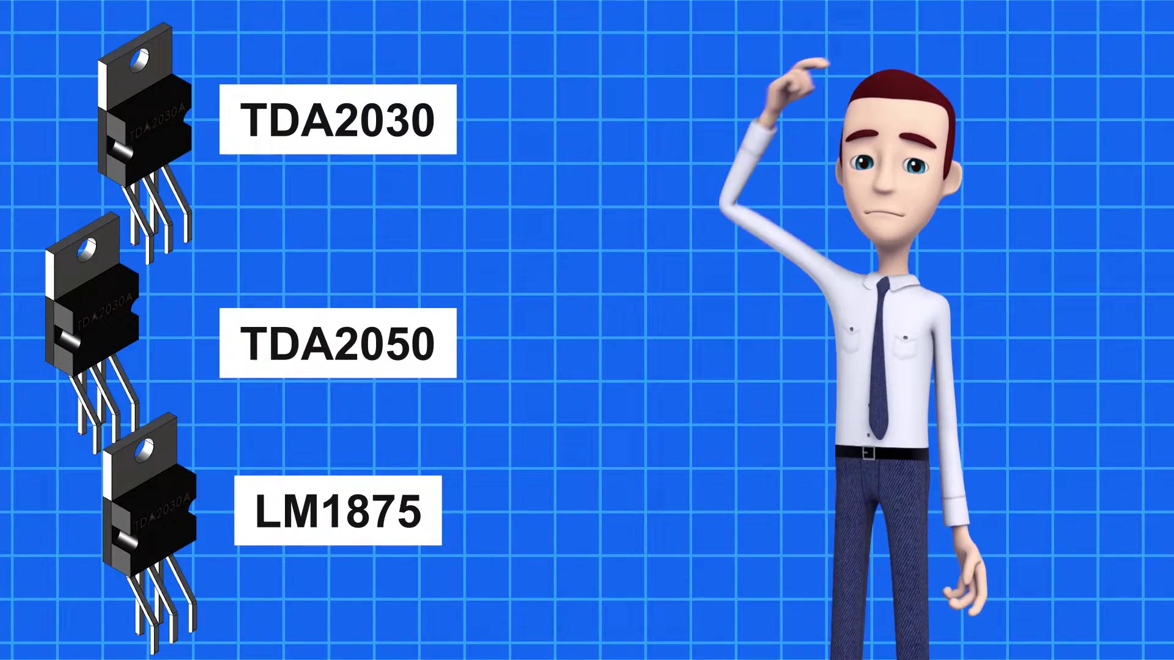 (score 95.0000)
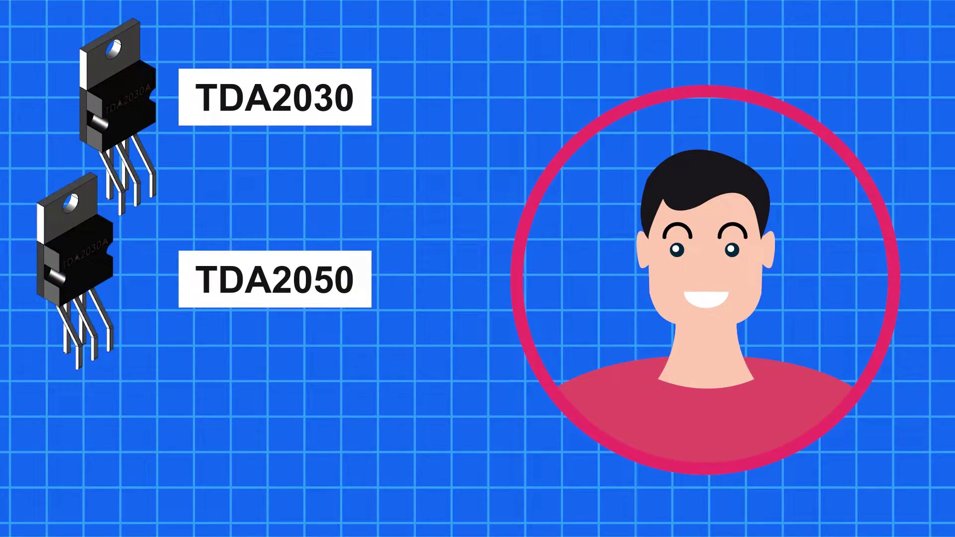 (score 95.0000)
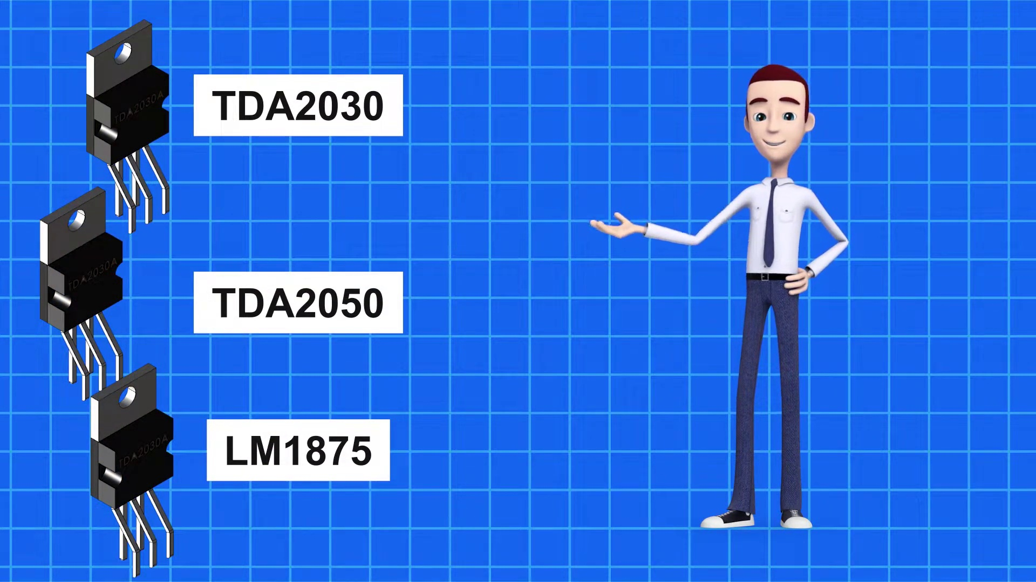 (score 95.0000)
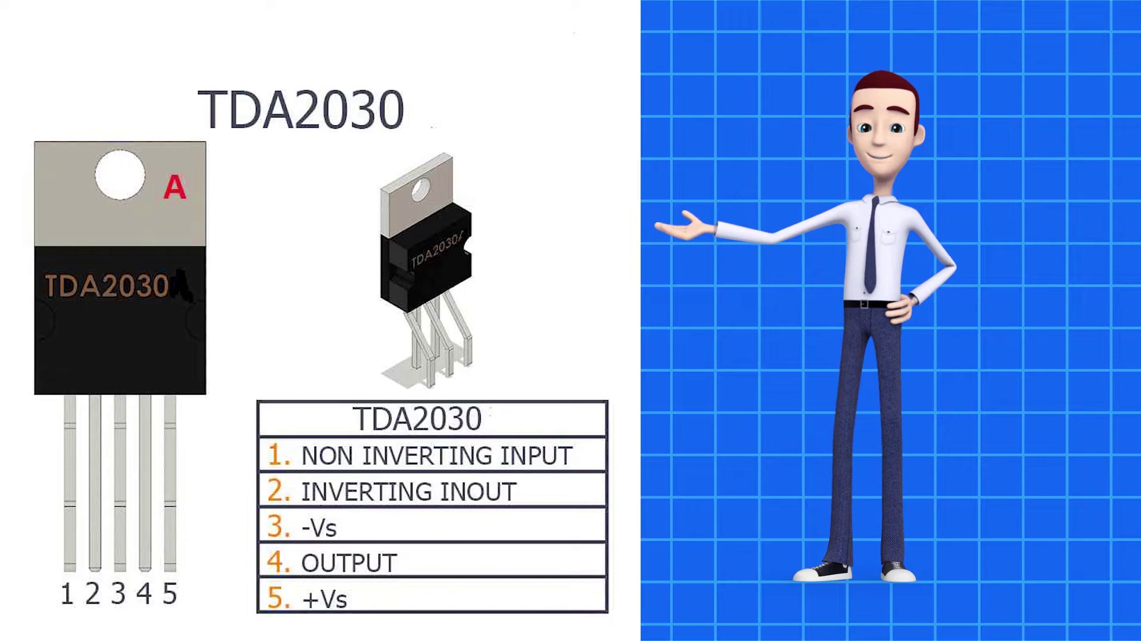 (score 90.0000)
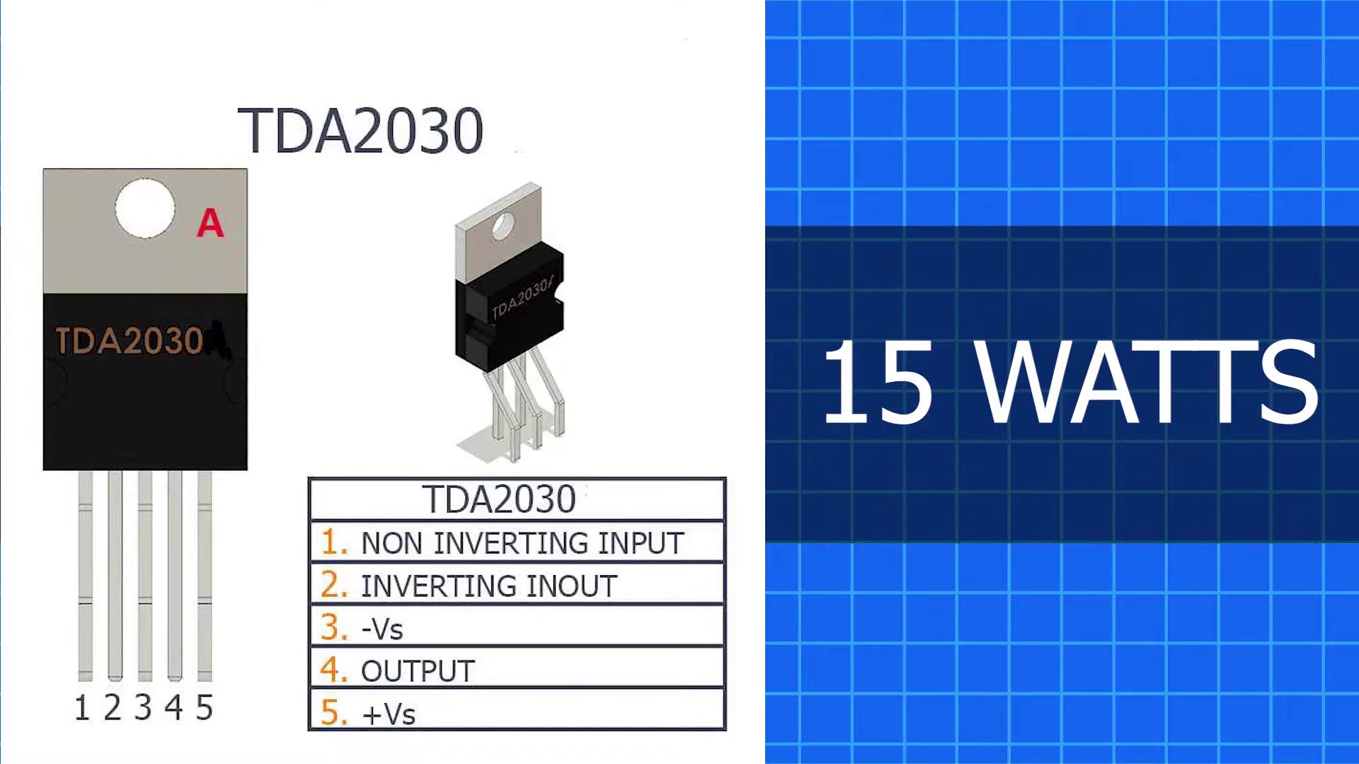 (score 90.0000)
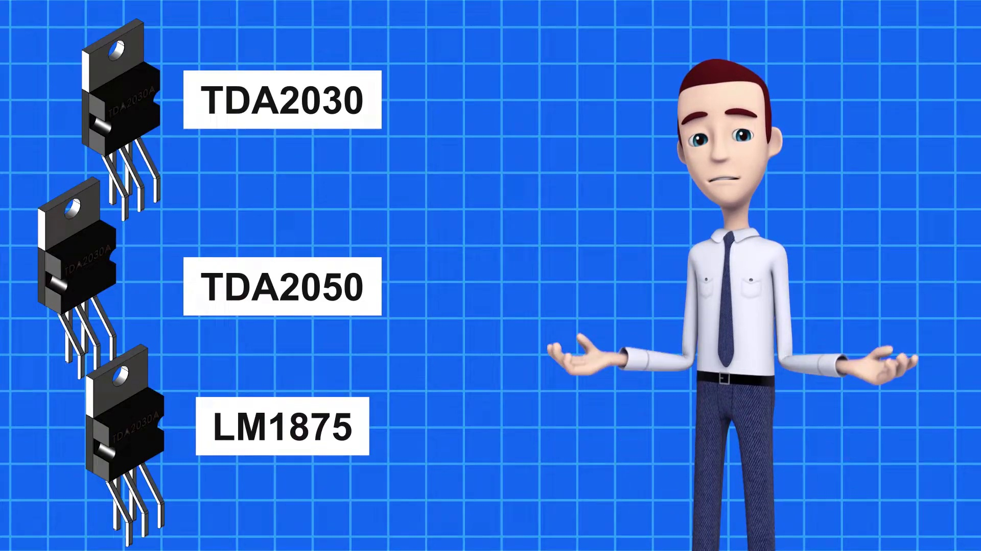 (score 90.0000)
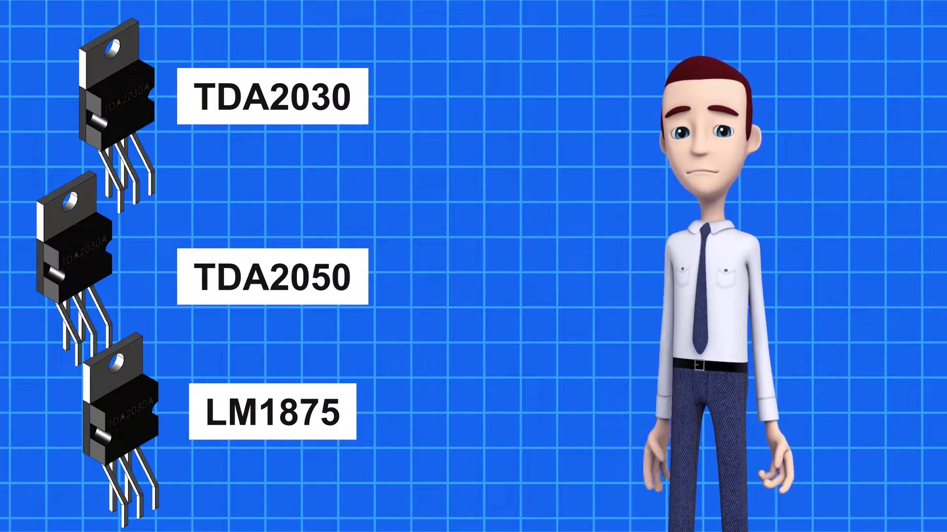 (score 90.0000)
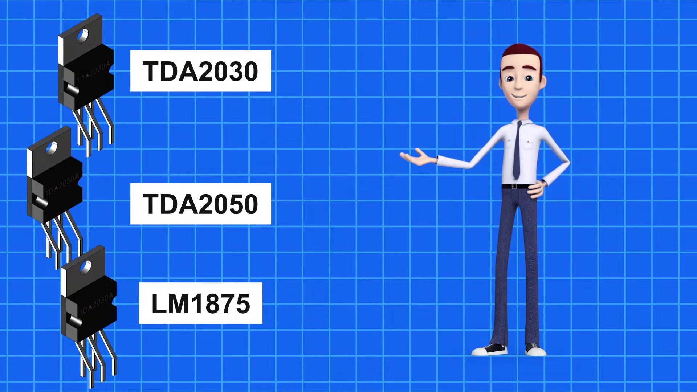 (score 90.0000)
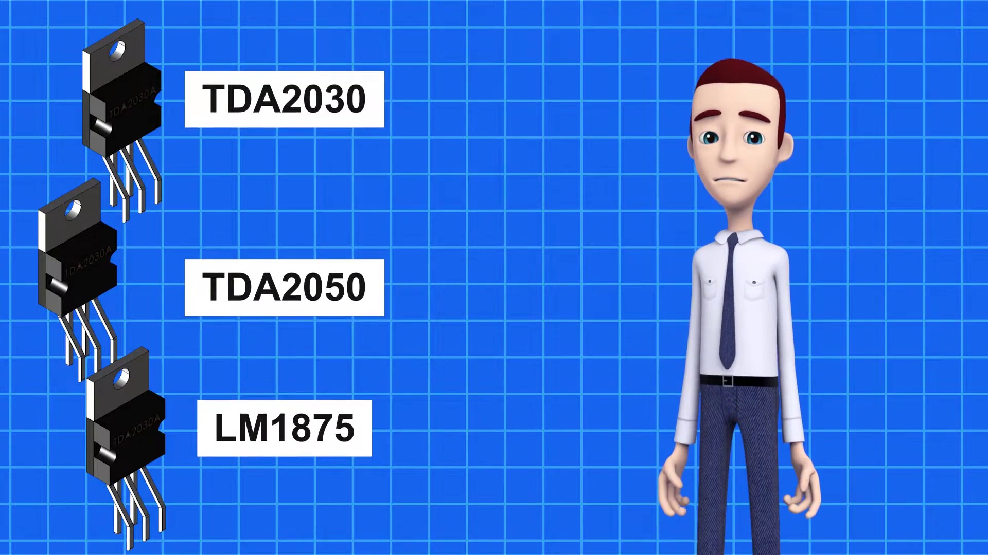 (score 90.0000)
Least correlated frames:
 (score 0.0000)
 (score 0.0000)
 (score 0.0000)
 (score 0.0000)
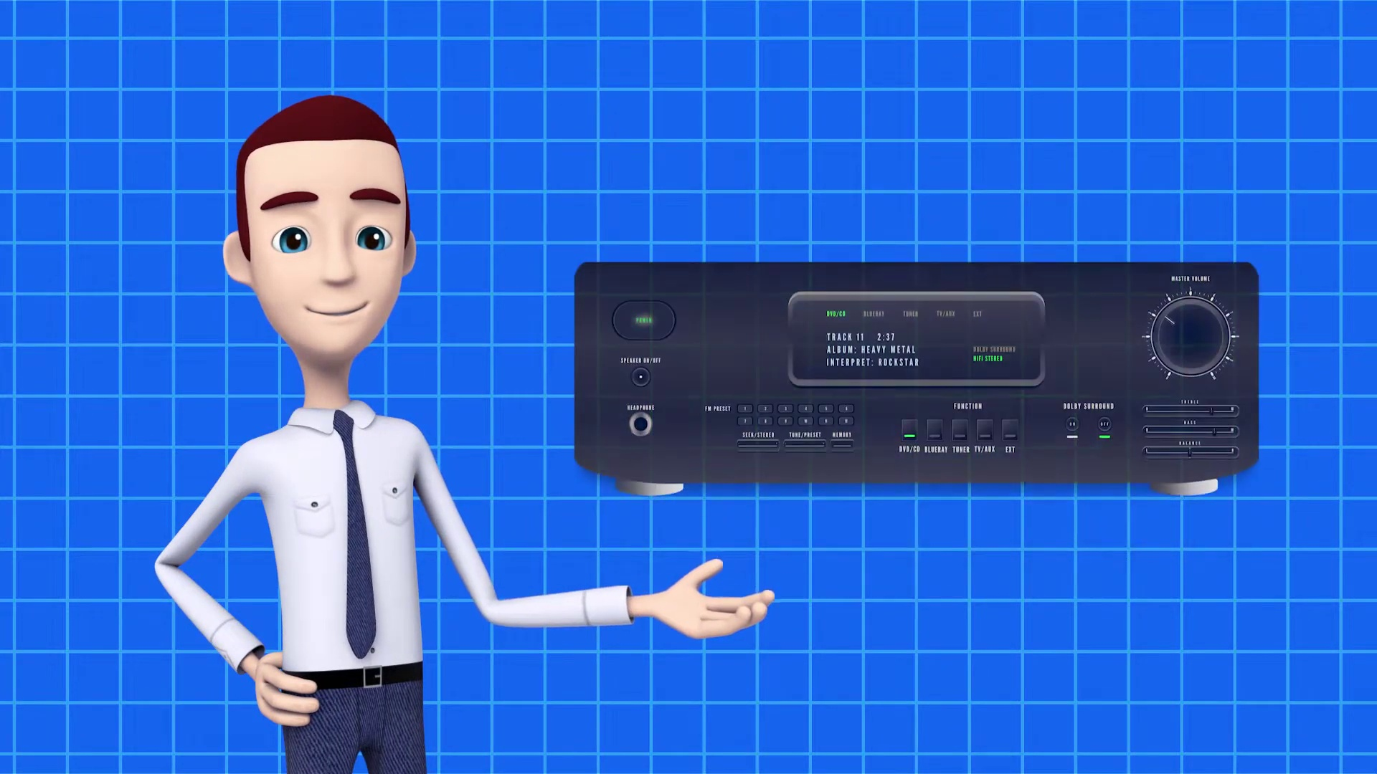 (score 0.0000)
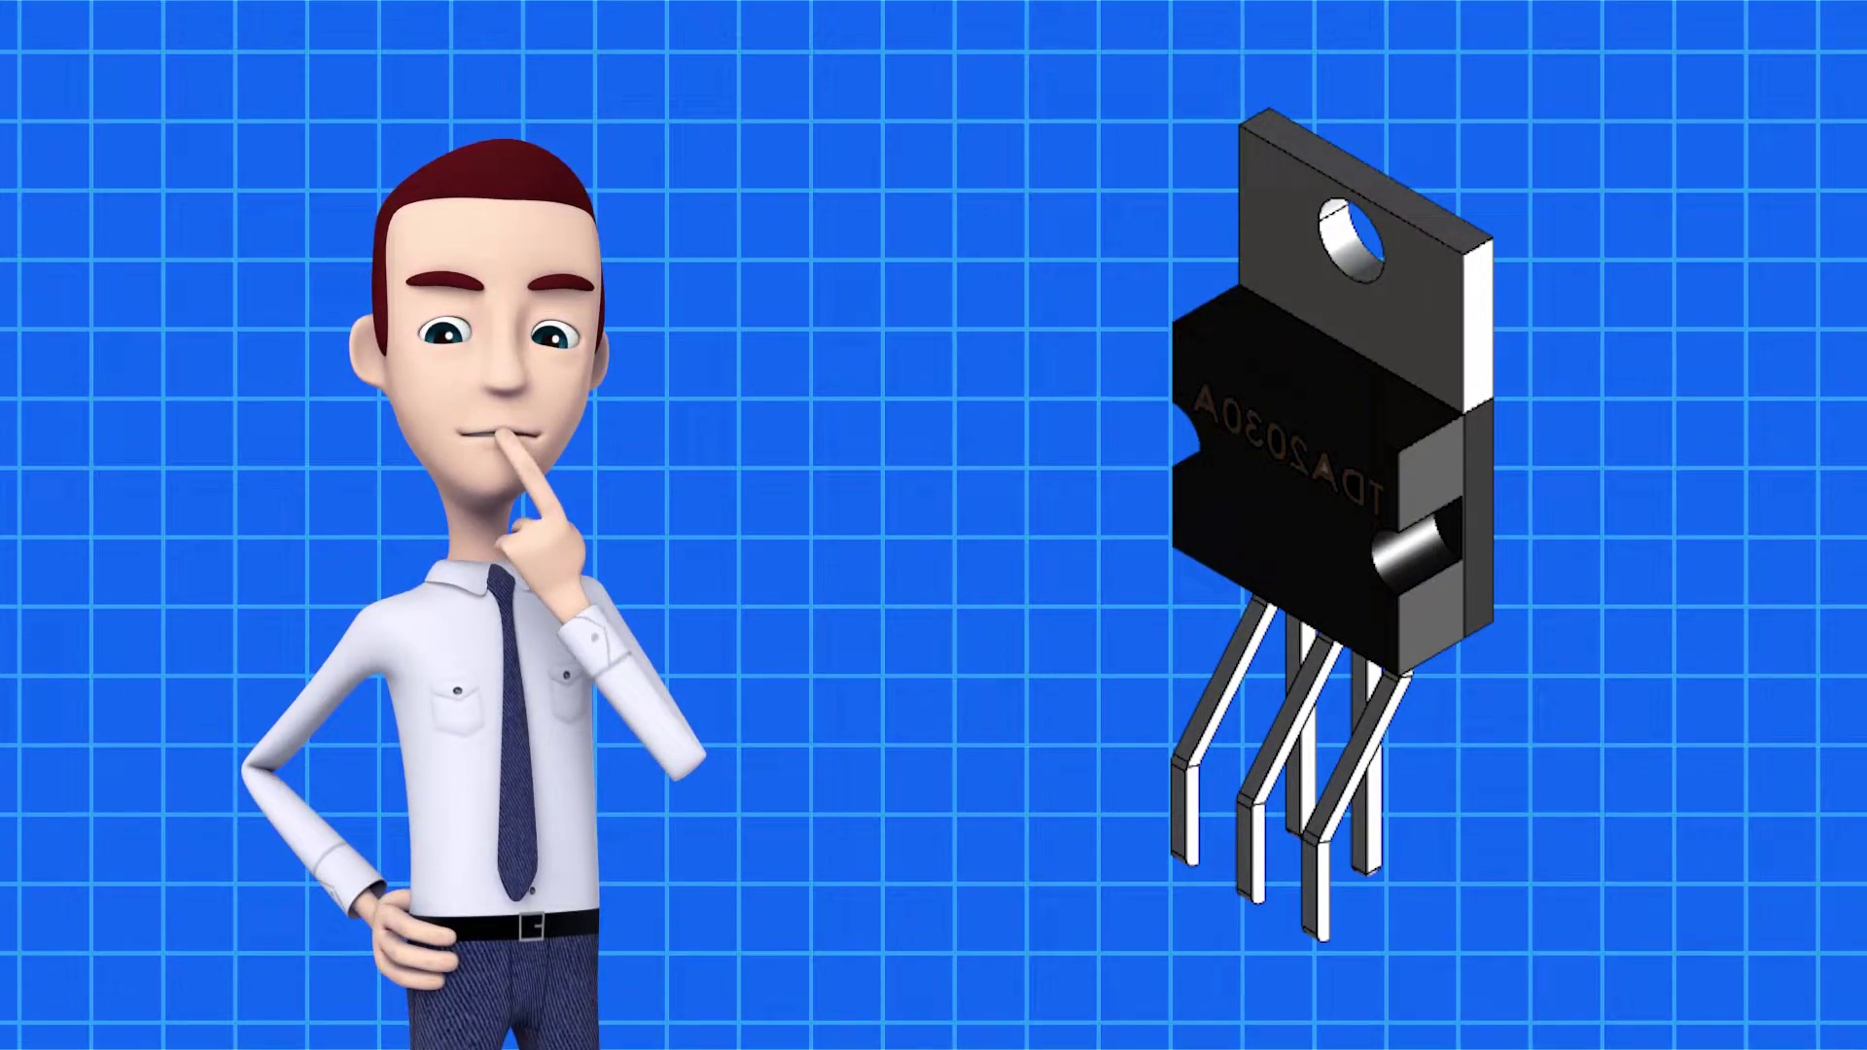 (score 0.0000)
 (score 0.0000)
 (score 0.0000)
 (score 0.0000)
 (score 0.0000)
- matched 33 frame(s), max score 95.0000: The power output of the TDA 2030 is 15W, 32W for the TDA 2050, and 20W for the LM1875.Most of the video was not in English, so I had to find a similar video that covered the same topics.
Source: https://www.youtube.com/watch?v=MEHVDGUP2Co&t=32s: TDA2030 VS TDA2050 VS LM1875 Which one is Best Amplifier IC ? Must Watch
Top correlated frames:
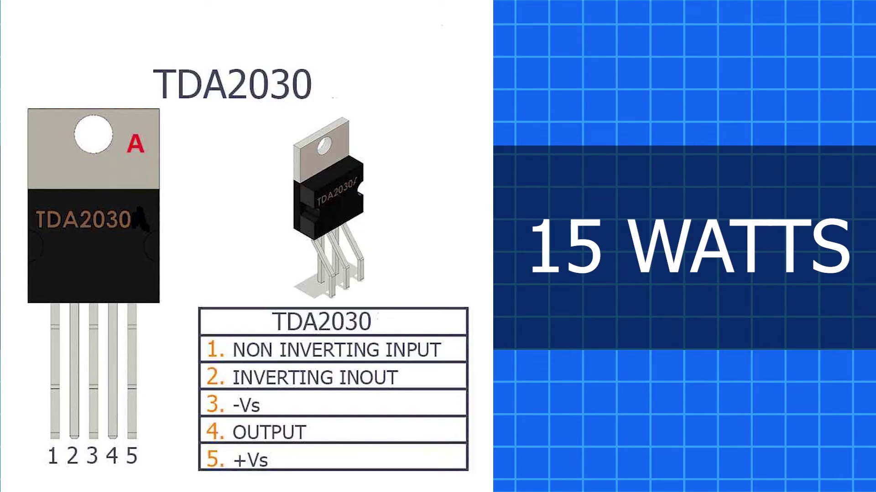 (score 95.0000)
 (score 95.0000)
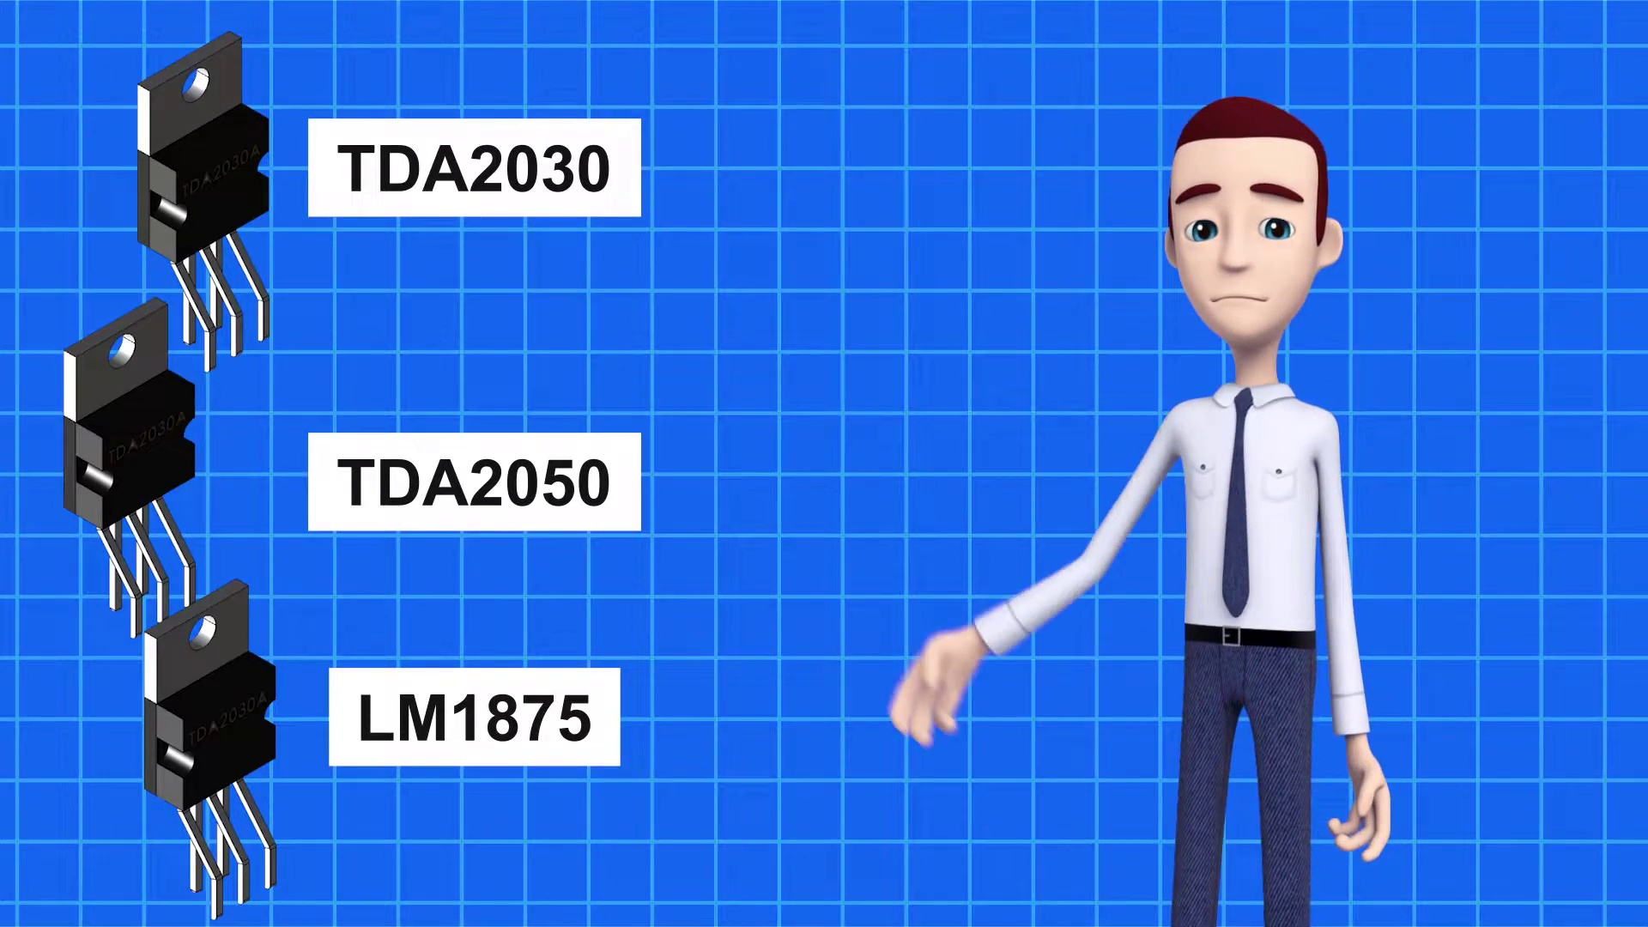 (score 95.0000)
 (score 95.0000)
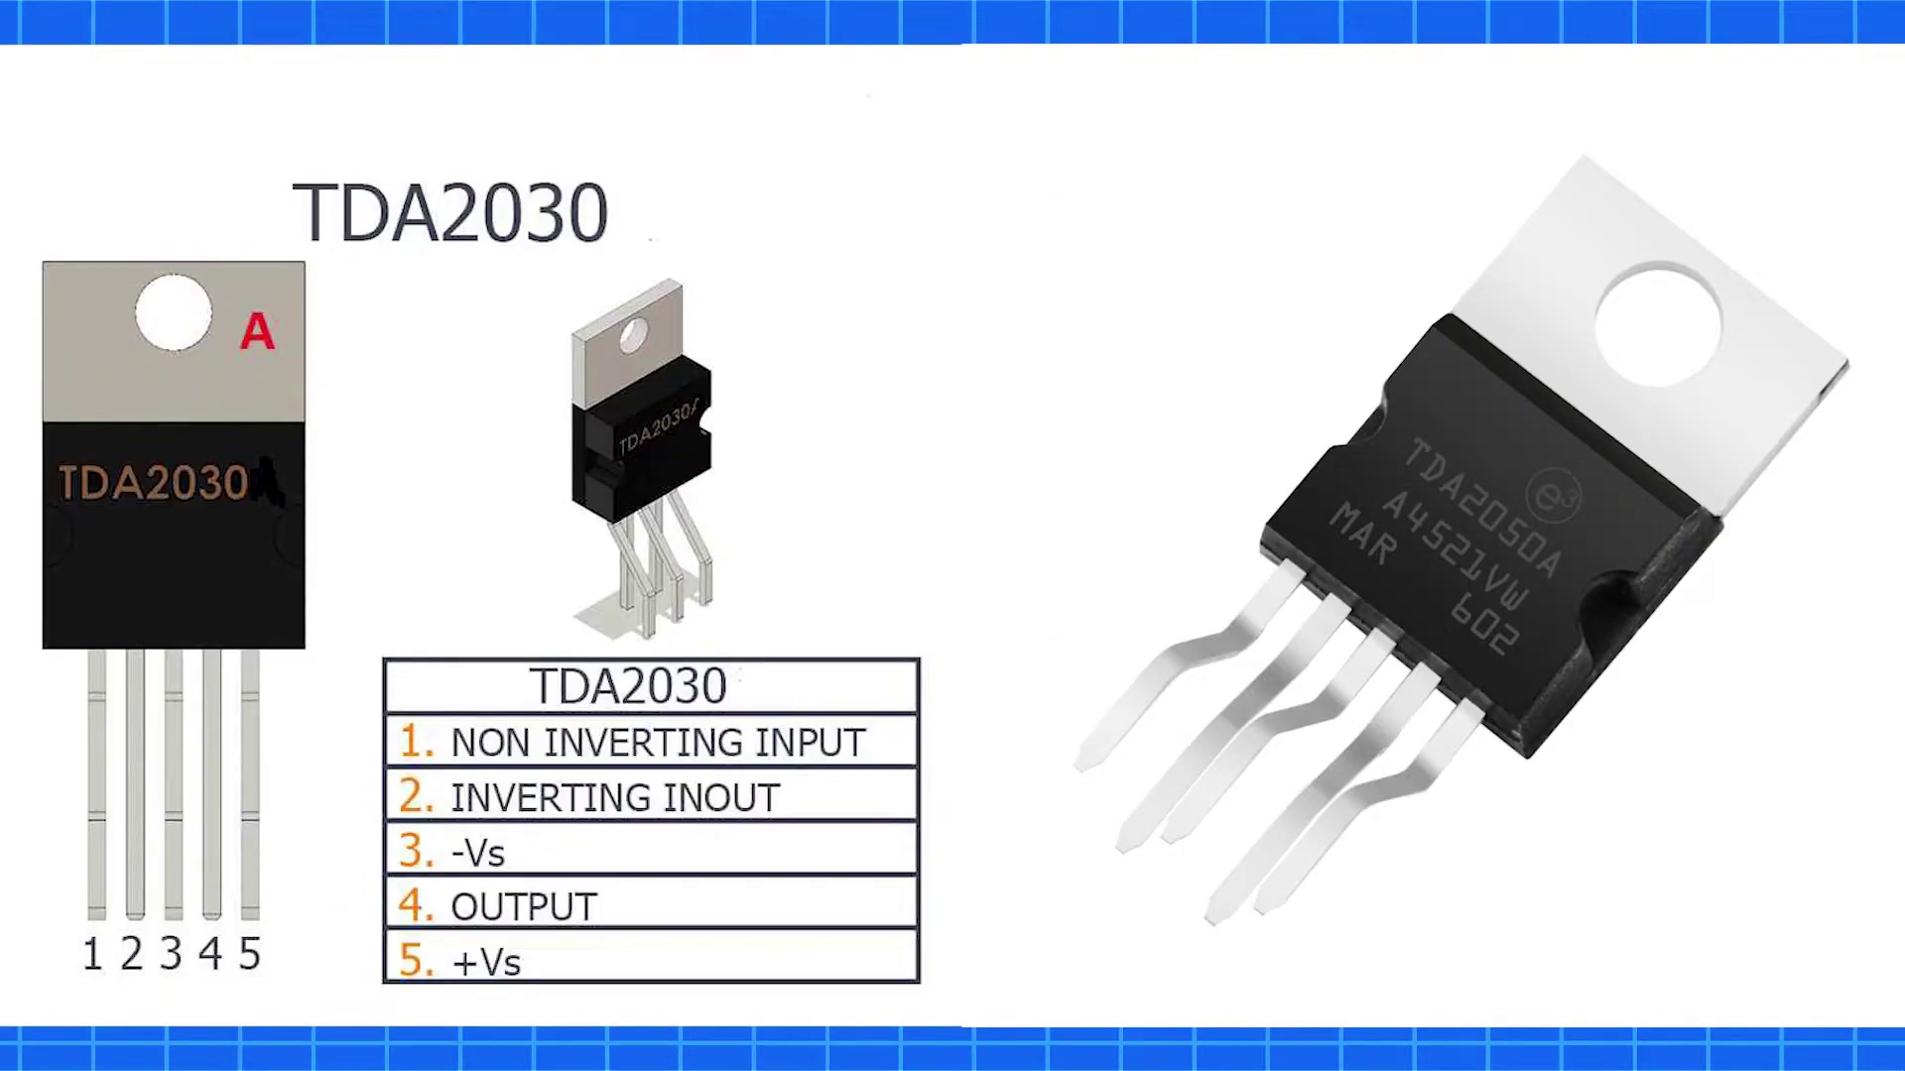 (score 90.0000)
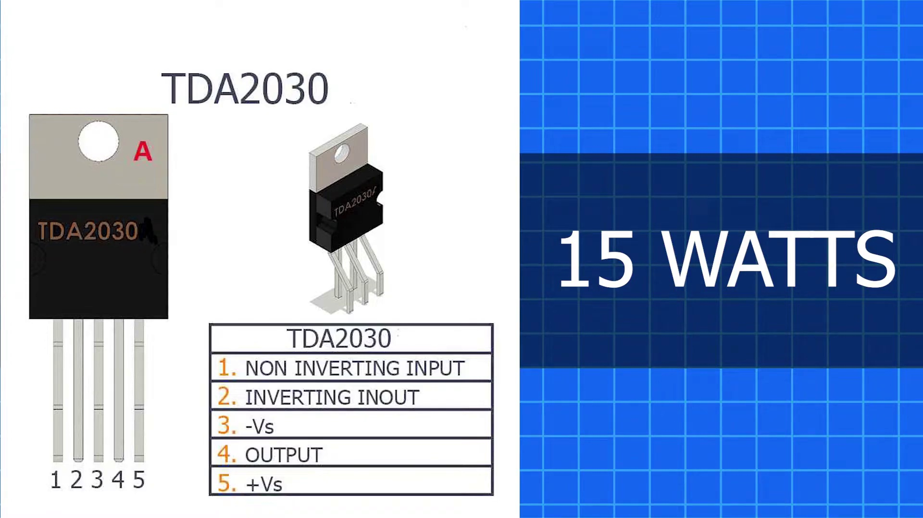 (score 90.0000)
 (score 90.0000)
 (score 90.0000)
 (score 90.0000)
 (score 90.0000)
Least correlated frames:
 (score 0.0000)
 (score 0.0000)
 (score 0.0000)
 (score 0.0000)
 (score 0.0000)
 (score 0.0000)
 (score 0.0000)
 (score 0.0000)
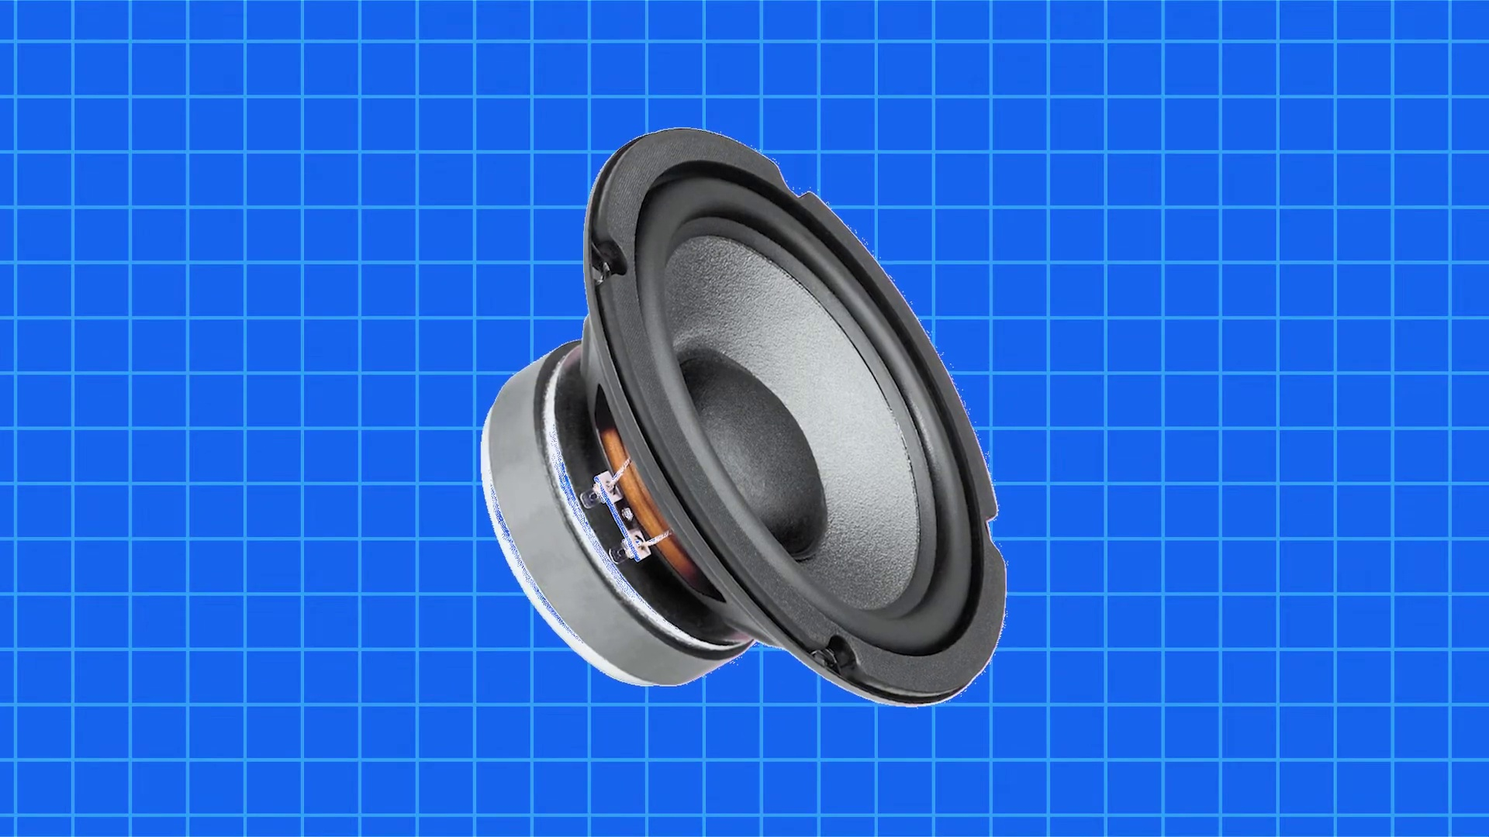 (score 0.0000)
 (score 0.0000)

Frame: frame_0000.jpg
Caption: The image presents a visually striking combination of contrasting elements. The majority of the slide features a dark blue background that transitions into black at the bottom, while on the left side, an inset image shows a person's face and upper body against a similar blue background. This inset image appears to capture the moment just before or during a projection or screen sharing on this particular slide.
The main slide itself contains text that seems to be related to a presentation on electrical engineering or a related field, as indicated by the visible symbols of "V" and "R," which commonly represent voltage and resistance in an electrical circuit respectively. Although the resolution of the image prevents the text from being fully readable, it appears to include equations or formulas relevant to electrical circuits or analysis.
The style of the slide is typical for educational presentations, with a clear separation between the content area and the inset photo of the presenter. The overall theme of the presentation suggests an academic or technical setting where concepts such as Ohm's law, circuit analysis, or related topics are being explained or demonstrated.
In contrast to the dark blue background, the presenter in the inset image seems unengaged, preparing for or already engaged in delivering the content of this particular slide. They do not appear to be writing, pointing, holding a model, or speaking from the slide.
No strongly correlated comments found for this frame.

Frame: frame_0001.jpg
Caption: The image appears to show a presentation or lecture environment with a focus on visual aid. In the foreground, an instructor is seen standing at a lectern, indicating that they are presenting to an audience. The background features a large blue screen with a partially visible slide on the right side, which contains what appears to be a diagram or graphic. However, due to the angle and focus on the instructor, the content of the slide is not clearly readable or distinguishable.
Despite the complexity of the presentation environment, the background remains simple, featuring only the large blue screen with the partially visible slide. The image does not contain any text or other elements that provide specific information about the content of the lecture or the identity of the instructor. However, the environment suggests an educational setting, possibly a university or college classroom, where lectures or seminars are conducted for students.
In contrast to the complexity of the presentation environment, the background features a simple blue geometric shape, specifically a square, which is positioned centrally and outlined in white against a dark blue background. The square stands out prominently against the dark blue background, providing a stark contrast that creates visual interest.
No strongly correlated comments found for this frame.

Frame: frame_0002.jpg
Caption: The image features a computer monitor displaying a graphic design with a predominantly dark background, prominently centered with a circular logo that contains a white outline of the stylized letter 'T' within it, accompanied by a partial depiction of an eye. This suggests technology or tech mentoring. To the left of the monitor, there appears to be a person with the lower body and feet visible against a darker background, but they are not interacting with the content on the screen. The person seems to be sitting in a room with low lighting.
The screen itself displays a website or digital platform interface with text elements and possibly additional graphics or icons that are too small to discern clearly. There is no visible text or writing on the screen, making it impossible to determine the context of the instructional content without clearer visuals. The overall setting suggests an educational or informational context, perhaps related to technology or mentoring services, as indicated by the logo.
The blue logo, prominently displaying the letters "T Tech Mentor", is centered on the black background, creating a strong visual impact. The letters are in white, making them stand out against the dark background. This design choice creates a contrast that makes the logo more visible and memorable, suggesting a professional and modern branding for the T Tech Mentor company. The simplicity of the design with just the logo and the company name allows for a clear and direct message to be conveyed.
No strongly correlated comments found for this frame.

Frame: frame_0003.jpg
Caption: The image appears to show a computer screen displaying a large, square grid of blue squares, each filled with a light blue gradient. The grid is set against a solid gray background, which creates a stark contrast between the bright blue and dull gray colors. The squares are evenly spaced and aligned horizontally, giving the grid a sense of order and symmetry. The focus of the image appears to be solely on the visual content, which consists of a repetitive pattern of blue squares without any additional context provided by other elements in the frame.
No strongly correlated comments found for this frame.

Frame: frame_0004.jpg
Caption: The image shows a 3D animated male character standing in front of a blue background with a grid-like pattern and numbers. The character, dressed in a white shirt, dark gray suit, and tie, has short brown hair and appears to be facing the viewer directly. His right hand is raised confidently, while his left hand is casually tucked into his pocket. The character's face is turned to the right, conveying directness and engagement.
The blue background adds depth to the image, providing a stark contrast to the character's professional attire. On the screen, there appears to be a diagram with lines and numbers that are likely related to the instruction or explanation being given. The text on the screen is not fully visible, but it seems to be part of an educational presentation possibly related to physics, math, or engineering concepts.
The instructor or presenter appears to be gesturing with their hands in a way that suggests they are explaining something or giving instructions. However, no visible text provides context about the topic or instructor's name. The overall setting suggests an educational video where a presenter is teaching or explaining a concept.
No strongly correlated comments found for this frame.

Frame: frame_0005.jpg
Caption: The image presents a 3D animated scene set against a blue background. At the center of the image, an instructor is animatedly pointing at a projection screen that displays a vibrant landscape dominated by a majestic mountain range with a sun peeking over the top, casting a warm glow on the scene. The instructor is dressed in a suit and tie, adding a professional touch to the scene. The overall image gives a sense of motion and energy, with the instructor's animated gesture and the dynamic landscape. The projection screen displays the text "Mountain Climbing," indicating that the instructor might be discussing this topic. The style of the image is consistent with educational materials, specifically those used in online or distance learning environments. The background behind the presentation screen has a grid pattern, suggesting it could be a digital backdrop or a projection on a whiteboard.
No strongly correlated comments found for this frame.

Frame: frame_0006.jpg
Caption: The image shows two 3D animated characters, one appearing to be an instructor standing in front of a blue background with grid lines. The instructor is dressed in a lab coat, suggesting a theme related to science education, and is pointing towards a large graphic of a magnifying glass over a transparent sheet with various scientific or educational equipment. To the right of the instructor is a cartoon man wearing a white shirt and red tie, standing on a blue grid pattern. His face is turned towards the camera, looking directly at the viewer, and he is wearing a black belt with a silver buckle.
The background for both characters is a solid blue, providing a stark contrast to their attire. The instructor's position and the graphic behind them suggest they might be conducting a demonstration or explanation related to science or microscopy as part of an online educational platform or resource. In contrast, the man in the background appears to be in an office setting, possibly a workspace or laboratory, with no visible text providing additional context or information about his actions or purpose.
The image does not contain any other objects or characters, and while it provides some details about the settings and attire of the two characters, it does not provide explicit information about their professions, the purpose of the grid patterns, or the man's specific actions.
No strongly correlated comments found for this frame.

Frame: frame_0007.jpg
Caption: The image displays an animated scene that seems to be educational in nature. On the left side of the image, there is a humanoid figure with blue jeans and a brown shirt, standing next to four electronic devices labeled "TDDA300." Each device has a unique appearance but resembles a black box with a control interface on its top face.
On the right side, an illustrated character stands against a light blue background with a grid pattern, suggesting a technical or factory setting. The character is depicted with a speech bubble containing the text "DA200," which could imply it's a different model or version of the devices.
In the image, a man dressed in a blue shirt and black pants holds a white paper labeled "TDA2050" in his hand. He stands on a blue background with a grid pattern, providing a stark contrast to his attire and making him stand out in the image. A white rectangular label reading "TDA2050" is situated in the top left corner of the image, likely serving as a product identifier or description of the model.
Two other rectangular labels are present, one in the top right corner and another in the bottom right corner; however, their content is not visible in the image. The overall style of the image is cartoonish and colorful, with a focus on simplicity and clarity for educational purposes.
Comment (score 80): The power output of the TDA 2030 is 15W, 32W for the TDA 2050, and 20W for the LM1875.Most of the video was not in English, so I had to find a similar video that covered the same topics.
Reason: The comment directly discusses the power output of specific devices (TDA 2030, TDA 2050, LM1875) which are mentioned in the caption as 'TDDA300' and 'TDA2050'. The mention of similar video covering same topics also indicates a strong connection to the educational nature of the image.
Source: https://www.youtube.com/watch?v=MEHVDGUP2Co&t=32s: TDA2030 VS TDA2050 VS LM1875 Which one is Best Amplifier IC ? Must Watch
Comment (score 80): The power output of the TDA 2030 is 15W, 32W for the TDA 2050, and 20W for the LM1875.Most of the video was not in English, so I had to find a similar video that covered the same topics.
Reason: The comment directly discusses the power output of specific models (TDA2030, TDA2050, LM1875) mentioned in the caption, which strongly relates to the technical steps and objects described in the image.
Source: https://www.youtube.com/watch?v=MEHVDGUP2Co&t=32s:

Frame: frame_0008.jpg
Caption: The image features two scenes merged together, depicting a person standing in front of four black televisions displaying different white labels with text and numbers indicating their model numbers. The first television on the left has the label "TA DA 203", suggesting this is the title or model name for that particular TV. The person appears to be presenting or demonstrating these televisions, dressed casually in a white t-shirt and dark pants, with short hair.
The background of the illustration is a blue grid, which could be a visual aid for the instructional context. To the right of the illustration, there's a text reading "TA DA 203", likely indicating the title or model name of the first television on the left.
On the opposite side of the image, a man in professional attire stands against a blue background. He is holding a white business card labeled with the text "TDA2030". On his right side, there's another white rectangular box labeled "TDA2030", and on the left side, a similar box with the same label "TDA2030" appears.
The man's attire includes a white shirt and black tie, both labeled with the text "TDA2050". Another rectangular box with the same label "TDA2050" is present on the right side. The image overall conveys a professional and technical atmosphere, possibly related to electronics or tech products.
Comment (score 80): The power output of the TDA 2030 is 15W, 32W for the TDA 2050, and 20W for the LM1875.Most of the video was not in English, so I had to find a similar video that covered the same topics.
Reason: The comment directly mentions specific technical details (power output) and device labels (TDA 2030, TDA 2050, LM1875) that are also present in the caption. The mention of a similar video covering the same topics suggests a focus on electronics or tech products, aligning with the professional and technical atmosphere depicted in the image.
Source: https://www.youtube.com/watch?v=MEHVDGUP2Co&t=32s: TDA2030 VS TDA2050 VS LM1875 Which one is Best Amplifier IC ? Must Watch

Frame: frame_0009.jpg
Caption: This image appears to show a professional individual standing in front of a simple blue background with no visible text, except for the labels on the devices. The person is dressed in a suit and tie, holding a white business card rectangularly shaped, and pointing towards three objects labeled TDA2030, TDA2050, and LM1875. These objects are likely related to electronics or technology given the "T" and "L" designations, which are often used in industry to denote various types of electronic components or devices.
In a separate area, another individual is standing next to a series of electronics equipment labeled as follows:
1. "TD-A303"
2. "LM1875"
3. "DA-500"
4. "LD-M1865"
5. "LDM-1895"
The equipment seems to be some kind of electronics, possibly related to audio equipment or amplifiers, given the 'A', 'D', and 'M' designations. The environment is a simple blue background with a white grid pattern, focusing attention on the equipment and the individual's explanation. There are no visible texts other than the device labels.
Comment (score 95): The power output of the TDA 2030 is 15W, 32W for the TDA 2050, and 20W for the LM1875.Most of the video was not in English, so I had to find a similar video that covered the same topics.
Reason: The comment directly discusses the technical specifications of the devices mentioned in the caption (TDA2030, TDA2050, and LM1875), specifically their power output. This is a strong connection to the frame caption, which describes these devices and their likely relevance to electronics or technology.
Source: https://www.youtube.com/watch?v=MEHVDGUP2Co&t=32s: TDA2030 VS TDA2050 VS LM1875 Which one is Best Amplifier IC ? Must Watch
Comment (score 95): The power output of the TDA 2030 is 15W, 32W for the TDA 2050, and 20W for the LM1875.Most of the video was not in English, so I had to find a similar video that covered the same topics.
Reason: The comment directly discusses the technical specifications of the devices (TDA2030, TDA2050, LM1875) mentioned in the caption, indicating a strong correlation between the two.
Source: https://www.youtube.com/watch?v=MEHVDGUP2Co&t=32s:

Frame: frame_0010.jpg
Caption: The image appears to show an animated scene with an instructional theme. In the foreground, there is an animated figure of a man standing behind three black boxes labeled "TDDA203," "DA205," and "LM186." To the right of the boxes, there is a label that reads "LMP 780." The man seems to be gesturing towards one of the black boxes, perhaps indicating a particular feature or function.
To the right of the man, there is a blue grid on which more black boxes are placed. One of these boxes prominently displays the number "TDDA201." In the background, four additional smaller black boxes labeled with numbers - "DA203," "DA204," "DA205," and "DA206" - can be seen.
The man in the foreground is dressed casually, unlike the suit-and-tie attire of a professional setting. The computer monitor displaying three text boxes to his right, labeled as "TDA2030", "TDA2050", and "LM1875", suggests that this could be a classroom or lecture hall environment where electronic devices or components related to TDA (Thermal-Electric Data Acquisition) are being discussed or demonstrated. The instructor possibly explaining how these devices work or what they do, with the blue gradient background providing a neutral backdrop for the scene.
Comment (score 95): The power output of the TDA 2030 is 15W, 32W for the TDA 2050, and 20W for the LM1875.Most of the video was not in English, so I had to find a similar video that covered the same topics.
Reason: The comment directly discusses the power output of specific devices mentioned in the caption (TDA 2030, TDA 2050, and LM1875), which are the same technical steps and objects described in the caption.
Source: https://www.youtube.com/watch?v=MEHVDGUP2Co&t=32s: TDA2030 VS TDA2050 VS LM1875 Which one is Best Amplifier IC ? Must Watch
Comment (score 80): The power output of the TDA 2030 is 15W, 32W for the TDA 2050, and 20W for the LM1875.Most of the video was not in English, so I had to find a similar video that covered the same topics.
Reason: The comment directly discusses specific technical details (power output) mentioned in the caption (TDA 2030, TDA 2050, and LM1875), indicating a strong connection between the two.
Source: https://www.youtube.com/watch?v=MEHVDGUP2Co&t=32s:

Frame: frame_0011.jpg
Caption: In the image, an animated character standing to the right gestures towards a line of four devices that resemble computer monitors. The devices are labeled "TDA203", "LMDA400", "LMDA600", and "LMDA800". Each label has a different number indicating a model or type of device. A small black object with the text "LMDA150" is held up by the character, suggesting that this is also part of the product line being discussed.
In the background, a blue grid pattern is featured, commonly associated with technical schematics or diagrams, which supports the educational context of the image. There is no visible text in the image to provide additional information about the content being taught. The character's gestures and the device labels imply that the focus is on these devices and their characteristics.
Notably absent from the image are any other objects or text that could provide further context or information about the products or their applications.
Comment (score 90): The power output of the TDA 2030 is 15W, 32W for the TDA 2050, and 20W for the LM1875.Most of the video was not in English, so I had to find a similar video that covered the same topics.
Reason: The comment directly discusses the power output of specific devices (TDA2030, TDA2050, LM1875) mentioned in the caption, which are labeled as computer monitors. The only slight mismatch is that the video was not entirely in English, but the comment still focuses on the same technical topics described in the caption.
Source: https://www.youtube.com/watch?v=MEHVDGUP2Co&t=32s:
Comment (score 80): The power output of the TDA 2030 is 15W, 32W for the TDA 2050, and 20W for the LM1875.Most of the video was not in English, so I had to find a similar video that covered the same topics.
Reason: The comment directly discusses the power output of specific devices mentioned in the caption (TDA203, TDA2050, LM1875), which are the same devices labeled in the image. The comment also mentions the video topic being similar to the one shown in the image, further supporting a strong correlation.
Source: https://www.youtube.com/watch?v=MEHVDGUP2Co&t=32s: TDA2030 VS TDA2050 VS LM1875 Which one is Best Amplifier IC ? Must Watch

Frame: frame_0012.jpg
Caption: The image appears to be an illustration or digital rendering rather than a photograph, depicting an animated figure standing in front of a blue background with a grid pattern resembling a pinboard or bulletin board. In the foreground, there are four images of electronic devices or gadgets, each labeled with a numerical value and label: "TDA300," "LMI186," "MDA205," and "LD1189." Each device is accompanied by an image of a black briefcase.
The animated character in the center, resembling a human figure but lacking facial features, has its hands outstretched as if gesturing or presenting. The character is positioned between two of the devices and is facing towards them, possibly indicating their significance or role.
In the background, there appears to be a blue screen displaying three objects: a red TDA2030, a blue TDA2050, and a black LM1875. A man is standing in front of this screen, holding a white paper that reads "TDA2030". The background of the image features a blue color with white text.
The style of the image suggests an educational or teaching context, possibly illustrating different models or variants of a product line. However, without additional context, it is not possible to provide a detailed explanation of the content or its implications.
Comment (score 80): The power output of the TDA 2030 is 15W, 32W for the TDA 2050, and 20W for the LM1875.Most of the video was not in English, so I had to find a similar video that covered the same topics.
Reason: The comment directly discusses the technical specifications of the devices mentioned in the caption (TDA2030, TDA2050, and LM1875), matching the descriptive language used in the caption.
Source: https://www.youtube.com/watch?v=MEHVDGUP2Co&t=32s: TDA2030 VS TDA2050 VS LM1875 Which one is Best Amplifier IC ? Must Watch
Comment (score 80): The power output of the TDA 2030 is 15W, 32W for the TDA 2050, and 20W for the LM1875.Most of the video was not in English, so I had to find a similar video that covered the same topics.
Reason: The comment directly discusses the power output of the TDA2030, TDA2050, and LM1875 devices, which are specifically mentioned in the caption. The mention of finding a similar video to cover the same topics also shows a connection between the comment and the caption.
Source: https://www.youtube.com/watch?v=MEHVDGUP2Co&t=32s:

Frame: frame_0013.jpg
Caption: The image displays an animated character standing in front of a blue screen with a grid pattern. To the left, there are five electronic devices mounted on what appears to be a wall-mounted rail system, each labeled with a unique code: "TDA035," "TDA036," "TDA037," "TDA038," and "TDA039." These labels suggest that the items could be technology demonstration areas or test stations.
In the foreground, the character in blue shirt and black pants is standing with his hands at his sides facing away from the viewer. His presence suggests that he might be an instructor, presenter, or demonstrator within the context of this image. The character is not shown interacting with any device or model, nor does he seem to be writing or speaking from a slide.
In contrast, the man standing in front of another blue background is holding a small electronic component in his right hand, marked with the letters "TDA2030" and "TDA2050". The components he holds are arranged vertically on either side of him. Behind him, there are three other electronic components labeled with the letters "LM1875", arranged horizontally.
The man's position in relation to these components suggests that he is examining their functionality or characteristics, possibly within a study or work environment related to electronics or computer science.
Comment (score 90): The power output of the TDA 2030 is 15W, 32W for the TDA 2050, and 20W for the LM1875.Most of the video was not in English, so I had to find a similar video that covered the same topics.
Reason: The comment directly discusses the power output of specific devices (TDA2030, TDA2050, and LM1875) mentioned in the caption, which is a technical detail described in the frame. The mention of finding a similar video to cover the same topics also supports the connection.
Source: https://www.youtube.com/watch?v=MEHVDGUP2Co&t=32s: TDA2030 VS TDA2050 VS LM1875 Which one is Best Amplifier IC ? Must Watch
Comment (score 90): The power output of the TDA 2030 is 15W, 32W for the TDA 2050, and 20W for the LM1875.Most of the video was not in English, so I had to find a similar video that covered the same topics.
Reason: The comment directly discusses the technical specifications of the electronic components shown in the frame caption (TDA2030, TDA2050, and LM1875), which are also mentioned in the caption as being labeled on the devices. The comment's mention of the video not being in English and finding a similar video to cover the same topics further supports the strong correlation between the comment and caption.
Source: https://www.youtube.com/watch?v=MEHVDGUP2Co&t=32s:

Frame: frame_0014.jpg
Caption: This three-dimensional rendering features a cartoonish and simplistic design, likely intended for digital use or as part of an animated character. The scene depicts a person standing to the right with their hand pointing towards a graphic on a display or screen. The graphic shows a landscape with a mountain and a sunset, suggesting it could be related to nature, geography, or travel topics. A cartoon man is standing next to the projection screen, dressed in a white shirt and a black tie, with his hand on his chin, indicating thought or contemplation. The projection screen itself is a vibrant blue with a cartoon image of a mountain range displayed on it, rendered in shades of orange and yellow, with the sun, a bright yellow circle, in the background. There are no visible texts or diagrams in this image that provide specific information or instructions about the content being taught. The man and the projection screen are the only objects in the image, with the relative position suggesting he is in front of it, possibly giving a presentation or discussing the image on the screen.
No strongly correlated comments found for this frame.

Frame: frame_0015.jpg
Caption: This image depicts a 3D animated character, a humanoid figure standing on a blue background with a grid pattern. The character is dressed in casual attire, wearing a blue shirt and a red tie. He is posing with one hand pointing to the right, suggesting an action or direction. His face is turned to the right, his eyes are closed, and his mouth is open, indicating a smile. The character's posture and facial expression convey a friendly and approachable demeanor. Standing against this blue grid background, which resembles a presentation board or dry-erase board commonly used in educational settings, the character appears to be giving a lecture or explanation, as suggested by his gesture and setting. Although there is no visible text, diagrams, or other elements within the frame that would provide additional context or information about the content of the presentation or lecture, the image captures a moment where the character might be addressing an audience or explaining something on the tiled background.
No strongly correlated comments found for this frame.

Frame: frame_0016.jpg
Caption: The image features an animated 3D scene with a male character standing in front of a blue screen background that suggests a digital or instructional setting. The character, dressed in a white shirt, dark pants, and black shoes, is holding up his fingers to signal "two" or "a couple" using American Sign Language (ASL). On his right side, there is a circular green checkmark with a white tick inside, which is often used to indicate "approved," "correct," or "positive feedback" within the context of teaching or instructional content.
The character is pointing up, and the check mark symbol is in the background. The overall style of the image suggests a friendly and informative tone, commonly used in educational materials, tutorials, or instructional content to convey the message "this is correct" or "approved." The grid pattern on the blue screen behind the character may imply that the setting is a virtual classroom or an interactive teaching environment.
No strongly correlated comments found for this frame.

Frame: frame_0017.jpg
Caption: The image features an animated character resembling a humanoid robot standing in front of a stylized blue background, with a friendly appearance and a smiling face. The robot is wearing a light-colored shirt, dark pants, and a name tag that reads "Robo." It is gesturing towards a large digital device on its left side, which appears to be an oversized version of a modern stereo system or home theater setup. The device features a control panel with buttons and knobs, as well as a display screen showing what seems to be an audio waveform or playback interface.
To the right of the robot, there is a blue grid backdrop that suggests a technical or educational setting. In contrast, a 3D animated man in a white shirt and blue tie stands in front of a black stereo equipment on the opposite side of the image. The stereo equipment is turned on, and the man is pointing at the screen of the equipment, which displays a blue background with white text and symbols. Although the text and symbols are not clear from the image, they seem to be related to the audio equipment or home entertainment system being depicted. The man is also wearing a black belt, adding to the overall technical or instructional feel of the scene.
No strongly correlated comments found for this frame.

Frame: frame_0018.jpg
Caption: This digital image features a 3D animated character standing to the right of a blue screen with grid lines. The character appears to be male, dressed in casual attire, with short hair and wearing a white shirt with a dark tie. He seems to be presenting or teaching, as he is gesturing towards an object on the screen with his left hand extended outwards.
On the blue screen, there is a graphical representation of a 3D printer. The printer is depicted in profile view with a build area on top and a base at the bottom. The printer has a nozzle and appears to be ready for printing. There are also visible instructions or settings on the left side of the image, including what looks like a temperature setting panel, but the text is not entirely clear due to the angle and resolution of the image.
The character is dressed in a white shirt and blue pants, wearing a red tie. He is holding a blue object, which appears to be a chip or a component, in his right hand. His left hand is raised in a gesture of greeting or acknowledgment. The background behind the animated character includes a desk with a blue surface that matches the color of the screen, suggesting a studio environment for the animation or video production. There are no visible texts, equations, or diagrams within the frame that provide additional context or information about the content being taught or presented.
No strongly correlated comments found for this frame.

Frame: frame_0019.jpg
Caption: This image appears to show a 3D animated setting with two main subjects: a cartoon man and an animated robot or machine. The man, dressed in a white shirt with a dark tie, wears glasses and is standing upright, with his right hand raised towards his mouth as if thinking or contemplating. To the right of the man stands the machine character, featuring a simplistic design with a large head, torso, and arms positioned at its sides.
The background consists of a blue grid pattern reminiscent of technical drawings, which provides a sense of depth and space within the image. On the right side, there is a text box that reads "SECRET," suggesting a theme or topic being discussed or revealed in this context. The overall style suggests an instructional environment related to technology, possibly robotics or engineering.
The man appears to be standing in front of a blue grid pattern, which adds depth to the image. He is holding his chin with his left hand, indicating he is deep in thought. The chip, colored black and featuring a red and white label, is positioned to the right of the man.
No strongly correlated comments found for this frame.

Frame: frame_0020.jpg
Caption: The image depicts an animated scene that appears to be set in a classroom or tutorial setting. On the left side of the image, there is a 3D model of a humanoid figure, which could represent an instructor or teaching assistant. This figure is wearing a white shirt and dark pants, with short brown hair, glasses, and a neutral expression. The figure is standing and appears to be gesturing with its right hand towards a piece of machinery on the right side.
The machinery, labeled as "3D Printer," has a sleek design with a prominent LCD screen displaying what appears to be the process of 3D printing or a model being printed. The printer is standing upright and is colored in shades of gray and black.
On the right side of the image, there are two blue-toned surfaces that seem to represent whiteboards, but no text or drawings can be seen on them. The backdrop of both figures is a plain, light blue color, suggesting a calm and focused environment.
In contrast, on the opposite side of the image, a cartoon character is standing next to what appears to be an electronic chip, likely labeled as "4002 ACKIT." The character, dressed in a white shirt and a blue tie, is pointing to the chip with their finger. The chip is positioned on a blue background with a grid pattern, and the character's blue tie matches the background color.
The overall scene suggests a comparison or connection being made between the instructor/teaching assistant figure and the electronic chip, possibly highlighting similarities or differences between human and machine learning.
No strongly correlated comments found for this frame.

Frame: frame_0021.jpg
Caption: In this 3D animated scene, we see a person standing in front of a blue background that resembles a whiteboard, suggesting an instructional or teaching context. The character is dressed in casual attire: a white shirt and blue jeans, with their left hand raised as if gesturing or explaining something to the audience. Their expression appears engaged and friendly, typical of an educator or presenter.
On the left side of the screen, a robotic arm is visible, made up of various mechanical components that give it an industrial look. The robot's hand points towards something on the right side of the image. Next to the robot, we see a device resembling a mechanical structure, possibly related to the topic being discussed by the character.
On the opposite side of the screen, a man in a white shirt and tie stands next to a black circuit board, featuring a red and white stripe running along its length. The text "4020C2ACT" is prominently displayed on the board. The background is a simple blue grid pattern, providing a stark contrast to the man and the circuit board.
The overall style of the image suggests a focus on technology, engineering, and perhaps robotics or automation, with an emphasis on electronics or computer hardware.
Comment (score 80): The power output of the TDA 2030 is 15W, 32W for the TDA 2050, and 20W for the LM1875.Most of the video was not in English, so I had to find a similar video that covered the same topics.
Reason: The comment directly mentions specific electronic components (TDA 2030, TDA 2050, LM1875) that are likely related to the mechanical structure and circuit board depicted in the frame caption.
Source: https://www.youtube.com/watch?v=MEHVDGUP2Co&t=32s: TDA2030 VS TDA2050 VS LM1875 Which one is Best Amplifier IC ? Must Watch

Frame: frame_0022.jpg
Caption: The image depicts a striking contrast between a red object and a blue background, with an animated setting featuring two main characters: a pink cartoon dog and a humanoid robot that appears to be a teacher figure given the instructional context. The dog is standing upright, holding a remote control in its right paw, and seems to be operating some sort of equipment or system.
The robot has a head with facial features and is holding a tablet displaying what looks like a diagram or chart, possibly related to education or training due to the text "TD203" visible on the screen. The blue grid floor and blue walls in the background indicate an indoor space, and a large magnifying glass floating over the robot and the dog suggests a focus or examination of the content being presented.
The red object, a small round object with a flat top and a slightly curved bottom, is placed centrally in the image, featuring a small hole in the center. The text "TDA2030" is visible on the object, but its meaning is not clear from the image alone. The blue background, dotted with white lines, serves as a stark backdrop, highlighting the red object and creating a sense of depth and dimension that draws the viewer's attention to it.
The overall style of the image suggests that it could be a screenshot from an online video platform where educational sessions are taking place. The cartoon characters add a friendly and approachable element to the scene, possibly intended to engage viewers and create a welcoming atmosphere for learning.
Comment (score 80): The power output of the TDA 2030 is 15W, 32W for the TDA 2050, and 20W for the LM1875.Most of the video was not in English, so I had to find a similar video that covered the same topics.
Reason: The comment directly discusses the technical specifications of the TDA2030, which is a specific object mentioned in the frame caption. The mention of similar videos covering the same topics also suggests a strong connection to the educational and instructional context depicted in the image.
Source: https://www.youtube.com/watch?v=MEHVDGUP2Co&t=32s: TDA2030 VS TDA2050 VS LM1875 Which one is Best Amplifier IC ? Must Watch
Comment (score 80): The power output of the TDA 2030 is 15W, 32W for the TDA 2050, and 20W for the LM1875.Most of the video was not in English, so I had to find a similar video that covered the same topics.
Reason: The comment directly mentions 'TDA 2030', which is also mentioned in the caption as a part of the red object. The caption provides more context about the TDA 2030, but the connection between the two is clear.
Source: https://www.youtube.com/watch?v=MEHVDGUP2Co&t=32s:

Frame: frame_0023.jpg
Caption: The image presents a unique blend of educational and informative elements, suggesting it is part of an instructional or technical context. In the foreground, three electronic devices labeled "DDA030" are depicted in a schematic style, with circular labels indicating "260" and "870," potentially referring to model numbers or configuration settings. The devices are being held by a person shown in a speech bubble, who appears to be explaining their features.
The background of the image is dominated by diagrams illustrating network connections between nodes, featuring arrows indicating data flow or transmission. A grid overlay adds visual interest and could represent an interactive teaching tool or a design choice.
In stark contrast to this technical focus, the lower half of the image features a blue circle with a smiling man's face in the center, wearing a blue shirt and tie. The surrounding text, "TDA2030" (bottom left) and "TDA2050" (bottom right), is displayed prominently. A red rectangle with a white arrow pointing to it and a black rectangle with a white arrow pointing to it are situated at the top left corner of the image.
The color scheme is predominantly blue, with red accents used for the man's face and text. The symbols and text in black provide a striking contrast against the blue background. Overall, this image appears to be designed for an audience interested in networking or technical support within an academic or training context.
Comment (score 95): The power output of the TDA 2030 is 15W, 32W for the TDA 2050, and 20W for the LM1875.Most of the video was not in English, so I had to find a similar video that covered the same topics.
Reason: The comment directly discusses the TDA2030 and TDA2050 model numbers mentioned in the caption, which suggests a strong connection between the two.
Source: https://www.youtube.com/watch?v=MEHVDGUP2Co&t=32s:
Comment (score 80): The power output of the TDA 2030 is 15W, 32W for the TDA 2050, and 20W for the LM1875.Most of the video was not in English, so I had to find a similar video that covered the same topics.
Reason: The comment directly discusses specific technical details ('power output of TDA 2030', 'TDA 2050', and 'LM1875') mentioned in the caption, including model numbers and configuration settings. The caption's focus on networking and technical support also aligns with the viewer's goal to find a similar video covering the same topics.
Source: https://www.youtube.com/watch?v=MEHVDGUP2Co&t=32s: TDA2030 VS TDA2050 VS LM1875 Which one is Best Amplifier IC ? Must Watch

Frame: frame_0024.jpg
Caption: LLaVA: The image appears to be a digital illustration rather than a photograph of a real-world scene. It shows a 3D animated character, which looks like a robot or an anthropomorphic figure, standing to the right of a sequence of three projection screens displaying various pieces of equipment labeled with different model numbers and identifiers: "TDDA203", "Lm85", and "Da37". To the left of these screens is another screen showing two icons representing laptops and keyboards, with text indicating that one of the laptops has been upgraded to include machine learning capabilities. The icon on the right shows a pair of glasses connected to a computer interface. Below these icons are numbers "TDDA203", "Lm85", and "Da37".
The figure in the foreground is holding a tablet with an app labeled "TDDA203" open, pointing towards it with their left hand. The background has a blue gradient and features a light grid pattern, which could be interpreted as a reference for technical drawings or measurements. There are no visible texts within this section of the image.
In the integrated scene, a man dressed in a professional suit stands to the side. He is holding a white object, which appears to be a piece of paper with the text "TDDA2030" written on it, located on the left side of the paper. The man also wears a necktie, situated below the paper.
To the right of the man, there are three rectangular objects: one labeled "TDA2050", positioned slightly below him and the paper; another labeled "LM1875", placed above him and the paper; and the third remains unlabelled in this integrated view.
The overall style suggests that the illustration is related to technology education or product promotion, possibly depicting an upgrade process or new products from a company named "TDDA". The context implies that these devices are being showcased for their upgrades and improvements over time, with a focus on scientific or technical aspects.
Comment (score 85): The power output of the TDA 2030 is 15W, 32W for the TDA 2050, and 20W for the LM1875.Most of the video was not in English, so I had to find a similar video that covered the same topics.
Reason: The comment directly discusses the technical details of the devices mentioned in the caption (TDA2030, TDA2050, LM1875) and their power outputs, indicating a strong connection to the illustration.
Source: https://www.youtube.com/watch?v=MEHVDGUP2Co&t=32s: TDA2030 VS TDA2050 VS LM1875 Which one is Best Amplifier IC ? Must Watch
Comment (score 80): The power output of the TDA 2030 is 15W, 32W for the TDA 2050, and 20W for the LM1875.Most of the video was not in English, so I had to find a similar video that covered the same topics.
Reason: The comment directly discusses the technical details of the devices (TDA 2030, TDA 2050, LM1875) mentioned in the caption, specifically their power output. This is a strong correlation as it connects the same technical steps and objects described in the caption.
Source: https://www.youtube.com/watch?v=MEHVDGUP2Co&t=32s:

Frame: frame_0025.jpg
Caption: The image presents a digital graphic featuring a character standing in front of three blackboards, with a focus on providing clear information about the boards. The background is a solid blue color, which provides a stark contrast to the white text and the blackboards, making the content easy to read and understand. A small cartoon-style figure of a person stands in front of the blackboards, likely serving as an instructor or presenter.
Each board displays numbers and labels, including:
1. "TDA 203" with accompanying number "5864659" and below that is "DTA 203" with another set of numbers "LM 186135."
2. "TDA 202" with the numbers "5864659" and "DTA 202" with "LJ 85719."
3. "TDA 201" with "5864659" and "DTA 201" with "LM 12345."
The numbers on the boards are likely references or codes, possibly for identification or tracking purposes. The graphic style is minimalistic, focusing on providing clear information about the boards.
In a separate scene, a man dressed in formal attire stands in front of a computer screen. He points towards the screen, indicating a certain direction. The screen displays three rectangular objects labeled "TDA2030", "TDA2050", and "LM1875". Each object is colored differently: "TDA2030" and "TDA2050" are white, while "LM1875" is blue. The text "TDA2030", "TDA2050", and "LM1875" also appears on the screen, indicating the names of the objects.
The overall scene suggests a technical or scientific setting, with the man possibly demonstrating or explaining the properties of these electronic components.
Comment (score 90): The power output of the TDA 2030 is 15W, 32W for the TDA 2050, and 20W for the LM1875.Most of the video was not in English, so I had to find a similar video that covered the same topics.
Reason: The comment directly discusses the same technical steps (power output) and objects (TDA2030, TDA2050, LM1875) described in the caption. The viewer is also mentioning the video being not in English, which indirectly relates to the scene's setting.
Source: https://www.youtube.com/watch?v=MEHVDGUP2Co&t=32s: TDA2030 VS TDA2050 VS LM1875 Which one is Best Amplifier IC ? Must Watch
Comment (score 90): The power output of the TDA 2030 is 15W, 32W for the TDA 2050, and 20W for the LM1875.Most of the video was not in English, so I had to find a similar video that covered the same topics.
Reason: The comment directly discusses the numbers and labels on the blackboards in the caption, referencing specific technical details (power output of TDA 2030, TDA 2050, and LM1875) that are also mentioned in the caption.
Source: https://www.youtube.com/watch?v=MEHVDGUP2Co&t=32s:

Frame: frame_0026.jpg
Caption: The image depicts two distinct scenes merged together, seemingly unrelated at first glance. On the left side, an animated character stands next to a blue grid featuring various pieces of technology. The grid contains five items labeled "TDDA203," "TDDA365," "TDDA400," and "TDDA80," each appearing to be a laptop with different models indicated by the numbers in parentheses. Additionally, there are four smaller electronic devices at the bottom of the image, labeled "LH205," "LM1785," "LDDA456," and "LLDDA512." These devices have multiple ports or connections on them.
On the right side, a man is standing in front of a blue background, his hand raised in a "thumbs up" gesture. He is dressed in a white shirt and black pants. A cartoon drawing of a man wearing a white shirt and a black suit appears on his shirt, holding a white paper with three black and white symbols. The man also holds a white plastic bag. In the background, there are blue boxes labeled "TDA2030", "TDA2050", and "LM1875."
Comment (score 95): The power output of the TDA 2030 is 15W, 32W for the TDA 2050, and 20W for the LM1875.Most of the video was not in English, so I had to find a similar video that covered the same topics.
Reason: The comment directly discusses the power output of specific devices (TDA2030, TDA2050, LM1875) mentioned in the caption, which are part of the technical details described in the image.
Source: https://www.youtube.com/watch?v=MEHVDGUP2Co&t=32s:
Comment (score 90): The power output of the TDA 2030 is 15W, 32W for the TDA 2050, and 20W for the LM1875.Most of the video was not in English, so I had to find a similar video that covered the same topics.
Reason: The comment directly discusses the technical specifications (power output) of specific devices (TDA 2030, TDA 2050, LM1875) mentioned in the caption, which are highlighted as distinct objects and settings. The correlation is strong because it focuses on the same technical details described in the caption.
Source: https://www.youtube.com/watch?v=MEHVDGUP2Co&t=32s: TDA2030 VS TDA2050 VS LM1875 Which one is Best Amplifier IC ? Must Watch

Frame: frame_0027.jpg
Caption: The image depicts an animated scene with a cartoon man standing in front of three electronic components and projectors displaying different images. The man is dressed in a blue shirt and appears to be presenting or explaining the content on the projectors, possibly as part of a class, lecture, or workshop.
On the projectors, there are three distinct images: (1) a blue background with white text and numbers reading "TD030," "LM1865," and "LMI209," which likely represent model numbers or codes for a product line, such as televisions, laptops, or other devices; (2) an image of a computer monitor with the text "DA030" on it, suggesting another model number from the same product line as the first two; and (3) a blue background with white text reading "LM1865," similar to the first projector, and a red circular symbol resembling a stop sign or alarm icon next to it. The presence of a stop sign could indicate a warning or alert associated with this model.
The man is standing in front of these projections, wearing a white shirt and a blue lanyard around his neck. In the background, there's a blue grid pattern, giving the impression of a technical or academic setting. Notably, there are no additional objects or text within the image that provides context about the content being presented.
Additionally, in the bottom right corner, there's a cartoon representation of a person holding a laptop labeled "DA030," reinforcing that the devices being presented are related to the models mentioned on the projectors. The man's professional attire and posture suggest that he might be discussing or examining these electronic components and devices in an educational or professional context.
Comment (score 90): The power output of the TDA 2030 is 15W, 32W for the TDA 2050, and 20W for the LM1875.Most of the video was not in English, so I had to find a similar video that covered the same topics.
Reason: The comment directly discusses the power output of specific electronic components (TDA 2030, TDA 2050, LM1875) which are mentioned in the caption on the projectors. The mention of model numbers and related video topics further strengthens the correlation between the caption and comment.
Source: https://www.youtube.com/watch?v=MEHVDGUP2Co&t=32s:
Comment (score 85): The power output of the TDA 2030 is 15W, 32W for the TDA 2050, and 20W for the LM1875.Most of the video was not in English, so I had to find a similar video that covered the same topics.
Reason: The comment directly discusses the technical specifications of electronic components (TDA 2030, TDA 2050, and LM1875) mentioned in the caption, specifically their power output. The caption provides context about these components being presented or examined in an educational or professional setting, which is also reflected in the comment.
Source: https://www.youtube.com/watch?v=MEHVDGUP2Co&t=32s: TDA2030 VS TDA2050 VS LM1875 Which one is Best Amplifier IC ? Must Watch

Frame: frame_0028.jpg
Caption: The digital illustration depicts an animated character standing in front of a blue grid background, which resembles a blueprint or engineering schematic. The character is pointing towards a series of devices with stylized computer monitors on the left side and four stylized laptops on the right side.
On the left side, there are four computer monitors labeled with the numbers TDA203, TDA205, TDA208, and LM1865, arranged in a straight line from left to right. The character is gesturing towards these monitors with their left hand open, as if explaining the items in the diagram.
To the right of the character are four stylized laptops with names "Dell," "Asus," "MacBook," and "HP" visible on their screens.
At the bottom of the image, there is a text that reads "TDA300", "TDA203", "TDA205", "TDA206", "TDA208", and "LM1865", which are likely model numbers or specifications for the devices depicted.
Note: The character's watch on their left wrist and the blue gradient background, as described in the MiniCPM caption, are not visible in this integrated image.
Comment (score 90): The power output of the TDA 2030 is 15W, 32W for the TDA 2050, and 20W for the LM1875.Most of the video was not in English, so I had to find a similar video that covered the same topics.
Reason: The comment directly discusses the power output of specific devices mentioned in the caption (TDA2030, TDA2050, and LM1875), which are also depicted in the illustration. The mention of similar video topics further strengthens the connection.
Source: https://www.youtube.com/watch?v=MEHVDGUP2Co&t=32s:
Comment (score 80): The power output of the TDA 2030 is 15W, 32W for the TDA 2050, and 20W for the LM1875.Most of the video was not in English, so I had to find a similar video that covered the same topics.
Reason: The comment directly references specific model numbers and specifications mentioned in the frame caption (TDA203, TDA205, LM1865), indicating a strong connection between the two.
Source: https://www.youtube.com/watch?v=MEHVDGUP2Co&t=32s: TDA2030 VS TDA2050 VS LM1875 Which one is Best Amplifier IC ? Must Watch

Frame: frame_0029.jpg
Caption: The image appears to show a 3D-rendered scene with a man standing in front of a blue background. He is dressed in professional attire, wearing a white shirt and no tie, but his suit jacket is dark. The man's pose suggests he might be giving a presentation or explaining something, possibly discussing the functions or features of the robots shown behind him.
To the right of the man are five black robots, each with a unique number displayed on its chest: "DTA2030", "L185V", "LM185V", "LD2050", and "LA185V". Each robot has what looks like a camera or sensor on its head. The blue background behind the man appears to be a projection screen, displaying four white squares with black text inside them. Although the text is partially obscured, it reads "DTA2030", "L185V", "LM185V", and "LD2050", which correspond to the robots on the right.
The style of the image suggests it might be a slide from a presentation or a graphic representation of an educational material, designed to visually represent a teaching context. The man is likely an instructor explaining the features or functions of the robots shown behind him.
Comment (score 80): The power output of the TDA 2030 is 15W, 32W for the TDA 2050, and 20W for the LM1875.Most of the video was not in English, so I had to find a similar video that covered the same topics.
Reason: The comment directly references specific robot models (TDA2030, TDA2050, LM1875) and their power output, which is mentioned in the caption as part of the robots' features displayed on the screen. The comment also mentions covering similar topics in a video, which aligns with the educational context suggested by the caption.
Source: https://www.youtube.com/watch?v=MEHVDGUP2Co&t=32s: TDA2030 VS TDA2050 VS LM1875 Which one is Best Amplifier IC ? Must Watch
Comment (score 80): The power output of the TDA 2030 is 15W, 32W for the TDA 2050, and 20W for the LM1875.Most of the video was not in English, so I had to find a similar video that covered the same topics.
Reason: The comment directly discusses specific technical details (power output of the robots) mentioned in the caption, and is strongly related to the same robots shown behind the man.
Source: https://www.youtube.com/watch?v=MEHVDGUP2Co&t=32s:

Frame: frame_0030.jpg
Caption: In this thought-provoking image, a person sits in contemplation, their facial expression reflecting deep introspection. The subtle lighting and earthy tones create a sense of serenity, inviting the viewer to immerse themselves in the scene. As our eyes meet theirs, we can't help but wonder what profound idea or realization has sparked this moment of quiet reflection. Is it a profound philosophical concept, a personal epiphany, or perhaps the culmination of life experiences? Whatever the case, this captivating image encourages us to pause, reflect, and explore the depths of human thought.
Please let me know if you'd like any changes or adjustments!
No strongly correlated comments found for this frame.

Frame: frame_0031.jpg
Caption: The image features an illustration of a person with a thoughtful expression, hands placed behind their head, and a gaze that suggests deep contemplation. Above the character's head, a speech bubble contains three question marks, indicating a state of confusion or questioning. The background below the speech bubble is plain blue, without any visual elements that would indicate an educational setting. The person's facial expression and body language convey a sense of introspection and curiosity, as if they are pondering a question.
No strongly correlated comments found for this frame.

Frame: frame_0032.jpg
Caption: The image appears to be a digital illustration rather than a photograph of an educational setting. It features a cartoon character, likely an instructor or educator, standing with their left hand on their hip and their right hand resting on their head, conveying deep thought or questioning. The background is a simple blue grid resembling a bulletin board, suggesting an educational environment. A question mark hovers above the instructor's head, reinforcing the idea of exploration or inquiry.
The character's expression is contemplative, with their gaze directed upwards towards the top right corner of the image. On the left side of the illustration, there is a speech bubble containing text; however, the resolution is too low to read the text clearly. Notably, no devices or screens are visible in this illustration, nor can any slides, diagrams, or models be discerned.
The instructor's attire includes a black shirt and a black and white hat, while their beard and mustache add a touch of personality to the character. The red and white question marks on the blue background create a visually appealing and thought-provoking atmosphere, evoking introspection and reflection.
The text "?️" is overlaid near the instructor's head, subtly emphasizing the theme of questioning or exploration. Overall, the whimsical and cartoonish style aims to engage learners and make educational material more approachable.
No strongly correlated comments found for this frame.

Frame: frame_0033.jpg
Caption: The image depicts two individuals, one an animated character and the other a bearded man, both exhibiting contemplative expressions. The animated character appears to be a young adult male with a surprised facial expression and hands on his hips, looking directly at the viewer with question marks above his head, indicating confusion or questioning. To the right of his head, three speech bubbles containing question marks suggest he is in the midst of a conversation or explanation that involves questions.
In contrast, the bearded man stands against a blue background adorned with red question marks, adopting a thoughtful pose with his hand resting on his chin and his gaze directed upwards. The scattered question marks across the background seem to be an integral part of his contemplation, adding intrigue to the scene.
Both individuals are lost in thought, their facial expressions and body language conveying a sense of deep consideration or decision-making. The style of the animation is casual and cartoonish, while the composition of the image suggests a moment of introspection, inviting the viewer to reflect on the nature of the characters' thoughts.
No strongly correlated comments found for this frame.

Frame: frame_0034.jpg
Caption: In this illustration, we see a cartoon man with a black beard and mustache standing against a blue grid background, which gives the impression of a presentation or lecture setting. The man is positioned with his arms crossed and his head tilted to the left, as if he is deep in thought, with a facial expression that suggests contemplation. His attire consists of a black jacket and a white shirt.
The illustration style is simple yet detailed, capturing the essence of the individual and the setting without excessive detail or embellishment. The man is depicted from the waist up, facing slightly to his right, and appears to be standing confidently with one hand resting on his hip, similar to the way he might stand during a presentation or lecture.
There are no visible texts, equations, or diagrams in this frame, allowing the focus to solely be on the illustrated character and the environment he is placed in. The overall image gives off a sense of introspection and thoughtfulness, inviting the viewer to consider what the man might be thinking about as he stands amidst the blue grid background.
No strongly correlated comments found for this frame.

Frame: frame_0035.jpg
Caption: The image shows a graphic with a blue grid background and a translucent white layer overlaying it. On this white layer, there is a rectangular box containing large black text that reads "OUTPUT POWER." Below the text, two horizontal bands of varying opacity appear as a gradient from left to right, transitioning between shades of blue and red, with the lighter area on the right side and the darker area on the left. The overall composition of the image features white text aligned in a horizontal line, reading "OUTPUT POWER," which is set against a backdrop of blue squares that add contrast to the text. The text is emphasized by being repeated twice, creating a sense of prominence.
No strongly correlated comments found for this frame.

Frame: frame_0036.jpg
Caption: The image shows a graphic representation of an electronic device, specifically a microcontroller development board (MDB), alongside its components and documentation. At the top left corner of the image, there is a logo with the text "TDA 2030," suggesting that this is a product from TDA Semiconductors or related to the year 2030.
The MDB in question has the model number "100M" and features numerous components, including resistors, capacitors, and integrated circuits. The board appears to be designed for use in various applications, such as automation, robotics, and data acquisition systems.
In addition to the main circuitry, the image also shows a series of text labels and symbols, likely indicating component values, pin configurations, and other relevant information. These labels are densely packed and may require close examination to decipher their meanings.
Overall, this image provides a detailed view of a complex electronic device, showcasing its internal structure and potentially useful for design, testing, or troubleshooting purposes.
Comment (score 80): The power output of the TDA 2030 is 15W, 32W for the TDA 2050, and 20W for the LM1875.Most of the video was not in English, so I had to find a similar video that covered the same topics.
Reason: The comment directly discusses the power output of the TDA 2030, which is mentioned in the caption as a logo with the text 'TDA 2030'. The mention of other similar chips (TDA 2050 and LM1875) also shows a strong connection to the technical details presented in the caption.
Source: https://www.youtube.com/watch?v=MEHVDGUP2Co&t=32s:

Frame: frame_0037.jpg
Caption: The image displays an educational or informative graphic featuring a blue circuit board with a TDA2030 chip, marked as "15 Watts" and labeled as a "NON INVERTING INPUT", positioned towards the top of the board. The chip is accompanied by a title "15 Watts" prominently displayed in a bold, sans-serif font at the top right corner, along with specifications such as "TDA 2030," "Non-Isolated," and lists specifications including "110V~240V AC 50/60Hz," "12A," "135°C, Class II," "Dry Type, F.C.," and includes a model number "TDA 2030." Below the title, additional details are listed, including input and output specifications.
The circuit board also features three other chips labeled as "5 V - 5 V +5 V" located at the bottom of the board. The overall style of the image suggests that it is intended for informational or educational purposes, likely as part of a technical or engineering course, presentation, or instructional guide. The content appears to be focused on explaining the specifications and features of the electronic component shown, with the text providing important information about its electrical characteristics and classifications.
Comment (score 90): The power output of the TDA 2030 is 15W, 32W for the TDA 2050, and 20W for the LM1875.Most of the video was not in English, so I had to find a similar video that covered the same topics.
Reason: The comment directly discusses the power output of the TDA2030 chip, which is mentioned in the caption. The commenter also mentions other chips (TDA2050 and LM1875) and references to the video being mostly non-English, which are not discussed in the caption. However, the main point about the power output is strongly correlated with the caption.
Source: https://www.youtube.com/watch?v=MEHVDGUP2Co&t=32s: TDA2030 VS TDA2050 VS LM1875 Which one is Best Amplifier IC ? Must Watch
Comment (score 90): The power output of the TDA 2030 is 15W, 32W for the TDA 2050, and 20W for the LM1875.Most of the video was not in English, so I had to find a similar video that covered the same topics.
Reason: The comment directly discusses the specifications of the TDA2030 chip, including its power output (15W), which is mentioned in the caption. The comment also references other similar chips and their power outputs, further supporting a strong correlation with the frame caption.
Source: https://www.youtube.com/watch?v=MEHVDGUP2Co&t=32s:

Frame: frame_0038.jpg
Caption: The image shows a small electronic component, which appears to be an integrated circuit (IC) labeled with "A1520". This IC is connected to a breadboard and a power source or circuit, indicating that it might be in the process of being tested or demonstrated. In the background, there's text that reads "TD0203" and "15 Watts", suggesting that this particular IC has a maximum power rating of 15 watts.
The image also includes a numbered instruction: "Step 7. Output to circuit". This implies that the next step in the process being shown, which is not visible in the frame, would involve connecting the output of the circuit to another part of the system or device.
In addition, the image features a circuit diagram for a TDA2030 circuit set against a blue background and filled with text and symbols. The main components of the circuit are a transistor labeled "TDA2030", an inverter, and a resistor labeled "5.5V". The circuit is designed to work with a voltage of 5.5 volts and a current of 1 ampere, with a maximum voltage handle of 14.5V, likely indicating non-inverting operation.
The style of the image is informative and appears to be related to an educational context, possibly a guide on how to use or assemble this specific IC within an electronic setup.
Comment (score 90): The power output of the TDA 2030 is 15W, 32W for the TDA 2050, and 20W for the LM1875.Most of the video was not in English, so I had to find a similar video that covered the same topics.
Reason: The comment directly mentions the TDA2030 IC and its power output (15W), which is discussed in the caption. The mention of similar videos covering the same topics also indicates a strong connection to the frame caption.
Source: https://www.youtube.com/watch?v=MEHVDGUP2Co&t=32s: TDA2030 VS TDA2050 VS LM1875 Which one is Best Amplifier IC ? Must Watch
Comment (score 80): The power output of the TDA 2030 is 15W, 32W for the TDA 2050, and 20W for the LM1875.Most of the video was not in English, so I had to find a similar video that covered the same topics.
Reason: The comment directly references the TDA2030 and its power output (15W) which is mentioned in the caption. The mention of similar videos covering the same topics also implies a connection to the educational context described in the caption.
Source: https://www.youtube.com/watch?v=MEHVDGUP2Co&t=32s:

Frame: frame_0039.jpg
Caption: The image presents an educational or instructional setting with a focus on electronics and specifically a breadboard and electronic components. On the left side of the image, there is a diagram or schematic drawing with various elements labeled in English. The diagram features a part number "TDA2030" at the top, likely referring to the integrated circuit (IC) used in the circuit. Below this label, the diagram shows various electronic components, including a transistor, a resistor, and a capacitor.
The resistor is colored red and has a value of 5 ohms, while the capacitor is colored blue and has a value of 4.5uF. The transistor is colored black and is labeled as a non-inverting input. The diagram also includes a voltage source, which is labeled as +5V. The circuit is designed to operate at 12V.
Next to these labels is the text "15 Watts" in large white letters, suggesting that this setup is rated for 15 watts. The background is a blue grid pattern, which might represent the circuit board or a workspace setting.
On the right side of the image, there is a photograph showing an actual physical setup:
- A black breadboard with several electronic components inserted into it.
- At least one small LED, which appears to be connected to pin 14 on the breadboard.
- A 5V power supply connected to pins 2 and 3 on the breadboard, likely providing power to the circuit.
The labels on the breadboard include "GND," "VCC," "MISO," "MOSI," "SCK," and "CS." These labels are likely referring to various components of the electronic setup. The image does not feature any visible text or instructor; instead, it focuses solely on the electronic setup and its schematic representation.
Comment (score 85): The power output of the TDA 2030 is 15W, 32W for the TDA 2050, and 20W for the LM1875.Most of the video was not in English, so I had to find a similar video that covered the same topics.
Reason: The comment directly references the power output of the TDA2030 IC, which is also highlighted in the frame caption as '15 Watts'. Additionally, the comment mentions similar video topics, which aligns with the focus on electronics and breadboard setup described in the caption.
Source: https://www.youtube.com/watch?v=MEHVDGUP2Co&t=32s: TDA2030 VS TDA2050 VS LM1875 Which one is Best Amplifier IC ? Must Watch
Comment (score 80): The power output of the TDA 2030 is 15W, 32W for the TDA 2050, and 20W for the LM1875.Most of the video was not in English, so I had to find a similar video that covered the same topics.
Reason: The comment directly mentions the power output of the TDA2030 IC (15W), which is also mentioned in the frame caption. Additionally, the commenter refers to the video's focus on topics similar to those covered in the frame, matching the educational/instructional setting described in the caption.
Source: https://www.youtube.com/watch?v=MEHVDGUP2Co&t=32s:

Frame: frame_0040.jpg
Caption: The image presents a dual-focus electronics project setup and a close-up view of the TDA2050 32 watts power amplifier chip. On the left side, an integrated circuit (IC) labeled "32 DA201" is shown, which suggests it is a data acquisition IC from Analog Devices used for interfacing digital devices with an analog environment.
Next to the IC, various electronic components are connected together:
* A 9V battery powers the circuit.
* Jumper wires connect the ground pins of the IC and route the output pin (pin 1) to a voltmeter or test device.
* A small breadboard is used for making temporary electrical connections without soldering.
On the right side, a digital display screen highlights the number "32", possibly indicating that this is the model or version of the DA201 IC used in this setup. Below the screen, text reads "32 WATTS," which could imply that this configuration has 32 watts of power, although the context is unclear.
In contrast to the electronics project setup, a close-up view on the right side shows a TDA2050 32 watts power amplifier chip with its internal structure diagrammed in the background. The black chip features a white label displaying the TDA2050 logo and indicating its power rating as 32 watts.
The diagram provides a detailed view of the chip's internal structure, labeling its pins with numbers to indicate input and output connections. The stark white background offers a clear and unobstructed view of the chip and diagram, allowing for easy identification of its features and details.
No strongly correlated comments found for this frame.

Frame: frame_0041.jpg
Caption: The image presents a comprehensive overview of an electronic circuit and its corresponding physical components. On the left side, there is a graphic representation of a 32-bit microcontroller (MCU) with various pins labeled, including A0, A1, A2, GND, VCC, and others, suggesting it's an Arduino board or similar MCU. The connections between the pins, including ground lines, are important for reducing noise in digital circuits.
Above the diagram of the MCU, there is a title that reads "32 Watts," which seems to be incorrect as it refers to wattage rather than the number of bits on the MCU. This could be an error or a misinterpretation.
To the right of the schematic, there's an image of a physical Arduino board with wires connecting the pins, consistent with the diagram. On top of the physical board, there is an overlaid graphical user interface (GUI) that displays numbers on a vertical axis and a horizontal line, which might represent data or some form of measurement. The text "32 Watts" is also present in this image, reinforcing the incorrect wattage information.
The background of the images features a blue grid texture, and there's a watermark with the text "32 Watts" repeated, suggesting that the image may have been edited or generated by a digital tool related to electronics or computing. In contrast, another diagram appears on the right side of the image, which presents a circuit diagram for a 32-watt TDA2505 transistor. The diagram is labeled with the TDA2505 and 32Watt symbols, indicating the type and power of the transistor respectively.
The circuit diagram shows four components: two resistors (R1 and R2), a capacitor (C1), and a transistor (T1). The components are arranged in a series configuration, with the transistor (T1) as the center of the circuit. The resistors (R1 and R2) are connected in series, while the capacitor (C1) is connected in parallel. This circuit is designed to provide a total power of 32 watts and demonstrates fundamental principles of electronic circuits.
There is no instructor visible in this frame, and no text provides any additional context or explanation about the content shown. The focus seems to be on the components and their arrangement rather than teaching in real-time.
No strongly correlated comments found for this frame.

Frame: frame_0042.jpg
Caption: The image presents a photograph and an overlaid digital graphic. On the left side of the image is a photograph showing a 32-pin JTAG (Joint Test Action) connector attached to a circuit board, labeled "TD2030," with several pins connected to a breadboard. A single resistor is also connected to the breadboard, and there are jumper wires connecting some of the pins to the power rails of a soldering iron.
On the right side of the image is a digital graphic showing an integrated circuit (IC) labeled "32 Watts." The IC has a series of connections with different components such as resistors and capacitors connected to its pins. This graphic seems to be explaining how to set up or configure the JTAG connector to interface with the IC, which is likely used for testing or programming purposes.
The TDA2050 transistor, colored in blue and labeled "32 WATTS", is featured in a separate circuit diagram that divides into four sections: red (labeled "INVERTING"), green (labeled "IN"), yellow (labeled "NON-INVERTING"), and blue (labeled "OUT"). The text overlay on the right side of the original image also reads "32 WATTS", presumably indicating that this IC or transistor operates at a 32-watt output. The overall impression is that the image is educational or instructional in nature, possibly from a technical class or tutorial explaining how to interface a JTAG connector with an integrated circuit for testing or programming purposes, and/or demonstrating the operation of a digital circuit using the TDA2050 transistor.
Comment (score 80): The power output of the TDA 2030 is 15W, 32W for the TDA 2050, and 20W for the LM1875.Most of the video was not in English, so I had to find a similar video that covered the same topics.
Reason: The comment directly discusses the power output of ICs mentioned in the caption (TDA2030, TDA2050, LM1875), which is a specific technical detail related to the setup and configuration of JTAG connectors and integrated circuits. The comment also mentions the video's non-English nature, which is relevant to the educational/instructional context implied by the image.
Source: https://www.youtube.com/watch?v=MEHVDGUP2Co&t=32s: TDA2030 VS TDA2050 VS LM1875 Which one is Best Amplifier IC ? Must Watch

Frame: frame_0043.jpg
Caption: The image presents an electronic component, specifically an Integrated Circuit (IC) named LM1875, which appears to be a voltage regulator designed for operation with 3.3V inputs and providing a regulated output of 3.3V, typically used in computer circuits. The IC is depicted as a 20-pin device with pin functions labeled "INPUTS," "OUTPUT," and "CONTROL." Below the pins, the text "20 Watts" suggests that the IC has a specified current capacity for its output, which can be derived from the voltage and resistance if needed.
The LM1875 transistor is represented in a circuit diagram set against a blue background. The four terminals of the transistor are labeled as VCC, VCC, Vcc, and Vcc, indicating its function as a main component in providing a 20-watt output. The text "Vcc" is also visible, suggesting a connection point or terminal for a voltage source. The circuit's components are arranged to facilitate easy understanding of the transistor's operation and the flow of current.
The overall image provides a clear and detailed representation of the LM1875 IC and its associated circuit, making it suitable for educational or informational purposes aimed at teaching about electronic components and their properties.
No strongly correlated comments found for this frame.

Frame: frame_0044.jpg
Caption: The image appears to be a composite of multiple elements:
On the left side, there is an electronic component that resembles a transistor labeled "LM385" with a 20-watt specification indicated below it. This labeling suggests it is a silicon regulator designed to produce 5V at various load currents while maintaining 20V across the output terminals.
To the right, there is an illustration of a breadboard with various jumper wires connected in different configurations. The text "20 Watts" is written near the top left corner, indicating that the breadboard setup is designed to handle or demonstrate 20 watts of power.
Below this setup, there are two images of an oscilloscope screen. The first image shows a waveform that resembles a square wave with a frequency of approximately 1 MHz and a peak-to-peak voltage of about 5V. The second image shows the same waveform but with additional markers indicating points of interest or measurements, such as peak amplitude (Vpp), period (T), duty cycle (D), and possibly risetime or other timing parameters for the digital signal.
At the bottom right corner of the images, there is a label "20 Watts" which corresponds to the 20-watt specification on the component in the upper left corner, suggesting that this oscilloscope test may be related to assessing or demonstrating the performance of the silicon regulator under certain conditions.
The style of the image is instructional or educational, typically used for teaching circuits, electronics components, and how to interpret waveforms using an oscilloscope. The text "20 Watts" in multiple places emphasizes the 20-watt theme across the elements shown.
In a separate portion of the image, there is a circuit diagram predominantly in blue and white that prominently features a LM1875 chip, a type of power amplifier, with a red label "20 WATT" on it. The LM1875 chip is connected in a series configuration with a VCC (voltage) input, a VCC (voltage) output, and a ground. The ground is represented by a white arrow pointing downwards, indicating the common connection. The VCC (voltage) input and output are represented by white arrows pointing upwards, suggesting the source and destination of the voltage. The circuit is completed by a white square labeled "IN1" and "IN2", indicating the input and output of the circuit.
The overall layout of both elements is clear and organized, providing a visual representation of the electronic components and their connections, as well as demonstrating or assessing the performance of these components under certain conditions.
No strongly correlated comments found for this frame.

Frame: frame_0045.jpg
Caption: This image displays two distinct electronic devices, both prominently labeled as "20 Watts", against a blue background. On the left side of the image, there appears to be a module with several integrated circuits and connections, labeled "LM8156". This device seems to be part of an educational context, possibly from a slide or material used to teach electronics. A diagram illustrating how to connect an LM386 integrated circuit is visible next to the module, featuring wiring for positive (+), ground (GND), Vout, Vcc, IN1, IN2, and OUT connections.
Below this main image, a text reads "LM386: 20 Watts", providing additional information about the device. To the right of this label, an equation representing Ohm's law is displayed, suggesting that this could be part of an electrical engineering or physics lesson. The variables included in the equation are current (I), voltage (V), and resistance (R).
On the right side of the image, another power MOSFET device, labeled "LM1875", is prominently displayed. This three-terminal power MOSFET has a black body and a gold terminal, which represent the power MOSFET itself and its gate, respectively. The device is connected in a forward-biased state, with the black body pointing towards the gate terminal. Additionally, the LM1875 is labeled as "Non-Inverting Input" and "Vcc/Vcc5", suggesting its power rating and voltage source.
Overall, this image appears to be instructional in style, focused on teaching about electronic components and their applications in circuits. The presence of diagrams and explanatory text suggests that this could be part of a slide or educational material used to teach electronics, specifically about the LM386, LM8156, and LM1875 devices.
No strongly correlated comments found for this frame.

Frame: frame_0046.jpg
Caption: The image presents an informational graphic design featuring text and overlay elements. At the top, a blue header reads "OUTPUT" in white capital letters, with a partial view of a grid with blue squares on a gray background visible to the left. Below this header, a large, bold text in black capital letters dominates the center-right portion of the image, reading "OUTPUT POWER". The emphasized font size of "POWER" suggests its importance.
In smaller white text below the main heading, an incomplete sentence reads "Instructors often talk about this...", hinting at an educational context related to "output power". Although the sentence is cut off, it implies a discussion or presentation on the topic. The overall style of the image appears informational or educational, possibly a slide or graphic template used for teaching purposes.
The visual contrast between the blue grid pattern and white text creates a striking composition. The varying thickness of the vertical lines in the grid adds depth and dimension to the design. The bold white text, with its prominent message "OUTPUT POWER", serves as a focal point against the otherwise subdued blue background. The harmonious balance between the text and grid pattern suggests that the image is related to technology or computing, potentially conveying the power or efficiency of a system or device.
Comment (score 95): The power output of the TDA 2030 is 15W, 32W for the TDA 2050, and 20W for the LM1875.Most of the video was not in English, so I had to find a similar video that covered the same topics.
Reason: The comment directly discusses the technical step of measuring power output (15W, 32W, and 20W) for specific components (TDA 2030, TDA 2050, and LM1875), which is strongly related to the frame caption's topic 'OUTPUT POWER' and its implied educational context.
Source: https://www.youtube.com/watch?v=MEHVDGUP2Co&t=32s: TDA2030 VS TDA2050 VS LM1875 Which one is Best Amplifier IC ? Must Watch
Comment (score 85): The power output of the TDA 2030 is 15W, 32W for the TDA 2050, and 20W for the LM1875.Most of the video was not in English, so I had to find a similar video that covered the same topics.
Reason: The comment directly discusses the power output of specific components (TDA 2030, TDA 2050, LM1875) which is strongly related to the technical topic mentioned in the caption ('OUTPUT POWER'). The mention of finding a similar video that covers the same topics further supports the correlation.
Source: https://www.youtube.com/watch?v=MEHVDGUP2Co&t=32s:

Frame: frame_0047.jpg
Caption: The image features a digital interface with a blue grid pattern on the left side, suggesting a technical or engineering environment. On this background, two main elements stand out: a label reading "OUTPUT POWER" in white capital letters on a black background, highlighting the central theme of the concept being discussed; and below it, a large graphic element consisting of two blocks, one filled with a blue grid pattern matching the background and another filled with plain blue color. The upper block is labeled "OUTPUT POWER" in white text, appearing to be a simplified visual representation of power output, possibly from an educational slide or presentation tool.
The dominant feature of the image is the large, bold white text at its center, reading "OUTPUT POWER" in a simple sans-serif font that matches the overall simplicity of the blue background with a checkered pattern. The word "OUTPUT" is clearly visible, while "POWER" is slightly blurred, emphasizing the importance of the concept being conveyed. There are no other objects or texts present in the image to distract from the main message, which is centered around the idea of output power.
Comment (score 95): The power output of the TDA 2030 is 15W, 32W for the TDA 2050, and 20W for the LM1875.Most of the video was not in English, so I had to find a similar video that covered the same topics.
Reason: The comment directly discusses the concept of output power (15W, 32W, and 20W) which is prominently featured in the frame caption. The language used in the comment also matches the technical tone of the caption, highlighting the connection between the two.
Source: https://www.youtube.com/watch?v=MEHVDGUP2Co&t=32s:
Comment (score 80): The power output of the TDA 2030 is 15W, 32W for the TDA 2050, and 20W for the LM1875.Most of the video was not in English, so I had to find a similar video that covered the same topics.
Reason: The comment directly discusses the technical concept of 'output power' and mentions specific values (15W, 32W, 20W) that are related to the graphical representation in the caption. Although the video language was not English, the connection between the comment and caption is strong due to the focus on output power.
Source: https://www.youtube.com/watch?v=MEHVDGUP2Co&t=32s: TDA2030 VS TDA2050 VS LM1875 Which one is Best Amplifier IC ? Must Watch

Frame: frame_0048.jpg
Caption: The image presents a collection of items on a light blue surface with a grid pattern that might represent a workbench or a presentation slide. On the left side, there's a small electronic component that appears to be a socket or connector for electrical components, featuring a black housing and a visible white label with text that is not fully legible due to the resolution of the image.
On the right side, two graphics superimposed over the image catch attention: a checkmark enclosed in a green circle, typically signifying approval or success, and a circular green progress bar with the word "Done" at its center, suggesting that the item on the left has been completed or achieved some kind of status.
Below these graphics, there are two smaller images. On the top right, an image of a smartwatch with a black strap and a white face displaying what appears to be a fitness tracking application with various metrics around exercise, heart rate, and steps taken is shown. The watch features a digital crown on its side and a couple of buttons.
The bottom right image presents a close-up view of the same electronic component as the one at the top left – a transistor labeled as TJA2020DA. It's positioned in the center of the image, slightly tilted to the right, placed on what looks like a printed circuit board (PCB) with blue solder mask, indicating it's part of an electronics project or hobbyist activity.
On the left side of the bottom image, there's a circular object labeled as "MAR 5621V", positioned on the left side of the image, slightly overlapping with the transistor. The background of this section is a blue square with a white circle in the center filled with a green check mark, adding a touch of color to the otherwise monochromatic image.
The overall layout and composition of the objects contribute to the image's focus on electronic components, their labels, and their placement within the blue squares.
No strongly correlated comments found for this frame.

Frame: frame_0049.jpg
Caption: The image shows two distinct items on a blue square on a white background with a green check mark indicating a positive result, and a red bolt symbol with a black arrow pointing to it. On the left side of the square is a small electronic device with an LED display and several pins around its perimeter, resembling a USB dongle or adapter, which has a blue checkmark on it, suggesting it has passed some form of testing or certification process.
Below the square is a screenshot of an online interface showing a product listing for this electronic device. The interface displays the name "Type C USB Charger" and includes a circular green icon with a checkmark through it, reinforcing that the product has been verified or approved. The price "€14.95" is also visible, along with a button labeled "Add to cart." On the left side of the screenshot is a small image of a person holding the actual product.
The image is likely used for an online retail or shopping guide context where users can see the physical item and its corresponding product listing page from a website. There are no texts or diagrams overlaying the image that provide additional information about the product or how it works.
No strongly correlated comments found for this frame.

Frame: frame_0050.jpg
Caption: The image presents a detailed view of an electronic component, specifically a transistor, with additional visual elements that provide context and information. The transistor itself appears as a rectangular shape, divided into black and white colors, with a green checkmark placed to the right of it. The checkmark is surrounded by a blue circle, which also shares the same green color. The background of the image is a solid blue square.
Above the transistor, the text "TJ2020DA" is written in white, while below it, the text "MAR 5511V" is written in black. To the left of the main image, there is a smaller inset image showing another similar electronic component with technical specifications or a product description surrounding its border. On the right side of the inset image, a circular icon resembling an electrical symbol within a shield is present, typically representing electrical protection or safety features.
The overall style of the image suggests it may be used for educational purposes to illustrate concepts related to electronics, such as quality control, electronic components, and possibly how to recognize authentic parts from counterfeits.
No strongly correlated comments found for this frame.

Frame: frame_0051.jpg
Caption: The image displays a digital screen with two distinct sections, both featuring a blue and white grid pattern that resembles a construction or engineering concept, often associated with blueprint designs. The upper section of the screen has a text overlay that reads "SOUND QUALITY," indicating the focus on sound quality, possibly within an educational or informative context. Below this section is a depiction of a microphone stand, commonly used for setting up a microphone in a studio or recording environment.
The image's blue background is divided into smaller squares of varying sizes, adding to its construction or engineering theme. A bold white text, positioned centrally in the image, reads "Sound Quality" in a simple, sans-serif font. This prominent text draws immediate attention to its message, emphasizing the importance of sound quality. The overall style of the image is simple and functional, with a focus on clarity for the intended topic or subject matter, suggesting an educational or instructional purpose related to sound quality and possibly the use of microphones in sound recording.
No strongly correlated comments found for this frame.

Frame: frame_0052.jpg
Caption: The image shows a comprehensive presentation slide with multiple components diagrammed on it, including an electronic circuit board, breadboard, and various components. The slide is divided into different sections, providing detailed information about the parts involved.
On the right side of the slide, there is a photograph of the actual physical components:
1. A small circuit board labeled "DA200"
2. A 3-pin JST connector (often used for USB or other small electronics)
3. Two 22n capacitors with their values indicated as 22pF
4. Two resistors with their values indicated as 10kΩ
5. An integrated circuit labeled "A" which could be an Arduino board or a similar programmable microcontroller board, given the presence of JST and Vcc pins
6. A breadboard for connecting various components together
7. Two wires connected to the breadboard and JST connector
The slide also includes text elements:
- The word "INPUT" on the right side of the slide next to the breadboard and wires, indicating the purpose or function of the connected components
- A list of items with their quantities and types, including one 22n capacitor (quantity: 1, type: ceramic), two resistors (quantity: 2, type: carbon), one microcontroller board (type: Arduino), and one JST cable (quantity: 1).
- The slide's title "TD200" at the top left corner.
Additionally, there is a diagram of the components with labels indicating how they are connected or what they represent. On the bottom right, there is a legend that shows the connections and their meanings:
- Vcc represents a power source, typically 5V for Arduino boards
- GND stands for ground, which is often a common point for all electronic components to ensure proper flow of current within a circuit
- A0 represents analog input on the Arduino board
- D0 and D1 are likely digital pins (inputs or outputs) on the Arduino board
In the bottom left corner, there is a separate section displaying information about the TDA2030 component. This image presents four sections, each labeled with a different component function.
The first section, labeled "A", displays the part number "TDA2030" and a brief description of the component as a non-inverting amplifier.
The second section, labeled "B", also displays the part number "TDA2030" and describes it as an inverting amplifier.
The third section, labeled "C", displays the part number "TDA2030" again and describes it as a voltage divider.
The fourth section, labeled "D", shows the part number "TDA2030" once more and describes it as a voltage amplifier. Each section includes a picture of the corresponding component, making it easy for viewers to identify the different parts of the TDA2030.
This slide likely serves as an educational resource to teach about basic electronic circuits, possibly in a workshop or class setting, providing students with a comprehensive overview of the components involved and their functions.
No strongly correlated comments found for this frame.

Frame: frame_0053.jpg
Caption: The image displays a set of electronic components against a blue background with grid lines, suggesting a technical or educational setting. On the left side of the image, there is a USB plugged into what appears to be an Arduino board given its rectangular shape and familiar design. Next to this setup, there are four small electronic components: a capacitor, an integrated circuit (IC), a resistor, and another IC. These components are commonly used in building circuits or constructing electronic devices.
On the right side of the image, there is a card with text and diagrams on it. The text reads "DA200," which seems to be a model number or product code for the device connected to the USB. Below this text are two sets of pins: one labeled "A" and another labeled "B," indicating the male and female ends of a JTAG (Joint Test Action) connector. The diagrams show how the pins are arranged on either side of the connector, with each pin numbered from 1 to 20.
In addition to these components, the image also features a TDA2030 digital signal processor housed in a white rectangular enclosure with a silver top and a black bottom. The processor is equipped with two black connectors, one at the top and one at the bottom, indicating its connection to other devices. The processor itself is black, contrasting with the white enclosure. The processor is powered by a red power connector. The TDA2030 is a non-inverting amplifier, indicated by the "non-inverting" text on the top of the enclosure. It is capable of providing a voltage output of 5V and an input voltage of 4.5V. The processor is labeled as "TDA2030" and the text "TDA2030" is also present on the enclosure.
The image has an instructional or educational purpose, possibly related to electronics engineering, computer science, or hardware programming. It is intended to explain or demonstrate the use and connection of JTAG debuggers to Arduino boards, which are commonly used in prototyping electronic devices. The layout suggests that someone could be teaching others how to work with these components.
No strongly correlated comments found for this frame.

Frame: frame_0054.jpg
Caption: The image presents a product packaging for a TDA2030 chip, an integrated circuit with various electronic applications. The package displays a photograph of the actual silicon chip on the left side, featuring its pins and a black package with a gold contact pad and a white label indicating "TDA2030." A diagram illustrating an LED circuit surrounds the chip, consisting of a resistor, diode, and connecting wires, labeled as an "LED circuit," suggesting that this chip can be used to control an LED in a simple electronic project.
The right side of the packaging lists three parameters related to the chip's specifications: "Non-inverting input," "Vcc: 5-15V DC," and "Output: 3-5V DC." These parameters provide information about how the chip can be used in different configurations. The TDA2030 is a single-supply, non-inverting operational amplifier, which means it operates with a single power supply and two input signals. It has a maximum power rating of 20 mW and a maximum operating temperature of 125°C.
Characterized by its non-inverting input, the device accepts an input signal and outputs its negative of the input signal. This type of amplifier is commonly used in audio and power applications. The TDA2030 also provides a voltage output, which can be used for various purposes such as driving loads or serving as a reference for other components. The package includes a barcode with numbers at the bottom, likely for inventory management or pricing purposes.
No strongly correlated comments found for this frame.

Frame: frame_0055.jpg
Caption: **
A small, rectangular device with a silver metal casing and a transparent plastic cover is lying on a flat surface. The device measures approximately 2 centimeters in length and has a width of about 1 centimeter. Its thickness is around 0.5 millimeters. On the top side of the device, there are two small protrusions, one slightly larger than the other, which appear to be some kind of connection points or terminals. The surface of the device is smooth and even, with no visible scratches, marks, or debris.
Inscribed on the bottom side of the device in a clear, black font are several lines of text: "TMS320C6748", "Texas Instruments", "Digital Signal Processor", and "64-bit CPU". Additionally, there is a small serial number etched onto the surface. The edges of the device are slightly curved to provide some protection against physical damage.
This compact device appears to be some type of microprocessor or computer chip, perhaps used in various electronic devices such as smart home appliances, medical equipment, or automotive systems. Its precise function and capabilities cannot be determined without further examination or testing.
No strongly correlated comments found for this frame.

Frame: frame_0056.jpg
Caption: The image shows two separate frames that present a detailed overview of the LM1875 integrated circuit, a four-channel operational amplifier. The first frame on the left illustrates an electronic setup featuring a breadboard with components connected to it, including the LM875 (labeled) and connecting wires. A circuit diagram is visible in the top right corner, showing connections between the breadboard and other components. A green checkmark next to the breadboard suggests that the setup is complete or correct.
The second frame on the right provides instructional text that reads "Non-inverting amplifier," accompanied by a detailed diagram of the breadboard and its connected components. The diagram includes symbols for resistors (R1, R2), an op-amp with the pinout indicating which pins are used, and connections from the op-amp to the circuit.
The LM1875 integrated circuit is a four-stage, fully differential amplifier with a gain of 100 and a bandwidth of 200 kHz. It is designed for single-ended operation, with a supply voltage of 5V and a maximum power dissipation of 100mW. The circuit is equipped with a 4-pin package and is intended for use in low-noise applications.
As a critical component in many electronic devices, the LM1875 provides the necessary amplification and signal processing capabilities.
No strongly correlated comments found for this frame.

Frame: frame_0057.jpg
Caption: The image shows two separate parts, each with its own description and context. The top half of the image is a diagram explaining a technical process, featuring an electronic component labeled "LM865" with various pins connected to it by wires. The diagram appears to be an instructional guide on how to test or verify a particular circuit point. Various symbols indicate that something is being checked or verified, as suggested by the green check mark next to a text box that reads "100%," accompanied by a circle and an arrow pointing at a specific pin of the chip.
The diagram includes labels like "VIN," "GND," and "5V" indicating various connections, along with other electronic components such as resistors, connectors, and grounding elements. Text and symbols provide a schematic representation of the testing setup, including lines pointing from the chip to different points on the circuit, which are likely part of the testing process or signal flow within the circuit.
The bottom half of the image is a real-life photograph of an electronic device with various components and wires connected to it. The device has a label that reads "LM865," matching the text in the diagram above, suggesting that this is the same type of chip being referenced in the schematic. The photo shows the physical components mentioned in the diagram: a black chip with writing on it (which could be "LM865"), wires connecting to it, and possibly other electronic components such as resistors or a grounding point.
The background behind the device is blurred, but it seems like an indoor setting with blue walls, which might indicate a lab or workshop environment. The LM1875 is a three-terminal, fixed-voltage linear regulator used for powering various electronic devices, including microcontrollers, digital circuits, and battery-powered devices. The circuit is composed of four key components: a source, a load, a feedback resistor, and a voltage divider.
No strongly correlated comments found for this frame.

Frame: frame_0058.jpg
Caption: The image depicts an electronics repair or modification scenario, featuring a microcontroller board (MCU) and a four-channel operational amplifier, LM1875. On the left side of the image, there is a step-by-step diagram showing how to replace a component in an electronic device, presumably an MCU. The diagram illustrates the following steps:
1. Unplugging the power supply from the device.
2. Removing screws securing the cover of the MCU board.
3. Carefully handling the cover to avoid damage.
4. Inserting a new component into its socket on the board.
5. Reconnecting the power supply and checking for proper operation.
The diagram uses icons and symbols to represent each step, along with text and a small illustration of the device being modified.
On the right side of the image, there is a photograph of an actual microcontroller board labeled "LM1865" (not LM1875) with pins numbered around its perimeter. The board has been partially disassembled, and the cover is removed to reveal the circuitry inside. A green checkmark next to a text bubble reading "LM1865" suggests that the person performing this task might be checking or verifying the correctness of the component replacement, possibly during an online class or tutorial.
The image also presents a color-coded circuit diagram featuring a LM1875, a four-channel operational amplifier with a gain of 100. The diagram shows the LM1875 connected to various components, including resistors and capacitors, with green lines representing the power supply connections. A green checkmark indicates that the circuit is functioning properly.
The overall style of the image is instructional and informative, intended to guide someone through the process of repairing or replacing specific components in electronic devices.
No strongly correlated comments found for this frame.

Frame: frame_0059.jpg
Caption: The image shows an electronic device, which appears to be a small USB drive with some connectors attached, against a background that includes both technical elements and a product packaging graphic. The USB drive has several components: it is connected by wires to a circuit board or module, which has a few components on it such as resistors (labeled "R1" and "R2") and a capacitor labeled "C1." The circuit board also has a single integrated circuit (IC) labeled "U1," with the text "TDA200" visible next to it. To the right of this IC, there is a USB connector and additional electronic components that are too small to discern clearly.
The background includes a product packaging graphic with a logo and the text "TDDA200 USB" at the top left corner. There are also numerical indicators: "A" pointing to one of the integrated circuits, "B" near another IC, and "C" next to a test point or socket. Below these labels, there's a text box with the following information:
- "TDA200 USB" which is likely the model number of the USB drive.
- A description of the pins connected to the TDA200 IC:
- Pin 1 marked as "Vccin" (input voltage).
- Pin 2 marked as "Non-inverting input."
- Pin 3 marked as "Vsout," which likely refers to the output voltage.
- Pin 4 marked as "GND."
There's also a table with values for each of these pins:
- Pin 1: 0-5V
- Pin 2: 0-3V
- Pin 3: 0-3.3V (which might be the input voltage range for another component)
- Pin 4: GND
The image also includes a black and white diagram of the chip and its components, featuring a TDA2030 chip, a type of analog-to-digital converter, with a black and white color scheme. The chip is held in place by a white plastic casing, which has a black handle. The chip itself is white, with the numbers "TDA2030" printed in black on its surface. The chip is mounted on a silver board, which also features a black line. On the left side of the board, there's a red label with the number "1325" printed on it. The right side of the board has a white label with the number "A" printed on it. The board also has a black line running through it.
The overall image suggests an educational context, perhaps a tutorial or diagram related to electronics and circuit design, specifically focusing on the integration of USB functionality into a custom electronic device using a TDA200 IC.
Comment (score 80): The power output of the TDA 2030 is 15W, 32W for the TDA 2050, and 20W for the LM1875.Most of the video was not in English, so I had to find a similar video that covered the same topics.
Reason: The comment directly mentions the TDA2030 chip, which is prominently displayed in the frame caption's diagram. The caption also describes the USB drive and its components, including the TDA200 IC, which are discussed in the comment as part of a comparison with other chips.
Source: https://www.youtube.com/watch?v=MEHVDGUP2Co&t=32s: TDA2030 VS TDA2050 VS LM1875 Which one is Best Amplifier IC ? Must Watch
Comment (score 80): The power output of the TDA 2030 is 15W, 32W for the TDA 2050, and 20W for the LM1875.Most of the video was not in English, so I had to find a similar video that covered the same topics.
Reason: The comment directly discusses the power output of a specific integrated circuit (TDA2030) mentioned in the caption, indicating a strong connection between the two.
Source: https://www.youtube.com/watch?v=MEHVDGUP2Co&t=32s:

Frame: frame_0060.jpg
Caption: The image shows an electronic setup related to electronics education or demonstration, featuring a small circuit board with several components and a metal frame structure. At the center of the image is a circuit board with a TDA200 amplifier integrated circuit (IC), accompanied by two transistors, three capacitors, one resistor, and wires connecting these components together. A small heatsink for the IC and a black USB cable plugged into the board are also visible.
The setup includes various slots and compartments in the metal frame designed to hold tools, parts, or materials relevant to electronics work, as well as a clear plastic bag filled with electronic components and accessories. In the bottom left corner of the image, the text "TDDA200" stands out against the background, possibly referring to the specific IC model being used or an educational topic related to it.
The TDA2030 chip, an operational amplifier, is also featured in the image. The chip is labeled with its model number and part number, as well as information indicating that it is a non-inverting amplifier (A 1 Non-Inverting). Additionally, the label "V1-V5" suggests that the chip can operate within a voltage range of 1.35V to 5.5V.
The image includes diagrams and annotations overlaid on top, which appear to be part of an educational resource or project instruction manual. These graphics may provide guidance on using electronic components, interpreting circuit diagrams, or troubleshooting issues with electronics circuits.
Overall, the style of the image suggests a practical demonstration-oriented setup designed to guide students or hobbyists through the process of building and understanding electronic circuits.
Comment (score 90): The power output of the TDA 2030 is 15W, 32W for the TDA 2050, and 20W for the LM1875.Most of the video was not in English, so I had to find a similar video that covered the same topics.
Reason: The comment directly discusses the TDA2030 chip and its power output, which is also mentioned in the frame caption. The mention of similar videos covering same topics also implies a strong connection to the electronics education or demonstration context described in the caption.
Source: https://www.youtube.com/watch?v=MEHVDGUP2Co&t=32s: TDA2030 VS TDA2050 VS LM1875 Which one is Best Amplifier IC ? Must Watch
Comment (score 85): The power output of the TDA 2030 is 15W, 32W for the TDA 2050, and 20W for the LM1875.Most of the video was not in English, so I had to find a similar video that covered the same topics.
Reason: The comment directly discusses the TDA2030 chip, its power output, and its relationship to other similar chips (TDA2050, LM1875), which are all mentioned in the frame caption. The comment also mentions finding a similar video that covers the same topics, suggesting a direct connection to the educational or demonstration-oriented setup shown in the image.
Source: https://www.youtube.com/watch?v=MEHVDGUP2Co&t=32s:

Frame: frame_0061.jpg
Caption: The image features an instructional graphic with a semi-transparent overlay that appears to be an instructional material for teaching financial concepts, specifically handling money. At the center of the image is a diagrammatic representation of two people: one holding out a hand with a banknote and the other reaching out towards it, suggesting the act of receiving or exchanging currency. Above this interaction is a magnified view of the same scene, showing the banknote in greater detail.
The banknote has some text on it, although the resolution does not allow for legibility of the text. The background and surrounding elements are abstracted to include various geometric shapes like circles and rectangles, as well as a blue grid pattern that might suggest a technical or mathematical context, potentially indicating that this is part of an educational module within a software interface or presentation slide.
The image also features a hand making a handshake on a blue background with a grid pattern. The handshake is accompanied by a green dollar bill, further emphasizing the business context of the image. The handshake is positioned in the center of the image, with the dollar bill to its right, creating a balanced composition. There is no text present in the image.
The overall style and layout of the image suggest a professional and formal setting, possibly within a financial education platform, software application for learning financial skills, or as part of a lesson on money handling in a classroom setting.
No strongly correlated comments found for this frame.

Frame: frame_0062.jpg
Caption: The animated graphic features a humorous theme, with an interactive cartoon dog holding a magnifying glass over its ear, as if inspecting itself. The central figure is surrounded by a blue grid texture, suggesting a technical or workspace setting. To the right of this central figure, a person's head and upper torso are depicted, wearing a white shirt with a red tie. The person appears to be observing something, accompanied by a speech bubble containing an image of a dollar bill with a coin on top, implying contemplation about money or finance.
In the bottom left corner of the image, a small icon of a dollar sign with a coin on top is visible, aligning with the theme suggested by the speech bubble. The overall style of the image is cartoonish and whimsical, aiming to engage viewers with its cute and humorous elements.
The illustration also features two hands holding a piece of paper with a blue and yellow design, reminiscent of a checkbook. The yellow represents the check, while the blue forms the background. The hands are positioned in a way that suggests they are about to make a transaction, with one hand offering the check and the other hand receiving it. Against this colorful check, the background remains a simple blue grid pattern, conveying a sense of financial exchange or transaction.
This playful and engaging illustration is likely intended to convey a commentary on observation or investigation in a financial context, possibly for educational purposes or as part of an infographic.
No strongly correlated comments found for this frame.

Frame: frame_0063.jpg
Caption: The image presents a unique integration of technical learning and instruction, featuring an animated character standing with their hands together, gesturing towards a graphic element labeled "TA2030", on the right side of a light blue backdrop. The character is situated in front of a detailed diagram or technical drawing of a TDA2030 device, which appears to be an electronic component or module. This central part of the image features a highly detailed and labeled diagram, likely pertaining to specifications or components within the TDA2030 device.
The animated character serves as an instructor figure, providing guidance or context to the viewer regarding the diagrammed component. The style of the layout is consistent with educational materials, such as textbooks or online courses, where clear and concise visuals are used alongside written instructions.
In a separate section, the image presents a circuit diagram featuring a TDA2030 integrated circuit. The circuit is depicted in a two-dimensional space, with the components clearly labeled and arranged. The TDA2030 is the main component of the circuit, located centrally, functioning as a non-inverting amplifier connected to a 5V supply. The circuit also includes a 470pF capacitor, likely part of the circuit's filtering or timing components, and a 100pF capacitor, which could be part of the circuit's timing or filtering components.
Accompanying the diagram is text that provides additional information about the circuit, reading "TDA2030: Non-inverting amplifier" and "5V 470pF 100pF". This text offers a description of the components and their function within the circuit. The overall layout of the circuit is organized, with each component clearly labeled and positioned relative to one another, making it well-suited for understanding the function and components of the TDA2030 integrated circuit.
No strongly correlated comments found for this frame.

Frame: frame_0064.jpg
Caption: The image is a composite of three different photographs, which are arranged in a vertical collage with a focus on electronics and hardware. At the top of the collage, there's an illustration of a humanoid robot, possibly a toy or conceptual model, depicted in a friendly and cartoon-like manner.
In the middle section, there is a product photo of a packaged electronic component featuring "Tektronix 200-052" text on the packaging, likely indicating the brand and model number of the integrated circuits (ICs) contained within. The clear plastic front allows for viewing multiple similar ICs inside.
At the bottom, there's a photograph of an educational or demonstration setup, possibly in a classroom or workshop setting. A blue surface with various items is displayed:
1. A set of electronic components, including resistors and capacitors, arranged to suggest they might be part of an experiment or demonstration related to the ICs above.
2. A person's lower torso, either human or mannequin, with a device attached, although details are unclear due to the angle and resolution.
3. Various wires and cables connecting different components together, possibly part of an experiment or demonstration setup.
4. A small robot or autonomous vehicle with a visible chassis and wheels, indicating it's a mobile platform for the electronics setup.
Two text messages appear: "Tektronix 200-052" on the packaged ICs and "TRUST ME" on the screen of the small robot or vehicle. The latter text is likely part of an instructional message or command to the robot.
The overall theme suggests a teaching context where electronic components and robotic systems are being demonstrated or taught about, possibly in the field of electronics engineering or robotics education. The style of the images is realistic with clear product shots and a more stylized representation for the robot illustration.
No strongly correlated comments found for this frame.

Frame: frame_0065.jpg
Caption: The image presents a collage of elements related to electronics and a teaching context. On the left side, there is a small 3D printed figure resembling a person holding a tool that looks like a soldering iron. The figure has short hair, a plain face with no features, and is wearing what appears to be a blue shirt and dark pants.
Next to the figure, in the top right corner, are two electronic components: one is an integrated circuit (IC) in its protective packaging labeled "STM32," and the other is a small socket that fits the IC, commonly used for programming or debugging. These components are typical of those used in electronics prototyping.
On the right side of the collage, there's an image of a blue grid background with the 3D printed figure in the foreground, suggesting a classroom or educational setting. The grid pattern is often used to indicate a teaching platform or learning environment.
In the bottom left corner, there is a gray rectangle with text that reads "STM32," which matches the label on the integrated circuit, indicating the type of microcontroller being used in this context. This suggests that the teaching subject may be about using an STM32 microcontroller for electronics projects or learning.
The image also features a separate scene on the right side, where a cartoon representation of a man dressed in a white shirt and blue pants is pointing to a square-shaped chip with the text "TDA2053A" prominently displayed. The chip is positioned on a blue background with a white grid pattern, suggesting a scene related to electronics or technology.
The overall composition of the image presents a teaching context, likely intended for educational purposes to teach about integrating components into a circuit or to illustrate how to work with such devices.
No strongly correlated comments found for this frame.

Frame: frame_0066.jpg
Caption: The image appears to be a collage of three separate items. On the left side, there is a blue background with a 3D model of an individual with short hair wearing a white shirt and blue jeans. The figure is standing against a grid that suggests a digital or virtual space, possibly indicating a virtual environment for teaching or learning purposes.
In the center, there are two small images side by side. On the left, there is a black plastic object resembling a USB flash drive with the text "USB Flash Drive" printed on it. The right image shows a similar object but in a white color. These objects seem to be physical representations of digital data storage devices.
On the right side, there are two more images. At the top, there is an illustration of the same USB flash drive with text that reads "USB Flash Drive" and also mentions "SD Card." Below this, there is a real-life SD card inserted into the top of the USB flash drive. The SD card has some text on it, but it's not fully legible due to the image's resolution.
The image also features a cartoon character standing next to a modern electronic device, specifically a transistor made of gray with a red power symbol on it. The device is positioned on a blue background with a white border and is labeled "TDA2053A" and "MAR 5621". The character, dressed in a blue shirt and black pants, has a white beard and a black mustache, and is holding a white envelope in his hand.
The overall style of the image seems to be related to technology or digital storage devices, possibly used in an educational context to illustrate the differences between a USB flash drive and an SD card. The character's presence adds a playful touch to the image, which appears to have been designed for instructional purposes, likely explaining concepts related to data storage and access methods for different types of memory cards.
No strongly correlated comments found for this frame.

Frame: frame_0067.jpg
Caption: The image displays a teaching scenario with both visual and written content. On the left side of the image is an illustration of an electronic device resembling a microchip, featuring components such as resistors (R), inductors (L), and capacitors (C). The connections between these components are represented by wires, indicating electrical flow. This microchip appears to be part of a larger circuit or system.
On the right side of the image is a real-life photograph of a person standing next to a transparent blue surface with grid markings, suggesting a workspace or laboratory environment. This individual seems to be in the process of assembling or testing an electronic device, possibly related to the microchip illustration on the left.
In the top right corner of the image, there is a text graphic that reads "LM1865," which could indicate the model or part number of the device being discussed or demonstrated. Below this text, there are arrows pointing at various parts of the microchip illustration, with labels such as "R: Resistor," "C: Capacitor," and "L: Inductor." These labels suggest an educational context where the components are being explained or identified to the viewer.
The bottom left corner features a diagram with text explaining how a certain output (Vout) is determined by the values of resistors (R1, R2), inductors (L), and capacitors (C). The equation shown is Vout = I*(R1+R2)/sqrt(1+((2πfL)/I)^2), where f is the frequency.
In addition to this visual content, there is a separate illustration of a LM1875 integrated circuit. This image presents a detailed view of the components and their connections within the circuit. The circuit is composed of several components, including a transistor labeled "VCC," a resistor, a capacitor, and a diode. Each component is labeled with its corresponding part number.
A text box provides additional information about the circuit, including details on the input and output, as well as the function of each component within the circuit. This text box is also labeled "LM1875", indicating that this is the specific integrated circuit being illustrated.
The overall impression given by the image is one of a technology or electronics class in progress, with the instructor guiding students through understanding and possibly assembling electronic circuits or systems. The teaching style seems to be a combination of visual aids and real-life demonstration, aimed at providing practical knowledge of circuit analysis and design.
No strongly correlated comments found for this frame.

Frame: frame_0068.jpg
Caption: The image presents a unique combination of educational materials, featuring both a 3D rendering of a classroom setting and a diagram illustrating an electronic component. On the left side of the image, a 3D model of a classroom is depicted, with a teacher standing in front of a whiteboard that has mathematical equations written on it: "L1 = 9V" and "L2 = 5V". The teacher appears to be pointing to these equations, possibly explaining a concept related to electrical circuits or voltages.
On the right side of the image, a diagram shows an LM386 integrated circuit (IC) labeled as "LM386", along with three connections leading from it: two connected to a "Jumper" labeled as "Vcc" and another connected to what seems to be an LED. In the bottom-right corner, there is a small icon with text that reads "LM386", placed within a blue rectangle with a grid pattern on its surface.
In addition, the image presents a separate circuit diagram featuring an LM1875 power amplifier chip. The chip is connected to input and output terminals, marked respectively by a green "+" symbol and a black "Vcc" symbol. A black "Vee" symbol also appears, indicating the negative terminal. This diagram is accompanied by a text box that reads "LM1875", presumably referencing the chip's model.
The overall style of the image suggests it might be used as educational content, perhaps for an online course or tutorial that covers topics related to electronics and circuits. The plain white background behind the classroom model and the right side's diagram emphasizes the educational content without any distractions. The structured layout of the image guides the viewer through a conceptual explanation of electrical components or circuits, with each element playing a role in this process.
No strongly correlated comments found for this frame.

Frame: frame_0069.jpg
Caption: This image features two main elements: an instructional graphic and a 3D rendered figure of a humanoid. The graphic is informational and appears to be related to electronics or technology, featuring a detailed diagram of the TDA2030 chip positioned centrally. The chip is surrounded by text that provides information about its components and functions.
The text indicates that the chip is a non-inverting amplifier, capable of handling a voltage of 5V and outputting a voltage of 4.5V. It also notes that the chip is compatible with a variety of circuits and devices.
In addition to the graphic, the image includes a USB adapter (TD-A01) with its specifications listed below it. The specifications mentioned include "DA-2020," which might refer to a specific product or model number; "Non-inverting input," indicating the type of connection on one side of the adapter; "Inside: 3V," suggesting that the output voltage is three volts; "Current: 1A," meaning that it can supply up to one ampere of current; and "Output," which typically refers to the other end of the USB cable.
The USB adapter is placed against a blue backdrop, with two white labels featuring red text. The left label has an arrow pointing rightwards and reads "DA-2020," while the right label has an arrow pointing leftwards and displays "TD-A01," aligning with the name of the USB adapter shown above.
To the right, there's a 3D rendering of a humanoid figure standing in front of the graphic. The figure is not interacting with any object or device; it seems to be a placeholder for an instructor or presenter.
The image has a digital overlay, suggesting that this could be a slide from a presentation, possibly used to teach about USB adapters, TDA2030 chips, or related electronics components.
No strongly correlated comments found for this frame.

Frame: frame_0070.jpg
Caption: The image presents a detailed view of an electronic component, labeled "TDA2030," with various components and connections on a white circuit board. A male figure, dressed in a business suit, stands next to the board, poised to operate or connect the device. The robot illustration on the left side of the frame, featuring red hair and a blue outfit, stands out against a light grey background resembling a grid or checkered pattern.
The circuit board is a complex network of lines and symbols, representing the connections and components that make up the electronic device. Numerical values, text, and specifications below the "TDA203" data transfer device label provide information about its functions, such as "Non-inverting input," "1 x Amp DC Output," and "5V @ 50mA max." The labels on the board offer further insight into the components' roles.
Above the diagram is an instructional label indicating that it's a "TDA203" component, with the numbers "1 2 3 4 5 6 7 8 9 10 11 12 13 14 15" suggesting there might be 15 connections or functions associated with the device. The overall style of the image suggests an educational context where components are being introduced and explained, possibly in a technical course or tutorial. The robot's presence could indicate a focus on AI, robotics, or technology integration within the content.
Comment (score 80): The power output of the TDA 2030 is 15W, 32W for the TDA 2050, and 20W for the LM1875.Most of the video was not in English, so I had to find a similar video that covered the same topics.
Reason: The comment directly discusses the technical specifications of the TDA2030 component mentioned in the caption, including its power output, which is highlighted by the numerical values and labels on the circuit board. The mention of other components (TDA2050, LM1875) also shows a focus on specific electronic devices, matching the technical tone of the caption.
Source: https://www.youtube.com/watch?v=MEHVDGUP2Co&t=32s: TDA2030 VS TDA2050 VS LM1875 Which one is Best Amplifier IC ? Must Watch
Comment (score 80): The power output of the TDA 2030 is 15W, 32W for the TDA 2050, and 20W for the LM1875.Most of the video was not in English, so I had to find a similar video that covered the same topics.
Reason: The comment directly discusses the power output of the TDA2030, which is specifically mentioned in the caption as a '1 x Amp DC Output' along with other specifications. The mention of similar videos covering the same topics also shows a connection to the educational context and technical components described in the caption.
Source: https://www.youtube.com/watch?v=MEHVDGUP2Co&t=32s:

Frame: frame_0071.jpg
Caption: The image shows a figure standing next to an electronic device with a USB cable and a diagram illustrating the device's function, along with its name "TDA2030". To the left of the figure is a schematic representation of the device with labels such as "12V", "OUT", "IN/OUT", "INPUT", "INPUT/OUTPUT", and various electrical symbols indicating connections or functions. The figure appears to be an animated character, standing upright with human-like proportions, pointing towards the schematic diagram with their left hand, suggesting they are explaining or demonstrating how the device works.
There is text visible on the figure's right arm, which includes a label "2A" and some form of numerical data, possibly indicating current capacity or electrical rating. Additionally, a barcode or QR code with a digital readout shows "DA301", which might refer to a model number or a part identifier. The figure is set against a blue grid background, giving the impression that this could be a tutorial or instructional graphic, possibly from a video or presentation about the device shown in the image.
In the same image, the man standing next to a whiteboard with the text "TDA2030" written on it is pointing towards a circuit diagram. The circuit diagram shows a 5V supply and a 4.5V supply, indicating that the circuit is designed to work with these voltage levels. The circuit diagram also shows a 5V output and a 4.5V output, which are labeled "OUT". The overall style of the image is informative and educational, with a focus on technical information related to electronics and electrical systems.
Comment (score 85): The power output of the TDA 2030 is 15W, 32W for the TDA 2050, and 20W for the LM1875.Most of the video was not in English, so I had to find a similar video that covered the same topics.
Reason: The comment directly discusses the power output of TDA2030, which is specifically mentioned in the caption. The mention of other devices (TDA2050 and LM1875) also supports a strong correlation.
Source: https://www.youtube.com/watch?v=MEHVDGUP2Co&t=32s:
Comment (score 80): The power output of the TDA 2030 is 15W, 32W for the TDA 2050, and 20W for the LM1875.Most of the video was not in English, so I had to find a similar video that covered the same topics.
Reason: The comment directly mentions the TDA2030 device and provides technical specifications related to its power output, which is discussed in the caption. The mention of similar videos that cover the same topics also indicates a strong connection between the comment and the caption.
Source: https://www.youtube.com/watch?v=MEHVDGUP2Co&t=32s: TDA2030 VS TDA2050 VS LM1875 Which one is Best Amplifier IC ? Must Watch

Frame: frame_0072.jpg
Caption: The image displays a 3D rendering of a scene that appears to be related to electronics or computer hardware. On the left side of the image, there is a figure of a man who seems to be a student or someone learning about technology. He is standing and looking at a smartphone with a USB cable connected to it.
On the right side of the image, against a blue background, there is a detailed representation of what appears to be a TDA2030 chipset, which is commonly used in DDR memory modules. The chipset includes various components labeled "USB 3.1", "SATA 6Gb/s", and "4 PCIe Lanes", among others.
The image also contains a text box with the words "TDDA2030" at the top, indicating the model of the chipset. Below this, there are diagrams showing electrical connections for different components of the chipset. There's also a USB port connected to the chipset, suggesting its role in data transfer.
In addition to the 3D rendering, the image also presents a man standing next to a circuit board, which is labeled as TDA2030. The circuit board is a complex electronic device, with various components and connections visible. The components include resistors, capacitors, and transistors, all of which are crucial for the functioning of the device. The connections between the components are clearly labeled, indicating the flow of current within the circuit.
The man, dressed in a white shirt and a tie, stands in front of the circuit board, possibly indicating his interest or involvement in the device. The text on the circuit board reads "TDA2030" and "NON INVERTING", indicating the type of circuit board and its function. The text "5V+5V" also appears on the board, suggesting the input voltage for the device.
The overall setting appears to be an educational or instructional environment where someone might be explaining the details and functions of the TDA2030 chipset. The teaching context is not visible; however, the presence of the student figure, the detailed technical information, and the circuit board suggest that this could be a part of a tutorial or lecture on computer hardware components.
Comment (score 85): The power output of the TDA 2030 is 15W, 32W for the TDA 2050, and 20W for the LM1875.Most of the video was not in English, so I had to find a similar video that covered the same topics.
Reason: The comment directly discusses the power output of the TDA2030 chipset, which is a specific technical detail mentioned in the caption. Although the comment also mentions other chipsets (TDA2050 and LM1875), it still shows a strong connection to the main topic described in the caption.
Source: https://www.youtube.com/watch?v=MEHVDGUP2Co&t=32s:

Frame: frame_0073.jpg
Caption: The image presents a 3D rendering of an educational scene featuring an electronic device labeled "TDA2030," which appears to be a USB stick or similar memory device. On the left side, there is a detailed representation of the TDA2030 with various texts and numbers indicating specifications or parameters related to the chip: "USB 3.1," "Non-Inverting Input (S)," "Output (T)," "Vcc 5V," "GND," "VIN," and "GND." Next to it, on the right side, there's an illustrated figure of a person pointing to the TDA2030 with their left hand. The individual is standing against a blue backdrop that resembles a chalkboard.
The chip has four pins, each labeled with a specific function: VIN, VOUT, and a pair of inputs labeled as Vs and V5. This indicates that the TDA2030 is an analog-to-digital converter designed to convert analog signals into digital ones by inverting the signal before conversion. The power supply indicated as +5V suggests that the chip requires a voltage of 5 volts to operate.
At the bottom of the image, there is a label with the text "TDAS2030" in bold letters. The numbers "1,5,6,7,8,9,10,11,12" are also visible beneath the USB 3.1 label, which might represent pin connections or another form of configuration.
The overall style of the image is a blend of real-world photography with graphic design elements, suggesting it could be used for an educational tutorial on electronics or technology. The person depicted seems to be in the role of a teacher or instructor, providing information about the TDA2030 device.
Comment (score 90): The power output of the TDA 2030 is 15W, 32W for the TDA 2050, and 20W for the LM1875.Most of the video was not in English, so I had to find a similar video that covered the same topics.
Reason: The comment directly discusses the power output of the TDA2030, which is specifically mentioned in the frame caption as requiring a voltage of +5V. The mention of similar devices (TDA2050 and LM1875) also relates to the technical information provided in the caption.
Source: https://www.youtube.com/watch?v=MEHVDGUP2Co&t=32s:
Comment (score 80): The power output of the TDA 2030 is 15W, 32W for the TDA 2050, and 20W for the LM1875.Most of the video was not in English, so I had to find a similar video that covered the same topics.
Reason: The comment directly discusses the power output of the TDA2030, which is a specific technical detail mentioned in the caption. The mention of similar videos also shows an understanding of the device's topics and goals.
Source: https://www.youtube.com/watch?v=MEHVDGUP2Co&t=32s: TDA2030 VS TDA2050 VS LM1875 Which one is Best Amplifier IC ? Must Watch

Frame: frame_0074.jpg
Caption: The image presents a teaching context with two main components: a 3D rendering of an electronics hobbyist and a physical device. The hobbyist, possibly a representation of an adult male based on typical human features, stands on the right side of the image, wearing casual attire (a blue shirt and black pants) and having short hair. He appears to be standing in front of a workbench or workspace, which suggests a setting for creating electronic projects.
Various electronics components are visible around him, such as capacitors, resistors, and an integrated circuit (IC), commonly used in hobbyist electronics projects. On the left side of the image, there is a physical representation of an electronic device, a small, breadboard-style prototyping board with multiple jumper pins for connecting wires or modules.
Below the breadboard, four capacitors are stacked on top of each other, and above them is a small integrated circuit (IC). These components are likely used in this electronic project. The text "MICROCONTROLLER" is visible on one of the capacitors, indicating its function within the circuit.
The background features a blue grid pattern, which might indicate a classroom or a learning environment. There is no direct visual interaction between the hobbyist and the device; however, the arrangement suggests that the hobbyist is either assembling or showing how to use the components for a DIY electronics project.
In contrast, on the opposite side of the image, a cartoon character stands on a blue background with a white grid pattern. The character is dressed in a blue shirt and white pants and holds a white paper with a red arrow pointing towards a white box with the text "TJA202U2C 4531V MAR 602".
No strongly correlated comments found for this frame.

Frame: frame_0075.jpg
Caption: The image presents a collage of three separate items. On the left side, there is a photograph of an individual who appears to be wearing a white shirt and blue pants. The person's face is cropped out of the frame, showing only from the chest up, and they are standing against a blue grid background that has a transparent appearance.
In the center, there is a plastic connector with multiple jacks and pins in various configurations. The connecter seems to be designed for an electrical or electronic system, as indicated by the terminals that are intended to interface with wires or cables.
On the right side of the image, there's a digital illustration featuring a stylized, cartoon-like figure of a humanoid robot standing upright against a plain blue backdrop. The robot has a simplistic design with visible joints and mechanical components, suggesting it is a model or representation rather than a physical being.
Next to the robot, a transistor is depicted, presented as a black rectangle with a white label on it. The label reads "TJX2020CA" and "4531V". The background of the image features a blue gradient, providing a stark contrast to the cartoon figures and electronic components. The overall composition of the image suggests a connection between the man, the robot, and the transistor, perhaps hinting at a professional or technical theme, possibly related to electronics, engineering, or robotics concepts.
No strongly correlated comments found for this frame.

Frame: frame_0076.jpg
Caption: The image presents a 3D rendering of a person standing next to an electronic component, which appears to be an object with various pins used for interconnecting electrical components in circuits. The person is dressed in a white shirt and blue pants, and they are holding a white box with a black logo shaped like the letter "A" in their hand. The background of the image features a blue grid pattern.
The electronic component has different views displayed below it: front, top, and bottom perspectives. The text "Solder the component to the circuit board" suggests that the context is likely related to soldering or electronics assembly. Additionally, there is a blue-screened depiction of the person pointing at the component on the left side of the image, along with the text "MAKING THINGS MORE EFFICIENTLY," implying a theme focused on improving efficiency or processes.
The overall style and impression of the image suggest an educational or instructional purpose, possibly for a tutorial or guide on soldering or assembling electronic circuits. The presence of multiple views and accompanying text implies a step-by-step guide meant to assist in understanding or performing the task at hand.
No strongly correlated comments found for this frame.

Frame: frame_0077.jpg
Caption: The image displays three distinct sections against different backgrounds. On the left side, there is a person holding a small metal object that appears to be an electronic component, possibly a capacitor given its cylindrical shape and appearance. Next to this individual, there are four more of the same component arranged in a straight line on a surface with blue grid lines. The person seems to be explaining or demonstrating the use of these components, potentially in an educational context such as a DIY electronics tutorial.
In the center and right sections, there is a graphic representation of the electronic component against a light blue background, indicating its usage in a breadboard setup. This image is likely used to visually explain how the component can be integrated into an electrical circuit. The graphic representation appears to be that of a modern digital integrated circuit with a blue and white logo on its front.
On the bottom left corner, a small 3D model of a human figure stands next to a blue grid that resembles a workspace or lab environment. The presence of the person in this section, along with the breadboard diagrams and the real-life component, suggests that these images are part of an educational resource or instructional video on how to use electronic components in DIY projects or circuits.
The image also features a cartoon representation of a man standing next to a modern digital integrated circuit, which is colored in black and white. The man is depicted in a light blue shirt and white dress pants with a white shirt underneath, holding a white pen in his hand. The text "TDA2052A" is visible on the electronic component.
No strongly correlated comments found for this frame.

Frame: frame_0078.jpg
Caption: The image appears to be an informative and instructional visual aid, likely used for educational purposes related to electronics or electrical engineering. It presents a collage with three different elements. On the left side of the image is a diagram showing an electronic device labeled "LM1865" along with a circuit board and several electronic components connected to it. The text "VIN" suggests a teaching context related to electronics or electrical engineering, implying that this section might be used as a learning tool for understanding the LM1865 device.
In the center of the image is another diagram illustrating the connections of the LM1865 device. A person is indicated by a stick figure holding a laptop and a notebook, suggesting that they are involved in a presentation or explanation about the device shown on the left. Additionally, there's a drawing of a hand placing an object labeled "LM1865" into a circuit board, with a green checkmark symbolizing successful insertion or completion of a step.
On the right side of the image is a photograph depicting two people, one seated at a table and another standing nearby, both appearing to be engaged in conversation or activity related to the LM1865 device. This context suggests that this image might be used for educational purposes, illustrating the use or application of the LM1865 device.
It's worth noting that the LM1875 integrated circuit is also depicted in the image, presented as a four-stage amplifier with a gain of 20, designed for high-power applications. The control voltage is set at 1.2V, while the operational voltage is set at 0.8V. The text reads "LM1875" and "VCC = 1.2V", indicating the voltage source for the circuit.
The overall style of the image is informative, instructional, and likely serves as a visual aid in a presentation about electronic devices and their functions.
No strongly correlated comments found for this frame.

Frame: frame_0079.jpg
Caption: This image appears to be a combination of educational materials and demonstration aids for teaching electronic circuit design or construction. At the top left, there is a diagram showing the pinout and function of an LM7865 integrated circuit (IC), highlighting its high-side or low-side switching capabilities in various electronic circuits.
In the bottom left corner, an image illustrates how the LM7865 IC operates in practice, possibly as part of a circuit setup. On the right side of the image, there is a colorful illustration depicting people interacting with a device that appears to be connected to the LM7865 IC and displaying or measuring something, suggesting hands-on testing or setting up of the circuit.
In the bottom right corner, there is a photograph showing a group discussion or lecture, where the person at the front is speaking, and others are listening attentively. A projection screen in front of them displays the same diagram from the top left, indicating that this image is part of an educational or technical workshop focused on electronic circuit design or construction.
The LM7865 IC is often used for its high-side or low-side switching capabilities, which is further demonstrated by the images provided. Additionally, another circuit diagram in the bottom right corner shows a 5-volt linear voltage regulator using an LM1875 IC, including information about input and output voltages, operational mode, and external power components (VCC and VEE).
No strongly correlated comments found for this frame.

Frame: frame_0080.jpg
Caption: A close-up shot of a vintage computer motherboard, with a mix of beige and gray components scattered across its surface. In the center of the board, a large Intel 8088 microprocessor chip sits proudly, surrounded by rows of tiny transistors, capacitors, and resistors. A few wires stretch out from the processor to other parts of the board, connecting it to various components like memory chips, input/output connectors, and a power supply module.
To the left of the processor, a small LED display flickers softly, casting a warm glow over the surrounding components. Above the processor, a series of tiny switches and buttons allow users to adjust settings and interact with the system. In the top-right corner of the board, a miniature floppy disk drive is nestled comfortably next to a collection of memory cards and other storage media.
In the background, you can see the faint outline of a vintage computer tower housing the motherboard, with its casing made of a worn, beige plastic. The overall effect is one of nostalgic fascination, as if you're peering into a time capsule containing the essence of early computing.
No strongly correlated comments found for this frame.

Frame: frame_0081.jpg
Caption: The image features two panels that provide a comprehensive view of an electronics project. The first panel is divided into two sections: an illustration and a photograph. In the illustration, a black-and-white line drawing shows an integrated circuit (IC) with pins around its perimeter, accompanied by a representation of a laptop and a USB cable connected to it. Below the IC, a text box provides information on the chip's capabilities, including "L169M" at the top and "INVERT 3 OUTPUTS 0 VEE 4 VEES 5V" below, indicating that the IC has three outputs that can be inverted and provides different voltage levels. A person is depicted standing next to the laptop, looking towards the viewer with a slight smile.
The photograph in this panel shows the same microchip attached to a breadboard with wires connected to its pins. A person is also present, standing behind the breadboard and interacting with the setup. At the bottom right of the photograph, there is a label "INVERT 3 OUTPUTS 0 VEE 4 VEES 5V," reinforcing that the component can be used for non-inverting operations with different voltage levels.
The second panel presents a circuit diagram rich with symbols and labels, featuring a LM1875 voltage regulator connected to a series of resistors, indicating a voltage regulation circuit. The text accompanying the circuit reads "LM1875, VCC, Vcc, Vee, Non-inverting input, Vout," suggesting that the circuit is designed to regulate voltage levels. In the background, two men are engaged in an activity, one holding a paper and the other a pencil, possibly working on a project related to the circuit.
The overall style of the image suggests it might be part of online tutorial or course materials, providing instructions on how to use an integrated circuit in a project related to electronics and tinkering.
No strongly correlated comments found for this frame.

Frame: frame_0082.jpg
Caption: The image depicts an animated character that appears to be a young man with a beard and glasses, standing in front of a blue grid background. His posture is contemplative, with his right hand resting on his chin and his left hand holding up three fingers pointing upwards. On the wall behind him, there are four question marks in different sizes, adding an air of inquiry to the scene. The man's facial expression is thoughtful and curious, suggesting that he may be giving a lecture, presentation, or tutorial on some subject matter that requires thinking or analysis.
The blue background and the character's serious yet relaxed posture create a casual yet educational setting, possibly within a technical, scientific, or academic field. The red question marks in the top left corner of the image draw attention to the man's contemplative pose, implying a moment of introspection or decision-making.
No strongly correlated comments found for this frame.

Frame: frame_0083.jpg
Caption: The illustration depicts two men with distinct facial features standing in front of a vibrant blue background, which is adorned with red question marks. One individual has short hair and is dressed casually with a patterned shirt, while the other man has a beard and mustache, wearing a black shirt and blue jeans.
The person with short hair appears to be addressing or presenting to an audience, as their body language suggests they are engaged in a conversation or speech. Their left hand is raised with the palm facing upwards, and they are gesturing towards it with their right hand, as if pointing to something in their speech. A thought bubble on their head contains three different exclamation marks, indicating confusion or questioning.
In contrast, the man with a beard and mustache appears contemplative, standing with his arms crossed and fingers lightly touching his chin. The red question marks in the background seem to be questioning his thoughts, creating a sense of anticipation as if he is about to answer or explain his thoughts.
The illustration has a cartoonish and informal style, suggesting a casual and possibly humorous tone. The person with short hair's speech bubble contains text that reads "WHOAH WHOAH NO WAY" in all capital letters, conveying surprise or disbelief. There are no visible devices or objects around the individuals, nor any slides or diagrams that indicate a teaching context. The only readable text in the image is on the thought bubble of the person with short hair. Overall, the composition of the image suggests moments of introspection, contemplation, and possibly surprise or disbelief.
No strongly correlated comments found for this frame.

Frame: frame_0084.jpg
Caption: The image depicts an illustration of a person against a blue grid backdrop. The individual appears to be male with short hair, looking directly at the viewer with a neutral expression, suggesting contemplation or indecision. He is standing upright with his left hand resting on his chin and his right hand on his hip. The man is wearing a black shirt and a black jacket, which provides a stark contrast to the blue grid pattern in the background. The illustration style is simplistic with flat colors, giving the image a stylized portrait-like quality rather than an educational or teaching context. There are no visible texts, devices, slides, diagrams, or other distinguishable elements that would suggest teaching content or context. The man's position and the grid background create a sense of depth and perspective in the image, making him the sole focus of the illustration.
No strongly correlated comments found for this frame.

Frame: frame_0085.jpg
Caption: In this illustration, there is a stylized representation of an individual, who appears to be male based on his hairstyle and facial features, with a beard and mustache. The person has short hair and is looking upwards and slightly to the left. He is wearing a black shirt and standing in front of a blue background that features scattered red question marks. He is gesturing towards the viewer with his hands.
The style of the image suggests it may be used for educational or informative purposes, possibly in an online course or presentation, as indicated by the use of question marks which often symbolize interactive learning environments. The individual seems to be a teacher or lecturer given his position and the context provided by the questions.
His facial expression, with his right hand on his chin, suggests deep thought or contemplation, inviting the viewer to engage in discussion or inquiry about the topic at hand. The blue background and red question marks create a sense of intrigue and curiosity, drawing attention to the subject's thoughtful demeanor.
No strongly correlated comments found for this frame.

Frame: frame_0086.jpg
Caption: The image depicts an illustration of a man who appears to be engaged in deep thought and contemplation. He is standing in front of a blue wall with a grid pattern, adorned with small red question marks that add a sense of intrigue or curiosity to the scene. The man himself is dressed casually in a dark top and has a beard and mustache that are neatly groomed. His facial expression is serious, and his posture suggests he is in a contemplative mood, looking downward with a pondering posture.
In one hand, he is holding up an index finger, suggesting a question or point for discussion. Above his head, there's a speech bubble containing a red question mark icon, indicating that he may be asking a question to an audience or posing a problem for consideration.
No strongly correlated comments found for this frame.

Frame: frame_0087.jpg
Caption: The image presents an open speaker against a blue backdrop with a technical setting suggested by the overlapping lines and blue tint. The speaker is positioned in the center, its internal components exposed, displaying a combination of cones, magnets, and possibly other parts associated with speaker construction. The speaker's silver body and black top are visible on either side of the image, with the silver body visible on the left and the black top on the right. The speaker faces towards the right side of the image, suggesting it is in a static position on a blue grid background divided into squares of varying sizes. The focus remains solely on the speaker and its technical environment, without any visible text or additional objects.
Comment (score 80): The power output of the TDA 2030 is 15W, 32W for the TDA 2050, and 20W for the LM1875.Most of the video was not in English, so I had to find a similar video that covered the same topics.
Reason: The comment mentions specific technical details about the power output of three amplifier ICs (TDA 2030, TDA 2050, and LM1875), which are directly related to the speaker's internal components exposed in the caption. The mention of finding a similar video that covers the same topics also reinforces the connection.
Source: https://www.youtube.com/watch?v=MEHVDGUP2Co&t=32s:

Frame: frame_0088.jpg
Caption: The image presents a detailed view of a single speaker mounted on a wall with an open back panel, showcasing its internal components. The speaker is circular and features a visible woofer cone through the back plate, indicating it is likely a wired or hardwired speaker, as suggested by the cables leading to it. Behind the speaker lies a blue grid pattern background, which could be part of an instructional setup for a workshop or class about sound systems, acoustics, or home theater components.
The focus of this setup appears to be the demonstration or explanation of the speaker and its function within an audio system. The speaker itself is black in color, with a cone-shaped woofer on the left side and a tweeter positioned on the right side. The speaker rests in a neutral position, facing upwards, creating a striking contrast against the blue grid background.
The image does not contain any visible text or diagrams providing additional context or information. The setting suggests an educational environment where the instructor might be explaining the workings of a speaker, its components, or how it fits into a larger sound system setup, potentially in the context of music or audio applications.
No strongly correlated comments found for this frame.

Frame: frame_0089.jpg
Caption: The image appears to show an educational setting where someone is teaching about electronic components. There's a person in the bottom right corner who seems to be giving a lecture, though their full body and face are not visible in this cropped image. They are holding up a microchip or integrated circuit (IC) which has various pins labeled with their respective functions: "GND," "Vcc," "Vdd," "AGND," "DGND," "IO."
On the board, there is a diagram illustrating how the IC is connected to other components. There are two capacitors (C1 and C2), a resistor (R1), a transistor (Q1), and an LED (D1) with its associated resistor (R2). The connections indicate that the Vcc pin of the IC is connected directly to the 5V power source, while the AGND and DGND pins are connected to ground. The IO pins appear to be connected through the circuit to other components, though it's not clear what these specific connections represent without additional context.
The board also includes some text explaining the operation of the IC: "Vcc," "GND," "AGND," and "DGND." The text suggests that Vcc is the voltage input, GND and AGND are ground connections for analog and digital signals respectively, and DGND is a dedicated pin for digital ground.
The image style is simple and instructional, typical of classroom or online educational materials where diagrams and annotations are used to teach about specific topics in electronics or engineering.
No strongly correlated comments found for this frame.

Frame: frame_0090.jpg
Caption: The image presents an educational setting where someone is demonstrating how to build or repair an electronic circuit. The focus is on teaching about electronics and specifically, building a non-inverting op-amp circuit with 5V output voltage. A breadboard is in the foreground, featuring various components, including:
1. Two jumper cables clipped into the top row, and a single cable extending from the top right corner to the left side.
2. A small rectangular component labeled "LM1876" at the upper center part of the breadboard, likely an operational amplifier (op-amp) commonly used in electronics.
3. A voltage regulator component with an output voltage indicator reading 5V, suggesting that this circuit might be generating or regulating a constant 5V output.
A text box on the right side provides additional information, including the label "LM1876" for the operational amplifier, input voltage "Vcc", desired output voltage "Vout 5V", and notes about the non-inverting op-amp. The background appears to be a blue tiled surface, possibly the floor or wall of the teaching environment.
The overall style of the image is instructional, with diagrams or sketches that likely correspond to an electronic circuit diagram. A separate diagram illustrates a circuit for an LM1875 integrated circuit, which is a precision voltage regulator commonly used in electronic circuits for stabilizing voltage. The diagram is color-coded, featuring green for power supply, yellow for output, and blue for input. The LM1875 is connected to the input, output, and power supply, with its function indicated by a schematic symbol.
The text "LM1875" is clearly visible in the diagram, confirming the name of the integrated circuit. This combined image provides a comprehensive representation of building or repairing an electronic circuit, including instructional information on constructing a non-inverting op-amp circuit with 5V output voltage.
No strongly correlated comments found for this frame.

Frame: frame_0091.jpg
Caption: The image presents a comprehensive view of a single-driver speaker, showcasing its internal structure and components. The speaker is depicted in an exploded view or cutaway diagram, revealing its intricate details such as the driver cone, magnet, voice coil, spider, and surrounding mechanical parts against a blue backdrop that appears to be part of a manual, instructional guide, or similar educational material. A transparent overlay on the right side contains text or graphics related to the speaker's operation or assembly, although the specific content is not clearly legible due to the image resolution.
The central focus of the image is the speaker itself, which features a black cone at the top and a silver wire connecting it to the woofer at the bottom. The speaker is positioned against a blue grid pattern that adds a contrasting backdrop to its design, creating a sense of symmetry through the evenly distributed grid across the image. The central placement of the speaker draws the viewer's attention directly to it, effectively communicating its design and positioning against the blue grid pattern.
No strongly correlated comments found for this frame.

Frame: frame_0092.jpg
Caption: This digital display appears to present an educational or instructional context, as suggested by the various graphics and elements on the screen. On the left side of the image, a partial view of a classroom setting is visible, including a person's arm, possibly belonging to an instructor, pointing at the screen or projected content. The central part of the image features a large magnified image on a blue background that resembles a microscopic view of a cell or similar cellular structure. The high level of detail in this magnified image suggests that the instructor is showing something that requires close examination or is of particular importance.
The right side of the image displays an overlay of a grid pattern, which may indicate that the instructor is using digital drawing tools or comparing two images for accuracy or detail. The bottom part of the image shows gray flooring and what appears to be a section of wall, suggesting that this could be a STEM (Science, Technology, Engineering, and Mathematics) classroom where microscopic biology or cellular studies are being discussed or demonstrated.
The image does not contain any readable text, so it is not possible to provide information on specific topics or content of the lecture. The striking contrast between two distinct sections, however, adds depth and perspective to the composition. On one side, a black and white blurred image appears to depict a solitary figure walking across a street, while on the other side, a vibrant display of blue and white squares, arranged in a grid-like pattern, creates a dynamic visual effect. The squares vary in size and position, creating a sense of movement without any discernible action or movement.
No strongly correlated comments found for this frame.

Frame: frame_0093.jpg
Caption: The image appears to show a square-shaped electronic component, specifically a transistor with the number "442511" printed on it. The transistor is positioned in the center of the image, surrounded by a blue border that adds a contrasting backdrop. The transistor itself is white, with black components and wires visible on its surface. The number "442511" is written in black on the side of the transistor. Against this visual background, there appears to be an object resembling a key placed next to the transistor, possibly connected or interfaced with it. This combination is situated against a contrasting blue-lined or ruled background that suggests precision or measurement. The image does not contain any text other than the printed number on the transistor.
No strongly correlated comments found for this frame.

Frame: frame_0094.jpg
Caption: The image presents a dual-view scene featuring a white rectangular chip with black lettering, positioned at the center of a blue and white grid on a white background. The text on the chip reads "TD12050A 4A452V MAR 602", indicating its model number, voltage rating, and current rating.
Below the chip, a mechanical key with its head partially visible is attached to a set of four key pins, commonly known as a key blank. The key appears to have been used for opening a lock, as indicated by the slight wear on the key's edges and the presence of some debris or dust on the pins.
The background consists of a blue and white design that could be a tablecloth or similar surface, creating a grid-like effect below the key. There is no text or labels visible in this frame to provide additional context or information about the key or its use.
No strongly correlated comments found for this frame.

Frame: frame_0095.jpg
Caption: The image shows a mechanical keyboard assembly kit and a circuit diagram featuring several electronic components. On the left side of the image, there are small plastic components, including what appears to be keycaps and mechanical switches, which are presumably part of the assembly process. There's also a black connector with text that reads "DA200," possibly indicating a model number or brand name.
On the right side of the image, there is a photograph of the assembled keyboard, which is labeled as "DA200" and has a row of keycaps with mechanical switches underneath them. The assembly kit itself is also labeled as "DA200." Below this, there's a list with items numbered 1 through 4, likely describing the steps or components in the assembly process. Each item on the list has an icon representing the component it refers to.
In addition to the keyboard and its assembly kit, the image also presents a circuit diagram featuring several electronic components. At the center of the diagram, there's a TDA2030, a non-inverting amplifier, labeled as TDA2030. To its right, there's another TDA2030, but it's labeled as TDA2030-V, suggesting it's a voltage divider. To the left of the TDA2030-V, there's a 4.7k resistor, and to the right, there's a 47k resistor. The components are arranged in a horizontal orientation.
The image does not show any people, slides, diagrams, or text that would suggest a teaching context. The focus is solely on the mechanical keyboard, its assembly kit, and the circuit diagram featuring electronic components.
Comment (score 85): The power output of the TDA 2030 is 15W, 32W for the TDA 2050, and 20W for the LM1875.Most of the video was not in English, so I had to find a similar video that covered the same topics.
Reason: The comment directly discusses the technical details of the TDA2030 amplifier, which is specifically mentioned in the frame caption. The mention of other amplifiers (TDA2050 and LM1875) further supports the connection between the comment and caption.
Source: https://www.youtube.com/watch?v=MEHVDGUP2Co&t=32s: TDA2030 VS TDA2050 VS LM1875 Which one is Best Amplifier IC ? Must Watch
Comment (score 85): The power output of the TDA 2030 is 15W, 32W for the TDA 2050, and 20W for the LM1875.Most of the video was not in English, so I had to find a similar video that covered the same topics.
Reason: The comment directly discusses the technical details of the TDA2030 and other electronic components mentioned in the caption, specifically their power output values. This shows a strong connection between the two.
Source: https://www.youtube.com/watch?v=MEHVDGUP2Co&t=32s:

Frame: frame_0096.jpg
Caption: The image presents a close-up view of electronic components arranged in a tutorial or educational context. On the left side, an unassembled circuit board is displayed with various pins and holes designed for mounting integrated circuits (ICs) and other components. Two ICs are placed on the board: one labeled "DA202" with its pinout shown in a diagram at the bottom right corner of the image, indicating it is an analog front-end for communication devices; and another unidentified chip.
The circuit board appears to be for a DAC (Digital-to-Analog Converter) application, as indicated by the presence of a DA converter IC, suggesting that this setup may be related to audio or data processing. The pins are labeled with their function, such as Vcc, GND, A0, A1, etc., and there is a 2-pin JTAG interface connector for programming the ICs.
In the top left corner of the image, a small black box with a red stripe on one side may represent an additional component or accessory. The background is a plain, light blue color, providing a neutral backdrop to highlight the components and circuit board. No visible texts or diagrams provide additional information about the setup within the image, suggesting that the focus is on displaying the electronic parts and the concept of assembling an electronic circuit.
One of the ICs is a TDA2030 digital to analog converter chip, which is white in color and equipped with a pair of pins labeled "A" and "B". The "A" pin is located on the left side of the chip, while the "B" pin is on the right side. This chip is housed within a black enclosure that also carries a small white label providing information about the chip: "TDA2030 Non-Inverting Analog To Digital Converter", with input voltage range 4.5V to 5.5V and output voltage range 1.2V to 3.6V.
The image provides a clear and detailed view of the TDA2030 digital to analog converter chip, allowing for close inspection of its features.
Comment (score 80): The power output of the TDA 2030 is 15W, 32W for the TDA 2050, and 20W for the LM1875.Most of the video was not in English, so I had to find a similar video that covered the same topics.
Reason: The comment directly discusses the technical details of the TDA2030 chip, specifically its power output and comparison to other similar chips. The caption provides a detailed view of the chip's features, which is strongly related to the information in the comment.
Source: https://www.youtube.com/watch?v=MEHVDGUP2Co&t=32s: TDA2030 VS TDA2050 VS LM1875 Which one is Best Amplifier IC ? Must Watch

Frame: frame_0097.jpg
Caption: The two images presented show distinct illustrations with different subjects and styles. One is a graphic representation of an object, possibly a mechanical or electronic device, against a blue background with a grid pattern. This object appears to be modular in nature, consisting of several components that might serve specific purposes when assembled correctly. The illustration includes what looks like a central processing unit (CPU) block with ports and connectors, surrounded by rectangular shapes that could represent sensors, control circuits, or memory modules.
In contrast, the second image is an illustration of a purple wallet resting on a grid-like background. The wallet features a brown leather exterior and a neatly organized interior with a yellow tab on the right side. A green piece of paper is nestled inside the wallet, perhaps containing a receipt or note. This composition suggests a moment of everyday organization or personal detail that brings life to the illustration.
Both images lack any human figures, devices, or text, focusing solely on their respective subjects without additional context provided. The first image appears to be used for instructional purposes or as part of a technical presentation, while the second image captures the essence of everyday life through its charming illustration and composition.
No strongly correlated comments found for this frame.

Frame: frame_0098.jpg
Caption: The image presents a stylized illustration of an electronic wallet with two cards inserted into it, against a blue grid background suggesting a technical or mechanical setting. The top card displays an amount of money, indicating the possibility of cashless transactions. The lower card features a chip icon on its surface, implying that it's an RFID (Radio Frequency Identification) card commonly used for contactless payments. In contrast to the first wallet, this illustration presents a purple wallet with a blue background, open to reveal a blue bill and a green coin inside. The bill is oriented diagonally, with the green coin positioned slightly to the right of the bill. The design of the wallet and objects within it takes center stage in this image. The overall composition suggests a casual and practical setting, possibly depicting a day-to-day scene from someone's life, where both cashless transactions and physical currency are represented.
No strongly correlated comments found for this frame.

Frame: frame_0099.jpg
Caption: This image is a detailed representation of a TDA2030 integrated circuit (IC), commonly used in radio transmitters and receivers, against a blue background. The IC is displayed with a clear focus on the product. In the foreground, a graphic design overlaying the photograph provides specifications for the TDA2030 IC. Notably, the text "15 Watts" indicates that this particular configuration of the IC can handle 15 watts of power.
The specifications listed include a non-inverting JFET input and 1 x 4 output pins, suggesting that this is likely a technical or product information graphic. The image has an educational or informational purpose, aiming to provide key details about the TDA2030 IC's capabilities and connections.
Furthermore, the image reveals its application in a power supply circuit diagram, where it plays a crucial role in providing a 15 Watt output. The diagram shows that the TDA2030 IC is connected with three DC power supplies - 12V, 4V, and 5V - to achieve this output. Additionally, the note "A = Non-Inverting Input" provides further insight into the IC's function within the circuit.
There are no people or actions visible in this image, which is a static representation of an electronic component with its specifications and function within the context of radio communication equipment.
Comment (score 80): The power output of the TDA 2030 is 15W, 32W for the TDA 2050, and 20W for the LM1875.Most of the video was not in English, so I had to find a similar video that covered the same topics.
Reason: The comment directly discusses the power output of the TDA2030 IC, which is also mentioned in the caption. The comparison to other ICs and the mention of finding a similar video that covers the same topics further reinforces the connection between the comment and the caption.
Source: https://www.youtube.com/watch?v=MEHVDGUP2Co&t=32s: TDA2030 VS TDA2050 VS LM1875 Which one is Best Amplifier IC ? Must Watch
Comment (score 80): The power output of the TDA 2030 is 15W, 32W for the TDA 2050, and 20W for the LM1875.Most of the video was not in English, so I had to find a similar video that covered the same topics.
Reason: The comment directly discusses the power output of the TDA2030 IC (15W), which is specifically mentioned in the caption. The mention of other similar ICs and their power outputs also shows a clear connection to the technical details presented in the caption.
Source: https://www.youtube.com/watch?v=MEHVDGUP2Co&t=32s:

Frame: frame_0100.jpg
Caption: The image shows an electronic device next to its schematic diagram, featuring a TDA2030 analog operational amplifier. The amplifier is depicted in two states: a non-inverting configuration on the left and a biasing configuration on the right. The amplifier is connected to a 5V supply and a 4.5V supply. The schematic includes various components labeled with their part numbers or names, such as resistors (R), capacitors (C), and an inductor (L). There are also connections indicated by lines representing wires, which would be used to interface this chip with other electronic components in a circuit.
The text overlaid on the image reads "TDA2030" at the top, followed by "15 Watts" below it, and "Non-inverting JFET amplifier IC 741" on the right side. The bottom of the image shows a watermark or logo with "TDK" written in capital letters, indicating the manufacturer of the chip.
The overall style of the image suggests an educational context, possibly a slide from a presentation about electronics, semiconductors, or radio engineering. The visual content is meant to be instructional, showing both the physical component and its schematic representation for teaching or reference purposes.
Comment (score 80): The power output of the TDA 2030 is 15W, 32W for the TDA 2050, and 20W for the LM1875.Most of the video was not in English, so I had to find a similar video that covered the same topics.
Reason: The comment directly discusses the power output of the TDA2030 analog operational amplifier mentioned in the caption, which is a specific technical detail. Although the majority of the video was not in English, this detail demonstrates a strong connection between the caption and the comment.
Source: https://www.youtube.com/watch?v=MEHVDGUP2Co&t=32s:

Frame: frame_0101.jpg
Caption: The image displays a combination of electronic equipment and circuitry, featuring an oscilloscope on a blue grid background. To the left side of the oscilloscope, there is a graphic representation of the device labeled "DA-2030" at the top and "15 WATTS" below it, indicating the specific model and power capacity of the oscilloscope. Next to this graphic, text reads "TDA 2030" followed by a list detailing the features or components:
* Non-inverting JIC
* 15 Volts DC +/- 1 Volts
* 1 Ampere Maximum
* Output Impedance: 50 Ohms
* Operating Temperature: -20°C to 70°C
* Storage Temperature: -30°C to 85°C
To the right of the oscilloscope, a white circuit board is presented with the text "TDA2030" printed on it. The board features four rectangular components placed at the corners and four circular components positioned in the center, each labeled with its respective part number and voltage rating. The components are arranged in a grid-like pattern, with each component having a unique position. Additionally, the text "15 Watts" is present on the board, indicating the power rating of the components.
The overall layout of the image suggests that it might be used in an educational context, possibly for teaching about electronics or electrical engineering. The focus remains on the oscilloscope and its specifications, as well as the circuitry on the white board, with no indication of an instructor or any other visual content beyond these devices themselves.
Comment (score 80): The power output of the TDA 2030 is 15W, 32W for the TDA 2050, and 20W for the LM1875.Most of the video was not in English, so I had to find a similar video that covered the same topics.
Reason: The comment directly discusses the power output of the TDA2030, which is also mentioned in the caption. Additionally, the mention of similar devices and finding a video that covers the same topics shows an attempt to understand and engage with the technical information presented in the caption.
Source: https://www.youtube.com/watch?v=MEHVDGUP2Co&t=32s: TDA2030 VS TDA2050 VS LM1875 Which one is Best Amplifier IC ? Must Watch
Comment (score 80): The power output of the TDA 2030 is 15W, 32W for the TDA 2050, and 20W for the LM1875.Most of the video was not in English, so I had to find a similar video that covered the same topics.
Reason: The comment directly discusses the power output of the TDA 2030, which is mentioned in the caption as '15 Watts'. The comment also mentions other device models and their corresponding power outputs, which aligns with the technical specifications listed in the caption. Although the video was mostly not in English, the commenter's goal to find a similar video that covered the same topics shows an attempt to understand and connect with the information presented in the frame.
Source: https://www.youtube.com/watch?v=MEHVDGUP2Co&t=32s:

Frame: frame_0102.jpg
Caption: The image appears to be an instructional graphic related to electronics or DIY projects. On the left side of the image, there is a microcontroller module with a label that reads "TD2030" and various pins and connectors on it. Next to the module, there is a USB cable connected to a small device labeled as "15 Watts." The text on this device is not fully legible due to the angle and size of the image.
On the right side, there is a block diagram or schematic that seems to illustrate the connections between the microcontroller and the 15-watt device. The diagram shows a series of electrical symbols such as resistors (labeled with values), a transistor (labeled with "Q1"), an integrated circuit (IC, possibly representing another component in the circuit), and the ground symbol (indicated by a triangle with three sides). The text "5 Watts" is visible within the diagram, which could indicate that the 15-watt device is being used as a source of power for the microcontroller. The connection points on the diagram are not specific enough to identify without additional context.
The circuit board in the background features a label that reads "TDA2030", indicating a non-inverting input op-amp with a voltage range of 5V to +5V, and is labeled as a 15 watts amplifier. The overall style of the image is educational, aimed at teaching someone how to interface a microcontroller with a power source through wiring connections, possibly related to this particular microcontroller ("TD2030") and its application in a circuit.
Comment (score 85): The power output of the TDA 2030 is 15W, 32W for the TDA 2050, and 20W for the LM1875.Most of the video was not in English, so I had to find a similar video that covered the same topics.
Reason: The comment directly discusses the power output of TDA2030 and its comparison with other op-amps, which is strongly related to the technical steps described in the caption (power source connection for microcontroller), objects (TDA2030), and goals (understanding circuit application) presented in the image.
Source: https://www.youtube.com/watch?v=MEHVDGUP2Co&t=32s:

Frame: frame_0103.jpg
Caption: The image features a combination of physical components and digital representation, presenting an electronic circuit setup or educational material. On the left side, there is a physical integrated circuit (IC) with the text "32 DA512" visible on it, indicating the type of chip. Below the IC, various resistors and a capacitor are connected to it, suggesting a basic electronic circuit setup.
On the right side of the image, a digital representation or schematic shows the connections between the resistors, capacitor, and the IC. The numbers next to the components indicate the values of the resistors: "100," "220," and "470" Ohms. At the bottom right corner, there is a text that reads "32 Watts," suggesting the power rating of the setup or circuit being depicted.
The background appears to be a blue grid with text annotations that seem to be part of a teaching context or explanation: "DA512," "5V," and "GND." These terms are common in electronics, indicating the type of chip, supply voltage, and ground connection point. The overall style of the image is educational and informative, focusing on illustrating electronic principles.
In the center of the diagram, the TDA2050 chip serves as the central component, surrounded by four wires labeled "Inverting," "Non-Inverting," "Ground," and "Output." Each wire connects to the corresponding terminal of the chip, forming a complete power supply circuit. The blue background provides a stark contrast to the white text and circuit elements, making the diagram easy to understand.
Comment (score 80): The power output of the TDA 2030 is 15W, 32W for the TDA 2050, and 20W for the LM1875.Most of the video was not in English, so I had to find a similar video that covered the same topics.
Reason: The comment directly references specific components (TDA2050) and power ratings (32W) mentioned in the caption, indicating a strong connection between the two.
Source: https://www.youtube.com/watch?v=MEHVDGUP2Co&t=32s: TDA2030 VS TDA2050 VS LM1875 Which one is Best Amplifier IC ? Must Watch
Comment (score 80): The power output of the TDA 2030 is 15W, 32W for the TDA 2050, and 20W for the LM1875.Most of the video was not in English, so I had to find a similar video that covered the same topics.
Reason: The comment directly references specific details from the caption, such as the power output of TDA2050 chip and the LM1875 chip, which are mentioned in the caption. Although the video was not in English, this detail shows a strong connection between the caption and the comment.
Source: https://www.youtube.com/watch?v=MEHVDGUP2Co&t=32s:

Frame: frame_0104.jpg
Caption: The image shows a physical electronic component connected to a circuit board, featuring an integrated circuit (IC) with various pins identified as a 5-pin TDA2030 IC. Below the IC, wires are attached to pins 1, 2, and 3, accompanied by small labels indicating pin numbers: "1", "2", and "3". The background is a blue grid, suggesting this image might be from an educational resource or presentation about electronics or circuits.
On the right side of the image, additional text reads "32 Watts," which likely refers to the wattage rating of this component. In conjunction with the IC's identification as a TDA2030, this information may indicate that the 5-pin IC is part of a larger circuit designed for amplification purposes.
A separate and distinct diagram shows a circuit design featuring a TDA2505 32Watt power amplifier, connected to series resistors labeled with unique numbers. This diagram provides a clear representation of the circuit's components and their interconnections, illustrating how the input voltage affects the output voltage through the resistance values.
Comment (score 80): The power output of the TDA 2030 is 15W, 32W for the TDA 2050, and 20W for the LM1875.Most of the video was not in English, so I had to find a similar video that covered the same topics.
Reason: The comment directly discusses the power output of the TDA2030 IC, which is mentioned in the caption as having a wattage rating of 32 Watts. The comment also references other ICs (TDA2050 and LM1875) that are not mentioned in the caption, but are related to the discussion of amplification purposes, which is hinted at in the caption.
Source: https://www.youtube.com/watch?v=MEHVDGUP2Co&t=32s:

Frame: frame_0105.jpg
Caption: The image you've provided appears to be related to electronics and specifically mentions "32 Watts." There is a circuit board or integrated circuit (IC) in the upper left corner of the image, which seems to be the subject of the 32 watts label. To the right of the IC, there is a diagram with various labels like "D/A Converter," "3V, 100mA," and other electrical symbols such as resistors (R), capacitors (C), and possibly a transistor or integrated circuit block labeled with "Q1."
The text "32 Watts" is superimposed on the image, suggesting that this is a schematic or representation of an electronic component that outputs 32 watts. The context suggests that this might be related to an educational material, possibly a slide from a presentation or lecture notes explaining how this circuit functions or how it can be assembled and used to generate 32 watts of power.
There is no visible instructor or audience in the image, so there's no indication of any person teaching or speaking about the content of the image. The focus here seems to be on the technical content, specifically the schematic and explanation of how an electronic circuit can output a specific amount of power.
Comment (score 85): The power output of the TDA 2030 is 15W, 32W for the TDA 2050, and 20W for the LM1875.Most of the video was not in English, so I had to find a similar video that covered the same topics.
Reason: The comment directly discusses the power output of specific electronic components (TDA 2030, TDA 2050, LM1875) which is strongly related to the caption's mention of '32 Watts' as a power output. The correlation score is high because the comment specifically references the same units and context described in the caption, indicating a strong connection between the two.
Source: https://www.youtube.com/watch?v=MEHVDGUP2Co&t=32s: TDA2030 VS TDA2050 VS LM1875 Which one is Best Amplifier IC ? Must Watch
Comment (score 80): The power output of the TDA 2030 is 15W, 32W for the TDA 2050, and 20W for the LM1875.Most of the video was not in English, so I had to find a similar video that covered the same topics.
Reason: The comment directly discusses the power output of different electronic components (TDA 2030, TDA 2050, LM1875), which matches the technical information in the caption about a circuit that outputs 32 watts. The reason for the moderate score is that while the comment does relate to the same topic as the caption, it doesn't specifically discuss the schematic or diagram shown in the image.
Source: https://www.youtube.com/watch?v=MEHVDGUP2Co&t=32s:

Frame: frame_0106.jpg
Caption: The image displays an electronic component, specifically an LM8165 integrated circuit (IC), which is known for its wide range of switching speed and power-supply operating conditions. Below the IC, there are wires with labels indicating the connection points: "INPUT 2", "OUTPUT 3", and "GND". To the left of the IC, a USB cable is connected to it, suggesting that this setup might be demonstrating how to use the LM8165 as a switch for a USB power supply. The text "20 Watts" is present in the image, indicating that the LM8165 is capable of handling 20 watts of power.
In addition to the IC and wiring labels, the diagram also includes a schematic of the circuit, with a red line connecting the LM8165 to other components, similar to those found in a MiniCPM (LM1875) component. This power transistor, colored in shades of blue and gray, has a yellow label indicating its function.
The overall setting suggests a hands-on teaching or learning context, possibly related to an electronics class or tutorial, with the background appearing to be a workspace featuring blue surfaces that might be protective or aesthetic elements. The image does not contain any visible texts other than the wiring labels and the prominently displayed "20 Watts" label in the top right corner of the diagram. This type of circuitry is often used in DIY electronics projects for switching on and off devices like lights or small appliances, such as those powered by USB supplies.
No strongly correlated comments found for this frame.

Frame: frame_0107.jpg
Caption: The image shows a component labeled "LM3865" which appears to be an integrated circuit (IC), specifically a voltage regulator. The IC is attached to a breadboard with various jumper wires connecting it to other components or power sources. There are annotations and labels on the breadboard, including "Vin," "Vout," and "GND," indicating the input voltage, output voltage, and ground connections respectively.
To the right of the IC, there is a label that reads "20 Watts." This suggests that the image is likely used to explain or demonstrate how this component can be used in electronic circuits, possibly as part of an educational material, such as a presentation slide or instructional graphic. The wiring diagram indicates connections for power supply and output, which would typically include connections for input voltage, ground, and output voltage.
The LM3865 IC is likely being used as a linear power amplifier, capable of delivering up to 20 watts of power. This is supported by the presence of a label reading "20 Watts" on the right side of the image. The diagram also shows the LM1875 IC connected in series with the power supply and output connected to a speaker or another amplifier.
In the bottom right corner of the image, there appears to be a microchip design, although the text is not legible. This could imply that the image is from an educational resource related to electronics or semiconductor technology. The style of the image is informative and instructional, designed to illustrate the use of an electronic component in a practical context. There is no visible instructor, but the content of the image suggests an educational focus.
No strongly correlated comments found for this frame.

Frame: frame_0108.jpg
Caption: The image appears to show an educational context related to electronics or computer hardware, specifically focusing on a component labeled "UM1875" or "LM1875," which is an integrated microcontroller chip. Here are the details visible in the frame:
- The central figure is an **integrated circuit (IC)**, often referred to as a microchip. It's encased within a black ceramic package that has a notch on one corner, indicating it's a DIP (Dual In-line Package).
- Above the IC, there's a **blue background** with the following text and elements:
- The upper portion of the image features "**20 WATTS**" written in bold white letters.
- Below that, on the left side, there are two lines with black arrows pointing from them to the IC, suggesting a conceptual or informative connection.
- To the right of this text and diagram, there is an **LED (Light-Emitting Diode)**, which is a common output device in electronics that indicates status.
- The lower portion of the image shows a **blue workspace** with what appears to be an electronic breadboard or similar tool used for prototyping circuits. There are various components connected to the breadboard, although specific details about them are not clear due to the resolution and angle of the photo.
- Below the breadboard, there's a **black background** with the text "**10 WATTS**" in white letters, which might indicate a specific limit or requirement for the IC or circuit being demonstrated.
The image presents a LM1875 integrated circuit, an operational amplifier commonly used in electronic circuits. The LM1875 is a four-input, single-output operational amplifier designed to provide a gain of 20 watts. The circuit is shown in a schematic form, indicating the connections and components of the circuit.
No strongly correlated comments found for this frame.

Frame: frame_0109.jpg
Caption: The image presents a scene of a professional office setting, showcasing a well-organized workspace with various elements. At the center of the image is a white board, mounted on a black stand, displaying a colorful graph. The graph is divided into four sections, each representing a different color, with a green pie chart in the middle. On the blue desk, supported by two black legs, a standalone computer monitor displays multiple charts and graphs, suggesting a data visualization theme. The visible content includes a pie chart at the top left, which seems to represent percentages or shares of different categories, although the specific labels and values are not legible. Below it, there is a stacked bar graph with colored bars, possibly indicating a financial summary or budget breakdown.
To the left of the board, there's a black filing cabinet, filled with books, suggesting a well-organized workspace. To the right of the board, there's a black bookcase also filled with books, neatly arranged and more towards the right side of the image. A laptop is placed on a desk to the right of the monitor, with its screen not visible.
A figure stands at the podium, facing towards the viewer and gesturing towards the monitor, appearing to be a presenter giving a lecture. The overall setting suggests a professional learning environment, perhaps within an office or conference room. Various potted plants scattered around the room add a touch of greenery to the blue-colored floor and walls.
The image also features a presentation stand with an open book or binder, which may contain printed materials or notes used by the presenter during their talk. A whiteboard with a grid pattern on it is mounted on the wall behind the presenter, possibly for note-taking or additional visual aids during the presentation.
The blue checkered pattern in the background adds a touch of color to the otherwise monochrome scene, creating a professional and organized office environment that is both functional and aesthetically pleasing.
No strongly correlated comments found for this frame.

Frame: frame_0110.jpg
Caption: The image presents a vibrant and dynamic presentation setup, featuring an animated representation of a teaching scenario at its center. At the forefront of the scene is a large presentation screen with various charts and graphs displayed prominently. The most notable graphic is a pie chart with different colored slices, each representing a segment or proportion, possibly indicating percentages or proportions. To the right of this chart, there's a bar graph with horizontal bars of varying heights, suggesting comparative data across multiple categories.
In front of the presentation screen, a white podium stands on which rests a microphone, hinting that someone might be speaking to an audience. The speaker is not visible in this frame. Behind the podium, three small potted plants add a touch of greenery to the professional setting.
The background of the scene is a simple blue grid, providing a neutral and organized look to the presentation setup. Two green plants flank either side of the infographic, creating a balanced composition that complements the colorful charts and graphs. The overall arrangement of objects suggests a well-organized and professional presentation setup, with the focus solely on the presentation elements and their relative positions.
The image does not contain any discernible text, allowing the viewer to focus on the visual representation of the teaching scenario and its various components.
No strongly correlated comments found for this frame.

Frame: frame_0111.jpg
Caption: The image presents a scene set against a blue background, which is divided into six equal squares. In the center of the image, there's a large white board mounted on a black tripod stand. The board is adorned with a colorful graph, depicting three distinct pie charts. The largest pie chart, located at the top of the board, displays a red color. The middle pie chart, positioned in the center of the board, is blue. The smallest pie chart, located at the bottom of the board, is green.
To the right of the board, there are three wooden drawers, each with a handle. The drawers are arranged in a row, with the first drawer on the left, the second on the right, and the third one in between. The drawers are neatly arranged, suggesting they are part of a desk or a similar workspace.
In front of the white board, there is a desk with a laptop on it and a plant. The laptop screen is not visible in this view. To the right of the desk, there are three stacked trays with what appear to be documents or books, suggesting that these materials are part of the lesson or lecture being presented.
A person stands at the front of the room, gesturing towards the presentation on the white board. They are wearing a shirt and seem to be in the process of delivering the class or giving a lecture. The individual is not facing the camera directly but rather is turned slightly sideways, indicating that they may be addressing an audience out of frame.
The overall style of the image suggests it could be related to business, finance, marketing, or any subject where data visualization and presentations are commonly used. The setting appears to be a modern classroom with a casual and inviting atmosphere.
No strongly correlated comments found for this frame.

Frame: frame_0112.jpg
Caption: The image displays a close-up of a Facebook "Like" button with a blue border and the word "like" in white lettering. The dominant feature of the icon is a stylized "Like" sign, characterized by a large thumb-up symbol depicted in a blue and white color scheme. The thumb is positioned in such a way that it appears to be extending upwards, suggesting a positive or favorable sentiment. The text "Like" is clearly visible at the bottom of the icon, in a contrasting white color that stands out against the blue background. The overall composition of the image is simple yet effective, with the "Like" sign being the focal point. The blue background provides a clean and modern aesthetic, while the white text adds a touch of contrast and readability. The icon is set against a blue background, which is also used for the text, creating a cohesive and visually appealing design.
No strongly correlated comments found for this frame.

Frame: frame_0113.jpg
Caption: The image presents a visually striking representation of the Facebook "like" button, featuring a simplified graphical style commonly found in social media interfaces. The button is depicted as a thumbs-up gesture with a hand and thumb on top of a heart icon, set against a technical or engineering context suggested by the grid background. This potentially relates to programming, data structures, or digital design. In contrast, the sticker-based image features a vibrant blue square serving as its background, with a white sticker bearing the central focus: a blue thumbs-up symbol accompanied by the bold, sans-serif text "Like". The composition of this second image conveys a playful and positive tone, where the contrasting colors of blue and white create visual interest.
No strongly correlated comments found for this frame.

Frame: frame_0114.jpg
Caption: The image shows a graphic representation of the Facebook "Like" button, which includes a stylized thumbs-up symbol rendered in a blue gradient, positioned in a manner that suggests an upward motion, signifying approval or positive sentiment. The central element is accompanied by the accompanying text "Like" written in white cursive below the thumbs. The Facebook logo is situated at the center of the graphic representation.
No strongly correlated comments found for this frame.

Frame: frame_0115.jpg
Caption: The image is a digital screenshot that shows a presentation slide with various elements and text. At the top of the slide, there's a message in red text that reads "THANKS FOR WATCHING" along with an emoji of a thumbs-up sign. Below this text, there's no logo or icon that can be identified due to the resolution. The central part of the slide features a bold, capitalized headline that says "SUPERCHARGED," suggesting a theme related to performance enhancement, possibly in the context of a conference, workshop, or seminar focused on technology or business. To the right of this headline is a smaller text "THE FUTURE OF YOUR CAREER" indicating the topic of discussion for the slide's content.
The bottom left corner of the slide includes a logo with the initials "LK" and a tagline that reads "REDEFINING WORK LIFE BALANCE." This logo might represent an organization or company involved in the event or program where the presentation is being held. In the center-right part of the slide, there's a logo for "THE LEADERSHIP EXPERIENCE," further suggesting that this slide is part of a workshop or conference related to leadership development.
The bottom right corner of the slide contains a call to action with a button labeled "SHOW ME THE ROPES" accompanied by an arrow graphic, likely leading to additional information about the program or service being advertised. The button and graphic are designed to attract attention and encourage viewers to click for more details.
No strongly correlated comments found for this frame.

Frame: frame_0116.jpg
Caption: The image appears to be a screenshot from a video platform, featuring a graphic overlay with multiple text overlays. At the top, a clean and modern logo with the initials "T." followed by the word "tech" is displayed, along with the text "Thanks for watching" in bold blue font. In the center of the image, a bold message reads "THANK YOU!", suggesting the conclusion or closing remarks of the video being watched.
On the left side of the image, another bold message appears, reading "THANKS FOR WATCHING!" in bold, capitalized letters, serving as the focal point. Below this message, a call to action is written in smaller font size, reading "SUBSCRIBE", inviting viewers to engage with more content.
At the bottom right corner, the text "SHOW NOTES" is visible, implying that the video may have accompanying text or notes for viewers seeking further information on the topics discussed.
The image itself features a graphic overlay on what appears to be a video player interface, including the play button. The overall design suggests an educational content focused on technology or mentorship opportunities in the tech field, possibly intended for viewers interested in these topics.
No strongly correlated comments found for this frame.

Frame: frame_0117.jpg
Caption: The screenshot appears to be from a digital interface, possibly related to a video streaming service, webpage, or educational content. The image features several graphical elements. On the left side, there is a text in white font on a dark background that reads "THANKS FOR WATCHING." Below this message is an emoji and a watermark-like graphic resembling a shield with the text "TECH MENTOR" underneath. To the right of this graphic is a circular icon featuring three lines, commonly associated with WiFi connectivity or internet signal strength.
In the center of the image is a larger graphic that includes a red oval containing a small image of a trophy and an open book, symbolizing achievement or knowledge acquisition. Inside the oval, there's a circular graphic with what looks like a light bulb at the center, encircled by a white line. The oval is overlapping slightly with the shield from the left side.
To the right of this central graphic is a smaller image of a person's arm and hand holding a tablet or a tablet-like device. The person is wearing a watch on their wrist, but their identity is not visible in the screenshot.
At the bottom of the screen are two blocks of text. On the left, it says "TECH MENTOR" again, matching the text inside the shield graphic on the left. To the right, there's a block with the word "SURE." The overall style of the image is digital and promotional, suggesting that it might be from an interactive experience related to technology or mentoring.
Upon closer inspection, the red "T" logo in the center of two black squares at the top of the image suggests that this screenshot may also be from a video game tutorial or review.
No strongly correlated comments found for this frame.

Frame: frame_0118.jpg
Caption: The image appears to be a promotional graphic for a tech mentorship program, showcasing an interface with various elements on a video-sharing platform. At the top of the frame, there is text that reads "THANKS FOR WATCHING" in black on a white background. Below this, there is a graphic element featuring a blue and red logo with what seems to be a circular pattern, possibly representing the brand or organization behind the mentorship program.
The central part of the image features a thumbnail for a video titled "Tech Mentor." The text "Tech Mentor" is clearly visible and appears to be the focus of the content shown in the screenshot. To the right, there is a text that reads "SUSE MENTOR," which might indicate the mentorship program or the entity providing the mentorship program.
In the bottom left corner of the image, a graphic with what looks like a handwritten note contains a list of items or tasks: "Tech", "Mentor", and "SUSE". Additionally, there is text in a white square that says "Watching," suggesting an interactive element of the video interface where viewers can indicate their status.
The overall style of the image suggests it's a promotional graphic for a tech mentorship program designed to be visually engaging and informative within the context of a video-sharing platform.
No strongly correlated comments found for this frame.

Frame: frame_0119.jpg
Caption: The image shows a promotional poster for a technology mentorship program called "T Tech Mentor". The poster features a large, black rectangular frame that takes up most of the space. Within this frame, there are two smaller rectangular frames. The top one is filled with a black circle and contains a white "T" logo in its center, while the bottom frame is filled with a black square and includes a red "Subscribe" button.
At the top of the poster, the text "Thanks for watching!" is written in white, suggesting that the content is intended to thank viewers for watching and acknowledging the individual who is leading or mentoring the session. At the bottom of the poster, the text "T Tech Mentor" is written in black, indicating that the program is focused on providing mentorship in the field of technology.
The central part of the image also shows an on-screen design with a logo or emblem and the text "TT TECH MENTOR" in bold, capital letters, which suggests that the content may be related to technology training or coaching provided by a mentor associated with TT Tech. The design includes three circles of varying sizes, containing different symbols: one circle has a shield symbol, another has a magnifying glass, and the third has a gear icon. These icons might represent different aspects or tools related to technology teaching or mentoring.
The color scheme consists of shades of gray, blue, and white, giving the design a modern and professional appearance, similar to the style of the original video playback screenshot. The overall design of the poster suggests a serious tone, possibly indicating that the "T Tech Mentor" program is a valuable endeavor aimed at providing mentorship in the field of technology.
The style of the image is digital and informational, likely part of an online class or educational video focused on providing mentorship or teaching related to technology.
No strongly correlated comments found for this frame.

Frame: frame_0120.jpg
Caption: The image shows two rectangular panels on a black background, with each panel containing a rectangular box featuring a black circle at its center. Above these panels is the text "Thanks for watching!" displayed prominently in white letters. Below this text, there is a red button labeled "Subscribe". The text "T Tech Mentor" is also visible, written in white letters.
On the right side of the screen, there is additional text overlaid that reads "THANKS FOR WATCHING!" in uppercase letters, indicating an appreciation message from the content creator for viewers participating in the live event. This message appears to be part of a video call or streaming service interface with a chat window and other interface elements.
The background of the chat window is gray, and the text within it stands out against the lighter backdrop. Although the chat window contains only one message that is not fully visible due to cropping, it begins with "SUPERSE" in uppercase letters followed by "T TECH MENTOR," likely indicating the name or title of the content creator or the channel being used for the live stream.
The overall style of the interface suggests a modern, digital context, possibly from a video hosting platform or a social media application where live streaming is available.
No strongly correlated comments found for this frame.

Frame: frame_0121.jpg
Caption: The image appears to be a screenshot or video thumbnail from a digital presentation or lecture, likely being watched live, as indicated by the "LIVE" notification at the top right corner. The video is paused at a slide featuring a logo for "T Tech Mentor," which suggests the content may be related to technology mentoring services or strategies.
The text visible on the screen includes a badge or tag that reads "THANKS FOR WATCHING" at the top, accompanied by a circular logo with the initials "T T" inside, resembling a stylized tree or plant. The logo is accompanied by the word "MENTOR." To the right of the logo, there's a URL: "WWW.SUPERSTARTUP.CO," which suggests that the presentation may be associated with a website that provides startup services or resources.
The image also presents a message from a YouTube channel, inviting viewers to "Subscribe T Tech Mentor" in bold white letters against a black background. The channel name, "T Tech Mentor", is also written in white letters, standing out against the black background. This message is clearly positioned in the center of the image, making it the focal point.
The overall layout of the image is simple and straightforward, with the logo and URL at the top and the subscription invitation at the bottom.
No strongly correlated comments found for this frame.

Frame: frame_0122.jpg
Caption: The image presents a mixed-media composition that combines elements from both a computer screen and a video. On the left side of the screen, there is a graphic of a person wearing headphones and sitting at a desk, suggesting a home office or study environment. Next to this graphic is a text bubble that says "Thanks for watching," indicating some form of interaction or acknowledgment of an audience.
Below this text bubble, the phrase "Tech Tech Mentor" is visible, reinforcing the theme of technology and mentorship in the context of the webpage. The rest of the image contains various graphical elements such as icons, logos, and other design elements that are typical for a website's layout. A circular logo with a stylized letter 'T' at its center appears to be one of these elements, although the text within this logo is not fully legible due to the image's resolution.
The webpage has a clean, professional design with a color scheme primarily consisting of shades of gray, blue, and white. There are no visible texts or interactive elements on the screen that provide further information about the content being watched or the identity of the instructor, if any.
In the center of the image, a video is playing on a black background. The title of the video is displayed in white text at the top of the image and reads "T Tech Mentor". The video's title is written in black text at the bottom of the image. A red button with the text "Subscribe" invites viewers to subscribe to the video, situated in the center of the screen. Overall, the design of the image is simple and clean, with the video prominently displayed on the black background.
No strongly correlated comments found for this frame.

Frame: frame_0123.jpg
Caption: The image appears to be a screenshot of a computer screen showing a video player interface with an overlaid graphic design that includes a variety of elements. In the top right corner, there is a text overlay that reads "THANKS FOR WATCHING!" and below it, in smaller font, is the text "Tech Mentor." These texts suggest that the content being watched may be related to technology mentorship or instruction.
The central graphic includes what looks like a stylized logo with a symbol resembling a letter "M" within a circle, which could indicate an organization, product, or service associated with tech mentoring. Adjacent to this symbol is the word "MENTOR" in capital letters.
To the left of this graphic is a rectangular box containing what appears to be a profile picture and accompanying text that reads "SUPERTECH MENTOR," indicating the name of an individual or entity responsible for the content being watched.
In the bottom right corner, there is another overlaid text that says "Thanks for watching."
The background of the screenshot shows part of a computer interface with a video player window open and displaying a paused video. The video seems to be a presentation or lecture, as suggested by the title "SUPERTECH MENTOR" and the context provided by the text overlays. There are no visible instructional elements such as slides, diagrams, or the instructor in this frame.
At the bottom of the image, the message "Thanks for watching! Subscribe T Tech Mentor" is displayed prominently against a black background, with a red circle and a black square in the center. The circle and square are positioned on opposite sides of the message, with the circle on the left and the square on the right. The text "Subscribe T Tech Mentor" is written in a bold, capitalized font, inviting viewers to subscribe to the T Tech Mentor channel for more content.
No strongly correlated comments found for this frame.

Frame: frame_0124.jpg
Caption: The image shows a vibrant banner with a red and black color scheme, set against a darker background. Dominating the center of the banner is a white "T" symbol, standing out against the contrasting black background, surrounded by a red circle. This symbol is accompanied by additional design elements on either side.
To the right of the "T" symbol, there's a white text that reads "THANKS FOR WATCHING!" in bold, capital letters, emphasizing its importance. Just below it, the phrase "SUBSCRIBE" is written in smaller letters, suggesting an invitation to join or follow.
On the left side of the banner, there's another white text that says "T TECH MENTOR" in smaller letters, providing additional information about the banner's content. The logo includes a stylized letter 'S' and an additional graphic element above it, with the tagline "Tech Mentor" written in smaller font next to it.
In the background of the screen, there is a watermark or logo that includes a circular design with two overlapping lines forming a 'T' shape, where the top line is red and the bottom one is white.
No strongly correlated comments found for this frame.

Frame: frame_0125.jpg
Caption: The image appears to be a banner for a YouTube channel. At the top of the banner, there is a logo that reads "SUISE" accompanied by a small icon resembling an abstract face, along with the text "THANKS FOR WATCHING." in red letters on a white background. To the left side of the image, another logo and accompanying text are present, reading "T TECH MENTOR" in black letters against a light grey background.
The main focus of the banner is a graphic design featuring a combination of colors—blue, red, white, and black—and various shapes such as circles and rectangles. One icon resembles a speech bubble with a blue color and two arrows inside, suggesting communication or conversation. The background behind the graphic design is blurred but appears to be a gradient from light grey at the top to a darker grey at the bottom.
The overall style of the banner suggests it could be part of an advertisement or promotional material for a mentorship program related to technology (T TECH MENTOR).
No strongly correlated comments found for this frame.

Frame: frame_0126.jpg
Caption: The image shows a combination of visual elements that appear to be related to technology or tech education. On the left side, a person's head and shoulders are partially visible due to being cropped out of the frame, with their eyes hidden by the angle of the shot. The background is a neutral gray color, and on the right side of the monitor, there is text that reads "THANKS FOR WATCHING" at the top, followed by a logo with the text "TECH MENTOR" in shades of blue and white. Additionally, the center of the image features another line of text stating "Tech Mentor".
In the background, it appears to be a presentation slide or webpage with text and graphics related to technology or software development, although the specific details are not entirely clear from this angle and resolution.
The overall design suggests that this content is part of a video, as supported by the black and white poster for "T Tech Mentor" (MiniCPM). The poster features two sections: the top section contains a rectangular logo of a person holding a computer mouse, while the bottom section displays a rectangular logo of a computer monitor. The text "Thanks for watching!" is prominently displayed at the top, followed by the text "Subscribe" and "T Tech Mentor" at the bottom.
The design and layout of both the screen capture and video poster suggest a professional and engaging video content related to technology, with a focus on tech mentorship.
No strongly correlated comments found for this frame.

