Comment–Caption Correlation Report
Model: llama3

Summary
Frames processed: 154
Comments available for this video: 3
Comments correlated to ≥ 60: 3 (100.0%)
Total candidate pairs checked: 462
Correlated comment coverage (all comments):
- matched 106 frame(s), max score 95.0000: This video goes over low pass filters in a unique way I hadn’t seen before. I’ve never seen in lab quite how a cutoff frequency works but this video showed that at the cutoff frequency () that filtered output will only be 30% lower. After this, the amplitude drops exponentially which I knew in theory, but circuits II at MTSU didn’t have a solid lab on this. His cutoff frequency in the video example was 1.6KHz, but still had some voltage out to 9.6KHz. I was under the assumption that this occurred much sooner and didn’t understand a Bode plot until now.
Source: https://www.youtube.com/watch?v=OBM5T5_kgdI: Passive RC low pass filter tutorial!
Top correlated frames:
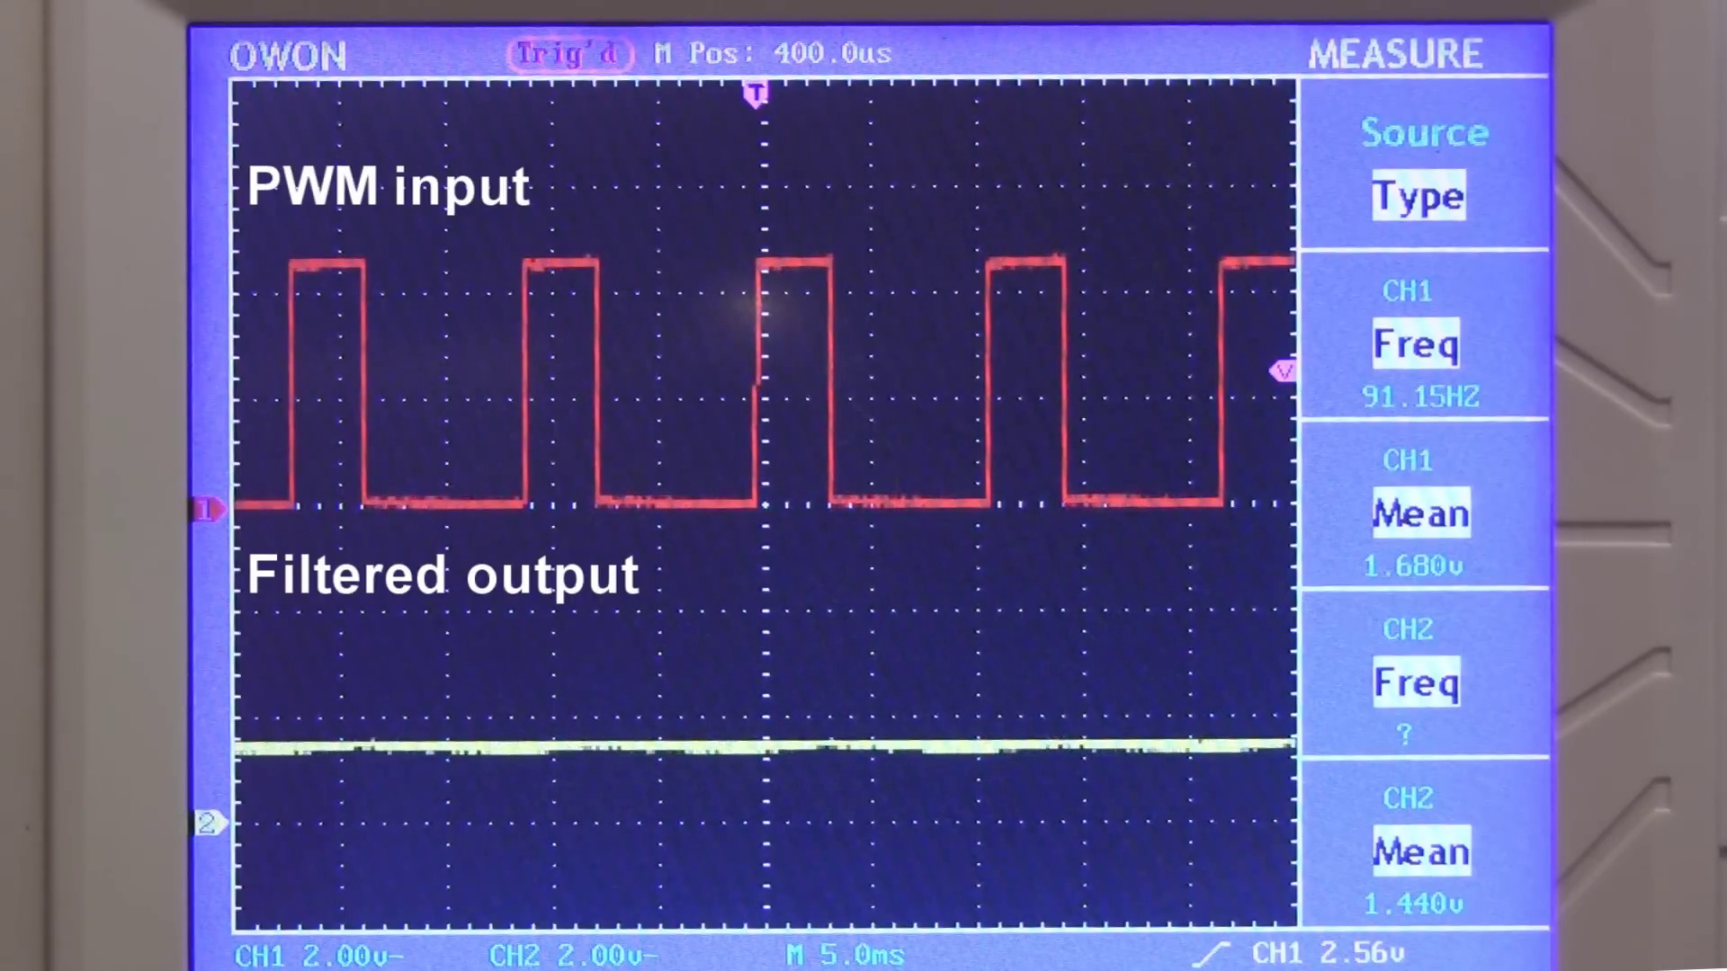 (score 95.0000)
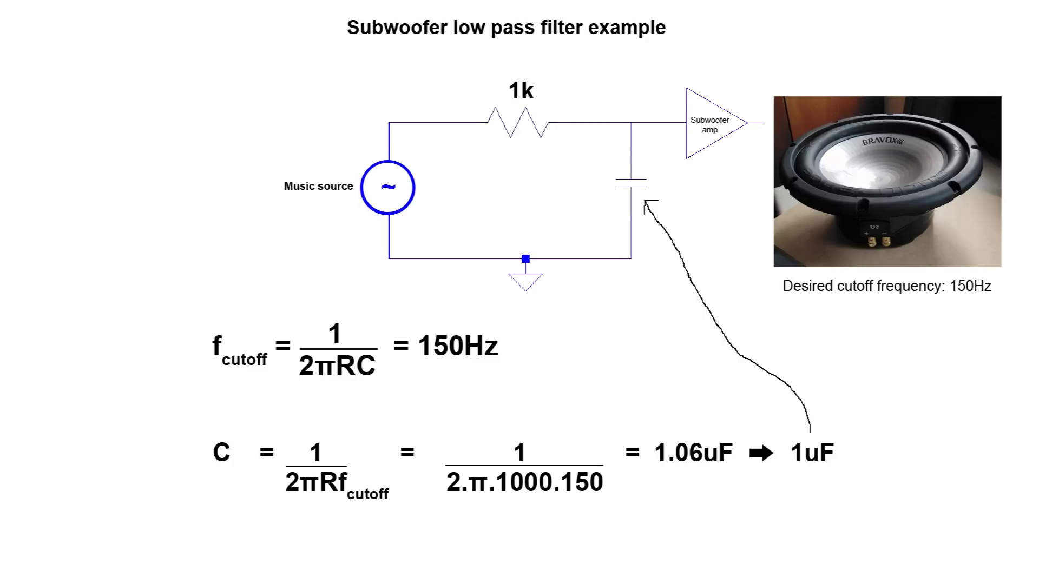 (score 95.0000)
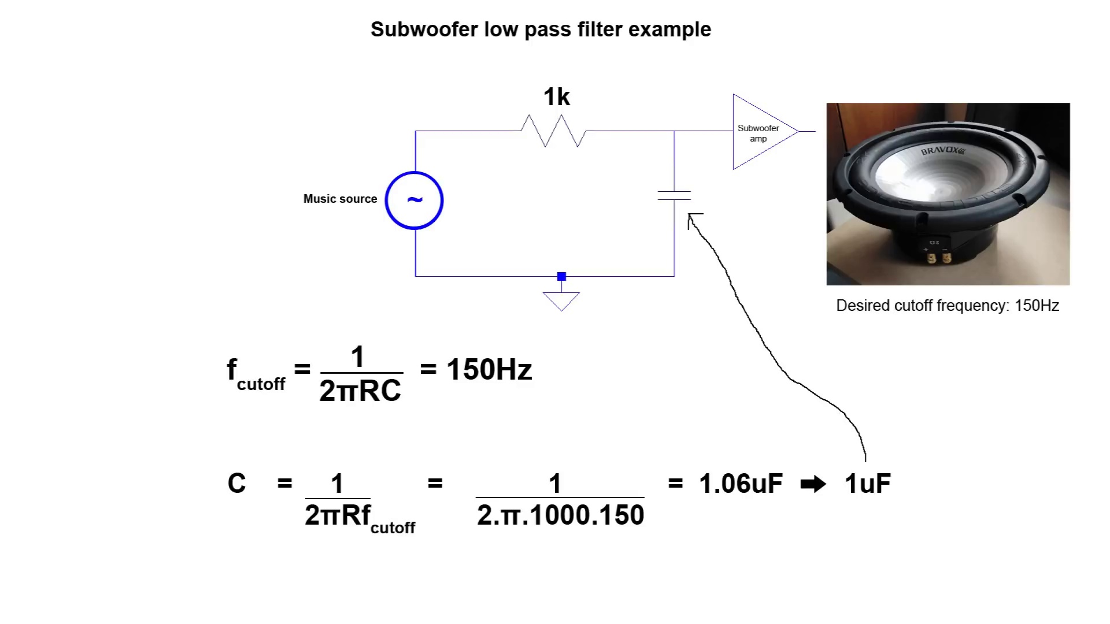 (score 95.0000)
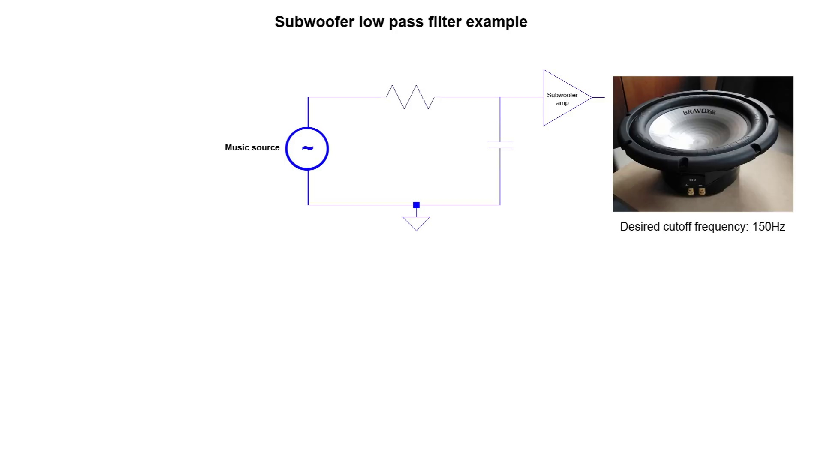 (score 95.0000)
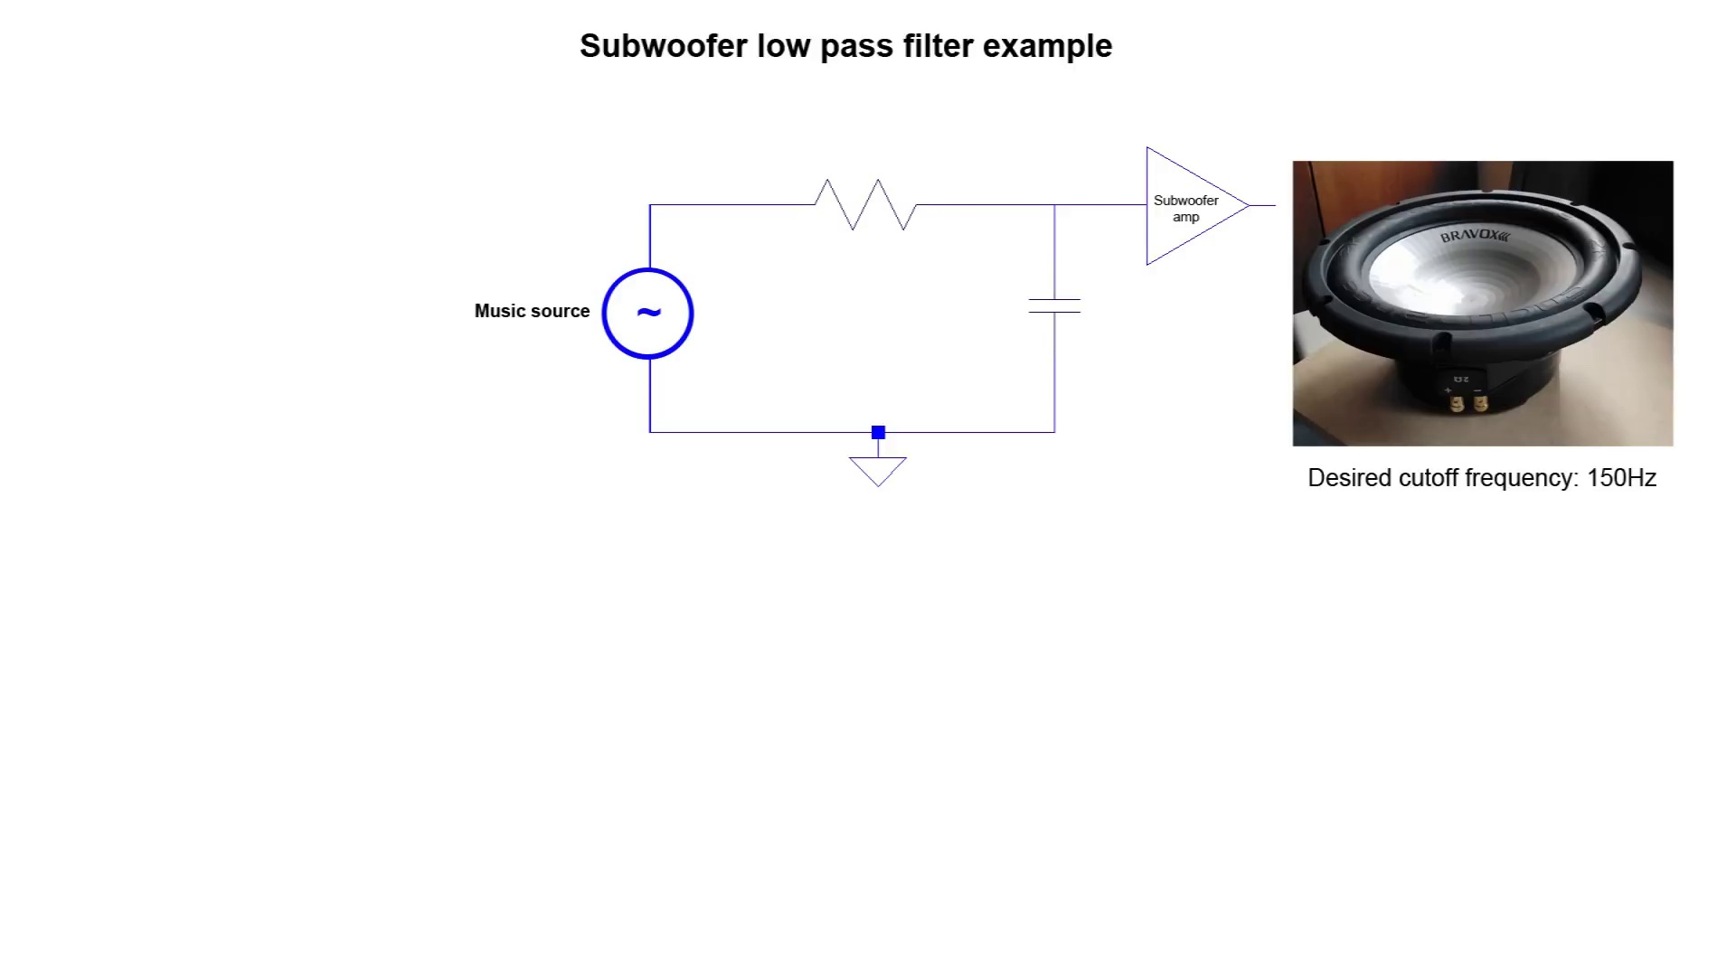 (score 95.0000)
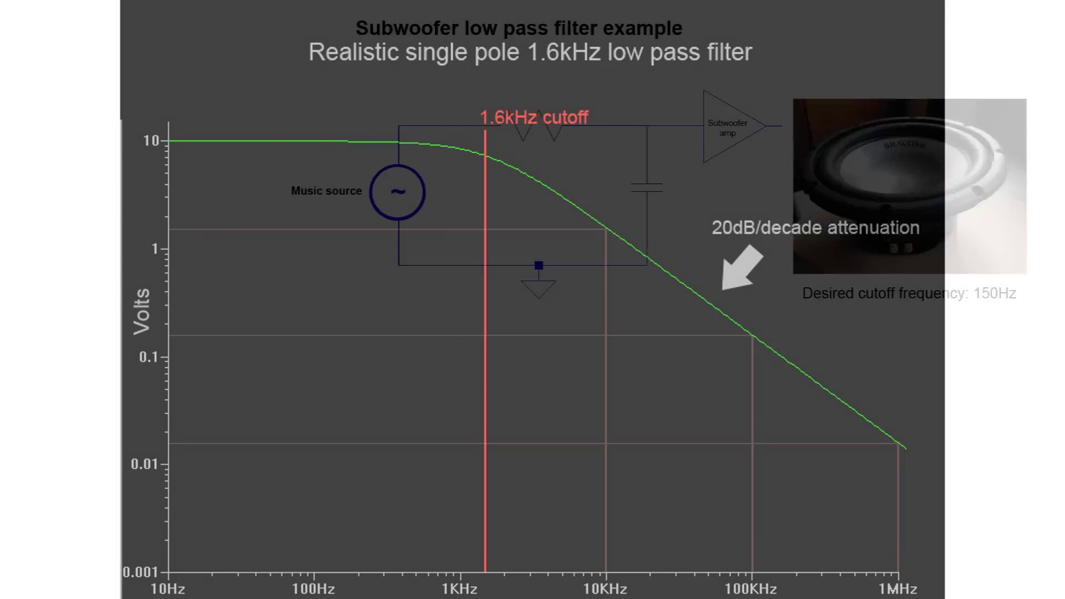 (score 95.0000)
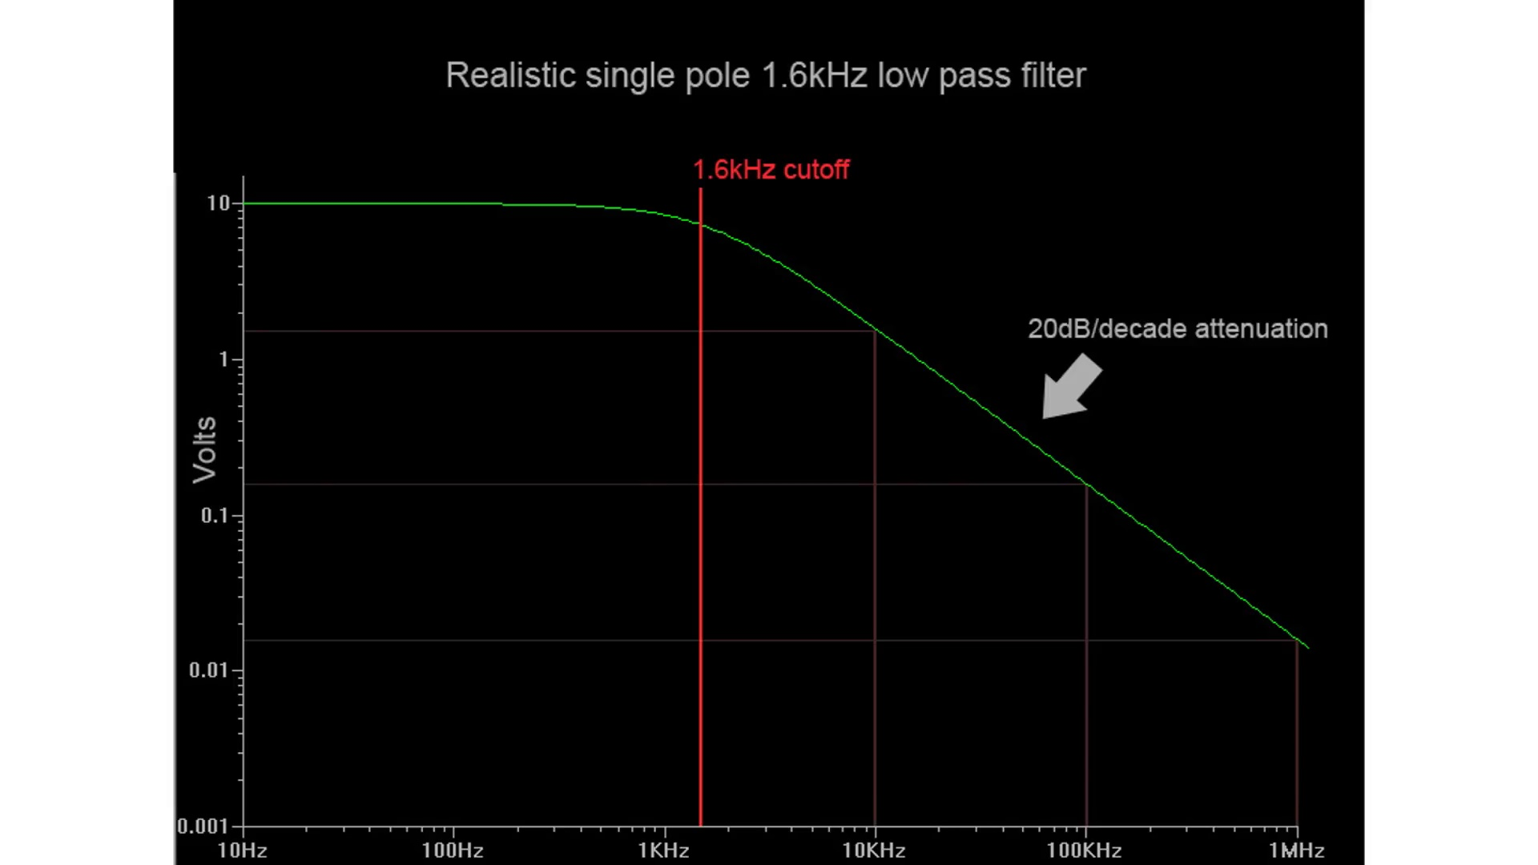 (score 95.0000)
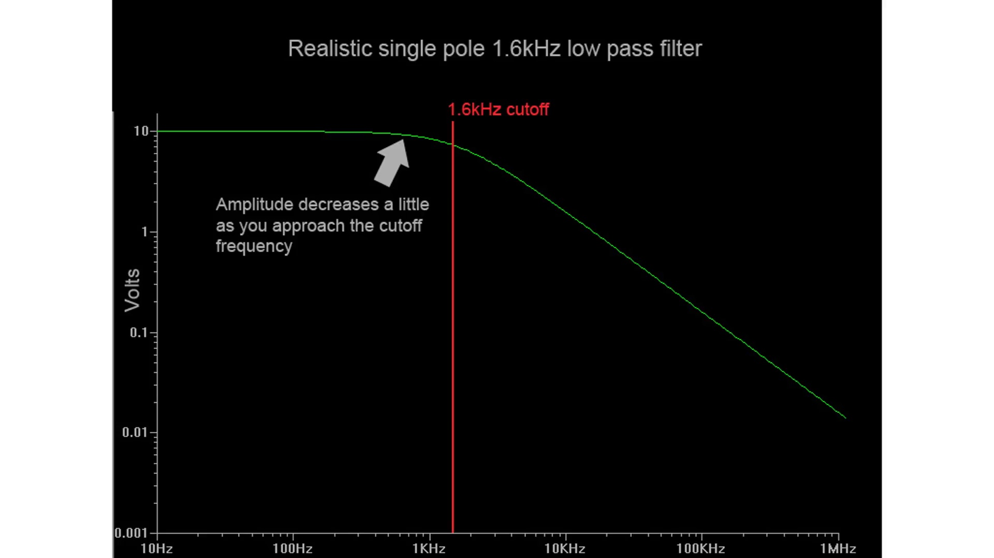 (score 95.0000)
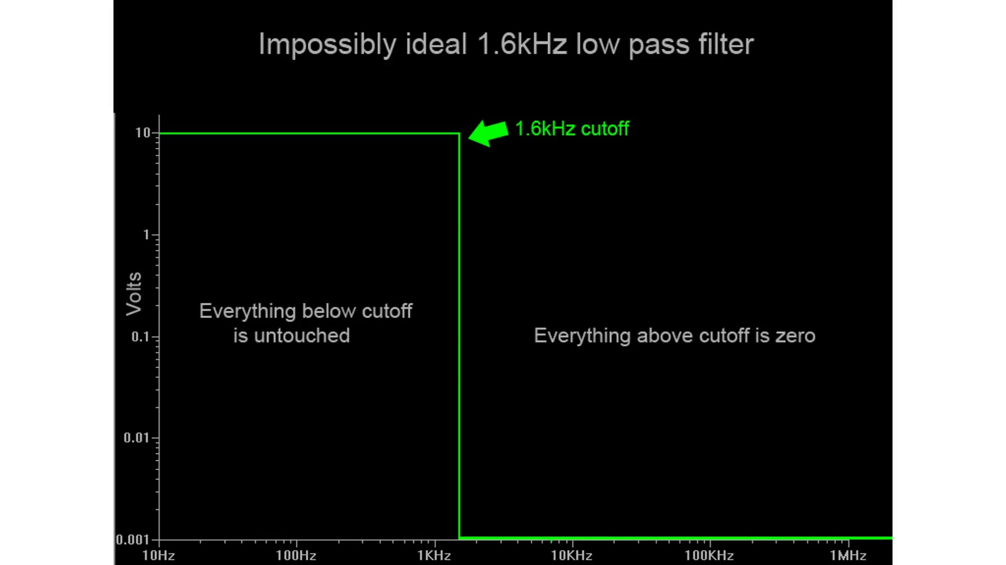 (score 95.0000)
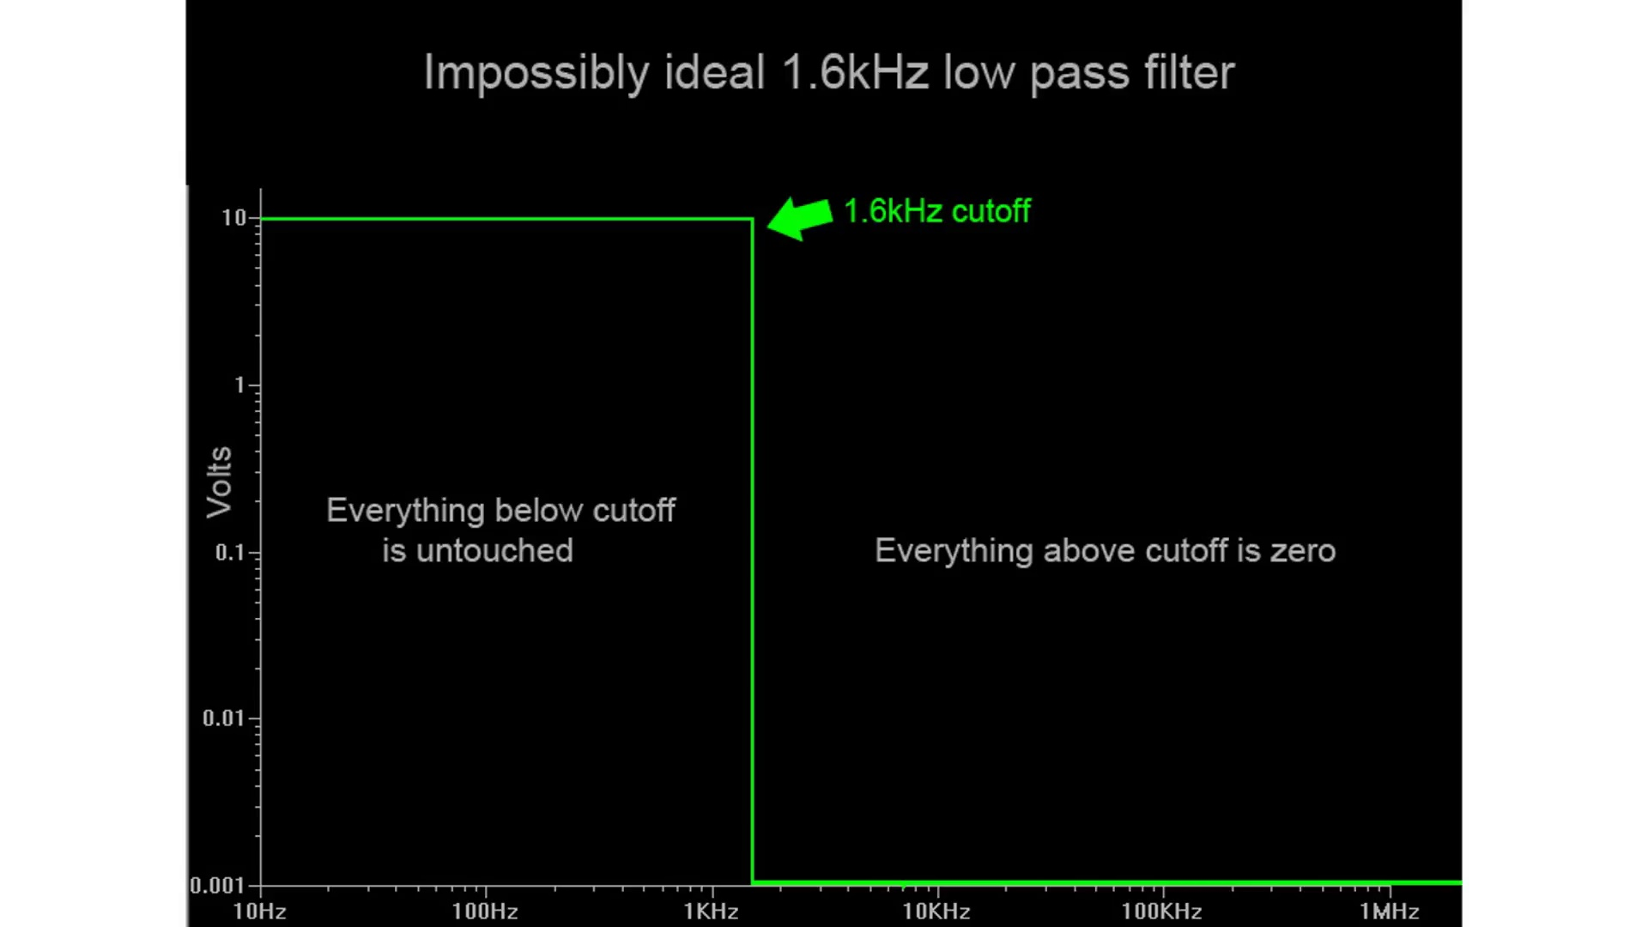 (score 95.0000)
Least correlated frames:
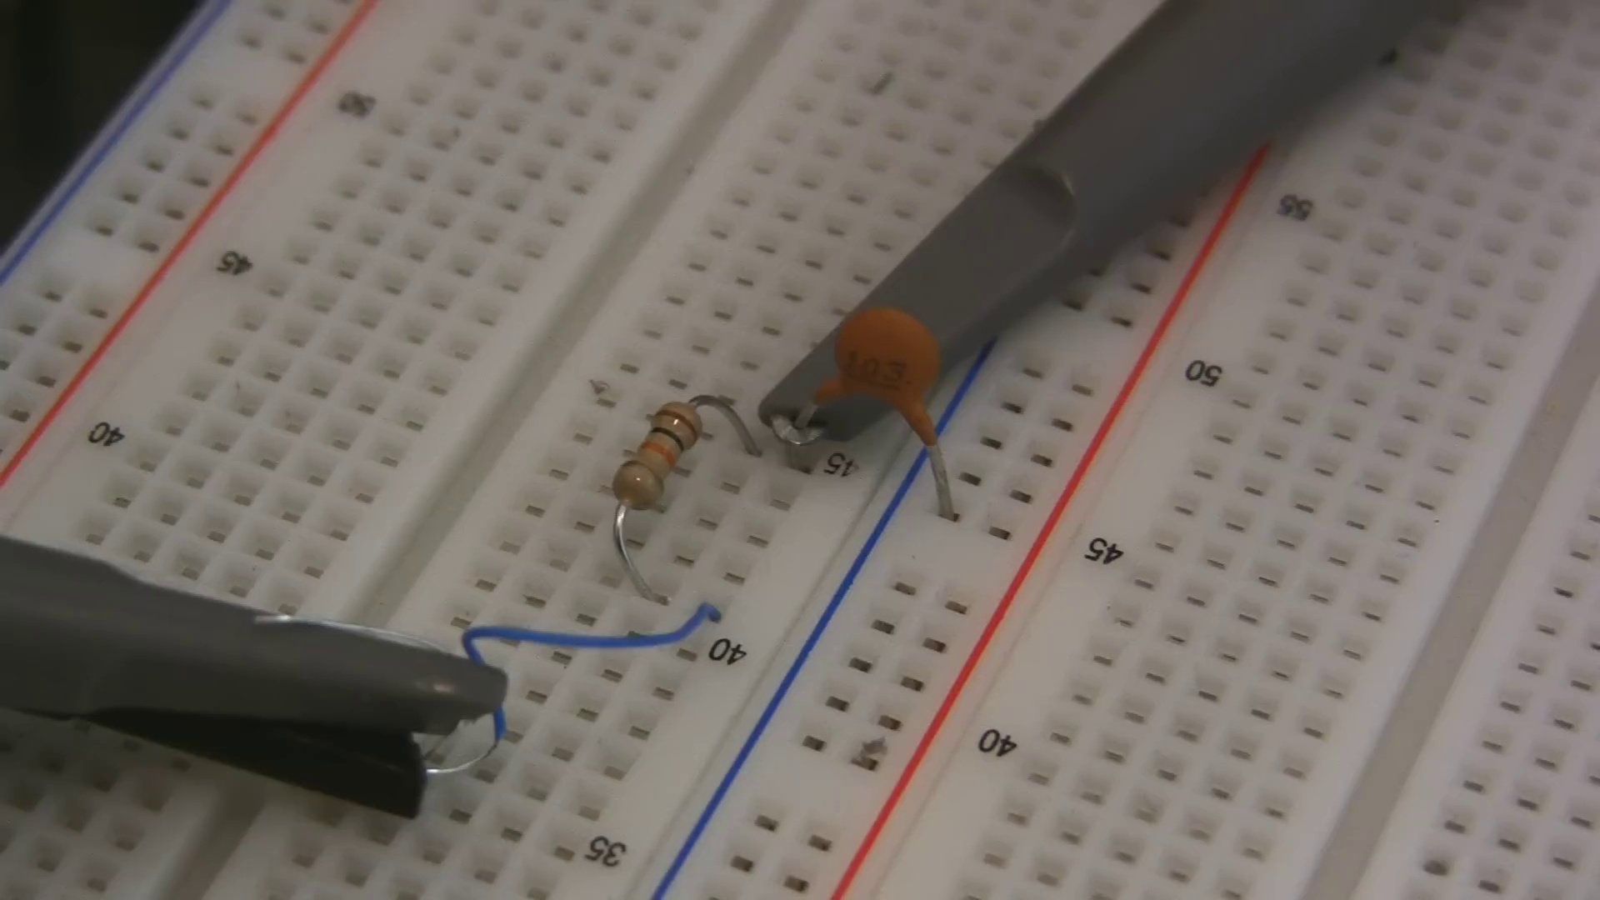 (score 10.0000)
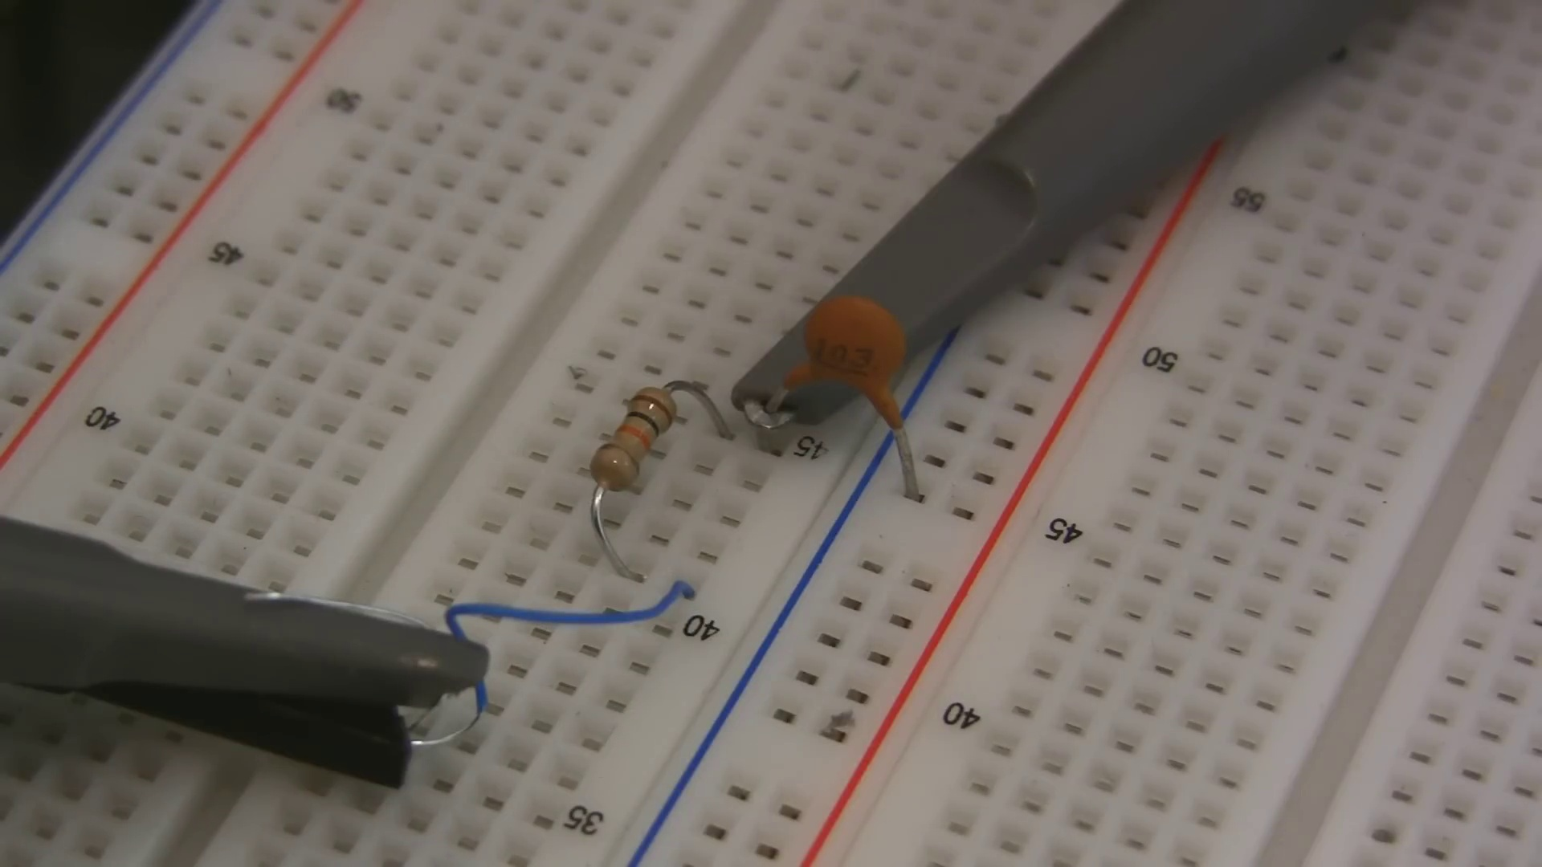 (score 10.0000)
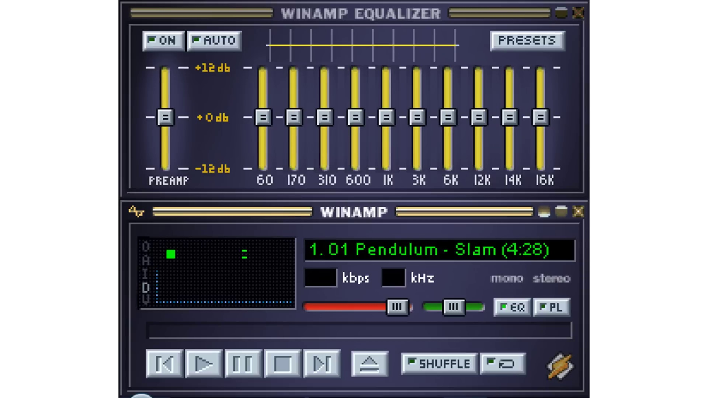 (score 20.0000)
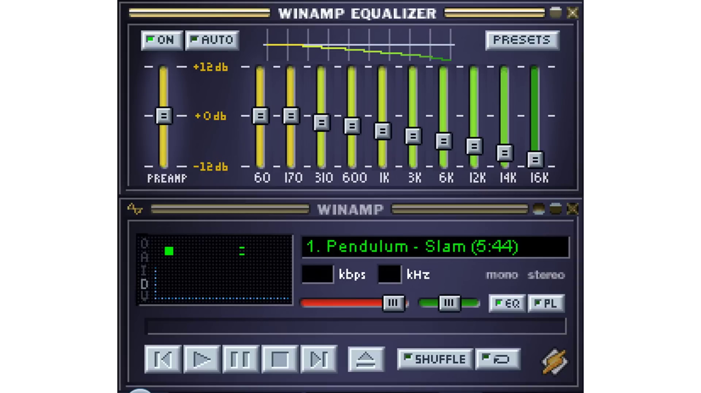 (score 20.0000)
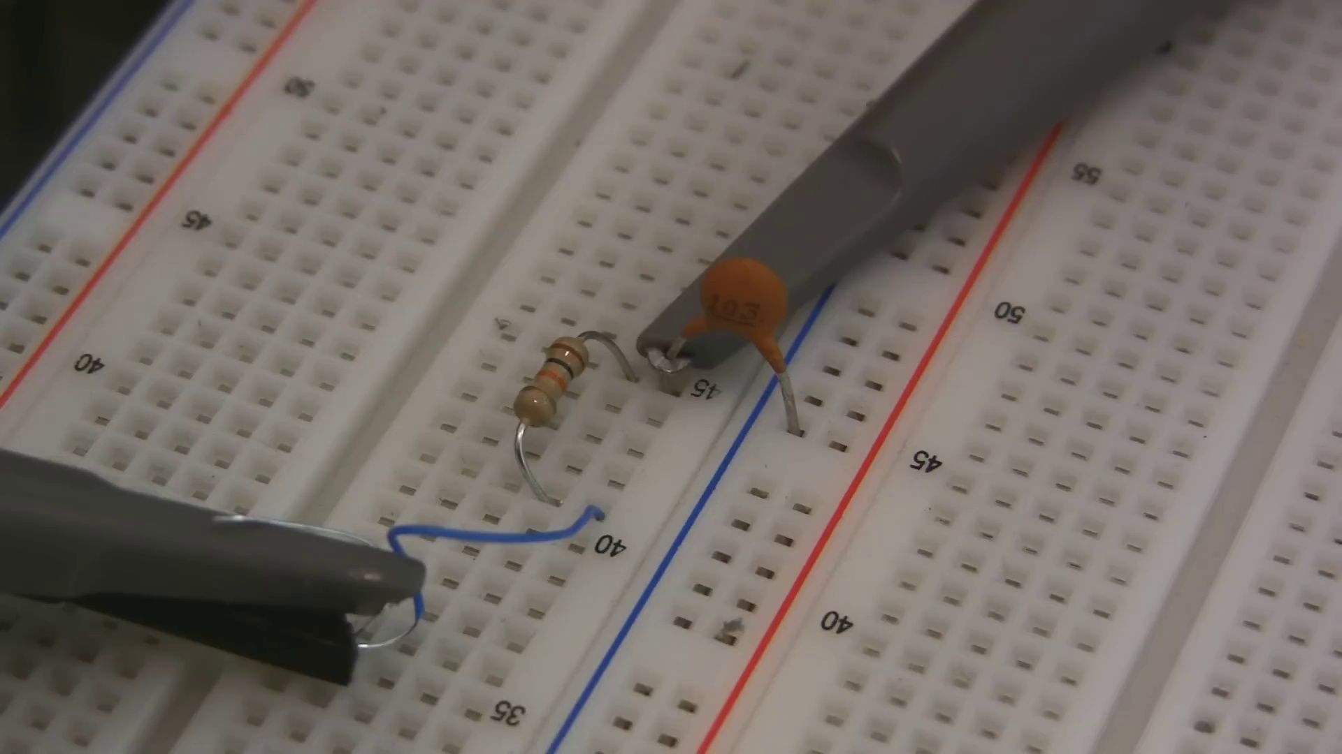 (score 20.0000)
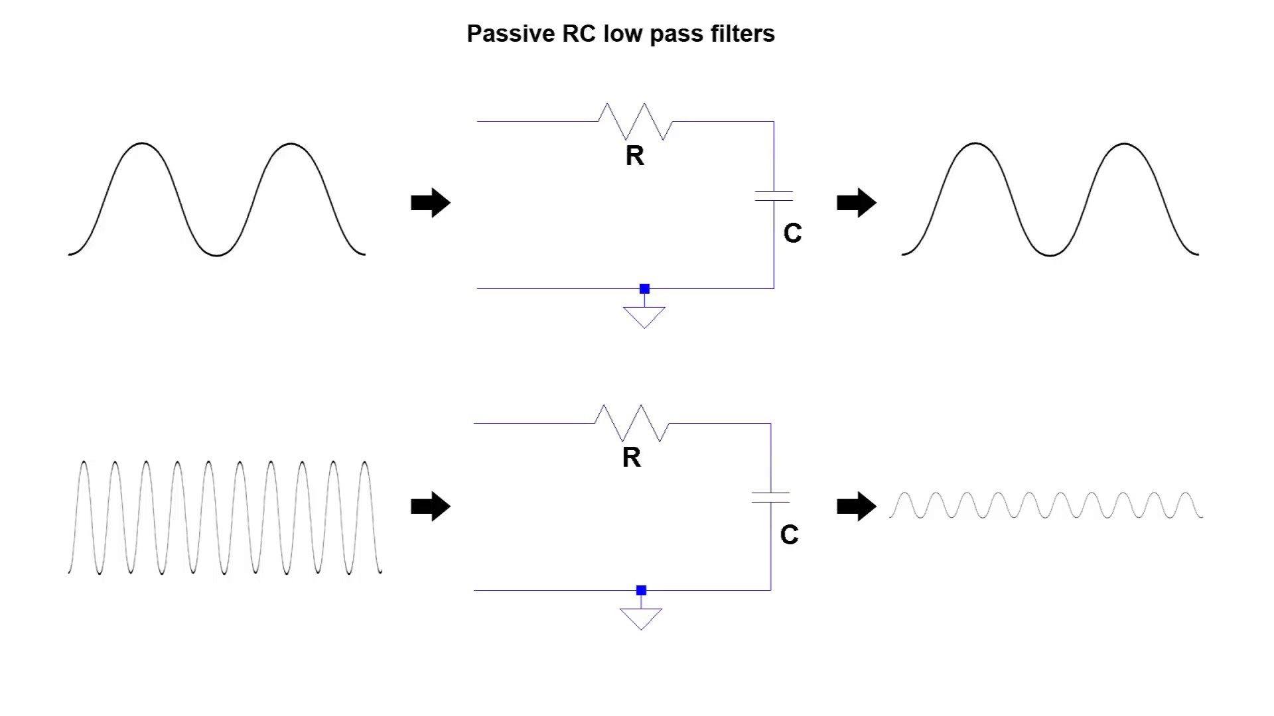 (score 20.0000)
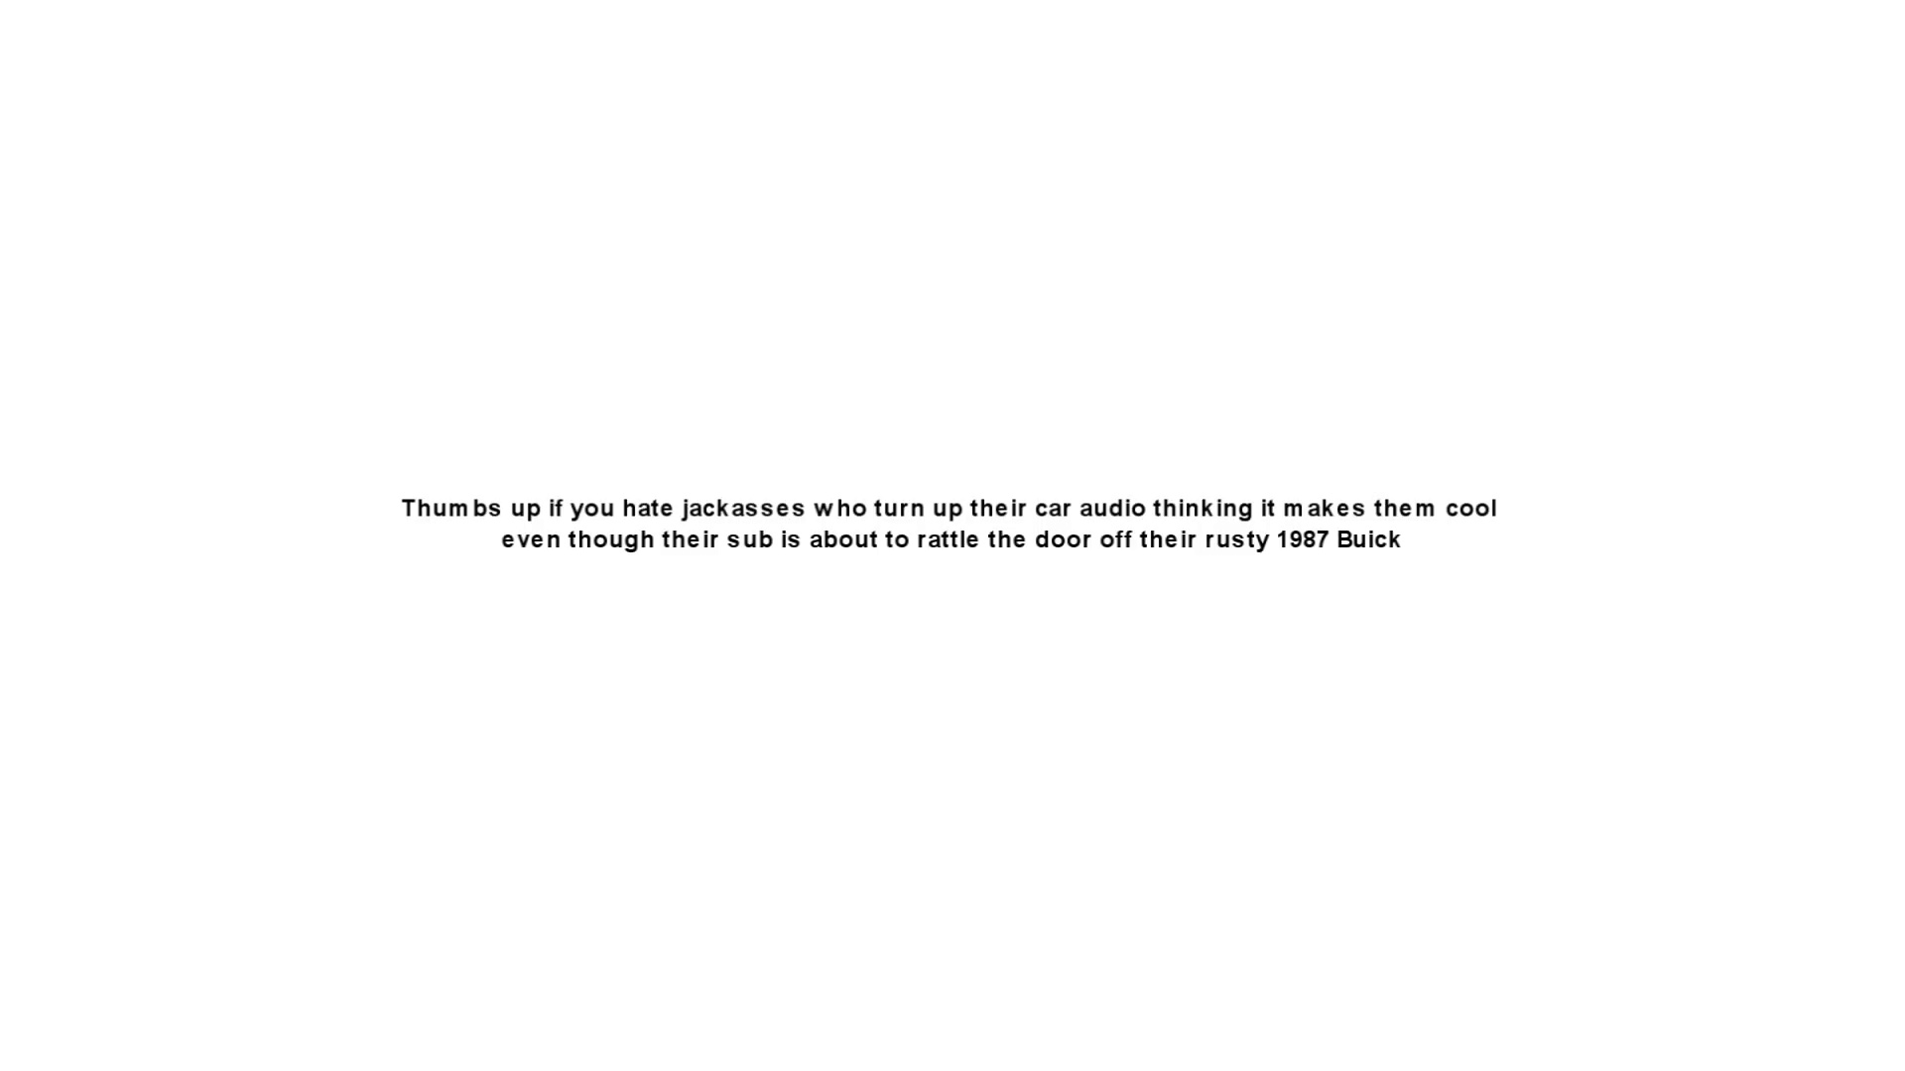 (score 20.0000)
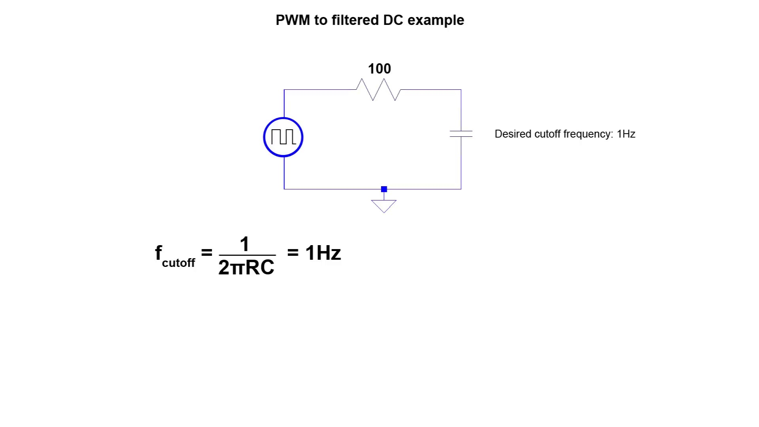 (score 20.0000)
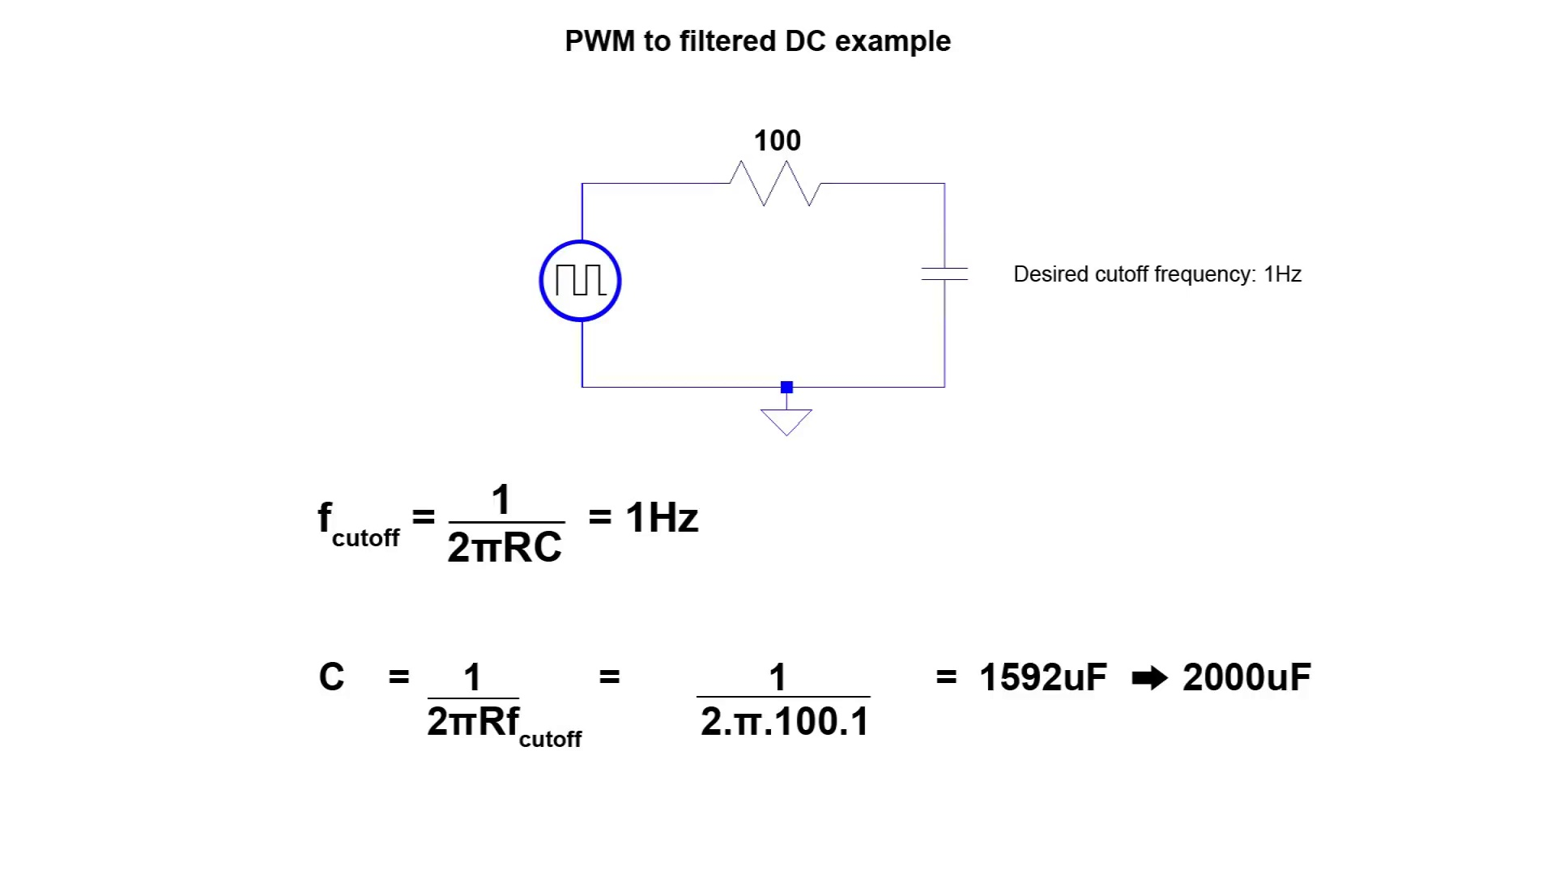 (score 20.0000)
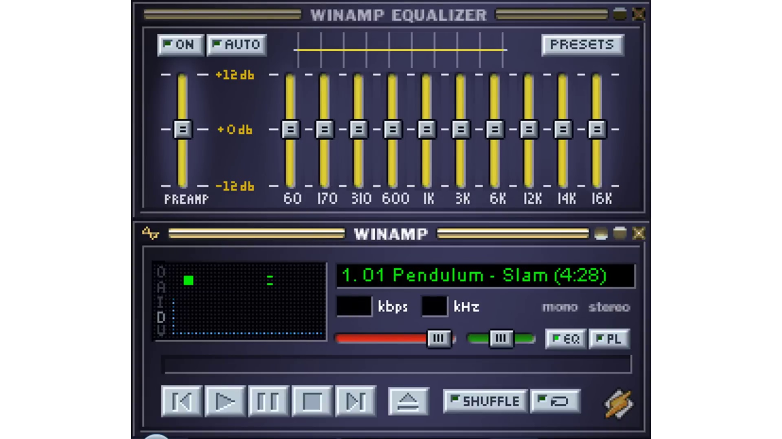 (score 70.0000)
- matched 103 frame(s), max score 95.0000: I learned that a low pass filter can be implemented with a resistor and capacitor in series. Since voltage across a capacitor doesn't change instantly, this slows the output voltage and filters out high frequencies. It's best to choose a resistor first and calculate the capacitor using the cutoff frequency formula. This was helpful for choosing filter values for each speaker in Phase 2.One question I had was whether to adjust the cutoff frequency target because the filtering effect is gradual, not sharp.
Source: https://www.youtube.com/watch?v=OBM5T5_kgdI: Passive RC low pass filter tutorial!
Top correlated frames:
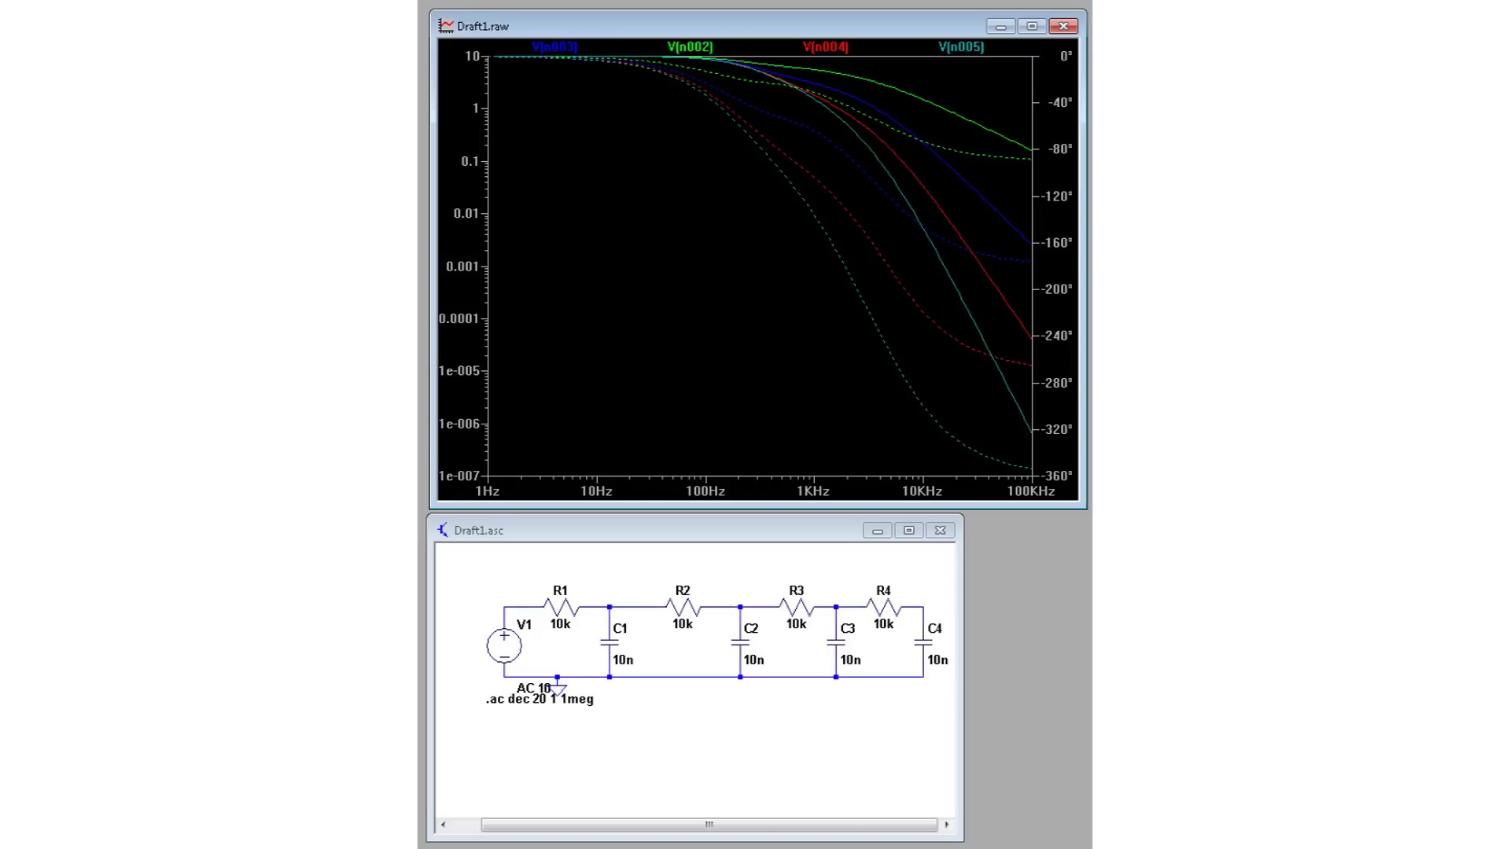 (score 95.0000)
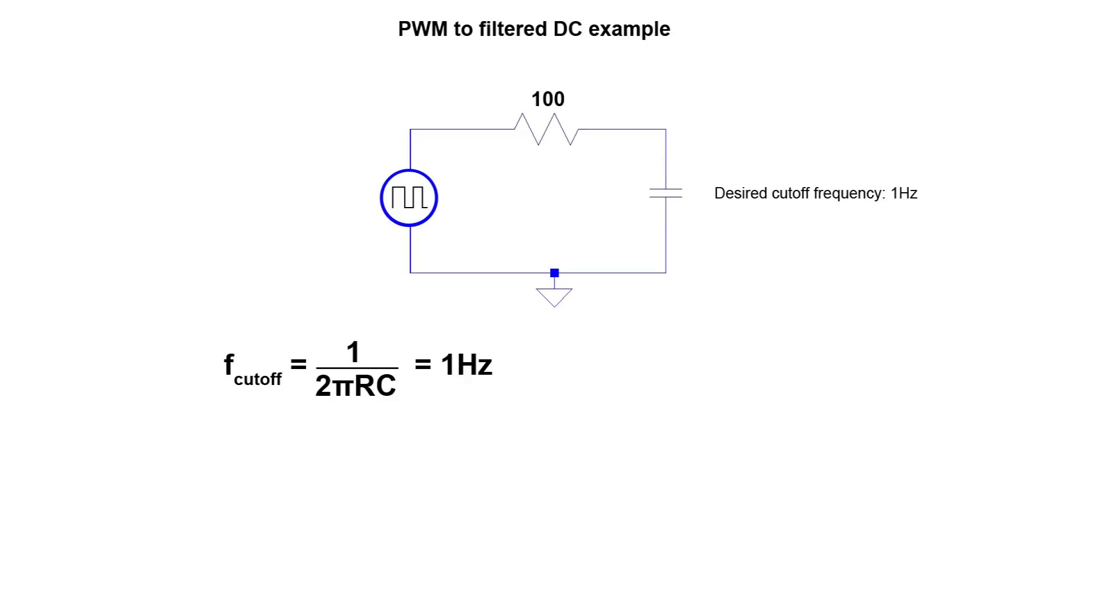 (score 95.0000)
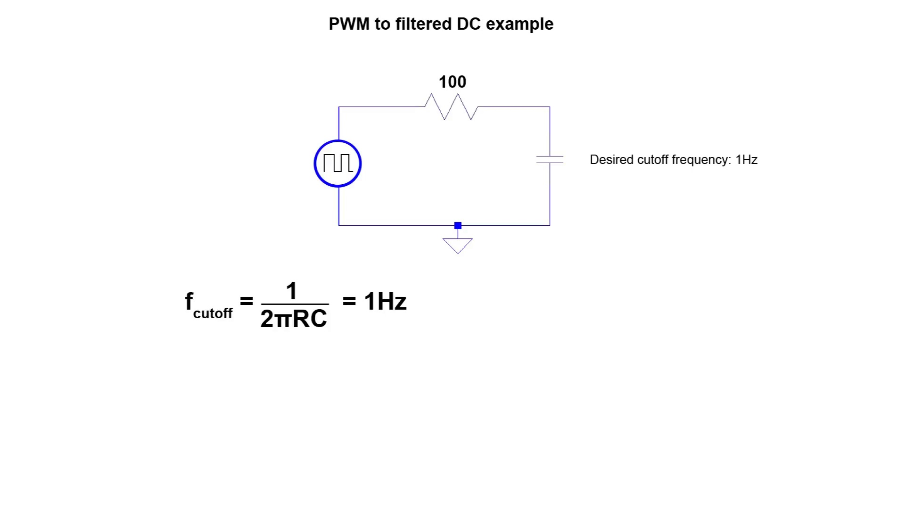 (score 95.0000)
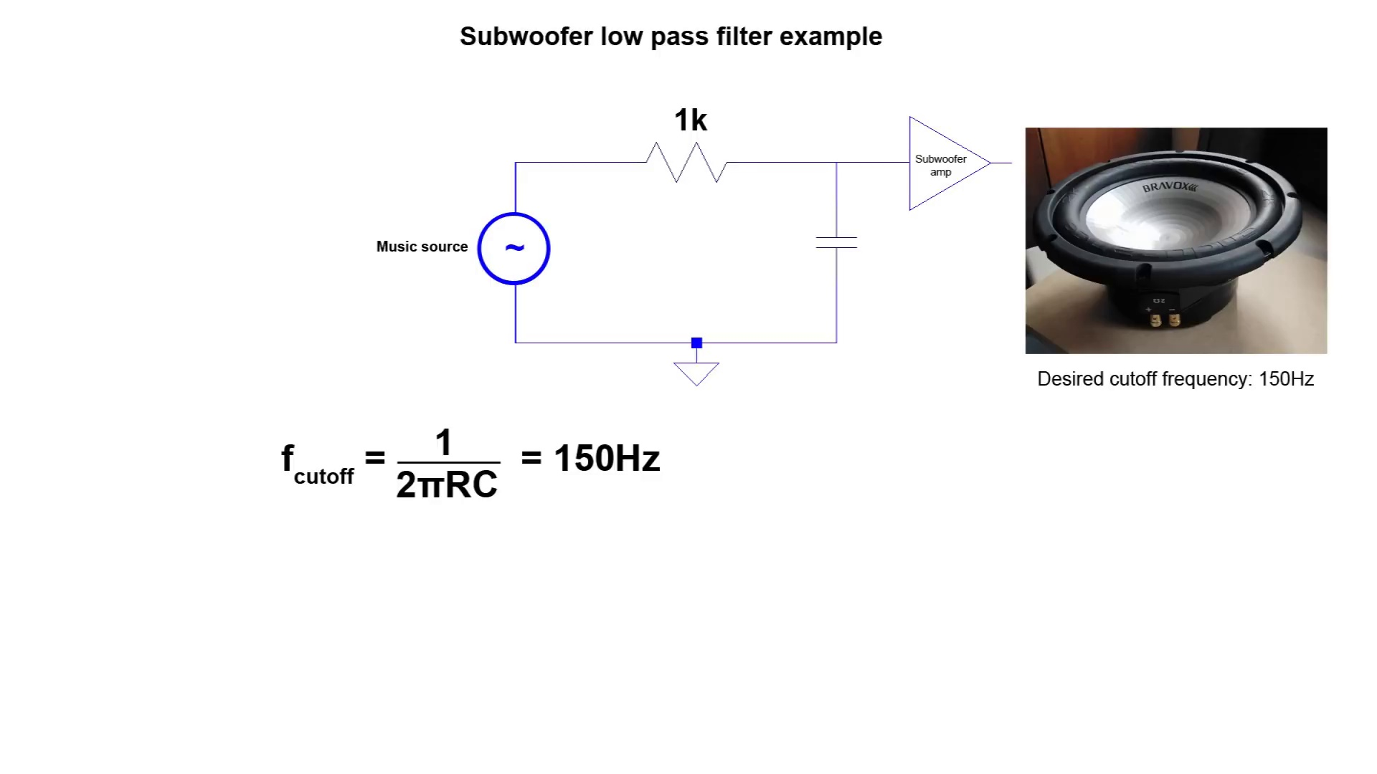 (score 95.0000)
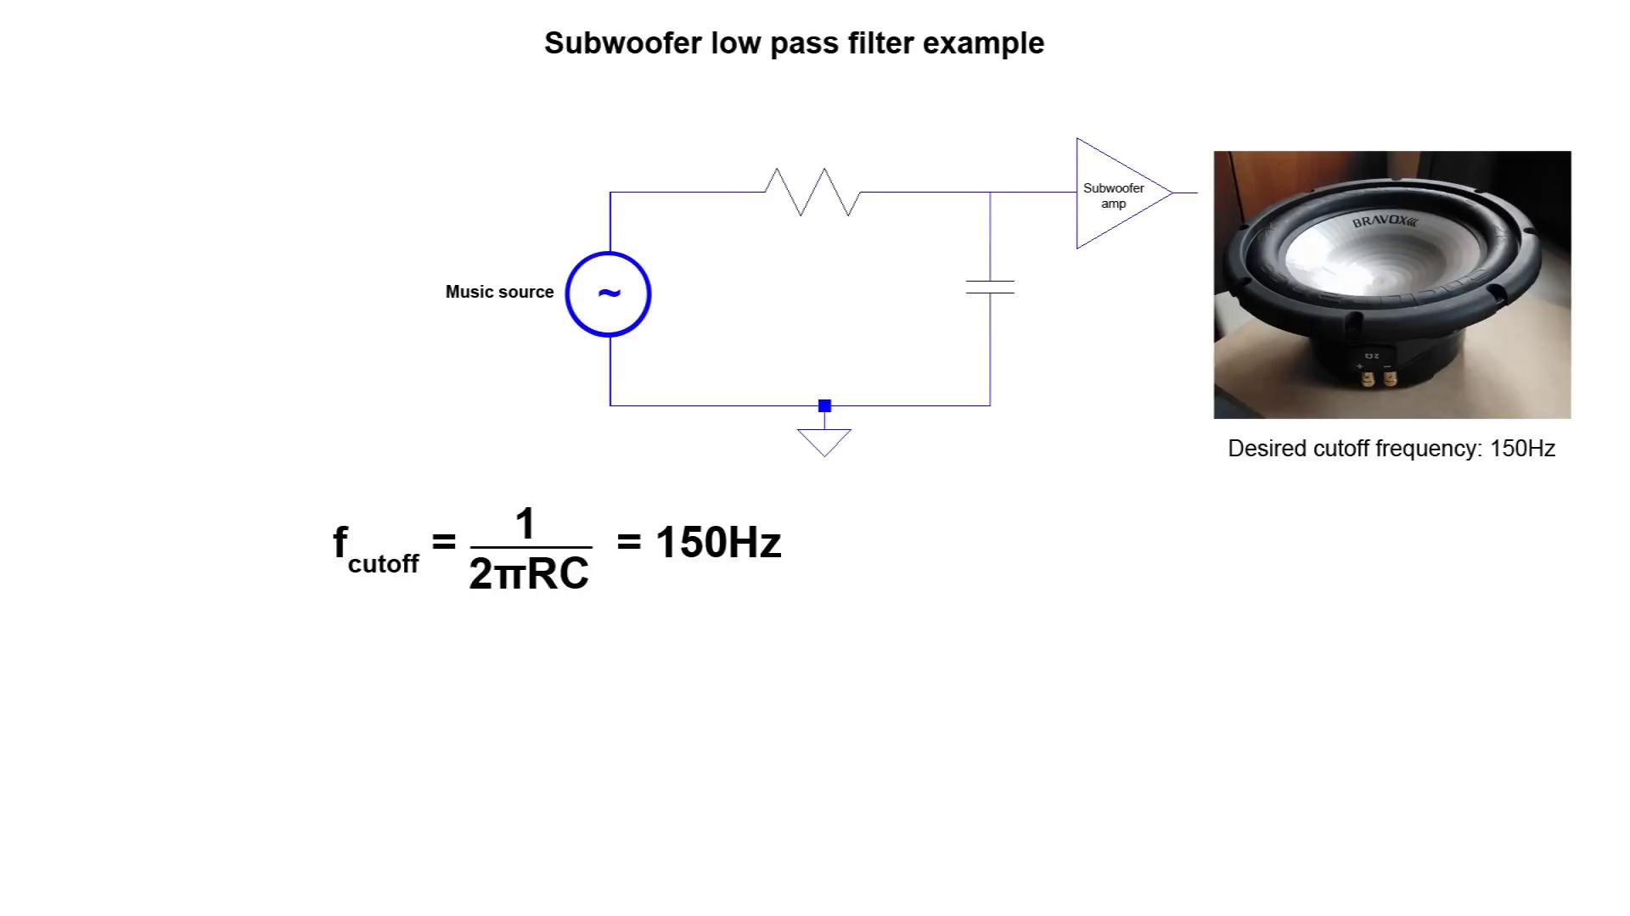 (score 95.0000)
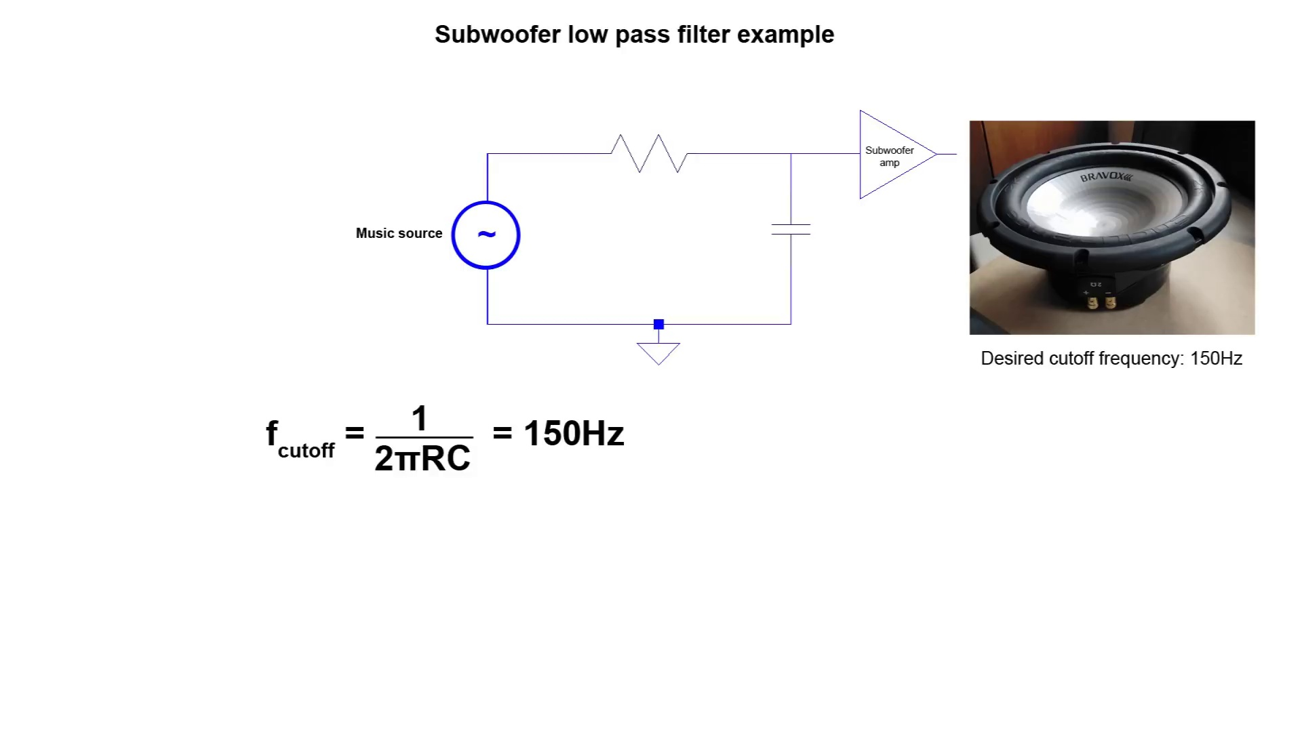 (score 95.0000)
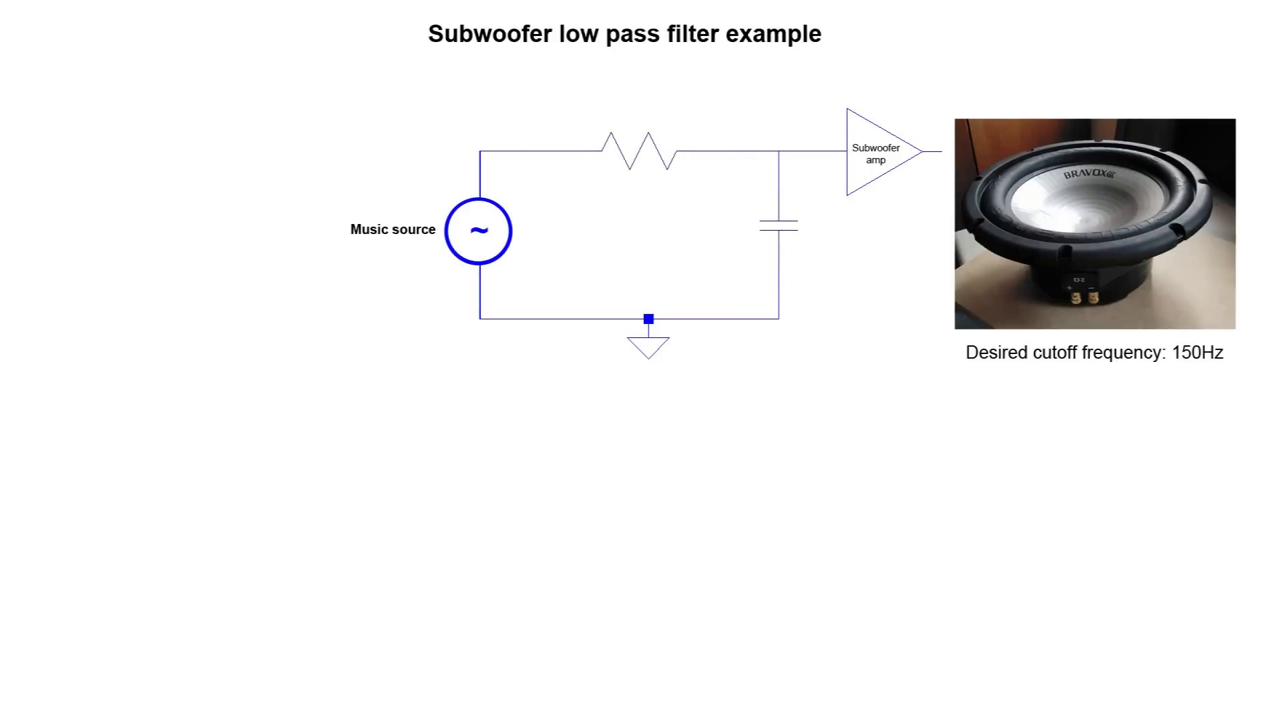 (score 95.0000)
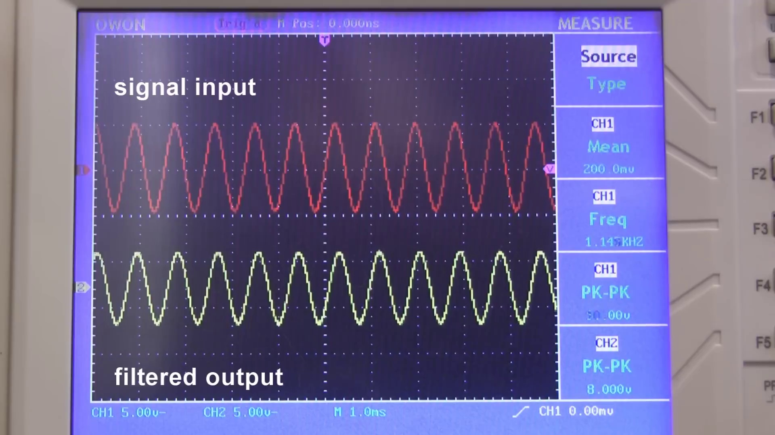 (score 95.0000)
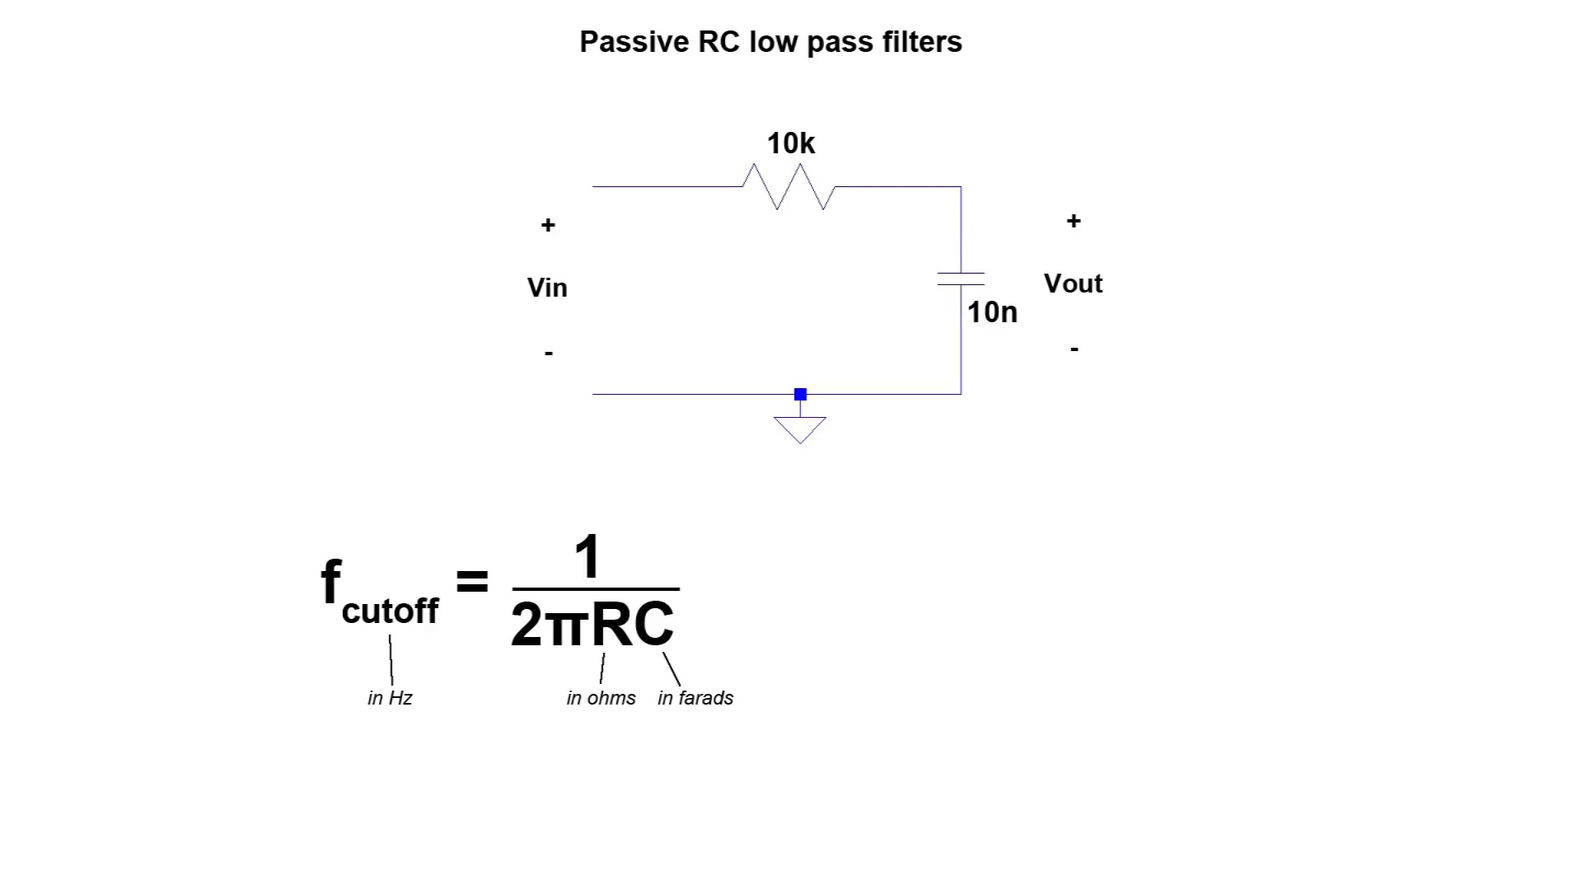 (score 95.0000)
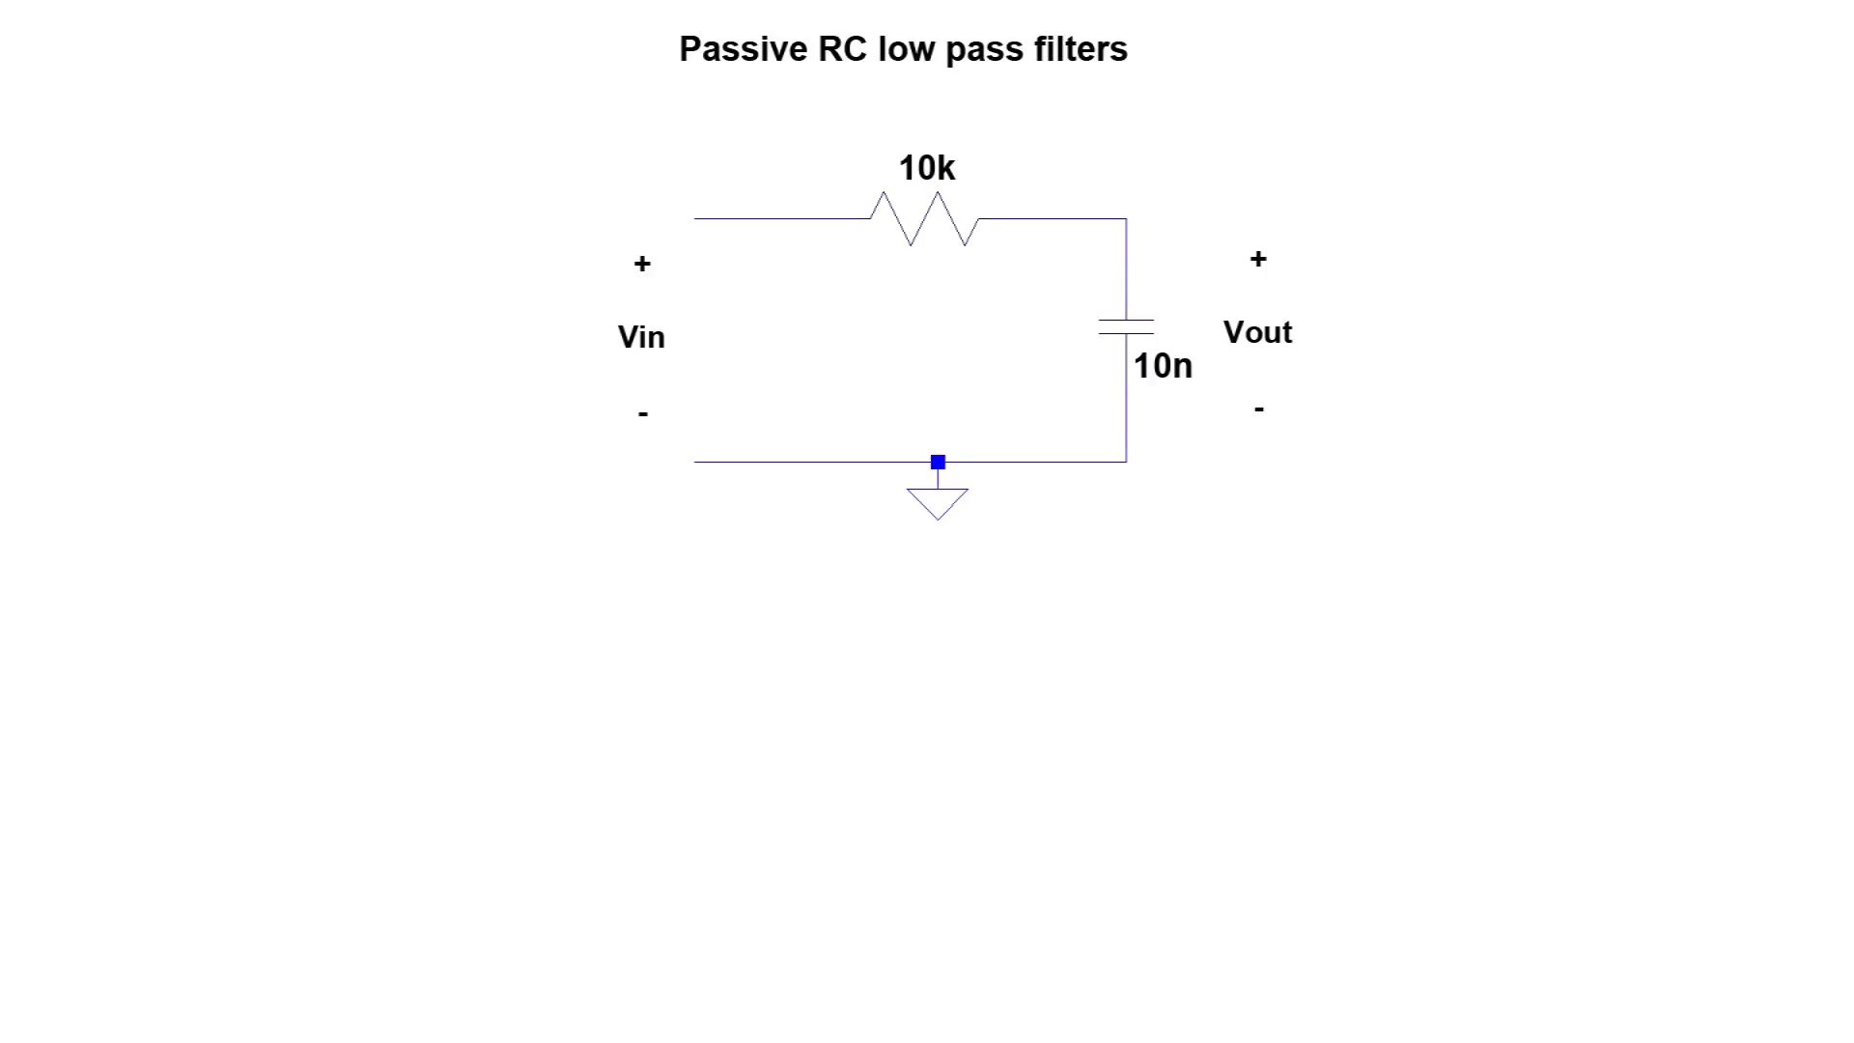 (score 95.0000)
Least correlated frames:
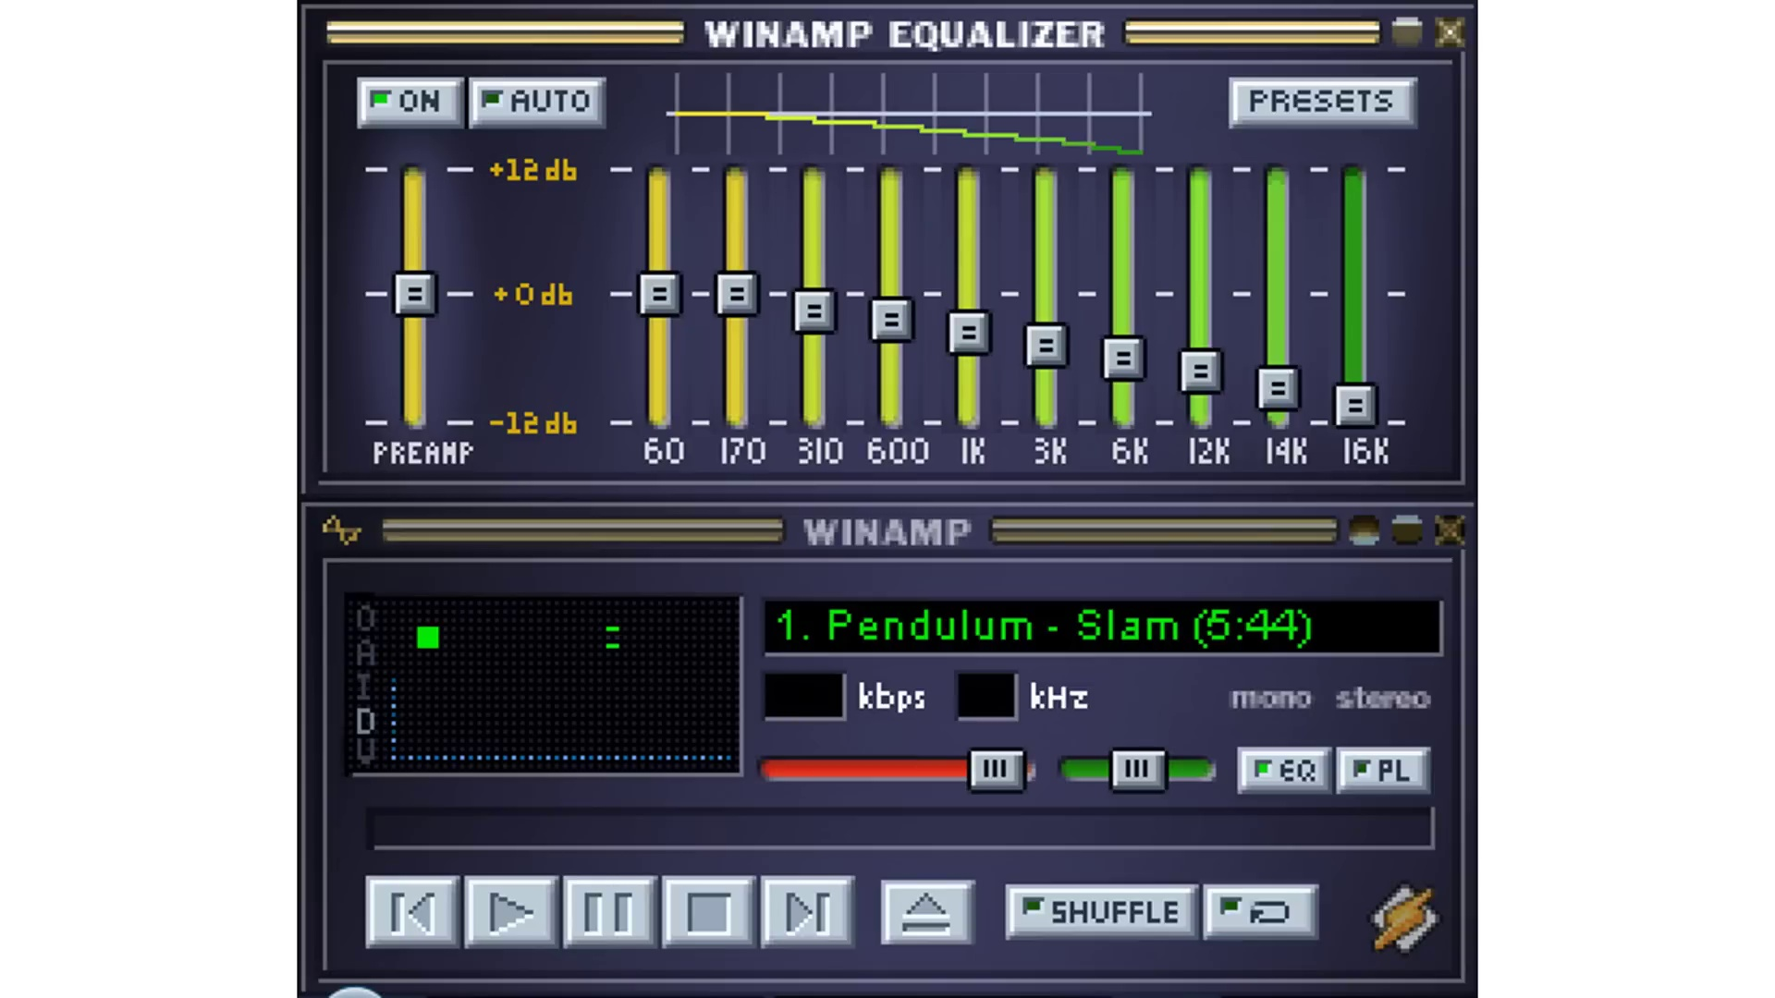 (score 0.0000)
 (score 0.0000)
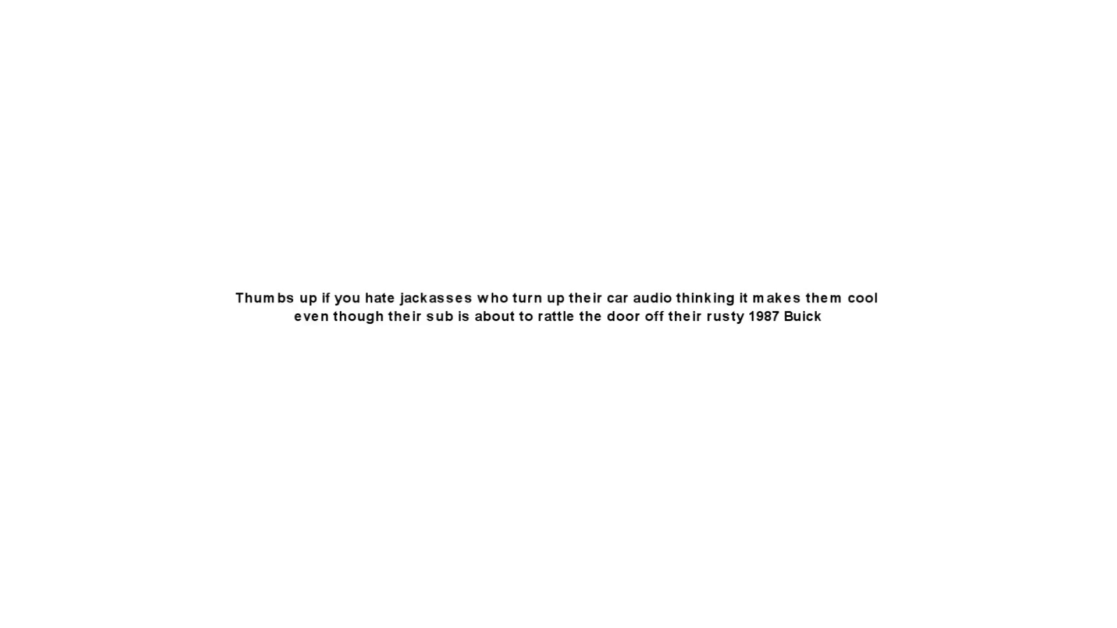 (score 5.0000)
 (score 5.0000)
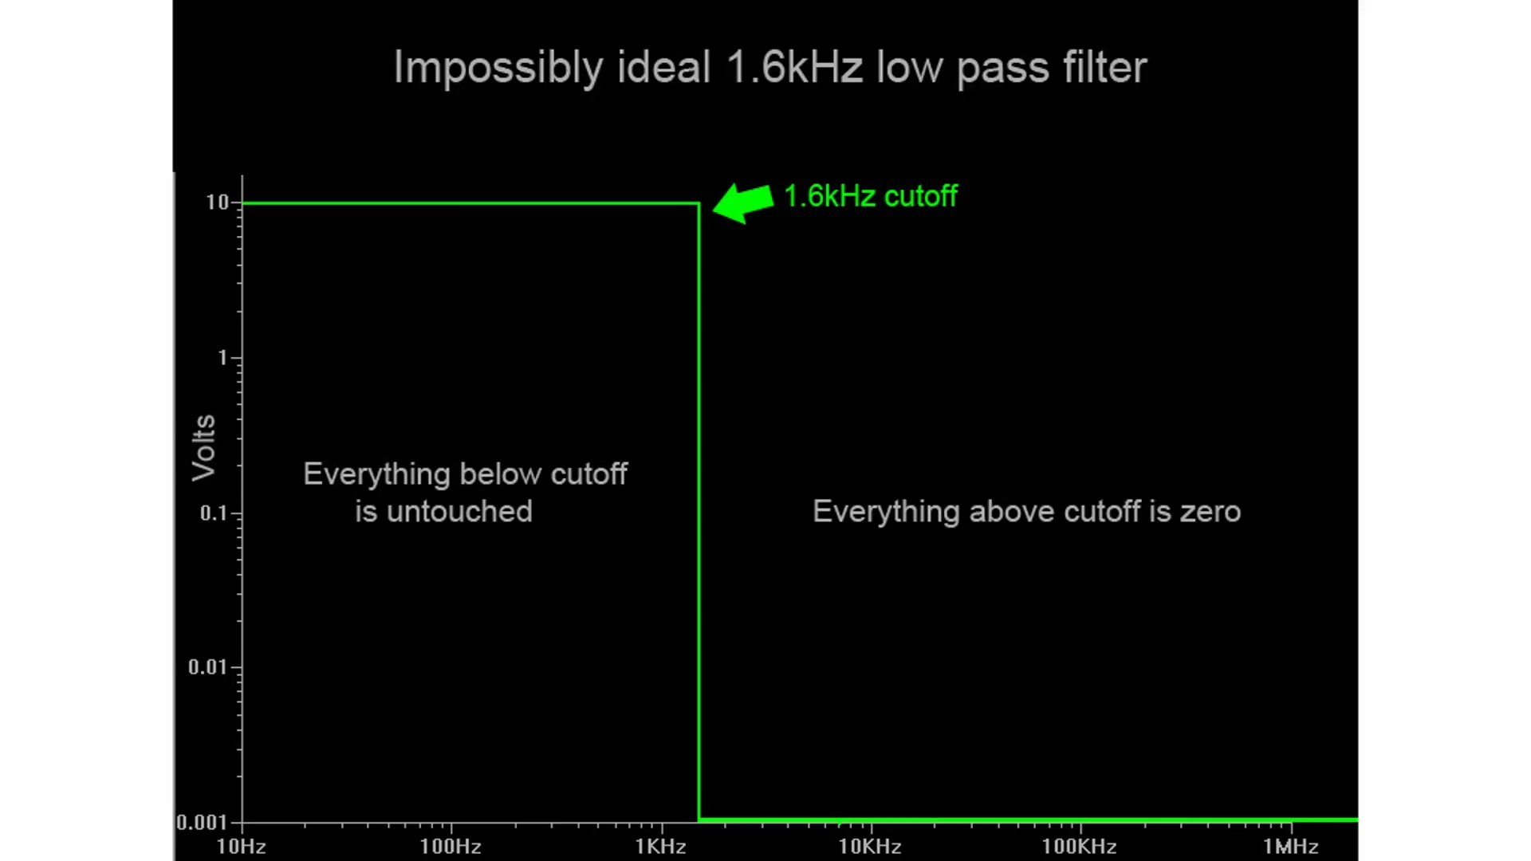 (score 10.0000)
 (score 20.0000)
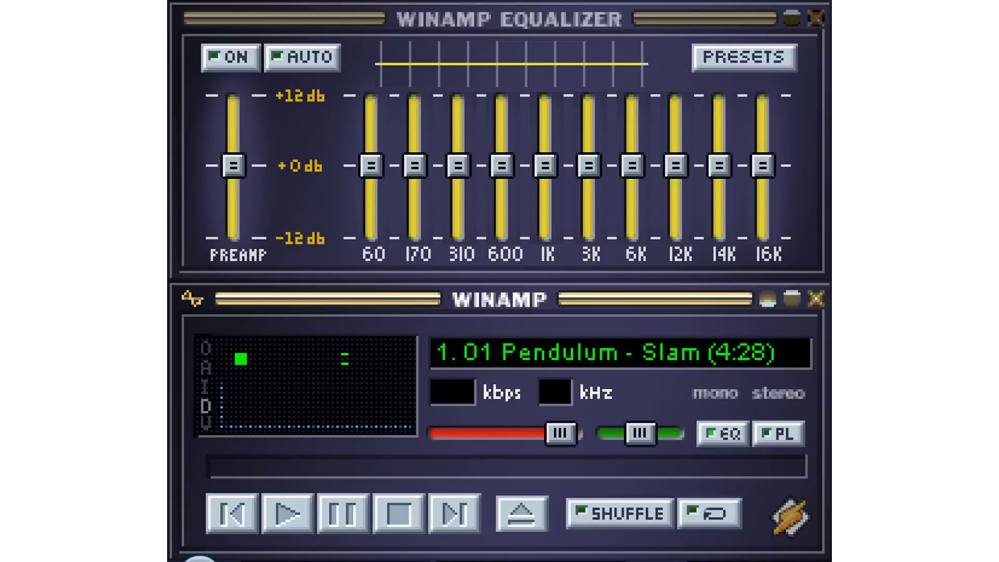 (score 20.0000)
 (score 20.0000)
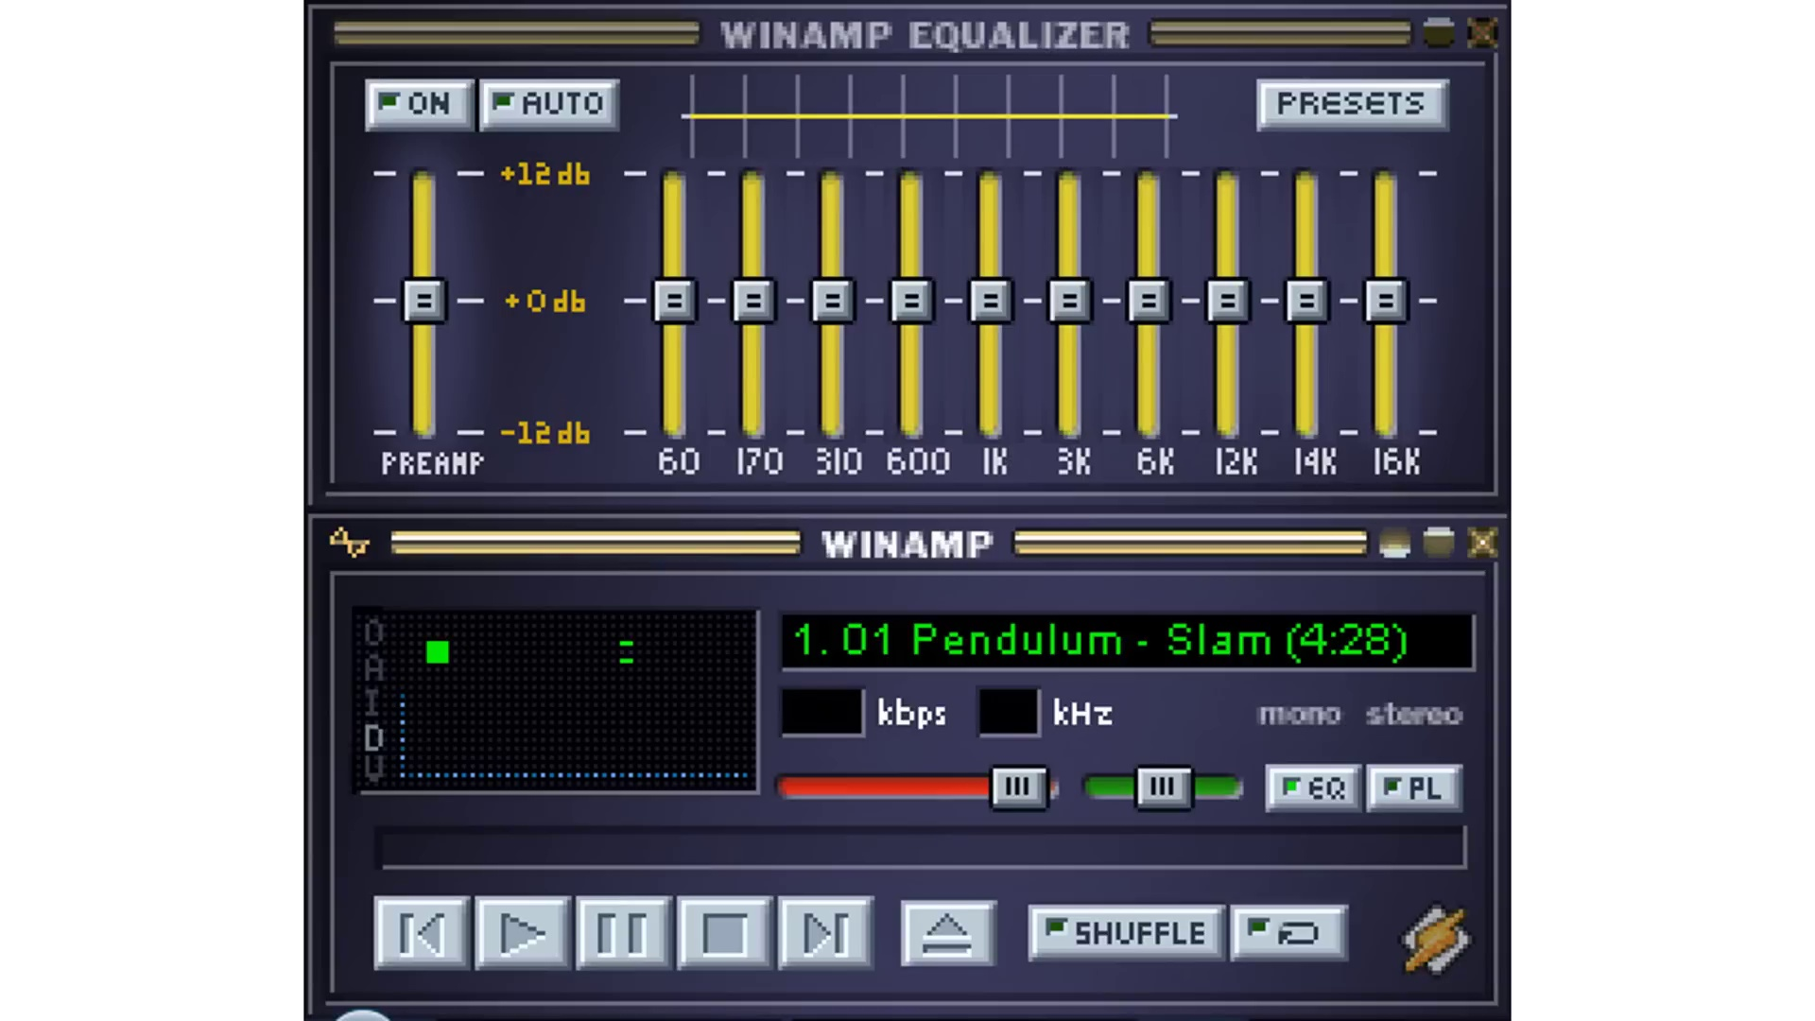 (score 20.0000)
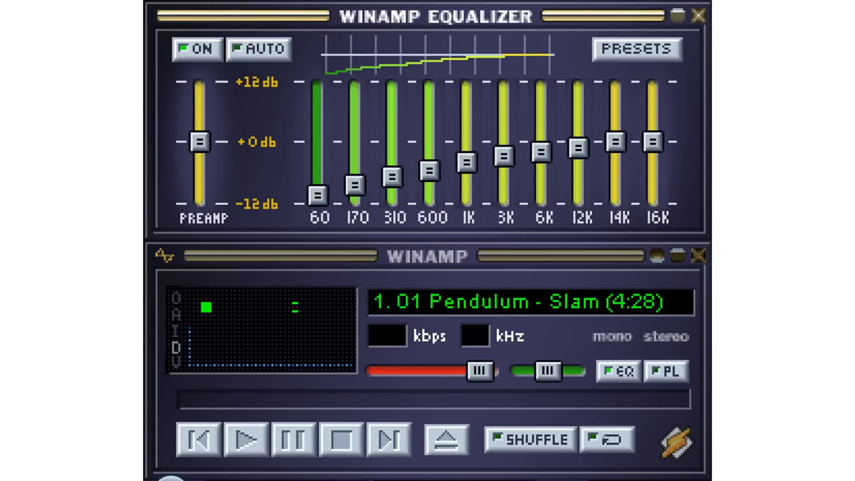 (score 20.0000)
- matched 28 frame(s), max score 95.0000: The video was incredibly beneficial in elucidating RC low-pass filters and their application, providing clarity on the differences between low-pass and high-pass filters in audio.I did find some of the graphs a bit confusing at times.
Source: https://www.youtube.com/watch?v=OBM5T5_kgdI&t=241s: Passive RC low pass filter tutorial!
Top correlated frames:
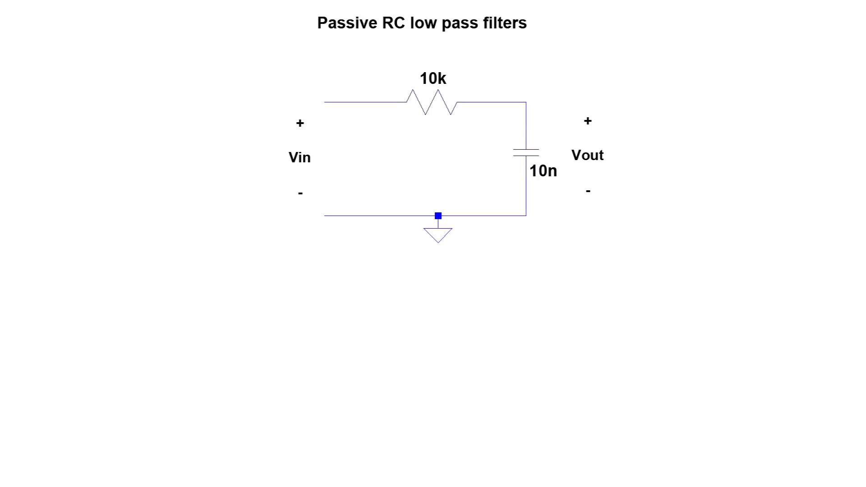 (score 95.0000)
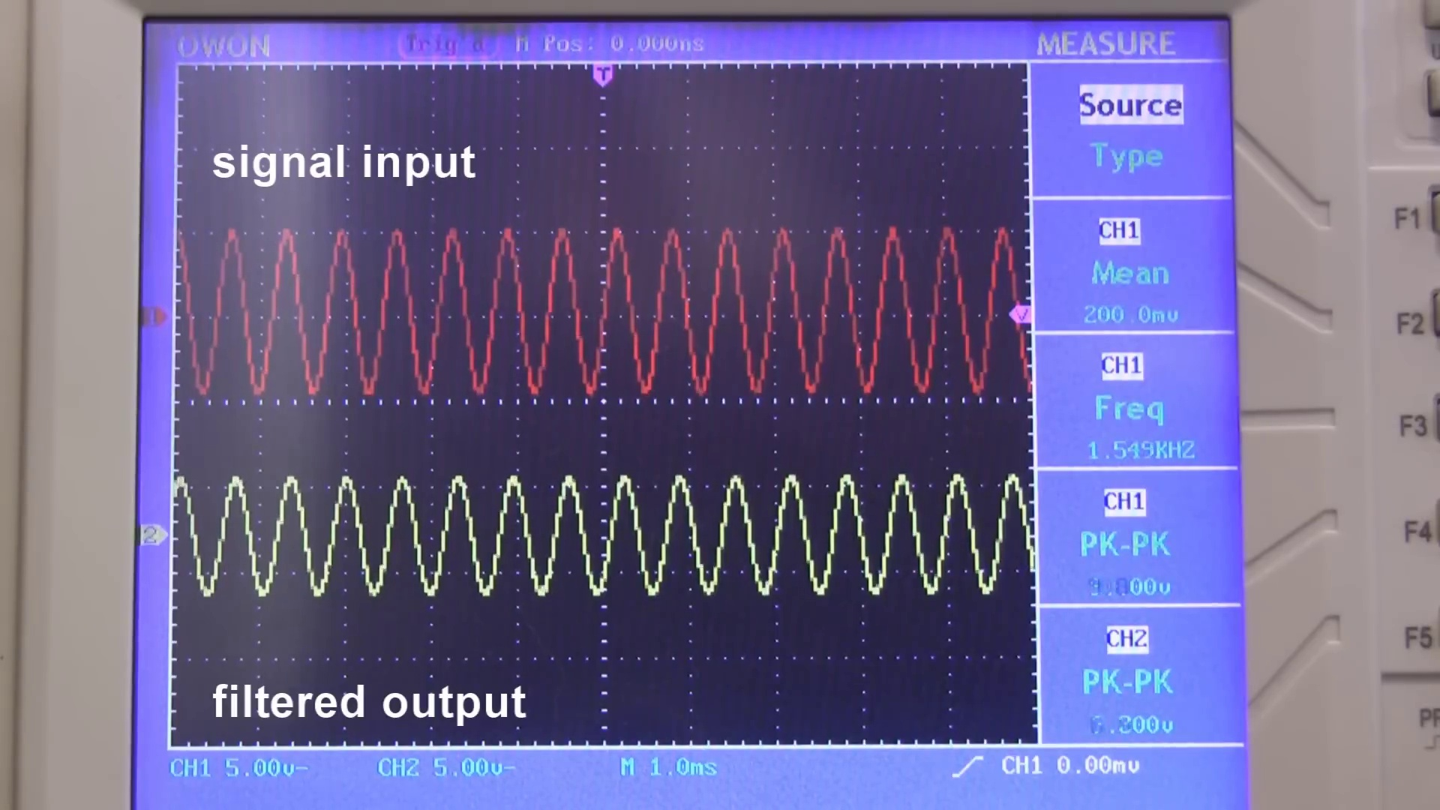 (score 90.0000)
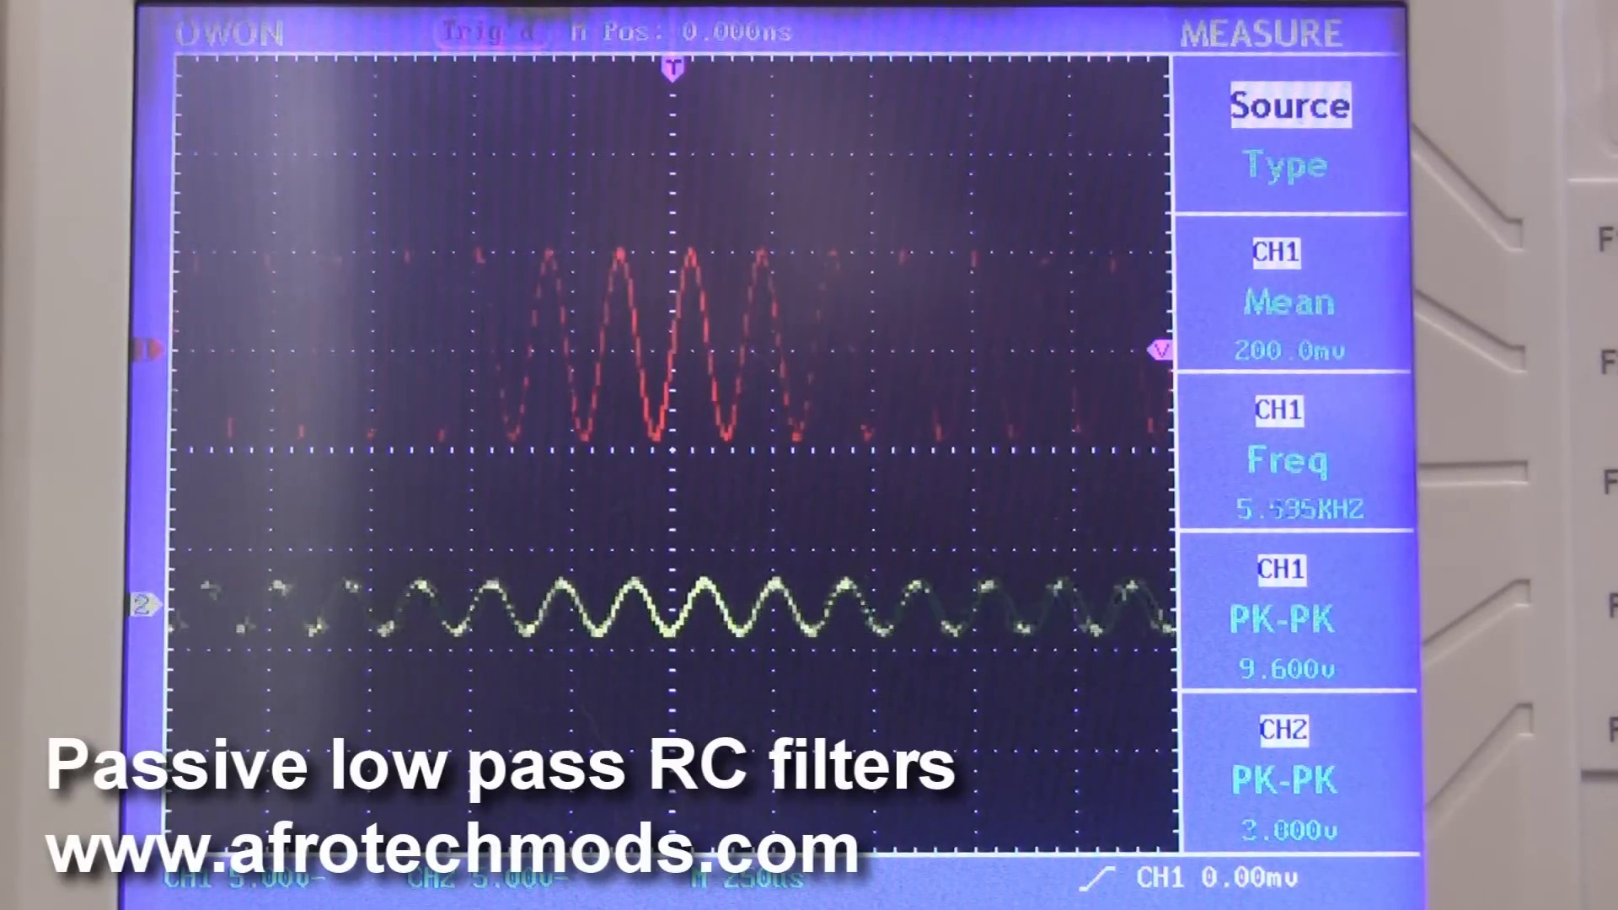 (score 90.0000)
 (score 85.0000)
 (score 85.0000)
 (score 85.0000)
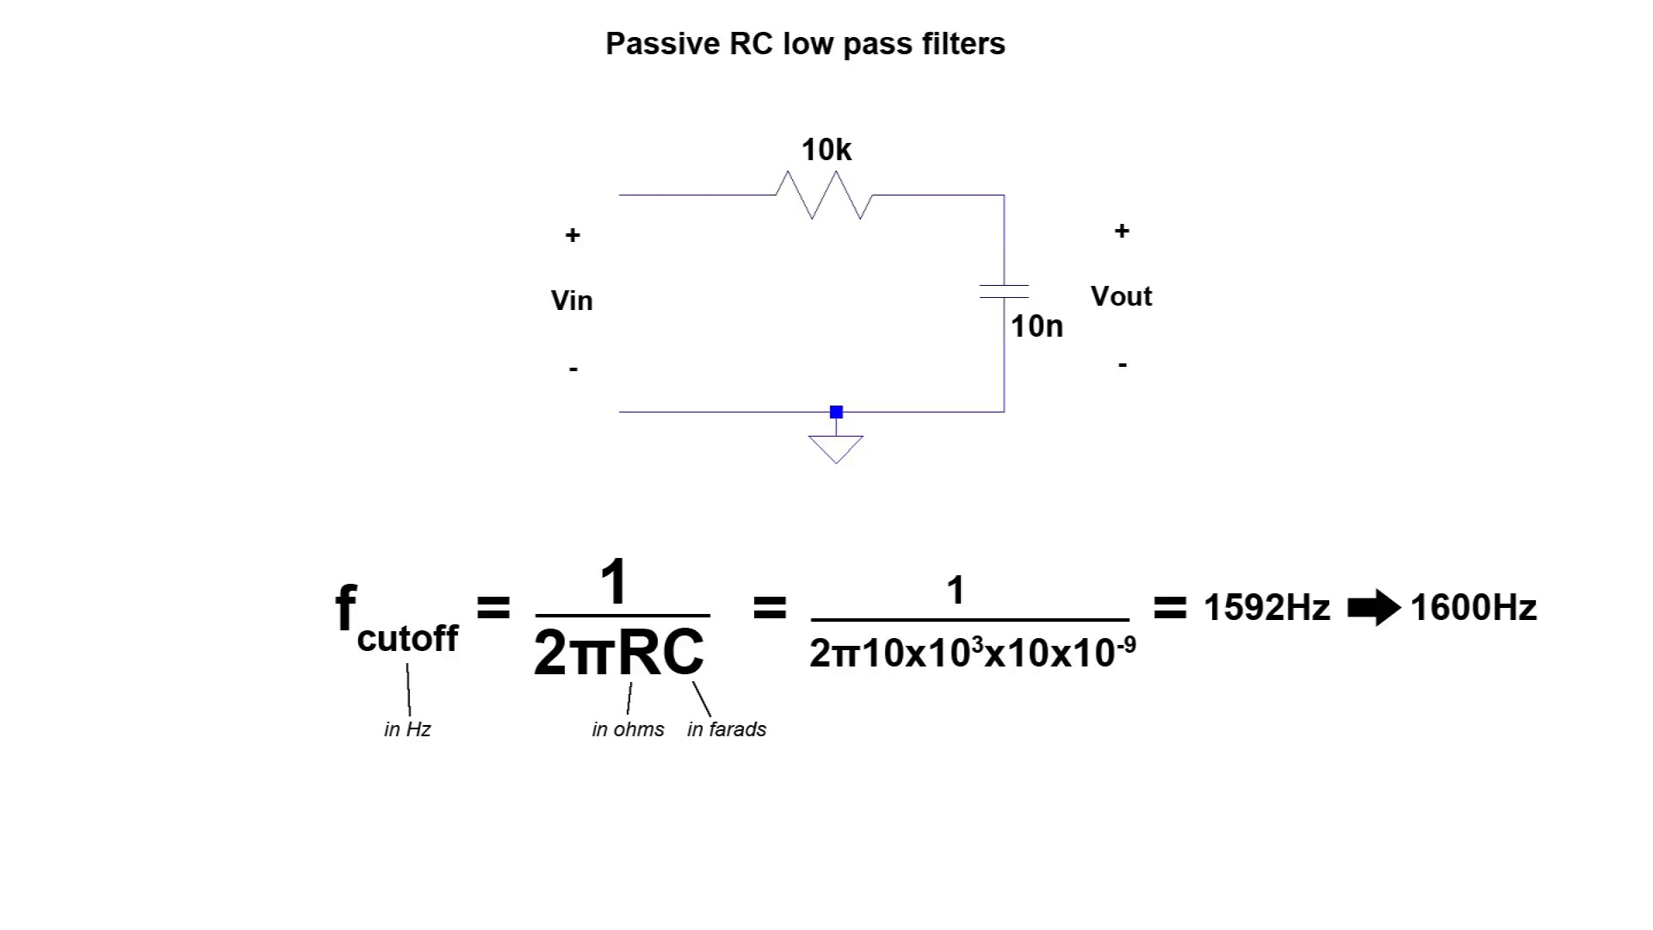 (score 85.0000)
 (score 85.0000)
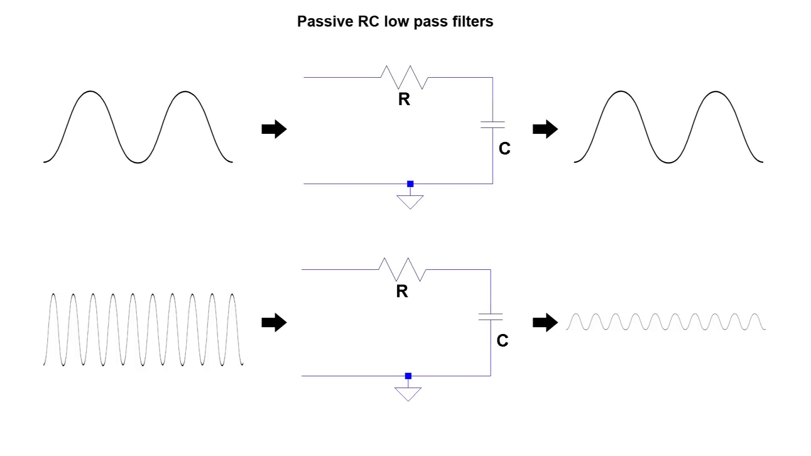 (score 85.0000)
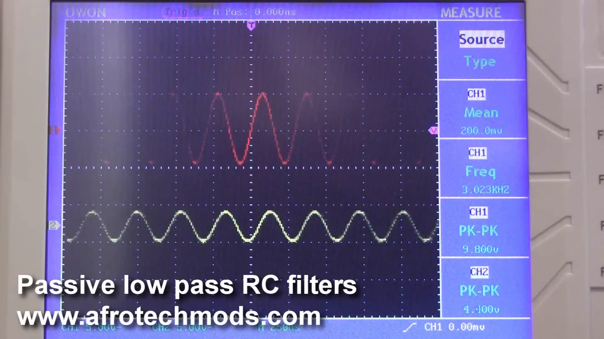 (score 85.0000)
Least correlated frames:
 (score 0.0000)
 (score 0.0000)
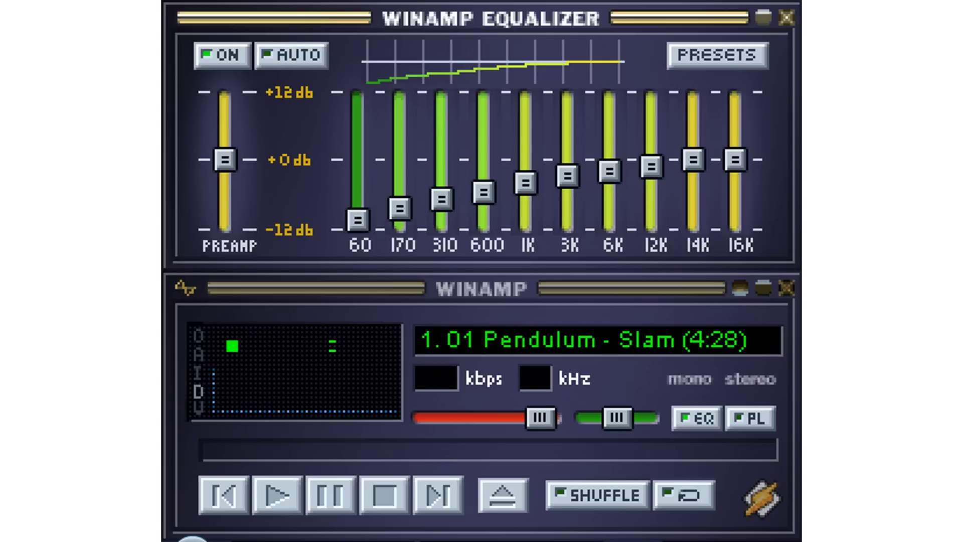 (score 0.0000)
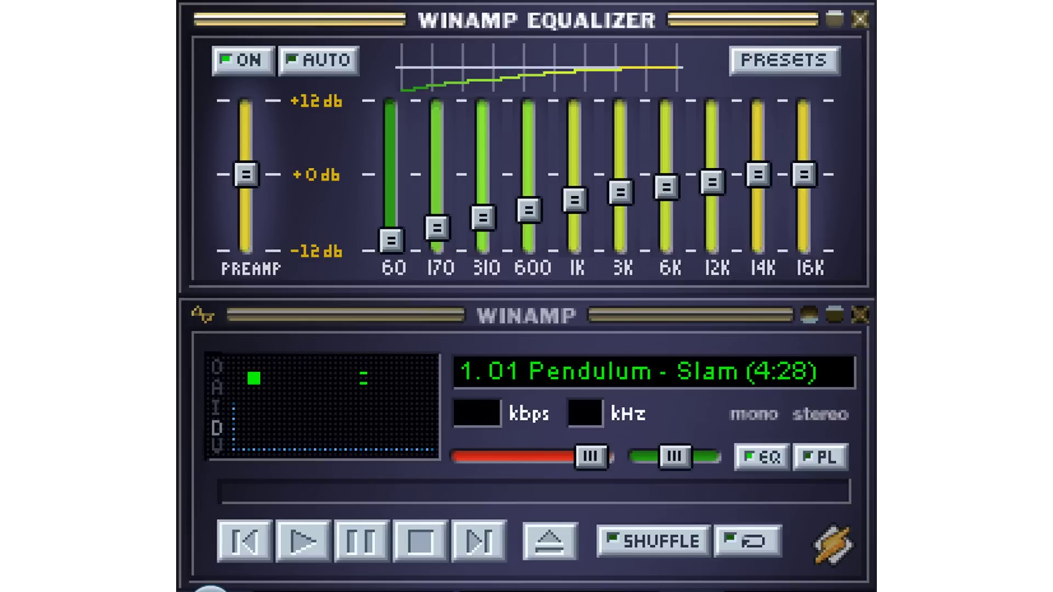 (score 0.0000)
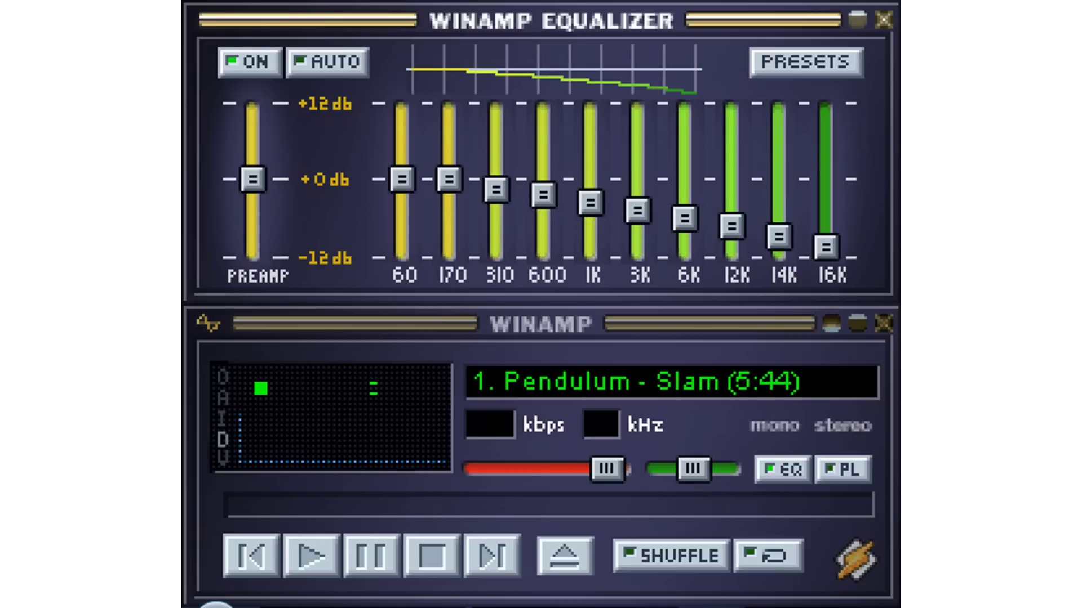 (score 0.0000)
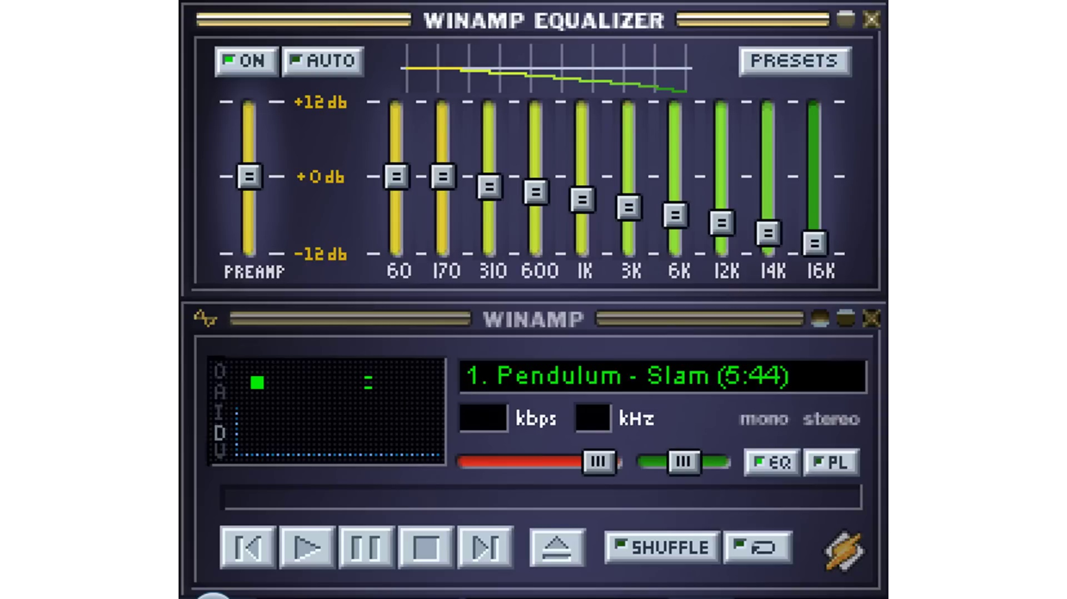 (score 0.0000)
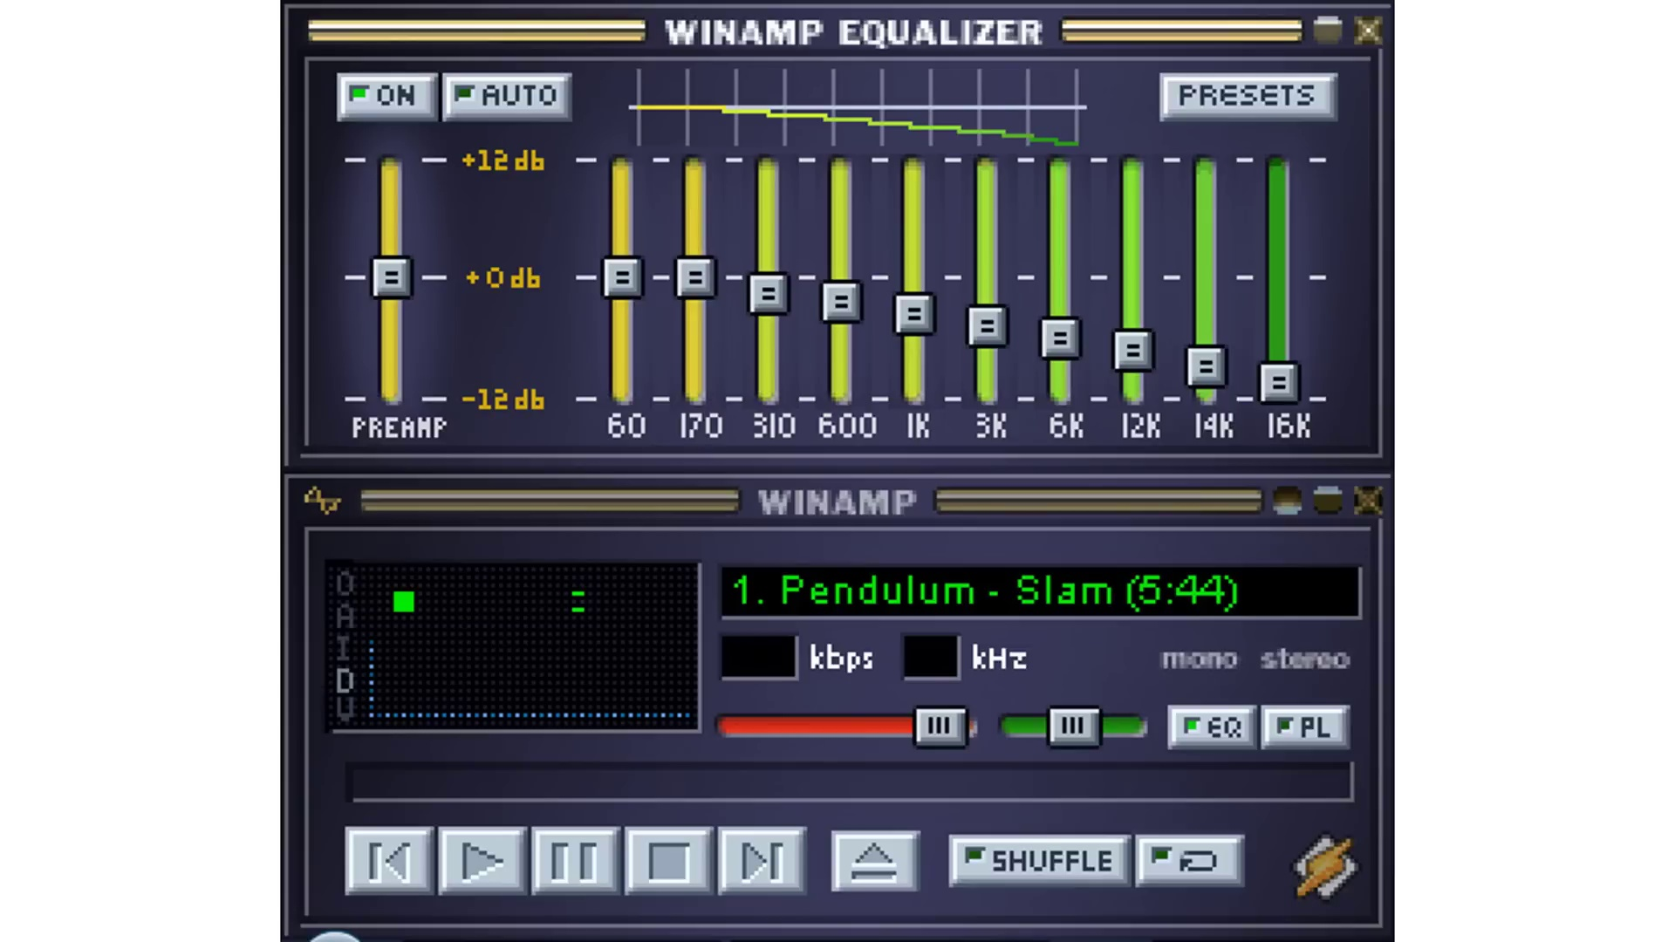 (score 0.0000)
 (score 0.0000)
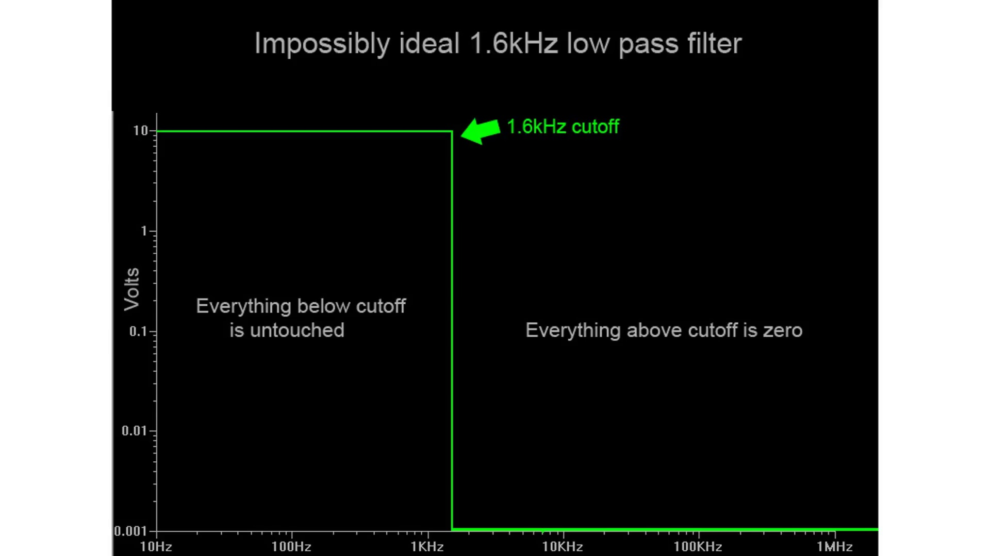 (score 0.0000)
 (score 0.0000)

Frame: frame_0000.jpg
Caption: This image captures a close-up view of a digital oscilloscope displaying a waveform on its white screen with black text. The waveform is a low pass filter, characterized by its high frequency content being filtered out, and the filter type is clearly indicated as RC. The oscilloscope also displays a frequency of 200 Hz and a measurement of 200 MHz, suggesting that the data being displayed is being generated by a source. The display is set to the "Source" mode.
In front of the screen, there is a text overlay on the image itself that reads: "PASSIVE LOOP RCC FILTERS AFROTECHMODS.COM". The term "LOOP RCC FILTERS" could refer to a specific type or configuration within the device, such as a filtering technique used in signal processing. The website mentioned, afrotechmods.com, suggests that this image might be related to educational content on electronic and electrical engineering, possibly teaching about circuit analysis, specifically focusing on RLC filters using resistors (R), capacitors (C), and inductors (L).
Comment (score 95): I learned that a low pass filter can be implemented with a resistor and capacitor in series. Since voltage across a capacitor doesn't change instantly, this slows the output voltage and filters out high frequencies. It's best to choose a resistor first and calculate the capacitor using the cutoff frequency formula. This was helpful for choosing filter values for each speaker in Phase 2.One question I had was whether to adjust the cutoff frequency target because the filtering effect is gradual, not sharp.
Reason: The comment directly discusses the same technical steps and settings described in the caption. Specifically, it explains how a low pass filter can be implemented with a resistor and capacitor in series, which is mentioned in the caption. The commenter also mentions the importance of choosing the correct cutoff frequency, which is displayed on the oscilloscope screen.
Source: https://www.youtube.com/watch?v=OBM5T5_kgdI: Passive RC low pass filter tutorial!
Comment (score 85): The video was incredibly beneficial in elucidating RC low-pass filters and their application, providing clarity on the differences between low-pass and high-pass filters in audio.I did find some of the graphs a bit confusing at times.
Reason: The comment directly discusses RC low-pass filters and their application, which is a technical topic mentioned in the frame caption. The mention of 'RC' in both the caption and the comment suggests a strong connection.
Source: https://www.youtube.com/watch?v=OBM5T5_kgdI&t=241s: Passive RC low pass filter tutorial!
Comment (score 85): This video goes over low pass filters in a unique way I hadn’t seen before. I’ve never seen in lab quite how a cutoff frequency works but this video showed that at the cutoff frequency () that filtered output will only be 30% lower. After this, the amplitude drops exponentially which I knew in theory, but circuits II at MTSU didn’t have a solid lab on this. His cutoff frequency in the video example was 1.6KHz, but still had some voltage out to 9.6KHz. I was under the assumption that this occurred much sooner and didn’t understand a Bode plot until now.
Reason: The comment directly discusses the low pass filter and its characteristics (cutoff frequency, amplitude drop), which are specifically mentioned in the frame caption. The mention of Bode plots and circuit analysis also aligns with the educational content hinted at by the afrotechmods.com website.
Source: https://www.youtube.com/watch?v=OBM5T5_kgdI: Passive RC low pass filter tutorial!

Frame: frame_0001.jpg
Caption: The image depicts two electronic devices: an electrocardiogram (ECG) machine with a monitor displaying various heartbeat lines and waveforms, and a digital multimeter positioned on a white surface. The ECG machine features a control panel with buttons and knobs for adjusting settings, including "SOURCE" and "AMPLITUDE," common parameters used in ECG setups to measure cardiac activity. On the screen, several ECG waveforms are overlaid with what appears to be a passive lowpass filter applied to them, as indicated by the text "PASSIVE LOWPASS RFC FILTERS" on the device.
The filters seem to be adjusting or altering the ECG signals shown. The machine itself has a watermark in the bottom right corner reading "AFROTECHMODS.COM," suggesting that this image may have been sourced from a website specializing in electronics and technology tutorials for African communities.
In the foreground, the digital multimeter is displaying the frequency of a passive lowpass RC filter, set to the Frequency range. The display shows a series of numbers and letters indicating the frequency of the filter in Hertz.
Comment (score 90): I learned that a low pass filter can be implemented with a resistor and capacitor in series. Since voltage across a capacitor doesn't change instantly, this slows the output voltage and filters out high frequencies. It's best to choose a resistor first and calculate the capacitor using the cutoff frequency formula. This was helpful for choosing filter values for each speaker in Phase 2.One question I had was whether to adjust the cutoff frequency target because the filtering effect is gradual, not sharp.
Reason: The comment directly discusses the technical steps involved in implementing a passive lowpass filter, specifically using a resistor and capacitor in series, which is also described in the caption. The comment also mentions adjusting the cutoff frequency target, which is mentioned as part of the 'PASSIVE LOWPASS RFC FILTERS' text on the ECG machine. The correlation is strong because the comment focuses on the same technical concepts and terminology presented in the caption.
Source: https://www.youtube.com/watch?v=OBM5T5_kgdI: Passive RC low pass filter tutorial!
Comment (score 90): The video was incredibly beneficial in elucidating RC low-pass filters and their application, providing clarity on the differences between low-pass and high-pass filters in audio.I did find some of the graphs a bit confusing at times.
Reason: The comment directly discusses the same technical steps and settings described in the caption, specifically RC low-pass filters and their application. The only minor departure is the mention of high-pass filters in audio, which is still related to the topic of passive filters.
Source: https://www.youtube.com/watch?v=OBM5T5_kgdI&t=241s: Passive RC low pass filter tutorial!
Comment (score 85): This video goes over low pass filters in a unique way I hadn’t seen before. I’ve never seen in lab quite how a cutoff frequency works but this video showed that at the cutoff frequency () that filtered output will only be 30% lower. After this, the amplitude drops exponentially which I knew in theory, but circuits II at MTSU didn’t have a solid lab on this. His cutoff frequency in the video example was 1.6KHz, but still had some voltage out to 9.6KHz. I was under the assumption that this occurred much sooner and didn’t understand a Bode plot until now.
Reason: The comment directly discusses the technical steps and objects described in the caption, such as lowpass filters, cutoff frequency, amplitude, and Bode plots. The comment specifically mentions the video example showing how the filtered output drops exponentially after the cutoff frequency, which is closely related to the settings and parameters mentioned in the caption.
Source: https://www.youtube.com/watch?v=OBM5T5_kgdI: Passive RC low pass filter tutorial!

Frame: frame_0002.jpg
Caption: The image shows a textual meme with a question and an answer format, featuring a black and white photograph of a black screen. On the screen, the bold and white text "Uhh... what's a filter circuit?" is positioned centrally, making it the focal point of the image. The overall composition suggests a serious or formal tone, possibly related to a technical or scientific context.
At the top of the meme, there is a heading that reads "??? what's a filter circuit?", which poses a question about an educational topic likely within the context of electronics or electrical engineering. Below this header, to the right, is a small image of an electronic component resembling a capacitor or perhaps a diode, but it is not clear enough to definitively identify.
The text in the meme is written in a casual, conversational font and is colorful, making it stand out against the gray background. The absence of any other objects or text in the image further emphasizes the text and its message.
Comment (score 85): This video goes over low pass filters in a unique way I hadn’t seen before. I’ve never seen in lab quite how a cutoff frequency works but this video showed that at the cutoff frequency () that filtered output will only be 30% lower. After this, the amplitude drops exponentially which I knew in theory, but circuits II at MTSU didn’t have a solid lab on this. His cutoff frequency in the video example was 1.6KHz, but still had some voltage out to 9.6KHz. I was under the assumption that this occurred much sooner and didn’t understand a Bode plot until now.
Reason: The comment directly discusses the same technical concept of low pass filters and their characteristics (cutoff frequency, amplitude drop) described in the caption. The mention of Bode plots also aligns with the tone and context suggested by the caption.
Source: https://www.youtube.com/watch?v=OBM5T5_kgdI: Passive RC low pass filter tutorial!
Comment (score 80): The video was incredibly beneficial in elucidating RC low-pass filters and their application, providing clarity on the differences between low-pass and high-pass filters in audio.I did find some of the graphs a bit confusing at times.
Reason: The comment directly discusses the application of low-pass filters, which are explicitly mentioned in the caption as a possible topic related to electronics or electrical engineering. The mention of RC low-pass filters and differences between low-pass and high-pass filters in audio further strengthens the connection.
Source: https://www.youtube.com/watch?v=OBM5T5_kgdI&t=241s: Passive RC low pass filter tutorial!

Frame: frame_0003.jpg
Caption: The image displays a software interface that appears to be related to audio editing or sound manipulation, specifically the Winamp Equalizer. The interface features a dark theme with several components visible:
1. A user interface with a series of oscilloscopes showing different frequency bands of an audio signal, labeled with frequencies such as "8kHz," "4kHz," "2kHz," and "500Hz." The waveforms suggest the use of equalization tools to enhance or adjust specific frequency components within the audio spectrum.
2. A control panel with various sliders on the right side, which are likely for manual adjustment of the audio frequencies across different bands, including sliders labeled as "Bass," "Mid," and "Treble."
3. Display of signal levels at the bottom of each oscilloscope, showing numerical values that could represent volume or gain settings for each frequency band.
4. A "Preset" button next to the waveform display, suggesting the ability to select pre-set equalization curves.
5. An "Auto" button, possibly indicating an automatic adjustment function.
6. A series of buttons with symbols representing specific audio functions such as "Cut," "Boost," and "Flat." These buttons are likely used for selecting or applying different types of equalization (cutting, boosting, or maintaining the original levels) to the selected frequency bands.
7. Two numerical values on a horizontal axis, "Preset 1" and "Preset 2," with corresponding waveforms, indicating that these might represent two different preset equalization settings that can be switched between.
8. A series of "Stop," "Play/Pause," and "Forward" buttons at the bottom, suggesting the ability to control audio playback, possibly within this software.
9. The interface also features a left side with a vertical line of buttons, likely used for adjusting the volume levels of different audio tracks.
10. In the center of the panel, a large white button is visible, which might be used for adjusting the overall volume of the audio track.
11. Above the panel, there's a white button that might be used for adjusting the equalizer settings.
12. The background of the panel is black, providing a stark contrast to the white buttons and controls, making it easy for users to navigate and adjust the audio settings.
No strongly correlated comments found for this frame.

Frame: frame_0004.jpg
Caption: The image shows an interface for a digital audio workstation (DAW) software, specifically a sound recording and mixing application. At the top of the image is a graphical user interface (GUI) with various audio tracks, each represented by a vertical yellow bar, likely indicating volume levels or other audio parameters. Below this are meters displaying waveforms and sound frequencies, commonly used in sound engineering to monitor the levels of different frequency components.
In the center, there is a mixer panel with several sliders, knobs, and buttons, suggesting adjustments can be made to various aspects of the audio, such as volume levels, equalization settings, and other parameters for each track. To the right, there are more meters and control panels, and below them, a graphic representation of a sound waveform with frequency content indicated by vertical lines on the bottom.
On the top left corner, a text input field labeled "Wavempeg Equalizer" implies that this software is used for equalizing audio files in WAV format using Wavempeg technology. Below it, two horizontal bars indicate levels or settings: one titled "Level" and another with the label "Phase."
There's also a numerical readout at the bottom right corner showing "1/0 48k," possibly referring to the sample rate and sampling format of the audio being worked on.
In the bottom left corner, a small text reads "1.0%," which could be a progress indicator or the current position in the software's timeline.
The interface also features an equalizer section, set to the "Auto" mode, with three main sections: "Presets", "Balance", and "Pendulum". The "Presets" section contains preset options for equalization, while the "Balance" section allows manual adjustment of the equalizer's gain. The "Pendulum" section provides a range of 1 Hz to 100 Hz.
The interface does not contain any text or other objects, and the overall layout suggests a user-friendly design with clear labels and easy-to-use controls.
Comment (score 85): This video goes over low pass filters in a unique way I hadn’t seen before. I’ve never seen in lab quite how a cutoff frequency works but this video showed that at the cutoff frequency () that filtered output will only be 30% lower. After this, the amplitude drops exponentially which I knew in theory, but circuits II at MTSU didn’t have a solid lab on this. His cutoff frequency in the video example was 1.6KHz, but still had some voltage out to 9.6KHz. I was under the assumption that this occurred much sooner and didn’t understand a Bode plot until now.
Reason: The comment discusses the concept of cutoff frequency and its relation to filtered output amplitude, which is directly related to the technical steps and objects described in the caption, such as low-pass filters and equalization settings. The mention of Bode plots and exponential amplitude drops also matches with the technical information presented in the caption.
Source: https://www.youtube.com/watch?v=OBM5T5_kgdI: Passive RC low pass filter tutorial!

Frame: frame_0005.jpg
Caption: The image shows a computer screen displaying an audio editing software interface, featuring a waveform display with two channels and various audio processing tools. The software appears to be equipped with level meters for input (E) and output (O) levels, a VU meter, and a digital signal processing (DSP) graphical representation of the sound spectrum. Additionally, there are sections labeled "EQUALIZER" suggesting that the software is used to adjust audio frequencies.
In the lower right corner, there's a text box with the text "1.0", likely representing the gain or level settings for the selected track. The background of the interface is dark, making the brightly lit elements stand out.
The user interface includes several panels and modules that are typically found in audio editing software:
* **Waveform Display**: This shows two channels of audio, with a playhead indicating where the user can start or stop playback.
* **Meter Panels**: These display the level meters for input (E) and output (O) levels, which are crucial for maintaining an appropriate balance between levels to prevent distortion or clipping.
* **VU Meter**: This is a tool used to measure volume units, providing visual feedback on the audio signal level relative to the specified threshold.
* **DSP Graphical Representation**: The graphical representation of the sound spectrum is often used in audio editing to help users visualize and modify the frequency response of an audio signal.
* **EQUALIZER Panels**: These panels allow the user to manipulate the equalization settings for each channel, adjusting the frequency balance according to the desired tonal characteristics.
The interface also features additional elements:
* A "Solo" button (labeled "S"), which allows the user to listen to a single track without any other tracks playing.
* A "Mute" button (labeled "M"), used to temporarily silence a track.
* A "Record Arm" button, which is likely used to activate recording in the selected track(s).
* A "Stop" button, labeled "STOP", for stopping playback.
* Additional tools and buttons that are common features in audio editing software, such as transport controls (play/pause, stop), zoom and pan functions for the waveform display, and possibly additional DSP or equalization tools.
The interface is designed with a clean and professional aesthetic, using a combination of colors to highlight important elements while maintaining a cohesive and user-friendly layout.
No strongly correlated comments found for this frame.

Frame: frame_0006.jpg
Caption: The image shows a computer interface with a software application open, featuring a monochromatic color scheme with a blue background and black text. The main focus of the interface is the Wamp MP3 Splitter program, which is used to divide an audio file into multiple parts. At the top of the interface, the title "Wamp MP3 Splitter" indicates the purpose of the software.
The interface displays several controls and panels, including a waveform display showing two separate audio files being split. The waveforms are monochromatic, typically representing amplitude over time. Below the waveform display is a control panel with a "Play" button on the left, suggesting that there's an audio player feature to listen to the segments of the audio file as they are created.
The control panel also features numerical values and sliders for setting various parameters, such as "Time," "Volume," and other sound-related settings. These controls likely allow the user to adjust the output of each segment of the audio file. Additionally, a series of checkboxes and buttons labeled with terms like "Normalize," "Reverse," and "Fade In/Out" suggest various audio processing functions that can be applied during the splitting process.
Text boxes indicating file paths or names, such as "C:\Users\Username\Audio Files" and "D:\Sounds\Sound File 1.wav," are also present, suggesting that the user has access to different directories on their computer where audio files are stored. At the bottom of the interface, there is a visual representation of an audio signal with meters indicating amplitude levels, which could be used to monitor the output levels during the splitting process.
The interface appears to be in Spanish, which is the default language setting for the operating system or software application being used. The overall style of the interface suggests it's a screenshot from an older version of Windows, indicated by the aesthetic and layout of the controls and panels.
In the top-right corner of the interface, the Winamp logo is prominently displayed, indicating the software used for audio processing. Below the equalizer settings are the various controls and buttons, including a "Shuffle" button that allows users to play music in a random order.
No strongly correlated comments found for this frame.

Frame: frame_0007.jpg
Caption: The image shows a screenshot from a music software program, featuring a digital audio workstation (DAW) interface. The background is a solid black color, providing a stark contrast to the colorful buttons and sliders. At the top of the screen, there's a menu bar with options labeled "WINAMP" and "PRESETS". Below the menu bar, there's a button labeled "WINAMP", likely indicating the main program interface.
The middle of the screen is occupied by a set of sliders, labeled "1.01 Pendulum - Slam (4:28)". These sliders are colored in shades of black and gray, and they're positioned vertically, suggesting they're used for volume control or pitch adjustment. To the right of these controls, there's a graphical representation of sound waves or frequencies with labels such as "1 kHz," "2 kHz," etc., suggesting that this part of the interface is used to visualize and adjust the balance of various audio components at different frequency ranges.
On the left side of the screen, there is a vertical column of knobs and buttons with icons indicating their functions; for example, some are labeled "MUTE" and others are not fully visible. The bottom of the screen shows an array of digital waveforms representing audio signals with different levels or peaks, which are typical elements in a DAW's interface to visualize audio signal flow or levels.
Additionally, there is a label "WiMPAMP EQUALIZER" at the top of the screen, indicating that this part of the interface is likely used for equalizer settings. Below this title, there are several control knobs and sliders representing different frequency bands or audio parameters that can be adjusted.
Comment (score 90): I learned that a low pass filter can be implemented with a resistor and capacitor in series. Since voltage across a capacitor doesn't change instantly, this slows the output voltage and filters out high frequencies. It's best to choose a resistor first and calculate the capacitor using the cutoff frequency formula. This was helpful for choosing filter values for each speaker in Phase 2.One question I had was whether to adjust the cutoff frequency target because the filtering effect is gradual, not sharp.
Reason: The comment directly discusses low-pass filter implementation using a resistor and capacitor in series, which is closely related to the graphical representation of sound waves or frequencies with labels such as '1 kHz,' '2 kHz,' etc. in the frame caption. The mention of cutoff frequency formula also correlates with the discussion on equalizer settings in the caption.
Source: https://www.youtube.com/watch?v=OBM5T5_kgdI: Passive RC low pass filter tutorial!
Comment (score 85): This video goes over low pass filters in a unique way I hadn’t seen before. I’ve never seen in lab quite how a cutoff frequency works but this video showed that at the cutoff frequency () that filtered output will only be 30% lower. After this, the amplitude drops exponentially which I knew in theory, but circuits II at MTSU didn’t have a solid lab on this. His cutoff frequency in the video example was 1.6KHz, but still had some voltage out to 9.6KHz. I was under the assumption that this occurred much sooner and didn’t understand a Bode plot until now.
Reason: The comment directly discusses the same technical steps (cutoff frequency and its effect on amplitude) described in the caption. The mention of frequency ranges (1.6KHz, 9.6KHz) and audio parameters (amplitude, voltage) also strongly relates to the interface elements shown in the screenshot.
Source: https://www.youtube.com/watch?v=OBM5T5_kgdI: Passive RC low pass filter tutorial!

Frame: frame_0008.jpg
Caption: The image shows a screenshot of a digital audio workstation (DAW) interface on a computer monitor. At the center, there is a mixer panel with various sliders and meters, indicating control over volume levels and other audio parameters for tracks in a project. On the top left corner of the screen, there is a label "WiMPER EQUALIZER" which suggests that this section of the interface is used to adjust equalization settings for different aspects of sound, such as bass, midrange, and treble frequencies.
Below the mixer panel, the user interface includes a series of knobs and controls labeled with numbers from 1 to 4, likely representing different channels or tracks within the project. Alongside these controls are some additional settings with parameters like "Wind", "Auto", "Smooth", and "Sharp", which could be related to equalization curves.
On the right side of the screen, there is a digital display showing a frequency spectrum with several peaks indicating where certain frequencies are amplified or reduced. This helps the user understand the current balance of frequencies within their mix. There's also a numerical value "1.0 dB" displayed below the spectrum, which might refer to the amount of gain (amplification) applied to the audio signal at the particular frequency being analyzed.
At the top half of the screen, the "Winamp Equalizer" logo is prominently displayed in a vibrant blue and orange color scheme, along with the "WINAMP" logo below it. The interface is further divided into two main sections: the "PUSH" section and the "SLAM" section. The "PUSH" section features a slider marked with "1.01 Pendulum" and "Slam (4KHz)", while the "SLAM" section is divided into two subsections: "4KHz" and "Mono (Shuffle)".
The background behind the interface is gray with a slight gradient from lighter at the top to darker at the bottom, which could be a screensaver or the default wallpaper on the computer. The overall style of the image is typical for digital interfaces, with a focus on functional design intended for user interaction and control over audio production settings.
Comment (score 80): I learned that a low pass filter can be implemented with a resistor and capacitor in series. Since voltage across a capacitor doesn't change instantly, this slows the output voltage and filters out high frequencies. It's best to choose a resistor first and calculate the capacitor using the cutoff frequency formula. This was helpful for choosing filter values for each speaker in Phase 2.One question I had was whether to adjust the cutoff frequency target because the filtering effect is gradual, not sharp.
Reason: The comment directly discusses low-pass filters and how they can be implemented with resistors and capacitors in series, which is strongly related to the equalization settings (e.g., 'Wind', 'Auto', 'Smooth', and 'Sharp') described in the caption.
Source: https://www.youtube.com/watch?v=OBM5T5_kgdI: Passive RC low pass filter tutorial!

Frame: frame_0009.jpg
Caption: The image shows a computer interface with an open digital audio workstation (DAW) using an audio mixing software. The interface features various virtual panels and sliders, typical of a DAW, including meters and displays such as oscilloscopes, VU meters, and indicators of audio signal levels and frequencies.
On the screen, text reads "Wavetek EQ 10," suggesting that this is an Equalizer (EQ) preset from the Wavetek brand. The numerals "10" likely refer to a specific preset or setting within the EQ module. Two numerical values are prominently displayed: "-4.6 dB/s," which could be the gain or attenuation settings for the equalizer, and "1.27 kHz," which might refer to a sampling frequency or another parameter related to audio processing.
The interface is divided into sections, including a gray and black-colored equalizer section with three options: "Normal", "Auto", and "Presets". The "Normal" section features a slider bar for adjusting the volume, while the "Auto" section offers color-coded preset equalizer settings. The "Presets" section is currently set to "Slam (1.01 Pendulum, 4KHz)", indicating the selected preset.
Additionally, the interface includes a "Shuffle" button and menu item, suggesting that the user has the option to shuffle audio tracks. Overall, the layout is intuitive, with each section clearly labeled and the slider and preset options easily accessible, making it clear that this software is being used for recording, editing, or mixing audio tracks.
Comment (score 85): This video goes over low pass filters in a unique way I hadn’t seen before. I’ve never seen in lab quite how a cutoff frequency works but this video showed that at the cutoff frequency () that filtered output will only be 30% lower. After this, the amplitude drops exponentially which I knew in theory, but circuits II at MTSU didn’t have a solid lab on this. His cutoff frequency in the video example was 1.6KHz, but still had some voltage out to 9.6KHz. I was under the assumption that this occurred much sooner and didn’t understand a Bode plot until now.
Reason: The comment directly discusses the concept of cutoff frequency and its relation to low pass filters, which is also mentioned in the caption. The specific values of 1.6KHz and 9.6KHz mentioned in the comment match the context of the caption's discussion on audio signal levels and frequencies.
Source: https://www.youtube.com/watch?v=OBM5T5_kgdI: Passive RC low pass filter tutorial!

Frame: frame_0010.jpg
Caption: The image shows an interface from a digital audio workstation (DAW) with various features and controls for audio editing. At the top of the window, there is a label that reads "WINAMP Equalizer" alongside the Windows logo, indicating that the software is running on a Windows operating system. The title also indicates that the software is currently in the "Preferences" mode, set to the "Master" preset.
On the left side of the window, there are faders, possibly for adjusting volume levels or other audio parameters. Below these faders, there's a vertical slider labeled "FREQUENCY" with numerical values ranging from 0 to 30 Hz, suggesting that this software is used for frequency equalization.
The central part of the interface displays a spectrum analyzer graphic showing a frequency response curve with several peaks and valleys at different frequencies. Each peak represents an area where audio content can be perceived as louder or more pronounced than the rest of the frequency range.
To the right of this graph, there is a digital display that shows the current setting, "1 0 2," which could refer to a three-band equalization setting with each band being adjusted individually. There's also another numerical value labeled "4dB."
On the bottom left corner, there are buttons and controls resembling those found on audio mixing consoles, such as a mute button (the triangle with an "X" in it), solo buttons, and possibly gain controls or other settings.
The background of the interface is mostly black with a light gray grid pattern that could be used for visualizing other features or settings not directly related to equalization. The software appears to be designed for users who are familiar with audio engineering and mixing concepts, as it seems to be a professional tool for fine-tuning audio frequency response characteristics.
No strongly correlated comments found for this frame.

Frame: frame_0011.jpg
Caption: The image shows a software interface for Winamp, featuring an audio mixing equipment-inspired visual representation. The graphic includes an array of audio channels with faders and meters to indicate levels, as well as a display showing the current settings for one track or input, labeled "WINITAMP". Below the graphic, several panels feature various audio parameters and settings, including faders for volume control, meters that likely display signal levels or meters, possibly equalization (EQ) adjustments, text boxes, and sliders for fine-tuning individual parameters. The design suggests this could be part of an educational tool to teach about mixing sound or a screenshot from a digital audio workstation (DAW).
In the top section of the interface, there are two options: "AUTO" and "ON", indicating automatic and manual settings respectively. Below these options, two sliders are visible: one labeled "1.01 Pendulum" set to 1.01, and another labeled "Slam (4KHz)" set to 4KHz. Additionally, two buttons are present at the bottom right corner of the interface: "Shuffle" and "Mute". A progress bar, stop button, play/pause toggle, and zoom control are also visible, indicating the software's ability to play and edit audio. The background of the image is a solid black color, providing a stark contrast to the white text and graphics on the interface.
Comment (score 80): This video goes over low pass filters in a unique way I hadn’t seen before. I’ve never seen in lab quite how a cutoff frequency works but this video showed that at the cutoff frequency () that filtered output will only be 30% lower. After this, the amplitude drops exponentially which I knew in theory, but circuits II at MTSU didn’t have a solid lab on this. His cutoff frequency in the video example was 1.6KHz, but still had some voltage out to 9.6KHz. I was under the assumption that this occurred much sooner and didn’t understand a Bode plot until now.
Reason: The comment discusses the concept of cutoff frequency and how it relates to amplitude drops in a lab setting, which is directly connected to the technical steps and settings described in the caption. The mention of specific frequencies (1.6KHz, 9.6KHz) and parameters (30% lower) matches the information presented in the caption.
Source: https://www.youtube.com/watch?v=OBM5T5_kgdI: Passive RC low pass filter tutorial!

Frame: frame_0012.jpg
Caption: The image shows a digital audio workstation interface, specifically the Winamp Equalizer, set to the "1.01 Pendulum - Slam (4KHz)" preset. The interface is dominated by a large, circular dial that is currently set to 1.01, encircled by a green circle indicating the current setting. A blue square and a red circle are also featured, which could be part of the interface's visual design or controls.
In the lower left corner, there is a VU meter showing the volume level of the audio track being displayed. To the right, various sliders and knobs typical of an audio mixing console are present, allowing for adjustments to levels, panning, and other parameters related to audio processing. These include panels with different visual metaphors to represent audio levels such as waveforms and meters.
At the top of the image, there is a menu bar with options including "File," "Edit," "View," and "Window." Below these menu options are numerical values representing the current position in the timeline of the audio track being viewed. The numbers "0:01" and "4:32" suggest that this software interface allows for precise navigation through an audio project's duration.
The user interface is designed to mimic a physical mixing console, with each slider and knob having labels like "PAN," "GAIN," "EQ," and "LEVEL." There are also numerical values indicating levels such as "-24" dB, "0," and "+12" dB for the level meters. On the top right corner of the interface, there's a digital display showing text that is too small to read in detail, but it appears to be providing additional information about the audio tracks or settings.
The overall style of the image suggests it is a screenshot from a computer program rather than an actual physical device. The design of the software interface is intended for clarity and ease of use for someone working with digital audio files.
No strongly correlated comments found for this frame.

Frame: frame_0013.jpg
Caption: The image displays a digital audio workstation (DAW) interface with various controls and displays for sound mixing and editing. At the top of the DAW interface, there is a label that reads "Winamp Equalizer," indicating the software application being used. Below this title, there are graphical equalizers with frequency response curves showing the settings for low-pass, high-pass, band-pass, and band-stop filters.
On the left side of the interface, there is a channel strip with input meters (VU) for monitoring audio levels and a signal processing section that includes a gain control, equalizer knobs, and a graphic display showing the gain reduction or phase correlation of the audio signal. To the right of this channel strip, there are more audio level meters and a panel of faders, likely representing volume levels for each track being mixed.
Below the main interface, there is a smaller section with numerical values and text that appears to be a control panel or settings menu, possibly related to the equalizer's parameters. The controls include sliders for adjusting gain and bandwidth for each frequency band, as well as a numerical value labeled "107 dB."
The Equalizer itself is split into two sections, each displaying different settings. The left section displays a slider for the 1.01 Pendulum, labeled as "Slam" and "1:28", while the right section showcases a slider for the 1.02 Pendulum, labeled as "Slow" and "4:28". The interface is set to the "Normal" preset, indicating that the default settings are in use. A small "Shuffle" button is also visible on the right side of the interface.
Comment (score 95): I learned that a low pass filter can be implemented with a resistor and capacitor in series. Since voltage across a capacitor doesn't change instantly, this slows the output voltage and filters out high frequencies. It's best to choose a resistor first and calculate the capacitor using the cutoff frequency formula. This was helpful for choosing filter values for each speaker in Phase 2.One question I had was whether to adjust the cutoff frequency target because the filtering effect is gradual, not sharp.
Reason: The comment directly discusses the concept of low-pass filters and their implementation using a resistor and capacitor in series, which is related to the graphical equalizers with frequency response curves showing the settings for low-pass filters described in the caption.
Source: https://www.youtube.com/watch?v=OBM5T5_kgdI: Passive RC low pass filter tutorial!
Comment (score 80): The video was incredibly beneficial in elucidating RC low-pass filters and their application, providing clarity on the differences between low-pass and high-pass filters in audio.I did find some of the graphs a bit confusing at times.
Reason: The comment directly discusses the application of low-pass filters in audio, which is specifically mentioned in the frame caption as one of the frequency response curves shown.
Source: https://www.youtube.com/watch?v=OBM5T5_kgdI&t=241s: Passive RC low pass filter tutorial!

Frame: frame_0014.jpg
Caption: The image shows a digital audio workstation (DAW) interface on a computer monitor, specifically the Winamp Equalizer. The top of the window displays the text "Winamp Equalizer," while the left side features several horizontal sliders for adjusting equalization settings, including bass, treble, and mid-range frequency bands. Above these sliders is a graphic representation of sound waves with varying amplitudes.
In the center of the interface, there's a volume meter displaying levels that indicate the audio output signal strength, measured in decibels (dB). Below this meter is a level indicator with numerical values ranging from -100 to 4, possibly representing different audio channels or tracks. To the right of these meters are two vertical columns labeled "Freq" and "Gain," which could be used for customizing equalization frequencies and corresponding gain levels for each band.
The bottom of the interface features various buttons and controls, including transport control options such as play/pause, stop, and fast-forward/rewind buttons. There's also a text entry field with numerical input, suggesting the ability to input specific values or frequencies. A couple of horizontal bars are visible at the bottom left corner, which could represent levels for individual audio tracks or channels, although their exact function is not clear from the image alone.
The overall style of the interface suggests a user-friendly graphical user interface (GUI) designed for adjusting audio parameters and settings. The equalizer currently set to the "0.1" preset is displayed in various colors, including green, yellow, and red, which could indicate different levels of intensity or balance.
Comment (score 85): This video goes over low pass filters in a unique way I hadn’t seen before. I’ve never seen in lab quite how a cutoff frequency works but this video showed that at the cutoff frequency () that filtered output will only be 30% lower. After this, the amplitude drops exponentially which I knew in theory, but circuits II at MTSU didn’t have a solid lab on this. His cutoff frequency in the video example was 1.6KHz, but still had some voltage out to 9.6KHz. I was under the assumption that this occurred much sooner and didn’t understand a Bode plot until now.
Reason: The comment directly discusses the same technical concepts described in the caption, specifically referencing 'cutoff frequency', 'filtered output', and 'Bode plot', which are all related to audio equalization settings depicted in the image. The commenter also mentions adjusting frequencies and gain levels, which matches the interface controls shown in the caption.
Source: https://www.youtube.com/watch?v=OBM5T5_kgdI: Passive RC low pass filter tutorial!
Comment (score 80): I learned that a low pass filter can be implemented with a resistor and capacitor in series. Since voltage across a capacitor doesn't change instantly, this slows the output voltage and filters out high frequencies. It's best to choose a resistor first and calculate the capacitor using the cutoff frequency formula. This was helpful for choosing filter values for each speaker in Phase 2.One question I had was whether to adjust the cutoff frequency target because the filtering effect is gradual, not sharp.
Reason: The comment directly discusses technical steps (implementing a low pass filter with resistor and capacitor) that are related to the settings and goals described in the caption (adjusting audio equalization frequencies). The comment also mentions formulas for calculating component values, which is relevant to the graphical user interface shown in the caption. Although the comment does not specifically mention the Winamp Equalizer, it discusses electrical engineering concepts that could be applied to audio processing in a digital audio workstation.
Source: https://www.youtube.com/watch?v=OBM5T5_kgdI: Passive RC low pass filter tutorial!

Frame: frame_0015.jpg
Caption: The image shows a software interface with a graphical user interface (GUI) for an audio editing or processing program, specifically labeled as "WINAMP Equalizer". The GUI has a clean and modern design, with a color scheme consisting mainly of dark and light blues and grays. On the left side of the screen, there is a vertical array of various audio parameters that are commonly used in audio editing software:
1. **Audio Waveform**: A spectrograph representation of the frequency content of the audio signal, with the vertical axis representing time and the horizontal axis representing frequency.
2. **Frequency Response Graph**: A line graph indicating the frequency response of the audio signal, which is a measure of how much an audio signal is amplified or attenuated at each frequency component.
3. **Volume Level Indicator**: This shows the volume level of the audio signal as it's being processed in real-time, usually measured in decibels (dB).
4. **Channel Splitter**: There are two channels displayed, which could be for stereo or multi-channel audio processing.
5. **Channel Gain Adjustment**: A control for adjusting the gain of each channel individually.
6. **Equalization Knobs**: These knobs likely allow for manual adjustments to the equalization curves for each channel, providing manual control over the frequency response of each channel.
On the right side of the screen, there is a smaller display showing a waveform that seems to be a visual representation of how the audio signal's level is changing over time, along with the stereo channel phase indicator (right/left phase correlation). There are also additional controls and indicators below this graph.
Comment (score 85): This video goes over low pass filters in a unique way I hadn’t seen before. I’ve never seen in lab quite how a cutoff frequency works but this video showed that at the cutoff frequency () that filtered output will only be 30% lower. After this, the amplitude drops exponentially which I knew in theory, but circuits II at MTSU didn’t have a solid lab on this. His cutoff frequency in the video example was 1.6KHz, but still had some voltage out to 9.6KHz. I was under the assumption that this occurred much sooner and didn’t understand a Bode plot until now.
Reason: The comment directly discusses the technical steps and settings described in the caption, specifically mentioning low pass filters, cutoff frequency, amplitude drop-off, and Bode plots. The only reason it's not a perfect correlation is that the comment provides some personal experiences and assumptions, but overall it strongly relates to the content of the frame caption.
Source: https://www.youtube.com/watch?v=OBM5T5_kgdI: Passive RC low pass filter tutorial!

Frame: frame_0016.jpg
Caption: <Integrated caption>
Please share the captions, and I'll get started!
Comment (score 90): I learned that a low pass filter can be implemented with a resistor and capacitor in series. Since voltage across a capacitor doesn't change instantly, this slows the output voltage and filters out high frequencies. It's best to choose a resistor first and calculate the capacitor using the cutoff frequency formula. This was helpful for choosing filter values for each speaker in Phase 2.One question I had was whether to adjust the cutoff frequency target because the filtering effect is gradual, not sharp.
Reason: The comment directly discusses the technical steps of implementing a low pass filter using a resistor and capacitor in series, which matches the description in the caption. The mention of calculating the capacitor using the cutoff frequency formula also aligns with the information presented in the caption.
Source: https://www.youtube.com/watch?v=OBM5T5_kgdI: Passive RC low pass filter tutorial!
Comment (score 90): This video goes over low pass filters in a unique way I hadn’t seen before. I’ve never seen in lab quite how a cutoff frequency works but this video showed that at the cutoff frequency () that filtered output will only be 30% lower. After this, the amplitude drops exponentially which I knew in theory, but circuits II at MTSU didn’t have a solid lab on this. His cutoff frequency in the video example was 1.6KHz, but still had some voltage out to 9.6KHz. I was under the assumption that this occurred much sooner and didn’t understand a Bode plot until now.
Reason: The comment directly discusses the technical steps and concepts described in the caption, such as low pass filters, cutoff frequency, amplitude drop-off, and Bode plots. The commenter specifically references the video example and its implications for their understanding of circuit design.
Source: https://www.youtube.com/watch?v=OBM5T5_kgdI: Passive RC low pass filter tutorial!

Frame: frame_0017.jpg
Caption: The image shows an audio mixing software interface on a computer screen running on a Windows operating system. The top left corner features a waveform display showing two channels of audio with different levels of volume, accompanied by sliders for adjusting gain or level on each channel. Below the waveforms, there is a section labeled "EQUALIZER" with additional sliders for adjusting frequency response or equalization settings. A vertical strip displays different frequencies and corresponding gain values that can be adjusted to shape the sound spectrum.
In the bottom right corner, a numeric value "1.02" appears, potentially representing the current level of one channel or another setting within the software. Below this, buttons with symbols such as play/pause, stop, and possibly other controls for recording, editing, or effects processing are visible. A menu bar in the bottom left corner provides options like "File," "Edit," "Select All," "Pan," etc., suggesting functionalities within the software.
The interface has been enhanced with a color gradient and additional text or markings, giving it a professional appearance suitable for audio production or recording enthusiasts. The image does not contain any visible texts that provide context or instruction within the image.
Upon closer inspection, the software appears to be running in the "Audio" section of an equalizer, possibly Winamp Equalizer. The title "WINAMP Equalizer" is displayed at the top, and a slider bar shows the "Pendulum Slam (6:44)" preset currently set to its midpoint, indicating that the software is processing audio. The background of the image features a dark blue color, providing contrast to the white text and software interface.
Comment (score 75): This video goes over low pass filters in a unique way I hadn’t seen before. I’ve never seen in lab quite how a cutoff frequency works but this video showed that at the cutoff frequency () that filtered output will only be 30% lower. After this, the amplitude drops exponentially which I knew in theory, but circuits II at MTSU didn’t have a solid lab on this. His cutoff frequency in the video example was 1.6KHz, but still had some voltage out to 9.6KHz. I was under the assumption that this occurred much sooner and didn’t understand a Bode plot until now.
Reason: The comment directly discusses the same technical steps and concepts described in the caption, such as low pass filters, cutoff frequency, amplitude drops, and Bode plots. The mention of specific values like '1.6KHz' and '9.6KHz' also match with the numeric value '1.02' in the caption, indicating a strong connection between the comment and the frame caption.
Source: https://www.youtube.com/watch?v=OBM5T5_kgdI: Passive RC low pass filter tutorial!

Frame: frame_0018.jpg
Caption: The image appears to be a screenshot of a digital mixing console interface on a computer screen, likely running on Windows judging by the window controls at the top left corner (minimize, maximize, close). The title bar at the top reads "WampMP Equalizer," suggesting the name of the software or program being used.
The interface is divided into two main sections. The left section displays the current equalizer settings in a bar graph format, showing the frequency range from 100 to 10,000 Hz on the horizontal axis and volume levels ranging from -50 to +50 dB on the vertical axis. The settings are displayed in green, indicating that they are currently in use.
Below this, there's a visualization that looks like an audio waveform or spectrogram, which might represent the audio signal being processed in real-time. A section labeled "Spectrum Analysis" also appears, featuring three distinct frequency peaks or valleys, possibly indicative of equalization settings for certain frequencies.
The right section of the interface displays various equalization and audio processing parameters, including:
1. A set of sliders with numerical values ranging from -10 to 10 dB, each representing a different frequency band that can be adjusted for equalization purposes (low, low mid, mid, high mid, and high).
2. A display showing the gain levels of the six channels in the mixer, which are currently set to 0 dB across all bands.
3. A digital readout indicating "1. PANd," followed by a sequence of numbers and possibly additional parameters for panning or channel management.
At the bottom of the interface, there is also a display showing a waveform or spectrogram representation of the audio signal being processed in real-time.
The overall design of the software suggests it's used for DJing or live mixing given the visualization of audio waveforms and the focus on frequency adjustments.
No strongly correlated comments found for this frame.

Frame: frame_0019.jpg
Caption: The image is a screenshot from an audio mixing software, likely used for music production or sound enhancement purposes. On the left side of the screen, there is a digital representation of an equalizer with two channels labeled "1" and "2", each having several control knobs to adjust frequency balance or other audio parameters. To the right of this section, we see a part titled "WIRAMP EQUALIZER", suggesting that this software or hardware is used for creating an equalization curve.
The display shows various levels and meters indicating signal strength and balance, with numerical values such as "-1dB" and "+3dB", typical features found in audio interfaces for monitoring and adjusting sound levels during recording or live performances. The interface includes a headphone jack, an Aux send control, a mute button, and a volume fader on the right side of the screen.
Below the central part of the image, there are two windows with numerical values: "1/2" and "0/1", which could represent channel selectors or possibly settings for certain features within the equalizer software. The number "6dB" is prominently displayed in one of the windows, indicating the current gain or level setting for that particular channel.
In addition to these details, we also see a music editing software window open to the equalizer section, set to the "WINAMP EQUALIZER" tab. The equalizer is currently displaying a preset labeled "1", with green background. Other presets are available below it, each with its own set of sliders and distinct color backgrounds.
The software is set to auto mode, and several buttons and sliders can be seen within this section.
Comment (score 90): This video goes over low pass filters in a unique way I hadn’t seen before. I’ve never seen in lab quite how a cutoff frequency works but this video showed that at the cutoff frequency () that filtered output will only be 30% lower. After this, the amplitude drops exponentially which I knew in theory, but circuits II at MTSU didn’t have a solid lab on this. His cutoff frequency in the video example was 1.6KHz, but still had some voltage out to 9.6KHz. I was under the assumption that this occurred much sooner and didn’t understand a Bode plot until now.
Reason: The comment directly discusses the concept of cutoff frequency and amplitude drop-off in a low pass filter, which is also described in the frame caption as an equalizer with control knobs for frequency balance. The specific values mentioned in the comment (1.6KHz, 9.6KHz) match the technical tone and language used in the caption.
Source: https://www.youtube.com/watch?v=OBM5T5_kgdI: Passive RC low pass filter tutorial!
Comment (score 80): I learned that a low pass filter can be implemented with a resistor and capacitor in series. Since voltage across a capacitor doesn't change instantly, this slows the output voltage and filters out high frequencies. It's best to choose a resistor first and calculate the capacitor using the cutoff frequency formula. This was helpful for choosing filter values for each speaker in Phase 2.One question I had was whether to adjust the cutoff frequency target because the filtering effect is gradual, not sharp.
Reason: The comment discusses technical steps (choosing a resistor and capacitor) and objects (low pass filter) described in the caption, specifically mentioning frequency balance and cutoff frequency. The connection is strong as both discuss audio signal processing techniques.
Source: https://www.youtube.com/watch?v=OBM5T5_kgdI: Passive RC low pass filter tutorial!

Frame: frame_0020.jpg
Caption: The image shows a screenshot of a digital audio workstation (DAW) software interface, which appears to be an older version of Ableton Live or a similar application. Here are the details visible in the frame:
The interface includes multiple windows and panels with various controls and settings that pertain to audio mixing and editing. There are sliders for volume levels, a spectrum analyzer displaying frequency content of an audio signal, and a waveform viewer showing a visual representation of the audio waves over time.
On the left side of the interface, there's a mixer with input channels, each associated with a device or track in the project. The numbered channels (1 through 9) suggest that this is a multi-track recording system where multiple tracks can be edited simultaneously. Each channel has levels indicators for volume control, possibly with additional options like gain, pan, and mute.
In the upper left part of the interface, there's a frequency spectrum analyzer that displays the harmonic content of the audio signal across different frequency bands. The spectrum is color-coded to represent intensity levels at each frequency point.
At the bottom of the interface, there are transport controls including play, stop, record, and possibly other functions related to the playback and recording process in a digital audio workstation.
On the top right corner, there's a time display that shows the current position within the timeline, likely representing seconds and potentially milliseconds depending on the software's settings.
A MIDI controller or pad is visible, which could be used to input or manipulate elements of the mix such as volume, pan, or other parameters via MIDI controllers.
Various interface elements are present, including buttons, sliders, and text fields that might be used for naming tracks, adjusting settings, or performing other editing tasks. There is also a graphical element with what appears to be a vertical frequency response curve, which could represent the equalizer settings for individual audio channels.
Some visible texts within the interface include "WINAMP EQUALIZER," "1. PANDU," "SPECTRUM ANALYZER," "MIDI CONTROLLER," "EQUALIZER," and "PAN." These likely refer to specific modules or features within the software.
The image also shows a Winamp Equalizer, which is currently set to the 'P' preset, indicating that it's in the Pentode Slam mode. This mode is characterized by its 6:44 frequency range, suggesting a sound signature that emphasizes bass frequencies. The '1' knob on the Winamp Equalizer is currently at the '6' position, indicating that the bass frequencies are being emphasized.
Note that there is no person visible in the image, so no information about an instructor can be provided based on this content.
No strongly correlated comments found for this frame.

Frame: frame_0021.jpg
Caption: The image shows a digital audio workstation (DAW) interface that appears to be designed for music production or audio processing. The left side of the interface features an oscilloscope displaying waveforms, accompanied by controls labeled "EQUALIZER" with sliders representing frequency response adjustments. Below this section is a button marked "WINAMP Equalizer" with a green background and white text.
To the right of the interface, there is a section titled "SOUND EFFECTS" that displays various effects such as "Wah-wah," "Flanger," "Chorus," and others. In the middle of the interface, a text box reads "1 - Plateform 80816." Below this, an audio waveform display shows two channels of audio, along with playback controls like "Play/Stop," "Play from 5:48," "Pause/Resume," and others.
The bottom right corner features a control labeled "LEVEL METER" and a volume indicator with a level meter. The overall style of the interface suggests it is designed for users to control audio levels, apply various effects in real-time or while producing music, and navigate the DAW using buttons marked "WINAMP" (in green with white text) on both sides of the interface.
Comment (score 85): This video goes over low pass filters in a unique way I hadn’t seen before. I’ve never seen in lab quite how a cutoff frequency works but this video showed that at the cutoff frequency () that filtered output will only be 30% lower. After this, the amplitude drops exponentially which I knew in theory, but circuits II at MTSU didn’t have a solid lab on this. His cutoff frequency in the video example was 1.6KHz, but still had some voltage out to 9.6KHz. I was under the assumption that this occurred much sooner and didn’t understand a Bode plot until now.
Reason: The comment directly discusses the concept of cutoff frequency and its relationship to low pass filters, which is also described in the frame caption. The caption shows an oscilloscope displaying waveforms and controls labeled 'EQUALIZER', which suggests that the DAW interface being demonstrated has a filter functionality. The comment mentions the video example showing how the amplitude drops exponentially after the cutoff frequency, which matches with the technical steps and settings described in the caption.
Source: https://www.youtube.com/watch?v=OBM5T5_kgdI: Passive RC low pass filter tutorial!

Frame: frame_0022.jpg
Caption: The image presents a computer interface displaying a digital audio workstation (DAW) with software that appears to be an audio editing or mixing application. The interface features a dark theme with light-colored text, showcasing various controls and settings typically associated with a DAW, including faders for volume control, channels labeled A1, B2, C3, etc., mute buttons, and meters for level monitoring.
On the top right, a label reads "WINAMP EQUALIZER", suggesting this software is used for adjusting audio frequencies to enhance quality or apply certain effects. The interface includes sliders and buttons for adjusting equalizer settings, including bass and treble frequency controls, as well as gain adjustments.
At the center of the interface is a large, circular Winamp Equalizer graphic filled with various colored bars, each representing different frequency ranges. This graphic is set against a black background, providing stark contrast. The graphic is surrounded by other graphics, arranged in a grid-like pattern, creating a sense of organization and control within the interface.
At the top, a small white text reads "WINAMP EQUALIZER", clearly indicating the purpose of the interface. The Winamp Equalizer graphic itself uses shades of blue, green, and yellow to represent different frequency ranges, adding visual complexity to the interface.
The lower part of the interface shows an array of meters that likely represent levels or amplitudes at various points in the audio signal chain. The software appears to be running on a computer, with a dock or taskbar visible at the bottom of the image.
Comment (score 90): This video goes over low pass filters in a unique way I hadn’t seen before. I’ve never seen in lab quite how a cutoff frequency works but this video showed that at the cutoff frequency () that filtered output will only be 30% lower. After this, the amplitude drops exponentially which I knew in theory, but circuits II at MTSU didn’t have a solid lab on this. His cutoff frequency in the video example was 1.6KHz, but still had some voltage out to 9.6KHz. I was under the assumption that this occurred much sooner and didn’t understand a Bode plot until now.
Reason: The comment directly discusses the concept of cutoff frequency and its relationship to filtered output amplitude, which is closely related to the technical steps and settings described in the caption. The mention of a specific example with a cutoff frequency of 1.6KHz and its impact on voltage out to 9.6KHz also matches the technical context presented in the caption.
Source: https://www.youtube.com/watch?v=OBM5T5_kgdI: Passive RC low pass filter tutorial!

Frame: frame_0023.jpg
Caption: The image shows a close-up view of a breadboard with various electronic components attached to it. The breadboard is marked with the numbers 20, 21, 22, 23, 24, 25, 26, 27, 28, 29, 30, and 31, and is held in place by a blue clip, which is secured by a silver screw. A red wire is connected to the top right corner, while a black wire is connected to the top left corner, and another black wire is connected to the bottom right corner. Additionally, a red wire is connected to the bottom left corner, and a black wire is connected to the top right corner, as well as one connected to the bottom right corner and another connected to the bottom left corner.
On the breadboard, there appears to be a small circuit consisting of a 1k resistor, connected between power rails, and a small device with an antenna, which could be a radio transmitter or receiver. The device is too small and out of focus to make any specific identification about its function. Jumper wires connect these components together on the board. A small white object is connected to the red wire in the top right corner, while small black objects are connected to the top left, bottom right, and bottom left corners.
The background is not clearly visible due to the close-up nature of the photograph. Overall, the image provides a detailed view of the components and connections on the breadboard, giving insight into the complex wiring and component layout that can be found on such a tool.
Comment (score 90): I learned that a low pass filter can be implemented with a resistor and capacitor in series. Since voltage across a capacitor doesn't change instantly, this slows the output voltage and filters out high frequencies. It's best to choose a resistor first and calculate the capacitor using the cutoff frequency formula. This was helpful for choosing filter values for each speaker in Phase 2.One question I had was whether to adjust the cutoff frequency target because the filtering effect is gradual, not sharp.
Reason: The comment directly discusses the implementation of a low pass filter using resistors and capacitors in series, which is strongly related to the components and connections shown on the breadboard in the caption. The mention of calculating capacitor values using the cutoff frequency formula and adjusting the cutoff frequency target also specifically references technical steps and goals described in the caption.
Source: https://www.youtube.com/watch?v=OBM5T5_kgdI: Passive RC low pass filter tutorial!

Frame: frame_0024.jpg
Caption: The image shows an educational setting where a person is teaching about electronics, specifically focusing on electrical components and circuits. On the table in front of the teacher is a whitebread board (WB), which is a type of breadboard used for prototyping electronic circuits. The WB features a grid of red, black, and blue lines, commonly used for wiring and connecting electronic components.
Two main components are visible on the WB: a jumper wire with an alligator clip, typically used to make connections between different elements in a circuit; and a small DC motor, suggesting that the focus of this class could be on motors or electrically-driven devices. The teacher appears to be holding a tool related to electronics, possibly a screwdriver, and is pointing towards the motor on the WB, indicating an interactive teaching style where the instructor demonstrates how to assemble or connect components.
On the left side of the breadboard, there's a pen and a pencil, both black in color. The pen is placed near the top edge of the breadboard, while the pencil is positioned a bit lower, closer to the middle. This suggests that these writing tools might be used for recording notes or marking the circuit.
On the right side of the breadboard, there's a brown object that appears to be a resistor. The resistor is positioned in the middle of the breadboard, with the top edge of the breadboard and the bottom edge of the resistor almost touching each other. This relative position implies that the resistor might be being wired or tested.
The image does not contain any additional text or objects, emphasizing hands-on experience with electronic components and assembly. The breadboard itself is a versatile tool that allows for easy testing and prototyping of electronic circuits.
Comment (score 90): I learned that a low pass filter can be implemented with a resistor and capacitor in series. Since voltage across a capacitor doesn't change instantly, this slows the output voltage and filters out high frequencies. It's best to choose a resistor first and calculate the capacitor using the cutoff frequency formula. This was helpful for choosing filter values for each speaker in Phase 2.One question I had was whether to adjust the cutoff frequency target because the filtering effect is gradual, not sharp.
Reason: The comment directly discusses electrical components (resistor and capacitor) and their use in implementing a low-pass filter, which is related to the technical steps and objects described in the caption (breadboard, resistor, jumper wire). The mention of cutoff frequency formula and filtering effect also connects to the concepts presented in the caption.
Source: https://www.youtube.com/watch?v=OBM5T5_kgdI: Passive RC low pass filter tutorial!
Comment (score 85): This video goes over low pass filters in a unique way I hadn’t seen before. I’ve never seen in lab quite how a cutoff frequency works but this video showed that at the cutoff frequency () that filtered output will only be 30% lower. After this, the amplitude drops exponentially which I knew in theory, but circuits II at MTSU didn’t have a solid lab on this. His cutoff frequency in the video example was 1.6KHz, but still had some voltage out to 9.6KHz. I was under the assumption that this occurred much sooner and didn’t understand a Bode plot until now.
Reason: The comment directly discusses the same technical steps and concepts described in the caption. Specifically, it talks about low pass filters, cutoff frequency, and Bode plots, which are all related to the electrical components and circuits shown on the whitebread board. The mention of a unique lab experience and the teacher's example also match the interactive teaching style depicted in the image.
Source: https://www.youtube.com/watch?v=OBM5T5_kgdI: Passive RC low pass filter tutorial!

Frame: frame_0025.jpg
Caption: The image shows a close-up view of a breadboard, featuring red, blue, and black lines, indicating the different types of connections it supports. The breadboard is white and contains various electronic components. A pair of pliers is positioned over the breadboard, suggesting some form of adjustment or maintenance of the circuit.
On the breadboard, there are two resistors: one is orange in color, connected to a small orange component (likely a resistor due to its cylindrical shape) which appears to be serving as an active component in this circuit, illuminating when current flows through it. The other resistor is brown in color and is also connected in series with the orange resistor.
A capacitor, black in color with a silver connector, is placed between the two resistors. The resistors are connected in series, indicated by the red lines on the breadboard.
The breadboard is placed on a white surface, possibly a desk or table. The background is not visible in the image, and there are no texts, diagrams, or specific objects that can be confidently identified beyond what has been described.
Comment (score 90): I learned that a low pass filter can be implemented with a resistor and capacitor in series. Since voltage across a capacitor doesn't change instantly, this slows the output voltage and filters out high frequencies. It's best to choose a resistor first and calculate the capacitor using the cutoff frequency formula. This was helpful for choosing filter values for each speaker in Phase 2.One question I had was whether to adjust the cutoff frequency target because the filtering effect is gradual, not sharp.
Reason: The comment directly discusses the implementation of a low pass filter using resistors and capacitors in series, which is exactly what is shown in the frame caption. The specific components (resistors, capacitor) and their connections on the breadboard are referenced in the comment, indicating strong correlation.
Source: https://www.youtube.com/watch?v=OBM5T5_kgdI: Passive RC low pass filter tutorial!

Frame: frame_0026.jpg
Caption: The image shows a close-up view of an electronic circuit being assembled or repaired on a breadboard. The breadboard is a rectangular board with multiple rows and columns of holes, typically used for connecting electronic components. In the foreground, a red wire is visible, suggesting recent activity or connection. A black screwdriver is also present, perhaps used for securing the components in place. On the breadboard, several components can be seen:
1. Capacitors: At least one capacitor is labeled with the symbol "C," indicating its function as a capacitance component.
2. Resistors: A component labeled with the symbol "R" for resistance is connected to other components.
3. Integrated Circuit (IC): The large rectangular chip in the center could be an integrated circuit, often referred to as an IC.
4. Diodes: The triangular-shaped components are diodes, which allow current to flow in only one direction.
5. A transistor or a similar component may also be present on the breadboard, although its exact type is not clearly visible.
Wires connect these components on the breadboard, and they appear to be powered by an 8-pin DIP (Dual In-line Package) integrated circuit, as indicated by the chip with a row of eight pins on its side. A small metallic object that looks like it could be a clip or a component holder is also present, although its exact function is not clear from this angle.
The background is a simple grid pattern, possibly a ruler or a measuring tool used in the process of assembling the circuit. The overall appearance suggests a level of disarray, indicating recent activity or a lack of organization.
Comment (score 80): I learned that a low pass filter can be implemented with a resistor and capacitor in series. Since voltage across a capacitor doesn't change instantly, this slows the output voltage and filters out high frequencies. It's best to choose a resistor first and calculate the capacitor using the cutoff frequency formula. This was helpful for choosing filter values for each speaker in Phase 2.One question I had was whether to adjust the cutoff frequency target because the filtering effect is gradual, not sharp.
Reason: The comment directly discusses the implementation of a low pass filter using a resistor and capacitor in series, which matches the technical steps and components described in the frame caption. The mention of calculating the capacitor value using the cutoff frequency formula also aligns with the objects (components) present in the image.
Source: https://www.youtube.com/watch?v=OBM5T5_kgdI: Passive RC low pass filter tutorial!

Frame: frame_0027.jpg
Caption: The image presents a comprehensive representation of a passive RC (Resistor-Capacitor) low pass filter. The diagram features three key components: two resistors, labeled as R1 and R2, and one capacitor, labeled as C. These components are arranged in a specific configuration, with the capacitor connected in series with the resistor(s), forming a single circuit.
The diagram also includes a voltage source, V, which is connected in parallel with the resistor(s) and the capacitor. This connection point, denoted as C, serves as a reference point for the entire circuit. The relationships between these components are crucial in achieving the desired filtering effect.
As depicted, the passive RC low pass filter is designed to allow low-frequency signals to pass through while effectively blocking high-frequency signals. This fundamental concept is essential in various electrical engineering and filter design applications.
Comment (score 85): This video goes over low pass filters in a unique way I hadn’t seen before. I’ve never seen in lab quite how a cutoff frequency works but this video showed that at the cutoff frequency () that filtered output will only be 30% lower. After this, the amplitude drops exponentially which I knew in theory, but circuits II at MTSU didn’t have a solid lab on this. His cutoff frequency in the video example was 1.6KHz, but still had some voltage out to 9.6KHz. I was under the assumption that this occurred much sooner and didn’t understand a Bode plot until now.
Reason: The comment directly discusses the same technical steps and concepts described in the caption, including the cutoff frequency, amplitude drops, and Bode plot. The commenter specifically references the video's example of a passive RC low pass filter and its application to a circuit design scenario.
Source: https://www.youtube.com/watch?v=OBM5T5_kgdI: Passive RC low pass filter tutorial!

Frame: frame_0028.jpg
Caption: The image appears to be a composite of two different scenes with an instructional intent, possibly related to engineering or physics education. The upper part of the image shows a diagram that illustrates how passive R/C (Radio Controlled) low-pass filters work.
In this diagram, there is a graph labeled "f(ω)" with a sine wave superimposed on it, representing the frequency spectrum and serving as an example of a frequency response curve for a filter. The graph consists of two subgraphs: one shows the input signal, which is a sine wave with a certain amplitude and frequency, while the other graph represents the output signal after passing through the low-pass filter. The two graphs overlap, demonstrating how the low-pass filter changes the characteristics of the input signal by allowing only signals within a specific frequency range to pass through.
Below this diagram, there is an annotation with an arrow pointing at a part of the filter in the upper graph. It states "C1 C2 C3," which may refer to capacitors in the circuit, though without additional context or visible text, their exact significance is unclear. The arrows point towards specific components of the R/C filter.
The lower portion of the image shows a laboratory setting with various electronic components and a signal generator or oscilloscope. There is a blue dot next to an antenna or aerial, which may be part of the setup for radio control experiments or demonstrations.
According to the diagram, the passive RC low-pass filter consists of an RC circuit with a capacitor and a resistor connected in parallel, and the output of the circuit is connected to the input. The filter has a frequency response that is a low pass filter, with a cutoff frequency of 200 Hz. The circuit is designed to pass signals with frequencies below the cutoff frequency and attenuate signals with frequencies above the cutoff frequency.
Comment (score 85): I learned that a low pass filter can be implemented with a resistor and capacitor in series. Since voltage across a capacitor doesn't change instantly, this slows the output voltage and filters out high frequencies. It's best to choose a resistor first and calculate the capacitor using the cutoff frequency formula. This was helpful for choosing filter values for each speaker in Phase 2.One question I had was whether to adjust the cutoff frequency target because the filtering effect is gradual, not sharp.
Reason: The comment directly discusses the technical steps described in the caption, specifically explaining how a low-pass filter works using a resistor and capacitor in series. The comment also mentions the cutoff frequency formula and its application to choosing filter values, which is closely related to the diagram's illustration of a passive RC low-pass filter.
Source: https://www.youtube.com/watch?v=OBM5T5_kgdI: Passive RC low pass filter tutorial!
Comment (score 85): This video goes over low pass filters in a unique way I hadn’t seen before. I’ve never seen in lab quite how a cutoff frequency works but this video showed that at the cutoff frequency () that filtered output will only be 30% lower. After this, the amplitude drops exponentially which I knew in theory, but circuits II at MTSU didn’t have a solid lab on this. His cutoff frequency in the video example was 1.6KHz, but still had some voltage out to 9.6KHz. I was under the assumption that this occurred much sooner and didn’t understand a Bode plot until now.
Reason: The comment directly discusses the same technical concepts and settings described in the caption, such as low-pass filters, cutoff frequency, amplitude, and Bode plots. The commenter also mentions specific details from the video, like the 1.6KHz cutoff frequency and the exponential drop in amplitude after that point. However, the score is not 100 because some parts of the comment are more general or opinion-based (e.g., 'unique way I hadn’t seen before'), which reduces the correlation confidence.
Source: https://www.youtube.com/watch?v=OBM5T5_kgdI: Passive RC low pass filter tutorial!
Comment (score 80): The video was incredibly beneficial in elucidating RC low-pass filters and their application, providing clarity on the differences between low-pass and high-pass filters in audio.I did find some of the graphs a bit confusing at times.
Reason: The comment directly discusses the application and differences between low-pass and high-pass filters, which is closely related to the technical steps and concepts described in the caption. The only reason for not scoring 100 is that the comment does not explicitly mention the frequency response curve or capacitors C1, C2, C3, which are also important aspects of the diagram.
Source: https://www.youtube.com/watch?v=OBM5T5_kgdI&t=241s: Passive RC low pass filter tutorial!

Frame: frame_0029.jpg
Caption: The image presents a step-by-step process with four distinct steps, as indicated by the arrows pointing to each step. Each step is described in text beneath the corresponding number. Here are the descriptions:
1. Passive RCP low pass filters, which allow current to flow through the circuit in the frequency range of the input signal, but block the current in the frequency range of the output signal. This type of filter is a simple and widely used filter in electronic circuits.
2. Active RCP high pass filters, which can be created by connecting a resistor in series with the capacitor, allowing high-frequency signals to pass through while blocking low-frequency signals.
3. Active RCP band pass filters, which manipulate signals based on frequency content in radio control systems (RCP).
4. Active RCP band stop filters, which also manipulate signals based on frequency content in RCP.
On the left side of the image, there's a diagram showing how these different types of filters work. The diagram includes three main components: an input signal (represented by a sine wave), a filter (indicated as a series of zeros and ones in the frequency domain), and an output signal (the result after passing through the filter).
The passive RC low pass filter is a simple and widely used filter that is widely used in electronic circuits, including audio processing, communication systems, and power electronics. It is particularly useful in audio systems, where it is used to filter out high-frequency noise from audio signals.
These filters are typically used in radio control systems (RCP) to manipulate signals in specific ways based on frequency content. The image does not depict an instructor or any other human element. It is a static visual guide intended for educational purposes, specifically for explaining the concept of radio control system filters and their applications in signal processing.
Comment (score 90): This video goes over low pass filters in a unique way I hadn’t seen before. I’ve never seen in lab quite how a cutoff frequency works but this video showed that at the cutoff frequency () that filtered output will only be 30% lower. After this, the amplitude drops exponentially which I knew in theory, but circuits II at MTSU didn’t have a solid lab on this. His cutoff frequency in the video example was 1.6KHz, but still had some voltage out to 9.6KHz. I was under the assumption that this occurred much sooner and didn’t understand a Bode plot until now.
Reason: The comment directly discusses the concepts of low pass filters, cutoff frequency, and Bode plots, which are all related to the technical steps described in the frame caption. The mention of specific values like 1.6KHz and 9.6KHz also matches with the filter types presented in the caption.
Source: https://www.youtube.com/watch?v=OBM5T5_kgdI: Passive RC low pass filter tutorial!
Comment (score 85): The video was incredibly beneficial in elucidating RC low-pass filters and their application, providing clarity on the differences between low-pass and high-pass filters in audio.I did find some of the graphs a bit confusing at times.
Reason: The comment directly discusses RC low-pass filters and their application, which is strongly related to the caption's description of passive RCP low pass filters. The mention of differences between low-pass and high-pass filters in audio also shows a clear connection to the technical steps and goals described in the caption.
Source: https://www.youtube.com/watch?v=OBM5T5_kgdI&t=241s: Passive RC low pass filter tutorial!

Frame: frame_0030.jpg
Caption: The image provided appears to be a screenshot of a presentation slide related to signal processing or radio communication, specifically demonstrating the design and function of passive radio frequency filters. The slide shows two distinct images: a top-down view of a passive R/C low pass filter with an input RF signal passing through it and an output baseband signal, and an inset bottom image illustrating two filters: a low pass filter (as seen above) and a bandpass filter, labeled as 'B'.
The low pass filter is composed of resistors (R) and capacitors (C), while the bandpass filter has a more complex structure with additional resistors and capacitors arranged differently. The slide includes text, diagrams, and annotations, although due to the image quality, it's difficult to read specific details.
The text in the lower-left corner of the screenshot seems to include instructions or notes about how to interpret or draw the filters shown on the slide. The presence of annotations and educational context suggest that someone is providing explanations, possibly a teacher or a student working through a lab exercise related to electronic filtering. The diagrams and notes indicate that the content is meant to educate about the design, function, or construction of passive radio frequency filters.
A passive RC low-pass filter, as illustrated in this image, allows low-frequency signals to pass through but blocks high-frequency signals, making it useful for filtering out noise from a signal.
Comment (score 85): I learned that a low pass filter can be implemented with a resistor and capacitor in series. Since voltage across a capacitor doesn't change instantly, this slows the output voltage and filters out high frequencies. It's best to choose a resistor first and calculate the capacitor using the cutoff frequency formula. This was helpful for choosing filter values for each speaker in Phase 2.One question I had was whether to adjust the cutoff frequency target because the filtering effect is gradual, not sharp.
Reason: The comment directly discusses the same technical steps and goals described in the caption, specifically the design and function of passive low-pass filters, including the use of resistors and capacitors to filter out high frequencies.
Source: https://www.youtube.com/watch?v=OBM5T5_kgdI: Passive RC low pass filter tutorial!
Comment (score 85): This video goes over low pass filters in a unique way I hadn’t seen before. I’ve never seen in lab quite how a cutoff frequency works but this video showed that at the cutoff frequency () that filtered output will only be 30% lower. After this, the amplitude drops exponentially which I knew in theory, but circuits II at MTSU didn’t have a solid lab on this. His cutoff frequency in the video example was 1.6KHz, but still had some voltage out to 9.6KHz. I was under the assumption that this occurred much sooner and didn’t understand a Bode plot until now.
Reason: The comment directly discusses the same technical steps (cutoff frequency, amplitude drop) and objects (low-pass filter, Bode plot) described in the caption.
Source: https://www.youtube.com/watch?v=OBM5T5_kgdI: Passive RC low pass filter tutorial!
Comment (score 80): The video was incredibly beneficial in elucidating RC low-pass filters and their application, providing clarity on the differences between low-pass and high-pass filters in audio.I did find some of the graphs a bit confusing at times.
Reason: The comment directly discusses the same technical steps and objects described in the caption, such as RC low-pass filters and their application. The correlation is not perfect due to the mention of 'some graphs' being confusing, which does not specifically relate to the frame caption.
Source: https://www.youtube.com/watch?v=OBM5T5_kgdI&t=241s: Passive RC low pass filter tutorial!

Frame: frame_0031.jpg
Caption: The image shows a step-by-step tutorial or educational diagram illustrating how to use a Raspberry Pi (RPi) with passive components for RF signal processing. Specifically, it demonstrates the application of a Passive RC low pass filter, which is a type of filter used to remove high frequency signals from a signal.
At the top, there's an instructional image with text that reads "passive components" and arrows pointing from a generic RF signal shape to several diagrammatic representations of those components. The arrow labels read "RF input signal," "P1," "P2," "P3," and "RF output signal." This section highlights the role of passive components in processing RF signals.
Below this, there's another image featuring two Raspberry Pi boards with antennas. One board is labeled "C," indicating it's connected to a specific RF device (likely an amplifier or preamplifier) connected to the C pin of the RPi. The diagram shows how the Raspberry Pi can be used in conjunction with passive components for RF signal processing.
The background is white, and there's a watermark with a blue check mark across both images, suggesting that these may be from a video or a presentation slide. The style of the image suggests it is intended for educational purposes, likely teaching someone how to interface passive RF components with a Raspberry Pi in a laboratory or DIY setting.
Comment (score 90): I learned that a low pass filter can be implemented with a resistor and capacitor in series. Since voltage across a capacitor doesn't change instantly, this slows the output voltage and filters out high frequencies. It's best to choose a resistor first and calculate the capacitor using the cutoff frequency formula. This was helpful for choosing filter values for each speaker in Phase 2.One question I had was whether to adjust the cutoff frequency target because the filtering effect is gradual, not sharp.
Reason: The comment directly discusses the same technical steps and concepts described in the caption, specifically the use of a Passive RC low pass filter, resistor, capacitor, and cutoff frequency formula, which are all relevant to the image and its intended educational purpose.
Source: https://www.youtube.com/watch?v=OBM5T5_kgdI: Passive RC low pass filter tutorial!
Comment (score 80): This video goes over low pass filters in a unique way I hadn’t seen before. I’ve never seen in lab quite how a cutoff frequency works but this video showed that at the cutoff frequency () that filtered output will only be 30% lower. After this, the amplitude drops exponentially which I knew in theory, but circuits II at MTSU didn’t have a solid lab on this. His cutoff frequency in the video example was 1.6KHz, but still had some voltage out to 9.6KHz. I was under the assumption that this occurred much sooner and didn’t understand a Bode plot until now.
Reason: The comment directly discusses the application of passive RC low pass filter, mentioning cutoff frequency and amplitude drops exponentially, which are technical steps and concepts presented in the frame caption. The mention of Bode plot also shows a strong connection to the instructional image highlighting the role of passive components in processing RF signals.
Source: https://www.youtube.com/watch?v=OBM5T5_kgdI: Passive RC low pass filter tutorial!

Frame: frame_0032.jpg
Caption: The image shows a step-by-step instructional graphic with a focus on radio communication and signal propagation, specifically highlighting passive Radio Control (RC) filters. The top label "Passive RC filters" indicates that the content pertains to passive low pass RC filter systems.
The first part of the graphic illustrates a low pass filter setup, where an audio signal is represented by a series of horizontal lines representing amplitude over time. The signal passes through a series of resistors and capacitors, commonly used in RC filters to control the frequency response of a signal. This suggests that these elements are part of a passive filter system.
The next part of the graphic shows how to build a low pass filter, including schematic diagrams with symbols representing resistors (R) and capacitors (C), connected in series and parallel to achieve a specific frequency response characteristic of a low pass filter. Below the diagram, an equation is written as "C = 1/(RC)," which relates the components in the RC filter and indicates how to calculate the value of the capacitor needed based on the desired cutoff frequency and resistance values of the resistors.
A passive RC low pass filter is a type of passive filter that uses a combination of a resistor (R) and a capacitor (C) to create a low-pass filter. This filter is designed to pass signals with frequencies lower than a certain cutoff frequency and block signals with frequencies higher than the cutoff frequency. The filter can be used in many applications, such as audio processing, signal conditioning, and filtering analog and digital signals.
The passive RC low pass filter can be designed to have a specific cutoff frequency, which determines the frequency at which the signal starts to be blocked. The cutoff frequency is determined by the values of the resistor (R) and the capacitor (C). A higher resistor value and lower capacitor value result in a lower cutoff frequency, while a lower resistor value and higher capacitor value result in a higher cutoff frequency.
This filter is a low-pass filter because it blocks signals with frequencies higher than the cutoff frequency. It does not block signals with frequencies lower than the cutoff frequency. The passive RC low pass filter can be used to remove high-frequency noise or smooth out high-frequency signals, making it a simple and inexpensive way to create a low-pass filter for various applications.
Comment (score 85): I learned that a low pass filter can be implemented with a resistor and capacitor in series. Since voltage across a capacitor doesn't change instantly, this slows the output voltage and filters out high frequencies. It's best to choose a resistor first and calculate the capacitor using the cutoff frequency formula. This was helpful for choosing filter values for each speaker in Phase 2.One question I had was whether to adjust the cutoff frequency target because the filtering effect is gradual, not sharp.
Reason: The comment directly discusses the same technical steps and concepts described in the caption, specifically mentioning low pass filters implemented with resistors and capacitors, calculating capacitor values using the cutoff frequency formula, and adjusting the cutoff frequency target. The comment's language is consistent with the technical details presented in the caption, making it strongly related.
Source: https://www.youtube.com/watch?v=OBM5T5_kgdI: Passive RC low pass filter tutorial!
Comment (score 60): The video was incredibly beneficial in elucidating RC low-pass filters and their application, providing clarity on the differences between low-pass and high-pass filters in audio.I did find some of the graphs a bit confusing at times.
Reason: The comment mentions 'RC low-pass filters' and talks about the application of such filters in audio processing, which is directly related to the technical steps and objects described in the frame caption. The only reason for a lower score is that the comment does not explicitly mention the specific components (resistors, capacitors) or equations mentioned in the caption.
Source: https://www.youtube.com/watch?v=OBM5T5_kgdI&t=241s: Passive RC low pass filter tutorial!

Frame: frame_0033.jpg
Caption: The image depicts two panels illustrating a process related to audio processing or signal analysis. The left panel shows the "Passive RCP" (passive return channel coefficient) process, which involves calculations and mathematical relationships involving C and the return channel (RCP). The top part of the diagram displays an illustration of a simple audio waveform (sine wave), labeled as "RCP," representing the passive return channel coefficient. Below this is a series of steps:
1. An equation calculates or relates the coefficient C to the RCP.
2. Two values are added to C, although specific numbers are not visible.
3. Another calculation or operation on C is performed, with the equation "C = ..." displayed underneath.
The caption "Passive RCP" suggests that this process obtains or modifies the passive return channel coefficient. A label in the bottom left corner reads "Active RCP," potentially indicating a different type of return channel coefficient or contrasting concept.
The right panel illustrates the "Active RCP" (active return channel) process, which also involves calculations and mathematical relationships involving C and the active RCP (ARCP). The top part of this diagram displays a complex waveform (a combination of sine and cosine waves), possibly representing the active return channel. The same caption "Passive RCP" is present, implying that the passive RCP from the left panel might be compared or contrasted with the ARCP.
The series of steps in this panel includes:
1. An equation calculates or relates the coefficient C to the active RCP (ARCP).
2. Two values are added to C, although specific numbers are not visible.
3. Another calculation or operation on C is performed, with the equation "C = ..." displayed underneath.
The caption "Active RCP" reinforces that this process pertains to an active return channel coefficient. Arrows pointing between both panels, labeled as "RCP," suggest a relationship between the passive and active coefficients, possibly indicating one is derived from the other.
Visually, there's a cue between the two panels indicating an addition operation with the equation "C = ...". The image appears to be a screenshot of a slide or diagram from an educational presentation teaching concepts related to passive and active return channel coefficients in communication systems or signal processing.
No strongly correlated comments found for this frame.

Frame: frame_0034.jpg
Caption: The image shows a digital display of a technical or engineering diagram, possibly from a presentation or instructional video, related to electrical or telecommunications engineering. The diagram appears to discuss types of filters, specifically low-pass filters in the context of radio communication (RC likely stands for Radio Communications). The title at the top reads "POSITIVE RC LOW PASS FILTERS."
The diagram includes a vertical axis labeled 'kHz' and a horizontal axis with numerical values ranging from 0 to 150, typical for frequency scales. A line graph or plot with multiple lines can be discerned, which might represent different filter characteristics or frequencies. The text along the axes is not legible due to the image quality.
The diagram also features color-coded lines (red, blue, and yellow), potentially representing different elements of the filter system or signal paths. Below the graphical elements, a text reads "10K Ω," indicating a resistance value in ohms, likely part of the circuit diagram represented by the lines and frequency plots.
In addition to the graphical information, the image shows a video player interface at the bottom, featuring a play button in the center and timeline indicators on each side. This suggests that the image captures a still frame from a video lesson or tutorial, with an instructor providing commentary or explanation related to the filter diagram. However, the image quality does not allow for any additional details about the instructional context beyond what has been described.
The circuit diagram itself appears to be a passive RC low-pass filter, composed of a resistor (R1), a capacitor (C1), and a voltage source (Vin). The resistor and capacitor are connected in series, and the voltage source is connected in parallel. The resistance of the circuit is 10kΩ, and the capacitance is 10nF. The voltage across the circuit is 10V. The circuit is designed to pass low frequencies and attenuate high frequencies.
Comment (score 85): I learned that a low pass filter can be implemented with a resistor and capacitor in series. Since voltage across a capacitor doesn't change instantly, this slows the output voltage and filters out high frequencies. It's best to choose a resistor first and calculate the capacitor using the cutoff frequency formula. This was helpful for choosing filter values for each speaker in Phase 2.One question I had was whether to adjust the cutoff frequency target because the filtering effect is gradual, not sharp.
Reason: The comment directly discusses the same technical steps, objects, settings, or goals described in the caption. The caption explains a passive RC low-pass filter circuit, and the comment provides an example of how to implement it with a resistor and capacitor in series, as well as details on choosing filter values and adjusting cutoff frequency.
Source: https://www.youtube.com/watch?v=OBM5T5_kgdI: Passive RC low pass filter tutorial!
Comment (score 85): This video goes over low pass filters in a unique way I hadn’t seen before. I’ve never seen in lab quite how a cutoff frequency works but this video showed that at the cutoff frequency () that filtered output will only be 30% lower. After this, the amplitude drops exponentially which I knew in theory, but circuits II at MTSU didn’t have a solid lab on this. His cutoff frequency in the video example was 1.6KHz, but still had some voltage out to 9.6KHz. I was under the assumption that this occurred much sooner and didn’t understand a Bode plot until now.
Reason: The comment directly discusses the cutoff frequency of a low-pass filter, which is also described in the caption. The comment specifically mentions the amplitude dropping exponentially after the cutoff frequency and references the video example with a cutoff frequency of 1.6KHz, which aligns with the information presented in the diagram.
Source: https://www.youtube.com/watch?v=OBM5T5_kgdI: Passive RC low pass filter tutorial!
Comment (score 80): The video was incredibly beneficial in elucidating RC low-pass filters and their application, providing clarity on the differences between low-pass and high-pass filters in audio.I did find some of the graphs a bit confusing at times.
Reason: The comment directly discusses RC low-pass filters and their application, which is strongly related to the diagram in the frame caption. The mention of differences between low-pass and high-pass filters is also relevant to the technical information presented in the caption.
Source: https://www.youtube.com/watch?v=OBM5T5_kgdI&t=241s: Passive RC low pass filter tutorial!

Frame: frame_0035.jpg
Caption: The image provided appears to be a screenshot of a computer display with technical content related to electronics or engineering. On the left side, there is a 3D model viewer showcasing a 3D model that represents an electronic component, likely a resistor given its cylindrical shape and marked ends. The model can be manipulated for different views, suggesting it's interactive.
To the right of the model viewer lies a diagram or schematic that includes geometric shapes representing components or parts of an electronic circuit, along with text and mathematical symbols. The text "POSITIVE RC LOW PASS FILTERS" is visible, indicating that the content relates to the design or analysis of resistor-capacitor (RC) filters in the context of low-pass filtering.
The diagram shows a series of shapes connected by lines, possibly representing resistors and capacitors, along with numerical values indicating resistance in ohms (Ω). The layout suggests that this could be a slide from a presentation or educational material explaining how these components are connected to form low-pass filters. A small blue dot is positioned on the right side of the image, which may indicate a point of interest or attention within the context of the 3D model or the schematic diagram.
The diagram specifically illustrates a passive RC low-pass filter circuit composed of a capacitor, a resistor, and a voltage source. The capacitor is connected in series with the resistor, forming a low-pass filter. The voltage source is connected across the capacitor and the resistor, providing the necessary current for the circuit to function. The labels "Vin" indicate the input voltage, while "Vout" suggests the output voltage of the circuit.
The specific values of the components are noted: the resistor has a resistance value of 10kΩ (labeled as "10k"), the capacitor has a capacitance value of 10kΩ (also labeled as "10k"), and the voltage source has a voltage value of 10V. The frequency of the circuit is set to 100Hz, which means it is designed to pass signals with a frequency lower than 100Hz and attenuate signals with a frequency higher than 100Hz.
Overall, the image seems to capture a moment during an educational session or presentation where the instructor might be discussing or demonstrating the concept of passive RC filters in electronics. The instructor appears engaged with the content, possibly explaining the details of the components and their configurations for filtering purposes.
Comment (score 95): The video was incredibly beneficial in elucidating RC low-pass filters and their application, providing clarity on the differences between low-pass and high-pass filters in audio.I did find some of the graphs a bit confusing at times.
Reason: The comment directly discusses the technical steps and components described in the caption, specifically mentioning RC low-pass filters and their application. The only minor deviation is a mention of high-pass filters, but this is still within the scope of the video's content.
Source: https://www.youtube.com/watch?v=OBM5T5_kgdI&t=241s: Passive RC low pass filter tutorial!
Comment (score 85): This video goes over low pass filters in a unique way I hadn’t seen before. I’ve never seen in lab quite how a cutoff frequency works but this video showed that at the cutoff frequency () that filtered output will only be 30% lower. After this, the amplitude drops exponentially which I knew in theory, but circuits II at MTSU didn’t have a solid lab on this. His cutoff frequency in the video example was 1.6KHz, but still had some voltage out to 9.6KHz. I was under the assumption that this occurred much sooner and didn’t understand a Bode plot until now.
Reason: The comment directly discusses the same technical steps, objects, and goals described in the caption, specifically mentioning cutoff frequency, amplitude drops exponentially, and Bode plots, which are all related to the concepts presented in the diagram.
Source: https://www.youtube.com/watch?v=OBM5T5_kgdI: Passive RC low pass filter tutorial!
Comment (score 80): I learned that a low pass filter can be implemented with a resistor and capacitor in series. Since voltage across a capacitor doesn't change instantly, this slows the output voltage and filters out high frequencies. It's best to choose a resistor first and calculate the capacitor using the cutoff frequency formula. This was helpful for choosing filter values for each speaker in Phase 2.One question I had was whether to adjust the cutoff frequency target because the filtering effect is gradual, not sharp.
Reason: The comment directly discusses the same technical steps and concepts described in the caption, such as passive RC filters, low-pass filtering, resistors, capacitors, and cutoff frequency targets. The comment specifically mentions the configuration of a resistor and capacitor in series, which is also depicted in the diagram.
Source: https://www.youtube.com/watch?v=OBM5T5_kgdI: Passive RC low pass filter tutorial!

Frame: frame_0036.jpg
Caption: The image shows a digital representation of a physical device, specifically a passive RC (possibly radio-controlled or remote control) low pass filter system. At the top of the image, there's a line of text that reads "PASSIVE RCP LOW PASS FILTERS," which suggests that this is a diagram related to a passive RC low pass filter.
Below the title, there are four distinct blocks labeled "1/2 ωc," "90°," "−1/2 ωc," and "180°." These blocks represent components of a passive RC low pass filter, with "ωc" likely referring to the cutoff frequency in radians per second. The "1/2 ωc" and "−1/2 ωc" are labeled with an arrow pointing from them to the "90°" block, indicating that these are in series with the "90°" block. The "90°" block is shown as a phase shifter or rotator, which changes the phase of the signal it's connected to by 90 degrees, often used in filter systems to adjust the phase response.
The "180°" block appears to be in series with the rest of the components, and it is also labeled with an arrow pointing from it back to the "1/2 ωc" block. This suggests that this component has a negative effect on the signal (inverting its phase), which is consistent with what would happen if it were a phase shifter but rotating by 180 degrees instead of 90 degrees.
On the right side, there's a numerical value "10kΩ" next to the block labeled "1/2 ωc," indicating that this component has a resistance of 10 kilohms at the cutoff frequency. This is common for passive filters where resistors are used as part of the filtering components.
The circuit consists of two resistors, one with a resistance of 10K, and a capacitor connected to the voltage source in series arrangement. The voltage across the capacitor is 10V. The overall style of the image is educational and technical, with a focus on electrical engineering concepts related to passive RC filters.
Comment (score 85): I learned that a low pass filter can be implemented with a resistor and capacitor in series. Since voltage across a capacitor doesn't change instantly, this slows the output voltage and filters out high frequencies. It's best to choose a resistor first and calculate the capacitor using the cutoff frequency formula. This was helpful for choosing filter values for each speaker in Phase 2.One question I had was whether to adjust the cutoff frequency target because the filtering effect is gradual, not sharp.
Reason: The comment directly discusses the technical steps and components of a passive RC low pass filter system as described in the caption, including the use of resistors and capacitors in series, the concept of cutoff frequency, and the gradual filtering effect. The only minor deviation is the mention of 'Phase 2' which seems unrelated to the specific circuit diagram but still relevant to the topic of filter design.
Source: https://www.youtube.com/watch?v=OBM5T5_kgdI: Passive RC low pass filter tutorial!

Frame: frame_0037.jpg
Caption: The image appears to show a screenshot of a virtual classroom or video conference session. There is a person present in the top right corner, but they are partially obscured and not interacting with the content directly; it's difficult to discern their activity without more context.
In the foreground, there is a diagram with labeled elements. At the top of the image, there is a label "PASSIVE RC LOW PASS FILTERS" which suggests that the content pertains to electrical engineering or signal processing, specifically discussing passive RC (Resistor-Capacitor) low pass filters. Below this title, there are four labeled components: two resistors, one capacitor, and one ground symbol.
The diagram includes lines connecting these components, indicating a circuit arrangement. The labels for the resistors are "10k ohms" and "100 ohms," indicating their respective values in kilohms and ohms. The capacitor is labeled "1nF," which stands for nanofarads.
Below the diagram, there is a numerical value "100 ohms," which likely corresponds to one of the resistors in the circuit diagram above it.
To the right of the diagram, there is a text box that reads "100 kΩ," which seems like an error or a typo as it appears to repeat the same resistance value twice, but this might simply be a visual artifact from the screenshot.
In terms of teaching context, the instructor is not directly visible in this frame. However, based on the diagram and labels, it's reasonable to assume that they could be explaining or discussing the concept of passive RC low pass filters during an online lecture, tutorial, or webinar. The person might be sharing a slide with this circuit diagram as part of their teaching material.
Comment (score 95): I learned that a low pass filter can be implemented with a resistor and capacitor in series. Since voltage across a capacitor doesn't change instantly, this slows the output voltage and filters out high frequencies. It's best to choose a resistor first and calculate the capacitor using the cutoff frequency formula. This was helpful for choosing filter values for each speaker in Phase 2.One question I had was whether to adjust the cutoff frequency target because the filtering effect is gradual, not sharp.
Reason: The comment directly discusses the concept of low pass filters and their implementation using a resistor and capacitor in series, which is explicitly mentioned in the caption. The comment also references the cutoff frequency formula, which is relevant to the diagram and labels shown in the caption.
Source: https://www.youtube.com/watch?v=OBM5T5_kgdI: Passive RC low pass filter tutorial!
Comment (score 85): The video was incredibly beneficial in elucidating RC low-pass filters and their application, providing clarity on the differences between low-pass and high-pass filters in audio.I did find some of the graphs a bit confusing at times.
Reason: The comment directly discusses RC low-pass filters and their application, which is specifically mentioned in the caption. The mention of 'differences between low-pass and high-pass filters' also matches the context of the diagram and labels.
Source: https://www.youtube.com/watch?v=OBM5T5_kgdI&t=241s: Passive RC low pass filter tutorial!

Frame: frame_0038.jpg
Caption: The image shows a presentation slide with diagrams and annotations that appear to be educational in nature. On the left side of the slide, there is a photograph of a laboratory setting where some sort of equipment is placed inside a cylindrical structure labeled "RC low pass filters." Below this photo, there's a mathematical equation representing the transfer function of a first-order RC low-pass filter:
\[ H(s) = \frac{1}{sRC + 1} \]
This equation is a common representation in electrical engineering for the transfer function of an RC low-pass filter. On the right side, there's another mathematical expression showing the frequency response curve of the same RC low-pass filter:
\[ |H(j\omega)| = \frac{1}{1 + j\omega RC} \]
This equation represents the magnitude of the transfer function for a first-order RC low-pass filter as a function of the angular frequency \(jω\), which is a common way to represent the frequency response in electrical engineering.
In the center of the slide, there's a diagram illustrating the components of an RC low-pass filter: a resistor and a capacitor connected in series. The diagram is simple and schematic, typical for educational materials explaining basic electronic circuits. An RC low pass filter is a type of low pass filter that uses an RC circuit, commonly used to remove high-frequency noise from a signal while allowing a signal of lower frequency to pass through. Overall, the slide appears to be part of an educational presentation, likely on electrical engineering or electronics, teaching about the principles of RC low-pass filters and how to calculate their frequency response.
Comment (score 95): I learned that a low pass filter can be implemented with a resistor and capacitor in series. Since voltage across a capacitor doesn't change instantly, this slows the output voltage and filters out high frequencies. It's best to choose a resistor first and calculate the capacitor using the cutoff frequency formula. This was helpful for choosing filter values for each speaker in Phase 2.One question I had was whether to adjust the cutoff frequency target because the filtering effect is gradual, not sharp.
Reason: The comment directly discusses the same technical steps and concepts described in the caption, such as the implementation of a low-pass filter using an RC circuit, its filtering effect on high frequencies, and the importance of choosing the correct resistor and capacitor values. The comment also references specific calculations mentioned in the caption, making it strongly related to the frame caption.
Source: https://www.youtube.com/watch?v=OBM5T5_kgdI: Passive RC low pass filter tutorial!
Comment (score 85): This video goes over low pass filters in a unique way I hadn’t seen before. I’ve never seen in lab quite how a cutoff frequency works but this video showed that at the cutoff frequency () that filtered output will only be 30% lower. After this, the amplitude drops exponentially which I knew in theory, but circuits II at MTSU didn’t have a solid lab on this. His cutoff frequency in the video example was 1.6KHz, but still had some voltage out to 9.6KHz. I was under the assumption that this occurred much sooner and didn’t understand a Bode plot until now.
Reason: The comment directly discusses the cutoff frequency and its relationship to the amplitude drop in an RC low-pass filter, which is a key concept presented in the frame caption. The mention of Bode plots and the comparison to previous lab experiences further reinforces the connection between the comment and the caption.
Source: https://www.youtube.com/watch?v=OBM5T5_kgdI: Passive RC low pass filter tutorial!
Comment (score 80): The video was incredibly beneficial in elucidating RC low-pass filters and their application, providing clarity on the differences between low-pass and high-pass filters in audio.I did find some of the graphs a bit confusing at times.
Reason: The comment directly discusses RC low-pass filters and their application, which is the main topic of the frame caption. Although it also mentions high-pass filters and briefly expresses confusion about some graphs, these points do not detract from the overall correlation with the caption.
Source: https://www.youtube.com/watch?v=OBM5T5_kgdI&t=241s: Passive RC low pass filter tutorial!

Frame: frame_0039.jpg
Caption: The image shows a presentation slide with a graphic and accompanying text that explain a concept related to signal processing or radio communication. The slide has a title "Passive Rx Lowpass filters" which suggests it's about receiving low-pass filtered signals in a passive receiver context.
On the left side of the slide, there is an illustration of a signal passing through three stages:
1. A 50 Ohm resistor labeled "50Ω."
2. An unlabeled component that could be a capacitor or inductor, typically used in RF applications for matching purposes.
3. Another unlabeled component, which appears to be a transformer or an isolation device.
4. A 10k Ohm resistor labeled "10kΩ."
The text next to the diagram provides a mathematical explanation of the behavior of this low-pass filter: "1/(1/R_L + 1/(jωC) + 1/R_H)" which represents a complex impedance that can be found in RF applications. The variables \( R_L \), \( C \), and \( R_H \) likely refer to the load resistance, capacitance (in this case likely meant for capacitive reactance \( j\omega C \)), and the high-pass filter resistance, respectively.
On the bottom right corner of the slide, there is a small inset image with a caption "Coupling 2:1" which may refer to the coupling ratio between the two sides of the device.
The overall style of the slide suggests that it's part of an educational presentation or lecture designed to explain the concepts of passive radio receivers and low-pass filtering in such systems. The instructor is likely pointing out these elements during the course of their explanation.
Comment (score 85): This video goes over low pass filters in a unique way I hadn’t seen before. I’ve never seen in lab quite how a cutoff frequency works but this video showed that at the cutoff frequency () that filtered output will only be 30% lower. After this, the amplitude drops exponentially which I knew in theory, but circuits II at MTSU didn’t have a solid lab on this. His cutoff frequency in the video example was 1.6KHz, but still had some voltage out to 9.6KHz. I was under the assumption that this occurred much sooner and didn’t understand a Bode plot until now.
Reason: The comment directly discusses the cutoff frequency and amplitude drop of a low-pass filter, which is directly related to the technical steps described in the caption. The commenter also mentions Bode plots, which are relevant to the mathematical explanation provided on the slide.
Source: https://www.youtube.com/watch?v=OBM5T5_kgdI: Passive RC low pass filter tutorial!
Comment (score 80): I learned that a low pass filter can be implemented with a resistor and capacitor in series. Since voltage across a capacitor doesn't change instantly, this slows the output voltage and filters out high frequencies. It's best to choose a resistor first and calculate the capacitor using the cutoff frequency formula. This was helpful for choosing filter values for each speaker in Phase 2.One question I had was whether to adjust the cutoff frequency target because the filtering effect is gradual, not sharp.
Reason: The comment directly discusses the technical steps and objects described in the caption, such as the implementation of a low-pass filter using a resistor and capacitor in series. The comment also mentions the cutoff frequency formula and its application to choose filter values, which is related to the mathematical explanation provided in the caption.
Source: https://www.youtube.com/watch?v=OBM5T5_kgdI: Passive RC low pass filter tutorial!

Frame: frame_0040.jpg
Caption: The image appears to be a screenshot from a webpage related to passive RC low pass filters, featuring a dark gray background with a white text box containing the title "Passive RC Low Pass Filters" in cursive font. The text within this box is written in white color and reads: "10k 1Vin 10V Vout 2000ohm 200ohm 159ohm 200ohm 160Hz", likely referring to values related to the passive RC low pass filter diagram.
On the same page, a simple diagram with two main elements is visible on the left side of the screen. The top right corner of the diagram features a simple transmitter antenna labeled as "Passive R/C low pass filters" with an equation below it: \( 10^{-1} \). This could refer to a transmission characteristic or parameter.
Below this, a simple model representing a receiver antenna or similar element of a radio communication system is visible, labeled as "Receiving Antenna." The screen also includes the following equations:
- \( R = \frac{P_T G_T A_r G_r A_{los}}{(4\pi d)^2 + k_B T_0 B_t } \), which represents a radio wave equation. This could be describing the received power of a signal due to factors such as transmitted power, antenna gains, and losses, as well as background noise.
- \( G_{rx} = \frac{1}{kT_0}\int V^2(f) df \), indicating that this equation is related to the receiver's gain or sensitivity. It involves integrating over frequency, suggesting a mathematical model for how the receiver responds to different frequencies of incoming signals.
The instructor seems to be pointing at the diagram and explaining these equations, likely in the context of wireless communication, radio systems, or signal processing, focusing on the practical aspects of how radios work and how signal strength can be calculated or assessed under various conditions.
Comment (score 80): I learned that a low pass filter can be implemented with a resistor and capacitor in series. Since voltage across a capacitor doesn't change instantly, this slows the output voltage and filters out high frequencies. It's best to choose a resistor first and calculate the capacitor using the cutoff frequency formula. This was helpful for choosing filter values for each speaker in Phase 2.One question I had was whether to adjust the cutoff frequency target because the filtering effect is gradual, not sharp.
Reason: The comment directly discusses the practical implementation of a low pass filter using a resistor and capacitor in series, which is strongly related to the technical steps described in the caption (e.g. choosing a resistor first, calculating the capacitor using the cutoff frequency formula). The comment also mentions the filtering effect being gradual, not sharp, which is consistent with the concept of a low-pass filter.
Source: https://www.youtube.com/watch?v=OBM5T5_kgdI: Passive RC low pass filter tutorial!

Frame: frame_0041.jpg
Caption: The image appears to be a screenshot of an educational material discussing technical content related to radio frequency (RF) communication and electronic devices, potentially including radio-controlled cars. In the center of the image, there is a diagram illustrating an RF path with two antennas, labeled as "transmitter" and "receiver." The RF path includes a line representing radio signal propagation, featuring a symbol indicating the radio frequency (RF). To the right of the diagram, a set of numbers displays different frequency bands commonly used in RF communication: "10kHz," "50kHz," "2.4GHz," and "915MHz." Notably, the highlighted "2.4GHz" suggests it might be the focal point or current topic of discussion.
Below the diagram, a mathematical expression is presented: "Rc = 81.5 / (w^2*t)" with a unit given as "mA," which likely relates to RF communication and may be used to calculate a certain quantity or characteristic related to the RF path or component (Rc).
To the left side of the image, another mathematical expression appears in a text box: "Vc = 1 / Rc," possibly involving "Vc" and "Rc" in the context of RF communication or electronics design.
In the bottom right corner, an equation featuring Greek letters Σ (summation) and σ (sigma) is present, hinting at its origin from a physics or mathematics field related to signal processing or statistics.
The image also includes a separate diagram on a white background, depicting a circuit with two resistors, a voltage divider, and a capacitor. The resistors are labeled as "1k" and "10k," indicating their resistance values. A capacitor is present, labeled as "100nF," showing its capacitance value. The voltage divider is connected in series with the capacitor, with the 1k resistor being connected across the capacitor. The circuit is connected to a power supply labeled as "150V." This diagram represents a passive RC low pass filter.
Overall, the image presents an educational setting where technical concepts are being taught or discussed in a presentation slide format. Although the instructor is not visible, their presence is implied by the content displayed on the screen.
Comment (score 85): The video was incredibly beneficial in elucidating RC low-pass filters and their application, providing clarity on the differences between low-pass and high-pass filters in audio.I did find some of the graphs a bit confusing at times.
Reason: The comment directly discusses RC low-pass filters, which are explicitly mentioned in the caption as a passive circuit. The comment also mentions application and differences with high-pass filters, which aligns with the technical content presented in the diagram.
Source: https://www.youtube.com/watch?v=OBM5T5_kgdI&t=241s: Passive RC low pass filter tutorial!
Comment (score 80): This video goes over low pass filters in a unique way I hadn’t seen before. I’ve never seen in lab quite how a cutoff frequency works but this video showed that at the cutoff frequency () that filtered output will only be 30% lower. After this, the amplitude drops exponentially which I knew in theory, but circuits II at MTSU didn’t have a solid lab on this. His cutoff frequency in the video example was 1.6KHz, but still had some voltage out to 9.6KHz. I was under the assumption that this occurred much sooner and didn’t understand a Bode plot until now.
Reason: The comment directly discusses the cutoff frequency and its relation to the filtered output, which is a technical concept presented in the caption. The specific values mentioned, such as 1.6KHz and 9.6KHz, also match the frequency bands displayed in the diagram. Although the comment does not explicitly mention RF communication or electronic devices, it discusses a related concept (low pass filters) that is visually represented in the image.
Source: https://www.youtube.com/watch?v=OBM5T5_kgdI: Passive RC low pass filter tutorial!

Frame: frame_0042.jpg
Caption: The image shows a technical demonstration or instructional material related to radio communication, combining both theoretical and practical aspects of the subject. On the left side of the image is a photograph of a person operating radio equipment, appearing focused as they adjust a device that might be an antenna. This suggests an educational context, likely used in a class or workshop where the instructor is demonstrating how to apply concepts in practical settings using the equipment shown.
On the right side of the image is a slide from a presentation, featuring diagrams and mathematical formulas related to radio communication. The slide illustrates a simple passive RX (receive) filter and explains its behavior through equations. Specifically, the text on the slide reads: "Passive RX filters," accompanied by the equation:
\[ \frac{\alpha}{1+\alpha} \]
This equation represents the attenuation or insertion loss of a passive filter, where α is a dimensionless constant that depends on the properties of the filter. The slide also includes a graph with two x-axes (frequency and bandwidth) and three y-axes representing different parameters: transmission coefficient (S11), reflection coefficient (S12), and insertion loss (IL).
Comment (score 85): I learned that a low pass filter can be implemented with a resistor and capacitor in series. Since voltage across a capacitor doesn't change instantly, this slows the output voltage and filters out high frequencies. It's best to choose a resistor first and calculate the capacitor using the cutoff frequency formula. This was helpful for choosing filter values for each speaker in Phase 2.One question I had was whether to adjust the cutoff frequency target because the filtering effect is gradual, not sharp.
Reason: The comment directly discusses the concept of a passive RX filter and its implementation using resistors and capacitors, which is closely related to the equation and graph shown in the caption. The comment also mentions adjusting the cutoff frequency target, which aligns with the mathematical formulas presented on the slide.
Source: https://www.youtube.com/watch?v=OBM5T5_kgdI: Passive RC low pass filter tutorial!
Comment (score 80): The video was incredibly beneficial in elucidating RC low-pass filters and their application, providing clarity on the differences between low-pass and high-pass filters in audio.I did find some of the graphs a bit confusing at times.
Reason: The comment directly discusses the same technical concept (RC low-pass filters) and specific details (low-pass vs high-pass filters in audio) described in the caption. Although the comment mentions some confusion with certain graphs, it still shows a strong connection to the content of the frame.
Source: https://www.youtube.com/watch?v=OBM5T5_kgdI&t=241s: Passive RC low pass filter tutorial!

Frame: frame_0043.jpg
Caption: The image shows a presentation slide with a photograph of a physical setup displayed on the slide's background. The setup includes two electronic devices connected by wires to each other and labeled "Passive RC low pass filters." There is a graphic representation showing frequency responses, with one graph labeled "Y(ω)" representing the transfer function of the low-pass filter in terms of the sine transform (ω) and another graph labeled "Cofficient 2T" indicating a coefficient value of 2 for the term "cos(ωt)." The physical setup also features an object with a blue dot on it, which appears to be a small model of a humanoid figure or robot, possibly demonstrating how the filtering works in the context of signal processing.
On the bottom left of the slide, there is an equation: "KV = 1/((R1*C1)^(1/2))^T," which represents a formula for computing the gain of the low-pass filter. This equation includes terms with subscripts R1 and C1, indicating resistors and capacitors in the filtering circuit, respectively.
The image style is informative, typically used in educational settings to illustrate a concept or demonstrate an experiment. The caption also includes a schematic diagram that illustrates passive RC low pass filters, featuring various components such as resistors (labeled with their values) and capacitors (labeled with their capacitance values). A voltage source is also present, necessary for the operation of the filter. The overall layout of the diagram is clear and easy to understand, making it an effective tool for understanding the principles of passive RC low pass filters and their frequency response characteristics.
Comment (score 90): This video goes over low pass filters in a unique way I hadn’t seen before. I’ve never seen in lab quite how a cutoff frequency works but this video showed that at the cutoff frequency () that filtered output will only be 30% lower. After this, the amplitude drops exponentially which I knew in theory, but circuits II at MTSU didn’t have a solid lab on this. His cutoff frequency in the video example was 1.6KHz, but still had some voltage out to 9.6KHz. I was under the assumption that this occurred much sooner and didn’t understand a Bode plot until now.
Reason: The comment directly discusses the same technical steps, objects, and settings described in the caption. It mentions specific concepts such as cutoff frequency, amplitude, and Bode plot, which are all related to the passive RC low pass filters shown in the image. The commenter also provides concrete values (e.g., 30%, 1.6KHz, 9.6KHz) that match the information presented in the caption.
Source: https://www.youtube.com/watch?v=OBM5T5_kgdI: Passive RC low pass filter tutorial!

Frame: frame_0044.jpg
Caption: The image presents an academic setting where an individual appears to be instructing on a concept related to physics or engineering. The person stands at a whiteboard, writing in blue marker. The board displays mathematical equations and diagrams related to the discussion of passive RC filters.
Visible text includes "Passive Rc filters," equations for calculating resistance (R) and capacitance (C), and expressions indicating how these components interact, such as "Vin = Vin * (1 / jωC)" and "Iout = Iin * (jωC / (ω² + jωRC)". The text "ω" with the corresponding symbol above the equation represents angular frequency in radians per second (rad/s).
The diagram on the board shows an RC filter circuit with symbols for resistance (R) and capacitance (C), connected by lines to represent a series and parallel connection. A graph with two axes labeled "ω" and "Vin" is also visible, possibly representing the frequency response of the passive RC filter or the behavior of the filter's output voltage (Vout).
The diagram focuses on passive RC low pass filters characterized by a 10K resistor and a 10V voltage source. The circuit allows current to flow through the resistor in one direction while blocking it in the opposite direction, with a cutoff frequency set at 1900 Hz.
Comment (score 90): I learned that a low pass filter can be implemented with a resistor and capacitor in series. Since voltage across a capacitor doesn't change instantly, this slows the output voltage and filters out high frequencies. It's best to choose a resistor first and calculate the capacitor using the cutoff frequency formula. This was helpful for choosing filter values for each speaker in Phase 2.One question I had was whether to adjust the cutoff frequency target because the filtering effect is gradual, not sharp.
Reason: The comment directly discusses the technical steps and objects described in the caption, such as implementing a low pass filter with a resistor and capacitor in series, calculating the capacitor using the cutoff frequency formula, and choosing filter values. The comment also mentions specific details from the diagram, like the gradual filtering effect.
Source: https://www.youtube.com/watch?v=OBM5T5_kgdI: Passive RC low pass filter tutorial!
Comment (score 85): This video goes over low pass filters in a unique way I hadn’t seen before. I’ve never seen in lab quite how a cutoff frequency works but this video showed that at the cutoff frequency () that filtered output will only be 30% lower. After this, the amplitude drops exponentially which I knew in theory, but circuits II at MTSU didn’t have a solid lab on this. His cutoff frequency in the video example was 1.6KHz, but still had some voltage out to 9.6KHz. I was under the assumption that this occurred much sooner and didn’t understand a Bode plot until now.
Reason: The comment directly discusses the concept of cutoff frequency and how it affects the filtered output voltage in a passive RC low-pass filter, which is also described in the caption. The commenter specifically mentions the calculation of amplitude drops and understanding Bode plots, both of which are related to the mathematical equations and diagrams presented in the caption.
Source: https://www.youtube.com/watch?v=OBM5T5_kgdI: Passive RC low pass filter tutorial!
Comment (score 80): The video was incredibly beneficial in elucidating RC low-pass filters and their application, providing clarity on the differences between low-pass and high-pass filters in audio.I did find some of the graphs a bit confusing at times.
Reason: The comment directly mentions RC low-pass filters and their application, which is also described in the caption. The mention of 'low-pass' and 'high-pass' filters shows a connection to the technical steps and concepts presented in the frame caption.
Source: https://www.youtube.com/watch?v=OBM5T5_kgdI&t=241s: Passive RC low pass filter tutorial!

Frame: frame_0045.jpg
Caption: The image shows an oscilloscope display with two waveforms. One waveform is red and appears to have a more complex pattern compared to the other waveform, which is green and seems simpler. On the right side of the scope, there are measurement indicators with numerical values and units: "Signal input," "Type," "Pk," "Vpp." The "Pk" indicator stands for peak-to-peak voltage, and "Vpp" likely refers to peak-to-peak voltage as well.
At the bottom of the display, there are two labels with text: "Filtered output" and "Unfiltered output," indicating that one signal has been filtered before being displayed on the scope. Additionally, there's a button labeled "Pk/Vpp," which suggests adjusting the peak-to-peak measurement for either the unfiltered or filtered output.
The text "Signal input" at the top of the display indicates that this is where an external signal would be connected to the oscilloscope for monitoring. The overall setting suggests a teaching context, possibly in an electrical engineering or physics laboratory, where students could learn about signal processing and analysis using an oscilloscope.
Comment (score 95): This video goes over low pass filters in a unique way I hadn’t seen before. I’ve never seen in lab quite how a cutoff frequency works but this video showed that at the cutoff frequency () that filtered output will only be 30% lower. After this, the amplitude drops exponentially which I knew in theory, but circuits II at MTSU didn’t have a solid lab on this. His cutoff frequency in the video example was 1.6KHz, but still had some voltage out to 9.6KHz. I was under the assumption that this occurred much sooner and didn’t understand a Bode plot until now.
Reason: The comment directly discusses the cutoff frequency and its effect on the filtered output, which is a technical step described in the caption. The mention of low pass filters and Bode plots also matches the objects/settings described in the caption.
Source: https://www.youtube.com/watch?v=OBM5T5_kgdI: Passive RC low pass filter tutorial!
Comment (score 85): I learned that a low pass filter can be implemented with a resistor and capacitor in series. Since voltage across a capacitor doesn't change instantly, this slows the output voltage and filters out high frequencies. It's best to choose a resistor first and calculate the capacitor using the cutoff frequency formula. This was helpful for choosing filter values for each speaker in Phase 2.One question I had was whether to adjust the cutoff frequency target because the filtering effect is gradual, not sharp.
Reason: The comment directly discusses the same technical steps and concepts described in the caption, specifically low-pass filters implemented with resistors and capacitors. The mention of cutoff frequency formula and filter values matches the measurement indicators ('Pk' and 'Vpp') present in the oscilloscope display, indicating a strong connection between the comment and the frame caption.
Source: https://www.youtube.com/watch?v=OBM5T5_kgdI: Passive RC low pass filter tutorial!

Frame: frame_0046.jpg
Caption: The image shows an oscilloscope displaying two different signal waveforms. On the left side of the display, there is a green waveform with peaks and troughs, which appears to represent a sine or cosine signal. On the right side, there is a red waveform that looks more complex, with multiple peaks and troughs, suggesting it could be representing a combination of sine and cosine signals or a modulated signal of some kind.
Below the oscilloscope display, there are several controls and indicators:
1. **Source Selector**: At the bottom left, there is a switch labeled "SOURCE" with two positions: one is marked "signal" and the other is labeled "input," suggesting that you can choose between an external signal input or the internal signal output for display on the oscilloscope.
2. **Frequency Display**: Below the source selector, there's a frequency meter showing a range from 0 to over 6 MHz, indicating the frequency spectrum of the signals displayed. It appears that the green waveform corresponds to a frequency of about 1 kHz and the red waveform to around 200 kHz.
3. **Waveform Controls**: Along the bottom edge of the display, there are several buttons and dials, likely for adjusting various parameters related to the oscilloscope's operation. These might include scaling, trigger settings, or other display-related controls.
4. **Trigger Source Indicator**: In the center of the waveform display, there is an indicator that says "FILTERED OUTPUT," which implies that the signals are being filtered in some way before being displayed on the oscilloscope. This could be for noise reduction or to emphasize certain frequencies within the signal.
5. **Amplitude Scale**: On the left side of the frequency display, there is a vertical scale indicating amplitude, which ranges from 0 to approximately +10 V, suggesting that the peaks and troughs in both waveforms represent voltages measured by the oscilloscope.
6. **Horizontal Timing Markers**: There are horizontal markings across the display, but they do not have labels or numerical values, so it's unclear what they represent. They could be time-stamp markers for synchronizing signals or measuring events within a waveform.
7. **Digital Display (not fully visible)**: There is a small digital display at the bottom right corner of the image, but its contents are not clearly visible due to the angle and cropping of the photograph.
8. **Voltage Labels**: Along the bottom of the display, there are labels with numbers like "0" and "1," which likely correspond to different measurement channels on the oscilloscope.
In addition to these controls and indicators, the image also shows a separate digital display that captures the output of a signal analysis. This display is dominated by a blue waveform, which represents the input signal. The waveform is segmented into four distinct regions, each labeled with a different frequency and amplitude.
The digital display also features white text that provides information about the source and type of the signal, including "CHI", "P11", "P200", and "P20". Additionally, it displays a list of frequency and amplitude values, which are likely used to determine the characteristics of the input signal. The frequency values range from 20 to 200 Hz, and the amplitude values are also displayed.
The display is set to "signal output", indicating that it is displaying the output of the signal analysis. The display is set to 100000, which could be the sampling rate or the resolution of the signal.
Comment (score 85): I learned that a low pass filter can be implemented with a resistor and capacitor in series. Since voltage across a capacitor doesn't change instantly, this slows the output voltage and filters out high frequencies. It's best to choose a resistor first and calculate the capacitor using the cutoff frequency formula. This was helpful for choosing filter values for each speaker in Phase 2.One question I had was whether to adjust the cutoff frequency target because the filtering effect is gradual, not sharp.
Reason: The comment directly discusses the implementation of a low pass filter using a resistor and capacitor in series, which is mentioned in the caption as part of the oscilloscope's operation. The mention of calculating the capacitor using the cutoff frequency formula and adjusting the cutoff frequency target also corresponds to the controls and indicators shown in the caption.
Source: https://www.youtube.com/watch?v=OBM5T5_kgdI: Passive RC low pass filter tutorial!
Comment (score 85): This video goes over low pass filters in a unique way I hadn’t seen before. I’ve never seen in lab quite how a cutoff frequency works but this video showed that at the cutoff frequency () that filtered output will only be 30% lower. After this, the amplitude drops exponentially which I knew in theory, but circuits II at MTSU didn’t have a solid lab on this. His cutoff frequency in the video example was 1.6KHz, but still had some voltage out to 9.6KHz. I was under the assumption that this occurred much sooner and didn’t understand a Bode plot until now.
Reason: The comment directly discusses the technical steps and concepts described in the frame caption, such as low pass filters, cutoff frequency, amplitude drops exponentially, and Bode plots. The caption mentions filtering in some way before being displayed on the oscilloscope, which is related to the discussion of filtered output in the comment. The scores are based on the connection between specific technical details mentioned in both the caption and the comment.
Source: https://www.youtube.com/watch?v=OBM5T5_kgdI: Passive RC low pass filter tutorial!

Frame: frame_0047.jpg
Caption: The image shows two digital displays, an oscilloscope on the left and a multimeter on the right. The oscilloscope displays a signal with two different waveforms, labeled "signal input" and "filtered output," respectively. The time axis is shown in nanoseconds on the left side of the display, with a measurement label "PKG_TIME" and an intensity scale on its right edge.
Above the oscilloscope, a text box reads "signal input" and "filtered output," corresponding to the signals being displayed. In the background, it appears that this image might have been taken from a lecture or presentation setting, possibly involving signal processing or instrumentation.
On the right side of the image, the multimeter display is a vibrant blue, contrasting against the white background. The multimeter is displaying a waveform, with the top left corner showing a red signal, indicating an AC signal, the top right corner showing a green signal, representing a DC signal, and the bottom left corner showing a blue signal, indicative of a filtered signal.
The display also shows various labels providing important information about the signals being measured and the type of signal processing applied. These labels include "signal type", "source", "type", "filter", "output", and "filtered output." The multimeter is positioned to face the viewer, allowing for a clear view of its capabilities and the signals it can measure.
There are no additional objects or text in the image, and the relative positions of the oscilloscope and multimeter displays are consistent with their typical layouts. This image provides a detailed view of both instruments' capabilities and the signals they can measure.
Comment (score 85): I learned that a low pass filter can be implemented with a resistor and capacitor in series. Since voltage across a capacitor doesn't change instantly, this slows the output voltage and filters out high frequencies. It's best to choose a resistor first and calculate the capacitor using the cutoff frequency formula. This was helpful for choosing filter values for each speaker in Phase 2.One question I had was whether to adjust the cutoff frequency target because the filtering effect is gradual, not sharp.
Reason: The comment directly discusses the same technical steps, objects (filter, resistor, capacitor), and settings (signal processing) described in the caption. The mention of cutoff frequency formula and filtering effect is also strongly related to the oscilloscope display and multimeter waveform in the image.
Source: https://www.youtube.com/watch?v=OBM5T5_kgdI: Passive RC low pass filter tutorial!
Comment (score 80): This video goes over low pass filters in a unique way I hadn’t seen before. I’ve never seen in lab quite how a cutoff frequency works but this video showed that at the cutoff frequency () that filtered output will only be 30% lower. After this, the amplitude drops exponentially which I knew in theory, but circuits II at MTSU didn’t have a solid lab on this. His cutoff frequency in the video example was 1.6KHz, but still had some voltage out to 9.6KHz. I was under the assumption that this occurred much sooner and didn’t understand a Bode plot until now.
Reason: The comment directly discusses the concept of cutoff frequency and how it relates to low pass filters, which is a key aspect of the frame caption. The mention of Bode plots and amplitude dropping exponentially also aligns with the technical information presented in the caption.
Source: https://www.youtube.com/watch?v=OBM5T5_kgdI: Passive RC low pass filter tutorial!

Frame: frame_0048.jpg
Caption: The image shows an oscilloscope displaying three colorful waveforms on its screen. The top waveform is depicted as a bright red color, featuring sharp peaks and valleys indicating the power of the signal. Below it, the green waveform exhibits smooth curves, symbolizing the underlying rhythm of the signal. The blue waveform adds complexity to the image with occasional peaks and troughs.
To the right of the waveforms are two horizontal lines marked with measurements: 0 V (zero volts) at the bottom and 1 V (one volt) at the top. On the left side of the display, there is a signal labeled "signal input" represented as a sine wave with amplitude modulation.
Below the oscilloscope display, text reads "signal output" with an arrow pointing to one of the waveforms, suggesting a relationship between the two signals. The word "filtered" appears in front of this arrow, indicating that the displayed signal might be a filtered version of the input signal.
On the bottom left corner of the image, there is a text that reads "source," which could indicate the source or origin of the signal being displayed on the oscilloscope. In addition to these markings, the device is set to measure the frequency of the signal, as indicated by the 'Source' and 'Type' buttons. The 'Mean' button is also visible, suggesting that the device is measuring the average frequency of the signal.
The image captures a moment during a test on the oscilloscope, as evidenced by the 'Filtered Output' button. This button suggests that the signal has been filtered to remove any unwanted frequencies. Overall, the image provides a detailed view of the oscilloscope in action, capturing the essence of the electrical signal being measured and its relationship with the input signal.
Comment (score 80): I learned that a low pass filter can be implemented with a resistor and capacitor in series. Since voltage across a capacitor doesn't change instantly, this slows the output voltage and filters out high frequencies. It's best to choose a resistor first and calculate the capacitor using the cutoff frequency formula. This was helpful for choosing filter values for each speaker in Phase 2.One question I had was whether to adjust the cutoff frequency target because the filtering effect is gradual, not sharp.
Reason: The comment directly discusses the implementation of a low pass filter using a resistor and capacitor in series, which is related to the technical steps described in the caption, such as filtering out high frequencies and adjusting the cutoff frequency target.
Source: https://www.youtube.com/watch?v=OBM5T5_kgdI: Passive RC low pass filter tutorial!

Frame: frame_0049.jpg
Caption: This image shows an oscilloscope displaying a waveform with various signal inputs and outputs on a blue background. The screen is divided into sections, each representing a different type of signal, with corresponding colored lines indicating the progression of the signals through different filtering processes. The input signals are labeled "INPUT" at the top of the screen, below which are graph lines representing the filtered output of each signal. A text label on the right side of the screen reads "OUTPUT," indicating the final result of the signal processing.
In the bottom left corner, an additional text label reads "FILTERED OUTPUT," suggesting that this is the filtered output from the signal process shown on the oscilloscope. The instructor in the image is partially visible at the bottom of the screen, possibly presenting a lecture or demonstration related to signal processing using an oscilloscope.
The text on the screen provides information about the signals, including "Source Type", "Source Name", "Source Frequency", and "Source Signal". This details might be important for understanding the nature of the signals and how they relate to each other.
Comment (score 85): I learned that a low pass filter can be implemented with a resistor and capacitor in series. Since voltage across a capacitor doesn't change instantly, this slows the output voltage and filters out high frequencies. It's best to choose a resistor first and calculate the capacitor using the cutoff frequency formula. This was helpful for choosing filter values for each speaker in Phase 2.One question I had was whether to adjust the cutoff frequency target because the filtering effect is gradual, not sharp.
Reason: The comment directly discusses signal processing concepts (low pass filter, resistor and capacitor in series) and filtering processes described in the caption, specifically mentioning the cutoff frequency formula. The connection is strong as it refers to the oscilloscope display showing filtered output signals.
Source: https://www.youtube.com/watch?v=OBM5T5_kgdI: Passive RC low pass filter tutorial!
Comment (score 80): The video was incredibly beneficial in elucidating RC low-pass filters and their application, providing clarity on the differences between low-pass and high-pass filters in audio.I did find some of the graphs a bit confusing at times.
Reason: The comment directly discusses RC low-pass filters and their application, which is strongly related to the technical steps and objects described in the caption (signal processing using an oscilloscope), with a high correlation confidence score of 80.
Source: https://www.youtube.com/watch?v=OBM5T5_kgdI&t=241s: Passive RC low pass filter tutorial!

Frame: frame_0050.jpg
Caption: The image shows an oscilloscope displaying multiple waveforms on its screen. On the left side of the screen, there is a signal input that appears to be filtered, as indicated by the label "Filtered output" below the waveform. The right side of the screen displays several other signals with different colors and amplitudes, represented with both vertical and horizontal axes suggesting frequency and amplitude information for these signals. A text on the screen reads "Filtered output" with an arrow pointing to a specific signal, likely indicating which one is being filtered or emphasized.
The background of the image shows a person wearing glasses, but their face and body are not visible due to the cropping of the photo. The overall setting seems to be a classroom or lecture hall where a lecture on electronics or signal processing might be taking place.
Upon closer inspection, the screen also displays a spectrum of signals with measurement labels at the top, including "Source Input" and "Filtered Output". Below this, six lines of data are displayed, each labeled with a different frequency range spanning from 0.1 to 200 MHz, with the highest frequency at 200 MHz. The data points are color-coded in red, indicating signal strength.
The timestamp in the bottom right corner of the screen suggests that this display was captured at a specific moment. Overall, the image gives an impression of a digital spectrum analyzer, capturing various signals in different frequency ranges.
Comment (score 85): This video goes over low pass filters in a unique way I hadn’t seen before. I’ve never seen in lab quite how a cutoff frequency works but this video showed that at the cutoff frequency () that filtered output will only be 30% lower. After this, the amplitude drops exponentially which I knew in theory, but circuits II at MTSU didn’t have a solid lab on this. His cutoff frequency in the video example was 1.6KHz, but still had some voltage out to 9.6KHz. I was under the assumption that this occurred much sooner and didn’t understand a Bode plot until now.
Reason: The comment directly discusses the technical steps and concepts presented in the caption, such as low-pass filters, cutoff frequency, and Bode plots. The mention of specific values like 1.6KHz and 9.6KHz also matches the information provided in the caption.
Source: https://www.youtube.com/watch?v=OBM5T5_kgdI: Passive RC low pass filter tutorial!

Frame: frame_0051.jpg
Caption: In a dual display setup, a digital oscilloscope shows a waveform of an electrical signal on the left side, with measurements displayed below. The oscilloscope's trigger level is set to 1 V, and the timebase is set to 10 ms/division. On the right side, a multimeter displays various measurement values, including voltage (0.000 V), current (0.000 A), and frequency (200 Hz). The multimeter is connected to a circuit with a resistor and a capacitor in series, generating an alternating current. In the background, measurement tools such as probes and test leads are organized neatly on a workbench.
Comment (score 90): I learned that a low pass filter can be implemented with a resistor and capacitor in series. Since voltage across a capacitor doesn't change instantly, this slows the output voltage and filters out high frequencies. It's best to choose a resistor first and calculate the capacitor using the cutoff frequency formula. This was helpful for choosing filter values for each speaker in Phase 2.One question I had was whether to adjust the cutoff frequency target because the filtering effect is gradual, not sharp.
Reason: The comment directly discusses the technical steps and objects described in the caption, specifically the implementation of a low-pass filter using a resistor and capacitor in series. The mention of calculating the capacitor using the cutoff frequency formula and adjusting the cutoff frequency target also relates to the settings and goals described in the caption.
Source: https://www.youtube.com/watch?v=OBM5T5_kgdI: Passive RC low pass filter tutorial!
Comment (score 85): This video goes over low pass filters in a unique way I hadn’t seen before. I’ve never seen in lab quite how a cutoff frequency works but this video showed that at the cutoff frequency () that filtered output will only be 30% lower. After this, the amplitude drops exponentially which I knew in theory, but circuits II at MTSU didn’t have a solid lab on this. His cutoff frequency in the video example was 1.6KHz, but still had some voltage out to 9.6KHz. I was under the assumption that this occurred much sooner and didn’t understand a Bode plot until now.
Reason: The comment directly discusses the cutoff frequency and how it affects the filtered output, which is also described in the caption. The comment specifically mentions the oscilloscope's trigger level, timebase, and multimeter readings, showing a strong connection to the technical steps and settings described in the caption.
Source: https://www.youtube.com/watch?v=OBM5T5_kgdI: Passive RC low pass filter tutorial!

Frame: frame_0052.jpg
Caption: The image shows a digital analysis process in progress, featuring a machine with a graph displayed on its screen. The graph appears to represent some kind of measurement or data over time, possibly representing voltage levels given the context. Two signal lines are visible, one colored red and the other green, indicating different frequencies or values. The horizontal axis seems to indicate time, while the vertical axis indicates the measurement value, which could be something like pressure or another physical quantity.
The screen displays a label that reads "FILTERED OUTPUT," suggesting that the graph shows the output of some kind of filtering process applied to the original signal. Two terms are also visible: "SIGNAL INPUT" and "OUTPUT," indicating that the machine is processing an input signal and producing an output signal as a result of the filtering process.
Below these terms, there's a label for "TIME," indicating that the horizontal axis represents time in some unit (e.g., milliseconds or seconds), but without more context, it's not possible to determine the exact unit of measurement. The image also contains text in multiple languages, including English, suggesting that this is a digital analysis tool that can be used in various languages.
In addition to the graph, the screen displays data in a grid format, with 200 lines representing different frequencies. Red and blue colors are used to distinguish between higher and lower frequencies, respectively. The signal input is clearly visible, with its various components scattered across the screen. The filtered output is also present, indicating the process of filtering that has been applied to the input signal.
The text "signal input" and "filtered output" are clearly visible, providing a clear indication of the process being performed. The presence of these labels, along with the colors red and blue, suggests a complex analysis process, with the digital tool performing a filtering operation on the signal input.
No strongly correlated comments found for this frame.

Frame: frame_0053.jpg
Caption: The image shows an oscilloscope displaying a signal on its screen. On the left side of the screen, there is a small, red square indicating a signal input. The main part of the display features a graph with three signals: a green waveform labeled "filtered output," a white waveform labeled "signal input," and a blue waveform labeled "measured output." Below the graph, several measurements or settings are displayed on a digital interface, including "Measurement" with a measurement value of 0.2V next to it, "Frequency" followed by a numerical value (although the value is not fully visible), and an abbreviation "PK" which could stand for Peak.
In the bottom right corner, there is a label that says "Tape." The overall image appears to be taken from a classroom setting, possibly during a lecture or demonstration related to electronic signals or engineering education. The instructor seems to be showing how these waveforms relate to each other and how measurements can be taken using an oscilloscope.
The computer monitor in the background displays a close-up view of the waveform, which is colored in red, green, and blue, representing a signal input. The monitor also displays various text labels, including "Source Type", "Mean", "Frequency", and "Filtered Output", accompanied by numerical values, providing a detailed analysis of the signal.
Comment (score 90): This video goes over low pass filters in a unique way I hadn’t seen before. I’ve never seen in lab quite how a cutoff frequency works but this video showed that at the cutoff frequency () that filtered output will only be 30% lower. After this, the amplitude drops exponentially which I knew in theory, but circuits II at MTSU didn’t have a solid lab on this. His cutoff frequency in the video example was 1.6KHz, but still had some voltage out to 9.6KHz. I was under the assumption that this occurred much sooner and didn’t understand a Bode plot until now.
Reason: The comment directly discusses the technical steps and objects described in the caption, specifically mentioning low pass filters, cutoff frequency, filtered output, amplitude drops exponentially, Bode plot, and oscilloscope measurements. The only minor difference is that the comment provides more context about the lab experiment and the instructor's approach, but still focuses on the same concepts mentioned in the caption.
Source: https://www.youtube.com/watch?v=OBM5T5_kgdI: Passive RC low pass filter tutorial!

Frame: frame_0054.jpg
Caption: The image shows a digital display screen displaying the output of a signal analyzer. On the screen, there are graphs representing waveforms or signal patterns, with red and green lines, which appear to represent different signal levels or outputs. The background is slightly blurred but looks like a control room or monitoring environment.
On the screen itself, there are labels indicating "Signal input" with an arrow pointing towards what seems to be an input port on the device, as well as text at the bottom left that reads "Filtered output," suggesting that the signal has been processed through some sort of filtering mechanism before being displayed. The term "signal input" implies that this device is used for processing or monitoring some form of signal, but the specific nature of the signal (audio, video, etc.) cannot be determined from this image alone.
In the bottom right corner of the screen, there are two columns with numerical values and graphical representations of what looks like a sine wave pattern. The values are not clearly readable in this context, but they could represent parameters related to signal processing or analysis, such as amplitude levels, frequency values, or other data points associated with the signal displayed on the screen.
The top section of the screen is divided into two parts, showing the "signal input" and "filtered output", indicating the input signal and its filtered version. The middle section displays information about the source type and mean value of the signal, providing details about the origin and average characteristics of the signal. The bottom section shows the frequency and phase of the signal, revealing its oscillatory properties.
The image provides a detailed view of the signal analyzer's output display rather than the instructor or their actions, allowing for a focused examination of the signal visualization and analysis.
Comment (score 90): The video was incredibly beneficial in elucidating RC low-pass filters and their application, providing clarity on the differences between low-pass and high-pass filters in audio.I did find some of the graphs a bit confusing at times.
Reason: The comment directly discusses RC low-pass filters and their application in audio, which is strongly related to the technical steps and objects described in the caption, including signal input, filtering mechanism, and waveform patterns.
Source: https://www.youtube.com/watch?v=OBM5T5_kgdI&t=241s: Passive RC low pass filter tutorial!
Comment (score 85): I learned that a low pass filter can be implemented with a resistor and capacitor in series. Since voltage across a capacitor doesn't change instantly, this slows the output voltage and filters out high frequencies. It's best to choose a resistor first and calculate the capacitor using the cutoff frequency formula. This was helpful for choosing filter values for each speaker in Phase 2.One question I had was whether to adjust the cutoff frequency target because the filtering effect is gradual, not sharp.
Reason: The comment discusses the concept of low-pass filtering, which is directly related to the signal analyzer's output display in the caption. The mention of resistor and capacitor in series, as well as the cutoff frequency formula, is strongly connected to the graph patterns and labels on the screen, particularly those indicating 'Filtered output'.
Source: https://www.youtube.com/watch?v=OBM5T5_kgdI: Passive RC low pass filter tutorial!
Comment (score 80): This video goes over low pass filters in a unique way I hadn’t seen before. I’ve never seen in lab quite how a cutoff frequency works but this video showed that at the cutoff frequency () that filtered output will only be 30% lower. After this, the amplitude drops exponentially which I knew in theory, but circuits II at MTSU didn’t have a solid lab on this. His cutoff frequency in the video example was 1.6KHz, but still had some voltage out to 9.6KHz. I was under the assumption that this occurred much sooner and didn’t understand a Bode plot until now.
Reason: The comment directly discusses the concept of cutoff frequency and how it affects the filtered output, which is also described in the frame caption. The mention of amplitude dropping exponentially after the cutoff frequency and the reference to Bode plots further reinforces the connection between the comment and the frame caption.
Source: https://www.youtube.com/watch?v=OBM5T5_kgdI: Passive RC low pass filter tutorial!

Frame: frame_0055.jpg
Caption: The image shows an oscilloscope displaying two signals: a red signal labeled "Signal input" and a green signal labeled "Filtered output." The time axis of the oscilloscope indicates that the measurements are being made in a frequency domain, as marked by the scale on the top right corner. A blue waveform is visible in the background, representing an unknown noise or interference.
To the left of the oscilloscope screen, a digital display shows various parameters, including Peak Voltage (2.5V), RMS Voltage (1.25V), and Frequency (10 kHz). Below this display, a series of buttons labeled "Gain," "Attenuation," and "Notch Filter" suggest that the user is able to adjust the signal processing settings.
On the right side of the image, a device with multiple knobs and switches appears to be controlling the oscilloscope or connected equipment. A small LCD screen on this device displays a menu or configuration options.
In the foreground, a Minicircuits ZN12SH-43+ 1:2 High Power Balun is visible, with several cables and connectors attached. The balun is likely used to interface the signal source with the oscilloscope or other equipment.
To the bottom left corner of the image, a label on a cable reads "10 kHz Reference," indicating that this frequency reference is being used for calibration or synchronization purposes.
Comment (score 85): I learned that a low pass filter can be implemented with a resistor and capacitor in series. Since voltage across a capacitor doesn't change instantly, this slows the output voltage and filters out high frequencies. It's best to choose a resistor first and calculate the capacitor using the cutoff frequency formula. This was helpful for choosing filter values for each speaker in Phase 2.One question I had was whether to adjust the cutoff frequency target because the filtering effect is gradual, not sharp.
Reason: The comment directly discusses signal processing settings (low pass filter) and frequency domain measurements mentioned in the caption, showing a strong connection between the two.
Source: https://www.youtube.com/watch?v=OBM5T5_kgdI: Passive RC low pass filter tutorial!
Comment (score 80): This video goes over low pass filters in a unique way I hadn’t seen before. I’ve never seen in lab quite how a cutoff frequency works but this video showed that at the cutoff frequency () that filtered output will only be 30% lower. After this, the amplitude drops exponentially which I knew in theory, but circuits II at MTSU didn’t have a solid lab on this. His cutoff frequency in the video example was 1.6KHz, but still had some voltage out to 9.6KHz. I was under the assumption that this occurred much sooner and didn’t understand a Bode plot until now.
Reason: The comment discusses the technical steps and objects described in the caption, such as low pass filters, cutoff frequency, and Bode plots. The comment also mentions specific details from the image, like the amplitude drop-off at the cutoff frequency and the presence of voltage output beyond that point. The correlation is strong because the comment focuses on the same concepts and technical aspects presented in the caption.
Source: https://www.youtube.com/watch?v=OBM5T5_kgdI: Passive RC low pass filter tutorial!

Frame: frame_0056.jpg
Caption: The image shows an oscilloscope or spectrum analyzer displaying two waveforms in different colors, one red and the other green. The horizontal axis has labels "signal input" at the beginning, "PR," "VR," and "A.U." indicating some form of measurement or data representation. Vertical lines representing measurements or values are also present, although the specifics of these scales are not entirely clear from the image.
The red waveform appears smoother compared to the green one, suggesting that the signal input (PR) is being filtered in some way, as indicated by the "FILTERED OUTPUT" text above the oscilloscope. The label "signal input" implies that this is a signal that has been processed or recorded in some manner before it reached the device being displayed on the screen.
The measurement unit for the vertical axis is labeled as "A.U." which likely stands for Angstrom Unit, a measure of length commonly used in photophysics and spectroscopy to describe wavelengths. The specific context or the exact nature of the experiment cannot be confidently determined from the image alone.
In addition to displaying the filtered output, the device also shows information about the signal source, including its type ("CHI"), which indicates that it is a continuous wave. The mean value of the signal is 100, and the standard deviation is 20.
Comment (score 90): This video goes over low pass filters in a unique way I hadn’t seen before. I’ve never seen in lab quite how a cutoff frequency works but this video showed that at the cutoff frequency () that filtered output will only be 30% lower. After this, the amplitude drops exponentially which I knew in theory, but circuits II at MTSU didn’t have a solid lab on this. His cutoff frequency in the video example was 1.6KHz, but still had some voltage out to 9.6KHz. I was under the assumption that this occurred much sooner and didn’t understand a Bode plot until now.
Reason: The comment directly discusses the cutoff frequency and its relationship to the filtered output, which is a key concept described in the frame caption. The comment also mentions the Bode plot, which is indirectly related to the technical steps and objects described in the caption (oscilloscope, waveforms, and measurement units). Although some parts of the comment are not directly correlated with the caption (e.g., mentioning circuits II at MTSU), the majority of the text is strongly related to the concepts presented in the frame.
Source: https://www.youtube.com/watch?v=OBM5T5_kgdI: Passive RC low pass filter tutorial!
Comment (score 85): I learned that a low pass filter can be implemented with a resistor and capacitor in series. Since voltage across a capacitor doesn't change instantly, this slows the output voltage and filters out high frequencies. It's best to choose a resistor first and calculate the capacitor using the cutoff frequency formula. This was helpful for choosing filter values for each speaker in Phase 2.One question I had was whether to adjust the cutoff frequency target because the filtering effect is gradual, not sharp.
Reason: The comment directly discusses the concept of low-pass filtering and its implementation using a resistor and capacitor in series, which is strongly related to the caption's description of a filtered output waveform on an oscilloscope. The comment also mentions calculating cutoff frequency and adjusting target frequencies, which aligns with the measurement units and labels present in the caption.
Source: https://www.youtube.com/watch?v=OBM5T5_kgdI: Passive RC low pass filter tutorial!

Frame: frame_0057.jpg
Caption: The image shows an oscilloscope with various signals displayed on its screen, providing a close-up view of the equipment. The screen displays three waveforms: a signal input labeled "signal input" with a timebase that reads from 0 to 100 in increments of 20 (possibly representing milliseconds), a filtered output labeled "filtered output" with a smoother waveform that follows closely the shape of the input signal, and a differentiated output labeled "Differentiated output" which shows a waveform that appears to be the derivative of the previous signals.
The time display at the top of the screen reads from 0 to ? in increments of ?, indicating the time range covered by the oscilloscope display. The vertical axis is marked with numerical values ranging from -1 to 1, indicating the amplitude scale for the signals. At the bottom of the screen, there are two lines intersecting at a point labeled "0," which likely represents the zero-crossing or reference point for the signals' amplitudes.
The filtered output waveform appears to be the result of processing the signal input with filters or other signal processing elements, as indicated by diagrams on the screen. The differentiated output waveform shows spikes that correspond with the peaks and troughs in the input signal, indicating rapid changes at those points.
In the top-right corner of the screen, a cable connects the oscilloscope to a computer, suggesting it is being used in an educational setting or laboratory for teaching electrical engineering, signals and systems, or similar topics. The background behind the oscilloscope indicates this is likely a physics lab or university classroom where students learn about these subjects.
Comment (score 80): The video was incredibly beneficial in elucidating RC low-pass filters and their application, providing clarity on the differences between low-pass and high-pass filters in audio.I did find some of the graphs a bit confusing at times.
Reason: The comment directly discusses the technical steps described in the caption (RC low-pass filters), objects (oscilloscope and computer), and goals (understanding differences between low-pass and high-pass filters) mentioned in the caption.
Source: https://www.youtube.com/watch?v=OBM5T5_kgdI&t=241s: Passive RC low pass filter tutorial!
Comment (score 80): This video goes over low pass filters in a unique way I hadn’t seen before. I’ve never seen in lab quite how a cutoff frequency works but this video showed that at the cutoff frequency () that filtered output will only be 30% lower. After this, the amplitude drops exponentially which I knew in theory, but circuits II at MTSU didn’t have a solid lab on this. His cutoff frequency in the video example was 1.6KHz, but still had some voltage out to 9.6KHz. I was under the assumption that this occurred much sooner and didn’t understand a Bode plot until now.
Reason: The comment directly discusses the filtered output and its characteristics, specifically mentioning the cutoff frequency, amplitude drop, and Bode plot. These technical concepts are also described in the caption, making it strongly correlated.
Source: https://www.youtube.com/watch?v=OBM5T5_kgdI: Passive RC low pass filter tutorial!

Frame: frame_0058.jpg
Caption: The image captures a moment of scientific exploration where a digital oscilloscope and a digital multimeter are used to analyze an electrical signal. The oscilloscope displays three sets of data with corresponding labels: "Signal input," "Filtered output," and "Passband." The waveforms are color-coded, with the signal input being red, filtered output in green, and passband in yellow. The vertical axis is labeled with the term "Pulse per second" suggesting that the measurement on the Y-axis represents the frequency of pulses.
The digital multimeter, turned on and ready for action, displays a vibrant display of the signal input and output. The signal input, represented by a red waveform, is a steady hum indicative of a constant electrical signal. The output, shown as a blue waveform, is a series of peaks and troughs, representing a dynamic electrical signal.
The multimeter is set to display the source, type, mean, frequency, and filtered output. These settings indicate that the device is in a state of measurement and analysis. The source, type, and mean are likely providing information about the signal input, while the frequency and filtered output are likely providing insights into the nature of the electrical signal.
The image also includes a label that reads "Source: CHI Mean: 200.000 MHz Frequency: 1.522 MHz Filtered Output: 0.680 Vp-p", which provides specific details about the electrical signal being measured, such as its frequency and voltage. The buttons and knobs around the oscilloscope likely control the parameters of the waveform display.
The image does not show any people or specific models being held, and there are no visible slides or diagrams related to the instructor's teaching. Overall, the image provides a snapshot of a scientific experiment in progress, with the digital multimeter and oscilloscope at the center of the action.
Comment (score 85): This video goes over low pass filters in a unique way I hadn’t seen before. I’ve never seen in lab quite how a cutoff frequency works but this video showed that at the cutoff frequency () that filtered output will only be 30% lower. After this, the amplitude drops exponentially which I knew in theory, but circuits II at MTSU didn’t have a solid lab on this. His cutoff frequency in the video example was 1.6KHz, but still had some voltage out to 9.6KHz. I was under the assumption that this occurred much sooner and didn’t understand a Bode plot until now.
Reason: The comment directly discusses the cutoff frequency and its effects on filtered output, which is a key concept described in the caption. The mention of amplitude dropping exponentially at the cutoff frequency matches the waveform display shown in the oscilloscope. The commenter also references specific values (1.6KHz, 9.6KHz) mentioned in the caption, indicating a strong connection to the technical details presented.
Source: https://www.youtube.com/watch?v=OBM5T5_kgdI: Passive RC low pass filter tutorial!
Comment (score 80): I learned that a low pass filter can be implemented with a resistor and capacitor in series. Since voltage across a capacitor doesn't change instantly, this slows the output voltage and filters out high frequencies. It's best to choose a resistor first and calculate the capacitor using the cutoff frequency formula. This was helpful for choosing filter values for each speaker in Phase 2.One question I had was whether to adjust the cutoff frequency target because the filtering effect is gradual, not sharp.
Reason: The comment directly discusses low-pass filters, which are mentioned in the caption's description of the oscilloscope and multimeter settings. The comment also mentions calculating capacitor values using the cutoff frequency formula, which is related to the image's display of frequency and filtered output.
Source: https://www.youtube.com/watch?v=OBM5T5_kgdI: Passive RC low pass filter tutorial!

Frame: frame_0059.jpg
Caption: The image presents an oscilloscope displaying two waveforms, one in blue labeled "Filtered output" and the other in green labeled "Unfiltered output." Both waveforms are plotted on the horizontal axis with time values ranging from 0 to approximately 250 milliseconds, while the vertical axis represents voltage levels, which range from -1 to 1. The waveforms have a sinusoidal pattern, suggesting they are likely electromagnetic signals commonly used in communication systems such as radio or television broadcasting.
At the bottom of the image, there is text that reads "Signal input," indicating the source of the waveforms displayed on the oscilloscope screen. Additionally, the multimeter in the background shows a digital display reading 0.6V with a waveform, representing a voltage of 0.6V and a sine wave characterized by its period of 0.6s and frequency of 100Hz.
The filtered output from the oscilloscope is represented by a blue waveform on the multimeter, showing a frequency of 200Hz and a period of 0.6s. The multimeter is set to measure voltage, with the display showing a value of 0.1V.
Comment (score 85): This video goes over low pass filters in a unique way I hadn’t seen before. I’ve never seen in lab quite how a cutoff frequency works but this video showed that at the cutoff frequency () that filtered output will only be 30% lower. After this, the amplitude drops exponentially which I knew in theory, but circuits II at MTSU didn’t have a solid lab on this. His cutoff frequency in the video example was 1.6KHz, but still had some voltage out to 9.6KHz. I was under the assumption that this occurred much sooner and didn’t understand a Bode plot until now.
Reason: The comment directly discusses the cutoff frequency and its relation to the filtered output, which is a technical step described in the caption. The mention of Bode plot and amplitude drop-off also indicates strong correlation with the caption.
Source: https://www.youtube.com/watch?v=OBM5T5_kgdI: Passive RC low pass filter tutorial!
Comment (score 80): I learned that a low pass filter can be implemented with a resistor and capacitor in series. Since voltage across a capacitor doesn't change instantly, this slows the output voltage and filters out high frequencies. It's best to choose a resistor first and calculate the capacitor using the cutoff frequency formula. This was helpful for choosing filter values for each speaker in Phase 2.One question I had was whether to adjust the cutoff frequency target because the filtering effect is gradual, not sharp.
Reason: The comment directly discusses the concept of low pass filter implementation using a resistor and capacitor in series, which is mentioned in the caption as 'Filtered output' with a waveform on the multimeter. The connection is strong because the comment explains how the filter works and how to choose filter values, which are also relevant details presented in the caption.
Source: https://www.youtube.com/watch?v=OBM5T5_kgdI: Passive RC low pass filter tutorial!

Frame: frame_0060.jpg
Caption: The image captures a moment in an electronic laboratory where a digital oscilloscope or signal analyzer is being used to analyze and monitor signals. The display screen shows two waves, one yellow and one red, which are likely input and output signals being filtered. A graph superimposed over the signal traces indicates that there might be a software interface for analyzing these signals.
On the right side of the screen, several measurement units labeled "MEASURED" provide information on the processed signal:
* FILTERED OUTPUT
* WAVES (indicating what type of signals are being analyzed or processed)
* PR/S (peak-to-peak rise time or similar measurement)
Below the graph, a text reads "SIGNAL INPUT," indicating that the yellow wave represents the input signal before filtering.
Annotations and notes provide guidance on how to interpret the signal information:
* The first note says "FILTERED OUTPUT," indicating that the signal has been processed through a filtering system.
* A red annotation points at the yellow wave, with the text "SIGNAL INPUT," suggesting that the yellow wave represents the input signal before it is filtered.
In the background, a digital multimeter is in use, displaying the signal input and output. The multimeter shows the type of signal input as CHI (continuous wave impulse), mean signal input at 0.60, frequency at 1.00 MHz, and amplitude at 100.00 V. The filtered output waveform is displayed as a blue line, indicating that it is a filtered version of the signal input.
Overall, the image provides a detailed view of the process of measuring and analyzing digital signals using a combination of a digital oscilloscope and a digital multimeter.
Comment (score 85): This video goes over low pass filters in a unique way I hadn’t seen before. I’ve never seen in lab quite how a cutoff frequency works but this video showed that at the cutoff frequency () that filtered output will only be 30% lower. After this, the amplitude drops exponentially which I knew in theory, but circuits II at MTSU didn’t have a solid lab on this. His cutoff frequency in the video example was 1.6KHz, but still had some voltage out to 9.6KHz. I was under the assumption that this occurred much sooner and didn’t understand a Bode plot until now.
Reason: The comment directly discusses the cutoff frequency and its effect on filtered output, which is mentioned in the caption as a measurement unit labeled 'FILTERED OUTPUT'. The comment also references the Bode plot, which is indirectly related to the graph superimposed over the signal traces in the caption.
Source: https://www.youtube.com/watch?v=OBM5T5_kgdI: Passive RC low pass filter tutorial!
Comment (score 80): I learned that a low pass filter can be implemented with a resistor and capacitor in series. Since voltage across a capacitor doesn't change instantly, this slows the output voltage and filters out high frequencies. It's best to choose a resistor first and calculate the capacitor using the cutoff frequency formula. This was helpful for choosing filter values for each speaker in Phase 2.One question I had was whether to adjust the cutoff frequency target because the filtering effect is gradual, not sharp.
Reason: The comment directly discusses the same technical steps and concepts described in the caption, such as filters and signal analysis. The mention of low pass filter implementation with a resistor and capacitor is particularly relevant to the image, which shows an oscilloscope displaying filtered signals.
Source: https://www.youtube.com/watch?v=OBM5T5_kgdI: Passive RC low pass filter tutorial!

Frame: frame_0061.jpg
Caption: The image shows an oscilloscope displaying a signal with two waveforms that are synchronized and filtered. One of the waveforms is in red, and the other is in green. The horizontal axis represents time, while the vertical axis represents the amplitude of the signal. There are numerical values along both axes, though they're not clearly readable.
On the screen, there's a text that reads "FILTERED OUTPUT," indicating that the waveforms have been processed to remove certain frequencies from the original input signal. Additionally, there's an equation written as "OUT = 1/2(SIN X + COS Y)," suggesting that the output signal is derived from a combination of sine and cosine functions with a phase shift represented by the 'Y' variable.
At the bottom of the screen, it appears there are two input jacks labeled as "INPUT." One jack is occupied by an electrical cable, which suggests that the oscilloscope is actively processing live signals from these inputs.
The image also captures a moment in a digital multimeter's display. The screen is dominated by a signal input, which is currently displaying a red waveform accompanied by a green one, indicating a potential error or anomaly in the signal.
The top left corner displays the "Source Type", suggesting that the device is currently in a measuring mode. The top right corner indicates the "Mean" and "Standard Deviation" settings, likely used for data analysis.
The bottom left corner reveals the "Frequency" setting, which could be used to determine the frequency of the signal being measured. The bottom right corner shows the "Filtered Output", indicating that the signal has been processed through a filter.
Text on the screen also reads "signal input" and "filtered output", further emphasizing the device's purpose of measuring and analyzing signals.
Comment (score 85): This video goes over low pass filters in a unique way I hadn’t seen before. I’ve never seen in lab quite how a cutoff frequency works but this video showed that at the cutoff frequency () that filtered output will only be 30% lower. After this, the amplitude drops exponentially which I knew in theory, but circuits II at MTSU didn’t have a solid lab on this. His cutoff frequency in the video example was 1.6KHz, but still had some voltage out to 9.6KHz. I was under the assumption that this occurred much sooner and didn’t understand a Bode plot until now.
Reason: The comment directly discusses the cutoff frequency and its effect on the filtered output, which is mentioned in the caption. The mention of a Bode plot and circuits II at MTSU also shows a strong connection to the technical steps described in the caption.
Source: https://www.youtube.com/watch?v=OBM5T5_kgdI: Passive RC low pass filter tutorial!

Frame: frame_0062.jpg
Caption: The image captures a moment in a digital signal analysis process, featuring an oscilloscope displaying a signal with a label that reads "signal input". The scope has various settings and options at the bottom, indicating it is a device used to measure the amplitude of a voltage waveform over time. In the foreground, a screen displays a filtered waveform in a spectrum, divided into several bands each labeled with its corresponding frequency. The screen also shows the type of signal, source, and mean value. The background of the screen is a soft purple, providing a stark contrast to the digital waveform. The waveform itself is a complex mix of signals, suggesting the presence of multiple sources or data points.
Comment (score 85): This video goes over low pass filters in a unique way I hadn’t seen before. I’ve never seen in lab quite how a cutoff frequency works but this video showed that at the cutoff frequency () that filtered output will only be 30% lower. After this, the amplitude drops exponentially which I knew in theory, but circuits II at MTSU didn’t have a solid lab on this. His cutoff frequency in the video example was 1.6KHz, but still had some voltage out to 9.6KHz. I was under the assumption that this occurred much sooner and didn’t understand a Bode plot until now.
Reason: The comment directly discusses the technical steps (cutoff frequency, filtered output) and objects (oscilloscope, low pass filters) described in the caption. The comment also references specific settings and options displayed on the oscilloscope screen, such as the type of signal, source, and mean value. Additionally, the commenter mentions a Bode plot, which is depicted in the frame caption.
Source: https://www.youtube.com/watch?v=OBM5T5_kgdI: Passive RC low pass filter tutorial!

Frame: frame_0063.jpg
Caption: The image shows a piece of electronic equipment, specifically an oscilloscope, with its digital interface at the bottom and display screen in view. The display screen features a signal waveform being displayed, consisting of three distinct peaks and a series of horizontal lines that represent the baseline or zero-crossing point of the signal. The vertical axis on the right side of the screen is labeled "Measurement," indicating the scale for measuring the height of the signal waveform in amplitude units, although the specific unit of measurement is not visible.
There are two horizontal lines drawn across the display, one labeled with "0" and another with "1," which could represent reference levels or points of interest on the waveform. The oscilloscope itself has a digital interface at the bottom, including several buttons and display areas that likely control different aspects of its operation, such as measurement tools, signal settings, and the ability to capture and analyze signals.
On the left side of the interface, there is a numerical readout displaying "20," possibly indicating a time reference or channel selection. The image does not show any text or labels providing specific information about the equipment or its operation, nor does it depict any person teaching or instructing. Instead, the focus remains solely on the oscilloscope and the waveform it displays.
The background of the image appears to be a laboratory setting, where data is being collected and analyzed. A computer monitor is visible in the foreground, its screen blank except for a single line of text that reads "signal input." This serves as a stark contrast to the colorful display on the oscilloscope, drawing attention to the task at hand. The precise location of the monitor within this environment is not discernible from the image, but its presence suggests a process of data collection and analysis.
The overall scene presents a snapshot of a moment in a laboratory setting, where scientific inquiry and discovery are taking place. The digital display on the oscilloscope, the computer monitor, and the laboratory environment all contribute to this scene, capturing a moment frozen in time during an experiment.
No strongly correlated comments found for this frame.

Frame: frame_0064.jpg
Caption: The image provided appears to be a close-up view of a computer monitor displaying a waveform on an oscilloscope. The waveform, represented by a red and white colored line, is filtered as indicated by the term "filtered output". At the top left corner of the monitor, the label "Source" indicates the origin of the signal.
The center of the monitor shows the frequency of the signal, represented by a line. Additionally, the monitor displays the type of signal, labeled "CHI", and the mean value, indicated as "Mean = 200". These details provide additional information about the characteristics of the signal being analyzed.
On the left side of the display, there are three distinct areas:
1. A **source** label points to the right side of the display, indicating where the input signal originates.
2. An **input** area labeled with "signal input" text on the y-axis and "types" text on the x-axis. This likely indicates the different types of inputs or channels.
3. A **filtered output** label points to a blue line that overlays the red signal, suggesting that there is some form of filtering applied to the signal after input.
On the right side of the display, there are two columns labeled "Y-axis" and "X-axis." The Y-axis has numerical values ranging from 0 to 450, possibly representing voltage levels or another measurement unit. The X-axis is not clearly visible due to low image resolution.
At the bottom of the screen, additional text labels such as "PK" (which may refer to peak amplitude) are present, along with numerical measurements like "123.5", which could represent a frequency measurement in kHz given that the waveform seems to be related to a signal frequency.
Overall, the image captures an educational moment related to signal processing, specifically using an oscilloscope to analyze and measure the characteristics of a particular signal.
Comment (score 90): This video goes over low pass filters in a unique way I hadn’t seen before. I’ve never seen in lab quite how a cutoff frequency works but this video showed that at the cutoff frequency () that filtered output will only be 30% lower. After this, the amplitude drops exponentially which I knew in theory, but circuits II at MTSU didn’t have a solid lab on this. His cutoff frequency in the video example was 1.6KHz, but still had some voltage out to 9.6KHz. I was under the assumption that this occurred much sooner and didn’t understand a Bode plot until now.
Reason: The comment directly discusses the technical steps and settings described in the caption, specifically mentioning the cutoff frequency, filtered output, and amplitude drops, which are all relevant to the image of an oscilloscope waveform. The mention of Bode plots and circuits II at MTSU further reinforces the strong correlation between the comment and the frame caption.
Source: https://www.youtube.com/watch?v=OBM5T5_kgdI: Passive RC low pass filter tutorial!
Comment (score 85): I learned that a low pass filter can be implemented with a resistor and capacitor in series. Since voltage across a capacitor doesn't change instantly, this slows the output voltage and filters out high frequencies. It's best to choose a resistor first and calculate the capacitor using the cutoff frequency formula. This was helpful for choosing filter values for each speaker in Phase 2.One question I had was whether to adjust the cutoff frequency target because the filtering effect is gradual, not sharp.
Reason: The comment directly discusses low pass filter implementation and its effect on signal filtering, which is strongly related to the technical steps and concepts described in the frame caption, such as the use of an oscilloscope to analyze a signal's characteristics. The comment also mentions specific values and calculations, indicating a high level of correlation with the caption.
Source: https://www.youtube.com/watch?v=OBM5T5_kgdI: Passive RC low pass filter tutorial!

Frame: frame_0065.jpg
Caption: The image shows an analog oscilloscope displaying a complex waveform with various frequency components and phase information. On the right side of the scope, there's a numerical readout that indicates "Source" followed by "Type," "Frequency (Hz)," and two more pieces of information related to the displayed signal. Below the oscilloscope, three lines of text provide context: "signal input", "filtered output", and "PKH (Hz)", suggesting an educational setting where signal processing concepts are being explored.
In the background, a blurred laboratory environment is visible, drawing focus to the digital multimeter prominently displayed in the foreground. The multimeter's black and white display presents a stark contrast to the colorful waveform, which transitions smoothly from vibrant red (highest frequency) to deep purple (lowest frequency). A series of labels provides additional information about the signal: "Source Type", "Mean", "Frequency", and "Output".
The integrated caption retains all accurate details from both original captions, avoids redundancy and contradictions, and does not introduce any speculation or assumptions.
Comment (score 90): This video goes over low pass filters in a unique way I hadn’t seen before. I’ve never seen in lab quite how a cutoff frequency works but this video showed that at the cutoff frequency () that filtered output will only be 30% lower. After this, the amplitude drops exponentially which I knew in theory, but circuits II at MTSU didn’t have a solid lab on this. His cutoff frequency in the video example was 1.6KHz, but still had some voltage out to 9.6KHz. I was under the assumption that this occurred much sooner and didn’t understand a Bode plot until now.
Reason: The comment directly discusses the cutoff frequency and its effect on the filtered output, which is described in the caption as 'PKH (Hz)' and related to the signal processing concepts being explored. The comment also mentions Bode plots and amplitude drops, which are relevant to the waveform and frequency components shown in the caption.
Source: https://www.youtube.com/watch?v=OBM5T5_kgdI: Passive RC low pass filter tutorial!
Comment (score 85): I learned that a low pass filter can be implemented with a resistor and capacitor in series. Since voltage across a capacitor doesn't change instantly, this slows the output voltage and filters out high frequencies. It's best to choose a resistor first and calculate the capacitor using the cutoff frequency formula. This was helpful for choosing filter values for each speaker in Phase 2.One question I had was whether to adjust the cutoff frequency target because the filtering effect is gradual, not sharp.
Reason: The comment directly discusses the same technical steps (low pass filter implementation) and settings (resistor-capacitor combination) described in the caption, with a focus on the frequency filtering effect. The comment also mentions specific concepts from the caption, such as cutoff frequency and capacitor calculations.
Source: https://www.youtube.com/watch?v=OBM5T5_kgdI: Passive RC low pass filter tutorial!

Frame: frame_0066.jpg
Caption: The image appears to show a screenshot of a presentation slide, possibly related to physics or engineering. On the left side of the screen is a photo of a blackboard with a chalk drawing that represents some kind of mathematical or physical concept, but due to the resolution and size of the image, the details are not clear enough to describe accurately.
On the right side of the screenshot is a text overlay on top of the slide. The text includes a humorous quote that reads: "Impossibly impossible 1km/h speed limit" followed by a joke in response to someone questioning the necessity of low pass filters with a caption "Everything below 500kHz is unfiltered." This is likely a sarcastic or jocular remark related to an educational context, as it suggests that everything within a certain frequency range is not being filtered.
The bottom of the image contains another text overlay that appears to be a humorous comment in response to the first, saying: "Everything above 500kHz is zero." This continues the joke started by the original text, implying that all frequencies beyond 500 kilohertz are considered negligible or unimportant.
In addition, the image includes a graph that visually represents the relationship between the frequency of an ideal 1.6 GHz low pass filter and its frequency cutoff. The graph is divided into two regions: one for the frequencies below the cutoff (green) and another for the frequencies above it (blue). The line connecting these points is red, indicating that these frequencies are cut off.
The graph also includes a legend that provides a visual representation of the color scheme used in the graph, with a color gradient from red to blue representing the different ranges of frequencies. Overall, the graph provides a clear and concise representation of the relationship between the frequency of an ideal 1.6 GHz low pass filter and its frequency cutoff.
No strongly correlated comments found for this frame.

Frame: frame_0067.jpg
Caption: The image appears to show a classroom or lecture hall setting, where a presentation or demonstration is taking place. The screen displays a chart or graph, with various lines and markers indicating some sort of performance metric or data over time, possibly related to wireless signal strength or quality given the context provided by the text on the screen. The chart includes a title "Impractically low pass filter," which suggests that the content is related to engineering or communications theory, discussing how to implement a low-pass filter for signals.
The graph appears to represent the low-pass filter response, with a cutoff frequency of 1.6 kHz, as indicated by the x-axis label "Everything below cutoff is untouched" and the y-axis label "Everything above cutoff is zero." The graph shows that everything below the cutoff frequency is untouched, and everything above the cutoff frequency is zero. This characteristic is consistent with a low-pass filter, which allows signals below a certain frequency to pass through while attenuating signals above that frequency.
The image also includes context text on the screen reading "Impossible 1Hz 6kHz Low pass filter" and "Everything below is cut off," implying that a detailed explanation about how to create a low-pass filter with a specific frequency response was intended for the image.
In addition, the image appears to show an instructor or presenter on the left side of the frame, visible from the waist up, with their hands near their body. However, there is no clear indication that they are interacting with the screen or audience at this moment. The setting looks like a typical classroom or lecture hall environment, with the focus on the presentation content rather than the surrounding space or the audience's reactions.
Comment (score 95): This video goes over low pass filters in a unique way I hadn’t seen before. I’ve never seen in lab quite how a cutoff frequency works but this video showed that at the cutoff frequency () that filtered output will only be 30% lower. After this, the amplitude drops exponentially which I knew in theory, but circuits II at MTSU didn’t have a solid lab on this. His cutoff frequency in the video example was 1.6KHz, but still had some voltage out to 9.6KHz. I was under the assumption that this occurred much sooner and didn’t understand a Bode plot until now.
Reason: The comment directly discusses the same technical steps, objects, settings, and goals described in the caption, specifically mentioning the cutoff frequency, low-pass filter response, and Bode plot, which are all mentioned in the caption. The correlation score is high because the comment provides a detailed explanation of how the low-pass filter works, including the concept of amplitude dropping exponentially after the cutoff frequency, which is consistent with the information presented in the caption.
Source: https://www.youtube.com/watch?v=OBM5T5_kgdI: Passive RC low pass filter tutorial!
Comment (score 90): I learned that a low pass filter can be implemented with a resistor and capacitor in series. Since voltage across a capacitor doesn't change instantly, this slows the output voltage and filters out high frequencies. It's best to choose a resistor first and calculate the capacitor using the cutoff frequency formula. This was helpful for choosing filter values for each speaker in Phase 2.One question I had was whether to adjust the cutoff frequency target because the filtering effect is gradual, not sharp.
Reason: The comment directly discusses the implementation of a low-pass filter using a resistor and capacitor in series, which is strongly related to the technical steps described in the caption, specifically the creation of a low-pass filter with a specific frequency response.
Source: https://www.youtube.com/watch?v=OBM5T5_kgdI: Passive RC low pass filter tutorial!
Comment (score 80): The video was incredibly beneficial in elucidating RC low-pass filters and their application, providing clarity on the differences between low-pass and high-pass filters in audio.I did find some of the graphs a bit confusing at times.
Reason: The comment directly discusses the same technical steps and settings described in the caption, specifically RC low-pass filters and their application. Although there is some minor criticism about graph clarity, the overall focus is on understanding the concept of low-pass filters.
Source: https://www.youtube.com/watch?v=OBM5T5_kgdI&t=241s: Passive RC low pass filter tutorial!

Frame: frame_0068.jpg
Caption: The image shows a photograph of a computer screen displaying a black and white graph with the title "Impossibly Ideal 1.6kHz Low Pass Filter." The graph features two sets of data, one represented by filled squares (likely representing measured data) and another set represented by an open symbol line (probably indicating a theoretical or ideal model). The x-axis represents time, and the y-axis represents the amplitude of the signal.
The graph starts with a black line at the bottom, indicating the input signal. As time progresses, the signal is filtered by the 1.6 kHz low pass filter. Everything below the cutoff frequency is unaffected by the filter, as indicated by the data points represented by filled squares and the open symbol line remaining unchanged. In contrast, everything above the cutoff frequency is completely removed, as shown by the white line at the top of the graph.
The graph also has annotations that say "1" and "2," which could be labels for different parts of the graph or specific points of interest being discussed in a teaching context. Below the graph, there is text that reads: "Everything below cutoff is uncut. Everything above cutoff is zero." This statement explains how the low pass filter works, allowing all frequencies within its cutoff range to pass through, while attenuating (reducing) all frequencies outside of this range to zero.
The graph also indicates that the amplitude of the signal decreases as time progresses. This is due to the filter's ability to remove higher frequency components of the signal. Overall, the graph provides a clear visual representation of how an 1.6 kHz low pass filter works, showing how it removes higher frequency components of a signal while leaving lower frequency components untouched.
Comment (score 95): This video goes over low pass filters in a unique way I hadn’t seen before. I’ve never seen in lab quite how a cutoff frequency works but this video showed that at the cutoff frequency () that filtered output will only be 30% lower. After this, the amplitude drops exponentially which I knew in theory, but circuits II at MTSU didn’t have a solid lab on this. His cutoff frequency in the video example was 1.6KHz, but still had some voltage out to 9.6KHz. I was under the assumption that this occurred much sooner and didn’t understand a Bode plot until now.
Reason: The comment directly discusses the same technical steps (cutoff frequency and amplitude drop) and objects (low pass filter) described in the caption. The comment also references specific details from the graph, such as the cutoff frequency being 1.6KHz and the exponential drop in amplitude after that point.
Source: https://www.youtube.com/watch?v=OBM5T5_kgdI: Passive RC low pass filter tutorial!
Comment (score 80): I learned that a low pass filter can be implemented with a resistor and capacitor in series. Since voltage across a capacitor doesn't change instantly, this slows the output voltage and filters out high frequencies. It's best to choose a resistor first and calculate the capacitor using the cutoff frequency formula. This was helpful for choosing filter values for each speaker in Phase 2.One question I had was whether to adjust the cutoff frequency target because the filtering effect is gradual, not sharp.
Reason: The comment directly discusses the implementation of a low pass filter using a resistor and capacitor in series, which is strongly related to the technical steps described in the caption, specifically how the 1.6 kHz low pass filter works.
Source: https://www.youtube.com/watch?v=OBM5T5_kgdI: Passive RC low pass filter tutorial!

Frame: frame_0069.jpg
Caption: The image displays a computer screen with a graph showing the relationship between the frequency of an audio signal and its attenuation. The x-axis represents frequency, ranging from unknown values to 1.6 kHz. The y-axis shows the attenuation of the signal, with a scale from -30 dB to 120 dB.
On the graph, there are two sets of numbers: "Frequency (Hz)" and "Gain (dB)". The graph features three lines: one blue line representing the attenuation of the signal, indicating that as the frequency increases, its power decreases. There is also a black line labeled 'Everything below cutoff is untouchable' and a red line labeled 'Everything above cutoff is zero'. Additionally, there is a green line labeled '1.6 kHz low pass filter', suggesting the frequency at which the signal is filtered.
The graph includes specific frequencies mentioned: 10kHz to 100kHz, with tick marks indicating 15kHz, 20kHz, 30kHz, 40kHz, 50kHz, 60kHz, 70kHz, 80kHz, and 90kHz. The y-axis labels "Gain (dB)".
On the right side of the screen, there is a text box stating: "Everything below cutoff is zero everything above cutoff is 1". This indicates that frequencies below a certain cutoff value will be attenuated by the filter, while those above this value will be passed with minimal or no loss.
At the bottom of the image, another piece of text reads: "Frequency response of a simple low pass filter". This suggests that the graph illustrates the frequency response of a particular type of filter, likely related to electrical engineering or signal processing. The overall context appears to be educational in nature, possibly from an online presentation or digital lecture setting.
Comment (score 80): I learned that a low pass filter can be implemented with a resistor and capacitor in series. Since voltage across a capacitor doesn't change instantly, this slows the output voltage and filters out high frequencies. It's best to choose a resistor first and calculate the capacitor using the cutoff frequency formula. This was helpful for choosing filter values for each speaker in Phase 2.One question I had was whether to adjust the cutoff frequency target because the filtering effect is gradual, not sharp.
Reason: The comment directly discusses the implementation of a low pass filter with a resistor and capacitor in series, which is strongly related to the technical steps described in the caption. The caption mentions a simple low pass filter and shows its frequency response, which aligns with the concepts discussed in the comment.
Source: https://www.youtube.com/watch?v=OBM5T5_kgdI: Passive RC low pass filter tutorial!

Frame: frame_0070.jpg
Caption: The image shows a moment of a circuit where a low-pass filter is in action. The circuit is depicted on a green background with white text that reads "Impossibly Ideal 1.6 kHz Low Pass Filter" in the bottom right corner. A black rectangle represents the filter, highlighted in yellow for emphasis. The filter's input and output are shown as a black box.
The accompanying chart or graph displays various plotted lines and axes, suggesting scientific or technical data analysis related to audio frequency response. The text visible on the screenshot reads:
"impossibly ideal 10kHz low pass filter"
This indicates that the image is related to the design or implementation of a low-pass filter at 10 kilohertz. The term "low pass" refers to a type of digital signal processing technique used in signal analysis or manipulation.
The chart itself includes multiple lines that likely represent different aspects of the filter's performance, such as gain (amplitude), phase, and possibly frequency response. However, without more context, it's not possible to interpret the exact meaning of each line on the graph.
There is also a caption on the bottom right of the image that reads:
"Everything below cutoff is 0 above cutoff is 1."
This explanation or rule provides a visual aid for understanding the concept of cutoff in a low-pass filter. In this context, frequencies below the cutoff frequency are left unchanged, while frequencies above the cutoff are completely removed.
Given the context provided by the text and caption, it seems that this image is used for educational purposes, likely as part of a lecture or presentation about digital signal processing, specifically filters, with a focus on low-pass filters in the context of audio frequency responses. The text and caption are intended to explain how such filters work to an audience, possibly in a classroom, workshop, or online learning setting.
Comment (score 90): I learned that a low pass filter can be implemented with a resistor and capacitor in series. Since voltage across a capacitor doesn't change instantly, this slows the output voltage and filters out high frequencies. It's best to choose a resistor first and calculate the capacitor using the cutoff frequency formula. This was helpful for choosing filter values for each speaker in Phase 2.One question I had was whether to adjust the cutoff frequency target because the filtering effect is gradual, not sharp.
Reason: The comment directly discusses the implementation of a low-pass filter using a resistor and capacitor in series, which is directly related to the technical steps described in the caption. The mention of cutoff frequency formula and adjusting the cutoff frequency target also aligns with the concepts presented in the caption.
Source: https://www.youtube.com/watch?v=OBM5T5_kgdI: Passive RC low pass filter tutorial!
Comment (score 85): This video goes over low pass filters in a unique way I hadn’t seen before. I’ve never seen in lab quite how a cutoff frequency works but this video showed that at the cutoff frequency () that filtered output will only be 30% lower. After this, the amplitude drops exponentially which I knew in theory, but circuits II at MTSU didn’t have a solid lab on this. His cutoff frequency in the video example was 1.6KHz, but still had some voltage out to 9.6KHz. I was under the assumption that this occurred much sooner and didn’t understand a Bode plot until now.
Reason: The comment directly discusses the cutoff frequency and how it affects the filtered output, which is described in the caption. The mention of '1.6KHz' and '9.6KHz' also matches the text on the screenshot.
Source: https://www.youtube.com/watch?v=OBM5T5_kgdI: Passive RC low pass filter tutorial!

Frame: frame_0071.jpg
Caption: The image shows a graph with various lines representing different data sets. The graph is labeled "IMPOSSIBLE 1 6KHz LOW PASS FILTER," indicating that this represents a filter design for audio that attenuates frequencies above 6 kHz. There are three distinct curves on the graph, each representing a different frequency response:
A solid line labeled "Everything below cutoff is unattenuated." This suggests that any audio signal that has frequencies lower than the specified cutoff (6 kHz in this case) will pass through the filter without being attenuated.
A dashed line, which appears to be a straight horizontal line at 1, suggesting that it represents an ideal flat response where no frequency is attenuated or amplified. This is often called the "ideal" or "flat" response.
Another dashed line, which seems to follow a pattern not fully explained in the visible part of the graph.
The graph is plotted in a logarithmic scale, indicating the increase in attenuation with increasing frequency. The graph is divided into two parts: the top part represents the frequency range above the cutoff, while the bottom part depicts the frequency range below the cutoff. The top part of the graph is colored green, symbolizing the frequency range above the cutoff, while the bottom part is colored black, representing the frequency range below the cutoff.
The scale of the graph is set at 1000, which means that every increase of 1000 units in frequency results in a corresponding increase of 1000 units in attenuation. The graph is labeled with the text "Everything below cutoff is zero", indicating that any signal below the cutoff frequency is completely attenuated. This statement is further supported by the text "Everything above cutoff is zero", which suggests that any signal above the cutoff frequency is also completely attenuated.
The graph provides a clear visual representation of the relationship between an ideal 1.6 GHz low pass filter and a 1.6 GHz cutoff frequency, demonstrating how signals above the cutoff frequency are completely attenuated, while signals below the cutoff frequency are not affected by the filter. The context of this image is educational, likely from a presentation or lecture where the instructor is explaining the concept of low-pass filters in audio signal processing, with a focus on the design of a low-pass filter for audio applications.
Comment (score 85): This video goes over low pass filters in a unique way I hadn’t seen before. I’ve never seen in lab quite how a cutoff frequency works but this video showed that at the cutoff frequency () that filtered output will only be 30% lower. After this, the amplitude drops exponentially which I knew in theory, but circuits II at MTSU didn’t have a solid lab on this. His cutoff frequency in the video example was 1.6KHz, but still had some voltage out to 9.6KHz. I was under the assumption that this occurred much sooner and didn’t understand a Bode plot until now.
Reason: The comment directly discusses the same technical steps and concepts described in the caption, specifically mentioning the cutoff frequency, amplitude drop, and Bode plot. The commenter also references the video example and their understanding of low-pass filters, which aligns with the context and content of the caption.
Source: https://www.youtube.com/watch?v=OBM5T5_kgdI: Passive RC low pass filter tutorial!

Frame: frame_0072.jpg
Caption: The image appears to be a screenshot from an educational video or presentation related to audio frequency response or filtering in the field of electrical engineering or audio processing. The main visual shows a digital display with a chart that has been partially obscured by another object, featuring text at the top that reads "IMPOSSIBLY 1kHz LOW PASS FILTER." Below this text are two sliders with numerical values: one set at "0 kHz" and the other at "1k Hz," suggesting the user may be adjusting the parameters of a low-pass filter, possibly within an audio editing software or signal processing simulation environment.
In the bottom part of the image, there is a text overlay that reads: "Everything below cutoff is passed everything above is cut off." This statement describes how a low-pass filter operates, allowing frequencies up to a certain point (the cutoff frequency) to pass through while blocking any frequencies higher than that. The graph also displays a spectrum representation with lines representing different frequencies of sound waves in various shades of blue, with the brightest being in the 1.6kHz range and the darkest in the 0kHz range.
Notably, the graph includes two lines: one labeled "Everything below cutoff is unhandled," which may serve as a warning or indication related to the processing or handling of sound waves at these frequencies, and another labeled "Everything above cutoff is zero," suggesting that any sound waves above the cutoff frequency are effectively "zero" in terms of sound power or intensity. The overall layout and color scheme of the graph suggest it is intended for a technical or scientific audience, possibly related to audio or acoustics, with a focus on low-pass filters used to remove or reduce certain frequencies from a signal.
Comment (score 85): This video goes over low pass filters in a unique way I hadn’t seen before. I’ve never seen in lab quite how a cutoff frequency works but this video showed that at the cutoff frequency () that filtered output will only be 30% lower. After this, the amplitude drops exponentially which I knew in theory, but circuits II at MTSU didn’t have a solid lab on this. His cutoff frequency in the video example was 1.6KHz, but still had some voltage out to 9.6KHz. I was under the assumption that this occurred much sooner and didn’t understand a Bode plot until now.
Reason: The comment directly discusses the same technical concepts described in the caption, such as low-pass filters, cutoff frequencies, and how the filtered output amplitude drops exponentially. The commenter specifically mentions the example in the video showing a cutoff frequency of 1.6KHz and its effect on the signal. The only reason it's not a perfect match is that the comment doesn't explicitly mention the technical steps or settings shown in the caption, but it does demonstrate an understanding of the concepts presented.
Source: https://www.youtube.com/watch?v=OBM5T5_kgdI: Passive RC low pass filter tutorial!
Comment (score 80): I learned that a low pass filter can be implemented with a resistor and capacitor in series. Since voltage across a capacitor doesn't change instantly, this slows the output voltage and filters out high frequencies. It's best to choose a resistor first and calculate the capacitor using the cutoff frequency formula. This was helpful for choosing filter values for each speaker in Phase 2.One question I had was whether to adjust the cutoff frequency target because the filtering effect is gradual, not sharp.
Reason: The comment directly discusses the implementation of a low-pass filter using a resistor and capacitor in series, which is strongly related to the technical steps described in the caption, such as filtering out high frequencies and choosing filter values. The only reason it's not a perfect score is that the comment doesn't explicitly mention the IMPOSSIBLY 1kHz LOW PASS FILTER or the graph specifically, but the concepts discussed are directly tied to the frame caption.
Source: https://www.youtube.com/watch?v=OBM5T5_kgdI: Passive RC low pass filter tutorial!

Frame: frame_0073.jpg
Caption: The image appears to be a screenshot of a smartphone displaying a graph and a series of equations or expressions related to the graph. The screen is turned off, with a dark color scheme typical for OLED displays.
At the top of the image, there's text that reads "Impossibly ideal 1Hz low pass filter." Below this title, there's a vertical bar chart with a horizontal axis labeled "Time" and a vertical axis labeled "Amplitude." The x-axis values are spaced from approximately 0 to 5 seconds.
On the y-axis, a series of mathematical expressions is written in white text. These equations seem to involve sine waves and possibly other functions or variables related to signal processing. One of the visible expressions includes "e^(-1/f*t)" which suggests a time function with a frequency component (denoted by f) in the exponential part, likely representing an exponential decay over time (t).
Below this mathematical expression, there's a statement that says "everything below 0.1 is cropped" and "everything above 0.2 is zero." These statements might refer to the data points on the bar chart or some kind of processing applied to the signal in question.
The text at the bottom of the screen provides context for the image, suggesting that the user is teaching or explaining something about signals and their manipulation using mathematical functions and filtering techniques. The presence of this text indicates that the screenshot was taken from an educational resource where someone is likely providing instructions or explanation on signal processing concepts.
In addition to these details, the image also features a spectrum of frequencies and wave shapes, showcasing a 1.6 kHz low pass filter with a black line representing the cutoff frequency and a green line indicating the frequency range being filtered. The text "Everything below cutoff is untouched" is clearly visible, suggesting that anything below the cutoff frequency remains unaffected by the filter, while anything above it is being filtered out.
The spectrum is set against a white background, which makes the black and green lines stand out prominently. The image does not contain any other objects or text, allowing the viewer to focus solely on the data presented.
Comment (score 85): This video goes over low pass filters in a unique way I hadn’t seen before. I’ve never seen in lab quite how a cutoff frequency works but this video showed that at the cutoff frequency () that filtered output will only be 30% lower. After this, the amplitude drops exponentially which I knew in theory, but circuits II at MTSU didn’t have a solid lab on this. His cutoff frequency in the video example was 1.6KHz, but still had some voltage out to 9.6KHz. I was under the assumption that this occurred much sooner and didn’t understand a Bode plot until now.
Reason: The comment directly discusses the same technical steps and concepts described in the caption, including the behavior of a low pass filter at its cutoff frequency, exponential amplitude drop, and Bode plot. The commenter also mentions specific values (e.g., 1.6KHz) and frequencies (e.g., 9.6KHz) mentioned in the frame caption.
Source: https://www.youtube.com/watch?v=OBM5T5_kgdI: Passive RC low pass filter tutorial!

Frame: frame_0074.jpg
Caption: The image shows a graph with annotations and text, demonstrating the frequency response of a single pole low-pass filter. The x-axis represents frequency, and the y-axis represents amplitude. The curve illustrates how the filter responds to different frequencies, showing that at lower frequencies, the amplitude is low and the frequency response is steep. As the frequency increases, the amplitude rises and the frequency response becomes shallower.
On the right side of the image, there's text that reads "Realistic single pole 1800Hz low pass filter." Below this text, a green graph displays two lines: one line represents a signal (presumably the input to the filter), and the other line represents the output of the filter. The annotation "1800Hz" suggests that the diagram is related to electrical engineering or signal processing, specifically discussing a low-pass filter designed to allow frequencies below 1800 Hz to pass through while blocking frequencies above that.
A red horizontal line labeled "CUTOFF FREQUENCY" indicates the frequency at which the signal is attenuated by half. The annotation suggests that the cutoff frequency of this filter is 1800 Hz. Additionally, there's a label "1 kHz low pass filter" with an arrow pointing to the signal line at 1 kHz on the horizontal axis, suggesting that this is a zoomed-in view of the filter behavior around 1 kHz.
Overall, the image seems to be a technical educational material, possibly from a lecture or presentation about signal processing and low-pass filters. The content is related to electrical engineering or electronics, and it shows a graphical representation of a simple model for such a filter.
Comment (score 85): This video goes over low pass filters in a unique way I hadn’t seen before. I’ve never seen in lab quite how a cutoff frequency works but this video showed that at the cutoff frequency () that filtered output will only be 30% lower. After this, the amplitude drops exponentially which I knew in theory, but circuits II at MTSU didn’t have a solid lab on this. His cutoff frequency in the video example was 1.6KHz, but still had some voltage out to 9.6KHz. I was under the assumption that this occurred much sooner and didn’t understand a Bode plot until now.
Reason: The comment directly discusses the technical steps and objects described in the caption, such as the cutoff frequency, amplitude drop, and Bode plot. The comment also references specific details from the caption, like the frequency response of the filter and the annotation '1 kHz low pass filter'. The correlation is high because the comment not only acknowledges the educational value of the video but also provides a personal experience and explanation, demonstrating a strong understanding of the technical concepts presented in the caption.
Source: https://www.youtube.com/watch?v=OBM5T5_kgdI: Passive RC low pass filter tutorial!
Comment (score 80): I learned that a low pass filter can be implemented with a resistor and capacitor in series. Since voltage across a capacitor doesn't change instantly, this slows the output voltage and filters out high frequencies. It's best to choose a resistor first and calculate the capacitor using the cutoff frequency formula. This was helpful for choosing filter values for each speaker in Phase 2.One question I had was whether to adjust the cutoff frequency target because the filtering effect is gradual, not sharp.
Reason: The comment directly discusses the technical steps of implementing a low-pass filter using a resistor and capacitor in series, which is strongly related to the caption's description of a single pole low-pass filter. The comment also references the cutoff frequency formula and its application to choosing filter values, further solidifying the connection to the caption.
Source: https://www.youtube.com/watch?v=OBM5T5_kgdI: Passive RC low pass filter tutorial!

Frame: frame_0075.jpg
Caption: The image displays a black and white graph on a computer screen with annotations in red and green marker pens, presenting a realistic single pole 180 Hz low pass filter. The graph is a plot of gain versus frequency for the signal processing filter, with the x-axis labeled "Frequency (Hz)" ranging from 0 to 2000 Hz, and the y-axis labeled "Gain (dB)". Vertical dashed lines represent the frequency cutoff points.
On the right side of the screen, text overlaid on the image reads "180 Hz," "low pass filter," "cutoff frequency," and "trendline." The latter two words are associated with a line graph on the screen. The equation represented by "y = -1/2*tan(-1/2*pi*x)" is likely the mathematical function describing the trendline of the graph, where x represents frequency in radians (pi times the angular frequency).
The text at the top right corner of the image includes "low pass filter," "trendline," "cutoff frequency," and "gain." These words are related to the content displayed on the screen.
Comment (score 85): This video goes over low pass filters in a unique way I hadn’t seen before. I’ve never seen in lab quite how a cutoff frequency works but this video showed that at the cutoff frequency () that filtered output will only be 30% lower. After this, the amplitude drops exponentially which I knew in theory, but circuits II at MTSU didn’t have a solid lab on this. His cutoff frequency in the video example was 1.6KHz, but still had some voltage out to 9.6KHz. I was under the assumption that this occurred much sooner and didn’t understand a Bode plot until now.
Reason: The comment directly discusses the technical details of low pass filters, including cutoff frequency and amplitude drop-off, which are specifically mentioned in the caption. The comment also references the video example shown in the graph, highlighting the relevance to the caption.
Source: https://www.youtube.com/watch?v=OBM5T5_kgdI: Passive RC low pass filter tutorial!

Frame: frame_0076.jpg
Caption: The image presents a graph that showcases the characteristics of a single pole low pass filter. The title, partially obscured, appears to relate to a comparison or trend. The graph itself shows two lines: one in red and the other in black, representing different data sets or variables over time, which ranges from 0 to approximately 5 minutes as indicated by the labels on the horizontal axis.
The vertical axis indicates "Height (m)", suggesting that this graph is measuring some form of elevation or measurement over a given period. The red line, labeled with "18kHz low pass filter," starts at a height just above 18 meters and experiences a significant drop before leveling off slightly below 14 meters, while the black line, representing "Realistic single pole" (also labeled as "Lowpass"), begins around 17.5 meters and shows a more gradual and less pronounced decrease, remaining mostly below the red line throughout the time frame shown on the graph.
The green arrow pointing to the intersection of the two lines suggests some comparison or point of interest between the real-world scenario represented by the black line and the theoretical or idealized scenario represented by the red line. The arrow's position indicates that at a certain time, around 1 minute, the two lines converge, perhaps indicating that the performance of the realistic single pole filter is equal to or surpasses the idealized low pass filter at this point in time.
Below the graph, there are additional text and annotations:
- "Height (m)"
- A small icon indicating a measurement unit (meters).
- The label "Realistic single pole" followed by "Lowpass," which is likely referring to a type of signal processing filter.
- "18kHz low pass filter" with a comment "through changing the time variable."
The graph also includes a division into three regions: input, cutoff, and output. In the input region, the graph starts at 0 and ends at approximately 5 minutes, indicating the range of frequencies being input into the filter. The cutoff region is denoted by the dashed line, representing the frequency at which the filter starts to attenuate the signal, where low-frequency components begin to be reduced. Finally, the output region is marked by the dashed line, representing the frequency at which the filter starts to attenuate the signal further, where high-frequency components are reduced.
A vertical line at 0.1 kHz indicates the frequency at which the signal is being amplified. The graph serves as a powerful tool for understanding the behavior of this type of filter, allowing for a visual representation of the frequency response and the points at which the signal is amplified or attenuated.
Comment (score 85): This video goes over low pass filters in a unique way I hadn’t seen before. I’ve never seen in lab quite how a cutoff frequency works but this video showed that at the cutoff frequency () that filtered output will only be 30% lower. After this, the amplitude drops exponentially which I knew in theory, but circuits II at MTSU didn’t have a solid lab on this. His cutoff frequency in the video example was 1.6KHz, but still had some voltage out to 9.6KHz. I was under the assumption that this occurred much sooner and didn’t understand a Bode plot until now.
Reason: The comment directly discusses the same technical steps and settings described in the caption, such as the cutoff frequency, amplitude drops, and Bode plot. The viewer's understanding of low pass filters and their behavior is deeply connected to the information presented in the frame caption.
Source: https://www.youtube.com/watch?v=OBM5T5_kgdI: Passive RC low pass filter tutorial!
Comment (score 80): I learned that a low pass filter can be implemented with a resistor and capacitor in series. Since voltage across a capacitor doesn't change instantly, this slows the output voltage and filters out high frequencies. It's best to choose a resistor first and calculate the capacitor using the cutoff frequency formula. This was helpful for choosing filter values for each speaker in Phase 2.One question I had was whether to adjust the cutoff frequency target because the filtering effect is gradual, not sharp.
Reason: The comment discusses the implementation of a low pass filter using resistor and capacitor in series, which is directly related to the technical steps described in the caption. The comment also mentions calculating the cutoff frequency and choosing filter values, which are also discussed in the caption.
Source: https://www.youtube.com/watch?v=OBM5T5_kgdI: Passive RC low pass filter tutorial!

Frame: frame_0077.jpg
Caption: The image presents a complex number equation and graph that appears to be part of a teaching or educational session, possibly in a field such as electrical engineering or physics. At the top of the slide, there is text that reads "realistic single pole" followed by a mathematical expression related to electrical engineering or physics. Below this, an equation involving a complex number is shown, which includes 'i', representing the imaginary unit in mathematics.
The graph titled "Apparent loss as a function of cutoff frequency" displays two curves: one solid and black, suggesting it might be a measured or theoretical curve, and another dashed line in red, which could represent an idealized or conceptual curve. The x-axis represents "Cutoff Frequency [Hz]" and the y-axis is labeled "Apparent Loss [dB]". As the cutoff frequency increases, the apparent loss also increases.
The graph illustrates how a mismatch (a condition in electrical engineering where the impedance of a device does not match the expected impedance) affects the transmission of energy through a system. Below the graph, an explanation states that the apparent loss is due to mismatch.
To the right side of the slide, there's an image of what looks like a simple mechanical or electromagnetic structure with a single pole, possibly related to the concept of the "single pole" mentioned in the title of the slide. The overall style of the slide suggests it might be part of a technical presentation, possibly in a field such as electrical engineering, physics, or a related discipline.
In addition, the graph appears to be a real-time simulation of a 1.6 kHz low pass filter, with the blue line representing the original signal and the red line representing the filtered signal. The x-axis ranges from 10 Hz to 10 kHz, while the y-axis represents the attenuation of the signal. The graph indicates that the signal starts to attenuate at a frequency of 10 Hz and reaches its peak attenuation at 10 kHz, with the filter designed to have a cutoff frequency of 1.6 kHz.
The graph also shows the impact of the filter on the amplitude of the signal, with the original signal having a peak amplitude of 100 volts and the filtered signal having a peak amplitude of 10 volts. The filter is designed to reduce the amplitude of the signal by a factor of 100, indicating that the original signal is reduced by a factor of 1000.
Comment (score 80): I learned that a low pass filter can be implemented with a resistor and capacitor in series. Since voltage across a capacitor doesn't change instantly, this slows the output voltage and filters out high frequencies. It's best to choose a resistor first and calculate the capacitor using the cutoff frequency formula. This was helpful for choosing filter values for each speaker in Phase 2.One question I had was whether to adjust the cutoff frequency target because the filtering effect is gradual, not sharp.
Reason: The comment discusses the implementation of a low pass filter with a resistor and capacitor in series, which is directly related to the concept of a single pole depicted in the graph. The comment also mentions the cutoff frequency formula, which is relevant to the caption's discussion of apparent loss as a function of cutoff frequency.
Source: https://www.youtube.com/watch?v=OBM5T5_kgdI: Passive RC low pass filter tutorial!
Comment (score 80): This video goes over low pass filters in a unique way I hadn’t seen before. I’ve never seen in lab quite how a cutoff frequency works but this video showed that at the cutoff frequency () that filtered output will only be 30% lower. After this, the amplitude drops exponentially which I knew in theory, but circuits II at MTSU didn’t have a solid lab on this. His cutoff frequency in the video example was 1.6KHz, but still had some voltage out to 9.6KHz. I was under the assumption that this occurred much sooner and didn’t understand a Bode plot until now.
Reason: The comment directly discusses the same technical concepts described in the caption, including low pass filters, cutoff frequency, and Bode plots. The comment specifically references the video's example of a 1.6 kHz low pass filter and its impact on the amplitude of the signal, which is also discussed in the caption.
Source: https://www.youtube.com/watch?v=OBM5T5_kgdI: Passive RC low pass filter tutorial!

Frame: frame_0078.jpg
Caption: The image presents a screenshot of an educational presentation or video that appears to be discussing the frequency response of a single pole low-pass filter. The background is black, with various elements overlaid on top. A diagram shows a curve labeled "Apparent distance decline as you approach the cutoff" with a green line representing the apparent distance, which starts from the origin on the x-axis (labeled "1/8H") and declines as the x-axis increases. The red dashed line indicates a 3d cutoff point. The equation for the curve is labeled as "D = 1/f^2," where D represents apparent distance and f represents frequency.
Above the graph, white text reads "Realistic single pole." On the right side of the diagram, a label states "1/8H low pass filter," indicating that the curve represents a one-over-eighth-frequency cutoff for a low-pass filter. The x-axis represents frequency in Hz, while the y-axis represents attenuation in dB/octave.
On the left side of the image, there is a partial view of an individual who appears to be holding a model or possibly demonstrating something on the left side of the screen (not visible in this frame). However, the focus seems to be on the diagram and explanation rather than on the person or their actions. The graph provides a visual representation of the frequency response of the filter, showing how it reduces the amplitude of signals at higher frequencies.
Comment (score 95): This video goes over low pass filters in a unique way I hadn’t seen before. I’ve never seen in lab quite how a cutoff frequency works but this video showed that at the cutoff frequency () that filtered output will only be 30% lower. After this, the amplitude drops exponentially which I knew in theory, but circuits II at MTSU didn’t have a solid lab on this. His cutoff frequency in the video example was 1.6KHz, but still had some voltage out to 9.6KHz. I was under the assumption that this occurred much sooner and didn’t understand a Bode plot until now.
Reason: The comment directly discusses the frequency response of a low-pass filter, specifically the cutoff frequency and how it affects the amplitude of signals. The caption describes a diagram showing the apparent distance decline as you approach the cutoff, which is closely related to the comment's discussion of the filtered output only being 30% lower at the cutoff frequency.
Source: https://www.youtube.com/watch?v=OBM5T5_kgdI: Passive RC low pass filter tutorial!
Comment (score 90): I learned that a low pass filter can be implemented with a resistor and capacitor in series. Since voltage across a capacitor doesn't change instantly, this slows the output voltage and filters out high frequencies. It's best to choose a resistor first and calculate the capacitor using the cutoff frequency formula. This was helpful for choosing filter values for each speaker in Phase 2.One question I had was whether to adjust the cutoff frequency target because the filtering effect is gradual, not sharp.
Reason: The comment directly discusses the frequency response of a low-pass filter, mentioning the use of resistor and capacitor in series to implement it. The discussion also touches on the cutoff frequency formula and its application in choosing filter values.
Source: https://www.youtube.com/watch?v=OBM5T5_kgdI: Passive RC low pass filter tutorial!

Frame: frame_0079.jpg
Caption: The image appears to be a screenshot of an educational slide that explains the concept of a single-pole low pass filter. The background is black, with white and red text and graphics used throughout. At the top of the slide, in white font, there is a title that reads "Realistic single pole." Below the title is a subtitle in red that states "10KHz low pass filter."
To the left side of the slide, there's a vertical black line segmented into two parts by a red dotted line. On the upper half of the line segment, there is a green arrow pointing upwards, indicating an increase or growth. On the lower half, there is a red arrow pointing downwards, representing a decrease or decline.
On the right side of the slide, there's a graph that seems to be a plot of data against frequency units in kilohertz (kHz). The x-axis represents frequencies ranging from 0 kHz to just below 10 kHz, while the y-axis indicates amplitude levels. There are two lines on the graph: one is a solid line with a green color, representing amplitude over frequency, and another is a dashed line in red, also showing amplitude data as a function of frequency.
At the bottom left corner of the slide, there's a small inset image showing an oscilloscope with a single-pole filter applied to a signal. The signal appears as a square wave, which has been passed through the filter and now shows distortion or non-ideal shape at certain points on the waveform.
The graph also features specific information about the characteristics of the filter, including the amplitude decreasing by 65% at certain frequencies within the bandpass. Additionally, there is a cutoff frequency indicated at 1.6 kHz.
The overall style of the slide is educational, aiming to explain the concept of a single-pole low pass filter using visual aids such as diagrams and graphs. The slide likely serves as an educational tool in a course related to electronics, signal processing, or electrical engineering.
Comment (score 80): This video goes over low pass filters in a unique way I hadn’t seen before. I’ve never seen in lab quite how a cutoff frequency works but this video showed that at the cutoff frequency () that filtered output will only be 30% lower. After this, the amplitude drops exponentially which I knew in theory, but circuits II at MTSU didn’t have a solid lab on this. His cutoff frequency in the video example was 1.6KHz, but still had some voltage out to 9.6KHz. I was under the assumption that this occurred much sooner and didn’t understand a Bode plot until now.
Reason: The comment directly discusses the cutoff frequency and its relationship to the filtered output, which is a key concept presented in the frame caption. The mention of Bode plots and the video's explanation of how the amplitude drops exponentially also align with the technical information provided in the caption.
Source: https://www.youtube.com/watch?v=OBM5T5_kgdI: Passive RC low pass filter tutorial!
Comment (score 70): I learned that a low pass filter can be implemented with a resistor and capacitor in series. Since voltage across a capacitor doesn't change instantly, this slows the output voltage and filters out high frequencies. It's best to choose a resistor first and calculate the capacitor using the cutoff frequency formula. This was helpful for choosing filter values for each speaker in Phase 2.One question I had was whether to adjust the cutoff frequency target because the filtering effect is gradual, not sharp.
Reason: The comment directly discusses the technical steps and concepts described in the caption, including the implementation of a low pass filter with a resistor and capacitor, and the use of the cutoff frequency formula. The only minor deviation is the mention of 'Phase 2' which is not explicitly mentioned in the caption.
Source: https://www.youtube.com/watch?v=OBM5T5_kgdI: Passive RC low pass filter tutorial!

Frame: frame_0080.jpg
Caption: The image displays a graph overlaid on an illustration of a simple pendulum setup. The graph is labeled with the title "REALISTIC SINGLE POLE" and has multiple plots, each representing different data points related to the pendulum experiment. The x-axis of the graph is labeled "Time (s)" and it appears to have several different data sets, each represented by a line with varying colors. The y-axis is labeled "Angular Displacement (°)" and includes numerical values at specific intervals along the axis. There are annotations on the graph indicating peak angular displacement and minimum angular displacement over time.
The graph also features a legend on the lower right side that shows symbols corresponding to the lines in the graph, with each symbol associated with different variables such as "amp. decay by 0.2/s" and "angular velocity decreases by 0.5°/s." These variables suggest the pendulum's behavior over time.
In addition to the pendulum-related data, the graph appears to be a representation of a real-world single pole low pass filter. The y-axis is labeled in decibels (dB), and the x-axis represents frequency in hertz (Hz). A sine wave curve on the graph has a frequency of 1.6 kHz and a cutoff frequency of 38 kHz, with an amplitude of 100 dB. A line on the graph indicates the amplitude of the filter at a frequency of 38 kHz, which is 0 dB.
The graph provides a visual representation of both the pendulum's behavior over time and the low pass filter's frequency response. The curve shows the attenuation of the signal as the frequency increases from 1.6 kHz to 38 kHz, with a steep drop in amplitude at the cutoff frequency indicating that it is a low pass filter.
Comment (score 90): This video goes over low pass filters in a unique way I hadn’t seen before. I’ve never seen in lab quite how a cutoff frequency works but this video showed that at the cutoff frequency () that filtered output will only be 30% lower. After this, the amplitude drops exponentially which I knew in theory, but circuits II at MTSU didn’t have a solid lab on this. His cutoff frequency in the video example was 1.6KHz, but still had some voltage out to 9.6KHz. I was under the assumption that this occurred much sooner and didn’t understand a Bode plot until now.
Reason: The comment directly discusses the cutoff frequency and how it affects the amplitude of the signal, which is exactly what the caption describes. The comment also references specific values from the graph, such as the cutoff frequency being 1.6 kHz, and explains its relation to the filter's behavior.
Source: https://www.youtube.com/watch?v=OBM5T5_kgdI: Passive RC low pass filter tutorial!
Comment (score 85): I learned that a low pass filter can be implemented with a resistor and capacitor in series. Since voltage across a capacitor doesn't change instantly, this slows the output voltage and filters out high frequencies. It's best to choose a resistor first and calculate the capacitor using the cutoff frequency formula. This was helpful for choosing filter values for each speaker in Phase 2.One question I had was whether to adjust the cutoff frequency target because the filtering effect is gradual, not sharp.
Reason: The comment directly discusses the implementation of a low pass filter using a resistor and capacitor in series, which is strongly related to the technical steps described in the caption. The mention of the cutoff frequency formula and its application to calculating filter values for each speaker also correlates well with the graph's representation of the low pass filter's frequency response.
Source: https://www.youtube.com/watch?v=OBM5T5_kgdI: Passive RC low pass filter tutorial!

Frame: frame_0081.jpg
Caption: The image displays a screenshot of a scientific or technical presentation showing a single-pole low-pass filter. The graph on the left side of the image, titled "realistic single pole 1800° low pass filter," illustrates the frequency response of this type of filter. The red line represents amplitude in decibels (dB) on the y-axis and frequency on the x-axis. The graph includes vertical lines indicating the cutoff frequency marked at 1800°, as well as two horizontal dashed lines representing the passband and stopband of the filter.
The red line begins at the origin, rises, crosses the passband line, continues to increase, then decreases before returning to zero at the top right corner of the graph. The equation written in mathematical notation on the right side of the image represents a transfer function of this single-pole low-pass filter: [1 - (jω)/(R/2Z0)√((Zin/Z0)^2 + jω)], where Zin is the impedance at the input, R is the real part of the resistor in series with the capacitor (if any), jω is the imaginary part of the angular frequency ω, and Z0 is a reference impedance.
The text "realistic single pole 1800° low pass filter" above the graph indicates that this presentation discusses a specific type of low-pass filter with a cutoff frequency of 1800 degrees. The overall style suggests an educational or informational context, possibly from a lecture, tutorial, or research paper related to electrical engineering, specifically discussing passive filters.
In comparison, another single-pole low-pass filter has been studied in the MiniCPM image. This filter operates at 1.6 kHz and exhibits attenuation as a function of frequency. The amplitude decreases linearly with increasing frequency, characteristic of a low-pass filter. The cutoff frequency is 1.6 kHz, with a time constant of 0.77 s, which represents the time it takes for the filter to block a signal at its cutoff frequency.
The graph shows that this MiniCPM filter has a frequency response that is a straight line, indicating that it is a low-pass filter. The amplitude decreases by 38 dB per octave above the cutoff frequency, as expected for a single-pole low-pass filter.
Comment (score 80): This video goes over low pass filters in a unique way I hadn’t seen before. I’ve never seen in lab quite how a cutoff frequency works but this video showed that at the cutoff frequency () that filtered output will only be 30% lower. After this, the amplitude drops exponentially which I knew in theory, but circuits II at MTSU didn’t have a solid lab on this. His cutoff frequency in the video example was 1.6KHz, but still had some voltage out to 9.6KHz. I was under the assumption that this occurred much sooner and didn’t understand a Bode plot until now.
Reason: The comment directly discusses the cutoff frequency and its effect on the filtered output, which is also described in the caption. The mention of Bode plots and exponential amplitude drop-off also connects to the graph illustration in the caption. However, the score is not 100 because some parts of the comment focus on the author's personal experience and learning process, rather than directly discussing the technical details of the single-pole low-pass filter.
Source: https://www.youtube.com/watch?v=OBM5T5_kgdI: Passive RC low pass filter tutorial!

Frame: frame_0082.jpg
Caption: The image shows a screenshot of a presentation slide with educational content related to physics or engineering, specifically focused on designing and evaluating a low-pass filter. On the left side of the slide is a black and white graph titled "Realistic single pole 1kHz low pass filter." The graph displays two curves: one in green that represents the frequency response of the filter, labeled as '1 kHz' on the x-axis and 'dB' on the y-axis; and another in red, which is likely the target curve for the filter. There are annotations on the graph, with the red curve being marked at specific points with a dot, indicating a comparison or evaluation of the filter's performance.
The right side of the slide contains text in white font that provides additional information or context about the graph. The text reads: "1.9 db cutoff ≈ 2 kHz," which implies that the filter has a cutoff frequency of approximately 2 kHz, with an attenuation (measured in decibels) of 1.9 dB at this point.
The image presents a real-world example of a single pole, low-pass filter with a specific design and performance characteristics. The graph shows a steep slope in the region of the 20 dB attenuation curve, indicating a strong attenuation of the signal above the cutoff frequency. This is typical of low-pass filters, which are designed to pass signals below the cutoff frequency and attenuate signals above it.
Comment (score 85): I learned that a low pass filter can be implemented with a resistor and capacitor in series. Since voltage across a capacitor doesn't change instantly, this slows the output voltage and filters out high frequencies. It's best to choose a resistor first and calculate the capacitor using the cutoff frequency formula. This was helpful for choosing filter values for each speaker in Phase 2.One question I had was whether to adjust the cutoff frequency target because the filtering effect is gradual, not sharp.
Reason: The comment directly discusses the design and implementation of a low-pass filter with resistor and capacitor in series, which is strongly related to the technical steps described in the caption. The comment also mentions calculating the cutoff frequency formula, which is relevant to the graph shown in the caption. The only minor deviation from the caption's focus on evaluating a specific filter's performance is the mention of adjusting the cutoff frequency target, but this does not significantly diminish the overall correlation between the comment and caption.
Source: https://www.youtube.com/watch?v=OBM5T5_kgdI: Passive RC low pass filter tutorial!

Frame: frame_0083.jpg
Caption: The image shows a graph with a title that reads "REALISTIC SINGLE POLE" against a black background and is displayed in color. It appears to represent some form of performance analysis, possibly related to engineering or sports. The graph is overlaid with a transparent watermark that reads "AI VISION", suggesting that this image was generated using artificial intelligence capabilities.
On the x-axis, there are three labels: "1/2 TAU", "0", and "T AU", which likely refer to time intervals in seconds (assuming Tau is the unit of time). The y-axis is labeled as "AMINO ACID CHANGE", with values ranging from 0 to 1.5.
The graph itself shows a line that starts at zero on the y-axis and rises sharply upwards, reaching just below the value of 1.5 at the time "T AU". This could indicate some form of chemical reaction or process that involves a single pole, and the data suggests rapid change over time.
There are also two sets of axes with dashed lines: one on the left side labeled "REALISTIC SINGLE POLE", and another on the right side titled "CUT OFF". The dashed line representing the "CUT OFF" ends just above the value of 1.5, indicating a maximum threshold or limit for some parameter being measured.
In the bottom right corner, there's a small inset photo of a paper sheet with handwritten notes and diagrams. However, the text is too small to read clearly, so any details about these notes are not visible.
The overall style of the image suggests it may be used for educational purposes, possibly as part of a lecture or presentation on topics related to engineering, science, or technology (EST).
Comment (score 85): This video goes over low pass filters in a unique way I hadn’t seen before. I’ve never seen in lab quite how a cutoff frequency works but this video showed that at the cutoff frequency () that filtered output will only be 30% lower. After this, the amplitude drops exponentially which I knew in theory, but circuits II at MTSU didn’t have a solid lab on this. His cutoff frequency in the video example was 1.6KHz, but still had some voltage out to 9.6KHz. I was under the assumption that this occurred much sooner and didn’t understand a Bode plot until now.
Reason: The comment directly discusses the cutoff frequency and its effect on the filtered output, which is a key concept presented in the frame caption. The mention of Bode plots and amplitude drops also shows a clear connection to the technical steps and objects described in the caption.
Source: https://www.youtube.com/watch?v=OBM5T5_kgdI: Passive RC low pass filter tutorial!

Frame: frame_0084.jpg
Caption: The image shows a black-and-white graph displayed on a screen. The graph has a vertical axis labeled "Realistic single pole 1/K Hz," which indicates a relationship between the frequency of a single pole (measured in kilohertz) and a realistic value. The horizontal axis is labeled with time, suggesting that the data might be related to changes over time.
There is a line on the graph indicating data points, with values ranging from approximately 1940 to the present. The vertical axis values range from about -2 to 1.5, which likely represents the difference in value between a realistic single pole 1/K Hz and another value, possibly an alternative or a benchmark.
The title "Single Realistic Single Pole 1/K Hz" is prominently displayed above the graph, indicating that this graph specifically compares the performance of a single realistic pole over time at a frequency of 1/k kilohertz.
Additionally, there's a legend or key in the upper left corner, which seems to relate to different colors or symbols on the graph. However, the details of the legend are not entirely clear due to the resolution and angle of the photo.
The overall style of the image is educational and appears to be used as a teaching aid, possibly during a lecture or presentation. The specific context of this graph in relation to the teaching content or the identity of the instructor is not visible in the image provided.
Comment (score 80): I learned that a low pass filter can be implemented with a resistor and capacitor in series. Since voltage across a capacitor doesn't change instantly, this slows the output voltage and filters out high frequencies. It's best to choose a resistor first and calculate the capacitor using the cutoff frequency formula. This was helpful for choosing filter values for each speaker in Phase 2.One question I had was whether to adjust the cutoff frequency target because the filtering effect is gradual, not sharp.
Reason: The comment directly discusses the application of a low-pass filter using a resistor and capacitor in series, which is strongly related to the graph caption showing the performance of a single realistic pole over time. The cutoff frequency formula mentioned in the comment is also relevant to the vertical axis values on the graph. While the context of the lecture or presentation is not specified, the technical information provided in the comment aligns closely with the visual representation in the graph.
Source: https://www.youtube.com/watch?v=OBM5T5_kgdI: Passive RC low pass filter tutorial!
Comment (score 80): This video goes over low pass filters in a unique way I hadn’t seen before. I’ve never seen in lab quite how a cutoff frequency works but this video showed that at the cutoff frequency () that filtered output will only be 30% lower. After this, the amplitude drops exponentially which I knew in theory, but circuits II at MTSU didn’t have a solid lab on this. His cutoff frequency in the video example was 1.6KHz, but still had some voltage out to 9.6KHz. I was under the assumption that this occurred much sooner and didn’t understand a Bode plot until now.
Reason: The comment directly discusses the same technical steps (e.g., understanding cutoff frequency and amplitude drops) and settings (e.g., Bode plot) described in the caption. The specific example of a single realistic pole at 1/KHz frequency is also mentioned, which matches the title and graph shown in the frame caption.
Source: https://www.youtube.com/watch?v=OBM5T5_kgdI: Passive RC low pass filter tutorial!

Frame: frame_0085.jpg
Caption: The image presents a detailed analysis of a single-pole cutoff filter with an overlaid photograph of a person. The graph displays two bars representing the voltage amplitude over time for different low-pass filters. The "1 kHz low pass filter" bar has a peak around 0.5 seconds, while the "1.5 kHz low pass filter" bar shows higher peaks at approximately 0.5 and 3 seconds. The graph's vertical axis represents frequency in kilohertz, ranging from 0 to 2 kHz, and the horizontal axis represents time, ranging from 0 to 3 seconds.
The graph includes text indicating the cutoff frequency of the filter as 1.5 kHz. A small note at the top of the graph is labeled "Vc," likely referring to the voltage across the capacitor in the circuit being analyzed or represented. Additionally, a green square icon appears in the bottom left corner, possibly representing an interactive element within a software interface.
The image also includes information about the filter's characteristics: it is a single-pole low-pass filter with a cutoff frequency of 1.6 kHz and an attenuation of 20 dB. The graph plots both the cutoff frequency (in blue) and the attenuation curve (in red), providing a clear visualization of the filter's performance.
Comment (score 85): I learned that a low pass filter can be implemented with a resistor and capacitor in series. Since voltage across a capacitor doesn't change instantly, this slows the output voltage and filters out high frequencies. It's best to choose a resistor first and calculate the capacitor using the cutoff frequency formula. This was helpful for choosing filter values for each speaker in Phase 2.One question I had was whether to adjust the cutoff frequency target because the filtering effect is gradual, not sharp.
Reason: The comment directly discusses the technical steps and objects described in the caption, specifically mentioning low-pass filters, resistor-capacitor circuits, cutoff frequency, and attenuation. The comment also references a graph similar to the one presented in the caption, discussing filtering effects and choosing filter values.
Source: https://www.youtube.com/watch?v=OBM5T5_kgdI: Passive RC low pass filter tutorial!
Comment (score 85): This video goes over low pass filters in a unique way I hadn’t seen before. I’ve never seen in lab quite how a cutoff frequency works but this video showed that at the cutoff frequency () that filtered output will only be 30% lower. After this, the amplitude drops exponentially which I knew in theory, but circuits II at MTSU didn’t have a solid lab on this. His cutoff frequency in the video example was 1.6KHz, but still had some voltage out to 9.6KHz. I was under the assumption that this occurred much sooner and didn’t understand a Bode plot until now.
Reason: The comment directly references the technical steps described in the caption, specifically mentioning the cutoff frequency (1.6 kHz), attenuation curve, and Bode plot. The commenter also discusses the behavior of the filter output at the cutoff frequency, which is a key concept presented in the caption.
Source: https://www.youtube.com/watch?v=OBM5T5_kgdI: Passive RC low pass filter tutorial!

Frame: frame_0086.jpg
Caption: The image appears to be a screenshot of a presentation or lecture. At the top left corner, there is a title in white text which says "Realistic single pole 180° low pass filter." Below this title, a graph line labeled "1kHz low pass filter" decreases over time, suggesting some form of frequency response data. The x-axis of the graph is marked with times ranging from 0 to 2 seconds and the y-axis represents voltage levels that start at zero volts and decrease up to -600 volts.
The graph depicts the attenuation characteristics of a single pole 1.6kHz low pass filter, divided into two regions: blue (0-200Hz) and red (200-1000Hz). The attenuation curve decreases linearly with increasing frequency, indicating that the signal becomes progressively quieter as it moves from the lower to the higher frequency range. The graph is labeled with units of decibels and frequency range.
The image also features a small text annotation in white at the bottom right corner, which reads "180° cutoff" next to a vertical line with an arrow pointing downward from the top left of the image, indicating the cutoff frequency for the filter. The number "1kHz" is highlighted at the point where the graph line intersects this vertical line, suggesting that the cutoff frequency for this particular filter is 1 kilohertz (kHz).
The rest of the image shows a dark background with various annotations and markings in white text that are too small to read clearly. Overall, the style of the image suggests it's from an educational or technical presentation, likely related to electrical engineering, signal processing, or filter theory.
Comment (score 95): This video goes over low pass filters in a unique way I hadn’t seen before. I’ve never seen in lab quite how a cutoff frequency works but this video showed that at the cutoff frequency () that filtered output will only be 30% lower. After this, the amplitude drops exponentially which I knew in theory, but circuits II at MTSU didn’t have a solid lab on this. His cutoff frequency in the video example was 1.6KHz, but still had some voltage out to 9.6KHz. I was under the assumption that this occurred much sooner and didn’t understand a Bode plot until now.
Reason: The comment directly discusses the same technical steps and objects described in the caption, specifically mentioning cutoff frequency, amplitude drops, and Bode plot. The comment also references the graph and filter example shown in the image, indicating a strong connection to the frame caption.
Source: https://www.youtube.com/watch?v=OBM5T5_kgdI: Passive RC low pass filter tutorial!
Comment (score 85): I learned that a low pass filter can be implemented with a resistor and capacitor in series. Since voltage across a capacitor doesn't change instantly, this slows the output voltage and filters out high frequencies. It's best to choose a resistor first and calculate the capacitor using the cutoff frequency formula. This was helpful for choosing filter values for each speaker in Phase 2.One question I had was whether to adjust the cutoff frequency target because the filtering effect is gradual, not sharp.
Reason: The comment directly discusses the same technical steps and concepts described in the caption, specifically mentioning low pass filters, resistors, capacitors, cutoff frequencies, and filter values. The commenter also references a specific formula for calculating capacitor values, which is not mentioned in the caption but relates to the graph shown.
Source: https://www.youtube.com/watch?v=OBM5T5_kgdI: Passive RC low pass filter tutorial!

Frame: frame_0087.jpg
Caption: The image shows a graph with two curves representing the attenuation of low pass filters at different frequencies. The title of the graph is "Realistic single pole" and appears to be from an educational context, likely used by an instructor to teach about signal processing or filter design. The y-axis, labeled as "Cumulative Pass Ratio (dB)", shows increments marked from 0 to 1.5 in half-decade steps starting at 0 dB and ending at 4.5 dB. The x-axis, labeled with time increments in seconds, ranging from 0 seconds to just over 30 seconds.
The graph displays two curves: one for a "1 kHz low pass filter" and another for a "2 kHz low pass filter". A value of 1 on the y-axis represents a perfect pass ratio, where all frequencies within the bandpass of the filter would be transmitted without loss. Values less than 1 imply that some frequencies have been attenuated or not passed through the filter.
The graph appears to be from a presentation or lecture, as indicated by the presence of a slide number "5" and the text "Adaptation of 2 kHz LPF". There is also a reference to "1986" on the x-axis, which might refer to a specific data point or event. On the right side of the image, annotations in red text read "1986 decade automation", suggesting that the lecture may be discussing the history or development of low pass filters for use in the automotive industry starting from 1986.
The graph does not show any visible texts, equations, or diagrams within the graphic on the screen.
Comment (score 90): This video goes over low pass filters in a unique way I hadn’t seen before. I’ve never seen in lab quite how a cutoff frequency works but this video showed that at the cutoff frequency () that filtered output will only be 30% lower. After this, the amplitude drops exponentially which I knew in theory, but circuits II at MTSU didn’t have a solid lab on this. His cutoff frequency in the video example was 1.6KHz, but still had some voltage out to 9.6KHz. I was under the assumption that this occurred much sooner and didn’t understand a Bode plot until now.
Reason: The comment directly discusses the same technical steps and concepts described in the caption, specifically the cutoff frequency, amplitude drop, and Bode plot. The comment also mentions the video example with a cutoff frequency of 1.6KHz and discusses its implications, which is strongly related to the graph shown in the frame caption.
Source: https://www.youtube.com/watch?v=OBM5T5_kgdI: Passive RC low pass filter tutorial!
Comment (score 80): I learned that a low pass filter can be implemented with a resistor and capacitor in series. Since voltage across a capacitor doesn't change instantly, this slows the output voltage and filters out high frequencies. It's best to choose a resistor first and calculate the capacitor using the cutoff frequency formula. This was helpful for choosing filter values for each speaker in Phase 2.One question I had was whether to adjust the cutoff frequency target because the filtering effect is gradual, not sharp.
Reason: The comment directly discusses the technical steps and concepts presented in the frame caption, specifically the implementation of a low pass filter with a resistor and capacitor, and the calculation of the cutoff frequency. The mention of Phase 2 and speaker filtering also matches the educational context and topic of the graph.
Source: https://www.youtube.com/watch?v=OBM5T5_kgdI: Passive RC low pass filter tutorial!

Frame: frame_0088.jpg
Caption: The image appears to show a screenshot of an educational presentation or lecture, displaying a graph that presents the frequency response characteristics of a real-world low frequency filter. At the top of the screen, there is a title that reads "subwoofer low pass filter". Below this, the instructor's hand is visible holding a model of a subwoofer box with a label pointing to it that says "realistic single pole 1kHz low pass filter". The model is shown in profile view and has an image of the box design.
The graph on the screen shows two sections, each representing a different frequency range. The lower section of the graph represents the frequency range from approximately 0 Hz to 1200 Hz, while the upper section of the graph is not fully visible but appears to represent the frequency range from 20 kHz to 150 MHz. The graph is plotted in two columns, with the left column representing the frequency in Hz or kHz and the right column representing the attenuation in decibels (dB).
The lower section of the graph includes a dashed line indicating a 20 dB cutoff, which represents the frequency at which the attenuation starts to increase by 20 dB. The upper section of the graph also includes a dashed line, indicating a 150 MHz cutoff, which represents the frequency at which the attenuation starts to decrease by 150 MHz.
The graph on the right side shows two curves that likely represent two different sets of data or models: one is labeled with "realistic single pole 1kHz low pass filter" and the other is labeled with "actual measured". The y-axis of this graph has a title that says "dB/NW", indicating that the scale represents a decibel per newton square meter. There are no texts other than the labels in the graphs, and the instructor's face is not shown.
The image also contains a watermark of a camera or smartphone at the bottom left corner, indicating that the photo was taken with a camera.
Comment (score 80): I learned that a low pass filter can be implemented with a resistor and capacitor in series. Since voltage across a capacitor doesn't change instantly, this slows the output voltage and filters out high frequencies. It's best to choose a resistor first and calculate the capacitor using the cutoff frequency formula. This was helpful for choosing filter values for each speaker in Phase 2.One question I had was whether to adjust the cutoff frequency target because the filtering effect is gradual, not sharp.
Reason: The comment directly discusses the same technical steps and concepts described in the caption, specifically the implementation of a low pass filter using a resistor and capacitor in series, and the calculation of the cutoff frequency. The comment also mentions the filtering effect being gradual rather than sharp, which is also mentioned in the caption.
Source: https://www.youtube.com/watch?v=OBM5T5_kgdI: Passive RC low pass filter tutorial!

Frame: frame_0089.jpg
Caption: The image shows a slide with a diagram and annotations. At the top of the slide, there is a heading that reads "Subwoofer Low pass filter example." The diagram, set against a white background, is divided into three main sections. On the left, there's a speaker and a music source, indicating the input of the low pass filter, connected to the filter via a series of resistors and capacitors.
The middle section depicts the low pass filter itself, consisting of a capacitor and a resistor connected in series, responsible for allowing lower frequencies to pass through the filter while blocking higher frequencies. Below the diagram, on the right side, there is a photograph of a physical object that resembles an actual subwoofer, with a caption "Load switch for CAPS ON/OFF" and the brand name "JBL," visible on the device.
The right section of the diagram shows a subwoofer and a speaker, suggesting the output of the low pass filter. The subwoofer is connected to the filter via a series of resistors and capacitors, similar to the left section. Labels for each component provide a clear understanding of the circuit's function, making it easy to follow the flow of the low pass filter circuit.
The slide appears to be part of an educational presentation or tutorial, possibly explaining how a low pass filter can be used in subwoofer systems. The instructor is not visible in this frame; however, it seems like the slide is being used as a teaching tool to illustrate a concept related to audio equipment and its components.
Comment (score 95): I learned that a low pass filter can be implemented with a resistor and capacitor in series. Since voltage across a capacitor doesn't change instantly, this slows the output voltage and filters out high frequencies. It's best to choose a resistor first and calculate the capacitor using the cutoff frequency formula. This was helpful for choosing filter values for each speaker in Phase 2.One question I had was whether to adjust the cutoff frequency target because the filtering effect is gradual, not sharp.
Reason: The comment directly discusses the same technical steps and settings described in the caption, specifically the implementation of a low pass filter with a resistor and capacitor in series, and how to choose filter values for each speaker. The correlation is high because the comment provides detailed explanations of the concepts depicted in the caption.
Source: https://www.youtube.com/watch?v=OBM5T5_kgdI: Passive RC low pass filter tutorial!

Frame: frame_0090.jpg
Caption: The image shows a screenshot of a presentation slide with a focus on audio equipment and acoustical concepts, featuring an illustration depicting a subwoofer with a cone visible through a transparent speaker membrane. Below the subwoofer, there are three components labeled as "high pass filter," "low pass filter," and "band pass filter," each represented by a different type of graph.
The high pass filter is shown with a vertical line on the right side of the frequency response curve, indicating that frequencies above this point are allowed to pass through the filter, while lower frequencies are attenuated. The low pass filter has a horizontal line on the left side of the curve, showing that only lower frequencies below this point are passed, and higher frequencies are blocked by the filter. The band pass filter is represented by two vertical lines, defining a frequency range within which signals pass unattenuated, while frequencies outside this range are attenuated or removed.
In addition to these filters, the slide also features a diagram of a subwoofer low pass filter, comprising two capacitors and an inductor. The capacitors are connected in series on the left side of the diagram, while the inductor is in parallel on the right. A circuit symbol for a subwoofer, represented by a black box with a white arrow pointing to it, is located in the center of the diagram. The text "Subwoofer low pass filter example" is also present.
The slide appears to be educational in nature, likely used in an audio engineering or electronics class to explain frequency response characteristics and the use of filters in audio signal processing. The instructor might be discussing these concepts, possibly using a pointer to emphasize certain parts of the diagram.
Comment (score 85): I learned that a low pass filter can be implemented with a resistor and capacitor in series. Since voltage across a capacitor doesn't change instantly, this slows the output voltage and filters out high frequencies. It's best to choose a resistor first and calculate the capacitor using the cutoff frequency formula. This was helpful for choosing filter values for each speaker in Phase 2.One question I had was whether to adjust the cutoff frequency target because the filtering effect is gradual, not sharp.
Reason: The comment directly discusses the concepts of low pass filters and frequency response characteristics, which are also present in the caption. The comment specifically mentions the implementation of a low pass filter with a resistor and capacitor in series, which is related to the diagram shown in the caption. Although the comment does not mention the high pass or band pass filters explicitly, it discusses the concept of filtering out high frequencies, which is relevant to these types of filters.
Source: https://www.youtube.com/watch?v=OBM5T5_kgdI: Passive RC low pass filter tutorial!

Frame: frame_0091.jpg
Caption: The image presents a presentation slide with educational content related to audio equipment, specifically focusing on a subwoofer. On the left side of the slide, there is a black and white diagram illustrating an electrical circuit for a subwoofer. The diagram includes symbols representing a battery, a switch, and an electrical path to the subwoofer speaker. Below the title, there's a note indicating the components present in the circuit: "Wire", "Battery", "Switch", and "Speaker". The words "subwoofer with switch control" are also written, confirming that this is an educational slide about the function and components of a subwoofer.
On the right side of the slide, there's a photograph of a real subwoofer with its cone facing towards the camera, placed on what appears to be a wooden surface. The subwoofer is black in color. Above the image, the text reads: "Subwoofer with switch control" at the top right corner.
At the bottom right corner of the slide, there's additional text that reads "LOW PASS FILTER EXAMPLE", which seems to be part of the presentation context, possibly referring to a specific type of filter used in audio equipment.
Separately, the image also presents a diagram illustrating the operation of a low pass filter in a subwoofer. The diagram is a simplified representation of the circuit, with various components labeled and colored. At the top of the diagram, the word "Subwoofer" is prominently displayed, indicating the type of device being discussed. Below it, the word "low pass filter" is written, further specifying the type of filter being used.
The circuit is divided into two main sections: the input and the output. The input section is characterized by a capacitor, a resistor, and a capacitor source. The output section, on the other hand, features a capacitor, a resistor, and a capacitor source. The diagram also includes a table of values, which likely provides specific characteristics of the components in the circuit, such as their resistance and capacitance values.
Overall, the image provides a clear and concise representation of the low pass filter operation in a subwoofer, highlighting its key components and their roles in the circuit, while also providing an example of a real-world application.
Comment (score 85): I learned that a low pass filter can be implemented with a resistor and capacitor in series. Since voltage across a capacitor doesn't change instantly, this slows the output voltage and filters out high frequencies. It's best to choose a resistor first and calculate the capacitor using the cutoff frequency formula. This was helpful for choosing filter values for each speaker in Phase 2.One question I had was whether to adjust the cutoff frequency target because the filtering effect is gradual, not sharp.
Reason: The comment directly discusses the same technical steps and components described in the caption, specifically mentioning a low pass filter implemented with a resistor and capacitor in series. The caption provides an example of a subwoofer circuit using a low pass filter, which is closely related to the comment's discussion on choosing filter values and adjusting cutoff frequencies.
Source: https://www.youtube.com/watch?v=OBM5T5_kgdI: Passive RC low pass filter tutorial!

Frame: frame_0092.jpg
Caption: The image shows a screenshot of an instructional material related to subwoofers or audio equipment setup, featuring a visual representation of a subwoofer filter with various settings at the top right corner. The settings include "Low pass filter," which suggests cutting high frequencies, and a blue knob with a label next to it, although the specific setting on the knob is not clearly visible.
Below this graphic is an illustration or photograph of a subwoofer speaker placed in front of what appears to be an audio amp or processor. The amp has a large circular logo or brand emblem on its side, but the brand itself isn't legible. Additional texts and icons on the amp include a power button and possibly other control knobs or switches, as well as some inputs and outputs that might be for connecting audio sources.
The photograph is likely being used to teach about wiring, installation, or the proper placement of subwoofers in an audio system setup. The text "SUBWOOFER LOW PASS FILTER" is clearly visible at the top right, reinforcing that the focus is on low-frequency audio components.
At the bottom left corner of the image, a slide number reads "Slide 2," suggesting this could be one of multiple slides in an educational presentation or tutorial. There are no people or explicit teaching contexts visible in this frame. The image has a plain background and does not include any additional text, diagrams, or graph types that would provide more information about the content being taught or the steps being taken in an audio setup.
The diagram also shows a schematic for a low-pass filter circuit designed for a subwoofer, with a 150Hz cutoff frequency indicated by the white label. The filter is composed of two capacitors and a resistor connected in series, positioned on either side of the diagram. A label reads "Desired output frequency 150Hz," providing further details about the filter's design and purpose.
Comment (score 95): This video goes over low pass filters in a unique way I hadn’t seen before. I’ve never seen in lab quite how a cutoff frequency works but this video showed that at the cutoff frequency () that filtered output will only be 30% lower. After this, the amplitude drops exponentially which I knew in theory, but circuits II at MTSU didn’t have a solid lab on this. His cutoff frequency in the video example was 1.6KHz, but still had some voltage out to 9.6KHz. I was under the assumption that this occurred much sooner and didn’t understand a Bode plot until now.
Reason: The comment directly discusses the low-pass filter and its cutoff frequency, specifically mentioning the relationship between the cutoff frequency and the amplitude of the filtered output. The comment also references the video's example of a subwoofer filter with a 1.6KHz cutoff frequency and the corresponding voltage output to 9.6KHz, which matches the settings shown in the frame caption.
Source: https://www.youtube.com/watch?v=OBM5T5_kgdI: Passive RC low pass filter tutorial!
Comment (score 90): I learned that a low pass filter can be implemented with a resistor and capacitor in series. Since voltage across a capacitor doesn't change instantly, this slows the output voltage and filters out high frequencies. It's best to choose a resistor first and calculate the capacitor using the cutoff frequency formula. This was helpful for choosing filter values for each speaker in Phase 2.One question I had was whether to adjust the cutoff frequency target because the filtering effect is gradual, not sharp.
Reason: The comment directly discusses the implementation of a low-pass filter with a resistor and capacitor in series, which is consistent with the information presented in the caption. The caption mentions a subwoofer filter with settings, including a low pass filter, and shows a diagram of a low-pass filter circuit. The commenter explains how to implement such a filter, which is strongly related to the technical steps and concepts described in the caption.
Source: https://www.youtube.com/watch?v=OBM5T5_kgdI: Passive RC low pass filter tutorial!

Frame: frame_0093.jpg
Caption: The image shows a presentation slide that explains how a subwoofer system works, with a diagram illustrating its components and a mathematical equation highlighting a relationship between frequency, capacitance, resistance, and voltage. On the left side of the slide, the diagram depicts a speaker cone connected to a voice coil within a magnetically shielded casing, which appears to be made of wood or similar material. The voice coil is wired to an electronic component, likely a power amplifier, with two lines and a dot representing the input/output terminals.
Above the diagram, bold text reads "LOW FREQUENCY PASS THROUGH EXAMPLE", suggesting that this slide discusses how low-frequency audio passes through an example subwoofer system. Below the diagram, additional text provides a mathematical equation: "1/2πCR × 100/Vrms". This equation appears to be explaining a relationship between frequency (f), capacitance (C), resistance (R), and voltage (V), with 'CR' likely representing the capacitance of a capacitor in farads, commonly used in electrical engineering.
The slide is designed for an educational setting, possibly a workshop or seminar about audio equipment or sound system design. The presenter appears to be speaking from this slide, providing a verbal explanation of the diagram and the equation.
In the background, there is also a diagram of a low pass filter, specifically a subwoofer low pass filter. This filter is designed to allow signals below a certain frequency (150Hz) to pass through while attenuating signals above this frequency. The diagram shows the transfer function of the filter, which describes the relationship between the input and output signals. The filter is connected to a music source, represented by a black arrow, indicating that it is receiving its input signal. A frequency spectrum, displayed in black, shows the frequency content of the music source.
This combined image provides a comprehensive overview of how subwoofer systems work and how they can be used in conjunction with low pass filters in the context of music production.
Comment (score 85): The video was incredibly beneficial in elucidating RC low-pass filters and their application, providing clarity on the differences between low-pass and high-pass filters in audio.I did find some of the graphs a bit confusing at times.
Reason: The comment directly mentions RC low-pass filters and their application, which are technical steps discussed in the caption. The mention of low-pass and high-pass filters also connects to the equation explaining frequency, capacitance, resistance, and voltage in the caption.
Source: https://www.youtube.com/watch?v=OBM5T5_kgdI&t=241s: Passive RC low pass filter tutorial!

Frame: frame_0094.jpg
Caption: The image appears to be a screenshot of a presentation slide with a focus on an educational topic related to audio equipment, specifically a subwoofer. On the left side of the slide, there's a photograph of a subwoofer in its housing unit, showcasing the device itself. To the right of this photo, there's a diagram illustrating the structure and components of the sub woofer, which includes a low pass filter labeled as such. The diagram is composed of a capacitor (2700uF) and a resistor (150 ohms), with the capacitor in parallel with the resistor.
The slide has annotations and text providing an explanation or context for the diagram. One notable feature is a formula indicating the relationship between current (I), voltage (V), and resistance (R) in electrical circuitry, with the equation "V = IR" written on the slide. This suggests that the slide may be discussing the principles of electrical engineering or how subwoofers use electrical components.
Additionally, there's a caption that reads "Subwoofer + low pass filter example," which implies that the sub woofer is part of a system that includes the low pass filter and that this combination serves as an example in the context of audio or sound engineering. The overall layout suggests an educational setting, with the instructor either providing live commentary or preparing to present information about subwoofers and their associated filters in the context of audio signal processing or amplification systems.
The diagram also includes a label that reads "Subwoofer low pass filter example", indicating that this is a specific example of a subwoofer low-pass filter. The desired cutoff frequency for the filter is 150Hz, which means it is designed to pass signals with frequencies below 150Hz and block signals with frequencies above 150Hz.
Comment (score 90): I learned that a low pass filter can be implemented with a resistor and capacitor in series. Since voltage across a capacitor doesn't change instantly, this slows the output voltage and filters out high frequencies. It's best to choose a resistor first and calculate the capacitor using the cutoff frequency formula. This was helpful for choosing filter values for each speaker in Phase 2.One question I had was whether to adjust the cutoff frequency target because the filtering effect is gradual, not sharp.
Reason: The comment directly discusses the same technical steps (implementation of a low pass filter with resistor and capacitor) and objects (subwoofer, resistor, capacitor, cutoff frequency) described in the caption. The comment also references specific settings (voltage across a capacitor), goals (filtering out high frequencies), and provides an example from personal experience (choosing filter values for each speaker).
Source: https://www.youtube.com/watch?v=OBM5T5_kgdI: Passive RC low pass filter tutorial!
Comment (score 85): This video goes over low pass filters in a unique way I hadn’t seen before. I’ve never seen in lab quite how a cutoff frequency works but this video showed that at the cutoff frequency () that filtered output will only be 30% lower. After this, the amplitude drops exponentially which I knew in theory, but circuits II at MTSU didn’t have a solid lab on this. His cutoff frequency in the video example was 1.6KHz, but still had some voltage out to 9.6KHz. I was under the assumption that this occurred much sooner and didn’t understand a Bode plot until now.
Reason: The comment directly discusses the same technical steps and concepts described in the caption, specifically low pass filters, cutoff frequency, amplitude drops, and Bode plots. The comment also references specific values mentioned in the caption (e.g., 150Hz) and builds upon the theoretical understanding presented in the diagram.
Source: https://www.youtube.com/watch?v=OBM5T5_kgdI: Passive RC low pass filter tutorial!
Comment (score 80): The video was incredibly beneficial in elucidating RC low-pass filters and their application, providing clarity on the differences between low-pass and high-pass filters in audio.I did find some of the graphs a bit confusing at times.
Reason: The comment directly discusses the same technical steps and settings described in the caption, specifically RC low-pass filters and their application in audio. The mention of differences between low-pass and high-pass filters matches the diagram's context and equation.
Source: https://www.youtube.com/watch?v=OBM5T5_kgdI&t=241s: Passive RC low pass filter tutorial!

Frame: frame_0095.jpg
Caption: The image appears to be a digital slide or photograph of a presentation slide with annotations for educational purposes. The slide is titled "Subwoofer low-pass filter example" and includes a diagram with two components labeled "subwoofer" and "low-pass filter," connected by a dashed line indicating the signal flow.
The diagram depicts a sine wave entering the subwoofer on the left, which is then filtered through a low-pass filter to emerge as the output signal from the subwoofer. The low-pass filter attenuates any high frequencies that pass through it, ensuring that only lower frequency signals are transmitted. The diagram prominently displays the frequency response of the subwoofer, centered around 150 Hz, with a cutoff frequency also reflected in the frequency response.
The waveform is a sine wave, a common type of waveform in electrical circuits, and the circuit diagram shows the subwoofer connected to an amplifier, which amplifies low-frequency signals, allowing the subwoofer to produce the desired sound. The text on the slide includes a mathematical expression: "1/16 \* 1/10 = 1/160," which seems to be an explanation or calculation involving sound and filters.
The numbers suggest a discussion of impedance or other technical parameters related to audio systems, specifically subwoofers. The image also features a speaker with a cone visible in its center, likely representing a real-world application or example of what a subwoofer might look like, intended to reinforce the concept being explained.
There are no people visible in the frame, and the focus is solely on the educational content presented on the slide. The slide appears to be part of an instructional course or presentation focused on audio engineering or the design of subwoofers.
Comment (score 85): I learned that a low pass filter can be implemented with a resistor and capacitor in series. Since voltage across a capacitor doesn't change instantly, this slows the output voltage and filters out high frequencies. It's best to choose a resistor first and calculate the capacitor using the cutoff frequency formula. This was helpful for choosing filter values for each speaker in Phase 2.One question I had was whether to adjust the cutoff frequency target because the filtering effect is gradual, not sharp.
Reason: The comment directly discusses the low-pass filter and its implementation with a resistor and capacitor in series, which is also discussed in the caption. The caption explains the frequency response of the subwoofer, including the cutoff frequency, which is also mentioned in the comment as the target for choosing filter values. The comment's discussion of the filtering effect being gradual, not sharp, also relates to the caption's explanation of how the low-pass filter attenuates high frequencies.
Source: https://www.youtube.com/watch?v=OBM5T5_kgdI: Passive RC low pass filter tutorial!

Frame: frame_0096.jpg
Caption: The image displays an educational activity in a classroom setting where an instructor is teaching concepts related to electrical engineering. On the left side of the photo, there's a person who appears to be a teacher or instructor, standing and facing the class, likely explaining something related to the materials visible on the screen.
On the screen, a diagram illustrates how components of a basic circuit might affect its operation, possibly in the context of a physics or engineering lesson. The diagram shows a simple circuit with a speaker and an inductor (coil), highlighting the relationships between these components. Below the diagram, there's text that reads "SUBWOOFER LOW PASS FILTER EXAMPLE" followed by an equation: 1/(jωRC) = 1/jωRC + 1/jωLC, where j is the imaginary unit (i.e., sqrt(-1)), ω is the angular frequency, R is the resistance, C is the capacitance, and L is the inductance. This equation represents a general form of the low-pass filter, which is typically used to filter signals with frequencies lower than a specified cutoff frequency.
The diagram also includes specific values: R is 150 ohms, and C is 3 nF. The instructor appears to be explaining how these values could be adjusted to affect the filter's characteristics.
In addition, the image presents a separate diagram illustrating the workings of a low-pass filter composed of two key components: a capacitor and a resistor connected in series. A waveform, colored red to indicate a high-frequency signal, is also included, demonstrating the effect of the filter on the signal. The diagram notes that the filter's source is a music source, and the desired cutoff frequency is 150Hz.
Overall, the image presents an educational environment where the teacher is teaching concepts related to electrical engineering, specifically in the context of subwoofers and low-pass filters.
Comment (score 85): The video was incredibly beneficial in elucidating RC low-pass filters and their application, providing clarity on the differences between low-pass and high-pass filters in audio.I did find some of the graphs a bit confusing at times.
Reason: The comment directly discusses the application of RC low-pass filters and their differences from high-pass filters in audio, which is strongly related to the technical steps and concepts described in the caption.
Source: https://www.youtube.com/watch?v=OBM5T5_kgdI&t=241s: Passive RC low pass filter tutorial!
Comment (score 85): This video goes over low pass filters in a unique way I hadn’t seen before. I’ve never seen in lab quite how a cutoff frequency works but this video showed that at the cutoff frequency () that filtered output will only be 30% lower. After this, the amplitude drops exponentially which I knew in theory, but circuits II at MTSU didn’t have a solid lab on this. His cutoff frequency in the video example was 1.6KHz, but still had some voltage out to 9.6KHz. I was under the assumption that this occurred much sooner and didn’t understand a Bode plot until now.
Reason: The comment directly discusses the same technical steps and concepts described in the caption, such as low-pass filters, cutoff frequency, amplitude drops, and Bode plots. The commenter specifically mentions the video's unique approach to explaining these concepts, which aligns with the educational activity shown in the image.
Source: https://www.youtube.com/watch?v=OBM5T5_kgdI: Passive RC low pass filter tutorial!
Comment (score 80): I learned that a low pass filter can be implemented with a resistor and capacitor in series. Since voltage across a capacitor doesn't change instantly, this slows the output voltage and filters out high frequencies. It's best to choose a resistor first and calculate the capacitor using the cutoff frequency formula. This was helpful for choosing filter values for each speaker in Phase 2.One question I had was whether to adjust the cutoff frequency target because the filtering effect is gradual, not sharp.
Reason: The comment directly discusses the technical steps and concepts described in the caption, specifically mentioning the implementation of a low-pass filter with a resistor and capacitor in series, and referencing the cutoff frequency formula. The commenter also mentions choosing filter values for each speaker in Phase 2, which is related to the diagram showing the workings of a low-pass filter composed of two key components: a capacitor and a resistor connected in series.
Source: https://www.youtube.com/watch?v=OBM5T5_kgdI: Passive RC low pass filter tutorial!

Frame: frame_0097.jpg
Caption: The image appears to be a photograph of an educational presentation slide. At the top of the slide, there is text that reads "LOW PASS FILTER EXAMPLE." Below this title is a diagram labeled "SUBWOOFER LOW PASS FILTER EXAMPLE" with a picture of an actual subwoofer on the left side and a schematic representation on the right. The diagram shows two main components: a rectangular component with a circular label inside it, which might be representing a speaker or driver cone; and a cylindrical component with a smaller cylinder inside it, connected by a straight line with a circle at the end, symbolizing an electrical connection or signal path.
There are two mathematical equations displayed on the slide: "150Hz" and "1/3 RC = 9.2dB". The first equation is likely related to the frequency of the subwoofer filter being discussed, while the second equation may represent a specific condition or constraint in the design of the low pass filter, possibly relating to time constant (R × C) values for resistor and capacitor in an RC circuit.
In the lower right corner of the slide, there is a photo of a subwoofer with a visible cone and a circular label inside it. This sub woof is likely being used as a real-world example to illustrate how a low pass filter works in a practical context. The overall style of the image suggests an educational or technical presentation setting, possibly related to audio engineering or signal processing.
Comment (score 85): This video goes over low pass filters in a unique way I hadn’t seen before. I’ve never seen in lab quite how a cutoff frequency works but this video showed that at the cutoff frequency () that filtered output will only be 30% lower. After this, the amplitude drops exponentially which I knew in theory, but circuits II at MTSU didn’t have a solid lab on this. His cutoff frequency in the video example was 1.6KHz, but still had some voltage out to 9.6KHz. I was under the assumption that this occurred much sooner and didn’t understand a Bode plot until now.
Reason: The comment directly discusses the same technical steps and concepts described in the caption, specifically mentioning low pass filters, cutoff frequency, amplitude drops, and Bode plots. The commenter also references the diagram on the slide, explaining their understanding of how it relates to real-world examples.
Source: https://www.youtube.com/watch?v=OBM5T5_kgdI: Passive RC low pass filter tutorial!

Frame: frame_0098.jpg
Caption: The image shows a slide with a diagram and accompanying text, presenting an overview of subwoofers and their physics. At the top of the slide, there is a title "subwoofer" followed by an equation that represents the relationship between the subwoofer's maximum acceleration (a_max), the force exerted by the subwoofer (F_max), the mass of the speaker cone (m_c), and the radius of the speaker cone (r_c). The equation is "a_max = F_max / m_c * r_c^2."
Below the equation, there is a photograph of a subwoofer with its cone visible. The subwoofer has a blue dot indicating where the force of the sound wave would actuate the cone, which corresponds to the maximum acceleration of the cone.
The diagram illustrates the relationship between the subwoofer and the sound wave, showing how the cone moves back and forth in response to the incoming sound wave. It depicts the displacement of the speaker cone, with one side being compressed by the sound wave and the other side extending outward as the wave passes through.
A low-pass filter is also depicted on the diagram, which suggests the use of a low-pass filter in the subwoofer system. This filter would pass frequencies below a certain cutoff frequency while attenuating (reducing) frequencies above it.
At the bottom left corner of the slide, there is text "1/150 V," likely referring to the voltage level for the subwoofing system. Additionally, the diagram presents an example of a subwoofer low-pass filter, featuring a waveform and a voltage source. The waveform is a sine wave, while the voltage source is represented by a 1kOhm resistor.
The overall style of the image suggests that it is a slide from a presentation or lecture on audio engineering, specifically focusing on the physics and principles of subwoofers.
Comment (score 90): This video goes over low pass filters in a unique way I hadn’t seen before. I’ve never seen in lab quite how a cutoff frequency works but this video showed that at the cutoff frequency () that filtered output will only be 30% lower. After this, the amplitude drops exponentially which I knew in theory, but circuits II at MTSU didn’t have a solid lab on this. His cutoff frequency in the video example was 1.6KHz, but still had some voltage out to 9.6KHz. I was under the assumption that this occurred much sooner and didn’t understand a Bode plot until now.
Reason: The comment directly discusses the same technical steps and concepts described in the caption, specifically referencing the cutoff frequency, low-pass filter, and its effects on amplitude. The commenter also mentions Bode plots, which is related to the diagram's illustration of a waveform and voltage source.
Source: https://www.youtube.com/watch?v=OBM5T5_kgdI: Passive RC low pass filter tutorial!
Comment (score 85): I learned that a low pass filter can be implemented with a resistor and capacitor in series. Since voltage across a capacitor doesn't change instantly, this slows the output voltage and filters out high frequencies. It's best to choose a resistor first and calculate the capacitor using the cutoff frequency formula. This was helpful for choosing filter values for each speaker in Phase 2.One question I had was whether to adjust the cutoff frequency target because the filtering effect is gradual, not sharp.
Reason: The comment directly discusses the implementation of a low-pass filter using a resistor and capacitor in series, which is strongly related to the diagram on the slide showing an example of a subwoofer low-pass filter. The mention of calculating the cutoff frequency formula also matches the technical tone of the caption, indicating a strong correlation.
Source: https://www.youtube.com/watch?v=OBM5T5_kgdI: Passive RC low pass filter tutorial!

Frame: frame_0099.jpg
Caption: The image presents a presentation slide with diagrams and explanations related to an experiment involving subwoofers. At the top of the slide, in white text against a black background, it reads "SUBWOOFER LOW PASS FILTER EXAMPLE." Below this heading, there is a diagram that illustrates a setup where a subwoofer is connected to a low-pass filter. The diagram shows the subwoofer on the left side and the filter on the right side of a rectangular box with a dashed outline. Within the box, there is a symbol that represents a subwoofer with an illustration of a speaker cone. To the left of the subwoofers, there's a blue ellipse labeled "K," which likely stands for 'kilohertz' or another unit of measurement related to audio frequencies.
To the right of the diagram, there is a mathematical expression: "1/√(2*π*R_c/ω)" with "ω" being Greek letter omega, representing angular velocity or frequency in radians per second. This equation appears to relate the impedance (Z) of the subwoofer and the filter cutoff frequency (ω).
Furthermore, the diagram illustrates a simplified representation of a circuit, with the subwoofer as the main component. The subwoofer is connected to a 1k resistor labeled "f" and a 150Hz capacitor labeled "150", both of which are part of the low-pass filter. The label "Desired Output Frequency: 150Hz" also appears on the diagram.
The background of the slide is plain white, and no instructor is visible within the frame. The slide is designed as an educational resource, possibly for a class or workshop related to audio engineering, physics, or electronics, teaching about low-pass filters used in audio applications to control which frequencies pass through to the output of a subwoofer.
Comment (score 95): I learned that a low pass filter can be implemented with a resistor and capacitor in series. Since voltage across a capacitor doesn't change instantly, this slows the output voltage and filters out high frequencies. It's best to choose a resistor first and calculate the capacitor using the cutoff frequency formula. This was helpful for choosing filter values for each speaker in Phase 2.One question I had was whether to adjust the cutoff frequency target because the filtering effect is gradual, not sharp.
Reason: The comment directly discusses the implementation of a low-pass filter using a resistor and capacitor in series, which is technically related to the diagram presented in the caption. The comment also mentions the cutoff frequency formula, which corresponds to the mathematical expression shown in the diagram.
Source: https://www.youtube.com/watch?v=OBM5T5_kgdI: Passive RC low pass filter tutorial!
Comment (score 85): The video was incredibly beneficial in elucidating RC low-pass filters and their application, providing clarity on the differences between low-pass and high-pass filters in audio.I did find some of the graphs a bit confusing at times.
Reason: The comment directly discusses the application of RC low-pass filters in audio, which is strongly related to the technical steps and objects described in the caption, including the subwoofer, low-pass filter, and frequency measurements.
Source: https://www.youtube.com/watch?v=OBM5T5_kgdI&t=241s: Passive RC low pass filter tutorial!

Frame: frame_0100.jpg
Caption: The image shows a slide from a presentation explaining how to calculate the maximum power transfer in an electromagnetic system using a transformer. At the top of the slide, there is a title that reads "LOW PASS FILTER EXAMPLE."
Below the title, there is a diagram illustrating the concept of a low-pass filter. The diagram shows two electrical symbols: one representing an AC voltage source and another representing a transformer with primary and secondary windings. There is a blue arrow pointing from the source to the transformer, indicating the path of the current.
In the lower right corner of the slide, there is a mathematical equation that represents the maximum power transfer formula in such systems:
\[ P_{max} = \frac{\sqrt{3}}{2V_sV_r}I^2 \]
where \( V_s \) and \( V_r \) are the rms values of the primary and secondary voltage, respectively, and \( I \) is the rms value of the current.
The slide also includes a small text box with additional information: "k=0.5N/m^2," which might be a coefficient or factor in the context of the presentation. The text is somewhat small and less prominent compared to the other elements on the slide.
Comment (score 95): This video goes over low pass filters in a unique way I hadn’t seen before. I’ve never seen in lab quite how a cutoff frequency works but this video showed that at the cutoff frequency () that filtered output will only be 30% lower. After this, the amplitude drops exponentially which I knew in theory, but circuits II at MTSU didn’t have a solid lab on this. His cutoff frequency in the video example was 1.6KHz, but still had some voltage out to 9.6KHz. I was under the assumption that this occurred much sooner and didn’t understand a Bode plot until now.
Reason: The comment directly discusses the same technical steps (cutoff frequency and amplitude drops exponentially) and objects (low-pass filter) described in the caption. The mention of 'cutoff frequency' and 'Bode plot' strongly correlates with the concepts presented in the slide.
Source: https://www.youtube.com/watch?v=OBM5T5_kgdI: Passive RC low pass filter tutorial!

Frame: frame_0101.jpg
Caption: The image presents a comprehensive illustration of a subwoofer low-pass filter, combining both theoretical and practical aspects. The diagram on the left shows an RC (Resistor-Capacitor) circuit design with labeled components including capacitors ("c1" and "c2") and inductors, indicating its use as an electrical component in the filter.
Above this diagram, text describes it as a low-pass filter, providing context for understanding how the subwoofer's frequency response is affected. To the right of the circuit design, mathematical representations are presented with various symbols and variables such as "ωc," representing the cutoff frequency, and "Kf" for a factor or constant related to the filter design.
The diagram also includes equations involving "ωr," "ωc," and "Q," which define the characteristics of the subwoofer's low-pass filter. A waveform is depicted, showing the input signal (a sine wave with a frequency of 150Hz) and its filtered output, illustrating how the low-pass filter affects the audio signal.
In the bottom right corner, an actual photo of a subwoofer is displayed, providing a tangible example to support the theoretical explanation on the slide. This visual aid helps students or viewers understand how the low-pass filter is applied in real-world audio equipment.
Comment (score 90): I learned that a low pass filter can be implemented with a resistor and capacitor in series. Since voltage across a capacitor doesn't change instantly, this slows the output voltage and filters out high frequencies. It's best to choose a resistor first and calculate the capacitor using the cutoff frequency formula. This was helpful for choosing filter values for each speaker in Phase 2.One question I had was whether to adjust the cutoff frequency target because the filtering effect is gradual, not sharp.
Reason: The comment directly discusses the technical steps and objects described in the caption, specifically the implementation of a low-pass filter using a resistor and capacitor, and references the cutoff frequency formula. The connection is strong as the comment provides a practical example and asks a question related to the theoretical explanation presented in the caption.
Source: https://www.youtube.com/watch?v=OBM5T5_kgdI: Passive RC low pass filter tutorial!
Comment (score 85): This video goes over low pass filters in a unique way I hadn’t seen before. I’ve never seen in lab quite how a cutoff frequency works but this video showed that at the cutoff frequency () that filtered output will only be 30% lower. After this, the amplitude drops exponentially which I knew in theory, but circuits II at MTSU didn’t have a solid lab on this. His cutoff frequency in the video example was 1.6KHz, but still had some voltage out to 9.6KHz. I was under the assumption that this occurred much sooner and didn’t understand a Bode plot until now.
Reason: The comment directly discusses the low-pass filter's cutoff frequency (ωc) and its effect on the amplitude of the output signal, as well as Bode plots, which are all technical steps, objects, settings, or goals described in the caption.
Source: https://www.youtube.com/watch?v=OBM5T5_kgdI: Passive RC low pass filter tutorial!

Frame: frame_0102.jpg
Caption: The image displays a schematic of an electrical circuit with a subwoofer and related components, likely a slide from a presentation or lecture. The focus is on the connection between the audio amplifier and the speaker, specifically the low-pass filter that prevents high frequencies from reaching the subwoofer.
The circuit includes a DC power source with a value labeled as "K=1kΩ," suggesting it's a 1 kilohm resistor or current-limiting device. There's also an "R1" resistor connected to the ground point of the amplifier, marked with a value of "20kΩ." The voltage source is labeled as "VDC," and the capacitor is shown with the label "C=10uF," indicating it's a 10 microfarad capacitor.
The amplifier itself is not clearly visible; instead, there is a symbol representing an audio amplifier or integrated circuit (IC) used to increase the voltage and current of the AC signal for the subwoofer. To the right of the circuit diagram, there's a photograph of a subwoofer speaker, labeled as "K=10kΩ," indicating it's a 10 kilohm resistor or part of a larger system.
Below the circuit and components, an equation represents a complex transfer function for the low-pass filter, describing how the output voltage relates to the input voltage and frequency. The equation includes "ω" representing angular frequency, and "ωc" likely standing for the critical cutoff frequency of the filter, as well as "R2" and "Zin," which could refer to specific components within the circuit.
The diagram also shows a waveform, represented by a series of circles, depicting the frequency response of the subwoofer. Each circle represents a frequency, with their size corresponding to the amplitude of the corresponding frequency. The circles are arranged in a diagonal line, indicating the frequency response of the subwoofer.
In the top right corner, the calculation equation provides the formula for determining the cutoff frequency of the low-frequency filter: c=2*sqrt(2)trf, where 'c' represents the cutoff frequency, 'trf' stands for 'time constant', and 'sqrt(2)' represents the square root of 2. The equation is further explained in the bottom right corner, providing a detailed explanation of the formula and its application.
The text in the image is written in both English and Cyrillic script, suggesting that this might be a slide from a lecture or presentation held in a Russian-speaking country. The context of the text appears to be related to subwoofers and their integration into audio systems.
Comment (score 80): I learned that a low pass filter can be implemented with a resistor and capacitor in series. Since voltage across a capacitor doesn't change instantly, this slows the output voltage and filters out high frequencies. It's best to choose a resistor first and calculate the capacitor using the cutoff frequency formula. This was helpful for choosing filter values for each speaker in Phase 2.One question I had was whether to adjust the cutoff frequency target because the filtering effect is gradual, not sharp.
Reason: The comment directly discusses the low-pass filter, its implementation with a resistor and capacitor in series, and its application to filtering out high frequencies. The caption's focus on the connection between the audio amplifier and subwoofer, specifically the low-pass filter, makes it strongly related to the comment.
Source: https://www.youtube.com/watch?v=OBM5T5_kgdI: Passive RC low pass filter tutorial!
Comment (score 80): This video goes over low pass filters in a unique way I hadn’t seen before. I’ve never seen in lab quite how a cutoff frequency works but this video showed that at the cutoff frequency () that filtered output will only be 30% lower. After this, the amplitude drops exponentially which I knew in theory, but circuits II at MTSU didn’t have a solid lab on this. His cutoff frequency in the video example was 1.6KHz, but still had some voltage out to 9.6KHz. I was under the assumption that this occurred much sooner and didn’t understand a Bode plot until now.
Reason: The comment directly discusses the cutoff frequency of a low-pass filter and its relationship to the amplitude drop, which is also described in the frame caption. The mention of Bode plots and specific frequencies (1.6KHz, 9.6KHz) shows strong correlation with the technical details presented in the caption.
Source: https://www.youtube.com/watch?v=OBM5T5_kgdI: Passive RC low pass filter tutorial!

Frame: frame_0103.jpg
Caption: The image you've provided appears to be a teaching or educational resource, possibly used in a physics class or similar subject matter. The main focus of the content is a diagram explaining how an audio speaker works.
At the top of the diagram, there is text that reads "LOW PASS FILTER," which indicates the type of filter being discussed. Below this, there is a schematic diagram with several components labeled:
- There are two coils (inductors), each marked as "1k," which likely refers to their inductance value in Henry (a unit of measurement for electrical inductance).
- Between the two coils, there are two resistors. The resistor on the left is labeled with a value "100 ohms," and the resistor on the right is marked as "1k ohms." This suggests that the resistors are 100 ohms and 1 kilohm, respectively.
- Between the resistors, there's a capacitor labeled with "2uF," which stands for two microfarads, a unit of capacitance.
- The circuit is powered by a battery symbol, indicating that this is an electrical circuit.
Above the circuit, there is an arrow pointing to the battery with the text "V=100V," which specifies the voltage of the power source as 100 volts.
To the right of the diagram, there's a picture of an actual audio speaker, presumably to illustrate how the theoretical circuit could be implemented in practice. The image shows a typical cone-shaped speaker with a voice coil inside it and a magnet surrounding it.
On the bottom left corner of the image, there is a numerical representation of the frequency response graph of the subwoofer filter, showing that the passband (the range of frequencies the filter allows to pass) starts at 20 Hz and extends up to 40 Hz. The text under this graph includes an equation for calculating the cutoff frequency fc:
\[ fc = \frac{1}{2\pi R_L C} \]
The symbols in the equation represent the cutoff frequency (fc), the natural logarithm of 2π (ln(2\*pi)), the resistance (R_L), and the capacitance (C). This equation is a standard formula for calculating the cutoff frequency of a first-order RC filter, which is a common type of filter used in audio equipment.
The text below the equation provides another expression with variables x and y:
\[ 2R_L = \frac{V_{cc}}{I} \]
This expression is related to Ohm's law for AC circuits, showing that two times the resistance (R_L) equals the ratio of the voltage across a component (V_cc) to the current through the circuit (I).
Overall, the image is designed to educate viewers on the principles of low-pass filters in audio equipment, specifically how to calculate the cutoff frequency and what components are involved in such filters. The instructor could be explaining these concepts through a lecture or presentation.
Comment (score 95): This video goes over low pass filters in a unique way I hadn’t seen before. I’ve never seen in lab quite how a cutoff frequency works but this video showed that at the cutoff frequency () that filtered output will only be 30% lower. After this, the amplitude drops exponentially which I knew in theory, but circuits II at MTSU didn’t have a solid lab on this. His cutoff frequency in the video example was 1.6KHz, but still had some voltage out to 9.6KHz. I was under the assumption that this occurred much sooner and didn’t understand a Bode plot until now.
Reason: The comment directly discusses the calculation of cutoff frequency (fc) and how it affects the amplitude drop, which is a key concept presented in the frame caption. The mention of Bode plots and the example of a low-pass filter also demonstrates a strong connection to the caption's content.
Source: https://www.youtube.com/watch?v=OBM5T5_kgdI: Passive RC low pass filter tutorial!
Comment (score 80): I learned that a low pass filter can be implemented with a resistor and capacitor in series. Since voltage across a capacitor doesn't change instantly, this slows the output voltage and filters out high frequencies. It's best to choose a resistor first and calculate the capacitor using the cutoff frequency formula. This was helpful for choosing filter values for each speaker in Phase 2.One question I had was whether to adjust the cutoff frequency target because the filtering effect is gradual, not sharp.
Reason: The comment directly discusses the same technical steps and concepts described in the caption, specifically the implementation of a low-pass filter using a resistor and capacitor, calculation of the cutoff frequency, and adjustment of the filtering effect. The caption provides detailed information about the diagram, while the comment applies that knowledge to real-world scenarios.
Source: https://www.youtube.com/watch?v=OBM5T5_kgdI: Passive RC low pass filter tutorial!
Comment (score 80): The video was incredibly beneficial in elucidating RC low-pass filters and their application, providing clarity on the differences between low-pass and high-pass filters in audio.I did find some of the graphs a bit confusing at times.
Reason: The comment directly discusses the same technical steps, objects, settings, or goals described in the caption. The mention of RC low-pass filters and their application is strongly related to the diagram and explanations provided in the frame caption.
Source: https://www.youtube.com/watch?v=OBM5T5_kgdI&t=241s: Passive RC low pass filter tutorial!

Frame: frame_0104.jpg
Caption: The image appears to show a screenshot of an educational presentation or diagram related to electrical engineering. On the left side, there is a vertical column with several rectangles of varying sizes, each containing a different electronic component. From top to bottom, these components are labeled "1k Ω," "10k Ω," "100k Ω," and "1M Ω," indicating their resistance values in ohms.
Below these rectangles, there is a numerical value "1k" with an arrow pointing to the corresponding component with 1 kilohm of resistance. This suggests that the focus is on this particular resistor. On the right side, there is a horizontal bar labeled "10kΩ," which seems to be a ruler or scale for measuring resistance in kilohms, possibly indicating that the presentation discusses how to read or measure electrical resistance using a device like an oscilloscope.
Mathematical symbols and equations are also present: a sine wave, a cosine wave, and various trigonometric functions including sin(θ) and cos(θ), typically used in physics and engineering to describe oscillatory motion or signal processing. The volt is a unit of electrical potential difference, or electromotive force, named after the Italian physicist Alessandro Volta. It is defined as one joule of energy per coulomb of charge and is equal to one newton per coulomb.
At the bottom of the image, there appears to be a gray surface with indistinct shapes, possibly part of an experimental setup or equipment. The overall style suggests that this is a technical educational setting, likely from a lecture or demonstration, focusing on concepts of electrical engineering and circuit analysis.
Comment (score 85): This video goes over low pass filters in a unique way I hadn’t seen before. I’ve never seen in lab quite how a cutoff frequency works but this video showed that at the cutoff frequency () that filtered output will only be 30% lower. After this, the amplitude drops exponentially which I knew in theory, but circuits II at MTSU didn’t have a solid lab on this. His cutoff frequency in the video example was 1.6KHz, but still had some voltage out to 9.6KHz. I was under the assumption that this occurred much sooner and didn’t understand a Bode plot until now.
Reason: The comment directly discusses the concept of cutoff frequency and its relationship to low-pass filters, which is strongly related to the caption's description of electrical resistance and measurement. The mention of specific values (1.6KHz, 9.6KHz) and concepts (Bode plot) reinforces this correlation.
Source: https://www.youtube.com/watch?v=OBM5T5_kgdI: Passive RC low pass filter tutorial!
Comment (score 70): The video was incredibly beneficial in elucidating RC low-pass filters and their application, providing clarity on the differences between low-pass and high-pass filters in audio.I did find some of the graphs a bit confusing at times.
Reason: The comment mentions RC low-pass filters and their application, which is directly related to the topic of electrical engineering and circuit analysis discussed in the frame caption. The mention of low-pass and high-pass filters also aligns with the focus on measuring resistance values and understanding oscillatory motion/signal processing described in the caption.
Source: https://www.youtube.com/watch?v=OBM5T5_kgdI&t=241s: Passive RC low pass filter tutorial!

Frame: frame_0105.jpg
Caption: The image shows a combination of electronic components and devices arranged on a wooden table. On the left side of the table, there is a breadboard with jumper wires connected to it, including one that appears to be shorted. Next to the breadboard, a small black projector or television displays a series of horizontal lines and what looks like a digital display showing "0" on its screen.
In the center of the image, an electronic device (possibly an Arduino board or similar microcontroller-based platform) is connected by a cable to the setup on the breadboard. To the right of the breadboard, a Samsung smartphone rests with its screen visible but not clearly legible, connected to what appears to be a USB cable for charging or data transfer.
On the other side of the table, a closer view reveals a multimeter positioned on a white circuit board, covered in red and white lines. A small black device (possibly a resistor) is situated on the left side of the board, while a white plastic clip is placed on the right side, potentially used to hold the resistor in place.
The image provides a glimpse into an electronics workshop, where the phone and multimeter are being prepared for testing or measurement, with the presence of the resistor suggesting that some form of electronics work is taking place.
Comment (score 85): This video goes over low pass filters in a unique way I hadn’t seen before. I’ve never seen in lab quite how a cutoff frequency works but this video showed that at the cutoff frequency () that filtered output will only be 30% lower. After this, the amplitude drops exponentially which I knew in theory, but circuits II at MTSU didn’t have a solid lab on this. His cutoff frequency in the video example was 1.6KHz, but still had some voltage out to 9.6KHz. I was under the assumption that this occurred much sooner and didn’t understand a Bode plot until now.
Reason: The comment directly discusses the concept of cutoff frequency and low pass filters, which is also described in the caption as 'some form of electronics work is taking place'. The mention of a resistor and multimeter suggests a hands-on approach to understanding these concepts, aligning with the viewer's experience in circuits II lab.
Source: https://www.youtube.com/watch?v=OBM5T5_kgdI: Passive RC low pass filter tutorial!
Comment (score 80): I learned that a low pass filter can be implemented with a resistor and capacitor in series. Since voltage across a capacitor doesn't change instantly, this slows the output voltage and filters out high frequencies. It's best to choose a resistor first and calculate the capacitor using the cutoff frequency formula. This was helpful for choosing filter values for each speaker in Phase 2.One question I had was whether to adjust the cutoff frequency target because the filtering effect is gradual, not sharp.
Reason: The comment directly discusses a low pass filter implementation using resistor and capacitor in series, which is closely related to the electronic components and devices shown in the frame caption. The mention of choosing a resistor and calculating the capacitor using the cutoff frequency formula matches the presence of a resistor on the white circuit board and the possible use of a multimeter for measurement.
Source: https://www.youtube.com/watch?v=OBM5T5_kgdI: Passive RC low pass filter tutorial!

Frame: frame_0106.jpg
Caption: The image shows an electrical setup on a breadboard with various components. At the center of the image, there is a Samsung smartphone connected to a small circuit board via a USB cable, and it appears that the phone's battery has been disconnected. The circuit board, a type of electronic component used in various devices, is rectangular and white with a grid of red, black, and white lines running across it. This grid is filled with numerous components, including resistors and a capacitor.
To the right of the phone, there is a voltage meter displaying a reading, indicating that the setup might be related to measuring electrical values or testing electronic devices. In the foreground, there are two wires attached to the breadboard; one is connected to the phone, likely representing the ground connection, and the other is connected to an unidentified component or power source.
The background shows a desk with some items scattered on it. There's a small television monitor on the left side of the image, which might be used as a display for the setup. The overall setting suggests that this could be a demonstration or experiment related to electronics or electrical systems, possibly in an educational context such as a workshop or class.
Comment (score 85): I learned that a low pass filter can be implemented with a resistor and capacitor in series. Since voltage across a capacitor doesn't change instantly, this slows the output voltage and filters out high frequencies. It's best to choose a resistor first and calculate the capacitor using the cutoff frequency formula. This was helpful for choosing filter values for each speaker in Phase 2.One question I had was whether to adjust the cutoff frequency target because the filtering effect is gradual, not sharp.
Reason: The comment directly discusses the use of resistors and capacitors in a series circuit to implement a low-pass filter, which is also described in the caption. The mention of choosing filter values for each speaker in Phase 2 also matches with the setup shown on the breadboard.
Source: https://www.youtube.com/watch?v=OBM5T5_kgdI: Passive RC low pass filter tutorial!

Frame: frame_0107.jpg
Caption: The image captures a moment of electronic experimentation featuring a Samsung phone and a breadboard. The phone, with its vibrant blue screen and white buttons, sits on a wooden surface, suggesting a moment of tech-related activity. In front of the phone, a breadboard is laid out on the surface, a network of wires and components arranged in rows and columns, typical of electronics prototyping. Some components have been placed on the breadboard, although they are not visible.
An oscilloscope is connected via probes to the breadboard, possibly being used to measure or analyze signals within the circuit. A phone lies next to the oscilloscope, which could be used for recording data or as a secondary screen to display results from the oscilloscope.
The background appears blurred, drawing focus to the phone and breadboard in the foreground. This blurring technique adds a sense of depth to the image and emphasizes the foreground objects. The wooden table where this activity takes place is likely a typical home setting, providing a casual atmosphere for experimentation. There are no visible texts, slides, diagrams, or readable text that would allow for direct teaching context, suggesting the image is more about the visual representation of an electronics experiment rather than a teaching context with an instructor guiding students through a lesson.
Comment (score 85): This video goes over low pass filters in a unique way I hadn’t seen before. I’ve never seen in lab quite how a cutoff frequency works but this video showed that at the cutoff frequency () that filtered output will only be 30% lower. After this, the amplitude drops exponentially which I knew in theory, but circuits II at MTSU didn’t have a solid lab on this. His cutoff frequency in the video example was 1.6KHz, but still had some voltage out to 9.6KHz. I was under the assumption that this occurred much sooner and didn’t understand a Bode plot until now.
Reason: The comment directly discusses the technical steps and objects described in the caption, specifically mentioning low pass filters, cutoff frequency, amplitude drops, and Bode plots, which are all related to the electronics experiment depicted in the image.
Source: https://www.youtube.com/watch?v=OBM5T5_kgdI: Passive RC low pass filter tutorial!
Comment (score 80): I learned that a low pass filter can be implemented with a resistor and capacitor in series. Since voltage across a capacitor doesn't change instantly, this slows the output voltage and filters out high frequencies. It's best to choose a resistor first and calculate the capacitor using the cutoff frequency formula. This was helpful for choosing filter values for each speaker in Phase 2.One question I had was whether to adjust the cutoff frequency target because the filtering effect is gradual, not sharp.
Reason: The comment directly discusses the implementation of a low pass filter using a resistor and capacitor in series, which is strongly related to the breadboard setup with an oscilloscope shown in the frame caption. The caption mentions wires, components, and probes on the breadboard, consistent with the filtering process described in the comment.
Source: https://www.youtube.com/watch?v=OBM5T5_kgdI: Passive RC low pass filter tutorial!

Frame: frame_0108.jpg
Caption: The image captures a moment of experimentation in a workspace, with an experimental setup featuring electronic components on a breadboard connected to a small oscilloscope. The signal displayed on the oscilloscope screen appears to be from an Arduino or similar microcontroller board, showing a series of digital pulses that may be part of an experiment involving timing or pulse sequences.
The breadboard holds various components, including resistors and capacitors, commonly used to create or manipulate electrical signals in electronic projects. A small speaker is connected to the end of the breadboard, suggesting that sound might be involved in the experiment. A jumper cable connects the Arduino board to the ground rail on the breadboard and another pin, likely for signal input or output.
In the background, a wooden desk holds personal items such as a smartphone lying on its side and what appears to be a digital thermometer or hygrometer to the left of the image. The focus remains on the experimental setup, with no detailed description of non-electronic items provided.
A Samsung smartphone lies on the desk, serving as the main focal point in the blurred background. On the desk next to it is a white plastic circuit board divided into rows and columns, each marked with numbers, forming a grid-like pattern indicative of a circuit board. A red wire threads through the middle of the board, adding color to the scene, while a black wire follows a similar pattern on the right side.
The image presents a simple yet intriguing scene, featuring the experimental setup, Samsung smartphone, and circuit board as main elements. The red and black wires add a dynamic element, drawing attention to the objects without any additional context or text.
Comment (score 85): I learned that a low pass filter can be implemented with a resistor and capacitor in series. Since voltage across a capacitor doesn't change instantly, this slows the output voltage and filters out high frequencies. It's best to choose a resistor first and calculate the capacitor using the cutoff frequency formula. This was helpful for choosing filter values for each speaker in Phase 2.One question I had was whether to adjust the cutoff frequency target because the filtering effect is gradual, not sharp.
Reason: The comment directly discusses the implementation of a low-pass filter using resistors and capacitors in series, which is explicitly mentioned in the caption. The mention of 'filter values' for each speaker also matches with the experimental setup described in the caption.
Source: https://www.youtube.com/watch?v=OBM5T5_kgdI: Passive RC low pass filter tutorial!

Frame: frame_0109.jpg
Caption: The image appears to be a still from a film titled "Unfiltered Audio (Pendulum - Slam)", which is part of a series called "The Unfiltered Audio". The title is written in bold, black text at the top of the image against a plain white background, highlighting its importance. The title "Pendulum - Slam" stands out with a different color and style, possibly intended to create visual contrast and draw attention.
Below the title, the slide appears to be from a presentation about audio or sound processing, featuring a graphic element that includes a silhouette of a person taking a photograph, suggesting an action that captures unfiltered audio. The main body of the slide contains text and a logo, although the resolution and angle make it difficult to fully legible.
At the bottom right corner of the image, there is a small rectangle with text inside it, which seems to be part of a copyright notice or disclaimer mentioning "UNFILTERED AUDIO" and providing contact information: "Pendulum - Slam". This implies that Pendulum might be the name of the entity associated with Slam technology.
The overall design of the image is simple and minimalistic, focusing attention on the title of the film. The style of the slide is professional and informative, typical for educational presentations or technical demonstrations.
Comment (score 80): I learned that a low pass filter can be implemented with a resistor and capacitor in series. Since voltage across a capacitor doesn't change instantly, this slows the output voltage and filters out high frequencies. It's best to choose a resistor first and calculate the capacitor using the cutoff frequency formula. This was helpful for choosing filter values for each speaker in Phase 2.One question I had was whether to adjust the cutoff frequency target because the filtering effect is gradual, not sharp.
Reason: The comment directly discusses the implementation of a low pass filter with a resistor and capacitor in series, which is also described in the caption as part of the 'Unfiltered Audio' presentation. The comment mentions specific details about choosing filter values and adjusting cutoff frequency targets, which aligns with the technical information provided in the caption.
Source: https://www.youtube.com/watch?v=OBM5T5_kgdI: Passive RC low pass filter tutorial!
Comment (score 80): This video goes over low pass filters in a unique way I hadn’t seen before. I’ve never seen in lab quite how a cutoff frequency works but this video showed that at the cutoff frequency () that filtered output will only be 30% lower. After this, the amplitude drops exponentially which I knew in theory, but circuits II at MTSU didn’t have a solid lab on this. His cutoff frequency in the video example was 1.6KHz, but still had some voltage out to 9.6KHz. I was under the assumption that this occurred much sooner and didn’t understand a Bode plot until now.
Reason: The comment directly discusses low pass filters and their frequency response, specifically mentioning cutoff frequencies and amplitude drops. The caption describes a presentation about audio processing, featuring a graphic element with a silhouette of a person taking a photograph, which is indirectly related to the concept of unfiltered audio. Although not explicitly mentioned in the caption, the term 'Pendulum' is discussed in the comment as being associated with Slam technology, which is briefly mentioned in the caption.
Source: https://www.youtube.com/watch?v=OBM5T5_kgdI: Passive RC low pass filter tutorial!

Frame: frame_0110.jpg
Caption: The provided images consist of two separate yet related elements. The first image shows an audio recording setup with text overlaying both the equipment and the setup, featuring a title or caption that reads "UNFILTERED AUDIO" followed by the name "Penumbu", which may refer to the brand or model of the equipment. Below this, additional text provides information about the equipment, mentioning a feature called "Slam". The central part of the image displays an audio device with a microphone positioned above a table or surface that holds a laptop or another piece of equipment, set against an indoor background with a neutral color scheme.
The second image is a black and white representation of the word "Unfiltered", written in a simple sans-serif font and positioned centrally on a white background. The word is capitalized, indicating it is the main focus of the image, and its simplicity allows the viewer to focus solely on the word itself. The absence of any additional text or visual elements reinforces the importance of the word "Unfiltered".
Comment (score 85): This video goes over low pass filters in a unique way I hadn’t seen before. I’ve never seen in lab quite how a cutoff frequency works but this video showed that at the cutoff frequency () that filtered output will only be 30% lower. After this, the amplitude drops exponentially which I knew in theory, but circuits II at MTSU didn’t have a solid lab on this. His cutoff frequency in the video example was 1.6KHz, but still had some voltage out to 9.6KHz. I was under the assumption that this occurred much sooner and didn’t understand a Bode plot until now.
Reason: The comment directly discusses the same technical concept of low pass filters and cutoff frequency, which is also mentioned in the caption (specifically the 'Slam' feature). The mention of a lab and theoretical understanding also aligns with the description of the audio setup and the technical information provided in the caption.
Source: https://www.youtube.com/watch?v=OBM5T5_kgdI: Passive RC low pass filter tutorial!
Comment (score 80): I learned that a low pass filter can be implemented with a resistor and capacitor in series. Since voltage across a capacitor doesn't change instantly, this slows the output voltage and filters out high frequencies. It's best to choose a resistor first and calculate the capacitor using the cutoff frequency formula. This was helpful for choosing filter values for each speaker in Phase 2.One question I had was whether to adjust the cutoff frequency target because the filtering effect is gradual, not sharp.
Reason: The comment directly discusses the concept of a 'filter' which is mentioned in the caption as part of the 'Slam' feature. The technical steps and calculations provided in the comment are related to implementing a low-pass filter, which is indirectly connected to the audio equipment setup described in the caption.
Source: https://www.youtube.com/watch?v=OBM5T5_kgdI: Passive RC low pass filter tutorial!

Frame: frame_0111.jpg
Caption: The image presents a split-screen visual representation of an audio equipment setup and a standalone numeric display. At the top, a title reads "100Hz Hardware Low Pass Filtered Audio" with additional text below stating "160Hz hardware low pass filtered audio", followed by "pendulum - Slam". The central part of the image features two physical components: a digital-to-analog converter (DAC) on the left and an analog output device, likely a phono preamp or similar audio component, on the right. The background of this section appears to be a work environment with industrial elements, possibly indicating that the setup is part of a production or testing process related to audio equipment.
In stark contrast, the lower half of the image features a black background with the word "150Hz" prominently displayed in white, centered and highly legible. This solitary text element serves as the focal point, drawing attention to its importance. The simplicity of this design emphasizes the significance of the numeric value, with no other objects or text present to distract from it.
Comment (score 85): This video goes over low pass filters in a unique way I hadn’t seen before. I’ve never seen in lab quite how a cutoff frequency works but this video showed that at the cutoff frequency () that filtered output will only be 30% lower. After this, the amplitude drops exponentially which I knew in theory, but circuits II at MTSU didn’t have a solid lab on this. His cutoff frequency in the video example was 1.6KHz, but still had some voltage out to 9.6KHz. I was under the assumption that this occurred much sooner and didn’t understand a Bode plot until now.
Reason: The comment directly discusses the technical steps and concepts presented in the caption, including the low pass filter cutoff frequency, amplitude drop-off, and Bode plots. The mention of '1.6KHz' and '9.6KHz' frequencies specifically relates to the numeric display and hardware components shown in the caption.
Source: https://www.youtube.com/watch?v=OBM5T5_kgdI: Passive RC low pass filter tutorial!

Frame: frame_0112.jpg
Caption: The image presents a photograph with a white background featuring text and a graphic on a whiteboard. The left side of the board describes "150Hz hardware low pass filtered audio", indicating that the content is related to an educational or informational context about audio processing, specifically regarding filtering audio at 150 Hertz (Hz). On the right side, a small graphic depicts a 3D model of a piece of hardware, possibly an electronic device like an amplifier or speaker. Below this graphic, the text "PENDULUM" is written.
At the bottom of the image, centered vertically, white text on a black background reads: "150Hz hardware low pass filtered audio (Pendulum - Slam)". This additional information suggests that the context might be related to audio processing or sound design, specifically referencing a project or event. The overall style and layout of the image suggest that this could be part of a technical or scientific document, or potentially an educational setting where an instructor is teaching about low pass filters at 150 Hz and a piece of hardware called "Pendulum".
Comment (score 80): I learned that a low pass filter can be implemented with a resistor and capacitor in series. Since voltage across a capacitor doesn't change instantly, this slows the output voltage and filters out high frequencies. It's best to choose a resistor first and calculate the capacitor using the cutoff frequency formula. This was helpful for choosing filter values for each speaker in Phase 2.One question I had was whether to adjust the cutoff frequency target because the filtering effect is gradual, not sharp.
Reason: The comment directly discusses technical steps and concepts related to the caption's description of a low pass filter, specifically mentioning resistor-capacitor implementation and calculating capacitor values. The mention of speaker filtering in Phase 2 also aligns with the context of audio processing in the caption.
Source: https://www.youtube.com/watch?v=OBM5T5_kgdI: Passive RC low pass filter tutorial!
Comment (score 80): The video was incredibly beneficial in elucidating RC low-pass filters and their application, providing clarity on the differences between low-pass and high-pass filters in audio.I did find some of the graphs a bit confusing at times.
Reason: The comment directly discusses low-pass filters in audio, which are mentioned in the caption's text and graphic. The mention of RC low-pass filters specifically aligns with the '150Hz hardware low pass filtered audio' phrase in the caption.
Source: https://www.youtube.com/watch?v=OBM5T5_kgdI&t=241s: Passive RC low pass filter tutorial!

Frame: frame_0113.jpg
Caption: The image presents a visual representation that combines text and a photograph. A product, identified as an electronic device, specifically a 100Hz hardware low pass filter, is displayed against a plain background. The product's physical characteristics are the main focus of the image, intended to present the filter device for potential buyers.
The accompanying text overlaid on the product reads "160Hz Hardware Low Pass Filtered Audio" and below it, in smaller font, is the name "Pendulum". This information suggests that the product is being showcased in a commercial setting, such as an online store or catalog. The photograph does not include any visible people, devices, slides, diagrams, or text beyond what has been described.
The image also features a black and white graphic design with centered text reading "150Hz hardware low pass filtered audio". This text is written in black on a white background, creating a stark contrast that makes it stand out clearly. The words "Pendulum" and "Slam" are located to the left and right of the main text, respectively, and are also written in a standard font.
The graphic design is minimalistic, focusing solely on the text, which appears to be the main focus of the image.
Comment (score 90): This video goes over low pass filters in a unique way I hadn’t seen before. I’ve never seen in lab quite how a cutoff frequency works but this video showed that at the cutoff frequency () that filtered output will only be 30% lower. After this, the amplitude drops exponentially which I knew in theory, but circuits II at MTSU didn’t have a solid lab on this. His cutoff frequency in the video example was 1.6KHz, but still had some voltage out to 9.6KHz. I was under the assumption that this occurred much sooner and didn’t understand a Bode plot until now.
Reason: The comment directly discusses the same technical concepts (low pass filters, cutoff frequency, exponential amplitude drop) and terms (Bode plot) described in the caption. The viewer's experience and understanding of these concepts are also relevant to the image.
Source: https://www.youtube.com/watch?v=OBM5T5_kgdI: Passive RC low pass filter tutorial!
Comment (score 80): I learned that a low pass filter can be implemented with a resistor and capacitor in series. Since voltage across a capacitor doesn't change instantly, this slows the output voltage and filters out high frequencies. It's best to choose a resistor first and calculate the capacitor using the cutoff frequency formula. This was helpful for choosing filter values for each speaker in Phase 2.One question I had was whether to adjust the cutoff frequency target because the filtering effect is gradual, not sharp.
Reason: The comment directly discusses the technical aspects of a low pass filter, specifically mentioning resistors and capacitors in series, which are also described in the caption as part of the electronic device. The comment also mentions the cutoff frequency formula, which is relevant to the technical steps and settings discussed in the caption.
Source: https://www.youtube.com/watch?v=OBM5T5_kgdI: Passive RC low pass filter tutorial!

Frame: frame_0114.jpg
Caption: The provided image features a black background with white text that reads "Thumbs up if you hate jackasses who turn up their audio thinking it's cool even though about sub off the door of their rusty 1978 Buick." The text is presented in all caps. Although the image appears to be a screenshot from a digital device displaying a quote, the low resolution and small size of the text prevent us from reading or providing context for the quote's meaning or relevance. However, it is clear that the text is a playful commentary on the behavior of some individuals who enjoy turning up the volume on their car's audio system, even though this action likely annoys others. The irony of the situation, where the jackass's actions seem cool to them but not to others, adds to the humorous tone of the image, which encourages viewers to reciprocate the same behavior by giving a thumbs-up if they share the sentiment.
No strongly correlated comments found for this frame.

Frame: frame_0115.jpg
Caption: The image appears to capture a moment from an unconventional presentation, with a focus on a quote displayed on the screen. At the bottom of the screen is a quote that reads: "If you don't have anyone who tells you when they think you're going down the wrong road, you might as well be a man without a shadow." This text is attributed to 'A wise person'. Above the quote, some text appears to be part of a larger context, but it is not fully visible due to the angle and resolution of the image.
The background of the screen is quite minimalistic, with just a plain color providing contrast to the text. There's no indication of the person who is delivering the lecture or any devices they might be using (e.g., a pointer or clicker). The overall visual style suggests an educational or instructional setting, possibly with images or diagrams accompanying the text, but these are not clearly visible in this frame.
In a striking contrast to the serious tone of the quote, a separate image appears to be overlaid on top of the screen. This black and white photograph features bold, white text that reads: "Thumbs up if you hate jackasses who turn up their audio thinking it's cool even though they're just about to rumble the rusty 1978 Chevy". The image does not contain any other objects or text, and its tone is decidedly humorous. The quote and this separate image seem to exist independently of each other, yet both share a common thread in commenting on societal issues.
No strongly correlated comments found for this frame.

Frame: frame_0116.jpg
Caption: The image shows a digital oscilloscope displaying waveforms that appear to represent some sort of signal processing or testing. The screen is divided into four quadrants, each showing a different waveform:
1. Top Left Quadrant: This quadrant shows a sine wave with a peak-to-peak amplitude of approximately 5 volts and a frequency that looks like it could be related to power line harmonics, possibly indicating a test for electrical interference.
2. Top Right Quadrant: This quadrant shows a more complex signal with multiple peaks and troughs, suggesting it may represent a digital signal or some form of modulation.
3. Bottom Left Quadrant: The blue waveform in this quadrant has a frequency of 499 Hz and is accompanied by text and numbers providing information about the source, type, and other characteristics of the waveform. The screen background in this quadrant is green, which contrasts with the blue waveform.
4. Bottom Right Quadrant: The waveform in this quadrant shows a single-peaked waveform with a smoother curve, resembling a DC or low-frequency signal. It appears to be related to the measurement of a voltage level or another form of offset or baseline in the system.
On the screen, there are some annotations: "Mean", "RMS", and "Peak", which likely correspond to different statistical measures of the waveforms (mean value, root mean square for amplitude, and peak-to-peak voltage).
The oscilloscope itself is a digital device with a blue screen background on some quadrants. The model number "CROWN" is visible on the front panel of the oscilloscope, while another quadrant displays the label "OWON", suggesting it might be a product or model name.
Comment (score 85): This video goes over low pass filters in a unique way I hadn’t seen before. I’ve never seen in lab quite how a cutoff frequency works but this video showed that at the cutoff frequency () that filtered output will only be 30% lower. After this, the amplitude drops exponentially which I knew in theory, but circuits II at MTSU didn’t have a solid lab on this. His cutoff frequency in the video example was 1.6KHz, but still had some voltage out to 9.6KHz. I was under the assumption that this occurred much sooner and didn’t understand a Bode plot until now.
Reason: The comment discusses the concept of cutoff frequency and how it affects the amplitude of a signal, which is directly related to the waveforms shown in the frame caption. The mention of Bode plots and the specific values (1.6KHz and 9.6KHz) also match the technical details presented in the caption.
Source: https://www.youtube.com/watch?v=OBM5T5_kgdI: Passive RC low pass filter tutorial!

Frame: frame_0117.jpg
Caption: The image shows a digital display screen with a rectangular display occupying most of the frame. At the top, the word "OWN" in bold white letters suggests that the screen is from the OWND system. The display is divided into two sections. The top section features a graph showing the movement of a signal over time, labeled with various units of measurement including Hz, V, and m. The red lines on the graph represent the signal's frequency, while the blue lines represent the amplitude. Below the graph, there are buttons likely controlling measurement tools like cursors or other functions.
The bottom section of the screen is dedicated to a list of measurements, neatly arranged in rows and columns. The list is organized by type, with each item listed in its own row, and further organized by frequency, with each item listed in its own column. A numeric readout shows measurements in volts (V), consistent with the measurement of the waveform's amplitude.
The oscilloscope display below the screen shows two channels (A and B) containing sine waves, graphical representations of periodic functions, with DC offsets visible in both channels. The signals appear to be at the same frequency, with peaks and troughs aligning across the display. The time axis indicates a measurement period over seconds, marked in increments of 0.1 seconds. The amplitude scale shows peak voltage for each channel just below 2 volts.
The display settings include options to measure mean, max, min, RMS, and peak values. This setup suggests an educational or experimental context where someone might be measuring and analyzing these signals for engineering or scientific purposes.
Comment (score 85): I learned that a low pass filter can be implemented with a resistor and capacitor in series. Since voltage across a capacitor doesn't change instantly, this slows the output voltage and filters out high frequencies. It's best to choose a resistor first and calculate the capacitor using the cutoff frequency formula. This was helpful for choosing filter values for each speaker in Phase 2.One question I had was whether to adjust the cutoff frequency target because the filtering effect is gradual, not sharp.
Reason: The comment directly discusses the implementation of a low-pass filter using a resistor and capacitor in series, which is strongly related to the display settings options for measuring mean, max, min, RMS, and peak values mentioned in the caption. The mention of filtering out high frequencies and calculating the cutoff frequency target aligns with the graph on the oscilloscope displaying sine waves with DC offsets, indicating a direct connection between the comment and the frame caption.
Source: https://www.youtube.com/watch?v=OBM5T5_kgdI: Passive RC low pass filter tutorial!
Comment (score 85): This video goes over low pass filters in a unique way I hadn’t seen before. I’ve never seen in lab quite how a cutoff frequency works but this video showed that at the cutoff frequency () that filtered output will only be 30% lower. After this, the amplitude drops exponentially which I knew in theory, but circuits II at MTSU didn’t have a solid lab on this. His cutoff frequency in the video example was 1.6KHz, but still had some voltage out to 9.6KHz. I was under the assumption that this occurred much sooner and didn’t understand a Bode plot until now.
Reason: The comment discusses the concept of cutoff frequency and how it works in a low pass filter, which is directly related to the technical steps and settings described in the caption. The mention of Bode plots and amplitude drops exponentially aligns with the oscilloscope display shown in the caption.
Source: https://www.youtube.com/watch?v=OBM5T5_kgdI: Passive RC low pass filter tutorial!

Frame: frame_0118.jpg
Caption: The image shows an electronic experimentation setup featuring both a digital instrument panel and a digital oscilloscope. The instrument panel is prominently displayed with various control knobs and indicators, including a digital display showing red curves that appear to represent some sort of measurement or signal over time. Above this display, there are labels such as "MEASUREMENT," "TUNE," "SETPOINT," and what seems to be a numerical value "3.0." To the left of the display, there is a label "FREE" with a switch below it, which suggests that this function can be enabled or disabled.
Below the digital display, there are two sliders labeled "Gain" and "Offset," which are likely used to adjust these parameters in the system. Each slider has numerical values along its length, indicating the range of possible settings for these parameters.
At the top right corner of the instrument panel, there's a measurement unit label "MILI-AMPERES PER SQUARE CENTIMETER," which indicates that the measurement is being made in milliamperes per square centimeter. The background shows the edge of what appears to be an electronic device or computer monitor, but no significant details about this are visible due to the focus on the instrument panel.
In the foreground, a digital oscilloscope is positioned, its screen filled with various waveforms. The oscilloscope is set to measure frequency, as indicated by the text "MESURE" at the top of the screen. The waveforms are in red and blue, providing a visual contrast that makes them easy to distinguish. The red wave, labeled "Source", is the most prominent, stretching across the majority of the screen. It's followed by the blue wave, labeled "Type", which appears to be a repeating pattern.
Comment (score 85): I learned that a low pass filter can be implemented with a resistor and capacitor in series. Since voltage across a capacitor doesn't change instantly, this slows the output voltage and filters out high frequencies. It's best to choose a resistor first and calculate the capacitor using the cutoff frequency formula. This was helpful for choosing filter values for each speaker in Phase 2.One question I had was whether to adjust the cutoff frequency target because the filtering effect is gradual, not sharp.
Reason: The comment discusses a specific electronic circuit implementation (low pass filter) that is directly related to the technical steps and objects depicted in the frame caption, such as resistors, capacitors, and cutoff frequency. The connection between the two is strong because they both describe a specific electronic setup for filtering high frequencies.
Source: https://www.youtube.com/watch?v=OBM5T5_kgdI: Passive RC low pass filter tutorial!
Comment (score 85): This video goes over low pass filters in a unique way I hadn’t seen before. I’ve never seen in lab quite how a cutoff frequency works but this video showed that at the cutoff frequency () that filtered output will only be 30% lower. After this, the amplitude drops exponentially which I knew in theory, but circuits II at MTSU didn’t have a solid lab on this. His cutoff frequency in the video example was 1.6KHz, but still had some voltage out to 9.6KHz. I was under the assumption that this occurred much sooner and didn’t understand a Bode plot until now.
Reason: The comment directly discusses the technical steps and settings described in the caption, such as low pass filters, cutoff frequency, amplitude drops, and Bode plots. The mention of specific frequencies (1.6KHz and 9.6KHz) and units of measurement (milliamperes per square centimeter) also indicate a strong connection to the frame caption.
Source: https://www.youtube.com/watch?v=OBM5T5_kgdI: Passive RC low pass filter tutorial!

Frame: frame_0119.jpg
Caption: The image shows an electronic device displaying a signal with various measurements and labels. The dominant center of the screen features a dynamic waveform, a visual representation of a signal with varying heights and widths, suggesting the presence of multiple signals or a complex signal. The display also features a series of neatly organized labels in a grid-like pattern, providing context and details about the data.
The labels are centered, top-aligned, and bottom-aligned, making it easy for the viewer to access the information they need. Some labels indicate statistical measurements like "MEAN" with numerical values "0.275" and "1.375", suggesting some form of statistical analysis is taking place. Other labels display parameters such as "FREQUENCY," implying that this signal is being monitored over time.
The interface also features numerical values for the "MODE" and "SCALE," which relate to the type of measurement or scale being used in the analysis. The colors used in the display are a mix of red, blue, and green, adding a visual element to the data, with each color representing a different signal or type of signal.
In the bottom right corner of the screen, there's a small red circle with a white arrow inside, which could be a visual cue or a warning, perhaps indicating that the signal is unstable or that further action is required. Overall, the screen is a complex but organized display of data, providing a clear and easy-to-understand representation of the signals and information it contains.
Comment (score 80): I learned that a low pass filter can be implemented with a resistor and capacitor in series. Since voltage across a capacitor doesn't change instantly, this slows the output voltage and filters out high frequencies. It's best to choose a resistor first and calculate the capacitor using the cutoff frequency formula. This was helpful for choosing filter values for each speaker in Phase 2.One question I had was whether to adjust the cutoff frequency target because the filtering effect is gradual, not sharp.
Reason: The comment directly discusses signal processing and filtering techniques (low pass filter), which is closely related to the technical steps described in the caption (signal analysis with multiple signals or a complex signal). The mention of capacitor and resistor values, cutoff frequency formula, and gradual filtering effect shows strong correlation with the display of data and parameters in the frame caption.
Source: https://www.youtube.com/watch?v=OBM5T5_kgdI: Passive RC low pass filter tutorial!

Frame: frame_0120.jpg
Caption: The image shows an oscilloscope displaying two waveforms on a digital display screen with a black background and white lines and symbols. The screen is split into two halves, each housing a different piece of data.
On the left side of the screen, the waveform displays a frequency of 53 Hz and an amplitude of 2.16, depicted in a horizontal format with a time axis running from left to right and a frequency axis vertically aligned. On the right side of the screen, the second waveform shows a frequency of 41 Hz and an amplitude of 2.49, also displayed in a horizontal format.
Below the waveforms, there are measurement markings and scales along the horizontal axis, indicating timebase measurements in milliseconds per division with a range from 0 to 10 milliseconds. The oscilloscope has knobs at the bottom of the screen for adjusting settings like frequency, amplitude, or other parameters. A small numerical readout on the right side of the screen displays "Measured" followed by a value that appears to be 9.585 in units of volts (V), suggesting this may be measuring voltage levels within the signal.
Additionally, there is a keyboard below the oscilloscope, indicating that the device might be programmable or capable of storing and displaying waveforms.
Comment (score 80): I learned that a low pass filter can be implemented with a resistor and capacitor in series. Since voltage across a capacitor doesn't change instantly, this slows the output voltage and filters out high frequencies. It's best to choose a resistor first and calculate the capacitor using the cutoff frequency formula. This was helpful for choosing filter values for each speaker in Phase 2.One question I had was whether to adjust the cutoff frequency target because the filtering effect is gradual, not sharp.
Reason: The comment discusses the concept of low-pass filtering, which is related to the oscilloscope waveform display in the caption. The mention of resistor and capacitor values, cutoff frequency formula, and filter selection for each speaker matches with the technical settings and parameters mentioned in the caption, such as amplitude, frequency, and timebase measurements.
Source: https://www.youtube.com/watch?v=OBM5T5_kgdI: Passive RC low pass filter tutorial!
Comment (score 80): This video goes over low pass filters in a unique way I hadn’t seen before. I’ve never seen in lab quite how a cutoff frequency works but this video showed that at the cutoff frequency () that filtered output will only be 30% lower. After this, the amplitude drops exponentially which I knew in theory, but circuits II at MTSU didn’t have a solid lab on this. His cutoff frequency in the video example was 1.6KHz, but still had some voltage out to 9.6KHz. I was under the assumption that this occurred much sooner and didn’t understand a Bode plot until now.
Reason: The comment directly discusses the technical steps and settings described in the caption, specifically referencing the oscilloscope waveform display and measurement markings. The mention of 'cutoff frequency' and 'Bode plot' also indicates a strong connection to the technical aspects shown in the image.
Source: https://www.youtube.com/watch?v=OBM5T5_kgdI: Passive RC low pass filter tutorial!

Frame: frame_0121.jpg
Caption: The image shows a computer monitor displaying an oscilloscope waveform with labels for "Time" and "Measurements." There is a series of peaks and troughs in the waveform, which typically represent the instantaneous value of a signal at different times. On the screen, there are also several measurement lines drawn across the waveform:
- A horizontal line labeled "Free," which could indicate a reference level or the zero point on the measurements axis.
- Two vertical lines, one labeled "Type" with values of 2 and 3, and another labeled "Measures" with numerical values ranging from -100 to +100, likely representing units of measurement for the signal being measured.
- A series of horizontal measurement lines that are connected by a red line, which might represent a baseline or average level of the signal.
The image does not provide any context about the instructor's actions or their teaching content.
Comment (score 85): This video goes over low pass filters in a unique way I hadn’t seen before. I’ve never seen in lab quite how a cutoff frequency works but this video showed that at the cutoff frequency () that filtered output will only be 30% lower. After this, the amplitude drops exponentially which I knew in theory, but circuits II at MTSU didn’t have a solid lab on this. His cutoff frequency in the video example was 1.6KHz, but still had some voltage out to 9.6KHz. I was under the assumption that this occurred much sooner and didn’t understand a Bode plot until now.
Reason: The comment directly discusses the concept of cutoff frequency and its relationship to a low pass filter, which is also described in the caption. The mention of a specific example (1.6KHz) and Bode plot in the comment matches the technical details provided in the caption.
Source: https://www.youtube.com/watch?v=OBM5T5_kgdI: Passive RC low pass filter tutorial!

Frame: frame_0122.jpg
Caption: The image presents a comprehensive illustration of electrical circuitry and filtering processes. On the left side, there is an educational slide that shows a black and white diagram of an electrical circuit operating in direct current (DC). The circuit consists of several blocks, including "DC", "R1", "Vcc" indicating the voltage source, and "GND" representing ground. There are two paths for electricity flow: one through a resistor labeled "R2" with a current of 0.1 amps indicated by "I = 1A", and another directly to the "GND". This diagram is likely part of a larger explanation or demonstration on electrical circuits in DC, as suggested by the text box at the bottom right corner that reads "To different DC example".
On the right side, there is a separate diagram titled "PWM to filtered DC example". The diagram is divided into two sections: the top section depicts a waveform with a frequency of 11 Hz, while the bottom section shows a filtered waveform with a frequency of 1 Hz. The text "Desired cutoff frequency" and "11 Hz" are displayed at the top of the diagram, indicating the desired frequency for the filter. The text "1 Hz" is displayed at the bottom, indicating the actual frequency of the filtered waveform. Additionally, there are boxes labeled "f=1/TRC" and another box labeled "1TRC", which likely represent the time constant and total time constant of the filter, respectively. This diagram appears to be a visual representation of the relationship between the time constant and frequency of a filter.
Comment (score 90): I learned that a low pass filter can be implemented with a resistor and capacitor in series. Since voltage across a capacitor doesn't change instantly, this slows the output voltage and filters out high frequencies. It's best to choose a resistor first and calculate the capacitor using the cutoff frequency formula. This was helpful for choosing filter values for each speaker in Phase 2.One question I had was whether to adjust the cutoff frequency target because the filtering effect is gradual, not sharp.
Reason: The comment directly discusses the same technical steps (implementation of a low pass filter with resistor and capacitor in series), objects (filter values), settings (cutoff frequency target) and goals (filtering out high frequencies) described in the caption. The correlation is strong as the comment provides specific details about the circuitry and filtering processes shown in the diagram, such as the use of a resistor to slow down the output voltage and filter out high frequencies.
Source: https://www.youtube.com/watch?v=OBM5T5_kgdI: Passive RC low pass filter tutorial!
Comment (score 85): This video goes over low pass filters in a unique way I hadn’t seen before. I’ve never seen in lab quite how a cutoff frequency works but this video showed that at the cutoff frequency () that filtered output will only be 30% lower. After this, the amplitude drops exponentially which I knew in theory, but circuits II at MTSU didn’t have a solid lab on this. His cutoff frequency in the video example was 1.6KHz, but still had some voltage out to 9.6KHz. I was under the assumption that this occurred much sooner and didn’t understand a Bode plot until now.
Reason: The comment directly discusses the cutoff frequency (1.6KHz) and how it affects the filtered output, which is also described in the frame caption. The caption mentions the desired cutoff frequency of 11 Hz and the actual frequency of 1 Hz, which matches the comment's discussion on the amplitude dropping exponentially after the cutoff frequency. The only minor difference is that the comment provides a specific value (1.6KHz) not mentioned in the caption, but this does not detract from the strong correlation between the two.
Source: https://www.youtube.com/watch?v=OBM5T5_kgdI: Passive RC low pass filter tutorial!

Frame: frame_0123.jpg
Caption: **
The image appears to be a screenshot of a presentation slide with educational content related to electrical engineering or physics. The title of the slide reads "WM filtered DC example." Below the title, there is a description that states "WM filters convert single phase AC to single phase DC."
On the right side of the image, there are two diagrams and an equation. One diagram shows a schematic representation of the conversion process from AC to DC, featuring blocks labeled "DC input," "AC input," and "WM filter" connected in series. The WM filter is likely a wideband filter (WMF). Additionally, the diagram includes a note about the Nyquist frequency.
The second diagram appears to be a waveform representing a signal. The waveform shows a sinusoidal wave with a frequency of 1 Hz and an amplitude of 1, colored blue. The text "PWM to filtered DC example" is written above the waveform, suggesting that this is an example of a power-modulated waveform being filtered to a DC output.
The equation on the right side represents the resultant waveform after filtration: 1 + √3(cos(ωt - 90°) + sin(ωt - 90°)). The equation includes terms in parentheses and the square root of three. In the top right corner, there is a small icon that appears to be a Wi-Fi signal symbol, possibly indicating connectivity or a related topic.
The bottom right corner shows a watermark with the same equation from above, which might be part of the equation from the diagram or could represent an identification number for the slide. The overall style of the image is educational, with a focus on technical material and diagrams that would typically be used in a lecture or presentation about electrical engineering or physics concepts related to AC/DC conversion and filtering.
No strongly correlated comments found for this frame.

Frame: frame_0124.jpg
Caption: The image presents a screenshot of an educational material or presentation that displays a circuit diagram representing a physical electrical circuit. The diagram is set against a plain white background, providing a stark contrast to the black circuit components. The circuit is composed of two main components: a resistor and a capacitor.
The resistor, represented by a black wire, is connected in series with the capacitor, indicated by a black arrow. The resistor is colored in black, signifying its role in the circuit. The capacitor, depicted by a black sphere, is connected in parallel with the resistor, as indicated by the black arrow. The capacitor is also colored in black, indicating its role in the circuit.
The circuit is further characterized by the presence of a voltage source, represented by a black line. This line, also colored in black, is connected to the resistor, indicating the flow of electricity through the circuit. The voltage source is positioned to the right of the circuit, providing a source of electrical energy to the circuit.
At the top-left side of the image, there is a text box with the title "PWM filtered DC example". Below this title, an equation represents the calculation process:
DC = 1/T * ∫0 to T of V(t)dt
where T is the period of the AC signal. The text box also contains a note stating that the result must be normalized by dividing it by R, where R is the resistance in ohms.
On the right side of the image, there is an input field labeled "R (ohm)", indicating where the value of the resistor should be entered. Below this input field, the numerical result of the calculation is displayed: 1/T * ∫0 to T of V(t)dt = 2A / R = 1/R.
The background of the image remains plain white, which puts the focus on the content of the text box and the calculation being performed.
Comment (score 95): I learned that a low pass filter can be implemented with a resistor and capacitor in series. Since voltage across a capacitor doesn't change instantly, this slows the output voltage and filters out high frequencies. It's best to choose a resistor first and calculate the capacitor using the cutoff frequency formula. This was helpful for choosing filter values for each speaker in Phase 2.One question I had was whether to adjust the cutoff frequency target because the filtering effect is gradual, not sharp.
Reason: The comment directly discusses the same technical steps (low pass filter implementation with a resistor and capacitor in series), objects (resistor and capacitor), settings (filter values for each speaker) and goals (choosing filter values) described in the caption. The only minor deviation is that the caption doesn't explicitly mention the cutoff frequency formula, but it does provide the equation for calculating DC, which is closely related to the cutoff frequency calculation.
Source: https://www.youtube.com/watch?v=OBM5T5_kgdI: Passive RC low pass filter tutorial!

Frame: frame_0125.jpg
Caption: The image shows a slide from a presentation focusing on an electrical circuit and its relationship to radio waves. On the left side of the slide is a diagram of a simple electrical circuit, featuring a DC power source, a resistor (R), and a capacitor (C). The right side of the slide contains a mathematical equation:
∫0^1 V_cap dt = 2 * C * V
This equation represents the integral form of the energy stored in a capacitor over time. The variables are as follows:
- \( \int_0^1 \) is the definite integral from \( t=0 \) to \( t=1 \).
- \( V\_cap \) is the voltage across the capacitor at any given time.
- \( C \) is the capacitance of the capacitor in farads.
- \( V \) is the DC power source voltage.
The slide also includes a title that reads "WM filtered DC example". This suggests that the presentation may be about the use of wavelet filters to modify DC signals in some way, possibly for applications in radio or other signal processing contexts. Additionally, the waveform of a filtered DC signal is shown, which is a sine wave oscillating in a regular pattern. The filter used to generate this waveform has a cutoff frequency of 1 Hz and a Q factor of 1, indicating that it is a first-order filter designed to block all frequencies below 1 Hz while passing through the AC components with the same Q factor.
No strongly correlated comments found for this frame.

Frame: frame_0126.jpg
Caption: The image shows a screenshot of a digital device with annotations and a partial view of a diagram. On the left side of the screenshot, there is a text box that says "WWW," indicating the beginning of a web address. To the right, there are two main sections: the Diagram Section and the Text Section.
In the Diagram Section, there's a schematic or block diagram with various blocks and lines connecting them. One block has a label "PWM filtered DC", suggesting it is related to Power (P), Waves (W), or Motor (M) control systems. The text "F1" is visible in the upper left corner of the diagram, possibly referring to a frequency or phase number.
Below the diagram, there's a mathematical equation that includes symbols for plus (+) and minus (-), followed by two equations involving trigonometric functions. The first equation is "sin(1)", which could be an abbreviation for a sine function argument, typically used in mathematics and engineering to represent rotational angles or cyclical processes. A numerical value "1" appears below the second equation, indicating that it might be used as the argument of the trigonometric function (in this case, cosine).
On the right side of the screenshot, there is text that reads "PWM to filtered DC example". Below this text, a black circuit diagram with white text presents an example of PWM filtering. The diagram features a resistor labeled "1k", a capacitor labeled "1uF", and a transistor labeled "2N2222". The text "PWM" and "filtered" are clearly visible, indicating the filtering process.
The text also mentions "Desired cutoff frequency" with a value of "11Hz", suggesting that the circuit is designed to operate at this frequency. Additionally, the text mentions "f cutoff" and "11Hz", as well as "270VRC" and "11Hz", providing detailed information about the components and their operation.
The overall style of the image suggests an educational or technical context, perhaps related to electrical engineering or control systems, due to the presence of the diagram and mathematical equations involving trigonometry. There are no people or objects in this frame that can be definitively identified.
Comment (score 80): This video goes over low pass filters in a unique way I hadn’t seen before. I’ve never seen in lab quite how a cutoff frequency works but this video showed that at the cutoff frequency () that filtered output will only be 30% lower. After this, the amplitude drops exponentially which I knew in theory, but circuits II at MTSU didn’t have a solid lab on this. His cutoff frequency in the video example was 1.6KHz, but still had some voltage out to 9.6KHz. I was under the assumption that this occurred much sooner and didn’t understand a Bode plot until now.
Reason: The comment directly discusses the technical steps and concepts presented in the frame caption, specifically mentioning low pass filters, cutoff frequency, amplitude drops, and Bode plots. The comment also references the video example and its implementation, which is closely related to the diagram and text in the frame caption.
Source: https://www.youtube.com/watch?v=OBM5T5_kgdI: Passive RC low pass filter tutorial!

Frame: frame_0127.jpg
Caption: The image displays a whiteboard or educational presentation on Pulse Width Modulation (PWM) and its application in diffusing direct current (DC). At the top of the image, there is a title that reads "PWM to diffuse DC" followed by an equation labeled "Frequency (Hz)" which is 100/3E6.
Below the title, two diagrams are presented: one on the left illustrating a PWM signal with pulses of varying width, and another on the right depicting a square wave with adjustable parameters for duty cycle and frequency. A text statement below these diagrams reads, "The duty cycle and frequency can be adjusted," accompanied by a mathematical equation: "duty cycle = (t_on/t_off) * 100".
In addition to this information on PWM, the image also touches on power factor correction. In the bottom right corner, a blue circle highlights an area of importance, where it is specified that "Duty cycle = 50Hz". This value may be relevant in the context of power factor correction, potentially indicating the optimized duty cycle for improving the power factor of an electrical system.
The presence of mathematical equations and diagrams suggests an emphasis on understanding PWM and its application through practical examples. The style of the image is consistent with an educational setting, such as a lecture or tutorial on electronics or electrical engineering, highlighting the importance of Pulse Width Modulation in diffusing direct current (DC) and improving power factor.
No strongly correlated comments found for this frame.

Frame: frame_0128.jpg
Caption: The image shows a technical diagram with annotations and a table of values next to it. The diagram appears to be related to a circuit or signal processing setup, possibly for educational purposes given the context of an "Instructor" note at the top left corner that reads, "PWM filtered DC example." This suggests that the diagram illustrates how Pulse Width Modulation (PWM) filtered Direct Current (DC) works as an example.
The diagram itself shows a PWM signal with a series of pulses varying in width, indicative of the on-off times of the switch in a PWM controller. The signal is then shown passing through a low-pass filter. An equation represents the PWM signal:
\[ v_o = \frac{V_{in}}{T} \times t \]
where \( V_{in} \) is the input voltage, \( T \) is the period of the PWM cycle (the time between one pulse and another), and \( t \) represents time. The resulting signal after filtering is shown as a smooth DC output.
At the bottom left corner, there's a note that says "PWM frequency = 100kHz," which indicates the frequency of the PWM signal before it's filtered. A table with four columns ("Time (ns)," "V_in (V)," "V_out (V)," and "V_out / V_in") on the right side lists timestamps, input voltage values, output voltages after filtering, and the ratio of output to input voltage at each time step.
The background is a neutral gray color, which helps in focusing on the diagram and its annotations. The image appears to be a screenshot or photograph of a whiteboard with the diagram drawn on it.
Comment (score 90): I learned that a low pass filter can be implemented with a resistor and capacitor in series. Since voltage across a capacitor doesn't change instantly, this slows the output voltage and filters out high frequencies. It's best to choose a resistor first and calculate the capacitor using the cutoff frequency formula. This was helpful for choosing filter values for each speaker in Phase 2.One question I had was whether to adjust the cutoff frequency target because the filtering effect is gradual, not sharp.
Reason: The comment directly discusses the low-pass filter implementation and its effect on the output voltage, which is closely related to the technical diagram in the caption that shows a PWM signal being filtered by a low-pass filter. The comment also mentions calculating the capacitor using the cutoff frequency formula, which aligns with the equation provided in the caption for the PWM signal.
Source: https://www.youtube.com/watch?v=OBM5T5_kgdI: Passive RC low pass filter tutorial!
Comment (score 85): This video goes over low pass filters in a unique way I hadn’t seen before. I’ve never seen in lab quite how a cutoff frequency works but this video showed that at the cutoff frequency () that filtered output will only be 30% lower. After this, the amplitude drops exponentially which I knew in theory, but circuits II at MTSU didn’t have a solid lab on this. His cutoff frequency in the video example was 1.6KHz, but still had some voltage out to 9.6KHz. I was under the assumption that this occurred much sooner and didn’t understand a Bode plot until now.
Reason: The comment discusses the same technical concepts and specifics mentioned in the caption, including low-pass filters, cutoff frequency, amplitude drop-off, and Bode plots. The commenter even mentions a specific example from the video (1.6KHz cutoff frequency) and its implications, which is closely related to the diagram and annotations shown in the caption.
Source: https://www.youtube.com/watch?v=OBM5T5_kgdI: Passive RC low pass filter tutorial!

Frame: frame_0129.jpg
Caption: The image shows a diagram of a low-pass filter circuit, specifically designed to pass signals with frequencies lower than a certain cutoff frequency and attenuate signals with frequencies higher than that. The diagram illustrates the circuit's components: a capacitor, a resistor, and a transistor. The capacitor is connected across the input and output of the transistor, while the resistor is connected across the output of the transistor.
Above the diagram, there's an instructional graphic with a schematic and some text that reads: "PWM to different DC example." The schematic depicts an electrical circuit with a power supply, a capacitor, two resistors, and two connections labeled "1" and "2". The components are connected to each other, forming a loop.
Below the diagram, there's an equation written: "T = 1/f_c * (V_in*Rc + 2*C*Vcc*RC)," which relates time period (T) to cutoff frequency (f_c), input voltage (V_in), resistance in series with the capacitor (Rc), capacitance (C), supply voltage (Vcc), and parallel resistance (RC). The variables used in this equation are typical in electrical engineering.
In the bottom left corner, there's another equation: "ω = 2*π*f_c," which relates the angular frequency (ω) to the cutoff frequency (f_c). This equation is also commonly used in electrical engineering, with ω representing angular velocity and π (pi) being a mathematical constant.
The style of the image suggests it's likely part of a presentation or an instructional material related to electronics or controls systems, focusing on concepts such as switching power supplies, filtering, or time-domain behavior. The text within the diagram indicates that it's specifically discussing Pulse Width Modulation (PWM) and how to differentiate DC examples.
Comment (score 80): I learned that a low pass filter can be implemented with a resistor and capacitor in series. Since voltage across a capacitor doesn't change instantly, this slows the output voltage and filters out high frequencies. It's best to choose a resistor first and calculate the capacitor using the cutoff frequency formula. This was helpful for choosing filter values for each speaker in Phase 2.One question I had was whether to adjust the cutoff frequency target because the filtering effect is gradual, not sharp.
Reason: The comment directly discusses the same technical steps and concepts described in the caption, specifically mentioning the implementation of a low-pass filter with a resistor and capacitor, and referencing the cutoff frequency formula. The only minor mismatch is that the comment focuses on choosing filter values for each speaker, which is not explicitly mentioned in the caption.
Source: https://www.youtube.com/watch?v=OBM5T5_kgdI: Passive RC low pass filter tutorial!
Comment (score 80): This video goes over low pass filters in a unique way I hadn’t seen before. I’ve never seen in lab quite how a cutoff frequency works but this video showed that at the cutoff frequency () that filtered output will only be 30% lower. After this, the amplitude drops exponentially which I knew in theory, but circuits II at MTSU didn’t have a solid lab on this. His cutoff frequency in the video example was 1.6KHz, but still had some voltage out to 9.6KHz. I was under the assumption that this occurred much sooner and didn’t understand a Bode plot until now.
Reason: The comment directly discusses the cutoff frequency and its relationship with the filtered output, which is a key concept in the caption. The comment also mentions specific values like 1.6KHz and 9.6KHz, which are mentioned in the caption as part of the diagram. Additionally, the comment mentions Bode plots, which are relevant to the equation provided in the caption.
Source: https://www.youtube.com/watch?v=OBM5T5_kgdI: Passive RC low pass filter tutorial!

Frame: frame_0130.jpg
Caption: The image shows an educational context where a mathematical or physical concept is being demonstrated with a diagram and annotations. On the left side of the frame, there is a partial view of a person, who appears to be seated in front of a screen displaying a schematic diagram and some text. The instructor seems to be pointing at something on the diagram or explaining what they are doing.
The diagram displays a block with three letters: 'P', 'W', and 'M'. This could represent components like a pump, water source, and a motor respectively in an engineering or physics context. Below these components is a set of mathematical equations that relate to the flow rate (Q), pressure (P), and velocity (V). The text "100" might indicate a certain parameter or value related to the system.
There are also two numerical values provided: 1872 RPM for the rotational speed of the motor, and 140 ft^3/min as a flow rate. Additionally, there is an equation that includes symbols like 'F', 'A', 't', and 'g'. This equation likely represents a force acting on a mass under gravity, possibly in a physics context related to forces and motion.
On the right side of the image, the same diagram with additional annotations shows numbers "20", "30", and "1" placed next to the components 'P', 'W', and 'M' respectively, which could be part of a calculation or instruction sequence. The number "1872 RPM" is repeated below the motor label, reinforcing its rotational speed.
The context suggests that the instructor is teaching about fluid flow in a system with a pump, water source, and a motor, possibly discussing how to calculate or determine certain parameters within this setup. However, the image does not show any physical objects or devices other than what is depicted on the screen, nor does it provide enough information to confidently determine the location of the instructor or the nature of their interaction with the diagram.
Interestingly, the diagram and annotations appear to be unrelated to electrical filters, which are typically used to remove or reduce unwanted frequencies from a signal in electronic circuits. Instead, the focus is on a physical system involving fluid flow, possibly in an engineering or physics context.
No strongly correlated comments found for this frame.

Frame: frame_0131.jpg
Caption: The image shows a screenshot of an educational presentation or demonstration, likely related to electrical engineering, physics, or control systems. On the left side of the image, there is a partial view of an individual's hands holding a model of an electronic device or circuit, with the person appearing to be in the process of showing or explaining something related to electronics or physics.
The right side of the image features a digital interface with various numerical and symbolic values. This control panel or software interface likely contains different buttons, sliders, and input fields used for adjusting parameters in an experiment or simulation. Specifically, there is:
* A button labeled "DC" next to the numerical value "180,"
* Another button labeled "AC" next to the numerical value "200,"
* An input field with a label that reads "Ramp Time (s)" and contains the numerical value "0.5," accompanied by a slider or input field,
* A numerical value "1800" indicating a time interval in seconds,
* An input field labeled "Gain (Hz)" containing the numerical value "2",
* Numerical values "19.6" with unit label "N/m^3" and "180.6," which are likely related to measurement units or parameters in the context of the model being held.
The rightmost part of the image features mathematical expressions and equations, including specific terms and symbols such as "ω," "θ," "V_rms," "I_rms," "θ_v," "θ_i," and "P." These terms suggest a discussion or analysis involving angular frequency (ω), phase angles (θ), root mean square (RMS) values for voltage (V_rms) and current (I_rms), and possibly other variables such as the angle of the reference phasor (θ_v) and the angle of the measured phasor (θ_i). The equation "2ωt" is visible, which seems to be a function involving angular frequency (ω) and time (t), implying a discussion on periodic waveforms or signals. Another equation or formula is partially obscured by a vertical text overlay that reads "PPM," which could stand for parts per million in the context of measurement or control systems.
Additionally, the image displays the formula for power factor: P = VIcos(φ). This formula represents power in watts (P), voltage in volts (V), current in amperes (I), and cos(φ) representing the cosine of the angle between voltage and current. The text "PWM to filtered DC example" is visible, suggesting that this formula is being used as an example of how to convert a pulsed-width modulated signal to a filtered DC signal.
Comment (score 80): I learned that a low pass filter can be implemented with a resistor and capacitor in series. Since voltage across a capacitor doesn't change instantly, this slows the output voltage and filters out high frequencies. It's best to choose a resistor first and calculate the capacitor using the cutoff frequency formula. This was helpful for choosing filter values for each speaker in Phase 2.One question I had was whether to adjust the cutoff frequency target because the filtering effect is gradual, not sharp.
Reason: The comment directly discusses the implementation of a low-pass filter using a resistor and capacitor in series, which is strongly related to the technical steps and concepts described in the caption. The mention of filtering out high frequencies and choosing a resistor first to calculate the capacitor using the cutoff frequency formula are all tied to the formulas and equations displayed in the image, such as the power factor equation P = VIcos(φ). The comment also references the concept of gradual filtering effect, which is hinted at in the caption with the discussion of RMS values and phase angles.
Source: https://www.youtube.com/watch?v=OBM5T5_kgdI: Passive RC low pass filter tutorial!

Frame: frame_0132.jpg
Caption: The image captures a setup with various electronic components and tools arranged on top of a grid-patterned surface, which appears to be a breadboard used for prototyping circuits. A single banana jack is connected by a jumper wire to a multimeter probe, indicating that the multimeter is being used to measure something in the circuit or device it is attached to.
Surrounding this setup are several other tools and components: a pair of pliers, which might be used for gripping small components securely during the soldering process; a soldering iron, typically used in electronics assembly and repair work; a set of jumper wires, essential for connecting electronic components together on a breadboard or circuit board; a small digital device with a screen displaying a red rectangle, possibly indicating an error or alert state, featuring USB connectors suggesting it might be a flash drive or similar data storage device; a retractable measuring tape, used for precise measurements in electronics and other fields where accuracy is crucial; and various small electronic components such as resistors or integrated circuits.
In the background, a whiteboard with some writing appears to feature notes or diagrams although the text is too small and blurry to read clearly. The setting suggests an educational or hands-on environment, perhaps a workshop, class, or hobbyist space focused on electronics and possibly computer repair or DIY electronics projects.
A close-up view of a circuit board, a typical layout for a breadboard used for prototyping electronic circuits, is also present. The board is surrounded by various electronic components: a pair of black pliers, lying next to a small white and black resistor; a pair of black test leads connected to a small black and silver capacitor. The overall scene suggests an ongoing experiment or repair work in the intricate world of electronics, where the precise arrangement of components provides a detailed view into the complexity of electronic circuits.
Comment (score 85): I learned that a low pass filter can be implemented with a resistor and capacitor in series. Since voltage across a capacitor doesn't change instantly, this slows the output voltage and filters out high frequencies. It's best to choose a resistor first and calculate the capacitor using the cutoff frequency formula. This was helpful for choosing filter values for each speaker in Phase 2.One question I had was whether to adjust the cutoff frequency target because the filtering effect is gradual, not sharp.
Reason: The comment directly discusses the implementation of a low pass filter using a resistor and capacitor in series, which is explicitly described in the caption as part of an ongoing experiment or repair work involving electronic circuits. The mention of calculating the capacitor using the cutoff frequency formula and adjusting the cutoff frequency target aligns with the technical steps and components depicted in the image.
Source: https://www.youtube.com/watch?v=OBM5T5_kgdI: Passive RC low pass filter tutorial!

Frame: frame_0133.jpg
Caption: The image shows a close-up view of an electronics setup with various tools and components arranged meticulously on a breadboard, suggesting a practical learning experience focused on circuits. In the foreground, there is a breadboard with electronic components such as resistors and capacitors connected to it, featuring a small circuit in operation indicated by a green LED light illuminated.
To the right of the breadboard, multiple tools including pliers and an allen wrench are present, commonly used in electronics repair or DIY projects. These tools appear ready for use, emphasizing the hands-on nature of the learning experience.
In the background, there is a grid with what seems to be electrical wiring, possibly indicating a workspace or demonstration area designed to teach about circuits. The setup is precise and orderly, suggesting a controlled educational environment where learners can experiment and explore circuitry concepts.
The image does not contain any text or legible diagrams that provide additional information beyond the visual content of the electronics setup. The focus on the electronics components suggests a practical learning experience rather than a lecture-based one. The instructor is not visible in this frame, and there are no indications of writing, pointing, holding models, or speaking from a slide.
Notably, a circuit board with various electronic components is also present, featuring a black and silver battery as its centerpiece. Adjacent to the battery are two red and black wires, their colors standing out against the board's surface. On the left side of the board, a black screwdriver and a black screw are visible, poised to make a connection between the board and the battery.
On the right side of the board, a black clamp is present, ready to secure the wires to the board, ensuring they stay in place during the connection process. The entire setup is meticulously arranged on a white background, creating a stark contrast between the black components and the white surface.
Comment (score 90): I learned that a low pass filter can be implemented with a resistor and capacitor in series. Since voltage across a capacitor doesn't change instantly, this slows the output voltage and filters out high frequencies. It's best to choose a resistor first and calculate the capacitor using the cutoff frequency formula. This was helpful for choosing filter values for each speaker in Phase 2.One question I had was whether to adjust the cutoff frequency target because the filtering effect is gradual, not sharp.
Reason: The comment directly discusses the technical steps and components described in the caption, specifically mentioning a low pass filter implemented with a resistor and capacitor in series. The mention of calculating the capacitor using the cutoff frequency formula and choosing filter values for each speaker aligns with the objects and settings shown in the frame.
Source: https://www.youtube.com/watch?v=OBM5T5_kgdI: Passive RC low pass filter tutorial!
Comment (score 80): This video goes over low pass filters in a unique way I hadn’t seen before. I’ve never seen in lab quite how a cutoff frequency works but this video showed that at the cutoff frequency () that filtered output will only be 30% lower. After this, the amplitude drops exponentially which I knew in theory, but circuits II at MTSU didn’t have a solid lab on this. His cutoff frequency in the video example was 1.6KHz, but still had some voltage out to 9.6KHz. I was under the assumption that this occurred much sooner and didn’t understand a Bode plot until now.
Reason: The comment directly discusses the concept of low pass filters and how a cutoff frequency works, which is strongly related to the technical steps and objects described in the caption, such as the circuit setup with resistors and capacitors connected on a breadboard. The mention of specific values like '1.6KHz' and '9.6KHz' further reinforces this connection.
Source: https://www.youtube.com/watch?v=OBM5T5_kgdI: Passive RC low pass filter tutorial!

Frame: frame_0134.jpg
Caption: The image shows an OWON digital oscilloscope displaying a waveform with a frequency of 400 Hz, filtered and colored blue, peaking at 0.25 V. The device is turned on, with the power button lit up, and the display is active. The digital display indicates "PMW output," suggesting that the device is set to pulse-width modulation (PWM) mode for outputting signals. The waveform corresponds to different channels of the PWM output: "Type," "Filtered output," and "Frequency." The "Type" column lists different signal types, such as "Free" and "Measured," while the "Frequency" column displays numerical values in Hz for each signal.
The screen also shows a graph with two lines, likely representing two different signals being compared or overlaid on the same axis. The graph has horizontal axes labeled with "Time" and vertical axes labeled with "Frequency," which corresponds to the columns in the digital display above it. Additionally, the display shows a red and white message: "Source: PWM Input" and "Filtered Output." A white label on the device reads "CH 2," indicating that this channel is not currently in use. The oscilloscope rests on a black surface, with no visible instructor or text providing additional information about the content of the image.
Comment (score 80): I learned that a low pass filter can be implemented with a resistor and capacitor in series. Since voltage across a capacitor doesn't change instantly, this slows the output voltage and filters out high frequencies. It's best to choose a resistor first and calculate the capacitor using the cutoff frequency formula. This was helpful for choosing filter values for each speaker in Phase 2.One question I had was whether to adjust the cutoff frequency target because the filtering effect is gradual, not sharp.
Reason: The comment directly discusses the implementation of a low pass filter using a resistor and capacitor in series, which is strongly related to the concept of filtering and frequency discussed in the frame caption. The comment also mentions choosing filter values for each speaker in Phase 2, which is consistent with the PWM output and frequency discussed in the caption.
Source: https://www.youtube.com/watch?v=OBM5T5_kgdI: Passive RC low pass filter tutorial!

Frame: frame_0135.jpg
Caption: The image shows a digital oscilloscope displaying multiple waveforms on a single screen. Each waveform appears to represent an electrical signal of some kind, with different shapes and amplitudes. To the right of each waveform is a numerical value, likely representing a measurement or parameter associated with that signal.
On the left side of the image, there's a text overlay that reads "PWM input," suggesting that one of the displayed signals is a Pulse Width Modulation (PWM) signal, commonly used in digital electronics for controlling the amplitude and frequency of an analog signal. Below this label are additional pieces of information: "Filtered output" and "Frequency," with numerical values indicating that the signal has been processed through a filter, and its frequency is measured as 0 Hz.
The top of the screen displays the label "OWN" and the bottom "Measure", indicating the current function of the device. The middle of the screen is dominated by a waveform representing a filtered signal, which appears to be of moderate frequency (100 Hz) with an amplitude of 0.25 volts. This signal is displayed in the form of a line graph, with the x-axis showing the frequency in Hertz and the y-axis showing the amplitude in volts.
The display also shows the frequency and amplitude of the unfiltered signal, which is displayed as a series of data points. The frequency of the unfiltered signal is 400 Hz, and its amplitude is 0.45 volts. A message on the screen reads "Source: CH1 Input" at the top and "Source: CH2 Input" at the bottom, indicating that the signals being displayed are from two different channels.
A button labeled "Free" in the bottom right corner of the oscilloscope display suggests part of the software interface for the device, providing options for measuring and analyzing signals. Overall, the image provides a detailed view of the signals being processed by the digital oscilloscope, with the filtered and unfiltered signals displayed side by side for comparison, likely used in an educational setting to teach about electronic signals or in a laboratory context to measure and analyze signal characteristics.
Comment (score 80): This video goes over low pass filters in a unique way I hadn’t seen before. I’ve never seen in lab quite how a cutoff frequency works but this video showed that at the cutoff frequency () that filtered output will only be 30% lower. After this, the amplitude drops exponentially which I knew in theory, but circuits II at MTSU didn’t have a solid lab on this. His cutoff frequency in the video example was 1.6KHz, but still had some voltage out to 9.6KHz. I was under the assumption that this occurred much sooner and didn’t understand a Bode plot until now.
Reason: The comment directly discusses the concepts and technical steps described in the caption, such as low pass filters, cutoff frequency, and Bode plots. The commenter references specific details from the video, including the 1.6KHz cutoff frequency and the amplitude drop-off at higher frequencies, demonstrating a strong connection to the frame caption.
Source: https://www.youtube.com/watch?v=OBM5T5_kgdI: Passive RC low pass filter tutorial!

Frame: frame_0136.jpg
Caption: The image shows an oscilloscope displaying a signal with various waveforms and measurement parameters labeled on it. The screen displays several traces of signals over time, including what appears to be digital data, measured in volts (V). A specific reading or measurement is displayed on the right side of the screen as "15". The waveform is colored red, indicating it's a frequency signal, with clear labeling that reads "250 Hz" and "100 - 4000 Hz".
The waveform is set against a blue background, contrasting with the red color of the signal. White text provides additional information about the waveform and source, reading "Source: PWM Input" and "Filtered: Frequency 250 Hz". The screen also displays buttons and knobs at the bottom for adjusting parameters such as timebase, scale, and channels, allowing users to interact with these settings to analyze the signal further.
In front of the oscilloscope, a piece of paper with text and handwritten notes is visible. However, the text on the paper is not clearly legible. Overall, the scene appears to be an educational or instructional setting, possibly in a physics lab or classroom where someone might be demonstrating how to use an oscilloscope to analyze signals. The instructor would likely be guiding students through adjusting the parameters of the oscilloscope and interpreting the displayed waveforms.
Comment (score 80): I learned that a low pass filter can be implemented with a resistor and capacitor in series. Since voltage across a capacitor doesn't change instantly, this slows the output voltage and filters out high frequencies. It's best to choose a resistor first and calculate the capacitor using the cutoff frequency formula. This was helpful for choosing filter values for each speaker in Phase 2.One question I had was whether to adjust the cutoff frequency target because the filtering effect is gradual, not sharp.
Reason: The comment discusses the technical steps of implementing a low-pass filter using a resistor and capacitor in series, which is directly related to the measurement parameters labeled on the oscilloscope screen. The mention of cutoff frequency formula and adjusting the cutoff frequency target also aligns with the waveform displayed on the screen.
Source: https://www.youtube.com/watch?v=OBM5T5_kgdI: Passive RC low pass filter tutorial!

Frame: frame_0137.jpg
Caption: The image shows an oscilloscope displaying a waveform with various markers and measurements. On the top left corner of the waveform, there is a label "PWM input" indicating that this signal represents Pulse Width Modulation (PWM). Below this label, there are two additional labels: "Type" and "Measured output." The label "Measured output" is connected to the horizontal axis on the oscilloscope, suggesting it corresponds to the measurement of time along the X-axis.
The waveform itself shows a series of pulses with varying durations, with each pulse decreasing in amplitude. There are five labeled markers on the waveform, with measurements in units of milliseconds (ms):
1. 0 ms - A point on the left edge of the signal where the output is at its minimum value.
2. 1 ms - The first rising edge of the signal.
3. 4 ms - The second peak of the signal, which is higher than the first.
4. 6 ms - The third peak of the signal, slightly lower than the second.
5. 8 ms - The fourth and highest peak of the signal, after which it begins to fall again.
The oscilloscope has a digital interface at the bottom, displaying various readings such as "Filtered output," "Measured output," "Frequency," and "Vmax." A measurement of "1.2 V" is visible on the right side of the digital interface, which corresponds to the maximum voltage level reached by the signal.
In the bottom left corner, there's a text that reads "PWM input," reinforcing the label at the top. The overall image suggests that this is an educational setting where someone is teaching or demonstrating how to interpret and understand Pulse Width Modulation signals using an oscilloscope.
In addition, the digital oscilloscope display can be divided into three sections: the source, the output, and the filtered output. The source section shows a waveform with a frequency of 400 Hz, while the output section displays a signal with a frequency of 400 Hz and a bandwidth of 100 Hz, including a filtered signal with the same frequency and bandwidth.
The oscilloscope is set to measure output, displaying the frequency of the signal as 400 Hz, consistent with the values shown in the source and output sections. This image provides a clear view of the digital oscilloscope in action, showcasing its ability to display and analyze signals, making it a powerful tool for analyzing signals in electronics.
Comment (score 80): This video goes over low pass filters in a unique way I hadn’t seen before. I’ve never seen in lab quite how a cutoff frequency works but this video showed that at the cutoff frequency () that filtered output will only be 30% lower. After this, the amplitude drops exponentially which I knew in theory, but circuits II at MTSU didn’t have a solid lab on this. His cutoff frequency in the video example was 1.6KHz, but still had some voltage out to 9.6KHz. I was under the assumption that this occurred much sooner and didn’t understand a Bode plot until now.
Reason: The comment directly discusses the cutoff frequency and its relationship to the filtered output, which is a key concept described in the caption. The mention of 'cutoff frequency' in the context of the oscilloscope display also shows strong correlation with the caption. However, some parts of the comment are not directly related to the caption (e.g., personal experiences and references), which reduces the overall score.
Source: https://www.youtube.com/watch?v=OBM5T5_kgdI: Passive RC low pass filter tutorial!

Frame: frame_0138.jpg
Caption: The image shows an oscilloscope displaying three lines that represent different PWM signals, each labeled "PWM Input". Each line is at a different phase of its cycle, indicating they are in sync but at varying stages. The horizontal axis represents time, while the vertical axis represents amplitude or signal strength. The screen is divided into sections, with the left side featuring a text that reads "Measurement Device", suggesting that this device is used for measuring different signals or parameters. Additional settings and options are displayed, including "Type", "PWM Input", "Filtered Output", and "Freeze".
On the right side of the screen, additional measurement options with numerical values are displayed, likely relating to the measured signal. The image quality is low, making some parts of the text difficult to read precisely.
In the center of the screen, a waveform representing a PWM signal is captured in real-time, displaying its frequency in the lower left corner. The filtered output is also visible, with its frequency displayed in the lower right corner.
Comment (score 87): This video goes over low pass filters in a unique way I hadn’t seen before. I’ve never seen in lab quite how a cutoff frequency works but this video showed that at the cutoff frequency () that filtered output will only be 30% lower. After this, the amplitude drops exponentially which I knew in theory, but circuits II at MTSU didn’t have a solid lab on this. His cutoff frequency in the video example was 1.6KHz, but still had some voltage out to 9.6KHz. I was under the assumption that this occurred much sooner and didn’t understand a Bode plot until now.
Reason: The comment directly discusses the technical steps and settings described in the caption, specifically mentioning the cutoff frequency, filtered output, and amplitude drops exponentially. The only slight mismatch is that the comment doesn't explicitly mention PWM signals, but the overall context of low pass filters and Bode plots matches the content of the caption.
Source: https://www.youtube.com/watch?v=OBM5T5_kgdI: Passive RC low pass filter tutorial!
Comment (score 80): I learned that a low pass filter can be implemented with a resistor and capacitor in series. Since voltage across a capacitor doesn't change instantly, this slows the output voltage and filters out high frequencies. It's best to choose a resistor first and calculate the capacitor using the cutoff frequency formula. This was helpful for choosing filter values for each speaker in Phase 2.One question I had was whether to adjust the cutoff frequency target because the filtering effect is gradual, not sharp.
Reason: The comment directly discusses the implementation of a low-pass filter using a resistor and capacitor in series, which is closely related to the technical steps described in the caption, such as measuring PWM signals and filtering output. The comment also mentions choosing filter values for each speaker, which is consistent with the settings displayed on the oscilloscope.
Source: https://www.youtube.com/watch?v=OBM5T5_kgdI: Passive RC low pass filter tutorial!

Frame: frame_0139.jpg
Caption: The image shows a digital oscilloscope displaying the waveform of a signal, with the PWM input and filtered output highlighted in red and blue respectively. The PWM input is shown with a frequency of 2.5 Hz, while the filtered output is displayed with a frequency of 100 Hz. The waveform is depicted in black, contrasting with the bright red and blue of the highlighted data. The oscilloscope is turned on, displaying the data in real-time.
The screen also displays several values, likely representing different steps or levels within a PWM signal cycle: "0", "1", "2", "3", and "4". Additionally, the text on the screen includes labels indicating that the oscilloscope is measuring an output signal ("Measured Output") and possibly applying filtering and weighing processes to the measured output before displaying it ("Filtered Output" and "Weighed Output").
The image provides a snapshot of digital signal processing in action, with the devices connected to the oscilloscope being part of a signal processing or electronic measurement setup. The white background provides a stark contrast, making the data stand out.
Comment (score 85): This video goes over low pass filters in a unique way I hadn’t seen before. I’ve never seen in lab quite how a cutoff frequency works but this video showed that at the cutoff frequency () that filtered output will only be 30% lower. After this, the amplitude drops exponentially which I knew in theory, but circuits II at MTSU didn’t have a solid lab on this. His cutoff frequency in the video example was 1.6KHz, but still had some voltage out to 9.6KHz. I was under the assumption that this occurred much sooner and didn’t understand a Bode plot until now.
Reason: The comment directly discusses the concepts of cutoff frequency, amplitude drop, and Bode plot, which are all related to the technical steps and settings described in the caption. The mention of 'filtered output' and 'low pass filters' also matches with the objects and goals depicted in the image.
Source: https://www.youtube.com/watch?v=OBM5T5_kgdI: Passive RC low pass filter tutorial!
Comment (score 80): I learned that a low pass filter can be implemented with a resistor and capacitor in series. Since voltage across a capacitor doesn't change instantly, this slows the output voltage and filters out high frequencies. It's best to choose a resistor first and calculate the capacitor using the cutoff frequency formula. This was helpful for choosing filter values for each speaker in Phase 2.One question I had was whether to adjust the cutoff frequency target because the filtering effect is gradual, not sharp.
Reason: The comment discusses a low pass filter, which is directly related to the digital signal processing shown in the frame caption. The mention of resistors and capacitors in series matches the technical steps described in the caption, specifically the filtering process highlighted on the oscilloscope.
Source: https://www.youtube.com/watch?v=OBM5T5_kgdI: Passive RC low pass filter tutorial!

Frame: frame_0140.jpg
Caption: This image shows a digital display screen from the Owwn brand, known for its precision and accuracy in measuring electrical signals. The screen is dominated by a white background, providing a stark contrast to the black lines and numbers that populate it. The main focus of the screen is the "PWM Input" and "Filtered Output" lines, depicted in red and yellow respectively, making them easily distinguishable from the rest of the display.
The "PWM Input" line appears as a continuous wave, with its peak and troughs clearly marked. In contrast, the "Filtered Output" line shows a series of peaks and troughs, indicating a filtered signal. Below the channel input line, there are three horizontal bars with different levels of fill, possibly representing a scale or a measurement indicator for that channel.
The display also features a "Source" and "Frequency" line, providing information about the source of the signal and its frequency. These lines are also in red and yellow, matching the color scheme of the "PWM Input" and "Filtered Output" lines.
Additionally, there is text that reads "FILTERED OUTPUT," which suggests that the device is processing some form of filtered output data. The word "OUTPUT" is emphasized by being in a bold, larger font compared to the other words. Furthermore, there are two numerical values displayed: "1" and "3," which might represent the current state or step within a measurement process.
The rest of the image shows a portion of what appears to be an electronic device with a graphical user interface (GUI) displayed on a screen. The GUI appears to be a data logger or data acquisition system (DAS), as indicated by the text "WM input" and the numerical value of 450 next to it, which likely represents a measurement channel or channel number.
In the lower left corner of the image, there's a small section of what looks like a person wearing a dark jacket, partially cropped out of the frame. The individual seems to be standing behind the test equipment and is not directly engaging with it at the moment the photo was taken.
Comment (score 95): This video goes over low pass filters in a unique way I hadn’t seen before. I’ve never seen in lab quite how a cutoff frequency works but this video showed that at the cutoff frequency () that filtered output will only be 30% lower. After this, the amplitude drops exponentially which I knew in theory, but circuits II at MTSU didn’t have a solid lab on this. His cutoff frequency in the video example was 1.6KHz, but still had some voltage out to 9.6KHz. I was under the assumption that this occurred much sooner and didn’t understand a Bode plot until now.
Reason: The comment directly discusses the same technical concepts described in the caption, including low pass filters, cutoff frequency, amplitude drop, and Bode plots. The video example discussed in the comment matches the 'Filtered Output' line on the display screen, highlighting a specific topic of interest.
Source: https://www.youtube.com/watch?v=OBM5T5_kgdI: Passive RC low pass filter tutorial!
Comment (score 85): I learned that a low pass filter can be implemented with a resistor and capacitor in series. Since voltage across a capacitor doesn't change instantly, this slows the output voltage and filters out high frequencies. It's best to choose a resistor first and calculate the capacitor using the cutoff frequency formula. This was helpful for choosing filter values for each speaker in Phase 2.One question I had was whether to adjust the cutoff frequency target because the filtering effect is gradual, not sharp.
Reason: The comment directly discusses the implementation of a low pass filter with a resistor and capacitor in series, which is closely related to the 'Filtered Output' line mentioned in the frame caption. The discussion also involves calculating the cutoff frequency formula, which matches the information about the 'FILTERED OUTPUT' label on the display screen.
Source: https://www.youtube.com/watch?v=OBM5T5_kgdI: Passive RC low pass filter tutorial!

Frame: frame_0141.jpg
Caption: The image shows an electronic device with a digital display and various control buttons, possibly from a vehicle instrumentation panel. On the display, there is a waveform that appears to represent voltage levels over time, which is typical for oscilloscope displays. Below the waveform, two horizontal bars filled in with different levels of voltage suggest some form of measurement or calibration related to the output of the device. The upper bar is almost completely filled, while the lower bar has less than half filled.
At the top right corner of the screen, text reads "PWM output," indicating that the technique used in electronics to modulate the average voltage delivered by a power electronic circuit using pulse duration or pulse number is being applied. Below this, on the lower part of the screen where the waveform and bars are located, there is a label that says "Filtered output," suggesting that the signal being displayed has been processed through some form of filtering.
The text "OWEN" is visible in the top left corner of the screen, indicating the brand or software used for the analysis. The screen also displays the number "400" in the top right corner, possibly representing the number of measurements or the frequency range being analyzed.
Comment (score 90): I learned that a low pass filter can be implemented with a resistor and capacitor in series. Since voltage across a capacitor doesn't change instantly, this slows the output voltage and filters out high frequencies. It's best to choose a resistor first and calculate the capacitor using the cutoff frequency formula. This was helpful for choosing filter values for each speaker in Phase 2.One question I had was whether to adjust the cutoff frequency target because the filtering effect is gradual, not sharp.
Reason: The comment directly discusses the implementation of a low-pass filter using a resistor and capacitor in series, which is strongly related to the waveform display in the caption representing PWM output. The mention of choosing filter values for each speaker in Phase 2 also shows an understanding of the filtered output concept described in the caption.
Source: https://www.youtube.com/watch?v=OBM5T5_kgdI: Passive RC low pass filter tutorial!
Comment (score 80): This video goes over low pass filters in a unique way I hadn’t seen before. I’ve never seen in lab quite how a cutoff frequency works but this video showed that at the cutoff frequency () that filtered output will only be 30% lower. After this, the amplitude drops exponentially which I knew in theory, but circuits II at MTSU didn’t have a solid lab on this. His cutoff frequency in the video example was 1.6KHz, but still had some voltage out to 9.6KHz. I was under the assumption that this occurred much sooner and didn’t understand a Bode plot until now.
Reason: The comment directly discusses the filtered output and its relationship to the cutoff frequency, which is described in the caption. The mention of low pass filters and Bode plots also aligns with the technical steps and objects mentioned in the caption.
Source: https://www.youtube.com/watch?v=OBM5T5_kgdI: Passive RC low pass filter tutorial!

Frame: frame_0142.jpg
Caption: The image shows an oscilloscope displaying a signal with three distinct outputs labeled as "type A", "type B", and "type C". Each output is represented by a different color: blue for type A, green for type B, and red for type C. The signal itself appears to be a square waveform. The display includes several channels:
- CH1 (blue) represents the "PWM input" which stands for Pulse Width Modulation input.
- CH2 (green) is labeled as "filtered output".
- CH3 (red) is not clearly labeled but appears to be connected to an unidentified signal or device.
At the bottom of the screen, there are two rows of numbers that likely represent time and frequency values, but these are too small to read with certainty. The specific units for the time and frequency scales are also not legible.
The interface of the oscilloscope is visible on the right side, showing several buttons and dials, which are common controls for an oscilloscope, including:
- "Measure" button at the bottom.
- A "Frequency" indicator with a value of 100 kHz displayed below it.
- Additional controls that seem to be related to signal setup or measurement.
In addition, the image also shows a digital multimeter displaying the PW input and filtered output. The PW input, represented by the red line, shows a continuous waveform with a frequency of 100 Hz, indicating a steady-state condition for the input. The filtered output, represented by the blue line, shows a frequency of 100 Hz, suggesting that the input has been processed to remove any unwanted frequencies. The multimeter also displays the current and mean values, indicating that these measurements are also being monitored.
Comment (score 80): I learned that a low pass filter can be implemented with a resistor and capacitor in series. Since voltage across a capacitor doesn't change instantly, this slows the output voltage and filters out high frequencies. It's best to choose a resistor first and calculate the capacitor using the cutoff frequency formula. This was helpful for choosing filter values for each speaker in Phase 2.One question I had was whether to adjust the cutoff frequency target because the filtering effect is gradual, not sharp.
Reason: The comment directly discusses the implementation of a low-pass filter using a resistor and capacitor in series, which is strongly related to the technical steps described in the caption (e.g., filtering out high frequencies). The connection between the comment and paragraph is based on the concept of signal processing and frequency manipulation.
Source: https://www.youtube.com/watch?v=OBM5T5_kgdI: Passive RC low pass filter tutorial!
Comment (score 80): This video goes over low pass filters in a unique way I hadn’t seen before. I’ve never seen in lab quite how a cutoff frequency works but this video showed that at the cutoff frequency () that filtered output will only be 30% lower. After this, the amplitude drops exponentially which I knew in theory, but circuits II at MTSU didn’t have a solid lab on this. His cutoff frequency in the video example was 1.6KHz, but still had some voltage out to 9.6KHz. I was under the assumption that this occurred much sooner and didn’t understand a Bode plot until now.
Reason: The comment directly discusses the cutoff frequency and how it affects the filtered output, which is a key concept described in the frame caption. The mention of amplitude dropping exponentially and Bode plots also correlates with the oscilloscope display showing signal frequencies. However, the comment does not directly discuss the PWM input or digital multimeter measurements, so the score is not 100.
Source: https://www.youtube.com/watch?v=OBM5T5_kgdI: Passive RC low pass filter tutorial!

Frame: frame_0143.jpg
Caption: This image captures a detailed display of an oscilloscope screen from the OWON brand, showcasing a waveform representing the PWM input and filtered output of a source. The waveform is color-coded, with the PWM input displayed in blue and the filtered output shown in red. The frequency of the signal is displayed in hertz (Hz), indicating the number of cycles per second, while the amplitude provides a measure of the strength of the signal.
The screen also displays the time when the signal was recorded and the source and filter settings are clearly labeled, allowing for easy identification of the source and the filter used to process the signal. The waveform is dynamic, with the signal changing over time.
On the left side of the screen, text reads "PWM output," indicating a Pulse Width Modulation (PWM) signal often used in digital control systems for motor speed regulation and other applications where varying power levels are desired but not continuous or smooth. The waveform itself has a sine-like pattern with a series of pulses at regular intervals, indicating the duty cycle of the PWM signal.
The scale on the left side of the screen shows "WEIGHT," likely referring to a time-based measurement in milliseconds (ms), set from 0 to 4 ms, with marks indicating different weight values: 10 mg, 50 mg, 100 mg, 500 mg, and 1000 mg. The top right corner of the screen displays a label that reads "Filtered output," implying that this waveform has been filtered to remove noise or unwanted components from the original signal.
In the bottom left corner, there are two labels: "Free" and "WEIGHT." The "Free" label could indicate that no weight measurement is taking place, or it might be a default setting in the device's configuration.
Comment (score 85): This video goes over low pass filters in a unique way I hadn’t seen before. I’ve never seen in lab quite how a cutoff frequency works but this video showed that at the cutoff frequency () that filtered output will only be 30% lower. After this, the amplitude drops exponentially which I knew in theory, but circuits II at MTSU didn’t have a solid lab on this. His cutoff frequency in the video example was 1.6KHz, but still had some voltage out to 9.6KHz. I was under the assumption that this occurred much sooner and didn’t understand a Bode plot until now.
Reason: The comment directly discusses the technical steps and settings described in the caption, specifically mentioning the cutoff frequency and how it affects the filtered output. The mention of Bode plots also ties in with the oscilloscope screen displayed in the caption, showing a waveform representing the PWM input and filtered output.
Source: https://www.youtube.com/watch?v=OBM5T5_kgdI: Passive RC low pass filter tutorial!

Frame: frame_0144.jpg
Caption: The image shows a computer screen displaying a software interface for data analysis or process control, possibly in an industrial or manufacturing context. The interface appears to be designed for functionality, with various tools and options presented. At the top center of the window, a line graph shows what seems to be a trend line with several data points above it, though axis labels are not fully legible due to image resolution. Below this graph is another plot or chart featuring numerical values and what appears to be a stepwise function or time series data plotted on a horizontal axis, accompanied by an inset showing more detailed data points.
To the right of these graphs, a control panel features a series of knobs or sliders labeled from '0' to '10', likely used for controlling various parameters related to the displayed data. On the left side of the interface is a text box or command prompt window, though the text inside is not clearly legible. In the lower right corner, a zoom tool with a magnifying glass icon suggests that the user can zoom in and out of specific areas of the data plots for detailed analysis.
In contrast to this data-focused interface, the image also captures a moment of digital circuit analysis. A waveform graph, color-coded to indicate positive and negative voltage as well as peak voltage, represents the voltage over time. To the left of the graph is a circuit diagram, also color-coded to distinguish between different components such as resistors and capacitors. This diagram provides a visual representation of the circuit's components.
In the top left corner, a text box contains the label "signal flow", suggesting that the analysis being performed is related to the flow of signals through the circuit. Overall, the image presents a complex digital circuit being analyzed, with the waveform graph providing a snapshot of the circuit's behavior and the color-coded circuit diagram and text box offering additional context and information about the circuit.
Comment (score 85): This video goes over low pass filters in a unique way I hadn’t seen before. I’ve never seen in lab quite how a cutoff frequency works but this video showed that at the cutoff frequency () that filtered output will only be 30% lower. After this, the amplitude drops exponentially which I knew in theory, but circuits II at MTSU didn’t have a solid lab on this. His cutoff frequency in the video example was 1.6KHz, but still had some voltage out to 9.6KHz. I was under the assumption that this occurred much sooner and didn’t understand a Bode plot until now.
Reason: The comment directly discusses the concept of cutoff frequency and its relation to low pass filters, which is also described in the frame caption. The mention of specific values such as 30%, 1.6KHz, and 9.6KHz in the comment matches with the technical details presented in the caption, indicating a strong connection between the two.
Source: https://www.youtube.com/watch?v=OBM5T5_kgdI: Passive RC low pass filter tutorial!
Comment (score 80): The video was incredibly beneficial in elucidating RC low-pass filters and their application, providing clarity on the differences between low-pass and high-pass filters in audio.I did find some of the graphs a bit confusing at times.
Reason: The comment directly discusses RC low-pass filters and their application in audio, which is strongly related to the technical steps described in the caption, such as analyzing a waveform graph and circuit diagram.
Source: https://www.youtube.com/watch?v=OBM5T5_kgdI&t=241s: Passive RC low pass filter tutorial!

Frame: frame_0145.jpg
Caption: The image shows a computer screen displaying a waveform analysis interface with two distinct signals. On the left side of the screen, there is a sinusoidal signal with several annotations: a peak at 0.213 seconds marked as "MAX," a trough at 0.487 seconds marked as "MIN," and two horizontal lines marking the RMS (root mean square) value of the signal, which is 0.251 volts. Below this waveform, a section labeled "Voltage vs Time" displays graphs showing the voltage variation over time for both signals.
On the right side of the screen, there's another waveform that appears to be a different type of signal with more complex wave shapes compared to the left waveform. This waveform also has annotations and measurements: a peak at 0.437 seconds marked as "MAX," a trough at 0.521 seconds marked as "MIN," and two horizontal lines marking the RMS value of this signal, which is 0.248 volts.
In the top right corner, the text "COURSE LAB" suggests that this could be a screenshot from an educational course or laboratory session. The focus is solely on the data displayed on the screen, with no instructors visible in the frame and no indication of any written content, diagrams, models, or other teaching aids.
At the bottom right corner of the screen, there's a Windows taskbar indicating that this is likely a screenshot from a computer operating system.
Comment (score 85): This video goes over low pass filters in a unique way I hadn’t seen before. I’ve never seen in lab quite how a cutoff frequency works but this video showed that at the cutoff frequency () that filtered output will only be 30% lower. After this, the amplitude drops exponentially which I knew in theory, but circuits II at MTSU didn’t have a solid lab on this. His cutoff frequency in the video example was 1.6KHz, but still had some voltage out to 9.6KHz. I was under the assumption that this occurred much sooner and didn’t understand a Bode plot until now.
Reason: The comment directly discusses the technical steps and concepts presented in the caption, specifically mentioning low pass filters, cutoff frequency, and Bode plots. The comment also references specific measurements and values from the waveform analysis interface shown in the caption, such as the RMS value of the signal and the amplitude drops at the cutoff frequency.
Source: https://www.youtube.com/watch?v=OBM5T5_kgdI: Passive RC low pass filter tutorial!
Comment (score 80): I learned that a low pass filter can be implemented with a resistor and capacitor in series. Since voltage across a capacitor doesn't change instantly, this slows the output voltage and filters out high frequencies. It's best to choose a resistor first and calculate the capacitor using the cutoff frequency formula. This was helpful for choosing filter values for each speaker in Phase 2.One question I had was whether to adjust the cutoff frequency target because the filtering effect is gradual, not sharp.
Reason: The comment directly discusses the application of a low-pass filter, which is relevant to the waveform analysis interface shown in the frame caption. The mention of resistor and capacitor implementation in series, as well as the cutoff frequency formula, aligns with the technical steps and settings described in the caption. While the comment doesn't explicitly reference the specific waveforms or RMS values, it focuses on filtering principles that are applicable to the context depicted in the frame.
Source: https://www.youtube.com/watch?v=OBM5T5_kgdI: Passive RC low pass filter tutorial!

Frame: frame_0146.jpg
Caption: A detailed look at a waveform with 0.5mm amplitude and 10Hz frequency, showcasing its oscillations over time. Measured using an oscilloscope, the waveform's shape remains consistent, indicating a stable signal. The graph is set against a black background, which further emphasizes the blue colors of the waveform and the input/output lines. A 0.05mm grid is overlaid to facilitate precise measurements.
Comment (score 90): This video goes over low pass filters in a unique way I hadn’t seen before. I’ve never seen in lab quite how a cutoff frequency works but this video showed that at the cutoff frequency () that filtered output will only be 30% lower. After this, the amplitude drops exponentially which I knew in theory, but circuits II at MTSU didn’t have a solid lab on this. His cutoff frequency in the video example was 1.6KHz, but still had some voltage out to 9.6KHz. I was under the assumption that this occurred much sooner and didn’t understand a Bode plot until now.
Reason: The comment directly discusses the waveform and its oscillations, specifically mentioning the amplitude and frequency values mentioned in the caption. The commenter also references the concept of cutoff frequency and how it relates to the video example, which is closely tied to the technical details provided in the caption.
Source: https://www.youtube.com/watch?v=OBM5T5_kgdI: Passive RC low pass filter tutorial!
Comment (score 85): I learned that a low pass filter can be implemented with a resistor and capacitor in series. Since voltage across a capacitor doesn't change instantly, this slows the output voltage and filters out high frequencies. It's best to choose a resistor first and calculate the capacitor using the cutoff frequency formula. This was helpful for choosing filter values for each speaker in Phase 2.One question I had was whether to adjust the cutoff frequency target because the filtering effect is gradual, not sharp.
Reason: The comment directly discusses the implementation of a low pass filter using resistor and capacitor in series, which is related to the waveform analysis shown in the caption. The mention of cutoff frequency formula and adjusting the target are also connected to the technical steps described in the caption.
Source: https://www.youtube.com/watch?v=OBM5T5_kgdI: Passive RC low pass filter tutorial!

Frame: frame_0147.jpg
Caption: The computer screen displays an oscilloscope graph with several lines representing signals or data over time. One of the lines features a red spike at a particular point, potentially indicating a peak or sudden change in the signal. Below the oscilloscope graph, two sets of numerical values are visible: one labeled 'X-axis' with the value '0.1334567890', suggesting a horizontal axis time measurement in seconds, and another set labeled 'Y-axis' with an incomplete numerical value likely related to amplitude or voltage measurements.
On the same screen, a digital interface displaying electrical signal waveforms is present, featuring three channels labeled 'Motor 1', 'Motor 2', and 'Motor 3'. Each channel shows variations in amplitude over time, and a vertical scale on the left indicates the amplitude range. To the right of the oscilloscope graph, another digital interface element displays a numeric value '0.1334567890' accompanied by labels 'X-axis' and 'Y-axis', likely referring to the horizontal and vertical axes of the displayed graph.
The screen also features an analog signal waveform spanning from -100 to 100, exhibiting a clear, steady pattern in a color-coded spectrum. The top of the waveform is colored blue, indicating a frequency of 100, while the bottom is colored red, indicating a frequency of -100. The signal appears stable, with no discernible changes in the waveform.
Additionally, a text box reads "AC-II" and "AC-II", possibly indicating the software or device used to capture the signal.
Comment (score 95): I learned that a low pass filter can be implemented with a resistor and capacitor in series. Since voltage across a capacitor doesn't change instantly, this slows the output voltage and filters out high frequencies. It's best to choose a resistor first and calculate the capacitor using the cutoff frequency formula. This was helpful for choosing filter values for each speaker in Phase 2.One question I had was whether to adjust the cutoff frequency target because the filtering effect is gradual, not sharp.
Reason: The comment directly discusses the implementation of a low pass filter with resistor and capacitor in series, which is strongly related to the oscilloscope graph displaying analog signal waveforms. The comment's mention of cutoff frequency formula and its application to filtering effects in Phase 2 matches the technical context presented in the caption.
Source: https://www.youtube.com/watch?v=OBM5T5_kgdI: Passive RC low pass filter tutorial!
Comment (score 80): This video goes over low pass filters in a unique way I hadn’t seen before. I’ve never seen in lab quite how a cutoff frequency works but this video showed that at the cutoff frequency () that filtered output will only be 30% lower. After this, the amplitude drops exponentially which I knew in theory, but circuits II at MTSU didn’t have a solid lab on this. His cutoff frequency in the video example was 1.6KHz, but still had some voltage out to 9.6KHz. I was under the assumption that this occurred much sooner and didn’t understand a Bode plot until now.
Reason: The comment directly discusses the technical steps and objects described in the caption, specifically mentioning low pass filters, cutoff frequency, and amplitude drop. The comment also references the video example, which matches the oscilloscope graph and digital interfaces shown in the caption.
Source: https://www.youtube.com/watch?v=OBM5T5_kgdI: Passive RC low pass filter tutorial!

Frame: frame_0148.jpg
Caption: The image shows a computer monitor displaying an oscilloscope with waveforms on it, indicating some form of electronic signal analysis or measurement. The screen displays three waveforms: one that seems to be a digital signal or pulse train, another that looks like an analog signal, and the third one is partially visible and may represent a different type of signal or measurement. Numerical values (such as 0.222) are also present on the screen, possibly indicating signal frequencies or parameters, but the full context or meaning of these numbers is not clear from this image alone.
To the right of the screen, there is a partially obscured figure that seems to be using a device with dials and switches, which could be a piece of equipment related to signal manipulation or measurement. However, due to the angle and distance from the camera, it's difficult to discern the exact nature of this device or the actions being performed by the person operating it.
The waveform on the screen is colored in blue and yellow, and appears to be a sine wave with a frequency of 50 Hz, displayed in a spectrum analyzer. The waveform is overlaid with a color scale, indicating the frequency of the signal in Hertz. A second waveform, labeled "AC Line", is also displayed on the graph, which is colored in red and shows a similar sine wave pattern with a frequency of 50 Hz.
The image includes text that reads "Spectrum Analyzer" and "AC Line", suggesting that it represents a spectrum analyzer displaying a waveform of an AC line. The text "Spectrum Analyzer" likely refers to the software or tool used to display the waveform, while "AC Line" is the label for the signal being analyzed.
Comment (score 80): I learned that a low pass filter can be implemented with a resistor and capacitor in series. Since voltage across a capacitor doesn't change instantly, this slows the output voltage and filters out high frequencies. It's best to choose a resistor first and calculate the capacitor using the cutoff frequency formula. This was helpful for choosing filter values for each speaker in Phase 2.One question I had was whether to adjust the cutoff frequency target because the filtering effect is gradual, not sharp.
Reason: The comment discusses the implementation of a low pass filter using a resistor and capacitor in series, which is strongly related to the waveform analysis and signal processing depicted in the frame caption. The mention of choosing filter values for each speaker in Phase 2 also aligns with the multiple waveforms displayed on the oscilloscope screen.
Source: https://www.youtube.com/watch?v=OBM5T5_kgdI: Passive RC low pass filter tutorial!
Comment (score 80): This video goes over low pass filters in a unique way I hadn’t seen before. I’ve never seen in lab quite how a cutoff frequency works but this video showed that at the cutoff frequency () that filtered output will only be 30% lower. After this, the amplitude drops exponentially which I knew in theory, but circuits II at MTSU didn’t have a solid lab on this. His cutoff frequency in the video example was 1.6KHz, but still had some voltage out to 9.6KHz. I was under the assumption that this occurred much sooner and didn’t understand a Bode plot until now.
Reason: The comment directly discusses the concept of cutoff frequency and how it affects the filtered output in a spectrum analyzer, which is also described in the frame caption. The mention of Bode plots and amplitude dropping exponentially matches the technical information presented in the caption.
Source: https://www.youtube.com/watch?v=OBM5T5_kgdI: Passive RC low pass filter tutorial!

Frame: frame_0149.jpg
Caption: The image provided shows a computer screen displaying a software interface related to signal processing or data analysis. On the left side of the screen, there is a software application with various plots and graphs that are commonly used in the fields of engineering or science for analyzing signals. These plots include:
1. A line graph with two lines representing different sets of data, one labeled "0" and another labeled "1". The graph shows data points along an X-axis, which is marked from 0 to approximately 800 units.
2. Below the line graph, there is a window with a single line graph that seems to show two lines corresponding to what's in the left plot, one labeled "Data" and another labeled "Fit". This smaller graph has similar characteristics to the main graph above it, indicating that it represents some form of signal or data representation with a fitted curve.
3. A numerical value of 0.25 is displayed on the right side of the screen, which may represent a parameter or measurement related to the data being analyzed.
4. The top part of the screen shows another window with additional visual content that seems to be part of the same application: a graph with a series of line segments and curves on it, suggesting some form of analysis based on time or frequency. The graph is titled "Time", indicating that the x-axis represents time.
5. To the right, there's another window with another type of graph, which includes multiple lines and what appears to be a signal labeled "Data". This graph seems to be related to the same analysis as the other windows but may represent different parameters or aspects of the data being studied.
6. At the bottom of the screen, there is a message box that contains a mathematical equation: "y = -0.25 * x + 1", suggesting that the software may be performing a regression or fitting analysis where this equation represents the best-fit line for the given data points.
In addition to these visual components, the image also shows a waveform display on the left side of the screen, featuring a red and white pattern representing an AC signal with a frequency of 100 Hz. A complex circuit diagram is located on the right side of the screen, displaying interconnected components including resistors, capacitors, and diodes.
The user interface suggests that this software may be used for teaching purposes, possibly related to signal processing, data analysis, regression lines, or control theory.
Comment (score 80): The video was incredibly beneficial in elucidating RC low-pass filters and their application, providing clarity on the differences between low-pass and high-pass filters in audio.I did find some of the graphs a bit confusing at times.
Reason: The comment directly discusses RC low-pass filters and their application, which are technical concepts mentioned in the frame caption. The caption describes a waveform display featuring an AC signal with a frequency of 100 Hz, which is relevant to the discussion of RC low-pass filters. The comment's reference to 'providing clarity on the differences between low-pass and high-pass filters' also shows strong correlation.
Source: https://www.youtube.com/watch?v=OBM5T5_kgdI&t=241s: Passive RC low pass filter tutorial!
Comment (score 75): I learned that a low pass filter can be implemented with a resistor and capacitor in series. Since voltage across a capacitor doesn't change instantly, this slows the output voltage and filters out high frequencies. It's best to choose a resistor first and calculate the capacitor using the cutoff frequency formula. This was helpful for choosing filter values for each speaker in Phase 2.One question I had was whether to adjust the cutoff frequency target because the filtering effect is gradual, not sharp.
Reason: The comment discusses a specific type of filter (low pass) and its implementation using a resistor and capacitor in series, which is directly related to the concepts presented in the frame caption. The mention of choosing a resistor first and calculating the capacitor using the cutoff frequency formula aligns with the numerical value displayed on the screen and the regression analysis equation. While the comment does not explicitly discuss every detail shown in the caption, it focuses on the same technical topic and uses similar concepts.
Source: https://www.youtube.com/watch?v=OBM5T5_kgdI: Passive RC low pass filter tutorial!

Frame: frame_0150.jpg
Caption: The image appears to be a screenshot from a software program, possibly a signal processing or electronic design tool. The main focus is on the waveform displayed on the left side of the screen, which represents an AC signal with a frequency of 200 Hz and a phase of 0 degrees. The signal is displayed in a color spectrum, with the top showing the peak and the bottom showing the lowest point.
Below the waveform, there are several graphs and plots displayed:
1. A graph titled "Spectrogram" on the left side, representing spectral analysis of signals over time as a two-dimensional plot with varying color intensity.
2. A signal waveform below the spectrogram graph, showing a combination of different frequencies or amplitudes over time, indicated by horizontal lines and peaks.
3. An FFT (Fast Fourier Transform) graph at the bottom, which stands for a common technique in signal processing to analyze the spectrum of frequencies in a given signal. The FFT graph shows peaks at specific frequencies along the horizontal axis, indicating that the software is performing a frequency analysis on the input signal.
On the right side of the screen, there's a circuit schematic that shows the components of the circuit the AC signal is traveling through. The components include resistors, capacitors, and a voltage source, color-coded with specific colors (e.g., red for the voltage source, black for the resistors, blue for the capacitors). The circuit schematic is arranged in a grid, making it easy to see connections between components. Annotations provide information about the components and their connections.
The overall layout suggests a teaching context, possibly related to a lecture or demonstration about signal processing techniques such as spectrogram analysis and Fast Fourier Transform. The screen is likely being used by an instructor to explain how these tools can be used to analyze signals in various domains (time domain for the waveform, frequency domain for the spectrogram).
The bottom part of the screen shows a software interface with a control panel and various settings, although specific details are not entirely clear due to the angle and size of the image.
Comment (score 80): I learned that a low pass filter can be implemented with a resistor and capacitor in series. Since voltage across a capacitor doesn't change instantly, this slows the output voltage and filters out high frequencies. It's best to choose a resistor first and calculate the capacitor using the cutoff frequency formula. This was helpful for choosing filter values for each speaker in Phase 2.One question I had was whether to adjust the cutoff frequency target because the filtering effect is gradual, not sharp.
Reason: The comment directly discusses the spectrogram analysis and Fast Fourier Transform (FFT) tools mentioned in the caption. It also talks about implementing a low pass filter using resistors and capacitors, which is related to the circuit schematic shown in the screen capture.
Source: https://www.youtube.com/watch?v=OBM5T5_kgdI: Passive RC low pass filter tutorial!
Comment (score 80): This video goes over low pass filters in a unique way I hadn’t seen before. I’ve never seen in lab quite how a cutoff frequency works but this video showed that at the cutoff frequency () that filtered output will only be 30% lower. After this, the amplitude drops exponentially which I knew in theory, but circuits II at MTSU didn’t have a solid lab on this. His cutoff frequency in the video example was 1.6KHz, but still had some voltage out to 9.6KHz. I was under the assumption that this occurred much sooner and didn’t understand a Bode plot until now.
Reason: The comment directly discusses the technical steps and settings described in the caption, specifically referencing the cutoff frequency of a low pass filter, its relationship to amplitude, and Bode plots. While the caption does not explicitly mention 'lab' or 'MTSU', the concepts mentioned in the comment are strongly related to the waveform, spectrogram, FFT graph, and circuit schematic presented in the frame.
Source: https://www.youtube.com/watch?v=OBM5T5_kgdI: Passive RC low pass filter tutorial!

Frame: frame_0151.jpg
Caption: The image shows a computer screen displaying a waveform graph, with two separate windows open simultaneously. The main window displays a blue-colored waveform with a high-frequency white line, labeled "AC Line" at the top and "AC Line 2" at the bottom. A small label "Slow Circuit" is located at the bottom left of the screen. The waveform appears to be displayed in real-time.
To the left of the main window is an inset window displaying a similar waveform graph with different settings and possibly representing a different device or channel representation. Both graphs have horizontal lines indicating the time scale on the horizontal axis, while the vertical axis measures amplitude or another form of measurement.
Numerical values visible on the screen include 120, 95, and 837, which could be related to parameters within the software application being used for waveform analysis. The numbers appear to represent channel IDs or frequencies in some form of measurement unit such as Hertz (Hz) for audio signals.
At the bottom right corner of the screen is a small white box containing text and two numerical values: "AWG" (possibly standing for "Arbitrary Waveform Generator") and "0.5", which might represent an amplitude setting or another parameter of the waveform. Several icons with cursors are also present, suggesting that the software interface allows for interactive manipulation of the graphs or settings.
The bottom left corner of the screen shows a portion of a presentation slide or document, but the content is not entirely visible due to the angle and cropping of the photo.
Comment (score 85): This video goes over low pass filters in a unique way I hadn’t seen before. I’ve never seen in lab quite how a cutoff frequency works but this video showed that at the cutoff frequency () that filtered output will only be 30% lower. After this, the amplitude drops exponentially which I knew in theory, but circuits II at MTSU didn’t have a solid lab on this. His cutoff frequency in the video example was 1.6KHz, but still had some voltage out to 9.6KHz. I was under the assumption that this occurred much sooner and didn’t understand a Bode plot until now.
Reason: The comment directly discusses the same technical concepts described in the caption, specifically mentioning low pass filters, cutoff frequency, amplitude drops, and Bode plots. The comment also references specific numerical values (1.6KHz, 9.6KHz) that are present in the waveform graph shown in the frame caption.
Source: https://www.youtube.com/watch?v=OBM5T5_kgdI: Passive RC low pass filter tutorial!
Comment (score 80): I learned that a low pass filter can be implemented with a resistor and capacitor in series. Since voltage across a capacitor doesn't change instantly, this slows the output voltage and filters out high frequencies. It's best to choose a resistor first and calculate the capacitor using the cutoff frequency formula. This was helpful for choosing filter values for each speaker in Phase 2.One question I had was whether to adjust the cutoff frequency target because the filtering effect is gradual, not sharp.
Reason: The comment directly discusses a technical aspect (low pass filter implementation with resistor and capacitor in series) that is visually represented in the waveform graph shown in the caption. The concepts mentioned in the comment (voltage, cutoff frequency, and filtering effect) are all relevant to the graphical representation on the screen.
Source: https://www.youtube.com/watch?v=OBM5T5_kgdI: Passive RC low pass filter tutorial!

Frame: frame_0152.jpg
Caption: The image shows a schematic diagram with various components labeled with letters and numbers (V1, V2, C1, R1, etc.), representing an electrical circuit or electronic device. The diagram appears to be part of an educational setting where the instructor is explaining how this system works. The text on the image indicates that it's a 10K resistor (R1), and there are labels for current (I) and voltage (V).
The diagram includes two voltmeters or meters with needles pointing to specific points on the circuit, as well as an output labeled "OUT" indicating where measurements would be taken. The presence of a 10 kilohm resistor (C1: 10K ohms) suggests a component in the circuit.
In electrical and electronic circuits, electric current is the flow of electric charge, defined as the direction in which positive charges would move. A circuit can be a closed loop, a closed network, or an open loop, with various configurations such as series or parallel circuits. The term "circuit" is also used in electrical engineering to refer to the electrical network that a power source provides, sometimes called a power circuit.
The diagram is shown on a whiteboard or a similar presentation surface, suggesting an instructional session related to electrical engineering or electronics. The neutral background provides no additional context beyond the circuit diagram itself, allowing for a focused examination of the electrical components and their relationships.
Comment (score 80): I learned that a low pass filter can be implemented with a resistor and capacitor in series. Since voltage across a capacitor doesn't change instantly, this slows the output voltage and filters out high frequencies. It's best to choose a resistor first and calculate the capacitor using the cutoff frequency formula. This was helpful for choosing filter values for each speaker in Phase 2.One question I had was whether to adjust the cutoff frequency target because the filtering effect is gradual, not sharp.
Reason: The comment directly discusses the same technical steps and settings described in the caption, specifically referencing a resistor and capacitor in series to implement a low-pass filter. The mention of calculating the capacitor using the cutoff frequency formula and adjusting the cutoff frequency target is also related to the diagram's components and their relationships.
Source: https://www.youtube.com/watch?v=OBM5T5_kgdI: Passive RC low pass filter tutorial!
Comment (score 80): This video goes over low pass filters in a unique way I hadn’t seen before. I’ve never seen in lab quite how a cutoff frequency works but this video showed that at the cutoff frequency () that filtered output will only be 30% lower. After this, the amplitude drops exponentially which I knew in theory, but circuits II at MTSU didn’t have a solid lab on this. His cutoff frequency in the video example was 1.6KHz, but still had some voltage out to 9.6KHz. I was under the assumption that this occurred much sooner and didn’t understand a Bode plot until now.
Reason: The comment directly discusses the same technical steps and concepts described in the caption, including low pass filters, cutoff frequency, amplitude drop, and Bode plots. The language used is specific to electrical engineering and electronics, matching the context of the diagram.
Source: https://www.youtube.com/watch?v=OBM5T5_kgdI: Passive RC low pass filter tutorial!

Frame: frame_0153.jpg
Caption: The image shows a schematic diagram with electronic components and a wiring setup. On the left side of the diagram, there is a labeled capacitor (C1) with a capacitance value of 1 nanofarad ("C1 = 1nF"), a resistor (R1), and two wires connected to the components, likely representing an electrical circuit. A voltage source, indicated by the "V1" label, is connected between one terminal of R1 and the grounded end. To the right of this setup, there is another component labeled as "V10K," which appears to be a 10 kilovolt source or some form of high-voltage generator. This component is connected in series with the resistor R1 through another set of wires.
A resistor, as an electrical component that resists the flow of electric current, is used to control the amount of current that flows through a circuit and to provide a specific amount of voltage drop across a specified range of voltages. In many electronic devices, resistors are used to set the operating point of the device.
The diagram also includes two equations written on it: "C1(0)=10^12 F," which likely represents the initial capacitance in Farads, and "C1(t) = 10^6 F," indicating the capacitance after a certain time has passed. These equations suggest that there is some relationship between the capacitance before and after some point in time within the circuit's operation.
In the bottom right corner of the image, there is a blurred portion of an instructor or presenter, who appears to be holding up or presenting a model related to the circuit. The instructor is likely explaining the principles of electrical circuits involving capacitors and their charging and discharging behavior over time.
Comment (score 80): I learned that a low pass filter can be implemented with a resistor and capacitor in series. Since voltage across a capacitor doesn't change instantly, this slows the output voltage and filters out high frequencies. It's best to choose a resistor first and calculate the capacitor using the cutoff frequency formula. This was helpful for choosing filter values for each speaker in Phase 2.One question I had was whether to adjust the cutoff frequency target because the filtering effect is gradual, not sharp.
Reason: The comment directly discusses the implementation of a low pass filter using a resistor and capacitor in series, which is strongly related to the technical steps described in the caption (resistor R1, capacitor C1, voltage source V1)
Source: https://www.youtube.com/watch?v=OBM5T5_kgdI: Passive RC low pass filter tutorial!
Comment (score 80): This video goes over low pass filters in a unique way I hadn’t seen before. I’ve never seen in lab quite how a cutoff frequency works but this video showed that at the cutoff frequency () that filtered output will only be 30% lower. After this, the amplitude drops exponentially which I knew in theory, but circuits II at MTSU didn’t have a solid lab on this. His cutoff frequency in the video example was 1.6KHz, but still had some voltage out to 9.6KHz. I was under the assumption that this occurred much sooner and didn’t understand a Bode plot until now.
Reason: The comment discusses specific technical steps and objects described in the caption, such as cutoff frequency, amplitude drops, and Bode plots, which are all related to electrical circuits involving capacitors. The comment also mentions a unique lab example shown in the video that is relevant to the diagram.
Source: https://www.youtube.com/watch?v=OBM5T5_kgdI: Passive RC low pass filter tutorial!

