Comment–Caption Correlation Report
Model: llama3

Summary
Frames processed: 44
Comments available for this video: 1
Comments correlated to ≥ 60: 1 (100.0%)
Total candidate pairs checked: 44
Correlated comment coverage (all comments):
- matched 26 frame(s), max score 95.0000: The video explains the difference between a flight controller and a flight computer in autonomous drones. The flight controller stabilizes the drone's inner loop, this is you’re PID control of the drone. We know that the PID (inner loop) of the drone is responsible for the proper orientation. Where the input of the feedback system is the desired angle of the drone, and the output is the actual angle of the drone. The flight computer, handling the outer loop, makes decisions based on sensor data for navigation. For example, the TJI Tello drone has a camera on the drone and detects the face of a person in the outer loop of the system. In the code it was seen to have its own PID control, enforcing the idea that the two systems need to have two separate controls. The importance of keeping these two systems separate is emphasized in the video to ensure that the drone flies efficiently.
Source: https://www.youtube.com/watch?v=PlKeFj5teo4 : The Difference Between a Drone Flight Controller and Flight Computer
Top correlated frames:
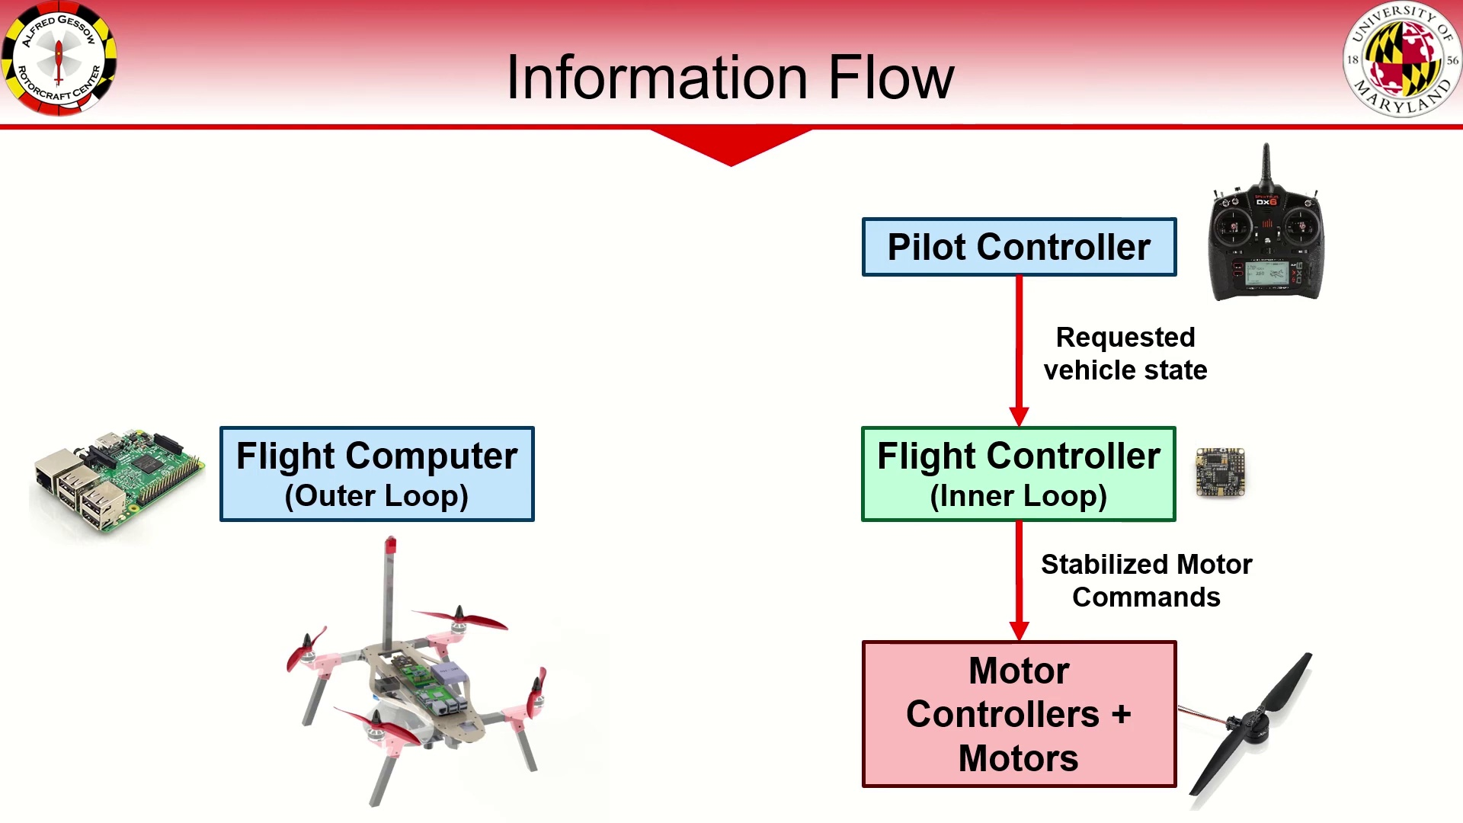 (score 95.0000)
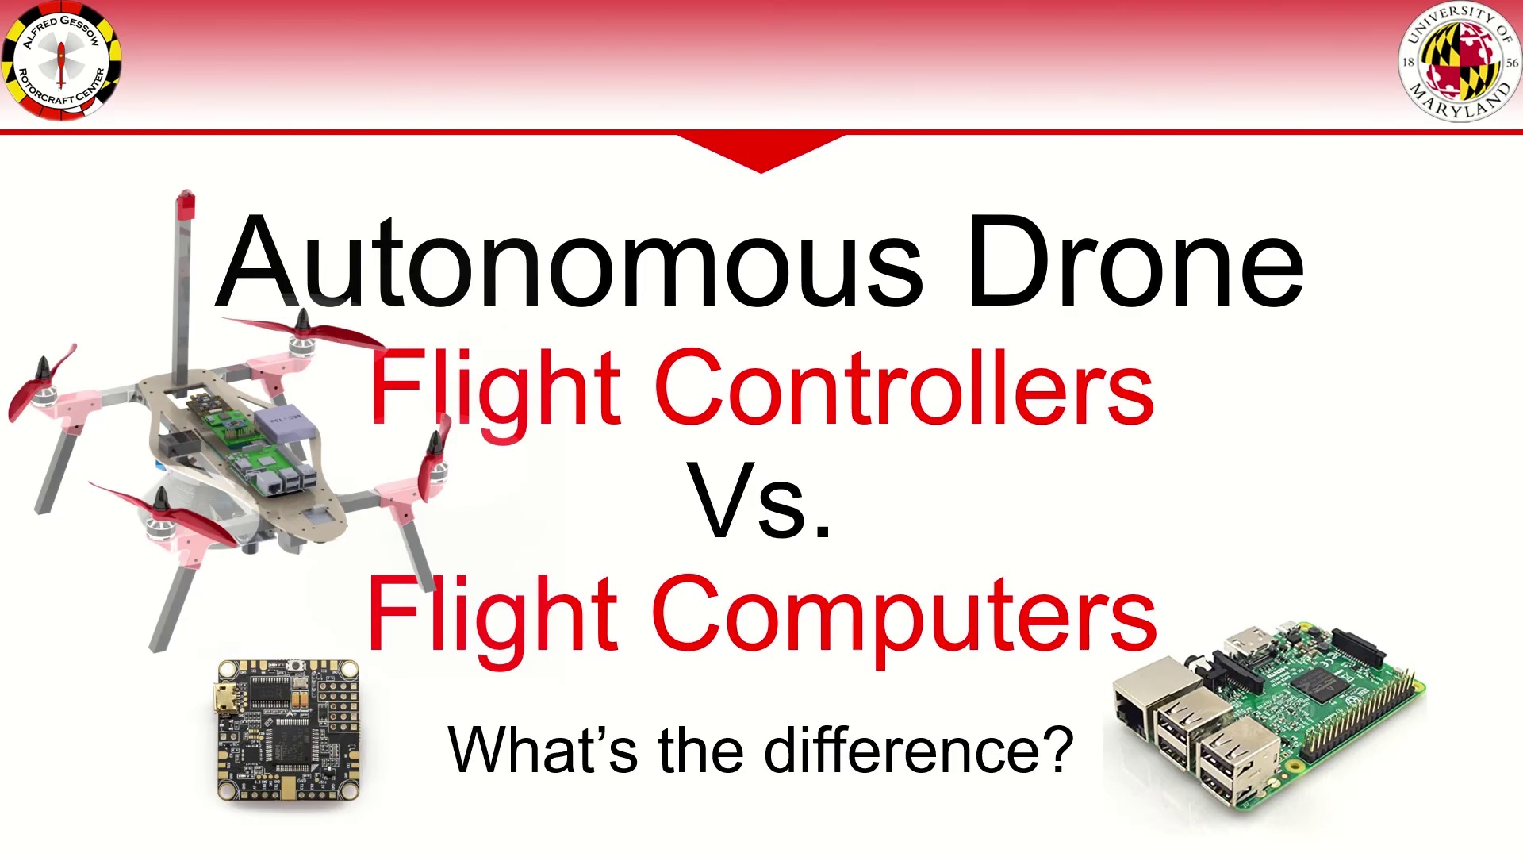 (score 95.0000)
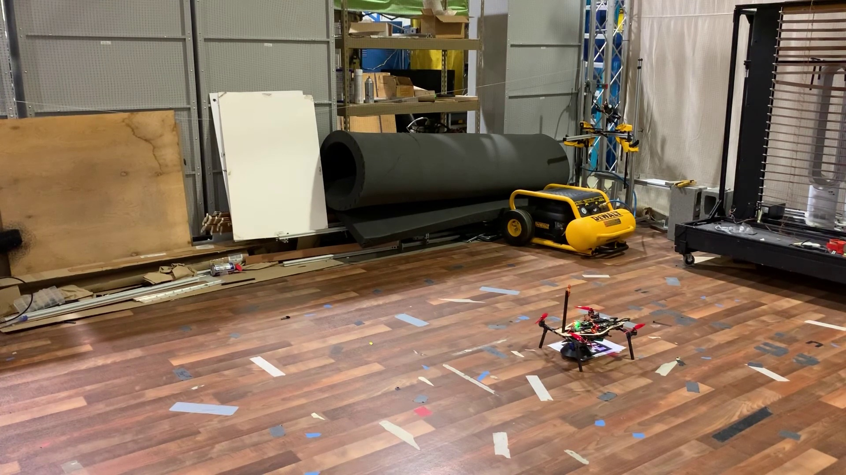 (score 90.0000)
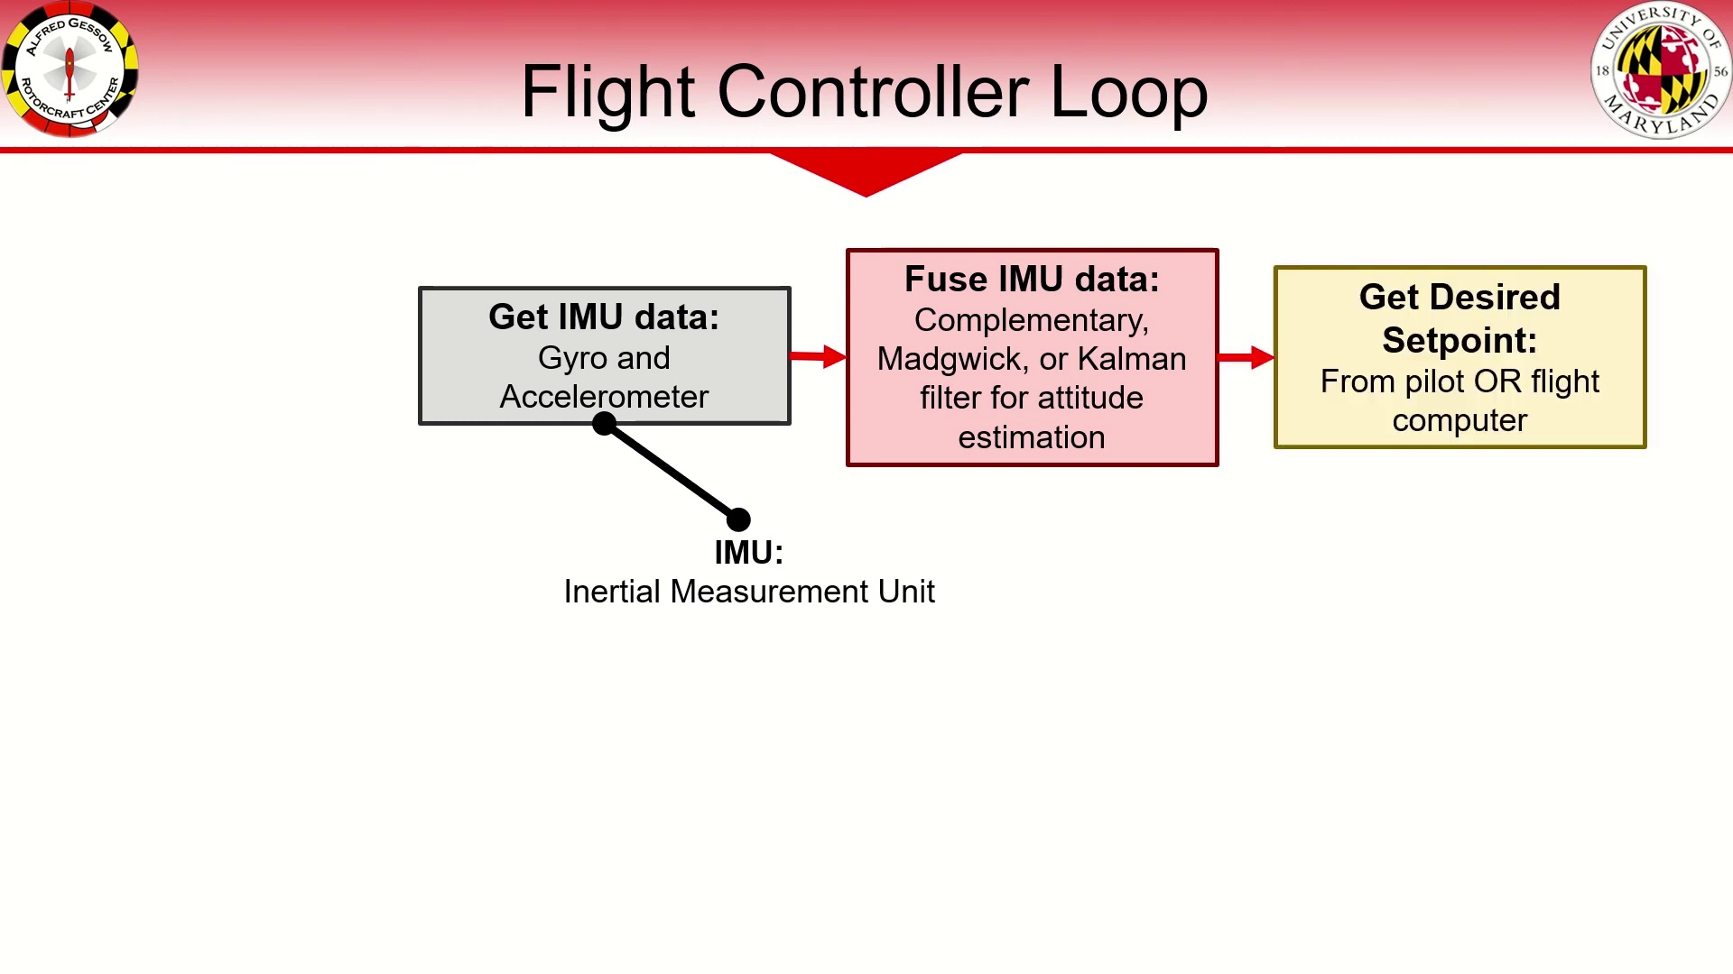 (score 90.0000)
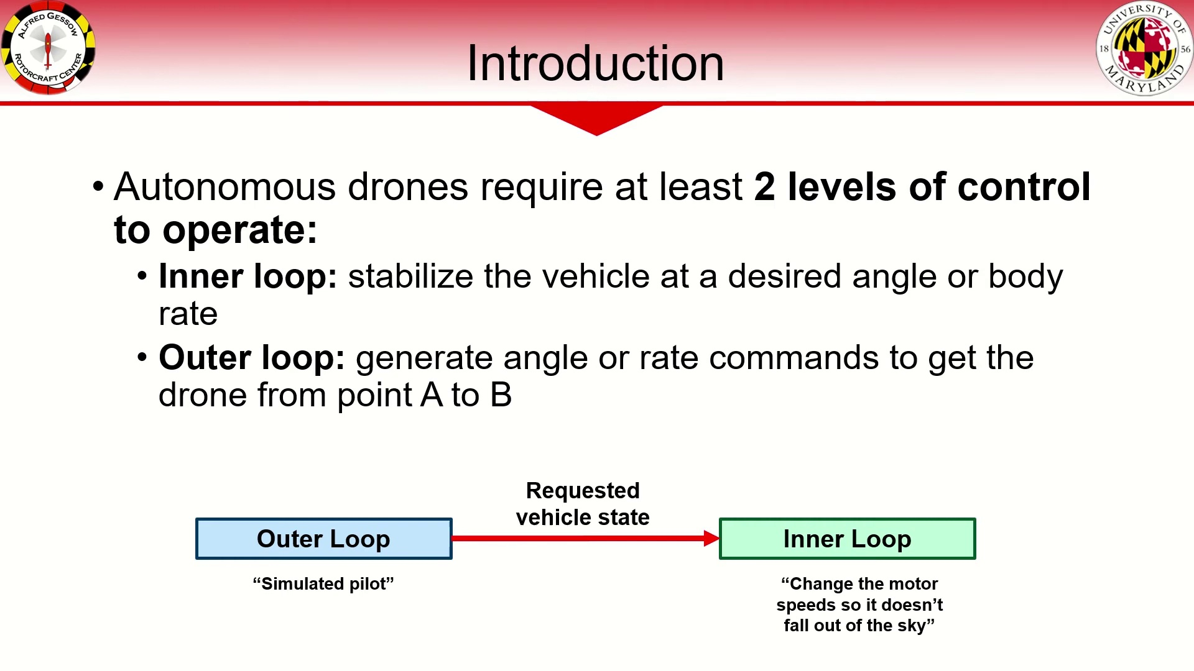 (score 90.0000)
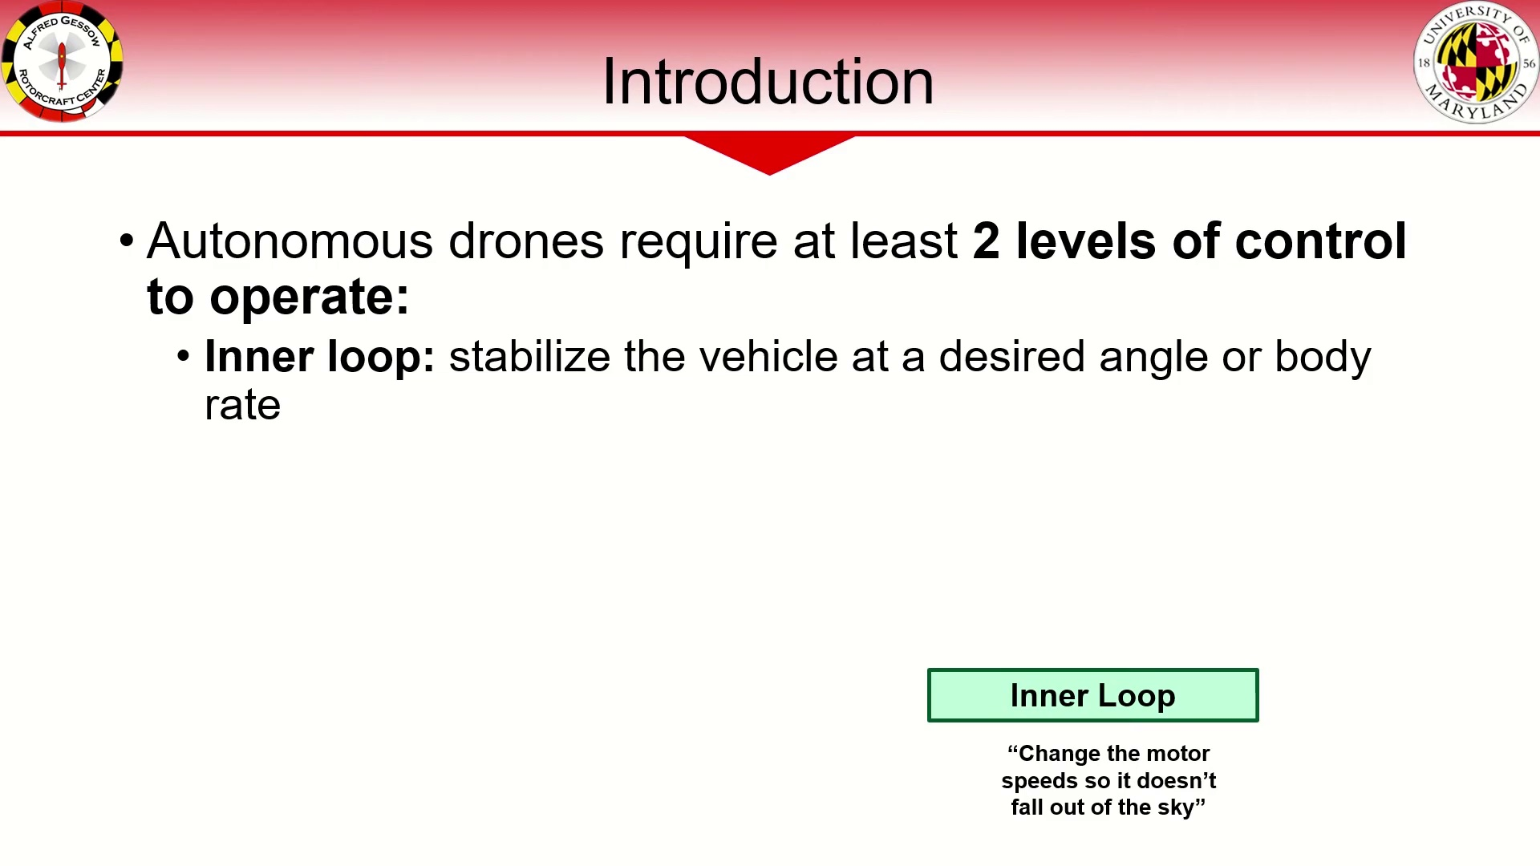 (score 90.0000)
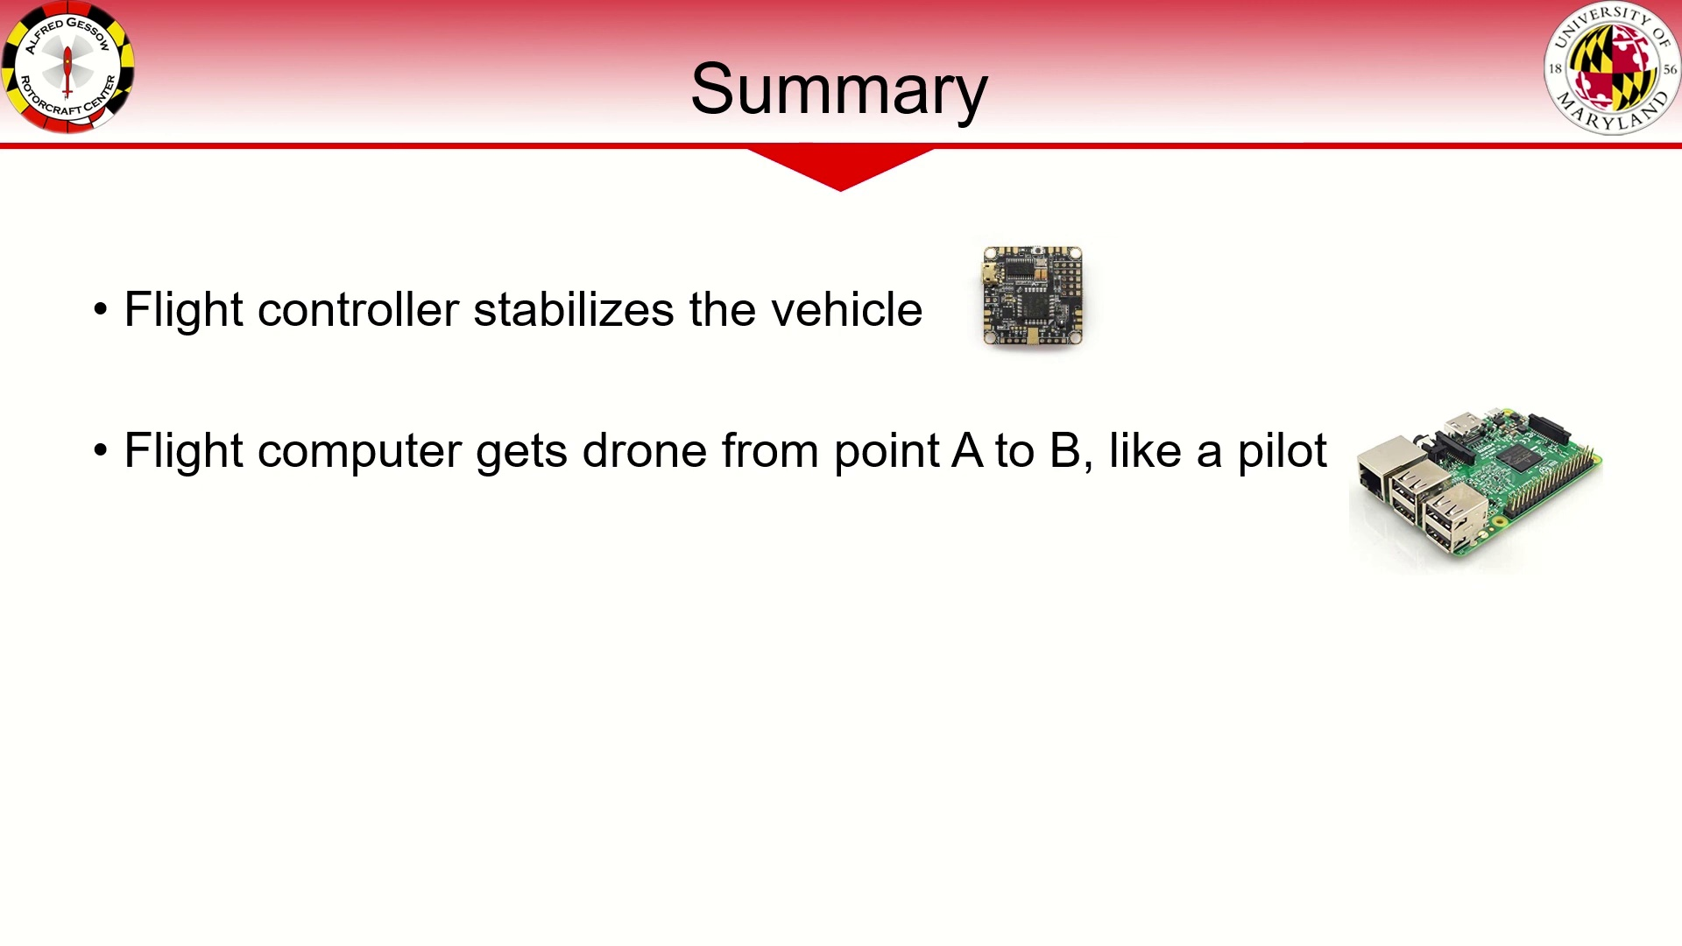 (score 85.0000)
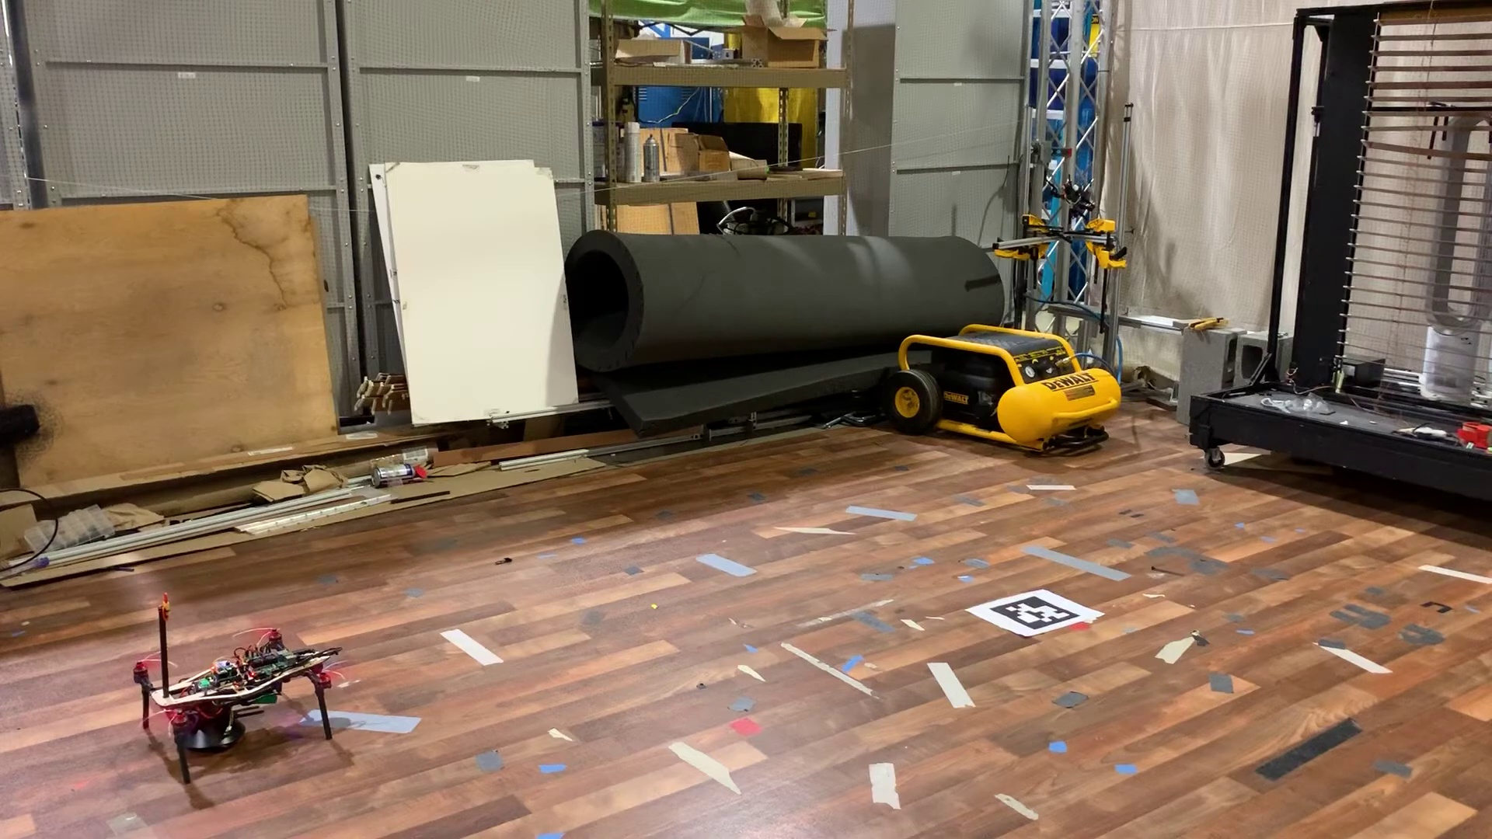 (score 85.0000)
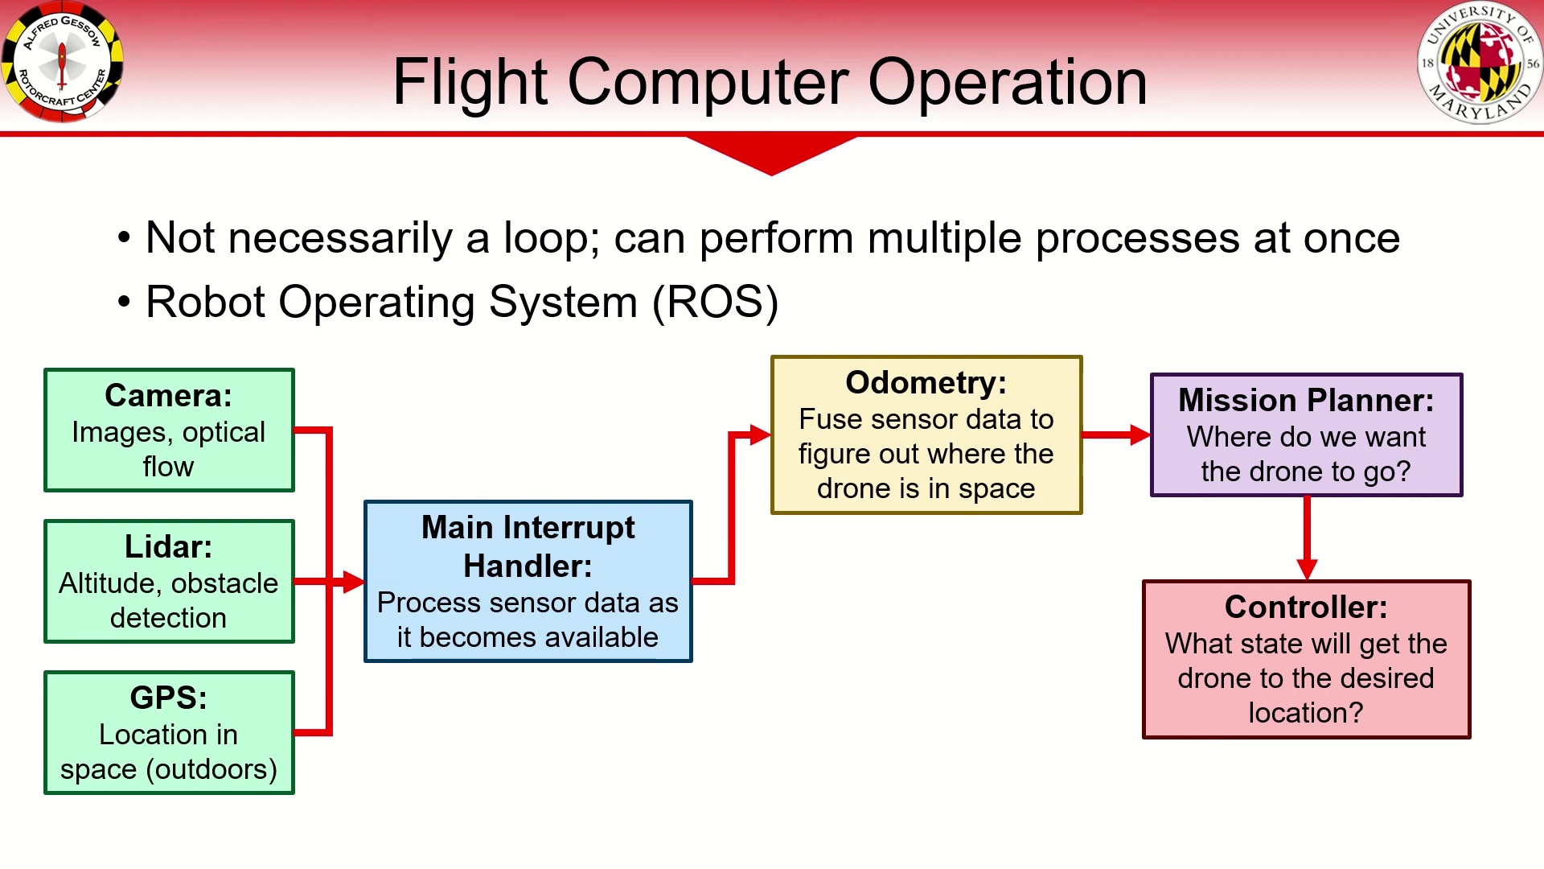 (score 85.0000)
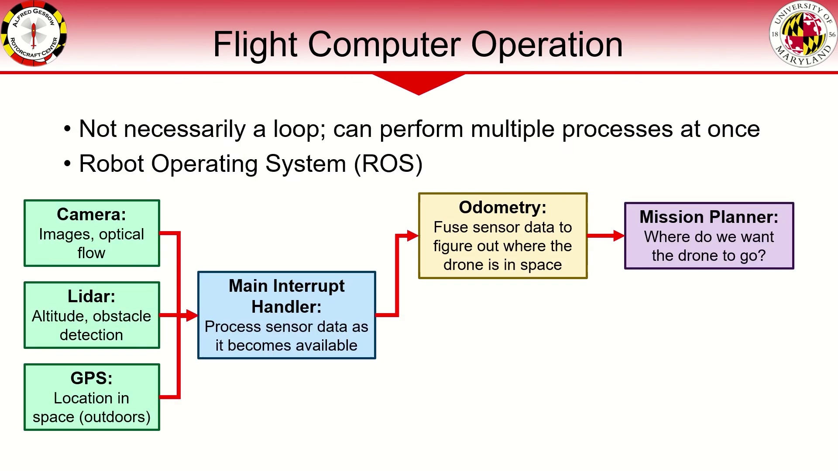 (score 85.0000)
Least correlated frames:
 (score 0.0000)
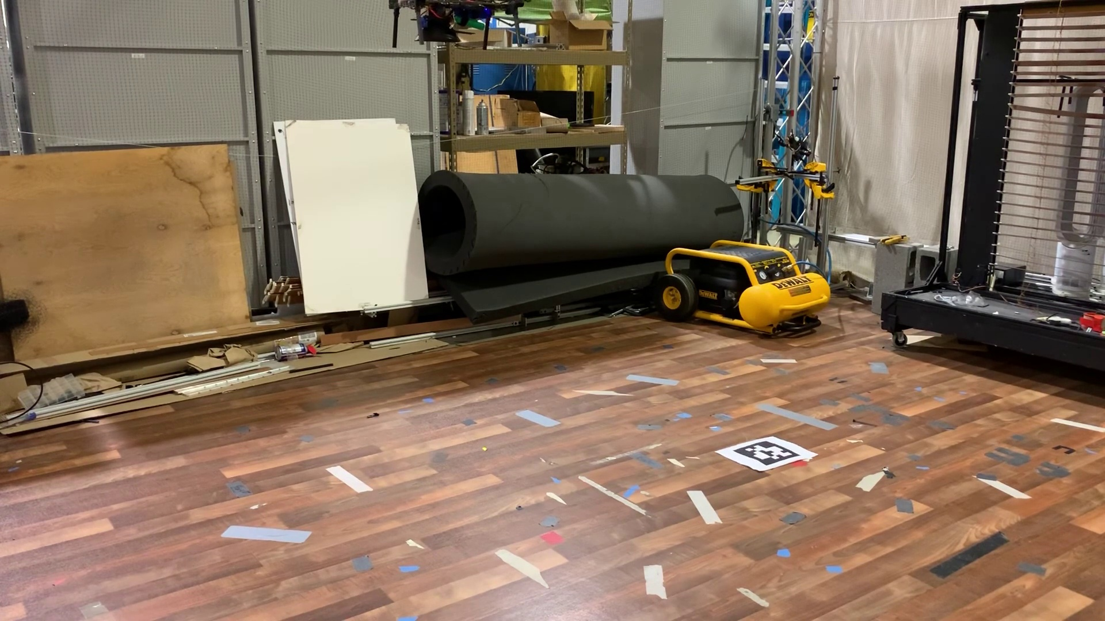 (score 0.0000)
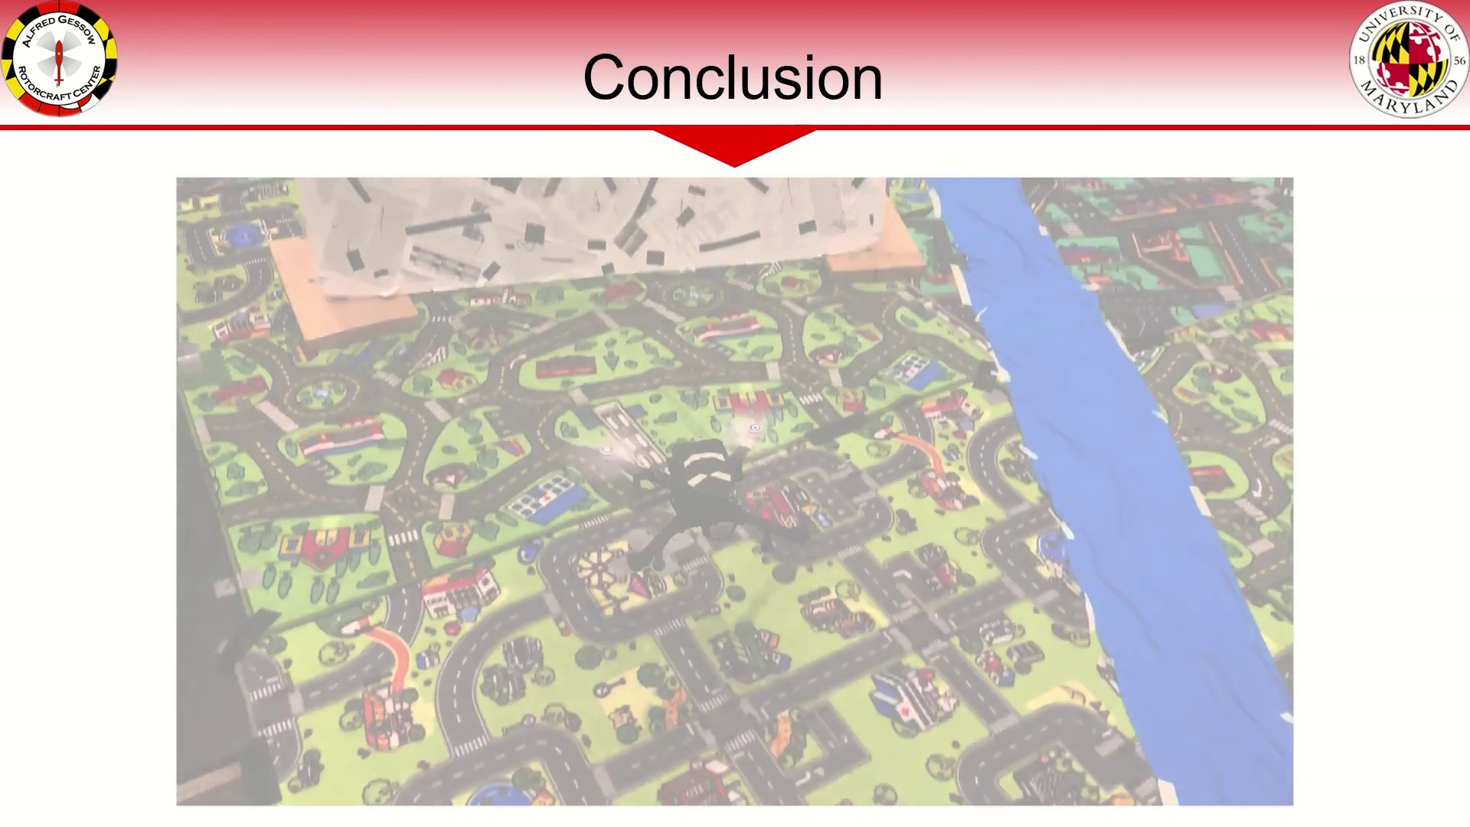 (score 0.0000)
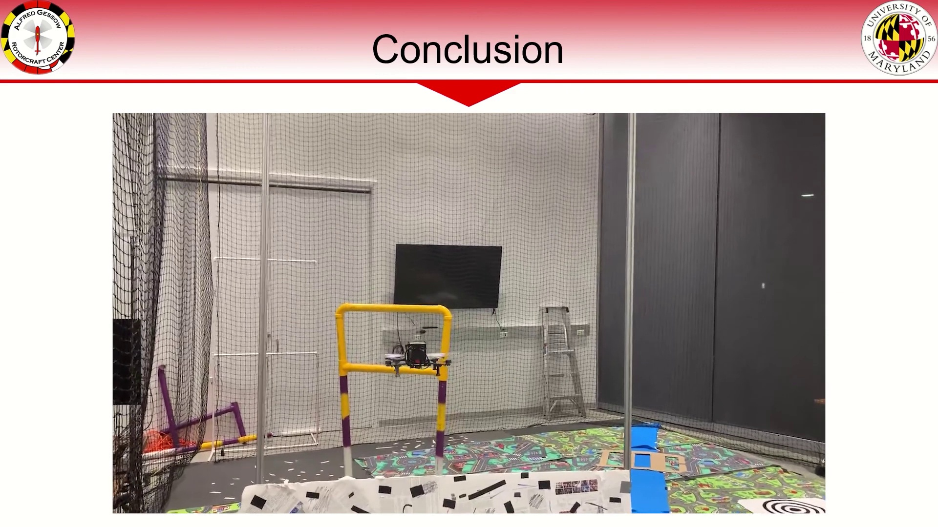 (score 0.0000)
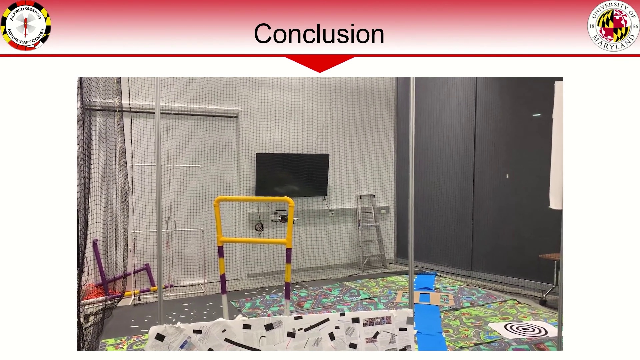 (score 0.0000)
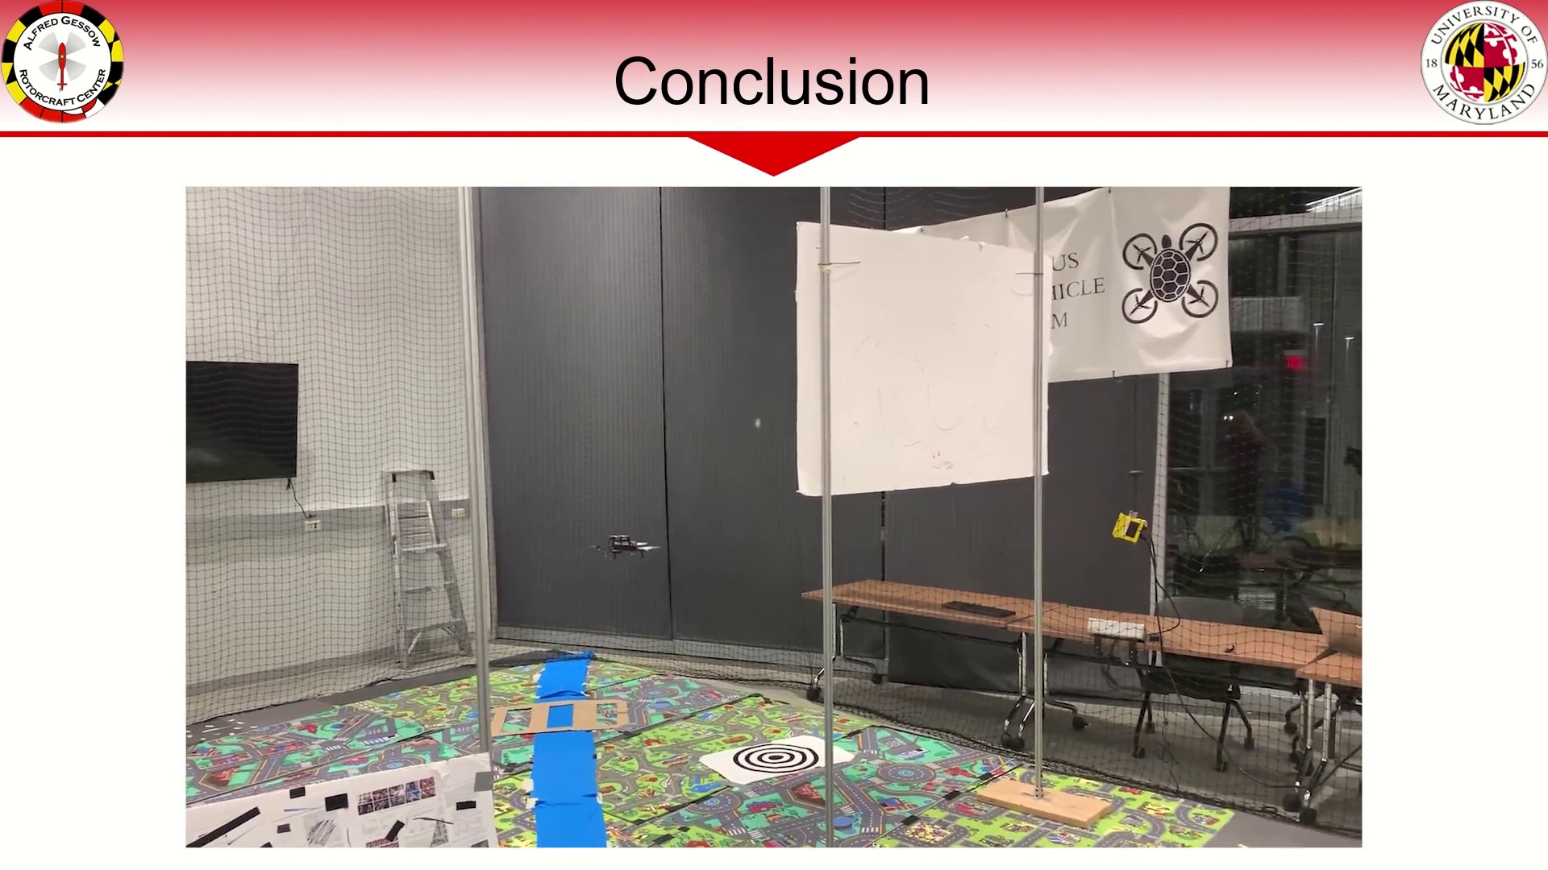 (score 0.0000)
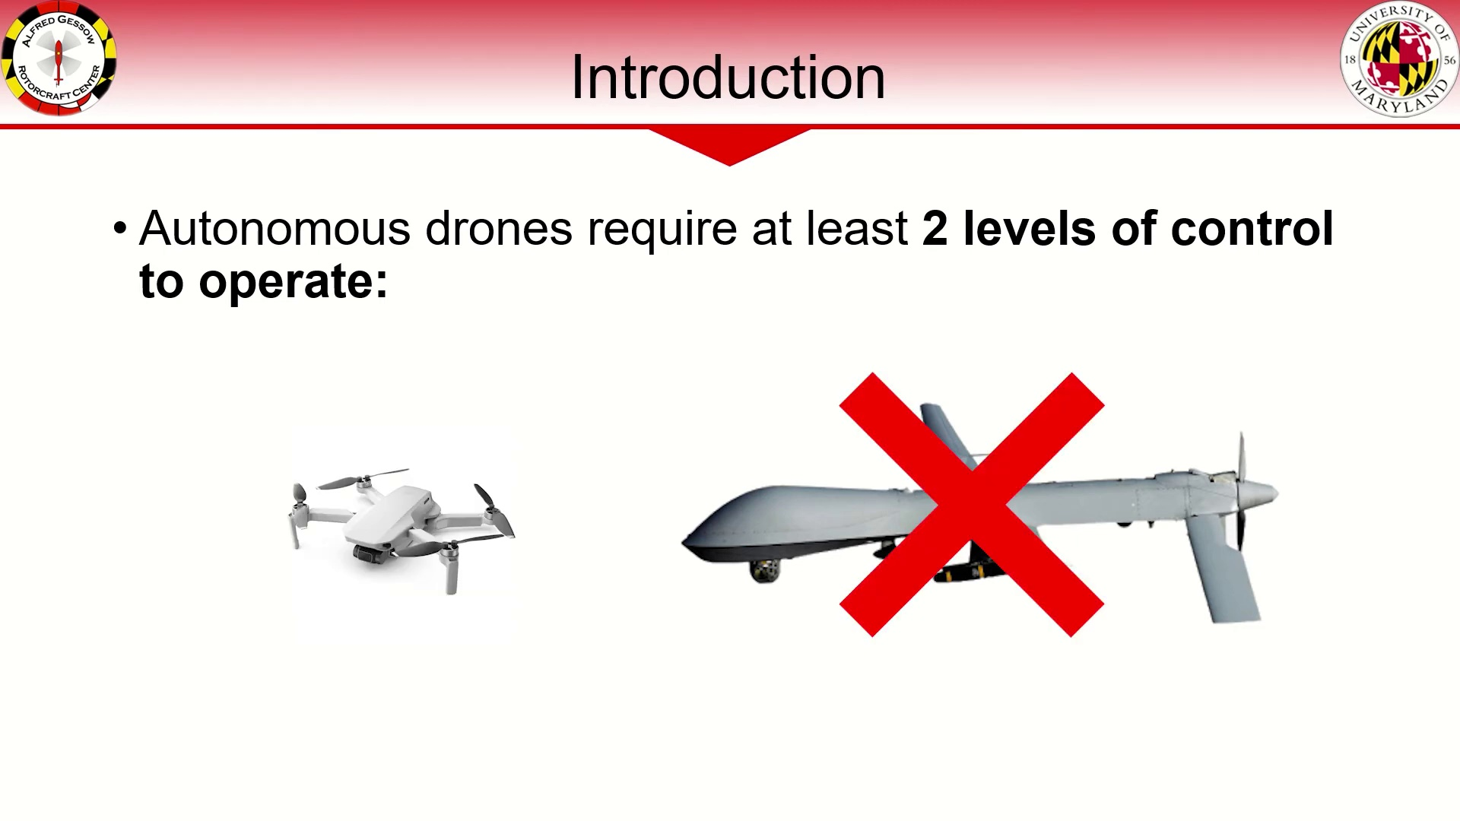 (score 20.0000)
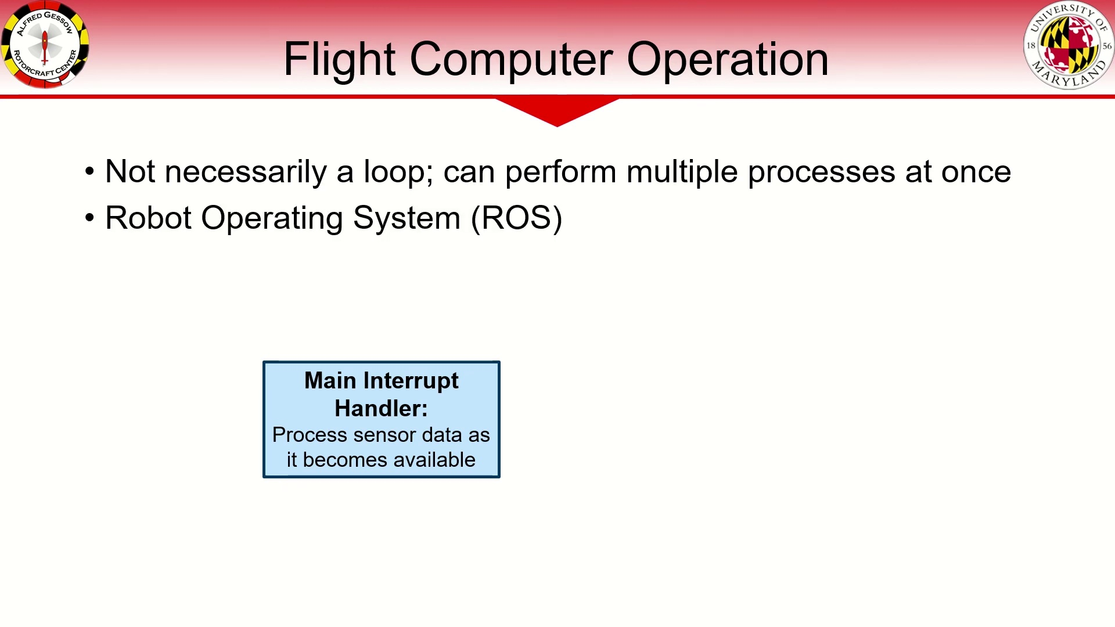 (score 20.0000)
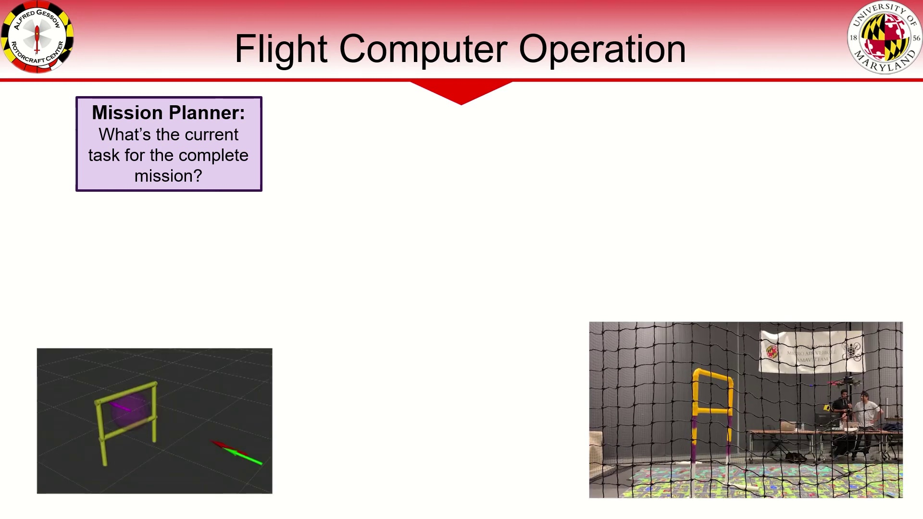 (score 20.0000)
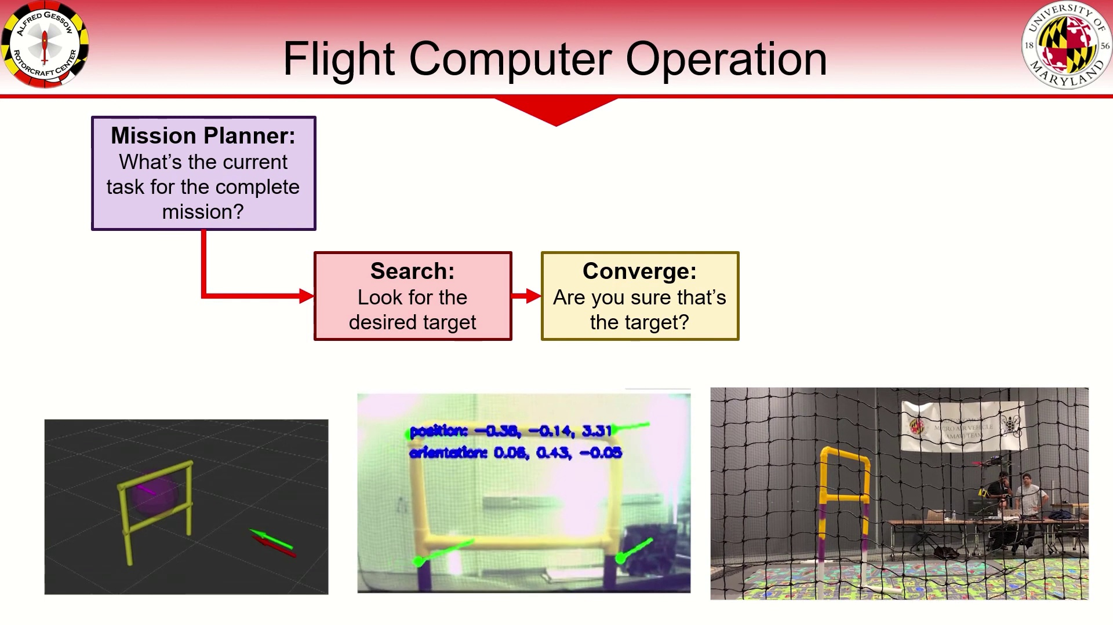 (score 20.0000)

Frame: frame_0000.jpg
Caption: This image appears to show a presentation or lecture environment with a dark-colored background and a lighter gradient at the top of the frame. On the right side of the image, there's a vertical gray line that could be part of a slide or presentation deck. The visible part of this line is mostly blank, with no text or images on it. There is no instructor or teaching context visible in this frame. Due to the lack of readable text and clear visual content, I am unable to provide specific details about the content being presented or any educational materials or tools used.
In a completely unrelated context, 2-Methyl-3-buten-1-one is a colorless liquid with a sweet, fruity odor. It is used as a solvent and in the manufacture of some pesticides. It is also a precursor to the antiseptic chloroxylenol.
No strongly correlated comments found for this frame.

Frame: frame_0001.jpg
Caption: The image presents a promotional graphic focused on the topic of autonomous drones, featuring a comparison between flight controllers and computers. At the top right, there is text that reads "AUTOMIOUS DRAONE," with a red line underlining the words "DRONE" and "FLIGHT CONTROLLERS." Below this, an image depicts a small quadcopter drone with a camera module on its front, accompanied by a green circuit board with various electronic components attached.
In the center bottom of the image, there is a comparison graphic with text that reads "FLIGHT CONTROLLERS VS" followed by two columns, each labeled with a different type of device: "COMPUTERS" on the left and "DRONES" on the right. The left column features an image of a desktop computer tower. Above the comparison graphic, there is another line of text that asks, "WHAT'S THE DIFFERENCE?"
The bottom section of the image explains the differences between autonomous drones and flight controllers, with text stating: "Autonomous Drones are unmanned aerial vehicles designed for a wide range of applications. Flight Controllers are electronic devices used to control the flight of an aircraft. Flight Computers are electronic devices that provide flight information and control the flight of an aircraft." This educational graphic aims to teach about the differences between these two crucial components in the context of drones, making it easy for viewers interested in drone technology or computer hardware education to understand the main points discussed.
Comment (score 95): The video explains the difference between a flight controller and a flight computer in autonomous drones. The flight controller stabilizes the drone's inner loop, this is you’re PID control of the drone. We know that the PID (inner loop) of the drone is responsible for the proper orientation. Where the input of the feedback system is the desired angle of the drone, and the output is the actual angle of the drone. The flight computer, handling the outer loop, makes decisions based on sensor data for navigation. For example, the TJI Tello drone has a camera on the drone and detects the face of a person in the outer loop of the system. In the code it was seen to have its own PID control, enforcing the idea that the two systems need to have two separate controls. The importance of keeping these two systems separate is emphasized in the video to ensure that the drone flies efficiently.
Reason: The comment directly discusses the technical steps and goals described in the caption, specifically highlighting the differences between flight controllers and computers, and their respective roles in autonomous drones.
Source: https://www.youtube.com/watch?v=PlKeFj5teo4 : The Difference Between a Drone Flight Controller and Flight Computer

Frame: frame_0002.jpg
Caption: The image shows a presentation slide with a plain white background and red text, featuring an official-looking document titled "Introduction". At the top of the slide, there is a title in bold, black font that reads "AUTOMATIC CONTROL." Below the title, under the heading "INTRODUCTION," there are two bullet points:
1. "Autonomous drones require at least 2 levels of control to operate."
2. A subtitle below the bullet points states, "The person controlling the UAV is not present in the scene."
The red text on the slide provides a brief introduction or explanation about autonomous control systems in unmanned aerial vehicles (UAVs), highlighting the need for at least two levels of control for operation and mentioning that the controller of the UAV is absent from the scene. The overall style of the slide is simple and educational, commonly used in academic or professional contexts to summarize key points from lectures or workshops.
The bottom left corner of the image contains a small logo, but it is not possible to read any text associated with the logo due to its size and resolution in the photo.
Comment (score 85): The video explains the difference between a flight controller and a flight computer in autonomous drones. The flight controller stabilizes the drone's inner loop, this is you’re PID control of the drone. We know that the PID (inner loop) of the drone is responsible for the proper orientation. Where the input of the feedback system is the desired angle of the drone, and the output is the actual angle of the drone. The flight computer, handling the outer loop, makes decisions based on sensor data for navigation. For example, the TJI Tello drone has a camera on the drone and detects the face of a person in the outer loop of the system. In the code it was seen to have its own PID control, enforcing the idea that the two systems need to have two separate controls. The importance of keeping these two systems separate is emphasized in the video to ensure that the drone flies efficiently.
Reason: The comment directly discusses the technical steps of autonomous drones' control systems, specifically mentioning PID control and the importance of separating flight controller and flight computer functions, which is also described in the caption as 'Autonomous drones require at least 2 levels of control to operate.'
Source: https://www.youtube.com/watch?v=PlKeFj5teo4 : The Difference Between a Drone Flight Controller and Flight Computer

Frame: frame_0003.jpg
Caption: The image presents an informative slide with a white background and red text, introducing the concept of autonomous drones. At the top of the slide, there's an introduction text that reads "INTRODUCTION: Autonomous drones require at least 2 levels of control to operate." Below this text is a diagram illustrating two levels of control for autonomous drones.
On the left side of the image, a white model airplane with a red X over it illustrates manual operation by the pilot, depicted by the handheld controller in the diagram. On the right side, an unmanned aerial vehicle (UAV) appears to be an advanced drone equipped with various sensors and antennas, representing autonomous control where the drone operates independently without human intervention.
The diagram highlights that level 1 control involves manual operation, while level 2 control requires autonomy, emphasizing the need for at least two levels—manual and autonomous—to ensure safe and effective operation.
No strongly correlated comments found for this frame.

Frame: frame_0004.jpg
Caption: The image shows a presentation slide with educational content related to autonomous drones. The title of the slide reads "Introduction". On the right side of the slide, there's an image of a quadcopter drone with its arms extended and propellers off, suggesting it is not currently in flight mode. Below the drone, there are two diagrams. One diagram depicts a vehicle with a label indicating that it requires "Autonomous Drones" to operate. The second diagram shows a drone flying near a car.
Text on the slide provides information about the required levels of control for autonomous drones: "To Operate: 2 levels of control are necessary, inner loop and outer loop or body rate control." The text implies that there are two different types of control loops in operation: an inner loop and an outer loop. At the top of the logo, the text "Introduction" is written in black.
The bottom right corner of the slide has a logo resembling a shield with wings spread out on either side, which is commonly associated with organizations or institutions such as schools, companies, or government agencies. However, without specific details, it's not possible to determine the exact organization represented by the logo. The overall style of the slide suggests an educational context where this presentation might be part of a lecture or workshop about autonomous drones and their applications in automotive or other industries.
Comment (score 85): The video explains the difference between a flight controller and a flight computer in autonomous drones. The flight controller stabilizes the drone's inner loop, this is you’re PID control of the drone. We know that the PID (inner loop) of the drone is responsible for the proper orientation. Where the input of the feedback system is the desired angle of the drone, and the output is the actual angle of the drone. The flight computer, handling the outer loop, makes decisions based on sensor data for navigation. For example, the TJI Tello drone has a camera on the drone and detects the face of a person in the outer loop of the system. In the code it was seen to have its own PID control, enforcing the idea that the two systems need to have two separate controls. The importance of keeping these two systems separate is emphasized in the video to ensure that the drone flies efficiently.
Reason: The comment directly discusses the same technical concepts and systems mentioned in the caption, specifically referring to the 'inner loop' and 'outer loop' control systems of autonomous drones. The connection is strong as both the caption and comment provide information about the different levels of control required for autonomous drone operation.
Source: https://www.youtube.com/watch?v=PlKeFj5teo4 : The Difference Between a Drone Flight Controller and Flight Computer

Frame: frame_0005.jpg
Caption: The image displays a slide with a title that reads "Introduction" and the main body of text providing information about autonomous vehicles. The text states that autonomous drones require at least 2 levels of control to operate, which involves two distinct loops. The Inner Loop is responsible for stabilizing the vehicle at a desired angle or body rate, while the Outer Loop, also known as autopilot or automotive mode, allows for changes in motor speed to ensure the drone remains stable and does not fall out of the sky.
Below the main text, there is an additional instruction that reads: "Press any button to advance the slide", suggesting that this slide is part of a teaching session where the instructor might be explaining how autonomous vehicles operate and are controlled. The context implies that this is an educational presentation or lecture focused on autonomous systems in drones and vehicles, possibly exploring the technical aspects of controlling these systems.
Comment (score 90): The video explains the difference between a flight controller and a flight computer in autonomous drones. The flight controller stabilizes the drone's inner loop, this is you’re PID control of the drone. We know that the PID (inner loop) of the drone is responsible for the proper orientation. Where the input of the feedback system is the desired angle of the drone, and the output is the actual angle of the drone. The flight computer, handling the outer loop, makes decisions based on sensor data for navigation. For example, the TJI Tello drone has a camera on the drone and detects the face of a person in the outer loop of the system. In the code it was seen to have its own PID control, enforcing the idea that the two systems need to have two separate controls. The importance of keeping these two systems separate is emphasized in the video to ensure that the drone flies efficiently.
Reason: The comment directly discusses the technical steps and objects described in the caption, specifically mentioning the inner loop and outer loop of autonomous drones, which aligns with the information provided in the caption. The comment also highlights the importance of keeping these two systems separate, as emphasized in the video.
Source: https://www.youtube.com/watch?v=PlKeFj5teo4 : The Difference Between a Drone Flight Controller and Flight Computer

Frame: frame_0006.jpg
Caption: ** The image shows a presentation slide with educational content related to autonomous driving technology, specifically focused on introducing autonomous drones. At the top of the slide, the title reads "INTRODUCTION." Below the title, it states that "AUTOMIOUS Drones require at least 2 levels of control to operate," suggesting that the slide discusses the need for multiple layers of control in autonomous drones.
On the right side of the slide, a diagram illustrates an autonomous vehicle navigation loop, with two distinct sections: "Inner Loop" and "Outer Loop." The Inner Loop stabilizes the vehicle at a desired angle or body rate, while the Outer Loop generates commands to get the vehicle from one point to another. A flowchart-like diagram above the text shows an input signal labeled "outer loop" feeding into a central processing unit (CPU) where it is compared with a reference signal or setpoint. From there, the output of this comparison goes to two controllers or modules: one for body rate control and another for steering command generation. These outputs are then fed back into the CPU, suggesting a feedback loop control system architecture.
The slide also explains that the Outer Loop (generate commands) generates commands for the vehicle to follow. Below the diagram, further details provide insight into the autonomous drone's navigation system. The name "Woody" is displayed in the lower right corner of the slide, possibly indicating the presenter's name. Overall, this educational slide appears designed to teach students or professionals about autonomous vehicle navigation systems, specifically focusing on introducing autonomous drones and their control mechanisms.
Comment (score 90): The video explains the difference between a flight controller and a flight computer in autonomous drones. The flight controller stabilizes the drone's inner loop, this is you’re PID control of the drone. We know that the PID (inner loop) of the drone is responsible for the proper orientation. Where the input of the feedback system is the desired angle of the drone, and the output is the actual angle of the drone. The flight computer, handling the outer loop, makes decisions based on sensor data for navigation. For example, the TJI Tello drone has a camera on the drone and detects the face of a person in the outer loop of the system. In the code it was seen to have its own PID control, enforcing the idea that the two systems need to have two separate controls. The importance of keeping these two systems separate is emphasized in the video to ensure that the drone flies efficiently.
Reason: The comment directly discusses the same technical steps and objects described in the caption, specifically mentioning autonomous drones' control mechanisms (inner loop and outer loop), flight controllers, and PID control. The comment also highlights the importance of keeping these two systems separate, which is also mentioned in the caption.
Source: https://www.youtube.com/watch?v=PlKeFj5teo4 : The Difference Between a Drone Flight Controller and Flight Computer

Frame: frame_0007.jpg
Caption: The image shows a detailed diagram on a whiteboard that describes the process of using an information system for "Flight Control." The flowchart includes several steps with accompanying text, providing a clear understanding of the system's functionality. The steps are labeled as follows:
1. Information flow
2. Flight control
3. Pilot controller
4. Required inner loop (red dashed line)
5. Inner loop (green dashed line)
6. Outer loop (blue dashed line)
The diagram also includes instructions for operating the system, which are broken down into five steps:
- Step 1: Activate system
- Step 2: Enter data and parameters
- Step 3: Perform required checks
- Step 4: Initiate flight
- Step 5: Monitor vehicle state
On the right side of the board, a toy model of an airplane is depicted, likely used to represent the aircraft in the flowchart. The background features a red, white, and blue logo or emblem at the top left corner, although its details are unclear.
The diagram also includes labels for each component, providing a clear understanding of the system's operation. These components include the flight controller, the drone, and the request vehicle state. The flight controller is positioned at the top, while the drone is at the bottom. The request vehicle state is shown in the center. Red and blue lines connecting the components indicate the flow of data and control within the system.
The diagram suggests a classroom or educational setting where such diagrams might be used to teach about control systems and information handling within aviation contexts. However, no instructor is visible in the frame.
No strongly correlated comments found for this frame.

Frame: frame_0008.jpg
Caption: This image presents an educational setting that illustrates the "Information Flow" concept in aviation or drone systems. On the left side of the frame, a blackboard provides a conceptual overview of the flow, with text and diagrams explaining how information is processed and managed. The diagram depicts three main components: Flight Controller (FC), which receives flight status and sends motor commands plus sensor data; Pilot Computer (PC) or Outer Computer, responsible for processing and managing the information flow; and Stabilized Motor Controllers (SMC) at the bottom right, controlling the precise navigation of the flight.
The physical setup on the right side of the frame demonstrates the system, featuring two main components: a flight controller unit with attached electronic components and an electronic device resembling an advanced drone or quadcopter with a remote control unit (RCU) and possibly additional sensors or equipment. The devices are connected by wires to the flight controller, highlighting their interaction.
A small, detailed model of the electronics and flight controller is displayed on the left side, corresponding to the conceptual model on the blackboard diagram. The overall setup suggests that an instructor is teaching about how information flows through an aviation or drone system, focusing on the use of a flight controller and its interaction with a pilot or automated system for controlling the motors and stabilizing the flight computer.
The schematic diagram at the top of the image, labeled "Information Flow", provides further details on the system's components. The Pilot Computer (Outer Computer) is the central hub, processing and managing information flow. The Flight Controller (Inner Computer) is connected to the Pilot Computer through a wire, suggesting communication between the two. Finally, the Stabilized Motor Controllers are responsible for controlling and stabilizing the flight, ensuring safe navigation.
The image does not include people; instead, it focuses on the educational content and setup meant to illustrate the concepts being taught.
Comment (score 95): The video explains the difference between a flight controller and a flight computer in autonomous drones. The flight controller stabilizes the drone's inner loop, this is you’re PID control of the drone. We know that the PID (inner loop) of the drone is responsible for the proper orientation. Where the input of the feedback system is the desired angle of the drone, and the output is the actual angle of the drone. The flight computer, handling the outer loop, makes decisions based on sensor data for navigation. For example, the TJI Tello drone has a camera on the drone and detects the face of a person in the outer loop of the system. In the code it was seen to have its own PID control, enforcing the idea that the two systems need to have two separate controls. The importance of keeping these two systems separate is emphasized in the video to ensure that the drone flies efficiently.
Reason: The comment directly discusses the technical steps and objects described in the caption, such as the difference between flight controller and flight computer, PID control, and sensor data for navigation. The comment provides specific examples from autonomous drones, like TJI Tello, which are mentioned in the caption's setup. The correlation is strong because the comment focuses on explaining the same concepts and systems presented in the caption.
Source: https://www.youtube.com/watch?v=PlKeFj5teo4 : The Difference Between a Drone Flight Controller and Flight Computer

Frame: frame_0009.jpg
Caption: The image presents an educational diagram that illustrates the concept of "Information Flow" in a simplified manner. At the center is a black airplane, symbolizing the main subject of the flow. The airplane is surrounded by several components, each playing a crucial role in the information flow.
On one side of the diagram are two cameras, which capture images and data about the airplane's surroundings. On the opposite side are three sensors that collect vital information about the airplane's internal state, including altitude, speed, and other essential data.
At the top of the diagram is a title "Information Flow." Below this heading are four main components: a camera with a lens pointing towards it, labeled as "Camera," indicating the capture of visual information; a central processor unit (CPU) labeled as "Pilot Controller," suggesting the processing of data from the camera into usable information; a flight control system or device labeled as "Flight Control System," which appears to be the output or result of the processing done by the pilot controller; and a radio transmitter and receiver, part of the flight control system.
Below these components is a diagram that represents the process of information flow. The arrow starting from the camera points towards the CPU, signifying the input of visual data into the system. From the CPU, there are two arrows: one pointing to the flight control system, representing the processing of information by the system; and another pointing downwards, which might indicate additional processes or outputs not depicted in this image.
The diagram also includes a motor and a battery, likely part of the airplane's power system, providing the necessary energy for the airplane's movement and operation. An arrow leaving the flight control system points towards the airplane model, representing the final outcome or result of the information flow process.
The diagram uses simple shapes and clear labeling to explain the concept visually, likely for instructional purposes in an educational setting.
Comment (score 80): The video explains the difference between a flight controller and a flight computer in autonomous drones. The flight controller stabilizes the drone's inner loop, this is you’re PID control of the drone. We know that the PID (inner loop) of the drone is responsible for the proper orientation. Where the input of the feedback system is the desired angle of the drone, and the output is the actual angle of the drone. The flight computer, handling the outer loop, makes decisions based on sensor data for navigation. For example, the TJI Tello drone has a camera on the drone and detects the face of a person in the outer loop of the system. In the code it was seen to have its own PID control, enforcing the idea that the two systems need to have two separate controls. The importance of keeping these two systems separate is emphasized in the video to ensure that the drone flies efficiently.
Reason: The comment directly discusses the same technical steps and concepts described in the caption, specifically mentioning flight controllers, flight computers, and PID control, which are all part of the information flow diagram. The comment also refers to autonomous drones, such as the Tello drone, which is related to the airplane symbol in the diagram.
Source: https://www.youtube.com/watch?v=PlKeFj5teo4 : The Difference Between a Drone Flight Controller and Flight Computer

Frame: frame_0010.jpg
Caption: The image appears to be an educational or training context that illustrates the concept of information flow. In the foreground, a colorful quadcopter is depicted with rotors and a graphical representation of network connectivity below it. The icon on the left features an arrow pointing downward from the drone, indicating the flow of information from the device to some central location or system, labeled "Information Flow".
The bottom icon has a red border containing two pieces of text: "You are at &lt;" on the left side, suggesting an instructional message in HTML/CSS format, often representing 'you are at home page', which is typically the first page loaded when connecting to a network or website. On the right side of the icon, there's a red arrow pointing upwards and the text "You get &gt;", translating to 'you go to the next page', implying an interactive navigation feature within a website or application.
In the background, there's a simple graphical representation of a network with two devices connected by lines labeled "SEND DATA" from one device to another. The text "Information Flow" is written above the graph, reinforcing the theme.
The overall setting suggests that this image might be used in an educational or training context to explain how data can flow between different nodes or points within a network. It's possible that this image is part of a presentation slide or a visual aid for teaching about computer networks and their operation.
In addition to these elements, the image also features a cartoon representation of an Information Flow. The main focus is on a small drone with a red propeller and white antenna, equipped with a small red box and black box, possibly part of a larger system. The drone is flying towards point A, indicated by a red arrow.
In the background, there's a red balloon with a white message that reads "You are at point A", suggesting that the drone is currently at point A. To the right of the drone, there's a red box with a white arrow pointing to a black box, possibly part of the drone's control system, implying that the drone needs to "get to B" and then "forward".
The overall scene suggests a journey or movement from point A to point B, with the drone being the central figure in this journey. The red and white colors used in the image create a vibrant and eye-catching effect, drawing the viewer's attention to the drone and its journey.
Comment (score 85): The video explains the difference between a flight controller and a flight computer in autonomous drones. The flight controller stabilizes the drone's inner loop, this is you’re PID control of the drone. We know that the PID (inner loop) of the drone is responsible for the proper orientation. Where the input of the feedback system is the desired angle of the drone, and the output is the actual angle of the drone. The flight computer, handling the outer loop, makes decisions based on sensor data for navigation. For example, the TJI Tello drone has a camera on the drone and detects the face of a person in the outer loop of the system. In the code it was seen to have its own PID control, enforcing the idea that the two systems need to have two separate controls. The importance of keeping these two systems separate is emphasized in the video to ensure that the drone flies efficiently.
Reason: The comment discusses the technical steps and objects described in the caption, specifically the flight controller and flight computer of autonomous drones. The caption mentions a 'quadcopter' with rotors and a graphical representation of network connectivity, which is similar to the concept of a drone's PID control system discussed in the comment. Additionally, the caption features an icon on the left with an arrow pointing downward, indicating the flow of information from the device to some central location or system, which relates to the comment's discussion of the outer loop making decisions based on sensor data for navigation.
Source: https://www.youtube.com/watch?v=PlKeFj5teo4 : The Difference Between a Drone Flight Controller and Flight Computer

Frame: frame_0011.jpg
Caption: The image shows a composite of two distinct visual elements: a presentation slide and a logo. The presentation slide, titled "Flight Controller Loop" with the subtitle "UVM," displays a diagram labeled "Get UM data." This process involves collecting data from the University of Michigan, including an access token, measurement IDs, and a URL pointing to a specified endpoint. Below the title, there is a block of text explaining the purpose of this flight controller loop: to collect data from the University of Michigan for various measurement IDs.
In addition to the presentation slide, the image also features a logo in the shape of a red circle with a white border. The logo includes a white rectangle with a red line through it in the center, accompanied by the words "Flight Controller Loop" written in white above and "IMU: Inertial Measurement Unit" written in white below. This logo is set against a white background.
The overall style of the image is a combination of a computer screen capture and a graphic design element, with the presentation slide focusing on educational or informational content and the logo potentially representing the University of Maryland's Flight Controller Loop.
No strongly correlated comments found for this frame.

Frame: frame_0012.jpg
Caption: This diagram illustrates the integration of flight control systems for a autonomous aircraft, showcasing the sophisticated technology employed to ensure safe and efficient flight operations. The upper left quadrant highlights the autopilot system's primary functions, including altitude and airspeed maintenance, as well as navigation and obstacle avoidance. Below this, the chart displays the autopilot's secondary features, such as pitch and roll control, wind shear compensation, and terrain-following radar. To the right, the Kalman filter, a crucial component of the overall system, is depicted, providing real-time sensor data processing and predictive modeling to ensure accurate flight trajectory tracking. In the lower left quadrant, a detailed breakdown of the autopilot's control algorithms is shown, featuring advanced techniques like model predictive control (MPC) and linear quadratic regulator (LQR).
Comment (score 60): The video explains the difference between a flight controller and a flight computer in autonomous drones. The flight controller stabilizes the drone's inner loop, this is you’re PID control of the drone. We know that the PID (inner loop) of the drone is responsible for the proper orientation. Where the input of the feedback system is the desired angle of the drone, and the output is the actual angle of the drone. The flight computer, handling the outer loop, makes decisions based on sensor data for navigation. For example, the TJI Tello drone has a camera on the drone and detects the face of a person in the outer loop of the system. In the code it was seen to have its own PID control, enforcing the idea that the two systems need to have two separate controls. The importance of keeping these two systems separate is emphasized in the video to ensure that the drone flies efficiently.
Reason: The comment directly discusses the same technical steps, objects, and settings described in the caption, such as flight control systems, autopilot functions, PID control, and sensor data processing. While it does not specifically mention the diagram or its components, the concepts mentioned in the comment are related to the topics presented in the caption.
Source: https://www.youtube.com/watch?v=PlKeFj5teo4 : The Difference Between a Drone Flight Controller and Flight Computer

Frame: frame_0013.jpg
Caption: The image shows a slide with an educational diagram related to a "Flight Control Loop" that describes how data is processed within an aircraft's flight control system. At the top of the slide, there is text that reads: "Flight Control Loop" followed by a list of components with accompanying images, including:
* A small airplane model indicating "Aircraft," with one wing and propeller visible.
* A representation of an Integrated Modular Avionics (IMA) system with a display screen showing various data and indicators. The IMA is a standardized set of avionic equipment for aircraft.
* An "Inertial Measurement Unit" (IMU), which is part of the aircraft's navigation system, and another image labeled "Get MU Data."
* A block labeled "Accelerometer," indicating one component within the IMA that measures acceleration in three dimensions.
* A "Heading Module," which typically provides information on the heading of the aircraft relative to its body reference frame.
* A "Gyroscope," which is a device used for measuring rotation rates in the context of navigation and control systems.
Below these images, there's an explanation: "Fuse MU data into 3 axes." This indicates that the data from the various sensors (IMU and Gyroscope) is processed to determine the aircraft's movement along three axes—roll, pitch, and yaw.
At the bottom of the slide, there are two additional pieces of text: "Convert MU Data into 3 axes." This suggests that the data from the IMU is further processed to calculate the changes in roll, pitch, and yaw.
The Flight Control Loop (FCL) is a system of algorithms and hardware components used in modern flight control systems for aircraft. It is used to control the aircraft's attitude, speed, and altitude by continuously adjusting the control surface position in response to the aircraft's attitude and speed through a feedback loop. The FCL uses data from components such as the gyroscope, accelerometer, and control surface magnetorheological actuators to maintain a desired attitude and altitude, even in the presence of external disturbances such as wind or turbulence.
Comment (score 85): The video explains the difference between a flight controller and a flight computer in autonomous drones. The flight controller stabilizes the drone's inner loop, this is you’re PID control of the drone. We know that the PID (inner loop) of the drone is responsible for the proper orientation. Where the input of the feedback system is the desired angle of the drone, and the output is the actual angle of the drone. The flight computer, handling the outer loop, makes decisions based on sensor data for navigation. For example, the TJI Tello drone has a camera on the drone and detects the face of a person in the outer loop of the system. In the code it was seen to have its own PID control, enforcing the idea that the two systems need to have two separate controls. The importance of keeping these two systems separate is emphasized in the video to ensure that the drone flies efficiently.
Reason: The comment directly discusses the same technical concepts and components mentioned in the caption, specifically the flight control loop, PID control, and sensors like gyroscope and accelerometer. The commenter provides a clear example of how these concepts apply to autonomous drones, which is closely related to the diagram and explanation provided in the caption.
Source: https://www.youtube.com/watch?v=PlKeFj5teo4 : The Difference Between a Drone Flight Controller and Flight Computer

Frame: frame_0014.jpg
Caption: The image appears to be a screenshot of an educational presentation with a diagram illustrating the concept of "Flight Controller Loop." The central focus of the image is a diagram labeled "Flight Control Loop," which shows a flow from a device labeled "Get IMU data" to another device or component labeled "Fuse mu data." The diagram illustrates the steps within the loop as follows:
* From the fused motion data, an arrow points to a step "Get umu data."
* Another arrow from the UMM (Unmanned Aerial Motion) data leads to a process labeled "Accelerometer."
* The output of this accelerometer is then sent to a "Smoother," which seems to be a component that smooths out any sudden or irregular movements.
* Finally, the smoothed output is sent back into the loop, completing the cycle.
The diagram also includes annotations pointing to specific elements, including one that reads "Get IMU data" and another labeled "Get umu data." Alongside the diagram, there's additional text explaining that the controller is used for all flight controllers "from a small quadcopter to a large airplane."
The image also features an instructor's hand and pen on the slide, indicating that they may have been writing or drawing in front of the class. The background is a simple whiteboard, providing a neutral backdrop for the diagram and text. The text "Get IMU data" is visible at the top of the loop, indicating that this part of the loop retrieves inertial measurement unit (IMU) data.
The visual style is educational and informative, with a focus on clarity and simplicity to facilitate understanding of the flight controller loop concept. The purpose of this slide or section appears to be educating learners about the structure and function of a flight controller loop within unmanned aerial vehicles, providing a simplified visual representation that helps explain how such systems work.
Comment (score 90): The video explains the difference between a flight controller and a flight computer in autonomous drones. The flight controller stabilizes the drone's inner loop, this is you’re PID control of the drone. We know that the PID (inner loop) of the drone is responsible for the proper orientation. Where the input of the feedback system is the desired angle of the drone, and the output is the actual angle of the drone. The flight computer, handling the outer loop, makes decisions based on sensor data for navigation. For example, the TJI Tello drone has a camera on the drone and detects the face of a person in the outer loop of the system. In the code it was seen to have its own PID control, enforcing the idea that the two systems need to have two separate controls. The importance of keeping these two systems separate is emphasized in the video to ensure that the drone flies efficiently.
Reason: The comment directly discusses the same technical steps, objects, settings, and goals described in the caption, such as the inner loop PID control, sensor data for navigation, and the importance of keeping the flight controller and computer separate. The comment provides a clear explanation of how these systems work together to ensure efficient drone flying, which is strongly related to the diagram illustrating the concept of 'Flight Controller Loop'.
Source: https://www.youtube.com/watch?v=PlKeFj5teo4 : The Difference Between a Drone Flight Controller and Flight Computer

Frame: frame_0015.jpg
Caption: The image shows a flowchart titled "Flight Controller Loop," which appears to represent a process related to aircraft control systems, specifically focusing on data handling within an avionics loop. The chart is structured with boxes and connecting arrows that indicate the sequence of steps or actions in the loop.
Starting from the top left, there's a box labeled "Flight Controller" connected by an arrow to another box labeled "Get MU Data." This suggests that the flight controller retrieves data from an unidentified source (MU). From there, an arrow points to a third box that reads "Calculate Angle of Attack," which implies a calculation is performed based on the data obtained.
Following this, another arrow connects to a box labeled "Get MU Data" again, indicating that the flight controller receives additional data from the same source (MU). This second "Get MU Data" step seems redundant, as it directly follows the first one, suggesting a cyclical or iterative process.
Next, an arrow leads to a red box in the center of the diagram, labeled "Fuse IMU data," which implies that multiple data sources are fused together for further processing or decision-making. This fusion step is presumably performed on the MU data retrieved earlier.
Following the fused data is another step that says "Send Control Signal."
The last part of the loop includes an arrow pointing from the "Send Control Signal" box to a box labeled "Flight Controller," completing the loop and returning the control signal back to the flight controller, presumably for further processing or execution.
Below the main flowchart diagram, there are two smaller boxes with arrows connecting them. One of these smaller boxes contains text that reads "Send Control Signal." The other box is partially visible and contains a single line of text: "Control Surface (if necessary)." This suggests that control surfaces may be operated based on the control signal sent by the flight controller loop.
The background color of the flowchart diagram is white, with the text and boxes in black and red, respectively. There's a slight shadow beneath the flowchart, possibly indicating that the image has been placed over another surface or that it has a three-dimensional effect. The style of the image suggests it could be from an educational presentation, such as a slide or a handout used to teach avionics or engineering principles related to flight control systems.
Comment (score 80): The video explains the difference between a flight controller and a flight computer in autonomous drones. The flight controller stabilizes the drone's inner loop, this is you’re PID control of the drone. We know that the PID (inner loop) of the drone is responsible for the proper orientation. Where the input of the feedback system is the desired angle of the drone, and the output is the actual angle of the drone. The flight computer, handling the outer loop, makes decisions based on sensor data for navigation. For example, the TJI Tello drone has a camera on the drone and detects the face of a person in the outer loop of the system. In the code it was seen to have its own PID control, enforcing the idea that the two systems need to have two separate controls. The importance of keeping these two systems separate is emphasized in the video to ensure that the drone flies efficiently.
Reason: The comment directly discusses the concept of a flight controller loop, PID control, and the distinction between inner and outer loops, which are all relevant to the flowchart diagram described in the frame caption. While the comment doesn't mention specific technical steps or objects exactly mirrored in the caption, it provides a high-level overview of the same concepts and systems depicted in the image.
Source: https://www.youtube.com/watch?v=PlKeFj5teo4 : The Difference Between a Drone Flight Controller and Flight Computer

Frame: frame_0016.jpg
Caption: The image presents a detailed flowchart titled "Flight Control Loop," illustrating the complex system used in various aircraft for controlling their movements. The loop consists of three main components: the Inertial Measurement Unit (IMU), Gyroscope, and Accelerometer.
At the top, the IMU measures the aircraft's position and orientation using data from the Gyroscope and Accelerometer. This data is then processed and used for navigation and attitude determination, as indicated by the arrow labeled "Get IMU Data" connecting to the box "Fuse IMU Data."
The Gyroscope, positioned at the center of the diagram, calculates the aircraft's orientation, which is then used by the Accelerometer to determine its position. The Accelerometer measures the aircraft's position and orientation using the data from the IMU, as shown by the arrow labeled "Get MU Data" connecting the boxes.
Below these components, additional text elements describe specific tasks within the loop:
* "Set control surfaces" with an arrow pointing downward towards a box labeled "Get MU Data."
* "Control the aircraft," which is also connected to the "Get IMU Data" and "Get MU Data" boxes, indicating that it depends on both sets of data.
* "Set aircraft attitude," which is connected back to the IMU data fusion point with an arrow labeled "Attitude control."
The background of the chart features two red rectangles highlighting specific objectives related to aircraft stability and maneuverability: "Reduce Maneuvering Efforts" and "Keep the aircraft stable during all phases of flight." Additionally, a message at the bottom left corner reinforces the importance of data fusion.
Overall, this image appears to be an educational diagram used to teach the concept of flight control loops and the processes involved in managing aircraft control systems.
Comment (score 85): The video explains the difference between a flight controller and a flight computer in autonomous drones. The flight controller stabilizes the drone's inner loop, this is you’re PID control of the drone. We know that the PID (inner loop) of the drone is responsible for the proper orientation. Where the input of the feedback system is the desired angle of the drone, and the output is the actual angle of the drone. The flight computer, handling the outer loop, makes decisions based on sensor data for navigation. For example, the TJI Tello drone has a camera on the drone and detects the face of a person in the outer loop of the system. In the code it was seen to have its own PID control, enforcing the idea that the two systems need to have two separate controls. The importance of keeping these two systems separate is emphasized in the video to ensure that the drone flies efficiently.
Reason: The comment directly discusses the technical steps and components described in the caption, specifically mentioning flight controllers, PID control, inner loops, and outer loops. The comment also highlights the importance of separating these two systems, which is reflected in the caption's description of the IMU, Gyroscope, Accelerometer, and their roles in controlling aircraft movement. While some details are specific to autonomous drones, the overall concepts and terminology align closely with those presented in the frame caption.
Source: https://www.youtube.com/watch?v=PlKeFj5teo4 : The Difference Between a Drone Flight Controller and Flight Computer

Frame: frame_0017.jpg
Caption: The image appears to be a screenshot of a presentation slide with annotations explaining a process related to flight control systems, specifically mentioning "FUSION" and "PILOT." The slide includes diagrams and text that describe the steps involved in this process.
At the top of the slide, there is a title that reads "Flight Controller Loop." Below the title, there are three flowchart elements labeled:
1. "FUSION," which seems to be the main process or control loop.
2. "PILOT," which could represent the user interface or manual input component of the system.
3. An arrow leading to a symbol for an external data source, indicating that this is where additional information can be accessed.
The main flowchart element is the "FUSION" box, which contains three branches with dashed lines connecting them:
- One branch from "FUSION" to "PILOT," labeled with a box and two arrows pointing from it to "PILOT." This suggests that information from the fusion process goes to the pilot.
- Another branch from "PILOT" to "SENSOR DATA," indicating that sensor data is being sent to the pilot.
- The third branch from "PILOT" to "GET UMU DATA," suggesting that the user (pilot) retrieves data from a source labeled "UMU."
The diagram also includes additional details, such as:
* A box labeled "DATA" connected by arrows to the branches, suggesting that data is being processed or collected at various points within the system.
* A small rectangle with the letters "UMU," which may represent a specific component or system involved in the flight control loop.
At the bottom of the slide, there's an image of a person holding a model aircraft, possibly to illustrate the practical application of this flight controller loop in aviation. The text "GET UMU DATA" is written on the right side of the model aircraft.
This diagram represents a block diagram of a Flight Controller Loop, which includes Inputs, Outputs, and Control components. The Inputs are the data that the controller receives from the gyroscope, accelerometer, and Magnuson filter. The Outputs are the control commands that the controller sends to the autopilot. The Control is the control loop that adjusts the autopilot's commands based on the inputs.
The diagram shows how the fusion process interacts with the pilot interface, sensor data, and external data sources (such as UMU) to control the flight system.
No strongly correlated comments found for this frame.

Frame: frame_0018.jpg
Caption: The image shows a detailed flowchart diagram representing a "Flight Controller Loop" that appears to be related to aviation electronics, specifically the control loop of an unmanned aircraft (UAV), also known as a quadcopter or drone. The flowchart illustrates the sequence and interactions within the flight controller loop, featuring various blocks connected by arrows.
The blocks contain text describing different operations within the loop, including:
* "Get IMU data" - referring to inertial measurement unit data that measures acceleration, angular velocity, and orientation of the aircraft.
* "Fuse IMU data with GPS data" - combining data from both sources to estimate the aircraft's attitude and altitude.
* "Estimate the aircraft's attitude and altitude"
* "Calculate desired control input"
* "Send the calculated control input to the vehicle"
* "Perform a vehicle response measurement"
The diagram also includes arrows pointing to specific components or actions, indicating a feedback loop where data from the drone is processed and then used to modify its flight.
The style of the flowchart suggests it could be part of lecture slides or instructional material for an aviation class or workshop, explaining the concept of a flight controller loop to students or trainees. The diagram would likely be accompanied by further explanations or context in a teaching setting, providing a step-by-step process for understanding the Flight Controller Loop.
The diagram is organized in a logical manner, making it easy to follow the flow of the Flight Controller Loop, which begins with the Loop at the top, followed by inputs and outputs, then the Control Loop, and finally the PID Control Loop. The Inputs include Gyro and Accelerometer data, while the Outputs feature functions such as Fuse, Get IMU data, and Accelerometer.
Comment (score 85): The video explains the difference between a flight controller and a flight computer in autonomous drones. The flight controller stabilizes the drone's inner loop, this is you’re PID control of the drone. We know that the PID (inner loop) of the drone is responsible for the proper orientation. Where the input of the feedback system is the desired angle of the drone, and the output is the actual angle of the drone. The flight computer, handling the outer loop, makes decisions based on sensor data for navigation. For example, the TJI Tello drone has a camera on the drone and detects the face of a person in the outer loop of the system. In the code it was seen to have its own PID control, enforcing the idea that the two systems need to have two separate controls. The importance of keeping these two systems separate is emphasized in the video to ensure that the drone flies efficiently.
Reason: The comment directly discusses the same technical steps and concepts described in the caption, specifically the flight controller loop, PID control, and distinction between inner and outer loops. The language used is technical and specific, matching the level of detail presented in the frame caption.
Source: https://www.youtube.com/watch?v=PlKeFj5teo4 : The Difference Between a Drone Flight Controller and Flight Computer

Frame: frame_0019.jpg
Caption: This diagram illustrates the architecture of an Autonomous Vehicle (AV) loop system, specifically focused on the flight control systems used in drones or similar autonomous vehicles. The flowchart is divided into two main sections: the top part represents the "Flight Controller Loop" and the right side features additional components.
The central section of the diagram depicts a sequence of processors and sensors that work together to generate motion commands based on inputs such as desired altitude or heading. These components include:
1. A "Fusion" processor connected to an IMU (Inertial Measurement Unit) data source, suggesting it processes data from the Inertial Measurement Unit.
2. An "Motion Command Generator" connected to a "Control Signal Generator," indicating these two systems work together to generate motion commands.
3. A "Vehicle" component connected to an "Accelerometer" and a "Gyroscope," common sensors used to measure acceleration and rotation rate, respectively, for use in flight control.
4. The vehicle is connected to a "Sensor Data Processing System," which likely filters or processes the data from the sensors before it is used by the controller.
The system also features an "Actuator" that receives commands from the "Control Signal Generator" to control the vehicle's movement, such as adjusting pitch, roll, and yaw. The actuator then feeds back into the sensor data processing system, creating a feedback loop where the results of the actuation can be used for future control decisions.
On the right side of the diagram, there are two additional components:
1. A "Mission Planner" that likely devises and schedules missions or flight paths based on user input or predefined plans.
2. An "Integration Manager," which may coordinate the integration of the various control loops or systems, ensuring all aspects of flight control are properly synchronized and functioning.
A message at the bottom of the diagram reads, "Get data from IMU. If data is out-of-bounds." This indicates a step in the control loop where data is checked for validity before being processed by the system.
The diagram uses color coding to differentiate between components and their respective functions, with the "Motion Command Generator" and "Control Signal Generator" highlighted in yellow, suggesting they may be important or central processes in the AV's control loop. The connections between components are represented by lines and arrows, visually representing the flow of information from one component to another.
This diagram is designed to educate and inform about how an autonomous vehicle like a drone controls its movement through interconnected systems, making it suitable for use in courses or training programs related to autonomous vehicles or robotics.
No strongly correlated comments found for this frame.

Frame: frame_0020.jpg
Caption: The image appears to be a screenshot of a presentation or educational material related to aviation. On the left side of the image, there is a photograph that seems to show an indoor setting with various pieces of equipment and possibly a small model airplane. The right side of the image shows a slide from a presentation, which includes both text and visuals.
The title of the slide reads "Flight Controller" at the top, suggesting the context of this slide is related to the operation of a flight controller within an aircraft or drone system. Below the title, the graphic depicts two graphs: one showing a line that increases over time, labeled "Time," and another with a step-like structure labeled "Blue Slope Point." The text at the bottom of the slide reads "Blue Slope Point."
In addition to the graphical representation, the slide also includes specific details about the flight controller's functionality. The diagram shows a blue point of reference, a red point, and an angle of 90 degrees. The text on the slide clarifies the meaning of these elements: "Blue = Point of Reference" and "Red = Actual." Furthermore, the time "15:15" is also displayed on the slide.
The watermark in the lower left corner of the image includes a red shield logo with the letters "C" and "M" inside it, followed by "UW" and "Military," suggesting an affiliation with the University of Wisconsin and the military. The overall style of the image suggests it is being used as educational material, possibly in the context of engineering or aviation technology, to explain concepts related to flight control systems. The instructor is not visible in this frame, and there are no clear indications that they are writing, pointing, holding a model, or speaking from a slide. The focus is on the visual content and teaching context provided by the presentation slide.
Comment (score 85): The video explains the difference between a flight controller and a flight computer in autonomous drones. The flight controller stabilizes the drone's inner loop, this is you’re PID control of the drone. We know that the PID (inner loop) of the drone is responsible for the proper orientation. Where the input of the feedback system is the desired angle of the drone, and the output is the actual angle of the drone. The flight computer, handling the outer loop, makes decisions based on sensor data for navigation. For example, the TJI Tello drone has a camera on the drone and detects the face of a person in the outer loop of the system. In the code it was seen to have its own PID control, enforcing the idea that the two systems need to have two separate controls. The importance of keeping these two systems separate is emphasized in the video to ensure that the drone flies efficiently.
Reason: The comment directly discusses the same technical steps and concepts described in the caption, specifically flight controllers and flight computers, their roles in autonomous drones, and the importance of keeping them separate. The mention of PID control, inner and outer loops, and sensor data aligns with the graphical representation and text on the slide.
Source: https://www.youtube.com/watch?v=PlKeFj5teo4 : The Difference Between a Drone Flight Controller and Flight Computer

Frame: frame_0021.jpg
Caption: The image displays a combination of digital and graphic elements that convey information about "Flight Computer Operation." The dominant visual feature is a computer screen with a presentation slide featuring two bullet points. One point reads, "Not necessarily a loop, but can perform multiple processes at once," suggesting a discussion about the capabilities of flight computers to manage multiple tasks concurrently.
Accompanying the digital element is a red and white graphic design in the upper left corner, which prominently displays the text "Flight Computer Operation" written in black. The design is divided into two main sections: a red circle with a white arrow pointing upwards, and a white circle with a red arrow pointing downwards. Both circles are filled with the same text, "Flight Computer Operation." This graphic element appears to be a symbol or logo related to flight computer operation, possibly representing its importance or function in aviation.
No strongly correlated comments found for this frame.

Frame: frame_0022.jpg
Caption: The image depicts a slide with a title at the top, reading "Flight Computer Operation." Below the title, a bullet point states, "Not necessarily a loop, can perform multiple processes at once." The graphic below the text appears to be a schematic or diagram of a flight computer system, showcasing various blocks and connections that suggest the structure of its architecture or components. However, due to the image's low resolution, the details of the diagram are not entirely clear.
The graphic itself features a red and white circular design with black text at the top reading "Flight Computer Operation." The bottom of the graphic is bordered by a red frame, containing white text that reads, "Not necessarily a loop: Can perform multiple processes at once." A solid red background completes the visual presentation.
Comment (score 80): The video explains the difference between a flight controller and a flight computer in autonomous drones. The flight controller stabilizes the drone's inner loop, this is you’re PID control of the drone. We know that the PID (inner loop) of the drone is responsible for the proper orientation. Where the input of the feedback system is the desired angle of the drone, and the output is the actual angle of the drone. The flight computer, handling the outer loop, makes decisions based on sensor data for navigation. For example, the TJI Tello drone has a camera on the drone and detects the face of a person in the outer loop of the system. In the code it was seen to have its own PID control, enforcing the idea that the two systems need to have two separate controls. The importance of keeping these two systems separate is emphasized in the video to ensure that the drone flies efficiently.
Reason: The comment directly discusses the technical steps and concepts mentioned in the caption, such as 'not necessarily a loop', 'PID control', and 'outer loop'. The comment also references specific examples from the video, such as the Tello drone's camera and sensor data, which further supports the correlation.
Source: https://www.youtube.com/watch?v=PlKeFj5teo4 : The Difference Between a Drone Flight Controller and Flight Computer

Frame: frame_0023.jpg
Caption: The image shows a slide titled "Flight Computer Operation" at the top right corner, with an accompanying bullet point clarifying that the flight computer can perform multiple processes simultaneously, not necessarily through a loop. Below this information, there is an instruction to process data as soon as possible during the main interrupt. The screen also displays a command prompt window with input and output, including a file path that includes directories named "ROS" and "src/autonomy/planner_node."
No strongly correlated comments found for this frame.

Frame: frame_0024.jpg
Caption: The image appears to be a diagram of a flight operation, specifically highlighting the components and functions involved in the process. At the top left corner of the slide, there is an icon that resembles a gear and text reading "Flight Computer Operation," suggesting an educational content related to computer systems.
Below this heading, a bullet point states: "Not necessarily a loop can perform multiple processes at once. Robot Operating System (ROS)." This implies a comparison between flight computer operations and robot operating systems, possibly highlighting similarities or differences in terms of process capabilities.
The main part of the slide displays a flowchart or diagram that outlines the structure of the ROS system in relation to flight computers. The diagram shows several nodes connected by arrows, suggesting a network or process flow within the ROS environment. These nodes are labeled with terms like "camera," "lidar," and "main interrupt," which likely correspond to specific components or functions involved in the flight computer operation.
The diagram also depicts the robot's ability to detect obstacles using Lidar technology, as well as its capacity for object detection through cameras and optical sensors. Additionally, it appears that the robot can detect its location and move within the outdoor environment.
As part of an educational presentation, this slide likely aims to explain how a flight computer operates within the context of a robot operating system (ROS). Although the instructor is not visible in this image, it seems they might be speaking from a slide with a diagram that is too small to read the details accurately.
Comment (score 85): The video explains the difference between a flight controller and a flight computer in autonomous drones. The flight controller stabilizes the drone's inner loop, this is you’re PID control of the drone. We know that the PID (inner loop) of the drone is responsible for the proper orientation. Where the input of the feedback system is the desired angle of the drone, and the output is the actual angle of the drone. The flight computer, handling the outer loop, makes decisions based on sensor data for navigation. For example, the TJI Tello drone has a camera on the drone and detects the face of a person in the outer loop of the system. In the code it was seen to have its own PID control, enforcing the idea that the two systems need to have two separate controls. The importance of keeping these two systems separate is emphasized in the video to ensure that the drone flies efficiently.
Reason: The comment directly discusses the technical steps and components described in the caption, such as flight controllers, PID control, inner and outer loops, sensor data, navigation, and separate controls for efficient flying. The correlation is high because the comment provides specific examples from the video (e.g., TJI Tello drone) that are related to the diagram and text on the slide.
Source: https://www.youtube.com/watch?v=PlKeFj5teo4 : The Difference Between a Drone Flight Controller and Flight Computer

Frame: frame_0025.jpg
Caption: The image displays a whiteboard with a flowchart and accompanying text, set within a classroom or lecture hall setting. The flowchart outlines steps related to "FLIGHT COMPUTER OPERATION," indicating that it may be a procedure or process map for flight computer operation in an airplane.
The flowchart begins with the title "NOT NECESSARILY A LOOP CAN PERFORM MULTIPLE PROCESSES AT ONCE." It then branches into two paths, one labeled "ROBOTIC ARM" and another labeled "CAMERAS," suggesting that these are separate processes or components within the flight computer operation system. From there, both paths converge on a common point labeled "DATA INSERTION."
The text on the right side of the flowchart includes the following stages:
1. GCP (Global Communication Protocol)
2. OBSTACLE DETECTION AND AVOIDANCE (with a subpoint "CAMERA" and a diagram showing a path or trajectory)
3. MAIN INTERUPT (with a subpoint "LOCATION OF THE ROVER") and two connected boxes labeled "GPS DATA" and "ROBOT CAMERAS," indicating that location data is being processed by the robot's cameras.
4. PLANNED MISSIONS (with an arrow pointing to a box labeled "ROVER OPERATOR" and a subpoint "PLOTTER")
5. PROCESS DATA (with a subpoint "GCP DATA," implying that data from the Global Communication Protocol is being processed)
6. TRANSMIT DATA (connected to the "ROVER OPERATOR" box, suggesting that data is being transmitted)
7. STORE LOGS (connected to the "DATA INSERTION" box, indicating that logs are being stored)
8. COMMUNICATION WITH MISSION PLANNER (with an arrow pointing from the "DATA INSERTION" box to the "PLANNED MISSIONS" box)
9. CAMERAS (connected back to the "ROBOTIC ARM" branch, showing that camera operation is part of the data insertion process)
10. ROBOTIC ARM (with an arrow pointing from the "DATA INSERTION" box back to the "DATA INSERTION" box, creating a feedback loop)
In the background, a scene is depicted with a robot in the center, surrounded by a camera on the left and a lidar on the right. The robot is moving towards a location in the background, suggesting that it is in the process of performing a mission.
Comment (score 85): The video explains the difference between a flight controller and a flight computer in autonomous drones. The flight controller stabilizes the drone's inner loop, this is you’re PID control of the drone. We know that the PID (inner loop) of the drone is responsible for the proper orientation. Where the input of the feedback system is the desired angle of the drone, and the output is the actual angle of the drone. The flight computer, handling the outer loop, makes decisions based on sensor data for navigation. For example, the TJI Tello drone has a camera on the drone and detects the face of a person in the outer loop of the system. In the code it was seen to have its own PID control, enforcing the idea that the two systems need to have two separate controls. The importance of keeping these two systems separate is emphasized in the video to ensure that the drone flies efficiently.
Reason: The comment directly discusses the technical steps and objects described in the caption, including flight computer operation, robotic arm, cameras, data insertion, and planned missions. The mention of PID control and feedback systems also matches the flowchart's focus on processes and loops.
Source: https://www.youtube.com/watch?v=PlKeFj5teo4 : The Difference Between a Drone Flight Controller and Flight Computer

Frame: frame_0026.jpg
Caption: This image shows a PowerPoint slide from a presentation titled "Flight Computer Operation". The slide is divided into three distinct sections.
**Top Section:** This section appears to be an introduction or overview of the topic, featuring a title that reads "Flight Computer Operation" and a subtitle that says "Mission Planner", suggesting the role of the flight computer in planning missions. Partially obscured text below the subtitle seems to discuss what one can do with the current flight computer software.
**Bottom Section:** This section includes three images:
- On the left side, there's a photo of a person holding what looks like a flight control system or a model of one, possibly demonstrating its function in a mission planner context.
- In the middle, there is a diagram or illustration that depicts a graphical user interface (GUI) of the mission planner software, suggesting an interactive element where users can input data and visualize results.
- On the right side, there's another image showing what appears to be a computer screen with graphs or charts displayed, possibly illustrating the type of data or analysis involved in flight computer operation.
**Background Image:** The background of the slide features a photo of a person sitting at a desk, possibly using the mission planner software or working on another task related to flight computer operation.
The slide itself is part of a larger presentation designed to educate viewers about the concept and functionality of flight computer operation in a mission planning context.
No strongly correlated comments found for this frame.

Frame: frame_0027.jpg
Caption: The image presents a presentation slide related to "Flight Computer Operation" with several components. At the top, there is a title that says "Flight Computer Operation," indicating the main topic of the presentation, followed by a subtitle that reads "Mission Pilot." This suggests that the presentation is focused on the role of a mission pilot in flight computer operations.
In the upper right corner of the slide, there's an image of a spacecraft console with various buttons and displays. This likely represents the equipment used by mission pilots in their operations. To the left of the spacecraft console, there is a flowchart or diagram that outlines a process or procedure. The text "Are you looking for something? Check under the desk" points to an image below it, which shows what looks like an object under a desk, possibly implying that there are tools or equipment stored beneath the workspace.
On the right side of the slide, there's a list labeled "What is needed?" but the items in the list are not fully visible and would require zooming into the image to read them clearly. In the lower left corner of the slide, there are three text boxes with various messages: "Look under the desk," a question "Are you looking for something?" with an arrow pointing to the image under the desk, and two sentences that read "If you can't find what you are looking for" and a continuation or conclusion of the previous sentence.
The slide also features a search box with a magnifying glass icon at the top right corner, which could be used by an instructor to find specific content within the presentation. Additionally, there is a visual aid in the bottom left corner that includes three images side by side: a camera, a light bulb, and what appears to be a microscope or a loupe. These might represent different types of equipment used in flight computer operations or for training purposes.
The slide is organized with clear headings and descriptions, making it easy for the viewer to understand the content. The use of bold text and headings helps to highlight important information and guide the viewer's attention. The overall layout of the slide is simple and straightforward, ensuring that the viewer can focus on the content without distractions.
No strongly correlated comments found for this frame.

Frame: frame_0028.jpg
Caption: The image appears to be a digital or printed presentation slide related to "Flight Computer Operation" using Notion, Robot Operating System (ROS). The slide is structured as follows:
**Title:** "Flight Computer Operation"
**Subtitle:** "Not necessarily a loop can perform multiple processes at once."
**Main Body Text:** "ROS (Robot Operating System) can be used for Robotics & Computer Vision. Main interrupt can be set to trigger when a ROS message is received from the camera."
The slide includes a flowchart or diagram representing the operations of a flight computer, indicating the sequence of actions and decisions within the system.
The diagram shows several steps and components:
1. "ROS (Robot Operating System) can be used for Robotics & Computer Vision."
2. "Main interrupt can be set to trigger when a ROS message is received from the camera."
3. A sequence of operations or actions, including what seems to be image processing ("Camera") and possibly other operations or processes.
4. "GPS," which may stand for Global Positioning System, suggesting that GPS data might also be part of the system's functionality.
5. An arrow indicating a feedback loop, with a camera pointing back at itself, symbolizing the continuous loop of image processing.
6. The ROS logo or emblem, indicating its use in the flight computer operation.
7. "Location," suggesting that location data from GPS might be integrated into the system's operations.
8. A series of arrows pointing between various components and processes within the diagram.
Additionally, the slide appears to be related to a larger diagram illustrating the Flight Operations of a robot, as seen in the MiniCPM image. This diagram presents 7 different processes that a robot can perform:
1. Image Sensor
2. Fuse Sensor
3. Laser Sensor
4. Main Navigator
5. Lidar
6. Sensor Planner
7. Mission Planner
Each process is represented by a different colored box, and the text "Notion: Robot Operating System" is located at the bottom of the image.
The image seems to provide an overview of the structure and flow of operations within the Notion/ROS-based flight computer system, highlighting its capabilities in robotics and computer vision.
Comment (score 85): The video explains the difference between a flight controller and a flight computer in autonomous drones. The flight controller stabilizes the drone's inner loop, this is you’re PID control of the drone. We know that the PID (inner loop) of the drone is responsible for the proper orientation. Where the input of the feedback system is the desired angle of the drone, and the output is the actual angle of the drone. The flight computer, handling the outer loop, makes decisions based on sensor data for navigation. For example, the TJI Tello drone has a camera on the drone and detects the face of a person in the outer loop of the system. In the code it was seen to have its own PID control, enforcing the idea that the two systems need to have two separate controls. The importance of keeping these two systems separate is emphasized in the video to ensure that the drone flies efficiently.
Reason: The comment directly discusses the concept of inner and outer loops in autonomous drones, which is also depicted in the flight computer operation diagram. The mention of PID control and sensor data aligns with the technical steps presented in the caption. However, the connection is not perfect as the comment focuses on drone operations rather than specific details about Notion/ROS-based systems.
Source: https://www.youtube.com/watch?v=PlKeFj5teo4 : The Difference Between a Drone Flight Controller and Flight Computer

Frame: frame_0029.jpg
Caption: The image presents a comprehensive system for flight computer operation, featuring a flowchart diagram that illustrates the integration of various components. At the top right corner, the title "Flight Computer Operation" is highlighted in bold, with two sub-points indicating that the process may not be a loop and can perform multiple processes simultaneously.
To the left of the diagram, an arrow points to a box labeled "Ros," suggesting that Robot Operating System (ROS) is part of the system being depicted. The main body of the diagram showcases a series of arrows connecting several boxes, each containing text.
The first box at the top left corner states "Camera" and has an arrow pointing to the next box which says "Ros." This indicates that camera data is being processed or integrated with ROS. From the "Ros" box, there are two arrows: one leading to "GPS," indicating that GPS data is being processed or integrated with ROS, and the other to "Main interrupt."
The "GPS" box has arrows pointing to two other boxes, labeled "ODOM" and "Main interrupt." This suggests that GPS data is being sent to the main interrupt and is also connected to odometry processing. The "ODOM" box, which likely stands for Odometry (a method used to estimate the position of a moving object), is connected by an arrow to "Main interrupt," indicating that odometry data is being sent to the main interrupt.
The "Main interrupt" box has arrows pointing to two other boxes, labeled "Flight computer processing" and "Process control." This suggests that process control is part of the flowchart where multiple processes are being managed or coordinated. The "Flight computer processing" box contains text that says "Camera," "GPS," and "ODOM," indicating the inputs or data sources for the flight computer's processing.
The bottom of the diagram includes a smaller section with the title "Robot Operating System (ROS)" and three boxes representing different components: "Cameras," "GPS," and "Flight computer processing." There are arrows pointing from each of these boxes to "Main interrupt," indicating that these are sources of data that can interrupt the main flight computer processing.
The diagram also includes a red dot in the middle, representing the robot's position. A red line at the bottom represents the GPS coordinates of the robot. This information is provided by MiniCPM, with the green highlighted components suggesting that the camera and GPS are primary sensors.
Overall, the system illustrates how multiple sensors (cameras and GPS) feed data into a Robot Operating System (ROS), which then processes this information and sends it to a flight computer for further processing and process control. This diagram appears to be part of an educational context, possibly explaining how a flight computer operates within an autonomous vehicle or drone system that uses ROS for real-time data processing.
Comment (score 85): The video explains the difference between a flight controller and a flight computer in autonomous drones. The flight controller stabilizes the drone's inner loop, this is you’re PID control of the drone. We know that the PID (inner loop) of the drone is responsible for the proper orientation. Where the input of the feedback system is the desired angle of the drone, and the output is the actual angle of the drone. The flight computer, handling the outer loop, makes decisions based on sensor data for navigation. For example, the TJI Tello drone has a camera on the drone and detects the face of a person in the outer loop of the system. In the code it was seen to have its own PID control, enforcing the idea that the two systems need to have two separate controls. The importance of keeping these two systems separate is emphasized in the video to ensure that the drone flies efficiently.
Reason: The comment directly discusses the technical steps and components described in the caption, such as the integration of cameras and GPS with ROS, flight computer processing, and process control. The comment also highlights the importance of separating the inner and outer loops of a drone's system, which is consistent with the diagram's representation of multiple sensors feeding data into ROS.
Source: https://www.youtube.com/watch?v=PlKeFj5teo4 : The Difference Between a Drone Flight Controller and Flight Computer

Frame: frame_0030.jpg
Caption: This image captures a bustling workshop scene that appears to be dedicated to the assembly, testing, and possibly even presentation of remote-controlled devices. The room is dominated by a large black rolling air compressor situated on a black platform, adding an industrial touch to the space.
On the left side of the frame, a workbench holds various tools and materials, including a soldering iron, pliers, wires, and papers related to the projects at hand. In the foreground, an unmanned quadcopter, or drone, with its propellers off, suggests it might have been recently assembled or serviced. The bench also has additional electronic components such as motors and possibly batteries or other power sources in front of the drone.
The background features a larger drone with a camera mounted to the bottom, appearing ready for use with a visible battery pack attached to its underside. This setup implies that the space is used not only for assembly but also for testing remote-controlled devices.
To the right of the air compressor, a white drone is perched on the floor, its propellers in motion, and equipped with a black camera ready to capture the room's activities. The colorful patchwork flooring - featuring white tiles, brown wooden planks, and a section of black carpet - adds a dynamic element to the otherwise industrial setting.
In the background, a white sign with black text can be seen, although its message is unclear from the image. However, it adds a touch of color and purpose to the room, hinting at a space where creativity and efficiency coexist. Overall, this workshop is not just a place for tools and equipment but also a canvas for innovation and experimentation.
No strongly correlated comments found for this frame.

Frame: frame_0031.jpg
Caption: The image captures an indoor setting that appears to be a workshop or manufacturing area with equipment and materials scattered about. On the left side of the image, there is a large piece of machinery or equipment with various parts and components attached to it, though its purpose remains unclear from this angle. The machine could be related to some kind of production process.
On the right side of the image, there is a room that seems to be used for office work or perhaps as an additional workspace. The walls are adorned with various posters and papers attached to them, including visible text that reads "17/09," which may indicate a date. Other text is too small to read clearly. A whiteboard-like structure is partially visible but the content on it is not legible in this image.
The floor appears to be made of wood panels with various materials scattered across them, indicating some ongoing work or project. In the foreground, there are pieces of paper or cardboard, possibly used for planning, measuring, or marking components during the manufacturing process. The room seems focused on the equipment and materials rather than any individuals who may be working in the area.
Upon closer inspection, the image reveals a well-lit room with a soft glow that accentuates the warm tones of the wooden floor, which is adorned with a multitude of small, colorful pieces of paper, each with a unique design or message. The papers are scattered haphazardly, creating a sense of chaos and creativity.
In the center of the room, a black vacuum cleaner stands out against the wooden backdrop, adding a touch of modernity to the scene. Its sleek design contrasts with the rustic charm of the wooden floor.
A person is partially visible in the background, suggesting that the room is in use, perhaps for a project or task that requires the vacuum cleaner. The presence of the vacuum and the scattered papers implies a space where ideas are gathered, transformed, and then brought to life.
No strongly correlated comments found for this frame.

Frame: frame_0032.jpg
Caption: The image captures an indoor setting that appears to be a workshop or factory space with various equipment and materials. The room is well-lit, with the drone's bright lights illuminating the area. At the center of the room, a black drone is seen flying, with its propellers spinning in a circular motion. To the left of the drone, an open cardboard box on the floor next to some other items that might be tools or parts. On the right side of the room, a yellow and black air compressor stands, ready to inflate or deflate whatever is needed. A yellow industrial vacuum cleaner is parked to the left of the drone, ready for action. The floor of the room is covered in a variety of stickers, adding a splash of color to the otherwise monochrome scene.
The shelves are filled with what seems to be electronic components or parts. On the floor, there are pieces of paper scattered around, possibly related to the ongoing work. In the background, there's a piece of machinery that looks like an industrial laser cutter or engraver machine. The walls have no visible text or diagrams. There are no people in the immediate view of this image, and no specific educational context is evident from the given frame. The objects are arranged in a way that suggests they are in the midst of some sort of repair or maintenance work. Despite the chaos, there's a sense of order and purpose in the room, with each object clearly placed for its intended use.
Comment (score 80): The video explains the difference between a flight controller and a flight computer in autonomous drones. The flight controller stabilizes the drone's inner loop, this is you’re PID control of the drone. We know that the PID (inner loop) of the drone is responsible for the proper orientation. Where the input of the feedback system is the desired angle of the drone, and the output is the actual angle of the drone. The flight computer, handling the outer loop, makes decisions based on sensor data for navigation. For example, the TJI Tello drone has a camera on the drone and detects the face of a person in the outer loop of the system. In the code it was seen to have its own PID control, enforcing the idea that the two systems need to have two separate controls. The importance of keeping these two systems separate is emphasized in the video to ensure that the drone flies efficiently.
Reason: The comment directly discusses the technical steps (flight controller and flight computer) and objects (drone, camera) described in the caption. The mention of PID control and its relation to the drone's orientation also matches with the settings shown in the image. Although there is no direct mention of the specific workshop or factory setting, the context of autonomous drones and their components aligns well with the caption.
Source: https://www.youtube.com/watch?v=PlKeFj5teo4 : The Difference Between a Drone Flight Controller and Flight Computer

Frame: frame_0033.jpg
Caption: The image depicts an indoor setting that appears to be a bustling workspace or workshop area, with no instructor visible in this frame. The focus is on the environment itself, which features a variety of objects and equipment.
In the foreground, several pieces of equipment and materials can be seen, including: a black object with multiple panels, resembling some type of modular construction or possibly a machine part; cardboard boxes that seem to be used for shipping or packaging purposes; a yellow vehicle that could be used for transportation within the facility; and various items scattered on the floor, including what appears to be a small drone and other miscellaneous objects.
The background features an unfinished room with visible construction materials and framework. A whiteboard is also visible, possibly used for brainstorming or planning, which adds to the impression of a space actively used for creative work or problem-solving. The floor, made of wood, has a layer of blue painter's tape, suggesting recent activity or a need for caution.
The large yellow object in the center of the room, possibly a machine or tool, with a black handle, dominates the space. To its right is a small black drone, its wings slightly raised as if ready to take flight. The floor is covered with various objects, including a stack of papers, which hints at the room's purpose as a workspace or workshop. Overall, the image suggests an organized and well-used space that is conducive to creative work and experimentation.
Comment (score 90): The video explains the difference between a flight controller and a flight computer in autonomous drones. The flight controller stabilizes the drone's inner loop, this is you’re PID control of the drone. We know that the PID (inner loop) of the drone is responsible for the proper orientation. Where the input of the feedback system is the desired angle of the drone, and the output is the actual angle of the drone. The flight computer, handling the outer loop, makes decisions based on sensor data for navigation. For example, the TJI Tello drone has a camera on the drone and detects the face of a person in the outer loop of the system. In the code it was seen to have its own PID control, enforcing the idea that the two systems need to have two separate controls. The importance of keeping these two systems separate is emphasized in the video to ensure that the drone flies efficiently.
Reason: The comment directly discusses the technical steps and objects described in the caption, specifically mentioning a black drone and referencing PID control, which are both featured in the frame. The connection is strong as the comment explains the inner loop of the drone's orientation and navigation, aligning with the image showing a small black drone with its wings slightly raised.
Source: https://www.youtube.com/watch?v=PlKeFj5teo4 : The Difference Between a Drone Flight Controller and Flight Computer

Frame: frame_0034.jpg
Caption: The image shows a presentation slide with a clean, professional look, featuring a white background and minimal graphics. At the top of the slide, there is a title in bold text that reads "Why Not Just One?" followed by a question "why not perform stabilization on the flight computer?" The central focus of the slide is an image of a drone with its rotors folded down, depicted against a white background.
To the right of the drone, there's a statement in text that says "well you can but..." which implies that while it's possible to perform stabilization on the flight computer, there are reasons or implications for not doing so. On the left side of the slide, there is a small image of a book and some writing that is partially obscured by the book cover. The visible text includes "why not...", suggesting an emphasis on the question about stabilization.
The drone itself features a red and black logo, and appears to be in flight, with a white wall with the same logo as its background. The overall design of the slide conveys an educational point about the practicalities of flight control systems in unmanned aircraft like drones, with a focus on the text and visual aid of the drone image.
Comment (score 80): The video explains the difference between a flight controller and a flight computer in autonomous drones. The flight controller stabilizes the drone's inner loop, this is you’re PID control of the drone. We know that the PID (inner loop) of the drone is responsible for the proper orientation. Where the input of the feedback system is the desired angle of the drone, and the output is the actual angle of the drone. The flight computer, handling the outer loop, makes decisions based on sensor data for navigation. For example, the TJI Tello drone has a camera on the drone and detects the face of a person in the outer loop of the system. In the code it was seen to have its own PID control, enforcing the idea that the two systems need to have two separate controls. The importance of keeping these two systems separate is emphasized in the video to ensure that the drone flies efficiently.
Reason: The comment directly discusses the stabilization of the drone's inner loop using PID control, which is mentioned in the caption as a possibility for performing on the flight computer. The comment also highlights the importance of keeping the two systems (inner and outer loops) separate, which aligns with the emphasis on 'why not' performance stabilization on the flight computer in the caption.
Source: https://www.youtube.com/watch?v=PlKeFj5teo4 : The Difference Between a Drone Flight Controller and Flight Computer

Frame: frame_0035.jpg
Caption: The image presents a red and white banner with a question at its center, asking "Why not just one?" followed by a question mark. The title suggests an interactive element in the presentation, possibly inviting the audience to provide their answer. Below the question, three bullet points offer humorous insights into the limitations of flight computers.
The first point states that the flight computer's speed is limited by hardware, implying that its processing power is restricted by its physical components. The second point notes that the flight computer's RAM is guaranteed constant, suggesting a stable memory capacity. However, the third point takes a tongue-in-cheek approach, stating that the flight computer is "guaranteed not to guarantee" speed, which implies that its speed may fluctuate and potentially cause instability in the stabilization process.
The overall tone of the text on the slide is light-hearted and sarcastic, using humor to describe the limitations of flight computers. The red and white banner against a white background ensures clear visibility of the text, making it easy for the audience to engage with the presentation.
No strongly correlated comments found for this frame.

Frame: frame_0036.jpg
Caption: The image shows a red and white graphic with the text "Why Not Just One?" written in white at the top. Below the text, there are two statements that provide insight into the importance of flight computer speed and consistency. The first statement reads, "Why not perform stabilization on the flight computer? Well, you can, but..." followed by a bullet point stating "flight computer speed not guarantee constant." This is further illustrated with an example: "flight computer speed not guarantee speed constant."
The text on the slide is white against a dark background, making it clearly readable. A red checkmark with a note next to the example highlights the key distinction between computer speed and consistency. The overall style of the graphic suggests an educational or technical context, likely used in a presentation to explain a concept related to flight control systems or aircraft software.
Comment (score 80): The video explains the difference between a flight controller and a flight computer in autonomous drones. The flight controller stabilizes the drone's inner loop, this is you’re PID control of the drone. We know that the PID (inner loop) of the drone is responsible for the proper orientation. Where the input of the feedback system is the desired angle of the drone, and the output is the actual angle of the drone. The flight computer, handling the outer loop, makes decisions based on sensor data for navigation. For example, the TJI Tello drone has a camera on the drone and detects the face of a person in the outer loop of the system. In the code it was seen to have its own PID control, enforcing the idea that the two systems need to have two separate controls. The importance of keeping these two systems separate is emphasized in the video to ensure that the drone flies efficiently.
Reason: The comment directly discusses the flight computer speed and consistency mentioned in the caption, explaining the difference between flight controller and flight computer, and how they work together to ensure efficient drone flying.
Source: https://www.youtube.com/watch?v=PlKeFj5teo4 : The Difference Between a Drone Flight Controller and Flight Computer

Frame: frame_0037.jpg
Caption: The image appears to be a screenshot of a presentation slide with content related to flight stabilization and the use of flight computers for this purpose. The slide is titled "Why Not Just One?" which could imply the question being addressed is about why multiple flight computers might be necessary in an aircraft.
Below the title, there is text that says, "But why not perform stabilization on the flight computer? Because you can't do it with a single task microcontroller." This suggests that a regular microcontroller (often used for single-task operations) may not have the processing power or capabilities required to handle complex tasks like flight stabilization.
The slide lists several reasons why a single microcontroller is insufficient for this purpose:
1. Flight computers need to guarantee "safe operation at all times," which implies that they must always be functioning and capable of handling emergencies, such as freezing or crashing.
2. They need to perform tasks like "freeze" and "crash," which are presumably actions taken in response to specific emergency conditions, although the exact meaning of these terms is not clear from the slide alone.
3. The flight computer must have a stable mechanism for handling stability requirements, suggesting that it needs to be able to maintain control even in challenging circumstances.
The text on the slide includes three bullet points, each describing a different capability or requirement for a flight computer: the lack of performance speed, the lack of guaranteed constant flight, and flight freezing constantly. A red box with the text "Flight speed not guaranteed" emphasizes these limitations.
Additionally, there is a logo with the text "Why Not Just One?" at the top right corner, which seems to be the branding of the presentation or the organization that created it. The background behind the text is light grey, providing a neutral backdrop that helps the text stand out.
No strongly correlated comments found for this frame.

Frame: frame_0038.jpg
Caption: The image shows a presentation slide with a title "Why Not Just One?" which seems to be part of an educational or informative session related to computer hardware and reliability. On the left side of the slide, there is text that reads:
"Why Not Just One?
[...]
[...]"
This suggests that the presentation might delve into the reasons why having only one device or component is not recommended for some applications.
On the right side of the slide, there's a list with bullet points that include:
- "Why Not Perform Stabilization on the Flight Computer?"
- "Flight computer not guaranteed to freeze/crashing"
The first bullet point seems to be suggesting the importance of flight computer stabilization for reasons that are not fully clear from the image. The second bullet point is about the flight computer not being guaranteed to operate without freezing or crashing, which is likely related to performance and safety in an aviation context.
Notably, a red checkmark next to the second bullet point indicates that this item has been considered or addressed by the presenter. Additionally, the slide contains a list of items underlined on the right side, though the text is cut off and not fully visible in the image provided.
The overall style of the slide is simple with a clear focus on textual content, typical for educational or informative presentations where visuals support verbal explanations rather than dominating them.
Comment (score 80): The video explains the difference between a flight controller and a flight computer in autonomous drones. The flight controller stabilizes the drone's inner loop, this is you’re PID control of the drone. We know that the PID (inner loop) of the drone is responsible for the proper orientation. Where the input of the feedback system is the desired angle of the drone, and the output is the actual angle of the drone. The flight computer, handling the outer loop, makes decisions based on sensor data for navigation. For example, the TJI Tello drone has a camera on the drone and detects the face of a person in the outer loop of the system. In the code it was seen to have its own PID control, enforcing the idea that the two systems need to have two separate controls. The importance of keeping these two systems separate is emphasized in the video to ensure that the drone flies efficiently.
Reason: The comment directly discusses the stabilization of the flight computer, which is related to the 'Why Not Perform Stabilization on the Flight Computer?' bullet point in the caption. Additionally, the comment mentions the importance of keeping the flight controller and computer separate, which is hinted at in the second bullet point in the caption ('Flight computer not guaranteed to freeze/crashing').
Source: https://www.youtube.com/watch?v=PlKeFj5teo4 : The Difference Between a Drone Flight Controller and Flight Computer

Frame: frame_0039.jpg
Caption: The image shows a red and white poster that provides a summary of the work done by a flight controller, with the title "SUMMARY" prominently displayed at the top. Below the title is a bullet point stating, "Flight controller stabilizes the vehicle." This text is accompanied by an illustration of a flight controller with the caption, "like a pilot," indicating that it serves as a crucial component in maintaining stability and control during a flight, much like a pilot navigates an aircraft.
Next to the flight controller image is a photograph of a remote control car equipped with a small camera on top. This suggests that the summary may be discussing the use of such devices for controlling vehicles remotely or using them as prototypes for vehicle stabilization technology. The overall structure and focus on explaining a technical concept suggest that this poster is part of an educational presentation or lecture, implying the presence of an instructor who is guiding the audience through the material.
Comment (score 85): The video explains the difference between a flight controller and a flight computer in autonomous drones. The flight controller stabilizes the drone's inner loop, this is you’re PID control of the drone. We know that the PID (inner loop) of the drone is responsible for the proper orientation. Where the input of the feedback system is the desired angle of the drone, and the output is the actual angle of the drone. The flight computer, handling the outer loop, makes decisions based on sensor data for navigation. For example, the TJI Tello drone has a camera on the drone and detects the face of a person in the outer loop of the system. In the code it was seen to have its own PID control, enforcing the idea that the two systems need to have two separate controls. The importance of keeping these two systems separate is emphasized in the video to ensure that the drone flies efficiently.
Reason: The comment directly discusses the technical steps and goals described in the caption, specifically the role of a flight controller in stabilizing a vehicle's inner loop (PID control) and its distinction from a flight computer handling navigation. The commenter also references a specific drone model (TJI Tello) as an example, which aligns with the educational presentation tone implied by the poster.
Source: https://www.youtube.com/watch?v=PlKeFj5teo4 : The Difference Between a Drone Flight Controller and Flight Computer

Frame: frame_0040.jpg
Caption: The image shows a digital presentation slide with a title that reads "CONCLUSION" in bold black text at the top of the slide. Below the title, there is a subtitle in smaller white font, which appears to be part of a presentation but is not fully visible due to the angle and cropping of the photograph.
The main visual content on the slide depicts a colorful satellite view or map, likely representing a geographical area with various labeled locations. There are also symbols indicating land usage such as residential areas, parks, and possibly highways or transportation routes. The map is intricately detailed with numerous roads, buildings, and landmarks, all meticulously placed in their respective locations.
The colors used in the map are a mix of green, blue, and yellow, adding to the overall vibrancy of the scene. In the top left corner of the map, there's a red and white logo, which might indicate the origin or purpose of this map. The logo is placed in such a way that it's easily noticeable, yet not intrusive.
In the bottom right corner of the map, there's a small text that reads "Conclusion". This text might suggest that the map is a conclusion or summary of some sort, or it could simply be a part of the logo.
To the left of the slide's text box, there is a photograph taken from behind the presenter, showing an individual wearing a black top and glasses, suggesting that they may be presenting in a room with lighting that casts shadows on their face. The presenter seems to be gesturing or pointing at something off-screen as part of their discussion.
The bottom left corner of the slide contains a partial view of what appears to be the foot of the presenter, visible due to the angle and cropping of the photograph.
No strongly correlated comments found for this frame.

Frame: frame_0041.jpg
Caption: The image captures a contrasting environment, juxtaposing a vibrant red television screen against a backdrop of neutral white walls. The TV, turned off and reflecting the room's ambiance, sits centrally on the wall, flanked by a black curtain that adds an air of mystery to the space.
A striking visual triangle is formed by the TV, the chair, and the curtain, each element carefully positioned for balance. The chair, with its bold yellow and gray hues, stands out against the monochrome tableau. A black screen with a red logo sits on a table, creating a bold declaration of purpose that contrasts with the otherwise neutral tones.
In a separate corner of the room, a classroom setting is depicted on a projected image, with the text "CONCLUSION" in bold letters visible at the top right corner of the projector screen. This suggests that this slide is part of a presentation or lecture concluding on a particular topic or subject. The teacher appears to be standing next to a blackboard and facing away from the camera towards the projected image.
The presence of a desk in the classroom setting indicates an educational environment, likely a university or college classroom.
No strongly correlated comments found for this frame.

Frame: frame_0042.jpg
Caption: The image presents a unique combination of elements, with a presentation slide taking center stage alongside a photograph of an indoor sports training facility. The slide itself features a simple white background with the bold red title "CONCLUSION" at the top. A watermark in the bottom left corner includes a logo, although its specific details are unclear due to the image's resolution and size.
The background photo depicts an indoor sports facility equipped with various equipment for training different sports. The environment includes sports balls, a batting cage, a wall-mounted punching bag, and other exercise equipment, but no human figure or legible text is visible in the image.
In contrast, the room surrounding the slide appears to be well-organized and structured, suggesting a space used for work or study. A black television set dominates the center of the room, its screen displaying a blue screen with white text. To its left, a yellow and purple game controller rests on a black surface, creating a vibrant contrast.
On the right side of the room, a black and white target is visible, potentially hinting at an indoor sport or game. The room itself is enclosed by a black wall featuring a white logo in the top-left corner, as well as the text "Conclusion" suggesting that this space might be used for presentations or meetings.
The overall scene is one of order and efficiency, with natural light streaming in from the left side, indicating a well-lit environment. The precise arrangement of objects and clear labeling of the room suggest a highly organized and structured environment.
No strongly correlated comments found for this frame.

Frame: frame_0043.jpg
Caption: The image appears to show a teaching or training scenario, possibly within an educational setting or a corporate training environment. The room itself has various elements that could be part of a lecture hall setup: there's a podium on the left side, suggesting a speaker area; some objects or possibly educational materials are scattered around; and there is a blackboard or chalkboard to the right with visible writing (although it is not legible). The overall setting seems to be geared towards delivering information or conducting an educational session.
The scene is characterized by a large, white wall that dominates the background. A banner on this wall displays the word "CONCLUSION" in bold, black letters, slightly tilted towards the viewer. Below the conclusion, there's a list of items in a sorting tray, which are likely related to the content being presented or the activity at hand. However, the specific content of the slide is not clear due to the angle of the photo and the distance from the text.
The floor beneath the wall is covered in a vibrant, multicolored carpet that adds a splash of color to the otherwise neutral setting. In the center of the room, there's a table with a black and white checkered tablecloth, surrounded by chairs, suggesting that it's a space for gatherings or discussions. The table and chairs are positioned in front of a large window that offers a view of the outside world.
The overall atmosphere of the scene is one of anticipation and excitement, as if ready for a conclusion or a discussion. The precise arrangement of objects and the careful positioning of the banner and table create a sense of order and purpose.
No strongly correlated comments found for this frame.

