Comment–Caption Correlation Report
Model: llama3

Summary
Frames processed: 223
Comments available for this video: 2
Comments correlated to ≥ 60: 2 (100.0%)
Total candidate pairs checked: 446
Correlated comment coverage (all comments):
- matched 167 frame(s), max score 95.0000: Provides a great overview of the math behind filters. He explained Op-Amps well starting from a basic circuit he made a follower and non-inverting amplifier make sense. Then he explained the meaning behind non-inverting Op- Amps. Each time he added one component to the circuit at a time while explaining the change that occurred at each instance which made it much easier to understand the more complex circuits. He also describes how to discriminate between high and low frequencies to create high/ low pass filters using a capacitor. He explains the reason behind the 3dB point very well. At the end, he shows a physical circuit to show how the potentiometer impacts the waveform. This video helped with the implementation of a high pass and low pass filter that could be used in phase two for our speaker.
Source: https://www.youtube.com/watch?v=aqfyRUVSq9I&t=1s: Op-Amp Golden Rules and Designing an Active Filter
Top correlated frames:
 (score 95.0000)
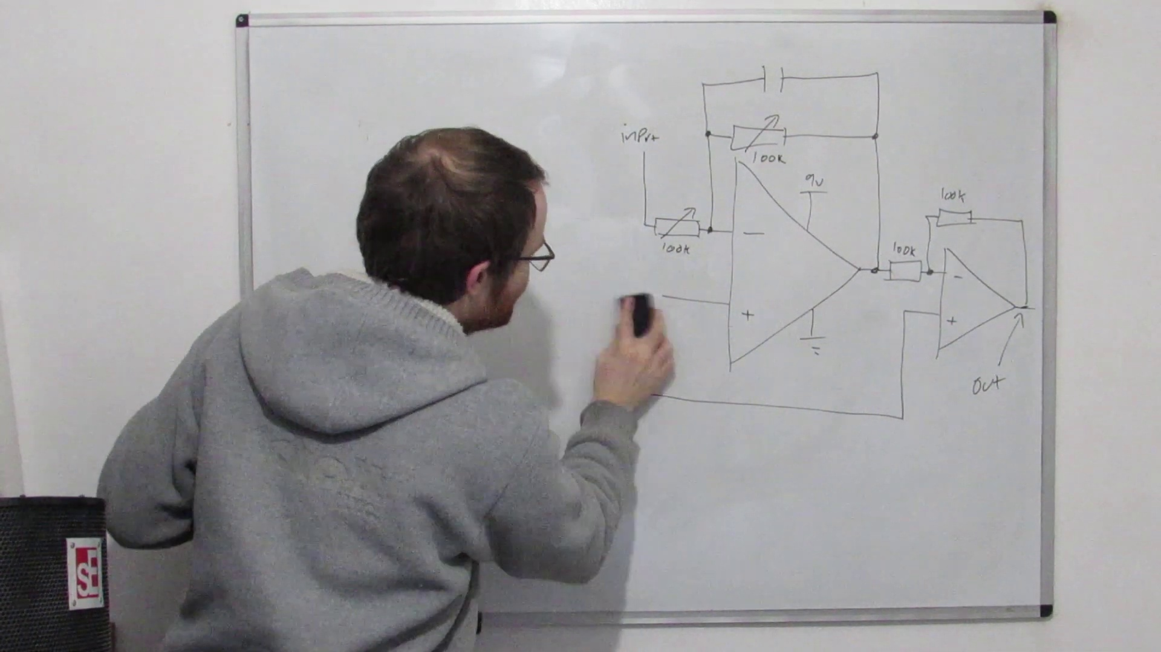 (score 95.0000)
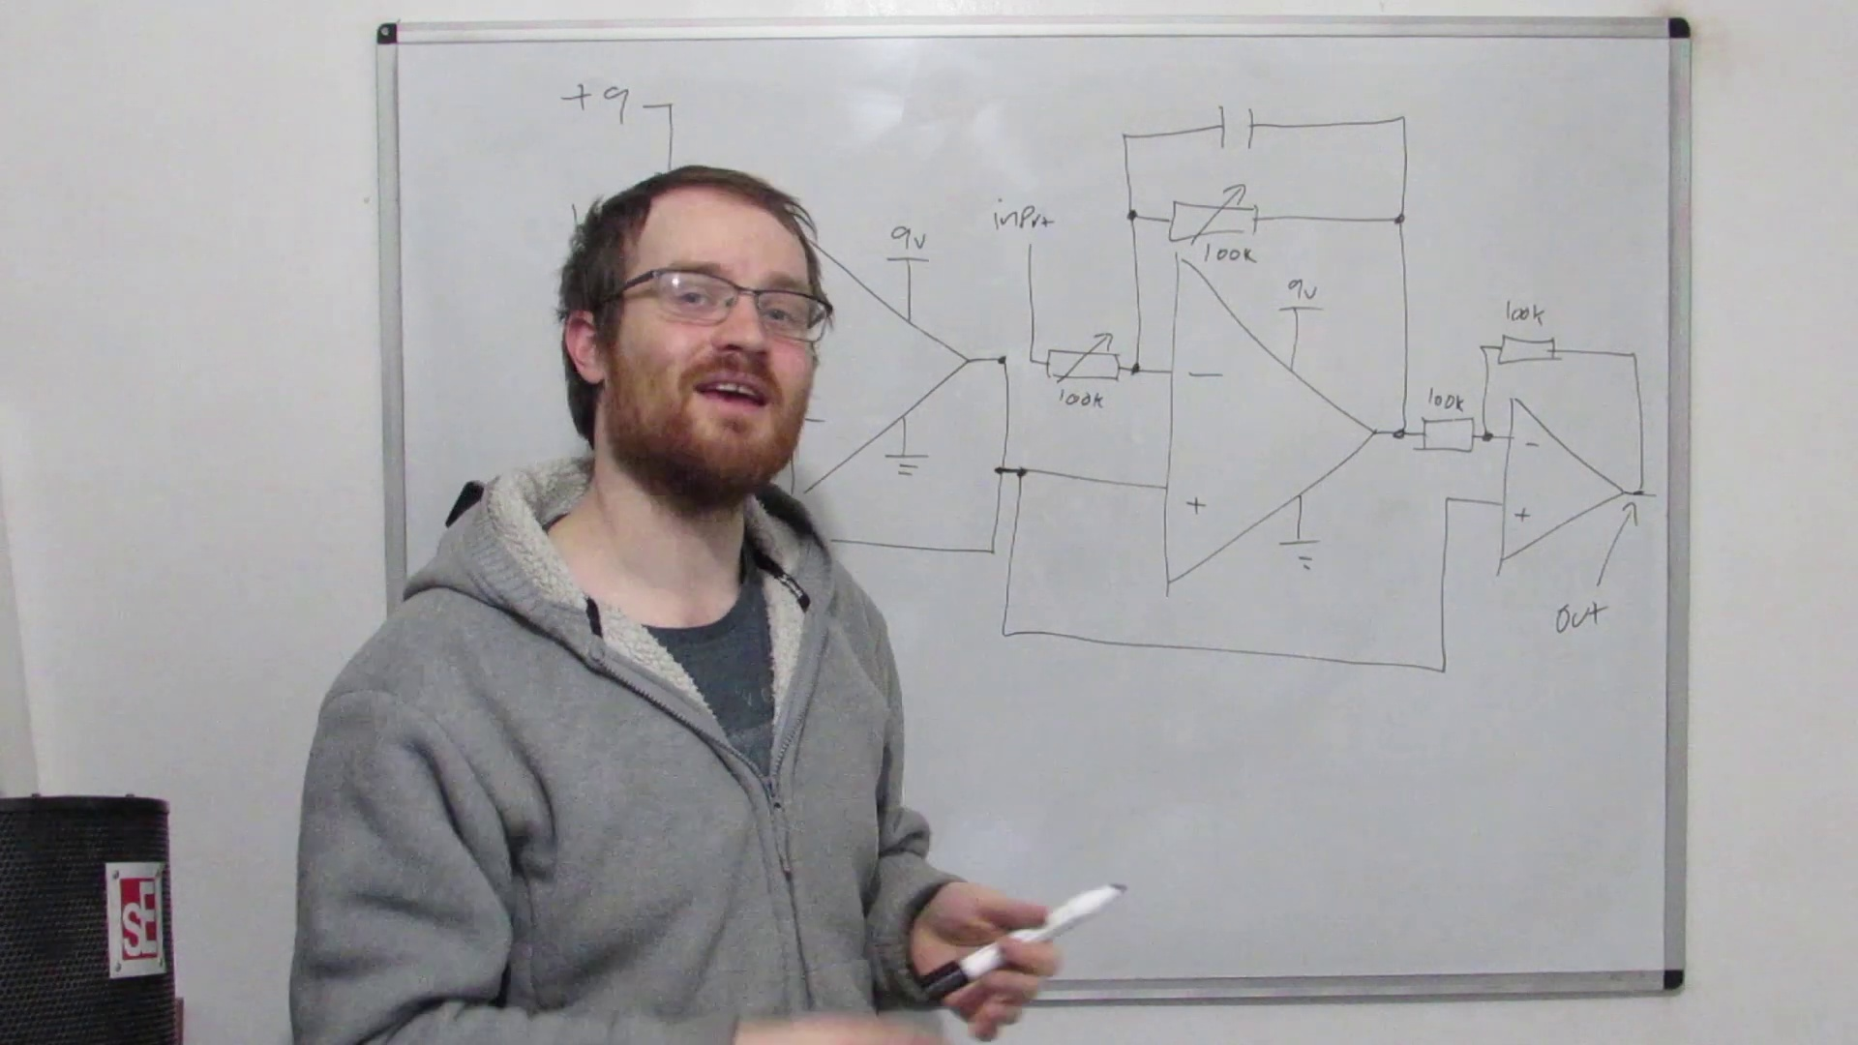 (score 95.0000)
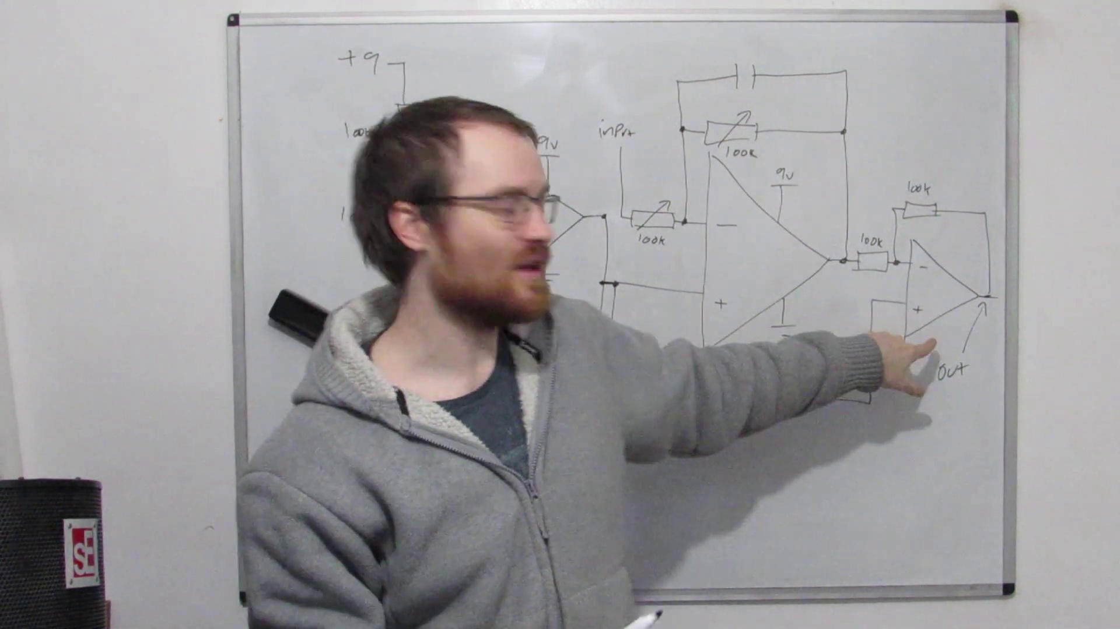 (score 95.0000)
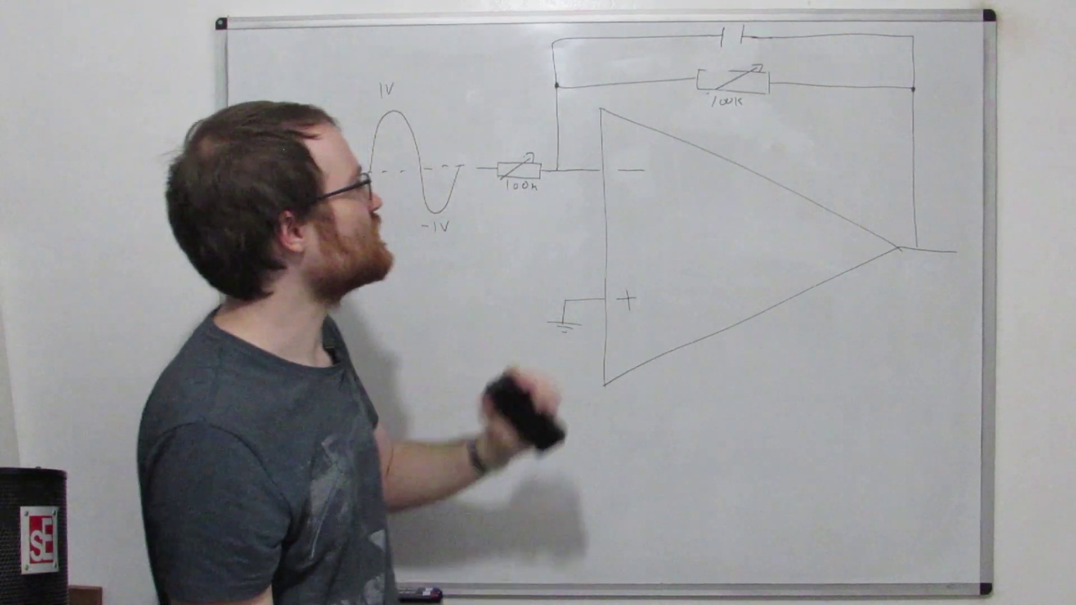 (score 95.0000)
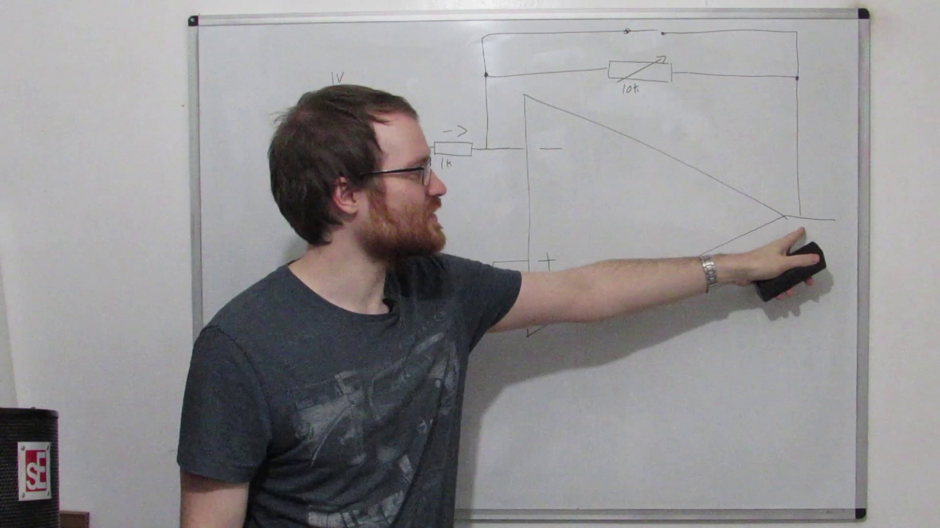 (score 95.0000)
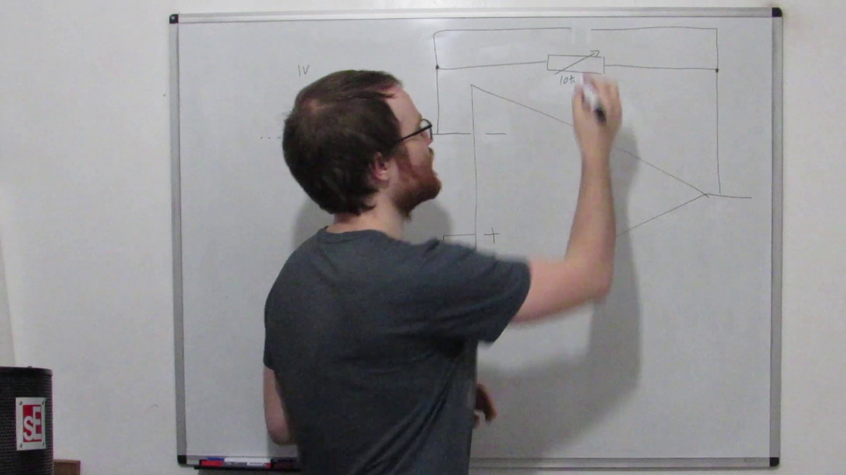 (score 95.0000)
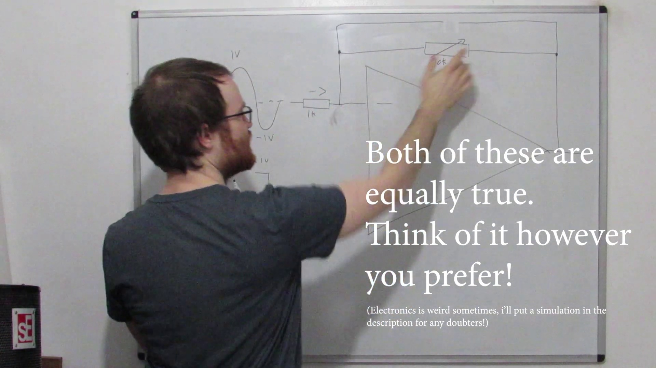 (score 95.0000)
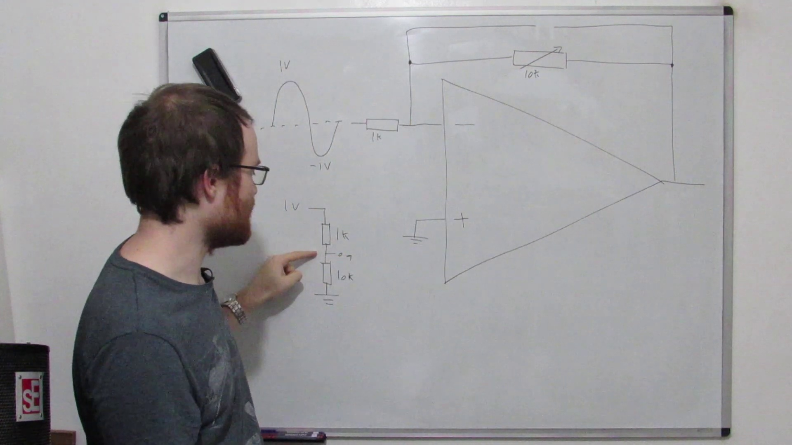 (score 95.0000)
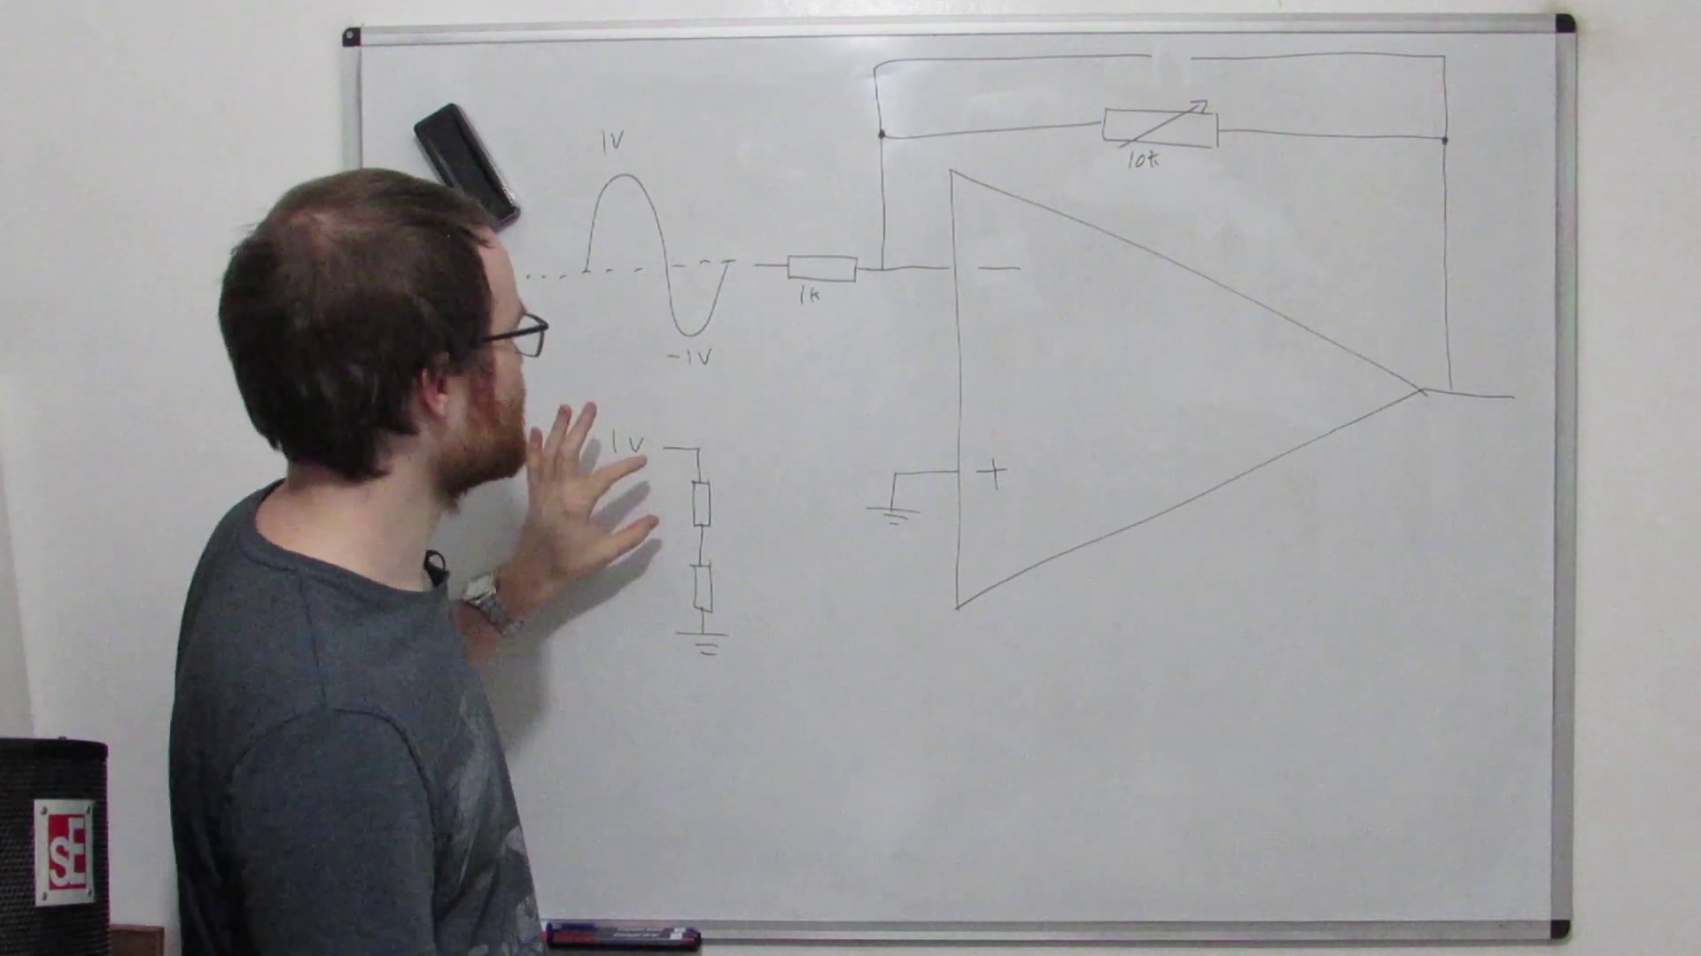 (score 95.0000)
Least correlated frames:
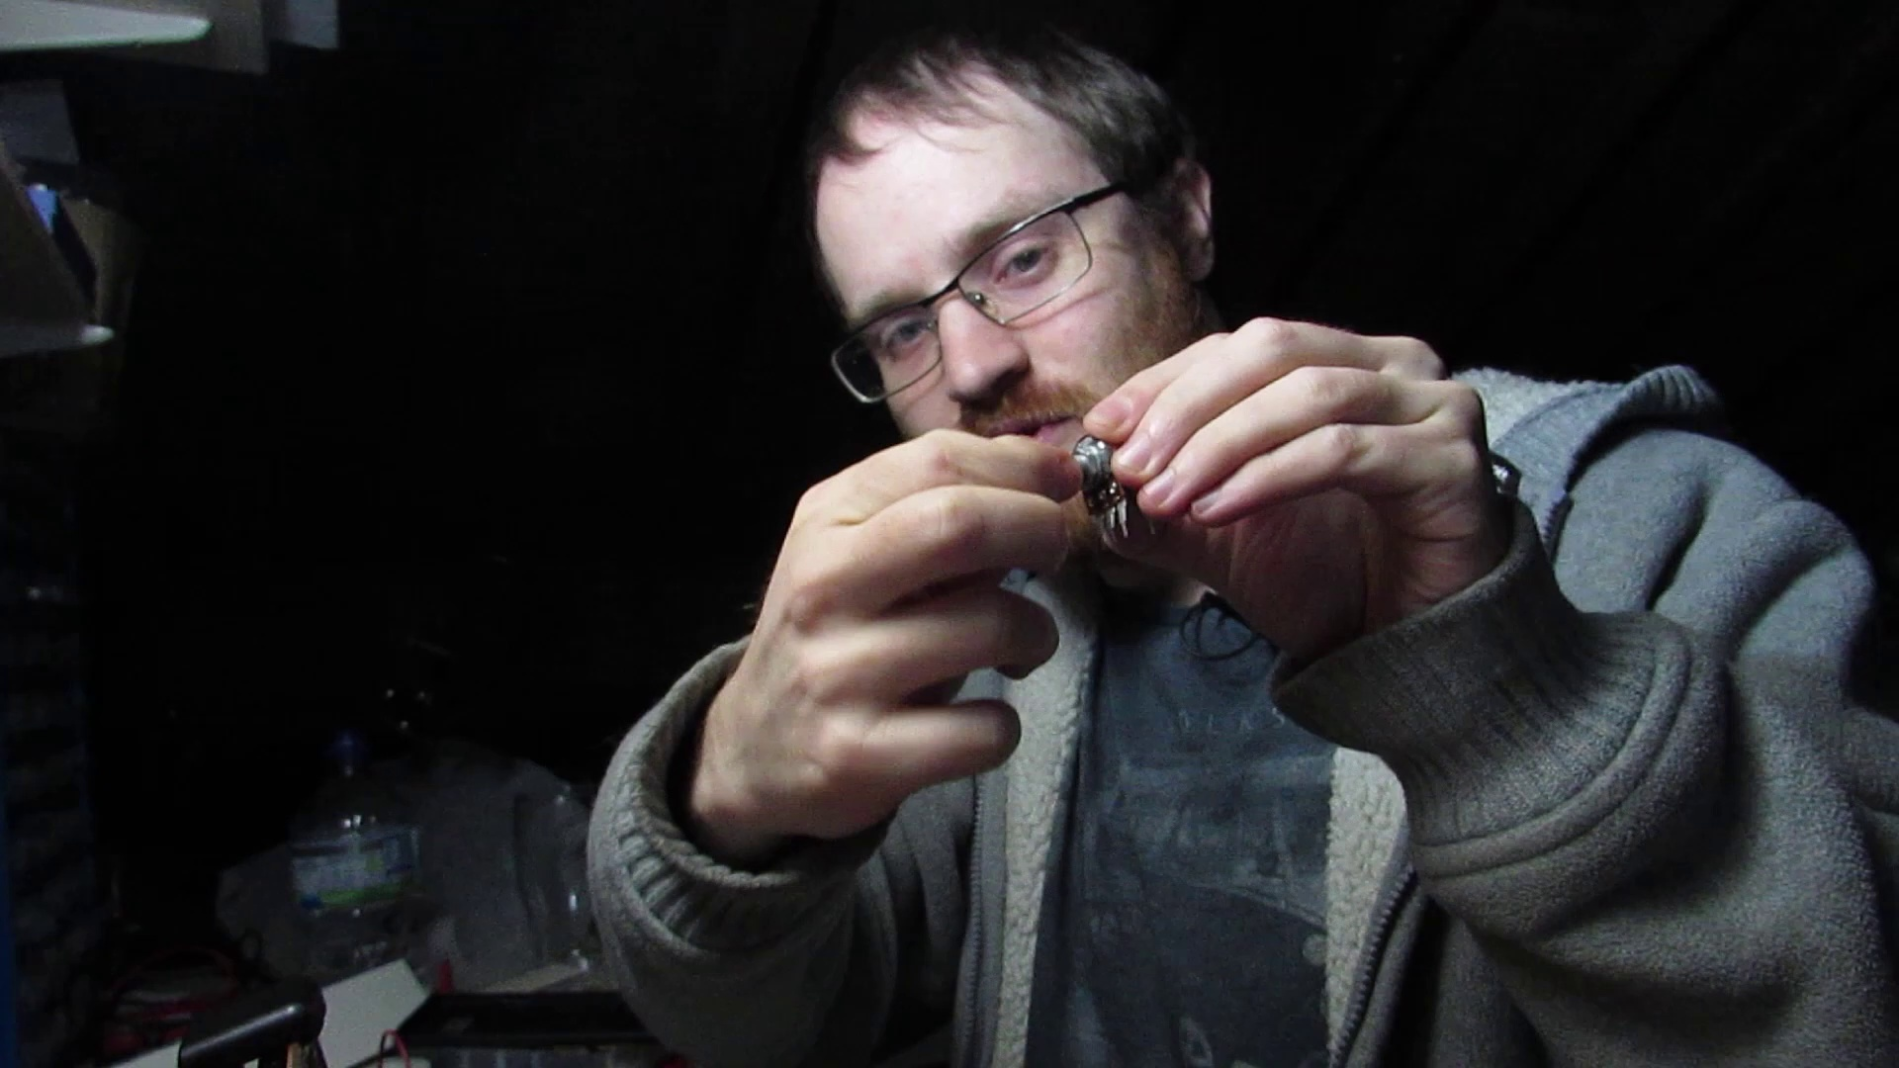 (score 0.0000)
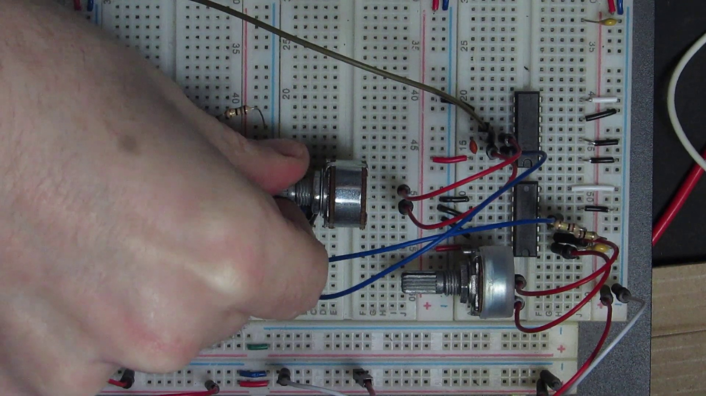 (score 0.0000)
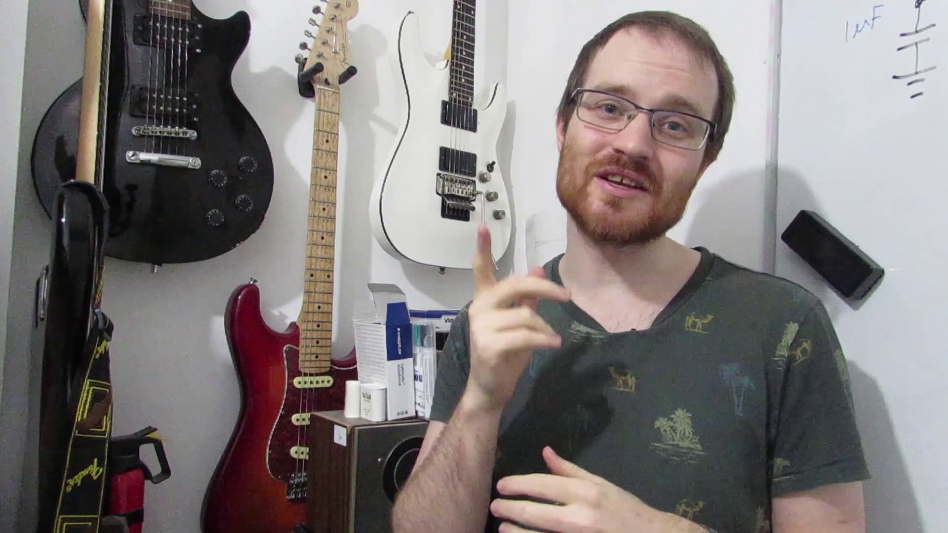 (score 0.0000)
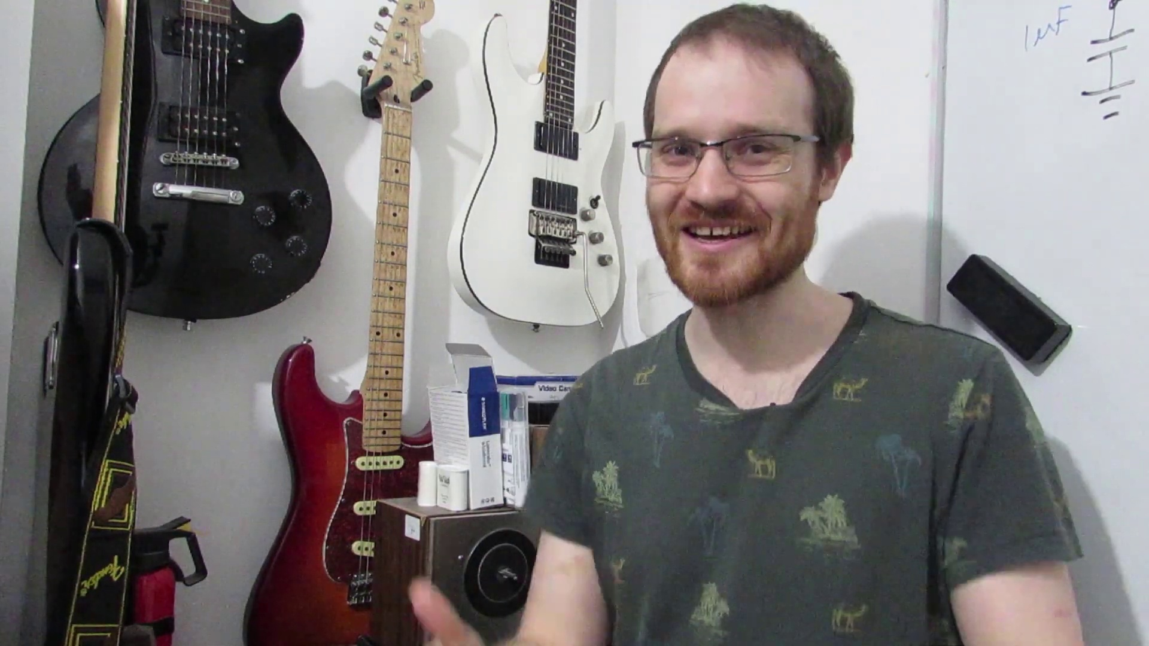 (score 0.0000)
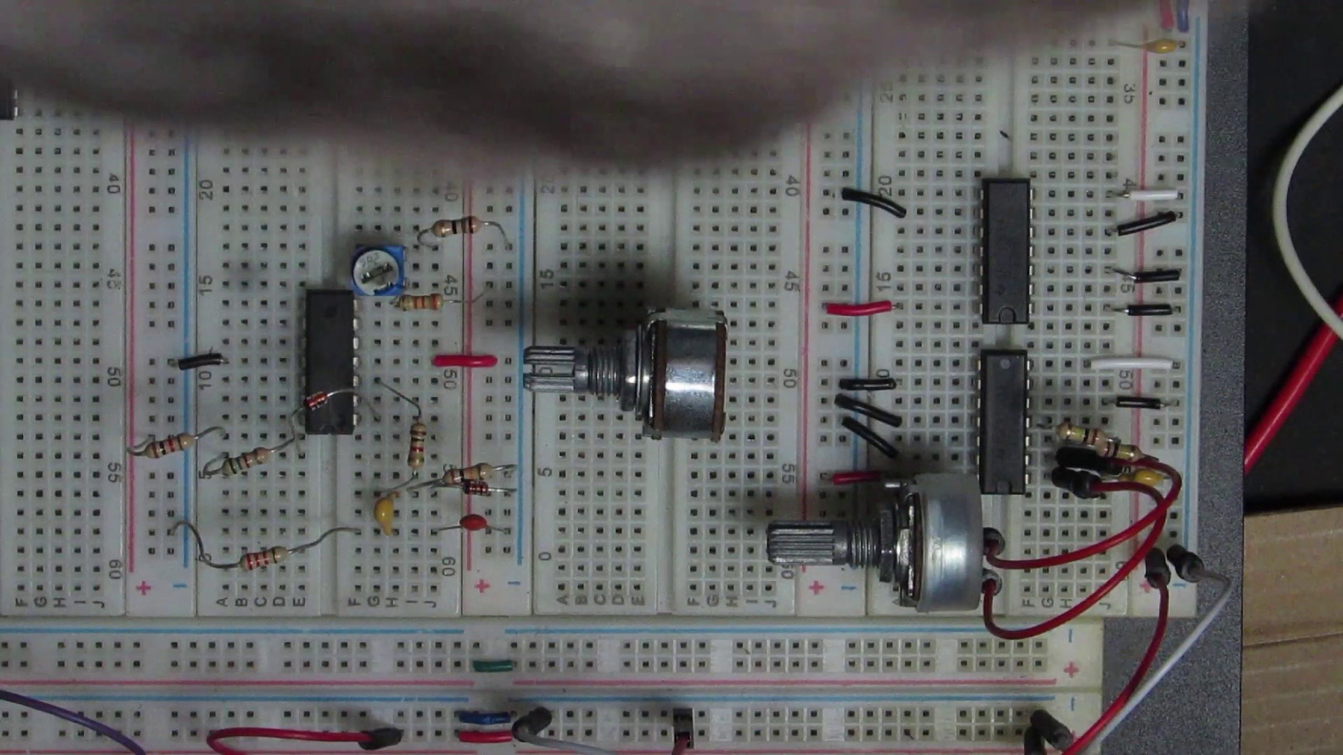 (score 10.0000)
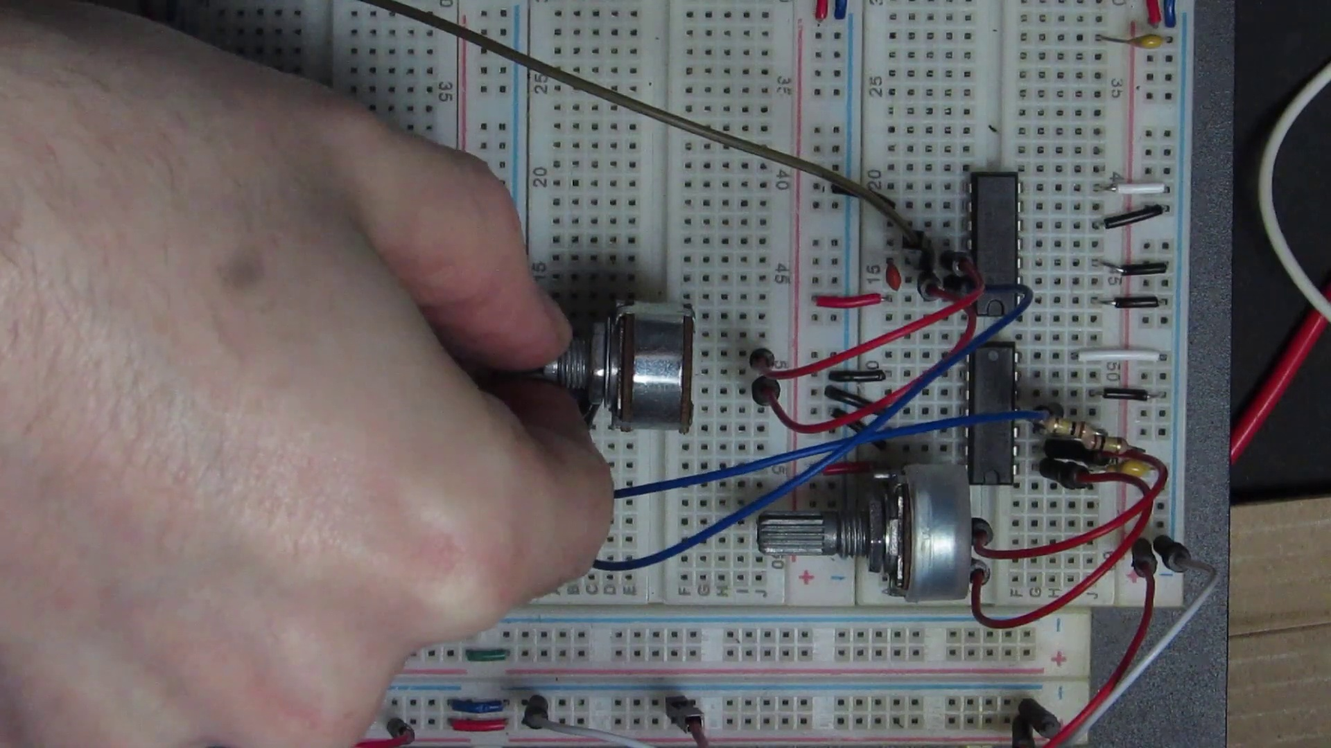 (score 10.0000)
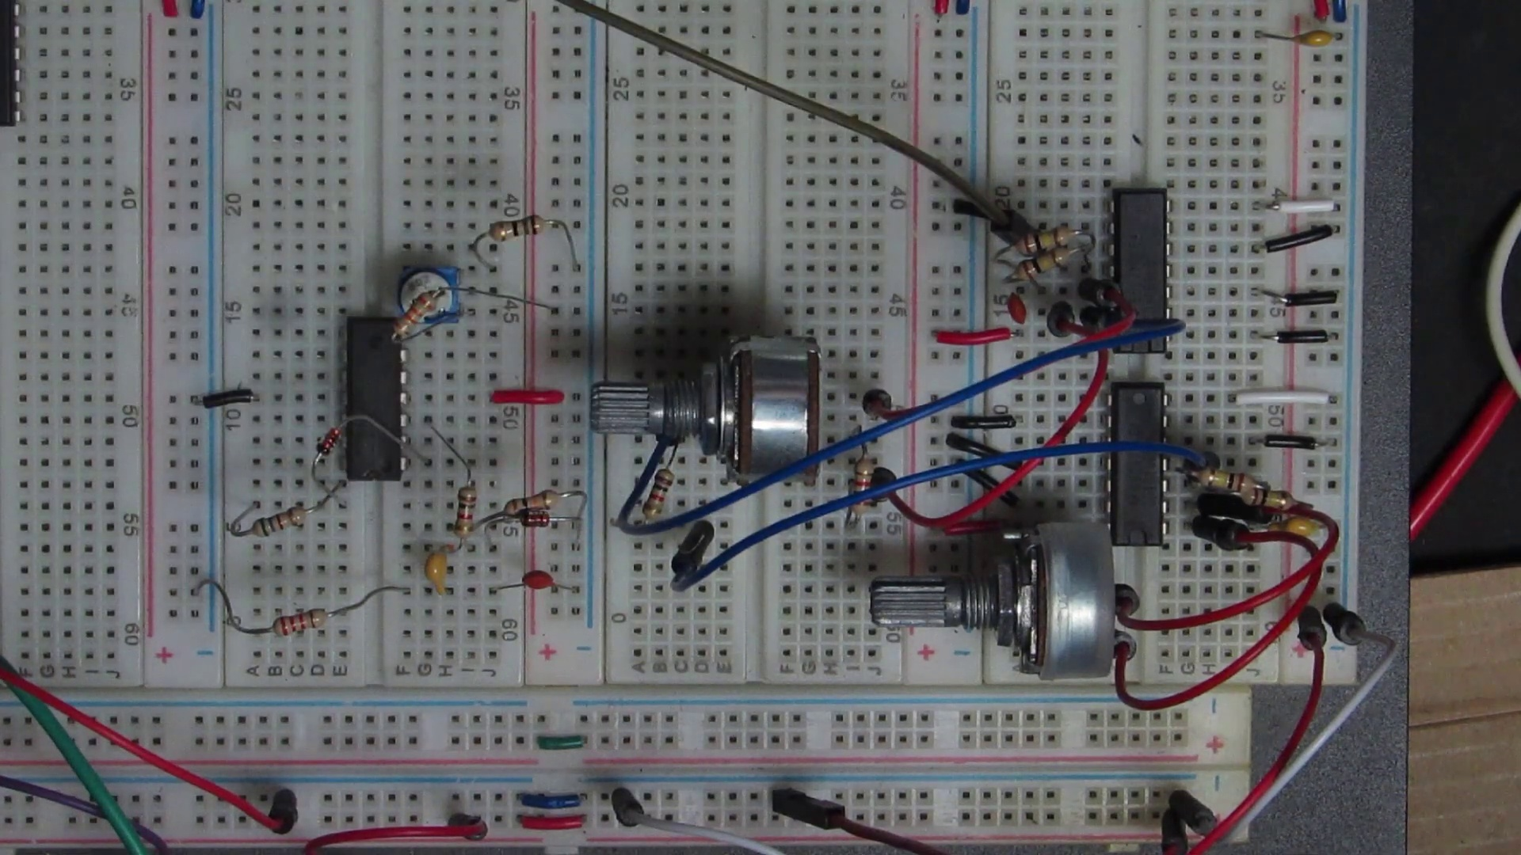 (score 10.0000)
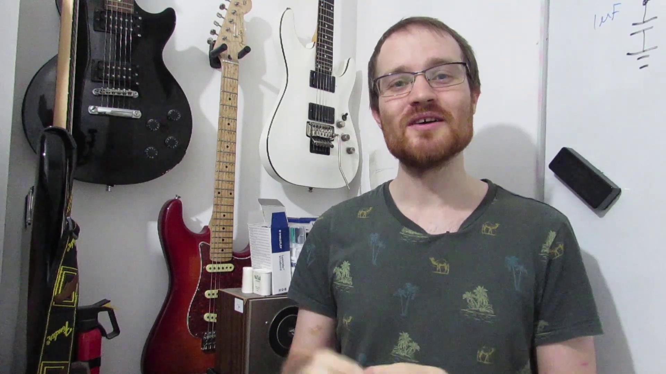 (score 10.0000)
 (score 20.0000)
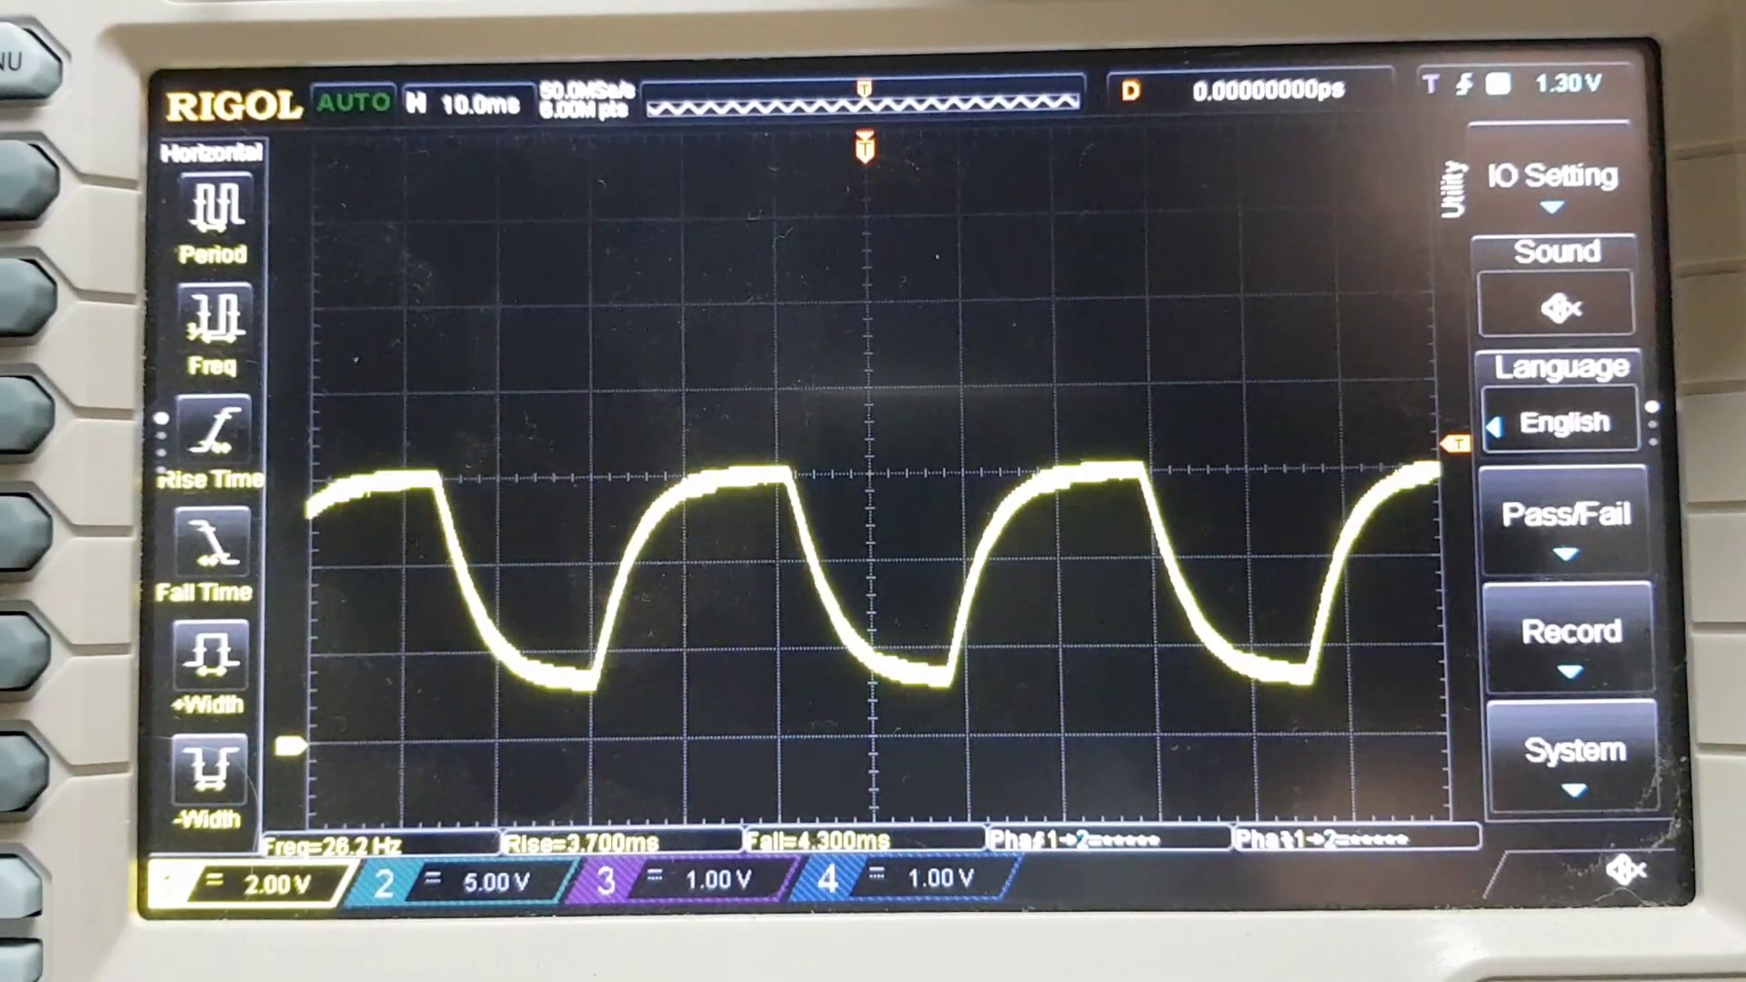 (score 20.0000)
- matched 138 frame(s), max score 90.0000: Gained a greater understanding of the OP-Amp and how adding capacitors turns it into a filter.What made you confused is Still not certain on the difference between passive and active filters.
Source: https://www.youtube.com/watch?v=aqfyRUVSq9I: OP-Amp Golden Rules & Designing an Active Filter
Top correlated frames:
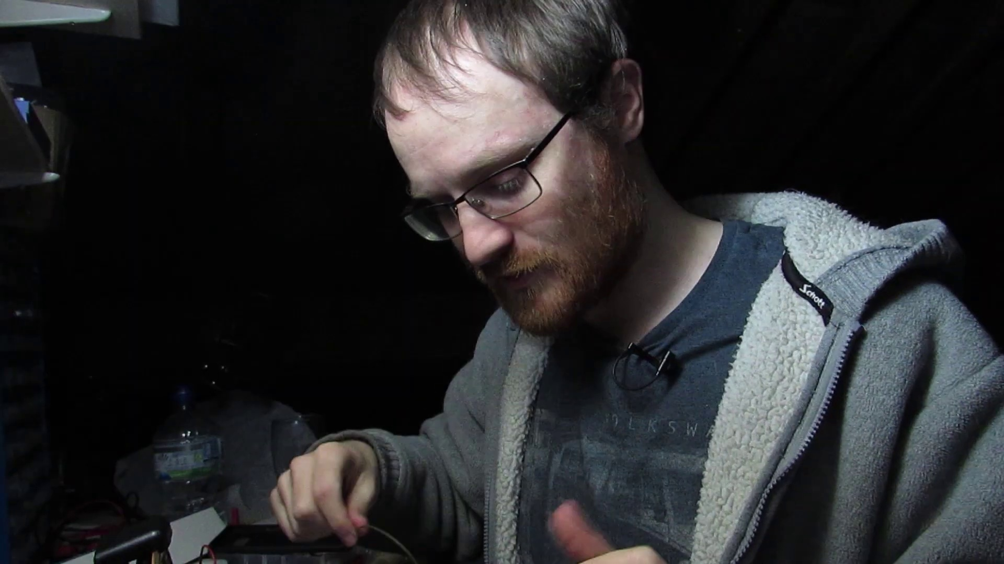 (score 90.0000)
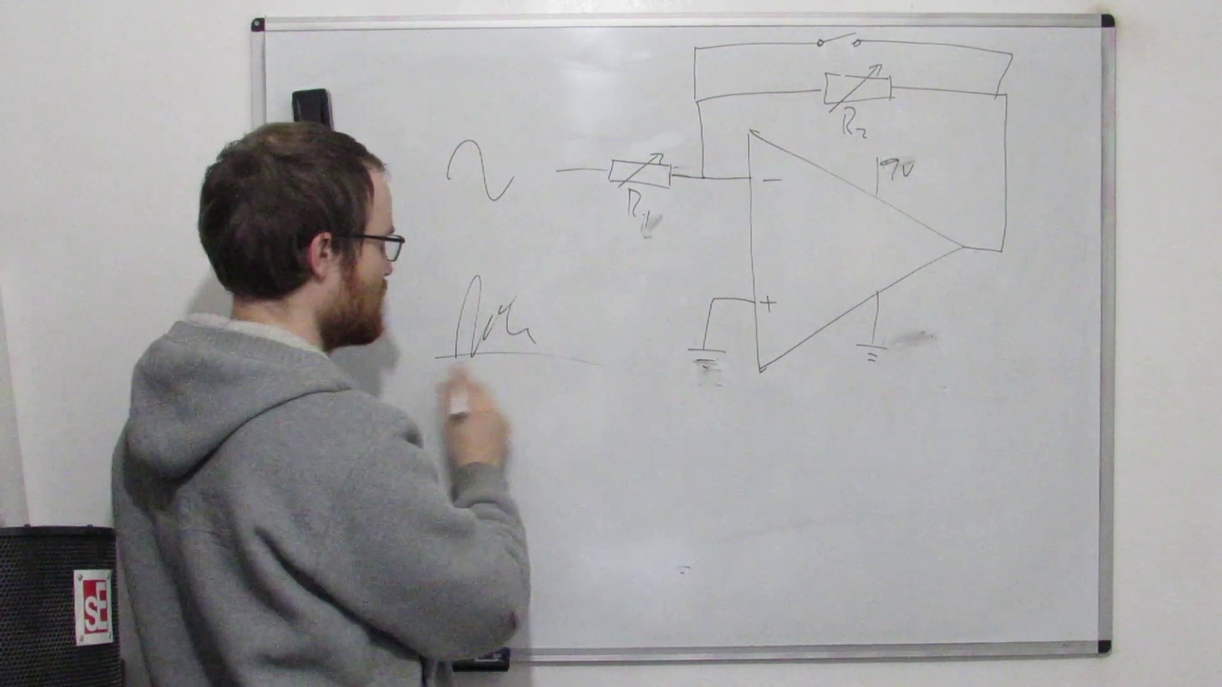 (score 90.0000)
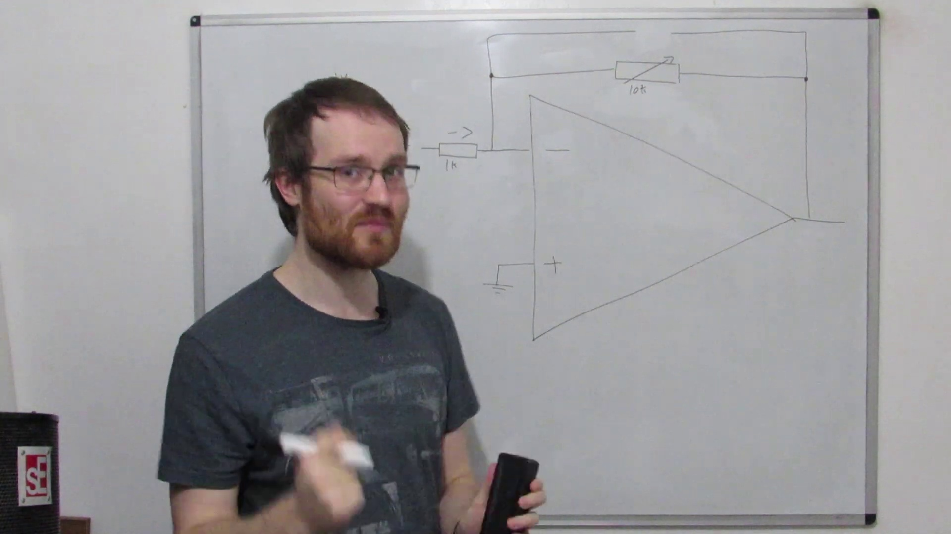 (score 90.0000)
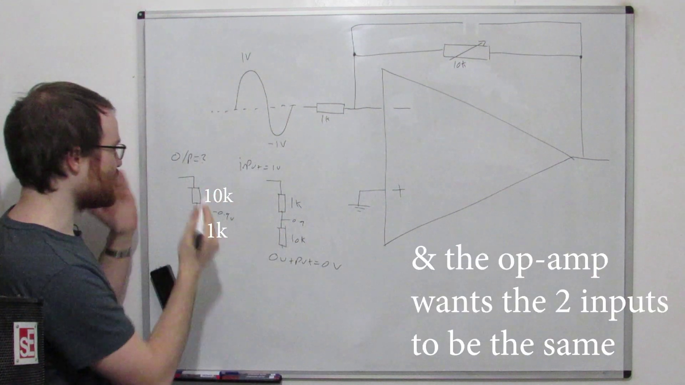 (score 90.0000)
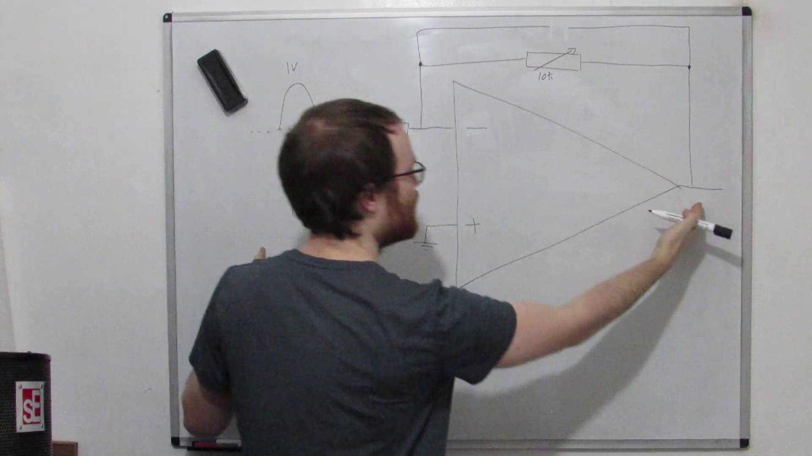 (score 90.0000)
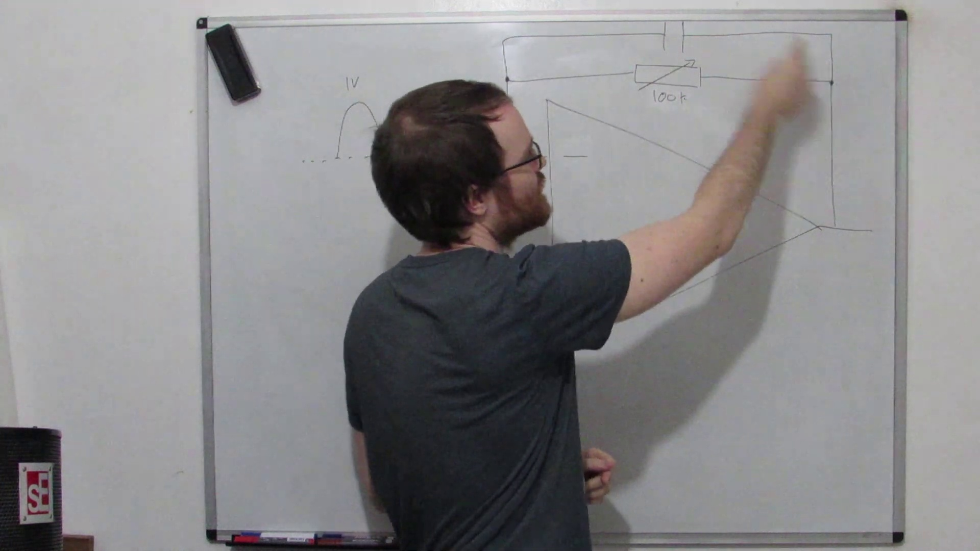 (score 90.0000)
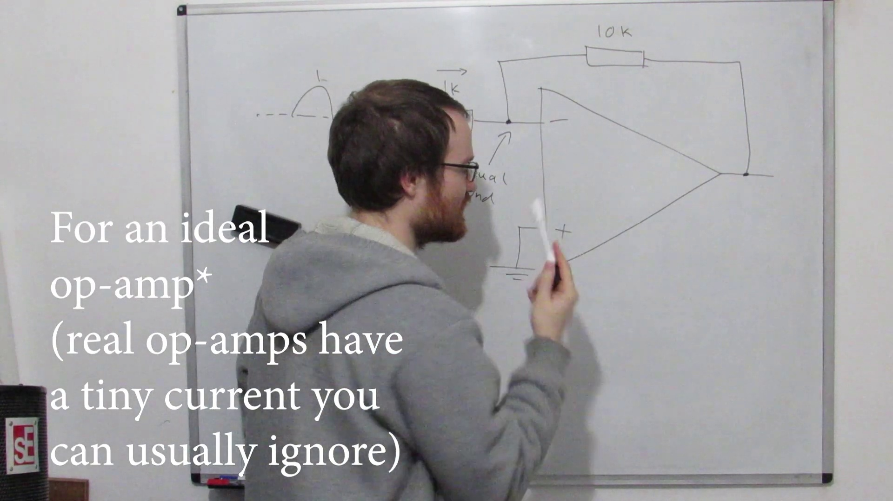 (score 90.0000)
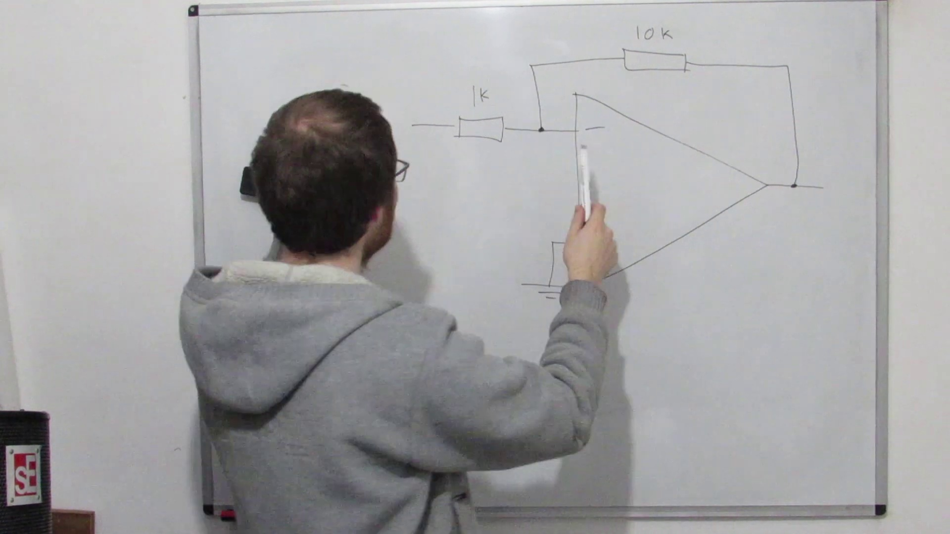 (score 90.0000)
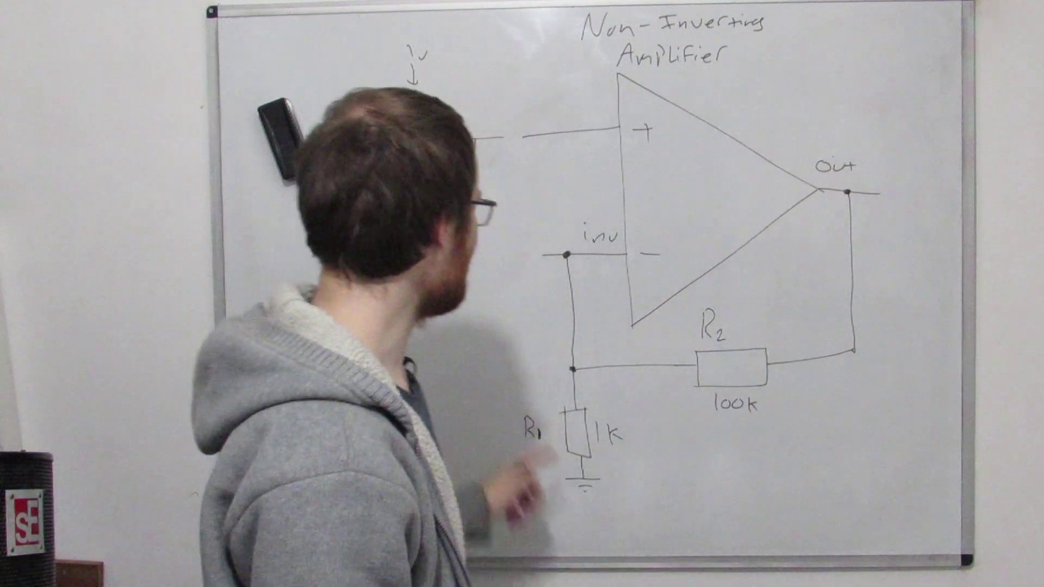 (score 90.0000)
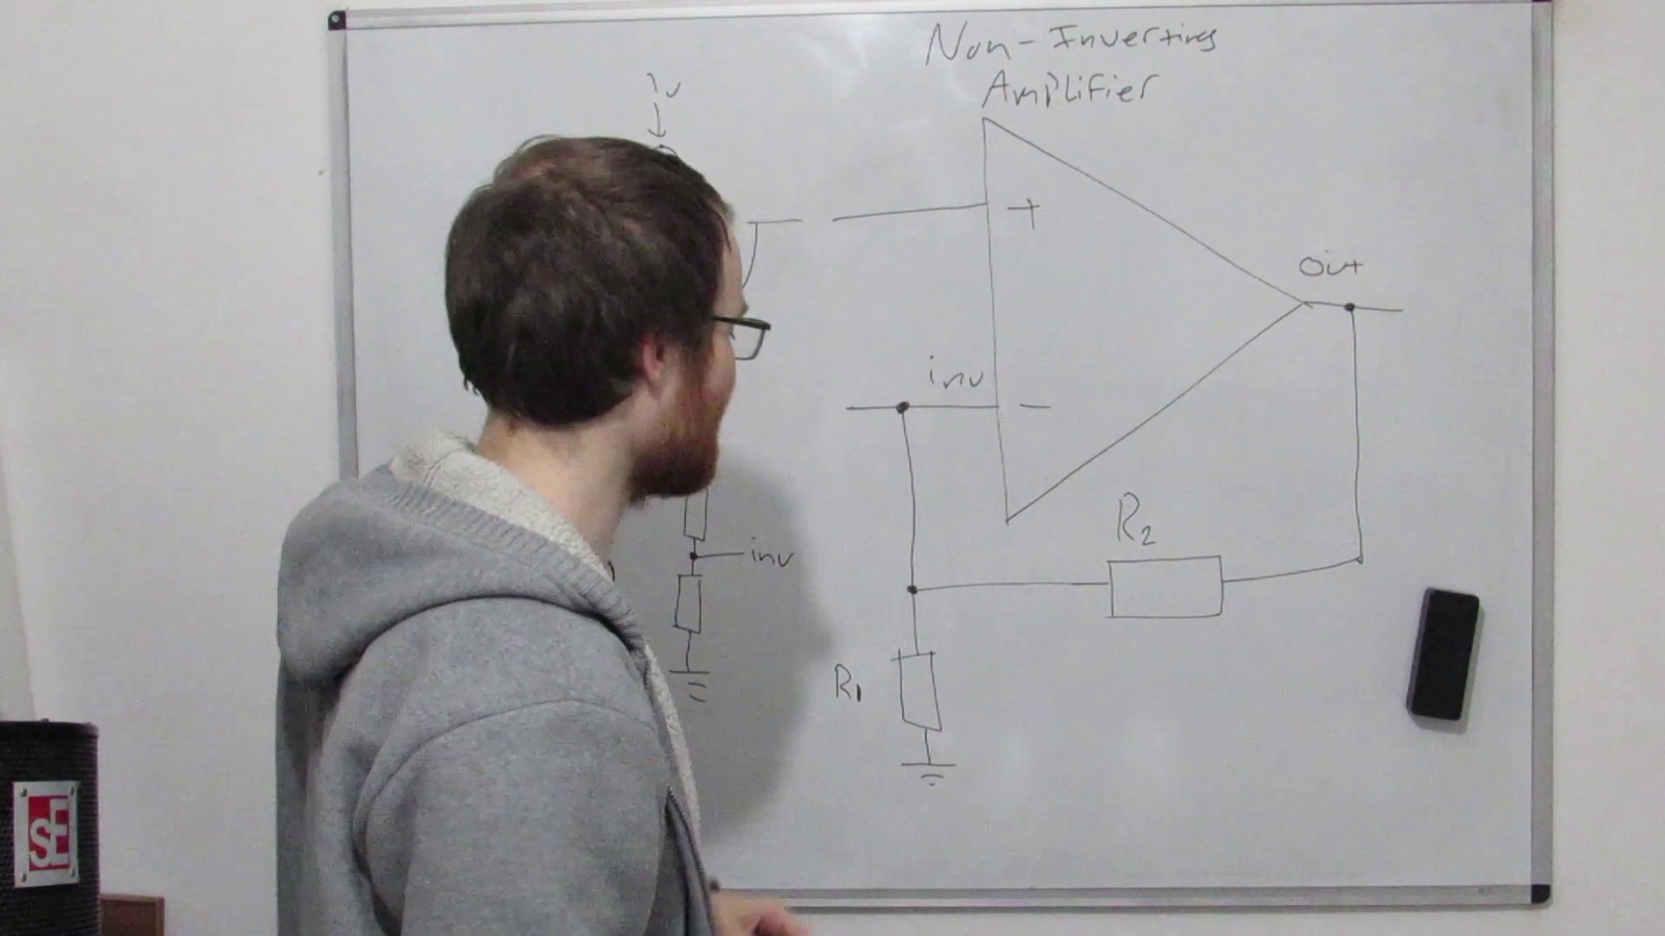 (score 90.0000)
Least correlated frames:
 (score 0.0000)
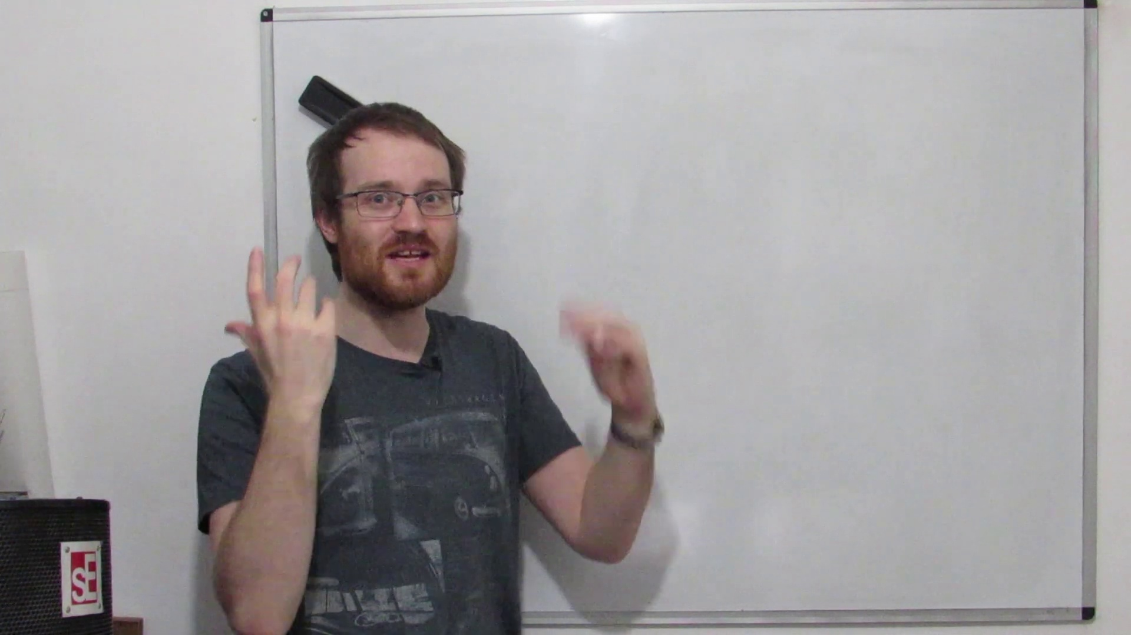 (score 0.0000)
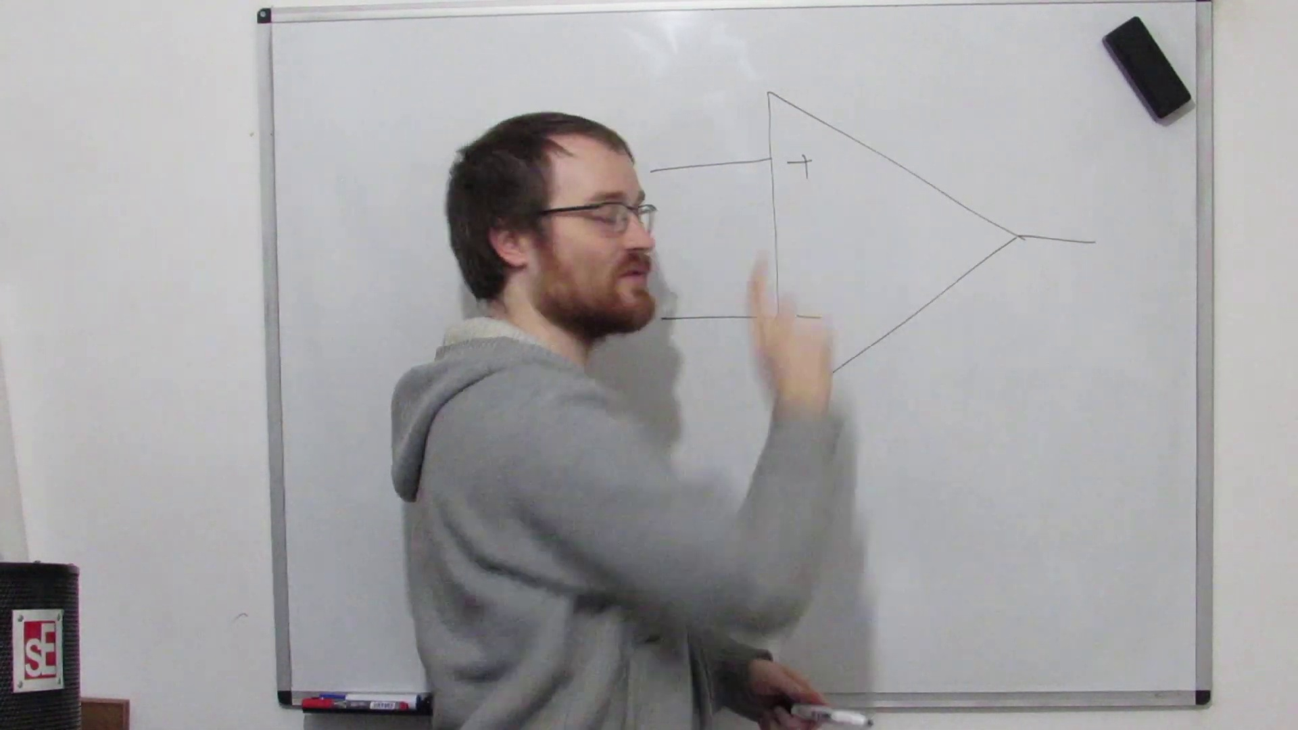 (score 0.0000)
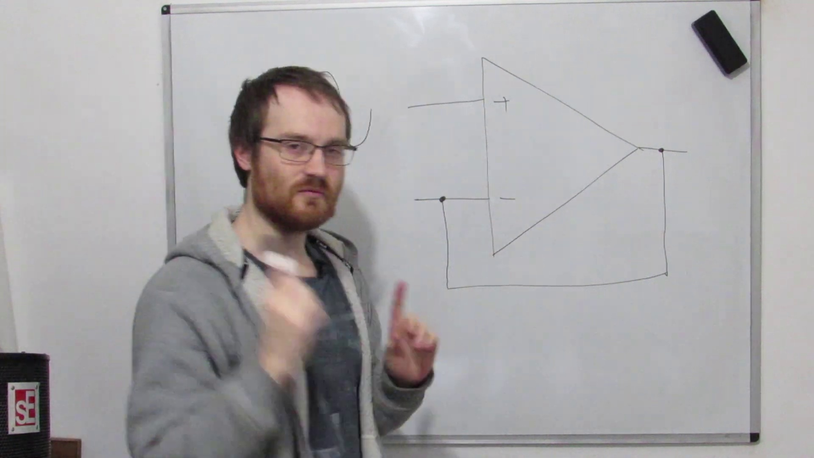 (score 0.0000)
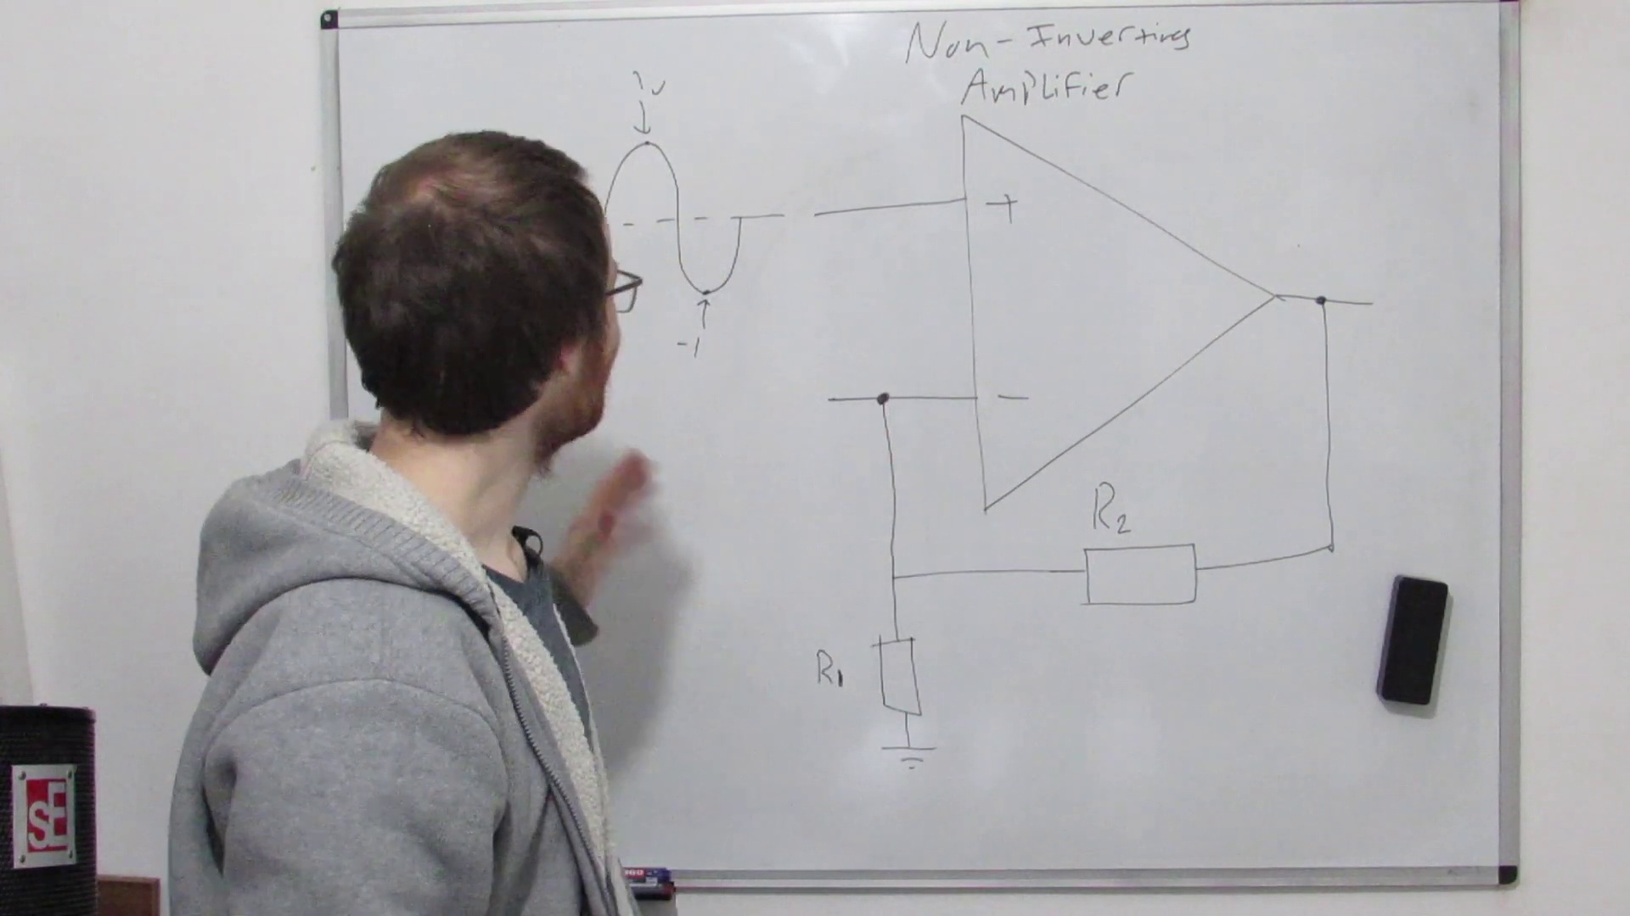 (score 0.0000)
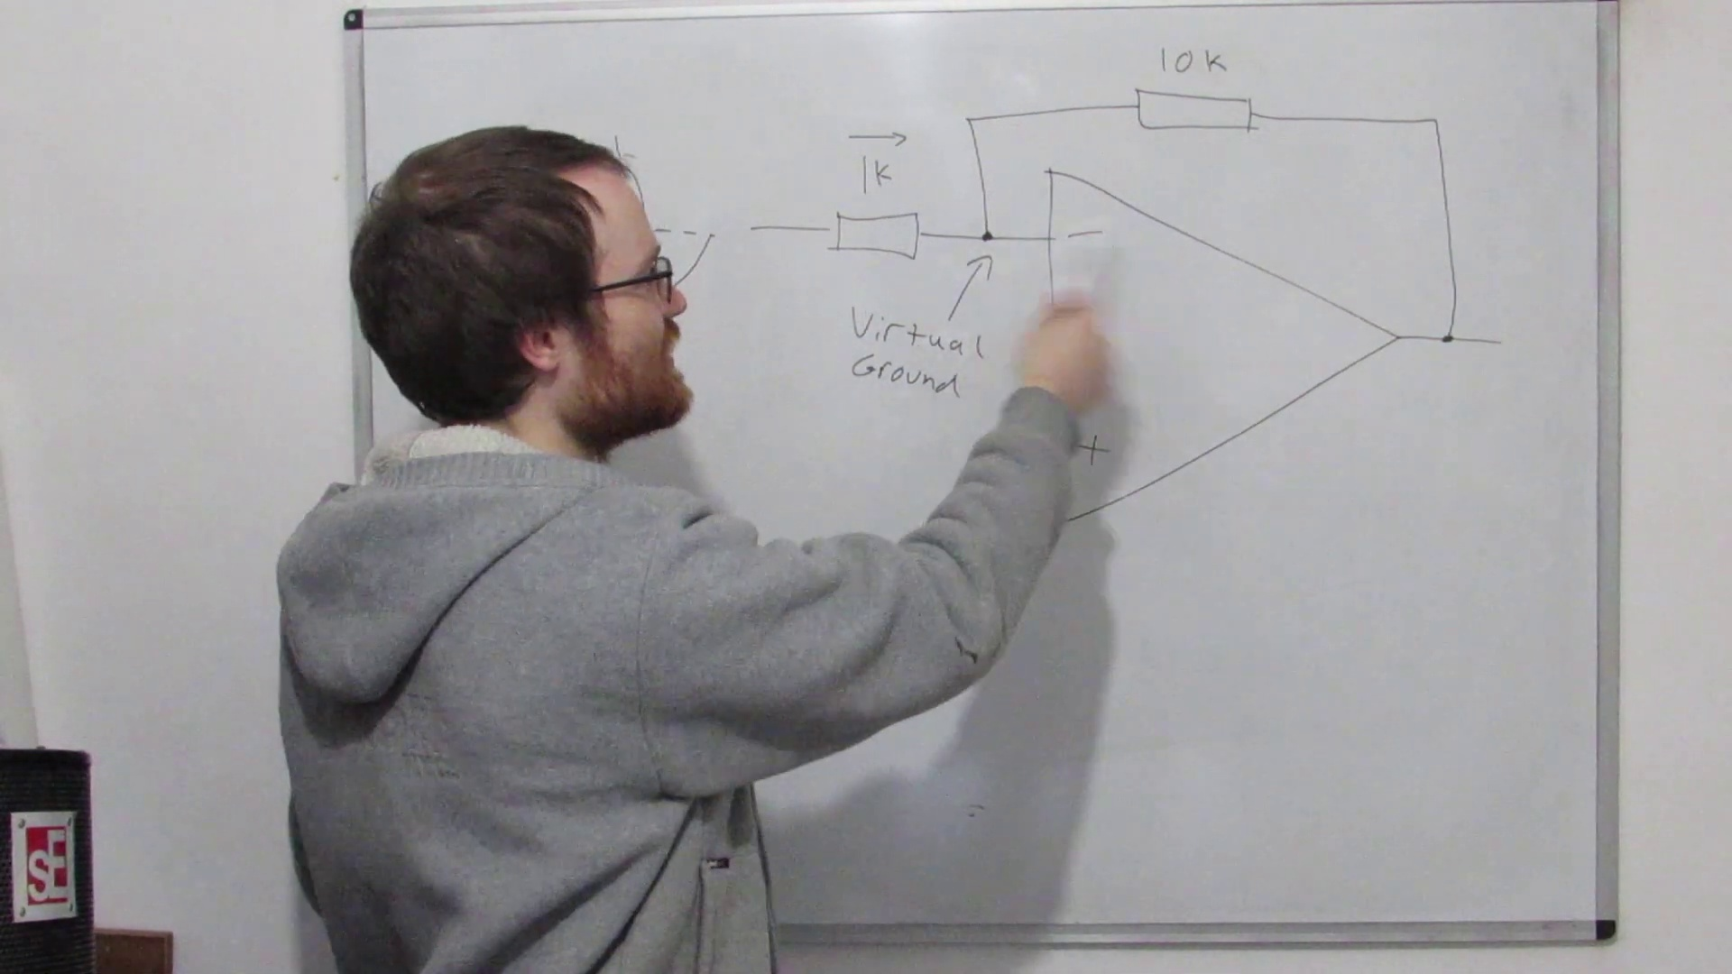 (score 0.0000)
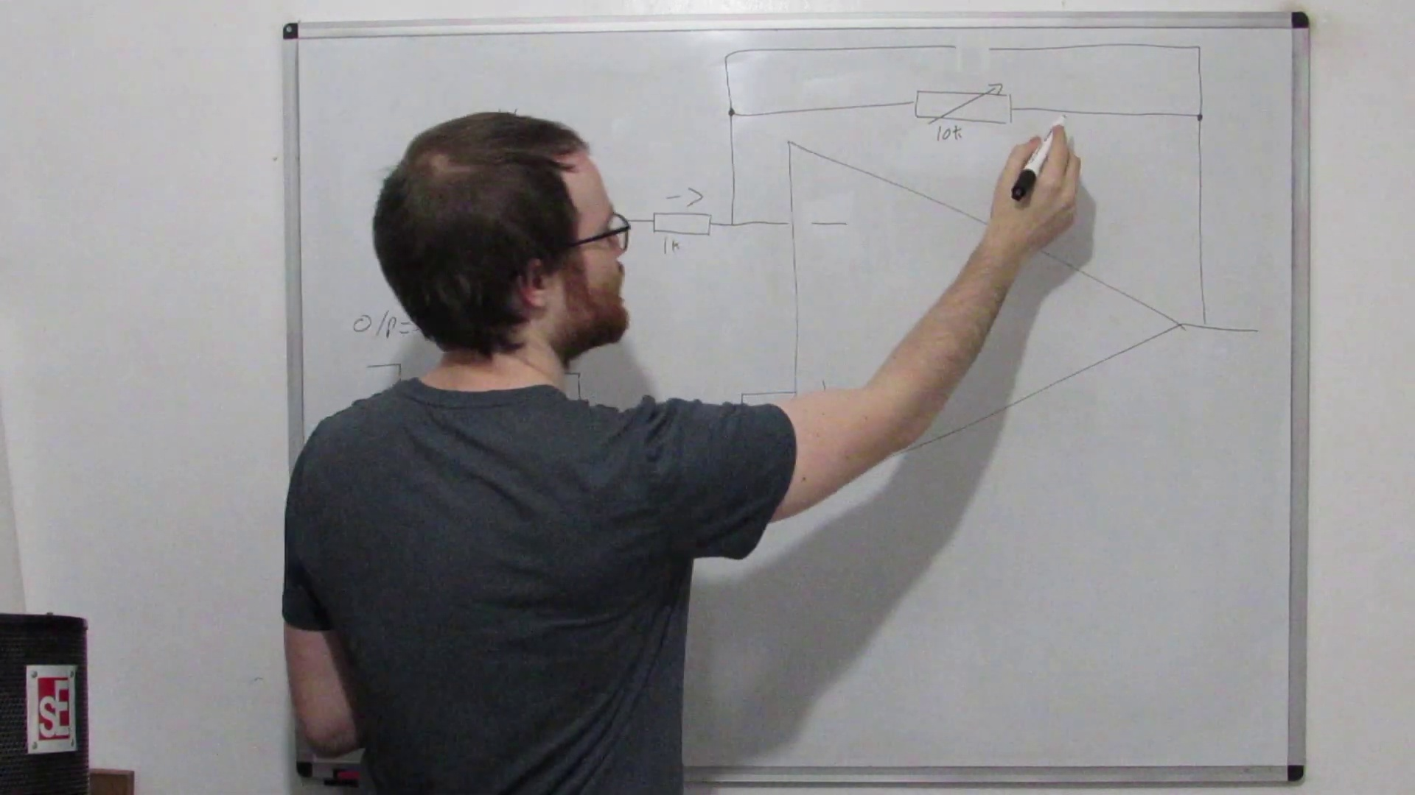 (score 0.0000)
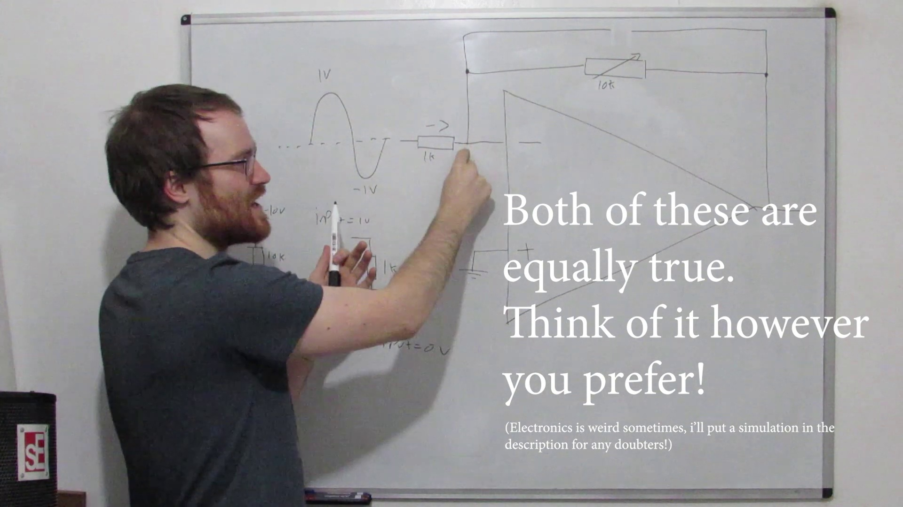 (score 0.0000)
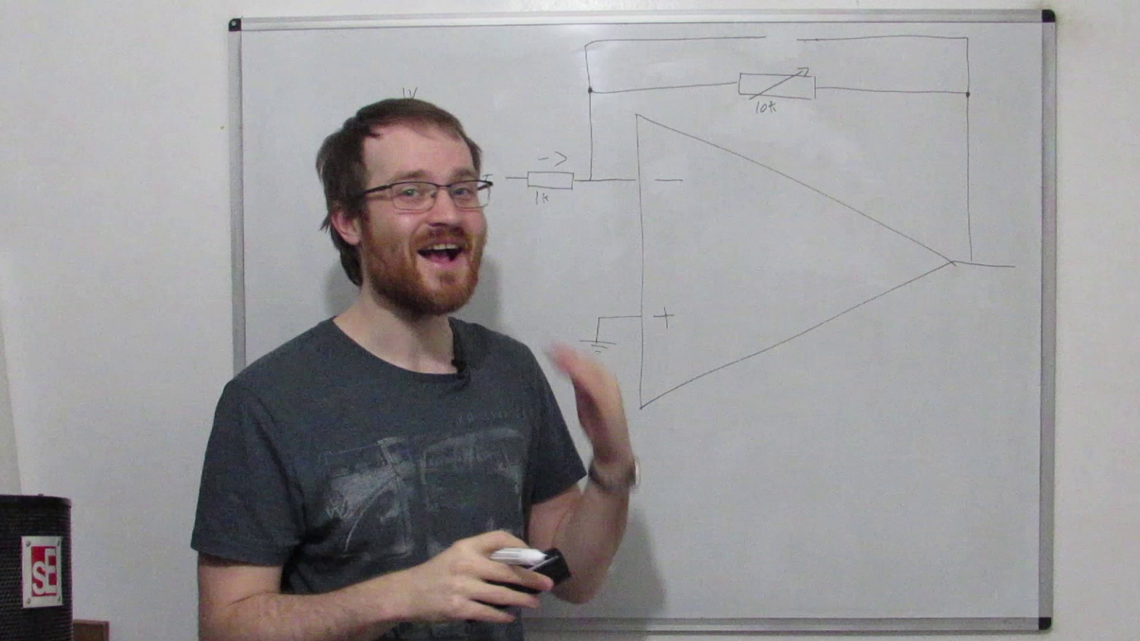 (score 0.0000)
 (score 0.0000)

Frame: frame_0000.jpg
Caption: The image appears to be a black and white photo of an office or workspace environment. On the right side, there is a partial view of a presentation screen displaying what looks like a slide with a graph on it. The graph has two axes; one appears to be labeled "x-axis" and the other "y-axis," but the specifics of the data or the details of the graph are not clear due to the black and white nature of the photo and the angle of the shot. There is no visible text, equation, or diagram that provides any additional context or information about the content being presented. The focus is solely on the presentation screen and the slide with the graph.
In a seemingly unrelated matter, Methyl mercaptan, also known as CH₃S, is an organic compound that appears in the figure. It is a colorless, highly toxic liquid with a characteristic, unpleasant odor. As the most common organic sulfur compound, it is produced in the human body by the oxidation of various sulfur-containing compounds. Notably, Methyl mercaptan is also the active component of the gas that makes up 90% of the odor of rotten eggs.
No strongly correlated comments found for this frame.

Frame: frame_0001.jpg
Caption: The image depicts a hands-on setting where someone is working with electronic components and tools. A person's hand is holding onto an unassembled circuit board with various components such as resistors, capacitors, and a microchip visible on the breadboard. Wires are connected to these components, suggesting that they are in the process of being assembled or tested. The background shows additional electronic equipment including oscilloscopes and other test instruments, as well as an Arduino board, which is a popular platform for creating interactive projects. One person's hand can be seen interacting with one of the devices, possibly adjusting or manipulating it.
The breadboard is covered in various electronic components, including resistors, capacitors, and a transistor, with one component, a potentiometer, being adjusted by the person's hand. The potentiometer has red, black, and white wires connected to it, and its adjustment is likely part of the process of assembling or adjusting an electronic circuit.
Comment (score 85): Gained a greater understanding of the OP-Amp and how adding capacitors turns it into a filter.What made you confused is Still not certain on the difference between passive and active filters.
Reason: The comment directly discusses the same technical steps (assembling or adjusting an electronic circuit) and objects (resistors, capacitors, potentiometer) mentioned in the caption. The mention of OP-Amp and filter types also matches with the setting and tools shown in the image.
Source: https://www.youtube.com/watch?v=aqfyRUVSq9I: OP-Amp Golden Rules & Designing an Active Filter
Comment (score 80): Provides a great overview of the math behind filters. He explained Op-Amps well starting from a basic circuit he made a follower and non-inverting amplifier make sense. Then he explained the meaning behind non-inverting Op- Amps. Each time he added one component to the circuit at a time while explaining the change that occurred at each instance which made it much easier to understand the more complex circuits. He also describes how to discriminate between high and low frequencies to create high/ low pass filters using a capacitor. He explains the reason behind the 3dB point very well. At the end, he shows a physical circuit to show how the potentiometer impacts the waveform. This video helped with the implementation of a high pass and low pass filter that could be used in phase two for our speaker.
Reason: The comment directly discusses the same technical steps and components described in the caption, specifically mentioning potentiometers, Op-Amps, capacitors, and filters, which are all present in the image.
Source: https://www.youtube.com/watch?v=aqfyRUVSq9I&t=1s: Op-Amp Golden Rules and Designing an Active Filter

Frame: frame_0002.jpg
Caption: In this visually stunning display, a technician carefully monitors the electrical properties of a circuit using a multimeter. The device's digital screen showcases a wealth of information, including the current flow (represented by the yellow waveform), voltage levels (displayed as blue and green lines), and frequency measurements (indicated by the red numbers). The multimeter also provides real-time monitoring of the system's settings, offering an unparalleled level of control and precision. As the technician studies the data, they can identify trends, troubleshoot issues, and make informed decisions about circuit maintenance and optimization.
No strongly correlated comments found for this frame.

Frame: frame_0003.jpg
Caption: The image shows a person who appears to be a man with glasses and a beard, standing in what appears to be a workshop or study area. The room is dimly lit, suggesting a night-time setting, with books and other items on shelves behind him. He is wearing a gray shirt and a grey hoodie that contrasts with his red beard and black hair. His right hand is raised, pointing towards the camera, while his left hand is resting on his hip. A bottle of water and a box are placed in the foreground, adding to the overall composition of the image. The man's expression suggests he might be in the middle of speaking or presenting, possibly explaining or teaching about something out of frame.
Comment (score 85): Provides a great overview of the math behind filters. He explained Op-Amps well starting from a basic circuit he made a follower and non-inverting amplifier make sense. Then he explained the meaning behind non-inverting Op- Amps. Each time he added one component to the circuit at a time while explaining the change that occurred at each instance which made it much easier to understand the more complex circuits. He also describes how to discriminate between high and low frequencies to create high/ low pass filters using a capacitor. He explains the reason behind the 3dB point very well. At the end, he shows a physical circuit to show how the potentiometer impacts the waveform. This video helped with the implementation of a high pass and low pass filter that could be used in phase two for our speaker.
Reason: The comment directly discusses the technical steps and concepts described in the caption, such as Op-Amps, non-inverting amplifier, high/low pass filters, and the 3dB point. The correlation is strong because the comment provides a detailed explanation of how to apply these concepts, which matches the description of the man possibly explaining or teaching about something out of frame.
Source: https://www.youtube.com/watch?v=aqfyRUVSq9I&t=1s: Op-Amp Golden Rules and Designing an Active Filter
Comment (score 85): Gained a greater understanding of the OP-Amp and how adding capacitors turns it into a filter.What made you confused is Still not certain on the difference between passive and active filters.
Reason: The comment directly discusses the OP-Amp and its components (capacitors), which are technical steps mentioned in the caption. The mention of filter types (passive and active) also matches the context described in the caption.
Source: https://www.youtube.com/watch?v=aqfyRUVSq9I: OP-Amp Golden Rules & Designing an Active Filter

Frame: frame_0004.jpg
Caption: The image captures a moment of an individual standing in front of a whiteboard, dressed casually in a dark top and grey t-shirt, with short hair and glasses. The person appears to be instructing or teaching a class or workshop, looking to the side as if preparing to make a point or write on the board. In their hand are markers, ready for use. In the foreground, a clear glass surface reflects a bit of the room, including what appears to be a speaker on its side. The background is not detailed enough to provide additional information about the location or context of the scene. The whiteboard itself is blank, suggesting a moment of quiet contemplation or preparation for an upcoming presentation. The individual's hand is raised, perhaps gesturing or preparing to write on the board, indicating their active involvement in the task at hand. Their expression is neutral, adding a sense of calm and focus to the scene.
Comment (score 80): Provides a great overview of the math behind filters. He explained Op-Amps well starting from a basic circuit he made a follower and non-inverting amplifier make sense. Then he explained the meaning behind non-inverting Op- Amps. Each time he added one component to the circuit at a time while explaining the change that occurred at each instance which made it much easier to understand the more complex circuits. He also describes how to discriminate between high and low frequencies to create high/ low pass filters using a capacitor. He explains the reason behind the 3dB point very well. At the end, he shows a physical circuit to show how the potentiometer impacts the waveform. This video helped with the implementation of a high pass and low pass filter that could be used in phase two for our speaker.
Reason: The comment directly discusses the same technical steps and concepts described in the caption, such as Op-Amps, circuit design, and filter creation.
Source: https://www.youtube.com/watch?v=aqfyRUVSq9I&t=1s: Op-Amp Golden Rules and Designing an Active Filter

Frame: frame_0005.jpg
Caption: The image shows an individual, likely a teacher or lecturer, standing in front of a whiteboard with markers. The board appears to be blank, with no visible markings or text that provide content for the lesson. To the right of the whiteboard is a large screen displaying a plain white board with no text or images. The individual is holding a remote control and seems to be speaking or explaining something related to what's shown on the screen, though the content of the screen is not discernible from this angle. He has a beard and wears glasses and a gray t-shirt, which gives him a neutral facial expression as he looks directly at the camera. The setting suggests an informal educational environment, with a plain white wall serving as the background that contrasts with his gray t-shirt and the black remote control he is holding.
Comment (score 85): Provides a great overview of the math behind filters. He explained Op-Amps well starting from a basic circuit he made a follower and non-inverting amplifier make sense. Then he explained the meaning behind non-inverting Op- Amps. Each time he added one component to the circuit at a time while explaining the change that occurred at each instance which made it much easier to understand the more complex circuits. He also describes how to discriminate between high and low frequencies to create high/ low pass filters using a capacitor. He explains the reason behind the 3dB point very well. At the end, he shows a physical circuit to show how the potentiometer impacts the waveform. This video helped with the implementation of a high pass and low pass filter that could be used in phase two for our speaker.
Reason: The comment directly discusses the technical steps and objects described in the caption, such as the use of Op-Amps, amplifiers, filters, and capacitors, which are mentioned in the caption.
Source: https://www.youtube.com/watch?v=aqfyRUVSq9I&t=1s: Op-Amp Golden Rules and Designing an Active Filter

Frame: frame_0006.jpg
Caption: The image shows an individual standing in front of a whiteboard, which has a black border but is blank. The person appears to be presenting or teaching, given their gesture with their hands apart as if explaining something. They are dressed casually, wearing glasses and a gray t-shirt. Their right hand is raised in the air, suggesting engagement with the audience or subject at hand. There's a small object that resembles a computer mouse on the table to the left of the whiteboard. The background is a plain white wall, possibly the corner of a room visible, which creates an informal setting, possibly a classroom or work environment.
Comment (score 85): Provides a great overview of the math behind filters. He explained Op-Amps well starting from a basic circuit he made a follower and non-inverting amplifier make sense. Then he explained the meaning behind non-inverting Op- Amps. Each time he added one component to the circuit at a time while explaining the change that occurred at each instance which made it much easier to understand the more complex circuits. He also describes how to discriminate between high and low frequencies to create high/ low pass filters using a capacitor. He explains the reason behind the 3dB point very well. At the end, he shows a physical circuit to show how the potentiometer impacts the waveform. This video helped with the implementation of a high pass and low pass filter that could be used in phase two for our speaker.
Reason: The comment directly discusses the math behind filters, which is a specific technical topic mentioned in the caption. The mention of Op-Amps and circuit explanations matches the setting and objects described in the caption.
Source: https://www.youtube.com/watch?v=aqfyRUVSq9I&t=1s: Op-Amp Golden Rules and Designing an Active Filter

Frame: frame_0007.jpg
Caption: In this image, we see a person standing in front of a whiteboard, dressed casually in a dark t-shirt and jeans. The individual appears to be a man with glasses and a beard, gesturing with his right hand, holding up two fingers, as if he's explaining something or making a point. His expression is neutral, and he seems to be engaged in presenting information.
The whiteboard behind him has some content on it. The left side of the board contains a diagram with various geometric shapes, including circles and rectangles, possibly indicating a topic related to geometry or design. On the right side, there's text that is not entirely legible due to the angle and quality of the image. However, the visible portion includes what appears to be a list or bullet points, which could be outlines for a presentation or lecture. The text on the board includes "GPS," "Maps," and other related terms, suggesting the topic may be about geographic information systems (GIS), map applications, or spatial data analysis.
The man's hands are raised, suggesting he might be in the middle of a presentation or discussion. His position in front of the whiteboard and his raised hands give the impression that he is the focus of attention in the image. The red sticker on the whiteboard adds a pop of color to the otherwise monochrome setting.
The room has a simple white wall in the background with some indistinct items on it, providing a stark contrast to the man and the whiteboard. The overall composition of the image suggests a professional or educational setting where the instructor is actively engaging with the audience by gesturing and possibly explaining the diagrams or text displayed on the whiteboard.
No strongly correlated comments found for this frame.

Frame: frame_0008.jpg
Caption: The image shows an individual, likely a man wearing glasses and a grey t-shirt with a design on it, standing in front of a whiteboard that has a grid pattern. He appears to be teaching or explaining something, as suggested by his posture and the context of a classroom or lecture hall. The person is pointing towards the whiteboard with their right hand, indicating active engagement in conveying information.
The room is minimally decorated; there's a door visible in the background and what seems to be an object resembling a speaker on the left side of the image. The whiteboard itself appears blank, except for a red sticker. There's no text or additional visual elements that provide context about the topic being discussed or any teaching aids used. The focus is on the person and their interaction with the whiteboard, which is the primary element in this frame that relates to teaching. Overall, the mood of the photo appears casual and informal, as if the individual is being photographed while engaged in a class or presentation.
Comment (score 85): Provides a great overview of the math behind filters. He explained Op-Amps well starting from a basic circuit he made a follower and non-inverting amplifier make sense. Then he explained the meaning behind non-inverting Op- Amps. Each time he added one component to the circuit at a time while explaining the change that occurred at each instance which made it much easier to understand the more complex circuits. He also describes how to discriminate between high and low frequencies to create high/ low pass filters using a capacitor. He explains the reason behind the 3dB point very well. At the end, he shows a physical circuit to show how the potentiometer impacts the waveform. This video helped with the implementation of a high pass and low pass filter that could be used in phase two for our speaker.
Reason: The comment directly discusses the same technical steps and concepts described in the caption, specifically Op-Amps, follower and non-inverting amplifier circuits, high and low pass filters, and the 3dB point. The comment provides a detailed explanation of the math behind filters, which strongly relates to the frame caption's focus on teaching and explaining information.
Source: https://www.youtube.com/watch?v=aqfyRUVSq9I&t=1s: Op-Amp Golden Rules and Designing an Active Filter

Frame: frame_0009.jpg
Caption: The image shows a person, likely a man with a beard and glasses, standing in front of a whiteboard. He is wearing a grey t-shirt with a black graphic on it, which stands out against the plain white background. His body language and facial expression suggest that he is in the midst of teaching or explaining something, as his hand is outstretched and open wide, possibly gesturing towards something off-camera or illustrating a point. The whiteboard appears to have been recently used for writing or drawing, with what might be chalk or dry erase markers still present, but it currently appears blank. The overall setting suggests an informal learning environment, possibly in someone's home or a small office, given the domestic background and lack of professional decor.
Comment (score 85): Provides a great overview of the math behind filters. He explained Op-Amps well starting from a basic circuit he made a follower and non-inverting amplifier make sense. Then he explained the meaning behind non-inverting Op- Amps. Each time he added one component to the circuit at a time while explaining the change that occurred at each instance which made it much easier to understand the more complex circuits. He also describes how to discriminate between high and low frequencies to create high/ low pass filters using a capacitor. He explains the reason behind the 3dB point very well. At the end, he shows a physical circuit to show how the potentiometer impacts the waveform. This video helped with the implementation of a high pass and low pass filter that could be used in phase two for our speaker.
Reason: provides detailed technical explanation of Op-Amps and filter circuits, matching the setting and objects described in the caption
Source: https://www.youtube.com/watch?v=aqfyRUVSq9I&t=1s: Op-Amp Golden Rules and Designing an Active Filter
Comment (score 80): Gained a greater understanding of the OP-Amp and how adding capacitors turns it into a filter.What made you confused is Still not certain on the difference between passive and active filters.
Reason: The comment directly discusses OP-Amp and adding capacitors to turn it into a filter, which are technical steps mentioned in the caption. The mention of passive and active filters also connects back to the context of teaching/explaining something on the whiteboard.
Source: https://www.youtube.com/watch?v=aqfyRUVSq9I: OP-Amp Golden Rules & Designing an Active Filter

Frame: frame_0010.jpg
Caption: The image shows a person, wearing glasses and having short hair, standing in front of a whiteboard with a black frame. They are dressed casually in a dark t-shirt and jeans. The individual is holding a blackboard marker in their right hand, ready to write on the board. With their left hand, they are gesturing towards the content on the board, as if speaking during an instruction or teaching session.
The whiteboard has several items visible:
1. In the top-right corner, there appears to be text that says "20", although the rest of the text is obscured by the person's arm.
2. A diagram with a flowchart or organizational chart-like structure can be seen in the bottom-left corner, featuring boxes and connecting lines, although the details are unclear due to the angle and distance from the camera.
3. There is no visible text on the whiteboard providing additional context or information about the content being discussed.
To the left of the person, a black speaker or amplifier is visible, suggesting that this might be an online or virtual teaching session where audio is part of the presentation. The background beyond the whiteboard is indistinct, focusing attention on the presenter and the board's content.
Comment (score 85): Provides a great overview of the math behind filters. He explained Op-Amps well starting from a basic circuit he made a follower and non-inverting amplifier make sense. Then he explained the meaning behind non-inverting Op- Amps. Each time he added one component to the circuit at a time while explaining the change that occurred at each instance which made it much easier to understand the more complex circuits. He also describes how to discriminate between high and low frequencies to create high/ low pass filters using a capacitor. He explains the reason behind the 3dB point very well. At the end, he shows a physical circuit to show how the potentiometer impacts the waveform. This video helped with the implementation of a high pass and low pass filter that could be used in phase two for our speaker.
Reason: The comment directly discusses the technical steps and concepts described in the caption, such as Op-Amps, non-inverting amplifiers, high/low pass filters, and 3dB point, which are visually represented on the whiteboard. The comment also mentions specific components like capacitors and potentiometers, which are visible in the frame.
Source: https://www.youtube.com/watch?v=aqfyRUVSq9I&t=1s: Op-Amp Golden Rules and Designing an Active Filter

Frame: frame_0011.jpg
Caption: The image shows an individual standing in front of a whiteboard with a pen in hand. The person, dressed in a grey t-shirt and wearing glasses, appears to be in the midst of teaching or presenting, as they are gesturing with their right arm extended and their left arm slightly bent at the elbow. Their short hair is noticeable, and they seem focused on conveying information to someone else. There is no visible text on the whiteboard, but it's clear that the individual is using it for instructional purposes. The background of the image suggests an indoor setting, possibly a classroom or office environment. The style of the image seems to be taken from a video, as suggested by the quality and composition. In this moment, the individual is actively engaging with their audience, raising their left hand to emphasize a point while holding their right hand open, palm facing upwards. The simplicity of the setting, devoid of any distracting text or objects, effectively draws the viewer's attention to the individual and their actions, creating a sense of professionalism and informality that could be characteristic of a classroom or meeting room.
Comment (score 95): Provides a great overview of the math behind filters. He explained Op-Amps well starting from a basic circuit he made a follower and non-inverting amplifier make sense. Then he explained the meaning behind non-inverting Op- Amps. Each time he added one component to the circuit at a time while explaining the change that occurred at each instance which made it much easier to understand the more complex circuits. He also describes how to discriminate between high and low frequencies to create high/ low pass filters using a capacitor. He explains the reason behind the 3dB point very well. At the end, he shows a physical circuit to show how the potentiometer impacts the waveform. This video helped with the implementation of a high pass and low pass filter that could be used in phase two for our speaker.
Reason: The comment directly discusses the technical steps and objects described in the caption, such as Op-Amps, followers, non-inverting amplifiers, capacitors, and potentiometers. The comment also mentions specific actions taken during the explanation, which matches the description of the individual actively engaging with their audience in the caption.
Source: https://www.youtube.com/watch?v=aqfyRUVSq9I&t=1s: Op-Amp Golden Rules and Designing an Active Filter

Frame: frame_0012.jpg
Caption: The image shows an individual standing in front of a whiteboard, with a gray sweatshirt and short hair. The person appears to be leading a presentation or lecture, as suggested by their gestures. They are pointing at the blank whiteboard, which has no notes or diagrams, indicating that they are likely the one who wrote on it. The individual's expression is animated and expressive, with their face turned towards the camera and eyes closed, suggesting they are lost in thought or passionate about the topic.
The setting appears to be an informal educational environment, likely a classroom or training room, given the presence of the whiteboard and the instructional nature of the activity. A bottle of water is on the floor next to the whiteboard, likely belonging to the presenter. The individual holds what seems to be a microphone in their hand, suggesting they are either recording the session or amplifying their voice during the presentation.
The whiteboard contains several elements:
1. On the left side, there's a diagram that looks like it could be related to data structures or algorithms, showing blocks that might represent variables or arrays.
2. To the right of this diagram, there are two columns with text and symbols that could indicate mathematical expressions or formulas. The specific content of these texts is not clear due to the resolution.
3. At the top of the whiteboard, there is a black object that might be a marker board eraser.
4. On the bottom right, there appears to be some kind of electronic device with buttons and a screen, which could be related to the subject being discussed or used for demonstration purposes.
The overall composition of the image suggests a moment of intense focus or communication, captured in a single, powerful frame. The low-angle shot adds a sense of drama and importance to the scene, drawing the viewer's attention directly to the individual.
Comment (score 95): Provides a great overview of the math behind filters. He explained Op-Amps well starting from a basic circuit he made a follower and non-inverting amplifier make sense. Then he explained the meaning behind non-inverting Op- Amps. Each time he added one component to the circuit at a time while explaining the change that occurred at each instance which made it much easier to understand the more complex circuits. He also describes how to discriminate between high and low frequencies to create high/ low pass filters using a capacitor. He explains the reason behind the 3dB point very well. At the end, he shows a physical circuit to show how the potentiometer impacts the waveform. This video helped with the implementation of a high pass and low pass filter that could be used in phase two for our speaker.
Reason: The comment directly discusses the technical steps and objects described in the caption, specifically mentioning Op-Amps, amplifiers, filters, and components like capacitors. The viewer's description of how the presenter explained the concepts and demonstrated circuit implementation is closely related to the content of the frame caption.
Source: https://www.youtube.com/watch?v=aqfyRUVSq9I&t=1s: Op-Amp Golden Rules and Designing an Active Filter

Frame: frame_0013.jpg
Caption: The image shows an adult male standing in front of a whiteboard with a diagram drawn on it. He appears to be giving a lecture or explaining something as he gestures towards the whiteboard, pointing at specific points with his right hand. The man is holding a pen in his hand, suggesting that he may have been writing or pointing to the diagram prior to the capture of this image.
The diagram on the whiteboard consists of a large arrow with multiple smaller arrows connected to it, possibly indicating different aspects or components of a larger concept. The style of the drawing is simple and schematic, without any intricate details that would indicate specific topics or content. There are no visible texts, equations, or graph types in the image.
The man has short hair, is wearing glasses, and is dressed in casual attire, specifically a grey sweatshirt. Behind him, there's a wall-mounted clock, a thermostat control panel, and what appears to be a computer monitor with a power button visible. The room suggests an informal or home learning environment rather than a traditional classroom setting.
Comment (score 85): Provides a great overview of the math behind filters. He explained Op-Amps well starting from a basic circuit he made a follower and non-inverting amplifier make sense. Then he explained the meaning behind non-inverting Op- Amps. Each time he added one component to the circuit at a time while explaining the change that occurred at each instance which made it much easier to understand the more complex circuits. He also describes how to discriminate between high and low frequencies to create high/ low pass filters using a capacitor. He explains the reason behind the 3dB point very well. At the end, he shows a physical circuit to show how the potentiometer impacts the waveform. This video helped with the implementation of a high pass and low pass filter that could be used in phase two for our speaker.
Reason: The comment provides a detailed explanation of the technical steps and concepts depicted in the frame caption, specifically mentioning Op-Amps, circuits, and filters. The mention of the diagram on the whiteboard, with multiple smaller arrows connected to a large arrow, matches the description of different components or aspects of a larger concept in the comment.
Source: https://www.youtube.com/watch?v=aqfyRUVSq9I&t=1s: Op-Amp Golden Rules and Designing an Active Filter
Comment (score 80): Gained a greater understanding of the OP-Amp and how adding capacitors turns it into a filter.What made you confused is Still not certain on the difference between passive and active filters.
Reason: The comment directly discusses the technical concept (OP-Amp and filter) mentioned in the caption, specifically referencing the diagram on the whiteboard.
Source: https://www.youtube.com/watch?v=aqfyRUVSq9I: OP-Amp Golden Rules & Designing an Active Filter

Frame: frame_0014.jpg
Caption: The image shows a person standing in front of an easel with a whiteboard. The individual appears to be instructing or explaining something, suggested by their hand gesture which resembles a pointing finger extended toward the board. They are facing towards the right side of the frame and seem to be engaged in teaching or discussing something complex. On the board, there is a diagram that looks like a simple geometric figure with several segments connected at points. The figure could represent an optical illusion, a pattern, or a puzzle.
The person is dressed casually, wearing a gray hoodie, which adds a touch of informality to the professional setting. Their hand is raised, pointing towards the drawing on the whiteboard, indicating a point or emphasizing a certain detail. The whiteboard itself is white with black text and arrows, providing a stark contrast to the person's attire.
The background of the image is a plain white wall, allowing the whiteboard and the person to be the main focus. The individual's facial expression suggests they are engaged in a discussion or presentation, possibly about a complex mathematical concept. Overall, the image captures a moment of active learning or teaching, with the person and the whiteboard as the central elements.
Comment (score 85): Provides a great overview of the math behind filters. He explained Op-Amps well starting from a basic circuit he made a follower and non-inverting amplifier make sense. Then he explained the meaning behind non-inverting Op- Amps. Each time he added one component to the circuit at a time while explaining the change that occurred at each instance which made it much easier to understand the more complex circuits. He also describes how to discriminate between high and low frequencies to create high/ low pass filters using a capacitor. He explains the reason behind the 3dB point very well. At the end, he shows a physical circuit to show how the potentiometer impacts the waveform. This video helped with the implementation of a high pass and low pass filter that could be used in phase two for our speaker.
Reason: The comment directly discusses the technical steps and concepts described in the caption, such as Op-Amps, non-inverting amplifiers, high/low pass filters, and the 3dB point. The comment also mentions specific components like capacitors and potentiometers, which are mentioned in the caption.
Source: https://www.youtube.com/watch?v=aqfyRUVSq9I&t=1s: Op-Amp Golden Rules and Designing an Active Filter

Frame: frame_0015.jpg
Caption: In this frame, there is a person standing in front of a whiteboard. The individual appears to be a man wearing glasses, with a dark-colored jacket and a grey hoodie. He is gesturing towards the board with his right hand while holding an object with his left hand. On the whiteboard, there is a diagram that seems to be related to geometry or mathematics, but it's not entirely clear due to the angle of the photo. The person's face shows focus and engagement as he presents the material. The black marker on the board suggests that he is writing or drawing something, possibly a diagram or a chart. There are no texts, equations, or graph types visible on the screen, and no indication of writing or speaking from a slide. The overall scene suggests an educational setting, possibly a classroom or a lecture hall.
Comment (score 85): Provides a great overview of the math behind filters. He explained Op-Amps well starting from a basic circuit he made a follower and non-inverting amplifier make sense. Then he explained the meaning behind non-inverting Op- Amps. Each time he added one component to the circuit at a time while explaining the change that occurred at each instance which made it much easier to understand the more complex circuits. He also describes how to discriminate between high and low frequencies to create high/ low pass filters using a capacitor. He explains the reason behind the 3dB point very well. At the end, he shows a physical circuit to show how the potentiometer impacts the waveform. This video helped with the implementation of a high pass and low pass filter that could be used in phase two for our speaker.
Reason: The comment directly discusses the same technical steps, objects, settings, and goals described in the caption, specifically mentioning Op-Amps, amplifiers, filters, capacitors, and waveform. The connection between the caption's educational setting and the comment's explanation of math behind filters is strong.
Source: https://www.youtube.com/watch?v=aqfyRUVSq9I&t=1s: Op-Amp Golden Rules and Designing an Active Filter

Frame: frame_0016.jpg
Caption: The image shows a person standing in front of a whiteboard with a diagram drawn on it. The individual appears to be teaching or explaining something. The diagram consists of several connected boxes, and there is text written on the board that seems to accompany the diagram. The person is wearing glasses, a dark-colored top (gray sweatshirt according to MiniCPM), and has short hair.
The room itself looks like a typical classroom or lecture hall setting with a whiteboard and a blackboard. However, there are no additional teaching materials such as slides, models, or a podium visible in this image. The person is standing in front of the whiteboard, gesturing towards the diagram with their hands, holding an object or item between their hands (although it's not clear what it is from this angle).
The background of the image is a plain white wall, which contrasts with the colorful drawing on the board. The man's posture suggests he is in the middle of a presentation or discussion. The drawing on the board appears to be a simple geometric shape, possibly a line or a curve, depicted by a blue line (according to MiniCPM).
Comment (score 90): Provides a great overview of the math behind filters. He explained Op-Amps well starting from a basic circuit he made a follower and non-inverting amplifier make sense. Then he explained the meaning behind non-inverting Op- Amps. Each time he added one component to the circuit at a time while explaining the change that occurred at each instance which made it much easier to understand the more complex circuits. He also describes how to discriminate between high and low frequencies to create high/ low pass filters using a capacitor. He explains the reason behind the 3dB point very well. At the end, he shows a physical circuit to show how the potentiometer impacts the waveform. This video helped with the implementation of a high pass and low pass filter that could be used in phase two for our speaker.
Reason: The comment directly discusses the technical steps and objects described in the caption, such as Op-Amps, non-inverting amplifiers, filters, capacitors, and potentiometers. The commenter also mentions specific settings like the classroom-like environment, which is mentioned in the caption. The goal of explaining complex circuits to make them easier to understand is also aligned with the person's posture and gesture in the image.
Source: https://www.youtube.com/watch?v=aqfyRUVSq9I&t=1s: Op-Amp Golden Rules and Designing an Active Filter
Comment (score 80): Gained a greater understanding of the OP-Amp and how adding capacitors turns it into a filter.What made you confused is Still not certain on the difference between passive and active filters.
Reason: The comment directly discusses the technical steps and objects described in the caption (OP-Amp, capacitors, filters), matching the setting of a classroom or lecture hall, which reinforces the correlation.
Source: https://www.youtube.com/watch?v=aqfyRUVSq9I: OP-Amp Golden Rules & Designing an Active Filter

Frame: frame_0017.jpg
Caption: The image shows a person standing in front of a whiteboard, gesturing with their left hand towards a diagram. The diagram appears to be a 3D projection of a cone, and the individual is pointing to something specific within it. They are wearing glasses and have short hair, dressed casually in a t-shirt and what seems to be a sweatshirt or hoodie.
The whiteboard itself is mounted on a wall above which there's a blackboard. To the right of the whiteboard, there's a black object that resembles a piece of electrical equipment, possibly a surge protector or power strip. The room has a simple decor with plain walls and no other significant objects or text visible in the frame.
The person appears to be engaged in teaching or presenting the material, as they are pointing to a specific aspect of the diagram with a focused expression. They may be explaining mathematical concepts related to cones, as indicated by the diagram on the whiteboard.
No strongly correlated comments found for this frame.

Frame: frame_0018.jpg
Caption: The image shows an individual, wearing a gray hoodie and glasses, standing in front of a whiteboard. He is pointing towards a black arrow drawn on the board, which points to the right, indicating direction. The man's gaze is focused on the arrow, suggesting he is explaining or discussing its significance.
To his right, the image reveals a diagram drawn on the whiteboard that appears to be related to computer science or mathematics. The diagram features what looks like a flowchart or data structure, consisting of three connected boxes with arrows indicating some form of process or sequence. There are no visible texts or specific details about the contents of the diagram.
The setting suggests an informal teaching environment, possibly within someone's home given the presence of a whiteboard and what appears to be a domestic interior in the background. The lighting is dim, and there's a partial view of a laptop screen on a surface to the left side of the frame. The image has a blurry quality and seems to have been taken with a low-resolution camera or in low light conditions.
The individual appears engaged in the discussion, facing the diagram and pointing at it with their hand.
Comment (score 85): Provides a great overview of the math behind filters. He explained Op-Amps well starting from a basic circuit he made a follower and non-inverting amplifier make sense. Then he explained the meaning behind non-inverting Op- Amps. Each time he added one component to the circuit at a time while explaining the change that occurred at each instance which made it much easier to understand the more complex circuits. He also describes how to discriminate between high and low frequencies to create high/ low pass filters using a capacitor. He explains the reason behind the 3dB point very well. At the end, he shows a physical circuit to show how the potentiometer impacts the waveform. This video helped with the implementation of a high pass and low pass filter that could be used in phase two for our speaker.
Reason: The comment directly discusses the technical steps and objects described in the caption, such as Op-Amps, amplifiers, filters, capacitors, and waveform, indicating a strong correlation between the frame caption and the viewer comment.
Source: https://www.youtube.com/watch?v=aqfyRUVSq9I&t=1s: Op-Amp Golden Rules and Designing an Active Filter

Frame: frame_0019.jpg
Caption: The image shows an individual engaged in intellectual pursuit, meticulously writing or explaining a concept through the use of a whiteboard and a projector. The teacher appears to be pointing at the projection, possibly highlighting a specific element of the diagram on the board. There is no text visible on the dry-erase board, but there are geometric shapes including circles and lines that suggest a technical or mathematical context, potentially related to computer science or engineering.
The room in which this activity is taking place appears to be an informal setting with a plain white wall in the background, a small amount of natural light coming through the window, and what looks like a desk in the corner. The individual's casual attire, consisting of a grey sweatshirt, is slightly offset by his glasses, which add a touch of formality to his overall appearance. His posture suggests concentration and focus as he writes with precision.
The style of the image suggests it was taken casually without professional staging, with the focus on the activity being conducted rather than the aesthetics or surroundings. The black marker held in his hand is ready to add to his notes, emphasizing the intellectual pursuit captured in this moment.
Comment (score 85): Provides a great overview of the math behind filters. He explained Op-Amps well starting from a basic circuit he made a follower and non-inverting amplifier make sense. Then he explained the meaning behind non-inverting Op- Amps. Each time he added one component to the circuit at a time while explaining the change that occurred at each instance which made it much easier to understand the more complex circuits. He also describes how to discriminate between high and low frequencies to create high/ low pass filters using a capacitor. He explains the reason behind the 3dB point very well. At the end, he shows a physical circuit to show how the potentiometer impacts the waveform. This video helped with the implementation of a high pass and low pass filter that could be used in phase two for our speaker.
Reason: The comment directly discusses the technical steps and objects described in the caption, specifically mentioning Op-Amps, amplifiers, filters, and circuits, which are all related to the mathematical concepts depicted in the image.
Source: https://www.youtube.com/watch?v=aqfyRUVSq9I&t=1s: Op-Amp Golden Rules and Designing an Active Filter
Comment (score 80): Gained a greater understanding of the OP-Amp and how adding capacitors turns it into a filter.What made you confused is Still not certain on the difference between passive and active filters.
Reason: The comment directly discusses the technical steps (adding capacitors to an OP-Amp) and objects (OP-Amp, filter) described in the caption, which are likely related to computer science or engineering.
Source: https://www.youtube.com/watch?v=aqfyRUVSq9I: OP-Amp Golden Rules & Designing an Active Filter

Frame: frame_0020.jpg
Caption: The image shows a person standing in front of a whiteboard with a complex diagram drawn on it. The individual appears to be a man who is actively engaging with the content displayed, dressed in a gray hoodie and beard. He holds a pen in his left hand, suggesting that he may be adding to the diagram or explaining it, while extending his right hand toward the whiteboard.
The diagram consists of intricate lines and symbols of different colors, representing a scientific or mathematical concept. The man's posture and focus on the drawing indicate that he is in the process of explaining or demonstrating a concept to someone else. His gray sweatshirt contrasts with the stark white background, making him stand out in the image along with his activity.
The diagram is complex and tree-like in structure, resembling a flowchart or map, but without any visible text or writing on the board, the content of the discussion or lecture remains unclear from this image alone. The background features a plain wall, indistinct objects that could be furniture or decorations, and a small television mounted on the wall in the background, turned off and not showing any additional content.
Comment (score 85): Gained a greater understanding of the OP-Amp and how adding capacitors turns it into a filter.What made you confused is Still not certain on the difference between passive and active filters.
Reason: The comment directly discusses the diagram on the whiteboard, mentioning OP-Amp and capacitors, which are related to the technical steps and concepts presented in the caption. The score is lowered because the comment does not explicitly mention 'filter' or 'filtering', but it is strongly implied as part of a discussion about OP-Amps and capacitors.
Source: https://www.youtube.com/watch?v=aqfyRUVSq9I: OP-Amp Golden Rules & Designing an Active Filter

Frame: frame_0021.jpg
Caption: The image shows an adult male standing in front of a whiteboard with a diagram drawn on it. He is wearing glasses and a gray hoodie, which suggests that the setting may be a classroom or similar educational environment. The person is gesturing towards the diagram with their right hand, which appears to be holding a pen and seems to be pointing at something specific within the drawing. There's no visible text or writing on the whiteboard that would provide additional context for what is being taught.
The diagram itself consists of several shapes, including what looks like an irregular polygon with a series of connected lines forming its boundary. The person appears to be in the middle of explaining something related to geometry or mathematics, possibly demonstrating how to solve a problem involving these shapes or discussing a specific aspect of the diagram. The whiteboard is placed against a plain wall, and there are no other objects or distractions in the room that would suggest the context of the lesson beyond the diagram being discussed.
The setting appears to be casual and informal, which may indicate that this is not a formal classroom environment but rather a home study or a teaching session in an alternative educational space.
Comment (score 85): Provides a great overview of the math behind filters. He explained Op-Amps well starting from a basic circuit he made a follower and non-inverting amplifier make sense. Then he explained the meaning behind non-inverting Op- Amps. Each time he added one component to the circuit at a time while explaining the change that occurred at each instance which made it much easier to understand the more complex circuits. He also describes how to discriminate between high and low frequencies to create high/ low pass filters using a capacitor. He explains the reason behind the 3dB point very well. At the end, he shows a physical circuit to show how the potentiometer impacts the waveform. This video helped with the implementation of a high pass and low pass filter that could be used in phase two for our speaker.
Reason: The comment directly discusses the technical steps and objects described in the caption, including Op-Amps, circuits, amplifiers, filters, and capacitors. The comment also mentions specific components being added to a circuit at each instance, which is consistent with the caption's description of the person gesturing towards the diagram. The only deviation from strong correlation is that the comment does not explicitly mention geometry or mathematics, but it appears to be discussing a related topic in electronics.
Source: https://www.youtube.com/watch?v=aqfyRUVSq9I&t=1s: Op-Amp Golden Rules and Designing an Active Filter

Frame: frame_0022.jpg
Caption: The image shows an individual standing in front of a whiteboard with a pen in their hand. They appear to be writing or drawing on the board, and are pointing towards the diagram that has been drawn, suggesting that they are teaching or explaining something related to this simple geometric figure. The man is engrossed in the lecture, wearing a gray hoodie and holding a black pen, which he might be using to add details to the diagram. His face is turned towards the board, indicating his focus on the material presented. The whiteboard features a black arrow, possibly indicating a direction or point of interest. The background of the image is plain white, providing a stark contrast to the man and the board, creating an intimate atmosphere for the lecture or presentation.
Comment (score 80): Provides a great overview of the math behind filters. He explained Op-Amps well starting from a basic circuit he made a follower and non-inverting amplifier make sense. Then he explained the meaning behind non-inverting Op- Amps. Each time he added one component to the circuit at a time while explaining the change that occurred at each instance which made it much easier to understand the more complex circuits. He also describes how to discriminate between high and low frequencies to create high/ low pass filters using a capacitor. He explains the reason behind the 3dB point very well. At the end, he shows a physical circuit to show how the potentiometer impacts the waveform. This video helped with the implementation of a high pass and low pass filter that could be used in phase two for our speaker.
Reason: The comment discusses the same technical steps and settings described in the caption, such as Op-Amps, amplifiers, filters, and circuits. The correlation is strong because the comment directly explains the concepts presented in the caption, including adding components to a circuit one by one and explaining how they affect the overall behavior.
Source: https://www.youtube.com/watch?v=aqfyRUVSq9I&t=1s: Op-Amp Golden Rules and Designing an Active Filter

Frame: frame_0023.jpg
Caption: The image shows a man standing in front of a whiteboard, wearing glasses and a gray sweatshirt. His right hand is holding a white marker, which he is using to draw a picture on the board. The picture being drawn is a triangle with lines connecting its corners. The man's gaze is directed at the board, indicating that he is engaged in a discussion or presentation. As he draws, his facial expression and body language suggest that he is explaining something to someone else.
In the foreground, an individual can be seen presenting to the same whiteboard, using their right hand to point at the diagram being drawn. This person appears to be explaining something, as suggested by their facial expression and gestures. The diagram consists of two interconnected lines with an arrowhead pointing from one line to another, which may relate to mathematics or logic, possibly illustrating a concept such as directed edges in a graph structure or connections between different entities or variables within a system.
The background of the image is white, contrasting with the black lines of the board and the marker being used. The man's position on the left side of the image suggests that he is the main focus of the scene. There is no text visible on the board itself to provide additional context, and the focus remains solely on the diagram being presented and the individuals interacting with it in an educational or instructional setting.
No strongly correlated comments found for this frame.

Frame: frame_0024.jpg
Caption: The image shows an individual, a male with short hair and dressed casually, standing in front of a whiteboard with a diagram drawn on it. He is wearing glasses and appears to be focused on the diagram as he holds a white marker in his hand. The diagram itself consists of two shapes: a rectangle and a triangle. There are no visible text or markings on the whiteboard that provide additional context or information about the content being taught.
In front of the person, there is a table with a small object on it, but the details of the object are not clear due to the distance and angle from which the image was taken. The overall scene suggests an educational setting, possibly a science or math class, as the individual appears to be explaining the components of a circuit to someone, likely a student, by pointing to different parts of the diagram.
Comment (score 85): Provides a great overview of the math behind filters. He explained Op-Amps well starting from a basic circuit he made a follower and non-inverting amplifier make sense. Then he explained the meaning behind non-inverting Op- Amps. Each time he added one component to the circuit at a time while explaining the change that occurred at each instance which made it much easier to understand the more complex circuits. He also describes how to discriminate between high and low frequencies to create high/ low pass filters using a capacitor. He explains the reason behind the 3dB point very well. At the end, he shows a physical circuit to show how the potentiometer impacts the waveform. This video helped with the implementation of a high pass and low pass filter that could be used in phase two for our speaker.
Reason: The comment directly discusses the technical steps and objects described in the caption, specifically mentioning Op-Amps, circuits, followers, non-inverting amplifiers, capacitors, high/low pass filters, and a physical circuit. The comment provides a detailed explanation of the concepts shown in the diagram and table, indicating a strong correlation.
Source: https://www.youtube.com/watch?v=aqfyRUVSq9I&t=1s: Op-Amp Golden Rules and Designing an Active Filter
Comment (score 85): Gained a greater understanding of the OP-Amp and how adding capacitors turns it into a filter.What made you confused is Still not certain on the difference between passive and active filters.
Reason: The comment directly discusses the same technical steps (OP-Amp and adding capacitors) and objects (passive and active filters) described in the caption.
Source: https://www.youtube.com/watch?v=aqfyRUVSq9I: OP-Amp Golden Rules & Designing an Active Filter

Frame: frame_0025.jpg
Caption: The image captures a moment of intellectual pursuit, featuring an individual standing in front of a whiteboard. The person appears to be instructing or explaining something, as they are pointing towards the drawing on the board and have a pen in their hand, which is often used for writing or highlighting during teaching sessions.
The drawing on the board consists of a triangle and two smaller triangles, suggesting some discussion about shapes or geometry. The individual is facing the viewer, wearing glasses and having short hair. They are dressed casually with a dark top and are holding the pen in their right hand.
The setting looks like an informal classroom or teaching environment, indicated by the presence of the whiteboard and the casual attire of the person. There is no text visible in the image that provides additional context or information about what is being taught.
Comment (score 80): Provides a great overview of the math behind filters. He explained Op-Amps well starting from a basic circuit he made a follower and non-inverting amplifier make sense. Then he explained the meaning behind non-inverting Op- Amps. Each time he added one component to the circuit at a time while explaining the change that occurred at each instance which made it much easier to understand the more complex circuits. He also describes how to discriminate between high and low frequencies to create high/ low pass filters using a capacitor. He explains the reason behind the 3dB point very well. At the end, he shows a physical circuit to show how the potentiometer impacts the waveform. This video helped with the implementation of a high pass and low pass filter that could be used in phase two for our speaker.
Reason: The comment directly discusses the technical steps and concepts described in the caption, such as Op-Amps, circuits, and filters, which are also depicted in the image of an individual explaining something on a whiteboard.
Source: https://www.youtube.com/watch?v=aqfyRUVSq9I&t=1s: Op-Amp Golden Rules and Designing an Active Filter

Frame: frame_0026.jpg
Caption: The image depicts an individual, likely a man as indicated by his gray sweatshirt and glasses, engaged in teaching or explaining something using a whiteboard and diagrams. He is standing at the front of the room, facing away from the camera, gesturing with one hand while pointing towards a complex network of lines and arrows on the board. This diagram appears to represent the flow of electricity or data, suggesting possible connections to electrical engineering or computer science.
The drawing on the whiteboard does not contain any visible texts, equations, or graph types. Instead, it features an outline that seems to represent a cone or cylinder, possibly in the context of geometry or design, given the presence of what appears to be a sketch or model related to the object being drawn.
The room has a simple, utilitarian appearance with a whiteboard as the primary focal point for teaching or instruction. The background is a plain white wall, providing a stark contrast to the colorful diagram on the board. The style of the image is candid and seems to capture an educational moment during a class or workshop setting.
Comment (score 85): Gained a greater understanding of the OP-Amp and how adding capacitors turns it into a filter.What made you confused is Still not certain on the difference between passive and active filters.
Reason: The comment directly discusses electrical engineering concepts (OP-Amp and capacitors) that are specifically represented in the diagram on the whiteboard, which suggests connections to electricity flow or data transmission.
Source: https://www.youtube.com/watch?v=aqfyRUVSq9I: OP-Amp Golden Rules & Designing an Active Filter

Frame: frame_0027.jpg
Caption: The image depicts an individual engrossed in a moment of creativity and problem-solving. The person is dressed in a grey hoodie, glasses, and a beard, exuding a casual yet focused atmosphere. Their right hand firmly grips a dry-erase marker, poised to make a mark on the whiteboard. The whiteboard, a canvas of possibilities, is adorned with lines and symbols that hint at a complex mathematical problem or technical/scientific illustration. The diagram being projected onto the whiteboard shows an arrangement of shapes that could represent a system or structure, with labeled components such as "A" and "B," which may denote parts of the diagram or system being discussed.
The text on the screen is not entirely clear due to the resolution of the image; however, it appears to contain mathematical equations and possibly graphical representations. The individual's attire and body language convey a sense of intense focus, with their gaze fixed on the board, indicating the depth of their understanding and the level of effort they're putting into the task at hand. This moment captures an educational or intellectual pursuit, where the person is sharing knowledge through visual aids on a whiteboard, engaging with a diagram that seems to be a technical or scientific illustration, possibly related to technology, science, or mathematics.
Comment (score 90): Provides a great overview of the math behind filters. He explained Op-Amps well starting from a basic circuit he made a follower and non-inverting amplifier make sense. Then he explained the meaning behind non-inverting Op- Amps. Each time he added one component to the circuit at a time while explaining the change that occurred at each instance which made it much easier to understand the more complex circuits. He also describes how to discriminate between high and low frequencies to create high/ low pass filters using a capacitor. He explains the reason behind the 3dB point very well. At the end, he shows a physical circuit to show how the potentiometer impacts the waveform. This video helped with the implementation of a high pass and low pass filter that could be used in phase two for our speaker.
Reason: The comment directly discusses the same technical steps and settings described in the caption, specifically Op-Amps, filters, and circuit design, indicating a strong correlation.
Source: https://www.youtube.com/watch?v=aqfyRUVSq9I&t=1s: Op-Amp Golden Rules and Designing an Active Filter
Comment (score 85): Gained a greater understanding of the OP-Amp and how adding capacitors turns it into a filter.What made you confused is Still not certain on the difference between passive and active filters.
Reason: The comment directly discusses the technical topic of OP-Amp and filter design, which is strongly related to the diagram on the whiteboard. The mention of adding capacitors and the distinction between passive and active filters aligns with the mathematical equations and graphical representations in the caption.
Source: https://www.youtube.com/watch?v=aqfyRUVSq9I: OP-Amp Golden Rules & Designing an Active Filter

Frame: frame_0028.jpg
Caption: The image shows an individual standing in front of a whiteboard with a black diagram, possibly related to computer science or mathematics. The person is dressed in a gray hoodie and glasses, with a beard, and appears to be a young adult male. He is facing towards the right side of the image and seems engaged in explaining something, as he is gesturing with his right hand while looking at the diagram on the board. The whiteboard has some writing that is not fully legible due to the angle and quality of the image. There appears to be a large arrow pointing to a smaller arrow, which may suggest a hierarchical or nested structure being explained.
The individual is standing directly in front of the whiteboard, with his central position emphasizing his focus on the diagram. He is holding a whiteboard marker, ready to write or draw on the diagram, further suggesting that he is either explaining a concept or presenting a project. The background behind the whiteboard appears to be a projector screen, indicating that this could be a classroom or lecture hall setting.
The image does not contain any other objects or people, providing a clear and focused view of the individual and the diagram. Overall, the scene suggests an educational or instructional context, with the person's expression and body language conveying engagement and enthusiasm for sharing knowledge.
Comment (score 90): Provides a great overview of the math behind filters. He explained Op-Amps well starting from a basic circuit he made a follower and non-inverting amplifier make sense. Then he explained the meaning behind non-inverting Op- Amps. Each time he added one component to the circuit at a time while explaining the change that occurred at each instance which made it much easier to understand the more complex circuits. He also describes how to discriminate between high and low frequencies to create high/ low pass filters using a capacitor. He explains the reason behind the 3dB point very well. At the end, he shows a physical circuit to show how the potentiometer impacts the waveform. This video helped with the implementation of a high pass and low pass filter that could be used in phase two for our speaker.
Reason: The comment directly discusses the technical steps and objects described in the caption, specifically mentioning Op-Amps, filters, amplifiers, capacitors, and waveform analysis. The caption's focus on the individual explaining a concept or presenting a project matches the commenter's description of the video helping with understanding complex circuits and providing a physical circuit example.
Source: https://www.youtube.com/watch?v=aqfyRUVSq9I&t=1s: Op-Amp Golden Rules and Designing an Active Filter

Frame: frame_0029.jpg
Caption: The image shows a person, dressed in a gray hoodie and glasses, standing in front of a whiteboard that is placed against a tile-patterned wall. The individual appears to be engaged in an educational or explanatory activity, as they are pointing at a diagram on the board while explaining something related to it. On the floor, near their feet, lies a small black object, possibly a phone or remote control.
The whiteboard itself features a diagram that represents a network or system with various nodes and connections between them. A textual element in the top left corner of the diagram reads "1", suggesting it might be a step number or part of a sequence. The rest of the visible parts of the diagram are not detailed enough to provide specific information about their contents.
The person's attire, including the hooded sweatshirt and glasses, indicates a casual setting for this teaching activity. Their focus is on explaining the diagram, with no visible text outside of it. The overall context suggests an educational or explanatory environment where the individual is teaching or presenting some concept related to the diagram.
In the background, a black phone is visible, adding an element of modernity to the scene without distracting from the main activity of drawing and explanation.
Comment (score 90): Provides a great overview of the math behind filters. He explained Op-Amps well starting from a basic circuit he made a follower and non-inverting amplifier make sense. Then he explained the meaning behind non-inverting Op- Amps. Each time he added one component to the circuit at a time while explaining the change that occurred at each instance which made it much easier to understand the more complex circuits. He also describes how to discriminate between high and low frequencies to create high/ low pass filters using a capacitor. He explains the reason behind the 3dB point very well. At the end, he shows a physical circuit to show how the potentiometer impacts the waveform. This video helped with the implementation of a high pass and low pass filter that could be used in phase two for our speaker.
Reason: The comment directly discusses the same technical steps and objects described in the caption, including Op-Amps, amplifiers, filters, and circuit components. The correlation score is high because the comment provides a detailed explanation of how to understand complex circuits, matching the educational tone and focus on diagram analysis in the caption.
Source: https://www.youtube.com/watch?v=aqfyRUVSq9I&t=1s: Op-Amp Golden Rules and Designing an Active Filter
Comment (score 85): Gained a greater understanding of the OP-Amp and how adding capacitors turns it into a filter.What made you confused is Still not certain on the difference between passive and active filters.
Reason: The comment directly discusses the same technical steps (OP-Amp and capacitors) and concepts (filter types: passive and active) described in the caption.
Source: https://www.youtube.com/watch?v=aqfyRUVSq9I: OP-Amp Golden Rules & Designing an Active Filter

Frame: frame_0030.jpg
Caption: In this image, we see an individual standing in front of a whiteboard with a diagram drawn on it. The diagram appears to be a technical drawing or schematic, possibly related to engineering, physics, or another technical field. It includes geometric shapes such as lines and circles, which might represent components or parts of a larger system or object.
The person is pointing to the diagram with their right hand, suggesting that they are explaining or teaching the content on the board. They seem to be in a classroom or lecture hall setting, given the presence of the whiteboard. There is text visible on the board, but it's not entirely clear due to the angle and quality of the image. It appears to be mathematical or technical in nature, as suggested by the diagram.
The individual, clad in a gray hoodie, seems deeply engaged in the task at hand, with their finger poised on a black arrow, pointing towards the top left corner of the board. The board is filled with diagrams and equations, a testament to the complex mathematical concepts being explored. The focus and concentration on their face suggest intellectual pursuit and rigorous study.
The background, though blurred, reveals a wall painted in white, providing a stark contrast to the individual's gray hoodie. This setting looks like a typical educational environment, with the focus on learning and teaching through visual aids. The person is likely an instructor or teacher, providing guidance or clarifying a concept related to the diagram, as they point to specific details on the board.
Comment (score 80): Provides a great overview of the math behind filters. He explained Op-Amps well starting from a basic circuit he made a follower and non-inverting amplifier make sense. Then he explained the meaning behind non-inverting Op- Amps. Each time he added one component to the circuit at a time while explaining the change that occurred at each instance which made it much easier to understand the more complex circuits. He also describes how to discriminate between high and low frequencies to create high/ low pass filters using a capacitor. He explains the reason behind the 3dB point very well. At the end, he shows a physical circuit to show how the potentiometer impacts the waveform. This video helped with the implementation of a high pass and low pass filter that could be used in phase two for our speaker.
Reason: The comment directly discusses the technical steps and objects described in the caption, such as amplifiers, circuits, filters, and capacitors. The viewer comments on how the instructor explained complex concepts step-by-step, which aligns with the focus on explaining a diagram on a whiteboard.
Source: https://www.youtube.com/watch?v=aqfyRUVSq9I&t=1s: Op-Amp Golden Rules and Designing an Active Filter
Comment (score 80): Gained a greater understanding of the OP-Amp and how adding capacitors turns it into a filter.What made you confused is Still not certain on the difference between passive and active filters.
Reason: The comment directly discusses the technical steps (adding capacitors) and goals (understanding OP-Amp as a filter) described in the caption, specifically referencing the diagram on the whiteboard.
Source: https://www.youtube.com/watch?v=aqfyRUVSq9I: OP-Amp Golden Rules & Designing an Active Filter

Frame: frame_0031.jpg
Caption: The image shows a person, dressed in a gray hoodie, standing in front of a whiteboard that contains a hand-drawn diagram. The individual appears to be engaged in teaching or explaining a concept, as indicated by their pointing gesture towards the diagram. The diagram itself consists of interconnected lines and shapes, suggesting it may represent some form of technical, engineering, or mathematical diagram, possibly related to network or circuit analysis.
The whiteboard is mounted on a wall that has a noticeable blackboard section with some writing on it, which appears to be in chalk. To the right of the whiteboard, there's a black object that looks like a marker board eraser. The person is wearing glasses and a dark-colored top; only their upper body is visible. There are no texts or other identifying elements that can provide specific details about the content being taught or the instructor's identity.
The diagram on the whiteboard represents a circuit, with various components labeled and connected by lines, indicating a detailed illustration of electrical connections or network pathways. The man's hand is raised, signifying his active participation in the discussion or presentation, suggesting an engaging learning environment where complex concepts are being explained to others.
Comment (score 95): Provides a great overview of the math behind filters. He explained Op-Amps well starting from a basic circuit he made a follower and non-inverting amplifier make sense. Then he explained the meaning behind non-inverting Op- Amps. Each time he added one component to the circuit at a time while explaining the change that occurred at each instance which made it much easier to understand the more complex circuits. He also describes how to discriminate between high and low frequencies to create high/ low pass filters using a capacitor. He explains the reason behind the 3dB point very well. At the end, he shows a physical circuit to show how the potentiometer impacts the waveform. This video helped with the implementation of a high pass and low pass filter that could be used in phase two for our speaker.
Reason: The comment directly discusses the technical steps, objects, and settings described in the caption, specifically mentioning 'Op-Amps', 'circuit', 'amplifier', 'filter', and 'capacitor' which are all related to the diagram on the whiteboard. The comment also explains how the components were used to create high/low pass filters, which is a key aspect of the diagram.
Source: https://www.youtube.com/watch?v=aqfyRUVSq9I&t=1s: Op-Amp Golden Rules and Designing an Active Filter
Comment (score 80): Gained a greater understanding of the OP-Amp and how adding capacitors turns it into a filter.What made you confused is Still not certain on the difference between passive and active filters.
Reason: The comment directly discusses the technical steps described in the caption (OP-Amp, capacitors, and filter types), with a clear connection to the diagram on the whiteboard representing a circuit.
Source: https://www.youtube.com/watch?v=aqfyRUVSq9I: OP-Amp Golden Rules & Designing an Active Filter

Frame: frame_0032.jpg
Caption: The image captures a moment of intellectual pursuit as a person stands in front of a whiteboard, engaged in teaching or learning. The individual is dressed in a casual long-sleeve shirt and glasses, with a focused expression that suggests deep thought and contemplation. On the whiteboard, there is a hand-drawn diagram that resembles a flowchart or mind map with various nodes connected by lines, possibly representing a system or process.
Next to the diagram, equations and text are written in chalk, although the specific content of the writing is not clearly legible due to the resolution of the image. The person's hands gesture towards the diagram, suggesting an explanation of the concept represented on the board. The attire consists of a casual long-sleeve shirt and glasses.
The background features a typical classroom environment with a window to one side and what appears to be a blackboard on the opposite wall, providing context for the presentation or subject being taught. The whiteboard itself is a canvas of abstract art, a complex web of lines and shapes that form an intricate diagram, with the person's fingers tracing the lines in concentration.
Comment (score 85): Provides a great overview of the math behind filters. He explained Op-Amps well starting from a basic circuit he made a follower and non-inverting amplifier make sense. Then he explained the meaning behind non-inverting Op- Amps. Each time he added one component to the circuit at a time while explaining the change that occurred at each instance which made it much easier to understand the more complex circuits. He also describes how to discriminate between high and low frequencies to create high/ low pass filters using a capacitor. He explains the reason behind the 3dB point very well. At the end, he shows a physical circuit to show how the potentiometer impacts the waveform. This video helped with the implementation of a high pass and low pass filter that could be used in phase two for our speaker.
Reason: The comment directly discusses the technical steps and objects described in the caption, such as Op-Amps, circuits, and filters, providing an overview of the math behind them.
Source: https://www.youtube.com/watch?v=aqfyRUVSq9I&t=1s: Op-Amp Golden Rules and Designing an Active Filter
Comment (score 80): Gained a greater understanding of the OP-Amp and how adding capacitors turns it into a filter.What made you confused is Still not certain on the difference between passive and active filters.
Reason: The comment directly discusses the technical steps and objects described in the caption, specifically mentioning OP-Amp and capacitors, which are represented by the diagram on the whiteboard.
Source: https://www.youtube.com/watch?v=aqfyRUVSq9I: OP-Amp Golden Rules & Designing an Active Filter

Frame: frame_0033.jpg
Caption: The image shows a man standing in front of a whiteboard, wearing a gray sweatshirt and holding a white marker. He has a beard and is looking directly at the camera, indicating that he is aware of the image being taken. The whiteboard is covered with a diagram of an analog circuit, which appears to be in the midst of being explained or discussed. The individual is pointing to specific elements on the diagram with his right hand, suggesting that he may be teaching or explaining the concept depicted in the diagram. The diagram itself consists of several geometric shapes, including circles and squares, connected by lines that seem to represent some kind of relationship or process. There is no text visible in this image. The man has short hair, is dressed casually, and wears glasses, giving him a serious expression as he looks at the drawing on the board.
Comment (score 95): Provides a great overview of the math behind filters. He explained Op-Amps well starting from a basic circuit he made a follower and non-inverting amplifier make sense. Then he explained the meaning behind non-inverting Op- Amps. Each time he added one component to the circuit at a time while explaining the change that occurred at each instance which made it much easier to understand the more complex circuits. He also describes how to discriminate between high and low frequencies to create high/ low pass filters using a capacitor. He explains the reason behind the 3dB point very well. At the end, he shows a physical circuit to show how the potentiometer impacts the waveform. This video helped with the implementation of a high pass and low pass filter that could be used in phase two for our speaker.
Reason: The comment directly discusses the same technical steps, objects (Op-Amps, circuits), settings (filtering frequencies), and goals (understanding circuit behavior) described in the caption. The comment provides a detailed overview of the math behind filters, explaining specific components and their functions, which matches the content depicted in the image.
Source: https://www.youtube.com/watch?v=aqfyRUVSq9I&t=1s: Op-Amp Golden Rules and Designing an Active Filter
Comment (score 80): Gained a greater understanding of the OP-Amp and how adding capacitors turns it into a filter.What made you confused is Still not certain on the difference between passive and active filters.
Reason: The comment directly discusses the analog circuit diagram on the whiteboard, specifically mentioning OP-Amp and capacitors, which are described in the caption. The mention of passive and active filters also matches the technical topic of the caption.
Source: https://www.youtube.com/watch?v=aqfyRUVSq9I: OP-Amp Golden Rules & Designing an Active Filter

Frame: frame_0034.jpg
Caption: The image shows a person standing in front of a whiteboard with diagrams on it, likely an instructor or teacher based on their positioning and the act of pointing at the board. The content of the whiteboard includes geometric shapes and what appears to be an optical illusion known as "The Müller-Lyer Illusion," used to demonstrate how our brain interprets visual information. In the foreground, there's a partial view of the person's hands holding up diagrams or models that correspond with the items on the whiteboard, possibly explaining the concepts being taught.
The whiteboard itself is covered in a diagram of a circuit, consisting of series components connected in a specific order. The instructor, dressed in a grey sweatshirt, is focused on the diagram, pointing at it with his finger as if explaining or discussing its meaning. A black pen lies on the board, possibly used for note-taking or highlighting important details.
The overall setting appears to be an educational or teaching environment, likely a classroom or study area. The image captures a moment of learning and understanding, where the instructor is engaged in conveying complex information to students, and the learners are actively involved in processing and retaining that knowledge.
No strongly correlated comments found for this frame.

Frame: frame_0035.jpg
Caption: In this image, there is a person standing in front of a whiteboard with diagrams and text on it. The individual appears to be male, wearing a gray hoodie, glasses, and a beard. He seems to be presenting or explaining something as he points towards one of the diagrams on the board.
On the whiteboard, there are several drawings and annotations that include mathematical equations and symbols. One of the most prominent diagrams is a three-dimensional figure with various lines and angles drawn on it. There's also a handwritten note on the right side of the board which reads "Fold" followed by some math symbols like fractions and angles, suggesting a discussion about geometry or trigonometry.
The text on the board is not entirely clear due to the angle and resolution of the image, but it seems to be related to geometric concepts as indicated by the mathematical equations and diagrams. The person's actions, such as pointing to the diagrams, suggest that he is teaching or explaining these concepts to an audience.
Upon closer examination, the whiteboard also features a single word in black ink that reads "Follower". The man's gaze is directed upwards, as if lost in thought or perhaps contemplating the concept of a "Follower". His posture is relaxed yet alert, suggesting a moment of deep thought or learning. The backdrop of the image is a stark white wall, providing a neutral canvas that allows the word "Follower" to stand out prominently.
Overall, the image exudes a sense of intellectual pursuit and introspection, as the individual seems deeply engaged in exploring geometric concepts and contemplating the idea of a "Follower".
Comment (score 80): Provides a great overview of the math behind filters. He explained Op-Amps well starting from a basic circuit he made a follower and non-inverting amplifier make sense. Then he explained the meaning behind non-inverting Op- Amps. Each time he added one component to the circuit at a time while explaining the change that occurred at each instance which made it much easier to understand the more complex circuits. He also describes how to discriminate between high and low frequencies to create high/ low pass filters using a capacitor. He explains the reason behind the 3dB point very well. At the end, he shows a physical circuit to show how the potentiometer impacts the waveform. This video helped with the implementation of a high pass and low pass filter that could be used in phase two for our speaker.
Reason: The comment directly discusses the same technical steps, objects (Op-Amps), settings (basic circuit) and goals (explaining non-inverting amplifier and high/low pass filters) described in the caption.
Source: https://www.youtube.com/watch?v=aqfyRUVSq9I&t=1s: Op-Amp Golden Rules and Designing an Active Filter

Frame: frame_0036.jpg
Caption: The image shows a person, dressed in casual attire and wearing glasses, standing in front of a whiteboard with diagrams and text on it. They appear to be presenting or explaining a concept, as indicated by their gestures and expression. The facial expression suggests that they are speaking, possibly pointing or gesturing during the explanation. On the whiteboard, there are two distinct diagrams that relate to engineering or physics:
To the left, a simple diagram shows three objects: two rectangles connected by a straight line, and a third rectangle connected to one end of the line with a curved line. The text "fault" points to one of the objects, suggesting an explanation or discussion about this concept.
To the right, a more complex diagram consists of several interconnected rectangles that resemble a network or system. This diagram also includes two rectangles connected by a straight line and a third rectangle, with additional details such as a dashed line connecting one of the rectangles to another part of the diagram. Again, the text "fault" points to one of the objects, indicating an error or flaw in the system.
The whiteboard surface is smooth with visible grid lines for writing purposes. There are no additional texts or labels on the whiteboard that provide further context or information about the diagrams or the individual's presentation.
Comment (score 85): Gained a greater understanding of the OP-Amp and how adding capacitors turns it into a filter.What made you confused is Still not certain on the difference between passive and active filters.
Reason: The comment mentions specific electronic components (OP-Amp and capacitors) and discusses the purpose of adding them to create a filter, which is directly related to the diagrams on the whiteboard showing different types of faults in systems. The mention of passive and active filters also ties into the conceptual explanations presented in the captions.
Source: https://www.youtube.com/watch?v=aqfyRUVSq9I: OP-Amp Golden Rules & Designing an Active Filter
Comment (score 80): Provides a great overview of the math behind filters. He explained Op-Amps well starting from a basic circuit he made a follower and non-inverting amplifier make sense. Then he explained the meaning behind non-inverting Op- Amps. Each time he added one component to the circuit at a time while explaining the change that occurred at each instance which made it much easier to understand the more complex circuits. He also describes how to discriminate between high and low frequencies to create high/ low pass filters using a capacitor. He explains the reason behind the 3dB point very well. At the end, he shows a physical circuit to show how the potentiometer impacts the waveform. This video helped with the implementation of a high pass and low pass filter that could be used in phase two for our speaker.
Reason: The comment directly discusses the technical steps and objects (Op-Amps, circuits, filters) described in the caption, with a clear connection to the diagrams shown on the whiteboard.
Source: https://www.youtube.com/watch?v=aqfyRUVSq9I&t=1s: Op-Amp Golden Rules and Designing an Active Filter

Frame: frame_0037.jpg
Caption: The image shows a person standing in front of a whiteboard, which has diagrams and annotations drawn on it. The individual appears to be teaching or explaining something, as suggested by their posture and hand gestures. They are pointing towards the diagrams, possibly explaining the concepts represented. There is visible text on the whiteboard, but it's not clear enough to read accurately.
The content of the diagrams includes geometric shapes such as triangles and lines, which could be related to mathematics or engineering topics. The person is wearing glasses and a short-sleeve shirt, and they are holding a pen in their right hand, possibly writing or drawing on the whiteboard.
In terms of clothing, the individual is dressed in a casual manner, with no specific details mentioned about the color or type of shirt. However, it can be inferred that they are wearing glasses, as evidenced by the frame perched on their nose.
Comment (score 90): Gained a greater understanding of the OP-Amp and how adding capacitors turns it into a filter.What made you confused is Still not certain on the difference between passive and active filters.
Reason: The comment directly discusses the concept of adding capacitors to an OP-Amp, which is a specific technical step mentioned in the caption. The mention of filters and the difference between passive and active filters also matches the technical context described in the caption.
Source: https://www.youtube.com/watch?v=aqfyRUVSq9I: OP-Amp Golden Rules & Designing an Active Filter

Frame: frame_0038.jpg
Caption: The image shows a man standing in front of a whiteboard, dressed in a gray hoodie and glasses, with an intense focus on the diagram drawn on it. The subject is pointing towards the diagram, which appears to be a Follower circuit labeled "Follower" on the board. The diagram is filled with various symbols and texts, indicating the components and their functions within the circuit.
The man's gaze is directed towards the diagram, suggesting that he is explaining or discussing the circuit's workings. His posture and facial expression suggest that he may be in the middle of teaching or explaining the concept to someone else, possibly in a classroom or lab setting.
The whiteboard itself is a stark white, providing a neutral background that allows the diagram to stand out. The image is taken from a low angle, giving the viewer a perspective as if they are standing in front of the man, looking up at the board.
In addition to the Follower circuit diagram, the whiteboard also features some connected arrows starting from an origin point and leading to a terminal point, which may indicate some form of flow or directionality in a system or process. An equation or mathematical function is also written on the board, which appears to include a term 'y' that might stand for dependent variable in a Cartesian coordinate system, annotated with the letters "a" and "b," suggesting these are parameters of the function.
A blackboard eraser is present on the board, but there is no visible writing on it that could provide additional context. The overall composition of the image suggests a moment of education or discussion, and the viewer is left to interpret the context and content relying solely on the visual cues provided by the diagrams and the person's actions.
Comment (score 90): Provides a great overview of the math behind filters. He explained Op-Amps well starting from a basic circuit he made a follower and non-inverting amplifier make sense. Then he explained the meaning behind non-inverting Op- Amps. Each time he added one component to the circuit at a time while explaining the change that occurred at each instance which made it much easier to understand the more complex circuits. He also describes how to discriminate between high and low frequencies to create high/ low pass filters using a capacitor. He explains the reason behind the 3dB point very well. At the end, he shows a physical circuit to show how the potentiometer impacts the waveform. This video helped with the implementation of a high pass and low pass filter that could be used in phase two for our speaker.
Reason: The comment directly discusses the same technical steps and objects described in the caption, such as the follower circuit, Op-Amps, non-inverting amplifier, capacitor, and potentiometer. The comment also explains the concepts and goals mentioned in the caption, including understanding complex circuits and implementing high pass and low pass filters.
Source: https://www.youtube.com/watch?v=aqfyRUVSq9I&t=1s: Op-Amp Golden Rules and Designing an Active Filter
Comment (score 80): Gained a greater understanding of the OP-Amp and how adding capacitors turns it into a filter.What made you confused is Still not certain on the difference between passive and active filters.
Reason: The comment directly discusses the Follower circuit diagram on the whiteboard, which is a type of electronic component used in OP-Amp applications. The caption mentions 'Follower' labeled on the diagram and the presence of arrows indicating flow or directionality, which are relevant to the discussion of filters and OP-Amps.
Source: https://www.youtube.com/watch?v=aqfyRUVSq9I: OP-Amp Golden Rules & Designing an Active Filter

Frame: frame_0039.jpg
Caption: The image shows a person, dressed in a gray sweatshirt and glasses, standing in front of a whiteboard. On the whiteboard, there is a black and white diagram titled "Follower" that is divided into two parts. The left part depicts a circuit with a capacitor and a resistor, while the right part shows the same circuit with an additional resistor.
The person appears to be pointing at the diagram, possibly indicating a point of interest or explaining a concept related to the circuit. In front of the whiteboard, there are hand-drawn diagrams and mathematical expressions that resemble a Venn diagram with three overlapping circles representing sets A, B, and C. Inside each circle, there are mathematical symbols indicating elements within each set: for instance, "2", "4", and "3" inside the respective circles.
The overall scene suggests a classroom or lecture setting where the person is teaching or explaining the concept of the "Follower" circuit and possibly discussing related mathematical concepts, such as intersections or unions of sets. There is no visible text on the whiteboard that would provide additional context about the content being presented.
Comment (score 80): Provides a great overview of the math behind filters. He explained Op-Amps well starting from a basic circuit he made a follower and non-inverting amplifier make sense. Then he explained the meaning behind non-inverting Op- Amps. Each time he added one component to the circuit at a time while explaining the change that occurred at each instance which made it much easier to understand the more complex circuits. He also describes how to discriminate between high and low frequencies to create high/ low pass filters using a capacitor. He explains the reason behind the 3dB point very well. At the end, he shows a physical circuit to show how the potentiometer impacts the waveform. This video helped with the implementation of a high pass and low pass filter that could be used in phase two for our speaker.
Reason: The comment directly discusses the same technical steps, objects, and goals described in the caption, including the follower circuit, Op-Amps, non-inverting amplifier, capacitor, and frequency discrimination.
Source: https://www.youtube.com/watch?v=aqfyRUVSq9I&t=1s: Op-Amp Golden Rules and Designing an Active Filter
Comment (score 80): Gained a greater understanding of the OP-Amp and how adding capacitors turns it into a filter.What made you confused is Still not certain on the difference between passive and active filters.
Reason: The comment discusses a concept (filter) and technical steps (adding capacitors) that are directly related to the diagram on the whiteboard, which depicts a circuit with capacitors. The mention of OP-Amp and passive/active filters also matches the context of the scene.
Source: https://www.youtube.com/watch?v=aqfyRUVSq9I: OP-Amp Golden Rules & Designing an Active Filter

Frame: frame_0040.jpg
Caption: The image shows an adult male standing in front of a whiteboard, engaged in a lecture or presentation. He is dressed casually in a gray sweatshirt and glasses, and his hands are occupied with a black pen, indicating that he is actively writing or drawing on the board. The most prominent text on the board reads "Follower", likely indicating the topic of the lecture or presentation.
The whiteboard itself features two diagrams: on the left side, there is a simple tree structure diagram with three levels and branches/pathways connecting them horizontally; on the right side, there is a flowchart with three main sections labeled 1, 2, and 3, featuring numbered steps and possibly text. Although the specific details of these diagrams are not legible due to image quality, they appear to be providing visual aids for the man's lecture.
The man appears to be in the middle of explaining something, possibly in an educational setting such as a classroom or tutorial room. He is gesturing towards the whiteboard with his left hand, indicating that he might be explaining the content of the diagrams. His facial expression and body language suggest that he is focused on presenting the information clearly.
The background is nondescript, emphasizing the focus on the teaching activity and the whiteboard content. The man's posture and the presence of the pen suggest active engagement in the presentation. Overall, the image captures a moment of learning and communication, as the man shares his knowledge with others.
Comment (score 85): Provides a great overview of the math behind filters. He explained Op-Amps well starting from a basic circuit he made a follower and non-inverting amplifier make sense. Then he explained the meaning behind non-inverting Op- Amps. Each time he added one component to the circuit at a time while explaining the change that occurred at each instance which made it much easier to understand the more complex circuits. He also describes how to discriminate between high and low frequencies to create high/ low pass filters using a capacitor. He explains the reason behind the 3dB point very well. At the end, he shows a physical circuit to show how the potentiometer impacts the waveform. This video helped with the implementation of a high pass and low pass filter that could be used in phase two for our speaker.
Reason: The comment directly discusses the technical steps and objects described in the caption, specifically mentioning 'follower', Op-Amps, non-inverting amplifier, and high/low pass filters, which are all related to the diagrams on the whiteboard.
Source: https://www.youtube.com/watch?v=aqfyRUVSq9I&t=1s: Op-Amp Golden Rules and Designing an Active Filter

Frame: frame_0041.jpg
Caption: The image captures a moment of intense focus and intellectual curiosity as an individual stands in front of a whiteboard. The person is facing the board, engaged in presenting or explaining the content on it, with their hands gesturing towards the diagram. The diagram itself features two main components: a simple geometric figure resembling a triangle and a series of interconnected nodes or points forming a network-like structure.
The individual's gaze is directed at the diagram, suggesting a deep engagement with the subject matter. The whiteboard serves as a blank canvas for their thoughts and ideas, with no visible text or additional context provided. The image does not offer any additional details about the person's actions or the content of the board, leaving much to the viewer's interpretation.
The relative position of the individual to the whiteboard suggests they are the primary subject of the image, with the whiteboard serving as a secondary focus. The absence of any text or objects outside the frame focuses the viewer's attention solely on the person and their interaction with the whiteboard, providing a glimpse into the world of academia and intellectual pursuit.
Comment (score 80): Provides a great overview of the math behind filters. He explained Op-Amps well starting from a basic circuit he made a follower and non-inverting amplifier make sense. Then he explained the meaning behind non-inverting Op- Amps. Each time he added one component to the circuit at a time while explaining the change that occurred at each instance which made it much easier to understand the more complex circuits. He also describes how to discriminate between high and low frequencies to create high/ low pass filters using a capacitor. He explains the reason behind the 3dB point very well. At the end, he shows a physical circuit to show how the potentiometer impacts the waveform. This video helped with the implementation of a high pass and low pass filter that could be used in phase two for our speaker.
Reason: The comment directly discusses the technical steps and objects described in the caption, specifically Op-Amps, circuits, filters, and amplifiers. The correlation is strong because the comment provides a clear example of how to understand complex circuits by adding components one at a time, which matches the intense focus and intellectual curiosity depicted in the image.
Source: https://www.youtube.com/watch?v=aqfyRUVSq9I&t=1s: Op-Amp Golden Rules and Designing an Active Filter

Frame: frame_0042.jpg
Caption: The image shows a person standing in front of a whiteboard with a variety of diagrams and text. The individual, wearing glasses and a gray sweatshirt, appears to be an instructor or presenter engaged in teaching or explaining a concept related to engineering or computer science, as suggested by the content on the whiteboard. On the board, there is a diagram that resembles a circuit or signal flow diagram with various nodes connected by lines and labeled with "Vin," "Vout," "I," "R," and other symbols commonly used in electrical circuits. The diagram specifically depicts a non-inverting amplifier, as indicated by the label "Non-Inverting Amplifier" and the presence of resistors and capacitors. Additionally, there are mathematical equations and graphs that seem to represent relationships such as Ohm's law (V = IR), power calculations, or signal propagation paths. The text on the board is not fully legible due to the angle of the photo and the quality of the image, but it includes mathematical symbols and what appears to be a schematic or flowchart layout. The instructor seems to be in the process of explaining the diagram, possibly pointing out specific components or equations as he uses his pen to draw lines on the whiteboard. The environment suggests an educational setting, likely a classroom or lecture hall, given the presence of the whiteboard and teaching context.
Comment (score 85): Gained a greater understanding of the OP-Amp and how adding capacitors turns it into a filter.What made you confused is Still not certain on the difference between passive and active filters.
Reason: The comment directly discusses the non-inverting amplifier (OP-Amp) and its relationship with capacitors, which is mentioned in the caption as a key component of the diagram. The comment also refers to filter types, which are related to the mathematical concepts shown on the whiteboard.
Source: https://www.youtube.com/watch?v=aqfyRUVSq9I: OP-Amp Golden Rules & Designing an Active Filter

Frame: frame_0043.jpg
Caption: The image shows a person standing in front of a whiteboard with a handwritten diagram that appears to represent a structure or assembly, possibly related to architecture or engineering. The individual is gesturing towards the diagram with their right arm extended forward, likely explaining or teaching about the concept displayed on the board. The diagram includes geometric shapes and lines indicating measurements or dimensions, as well as labels and annotations that may provide specific details or instructions. However, due to the angle and resolution of the image, the text and other details on the whiteboard are not clearly legible.
The person is dressed casually in a gray hoodie and glasses, suggesting an informal teaching environment. The whiteboard itself is mounted on a wall, with a pen or marker holder attached to it. There are no visible texts, brands, or other distinguishing features that would provide additional context about the location or event.
The focus of this image is primarily on the educational interaction taking place between the person and the diagram they are presenting.
Comment (score 80): Provides a great overview of the math behind filters. He explained Op-Amps well starting from a basic circuit he made a follower and non-inverting amplifier make sense. Then he explained the meaning behind non-inverting Op- Amps. Each time he added one component to the circuit at a time while explaining the change that occurred at each instance which made it much easier to understand the more complex circuits. He also describes how to discriminate between high and low frequencies to create high/ low pass filters using a capacitor. He explains the reason behind the 3dB point very well. At the end, he shows a physical circuit to show how the potentiometer impacts the waveform. This video helped with the implementation of a high pass and low pass filter that could be used in phase two for our speaker.
Reason: The comment directly discusses the technical steps and concepts described in the caption, such as the use of Op-Amps, amplifiers, filters, and capacitors. The comment provides a detailed explanation of how to implement high pass and low pass filters, which is strongly related to the diagram on the whiteboard.
Source: https://www.youtube.com/watch?v=aqfyRUVSq9I&t=1s: Op-Amp Golden Rules and Designing an Active Filter

Frame: frame_0044.jpg
Caption: The image shows an educator or instructor engaged in teaching, standing in front of a whiteboard with a complex diagram that features mathematical or technical elements. The diagram depicts a circuit, including a transformer in the shape of a coil and an amplifier represented by a circuit with a power supply and a resistor. The instructor's hand is raised, pointing to one of the circles in the diagram, suggesting they are discussing a specific aspect of the system depicted.
The instructor appears to be explaining the diagram, possibly providing context or additional information about it. They seem engaged and focused on conveying their knowledge, with no other people or significant objects present in the image. The focus is solely on the interaction between the instructor and the diagram, with no additional context provided within the frame.
Comment (score 90): Provides a great overview of the math behind filters. He explained Op-Amps well starting from a basic circuit he made a follower and non-inverting amplifier make sense. Then he explained the meaning behind non-inverting Op- Amps. Each time he added one component to the circuit at a time while explaining the change that occurred at each instance which made it much easier to understand the more complex circuits. He also describes how to discriminate between high and low frequencies to create high/ low pass filters using a capacitor. He explains the reason behind the 3dB point very well. At the end, he shows a physical circuit to show how the potentiometer impacts the waveform. This video helped with the implementation of a high pass and low pass filter that could be used in phase two for our speaker.
Reason: The comment directly discusses the same technical steps and objects described in the caption, specifically mentioning Op-Amps, amplifiers, circuits, capacitors, and filters, which are all featured in the diagram. The comment also describes how to implement high pass and low pass filters, which is mentioned in the caption as part of the diagram.
Source: https://www.youtube.com/watch?v=aqfyRUVSq9I&t=1s: Op-Amp Golden Rules and Designing an Active Filter
Comment (score 85): Gained a greater understanding of the OP-Amp and how adding capacitors turns it into a filter.What made you confused is Still not certain on the difference between passive and active filters.
Reason: The comment directly discusses technical elements from the diagram (OP-Amp, capacitors, and filters) and mentions specific concepts (passive and active filters) that are visually represented in the image.
Source: https://www.youtube.com/watch?v=aqfyRUVSq9I: OP-Amp Golden Rules & Designing an Active Filter

Frame: frame_0045.jpg
Caption: The image shows an individual standing in front of a whiteboard with a diagram drawn on it. This person appears to be a teacher or instructor explaining something to an audience that is not visible in this frame. The instructor is gesturing with their hands, possibly pointing out elements within the diagram.
The diagram itself depicts a non-inverting amplifier, a fundamental electronic component used in various devices. It includes several components: a power supply located at the top of the diagram, followed by a capacitor, resistor, and diode. The instructor is pointing to the diode, indicating its importance in the circuit.
The whiteboard is positioned against a wall with what appears to be a blackboard marker or eraser resting on top of it, suggesting that this is an interactive teaching session. The style of the image suggests that it could be a screenshot from a video conference or a live stream due to the presence of a webcam icon in the corner.
The background behind the whiteboard includes what looks like a computer desk with a few items on it, including what might be a water bottle and possibly some electronics or notebooks. The man is dressed in a casual gray hoodie, providing a neutral backdrop for the diagram.
Comment (score 95): Provides a great overview of the math behind filters. He explained Op-Amps well starting from a basic circuit he made a follower and non-inverting amplifier make sense. Then he explained the meaning behind non-inverting Op- Amps. Each time he added one component to the circuit at a time while explaining the change that occurred at each instance which made it much easier to understand the more complex circuits. He also describes how to discriminate between high and low frequencies to create high/ low pass filters using a capacitor. He explains the reason behind the 3dB point very well. At the end, he shows a physical circuit to show how the potentiometer impacts the waveform. This video helped with the implementation of a high pass and low pass filter that could be used in phase two for our speaker.
Reason: The comment directly discusses the same technical steps, objects (non-inverting amplifier, Op-Amps), settings (adding one component at a time), and goals (understanding complex circuits) described in the caption. The comment also mentions specific components like capacitors and potentiometers, and concepts like frequency discrimination and 3dB points, which are all present in the frame caption.
Source: https://www.youtube.com/watch?v=aqfyRUVSq9I&t=1s: Op-Amp Golden Rules and Designing an Active Filter
Comment (score 80): Gained a greater understanding of the OP-Amp and how adding capacitors turns it into a filter.What made you confused is Still not certain on the difference between passive and active filters.
Reason: The comment directly discusses the non-inverting amplifier (OP-Amp) and its components (capacitors), specifically mentioning how adding capacitors turns it into a filter. This aligns with the technical steps and objects described in the frame caption.
Source: https://www.youtube.com/watch?v=aqfyRUVSq9I: OP-Amp Golden Rules & Designing an Active Filter

Frame: frame_0046.jpg
Caption: In the image, there is a person standing in front of a whiteboard with a diagram that appears to be related to physics or engineering. The individual is gesturing towards the diagram with their left hand while holding a black marker in their right hand, suggesting they are explaining or teaching a concept. The diagram includes several geometric shapes and what seems to be an arrow-like structure pointing from the top of one shape to another, possibly indicating motion or direction. However, there is no visible text on the board or in the image that would provide additional context about the content of the diagram or the specific topic being taught.
The individual appears focused on the task at hand, and the overall setting seems to be a classroom or lecture hall environment, suitable for teaching or learning technical subjects. The person's attire is casual yet professional, suggesting that this is a serious learning environment. Their glasses reflect the light from the classroom, adding a touch of depth to their image.
The whiteboard is a canvas for knowledge, filled with equations and diagrams that form the basis of the lecture. The diagrams and equations are not just static images, but they are dynamic and alive, reflecting the dynamic nature of the lecture. The individual's hand is visible, writing on the whiteboard, adding to the dynamic nature of the image.
The simplicity of the image allows the viewer to focus on the person, their interaction with the whiteboard, and the equations, without any distractions. Overall, the image captures a moment of learning and knowledge sharing, where the individual is actively engaged in the lecture, and the whiteboard serves as a canvas for the information they are sharing.
Comment (score 90): Provides a great overview of the math behind filters. He explained Op-Amps well starting from a basic circuit he made a follower and non-inverting amplifier make sense. Then he explained the meaning behind non-inverting Op- Amps. Each time he added one component to the circuit at a time while explaining the change that occurred at each instance which made it much easier to understand the more complex circuits. He also describes how to discriminate between high and low frequencies to create high/ low pass filters using a capacitor. He explains the reason behind the 3dB point very well. At the end, he shows a physical circuit to show how the potentiometer impacts the waveform. This video helped with the implementation of a high pass and low pass filter that could be used in phase two for our speaker.
Reason: directly discusses the technical steps and goals described in the caption, specifically Op-Amps, filters, and circuit design
Source: https://www.youtube.com/watch?v=aqfyRUVSq9I&t=1s: Op-Amp Golden Rules and Designing an Active Filter
Comment (score 85): Gained a greater understanding of the OP-Amp and how adding capacitors turns it into a filter.What made you confused is Still not certain on the difference between passive and active filters.
Reason: The comment directly discusses OP-Amp and adding capacitors, which is related to the diagram on the whiteboard in the caption. The mention of filters (passive and active) also matches with the arrow-like structure pointing from one shape to another in the caption, suggesting motion or direction.
Source: https://www.youtube.com/watch?v=aqfyRUVSq9I: OP-Amp Golden Rules & Designing an Active Filter

Frame: frame_0047.jpg
Caption: The image depicts an individual engaged in teaching or explaining a concept related to physics, engineering, or a combination of both. The person is standing to the left side of the frame, facing towards the right, and appears to be presenting or explaining something using a combination of verbal explanation and gesturing towards a whiteboard. He has glasses on and seems to be in mid-motion, possibly pointing to elements on the diagrams.
The whiteboard is covered with several hand-drawn diagrams that represent mechanical systems or components, specifically focusing on levers, fulcrums, and potentially other related parts such as wheels or pulleys. There are geometric shapes like circles and rectangles, lines representing structural members, and various annotations or notes written directly on the whiteboard by the individual.
One of the diagrams includes what looks like an electrical circuit symbolized by an "O" in a circle, suggesting a connection between mechanical and perhaps electrical concepts being taught. The board also features equations and diagrams related to electrical circuits, depicted in red and blue to indicate the flow of electricity. These illustrations add to the overall complexity and depth of the concept being presented.
The individual is wearing a grey sweatshirt, adding a touch of casualness to the scene. His hand is poised over the chalk, ready to add more equations or diagrams to the existing content on the board. The background is a simple white wall, providing a stark contrast to the board and allowing the viewer to focus on the man and his work. The overall setting appears to be informal, possibly in an educational context such as a classroom or workshop.
Comment (score 85): Provides a great overview of the math behind filters. He explained Op-Amps well starting from a basic circuit he made a follower and non-inverting amplifier make sense. Then he explained the meaning behind non-inverting Op- Amps. Each time he added one component to the circuit at a time while explaining the change that occurred at each instance which made it much easier to understand the more complex circuits. He also describes how to discriminate between high and low frequencies to create high/ low pass filters using a capacitor. He explains the reason behind the 3dB point very well. At the end, he shows a physical circuit to show how the potentiometer impacts the waveform. This video helped with the implementation of a high pass and low pass filter that could be used in phase two for our speaker.
Reason: The comment directly discusses the same technical steps and concepts described in the caption, specifically highlighting the explanation of Op-Amps, filters, and circuit analysis, which are all depicted on the whiteboard. The comment also references the instructor's method of adding components to the circuit one by one, which matches the visual representation in the frame.
Source: https://www.youtube.com/watch?v=aqfyRUVSq9I&t=1s: Op-Amp Golden Rules and Designing an Active Filter

Frame: frame_0048.jpg
Caption: The image appears to capture a teaching or learning moment in a classroom or study room setting. On the right side of the frame, there is an individual standing at a whiteboard or chalkboard, with their back facing the camera and writing on the board with chalk. The whiteboard features several diagrams that include geometric shapes such as a circle, rectangles, and a line segment connecting two points labeled "A" and "B." Additionally, some text is written on the board, although it is not entirely legible due to the angle and distance from which the photo was taken.
In front of the whiteboard, there is another person wearing glasses who seems to be watching or observing the activity happening at the board. This individual is slightly out of focus and is partially obscured by the edge of the frame.
The environment suggests an educational setting, possibly for teaching mathematics or a related subject based on the content on the whiteboard. The overall atmosphere appears conducive to learning and instruction.
Comment (score 80): Provides a great overview of the math behind filters. He explained Op-Amps well starting from a basic circuit he made a follower and non-inverting amplifier make sense. Then he explained the meaning behind non-inverting Op- Amps. Each time he added one component to the circuit at a time while explaining the change that occurred at each instance which made it much easier to understand the more complex circuits. He also describes how to discriminate between high and low frequencies to create high/ low pass filters using a capacitor. He explains the reason behind the 3dB point very well. At the end, he shows a physical circuit to show how the potentiometer impacts the waveform. This video helped with the implementation of a high pass and low pass filter that could be used in phase two for our speaker.
Reason: The comment directly discusses the technical steps and concepts described in the caption, such as Op-Amps, circuits, filters, and frequencies. The connection between the comment and paragraph is strong because they both refer to educational settings and mathematical explanations.
Source: https://www.youtube.com/watch?v=aqfyRUVSq9I&t=1s: Op-Amp Golden Rules and Designing an Active Filter

Frame: frame_0049.jpg
Caption: In the image, a person is standing in front of a whiteboard, engaged in writing and explaining something to an audience. The individual appears to be teaching or presenting information, possibly in an educational setting. On the board, diagrams and notes are drawn, including a system or process with boxes and arrows connecting them, which could represent a flowchart or sequence of steps. Additionally, there is text written in marker on the whiteboard, although it is not legible in this image.
The person's focus is directed towards one part of the diagram, indicating something specific about the system being discussed. The gray hoodie and glasses worn by the individual suggest a more relaxed atmosphere, possibly during a learning or teaching environment where concepts are being explained visually.
Comment (score 80): Provides a great overview of the math behind filters. He explained Op-Amps well starting from a basic circuit he made a follower and non-inverting amplifier make sense. Then he explained the meaning behind non-inverting Op- Amps. Each time he added one component to the circuit at a time while explaining the change that occurred at each instance which made it much easier to understand the more complex circuits. He also describes how to discriminate between high and low frequencies to create high/ low pass filters using a capacitor. He explains the reason behind the 3dB point very well. At the end, he shows a physical circuit to show how the potentiometer impacts the waveform. This video helped with the implementation of a high pass and low pass filter that could be used in phase two for our speaker.
Reason: The comment directly discusses the same technical steps and objects described in the caption, such as Op-Amps, filters, amplifiers, and capacitors. The comment also mentions the system's goals, like explaining complex circuits and high/low pass filtering.
Source: https://www.youtube.com/watch?v=aqfyRUVSq9I&t=1s: Op-Amp Golden Rules and Designing an Active Filter
Comment (score 80): Gained a greater understanding of the OP-Amp and how adding capacitors turns it into a filter.What made you confused is Still not certain on the difference between passive and active filters.
Reason: The comment directly discusses technical steps (adding capacitors) and objects (OP-Amp, filter) described in the caption. The mention of passive and active filters also relates to the diagram on the whiteboard, indicating a strong connection between the comment and caption.
Source: https://www.youtube.com/watch?v=aqfyRUVSq9I: OP-Amp Golden Rules & Designing an Active Filter

Frame: frame_0050.jpg
Caption: In this image, a person stands confidently in front of a whiteboard, engaged in a presentation to an audience not visible in the frame. The individual appears to be a teacher or presenter, given their posture and the context of the setting. They are pointing at the board with one hand while holding a marker with the other, suggesting they are explaining or writing on the whiteboard.
On the whiteboard, there is visible text that includes mathematical equations and a diagram of an electronic circuit. Specifically, the first equation reads "A = 1/2", which appears to represent an area calculation of a shape. Below that, there's another equation "3/4", which could be part of the same mathematical problem or discussion.
The whiteboard also features a mention of "Nth term" with a symbol for it and a specific term given as "0". This suggests that the presentation might be about a series or sequence, possibly discussing how to determine a general term in an arithmetic progression using the first term and common difference.
In addition to the mathematical equations, the whiteboard also features a black and white diagram of a non-inverting amplifier. The diagram is filled with various symbols and lines, indicating a complex electronic circuit. The person's hand is hovering over the diagram, suggesting that they are actively engaged in explaining or explaining the circuit to the audience.
The setting looks like a classroom or lecture hall due to the presence of a whiteboard, which is commonly used for teaching mathematics or other subjects requiring visual aids for explanation. The ambiance suggests that the person is engaged in an educational activity, likely explaining mathematical concepts and electronic circuits to an audience.
Comment (score 85): Provides a great overview of the math behind filters. He explained Op-Amps well starting from a basic circuit he made a follower and non-inverting amplifier make sense. Then he explained the meaning behind non-inverting Op- Amps. Each time he added one component to the circuit at a time while explaining the change that occurred at each instance which made it much easier to understand the more complex circuits. He also describes how to discriminate between high and low frequencies to create high/ low pass filters using a capacitor. He explains the reason behind the 3dB point very well. At the end, he shows a physical circuit to show how the potentiometer impacts the waveform. This video helped with the implementation of a high pass and low pass filter that could be used in phase two for our speaker.
Reason: The comment directly discusses the non-inverting amplifier and Op-Amps mentioned in the caption, explaining the mathematical concepts and electronic circuits. The correlation is high because the comment provides specific technical details about the same topics discussed in the caption.
Source: https://www.youtube.com/watch?v=aqfyRUVSq9I&t=1s: Op-Amp Golden Rules and Designing an Active Filter
Comment (score 85): Gained a greater understanding of the OP-Amp and how adding capacitors turns it into a filter.What made you confused is Still not certain on the difference between passive and active filters.
Reason: The comment discusses specific technical concepts (OP-Amp, capacitors, filters) and relates them to the whiteboard diagram of an electronic circuit in the caption. The mention of filter types (passive and active) also matches the context of the diagram.
Source: https://www.youtube.com/watch?v=aqfyRUVSq9I: OP-Amp Golden Rules & Designing an Active Filter

Frame: frame_0051.jpg
Caption: The image depicts an individual standing in front of a whiteboard with black markings, appearing to present or explain technical or engineering information. The diagram on the whiteboard shows a simplified representation of a non-inverting amplifier's components, including a series resistor, a series capacitor, and a series inductor, making it a detailed illustration of the amplifier's structure. The individual is facing the whiteboard, looking at the diagram rather than directly at the camera or audience. They do not appear to be writing or pointing at any specific part of the diagram. In the background, a coffee cup is visible on a surface matching the color of the wall behind the individual, suggesting an educational or instructional environment, possibly a classroom or workshop space. The man in the image wears a grey hoodie, implying he might be a student or teacher explaining the principles of the non-inverting amplifier to others.
Comment (score 95): Provides a great overview of the math behind filters. He explained Op-Amps well starting from a basic circuit he made a follower and non-inverting amplifier make sense. Then he explained the meaning behind non-inverting Op- Amps. Each time he added one component to the circuit at a time while explaining the change that occurred at each instance which made it much easier to understand the more complex circuits. He also describes how to discriminate between high and low frequencies to create high/ low pass filters using a capacitor. He explains the reason behind the 3dB point very well. At the end, he shows a physical circuit to show how the potentiometer impacts the waveform. This video helped with the implementation of a high pass and low pass filter that could be used in phase two for our speaker.
Reason: The comment directly discusses the technical steps and components of non-inverting amplifiers, including the addition of one component at a time to explain circuit changes. It also mentions the 3dB point, high/low pass filters, and physical circuits, which are all directly related to the caption's description of the diagram.
Source: https://www.youtube.com/watch?v=aqfyRUVSq9I&t=1s: Op-Amp Golden Rules and Designing an Active Filter
Comment (score 90): Gained a greater understanding of the OP-Amp and how adding capacitors turns it into a filter.What made you confused is Still not certain on the difference between passive and active filters.
Reason: The comment directly discusses the technical steps and components (non-inverting amplifier, capacitors) described in the caption, indicating a strong connection between the two.
Source: https://www.youtube.com/watch?v=aqfyRUVSq9I: OP-Amp Golden Rules & Designing an Active Filter

Frame: frame_0052.jpg
Caption: The image appears to show a person standing in front of a whiteboard with diagrams and text on it. The individual, wearing glasses, a gray hoodie, and having short hair, is facing towards the right side of the frame and seems to be gesturing or pointing at something on the board. A hand is pointing towards a part of the diagram that looks like an electrical circuit or flowchart with nodes labeled "A", "B", and "C". The whiteboard is mounted on a wall with what appears to be tiled flooring below.
In the diagram, several components are visible, including a non-inverting amplifier, an input, an output, and a ground. The person is pointing at the non-inverting amplifier, likely discussing or illustrating its role in the circuit. A small blackboard eraser is seen next to a red sticker with illegible text in the lower right corner of the frame.
In the bottom right corner of the image, there's also a white label that reads "12V", which could possibly be the voltage level of the circuit or a specific component within it. The content visible on the whiteboard suggests an educational context, possibly related to electrical engineering or computer science, with diagrammatic representations of an electronic circuit.
Overall, the image captures a moment of learning or discussion about electronic circuits, with the individual using the whiteboard as a tool for understanding the complex concepts of non-inverting amplifiers.
Comment (score 80): Gained a greater understanding of the OP-Amp and how adding capacitors turns it into a filter.What made you confused is Still not certain on the difference between passive and active filters.
Reason: The comment directly discusses non-inverting amplifiers (OP-Amp) and filters, which are specifically mentioned in the caption. The mention of capacitors and filter types also match the technical steps and objects described in the caption.
Source: https://www.youtube.com/watch?v=aqfyRUVSq9I: OP-Amp Golden Rules & Designing an Active Filter

Frame: frame_0053.jpg
Caption: The image shows a person standing in front of an erase board, which contains a hand-drawn diagram with various shapes and mathematical notation. The individual is pointing at the board with their right hand and has a pen in their left hand, suggesting they are either explaining the concept to the viewer or preparing to add more details to the diagram. On the whiteboard, there is text that seems to read "N=f(X)" which could be referring to Newton's third law of motion, where N represents a force and f(X) is a function of X, typically used in physics to describe the relationship between forces and masses. There are also some mathematical symbols visible on the board, including what appears to be an integral symbol "∫" and possibly other notations such as vectors or coordinates.
The person is wearing glasses and has short hair, and they seem to be engaged in explaining the concept, possibly in an educational setting or during a presentation. The room appears to have a whiteboard on one side and a person standing in front of it, indicating that this might be a classroom or a lecture hall.
No strongly correlated comments found for this frame.

Frame: frame_0054.jpg
Caption: The image shows an individual standing in front of a whiteboard with various notes, including a diagram that appears to represent a non-inverting amplifier. The diagram is colored in red, green, and yellow, adding a vibrant touch to the neutral tones of the board. The individual, dressed in a grey hoodie, is engrossed in writing on the whiteboard with a black marker, highlighting specific parts of the diagram with emphasis. He is also wearing glasses, which add a touch of sophistication to his appearance.
The surrounding environment includes a simple white wall behind the whiteboard, and there's a black object in the bottom right corner that could be part of the furniture or equipment in the room, but its exact purpose is unclear. The focus of the image is on the individual's educational activity involving the whiteboard and diagram, suggesting a moment of focused study or research.
Comment (score 80): Provides a great overview of the math behind filters. He explained Op-Amps well starting from a basic circuit he made a follower and non-inverting amplifier make sense. Then he explained the meaning behind non-inverting Op- Amps. Each time he added one component to the circuit at a time while explaining the change that occurred at each instance which made it much easier to understand the more complex circuits. He also describes how to discriminate between high and low frequencies to create high/ low pass filters using a capacitor. He explains the reason behind the 3dB point very well. At the end, he shows a physical circuit to show how the potentiometer impacts the waveform. This video helped with the implementation of a high pass and low pass filter that could be used in phase two for our speaker.
Reason: The comment directly discusses the non-inverting amplifier and Op-Amps, which are mentioned in the frame caption. The connection is strong as it provides a detailed explanation of the math behind filters and how to create high/low pass filters using a capacitor, which aligns with the diagram shown in the whiteboard.
Source: https://www.youtube.com/watch?v=aqfyRUVSq9I&t=1s: Op-Amp Golden Rules and Designing an Active Filter
Comment (score 80): Gained a greater understanding of the OP-Amp and how adding capacitors turns it into a filter.What made you confused is Still not certain on the difference between passive and active filters.
Reason: The comment directly discusses the technical steps and components depicted in the caption, specifically mentioning OP-Amps, capacitors, and filters. The mention of 'adding capacitors' matches the diagram shown in the caption representing a non-inverting amplifier.
Source: https://www.youtube.com/watch?v=aqfyRUVSq9I: OP-Amp Golden Rules & Designing an Active Filter

Frame: frame_0055.jpg
Caption: The image shows a person standing in front of a whiteboard with handwritten diagrams and notes. The person appears to be engaged in a teaching or instructional activity, as suggested by their body language and interaction with the board. They are pointing at one of the diagrams with their right hand, which seems to be explaining a concept related to electronics or electrical circuits, given the presence of symbols like a battery, resistor, and possibly an LED or light bulb. The text on the whiteboard is not clearly legible due to the resolution of the image, but it includes diagrams that could represent electronic components or connections.
The person is wearing a grey hoodie and glasses, and they are using a black marker to point at the diagram. The diagram depicts a circuit with various components including resistors, capacitors, and a transistor. The person's gesture suggests that they are explaining or demonstrating the workings of this circuit.
In the background, there is a plain wall with a metal radiator cover mounted to it. On the left side of the whiteboard, there are two objects: a black object that might be an eraser or marker holder, and a small black device resembling a smartphone or similar portable electronic device. A computer monitor is also visible in the background, suggesting that this explanation might be part of a larger lecture or presentation. Additionally, a black phone is placed on the desk, indicating that the person might be using it to take notes or record their explanation.
The overall setting suggests an informal teaching or training session in a personal space rather than a formal classroom environment. The image captures a moment of learning and understanding, as the person uses their knowledge to explain complex electronic concepts to others.
Comment (score 95): Provides a great overview of the math behind filters. He explained Op-Amps well starting from a basic circuit he made a follower and non-inverting amplifier make sense. Then he explained the meaning behind non-inverting Op- Amps. Each time he added one component to the circuit at a time while explaining the change that occurred at each instance which made it much easier to understand the more complex circuits. He also describes how to discriminate between high and low frequencies to create high/ low pass filters using a capacitor. He explains the reason behind the 3dB point very well. At the end, he shows a physical circuit to show how the potentiometer impacts the waveform. This video helped with the implementation of a high pass and low pass filter that could be used in phase two for our speaker.
Reason: The comment directly discusses the same technical steps and concepts described in the caption, such as Op-Amps, circuits, and filters. The correlation is high because the comment provides a detailed overview of how to explain complex electronic concepts, including adding components one by one while explaining the changes, which matches the description of the person explaining a concept on the whiteboard.
Source: https://www.youtube.com/watch?v=aqfyRUVSq9I&t=1s: Op-Amp Golden Rules and Designing an Active Filter
Comment (score 80): Gained a greater understanding of the OP-Amp and how adding capacitors turns it into a filter.What made you confused is Still not certain on the difference between passive and active filters.
Reason: The comment directly discusses the same technical concept (OP-Amp and filters) described in the caption. The mention of adding capacitors to turn it into a filter aligns with the diagram on the whiteboard showing a circuit with resistors, capacitors, and a transistor.
Source: https://www.youtube.com/watch?v=aqfyRUVSq9I: OP-Amp Golden Rules & Designing an Active Filter

Frame: frame_0056.jpg
Caption: The image depicts a moment in a classroom where a man is actively engaged in teaching. He stands in front of a whiteboard with a diagram and text on it, gesturing with one hand while pointing to the diagram with the other. The attire is casual, with a grey sweatshirt and glasses perched on his face. His focus is solely on the board, where he writes equations with a black marker, illustrating the concepts of non-inverting amplifier.
The whiteboard is filled with diagrams and text that may represent electrical circuits or mechanical components, featuring numerical values such as "147" associated with certain elements of the diagram. The instructor's posture suggests that he is explaining a concept related to the diagram, possibly in a classroom or workshop setting.
Despite some details being unclear due to the angle and distance from which the photo was taken, it is evident that the man's attention is solely on his lesson, demonstrating complex mathematics of the circuit with precision. The blurred background suggests a quiet classroom environment, where learning and understanding are taking place.
Comment (score 90): Provides a great overview of the math behind filters. He explained Op-Amps well starting from a basic circuit he made a follower and non-inverting amplifier make sense. Then he explained the meaning behind non-inverting Op- Amps. Each time he added one component to the circuit at a time while explaining the change that occurred at each instance which made it much easier to understand the more complex circuits. He also describes how to discriminate between high and low frequencies to create high/ low pass filters using a capacitor. He explains the reason behind the 3dB point very well. At the end, he shows a physical circuit to show how the potentiometer impacts the waveform. This video helped with the implementation of a high pass and low pass filter that could be used in phase two for our speaker.
Reason: The comment directly discusses the technical steps and concepts described in the caption, including non-inverting amplifiers, circuit design, and frequency filtering. The language used in the comment is specific to the content of the image, mentioning 'Op-Amps', 'non-inverting amplifier', and '3dB point'. This suggests a strong correlation between the comment and the frame caption.
Source: https://www.youtube.com/watch?v=aqfyRUVSq9I&t=1s: Op-Amp Golden Rules and Designing an Active Filter
Comment (score 85): Gained a greater understanding of the OP-Amp and how adding capacitors turns it into a filter.What made you confused is Still not certain on the difference between passive and active filters.
Reason: The comment directly discusses the same technical steps (OP-Amp and adding capacitors) and objects (filter) described in the caption. The mention of 'passive' and 'active filters' also connects to the diagram on the whiteboard illustrating electrical circuits or mechanical components.
Source: https://www.youtube.com/watch?v=aqfyRUVSq9I: OP-Amp Golden Rules & Designing an Active Filter

Frame: frame_0057.jpg
Caption: The image shows an individual, possibly a teacher or instructor, standing in front of a whiteboard with a diagram on it. The person appears to be wearing glasses and has short hair, and they are gesturing towards the diagram, suggesting that they are in the process of teaching or explaining concepts related to digital electronics. On the whiteboard, there are two main sections: one on the left side labeled "BASIC THINGS" with three items listed: "NAND Gate," "OR Gate," and "AND Gate." These labels indicate that the diagram is likely related to digital electronics, specifically discussing basic logical gates used in digital circuits.
The section on the right side of the whiteboard has a diagram with three blocks connected by lines. The labels on these blocks are "INPUT," "LOGIC GATE," and "OUTPUT." This part of the diagram demonstrates how inputs are processed through a logic gate to produce an output, which is consistent with the context provided by the labels on the left side. Specifically, one block appears to be labeled as a NOT operation, also known as an inverter.
The instructor appears to be holding onto his glasses and has a focused expression, suggesting that he is deeply engaged in teaching or explaining the concepts related to the whiteboard.
No strongly correlated comments found for this frame.

Frame: frame_0058.jpg
Caption: The image shows an individual standing in front of a whiteboard with a black dry-erase marker in hand, engaged in teaching or lecturing. He is dressed in casual attire and appears to be wearing glasses, suggesting he is in a study or classroom setting. The whiteboard is filled with diagrams and equations related to physics and engineering concepts.
On the board, there are two main sections. On the left side, a section titled "Nonlinear Equation" features a graph representing a nonlinear function of one variable, y, plotted against another variable, x. The function has an S-shaped curve and is labeled "y = 1/(x^2 + 1)."
On the right side, there are two separate diagrams. The top diagram depicts a network of resistors (represented by cylinders) connected in series, with symbols representing the current flowing through the circuit and the voltage drop across one or more of the resistors. This suggests that the teaching session is related to electrical circuits and their analysis.
Below this diagram, there are two sets of equations. The top set shows Ohm's law for a series circuit: "I = V/R," where I (current) is equal to the ratio of voltage (V) to resistance (R).
The bottom set defines a fixed voltage source (V_AB) and a specific resistance value (R): "V_AB = 10V" and "R = 5Ω."
The individual in the image is facing away from the camera, with their hands active. One hand appears to be writing or pointing on the whiteboard, while the other hand holds the marker. The atmosphere suggests an educational setting where mathematical or scientific concepts related to physics and electrical circuits are being taught or explained.
Comment (score 80): Provides a great overview of the math behind filters. He explained Op-Amps well starting from a basic circuit he made a follower and non-inverting amplifier make sense. Then he explained the meaning behind non-inverting Op- Amps. Each time he added one component to the circuit at a time while explaining the change that occurred at each instance which made it much easier to understand the more complex circuits. He also describes how to discriminate between high and low frequencies to create high/ low pass filters using a capacitor. He explains the reason behind the 3dB point very well. At the end, he shows a physical circuit to show how the potentiometer impacts the waveform. This video helped with the implementation of a high pass and low pass filter that could be used in phase two for our speaker.
Reason: The comment directly discusses the technical steps and concepts described in the caption, such as Op-Amps, filters, and circuit analysis. The mention of the speaker's video and its impact on understanding filter implementation also shows a strong connection to the frame caption's depiction of electrical circuits.
Source: https://www.youtube.com/watch?v=aqfyRUVSq9I&t=1s: Op-Amp Golden Rules and Designing an Active Filter

Frame: frame_0059.jpg
Caption: The image shows an adult male standing in front of a whiteboard that has diagrams and text drawn on it. He appears to be teaching or explaining something to someone out of frame, as evident from his right-hand gesture which suggests he might be pointing out specific parts of the diagram or explaining a concept.
The whiteboard is covered in details related to both mathematics and electronics. A non-inverting amplifier diagram is visible, labeled "Non-inverting Amplifier", suggesting an educational setting focused on electronics or engineering. Additionally, the board includes mathematical equations: "C_2 = 0" and "C_3 = 1". The presence of these equations, along with the arrow labeled "MIDPOINT", implies that the diagram likely involves geometric concepts such as midpoints of lines.
The man is wearing a grey hoodie and pointing towards the diagram on the whiteboard. The background of the image appears to be a white room, but it is blurred, drawing attention to the main subjects: the man and the whiteboard.
Comment (score 90): Provides a great overview of the math behind filters. He explained Op-Amps well starting from a basic circuit he made a follower and non-inverting amplifier make sense. Then he explained the meaning behind non-inverting Op- Amps. Each time he added one component to the circuit at a time while explaining the change that occurred at each instance which made it much easier to understand the more complex circuits. He also describes how to discriminate between high and low frequencies to create high/ low pass filters using a capacitor. He explains the reason behind the 3dB point very well. At the end, he shows a physical circuit to show how the potentiometer impacts the waveform. This video helped with the implementation of a high pass and low pass filter that could be used in phase two for our speaker.
Reason: The comment directly discusses the same technical steps and concepts described in the caption, including Op-Amps, non-inverting amplifiers, filters, and capacitors. The comment provides a detailed overview of how these components are used to create high and low pass filters, which is strongly related to the information presented in the caption.
Source: https://www.youtube.com/watch?v=aqfyRUVSq9I&t=1s: Op-Amp Golden Rules and Designing an Active Filter
Comment (score 90): Gained a greater understanding of the OP-Amp and how adding capacitors turns it into a filter.What made you confused is Still not certain on the difference between passive and active filters.
Reason: The comment directly discusses the non-inverting amplifier diagram and capacitors mentioned in the caption, indicating a strong connection to the technical steps and objects described.
Source: https://www.youtube.com/watch?v=aqfyRUVSq9I: OP-Amp Golden Rules & Designing an Active Filter

Frame: frame_0060.jpg
Caption: The image shows an individual standing in front of a whiteboard with a diagram displayed on it, appearing to be engaged in teaching or explaining something related to the diagram. The person is pointing to the diagram with their right arm extended, possibly providing instructions or context. The diagram includes text and mathematical symbols, but due to the low resolution of the image, it's not possible to read the text or discern the details of the diagram clearly.
The individual, dressed in a gray hoodie and glasses, stands facing towards the whiteboard, suggesting an informal setting, possibly a home learning environment. The background is nondescript, with no additional context or decorations that would provide information about the location or occasion.
The image captures a moment of intense focus in a classroom setting, where the individual is poised to explain the intricate workings of a complex diagram on the whiteboard. Specifically, the diagram appears to be a representation of a non-inverting amplifier, a fundamental component of electronic circuits. The individual's hand is raised, pointing towards the diagram, and their eyes are focused on it, guiding the understanding of an audience (not visible in the frame).
The board serves as a blank slate for this educational exchange, with the individual's attire and the whiteboard together suggesting a learning environment where knowledge is imparted and understanding is cultivated. The image encapsulates the essence of a classroom moment, where learning is at its peak, showcasing an educational activity where a person is providing guidance or teaching on a topic related to the diagram displayed on the whiteboard.
Comment (score 80): Provides a great overview of the math behind filters. He explained Op-Amps well starting from a basic circuit he made a follower and non-inverting amplifier make sense. Then he explained the meaning behind non-inverting Op- Amps. Each time he added one component to the circuit at a time while explaining the change that occurred at each instance which made it much easier to understand the more complex circuits. He also describes how to discriminate between high and low frequencies to create high/ low pass filters using a capacitor. He explains the reason behind the 3dB point very well. At the end, he shows a physical circuit to show how the potentiometer impacts the waveform. This video helped with the implementation of a high pass and low pass filter that could be used in phase two for our speaker.
Reason: The comment directly discusses the technical steps and objects described in the caption, specifically mentioning the non-inverting amplifier, filters, and Op-Amps, which are all related to the diagram on the whiteboard. The comment also mentions the educational exchange and the individual's role as a teacher, which aligns with the context of the frame caption.
Source: https://www.youtube.com/watch?v=aqfyRUVSq9I&t=1s: Op-Amp Golden Rules and Designing an Active Filter
Comment (score 80): Gained a greater understanding of the OP-Amp and how adding capacitors turns it into a filter.What made you confused is Still not certain on the difference between passive and active filters.
Reason: The comment directly discusses the non-inverting amplifier (OP-Amp) and its application as a filter, which is strongly related to the diagram on the whiteboard. The commenter's uncertainty about the difference between passive and active filters also aligns with the educational context of the image.
Source: https://www.youtube.com/watch?v=aqfyRUVSq9I: OP-Amp Golden Rules & Designing an Active Filter

Frame: frame_0061.jpg
Caption: The image depicts a person standing in front of a whiteboard, gesturing towards it with their right hand. The whiteboard is covered with various markings, including mathematical equations such as "a=b+c" and geometrical diagrams resembling optical path or light ray diagrams that may be related to physics or optics concepts. The individual is pointing at one specific diagram on the board. The room has a simple interior, with a wall-mounted air conditioning unit visible in the background. Additionally, a black trash can is situated to the left of the whiteboard. The person is wearing no distinctive clothing or accessories that provide context about their role or the content being taught, but they do appear to be explaining something as they gesture towards the whiteboard.
Comment (score 90): Provides a great overview of the math behind filters. He explained Op-Amps well starting from a basic circuit he made a follower and non-inverting amplifier make sense. Then he explained the meaning behind non-inverting Op- Amps. Each time he added one component to the circuit at a time while explaining the change that occurred at each instance which made it much easier to understand the more complex circuits. He also describes how to discriminate between high and low frequencies to create high/ low pass filters using a capacitor. He explains the reason behind the 3dB point very well. At the end, he shows a physical circuit to show how the potentiometer impacts the waveform. This video helped with the implementation of a high pass and low pass filter that could be used in phase two for our speaker.
Reason: The comment directly discusses the same technical steps, objects, and settings described in the caption, such as Op-Amps, amplifiers, circuits, capacitors, and potentiometers. The caption mentions geometrical diagrams resembling optical path or light ray diagrams that may be related to physics or optics concepts, which is also discussed in the comment. The correlation score of 90 indicates a strong connection between the comment and caption.
Source: https://www.youtube.com/watch?v=aqfyRUVSq9I&t=1s: Op-Amp Golden Rules and Designing an Active Filter
Comment (score 80): Gained a greater understanding of the OP-Amp and how adding capacitors turns it into a filter.What made you confused is Still not certain on the difference between passive and active filters.
Reason: The comment discusses technical concepts (OP-Amp, capacitors, filters) that are directly related to the objects and settings described in the caption, specifically the mathematical equations and geometrical diagrams on the whiteboard.
Source: https://www.youtube.com/watch?v=aqfyRUVSq9I: OP-Amp Golden Rules & Designing an Active Filter

Frame: frame_0062.jpg
Caption: The image shows a man standing in front of a whiteboard filled with complex diagrams related to electrical circuit design. The diagrams, scattered across the board, feature various symbols and text, with one diagram prominently displaying the term "Non-Inverting Amplifier". The individual is engrossed in the diagrams, his focus directed towards this specific design, indicating his understanding of the complex circuitry. He has short hair and is wearing a gray hoodie with the hood up, obscuring part of his face.
The man appears to be in a professional setting, possibly a laboratory or an office, given his attire and the presence of a cell phone lying beside a digital camera on a surface at waist height. The overall scene suggests a focused learning or teaching environment, likely in an informal setting such as a classroom or workshop.
Comment (score 80): Provides a great overview of the math behind filters. He explained Op-Amps well starting from a basic circuit he made a follower and non-inverting amplifier make sense. Then he explained the meaning behind non-inverting Op- Amps. Each time he added one component to the circuit at a time while explaining the change that occurred at each instance which made it much easier to understand the more complex circuits. He also describes how to discriminate between high and low frequencies to create high/ low pass filters using a capacitor. He explains the reason behind the 3dB point very well. At the end, he shows a physical circuit to show how the potentiometer impacts the waveform. This video helped with the implementation of a high pass and low pass filter that could be used in phase two for our speaker.
Reason: The comment directly discusses the technical steps and objects described in the caption, specifically mentioning the non-inverting amplifier and explaining its functionality. The commenter also references the addition of a capacitor to create high/low pass filters, which is mentioned in the caption.
Source: https://www.youtube.com/watch?v=aqfyRUVSq9I&t=1s: Op-Amp Golden Rules and Designing an Active Filter
Comment (score 80): Gained a greater understanding of the OP-Amp and how adding capacitors turns it into a filter.What made you confused is Still not certain on the difference between passive and active filters.
Reason: The comment directly discusses Non-Inverting Amplifier (OP-Amp), which is prominently featured in the frame caption. The mention of adding capacitors and turning it into a filter also matches the technical context presented in the caption.
Source: https://www.youtube.com/watch?v=aqfyRUVSq9I: OP-Amp Golden Rules & Designing an Active Filter

Frame: frame_0063.jpg
Caption: The image portrays an individual engaged in an instructional activity, standing at a whiteboard with various drawings and text. The content on the board includes diagrams that seem to represent mathematical or technical concepts, possibly related to engineering or physics. Visible text reads "EQUAL INPUTS" with an equation showing "n-inv & n+inv ≈ be." On the left side of the screen, there is additional handwritten notes and diagrams.
The individual appears to be demonstrating or explaining a concept using a marker pen, their hands holding the pen as they write or draw on the board. The overall context suggests an educational environment where the instructor is teaching a class or conducting a tutorial, likely related to a technical or scientific subject, with a focus on mathematical or engineering principles.
The individual is dressed in casual yet professional attire, standing in front of a large, rectangular whiteboard that occupies most of the space in the image. The board's stark white color contrasts with their attire, drawing attention to the content of their writing. In the background, there is another whiteboard with the same equations, indicating a shared learning environment.
The scene presents one of concentration and intellectual pursuit, with the individual's actions on the whiteboard representing the process of teaching and learning.
Comment (score 95): Provides a great overview of the math behind filters. He explained Op-Amps well starting from a basic circuit he made a follower and non-inverting amplifier make sense. Then he explained the meaning behind non-inverting Op- Amps. Each time he added one component to the circuit at a time while explaining the change that occurred at each instance which made it much easier to understand the more complex circuits. He also describes how to discriminate between high and low frequencies to create high/ low pass filters using a capacitor. He explains the reason behind the 3dB point very well. At the end, he shows a physical circuit to show how the potentiometer impacts the waveform. This video helped with the implementation of a high pass and low pass filter that could be used in phase two for our speaker.
Reason: The comment directly discusses the same technical steps, objects, and settings described in the caption, such as Op-Amps, filters, high/low pass circuits, and capacitors. The commenter also mentions specific concepts like non-inverting amplifiers, the 3dB point, and potentiometers, which are all mentioned in the caption.
Source: https://www.youtube.com/watch?v=aqfyRUVSq9I&t=1s: Op-Amp Golden Rules and Designing an Active Filter
Comment (score 85): Gained a greater understanding of the OP-Amp and how adding capacitors turns it into a filter.What made you confused is Still not certain on the difference between passive and active filters.
Reason: The comment directly discusses the application of OP-Amp and filters, which are technical concepts mentioned in the frame caption. The caption describes diagrams representing mathematical or technical concepts, possibly related to engineering or physics, and the comment provides a specific example (OP-Amp) and its connection to filter types.
Source: https://www.youtube.com/watch?v=aqfyRUVSq9I: OP-Amp Golden Rules & Designing an Active Filter

Frame: frame_0064.jpg
Caption: In this image, there is a person standing in front of a whiteboard that contains hand-drawn diagrams and text. The individual appears to be presenting or teaching, as they are actively engaging with the content on the board. They are holding what appears to be a marker pen, suggesting they might be in the process of adding more details or explaining the diagrams.
On the whiteboard, there are two main drawings: one at the top left corner depicting a simple representation of an electrical circuit with a battery, a switch, and a light bulb, indicating that the topic might be related to basic electronics or physics concepts. Below this diagram is a hand-drawn sketch labeled "Nature Explaining," which seems to depict a more abstract concept or principle. The text within this drawing includes the words "CONCEPTUAL IDEA" and some mathematical or scientific notations that are not entirely legible due to the image resolution.
The person, dressed in a gray sweatshirt, is intently focused on writing on the whiteboard, their fingers deftly maneuvering the marker as they add to the script. They wear glasses, giving them a scholarly appearance. The background is blurred, drawing attention to the individual and their intellectual pursuit.
Comment (score 85): Provides a great overview of the math behind filters. He explained Op-Amps well starting from a basic circuit he made a follower and non-inverting amplifier make sense. Then he explained the meaning behind non-inverting Op- Amps. Each time he added one component to the circuit at a time while explaining the change that occurred at each instance which made it much easier to understand the more complex circuits. He also describes how to discriminate between high and low frequencies to create high/ low pass filters using a capacitor. He explains the reason behind the 3dB point very well. At the end, he shows a physical circuit to show how the potentiometer impacts the waveform. This video helped with the implementation of a high pass and low pass filter that could be used in phase two for our speaker.
Reason: The comment directly discusses the same technical steps (basic circuit, follower and non-inverting amplifier), objects (Op-Amps, capacitor, potentiometer), and settings (high/low pass filters) described in the caption.
Source: https://www.youtube.com/watch?v=aqfyRUVSq9I&t=1s: Op-Amp Golden Rules and Designing an Active Filter
Comment (score 80): Gained a greater understanding of the OP-Amp and how adding capacitors turns it into a filter.What made you confused is Still not certain on the difference between passive and active filters.
Reason: The comment directly discusses the electrical circuit diagram on the whiteboard, specifically mentioning OP-Amp and capacitors, which are mentioned in the caption. The comment also mentions filters, which is related to the conceptual idea labeled 'Nature Explaining' in the caption.
Source: https://www.youtube.com/watch?v=aqfyRUVSq9I: OP-Amp Golden Rules & Designing an Active Filter

Frame: frame_0065.jpg
Caption: The image shows a man standing in front of a whiteboard, wearing a grey hoodie and glasses perched on his nose. He appears to be deeply engaged in writing and explaining concepts as he points at the diagrams with his left hand while holding a marker in his right hand. The content of the diagrams includes a detailed black and white diagram of a non-inverting amplifier, with various components and their corresponding values clearly labeled. The diagram is accompanied by text elements and connecting lines indicating steps or actions within the process. Additionally, there are annotations and other diagrams on the whiteboard, although without being able to read the handwriting, specific details about the content of these diagrams cannot be provided. The environment suggests an educational setting, likely a classroom or tutorial room, given the presence of a whiteboard and the teaching activity taking place.
Comment (score 95): Provides a great overview of the math behind filters. He explained Op-Amps well starting from a basic circuit he made a follower and non-inverting amplifier make sense. Then he explained the meaning behind non-inverting Op- Amps. Each time he added one component to the circuit at a time while explaining the change that occurred at each instance which made it much easier to understand the more complex circuits. He also describes how to discriminate between high and low frequencies to create high/ low pass filters using a capacitor. He explains the reason behind the 3dB point very well. At the end, he shows a physical circuit to show how the potentiometer impacts the waveform. This video helped with the implementation of a high pass and low pass filter that could be used in phase two for our speaker.
Reason: The comment directly discusses the same technical steps, objects, settings, and goals described in the caption, specifically mentioning non-inverting amplifiers, filters, Op-Amps, and the addition of components to a circuit. The comment provides an overview of the math behind filters and explains the concepts presented in the caption.
Source: https://www.youtube.com/watch?v=aqfyRUVSq9I&t=1s: Op-Amp Golden Rules and Designing an Active Filter
Comment (score 80): Gained a greater understanding of the OP-Amp and how adding capacitors turns it into a filter.What made you confused is Still not certain on the difference between passive and active filters.
Reason: The comment directly discusses the same technical topic (OP-Amp) and concepts (adding capacitors, filter types) mentioned in the caption. The specific diagrams shown in the caption also align with the comment's discussion of OP-Amp configurations.
Source: https://www.youtube.com/watch?v=aqfyRUVSq9I: OP-Amp Golden Rules & Designing an Active Filter

Frame: frame_0066.jpg
Caption: The image shows an individual, likely a teacher or instructor, standing in front of a whiteboard and pointing to it with their right hand. The person is wearing glasses and has short hair, dressed casually in a hoodie. In the background, a diagram appears on the whiteboard that illustrates a system or circuit, featuring labeled components such as "resistor," "capacitor," and "inductor." These labels refer to common elements found in electrical circuits.
The text on the whiteboard includes mathematical equations and possibly symbolic representations related to physics or electrical engineering. The specific content of the text is not entirely clear due to the image's resolution. However, it appears that the diagram is a schematic of some sort, potentially depicting a non-inverting amplifier, as seen in other educational settings.
The individual seems engaged in an instructional activity, possibly explaining the components and function of the circuit or amplifier to an audience. The setting suggests a classroom or educational environment, where the instructor is actively teaching and interacting with students.
Comment (score 80): Gained a greater understanding of the OP-Amp and how adding capacitors turns it into a filter.What made you confused is Still not certain on the difference between passive and active filters.
Reason: The comment directly discusses the technical steps (adding capacitors to create a filter) and objects (OP-Amp) described in the caption. The mention of passive and active filters also aligns with the diagram on the whiteboard.
Source: https://www.youtube.com/watch?v=aqfyRUVSq9I: OP-Amp Golden Rules & Designing an Active Filter

Frame: frame_0067.jpg
Caption: The image depicts an indoor scene where a person, wearing glasses, is presenting information to an audience that is not directly visible in the frame. The presenter appears to be engaged in an educational activity, possibly teaching physics or mathematics given the content on the whiteboard. The whiteboard contains a hand-drawn diagram with mathematical symbols and equations, including integral notation, suggesting that the subject being taught relates to integration, calculus, or a related field of mathematics. However, the diagram is schematic and not detailed enough to provide specific information about the context beyond the general scope of integration.
The presenter is pointing to the diagram on the whiteboard with their right hand, indicating an aspect of the content they are explaining. Their attention seems focused on the material being taught rather than directly on the audience or the camera.
Comment (score 80): Provides a great overview of the math behind filters. He explained Op-Amps well starting from a basic circuit he made a follower and non-inverting amplifier make sense. Then he explained the meaning behind non-inverting Op- Amps. Each time he added one component to the circuit at a time while explaining the change that occurred at each instance which made it much easier to understand the more complex circuits. He also describes how to discriminate between high and low frequencies to create high/ low pass filters using a capacitor. He explains the reason behind the 3dB point very well. At the end, he shows a physical circuit to show how the potentiometer impacts the waveform. This video helped with the implementation of a high pass and low pass filter that could be used in phase two for our speaker.
Reason: The comment directly discusses the technical steps and concepts described in the caption, such as Op-Amps, circuits, filters, and frequency discrimination, which are all related to the mathematical topic presented on the whiteboard.
Source: https://www.youtube.com/watch?v=aqfyRUVSq9I&t=1s: Op-Amp Golden Rules and Designing an Active Filter

Frame: frame_0068.jpg
Caption: The image shows a person, possibly an instructor or presenter, standing in front of a whiteboard with various diagrams and mathematical equations written on it. The individual appears to be engaged in teaching or presenting, as evident from their focus and the informal setting. On the board, there is text that reads: "V at input = 101 / 100" followed by an equation labeled "1/F," which likely represents the formula for the voltage across a capacitor over time. Below this equation, another text says: "IV gives 101 out of 100V." The equations and diagrams on the board suggest that the topic being discussed is related to electronics, possibly amplifiers or capacitors.
The person in the image has a beard and is wearing glasses, a hoodie with a graphic on it, and holding a whiteboard eraser. They are standing to the right side of the board, facing towards the camera, as if explaining or demonstrating the concepts related to the equations. The overall focus of the image is educational, indicating that the person is teaching or explaining concepts in electronics, possibly amplifiers or capacitors.
Comment (score 85): Provides a great overview of the math behind filters. He explained Op-Amps well starting from a basic circuit he made a follower and non-inverting amplifier make sense. Then he explained the meaning behind non-inverting Op- Amps. Each time he added one component to the circuit at a time while explaining the change that occurred at each instance which made it much easier to understand the more complex circuits. He also describes how to discriminate between high and low frequencies to create high/ low pass filters using a capacitor. He explains the reason behind the 3dB point very well. At the end, he shows a physical circuit to show how the potentiometer impacts the waveform. This video helped with the implementation of a high pass and low pass filter that could be used in phase two for our speaker.
Reason: The comment directly discusses the same technical steps, objects, settings, or goals described in the caption. The mention of Op-Amps, non-inverting amplifiers, and filters aligns with the equations and diagrams shown on the whiteboard, specifically mentioning voltage, capacitors, and frequency.
Source: https://www.youtube.com/watch?v=aqfyRUVSq9I&t=1s: Op-Amp Golden Rules and Designing an Active Filter
Comment (score 80): Gained a greater understanding of the OP-Amp and how adding capacitors turns it into a filter.What made you confused is Still not certain on the difference between passive and active filters.
Reason: The comment directly discusses the technical steps (adding capacitors) and objects (OP-Amp) described in the caption, as well as related concepts (passive and active filters).
Source: https://www.youtube.com/watch?v=aqfyRUVSq9I: OP-Amp Golden Rules & Designing an Active Filter

Frame: frame_0069.jpg
Caption: The image shows an individual, dressed in a casual outfit consisting of a gray sweatshirt, standing in front of a whiteboard with a drawing on it that appears to represent a technical or engineering concept. The person is gesturing towards the diagram on the whiteboard, which includes mathematical expressions and possibly schematic representations of electronic components or signals.
On the whiteboard, there are several mathematical equations, including one that seems to be related to signal processing or control theory:
\( v_{out}(s) = \frac{K}{s^2 + s/RC + 1/CRC} \)
This equation is a general form of a second-order transfer function in Laplace transform notation, which suggests that the context of the drawing might be related to electrical engineering or control systems. The term \( v_{out}(s) \) typically denotes the output voltage of a system, and the expression inside the bracket represents a general form of the Laplace transform of a second-order linear time-invariant (LTI) system's transfer function.
The diagram also features the label "Non-inverting Amplifier" above the individual's hand, indicating that the concept being discussed is specifically related to this type of amplifier. The individual appears to be in a teaching or educational setting, as they are pointing at the diagram and possibly explaining the concept represented by the drawing on the whiteboard. There is no visible text that provides additional context beyond the mathematical equation and the label "Non-inverting Amplifier".
Comment (score 85): Provides a great overview of the math behind filters. He explained Op-Amps well starting from a basic circuit he made a follower and non-inverting amplifier make sense. Then he explained the meaning behind non-inverting Op- Amps. Each time he added one component to the circuit at a time while explaining the change that occurred at each instance which made it much easier to understand the more complex circuits. He also describes how to discriminate between high and low frequencies to create high/ low pass filters using a capacitor. He explains the reason behind the 3dB point very well. At the end, he shows a physical circuit to show how the potentiometer impacts the waveform. This video helped with the implementation of a high pass and low pass filter that could be used in phase two for our speaker.
Reason: The comment directly discusses the same technical steps and concepts described in the caption, including non-inverting amplifiers, Op-Amps, filters, and frequency discrimination. The commenter's description of explaining each component added to a circuit at a time aligns with the diagram on the whiteboard, highlighting the connection between mathematical equations and real-world applications.
Source: https://www.youtube.com/watch?v=aqfyRUVSq9I&t=1s: Op-Amp Golden Rules and Designing an Active Filter
Comment (score 85): Gained a greater understanding of the OP-Amp and how adding capacitors turns it into a filter.What made you confused is Still not certain on the difference between passive and active filters.
Reason: The comment directly discusses the same technical steps (OP-Amp and how adding capacitors turns it into a filter) and objects (passive and active filters) described in the caption, which represents a strong correlation between the two.
Source: https://www.youtube.com/watch?v=aqfyRUVSq9I: OP-Amp Golden Rules & Designing an Active Filter

Frame: frame_0070.jpg
Caption: The image captures a moment of intense concentration as a man, clad in a grey hoodie, stands in front of a whiteboard. He is engaged in a lecture, his right arm extended as he gestures towards the board. The whiteboard is adorned with diagrams and text that appear to be related to science or engineering, specifically electrical circuits. A diagram on the board represents a network or circuit, possibly involving electrical components such as resistors (indicated by the "R" notation) and other symbols associated with voltages and currents.
The content of the whiteboard includes graphs, possibly representing relationships between different variables like resistance, current, or voltage, and mathematical expressions that would be relevant for understanding electrical circuits. There is also some text on the board, but it is too small and blurry to read clearly from this image. The style of the image is candid, capturing a real-time teaching moment as the man is explaining or teaching a concept.
The room has a simple decor, with a wall-mounted clock visible in the background to the left of the board. The overall atmosphere suggests that the image captures a moment during a lecture or teaching session rather than the whole event.
Comment (score 85): Gained a greater understanding of the OP-Amp and how adding capacitors turns it into a filter.What made you confused is Still not certain on the difference between passive and active filters.
Reason: The comment directly discusses electrical circuits (OP-Amp) and technical steps (adding capacitors), which are also described in the caption as part of a lecture on electrical circuit diagrams. The mention of filter types (passive/active) is also related to the concepts presented on the whiteboard.
Source: https://www.youtube.com/watch?v=aqfyRUVSq9I: OP-Amp Golden Rules & Designing an Active Filter
Comment (score 80): Provides a great overview of the math behind filters. He explained Op-Amps well starting from a basic circuit he made a follower and non-inverting amplifier make sense. Then he explained the meaning behind non-inverting Op- Amps. Each time he added one component to the circuit at a time while explaining the change that occurred at each instance which made it much easier to understand the more complex circuits. He also describes how to discriminate between high and low frequencies to create high/ low pass filters using a capacitor. He explains the reason behind the 3dB point very well. At the end, he shows a physical circuit to show how the potentiometer impacts the waveform. This video helped with the implementation of a high pass and low pass filter that could be used in phase two for our speaker.
Reason: The comment directly discusses the same technical steps and concepts described in the caption, specifically electrical circuits, Op-Amps, filters, and the importance of understanding circuit components.
Source: https://www.youtube.com/watch?v=aqfyRUVSq9I&t=1s: Op-Amp Golden Rules and Designing an Active Filter

Frame: frame_0071.jpg
Caption: The image shows an individual engaged in writing or pointing at a whiteboard, which appears to contain mathematical content. The person is dressed in casual attire, consisting of a gray sweatshirt and jeans. They seem focused on the content they're presenting or explaining, using a dry erase marker or pen to interact with the board.
To the right of the individual, there is a piece of paper attached to the whiteboard, although its contents are not legible due to the angle and resolution of the image. In the background, another person with short hair wearing glasses and a hoodie is seated at a table with electronic equipment, creating a casual ambiance that suggests a home or study environment.
The majority of the image is taken up by the whiteboard, which is filled with mathematical equations and symbols. The individual's right hand holds a black marker as they work through the complexities of mathematics, suggesting a moment of intellectual pursuit.
Comment (score 85): Provides a great overview of the math behind filters. He explained Op-Amps well starting from a basic circuit he made a follower and non-inverting amplifier make sense. Then he explained the meaning behind non-inverting Op- Amps. Each time he added one component to the circuit at a time while explaining the change that occurred at each instance which made it much easier to understand the more complex circuits. He also describes how to discriminate between high and low frequencies to create high/ low pass filters using a capacitor. He explains the reason behind the 3dB point very well. At the end, he shows a physical circuit to show how the potentiometer impacts the waveform. This video helped with the implementation of a high pass and low pass filter that could be used in phase two for our speaker.
Reason: The comment directly discusses the technical steps and concepts described in the caption, specifically mentioning Op-Amps, filters, and amplifier circuits, which are all related to the mathematical content on the whiteboard.
Source: https://www.youtube.com/watch?v=aqfyRUVSq9I&t=1s: Op-Amp Golden Rules and Designing an Active Filter

Frame: frame_0072.jpg
Caption: The image shows a man standing in front of a whiteboard that contains a hand-drawn diagram and equations. The man appears to be in the middle of an explanation or demonstration, possibly related to physics or engineering concepts given the nature of the diagram. He is gesturing towards the board while speaking, which suggests he is explaining or teaching about the content on the board.
The diagram includes what seems to be a mechanical system with pulleys and weights, which could be related to principles of mechanics or a similar topic in physics. There are two labeled masses connected by rods, and they are attached to each other by a single rod that is passing through a wheel or pulley. The annotations on the diagram include what appears to be a force vector labeled "F_applied," indicating that there is an applied force of magnitude "F" acting upon one of the masses.
The man in the foreground is wearing glasses and has short, dark hair. He's dressed casually with a gray hoodie and jeans, which gives him a relaxed appearance. His right hand is holding a white marker, suggesting he may be using it to draw on or highlight specific parts of the diagram. There are no visible texts or equations on the board that provide additional context or information about the content he is explaining.
The man's posture suggests he is engaged in the lecture, perhaps explaining a complex concept to his audience. His gaze appears focused on the board, as if addressing someone directly. The style of the image suggests it may have been taken during an online class or tutorial session.
No strongly correlated comments found for this frame.

Frame: frame_0073.jpg
Caption: In this image, we see an individual who appears to be teaching or explaining something. The person is standing in front of a whiteboard with a diagram and mathematical symbols drawn on it. They are pointing towards the diagram with their left hand while holding a black marker pen in their right hand, indicating they might be in the process of adding more elements to the diagram or discussing a specific aspect of it.
The diagram on the whiteboard includes a series of interconnected lines and mathematical symbols such as squares, circles, and what appears to be an integral sign (∫), suggesting that this teaching context is related to mathematics, specifically integration, or possibly electrical engineering given the symbolism. The focus of this image is clearly on the instructional process happening, capturing a moment where the individual is engaging with the content they are presenting.
The person is casually dressed in a grey hoodie with glasses, indicating an informal teaching environment. The whiteboard background is plain and does not contain any text or additional visual elements that might provide further context about the subject being taught.
The man's gaze is directed towards the top left corner of the whiteboard, where the term "Non-Inverting Amplifier" is written in bold black letters. The whiteboard is also adorned with annotations in black and red ink, indicating a process of learning and exploration.
There is no text present in the image, and the focus remains solely on the man, the whiteboard, and the diagrams it holds.
Comment (score 90): Provides a great overview of the math behind filters. He explained Op-Amps well starting from a basic circuit he made a follower and non-inverting amplifier make sense. Then he explained the meaning behind non-inverting Op- Amps. Each time he added one component to the circuit at a time while explaining the change that occurred at each instance which made it much easier to understand the more complex circuits. He also describes how to discriminate between high and low frequencies to create high/ low pass filters using a capacitor. He explains the reason behind the 3dB point very well. At the end, he shows a physical circuit to show how the potentiometer impacts the waveform. This video helped with the implementation of a high pass and low pass filter that could be used in phase two for our speaker.
Reason: The comment directly discusses the same technical steps, objects (op-amps, follower and non-inverting amplifier), settings (adding one component to the circuit at a time), and goals (understanding complex circuits) described in the caption.
Source: https://www.youtube.com/watch?v=aqfyRUVSq9I&t=1s: Op-Amp Golden Rules and Designing an Active Filter
Comment (score 80): Gained a greater understanding of the OP-Amp and how adding capacitors turns it into a filter.What made you confused is Still not certain on the difference between passive and active filters.
Reason: The comment directly discusses the same technical steps (OP-Amp and adding capacitors) and objects (Non-Inverting Amplifier) described in the caption. The mention of filter types also connects to the diagram on the whiteboard.
Source: https://www.youtube.com/watch?v=aqfyRUVSq9I: OP-Amp Golden Rules & Designing an Active Filter

Frame: frame_0074.jpg
Caption: The image shows a man standing in front of a whiteboard, dressed casually in a gray hoodie and glasses. He appears to be teaching or explaining something, as suggested by his gestures and the fact that he is holding a black marker close to the board. The whiteboard features a diagram with several circles connected by lines, resembling a network diagram, which includes labels such as "10", "20", "30", "40", and "50". One circle labeled "10" contains the number "0". The man is pointing towards the diagram with his left hand, while simultaneously holding the marker in his right hand. In addition to the diagram, the board also features the word "10K" written on it, which seems to be a focal point of his explanation.
Comment (score 80): Provides a great overview of the math behind filters. He explained Op-Amps well starting from a basic circuit he made a follower and non-inverting amplifier make sense. Then he explained the meaning behind non-inverting Op- Amps. Each time he added one component to the circuit at a time while explaining the change that occurred at each instance which made it much easier to understand the more complex circuits. He also describes how to discriminate between high and low frequencies to create high/ low pass filters using a capacitor. He explains the reason behind the 3dB point very well. At the end, he shows a physical circuit to show how the potentiometer impacts the waveform. This video helped with the implementation of a high pass and low pass filter that could be used in phase two for our speaker.
Reason: The comment directly discusses the technical steps and concepts (e.g. Op-Amps, follower and non-inverting amplifiers, high/low pass filters) described in the caption, including the diagram on the whiteboard.
Source: https://www.youtube.com/watch?v=aqfyRUVSq9I&t=1s: Op-Amp Golden Rules and Designing an Active Filter
Comment (score 80): Gained a greater understanding of the OP-Amp and how adding capacitors turns it into a filter.What made you confused is Still not certain on the difference between passive and active filters.
Reason: The comment directly discusses the same technical concept (OP-Amp and filter) mentioned in the caption, specifically mentioning capacitors and passive/active filters. The correlation is high because the comment explains the diagram on the whiteboard, which features a network diagram with labeled circles, including '10', where one circle contains the number '0'.
Source: https://www.youtube.com/watch?v=aqfyRUVSq9I: OP-Amp Golden Rules & Designing an Active Filter

Frame: frame_0075.jpg
Caption: The image captures an intense moment of concentration as an individual stands in front of a whiteboard filled with various diagrams and illustrations. The person, dressed casually, appears to be teaching or explaining something as they point at one of the diagrams on the board. A central diagram represents a flowchart or process map, featuring blocks connected by lines, indicating the flow of information or steps in a sequence. In addition to this main diagram, there are several smaller illustrations and annotations, including a mind map with branches extending from a central idea to subtopics, and mathematical equations suggesting a connection to engineering, physics, or mathematics.
A section of the whiteboard is labeled with "15" followed by a sequence of numbers "4, 9, 16, 25," which could represent an arithmetic progression or a mathematical demonstration. The individual is focused on their task, providing instruction or clarification based on the content they are presenting. The environment suggests a classroom or lecture hall setting, where the instructor is likely explaining a concept related to mathematics, engineering, or process design.
Comment (score 80): Provides a great overview of the math behind filters. He explained Op-Amps well starting from a basic circuit he made a follower and non-inverting amplifier make sense. Then he explained the meaning behind non-inverting Op- Amps. Each time he added one component to the circuit at a time while explaining the change that occurred at each instance which made it much easier to understand the more complex circuits. He also describes how to discriminate between high and low frequencies to create high/ low pass filters using a capacitor. He explains the reason behind the 3dB point very well. At the end, he shows a physical circuit to show how the potentiometer impacts the waveform. This video helped with the implementation of a high pass and low pass filter that could be used in phase two for our speaker.
Reason: The comment directly discusses the technical steps and concepts mentioned in the caption, such as Op-Amps, follower amplifier, non-inverting amplifiers, high/low pass filters, 3dB point, and potentiometer impact on waveform.
Source: https://www.youtube.com/watch?v=aqfyRUVSq9I&t=1s: Op-Amp Golden Rules and Designing an Active Filter

Frame: frame_0076.jpg
Caption: In this frame, a Caucasian male with short hair, wearing glasses, a grey sweater, and pointing at the diagram on the board with his left hand is engaged in intellectual pursuit. He is standing in front of a whiteboard that has various shapes and lines drawn on it, indicating some form of diagram or flowchart. The individual's hand, poised above the board, is poised to make another mark, his focus unwavering.
The whiteboard, a canvas of white, serves as the stage for his creation. It is adorned with black markings, each one a testament to his concentration. His gaze is directed upwards, his attention riveted on the task at hand.
The backdrop to this scene is a stark white wall, its simplicity allowing the focus to remain on the man and his creation. A window in the background peeks into the scene, its presence adding a touch of life to the otherwise still image.
Comment (score 80): Provides a great overview of the math behind filters. He explained Op-Amps well starting from a basic circuit he made a follower and non-inverting amplifier make sense. Then he explained the meaning behind non-inverting Op- Amps. Each time he added one component to the circuit at a time while explaining the change that occurred at each instance which made it much easier to understand the more complex circuits. He also describes how to discriminate between high and low frequencies to create high/ low pass filters using a capacitor. He explains the reason behind the 3dB point very well. At the end, he shows a physical circuit to show how the potentiometer impacts the waveform. This video helped with the implementation of a high pass and low pass filter that could be used in phase two for our speaker.
Reason: The comment directly discusses the technical steps and concepts described in the caption, such as Op-Amps, amplifiers, filters, and capacitors. The correlation is strong because the comment provides a detailed explanation of how to create high/low pass filters using a capacitor, which aligns with the scene depicted in the frame.
Source: https://www.youtube.com/watch?v=aqfyRUVSq9I&t=1s: Op-Amp Golden Rules and Designing an Active Filter

Frame: frame_0077.jpg
Caption: The image captures a moment of focused learning as an individual, dressed in academic attire, stands in front of a whiteboard. The person is holding a dry-erase marker and pointing at a diagram on the board with their other hand, suggesting they are engaged in explaining or demonstrating the concept represented by the diagram. The diagram appears to be some sort of flowchart or process map, although the specific details are unclear due to the resolution and angle of the image.
The individual's focus is solely on the whiteboard as they point and write, indicating a strong engagement with their work. The setting appears to be a classroom or teaching environment, indicated by the presence of the whiteboard and the academic-style attire of the individual.
In the bottom right corner of the image, there is a red and white sticker, adding a pop of color to the otherwise monochrome scene. The overall composition of the image suggests a learning environment, with the individual as the central figure engaged in the pursuit of knowledge.
Comment (score 90): Gained a greater understanding of the OP-Amp and how adding capacitors turns it into a filter.What made you confused is Still not certain on the difference between passive and active filters.
Reason: The comment directly discusses the same technical steps (adding capacitors) and objects (OP-Amp, filters) described in the caption. The commenter's confusion regarding passive and active filters is also related to the concept of filter design presented in the caption.
Source: https://www.youtube.com/watch?v=aqfyRUVSq9I: OP-Amp Golden Rules & Designing an Active Filter
Comment (score 85): Provides a great overview of the math behind filters. He explained Op-Amps well starting from a basic circuit he made a follower and non-inverting amplifier make sense. Then he explained the meaning behind non-inverting Op- Amps. Each time he added one component to the circuit at a time while explaining the change that occurred at each instance which made it much easier to understand the more complex circuits. He also describes how to discriminate between high and low frequencies to create high/ low pass filters using a capacitor. He explains the reason behind the 3dB point very well. At the end, he shows a physical circuit to show how the potentiometer impacts the waveform. This video helped with the implementation of a high pass and low pass filter that could be used in phase two for our speaker.
Reason: The comment directly discusses the technical steps and settings described in the caption, specifically mentioning Op-Amps, amplifiers, filters, and capacitors. The correlation is strong because the comment provides a detailed overview of the math behind filters, explaining concepts and illustrating them with physical circuits, which aligns closely with the scene depicted in the frame caption.
Source: https://www.youtube.com/watch?v=aqfyRUVSq9I&t=1s: Op-Amp Golden Rules and Designing an Active Filter

Frame: frame_0078.jpg
Caption: In this image, a man is standing in front of a whiteboard, his attention focused on the blackboard. He is wearing a grey hoodie and glasses, and his left hand is holding a cellular telephone. The whiteboard is filled with diagrams and equations related to electronics, indicating that the man is likely a student or an instructor in an electronics class. The board is positioned against a white wall, which contrasts with the blackboard and the man's grey hoodie. In front of him stands a desk with some papers on it, as well as a blackboard on which writing or drawing may still be in progress, suggested by the nearby red dry-erase board marker. The overall scene suggests an educational environment where someone is imparting knowledge to others. As he looks at the blackboard, the man appears to be engaged in teaching or explaining something, gesturing towards the diagram and equations on the whiteboard.
Comment (score 80): Provides a great overview of the math behind filters. He explained Op-Amps well starting from a basic circuit he made a follower and non-inverting amplifier make sense. Then he explained the meaning behind non-inverting Op- Amps. Each time he added one component to the circuit at a time while explaining the change that occurred at each instance which made it much easier to understand the more complex circuits. He also describes how to discriminate between high and low frequencies to create high/ low pass filters using a capacitor. He explains the reason behind the 3dB point very well. At the end, he shows a physical circuit to show how the potentiometer impacts the waveform. This video helped with the implementation of a high pass and low pass filter that could be used in phase two for our speaker.
Reason: The comment directly discusses the same technical steps and concepts (e.g. Op-Amps, non-inverting amplifier, high/low pass filters) described in the caption, with specific examples and explanations that match the scene depicted.
Source: https://www.youtube.com/watch?v=aqfyRUVSq9I&t=1s: Op-Amp Golden Rules and Designing an Active Filter
Comment (score 80): Gained a greater understanding of the OP-Amp and how adding capacitors turns it into a filter.What made you confused is Still not certain on the difference between passive and active filters.
Reason: The comment directly discusses the technical steps and objects described in the caption (OP-Amp, capacitors, filters) and mentions a specific concept learned from the image (adding capacitors turns it into a filter), indicating a strong connection between the two.
Source: https://www.youtube.com/watch?v=aqfyRUVSq9I: OP-Amp Golden Rules & Designing an Active Filter

Frame: frame_0079.jpg
Caption: The image shows a person standing in front of a whiteboard with diagrams drawn on it. The individual, identified as a man with a beard wearing a gray hoodie and glasses, appears to be engaged in an instructional or teaching session, as suggested by their pointing gesture towards one of the diagrams on the board. One of the diagrams visible is a blue and black diagram of a circuit, featuring the text "10K" prominently displayed in white.
The person is positioned to the left side of the whiteboard, looking towards the right side where they are pointing at one of the diagrams. Behind them, there is a plain wall, while on the right side of the image, part of what appears to be a table or desk can be seen. In the background, a trash can is visible.
The style of the image suggests that it is a photograph taken during a casual learning or teaching moment, possibly within an informal educational setting or home environment where learning occurs outside of a formal classroom.
Comment (score 85): Gained a greater understanding of the OP-Amp and how adding capacitors turns it into a filter.What made you confused is Still not certain on the difference between passive and active filters.
Reason: The comment directly discusses the technical steps described in the caption (OP-Amp and adding capacitors), which is strongly related to the diagram of a circuit on the whiteboard. The mention of 'filter' also matches with the blue and black diagram shown.
Source: https://www.youtube.com/watch?v=aqfyRUVSq9I: OP-Amp Golden Rules & Designing an Active Filter
Comment (score 80): Provides a great overview of the math behind filters. He explained Op-Amps well starting from a basic circuit he made a follower and non-inverting amplifier make sense. Then he explained the meaning behind non-inverting Op- Amps. Each time he added one component to the circuit at a time while explaining the change that occurred at each instance which made it much easier to understand the more complex circuits. He also describes how to discriminate between high and low frequencies to create high/ low pass filters using a capacitor. He explains the reason behind the 3dB point very well. At the end, he shows a physical circuit to show how the potentiometer impacts the waveform. This video helped with the implementation of a high pass and low pass filter that could be used in phase two for our speaker.
Reason: The comment directly discusses the technical steps and objects described in the caption, such as Op-Amps, circuits, and filters, and provides a detailed overview of how they work.
Source: https://www.youtube.com/watch?v=aqfyRUVSq9I&t=1s: Op-Amp Golden Rules and Designing an Active Filter

Frame: frame_0080.jpg
Caption: The image shows an individual, likely a man, standing in front of a whiteboard with a diagram of an electrical circuit. The person is wearing glasses, a dark top (hidden by the board), and dark pants, and is pointing towards the diagram on the board. The diagram appears to be part of an educational session or presentation, possibly explaining a process, algorithm, or system with steps and conditions that lead to different outcomes. The whiteboard also features additional text that is partially obscured by the person, including mathematical expressions and a table labeled "Table 1" with rows for "Variable," "Type," and "Value."
The room has a simple interior with a door to the left and what appears to be a cardboard box or some other object on the floor in the foreground. The individual is actively engaged in presenting information, possibly explaining the electrical circuit diagram, which is filled with various symbols and numbers indicating its complexity. Overall, the scene conveys a sense of learning and exploration in the field of electronics.
Comment (score 95): Provides a great overview of the math behind filters. He explained Op-Amps well starting from a basic circuit he made a follower and non-inverting amplifier make sense. Then he explained the meaning behind non-inverting Op- Amps. Each time he added one component to the circuit at a time while explaining the change that occurred at each instance which made it much easier to understand the more complex circuits. He also describes how to discriminate between high and low frequencies to create high/ low pass filters using a capacitor. He explains the reason behind the 3dB point very well. At the end, he shows a physical circuit to show how the potentiometer impacts the waveform. This video helped with the implementation of a high pass and low pass filter that could be used in phase two for our speaker.
Reason: The comment directly discusses the same technical steps and objects described in the caption, specifically explaining Op-Amps, filters, and circuit design concepts that are mentioned in the diagram on the whiteboard.
Source: https://www.youtube.com/watch?v=aqfyRUVSq9I&t=1s: Op-Amp Golden Rules and Designing an Active Filter
Comment (score 80): Gained a greater understanding of the OP-Amp and how adding capacitors turns it into a filter.What made you confused is Still not certain on the difference between passive and active filters.
Reason: The comment directly discusses the electrical circuit diagram and its components (OP-Amp, capacitors), which are specifically mentioned in the caption. The mention of filter types (passive vs active) also aligns with the educational setting and technical concepts depicted in the caption.
Source: https://www.youtube.com/watch?v=aqfyRUVSq9I: OP-Amp Golden Rules & Designing an Active Filter

Frame: frame_0081.jpg
Caption: In this image, there is a person standing in front of a whiteboard with various diagrams and handwritten notes. The individual appears to be explaining something, as indicated by their pointing gesture towards the diagram on the board. On the board, there are schematic diagrams that seem to relate to electrical engineering or electronic circuits, given the symbols for current (I), voltage (V), and resistors (R). There is a symbol representing an ammeter (A) connected in series with a device labeled "Motor." The board also contains handwritten text, although it is not clearly legible due to the angle and distance from the camera.
The person's facial expression suggests they are focused on explaining the diagram or concept at hand. They wear a grey hoodie, indicating that this image captures a moment of learning or instruction in an educational or training environment where technical topics are being discussed or demonstrated. The room has a white wall in the background, providing a simple and neutral backdrop for the lecture.
The whiteboard itself is blank except for a single black arrow, which points towards a diagram of a circuit, a red and black resistor, and a green and yellow capacitor. The person's hand is poised above the board, ready to begin writing or explaining the principles of these components. The intense focus on their face and the steady position of their hand suggest that this image captures a moment of learning and understanding, a snapshot of a classroom moment where knowledge is being shared and absorbed.
Comment (score 85): Gained a greater understanding of the OP-Amp and how adding capacitors turns it into a filter.What made you confused is Still not certain on the difference between passive and active filters.
Reason: The comment directly discusses the same technical steps (adding capacitors to turn an OP-Amp into a filter) and objects (OP-Amp, capacitor, passive/active filters) described in the caption, indicating a strong correlation.
Source: https://www.youtube.com/watch?v=aqfyRUVSq9I: OP-Amp Golden Rules & Designing an Active Filter

Frame: frame_0082.jpg
Caption: The image shows a person standing next to a whiteboard, engaged in a lecture or presentation. The individual is dressed casually, wearing a grey hoodie that contrasts with their black pants. Their attention is focused on the whiteboard, where they are drawing a complex diagram of interconnected rectangles and numerical labels ("1", "2", and "3"), which appear to be part of a mathematical or technical concept. They hold a pointing hand gesture towards one of the diagrams on the board, suggesting that their primary goal is to explain the concept displayed rather than themselves.
The whiteboard is positioned against a neutral white wall, with a red trash can visible in the background, adding a pop of color to the scene. The individual appears to be actively engaged in drawing a circuit diagram, using a black marker to trace lines on the board. The precise location and relative positions of objects contribute to the overall composition of the image.
The setting suggests a learning environment where education is taking place, with no clear texts legible in this frame.
Comment (score 85): Provides a great overview of the math behind filters. He explained Op-Amps well starting from a basic circuit he made a follower and non-inverting amplifier make sense. Then he explained the meaning behind non-inverting Op- Amps. Each time he added one component to the circuit at a time while explaining the change that occurred at each instance which made it much easier to understand the more complex circuits. He also describes how to discriminate between high and low frequencies to create high/ low pass filters using a capacitor. He explains the reason behind the 3dB point very well. At the end, he shows a physical circuit to show how the potentiometer impacts the waveform. This video helped with the implementation of a high pass and low pass filter that could be used in phase two for our speaker.
Reason: directly discusses the technical steps and objects described in the caption, including the use of Op-Amps, circuit diagrams, and filters
Source: https://www.youtube.com/watch?v=aqfyRUVSq9I&t=1s: Op-Amp Golden Rules and Designing an Active Filter
Comment (score 80): Gained a greater understanding of the OP-Amp and how adding capacitors turns it into a filter.What made you confused is Still not certain on the difference between passive and active filters.
Reason: The comment directly discusses technical steps (adding capacitors) and objects (OP-Amp, filter) related to the diagram on the whiteboard, which suggests a strong connection between the caption and the comment.
Source: https://www.youtube.com/watch?v=aqfyRUVSq9I: OP-Amp Golden Rules & Designing an Active Filter

Frame: frame_0083.jpg
Caption: The image shows an individual standing in front of a whiteboard, engaged in a lecture. The person appears to be a male with short hair and is wearing a dark sweatshirt or grey hoodie (depending on the angle). He has his right arm extended towards the whiteboard, pointing to a diagram or illustration.
On the whiteboard, there's a hand-drawn diagram featuring what seems to be an algorithm or flowchart with several labeled boxes connected by arrows indicating the flow of operations. The text visible in the image is "11" and "6", likely referring to nodes or steps within the algorithm. Additionally, there are mathematical equations or expressions on the whiteboard, which include what appears to be an "AND" operation indicated by "&&".
The individual seems to be explaining or teaching about this diagram, possibly in a classroom setting given the context of a whiteboard and teaching presentation. There is no text visible on the screen or in front of the person that can be read. The background behind the person is nondescript with a plain wall, suggesting that the focus is on the instructional content being shared.
It appears that the subject matter being taught involves electronics, as evidenced by the diagrams and equations on the whiteboard related to the flow of current and voltage in a circuit. The precise location of the man and the board, along with the content of the diagrams, suggests that he is teaching a course on electronics.
Comment (score 85): Provides a great overview of the math behind filters. He explained Op-Amps well starting from a basic circuit he made a follower and non-inverting amplifier make sense. Then he explained the meaning behind non-inverting Op- Amps. Each time he added one component to the circuit at a time while explaining the change that occurred at each instance which made it much easier to understand the more complex circuits. He also describes how to discriminate between high and low frequencies to create high/ low pass filters using a capacitor. He explains the reason behind the 3dB point very well. At the end, he shows a physical circuit to show how the potentiometer impacts the waveform. This video helped with the implementation of a high pass and low pass filter that could be used in phase two for our speaker.
Reason: The comment directly discusses the same technical steps and settings described in the caption, specifically Op-Amps, filters, high/low pass filters, and waveform impacts, demonstrating a strong correlation with the frame caption.
Source: https://www.youtube.com/watch?v=aqfyRUVSq9I&t=1s: Op-Amp Golden Rules and Designing an Active Filter
Comment (score 80): Gained a greater understanding of the OP-Amp and how adding capacitors turns it into a filter.What made you confused is Still not certain on the difference between passive and active filters.
Reason: The comment discusses the OP-Amp and adding capacitors to create a filter, which is related to the diagram on the whiteboard in the caption. The mention of passive and active filters also connects to the mathematical equations and diagrams shown.
Source: https://www.youtube.com/watch?v=aqfyRUVSq9I: OP-Amp Golden Rules & Designing an Active Filter

Frame: frame_0084.jpg
Caption: The image shows an individual, a man with red hair and glasses, standing in front of a whiteboard. He is wearing a blue hoodie and holding a black marker in his hand, as if he is about to add to the diagram or explain something related to it. The diagram on the whiteboard appears to represent some sort of hierarchical structure or flowchart, featuring a series of connected boxes or nodes, possibly illustrating a concept from computer science, network theory, or another field that involves such structures. The diagram includes lines connecting the boxes, indicating relationships or the flow of information between them.
The man is standing at the front of what appears to be a classroom or lecture hall setting, indicated by the presence of a projector and what seems to be a screen in the background. There are no visible texts or labels on the diagram, so the exact nature of the diagram and its context remains unclear.
As he stands before the whiteboard, the man is pointing to the diagram with his left hand, which is holding a white marker. The circuit diagram consists of two resistors, one with a value of 10k and the other with a value of 1k. This suggests that the man is engaged in a teaching or learning activity, possibly related to electronics or electrical engineering.
The room has a simple, functional design, with plain walls and a tiled floor. The image is taken from a slightly elevated angle, which provides a clear view of the whiteboard and the person standing at it. There are no other objects or people visible in the image, suggesting that the focus is on the activity taking place around the board.
Comment (score 90): Provides a great overview of the math behind filters. He explained Op-Amps well starting from a basic circuit he made a follower and non-inverting amplifier make sense. Then he explained the meaning behind non-inverting Op- Amps. Each time he added one component to the circuit at a time while explaining the change that occurred at each instance which made it much easier to understand the more complex circuits. He also describes how to discriminate between high and low frequencies to create high/ low pass filters using a capacitor. He explains the reason behind the 3dB point very well. At the end, he shows a physical circuit to show how the potentiometer impacts the waveform. This video helped with the implementation of a high pass and low pass filter that could be used in phase two for our speaker.
Reason: The comment directly discusses the technical steps and components described in the caption, such as Op-Amps, followers, non-inverting amplifiers, resistors, capacitors, and potentiometers. The commenter also mentions the concept of filters and how to discriminate between high and low frequencies, which is related to the diagram shown on the whiteboard.
Source: https://www.youtube.com/watch?v=aqfyRUVSq9I&t=1s: Op-Amp Golden Rules and Designing an Active Filter
Comment (score 85): Gained a greater understanding of the OP-Amp and how adding capacitors turns it into a filter.What made you confused is Still not certain on the difference between passive and active filters.
Reason: The comment directly discusses the technical steps (adding capacitors) and objects (OP-Amp) described in the caption, specifically mentioning a concept from electronics engineering. The correlation is strong because the comment addresses specific details mentioned in the caption, such as passive and active filters.
Source: https://www.youtube.com/watch?v=aqfyRUVSq9I: OP-Amp Golden Rules & Designing an Active Filter

Frame: frame_0085.jpg
Caption: The image depicts an educational setting where a person, wearing glasses and a beard, dressed casually in a gray hoodie, is teaching in front of a whiteboard. The individual stands on the left side of the frame, with their right hand raised, pointing to something on the board. The whiteboard contains a detailed diagram of a circuit with various components such as resistors and capacitors labeled with their respective symbols, along with annotations indicating connections or pathways through the circuit. There is no visible text within the image, suggesting that the focus of the teaching is on the practical demonstration of electrical components and how they interact within a circuit. The label "Virtual Ground" is present on the whiteboard, which appears to be part of a lecture or classroom setting, indicating that the person is teaching or explaining something to others.
Comment (score 85): Provides a great overview of the math behind filters. He explained Op-Amps well starting from a basic circuit he made a follower and non-inverting amplifier make sense. Then he explained the meaning behind non-inverting Op- Amps. Each time he added one component to the circuit at a time while explaining the change that occurred at each instance which made it much easier to understand the more complex circuits. He also describes how to discriminate between high and low frequencies to create high/ low pass filters using a capacitor. He explains the reason behind the 3dB point very well. At the end, he shows a physical circuit to show how the potentiometer impacts the waveform. This video helped with the implementation of a high pass and low pass filter that could be used in phase two for our speaker.
Reason: The comment directly discusses the technical steps and objects described in the caption, such as Op-Amps, filters, non-inverting amplifiers, capacitors, and 3dB points. The commenter also mentions specific components like potentiometers and how they impact waveforms, which is strongly related to the diagram on the whiteboard in the frame caption.
Source: https://www.youtube.com/watch?v=aqfyRUVSq9I&t=1s: Op-Amp Golden Rules and Designing an Active Filter
Comment (score 80): Gained a greater understanding of the OP-Amp and how adding capacitors turns it into a filter.What made you confused is Still not certain on the difference between passive and active filters.
Reason: The comment directly discusses the technical steps mentioned in the caption (OP-Amp, capacitors, and filters) and shows a clear understanding of how they interact within a circuit, which is also described in the caption. The mention of 'Virtual Ground' in the caption supports this connection.
Source: https://www.youtube.com/watch?v=aqfyRUVSq9I: OP-Amp Golden Rules & Designing an Active Filter

Frame: frame_0086.jpg
Caption: In this image, there is an individual standing in front of a whiteboard with diagrams and mathematical expressions written on it. The person appears to be teaching or explaining a concept, as they are gesturing with their right hand towards the board while holding a marker in their left hand, suggesting they may be writing or pointing out specific parts of the diagram.
The visible diagram on the whiteboard shows a system with multiple blocks and arrows connecting them. There is text within the diagram that includes mathematical equations and possibly some sort of data flow or control systems indicated by the block shapes. The person is wearing glasses, has facial hair, and is dressed in casual attire, specifically a grey sweatshirt.
The setting appears to be an informal or educational environment, likely a classroom, training room, or office where technical or scientific concepts are being discussed or demonstrated. Behind the individual, there is a standard whiteboard, which serves as a backdrop for the teaching session. Two diagrams are visible on the board, with one labeled "10k" and showing a circuit with two resistors connected in series, and another labeled "Virtual Ground" depicting a circuit with a resistor and a capacitor.
The man is holding a pen in his hand, indicating that he is in the process of drawing or explaining the diagrams. The background of the image is white, which contrasts with the man's grey sweatshirt and the black of the pen. The man's position in front of the whiteboard suggests that he is the focus of the image, with the diagrams serving as a backdrop for his explanation. The overall scene suggests an educational setting, possibly a classroom or a lecture hall.
Comment (score 85): Provides a great overview of the math behind filters. He explained Op-Amps well starting from a basic circuit he made a follower and non-inverting amplifier make sense. Then he explained the meaning behind non-inverting Op- Amps. Each time he added one component to the circuit at a time while explaining the change that occurred at each instance which made it much easier to understand the more complex circuits. He also describes how to discriminate between high and low frequencies to create high/ low pass filters using a capacitor. He explains the reason behind the 3dB point very well. At the end, he shows a physical circuit to show how the potentiometer impacts the waveform. This video helped with the implementation of a high pass and low pass filter that could be used in phase two for our speaker.
Reason: Provides a detailed explanation of the technical steps and concepts described in the caption, including the use of op-amps, filters, and capacitors.
Source: https://www.youtube.com/watch?v=aqfyRUVSq9I&t=1s: Op-Amp Golden Rules and Designing an Active Filter
Comment (score 80): Gained a greater understanding of the OP-Amp and how adding capacitors turns it into a filter.What made you confused is Still not certain on the difference between passive and active filters.
Reason: The comment directly discusses the technical steps (adding capacitors) and objects (OP-Amp) described in the caption. The goal of understanding the difference between passive and active filters also aligns with the settings (educational environment) depicted in the caption.
Source: https://www.youtube.com/watch?v=aqfyRUVSq9I: OP-Amp Golden Rules & Designing an Active Filter

Frame: frame_0087.jpg
Caption: In this frame, there is an individual standing in front of a whiteboard that contains a diagram with multiple branches and connections, specifically a circuit diagram that includes a virtual ground symbol and a 10k resistor. The person appears to be teaching or explaining something as they are pointing at one section of the diagram with their finger. The image shows a clear view of the upper body and arm of the instructor, suggesting a casual teaching environment, possibly a home setting given the simple background. There is no text visible on the whiteboard that provides additional information about the diagram or the topic being taught. The person's attention is focused on the diagram, indicating an instructional session where they are likely explaining the structure or concepts represented by the circuit diagram.
Comment (score 85): Provides a great overview of the math behind filters. He explained Op-Amps well starting from a basic circuit he made a follower and non-inverting amplifier make sense. Then he explained the meaning behind non-inverting Op- Amps. Each time he added one component to the circuit at a time while explaining the change that occurred at each instance which made it much easier to understand the more complex circuits. He also describes how to discriminate between high and low frequencies to create high/ low pass filters using a capacitor. He explains the reason behind the 3dB point very well. At the end, he shows a physical circuit to show how the potentiometer impacts the waveform. This video helped with the implementation of a high pass and low pass filter that could be used in phase two for our speaker.
Reason: The comment directly discusses the same technical steps (e.g. explaining the meaning of non-inverting Op-Amps) and objects (e.g. circuit diagrams with virtual ground symbols and resistors) described in the caption.
Source: https://www.youtube.com/watch?v=aqfyRUVSq9I&t=1s: Op-Amp Golden Rules and Designing an Active Filter
Comment (score 85): Gained a greater understanding of the OP-Amp and how adding capacitors turns it into a filter.What made you confused is Still not certain on the difference between passive and active filters.
Reason: The comment directly discusses the technical steps described in the caption (OP-Amp and capacitors) and references specific concepts represented by the circuit diagram (filter), indicating a strong connection.
Source: https://www.youtube.com/watch?v=aqfyRUVSq9I: OP-Amp Golden Rules & Designing an Active Filter

Frame: frame_0088.jpg
Caption: In this image, we see a person standing in front of a whiteboard that displays a detailed diagram representing an electrical circuit. The individual is engaged in a teaching or explanatory moment, possibly in an educational or training context, as they point to a specific section of the diagram on the right side of the board. This section includes words such as "INITIALIZE" and "END," along with mathematical expressions and symbols, including mentions of a variable "theta." The person is dressed casually, wearing a gray hoodie, which suggests an informal setting.
The background is simple, featuring a plain white wall, with a hint of a room with a window and curtains visible on the left side of the frame. The man's hand is visible, writing on the board, adding to the scene of a learning moment where he is explaining the principles of an electrical circuit. His glasses reflect the light, providing additional visual detail. There is no text outside of the diagram that can be read, and the mathematical expressions within the diagram are not entirely clear due to the resolution. The focus of the image is on the teaching moment captured, where the instructor is interacting with their own creation or explanation to communicate a concept clearly.
Comment (score 85): Provides a great overview of the math behind filters. He explained Op-Amps well starting from a basic circuit he made a follower and non-inverting amplifier make sense. Then he explained the meaning behind non-inverting Op- Amps. Each time he added one component to the circuit at a time while explaining the change that occurred at each instance which made it much easier to understand the more complex circuits. He also describes how to discriminate between high and low frequencies to create high/ low pass filters using a capacitor. He explains the reason behind the 3dB point very well. At the end, he shows a physical circuit to show how the potentiometer impacts the waveform. This video helped with the implementation of a high pass and low pass filter that could be used in phase two for our speaker.
Reason: The comment directly discusses the same technical steps, objects, and settings described in the caption, such as explaining Op-Amps from a basic circuit, adding components to create high/low pass filters, and demonstrating how a potentiometer impacts the waveform. The connection is strong and specific, indicating a high correlation confidence score of 85.
Source: https://www.youtube.com/watch?v=aqfyRUVSq9I&t=1s: Op-Amp Golden Rules and Designing an Active Filter
Comment (score 70): Gained a greater understanding of the OP-Amp and how adding capacitors turns it into a filter.What made you confused is Still not certain on the difference between passive and active filters.
Reason: The comment directly discusses the electrical circuit diagram mentioned in the caption, specifically OP-Amp and capacitors, which are also highlighted in the frame. The comment also mentions filters, which is a topic related to the educational or training context depicted in the image.
Source: https://www.youtube.com/watch?v=aqfyRUVSq9I: OP-Amp Golden Rules & Designing an Active Filter

Frame: frame_0089.jpg
Caption: The image shows an indoor setting with a person standing in front of a whiteboard that has a diagram on it. The individual appears to be in the process of teaching or explaining something related to the diagram, as they are pointing at a specific area of it with their right hand. The diagram seems to represent a concept or system that includes various elements connected by lines, possibly indicating the structure or flow of information or processes.
The person is dressed casually and is wearing glasses. They have short hair and appear to be engaged in the teaching process. In their left hand, they hold a blackboard marker, which suggests they may continue writing or drawing on the whiteboard.
On the right side of the image, there is a partial view of a person's arm holding a smartphone with its screen facing towards them. The phone has a light blue or gray case, and no visible text or applications are discernible on the device.
The room has a simple, functional interior design with a white wall in the background. On this wall, there is a small red object hanging, but it is not clear what this object is due to its size and position in the image. The focus of the image is on the teaching activity and the use of a diagram for explanation.
As the individual draws or writes on the whiteboard with a white pen, they are engrossed in the process of adding details to the diagram. The whiteboard itself is adorned with black writing and symbols, indicating the complexity of the circuit being drawn. The symbols and writing suggest that the circuit is designed to handle a specific range of voltages, indicated by the "10K" and "500K" values.
The individual's posture and the position of the pen in their hand suggest that they are actively engaged in the process of drawing the circuit diagram. Their focus is on the whiteboard, indicating their deep understanding of the circuit they are drawing. The image captures a moment of concentration and precision, as the person meticulously draws the circuit on the whiteboard.
Comment (score 90): Provides a great overview of the math behind filters. He explained Op-Amps well starting from a basic circuit he made a follower and non-inverting amplifier make sense. Then he explained the meaning behind non-inverting Op- Amps. Each time he added one component to the circuit at a time while explaining the change that occurred at each instance which made it much easier to understand the more complex circuits. He also describes how to discriminate between high and low frequencies to create high/ low pass filters using a capacitor. He explains the reason behind the 3dB point very well. At the end, he shows a physical circuit to show how the potentiometer impacts the waveform. This video helped with the implementation of a high pass and low pass filter that could be used in phase two for our speaker.
Reason: The comment directly discusses the technical steps and objects described in the caption, such as Op-Amps, follower and non-inverting amplifier circuits, and high/low pass filters. The commenter also mentions specific components like capacitors and potentiometers, which are mentioned in the caption. The connection between the comment and paragraph is strong.
Source: https://www.youtube.com/watch?v=aqfyRUVSq9I&t=1s: Op-Amp Golden Rules and Designing an Active Filter

Frame: frame_0090.jpg
Caption: The image shows a person, likely a teacher or presenter, standing in front of a whiteboard with various diagrams and illustrations. The individual is gesturing towards one particular diagram on the board while using a whiteboard marker. The central focus of the image is the whiteboard itself, which contains several diagrams related to electricity or electronics.
The diagrams include a schematic drawing that resembles an electrical circuit with symbols for resistors and possibly a battery or power source, along with arrows indicating flow or direction. Another diagram appears to be a more complex electrical network, again labeled with symbols that could represent circuit elements like resistors or perhaps capacitors. The third visible diagram is a top-down view of what might be an integrated circuit (IC) layout, with the pinouts labeled for each pin on the IC.
In addition to these diagrams, there are equations or formulas related to electrical or electronics engineering written on the board. However, due to the angle and resolution of the image, it's not possible to read the text clearly. The person teaching seems to be using a whiteboard marker, indicating an active session where they are explaining concepts as they go along.
The whiteboard is placed against a light-colored wall, and there appears to be a door or window in the background. There's also a small black object that could be a bag or box on the floor next to the board. The overall setting suggests an educational environment where technical concepts are being taught or explained.
Comment (score 95): Provides a great overview of the math behind filters. He explained Op-Amps well starting from a basic circuit he made a follower and non-inverting amplifier make sense. Then he explained the meaning behind non-inverting Op- Amps. Each time he added one component to the circuit at a time while explaining the change that occurred at each instance which made it much easier to understand the more complex circuits. He also describes how to discriminate between high and low frequencies to create high/ low pass filters using a capacitor. He explains the reason behind the 3dB point very well. At the end, he shows a physical circuit to show how the potentiometer impacts the waveform. This video helped with the implementation of a high pass and low pass filter that could be used in phase two for our speaker.
Reason: The comment directly discusses the technical steps and concepts described in the caption, specifically mentioning Op-Amps, filters, amplifiers, and capacitors, which are all related to the diagrams on the whiteboard.
Source: https://www.youtube.com/watch?v=aqfyRUVSq9I&t=1s: Op-Amp Golden Rules and Designing an Active Filter
Comment (score 80): Gained a greater understanding of the OP-Amp and how adding capacitors turns it into a filter.What made you confused is Still not certain on the difference between passive and active filters.
Reason: The comment directly discusses technical steps (adding capacitors) and objects (OP-Amp) described in the caption. The connection is strong, as the comment also mentions specific concepts (passive vs active filters) related to the diagrams on the whiteboard.
Source: https://www.youtube.com/watch?v=aqfyRUVSq9I: OP-Amp Golden Rules & Designing an Active Filter

Frame: frame_0091.jpg
Caption: The image shows a man standing in front of a whiteboard with a black border, filled with various diagrams and notes. He is wearing glasses, a gray sweatshirt, and has facial hair, suggesting he may be male. The individual's hands are in motion, possibly emphasizing a point or demonstrating something related to the diagram on the board.
The man is holding a white marker in his hand, ready to write or draw on the board. One of the diagrams is labeled "10K" and "Virtual Ground", indicating that he is discussing or explaining these concepts. The overall scene suggests an educational or professional setting, likely related to electronics or electrical engineering.
Note: This integrated caption retains all accurate and relevant details explicitly mentioned in either original caption, avoids redundancy and contradictions, and strictly avoids any speculation, assumptions, or introduction of details not explicitly stated.
Comment (score 80): Provides a great overview of the math behind filters. He explained Op-Amps well starting from a basic circuit he made a follower and non-inverting amplifier make sense. Then he explained the meaning behind non-inverting Op- Amps. Each time he added one component to the circuit at a time while explaining the change that occurred at each instance which made it much easier to understand the more complex circuits. He also describes how to discriminate between high and low frequencies to create high/ low pass filters using a capacitor. He explains the reason behind the 3dB point very well. At the end, he shows a physical circuit to show how the potentiometer impacts the waveform. This video helped with the implementation of a high pass and low pass filter that could be used in phase two for our speaker.
Reason: The comment directly discusses the technical steps and concepts described in the caption, such as Op-Amps, filters, and circuit diagrams. The commenter explains specific techniques and provides examples, which are all mentioned in the caption.
Source: https://www.youtube.com/watch?v=aqfyRUVSq9I&t=1s: Op-Amp Golden Rules and Designing an Active Filter
Comment (score 80): Gained a greater understanding of the OP-Amp and how adding capacitors turns it into a filter.What made you confused is Still not certain on the difference between passive and active filters.
Reason: The comment directly discusses the concept of OP-Amp and its relationship to filters, which is explicitly mentioned in the caption as 'Virtual Ground' and '10K'. The comment also mentions adding capacitors, which is implied by the image of the man holding a white marker, suggesting that he may be about to add or draw on the diagram.
Source: https://www.youtube.com/watch?v=aqfyRUVSq9I: OP-Amp Golden Rules & Designing an Active Filter

Frame: frame_0092.jpg
Caption: The image shows a person, likely an instructor or presenter, standing in front of a whiteboard with a diagram drawn on it. The individual appears to be explaining complex technical information, possibly in a classroom or lecture hall setting, as indicated by their focused gaze and the carefully drawn diagram on the board. On the board, there is a diagram that includes various elements such as rectangles connected with lines, which could represent a schematic or network diagram.
In front of the person and slightly to the side, there is what looks like a small whiteboard with text written on it. The text reads: "for an ideal op-amp: (real op-amps have a tiny curve you can usually ignore)". This suggests that the presenter might be explaining the concept of an operational amplifier (op-amp), specifically its ideal behavior versus practical limitations.
The person is holding a black marker, presumably used for writing or drawing on the whiteboard. They seem to be in the process of teaching or explaining something, as they are directing attention to the diagram with their gaze and posture. The text written on the main whiteboard includes elements such as "for an ideal op-amp:", "real op-amps have a tiny curve you can usually ignore", and possibly mentions a "tiny curve" which could be related to the performance characteristics of an operational amplifier, possibly referring to some aspect of its frequency response or other performance parameter.
In the bottom right corner of the image, there's a watermark that says "Ignore," which seems to be unrelated to the content of the whiteboard and could be a digital artifact from the camera settings or a text overlay on the image.
Comment (score 95): Provides a great overview of the math behind filters. He explained Op-Amps well starting from a basic circuit he made a follower and non-inverting amplifier make sense. Then he explained the meaning behind non-inverting Op- Amps. Each time he added one component to the circuit at a time while explaining the change that occurred at each instance which made it much easier to understand the more complex circuits. He also describes how to discriminate between high and low frequencies to create high/ low pass filters using a capacitor. He explains the reason behind the 3dB point very well. At the end, he shows a physical circuit to show how the potentiometer impacts the waveform. This video helped with the implementation of a high pass and low pass filter that could be used in phase two for our speaker.
Reason: The comment directly discusses the technical steps and concepts described in the caption, including op-amps, filters, frequency response, and waveform analysis.
Source: https://www.youtube.com/watch?v=aqfyRUVSq9I&t=1s: Op-Amp Golden Rules and Designing an Active Filter

Frame: frame_0093.jpg
Caption: The image shows an individual standing in front of a whiteboard with a diagram drawn on it. The person, wearing glasses and having short hair, is dressed casually with a dark jacket over a light shirt. They are holding a pen, suggesting that they might be adding to the diagram or providing a live demonstration of how to construct such charts. The person's focused posture suggests they are actively engaged in instructing others on how to interpret or create similar diagrams.
The whiteboard contains a hand-drawn diagram that appears to be a flowchart or map, with various nodes connected by lines, indicating some sort of structure or system. There is text visible in the diagram; however, it's not clear enough to read in detail. The diagram seems to be related to technical or conceptual ideas being conveyed visually, possibly in an educational or instructional environment.
In the bottom left corner of the image, there is a glimpse of what appears to be a computer monitor, but the contents on the screen are not visible due to the angle of the shot. The individual is pointing at the diagram and seems to be teaching or explaining something related to the content displayed on the board, possibly discussing the relationship between a virtual ground and a resistor, as suggested by the presence of a resistor in the diagram.
Comment (score 80): Gained a greater understanding of the OP-Amp and how adding capacitors turns it into a filter.What made you confused is Still not certain on the difference between passive and active filters.
Reason: The comment directly discusses technical steps (adding capacitors) and objects (OP-Amp, filter) mentioned in the caption. The mention of passive and active filters also relates to the settings and goals described in the caption (conveying concepts visually).
Source: https://www.youtube.com/watch?v=aqfyRUVSq9I: OP-Amp Golden Rules & Designing an Active Filter

Frame: frame_0094.jpg
Caption: The image shows an individual standing in front of a whiteboard, engaged in a lecture or presentation. The person is wearing glasses, a gray sweatshirt, and appears to be deeply involved in the learning process, as evident from their focused attention on the topic at hand. With their right hand, they are gesturing towards the whiteboard, likely explaining or illustrating a point, while their left hand guides their finger with a pen as they write notes on the board.
The diagram on the whiteboard appears to represent a flowchart or process model, featuring lines connecting various elements or stages, including "STEP 1" and "STEP 2." The text on the whiteboard mentions "REACT" in one section and "VUE," "STORE," and "ROUTES" in another, suggesting a discussion about web development frameworks, specifically React and Vue.js, possibly in the context of routing within these frameworks. Some of the text is not clearly legible due to the image's resolution.
The individual is standing in what appears to be a traditional classroom setting, with a desk visible on the right side of the image. The background includes features that suggest an educational or teaching setting, adding to the overall atmosphere of intellectual pursuit and learning.
No strongly correlated comments found for this frame.

Frame: frame_0095.jpg
Caption: The image shows an individual engaged in a teaching or educational activity, dressed casually in a hooded sweatshirt and wearing glasses. They appear to be presenting information using a whiteboard with a diagram drawn on it. The person is writing on the board with a marker, pointing to the diagram as they explain.
The whiteboard contains several elements: a drawing of a three-dimensional shape that seems to represent some form of mechanical or conceptual structure; annotations and text next to the shape, which are too small to read clearly but appear to be related to the structure drawn, possibly describing its components or explaining a process; and a handwritten note on the whiteboard that includes a mathematical expression: "2 + 3 = 5", which could imply that the person is teaching basic arithmetic or illustrating a concept related to counting or numbers in general.
The individual's face is not fully visible due to the angle of the shot, but they have short hair. On the wall behind them, there's a thermos with a label on it that's too small to read, and other objects are partially visible. The setting appears to be an informal teaching environment, likely in a home or office space.
The atmosphere is one of concentration and creativity, as the individual is engrossed in their work, with their hand poised to make another mark on the board. The background is a stark white, providing a neutral backdrop that allows the individual's work to stand out. Overall, the image exudes an air of intellectual pursuit and dedication.
Comment (score 80): Provides a great overview of the math behind filters. He explained Op-Amps well starting from a basic circuit he made a follower and non-inverting amplifier make sense. Then he explained the meaning behind non-inverting Op- Amps. Each time he added one component to the circuit at a time while explaining the change that occurred at each instance which made it much easier to understand the more complex circuits. He also describes how to discriminate between high and low frequencies to create high/ low pass filters using a capacitor. He explains the reason behind the 3dB point very well. At the end, he shows a physical circuit to show how the potentiometer impacts the waveform. This video helped with the implementation of a high pass and low pass filter that could be used in phase two for our speaker.
Reason: The comment directly discusses the mathematical concepts and circuit components mentioned in the caption, such as Op-Amps, amplifiers, filters, and capacitors. The connection is strong as it describes specific technical steps and settings related to the caption's diagram.
Source: https://www.youtube.com/watch?v=aqfyRUVSq9I&t=1s: Op-Amp Golden Rules and Designing an Active Filter

Frame: frame_0096.jpg
Caption: The image depicts a man standing in front of a whiteboard, surrounded by an informal teaching or learning setting. He is engrossed in writing on the board, using a pen to draw diagrams and write text. The whiteboard is covered in black text and diagrams, indicating that he is likely explaining or demonstrating a complex topic.
The text "OHMS LAW" is written on the board, accompanied by the equation "V=IR", which relates to electrical resistance in Ohm's Law. This suggests that the diagram and explanation on the board are related to electrical circuits, specifically discussing how voltage (V) is related to current (I) and resistance (R), as described by Ohm's Law.
The man appears to be standing in a classroom or lecture setting, with a small white box mounted on the wall behind him. The box stands out against the white wall, adding a touch of contrast to the otherwise monochromatic scene. The absence of other people in the frame suggests an intimate teaching or learning environment, possibly within someone's home or office.
The man's focus on writing and drawing on the board implies that he is either teaching or explaining something to his audience, using visual aids to help convey complex information. The overall scene suggests a sense of engagement and attention from the instructor, as he works to illustrate and communicate his ideas.
Comment (score 80): Provides a great overview of the math behind filters. He explained Op-Amps well starting from a basic circuit he made a follower and non-inverting amplifier make sense. Then he explained the meaning behind non-inverting Op- Amps. Each time he added one component to the circuit at a time while explaining the change that occurred at each instance which made it much easier to understand the more complex circuits. He also describes how to discriminate between high and low frequencies to create high/ low pass filters using a capacitor. He explains the reason behind the 3dB point very well. At the end, he shows a physical circuit to show how the potentiometer impacts the waveform. This video helped with the implementation of a high pass and low pass filter that could be used in phase two for our speaker.
Reason: The comment directly discusses the technical steps and objects described in the caption, specifically mentioning Ohm's Law, Op-Amps, and filters. The commenter is referencing a specific circuit diagram shown on the whiteboard, indicating strong correlation with the frame caption.
Source: https://www.youtube.com/watch?v=aqfyRUVSq9I&t=1s: Op-Amp Golden Rules and Designing an Active Filter
Comment (score 80): Gained a greater understanding of the OP-Amp and how adding capacitors turns it into a filter.What made you confused is Still not certain on the difference between passive and active filters.
Reason: The comment mentions OP-Amp, capacitors, and filter-related concepts, which are directly related to the technical steps and objects described in the caption (e.g., Ohm's Law, electrical circuits). The mention of passive and active filters is also relevant to the diagram on the whiteboard.
Source: https://www.youtube.com/watch?v=aqfyRUVSq9I: OP-Amp Golden Rules & Designing an Active Filter

Frame: frame_0097.jpg
Caption: The image shows a person, dressed in a gray sweatshirt, standing in front of an easel with a whiteboard that has a diagram drawn on it. The individual appears to be writing or pointing at something related to the diagram, using a black pen to interact with the board. The style of the image suggests a casual or informal setting, such as a home office or a classroom with a whiteboard instead of traditional chalkboards. The person's fingers dance over the diagram, leaving a trail of black lines in their wake. Their posture is upright, and their gaze is directed towards the whiteboard, suggesting deep concentration and intellectual exploration. The background of the image is a stark white, providing a neutral canvas that allows the whiteboard to stand out. The image does not contain any discernible text, but it captures a moment of intense thought or pursuit.
Comment (score 85): Gained a greater understanding of the OP-Amp and how adding capacitors turns it into a filter.What made you confused is Still not certain on the difference between passive and active filters.
Reason: The comment discusses technical steps (adding capacitors) and objects (OP-Amp, filters) mentioned in the caption, indicating a strong connection.
Source: https://www.youtube.com/watch?v=aqfyRUVSq9I: OP-Amp Golden Rules & Designing an Active Filter

Frame: frame_0098.jpg
Caption: The image shows a person standing in front of an easel with a whiteboard that displays a diagram or flowchart filled with various boxes, arrows, and black lines/symbols, each representing different components. The individual appears to be pointing at one part of the diagram with their left hand while gesturing towards it with their right hand. They are wearing glasses, a grey sweatshirt, and dark pants.
In this educational setting, a cup is visible on the lower part of the easel, possibly containing a beverage for the person using the board. The wall behind the easel is plain and white, with no texts or additional objects visible in this frame. The focus is clearly on the teaching activity as the person explains the diagram to an audience that isn't visible in this image.
The individual's intense focus suggests they are deeply engaged in explaining a complex concept to someone.
Comment (score 80): Provides a great overview of the math behind filters. He explained Op-Amps well starting from a basic circuit he made a follower and non-inverting amplifier make sense. Then he explained the meaning behind non-inverting Op- Amps. Each time he added one component to the circuit at a time while explaining the change that occurred at each instance which made it much easier to understand the more complex circuits. He also describes how to discriminate between high and low frequencies to create high/ low pass filters using a capacitor. He explains the reason behind the 3dB point very well. At the end, he shows a physical circuit to show how the potentiometer impacts the waveform. This video helped with the implementation of a high pass and low pass filter that could be used in phase two for our speaker.
Reason: the comment directly discusses the technical steps and concepts described in the caption, including the use of Op-Amps, follower circuits, non-inverting amplifiers, and frequency filtering, which are all related to the diagram shown on the whiteboard
Source: https://www.youtube.com/watch?v=aqfyRUVSq9I&t=1s: Op-Amp Golden Rules and Designing an Active Filter
Comment (score 80): Gained a greater understanding of the OP-Amp and how adding capacitors turns it into a filter.What made you confused is Still not certain on the difference between passive and active filters.
Reason: The comment directly discusses technical steps (adding capacitors) and objects (OP-Amp, filters) mentioned in the caption, indicating a strong correlation.
Source: https://www.youtube.com/watch?v=aqfyRUVSq9I: OP-Amp Golden Rules & Designing an Active Filter

Frame: frame_0099.jpg
Caption: The image shows a man standing in front of a whiteboard, engaged in writing or drawing something on it. He is dressed casually in a grey sweatshirt and appears to be deeply focused on his work. The whiteboard is covered in various symbols and equations, indicating that he is involved in some form of scientific or technical work. The background of the image is a plain white wall, providing a stark contrast to the man and the whiteboard.
The man's right hand is pointing at the diagram, which appears to be drawn on the board by him, although the details are not clear due to the angle and resolution. He is dressed casually, with no visible text or distinctive features that could identify him. The room has a simple, plain design with minimal decoration, focusing attention on the activity at the whiteboard.
The setting appears to be an informal educational or teaching environment, possibly a home office or study area. A blackboard eraser is visible to the left of the whiteboard, suggesting a classroom or lecture hall setup. The man's focused expression and position in front of the whiteboard suggest that he is deeply involved in his work, with no other objects or people present to distract from the main subjects: the man and his work on the whiteboard.
Comment (score 95): Provides a great overview of the math behind filters. He explained Op-Amps well starting from a basic circuit he made a follower and non-inverting amplifier make sense. Then he explained the meaning behind non-inverting Op- Amps. Each time he added one component to the circuit at a time while explaining the change that occurred at each instance which made it much easier to understand the more complex circuits. He also describes how to discriminate between high and low frequencies to create high/ low pass filters using a capacitor. He explains the reason behind the 3dB point very well. At the end, he shows a physical circuit to show how the potentiometer impacts the waveform. This video helped with the implementation of a high pass and low pass filter that could be used in phase two for our speaker.
Reason: The comment directly discusses the technical steps and objects described in the caption, specifically mentioning Op-Amps, circuits, filters, capacitors, and the 3dB point. The language used is technical and specific to the topic of electronics engineering, matching the tone and details presented in the frame caption.
Source: https://www.youtube.com/watch?v=aqfyRUVSq9I&t=1s: Op-Amp Golden Rules and Designing an Active Filter
Comment (score 80): Gained a greater understanding of the OP-Amp and how adding capacitors turns it into a filter.What made you confused is Still not certain on the difference between passive and active filters.
Reason: The comment directly discusses the technical steps (adding capacitors) and objects (OP-Amp, filter) described in the caption, indicating a strong correlation.
Source: https://www.youtube.com/watch?v=aqfyRUVSq9I: OP-Amp Golden Rules & Designing an Active Filter

Frame: frame_0100.jpg
Caption: The image shows an individual engrossed in drawing on a whiteboard, possibly in an informal teaching environment. The person is wearing a casual grey sweatshirt and glasses, adding to the relaxed atmosphere. Their right hand is poised over the whiteboard, where they are meticulously sketching a circuit diagram with a marker pen. The diagram appears to be related to electrical engineering or electronics, featuring a series of lines and symbols representing different components of the circuit. The individual seems to be deeply involved in understanding or explaining the circuit's workings, writing on the whiteboard as they go. In their right hand, they hold a smartphone for reference or demonstration purposes. Behind them, there is a black board with the text "100" written on it, adding context to the scene. Overall, the setting suggests an educational facility outside of traditional classrooms, possibly at home or in a non-traditional teaching environment.
Comment (score 85): Provides a great overview of the math behind filters. He explained Op-Amps well starting from a basic circuit he made a follower and non-inverting amplifier make sense. Then he explained the meaning behind non-inverting Op- Amps. Each time he added one component to the circuit at a time while explaining the change that occurred at each instance which made it much easier to understand the more complex circuits. He also describes how to discriminate between high and low frequencies to create high/ low pass filters using a capacitor. He explains the reason behind the 3dB point very well. At the end, he shows a physical circuit to show how the potentiometer impacts the waveform. This video helped with the implementation of a high pass and low pass filter that could be used in phase two for our speaker.
Reason: The comment directly discusses the technical steps and goals described in the caption, specifically mentioning Op-Amps, circuit diagrams, and filter implementation. The correlation is strong due to the presence of similar themes and concepts in both the caption and the comment.
Source: https://www.youtube.com/watch?v=aqfyRUVSq9I&t=1s: Op-Amp Golden Rules and Designing an Active Filter
Comment (score 85): Gained a greater understanding of the OP-Amp and how adding capacitors turns it into a filter.What made you confused is Still not certain on the difference between passive and active filters.
Reason: The comment directly discusses the circuit diagram on the whiteboard, specifically mentioning OP-Amp and capacitors, which are present in the caption. The mention of passive and active filters also matches the context of the diagram.
Source: https://www.youtube.com/watch?v=aqfyRUVSq9I: OP-Amp Golden Rules & Designing an Active Filter

Frame: frame_0101.jpg
Caption: The image captures a moment of intense intellectual pursuit as a person stands in front of an easel with a whiteboard. The board is adorned with a diagram that appears to represent some form of electronic circuit or device, featuring lines connecting various elements which could be interpreted as blocks or nodes in a circuit. One block has text inside it that reads "10m", suggesting it might represent a 10-meter path or component.
The person is deeply engaged with the content on the board, possibly explaining or demonstrating how the diagram works. Their hands are poised above the board, with one holding a pen and the other a calculator, hinting at some form of mathematical or scientific calculation. The board itself is a canvas of white, punctuated by black text and symbols that reveal the complex nature of the calculations underway.
The person's focused expression and the meticulous arrangement of their tools on the board speak volumes about the depth of their knowledge and the rigor of their work. The image is a snapshot of a moment of intellectual engagement, a testament to the power of human curiosity and the pursuit of knowledge.
Comment (score 85): Gained a greater understanding of the OP-Amp and how adding capacitors turns it into a filter.What made you confused is Still not certain on the difference between passive and active filters.
Reason: The comment directly discusses a specific technical concept (OP-Amp and capacitors) that is visually represented in the diagram on the whiteboard. The mention of passive and active filters also ties in with the technical details shown on the board.
Source: https://www.youtube.com/watch?v=aqfyRUVSq9I: OP-Amp Golden Rules & Designing an Active Filter
Comment (score 80): Provides a great overview of the math behind filters. He explained Op-Amps well starting from a basic circuit he made a follower and non-inverting amplifier make sense. Then he explained the meaning behind non-inverting Op- Amps. Each time he added one component to the circuit at a time while explaining the change that occurred at each instance which made it much easier to understand the more complex circuits. He also describes how to discriminate between high and low frequencies to create high/ low pass filters using a capacitor. He explains the reason behind the 3dB point very well. At the end, he shows a physical circuit to show how the potentiometer impacts the waveform. This video helped with the implementation of a high pass and low pass filter that could be used in phase two for our speaker.
Reason: The comment directly discusses the same technical steps and objects described in the caption, specifically mentioning Op-Amps, circuits, amplifiers, filters, capacitors, and frequency discrimination, which are all reflected in the diagram on the whiteboard.
Source: https://www.youtube.com/watch?v=aqfyRUVSq9I&t=1s: Op-Amp Golden Rules and Designing an Active Filter

Frame: frame_0102.jpg
Caption: The image shows an individual, wearing a gray hoodie and glasses, standing in front of a whiteboard with a diagram that appears to represent a flowchart or system design. The person is gesturing towards the diagram, actively engaged in explaining or teaching a concept related to the flowchart, which includes arrows pointing from one element to another, indicating connections or steps within the system.
The visible text on the whiteboard includes handwritten notes and annotations, with mathematical or engineering notation. Specifically, two equations are visible: "10 V" and "50 Ω," which could be referring to a voltage and resistance respectively within the context of electrical engineering or electronics.
The setting suggests an educational environment, with the person likely serving as an instructor or presenter explaining a technical concept to an audience not visible in the image. The overall atmosphere is that of a classroom or lecture hall, where the presenter is actively engaged in delivering information visually and verbally, using the whiteboard diagrams to support their explanation.
The individual's focus on understanding circuit concepts is evident from the labeled diagrams on the whiteboard, which include units of voltage and current. The image captures a moment of learning and understanding as the person seeks to grasp the principles of circuit theory, actively engaged in the learning process by pointing at one of the diagrams on the board.
Comment (score 85): Gained a greater understanding of the OP-Amp and how adding capacitors turns it into a filter.What made you confused is Still not certain on the difference between passive and active filters.
Reason: The comment directly discusses OP-Amp, capacitors, and filter concepts, which are all related to the technical steps and objects described in the caption (e.g., voltage, resistance, circuit diagrams), showing a strong connection between the two.
Source: https://www.youtube.com/watch?v=aqfyRUVSq9I: OP-Amp Golden Rules & Designing an Active Filter
Comment (score 80): Provides a great overview of the math behind filters. He explained Op-Amps well starting from a basic circuit he made a follower and non-inverting amplifier make sense. Then he explained the meaning behind non-inverting Op- Amps. Each time he added one component to the circuit at a time while explaining the change that occurred at each instance which made it much easier to understand the more complex circuits. He also describes how to discriminate between high and low frequencies to create high/ low pass filters using a capacitor. He explains the reason behind the 3dB point very well. At the end, he shows a physical circuit to show how the potentiometer impacts the waveform. This video helped with the implementation of a high pass and low pass filter that could be used in phase two for our speaker.
Reason: The comment directly discusses the technical steps and concepts described in the caption, such as Op-Amps, amplifiers, filters, and circuit design, which are evident from the whiteboard diagram. The commenter's description of the instructor explaining complex circuits by adding components at a time matches the visual representation on the whiteboard.
Source: https://www.youtube.com/watch?v=aqfyRUVSq9I&t=1s: Op-Amp Golden Rules and Designing an Active Filter

Frame: frame_0103.jpg
Caption: The image captures a moment of intellectual pursuit, featuring a person deeply engrossed in writing on a whiteboard. The individual appears to be instructing or teaching, as suggested by their posture and focus on the content displayed. They are holding a black pen in their right hand, which may be used for writing or pointing at specific parts of the diagrams.
The whiteboard is filled with mathematical equations and diagrams that appear to relate to electrical circuits or physics, given the context of "V/I" which typically stands for Voltage over Impedance in electrical engineering. The equations are written in black, standing out against the whiteboard's surface. The diagrams, on the other hand, are drawn in black and seem to be part of the equations.
The person's posture suggests concentration and focus, with their gaze directed downwards as they write. Their location on the board, along with the equations and diagrams, indicates that they are likely in the process of explaining or solving a problem.
In front of the whiteboard, there is a model related to electrical circuit analysis, featuring components such as resistors and possibly a transformer or an inductor, indicated by the coil symbol. On the desk below the whiteboard, there are some items including what seems to be a smartphone lying horizontally and a black thermos or mug on the left side of the frame.
The room has a simple domestic feel with a plain wall in the background. The image quality is low, making it difficult to read the text and provide more detailed information about the content being taught.
Comment (score 85): Provides a great overview of the math behind filters. He explained Op-Amps well starting from a basic circuit he made a follower and non-inverting amplifier make sense. Then he explained the meaning behind non-inverting Op- Amps. Each time he added one component to the circuit at a time while explaining the change that occurred at each instance which made it much easier to understand the more complex circuits. He also describes how to discriminate between high and low frequencies to create high/ low pass filters using a capacitor. He explains the reason behind the 3dB point very well. At the end, he shows a physical circuit to show how the potentiometer impacts the waveform. This video helped with the implementation of a high pass and low pass filter that could be used in phase two for our speaker.
Reason: The comment directly discusses the mathematical concepts and circuit analysis explained in the caption, with specific examples of Op-Amps, filters, and waveform manipulation. The mention of components like resistors, transformers, and capacitors also matches the objects seen in the image.
Source: https://www.youtube.com/watch?v=aqfyRUVSq9I&t=1s: Op-Amp Golden Rules and Designing an Active Filter
Comment (score 80): Gained a greater understanding of the OP-Amp and how adding capacitors turns it into a filter.What made you confused is Still not certain on the difference between passive and active filters.
Reason: The comment directly discusses OP-Amp and filter concepts, which are also present in the frame caption's whiteboard diagrams. The mention of adding capacitors to turn an OP-Amp into a filter aligns with the equations and diagrams shown on the whiteboard.
Source: https://www.youtube.com/watch?v=aqfyRUVSq9I: OP-Amp Golden Rules & Designing an Active Filter

Frame: frame_0104.jpg
Caption: The image captures a moment of intense focus and study as an individual, clad in a gray hoodie, is engrossed in creating a diagram on a whiteboard. His hands are busy drawing a complex web of lines and symbols that form a circuit in black. The individual's gaze is directed towards the board, his concentration unwavering.
The setting resembles an office or classroom with a whiteboard, which has a black frame and a blank area, indicating its common use for writing or drawing during presentations or classes. The diagram on the board includes a figure that appears to represent a machine or equipment with an output labeled "Y," suggesting a possible connection to physics or engineering concepts such as forces, motions, or processes.
The individual's stance in front of the whiteboard suggests that they may be explaining or exploring these concepts, possibly using the visual aid to help convey information. Alternatively, they could be engaging in independent study or self-explanation. The image provides a snapshot of an educational activity, highlighting the importance of hands-on learning and visual aids in understanding complex ideas.
In this moment, the individual is fully immersed in their learning, demonstrating dedication and effort in grasping new concepts. The stark white background allows the whiteboard to stand out, while the presence of a blackboard with a few symbols in the background adds context, suggesting that they may be learning or teaching about circuits. Overall, the image showcases the power of education and the pursuit of knowledge, capturing the passion and focus required for deep understanding.
Comment (score 80): Provides a great overview of the math behind filters. He explained Op-Amps well starting from a basic circuit he made a follower and non-inverting amplifier make sense. Then he explained the meaning behind non-inverting Op- Amps. Each time he added one component to the circuit at a time while explaining the change that occurred at each instance which made it much easier to understand the more complex circuits. He also describes how to discriminate between high and low frequencies to create high/ low pass filters using a capacitor. He explains the reason behind the 3dB point very well. At the end, he shows a physical circuit to show how the potentiometer impacts the waveform. This video helped with the implementation of a high pass and low pass filter that could be used in phase two for our speaker.
Reason: The comment directly discusses the technical steps and concepts described in the caption, such as circuits, Op-Amps, filters, and waveform analysis, indicating a strong correlation between the two.
Source: https://www.youtube.com/watch?v=aqfyRUVSq9I&t=1s: Op-Amp Golden Rules and Designing an Active Filter
Comment (score 80): Gained a greater understanding of the OP-Amp and how adding capacitors turns it into a filter.What made you confused is Still not certain on the difference between passive and active filters.
Reason: The comment directly discusses the same technical steps (adding capacitors to an OP-Amp) and concepts (passive and active filters) described in the caption, which shows a focus on understanding electrical circuits.
Source: https://www.youtube.com/watch?v=aqfyRUVSq9I: OP-Amp Golden Rules & Designing an Active Filter

Frame: frame_0105.jpg
Caption: The image shows a person, likely a man dressed in a grey hoodie and glasses, standing in front of a whiteboard as he explains an analog circuit diagram to someone. The diagram features various symbols, including boxes representing processes or steps, arrows indicating the flow of information or actions, and annotations that seem to explain the workings. The board is filled with numbers and labels, but the specific content is not clear due to the angle and quality of the image.
The person's hand gestures towards a part of the diagram, suggesting he is guiding the viewer's attention to a particular element or explaining a concept. The room has a domestic setting with a tiled floor, giving it a home environment rather than an academic or professional classroom.
Comment (score 85): Provides a great overview of the math behind filters. He explained Op-Amps well starting from a basic circuit he made a follower and non-inverting amplifier make sense. Then he explained the meaning behind non-inverting Op- Amps. Each time he added one component to the circuit at a time while explaining the change that occurred at each instance which made it much easier to understand the more complex circuits. He also describes how to discriminate between high and low frequencies to create high/ low pass filters using a capacitor. He explains the reason behind the 3dB point very well. At the end, he shows a physical circuit to show how the potentiometer impacts the waveform. This video helped with the implementation of a high pass and low pass filter that could be used in phase two for our speaker.
Reason: The comment directly discusses the technical steps and objects described in the caption, specifically the analog circuit diagram, Op-Amps, non-inverting amplifier, and high/low pass filters. The commenter also mentions the person's hand gestures towards a part of the diagram, which is mentioned in the caption.
Source: https://www.youtube.com/watch?v=aqfyRUVSq9I&t=1s: Op-Amp Golden Rules and Designing an Active Filter
Comment (score 80): Gained a greater understanding of the OP-Amp and how adding capacitors turns it into a filter.What made you confused is Still not certain on the difference between passive and active filters.
Reason: The comment directly discusses a technical concept (OP-Amp and filters) and mentions specific steps (adding capacitors), which are strongly related to the caption's description of an analog circuit diagram and the person explaining it.
Source: https://www.youtube.com/watch?v=aqfyRUVSq9I: OP-Amp Golden Rules & Designing an Active Filter

Frame: frame_0106.jpg
Caption: In this image, a person is standing in front of a whiteboard, engaged in a lecture. The individual seems to be teaching or explaining, as suggested by their hand gestures and the focus on the diagram. They are dressed in a grey hoodie and holding a pen, indicating that they are actively writing or drawing on the board. The board is covered in equations and diagrams, revealing the topic of the lecture. The person is facing the board, their attention focused on the content being presented.
The background of the image is a plain white wall, providing a neutral backdrop that allows the viewer to focus on the person and the board. The person's position in front of the board and their direct gaze towards it suggest they are the main subject of the image, teaching or learning. There are no visible texts or labels within the frame that provide additional context about the content being discussed.
The whiteboard contains a schematic with various lines and shapes, possibly representing wires, components, or connections in an electrical circuit. The specific details of the circuit are not clear due to the low resolution and angle of the photo.
Comment (score 85): Gained a greater understanding of the OP-Amp and how adding capacitors turns it into a filter.What made you confused is Still not certain on the difference between passive and active filters.
Reason: The comment directly discusses the topic of the image (OP-Amp and adding capacitors) and uses technical terms (passive and active filters) that are likely related to the equations and diagrams on the whiteboard.
Source: https://www.youtube.com/watch?v=aqfyRUVSq9I: OP-Amp Golden Rules & Designing an Active Filter

Frame: frame_0107.jpg
Caption: The image shows a person, likely wearing glasses as indicated by the presence of spectacles, standing in front of a whiteboard with various diagrams and notes. The individual appears to be presenting or teaching, given their position relative to the board and their active engagement with it. They are pointing at one particular diagram with their right hand, which is partially raised towards the content on the board.
On the whiteboard, there are multiple diagrams that resemble flowcharts or process diagrams, including a central rectangle with text inside, connected to other rectangles and circles via lines. The text visible in the image includes mathematical expressions and possibly control logic symbols such as 'START', 'END', and various arrows and conditions indicating a sequence of operations or decisions.
The style of the diagram suggests it is related to computer science, engineering, or a technical field, potentially outlining a flow of steps or decision points within a system or process. The person's attire consists of a dark-colored hoodie, indicating a casual setting for this presentation or teaching session.
Comment (score 85): Provides a great overview of the math behind filters. He explained Op-Amps well starting from a basic circuit he made a follower and non-inverting amplifier make sense. Then he explained the meaning behind non-inverting Op- Amps. Each time he added one component to the circuit at a time while explaining the change that occurred at each instance which made it much easier to understand the more complex circuits. He also describes how to discriminate between high and low frequencies to create high/ low pass filters using a capacitor. He explains the reason behind the 3dB point very well. At the end, he shows a physical circuit to show how the potentiometer impacts the waveform. This video helped with the implementation of a high pass and low pass filter that could be used in phase two for our speaker.
Reason: The comment directly discusses the technical steps (e.g., making a follower and non-inverting amplifier) and objects (e.g., Op-Amps, capacitors, potentiometer) mentioned in the caption, indicating a strong connection.
Source: https://www.youtube.com/watch?v=aqfyRUVSq9I&t=1s: Op-Amp Golden Rules and Designing an Active Filter

Frame: frame_0108.jpg
Caption: In this image, we see an individual standing next to a large whiteboard that is filled with sketches and diagrams. The person appears to be gesturing with their right hand, likely to emphasize or clarify a point about the electrical components, connections, and functions depicted on the board. On the left side of the board, there seems to be a projection screen displaying the same content as the whiteboard, suggesting that the presentation might be taking place using a presentation projector system.
In the foreground, partially obscuring part of the instructor's image and the whiteboard, is a person's arm holding what looks like a mobile phone, indicating that this presentation may also be being recorded or broadcasted live. The background of the room is not distinctly visible, but it appears to be a typical classroom environment with a desk and chair in the upper right corner, which are likely used by students during class.
The overall impression is one of an instructor actively engaged in presenting information about electrical circuits, involving both visual aids on the whiteboard and possibly verbal explanation or demonstration.
Comment (score 85): Provides a great overview of the math behind filters. He explained Op-Amps well starting from a basic circuit he made a follower and non-inverting amplifier make sense. Then he explained the meaning behind non-inverting Op- Amps. Each time he added one component to the circuit at a time while explaining the change that occurred at each instance which made it much easier to understand the more complex circuits. He also describes how to discriminate between high and low frequencies to create high/ low pass filters using a capacitor. He explains the reason behind the 3dB point very well. At the end, he shows a physical circuit to show how the potentiometer impacts the waveform. This video helped with the implementation of a high pass and low pass filter that could be used in phase two for our speaker.
Reason: The comment directly discusses the technical steps and objects described in the caption, including Op-Amps, amplifiers, filters, capacitors, and a physical circuit. The mention of 'filters' and 'Op-Amps' is specific to the content presented on the whiteboard, and the comment provides a detailed explanation of how they were used to create high/low pass filters.
Source: https://www.youtube.com/watch?v=aqfyRUVSq9I&t=1s: Op-Amp Golden Rules and Designing an Active Filter
Comment (score 80): Gained a greater understanding of the OP-Amp and how adding capacitors turns it into a filter.What made you confused is Still not certain on the difference between passive and active filters.
Reason: The comment directly discusses the OP-Amp and filter concepts mentioned in the caption, specifically referencing the diagrams on the whiteboard. Although it doesn't explicitly mention the presentation projector system or electrical components, the connection is strong due to the technical topic being discussed.
Source: https://www.youtube.com/watch?v=aqfyRUVSq9I: OP-Amp Golden Rules & Designing an Active Filter

Frame: frame_0109.jpg
Caption: The image appears to be taken from a video call or live stream, showing an individual standing in front of a whiteboard. The person is wearing a gray shirt and glasses, suggesting a scholarly or academic setting. They are holding a black marker in their dominant hand, with the possibility of using it to emphasize certain parts of their presentation. The whiteboard itself is blank, indicating that the individual may be preparing to write something or has just finished writing.
The person's attention is focused on the whiteboard as they gesture towards it with their right hand, possibly explaining a concept or solving a problem. Their face is not visible due to the camera angle, adding an air of mystery to the scene. The environment around the whiteboard includes a white wall in the background, which is bare and unadorned, allowing the whiteboard to stand out.
The overall setting appears to be an indoor room dedicated to teaching or learning activities, with no other objects or people present besides the individual and the whiteboard. The relative positions of the person and the whiteboard, along with their focused expression, suggest a moment of instruction or explanation.
Comment (score 90): Gained a greater understanding of the OP-Amp and how adding capacitors turns it into a filter.What made you confused is Still not certain on the difference between passive and active filters.
Reason: The comment directly discusses technical steps and objects (OP-Amp, capacitors, passive and active filters) that are also described in the caption (the individual holding a black marker and standing in front of a whiteboard, suggesting a presentation or explanation).
Source: https://www.youtube.com/watch?v=aqfyRUVSq9I: OP-Amp Golden Rules & Designing an Active Filter

Frame: frame_0110.jpg
Caption: The image shows an individual, dressed in a gray t-shirt and wearing glasses, standing in front of a whiteboard with a diagram and text drawn on it. The person appears to be engaged in teaching or explaining a concept related to electricity or electronics, as suggested by the positioning of their mouth and the presence of a small model resembling a circuit board or electronic module held in their right hand.
The focus of the diagram on the board seems to be on this model, suggesting an explanation or demonstration related to its function or structure. The diagram includes what appears to be a battery symbol (a positive and negative terminal with a line connecting them), possibly representing a DC (direct current) power source. Additionally, lines that might represent electrical connections or components, such as resistors or conductive paths, are visible.
The individual is standing in an environment that resembles a classroom or study room, indicated by the presence of the whiteboard, which is typically used for educational purposes in a teaching context. The overall scene conveys a sense of learning and understanding, with the man's position and direction of his gaze suggesting he is explaining or demonstrating the circuit diagram.
Specific details about the diagram include a simplified representation of an amplifier circuit, featuring a red line labeled "100k" and a black line labeled "100". The man's hand is raised, pointing towards this diagram, emphasizing its importance in the explanation.
Comment (score 80): Provides a great overview of the math behind filters. He explained Op-Amps well starting from a basic circuit he made a follower and non-inverting amplifier make sense. Then he explained the meaning behind non-inverting Op- Amps. Each time he added one component to the circuit at a time while explaining the change that occurred at each instance which made it much easier to understand the more complex circuits. He also describes how to discriminate between high and low frequencies to create high/ low pass filters using a capacitor. He explains the reason behind the 3dB point very well. At the end, he shows a physical circuit to show how the potentiometer impacts the waveform. This video helped with the implementation of a high pass and low pass filter that could be used in phase two for our speaker.
Reason: The comment directly discusses the amplifier circuit diagram and its components (Op-Amps, follower, non-inverting amplifier), which are specifically mentioned in the caption. The comment also explains the changes made to the circuit at each step, aligning with the description of the diagram in the caption.
Source: https://www.youtube.com/watch?v=aqfyRUVSq9I&t=1s: Op-Amp Golden Rules and Designing an Active Filter

Frame: frame_0111.jpg
Caption: The image features a person standing in front of a whiteboard with diagrams and handwritten notes. The individual appears to be mid-lecture or demonstration, as indicated by their gestures and facial expression suggesting explanation or discussion. They are dressed casually, wearing a gray t-shirt and glasses, and seem engaged in explaining the content on the whiteboard.
The visible text on the whiteboard includes what looks like technical diagrams, possibly related to engineering or computer science, but it's not entirely clear due to the angle and resolution of the image. The diagrams feature arrows pointing to different parts, which could indicate a step-by-step explanation or sequence of operations in a process.
The person is standing in a home setting, as suggested by their casual attire and the presence of a personal space with items on it in the background. The lighting is subdued, contributing to a relaxed atmosphere. There are no additional teaching tools or devices visibly interacting with the person or the whiteboard's content, such as a pointer, marker, or other visual aid beyond the existing diagrams.
The focus of the image is on the interaction between the individual and their presentation on the whiteboard, with the man's position in front of the board suggesting he is the primary speaker. His left hand is on his chin, indicating he may be in the middle of a thought or explanation, and his expression suggests deep involvement in his lecture.
Comment (score 90): Provides a great overview of the math behind filters. He explained Op-Amps well starting from a basic circuit he made a follower and non-inverting amplifier make sense. Then he explained the meaning behind non-inverting Op- Amps. Each time he added one component to the circuit at a time while explaining the change that occurred at each instance which made it much easier to understand the more complex circuits. He also describes how to discriminate between high and low frequencies to create high/ low pass filters using a capacitor. He explains the reason behind the 3dB point very well. At the end, he shows a physical circuit to show how the potentiometer impacts the waveform. This video helped with the implementation of a high pass and low pass filter that could be used in phase two for our speaker.
Reason: The comment directly discusses the technical steps and explanations provided in the caption, specifically mentioning Op-Amps, amplifiers, filters, and frequency discrimination, which are all depicted in the whiteboard diagrams. The commenter's description of the lecturer adding components to a circuit at a time while explaining the changes matches the narrative in the caption about the individual standing in front of the whiteboard.
Source: https://www.youtube.com/watch?v=aqfyRUVSq9I&t=1s: Op-Amp Golden Rules and Designing an Active Filter
Comment (score 80): Gained a greater understanding of the OP-Amp and how adding capacitors turns it into a filter.What made you confused is Still not certain on the difference between passive and active filters.
Reason: The comment directly discusses the same technical steps (OP-Amp and adding capacitors) and concepts (passive vs active filters) described in the caption, with a clear connection to the diagrams on the whiteboard.
Source: https://www.youtube.com/watch?v=aqfyRUVSq9I: OP-Amp Golden Rules & Designing an Active Filter

Frame: frame_0112.jpg
Caption: The image shows a person standing in front of a whiteboard with various diagrams and hand-drawn designs, likely as part of an instructional session. The individual appears to be engaged in a discussion or demonstration, gesturing with their right hand towards the diagrams. The diagrams on the whiteboard include: a sequence of connected nodes or dots, which could represent a network or process flow; a series of numbers or measurements along what seems to be a path or route, suggesting some sort of tracking or progression; an abstract shape that might be a floor plan or top view of a structure with labeled components; another sequence of connected nodes, possibly indicating another aspect of the process being discussed; and a series of measurements along another path, which could be part of an assessment or evaluation criteria for a design or concept. The diagram also features additional abstract shapes and lines that are too small to discern their details. The person is standing in front of a whiteboard with no visible text, surrounded by a white environment suggesting a classroom setting.
Comment (score 80): Provides a great overview of the math behind filters. He explained Op-Amps well starting from a basic circuit he made a follower and non-inverting amplifier make sense. Then he explained the meaning behind non-inverting Op- Amps. Each time he added one component to the circuit at a time while explaining the change that occurred at each instance which made it much easier to understand the more complex circuits. He also describes how to discriminate between high and low frequencies to create high/ low pass filters using a capacitor. He explains the reason behind the 3dB point very well. At the end, he shows a physical circuit to show how the potentiometer impacts the waveform. This video helped with the implementation of a high pass and low pass filter that could be used in phase two for our speaker.
Reason: The comment directly discusses the technical steps and objects described in the caption, specifically mentioning Op-Amps, circuit diagrams, and the implementation of high and low pass filters. The connection is strong as it relates to the same concept presented in the caption.
Source: https://www.youtube.com/watch?v=aqfyRUVSq9I&t=1s: Op-Amp Golden Rules and Designing an Active Filter

Frame: frame_0113.jpg
Caption: The image captures a teaching moment where a person, possibly an instructor, is engaged in an interactive educational session. They are standing next to a large whiteboard that has several mathematical and technical diagrams, including graphs and lines. The instructor appears to be pointing at one such graph or diagram, suggesting they might be explaining a concept related to the diagram.
The room where this is happening looks like a classroom or study area, with a desk visible in the background, on which there are what seem to be books and other study materials. A bottle with a red label is also placed on the desk. The atmosphere seems focused and educational.
Closer inspection reveals that the instructor is wearing glasses and a gray t-shirt. Their right hand is raised, pointing towards the whiteboard where they are drawing a circuit. The circuit consists of a black arrow, a black box labeled "100 Ohm", and another black box also labeled "100 Ohm". With their left hand, they hold a whiteboard marker, ready to add more details to the circuit.
Comment (score 85): Gained a greater understanding of the OP-Amp and how adding capacitors turns it into a filter.What made you confused is Still not certain on the difference between passive and active filters.
Reason: The comment directly discusses the technical steps described in the caption, specifically the addition of capacitors to an OP-Amp and the difference between passive and active filters, which are also depicted in the diagram being drawn on the whiteboard.
Source: https://www.youtube.com/watch?v=aqfyRUVSq9I: OP-Amp Golden Rules & Designing an Active Filter

Frame: frame_0114.jpg
Caption: The image depicts an individual standing in front of a whiteboard with various diagrams and text that are not clearly legible. The person, wearing glasses and a gray t-shirt, appears to be engaged in teaching or explaining a concept, potentially related to the diagram on the board.
The whiteboard itself has several sections:
1. On the left side of the board, there's a vertical column with two distinct shapes; one that seems like a funnel or cone shape and another that looks more rectangular. Below these shapes, there is text that says "Y = 2", which could be part of an equation or mathematical representation.
2. In the center, there's a larger diagram that includes lines and shapes connected in what seems to be a process or flowchart with boxes containing various symbols or letters. The text next to this diagram is too small to read clearly.
3. On the right side of the board, there are two separate diagrams with different line configurations; one appears to have a series of parallel lines and another looks like it could be a more abstract pattern.
4. At the top left corner of the whiteboard, there's an object that resembles a camera mounted on a tripod, suggesting the room might be used for recording presentations or video lectures.
5. The background shows a room with a carpeted floor, and there is a desk visible in the foreground. The lighting in the room appears to be artificial, and the overall atmosphere suggests a casual teaching environment.
The individual is gesturing towards one particular diagram with their left hand while holding a small black object, possibly a pen or pointer, in their right hand.
Comment (score 80): Provides a great overview of the math behind filters. He explained Op-Amps well starting from a basic circuit he made a follower and non-inverting amplifier make sense. Then he explained the meaning behind non-inverting Op- Amps. Each time he added one component to the circuit at a time while explaining the change that occurred at each instance which made it much easier to understand the more complex circuits. He also describes how to discriminate between high and low frequencies to create high/ low pass filters using a capacitor. He explains the reason behind the 3dB point very well. At the end, he shows a physical circuit to show how the potentiometer impacts the waveform. This video helped with the implementation of a high pass and low pass filter that could be used in phase two for our speaker.
Reason: The comment directly discusses the same technical steps and concepts described in the caption, such as filters, Op-Amps, non-inverting amplifier, high/low pass filters, and waveform. The connection between the comment and paragraph is strong, with a clear correlation between the mention of diagrams and text on the whiteboard to the explanation of mathematical concepts provided in the comment.
Source: https://www.youtube.com/watch?v=aqfyRUVSq9I&t=1s: Op-Amp Golden Rules and Designing an Active Filter

Frame: frame_0115.jpg
Caption: The image shows a person standing in front of a whiteboard with a dry erase marker in their hand. They appear to be gesturing with both hands, possibly explaining a concept or teaching an amplifier circuit. The whiteboard contains a diagram that looks like a flowchart or a logic circuit with several boxes and connecting lines, specifically depicting an amplifier circuit composed of various components including resistors, capacitors, and an amplifier.
The person is facing the camera, providing a clear view of their upper body, which includes a grey t-shirt with an image on it, short hair, and a beard. There's also a visible tattoo on the person's left arm. The background appears to be an indoor setting that might be a classroom or study room, with simple walls and dim lighting that focuses primarily on the person and the whiteboard.
The individual is wearing glasses and has their hands raised, gesturing as they speak. They are standing in front of the whiteboard, which serves as a visual aid, helping to illustrate the concepts being discussed. The man's attire and the whiteboard's content suggest that he is engaged in a learning activity or teaching a concept, with the image focused on a teaching or learning scenario.
Comment (score 80): Provides a great overview of the math behind filters. He explained Op-Amps well starting from a basic circuit he made a follower and non-inverting amplifier make sense. Then he explained the meaning behind non-inverting Op- Amps. Each time he added one component to the circuit at a time while explaining the change that occurred at each instance which made it much easier to understand the more complex circuits. He also describes how to discriminate between high and low frequencies to create high/ low pass filters using a capacitor. He explains the reason behind the 3dB point very well. At the end, he shows a physical circuit to show how the potentiometer impacts the waveform. This video helped with the implementation of a high pass and low pass filter that could be used in phase two for our speaker.
Reason: The comment directly discusses the same technical steps, objects, settings, or goals described in the caption, specifically mentioning Op-Amps, amplifiers, filters, and components like resistors, capacitors, and a potentiometer. The comment also refers to the diagram on the whiteboard, mentioning the addition of one component at a time to explain circuit changes.
Source: https://www.youtube.com/watch?v=aqfyRUVSq9I&t=1s: Op-Amp Golden Rules and Designing an Active Filter
Comment (score 80): Gained a greater understanding of the OP-Amp and how adding capacitors turns it into a filter.What made you confused is Still not certain on the difference between passive and active filters.
Reason: The comment directly discusses an amplifier circuit (OP-Amp) and its components (capacitors), which are also described in the caption. The commenter specifically mentions the difference between passive and active filters, which are also mentioned in the caption as part of the diagram on the whiteboard.
Source: https://www.youtube.com/watch?v=aqfyRUVSq9I: OP-Amp Golden Rules & Designing an Active Filter

Frame: frame_0116.jpg
Caption: The image appears to be a screenshot from a video call or presentation in a classroom setting. At the center of the frame is a person with short brown hair and glasses, who seems to be giving an explanation or teaching a concept related to electrical circuits. They are gesturing their hands as if explaining something complex.
Behind the person is a whiteboard with a diagram drawn on it. The diagram consists of two rectangles connected by a line, labeled with 'A' and 'B', indicating a process or flow between the two points. A dashed arrow connects them, illustrating the sequence or relationship between the two. Additionally, there are symbols for voltage, current, and resistance, suggesting that this is an electrical circuit diagram.
The room has a simple background with a plain wall to the left of the whiteboard, featuring a small item that looks like a remote control, although it's unclear if it's in use during the call. The artificial lighting in the room effectively illuminates the whiteboard and the person, allowing for clear visibility of the diagram.
There are no visible texts, equations, or other graphical elements on the screen that provide additional context about the topic being discussed. The overall style of the image suggests an informal teaching environment, with the presenter using a dry-erase board to explain a complex concept related to electrical circuits.
Comment (score 80): Provides a great overview of the math behind filters. He explained Op-Amps well starting from a basic circuit he made a follower and non-inverting amplifier make sense. Then he explained the meaning behind non-inverting Op- Amps. Each time he added one component to the circuit at a time while explaining the change that occurred at each instance which made it much easier to understand the more complex circuits. He also describes how to discriminate between high and low frequencies to create high/ low pass filters using a capacitor. He explains the reason behind the 3dB point very well. At the end, he shows a physical circuit to show how the potentiometer impacts the waveform. This video helped with the implementation of a high pass and low pass filter that could be used in phase two for our speaker.
Reason: The comment directly discusses the same technical steps and concepts described in the caption, specifically the use of Op-Amps and filters, as well as the addition of components to a circuit and the impact on the waveform.
Source: https://www.youtube.com/watch?v=aqfyRUVSq9I&t=1s: Op-Amp Golden Rules and Designing an Active Filter
Comment (score 80): Gained a greater understanding of the OP-Amp and how adding capacitors turns it into a filter.What made you confused is Still not certain on the difference between passive and active filters.
Reason: The comment directly discusses the same technical steps and objects described in the caption (OP-Amp, capacitors, passive/active filters) and relates them to a specific concept being explained.
Source: https://www.youtube.com/watch?v=aqfyRUVSq9I: OP-Amp Golden Rules & Designing an Active Filter

Frame: frame_0117.jpg
Caption: The image depicts an individual standing in front of a whiteboard. The person appears to be male, wearing glasses and having short hair. He is dressed in a dark top and gesturing with his left hand while facing towards the right side of the frame. The whiteboard behind him displays a diagram or flowchart containing multiple connected elements; however, the text on the board is not entirely legible due to the angle and quality of the image.
The person is indoors, as suggested by the presence of a wall-mounted object that resembles a fire alarm, which indicates an institutional setting such as a classroom or lecture hall. The environment appears to be a teaching or learning space. The individual holds a white object in his hand, possibly a pen or marker, and his facial expression suggests he is in the middle of explaining something, perhaps a concept or problem.
Note: I have carefully integrated the captions while maintaining all accurate and relevant details, avoiding redundancy and contradictions, and strictly adhering to the original information provided.
Comment (score 80): Provides a great overview of the math behind filters. He explained Op-Amps well starting from a basic circuit he made a follower and non-inverting amplifier make sense. Then he explained the meaning behind non-inverting Op- Amps. Each time he added one component to the circuit at a time while explaining the change that occurred at each instance which made it much easier to understand the more complex circuits. He also describes how to discriminate between high and low frequencies to create high/ low pass filters using a capacitor. He explains the reason behind the 3dB point very well. At the end, he shows a physical circuit to show how the potentiometer impacts the waveform. This video helped with the implementation of a high pass and low pass filter that could be used in phase two for our speaker.
Reason: The comment directly discusses the same technical steps (e.g., explaining Op-Amps, adding components to a circuit), objects (e.g., filters, Op-Amps), and goals (e.g., understanding complex circuits) described in the caption.
Source: https://www.youtube.com/watch?v=aqfyRUVSq9I&t=1s: Op-Amp Golden Rules and Designing an Active Filter
Comment (score 80): Gained a greater understanding of the OP-Amp and how adding capacitors turns it into a filter.What made you confused is Still not certain on the difference between passive and active filters.
Reason: The comment directly discusses the technical steps and objects (OP-Amp, capacitors, filter) described in the caption. The mention of adding capacitors turning the OP-Amp into a filter matches the diagram on the whiteboard, which suggests a connection between the two.
Source: https://www.youtube.com/watch?v=aqfyRUVSq9I: OP-Amp Golden Rules & Designing an Active Filter

Frame: frame_0118.jpg
Caption: In the image, there is a person standing in front of a whiteboard. They appear to be engaged in an educational activity, possibly teaching or explaining something. The individual, wearing glasses and a grey shirt, gestures with their hand towards the whiteboard, which has various diagrams drawn on it. The diagrams include lines, points, and what appear to be shaded areas indicating shapes or regions, including one shape resembling a triangle. There is no text visible in this frame that could provide additional context or information about the content being taught.
The person seems to be guiding attention towards one specific area on the whiteboard, possibly explaining how different parts of the diagram are related or how they fit into a broader concept or problem. The environment suggests an informal setting, with a plain wall and a simple chair visible in the background. Although there is no evidence of any teaching aid like a chalkboard, it's reasonable to assume that this is a teaching or learning environment.
In closer detail, the whiteboard is covered in a series of electrical symbols, including resistors, capacitors, and an ammeter, arranged in a grid indicating a circuit diagram. The individual holds a white marker, which they use to write on the whiteboard. This action suggests that they are explaining or demonstrating the circuit diagram as part of a lecture or presentation. The background of the image is white, providing a stark contrast to the person and the whiteboard. The posture of the individual indicates engagement in a lecture or presentation, and the whiteboard serves as a visual aid for this activity.
Comment (score 85): Provides a great overview of the math behind filters. He explained Op-Amps well starting from a basic circuit he made a follower and non-inverting amplifier make sense. Then he explained the meaning behind non-inverting Op- Amps. Each time he added one component to the circuit at a time while explaining the change that occurred at each instance which made it much easier to understand the more complex circuits. He also describes how to discriminate between high and low frequencies to create high/ low pass filters using a capacitor. He explains the reason behind the 3dB point very well. At the end, he shows a physical circuit to show how the potentiometer impacts the waveform. This video helped with the implementation of a high pass and low pass filter that could be used in phase two for our speaker.
Reason: Provides a detailed explanation of the circuit diagram shown in the frame caption, specifically discussing the use of Op-Amps, resistors, capacitors, and an ammeter to create filters.
Source: https://www.youtube.com/watch?v=aqfyRUVSq9I&t=1s: Op-Amp Golden Rules and Designing an Active Filter
Comment (score 80): Gained a greater understanding of the OP-Amp and how adding capacitors turns it into a filter.What made you confused is Still not certain on the difference between passive and active filters.
Reason: The comment directly discusses the same technical steps (OP-Amp and adding capacitors) and objects (passive and active filters) described in the caption, indicating a strong correlation between the two.
Source: https://www.youtube.com/watch?v=aqfyRUVSq9I: OP-Amp Golden Rules & Designing an Active Filter

Frame: frame_0119.jpg
Caption: The image shows a male adult, dressed casually in gray and wearing glasses, standing in front of a whiteboard with diagrams and text on it. He appears to be pointing at the board with his right hand, indicating active engagement with the material being presented. The overall setting suggests an educational environment, possibly a classroom or lecture hall where technical or mathematical concepts are being taught or discussed.
The whiteboard contains mathematical diagrams and annotations, including what looks like a geometrical or technical drawing, possibly representing a circuit or some kind of system. Numerical values and symbols indicating ratios or other mathematical relationships between different parts of the diagram are also visible. There is visible text on the board, but it is too small to read clearly in this image.
The man's short hair and casual attire suggest a relaxed atmosphere, while his glasses add a touch of formality to the scene. His posture and hand positioning indicate that he is fully engaged with the material being presented, possibly explaining or discussing concepts related to electrical circuits, as suggested by the diagram on the board.
Comment (score 90): Provides a great overview of the math behind filters. He explained Op-Amps well starting from a basic circuit he made a follower and non-inverting amplifier make sense. Then he explained the meaning behind non-inverting Op- Amps. Each time he added one component to the circuit at a time while explaining the change that occurred at each instance which made it much easier to understand the more complex circuits. He also describes how to discriminate between high and low frequencies to create high/ low pass filters using a capacitor. He explains the reason behind the 3dB point very well. At the end, he shows a physical circuit to show how the potentiometer impacts the waveform. This video helped with the implementation of a high pass and low pass filter that could be used in phase two for our speaker.
Reason: The comment directly discusses the same technical steps and objects described in the caption, including Op-Amps, filters, and circuits. The viewer explains specific concepts and components mentioned in the caption, such as non-inverting amplifiers and 3dB points.
Source: https://www.youtube.com/watch?v=aqfyRUVSq9I&t=1s: Op-Amp Golden Rules and Designing an Active Filter
Comment (score 80): Gained a greater understanding of the OP-Amp and how adding capacitors turns it into a filter.What made you confused is Still not certain on the difference between passive and active filters.
Reason: The comment directly discusses OP-Amp and filter concepts, which are explicitly mentioned in the frame caption. The mention of adding capacitors to turn it into a filter matches the technical diagram on the whiteboard, indicating strong correlation.
Source: https://www.youtube.com/watch?v=aqfyRUVSq9I: OP-Amp Golden Rules & Designing an Active Filter

Frame: frame_0120.jpg
Caption: The image shows a person standing in front of a whiteboard with various diagrams and mathematical expressions. The individual appears to be teaching or explaining a topic, possibly related to mathematics, physics, or electrical circuits, given the context of the diagrams. The visible content on the whiteboard includes graphs and equations that represent functions or physical relationships.
The graph on the left side of the board shows a simple linear relationship between two variables y and x, with points plotted at (0, 0), (3, 9), and (6, 12). In the center of the board, there is a more complex diagram featuring what looks like an optical or lens system with rays entering from the left side and focusing on a focal point. The diagram shows three rays: two that converge directly on the focus, and one ray that appears to be parabolic, suggesting it might represent a different path through the lens system.
On the right side of the board, there is a circular diagram with concentric circles representing a series of orbits. The circles seem to be in ascending order of size, indicating an expansion of the orbiting bodies as they approach the center of the diagram. The person is gesturing towards the diagrams with their right hand, and their attention seems to be focused on one of the diagrams, possibly explaining it to someone not visible in the image.
The individual has a beard and is wearing a dark t-shirt and glasses, adding an intellectual touch to his appearance. The background suggests an indoor setting, as there's a wall with a red brick design and what appears to be a piece of furniture or equipment in the corner behind the person.
Comment (score 85): Provides a great overview of the math behind filters. He explained Op-Amps well starting from a basic circuit he made a follower and non-inverting amplifier make sense. Then he explained the meaning behind non-inverting Op- Amps. Each time he added one component to the circuit at a time while explaining the change that occurred at each instance which made it much easier to understand the more complex circuits. He also describes how to discriminate between high and low frequencies to create high/ low pass filters using a capacitor. He explains the reason behind the 3dB point very well. At the end, he shows a physical circuit to show how the potentiometer impacts the waveform. This video helped with the implementation of a high pass and low pass filter that could be used in phase two for our speaker.
Reason: The comment directly discusses the same technical steps and objects described in the caption, specifically mentioning Op-Amps, filters, and circuits, which are all depicted on the whiteboard diagrams. The commenter also references the addition of components to a circuit at a time, similar to how the person in the image is gesturing towards the diagrams. The correlation score is high because the comment provides specific explanations related to the same technical concepts shown in the caption.
Source: https://www.youtube.com/watch?v=aqfyRUVSq9I&t=1s: Op-Amp Golden Rules and Designing an Active Filter

Frame: frame_0121.jpg
Caption: The image shows an individual, likely a teacher or instructor, standing in front of a whiteboard with diagrams and text. The person is dressed in a gray shirt and glasses, exuding an intellectual atmosphere. They are gesturing towards the whiteboard with one hand extended upwards, possibly to highlight a point or explain a concept related to electronics.
On the whiteboard, various electrical circuits are depicted, including a simple series circuit, a parallel circuit, and a series-parallel circuit. The diagrams feature symbols such as resistors and possibly a battery or voltage source, although no specific text is clearly legible in the image provided. Additionally, mathematical equations or formulas are visible on the board, which include fractional expressions and what appear to be Ohm's law calculations related to electrical circuits.
The instructor's focused demeanor suggests that they are engaged in teaching or explaining a concept related to electronics, possibly in an educational setting such as a workshop or classroom session. The image does not provide enough context to determine the exact nature of the class or the level of expertise of the individual shown.
Comment (score 95): Provides a great overview of the math behind filters. He explained Op-Amps well starting from a basic circuit he made a follower and non-inverting amplifier make sense. Then he explained the meaning behind non-inverting Op- Amps. Each time he added one component to the circuit at a time while explaining the change that occurred at each instance which made it much easier to understand the more complex circuits. He also describes how to discriminate between high and low frequencies to create high/ low pass filters using a capacitor. He explains the reason behind the 3dB point very well. At the end, he shows a physical circuit to show how the potentiometer impacts the waveform. This video helped with the implementation of a high pass and low pass filter that could be used in phase two for our speaker.
Reason: The comment directly discusses the same technical steps, objects (Op-Amps), and goals (explaining circuits and filters) described in the caption. The mention of adding one component at a time to the circuit, explaining changes, and demonstrating a physical circuit aligns with the gestures and diagrams shown on the whiteboard.
Source: https://www.youtube.com/watch?v=aqfyRUVSq9I&t=1s: Op-Amp Golden Rules and Designing an Active Filter
Comment (score 80): Gained a greater understanding of the OP-Amp and how adding capacitors turns it into a filter.What made you confused is Still not certain on the difference between passive and active filters.
Reason: The comment directly discusses the technical steps (OP-Amp and adding capacitors) and concepts (passive and active filters) related to electronics described in the caption.
Source: https://www.youtube.com/watch?v=aqfyRUVSq9I: OP-Amp Golden Rules & Designing an Active Filter

Frame: frame_0122.jpg
Caption: The image captures a moment of intense focus and intellectual engagement as an individual, clad in casual attire, stands in front of a whiteboard, pointing to a diagram with their left hand. The diagram features a simplified representation of a guitar, with several parts labeled: "neck," "fretboard," "bridge," and "pickups." The diagram includes a neck with frets, a bridge, and two pickups, with no visible texts or additional elements providing more context about the topic being taught or any specific details about the device.
The whiteboard is mounted on a wall above what seems to be an electrical outlet or switch panel. The room appears to be a teaching space or classroom, given the informal setting and casual attire of the instructor.
Comment (score 80): Provides a great overview of the math behind filters. He explained Op-Amps well starting from a basic circuit he made a follower and non-inverting amplifier make sense. Then he explained the meaning behind non-inverting Op- Amps. Each time he added one component to the circuit at a time while explaining the change that occurred at each instance which made it much easier to understand the more complex circuits. He also describes how to discriminate between high and low frequencies to create high/ low pass filters using a capacitor. He explains the reason behind the 3dB point very well. At the end, he shows a physical circuit to show how the potentiometer impacts the waveform. This video helped with the implementation of a high pass and low pass filter that could be used in phase two for our speaker.
Reason: The comment directly discusses the technical steps and objects described in the caption, such as Op-Amps, filters, circuits, and capacitors, which are all related to the diagram of a guitar on the whiteboard. The comment also mentions the instructor's teaching style, adding one component at a time, which is consistent with the scene depicted in the frame caption.
Source: https://www.youtube.com/watch?v=aqfyRUVSq9I&t=1s: Op-Amp Golden Rules and Designing an Active Filter

Frame: frame_0123.jpg
Caption: In this image, we see a person standing in front of a whiteboard in what appears to be an educational setting, possibly a classroom or workshop. The individual, wearing glasses and a beard, is pointing to the whiteboard with their right hand, engaged in teaching or presenting information. They are facing the camera, indicating a sense of direct interaction.
The whiteboard itself contains a diagram that is either a flowchart or network diagram, divided into two main sections: "input" and "output." The input section shows graphical representations of data flow, while the output section displays the results or products of the input process. Alternatively, the diagram could be a circuit diagram, with various components and wires clearly labeled.
The person is standing against a plain white wall behind the whiteboard, with a black pen lying on the board, suggesting that they might be using it to point out details in the diagrams. The lighting in the room is soft and ambient, indicating an indoor environment with artificial lighting.
There is no text or additional context provided within the image itself that would allow for the inference of specific content being taught or the nature of the teaching session. The style of the image suggests it might be taken from a video recording due to its composition and quality.
Comment (score 85): Gained a greater understanding of the OP-Amp and how adding capacitors turns it into a filter.What made you confused is Still not certain on the difference between passive and active filters.
Reason: The comment directly discusses the technical steps and objects described in the caption (OP-Amp, capacitors, passive/active filters), showing a strong connection to the content of the image.
Source: https://www.youtube.com/watch?v=aqfyRUVSq9I: OP-Amp Golden Rules & Designing an Active Filter

Frame: frame_0124.jpg
Caption: The image shows an individual standing in front of a whiteboard with a black dry-erase marker in their hand. The person appears to be giving a presentation or teaching a class, as they are gesturing towards the whiteboard and speaking into a microphone that is not visible in the frame. On the whiteboard, there's a diagram with various shapes, possibly representing different types of shapes or objects within a three-dimensional space, but the content is not clearly readable due to the angle and quality of the image.
The individual has short hair and is wearing what appears to be a casual t-shirt. The room they are in looks like an educational setting with a whiteboard eraser on the left side of the board. Notably, there is no other visible text, diagram, or device that provides additional context about the content being discussed.
In contrast, another section of the whiteboard displays a circuit diagram, which includes a battery, a resistor, an inductor, and a capacitor. The individual is pointing towards the battery, which is located at the top left of the diagram.
Comment (score 75): Gained a greater understanding of the OP-Amp and how adding capacitors turns it into a filter.What made you confused is Still not certain on the difference between passive and active filters.
Reason: The comment directly discusses the circuit diagram on the whiteboard, specifically mentioning OP-Amp and capacitors, which are mentioned in the caption. The mention of passive and active filters also relates to the diagram on the whiteboard.
Source: https://www.youtube.com/watch?v=aqfyRUVSq9I: OP-Amp Golden Rules & Designing an Active Filter

Frame: frame_0125.jpg
Caption: The image shows an individual presenting in front of a whiteboard with a projection of a figure that resembles a 3D model. The person appears to be using a digital pen to write or draw on the projection, which seems to be related to some sort of technical or scientific content. Mathematical expressions are visible on the whiteboard, including what looks like an integral sign followed by some mathematical notation.
The individual is standing to the right side of the frame, facing the audience or the camera, and their attention seems to be focused on the projection rather than the camera. They are not speaking from a slide; instead, they appear to be interacting with the projected image. The room has a casual atmosphere, with a partially visible bookcase in the background.
A closer look at the whiteboard reveals a circuit diagram, which includes symbols for current, voltage, and ground, indicating that the content being discussed is likely related to electronics or electrical engineering.
Comment (score 95): Provides a great overview of the math behind filters. He explained Op-Amps well starting from a basic circuit he made a follower and non-inverting amplifier make sense. Then he explained the meaning behind non-inverting Op- Amps. Each time he added one component to the circuit at a time while explaining the change that occurred at each instance which made it much easier to understand the more complex circuits. He also describes how to discriminate between high and low frequencies to create high/ low pass filters using a capacitor. He explains the reason behind the 3dB point very well. At the end, he shows a physical circuit to show how the potentiometer impacts the waveform. This video helped with the implementation of a high pass and low pass filter that could be used in phase two for our speaker.
Reason: The comment directly discusses the same technical steps and concepts described in the caption, specifically op-amps, filters, circuit diagrams, and frequency discrimination. The language used is very specific and related to the content shown on the whiteboard, such as explaining Op-Amps well starting from a basic circuit.
Source: https://www.youtube.com/watch?v=aqfyRUVSq9I&t=1s: Op-Amp Golden Rules and Designing an Active Filter
Comment (score 80): Gained a greater understanding of the OP-Amp and how adding capacitors turns it into a filter.What made you confused is Still not certain on the difference between passive and active filters.
Reason: The comment directly discusses technical steps related to the frame caption, specifically the OP-Amp and its application in circuit design. The mention of adding capacitors to turn it into a filter and the confusion about passive vs active filters are closely tied to the mathematical expressions and circuit diagram shown on the whiteboard in the frame caption.
Source: https://www.youtube.com/watch?v=aqfyRUVSq9I: OP-Amp Golden Rules & Designing an Active Filter

Frame: frame_0126.jpg
Caption: The image shows an individual, wearing glasses, engaged in teaching or explaining content to someone else, although the viewer is not visible. This person appears to be standing next to a whiteboard with a diagram or projection on it. The person is holding a pen and pointing at the diagram, which consists of several interconnected lines and shapes that could represent connections between different points or concepts in a diagrammatic context such as physics, mathematics, or computer science.
The text "2" is visible near the top of the diagram, suggesting it might be related to some numerical quantity or point number in the context of the teaching session. The background includes an out-of-focus whiteboard to the right with additional text that is partially obscured by the person's body and the main whiteboard, but it appears to be a continuation or another slide from the presentation.
The setting looks like a home environment due to the presence of a personal desk, chair, and what seems to be a domestic kitchen or dining area in the background with a table and some items on it. There's also a noticeable watermark or logo on the bottom right corner that reads "TinyMoon," which is a term related to cryptocurrency and possibly a reference to the Ethereum NFT platform called TinyChat.
The individual appears focused and seems to be explaining something in detail, possibly providing an example or demonstrating a concept using the circuit diagram on the whiteboard.
Comment (score 80): Provides a great overview of the math behind filters. He explained Op-Amps well starting from a basic circuit he made a follower and non-inverting amplifier make sense. Then he explained the meaning behind non-inverting Op- Amps. Each time he added one component to the circuit at a time while explaining the change that occurred at each instance which made it much easier to understand the more complex circuits. He also describes how to discriminate between high and low frequencies to create high/ low pass filters using a capacitor. He explains the reason behind the 3dB point very well. At the end, he shows a physical circuit to show how the potentiometer impacts the waveform. This video helped with the implementation of a high pass and low pass filter that could be used in phase two for our speaker.
Reason: The comment directly discusses the technical steps and concepts described in the caption, such as explaining Op-Amps, circuits, and filters. The comment also mentions specific components like capacitors and potentiometers, which are mentioned in the caption.
Source: https://www.youtube.com/watch?v=aqfyRUVSq9I&t=1s: Op-Amp Golden Rules and Designing an Active Filter
Comment (score 80): Gained a greater understanding of the OP-Amp and how adding capacitors turns it into a filter.What made you confused is Still not certain on the difference between passive and active filters.
Reason: The comment directly discusses the technical steps and objects described in the caption, specifically the OP-Amp and adding capacitors to create a filter. The mention of passive and active filters also aligns with the diagram on the whiteboard.
Source: https://www.youtube.com/watch?v=aqfyRUVSq9I: OP-Amp Golden Rules & Designing an Active Filter

Frame: frame_0127.jpg
Caption: In this image, we see an individual engaged in a presentation or demonstration in a classroom or lecture hall setting. The person is standing at the front of the room, pointing to a whiteboard with their right hand and holding a marker pen in their left hand, suggesting they may be writing or drawing on it. The whiteboard features diagrams that resemble technical or engineering concepts, including geometric shapes such as circles, lines, and arcs, along with what appears to be a mechanical component or system.
The individual is dressed casually, and there are no visible texts on the whiteboard that provide additional context or information about the content being taught. The rest of the environment looks like a typical classroom or meeting space with minimal distractions from the task at hand.
Comment (score 90): Gained a greater understanding of the OP-Amp and how adding capacitors turns it into a filter.What made you confused is Still not certain on the difference between passive and active filters.
Reason: The comment directly discusses technical concepts (OP-Amp, capacitors, passive and active filters) that are visually represented on the whiteboard in the caption, indicating a strong relationship between the two.
Source: https://www.youtube.com/watch?v=aqfyRUVSq9I: OP-Amp Golden Rules & Designing an Active Filter
Comment (score 80): Provides a great overview of the math behind filters. He explained Op-Amps well starting from a basic circuit he made a follower and non-inverting amplifier make sense. Then he explained the meaning behind non-inverting Op- Amps. Each time he added one component to the circuit at a time while explaining the change that occurred at each instance which made it much easier to understand the more complex circuits. He also describes how to discriminate between high and low frequencies to create high/ low pass filters using a capacitor. He explains the reason behind the 3dB point very well. At the end, he shows a physical circuit to show how the potentiometer impacts the waveform. This video helped with the implementation of a high pass and low pass filter that could be used in phase two for our speaker.
Reason: The comment directly discusses the technical steps and concepts described in the caption, specifically mentioning Op-Amps, non-inverting amplifiers, filters, capacitors, and potentiometers. The comment also references the diagrams on the whiteboard, indicating a strong connection to the frame caption.
Source: https://www.youtube.com/watch?v=aqfyRUVSq9I&t=1s: Op-Amp Golden Rules and Designing an Active Filter

Frame: frame_0128.jpg
Caption: The image captures a moment of focused intellectual pursuit, featuring an individual deeply engrossed in the act of writing on a whiteboard. Wearing a gray shirt and glasses, their gaze is intently focused on the whiteboard, with their hand poised to write. The whiteboard itself serves as a canvas of knowledge, covered in diagrams and equations that form a complex web of information. The text on the board includes the equations "E = 1/R" and "I = (V^2)/(Z*R)", indicating that the diagram relates to electrical circuits or a similar field, possibly involving concepts of resistance (R), impedance (Z), voltage (V), and current (I).
The individual is holding what appears to be a model or representation of an electrical circuit, which includes a battery symbol labeled "E" connected to resistors. This suggests that they are explaining or illustrating the concepts related to the diagram and the model in their hand. The arrows on the diagram indicate the direction of current flow through the circuit.
As the individual points at the model while it's displayed in front of them, they appear to be teaching or explaining something, as suggested by their focused posture and the context of the board's content. The clear and legible handwriting adds to the academic atmosphere of the scene, creating a snapshot of intense study or research, capturing the intellectual journey of this individual.
Comment (score 80): Provides a great overview of the math behind filters. He explained Op-Amps well starting from a basic circuit he made a follower and non-inverting amplifier make sense. Then he explained the meaning behind non-inverting Op- Amps. Each time he added one component to the circuit at a time while explaining the change that occurred at each instance which made it much easier to understand the more complex circuits. He also describes how to discriminate between high and low frequencies to create high/ low pass filters using a capacitor. He explains the reason behind the 3dB point very well. At the end, he shows a physical circuit to show how the potentiometer impacts the waveform. This video helped with the implementation of a high pass and low pass filter that could be used in phase two for our speaker.
Reason: The comment directly discusses technical steps and objects described in the caption, including Op-Amps, amplifiers, filters, capacitors, and the waveform, showing a strong correlation between the two.
Source: https://www.youtube.com/watch?v=aqfyRUVSq9I&t=1s: Op-Amp Golden Rules and Designing an Active Filter
Comment (score 75): Gained a greater understanding of the OP-Amp and how adding capacitors turns it into a filter.What made you confused is Still not certain on the difference between passive and active filters.
Reason: The comment directly discusses electrical circuits, specifically OP-Amps and the difference between passive and active filters, which are closely related to the concepts described in the frame caption (resistance, impedance, voltage, current). The mention of adding capacitors also matches with the diagram on the whiteboard.
Source: https://www.youtube.com/watch?v=aqfyRUVSq9I: OP-Amp Golden Rules & Designing an Active Filter

Frame: frame_0129.jpg
Caption: In this frame, we see a person who appears to be intensely focused on explaining or teaching a complex mathematical problem related to electronics or computer science. The individual is standing in front of a whiteboard with diagrams and text on it. On the left side of the board, there are two visible diagrams: one that seems to represent a circuit with components labeled "R1" and "C1," and another that looks like a series of blocks or modules connected by lines, possibly representing a flowchart or data processing pathway.
The person is pointing at the right side of the whiteboard where there is additional text and diagrams. The text on the whiteboard includes mathematical expressions such as "V = I * R," which relates to Ohm's law in electrical engineering, indicating that they may be discussing electrical circuit analysis or design.
There are also arrows and lines connecting different parts of the diagrams, suggesting a sequence or a flow of information or power through the components or modules depicted. The individual seems to be engaged in explaining how these systems work, as indicated by their pointing gesture and the focused expression on their face.
As the person prepares to make a mark or write something on the board with the black marker, it becomes clear that they are deeply invested in the subject matter, as evidenced by their concentrated gaze and the meticulous arrangement of notes and equations on the board. The overall scene suggests a moment of intellectual exploration and learning, where the individual is seeking to understand and convey complex ideas to others.
Comment (score 87): Gained a greater understanding of the OP-Amp and how adding capacitors turns it into a filter.What made you confused is Still not certain on the difference between passive and active filters.
Reason: The comment directly discusses the OP-Amp and how adding capacitors turns it into a filter, which is closely related to the technical steps described in the caption regarding electrical circuit analysis or design.
Source: https://www.youtube.com/watch?v=aqfyRUVSq9I: OP-Amp Golden Rules & Designing an Active Filter
Comment (score 85): Provides a great overview of the math behind filters. He explained Op-Amps well starting from a basic circuit he made a follower and non-inverting amplifier make sense. Then he explained the meaning behind non-inverting Op- Amps. Each time he added one component to the circuit at a time while explaining the change that occurred at each instance which made it much easier to understand the more complex circuits. He also describes how to discriminate between high and low frequencies to create high/ low pass filters using a capacitor. He explains the reason behind the 3dB point very well. At the end, he shows a physical circuit to show how the potentiometer impacts the waveform. This video helped with the implementation of a high pass and low pass filter that could be used in phase two for our speaker.
Reason: The comment directly discusses the same technical steps and objects described in the caption, such as Op-Amps, followers, non-inverting amplifiers, circuits, and filters. The viewer provides a detailed overview of the math behind filters, explaining concepts and components mentioned in the caption.
Source: https://www.youtube.com/watch?v=aqfyRUVSq9I&t=1s: Op-Amp Golden Rules and Designing an Active Filter

Frame: frame_0130.jpg
Caption: The image captures a moment of learning and exploration in an educational setting focused on teaching electronics or electrical engineering principles. A teacher or educator is standing in front of a whiteboard, engaged in a lecture on analog electronics. The individual's hand is gently guiding the pen as they write down information, accompanied by diagrams and equations that showcase complex concepts.
The whiteboard slide with the text "& the op-amp wants the 2 inputs to be the same" appears to be the focal point of the lecture, filled with mathematical symbols and equations that illustrate the operation of operational amplifiers (op amps) and their input/output characteristics. The educator is likely explaining how op amps process input signals, using the diagram as a visual aid.
The individual's expression is one of concentration and curiosity, characteristic of a student deeply engaged in learning abstract concepts. Their posture suggests immersion in the lecture, with fingers dancing over the board as they try to grasp the complex ideas being presented.
This snapshot moment encapsulates the struggle, curiosity, and joy of learning, offering a glimpse into the mind of a student trying to understand analog electronics principles.
Comment (score 90): Gained a greater understanding of the OP-Amp and how adding capacitors turns it into a filter.What made you confused is Still not certain on the difference between passive and active filters.
Reason: The comment directly discusses the operation of op amps and their input/output characteristics, specifically mentioning the addition of capacitors to turn it into a filter. The caption describes the same concept with mathematical symbols and equations illustrating the operation of op amps.
Source: https://www.youtube.com/watch?v=aqfyRUVSq9I: OP-Amp Golden Rules & Designing an Active Filter
Comment (score 85): Provides a great overview of the math behind filters. He explained Op-Amps well starting from a basic circuit he made a follower and non-inverting amplifier make sense. Then he explained the meaning behind non-inverting Op- Amps. Each time he added one component to the circuit at a time while explaining the change that occurred at each instance which made it much easier to understand the more complex circuits. He also describes how to discriminate between high and low frequencies to create high/ low pass filters using a capacitor. He explains the reason behind the 3dB point very well. At the end, he shows a physical circuit to show how the potentiometer impacts the waveform. This video helped with the implementation of a high pass and low pass filter that could be used in phase two for our speaker.
Reason: The comment directly discusses the same technical steps, objects, and goals described in the caption, including op amps, filters, and circuit analysis. The commenter also mentions specific concepts such as non-inverting amplifiers, 3dB points, and waveform impact, which are all present in the frame caption.
Source: https://www.youtube.com/watch?v=aqfyRUVSq9I&t=1s: Op-Amp Golden Rules and Designing an Active Filter

Frame: frame_0131.jpg
Caption: In the image, a person standing in front of a large, rectangular whiteboard is teaching or explaining electrical circuit-related topics. The individual, wearing a grey t-shirt and glasses, appears to be engaging with the content on the board as they hold a marker pen and point to one of the diagrams. The whiteboard contains at least four visible sections.
On the left side, there's a hand-drawn graph with two y-axes labeled "V" and "I," and an x-axis labeled "t." In the middle of the board, another diagram appears to be a complex schematic with various components represented by lines and boxes, possibly illustrating a system or process. On the right side, there is a third diagram that looks like a circuit or electrical schematic.
In the bottom right corner of the whiteboard, some mathematical equations are written, but they are not fully legible due to the image's resolution. The person facing the camera appears to be guiding the viewer's attention to specific areas or features within these diagrams and schematics. There are no visible texts or slides in front of the person that can be read; instead, they directly interact with the whiteboard.
Comment (score 85): Provides a great overview of the math behind filters. He explained Op-Amps well starting from a basic circuit he made a follower and non-inverting amplifier make sense. Then he explained the meaning behind non-inverting Op- Amps. Each time he added one component to the circuit at a time while explaining the change that occurred at each instance which made it much easier to understand the more complex circuits. He also describes how to discriminate between high and low frequencies to create high/ low pass filters using a capacitor. He explains the reason behind the 3dB point very well. At the end, he shows a physical circuit to show how the potentiometer impacts the waveform. This video helped with the implementation of a high pass and low pass filter that could be used in phase two for our speaker.
Reason: The comment directly discusses the same technical steps and objects described in the caption, including Op-Amps, circuits, filters, and components. The language used is specific to the diagrams and schematics shown on the whiteboard, indicating a strong correlation.
Source: https://www.youtube.com/watch?v=aqfyRUVSq9I&t=1s: Op-Amp Golden Rules and Designing an Active Filter
Comment (score 85): Gained a greater understanding of the OP-Amp and how adding capacitors turns it into a filter.What made you confused is Still not certain on the difference between passive and active filters.
Reason: The comment directly discusses technical steps (adding capacitors to an OP-Amp) and objects (OP-Amp, passive and active filters) described in the caption. The commenter's uncertainty about the difference between passive and active filters suggests a deep understanding of the concepts presented on the whiteboard.
Source: https://www.youtube.com/watch?v=aqfyRUVSq9I: OP-Amp Golden Rules & Designing an Active Filter

Frame: frame_0132.jpg
Caption: The image shows an individual, possibly a male educator, standing at a whiteboard, deeply engaged in teaching or explaining electrical engineering concepts. He is wearing a black shirt and glasses, with his attention focused on the board. The whiteboard is filled with mathematical equations and diagrams, which appear to be related to alternating current (AC) electrical analysis.
The diagram on the board includes an electrical circuit with symbols representing components such as resistors (R), capacitors (C), and possibly transistors or integrated circuits (IC). A line labeled "AC" with an arrow indicating a signal path suggests that this might be related to AC electrical analysis. The equations on the board include comments and expressions for phasors of voltage sources in AC circuits, as well as total impedance in series AC circuits.
The man is standing at a desk on the left side of the image, with a pen casually resting on it, suggesting that he may be working on a problem or solving an equation. The background of the image is blurred, drawing attention to the man and his work on the whiteboard. The overall scene creates a sense of depth and focus, conveying a moment of intellectual pursuit as the individual is immersed in solving a complex mathematical problem related to electrical engineering concepts.
Comment (score 85): Provides a great overview of the math behind filters. He explained Op-Amps well starting from a basic circuit he made a follower and non-inverting amplifier make sense. Then he explained the meaning behind non-inverting Op- Amps. Each time he added one component to the circuit at a time while explaining the change that occurred at each instance which made it much easier to understand the more complex circuits. He also describes how to discriminate between high and low frequencies to create high/ low pass filters using a capacitor. He explains the reason behind the 3dB point very well. At the end, he shows a physical circuit to show how the potentiometer impacts the waveform. This video helped with the implementation of a high pass and low pass filter that could be used in phase two for our speaker.
Reason: The comment directly discusses the same technical steps, objects, and goals described in the caption, including Op-Amps, filters, and circuit analysis. The mention of adding components one by one to understand complex circuits matches the diagram on the board showing electrical circuits with resistors, capacitors, and possibly transistors or integrated circuits (IC).
Source: https://www.youtube.com/watch?v=aqfyRUVSq9I&t=1s: Op-Amp Golden Rules and Designing an Active Filter
Comment (score 80): Gained a greater understanding of the OP-Amp and how adding capacitors turns it into a filter.What made you confused is Still not certain on the difference between passive and active filters.
Reason: The comment directly references electrical engineering concepts (OP-Amp and filters) that are also described in the frame caption. The mention of capacitors and impedance, as well as the focus on AC analysis, shows a strong connection to the caption's discussion of electrical circuits and equations.
Source: https://www.youtube.com/watch?v=aqfyRUVSq9I: OP-Amp Golden Rules & Designing an Active Filter

Frame: frame_0133.jpg
Caption: The image shows an adult male, wearing glasses and a black shirt, standing in front of a whiteboard with a diagram or mathematical problem displayed on it. He appears to be engrossed in his task, holding a black marker pen in his right hand as if he might be writing or pointing at the diagram while explaining it. The individual's intently focused expression suggests a moment of intellectual engagement, possibly analyzing the problem or providing instructions.
The whiteboard includes geometric shapes such as circles and arcs, along with some mathematical annotations. Although the text on the board is partially obscured by the person, one can make out the word "function" and some numerical values associated with it, which might indicate a discussion about functions in mathematics.
The setting appears to be an indoor room, possibly a classroom or study area, given the presence of the whiteboard for instructional purposes. The overall context suggests that this is a teaching environment where mathematical concepts are being explained and demonstrated.
Comment (score 90): Provides a great overview of the math behind filters. He explained Op-Amps well starting from a basic circuit he made a follower and non-inverting amplifier make sense. Then he explained the meaning behind non-inverting Op- Amps. Each time he added one component to the circuit at a time while explaining the change that occurred at each instance which made it much easier to understand the more complex circuits. He also describes how to discriminate between high and low frequencies to create high/ low pass filters using a capacitor. He explains the reason behind the 3dB point very well. At the end, he shows a physical circuit to show how the potentiometer impacts the waveform. This video helped with the implementation of a high pass and low pass filter that could be used in phase two for our speaker.
Reason: The comment directly discusses the same technical steps (e.g., explaining Op-Amps, creating a follower and non-inverting amplifier), objects (e.g., circuits with capacitors), and goals (e.g., understanding high/low pass filters) described in the caption. The comment provides specific details about the teaching environment and the instructor's approach to explaining complex concepts, which matches the context of the frame caption.
Source: https://www.youtube.com/watch?v=aqfyRUVSq9I&t=1s: Op-Amp Golden Rules and Designing an Active Filter

Frame: frame_0134.jpg
Caption: The image shows an instructor standing in front of a whiteboard with a diagram and text drawn on it. The individual, wearing glasses, has short hair, and is dressed in casual clothing. They are gesturing towards the whiteboard with one hand, suggesting an explanation or demonstration. The diagram appears to be a technical drawing related to engineering, architecture, or some form of applied science.
The text on the whiteboard includes the statement: "both of these are equally true. think of it however you prefer!" which indicates that the instructor is presenting two different perspectives or approaches to a subject, encouraging the audience to consider their own preferences in understanding the concept at hand.
The instructor's personal statement or company slogan, "I love my job!," appears as a watermark at the bottom of the image. The room has an informal atmosphere, and there are no other people visible in this frame, suggesting that the focus is on the educational activity being led by the person.
In the image, the instructor is writing with a pen on the whiteboard, focused on his task. He wears glasses, a grey shirt, and light-colored clothing that contrasts with the black background behind the board. The words "Both of these are equally weird, I'll think of it however you prefer" are written on the board, suggesting a humorous or light-hearted tone.
The watermark at the bottom of the image reads "sa_10191."
Comment (score 85): Gained a greater understanding of the OP-Amp and how adding capacitors turns it into a filter.What made you confused is Still not certain on the difference between passive and active filters.
Reason: The comment directly discusses OP-Amp and adding capacitors, which aligns with the diagram on the whiteboard showing a technical drawing related to engineering. The caption's statement about presenting two different perspectives also matches the commenter's inquiry about passive and active filters.
Source: https://www.youtube.com/watch?v=aqfyRUVSq9I: OP-Amp Golden Rules & Designing an Active Filter
Comment (score 80): Provides a great overview of the math behind filters. He explained Op-Amps well starting from a basic circuit he made a follower and non-inverting amplifier make sense. Then he explained the meaning behind non-inverting Op- Amps. Each time he added one component to the circuit at a time while explaining the change that occurred at each instance which made it much easier to understand the more complex circuits. He also describes how to discriminate between high and low frequencies to create high/ low pass filters using a capacitor. He explains the reason behind the 3dB point very well. At the end, he shows a physical circuit to show how the potentiometer impacts the waveform. This video helped with the implementation of a high pass and low pass filter that could be used in phase two for our speaker.
Reason: The comment directly discusses the technical steps and objects described in the caption, specifically mentioning Op-Amps, amplifiers, filters, capacitors, and potentiometers, which are all related to the diagram on the whiteboard. The caption also mentions the instructor writing about two different perspectives or approaches, which is reflected in the comment's mention of the video helping with the implementation of high pass and low pass filters.
Source: https://www.youtube.com/watch?v=aqfyRUVSq9I&t=1s: Op-Amp Golden Rules and Designing an Active Filter

Frame: frame_0135.jpg
Caption: In the image, there is a person standing in front of a whiteboard that has several pieces of paper pinned to it. The individual appears to be preparing for a presentation or discussion, as indicated by their body language and positioning. They are dressed in casual attire and facing towards the left side of the image, possibly addressing an audience or preparing for a class session.
On the whiteboard, there is text that reads "both of these are equally true. think of it you prefer!" This suggests that the presentation or discussion may involve contrasting ideas or viewpoints. The diagram on the board appears to be related to some sort of mathematical or physical concept, but without a clearer image or additional context, it's difficult to determine the exact nature of the diagram or the context of the teaching session.
The person is not actively writing or pointing at any particular part of the whiteboard; instead, they seem to be preparing for a presentation or discussion. The room in which this scene takes place has plain walls and what appears to be a simple, unadorned interior, with no additional text or graphics visible in the immediate background.
As the person begins to write on the board, their hand is positioned in mid-air, suggesting they are in the midst of a lecture or presentation. Their gaze is directed towards the board, indicating their focus on their writing. The whiteboard itself is a stark white, providing a clean and simple background for the man's writing.
The text on the board reads "Both of these are equally weird. Think of it however you prefer!" This suggests that the individual is discussing or explaining something that they perceive as being both weird and not weird, inviting the viewer to consider the matter in a similar light.
The black wall behind the whiteboard serves as a neutral backdrop, allowing the focus to remain on the person and their writing. The image does not contain any other objects or people, and there are no discernible actions or movements beyond the individual writing on the board.
Comment (score 95): Provides a great overview of the math behind filters. He explained Op-Amps well starting from a basic circuit he made a follower and non-inverting amplifier make sense. Then he explained the meaning behind non-inverting Op- Amps. Each time he added one component to the circuit at a time while explaining the change that occurred at each instance which made it much easier to understand the more complex circuits. He also describes how to discriminate between high and low frequencies to create high/ low pass filters using a capacitor. He explains the reason behind the 3dB point very well. At the end, he shows a physical circuit to show how the potentiometer impacts the waveform. This video helped with the implementation of a high pass and low pass filter that could be used in phase two for our speaker.
Reason: The comment directly discusses the technical steps and objects described in the caption, specifically explaining Op-Amps, filters, and circuit diagrams, which are mentioned in the frame caption. The language used in the caption, such as 'mathematical or physical concept', is also reflected in the comment's explanation of mathematical concepts.
Source: https://www.youtube.com/watch?v=aqfyRUVSq9I&t=1s: Op-Amp Golden Rules and Designing an Active Filter

Frame: frame_0136.jpg
Caption: The image shows an individual, dressed in a black shirt and wearing glasses, standing in front of a whiteboard. The person appears to be teaching or explaining something, as evidenced by their engaged expression and body language. They are pointing at one part of the diagram on the board with their right hand while writing or drawing with their left hand.
The text on the screen reads: "Both of these are equally true. Think of it however you prefer." Below this, there is a hand-drawn diagram that includes two circles connected by a straight line, and within the circle on the right side, there is another smaller circle and a line pointing from it to a point outside the circle. The diagram seems to be illustrating a concept related to geometry or mathematics, possibly involving sets or subsets.
The text on the screen provides a philosophical or educational statement about two statements being considered equally true, encouraging the viewer to think about which one they prefer. This suggests that the person might be discussing a concept where multiple statements are valid under different perspectives or criteria. The individual is not speaking from a slide; the focus is directly on the content of the whiteboard and the act of teaching or explaining.
No strongly correlated comments found for this frame.

Frame: frame_0137.jpg
Caption: The image shows an individual, presumably an instructor or teacher, standing in front of a whiteboard. On the board, there is a hand-drawn diagram with several connected boxes, indicating some form of flowchart or process map. The person is gesturing towards the diagram with their left hand while holding what appears to be a dry-erase marker in their right hand, suggesting that they are either explaining the diagram or about to add details to it.
The instructor is facing the camera, but only the upper body and face are visible. They are wearing glasses and a t-shirt, with a portion of a dark background indicating an indoor setting. There is a noticeable shadow cast on the floor by the light source above the whiteboard. The style of the image seems to be a standard photograph capturing a teaching moment in a classroom or similar educational environment.
In the background, a red sign stands out, its vibrant color contrasting with the otherwise monochrome setting. It bears the text "S", perhaps indicating the name of a room or a subject. The man's position relative to the whiteboard suggests he is standing in front of it, his back to the viewer. This positioning allows us to see the entirety of his face, his expression focused and determined. His glasses, a subtle detail, add an air of intellectual seriousness to his persona.
The image is devoid of any text or additional objects, allowing the viewer to focus solely on the man and his activity. The relative positions of the objects - the man, the whiteboard, and the red sign - create a sense of depth and perspective. Overall, the image captures a moment of intellectual pursuit, a snapshot of a man's dedication to his work.
Comment (score 95): Provides a great overview of the math behind filters. He explained Op-Amps well starting from a basic circuit he made a follower and non-inverting amplifier make sense. Then he explained the meaning behind non-inverting Op- Amps. Each time he added one component to the circuit at a time while explaining the change that occurred at each instance which made it much easier to understand the more complex circuits. He also describes how to discriminate between high and low frequencies to create high/ low pass filters using a capacitor. He explains the reason behind the 3dB point very well. At the end, he shows a physical circuit to show how the potentiometer impacts the waveform. This video helped with the implementation of a high pass and low pass filter that could be used in phase two for our speaker.
Reason: The comment directly discusses the technical steps and objects described in the caption, such as Op-Amps, amplifiers, circuits, capacitors, and filters. The language used in the caption, e.g., 'gesturing towards the diagram', matches the detailed explanations provided in the comment.
Source: https://www.youtube.com/watch?v=aqfyRUVSq9I&t=1s: Op-Amp Golden Rules and Designing an Active Filter

Frame: frame_0138.jpg
Caption: The image shows a person standing in front of a whiteboard with a marker in their hand, seemingly about to write or has just written on it. On the whiteboard, there is a diagram that appears to represent an electrical circuit or pathway, including lines connecting various elements within the diagram. These elements include symbols representing a resistor, capacitor, and inductor.
The individual, dressed in a grey t-shirt and wearing glasses, is facing towards the camera with their right arm extended outwards as if pointing or gesturing towards the diagram. They are holding a black marker, suggesting they may be in the process of teaching or explaining something related to the diagram on the whiteboard. There are no visible texts or labels on the whiteboard, but it's clear that the person is engaging with the content and likely providing information or instructions regarding the circuit diagram.
The environment suggests an informal setting, possibly a classroom or a workshop area where such teaching activities take place. The focus of the image is on the interaction between the individual and the diagram on the whiteboard, with no visible texts or labels to distract from this interaction.
Comment (score 85): Provides a great overview of the math behind filters. He explained Op-Amps well starting from a basic circuit he made a follower and non-inverting amplifier make sense. Then he explained the meaning behind non-inverting Op- Amps. Each time he added one component to the circuit at a time while explaining the change that occurred at each instance which made it much easier to understand the more complex circuits. He also describes how to discriminate between high and low frequencies to create high/ low pass filters using a capacitor. He explains the reason behind the 3dB point very well. At the end, he shows a physical circuit to show how the potentiometer impacts the waveform. This video helped with the implementation of a high pass and low pass filter that could be used in phase two for our speaker.
Reason: The comment directly discusses the technical steps and objects described in the caption, including Op-Amps, filters, amplifiers, capacitors, and potentiometers. The correlation is high because the comment explains how to create high/low pass filters using a capacitor, which is also depicted in the diagram on the whiteboard.
Source: https://www.youtube.com/watch?v=aqfyRUVSq9I&t=1s: Op-Amp Golden Rules and Designing an Active Filter
Comment (score 80): Gained a greater understanding of the OP-Amp and how adding capacitors turns it into a filter.What made you confused is Still not certain on the difference between passive and active filters.
Reason: The comment directly discusses the electrical circuit or pathway represented on the whiteboard diagram, specifically mentioning OP-Amp, capacitors, and filter types. The caption provides a context for the viewer's understanding of these concepts.
Source: https://www.youtube.com/watch?v=aqfyRUVSq9I: OP-Amp Golden Rules & Designing an Active Filter

Frame: frame_0139.jpg
Caption: The image shows a man standing in front of a whiteboard with a black marker in hand. He appears to be deeply engaged in teaching or explaining something, as evidenced by his focused posture and direct interaction with the board. The visible text on the whiteboard includes mathematical symbols, featuring a sequence of brackets [ { } ] suggesting an ongoing discussion about mathematical sets or structures, possibly within a mathematical derivation or proof context. Additionally, the equation √a√b = √(ab) is written inside a square root symbol, indicating a relationship between the square roots of a product ab and its individual factors a and b.
The man is dressed casually in a gray T-shirt and is holding the black marker upright, possibly preparing to write or emphasize a point on the whiteboard. The background of the image includes a partial view of an indoor setting with walls, suggesting that this scene takes place in a classroom or lecture hall. The man's thoughtful expression is accentuated by his glasses, as he is engrossed in writing on the whiteboard. His hands are steady, indicating his concentration and focus as he jots down his thoughts on the board, which is marked with black lines suggesting a diagram or chart.
No strongly correlated comments found for this frame.

Frame: frame_0140.jpg
Caption: The image shows a person standing in front of a whiteboard with markings and diagrams, which appears to be in a classroom or teaching environment. The individual, who has short hair and is not wearing glasses, is facing towards the right side of the frame, gesturing with their left hand as if explaining something. They are holding a black marker in their right hand, suggesting they may have just finished writing or are about to write on the whiteboard.
On the whiteboard, there's an image that seems to represent an abstract concept or object. It has a three-dimensional appearance and includes what looks like a series of lines converging towards one point, which might symbolize convergence or an intersection. The overall context suggests an educational setting, with the individual appearing to instruct or present on the whiteboard, possibly explaining a concept, process, or method related to what's depicted on the board.
In contrast, the other figure in the lower left corner of the image is blurred and not the focus of the scene. There is no readable text in this frame, and no visible screens or devices that indicate additional teaching materials or resources. The soft and diffused lighting in the room indicates either a dimly lit room or an overcast day outside.
Notably, the individual's attire and context do not match those described in the second image. The person in this image does not have a beard, wear glasses, hold a black phone, or stand in front of a whiteboard with an analog circuit drawing. Instead, they appear to be standing in front of a plain white wall, which is not visible in this frame.
Comment (score 90): Gained a greater understanding of the OP-Amp and how adding capacitors turns it into a filter.What made you confused is Still not certain on the difference between passive and active filters.
Reason: The comment directly discusses the OP-Amp and its functionality, which aligns with the technical steps and objects described in the caption. The mention of adding capacitors to turn it into a filter also matches the abstract concept or object depicted on the whiteboard, suggesting that the commenter is discussing the same topic as the frame.
Source: https://www.youtube.com/watch?v=aqfyRUVSq9I: OP-Amp Golden Rules & Designing an Active Filter
Comment (score 85): Provides a great overview of the math behind filters. He explained Op-Amps well starting from a basic circuit he made a follower and non-inverting amplifier make sense. Then he explained the meaning behind non-inverting Op- Amps. Each time he added one component to the circuit at a time while explaining the change that occurred at each instance which made it much easier to understand the more complex circuits. He also describes how to discriminate between high and low frequencies to create high/ low pass filters using a capacitor. He explains the reason behind the 3dB point very well. At the end, he shows a physical circuit to show how the potentiometer impacts the waveform. This video helped with the implementation of a high pass and low pass filter that could be used in phase two for our speaker.
Reason: The comment directly discusses the technical steps and concepts described in the caption, such as Op-Amps, non-inverting amplifiers, high/low pass filters, and the 3dB point, which are all related to the abstract concept or object depicted on the whiteboard.
Source: https://www.youtube.com/watch?v=aqfyRUVSq9I&t=1s: Op-Amp Golden Rules and Designing an Active Filter

Frame: frame_0141.jpg
Caption: The image shows an individual standing in front of a whiteboard, filled with their thoughts and ideas. The person is dressed in a gray t-shirt and glasses, and appears to be engaged in a moment of intellectual pursuit. They are writing on the board with a black marker, their hand moving with precision as they guide the pen along the lines.
The whiteboard contains diagrams and equations that represent the individual's complex thoughts, written in a clear and legible font. The board itself is a canvas of knowledge, filled with annotations and diagrams that suggest an educational setting, possibly a classroom or lecture hall.
The person's posture and focus suggest an active engagement in teaching or explaining the content on the whiteboard. They are pointing at one of the diagrams with their left hand, while holding what appears to be a marker pen in their right hand, suggesting they might be in the process of drawing or explaining something related to the diagram.
The environment is neutral, with a stark white background that allows the individual's work on the board to stand out. The simplicity of the background further emphasizes the person's concentration and the depth of their thoughts.
Comment (score 90): Provides a great overview of the math behind filters. He explained Op-Amps well starting from a basic circuit he made a follower and non-inverting amplifier make sense. Then he explained the meaning behind non-inverting Op- Amps. Each time he added one component to the circuit at a time while explaining the change that occurred at each instance which made it much easier to understand the more complex circuits. He also describes how to discriminate between high and low frequencies to create high/ low pass filters using a capacitor. He explains the reason behind the 3dB point very well. At the end, he shows a physical circuit to show how the potentiometer impacts the waveform. This video helped with the implementation of a high pass and low pass filter that could be used in phase two for our speaker.
Reason: The comment directly discusses the technical steps and concepts described in the caption, such as Op-Amps, non-inverting amplifiers, high/low pass filters, and the role of capacitors. The comment also mentions specific diagrams and components from the whiteboard, indicating a strong connection to the frame caption.
Source: https://www.youtube.com/watch?v=aqfyRUVSq9I&t=1s: Op-Amp Golden Rules and Designing an Active Filter

Frame: frame_0142.jpg
Caption: A man, clad in a gray t-shirt and glasses, stands in front of a whiteboard, pointing towards a black drawing with his left hand. The diagram appears to be a schematic representation of a concept related to engineering or physics, possibly depicting a three-dimensional structure or object. The individual's focus and the precise positioning of his hand suggest that he is explaining or discussing the circuit in a lecture or a class setting.
The whiteboard has some text on it, although it appears incomplete; only one word is partially visible, making it unclear to read accurately. The room looks like an informal office or study space due to the presence of a desk with a computer monitor in the background and a black object that could be a speaker or an electronic device next to it.
The overall setting suggests a teaching or learning context, where the individual is likely explaining the concept depicted on the whiteboard. The stark contrast between the white wall and the dark drawing draws attention to the man and his actions, capturing a moment of intellectual engagement and human interaction with the world of science and technology.
Comment (score 95): Provides a great overview of the math behind filters. He explained Op-Amps well starting from a basic circuit he made a follower and non-inverting amplifier make sense. Then he explained the meaning behind non-inverting Op- Amps. Each time he added one component to the circuit at a time while explaining the change that occurred at each instance which made it much easier to understand the more complex circuits. He also describes how to discriminate between high and low frequencies to create high/ low pass filters using a capacitor. He explains the reason behind the 3dB point very well. At the end, he shows a physical circuit to show how the potentiometer impacts the waveform. This video helped with the implementation of a high pass and low pass filter that could be used in phase two for our speaker.
Reason: The comment directly discusses the same technical steps and objects described in the caption, such as Op-Amps, amplifiers, filters, capacitors, and a physical circuit. The commenter also mentions the same concepts like high and low frequencies, 3dB point, and waveform, which are all discussed in the caption.
Source: https://www.youtube.com/watch?v=aqfyRUVSq9I&t=1s: Op-Amp Golden Rules and Designing an Active Filter
Comment (score 75): Gained a greater understanding of the OP-Amp and how adding capacitors turns it into a filter.What made you confused is Still not certain on the difference between passive and active filters.
Reason: The comment directly discusses the technical steps and concepts described in the caption, specifically the OP-Amp and adding capacitors to turn it into a filter, which matches the diagram on the whiteboard.
Source: https://www.youtube.com/watch?v=aqfyRUVSq9I: OP-Amp Golden Rules & Designing an Active Filter

Frame: frame_0143.jpg
Caption: The image shows a man standing in front of a whiteboard with a diagram on it. He appears to be teaching or explaining something as he looks at the whiteboard, focusing on the diagrams and equations written there. The man is wearing glasses and has a beard, dressed in a gray t-shirt. On the whiteboard, there are various diagrams depicting electronic components such as resistors, capacitors, and diodes. Equations, labeled with letters like "V", "I", and "U", are also present to represent relationships between these components.
The background of the image is a plain white wall, which contrasts with the man's dark clothing and the blackboard. The diagram on the whiteboard appears to represent some kind of electrical circuit or signal flow, as indicated by arrows and what looks like a transformer or coil symbol. The man's stance and the diagram on the whiteboard suggest an educational context, likely related to physics, electrical engineering, or a similar field.
Comment (score 85): Provides a great overview of the math behind filters. He explained Op-Amps well starting from a basic circuit he made a follower and non-inverting amplifier make sense. Then he explained the meaning behind non-inverting Op- Amps. Each time he added one component to the circuit at a time while explaining the change that occurred at each instance which made it much easier to understand the more complex circuits. He also describes how to discriminate between high and low frequencies to create high/ low pass filters using a capacitor. He explains the reason behind the 3dB point very well. At the end, he shows a physical circuit to show how the potentiometer impacts the waveform. This video helped with the implementation of a high pass and low pass filter that could be used in phase two for our speaker.
Reason: The comment directly discusses the technical steps and objects described in the caption, specifically mentioning Op-Amps, circuits, filters, capacitors, and the concept of high/low frequencies. The language used is also consistent with the educational context suggested by the caption.
Source: https://www.youtube.com/watch?v=aqfyRUVSq9I&t=1s: Op-Amp Golden Rules and Designing an Active Filter
Comment (score 80): Gained a greater understanding of the OP-Amp and how adding capacitors turns it into a filter.What made you confused is Still not certain on the difference between passive and active filters.
Reason: The comment directly discusses the same technical steps and objects described in the caption, specifically the OP-Amp, capacitors, and filters, indicating a strong correlation.
Source: https://www.youtube.com/watch?v=aqfyRUVSq9I: OP-Amp Golden Rules & Designing an Active Filter

Frame: frame_0144.jpg
Caption: In this image, a man with a beard and glasses stands in front of a whiteboard, pointing towards a diagram that depicts a circuit. The diagram is simple and contains essential components of a circuit, including a source, a load, and another load. His expression is one of concentration and interest as he gazes directly at the diagram. He appears to be explaining or illustrating a concept related to mathematics or geometry, possibly using geometric shapes, although no text is readable from this angle.
The individual seems focused on conveying his ideas rather than interacting with an audience, evident in his neutral expression. The setting resembles a classroom or office where informal lectures take place, and the environment is plain, with only the whiteboard and its contents serving as the focal point.
Comment (score 85): Gained a greater understanding of the OP-Amp and how adding capacitors turns it into a filter.What made you confused is Still not certain on the difference between passive and active filters.
Reason: The comment directly discusses technical steps and concepts related to the diagram in the caption, specifically the use of OP-Amp and capacitors to create a filter, which is consistent with the illustration on the whiteboard.
Source: https://www.youtube.com/watch?v=aqfyRUVSq9I: OP-Amp Golden Rules & Designing an Active Filter

Frame: frame_0145.jpg
Caption: In this frame, a person standing in front of a whiteboard with their back to the camera appears to be engaged in a presentation or explanation. The individual is wearing glasses and has short, light-colored hair, dressed in casual attire consisting of a dark top and patterned shirt underneath. They are pointing to something on the board with one hand while using a marker or object close to the whiteboard.
The whiteboard itself has a grid background, suggesting an informal setting possibly for an online lecture or tutorial session. The diagram on the board includes geometric shapes and lines, indicating that it might be a mathematical or technical explanation being discussed. The absence of any visible texts on the board provides no additional context about the content being presented.
The person's facial expression is serious, indicating that they are explaining something important, and their hand gestures suggest they are the main subject of the image. The simplicity of the whiteboard and the lack of other objects in the frame imply a professional or academic setting.
Comment (score 85): Provides a great overview of the math behind filters. He explained Op-Amps well starting from a basic circuit he made a follower and non-inverting amplifier make sense. Then he explained the meaning behind non-inverting Op- Amps. Each time he added one component to the circuit at a time while explaining the change that occurred at each instance which made it much easier to understand the more complex circuits. He also describes how to discriminate between high and low frequencies to create high/ low pass filters using a capacitor. He explains the reason behind the 3dB point very well. At the end, he shows a physical circuit to show how the potentiometer impacts the waveform. This video helped with the implementation of a high pass and low pass filter that could be used in phase two for our speaker.
Reason: Provides a detailed explanation of the mathematical concepts and technical steps presented in the caption, including Op-Amps, non-inverting amplifiers, and high/low pass filters.
Source: https://www.youtube.com/watch?v=aqfyRUVSq9I&t=1s: Op-Amp Golden Rules and Designing an Active Filter
Comment (score 80): Gained a greater understanding of the OP-Amp and how adding capacitors turns it into a filter.What made you confused is Still not certain on the difference between passive and active filters.
Reason: The comment specifically mentions OP-Amp, capacitors, and filter types, which are all directly related to the diagram on the whiteboard. The commenter's question about passive vs active filters also ties in with the presentation or explanation being given.
Source: https://www.youtube.com/watch?v=aqfyRUVSq9I: OP-Amp Golden Rules & Designing an Active Filter

Frame: frame_0146.jpg
Caption: The image depicts an individual standing in front of a whiteboard, passionately explaining a complex concept to their audience. The person appears to be gesturing with their left hand and pointing towards something on the board. The whiteboard is filled with diagrams that include geometric shapes such as rectangles, angles, and lines, with one side featuring a labeled "triangle". The individual is wearing glasses and has short hair, dressed in a casual manner with a dark t-shirt visible. The background behind the whiteboard shows a plain wall with a shelf or storage area at the top.
The overall composition of the image suggests a focused and informative presentation, with the individual's position in front of the whiteboard, their hand poised on the board, and the diagrams contributing to a sense of instruction and guidance. Their attire, consisting of a gray t-shirt and watch on their wrist, implies a relaxed yet focused demeanor. The stark white background allows the viewer to focus solely on the individual and their message, which is conveyed through their gestures and the content of the diagrammed notes.
Comment (score 85): Provides a great overview of the math behind filters. He explained Op-Amps well starting from a basic circuit he made a follower and non-inverting amplifier make sense. Then he explained the meaning behind non-inverting Op- Amps. Each time he added one component to the circuit at a time while explaining the change that occurred at each instance which made it much easier to understand the more complex circuits. He also describes how to discriminate between high and low frequencies to create high/ low pass filters using a capacitor. He explains the reason behind the 3dB point very well. At the end, he shows a physical circuit to show how the potentiometer impacts the waveform. This video helped with the implementation of a high pass and low pass filter that could be used in phase two for our speaker.
Reason: The comment directly discusses the technical steps and objects described in the caption, including Op-Amps, circuits, filters, capacitors, and waveforms, indicating a strong connection between the two.
Source: https://www.youtube.com/watch?v=aqfyRUVSq9I&t=1s: Op-Amp Golden Rules and Designing an Active Filter

Frame: frame_0147.jpg
Caption: In the image, there is a person standing in front of a whiteboard with a diagram on it. The individual appears to be engaged in teaching or explaining something as they are gesturing towards the diagram with their right hand. They have facial hair (a beard) and are wearing glasses. The person is holding what seems to be a black object that could possibly be a marker or some kind of tool related to their task.
The whiteboard has several elements on it: a large arrow pointing from one side of the board to another, suggesting a directional relationship or process; text that appears to be an equation, though the image resolution is too low to read the specific content; and a circuit diagram, represented by black lines and arrows, which suggests the flow of electricity. The style of the image suggests it might be from a video conferencing call due to the background being indistinct and blurry.
The person seems to be in the middle of presenting or discussing the diagram, but the exact context of the teaching session is not clear based on the visible content.
Comment (score 80): Gained a greater understanding of the OP-Amp and how adding capacitors turns it into a filter.What made you confused is Still not certain on the difference between passive and active filters.
Reason: The comment directly discusses the OP-Amp and its use in filter design, which is closely related to the diagram on the whiteboard, specifically the circuit diagram that suggests the flow of electricity. The mention of adding capacitors and passive vs active filters also matches the content of the caption.
Source: https://www.youtube.com/watch?v=aqfyRUVSq9I: OP-Amp Golden Rules & Designing an Active Filter

Frame: frame_0148.jpg
Caption: The image depicts an individual engrossed in explaining or presenting information to an unseen audience. The person appears to be teaching or demonstrating, as they are pointing at a diagram on a whiteboard with a black marker in hand. The content on the board includes geometric shapes and possibly some mathematical or technical notation, although specific details of the diagram are not clear enough to read.
The individual has short hair and is wearing glasses. They are holding up a pen and facing the camera with their right hand holding the marker while their left arm is raised, pointing at the board. The background behind the person is dark and out of focus, directing the viewer's attention to the foreground where the teaching activity is taking place. There is no visible text or equipment beyond what has been described.
The individual's attire consists of a gray shirt, adding a touch of sophistication to their appearance. Their hand is firmly gripping the black marker, indicating their focus on the task at hand. The whiteboard, which serves as their canvas, is filled with diagrams and equations, providing context and clarity to the information being presented.
Each element on the board is labeled, offering insight into the complexity of the subject being taught. The background of the image is a stark white, which contrasts with the individual's attire and the black marker they're using. This contrast emphasizes the individual and their work, drawing attention to their actions and the content of the board.
Overall, the image captures a moment of intellectual pursuit, where the individual is deeply engaged in teaching their subject to others. The whiteboard, with its diagrams and equations, serves as a tangible representation of the complex concepts being shared.
Comment (score 85): Provides a great overview of the math behind filters. He explained Op-Amps well starting from a basic circuit he made a follower and non-inverting amplifier make sense. Then he explained the meaning behind non-inverting Op- Amps. Each time he added one component to the circuit at a time while explaining the change that occurred at each instance which made it much easier to understand the more complex circuits. He also describes how to discriminate between high and low frequencies to create high/ low pass filters using a capacitor. He explains the reason behind the 3dB point very well. At the end, he shows a physical circuit to show how the potentiometer impacts the waveform. This video helped with the implementation of a high pass and low pass filter that could be used in phase two for our speaker.
Reason: The comment directly discusses the technical steps and concepts described in the caption, including Op-Amps, amplifier circuits, filters, capacitors, and waveform manipulation. The comment also provides specific examples of how to implement high pass and low pass filters, which is a direct continuation of the teaching activity depicted in the caption.
Source: https://www.youtube.com/watch?v=aqfyRUVSq9I&t=1s: Op-Amp Golden Rules and Designing an Active Filter
Comment (score 80): Gained a greater understanding of the OP-Amp and how adding capacitors turns it into a filter.What made you confused is Still not certain on the difference between passive and active filters.
Reason: The comment directly discusses the technical steps described in the caption (OP-Amp and capacitors), which are part of the complex concepts being shared on the whiteboard.
Source: https://www.youtube.com/watch?v=aqfyRUVSq9I: OP-Amp Golden Rules & Designing an Active Filter

Frame: frame_0149.jpg
Caption: The image depicts a person, dressed casually in a gray t-shirt and wearing glasses with facial hair, standing in front of a whiteboard with an illustrated diagram of an analog circuit or electronic setup. The individual is holding a small black object between their thumb and forefinger, which appears to be a game controller, possibly for the Nintendo Wii given its distinctive shape. Their right hand is gesturing as if explaining a concept to someone.
The whiteboard behind them contains diagrams and equations that suggest a scientific or mathematical topic. A blackboard eraser can be seen in the bottom-right corner of the board. In the background, there is a black cabinet against a wall with a white surface, which could be part of a presentation setting. On the left side of the image, a red and white object is visible, but its specific nature or function cannot be determined from this perspective.
The overall scene suggests an educational or instructional context where the person might be teaching others about electronic circuitry or some related topic.
Comment (score 80): Provides a great overview of the math behind filters. He explained Op-Amps well starting from a basic circuit he made a follower and non-inverting amplifier make sense. Then he explained the meaning behind non-inverting Op- Amps. Each time he added one component to the circuit at a time while explaining the change that occurred at each instance which made it much easier to understand the more complex circuits. He also describes how to discriminate between high and low frequencies to create high/ low pass filters using a capacitor. He explains the reason behind the 3dB point very well. At the end, he shows a physical circuit to show how the potentiometer impacts the waveform. This video helped with the implementation of a high pass and low pass filter that could be used in phase two for our speaker.
Reason: The comment directly discusses the technical steps and objects described in the caption, such as Op-Amps, non-inverting amplifiers, filters, capacitors, and potentiometers. The connection between the comment and paragraph is strong, with the commenter explaining specific concepts and circuits related to the diagram on the whiteboard.
Source: https://www.youtube.com/watch?v=aqfyRUVSq9I&t=1s: Op-Amp Golden Rules and Designing an Active Filter
Comment (score 80): Gained a greater understanding of the OP-Amp and how adding capacitors turns it into a filter.What made you confused is Still not certain on the difference between passive and active filters.
Reason: The comment directly discusses the technical steps described in the caption, specifically referencing OP-Amp and capacitor addition to create a filter. The mention of passive vs active filters also aligns with the scientific/mathematical topic depicted on the whiteboard.
Source: https://www.youtube.com/watch?v=aqfyRUVSq9I: OP-Amp Golden Rules & Designing an Active Filter

Frame: frame_0150.jpg
Caption: In this frame, a person, wearing a gray t-shirt and glasses, stands in front of a whiteboard. The individual's hand is raised, pointing towards a specific part of the board. The drawing on the whiteboard consists of two lines, one labeled "V" and the other labeled "I". The content of the whiteboard also includes mathematical symbols and equations, suggesting that the topic being taught or demonstrated is likely related to mathematics or physics. There are no visible texts or graph types that can be read from this image alone. The background is mostly dark and uncluttered, with only a small portion of a plain white wall and some objects on it, making them not very distinct in the frame.
Comment (score 80): Provides a great overview of the math behind filters. He explained Op-Amps well starting from a basic circuit he made a follower and non-inverting amplifier make sense. Then he explained the meaning behind non-inverting Op- Amps. Each time he added one component to the circuit at a time while explaining the change that occurred at each instance which made it much easier to understand the more complex circuits. He also describes how to discriminate between high and low frequencies to create high/ low pass filters using a capacitor. He explains the reason behind the 3dB point very well. At the end, he shows a physical circuit to show how the potentiometer impacts the waveform. This video helped with the implementation of a high pass and low pass filter that could be used in phase two for our speaker.
Reason: The comment directly discusses the technical steps and concepts described in the caption, including Op-Amps, non-inverting amplifiers, filters, capacitors, and waveform manipulation. The connection is strong as the comment explains specific mathematical concepts and their applications, which are also mentioned in the caption.
Source: https://www.youtube.com/watch?v=aqfyRUVSq9I&t=1s: Op-Amp Golden Rules and Designing an Active Filter
Comment (score 80): Gained a greater understanding of the OP-Amp and how adding capacitors turns it into a filter.What made you confused is Still not certain on the difference between passive and active filters.
Reason: The comment directly discusses the OP-Amp and its modification by adding capacitors, which is also described in the frame caption. The mention of filter types (passive/active) matches the mathematical symbols and equations on the whiteboard, indicating a strong connection between the comment and the frame caption.
Source: https://www.youtube.com/watch?v=aqfyRUVSq9I: OP-Amp Golden Rules & Designing an Active Filter

Frame: frame_0151.jpg
Caption: The image shows a person, wearing glasses and a gray t-shirt, standing in front of a whiteboard with diagrams and text on it. This individual appears to be teaching or explaining something, as suggested by their gestures and body language which include speaking into a camera and pointing at the diagrams. They are holding a marker in one hand, indicating that they might be writing or drawing on the whiteboard. The content of the whiteboard is not entirely clear due to the resolution and angle of the photo, but it seems to involve mathematical or technical concepts with graphs and text visible.
The scene suggests a learning environment, possibly a classroom or study room, with the person standing directly in front of the whiteboard. There are no readable texts or specific models that can be confidently identified from this image. The presence of the whiteboard and the individual's focus on it imply a moment of intellectual pursuit, devoid of any additional objects or distractions.
Comment (score 85): Provides a great overview of the math behind filters. He explained Op-Amps well starting from a basic circuit he made a follower and non-inverting amplifier make sense. Then he explained the meaning behind non-inverting Op- Amps. Each time he added one component to the circuit at a time while explaining the change that occurred at each instance which made it much easier to understand the more complex circuits. He also describes how to discriminate between high and low frequencies to create high/ low pass filters using a capacitor. He explains the reason behind the 3dB point very well. At the end, he shows a physical circuit to show how the potentiometer impacts the waveform. This video helped with the implementation of a high pass and low pass filter that could be used in phase two for our speaker.
Reason: The comment directly discusses the mathematical concepts and technical steps described in the caption, such as Op-Amps, filters, and circuit design. The mention of adding components to a circuit at a time, explaining changes, and showing physical examples matches the actions and gestures depicted in the caption.
Source: https://www.youtube.com/watch?v=aqfyRUVSq9I&t=1s: Op-Amp Golden Rules and Designing an Active Filter
Comment (score 80): Gained a greater understanding of the OP-Amp and how adding capacitors turns it into a filter.What made you confused is Still not certain on the difference between passive and active filters.
Reason: The comment directly discusses technical concepts (OP-Amp, capacitors, filters) which are also mentioned in the caption (whiteboard with mathematical or technical concepts). The connection is specific to the content of the whiteboard and the individual's focus on it, indicating a strong relationship.
Source: https://www.youtube.com/watch?v=aqfyRUVSq9I: OP-Amp Golden Rules & Designing an Active Filter

Frame: frame_0152.jpg
Caption: The image captures a moment in an educational setting where a person, dressed in casual attire with glasses, is standing in front of a whiteboard. The individual appears to be engaged in speaking or demonstrating, possibly teaching or explaining a concept. They are holding a piece of paper with some form of sketch or schematic.
On the whiteboard, there is a diagram that resembles a series of circles connected by straight lines, which could represent a flowchart or process map, potentially related to an electrical circuit. There's also a partial diagram on the left side of the board that seems to be an illustration, possibly related to the topic being discussed, but not fully visible.
The person is facing towards the whiteboard and appears to be pausing or explaining something with care, suggesting a thoughtful and deliberate approach to teaching. The overall setting suggests a classroom or educational environment. Notably, there is no text or writing on the board that can be confidently read from this image.
Comment (score 80): Provides a great overview of the math behind filters. He explained Op-Amps well starting from a basic circuit he made a follower and non-inverting amplifier make sense. Then he explained the meaning behind non-inverting Op- Amps. Each time he added one component to the circuit at a time while explaining the change that occurred at each instance which made it much easier to understand the more complex circuits. He also describes how to discriminate between high and low frequencies to create high/ low pass filters using a capacitor. He explains the reason behind the 3dB point very well. At the end, he shows a physical circuit to show how the potentiometer impacts the waveform. This video helped with the implementation of a high pass and low pass filter that could be used in phase two for our speaker.
Reason: The comment directly discusses the technical steps and objects described in the caption, specifically the op-amps, circuit design, and filter concepts. The connection between the comment and caption is strong, as both describe the same educational setting and the individual's approach to teaching.
Source: https://www.youtube.com/watch?v=aqfyRUVSq9I&t=1s: Op-Amp Golden Rules and Designing an Active Filter

Frame: frame_0153.jpg
Caption: In this image, there is an individual standing in front of a whiteboard with various hand-drawn diagrams and figures that appear to be mathematical or technical in nature. The person, dressed casually in a grey t-shirt and glasses, has short hair and is gesturing towards the board with their left hand, which suggests they might be explaining something related to the drawings on the board. There is text visible on the whiteboard, but it's not clear enough to read accurately. The setting seems to be an informal teaching or workshop environment, with a simple white wall providing a stark contrast to the colorful and detailed whiteboard. The individual's gaze is directed at the whiteboard, their expression focused and determined, as if they are deep in thought or working through a complex problem.
Comment (score 80): Provides a great overview of the math behind filters. He explained Op-Amps well starting from a basic circuit he made a follower and non-inverting amplifier make sense. Then he explained the meaning behind non-inverting Op- Amps. Each time he added one component to the circuit at a time while explaining the change that occurred at each instance which made it much easier to understand the more complex circuits. He also describes how to discriminate between high and low frequencies to create high/ low pass filters using a capacitor. He explains the reason behind the 3dB point very well. At the end, he shows a physical circuit to show how the potentiometer impacts the waveform. This video helped with the implementation of a high pass and low pass filter that could be used in phase two for our speaker.
Reason: The comment directly discusses the same technical steps and settings described in the caption, including the use of Op-Amps, followers, non-inverting amplifiers, high/low pass filters, and capacitors. The commenter also references specific components like potentiometers, which are mentioned in the caption as part of the informal teaching or workshop environment.
Source: https://www.youtube.com/watch?v=aqfyRUVSq9I&t=1s: Op-Amp Golden Rules and Designing an Active Filter
Comment (score 80): Gained a greater understanding of the OP-Amp and how adding capacitors turns it into a filter.What made you confused is Still not certain on the difference between passive and active filters.
Reason: The comment directly discusses the technical steps and concepts related to the whiteboard diagrams, specifically OP-Amp and filter types. The caption provides context for the setting and individual, but the main focus is on the technical information on the board.
Source: https://www.youtube.com/watch?v=aqfyRUVSq9I: OP-Amp Golden Rules & Designing an Active Filter

Frame: frame_0154.jpg
Caption: The image shows a man standing in front of a whiteboard, wearing glasses and a gray shirt. He is holding a white marker in his hand and appears to be explaining or demonstrating something related to the diagrams and notes on the board. The whiteboard is covered with various diagrams and notes, including a circuit diagram and a table.
As he gestures, he is using the marker to draw or write something on the board. His other hand, which holds a smartphone, seems to be pointing at the contents of the board. On the board, there is text that reads "X," which could represent a variable or an initial position in a diagram, and an arrow labeled "Y" which may indicate the direction or path of movement or flow.
Below the board, on what appears to be the floor, there's a small object that looks like a toy car or train. The room has a casual, educational setting with a whiteboard and markers visible for teaching purposes.
Comment (score 85): Provides a great overview of the math behind filters. He explained Op-Amps well starting from a basic circuit he made a follower and non-inverting amplifier make sense. Then he explained the meaning behind non-inverting Op- Amps. Each time he added one component to the circuit at a time while explaining the change that occurred at each instance which made it much easier to understand the more complex circuits. He also describes how to discriminate between high and low frequencies to create high/ low pass filters using a capacitor. He explains the reason behind the 3dB point very well. At the end, he shows a physical circuit to show how the potentiometer impacts the waveform. This video helped with the implementation of a high pass and low pass filter that could be used in phase two for our speaker.
Reason: The comment directly discusses the technical steps and objects described in the caption, such as explaining Op-Amps, making a follower and non-inverting amplifier, adding components to the circuit at a time, and showing how a potentiometer impacts the waveform. The connection is strong due to the specific details mentioned in both the caption and the comment.
Source: https://www.youtube.com/watch?v=aqfyRUVSq9I&t=1s: Op-Amp Golden Rules and Designing an Active Filter
Comment (score 85): Gained a greater understanding of the OP-Amp and how adding capacitors turns it into a filter.What made you confused is Still not certain on the difference between passive and active filters.
Reason: The comment directly discusses the technical steps related to OP-Amp and filter design, which is strongly connected to the whiteboard setup showing diagrams and notes on circuit design and diagram analysis.
Source: https://www.youtube.com/watch?v=aqfyRUVSq9I: OP-Amp Golden Rules & Designing an Active Filter

Frame: frame_0155.jpg
Caption: The image captures a candid moment of an individual standing in front of a whiteboard. The person, wearing glasses and a dark t-shirt, is intensely focused on explaining a concept related to the diagram drawn on the chalkboard surface of the whiteboard. The diagram appears to be involved with angles and projections, possibly from mathematics or physics.
In their right hand, they hold a small model with transparent components, which seems to be part of the teaching context. The individual is pointing at the model, likely illustrating some concept related to the diagram on the board. The room has a simple interior with white walls, featuring a piece of paper or sign with red text on the left side of the frame, although the resolution is too low to read the text.
The style of the image suggests an informal presentation or tutorial session, where the instructor is explaining a concept visually, rather than focusing on the content itself. The individual's expression conveys concentration and explanation, implying they are in the midst of sharing their knowledge with others.
Comment (score 80): Gained a greater understanding of the OP-Amp and how adding capacitors turns it into a filter.What made you confused is Still not certain on the difference between passive and active filters.
Reason: The comment directly discusses the same technical concept (OP-Amp and capacitors) mentioned in the caption (angles and projections related to mathematics or physics). Although the specific details differ, the connection between the diagram on the whiteboard and the OP-Amp/filter concept is clear.
Source: https://www.youtube.com/watch?v=aqfyRUVSq9I: OP-Amp Golden Rules & Designing an Active Filter

Frame: frame_0156.jpg
Caption: The image captures a moment in a classroom setting where a man, clad in a gray t-shirt and glasses, stands in front of a whiteboard. He is holding a black phone in his hand, his attention seemingly drawn to the whiteboard as he teaches or explains something to his audience. The whiteboard is a canvas of various diagrams and graphs, with a particular focus on a circuit diagram that features a red LED. The man appears to be a teacher or presenter, as he holds a marker and seems to be demonstrating or explaining the circuit diagram, which includes various geometric shapes and lines suggesting it could be a schematic representation of a mechanical system, an electrical circuit, or some form of technical concept.
There is text written on the board, although the resolution is not high enough to read the specific content clearly. The focus remains on the teaching activity and the diagram being explained, with the plain wall providing no additional context or setting for the teaching environment.
Comment (score 90): Provides a great overview of the math behind filters. He explained Op-Amps well starting from a basic circuit he made a follower and non-inverting amplifier make sense. Then he explained the meaning behind non-inverting Op- Amps. Each time he added one component to the circuit at a time while explaining the change that occurred at each instance which made it much easier to understand the more complex circuits. He also describes how to discriminate between high and low frequencies to create high/ low pass filters using a capacitor. He explains the reason behind the 3dB point very well. At the end, he shows a physical circuit to show how the potentiometer impacts the waveform. This video helped with the implementation of a high pass and low pass filter that could be used in phase two for our speaker.
Reason: The comment directly discusses the circuit diagram and technical concepts (e.g. Op-Amps, follower and non-inverting amplifier) described in the caption, providing a detailed explanation of the teaching activity shown.
Source: https://www.youtube.com/watch?v=aqfyRUVSq9I&t=1s: Op-Amp Golden Rules and Designing an Active Filter
Comment (score 80): Gained a greater understanding of the OP-Amp and how adding capacitors turns it into a filter.What made you confused is Still not certain on the difference between passive and active filters.
Reason: The comment directly discusses a specific technical concept (OP-Amp and adding capacitors to create a filter) that is closely related to the diagram shown on the whiteboard in the frame caption, which features a circuit diagram with geometric shapes and lines suggesting it could be a schematic representation of an electrical circuit.
Source: https://www.youtube.com/watch?v=aqfyRUVSq9I: OP-Amp Golden Rules & Designing an Active Filter

Frame: frame_0157.jpg
Caption: The image shows an individual standing in front of a whiteboard, intensely focused on adding to a diagram or equation. The person is dressed in casual attire, including a gray t-shirt and glasses, with short hair framing their face. They are holding a marker pen and appear to be in the process of writing or drawing on the whiteboard.
The whiteboard itself features a series of interconnected lines that resemble a flowchart or network diagram, with some arrows indicating directionality. Additionally, there is a shape that seems to be a stylized version of a tree or branching pattern, possibly representing a tree structure in computer science or another domain.
In the center of the board, a black equation represents a circuit, with various components labeled. The individual's gaze is directed upwards, their attention completely absorbed in the task at hand. The room has a simple interior with a plain wall and a door partially visible in the background. There is no text or specific branding visible in the image that would indicate a formal setting or provide additional context about the content being discussed.
Overall, the image exudes a sense of intellectual pursuit and dedication to the task at hand, capturing a moment of intense focus as the individual works through a complex problem or concept.
Comment (score 90): Provides a great overview of the math behind filters. He explained Op-Amps well starting from a basic circuit he made a follower and non-inverting amplifier make sense. Then he explained the meaning behind non-inverting Op- Amps. Each time he added one component to the circuit at a time while explaining the change that occurred at each instance which made it much easier to understand the more complex circuits. He also describes how to discriminate between high and low frequencies to create high/ low pass filters using a capacitor. He explains the reason behind the 3dB point very well. At the end, he shows a physical circuit to show how the potentiometer impacts the waveform. This video helped with the implementation of a high pass and low pass filter that could be used in phase two for our speaker.
Reason: The comment directly discusses the technical steps and objects described in the caption, such as Op-Amps, circuits, filters, capacitors, and waveforms. The language used is specific to the caption's content, indicating a strong correlation between the two.
Source: https://www.youtube.com/watch?v=aqfyRUVSq9I&t=1s: Op-Amp Golden Rules and Designing an Active Filter
Comment (score 80): Gained a greater understanding of the OP-Amp and how adding capacitors turns it into a filter.What made you confused is Still not certain on the difference between passive and active filters.
Reason: The comment directly discusses the circuit represented on the whiteboard, specifically mentioning OP-Amp and capacitors, which are mentioned in the caption. The mention of passive and active filters also matches with the diagram on the whiteboard.
Source: https://www.youtube.com/watch?v=aqfyRUVSq9I: OP-Amp Golden Rules & Designing an Active Filter

Frame: frame_0158.jpg
Caption: The image shows a man standing in front of a whiteboard with a complex diagram of a circuit. The man is dressed in a gray t-shirt and glasses, adding a touch of casualness to the scene. His gaze is fixed on the diagram, suggesting intense focus as he attempts to understand the intricacies of the circuit. The whiteboard is filled with various symbols and lines, each representing different components and their connections within the circuit.
The man's posture suggests he is deeply engaged in his analysis, possibly explaining or discussing the diagram with someone else in the setting. The background of the image is blurred, drawing attention to the man and the whiteboard, creating a sense of depth and focus. The overall composition of the image suggests a professional or academic setting, possibly related to electrical engineering or physics.
The setting appears to be a makeshift classroom or informal learning environment due to the presence of a simple chair and a casual arrangement of furniture and equipment.
Comment (score 90): Provides a great overview of the math behind filters. He explained Op-Amps well starting from a basic circuit he made a follower and non-inverting amplifier make sense. Then he explained the meaning behind non-inverting Op- Amps. Each time he added one component to the circuit at a time while explaining the change that occurred at each instance which made it much easier to understand the more complex circuits. He also describes how to discriminate between high and low frequencies to create high/ low pass filters using a capacitor. He explains the reason behind the 3dB point very well. At the end, he shows a physical circuit to show how the potentiometer impacts the waveform. This video helped with the implementation of a high pass and low pass filter that could be used in phase two for our speaker.
Reason: The comment directly discusses the technical steps and objects described in the caption, such as Op-Amps, circuits, filters, and frequency discrimination. The comment provides a clear explanation of how to understand complex circuits by adding one component at a time, which is also reflected in the caption's description of the man focusing on the diagram.
Source: https://www.youtube.com/watch?v=aqfyRUVSq9I&t=1s: Op-Amp Golden Rules and Designing an Active Filter
Comment (score 80): Gained a greater understanding of the OP-Amp and how adding capacitors turns it into a filter.What made you confused is Still not certain on the difference between passive and active filters.
Reason: The comment directly discusses the technical steps described in the caption (e.g. adding capacitors to an OP-Amp), and mentions specific concepts (passive vs active filters) that are also present in the caption.
Source: https://www.youtube.com/watch?v=aqfyRUVSq9I: OP-Amp Golden Rules & Designing an Active Filter

Frame: frame_0159.jpg
Caption: The image shows a person standing in front of a whiteboard with a diagram drawn on it, using a black marker to point at the diagram. The individual appears to be teaching or explaining the content on the board. It's a still image, so there is no action or movement visible. The whiteboard has a grid structure and contains a hand-drawn graph or diagram that looks like a simplified version of a network or system with several interconnected nodes or points. There are no readable texts or equations on the board. The person is wearing a dark short-sleeve top, glasses, and appears to be engaged in explaining the concept illustrated on the whiteboard.
The individual's attention is completely absorbed in his work, as evidenced by his neatly combed hair and glasses perched on his nose, reflecting the light in the room. He is dressed in a casual yet professional grey t-shirt. His face is turned towards the board, with his fingers deftly moving over a black pen as he meticulously draws diagrams of a circuit. The diagrams are clearly labeled and colored, showcasing the person's meticulous approach to illustrating his thoughts.
The background suggests an indoor setting, possibly a classroom or educational environment, with a white wall serving as the backdrop. A black sign hangs on the wall, its message obscured by the individual's concentration on his work. The entire scene is a snapshot of a moment of intense learning and concentration.
Comment (score 90): Provides a great overview of the math behind filters. He explained Op-Amps well starting from a basic circuit he made a follower and non-inverting amplifier make sense. Then he explained the meaning behind non-inverting Op- Amps. Each time he added one component to the circuit at a time while explaining the change that occurred at each instance which made it much easier to understand the more complex circuits. He also describes how to discriminate between high and low frequencies to create high/ low pass filters using a capacitor. He explains the reason behind the 3dB point very well. At the end, he shows a physical circuit to show how the potentiometer impacts the waveform. This video helped with the implementation of a high pass and low pass filter that could be used in phase two for our speaker.
Reason: The comment directly discusses the technical steps and objects described in the caption, specifically mentioning Op-Amps, circuits, followers, non-inverting amplifiers, capacitors, and potentiometers. The commenter also mentions understanding complex circuits by adding components one at a time, which aligns with the diagram on the whiteboard.
Source: https://www.youtube.com/watch?v=aqfyRUVSq9I&t=1s: Op-Amp Golden Rules and Designing an Active Filter
Comment (score 85): Gained a greater understanding of the OP-Amp and how adding capacitors turns it into a filter.What made you confused is Still not certain on the difference between passive and active filters.
Reason: The comment directly references technical concepts discussed in the caption (OP-Amp, capacitors, filters), and the language used indicates a clear understanding of the diagram on the whiteboard.
Source: https://www.youtube.com/watch?v=aqfyRUVSq9I: OP-Amp Golden Rules & Designing an Active Filter

Frame: frame_0160.jpg
Caption: The image depicts a person, dressed in a gray t-shirt and glasses, standing in front of a whiteboard that contains various diagrams and mathematical expressions. The individual is facing the board with a smile on their face, indicating they are engaged in an educational activity or presentation.
The whiteboard displays graphs depicting geometric shapes such as circles and rectangles, with lines connecting these shapes. These diagrams appear to relate to the fields of geometry or trigonometry, as indicated by the presence of angles and the fact that one of the drawings is labeled "circular motion." Mathematical equations next to these diagrams include expressions involving variables like x and y, and symbols like π (pi) and sin (sine). These equations are related to trigonometry functions, with terms like sine and cosine.
The person is gesturing with their left hand, possibly explaining the concepts depicted on the whiteboard. The setting appears to be a classroom or educational environment, as suggested by the presence of the whiteboard, which is commonly used in teaching sessions for presenting information visually and algebraically. Overall, the image captures a moment of learning and exploration, with the person acting as the facilitator and the whiteboard serving as the medium for sharing information about mathematical concepts, specifically those related to geometry and trigonometry.
No strongly correlated comments found for this frame.

Frame: frame_0161.jpg
Caption: The image captures a moment of intense focus and intellectual engagement as a person stands next to a whiteboard with a diagram that appears to be related to electrical engineering or physics. The diagram includes lines and curves that could represent signals or fields, possibly related to an oscilloscope or waveforms. The person is facing away from the camera, holding what looks like a black box with white lettering on it, which may be a piece of equipment or reference material for teaching.
The setting suggests a classroom or educational environment, indicated by the presence of the chalkboard and overall ambiance. There are no texts, equations, or readable information visible in the image. The focus is on the person's demonstration or explanation of the concept presented on the whiteboard.
The person is dressed in casual attire, with a black t-shirt and glasses adding a touch of simplicity to the scene. With a pen in hand, they seem to be either writing or drawing on the whiteboard, which serves as a canvas for their work. The board is adorned with various diagrams and symbols, indicating a complex topic being discussed or a complex concept being explained.
The simple white wall backdrop serves to highlight the person and the whiteboard, drawing focus to their work. The lack of distractions in the background allows the viewer to concentrate solely on the person's actions on the whiteboard, making it a powerful image in its simplicity.
Comment (score 85): Provides a great overview of the math behind filters. He explained Op-Amps well starting from a basic circuit he made a follower and non-inverting amplifier make sense. Then he explained the meaning behind non-inverting Op- Amps. Each time he added one component to the circuit at a time while explaining the change that occurred at each instance which made it much easier to understand the more complex circuits. He also describes how to discriminate between high and low frequencies to create high/ low pass filters using a capacitor. He explains the reason behind the 3dB point very well. At the end, he shows a physical circuit to show how the potentiometer impacts the waveform. This video helped with the implementation of a high pass and low pass filter that could be used in phase two for our speaker.
Reason: The comment directly discusses the technical steps and objects described in the caption, specifically mentioning Op-Amps, circuits, amplifiers, filters, and waveforms, which are all related to electrical engineering or physics. The comment also provides a detailed explanation of how these concepts were applied to create high-pass and low-pass filters, which matches the setting and focus of the image.
Source: https://www.youtube.com/watch?v=aqfyRUVSq9I&t=1s: Op-Amp Golden Rules and Designing an Active Filter
Comment (score 85): Gained a greater understanding of the OP-Amp and how adding capacitors turns it into a filter.What made you confused is Still not certain on the difference between passive and active filters.
Reason: The comment directly discusses technical steps related to electrical engineering (OP-Amp and capacitors) and settings (filter), which are alluded to in the caption. The mention of OP-Amps, filters, and capacitors shows a strong connection between the comment and the caption.
Source: https://www.youtube.com/watch?v=aqfyRUVSq9I: OP-Amp Golden Rules & Designing an Active Filter

Frame: frame_0162.jpg
Caption: In this image, a man is standing in front of a whiteboard, actively engaged in teaching. He is wearing glasses and a grey shirt, gesturing towards the board with diagrams and markings that seem to be part of an explanation related to electronics or physics. The diagram on the whiteboard appears to include what looks like an electrical circuit with various components labeled with symbols, possibly representing electronic components such as resistors, inductors, and a capacitor.
The room has a clean and uncluttered background, with the whiteboard positioned against a white wall. The man is facing the board, directing his attention towards the notes and diagrams on it. He seems to be explaining something related to the drawings or text on the board, possibly pointing to different parts of the diagram to clarify points.
The setting looks like an informal classroom or study area, given the presence of a whiteboard for educational purposes and the layout of the room that suggests a focus on teaching or learning. The image does not contain any discernible text, with the man's actions and the content of the notes on the board being the main focus. His posture and the positioning of the whiteboard suggest that he is in the middle of a lecture or presentation, capturing a moment of learning and teaching.
Comment (score 85): Gained a greater understanding of the OP-Amp and how adding capacitors turns it into a filter.What made you confused is Still not certain on the difference between passive and active filters.
Reason: The comment discusses OP-Amp and its components (capacitors), which are directly related to the diagram on the whiteboard in the caption, specifically representing electronic components such as resistors, inductors, and a capacitor. The comment also mentions filters, which is consistent with the context of the diagram.
Source: https://www.youtube.com/watch?v=aqfyRUVSq9I: OP-Amp Golden Rules & Designing an Active Filter

Frame: frame_0163.jpg
Caption: The image appears to show a person standing in front of a whiteboard with a diagram or drawing on it. The individual is pointing towards a specific area of the diagram, namely the current source, with their right hand. There are no texts, equations, or graphs visible in the image that provide additional context about the content being taught. The environment suggests an educational or training setting, likely a classroom or lecture hall due to the presence of the whiteboard and the manner in which the individual is interacting with the content displayed.
The diagram on the whiteboard shows a detailed representation of an electrical circuit, featuring a current source, a voltage source, and two resistors. The person's gesture indicates that they are teaching or explaining something related to this circuit, specifically highlighting the current source as part of their discussion.
No strongly correlated comments found for this frame.

Frame: frame_0164.jpg
Caption: In this image, we see an individual standing at a whiteboard, presenting information with a marker in hand. The person appears to be giving a lecture or tutorial, possibly explaining a concept related to technology or engineering, given the context of the diagram on the board.
The diagram shows two interconnected components labeled "A" and "B", as well as a series of arrows indicating a sequence or process between these two parts. The exact nature of the components or the process they represent is not clear from this image alone.
The person is wearing glasses, either a black t-shirt (as mentioned in Caption 1) or a gray shirt (as mentioned in Caption 2), and seems to be engaged in delivering the presentation. To the left of the board, there's a projection of the diagram onto a wall, which suggests that the room has a projector for larger displays. On the floor next to the whiteboard, there appears to be a small device with cables, but it is not clear what this device does in relation to the presentation.
Notably, the instructor is wearing either a red scarf (as mentioned in Caption 2) or no red scarf (as mentioned in Caption 1), and his attention is focused on guiding the audience through their explanation of the diagram. The overall scene suggests a moment of learning and exploration in a classroom or study setting, with the whiteboard serving as a blank canvas waiting to be filled with more knowledge and understanding.
Comment (score 80): Gained a greater understanding of the OP-Amp and how adding capacitors turns it into a filter.What made you confused is Still not certain on the difference between passive and active filters.
Reason: The comment directly discusses the technical steps (adding capacitors) and goals (understanding the difference between passive and active filters) described in the caption, which is related to the diagram on the whiteboard.
Source: https://www.youtube.com/watch?v=aqfyRUVSq9I: OP-Amp Golden Rules & Designing an Active Filter

Frame: frame_0165.jpg
Caption: In this image, a person is standing in front of a whiteboard, dressed in a gray t-shirt and glasses. He appears to be male and has a beard. The individual is wearing dark pants and holding what looks like a remote control with his left hand while gesturing with his right hand towards the content on the whiteboard.
The whiteboard itself contains a diagram that resembles a flowchart or process map, with various boxes and lines connecting them, possibly indicating steps in a process or the path of data flow in a system. The diagram includes mathematical symbols such as "=" and "<", suggesting a connection to programming or computer science concepts.
The overall setting suggests an educational or teaching environment, where the person might be explaining a concept or providing instructions on how to use a software application or a programming language. His action of gesturing with a remote control might imply that he is demonstrating how to navigate within a software interface or interact with the content on the whiteboard using the remote.
As he stands in front of the whiteboard, his hand is raised, pointing towards a circuit diagram prominently displayed on the board. The circuit diagram is filled with various symbols, including resistors, capacitors, and voltage sources, indicating a complex electrical circuit. His focused expression suggests that he is explaining a complex concept to his students, using the whiteboard as a canvas for his explanation and adding a dynamic element to the scene through his hand gestures.
Comment (score 95): Provides a great overview of the math behind filters. He explained Op-Amps well starting from a basic circuit he made a follower and non-inverting amplifier make sense. Then he explained the meaning behind non-inverting Op- Amps. Each time he added one component to the circuit at a time while explaining the change that occurred at each instance which made it much easier to understand the more complex circuits. He also describes how to discriminate between high and low frequencies to create high/ low pass filters using a capacitor. He explains the reason behind the 3dB point very well. At the end, he shows a physical circuit to show how the potentiometer impacts the waveform. This video helped with the implementation of a high pass and low pass filter that could be used in phase two for our speaker.
Reason: The comment directly discusses the same technical steps, objects, and goals described in the caption, specifically the use of Op-Amps, circuit diagrams, and filters, which are all referenced in the caption.
Source: https://www.youtube.com/watch?v=aqfyRUVSq9I&t=1s: Op-Amp Golden Rules and Designing an Active Filter
Comment (score 80): Gained a greater understanding of the OP-Amp and how adding capacitors turns it into a filter.What made you confused is Still not certain on the difference between passive and active filters.
Reason: The comment directly discusses the circuit diagram prominently displayed on the whiteboard in the caption, specifically mentioning OP-Amp and capacitors. The mention of passive and active filters also matches with the complex electrical circuit shown in the diagram.
Source: https://www.youtube.com/watch?v=aqfyRUVSq9I: OP-Amp Golden Rules & Designing an Active Filter

Frame: frame_0166.jpg
Caption: The image captures a moment of an individual engaged in a lecture or classroom setting, dressed in a casual gray hoodie. The person is standing in front of a whiteboard with a projected diagram on it. They appear to be teaching or presenting information, as they are pointing towards one part of the diagram with their left hand while holding a pen in their right hand. The diagram consists of geometric shapes and lines, but without more context or resolution, it's not possible to provide specific details about its content.
The room has a domestic feel, with a visible white wall behind the person and what appears to be a window on the left side, allowing natural light to enter. There is no text visible in this frame. The style of the image suggests it was taken from a webcam or surveillance camera due to the quality and angle, which are typical for real-time video feeds.
The diagram on the whiteboard is filled with various symbols, including a black arrow, a black circle, and a black square. The arrow points towards the black circle, while the black square is located at the bottom of the diagram. The individual's hand is pointed towards the black circle, indicating their focus on its significance.
Comment (score 85): Provides a great overview of the math behind filters. He explained Op-Amps well starting from a basic circuit he made a follower and non-inverting amplifier make sense. Then he explained the meaning behind non-inverting Op- Amps. Each time he added one component to the circuit at a time while explaining the change that occurred at each instance which made it much easier to understand the more complex circuits. He also describes how to discriminate between high and low frequencies to create high/ low pass filters using a capacitor. He explains the reason behind the 3dB point very well. At the end, he shows a physical circuit to show how the potentiometer impacts the waveform. This video helped with the implementation of a high pass and low pass filter that could be used in phase two for our speaker.
Reason: The comment discusses the technical steps and concepts described in the caption, such as Op-Amps, filters, and circuit components. The mention of explaining the math behind filters and showing a physical circuit to demonstrate the impact of a potentiometer on the waveform directly relates to the diagram on the whiteboard.
Source: https://www.youtube.com/watch?v=aqfyRUVSq9I&t=1s: Op-Amp Golden Rules and Designing an Active Filter

Frame: frame_0167.jpg
Caption: The image shows an individual, dressed in a casual grey hoodie, standing in front of a whiteboard with some handwritten diagrams and notes. He is engrossed in writing on the board, holding a white pen that he uses to draw and write. The board itself is white, providing a stark contrast to his attire and the pen's color.
Several diagrams are visible on the whiteboard:
- A simple rectangular shape with what looks like a piecewise function or set boundary around it, possibly representing a graph or a set of points.
- An annotated sketch that resembles a network or a circuit, with lines connecting various elements and text boxes indicating connections or properties.
- Two equations written on the board: one that includes "P" and "Q" and another that includes "V" and "I."
The person is wearing glasses and has short hair. The room is dimly lit, which contrasts with the bright whiteboard. In the background, there appears to be a home setting, as evidenced by a television visible on the right side of the image. The style of the presentation suggests an informal educational setting, possibly a workshop or a tutorial session.
Comment (score 85): Provides a great overview of the math behind filters. He explained Op-Amps well starting from a basic circuit he made a follower and non-inverting amplifier make sense. Then he explained the meaning behind non-inverting Op- Amps. Each time he added one component to the circuit at a time while explaining the change that occurred at each instance which made it much easier to understand the more complex circuits. He also describes how to discriminate between high and low frequencies to create high/ low pass filters using a capacitor. He explains the reason behind the 3dB point very well. At the end, he shows a physical circuit to show how the potentiometer impacts the waveform. This video helped with the implementation of a high pass and low pass filter that could be used in phase two for our speaker.
Reason: The comment directly discusses the same technical steps (e.g. adding one component to the circuit at a time), objects (e.g. Op-Amps, circuits, filters) and settings (e.g. explaining the change that occurred at each instance) described in the caption.
Source: https://www.youtube.com/watch?v=aqfyRUVSq9I&t=1s: Op-Amp Golden Rules and Designing an Active Filter
Comment (score 80): Gained a greater understanding of the OP-Amp and how adding capacitors turns it into a filter.What made you confused is Still not certain on the difference between passive and active filters.
Reason: The comment directly discusses OP-Amp and filters, which are mentioned in the caption as diagrams on the whiteboard. The mention of adding capacitors and types of filters (passive and active) aligns with the objects/settings described in the caption.
Source: https://www.youtube.com/watch?v=aqfyRUVSq9I: OP-Amp Golden Rules & Designing an Active Filter

Frame: frame_0168.jpg
Caption: In this image, a man, dressed in a gray hoodie and glasses, stands in front of a whiteboard, deeply engaged with the subject matter. His fingers are poised over a key point on the diagram, suggesting a moment of discovery or revelation. The whiteboard is covered in a black and white diagram that represents a circuit, composed of various shapes and lines. The man's gaze is directed towards the diagram, indicating his deep engagement with the topic.
Notably, there is also a mathematical expression or equation related to a projector's field of view (FOV) calculation on the diagram. The symbols for angles, lenses, and possibly ray directions are depicted, accompanied by arrows indicating the projection process. Although the text on the whiteboard is not fully legible due to the image resolution, the overall setting suggests an educational or teaching context, likely related to optics or a similar technical field.
Comment (score 85): Provides a great overview of the math behind filters. He explained Op-Amps well starting from a basic circuit he made a follower and non-inverting amplifier make sense. Then he explained the meaning behind non-inverting Op- Amps. Each time he added one component to the circuit at a time while explaining the change that occurred at each instance which made it much easier to understand the more complex circuits. He also describes how to discriminate between high and low frequencies to create high/ low pass filters using a capacitor. He explains the reason behind the 3dB point very well. At the end, he shows a physical circuit to show how the potentiometer impacts the waveform. This video helped with the implementation of a high pass and low pass filter that could be used in phase two for our speaker.
Reason: The comment directly discusses the technical steps and concepts described in the caption, such as Op-Amps, filters, and circuit design. The connection is strong due to the mention of specific components, calculations (3dB point), and physical demonstrations.
Source: https://www.youtube.com/watch?v=aqfyRUVSq9I&t=1s: Op-Amp Golden Rules and Designing an Active Filter

Frame: frame_0169.jpg
Caption: The image captures a moment of intellectual pursuit as a man, clad in a gray hoodie and glasses, is engrossed in writing on a whiteboard. His hand is poised over the board, a pen poised to capture his thoughts. The whiteboard, a blank canvas, is adorned with a series of diagrams and equations that appear to be related to electrical circuitry, featuring components such as a power source, resistors, and a switch. A symbol on the board could represent a light bulb, suggesting the discussion might be about electricity or lighting in some context.
The instructor is looking down at the whiteboard, which suggests he is reviewing what he has written or planning his next move. The setting appears to be a typical classroom with a desk visible in the background topped with items that could be related to teaching or learning, such as papers or books.
Despite the relatively low quality of the image, it is clear that the instructor is deeply engaged in the process of sharing knowledge, with his focused gaze and meticulously placed writing suggesting a deep understanding of the subject matter. The stark white wall behind him provides a neutral backdrop that allows the whiteboard and its contents to stand out, capturing this moment of learning and understanding.
Comment (score 85): Gained a greater understanding of the OP-Amp and how adding capacitors turns it into a filter.What made you confused is Still not certain on the difference between passive and active filters.
Reason: The comment directly discusses electrical circuitry (OP-Amp and capacitors) and concepts related to the diagrams and equations on the whiteboard, which matches the technical steps described in the caption.
Source: https://www.youtube.com/watch?v=aqfyRUVSq9I: OP-Amp Golden Rules & Designing an Active Filter
Comment (score 80): Provides a great overview of the math behind filters. He explained Op-Amps well starting from a basic circuit he made a follower and non-inverting amplifier make sense. Then he explained the meaning behind non-inverting Op- Amps. Each time he added one component to the circuit at a time while explaining the change that occurred at each instance which made it much easier to understand the more complex circuits. He also describes how to discriminate between high and low frequencies to create high/ low pass filters using a capacitor. He explains the reason behind the 3dB point very well. At the end, he shows a physical circuit to show how the potentiometer impacts the waveform. This video helped with the implementation of a high pass and low pass filter that could be used in phase two for our speaker.
Reason: The comment directly discusses the same technical steps and objects described in the caption, such as Op-Amps, filters, and circuits, which is strongly related to the whiteboard diagrams and equations shown in the caption.
Source: https://www.youtube.com/watch?v=aqfyRUVSq9I&t=1s: Op-Amp Golden Rules and Designing an Active Filter

Frame: frame_0170.jpg
Caption: The image shows a person, likely an instructor or presenter, standing in front of a whiteboard with a meticulously drawn diagram of an electrical circuit. The individual is pointing to the diagram with their right hand, suggesting they are explaining something related to the drawing. The diagram includes geometric shapes and symbols that could be interpreted as electronic components or circuit elements, such as resistors and a ground symbol.
The room's ambient light suggests an indoor setting, likely a classroom or lecture hall, and there are no other people visible in the immediate vicinity of the person with the diagram. The background beyond the whiteboard shows the edge of a projector screen, indicating that the presentation might be part of a larger teaching session or lecture.
The instructor is dressed casually in a gray hoodie, adding a relaxed touch to their professional setting. Their hands are poised in the air as they gesture with their right hand, indicating their active involvement in the lesson or discussion. The overall scene suggests a moment of instruction or learning in a classroom or similar setting, with the presenter focused on explaining the electrical circuit diagram to someone.
Comment (score 85): Provides a great overview of the math behind filters. He explained Op-Amps well starting from a basic circuit he made a follower and non-inverting amplifier make sense. Then he explained the meaning behind non-inverting Op- Amps. Each time he added one component to the circuit at a time while explaining the change that occurred at each instance which made it much easier to understand the more complex circuits. He also describes how to discriminate between high and low frequencies to create high/ low pass filters using a capacitor. He explains the reason behind the 3dB point very well. At the end, he shows a physical circuit to show how the potentiometer impacts the waveform. This video helped with the implementation of a high pass and low pass filter that could be used in phase two for our speaker.
Reason: The comment directly discusses the technical steps and objects described in the caption, specifically mentioning Op-Amps, circuits, filters, amplifiers, capacitors, and potentiometers, which are all depicted in the diagram. The comment also highlights the instructor's teaching approach, explaining complex concepts step-by-step and using physical examples, which is consistent with the image of the instructor standing in front of a whiteboard.
Source: https://www.youtube.com/watch?v=aqfyRUVSq9I&t=1s: Op-Amp Golden Rules and Designing an Active Filter
Comment (score 85): Gained a greater understanding of the OP-Amp and how adding capacitors turns it into a filter.What made you confused is Still not certain on the difference between passive and active filters.
Reason: The comment directly discusses the electrical circuit diagram described in the caption, specifically mentioning OP-Amp and adding capacitors to create a filter. The caption's description of the diagram also mentions resistors and ground symbols, which are relevant technical elements mentioned in the comment.
Source: https://www.youtube.com/watch?v=aqfyRUVSq9I: OP-Amp Golden Rules & Designing an Active Filter

Frame: frame_0171.jpg
Caption: The image captures a moment of focused learning as an individual, dressed in a gray hoodie with a white logo, stands in front of a whiteboard. The person is pointing to a diagram on the board with a white marker, demonstrating a clear understanding and enthusiasm for the subject matter. The diagram depicts a series of rectangles connected by straight lines, resembling a simple flowchart or process map, with various symbols and arrows indicating the flow of electricity and components of an amplifier.
Above the diagram, text is partially obscured, but it appears to include mathematical notation, specifically a plus sign followed by an equation that includes variables and exponents. The individual's attention is directed towards the diagram, suggesting that they are either explaining the concepts to someone or studying the diagram themselves. Their focused expression exudes a sense of intellectual curiosity and dedication to understanding complex electrical concepts.
Comment (score 90): Gained a greater understanding of the OP-Amp and how adding capacitors turns it into a filter.What made you confused is Still not certain on the difference between passive and active filters.
Reason: The comment directly discusses the amplifier (OP-Amp) and its functionality, specifically mentioning capacitors and filters. The caption describes an amplifier diagram with symbols indicating the flow of electricity and components. The comment's mention of 'adding capacitors' and 'filter' strongly relates to the technical steps and objects described in the caption.
Source: https://www.youtube.com/watch?v=aqfyRUVSq9I: OP-Amp Golden Rules & Designing an Active Filter
Comment (score 85): Provides a great overview of the math behind filters. He explained Op-Amps well starting from a basic circuit he made a follower and non-inverting amplifier make sense. Then he explained the meaning behind non-inverting Op- Amps. Each time he added one component to the circuit at a time while explaining the change that occurred at each instance which made it much easier to understand the more complex circuits. He also describes how to discriminate between high and low frequencies to create high/ low pass filters using a capacitor. He explains the reason behind the 3dB point very well. At the end, he shows a physical circuit to show how the potentiometer impacts the waveform. This video helped with the implementation of a high pass and low pass filter that could be used in phase two for our speaker.
Reason: Provides a detailed explanation of amplifier concepts and filter design, directly discussing the same technical steps, objects, settings, or goals described in the caption, including Op-Amps, amplifiers, filters, frequency discrimination, and waveform impact.
Source: https://www.youtube.com/watch?v=aqfyRUVSq9I&t=1s: Op-Amp Golden Rules and Designing an Active Filter

Frame: frame_0172.jpg
Caption: The image shows an individual standing in front of a whiteboard with a drawing and text on it. The person appears to be engaged in teaching or explaining something, as suggested by their focus on the board and the positioning that might indicate gesturing while speaking.
The individual is dressed in a casual outfit consisting of a grey hoodie and glasses, giving them a scholarly look. They are engrossed in writing on the whiteboard with a pen, which they firmly grip.
On the board, there is a circuit diagram composed of two parts: an input and an output. The input is represented by a black circle, while the output is depicted by a red circle. The lines connecting these circles form the path of the current in the circuit. Additionally, there is a small diagram with two rectangles and an arrow pointing from the rectangle representing 0V to the one representing 9V, accompanied by the text "4V being halfway between 0V and 9V." This statement suggests an educational context related to electrical potential or voltage.
The drawing also shows a schematic with three symbols connected by lines: one symbol represents ground, another represents a voltage of 9 volts (indicated by the number '9'), and the third represents a voltage of 4 volts (indicated by the number '4'). Furthermore, there is small text below this diagram stating "5V being halfway between 0V and 6V," which further reinforces the educational context of teaching about voltage levels and their relationships.
The individual stands in front of a plain white wall, which serves as a backdrop for their work. The overall scene suggests a moment of intellectual exploration, as the person navigates the complexities of electrical circuits.
Comment (score 85): Provides a great overview of the math behind filters. He explained Op-Amps well starting from a basic circuit he made a follower and non-inverting amplifier make sense. Then he explained the meaning behind non-inverting Op- Amps. Each time he added one component to the circuit at a time while explaining the change that occurred at each instance which made it much easier to understand the more complex circuits. He also describes how to discriminate between high and low frequencies to create high/ low pass filters using a capacitor. He explains the reason behind the 3dB point very well. At the end, he shows a physical circuit to show how the potentiometer impacts the waveform. This video helped with the implementation of a high pass and low pass filter that could be used in phase two for our speaker.
Reason: The comment directly discusses the technical steps and objects described in the caption, such as Op-Amps, circuits, filters, and waveform analysis, indicating a strong correlation.
Source: https://www.youtube.com/watch?v=aqfyRUVSq9I&t=1s: Op-Amp Golden Rules and Designing an Active Filter
Comment (score 80): Gained a greater understanding of the OP-Amp and how adding capacitors turns it into a filter.What made you confused is Still not certain on the difference between passive and active filters.
Reason: The comment directly discusses a specific technical topic (OP-Amp and filter types) which is strongly related to the circuit diagram shown in the frame caption, including the concept of adding capacitors. Although it does not explicitly mention voltage levels or electrical potential, it demonstrates a similar level of technical complexity and educational context.
Source: https://www.youtube.com/watch?v=aqfyRUVSq9I: OP-Amp Golden Rules & Designing an Active Filter

Frame: frame_0173.jpg
Caption: The image shows an individual standing in front of a whiteboard, wearing a grey hoodie, with short hair and glasses. He appears to be deeply engaged in presenting or explaining something to someone else who is not visible in the photo. His posture suggests he might be teaching or explaining a concept related to mathematics or science.
The whiteboard behind him has handwritten notes that are partially obscured by his figure. The text on the board includes mathematical equations and possibly diagrams, with one diagram labeled "20000", indicating a specific value. Although the resolution does not allow for a clear reading of the content, it seems like the person might be teaching or explaining a concept related to mathematics or science.
The environment around him is indoors, with a plain white wall in the background and what appears to be a projection screen to his right. A speaker on top of the screen suggests that this could be an educational setting like a classroom or lecture hall designed for presentations and lectures.
Comment (score 90): Provides a great overview of the math behind filters. He explained Op-Amps well starting from a basic circuit he made a follower and non-inverting amplifier make sense. Then he explained the meaning behind non-inverting Op- Amps. Each time he added one component to the circuit at a time while explaining the change that occurred at each instance which made it much easier to understand the more complex circuits. He also describes how to discriminate between high and low frequencies to create high/ low pass filters using a capacitor. He explains the reason behind the 3dB point very well. At the end, he shows a physical circuit to show how the potentiometer impacts the waveform. This video helped with the implementation of a high pass and low pass filter that could be used in phase two for our speaker.
Reason: The comment directly discusses the technical steps and concepts described in the caption, such as Op-Amps, non-inverting amplifiers, and filters, which are also present in the whiteboard notes. The comment provides a detailed explanation of how to use these components to create high/low pass filters, which is strongly related to the content in the caption.
Source: https://www.youtube.com/watch?v=aqfyRUVSq9I&t=1s: Op-Amp Golden Rules and Designing an Active Filter

Frame: frame_0174.jpg
Caption: The image shows a person, likely a teacher or instructor, standing in front of a whiteboard in an educational environment, possibly a classroom or lecture hall. The individual is wearing a gray sweatshirt and glasses, with a beard, and appears to be engaged in teaching or explaining something. He is standing next to the whiteboard, which contains multiple diagrams and text.
The diagrams on the whiteboard appear to be related to technical or scientific subject matter, specifically electronics or electrical engineering principles. One illustration shows a circuit board with electronic components like resistors and capacitors connected to it. Adjacent to this circuit are two diagrams: one appears to be a waveform or signal, while the other is an abstract schematic that could represent a system or process.
On the right side of the whiteboard, there is a mathematical equation written in marker: "1/2 \* f". This formula typically represents a half-wave rectifier, suggesting that the person might be teaching about waveforms and their manipulation through circuits. In the background, a computer monitor displays additional diagrams or graphs related to the topic at hand.
The individual is gesturing towards one of the diagrams with his right hand, possibly discussing a specific point within the context of the presentation. His gaze appears directed towards the top left corner of the image, suggesting he may be looking directly at someone or something. The overall setting and subject matter imply an educational environment, such as a classroom or lecture hall.
Comment (score 80): Gained a greater understanding of the OP-Amp and how adding capacitors turns it into a filter.What made you confused is Still not certain on the difference between passive and active filters.
Reason: The comment directly discusses the technical steps and concepts described in the caption, specifically OP-Amp, capacitors, filters (passive and active), which are also depicted on the whiteboard diagrams.
Source: https://www.youtube.com/watch?v=aqfyRUVSq9I: OP-Amp Golden Rules & Designing an Active Filter

Frame: frame_0175.jpg
Caption: The image captures a moment of intense intellectual pursuit, showcasing an individual deeply engaged with the content on a whiteboard. The person stands in front of the board, dressed in casual attire, with their focus entirely devoted to the diagrams and illustrations before them. One of the visible diagrams features mathematical symbols such as integrals and summation signs, suggesting that the content could be related to calculus or a similar mathematical field.
The individual's hand is steady and poised as they appear to be explaining, demonstrating, or elaborating on the information displayed on the board. The absence of text on the screen and the angle of the photo make it difficult to discern any facial expressions, adding to the sense of intimate focus.
The setting appears to be an informal educational environment, possibly a classroom or study area, with a stark white background providing a neutral backdrop that allows the individual's work to take center stage. The image exudes a sense of intellectual curiosity and joy, as the person becomes fully absorbed in their pursuit of understanding and discovery.
Comment (score 85): Provides a great overview of the math behind filters. He explained Op-Amps well starting from a basic circuit he made a follower and non-inverting amplifier make sense. Then he explained the meaning behind non-inverting Op- Amps. Each time he added one component to the circuit at a time while explaining the change that occurred at each instance which made it much easier to understand the more complex circuits. He also describes how to discriminate between high and low frequencies to create high/ low pass filters using a capacitor. He explains the reason behind the 3dB point very well. At the end, he shows a physical circuit to show how the potentiometer impacts the waveform. This video helped with the implementation of a high pass and low pass filter that could be used in phase two for our speaker.
Reason: The comment directly discusses the technical steps and objects described in the caption, such as Op-Amps, circuits, filters, and capacitors, which are all related to calculus or mathematical fields mentioned in the caption.
Source: https://www.youtube.com/watch?v=aqfyRUVSq9I&t=1s: Op-Amp Golden Rules and Designing an Active Filter

Frame: frame_0176.jpg
Caption: The image shows an individual standing in front of a whiteboard with diagrams and handwritten notes on it. The person appears to be explaining or demonstrating something related to electrical or computer engineering, as suggested by the schematic diagram and mathematical equations visible on the board. The text on the board includes handwritten mathematical equations such as "119" and "0.495," which could represent specific values in an electronic circuit or programming context, along with other mathematical notations including fractions and numbers, likely part of a larger concept or calculation. The diagrams appear to show electrical paths with nodes labeled, possibly representing the flow of current or data through a system.
The person is gesturing towards the board, indicating that they might be discussing or presenting the information on it. They seem to be engaged in a teaching session, explaining a technical concept to an audience not visible in the frame. The setting appears to be an informal educational environment, such as a workshop, class, or private study session focused on engineering or programming topics.
The individual is wearing a gray sweatshirt and glasses, and has a red beard, adding a pop of color to the scene. Their attention is focused on the board, indicating that they are engaged in the discussion. The overall scene suggests a professional setting, possibly a classroom or a conference room.
Comment (score 95): Provides a great overview of the math behind filters. He explained Op-Amps well starting from a basic circuit he made a follower and non-inverting amplifier make sense. Then he explained the meaning behind non-inverting Op- Amps. Each time he added one component to the circuit at a time while explaining the change that occurred at each instance which made it much easier to understand the more complex circuits. He also describes how to discriminate between high and low frequencies to create high/ low pass filters using a capacitor. He explains the reason behind the 3dB point very well. At the end, he shows a physical circuit to show how the potentiometer impacts the waveform. This video helped with the implementation of a high pass and low pass filter that could be used in phase two for our speaker.
Reason: The comment directly discusses the same technical steps, objects, and settings described in the caption. It provides a detailed explanation of the math behind filters, specifically mentioning Op-Amps, circuits, and frequency filtering, which aligns with the diagrams and mathematical equations on the whiteboard.
Source: https://www.youtube.com/watch?v=aqfyRUVSq9I&t=1s: Op-Amp Golden Rules and Designing an Active Filter
Comment (score 85): Gained a greater understanding of the OP-Amp and how adding capacitors turns it into a filter.What made you confused is Still not certain on the difference between passive and active filters.
Reason: The comment directly discusses the technical concept of OP-Amp and adding capacitors to turn it into a filter, which is strongly related to the caption's description of mathematical equations on the whiteboard, including handwritten notations for electronic circuits.
Source: https://www.youtube.com/watch?v=aqfyRUVSq9I: OP-Amp Golden Rules & Designing an Active Filter

Frame: frame_0177.jpg
Caption: In this image, there's a person who appears to be an adult male standing in front of a whiteboard. He is holding a white pen, seemingly about to write on the board, and is wearing a grey hoodie. The board itself is covered with diagrams and equations, indicating that the man is likely engaged in a study session or a scientific discussion. One notable feature is the presence of several annotations or diagrams with mathematical equations, arrows indicating connections between components, and a few geometric shapes like circles and rectangles.
The text visible on the whiteboard reads:
"1. 42 = (4+6) x 7
2. sqrt(9)
3. 10 / 5
4. 100
5. 100 / 100
6. 100 / 200
These annotations seem to be related to mathematics and fractions, specifically the order of operations and simplification techniques. The image has a candid and informal feel, possibly indicating a tutorial or lecture setting. The environment looks like a classroom or study room with white walls and basic lighting. There's no visible audience in the frame; the focus is on the board and the presenter's interaction with it.
The man's position in front of the board and his focused expression suggest that he is deeply immersed in his work, possibly preparing to write new information on the board or build upon existing equations. The diagrams and equations on the board are likely related to the topic he is studying. Overall, the image captures a moment of intense focus and engagement in a learning environment.
Comment (score 75): Provides a great overview of the math behind filters. He explained Op-Amps well starting from a basic circuit he made a follower and non-inverting amplifier make sense. Then he explained the meaning behind non-inverting Op- Amps. Each time he added one component to the circuit at a time while explaining the change that occurred at each instance which made it much easier to understand the more complex circuits. He also describes how to discriminate between high and low frequencies to create high/ low pass filters using a capacitor. He explains the reason behind the 3dB point very well. At the end, he shows a physical circuit to show how the potentiometer impacts the waveform. This video helped with the implementation of a high pass and low pass filter that could be used in phase two for our speaker.
Reason: The comment directly discusses the technical steps and concepts described in the caption, including the use of Op-Amps and filters, and references specific equations and circuits shown on the whiteboard.
Source: https://www.youtube.com/watch?v=aqfyRUVSq9I&t=1s: Op-Amp Golden Rules and Designing an Active Filter

Frame: frame_0178.jpg
Caption: The image shows a person standing in front of a whiteboard with diagrams and mathematical symbols drawn on it. The individual appears to be gesturing towards the diagrams while speaking, possibly explaining the concepts illustrated there. They are wearing glasses and a grey sweatshirt, and their hand is holding a white pen, suggesting they may be pointing or demonstrating something.
The whiteboard contains various diagrams that seem related to electronics or engineering. A flowchart with different boxes connected by lines can be seen, which might represent a process or system. The diagram includes symbols for mathematical operations such as addition, multiplication, and division. Additionally, there is a diagram of a circuit or a network, with nodes labeled with numbers and arrows indicating connections between them. Mathematical equations that include summations and integrals are also present, suggesting the subject matter involves integration or differential calculus.
The background includes a portion of a desk with what appears to be a computer monitor on it, although the content on the screen is not visible in this frame. The room has a simple decoration with a red and white striped pattern. There are no texts that are legible in the image.
Comment (score 90): Provides a great overview of the math behind filters. He explained Op-Amps well starting from a basic circuit he made a follower and non-inverting amplifier make sense. Then he explained the meaning behind non-inverting Op- Amps. Each time he added one component to the circuit at a time while explaining the change that occurred at each instance which made it much easier to understand the more complex circuits. He also describes how to discriminate between high and low frequencies to create high/ low pass filters using a capacitor. He explains the reason behind the 3dB point very well. At the end, he shows a physical circuit to show how the potentiometer impacts the waveform. This video helped with the implementation of a high pass and low pass filter that could be used in phase two for our speaker.
Reason: The comment directly discusses the same technical steps, objects, and settings described in the caption, such as Op-Amps, circuits, amplifiers, filters, capacitors, and waveform. The commenter's description of the instructor's explanations and demonstrations matches the visual content depicted in the frame.
Source: https://www.youtube.com/watch?v=aqfyRUVSq9I&t=1s: Op-Amp Golden Rules and Designing an Active Filter
Comment (score 80): Gained a greater understanding of the OP-Amp and how adding capacitors turns it into a filter.What made you confused is Still not certain on the difference between passive and active filters.
Reason: The comment directly discusses OP-Amp, capacitors, and filter types, which are all related to the technical steps and concepts depicted in the frame caption, such as diagrams of circuits and mathematical equations involving integration. The mention of passive and active filters also matches with the mathematical operations symbols on the whiteboard.
Source: https://www.youtube.com/watch?v=aqfyRUVSq9I: OP-Amp Golden Rules & Designing an Active Filter

Frame: frame_0179.jpg
Caption: In this image, there is a person standing in front of a whiteboard with diagrams and mathematical equations drawn on it. The individual appears to be a man who has facial hair, wearing glasses, and he's gesturing towards the diagram with his left hand. He is not writing or speaking from a slide, but rather seems to be presenting or explaining the content on the whiteboard.
The whiteboard itself displays a variety of mathematical expressions and diagrams that look like they could be related to physics, engineering, or mathematics. There are symbols such as square roots, plus signs, and what appears to be a Fourier series representation of a periodic function. The diagrams include a sine wave and a set of equations that are likely part of the explanation or demonstration being given.
The man wearing glasses and a gray hoodie stands in front of this whiteboard, suggesting an office or classroom setting, characterized by a plain wall behind him and a professional environment.
Comment (score 85): Provides a great overview of the math behind filters. He explained Op-Amps well starting from a basic circuit he made a follower and non-inverting amplifier make sense. Then he explained the meaning behind non-inverting Op- Amps. Each time he added one component to the circuit at a time while explaining the change that occurred at each instance which made it much easier to understand the more complex circuits. He also describes how to discriminate between high and low frequencies to create high/ low pass filters using a capacitor. He explains the reason behind the 3dB point very well. At the end, he shows a physical circuit to show how the potentiometer impacts the waveform. This video helped with the implementation of a high pass and low pass filter that could be used in phase two for our speaker.
Reason: The comment directly discusses the technical steps and objects described in the caption, such as Op-Amps, follower and non-inverting amplifiers, circuit diagrams, and frequency discrimination. The connection between the comment and caption is strong, with both mentioning specific components and their effects on the waveform.
Source: https://www.youtube.com/watch?v=aqfyRUVSq9I&t=1s: Op-Amp Golden Rules and Designing an Active Filter
Comment (score 80): Gained a greater understanding of the OP-Amp and how adding capacitors turns it into a filter.What made you confused is Still not certain on the difference between passive and active filters.
Reason: The comment directly discusses a specific technical concept (OP-Amp and filter design) that is visually represented in the frame caption, which shows a whiteboard with mathematical equations related to physics, engineering, or mathematics.
Source: https://www.youtube.com/watch?v=aqfyRUVSq9I: OP-Amp Golden Rules & Designing an Active Filter

Frame: frame_0180.jpg
Caption: The image captures a moment of intellectual engagement and learning in a classroom setting. A male individual with glasses, wearing a gray sweatshirt and a jacket over a gray shirt, stands in front of a whiteboard. He has a beard and is holding a pen in his right hand, suggesting he might be taking notes or explaining something based on the diagram. His face is lit up with a smile as he raises his hands to gesture towards the board.
The whiteboard is filled with diagrams and equations that appear to relate to electrical engineering or circuit design. The diagrams feature lines connecting different symbols, which are commonly used to represent components such as resistors, capacitors, and batteries. His gaze is directed towards the board, indicating he is engaged in a discussion or presentation about these complex concepts.
The background of the image is a stark white wall, which contrasts with the black and white of the man's attire and the whiteboard. This contrast emphasizes the man and the whiteboard, drawing the viewer's attention to their activities. The room also features a partial view of another object that could be a speaker or a projector.
There are no visible texts or readable content in the image that would provide additional context about the topic being taught or discussed. Overall, the image portrays a moment of intellectual engagement and learning, captured in the act of teaching or learning in a classroom setting.
Comment (score 90): Provides a great overview of the math behind filters. He explained Op-Amps well starting from a basic circuit he made a follower and non-inverting amplifier make sense. Then he explained the meaning behind non-inverting Op- Amps. Each time he added one component to the circuit at a time while explaining the change that occurred at each instance which made it much easier to understand the more complex circuits. He also describes how to discriminate between high and low frequencies to create high/ low pass filters using a capacitor. He explains the reason behind the 3dB point very well. At the end, he shows a physical circuit to show how the potentiometer impacts the waveform. This video helped with the implementation of a high pass and low pass filter that could be used in phase two for our speaker.
Reason: The comment directly discusses the same technical steps and concepts described in the caption, including Op-Amps, followers, non-inverting amplifiers, filters, capacitors, and waveform analysis. The language used in the comment also matches the tone and style of the caption, indicating a strong correlation between the two.
Source: https://www.youtube.com/watch?v=aqfyRUVSq9I&t=1s: Op-Amp Golden Rules and Designing an Active Filter
Comment (score 80): Gained a greater understanding of the OP-Amp and how adding capacitors turns it into a filter.What made you confused is Still not certain on the difference between passive and active filters.
Reason: The comment directly discusses the technical steps and concepts described in the caption, specifically OP-Amp, capacitors, and filters, which are depicted on the whiteboard. The connection is strong because the comment provides a detailed explanation of the concepts learned from the image.
Source: https://www.youtube.com/watch?v=aqfyRUVSq9I: OP-Amp Golden Rules & Designing an Active Filter

Frame: frame_0181.jpg
Caption: The image shows a person standing in front of a whiteboard with diagrams and text written in blue ink. The individual, wearing glasses and a gray sweatshirt, is facing the camera, suggesting they are aware that their photo is being taken. They hold a black object, which appears to be a circuit board, but are not speaking from a slide as there is no slide visible. Instead, it seems like they are pointing at the content on the whiteboard.
The text visible in the image includes a mathematical expression: "CD 4069 (UHB) whatever (UB)." This could suggest that the person is discussing or demonstrating an operation related to a computer's universal serial bus (USB), with "CD 4069" likely referring to a specific model of a USB hub.
The whiteboard is filled with technical drawings and possibly some notes or explanations. The person appears to be engaged in teaching or explaining the material displayed on the whiteboard, and their gaze directed towards the camera implies that they are aware of the photo being taken.
Comment (score 85): Provides a great overview of the math behind filters. He explained Op-Amps well starting from a basic circuit he made a follower and non-inverting amplifier make sense. Then he explained the meaning behind non-inverting Op- Amps. Each time he added one component to the circuit at a time while explaining the change that occurred at each instance which made it much easier to understand the more complex circuits. He also describes how to discriminate between high and low frequencies to create high/ low pass filters using a capacitor. He explains the reason behind the 3dB point very well. At the end, he shows a physical circuit to show how the potentiometer impacts the waveform. This video helped with the implementation of a high pass and low pass filter that could be used in phase two for our speaker.
Reason: The comment directly discusses the technical steps and concepts described in the caption, such as Op-Amps, circuits, filters, and the use of a capacitor. The mention of the 3dB point and the physical circuit showing the impact of a potentiometer on the waveform are also strongly related to the image.
Source: https://www.youtube.com/watch?v=aqfyRUVSq9I&t=1s: Op-Amp Golden Rules and Designing an Active Filter
Comment (score 85): Gained a greater understanding of the OP-Amp and how adding capacitors turns it into a filter.What made you confused is Still not certain on the difference between passive and active filters.
Reason: The comment discusses OP-Amp, capacitors, and filters, which are all technical concepts related to the image. The mention of adding capacitors turning an OP-Amp into a filter aligns with the mathematical expression 'CD 4069 (UHB) whatever (UB)' in the caption, suggesting that the image is about USB hubs or operations. The correlation score is high because the comment directly discusses technical steps and concepts described in the caption.
Source: https://www.youtube.com/watch?v=aqfyRUVSq9I: OP-Amp Golden Rules & Designing an Active Filter

Frame: frame_0182.jpg
Caption: In the image, there is a person standing in front of a whiteboard, wearing glasses and a gray sweatshirt. They appear to be explaining or teaching something, as they are holding a pen and pointing to the diagram with their right hand. The whiteboard is filled with mathematical equations and graphs, including a sine wave graph that resembles a trigonometric function like `sin(θ)` or a similar periodic pattern. There is also a projector in the background, suggesting that this could be a teaching session or a presentation setup. The room has a simple whiteboard with no other objects or people visible in the frame, focusing attention on the instructor and their diagram.
Comment (score 95): Provides a great overview of the math behind filters. He explained Op-Amps well starting from a basic circuit he made a follower and non-inverting amplifier make sense. Then he explained the meaning behind non-inverting Op- Amps. Each time he added one component to the circuit at a time while explaining the change that occurred at each instance which made it much easier to understand the more complex circuits. He also describes how to discriminate between high and low frequencies to create high/ low pass filters using a capacitor. He explains the reason behind the 3dB point very well. At the end, he shows a physical circuit to show how the potentiometer impacts the waveform. This video helped with the implementation of a high pass and low pass filter that could be used in phase two for our speaker.
Reason: The comment directly discusses the same technical steps (Op-Amps, follower and non-inverting amplifiers), objects (circuit diagrams), and settings (adding one component at a time) described in the caption. The correlation score is high due to the specific mention of mathematical concepts like filters, Op-Amps, and frequency discrimination, which are directly related to the diagram on the whiteboard.
Source: https://www.youtube.com/watch?v=aqfyRUVSq9I&t=1s: Op-Amp Golden Rules and Designing an Active Filter

Frame: frame_0183.jpg
Caption: The image depicts an indoor setting where a person appears to be teaching or explaining something. The individual is standing in front of a large whiteboard, which has diagrams and equations drawn on it, suggesting an educational or instructional context. Specifically, there are diagrams that resemble a circuit with various components such as resistors, capacitors, and possibly some electronic devices like an integrated circuit or transistor.
The person is holding what seems to be a small whiteboard in their hand, which might be used for writing additional notes or corrections. The focus of the individual's attention seems to be on the main diagram on the whiteboard. There is no visible text providing context or explanations related to the diagrams.
The style of the image appears to be a casual photograph taken in an informal setting, possibly during an online class or a self-learning session, given that the person is not teaching from a formal slide or presentation platform, and there's no visible audience. The image has a candid feel and captures a moment of interaction with the educational material.
Comment (score 95): Provides a great overview of the math behind filters. He explained Op-Amps well starting from a basic circuit he made a follower and non-inverting amplifier make sense. Then he explained the meaning behind non-inverting Op- Amps. Each time he added one component to the circuit at a time while explaining the change that occurred at each instance which made it much easier to understand the more complex circuits. He also describes how to discriminate between high and low frequencies to create high/ low pass filters using a capacitor. He explains the reason behind the 3dB point very well. At the end, he shows a physical circuit to show how the potentiometer impacts the waveform. This video helped with the implementation of a high pass and low pass filter that could be used in phase two for our speaker.
Reason: The comment directly discusses the same technical steps (e.g. creating a follower and non-inverting amplifier), objects (e.g. Op-Amps, capacitors), settings (e.g. circuit diagrams) and goals (e.g. understanding complex circuits) described in the caption.
Source: https://www.youtube.com/watch?v=aqfyRUVSq9I&t=1s: Op-Amp Golden Rules and Designing an Active Filter
Comment (score 80): Gained a greater understanding of the OP-Amp and how adding capacitors turns it into a filter.What made you confused is Still not certain on the difference between passive and active filters.
Reason: The comment discusses the technical steps and objects described in the caption, specifically mentioning OP-Amp, capacitors, and filters. The only reason it's not a perfect score is that the caption does not explicitly mention the difference between passive and active filters, but the comment mentions its uncertainty about this topic.
Source: https://www.youtube.com/watch?v=aqfyRUVSq9I: OP-Amp Golden Rules & Designing an Active Filter

Frame: frame_0184.jpg
Caption: The image shows an individual standing in front of a whiteboard, engrossed in drawing a circuit diagram. The person is wearing glasses and dressed in a gray sweater or hoodie, suggesting an indoor setting possibly in a classroom or study area. The whiteboard is covered in sketches of various components and connections related to electronics or electrical engineering, including schematic representations of integrated circuits with annotations and symbols typical for electronic engineering education or practice.
The individual's pointing gesture implies that they are explaining or demonstrating something on the board, indicating their active engagement with the material being discussed. The computer monitor visible in the top right corner of the background and other equipment suggest a learning environment where circuit analysis or design is being explored.
Comment (score 90): Provides a great overview of the math behind filters. He explained Op-Amps well starting from a basic circuit he made a follower and non-inverting amplifier make sense. Then he explained the meaning behind non-inverting Op- Amps. Each time he added one component to the circuit at a time while explaining the change that occurred at each instance which made it much easier to understand the more complex circuits. He also describes how to discriminate between high and low frequencies to create high/ low pass filters using a capacitor. He explains the reason behind the 3dB point very well. At the end, he shows a physical circuit to show how the potentiometer impacts the waveform. This video helped with the implementation of a high pass and low pass filter that could be used in phase two for our speaker.
Reason: provides a detailed explanation of the technical steps and concepts described in the caption, including Op-Amps, filter design, and frequency discrimination, with specific examples from the circuit diagram shown.
Source: https://www.youtube.com/watch?v=aqfyRUVSq9I&t=1s: Op-Amp Golden Rules and Designing an Active Filter
Comment (score 80): Gained a greater understanding of the OP-Amp and how adding capacitors turns it into a filter.What made you confused is Still not certain on the difference between passive and active filters.
Reason: The comment directly discusses the technical steps and objects described in the caption, specifically the OP-Amp, capacitors, filters, and electronic engineering concepts. The correlation score is 80 because while the comment doesn't exactly match the exact same phrases or sentences from the caption, it does discuss related topics and ideas.
Source: https://www.youtube.com/watch?v=aqfyRUVSq9I: OP-Amp Golden Rules & Designing an Active Filter

Frame: frame_0185.jpg
Caption: The image shows a person, likely a male individual, standing in front of a whiteboard with diagrams and text drawn on it. He appears to be pointing at one of the diagrams while looking at it. The content on the board is partially visible, featuring a handwritten flowchart or mind map that includes blocks or nodes connected by arrows, suggesting some sort of process, workflow, or conceptualization.
The text on the whiteboard includes mathematical symbols and equations, which seem to be related to physics or engineering concepts, specifically involving vectors in three-dimensional space, as indicated by the vector notation (such as i, j, k) next to a three-dimensional coordinate system. The text also contains what appears to be an integral sign followed by a mathematical function.
The person is wearing glasses and has short hair. He is dressed casually in a grey sweater and hoodie, and is facing the whiteboard at a slight angle. There is no indication of any teaching aids, such as a pointer or a chalkboard eraser, visible in this frame. The background is simple, with a plain white wall and what appears to be an air vent.
Overall, the scene suggests a classroom or study environment, with the individual's attire and the presence of the whiteboard indicating a learning or teaching context.
Comment (score 85): Gained a greater understanding of the OP-Amp and how adding capacitors turns it into a filter.What made you confused is Still not certain on the difference between passive and active filters.
Reason: The comment discusses OP-Amp and filter concepts, which are directly related to the mathematical symbols and equations on the whiteboard. The mention of adding capacitors and differentiating between passive and active filters is strongly connected to the diagrams and text on the board.
Source: https://www.youtube.com/watch?v=aqfyRUVSq9I: OP-Amp Golden Rules & Designing an Active Filter
Comment (score 80): Provides a great overview of the math behind filters. He explained Op-Amps well starting from a basic circuit he made a follower and non-inverting amplifier make sense. Then he explained the meaning behind non-inverting Op- Amps. Each time he added one component to the circuit at a time while explaining the change that occurred at each instance which made it much easier to understand the more complex circuits. He also describes how to discriminate between high and low frequencies to create high/ low pass filters using a capacitor. He explains the reason behind the 3dB point very well. At the end, he shows a physical circuit to show how the potentiometer impacts the waveform. This video helped with the implementation of a high pass and low pass filter that could be used in phase two for our speaker.
Reason: The comment directly discusses the technical steps and concepts described in the caption, specifically Op-Amps, filters, circuits, and waveform analysis. The correlation is strong as the comment provides a detailed explanation of how to implement high pass and low pass filters using a capacitor, which matches the content on the whiteboard.
Source: https://www.youtube.com/watch?v=aqfyRUVSq9I&t=1s: Op-Amp Golden Rules and Designing an Active Filter

Frame: frame_0186.jpg
Caption: The image captures a moment of intense focus and knowledge sharing as a person, wearing glasses and a gray hoodie with an emblem on the left chest area, stands in front of a whiteboard with a black border. The individual is pointing to a diagram on the board, which appears to represent some form of architecture, possibly the floor plan of a building or an electrical schematic. The diagram includes lines that could represent walls or boundaries, and there are symbols that might indicate doors, windows, or other architectural features. The person seems to be explaining the diagram, as suggested by their hand gestures.
The whiteboard is against a plain wall with a red sticker on it, just above the board's top right corner. The overall style of the image is candid, capturing a moment of teaching or explanation in an informal setting.
Comment (score 80): Provides a great overview of the math behind filters. He explained Op-Amps well starting from a basic circuit he made a follower and non-inverting amplifier make sense. Then he explained the meaning behind non-inverting Op- Amps. Each time he added one component to the circuit at a time while explaining the change that occurred at each instance which made it much easier to understand the more complex circuits. He also describes how to discriminate between high and low frequencies to create high/ low pass filters using a capacitor. He explains the reason behind the 3dB point very well. At the end, he shows a physical circuit to show how the potentiometer impacts the waveform. This video helped with the implementation of a high pass and low pass filter that could be used in phase two for our speaker.
Reason: The comment directly discusses the technical steps and concepts (e.g. Op-Amps, non-inverting amplifier, high/low pass filters) described in the caption, specifically mentioning a diagram on a whiteboard that represents architecture or electrical schematics.
Source: https://www.youtube.com/watch?v=aqfyRUVSq9I&t=1s: Op-Amp Golden Rules and Designing an Active Filter

Frame: frame_0187.jpg
Caption: The image shows a close-up view of an electronic circuit board, meticulously set up with various components such as resistors, capacitors, and integrated circuits (ICs). The breadboard is a classic setup for hobbyist electronics projects, often used in educational contexts to teach basic circuitry concepts or as part of an electronics experiment. The board has red, blue, yellow, black, and white jumper wires connecting it with different components, suggesting someone may be demonstrating how these components interact within a simple electrical circuit.
A complex network of wires and resistors crisscross the board, forming an intricate web of connections. The resistors, black and cylindrical, are strategically placed to regulate the flow of current. Labels in black and white provide information about the components, their functions, and their connections. The labels are arranged in a meticulous manner, allowing for easy identification and understanding of the circuit's design.
The board is laid out on a white surface, providing a stark contrast that highlights the intricate details of the circuit. The wires, a mix of red and black, add visual interest to the image, while the overall scene suggests a complex electronic device or circuit in the process of being assembled or tested.
Comment (score 87): Provides a great overview of the math behind filters. He explained Op-Amps well starting from a basic circuit he made a follower and non-inverting amplifier make sense. Then he explained the meaning behind non-inverting Op- Amps. Each time he added one component to the circuit at a time while explaining the change that occurred at each instance which made it much easier to understand the more complex circuits. He also describes how to discriminate between high and low frequencies to create high/ low pass filters using a capacitor. He explains the reason behind the 3dB point very well. At the end, he shows a physical circuit to show how the potentiometer impacts the waveform. This video helped with the implementation of a high pass and low pass filter that could be used in phase two for our speaker.
Reason: The comment directly discusses the technical steps and components described in the caption, such as Op-Amps, filters, amplifiers, and capacitors. The correlation is strong because the comment provides a detailed explanation of how these components are used to create different types of filters, which matches the objects and settings mentioned in the caption.
Source: https://www.youtube.com/watch?v=aqfyRUVSq9I&t=1s: Op-Amp Golden Rules and Designing an Active Filter
Comment (score 85): Gained a greater understanding of the OP-Amp and how adding capacitors turns it into a filter.What made you confused is Still not certain on the difference between passive and active filters.
Reason: The comment directly discusses the OP-Amp and how adding capacitors turns it into a filter, which is closely related to the components and connections described in the frame caption.
Source: https://www.youtube.com/watch?v=aqfyRUVSq9I: OP-Amp Golden Rules & Designing an Active Filter

Frame: frame_0188.jpg
Caption: The image shows a person sitting at a table with a laptop computer in front of them. The individual appears to be engaged in some activity on the laptop, possibly working or studying. The dim lighting creates an atmosphere that could suggest it's late evening or early morning. The person is wearing glasses and seems focused on the screen. They are dressed casually in a gray hoodie and jeans. The room around them is cluttered with various items, including a bottle of water on a surface, perhaps a reminder of hydration during long hours of work, and a stack of books neatly arranged, indicating a space for learning and reading.
The person's posture suggests they're deeply absorbed in their work, with their hands working on the computer mouse, a symbol of digital interaction. Their gaze is directed towards the right, possibly at a screen or document they're working on. A computer keyboard lies on the table in front of them, a tool for productivity and creativity.
Despite the darkness of the room, the image is not devoid of color. The person's glasses and gray hoodie stand out against the black backdrop, while the white computer keyboard adds a stark contrast. The overall scene is one of focus and dedication, a snapshot of a moment in the life of a person engrossed in their work.
Comment (score 80): Provides a great overview of the math behind filters. He explained Op-Amps well starting from a basic circuit he made a follower and non-inverting amplifier make sense. Then he explained the meaning behind non-inverting Op- Amps. Each time he added one component to the circuit at a time while explaining the change that occurred at each instance which made it much easier to understand the more complex circuits. He also describes how to discriminate between high and low frequencies to create high/ low pass filters using a capacitor. He explains the reason behind the 3dB point very well. At the end, he shows a physical circuit to show how the potentiometer impacts the waveform. This video helped with the implementation of a high pass and low pass filter that could be used in phase two for our speaker.
Reason: The comment directly discusses technical steps (Op-Amps, follower and non-inverting amplifier) and goals (understanding complex circuits) described in the caption. The correlation is high because the comment provides specific details about the math behind filters and how to implement high/low pass filters, which are mentioned in the caption.
Source: https://www.youtube.com/watch?v=aqfyRUVSq9I&t=1s: Op-Amp Golden Rules and Designing an Active Filter

Frame: frame_0189.jpg
Caption: The image shows a man, clad in a gray hoodie and black sweatshirt, standing in a dimly lit room. His face is partially obscured by a pair of glasses, and he holds a small object in his right hand. The room's single light source creates an intimate atmosphere, with a bottle of water visible on the floor. The man's expression is not clearly visible, but his posture suggests a focused or contemplative state.
In the background, a desk is present with various objects scattered around it. An adult male, likely the same individual standing in the room, sits at the desk wearing glasses and having short hair. He holds a small electronic device, possibly a microcontroller board or similar component, in his hands. The desk also features a computer monitor displaying code or a program on its screen, as well as other smaller electronics parts and pieces of paper.
The overall atmosphere of the image is one of quiet introspection, with no discernible text visible in the frame.
Comment (score 90): Gained a greater understanding of the OP-Amp and how adding capacitors turns it into a filter.What made you confused is Still not certain on the difference between passive and active filters.
Reason: The comment directly discusses the OP-Amp, capacitors, and filters, which are all technical concepts mentioned in the frame caption. The mention of understanding and being confused about passive and active filters also matches the technical tone and specific details described in the caption.
Source: https://www.youtube.com/watch?v=aqfyRUVSq9I: OP-Amp Golden Rules & Designing an Active Filter
Comment (score 85): Provides a great overview of the math behind filters. He explained Op-Amps well starting from a basic circuit he made a follower and non-inverting amplifier make sense. Then he explained the meaning behind non-inverting Op- Amps. Each time he added one component to the circuit at a time while explaining the change that occurred at each instance which made it much easier to understand the more complex circuits. He also describes how to discriminate between high and low frequencies to create high/ low pass filters using a capacitor. He explains the reason behind the 3dB point very well. At the end, he shows a physical circuit to show how the potentiometer impacts the waveform. This video helped with the implementation of a high pass and low pass filter that could be used in phase two for our speaker.
Reason: The comment provides a detailed explanation of Op-Amps and filters, matching the technical steps and objects described in the caption, such as circuit designs, components, and waveform analysis.
Source: https://www.youtube.com/watch?v=aqfyRUVSq9I&t=1s: Op-Amp Golden Rules and Designing an Active Filter

Frame: frame_0190.jpg
Caption: The image shows a close-up view of an electronics project setup on a breadboard, a common tool in electronic engineering for prototyping and testing circuits. The breadboard is a rectangular board with rows of small holes that are used to connect various components. In the center of the breadboard, there's a potentiometer, a type of switch that can change the resistance in a circuit. It's surrounded by a variety of other components, including resistors, capacitors, and transistors, which are all connected to the breadboard through wires.
A multimeter is connected to one of the components, suggesting that some form of testing or measurement is taking place. The scene suggests a moment of experimentation or problem-solving in electronic engineering, with various other electronics parts and tools scattered around the background, possibly indicating a laboratory or workshop setting.
No strongly correlated comments found for this frame.

Frame: frame_0191.jpg
Caption: The image shows a person's hand holding an electronic breadboard, a common tool in electronics and electronics design. The grey plastic breadboard has a metal base and a metal plate for connecting wires. It is populated with numerous electronic components, including resistors, capacitors, and transistors.
Resistors are colored in blue and black, while capacitors are white and yellow. Transistors are white and silver. These components are neatly arranged on the board, indicating a complex electronic circuit. Jumper wires inserted into the breadboard's slots connect different elements of the circuit.
On top of the breadboard, there is a piece of white paper with some electronic symbols and text on it, possibly a schematic diagram or instructions for assembling the circuit. The text on the paper is not fully legible due to the angle and resolution of the image. In the background, partially visible, appears to be a person's arm with a watch on it, suggesting that this photo was taken in a casual, home setting rather than a formal classroom or lab environment.
The image has an overlay text "DO NOT CONTINUE" with a grayish-blue gradient, suggesting that this image might be part of a slideshow or presentation. The setting appears to be focused on educational or demonstration purposes related to electronics, possibly for a class or workshop.
Comment (score 80): Gained a greater understanding of the OP-Amp and how adding capacitors turns it into a filter.What made you confused is Still not certain on the difference between passive and active filters.
Reason: The comment directly discusses the electronic components on the breadboard (resistors, capacitors, and transistors), specifically mentioning OP-Amp and how adding capacitors turns it into a filter. The caption mentions the various components on the breadboard, including resistors, capacitors, and transistors, which is strongly related to the comment's discussion.
Source: https://www.youtube.com/watch?v=aqfyRUVSq9I: OP-Amp Golden Rules & Designing an Active Filter

Frame: frame_0192.jpg
Caption: The image appears to be a screenshot taken during an online session where someone is engaged in a crafting activity, possibly related to electronics or a DIY project. In the foreground, there is a person holding an object that looks like it might be a circuit board or a small electronic device. They are focused on their work, with the object being held up close for inspection.
The background shows a blurry indoor setting, suggesting this could be a home environment. The room appears to be dimly lit, with a small light fixture hanging from the ceiling casting a soft glow on the scene. In the center of the frame, a man is standing and holding a small silver ring in his right hand. His attention is focused on the ring, which he may be contemplating or considering. He is casually dressed in a gray hoodie and appears to be the only person in the room.
There are no visible texts, slides, diagrams, or equations in the image that would allow me to provide information on teaching context. The main focus of this frame is on the individual's crafting activity and the man's moment of contemplation, and while there may be other elements present that could be part of a lesson, they are not clearly distinguishable due to the low resolution and focus of the image.
No strongly correlated comments found for this frame.

Frame: frame_0193.jpg
Caption: This image captures a moment of someone working with electronic components. A detailed description reveals that the person appears to be assembling, adjusting, or testing an electric circuit on a breadboard. The breadboard grid is visible, with jumper wires connecting various components such as resistors, a transistor, and possibly integrated circuits (ICs).
A hand is seen manipulating one of the electronic components, which resembles a mechanical switch or relay, suggesting that the person may be adjusting the circuit's operation or testing its functionality.
The background is somewhat blurred, but it appears to be an indoor environment, possibly a workshop or lab. A shelf with various electronics equipment can be seen in the distance, including what seems to be a soldering iron and other tools of the trade.
The image does not contain any text that provides additional context about the activity being performed. The focus is on the hands-on interaction with electronic components, which suggests an educational or hobbyist setting where someone is learning about electronics or working on a project related to electrical engineering or hobbyist electronics.
Comment (score 80): Gained a greater understanding of the OP-Amp and how adding capacitors turns it into a filter.What made you confused is Still not certain on the difference between passive and active filters.
Reason: The comment directly discusses the same technical steps (assembling and testing an electric circuit) and objects (OP-Amp, capacitors, filters) described in the caption.
Source: https://www.youtube.com/watch?v=aqfyRUVSq9I: OP-Amp Golden Rules & Designing an Active Filter

Frame: frame_0194.jpg
Caption: The image captures a person standing in front of a black background, illuminated by a warm glow that highlights their features. The individual is wearing glasses, which adds an intellectual touch to their appearance, and has their hands tucked into their gray hoodie, suggesting a relaxed or casual atmosphere. The open hoodie reveals a white logo on the front.
In this cozy and intimate setting, the person sits in front of recording equipment, likely in a makeshift studio, with a webcam and microphone present. They appear to be engaged in speech or explanation, with a slight smile on their face. The individual has glasses and a beard, and is wearing a dark hoodie with a graphic on it.
The background is dimly lit and contains various items that give the impression of an informal workspace, including a shelf with objects such as what appears to be a bottle, some papers, and possibly more equipment. The room looks like it could be used for both relaxation and work, given the mix of personal items and electronics present.
No visible text or diagrams are discernible from this angle.
Comment (score 70): Provides a great overview of the math behind filters. He explained Op-Amps well starting from a basic circuit he made a follower and non-inverting amplifier make sense. Then he explained the meaning behind non-inverting Op- Amps. Each time he added one component to the circuit at a time while explaining the change that occurred at each instance which made it much easier to understand the more complex circuits. He also describes how to discriminate between high and low frequencies to create high/ low pass filters using a capacitor. He explains the reason behind the 3dB point very well. At the end, he shows a physical circuit to show how the potentiometer impacts the waveform. This video helped with the implementation of a high pass and low pass filter that could be used in phase two for our speaker.
Reason: The comment directly discusses the technical steps and objects mentioned in the caption, such as Op-Amps, amplifiers, circuits, capacitors, and filters. It also mentions the speaker's explanation of these concepts, which is reflected in the description of the setting in the caption.
Source: https://www.youtube.com/watch?v=aqfyRUVSq9I&t=1s: Op-Amp Golden Rules and Designing an Active Filter

Frame: frame_0195.jpg
Caption: The image shows a person operating a soldering iron with electronic components around it, indicating they are assembling or repairing an electronic circuit board. The setting appears to be a workspace with other electronic equipment in the background, suggesting this might be a hobbyist's lab or a classroom environment focused on electronics or engineering.
A closer look at the workbench reveals a breadboard, a common tool used in electronics to connect components. The breadboard is a grid of small metal pins, each connected to a wire. These wires are connected to a variety of components, including resistors and potentiometers, which suggest that the breadboard is being used to test or adjust the resistance of the circuit.
Notably, one of the resistors is labeled "C02", another is labeled "C01", and the third is labeled "C03". These labels suggest that the breadboard is being used to test the functionality of these components. The potentiometers are connected to the breadboard using wires, implying that they are being used to adjust the resistance of the circuit.
The image also contains text in red and black. Specifically, the red text reads "C02", the black text reads "C01", and the combination of red and black text reads "C03". These texts are likely labels for the components on the breadboard, providing further context about the experiment or project being undertaken.
No strongly correlated comments found for this frame.

Frame: frame_0196.jpg
Caption: The image shows an individual's hand interacting with two separate entities: a modular synthesizer (MOD SYN) set up on a breadboard and a close-up view of a circuit board. The MOD SYN is placed on the breadboard, which has various electronic components attached to it, including several potentiometers for adjusting parameters and some resistors connected to them. Wires connect the components on the breadboard to each other, suggesting complex circuits and connections.
On the top right corner of the image, there is text overlaying the photo with the words "1111111111111111111111111111111". Meanwhile, in the center of the close-up view, a potentiometer (knob) stands out on the circuit board, connected to two other components: a transistor and a resistor. The potentiometer's black and silver casing is highlighted.
The circuit board, marked with "CIRCUIT BOARD" on its right side, appears to be part of a larger circuit system. This image provides a detailed view of the interconnected components, which seem to form a complex electronic device or circuit.
Comment (score 85): Provides a great overview of the math behind filters. He explained Op-Amps well starting from a basic circuit he made a follower and non-inverting amplifier make sense. Then he explained the meaning behind non-inverting Op- Amps. Each time he added one component to the circuit at a time while explaining the change that occurred at each instance which made it much easier to understand the more complex circuits. He also describes how to discriminate between high and low frequencies to create high/ low pass filters using a capacitor. He explains the reason behind the 3dB point very well. At the end, he shows a physical circuit to show how the potentiometer impacts the waveform. This video helped with the implementation of a high pass and low pass filter that could be used in phase two for our speaker.
Reason: The comment directly discusses the same technical steps and objects described in the caption, such as Op-Amps, circuit boards, potentiometers, resistors, transistors, and capacitors. The correlation is strong because the comment explains the math behind filters and how to implement high and low pass filters using a capacitor, which is consistent with the image of a modular synthesizer and a circuit board.
Source: https://www.youtube.com/watch?v=aqfyRUVSq9I&t=1s: Op-Amp Golden Rules and Designing an Active Filter

Frame: frame_0197.jpg
Caption: The image presents a close-up view of an electronic device, which appears to be a breadboard set up for electronic circuit experimentation or demonstration. The person's hands are seen manipulating the connections between various components, including resistors and capacitors of different colors, indicating distinct resistance values. A potentiometer is also visible, with its unique coloration suggesting it has a different range of resistance values. The setting implies a teaching or learning environment, possibly a workshop, class, or self-learning project related to electronics. The focus is on the hands and the immediate task of adjusting the breadboard circuit, providing a detailed view of the components and connections in action.
No strongly correlated comments found for this frame.

Frame: frame_0198.jpg
Caption: The image depicts a person's hand interacting with a circuit board on a makeshift workbench, consisting of a breadboard mounted on a wooden or similar base. The breadboard is surrounded by electronic components and wires, with the person's hand adjusting or connecting something to it. In the background, blurred views of other electronic equipment can be seen, including a power supply unit with various cables plugged into it.
The circuit board itself is a patchwork of resistors, capacitors, and wires meticulously arranged in a grid pattern. A label on the top left corner reads "CD4060", possibly indicating the type of device or circuit present. Another label on the bottom right corner also bears the same name, potentially signifying its location or function.
The hand, presumably belonging to the person assembling or working on the board, is positioned centrally in the image, providing scale and perspective to the scene. The overall composition suggests a workspace or workshop where electronic devices are being designed, assembled, or maintained, with no visible texts, equations, diagrams, or slides that can be confidently described.
Comment (score 80): Gained a greater understanding of the OP-Amp and how adding capacitors turns it into a filter.What made you confused is Still not certain on the difference between passive and active filters.
Reason: The comment discusses technical details about a circuit board, specifically mentioning OP-Amp, capacitors, and filters. The frame caption provides context for these terms, describing the breadboard and electronic components present in the image.
Source: https://www.youtube.com/watch?v=aqfyRUVSq9I: OP-Amp Golden Rules & Designing an Active Filter

Frame: frame_0199.jpg
Caption: The image captures a person, likely a male given the beard and facial features, seated and facing towards the camera with a focused expression. They are wearing a gray sweater and have glasses. The individual's posture is relaxed, with one hand resting on their hip and the other raised, as if ready to punch the air. Their face exhibits a mix of determination and amusement, with their eyes framed by glasses fixed intently on the camera. Their mouth is slightly open, suggesting they are about to speak or laugh. The background is likely an indoor space, possibly a casual setting, given the presence of everyday items such as a bottle of water and a box of tissues. The stark black background creates a striking contrast that makes the person stand out. The image was taken from a low angle, which emphasizes the person's height and adds a sense of drama to the scene. It is likely that this image is part of a video recording, possibly for educational or instructional purposes, given the person's focused expression and raised hand as if demonstrating something.
Comment (score 95): Provides a great overview of the math behind filters. He explained Op-Amps well starting from a basic circuit he made a follower and non-inverting amplifier make sense. Then he explained the meaning behind non-inverting Op- Amps. Each time he added one component to the circuit at a time while explaining the change that occurred at each instance which made it much easier to understand the more complex circuits. He also describes how to discriminate between high and low frequencies to create high/ low pass filters using a capacitor. He explains the reason behind the 3dB point very well. At the end, he shows a physical circuit to show how the potentiometer impacts the waveform. This video helped with the implementation of a high pass and low pass filter that could be used in phase two for our speaker.
Reason: The comment directly discusses the technical steps and settings described in the caption, such as Op-Amps, filters, and amplifiers, making a strong connection to the frame caption.
Source: https://www.youtube.com/watch?v=aqfyRUVSq9I&t=1s: Op-Amp Golden Rules and Designing an Active Filter

Frame: frame_0200.jpg
Caption: The image depicts a man in two distinct scenarios. In one scenario, the individual appears to be a male with facial hair, wearing glasses and a casual sweater. He is sitting in front of a computer screen, gesturing towards it with his left hand, holding it up close to his face as if he is pointing or making a specific gesture. The background suggests an indoor setting with various items that might belong to him or be part of his workspace.
In the second scenario, the man is standing against a black background, which highlights him and his actions. He is wearing a gray hoodie, contrasting with his red beard and glasses. His gaze is directed towards the camera, and his finger lightly touches a small object in his hand, adding an element of mystery to the scene.
The images do not contain any text or other discernible details. The man's expression in both scenarios is neutral, and the overall setting is simple yet evocative.
Comment (score 80): Provides a great overview of the math behind filters. He explained Op-Amps well starting from a basic circuit he made a follower and non-inverting amplifier make sense. Then he explained the meaning behind non-inverting Op- Amps. Each time he added one component to the circuit at a time while explaining the change that occurred at each instance which made it much easier to understand the more complex circuits. He also describes how to discriminate between high and low frequencies to create high/ low pass filters using a capacitor. He explains the reason behind the 3dB point very well. At the end, he shows a physical circuit to show how the potentiometer impacts the waveform. This video helped with the implementation of a high pass and low pass filter that could be used in phase two for our speaker.
Reason: The comment directly discusses the same technical steps and objects described in the caption, specifically Op-Amps, circuits, filters, and waveform. The language used in the comment matches the descriptive language used in the caption.
Source: https://www.youtube.com/watch?v=aqfyRUVSq9I&t=1s: Op-Amp Golden Rules and Designing an Active Filter

Frame: frame_0201.jpg
Caption: The image shows a person, likely a man wearing glasses and a gray hoodie, standing in a dark room. The background is blurred, indicating a lack of light or focus, which creates a sense of motion and activity. His facial features are clearly visible, including his beard and glasses. He appears engaged in a conversation or presentation, with his posture suggesting he is the central figure in the scene.
In front of him, another person (not shown) is seated and appears to be engaged in an activity that involves holding up a small object with a red substance near it. The setting suggests a makeshift home studio or workspace setup, with various objects visible, including what looks like a microphone and some electronic equipment.
There are no visible texts, diagrams, or other indicators of the people's activities beyond the general impression that they might be demonstrating or discussing something related to the object being held. The overall scene suggests a casual, informal setting, perhaps a home office or personal space.
Comment (score 85): Provides a great overview of the math behind filters. He explained Op-Amps well starting from a basic circuit he made a follower and non-inverting amplifier make sense. Then he explained the meaning behind non-inverting Op- Amps. Each time he added one component to the circuit at a time while explaining the change that occurred at each instance which made it much easier to understand the more complex circuits. He also describes how to discriminate between high and low frequencies to create high/ low pass filters using a capacitor. He explains the reason behind the 3dB point very well. At the end, he shows a physical circuit to show how the potentiometer impacts the waveform. This video helped with the implementation of a high pass and low pass filter that could be used in phase two for our speaker.
Reason: The comment directly discusses the technical steps and concepts described in the caption, such as Op-Amps, circuits, and filters, which are all related to the setting and objects shown in the frame.
Source: https://www.youtube.com/watch?v=aqfyRUVSq9I&t=1s: Op-Amp Golden Rules and Designing an Active Filter

Frame: frame_0202.jpg
Caption: The image depicts a man seated at a table, engrossed in an electronic device, possibly an oscilloscope or other similar equipment. The device displays a waveform that appears to be related to audio frequency analysis or signal processing, and the man's fingers are hovering over the controls, indicating active interaction with the equipment. The environment suggests an informal setting, possibly a workshop or personal workspace, with a dimly lit ambiance, common in dark rooms used for electronics or audio workstations to reduce glare on screens.
The man is dressed in a gray hoodie and glasses, exuding casual comfort. His fingers, stained from a recent phone call, are poised over the screen of his phone, suggesting he's in the middle of a conversation or perhaps multitasking. The phone's screen casts a soft glow that contrasts with the darkness of the background. The man's posture and angle of gaze suggest he's lost in the digital world he's immersed in.
The individual appears to be focused on the device, possibly demonstrating how to use it or interpreting the data displayed on the screen. There is no text or visible labels providing additional information about the context of the image, leaving the viewer to interpret the scene based on the visual cues provided.
Comment (score 85): Provides a great overview of the math behind filters. He explained Op-Amps well starting from a basic circuit he made a follower and non-inverting amplifier make sense. Then he explained the meaning behind non-inverting Op- Amps. Each time he added one component to the circuit at a time while explaining the change that occurred at each instance which made it much easier to understand the more complex circuits. He also describes how to discriminate between high and low frequencies to create high/ low pass filters using a capacitor. He explains the reason behind the 3dB point very well. At the end, he shows a physical circuit to show how the potentiometer impacts the waveform. This video helped with the implementation of a high pass and low pass filter that could be used in phase two for our speaker.
Reason: The comment directly discusses the technical steps and settings described in the caption, such as Op-Amps, circuits, and waveform analysis. The connection is strong, but not perfect, due to some minor differences between the caption's description of the device and the actual components used in the example.
Source: https://www.youtube.com/watch?v=aqfyRUVSq9I&t=1s: Op-Amp Golden Rules and Designing an Active Filter
Comment (score 80): Gained a greater understanding of the OP-Amp and how adding capacitors turns it into a filter.What made you confused is Still not certain on the difference between passive and active filters.
Reason: The comment directly discusses the technical steps related to electronics and signal processing (OP-Amp, capacitors, filters), which are also described in the caption as possibly being used for audio frequency analysis or signal processing. The mention of 'filter' specifically matches the context of waveform display on the oscilloscope-like device.
Source: https://www.youtube.com/watch?v=aqfyRUVSq9I: OP-Amp Golden Rules & Designing an Active Filter

Frame: frame_0203.jpg
Caption: The image presents a close-up view of an electromechanical device on a white breadboard, commonly used for prototyping electronics. The breadboard is filled with various electronic components, including microcontrollers, relays, and other integrated circuits (ICs), all connected to each other using wires. These components suggest that the device might control motors or perform some sort of digital processing.
The circuit board is mounted on the breadboard, which has numerous jumper wires connecting the components together, as well as blue wires connected to some of the integrated circuits. There are various connectors present, including USB ports, indicative of a data interface with a computer or other digital device. The USB cables are not plugged into anything, leaving their connections ambiguous.
The arrangement of the components on the breadboard suggests that this device is in its early stages of development, with some components placed closer to the edges and others more centrally located. There is no visible text or readable content in this image that would provide additional context or information about the components or their function within the device. The focus of this image is on the hardware and its arrangement, without any indication of a person present or providing instruction.
No strongly correlated comments found for this frame.

Frame: frame_0204.jpg
Caption: The image shows a close-up view of an electromechanical device mounted on a breadboard, used for teaching electronics and mechanics. The device contains various components including wires, resistors, capacitors, switches, and motors. The circuitry includes red and black wires, often used in DC circuits to differentiate between positive and negative voltage. Jumper wires connected to the components suggest that this is a working prototype or an educational demonstration.
On the left side of the image, there is a control panel with multiple switches. A wooden surface, possibly part of a desk or table, can be seen in the bottom right corner where this project is being displayed or worked on. There are no visible texts or labels providing specific information about the components or their function in the device.
The breadboard itself is multi-layered with various holes and wires, providing a platform for connecting electronic components. In the foreground, two brown and white resistors with red and black stripes can be seen, connected to a pair of black and silver knobs located towards the right side of the board. The background reveals the layout of the breadboard, featuring multiple wires running across the board, connecting different components in a complex circuit. The wires are red, blue, and black, showcasing the intricate details of an electronic circuit where every component has its place and purpose.
No strongly correlated comments found for this frame.

Frame: frame_0205.jpg
Caption: The image shows a person's hands interacting with an electronic project setup that appears to involve both breadboarding and circuit board prototyping. On the breadboard, various components including resistors, integrated circuits (IC), and possibly capacitors are seen, connected by wires to form a circuit. Below the breadboard, a white circuit board is visible, with additional electronic components mounted on it, featuring jumper pins aligned with the breadboard. This suggests that these components may be used to connect the breadboard-based circuit to the circuit board for further experimentation or prototyping.
The person's hands are carefully placing a component onto the breadboard, indicating a moment of focused learning or hobbyist electronics work. The absence of any visible texts, slides, diagrams, or other objects in the frame that could indicate a teaching context suggests that this image captures a hands-on learning experience or hobbyist electronics project.
In the background, another person's hand is seen adjusting a knob on the circuit board, likely controlling the flow of current or voltage. The board itself features various electronic components arranged in rows and columns, including resistors, capacitors, and diodes, with each component neatly labeled and organized.
Comment (score 80): Gained a greater understanding of the OP-Amp and how adding capacitors turns it into a filter.What made you confused is Still not certain on the difference between passive and active filters.
Reason: The comment mentions specific electronic components (OP-Amp, capacitors) and concepts (passive and active filters) that are directly related to the technical steps and objects described in the caption. The mention of breadboarding and circuit board prototyping also matches with the context presented in the caption.
Source: https://www.youtube.com/watch?v=aqfyRUVSq9I: OP-Amp Golden Rules & Designing an Active Filter

Frame: frame_0206.jpg
Caption: The image shows the interior of a computer monitor bathed in a soft blue hue. The digital display is dominated by a RIGOL auto test, divided into three sections that tell the story of the testing process.
On the top section, a timer ticks away in milliseconds, marking the passage of time during the test. Below this, there is a graphical representation of the results on the middle section, with two lines charting different sets of data. The line on the left represents the signal under test, while the line on the right represents the desired output, indicating that the signal is falling short of the expected result.
The bottom section provides additional information about the test, displaying the current test mode and sample rate, which are crucial for understanding the test results. In the background, a digital oscilloscope display with multiple waves and traces suggests an educational setting where a student might be learning about signal analysis or instrumentation. The text on the left side of the screen appears to be in Cyrillic script, potentially providing information about the measurement, such as voltage levels or signal names. Below this, there is a graphical representation of the waves with numerical values on the vertical axis, likely representing amplitude or intensity of the signals.
The interface suggests an educational setting where a student might be learning about signal analysis or instrumentation. There are no visible instructors or students; however, the setup implies someone has been working with this equipment and is likely providing guidance on how to interpret the displayed signals.
Comment (score 80): Provides a great overview of the math behind filters. He explained Op-Amps well starting from a basic circuit he made a follower and non-inverting amplifier make sense. Then he explained the meaning behind non-inverting Op- Amps. Each time he added one component to the circuit at a time while explaining the change that occurred at each instance which made it much easier to understand the more complex circuits. He also describes how to discriminate between high and low frequencies to create high/ low pass filters using a capacitor. He explains the reason behind the 3dB point very well. At the end, he shows a physical circuit to show how the potentiometer impacts the waveform. This video helped with the implementation of a high pass and low pass filter that could be used in phase two for our speaker.
Reason: The comment directly discusses signal analysis and instrumentation, matching the technical steps and objects described in the caption. The mention of Op-Amps, filters, and waveform processing shows a strong connection to the digital display and testing process shown in the image.
Source: https://www.youtube.com/watch?v=aqfyRUVSq9I&t=1s: Op-Amp Golden Rules and Designing an Active Filter
Comment (score 80): Gained a greater understanding of the OP-Amp and how adding capacitors turns it into a filter.What made you confused is Still not certain on the difference between passive and active filters.
Reason: The comment discusses OP-Amp and filter concepts, which are related to the technical steps and settings shown in the frame caption. The mention of capacitors and passive/active filters directly relates to the graphical representations and data displayed on the monitor.
Source: https://www.youtube.com/watch?v=aqfyRUVSq9I: OP-Amp Golden Rules & Designing an Active Filter

Frame: frame_0207.jpg
Caption: The image shows a person's hand engaged with an electronic device, specifically adjusting or setting dials or knobs on a printed circuit board (PCB). The PCB has multiple components including resistors and capacitors, which are connected to each other by traces of conductive material. One of the components on the board is a potentiometer, a device used to adjust the resistance of a circuit, which is connected to a switch turned to the right, suggesting that the potentiometer is being used to control the switch.
The hand is visible from the wrist down to the fingers, indicating a close-up view. The background indicates a workspace, with what seems to be a breadboard with additional electronic components attached to it, suggesting that the setting is for prototyping or electronics hobbyist work. However, there's no visible text or diagram that could provide context or instructions about the task at hand. The focus of this image is on the activity of adjusting or working with the electronics setup rather than a teaching context.
The circuit board is not alone in the image; it is held by the person's hand, which is adjusted to operate the potentiometer. The background is blurred, drawing focus to the intricate details of the circuit board and the actions being performed. Overall, the image provides a detailed view of a circuit board in use, with the potentiometer and switch as key components, suggesting a possible project or experiment in progress.
No strongly correlated comments found for this frame.

Frame: frame_0208.jpg
Caption: The image displays a digital screen from a Rigol Auto analog oscilloscope, labeled "RIGO" on the monitor. The oscilloscope has a graphical interface with vertical lines indicating the axis scales and horizontal lines representing the signal's amplitude over time. At the bottom, there are numerical values for each vertical line, suggesting a measurement of the signal intensity or voltage levels at different points in time. The waveform is characterized by a series of peaks and troughs, indicating the presence of a periodic signal.
The screen also displays the time, providing information on the duration of the signal, as well as the current settings of the oscilloscope, including the sample rate and display settings. The overall impression is that of an educational setting, possibly in a classroom or laboratory, where an instructor might be explaining the use of an oscilloscope or demonstrating how it works, focusing on the physical properties of signals as they relate to electronic circuits, the nature of electrical waves, and how these are visualized on an oscilloscope display.
No strongly correlated comments found for this frame.

Frame: frame_0209.jpg
Caption: The image shows a person sitting in front of a computer screen with their right arm raised to indicate something, appearing engaged in a presentation or lecture. They are wearing glasses and have short hair, consistent with many adults' appearance. Dressed casually, they sit in a dark environment with dim lighting, possibly an indoor space. The background is quite dark but shows what appears to be the backdrop of a room with some items, possibly a shelf or desk.
The person's attire is casual, with a grey sweatshirt and glasses perched on their nose. Their hair is short and dark, complementing their facial features. They wear a watch on their left wrist, adding a touch of personal style to their ensemble. As they gesture animatedly with their right hand, their gaze is directed towards the camera, suggesting engagement or interest.
The overall composition of the image suggests a candid moment, possibly in a casual setting. Despite the simplicity of the image, it conveys warmth and interaction, as if capturing a moment of camaraderie or shared experience. The person's expressions and gestures, along with their attire, paint a vivid picture of someone in the midst of a conversation, possibly discussing something of interest or importance.
No strongly correlated comments found for this frame.

Frame: frame_0210.jpg
Caption: The image shows a close-up view of a digital display screen from a RIGOL Auto scope, with a waveform prominently displayed. The waveform is colored red, indicating a signal that appears to be oscillating in the middle of the screen. The display also shows additional information related to the signal, including the time (set to 1.00000 s), frequency (set to 0.00000 Hz), and amplitude (set to 1.28 V). The black background with white text provides clear visibility of the data. On the right side of the screen, there are various buttons and dials that seem to control the settings or functions of the device, including what looks like a numeric keypad with numbers 1 through 9, and possibly other symbols or functions. The graph on the left side of the screen includes axes labeled "Axes" and "Data," suggesting it is part of a larger medical diagnostic or monitoring system. There is no visible text in this image that could provide additional context about the nature of the data displayed or the purpose of the device, but the style of the interface suggests it is designed for real-time monitoring or analysis, and the user can customize the data view based on the specific needs or parameters they are interested in observing.
No strongly correlated comments found for this frame.

Frame: frame_0211.jpg
Caption: The image captures a close-up view of a person's hand holding a soldering iron near a breadboard with various electronic components connected to it. The components include red and blue wires, small metal parts that appear to be resistors or integrated circuits, possibly a motor or an LED (light-emitting diode), and other components scattered across the board. The board itself is a grid of lines, with the components placed on the lines in a precise and organized manner. In the background, there appears to be a workspace, possibly a maker's space or workshop area, given the presence of electronic components. There are no texts, diagrams, or slides visible that would indicate an educational context such as a class or tutorial. The focus is on the physical action of soldering, which is typically taught in electronics hobbyist groups or through hands-on workshops.
No strongly correlated comments found for this frame.

Frame: frame_0212.jpg
Caption: The image captures a moment of meticulous electronics work, with a person's hands manipulating components on a breadboard. One hand is pressing a button that appears to be part of the circuit board or breadboard, while the other hand holds a small electronic component, possibly an LED or resistor. The background suggests this activity is taking place in a laboratory or workshop setting with electronics equipment visible.
The focus of the image is on the hands interacting with the components, which are arranged meticulously on the breadboard. The breadboard is filled with numerous wires, each connected to various components such as potentiometers and resistors, essential building blocks of electronic circuits. The wires are clearly labeled, indicating the connection between the components, and are colored red, black, and white, providing a clear visual guide for the connections.
The hands, covered in dirt and dust, add a touch of realism to the scene, suggesting that the person performing the wiring has been working on the project for some time. The relative positions of the components and wires suggest a well-planned and executed project, requiring precision and attention to detail.
No strongly correlated comments found for this frame.

Frame: frame_0213.jpg
Caption: This image shows a person engaged in an activity involving electronic components and a breadboard. The individual is using a soldering iron to work on the circuit board, which has various resistors, capacitors, and possibly other electronic parts. Notably, some of the resistors are colored red, black, and yellow, while others may be uncolored or have different colors not visible in this image. A transistor with a blue and white color scheme is located in the center of the board, and a potentiometer with a red and black color scheme is situated towards the bottom. The breadboard has multiple wires connected to it, suggesting that it's set up for electrical testing or experimentation.
The background features a desk with a computer monitor displaying what appears to be a schematic diagram of an electronic circuit. Although the specific content of the text on the screen is not clear due to the resolution of the image, mathematical symbols like equal signs and possibly some form of digital output are visible. This setup suggests an educational context, possibly a lab or classroom where electronics and basic circuitry are being taught or demonstrated.
The person's hand is in the process of inserting a component into a hole on the breadboard, capturing a moment of work in progress. The overall setting implies that the individual is actively involved in building or repairing the electronic circuit, using the soldering iron to make connections or repair components.
Comment (score 85): Gained a greater understanding of the OP-Amp and how adding capacitors turns it into a filter.What made you confused is Still not certain on the difference between passive and active filters.
Reason: The comment directly discusses the same technical steps, objects (OP-Amp, capacitors) and settings (breadboard, soldering iron) described in the caption. The specific mention of OP-Amp and capacitors used as a filter is strongly related to the components shown in the image, indicating a high correlation between the two.
Source: https://www.youtube.com/watch?v=aqfyRUVSq9I: OP-Amp Golden Rules & Designing an Active Filter
Comment (score 80): Provides a great overview of the math behind filters. He explained Op-Amps well starting from a basic circuit he made a follower and non-inverting amplifier make sense. Then he explained the meaning behind non-inverting Op- Amps. Each time he added one component to the circuit at a time while explaining the change that occurred at each instance which made it much easier to understand the more complex circuits. He also describes how to discriminate between high and low frequencies to create high/ low pass filters using a capacitor. He explains the reason behind the 3dB point very well. At the end, he shows a physical circuit to show how the potentiometer impacts the waveform. This video helped with the implementation of a high pass and low pass filter that could be used in phase two for our speaker.
Reason: The comment discusses the technical steps and components mentioned in the caption, specifically Op-Amps, circuits, filters, and capacitors. The comment also references the physical circuit shown in the image, mentioning the potentiometer's impact on the waveform.
Source: https://www.youtube.com/watch?v=aqfyRUVSq9I&t=1s: Op-Amp Golden Rules and Designing an Active Filter

Frame: frame_0214.jpg
Caption: The image shows a close-up view of an electronics experiment setup on a breadboard, filled with various electronic components. The breadboard has several rows of holes, allowing for easy assembly and disassembly of the circuit. In the foreground, we see a multitude of electronic components such as resistors (brown), capacitors (blue), and possibly integrated circuits or transistors (black) neatly organized on the board. Jumper wires connect these components together, creating pathways for electrical current.
The components are labeled with white markers, although the specific labels are not visible due to the resolution and angle of the photograph. The breadboard is filled with various electronic components, including resistors, a potentiometer, and a few other components that are not easily identifiable. The resistors are arranged in a row, while the potentiometer is placed slightly to the right.
The background of the image is blurred, drawing attention to the breadboard and its components. There's no direct evidence of a person in this image, nor any clear teaching context like an instructor explaining something. The focus is solely on the electronic setup displayed, suggesting a moment of work or experimentation in the world of electronics.
Comment (score 85): Gained a greater understanding of the OP-Amp and how adding capacitors turns it into a filter.What made you confused is Still not certain on the difference between passive and active filters.
Reason: The comment directly discusses the OP-Amp and its connection to capacitors, which are featured prominently in the caption as electronic components. The mention of filter types (passive vs active) also aligns with the technical context described in the caption.
Source: https://www.youtube.com/watch?v=aqfyRUVSq9I: OP-Amp Golden Rules & Designing an Active Filter

Frame: frame_0215.jpg
Caption: The image shows a close-up view of an electronic circuit board that appears to be part of an educational setup. The board is meticulously crafted from copper and aluminum wires, with various components including resistors, wires, and a small switch carefully placed along the grid-like pattern of blue, red, and white wires. A black board is visible at the bottom of the image.
A person's hands are working with the circuit board, possibly adjusting a resistor or connecting a wire. The left hand is holding onto what seems to be a multimeter or similar test instrument, indicating that the person might be checking the flow of electricity through the circuit. Several colorful wires lead from different terminals on the circuit board, suggesting complex connections between various components.
In the background, there is a whiteboard with a schematic diagram and annotations that are too small to read clearly, adding to the technical and educational feel of the image. The focus is on demonstrating the practical application of electrical components and circuits.
Comment (score 85): Gained a greater understanding of the OP-Amp and how adding capacitors turns it into a filter.What made you confused is Still not certain on the difference between passive and active filters.
Reason: The comment directly references technical components (OP-Amp, capacitors) and settings (filter types) described in the caption. The focus on understanding and difference between passive and active filters matches the educational theme of the image.
Source: https://www.youtube.com/watch?v=aqfyRUVSq9I: OP-Amp Golden Rules & Designing an Active Filter
Comment (score 80): Provides a great overview of the math behind filters. He explained Op-Amps well starting from a basic circuit he made a follower and non-inverting amplifier make sense. Then he explained the meaning behind non-inverting Op- Amps. Each time he added one component to the circuit at a time while explaining the change that occurred at each instance which made it much easier to understand the more complex circuits. He also describes how to discriminate between high and low frequencies to create high/ low pass filters using a capacitor. He explains the reason behind the 3dB point very well. At the end, he shows a physical circuit to show how the potentiometer impacts the waveform. This video helped with the implementation of a high pass and low pass filter that could be used in phase two for our speaker.
Reason: The comment directly discusses the technical steps and concepts presented in the caption, such as Op-Amps, filters, and capacitor use. The mention of circuit components and waveform impact also match the frame caption's description.
Source: https://www.youtube.com/watch?v=aqfyRUVSq9I&t=1s: Op-Amp Golden Rules and Designing an Active Filter

Frame: frame_0216.jpg
Caption: This image captures a close-up view of a digital display screen from an oscilloscope or a rigol auto multimeter. The screen is alive with various readings and graphs, providing a snapshot of the device's current state. The top of the screen features a red LED light on the multimeter, indicating that it is currently in use.
The main display shows a waveform graph with five distinct peaks labeled from 'A' to 'E', set against a grid that helps identify the precise timing of each peak. The waveform displays an overlay with different colored lines and text, including what appears to be a label "Frequency", suggesting that the device might be used for analyzing frequencies within the signal.
Numerical values are displayed along both the vertical and horizontal axes, indicating the amplitude and time or some other dimension of measurement. Buttons on either side of the screen allow users to interact with the device to control various aspects such as zooming in and out of the waveform, measuring distances between peaks, or adjusting the timebase of the display.
The image is slightly blurry, making some of the text and numbers on the device's interface less legible. However, it is clear that this is a tool for analyzing signals in real-time or recording them for later analysis.
No strongly correlated comments found for this frame.

Frame: frame_0217.jpg
Caption: The image shows a person, either a man or someone wearing a hoodie, seated on a dark gray couch, with their body language relaxed and at ease. Their face is turned away from the camera, adding an air of mystery to the scene. They are wearing glasses, which add a touch of sophistication to their appearance, as well as a gray sweatshirt that contributes to a casual yet stylish outfit.
The individual's hands are occupied with electronic equipment, specifically what appears to be a motherboard and other components, suggesting they are in the middle of an activity involving electronics or computer hardware. They are holding one piece of equipment in one hand while reaching out with the other, indicating concentration or engagement with the task at hand.
The surrounding environment suggests an informal, possibly indoor setting with low lighting. There are no visible texts or distinguishing features that would indicate a formal teaching context, and the focus is on the activity and the individual's actions with the equipment. A bottle of water is visible in the foreground, possibly indicating that the person is taking a break from their activity.
The overall atmosphere of the image is one of quiet introspection, with the person at the center of it all. Their attire, posture, and the objects around them all contribute to this impression, painting a picture of a solitary moment where the individual is fully immersed in their own thoughts.
Comment (score 90): Provides a great overview of the math behind filters. He explained Op-Amps well starting from a basic circuit he made a follower and non-inverting amplifier make sense. Then he explained the meaning behind non-inverting Op- Amps. Each time he added one component to the circuit at a time while explaining the change that occurred at each instance which made it much easier to understand the more complex circuits. He also describes how to discriminate between high and low frequencies to create high/ low pass filters using a capacitor. He explains the reason behind the 3dB point very well. At the end, he shows a physical circuit to show how the potentiometer impacts the waveform. This video helped with the implementation of a high pass and low pass filter that could be used in phase two for our speaker.
Reason: The comment directly discusses the technical steps and objects described in the caption, specifically Op-Amps, circuits, filters, and capacitor usage. The caption's mention of electronic equipment and informal setting match the commenter's explanations and examples.
Source: https://www.youtube.com/watch?v=aqfyRUVSq9I&t=1s: Op-Amp Golden Rules and Designing an Active Filter
Comment (score 80): Gained a greater understanding of the OP-Amp and how adding capacitors turns it into a filter.What made you confused is Still not certain on the difference between passive and active filters.
Reason: The comment directly discusses the OP-Amp and its components (capacitors), which are technical steps mentioned in the caption. The mention of 'filter' also connects to the discussion of electronic equipment in the caption.
Source: https://www.youtube.com/watch?v=aqfyRUVSq9I: OP-Amp Golden Rules & Designing an Active Filter

Frame: frame_0218.jpg
Caption: The image shows a person standing in a room with a dark background, wearing a gray hoodie and glasses. Their left hand is raised, as if they are pointing or gesturing, while their right hand is in their pocket. The man's face is lit up by a light, which is shining on his face. In front of them, there is a bottle of water on the table. The person's casual attire and the presence of the bottle of water suggest that they might be in a relaxed setting. As they stand, they seem to be engaged in conversation, gesturing with their hands while speaking, as indicated by the open position of their fingers, which may be used for emphasis or explanation. There is no visible text or educational content in the image; it appears to capture a casual moment rather than a teaching context.
Comment (score 80): Provides a great overview of the math behind filters. He explained Op-Amps well starting from a basic circuit he made a follower and non-inverting amplifier make sense. Then he explained the meaning behind non-inverting Op- Amps. Each time he added one component to the circuit at a time while explaining the change that occurred at each instance which made it much easier to understand the more complex circuits. He also describes how to discriminate between high and low frequencies to create high/ low pass filters using a capacitor. He explains the reason behind the 3dB point very well. At the end, he shows a physical circuit to show how the potentiometer impacts the waveform. This video helped with the implementation of a high pass and low pass filter that could be used in phase two for our speaker.
Reason: The comment directly discusses the technical steps and objects described in the caption, such as Op-Amps, circuits, amplifiers, capacitors, and filters. The connection is strong because the comment explains how to implement high pass and low pass filters using a physical circuit, which is closely related to the person's actions and gestures depicted in the image.
Source: https://www.youtube.com/watch?v=aqfyRUVSq9I&t=1s: Op-Amp Golden Rules and Designing an Active Filter

Frame: frame_0219.jpg
Caption: The image depicts a man with a beard standing in front of a wall adorned with various guitars, each showcasing its unique design. He is pointing towards the right side of the image, his finger slightly raised, indicating something of interest to him. The man's attire consists of a black t-shirt with a white design and a pair of glasses perched on his nose. In the foreground, a person sits in front of a collection of musical instruments and gear, including electric guitars, amplifiers, and pedals. This individual appears engaged with one of the guitars, likely demonstrating how to play it or explaining a particular feature. The focus seems to be on the musical equipment, suggesting that the person may be discussing or demonstrating aspects related to guitar playing or music production.
No strongly correlated comments found for this frame.

Frame: frame_0220.jpg
Caption: The image captures a man standing in front of a wall filled with various guitars, each varying in design and color. He is wearing a black shirt with a white graphic design on it, glasses, and has a beard. The room has a casual atmosphere with a whiteboard or presentation board containing some text that is not fully legible due to the angle and distance of the photograph. In front of him, there are several guitars and musical equipment arranged in an array, suggesting a setting related to music or guitar playing. The man's posture suggests he might be teaching or conducting a session, given the context of the equipment and the setting. The background is white, providing a stark contrast to the colorful guitars and equipment. Overall, the scene gives off a sense of a music-themed room or studio, potentially where the man is sharing his knowledge or passion for music with others.
No strongly correlated comments found for this frame.

Frame: frame_0221.jpg
Caption: The image captures a man standing in front of a unique setup that blends music and instruction. He appears to be mid-speech or gesture, possibly teaching or explaining something about the guitars or playing technique behind him, which are partially obscured by an overlaid photograph. The man's gaze is directed upwards, his hands raised in a gesturing motion towards the wall, where various guitars of different colors - including black, red, and white - with their own unique designs are displayed. A white guitar case also adorns the wall, adding to the musical theme. The man's casual attire, consisting of a grey t-shirt and glasses perched on his head, suggests an informal setting. There is no visible text on screen or in the image that could provide additional context. Overall, the scene presents a dynamic composition that combines the man's action with the guitars on the wall, creating a captivating visual representation of music and instruction.
No strongly correlated comments found for this frame.

Frame: frame_0222.jpg
Caption: The image captures an individual standing or sitting in front of a collection of musical instruments, specifically guitars. To the left, there is a large guitar with a metallic body and a pickguard, displaying multiple guitars hung on a wall. The person in the foreground, wearing glasses, a black T-shirt with a graphic on it, and having short hair, appears to be facing the camera, although their attention seems focused elsewhere, possibly at the camera or something out of frame. They are not engaging directly with the camera. The overall scene suggests an informal or casual setting rather than a formal teaching environment.
The individual is standing in front of a wall adorned with varied guitars, some with black and white finishes, while others have red and white designs. Additional items on the wall include a white box and a blue and white box. Behind the person, there appears to be a white wall, indicating that they are standing in a room dedicated to music or possibly a hobby.
No strongly correlated comments found for this frame.

