Comment–Caption Correlation Report
Model: llama3

Summary
Frames processed: 73
Comments available for this video: 1
Comments correlated to ≥ 60: 1 (100.0%)
Total candidate pairs checked: 73
Correlated comment coverage (all comments):
- matched 23 frame(s), max score 90.0000: What I have learned from the video: Great animated explanation of diode physics. What confused me: Advanced concepts briefly mentioned without details. How I plan to use the electrical system in the future: Use animations for better understanding of diode operation.
Source: https://www.youtube.com/watch?v=btOIDQeMrMg: How Does a PN Junction Diode Work
Top correlated frames:
 (score 90.0000)
 (score 90.0000)
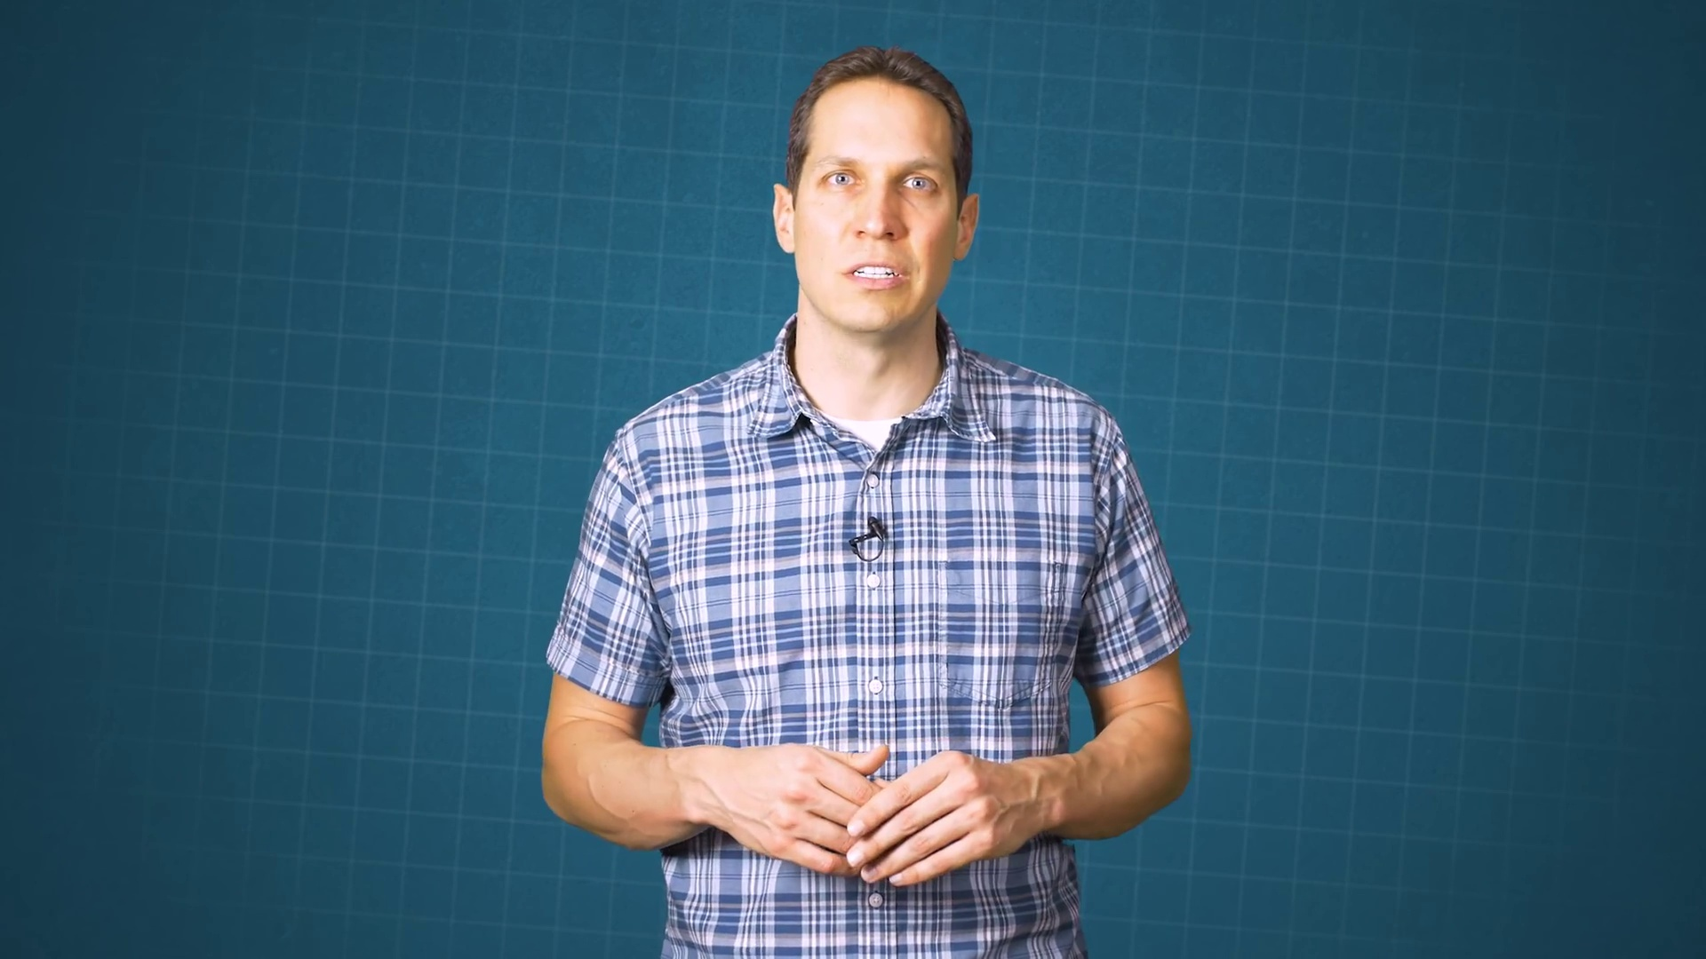 (score 85.0000)
 (score 85.0000)
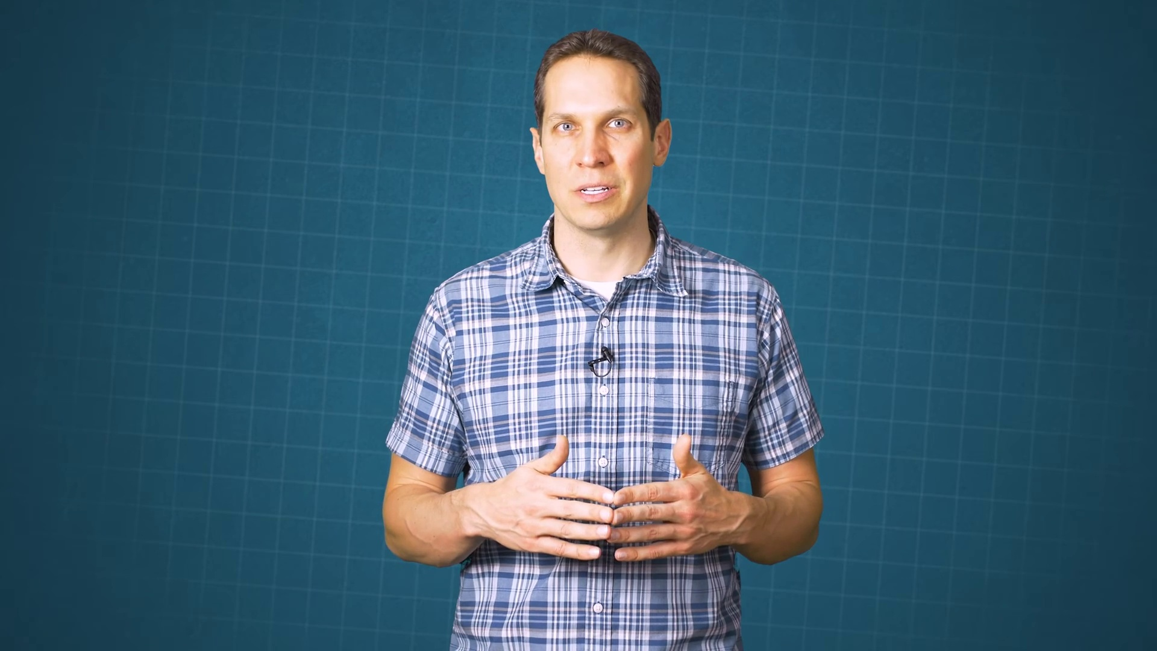 (score 85.0000)
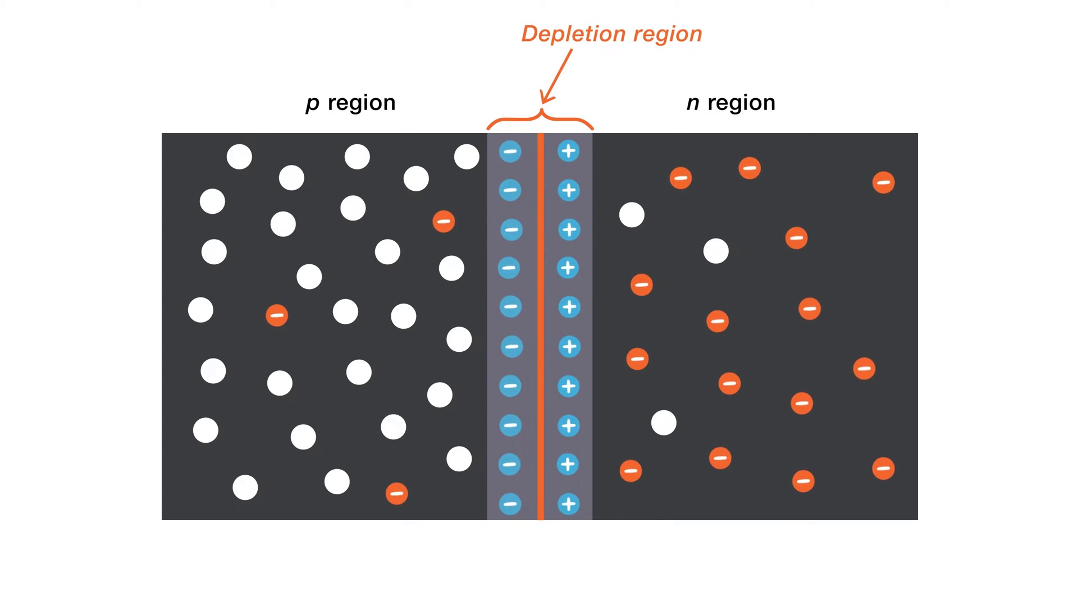 (score 85.0000)
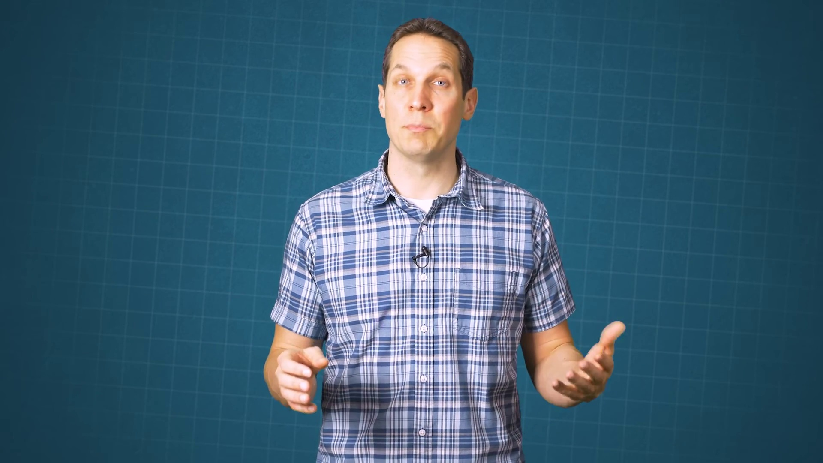 (score 85.0000)
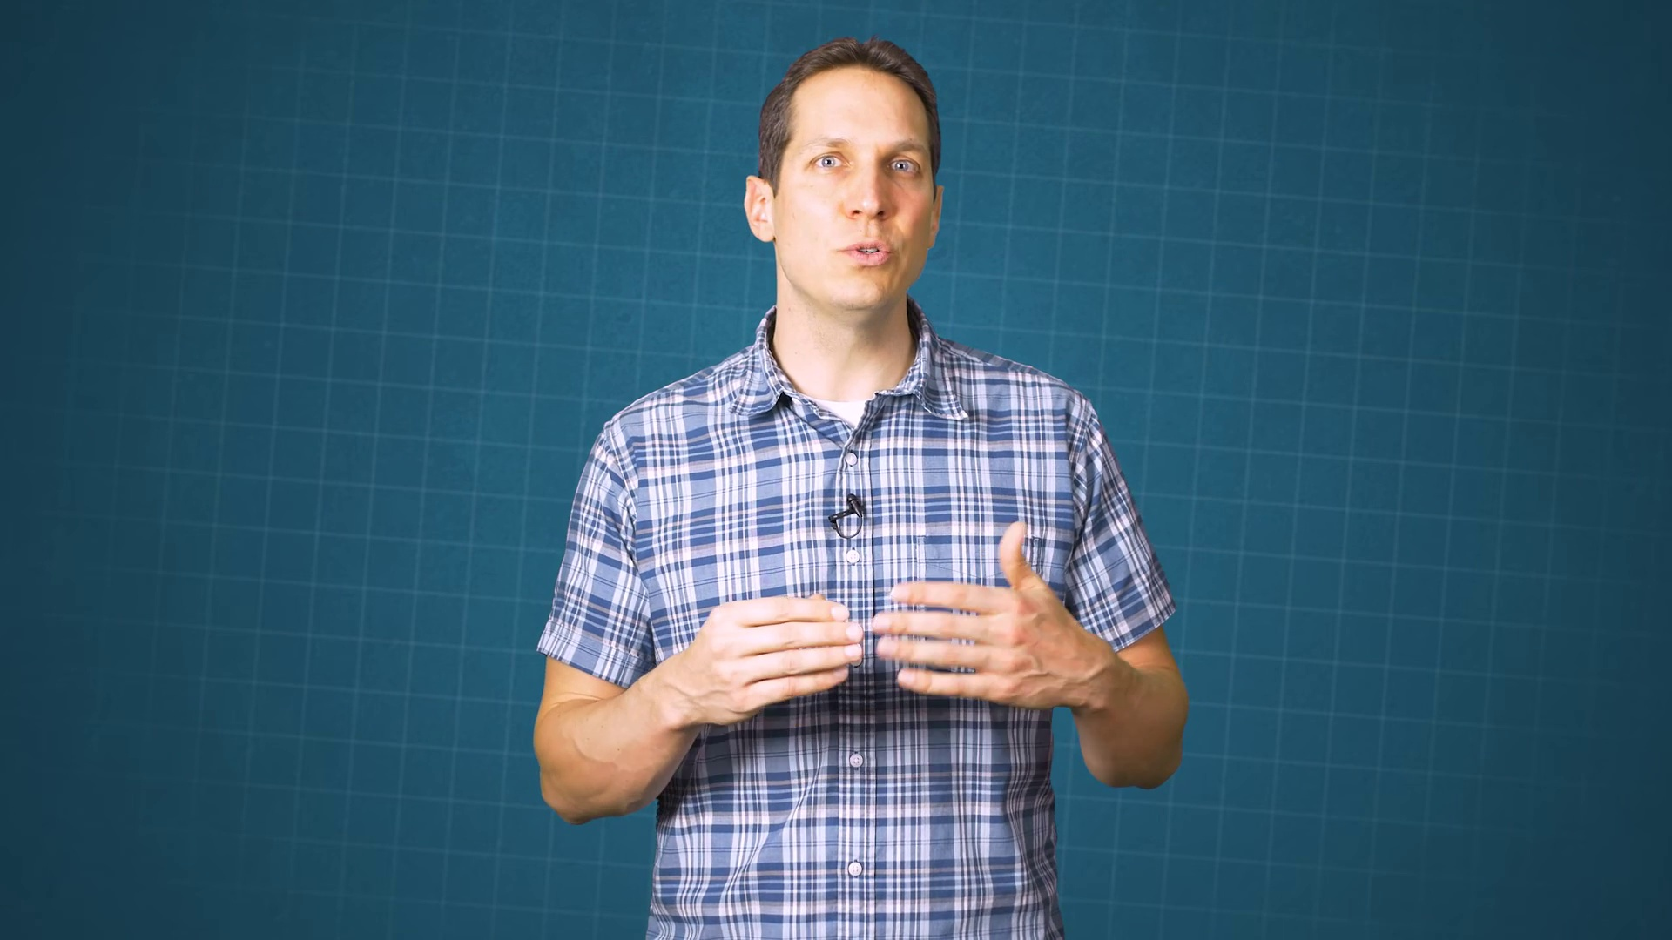 (score 85.0000)
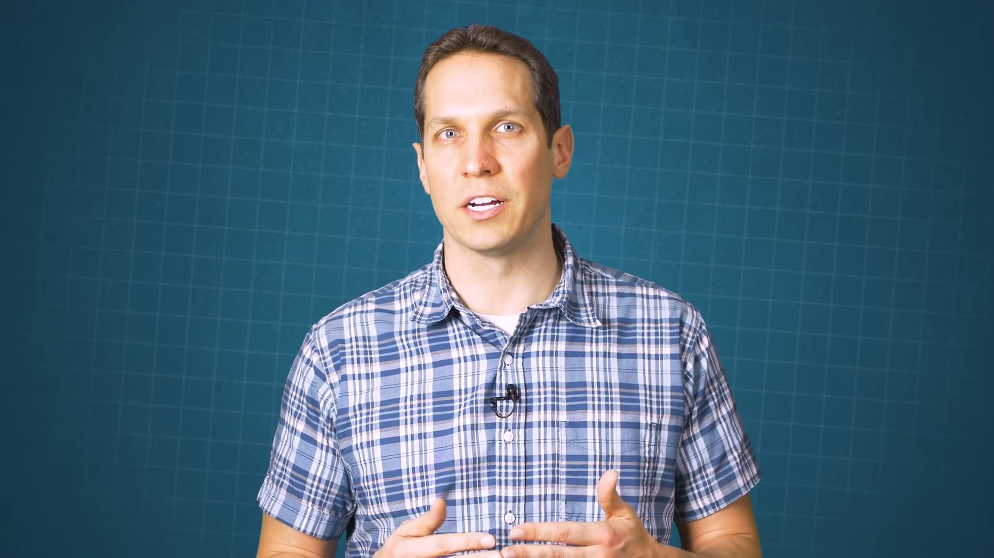 (score 85.0000)
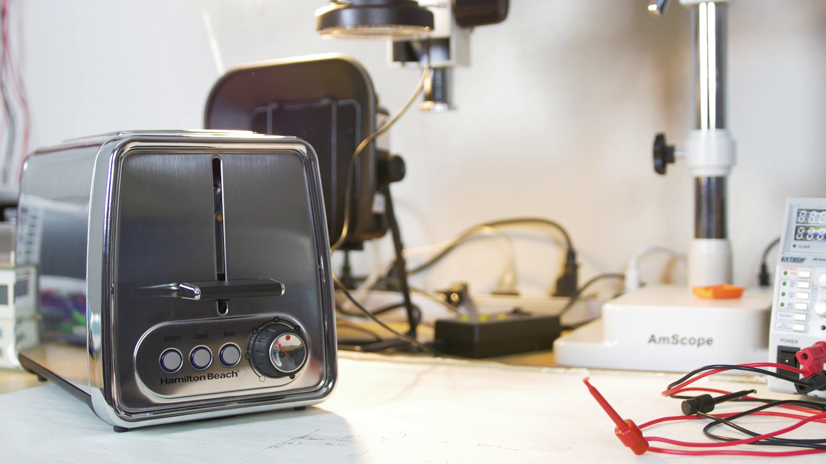 (score 80.0000)
Least correlated frames:
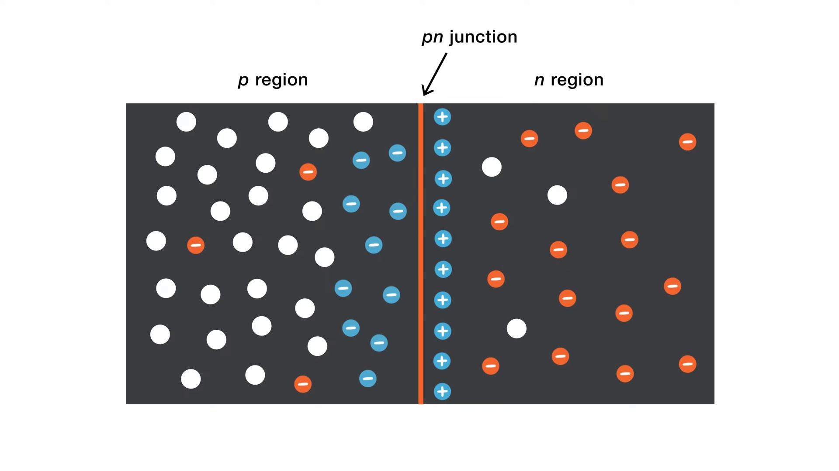 (score 0.0000)
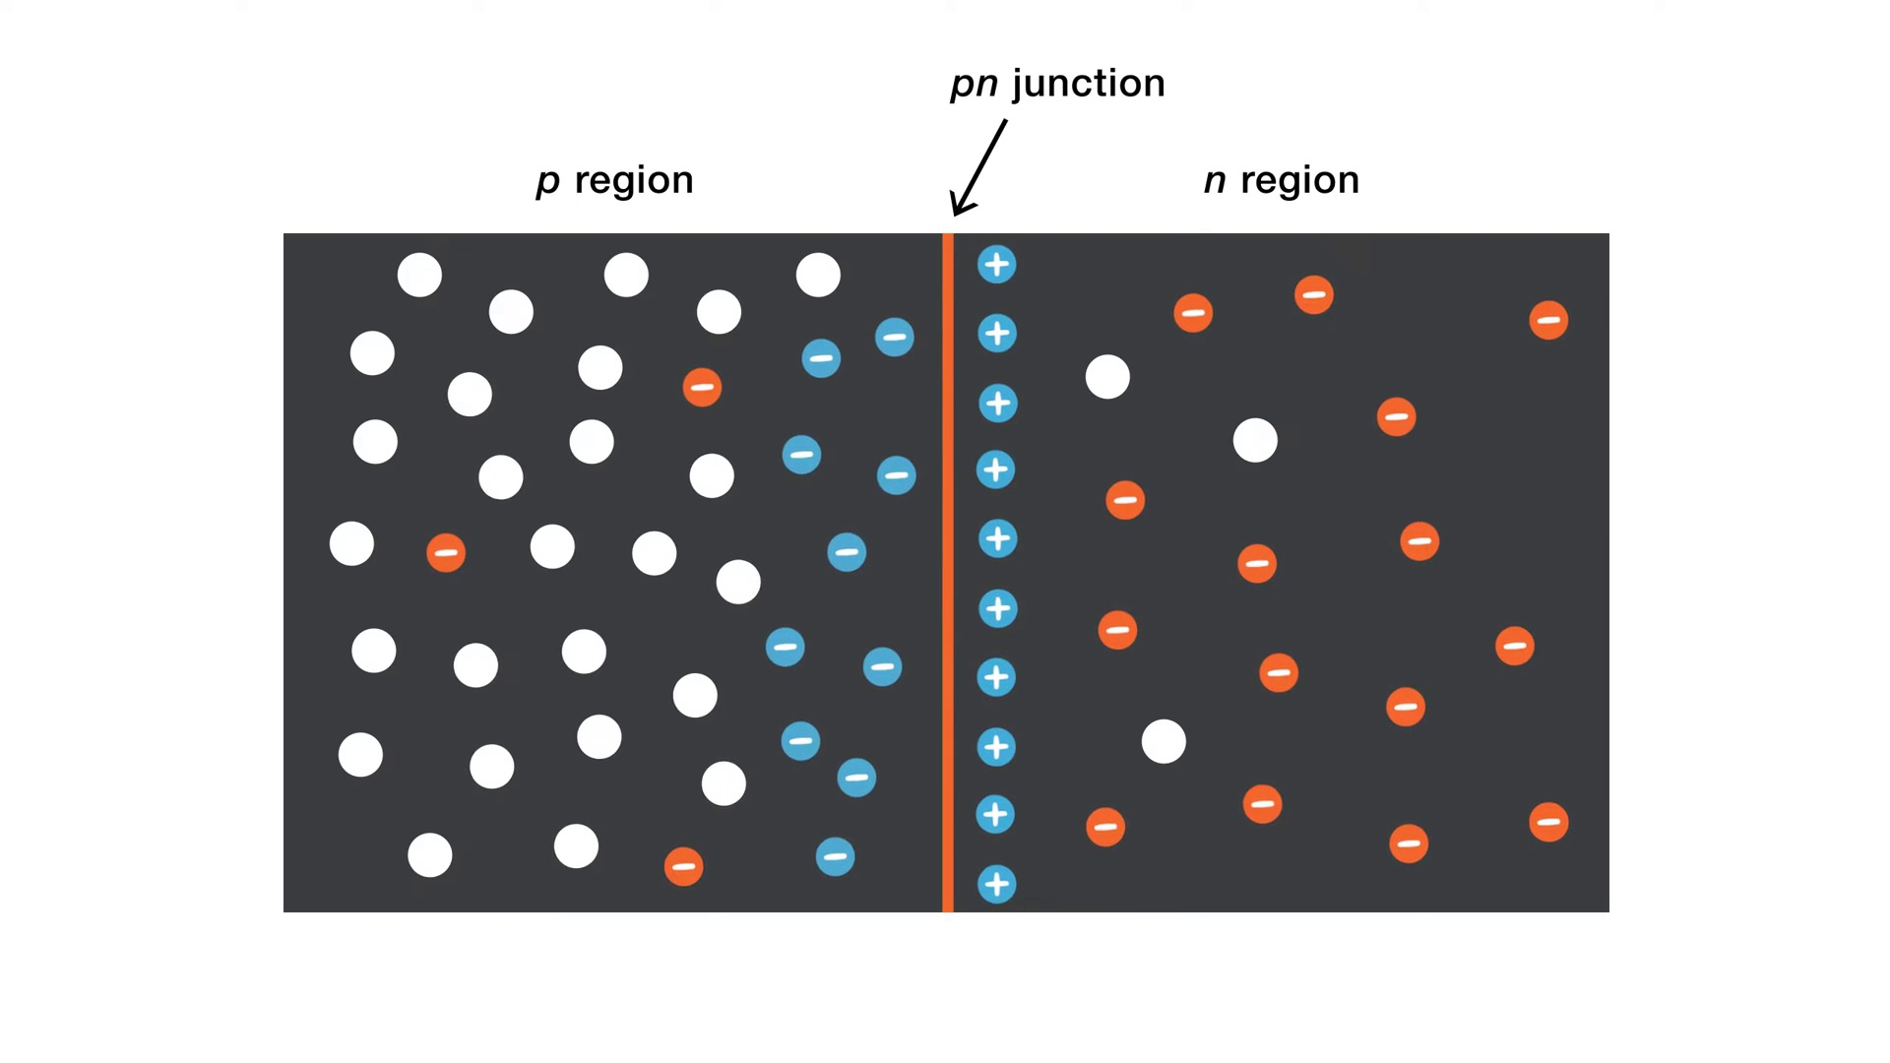 (score 0.0000)
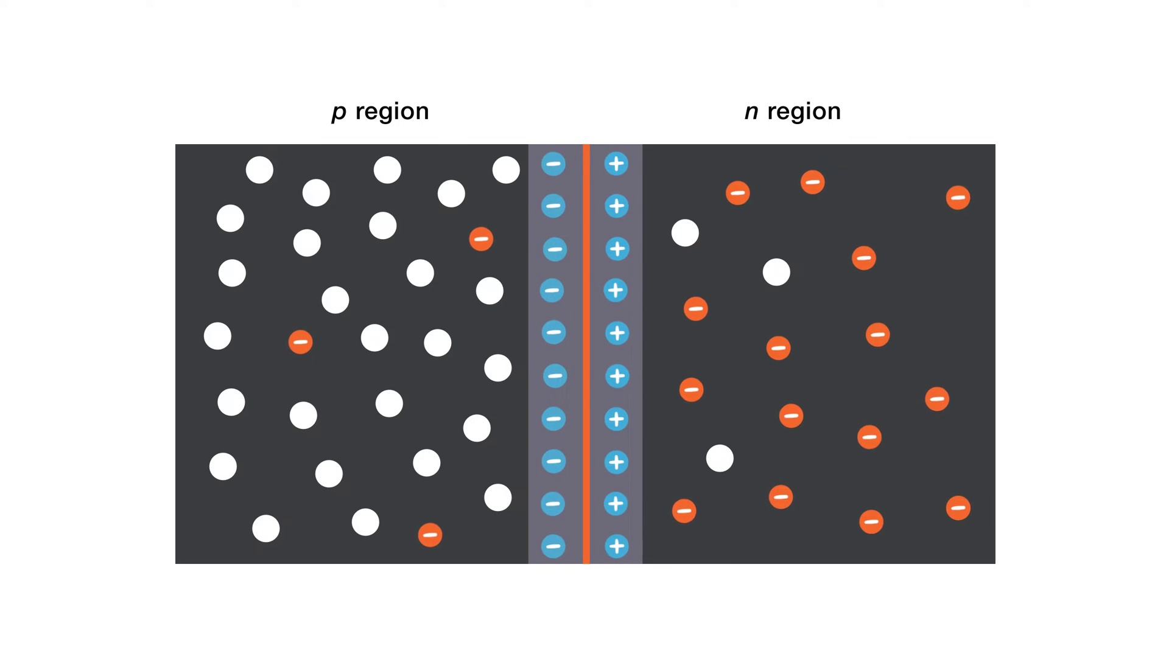 (score 0.0000)
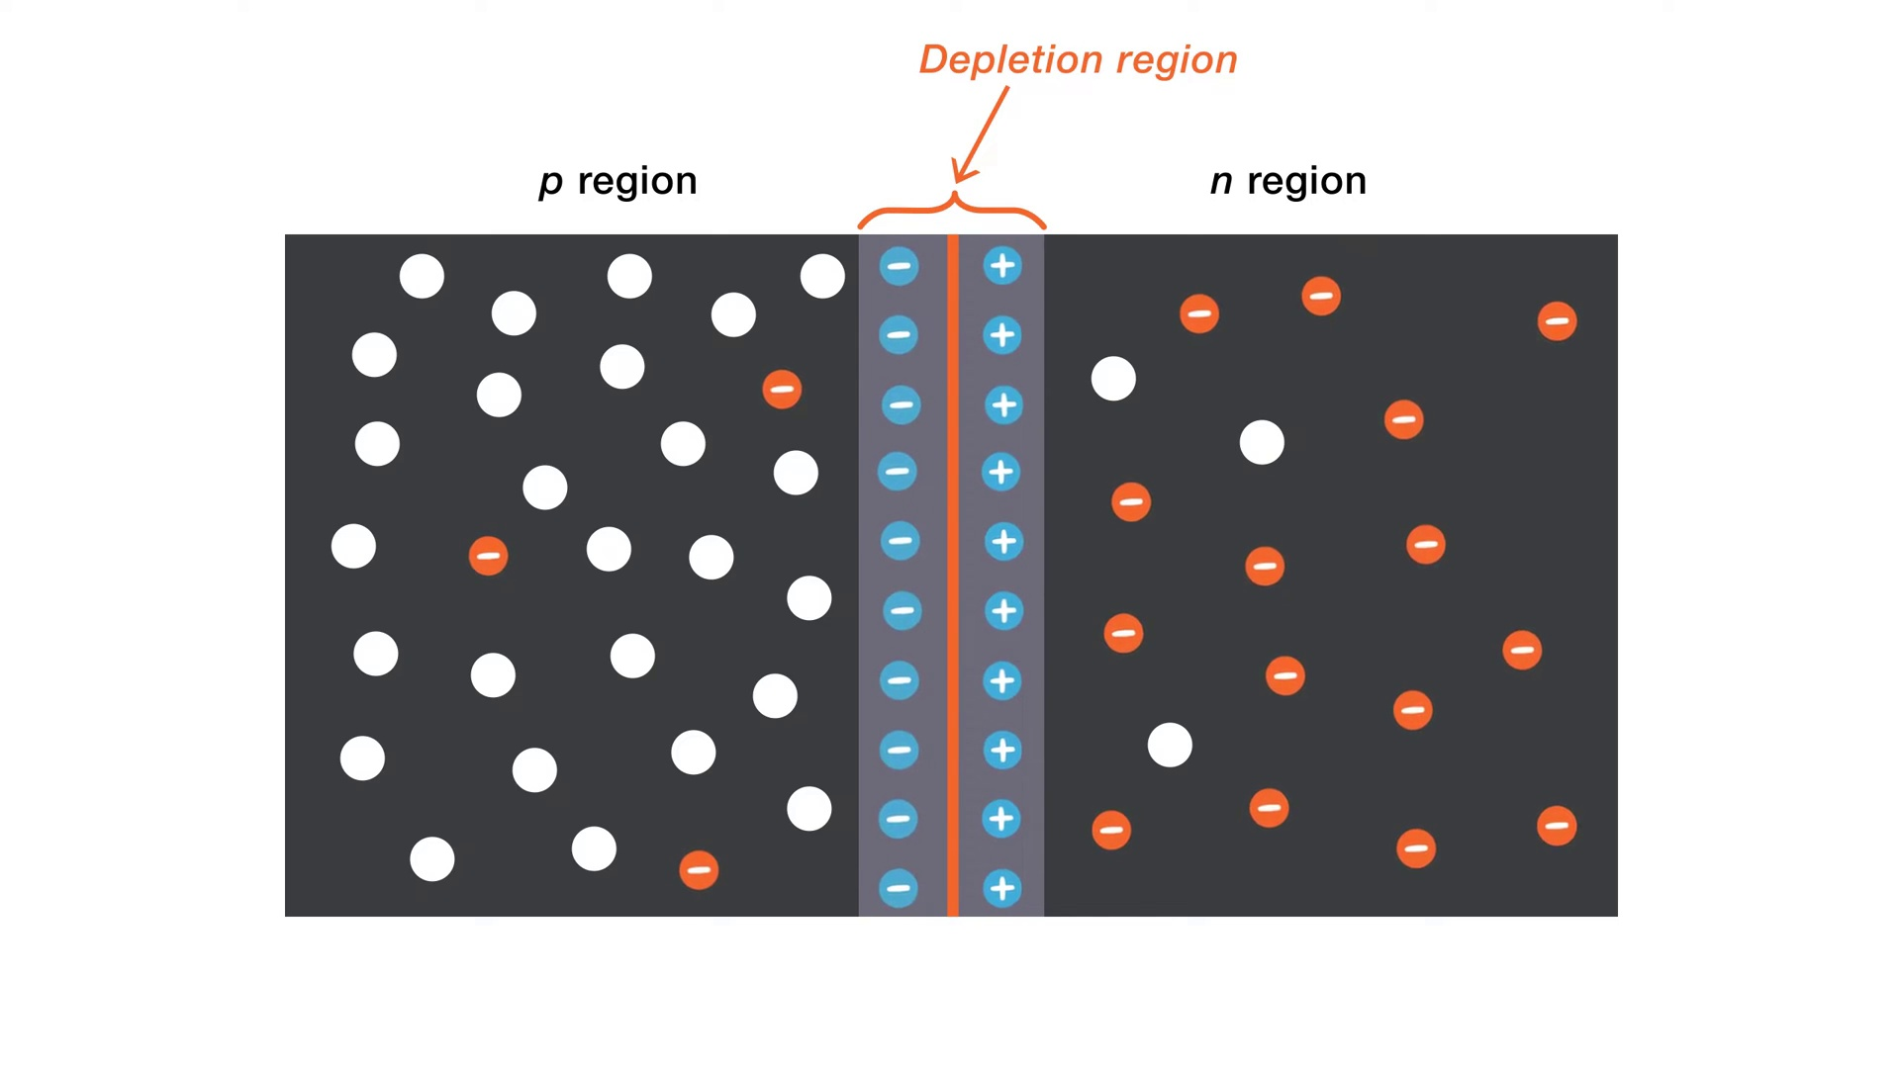 (score 0.0000)
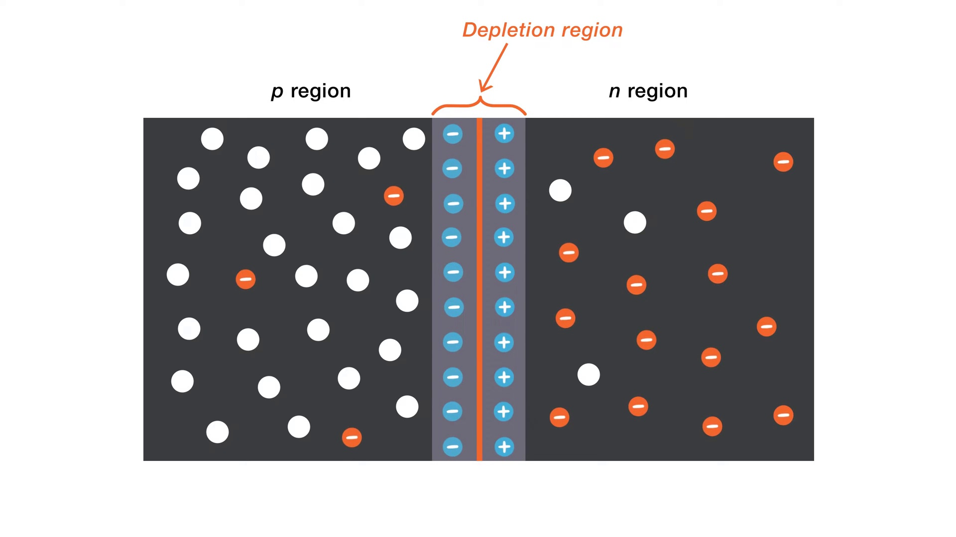 (score 0.0000)
 (score 0.0000)
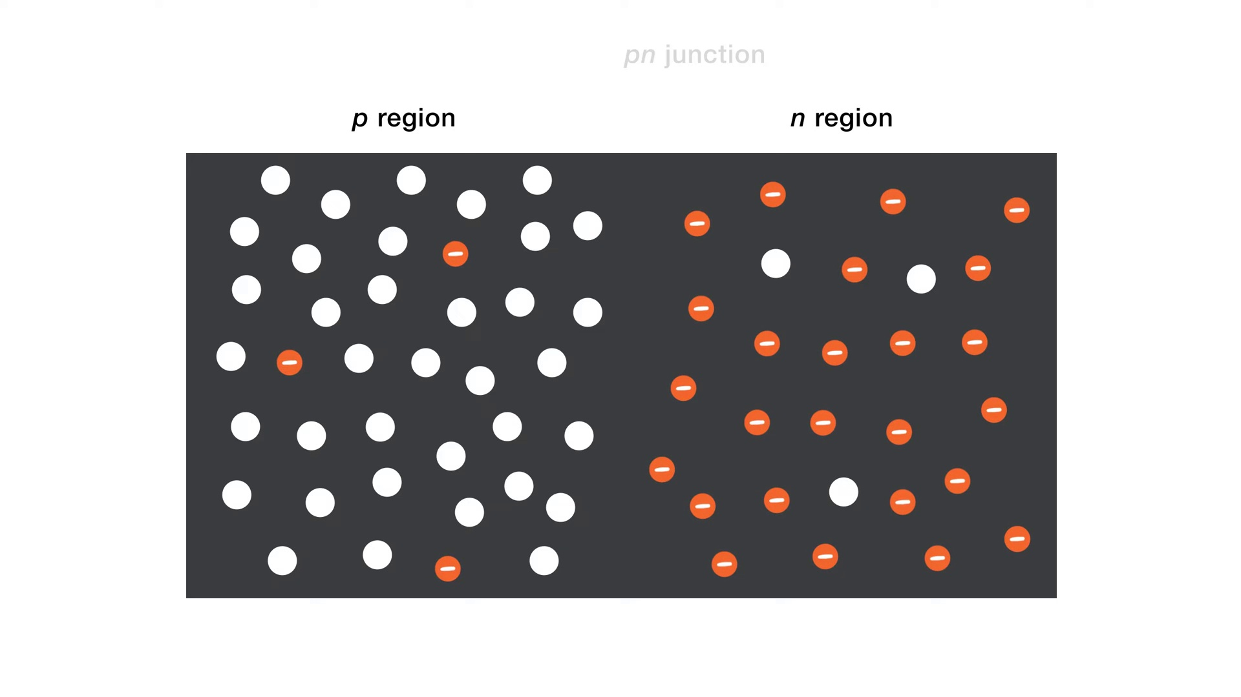 (score 10.0000)
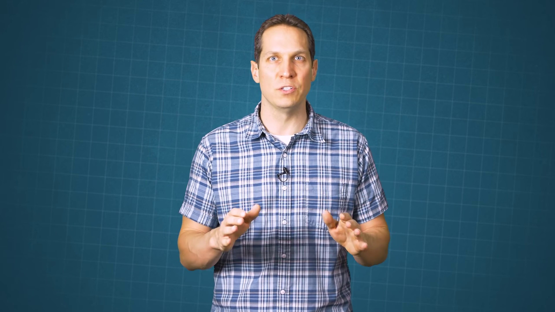 (score 10.0000)
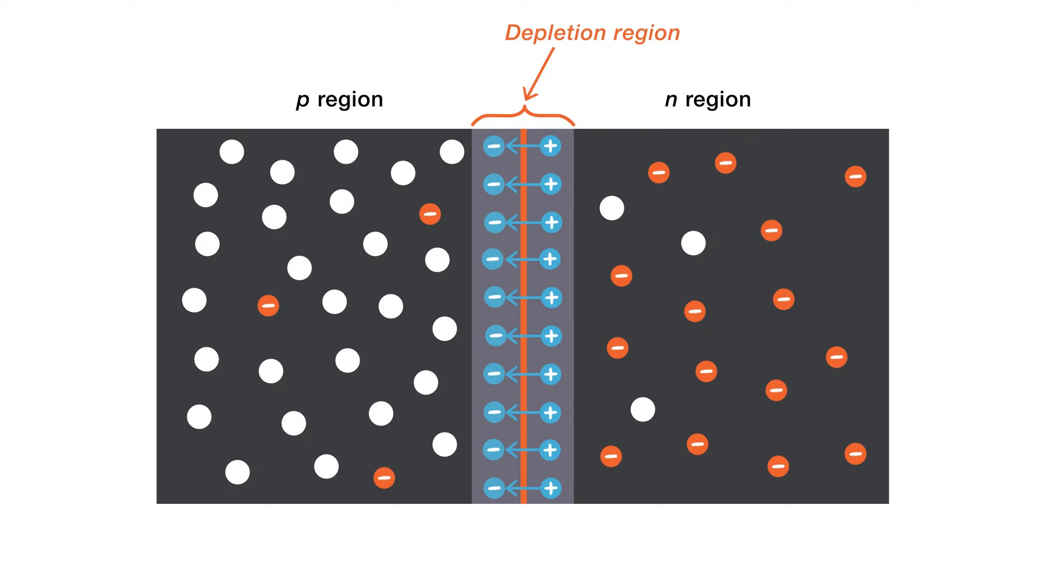 (score 14.0000)
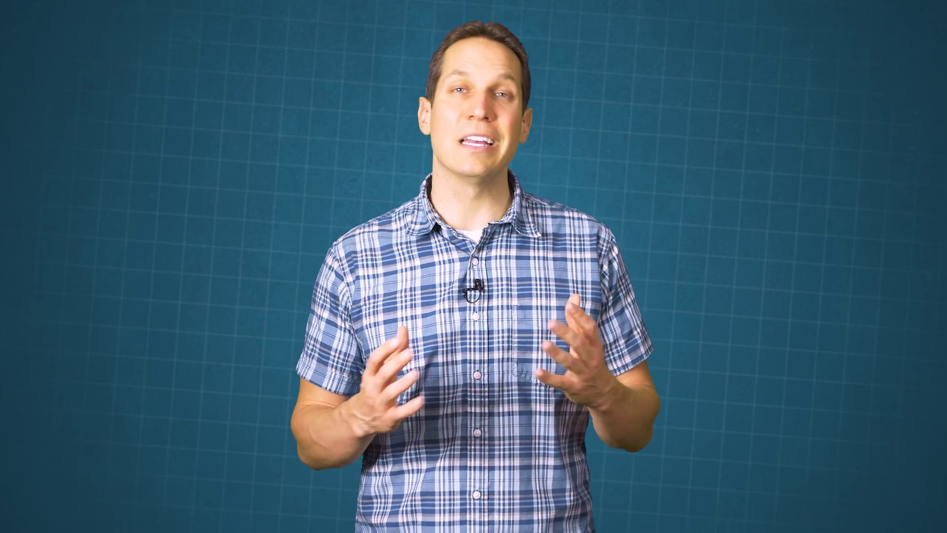 (score 20.0000)

Frame: frame_0000.jpg
Caption: The provided image presents two distinct sections on a presentation slide. On the left side, there is a stark dark gray background that transitions to black at the bottom, featuring a small white rectangular area with a stylized graphic resembling an inverted T shape, formed by two vertical lines meeting at a point, accompanied by a horizontal line creating a smiley face-like representation. The right side of the slide features a lighter gray gradient with a small section of black at the top-right corner and appears to contain some text or code snippet in white font on a dark background, although its resolution is not sufficient for clear reading.
The overall design of the slide suggests a focus on visual aid during a presentation rather than direct instruction or demonstration. The absence of an instructor or teaching aids in the frame implies that this slide is intended for use as a standalone visual element. While the presence of code and a logo-like graphic hints at a possible connection to software development or computer science, the lack of context or information about the subject matter prevents more specific determination.
In contrast, the right side of the image presents a stark dark blue background devoid of any discernible objects or text, evoking a sense of depth and mystery. The absence of other elements puts the focus solely on the text, making it the focal point. The small, bold sans-serif font adds a sense of urgency or importance, suggesting a serious or formal context, possibly related to law or justice.
Comment (score 80): What I have learned from the video: Great animated explanation of diode physics. What confused me: Advanced concepts briefly mentioned without details. How I plan to use the electrical system in the future: Use animations for better understanding of diode operation.
Reason: The comment directly discusses the concept of 'diode physics' which is mentioned in the caption as a possible connection to software development or computer science. The mention of using animations for better understanding also relates to the visual aid and graphic representation described in the caption.
Source: https://www.youtube.com/watch?v=btOIDQeMrMg: How Does a PN Junction Diode Work

Frame: frame_0001.jpg
Caption: The image shows a person standing in front of a blue background with graphical elements resembling technical diagrams and possibly some digital models or animations. This indicates that the setting could be for a video recording, likely educational or instructional in nature. The individual appears to be male, wearing a blue plaid shirt and dark pants, with short hair and glasses. He has his hands together in front of him, indicating he might be gesturing while speaking or presenting, and is positioned in a way that suggests he is in the middle of a presentation or speech.
His gaze is directed towards the camera, indicating engagement with the viewer, and his expression is neutral, with his lips slightly parted, perhaps indicating a pause in his speech. The blue background provides a stark contrast to his plaid shirt, making him stand out in the image. His attire suggests a casual approach to the content he's discussing, but the overall composition of the image suggests a formal or professional setting.
There are no slides or text visible on the screen, and the individual does not appear to be writing or holding any physical object that could suggest a hands-on demonstration. The focus of the content is the person and his apparent explanation or explanation of a concept related to technology or software development, as suggested by the diagrams in the background.
Comment (score 90): What I have learned from the video: Great animated explanation of diode physics. What confused me: Advanced concepts briefly mentioned without details. How I plan to use the electrical system in the future: Use animations for better understanding of diode operation.
Reason: The comment directly discusses the same technical concepts (diode physics) and learning objectives described in the caption, which are the focus of the video's apparent educational/instructional content.
Source: https://www.youtube.com/watch?v=btOIDQeMrMg: How Does a PN Junction Diode Work

Frame: frame_0002.jpg
Caption: The image depicts a man standing in front of a solid blue background, which provides a stark contrast to his attire and the microphone. He is wearing a blue and white plaid shirt with a black collar and appears to be speaking passionately into the microphone. His hands are raised in a gesture of excitement, conveying enthusiasm and engagement. The man's facial expression is animated, suggesting that he is speaking passionately about a topic. Although the audience itself is not visible within the frame, the focus is on the man, who seems to be engaging with his listeners. He has his hands together as if gesturing while talking, and his attire suggests a casual yet professional presentation style.
No strongly correlated comments found for this frame.

Frame: frame_0003.jpg
Caption: The image shows a man standing against a blue background with a grid pattern and an overlay of transparent paper with measurements and notes written on it. He is wearing a checkered shirt, has short hair, and a black tie around his neck, visible above the collar of his blue plaid shirt. The man's hand is extended, with his fingers spread wide, as if he is gesturing or emphasizing something, suggesting that he might be explaining something or presenting an idea to someone off-camera. His gaze is directed towards the camera, and his facial expression conveys a sense of engagement and interaction, indicating that he is in the midst of a presentation or discussion.
No strongly correlated comments found for this frame.

Frame: frame_0004.jpg
Caption: The image portrays a man standing in front of a blue background with grid lines. He appears to be giving a presentation or lecture, as indicated by his attire and the fact that he is looking towards an unseen audience. The man is dressed in a blue and white plaid shirt, adding a touch of casual elegance to his appearance. His short hair is also visible. His expression suggests he might be in the middle of speaking about something specific to the content of the presentation, with a look of concentration that implies engagement and seriousness. His right hand is raised, as if he is speaking or gesturing, while his left hand is in his pocket, subtly drawing attention to his right hand. There are no visible texts, diagrams, or other visual aids that provide information about the topic being discussed. The style of the image suggests it could be a screenshot from a video or a still image from a photo shoot, with its simplicity and focus on the man's action and expression making for an engaging scene.
Comment (score 80): What I have learned from the video: Great animated explanation of diode physics. What confused me: Advanced concepts briefly mentioned without details. How I plan to use the electrical system in the future: Use animations for better understanding of diode operation.
Reason: The comment directly discusses the technical topic (diode physics) and mentions a specific aspect of it (animated explanation), which is strongly related to the caption's description of a man giving a presentation or lecture about something specific, implying a connection to diode physics.
Source: https://www.youtube.com/watch?v=btOIDQeMrMg: How Does a PN Junction Diode Work

Frame: frame_0005.jpg
Caption: In this frame, a person stands in front of a blue background with a graphic grid overlaying it. The individual appears to be giving a presentation or interview, addressing someone or something out of the frame. They are wearing a checkered shirt and have short dark hair that contrasts with their light blue shirt. The person's expression is neutral, with a slight smile on their face as they speak. The man's attire suggests confidence and approachability, with his shirt buttoned up to reveal his white undershirt. The surroundings suggest an informal setting rather than a formal classroom or lecture hall, despite the professional touch added by the blue grid-like background. There is no visible text, diagrams, or graph types within this frame that could provide context for the topic being discussed, with the focus instead on the presenter and their surroundings.
No strongly correlated comments found for this frame.

Frame: frame_0006.jpg
Caption: The image shows a man standing in front of a blue background with a grid pattern that suggests a presentation or video recording setup. He appears to be giving a lecture or explanation, as indicated by his gesturing right hand and what seems to be an engaged facial expression. The man is wearing a checkered shirt with blue and white colors that contrast with the blue backdrop, and has short dark hair. There is no visible text on the screen, and there are no diagrams or slides that can be discerned from this angle and distance. His hands are raised, with one hand pointing upwards and the other downwards, as if he is making a point or expressing an idea. His face is turned towards the camera, and his gaze is directed upwards, giving the impression of engagement or interest in what he is talking about. The man's attire and his expressive gestures suggest he is in the midst of a discussion or presentation. The blue background provides a neutral and unobtrusive backdrop, allowing the viewer to focus on the man and his actions. The image does not contain any text or other discernible objects. The relative position of the man to the background suggests he is the main subject of the image. Overall, the image captures a moment in time rather than a dynamic action, presenting a still life that showcases the man's engagement and expression as he conveys information to an audience.
Comment (score 80): What I have learned from the video: Great animated explanation of diode physics. What confused me: Advanced concepts briefly mentioned without details. How I plan to use the electrical system in the future: Use animations for better understanding of diode operation.
Reason: The comment directly discusses the technical steps and concepts presented in the video (diode physics), which matches the description of a lecture or presentation in the caption.
Source: https://www.youtube.com/watch?v=btOIDQeMrMg: How Does a PN Junction Diode Work

Frame: frame_0007.jpg
Caption: The image shows a man standing in front of a blue background with a grid pattern, possibly indicating a presentation or recording setup. He appears to be addressing an audience or giving a lecture, as suggested by his gestures and the context of the setting. The man is wearing a short-sleeved plaid shirt and has a microphone near his face, implying that he could be speaking to an auditory audience or recording for a video platform. His gaze is directed slightly off to his left, with a neutral expression on his face.
Comment (score 80): What I have learned from the video: Great animated explanation of diode physics. What confused me: Advanced concepts briefly mentioned without details. How I plan to use the electrical system in the future: Use animations for better understanding of diode operation.
Reason: The comment mentions learning about diode physics and using animations for understanding, which is strongly related to the caption describing a lecture or presentation setting with a focus on technology/physics.
Source: https://www.youtube.com/watch?v=btOIDQeMrMg: How Does a PN Junction Diode Work

Frame: frame_0008.jpg
Caption: The image shows a person, likely male, standing in front of a blue-green background featuring grid patterns that resemble a technical setting or studio backdrop. He is facing slightly to the side, gesturing towards something off-camera with one hand. His short brown hair and checkered shirt are noticeable features. On his left wrist, he wears a watch. His expression is neutral, suggesting engagement in some kind of presentation or discussion.
In front of him, a screen displays a video call interface, complete with a chat window and user interface elements indicating the ability to share documents or files during the conversation. However, there are no visible texts, equations, diagrams, or slides on the screen that could provide context about their discussion. The realistic style and professional lighting suggest the image was taken in a video call setting.
No strongly correlated comments found for this frame.

Frame: frame_0009.jpg
Caption: In the image, there is a man standing in front of a background that has a gradient from green to blue and some pattern that resembles a grid or mesh. The man is wearing a short-sleeved button-up shirt with a plaid pattern, specifically a blue and white checkered design. A badge is visible around his neck. He is holding both hands up to his chest in a universal gesture for "stop" or "don't continue," with a neutral facial expression and direct gaze at the camera.
No strongly correlated comments found for this frame.

Frame: frame_0010.jpg
Caption: The image shows a man standing in front of a blue backdrop with grid-like patterns. He appears to be giving a presentation or talk, gesturing with his hands while speaking and looking directly at the camera with a neutral expression. The man is wearing a plaid shirt, suggesting a casual environment for this event. His short hair adds to the informal tone of the setting. He has a confident and poised stance, with his hands clasped behind his back (right hand making a gesture) drawing attention to him as the central figure in the image. The background is plain and does not provide any additional context or information about the topic being discussed, leaving it up to the viewer's interpretation.
No strongly correlated comments found for this frame.

Frame: frame_0011.jpg
Caption: The image presents a unique illustration of the concept of polarization. It consists of two distinct sections, divided by a vertical line. The left section features a gray gradient that transitions from a lighter shade on the left to a darker one on the right, serving as a backdrop for the upper pattern.
The upper section contains a geometric design composed of circles in various shades of gray, with each circle having a central red dot and surrounding red dots. There are no texts or identifiable symbols present in this area, and the background behind the pattern is not visible due to its complexity.
In contrast, the lower section features a simple gray gradient that provides visual separation between the two sections. The image does not contain any texts or additional objects, focusing solely on the geometric design above the gradient.
The image also contains no discernible actions or movement but instead provides a clear and detailed representation of the concept of polarization. This representation is divided into two distinct parts: an upper section with a pattern of circles and a lower section featuring a gray gradient.
No strongly correlated comments found for this frame.

Frame: frame_0012.jpg
Caption: The image presents a lesson or teaching session on a blackboard, featuring mathematical concepts and annotations. On the left side, a list labeled "pin" is visible, which appears to be a sequence of steps or operations. The list consists of 10 items, with no accompanying text or labels.
Below this list, a set of dots on a white background is arranged in a pattern that forms along the left side and then breaks into two distinct sets at the bottom right corner. The pattern is not clear without more context, but it could represent a sequence or pattern being taught.
The blackboard's background has some gray-colored elements, which are unclear without further context. There is no visible text or writing style, making the content on the blackboard illegible in this image. The illustration style suggests a classroom setting with educational purposes.
In addition to the blackboard contents, the image also presents two distinct regions in a simple yet effective illustration. The top region is predominantly black, featuring numerous white dots scattered throughout, creating a sense of uniformity. In contrast, the bottom region is predominantly white, punctuated by a few black dots that appear as clusters rather than individual dots.
A thin black line separates the two regions, adding a sense of dynamism to the image. The precise locations and relative positions of these objects remain unchanged, with no indication of movement or change.
No strongly correlated comments found for this frame.

Frame: frame_0013.jpg
Caption: The image shows a man standing against a backdrop with a greenish hue that gives the impression of a professional setting. He is wearing a blue and white plaid shirt, which contrasts with his dark hair and beard. The man appears to be speaking or gesturing as he looks directly at the camera. His right hand is raised, as if he is gesturing or pointing towards something. His left hand is casually resting on his hip. The man's expression is serious, and his gaze is directed towards the right side of the image, adding a sense of depth and dimension to the scene. The blue screen behind him includes graphical elements that could be part of a video production set, suggesting it may be taken from a video presentation or interview.
No strongly correlated comments found for this frame.

Frame: frame_0014.jpg
Caption: The image features a man standing against a blue background with a graphic overlay that includes lines and dots, possibly suggesting some form of technical or analytical context. The man appears to be speaking or presenting, as he has his hands out in front of him. He is wearing a plaid shirt, glasses, and seems to be addressing an audience, although the presence of an actual audience is not visible in this frame. The style of the image suggests it might be from a video interview or presentation. The man's attire, including the blue and white plaid shirt, creates a simple yet professional setting, suggesting the context of the image could be a business or formal event. His facial expression remains neutral, indicating he is not showing any particular emotion.
Comment (score 85): What I have learned from the video: Great animated explanation of diode physics. What confused me: Advanced concepts briefly mentioned without details. How I plan to use the electrical system in the future: Use animations for better understanding of diode operation.
Reason: The comment directly discusses the animated explanation of diode physics mentioned in the caption, which is a specific technical topic, and also mentions using animations for better understanding of diode operation, which matches the analytical context suggested by the graphic overlay.
Source: https://www.youtube.com/watch?v=btOIDQeMrMg: How Does a PN Junction Diode Work

Frame: frame_0015.jpg
Caption: The image appears to be a digital screenshot of a presentation slide with annotations explaining the content. On the left side of the slide is a graphic representation of two neural network architectures, labeled as "Pin junction" and "Another region," both shown in black and white line graph format. The graphic illustrates a simple neural network structure where layers are stacked on top of each other, with connections between nodes (neurons) represented by lines.
In the right side of the slide, there is a text-based annotation explaining what is depicted. There are arrows pointing to various elements in the graph, and the accompanying text reads: "Pin junction" -> "Another region." This indicates that the slide is discussing the relationship or connections between different parts of neural network architectures.
While seemingly unrelated to the left side of the slide, the diagram on the right side actually represents a different concept. The image shows a diagram illustrating the difference between two regions in a two-state quantum system: the p region and the n region. These regions are distinguished by distinct visual characteristics, with the p region represented by a black region with white dots and the n region represented by a white region with black dots, separated by a black line.
The diagram likely serves to explain the difference between these two regions in the context of quantum mechanics. The presentation slide as a whole appears to be part of an educational context, possibly a lecture or tutorial on the structure and function of neural networks in machine learning, as well as the principles of quantum mechanics.
No strongly correlated comments found for this frame.

Frame: frame_0016.jpg
Caption: The image presents a diagram that combines two distinct regions: one representing an input or negative region on the left, marked by predominantly black color with white dots, and another representing an output or positive region on the right, marked by predominantly white color with black dots. These regions are separated by an arrow pointing towards the right, suggesting a flow of current from the left to the right.
Between these two sections, there is a series of neural network nodes, represented by circles, each connected to neighboring nodes by lines indicating weighted connections or edges. The diagram is divided into three main parts: an input section on the left, multiple layers of neural network nodes in the middle, and an output section on the right.
The labels "pin" suggest that these layers may correspond to specific types of activation functions or layer types used in the network. There are no visible text or equations on the diagram, so it does not provide specific numerical information about the weights or other parameters of the network. Additionally, there is a note in the bottom right corner that appears to be an instruction related to using the diagram: "An equation for pin," but the actual equation itself is not legible in this image due to its size and resolution.
Overall, the image seems to be from educational material or a presentation, where such diagrams are often used to explain how neural networks process information through layers of connected nodes.
No strongly correlated comments found for this frame.

Frame: frame_0017.jpg
Caption: The image appears to be a screenshot of a digital presentation or teaching material, featuring an illustration of a network or process with various labeled elements. At the top, there is a title or heading that says "A pin function," suggesting that this part of the image discusses how different parts of a structure (presumably) function like pins.
The image consists of two diagrams: one with a single pin and another with multiple pins. The first diagram has labels such as "Region 1" at the top left corner, indicating it represents a specific part or region of the system or process being discussed.
On the right side of the image, there are three regions labeled with circles, which are connected by lines representing connections or links between them. An arrow pointing from "Region 1" to "Region 2" indicates a one-way connection or flow from Region 1 to Region 2.
At the bottom of the image, there is a list of items labeled as "Pin function," providing additional information on how each pin functions within the context of the system or process. The pins are represented by different colored circles, possibly representing various types of pins or their roles in the system or process.
The overall style of the image suggests that it is intended for educational purposes and may be part of a presentation discussing mechanical fasteners or components of a system that require pin-like connections.
No strongly correlated comments found for this frame.

Frame: frame_0018.jpg
Caption: The image displays a visual aid that teaches the concept of PinPoint Geography to children, featuring a schematic representation that visually explains the process of mapping locations. At the top of the image, the title "PinPoint Geography" in bold and larger font serves as the topic being covered.
Below the title, two vertical columns of circular icons are presented, each connected by a dotted line to a central figure labeled with an arrow "To Location." These icons are colored in shades of blue, red, and green, suggesting they represent different locations or regions. The icons are spaced apart from each other, indicating the concept of spatial distribution or diversity within these regions.
In the lower portion of the image, a horizontal dotted line represents a path or route being taken. This line connects to both ends of the schematic, visually connecting the locations and suggesting the idea of travel or navigation between points A and B. The two ends of the pathway are connected to the circular icons with dotted lines, reinforcing the connection between the points and the regions they represent.
The image also presents a subtle yet effective representation of two distinct regions, each with its own unique characteristics. One region is characterized by a pattern of dots and lines (predominantly black), while the other region is marked by a series of lines and dots (predominantly white). The difference in color between the two regions is significant, indicating a contrast between them.
The overall style is simplistic and child-friendly, with bright colors that likely aim to engage young learners.
No strongly correlated comments found for this frame.

Frame: frame_0019.jpg
Caption: The image shows a simplified diagram that combines two separate parts. The left part presents a p-region represented by a grid with black and white dots, which is separated from the right part by a dashed line. This region is distinct and separate from the adjacent n-region, also represented by a grid of black and white dots.
In conjunction with this diagram, an artificial neural network (ANN) is depicted on the right side of the image, modeled loosely after a human brain's layered structure. The ANN consists of three main parts: an input layer, one or more hidden layers, and an output layer.
The input layer is located on the left side of the diagram, with a single input connected to the first hidden layer. The number of neurons in each hidden layer isn't specified, but it could be any number of connections between the neurons within the layer and those in the adjacent layers or in the input and output layers.
The output layer is situated on the right side of the diagram, featuring two neurons (represented by circles) which are the final outputs of the network after processing information from the input layer through all the hidden layers. Connections between the neurons are represented by lines, typically indicating the strength and direction of the relationship or interaction between the connected neurons.
Each neuron in the ANN seems to have an activation function applied to its input, although the type of activation function used is not explicitly shown in the image. Common examples include sigmoid, tanh, or ReLU functions. The weights can be adjusted to change the way data is processed through the network, typically using a form of optimization algorithm like backpropagation.
The diagram includes a small legend on the bottom left that labels the input layer and the output layer. Two annotations are also present: "Pin" is labeled on one end of the network, and "Region" is labeled on the other end. These labels might refer to the regions being processed by the ANN, but their exact meaning isn't clear without additional context.
The background colors help distinguish between the input layer (light gray) and the hidden layers (dark gray). The image likely serves as a teaching tool to illustrate the basic structure of an ANN and how information flows through it during operation.
No strongly correlated comments found for this frame.

Frame: frame_0020.jpg
Caption: The image presents a computer-generated diagram that appears to represent an artificial neural network (ANN), with a striking visual similarity to a p-region junction. The ANN architecture is depicted as a series of layers, including the input layer (blue circles) on the left side, potentially representing the input data that will be processed by the network.
The middle section of the diagram shows hidden layers (red and yellow circles) which may represent feature extraction or transformation within the neural network. The output layer (green circles) is located on the right side, likely representing the results produced by the network based on the processed data from the input layer through the intermediate layers.
Connections between nodes are represented by lines connecting the circles, indicating the weights of the connections between the nodes. These weights are adjusted during the training process to optimize the network's performance. A label to the right of the image notes that each node corresponds to an activation function (a pin) that has been applied at the point of connection.
The color coding may indicate different types or functionalities of the neurons within the network, such as convolutional layers, dense layers, etc., but without additional context, this is speculative. The diagram also suggests the possibility of additional layers in the network architecture, represented by empty rows between the visible layers.
In comparison to the ANN, the image can be seen as a visual representation of a p-region junction, with two regions characterized by different electrical properties. The left region, labeled "p region", is defined by the presence of p-type material and holes (black dots), while the right region, labeled "n region", is defined by the presence of n-type material and electrons (white dots). A black line serves as a boundary between the two regions, clearly demarcating their distinct electrical properties.
A legend provides additional context, identifying the p region as "hole-dominated" and the n region as "electron-dominated". Overall, the image provides a clear and concise representation of both an artificial neural network and a p-region junction.
No strongly correlated comments found for this frame.

Frame: frame_0021.jpg
Caption: The image displays a map with two distinct regions that exhibit contrasting characteristics. On the left side of the image, there is a grid-like pattern of dots, each bearing a red dot, suggesting a sense of order and uniformity. In stark contrast, the right region is a black space devoid of any dots, drawing attention to the single red dot that stands out against this dark background. The lack of text or additional objects in the image allows the viewer's focus to be drawn to the regions themselves, rather than being distracted by other visual elements.
The map appears to be a graphical illustration or infographic used for educational purposes, possibly teaching about demographics, geographical data, or a similar concept. Each dot is associated with a letter, implying that each color corresponds to a category or variable within the dataset. The absence of any visible texts or labels on the map itself suggests that the image is intended to be self-explanatory and easy to interpret.
The image effectively represents the concept of regions in computer science, where the red dot can be seen as representing a specific region, and the black space can be viewed as representing the entire area. The use of contrasting colors and the simplicity of the design make this image a powerful tool for illustrating this concept.
No strongly correlated comments found for this frame.

Frame: frame_0022.jpg
Caption: The image displays a computer monitor with a diagram and labels, seemingly used in an educational setting, likely for teaching machine learning concepts. At the top of the image, there is a title slide that includes text such as "Deletion Region" and other terms related to the specific content of the diagram. However, the resolution is too low to read the entire text clearly. The slide appears to be part of a presentation or lecture.
The central part of the image shows a detailed diagram with labels pointing to various regions. There's a box labeled "Region" on the top left and two arrows point from this label to different areas. One arrow points downwards, indicating "Deletion Region," and the other points upwards, saying "Segment." These terms seem to be related to data categorization or partitioning, as suggested by the numerical values associated with these regions: 419 for the deletion region and 57 for the segment.
The diagram itself has a black background with several white squares distributed across it. These squares appear to represent data points or perhaps tokens in a sequence, which might be indicative of a specific neural network architecture or a particular algorithmic process. However, without more context, it's not possible to provide a detailed explanation.
Interestingly, the concept of depletion region is also relevant to semiconductor physics, where it refers to an area characterized by the presence of both p and n regions, with distinct positive and negative charges. The image does not explicitly depict this concept, but the presence of such regions might be related to the educational context in which the diagram is being used.
The image has a watermark that reads "Depositphotos," indicating the source of the image.
No strongly correlated comments found for this frame.

Frame: frame_0023.jpg
Caption: This image appears to be a screenshot of an educational or instructional presentation related to geographic data representation. The focus is on a map that illustrates territorial subdivision patterns, possibly for educational or informational purposes. In the upper left corner of the image, there's a red arrow with a text box indicating "Depletion Region," which suggests a discussion about areas where certain phenomena are occurring. Below this annotation, there is another arrow pointing to a different area labeled "A Region."
On the right side of the image, there is an overlay graphic with a vertical dotted line dividing the map into two halves. The left half of the map shows a pattern with white circles connected by lines, while the right half does not have this pattern and appears to show a different set of data represented visually, possibly with color coding or other means of differentiation.
It is worth noting that the image also appears to relate to a concept in semiconductor devices. A Depletion region is a region of a semiconductor material that is depleted of charge carriers, typically electrons, and has a high concentration of holes. This depletion region is formed when a material is doped with a small amount of dopant material, which creates an excess of holes. The map may be illustrating the application of this concept to territorial subdivision patterns or geographic data representation.
The presentation seems to involve an explanation of how territorial subdivision patterns can be used to analyze or represent data for various regions or areas, possibly drawing parallels between the depletion region in semiconductor devices and the concepts being presented on the map.
No strongly correlated comments found for this frame.

Frame: frame_0024.jpg
Caption: A man is standing in front of a blue background with grid lines, typical for video filming or recording a podcast. He appears to be addressing an audience, possibly explaining something as suggested by his gesture of holding up a hand while speaking, although the context of what he's explaining isn't visible in the image. The man is wearing a blue plaid shirt and has short hair, with an engaged expression suggesting that he is actively communicating with an audience, possibly during an educational session or presentation. He is gesturing with his hands, drawing attention to whatever point he is making. There are no visible text, diagrams, or other indicators of teaching content within the image itself, allowing the focus to remain on the man and his apparent explanation or commentary to an audience not visible in the frame.
Comment (score 85): What I have learned from the video: Great animated explanation of diode physics. What confused me: Advanced concepts briefly mentioned without details. How I plan to use the electrical system in the future: Use animations for better understanding of diode operation.
Reason: The comment directly discusses the man's explanation or commentary, mentioning 'animated explanation of diode physics', which is strongly related to the caption's description of the man speaking and gesturing about an unknown topic. The mention of 'diode operation' also matches the technical context implied in the caption.
Source: https://www.youtube.com/watch?v=btOIDQeMrMg: How Does a PN Junction Diode Work

Frame: frame_0025.jpg
Caption: The image depicts a person standing against a green backdrop featuring a grid pattern. The individual, wearing a dark plaid shirt and sporting short hair, is facing forward, gesturing with their right hand as if speaking. Behind them, there's a visible blue shirt or bib, suggesting they might be in a setting where safety attire is required, such as a lab. In the foreground, the person appears to be delivering a presentation or lecture, focusing on their spoken words rather than visual aids or slides in the background.
No strongly correlated comments found for this frame.

Frame: frame_0026.jpg
Caption: The image presents a graphical representation of a neural network with multiple layers, which appears to be a type of artificial intelligence model commonly used in machine learning for various tasks like classification and regression. At the top left, there is a label "DEPLOYMENT REGION" highlighted in blue and outlined by a dashed line, indicating that this is the region where the neural network has been deployed.
The deployment region is divided into two parts: the p region and the n region. In the p region, there are a total of 10 dots, predominantly white, spread out uniformly with a few black dots scattered within. Conversely, in the n region, there are a total of 12 dots, predominantly black, also spread out uniformly with a few white dots scattered within.
The regions are separated by a thin line, indicating a boundary between the two regions, which is colored black for visual distinction. Below this, on the right side of the diagram, is the text "REGIONS ARE MARKED BY RED PINS." This suggests that there are different regions within the network that have been identified or segmented for some purpose.
On the bottom left, there is a color legend showing two regions marked by blue and red pins, respectively, alongside their corresponding numerical values: 1 and 0. These numbers likely correspond to some form of categorization or binary classification (1 or 0) within the deployment region.
The rest of the image is a heat map with various shades of gray and green, which could represent different levels of neural activity or prediction scores across different regions of the network. The overall style of the image suggests it might be used in an educational context to teach about the architecture of a neural network or the concept of deployment regions within machine learning applications.
There is no visible text providing additional context or explanation, nor are there any instructors or learners present in the image.
No strongly correlated comments found for this frame.

Frame: frame_0027.jpg
Caption: The image shows a person, a man, standing against a blue background with a grid pattern that suggests a digital backdrop. He appears to be in the middle of giving a presentation or recording session, given the context of the image. The individual is wearing a blue and white plaid shirt and has short hair. He is speaking into a microphone and gesturing with his hands, including his right hand, which is extended towards the camera, indicating that he might be presenting information or ideas.
The text "GPT-4" is prominently displayed in the upper left corner of the image, suggesting that this may be a screenshot from a presentation or demonstration related to artificial intelligence.
No strongly correlated comments found for this frame.

Frame: frame_0028.jpg
Caption: The image shows a person, likely a man with short, light brown hair and glasses, standing in front of a blue-gray backdrop featuring grid lines and text elements. He is dressed in a blue and white plaid shirt, which contrasts with the blue background, and dark trousers. His facial expression suggests engagement, as if he is speaking to an audience or explaining something important. His hand is slightly extended towards the camera, as if he is gesturing while presenting. The even lighting and casual yet professional attire suggest a setting that is conducive to learning or professional development. There is no visible text on the screen providing context for the presentation's topic or content, but the focus on the speaker indicates their role as an educator or presenter in this frame.
Comment (score 85): What I have learned from the video: Great animated explanation of diode physics. What confused me: Advanced concepts briefly mentioned without details. How I plan to use the electrical system in the future: Use animations for better understanding of diode operation.
Reason: The comment directly discusses the topic of diode physics, which is mentioned in the caption's description of the speaker's role as an educator presenting on a topic.
Source: https://www.youtube.com/watch?v=btOIDQeMrMg: How Does a PN Junction Diode Work

Frame: frame_0029.jpg
Caption: The image shows a black-and-white illustration of a teaching context with a teacher or instructor explaining a concept using visuals and possibly speaking from a slide. The illustration is stylized to represent an educational setting, likely a classroom or lecture hall.
On the left side, there's a table labeled "depletion region" with three regions marked: A, B, and C. These regions are depicted as white shapes on a black background, suggesting a simplified model or diagram of depletion regions in semiconductor materials. The teacher is shown in the center of the image with a white circle around them, indicating their presence and role in explaining.
The instructor is labeled as "Depletion Region" on the right side, which correlates to the table on the left. There are also three circles representing different regions: A (Depletion Region), B (Region), and C (Region). The word "Depletion" is underlined above the "Depletion Region" label, emphasizing its importance in the context of the diagram.
The illustration appears to be used for educational purposes, possibly in a physics or chemistry class discussing the depletion regions of a material. The teacher is likely explaining the concept of depletion regions by referring to the labeled regions and arrows, providing an interactive teaching experience that visually communicates complex scientific concepts.
In solid-state physics, a depletion region is an area of a semiconductor material where the concentration of charge carriers is reduced. This region is created by the depletion of electrons and/or holes by the surrounding lattice, and is characterized by a negative electric potential. The depletion region may be an isolated region or part of a larger structure, such as a junction or a channel.
The illustration suggests that this concept plays a crucial role in controlling the flow of current through devices like transistors, diodes, and integrated circuits, which are often used to create p-n junctions – the basic building blocks of most electronic devices.
Comment (score 85): What I have learned from the video: Great animated explanation of diode physics. What confused me: Advanced concepts briefly mentioned without details. How I plan to use the electrical system in the future: Use animations for better understanding of diode operation.
Reason: The comment mentions 'diode physics' which is directly related to the concept of depletion regions discussed in the caption. The comment also expresses understanding and desire for further details on diode operation, which aligns with the educational setting and technical steps depicted in the illustration.
Source: https://www.youtube.com/watch?v=btOIDQeMrMg: How Does a PN Junction Diode Work

Frame: frame_0030.jpg
Caption: The image depicts a slide from a presentation that explores the concept of "depletion region" within the context of data structures, specifically in relation to neural networks or machine learning models. The slide features a diagram divided into two distinct regions: "a region" with multiple circles connected by lines and "n region" with only two circles connected.
The instructional text adjacent to the diagram reads "Deletion Region(S) = a region ↨ n region," suggesting a mapping or transformation from the "a region" to the "n region." This could indicate how data is processed or connections are established within this system. A legend or key, located at the bottom right corner, provides additional context or information about the symbols used in the diagram; however, due to the low resolution and cropping of the image, the text in the legend is obscured.
In a broader sense, this slide appears to be part of an educational presentation or lecture on artificial intelligence, neural networks, or machine learning models. The overall style of the slide is simple and informative, featuring clear labeling and diagrammatic elements designed to aid understanding complex concepts.
No strongly correlated comments found for this frame.

Frame: frame_0031.jpg
Caption: The image shows a person standing in front of a blue-gray gradient background, which features a grid overlaying part of it. The individual is wearing a plaid short-sleeved shirt and has their hands clasped together near their waist or are visible with one hand resting on their hip and the other extended towards the camera. Their face is turned towards the viewer, giving the impression that they are speaking or presenting to the audience. The person's expression suggests they might be engaged in a conversation or presentation. Although the text on the background slide is not clearly legible due to low resolution, the instructional or educational context appears to be a formal or professional setting. The style of the image is consistent with a video still from an online presentation or lecture.
No strongly correlated comments found for this frame.

Frame: frame_0032.jpg
Caption: The image shows a PowerPoint slide with a diagram and text explaining a concept related to geographical information systems (GIS) and semiconductor physics. The diagram illustrates a process of dividing an area into regions based on some criteria, such as proximity to specific locations or the presence of certain characteristics.
On the left side of the slide, there is a legend with four colored regions labeled A, B, C, and D, each color corresponding to a different region in the map. Each region has labels showing different types of data: "region," "average temperature," "precipitation," and "population density." This suggests that these are variables being analyzed or considered within the GIS system.
In contrast, the diagram also illustrates a phenomenon from semiconductor physics - the depletion region. In this region, the concentration of charge carriers, specifically electrons, is significantly reduced due to the application of a potential difference across the region. The majority of the electrons are attracted to the positive side and the majority of the holes to the negative side, resulting in a lower concentration of charge carriers.
The central part of the diagram shows two maps with overlays. The top map represents a baseline scenario, while the bottom map illustrates a differentiation of regions based on the criteria mentioned in the legend. There is an arrow pointing from the baseline to the differentiated map, indicating the process of refining the region divisions.
Text within the slide explains that there are four types of data: "region," "average temperature," "precipitation," and "population density." It states that there is a need to divide an area into regions for further analysis or mapping. The text emphasizes that "average temperature" and "precipitation" are significant factors in determining the regions, and it mentions that "region" has been selected as a starting point for consideration.
The instructor in the image is writing on a whiteboard beside the slide. The text on the board appears to be discussing the concept of GIS, possibly explaining how the areas have been segmented or why certain factors are important for division. There's also a hand pointing towards one part of the diagram, likely indicating a specific feature or explanation related to the data and region formation in the context of GIS.
No strongly correlated comments found for this frame.

Frame: frame_0033.jpg
Caption: This image appears to show a teaching session or presentation related to machine learning or pattern recognition, specifically focusing on "deletion region" and "potentia," which suggests some form of neural network or image processing application. On the left side of the screen, there's a slide with text that explains certain concepts, including:
* A title at the top reads "deletion region."
* An arrow labeled "A" pointing towards a particular area on an image.
* The label "Potentia," which might refer to potential or areas of interest within the context of the topic.
The slide also includes two mathematical equations:
* ∫ from A to B of f(x) dx, an integral equation where x is a variable and f represents some function of that variable.
* ∑ from n=1 to m of g(n), which suggests a summation over a range from 'n' equals 1 to 'm' of the function 'g' evaluated at those points.
On the right side of the screen, there's an image that demonstrates the application of these concepts. The image appears to show various regions highlighted within an image, including circular markers and lines forming a network or graph structure. This visual content suggests that the instructor might be explaining how certain regions within an image can be identified using mathematical or computational methods, possibly for image segmentation, feature extraction, or a similar purpose in machine learning.
In contrast, on the bottom of the image, there is a black and white diagram showing two regions labeled "p region" and "n region". The p region is filled with dots representing positive charge, arranged in a grid pattern. The n region is filled with circles representing negative charge, also arranged in a grid pattern.
In the middle of the diagram, there's a line labeled "barrier potential", indicating a potential barrier between the p and n regions. A note at the bottom reads "Deploitation region," which could be related to the separation of the p and n regions by the barrier potential.
Overall, this image presents two distinct visual representations: one focusing on machine learning concepts and their application to image processing, and another illustrating a diagram with charged particles and a potential barrier.
No strongly correlated comments found for this frame.

Frame: frame_0034.jpg
Caption: The image presents a visual depiction of data processing or manipulation, possibly related to statistics or data analysis. A detailed description of the visible content follows:
At the top, there is a title in black text that starts with "DELETION REGION," although it is not fully legible due to the angle and resolution of the image.
Below the title, an instructional note or explanation is provided in smaller font on the left side. However, the text is too small and blurry to read clearly.
The central part of the image shows a diagram that represents a form of data processing or manipulation. Two rectangles with white borders contain dots representing values within those rectangles. The rectangle on the left has a blue label with a "+" sign, suggesting some form of addition or merging of data points or regions.
The right side of the diagram is labeled with an arrow pointing to it, indicating that this could be a process being described. It appears to have two labels: one at the top in black text (which is not fully legible due to image quality), and another below it, also in black text but too small and blurry to read clearly.
At the bottom of the diagram, there are three rectangles with white borders containing dots again. These could be related to the instructional note at the top of the image. The text next to these is clearer and reads "REGION."
A horizontal line with a dashed border underneath the central part of the diagram represents a boundary or threshold, which is also labeled with the text "+ region," although the text above it is not fully legible due to image quality.
The background of the image is white, and the overall style suggests an educational setting where mathematical concepts or operations are being demonstrated. The instructor is not visible in this frame; there is no indication of a person writing, pointing, holding a model, or speaking from a slide.
In addition to these details, the diagram can be interpreted as a representation of a depletion region in a p region and an n region. The p region, characterized by the presence of positive charges, is represented by the dotted line. The n region, on the other hand, is depicted by the solid line. The depletion region, which is the region of space where the concentration of charge carriers is reduced, is represented by the dot.
Comment (score 80): What I have learned from the video: Great animated explanation of diode physics. What confused me: Advanced concepts briefly mentioned without details. How I plan to use the electrical system in the future: Use animations for better understanding of diode operation.
Reason: The comment directly discusses the concept of depletion region and diode physics, which is also described in the frame caption. The mention of animations helping understanding of diode operation shows a strong connection to the diagram depicted in the image.
Source: https://www.youtube.com/watch?v=btOIDQeMrMg: How Does a PN Junction Diode Work

Frame: frame_0035.jpg
Caption: The image shows a man standing against a blue background, dressed in a blue and white plaid shirt that adds a touch of casual elegance to his appearance. He appears to be giving a presentation or lecture, as suggested by his gesturing hands and the open-mouthed stance typical of speaking in public. His right hand is raised, fingers spread out, as if he's pointing or gesturing, while his left hand is casually tucked into his pocket. His face is turned towards the camera, giving us a clear view of his features and expressions. His eyes are focused on the camera, his mouth slightly open as if he's speaking or making a point. The image does not contain any text. The setting looks like a studio designed for video production, given the blue background which could be used to create transparent effects in post-production.
No strongly correlated comments found for this frame.

Frame: frame_0036.jpg
Caption: The image shows a man standing against a blue background with a grid pattern, which suggests a technical or educational setting such as a lecture hall or a classroom. He is dressed in a casual shirt and has short hair, wearing glasses on his face. His hands are clasped together in front of him. The man appears to be gesturing with his hands, possibly explaining a concept or demonstrating a point during his talk.
There's text on the screen behind him that reads "GRID VISION," which could be related to the content of his presentation or lecture. Notably, there is no visible slide, diagram, or other educational materials that would provide more context about the topic he might be discussing.
The man is wearing a blue and white checkered shirt, which contrasts with the blue of the background. His face is visible, but his eyes are not, indicating that he is not looking directly at the camera. The image conveys a sense of calm or concentration due to the man's clasped hands. The overall style of the image suggests it could be a still from an online lecture, webinar, or interview due to its composition and the presence of a background screen that is common in such contexts.
Comment (score 85): What I have learned from the video: Great animated explanation of diode physics. What confused me: Advanced concepts briefly mentioned without details. How I plan to use the electrical system in the future: Use animations for better understanding of diode operation.
Reason: The comment directly mentions 'diode physics', which is likely related to the 'GRID VISION' text on the screen behind the speaker. The caption also describes the speaker's hands clasped together, possibly explaining a concept or demonstrating a point, which matches the viewer's experience of advanced concepts being briefly mentioned without details.
Source: https://www.youtube.com/watch?v=btOIDQeMrMg: How Does a PN Junction Diode Work

Frame: frame_0037.jpg
Caption: The image displays a combination of line graphs and diagrammatic representations. On the left side, a line graph features multiple lines representing different variables over time. Each line is labeled with the name of the variable it represents: "energy," "conduction band," "valence band," and "region." Along each line, there are dots indicating specific data points or events in each category. The x-axis of the graph labels different regions, such as pion junction (pj), region (r), and pre-region (pr), while the y-axis appears to measure some value related to energy or conduction properties that increases with time.
On the right side, a diagram illustrates the four states of matter: solid, liquid, gas, and plasma. Each state is represented by a distinct color: solid in blue, liquid in yellow, gas in red, and plasma in green. The four states are stacked vertically, with each state below the one above it. The regions within each state are represented by circles. The solid state includes circles in the p region, n region, and region. The liquid state features circles in the n region, region, and region. The gas state is represented by circles in the region, region, and region. The plasma state has circles in the region, region, and region.
The background of the image is neutral, with no additional text or visual elements outside of the graph and diagram. The style suggests an educational context, possibly as part of a presentation or lecture, given the teaching aid reference on the right side, which may indicate that this could be a slide from a presentation.
No strongly correlated comments found for this frame.

Frame: frame_0038.jpg
Caption: The image appears to be a comprehensive presentation slide that combines both theoretical and graphical representations of energy levels. The title of the slide is "ENERGY," with two horizontal bars labeled "CONDUCTION BAND" and "VALENCE BAND" below it. These bands are accompanied by a legend indicating that orange dots represent "electrons." On the left side, there is a vertical bar labeled "VANADIUM," which seems to correspond to the energy levels indicated by the horizontal bars.
The right side of the slide shows a pattern of electrons on a periodic table-like structure, suggesting a relationship between the elements in that group and their energy levels. The periodic table is organized vertically, with different columns representing different elements. There are several rows visible, each containing multiple columns. Each cell within this table contains a symbol representing an element, such as "Fe" for iron, "Cu" for copper, and so on.
The diagram also includes a graph that displays the energy and valence band of a substance, divided into four sections: gaseous, liquid, solid, and n region. The graph shows that the energy of the gaseous phase is higher than that of the liquid and solid phases, indicating that the substance is more energetic in its gaseous state.
In the liquid phase, the energy level is lower than that of the gaseous phase, suggesting less energy. Similarly, the solid phase has a lower energy level than the liquid phase, indicating even less energy. The n region section shows an even lower energy level, implying the least energetic state among the four phases.
The graph also includes three lines labeled "Conducting band," "Valence band," and "pn junction." These lines represent the energy levels of the substance in its conducting, valence, and pn junction phases, respectively. The diagram provides a comprehensive visual representation of the energy levels of a substance in its different phases and offers insights into the relationships between these phases.
The instructor would likely use this visual aid to explain how valence electrons in different elements correspond to their positioning within the periodic table and how these positions relate to the conduction and valence bands in a material's band structure.
No strongly correlated comments found for this frame.

Frame: frame_0039.jpg
Caption: The image depicts a man standing in front of a light blue background with geometric patterns. He is wearing a blue and white checkered shirt and appears to be engaged in a speaking or presenting role, possibly recording a podcast or giving a lecture. The microphone positioned in front of him suggests this possibility. His hands are extended, making a gesture, as he stands with his face turned towards the camera, eyes closed, and wearing sunglasses. The style of the image is consistent with a typical video conference setting where one person is speaking to an audience not shown in the frame.
No strongly correlated comments found for this frame.

Frame: frame_0040.jpg
Caption: In this image, there is a person standing in front of a blue screen with grid lines, indicating that the photo might have been taken during a video recording session. The individual is facing slightly away from the camera, appearing to be giving a presentation or lecture. They are gesturing with their left hand as if explaining something and are positioned in such a way that their arms are outstretched, giving the impression of a speech or presentation. Their facial expression cannot be confidently described. The person is wearing a blue and white checkered shirt and has short hair. There is no visible text or graphical elements in this frame that can be confidently described. The setting suggests an educational or instructional environment, but the content of the presentation or the nature of the instruction cannot be determined from the image alone.
Comment (score 80): What I have learned from the video: Great animated explanation of diode physics. What confused me: Advanced concepts briefly mentioned without details. How I plan to use the electrical system in the future: Use animations for better understanding of diode operation.
Reason: The comment directly discusses the technical steps (animated explanation) and objects (diode physics) described in the caption, indicating a strong correlation between the two.
Source: https://www.youtube.com/watch?v=btOIDQeMrMg: How Does a PN Junction Diode Work

Frame: frame_0041.jpg
Caption: The image presents a diagrammatic representation of an educational or informational concept related to semiconductor physics or materials science, specifically discussing the energy levels and electron flow within a semiconductor material. The graph features three horizontal bands labeled "Energy", "Majority carrier", and "Minority carrier". The "Energy" band is characterized by a higher concentration of red dots, indicating that this region corresponds to a higher energy level.
The "Majority carrier" band, associated with an orange color, has a lower concentration of black dots compared to the "Energy" band. Underneath this label are two terms related to electricity and semiconductors: "Valance band" and "Majority carriers." The valence band is wider than the majority carriers band, suggesting that there are more electrons that are part of the valence band within the material compared to those that are in the majority carriers band.
The "Minority carrier" band, associated with a white color, has a lower concentration of black dots and is narrower than both the majority carriers band and the valence band. Underneath this label are two terms related to electron flow and semiconductors: "Minority carriers" and "Region on which electrons are injected." The minority carriers band is narrower than both the majority carriers band and the valence band, indicating that a smaller portion of electrons within the material are considered minority carriers.
The diagram includes arrows pointing to each label, likely for explanatory purposes, possibly in an educational context where an instructor might be explaining these concepts in a lecture or presentation. The text "Majority carriers" and "Minority carriers" indicate that electrons with majority carrier status are more abundant than those with minority carrier status in this particular context, likely pertaining to their role in semiconductors.
The graph also shows a line labeled "Valence band", which has a higher concentration of red dots compared to the "Majority carrier" and "Minority carrier" bands. This line is part of the energy level region and suggests that the valence band plays an important role in the semiconductor material's energy structure. The regions "p", "n", and "region" on the graph likely correspond to different electronic properties or behaviors within the material, further supporting its connection to semiconductor physics or materials science.
No strongly correlated comments found for this frame.

Frame: frame_0042.jpg
Caption: The image provided appears to be a graphical representation of the three types of carriers in a semiconductor material, specifically majority carriers, minority carriers, and conduction band. At the top of the slide, there is a title that reads "Energy" which indicates the main theme of the presentation. The central part of the slide contains a vertical bar chart with a horizontal axis labeled "Majority carriers" and a vertical axis labeled "Electricity generation [kWh]."
The graph elements include white and grey rectangles representing each carrier category, with at least two types of carriers being compared: one represented by white bars (likely majority carriers) and the other by grey ones (likely minority carriers). There are annotations on the diagram indicating the significance of each group's share in terms of energy production.
Below the graph, there is a horizontal text that reads "Valence band," "Conduction band," and "Minority carriers." This suggests that the diagram is related to band theory in physics or semiconductor physics. Additionally, there is an overlaid figure of an instructor or presenter in the bottom right corner who appears to be gesturing towards the graph with their hands, emphasizing a point related to the presentation content.
The image also includes a graphical representation of the three types of carriers in a semiconductor material: majority carriers, minority carriers, and conduction band. The majority carriers are represented by a red line, while the minority carriers are depicted by a blue line. The conduction band is represented by a white line.
The minority carriers are distinguished by the presence of small dots scattered throughout the conduction band, indicating their movement. The majority carriers, on the other hand, are represented by larger dots that are concentrated along the red line, signifying their movement in that direction.
The overall layout of both images is simple yet informative, making it easy for the viewer to understand the concept of carrier types in a semiconductor material and its relation to energy production. The use of color coding, clear legends, and annotations further enhance the clarity of the information presented.
No strongly correlated comments found for this frame.

Frame: frame_0043.jpg
Caption: The diagram depicts a representation of an energy distribution across different groups labeled as "Energy," "Majority carriers," "Valence band," and "Minority carriers." Along the horizontal axis, which represents the location of these groups, there is a label "Valence band" at one end. The image shows that the majority carriers (gray) are found in the valence band, while minority carriers (orange circles) are found in the energy distribution across different groups.
The diagram includes annotations such as "Energy," "Majority carriers," "Valance band," and "Minority carriers." At the bottom of the image, there is a vertical axis labeled "Majority carriers" with numerical values ranging from 0 to 10, indicating some form of electron binding energy. A horizontal axis labeled "Valence band" shows numerical values ranging from -2 to 2.
A key in the bottom right corner explains the symbols used: "minority carriers" (orange circle), "valance band" (white dot), and "majority carriers" (gray rectangle). This diagram illustrates the distribution of energy across different groups within a material, specifically highlighting the valence band, conduction band, and energy band gap.
The image shows that minority carriers are found in the conduction band, while majority carriers are found in the valence band. The energy band gap separates the valence and conduction bands. This diagram serves as a visual aid for teaching or explaining the concept of energy distribution across different groups within a material.
No strongly correlated comments found for this frame.

Frame: frame_0044.jpg
Caption: The image shows an educational setting with a diagram and accompanying text, providing a comprehensive overview of semiconductor concepts. On the left side of the image, there is a whiteboard with several components visible, including:
1. A horizontal bar chart titled "Energy" with three bars representing "Majority carriers," "Valence band," and "Minority carriers." Each bar has a different color scheme, indicating different data sets or groups.
2. Annotations above the bars explain that the vertical axis represents energy levels in electron volts (eV), while the horizontal axis represents probability density, likely related to quantum mechanics or material science concepts.
3. Text to the left of the chart, partially obscured, is not fully legible but appears to contain mathematical symbols and text related to the diagram, possibly indicating equations or formulas relevant to the subject matter.
To the right of the whiteboard, there's a gray area with the title "Majority carriers" and a legend showing three different icons, one for each group in the bar chart. Each icon is labeled with an orange dot.
A text box at the bottom of this gray area contains more detailed information about the data represented in the diagram, although it is too small to read clearly.
The diagram itself shows the conduction band of a semiconductor, divided into four regions: majority carrier, conduction band, valence band, and minority carrier. The majority carrier region is where electrons are moving, while the minority carrier region is where holes are moving. The conduction band is where both electrons and holes can move. The valence band is where electrons are bound to atoms and cannot move.
The diagram highlights the energy levels of each region, with a notable difference between the conduction band and valence band, amounting to 1.1 eV. This means that electrons in the conduction band have a higher energy level than those in the valence band.
The overall theme suggests a lesson or lecture on semiconductors, electron transport, or related physics or engineering concepts. The style of the image is straightforward and informational, typical of a classroom or educational presentation, with a focus on the diagrammatic representation and accompanying text, which are integral to explaining scientific concepts related to materials science or physics.
No strongly correlated comments found for this frame.

Frame: frame_0045.jpg
Caption: The image shows a whiteboard with diagrams and annotations that appear to be related to scientific data analysis or teaching. The left side of the board features a vertical bar labeled "Energy" with a graph showing a peak at a certain point on the horizontal axis, marked as "Conduction band," with a value of 0.7. Below this label is an annotation saying "Valence band," without additional context.
To the right of these labels and graph, there are two horizontal bars labeled "Valence band" with a corresponding graph showing a range of values from 0 to 0.8. The right side of the board includes another vertical bar labeled "Valence band," followed by another horizontal bar labeled "Conduction band." This bar also has a graph that shows a range of values, similar to those in the left bars.
Between these bars and annotations, small circular icons with numbers inside them indicate specific points or data points on a scale from 0 to 1. These icons are connected by a dashed line suggesting a relationship between the two horizontal bars and their corresponding energy levels. The exact nature of this relationship is unclear from the image alone.
At the bottom of the board, annotations and numbers appear to be part of a calculation or data analysis exercise, but they are too small to read clearly. The style of the image is educational, likely used in a classroom setting to explain concepts related to physics or material science, such as band theory in semiconductors.
In addition to these diagrams, there is also a separate graph that presents four distinct regions: "Energy" at the top with a gradient of 0.6; "Conduction band" below, with a gradient of 0.4; "Valence band" below, with a gradient of 0.2; and "pn junction" or "n region" at the bottom, both with gradients of 0.1. The gradient values provide information about the relative position and slope of each region, which can be used to analyze the behavior of the material in each region.
No strongly correlated comments found for this frame.

Frame: frame_0046.jpg
Caption: The image appears to be a slide from an educational presentation, illustrating the concept of energy and valence bands within a semi-conductor material. The title "Energy" at the top of the slide suggests that the topic of discussion is the concept of energy within a material or context.
The visual content of the slide includes a bar chart on the left side, showing a series of horizontal bars representing different levels or types of energy. The vertical axis is labeled "Energy," indicating that the values on the bars represent some form of quantitative measure of energy.
On the right side of the slide, there is a schematic diagram depicting an energy band structure, commonly used in physics and materials science to illustrate the energy levels within a material's conduction or valence band. The diagram shows two bands: one higher (the conduction band) and one lower (the valence band), with a series of dots indicating individual energy levels within each band.
The text on the slide provides context to the concept being illustrated, including labels such as "Conduction band" above the upper band, "Valance band" below the lower band, and various annotations along the horizontal axis, suggesting different regions or parts of the energy band structure. Additionally, there are dots along the lower band (the valence band) with annotations indicating different areas within the valence band where energy levels exist.
The slide is accompanied by textual content that describes the concept being illustrated, including a clear definition of the "Energy band" and "Valence band." The diagram also features three additional lines representing different energy levels or bands, colored red, green, and yellow, indicating separate regions with distinct energy values.
No strongly correlated comments found for this frame.

Frame: frame_0047.jpg
Caption: The image depicts a whiteboard with various diagrams and notes related to physics or engineering concepts. The board contains hand-drawn sketches and annotations in red marker, showing energy levels and band gaps in semiconductor materials. There are three main sections:
1. **Energy**: On the left side, there is a sketch of energy bands with a label "Energy." Below it, there's a red band labeled "Valence band," which seems to be part of a diagram representing a valence band in a solid.
2. **Band Diagram**: The central part of the board shows a detailed band diagram with labeled bands, including the conduction band and the valence band. The diagram includes an arrow pointing from the valence band to the conduction band, possibly indicating the path of electrons or energy transfer within a material. Above the band diagram is a red circle connected by a line to the energy level, indicating the band gap in semiconductor physics.
3. **Region Marking**: On the right side, there's a shaded area labeled "Regions" with dots representing points of interest or comparison, such as regions A and B. The annotations suggest a discussion or comparison between these two regions.
4. **Scale and Reference**: On the left side of the board, there's a horizontal reference line labeled "p region" with annotations pointing to regions A and B on the diagram. The x-axis is labeled "Energy," suggesting that this part of the whiteboard is discussing energy levels in materials.
5. **Textual Annotations**: The whiteboard includes text that reads "Valence band," "Conduction band," "Regions," "Region A," and "Region B." These labels are associated with the respective parts of the diagrams, aiding in understanding the material covered by the instructor.
The image suggests an academic or technical teaching context where an instructor is using visual aids to explain concepts such as energy levels, band gaps, and the difference between regions A and B within a semiconductor material. The instructor might be discussing these topics during a lecture, tutorial, or workshop.
No strongly correlated comments found for this frame.

Frame: frame_0048.jpg
Caption: The image displays a graph with a title "energy" that appears to be an educational or scientific diagram. On the left side of the graph, there is a vertical axis labeled "energy" with numerical values ranging from 0 at the bottom to 10 at the top, indicating units of energy measurement.
The horizontal axis represents different stages or conditions, each marked by a vertical dashed line with a number inside it (although the specific numbers are not clearly visible in this image). The leftmost condition is labeled "region" and has a symbol representing an open book next to it, suggesting that it might be referring to a chapter or section within a textbook or manual.
Across the top of the graph, there are labels such as "conductivity band," "valence band," and "energy band" that indicate different energy levels or bands that are part of the conduction or valance processes in semiconductors. The central part of the graph shows a vertical line labeled "valence band" on the left, which appears to be the ground state for electrons in semiconductors.
A symbol representing a solid filled with a series of circles of increasing size above this band suggests a potential energy distribution or energy levels within the valance band. Below the valence band, there is another vertical line labeled "energy band." The graph also shows a vertical dashed line to the right of the energy band, which represents "region," possibly referring to a particular region within a material's electronic structure.
The rightmost side of the graph has a series of symbols and numbers above the "energy band" line, indicating various energy levels or transitions that occur between the valence band and the next energy level. These are represented by dots connected by lines, although the numbers inside the circles are not fully visible in this image.
The bottom of the graph has labels indicating "p region", "pn junction", and "n region". The graph is divided into three regions, with the "pn junction" being the tallest and the "n region" being the shortest. The "p region" is in between the "pn junction" and the "n region", with the "pn junction" being the highest and the "n region" being the lowest.
The graph also shows values of "energy" and "valence band", with the "energy" value being higher than the "valence band" value in the "pn junction" and "n region" regions. The image itself has a plain white background with a simple gray outline around the graph, and there are no visible texts, equations, or graph types within the graph that can be confidently interpreted without clearer image resolution and specific label details.
Comment (score 60): What I have learned from the video: Great animated explanation of diode physics. What confused me: Advanced concepts briefly mentioned without details. How I plan to use the electrical system in the future: Use animations for better understanding of diode operation.
Reason: The comment mentions 'diode physics' and 'animation' which is directly related to the technical steps and concepts described in the caption, such as the p-n junction, valence band, and energy band.
Source: https://www.youtube.com/watch?v=btOIDQeMrMg: How Does a PN Junction Diode Work

Frame: frame_0049.jpg
Caption: This image shows a scientific chart displayed on a presentation slide, representing the Valence band and Conduction band in a solid-state physics context. The chart appears to be related to energy and valance band analysis in materials science or semiconductor physics.
The vertical axis is labeled "Energy" with numerical values ranging from 0 to 10, suggesting the scale of the energy levels being plotted. The horizontal axis is labeled "Conduction band - Valence band," indicating two distinct bands in the material's electronic structure, which represent different types of energy states for electrons within the material.
Inside the chart, there are multiple horizontal lines and rectangles, which likely represent peaks or distributions related to these energy bands. These lines may indicate specific points of interest within the valence band (VB) and conduction band (CB), such as minima or maxima in energy levels that can be observed using spectroscopic techniques.
The chart includes red dots and rectangles, which seem to be marking particular features of interest, possibly corresponding to experimental data points or specific transitions between the bands. The text on the slide includes a title "Energy" at the top and a subtitle "Band gap," indicating that the chart is specifically focusing on the bandgap – the energy difference between the conduction and valence bands.
The labels "Valence band," "Conduction band," and "Region of interest" help to identify different regions within the material's electronic structure that have special significance, such as the region around the bandgap. The overall style of the slide suggests a teaching or academic context, where concepts in materials science or semiconductor physics are being explained visually to an audience.
According to this representation, the Valence band is depicted as a dotted line, indicating that it is filled with electrons, while the Conduction band is represented by a solid line, showing that it is empty. The region 'p' represents the valence band, 'n' represents the conduction band, and 'region' represents the region of the solid-state. The relative positions of these regions suggest that the Valence band is above the Conduction band, indicating that electrons are not free to move in the solid-state.
No strongly correlated comments found for this frame.

Frame: frame_0050.jpg
Caption: This image appears to be a screenshot of a presentation slide, which contains several elements related to energy and electronic states. The title at the top reads "Energy," indicating that the content is focused on exploring different energy levels.
The graphical representation on the slide depicts four distinct bands, labeled "Energy," "Conduction band," "Valence band," and "P-junction" from top to bottom. Each bar represents a different state of an electron, with the blue color scheme indicating that these bars represent electronic states. The dots scattered across the bars represent energy levels of electrons in these states.
The horizontal axis is labeled as "PROTON" with intervals of 0.1 protons, suggesting that it may be related to proton numbers. However, this caption does not provide enough detail to accurately count or describe the exact number of data points. The vertical axes for both bands are marked as "CONDUCTION" and "VALENCE," respectively, but their units are not specified.
The textual annotation on the slide includes a label for the horizontal axis, reading "PROTON," which is marked with intervals of 0.1 protons, as well as an annotation that says "Valance band," indicating that the right band represents valence.
The background of the slide is plain and white, typical for presentation slides to ensure clarity of content. A partial view of a person, possibly an instructor, appears on the left side of the image, suggesting they may be presenting or explaining the content displayed.
The context of the presentation seems to be related to physics or chemistry, specifically discussing conduction and valence in a material, possibly solid-state physics or semiconductor physics.
Comment (score 80): What I have learned from the video: Great animated explanation of diode physics. What confused me: Advanced concepts briefly mentioned without details. How I plan to use the electrical system in the future: Use animations for better understanding of diode operation.
Reason: The comment directly discusses the concept of diode physics, which is related to the energy and electronic states described in the caption. The mention of 'diode operation' specifically ties back to the P-junction band mentioned in the caption.
Source: https://www.youtube.com/watch?v=btOIDQeMrMg: How Does a PN Junction Diode Work

Frame: frame_0051.jpg
Caption: LLaVA MiniCPM
The image appears to be a graphical representation of data with annotations and labels, depicting various elements such as axes (horizontal and vertical), a legend that describes different bands or levels, and annotations indicating specific parts of the graph. The horizontal axis is labeled "energy," and there are three distinct vertical axes labeled "conduction band," "valence band," and "depletion region." Each axis shows numerical values, suggesting that these represent energy levels in electronics or materials science contexts.
The graph includes several annotations:
- A red dashed line with a label pointing to it that reads "valence band."
- A blue solid line with a label pointing to it that says "conduction band."
- An orange dashed line labeled "depletion region."
A legend at the top left of the graph shows icons representing different bands or levels, which correspond to the colored lines on the graph. The legend is annotated as follows:
1. Red band - conduction band.
2. Blue band - valence band.
3. Orange dashed line - depletion region.
The text at the bottom of the image reads "p-region and depletion." The Valence band is specifically identified in the image, which is a concept commonly found in solid-state physics. According to this understanding, the Valence band is the energy band of a solid where the valence electrons of the atoms reside, being the highest energy band of electrons in a solid located above the energy band gap.
This graph appears to be part of a scientific or technical presentation, likely used in an educational setting to teach about conduction bands, valence bands, and depletion regions in materials science, physics, or electronics.
No strongly correlated comments found for this frame.

Frame: frame_0052.jpg
Caption: The image appears to be a graphical representation of the transition between a Valence band and a conduction band in a semiconductor material. The diagram features an illustration of a band structure, with the Valence band represented by a solid line and the Conduction band represented by a dashed line. The difference between the two bands is represented by the region "p region".
The Valence band is filled with electrons, while there are empty spaces or holes above it and below it, which correspond to the conduction band. This is indicative of the concept that certain energies are required for electrons to move through a solid material as they have enough energy to transition from the Valence band to the Conduction band.
The diagram also shows a line labeled "Fermi level", which represents the level at absolute zero where half of all electron states in the material are occupied and the other half are unoccupied. Electrons that can be excited to higher energy levels are present above the Fermi level, and those that have lost energy to lower energy levels are below it.
The region "n region" is a part of the band structure, but it is not the same as the Valence band or the Conduction band. It is likely a region where the energy levels of the electrons are in between the Valence band and the Conduction band.
Text annotations on the slide explain various aspects of conduction bands:
- The region labeled "Energy" shows a continuum of possible energies that electrons can have within the material.
- The label "Conduction band" above the red band indicates where conduction occurs.
- The label "Valence band" below the blue band shows where valence electrons reside.
- The text beneath the diagram explains that "electrons in conduction band can be excited to higher energy levels" and "the Fermi level is a reference point for this material".
The overall structure of the band structure indicates that the material is a semiconductor, as it has a Valence band and a Conduction band. This is a characteristic of semiconductors, which are materials that have an energy gap between the Valence band and the conduction band. This energy gap can be used to control the flow of electrons in the material, making it useful for various electronic applications.
No strongly correlated comments found for this frame.

Frame: frame_0053.jpg
Caption: The image shows a schematic representation of an energy conduction process in a device with multiple regions. The diagram depicts the interaction between a region, a junction, and a conduction band in a semiconductor. There are five distinct regions labeled as "Energy," "Conduction band," "Valence band," "p-region and junction with t-region," and "Depletion region." Each region has a set of red and blue dots, possibly representing energy levels or carrier densities within these different regimes.
The diagram shows that the p-region is located at the top, while the junction is positioned at the bottom. The conduction band (n-region) is situated between the p-region and the junction. A barrier separates the region and the junction, indicated by a dotted line. The conduction band is part of both the region and the junction.
The diagram illustrates three different states: when all three are in the same region, when the region and junction are in different regions, and when the region and conduction band are in different regions. The image also includes an arrow labeled "Electric field," indicating the direction of the electric field across the device.
No strongly correlated comments found for this frame.

Frame: frame_0054.jpg
Caption: The image shows a person standing against a blue background with a grid pattern. The individual is facing slightly to their left, appearing to be deep in thought or engaged in a serious conversation, as suggested by their posture and the absence of any visible text on the screen. They are wearing a blue and white plaid button-up shirt that contrasts with their dark hair. Their hands are clasped together in front of their chest, conveying a sense of seriousness and formalness. In front of them is a laptop screen displaying a presentation slide with text and a diagram, suggesting they may be presenting or discussing the content. The person's facial expression appears slightly surprised or inquisitive, and their hands are near their sides, possibly holding an object or preparing for the next point. The blue backdrop provides a neutral background that allows the viewer to focus on the individual and their actions, contributing to a sense of seriousness and thoughtfulness.
Comment (score 85): What I have learned from the video: Great animated explanation of diode physics. What confused me: Advanced concepts briefly mentioned without details. How I plan to use the electrical system in the future: Use animations for better understanding of diode operation.
Reason: The comment directly discusses the technical steps and concepts described in the caption, such as diode physics and operation. The mention of an animated explanation and using animations for understanding also matches with the presence of a laptop screen displaying a presentation slide in the caption.
Source: https://www.youtube.com/watch?v=btOIDQeMrMg: How Does a PN Junction Diode Work

Frame: frame_0055.jpg
Caption: The image captures a moment during an educational or instructional session where a man stands against a blue backdrop with grid lines. He is dressed in a short-sleeved plaid shirt, adding a touch of color to his outfit. His face is neutral, and he seems to be in the middle of explaining something as indicated by his gestures and the position of his hands, which are slightly open near his waist area. In front of him, there appears to be a screen displaying a slide with some text and a diagram that resembles a flowchart or process map, although the specific content is not clearly readable due to the resolution and angle of the photo.
The man holds no visible devices or models, but he does hold a microphone in his right hand, suggesting he might be in the midst of a presentation or discussion. His eyes are closed, perhaps indicating a moment of thought or concentration. His posture suggests engagement in a conversation or speech.
The blue background provides a neutral backdrop, allowing the viewer to focus on the man and his actions. The image is simple yet effective, with the man and his attire being the main focus.
Comment (score 85): What I have learned from the video: Great animated explanation of diode physics. What confused me: Advanced concepts briefly mentioned without details. How I plan to use the electrical system in the future: Use animations for better understanding of diode operation.
Reason: The comment directly discusses the animated explanation of diode physics mentioned in the caption, and also mentions the use of animations for better understanding of diode operation, which is related to the diagram on the screen.
Source: https://www.youtube.com/watch?v=btOIDQeMrMg: How Does a PN Junction Diode Work

Frame: frame_0056.jpg
Caption: The image captures a man standing against a blue background, his hands raised in the air. He is dressed in a blue and white checkered shirt, adding a touch of casual style to his appearance. His expression is serious, his gaze fixed on something out of frame, suggesting an intense focus or a moment of contemplation. The man's posture, with his hands raised, gives a sense of action and engagement. Unlike the typical teaching context, there are no visible texts, diagrams, or slides on the screen. Instead, he appears to be conveying a message, possibly explaining something, as suggested by his body language and the blurred graphic that resembles a technical schematic to his left side. The green background on this side adds a contrasting element to the overall composition. He is wearing a plaid shirt and has short hair, giving away little in terms of his identity or purpose. The image does not contain any discernible text. The overall composition of the image suggests a scene of active engagement or communication, possibly related to technology or design, as hinted by his clothing and the technical schematic.
Comment (score 70): What I have learned from the video: Great animated explanation of diode physics. What confused me: Advanced concepts briefly mentioned without details. How I plan to use the electrical system in the future: Use animations for better understanding of diode operation.
Reason: The comment mentions 'animated explanation' which is directly related to the caption's description of the man conveying a message possibly explaining something, and also references 'diode physics' which matches with the technical schematic in the image.
Source: https://www.youtube.com/watch?v=btOIDQeMrMg: How Does a PN Junction Diode Work

Frame: frame_0057.jpg
Caption: The image displays an educational graphic that appears to explain some scientific concept related to energy, conduction, and valence band, with a focus on the periodic table. On the left side of the image, there's a vertical column with headings: "Energy," "Conduction," "Valence band." Each heading is accompanied by a list of dots, with the number of dots increasing from one to three, possibly indicating an increase in intensity or concentration for each concept.
To the right of this column, there's a horizontal bar graph with a grid that represents different bands of energy levels, ranging from zero to 10. The graph is labeled as "Energy" along the top axis and has two main sections: "Valence band" at the bottom and "Conduction band" above it. A series of vertical lines, representing electron states or levels, are aligned across this grid. Some of these lines have small circular dots on them, which seem to correspond to electrons present in the energy bands, suggesting a visual representation of the filled orbitals in the valence and conduction bands of a semiconductor material.
The graph includes numerical labels for some of the lines, such as "0," "1," and "3," which likely refer to the number of electrons in each state. There are also annotations like "Region A" and "Region B," possibly indicating specific regions of interest or comparison within the energy bands. As the energy increases, the graph shows that the number of electrons in the conduction band decreases, while the number of electrons in the valence band increases, indicating that the material is becoming more insulating.
The graph also reveals a region where the conduction and valence bands intersect, known as the junction region, which suggests that the material has conducting properties. Furthermore, the graph shows that the p region is characterized by the presence of electrons in the conduction band, while the n region is characterized by the presence of electrons in the valence band.
In the bottom left corner of the image, there's an indication that this slide may be from a teaching session, with the words "the instructor is writing," suggesting that the slide was likely part of an interactive lecture where the instructor was providing additional information or context to the material displayed on the screen. The style of the image is reminiscent of a slide from a presentation, commonly used in educational settings.
No strongly correlated comments found for this frame.

Frame: frame_0058.jpg
Caption: The image appears to show a presentation slide with a diagram explaining some form of scientific or technological process. The diagram depicts three distinct regions within a material, labeled as "Energy", "Conduction Band", and "Valence Band". The "Energy" region is represented by a solid line, indicating a stable state of energy. The "Conduction Band" region is represented by a dashed line, suggesting a region where electrons can move freely. The "Valance Band" region is represented by a dotted line, indicating a region where electrons are strongly bound.
Within these regions, there is a p-region and an n-region. The p-region is represented by a solid line, indicating a region where electrons are strongly bound, whereas the n-region is represented by a dashed line, suggesting a region where electrons can move freely.
The diagram also includes a pn junction and a depletion region. The pn junction is represented by a dotted line, indicating a region where electrons are strongly bound, while the depletion region is not explicitly labeled as such but appears to be a region of reduced electron activity.
At the bottom of the slide, there's a text box with dots around it, although the content is not legible due to the resolution of the image. The style of the slide suggests an educational or scientific setting, possibly related to physics, electronics, or materials science. The diagram illustrates the energy levels within the bandgap for different regions and shows how valence electrons and conduction electrons are responsible for electrical conduction in the semiconductor material.
No strongly correlated comments found for this frame.

Frame: frame_0059.jpg
Caption: The image appears to be a digital representation of a teaching context, possibly from a presentation slide or educational material related to science or engineering, specifically focusing on energy and bandwidth concepts. In the upper half of the image, there is a graphical illustration that represents the relationship between conduction and valence bands in a material. The graph features two vertical bars labeled "Conduction band" and "Valance band," with horizontal lines indicating the positioning of these bands relative to the Fermi level at various temperatures or energy levels, ranging from 0 to 1 on the x-axis. Between these two bars, there is a shaded area that represents the forbidden gap in semiconductor materials.
The lower half of the image shows a microscopic model of a semiconductor structure with labeled regions. The conduction and valence bands are represented by red curves, while a white dashed line indicates the Fermi level within the material. A dotted line separates the conduction and valence bands, representing the bandgap. Impurities in the form of small blue circles, which might represent donor or acceptor impurities that can introduce additional energy levels within the forbidden gap, are also depicted.
The graph is divided into three parts, with different regions color-coded: blue for the "valence band" and "pn junction", red for the "pn junction" and "n region", and green for the "n region" and "pn junction". The direction of energy flow is indicated by arrows pointing from the leftmost region to the middle region, from the middle region to the rightmost region, and from the rightmost region back to the leftmost region. This visual representation illustrates the energy flow between these different regions.
The overall style of the image suggests it is from a scientific or engineering presentation aimed at explaining concepts related to semiconductors, specifically the relationship between energy levels and carrier concentration in materials.
No strongly correlated comments found for this frame.

Frame: frame_0060.jpg
Caption: The image appears to be a screenshot of an online presentation or lecture on semiconductor physics. It features a whiteboard with various elements related to physics or engineering concepts, such as "energy," "conduction band," and "valence band." The diagram shows three regions: a p region, a n region, and a junction region that represents the band gap in semiconductor material.
The conduction band is represented by a line that crosses the p region, indicating that the energy in this region is lower than the band gap. Similarly, the valence band is represented by a line that crosses the n region, indicating that the energy in this region is higher than the band gap. The band gap is represented by a line that crosses the junction region, indicating that the energy in this region is equal to the band gap.
The diagram also includes some red dots aligned vertically on one side of the band gap, which could be representing impurities or doping levels within the semiconductor material. To the right of this diagram, there is a legend explaining the colors used: "energy," "conduction band," and "valence band." The text below the legend appears to be part of an equation or explanation related to the energy levels in the conduction and valence bands.
The image also contains some hand-drawn notes or additional explanations, with text such as "p region," "n region," and "impurity." These notes suggest that the diagram is intended to illustrate concepts of semiconductor physics, material properties, or related fields. The overall style is informative and educational, consistent with a teaching or learning context.
The quality of the image is somewhat low, making some of the details hard to discern clearly.
No strongly correlated comments found for this frame.

Frame: frame_0061.jpg
Caption: The image displays an infographic with a dark gray background and various elements related to electrical conduction. At the top left, there is a title "energy" in white text, followed by two terms: "conduction band" and "valence band," which are part of the periodic table representation shown below it. Below the title, there is a horizontal bar with four colored bands: red, green, yellow, and blue, each marked with a numerical value ranging from 0 to 4. To the left of these bars, there is a legend that reads "valence band," indicating that each color represents a different energy level within the valence band.
To the right of this horizontal bar, there are four vertical bars labeled "conduction" with varying heights and two sets of dots with numerical values. The first set shows dots ranging from 1 to 5, with the value above each dot increasing from left to right. The second set has dots with the numbers 1 and 2, respectively.
Beneath the horizontal bar, there are two labeled rectangles: "region" and "depletion region," both shaded in gray with a darker background than the rest of the infographic. The graph also includes lines labeled 'p region' and 'n region', indicating regions where electrons have less energy.
In the bottom left corner, an inset image shows a microscopic view of semiconductor material with several regions highlighted: p-region, n-region, and junction area. This visual representation illustrates the band theory of solids, a fundamental concept in solid-state physics, highlighting the conduction band where electrons have enough energy to move freely, the valence band where electrons have enough energy to form bonds with other atoms, and the region of delocalized electrons where electrons have enough energy to move freely.
No strongly correlated comments found for this frame.

Frame: frame_0062.jpg
Caption: This image appears to be a digital composite of a diagram or graph presented in an educational context, likely for teaching purposes. The graphic is divided into three sections:
1. At the top, there's a heading labeled "Energy," followed by a subtitle that says "Conduction." Below this, two bars are visible; one bar is labeled with the word "Valence" and the other with the word "Conduction band."
2. In the middle section of the image, there's a vertical line labeled with the word "Band gap," which seems to be an explanatory label for the diagram. To the right of this vertical line, two horizontal bars are shown; one bar is filled with circular icons and labeled with "Electron energy levels" and the other is blank, with a note that it represents "Valence band."
3. On the bottom section, there are three horizontal bars:
- The first bar is labeled with "Valence band," indicating the band gap at this point.
- The second bar is filled with circular icons and marked with "Region of depletion" across its length, suggesting this is a region where certain properties or conditions apply.
- The third bar is not labeled but appears to be blank in this section, possibly representing an area of interest or comparison.
The image also depicts the interaction between different regions, including p, n, and valence bands. In the p region, the energy of the conduction band is higher than the valence band, as indicated by points located above the x-axis. Conversely, in the n region, the energy of the valence band is higher than the conduction band, with points located below the x-axis. The valence band shows that the energy of the valence band is higher than the conduction band, with points also located above the x-axis.
On the left side of the image, there is a partial view of what seems to be a person's hand and arm holding a model or device that is out of frame, suggesting they might be demonstrating how the diagram relates to the physical world or an educational tool used in a classroom or presentation setting.
The overall style of the image is informational, with a focus on teaching scientific concepts related to semiconductor physics, specifically about energy levels and band gaps within the context of conduction. The diagrams are designed to be easily understood by students learning about solid state materials or electronic devices.
Comment (score 60): What I have learned from the video: Great animated explanation of diode physics. What confused me: Advanced concepts briefly mentioned without details. How I plan to use the electrical system in the future: Use animations for better understanding of diode operation.
Reason: The comment mentions 'diode physics' and 'diode operation', which are directly related to the technical steps, objects, settings, or goals described in the caption. However, the correlation is not perfect as the comment does not specifically discuss the band gaps, energy levels, or conduction, but rather references the animated explanation of diode physics.
Source: https://www.youtube.com/watch?v=btOIDQeMrMg: How Does a PN Junction Diode Work

Frame: frame_0063.jpg
Caption: The image shows an adult male standing against a blue screen with a grid pattern, appearing to be in a teaching or presentation setting. He is wearing a plaid button-up shirt, dark pants, and no visible tie, suggesting a casual or informal dress code for the event he is participating in. His attire also features contrasting blue and white colors.
The man has short brown hair and looks directly at the camera with a slight smile, conveying a friendly and approachable demeanor. He is standing relaxed, with his feet slightly apart, indicating ease and comfort.
He is gesturing with his left hand while speaking into what seems to be a microphone or an audio device attached to a small black stand to his right. The microphone suggests that he might be delivering a speech or conducting a workshop.
The background is deliberately minimalistic, focusing on the man and his presentation, with no visible texts, diagrams, slides, or other visual aids providing context about the topic being taught or discussed.
Comment (score 80): What I have learned from the video: Great animated explanation of diode physics. What confused me: Advanced concepts briefly mentioned without details. How I plan to use the electrical system in the future: Use animations for better understanding of diode operation.
Reason: The comment discusses diode physics, which is directly related to the technical topic described in the caption (presentation setting and gestures suggesting a workshop or speech about electrical systems). The comment also mentions animations, which matches the focus on presentation-style content in the caption.
Source: https://www.youtube.com/watch?v=btOIDQeMrMg: How Does a PN Junction Diode Work

Frame: frame_0064.jpg
Caption: The image shows a person standing against a virtual backdrop with a blue and white tone. This individual is facing the camera with a slight angle and has their hands clasped in front of them. They are wearing a patterned shirt, specifically a blue and white plaid shirt, which appears to be possibly flannel. The person's posture and expression suggest they are delivering information in a conversational manner rather than directly from a slide or presentation materials. There are no visible slides, diagrams, or text on the screen that would suggest they are presenting educational content. The setting is informal, as indicated by the absence of traditional teaching aids such as a podium or presentation materials.
No strongly correlated comments found for this frame.

Frame: frame_0065.jpg
Caption: The image depicts a man standing in front of a vibrant blue background with a grid pattern, giving an impression of a technical or presentation setting. He is dressed in a blue and white plaid shirt that contrasts with his black pants. The individual appears to be focused on the audience, as he looks directly at the camera with determination on his face. His facial expression suggests he is passionate about the topic he is discussing, and his raised hands add emphasis to his words. The man's position in the center of the frame further emphasizes his importance. Notably, there are no visible objects or text behind him that would provide additional context about his presentation or topic.
Comment (score 80): What I have learned from the video: Great animated explanation of diode physics. What confused me: Advanced concepts briefly mentioned without details. How I plan to use the electrical system in the future: Use animations for better understanding of diode operation.
Reason: The comment directly discusses the same technical concept (diode physics) and mentions the video's animated explanation, which is closely related to the frame caption's description of a presentation setting.
Source: https://www.youtube.com/watch?v=btOIDQeMrMg: How Does a PN Junction Diode Work

Frame: frame_0066.jpg
Caption: The image shows a person standing against a blue background with a plaid shirt, black necktie, and microphone in hand. He appears to be mid-speech as he has his right hand raised and is pointing at something off-camera. His left hand rests on his hip, giving him a confident stance. He looks directly at the camera, conveying engagement and communication. The blue grid pattern overlaying the green background adds texture to the scene without providing any visual cues about the content of the discussion. This interactive session lacks visible text or graphical elements, focusing solely on the person's gesturing as he explains some technical concept or solution to the audience or viewers.
Comment (score 90): What I have learned from the video: Great animated explanation of diode physics. What confused me: Advanced concepts briefly mentioned without details. How I plan to use the electrical system in the future: Use animations for better understanding of diode operation.
Reason: The comment directly discusses the technical concept (diode physics) and its explanation in the video, which is also mentioned in the caption as a person explaining some technical concept or solution.
Source: https://www.youtube.com/watch?v=btOIDQeMrMg: How Does a PN Junction Diode Work

Frame: frame_0067.jpg
Caption: In this image, there's a person standing in front of a blue backdrop with a grid pattern. The individual, dressed in a checkered shirt, has short hair and appears to be speaking or gesturing while explaining something, as indicated by their open-mouthed stance. The speaker is holding a microphone in their right hand and has their left hand on their hip, suggesting that the setting may be a video recording or presentation studio. The professional background and lighting also suggest a controlled environment for recording or presenting information.
Comment (score 80): What I have learned from the video: Great animated explanation of diode physics. What confused me: Advanced concepts briefly mentioned without details. How I plan to use the electrical system in the future: Use animations for better understanding of diode operation.
Reason: The comment directly mentions the video's topic (diode physics) and refers to the animated explanation described in the caption. The mention of using animations for better understanding also relates back to the caption's description of the speaker holding a microphone, suggesting a presentation or recording studio setting.
Source: https://www.youtube.com/watch?v=btOIDQeMrMg: How Does a PN Junction Diode Work

Frame: frame_0068.jpg
Caption: The image depicts a Hamilton Beach toaster, featuring a sleek silver color and black digital display, situated on a white countertop. The toaster's controls are extended, with someone's hand visible, suggesting they are in the process of adjusting its settings. A black cord is attached to the toaster, providing power. In the background, another black cord is visible, possibly indicating the source of power for the toaster.
To the right of the image, various electronic devices and equipment can be seen, including a digital oscilloscope used for measuring voltage and time variations within an electrical signal. Small electronics modules are also present, which may be part of a DIY project or educational setup.
The indoor setting appears to be a workshop or lab, with no person directly interacting with the toaster in this frame. The style of the image suggests it might be used for educational purposes, possibly to demonstrate the use of a toaster or electrical components within a science or engineering curriculum.
No strongly correlated comments found for this frame.

Frame: frame_0069.jpg
Caption: The image shows a scene with multiple elements that suggest an educational context related to cooking or food science. A silver toaster oven stands out against a white background, equipped with two visible control knobs and buttons, indicating it is plugged in and ready for use. To the right of the toaster oven, various pieces of laboratory equipment are present, including what appears to be a microscope with a mounted camera, possibly for video recording or live imaging. A balance scale, often used in chemistry labs for weighing materials accurately, is also visible.
Additionally, an electronic device resembling a multimeter or oscilloscope, commonly used to measure electrical properties such as voltage, current, and resistance, is present. The foreground features a pair of hands holding what appears to be a small food item, suggesting a focus on food science or culinary experimentation.
The background shows a blurred workspace with more electronic equipment, including a power strip and additional wires or cables, indicating a well-equipped lab or workshop environment. A white AmScope monitor is visible, standing out against the white background, with black buttons suggesting its functionality. The placement of the monitor suggests it might be used for work or study.
The image does not contain any discernible text, and there are no people or slides that indicate the presence of an instructor teaching. The relative positions of the objects suggest a well-organized workspace, with the toaster oven, microscope, balance scale, multimeter or oscilloscope, and AmScope monitor being the main focus.
No strongly correlated comments found for this frame.

Frame: frame_0070.jpg
Caption: The image presents a scene of a laboratory setting with a unique combination of everyday appliances and scientific equipment. At the center of the composition is a silver Hamilton Beach toaster oven, which appears to be the focal point of the scene. The toaster oven features a control knob and a lever for opening the door, hinting at its potential use in various experiments or DIY projects.
To the right of the toaster oven lies a tabletop microscope, accompanied by an LED lamp serving as its light source. Above the microscope, a circuit board with electronic components and wires suggests a workspace or laboratory setting, possibly indicative of a DIY electronics project.
The background features a white desk with a computer monitor turned off, implying a moment of rest or perhaps a busy day ahead. A blue-lit phone screen hints at an ongoing conversation. Additionally, a corded telephone is present, but not in use, adding to the professional atmosphere of the room. The entire scene is bathed in natural light, casting a warm glow over the objects and creating a serene atmosphere.
In the foreground, the toaster oven takes center stage once again, this time placed in front of the microscope and electronic components. Various components such as resistors and capacitors are visible around the toaster oven, suggesting that it may be connected or modified for a particular project or experiment.
No strongly correlated comments found for this frame.

Frame: frame_0071.jpg
Caption: The image appears to capture a laboratory scene dominated by a Hamilton Beach toaster. The sleek silver machine with a black handle is positioned on a white countertop, equipped with a silver cord indicating it's plugged in. The toaster's buttons are neatly arranged on its front, ready for use.
To the left of the toaster, a microscope (AmScope) sits poised to examine or analyze an unknown substance, although no person is directly interacting with the equipment in this frame. A digital multimeter connected to the appliance suggests that electrical measurements are being taken or recorded.
In the bottom section of the image, a mini oven or griddle-like appliance is shown, featuring a control knob and several buttons. A power cord plugs into it, and a small red light illuminates, possibly indicating that the appliance is powered on or in standby mode.
In the lower right corner, batteries (possibly AA) and additional electronic equipment are visible, suggesting this might be a demonstration or educational setting focused on electronics or appliance operation. Overall, the image presents a snapshot of a typical laboratory setting, with a focus on the Hamilton Beach toaster, AmScope microscope, and other equipment, hinting at its importance in the lab.
No strongly correlated comments found for this frame.

Frame: frame_0072.jpg
Caption: The image captures two distinct views related to a laboratory setting. On the left side of the frame, a silver and black microwave oven with a digital control panel is displayed, positioned diagonally. The door of the oven is closed, with a knob on the right side for setting cooking times or power levels. To the left of the microwave, an electronic device with various buttons and ports is seen, connected by cords, suggesting it might be a machine used for testing or measuring microwave energy. Behind the microwave and electronic equipment, the back wall is slightly visible but does not reveal any significant details.
On the right side of the frame, a Hamilton Beach toaster sits on a white countertop, facing towards the right side. The toaster's silver exterior gleams under the light, with a black cord extending from it to connect it to a white power strip located on the same side. The countertop is cluttered with various objects, including a pair of black scissors stacked on the left side and a white box and black container on the right. These objects, along with the toaster and cord, are part of the laboratory equipment.
The background of the image is blurred, focusing attention on the foreground objects. However, no details are obscured, and the overall scene suggests a laboratory setting where scientific experiments or principles are being demonstrated or measured. The presence of the microwave oven and electronic device implies a focus on energy transfer, specifically in the context of microwaves and their applications.
Comment (score 80): What I have learned from the video: Great animated explanation of diode physics. What confused me: Advanced concepts briefly mentioned without details. How I plan to use the electrical system in the future: Use animations for better understanding of diode operation.
Reason: The comment directly discusses the application of microwave energy (diode physics) which is a key aspect of the caption's description of laboratory equipment and settings.
Source: https://www.youtube.com/watch?v=btOIDQeMrMg: How Does a PN Junction Diode Work

