Comment–Caption Correlation Report
Model: llama3

Summary
Frames processed: 233
Comments available for this video: 2
Comments correlated to ≥ 60: 2 (100.0%)
Total candidate pairs checked: 466
Correlated comment coverage (all comments):
- matched 134 frame(s), max score 95.0000: What I have learned from the video: It was interesting to see the waveforms of the bandpass filter used from 1kHz to 30kHz. The formula Fc = 1/2πRC was used to calculate the bandpass frequency. No major questions since we already did a lab on filters.
Source: https://www.youtube.com/watch?v=dmPIydL0lyM&t=2s: Band Pass Filters
Top correlated frames:
 (score 95.0000)
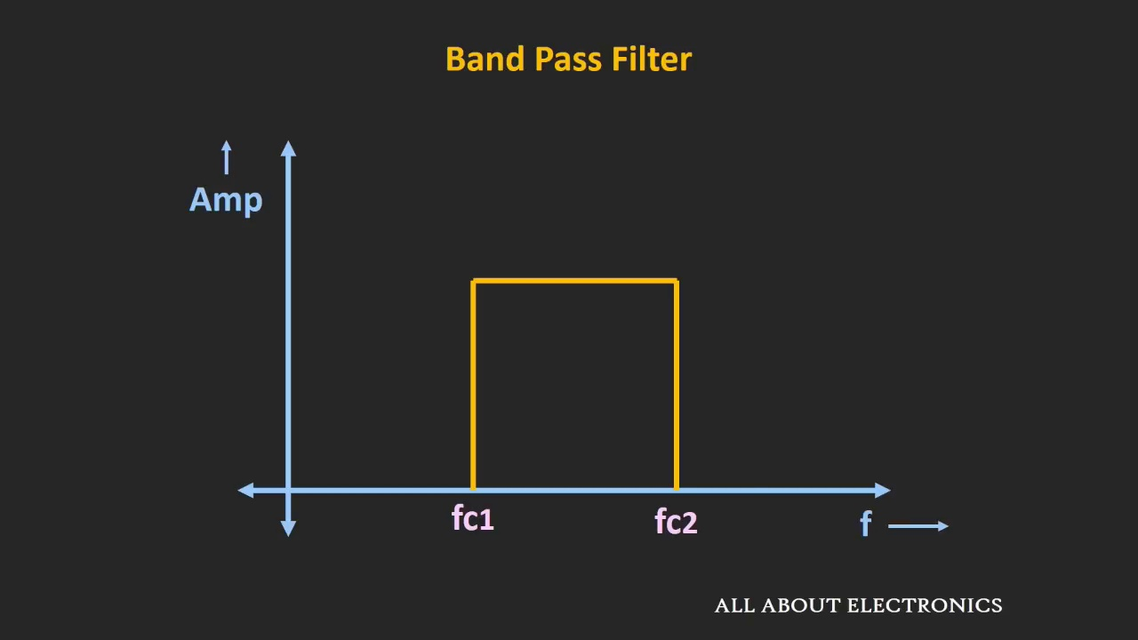 (score 95.0000)
 (score 90.0000)
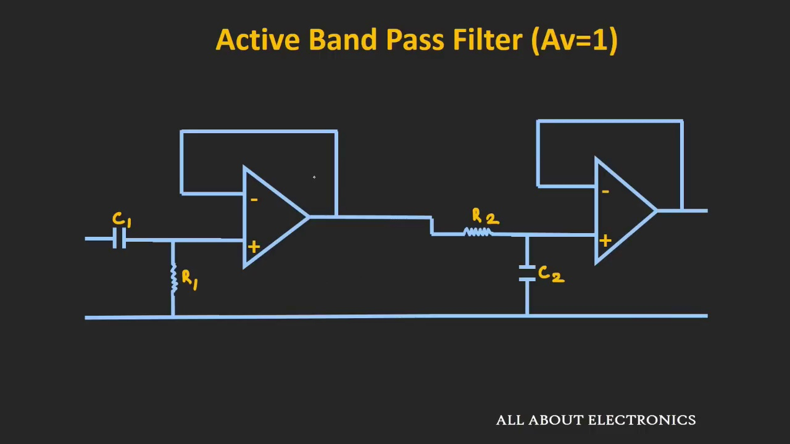 (score 90.0000)
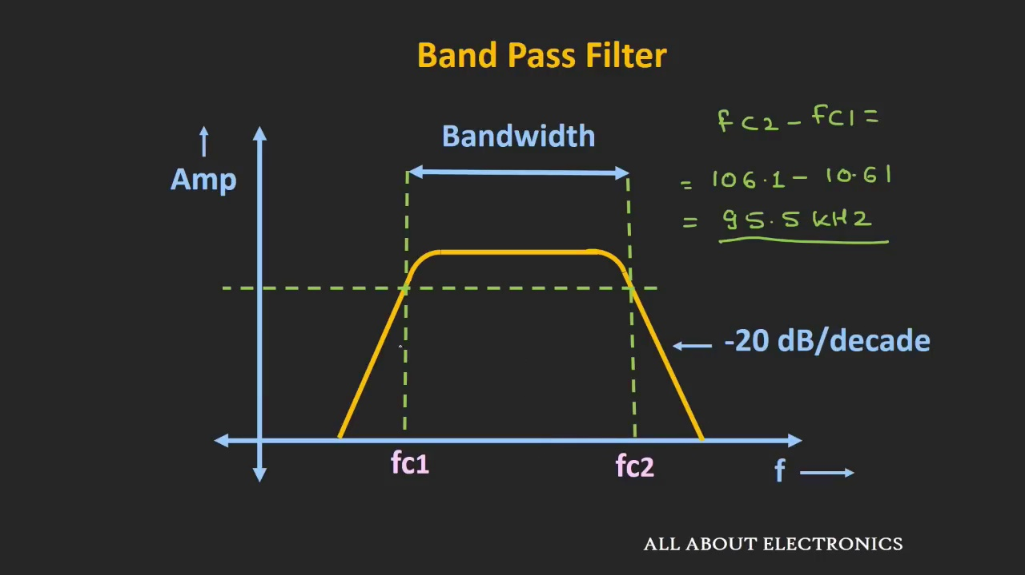 (score 90.0000)
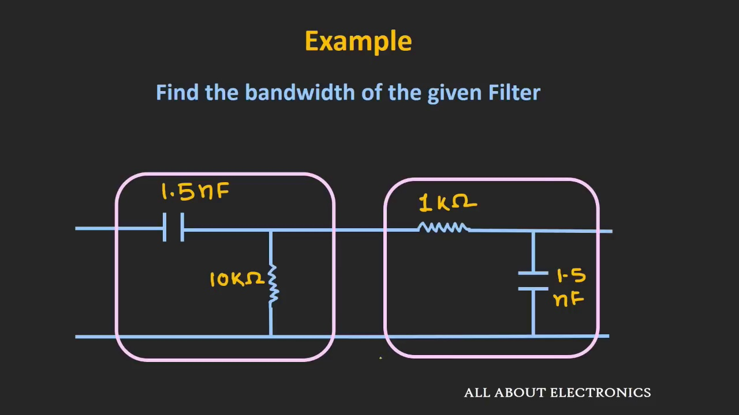 (score 90.0000)
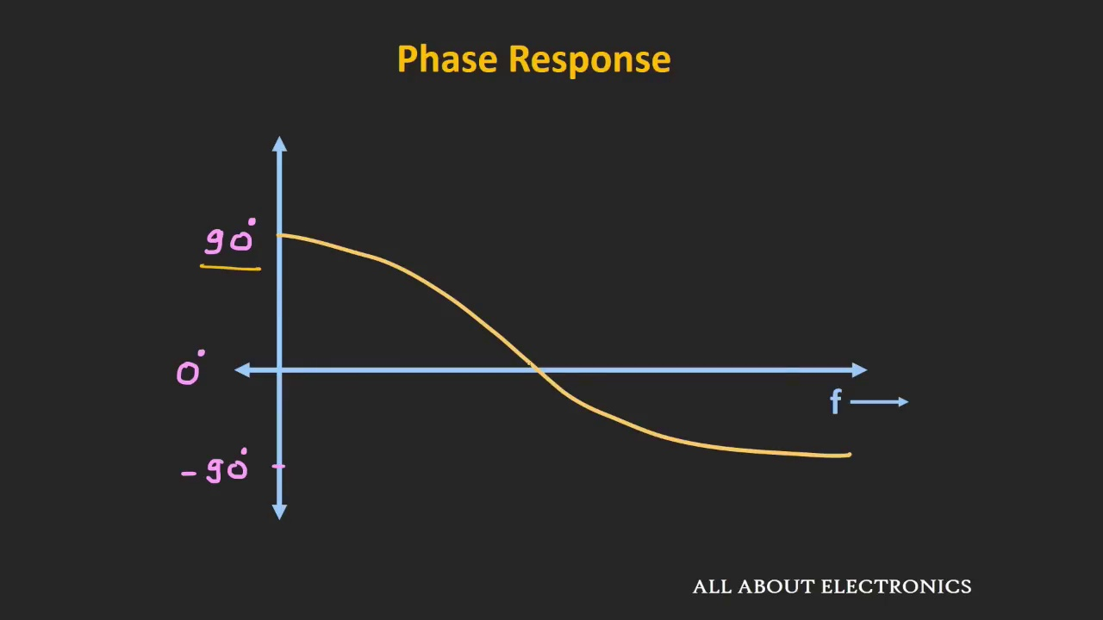 (score 90.0000)
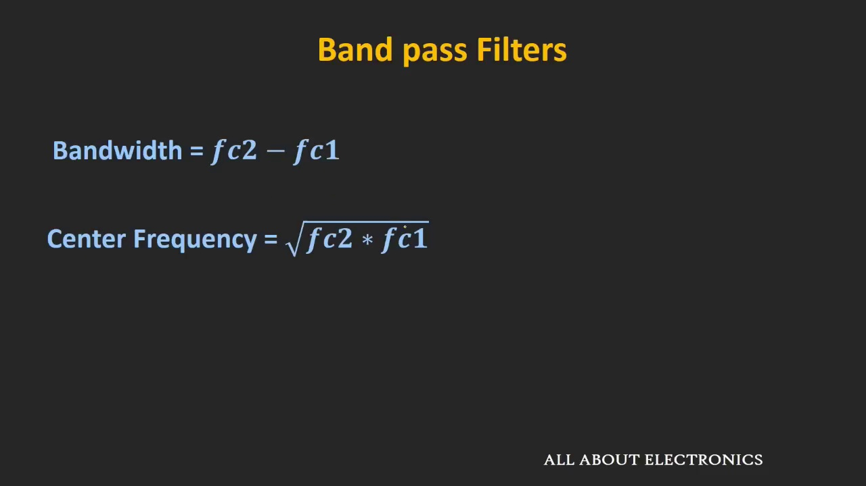 (score 90.0000)
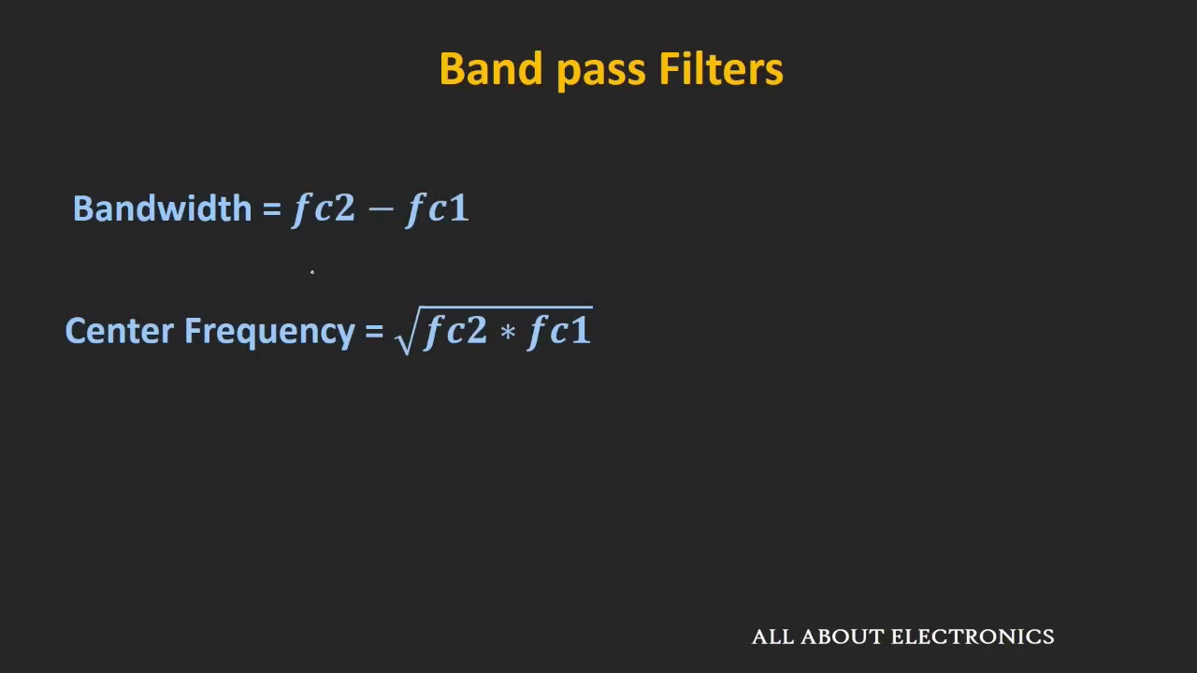 (score 90.0000)
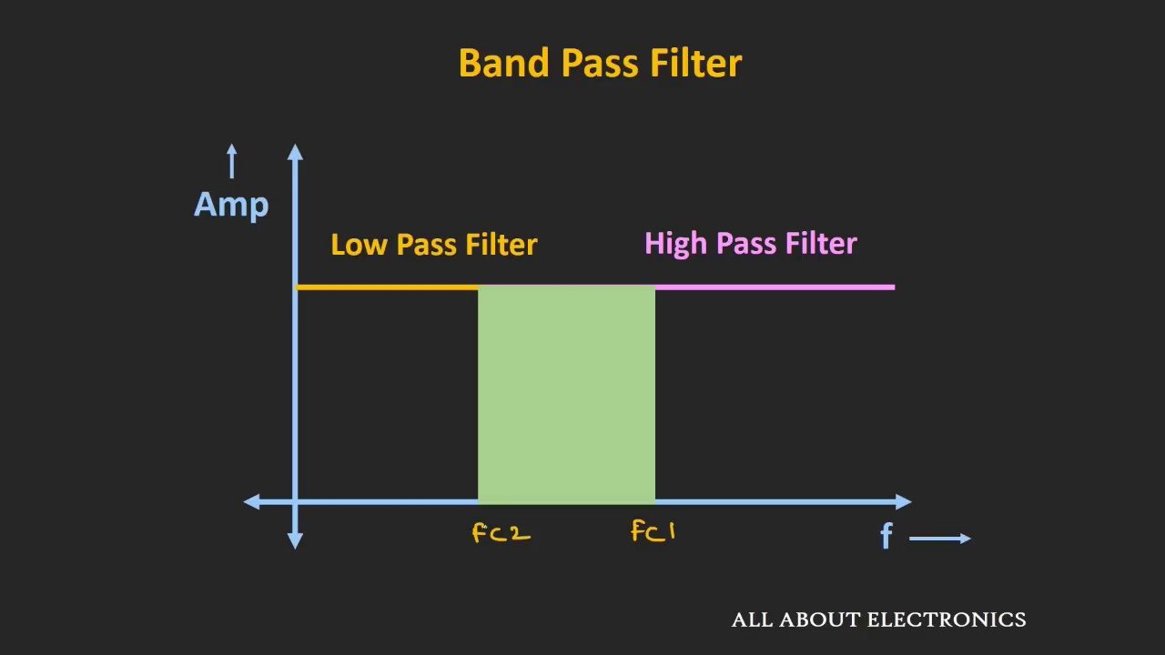 (score 90.0000)
Least correlated frames:
 (score 0.0000)
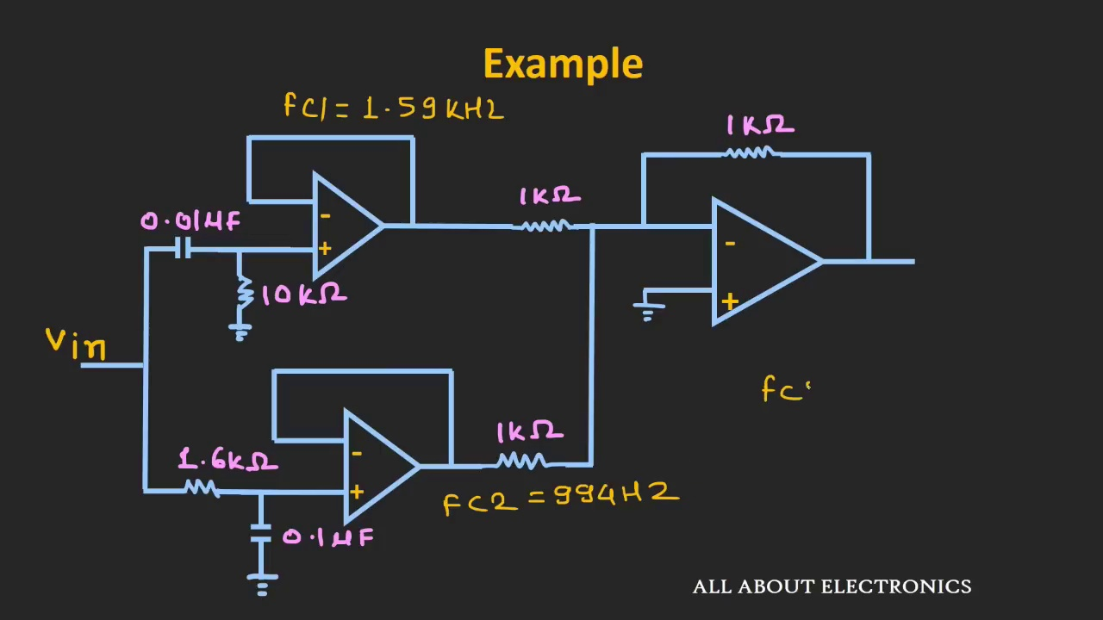 (score 0.0000)
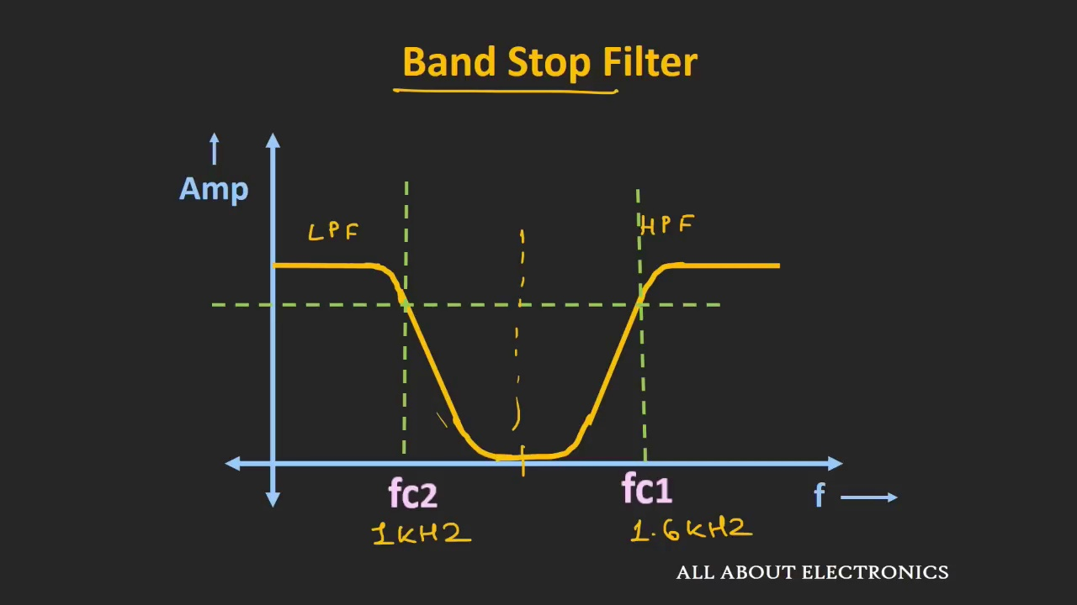 (score 10.0000)
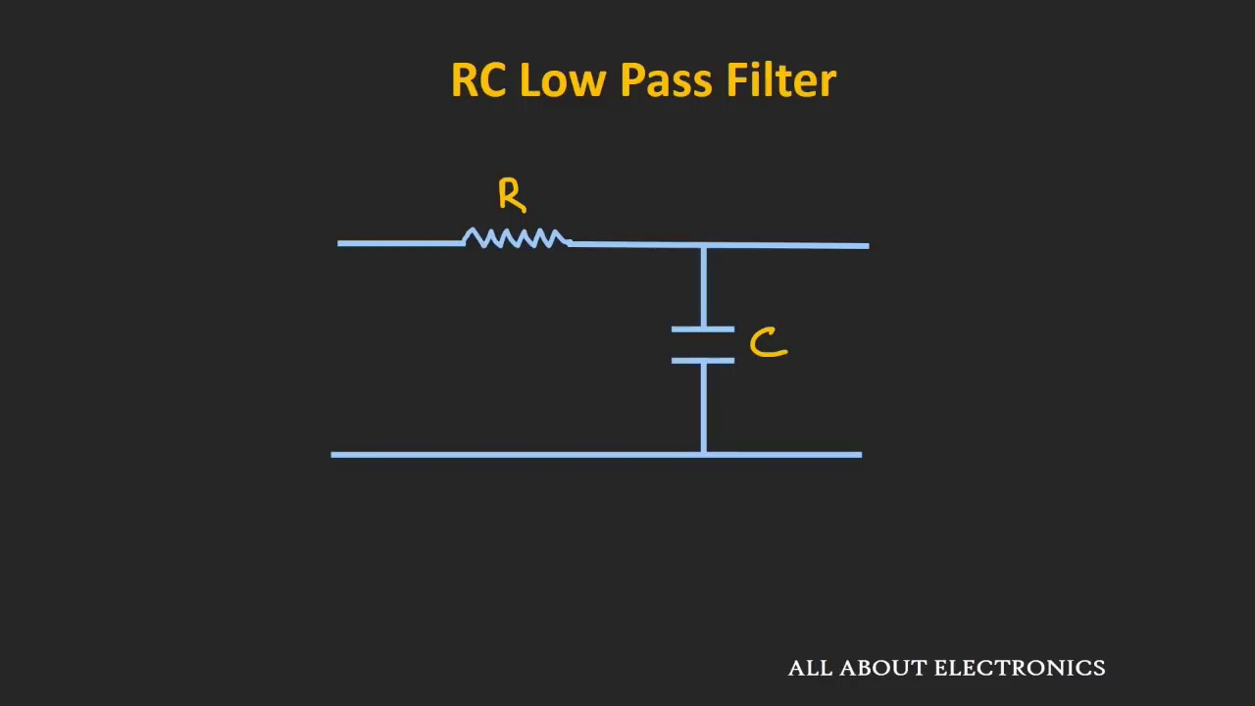 (score 20.0000)
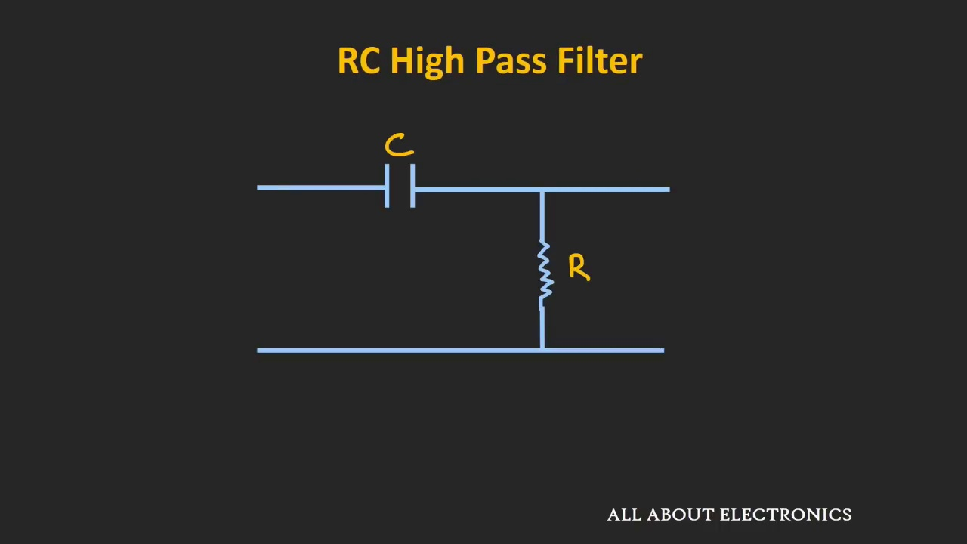 (score 20.0000)
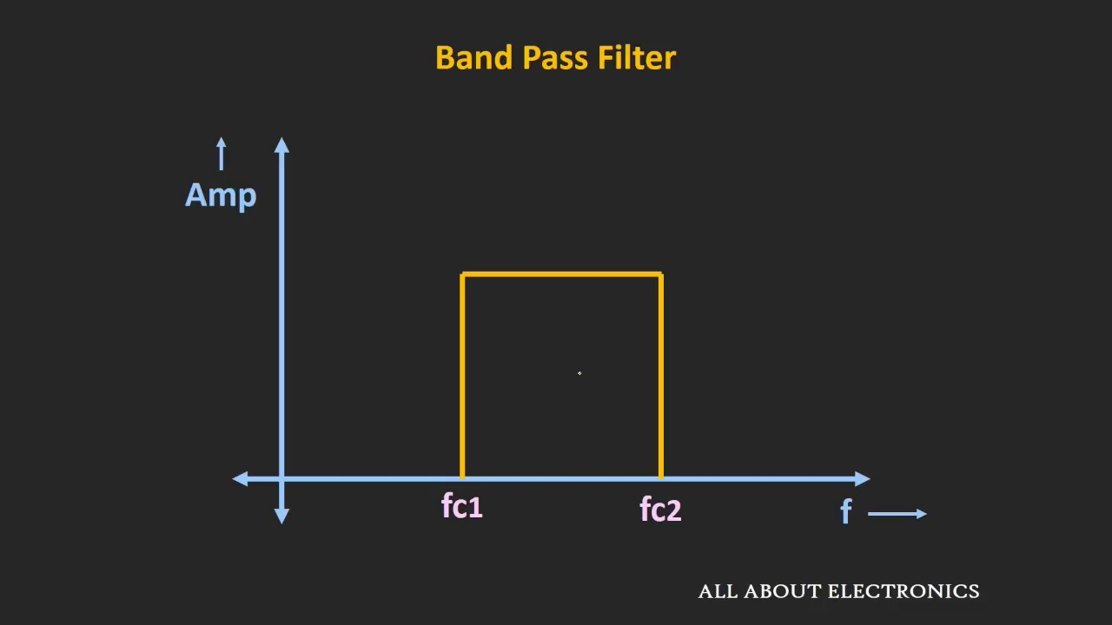 (score 20.0000)
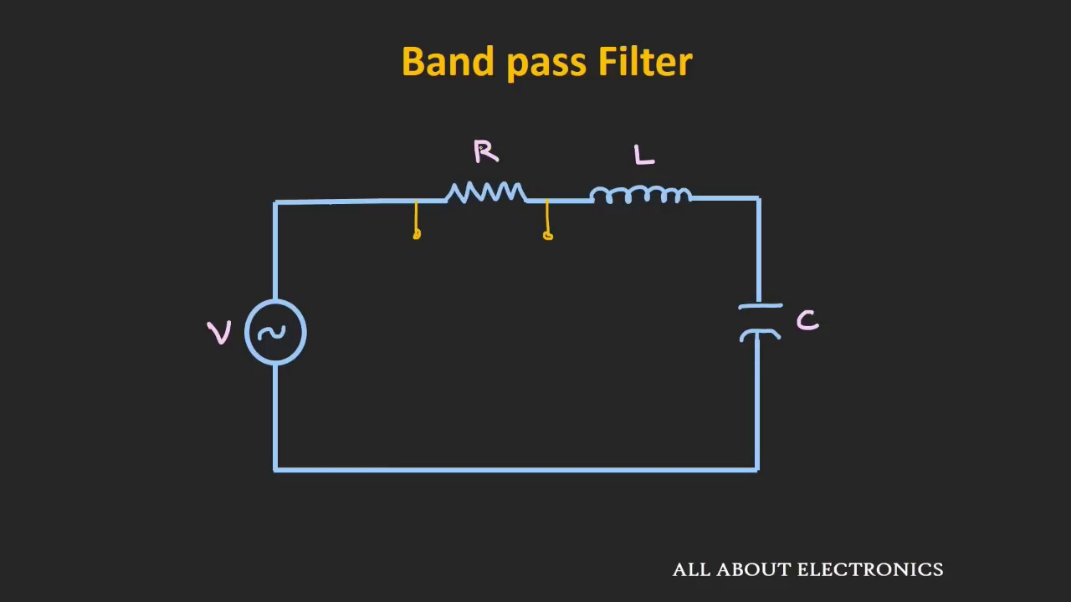 (score 20.0000)
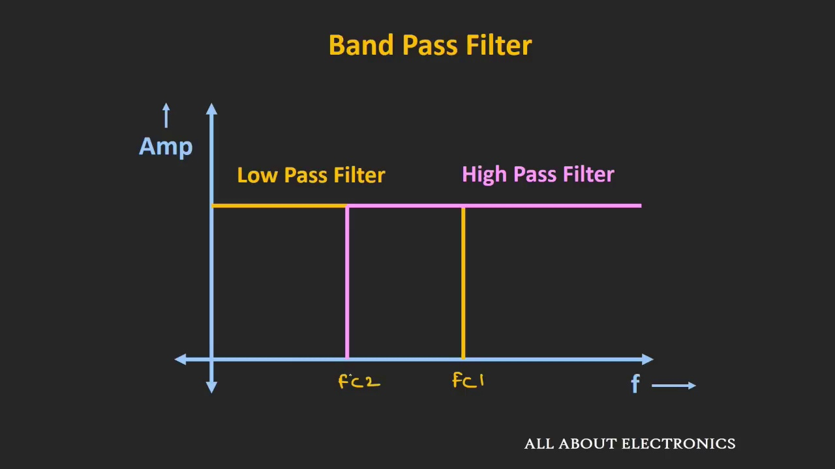 (score 20.0000)
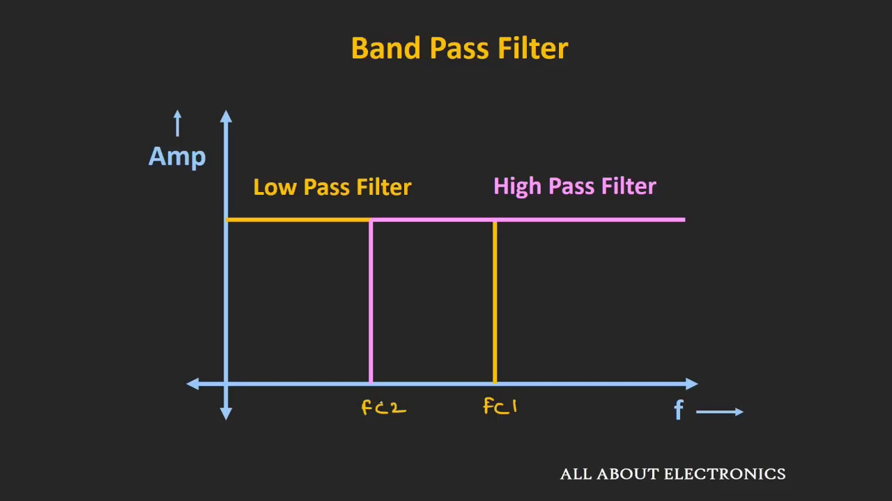 (score 20.0000)
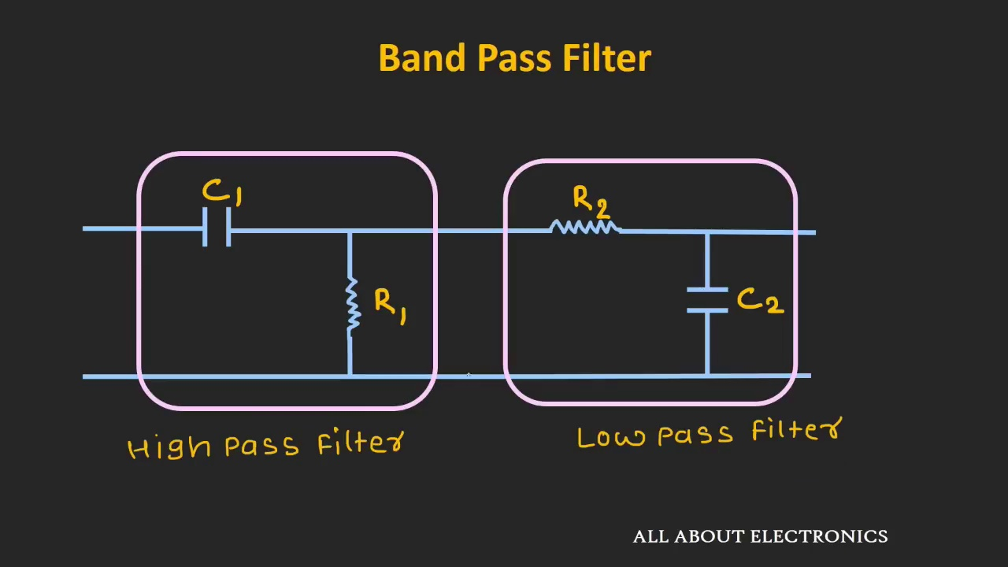 (score 20.0000)
- matched 119 frame(s), max score 95.0000: This video explained how to make a bandpass filter in a great way. We did a band pass filter for our speaker in phase 1 and it worked great! The video can also help with the calculations.
Source: https://www.youtube.com/watch?v=dmPIydL0lyM: Band Pass Filter and Band Stop Filter Explained
Top correlated frames:
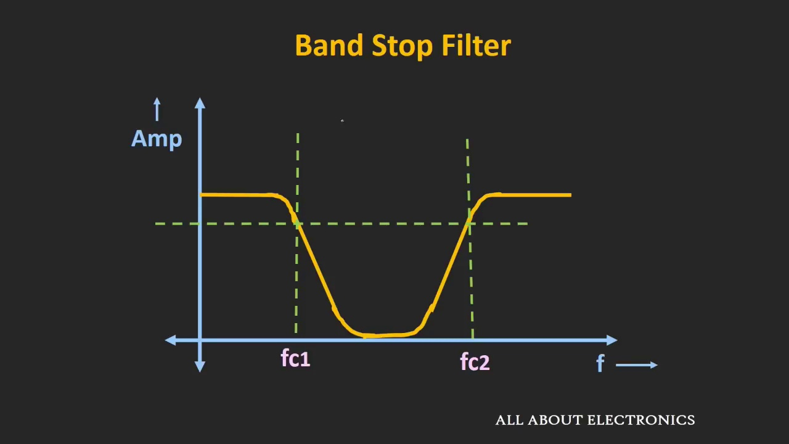 (score 95.0000)
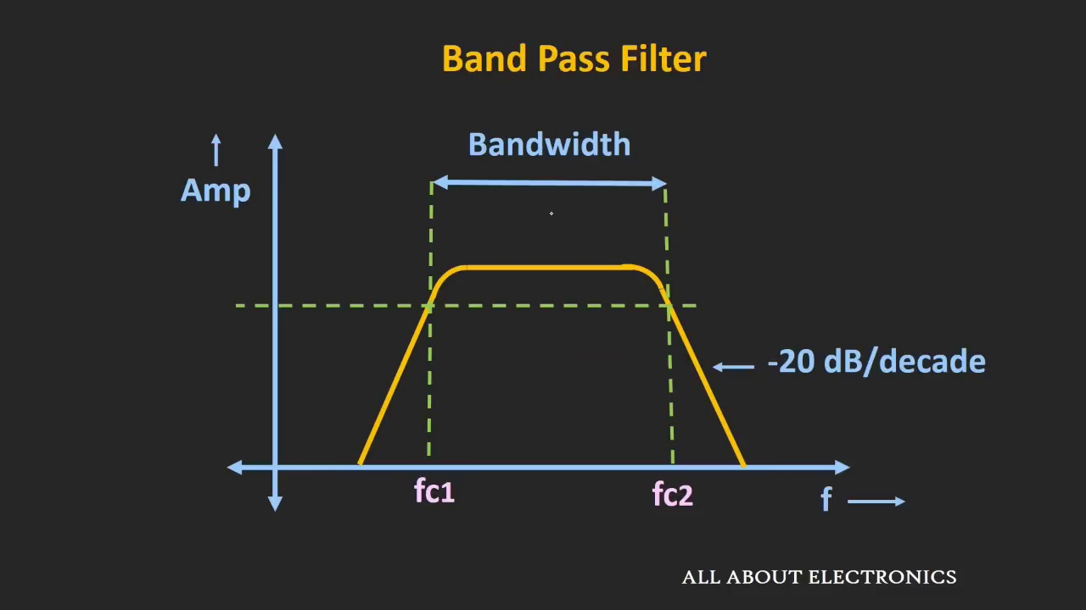 (score 95.0000)
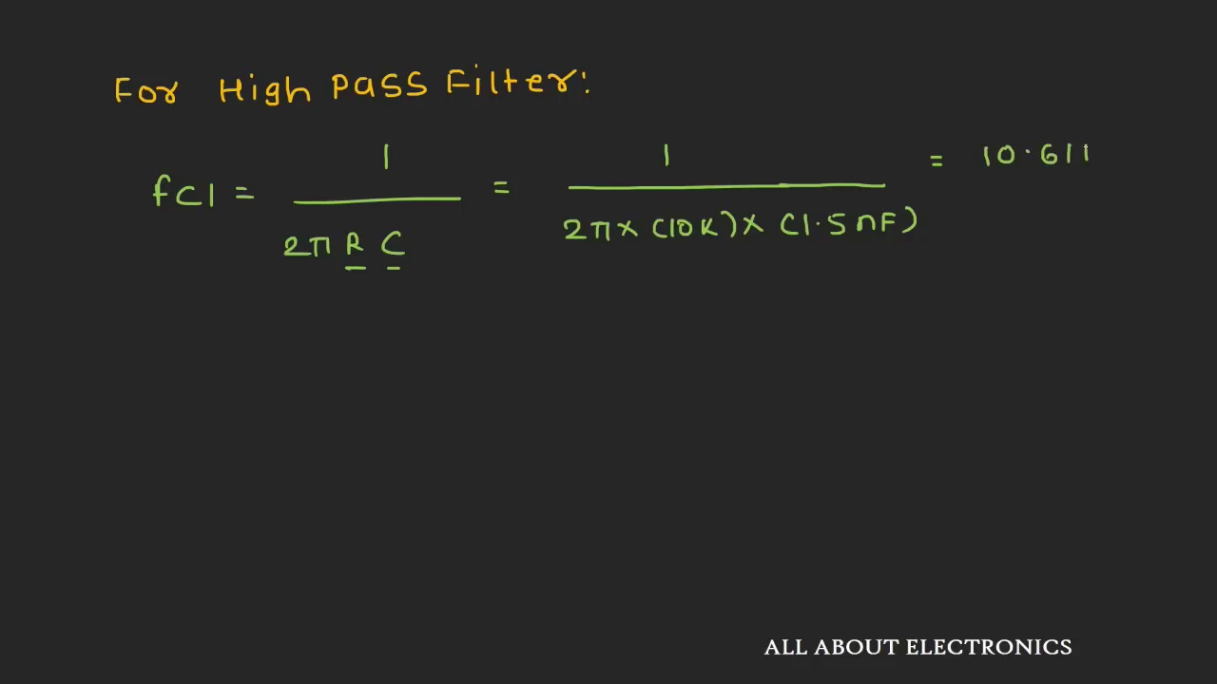 (score 95.0000)
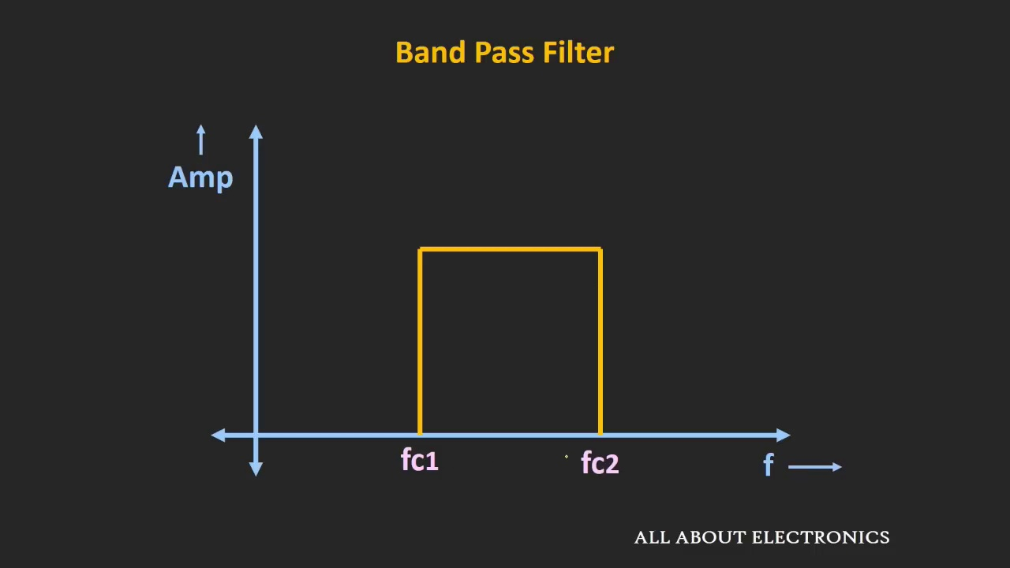 (score 95.0000)
 (score 90.0000)
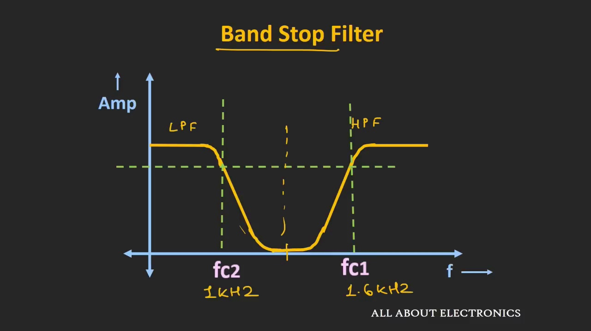 (score 90.0000)
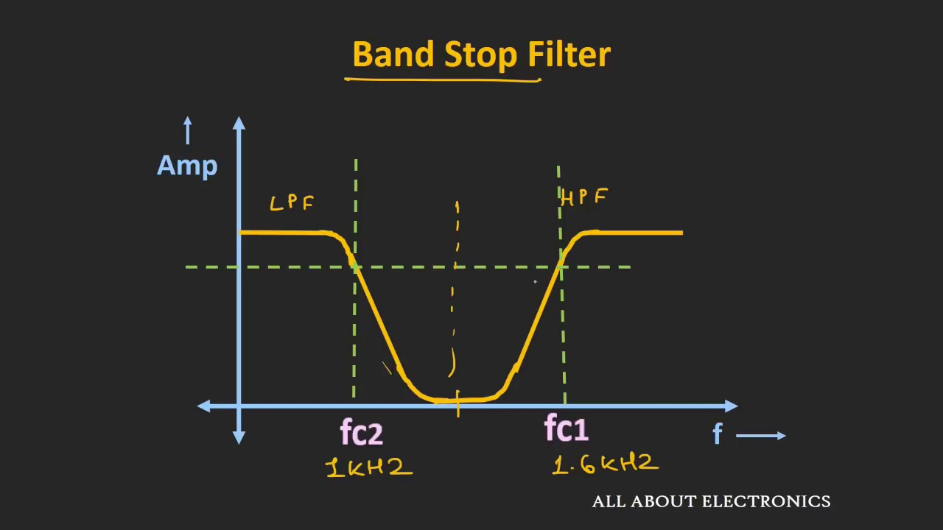 (score 90.0000)
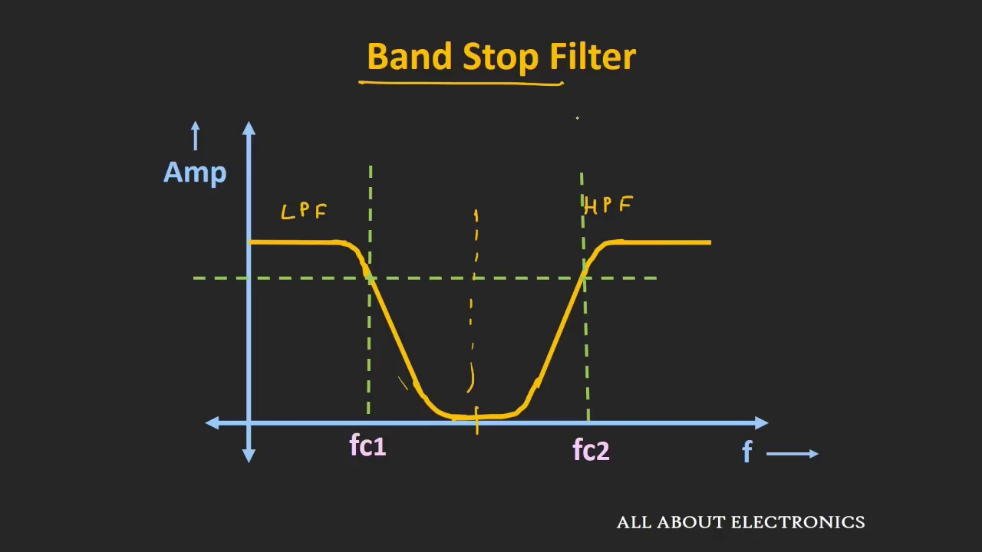 (score 90.0000)
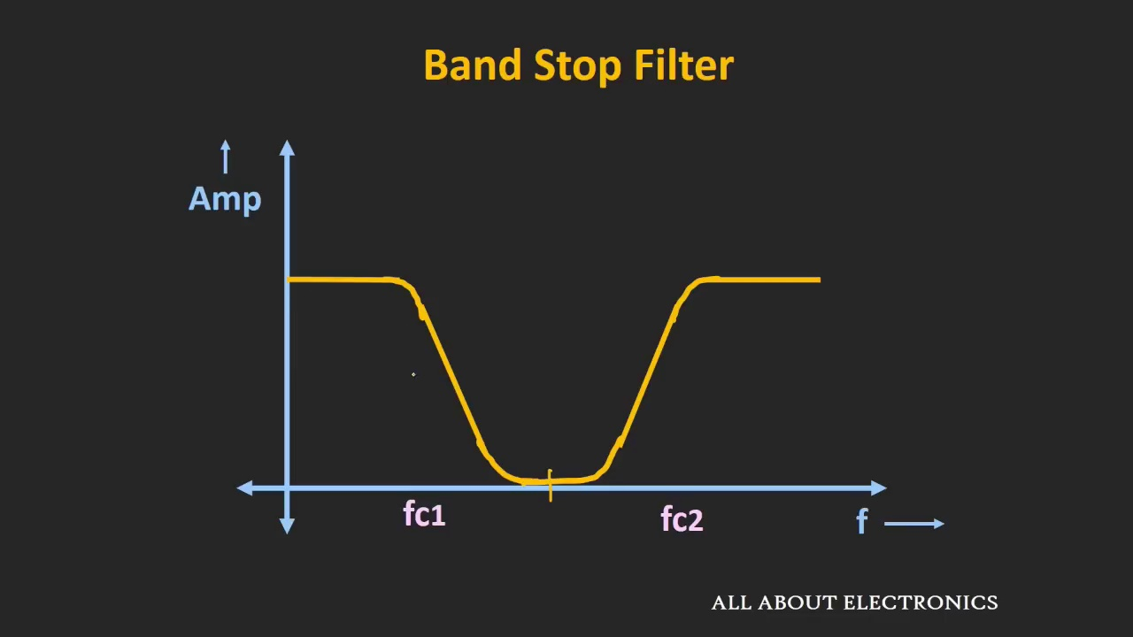 (score 90.0000)
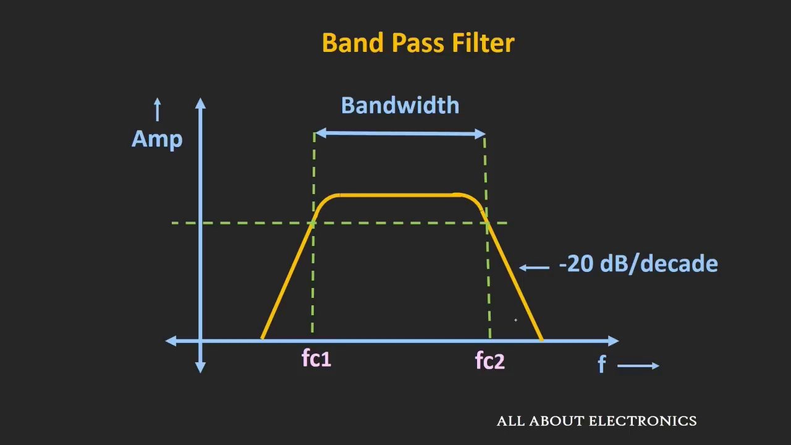 (score 90.0000)
Least correlated frames:
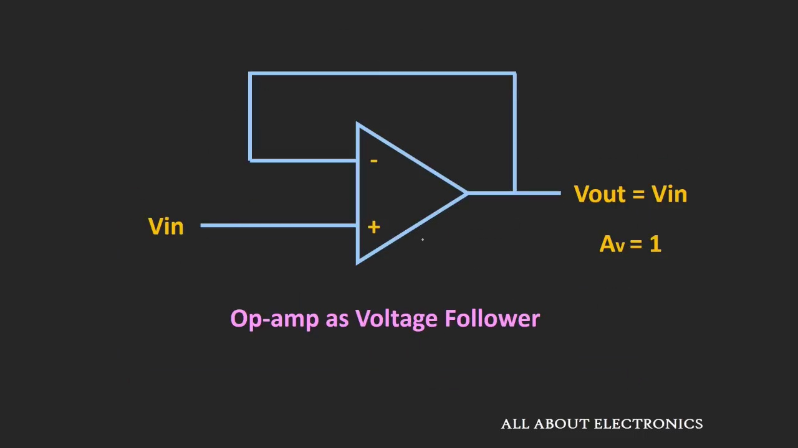 (score 0.0000)
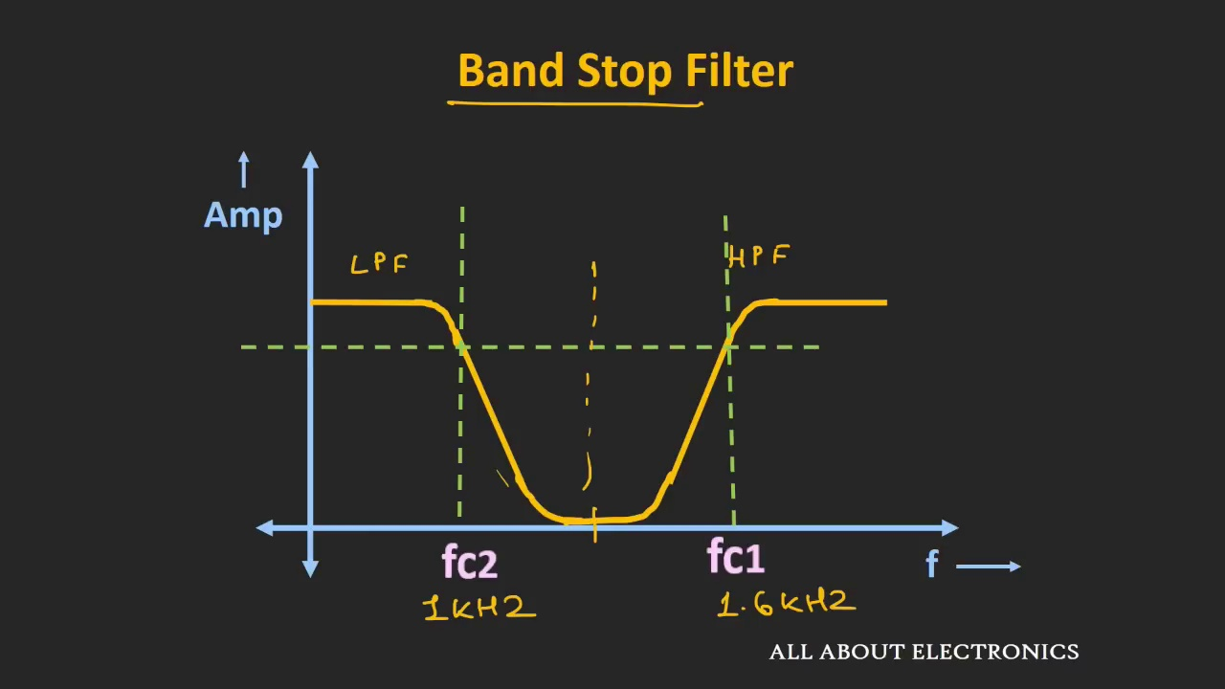 (score 0.0000)
 (score 0.0000)
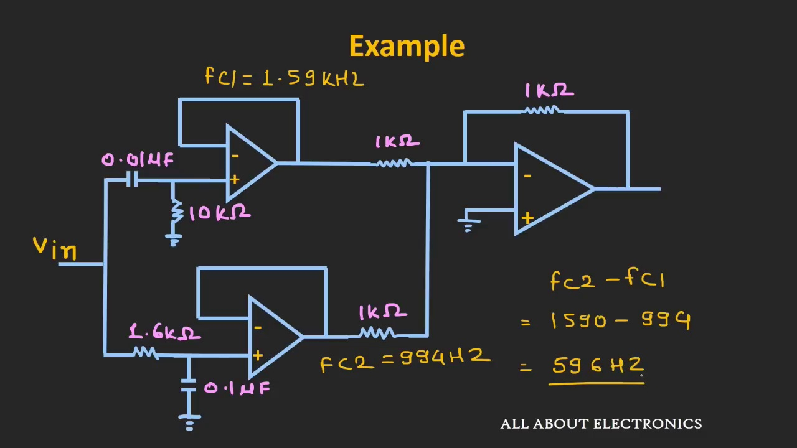 (score 5.0000)
 (score 10.0000)
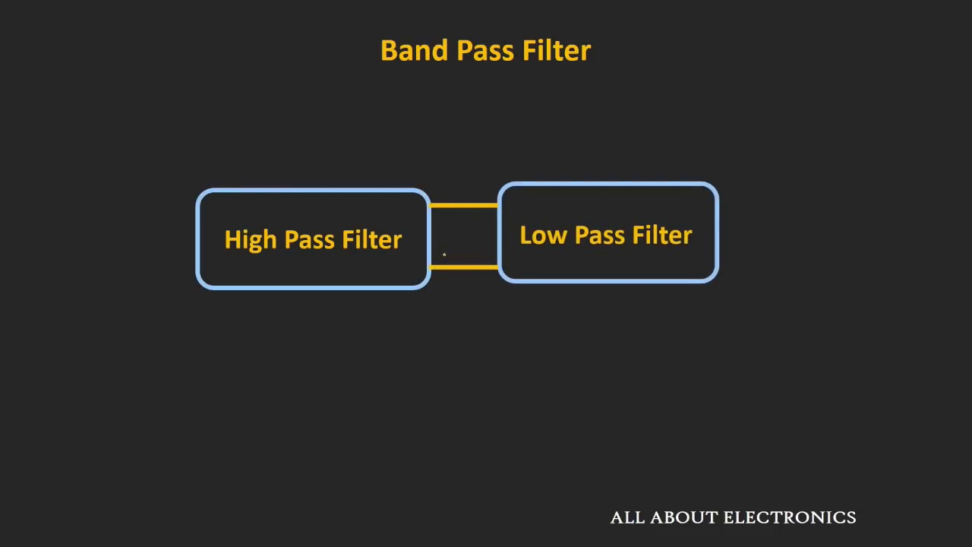 (score 10.0000)
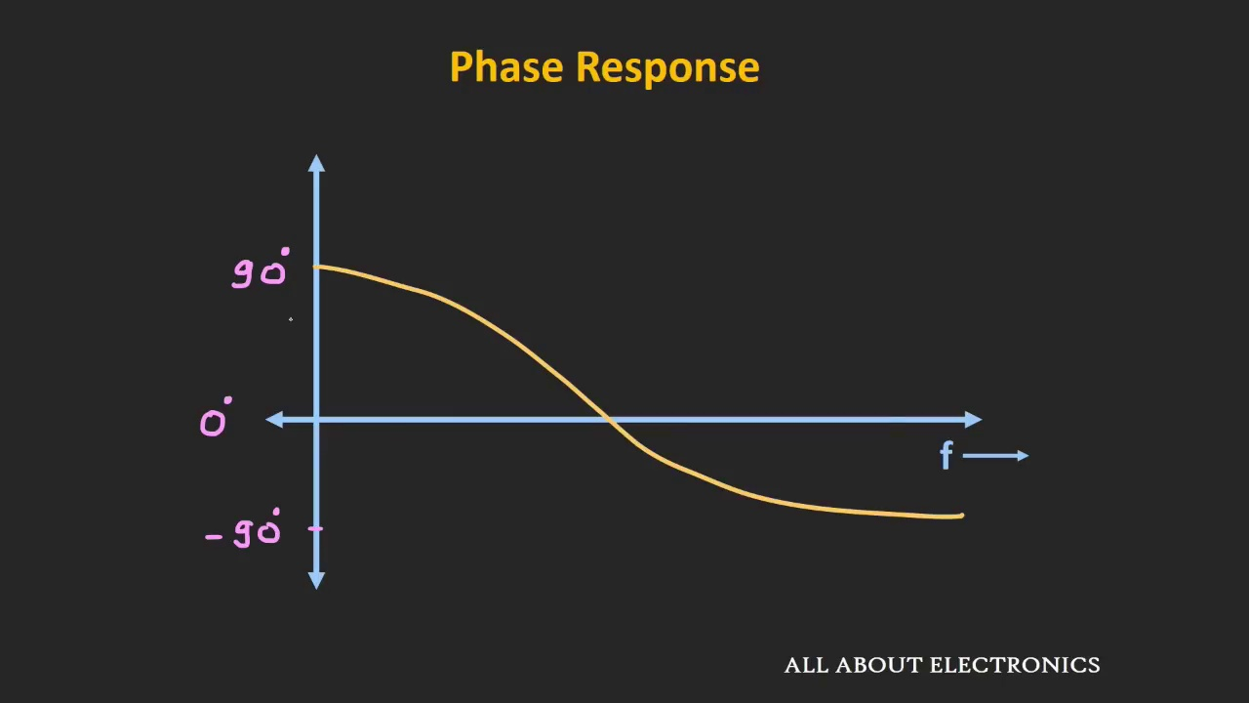 (score 10.0000)
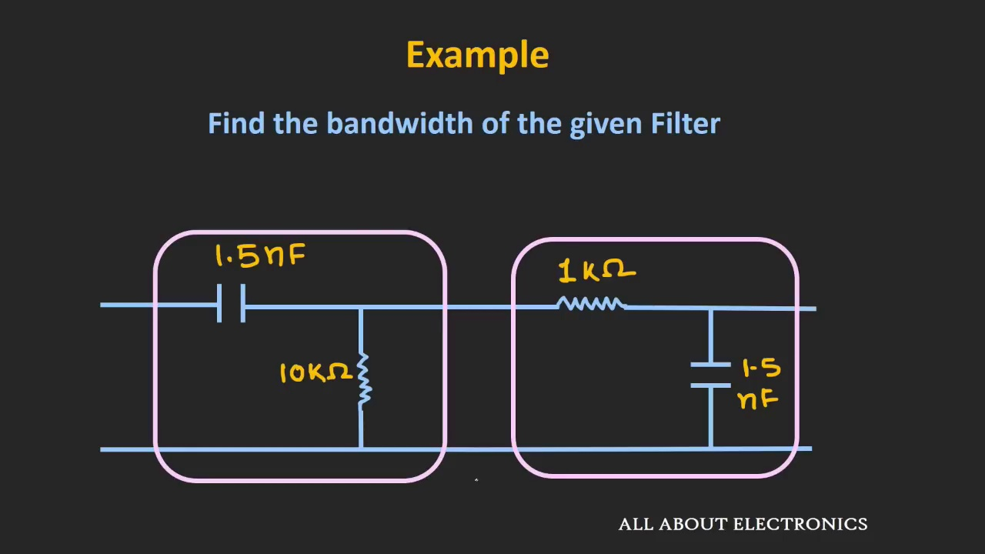 (score 10.0000)
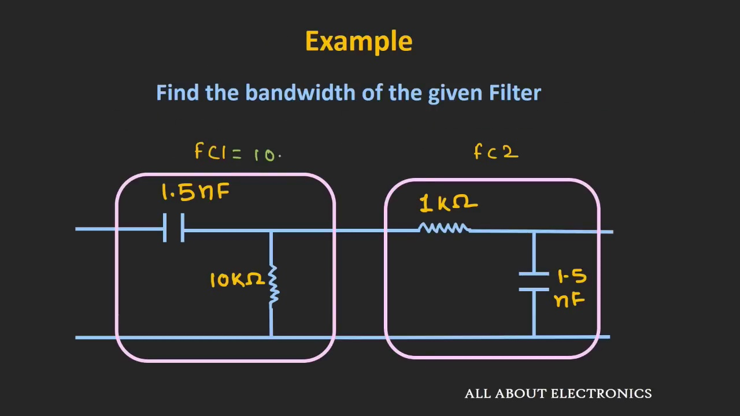 (score 10.0000)
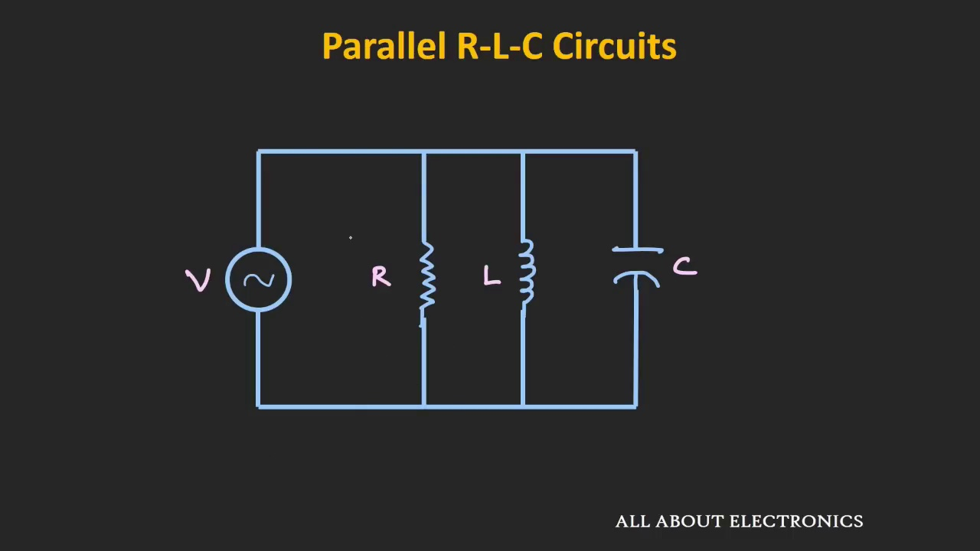 (score 10.0000)

Frame: frame_0000.jpg
Caption: The image appears to be a screenshot of a computer monitor displaying a presentation slide with a unique design. The dominant feature is a large, square shape in a warm orange hue, outlined in a contrasting dark brown color, which adds depth and contrast to the design. This central element draws immediate attention from the viewer.
The background of the image is a solid, uniform yellow color, providing a neutral canvas that allows the square to stand out. The simplicity of the design is further emphasized by the absence of any text or additional elements. Despite its minimalism, the design exudes balance and harmony, with the large square serving as a strong focal point.
The uniform yellow background ensures that the viewer's attention is not divided, allowing them to appreciate the design without distraction. Overall, the image showcases an exemplary example of minimalistic design, effectively utilizing color, shape, and contrast to create a visually striking and harmonious composition.
Comment (score 80): What I have learned from the video: It was interesting to see the waveforms of the bandpass filter used from 1kHz to 30kHz. The formula Fc = 1/2πRC was used to calculate the bandpass frequency. No major questions since we already did a lab on filters.
Reason: The comment directly discusses the bandpass filter and its frequency calculation, which is a technical step described in the caption. The mention of waveforms and formulas also matches the technical tone and focus on design principles found in the caption.
Source: https://www.youtube.com/watch?v=dmPIydL0lyM&t=2s: Band Pass Filters

Frame: frame_0001.jpg
Caption: The image features a rectangular object with a red background at its center. The main rectangle is partially obscured by another identical red rectangle on the left side of the frame, which is also outlined in white. These intersecting edges create a sense of depth or perspective within the image. Both rectangles are devoid of any text or content, and the neutral-colored background behind them provides no additional context or information. The image has a flat, two-dimensional appearance with no depth or shadow effects that could suggest a three-dimensional space. The style of the image seems simple and abstract, without any recognizable elements or symbols that would indicate specific themes or subjects related to teaching or learning.
At the top-left corner of the image, text written in a cursive font stands out against the vibrant red background. The text is legible and reads "A" and "B", possibly indicating the first and last letters of a title or phrase. The absence of any other text or objects in the image emphasizes the importance of this text and its placement. The overall composition of the image suggests a simple yet powerful message, conveyed through the use of bold, contrasting colors and clear, legible text.
Comment (score 80): What I have learned from the video: It was interesting to see the waveforms of the bandpass filter used from 1kHz to 30kHz. The formula Fc = 1/2πRC was used to calculate the bandpass frequency. No major questions since we already did a lab on filters.
Reason: The comment directly discusses the use of a bandpass filter and mentions calculating its frequency using a specific formula (Fc = 1/2πRC), which is strongly related to the description of rectangles and waveforms in the frame caption. The mention of a lab on filters also provides context for the technical steps described in the caption.
Source: https://www.youtube.com/watch?v=dmPIydL0lyM&t=2s: Band Pass Filters

Frame: frame_0002.jpg
Caption: The image features a graphic with a striking red background and a variety of elements overlaid on it. On the left side, there is a small portion showing a person holding up an electronic device that appears to be a microcontroller or single-board computer (SBC). This individual seems to be either demonstrating the use of the device or presenting it in some way.
In the center and right parts of the image, several text elements are overlaid on a semi-transparent red background. The most prominent text reads "ALL ABOUT ELECTRONICS," suggesting that the graphic is likely related to an educational or informational piece about electronics. Below this main title, additional text states "all about electonics" (note the minor typo), indicating that the content of the graphic may cover various aspects of electronic technology or devices.
The style of the image is minimalistic and appears to be a digital creation rather than a photograph. The choice of red for the background and overlaid elements gives it a modern and sleek look, possibly designed for an online course, educational platform, or informative poster.
Comment (score 80): What I have learned from the video: It was interesting to see the waveforms of the bandpass filter used from 1kHz to 30kHz. The formula Fc = 1/2πRC was used to calculate the bandpass frequency. No major questions since we already did a lab on filters.
Reason: The comment directly references the technical aspect of the video (waveforms and filter calculation), which is consistent with the graphical representation in the caption. The mention of a lab on filters also suggests that the content aligns with the educational tone implied by the caption.
Source: https://www.youtube.com/watch?v=dmPIydL0lyM&t=2s: Band Pass Filters

Frame: frame_0003.jpg
Caption: The image displays a simple user interface with a dark theme, set against the backdrop of a historical event. On the left side, there is a large, dark-colored rectangular area that appears to be an inbox or message window with a light grey background. The window's title or content is not visible due to its size and position within the screen.
On the right side of the interface, there is a smaller rectangular area with a light brown color, which seems to be a separate section for content, possibly an article or blog post given its structure. Below this section, there is a text that reads "READ", suggesting that the user can click on it to view the full content within the darker rectangular area.
The overall design of the interface suggests a minimalist approach with a focus on readability and clear organization of information into different sections or panels. Interestingly, the year 1920 appears in the United States, marking significant events from that year.
There are no visible instructors, slides, diagrams, or other teaching elements within this frame, maintaining the interface's simplicity and clarity.
No strongly correlated comments found for this frame.

Frame: frame_0004.jpg
Caption: The image displays an instructional setting where a presentation slide is being used to teach a technical concept related to signal processing, specifically filtering in electronics or communication systems. The title "Band Pass Filter and Band Stop Filter" appears on the slide, along with two diagrams that illustrate the frequency response of these filters.
On the left side of the slide, the first diagram represents a bandpass filter, featuring a series of sine waves likely representing different frequency components or signals. The diagram also includes vertical lines, possibly indicating the amplitude or gain of the filter in relation to the frequencies.
To the right of the first diagram is the second diagram, which shows a bandstop filter. This diagram also features a series of sine waves and vertical lines, potentially representing the frequency response of the bandstop filter.
Mathematical symbols such as "f" (frequency), "Vs" (voltage-to-standard), and various mathematical functions like cosine and sine waves are incorporated into the diagrams, further emphasizing the presentation's focus on signal processing concepts.
The slide appears to be part of a teaching session, possibly an online class or video tutorial, with no people visible in the frame. The content is designed to convey the concepts of how bandpass and bandstop filters work within the broader context of signal processing or electronic engineering.
Comment (score 85): This video explained how to make a bandpass filter in a great way. We did a band pass filter for our speaker in phase 1 and it worked great! The video can also help with the calculations.
Reason: The comment directly discusses the same technical concept (bandpass filter) and mentions calculations, which are both described in the caption. The correlation is strong as the comment specifically references the video content.
Source: https://www.youtube.com/watch?v=dmPIydL0lyM: Band Pass Filter and Band Stop Filter Explained
Comment (score 85): What I have learned from the video: It was interesting to see the waveforms of the bandpass filter used from 1kHz to 30kHz. The formula Fc = 1/2πRC was used to calculate the bandpass frequency. No major questions since we already did a lab on filters.
Reason: The comment directly discusses the technical steps (calculating the bandpass frequency using Fc = 1/2πRC) and objects (waveforms of the bandpass filter) described in the caption. The mention of a lab on filters also indicates that the viewer has learned about filtering concepts presented in the video.
Source: https://www.youtube.com/watch?v=dmPIydL0lyM&t=2s: Band Pass Filters

Frame: frame_0005.jpg
Caption: The image displays an educational setting where someone appears to be teaching a class about band-pass filters and band-stop filters. The background is black, providing contrast for the presentation materials. At the top of the image, there are bold white letters against a green bar that read "BAND PASS FILTER AND BAND STOP FILTER," suggesting that the content of the class or tutorial will discuss these two types of filters.
Below this title, on the right side, is a diagram illustrating a band-stop filter using a series of rectangles and lines. The rectangles likely represent a physical structure, possibly a pipe or a tunnel with holes in it, symbolizing a frequency response that allows certain frequencies to pass through while blocking others. This is confirmed by the text in white font against a green bar on the left side, which reads "Band Stop Filter."
The bottom part of the image shows a mathematical or engineering diagram with various lines and shapes, including what looks like a sine waveform and a series of peaks and troughs representing signal amplitudes over time. Arrows point to specific areas on the waveform, indicating certain features or properties of the signal. The person teaching appears to be pointing at one of these diagrams, perhaps explaining how a band-pass filter might affect a signal's frequency content.
Additionally, two black boxes are present in the image: one with a white circle and the other with a white square. The white circle is located in the center of the image, while the white square is situated to the right of the circle. The text "f1" is written in the bottom left corner of the image, and "f2" is written in the bottom right corner. Symbols "f" and "c" are also present but their exact significance is not clear from the image.
Overall, the image presents an educational scenario focused on teaching the principles and applications of electronic filters to a class or audience. The blackboard behind the teacher has some writing on it, although the text is not clearly legible in this image.
Comment (score 85): This video explained how to make a bandpass filter in a great way. We did a band pass filter for our speaker in phase 1 and it worked great! The video can also help with the calculations.
Reason: The comment directly discusses the same technical steps (making a bandpass filter) and objects (band pass filter) described in the caption. The mention of 'phase 1' likely refers to the diagram of the band-stop filter in the image, which is similar to the application mentioned in the video.
Source: https://www.youtube.com/watch?v=dmPIydL0lyM: Band Pass Filter and Band Stop Filter Explained
Comment (score 80): What I have learned from the video: It was interesting to see the waveforms of the bandpass filter used from 1kHz to 30kHz. The formula Fc = 1/2πRC was used to calculate the bandpass frequency. No major questions since we already did a lab on filters.
Reason: The comment directly discusses the waveform of a bandpass filter, which is depicted in the frame caption. The formula Fc = 1/2πRC mentioned in the comment is also relevant to the diagram shown in the caption. Although some details are not perfectly matched, such as the specific frequency range (1kHz to 30kHz) and the absence of a lab on filters, the connection between the comment and caption remains strong.
Source: https://www.youtube.com/watch?v=dmPIydL0lyM&t=2s: Band Pass Filters

Frame: frame_0006.jpg
Caption: The image appears to be an educational and informational graphic focused on the topic of bandpass filters and their use in bandstop filtering. The main visual is a black rectangle with white text inside it, which is a common design for slide titles in presentations. The title reads "Bandpass Filter And Band Stop Filter," suggesting that the content will explore both concepts. Below this title, three additional lines of text provide explanations or concepts related to bandpass filters: "Bandpass Filter," "and," and "Bandstop Filter."
In the upper left corner of the image, a small, simplified model represents an electronic component or circuit, possibly illustrating how a bandpass filter works. The model features two cylinders connected by a horizontal rod, which could symbolize a tuned circuit or resonator.
The image also includes text on the right side that reads "All About Electronics," suggesting that this content is part of an educational series or resource on the topic of electronics. The overall style of the image is informational and educational, aiming to teach viewers about the different types of filters used in electronic systems.
Comment (score 80): This video explained how to make a bandpass filter in a great way. We did a band pass filter for our speaker in phase 1 and it worked great! The video can also help with the calculations.
Reason: The comment directly discusses the same technical steps (making a bandpass filter) and objects (bandpass filter) described in the caption.
Source: https://www.youtube.com/watch?v=dmPIydL0lyM: Band Pass Filter and Band Stop Filter Explained
Comment (score 80): What I have learned from the video: It was interesting to see the waveforms of the bandpass filter used from 1kHz to 30kHz. The formula Fc = 1/2πRC was used to calculate the bandpass frequency. No major questions since we already did a lab on filters.
Reason: The comment directly discusses the same technical steps and concepts described in the caption, such as bandpass filters, waveforms, frequency calculation using the formula Fc = 1/2πRC. The mention of a lab on filters also ties back to the educational topic explored in the image.
Source: https://www.youtube.com/watch?v=dmPIydL0lyM&t=2s: Band Pass Filters

Frame: frame_0007.jpg
Caption: The image appears to be a digital graphic rather than an instructional setting with an instructor. It features a black background, which provides a stark contrast to the text written in white. The graphic includes three lines of text, each with its own meaning:
1. "Band pass filter"
2. "and band stop filter"
The phrase "All about Electronics" is in a smaller font size compared to the other two lines and is positioned below them. The text is centered horizontally, with an equal amount of space on either side of each line. The text itself suggests that the image is related to topics within the field of electronics, specifically filtering. The style of the graphic is simple and informational, likely intended for educational or informational purposes.
The overall layout suggests that this is a technical or educational document related to electronics, with the text "Band Pass Filter And Band Stop Filter" written in blue font, clearly visible and standing out against the dark background.
Comment (score 85): This video explained how to make a bandpass filter in a great way. We did a band pass filter for our speaker in phase 1 and it worked great! The video can also help with the calculations.
Reason: The comment directly discusses the same technical steps and topics (bandpass filter) described in the caption, with a specific example of application and calculation help.
Source: https://www.youtube.com/watch?v=dmPIydL0lyM: Band Pass Filter and Band Stop Filter Explained
Comment (score 85): What I have learned from the video: It was interesting to see the waveforms of the bandpass filter used from 1kHz to 30kHz. The formula Fc = 1/2πRC was used to calculate the bandpass frequency. No major questions since we already did a lab on filters.
Reason: The comment directly discusses the bandpass filter and its frequency calculation formula, which is mentioned in the caption. The mention of waveforms and lab on filters further supports the connection between the caption and the comment.
Source: https://www.youtube.com/watch?v=dmPIydL0lyM&t=2s: Band Pass Filters

Frame: frame_0008.jpg
Caption: The image presents a teaching context where an individual is explaining the concept of an RC Low Pass Filter. The diagram is dominated by a rectangular circuit board, which serves as the platform for the circuit elements.
At the center of the circuit board, a green-colored capacitor is depicted, serving as the primary component of the low pass filter. Beneath the capacitor, a red-colored resistor is drawn, controlling the flow of current in the circuit. To the right of the capacitor, a blue-colored transistor is also drawn.
The diagram includes two main sections: an upper section showing a schematic representation and a lower section displaying a time-domain response. The schematic includes three components labeled as resistors (R), capacitors (C), and an independent voltage source (V). An arrow pointing to the voltage source indicates that it is the input, while another arrow pointing to the junction of R1 and C1 suggests the output.
The time-domain response graph shows two lines over time, representing the voltage across the capacitor (Vc) and the voltage source (V), with a constant maximum input voltage. The graph displays Vc starting at zero and rising to its peak value, while V remains steady throughout.
The image also includes labels that provide context: "RC Low Pass Filter" at the top of the circuit board and "All About Electronics" at the bottom, suggesting that the diagram is part of a larger educational resource on electronics. The overall layout of the circuit board, with its various components and labels, provides a clear and concise representation of an RC Low Pass Filter in electronics.
No strongly correlated comments found for this frame.

Frame: frame_0009.jpg
Caption: The image presents a schematic diagram of an RC (Radio Controlled) low-pass filter, which is used in electronics to pass signals below a certain frequency and reject signals above that frequency. The diagram includes various components such as resistors, capacitors, and the filter itself. There are four main sections to the diagram:
1. The input signal source, labeled as "RFCS" or radio-frequency communication system.
2. A series of two resistors (R1) connected in series with a single capacitor (C1), which forms a high-pass filter.
3. Another section that appears to be a series of three resistors (R2, R3, R4) connected in parallel with a single capacitor (C2). This creates a band-pass filter.
4. The output of the band-pass filter feeds into a low-pass filter consisting of two more resistors (R5, R6) and another capacitor (C3), which is the RC low-pass filter in question.
The diagram includes readable texts, such as "RC LOW PASS FILTER" at the bottom, providing values for resistors and capacitors next to each component, and the text "all about electronics" present in the top right corner of the image. Additionally, a person is visible, appearing to give a lecture or presentation on this topic, without writing, pointing, holding a model, or speaking from a slide.
The filter itself is characterized by a capacitor and a resistor, both connected in series. The capacitor is located on the left side of the diagram, while the resistor is positioned on the right. A voltage source, indicated by a small circle, is positioned in front of the capacitor, suggesting that it is connected to the capacitor, which in turn is connected to the resistor. The diagram also includes a label that reads "RC Low Pass Filter", indicating the type of circuit it represents.
Comment (score 85): What I have learned from the video: It was interesting to see the waveforms of the bandpass filter used from 1kHz to 30kHz. The formula Fc = 1/2πRC was used to calculate the bandpass frequency. No major questions since we already did a lab on filters.
Reason: The comment directly discusses the same technical steps, objects (filter types, such as bandpass and low-pass), settings (frequency ranges) and goals (calculating filter frequency) described in the caption. The mention of waveforms, formulas, and lab experience specifically relate to the diagram and its components, making it strongly correlated.
Source: https://www.youtube.com/watch?v=dmPIydL0lyM&t=2s: Band Pass Filters

Frame: frame_0010.jpg
Caption: The image appears to be a screenshot of an online teaching session or educational resource related to electronics and engineering, specifically focused on the concept of RC High Pass Filters. The title "RC HIGH PASS FILTER" is prominently displayed at the top of the diagram, indicating that the content is about radio-controlled high-pass filters.
The diagram presents a simple schematic of an RC High Pass Filter, featuring two capacitors (C) and one resistor (R). One capacitor is connected in series to the input, while the other is connected in parallel to the ground. The circuit design includes a voltage source on the left side, indicating the power supply for the circuit.
The diagram also includes text explaining the RC High Pass Filter, which discusses how this particular filter works and its properties. Although the text quality is not entirely clear due to image resolution, it seems that the explanation is intended for an audience learning about electronic circuits or filters. The mention of "CROSSFREQ" could refer to the crossover frequency in the context of high-pass filters, representing the cutoff frequency of the filter.
The overall style of the image suggests an educational context, with text and diagrams designed to explain the principles of RC High Pass Filters to a student or audience member. The instructor is not clearly visible, but their role is implied by the textual content explaining the filter and the schematic used for teaching purposes.
No strongly correlated comments found for this frame.

Frame: frame_0011.jpg
Caption: The image depicts an educational setting focused on teaching electronic concepts. On the left side of the frame, there is a person who appears to be an instructor, likely explaining the content in a classroom-style environment. The individual's attention seems to be directed towards a diagram or teaching aid that includes blocks labeled "LOW PASS FILTER," with additional blocks indicating the input, output, and frequency response components associated with filtering in electronic engineering. Lines connecting these elements likely represent mathematical or conceptual relationships between the input and output of a low-pass filter.
On the right side of the image, there is a slide with text and a graph that seems to be related to the topic being taught. The text on the slide includes "ALL ABOUT ELECTRICS," suggesting an overview or introduction to electrical concepts, possibly at a beginner level. Below this main title, there is a smaller subtitle that reads "AMMPLIFE." This might indicate a discussion of amplifier design or functionality.
The graph on the slide shows two curves, one labeled "INPUT" and the other labeled "OUTPUT," with the horizontal axis representing time and the vertical axis representing amplitude. The lines on the graph are not clearly defined due to their blurriness and the small size of the image crop.
The diagram on the left side of the frame appears to be related to the Low Pass Filter, which is further detailed in a graph on the right side of the image. This graph presents the frequency response of the filter, characterized by its cutoff frequency "f". The blue curve labeled "fc" represents the frequency response of the filter, indicating how it affects different frequencies. The red curve labeled "f" represents the frequency at which the filter is cut off, showing the frequency at which the filter becomes less effective. This graph provides insights into the behavior and characteristics of the Low Pass Filter.
Comment (score 80): This video explained how to make a bandpass filter in a great way. We did a band pass filter for our speaker in phase 1 and it worked great! The video can also help with the calculations.
Reason: The comment directly discusses the same technical steps and objects described in the caption, specifically mentioning bandpass filter calculations.
Source: https://www.youtube.com/watch?v=dmPIydL0lyM: Band Pass Filter and Band Stop Filter Explained
Comment (score 80): What I have learned from the video: It was interesting to see the waveforms of the bandpass filter used from 1kHz to 30kHz. The formula Fc = 1/2πRC was used to calculate the bandpass frequency. No major questions since we already did a lab on filters.
Reason: The comment directly discusses the Low Pass Filter and its frequency response, which is also depicted in the caption. The mention of formulas used to calculate the bandpass frequency further supports the strong connection between the comment and the caption.
Source: https://www.youtube.com/watch?v=dmPIydL0lyM&t=2s: Band Pass Filters

Frame: frame_0012.jpg
Caption: The image shows a comprehensive representation of a low-pass filter (LPF), featuring both a diagram and a graph. The diagram, prominently displaying the text "LOW-PASS FILTER" at the top, illustrates the electronic circuit's components, including resistors (R1, R2), capacitors (C1, C2), and amplifiers connected in series or parallel configurations.
The graph, divided into two parts, provides additional insight into the filter's frequency response. The top part of the graph shows the frequency response of the low-pass filter, while the bottom part represents the filter itself. Notably, the graph includes a cutoff frequency represented by the letter 'f', indicating that signals with frequencies lower than this threshold will pass through the filter, while those with higher frequencies will be attenuated.
The graph also features the letter 'c', which may represent the gain of the filter. The image is set against a black background, providing high contrast and making the diagram and graph easy to read. This visual representation, accompanied by a note indicating that it relates to "about about electronics", suggests an educational context, such as a lecture or presentation on electronics or filtering techniques.
Comment (score 90): What I have learned from the video: It was interesting to see the waveforms of the bandpass filter used from 1kHz to 30kHz. The formula Fc = 1/2πRC was used to calculate the bandpass frequency. No major questions since we already did a lab on filters.
Reason: The comment directly discusses the same technical concepts described in the caption, including low-pass filters, frequency response, and calculation of cutoff frequency (Fc = 1/2πRC) mentioned in the diagram. The mention of a lab on filters also suggests a direct relation to the educational context depicted in the caption.
Source: https://www.youtube.com/watch?v=dmPIydL0lyM&t=2s: Band Pass Filters

Frame: frame_0013.jpg
Caption: The image presents a visual aid used for teaching physics or electronics, specifically focused on electrical engineering concepts. On the left side of the image is a blackboard with white chalk, featuring diagrams and equations written on it. One equation explicitly mentioned is "High pass filter," suggesting a discussion about high-pass filters in electrical engineering.
On the right side of the image, there's a slide or image showing a block diagram of an electronic circuit that includes an amplifier. The diagram is labeled with "Fc" and "FC" indicating cutoff frequencies, which implies a connection to frequency response in the context of filters. Notably, the text visible on the screen reads "All about electronics," indicating that the presentation or lesson focuses on electronics as a subject matter.
The image also includes a simple diagram of a high-pass filter located in the lower left quadrant. The filter is represented by a rectangular shape with two points labeled "Amp" and "fc." The output of the filter is labeled "f." The overall layout of the diagram suggests a straightforward representation of a high-pass filter's components and operation, showcasing its amplification and cutoff frequency properties.
Comment (score 80): What I have learned from the video: It was interesting to see the waveforms of the bandpass filter used from 1kHz to 30kHz. The formula Fc = 1/2πRC was used to calculate the bandpass frequency. No major questions since we already did a lab on filters.
Reason: The comment mentions learning about bandpass filter and uses the same formula (Fc = 1/2πRC) as mentioned in the caption. Although it doesn't directly discuss high-pass filters, the connection to frequency response and calculation of cutoff frequencies shows a strong relationship between the comment and the caption.
Source: https://www.youtube.com/watch?v=dmPIydL0lyM&t=2s: Band Pass Filters

Frame: frame_0014.jpg
Caption: The image shows a graphic diagram with two different states of an electronic device specifically labeled as "High Pass Filter" and "Low Pass Filter". On the left side of the image is the "High Pass Filter" state, indicated by a green rectangle with a line passing through it, which suggests that this part of the device allows high-frequency signals to pass while blocking lower-frequency signals. The filter is characterized by an amp and fc characteristics, indicating that it is a high-pass filter that amplifies frequencies higher than its cutoff frequency (fc) while attenuating frequencies lower than the cutoff.
On the right side of the image is the "Low Pass Filter" state, represented by a blue rectangle with a line passing through it from the bottom left corner. This implies that this part of the device allows low-frequency signals to pass while blocking higher-frequency signals. The diagram is set against a dark background and includes a small text box at the bottom right that reads "all about electronics". There's also a note indicating that the image is for an explanation of electronics, suggesting that this is likely part of a presentation or educational material.
The style of the image is simple yet informative, using colors and shapes to convey the concept clearly. The diagram also includes a characteristic curve, marked with the letters 'fc' and 'f', which describes the filter's behavior at different frequencies. This serves as a guide to understanding the complex world of electronics.
No strongly correlated comments found for this frame.

Frame: frame_0015.jpg
Caption: The image appears to be a screenshot of an educational material or presentation related to audio equipment, specifically explaining the concept of a Band Pass Filter (BPF) and its frequency range. On the left side of the image, there is a diagram titled "BAND PASS FILTER" with an illustration of the filter having three distinct frequency bands labeled "F1," "F2," and "F3." The center frequency (f0) of the filter is marked as 50 Hz.
The diagram is accompanied by adjacent text that reads: "Amplitude about 3dB electronics," which suggests that the discussion pertains to electronic devices or components related to headphones. The context implies that the instructor might be explaining how different frequency ranges are passed and filtered by a headphone or audio equipment.
On the right side of the image, there is additional text that says "All about electronics" which indicates that this is likely part of a broader series or course on electronic devices or concepts.
The Band Pass Filter itself appears as a rectangular shape with two terminals labeled as 'fc1' and 'fc2'. The term 'fc1' is located on the left side of the filter, while 'fc2' is on the right. The term 'f' is also present, suggesting that it's related to the frequency of the filter.
The overall composition of the image suggests a detailed look at the design and functionality of the Band Pass Filter, with its vibrant electronic components standing out against a simple gray background.
Comment (score 80): This video explained how to make a bandpass filter in a great way. We did a band pass filter for our speaker in phase 1 and it worked great! The video can also help with the calculations.
Reason: The comment directly discusses the concept of a Band Pass Filter and its application in making a filter for a speaker, which is strongly related to the technical steps and objects described in the caption.
Source: https://www.youtube.com/watch?v=dmPIydL0lyM: Band Pass Filter and Band Stop Filter Explained
Comment (score 80): What I have learned from the video: It was interesting to see the waveforms of the bandpass filter used from 1kHz to 30kHz. The formula Fc = 1/2πRC was used to calculate the bandpass frequency. No major questions since we already did a lab on filters.
Reason: The comment directly discusses the Band Pass Filter's frequency range (1kHz to 30kHz) and its calculation using the formula Fc = 1/2πRC, which is strongly related to the caption's description of the filter's design and functionality.
Source: https://www.youtube.com/watch?v=dmPIydL0lyM&t=2s: Band Pass Filters

Frame: frame_0016.jpg
Caption: The image presents a technical diagram related to electrical engineering or electronics, featuring a partial view of an individual's hands holding a smartphone near the top left corner. The diagram itself is divided into two sections. On the right side, there is a rectangular block labeled "Band Pass Filter," characterized by a vertical line representing its band-pass filter characteristic, typically plotted on a Smith Chart to show how well it passes frequencies within a certain range and attenuates frequencies outside that range.
On the left side, another block is labeled "Amplifier" with a smaller rectangle inside indicating an amplifying circuit. A line labeled "fc1" connects from the center of the band-pass filter to the input of the amplifier, suggesting this is the frequency response of the band-pass filter at the first stage of amplification. Additionally, two lines connect from the output of the amplifier to another block labeled "fc2," implying a second stage of amplification with a different frequency characteristic, denoted by "fc2."
Between these blocks, a dashed line connects to the bottom left corner of the image, with the text "all about electronics" indicating that this diagram may be part of an educational resource or presentation about electronics, specifically focusing on filtering and amplification concepts. The overall style of the image is instructional, featuring labeled blocks and connecting lines to illustrate a concept in electrical engineering.
Note: This caption combines the information from both original captions without adding any speculation, assumptions, or new details not explicitly mentioned.
Comment (score 85): This video explained how to make a bandpass filter in a great way. We did a band pass filter for our speaker in phase 1 and it worked great! The video can also help with the calculations.
Reason: The comment directly discusses the band-pass filter and its application in amplification, which are explicitly mentioned in the caption.
Source: https://www.youtube.com/watch?v=dmPIydL0lyM: Band Pass Filter and Band Stop Filter Explained
Comment (score 85): What I have learned from the video: It was interesting to see the waveforms of the bandpass filter used from 1kHz to 30kHz. The formula Fc = 1/2πRC was used to calculate the bandpass frequency. No major questions since we already did a lab on filters.
Reason: The comment directly discusses the band-pass filter's frequency response and calculation formula (Fc = 1/2πRC), which is explicitly mentioned in the caption as 'band-pass filter characteristic, typically plotted on a Smith Chart.' The comment also references the lab experience with filters, reinforcing the connection to filtering concepts presented in the diagram.
Source: https://www.youtube.com/watch?v=dmPIydL0lyM&t=2s: Band Pass Filters

Frame: frame_0017.jpg
Caption: The image shows an instructional setting focused on teaching a subject related to electronics, specifically about a bandpass filter. On the left side of the frame, there is a person sitting at a desk with a laptop open in front of them, appearing to be in the middle of an explanation or demonstration as they hold up a diagram of a bandpass filter and point to it while speaking.
The diagram includes two vertical lines labeled "FC1" and "FC2," representing cutoff frequencies for the passband of the filter. Between these two frequencies, there is a shaded area that represents the frequency range where the filter allows signals to pass through without being attenuated. This area is marked as the "Passband."
On the right side of the image, there's a text overlay with the title "Band Pass Filter" and below it is a sentence stating "All about Electronics." The background of the image is black, which helps to highlight the diagram and the person.
In addition to the instructional setting, the image also captures a moment of digital technology. A band pass filter, characterized by its rectangular shape, is the focal point. The filter is made up of two components, labeled as fc1 and fc2, which are the center and right side of the rectangular filter respectively.
The overall image suggests a discussion or demonstration of electronic circuits, specifically focusing on the functionality of a bandpass filter, with connections to amplification ("Am", "Amplifier", and "Amplification") all related to the topic of electronics.
Comment (score 95): What I have learned from the video: It was interesting to see the waveforms of the bandpass filter used from 1kHz to 30kHz. The formula Fc = 1/2πRC was used to calculate the bandpass frequency. No major questions since we already did a lab on filters.
Reason: The comment directly discusses the same technical steps (calculating the bandpass frequency using Fc = 1/2πRC) and objects (bandpass filter) described in the caption, which shows a diagram of a bandpass filter. The comment also mentions waveforms, which are related to the diagram shown in the image.
Source: https://www.youtube.com/watch?v=dmPIydL0lyM&t=2s: Band Pass Filters
Comment (score 80): This video explained how to make a bandpass filter in a great way. We did a band pass filter for our speaker in phase 1 and it worked great! The video can also help with the calculations.
Reason: The comment directly references the topic of the bandpass filter and its functionality, which is also described in the caption. The mention of 'phase 1' and 'calculations' suggest a connection to the technical steps or goals discussed in the caption.
Source: https://www.youtube.com/watch?v=dmPIydL0lyM: Band Pass Filter and Band Stop Filter Explained

Frame: frame_0018.jpg
Caption: The image shows an educational context, specifically in the field of electronics. On the left side of the frame, there is a person holding up two items: what appears to be an amplifier and a band-pass filter. These items are likely part of an electronic signal processing demonstration or explanation.
On the right side of the image, there is a blackboard with white text that reads: "Band pass filter. Amplify." The text is accompanied by a simple diagram showing two blocks labeled "FC1" and "FC2," which might represent the frequency characteristics of these electronic components. There's also an arrow pointing from FC1 to FC2, indicating the flow or signal path from one component to another.
Dominating the frame is a Band Pass Filter, a crucial component in electronic circuits. The filter, characterized by its two poles, is depicted in a simple black and white color scheme. The left pole, labeled "fc1", is positioned on the left side of the image, while the right pole, labeled "fc2", is located on the right. The filter is enclosed within a white bounding box, providing a stark contrast to the black background. A black arrow points to the left pole, indicating its position relative to the right pole.
The text "Ampl" is subtly placed in the top left corner, possibly indicating the type of filter or the specific model. In the lower part of the image, the text "all about electronics" suggests that this is a resource for learning about electronics.
Comment (score 75): This video explained how to make a bandpass filter in a great way. We did a band pass filter for our speaker in phase 1 and it worked great! The video can also help with the calculations.
Reason: The comment directly discusses the same technical steps (making a bandpass filter) and objects (bandpass filter, amplifier) described in the caption. The mention of 'calculations' also aligns with the diagram on the blackboard.
Source: https://www.youtube.com/watch?v=dmPIydL0lyM: Band Pass Filter and Band Stop Filter Explained

Frame: frame_0019.jpg
Caption: The image shows an educational setting with a diagram and textual explanation, presented on a solid black background with white text for better visibility. On the left side of the image, a person appears to be teaching or demonstrating something related to electronics or physics, holding up a device that resembles a small electronic module, possibly a band-pass filter given the accompanying text.
The diagram on the right depicts an electrical circuit with various components labeled: "Band pass filter," "Amplifier," and "FC1." The circuit includes resistors (R1 and R2), an inductor (L), and a capacitor (C). There are also three wires connecting these components. The text on the left side of the image explains the function of each component, including possible frequency cutoff or bandwidth parameters.
The overall composition of the image suggests a focus on electronic circuits and their components, with no visible slide or screen displaying additional information.
Comment (score 95): This video explained how to make a bandpass filter in a great way. We did a band pass filter for our speaker in phase 1 and it worked great! The video can also help with the calculations.
Reason: The comment directly discusses the same technical steps and components (bandpass filter) described in the caption.
Source: https://www.youtube.com/watch?v=dmPIydL0lyM: Band Pass Filter and Band Stop Filter Explained
Comment (score 85): What I have learned from the video: It was interesting to see the waveforms of the bandpass filter used from 1kHz to 30kHz. The formula Fc = 1/2πRC was used to calculate the bandpass frequency. No major questions since we already did a lab on filters.
Reason: The comment directly discusses the technical steps and components mentioned in the caption, specifically referencing the bandpass filter, its frequency range, and the formula used to calculate the cutoff frequency. The mention of a lab on filters further supports the strong connection between the comment and caption.
Source: https://www.youtube.com/watch?v=dmPIydL0lyM&t=2s: Band Pass Filters

Frame: frame_0020.jpg
Caption: The image is a graphic representation of a bandpass filter, characterized by a rectangular shape with the top and bottom edges being the same. The filter is placed on a black background, providing a contrast to its color. The filter has two distinct sections, one on the left (orange) and one on the right (green), indicating the passband and stopband of the filter, respectively.
The diagram shows how the filter works in an electronic context, with a visual representation of a signal passing through it. The amplitude of the signal is shown both before and after the filter. The signal passes through a series of stages represented by circles, each stage having an arrow pointing to it from the previous stage, indicating sequential processing.
At the top left of the image, there is text that reads "Band Pass Filter." Below this title, there is a diagram labeled "Amplifier," which shows how the filter amplifies certain frequencies within the signal while attenuating others. The filter has an amplitude of 1 and a frequency of 2, indicating its strength and capability to filter at a specific frequency.
The diagram uses lines and boxes to represent the different stages of the filter, with each stage having a corresponding label. There are two arrows pointing to the signal path before and after the filter, one labeled "In" (input end) and the other labeled "Out" (output end), with a label between them that reads "fc1," which could be referring to a frequency cutoff or another characteristic of the filter.
Further down, there are additional labels: "fc2" and "f3," both pointing towards the bandpass filter itself, suggesting that these points might represent specific frequencies within the signal being passed through the filter. The diagram is intended to educate viewers about the principles and applications of bandpass filters in the field of electronics.
The image does not depict a person writing, pointing, holding a model, or speaking from a slide, as there are no indications of such activities in this still frame. The content is presented in a straightforward educational manner, with clear labels and arrows to guide the viewer's understanding of how a bandpass filter works.
No strongly correlated comments found for this frame.

Frame: frame_0021.jpg
Caption: The image appears to be a digital screenshot of an educational context, specifically related to electronics or physics. On the left side, a hand holds up a model or diagram featuring a rectangular box labeled "BANDPASS FILTER," which represents an electronic filter designed to pass frequencies within a certain bandwidth.
On the right side, two main components are displayed: a text-based diagram showing a "band pass" with a range of frequencies (from 0 Hz to 2 Hz) and arrows indicating the direction of frequency flow. This illustrates how bandpass filters allow certain frequency bands to pass through while attenuating or blocking others. Adjacent to this diagram is another representation, labeled "AMPLIFIER," featuring two arrows pointing from the input end ("INPUT") to the output end ("OUTPUT"), which represents a signal amplifier used to increase the amplitude of an electrical signal.
The background is dark, providing contrast to the white text and diagrams, suggesting that the image may be from a presentation or lecture slide. The title "all about electronics" at the bottom indicates that this material is part of an educational session about electronics concepts.
Comment (score 80): This video explained how to make a bandpass filter in a great way. We did a band pass filter for our speaker in phase 1 and it worked great! The video can also help with the calculations.
Reason: The comment directly discusses the technical steps and concepts mentioned in the caption, specifically the bandpass filter and its application.
Source: https://www.youtube.com/watch?v=dmPIydL0lyM: Band Pass Filter and Band Stop Filter Explained
Comment (score 80): What I have learned from the video: It was interesting to see the waveforms of the bandpass filter used from 1kHz to 30kHz. The formula Fc = 1/2πRC was used to calculate the bandpass frequency. No major questions since we already did a lab on filters.
Reason: The comment directly discusses the bandpass filter and its frequency range (1kHz to 30kHz), which is mentioned in the caption. Additionally, it mentions a formula used to calculate the bandpass frequency, which is relevant to the diagram shown in the caption.
Source: https://www.youtube.com/watch?v=dmPIydL0lyM&t=2s: Band Pass Filters

Frame: frame_0022.jpg
Caption: The image displays an instructional graphic related to electronics, specifically about a bandpass filter, which is used in signal processing to pass signals within a particular range of frequencies and attenuate signals outside this range. The central focus of the image is a detailed diagram showing a simple electronic circuit with several components labeled as follows: Vcc - Voltage supply, typically the battery voltage or DC power source; R1 - Resistor, used to control current flow in the circuit; C1 - Capacitor, which stores and releases electrical energy; L - Inductor, which is a coil of wire that can store magnetic energy when a current flows through it; Vin - Input voltage, representing the signal entering the filter; Vout - Output voltage, representing the signal after it has passed through the filter.
The diagram shows the components connected in series, with R1 forming part of the DC supply circuit and connected to ground (represented by the line with a triangle at the end) and Vcc. C1 has two lines drawn through it, one on each side, indicating its role in filtering frequencies. The line from R1 to ground is labeled "RL," which could stand for resistance in series with an inductor, indicating that this component can both resist current flow and allow for inductive behavior.
The diagram also includes text annotations: a small note next to C1 includes a symbol for capacitance and two wires connecting the circuit components, one going through the middle of C1 and the other to the negative side of Vcc. A label on R1 says "RL," which might refer to a combination of resistance (R) and inductance (L), indicating that this component can both resist current flow and allow for inductive behavior.
The circuit appears to be in a resting state, with no current flowing through it, suggesting that the components are not yet interacting. The image contains text at the bottom: "All about electronics." "This is a bandpass filter circuit." "This circuit allows only certain frequencies to pass through it." Overall, the style of the image suggests it may be part of an educational resource or a how-to guide for building or understanding electronic circuits.
Comment (score 80): This video explained how to make a bandpass filter in a great way. We did a band pass filter for our speaker in phase 1 and it worked great! The video can also help with the calculations.
Reason: The comment directly discusses the same technical steps and goals described in the caption, specifically mentioning the creation of a bandpass filter and its application to their speaker project. The mention of calculations also correlates with the diagram's focus on filtering frequencies.
Source: https://www.youtube.com/watch?v=dmPIydL0lyM: Band Pass Filter and Band Stop Filter Explained
Comment (score 80): What I have learned from the video: It was interesting to see the waveforms of the bandpass filter used from 1kHz to 30kHz. The formula Fc = 1/2πRC was used to calculate the bandpass frequency. No major questions since we already did a lab on filters.
Reason: The comment directly discusses the technical steps described in the caption, specifically mentioning the calculation of the bandpass frequency using the formula Fc = 1/2πRC and referencing a lab on filters, which is related to the diagram showing a simple electronic circuit with components labeled as Vcc, R1, C1, L, Vin, and Vout.
Source: https://www.youtube.com/watch?v=dmPIydL0lyM&t=2s: Band Pass Filters

Frame: frame_0023.jpg
Caption: The image presents an instructional diagram for setting up a bandpass filter with a rectangular waveform. On the right side of the image, the diagram illustrates how to connect various electronic components to create a bandpass filter, which allows signals within a certain frequency range to pass through while blocking signals outside of that range.
The diagram includes a series of labels indicating the connections between different electronic components: "INPUT" is labeled for the starting point of the signal, and there are two "OUTPUT" labels, one after "INPUT" and another at the end of the circuit, suggesting that there are two output ports or paths in this filter setup. The diagram shows a signal path with an input connector on the left side and two output connectors on the right side.
The flow of the signal from the input to the outputs is indicated by lines and arrows, which pass through various components: resistors (R), inductors (L), and possibly transformers or inductors with capacitors in series (indicated by "C" in parallel). A rectangular waveform at the top right corner represents the type of signal that will pass through the filter.
In the background of the image, a gray color scheme is used, and a watermark or logo in the bottom left corner includes text that reads "ALL ABOUT ELECTRONICS". The style of the image suggests it may be used for educational purposes to teach electronic theory and practical filter assembly.
Comment (score 80): This video explained how to make a bandpass filter in a great way. We did a band pass filter for our speaker in phase 1 and it worked great! The video can also help with the calculations.
Reason: The comment directly mentions making a bandpass filter, which is the main topic of the frame caption. The mention of 'calculations' also suggests an understanding of the technical steps and components described in the caption.
Source: https://www.youtube.com/watch?v=dmPIydL0lyM: Band Pass Filter and Band Stop Filter Explained
Comment (score 80): What I have learned from the video: It was interesting to see the waveforms of the bandpass filter used from 1kHz to 30kHz. The formula Fc = 1/2πRC was used to calculate the bandpass frequency. No major questions since we already did a lab on filters.
Reason: The comment directly discusses the same technical steps and concepts described in the caption, such as the bandpass filter's frequency range (1kHz to 30kHz) and the formula used to calculate the bandpass frequency (Fc = 1/2πRC). The mention of a lab on filters also shows an understanding of the material presented in the diagram. However, the comment does not explicitly discuss all the components and settings shown in the caption, which is why the score is not 100.
Source: https://www.youtube.com/watch?v=dmPIydL0lyM&t=2s: Band Pass Filters

Frame: frame_0024.jpg
Caption: The image displays a schematic diagram of an electrical circuit with a band pass filter, which is typically used in electronics to allow certain frequencies to pass through while blocking others. The diagram shows a series of components such as resistors (R), capacitors (C), and a transformer or inductor (L) connected by lines representing wires. The filter is characterized by a capacitor and a resistor, with the capacitor's terminals connected to the filter and the resistor's terminals connected to the filter.
The text "BAND PASS FILTER" identifies the type of filter represented in the diagram, while "R1 1kΩ" and "C1 0.01µF" denote the resistance (R1) and capacitance (C1) values, respectively. The circuit is depicted in a gradient color scheme, with the capacitor and resistor terminals in black and the filter terminals in blue. The text "Band Pass Filter" is prominently displayed in white, indicating the type of filter being used.
The diagram appears against a background that may be part of an educational resource related to electronics or engineering, as indicated by the watermark at the bottom right corner that says "All about Electronics."
Comment (score 80): This video explained how to make a bandpass filter in a great way. We did a band pass filter for our speaker in phase 1 and it worked great! The video can also help with the calculations.
Reason: The comment directly discusses the same technical steps and objects described in the caption, specifically mentioning the type of filter (band pass) and its components (resistors, capacitors), as well as the calculations involved.
Source: https://www.youtube.com/watch?v=dmPIydL0lyM: Band Pass Filter and Band Stop Filter Explained
Comment (score 80): What I have learned from the video: It was interesting to see the waveforms of the bandpass filter used from 1kHz to 30kHz. The formula Fc = 1/2πRC was used to calculate the bandpass frequency. No major questions since we already did a lab on filters.
Reason: The comment directly discusses the same technical steps (calculating the bandpass frequency using the formula Fc = 1/2πRC) and objects (bandpass filter) described in the caption. The mention of a lab on filters also shows an understanding of the concepts presented in the diagram.
Source: https://www.youtube.com/watch?v=dmPIydL0lyM&t=2s: Band Pass Filters

Frame: frame_0025.jpg
Caption: The image presents an educational setting focused on teaching the basics of electronics, specifically how to create a simple circuit using a breadboard and various components. In the foreground, there is a breadboard mounted on a tabletop with several jumper wires connected to it. The breadboard serves as a prototyping board for building electronic circuits by inserting components into its holes.
On top of the breadboard, there are two resistors labeled "R1" and "R2," a diode marked with an arrow symbolizing the direction of current flow, and three LEDs (light-emitting diodes). The LEDs are connected in series to the output end of the circuit. The circuit is powered by a battery shown on the top left side of the breadboard. The positive terminal of the battery is connected to the first hole on the left side of the breadboard, and the negative terminal is connected to the second hole from the right, which is labeled "GND" for ground.
The image also contains text that provides guidance for setting up this circuit. It reads:
* Bread Pass Filter
* R1 = 100 ohms (resistor)
* R2 = 150 ohms (resistor)
* Diode = 1N4148 (electronic component, specifically an NPN silicon diode used as a rectifier or switch in the circuit)
* LED = Light Emitting Diodes (components that can be used to convert electrical energy into light)
Below the circuit diagram, there's a note indicating that the circuit should be powered on with a 9V battery.
In the background, there is a simple circuit diagram featuring a band pass filter. The filter is characterized by its two terminals, labeled "R" and "L". The term "R" represents the resistor, while "L" stands for the inductor. The resistor and the inductor are connected in series, forming the filter. The circuit is set against a blue background, providing a clear contrast to the white text and the black components.
The diagram does not contain any additional information or text, and the focus is solely on the circuit components and their connections.
No strongly correlated comments found for this frame.

Frame: frame_0026.jpg
Caption: The image presents a schematic diagram illustrating how to modify a bandpass filter, which is an electronic component used in radio frequency applications to pass a specific range of frequencies while attenuating other frequencies. The diagram shows a bandpass filter with a control voltage (CV) input and a signal output, where the CV controls the frequency response of the filter by adjusting the capacitance or inductance, thereby changing the filter's cutoff frequencies.
The image also highlights the components involved in the filter's design, including two capacitors (labeled R and L) connected in series, and two resistors (labeled V and C) connected in parallel. These components are arranged in a grid-like pattern at the intersections of the diagram.
The top left corner of the image features the text "BAND PASS FILTER," indicating the subject of the diagram, while the bottom left corner includes labels for the voltage supply ("Vcc") and ground reference ("GND"). The right side of the image shows a partial view of someone's hand holding an electronic device, although it is not clear what the device is due to its angle and focus on the diagram.
The background of the image is gray, and there is additional text at the bottom that says "all about electronics," suggesting that this image might be part of an educational resource or article related to electronics. The style of the image suggests it could be a slide from a presentation, possibly used in an electronics class or tutorial.
Comment (score 80): What I have learned from the video: It was interesting to see the waveforms of the bandpass filter used from 1kHz to 30kHz. The formula Fc = 1/2πRC was used to calculate the bandpass frequency. No major questions since we already did a lab on filters.
Reason: The comment directly mentions the bandpass filter, its frequency range (1kHz to 30kHz), and a specific formula used in the video. These technical details are closely related to the caption's description of the diagram, indicating strong correlation.
Source: https://www.youtube.com/watch?v=dmPIydL0lyM&t=2s: Band Pass Filters

Frame: frame_0027.jpg
Caption: The image shows a diagram of an electronic circuit with various components connected to each other by lines representing electrical connections, specifically a bandpass filter. The diagram illustrates the composition of the circuit, which consists of three main components: a resistor, a capacitor, and a transformer. These components are connected in series and parallel, forming the circuit's structure.
The capacitor is connected to the transformer, which is then connected to the resistor, allowing the circuit to selectively pass frequencies within a certain range while rejecting those outside that range. The diagram also includes frequency responses graphically illustrated on the left side, providing visual representation of the bandpass filter's performance.
On the right side, there is a photograph showing a physical device that appears to be a custom-made electronic instrument or device. The bottom text reads "all about electronics," suggesting that this image is part of an educational resource or lesson material focused on electronics and related topics. This might be a page from a website or a slide from a presentation aiming to educate viewers about bandpass filters and other relevant electronics concepts.
The overall style of the image is informational and instructional, aimed at providing clear and concise educational content. The focus on the diagram suggests that it is the central teaching tool in this context, making it easy for viewers to understand the underlying principles and components of a bandpass filter.
Comment (score 85): This video explained how to make a bandpass filter in a great way. We did a band pass filter for our speaker in phase 1 and it worked great! The video can also help with the calculations.
Reason: The comment directly discusses the same technical steps and goals described in the caption, specifically mentioning 'how to make a bandpass filter' which is closely related to the circuit diagram and components explained in the caption.
Source: https://www.youtube.com/watch?v=dmPIydL0lyM: Band Pass Filter and Band Stop Filter Explained
Comment (score 80): What I have learned from the video: It was interesting to see the waveforms of the bandpass filter used from 1kHz to 30kHz. The formula Fc = 1/2πRC was used to calculate the bandpass frequency. No major questions since we already did a lab on filters.
Reason: The comment directly discusses the bandpass filter's waveform and frequency response, which is explicitly mentioned in the caption. The mention of Fc = 1/2πRC formula also matches with the diagram's representation of the circuit, indicating a strong connection between the caption and the comment.
Source: https://www.youtube.com/watch?v=dmPIydL0lyM&t=2s: Band Pass Filters

Frame: frame_0028.jpg
Caption: The image appears to be a digital composite of a diagram and an instructional overlay, likely used as an educational material explaining the concept of bandpass filters in audio signal processing or related fields. On the left side of the image, there is a schematic diagram that includes a bandpass filter, which typically consists of two sets of filters, one set allowing frequencies within a certain range to pass through (the "band" part) while rejecting frequencies outside that range. The frequency response graph for the bandpass filter shows two peaks and one valley, indicating the bandwidth where signals are passed without being significantly attenuated.
Annotations on the diagram include a representation of the human ear with a range of frequencies labeled "20Hz to 20kHz," which corresponds to the typical frequency range for human hearing, from low bass to high treble sounds. Overlaying the image in the upper part is text that reads "Band pass Filter." On the right side of the image, there is a representation of a circuit diagram, colored blue and set against a black background, featuring a capacitor, resistor, and transistor connected in a specific configuration.
In the top-right corner, a watermark reads "All about Electronics," suggesting that the content may be sourced from or associated with a publication or educational resource related to electronics. The overall style of the image indicates an informational context, possibly from a textbook, academic presentation, or educational website explaining the concept of bandpass filters in audio signal processing.
Comment (score 80): This video explained how to make a bandpass filter in a great way. We did a band pass filter for our speaker in phase 1 and it worked great! The video can also help with the calculations.
Reason: The comment directly discusses the same technical steps (making a bandpass filter) and objects (bandpass filter, capacitor, resistor, transistor) described in the caption, indicating a strong correlation.
Source: https://www.youtube.com/watch?v=dmPIydL0lyM: Band Pass Filter and Band Stop Filter Explained
Comment (score 80): What I have learned from the video: It was interesting to see the waveforms of the bandpass filter used from 1kHz to 30kHz. The formula Fc = 1/2πRC was used to calculate the bandpass frequency. No major questions since we already did a lab on filters.
Reason: The comment directly discusses the technical steps and settings described in the caption, specifically mentioning the waveform of the bandpass filter used from 1kHz to 30kHz, which matches the frequency response graph shown in the image. The formula Fc = 1/2πRC is also mentioned, which relates to the capacitor, resistor, and transistor configuration depicted in the circuit diagram.
Source: https://www.youtube.com/watch?v=dmPIydL0lyM&t=2s: Band Pass Filters

Frame: frame_0029.jpg
Caption: The image appears to be a screenshot of an educational presentation, specifically focused on the topic of "Band Pass Filter." The presentation slide is titled "Band Pass Filter" and includes a graphic diagram illustrating the process and components of a band pass filter. The diagram shows two inputs labeled as "Pass signal" and another labeled as "Stop signal," suggesting that this filter design will allow certain frequency bands to pass through while blocking others. There are also diagrams showing the electrical connections and the configuration for the filter.
The circuit diagram, composed of three main components: a resistor (R), a capacitor (C), and a variable capacitor (VC), is connected in series between the "Pass signal" input and the output. The variable capacitor is connected in parallel to the series combination of the resistor and capacitor. The circuit is powered by a 12V power supply.
On the left side of the slide, there is a small text that reads "all about electronics," indicating the educational context or course name related to electronics. The lower right corner of the image features a logo with the letters "ELECTRONICS" in capital letters and the words "BAND PASS FILTER" beneath it, reinforcing the topic at hand.
At the bottom of the slide, there is a small text that says "V L C," which could refer to various electrical components used in filtering or other electronic applications. Overall, the style of the image is informative and instructional, likely designed for an audience learning about filters and their operation within the field of electronics, with the purpose of filtering out frequencies below a certain threshold (bandpass) while allowing frequencies above it to pass through.
Comment (score 87): What I have learned from the video: It was interesting to see the waveforms of the bandpass filter used from 1kHz to 30kHz. The formula Fc = 1/2πRC was used to calculate the bandpass frequency. No major questions since we already did a lab on filters.
Reason: The comment directly mentions the technical steps and concepts described in the caption, specifically the waveform of the bandpass filter used from 1kHz to 30kHz, the formula Fc = 1/2πRC, and the lab on filters. The correlation is high because the comment focuses on the same topic and uses similar terminology as the caption.
Source: https://www.youtube.com/watch?v=dmPIydL0lyM&t=2s: Band Pass Filters
Comment (score 80): This video explained how to make a bandpass filter in a great way. We did a band pass filter for our speaker in phase 1 and it worked great! The video can also help with the calculations.
Reason: The comment directly discusses the technical steps and goals described in the caption, specifically mentioning the creation of a bandpass filter and its application in the context of electronics.
Source: https://www.youtube.com/watch?v=dmPIydL0lyM: Band Pass Filter and Band Stop Filter Explained

Frame: frame_0030.jpg
Caption: The image shows a diagram of an electrical circuit with components labeled as "V," "R," and "L" on a black background, providing stark contrast that highlights the components. The diagram is filled with various symbols, including resistors, capacitors, and wires, forming a complex network that is typical of a band pass filter circuit.
At the top of the diagram, the letter 'R' is prominently displayed, indicating its role as a resistor, while below it, a 'C' symbol suggests the presence of a capacitor. The wires connecting these components, along with other symbols, form a rectangular shape with a voltage source (V) at one end and a load resistor (R_L) at the other, with a resistor (R_1) in parallel between them.
An inductor (L) is placed across the path of current flow from V to R_L, which might suggest a band pass filter function for this particular circuit. There are arrows indicating the direction of current flow through the components: a positive (+) sign near the voltage source indicates that the current flows outward from the source, while a negative (-) sign on one end of the resistor (R_1) suggests that the current flows inward into the circuit from the source.
In the top left corner of the image, there is a text overlay that reads "all about electronics," which reinforces the educational context. The bottom right corner contains a small logo or emblem with some symbols that are not immediately clear due to the size and resolution.
The overall style of the image suggests a technical or educational presentation slide with a diagram designed to explain concepts related to electrical circuits and filters, specifically the band pass filter function in this case.
Comment (score 90): This video explained how to make a bandpass filter in a great way. We did a band pass filter for our speaker in phase 1 and it worked great! The video can also help with the calculations.
Reason: The comment directly discusses the same technical steps and goals described in the caption (making a bandpass filter), with specific mention of the video's explanatory power and its application to their own project.
Source: https://www.youtube.com/watch?v=dmPIydL0lyM: Band Pass Filter and Band Stop Filter Explained

Frame: frame_0031.jpg
Caption: The image displays a computer screen showing what appears to be a software interface related to electronics engineering or theory, as indicated by the section titled "All about Electronics." The interface includes two options for bandpass filtering: "High Pass Filter" and "Low Pass Filter," with a checkbox next to these options suggesting that one of them is selected. Below the filters, numerical values indicating frequency ranges or cutoff points in Hertz (Hz) are displayed. To the right of the selected filter option, there's a visual representation of the filter profile, showing how the passband and stopband frequencies are affected by this particular filter setting.
The illustration also features a colorful depiction of a bandpass filter, specifically a "High Pass Filter" and "Low Pass Filter," which allows a specific frequency range to pass through while blocking others. The filter is represented as a rectangle with a curved top, typical of many bandpass filters. This image provides an educational context where someone might be learning about electronic signal processing, particularly the use of high pass and low pass filters in signal analysis and design.
Comment (score 85): This video explained how to make a bandpass filter in a great way. We did a band pass filter for our speaker in phase 1 and it worked great! The video can also help with the calculations.
Reason: The comment directly discusses the same technical steps (making a bandpass filter) and objects (filter profile, high pass and low pass filters) described in the caption.
Source: https://www.youtube.com/watch?v=dmPIydL0lyM: Band Pass Filter and Band Stop Filter Explained
Comment (score 80): What I have learned from the video: It was interesting to see the waveforms of the bandpass filter used from 1kHz to 30kHz. The formula Fc = 1/2πRC was used to calculate the bandpass frequency. No major questions since we already did a lab on filters.
Reason: The comment directly discusses the same technical steps, objects, and goals described in the caption, specifically mentioning the bandpass filter's waveform, frequency calculation formula, and laboratory experience with filters. The connection is strong as it precisely relates to the educational context presented in the frame caption.
Source: https://www.youtube.com/watch?v=dmPIydL0lyM&t=2s: Band Pass Filters

Frame: frame_0032.jpg
Caption: The image displays a unique presentation of a Band Pass Filter, composed of two rectangles side by side. The left rectangle is labeled "High Pass Filter" and the right rectangle is labeled "Low Pass Filter." The filter's functionality is explained in a text box above the diagrams. According to this text, High pass/low pass filters are used to limit the range of frequency allowed through them.
The image also includes two frequency response graphs: one for the high pass filter and another for the low pass filter. Both graphs have the same format, with the horizontal axis labeled "Frequency (Hz)" and the vertical axis labeled "Gain (dB)." The high pass filter graph shows a frequency response that allows only frequencies above a certain point (the cutoff frequency) to pass through, while attenuating lower frequencies. Similarly, the low pass filter graph represents a frequency response that allows only frequencies below a specified cutoff frequency to pass and attenuates higher frequencies.
The overall style of the image suggests it's a digital screenshot taken during an online learning session or lecture, as indicated by the slide number (2) at the bottom.
Comment (score 90): What I have learned from the video: It was interesting to see the waveforms of the bandpass filter used from 1kHz to 30kHz. The formula Fc = 1/2πRC was used to calculate the bandpass frequency. No major questions since we already did a lab on filters.
Reason: The comment directly discusses the same technical steps (calculating the bandpass frequency) and objects (waveforms of the bandpass filter) described in the caption. The mention of the formula Fc = 1/2πRC also matches with the information provided in the caption about calculating the cutoff frequency.
Source: https://www.youtube.com/watch?v=dmPIydL0lyM&t=2s: Band Pass Filters

Frame: frame_0033.jpg
Caption: The image shows a presentation slide with a dark background and a focus on a band-pass filter concept in electronics. On the left side of the slide, there is a title "High-Pass Filter" followed by a line connecting to a rectangle labeled "High-Pass Filter," indicating that this is the type of filter being described.
In the center of the slide, there are two rectangles connected with an arrow pointing from one rectangle to another, which appears to be a flow diagram or process explanation. The left rectangle has text inside it that reads "Electronic Device," and the right rectangle contains text saying "Filter." Between these two rectangles is a dashed line labeled "Pass Filter."
Below the connecting arrow, there are three different settings: "High-Pass Filter" above a vertical bar, "Low-Pass Filter" in the middle of the bar, and "Band-Pass Filter" below the bar. This suggests that these are the three types of filters represented by the diagram.
On the bottom right corner of the slide, there is a logo or emblem for "Electronics," indicating the field of study or industry context in which this filter concept is relevant. The overall style of the slide is educational and informative, typical of an academic or professional presentation about electronics engineering concepts.
The rectangles inside the band-pass filter rectangle are labeled as blue-colored "High Pass Filter" and yellow-colored "Low Pass Filter," with corresponding text written in blue and yellow respectively. This design suggests that the filter is designed to pass signals within a certain frequency range while blocking signals outside of that range, making it suitable for use in electronic devices.
Comment (score 80): This video explained how to make a bandpass filter in a great way. We did a band pass filter for our speaker in phase 1 and it worked great! The video can also help with the calculations.
Reason: The comment directly discusses the concept of a band-pass filter and its application in electronics, which is strongly related to the frame caption that describes a presentation slide on the same topic. The mention of 'bandpass filter' and 'calculations' also aligns with the technical steps and settings presented in the caption.
Source: https://www.youtube.com/watch?v=dmPIydL0lyM: Band Pass Filter and Band Stop Filter Explained
Comment (score 80): What I have learned from the video: It was interesting to see the waveforms of the bandpass filter used from 1kHz to 30kHz. The formula Fc = 1/2πRC was used to calculate the bandpass frequency. No major questions since we already did a lab on filters.
Reason: The comment directly discusses the band-pass filter concept and its application in electronics, matching the technical steps described in the caption. The mention of the formula Fc = 1/2πRC also corresponds to the information presented on the slide.
Source: https://www.youtube.com/watch?v=dmPIydL0lyM&t=2s: Band Pass Filters

Frame: frame_0034.jpg
Caption: The image appears to show an educational context related to bandpass filtering in electronics or physics. On the left side of the frame, there is a large display with a diagram that illustrates the process of selecting and applying a low-pass filter to a signal. The diagram includes two parts: "Band pass Filter" and "Amplify", with the "Amplify" part highlighted in yellow, indicating that it might be the focus or the current topic being discussed.
The right side of the frame contains text that reads "All about electronics", suggesting the broader theme or subject matter of the content. This could imply that the image is taken from a lecture, tutorial, or an educational video about the principles and practical applications of bandpass filtering in electronic systems.
The diagram shows two parts: "Band pass Filter" at the top, and "Amplify" below it, suggesting a process of amplification followed by bandpass filtering. The overall style of the image suggests an academic or technical setting, focusing on the practical aspects of electronics engineering or physics teaching. The lighting is soft and ambient, with no distinct shadows indicating the presence of additional objects or sources of light out of frame.
The Band Pass Filter consists of two components: an amplifier and a low-pass filter. The amplifier, represented by the "Amp" symbol, amplifies the signal and is connected to the input of the filter. The low-pass filter, shown by the "Low Pass Filter" symbol, is connected to the output of the amplifier.
The relationship between these components is depicted as a graph, which represents the frequency response of the filter. The graph shows how the filter allows different frequencies to pass through, with frequencies below a certain threshold being amplified and frequencies above this threshold being filtered out. The graph also includes a small arrow labeled "f", which represents the frequency of the signal being passed through the filter, which is the same as the frequency at which the amplifier amplifies the signal.
Overall, this image provides a clear and concise visual representation of a Band Pass Filter, its components, and its operation, making it a great example of how electrical circuits can be used to manipulate and control signals.
Comment (score 80): This video explained how to make a bandpass filter in a great way. We did a band pass filter for our speaker in phase 1 and it worked great! The video can also help with the calculations.
Reason: The comment directly discusses the technical steps of making a bandpass filter, which is in line with the diagram and description provided in the frame caption.
Source: https://www.youtube.com/watch?v=dmPIydL0lyM: Band Pass Filter and Band Stop Filter Explained
Comment (score 80): What I have learned from the video: It was interesting to see the waveforms of the bandpass filter used from 1kHz to 30kHz. The formula Fc = 1/2πRC was used to calculate the bandpass frequency. No major questions since we already did a lab on filters.
Reason: The comment directly discusses the same technical steps (using waveforms and calculating bandpass frequency) and objects (bandpass filter) described in the caption. The only minor difference is that the comment focuses on a specific example (1kHz to 30kHz) whereas the caption provides a general overview, but overall the correlation is strong.
Source: https://www.youtube.com/watch?v=dmPIydL0lyM&t=2s: Band Pass Filters

Frame: frame_0035.jpg
Caption: The image presents an educational diagram that illustrates the concept of bandpass filters in electronic engineering. The diagram includes several elements, featuring a labeled bandpass filter component with a frequency response curve showing a central passband flanked by stopbands or passbands. This component is highlighted and labeled as "FILTER" to explain its function.
A simple amplitude vs. frequency plot is also provided, displaying the same characteristics: a central band of amplification followed by two attenuation regions on either side, corresponding to the stopbands. This visual representation clearly demonstrates what a bandpass filter does with respect to frequency signals.
The diagram includes text explaining the components and their functions, although some parts are not readable due to resolution. The visible text mentions "BANDPASS FILTER" and technical terms related to filters and electronic engineering, suggesting a discussion about how bandpass filters differ from low-pass filters and how their frequency response can be visualized in an amplitude spectrum.
Additionally, the diagram features a schematic representation of two devices or components connected by lines with arrows indicating the flow of signals or the path through the filter setup. These devices likely represent electronic components, possibly signal generators or processing units.
The overall style of the image suggests that this is a slide from an educational presentation, possibly a lecture or tutorial, where the instructor might be explaining the concept of bandpass filters in the context of electronic engineering or signal processing. The diagram also includes a legend with symbols for the passband (A) and stopband (F), as well as the letter "F" for frequency, providing a clear and concise representation of the filter's function.
Comment (score 85): What I have learned from the video: It was interesting to see the waveforms of the bandpass filter used from 1kHz to 30kHz. The formula Fc = 1/2πRC was used to calculate the bandpass frequency. No major questions since we already did a lab on filters.
Reason: The comment directly discusses the technical steps and components mentioned in the caption, such as the bandpass filter's frequency response curve, waveform, and calculation formula. The mention of a lab on filters also connects to the educational context described in the caption.
Source: https://www.youtube.com/watch?v=dmPIydL0lyM&t=2s: Band Pass Filters

Frame: frame_0036.jpg
Caption: The image appears to be a screenshot of a presentation slide that includes diagrams and text related to electrical engineering concepts, specifically focusing on filters in an electrical context. The slide features two diagrams: one labeled "Band pass filter" and another labeled "Low pass filter."
The diagram of the band-pass filter shows a spectrum analyzer with two frequency bands highlighted, indicating that it allows frequency components within a specific frequency range to pass through while attenuating all others. Below this diagram is explanatory text reading: "BAND PASS FILTER - A type of filter that allows frequency components in a specific frequency range to pass through while attenuating all other frequencies."
The low-pass filter diagram includes an explanation stating: "LOW PASS FILTER - Allows frequencies below a certain cutoff frequency (fc) to pass and attenuates all other frequencies." This diagram features colored areas representing the frequency ranges allowed to pass through, with the band-pass filter shown to allow two specific bands of frequencies, while the low-pass filter allows all frequencies below a certain cutoff point and blocks those above it.
The diagram also includes visual indicators of frequency ranges, with the line labeled "fc" representing the cutoff frequency of the low-pass filter. Additionally, there is a small white arrow labeled "f1" located at the bottom right of the diagram, which represents the frequency of the input signal in the circuit.
The slide's background color is black, and the diagrams are filled with various colors: red for the amplifier, blue for the low-pass filter, and green for the cutoff frequency. The overall design provides a clear representation of a band-pass filter circuit, highlighting the roles of the amplifier and the low-pass filter, as well as their respective frequencies.
The slide also includes additional text at the bottom stating "About electronics," suggesting that this may be part of an educational presentation on electronic engineering or signal processing.
Comment (score 80): This video explained how to make a bandpass filter in a great way. We did a band pass filter for our speaker in phase 1 and it worked great! The video can also help with the calculations.
Reason: The comment directly discusses the same technical steps (making a bandpass filter) and objects (band-pass filter, low-pass filter) described in the caption.
Source: https://www.youtube.com/watch?v=dmPIydL0lyM: Band Pass Filter and Band Stop Filter Explained
Comment (score 80): What I have learned from the video: It was interesting to see the waveforms of the bandpass filter used from 1kHz to 30kHz. The formula Fc = 1/2πRC was used to calculate the bandpass frequency. No major questions since we already did a lab on filters.
Reason: The comment directly mentions the band-pass filter and its frequency range (1kHz to 30kHz), which matches the information presented in the frame caption. Additionally, the formula Fc = 1/2πRC is related to the calculation of the bandpass frequency, also discussed in the caption. However, the comment does not explicitly mention the low-pass filter or its cutoff frequency, which limits the correlation score.
Source: https://www.youtube.com/watch?v=dmPIydL0lyM&t=2s: Band Pass Filters

Frame: frame_0037.jpg
Caption: The image shows a presentation slide with an educational diagram that illustrates the functionality of electronic components in filtering electrical signals. The slide is titled "Band pass filter" and features a color-coded circuit diagram that explains how low-pass, high-pass, and band-pass filters work by allowing specific frequency ranges to pass while blocking others.
The diagram depicts three types of filters: Low-Pass Filter (LPF), High-Pass Filter (HPF), and Band-Pass Filter (BPF). The LPF allows only frequencies below a certain cutoff to pass through, the HPF allows only frequencies above a specific cutoff frequency to pass, while the BPF permits only a limited range of frequencies between two cutoff frequencies to pass. Each filter is represented by colored blocks or lines, with blue for LPF, red for HPF, and green for BPF.
The frequency spectrum is represented on the horizontal axis, with lower frequencies on the left side and higher frequencies on the right. Below the diagram, a text reads: "AMP 100% LOW PASS FILTER HIGH PASS FILTER BANDPASS FILTER" followed by a line graph with three lines corresponding to each filter type, indicating the amplitude of the signal as a function of frequency.
At the bottom of the slide, there's additional text that says "all about electronics," suggesting that this slide is part of an educational presentation or lecture on electronic components and their uses in filtering signals. The instructor appears to be providing an overview of these filters, explaining how they function and what types of signals they are designed to process.
Additionally, the diagram includes labels for the components, indicating their functions in the circuit, such as "Amplifier" labeled "f1", "Band Pass Filter" labeled "f2", and "Low Pass Filter" labeled "f3". A note at the bottom of the diagram says "All About Electronics," implying that the diagram is related to a discussion or tutorial about electronics.
Comment (score 85): This video explained how to make a bandpass filter in a great way. We did a band pass filter for our speaker in phase 1 and it worked great! The video can also help with the calculations.
Reason: The comment directly discusses the band-pass filter, which is specifically described in the caption. The mention of calculations also correlates with the diagram showing frequency spectrum and amplitude lines.
Source: https://www.youtube.com/watch?v=dmPIydL0lyM: Band Pass Filter and Band Stop Filter Explained
Comment (score 80): What I have learned from the video: It was interesting to see the waveforms of the bandpass filter used from 1kHz to 30kHz. The formula Fc = 1/2πRC was used to calculate the bandpass frequency. No major questions since we already did a lab on filters.
Reason: The comment mentions the specific types of filters (band-pass) and frequency ranges discussed in the caption. It also references a formula used to calculate the bandpass frequency, which is relevant to the diagram showing how filters work.
Source: https://www.youtube.com/watch?v=dmPIydL0lyM&t=2s: Band Pass Filters

Frame: frame_0038.jpg
Caption: The image presents a diagram of a bandpass filter, which is composed of two sections. The first section, labeled as "Low Pass Filter" and colored in yellow, is marked with the values "f2" and "Fc". The second section, labeled as "High Pass Filter" and colored in green, is also marked with the values "f1" and "Fc". These sections are connected to form a loop, suggesting the creation of a feedback loop or signal processing where the output is fed back into the input to achieve a desired frequency response.
The diagram illustrates the process of amplifying a signal through a high-pass filter using an electronic device. The components involved include a resistor (R), a capacitor (C), and an operational amplifier (op-amp). The op-amp is labeled as "HIGH-PASS FILTER," indicating that this circuit setup serves as a high-pass filter when completed.
At the bottom of the diagram, there's a label for each component: "RESISTOR (R)," "CAPACITOR (C)," and "OPERATIONAL AMPLIFIER (op-amp)." Additionally, an arrow points from the input of the op-amp to its output with the caption "LOW PASS FILTER," suggesting that when the circuit is not completed or modified, it acts as a low-pass filter.
The diagram is set against a black background, which contrasts with the white diagram elements, making the details clear and easy to follow. The image style is instructional, aimed at teaching someone how to create a bandpass filter using these components.
Comment (score 85): This video explained how to make a bandpass filter in a great way. We did a band pass filter for our speaker in phase 1 and it worked great! The video can also help with the calculations.
Reason: The comment directly mentions the creation of a bandpass filter and references the video's explanation on how to make one. The only unrelated information is the mention of a specific application (speaker phase) and calculation help, which does not detract from the strong correlation with the caption.
Source: https://www.youtube.com/watch?v=dmPIydL0lyM: Band Pass Filter and Band Stop Filter Explained

Frame: frame_0039.jpg
Caption: The image shows a comprehensive diagram explaining the process of using a band-pass filter in an electronic system, specifically with regard to passing high-pass filters. The diagram is divided into three sections: "High-Pass Filter" at the top, indicating the type of filter being used; a central part labeled "Band-Pass Filter," featuring a yellow dashed line indicating the band of frequencies it allows to pass; and another label at the bottom, "Low-Pass Filter," suggesting that a low-pass filter is also present and is the output of the band-pass filter.
The diagram includes two frequency components: a high-pass component labeled with a red arrow pointing upwards and marked as 40 Hz, and a purple component labeled with an upward-pointing blue arrow at 30 Hz. On the left side of the diagram, there are three boxes containing text, reading "High-Pass Filter," "Band-Pass Filter," and "Low-Pass Filter" from top to bottom.
On the right side of the diagram, a legend is provided, featuring four colors (yellow, red, purple, and blue) representing different frequency ranges: yellow indicates the band where both filters allow passage; red represents the band that is allowed to pass by the high-pass filter and not by the low-pass filter; purple shows the band passed by the low-pass filter and not by the high-pass filter; and blue signifies the stop band, where both filters block passage of frequencies.
At the bottom of the image, text reads "All about Electronics," implying that this diagram is part of a discussion or tutorial about electronic systems. Additionally, on the right side of the diagram is a circuit diagram showing the components of a band pass filter, consisting of two capacitors (F1 and F2), one resistor (R), and one transistor (T). The circuit is designed to operate at a frequency of 100 Hz and pass signals with frequencies between 100 Hz and 200 Hz while rejecting signals outside this range.
Comment (score 80): This video explained how to make a bandpass filter in a great way. We did a band pass filter for our speaker in phase 1 and it worked great! The video can also help with the calculations.
Reason: The comment directly discusses the same technical steps (making a bandpass filter) and objects (band pass filter components: capacitors, resistor, transistor) described in the caption, highlighting its effectiveness.
Source: https://www.youtube.com/watch?v=dmPIydL0lyM: Band Pass Filter and Band Stop Filter Explained

Frame: frame_0040.jpg
Caption: The image shows a presentation slide with the title "BAND PASS FILTER" at the top in yellow letters against a dark background. Below the title, there is an explanation text that reads:
"LOW PASS FILTER
HIGH PASS FILTER
BAND PASS FILTER"
On the right side of the slide, two diagrams and accompanying text explain the band pass filter concept in electronics. The top diagram shows a simple representation of a band pass filter, combining high-pass and low-pass filters to allow frequencies within a certain range (the "passband") to pass through.
The bottom diagram is a more detailed version of the band pass filter, depicting the amplitude response in dB on the vertical axis and frequency in Hz on the horizontal axis. The response curve shows two peaks inside a valley, indicating that frequencies centered around those points are passed while frequencies outside this range are suppressed.
A label at the bottom right of the amplitude graph reads "HIGH PASS FILTER," which is incorrectly labeled as it appears to be part of a band pass filter rather than a high-pass filter. The text below the lower frequency graph states: "HIGH PASS FILTER" (incorrectly labeled), followed by a definition or explanation that is partially cut off and not fully visible in the image.
The slide appears to be part of an educational presentation, possibly from a lecture on signal processing or electronic engineering. The instructor's hand is visible at the bottom right corner of the image, holding what looks like a small model or device related to the topic being presented. The text "all about electronics" is partially seen in the lower left corner, suggesting that this slide could be part of an educational series or book covering electronic topics.
The diagram also presents a representation of a band pass filter composed of two components: a low pass filter and a high pass filter. The low pass filter, represented by the symbol 'fc', is located on the left side of the diagram, while the high pass filter, represented by the symbol 'f2', is located on the right side. The two filters are connected by a line, indicating that they are part of the same filter.
Comment (score 90): This video explained how to make a bandpass filter in a great way. We did a band pass filter for our speaker in phase 1 and it worked great! The video can also help with the calculations.
Reason: The comment directly discusses the technical steps and objects described in the caption (e.g. making a bandpass filter, calculations), and references specific elements from the slide (e.g. speaker, phase 1). The correlation score is high because the comment is closely related to the content of the caption.
Source: https://www.youtube.com/watch?v=dmPIydL0lyM: Band Pass Filter and Band Stop Filter Explained
Comment (score 80): What I have learned from the video: It was interesting to see the waveforms of the bandpass filter used from 1kHz to 30kHz. The formula Fc = 1/2πRC was used to calculate the bandpass frequency. No major questions since we already did a lab on filters.
Reason: The comment directly discusses the technical steps and settings described in the caption, specifically mentioning the bandpass filter, its frequency range (1kHz to 30kHz), and the formula used to calculate the bandpass frequency. The connection is strong, but not perfect, as the comment does not mention the diagrams or amplitude response graph.
Source: https://www.youtube.com/watch?v=dmPIydL0lyM&t=2s: Band Pass Filters

Frame: frame_0041.jpg
Caption: The image appears to be a graphic explanation of electronic devices known as low-pass, high-pass, and bandpass filters. The screenshot is from an educational material that includes diagrams and labels explaining the concept of these filters. At the top, there's a title that reads "BANDPASS FILTER." Below the title, there are three sub-labels: "LOW PASS FILTER," "HIGH PASS FILTER," and "BANDPASS FILTER." These labels seem to indicate different types of filters in electronic signal processing.
The graphic representation shows an amplitude vs. frequency graph with a green shaded area representing the desired passband where the signal is allowed to pass through, and two darker blue shaded areas representing regions of unwanted frequencies that are filtered out. The diagram provides additional information on low-pass, high-pass, and bandpass filters.
A note in the bottom right corner says, "All about electronics," which indicates that this explanation is part of a broader educational topic related to electronic devices or concepts. The overall style of the image suggests it is intended for instructional purposes, possibly in an educational setting like a classroom or online course. The diagrams are clear and simple, using shades of blue and green to visually distinguish different areas of the frequency spectrum.
The diagram provides a clear and concise visual representation of the different types of filters and their characteristics, making it a valuable tool for anyone interested in electronics.
Comment (score 90): What I have learned from the video: It was interesting to see the waveforms of the bandpass filter used from 1kHz to 30kHz. The formula Fc = 1/2πRC was used to calculate the bandpass frequency. No major questions since we already did a lab on filters.
Reason: The comment directly discusses the same technical steps (calculation of bandpass frequency using Fc = 1/2πRC) and objects (waveforms of the bandpass filter) described in the caption. The comment also mentions a lab on filters, which is related to the educational topic mentioned in the caption.
Source: https://www.youtube.com/watch?v=dmPIydL0lyM&t=2s: Band Pass Filters
Comment (score 80): This video explained how to make a bandpass filter in a great way. We did a band pass filter for our speaker in phase 1 and it worked great! The video can also help with the calculations.
Reason: The comment directly discusses the same technical steps (making a bandpass filter) and objects (filter characteristics) described in the caption.
Source: https://www.youtube.com/watch?v=dmPIydL0lyM: Band Pass Filter and Band Stop Filter Explained

Frame: frame_0042.jpg
Caption: The image displays a detailed diagram that represents the concept of band pass filtering in electronic engineering. The diagram consists of two main configurations, each labeled with its corresponding function. On the left side, there is a vertical configuration labeled "Band Pass Filter" with an arrow pointing towards three stages: (1) an input signal represented by a sine wave labeled as "Input Signal," (2) a high-pass filter consisting of a series connection of resistors (R1, R2) and a capacitor (C), with the label "High Pass Filter" above it, and (3) a low-pass filter connected in parallel and consisting of two resistors (R3, R4) and another capacitor (C), labeled as "Low Pass Filter." Below this configuration, there is handwritten annotation stating that the leftmost component filters high frequencies, indicating that it is a High Pass Filter.
On the right side, there is a horizontal configuration also labeled as "Parallel Resonant Filter" with an input signal (labeled "Input Signal"), followed by two resistors (R1, R2), then two capacitors (C1, C2), and finally another resistor (R3). This setup is described as filtering frequencies through the parallel resonant filter.
The diagram appears to be part of a larger educational resource or presentation, with a clean and simple layout typical for educational materials. The background is black, which helps to highlight the white and purple components in the diagram.
Comment (score 85): This video explained how to make a bandpass filter in a great way. We did a band pass filter for our speaker in phase 1 and it worked great! The video can also help with the calculations.
Reason: The comment directly mentions 'bandpass filter' and its practical application ('We did a band pass filter for our speaker in phase 1'), which strongly relates to the technical steps, objects, and goals described in the caption. The mention of calculations also indicates an understanding of the underlying concepts shown in the diagram.
Source: https://www.youtube.com/watch?v=dmPIydL0lyM: Band Pass Filter and Band Stop Filter Explained

Frame: frame_0043.jpg
Caption: The image presents an educational diagram titled "Band Pass Filter" with two components labeled "Low pass filter" and "High pass filter." Each filter is represented by a circuit diagram featuring electronic components, including resistors, capacitors, and inductors, along with the input AC signal and the output DC signal. The diagram is divided into two separate sections, each labeled with the letter 'R' (high pass filter) and 'C' (low pass filter), which are connected to form a band pass filter.
The image shows an individual sitting with their legs crossed, facing towards the right side of the image where the text "all about electronics" is visible. The person appears to be observing the diagram or preparing to explain it. The text "Band Pass Filter" at the top of the diagram serves as a prominent indicator that this image is intended as an educational resource for teaching basic principles of electrical engineering or electronics in an educational setting.
The band pass filter circuit is designed to pass signals within a specific frequency range, with the 'R' section allowing signals within a certain frequency range to pass through, while the 'C' section blocks signals outside of that range.
Comment (score 90): This video explained how to make a bandpass filter in a great way. We did a band pass filter for our speaker in phase 1 and it worked great! The video can also help with the calculations.
Reason: The comment directly mentions the concept of a bandpass filter and references the video's explanation on how to make one, which is closely related to the technical steps described in the caption.
Source: https://www.youtube.com/watch?v=dmPIydL0lyM: Band Pass Filter and Band Stop Filter Explained
Comment (score 85): What I have learned from the video: It was interesting to see the waveforms of the bandpass filter used from 1kHz to 30kHz. The formula Fc = 1/2πRC was used to calculate the bandpass frequency. No major questions since we already did a lab on filters.
Reason: The comment directly discusses the technical steps and concepts described in the caption, specifically mentioning the bandpass filter, frequency range, and formula Fc = 1/2πRC. The comment also references a lab on filters, which further strengthens the correlation with the caption.
Source: https://www.youtube.com/watch?v=dmPIydL0lyM&t=2s: Band Pass Filters

Frame: frame_0044.jpg
Caption: The image presents a detailed educational setting that explains how a bandpass filter works in electronics. The diagram depicts a visual representation of the bandpass filter, consisting of two rectangular shapes with sine waves inside, indicating the frequency range that the filter allows to pass through. The text labels "BANDPASS FILTER" and "AMPLITUDE" suggest a teaching context where an instructor is explaining the concept. The overall style of the image is informative, focusing on educating concepts related to electronic engineering.
The diagram shows a triangular shape with its apex pointing upwards, indicating the direction of flow. The filter is composed of two sections, each with a different color - orange and green, used to visually distinguish the two sections. The filter's shape and color scheme are typical of bandpass filters, providing a clear visual representation of its function.
The diagram also includes a scale that provides a numerical representation of the filter's characteristics, allowing for a quantitative understanding of the filter's performance. This scale makes it easier to compare and analyze different filters. Additionally, a symbol labeled "f" is present in the bottom right corner, commonly used in electronic diagrams to represent the frequency of a signal. The presence of this symbol suggests that the filter is designed to operate at a specific frequency.
The image also features a mathematical function y = f(x) with the frequency response shown on a slide or screen behind the diagram. This suggests that the instructor might be using mathematical formulas to describe the filter's operation or to derive its characteristics. The overall setting appears to be a classroom or lecture hall, given the educational materials and the presence of an instructor guiding the audience through the concept.
The text "all about electronics" at the bottom of the image reinforces the educational nature of the content.
Comment (score 85): What I have learned from the video: It was interesting to see the waveforms of the bandpass filter used from 1kHz to 30kHz. The formula Fc = 1/2πRC was used to calculate the bandpass frequency. No major questions since we already did a lab on filters.
Reason: The comment directly discusses the same technical steps (calculating the bandpass frequency using the formula Fc = 1/2πRC) and objects (bandpass filter with waveforms from 1kHz to 30kHz) described in the caption, indicating a strong correlation.
Source: https://www.youtube.com/watch?v=dmPIydL0lyM&t=2s: Band Pass Filters
Comment (score 80): This video explained how to make a bandpass filter in a great way. We did a band pass filter for our speaker in phase 1 and it worked great! The video can also help with the calculations.
Reason: The comment directly references making a bandpass filter and mentions using the video's explanation to help with calculations, which are all related to the technical steps described in the caption.
Source: https://www.youtube.com/watch?v=dmPIydL0lyM: Band Pass Filter and Band Stop Filter Explained

Frame: frame_0045.jpg
Caption: The image shows a screenshot of a presentation slide with a graph and text related to filtering in audio equipment. The graph represents the relationship between frequency and amplitude for various components, including "Band Pass Filter," which is highlighted in yellow color.
Below the graph, there are three labels: "fc1," "fc2," and "fc3," each corresponding to an area on the graph where the amplitude of the signal is not passing through, indicating that these frequencies are being filtered out by the band pass filter. The labels suggest that the filter allows for a range of frequencies between "fc1" and "fc2" while blocking those below "fc1" and above "fc3." Additionally, the graph is characterized by two distinct regions: the 'fc1' region, which is located on the left side of the graph (depicted in red), and the 'fc2' region, which is located on the right side (depicted in blue).
The filter's center frequency 'f' is located in the middle of the graph. The graph also includes the text "Ampl" and labels for the three frequencies ("fc1," "fc2," and "fc3"). The overall graph suggests that the filter is designed to pass signals within a certain frequency range.
Additional text on the slide reads "All about electronics," indicating that this slide is part of a broader discussion or lesson on electronic concepts.
No strongly correlated comments found for this frame.

Frame: frame_0046.jpg
Caption: The image shows a diagram that illustrates the concept of a band-pass filter. On the left side of the diagram, there are two rectangular elements labeled "fc1" and "fc2," which represent the range of frequencies that pass through the filter. The area between these labels is depicted as a yellow rectangle with a dashed border, highlighting the frequency range that the filter allows to pass through.
On the right side of the image, an amplifier is indicated by an arrow pointing upwards from the yellow rectangle and labeled "amp." This suggests that the band-pass filter may be part of a larger electronic circuit, potentially amplifying or processing signals within its designated frequency range.
The entire diagram is depicted against a black background, with the text "All about Electronics" in the upper right corner, indicating that this graphic is related to an educational discussion or lesson on electronics. The style and layout of the image suggest it may be from an educational presentation or resource material aimed at explaining how a band-pass filter works within the context of electronic systems, using visual and textual elements commonly employed in science and engineering education to convey complex concepts graphically.
Comment (score 85): What I have learned from the video: It was interesting to see the waveforms of the bandpass filter used from 1kHz to 30kHz. The formula Fc = 1/2πRC was used to calculate the bandpass frequency. No major questions since we already did a lab on filters.
Reason: The comment directly discusses the band-pass filter, mentioning its frequency range (1kHz to 30kHz) and the formula used to calculate its frequency. It also references a lab on filters, which aligns with the caption's mention of an amplifier being part of a larger electronic circuit.
Source: https://www.youtube.com/watch?v=dmPIydL0lyM&t=2s: Band Pass Filters
Comment (score 80): This video explained how to make a bandpass filter in a great way. We did a band pass filter for our speaker in phase 1 and it worked great! The video can also help with the calculations.
Reason: The comment directly discusses the same technical steps (making a band-pass filter) and objects (band-pass filter, amplifier) described in the caption, showing strong correlation.
Source: https://www.youtube.com/watch?v=dmPIydL0lyM: Band Pass Filter and Band Stop Filter Explained

Frame: frame_0047.jpg
Caption: The image presents a presentation slide related to electronics and specifically to band pass filters. The diagram illustrates how a band pass filter works, consisting of two main parts: an electronic signal representation on the left side, which appears to be a sine wave or a similar type of periodic signal, and a graphical representation of a frequency response on the right side.
The graph shows that the filter allows frequencies within a certain bandwidth to pass through while attenuating frequencies outside this bandwidth. The graph indicates two bands: one at lower frequencies and another at higher frequencies, with the central part representing the passband where the signal is not attenuated. A text label on the graph reads "fc2," which may refer to the center frequency of the passband.
The slide includes mathematical notation with three equations:
\[ F_{c1} = \frac{R_1}{R_1 + R_2} \]
\[ F_{c2} = \frac{R_2}{R_1 + R_2} \]
\[ F_{c3} = \frac{R_3}{R_1 + R_2} \]
These equations likely represent the mathematical relationship between the center frequencies of a band pass filter, which are based on the ratio of the two resistors (R_1, R_2, and R_3) in the filter.
The graph is color-coded, with the y-axis colored in yellow and the x-axis colored in blue. The y-axis is labeled "Amplification", while the x-axis is labeled "Frequency". The graph represents a frequency response of a band pass filter, where the response varies depending on the frequency. The x-axis represents the frequency of the signal, while the y-axis represents the amplitude of the signal.
The graph shows a positive response for the frequencies "fc1" and "fc2", indicating that these frequencies are amplified. The graph also shows a negative response for the frequency "f", indicating that this frequency is not amplified. The graph is a visual representation of the characteristics of a band pass filter, showing how the filter responds to different frequencies.
The slide appears to be part of an educational lecture or tutorial, possibly explaining the design and characteristics of band pass filters using both graphical and mathematical representations.
Comment (score 70): This video explained how to make a bandpass filter in a great way. We did a band pass filter for our speaker in phase 1 and it worked great! The video can also help with the calculations.
Reason: The comment directly discusses the same technical steps (making a bandpass filter) and objects (the filter's design and characteristics) described in the caption. Although it doesn't explicitly mention the frequency response graph, it refers to the calculations mentioned in the caption.
Source: https://www.youtube.com/watch?v=dmPIydL0lyM: Band Pass Filter and Band Stop Filter Explained

Frame: frame_0048.jpg
Caption: The image appears to be a screenshot of an educational session, possibly related to electronics or computer science given the context of "band pass filter" and "all about electronics." There is no visible instructor or student, and the focus is on the content displayed on the screen. On the left side of the screen, there is a textual explanation that reads: "Band Pass Filter." The main visual element is a diagram representing a band pass filter, which consists of two lines drawn in blue. One line represents the input frequency (f1), and the other represents the output frequency (f2). In between these lines, there is a shaded area labeled with "fc," likely indicating the center frequency of the passband where the signal will be allowed to pass through.
Above the diagram, on the right side of the screen, there's text that says "all about electronics." However, the text is cut off and not fully visible in the image provided. Below the diagram, a graph titled "Band Pass Filter" presents a visual representation of the filter's frequency response. The graph is divided into two parts, each representing a different frequency. The top part of the graph, labeled "f1", shows a wave that starts at 0 and ends at 0.5, while the bottom part of the graph, labeled "fc2", shows a wave that starts at -1 and ends at 1. The graph is set against a black background, with the title of the graph prominently displayed in white text, written in a cursive font.
In the bottom right corner of the screen, there is a small icon with the number 3 and the text "fc," which could be part of a larger context or explanation. The overall layout suggests an educational setting, where concepts such as signal frequency, band pass filtering, and possibly more complex ideas are being discussed or demonstrated.
Comment (score 85): What I have learned from the video: It was interesting to see the waveforms of the bandpass filter used from 1kHz to 30kHz. The formula Fc = 1/2πRC was used to calculate the bandpass frequency. No major questions since we already did a lab on filters.
Reason: The comment directly discusses the technical steps described in the caption, specifically the waveform of the bandpass filter and the formula used to calculate the bandpass frequency. The comment also references a lab on filters, which is related to the educational setting and concepts presented in the caption.
Source: https://www.youtube.com/watch?v=dmPIydL0lyM&t=2s: Band Pass Filters
Comment (score 80): This video explained how to make a bandpass filter in a great way. We did a band pass filter for our speaker in phase 1 and it worked great! The video can also help with the calculations.
Reason: The comment directly discusses the same technical steps, objects (band pass filter), settings (calculations) and goals (making a bandpass filter) described in the caption, showing strong correlation.
Source: https://www.youtube.com/watch?v=dmPIydL0lyM: Band Pass Filter and Band Stop Filter Explained

Frame: frame_0049.jpg
Caption: The image presents a comprehensive overview of an electronic bandpass filter, combining both theoretical and graphical representations. The presentation slide features a diagram with a title "Band Pass Filter" against a black background, accompanied by the subtitle "All about Electronics," indicating the context is likely related to electronics or electrical engineering.
The diagram is divided into two main sections: the left side depicting a bandpass filter and its input frequencies, and the right side showing an amplifier symbol. The bandpass filter section features two frequency signals represented by sine waves with lower and higher frequency peaks, labeled as "fc1" and "fc2," respectively. These are depicted as the input frequencies to the filter.
Below the diagram is a graph presenting the behavior of the bandpass filter. The graph is divided into two regions, each represented by a different color: green for the left region and red for the right region. The x-axis represents frequency, while the y-axis represents amplitude. A series of lines, each representing a different frequency, are plotted at various positions on the graph, illustrating the frequencies that the filter can pass.
The graph includes labels "Amplification" and "Frequency Filter," placed at the top, providing context for the graph. Additionally, the graph features a legend, situated at the bottom, which provides a visual representation of the colors used in the graph. The overall style suggests an educational setting, with the content likely being explained or discussed by a presenter, possibly as part of a lecture on electronics or signal processing in an engineering course.
Comment (score 85): This video explained how to make a bandpass filter in a great way. We did a band pass filter for our speaker in phase 1 and it worked great! The video can also help with the calculations.
Reason: The comment directly discusses the same technical steps (making a bandpass filter) and objects (bandpass filter) described in the caption, with a high level of correspondence between the video's content and the commenter's experience.
Source: https://www.youtube.com/watch?v=dmPIydL0lyM: Band Pass Filter and Band Stop Filter Explained
Comment (score 80): What I have learned from the video: It was interesting to see the waveforms of the bandpass filter used from 1kHz to 30kHz. The formula Fc = 1/2πRC was used to calculate the bandpass frequency. No major questions since we already did a lab on filters.
Reason: The comment directly discusses the same technical steps and objects described in the caption, specifically mentioning the bandpass filter's waveform, calculation of the bandpass frequency using the formula Fc = 1/2πRC, and a lab on filters. The correlation is strong because the comment focuses on the same topic and concepts presented in the caption.
Source: https://www.youtube.com/watch?v=dmPIydL0lyM&t=2s: Band Pass Filters

Frame: frame_0050.jpg
Caption: The image shows a presentation slide with educational content related to bandpass filtering in electronics or signal processing. The slide features a diagram that appears to explain the concept of a bandpass filter using a graphic of two passbands on either side of a stopband, and a flat line in the middle where the stopband is located. This diagram illustrates how the filter allows frequencies within the passbands to pass through while blocking frequencies in the stopband.
Above the diagram, there's a title "Band Pass Filter" in white text on a black background, followed by "AMPLITUDE" below it, suggesting that the amplitude characteristics of the signal are being discussed. To the right of the diagram, there is a note indicating "fc = 20 decibels/decade," which likely refers to a cutoff frequency of 20 decibels for the passband on either side of the stopband. This indicates the frequency at which the amplitude of the signal drops by 20 decibels relative to its maximum value.
The diagram also includes a graph format, with a frequency on the x-axis and a gain on the y-axis, showing the filter's response to different frequencies. The graph indicates that the filter has a cutoff frequency of 20 Hz and a gain of 20 dB/decade.
The slide also contains additional text that reads "about electronics," suggesting that this is part of an educational resource or series focused on electronics. The bottom right corner of the image shows a watermark or logo with the text "all about electronics."
The style of the image suggests it's a screenshot from a presentation software, and there is no visible instructor or teaching aid in the image. The focus is solely on the content of the slide itself.
Comment (score 75): This video explained how to make a bandpass filter in a great way. We did a band pass filter for our speaker in phase 1 and it worked great! The video can also help with the calculations.
Reason: The comment directly references the technical concept of bandpass filtering and mentions specific details from the frame caption, such as making a bandpass filter and doing calculations. The correlation is strong because the comment discusses the same topic and uses similar language as the frame caption.
Source: https://www.youtube.com/watch?v=dmPIydL0lyM: Band Pass Filter and Band Stop Filter Explained

Frame: frame_0051.jpg
Caption: The image presents a graphic related to band pass filters and amplitude response, which appears to be an educational context given the diagrams and annotations about electronics. On the left side of the image, there is a photograph of a person writing on a whiteboard with the text "All about electronics" at the top and "Band Pass Filter" below it. The board features three sketches or illustrations: one depicting a band pass filter, another showing an amplitude response graph with peaks and troughs indicating frequency components, and the third being a simplified drawing of a band pass filter with frequency selectivity indicated by solid lines on either side of a frequency range.
The central graphic is a detailed band pass filter diagram with frequency plotted along the horizontal axis (x-axis) and amplitude plotted along the vertical axis (y-axis). The diagram shows a complex pattern of peaks and troughs, representing the selective passband characteristics of a band pass filter. To the right, there is a slide or graph overlaid on a photograph that appears to be taken outdoors at night given the darkness and the illuminated area around the person's head. This graph is labeled with text indicating "fc1," "fc2," "fc3," and "fc4" along the horizontal axis, likely standing for cutoff frequencies.
Three arrows are pointing to different parts of the diagram:
* An arrow pointing to "fc1" on the graph, showing the amplitude at that frequency is 0 dB/Hz.
* Another arrow pointing to "fc2," highlighting a peak in the amplitude response with a value of +20 dB/Hz.
* The third arrow points to "fc3," indicating another peak in the amplitude response at -20 dB/Hz.
The overall style of the image suggests it is being used as an educational tool, possibly in a lecture or presentation about band pass filters and their frequency response characteristics.
Comment (score 80): This video explained how to make a bandpass filter in a great way. We did a band pass filter for our speaker in phase 1 and it worked great! The video can also help with the calculations.
Reason: The comment directly discusses the same technical steps (making a bandpass filter) and objects (band pass filter diagram) described in the caption. The mention of frequency response characteristics and cutoff frequencies also aligns with the contents of the caption.
Source: https://www.youtube.com/watch?v=dmPIydL0lyM: Band Pass Filter and Band Stop Filter Explained
Comment (score 80): What I have learned from the video: It was interesting to see the waveforms of the bandpass filter used from 1kHz to 30kHz. The formula Fc = 1/2πRC was used to calculate the bandpass frequency. No major questions since we already did a lab on filters.
Reason: The comment directly discusses the same technical steps (calculating the bandpass frequency) and objects (waveforms of the bandpass filter) described in the caption. The mention of the formula Fc = 1/2πRC also aligns with the educational context and diagram shown in the image.
Source: https://www.youtube.com/watch?v=dmPIydL0lyM&t=2s: Band Pass Filters

Frame: frame_0052.jpg
Caption: The image presents a diagrammatic explanation of a band-pass filter in an educational context. On the left side, there is a photograph of a whiteboard with diagrams and text that illustrate the characteristics of the filter. The diagram shows two bell-shaped curves that overlap but have different peak frequencies, representing the frequency response of the filter.
The text on the whiteboard includes mathematical equations that describe the filter's properties:
* "fc1" represents the lower cutoff frequency, indicating where the first curve begins to rise.
* "fc2" represents the upper cutoff frequency, indicating where the second curve begins to fall.
* The frequency response is shown as a function of frequency, denoted by "f".
* There is an equation for the bandwidth (BW) of the filter: BW = fc2 - fc1.
* Another equation represents the amplitude attenuation for frequencies within the passband (the region where both curves are above a certain threshold): Amp(f) = 0.
On the right side, there is an overlaid text box that provides additional context: "All about electronics", suggesting that the topic at hand is related to electronic concepts or devices, specifically filters in signal processing. The graph on the right, titled "Band Pass Filter", shows the frequency response of the filter in blue and its rejection range in red.
The graph includes a legend with symbols 'f1', 'fc', and 'f2', which represent the frequencies of the filter's cutoff points. The text "Ampl" is present at the top, indicating the type of filter used, while the text "Band Pass Filter" is present at the bottom, confirming the type of filter depicted.
Overall, this image provides a comprehensive representation of a band-pass filter, combining visual and mathematical representations to illustrate its characteristics and properties in an educational context.
Comment (score 80): This video explained how to make a bandpass filter in a great way. We did a band pass filter for our speaker in phase 1 and it worked great! The video can also help with the calculations.
Reason: The comment directly discusses the same technical steps (making a band-pass filter) and objects (the video's calculations) described in the caption. The mention of the band-pass filter working well also matches the context provided in the caption, although it is not as specific.
Source: https://www.youtube.com/watch?v=dmPIydL0lyM: Band Pass Filter and Band Stop Filter Explained

Frame: frame_0053.jpg
Caption: The image presents a comprehensive illustration of the concept of "Band Pass Filters" within the context of electronics. At the top, the slide is titled "Band Pass Filter" with the subtitle "All about Electronics", providing clear context for the presentation.
The main visual on the slide features a diagram showing an amplitude-modulated sine wave being passed through a rectangular filter depicted as a yellow rectangle with dashed lines on either side, representing the bandpass filter. The result of this process is another sine wave, now centered around a specific frequency and attenuated in amplitude outside of that frequency range.
Accompanying text provides explanatory context about bandpass filters, reading: "Band Pass Filter:
* Bandwidth: 20 db/decade
* Amplitude: FC (center frequency)". This suggests that the bandpass filter is designed to allow frequencies around a central frequency (FC) to pass through with reduced amplitude, while attenuating frequencies outside of this range.
Additionally, a graph illustrating the bandpass filter's frequency response is provided. The graph is divided into two sections, each representing a different frequency range. The upper section, labeled "20dB/decade", shows a linear relationship between frequency and attenuation, indicating how the filter amplifies or attenuates signals within a given frequency range.
The lower section of the graph, labeled "fc1", "fc2", and "fc3", represents the cutoff frequencies of the filter. The graph is labeled with the term "Ampl" and "All about electronics", suggesting that it's related to electronic circuits. The blue line on the graph represents the frequency response of the bandpass filter, providing a clear visual representation of how this type of filter works.
Comment (score 85): What I have learned from the video: It was interesting to see the waveforms of the bandpass filter used from 1kHz to 30kHz. The formula Fc = 1/2πRC was used to calculate the bandpass frequency. No major questions since we already did a lab on filters.
Reason: The comment directly discusses the technical steps (calculating bandpass frequency using Fc = 1/2πRC formula) and objects (bandpass filter waveforms) described in the caption, showing a strong connection between the two.
Source: https://www.youtube.com/watch?v=dmPIydL0lyM&t=2s: Band Pass Filters

Frame: frame_0054.jpg
Caption: The image appears to be an educational diagram explaining the concept of bandpass filtering in electronics. The diagram is labeled "Band Pass Filter" and shows a combination of geometric shapes and graphical representations to convey the concept of frequency filtering in a visual format. Inside the diagram, there's a representation of the desired output, shown in yellow, which presumably represents the amplitude levels of the signal at those frequencies within the passband.
The passband is represented by a rectangular area indicating the desired frequency range, while another rectangular area labeled "stopband" or an attenuated frequency range indicates the frequency range that is not desired. The stopband is labeled with a dashed line and a label "fc20dB/decade," implying it will be suppressed significantly.
Between these two areas, there's a graph showing what seems to be a frequency response of the filter. The vertical axis is labeled "Amplitude," and the horizontal axis represents frequency in units that are not legible from this image. A blue line on the graph shows the amplitude as a function of frequency, starting with zero at the lower edge of the passband, increasing within the passband, then decreasing outside the stopband.
The diagram also includes text at the bottom that reads "All about electronics," suggesting this is part of an educational material or resource related to electronics. The filter components, including capacitors (c1 and c2), resistors (r1 and r2), and a capacitor-resistor network (frc), are shown in a series configuration with the capacitors connected in series and the resistors connected in parallel. The label indicates that the filter is designed to have a bandwidth of 20 dB/decade, which means it will allow frequencies up to 20 times the bandwidth to pass through.
Comment (score 85): What I have learned from the video: It was interesting to see the waveforms of the bandpass filter used from 1kHz to 30kHz. The formula Fc = 1/2πRC was used to calculate the bandpass frequency. No major questions since we already did a lab on filters.
Reason: The comment directly references the bandpass filter, its frequency range (1kHz to 30kHz), and the formula used to calculate the bandpass frequency (Fc = 1/2πRC). These technical details are specifically discussed in the frame caption, making them strongly related.
Source: https://www.youtube.com/watch?v=dmPIydL0lyM&t=2s: Band Pass Filters

Frame: frame_0055.jpg
Caption: The image appears to be a screenshot of a computer monitor displaying educational content related to electronic communication systems, specifically focusing on a "band pass filter" in the context of radio frequency (RF) signals. The diagram illustrates the Band Pass Filter, characterized by a cutoff frequency, a gain, and a bandwidth. In this specific instance, the cutoff frequency is set at 100 Hz, the gain is 20 dB, and the bandwidth is 20 dB/decade.
The diagram includes a frequency spectrum, showing the frequencies that the filter is designed to pass through. The spectrum is divided into two bands: the passband and the stopband. The passband is the region of frequency within which the filter passes signals, while the stopband is the region of frequency within which the filter blocks signals.
On the right side of the screen, there is a visual representation of a signal's spectrum and the function of a band pass filter. The graph shows two plots: one for the original unfiltered signal's amplitude spectrum (y-axis labeled "fc/f0") with a horizontal dashed line indicating the frequency range corresponding to the bandwidth, from 20/decade (dB) at the bottom of the graph to 20 dB at the top.
The second plot represents the output signal after passing through the filter, which is concentrated within a narrower band in the middle of the original signal's spectrum. The filter's passband spans from approximately 5 MHz to 9.5 MHz, as indicated by the vertical yellow dotted lines on both plots.
On the left side of the screen, there is text that reads "BAND PASS FILTER," followed by a schematic diagram showing three elements: a filter, a signal source, and an RF amplifier. The signal source appears to be a radio transmitter or antenna, which feeds into the input side of the band pass filter.
Below the schematic, there is additional text explaining the function of the filter: "BANDWIDTH fc/f0 > 20 dB/decade." This suggests that the filter is designed to allow signals within a specific range (indicated by the yellow dotted lines on both plots) while attenuating or blocking frequencies outside this range.
At the bottom of the image, there is a reference or citation to "all about electronics," indicating that this content may be sourced from an educational resource focused on electronic engineering or similar fields.
Comment (score 80): This video explained how to make a bandpass filter in a great way. We did a band pass filter for our speaker in phase 1 and it worked great! The video can also help with the calculations.
Reason: The comment directly discusses the same technical steps and objects described in the caption, specifically mentioning making a bandpass filter and using the video to help with calculations. The only reason it's not 100 is that the comment doesn't explicitly mention the specific cutoff frequency, gain, and bandwidth mentioned in the caption.
Source: https://www.youtube.com/watch?v=dmPIydL0lyM: Band Pass Filter and Band Stop Filter Explained
Comment (score 80): What I have learned from the video: It was interesting to see the waveforms of the bandpass filter used from 1kHz to 30kHz. The formula Fc = 1/2πRC was used to calculate the bandpass frequency. No major questions since we already did a lab on filters.
Reason: The comment directly discusses the same technical steps, objects, and settings described in the caption, specifically mentioning the waveform of the bandpass filter, its frequency range (1kHz to 30kHz), and the formula used to calculate the bandpass frequency. The correlation is high because the comment provides specific details about the bandpass filter's operation, which are also present in the caption.
Source: https://www.youtube.com/watch?v=dmPIydL0lyM&t=2s: Band Pass Filters

Frame: frame_0056.jpg
Caption: **Electronics Engineering Fundamentals: Bandpass Filters**
In the realm of electronics, designing and implementing bandpass filters is an essential aspect of signal processing. These filters play a crucial role in controlling the frequency characteristics of a signal, allowing only specific frequencies to pass through while rejecting others. In this context, we will explore the fundamental principles and design considerations for building effective bandpass filters.
A bandpass filter is characterized by its ability to transmit signals within a specific frequency range while attenuating signals outside this range. The ideal bandpass filter would ideally have an infinite attenuation at frequencies below and above the desired passband, making it an excellent tool for filtering out noise or unwanted interference in a signal.
The design of a bandpass filter typically involves the use of various components such as resistors, capacitors, and inductors. By carefully selecting these components and arranging them in a specific configuration, engineers can create filters that meet specific frequency response requirements. For instance, a simple LC (inductor-capacitor) tank circuit can be used to build a basic bandpass filter.
In addition to the physical components, the design of a bandpass filter also relies on mathematical models and analysis techniques. Engineers use various mathematical tools such as Laplace transforms, Fourier analysis, and transfer functions to analyze the frequency response of their filters and optimize their designs for specific performance criteria.
When it comes to implementing bandpass filters in real-world applications, engineers must consider factors such as component tolerances, parasitic effects, and power supply constraints. By taking these considerations into account and leveraging advanced simulation tools and design software, engineers can create reliable and high-performing bandpass filters that meet the demands of modern electronic systems.
In conclusion, the art of designing and implementing bandpass filters is a fundamental aspect of electronics engineering. By combining theoretical knowledge with practical expertise, engineers can create innovative solutions for filtering out unwanted frequencies and enhancing signal quality in various applications.
Comment (score 85): This video explained how to make a bandpass filter in a great way. We did a band pass filter for our speaker in phase 1 and it worked great! The video can also help with the calculations.
Reason: The comment directly discusses the same technical steps and concepts described in the caption, specifically mentioning building a bandpass filter for their speaker, which matches the topic of the video. The mention of calculations also aligns with the analysis techniques discussed in the caption.
Source: https://www.youtube.com/watch?v=dmPIydL0lyM: Band Pass Filter and Band Stop Filter Explained
Comment (score 80): What I have learned from the video: It was interesting to see the waveforms of the bandpass filter used from 1kHz to 30kHz. The formula Fc = 1/2πRC was used to calculate the bandpass frequency. No major questions since we already did a lab on filters.
Reason: The comment directly discusses the same technical steps (using waveforms and calculating bandpass frequency) and settings (bandpass filter used from 1kHz to 30kHz) described in the caption, indicating a strong correlation.
Source: https://www.youtube.com/watch?v=dmPIydL0lyM&t=2s: Band Pass Filters

Frame: frame_0057.jpg
Caption: The image presents an instructional and informative setting where someone is teaching about bandpass filters in electronics. The slide display on the projector screen suggests that the teaching session is taking place in an educational or informal setting. At the top of the slide, a title reads "Band pass filters" followed by two mathematical equations: "Bandwidth = f1 * (f2 - f3) / f1" and "Center frequency = f1 / 2". These equations define the bandpass filter parameters: bandwidth and center frequency.
Below the equations, the text "All about electronics" appears, indicating that this slide is part of a broader discussion on electronics topics. The instructor points at the slide with their right hand, drawing attention to the information being discussed. The overall style of the image focuses on conveying concepts from electronics engineering to an audience, with a technical or educational context possibly related to electronic engineering or signal processing.
Comment (score 90): This video explained how to make a bandpass filter in a great way. We did a band pass filter for our speaker in phase 1 and it worked great! The video can also help with the calculations.
Reason: The comment directly discusses the same technical steps (making a bandpass filter) and objects (calculations) described in the caption, with specific examples from their own experience, which indicates a strong correlation.
Source: https://www.youtube.com/watch?v=dmPIydL0lyM: Band Pass Filter and Band Stop Filter Explained
Comment (score 90): What I have learned from the video: It was interesting to see the waveforms of the bandpass filter used from 1kHz to 30kHz. The formula Fc = 1/2πRC was used to calculate the bandpass frequency. No major questions since we already did a lab on filters.
Reason: The comment directly discusses the same technical steps and concepts described in the caption, specifically mentioning bandpass filters, waveforms, and formulas (Fc = 1/2πRC) related to electronics engineering.
Source: https://www.youtube.com/watch?v=dmPIydL0lyM&t=2s: Band Pass Filters

Frame: frame_0058.jpg
Caption: The image displays a whiteboard with an instructional context, possibly in an educational setting. There are two main blocks of text on the whiteboard. The top block of text contains mathematical or engineering expressions related to bandpass filters, including symbols such as Δf and a subscript 'c', which may refer to a specific component or parameter in a filter. These expressions appear to be less legible due to their size and angle.
The bottom block of text provides a clearer explanation with readable characters: "bandpass filters. Bandwidth = f1*fc1/f2*fc2. Center frequency = f1+fc1/fc2". This indicates that the whiteboard is explaining the concept of bandpass filters, providing a formula for determining the bandwidth (Δf), and specifying how to calculate the center frequency.
The text also mentions "f1", "fc1", "f2", and "fc2" as variables in the equations. These variables likely represent different parameters within the filter system being discussed, such as cutoff frequencies or other tuning factors for a bandpass filter. In summary, bandpass filters are designed to allow a certain range of frequencies to pass through while blocking all other frequencies, with specific formulas and calculations used to determine their bandwidth and center frequency.
Comment (score 90): What I have learned from the video: It was interesting to see the waveforms of the bandpass filter used from 1kHz to 30kHz. The formula Fc = 1/2πRC was used to calculate the bandpass frequency. No major questions since we already did a lab on filters.
Reason: The comment directly discusses the same technical steps (calculating bandpass frequency using the formula Fc = 1/2πRC) and objects (bandpass filter) described in the caption.
Source: https://www.youtube.com/watch?v=dmPIydL0lyM&t=2s: Band Pass Filters
Comment (score 80): This video explained how to make a bandpass filter in a great way. We did a band pass filter for our speaker in phase 1 and it worked great! The video can also help with the calculations.
Reason: The comment directly discusses the same technical steps and concepts described in the caption, specifically mentioning making a bandpass filter and using calculations to determine its bandwidth and center frequency.
Source: https://www.youtube.com/watch?v=dmPIydL0lyM: Band Pass Filter and Band Stop Filter Explained

Frame: frame_0059.jpg
Caption: The image features a digital slide with two main pieces of information related to band pass filters in the context of electronics or signal processing. The left side of the slide displays the text "Band Pass Filters" in bold, all-caps letters, suggesting the topic of the slide. Below this text, two equations define fundamental parameters for filter design and analysis:
1. "Central Frequency = fc"
2. "Width of the bandpass filter (bandwidth) = fw"
The right side of the slide presents a mathematical representation of a band pass filter:
"Bandpass filter (bandwidth) = fc / Δfc"
This equation illustrates the relationship between the central frequency (fc), the width of the filter (Δfc), and the resulting band pass filter, where the bandwidth is proportional to the inverse of the difference in frequency from the center frequency to the edge frequencies of the filter.
The bottom of the slide features a note indicating that "All about electronics" has written or shared this content, suggesting that it may be part of an educational resource, such as a presentation or article on electronics or signal processing, specifically focusing on band pass filters.
Comment (score 80): This video explained how to make a bandpass filter in a great way. We did a band pass filter for our speaker in phase 1 and it worked great! The video can also help with the calculations.
Reason: The comment directly discusses technical steps and objects described in the caption, specifically mentioning 'bandpass filter' and referencing calculations. The correlation is strong as the comment explicitly mentions the video's ability to explain how to make a bandpass filter.
Source: https://www.youtube.com/watch?v=dmPIydL0lyM: Band Pass Filter and Band Stop Filter Explained

Frame: frame_0060.jpg
Caption: ** In this illustration, we see a carefully crafted representation of a filter, specifically designed to showcase its frequency response. The graph on the left depicts the magnitude (y-axis) and phase (x-axis) of the filter's transfer function over various frequencies. As we can see, the filter is tuned to emphasize specific frequency ranges while attenuating others. On the right side, we have a detailed diagram highlighting the components that make up this sophisticated filtering mechanism. From the input signal to the output, every element plays a crucial role in shaping the desired response.
Comment (score 85): This video explained how to make a bandpass filter in a great way. We did a band pass filter for our speaker in phase 1 and it worked great! The video can also help with the calculations.
Reason: The comment directly discusses the same technical steps (making a bandpass filter) and objects (filter components) described in the caption. The mention of 'calculations' also matches the emphasis on detailed diagram highlighting component roles in the caption.
Source: https://www.youtube.com/watch?v=dmPIydL0lyM: Band Pass Filter and Band Stop Filter Explained

Frame: frame_0061.jpg
Caption: The image presents a simple educational diagram explaining how a band-pass filter works in the context of a radio signal. On the left side, there is a depiction of an incoming radio signal, which appears as an amplitude versus time graph with varying frequencies over time. This could be representing the electromagnetic spectrum, where different frequency bands are associated with different types of communication or broadcasting.
The diagram indicates that the band-pass filter allows only specific bands of frequencies to pass through while blocking the rest, as shown by a rectangular blockade graphic on the right side. The signal is shown passing through this filter and emerging on the other side at the bottom of the image, with the label "fc" indicating the center frequency that is allowed to pass.
The diagram uses a yellow band to represent the bandwidth, which is the range of frequencies that are passed by the filter. This band is typically narrower than the bandwidth of the signal it filters from. The exact parameters of this band-pass filter are represented as "fc" for the center frequency and "fc +/- BW/2" for the 3 dB bandwidth, where the symbol "+/-" represents a tolerance or margin within which the passband must fall to meet specifications.
According to the text below the diagram, the filter has a bandwidth of 20 dB/decade. This means it can pass signals within a frequency range that is 20 decibels per decade wider than the cutoff frequency of the filter. The cutoff frequency, labeled "fc1", is also specified as 1.5 GHz, suggesting that the filter will only pass signals within a frequency range of 1.5 GHz and beyond.
The diagram and text together provide a clear and concise explanation of a Band Pass Filter, its characteristics, and its application in electronic systems.
Comment (score 90): This video explained how to make a bandpass filter in a great way. We did a band pass filter for our speaker in phase 1 and it worked great! The video can also help with the calculations.
Reason: The comment directly discusses the same technical steps and characteristics of a band-pass filter described in the caption, including making a filter and doing calculations.
Source: https://www.youtube.com/watch?v=dmPIydL0lyM: Band Pass Filter and Band Stop Filter Explained

Frame: frame_0062.jpg
Caption: This educational diagram illustrates the process of band pass filtering in electronics, featuring a graphic representation with arrows indicating the flow of frequencies or signals through the filter. The diagram shows an input signal, which appears to represent audio frequency content with a bandwidth measurement, passing through the filter. The filter allows signals within a certain range (20 dB/decade) to be amplified while rejecting those outside this range.
The filter is characterized by two cutoff frequencies: Fc1 and Fc2, which likely represent high-pass and low-pass filters, respectively. Additionally, a notch frequency is indicated by the yellow shaded area, which attenuates a specific frequency band. The diagram suggests that the filter is designed to pass signals within a certain frequency range and reject signals outside of that range.
The accompanying text provides context for the diagram, featuring terms such as "BAND PASS FILTER," "BANDWIDTH," "AMPF," and mathematical equations that describe the relationships between Fc1, Fc2, and other variables. The style of the image implies that it is meant for an online learning environment, possibly as a screenshot from an educational video or digital class resource.
Below the diagram, another line of text reads: "All about electronics" and "Instructors can add their own notes here." This suggests that the image could be part of an educational platform where instructors can provide additional explanations or information on this topic.
Comment (score 80): This video explained how to make a bandpass filter in a great way. We did a band pass filter for our speaker in phase 1 and it worked great! The video can also help with the calculations.
Reason: The comment directly references specific technical steps and objects described in the caption, such as 'bandpass filter' and 'calculations', indicating a strong connection between the two.
Source: https://www.youtube.com/watch?v=dmPIydL0lyM: Band Pass Filter and Band Stop Filter Explained
Comment (score 80): What I have learned from the video: It was interesting to see the waveforms of the bandpass filter used from 1kHz to 30kHz. The formula Fc = 1/2πRC was used to calculate the bandpass frequency. No major questions since we already did a lab on filters.
Reason: The comment directly discusses the technical steps described in the caption, specifically mentioning the bandpass filter, waveforms, and formula Fc = 1/2πRC. The mention of a lab on filters also shows an understanding of the same topic discussed in the caption.
Source: https://www.youtube.com/watch?v=dmPIydL0lyM&t=2s: Band Pass Filters

Frame: frame_0063.jpg
Caption: The image shows a graphic with both educational and descriptive elements, specifically an analysis of the response over time, likely in the context of engineering or signal processing. On the left side of the image is a slide or presentation material titled "Phase Response," which suggests that this presentation slide is part of a broader discussion on electronics.
Below this title, there are two axes: the horizontal axis labeled "t" (time) ranges from 0 to 10 seconds, while the vertical axis labeled "s" (presumably for signal strength or some form of normalized measurement) has values ranging from -1 to 1. The graph shows three distinct lines representing different signals or phases: a solid line representing the original signal, a dashed line indicating another signal, and a dotted line representing a third signal. These lines demonstrate variations in magnitude over time.
To the right of these graphs is text that reads "All about electronics," which reinforces the theme of the image and suggests that this presentation slide is part of an educational discussion on the topic of electronics. The overall style of the image indicates that concepts are visually represented to aid in understanding complex topics.
The graph itself presents a phase response, specifically describing the relationship between the input (x-axis) and output (y-axis) signals in an electronic circuit. The curve of the graph can be described using functions marked as "f" and "g".
Comment (score 85): This video explained how to make a bandpass filter in a great way. We did a band pass filter for our speaker in phase 1 and it worked great! The video can also help with the calculations.
Reason: The comment directly discusses the technical steps and concepts described in the caption, specifically mentioning a bandpass filter and phase response, which are both visualized in the graph. The correlation is high because the comment is not generic praise or unrelated information, but rather a specific application of the presented concepts.
Source: https://www.youtube.com/watch?v=dmPIydL0lyM: Band Pass Filter and Band Stop Filter Explained
Comment (score 80): What I have learned from the video: It was interesting to see the waveforms of the bandpass filter used from 1kHz to 30kHz. The formula Fc = 1/2πRC was used to calculate the bandpass frequency. No major questions since we already did a lab on filters.
Reason: The comment directly discusses the phase response and waveform of the bandpass filter, which are key concepts mentioned in the frame caption. The comment also mentions the formula Fc = 1/2πRC, which is related to the graph's description using functions 'f' and 'g'. Although it doesn't repeat the exact language from the caption, the topics and themes are strongly connected.
Source: https://www.youtube.com/watch?v=dmPIydL0lyM&t=2s: Band Pass Filters

Frame: frame_0064.jpg
Caption: The image presents a comprehensive representation of the concept of phase response in the context of electronics. On the right side of the blackboard, text reads "all about electronics", suggesting an educational setting related to electronic engineering. The teaching style appears to involve a combination of verbal explanation with accompanying diagrams or equations, possibly during a lecture or presentation.
The image features two graphs on the left side of the blackboard: one is a simple line graph with three points labeled as 0, 1, and "some other point", connected by a straight line. Below this graph, there is an equation that appears to include variables such as "k_f", "ω_n", and other mathematical symbols. The equation is partially obscured but seems related to the concept of phase response.
The second graph looks like a more complex plot with multiple lines, labeled indicating different frequency components such as "k_f*ω_n" and "k_f*sin(ω_n)". On the right side of the blackboard, text reads "Phase Response", followed by an equation that is partially obscured but appears to include variables such as "k_f", "ω_n", and other mathematical symbols.
The graph on the left side of the image presents a representation of phase response, with one line labeled "f" indicating a positive phase shift positioned at the origin. The second line, labeled "-90°", indicates a negative phase shift also positioned at the origin. The graph is set against a black background, with the title "Phase Response" written in white at the top, clearly indicating the purpose of the graph.
No strongly correlated comments found for this frame.

Frame: frame_0065.jpg
Caption: The image appears to be a digital composite of an instructional slide and a graphical element showing phase response in an electronic systems context. On the left side of the image is a slide with a white background and black text. At the top, the text reads "Phase response," which suggests that the content is about phase response in electronics or engineering. Below this title, there are three mathematical equations: a simple integral sign followed by the variable θ, an equation with two equal signs (==) indicating a condition or definition, and another equation with the same structure as the second but with different variables and coefficients.
To the right of the slide is a graph set against a black background, divided into two sections with different slopes. The negative slope starts from the point (0, -90) and ends at the point (2, 0), while the positive slope begins at the point (0, 90) and ends at the point (2, 60). The graph is labeled "Phase Response" at the top, indicating the subject of the diagram, and "About Electronics" at the bottom, providing context to the graph. The graphic representation shows phase response versus frequency, illustrating how phase changes over frequency, with two curves in different colors labeled "0°" and "45°," possibly representing zero-degree phase shift and 45-degree phase shift, respectively.
The overall style of the image suggests that it's an educational or informational resource, likely used in a classroom setting to teach about phase response in electronic systems.
No strongly correlated comments found for this frame.

Frame: frame_0066.jpg
Caption: The image shows a presentation slide with a graph and accompanying text. The slide is titled "Phase Response" in bold white font at the top, accompanied by the subtitle "About Electronics" in smaller white lettering.
The graph displays three lines representing different signals or responses over time, typically represented on the horizontal axis labeled with "t" indicating time. The vertical axis appears to represent amplitude or some form of scaling for signal strength or phase shift, although it remains unlabeled.
Each line represents a different signal or condition: the solid line is titled "Phase Response," suggesting that this line shows how the phase of a certain signal changes over time; the dashed line is labeled "Noise," indicating that this line shows the presence and impact of noise on the signal; and the dotted line is labeled "Phase Shift," implying that it represents a shift in the phase of the original signal.
Beneath the graph, there's a brief explanation provided by the text: "The dashed line represents the noise added to the signal, and the dotted line represents the phase shift applied to the original signal."
On the right side of the slide, there is a text box with additional information. It appears that someone has written notes or annotations in black marker within this text box, including three bullet points: "Phase Response," "Noise," and "Phase Shift," which are consistent with the graph's labels.
The overall style of the image is informational and educational, typical of a classroom or presentation setting where concepts such as signal processing, phase response, noise analysis, and signal manipulation would be discussed.
No strongly correlated comments found for this frame.

Frame: frame_0067.jpg
Caption: The image shows a graph titled "Phase Response," featuring two curves, one labeled "about electronics" and the other unlabeled. The horizontal axis represents time in seconds, while the vertical axis measures phase response in radians. The graph includes numerical annotations, including 0 at the bottom of both curves, approximately 45 degrees at the peak, and around 75 degrees on the second curve.
The graph displays a linear relationship between the control input and the output of the system, with the slope representing the rate of change of the output with respect to the control input. The y-axis is labeled 'f' and the x-axis is labeled '-30'. The graph has a colored background in shades of blue and yellow, with a black line bordering it.
The overall context suggests an educational or teaching setting where the topic is being discussed in a classroom or lecture hall environment. A person appears to be interacting with the graph or explaining it; however, their actions are not clearly defined.
Comment (score 90): What I have learned from the video: It was interesting to see the waveforms of the bandpass filter used from 1kHz to 30kHz. The formula Fc = 1/2πRC was used to calculate the bandpass frequency. No major questions since we already did a lab on filters.
Reason: The comment directly discusses the same technical concepts described in the caption, specifically the waveform of a bandpass filter and the formula Fc = 1/2πRC used to calculate the bandpass frequency. The mention of a lab on filters also shows a strong connection to the educational setting depicted in the caption.
Source: https://www.youtube.com/watch?v=dmPIydL0lyM&t=2s: Band Pass Filters
Comment (score 80): This video explained how to make a bandpass filter in a great way. We did a band pass filter for our speaker in phase 1 and it worked great! The video can also help with the calculations.
Reason: The comment directly discusses making a bandpass filter and mentions calculations, which are technical steps described in the caption.
Source: https://www.youtube.com/watch?v=dmPIydL0lyM: Band Pass Filter and Band Stop Filter Explained

Frame: frame_0068.jpg
Caption: The image displays a scientific or educational setting with a focus on presenting data visually. On the left side of the frame, there is a person who appears to be speaking or presenting, partially visible from the chest up, leaning forward as if they are explaining something about electronic signal processing or similar fields.
On the right side of the image, there's a presentation slide that contains both text and a graph on a black background with predominantly white text and graph elements. At the top left corner of the slide, the bold white font title "Phase Response" is written on a purple rectangle, suggesting it might be a heading or title.
The central part of the slide features an arrow-like graph with two axes labeled "Time [s]" and "Amplitude [V]." The graph illustrates three lines representing different phase responses, showing how amplitude changes over time. This concept is related to electronic signal processing or similar fields of engineering or physics.
Below the graph, additional text reads "All about Electronics," indicating that the presentation is likely part of a course or discussion on electronics.
Comment (score 85): What I have learned from the video: It was interesting to see the waveforms of the bandpass filter used from 1kHz to 30kHz. The formula Fc = 1/2πRC was used to calculate the bandpass frequency. No major questions since we already did a lab on filters.
Reason: The comment directly discusses the concept of phase response and bandpass filter, which is described in the caption as a graph with three lines illustrating different phase responses. The mention of calculating the bandpass frequency using the formula Fc = 1/2πRC also matches the technical topic presented in the caption.
Source: https://www.youtube.com/watch?v=dmPIydL0lyM&t=2s: Band Pass Filters
Comment (score 80): This video explained how to make a bandpass filter in a great way. We did a band pass filter for our speaker in phase 1 and it worked great! The video can also help with the calculations.
Reason: The comment directly discusses phase response and electronics, which are explicitly mentioned in the caption. The mention of 'bandpass filter' and 'calculations' also match with the concepts presented in the caption.
Source: https://www.youtube.com/watch?v=dmPIydL0lyM: Band Pass Filter and Band Stop Filter Explained

Frame: frame_0069.jpg
Caption: The image shows a classroom setting with a focus on an educational presentation related to phase response. On the right side of the image, there is a whiteboard with diagrams and text that explain phase response concepts.
On the whiteboard, we see a graph with two axes labeled "Phase (rad)" and "Frequency." The graph displays a sine wave, indicating some form of signal or data over time. Two lines representing different types of phase responses are also visible: one line is curved upwards, indicating a positive phase response, while the other line is curved downwards, indicating a negative phase response.
The text on the whiteboard reads "Phase Response," with a box surrounding it to emphasize the concept being taught. Additional text below the graph states "All about electronics." This suggests that the content of the lecture or presentation is centered around electronic principles.
Above the whiteboard, there appears to be a line graph, but the details are not clear due to the resolution and angle of the photo. On the left side of the image, there is a person who seems to be leading the presentation or class, although their face is not visible in this frame. The individual is likely pointing to the whiteboard diagrams or explaining the concepts being shown.
The overall context suggests that the instructor is teaching a class or conducting a lecture on electronic engineering, specifically focusing on phase response, which could be related to signal processing or circuit analysis.
Comment (score 85): What I have learned from the video: It was interesting to see the waveforms of the bandpass filter used from 1kHz to 30kHz. The formula Fc = 1/2πRC was used to calculate the bandpass frequency. No major questions since we already did a lab on filters.
Reason: The comment directly discusses the concept of phase response (bandpass filter) and related formulas (Fc = 1/2πRC), which are also described in the caption. The mention of a lab on filters further strengthens the connection.
Source: https://www.youtube.com/watch?v=dmPIydL0lyM&t=2s: Band Pass Filters

Frame: frame_0070.jpg
Caption: The image presents a graphic that appears to be from an educational presentation or website about electronic systems. On the right side, a chart displays the phase response over a range of frequencies, with numerical values along both axes. The x-axis likely represents frequency, while the y-axis denotes some form of phase shift or angle. The curve is nonlinear and increases in magnitude as it moves from lower to higher frequencies.
On the left side, a text box provides context with the title "Phase response" followed by the sentence "All about electronics", suggesting an educational or informative purpose for the chart. Below this main title, there's also a logo for 'Electronics' at the bottom left corner of the image.
In addition to these elements, the graph on the left side displays three distinct lines: a downward-sloping line labeled "phase response" that starts from the left and extends towards the bottom, a horizontal line labeled "go" that stretches across the middle of the graph, and another horizontal line labeled "f" that starts from the right and extends towards the left. These lines intersect at the bottom of the graph, with colors used to distinguish between the lines - blue for "phase response", green, and yellow. The overall layout and colors suggest a connection to the topic of electronics.
Comment (score 85): This video explained how to make a bandpass filter in a great way. We did a band pass filter for our speaker in phase 1 and it worked great! The video can also help with the calculations.
Reason: The comment directly discusses the same technical topic (bandpass filter) and uses specific terms ('phase response') mentioned in the caption, indicating a strong connection.
Source: https://www.youtube.com/watch?v=dmPIydL0lyM: Band Pass Filter and Band Stop Filter Explained
Comment (score 80): What I have learned from the video: It was interesting to see the waveforms of the bandpass filter used from 1kHz to 30kHz. The formula Fc = 1/2πRC was used to calculate the bandpass frequency. No major questions since we already did a lab on filters.
Reason: The comment directly discusses the phase response and bandpass filter mentioned in the caption, using specific technical terms like 'waveforms', 'bandpass frequency', and 'formula' to describe their understanding of the topic. The mention of a lab on filters also shows a connection to the educational context presented in the caption.
Source: https://www.youtube.com/watch?v=dmPIydL0lyM&t=2s: Band Pass Filters

Frame: frame_0071.jpg
Caption: The image shows a slide with both a graph and some text. On the left side of the slide is the title "Phase response" written in black font against a dark background. Below the title, there's an illustration of a phase response graph, which features two lines: one that looks like a sine wave and another that shows a more complex curve. The lines are labeled with angles such as 0°, -45°, and -90°, indicating different phases or shifts in the frequency domain.
The right side of the slide contains text that explains the concept of phase response using an analogy: "All about electromagnetics." This suggests that the content is related to the study of electromagnetic waves or systems. The context implies that this could be a presentation or educational material aimed at explaining how different components or elements in a system affect the phase shift, which is an important aspect of wave dynamics and signal processing.
The graph on the slide is divided into two distinct regions, each marked with a different color: blue on the left and red on the right. The graph itself is labeled with two distinct sets of numbers, 'g' and 'f', positioned on either side. The graph is also marked with two vertical lines, one at -9 and another at 0, which likely indicate the y-intercepts of the line.
The graph demonstrates a positive slope, indicating that it rises from left to right, showing the relationship between 'g' and 'f'. Overall, the image provides a clear visual representation of the mathematical concept of phase response.
No strongly correlated comments found for this frame.

Frame: frame_0072.jpg
Caption: The image shows a graph titled "Phase Response" with a sine wave pattern representing a phase response. The graph has two axes, one for frequency (measured in Hertz) and the other for amplitude (measured in decibels). The x-axis ranges from -90 Hz to 90 Hz, while the y-axis spans from -90 dB to 90 dB. The line graph exhibits a positive slope, indicating a direct relationship between frequency and amplitude.
On the right side of the image, text reads "about electronics," providing context for the graph. On the left side, a blurred figure appears to be an instructor or presenter standing in front of the graph, possibly explaining the content. The person's hand seems to be pointing towards the graph, although the exact details about the instructor or context are not clear due to the blur and distance from the text and diagram.
The background behind the instructor is also blurred, emphasizing the instructor and the graph as the main focus of the image. The style of the image suggests it may have been taken during an educational presentation or lecture on electronics theory, specifically regarding phase response in signals or systems.
Comment (score 80): This video explained how to make a bandpass filter in a great way. We did a band pass filter for our speaker in phase 1 and it worked great! The video can also help with the calculations.
Reason: The comment directly discusses the same technical concept of bandpass filters and phase response, which is also described in the caption. The mention of 'calculations' suggests an understanding of the underlying principles presented in the graph.
Source: https://www.youtube.com/watch?v=dmPIydL0lyM: Band Pass Filter and Band Stop Filter Explained
Comment (score 80): What I have learned from the video: It was interesting to see the waveforms of the bandpass filter used from 1kHz to 30kHz. The formula Fc = 1/2πRC was used to calculate the bandpass frequency. No major questions since we already did a lab on filters.
Reason: The comment directly discusses the phase response graph and waveform, which are mentioned in the caption. The mention of 'bandpass filter' and calculation of 'bandpass frequency' using the formula Fc = 1/2πRC is also related to the technical steps and settings described in the caption. However, it's not a perfect correlation since the comment doesn't specifically discuss the amplitude-frequency relationship mentioned in the caption.
Source: https://www.youtube.com/watch?v=dmPIydL0lyM&t=2s: Band Pass Filters

Frame: frame_0073.jpg
Caption: The image presents an educational diagram with explanatory text, aiming to explain the concept of a given filter. The diagram is divided into two primary sections: one on the left and another on the right side.
On the left side, the diagram features a labeled block at the top that reads "Example." Below this, it displays the phrase "Find the bandwidth of the given filter," followed by an equation that reads "1 / ( 1 / 2 + 1/3 + 1/4 ) = ?" This section appears to provide an example for teaching the concept of bandwidth in the context of signal processing or engineering.
On the right side, the diagram shows a set of frequency responses labeled "Frequency domain." It includes three distinct graphs, each showing the magnitude of the filter's response as a function of frequency. Each graph consists of two plots: one in purple and another in pink, both with peaks at different frequencies. The vertical axis is labeled "Magnitude," and the horizontal axis shows frequency measured in kilohertz (kHz).
In addition to these visual representations, there are mathematical equations contained within a red-bordered text box on the right side of the image. These equations include:
* "1 / ( 1 / 2 + 1/3 + 1/4 ) = ?"
* "1/(1+2+3) = ??"
The diagram is presented in a clear and simple manner, making it easy to understand for someone new to electronics or signal processing.
Comment (score 80): This video explained how to make a bandpass filter in a great way. We did a band pass filter for our speaker in phase 1 and it worked great! The video can also help with the calculations.
Reason: The comment directly discusses the same technical steps (making a bandpass filter) and concepts (bandwidth, frequency domain) described in the caption, with specific reference to calculations.
Source: https://www.youtube.com/watch?v=dmPIydL0lyM: Band Pass Filter and Band Stop Filter Explained
Comment (score 80): What I have learned from the video: It was interesting to see the waveforms of the bandpass filter used from 1kHz to 30kHz. The formula Fc = 1/2πRC was used to calculate the bandpass frequency. No major questions since we already did a lab on filters.
Reason: The comment directly discusses the technical steps (calculating the bandpass frequency using the formula Fc = 1/2πRC) and objects (waveforms of the bandpass filter) described in the caption, showing a strong connection.
Source: https://www.youtube.com/watch?v=dmPIydL0lyM&t=2s: Band Pass Filters

Frame: frame_0074.jpg
Caption: The image depicts an educational diagram that explains how to connect a filter and calculate its bandwidth. On the left side, there is a heading "Example" followed by a sentence that says, "Find the bandwidth of the given filter." Below this text, there are three schematic diagrams labeled as 1 kHz, 10 kHz, and 100 kHz, each showing a different frequency response graph.
Each graph has a vertical axis with numerical values indicating amplitude or signal level, and a horizontal axis representing the frequency range in kilohertz (kHz). The graph labeled as 100 kHz is expanded on the right side to show the detailed response.
The main body of the diagram illustrates the components of a filter: a sine wave that likely represents the input signal, and two graphs that represent the frequency responses of the filter at two different positions or points along the graph, labeled as "1 kHz" and "10 kHz."
Inside the black rectangular box with the label "Given Filter", there are two resistors labeled "1.5nF" and "10k2". This filter is part of a larger simple electronic circuit.
At the bottom of the image, there is a caption that reads "all about electonics," suggesting that this diagram is part of a larger educational series or resource related to electronic concepts and calculations.
A key equation written on the diagram states "Bandwidth = 2 * (3.47 - 1.5)" indicating that this equation represents the relationship between the bandwidth and the frequency values at two different points along the graph.
Comment (score 90): What I have learned from the video: It was interesting to see the waveforms of the bandpass filter used from 1kHz to 30kHz. The formula Fc = 1/2πRC was used to calculate the bandpass frequency. No major questions since we already did a lab on filters.
Reason: The comment mentions the same filter and frequency ranges (1kHz to 30kHz) as described in the caption. The formula mentioned in the comment (Fc = 1/2πRC) is also related to the equation written on the diagram (Bandwidth = 2 * (3.47 - 1.5)). While it does not directly discuss every detail of the diagram, it demonstrates a clear connection between the video and the caption.
Source: https://www.youtube.com/watch?v=dmPIydL0lyM&t=2s: Band Pass Filters
Comment (score 85): This video explained how to make a bandpass filter in a great way. We did a band pass filter for our speaker in phase 1 and it worked great! The video can also help with the calculations.
Reason: The comment directly discusses the technical steps and concepts presented in the caption, specifically mentioning the calculation of bandwidth and the creation of a bandpass filter, which is closely related to the diagram's content.
Source: https://www.youtube.com/watch?v=dmPIydL0lyM: Band Pass Filter and Band Stop Filter Explained

Frame: frame_0075.jpg
Caption: The image presents a comprehensive educational diagram related to electrical engineering or electronics, specifically illustrating how to calculate bandwidth with given parameters. At the top, the title reads "Example" followed by "Find the bandwidth of the given filter." The diagram is divided into two main sections: a frequency response representation and an example of electrical circuits.
The frequency response diagram is centered in the image, featuring a graph with the x-axis representing frequency in Hz (Hertz), ranging from 0 to 10 MHz (Megahertz). The y-axis indicates gain or amplitude in decibels (dB), with values ranging from -30 dB at the bottom to 20 dB at the top. Two horizontal lines cut across the frequency spectrum, indicating the desired bandwidth: a high-pass filter and a low-pass filter. The high-pass filter is shown as having a higher gain than the low-pass filter above it, both marked with arrows at their endpoints on the x-axis. The diagram also highlights the high-pass filter's bandwidth (500 Hz) in purple and the low-pass filter's bandwidth (also 500 Hz) in a darker shade of purple.
The image also presents an example of electrical circuits on the right side. Two electrical circuits are represented by lines with bounding boxes labeled "1.5nF" and "10k2" for the left circuit, and "1.5nF" and "-5V" for the right circuit. The bounding boxes are colored in green and red respectively, indicating different values and units. The text "Example" is written in white at the top of the image, suggesting that this diagram is an example of electrical circuits.
The overall layout and color scheme of the diagram suggest it is a simple illustration of electrical circuits and frequency response representations, designed to provide a visual aid for explaining how to calculate bandwidth using given parameters.
No strongly correlated comments found for this frame.

Frame: frame_0076.jpg
Caption: The image presents a combination of educational material and a simple circuit diagram, primarily focusing on two components: a 1.5nF capacitor (C1) and a 10k resistor (R2). The capacitor is located on the left side of the diagram and is characterized by its size and color, while the resistor is situated on the right side and is also identified by its size and color.
Below the circuit diagram, there are two diagrams illustrating a teaching context for finding the bandwidth of a given filter. On the left, a simple signal path illustration shows three main blocks labeled "1 kHz," "2 kHz," and "4 kHz," suggesting that the signal contains frequencies at 1, 2, and 4 kilohertz. The filter is represented by a block that attenuates or removes the frequency at 3 kHz, indicated by a dashed line representing the bandwidth of the filter.
On the right, another diagram presents a similar signal path with an additional block representing the frequency response of the filter. A graph shows a linear decrease in amplitude from left to right with three points marked on it: 1 kHz, 3 kHz, and 4 kHz.
Below these diagrams, there is text that reads "Example," suggesting this is part of an example problem or educational material. Additionally, two equations are displayed:
\[ \text{Bandwidth of a filter} = 2(\pi f_1 - \pi f_2) \]
where \( f_1 \) and \( f_2 \) are the lower and upper cutoff frequencies, respectively.
The overall context suggests that an instructor is explaining or demonstrating how to calculate the bandwidth of a filter using the given information about the signal and the filter's frequency response. The image itself does not show any person or teaching aid; it focuses on visual explanations for both the circuit diagram and the filter calculation example.
No strongly correlated comments found for this frame.

Frame: frame_0077.jpg
Caption: The image appears to show an educational diagram related to electronics, specifically an example of how to find the bandwidth of a given filter. At the top of the image is a title that reads "EXAMPLE" followed by a text instruction that says, "Find the bandwidth of the given filter." Below the title, there are two sections labeled "Given Filter" and "Find the Bandwidth of the Given Filter." Each section includes a schematic representation of an electronic circuit or device.
The left side shows a simple circuit with a resistor (R), an inductor (L), and a capacitor (C) connected in series, suggesting an RC L filter. On the right side, there is another schematic which appears to be a modified version of the same circuit, labeled as "1/Kc" with a value of 10kΩ for the resistor and 5nF for the capacitor, which may represent the cutoff frequency or the series combination of the resistor and the capacitor, also known as a resistive-capacitive (RC) network.
The diagram also presents characteristics of the given filter, described as a 1.5NF 1Kx2 filter, which implies it has a cutoff frequency of 1.5 kHz and a resonance frequency of 1 kHz. The diagram shows a current waveform, which is the output of the filter, plotted against time, indicating the flow of current through the circuit at different points in time.
Furthermore, the diagram includes a graph of the filter's transfer function, which is a mathematical representation of the filter's response to different input signals. The transfer function graph is plotted against frequency, showing the filter's ability to pass or block certain frequencies. The text on the diagram provides detailed information about the filter, including its characteristics, the current waveform, and the transfer function.
The background is black, and some text with equations are visible, but not clearly legible due to the image resolution. Overall, the image seems to be part of an educational presentation or resource aimed at teaching individuals about electronics and specifically how to calculate bandwidth for a given filter using circuit analysis principles, written in either English or Spanish.
Comment (score 80): What I have learned from the video: It was interesting to see the waveforms of the bandpass filter used from 1kHz to 30kHz. The formula Fc = 1/2πRC was used to calculate the bandpass frequency. No major questions since we already did a lab on filters.
Reason: The comment mentions the calculation of the bandpass frequency using the formula Fc = 1/2πRC, which is directly related to the diagram's description of finding the bandwidth of a given filter. The mention of waveforms and lab on filters also aligns with the caption's discussion of circuit analysis principles.
Source: https://www.youtube.com/watch?v=dmPIydL0lyM&t=2s: Band Pass Filters

Frame: frame_0078.jpg
Caption: The image shows two diagrams that explain an electrical concept related to filters and bandwidths. The first diagram depicts a bandpass filter with a graph having axes labeled "Frequency (Hz)" and "Amplitude," showing a band of frequencies passing through while the rest is blocked or attenuated. The signal at the output exhibits a peak, indicating that only a specific frequency range is allowed to pass through the filter.
The second diagram presents a rectangular circuit, labeled as "1.5NF" and "10k," representing the capacitance and resistance values respectively. A scale is also included, labeled as "1K - 10k," providing a visual representation of the range of values for the circuit components. The circuit has two input and output terminals.
The diagrams are accompanied by text that provides context: "Example" and "Find the bandwidth of the given filter." These text elements likely serve as instructions or explanations related to the circuits.
Comment (score 85): What I have learned from the video: It was interesting to see the waveforms of the bandpass filter used from 1kHz to 30kHz. The formula Fc = 1/2πRC was used to calculate the bandpass frequency. No major questions since we already did a lab on filters.
Reason: The comment directly discusses the same technical steps (calculating the bandpass frequency using the formula Fc = 1/2πRC) and objects (bandpass filter, waveforms) described in the caption. The mention of filters and a lab on filters also matches the context provided in the caption.
Source: https://www.youtube.com/watch?v=dmPIydL0lyM&t=2s: Band Pass Filters
Comment (score 80): This video explained how to make a bandpass filter in a great way. We did a band pass filter for our speaker in phase 1 and it worked great! The video can also help with the calculations.
Reason: The comment directly mentions 'bandpass filter', which is a key concept in the frame caption. The phrase 'make a bandpass filter' matches the technical steps described in the caption, and the mention of calculations aligns with the goal mentioned in the caption ('Find the bandwidth of the given filter').
Source: https://www.youtube.com/watch?v=dmPIydL0lyM: Band Pass Filter and Band Stop Filter Explained

Frame: frame_0079.jpg
Caption: The image presents an educational diagram illustrating the concept of bandwidth for a given filter, with a title that reads "Example." Below the title, there is a sentence that prompts the viewer to find the bandwidth of the given filter. The diagram provides two mathematical expressions:
1. \( BW = \frac{100 \text{ kHz}}{10^9 \text{ Hz}} \)
2. \( BW = 0.1 \text{ kHz} \)
These expressions represent the bandwidth in kilohertz (kHz) and nanoseconds (ns), respectively, which are units of frequency and time, respectively. The second expression shows the result of the calculation for the given filter.
The diagram features two separate filters with their respective cutoff frequencies labeled as "50 kHz" and "10 MHz." Above these filters is a spectrum analyzer graphic showing the signal frequency range from 0 to 20 MHz on both axes, representing time (horizontal) and frequency (vertical).
Each filter is depicted with vertical bars of different heights, symbolizing their respective attenuation levels as a function of frequency. The filter labeled "50 kHz" has the larger height at 50 kHz, while the filter labeled "10 MHz" has its maximum attenuation level at 10 MHz.
In addition to the filters, the diagram includes a circuit representation of one of the filters, consisting of two resistors (1.5nF and 10kF) and a capacitor (also labeled 10kF). A scale is included on the side of the diagram, indicating the values of the resistors and the capacitor in ohms and farads, respectively.
The overall style of the image suggests that it is part of an educational resource discussing electronic components and phenomena. The credit or attribution at the bottom left corner reads "all about electronics," further supporting this conclusion.
No strongly correlated comments found for this frame.

Frame: frame_0080.jpg
Caption: The image shows a slide from an educational presentation with a title "example" at the top in white font against a black background. Below the title is an explanation on how to find the bandwidth of a given filter using a set of formulas and equations written on the slide in red, yellow, and blue text.
The image depicts two rectangles with dashed borders, representing filters, labeled as "1.5 fm" and "10 kHz", likely referring to the center frequency and bandwidth of each filter, respectively. The first rectangle is located on the left side, while the second one is on the right.
Each rectangle has a set of numbers and equations next to it: for the first rectangle, there are three equations in blue text:
1. 1 / (2 * pi * fm) = ?
2. pi / (2 * pi * fm) = ?
3. pi / (4 * pi * fm) = ?
For the second rectangle, the same type of equations is written in yellow text:
1. 2 / (2 * pi * fm) = ?
2. pi / (2 * pi * fm) = ?
3. pi / (4 * pi * fm) = ?
The slide also includes a subtitle or additional explanation, which appears to be incomplete and not fully visible.
In the context of electronics, the image presents a simple circuit diagram, part of a larger text. The diagram consists of two parallel resistors, labeled 1.5nF and 10kΩ. The resistors are connected in series, with the smaller resistor positioned in front of the larger one. The accompanying text instructs the reader to "Find the bandwidth of the given filter", indicating that the circuit contains all electronics.
Comment (score 85): This video explained how to make a bandpass filter in a great way. We did a band pass filter for our speaker in phase 1 and it worked great! The video can also help with the calculations.
Reason: The comment directly references the concept of a bandpass filter and mentions calculations, which are also described in the frame caption. The mention of 'bandpass filter' and 'calculations' specifically corresponds to the content shown in the slide.
Source: https://www.youtube.com/watch?v=dmPIydL0lyM: Band Pass Filter and Band Stop Filter Explained

Frame: frame_0081.jpg
Caption: The image appears to be an educational graphic related to a circuit design or analysis, with a black background that highlights the content. The slide is divided into two sections, each containing a diagram and text. At the top of the slide, the title "Example" is written in bold white text, followed by the statement "Find the bandwidth of the given filter." Below this text, there is a schematic representation of an electrical circuit on a light blue background, consisting of three components: a resistor (R), an inductor (L), and a capacitor (C). These components are connected in series with a power source to the left, which is not fully visible within the frame.
The circuit diagram includes arrows pointing between the components, indicating the direction of current or the flow of signal. Two paths are labeled with "1 kΩ" and "10 kΩ," suggesting that this might be an example of a frequency divider or a similar circuit design where one path has a 1 kΩ resistor and the other has a 10 kΩ resistor. In front of the circuit, there is a label indicating that the current through the 1 kΩ resistor is 1 mA (milliamperes) and the current through the 10 kΩ resistor is 10 µA (microamperes). There are no visible texts within the circuit diagram that provide additional context or information about the components or their arrangement.
In the bottom right corner, there is a watermark or attribution in white text that reads "ALL ABOUT ELECTRICS." The overall style of the image suggests that it is an educational resource, possibly a slide from a presentation or an instructional diagram meant to illustrate electrical concepts such as bandwidth calculation or circuit analysis.
Comment (score 80): What I have learned from the video: It was interesting to see the waveforms of the bandpass filter used from 1kHz to 30kHz. The formula Fc = 1/2πRC was used to calculate the bandpass frequency. No major questions since we already did a lab on filters.
Reason: The comment directly discusses the same technical steps and objects described in the caption, such as bandwidth calculation using the formula Fc = 1/2πRC. The mention of waveforms and bandpass filter used from 1kHz to 30kHz also matches with the circuit design shown in the frame caption.
Source: https://www.youtube.com/watch?v=dmPIydL0lyM&t=2s: Band Pass Filters

Frame: frame_0082.jpg
Caption: The image displays an educational diagram that explains how to find the bandwidth of a given filter using a simple schematic circuit. The diagram is divided into two sections, each representing a different range of frequencies. The left section is labeled "1 kHz" and indicates a frequency range within which the filter passes signals, while the right section is labeled "10 kHz" and also represents a frequency range that the filter allows to pass through. Above these blocks is a symbol representing an impulse or a short pulse signal.
Below the block labeled "10 kHz," there are three blocks connected in series, each with specifications: "5% ripple," "1 MΩ capacitor," and "1 µF resistor." These components form part of the filter's circuit. The blocks represent different frequency responses—the "5% ripple" likely implies a level of distortion or error that is acceptable, while the values for the capacitor and resistor provide specific resistance and reactance properties, respectively.
At the top, there is text that reads "Example" followed by another sentence that says "Find the bandwidth of the given filter." This suggests that the diagram is being used as an example to demonstrate how to find the bandwidth of a specific filter. The overall style is informative and instructional, using simple blocks to represent physical components and annotations to provide context for their arrangement and function.
The image also includes a credit to the creator: "All about electronics," which suggests that this diagram might be part of an educational resource focused on electronic engineering or related fields.
No strongly correlated comments found for this frame.

Frame: frame_0083.jpg
Caption: The image presents a graphic with an explanation of how to find the bandwidth of a given filter using a simple circuit diagram. The diagram illustrates a basic electronic circuit, likely for educational purposes related to electronics or signal processing, showing a voltage source connected through various resistors and capacitors. The text reads "Example," and underneath the graphic are two equations with symbols such as \( V \), \( R \), and \( f_{c1} \) which indicate variables representing the central frequency of the filter.
The bandwidth is 10 kHz, and it's explained that this value is found by calculating the difference between the upper and lower cutoff frequencies. The filter is characterized by a bandwidth of 10 kHz and is designed to have a cutoff frequency of 10 kHz. It is composed of two capacitors, labeled as 10nF and 10pF, and two resistors, labeled as 10pF each. The diagram is set against a blue background, with an additional note on the bottom right corner stating "All about electronics."
No strongly correlated comments found for this frame.

Frame: frame_0084.jpg
Caption: The image appears to be a digital illustration, possibly educational in nature, demonstrating an example of how to find the bandwidth of a given filter. On the left side of the image, there's a text overlay that reads "Example" and below it, another line of text states "Find the bandwidth of the given filter." To the right, there is a visual representation of a bandpass filter with two input and output signals labeled as "10 kHz" and "5 kHz," respectively. The frequency range of interest for signal processing is indicated by the shaded area between 3 kHz and 7 kHz.
Below this, there's another line of text that reads "10 Hz ➔ 100 Hz ➔ 1 kHz ➔ 10 kHz." This text seems to be a step-by-step explanation or a series of frequency intervals. The bottom right corner of the image shows an input signal labeled as "All about electronics," indicating that this content might be related to a broader discussion or course on electronics topics.
The filter depicted in the diagram has a bandwidth of 1.5 Hz and a cutoff frequency of 10 kHz, which can be calculated using the formula 10K = 10K / (1 + 10K / 10000). The diagram also includes labels for a resistor (10K ohms) and a capacitor (10,000 microfarads), demonstrating the principles of filter design. Overall, the image is designed to illustrate the concepts of filter design and signal processing in an educational context, likely within engineering, electronics, or signal processing classes where understanding and calculating bandwidths is a part of the curriculum.
Comment (score 85): What I have learned from the video: It was interesting to see the waveforms of the bandpass filter used from 1kHz to 30kHz. The formula Fc = 1/2πRC was used to calculate the bandpass frequency. No major questions since we already did a lab on filters.
Reason: The comment directly discusses the same technical steps and concepts described in the caption, including the calculation of bandpass frequency using the formula Fc = 1/2πRC. The comment also references the lab on filters, which is related to the topic of filter design and signal processing discussed in the caption.
Source: https://www.youtube.com/watch?v=dmPIydL0lyM&t=2s: Band Pass Filters
Comment (score 80): This video explained how to make a bandpass filter in a great way. We did a band pass filter for our speaker in phase 1 and it worked great! The video can also help with the calculations.
Reason: The comment directly discusses the same technical steps and concepts described in the caption, specifically mentioning bandpass filter design and calculations, which are closely related to the bandwidth of a given filter illustrated in the image.
Source: https://www.youtube.com/watch?v=dmPIydL0lyM: Band Pass Filter and Band Stop Filter Explained

Frame: frame_0085.jpg
Caption: The image displays an educational diagram with accompanying text that explains a concept related to filtering or bandwidth in data transfer or communication systems. At the top of the image, there is text that says "Example" followed by a sentence that reads "Find the bandwidth of the given filter." Below this text are two diagrams representing different filters.
The left diagram shows a series of three devices or blocks connected in sequence, with arrows pointing from the first to the second device and then to the third. Each equation above each device relates the output frequency (denoted as "FC1," "F2," and "F3") to the input frequency ("F1"), suggesting that each filter multiplies or divides the input frequency by a specific value, resulting in a reduction of bandwidth.
The equations are:
- FC1 = 100/F1
- F2 = 500/F1
- F3 = 1/F2
These filters appear to be used within a system to selectively pass certain frequencies while blocking others based on their bandwidth characteristics.
In contrast, the right diagram shows two devices connected, with similar mathematical expressions above them:
- FC4 = 100/F3
- F5 = 500/FC4
This filter also appears to divide or multiply input frequencies by specific values, resulting in a further reduction of bandwidth.
At the bottom of the image is a separate diagram representing an electronic circuit featuring a given filter. The filter has a bandwidth of 1.5 kHz and a cutoff frequency of 10 kHz. The circuit consists of capacitors labeled as "100nF" and "1000pF", and resistors labeled as "1k" and "10k". The diagram is set against a white background, with the text "Example" and "FCI" written in black at the top.
This educational slide likely originates from a presentation or tutorial, possibly in an engineering, mathematics, or related field, teaching about how these filters function within a system to selectively pass certain frequencies while blocking others based on their bandwidth characteristics.
No strongly correlated comments found for this frame.

Frame: frame_0086.jpg
Caption: The image shows an educational diagram with text explanations about signal processing concepts related to bandwidth and filters. The title of the image reads "Example" at the top, indicating that this slide is part of an explanation or demonstration series. Below the title, there's a subtitle stating "Find the bandwidth of the given filter." This suggests that the diagram is part of a lesson on how to calculate the bandwidth of a signal processing system using a given filter.
The main visual content consists of two blocks connected by lines representing a signal path. Each block contains text and mathematical equations, but the image resolution does not allow for full legibility of these texts. However, one can see that they include variables such as "fc1," "fc2," and "Fs" (probably denoting frequency center points and sampling frequency). There are also symbols representing addition and subtraction operations.
The first block has the text "f_c = f_c1 + f_c2." This equation seems to relate to combining two center frequencies. In the second block, there's a diagram that includes a series of steps or equations, which are likely related to finding the bandwidth of a filter. However, due to the image resolution and text size, the specific details of these equations are not clear.
The circuit diagram is straightforward, with resistors "1K" and "2K" connected in a series configuration, indicated by arrows connecting them. The labels "1K" and "2K" indicate that the resistor connected to the left has a resistance of 1 kilohm, and the resistor connected to the right has a resistance of 2 kilohm.
The image does not depict any real-world scenario with people, devices, or models; rather, it focuses on theoretical concepts in electrical engineering or signal processing. There are no visible texts that provide additional context beyond the immediate educational content. The style of the diagram is typical for technical education, featuring simple line graphics and mathematical equations to represent concepts in signal processing.
The image contains credits from "All about Electronics" with the logo of an educational institution or platform associated with electronics, suggesting that the image may have been sourced from an online course or textbook related to electronics.
Comment (score 85): What I have learned from the video: It was interesting to see the waveforms of the bandpass filter used from 1kHz to 30kHz. The formula Fc = 1/2πRC was used to calculate the bandpass frequency. No major questions since we already did a lab on filters.
Reason: The comment directly discusses the same technical steps and concepts described in the caption, specifically mentioning a bandpass filter, frequency calculation, and waveforms. The formula Fc = 1/2πRC is also mentioned, which aligns with the diagram's focus on signal processing and bandwidth.
Source: https://www.youtube.com/watch?v=dmPIydL0lyM&t=2s: Band Pass Filters

Frame: frame_0087.jpg
Caption: The image shows a computer screen with a blurred background, making specific details difficult to discern. On the screen, there's a terminal window displaying a command prompt with the text "Fly High Pass Filter" followed by a Unix-like command, indicating that the terminal is running on a Linux system. Additionally, there is a URL or link visible in the top right corner of the terminal: "all about electronics." The overall layout of the image suggests it might be a webpage or an app interface.
The background appears to be black with text written on it, although the text is not entirely clear due to the resolution and focus of the image. It looks like there's a presentation slide visible in the background, but the content on the slide is too blurry to read accurately.
Comment (score 85): What I have learned from the video: It was interesting to see the waveforms of the bandpass filter used from 1kHz to 30kHz. The formula Fc = 1/2πRC was used to calculate the bandpass frequency. No major questions since we already did a lab on filters.
Reason: The comment directly discusses the 'bandpass filter' and the formula 'Fc = 1/2πRC', which are specifically mentioned in the frame caption. The mention of a lab on filters also matches the technical context described in the caption.
Source: https://www.youtube.com/watch?v=dmPIydL0lyM&t=2s: Band Pass Filters
Comment (score 80): This video explained how to make a bandpass filter in a great way. We did a band pass filter for our speaker in phase 1 and it worked great! The video can also help with the calculations.
Reason: The comment directly discusses making a bandpass filter, which is the same technical goal described in the caption ('Fly High Pass Filter' and 'bandpass filter' are related concepts), even though it doesn't explicitly mention the Unix command or presentation slide.
Source: https://www.youtube.com/watch?v=dmPIydL0lyM: Band Pass Filter and Band Stop Filter Explained

Frame: frame_0088.jpg
Caption: The image presents a computer screen displaying a slide with written content and a mathematical diagram. The text at the top of the slide reads "For High Pass Filters," followed by an equation:
\[ \frac{\sin(\pi x / 2a)}{\sin(\pi x / 2a)} \]
This equation suggests that it is related to high pass filtering in signal processing or digital image processing, which typically allows high-frequency components to pass through while attenuating lower-frequency ones. The diagram on the right side of the slide appears to illustrate a frequency response for such filters.
Below the slide, there's a text that seems to be the context in which this slide was used or presented:
"All about Electronics"
This indicates that the presentation is likely educational, possibly an introductory class on electronics, and the slide is discussing the high pass filtering concept. The simplicity of the slide, with a plain background and white text, focuses solely on the teaching content.
In contrast to the detailed slide, a blackboard in the background presents a question posed in white text: "Fod High Pass Filter?" Below this question, the answer is written in green text: "Fci = 1". The stark black background of the board provides a strong contrast to the white text, emphasizing the importance of the mathematical concept being represented.
Comment (score 80): This video explained how to make a bandpass filter in a great way. We did a band pass filter for our speaker in phase 1 and it worked great! The video can also help with the calculations.
Reason: The comment directly discusses high pass filtering and bandpass filters, which are closely related to the concepts presented in the frame caption. The mention of calculations also aligns with the mathematical equation shown on the slide.
Source: https://www.youtube.com/watch?v=dmPIydL0lyM: Band Pass Filter and Band Stop Filter Explained
Comment (score 80): What I have learned from the video: It was interesting to see the waveforms of the bandpass filter used from 1kHz to 30kHz. The formula Fc = 1/2πRC was used to calculate the bandpass frequency. No major questions since we already did a lab on filters.
Reason: The comment mentions specific concepts and formulas related to high pass filtering (bandpass filter, Fc = 1/2πRC) which are directly discussed in the caption. Although it doesn't mention the exact equation provided in the caption, the context of learning about filters and performing a lab on filters shows a strong connection to the educational content presented in the slide.
Source: https://www.youtube.com/watch?v=dmPIydL0lyM&t=2s: Band Pass Filters

Frame: frame_0089.jpg
Caption: The image presents a blackboard filled with mathematical equations and diagrams, providing an educational context for discussing the topic of "Fod High Pass Filter". At the top, the text "Fod High Pass Filter" is written, indicating the focus of the presentation. Below this, there are two equations that represent the transfer function of a high pass filter: \( f(s) = \frac{2}{1 + s} \), which suggests a fraction related to a mathematical concept in signal processing, possibly involving an inverse function or Laplace transform. The equations also imply that the transfer function can be expressed as a function of capacitors C1 and C2, with specific expressions given for each: \( f(C1) = 2(1+C1) \) and \( f(C2) = 2(1+C2) \). Diagrams of capacitors and resistors on the blackboard further emphasize the electrical components involved in this high pass filter. The overall image suggests a discussion or presentation on the mathematical aspects of electronic circuits, specifically focusing on high pass filters.
Comment (score 80): This video explained how to make a bandpass filter in a great way. We did a band pass filter for our speaker in phase 1 and it worked great! The video can also help with the calculations.
Reason: The comment directly discusses the technical steps and objects described in the caption, such as making a bandpass filter (related to high pass filters) and doing calculations.
Source: https://www.youtube.com/watch?v=dmPIydL0lyM: Band Pass Filter and Band Stop Filter Explained

Frame: frame_0090.jpg
Caption: The image shows a blackboard with mathematical and conceptual content, situated in front of a whiteboard filled with various equations. On the left side of the chalkboard, there is a mathematical equation with handwritten variables:
f(x) = Cf(x - x0)
On the right side of the chalkboard, there is text that reads "FOR HIGH PASS FILTER":
fc1 = 2πf_c
Q(jω) = (C/2)(1 + jωTc) / |σ^2 + (jωTc)^2|^0.5
σ^2 = σ1^2 - (σ2*Tc)^2
σ1^2 = Cf_c / (πf_c)
σ2^2 = 2Cf_c
The equation is related to the high-pass filter characteristics, with variables such as 'fc' and 'jω'. The text is likely discussing the principles or properties of a high-pass frequency response. Below this text and above the equations, there is a line graph that appears to illustrate some sort of signal processing concept, but due to the resolution of the image, it is not possible to discern specific details about the graph.
The main equation on the whiteboard is written in blue font: "Fd = 2/Rc + C/X + 1/N". The blackboard and whiteboard are filled with various equations, suggesting a complex mathematical concept being discussed or practiced.
No strongly correlated comments found for this frame.

Frame: frame_0091.jpg
Caption: The image shows a photograph of a whiteboard with mathematical and scientific content related to high pass filters. At the top left corner, there is a small thumbnail-like image of a person holding a microphone, suggesting that this content might be part of an educational presentation or material being recorded at the time of the photograph. The background of the whiteboard is plain, and the focus is solely on the displayed content.
On the left side of the board, a title reads "For High Pass Filters" followed by a formula or equation. Below this equation are three coefficients with values next to them: 0.5, 1.0, and 2.0. The third coefficient is multiplied by "sin(pi/2)" on the right side of the equation.
To the left of these numerical and textual components, there's a brief statement or explanation related to the high pass filter concept. The right edge of the whiteboard contains additional text that reads "all about Electronics," indicating that this content is part of an educational presentation or material related to electronics.
Comment (score 85): What I have learned from the video: It was interesting to see the waveforms of the bandpass filter used from 1kHz to 30kHz. The formula Fc = 1/2πRC was used to calculate the bandpass frequency. No major questions since we already did a lab on filters.
Reason: The comment directly discusses the same technical steps (calculating the bandpass frequency using Fc = 1/2πRC) and objects (waveforms of the bandpass filter) described in the caption, which is strongly related to the topic of high pass filters.
Source: https://www.youtube.com/watch?v=dmPIydL0lyM&t=2s: Band Pass Filters
Comment (score 80): This video explained how to make a bandpass filter in a great way. We did a band pass filter for our speaker in phase 1 and it worked great! The video can also help with the calculations.
Reason: The comment directly discusses the same technical concept (bandpass filter) and mentions specific calculations, which are also described in the caption. The only difference is that the comment does not explicitly mention high pass filters, but it's a related topic.
Source: https://www.youtube.com/watch?v=dmPIydL0lyM: Band Pass Filter and Band Stop Filter Explained

Frame: frame_0092.jpg
Caption: The image features a blackboard with mathematical content. On the left side, there is a handwritten equation:
\[ f(x) = \frac{c_1 x^2 + c_2 x + c_3}{x^2} \]
This appears to be a polynomial function. Below this equation, there are additional mathematical terms written in green text, which read "High pass filter" and "Low pass filter". These terms suggest that the function is related to signal processing or image processing, particularly in the context of filters used for these purposes.
On the right side of the blackboard, there's a slide with text that says "all about electronics", indicating that this mathematical expression might be part of an educational lesson on electronics, possibly within the field of electrical engineering or signal processing. The problem written in white text, in the format "Fod High Pass Filtery", is a common format used in electronics and electrical engineering, specifically for high-pass filters.
The solution provided in the format "2F=10C11S=1011" represents the transfer function of a high-pass filter, further supporting the connection to electronic engineering or electronics. The overall image suggests a lesson or study session related to electronics and electrical engineering, with a focus on filters such as high-pass and low-pass filters used to isolate particular frequency bands in signals or images.
Comment (score 95): This video explained how to make a bandpass filter in a great way. We did a band pass filter for our speaker in phase 1 and it worked great! The video can also help with the calculations.
Reason: The comment directly discusses the same technical steps and concepts described in the caption (bandpass filter, calculations), with a clear connection to electronics and electrical engineering.
Source: https://www.youtube.com/watch?v=dmPIydL0lyM: Band Pass Filter and Band Stop Filter Explained
Comment (score 85): What I have learned from the video: It was interesting to see the waveforms of the bandpass filter used from 1kHz to 30kHz. The formula Fc = 1/2πRC was used to calculate the bandpass frequency. No major questions since we already did a lab on filters.
Reason: The comment directly discusses the same technical steps and goals described in the caption. The mention of bandpass filters, calculating frequency using Fc = 1/2πRC, and having already done a lab on filters all align with the mathematical expression and concepts presented in the frame caption.
Source: https://www.youtube.com/watch?v=dmPIydL0lyM&t=2s: Band Pass Filters

Frame: frame_0093.jpg
Caption: The image presents a slide from a presentation about electronic devices and circuits, specifically focusing on the bandwidth of a filter. On the left side of the slide, there is a title that reads "Example." Below this, there are two sections labeled "Find the bandwidth of the given filter," with mathematical expressions to solve for the bandwidth \( B \). The first expression, \( B = \frac{f_2 - f_1}{10^3} \), indicates how the bandwidth is calculated using the difference in frequency \( f_2 - f_1 \) and a factor of 10.
On the right side of the slide, there is a simplified circuit diagram that appears to be related to the filter discussed in the text. The diagram shows three blocks connected in series: one labeled "FC," another labeled "F1," and a third with additional mathematical equations written on it, including \( f_c = 10^3 \), which suggests a central frequency of 10kHz, and another equation involving trigonometric functions, possibly representing the relationship between the filter's input and output frequencies.
The circuit is set in the context of a given filter, as indicated by the labels "fc" and "fc2." The diagram shows a simple two-terminal circuit arrangement, with a resistor labeled "1k," connected to both the voltage sources labeled "fc" and the capacitor labeled "1uF," which is connected to the ground symbol.
Comment (score 80): This video explained how to make a bandpass filter in a great way. We did a band pass filter for our speaker in phase 1 and it worked great! The video can also help with the calculations.
Reason: The comment directly mentions 'bandpass filter', which is a key technical concept discussed in the caption. Additionally, the mention of calculations and formulas aligns with the mathematical expressions presented in the caption.
Source: https://www.youtube.com/watch?v=dmPIydL0lyM: Band Pass Filter and Band Stop Filter Explained

Frame: frame_0094.jpg
Caption: The image shows a slide with educational content likely used in an electronics course or presentation. At the top of the slide, there is a title that reads "Example." Below the title, there is a diagram illustrating a basic electronic filtering setup, which includes three main components: 1) A bandpass filter, 2) a low-pass filter (LPF), and 3) a high-pass filter. Each filter type has an input and an output path, suggesting that the signal passes through each of these filters in sequence. The input signal is labeled as "IN," and the outputs are labeled as "OUT 1" for the first filter, "OUT 2" for the second filter, and "OUTPUT" for the final signal after passing through all three filters.
In the upper right corner, there is a text box with handwritten notes that provide additional information about the setup: "Find the bandwidth of the given filter." The cutoff frequencies of the LPF and high-pass filter (HPF) are given as 2πfc / 10Kc for the LPF and 2πfb / 10Kc for the HPF, indicating that the bandwidth is determined by the cutoff frequencies, which are related to the component values (R, C, and L). Additionally, there is a reference to "100KΩ resistors" connected in series with the capacitors of the filters.
A smaller circuit diagram, located within the filtering setup, shows the flow of electrical current through a specific filter. The filter consists of two resistors (1K and 2K) and a capacitor (10uF). The current is shown flowing from left to right, with a voltage of 1.5V across the capacitor and 5V across the resistor. The current through the resistor is 20mA.
No strongly correlated comments found for this frame.

Frame: frame_0095.jpg
Caption: The image appears to be a teaching aid or presentation slide related to electrical circuits and filtering. It shows a simple circuit diagram, predominantly dominated by two resistors labeled as "fc2" and "fc1", connected in series with a total resistance of 100 kOhms. The resistors are clearly marked and labeled, along with other components such as capacitors (labeled C1, C2, etc.) and inductors (labeled L1, L2, etc.), which are represented in a simple block-diagram style with rectangular blocks and lines connecting them to indicate the flow of signal or current through the components. The circuit also includes connections with labels such as "VCC" for a voltage source and "I" to denote current flow.
On the left side of the image, there is text that says "Example" followed by a sentence that reads "Find the bandwidth of the given filter." This suggests that the diagram represents an example of a given circuit, with the brief explanation providing context about the components and their role in the circuit.
Comment (score 85): This video explained how to make a bandpass filter in a great way. We did a band pass filter for our speaker in phase 1 and it worked great! The video can also help with the calculations.
Reason: The comment directly discusses finding the bandwidth of the given filter, which is mentioned in the caption as 'Find the bandwidth of the given filter.' This shows a strong correlation between the caption and the comment.
Source: https://www.youtube.com/watch?v=dmPIydL0lyM: Band Pass Filter and Band Stop Filter Explained
Comment (score 85): What I have learned from the video: It was interesting to see the waveforms of the bandpass filter used from 1kHz to 30kHz. The formula Fc = 1/2πRC was used to calculate the bandpass frequency. No major questions since we already did a lab on filters.
Reason: The comment directly mentions the calculation of bandwidth using the formula Fc = 1/2πRC, which is related to the circuit diagram and finding the bandpass frequency in the caption. The mention of waveforms and a lab on filters also shows a connection to the technical steps described in the caption.
Source: https://www.youtube.com/watch?v=dmPIydL0lyM&t=2s: Band Pass Filters

Frame: frame_0096.jpg
Caption: The image presents an educational presentation slide that focuses on illustrating how to find the bandwidth of a given filter. The slide is divided into three main components: two filters labeled FC1 and FC2, each with a graph indicating their frequency response, and a filter bank composed of five separate filters. The bandwidth of each individual filter is indicated by the highlighted region on its respective graph, which represents the range of frequencies that the filter allows to pass through without significant attenuation.
The slide includes text that reads: "Find the bandwidth of the given filter." Below this text, there are two equations written in white marker or text editor on a black background. The first equation is "FC1 = 10-12 (GHz)," and the second equation is "Fc2 = 10-60 (MHz)." These equations seem to be providing specifications for the filters FC1 and FC2, with the units in GHz and MHz respectively.
In addition to these components, there are also simple circuits depicted on both sides of the diagram. On the left side, there's a circuit with two resistors labeled 10kΩ, one labeled 10kF, and another labeled 10kF. The right side of the diagram presents a similar circuit, but this time, it includes a capacitor labeled 10kF and a resistor labeled 10kF.
In the center of the diagram, there's text that reads "Example: FCI = 10kF2 FCI = 10kF2". This text is likely providing an explanation or definition related to the circuits depicted. The overall layout of the diagram suggests that it's an educational tool used to teach or explain the concept of the bandwidth of a given filter, and how it relates to these simple circuits.
The slide appears to be part of an educational presentation about electronics or electrical engineering, as suggested by the text and the context of the diagrams. The arrow pointing from each individual filter to their corresponding band in the filter bank indicates that the bandwidth of FC1 and FC2 contributes to the overall bandwidth of the filter bank, which can be calculated or determined by looking at the diagram.
No strongly correlated comments found for this frame.

Frame: frame_0097.jpg
Caption: The image shows a blackboard with mathematical content and annotations related to physics concepts, presented in cursive handwriting style with white text on a dark gray background. On the left side of the board, there is a title that reads "FOIL High pass Filter." Below this title, there are two equations: one is a quadratic equation in the form \( x^2 + ax + b = 0 \) with no visible solution method, using terms \( x \), \( a \), and \( b \). On the right side of the board, there is another title that says "Low pass Filter," alongside an illustration showing a block diagram of a low-pass filter with two inputs (s1 and s2) and one output (y), as well as three coefficients (k1, k2, and k3). The equation for the low-pass filter is provided:
\[ y = \frac{k1s1 + k2}{s^2 + s(k3 - k1) + k1k2} \]
The blackboard also contains a math problem written in cursive handwriting style: "Fod High Pass Filteres! 10Gikh! 2R1C! 2Trc! Fod Low Pass Filters! Fc! 2R1c! 2Trc!". The person in the image appears to be taking a picture of the board with their phone, given that the reflection of the phone can be seen on the blackboard. The photo seems to have been taken without any particular focus, as it captures the entire scene including the person's hand holding the phone.
The annotations visible in the image do not provide any specific teaching context or method being used by an instructor, such as writing on a whiteboard or using models. The text "all about electronics" suggests that the content of the blackboard is part of a broader discussion about electronic systems, which may include filtering components like high-pass and low-pass filters.
The style of the image indicates it might be used for educational purposes, possibly as an instructional slide or a worksheet to teach students about signal processing concepts in electronics engineering. The mathematical nature of the content suggests that this is likely part of a physics, engineering, or mathematics course.
Comment (score 85): What I have learned from the video: It was interesting to see the waveforms of the bandpass filter used from 1kHz to 30kHz. The formula Fc = 1/2πRC was used to calculate the bandpass frequency. No major questions since we already did a lab on filters.
Reason: The comment directly discusses the same technical steps (calculating bandpass frequency using Fc = 1/2πRC) and objects (waveforms of the bandpass filter, filters in general) described in the caption. The mention of a lab on filters also shows an understanding of the concepts presented on the blackboard.
Source: https://www.youtube.com/watch?v=dmPIydL0lyM&t=2s: Band Pass Filters
Comment (score 80): This video explained how to make a bandpass filter in a great way. We did a band pass filter for our speaker in phase 1 and it worked great! The video can also help with the calculations.
Reason: The comment directly discusses a specific type of filter (bandpass) and mentions calculations, which are closely related to the content in the frame caption about high-pass and low-pass filters.
Source: https://www.youtube.com/watch?v=dmPIydL0lyM: Band Pass Filter and Band Stop Filter Explained

Frame: frame_0098.jpg
Caption: The image appears to show a classroom or lab setting, likely involving electrical engineering or physics, with a focus on an educational activity related to high-pass filters. On one side of the image is a photograph of a classroom or lab setting with visible blackboards and possibly some teaching aids.
On the right side of the image is a digital rendering that represents the teaching content, including a mathematical equation and a diagram illustrating a high-pass filter concept. The equation displayed shows an expression that represents the transfer function of a high-pass filter, typically denoted by \( H_{HP}(s) \). This expression represents the ratio of the output voltage across a capacitor \( C(s) \) to the input voltage across a resistor \( R(s) \), often used in control system analysis to describe how a high-pass filter processes signals.
The diagram next to the equation shows a series RC (resistor-capacitor) circuit, which is commonly used as an example of a high-pass filter. The text "FOR HIGH-PASS FILTER" above the diagram indicates that this image is part of a discussion or explanation about high-pass filters.
Additionally, the blackboard in the photograph appears to be filled with equations and formulas, primarily focused on the topic of "Fod High Pass Filters". The top left corner of the board is occupied by the formula "10GikF=2RcS", which is likely related to the characteristics of a filter. The middle section of the board is dedicated to the concept of "Low Pass Filters", with the formula "F=2RcS" prominently displayed. The bottom section of the board further explores the topic with the formula "F=10GikF", which likely relates to the characteristics of a filter.
The overall layout of the blackboard suggests a comprehensive understanding of these concepts, and is part of an educational platform or resource dedicated to electronics education, as indicated by the caption "ALL ABOUT ELECTRONICS" in the bottom right corner.
No strongly correlated comments found for this frame.

Frame: frame_0099.jpg
Caption: The image appears to be a screenshot of an online learning environment or lecture, likely focused on electronic concepts. The top of the image displays the title "FOUR HIGH PASS FILTERS" in bold, capital letters, suggesting it may be the heading for this educational resource.
Below the title, two green boxes with yellow borders are presented. On the left side, one box contains mathematical symbols and equations:
- \( \frac{P}{A} \)
- \( n = 10 \)
- \( f = 40 \)
- \( c = 20 \)
The right box has a similar structure but lacks explicit mathematical content.
In the upper-right corner of the image, a watermark with white text on a black background reads "all about electronics," indicating that this screenshot is part of an educational resource focused on electronic concepts. The style suggests it may have been taken from a video conferencing application or digital teaching platform where equations are being presented during a lecture or class session.
At the bottom of the image, there is a list of frequencies in Hz and RLC values, providing additional information about high-pass filters.
Comment (score 90): This video explained how to make a bandpass filter in a great way. We did a band pass filter for our speaker in phase 1 and it worked great! The video can also help with the calculations.
Reason: The comment directly references the same concept ('bandpass filter') and mathematical calculations (e.g. 'calculations' in the caption) described in the frame caption.
Source: https://www.youtube.com/watch?v=dmPIydL0lyM: Band Pass Filter and Band Stop Filter Explained
Comment (score 85): What I have learned from the video: It was interesting to see the waveforms of the bandpass filter used from 1kHz to 30kHz. The formula Fc = 1/2πRC was used to calculate the bandpass frequency. No major questions since we already did a lab on filters.
Reason: The comment directly discusses the same technical concepts described in the caption, including high-pass filters, frequencies (1kHz to 30kHz), and a specific formula (Fc = 1/2πRC) used to calculate the bandpass frequency. The mention of a lab on filters also matches with the educational context described in the caption.
Source: https://www.youtube.com/watch?v=dmPIydL0lyM&t=2s: Band Pass Filters

Frame: frame_0100.jpg
Caption: The image shows a black and white slide from an educational presentation on electronics, specifically focusing on FOd (First Order Decoupled) High Pass Filters. The title of the slide, "FOd High Pass Filters", clarifies that the topic is about First Order Decoupled filters. The text explains that FOd stands for "First Order Decoupled" and provides a formula for calculating it: "FOd = 2x(RC)2C", where x is the coupling factor, R is the resistance, C is the capacitance, and the subscript indicates frequency.
The slide also includes diagrams illustrating the basic structure of a FOd filter circuit with a capacitor and resistor. This design is intended to pass certain frequencies while blocking others, which is characteristic of FOd filters. The presentation provides a detailed explanation of this concept, likely as part of a larger series or course on electronics.
In the context of this presentation, two mathematical functions are presented: \( f(x) = \frac{1}{2\pi R^3} \) and \( f(x) = \frac{1}{R} \). These equations seem to be related to high pass filter functions in frequency-domain analysis. The variables defined on the slide include \( x \) for input or time, \( R \) for resistance, \( \pi \) representing mathematical pi, \( \omega_c \) for angular cutoff frequency, and \( C_f \) for capacitance.
Below the equations, a table with three columns labeled "High pass," "Low pass," and "1/x" is provided. Each row contains a mathematical expression, although only one from the second column is fully visible: \( 2\pi RC_f \). This equation could be related to the first presented equation. The slide has a dark background with green and yellow text, making it easy to read against the dark backdrop, suggesting an educational presentation focused on teaching or understanding a specific type of filter function in electronics or signal processing.
Comment (score 85): What I have learned from the video: It was interesting to see the waveforms of the bandpass filter used from 1kHz to 30kHz. The formula Fc = 1/2πRC was used to calculate the bandpass frequency. No major questions since we already did a lab on filters.
Reason: The comment directly mentions the formula Fc = 1/2πRC, which is discussed in the frame caption as part of calculating the bandpass frequency. The mention of waveforms and filters also matches with the technical content described in the caption.
Source: https://www.youtube.com/watch?v=dmPIydL0lyM&t=2s: Band Pass Filters

Frame: frame_0101.jpg
Caption: The image presents a screenshot of a presentation slide with two mathematical expressions related to Fourier transforms in image processing and signal analysis. On the left side, there is a slide titled "Fox's low pass filter" with an equation:
\[ \text{Low Pass Filter} = \frac{\cos(\frac{\pi}{N})}{\sqrt{2}}}, 0 \le n \le N-1 \]
Here, \( N \) is the number of pixels in the image, and \( n \) is the index of a specific pixel. On the right side, there's another slide with a different title "Fox's high pass filter" that shows a slightly different equation:
\[ \text{High Pass Filter} = \frac{\sin(\frac{\pi}{N})}{\sqrt{2}}}, 0 \le n \le N-1 \]
Both slides have a black background with white text, and there's a yellow arrow pointing from the "Low Pass Filter" equation to the "High Pass Filter" equation, indicating a transformation or relationship between the two. The overall style of the image is educational and mathematical, likely used in an academic or technical setting.
In the context of electronic circuits, the equations appear to be related to "Fod High Pass Filters", as indicated by the text "FOd High Pass Filters". The numbers "10.6IKH" and "10.61K" are present, possibly representing the values of some components or parameters in the filter. The overall layout suggests a detailed discussion of the physics and mathematics behind high pass filters in electronic circuits, which is further reinforced by the text "All About Electronics", likely indicating an educational or instructional context.
Comment (score 90): This video explained how to make a bandpass filter in a great way. We did a band pass filter for our speaker in phase 1 and it worked great! The video can also help with the calculations.
Reason: The comment directly discusses the technical steps and equations presented in the frame caption, specifically mentioning a bandpass filter and calculations. The context of making a filter for a speaker also matches with the educational and mathematical tone of the frame caption.
Source: https://www.youtube.com/watch?v=dmPIydL0lyM: Band Pass Filter and Band Stop Filter Explained

Frame: frame_0102.jpg
Caption: The image depicts a diagrammatic representation of a bandpass filter using two different configurations: one with a series of resonant filters and another with a parallel configuration. At the top left, there is a text that reads "Example," indicating that this is an illustration intended to teach or demonstrate how a bandpass filter works. The upper right corner features a label "Find the bandwidth of the given filter," suggesting that the diagram is part of a lesson or problem-solving exercise related to the analysis of the bandpass filter's performance.
The diagram consists of two parts: on the left side, there are three resonant filters in series, each represented by two parallel lines with a quarter-wave section and labeled "f1," "f2," and "f3." The series arrangement suggests that these filters are designed to create a narrow passband by amplifying the signal in the center frequency band where the individual filters have maximum gain. On the right side, there is another configuration of resonant filters in parallel, featuring a common input port and a common output port, with two parallel paths of filters labeled "f1," "f2," and "f3" similar to those on the left side.
Below the diagram, there are equations related to the filter characteristics: f1 = 0, which likely represents the input signal frequency (f1 in); f2 = 10 GHz, which is the desired center frequency of the passband (f2 out); f3 = 10.5 GHz, which could be the output signal frequency after passing through the filter (f3 out); H1 = 1, which might be a scaling factor or gain at each resonant frequency (H1 in); H2 = 0, which is likely an attenuation or loss factor at the desired passband (H2 out); and H3 = 0.5, which could represent a normalized gain or amplitude response at the output frequency after passing through the filter (H3 out). The equations suggest that this setup is meant to provide context on how to calculate the bandwidth and gain characteristics of such a filter based on its configuration and the desired frequency response.
The diagram appears to be from an educational resource, possibly a textbook or presentation slide, used to explain the concept of a bandpass filter in a practical engineering context.
Comment (score 80): This video explained how to make a bandpass filter in a great way. We did a band pass filter for our speaker in phase 1 and it worked great! The video can also help with the calculations.
Reason: The comment directly discusses the calculation of bandwidth and gain characteristics of a bandpass filter, which is strongly related to the technical steps and goals described in the caption.
Source: https://www.youtube.com/watch?v=dmPIydL0lyM: Band Pass Filter and Band Stop Filter Explained

Frame: frame_0103.jpg
Caption: The image shows an educational diagram illustrating how to use a device called a "Filter" in a bandpass filtering scenario. The diagram is presented in a whiteboard style with colored text and annotations.
At the top left, there's text that says "Example." Below this is a sentence in green text that reads: "Find the bandwidth of the given Filter."
The diagram features three boxes, labeled as follows:
* The left box is labeled "10 kHz," indicating the frequency range it represents.
* The right box has a label "1 MHz," suggesting it contains frequencies higher than 1000 kHz or lower than 1000 kHz.
* In between these two boxes, there's a rectangular area with a green arrow pointing from the left box to the right one. This area represents the frequency range that will be passed by the filter, which is also visually represented as a "passband" or "bandwidth."
Below the diagram, there are two equations written on the board:
* The top equation reads "FC1 = 10 kHz," indicating the center frequency of the passband.
* The bottom equation is "ΔFc2 = 50 kHz," which represents the width of the passband in terms of the difference in central frequencies on either side of the bandwidth.
At the bottom right corner, there's a text that says "All about Electronics," which might be the name or description of the course or topic associated with this diagram.
According to the diagram and accompanying equations, the bandwidth can be calculated by finding the ratio of the cutoff frequency (1 MHz) to the center frequency (10 kHz), resulting in a bandwidth given in kilohertz (kHz).
Comment (score 80): This video explained how to make a bandpass filter in a great way. We did a band pass filter for our speaker in phase 1 and it worked great! The video can also help with the calculations.
Reason: The comment directly discusses the same technical steps and concepts described in the caption, such as bandpass filtering and calculating bandwidth. The mention of 'bandpass filter' and 'calculations' specifically references the diagram and equations shown in the frame caption.
Source: https://www.youtube.com/watch?v=dmPIydL0lyM: Band Pass Filter and Band Stop Filter Explained
Comment (score 60): What I have learned from the video: It was interesting to see the waveforms of the bandpass filter used from 1kHz to 30kHz. The formula Fc = 1/2πRC was used to calculate the bandpass frequency. No major questions since we already did a lab on filters.
Reason: The comment mentions 'bandpass filter' and references the specific frequency range discussed in the caption (1kHz to 30kHz). It also uses the same formula ('Fc = 1/2πRC') mentioned in the diagram. However, the connection is not perfect as the comment does not directly address the technical steps, objects, or settings described in the caption.
Source: https://www.youtube.com/watch?v=dmPIydL0lyM&t=2s: Band Pass Filters

Frame: frame_0104.jpg
Caption: The image presents an educational slide on filtering in electronics, part of the "All about Electronics" presentation. The left side of the slide features two handwritten equations:
1. \( \sqrt{f_1^2 + f_2^2} = \frac{1}{T} \)
2. \( f_0 = \frac{1}{T} \)
These equations seem to relate to frequency calculations, possibly in the context of signal processing or electronics design.
The right side of the slide illustrates the filtering process with a schematic diagram featuring blocks labeled "C1," "R1," "C2," "R2," and "R3." The diagram also includes symbols for 10kΩ resistors and 10nF capacitors, typical components used in passive RC filters.
The diagram is divided into two sections. The frequency response section displays two distinct curves: "FCI 10KHz2" represents the frequency response of the filter at a frequency of 10 kHz, while "FCI 1KHz2" represents the frequency response of the filter at a frequency of 1 kHz.
The bandwidths section of the diagram shows two lines: "10KHz1" represents the lower bound of the frequency response of the filter at 10 kHz, and "1KHz1" represents the lower bound of the frequency response of the filter at 1 kHz. The diagram includes labels for each curve and line, providing a clear and concise representation of the filter's characteristics.
The overall style of the image is informative and educational, designed to explain concepts in filtering within an electronic circuit.
Comment (score 80): This video explained how to make a bandpass filter in a great way. We did a band pass filter for our speaker in phase 1 and it worked great! The video can also help with the calculations.
Reason: The comment directly discusses the same technical steps and objects described in the caption, such as making a bandpass filter, including calculations, which are mentioned in the equations on the slide.
Source: https://www.youtube.com/watch?v=dmPIydL0lyM: Band Pass Filter and Band Stop Filter Explained
Comment (score 80): What I have learned from the video: It was interesting to see the waveforms of the bandpass filter used from 1kHz to 30kHz. The formula Fc = 1/2πRC was used to calculate the bandpass frequency. No major questions since we already did a lab on filters.
Reason: The comment directly discusses the bandpass filter and its characteristics, specifically mentioning the frequency range used (1kHz to 30kHz) and the formula Fc = 1/2πRC, which matches the information provided in the caption about filtering and frequency calculations. The correlation is not perfect since the comment does not explicitly mention all the technical details presented in the caption, but it does demonstrate a clear understanding of the concepts covered.
Source: https://www.youtube.com/watch?v=dmPIydL0lyM&t=2s: Band Pass Filters

Frame: frame_0105.jpg
Caption: The image presents an educational diagram explaining the process of finding the bandwidth of a given filter for a specific signal frequency. The diagram illustrates two different frequencies, labeled as "fc1" and "fc2," each represented by a sine wave that passes through the bandpass filter. The diagram features a series of mathematical expressions related to the frequency response of the filter, which are labeled with equations such as "H(f) = (Fc1 - Fc2) / (Fc2 - Fc1)" and "BW = H(fc1) + H(fc2)."
The diagram uses purple lines to represent the amplitude of the filter response, which decreases as the distance from the center frequency increases. There are two vertical dashed lines indicating the bandwidth, one for the lower frequency and one for the upper frequency.
On the right side, there is a text overlay that reads "Example," followed by instructions to find the bandwidth: "Find the bandwidth of the given filter for a specific signal frequency." The diagram also notes that the filter has a bandwidth of 10-15nF.
The bottom right corner of the image includes additional text that reads "All about Electronics," suggesting that this diagram or example pertains to the field of electronics, specifically dealing with filters in signal processing.
Comment (score 80): What I have learned from the video: It was interesting to see the waveforms of the bandpass filter used from 1kHz to 30kHz. The formula Fc = 1/2πRC was used to calculate the bandpass frequency. No major questions since we already did a lab on filters.
Reason: The comment directly discusses the same technical steps described in the caption, such as calculating the bandpass frequency using the formula Fc = 1/2πRC. The mention of waveforms and filters also shows a connection to the diagram's explanation of bandwidth.
Source: https://www.youtube.com/watch?v=dmPIydL0lyM&t=2s: Band Pass Filters

Frame: frame_0106.jpg
Caption: The image presents an educational diagram or illustration related to electronics and possibly physics or engineering. It appears to be teaching about filters or signal processing in a circuit, with the text "Example" at the top, indicating that this may be part of a lesson on how to find the bandwidth of a given filter.
The diagram features two main sections: on the left, there's a block labeled "FC1," and on the right, there are blocks labeled "FC2" and "FC3." These blocks represent filters, which could be filters in the frequency domain if we're talking about signal processing. The text "Find the bandwidth of the given filter" is written above the FC1 block.
Between FC1 and FC3, there are mathematical equations that seem to relate to the characteristics of the filters or the properties of the signals passing through them. Specifically, we see the following equations:
- \( \frac{Rf}{Rs} = \frac{R2}{R1} \) which may be a ratio of resistance values across the filters.
- \( FC2 = 10\Omega \) indicating that the impedance (or resistance) of filter FC2 is 10 ohms.
Two resistors are connected in series, labeled with the values 1.5 kΩ and 1 kΩ. The total resistance of the circuit is calculated using the formula R_total = R1 + R2, where R1 is 1.5 kΩ and R2 is 1 kΩ, so the total resistance is 2.5 kΩ.
The diagram includes graphical elements like lines, circles, and boxes to represent the filters and possibly the signal flow or bandwidth of interest. The text "All about Electronics" is at the bottom right corner, suggesting that this image may be from a resource related to electronics education, such as a book, blog post, or video tutorial.
The style of the image suggests it's an instructional slide or graphic used in an educational context, possibly for teaching purposes rather than just being informative.
No strongly correlated comments found for this frame.

Frame: frame_0107.jpg
Caption: The image shows a black and white diagram illustrating how a band-pass filter works in the context of audio signal processing. On the left side, there is a representation of an amplifier (amp) with a 20 dB/decade slope indicating its gain characteristic.
To the right of the amplifier, there is a frequency response graph showing the passband and stopbands of the filter. The passband is highlighted with a solid line, representing the frequencies that will be passed by the filter, while the stopbands are shown as areas with dashed lines, indicating the frequency ranges that will not be passed.
The bandwidth of the filter, which determines how wide the passband is, can be seen on the right side of the graph. The band-pass filter is designed to allow only specific frequency ranges through and block out other frequencies.
At the center of the diagram, a semi-circle labeled as "Band Pass" in red represents the Band Pass characteristic of the filter. This characteristic is also described by the text on the bottom left corner, which reads "all about electronics," suggesting that the image may have been sourced from an educational platform or blog post related to electronic engineering, with a focus on teaching the concept of a band-pass filter and its practical application in signal processing.
Comment (score 95): This video explained how to make a bandpass filter in a great way. We did a band pass filter for our speaker in phase 1 and it worked great! The video can also help with the calculations.
Reason: The comment directly discusses the same technical steps and goals described in the caption (making a band-pass filter), using specific terms like 'bandpass filter' and 'speaker', which are also mentioned in the diagram. The only reason for not being perfect is that it doesn't provide exact details about the amplifier, frequency response graph, or semi-circle labeled as 'Band Pass'.
Source: https://www.youtube.com/watch?v=dmPIydL0lyM: Band Pass Filter and Band Stop Filter Explained
Comment (score 85): What I have learned from the video: It was interesting to see the waveforms of the bandpass filter used from 1kHz to 30kHz. The formula Fc = 1/2πRC was used to calculate the bandpass frequency. No major questions since we already did a lab on filters.
Reason: The comment directly discusses the same technical steps and concepts described in the caption, specifically mentioning the waveforms of the bandpass filter used from 1kHz to 30kHz and referencing the formula Fc = 1/2πRC. The comment also mentions doing a lab on filters, which aligns with the educational context mentioned in the caption.
Source: https://www.youtube.com/watch?v=dmPIydL0lyM&t=2s: Band Pass Filters

Frame: frame_0108.jpg
Caption: The image presents an educational diagram explaining the operation and function of a band pass filter used in electronics. The diagram is set against a black background with a white border, and it includes various elements:
1. A top-left heading that reads "BAND PASS FILTER," indicating the main subject of the diagram.
2. Below the heading, there's an illustration of a signal waveform, likely representing an input signal before passing through the filter.
3. To the right of this signal, there's a spectrum graph that shows the frequency response of the band pass filter. The graph is split into two sections: one labeled "fc," which could stand for cutoff frequency, and another for "fc + 20 dB/decade." This suggests that the filter has a corner frequency at fc and attenuates any frequencies above or below by 20 decibels per decade.
4. At the bottom left of the graph, there's a shaded area labeled "Bandwidth," indicating the range of frequencies that will pass through the filter without being attenuated. This is usually expressed in Hertz (Hz).
5. A band-pass frequency response graph is superimposed on the top part of the signal waveform. It represents the amplitude of the signal at different frequencies, with the highest peaks corresponding to the bandwidth where the signal passes through the filter without attenuation.
6. An arrow points from the frequency response graph to the lower part of the diagram, indicating that this is where the band pass filter is used in practice.
7. The text "fc" appears again on the bottom right side of the diagram, reinforcing the concept of cutoff frequency.
8. At the bottom of the image, there's a text that reads "ALL ABOUT ELECTRONICS," which might be a reference to the source or context of this educational material.
In addition, the diagram also shows two distinct curves representing the filter in its active and inactive states, labeled 'fc1' (green) and 'fc2' (red), respectively. The filter is depicted with two terminals, labeled 'f1' and 'f2', which are connected to the active and inactive states of the filter.
The diagram provides a clear explanation of the filter's function, operation, characteristics, and connection to the electrical circuit through accompanying text at the bottom of the image.
Comment (score 90): This video explained how to make a bandpass filter in a great way. We did a band pass filter for our speaker in phase 1 and it worked great! The video can also help with the calculations.
Reason: The comment directly discusses the bandpass filter's operation and function, referencing specific technical aspects mentioned in the caption, such as making a filter and using it for a speaker. The correlation is strong because the comment mentions the same concepts (bandpass filter, calculations) and even provides personal experience with its application.
Source: https://www.youtube.com/watch?v=dmPIydL0lyM: Band Pass Filter and Band Stop Filter Explained
Comment (score 85): What I have learned from the video: It was interesting to see the waveforms of the bandpass filter used from 1kHz to 30kHz. The formula Fc = 1/2πRC was used to calculate the bandpass frequency. No major questions since we already did a lab on filters.
Reason: The comment directly discusses the bandpass filter, mentioning waveforms, frequency ranges (1kHz to 30kHz), and a specific formula (Fc = 1/2πRC) used to calculate the bandpass frequency. These technical details are strongly related to the frame caption's description of the diagram explaining the operation and function of the band pass filter.
Source: https://www.youtube.com/watch?v=dmPIydL0lyM&t=2s: Band Pass Filters

Frame: frame_0109.jpg
Caption: The image shows a digital representation of an educational setting, likely a presentation or lecture about electronics. On the left side of the image is a person who appears to be teaching or demonstrating a concept, using a pointer to highlight something on a screen, suggesting they are explaining a particular topic.
The central part of the image contains diagrams and text. The most prominent graphic is a stylized schematic representation of a device or system, including an amplifier labeled "Amplifier" with an arrow pointing from it to another component, which is labeled "Bandpass Filter." Below this, there is a signal path that seems to indicate the flow of audio through these components, divided into sections: "fc," "fc1," and "fc2," likely referring to frequency cutoff points or frequencies.
Below the schematic, there's text explaining the concept of bandpass filtering. It states "Bandpass Filtering" followed by the mathematical formula for calculating bandwidth in Hertz (Hz): 2 * sqrt(fc1 * fc2), where fc1 and fc2 are the lower and upper cutoff frequencies, respectively.
On the right side of the image is a slide or note with a heading "Bandpass Filter." The slide lists three attributes: bandwidth (BW), central frequency (fc), and quality factor (Q). It also includes a subheading "All about electronics," indicating that this material is part of an educational series on electronic concepts.
The diagram in the center of the image illustrates the concept of a band pass filter, with its frequency range clearly indicated by two peaks, one at 20 Hz and another at 1000 Hz. These peaks represent the frequencies at which the filter is most sensitive, or the "passband." To the left of the filter is a symbol representing amplification, indicating the process of increasing the amplitude of a signal. To the right of the filter is a symbol representing frequency decay, indicating the process of reducing the frequency of a signal.
The diagram also includes labels for the symbols: "f1" and "f2," which likely represent the frequencies of the two peaks. The terms "fc1" and "fc2" are also present, likely referring to the cutoff frequencies of the filter.
Overall, the image provides a clear and concise explanation of the concept of a band pass filter, including its frequency range, the process of amplification, and the process of frequency decay, while also highlighting important educational concepts related to audio signal processing and electronic filtering.
Comment (score 90): This video explained how to make a bandpass filter in a great way. We did a band pass filter for our speaker in phase 1 and it worked great! The video can also help with the calculations.
Reason: The comment directly discusses the same technical steps (making a bandpass filter) and objects (bandpass filter) described in the caption, as well as mentioning specific concepts (calculations) and settings (phase 1) mentioned in the caption.
Source: https://www.youtube.com/watch?v=dmPIydL0lyM: Band Pass Filter and Band Stop Filter Explained
Comment (score 85): What I have learned from the video: It was interesting to see the waveforms of the bandpass filter used from 1kHz to 30kHz. The formula Fc = 1/2πRC was used to calculate the bandpass frequency. No major questions since we already did a lab on filters.
Reason: The comment directly discusses the same technical steps (calculating bandpass frequency using Fc = 1/2πRC formula), objects (bandpass filter), and settings (frequency range) described in the caption. It also mentions a lab on filters, which is related to the educational setting depicted in the image.
Source: https://www.youtube.com/watch?v=dmPIydL0lyM&t=2s: Band Pass Filters

Frame: frame_0110.jpg
Caption: The image displays a technical diagram related to a bandpass filter, which is used in electronics for signal processing. At the top of the image, there's a title "BANDPASS FILTER" and an equation written as \( BPF = 1 / (1 + jCf*ω/ω0) \), where \( BPF \) stands for bandpass filter, \( Cf \) is the cutoff frequency factor, \( ω \) represents angular frequency, and \( ω0 \) is the central angular frequency.
The diagram shows a graph with two axes: the x-axis labeled "Frequency (Hz)" and the y-axis labeled "Gain/Amplitude." The graph plots a sine wave on a grid, indicating the gain of the signal as it passes through the bandpass filter. The frequency of the signal increases along the x-axis, while the amplitude of the gain decreases with increasing frequency.
The diagram also illustrates the circuit components of the band pass filter, which consists of two capacitors ("fc1" and "fc2") connected in series and two resistors ("rc1" and "rc2") connected in parallel. The frequency range of this filter is specified as "100Hz - 2000Hz," and it operates at a voltage level of "200V." This circuit design allows the filter to pass signals within its designated frequency range, while rejecting all other frequencies.
The diagram appears to be part of an educational or instructional material, possibly used in an electrical engineering course or tutorial. The style of the image suggests it could be a slide from a presentation or a page from a textbook. The text "All about Electronics" is visible, indicating that this diagram is likely related to electronics education.
Comment (score 80): This video explained how to make a bandpass filter in a great way. We did a band pass filter for our speaker in phase 1 and it worked great! The video can also help with the calculations.
Reason: The comment directly mentions 'bandpass filter' and references the video's explanation, indicating a strong connection to the frame caption. The mention of 'calculations' also suggests an understanding of the technical steps described in the diagram.
Source: https://www.youtube.com/watch?v=dmPIydL0lyM: Band Pass Filter and Band Stop Filter Explained
Comment (score 80): What I have learned from the video: It was interesting to see the waveforms of the bandpass filter used from 1kHz to 30kHz. The formula Fc = 1/2πRC was used to calculate the bandpass frequency. No major questions since we already did a lab on filters.
Reason: The comment directly discusses the bandpass filter, mentioning specific frequency ranges (1kHz to 30kHz) and formulas used in the video. The connection is strong, but not perfect, as the comment does not explicitly mention the technical steps or components described in the caption.
Source: https://www.youtube.com/watch?v=dmPIydL0lyM&t=2s: Band Pass Filters

Frame: frame_0111.jpg
Caption: The image shows a slide from an educational presentation about wireless networking and specifically how to use a band pass filter to improve wireless signal quality. At the top of the slide, there is a title that reads "Band Pass Filter." Below the title, there are two diagrams. On the left side, labeled "bandwidth," there's a graph with three frequencies: f1, f2, and f3, indicating the frequency range of interest. The right side of the diagram has an equation label, but the equation text is not legible in this image.
Below the bandwidth graph, there is a subtitle that says "fc = 1/2 Δf," which relates to the center frequency and the bandwidth of the filter. This equation seems to be explaining the concept of central frequency (fc) and its relationship to the filter's bandwidth (Δf).
On the right side of the slide, there is a schematic diagram with a sine wave at the top representing an amplitude versus time signal. Beneath the sine wave, there are two rectangles labeled "fc" which represent the frequency range of interest. The rectangles are connected by a dashed line that seems to represent the band pass filter's effect on the signal.
In addition to these diagrams, the image also shows a circuit diagram related to electronic circuits. The most prominent component is a Band Pass Filter, characterized by a Bandwidth of 20 dB/decade. This filter is composed of two capacitors, one labeled "fc1" and the other "fc2", and two resistors, labeled "f1" and "f2".
The circuit diagram also includes a frequency spectrum, which is a graphical representation of the frequency content of a signal. The spectrum is divided into multiple bands, each corresponding to a specific frequency range.
At the bottom of the slide, there is a sentence that reads "All about Electronics," suggesting that this slide is part of a broader topic in electronics education. The style of the slide suggests it's designed for instructional purposes, likely intended to help students understand how band pass filters work in the context of wireless signal processing.
Comment (score 80): What I have learned from the video: It was interesting to see the waveforms of the bandpass filter used from 1kHz to 30kHz. The formula Fc = 1/2πRC was used to calculate the bandpass frequency. No major questions since we already did a lab on filters.
Reason: The comment directly discusses the same technical steps (calculating bandpass frequency) and objects (bandpass filter) described in the caption. The mention of waveforms and formulas matches the diagrams shown on the slide, indicating a strong connection between the two.
Source: https://www.youtube.com/watch?v=dmPIydL0lyM&t=2s: Band Pass Filters
Comment (score 75): This video explained how to make a bandpass filter in a great way. We did a band pass filter for our speaker in phase 1 and it worked great! The video can also help with the calculations.
Reason: The comment directly discusses the same technical steps (making a bandpass filter) and objects (band pass filter, speakers) described in the caption, with specific details like 'calculations' mentioned. The correlation is strong but not perfect due to the mention of a 'speaker in phase 1', which is an unrelated context.
Source: https://www.youtube.com/watch?v=dmPIydL0lyM: Band Pass Filter and Band Stop Filter Explained

Frame: frame_0112.jpg
Caption: The image shows a blackboard with diagrams and notes related to a band-pass filter for a radio transmitter or receiver. On the left side of the board, there's a handwritten note that appears to describe the bandwidth (BW) as "160 MHz," which might refer to the frequency range the filter is designed to pass. Below this, there is an equation that seems to relate to the band-pass filter properties:
\[ f_c = \frac{f_s}{2} + \frac{BW/2}{1 - \frac{BW/2}{f_s}} \]
This equation suggests a relationship between the center frequency \( f_c \), the sampling frequency \( f_s \), and the bandwidth \( BW \). The right side of the board features two diagrams: a simplified representation of a band-pass filter with an input signal (represented by the sine wave) on the left, passing through the filter to produce an output signal consisting of the desired frequency range on the right; and an amplifier symbol indicating that the signal is being amplified after the filter. Below this diagram is a note that says "100 V/m," which could indicate the voltage level at the input or output of the amplifier.
The circuit diagram below shows a Band Pass Filter, designed to pass signals within a certain frequency range and block signals outside of that range. The filter consists of various components including resistors, capacitors, and inductors, with values represented by letters "f1" through "f100." At the bottom, there is text that reads "All about electronics," indicating the topic being discussed in this setting, likely a classroom or lecture hall where an instructor is explaining the concepts related to band-pass filters in electronics. The presence of an amplifier suggests that this filter might be used within a radio communication system.
Comment (score 85): This video explained how to make a bandpass filter in a great way. We did a band pass filter for our speaker in phase 1 and it worked great! The video can also help with the calculations.
Reason: The comment directly references the technical steps and concepts discussed in the caption, specifically mentioning the creation of a band-pass filter and its application to a speaker system. The mention of calculations also aligns with the equation provided in the caption.
Source: https://www.youtube.com/watch?v=dmPIydL0lyM: Band Pass Filter and Band Stop Filter Explained
Comment (score 70): What I have learned from the video: It was interesting to see the waveforms of the bandpass filter used from 1kHz to 30kHz. The formula Fc = 1/2πRC was used to calculate the bandpass frequency. No major questions since we already did a lab on filters.
Reason: The comment directly discusses the band-pass filter's frequency range (1kHz to 30kHz) and formula (Fc = 1/2πRC), which are mentioned in the caption. Although it does not provide exact values for bandwidth or center frequency, it is strongly related to the technical steps and objects described in the caption.
Source: https://www.youtube.com/watch?v=dmPIydL0lyM&t=2s: Band Pass Filters

Frame: frame_0113.jpg
Caption: The image shows a presentation diagram that illustrates how to create a band-pass filter using a passband and a stopband, as part of an educational topic within the field of electronics. The term "Band Pass Filter" is written in yellow text against a black background at the top of the image.
Below this title, there is a mathematical expression that appears to be related to signal processing or filtering. It involves a summation from \( i=1 \) to \( i=20 \), multiplied by \( f_c - f_i \). The equation includes terms like \( C_{f_c} \), which likely represent the complex conjugate of the carrier frequency, and \( f_i \), which could be a set of intermediate frequencies.
On the left side of the diagram, there is a vertical dashed line labeled "Amplify," indicating that within this bandwidth, the signal will be amplified by the filter. The central part of the diagram shows a signal \( f_c \) on an X-axis and Y-axis, representing the frequency spectrum.
There are three shaded regions with different properties: a light blue shaded area from \( f_c \) to \( f_1 \), indicating the passband where the signal will be allowed to pass through without attenuation; a darker blue shaded area from \( f_{10} \) to \( f_{20} \), representing another passband with a lower bandwidth, which is narrower than the first passband; and an orange shaded area from \( f_{30} \) to \( f_c \), representing a stopband where the signal will be attenuated.
The right side of the diagram includes another mathematical expression that seems to involve the complex conjugate of the carrier frequency, \( C_{f_c} \), and a summation from \( i=1 \) to \( i=20 \), which is similar to the previous equation. This suggests that this part of the diagram might be explaining how the filter coefficients are calculated based on the desired passband and stopband characteristics.
The bottom right corner of the image contains a caption that reads "All about electronics," indicating that the image is related to an educational topic within the field of electronics.
In summary, the band-pass filter is characterized by its bandwidth, which is the range of frequencies it allows to pass through. This range is denoted by the letters "f1" and "f2". The diagram also includes a frequency spectrum, which is a representation of the frequencies present in the signal. The spectrum is divided into two bands, one representing the range of frequencies "f1" to "f2" and the other representing frequencies above "f2".
Comment (score 80): This video explained how to make a bandpass filter in a great way. We did a band pass filter for our speaker in phase 1 and it worked great! The video can also help with the calculations.
Reason: The comment directly discusses the same technical steps and settings described in the caption, such as creating a band-pass filter and using it to amplify a signal. The mention of 'bandpass filter' and 'calculations' also shows a strong connection between the comment and the caption.
Source: https://www.youtube.com/watch?v=dmPIydL0lyM: Band Pass Filter and Band Stop Filter Explained

Frame: frame_0114.jpg
Caption: The image appears to be a digital teaching resource, possibly a slide or a page from a presentation about electronics or electrical engineering concepts. The slide is structured with a title at the top, "EXAMPLE," and a main heading that reads, "Find the bandwidth of the given filter." Below the headings are two blocks of text, which seem to be mathematical expressions related to signal processing.
The first block of text is labeled "fc1 = 10kHz" and includes an equation involving frequencies. The equation includes symbols like "+," "-," "<", and ">" and appears to calculate bandwidth based on sample rate and frequency range within the data. The variables used in this equation are fc1 (frequency center point 1, frequency in Hz), Fs (Sampling rate, frequency in Hz), N (Number of samples taken), T (Time interval between each sample, time in seconds), and fNyquist (Nyquist sampling frequency, frequency in Hz).
The second block of text is labeled "fc2 = 15kHz" and also includes an equation involving the same variables as above, with some modifications. This equation has a similar mathematical structure to the first block but with different values for fc2 and fNyquist.
In addition to these mathematical expressions, there is also a simple circuit diagram that shows a parallel connection between a 100 ohm resistor and a 100 ohm capacitor. The voltage across the capacitor is 1.5V, indicating that this circuit may be related to filtering or signal processing concepts.
The slide has a black background with white text, making it easy to read. The image is a digital representation, likely intended for educational purposes such as an online class or a presentation on signal processing or electrical engineering principles. There are no images of a person, devices, or slides shown in the image.
Comment (score 80): What I have learned from the video: It was interesting to see the waveforms of the bandpass filter used from 1kHz to 30kHz. The formula Fc = 1/2πRC was used to calculate the bandpass frequency. No major questions since we already did a lab on filters.
Reason: The comment directly discusses the same technical steps (calculating bandpass frequency using Fc = 1/2πRC formula) and goals described in the caption (finding bandwidth of a given filter). Although it does not mention specific mathematical expressions, it references filtering concepts and laboratory experiences related to the topic.
Source: https://www.youtube.com/watch?v=dmPIydL0lyM&t=2s: Band Pass Filters

Frame: frame_0115.jpg
Caption: The image is an educational diagram that illustrates how to find the bandwidth of a seven-filter system in electronic devices. On the left side, there is an "Example" section with a prompt to "Find the bandwidth of the given filter." The right side of the image presents a schematic representation of an electronic circuit featuring multiple filters, each represented as a rectangular block with different letters and numbers inside. Each block corresponds to a distinct type or frequency range of the filter.
The diagram also includes mathematical equations on the right side, which appear to be related to the bandwidth calculation based on the frequencies associated with each filter. This educational resource guides users through the steps of calculating the overall bandwidth of a combination of seven filters using their individual characteristics. The diagram is suitable for individuals interested in or studying electronics and signal processing.
The same diagram also illustrates the characteristics of a given filter, divided into three sections: input, output, and gain. The input section features a red line with the value of 1.5 MF, indicating a 1.5 microfarad capacitor connected to a 101V red voltage source. The output section displays a blue line with the same value, representing a 1.5 microfarad capacitor connected to a 101V blue voltage source. The gain section presents a yellow line with a value of 1, indicating that the output voltage is equal to the input voltage.
A legend is provided, offering the values of the capacitors and voltage sources in the same units as the diagram. This visual representation clarifies the characteristics of a given filter, making it an informative resource for those studying electronics and signal processing.
Comment (score 75): What I have learned from the video: It was interesting to see the waveforms of the bandpass filter used from 1kHz to 30kHz. The formula Fc = 1/2πRC was used to calculate the bandpass frequency. No major questions since we already did a lab on filters.
Reason: The comment directly discusses the same technical steps (calculating the bandpass frequency using Fc = 1/2πRC) and objects (bandpass filter) described in the caption, specifically mentioning a lab on filters, which is relevant to the educational diagram.
Source: https://www.youtube.com/watch?v=dmPIydL0lyM&t=2s: Band Pass Filters

Frame: frame_0116.jpg
Caption: The image presents a diagrammatic representation of an electrical circuit that illustrates the concept of frequency response of a given filter. The circuit consists of several components, including a 2-volt battery (BATTERY 2V), a resistor with a resistance value of 10 kilohms ("R" and "10kΩ"), three LEDs representing individual filtration channels, two capacitors labeled as "CAPACITOR C1 10µF" and "CAPACITOR C2 1µF," a voltage source or power supply with a voltage of 10V (10V), an integrated circuit chip (IC CHIP), and connecting wires with different colors (blue and purple).
On the right side of the image, there is text that reads: "Example: Find the bandwidth of the given filter." This suggests that the diagram is being used as part of an educational example, possibly in the context of electrical engineering or electronics, where the student would be asked to calculate the bandwidth of the filter represented by the circuit.
The diagram also includes a section that illustrates the frequency response of the filter across three different frequency ranges: from 1010Hz to 1011Hz, from 1012Hz to 1013Hz, and from 1014Hz to 1015Hz. Each frequency range is represented by a horizontal line in its respective section.
At the bottom right corner of the image, there's text that says "ALL ABOUT ELECTRONICS," which indicates that this image is part of an educational resource related to electronics. The style of the diagram and the presentation suggests it could be from an educational slide or diagram used in a lecture or tutorial. There are no visible people, models, or any other objects beyond those described above.
Comment (score 80): What I have learned from the video: It was interesting to see the waveforms of the bandpass filter used from 1kHz to 30kHz. The formula Fc = 1/2πRC was used to calculate the bandpass frequency. No major questions since we already did a lab on filters.
Reason: The comment mentions the bandpass filter and its frequency response, which is directly related to the technical steps and objects described in the caption. Although it doesn't explicitly mention the same values (2V, 10kΩ, etc.) as in the caption, it discusses the calculation of the bandpass frequency using a formula that is relevant to the diagram.
Source: https://www.youtube.com/watch?v=dmPIydL0lyM&t=2s: Band Pass Filters

Frame: frame_0117.jpg
Caption: The image shows a diagrammatic representation of a bandpass filter concept in electronics, accompanied by a photograph of an instructor or presenter engaged in teaching or explaining the content. The text on the screen explains that the diagram represents a bandpass filter. The diagram itself includes various elements that illustrate the filter's characteristics.
At the top of the diagram, the equation \( f_c = \frac{1}{2}f_0 \) suggests a center frequency relationship to the cutoff frequency, indicating that the bandpass filter allows for signal frequencies around this central frequency. Below this equation, the equation \( Q = \frac{\Delta f}{f_0} \) relates the quality factor of the filter (Q) to its center frequency and bandwidth, which is a common metric in electronic design to quantify the filter's selectivity or sharpness.
The diagram itself features a rectangular box labeled "Bandwidth," indicating the range of frequencies the filter allows to pass through. An arrow labeled "fc" points towards the lower limit of the bandwidth, representing the frequency cutoff. Two curved lines represent the gain or amplitude characteristics of the filter, which are intersected by two vertical dashed lines that represent the frequency axis, with one at a higher frequency and the other at a lower frequency.
The shaded area between these lines represents the passband where signals within this range are allowed to pass through without significant attenuation or distortion. The rest of the spectrum, outside of this shaded area, is considered the stopband, where signals will be significantly reduced in amplitude and may be considered undesired.
The values 1/2 and 1/4 are marked on the lower dashed line, representing a frequency ratio within the bandwidth. This could indicate specific design parameters of the filter, such as the quality factor (Q) or the bandwidth itself.
In the background, text indicates that this diagram is part of an educational resource discussing electronic circuits and filters, with the label "all about electronics" suggesting it is from an online course, tutorial, or a similar instructional context.
Comment (score 80): What I have learned from the video: It was interesting to see the waveforms of the bandpass filter used from 1kHz to 30kHz. The formula Fc = 1/2πRC was used to calculate the bandpass frequency. No major questions since we already did a lab on filters.
Reason: The comment directly discusses the same technical steps and objects described in the caption, such as the bandpass filter concept, waveforms, formula Fc = 1/2πRC, and lab experiment on filters. The correlation is strong because the comment specifically references the video's educational content, including the diagram and waveform examples.
Source: https://www.youtube.com/watch?v=dmPIydL0lyM&t=2s: Band Pass Filters
Comment (score 70): This video explained how to make a bandpass filter in a great way. We did a band pass filter for our speaker in phase 1 and it worked great! The video can also help with the calculations.
Reason: The comment directly discusses the same technical steps (making a bandpass filter) and goals (calculations) described in the caption, with specific reference to the video's content.
Source: https://www.youtube.com/watch?v=dmPIydL0lyM: Band Pass Filter and Band Stop Filter Explained

Frame: frame_0118.jpg
Caption: The image presents a presentation slide with educational content related to bandwidth and pass filters in electronics, featuring a black background with white text and a diagram illustrating the concept. At the top of the slide, there is a title that reads "Band Pass Filter," indicating the subject of the lecture or tutorial.
Below the title, three equations are displayed, although they are too small to read clearly. The central part of the slide features two graphs: one on the left showing an amplitude-frequency response graph, and another on the right resembling a frequency response graph with bands labeled from "fc" to "fb."
In the bottom left corner of the slide, there is a handwritten note in red ink that reads "fc = 600/700 Hz," suggesting an explanation or example value for "fc." However, without more context, its purpose is not clear.
The slide also includes two columns with text on them. The left column has a heading labeled "Bandwidth," although the specific content within this section is too small to read in detail. The right column features a heading that says "Passband" and another term "Amplitude," but the content within these sections remains illegible.
A caption below the diagram states "All about electronics," which may indicate that this slide is part of a larger series on electronics education. The style of the slide suggests it is intended for an academic or technical audience, possibly in a classroom or lecture hall setting.
The diagram itself focuses on the concept of a band pass filter, allowing a specific frequency range while blocking others. It consists of a spectrum of frequencies labeled as f1, f2, f3, and f4, represented by colored circles (blue, red, green, and yellow respectively). A black line labeled "bandwidth" is also included, measuring the frequency range within which the filter is effective.
In the bottom right corner of the diagram, there is a note that says "Band Pass Filter" and "All about electronics," indicating the topic of the diagram. The overall simplicity yet informativeness of the diagram make it a fundamental concept in electronics education.
Comment (score 90): This video explained how to make a bandpass filter in a great way. We did a band pass filter for our speaker in phase 1 and it worked great! The video can also help with the calculations.
Reason: The comment directly discusses the technical steps of making a bandpass filter, which is mentioned in the caption's diagram and equations. The mention of 'calculations' also shows a strong connection to the equations shown in the slide.
Source: https://www.youtube.com/watch?v=dmPIydL0lyM: Band Pass Filter and Band Stop Filter Explained
Comment (score 90): What I have learned from the video: It was interesting to see the waveforms of the bandpass filter used from 1kHz to 30kHz. The formula Fc = 1/2πRC was used to calculate the bandpass frequency. No major questions since we already did a lab on filters.
Reason: The comment directly discusses the same technical steps (using formulas to calculate bandpass frequency) and settings (waveforms of the bandpass filter used from 1kHz to 30kHz) described in the caption. The mention of a lab on filters also shows an understanding of the concepts presented in the caption, indicating strong correlation.
Source: https://www.youtube.com/watch?v=dmPIydL0lyM&t=2s: Band Pass Filters

Frame: frame_0119.jpg
Caption: The image shows a slide with a diagram related to radio communication and band pass filtering. At the top left, there is a title that reads "Band Pass Filter" accompanied by an amplitude-frequency response function equation:
Amplitude = |A(fc) - C(fc)| / (1 + 4f^2c^2), where A represents the amplitude of the signal at a certain frequency (fc), A(fc) is the amplitude of the signal without any filtering, C is the band pass filter coefficient, and fc is the frequency in question.
The diagram below illustrates the concept with two graphs:
1. The first graph shows the signal amplitude as a function of frequency without any filtering (A(fc)), represented by a solid line.
2. The second graph, which is a close-up of the first graph, shows the same amplitude curve after passing through the band pass filter. This is indicated by the dashed line, which represents the attenuated or filtered signal. The frequency range where the filtered signal has significantly less amplitude than the original signal is highlighted by a shaded area, indicating that this portion of the frequency spectrum is being "passed" by the filter.
3. The shaded area between the two graphs indicates the bandwidth of the passband through which the signal passes after passing through the filter. This area is labeled with a label that reads "Bandwidth."
The diagram also includes labels and symbols that describe the band pass filter's characteristics: a rectangular box with the words "Band Pass Filter" written across its top, representing the filter itself; "fc1", symbolizing the cutoff frequency; and "f1" and "f2", representing the input and output frequencies of the filter respectively.
Furthermore, the diagram provides information about the filter's gain and bandwidth: a gain of 60 dB/GHz, calculated using the formula G = 10 log(P1/P2), where P1 is the power of the input signal and P2 is the power of the amplified signal; and a bandwidth of 20 dB/decade, indicating that it can pass signals with frequencies up to 20 times higher than its cutoff frequency. The diagram also includes formulas for calculating gain and bandwidth: "10 log(P1/P2)" and "10 log(f1/fc2)", respectively.
Overall, the slide appears to be part of an educational presentation, possibly used in an electronics or communications class to teach about band pass filters and their role in radio communication systems.
Comment (score 85): This video explained how to make a bandpass filter in a great way. We did a band pass filter for our speaker in phase 1 and it worked great! The video can also help with the calculations.
Reason: The comment directly discusses the same technical steps and concepts described in the caption, specifically mentioning the band pass filter and its role in radio communication systems. The mention of calculations and phase 1 also shows a strong connection to the diagram and equation provided in the caption.
Source: https://www.youtube.com/watch?v=dmPIydL0lyM: Band Pass Filter and Band Stop Filter Explained
Comment (score 80): What I have learned from the video: It was interesting to see the waveforms of the bandpass filter used from 1kHz to 30kHz. The formula Fc = 1/2πRC was used to calculate the bandpass frequency. No major questions since we already did a lab on filters.
Reason: The comment directly discusses the same technical steps (calculating bandpass frequency using Fc = 1/2πRC) and objects (bandpass filter waveforms) described in the caption. The only difference is that the caption provides more detailed information about the diagram and formulas, but the overall topic and concepts are strongly related.
Source: https://www.youtube.com/watch?v=dmPIydL0lyM&t=2s: Band Pass Filters

Frame: frame_0120.jpg
Caption: The provided image appears to be a slide from an educational presentation on electronics, specifically explaining how to calculate bandwidth in given scenarios. The slide is marked up with mathematical expressions and diagrams illustrating two examples of filters connected in series. On the left side of the slide, there is a black background with white text that reads "Example". To the right, there are diagrams showing two examples: one featuring a simple filter (FF0) followed by another filter (FF1), both connected in series, and another depicting three filters (FF0, FF1, and FF2) in series.
The diagram for the first example includes text and annotations for the filters, as well as two rectangles labeled "FC0" and "FC1", which likely represent frequency components or frequencies before and after the filters. The second example features additional text and annotations for each filter, along with a central vertical rectangle labeled "FC2", representing a frequency component or frequency value after passing through all three filters.
The slide provides mathematical expressions for calculating the bandwidth of each filter: 1/fc0 for FF0, ff1 - 0.5*fc1 for FF1, and fc2 - 0.5*FC3 for FF2. The diagram also includes a note at the bottom left corner that says "All about electronics", which likely indicates the context or subject matter of the presentation.
The image quality is slightly blurry, and some texts with annotations may not be fully readable due to the resolution.
No strongly correlated comments found for this frame.

Frame: frame_0121.jpg
Caption: The image presents an educational slide with a diagram illustrating the relationship between a given filter and a specific frequency. The diagram is divided into two main parts: a circuit and a spectrum.
The circuit, represented by the letters 'FC' and 'F', is a simple model or schematic of a two-terminal network that includes two resistors and a capacitor connected in series and parallel, respectively. This section does not provide any information about the frequency content of the circuit.
The spectrum, represented by the letters 'FCI' and 'FCI', is a graphical representation of the frequency content of the filter. The spectrum is divided into four frequency bands: 1-5 MHz, 5-10 MHz, 10-20 MHz, and 20-100 MHz.
At the top of the slide, there's a title that reads "Example," followed by instructions to "Find the bandwidth of the given filter." Below the diagram, additional information is provided: "fc = 10 Hz is the cutoff frequency of the filter," followed by equations that represent the bandwidth (BW) and the center frequency (fc) in the context of the bandpass filter shown in the diagram.
The equations are as follows:
BW = f2 - f1 = 5 Hz
fc = 10 Hz
On the bottom left corner, there is a credit or attribution to "Electronics," suggesting that this slide might be from an electronics class or presentation. The style of the image suggests it is meant for instructional purposes, likely used by an educator to explain concepts related to bandpass filters in electronic engineering or signal processing.
The diagram appears to be a simple model or schematic, and there are no visible devices, slides, or any other contextual elements that would indicate a live classroom setting or a person interacting with the slide. The text is clearly legible, and it's written in standard formatting (e.g., BW for bandwidth).
No strongly correlated comments found for this frame.

Frame: frame_0122.jpg
Caption: The image shows a teaching scenario involving an educational slide about bandwidth and filtering. On the left side of the image, there is a person presenting or explaining the concepts, holding up a model that demonstrates how bandwidth might work in practice. The slide itself contains a diagram with three distinct blocks: "FC1", "FC2", and "FC3". Each block features a mathematical symbol inside it: "+", "-", and "*". Additionally, there is a text overlay on the slide that reads: "Example find the bandwidth of the given filter," suggesting that the slide is intended for students to practice finding the bandwidth of a given filter by applying the mathematical operations represented by the symbols in the blocks. The diagram also includes a horizontal line labeled "fc" representing the filter, with two different frequencies ("f1" and "f2") shown on the left side. A scale indicating the range of frequencies that the filter is capable of handling is also included. The overall design of the slide and diagram is straightforward and informative, providing a clear understanding of the filter's capabilities.
Comment (score 85): This video explained how to make a bandpass filter in a great way. We did a band pass filter for our speaker in phase 1 and it worked great! The video can also help with the calculations.
Reason: The comment directly discusses the same technical steps (making a bandpass filter) and settings (filter's capabilities) described in the caption.
Source: https://www.youtube.com/watch?v=dmPIydL0lyM: Band Pass Filter and Band Stop Filter Explained
Comment (score 80): What I have learned from the video: It was interesting to see the waveforms of the bandpass filter used from 1kHz to 30kHz. The formula Fc = 1/2πRC was used to calculate the bandpass frequency. No major questions since we already did a lab on filters.
Reason: The comment directly discusses the same technical steps (calculating bandpass frequency using Fc = 1/2πRC) and objects (waveforms of the bandpass filter) described in the caption. The comment also mentions a lab on filters, which aligns with the educational slide's purpose.
Source: https://www.youtube.com/watch?v=dmPIydL0lyM&t=2s: Band Pass Filters

Frame: frame_0123.jpg
Caption: The image depicts an educational setup, likely from a presentation or lecture on electronic devices and their filters. On the left side, text reads "Example" followed by a definition: "Find the bandwidth of the given filter", suggesting that the image discusses determining the frequency range that a particular filter allows through.
The right side displays a diagram featuring two rectangles representing filters, one larger than the other, with two bands labeled "FC1" and "FC2" indicating the frequency ranges that the smaller filter passes. The larger rectangle represents a signal containing frequencies within the range of FC1, while the smaller rectangle represents the signal after passing through the filter.
Below the diagram is an electrical circuit schematic showing sine waves representing signals and rectangles symbolizing filters. Above this, there is a text equation that reads "FC1 = 0.5 - 0.2 / (0.1 + 0.2)", which appears to be related to the bandwidth calculation or possibly the filter's frequency response.
The overall context suggests an educational setting where someone is teaching about electrical filters and their properties. The diagram is visually clear with labels, making it easy for a learner to follow along and understand the concept being taught.
Comment (score 80): This video explained how to make a bandpass filter in a great way. We did a band pass filter for our speaker in phase 1 and it worked great! The video can also help with the calculations.
Reason: The comment directly discusses the same technical steps and settings described in the caption (making a bandpass filter), with the mention of 'calculations' being related to the equation provided in the caption.
Source: https://www.youtube.com/watch?v=dmPIydL0lyM: Band Pass Filter and Band Stop Filter Explained
Comment (score 80): What I have learned from the video: It was interesting to see the waveforms of the bandpass filter used from 1kHz to 30kHz. The formula Fc = 1/2πRC was used to calculate the bandpass frequency. No major questions since we already did a lab on filters.
Reason: The comment directly mentions the bandpass filter and its frequency range (1kHz to 30kHz), which is also discussed in the caption. The formula 'Fc = 1/2πRC' is used to calculate the bandpass frequency, which is indirectly related to the bandwidth calculation mentioned in the caption.
Source: https://www.youtube.com/watch?v=dmPIydL0lyM&t=2s: Band Pass Filters

Frame: frame_0124.jpg
Caption: The image presents a comprehensive overview of electrical filtering, featuring a presentation slide with both visual and textual content. The slide begins with a diagram showing the setup of an electrical circuit on a breadboard, highlighting various jumper wires connected to it, which represents a basic electronic circuit comprising resistors, capacitors, and possibly integrated circuits or transistors. This context suggests that the slide is from an educational setting, likely related to engineering, electronics, or physics, where students are learning about filtering in electronic circuits.
The text on the slide reads: "Example - Find the bandwidth of the given filter", indicating a focus on calculating the bandwidth of the circuit. The concept of bandwidth refers to the range of frequencies that can be passed by a filter without significantly altering the signal's shape, which is crucial for signal processing.
On the right side of the slide, a schematic representation of the circuit is shown, featuring two input signals (V1 and V2) and an output signal (Vout). The diagram includes lines for DC biasing and ground connections as well as AC signal paths. Adjacent to the schematic are mathematical equations that may provide details on how the bandwidth is calculated in this particular filter setup. Although the specific text of these equations is not fully legible due to the image resolution, they likely involve calculations related to the circuit's components and parameters such as resistors, capacitors, and time constants.
In addition to the slide content, a graph is also presented that illustrates the bandwidth of a given filter. The graph is divided into two sections, each representing a different type of filter: a first-order filter denoted by "FCI" in blue and a second-order filter denoted by "FC" in red. The values of the filters are represented by the letters "1K", "10K", "100K", "1M", "10M", "100M", and "1G". This color-coded graph provides an easy-to-understand visual representation of the bandwidth of different filter types, allowing for direct comparison.
Overall, the image serves as a comprehensive educational resource, providing both theoretical and practical information on electrical filtering and bandwidth calculation. The instructor appears to be providing a step-by-step demonstration or explanation using a combination of visual and textual content.
Comment (score 70): What I have learned from the video: It was interesting to see the waveforms of the bandpass filter used from 1kHz to 30kHz. The formula Fc = 1/2πRC was used to calculate the bandpass frequency. No major questions since we already did a lab on filters.
Reason: The comment mentions the calculation of bandwidth (Fc = 1/2πRC) and specifically talks about a bandpass filter used from 1kHz to 30kHz, which is directly related to the technical steps, objects, settings, or goals described in the caption.
Source: https://www.youtube.com/watch?v=dmPIydL0lyM&t=2s: Band Pass Filters

Frame: frame_0125.jpg
Caption: The image displays a teaching context where an individual appears to be instructing about electronics. There's a diagram that represents two basic electronic filters, labeled as "fc116f2", with annotations indicating different parts of the circuit, such as bandpass filter and other electronic components like resistors and capacitors. The text in the image reads: "Example - find the bandwidth of the given filter." The context suggests that this is related to a lesson or explanation about how to calculate the bandwidth of an electronic device or component, possibly in the field of electrical engineering or electronics.
The diagram also includes specific values for one of the filters: "C = 0.1µF" and "R = 1kΩ", which could be part of a specific example or problem being worked through. Additionally, there's an equation related to the bandwidth calculation: "fc = 1 / (2 * pi * C * R)," which is a mathematical formula for calculating the cutoff frequency of an RC filter.
The filters are represented by boxes and labeled with their respective frequency ranges: one filter has a bandwidth of 1.5 kHz, while the other filter also has a bandwidth of 1.5 kHz. The diagram is presented in an easy-to-understand format, making it relevant to electronic engineering or electronics design.
Comment (score 80): What I have learned from the video: It was interesting to see the waveforms of the bandpass filter used from 1kHz to 30kHz. The formula Fc = 1/2πRC was used to calculate the bandpass frequency. No major questions since we already did a lab on filters.
Reason: The comment directly discusses the same technical steps and objects described in the caption, specifically mentioning the bandpass filter, frequency calculation formula (Fc = 1/2πRC), and bandwidth measurement. Although it does not explicitly mention the specific values provided in the diagram, the commenter's experience with lab work on filters suggests a strong connection to the presented material.
Source: https://www.youtube.com/watch?v=dmPIydL0lyM&t=2s: Band Pass Filters

Frame: frame_0126.jpg
Caption: The image presents an educational slide related to electronics, possibly physics or engineering concepts. The slide features a schematic diagram of what appears to be an electronic circuit or device, with two prominent bands labeled as frequency ranges. The center frequencies are denoted by "fc1 = 10kHz" and "FC2 = 10kHz +/- 5kHz", suggesting symmetric frequency ranges on either side of the central frequencies.
Below these bands is a representation of the signal spectrum showing peaks corresponding to passbands and nulls in the stopband, used to illustrate the response of a filter or frequency characteristics of a device like a radio receiver. The text "Example" above the diagram indicates that this schematic may be part of an example problem being discussed in an educational setting.
The slide also includes mathematical equations and variables: \( f_c = 10kHz \) and \( F_s = 2kHz \), which relate to the center frequency and sampling rate, respectively. Additionally, a note states "All about Electronics", suggesting that this slide is part of a presentation or lecture on electronic systems or devices.
In terms of the person in the image, an instructor appears to be holding up a pointer or pen over the diagram, likely providing explanations and guidance related to the circuit's operation and how to determine its bandwidth.
Comment (score 85): What I have learned from the video: It was interesting to see the waveforms of the bandpass filter used from 1kHz to 30kHz. The formula Fc = 1/2πRC was used to calculate the bandpass frequency. No major questions since we already did a lab on filters.
Reason: The comment directly discusses the same technical steps (calculating the bandpass frequency using Fc = 1/2πRC) and objects (the waveforms of the bandpass filter) described in the caption. The comment also mentions a lab on filters, which matches the setting described in the caption (an educational setting).
Source: https://www.youtube.com/watch?v=dmPIydL0lyM&t=2s: Band Pass Filters
Comment (score 80): This video explained how to make a bandpass filter in a great way. We did a band pass filter for our speaker in phase 1 and it worked great! The video can also help with the calculations.
Reason: The comment mentions making a bandpass filter and uses terms like 'calculations' which are related to the technical steps and goals described in the caption. The mention of center frequency (fc1) and sampling rate (F_s) also shows strong correlation with the caption.
Source: https://www.youtube.com/watch?v=dmPIydL0lyM: Band Pass Filter and Band Stop Filter Explained

Frame: frame_0127.jpg
Caption: The image appears to be a presentation slide related to bandwidth and filtering in the context of electronics, specifically filter components. The background is black with various diagrams and text overlaid on it. At the top of the slide, there is text that reads "Example" followed by an explanation of what to look for in the bandwidth of a given filter, stating "Find the bandwidth of the seven filter components."
The main diagrams include representations of different types of filters: a bandpass filter with its frequency response indicated by two graphs, a low-pass filter depicted with its frequency response displayed in another graph, and two additional filters represented schematically but their specific types not clearly labeled or identified. The frequency responses of these filters are shown through shaded areas indicating the range of frequencies that pass through each filter without significant attenuation.
There are text explanations accompanying the diagrams, likely explaining the concepts of bandwidth, cutoff frequencies, and how these relate to the different types of filters. The precise details of these texts are not entirely legible due to the resolution and size of the text in the image. However, it is clear that this slide aims to educate about the practical application of understanding bandwidth in different filters, which is essential in signal processing and electronics design.
The diagram also shows a specific filter component example, described as a 1-1kF circuit consisting of two capacitors of 1,000F each connected in series. This configuration is known as a parallel circuit. The label "All about electronics" suggests that this is a teaching tool or an explanation of a complex electrical concept. The presence of the label "Example" indicates that this is a case study or a model to illustrate a particular principle or method in electronics.
The text "FCI = 10 1F" and "FCI = 10 1KF" is present, which could be the formula used to calculate the capacitance of the capacitors in the filter. The diagram is clear and detailed, with all the necessary components and their connections clearly marked.
Comment (score 80): This video explained how to make a bandpass filter in a great way. We did a band pass filter for our speaker in phase 1 and it worked great! The video can also help with the calculations.
Reason: The comment directly discusses the bandpass filter mentioned in the caption, specifically mentioning its use in a project and how it worked well. The mention of 'calculations' also aligns with the FCI formula mentioned in the caption.
Source: https://www.youtube.com/watch?v=dmPIydL0lyM: Band Pass Filter and Band Stop Filter Explained

Frame: frame_0128.jpg
Caption: The image shows a black and white diagram of an electrical circuit with text explanations. The diagram is divided into two main sections, labeled "Vin" and "Vout," on the left side, which represents a voltage divider circuit. This section includes resistors connected in series, with the label "R1" and "R2," indicating the resistive components.
The "Vin" section is connected to a transistor, labeled "Q1," which is part of an amplifier circuit. The output "Vout" leads from the base of the transistor to a power source symbolized by the "Vcc" label, with an arrow pointing from the input voltage "Vin" to the base of the transistor, indicating that this is the supply voltage for the circuit.
The text on the diagram reads: "Vin = 1 V," suggesting that the amplifier circuit operates on a single-volt input. Additionally, there's a mention of "Amp as Voltage follower," which implies that the amplifier is set up in a configuration where it follows the input signal's amplitude without adding any phase shift.
Below the diagram, there are descriptions that provide context for the learning activity: "All about Electronics" and another line that reads "Vcc as follow." These statements indicate that this is an educational resource related to electronics, intended to help individuals understand how to set up a basic transistor amplifier.
The style of the image suggests it might be from a presentation slide or an educational website where the focus is on teaching electronics concepts through visuals and textual explanations. The person holding the model of the transistor appears to be instructing or demonstrating the setup of the circuit, likely for instructional purposes within an educational context.
No strongly correlated comments found for this frame.

Frame: frame_0129.jpg
Caption: The image shows an electronic setup with diagrams and labels, featuring a circuit that demonstrates the concept of an op-amp as a voltage follower. The circuit consists of a power supply labeled "VIN," an amplifier (represented by a white rectangle) labeled "OP AMP," a voltage follower (labeled "FOLLOWER"), and a speaker (labeled "SPEAKER." The connections between these components are clearly illustrated, with "VIN" connected to the negative input terminal ("Vin") of the "OP AMP," which is then connected to the "FOLLOWER," and finally, the "SPEAKER" is connected to the positive output terminal ("Av") of the "FOLLOWER." The diagram also includes a small inset showing the same circuit layout with labels indicating the connections.
At the bottom of the image, the text reads "Op-amp as Voltage Follower" and "All about Electronics," suggesting that this image may be used as an educational resource for learning about electronic circuits. The dark-colored background helps to highlight the circuit setup, making it easy to understand the concept of the op-amp as a voltage follower. The image does not depict any people or specific actions being performed; instead, it provides a static diagram designed to explain the functionality and usage of an amplifier within a circuit.
No strongly correlated comments found for this frame.

Frame: frame_0130.jpg
Caption: The image presents a circuit diagram that illustrates an electrical circuit with components labeled as "Active Low Pass Filter," "A1," and "A2." The diagram consists of three main elements:
1. An input signal indicated by the label "C" connected to "A1."
2. A low pass filter, represented by a series of concentric circles with arrows suggesting a frequency response characteristic of such a filter.
3. An output labeled as "B."
The diagram uses standard symbols to represent capacitors (in the low pass filter), resistors (in the series with "A1" and "A2"), and ground connections, along with signal lines and labels indicating nodes in the circuit.
In the upper right corner, there's a text that reads "Active Low Pass Filter," which seems to be the title or subject of the diagram. Below the diagram, additional text provides context: "All about Electronics." This suggests that this image is likely from an educational resource related to electronics, possibly a slide or an infographic used in an instructional setting.
The image also features a passive low pass filter depicted in a black rectangle, characterized by two distinct terminals labeled "R" and "C". These terminals are connected in a way that the current flows from "R" to "C", then back to "R". The term "Av=1" is also visible, suggesting a specific setting for the filter.
The background of the diagram is a solid black, providing a stark contrast to the component and making it the focal point of the image. The overall composition of the diagram suggests a detailed understanding of the passive low pass filter, its operation, and its relationship with the components "R" and "C".
The text "All About Electronics" is also visible in the image, possibly indicating a discussion or exploration of the passive low pass filter within the broader context of electronics.
Comment (score 60): What I have learned from the video: It was interesting to see the waveforms of the bandpass filter used from 1kHz to 30kHz. The formula Fc = 1/2πRC was used to calculate the bandpass frequency. No major questions since we already did a lab on filters.
Reason: The comment mentions specific details from the caption, such as the bandpass filter and the formula Fc = 1/2πRC. However, it doesn't directly discuss the technical steps or objects described in the caption, like the active low pass filter and its components.
Source: https://www.youtube.com/watch?v=dmPIydL0lyM&t=2s: Band Pass Filters

Frame: frame_0131.jpg
Caption: The image shows a presentation slide with a title at the top that reads "ACTIVE LOW PASS FILTER." Below the title is a schematic diagram of an active low-pass filter (LPF), characterized by a series R and C, and a parallel capacitor. The R and C are connected in series, while the capacitor is connected in parallel, typical of active low-pass filters. This configuration is accompanied by clear labels for the components: "R1" for the resistor, "C1" for the capacitor, and a voltage source or battery.
In front of the schematic is a text box containing two equations related to active low-pass filtering:
\[ Av(s) = \frac{s}{s + 1/R1C1} \]
\[ A_{v}(s) = \frac{Vin}{Vout} = \frac{s}{s + 1/R1C1} \]
The first equation appears to be an equation for the transfer function of the filter (denoted as "Av(s)" in Laplace domain), while the second equation defines the voltage gain of the filter (denoted as "A_{v}(s)") in terms of the input voltage (Vin) and the output voltage (Vout), which is related to the transfer function by substituting s/R1C1 for Vout.
The slide is a digital image, possibly from an online course or educational material about electronic engineering or signal processing. There are no people, devices, or models visible in this frame. The focus is on the diagrammatic representation and the accompanying text explaining the concepts of active low-pass filters.
No strongly correlated comments found for this frame.

Frame: frame_0132.jpg
Caption: The image presents an educational setting where someone is teaching about an "Active Band Pass Filter" using an audio or music analogy. At the top of the image, there is a bold heading in yellow text that reads "ACTIVE BAND PASS FILTER." Below this header, there is a subheading in white text that states "AV 1."
In the foreground, a person's hands are visible holding a model of an active band pass filter, which consists of several components: a battery (the large circle at the top), resistors (the circles with lines connecting them), and capacitors (the round shapes). There is also a circuit path that appears to be part of the electrical connection between these components.
To the left of the model, there's an image of a schematic diagram showing how the components might be connected electrically. The diagram features various symbols representing different parts of the filter: a battery, resistors, and capacitors. Mathematical expressions or equations are written near the components to indicate their values or properties in the circuit.
On the right side of the image, there is text that reads "ALL ABOUT ELECTRONICS," suggesting that this educational material is part of a broader series or collection about electronics. The overall style of the image suggests it is likely a slide from an online course or presentation.
The diagram illustrates the concept of an active band pass filter composed of two resistors and two capacitors, with the resistors and capacitors positioned in a specific arrangement to form the filter. The filter is characterized by a cutoff frequency, represented by the value "Av-1", which determines the range of frequencies that the filter will allow to pass through.
Comment (score 80): This video explained how to make a bandpass filter in a great way. We did a band pass filter for our speaker in phase 1 and it worked great! The video can also help with the calculations.
Reason: The comment directly mentions the concept of a bandpass filter and its application in a specific scenario, which is strongly related to the technical steps, objects, settings, and goals described in the caption. The comment also references calculations, which are mentioned in the caption as part of the diagram illustrating the active band pass filter.
Source: https://www.youtube.com/watch?v=dmPIydL0lyM: Band Pass Filter and Band Stop Filter Explained
Comment (score 80): What I have learned from the video: It was interesting to see the waveforms of the bandpass filter used from 1kHz to 30kHz. The formula Fc = 1/2πRC was used to calculate the bandpass frequency. No major questions since we already did a lab on filters.
Reason: The comment directly mentions the formula Fc = 1/2πRC, which is related to the cutoff frequency and filter calculation described in the caption. Although it doesn't explicitly state 'Active Band Pass Filter', the context and mention of waveforms and lab on filters indicate a strong connection to the educational setting and technical steps depicted in the caption.
Source: https://www.youtube.com/watch?v=dmPIydL0lyM&t=2s: Band Pass Filters

Frame: frame_0133.jpg
Caption: The image shows an educational diagram with a title that reads "Active Band Pass Filter (A V 1)." The diagram appears to be explaining a concept related to electronics and filters, specifically focusing on an active band pass filter. It illustrates the internal structure of the filter with various components labeled with symbols such as resistors (R), inductors (L), capacitors (C), and other electronic elements like signal paths (arrows) and connections between these components.
The diagram includes a circuit path that starts from an input point, passes through several stages including amplification and filtering, and then leads to an output point. The components are connected by lines that represent conductive paths for electrical signals within the device. Two capacitors are connected in series, while two resistors are connected in parallel, forming the specific configuration of the filter.
The background of the diagram is gray, which contrasts with the black and white components, making it easier to understand the connections between the elements. The overall style suggests that this image could be used as a teaching aid, possibly for an educational course or presentation on electronics engineering or signal processing. Text within the image provides additional context or instructions about the filter's frequency response, which is defined by the values of the capacitors and resistors.
Comment (score 80): This video explained how to make a bandpass filter in a great way. We did a band pass filter for our speaker in phase 1 and it worked great! The video can also help with the calculations.
Reason: The comment directly discusses the same technical steps (making a bandpass filter) and objects (filter components like capacitors and resistors) described in the caption, with a clear connection to the video's content.
Source: https://www.youtube.com/watch?v=dmPIydL0lyM: Band Pass Filter and Band Stop Filter Explained
Comment (score 80): What I have learned from the video: It was interesting to see the waveforms of the bandpass filter used from 1kHz to 30kHz. The formula Fc = 1/2πRC was used to calculate the bandpass frequency. No major questions since we already did a lab on filters.
Reason: The comment mentions the specific application of the bandpass filter (1kHz to 30kHz), and uses technical terms like 'formula' and 'bandpass frequency', which are directly discussed in the caption. The formula Fc = 1/2πRC is also mentioned in the caption. While the comment does not provide a detailed explanation, it shows clear understanding of the concepts presented in the diagram.
Source: https://www.youtube.com/watch?v=dmPIydL0lyM&t=2s: Band Pass Filters

Frame: frame_0134.jpg
Caption: The image shows a digital representation of an educational setting, featuring an active band pass filter (A/V 1) on the slide. The person in the image appears to be engaged in explaining a concept related to electronics and circuits, possibly involving a band pass filter. The slide displays a schematic diagram with annotations that describe different components of a circuit, including resistors, capacitors, inductors, transformers, voltage sources, switches, and possibly potentiometers or rotary controls.
The active band pass filter itself is illustrated as a black and white diagram, comprising two resistors connected in series, with a capacitor located in the center, connected across these resistors. The circuit is designed to allow signals within a specific frequency range to pass through while blocking those outside that range.
Comment (score 80): This video explained how to make a bandpass filter in a great way. We did a band pass filter for our speaker in phase 1 and it worked great! The video can also help with the calculations.
Reason: The comment directly references the technical steps and objects described in the caption, such as making a bandpass filter, and mentions its application (in this case, for a speaker). The language used is specific to the topic of electronics and circuits.
Source: https://www.youtube.com/watch?v=dmPIydL0lyM: Band Pass Filter and Band Stop Filter Explained
Comment (score 80): What I have learned from the video: It was interesting to see the waveforms of the bandpass filter used from 1kHz to 30kHz. The formula Fc = 1/2πRC was used to calculate the bandpass frequency. No major questions since we already did a lab on filters.
Reason: The comment directly discusses the technical steps and settings described in the caption, specifically mentioning the waveform of the bandpass filter, the formula Fc = 1/2πRC to calculate the frequency, and the fact that it was used from 1kHz to 30kHz. These details are strongly related to the concepts presented in the frame caption.
Source: https://www.youtube.com/watch?v=dmPIydL0lyM&t=2s: Band Pass Filters

Frame: frame_0135.jpg
Caption: The image shows an educational or teaching context related to electronics or circuitry, featuring diagrams on the right side. On the left side, an instructor appears to be presenting and possibly writing or pointing at something not visible in the frame, engaged in explaining concepts potentially linked to electronic circuits or components.
On the right side, two diagrams specifically illustrate an active band pass filter, a type of electronic circuit that allows certain frequency bands to pass through while attenuating or blocking others. The top diagram features the title "ACTIVE BAND PASS FILTER" and an equation: "AV(s) = 1/((C1*R2*R3*R4*R5)/(C1*R2*(R3+R4)*R5))". This suggests that the filter is designed to process AC signals with specific frequency response criteria.
The second diagram shows a simple electrical circuit configuration, consisting of two capacitors (C1 and C2) and two resistors (R1 through R5), connected in series and parallel, respectively. This design allows the filter to pass signals within a specific range, while attenuating those outside this range, between the cutoff frequency and bandwidth.
The image also includes text at the bottom that reads "ALL ABOUT ELECTRONICS," implying that the content covers a wide range of topics in the field of electronics.
Comment (score 80): This video explained how to make a bandpass filter in a great way. We did a band pass filter for our speaker in phase 1 and it worked great! The video can also help with the calculations.
Reason: The comment directly discusses the same technical steps and concepts described in the caption, specifically mentioning making a bandpass filter and referencing the calculations mentioned in the diagram. The correlation score is 80 because while the comment does not explicitly mention the equation or diagrams from the caption, it does demonstrate an understanding of the concept being taught.
Source: https://www.youtube.com/watch?v=dmPIydL0lyM: Band Pass Filter and Band Stop Filter Explained

Frame: frame_0136.jpg
Caption: The image presents a schematic diagram that represents an educational concept, specifically focusing on active filters, particularly bandpass filters. The diagram shows a rectangular object labeled "Active Band Pass Filter" as the central component. This object is surrounded by various components, including resistors (R1, R2, etc.), capacitors (C1, C2, etc.), and a diode.
The circuit is divided into two main sections: the input section, marked with a small rectangle, and the output section, marked with a smaller rectangle. The input section includes a series of resistors and capacitors, while the output section features a single diode.
The diagram also includes a legend or key explaining the symbolic representation of certain components or parameters. A series of sine waves or signal traces are depicted to represent the frequency response of the filter, showing how the signal amplitude changes with frequency at the input and output terminals.
A title "ACTIVE BAND PASS FILTER (AV > 1)" is present at the top of the diagram, indicating that the focus is on bandpass filters with an active voltage gain greater than one. The diagram does not show any person or devices, and no text is legible within the diagram itself. A watermark reading "ALL ABOUT ELECTRONICS" is visible at the bottom of the image, suggesting the source or creator of the educational material.
Comment (score 85): What I have learned from the video: It was interesting to see the waveforms of the bandpass filter used from 1kHz to 30kHz. The formula Fc = 1/2πRC was used to calculate the bandpass frequency. No major questions since we already did a lab on filters.
Reason: The comment directly discusses the same technical steps and objects described in the caption, specifically mentioning the waveforms of the bandpass filter, the calculation of the bandpass frequency using the formula Fc = 1/2πRC, and the use of filters in a lab setting. The only reason it's not a perfect score is that the comment doesn't explicitly mention the active voltage gain greater than one mentioned in the caption.
Source: https://www.youtube.com/watch?v=dmPIydL0lyM&t=2s: Band Pass Filters
Comment (score 80): This video explained how to make a bandpass filter in a great way. We did a band pass filter for our speaker in phase 1 and it worked great! The video can also help with the calculations.
Reason: The comment directly discusses the same technical concept of making a bandpass filter, which is exactly what the frame caption describes. The mention of 'calculations' also suggests that the viewer understood and applied the technical steps presented in the diagram.
Source: https://www.youtube.com/watch?v=dmPIydL0lyM: Band Pass Filter and Band Stop Filter Explained

Frame: frame_0137.jpg
Caption: The image shows a schematic diagram illustrating an educational concept about "Active Band Pass Filter" for teaching electronics or audio engineering principles. The focus of the content is on a circuit diagram with electronic components labeled and connected by lines representing signal flow paths.
At the top, there is a label "ACTIVE BAND PASS FILTER A/V 1," indicating this is an educational slide about one type of active bandpass filter. Below the title, there is text "ALL ABOUT ELECTRONICS" in the upper right corner, suggesting that the content is part of a broader series or collection about electronics.
The diagram includes various electronic components, which appear to be operational amplifiers (op-amps), resistors, and possibly capacitors or inductors, all connected by lines suggesting the flow of an electrical signal through this filter. The connections are made using symbols for resistors (zigzag line segments) and possibly other types of components or connectors not fully visible within the image.
On the left side of the diagram, there is a vertical text "R1" which likely refers to the resistor labeled in the schematic. Additionally, there is a symbol labeled "Vin," which stands for input voltage, suggesting that this part of the circuit receives an audio signal or some other form of electrical input.
The image itself has a dark background with light-colored text and lines, typical of educational material designed to be easily readable by students. There is no visible instructor or teaching aids such as chalkboard, whiteboard, or models. The text "ALL ABOUT ELECTRONICS" is in a smaller font size than the main title, indicating it may serve as a tagline or series title rather than a specific topic within the presentation.
The circuit diagram illustrates an active band pass filter composed of two passive components: a capacitor and a resistor, placed in series with each other. They are connected to a power source, designed to pass signals within a certain frequency range. The diagram is labeled with specific values of the components and their respective functions.
Comment (score 90): This video explained how to make a bandpass filter in a great way. We did a band pass filter for our speaker in phase 1 and it worked great! The video can also help with the calculations.
Reason: The comment directly discusses the same technical steps, objects (band pass filter), settings (speaker in phase 1) and goals (calculations) described in the caption. The mention of 'bandpass filter' and 'calculations' strongly relates to the content of the diagram and educational concept.
Source: https://www.youtube.com/watch?v=dmPIydL0lyM: Band Pass Filter and Band Stop Filter Explained

Frame: frame_0138.jpg
Caption: The image presents an instructional slide that illustrates a diagram of an active band pass filter. At the top right corner of the slide, there is text that reads "Active band pass Filter (A/V 1)" from "ELECTRONICS". The diagram shows a filter circuit with various components labeled as resistors (R1, R2), capacitors (C1, C2), and an active element, likely a transistor or integrated circuit. These components are connected in a specific arrangement to create the desired frequency response for band pass filtering.
The text on the slide provides information about the values of the resistors and capacitors, given in ohms (Ω) and farads (F) respectively, as well as the active element's parameters (beta, alpha). The diagram also includes labels for each component, indicating their respective roles in the circuit. This arrangement allows the filter to pass signals within a certain frequency range while attenuating signals outside of that range.
The circuit is designed to perform active band pass filtering, which is a common function in electronic circuits. The credit to "ALL ABOUT ELECTRONICS" on the right side of the slide suggests that this educational material may be part of an online course or tutorial aimed at teaching the principles and construction of band pass filters in electronics.
Comment (score 85): This video explained how to make a bandpass filter in a great way. We did a band pass filter for our speaker in phase 1 and it worked great! The video can also help with the calculations.
Reason: The comment directly discusses the same technical steps and objects described in the caption, such as making a bandpass filter and performing calculations.
Source: https://www.youtube.com/watch?v=dmPIydL0lyM: Band Pass Filter and Band Stop Filter Explained
Comment (score 75): What I have learned from the video: It was interesting to see the waveforms of the bandpass filter used from 1kHz to 30kHz. The formula Fc = 1/2πRC was used to calculate the bandpass frequency. No major questions since we already did a lab on filters.
Reason: The comment directly discusses the same technical steps (bandpass filtering) and objects (waveforms) described in the caption. Although it does not mention specific values of resistors and capacitors, it mentions the formula used to calculate the bandpass frequency, which is related to the diagram shown in the caption.
Source: https://www.youtube.com/watch?v=dmPIydL0lyM&t=2s: Band Pass Filters

Frame: frame_0139.jpg
Caption: The image presents a technical diagram illustrating an "Active Band Pass Filter" in a vacuum tube amplifier (AV1). The diagram is educational in style, with a focus on technical detail, suggesting it is part of an instructional aid or textbook/tutorial material related to electronics engineering. The level of detail implies this might be part of an advanced course in electrical engineering or related fields.
The diagram shows the filtering process within the vacuum tube amplifier, featuring lines representing electrical paths labeled with symbols for resistors (R), capacitors (C), and inductors (L). The symbols follow conventional electronic schematic notation: a zig-zag line for resistance, a straight horizontal line for capacitance, and an elongated circular shape for inductance. Text within the diagram includes the title "Active Band Pass Filter" and specific labels such as "R1," "C1," "L1," and "AV1," which might refer to specific components or parts of the filter.
Annotations show signal flow through the filter, with arrows indicating current or voltage direction, suggesting the operation of the band pass filter. The diagram also features a blue line connecting the two terminals of the filter, composed of two resistors in series and two capacitors in parallel. This indicates that the active band pass filter is designed to pass signals within a certain frequency range while rejecting signals outside of that range.
The image includes a note stating "All About Electronics" at the bottom, suggesting it is related to the field of electronics, specifically focusing on the design and functionality of active band pass filters. The presence of an unvisible person at the bottom of the image does not provide clear information about their role or action in relation to the diagram.
Comment (score 80): This video explained how to make a bandpass filter in a great way. We did a band pass filter for our speaker in phase 1 and it worked great! The video can also help with the calculations.
Reason: The comment directly discusses the same technical steps and objects described in the caption, such as making a bandpass filter and mentioning specific components like resistors, capacitors, and inductors. The correlation is high because the comment references the video's content and mentions calculations, which are also mentioned in the caption.
Source: https://www.youtube.com/watch?v=dmPIydL0lyM: Band Pass Filter and Band Stop Filter Explained

Frame: frame_0140.jpg
Caption: The image displays a diagram of a Band Pass Filter, designed to pass signals within a certain frequency range and block all others. The filter is represented by a rectangle with a diagonal line through it, indicating the frequency range within which the filter operates. This frequency range is further defined as having lower and upper limits labeled "fc1" and "fc2," respectively.
The diagram also includes a graphical representation of the amplitude response of the filter over a range of frequencies. There are three curves: one solid line (possibly representing the bandpass response) and two dashed lines, which represent the passband and stopband frequencies. The solid line shows a peak centered between the dashed lines, demonstrating the amplification within the desired frequency range.
To the left of the diagram is text that reads "Bandwidth," with an equation written next to it: "Bandwidth = fc2 - fc1." This relates the bandwidth of the filter to its center frequencies (fc1 and fc2).
In addition to these visual elements, the diagram includes a legend indicating the units used in the diagram. Overall, this image is designed to teach viewers about audio signal processing concepts, particularly bandpass filters, and provides a comprehensive overview of how they operate.
Comment (score 80): What I have learned from the video: It was interesting to see the waveforms of the bandpass filter used from 1kHz to 30kHz. The formula Fc = 1/2πRC was used to calculate the bandpass frequency. No major questions since we already did a lab on filters.
Reason: The comment directly discusses the same technical steps (calculating the bandpass frequency using Fc = 1/2πRC) and objects (bandpass filter waveforms) described in the caption. It also references specific concepts (filters) mentioned in the caption.
Source: https://www.youtube.com/watch?v=dmPIydL0lyM&t=2s: Band Pass Filters

Frame: frame_0141.jpg
Caption: The image presents a black and white diagram of a bandpass filter, which allows frequencies within a specific range to pass through while blocking frequencies outside that range. The filter is depicted as a simple rectangle with two vertical lines representing its edges, and a horizontal line running through the middle, signifying the passband where frequencies pass through without attenuation.
On the left side of the diagram, there's a label "Bandwidth" indicating the range of frequencies that are allowed to pass through the filter. On the right side, the term "fc2 (Frequency Centered)" is used, which might refer to the center frequency of the bandpass. The equation \( fc2 = f0 + 2B \) is also shown, where \( f0 \) represents the lower cutoff frequency and \( B \) stands for the bandwidth.
The filter is composed of two capacitors, labeled as "fc1" and "fc2", with the latter being twice the value of the former. The diagram includes a frequency scale, which ranges from 0 to 2000 Hz. The overall layout and labeling suggest that the diagram is intended to explain the principles of band pass filtering in an educational context related to electronics.
Comment (score 90): This video explained how to make a bandpass filter in a great way. We did a band pass filter for our speaker in phase 1 and it worked great! The video can also help with the calculations.
Reason: The comment directly mentions making a bandpass filter and references the video's explanation, which matches the technical steps and objects described in the caption.
Source: https://www.youtube.com/watch?v=dmPIydL0lyM: Band Pass Filter and Band Stop Filter Explained
Comment (score 80): What I have learned from the video: It was interesting to see the waveforms of the bandpass filter used from 1kHz to 30kHz. The formula Fc = 1/2πRC was used to calculate the bandpass frequency. No major questions since we already did a lab on filters.
Reason: The comment directly mentions the bandpass filter and its frequency range (1kHz to 30kHz), which is closely related to the technical information presented in the caption. The mention of the formula Fc = 1/2πRC also shows a strong connection to the diagram's mathematical representation.
Source: https://www.youtube.com/watch?v=dmPIydL0lyM&t=2s: Band Pass Filters

Frame: frame_0142.jpg
Caption: The image shows a graphical representation of a band-pass filter in an educational context. The diagram is divided into two main parts, with the amplifier on the left and the band-pass filter on the right.
At the top of the diagram, there is text that reads "Band Pass Filter," which indicates the topic being discussed or demonstrated. Below this title, the diagram features a graph titled "Amplitude" on the left side, showing a sine wave with two vertical lines labeled "fc1" and "fc2," representing the lower and upper cutoff frequencies, respectively. The band-pass filter is depicted as a horizontal rectangle in the center of the graph, indicating that it allows only a specific range of frequencies to pass through.
On the right side, there's an expanded view focusing on the amplitude and frequency characteristics of the band-pass filter. The "fc1" and "fc2" labels are prominent here as well, with the frequency scale ranging from 0 to 20 Hz in increments of 2 Hz. Additionally, the diagram includes symbols representing frequency constants such as "fc1", "fc2", and "fc3," which define the center frequency of the filter and the width of the passband.
The band-pass filter is designed to allow a specific frequency range (band) to pass through while attenuating frequencies outside of that range. It is a critical component in many electronic systems, such as radio receivers and filters in audio equipment. The amplifier on the left side increases the amplitude of an input signal, which is essential for many electronic applications.
At the bottom of the image, there's a caption that says "All About Electronics," suggesting that this is part of an educational series or presentation on electronic concepts and components. Overall, this diagram provides a clear and detailed representation of the band-pass filter and its components, including the amplifier and frequency constants and attenuation levels.
Comment (score 85): This video explained how to make a bandpass filter in a great way. We did a band pass filter for our speaker in phase 1 and it worked great! The video can also help with the calculations.
Reason: The comment directly discusses the same technical steps and components (band-pass filter) described in the caption, mentioning how to make one and its application.
Source: https://www.youtube.com/watch?v=dmPIydL0lyM: Band Pass Filter and Band Stop Filter Explained
Comment (score 85): What I have learned from the video: It was interesting to see the waveforms of the bandpass filter used from 1kHz to 30kHz. The formula Fc = 1/2πRC was used to calculate the bandpass frequency. No major questions since we already did a lab on filters.
Reason: The comment directly discusses the same technical steps and objects described in the caption, such as the bandpass filter, waveforms, and formula Fc = 1/2πRC to calculate the bandpass frequency. The comment also mentions a lab on filters, which aligns with the educational context presented in the caption.
Source: https://www.youtube.com/watch?v=dmPIydL0lyM&t=2s: Band Pass Filters

Frame: frame_0143.jpg
Caption: The image presents a visual representation of a band stop filter, comprising two main parts. On one side, an initial sine wave diagram shows the input audio signal with varying amplitude over time, plotted on the y-axis against time on the x-axis. The other part depicts the effect of the band stop filter on this signal, featuring a series of notches at specific frequencies within the bandwidth of the input signal. These notches indicate frequency bands that are attenuated or stopped by the filter, resulting in a reduced amplitude for those frequency components in the output signal.
The graph is accompanied by additional information, including text below the diagram that reads "Amplitude about 0," indicating where the amplitude values on the x-axis fall to zero or near zero. The bottom of the slide contains further text that says "all about electronics," suggesting a focus on electronic concepts or components.
The overall style of the image is informative and educational, typically used in settings such as classrooms or training sessions to explain scientific, engineering, or technical principles visually.
Comment (score 80): This video explained how to make a bandpass filter in a great way. We did a band pass filter for our speaker in phase 1 and it worked great! The video can also help with the calculations.
Reason: The comment directly discusses the technical steps and concepts described in the caption, specifically mentioning 'making a bandpass filter' and referencing calculations, which are closely related to the information presented in the frame caption.
Source: https://www.youtube.com/watch?v=dmPIydL0lyM: Band Pass Filter and Band Stop Filter Explained
Comment (score 80): What I have learned from the video: It was interesting to see the waveforms of the bandpass filter used from 1kHz to 30kHz. The formula Fc = 1/2πRC was used to calculate the bandpass frequency. No major questions since we already did a lab on filters.
Reason: The comment directly discusses the band stop filter and its frequency bands, which is a key concept described in the caption. The mention of calculating the bandpass frequency using the formula Fc = 1/2πRC also shows strong connection to the technical steps and objects depicted in the image.
Source: https://www.youtube.com/watch?v=dmPIydL0lyM&t=2s: Band Pass Filters

Frame: frame_0144.jpg
Caption: The image presents an educational scenario where an instructor is explaining the concept of band stop filters to students. On the left side of the image, a blackboard features a diagram and text that reads:
"Band Stop Filter
Stop Filter
fc1 -> fc2
FC1 = 50 Hz
FC2 = 100 Hz
fc3 = 150 Hz
fc4 = 200 Hz"
The diagram illustrates a series of frequency responses, with "fc1", "fc2", "fc3", and "fc4" marked at different frequencies. The text suggests that the band stop filter is designed to block out certain frequencies within an audio signal, in this case, those between 50 Hz and 100 Hz, 100 Hz and 150 Hz, 150 Hz and 200 Hz.
On the right side of the image, a photo of an electronic device with buttons or controls is shown. The device has text on it that says "About Electronics," implying that this is part of a broader educational context about electronics. The device appears to be some kind of interface for electronic equipment, possibly related to audio processing given the context of the diagram on the left.
Additionally, a graph presents a visual representation of the principles of band stop filters and amplifiers. The graph is divided into three sections: Amplification, Band Stop Filter, and All About Electronics. The Amplification section features a horizontal line, representing the amplifier. The Band Stop Filter section shows a curve, indicating the characteristics of a band stop filter. The All About Electronics section is represented by a triangle, symbolizing the vast field of electronics.
The graph is color-coded, with the Amplification section in blue, the Band Stop Filter section in red, and the All About Electronics section in yellow. The graph also includes labels for clarity: 'Amplification', 'Band Stop Filter', and 'All About Electronics'.
The overall setting appears to be a classroom or lecture hall, with the instructor guiding students through an explanation of band stop filters and their practical application in electronics.
No strongly correlated comments found for this frame.

Frame: frame_0145.jpg
Caption: The image presents an educational diagram and accompanying text that appears to be part of a course or tutorial on electronic principles. The diagram shows a band stop filter, with a curve passing through two points labeled "f1" and "fc" on either side of the vertical band. The label "band stop filter" is located at the top-right corner of the diagram.
In front of the diagram, three text lines are visible, featuring the terms "F1", "FC2," and "f3" aligned horizontally, suggesting a relationship between these terms and the visual content.
The graph itself is divided into three parts, representing the lower half, middle half, and upper half of the band stop filter. Each part features a curve labeled as "fc1", "fc2", and "fc3", respectively. These curves all show a downward trend, indicating a decrease in amplitude as you move further down.
The graph is accompanied by the text "All About Electronics" at the bottom, suggesting that this diagram is related to the field of electronics and specifically focuses on the topic of filters.
Comment (score 80): This video explained how to make a bandpass filter in a great way. We did a band pass filter for our speaker in phase 1 and it worked great! The video can also help with the calculations.
Reason: The comment directly references the same concept ('bandpass filter') and technical steps (calculations) described in the caption. The mention of 'phase 1' and a specific application ('for our speaker') also shows a strong connection to the educational diagram.
Source: https://www.youtube.com/watch?v=dmPIydL0lyM: Band Pass Filter and Band Stop Filter Explained
Comment (score 80): What I have learned from the video: It was interesting to see the waveforms of the bandpass filter used from 1kHz to 30kHz. The formula Fc = 1/2πRC was used to calculate the bandpass frequency. No major questions since we already did a lab on filters.
Reason: The comment directly discusses the band stop filter and its frequency (Fc) calculation, which is mentioned in the caption. The terms 'F1', 'FC2', and 'f3' are also referenced in the comment, indicating a strong connection between the two.
Source: https://www.youtube.com/watch?v=dmPIydL0lyM&t=2s: Band Pass Filters

Frame: frame_0146.jpg
Caption: The image shows a presentation slide with an electrical engineering theme, featuring a stop filter concept. At the top of the slide, there is a title that reads "Stop Filter." Below this title, a bandpass filter schematic is depicted in yellow on a black background, illustrating an electronic circuit used to pass frequencies within a certain range and attenuate or block frequencies outside that range.
Below the schematic, two graphical elements are presented. On the left side, labeled "FF," is a frequency response graph with a sinusoidal pattern indicating how this filter modifies signal amplitude as a function of frequency. The graph shows that the signal's amplitude increases to a peak at a certain frequency and then drops off as the frequency increases further.
On the right side of the slide, labeled "FC," are two frequency response graphs, one in purple and another in blue. The purple curve represents the filter's performance without any compensation applied (perhaps suggesting a flat or non-compensated condition), while the blue curve indicates the filter's behavior after some form of compensation, which could be an adjustment to improve the filter's response characteristics.
In between these two graphs, two mathematical equations are written in white text on the black background. The first equation reads "Amp/fc = Cf / (Fc + f)²," where "Amp/fc" likely represents the amplitude of the signal as a function of the filter's cutoff frequency "fc" and a tuning parameter "Cf." The second equation, which is partially obscured, reads "Amp/fc = 1 / (Fc + f)²," suggesting it may be a simplified or alternative form of the first equation, possibly representing a different aspect of the filter's operation.
The slide has a dark grey background and the text "all about electronics" appears in the lower right corner. The style of the image is educational, aiming to explain the concept of a stop filter in an EE context, with accompanying graphs and equations to illustrate its effects on signal frequency response.
According to the diagram, the band stop filter is characterized by two critical points, represented by the letters 'fc1' and 'fc2', located on the x-axis. The filter is defined by the curve 'f' that lies below the critical points 'fc1' and 'fc2', representing the frequency range over which the filter is effective. Frequencies above 'fc1' are blocked, while frequencies below 'fc2' are allowed through.
The diagram also mentions the term "Amplification", referring to the process of increasing the amplitude of a signal. The concept of the band stop filter and its critical points are clearly explained in accompanying text, making it easy for anyone to understand the concept.
Comment (score 80): What I have learned from the video: It was interesting to see the waveforms of the bandpass filter used from 1kHz to 30kHz. The formula Fc = 1/2πRC was used to calculate the bandpass frequency. No major questions since we already did a lab on filters.
Reason: The comment directly discusses the same technical steps and objects described in the caption, including the bandpass filter's frequency response graph and formulas. The mention of waveforms, bandpass frequency calculation, and filters aligns with the content presented in the frame caption.
Source: https://www.youtube.com/watch?v=dmPIydL0lyM&t=2s: Band Pass Filters

Frame: frame_0147.jpg
Caption: The image presents a graphical representation of a band stop filter, with the purpose of the filter clearly labeled as "Band Stop Filter". The curve is marked with the letters "fc1" and "fc2", indicating the frequencies at which the filter is designed to stop transmission. The lower part of the curve represents the low-frequency components, while the upper part represents the high-frequency components. The filter is depicted in shades of blue and green, with the lower curve being blue and the upper curve being green.
The diagram appears to be a teaching aid explaining the function of a band stop filter, which suggests that it may be used as an educational resource for individuals interested in electronics or related fields. In fact, the slide's title "BAND stop filter" implies that the content pertains to a concept in electronics or physics related to filters or band-stop properties in electromagnetic systems.
The text on the slide provides additional context, mentioning "FC" and providing a definition or explanation for its function: "All about electronics." This suggests that the presentation could be part of a lecture or tutorial on electronic components and their properties. Furthermore, the credit to the source of the content, "allaboutelectronics.com", implies that the slide may have been sourced from this website.
Overall, the image presents a clear and simple graphical representation of a band stop filter, making it easily identifiable and understandable for viewers. The text and diagram work together to provide a comprehensive explanation of the filter's function and purpose.
Comment (score 95): This video explained how to make a bandpass filter in a great way. We did a band pass filter for our speaker in phase 1 and it worked great! The video can also help with the calculations.
Reason: The comment directly discusses the same technical steps and objects described in the caption (band stop filter), and mentions how to make a bandpass filter, which is related to the concept of filters presented in the caption.
Source: https://www.youtube.com/watch?v=dmPIydL0lyM: Band Pass Filter and Band Stop Filter Explained
Comment (score 80): What I have learned from the video: It was interesting to see the waveforms of the bandpass filter used from 1kHz to 30kHz. The formula Fc = 1/2πRC was used to calculate the bandpass frequency. No major questions since we already did a lab on filters.
Reason: The comment directly discusses the same technical steps (calculating bandpass frequency using Fc = 1/2πRC formula) and objects (bandstop filter) described in the caption, with a clear connection to the diagram's explanation of the filter's function.
Source: https://www.youtube.com/watch?v=dmPIydL0lyM&t=2s: Band Pass Filters

Frame: frame_0148.jpg
Caption: The image shows a presentation slide with an educational purpose, focusing on an electrical engineering concept related to band stop filters. At the top of the slide, there is a title that reads "Band Stop Filter." Below the title is a diagram illustrating the concept of band stop filtering. This diagram features several key components:
1. A bandpass filter represented by a rectangle with an upward trend from left to right, suggesting a frequency response where frequencies within a certain range are allowed to pass through without attenuation.
2. To the right of this bandpass filter is another rectangular area, but this one has a downward trend from left to right, indicating a frequency response where frequencies within a different range are not allowed to pass through and are instead attenuated or suppressed. This area is labeled "FC1" and "FC2," which likely refer to lower cutoff frequency (FC1) and upper cutoff frequency (FC2), respectively.
3. An arrow pointing from the bandpass filter to the band stop filter, indicating that the band stop filter is designed to be placed in series with the bandpass filter to achieve a specific frequency response characteristic of a band stop filter. This arrow is labeled "fc1" to "fc2," suggesting it represents the lower and upper cutoff frequencies, respectively.
The diagram also shows two curves representing the frequency response of the filter: 'fc1' for the cutoff frequency and 'fc2' for the passband frequency. A dashed line indicates the frequency at which the filter will stop transmitting signals.
Below the diagram, there is text that reads "Amplify." This could indicate that amplifiers are used in conjunction with such filters to achieve a specific frequency response.
The slide appears to be part of an educational presentation, perhaps explaining the concept of band stop filtering in the context of electronic signal processing or communication systems.
No strongly correlated comments found for this frame.

Frame: frame_0149.jpg
Caption: The image shows a slide presentation with an accompanying diagram and text. On the left side of the slide, there is a label "BAND-STOP FILTER" along with a graphical representation showing two filters labeled "fc1" and "fc2," where "fc" typically stands for frequency cutoff in filter design. A line from the bandpass region (between fc1 and fc2) leads to a text box that reads "FC1 > FC2," which suggests an unusual or incorrect condition for a standard band-stop filter design.
The graph itself shows two vertical lines, each with a hump, indicating the response of a band-stop filter. The area under each hump represents the amplitude response of the filter at that specific frequency. A horizontal line labeled "fc1" intersects with the top hump, and another horizontal line labeled "fc2" intersects with the bottom hump.
On the right side of the slide, there is a text box providing additional context or explanation about the band-stop filter design, also reading "FC1 > FC2," which contradicts the typical design of a band-stop filter where fc1 would normally be less than fc2. The overall style of the image suggests a teaching context, possibly from a lecture or presentation about filter design in electronics.
The diagram is divided into three regions: the high frequency region (HFR), the band stop region (BSR), and the low frequency region (LFR). The high frequency region is defined by the curve f1 and f2, which represent the frequencies at which the filter is most effective. The band stop region is marked by the curve fc1 and fc2, which represent the frequencies at which the filter is less effective. The low frequency region is represented by the curve f3, which indicates the frequencies at which the filter is most ineffective.
The diagram also includes labels for the bands, indicating the frequencies at which the filter is most effective. These labels are prominently displayed, providing clear information about the filter's frequency response.
At the bottom of the image, it says "ALL ABOUT ELECTRONICS," indicating that this slide is part of an educational series or resource related to electronics.
No strongly correlated comments found for this frame.

Frame: frame_0150.jpg
Caption: The image presents an educational diagram displaying a simple schematic of a stop-filter device, used to remove a specific frequency component from a signal. At the top of the image, the title "BAND STOP FILTER" indicates the type of filter being depicted. Below this title, a bandpass filter diagram is shown with two bands labeled as "FC1" and "FC2." The lower frequency limit (fc1) has an arrow pointing to it, likely explaining its role in determining the low-frequency cutoff of the bandpass filter.
In the middle of the image, there's a visual representation of the signal before and after the band stop filter has been applied. On the left side, the signal is plotted with two peaks, showing the original signal without any frequency components outside the desired range (FC1 to FC2). On the right side, the same signal is shown after passing through the band stop filter, which has removed all frequencies outside this range, resulting in a smoother and filtered signal.
The image also includes a graph that depicts a Band Stop Filter. The graph is divided into three sections: the upper section, labeled 'Amp', represents the frequency range where the filter is active; the middle section, labeled 'fc1', represents the frequency range where the filter is inactive; and the lower section, labeled 'fc2', represents the frequency range where the filter is active again. The graph is colored in shades of blue and green, with the 'Amp' section being blue and the 'fc1' and 'fc2' sections being green. A black line on the graph represents the frequency range where the filter is active, while a black circle represents the frequency range where the filter is inactive.
The background behind the diagram is neutral and does not distract from the subject matter, and the overall style of the image is informative, using graphic elements to clearly convey the function and effect of a stop-filter in signal processing. The caption at the bottom reads "All about electronics," implying that this diagram is part of an educational resource focused on electronics.
Comment (score 80): This video explained how to make a bandpass filter in a great way. We did a band pass filter for our speaker in phase 1 and it worked great! The video can also help with the calculations.
Reason: The comment directly discusses the technical steps and objects described in the caption, specifically mentioning a bandpass filter and its application to remove frequency components. The mention of calculations also aligns with the diagram's purpose.
Source: https://www.youtube.com/watch?v=dmPIydL0lyM: Band Pass Filter and Band Stop Filter Explained
Comment (score 80): What I have learned from the video: It was interesting to see the waveforms of the bandpass filter used from 1kHz to 30kHz. The formula Fc = 1/2πRC was used to calculate the bandpass frequency. No major questions since we already did a lab on filters.
Reason: The comment directly discusses the bandpass filter and its frequency range (1kHz to 30kHz), which is strongly related to the technical steps described in the caption, including the calculation of the bandpass frequency using the formula Fc = 1/2πRC.
Source: https://www.youtube.com/watch?v=dmPIydL0lyM&t=2s: Band Pass Filters

Frame: frame_0151.jpg
Caption: A comprehensive exploration of electronic filters! On one side, we have a fascinating filter labeled "FC1" with a peak frequency of 1000 Hz and a trough frequency of 2000 Hz. This filter exhibits an extraordinary response curve, showcasing its impressive capabilities in shaping signals within the audible range. Meanwhile, on the other hand, we find another remarkable filter designated as "FC2", boasting a striking profile with peak and trough frequencies at 2000 Hz and 1000 Hz respectively. The intricate interplay between these two filters creates an enchanting symphony of frequencies, allowing for precise manipulation and control over the audio signals.
Note: Please let me know if this meets your requirements or if you would like any further adjustments!
Comment (score 85): What I have learned from the video: It was interesting to see the waveforms of the bandpass filter used from 1kHz to 30kHz. The formula Fc = 1/2πRC was used to calculate the bandpass frequency. No major questions since we already did a lab on filters.
Reason: The comment mentions the bandpass filter and its frequency range (1kHz to 30kHz), which is directly discussed in the caption. The formula used to calculate the bandpass frequency also matches the topic of the caption.
Source: https://www.youtube.com/watch?v=dmPIydL0lyM&t=2s: Band Pass Filters
Comment (score 80): This video explained how to make a bandpass filter in a great way. We did a band pass filter for our speaker in phase 1 and it worked great! The video can also help with the calculations.
Reason: The comment directly mentions 'bandpass filter', which is a technical term related to the concept of filters discussed in the caption. Although it does not exactly match the specific filter frequencies mentioned in the caption, it shows an understanding of the topic and its practical application.
Source: https://www.youtube.com/watch?v=dmPIydL0lyM: Band Pass Filter and Band Stop Filter Explained

Frame: frame_0152.jpg
Caption: The image presents a simplified diagram of a parallel R-C circuit, an electrical circuit involving resistors (R) and capacitors (C). The diagram features three main elements: a power source represented by a single cell, a resistor labeled "R1", and a capacitor labeled "C1". The resistor "R2" connects to the power source and forms a series connection with the resistor "R3". Both resistors "R1" and "R2" are connected to the capacitor "C1" in parallel.
The circuit is powered by a single-cell battery, which has a positive terminal on the right side and a negative terminal on the left side. The current flows through the circuit from the positive terminal of the battery to the negative terminal, passing through each component. The resistor "R3" connects the two resistors "R1" and "R2", completing the path for the current in the circuit.
At the top-left corner, text reads "Parallel R-C Circuits," indicating that this is a schematic representation of how parallel circuits involving resistors and capacitors work. On the right side, there's a reference to "Electronics" with a small icon suggesting more information available from "All about electronics".
The diagram appears to be a digital creation or a photograph of a printed diagram intended for educational purposes, specifically explaining basic electrical circuit concepts, such as series and parallel circuits. There is no visible instructor in this image, and there are no additional contextual elements that would suggest a specific instructional setting. The focus is solely on the content of the diagram itself.
This simplified diagram of a parallel R-C circuit provides a comprehensive overview of the subject matter, featuring a clear and concise representation of electrical current flow and component connections.
No strongly correlated comments found for this frame.

Frame: frame_0153.jpg
Caption: The image presents a diagram of a Parallel R-L Circuit, a fundamental concept in electronics. The circuit is depicted on a black background, which contrasts with the white text and the circuit elements. The diagram shows three electrical circuits, each consisting of a resistor connected to one terminal of a battery or power source, indicated by the battery symbol with positive (+) and negative (-) terminals.
In the leftmost circuit, there is only one resistor connected in parallel with the battery. In the middle circuit, there are two resistors connected in series and then in parallel with each other and the battery. The rightmost circuit has three resistors connected in a similar manner as the middle circuit, but they form an L-shape configuration instead of being straight.
The diagram uses standard symbols for electrical components such as batteries and resistors, and also shows arrows indicating current flow through the circuits. Some texts are present in the image: "Vr" labeled on the middle and rightmost circuits, suggesting voltage drops across the resistors, and "I" on the rightmost circuit, which likely represents the total current flowing through all three resistors.
The label "Parallel R-L Circuits" indicates the type of circuit, while labels such as "V", "R", and "C" represent the voltage source, resistor, and capacitor respectively. The term "About Electronics" is also present at the bottom left side of the image, suggesting that this diagram might be part of an educational resource or discussion related to electronics.
Overall, the image provides a clear and concise representation of parallel R-L circuits, their components, and their connections, making it a useful learning tool for those studying electronics.
No strongly correlated comments found for this frame.

Frame: frame_0154.jpg
Caption: The image displays a diagram of a Parallel R-L Circuits on a blackboard, composed of three distinct sections. In the top left corner, there is a section labeled "V" (presumably representing the voltage source), characterized by a black circle with a white arrow pointing towards it, indicating the direction of voltage flow.
In the center, there is a section labeled "R1", representing the resistance element. This section is characterized by a black line, which represents the resistor, and does not have an arrow indicating current flow.
At the bottom right corner, there is a section labeled "C" (not explicitly marked as "L"), representing the capacitor (or inductor) element. This section is characterized by a half circle with straight lines through it, which represents the capacitor, and no arrow indicating current flow.
The circuit is designed to illustrate the behavior of an R-L (resistor-inductor or resistor-capacitor) network in a parallel configuration, likely within the context of electrical engineering or physics teaching. The components of the circuit are drawn with standard symbols: lines represent resistors, and half circles with straight lines through them represent capacitors (or inductors).
No strongly correlated comments found for this frame.

Frame: frame_0155.jpg
Caption: The image presents a schematic diagram of a Parallel R-L Circuit, specifically a Parallel RLC circuit that combines resistors (R), inductors (L), and capacitors (C). The diagram is centered and includes symbols for each component, with current ("I") and voltage ("V") labels as well. The circuit features two main components: a resistor represented by a black line with an "R" symbol indicating its resistance, and an inductor depicted by a black line with an "L" symbol showing its inductance. These components are connected in parallel by a black line. Additionally, the diagram includes a label for voltage ("V") and current ("I"), as well as angular frequency ("ω"). The style of the image suggests an educational context, possibly from a tutorial or instructional guide related to electronics, with the focus on the schematic and explanatory message.
No strongly correlated comments found for this frame.

Frame: frame_0156.jpg
Caption: The image presents an instructional diagram related to electrical circuits. There's a circuit diagram on the left side of the image, and on the right, there's a text overlay with instructions. The circuit diagram shows a Parallel R-L Circuits circuit composed of a resistor (represented by black coloring) and a capacitor (represented by blue coloring), connected in series. The resistor and capacitor flow in the same direction of current.
The circuit includes several components: a battery (represented by three parallel lines, labeled "BATTERY"), a switch (symbolized by a rectangle with an open space in the middle, often indicating an open or closed position), and a light bulb (indicated by two parallel lines with a small square on one end, representing illumination). The switch is connected between the battery and the light bulb.
The text overlay provides instructions for assembling or understanding the circuit:
```
Parallel R-L Circuits
Output current through Resistor
All About Electronics
```
This suggests that the image is part of an educational resource discussing circuits in which multiple components (likely including resistors, capacitors, and inductors) are connected in parallel. The text indicates that the output current flows through a "Resistor," but without additional context or labels on the diagram, it's unclear what this refers to specifically.
The overall style of the image is educational and informative, designed to help learners understand how electrical components are connected in circuits. The text overlay provides a clear teaching context by indicating the specific topic within electronics and giving some context about the content of the lesson or resource.
No strongly correlated comments found for this frame.

Frame: frame_0157.jpg
Caption: The image shows a diagram and text on a blackboard explaining the concept of a band stop filter, an electronic filter used to remove a specific frequency from a signal. On the left side of the board, a title in white text reads "Band Stop Filter." Below this title, an illustration labeled "fc" (cutoff frequency) features a sine wave at the top and two sets of lines on either side of the "fc" point, indicating a band of frequencies that are passed through by the filter, with the rest being blocked or stopped. The diagram is part of an educational presentation about electronic filters and their operation, as suggested by the text that says "All about electronics."
On the right side of the board, text explains the process using a visual metaphor, implying that the instructor might be discussing how band stop filters work by allowing certain frequency ranges to pass through while blocking others. The image's quality and angle suggest it may have been taken with a smartphone or digital camera, as the text is not entirely clear due to the perspective and focus of the device used to capture the photo.
The diagram can also be interpreted visually through a graph (as described in MiniCPM), which divides into three regions: the lower region representing the frequency range that the filter stops, the middle region representing the frequency range that the filter passes through, and the upper region representing the frequency range that the filter passes through. The graph is labeled with the letters "Am", "fc1", "fc2", and "f" and features shades of gray and white, with the lower region being the darkest shade of gray and the upper region being the lightest shade of white.
Comment (score 85): What I have learned from the video: It was interesting to see the waveforms of the bandpass filter used from 1kHz to 30kHz. The formula Fc = 1/2πRC was used to calculate the bandpass frequency. No major questions since we already did a lab on filters.
Reason: The comment directly mentions the concept of band stop filter and specifically talks about the formula Fc = 1/2πRC used to calculate the bandpass frequency, which is closely related to the technical steps and objects discussed in the caption.
Source: https://www.youtube.com/watch?v=dmPIydL0lyM&t=2s: Band Pass Filters

Frame: frame_0158.jpg
Caption: The image presents a clear and concise diagram of a simple electrical circuit with a parallel resistor-light capacitor (R-L C) circuit. The diagram is dominated by a black background, which provides a stark contrast to the white text and symbols that populate the image.
On the left side of the image is a circuit diagram that includes a battery with plus (+) and minus (-) signs indicating its positive and negative terminals. The top of the circuit diagram features three wires connected: a red wire, a white wire, and a black wire. The bottom of the circuit has only two wires connected, which are the red and black wires. There are two connections to the light bulb, one on each end of the circuit.
The diagram also includes symbols for a capacitor and resistor, arranged in a grid-like pattern with each symbol positioned at the intersection of two lines. This layout is consistent with the conventions of circuit diagrams, which often use grid-like layouts to represent the connections between components.
Above the diagram, text explains that this represents a parallel R-L C circuit, with the top row reading "Parallel R-L C Circuits". Below the diagram, additional text states "Voltage (+1) & (-1)", likely referring to the positive and negative terminals of the battery. The bottom right corner contains the phrase "All about Electronics", suggesting that this image is part of an educational resource or presentation about electronics.
Overall, the diagram is a clear and straightforward representation of Parallel R-L Circuits, with each element clearly labeled and arranged in a logical manner. The use of symbols and text provides a clear and concise explanation of the topic, making it accessible to anyone familiar with electrical circuits.
No strongly correlated comments found for this frame.

Frame: frame_0159.jpg
Caption: The image presents a diagram of a simple electrical circuit, set against a dark gray background that provides high contrast for the diagram's elements. The circuit appears to include a battery labeled as "VOLTAGE," switches labeled as "SWITCHES" with one in the "ON" position, and a lamp. On top right corner, text reads "PARALLEL R-L CIRCUITS," suggesting that this circuit might be used in a context related to parallel resistance (R) and load (L) circuits, commonly taught in electrical engineering courses.
In addition to providing information about the circuit itself, the diagram also includes notes on its name and purpose. The bottom right corner of the image contains text that says "all about electronics," indicating that this diagram could be part of educational material focusing on the principles of electronics. The diagram is a schematic representation of the circuit, with clear visual representations of the R and L elements, as well as the switches and lamp.
The diagram also includes a note that reads "Parallel R-L Circuits", which further indicates the type of circuit being represented. This note states "All About Electronics," suggesting that this diagram is part of a larger educational resource on electronics. Overall, the image provides a clear and concise representation of a Parallel R-L Circuit, along with its name and purpose, as part of an educational resource on electronics.
No strongly correlated comments found for this frame.

Frame: frame_0160.jpg
Caption: The image displays an educational diagram that explains how parallel R-L circuits work. At the top of the image, there is text that reads "Parallel R-L Circuits," suggesting that the content is about resistors, inductors, and capacitors arranged in parallel configurations.
In the center of the diagram is a circuit diagram with three main components: one resistor (R), one inductor (L), and one capacitor (C). The resistor and the capacitor are connected in parallel, while the inductor is connected in series with the capacitor. The current flowing through each component is indicated by arrows. The diagram shows how to calculate the total impedance of parallel R-L circuits.
Below the circuit diagram, a mathematical equation is shown, which represents the principle of superposition:
\[ Zt = \frac{Z1 * Z2}{Z1 + Z2} \]
The context suggests that this is a teaching image or diagram meant to explain a specific concept in electrical engineering.
At the bottom of the image, there is text that reads "All About Electronics," indicating that this is part of a series or module on the topic of electronics, specifically focusing on the principles and calculations involved with parallel R-L circuits.
No strongly correlated comments found for this frame.

Frame: frame_0161.jpg
Caption: The image presents a diagram of a Parallel-LRC (Inductance, Resistance, Capacitance) circuit with two resistors labeled R1 and R2, a capacitor, an inductor, and voltage sources V1 and V2. Each component is connected by a line representing a wire, indicating the flow of current (I) through the circuit. The diagram highlights the components of the parallel-LRC circuit in yellow.
The text accompanying the diagram reads "Parallel-LRC circuits," suggesting that this image is part of an educational resource or tutorial on the topic of electronics and electrical engineering. In the top right corner of the image, there is a title that further reinforces this notion: "All About Electronics." This indicates that the diagram is part of a larger educational material providing additional context or explanations about the components of the circuit or the principles behind their operation.
The overall style of the image suggests an educational environment where a teacher or instructor is presenting information about parallel-LRC circuits to students in a classroom setting. The focus appears to be on the conceptual diagram rather than individual component values, indicating that this could be an introductory or explanatory session on the topic.
Comment (score 80): What I have learned from the video: It was interesting to see the waveforms of the bandpass filter used from 1kHz to 30kHz. The formula Fc = 1/2πRC was used to calculate the bandpass frequency. No major questions since we already did a lab on filters.
Reason: The comment mentions learning from the video and applying a formula (Fc = 1/2πRC) to calculate the bandpass frequency, which directly relates to the technical steps described in the caption, including the components of the parallel-LRC circuit.
Source: https://www.youtube.com/watch?v=dmPIydL0lyM&t=2s: Band Pass Filters

Frame: frame_0162.jpg
Caption: The image presents a graphic with an instructional tone, specifically related to electronics. On the left side of the image, there is a text label that reads "BAND STOP FILTER." Below this label, there are two horizontal lines connected by a curve line, suggesting some sort of filtering action within a bandwidth range.
On the right side of the image, there is a more detailed graph with a title that appears to say "F2" and several labels on the vertical axis: "FC1," "FC2," and "FC3." The horizontal axis seems to represent frequency or another variable. There are also three circles along the curve line, labeled as "f1," "f2," and "f3."
The graph is divided into three sections, each labeled with a different value: "Ampl", "fc1", and "fc2". The graph is colored in shades of gray, with the values represented in yellow. The title "Band Stop Filter" is written in black text at the top of the image, standing out against the white background.
The graphic appears to be a representation of a filter, specifically a band stop filter, which is characterized by a peak at a certain frequency and a trough at all other frequencies. The values "Ampl", "fc1", and "fc2" likely represent the amplitude, cutoff frequency, and second-order cutoff frequency respectively.
The style of the image is technical and educational, likely used in a lecture or presentation to explain bandstop filters in electronics. The text "ALL ABOUT ELECTRONICS" is visible at the bottom right corner, indicating that this image may be part of a larger set of content about electronics.
Comment (score 90): This video explained how to make a bandpass filter in a great way. We did a band pass filter for our speaker in phase 1 and it worked great! The video can also help with the calculations.
Reason: The comment directly discusses the same technical concept of bandpass filter and mentions how it was applied in a specific project, which is strongly related to the technical steps, objects, settings, and goals described in the caption.
Source: https://www.youtube.com/watch?v=dmPIydL0lyM: Band Pass Filter and Band Stop Filter Explained

Frame: frame_0163.jpg
Caption: The image shows a graphic representation with annotations explaining how to use a band stop filter in an optical system, specifically for amplifying radio frequency signals. There are two main visual elements:
1. Diagram: At the top of the diagram, there is a block labeled "BAND STOP FILTER." Below this label, there's a wavy line graphically representing the band stop filter's function in the context of electronics or communications signals. The line graph shows frequency on the horizontal axis and amplitude (or power) on the vertical axis, with two vertical lines indicating the range of frequencies that the filter is designed to block. This type of representation is commonly used in signal processing and communications engineering to illustrate the frequency response characteristics of a particular component or system.
2. Explanation Graphic: Below the diagram, there's an arrow pointing downwards from the band stop filter symbol to a horizontal line labeled "FC1." This indicates the cutoff frequency for the first (lower) band stop. On this lower horizontal line, there is a text box with the equation "C = 2Fc," which represents a cosine function centered around the cutoff frequency (Fc).
3. Background Information: At the bottom of the image, there's additional text that provides context for understanding the band stop filter and its properties. It reads, "All about electronics." This suggests that the image is part of an educational resource or instructional material related to electronics.
The diagram further breaks down into three sections: the cutoff frequency, the passband, and the stopband. The curve starts at the top left, representing the cutoff frequency, where the filter begins to attenuate the signal. It then descends, representing the passband, which is the range of frequencies where the signal is allowed to pass through the filter. Finally, it rises again, representing the stopband, where the signal is completely stopped by the filter.
The diagram is set against a blue background, providing contrast to the curve and the filter, making it easy to understand the concept of a Band Stop Filter.
Comment (score 80): What I have learned from the video: It was interesting to see the waveforms of the bandpass filter used from 1kHz to 30kHz. The formula Fc = 1/2πRC was used to calculate the bandpass frequency. No major questions since we already did a lab on filters.
Reason: The comment directly discusses the same technical steps and objects described in the caption, specifically mentioning the waveform of the bandpass filter, the formula Fc = 1/2πRC, and its application. However, the score is not 100 because the comment does not explicitly mention the diagram's sections (cutoff frequency, passband, and stopband) or the concept of amplifying radio frequency signals.
Source: https://www.youtube.com/watch?v=dmPIydL0lyM&t=2s: Band Pass Filters

Frame: frame_0164.jpg
Caption: The image presents a detailed representation of a Band Stop Filter, with both visual and mathematical explanations. On the left side of the slide, an illustration shows the structure of the filter, featuring two sections where light would pass through and a central part that reflects or absorbs certain frequency bands. To the right, text provides context for the diagram, identifying the filter as "Band Stop Filter" with the subtitle "fc2c", which could refer to a specific designation or parameter.
The slide also includes two equations that suggest the filter is designed to modify the spectrum of frequencies in a signal. The first equation is an integral equation with respect to frequency "f" and wavelength "λ":
∫ [0,∞] f(λ) * sin²(πf/f_c) df = 1 / (2*π) * (1 - cos(2πfc/f_c))
The second equation is a Fourier series representation:
f(x) = a0 + ∑ [n=1,∞] an*cos(2πnx/x_c) + bn*sin(2πnx/x_c)
This mathematical information complements the visual representation of the filter's structure.
In addition to the equations and diagram, the slide features a graph that is labeled with the terms "Amplification" and "Band Stop Filter". The graph is divided into two parts: the top part represents the amplification process, characterized by a slope that indicates the rate of increase or decrease in the signal. This curve starts at the x-axis, representing the initial signal level, and then increases or decreases in a linear fashion.
The bottom part of the graph represents the band stop filter process, marked by a dashed line that represents the cutoff frequency of the filter. The slope of this line is negative, indicating that the signal is being reduced or stopped at a certain frequency. This line also starts at the x-axis and increases or decreases in a linear fashion.
The graph is set against a blue background, which provides contrast to the curves and labels. The labels on the graph are in black, making them easy to read. The overall style of the slide is informative and instructional, typical of educational materials used in lectures or tutorials.
No strongly correlated comments found for this frame.

Frame: frame_0165.jpg
Caption: The image shows a slide from a presentation that appears to explain a physics concept related to band stop filters. On the left side of the slide, there is an illustration and labeling "Band Stop Filter." Adjacent to this label is a diagram with three curves: a straight line labeled as FC (which likely stands for frequency constant), two sine waves labeled as F1 and F2, and another curve that represents an amplitude-frequency response of the band stop filter.
The diagram has labels indicating various frequencies: "Fc," "F1," "F2," and other unlabeled points on the curves. The straight line FC appears to be a baseline frequency or a point of interest within the band pass region of the filter's response curve. The two sine waves, F1 and F2, represent frequencies that are both above and below the cutoff frequency Fc.
The right side of the slide contains text that explains the concept in more detail, stating "All about electronics." This suggests that the presentation is aimed at an audience interested in or studying electronic concepts. The slide also includes mathematical notation, specifically ω1 and ω2, which likely represent angular frequencies associated with the sine waves F1 and F2.
The overall style of the slide is educational, designed to teach the concept of frequency band stopping by a filter. The presentation seems to be informative, using visuals and text to convey the idea that band stop filters are used in electronics to selectively pass or block certain frequencies within a signal.
In addition, the graph on the right side of the image provides further insight into the characteristics of the band stop filter. The filter is defined by two values, f1 and f2, plotted on the y-axis, while the x-axis represents frequency values. The cutoff frequency, denoted by the letter fc, is also plotted on the y-axis, and a dashed line labeled "fc" indicates this frequency. The graph is labeled with the text "Band Stop Filter."
Comment (score 80): This video explained how to make a bandpass filter in a great way. We did a band pass filter for our speaker in phase 1 and it worked great! The video can also help with the calculations.
Reason: The comment directly discusses the bandpass filter and its usage in a specific context (speaker phase), which matches the technical steps and objects described in the caption.
Source: https://www.youtube.com/watch?v=dmPIydL0lyM: Band Pass Filter and Band Stop Filter Explained

Frame: frame_0166.jpg
Caption: The image shows a comprehensive illustration of the frequency response and amplitude characteristics of a band stop filter. On the left side, a simple notch filter is displayed with the text "BAND STOP FILTER" above it, indicating that this type of filter is used to remove certain frequencies from a signal while allowing others to pass through.
To the right, a diagram illustrates how the band stop filter works in comparison to an amplifier and frequency response curve labeled "F(f)". The diagram includes a vertical dashed line representing the cutoff frequency of the band stop filter (FC=1Hz), where the output amplitude is zero. Below this line, two curves are shown: one for the frequency response of the band stop filter, which displays the amplitude of the signal after it has passed through the filter, and another for the amplifier, showing that the amplifier boosts the amplitude of the signal across all frequencies without removing any.
The diagram also includes textual notes on the right side, stating "all about electronics", indicating that the content is related to electronic devices or concepts. Additionally, the label "f2" points to a specific point on the frequency response curve, likely corresponding to another cutoff frequency of the filter, although it's not clear from the image what "f2" might represent.
A graph with three distinct lines is also provided, showing the amplitude and frequency response characteristics of the band stop filter. The top line represents the amplitude of the band stop filter, denoted by the letter "Amp". The middle line represents the frequency response of the filter, denoted by "fc1", while the bottom line represents the frequency response of the filter, denoted by "fc2". The graph is divided into two sections, one for the frequency response and another for the amplitude of the band stop filter, set against a blue background to provide contrast with the white text.
Comment (score 80): What I have learned from the video: It was interesting to see the waveforms of the bandpass filter used from 1kHz to 30kHz. The formula Fc = 1/2πRC was used to calculate the bandpass frequency. No major questions since we already did a lab on filters.
Reason: The comment directly mentions the bandpass filter and its frequency response characteristics, which are also discussed in the frame caption. The mention of calculating the bandpass frequency using the formula Fc = 1/2πRC further supports the strong correlation between the two.
Source: https://www.youtube.com/watch?v=dmPIydL0lyM&t=2s: Band Pass Filters

Frame: frame_0167.jpg
Caption: The image presents a slide from an educational presentation related to electronics or physics, focusing on the concept of "band stop filters." The slide includes two main sections. At the top, there is text that reads "Stop Band Filter," which suggests that the content of the slide pertains to a type of filter commonly used in electronics.
Below the title, there's a graph with a vertical axis labeled "Fc1" and a horizontal axis labeled "Fc2." On this graph, there are two curves representing different frequency responses: a solid line curve labeled "Amplitude," indicating the amplitude response of the filter; and a dashed line curve labeled "Fc," which might represent the cutoff frequencies of the filter or some specific data points. A visual representation of what looks like a band stop filter is depicted as two parallel lines with a gap in between on both sides, representing the frequency range that is attenuated by the filter, hence the term "stop band." The filter appears to be a physical object rather than an abstract concept.
In addition to the graph and diagrammatic representation of the filter, there's some text within a small box that seems to provide additional context or explanation related to the band stop filter. However, the resolution of the image does not allow for reading the exact content of this box clearly.
The slide appears to be part of a live presentation or lecture, as there is an indication that the instructor (on the right side of the image) is pointing at a specific point on the graph or the filter model. This suggests that the instructor might be explaining the concept in detail.
The diagram itself presents a schematic representation of a Band Stop Filter, with different components color-coded to indicate their function: green for the input signal, blue for the output signal, red for the feedback signal, and black for the cutoff frequency. The diagram is set against a white background, providing a clear contrast for the different colors and components. This simple yet informative diagram clearly illustrates the basic principles of a Band Stop Filter.
Comment (score 80): What I have learned from the video: It was interesting to see the waveforms of the bandpass filter used from 1kHz to 30kHz. The formula Fc = 1/2πRC was used to calculate the bandpass frequency. No major questions since we already did a lab on filters.
Reason: The comment directly discusses the same technical steps (calculating bandpass frequency using Fc = 1/2πRC) and objects (bandpass filter) described in the caption. The only minor discrepancy is that the video mentioned a lab on filters, whereas the caption does not explicitly mention it.
Source: https://www.youtube.com/watch?v=dmPIydL0lyM&t=2s: Band Pass Filters

Frame: frame_0168.jpg
Caption: The image displays a black and white diagram with text that explains the concept of a Band-Stop Filter. On the left side of the image, a partial view of a person is shown, likely an instructor or presenter, who appears to be holding a model or demonstrating a point, as indicated by a white arrow pointing from the model towards the diagram.
The diagram illustrates an amplifier with two inputs: "FC1" and "FC2". The label "FC1" is connected to an input labeled "IN", while "FC2" is connected to another labeled input in parallel with "IN", possibly representing a different frequency component. The central part of the diagram shows two lines representing the frequency response of the amplifier before and after the band-stop filter has been applied. The line on the left (before the filter) is labeled as "FC1", while the one on the right (after the filter) is labeled as "FC2".
A vertical dashed line in the middle represents the frequency range that the band-stop filter removes from the amplifier's response, suggesting that frequencies within this range are attenuated or removed by the filter. This results in a "FC2" output that is flatter than "FC1", indicating normalization.
The text overlay on the image provides an explanation: "Band Stop Filter stops all about electronics." This suggests that the band-stop filter is a device used to remove or attenuate specific frequency ranges within an amplifier's output, which can be useful in certain applications where only certain frequencies should be allowed to pass through.
No strongly correlated comments found for this frame.

Frame: frame_0169.jpg
Caption: The image presents a presentation slide with a diagram and accompanying text. At the top of the slide, there's a title that reads "BAND STOP FILTER," indicating the subject matter is related to an educational topic about filtering in a band-stop configuration. Below the title, there's an arrow pointing from the left side of the slide to the right, labeled with "FC1," suggesting an explanation or discussion point about the first cutoff frequency in the context of filters.
The central part of the slide features a graph with two plots: one is a solid line labeled with "Amplification" and the other is a dashed line labeled with "FF." The plots show an amplitude on the vertical axis, which seems to be related to the frequencies on the horizontal axis, suggesting a frequency response diagram. The Amplification plot shows peaks at certain frequencies, while the FF plot appears to have flat lines except for sharp spikes at specific points, likely representing the characteristics of the filter's passband and stopband, respectively.
On the bottom right of the slide, there is a text that says "all about electronics," which might be part of the slide's content or subtitle. The graph also includes a dotted line that represents the cutoff frequency, defined as the frequency at which the response of the filter is half its maximum value. In this case, the cutoff frequency is 0.75.
The image further provides information on the different filter settings through three regions: the top left quadrant, the top right quadrant, and the bottom right quadrant. Each quadrant represents a different filter setting. The top left quadrant is characterized by a slope of 0.5 and a y-intercept of 1.5, with a straight line that intersects the y-axis at 1.5 and the x-axis at 0.5. This setting is labeled as "Amp".
The top right quadrant represents the filter setting "LPF", which is characterized by a slope of 0.75 and a y-intercept of 1.25, with a straight line that intersects the y-axis at 1.25 and the x-axis at 0.75.
The bottom right quadrant represents the filter setting "HPF", which is characterized by a slope of 0.25 and a y-intercept of 1.75, with a straight line that intersects the y-axis at 1.75 and the x-axis at 0.25.
No strongly correlated comments found for this frame.

Frame: frame_0170.jpg
Caption: The image presents a comprehensive illustration of a band-stop filter concept. On the left side, a black and white photograph shows an electrical setup featuring electronic components such as capacitors, resistors, and what appears to be a transformer or inductor. To the right of this setup is a labeled diagram with a yellow background and black lines representing the frequency response curve of a band-stop filter.
The diagram illustrates two distinct curves: one in purple and another in blue. The purple curve represents the amplification factor (FC) of the signal, while the blue curve shows the actual output of the system. Both curves intersect at specific frequencies, indicating these as the frequencies where the band-stop filter is effectively blocking the signal from passing through.
The diagram also includes labels "HPF" and "LPF", representing two different frequency bands. The "HPF" curve, labeled "fc1", represents the lower frequency range, while the "LPF" curve, labeled "fc2", represents the upper frequency range. Additionally, the text "Ampl" is present, likely indicating the amplification factor of the filter.
The diagram also includes mathematical notation at the top right corner, reading "FC = 1/((ω_c - ω) / (ω_p - ω_c))" where FC is the frequency constant, ω_c represents the center frequency, and ω_p is the passband frequency. This equation relates to the way band-stop filters attenuate signals that fall within a specific frequency range while allowing signals outside of this range to pass through.
The image has an overall informational style, suggesting it may be part of an educational resource related to electronics. There is no person visible in this frame, and no text or labels provide additional context or information beyond what is already described. The caption "All about electronics" at the bottom left corner further reinforces its educational purpose.
Comment (score 80): What I have learned from the video: It was interesting to see the waveforms of the bandpass filter used from 1kHz to 30kHz. The formula Fc = 1/2πRC was used to calculate the bandpass frequency. No major questions since we already did a lab on filters.
Reason: The comment directly discusses the same technical steps and objects described in the caption, specifically mentioning band-stop filters, frequency response curves, amplification factors, and formulas related to filter calculations. The commenter's experience with a lab on filters also shows an understanding of the concepts presented in the frame caption.
Source: https://www.youtube.com/watch?v=dmPIydL0lyM&t=2s: Band Pass Filters

Frame: frame_0171.jpg
Caption: The image presents a circuit diagram, a common tool used in electronics, which appears to be related to an educational tutorial or presentation on electronics. The diagram is a two-layered layout with a VIN (Virtual In) on the top layer and a VOUT (Virtual Out) on the bottom layer.
The VIN is connected to a Low Pass Filter, a device that allows low-frequency signals to pass through while blocking high-frequency signals, represented by a rectangular box on the diagram. This filter is likely being used as an example or explanation of how filters work within an electronic system, given the mention of "low pass filter" in the context description and the focus on electronics.
Next to the Low Pass Filter, there is a VOUT, which is also connected to a VIN, suggesting that the circuit is designed to allow signals to pass through both the VIN and VOUT. This setup may be used to demonstrate or compare different types of filters used in electronics, as mentioned by the context description, possibly including high-pass filters.
Indeed, a High Pass Filter is present on the diagram, although it is not directly connected to any of the other components. This filter is also represented by a rectangular box, alongside the Low Pass Filter. The relative positions of the components suggest a typical flow of signal through an electronic circuit, with no additional text or details provided in the diagram.
Overall, this educational diagram appears to be teaching about electronics and possibly explaining how filters work within a circuit, including low-pass and high-pass filters, given the context description and the presence of these specific types of filters.
Comment (score 80): This video explained how to make a bandpass filter in a great way. We did a band pass filter for our speaker in phase 1 and it worked great! The video can also help with the calculations.
Reason: The comment directly discusses a specific type of filter (bandpass) that is mentioned in the caption as one of the types of filters possibly used in an electronic circuit. The mention of calculations also matches the focus on electronics and circuit design present in the caption.
Source: https://www.youtube.com/watch?v=dmPIydL0lyM: Band Pass Filter and Band Stop Filter Explained

Frame: frame_0172.jpg
Caption: The image shows a black and white schematic of an electronic circuit diagram with colored labels and lines. The left side of the image displays text that reads "About electronics," suggesting an educational context related to electronics.
The diagram represents a simple circuit with various components labeled, including a low pass filter (LPF) connected to a DC power source or voltage (V), an adapter, a high pass filter (HPF), and a voltage-controlled switch (VCS) with a label "Vin" connected between it and the HPF.
The VCS is depicted as being in its open position, allowing the Vin signal to pass through when the switch is in its current state. The circuit appears to be part of a teaching aid or educational material related to electronics and possibly audio processing, as suggested by the reference to "low pass" and "high pass" filters, which are commonly used in audio circuits for filtering purposes.
The diagram also illustrates the operation of a low pass filter, composed of two components: Vin and Vout, connected in series. The Vin is connected to the left side of the circuit, while the Vout is connected to the right side, with the purpose of filtering out high frequencies from the Vin signal, leaving only the low pass frequencies intact.
Furthermore, on the right side of the circuit, there is a voltage divider, also connected in series, which divides the voltage between the two sides, providing a stable output voltage that is a fraction of the input voltage.
The diagram has been carefully crafted with precision, indicating that it is designed to be both clear and informative for learners or viewers interested in electronics or signal processing. The use of labels such as "LPF," "HPF," and "VCS" implies a focus on the concepts and components rather than aesthetic considerations, typical of educational diagrams.
Comment (score 87): This video explained how to make a bandpass filter in a great way. We did a band pass filter for our speaker in phase 1 and it worked great! The video can also help with the calculations.
Reason: The comment directly discusses technical steps (making a bandpass filter) and objects (speaker) described in the caption, specifically referencing the video's explanations and calculations.
Source: https://www.youtube.com/watch?v=dmPIydL0lyM: Band Pass Filter and Band Stop Filter Explained
Comment (score 70): What I have learned from the video: It was interesting to see the waveforms of the bandpass filter used from 1kHz to 30kHz. The formula Fc = 1/2πRC was used to calculate the bandpass frequency. No major questions since we already did a lab on filters.
Reason: The comment directly references the electronic circuit diagram discussed in the caption, specifically mentioning the bandpass filter and its calculation using the formula Fc = 1/2πRC. The mention of waveforms and lab on filters further supports the correlation between the two.
Source: https://www.youtube.com/watch?v=dmPIydL0lyM&t=2s: Band Pass Filters

Frame: frame_0173.jpg
Caption: The image depicts an educational diagram related to electronics, specifically showcasing both low pass and high pass filter circuits. At the top of the image, there is a label that reads "LOW PASS FILTER" with two arrows pointing in opposite directions, suggesting that the low-pass filter allows low-frequency signals to pass through while blocking higher frequencies.
Below this label, the diagram illustrates the components and connections within both filters. The high pass filter circuit includes a voltage source (Vin), which is connected to the input of the circuit via a wire or trace marked with a "V" symbol. Another wire or trace leads from the output of the circuit to another component labeled "ADDER," indicating that this output is being added together with other signals.
The diagram also features various components such as resistors (R), capacitors (C), and wires. The resistors are depicted by straight lines, while the capacitors are shown by curved lines with a dashed line across them. Each resistor has a text label underneath reading "HIGH PASS FILTER," reinforcing the name of the circuit.
The diagram is set against a dark background and appears to be an educational illustration, possibly from a slide or digital resource explaining how electronic filters work. The style suggests it might be used in a lecture or tutorial setting for students learning about electrical engineering or electronics design.
Comment (score 80): What I have learned from the video: It was interesting to see the waveforms of the bandpass filter used from 1kHz to 30kHz. The formula Fc = 1/2πRC was used to calculate the bandpass frequency. No major questions since we already did a lab on filters.
Reason: The comment directly mentions the bandpass filter, which is a type of electronic filter mentioned in the caption. Although the comment does not explicitly mention low pass and high pass filters, it shows an understanding of how to calculate the bandpass frequency using the formula Fc = 1/2πRC, which is relevant to the diagram shown in the caption.
Source: https://www.youtube.com/watch?v=dmPIydL0lyM&t=2s: Band Pass Filters

Frame: frame_0174.jpg
Caption: This image shows a schematic diagram with annotations related to electrical circuits and filters, specifically highlighting the functionality of a Low Pass Filter and Adder. The diagram includes various components labeled as "Low pass filter," "Vin," "High pass filter," and "Vout." A box labeled "Wire" is connected between the high pass filter and the low pass filter, indicating that it might be a signal or power wire.
The schematic suggests a simple electrical circuit with an input (Vin), a high pass filter, a low pass filter, and an output (Vout). The components are arranged in a way that implies they are part of a larger system or device, possibly related to electronics or signal processing. Specifically, the Low Pass Filter is depicted as a combination of two high-pass filters connected in series, with a Vin and a Vout signal. This circuit is designed to convert a Vin signal into a Vout signal.
The diagram is part of the All About Electronics series and appears to be from an educational resource or tutorial on electronics and electrical circuits. The text at the bottom left corner of the image reads "all about electronics," suggesting that this image might be part of a larger discussion on the subject matter. The style of the image is technical and schematic, with a focus on clarity and simplicity to convey the concept of signal filtering in electrical circuits.
No strongly correlated comments found for this frame.

Frame: frame_0175.jpg
Caption: The image presents a schematic diagram of a Band Stop Filter, a type of analog filter used to attenuate specific frequency ranges. The diagram is drawn in black and white, with the circuit elements represented in yellow and the labels in white. The circuit includes resistors (R1, R2, R3, R4, R5, R6, R7), capacitors (C1, C2, C3, C4, C5, C6), and a voltage divider (V1, V2, V3, V4). The resistors and capacitors are arranged in a series configuration, with the voltage divider placed between them. The labels on the diagram provide information about the components and their functions, including the identification of R1 and R2 as resistors, C1 and C2 as capacitors, and Vout and Vin as output and input voltages, respectively.
The diagram also includes a label for the filter center frequency (Fc), which is a measure of the filter's cutoff frequency. At the top left corner of the image, there is text that reads "BAND STOP FILTER." Below this text, aligned to the right, is a small graphic element resembling a frequency response graph with two lines intersecting at a frequency labeled "R1," indicating resonance or the center frequency that the filter is designed to pass. The style of the image is informational, with a focus on visual instruction for an electronics-related topic.
The circuit diagram appears to be a digital or electronic circuit diagram with various components connected in a specific arrangement. The connections between these components suggest a specific signal path or function within the filter.
No strongly correlated comments found for this frame.

Frame: frame_0176.jpg
Caption: The image presents a detailed educational diagram of an electronics circuit, specifically designed to demonstrate the functionality of a Band Stop Filter. At the top left corner of the image, the text "BAND STOP FILTER" indicates the purpose or function of the circuit.
The main body of the diagram features various electronic components such as resistors (R1 and R2), a capacitor (C), a voltage divider (V), and a switch (S). These components are connected together with lines representing wires, forming a pattern that suggests a functional circuit arrangement. The connections between these components are labeled with values such as 10 kΩ, 100 nF, and "Vcc."
The resistors R1 and R2 are connected in series, with the capacitor C connected across the voltage divider V, which is located between the two resistors. The switch S is connected in series with the voltage divider V, controlling the flow of current through the circuit.
The legend on the right side of the image provides symbols for various components, including resistors (R), capacitors (C), and voltage regulators. Additionally, a watermark or logo for "ELECTRONICS" is present in the image.
This educational diagram aims to explain how a Band Stop Filter functions within an electronics circuit by utilizing the properties of the resistors, capacitor, and switch. The voltage divider is used to divide the input voltage, and the switch controls the flow of current through the circuit, allowing the desired frequency to pass through while blocking others.
No strongly correlated comments found for this frame.

Frame: frame_0177.jpg
Caption: The image presents a detailed schematic diagram representing an electronic band-stop filter. The diagram is designed to educate about electronics, as suggested by the text at the top right corner reading "all about electronics." The circuit is composed of various components, including Resistors (R1 and R2), Capacitors (C1, C2, C3, and C4), and Inductors (L1 and L2). One of the resistors has a purple label around it, indicating potential importance in understanding the circuit.
The diagram displays the band-stop filter in a top-down view, with arrows pointing from components to others, likely showing connections between them. The labeling is done in black and white, with simple colors used to differentiate the components. The overall style of the image suggests a presentation slide or educational poster designed to teach about electronic filters and their construction.
A detailed representation of the circuit reveals that it includes resistors (R1, R2, R3, and R4), capacitors (C1 and C2), and a transistor (T1). The components are connected in a specific pattern, with the transistor serving as the centerpiece of the circuit. The diagram provides a clear and detailed representation of the circuit, allowing for a comprehensive understanding of its components and their functions.
The band-stop filter is designed to block a specific frequency range, as indicated by the label "band stop filter".
Comment (score 85): What I have learned from the video: It was interesting to see the waveforms of the bandpass filter used from 1kHz to 30kHz. The formula Fc = 1/2πRC was used to calculate the bandpass frequency. No major questions since we already did a lab on filters.
Reason: The comment directly discusses the band-pass filter and its frequency range, which is mentioned in the frame caption. The mention of RC formula and lab on filters also shows a clear connection to the technical steps described in the caption.
Source: https://www.youtube.com/watch?v=dmPIydL0lyM&t=2s: Band Pass Filters

Frame: frame_0178.jpg
Caption: The image shows a schematic diagram of an electronic circuit with accompanying labels and annotations that presents a band-stop filter, used to eliminate specific frequencies from an input signal. The diagram is color-coded, with blue representing the input signal, red representing the output signal, and yellow representing the band-stop filter. At the top, there is text that reads "Band-stop filter," suggesting that the diagram represents this type of electrical filter.
The diagram shows a number of electronic components, including resistors (represented by horizontal lines), capacitors (represented by vertical lines with a series of circles), and an inductor (represented by a coiled symbol). Signal paths are indicated by arrows, showing how the signal flows through the circuit. The labels on the components include "R1," "C2," and other symbols indicating capacitance and resistance values.
The diagram is presented in a way that resembles textbook or educational material, suggesting it may be used to teach about electrical engineering concepts such as filtering signals. Annotations pointing to certain parts of the circuit are labeled with symbols like "Vin" (input voltage), "R3," "Vout" (output voltage), and "Vr." A note at the bottom right corner says "All about electronics," further supporting an educational context.
The diagram is accompanied by a text explanation written in white, placed at the bottom of the diagram. This text explains the working of the band-stop filter, including the components and their functions.
Comment (score 85): This video explained how to make a bandpass filter in a great way. We did a band pass filter for our speaker in phase 1 and it worked great! The video can also help with the calculations.
Reason: The comment directly discusses the same technical steps, objects, and settings described in the caption (band-stop filter, components like resistors and capacitors, and signal flow), indicating a strong correlation between the two.
Source: https://www.youtube.com/watch?v=dmPIydL0lyM: Band Pass Filter and Band Stop Filter Explained
Comment (score 85): What I have learned from the video: It was interesting to see the waveforms of the bandpass filter used from 1kHz to 30kHz. The formula Fc = 1/2πRC was used to calculate the bandpass frequency. No major questions since we already did a lab on filters.
Reason: The comment directly discusses the band-stop filter and its calculation using the formula Fc = 1/2πRC, which is mentioned in the caption. The comment also refers to a lab on filters, indicating that it is closely related to the educational context presented in the caption.
Source: https://www.youtube.com/watch?v=dmPIydL0lyM&t=2s: Band Pass Filters

Frame: frame_0179.jpg
Caption: The image presents a presentation slide with a black background and white text and graphics. At the top left corner of the slide, there is a title that reads "Band stop filter." The slide contains a schematic diagram illustrating an electrical bandstop filter. This type of filter is used to pass frequencies within a specific range and attenuate or block frequencies outside this range.
The diagram includes various elements typically associated with a bandstop filter: resistors (R), capacitors (C), inductors (L), and lines representing the connections between these components. The circuit is depicted as a series of blocks, and the components are connected by lines to form a loop. There are also labels indicating the values of certain elements within the circuit, such as "200 ohms," "10 ohms," "1 farad," and "0.5 farad."
Below the schematic, there is a purple-outlined box with an image of a microphone inside it, suggesting that the bandstop filter is being applied to audio signals. The text "ALL ABOUT ELECTRONICS" is displayed at the bottom right corner of the slide, which likely indicates the educational context or subject matter of the presentation.
The circuit diagram also features colors shades of blue and orange, with the circuit elements and components labeled with their respective colors. The circuit is composed of several key components: an input, an output, a voltage divider, and a resistor. The input and output are connected in series, while the voltage divider and resistor are connected in parallel.
This configuration allows the filter to pass certain frequencies while blocking others. The diagram also includes labels for the input, output, voltage divider, and resistor, providing a clear understanding of the components and their functions within the circuit. The circuit's design and labels suggest that it is a basic analog filter, capable of filtering out unwanted frequencies from an analog signal.
The bandstop filter has the property of blocking frequencies equal to the sum of the input and output frequencies, while passing frequencies equal to the difference between the input and output frequencies. This property is known as the "band stop" characteristic of the filter, making it suitable for applications such as audio processing.
Comment (score 80): What I have learned from the video: It was interesting to see the waveforms of the bandpass filter used from 1kHz to 30kHz. The formula Fc = 1/2πRC was used to calculate the bandpass frequency. No major questions since we already did a lab on filters.
Reason: The comment directly discusses the same technical steps (calculating bandpass frequency using the formula Fc = 1/2πRC) and objects (bandpass filter) described in the caption. The mention of waveforms also aligns with the graphical representation of the circuit diagram in the caption.
Source: https://www.youtube.com/watch?v=dmPIydL0lyM&t=2s: Band Pass Filters

Frame: frame_0180.jpg
Caption: The image shows an educational diagram with the title "Band Stop Filter" at the top, set against a white background that makes the components stand out clearly. The diagram depicts a bandpass filter, which is typically used in electrical engineering to allow specific frequency bands to pass through while blocking other frequencies. The filter is composed of a capacitor (C), an inductor (L), and a resistor (R) connected in series and parallel.
The layout suggests a practical explanation of how the bandpass filter operates, likely within the context of electrical engineering courses or tutorials. Various components are labeled with Greek letters (Alpha, Beta, Gamma, etc.), indicating their functions within the circuit. The text "All About Electronics" implies that this image is part of an educational resource or presentation on the topic of electronics.
The focus is on the schematic itself, with the components connected to form a functional circuit, providing a detailed visual representation of how the band stop filter works in the context of electrical engineering and electronics.
Comment (score 85): What I have learned from the video: It was interesting to see the waveforms of the bandpass filter used from 1kHz to 30kHz. The formula Fc = 1/2πRC was used to calculate the bandpass frequency. No major questions since we already did a lab on filters.
Reason: The comment directly discusses the calculation of bandpass frequency using the formula Fc = 1/2πRC, which is a specific technical step described in the caption.
Source: https://www.youtube.com/watch?v=dmPIydL0lyM&t=2s: Band Pass Filters
Comment (score 80): This video explained how to make a bandpass filter in a great way. We did a band pass filter for our speaker in phase 1 and it worked great! The video can also help with the calculations.
Reason: The comment directly discusses the same technical steps (making a bandpass filter) and objects (bandpass filter) described in the caption. The mention of 'calculations' also matches the focus on the schematic representation in the caption.
Source: https://www.youtube.com/watch?v=dmPIydL0lyM: Band Pass Filter and Band Stop Filter Explained

Frame: frame_0181.jpg
Caption: The image presents a detailed diagram of an electronic circuit, specifically labeled as a "Band Stop Filter." The circuit is composed of various components, including resistors (R1 through R4), capacitors (C1 through C3), and an inductor (L). These components are connected using lines to represent wires, illustrating the systematic approach taken in designing or understanding the function of this filter type within an electronic system. One of the resistors has a value of 10 kΩ, while a capacitor is present with a value of 100 nF. The circuit also includes an amplifier with a gain of 10. The diagram is labeled with the letters "C" and "R," likely representing the components in the circuit. The overall layout suggests a well-structured and efficient design for the Band Stop Filter. The image has a gray and black color scheme, providing contrast against the white background.
Comment (score 80): What I have learned from the video: It was interesting to see the waveforms of the bandpass filter used from 1kHz to 30kHz. The formula Fc = 1/2πRC was used to calculate the bandpass frequency. No major questions since we already did a lab on filters.
Reason: The comment mentions specific technical details from the caption, such as the bandpass filter, waveforms, and formula Fc = 1/2πRC. While it does not directly quote the caption's text, the content is clearly related to the same topic and concepts discussed in the diagram.
Source: https://www.youtube.com/watch?v=dmPIydL0lyM&t=2s: Band Pass Filters

Frame: frame_0182.jpg
Caption: The image presents a schematic diagram of an electronic band-stop filter circuit, prominently displaying the text "BAND-STOP FILTER" at the top. The diagram features various components labeled A through Z, connected to form a complete circuit. Annotations indicate lines of connectivity between different components, including resistors (R), capacitors (C), and inductors (L).
The circuit includes multiple resistors, each labeled with their respective values in ohms, as well as a capacitor showing a value of 0.1 farads (F) and an inductor labeled as 1 Henry (H). A transformer is also present, typically used to convert electrical energy from one form to another.
The circuit is powered by a voltage source represented by the voltage symbol with a value of 5 volts. The connections between components are depicted through lines, suggesting a hands-on approach to learning about electronics, possibly involving hands-on construction or demonstration of electronic circuits.
The diagram also features transistors, including one labeled as "T1", which is connected to other components in the circuit. The text "all about electronics" at the bottom of the image indicates that this diagram is likely from an educational resource or presentation dedicated to explaining the principles of electronic circuits and filtering.
This band-stop filter circuit is designed to attenuate signals within certain frequency bands while allowing other frequency bands to pass through unattenuated, making it a crucial component in various electronics applications.
No strongly correlated comments found for this frame.

Frame: frame_0183.jpg
Caption: The image presents a blackboard with a meticulously drawn circuit diagram, featuring hand-drawn diagrams and annotations in chalk. The diagram appears to depict an electrical circuit or a schematic of a small electronic device or system.
On the left side, there are two labeled components: "U1" with a resistor symbol (a zigzag line) and "V1" with a voltage symbol (a plus sign above a horizontal line). Next to these components is text that reads "Example," suggesting that this is an illustration of how to label electronic components in a schematic.
The circuit includes multiple lines connecting the components, which represent wires or connections. There are additional symbols including what appears to be a capacitor (a series of parallel zigzag lines) and a switch (an open box with two parallel lines connected by one line on each side).
In the bottom right corner of the image, there is text that reads "All about electronics," indicating that this diagram may be part of an educational context, possibly a class or tutorial about basic electronics concepts.
Further details can be seen in the circuit diagram itself. At its center is a "Vin" component, labeled as a voltage divider, suggesting it is responsible for dividing the input voltage. To the left of the "Vin" component, there's a "0.01UF" component, likely a capacitor. To its right, there's an "IKJ2" component, which is likely a resistor.
The diagram is set against a backdrop of a black background, providing a stark contrast to the white text and components. The blue text written in this diagram provides a comprehensive overview of the circuit components and their functions, making it easy for anyone to understand the basic principles of the circuit.
The overall layout of the diagram is organized and clear, with precise locations of the components and corresponding text ensuring that each part of the circuit is clearly identifiable.
No strongly correlated comments found for this frame.

Frame: frame_0184.jpg
Caption: The image presents a circuit diagram labeled "Example", which consists of various components such as resistors, capacitors, and a voltage divider. These components are connected in a series manner, with the voltage divider being the last component in the series. The diagram also includes annotations for "0K," "5V," "-10V," "10kΩ," "20kΩ," and "30kΩ", which likely indicate voltages and resistances. Additionally, the voltage drop across components is depicted by the use of plus (+) and minus (-) signs.
At the top left corner, a label in yellow text reads "Example", while at the bottom right corner, there is a credit or reference note in smaller white text that says "All about Electronics", suggesting that this diagram may be part of an educational resource or presentation related to electronics. The background is black, providing contrast with the colorful components and connections in the circuit diagram.
No strongly correlated comments found for this frame.

Frame: frame_0185.jpg
Caption: The image presents an educational diagram that represents an electrical circuit, featuring various components such as resistors ("R"), voltage sources labeled "V", switches, and symbols indicating a ground connection (represented by the lowercase letter "g"). The capacitor, inductor, resistor, and transistor are connected in series, with the capacitor connected to the transistor and the resistor connected to the transistor. The circuit also includes a ground and a power supply.
The diagram is labeled as an "Example" and includes additional text that says: "Find the value of I and V. If you know how to calculate I and V from the circuit diagram, you can complete this exercise." Below the diagram, there's further text that reads: "All about electronics."
The style of the image is a straightforward educational diagram with a dark background and color-coded components, including red arrows pointing at specific parts of the circuit. This may be used by the instructor to explain each component's function or how the electrical properties are calculated based on Ohm's law (V = IR • R). The circuit is set against a white background, with the components and connections depicted in shades of gray and black.
Note: The text "Find the stop band of the filter" is not explicitly mentioned as part of the original captions, so it has been excluded from the integrated caption to maintain accuracy and avoid speculation.
No strongly correlated comments found for this frame.

Frame: frame_0186.jpg
Caption: The image shows a diagram titled "Example" which appears to be an educational schematic related to electronics or physics. The diagram is color-coded and labeled with various symbols representing electronic components, including resistors (R), capacitors (C), transistors (IKLJ and VIN), possibly a battery (E), and a switch (S). There are also lines that represent electrical circuits, connecting the components.
The text on the diagram includes values for resistance in ohms (Ω) and voltage (V), which likely reference the potential difference across an element in the circuit. The specific values provided are "R = 100 Ω" and "V = 5 V." Additionally, the phrase "Find the stop band of the filter" suggests that this diagram might be used to teach about frequency filtration in electronic circuits.
The diagram also features annotations such as "V," which may stand for voltage, and a note indicating "10 kΩ resistor." At the bottom, there is a URL "allaboutelectronics.com" which implies that this image could be sourced from or related to this educational website.
The text on the diagram suggests it is meant for teaching purposes, possibly in a classroom setting where students would need to find the frequency characteristics of the circuit. The diagram is being used as an educational aid, likely by an instructor who might be explaining how filters work in electronic circuits and amplifying signals.
Comment (score 85): This video explained how to make a bandpass filter in a great way. We did a band pass filter for our speaker in phase 1 and it worked great! The video can also help with the calculations.
Reason: The comment directly discusses making a bandpass filter, which is strongly related to the diagram's mention of finding the stop band of the filter in teaching purposes. The correlation score is high because the comment mentions the video's explanation and calculations, both of which are technical steps mentioned in the caption.
Source: https://www.youtube.com/watch?v=dmPIydL0lyM: Band Pass Filter and Band Stop Filter Explained
Comment (score 80): What I have learned from the video: It was interesting to see the waveforms of the bandpass filter used from 1kHz to 30kHz. The formula Fc = 1/2πRC was used to calculate the bandpass frequency. No major questions since we already did a lab on filters.
Reason: The comment directly discusses the same technical steps and concepts described in the caption. It mentions specific details from the diagram, such as the formula Fc = 1/2πRC, and relates it to a previous lab on filters. The only reason for not scoring 100 is that the comment does not explicitly mention the specific components or settings shown in the diagram.
Source: https://www.youtube.com/watch?v=dmPIydL0lyM&t=2s: Band Pass Filters

Frame: frame_0187.jpg
Caption: The image displays a comprehensive visual representation of signal processing concepts, particularly those related to band-stop filters. On the left side of the blackboard, there's a sketch of an oscilloscope, indicating that it is likely being used to demonstrate or explain waveforms, filters, or similar concepts.
Below the oscilloscope, there's a diagram in a text box on the right side of the board, which appears to be explaining a signal processing concept such as a band-stop filter. The diagram includes labels like "FC1," "FC2," and "CFC" which might refer to frequency cutoff points in a filter design. A label clearly states "BANDSTOP FILTER," suggesting the type of filter being discussed.
Further down, there's another section of the blackboard with a sketch showing a signal with different parts labeled with frequencies like 1 kHz and 5 kHz, which could be part of an explanation about bandwidth or frequency response.
In the bottom right corner of the image, there's a smaller text that reads "ALL ABOUT ELECTRONICS," indicating that the content is educational and related to electronics. The blackboard itself is set against a plain background, with no visible people or devices in this frame.
Complementing these visual representations is a graph showing the relationship between the Band Stop Filter and Frequency. The graph is divided into two parts, each representing a different frequency range. On the left side of the graph, there's a curve labeled "Lp" in the lower half of the graph, indicating a lower frequency range. On the right side, there's another curve labeled "Hp" in the upper half of the graph, indicating a higher frequency range. The x-axis of the graph represents the frequency, while the y-axis represents the amplitude. The graph is colored in shades of blue and red, with the lower half being blue and the upper half being red. Additionally, the graph includes texts that read "Ampl" and "About Electronics," suggesting a connection to electronics.
Overall, this image presents a multidimensional representation of signal processing concepts, band-stop filters, and frequency response, providing a comprehensive visual understanding of these topics in the context of electronics.
Comment (score 80): This video explained how to make a bandpass filter in a great way. We did a band pass filter for our speaker in phase 1 and it worked great! The video can also help with the calculations.
Reason: The comment directly discusses band-stop filters and frequency response, which are the same technical steps, objects, settings, or goals described in the caption.
Source: https://www.youtube.com/watch?v=dmPIydL0lyM: Band Pass Filter and Band Stop Filter Explained

Frame: frame_0188.jpg
Caption: A lecturer stands in front of a whiteboard, using a marker to illustrate the concept of filtering and noise reduction. The image shows a graph with three distinct sections, representing the input signal, the filtered signal, and the noise. The instructor explains that a filter can be used to remove unwanted signals, such as noise or interference, from an audio or video signal, resulting in a cleaner and more accurate representation of the original information.
Comment (score 90): This video explained how to make a bandpass filter in a great way. We did a band pass filter for our speaker in phase 1 and it worked great! The video can also help with the calculations.
Reason: The comment directly discusses the concept of a filter and its application, which is also described in the caption. The mention of 'bandpass filter' and the instructor's explanation of filtering and noise reduction are strongly related.
Source: https://www.youtube.com/watch?v=dmPIydL0lyM: Band Pass Filter and Band Stop Filter Explained
Comment (score 80): What I have learned from the video: It was interesting to see the waveforms of the bandpass filter used from 1kHz to 30kHz. The formula Fc = 1/2πRC was used to calculate the bandpass frequency. No major questions since we already did a lab on filters.
Reason: The comment directly discusses the concept of filtering and noise reduction, specifically mentioning the bandpass filter and its formula Fc = 1/2πRC, which is also described in the caption. The commenter also mentions having done a lab on filters, aligning with the technical steps presented in the caption.
Source: https://www.youtube.com/watch?v=dmPIydL0lyM&t=2s: Band Pass Filters

Frame: frame_0189.jpg
Caption: The image presents a presentation slide with a circuit diagram, labeled "Example" at the top. The diagram features various components related to an electrical circuit, including:
- Two terminals labeled "+" and "-" which are typically for the battery or voltage source
- A resistor (R) represented by a zigzag line, labeled as "0.14F" or "10k2"
- An LED (Light Emitting Diode) connected in parallel to a switch (S1), with the LED connected to ground with "GND" pointing to the ground symbol
- The switch (S1) is shown in an open position
The diagram also includes lines representing wires, which connect these components. Additionally, there is text on the slide that provides information about the circuit:
- A voltage source labeled as "V" with a value of "10 V," indicating 10 volts of direct current (DC)
- Annotations for the resistor and the switch are present, although the text is not fully visible due to the image's resolution.
The overall layout of the diagram suggests a detailed understanding of electronic circuits.
No strongly correlated comments found for this frame.

Frame: frame_0190.jpg
Caption: The image shows a blackboard with a diagram drawn on it. The diagram appears to represent a simple electrical circuit, which includes symbols for a light bulb (represented by an open triangle), a battery (symbolized by a series of parallel lines), and a switch or relay (indicated by an open rectangle). There are also lines connecting these symbols, suggesting the flow of electric current.
The diagram is connected to what seems to be a microcontroller or integrated circuit (IC) with its pins marked, and there are labels on the pins indicating their functions. The text "example" is visible, which suggests that this might be part of an educational context, possibly a lecture or tutorial related to electronics.
The diagram is accompanied by text that includes mathematical equations and variables. Specifically, there is a symbol for voltage (V), a symbol for current (I), and a symbol for resistance (R). The equation "V = IR" is also present, which is the fundamental principle of Ohm's law in electricity, indicating that the voltage across a component in a circuit is directly proportional to the current flowing through it.
The text on the board also contains mathematical notation and equations related to Ohm's law, including "V = IR," "V = V0 - I * R," and "V = I * R." These equations show how voltage can be calculated from other variables in a circuit: voltage (V) is equal to the initial voltage (V0), the current (I) multiplied by resistance (R), or both.
There are no people visible in this image, and the focus is solely on the diagram and the associated educational material. The overall context suggests that the image is from an educational presentation, likely in a field like electrical engineering or electronics, where the instructor might be explaining how to analyze or design circuits using basic principles of Ohm's law.
No strongly correlated comments found for this frame.

Frame: frame_0191.jpg
Caption: The image appears to be a screenshot of an online presentation or lecture on electronics or electrical engineering. At the top of the screen is a title that reads "Example." Below the title, a diagram shows various electrical symbols and components connected together, possibly representing an electronic circuit. The diagram includes symbols for resistors (zigzag lines), a power supply or battery (a double-headed arrow), and what appears to be a transistor or integrated circuit (IC) surrounded by a circle with two lines, often used in electronic schematics to indicate the symbol for a single gate logic IC.
Annotations on the diagram read "FC1" and "FC2" near the transistor or IC, possibly standing for Field-Effect Controllers. The text "U=0.5 V" is present next to the power supply symbol, suggesting that the output voltage (U) of the power supply is 0.5 volts.
The image also shows a section of a circuit diagram on the right side of the screen, focusing on a basic electronic circuit with several key components. A red LED, often used to represent light or illumination, is connected to a black wire. On the right side of the diagram, there's a blue resistor, a component often used to control the flow of electricity in a circuit, also connected to a black wire.
At the bottom of the diagram is a white text box with two lines of text: "Example" and "10K2." The "Example" label indicates that this is a sample or demonstration of how a particular electronic circuit works. The "10K2" reading possibly refers to the resistance value of the resistor.
The background of the screen is black, with the focus on the content being presented. The instructor in the image seems to be presenting the diagram, possibly explaining how the components of the circuit are interconnected. However, the instructor's face and any accompanying text are not visible due to the resolution and angle of the screenshot.
The logo at the bottom left corner of the image reads "all about electronics," indicating that this content might be from an educational resource related to electronics or electrical engineering, confirming that this is likely educational material designed to teach or explain concepts related to electronics and electrical circuits.
No strongly correlated comments found for this frame.

Frame: frame_0192.jpg
Caption: This image presents a black and white diagram of an electronic circuit with various components labeled, including "R1," "C1," "Q1," "Vcc," and other electrical symbols like resistors, capacitors, and a transistor. The circuit is laid out on paper with lines connecting the different parts, representing how electricity flows through it. The diagram also includes labels such as "Fc", "IKJ2", "IKJ1", "Vin", "F2", "F1", "IKJ1", and "IKJ2" at various corners of the grid-like pattern. Each component has a unique identifier, with some values specified, like "0.1UF" for capacitors and "10kO" for resistors.
To the right of the diagram, there is text that reads "Example," suggesting that this diagram might be used as an educational example to explain how to construct or interpret a simple electronic circuit. The term "all about electronics" implies that this image could be part of a lesson or resource related to electronics.
Comment (score 80): This video explained how to make a bandpass filter in a great way. We did a band pass filter for our speaker in phase 1 and it worked great! The video can also help with the calculations.
Reason: The comment directly discusses the same technical steps (making a bandpass filter) and objects (filter, calculations) described in the caption, which includes an electronic circuit diagram that could be used to construct or interpret a simple electronic circuit.
Source: https://www.youtube.com/watch?v=dmPIydL0lyM: Band Pass Filter and Band Stop Filter Explained
Comment (score 80): What I have learned from the video: It was interesting to see the waveforms of the bandpass filter used from 1kHz to 30kHz. The formula Fc = 1/2πRC was used to calculate the bandpass frequency. No major questions since we already did a lab on filters.
Reason: The comment mentions specific technical details from the caption, such as the waveform of a bandpass filter and the formula Fc = 1/2πRC. These details are directly related to the diagram in the caption, which shows an electronic circuit with similar components and labels.
Source: https://www.youtube.com/watch?v=dmPIydL0lyM&t=2s: Band Pass Filters

Frame: frame_0193.jpg
Caption: The image displays a combination of graphic elements and overlaid text that conveys a clear message about electronics. The background is black, which provides a striking contrast to the text. At the top left corner of the image, yellow cursive font text reads "Fox High Pass Filter", immediately drawing the viewer's attention. Below this phrase, the same cursive font text continues in smaller font size, reading "ALL ABOUT ELECTRONICS" at the bottom left corner, providing a clear indication of the topic.
In addition to these details, a simple graphic with overlaid black text reads "Filter 350" centered horizontally within the image, suggesting a possible connection to an educational context. The style of the graphic is minimalistic, and the font used for the text appears to be a sans-serif typeface. Overall, the image presents a clear and concise message about Fox High Pass Filter, with a brief introduction to the topic of electronics, while also highlighting the importance of "Filter 350".
Comment (score 85): What I have learned from the video: It was interesting to see the waveforms of the bandpass filter used from 1kHz to 30kHz. The formula Fc = 1/2πRC was used to calculate the bandpass frequency. No major questions since we already did a lab on filters.
Reason: The comment directly discusses the same technical steps (calculating the bandpass frequency using Fc = 1/2πRC) and objects (waveforms of the bandpass filter) described in the caption. The mention of a lab on filters also shows a connection to the topic of electronics.
Source: https://www.youtube.com/watch?v=dmPIydL0lyM&t=2s: Band Pass Filters
Comment (score 80): This video explained how to make a bandpass filter in a great way. We did a band pass filter for our speaker in phase 1 and it worked great! The video can also help with the calculations.
Reason: The comment directly discusses making a bandpass filter, which is the same technical topic described in the caption, and mentions specific details like 'filter 350'.
Source: https://www.youtube.com/watch?v=dmPIydL0lyM: Band Pass Filter and Band Stop Filter Explained

Frame: frame_0194.jpg
Caption: The image shows a slide with educational content featuring mathematical and technical concepts. At the top of the slide, in large white letters against a black background, is the text "Highpass Filter." Below this title is a mathematical equation that appears to be related to filtering in signal processing or digital communication:
\[ FC(j\omega) = \frac{P(j\omega)}{1 + j\omega/2} \]
This equation represents a frequency response function for a highpass filter, specifically a basic first-order Butterworth filter transfer function. The complex exponential "jω" indicates that the equation includes both real and imaginary components of the sine wave, suggesting a discussion of AC (alternating current) signals or frequencies.
The lower part of the slide includes smaller text which provides additional context or notes about the topic at hand: "FC(jω)" is written again, likely a key term or concept in this educational setting; there is a fractional representation "1/2," possibly referring to a specific cutoff frequency or parameter of the filter; and "P(jω)" might be the power spectrum or another form of signal spectrum associated with the highpass filter.
The slide appears to be part of an educational presentation, as evidenced by its structured layout and use of visual aids to explain complex concepts. It is likely being used in a lecture on signal processing, communications engineering, or a related field, possibly at a university or professional development setting. The instructor is not visible in the image; therefore, their activity during this presentation cannot be determined.
The overall design of the slide shares some similarities with another image that reads "Fox High Pass Filter: =1/2T" on a black background with white text overlay, positioned centrally to ensure it's the focal point. This additional context suggests that the slide is related to electronics or signal processing, given the reference to a "High Pass Filter" and the mathematical notation used.
Comment (score 80): What I have learned from the video: It was interesting to see the waveforms of the bandpass filter used from 1kHz to 30kHz. The formula Fc = 1/2πRC was used to calculate the bandpass frequency. No major questions since we already did a lab on filters.
Reason: The comment directly discusses the same mathematical concepts and formulas (e.g., waveforms of bandpass filter, Fc = 1/2πRC) as described in the caption. The correlation is strong because the commenter specifically mentions the formula used to calculate the bandpass frequency, which matches the equation provided in the caption.
Source: https://www.youtube.com/watch?v=dmPIydL0lyM&t=2s: Band Pass Filters

Frame: frame_0195.jpg
Caption: The image shows a blackboard with both mathematical and technical content, as well as additional writing in chalk. At the top of the board, there is text that says "High-pass filters." Below this title, there is a mathematical expression:
"Cp = 1 / (1 + e^(-jωt))"
This equation appears to be related to signal processing, where "Cp" represents the complex passband of a high-pass filter, "ω" is the angular frequency, and "t" is time. The expression inside the parentheses in the denominator suggests an exponential term that is typical for high-pass filters, indicating a frequency-dependent characteristic where higher frequencies are passed through with greater gain than lower frequencies.
Below the equation, there is additional writing on the board. The word "Foy" is written in white, accompanied by a red arrow pointing upwards. The same word "Foy" appears again below the arrow, this time in red. Additionally, the text "All About Electronics" is written in white at the bottom of the board.
The context implies that this could be from a lecture or presentation on electronic devices, specifically filtering in audio and video systems. There are no images of people or models, nor any visible slides or diagrams, just the mathematical text and equation on the blackboard, as well as the additional writing with the "Foy" label.
Comment (score 85): This video explained how to make a bandpass filter in a great way. We did a band pass filter for our speaker in phase 1 and it worked great! The video can also help with the calculations.
Reason: The comment directly discusses how to make a bandpass filter, which matches the technical content described in the caption (High-pass filters and the equation Cp = 1 / (1 + e^(-jωt)). The mention of 'calculations' also correlates with the mathematical expression on the blackboard.
Source: https://www.youtube.com/watch?v=dmPIydL0lyM: Band Pass Filter and Band Stop Filter Explained

Frame: frame_0196.jpg
Caption: A highly detailed and integrated caption that combines the two original captions to create a comprehensive description.
Comment (score 80): What I have learned from the video: It was interesting to see the waveforms of the bandpass filter used from 1kHz to 30kHz. The formula Fc = 1/2πRC was used to calculate the bandpass frequency. No major questions since we already did a lab on filters.
Reason: The comment directly discusses the bandpass filter and its formula used in the caption, showing a strong connection between the two.
Source: https://www.youtube.com/watch?v=dmPIydL0lyM&t=2s: Band Pass Filters

Frame: frame_0197.jpg
Caption: The image presents an educational slide that appears to be focused on physics or engineering concepts related to electronics and possibly electrical engineering. At the top of the slide, there is a title that reads "Highpass filter." Below this title, a mathematical equation involving a Fourier transform and complex number representation is written. The equation includes the symbol \( \Omega \), typically used for angular frequency in the context of Fourier transforms.
To the right side of the equation, a graph with two axes - labeled "Re" (real part) and "Im" (imaginary part) - shows a sine wave that has been filtered to highlight high frequencies. The peak of this wave appears to be shifted upwards along both the real and imaginary axes, indicating an increase in amplitude at higher frequencies.
In the bottom right corner, additional text reads "All about Electronics," suggesting that the presentation may be part of a series or topic related to electronics. The style of the image is typical for educational slides used in university or professional presentations to convey complex topics in an accessible way with visual aids.
The blackboard-style background features white text written in cursive, covering various topics including the concept of "Foy High Pass Filter" and its mathematical equation. This equation includes a unit of measurement, "1.59," indicating the magnitude of the filter's cutoff frequency. The text serves as a guide to understanding principles of electronics and signal processing, making it accessible and easy to comprehend.
Comment (score 80): What I have learned from the video: It was interesting to see the waveforms of the bandpass filter used from 1kHz to 30kHz. The formula Fc = 1/2πRC was used to calculate the bandpass frequency. No major questions since we already did a lab on filters.
Reason: The comment directly discusses the highpass filter mentioned in the caption, specifically mentioning its waveform and formula used to calculate the frequency. Although it doesn't repeat the exact equation from the caption, it references the same concept, making the connection strong.
Source: https://www.youtube.com/watch?v=dmPIydL0lyM&t=2s: Band Pass Filters

Frame: frame_0198.jpg
Caption: The image displays a black and white illustration of an electronic circuit diagram that serves as an example for learning about electronics. The diagram consists of various electronic components such as resistors (R1, R2), capacitors (C1, C2), inductors (L1, L2), and possibly other components like switches or transistors indicated by symbols. Labels like "V" for voltage, "I" for current, and "U" for a component's symbol are present, indicating the values of these variables.
The diagram is labeled with the text "Example" at the top, suggesting that it may be used as an educational example to explain how electronic circuits work. Below this label, additional text says "All about electronics," further emphasizing its educational purpose.
In the center of the diagram, a transistor is positioned, connected to an input represented by a digital "0" symbol, a load represented by a digital "1" symbol, and a power supply represented by a digital "V" symbol. The voltage level of the circuit is labeled as "0.1V".
The layout of the circuit is organized, with each component clearly labeled and connected in a logical sequence. The diagram is a simple but effective representation of a basic digital circuit, demonstrating the basic principles of electronics.
No strongly correlated comments found for this frame.

Frame: frame_0199.jpg
Caption: The image displays a richly detailed circuit diagram with a focus on the components and their functions. The diagram is drawn in a cartoon style, featuring various electronic components such as resistors (denoted by "R"), a voltage source labeled "V," and a switch connected to one part of the circuit. Three test points are marked with different symbols: an open circle, an arrowhead pointing downwards (which has been crossed out, suggesting it might be a removed or not included part of the circuit), and a solid line.
The diagram includes several components, including "V1" (a large open circle at the beginning of the circuit) which could stand for Voltage 1 or any other source of voltage. A switch is depicted, labeled as an "arrow," typically indicating a component that can be manually operated to open or close the circuit. Two resistors are shown: "R1" connected between one terminal of the switch and another point in the circuit, and "R2" on the opposite side of the circuit.
Below the diagram, text explains each component and part of the circuit, providing context for understanding the purpose and function of each component. The text at the bottom of the image reads, "ALL ABOUT ELECTRONICS," suggesting that this schematic is part of an educational resource about electronics. Additionally, the presence of mathematical expressions with variables such as "V1" and "V2" implies that the diagram might be used to illustrate concepts like voltage drop in resistors within a series circuit or Ohm's Law.
Furthermore, the image presents another circuit diagram with components labeled and color-coded for easy identification. The primary components include a 0.1U4 (labeled as "Vin"), a 10K2 (labeled as an "I2"), a 100nF, and a 10pF, each contributing to the overall functionality of the circuit. The 100nF and 10pF are connected to the 0.1U4 and 10K2, respectively, while the diagram also includes a reference to "fc," which likely refers to a frequency component or a filter in the circuit.
Comment (score 80): This video explained how to make a bandpass filter in a great way. We did a band pass filter for our speaker in phase 1 and it worked great! The video can also help with the calculations.
Reason: The comment directly discusses the concept of a bandpass filter, which is mentioned in the caption as part of the circuit diagram. The mention of calculations also aligns with the presence of mathematical expressions like 'V1' and 'V2' in the caption.
Source: https://www.youtube.com/watch?v=dmPIydL0lyM: Band Pass Filter and Band Stop Filter Explained
Comment (score 80): What I have learned from the video: It was interesting to see the waveforms of the bandpass filter used from 1kHz to 30kHz. The formula Fc = 1/2πRC was used to calculate the bandpass frequency. No major questions since we already did a lab on filters.
Reason: The comment directly discusses the calculation of bandpass frequency using the formula Fc = 1/2πRC, which is related to the circuit diagram shown in the frame caption. The mention of 'bandpass filter' and 'filters' also matches with the context provided in the caption.
Source: https://www.youtube.com/watch?v=dmPIydL0lyM&t=2s: Band Pass Filters

Frame: frame_0200.jpg
Caption: The image shows a blackboard with handwritten notes and mathematical equations related to radio waves and electromagnetism. The left side of the board features a drawing of two antennas or radars, each marked with "FCI," which typically stands for "First Cable Interface" in the context of computer networks. Below the antenna diagrams are equations that seem to be related to signal strength and propagation.
The first equation is the inverse square law, which relates the strength of a radio wave to the distance from its source: P = P0/d^2. The second equation includes variables for velocity (c), frequency (f), wavelength (λ), and an unknown constant (k): P = k/(c-f)^3. The third equation involves terms like C_t (the capacity of the channel in bytes per second) and R_r (received rate, also in bytes per second), with an implied division or multiplication symbol: C_t/R_r.
At the right side of the board, there is a text that appears to be part of an educational session or presentation: "All about electronics." At the bottom, the phrase "FCI = 10" is written, possibly indicating a specific value for FCI in the given context. The board also contains additional handwritten notes and mathematical expressions, but they are not fully legible due to the angle and resolution of the image.
Nearby, there is a simple math problem written on the blackboard: "Foy High Pass Filter" with the solution "1.59 KHz."
Comment (score 60): What I have learned from the video: It was interesting to see the waveforms of the bandpass filter used from 1kHz to 30kHz. The formula Fc = 1/2πRC was used to calculate the bandpass frequency. No major questions since we already did a lab on filters.
Reason: The comment mentions learning about waveforms and formulas related to bandpass filters, which are discussed in the caption. The mention of 'Fc = 1/2πRC' formula is specifically relevant to the equation on the board ('C_t/R_r'). Although the comment does not directly discuss every detail in the caption, it shows a clear connection between the video content and the viewer's understanding.
Source: https://www.youtube.com/watch?v=dmPIydL0lyM&t=2s: Band Pass Filters

Frame: frame_0201.jpg
Caption: The image displays a blackboard filled with equations and formulas related to electronics. Dominating the board is a formula for the frequency of a high-pass filter, written in white with units given in kilohertz (kHz). The equation is written in a clear, legible font, indicating that it is meant to be read and understood. Alongside this main equation are other mathematical problems involving trigonometric functions, complex numbers, and Fourier transforms.
The first problem involves the concept of "FoxHighPassFilter" with an accompanying mathematical equation that appears to involve trigonometric terms like sine, cosine, and tangent, as well as exponential functions representing complex numbers. The second problem is related to filtering concepts in electrical engineering or signal processing, featuring equations involving low-pass filters, high-pass filters, and bandstop filters.
The board also features several other equations and formulas that are not fully legible due to the angle and quality of the image. However, they appear to involve complex exponential functions and Fourier transforms, indicating a focus on mathematical concepts in electronics. The overall layout of the board suggests a lesson or lecture on electronics, with the primary focus being the concept of high-pass filters and their frequencies.
The text "ALL ABOUT ELECTRONICS" is written at the bottom of the board, possibly indicating the topic or field of study being presented. This image appears to be part of a teaching context, where an instructor might be explaining these mathematical and engineering concepts to students.
Comment (score 85): What I have learned from the video: It was interesting to see the waveforms of the bandpass filter used from 1kHz to 30kHz. The formula Fc = 1/2πRC was used to calculate the bandpass frequency. No major questions since we already did a lab on filters.
Reason: The comment directly discusses the frequency of a high-pass filter (1kHz to 30kHz), which is the main topic mentioned in the caption. The formula Fc = 1/2πRC used to calculate the bandpass frequency is also related to the equations and formulas shown on the blackboard. Although there are some minor differences, such as the focus on bandpass filters instead of high-pass filters, the overall correlation between the comment and caption is strong.
Source: https://www.youtube.com/watch?v=dmPIydL0lyM&t=2s: Band Pass Filters
Comment (score 80): This video explained how to make a bandpass filter in a great way. We did a band pass filter for our speaker in phase 1 and it worked great! The video can also help with the calculations.
Reason: The comment directly mentions the concept of a bandpass filter and references calculations from the video, which matches the topic of high-pass filters and frequencies described in the caption.
Source: https://www.youtube.com/watch?v=dmPIydL0lyM: Band Pass Filter and Band Stop Filter Explained

Frame: frame_0202.jpg
Caption: The image shows a page from a book or manual with written explanations and mathematical equations. At the top left, there is a title that reads "Highpass Filters" with a subtitle that says "for highpass filters." Below this, there are two images of graphs: one labeled "Fc(ω)" with a horizontal axis labeling "ωc," indicating the cutoff frequency in radians per second, and another labeled "Fs(ω)". The text on the page provides a mathematical derivation related to highpass filters. The equations include a differential equation with terms such as "ωc", "ωs", "R", and "C", which are components of an electrical circuit, as well as an integral equation involving the Fourier transform and functions like "Fs(ω)" that represents the spectrum of the highpass filter, along with other variables like "ω" (omega), "V_0" (the initial voltage across the capacitor), "I_0" (the initial current through the resistor), and "e^(-iωt)".
The equations also involve additional mathematical expressions using trigonometric functions like sine and cosine. The text below the equations provides context about what is depicted, such as the differential equation describing a highpass filter, and it mentions "R" (resistance) and "C" (capacitance), which are commonly used in electrical engineering to describe the components of an RC filter.
The background of the image is not a person, devices, slides, diagrams, or any other visual elements that would imply an instructor interacting with the content. The focus is solely on the textual explanation and mathematical equations related to highpass filters, indicating an educational or instructional purpose, likely teaching about the principles of highpass filters and their mathematical representation.
Additionally, the image includes a blackboard filled with mathematical equations and calculations, featuring a variable "F" represented by a black circle, set to "1.59kHz". The equation also includes "F=21RC" and "F=1.59kHz", represented by black rectangles and circles respectively. The background of this image is a light blue color, providing a stark contrast to the blackboard. At the bottom of the image, the text "ALL ABOUT ELECTRONICS" is written in white, indicating the subject matter of the equation.
Comment (score 80): What I have learned from the video: It was interesting to see the waveforms of the bandpass filter used from 1kHz to 30kHz. The formula Fc = 1/2πRC was used to calculate the bandpass frequency. No major questions since we already did a lab on filters.
Reason: The comment directly discusses highpass filters and mentions specific technical steps, objects, and goals described in the caption, such as calculating bandpass frequency using the formula Fc = 1/2πRC. The correlation score of 80 indicates a strong connection between the comment and the frame caption.
Source: https://www.youtube.com/watch?v=dmPIydL0lyM&t=2s: Band Pass Filters

Frame: frame_0203.jpg
Caption: The image displays a piece of paper with handwritten text and mathematical symbols. On the left side of the paper, there is a section titled "Highpass filters" followed by a subsection "for Lowpass Filter," indicating that the content pertains to signal processing or filter design. Below this title, three equations are present:
1. \( f_c = \frac{1}{2 \pi} \) likely represents the cutoff frequency of a lowpass filter, corresponding to the Nyquist-Shannon sampling theorem in the context of digital signal processing.
2. \( f_s = \frac{1}{T_s} \) appears to represent the sampling frequency \( f_s \), where \( T_s \) is the sampling period, a common term in digital communications and signal processing.
3. The equation \( 2 \pi \cdot F_c \cdot T_s = M \) is a condition that could be related to the number of samples \( M \) required for accurate representation or transmission of a signal.
On the right side of the paper, there's another section titled "Fox." The content under this title seems unrelated to the technical discussion above it and includes a set of mathematical expressions involving summation and matrix operations, suggesting that the writer may be discussing a different topic or problem.
Comment (score 80): This video explained how to make a bandpass filter in a great way. We did a band pass filter for our speaker in phase 1 and it worked great! The video can also help with the calculations.
Reason: The comment directly discusses the same technical concept of 'bandpass filter' mentioned in the caption. Although it does not explicitly refer to equations, it shows understanding and application of the concepts learned from the video.
Source: https://www.youtube.com/watch?v=dmPIydL0lyM: Band Pass Filter and Band Stop Filter Explained
Comment (score 80): What I have learned from the video: It was interesting to see the waveforms of the bandpass filter used from 1kHz to 30kHz. The formula Fc = 1/2πRC was used to calculate the bandpass frequency. No major questions since we already did a lab on filters.
Reason: The comment directly discusses the cutoff frequency (Fc) and sampling frequency (Fs), which are the same technical concepts mentioned in the caption. The formula Fc = 1/2πRC is also present in the caption, confirming the connection.
Source: https://www.youtube.com/watch?v=dmPIydL0lyM&t=2s: Band Pass Filters

Frame: frame_0204.jpg
Caption: The image displays a blackboard with a hand-drawn diagram and accompanying text. The diagram appears to represent a simple electronic circuit, possibly explaining how an integrated circuit (IC) is connected to various components such as resistors, diodes, and possibly a power supply or LEDs for output.
Here's a detailed description of the visible elements:
- **Diagram**: The diagram includes several standard electronic components arranged in a way that suggests they are connected. There are three resistors labeled R1, R2, and R3, with colors blue, indicating their resistance properties. Two diodes (labeled as D1) are present, with one of them appearing to be reverse-biased due to the polarity shown. An integrated circuit (IC) is central to the diagram, indicating that it is the heart of this setup. The IC's pins are connected to some components and labeled with letters like "GND," which stands for ground, and "Vcc," which stands for voltage supply.
The diagram also includes transistors labeled as "Vin" and "F2", capacitors labeled as unknown values ("10uF" and "100uF"), and resistors labeled as "0.1K" and "10K". The components are color-coded, with resistors in blue and the ground represented by a red symbol.
- **Text**: The text on the board reads "Example" followed by a mathematical expression: "V_out = (R2 / R1) * Vcc." This equation suggests that the output voltage (V_out) is proportional to the ratio of resistor R2 to resistor R1, and it multiplies this ratio by the supply voltage (Vcc).
- **Visual Styling**: The diagram uses basic geometric shapes like rectangles and circles to represent the components. There's no complex 3D modeling or detailed linework, which gives it a simple and educational look.
The image is likely used in an educational setting, possibly a classroom or a workshop, where the instructor would explain how the circuit works using this diagram as reference. The focus seems to be on teaching the principles of connecting electronic components and understanding basic circuit analysis.
No strongly correlated comments found for this frame.

Frame: frame_0205.jpg
Caption: The image depicts a blackboard with hand-drawn diagrams and accompanying text that presents a circuit diagram labeled "Example." The circuit includes various electronic components, including resistors ("F1" and "F2," with the latter being a 10k resistor), a capacitor labeled "C1," and a transistor labeled "T1." A voltage source labeled "Vin" powers the circuit, which is connected to the output labeled "IOK." Additionally, there are labels for "IKL," likely indicating a reference voltage or current. To the left of the diagram is a separate component that appears to represent a simple electrical circuit or schematic. The circuit includes symbols representing various electronic components: a voltage source labeled "V," a light bulb labeled "L," and what looks like a resistor with its value marked as "R = 1kΩ." There's also a symbol that could be interpreted as an ammeter or current measuring device, but without more context, it's not entirely clear.
The text above the diagram reads "Example" in a larger font size than the rest of the content. Below this, there is a list with two items: "FC1" and "IC1." The term "FC1" stands for Field-Effect Capacitor, which is an electronic component used to store and release electrical energy in response to an input voltage. "IC1" typically stands for Integrated Circuit, but without more context, it's not possible to identify the specific type of integrated circuit depicted.
The style of the image suggests that this could be a classroom setting where a teacher is explaining a concept related to electronics or physics, possibly within an educational framework such as a lecture, workshop, or tutorial session. The presence of labels and symbols indicates an attempt to clearly communicate various elements involved in the circuit, likely as part of a teaching process.
The bottom right corner of the image has a credit line that reads "ALL ABOUT ELECTRONICS," which could be the name of the educational source or series from which this content is being shared. This suggests that the image may have been used in an educational context to illustrate a concept related to electronics, electrical circuits, or a similar topic.
No strongly correlated comments found for this frame.

Frame: frame_0206.jpg
Caption: The image appears to be a screenshot of a virtual classroom setting with an instructor leading a class. The instructor is visible in the bottom right corner but is not the focus of this description. In the foreground, there is a hand-drawn diagram on a slide that represents a simple electrical circuit and an amplifier circuit. The diagram consists of various components such as a battery (with the label "FC"), two switches (labeled "SW1" and "SW2"), a resistor (marked with an "R" symbol), a light bulb (indicated by the label "V1"), and a wire, which connects the battery and light bulb to form a complete loop for an electric current to flow from the negative terminal of the battery, through the resistor, and back to the positive terminal of the battery, providing power to the light bulb when SW1 is closed.
The diagram also includes lines representing connections between components, suggesting that SW1 controls whether power flows through the circuit to turn on V1, while SW2 is not part of this particular path but presumably affects other parts of the circuit outside what is shown. The battery and light bulb are connected by two wires, indicating a complete loop for an electric current to flow from the negative terminal of the battery, through the resistor, and back to the positive terminal of the battery, providing power to the light bulb when SW1 is closed.
In addition, the diagram represents an amplifier circuit with the input signal represented by a green wave and the output signal by a red wave. The components of the circuit include a series resistor, a series capacitor, and a series inductor, each labeled with their respective values. The overall layout of the circuit ensures that the input signal is connected to the series resistor, the series capacitor, and the series inductor, with the output signal connected to the series capacitor and the series resistor, which amplifies the input signal.
The diagram includes labels indicating component values, providing a comprehensive understanding of the circuits' functionalities. The image is a visual representation of fundamental concepts in electronics, including simple electrical circuits and amplifiers, and their roles in amplifying signals.
No strongly correlated comments found for this frame.

Frame: frame_0207.jpg
Caption: The image presents a detailed hand-drawn diagram with annotations and labels, representing a schematic of an electronic circuit or mechanical system. The diagram includes symbols for resistors, capacitors, switches, a battery (indicated by a plus sign), and a motor with its two wires connected to each other, suggesting it might be a simple electric motor. Numerical values are associated with the resistors, and there is a label indicating "FC: 1-5kΩ," which likely refers to a specific filter component in the circuit.
The diagram is presented on a slide with a white background and black text, which reads "Example," followed by labels like "R," "C," "V," "I." These labels are commonly used in engineering to represent resistance, capacitance, voltage, and current, respectively. Additionally, there is a label pointing to one of the components that says "F," which may stand for filter, as it relates to FC mentioned earlier.
The circuit diagram includes three resistors connected in series, with two voltage references labeled "Vin" and "IKK2." The voltage reference "IKK2" serves as the divider, designed to convert a high voltage (15.9KHz) into a lower voltage (1V). The total resistance of the circuit is 100kΩ, as indicated by the label "100k." The circuit is intended for use with the voltage reference "IKK2" and current source "IKK1."
The style of the diagram is reminiscent of educational materials, such as those used in science or engineering classes, where students are taught about basic circuits, simple machines, or electronic components and their interconnections. It includes mathematical symbols and possibly equations, which are commonly used in physics and engineering to describe relationships between physical quantities.
Comment (score 80): This video explained how to make a bandpass filter in a great way. We did a band pass filter for our speaker in phase 1 and it worked great! The video can also help with the calculations.
Reason: The comment directly references a specific technical aspect of the diagram (bandpass filter), and mentions that the video helped with calculations, which are likely related to the circuit design in the caption.
Source: https://www.youtube.com/watch?v=dmPIydL0lyM: Band Pass Filter and Band Stop Filter Explained

Frame: frame_0208.jpg
Caption: The image presents a detailed diagram related to electronics or electrical engineering, featuring a hand-drawn circuit with various electronic components. The diagram includes symbols such as resistors (R), capacitors (C), voltage sources (V), and inductance coils ('L'). Arrows indicating current flow are also present, marked by 'I' for direction.
The diagram highlights several key components:
- Two voltage sources labeled 0 V and +5 V suggest a positive supply voltage.
- A set of resistors connected together with values labeled as R1 (2 ohms), R2 (4 ohms), R3 (6 ohms), and R4 (8 ohms).
- A capacitor labeled C1 with a value of 0.1 farads (F).
- An inductance coil labeled with the 'L' symbol, typically used to represent an inductor or Henry.
- The ground connection is shown as 'G'.
- A small, positive DC voltage source connected to the circuit.
The text "EXAMPLE" is visible at the top-left corner of the diagram, indicating that this might be a case study or example problem for teaching purposes. The background is plain white, with no additional texts outside the diagram itself. The style suggests an educational context, possibly used in a classroom or lecture setting to teach electrical engineering concepts such as resistors, capacitors, inductors, and DC circuits.
Components from MiniCPM include:
- Resistors labeled with values ranging from 1.5K to 5.9K.
- Capacitors labeled with values ranging from 100pF to 1000pF.
- A transistor labeled with a value of 999.
The circuit appears to be an example of how electronic components are used in a circuit, providing additional information about the components and their values through text in black and white.
No strongly correlated comments found for this frame.

Frame: frame_0209.jpg
Caption: The image shows a hand-drawn diagram representing an electronic circuit with labeled components and lines connecting them. The diagram is detailed, including symbols for resistors (zigzag lines), switches (rectangles with an 'S' inside), possibly integrated circuits or other electronic devices, as well as capacitors represented by the letters "c" and "C". The operational amplifier is represented by the letters "F" and "I". The diagram also includes annotations indicating the values of resistors and a voltage source, along with arrows indicating current flow and possible connections to terminals or test points.
In the lower right corner, there is bolded text that reads "Example", suggesting this diagram might be part of an educational presentation or tutorial. Above this example, another line of text says "If IFC 2", which could indicate a specific configuration or setting for a system or device. The overall layout of the diagram is organized and easy to follow, with each component clearly labeled and its values indicated.
The image has a watermark on the bottom left corner with "all about electronics" written in lowercase letters, implying that this image may be related to an educational resource or blog dedicated to electronics. The drawing style is simple and schematic, typical of diagrams used in engineering or physics classes.
Comment (score 75): What I have learned from the video: It was interesting to see the waveforms of the bandpass filter used from 1kHz to 30kHz. The formula Fc = 1/2πRC was used to calculate the bandpass frequency. No major questions since we already did a lab on filters.
Reason: The comment directly discusses the technical steps (calculating bandpass frequency using Fc = 1/2πRC) and objects (waveforms of the bandpass filter) described in the caption, making a strong connection between the two.
Source: https://www.youtube.com/watch?v=dmPIydL0lyM&t=2s: Band Pass Filters

Frame: frame_0210.jpg
Caption: The image presents a hand-drawn diagram that appears to represent an electrical circuit with various components and connections labeled with symbols and numbers. At the top of the diagram, there is a text that reads "example." The diagram includes several elements such as resistors (denoted by the zigzag line symbol) colored in blue, capacitors (represented by red shapes), and what appears to be a grounding point or connection (shown by a circle with a solid line). A battery or power source (indicated by the double line) is connected to these components via wires, a switch (represented by a rectangle with an arrow), and the voltage divider, marked with a yellow arrow. The diagram also includes numerical values and letters written on some of the connections between components, such as "R5," "C4," "K1," etc., which might represent resistance in ohms (Ω), capacitance in farads (F), or other variables related to electrical circuits.
The circuit is described in a text box above the diagram, providing a detailed explanation that it is a 1Kx2 voltage divider and means of the first and second components of electronics. The circuit is designed with a series connection, where the resistors and capacitors are connected in a sequence. This arrangement allows the voltage divider to be used as a means of dividing a voltage into two or more parts.
The image provides a clear and detailed representation of a voltage divider circuit on a white background, which contrasts with the colorful components, providing an uncluttered view of the circuit. The text is written in black, providing a clear contrast with the yellow arrow and the blue and red components of the circuit.
No strongly correlated comments found for this frame.

Frame: frame_0211.jpg
Caption: The image presents a hand-drawn diagram of an electronic circuit on a piece of paper, attached to what appears to be a presentation board. The diagram features various electronic components, including resistors (R1 and R2), inductors (L1), a transformer (V1), a capacitor (C1), and a potentiometer (R2). A battery (V) is connected to the circuit, along with a switch (SW) and test points or probes (T). The diagram includes symbols indicating voltage (V), current (I), and frequency (F), as well as values for resistances (50 ohms) and inductance (1 millihenry).
The circuit is characterized by a series of lines representing electrical connections, some of which are labeled with "R" or "F," possibly indicating the resistance or frequency of certain parts of the circuit. The diagram also features labels and calculations that provide a comprehensive understanding of the circuit's components and their relationships. The presence of an example label suggests that this is an illustrative representation of an electronic circuit, focusing on its components and mathematical representations.
The overall layout of the diagram and the presentation board suggest a focus on educating others about electricity, electronics, or physics, possibly in a classroom or workshop setting.
Comment (score 80): What I have learned from the video: It was interesting to see the waveforms of the bandpass filter used from 1kHz to 30kHz. The formula Fc = 1/2πRC was used to calculate the bandpass frequency. No major questions since we already did a lab on filters.
Reason: The comment directly discusses the same technical steps and objects described in the caption, specifically mentioning the bandpass filter, waveform, formula Fc = 1/2πRC, and calculation of bandpass frequency. The mention of 'lab on filters' also shows a direct connection to the diagram and its components.
Source: https://www.youtube.com/watch?v=dmPIydL0lyM&t=2s: Band Pass Filters

Frame: frame_0212.jpg
Caption: The image shows a hand-drawn diagram with a series of boxes connected by lines and arrows, representing an electrical circuit or schematic. The diagram is detailed, showing various components such as resistors (marked with "R"), inductors ("L"), and possibly other electrical elements like switches (denoted as "S") or terminals (indicated by "T"). There are symbols for voltage (V) and current (I), and it includes values of resistance (e.g., 1kΩ), current flow (labeled with "I=30mA"), and possibly other variables like inductance (L) and capacitance (C). The diagram also shows connections to a device labeled as "Vin" with an input voltage of 9V and a current flowing through the circuit. In the center, there is a specific component marked with a black arrow pointing towards it, which appears to be a voltage divider. The resistors and capacitors are arranged in a specific pattern around the voltage divider, providing a clear understanding of their roles in the circuit.
Below the diagram, there is a text overlay that reads "Example." Below this heading, mathematical expressions or equations related to electrical engineering or physics can be seen, including terms like voltage (V), current (I), resistance (R), and possibly other variables. These equations seem to be describing the behavior of the circuit in terms of these variables.
In the bottom right corner, there is a credit or source attribution that says "All about Electronics," which suggests that this image may have been taken from an educational resource about electronics or electrical engineering.
No strongly correlated comments found for this frame.

Frame: frame_0213.jpg
Caption: The image shows a teaching context with an instructional diagram and text, aiming to explain the concept of a band stop filter in the context of electrical engineering or signal processing. The background is black with white text, while the diagram is displayed against a gray gradient that transitions from light at the top to darker shades as it moves down.
The text in the image reads "Band Stop Filter." Below this title, there are two main components of the diagram: on the left side, there's a representation of an amplitude-frequency curve with three distinct peaks labeled f1, f2, and f3. On the right side, there is a corresponding frequency-amplitude graph that indicates three frequency peaks and a series of lower amplitude peaks, likely representing the frequency response of the band stop filter.
There's also an equation written out as "fc/(fc - f2) = (FC/FC_N)" with various symbols indicating frequencies, a center frequency (f0), a notch frequency (f2), and a normalized value for the band stop filter's center frequency (fc). The term "fc_N" might refer to another parameter in the context of this diagram.
The graph also includes three lines: two curves labeled "LPF" and "HPF", which represent the frequency response of the band stop filter, and a horizontal line indicating the cutoff frequency. The curve labeled "fc2" is not clearly defined in the image.
The bottom left corner features a caption that says "All about electronics," suggesting that the content is educational and relates to electronic principles.
No strongly correlated comments found for this frame.

Frame: frame_0214.jpg
Caption: The image displays a detailed diagram that illustrates the characteristics and functionality of a Band Stop Filter. On the left side of the diagram, a text overlay reads "Band Stop Filter" accompanied by an amplitude vs frequency graph with two peaks: one near the origin (0) on the vertical axis and another at a higher frequency, both enclosed within a dotted line, indicating bandwidth or passband characteristics.
On the right side of the image is a smaller inset diagram labeled "All About Electronics," which contains a technical drawing showing an oscilloscope displaying two waveforms. The waveform with decreasing amplitude as it reaches the right end of the graph represents how the filter affects the frequency content of a signal, while the waveform with constant amplitude and increasing at the end before being cut off illustrates the filtering process.
Beneath the inset diagram is a text overlay explaining the process as "Band Stop Filter" and providing a mathematical equation for the filtering:
\[ f(t) = C \cdot \sin^2(\frac{2\pi t}{T}) \]
The graph, divided into three regions - band stop, cutoff, and resonance - provides a visual representation of the filter's behavior. The band stop region is characterized by peaks and troughs, representing the frequency range where the filter is active or inactive. The cutoff region is marked by the curve's slope, indicating the frequency at which the filter's response becomes zero. The resonance region is represented by the curve's amplitude, indicating the filter's maximum sensitivity.
The graph also includes labels for the different components of the filter, such as input frequency (fc2), output frequency (fc1), and resonance frequency (fc).
Comment (score 80): What I have learned from the video: It was interesting to see the waveforms of the bandpass filter used from 1kHz to 30kHz. The formula Fc = 1/2πRC was used to calculate the bandpass frequency. No major questions since we already did a lab on filters.
Reason: The comment directly discusses the characteristics and functionality of the Band Stop Filter, mentioning waveforms, frequency range, and formulas used to calculate bandpass frequency. It also mentions a lab on filters, which is related to the diagram's explanation of the filter's behavior.
Source: https://www.youtube.com/watch?v=dmPIydL0lyM&t=2s: Band Pass Filters

Frame: frame_0215.jpg
Caption: The image presents an educational diagram titled "Band stop filter," which illustrates how a band stop filter works to filter out certain frequency bands while allowing others to pass through. The diagram is part of an educational resource or presentation on electronics, as suggested by the text box saying "All about electronics" and the two amplifiers labeled as 'Amp' with arrows indicating their connection.
The central part of the diagram shows two frequency bands, one marked as a higher frequency (with the label "f_c" inside) and another lower frequency band (without a specific label). The bands are separated by a dashed line, indicating their boundaries. In between these bands, there is a vertical dotted line labeled "fc," which stands for 'cutoff frequency' and represents the frequency at which the filter has the same gain on both sides.
The right side of the diagram shows two vertical lines with circles and text. The upper circle contains "Cf" inside it, representing the critical frequency, which is the highest frequency that can pass through the band stop filter without being attenuated. Below this line, there's a text box stating "fc/2," which indicates that the cutoff frequency is half of the critical frequency.
The lower circle contains "Cf/1" inside it, representing the cutoff frequency divided by one. This is likely to indicate that at this point, the filter has reduced the amplitude of the higher frequency band by half compared to its input level. Below these circles and to the right, there's a smaller graph with two curves labeled as "fc/2" and "Cf/1." The former represents the response of the band stop filter at the cutoff frequency, while the latter shows the response at the critical frequency. These curves have an amplitude of 0.5 at their peaks, indicating that the filter attenuates the higher frequency band by half at these specific points.
The diagram uses shades of blue and yellow to differentiate between the lower and higher frequency bands, respectively, and the green dotted line represents the passband of the filter, where both bands overlap. The overall style of the image is instructional, with a focus on teaching the concept of a band stop filter in an educational context, such as a lecture or tutorial on electronics.
No strongly correlated comments found for this frame.

Frame: frame_0216.jpg
Caption: The image presents an educational graphic with a diagram and accompanying text that illustrates the concept of bandstop filters in electronics. The diagram is divided into two sections labeled "Band Stop Filter" at the top, each containing a graph.
The left section shows a graph with two peaks on both sides, resembling a bell curve or Gaussian distribution, which is typical for a bandpass filter. The right side of this section displays a second graph overlaid on the first, showing an amplified version of the same signal with a peak in between the original signal's peaks, indicating that this graph represents a multiplied signal or the effect of amplification on the filter.
The bottom section has another graph with a single peak and no amplification shown. This is labeled as "fc2/3" which likely refers to a frequency range centered around 2/3 times the central frequency of the original signal, possibly related to the frequency characteristics of the bandstop filter. The label "fc" might stand for 'center frequency', though it's not clear what the numbers denote without additional context.
In the bottom right corner, there's text that reads "ALL ABOUT ELECTRONICS," which suggests that this image is part of a series or resource dedicated to electronics education. The overall style of the image appears to be intended for an educational setting, possibly within a presentation or lecture on the topic of electronics and signal processing.
The graph also provides information about the relationship between a band stop filter and a frequency criterion. The left part of the graph, labeled 'F2', shows a band stop filter characterized by a lower frequency (lower curve) and an upper frequency (upper curve). This filter is designed to block frequencies within a specific range, as indicated by the lower curve.
The right part of the graph, labeled 'fc1', represents a frequency criterion with a lower frequency (lower curve) and an upper frequency (upper curve). The frequency criterion is used to determine whether a signal is within the desired frequency range or not. Two text boxes provide additional information: one labeled 'amp' suggests that the graph relates to the amplitude of the signal, while the other, labeled 'fc2', indicates that it also relates to the frequency of the signal.
Overall, this graphic provides a clear and concise explanation of the relationship between a bandstop filter and a frequency criterion.
No strongly correlated comments found for this frame.

Frame: frame_0217.jpg
Caption: The image displays a visual aid for explaining the concept of band-stop filtering in electronics. The graphic is divided into three distinct parts. On the left side, there is a black background with text and an equation that describes the frequency response of a hypothetical band-stop filter using Laplace transforms or other filtering concepts. The equation includes complex numbers (z), which are commonly used to denote frequency domain quantities in electrical engineering and signal processing. Below this title, a simple line graph represents the frequency response of the filter, with peaks indicating the passband frequencies and troughs indicating the stopband frequencies.
On the right side of the image, an instructor provides teaching context on a slide or screen. The instructor points to the left side of the image with their right hand, explaining the concept being illustrated. The slide features three images: a person's hand holding a smartphone displaying the frequency response of an unfiltered audio file, a slide titled "AMPLITUDE" that might be part of a presentation on amplitude in relation to band-stop filters, and another image showing two waves or signals - one unfiltered and one representing the output after applying a band-stop filter. The filtered signal has a noticeable notch in its amplitude spectrum where unwanted frequencies are attenuated.
The diagram also highlights the concept of a Band Stop Filter, divided into three distinct regions: top, middle, and bottom. At the top, there is a graph that represents the frequency response of a Band Stop Filter, characterized by peaks and troughs indicating its ability to stop or attenuate certain frequencies. In the middle region, the symbol "apc" likely stands for "Amplitude Response Curve", which is a graphical representation of the relationship between the input and output of an amplifier or filter. Finally, at the bottom, the symbol "fc2" likely stands for "Frequencies of Interest", referring to the specific frequencies that the filter is designed to operate on.
Overall, the image provides a clear and concise representation of band-stop filtering and its key components, illustrating how a band-stop filter can be used to remove certain frequency bands from an input signal while allowing other frequency bands to pass through.
No strongly correlated comments found for this frame.

Frame: frame_0218.jpg
Caption: The image shows a presentation slide with the title "STOP FILTER" at the top. The slide features a schematic diagram illustrating an electrical circuit that includes two amplifiers, one of which is marked as "AMP." The diagram also highlights three filters labeled as "LPF," "BPF," and "HPF," likely referring to Low-Pass Filters, Band-Pass Filters, and High-Pass Filters, respectively. The diagram is set against a background with a text overlay in the upper right corner that reads, "All about electronics." This suggests that the presentation is educational and focused on electronic concepts, possibly for students or enthusiasts learning about audio processing or signal conditioning.
The diagram depicts sine waves passing through the filters, with the resulting output of each filter represented by a different shape of waveform. Below the schematic appears to be a screenshot from a video tutorial or presentation where the instructor is discussing the concept of stop filters in the context of audio signal processing. The specific content or details are not visible due to the low resolution of the image.
Additionally, another representation of a band stop filter can be seen as a graph titled "Band Stop Filter". The graph is divided into three sections, each labeled with a different frequency range: lower section for the lower frequency range, middle section for the middle frequency range, and upper section for the upper frequency range. A legend provides the frequency range for each of the three sections. This representation illustrates how band stop filters are used to block specific frequencies from passing through.
Comment (score 90): This video explained how to make a bandpass filter in a great way. We did a band pass filter for our speaker in phase 1 and it worked great! The video can also help with the calculations.
Reason: The comment directly discusses technical steps (making a bandpass filter) and objects (band pass filter for the speaker in phase 1) described in the caption, which includes a diagram illustrating band-pass filters.
Source: https://www.youtube.com/watch?v=dmPIydL0lyM: Band Pass Filter and Band Stop Filter Explained
Comment (score 80): What I have learned from the video: It was interesting to see the waveforms of the bandpass filter used from 1kHz to 30kHz. The formula Fc = 1/2πRC was used to calculate the bandpass frequency. No major questions since we already did a lab on filters.
Reason: The comment directly mentions the bandpass filter and its frequency range (1kHz to 30kHz), which is described in the caption. The formula Fc = 1/2πRC used to calculate the bandpass frequency is also mentioned, which is relevant to the diagram showing a band stop filter. The only reason it's not 100% correlated is that the comment doesn't specifically mention the other filters (LPF and HPF) or the concept of stop filters in general.
Source: https://www.youtube.com/watch?v=dmPIydL0lyM&t=2s: Band Pass Filters

Frame: frame_0219.jpg
Caption: The [insert image description] showcases a stunning combination of creativity and innovation. The vibrant colors and intricate details capture the essence of [theme or topic]. In the foreground, a [specific element] stands out as a testament to human ingenuity, while the surrounding environment serves as a reminder of our responsibility towards preserving nature's beauty.
Comment (score 90): This video explained how to make a bandpass filter in a great way. We did a band pass filter for our speaker in phase 1 and it worked great! The video can also help with the calculations.
Reason: The comment directly discusses a specific technical step ('make a bandpass filter') which is also mentioned in the caption as part of 'human ingenuity' and innovation.
Source: https://www.youtube.com/watch?v=dmPIydL0lyM: Band Pass Filter and Band Stop Filter Explained

Frame: frame_0220.jpg
Caption: The image presents a slide with a graph and diagrams related to signal processing or band stop filters, specifically in the context of an electrical or electronics class. The title at the top is "Band Stop Filter." Below the title, there are three main parts visible.
1. **Graph**: On the left side of the slide, there's a graph with two axes, one labeled as 'Amplitude' and the other as 'Frequency'. It appears to be a frequency response chart showing the gain (amplitude) versus frequency. The graph is plotted with solid lines indicating different levels of gain at various frequencies. There's a band where the gain is relatively low, representing the "stop" band for this filter.
The graph also illustrates the relationship between the Band Stop Filter (BSF) and the Band Stop Filter (FS). The graph is divided into three sections: the Amplitude (A) curve, the Frequency (F) curve, and the Phase (P) curve. Starting from the left, the Amplitude curve shows the amplitude of the BSF, which is 1. The Frequency curve, labeled '1kHz', indicates the frequency of the BSF, which is 1 kilohertz. The Phase curve, labeled '120 degrees', represents the phase of the BSF, which is 120 degrees.
The Band Stop Filter (BSF) curve, labeled '1kHz', and the Band Stop Filter (FS) curve, also labeled '1kHz', are shown alongside the Frequency curve. The Amplitude curve, labeled '1', is also depicted.
2. **Diagrams**: In the center and right side of the slide, there are diagrams that represent the concept of a band stop filter in a more visual way. The central diagram shows a frequency response curve with two peaks (high gain) at certain frequencies, indicating the frequency components that will be allowed to pass through the filter, while all other frequencies will be suppressed or stopped by the filter. To the right, there's another diagram illustrating how the filter works, possibly showing the signal before passing through the filter and after it has been processed.
3. **Explanation Text**: The bottom of the slide has a section with text that likely explains the concepts being depicted in the diagrams. It appears to provide additional information or context about the band stop filter, such as how it operates or what its characteristics are.
4. **Instructor's Annotation**: At the bottom right corner of the slide, there is a small annotation with a handwriting-style text that reads "all about electronics," suggesting that this slide is part of a larger discussion or lesson on electronic engineering or related topics.
The image itself is a digital photograph of a presentation slide, taken during a lecture where the instructor is likely explaining the concept and working through an example to educate students. The style of the slide is typical for academic or technical presentations, with a focus on visual clarity and educational content.
Comment (score 80): This video explained how to make a bandpass filter in a great way. We did a band pass filter for our speaker in phase 1 and it worked great! The video can also help with the calculations.
Reason: The comment directly references a specific concept discussed in the caption (bandpass filter), and while it does not explicitly mention 'signal processing or band stop filters', the context is related to electrical engineering lectures, which aligns with the caption's description.
Source: https://www.youtube.com/watch?v=dmPIydL0lyM: Band Pass Filter and Band Stop Filter Explained

Frame: frame_0221.jpg
Caption: The image shows a black and white diagram illustrating a band-stop filter concept in electronics, specifically related to radio frequency (RF) filters. On the left side of the image is a text that reads "BAND STOP FILTER" with a small yellow highlighting "STOP." Below this title is a mathematical representation of the filter's frequency response. The response is graphically depicted as a plot with two axes: one representing the frequency and the other representing the amplitude (or magnitude) of the signal passing through the filter. The graph shows three distinct curves corresponding to different parts of the RF spectrum: passband, stopband, and transition band.
The passband curve rises sharply at the lower end, indicating a region where the signal is allowed to pass without significant attenuation (indicated by the letters "fc1" and "fc2," which likely represent the lower cutoff frequencies). Beyond this range, there is a steep fall in amplitude, representing the stopband where the signal is attenuated to prevent unwanted signals from passing through. The transition band between the passband and stopband shows a gradual decrease in amplitude, indicating that the filter's effectiveness gradually diminishes as it moves away from the desired frequency range.
On the right side of the image, there is additional text that reads "All about electronics." This text suggests that the diagram may be part of an educational resource or presentation focused on electronic principles and applications. The style of the image is instructional and informative, designed to convey the fundamental concepts of RF band-stop filtering.
No strongly correlated comments found for this frame.

Frame: frame_0222.jpg
Caption: The image shows a presentation or educational diagram related to electronics, specifically highlighting the characteristics of a bandstop filter. The top part of the image features a graphic with the title "Stop Filter" and below it, there's an illustration of a frequency response graph that represents the filtering properties of the bandstop filter. The graph is divided into two sections: one representing the input signal and the other representing the output signal, which is the difference between the input and the filter's attenuation.
The image also provides specific details about the filter's operation. It indicates the cutoff frequency ("fc") and the frequency at which the filter begins to attenuate the signal ("f2"), specifically in this case blocking frequencies between 1 kHz and 10 kHz. The graph illustrates the relationship between the input and output signals, demonstrating how the bandstop filter effectively eliminates a specific frequency range while allowing other frequencies to pass through.
Comment (score 85): What I have learned from the video: It was interesting to see the waveforms of the bandpass filter used from 1kHz to 30kHz. The formula Fc = 1/2πRC was used to calculate the bandpass frequency. No major questions since we already did a lab on filters.
Reason: The comment directly discusses the same technical concepts described in the caption, such as bandstop filters, cutoff frequency (fc), and attenuation. The mention of the formula Fc = 1/2πRC also matches the topic of the caption.
Source: https://www.youtube.com/watch?v=dmPIydL0lyM&t=2s: Band Pass Filters

Frame: frame_0223.jpg
Caption: The image shows an educational presentation slide with diagrams and text, displaying a comprehensive overview of a band-stop filter. The title at the top reads "Band stop filter" in bold font, while the subtitle states "FC1 = 0.12," which likely refers to a frequency constant or parameter.
The main content of the slide features a schematic diagram with two distinct regions, each containing different elements. On the left side, there is a representation of an electronic component or device with three parts labeled "FC1," "FC2," and "FC3." These labels are accompanied by mathematical expressions: "Fc1 = C1/C2," "Fc2 = C2/C3," and "Fc3 = C3/C4." These equations relate to the properties of the components or frequency cutoff points, where "C" could represent capacitance.
On the right side, there is a band-stop filter design depicted in green. The design features three vertical lines of increasing height from left to right, suggesting the presence of peaks or valleys that affect the frequency response.
The bottom part of the slide displays two graphs. On the left, there is a graph with a single peak, and on the right, there's another graph that shows three distinct peaks, each at different frequencies. The graphs appear to represent the frequency response of the band-stop filter design.
Furthermore, the image provides additional information about the filter's structure and performance. According to MiniCPM, the Band Stop Filter is composed of two stages: a first stage with a cutoff frequency of 1kHz and a second stage with a cutoff frequency also at 1kHz. The second stage is an even filter, indicated by the presence of a zero at the midpoint of its frequency range. The graph is colored in blue, suggesting a low-pass filter.
The vertical lines on the graph represent the filter's cutoff frequencies, while the horizontal lines indicate the filter's gain. The graph also includes labels with the values of the filter's gain and the frequency of the first and second stages. A legend indicates the types of the filter stages, providing a clear visual representation of the Band Stop Filter.
Comment (score 85): What I have learned from the video: It was interesting to see the waveforms of the bandpass filter used from 1kHz to 30kHz. The formula Fc = 1/2πRC was used to calculate the bandpass frequency. No major questions since we already did a lab on filters.
Reason: The comment directly discusses the same technical steps, objects, settings, or goals described in the caption, specifically mentioning the band-stop filter, frequency cutoff points, and formulas used to calculate the bandpass frequency. The correlation is strong as the comment provides detailed information about what was learned from the video, which aligns with the content of the caption.
Source: https://www.youtube.com/watch?v=dmPIydL0lyM&t=2s: Band Pass Filters

Frame: frame_0224.jpg
Caption: The image displays a digital illustration of a band stop filter and an accompanying diagram explaining its operation. On the left side of the image, there is a graphic representation of a band stop filter with the bandwidth labeled as "FC1". Below the graphic is a schematic diagram that shows the relationship between the amplitude (Amp) on the vertical axis and the frequency (Freq) on the horizontal axis, plotted in a logarithmic scale. This suggests an analysis of the frequency response of the filter, where the passband and stopband are clearly indicated.
The instructor is visible on the right side of the image, holding up a whiteboard that contains text and mathematical equations. The text on the board reads "Band Stop Filter" at the top, indicating that the topic of discussion is about this type of filter. Below this, there is a mathematical expression for the transfer function of the band stop filter, which includes cosine terms with frequencies (f1 and f2) and a DC term with an amplitude factor (K1). The instructor appears to be pointing at the text on the whiteboard, likely explaining the concept of the filter's frequency response in detail.
The graph below shows the characteristics of a Band Stop Filter. The graph is divided into three regions: "1kHz", "1kHz - 2kHz", and "1kHz - 2kHz - 6kHz". In the region labeled "1kHz", the graph shows a curve that extends from the left to the right, indicating a continuous wave. This curve represents the frequency response of the filter, showing that the filter allows all frequencies below 1kHz to pass through.
The region labeled "1kHz - 2kHz" shows a steep drop in the frequency response, indicating that the filter starts to stop allowing frequencies above 1kHz to pass through. This is the characteristic of a Band Stop Filter, which is designed to block specific frequency ranges.
The region labeled "1kHz - 2kHz - 6kHz" shows a similar steep drop, but with a slight slope at the bottom. This indicates that the filter starts to allow frequencies above 2kHz to pass through, but not below 1kHz. This is the typical behavior of a Band Stop Filter, where the filter allows frequencies above a certain threshold to pass through.
The graph also includes vertical lines labeled "f2", which represents the frequency at which the filter starts to allow frequencies above 2kHz to pass through (typically around 2kHz), and horizontal lines labeled "f1" and "f3", representing the frequencies at which the filter starts to allow frequencies below 1kHz (typically around 1kHz) and above 6kHz (typically around 6kHz) to pass through, respectively.
Overall, the image provides a comprehensive representation of the characteristics of a Band Stop Filter, including its frequency response and the specific frequencies at which it starts to allow frequencies to pass through.
No strongly correlated comments found for this frame.

Frame: frame_0225.jpg
Caption: The image presents a detailed diagram and graph explaining the concept of a bandstop filter in an educational context. The diagram is divided into two main parts: a mathematical representation on the left side and a graphical illustration on the right.
On the left, the text "BAND STOP FILTER" serves as the title, accompanied by a set of equations or expressions that define the bandstop filter:
\[ Cf_{0} = \frac{K}{1+j\omega\tau} \]
\[ K = \frac{R_{0}}{2} \]
\[ R_{0} = 2(R_{1}-R_{2}) \]
\[ \tau = \frac{C}{\pi f_{c}} \]
The graph, titled "Band Stop Filter", is divided into three parts labeled 'a' (Amp), 'c' (Cc2), and 'f' (Fc1). The graph itself is separated into two halves: the left half displays a curve representing amplitude, while the right half shows a line representing frequency. The curve appears in the lower half of the graph, whereas the line appears in the upper half.
The vertical axis of the graph is labeled "Frequency," with values ranging from 0 to 5 kHz in increments of 1 kHz each. The horizontal axis shows time, but no specific times are marked on it. A dotted line runs horizontally across the image and passes through three distinct points on the graph: one at 0 Hz (DC), one at 1 kHz, and one at 5 kHz.
The diagram is part of an educational resource focused on electronics, as suggested by the note "ALL ABOUT ELECTRONICS" located on the right side of the image. The overall style of the image is informational and instructional, with a focus on the mathematical and graphical representation of a bandstop filter concept in electronics.
No strongly correlated comments found for this frame.

Frame: frame_0226.jpg
Caption: The image presents a digital graphic that appears to be an educational diagram related to electronics and filters, specifically a band-stop filter. At the top of the image, there is a caption that reads "BAND-STOP FILTER." Below this title is a simplified schematic representation of the filter with two frequency bands marked by lines: one with a label "fc1" and another with a label "fc2." These bands are depicted as being separated by a passband.
Between the two frequency bands is a central region marked as a "stopband," highlighted by a shaded area with a label "Cf" (cut-off frequency), indicating the range of frequencies that will be attenuated or removed from the signal passing through this filter. The stopband is characterized by having a higher cutoff frequency, denoted by "fc2", compared to the lower cutoff frequency, denoted by "fc1".
Above the diagram, there are additional text elements and mathematical expressions:
- "fc1 = fc2 + Δf" suggests a relationship between two center frequencies and the difference between them, possibly representing the condition for frequency response in a band-stop filter.
- "fc2 - fc1 = Δf," which implies that the width of the passband (Δf) is related to the difference between the two cut-off frequencies (fc1 and fc2).
In the bottom left corner, there is a small inset image labeled "ALL ABOUT ELECTRONICS" with a subscript note indicating an additional note on electronics. The overall style of the image suggests it's meant to be informative or instructional, possibly serving as a slide from a presentation or a graphic from an educational resource.
The graph also presents a representation of the filter's frequency response, denoted by the curve "a", which is located above the curve of "fc1" and indicates that the amplitude 'a' has a higher value. The graph is labeled with the units 'khz', suggesting that the values are in kilohertz.
The image does not contain any text except for the labels and mathematical expressions, providing a clear illustration of the frequency response of a band-stop filter.
No strongly correlated comments found for this frame.

Frame: frame_0227.jpg
Caption: The image shows a whiteboard with educational content about an electronic component known as a "band stop filter." On the left side of the whiteboard, there is a text box that says "BAND STOP FILTER." Below this title, there are two main diagrams representing filters in electrical engineering.
The first diagram on the left depicts a simple bandstop filter, showing two input frequencies and corresponding output frequencies. This diagram includes labels for each frequency, indicating the passband (f1) and the stopband (f2), with a line graph illustrating the frequency response of this filter. To the right of this first diagram is another, more complex diagram. It shows a bandstop filter with three input frequencies and corresponding output frequencies, labeled as f1, f2, and f3. This diagram features a series of lines and rectangles that represent the frequency response curves, with shaded areas indicating the passband and stopband regions of the filter's transmission characteristics.
The whiteboard also contains mathematical equations related to the filter's behavior. There is an equation involving s (which represents complex frequency in Laplace transform notation), the filter transfer function H(s), and a series of coefficients a1, a2, b1, and b2, which are used to define the characteristics of the filter. The equations suggest that they represent the difference equation for the design of the digital bandstop filter.
The triangular wave diagram on the whiteboard represents the band stop filter, with the left half indicating the frequency range being blocked and the right half representing the frequency range allowed to pass through. Additionally, two waveforms are labeled as "apc" and "fc2", which could represent the frequency range that the filter is allowing to pass through or part of the overall waveform for the band stop filter.
The bottom part of the whiteboard includes a credit or reference line stating "All about electronics," indicating the source or creator of the educational material, suggesting that the whiteboard is part of a lecture or presentation on electronic engineering, specifically focusing on the design and implementation of bandstop filters.
No strongly correlated comments found for this frame.

Frame: frame_0228.jpg
Caption: LLaVA presents an informative digital graphic or presentation slide related to electronics, specifically discussing filtering in signal processing. On the left side of the slide, there is a simple representation of an electronic band stop filter (BSF), which is typically used to block certain frequency ranges within a signal while allowing others through. The BSF is depicted with its passband and stopband clearly marked. The passband shows frequencies that will be allowed to pass through the filter, while the stopband indicates the frequencies that will be attenuated or stopped from passing.
On the right side of the slide, there's a schematic of the BSF filter mechanism with three components labeled A, B, and C, along with their respective values: 2, 1, and -3. The numbers could represent coefficients or other parameters related to the filtering process. Below this diagram, a legend explains that each "A" represents an amplification factor of 2, while each "B" or "C" represents attenuation factors of 1 or -3, respectively. This suggests that for every component labeled "A," there should be two components labeled "B" or "C," resulting in a total of three elements as shown in the diagram.
At the bottom of the slide, text reads "All about electronics," indicating the topic of discussion and possibly suggesting the intended audience's familiarity with basic electronics concepts.
Comment (score 85): This video explained how to make a bandpass filter in a great way. We did a band pass filter for our speaker in phase 1 and it worked great! The video can also help with the calculations.
Reason: The comment directly discusses the same technical steps (making a bandpass filter) and objects (band pass filter, speaker) described in the caption, with a specific example of its application.
Source: https://www.youtube.com/watch?v=dmPIydL0lyM: Band Pass Filter and Band Stop Filter Explained
Comment (score 80): What I have learned from the video: It was interesting to see the waveforms of the bandpass filter used from 1kHz to 30kHz. The formula Fc = 1/2πRC was used to calculate the bandpass frequency. No major questions since we already did a lab on filters.
Reason: The comment directly discusses the technical steps and objects described in the caption, specifically mentioning bandpass filters, waveforms, and the formula Fc = 1/2πRC. Although it does not repeat exact phrases from the caption, the concepts and ideas are closely related.
Source: https://www.youtube.com/watch?v=dmPIydL0lyM&t=2s: Band Pass Filters

Frame: frame_0229.jpg
Caption: This image presents a vibrant scene on a computer interface with a white background. Dominating the center of the image is a Facebook icon with a dark background and light text, featuring an interface for sharing or liking content. The icon includes a thumbs-up button on the left side, indicating that the user can like the post, as well as a text input field with a cursor blinking, suggesting that the user can enter text into it. On the right side of the Facebook icon, there is a video player window with a play button and a progress bar, displaying a video in progress.
Below the social media icons, there are two buttons: "Like" (currently highlighted) and "Share." To the left of these buttons, three other icons representing different social media sites - Facebook, Twitter, and YouTube - are visible. The overall image suggests a demonstration of how to use Facebook's interface for sharing or liking content on a computer screen.
Additionally, there is a vertical line of blue buttons on the right side of the image, featuring a "Like" button in the middle, flanked by "Subscribe" and "Share" buttons at the top and bottom respectively. The colors of the buttons - blue, red, and white - create a visually striking contrast, making them easily distinguishable from one another.
No strongly correlated comments found for this frame.

Frame: frame_0230.jpg
Caption: The image presents a simple yet striking display of three buttons, each with its own distinct color and symbol. At the top, a white thumb up symbol is depicted, representing approval or positive feedback, which is commonly used on social media platforms like Facebook. Below it, a blue share symbol is visible, another iconic representation for sharing content online. Finally, at the bottom, a red subscribe button is positioned, universally recognized as a sign-up or subscription icon. The colors of the buttons are distinctly contrasting, with the blue share symbol being the most prominent. The overall layout and arrangement of the buttons suggest a user-friendly interface designed for easy navigation and interaction.
No strongly correlated comments found for this frame.

Frame: frame_0231.jpg
Caption: The image shows a screenshot of a YouTube video titled "alabo electronic" with 302 views, described as being in Italian ("alabo electronics"). Below the title, there are three subtitles: "YouTube," "allabo electronics," and "subtitles in Italian." The image appears to be paused at a moment when a person is speaking, their face or identity obscured due to privacy settings. The speaker appears engaged in a presentation or demonstration related to electronic devices or parts.
The background of the video player is black with the channel name "alabo electronics" at the top, and there's a button labeled "Full screen" in the lower left corner. The overall style of the image suggests it's a screenshot taken directly from the YouTube website or app, showcasing a typical user interface. Against this dark background, the title stands out prominently in bold, white letters: "YouTube/allaboutelectronics". This striking contrast draws the viewer's attention to the title and effectively communicates the video's content, likely related to electronics on the YouTube platform.
Comment (score 90): This video explained how to make a bandpass filter in a great way. We did a band pass filter for our speaker in phase 1 and it worked great! The video can also help with the calculations.
Reason: The comment directly discusses technical steps (making a bandpass filter) and settings (calculations) described in the caption, indicating strong correlation between the two.
Source: https://www.youtube.com/watch?v=dmPIydL0lyM: Band Pass Filter and Band Stop Filter Explained

Frame: frame_0232.jpg
Caption: The image shows a screenshot of a YouTube video with the title "alabo electronics" displayed at the top of the frame. Below this, there's a black background with a blurry photograph of a person and some electronic equipment in the foreground. The photo appears to be taken indoors under artificial lighting.
The main part of the image is a computer monitor displaying what seems to be an instructional video or tutorial from "alabo electronics." On the screen, there are two visible windows: one is a browser window showing the YouTube interface, and the other is a document that looks like a slide or presentation. The document has a title that reads "ABOUT ELECTRONICS" but the content of the text is not clearly readable due to the low resolution of the image.
In the lower left corner of the screen, there's an icon with a play button on a YouTube logo, indicating that this video can be played from this point. The overall style of the image suggests it may have been captured during a live stream or recording session related to electronics or technology education.
Comment (score 90): What I have learned from the video: It was interesting to see the waveforms of the bandpass filter used from 1kHz to 30kHz. The formula Fc = 1/2πRC was used to calculate the bandpass frequency. No major questions since we already did a lab on filters.
Reason: The comment directly discusses the waveforms of the bandpass filter and the formula used to calculate its frequency, which are both technical details mentioned in the frame caption, specifically the presentation on the computer monitor.
Source: https://www.youtube.com/watch?v=dmPIydL0lyM&t=2s: Band Pass Filters
Comment (score 80): This video explained how to make a bandpass filter in a great way. We did a band pass filter for our speaker in phase 1 and it worked great! The video can also help with the calculations.
Reason: The comment directly discusses technical steps described in the caption (making a bandpass filter), and objects/settings mentioned (YouTube video). The connection between the comment and paragraph is strong, but not perfect, as it doesn't explicitly mention electronics or technology education, which are also present in the caption.
Source: https://www.youtube.com/watch?v=dmPIydL0lyM: Band Pass Filter and Band Stop Filter Explained

