Comment–Caption Correlation Report
Model: llama3

Summary
Frames processed: 108
Comments available for this video: 1
Comments correlated to ≥ 60: 1 (100.0%)
Total candidate pairs checked: 108
Correlated comment coverage (all comments):
- matched 8 frame(s), max score 85.0000: I learned that tweeters typically cover the 2000–20000 Hz range. I also learned that what separates each of these types of speakers is size. Sound quality can depend on whether the frequencies being supplied to a speaker are best for the size of the speaker. In addition, I saw that the bass speaker is typically held in a separate compartment to help with sound. This is overall helpful for Phase 2 because it gives me a broad understanding of how important the filters applied are to the quality of the output sound.The video says that a bass speaker usually has a separate power source. Is that necessary for our project?
Source: https://www.youtube.com/watch?v=jhvXWpRmhvM: Subwoofers, Woofers, and Tweeters as Fast As Possible
Top correlated frames:
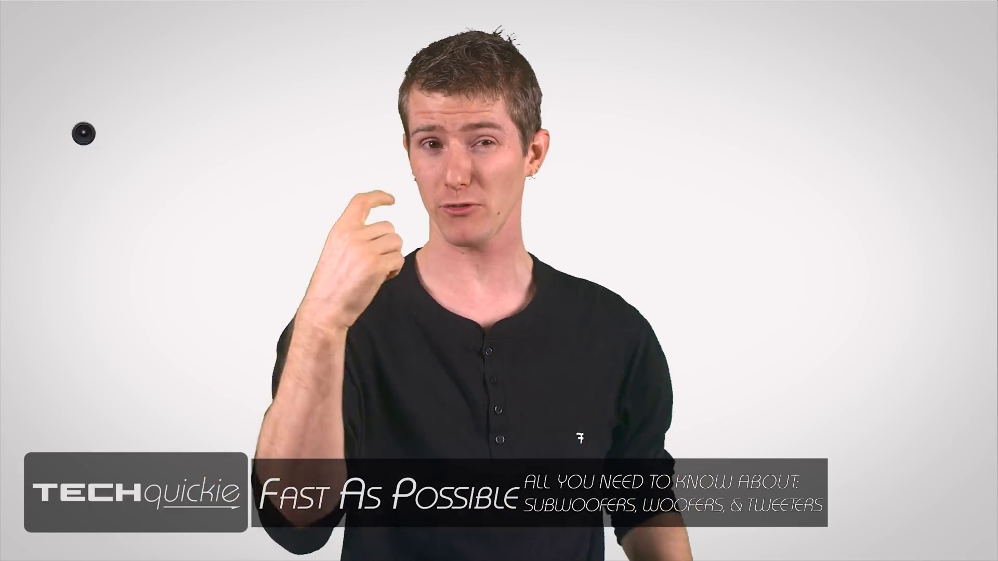 (score 90.0000)
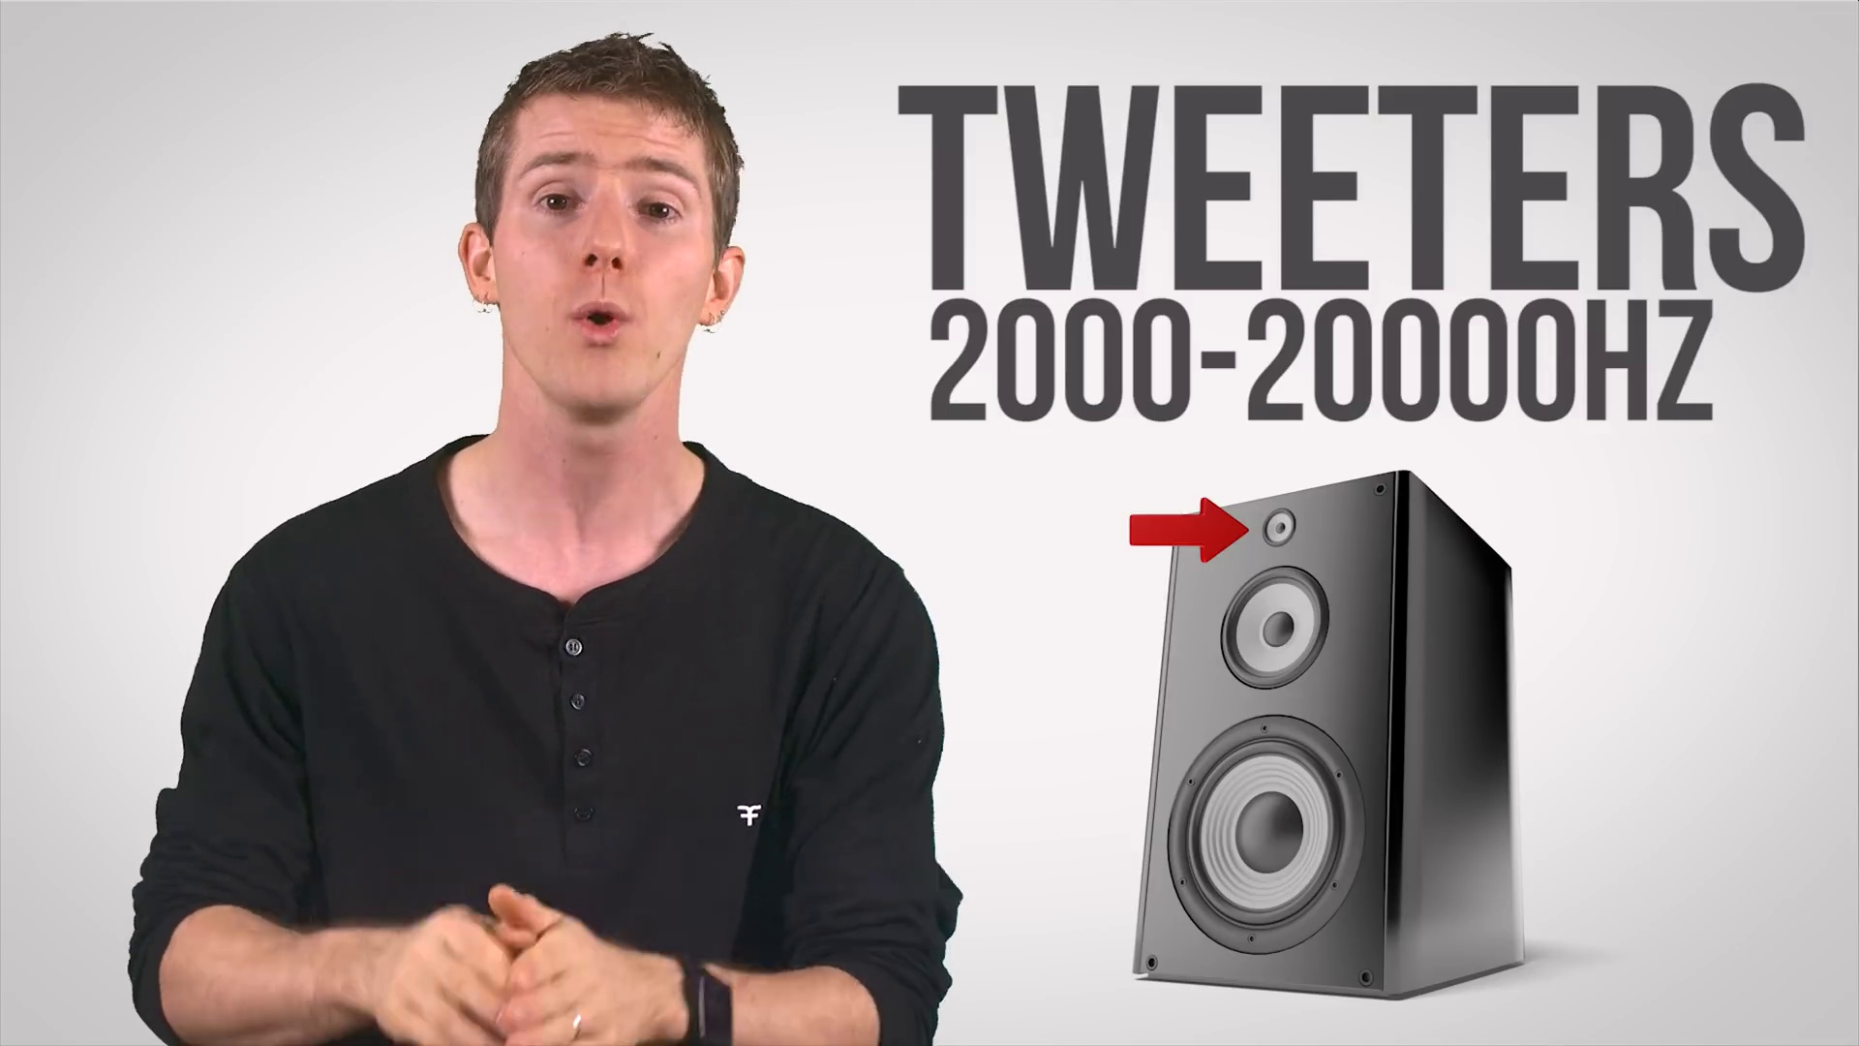 (score 85.0000)
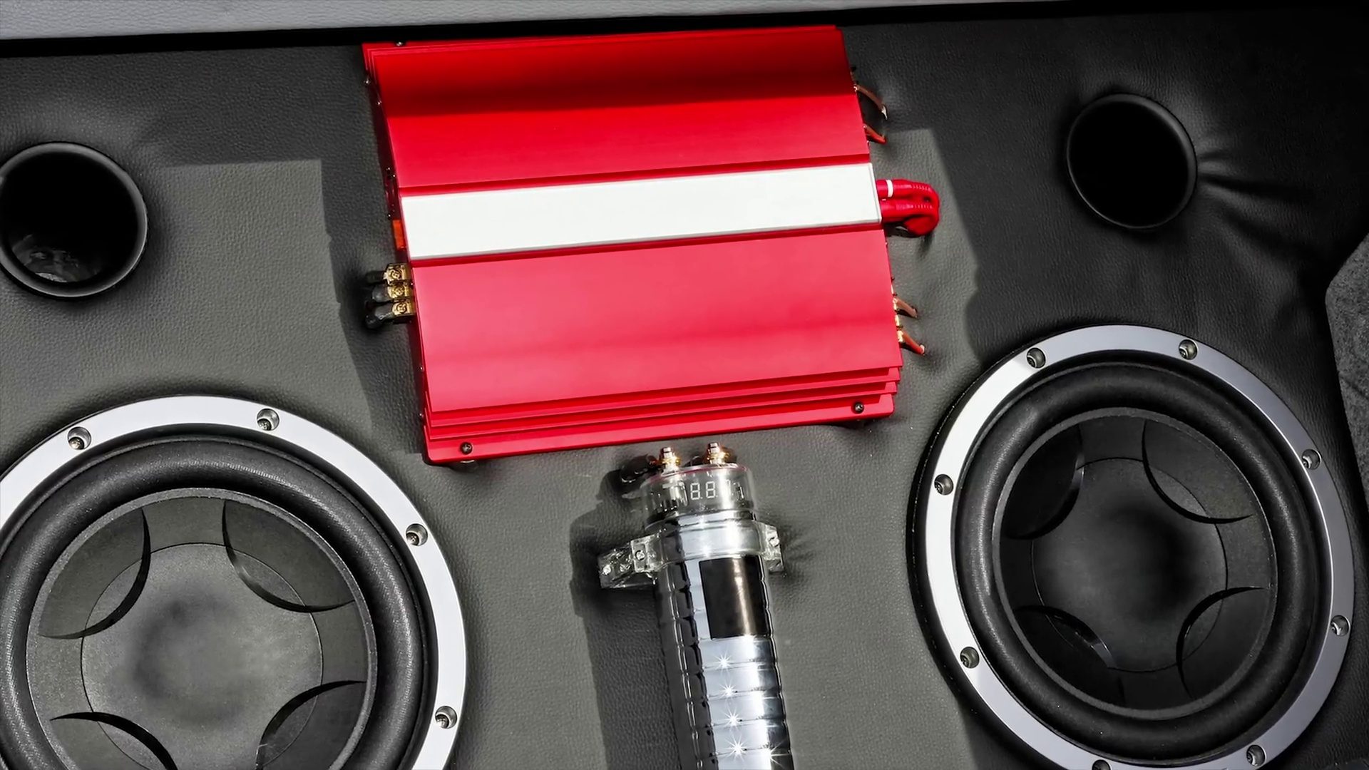 (score 80.0000)
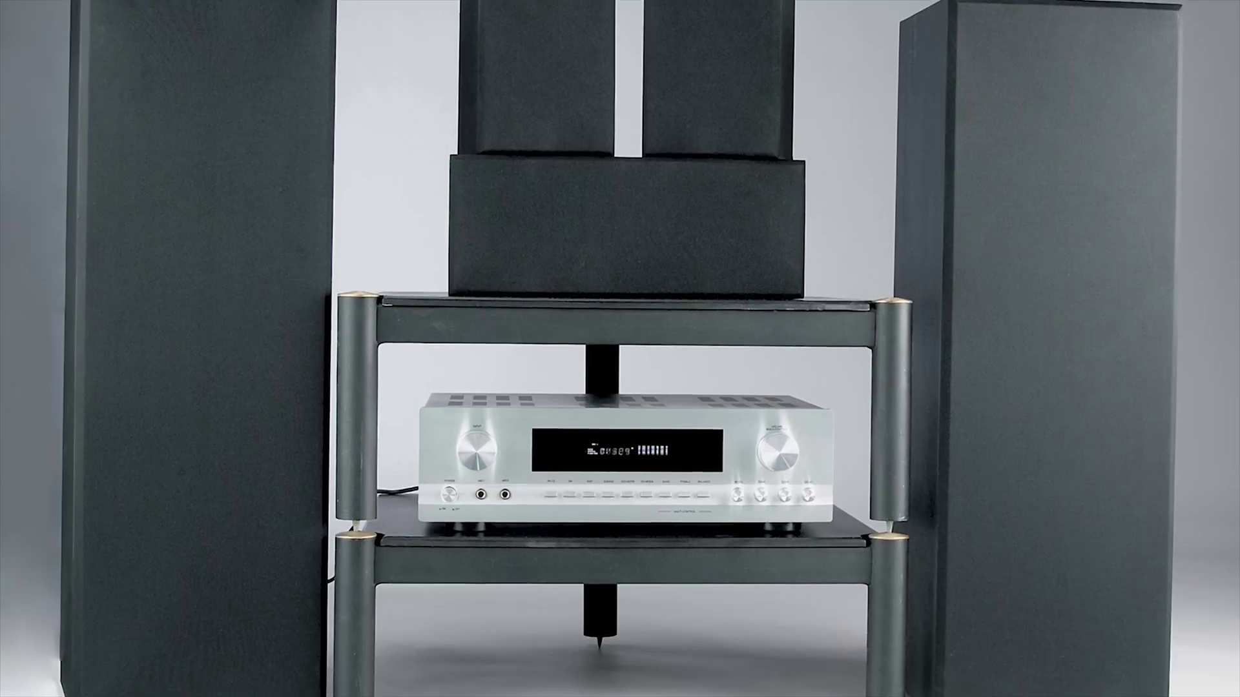 (score 80.0000)
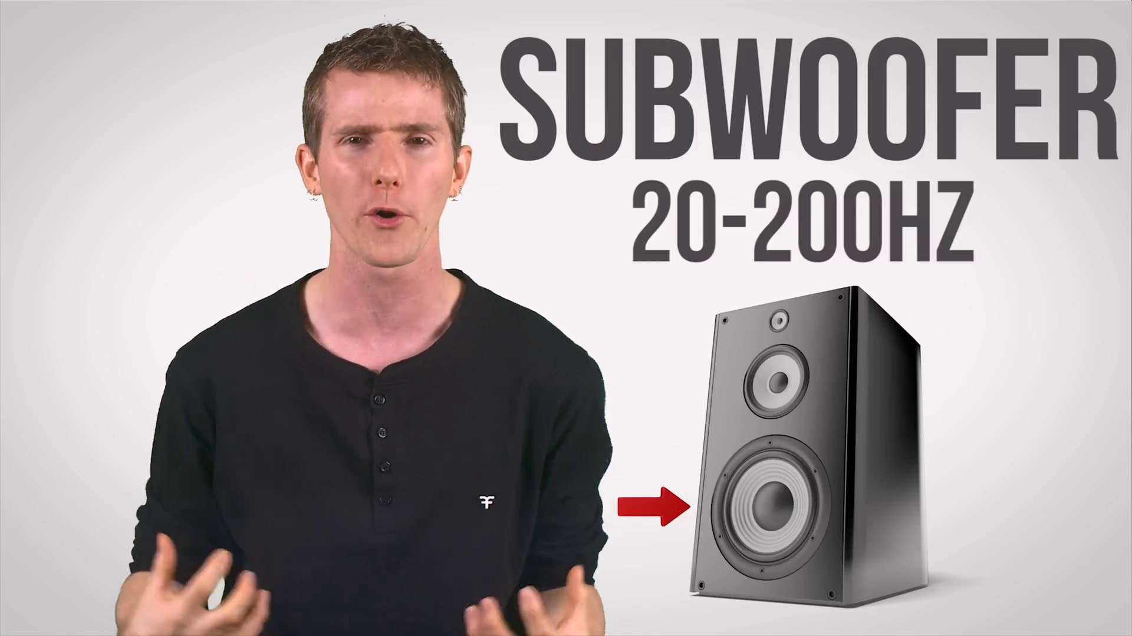 (score 80.0000)
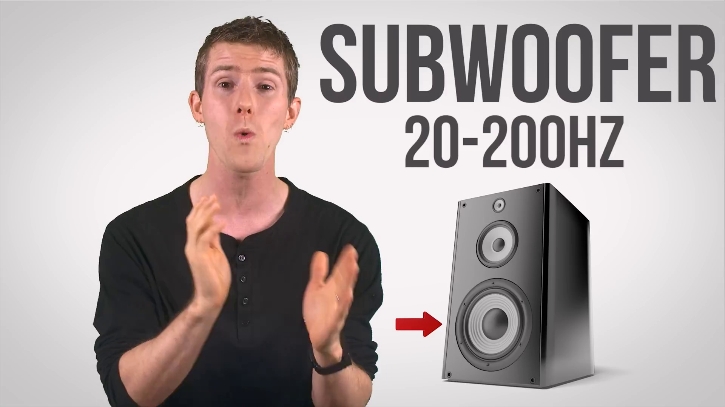 (score 80.0000)
 (score 80.0000)
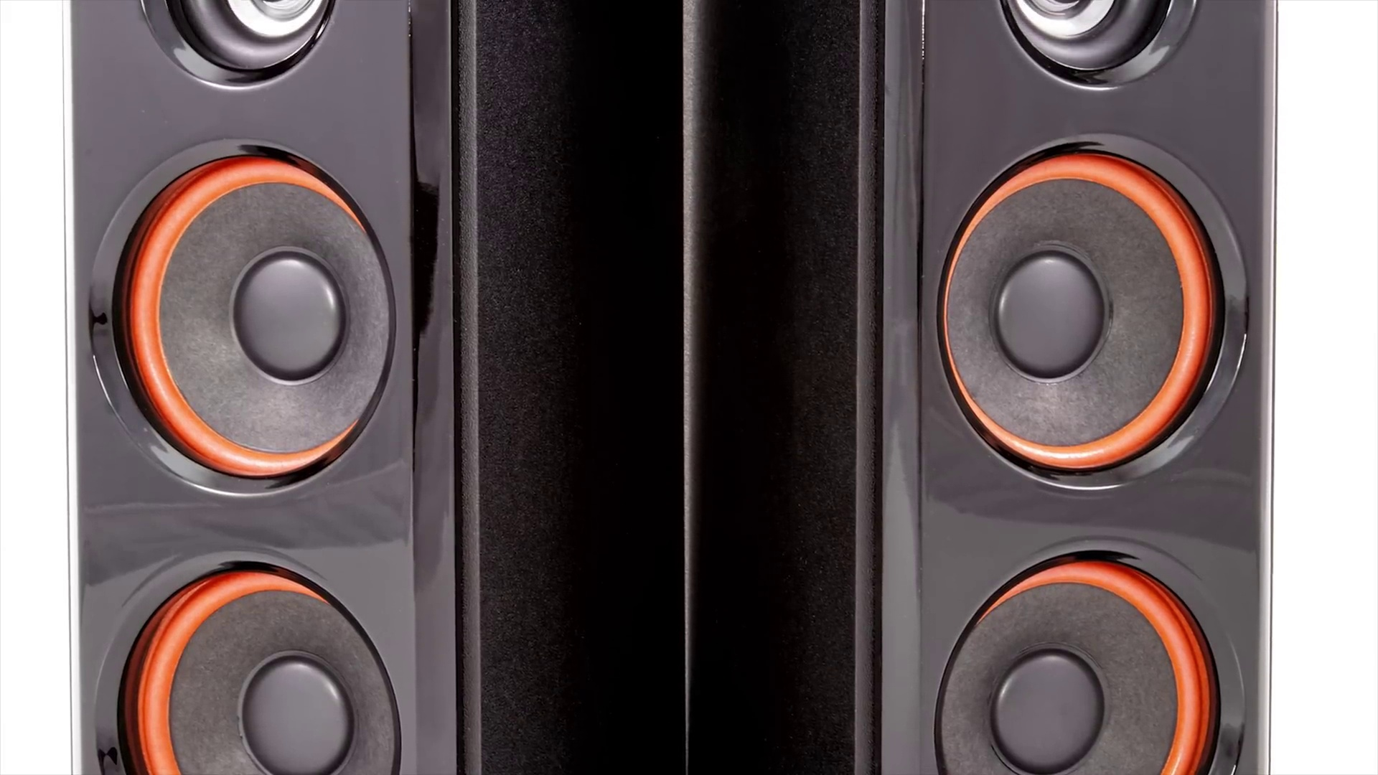 (score 80.0000)
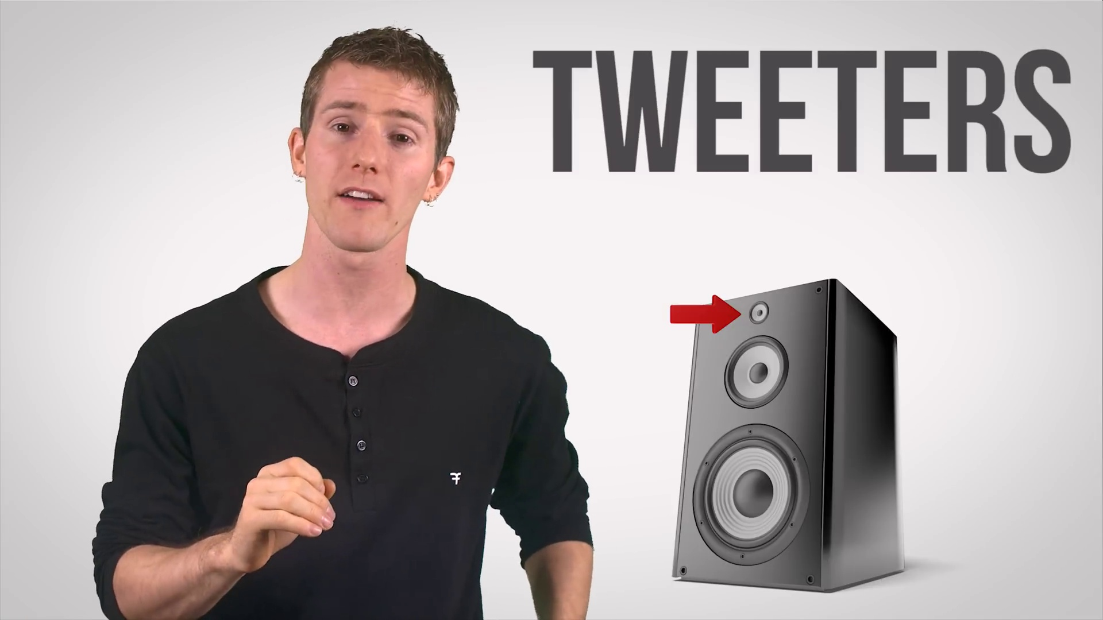 (score 80.0000)
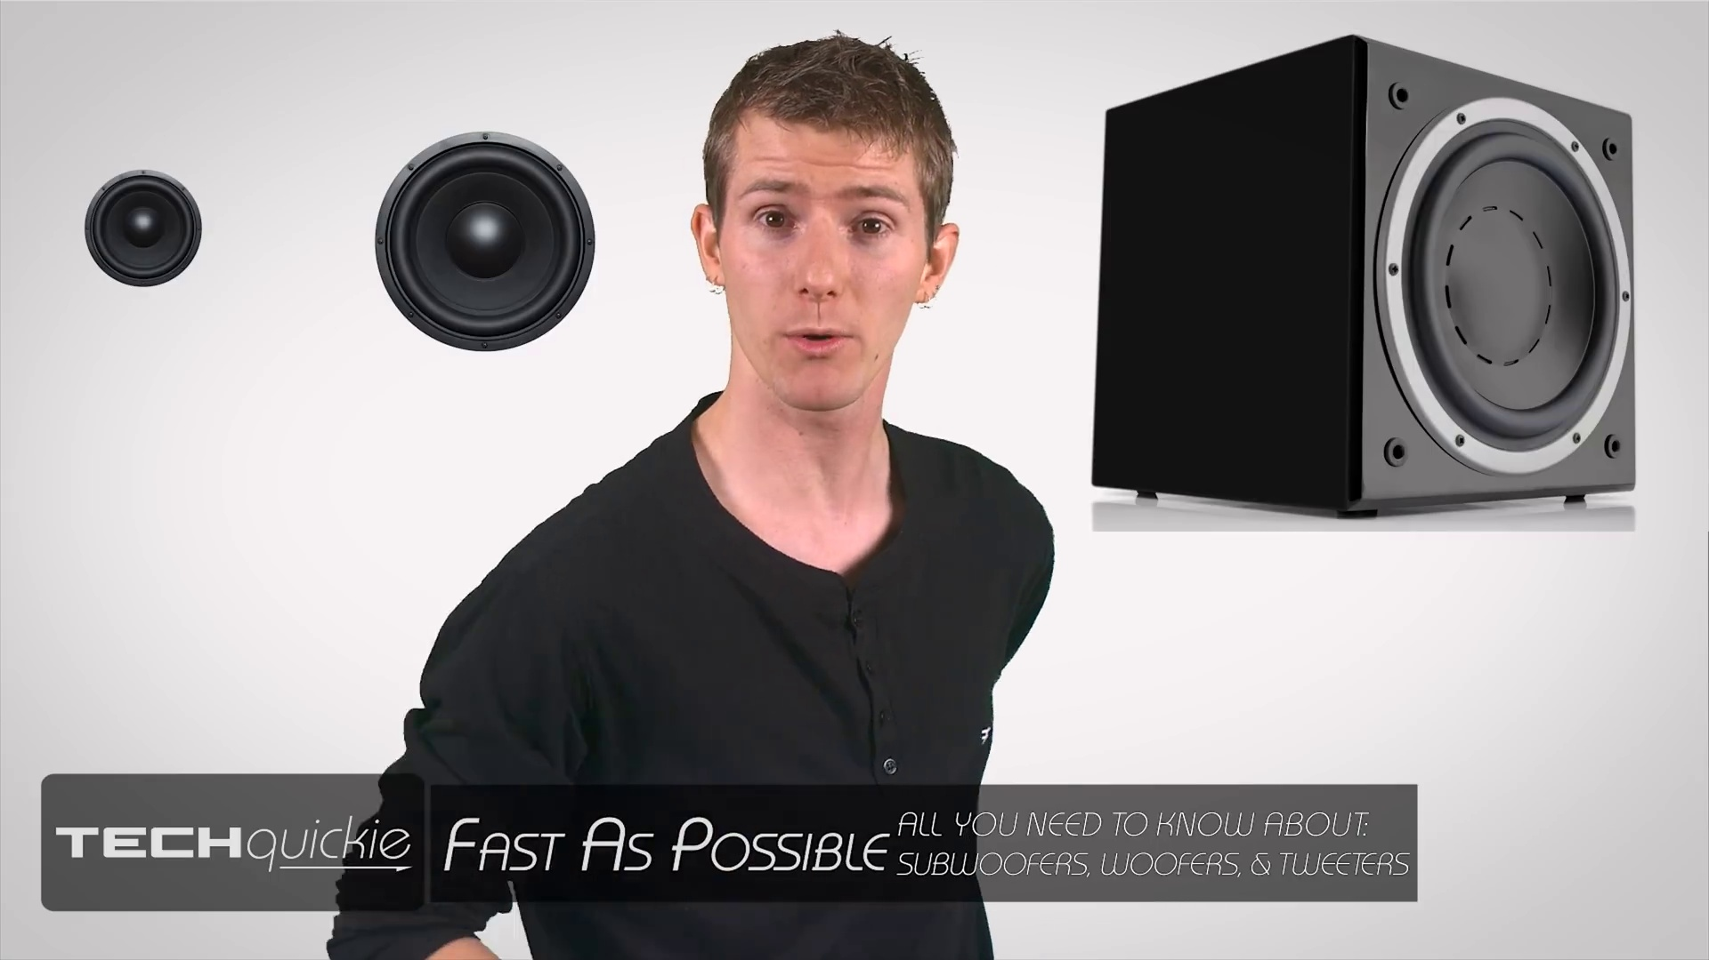 (score 80.0000)
Least correlated frames:
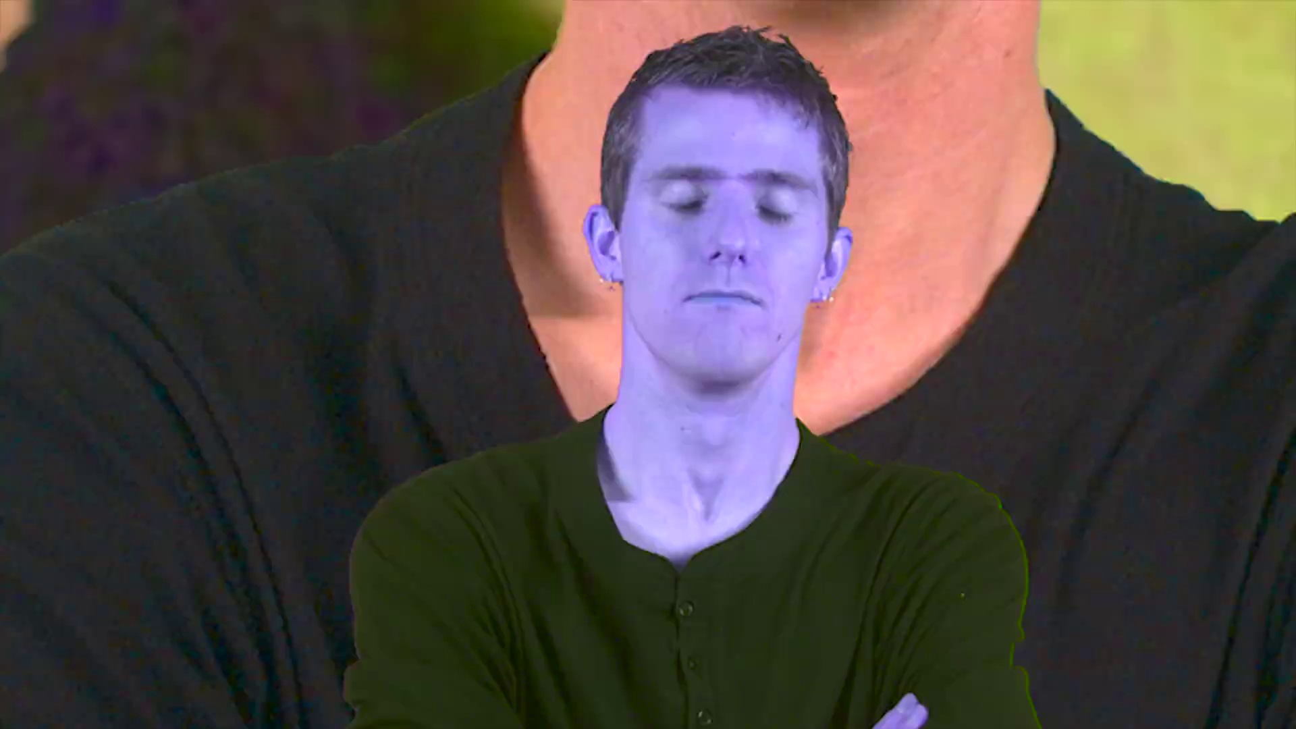 (score 0.0000)
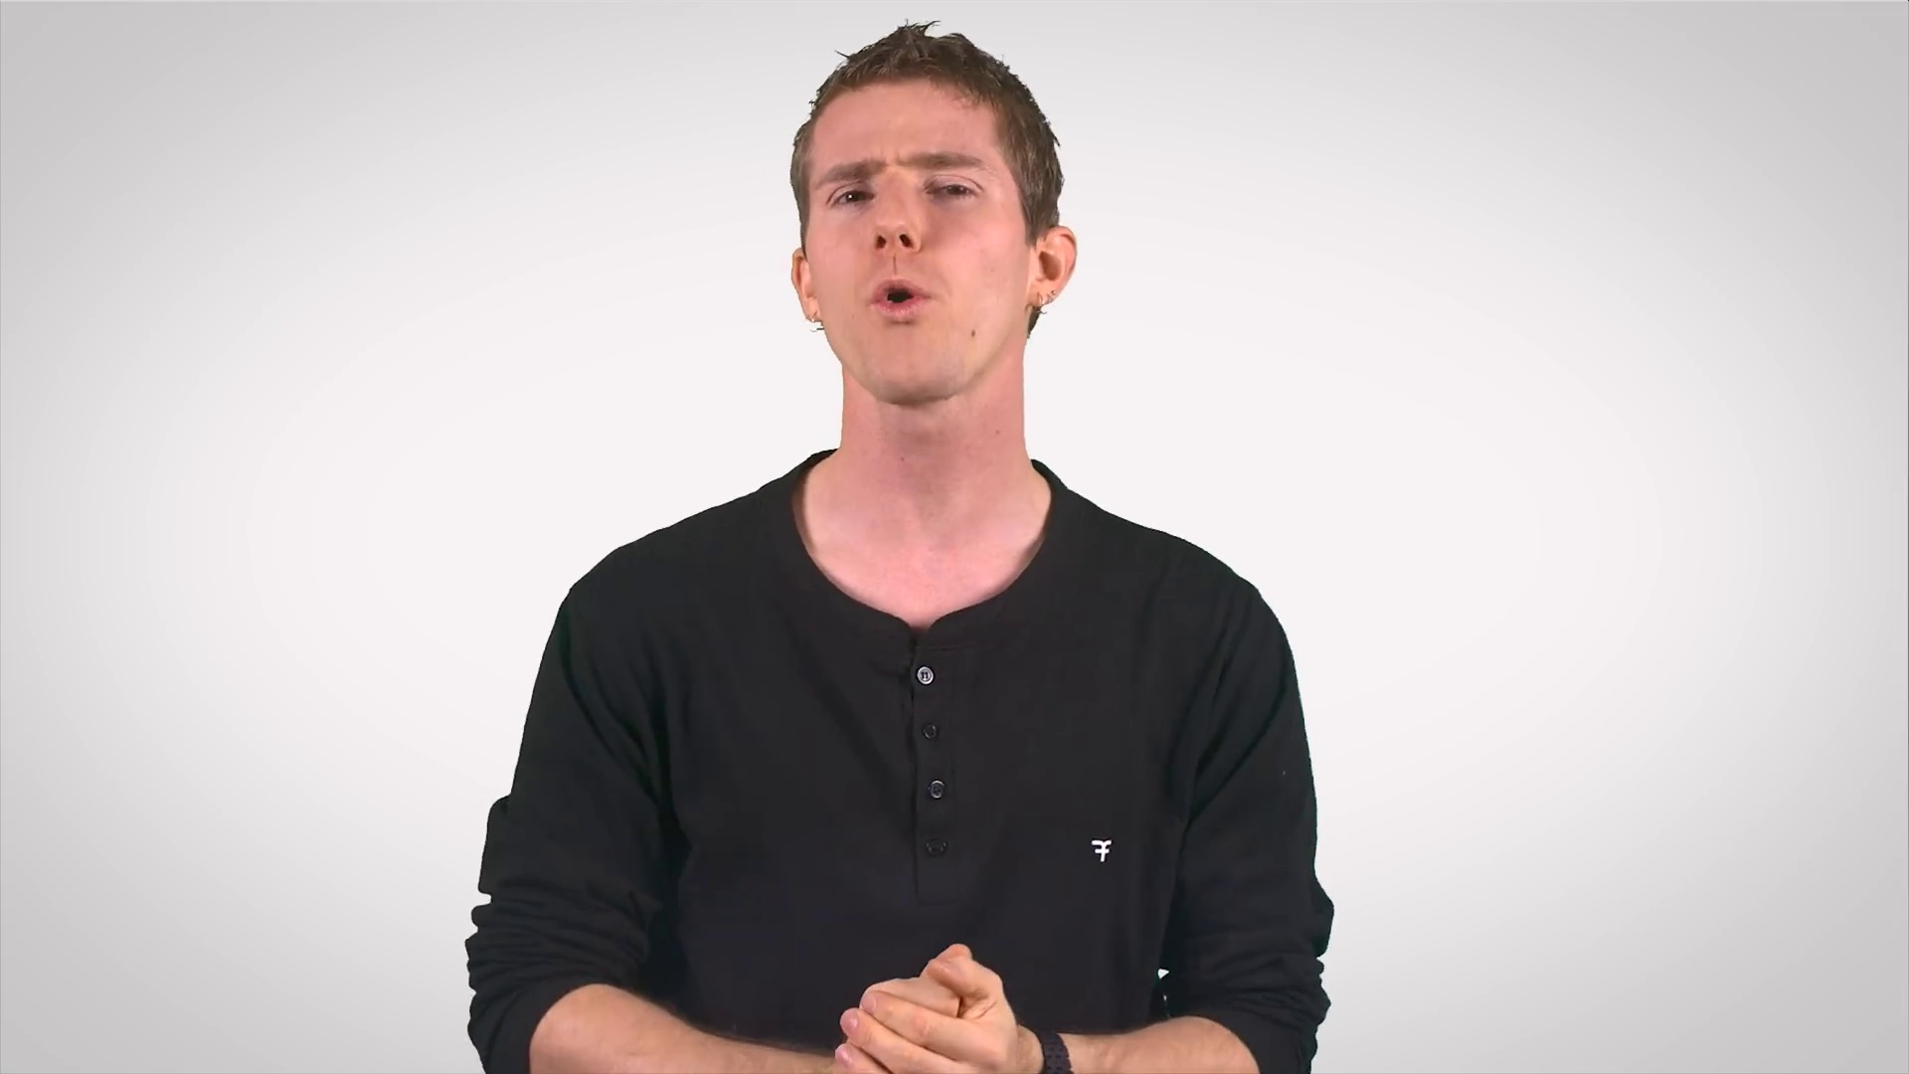 (score 0.0000)
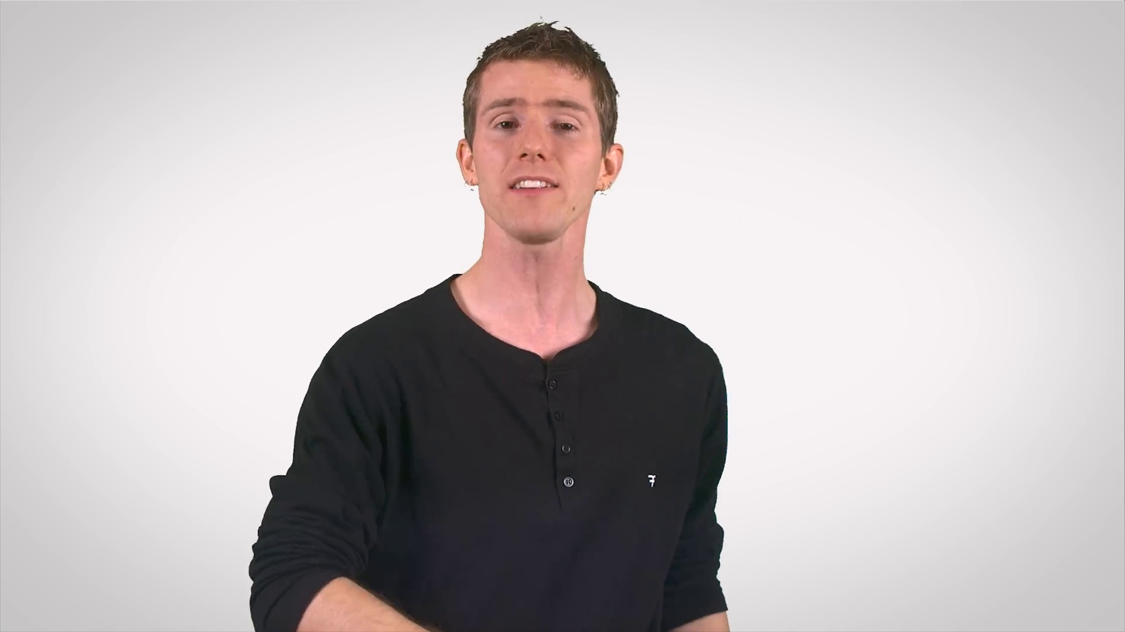 (score 0.0000)
 (score 0.0000)
 (score 0.0000)
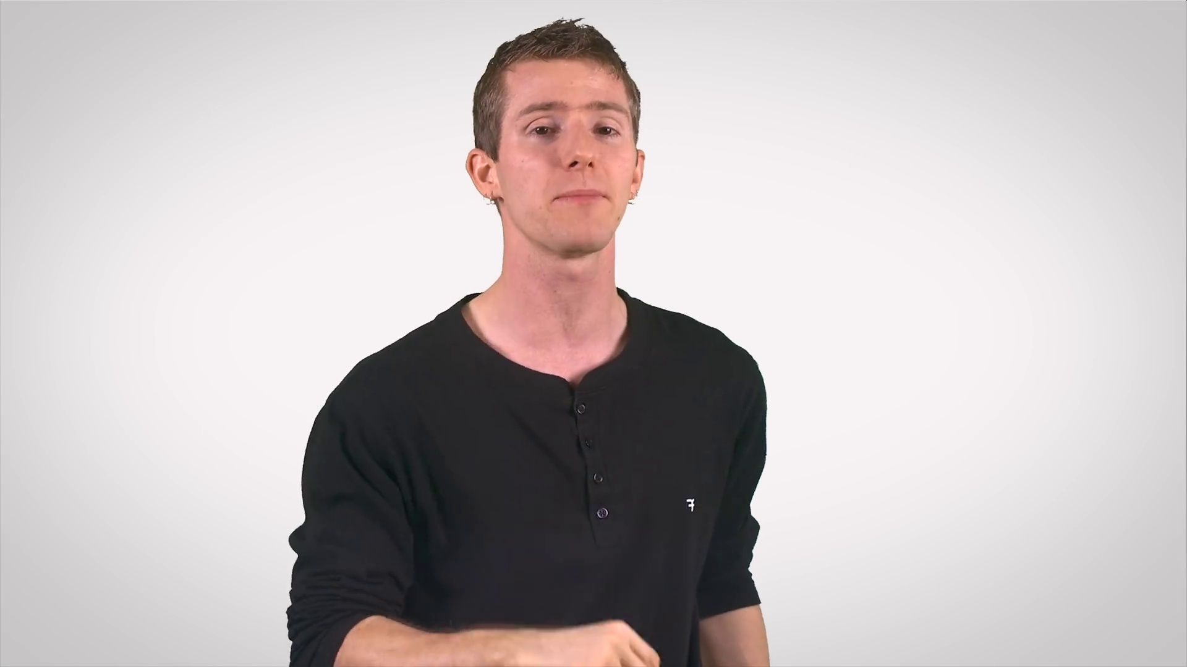 (score 0.0000)
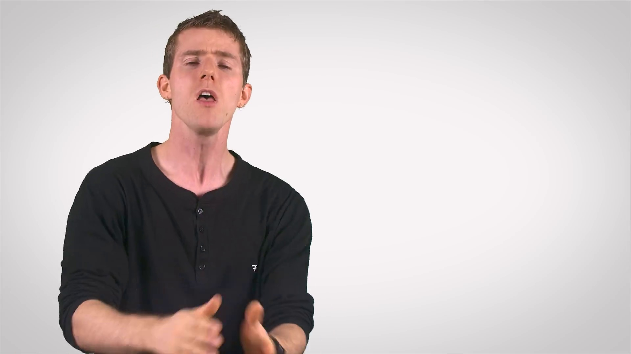 (score 0.0000)
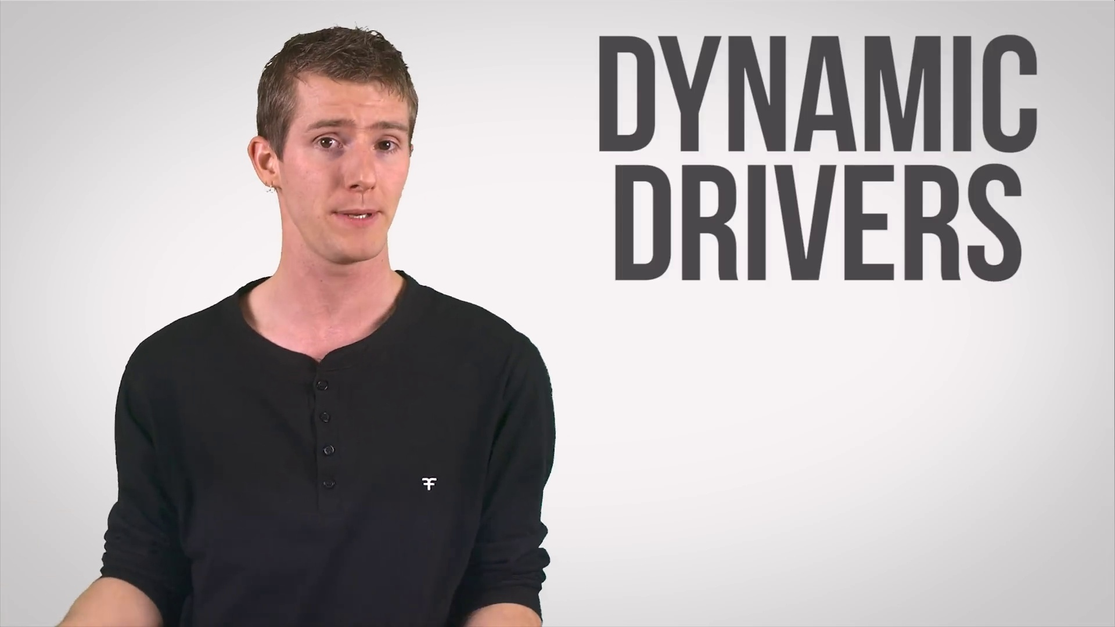 (score 0.0000)
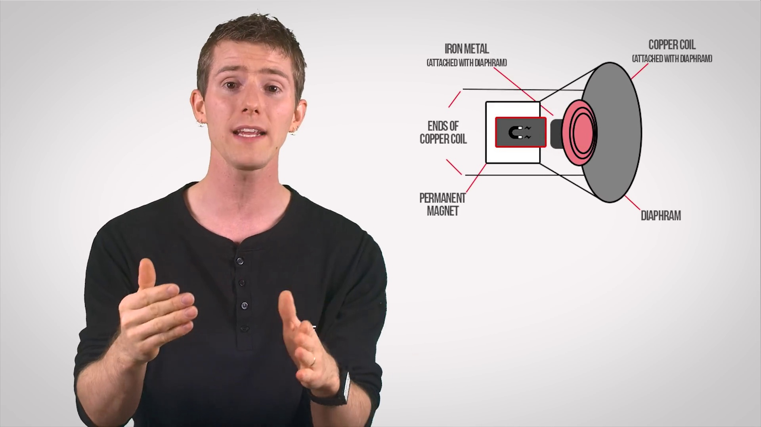 (score 0.0000)
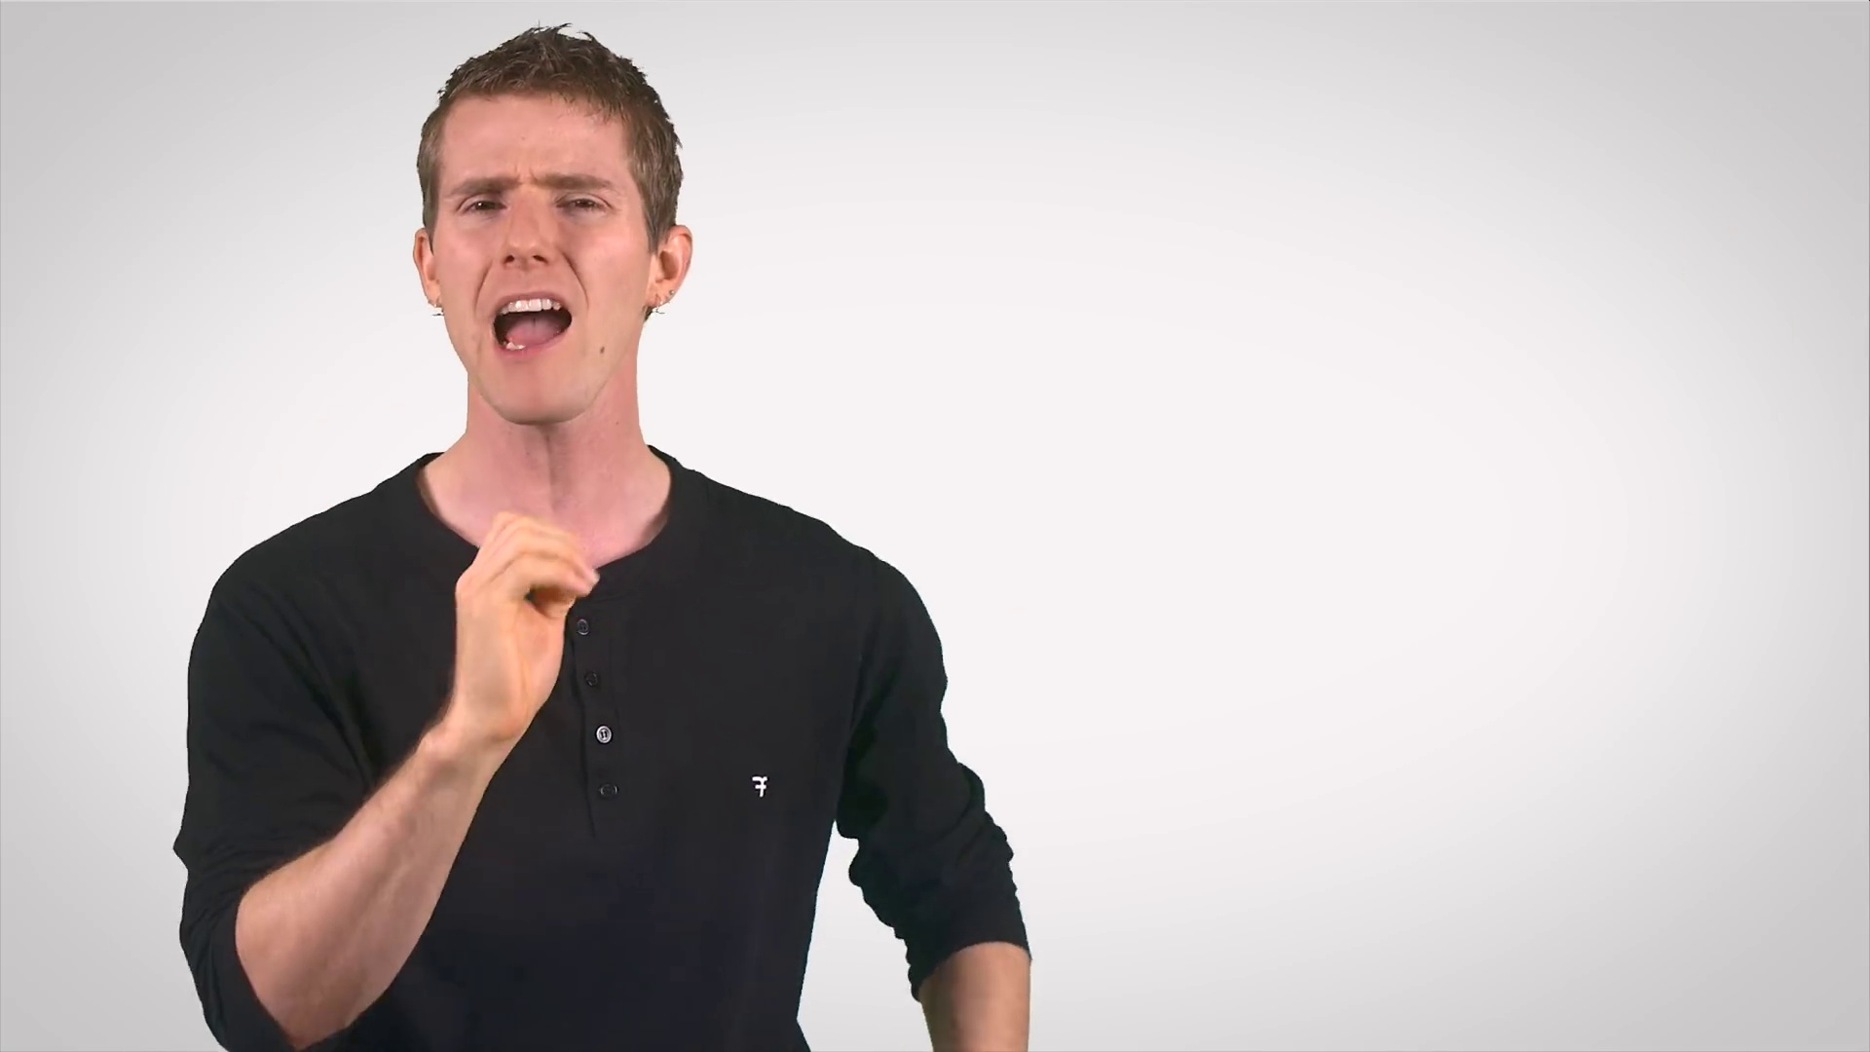 (score 0.0000)

Frame: frame_0000.jpg
Caption: The image shows a person sitting comfortably with their eyes closed and arms crossed in front of them. The individual is facing towards the left side of the frame, away from the viewer, which obscures their identity. They appear to be seated in front of a microphone and are wearing a blue shirt.
In the background, there's an image that seems to be digitally manipulated or a screenshot of a video playing. A Caucasian male with short hair and a beard is visible, wearing a dark-colored shirt with some visible text on it. He is holding up what looks like a tablet or a small screen displaying an image featuring a person with blue skin or a purple tint.
The overall style of the image suggests a casual, informal setting, possibly a workshop or a classroom where someone might be presenting or demonstrating something related to the content on the tablet or screen. The image itself is somewhat grainy and pixelated, indicative of a screenshot from a video or digital media. There are no texts that are clearly legible in this frame.
The individual in the foreground appears to be lost in thought, as their posture is relaxed with their arms at their sides, suggesting a state of calmness. The background's vibrant purple hue creates a striking visual contrast with the man's serene figure, evoking a sense of depth and intensity. This juxtaposition suggests a moment of pause and reflection, capturing the individual's inner world in this snapshot.
No strongly correlated comments found for this frame.

Frame: frame_0001.jpg
Caption: The image features a person standing against a white background, dressed in a black shirt and dark pants. The individual appears to be an important figure, conveying a serious expression while holding their arms crossed in front of their chest. To the right side of the image, the word "TECH" is prominently displayed, indicating that this is a tech-related advertisement. In a separate scene, another person is seated with a microphone set up to their right side, gesturing with their hands placed on their chest while speaking mid-sentence. They are wearing a dark top and have short, light hair. There is no visible text or diagrams within either frame that would suggest a teaching context or specific content being discussed.
No strongly correlated comments found for this frame.

Frame: frame_0002.jpg
Caption: The image shows a man sitting in front of a microphone and what appears to be a video recording setup. He is gesturing with his right hand as he speaks into the camera, his posture suggesting contemplation or deep thought. His left hand is pointing towards a circular icon on the screen behind him, which seems to be a logo or brand symbol. On the screen, there is an overlay text that reads "FAST AS POSSIBLE" in bold white letters on a black background, along with smaller text that says "TECH QUICKS." The man's casual and relaxed demeanor is emphasized by his hands resting on his hips.
To the right of the image, a bold, large font text reads "TECHQUICKIE FAST AS POSSIBLE ALL YOU NEED TO KNOW ABOUT SUBWOOFERS & TWEETERS," suggesting that the man might be discussing the benefits of subwoofers and tweeters in sound technology. The overall composition of the image places the man as the central focus, with the text serving as a guide to his discussion. The relative positions of the objects and the man suggest a casual, informal setting, possibly a personal or professional discussion about sound technology.
No strongly correlated comments found for this frame.

Frame: frame_0003.jpg
Caption: The image shows a person, presumably a man due to the clothing and hairstyle, standing in front of various audio equipment. He appears to be presenting or demonstrating something related to audio technology. In front of him is a large subwoofer speaker, which is likely the main focus of his explanation or demonstration. Above the subwoofer are two smaller speakers, possibly tweeters or satellite speakers that complement the bass produced by the subwoofer. To the left of the subwoofer, there's a smartphone displaying what seems to be an app interface, although the details on the screen are not clearly visible.
The man is looking slightly to his right, away from the camera and the viewer, with a serious expression. He is not holding any models or pointing directly at anything; instead, he seems to be in the middle of explaining something, possibly about the audio equipment or related technology.
In the background, a white sign with black text stands out, reading "TECHQUICKIE FAST AS POSSIBLE." The sign appears to be promoting a product or service related to audio equipment, suggesting that the man might be in a store or a showroom.
Comment (score 80): I learned that tweeters typically cover the 2000–20000 Hz range. I also learned that what separates each of these types of speakers is size. Sound quality can depend on whether the frequencies being supplied to a speaker are best for the size of the speaker. In addition, I saw that the bass speaker is typically held in a separate compartment to help with sound. This is overall helpful for Phase 2 because it gives me a broad understanding of how important the filters applied are to the quality of the output sound.The video says that a bass speaker usually has a separate power source. Is that necessary for our project?
Reason: The comment directly discusses the technical steps and objects described in the caption, such as tweeters, satellite speakers, and bass speakers. It also mentions the importance of filters applied to the quality of output sound, which is consistent with the goal of the man's presentation or demonstration.
Source: https://www.youtube.com/watch?v=jhvXWpRmhvM: Subwoofers, Woofers, and Tweeters as Fast As Possible

Frame: frame_0004.jpg
Caption: The image appears to be a screenshot of a video thumbnail featuring a man who is likely the main subject or presenter for the content being advertised or referenced. He has short hair and is wearing a dark shirt with a collar, as well as black pants. His expression is one of surprise or disbelief, as indicated by his mouth open slightly and his eyes directed to the side, away from the camera. The man's face is also turned towards the camera, adding to the intensity of his expression.
In the background, there appears to be a screen displaying what looks like a video or slide show. The visible content on the screen includes partial text that reads "...", which may indicate that the full text is not displayed in this image. Additionally, there are two graphic elements on the screen: one resembling an electrical circuit diagram and the other showing a human brain with various labeled areas. These graphics could be related to a discussion about technology, cognition, or a specific educational topic.
The overall impression of the image is promotional, designed to capture attention for a video or presentation that likely delves into the subject matter suggested by the content on the screen behind the man. The man's attire and facial expression suggest a serious or intense moment captured in time, adding to the overall sense of surprise and curiosity.
No strongly correlated comments found for this frame.

Frame: frame_0005.jpg
Caption: This image appears to be a screenshot from a video, possibly educational in nature, given the presence of text and graphics overlaying the main subject. The central figure is a person who seems to be speaking or gesturing with their hands. This individual is wearing a black t-shirt and has short brown hair. Above the person's head are two graphical elements: on the left side is a microphone icon, suggesting audio or sound production is part of what's being discussed; on the right side is a stop sign with an arrow through it, typically used to indicate a prohibition or pause action in a video or presentation context.
The person is set against a plain white background with a light source from the top left corner, casting a soft shadow underneath them. The lighting and composition give the impression that this is a professional setting, such as an online class or tutorial. There are various elements on the screen:
1. A white slide with text in black at the top right corner. The text is too small to read clearly, but it seems to be part of a presentation or lecture.
2. Graphic icons representing an ear and a brain connected by a neural synapse graphic, which could imply a discussion about sound processing, cognition, or communication.
3. A red bar with the number "1" on it, located at the bottom right corner of the screen, which might be used to indicate step number 1 in a series or process being taught or demonstrated.
The person's hands are positioned as if they are holding something small and invisible, but no object is visible within the image. There are no visible labels or logos indicating brand names or products. The overall style of the image suggests a blend of real-world photography with graphic design elements to enhance the educational content being delivered.
No strongly correlated comments found for this frame.

Frame: frame_0006.jpg
Caption: The image depicts a person giving a presentation or speaking to an audience. The individual appears to be male, wearing a dark-colored long-sleeve shirt with a white collar, and has short hair. He is seated in front of a microphone, suggesting that he might be conducting a lecture or interview. His posture is relaxed with one hand resting on his lap while the other is raised slightly towards the camera.
He exhibits intense concentration, with his gaze directed upwards as if staring at something out of frame. His facial expression conveys a sense of focus and determination. His hands are clasped together in front of his chest, emphasizing his engaged state.
The background features a plain white wall, which serves to highlight the person in the foreground and draw attention to him. The lighting in the room appears artificial and evenly distributed, without creating harsh shadows on the presenter. The overall composition of the image suggests a sense of focus and determination, consistent with a typical video still from an online lecture or interview, possibly used for promotional purposes or as part of an educational platform.
No strongly correlated comments found for this frame.

Frame: frame_0007.jpg
Caption: The image shows a person giving a presentation on a television screen. The individual, dressed in a casual black t-shirt and jeans, appears to be speaking and gesturing with their right hand, which is making a pointing gesture towards the content on the screen. They are standing in front of a digital display that showcases various data visualizations.
The screen behind the presenter displays a collection of charts and graphs, including:
1. A horizontal bar chart at the top of the screen, showing a series of peaks and valleys likely representing statistical or financial data.
2. A graphic interface resembling a digital dashboard in the center of the screen, possibly displaying real-time data or monitoring systems. The graphics display various metrics over time, with each line showing fluctuations similar to those in the bar chart above.
3. A vertical line graph on the right side of the screen, tracking what appears to be a numerical value over time, following a pattern that mirrors the data shown on the left side of the screen.
4. Two horizontal bar charts below this line graph, which seem to be related to each other and have similar structures and patterns to those seen in the top bar chart.
5. A vertical bar chart at the bottom of the screen with numerical values on the right side, which is also reminiscent of the data presented elsewhere.
The overall style of the image suggests it might be from a video conference or online seminar related to financial markets or analytics, given the context of the charts and graphs shown. The individual seems to be explaining or interpreting this data to an audience.
No strongly correlated comments found for this frame.

Frame: frame_0008.jpg
Caption: The image depicts a young man standing in front of a wall of sound, filled with various sound waves of different colors and intensities. He is in a state of concentration, possibly trying to decipher the complex patterns of the sound data. His right hand is placed on his chin, and his left hand is raised, as if he is pointing or gesturing towards the wall of sound.
In front of him, there is an oscilloscope displaying various waveforms, which appears to be connected to audio equipment. The man seems to be giving a lecture or demonstration, as he is gesturing with his hands and possibly explaining the concepts related to the equipment.
Behind the man, a large screen displays a graph that resembles a stock market chart, featuring different line graphs and numerical values indicating fluctuations and trends over time. Annotations on the screen include "Volume," "Open," "High," "Low," and "Close," which are common terms used in stock market analysis to describe trading volume, opening and closing prices, and highs and lows during the trading day.
The overall setting suggests that the man is discussing topics related to finance, economics, or possibly the technology behind financial data analysis. He appears to be engaging with an audience through his body language and speech, although we cannot hear what he is saying. The image does not contain any text or additional details about the content of the lecture.
No strongly correlated comments found for this frame.

Frame: frame_0009.jpg
Caption: The image shows a young man standing with his hands outstretched, as if he is gesturing during speech. He is dressed in a black shirt and has short hair. The background is plain and light-colored, which contrasts with the subject, making him stand out clearly. His face is a canvas of emotion, conveying a sense of passion and engagement. His eyes are wide and expressive, locked onto the camera as if speaking directly to the audience. He appears to be in the middle of giving a presentation or responding to an audience member's question, with his expression suggesting that he might be explaining a concept or answering a query. There is no text or graphical content visible on any screen or slide in this image, allowing the viewer to focus on the subject's facial expressions and body language as he connects with his audience.
No strongly correlated comments found for this frame.

Frame: frame_0010.jpg
Caption: The image shows a man seated in front of a plain background, possibly indicating he's being interviewed or providing a video tutorial. He appears to be deep in thought, with his face turned towards the camera and his gaze focused intently on something beyond the frame. His left hand is raised, fingers splayed as if he's gesturing towards something out of frame, while his right hand is held in a clenched fist, suggesting the gravity of his thoughts.
He is dressed in a black t-shirt, which provides a striking contrast to the monochrome background. The focus is on the upper body as he talks or thinks, with no visible devices, slides, diagrams, or text that can be confidently described. His posture and expression convey deep concentration, as if he's navigating complex thoughts and ideas. Despite being the sole character in this scene, his actions and expressions draw the viewer's attention directly to him, allowing for a fully immersive experience.
No strongly correlated comments found for this frame.

Frame: frame_0011.jpg
Caption: The image shows a man standing in front of a stark white background, which provides a striking contrast with his dark-colored long-sleeved shirt. He appears to be giving some kind of presentation or interview, as suggested by the blurred text in the foreground that includes a word "teaching." The man is facing forward with his head turned slightly to the left while looking towards something out of frame. His expression is neutral, and he is not directly engaging with any visual elements in the foreground; instead, his focus seems to be on delivering or discussing information that is not visible in this frame. The man's hair is neatly combed, and he has a slight smile on his face as he makes direct eye contact with the camera.
No strongly correlated comments found for this frame.

Frame: frame_0012.jpg
Caption: The image shows a person standing against a white background, dressed casually in a dark top without any visible text or logos. They appear to be engaged in a presentation or lecture, as they are gesturing with their left hand, which seems to be holding a pen. Their facial expression is one of concentration and engagement, suggesting that they are either explaining something or responding to an audience's question. The person's hands are in contrast: the left hand is raised in the air, fingers spread wide, possibly indicating surprise or shock, while the right hand is folded in their lap, creating a subtle sense of calm.
The screen behind them displays what looks like a slide from a presentation, but the content of the slide is not clearly legible due to the angle and resolution of the image. The style of the image appears to be a still from a video, possibly taken during an online class or seminar. The background remains white, emphasizing the person's expressive gesture and facial expression. There are no other objects or texts visible in the frame that provide additional context about the content being discussed or the identity of the person.
Overall, the image is a powerful representation of human emotion and expression, capturing a moment of animation and engagement from the subject. The setting appears to be informal, possibly public, but further details remain unclear.
No strongly correlated comments found for this frame.

Frame: frame_0013.jpg
Caption: The image shows a young man with an expression of discomfort or distress. He has a fair complexion and is covered in numerous red bumps, which appear to be pimples or acne, along with small white pimples that punctuate his skin. His dark brown hair is neatly combed back, framing his face. His gaze is directed downwards, with a slight frown on his lips. The man appears to be indoors with ambient lighting, as suggested by the diffused shadows around him. He's dressed casually in a gray t-shirt, a comfortable choice for a day out. The image captures a moment of emotion rather than a staged pose, giving it a candid and unposed feel.
No strongly correlated comments found for this frame.

Frame: frame_0014.jpg
Caption: The image features a close-up of an individual, either male or female, appearing to be in their late teens to early twenties. The person is looking directly at the camera with a neutral expression. Their skin has some acne, and they are wearing short hair that is styled upwards. On the face, there are numerous red spots, each unique in size and shape, scattered across the forehead, cheeks, and chin, creating a patchwork of redness that contrasts with the person's otherwise unblemished skin.
The red spots do not appear to be related to any educational or instructional context, as there are no visible devices, slides, diagrams, or other materials in the image. The overall tone of the scene is one of calmness and stillness, despite the apparent discomfort caused by the red spots. The person's neutral expression and closed eyes contribute to this sense of serenity, while their short hair adds a hint of structure to their facial features.
The stark white background provides a clean and minimalist setting for the image, allowing the viewer's attention to focus on the individual's face and the contrasting colors of their skin and red spots. Overall, the image captures a moment of quiet contemplation, inviting the viewer to examine the subtleties of human expression and the unexpected juxtapositions that can arise in life.
No strongly correlated comments found for this frame.

Frame: frame_0015.jpg
Caption: The image shows a person, likely a male individual given the context of MiniCPM's description, standing against a white background. He is dressed in a black shirt featuring a white logo on the left chest. His left hand is raised in a "V" sign, while his right hand is raised in the air, both fingers spread wide. This suggests a casual and candid moment, possibly indicating engagement in a casual conversation or presentation.
The person's mouth is slightly open, suggesting he might be making a statement or expressing a thought. His gaze is directed towards the camera, indicating a direct interaction or conversation with the viewer. The image quality suggests it might have been taken from a video recording, possibly from a live stream or a recorded interview, as indicated by the watermark in the bottom right corner with "GOTHAM" written on it.
There are no visible texts, diagrams, or any other objects that provide additional context about the presentation topic. The speaker is not actively pointing to anything specific or gesturing with a model, so the focus of their delivery is not apparent from this frame alone.
No strongly correlated comments found for this frame.

Frame: frame_0016.jpg
Caption: The image features a middle-aged individual standing against a plain light gray background, wearing a black V-neck top underneath another darker top with an emblem or logo on it. The person has short hair and is facing the camera, looking slightly to their left. Their posture suggests they are in a state of concentration or contemplation. Notably, there is no visible text, graph, or model in the image, nor does it appear that they are engaged in any specific activity. The individual's attire, particularly the darker top with an emblem, and the clean professional backdrop suggest a potential connection to technology or software development, possibly intended for promotional or informational purposes. The overall image presents a candid quality, characterized by simplicity and focus, as evidenced by the man's glasses and thoughtful expression.
No strongly correlated comments found for this frame.

Frame: frame_0017.jpg
Caption: The image shows two distinct scenes: a person giving a presentation or lecture on one side, and a young man contemplating on the other. The speaker is standing in front of a microphone, addressing an audience with hand gestures that suggest they might be explaining something or emphasizing a point. Behind them, a white screen serves as a projection surface for a presentation or slides, but there's no visible content, making it impossible to determine the specific topic being discussed.
On the opposite side of the frame, a young man stands against a stark white background, wearing a dark black shirt and facing forward with his hands resting on his hips. His eyes are closed, creating a serene and introspective atmosphere. The simplicity of the background and his attire suggests a calm and tranquil setting, with no other objects or people in the image making him the sole focus.
The overall quality of the image suggests it might be from an online webinar or video recording, given the presence of a microphone and a projector setup. However, no additional context about the event or the nature of the presentation can be confidently inferred from this frame alone.
No strongly correlated comments found for this frame.

Frame: frame_0018.jpg
Caption: The image depicts a split-screen setup with two distinct halves. On the left side, an individual is standing in front of a speaker set that includes at least one woofer and a subwoofer. The person appears to be giving a presentation or tutorial, pointing towards the speaker set with their right hand, possibly explaining how tweeters are used within the audio system.
On the right side of the image, there is a slide or graphic labeled "TWEETERS." This graphic seems to provide information related to Twitter and its functionality for music promotion. The illustration on the slide features a speaker with a label that says "TWEETERS," reinforcing the connection between tweeting and promoting audio content. The overall style of the image suggests it might be from a video tutorial or presentation slide intended to teach about music promotion strategies on social media platforms, potentially in conjunction with an explanation of tweeters' role in audio systems.
In this setup, a young man is standing in front of a gray speaker labeled "TWEETERS." He is dressed in a black shirt and pointing to the speaker with his left hand. The speaker is positioned to the right of the man, with its top facing upwards, and is situated against a plain white background featuring a red arrow pointing to the right, which is the direction of the speaker.
Comment (score 80): I learned that tweeters typically cover the 2000–20000 Hz range. I also learned that what separates each of these types of speakers is size. Sound quality can depend on whether the frequencies being supplied to a speaker are best for the size of the speaker. In addition, I saw that the bass speaker is typically held in a separate compartment to help with sound. This is overall helpful for Phase 2 because it gives me a broad understanding of how important the filters applied are to the quality of the output sound.The video says that a bass speaker usually has a separate power source. Is that necessary for our project?
Reason: The comment directly discusses the technical aspects of tweeters and speakers, specifically their frequency range, size, and compartmentalization, which are all mentioned in the caption. The connection is strong as the comment provides specific details about speaker characteristics that align with the image's representation.
Source: https://www.youtube.com/watch?v=jhvXWpRmhvM: Subwoofers, Woofers, and Tweeters as Fast As Possible

Frame: frame_0019.jpg
Caption: The image displays a split-screen composition with two separate panels. On the left side of the frame, there is a person standing in front of a microphone and wearing a dark shirt with a white label on it. The person appears to be a Caucasian male with short hair, facing towards the right, away from the camera, speaking into the microphone.
On the right side of the frame, there is an image of a speaker next to a text that reads "TWEETERS 2000-20000Hz", which suggests that the speaker is capable of producing sound within a range of 2000 to 20000 Hertz. This frequency range is typically associated with high-end audio equipment. The panel also includes a diagram with the text "500 Hz" pointing to a specific range on the frequency spectrum depicted in the diagram.
The style of the image suggests that it is likely a screenshot from a video, possibly educational content related to audio frequencies or technology. The person seems to be providing commentary or explanation for the content shown on the right side of the frame.
Comment (score 85): I learned that tweeters typically cover the 2000–20000 Hz range. I also learned that what separates each of these types of speakers is size. Sound quality can depend on whether the frequencies being supplied to a speaker are best for the size of the speaker. In addition, I saw that the bass speaker is typically held in a separate compartment to help with sound. This is overall helpful for Phase 2 because it gives me a broad understanding of how important the filters applied are to the quality of the output sound.The video says that a bass speaker usually has a separate power source. Is that necessary for our project?
Reason: The comment directly discusses the technical steps and objects described in the caption, such as tweeters covering a specific frequency range, speaker sizes affecting sound quality, and bass speakers having separate power sources. The only slightly unrelated part is the mention of Phase 2, but the rest of the comment strongly relates to the frame caption.
Source: https://www.youtube.com/watch?v=jhvXWpRmhvM: Subwoofers, Woofers, and Tweeters as Fast As Possible

Frame: frame_0020.jpg
Caption: The image shows a person, dressed in a dark-colored t-shirt, standing or sitting in front of a plain white background. The subject appears to be engaged and looks directly at the camera, giving a sense of directness and engagement. A bold black text overlay reads "2000Hz," which suggests a focus on radio frequencies, specifically 2000 kHz, often associated with FM radio broadcasts. Additionally, there is another text element that displays "1000kHz," which indicates 10^3 times per second, further emphasizing the focus on radio frequencies. The simplicity of the image, with its single subject and minimal text, allows the viewer to focus on the person and the frequency-related information presented.
No strongly correlated comments found for this frame.

Frame: frame_0021.jpg
Caption: The image depicts a person, likely a young male with short dark hair, wearing a casual black shirt and jeans. He is standing against a white background, his serious expression focused directly at the viewer. The man's body is positioned in a way that draws attention to him, with his gaze directed straight at the camera.
Prominently displayed behind the man is text that reads "DYNAMIC DRIVERS" in bold, capitalized letters. This title serves as an accompanying element to the image, drawing attention to its subject. The simplicity of the white background and the stark contrast between the man's attire and the dark title further emphasize the man's presence in the image.
The style of the image is reminiscent of a video still or a screen capture from a presentation or video content, focusing on the person delivering information rather than on the content or subject matter being discussed.
No strongly correlated comments found for this frame.

Frame: frame_0022.jpg
Caption: The image presents a split-screen photo collage featuring two different scenes. On the left side of the image is a person standing in front of a white background, wearing a black shirt, and giving a presentation or instruction. This individual is holding a glass and pointing at it, which seems to suggest some form of teaching about wine, specifically in relation to taste and smell. The person's right hand is positioned near their mouth, suggesting they are speaking or making a point. On the bottom right corner of this scene, there is visible text that reads "CLICK HERE TO WATCH," indicating an interactive element within this image where viewers can click for additional content.
On the right side of the image, there is another graphic with a checkmark icon overlaying the original photo. This could imply some form of verification or completion status for the video content linked to the text on the bottom right corner.
No strongly correlated comments found for this frame.

Frame: frame_0023.jpg
Caption: The image shows a young man standing in front of a whiteboard, dressed in a black shirt, engaged in a discussion about copper coils. The whiteboard is filled with diagrams and annotations, providing a visual guide to the topic. The illustrations depict the components of a copper coil, including the run metal, the copper coil itself, and the permanent magnet. Annotations explain the roles of each component and how they work together. The man is pointing to these components, emphasizing their importance in the functioning of the copper coil.
As he presents, the man is facing towards the camera, speaking into a microphone, suggesting that this is an educational setting where he is teaching or presenting to others. He is gesturing with his right hand, possibly explaining the concept being depicted on the whiteboard. The image captures only a portion of the content being displayed on the whiteboard, so it's not possible to provide a detailed description of all elements in the illustration. However, the visible part indicates that the teaching context involves a visual aid meant to help the audience understand and visualize the concept being discussed.
No strongly correlated comments found for this frame.

Frame: frame_0024.jpg
Caption: The image shows a split-screen composition with two different sections. On the left side, a person (a white male with short hair, wearing a black top) appears to be speaking to an audience in a teaching context. He has his hands gesturing as he speaks, suggesting a dynamic explanation or discussion. In the background of this section, the person is standing against a plain wall with a microphone visible.
On the right side, there is an instructional slide or diagram that seems to be related to computer hardware or networking. The slide features various graphics and labels. At the top left corner of the slide, there is a symbol resembling a shield with a network interface icon inside it, which could indicate security or protection in the context of computers or networks.
The graphic on the right side shows what appears to be an electrical circuit symbolized by a red box with a black outline, representing a power supply or outlet. There are arrows pointing to different components and cables within the circuit, labeled with terms like "Power Supply" in black text, indicating the different parts of the circuit.
Additionally, there's an illustration of a network router with Ethernet ports, labeled as "Router," suggesting that the topic might be related to networking hardware or configurations. The bottom part of the slide seems to include a diagram or drawing of what looks like a light bulb with a circuit extending from it, and there's text explaining "Power Supply" in more detail. The text is partially obscured, but the visible portion indicates that there might be information about the voltage and current requirements for the power supply.
On the left side of the image, opposite the slide, we see a young man standing in front of a whiteboard. He is wearing a black shirt and gesturing with his hands to emphasize a point of discussion on the whiteboard. The whiteboard is filled with various diagrams and labels, including the words "COPPER", "COPPER COIL", "END OF COPPER COIL", "MAGNET", "DURAMAGNET", and "DURAMAGNET". The diagrams and labels are arranged in a chain-like pattern, with the word "DURAMAGNET" appearing multiple times. The man appears to be explaining the concept of a "DURAMAGNET".
The overall scene suggests an educational setting, possibly for a workshop or tutorial, with both sections focusing on teaching or discussing technical information related to computer hardware and networking, as well as magnetic concepts.
No strongly correlated comments found for this frame.

Frame: frame_0025.jpg
Caption: The image shows a young man standing against a stark white background, clad in a black button-down shirt with a formal collar. His face is turned towards the camera, revealing expressive eyes and an open mouth as if he's speaking or singing. The individual appears to be gesturing with his right hand extended upwards, conveying a sense of animation and intensity. The lower half of his face is partially visible, indicating that he is male. He is standing against a plain white background, without any visual aids such as text, slides, diagrams, or other graphical elements, drawing the viewer's attention to his facial expression and body language. The overall composition of the image suggests a moment of passion or intensity, inviting the viewer to focus on the man's animated expression and potential message being conveyed.
No strongly correlated comments found for this frame.

Frame: frame_0026.jpg
Caption: The image depicts a man delivering a speech or presentation, appearing to be in the midst of his delivery. He stands with short, dark hair and no visible facial features apart from his mustache. The man is dressed in a black shirt, which contrasts with the plain, light-colored background behind him. The simplicity of the backdrop allows the focus to remain on the speaker and his gestures.
As he presents, he raises one hand while holding another in front of him, gesturing with enthusiasm or passion. His facial expression suggests he is engaged in a conversation or presentation, possibly discussing a topic of interest or passion. There are no visible slides, diagrams, or text on the screen, suggesting that the focus of this presentation might be more about speech than about visual aids.
The lighting in the image is artificial, with the source coming from above, casting shadows below the man and on the backdrop. A watermark or logo partially visible on the bottom right corner of the image provides an indication of the company or organization represented by this marking, although it is not clear enough to be identified.
The man's attire and his action suggest he is likely in a professional or formal setting, with the lack of visual aids emphasizing the importance of his spoken words.
No strongly correlated comments found for this frame.

Frame: frame_0027.jpg
Caption: The image shows an individual, seemingly deeply distressed, with their head resting on one hand and the other hand raised as if in protest or confusion. Their facial expression is intense, looking downward away from the viewer, conveying a sense of pressure and overwhelm.
In the background, a slide features bold text that reads, "SIZE IS IN FACT EVERYTHING," emphasizing its importance in the context of the image. The bottom right corner of the slide contains additional text that says, "AND SOMETIMES YOU JUST HAVE TO SHUT UP AND LISTEN," suggesting a humorous or sarcastic tone.
The poster itself is a stark contrast to the individual's somber expression, featuring simple yet powerful white text on a black background. The bold and clear statement, "SIZE IS IN FACT EVERYTHING", asserts the importance of size in our daily lives, with the repeated phrase "IN FACT EVERYTHING" emphasizing its significance.
This image presents a poignant reminder of the societal pressures we face and the importance of understanding and acceptance, highlighting the universal struggle with size and its impact on our lives. The style of the image is reminiscent of a presentation or lecture setting, possibly related to statistics, data analysis, or critical thinking due to the reference to size and the statement about listening.
No strongly correlated comments found for this frame.

Frame: frame_0028.jpg
Caption: The image features a person standing with their head down and hands clasped together, conveying a sense of deep thought or contemplation. The individual is dressed in a dark top and has short hair. Above them, the text "SIZE IS IN FACT EVERYTHING" is prominently displayed on a white background in bold black letters. The style of the image appears to be a digital composite, likely intended as a motivational or inspirational message.
No strongly correlated comments found for this frame.

Frame: frame_0029.jpg
Caption: The image appears to be a still frame from a video interview or promotional video featuring a young man standing confidently in front of a plain white background. He has short hair and is wearing a dark shirt with a white logo or emblem on it, suggesting he might be associated with a brand or company. His hands are placed on his hips, giving him a confident and assertive stance. The man's eyes are focused, and his mouth is slightly open, indicating that he is engaged in a conversation or presentation. His posture and facial expression suggest that he is responding to a question or addressing an audience, looking slightly off-camera as if he is involved in a dialogue. Overall, the atmosphere of the image is one of seriousness and engagement, with no visible texts, diagrams, devices, or objects providing further information about the context of this video.
No strongly correlated comments found for this frame.

Frame: frame_0030.jpg
Caption: This image features a young man with short brown hair and a black t-shirt adorned with a white logo. He is dressed in a dynamic pose, exuding an expression of surprise that adds intrigue to the scene. The background is a stark white, which serves to highlight the subject and his actions. The man appears to be addressing an audience as he points his right hand towards the camera, suggesting he might be speaking or conducting a discussion.
In the bottom left corner of the image, there is a small, blurred text that reads "LIVE", indicating that this may be from a live event or broadcast. The overall style of the image suggests it could be a screenshot from a video call, an online class, or a similar setting where someone is sharing information or teaching. There are no visible texts, diagrams, or other instructional content within the frame.
No strongly correlated comments found for this frame.

Frame: frame_0031.jpg
Caption: This image appears to be a screenshot from a video, likely taken during an online educational session or a vlog. The central figure is a man sitting indoors and speaking into a camera. He has short, light brown hair, is wearing a dark top, and is making a gesture with his left hand that could suggest he's emphasizing a point or preparing to make a sign. The background is plain, providing no additional context or information about the location.
The man in the image is dressed in a black shirt, which adds contrast to the overall scene. He is holding his hand in a fist and making a raised finger gesture, conveying a sense of alertness or determination. His face is turned to the side, giving a sense of motion and energy. The silver earrings he wears add a touch of style to his appearance.
The plain white background ensures that the focus remains on the man and his gesture, drawing attention to his engaged expression. There are no visible texts, equations, diagrams, or any other content that would indicate the nature of the lesson or the subject matter being discussed. The instructor seems to be engaged in an interactive conversation, potentially explaining something to an audience not seen in this frame.
A watermark text "WATERMARK" diagonally across the image overlaying the original content is visible, which is common for videos that use placeholder images or are shared on social media platforms. Overall, the image conveys a sense of energy and engagement, with the man's gesture and expression taking center stage.
No strongly correlated comments found for this frame.

Frame: frame_0032.jpg
Caption: The image shows a surround sound speaker system consisting of multiple circular speakers with red and orange highlights, indicating different audio frequency functions (tweeters and mid-range drivers). The main unit features two larger woofers below the circular speakers. To the left of the main unit is an additional smaller satellite speaker with a similar design of red and orange accents.
The image also reveals details about the speaker system's technical specifications, as indicated by the text "100 VOLT" in the lower right corner, suggesting the voltage rating for the speakers. The power button is centered below the tweeters, flanked by two red LED lights on both sides.
In a separate section of the image, two black speakers are positioned side by side, each featuring centrally located orange and black grills that provide a striking contrast to their monochromatic bodies. The speakers' symmetry creates a sense of balance, while the black and orange color scheme adds vibrancy to the scene.
Comment (score 80): I learned that tweeters typically cover the 2000–20000 Hz range. I also learned that what separates each of these types of speakers is size. Sound quality can depend on whether the frequencies being supplied to a speaker are best for the size of the speaker. In addition, I saw that the bass speaker is typically held in a separate compartment to help with sound. This is overall helpful for Phase 2 because it gives me a broad understanding of how important the filters applied are to the quality of the output sound.The video says that a bass speaker usually has a separate power source. Is that necessary for our project?
Reason: The comment directly discusses the same technical steps, objects, settings, and goals described in the caption, such as the different frequency ranges of speakers (tweeters), the importance of speaker size for sound quality, and the separation of bass speakers from other components. The comment also mentions the power source for bass speakers, which is mentioned in the caption.
Source: https://www.youtube.com/watch?v=jhvXWpRmhvM: Subwoofers, Woofers, and Tweeters as Fast As Possible

Frame: frame_0033.jpg
Caption: The image shows two individuals, one male and one female, depicted in different settings. The first person is seated in front of a plain background, appearing middle-aged with short hair, wearing a dark top, and facing slightly to their right away from the camera lens. Their expression is neutral, and they do not seem to be speaking or gesturing at anything specific within the frame. There are no visible texts, devices, slides, diagrams, or graph types in the image. The style of the image suggests it could be a screenshot from a video, possibly taken from an online class or interview given the casual attire and informal setting.
In contrast, the second individual is standing against a white background, with his face turned towards the camera. His mouth is slightly open, suggesting he might be speaking or making a sound. He has an upright posture with his arms at his sides. The simplicity of the background and the man's focused expression create a clear and uncluttered image. Notably, the black shirt and tie contrast with the white background, making the man the focal point of the image. The overall composition of the image suggests a formal or professional setting.
These two individuals, dressed in different attire and posing in distinct settings, provide a unique visual representation that captures their individual characteristics and potentially contrasting environments.
No strongly correlated comments found for this frame.

Frame: frame_0034.jpg
Caption: The image shows a man standing in front of a white background with some text at the bottom right corner that reads "FUTURE." He appears to be in a video recording or an instructional context, as suggested by his gestures and the content on the screen behind him. The man is holding a microphone and appears to be speaking to an audience.
He is wearing a dark shirt and has short black hair with a white collar. His expression is neutral, suggesting a sense of professionalism or seriousness. Behind him, there is a simple graphic of a webcam, possibly indicating that this image might be used for online instruction or a video call setup.
The overall setting suggests a modern, digital teaching environment where technology plays a significant role in education. The man's direct gaze at the camera and his neutral expression convey a sense of authority or expertise, as if he is addressing the audience with confidence and knowledge. The simplicity of the image focuses attention on the man and his attire, highlighting his appearance and the simplicity of his outfit.
No strongly correlated comments found for this frame.

Frame: frame_0035.jpg
Caption: This vibrant image features a young boy with a red cap, sunglasses, green scarf, and headphones, standing in front of a brick wall with graffiti. He's holding a microphone, suggesting an interest in performing or broadcasting music. The overall style is casual and humorous, focusing on youth culture and interests.
The image has been digitally altered to include text overlays. On the right side, there's a speech bubble with the text "Good cus I'm a bass boy #swag" in a casual font, possibly indicating a fan of electronic music or associated with electronic music culture. In the bottom left corner, there is a small circular inset showing a person wearing a headset and holding a gaming controller, labeled as "SWAG." The text inside this inset also reads: "Good cus I'm a bass boy #swag," which could suggest an interest in playing video games, possibly related to music or rhythm games.
The image presents a moment of youth enthusiasm, with the boy's passion for music evident in his attire and speech bubble. The contrast between his colorful outfit and the simple white background adds depth and interest.
No strongly correlated comments found for this frame.

Frame: frame_0036.jpg
Caption: The image appears to show a person presenting a product, likely in an educational or promotional context given the graphic elements and the focus on "Woofers" which suggests an audio-related topic. The scene depicts a man standing in front of a gray speaker labeled "Woofers 20", with his hand gesturing in front of the speaker. He is wearing a black shirt, black pants, and a black watch on his wrist.
To the right of the speaker, there is an illustration of a speaker with text next to it reading "WOOFERS." This reinforces the theme of the presentation, which is evidently centered around audio components like woofers. Below this text, a small graphic shows a computer monitor displaying the word "Woofers" in large bold letters, further emphasizing the focus on woofers.
On the left side of the image, there is a person who seems to be speaking or conducting a tutorial. They are gesturing with their hands, possibly explaining a concept related to woofers or speakers in general. The presenter has short hair and appears to be in mid-motion, indicating they might be in the middle of their explanation.
The background of the image is plain white, providing a stark contrast to the man, the speaker, and the graphic elements. The overall style of the image is promotional or educational, designed to capture attention with its graphic elements and textual information related to audio equipment.
No strongly correlated comments found for this frame.

Frame: frame_0037.jpg
Caption: The image presents an overhead view of a subwoofer, which is part of a speaker system typically used for home audio or installations in vehicles. The subwoofer has a black cone with a slightly tilted surface that appears ready to spring into action at any moment. A metal grille covers the top of the cone, possibly providing protection from external elements. The rim of the cone stands out as a deep black color against its body, which is also painted black. Against a white background, free from text or additional objects, the subwoofer's details are highlighted. The image captures the speaker cone in a state of stillness, ready to transform into a powerful sound source.
No strongly correlated comments found for this frame.

Frame: frame_0038.jpg
Caption: The image presents a close-up view of a large speaker, featuring a cone-shaped woofer and a flat midrange or tweeter. The speaker is predominantly black with a white rim around its base and a circular shape with slightly rounded top and bottom surfaces. The top surface is characterized by a series of small holes for ventilation or sound dispersion, while the bottom surface has a single large hole serving a similar purpose.
The speaker is positioned against a stark white background, which highlights its black color and the white rim around its base. The design and placement suggest it's likely designed for high-volume sound production. The image provides a detailed and close-up view of the speaker, showcasing its features in a clear and straightforward manner, with no additional context or objects visible.
No strongly correlated comments found for this frame.

Frame: frame_0039.jpg
Caption: The image shows a man standing against a stark white background, dressed in a black shirt with a white button and wearing a black watch on his wrist. He appears to be in mid-motion, possibly gesturing with his arms raised, suggesting he might be speaking or explaining something. The man's facial expression is one of surprise, as he is making a 'thumbs up' gesture with his right hand, while his left hand is raised in the air, adding to the impression of surprise. His posture is upright, and his gaze is directed towards the camera, creating a sense of direct interaction with the viewer. The simplicity of the background and the focus on the man in the foreground emphasize his presence and action.
No strongly correlated comments found for this frame.

Frame: frame_0040.jpg
Caption: The image shows a man sitting in front of a microphone with a plain white background behind him. He is smiling and appears to be addressing an audience or recording for a video, with no text, diagrams, or other teaching materials visible in this frame. The style of the image is consistent with what one might expect from media or promotional content, featuring a person presumably engaging with viewers through speech or visual instruction.
Upon closer inspection, the man can be seen to have short, dark hair and a black shirt. His expression changes as he looks up, his mouth slightly open in a state of surprise or astonishment, with his ears pointed upwards and a small earring in his left ear. The plain white background behind him provides a striking contrast to his dark attire, drawing attention to him as the main subject of the image.
The man's position in the center of the frame emphasizes his importance, creating a sense of focus on him. The overall composition of the image suggests a casual, everyday setting, inviting the viewer to engage with the scene and the person at its heart.
No strongly correlated comments found for this frame.

Frame: frame_0041.jpg
Caption: The image presents a detailed and clear view of a speaker system against a white background. The speaker system consists of a large black subwoofer with several drivers and a smaller black crossover unit placed in front of it, likely to manage the audio signal distribution for better sound quality. The top of the speaker is a vibrant yellow, adding a pop of color to the otherwise monochrome setting.
The speaker itself features two black speakers, each boasting a black grille located on either side, providing a symmetrical and balanced appearance. The speaker stands tall on a sturdy and well-constructed black stand, which provides a stable base for it.
There are no visible texts or additional graphics that provide information about the image, with the focus solely on the speaker system. The image captures the speaker in a state of stillness, with no indication of motion or activity. Overall, the image provides a detailed and clear view of a black speaker, highlighting its design and features.
No strongly correlated comments found for this frame.

Frame: frame_0042.jpg
Caption: The image presents a close-up view of a black speaker with a vibrant yellow circle in the center, adorned on its surface. The speaker's body is a stark black, providing a striking contrast that makes the yellow circle stand out. This speaker appears to be part of an audio system, possibly a subwoofer given its size and design, which features control knobs visible on the left side, indicating adjustable audio settings. The focus is on the speaker, which has a unique blend of modern and classic aesthetics, with two black rings surrounding the yellow circle, adding to its aesthetic appeal.
The black grille adds a touch of elegance to the speaker's overall design, making it an attractive piece that would complement any room's decor. Despite its technical specifications not being visible in the image, the speaker's design elements speak volumes about its potential sound quality and performance. The speaker is positioned in front of a backdrop that suggests a home theater setup, featuring a flat screen TV, surround sound speakers, and what looks like a media console or entertainment center.
No strongly correlated comments found for this frame.

Frame: frame_0043.jpg
Caption: The image features a young man standing in front of a white background. He is dressed in a black t-shirt and a black hat. His hands are raised, suggesting an action or gesture. He appears to be giving a presentation or interview, gesturing with his right hand, which suggests he might be explaining something or emphasizing a point during the conversation. The man's facial expression is neutral, devoid of any emotion, and his gaze is fixed directly on the camera. The simplicity of the background and his attire focus the viewer's attention on him, emphasizing his presence in the image. There are no visible slides, diagrams, or text on the screen that would indicate a specific context or topic of discussion, nor does the image provide any information about the setting or the purpose of the presentation or interview.
No strongly correlated comments found for this frame.

Frame: frame_0044.jpg
Caption: The image shows an individual standing with their arms outstretched, suggesting they might be gesturing while speaking. They appear to be focused on explaining something or guiding the viewer's attention towards a particular point of interest. The person has short hair and is wearing a dark top. They are looking directly at the camera, indicating that they may be addressing an audience or recording for instructional purposes.
In the foreground, there's a gray background that provides a contrasting visual element with the subject. On this background, there is a logo or emblem in the lower right corner, but it is not clear enough to describe its details. The overall style of the image suggests it could be from a video recording, possibly for instructional or educational purposes.
The individual's posture is upright, indicating they are in a formal or professional setting. They are wearing a black shirt and have a white object in their hand. Additionally, there is a black watch on their wrist, adding to the sense of formality. The facial expression appears focused and determined, suggesting the individual is fully engaged in the activity being depicted.
No strongly correlated comments found for this frame.

Frame: frame_0045.jpg
Caption: This image features a young adult male, likely in his late teens or early twenties, standing in front of a white background. He is dressed in a black t-shirt and jeans, exuding a sense of casualness through his posture, with his right hand placed on his hip. His left hand is raised, suggesting he might be gesturing or speaking into the microphone in front of him. The man appears to have short, dark hair and is wearing a black top. He has a serious expression on his face, which contrasts with the slight smile on his face as he speaks directly at the camera. In the background behind him, there is a white surface that could be a wall or a backdrop for video recording, with no other objects visible. The image does not contain any text and focuses solely on the man's figure, drawing attention to his actions through the stark contrast between his dark clothing and the white background.
No strongly correlated comments found for this frame.

Frame: frame_0046.jpg
Caption: The image depicts a male presenter or speaker standing against a plain backdrop, likely in a teaching or educational context. He appears to be engaged in a conversation or explanation, as he is gesturing with his right hand while speaking. The person has short brown hair and wears a dark top without any distinctive logos or patterns visible on it. His attire is completed with black pants (presumably blue jeans, although the resolution is low). The lighting suggests an indoor environment with ample natural light.
The man's posture indicates he is facing the camera, giving the impression that he is speaking or presenting something. His facial expression suggests he is engaged in a conversation or presentation. The image does not contain any text, diagrams, or other educational aids.
No strongly correlated comments found for this frame.

Frame: frame_0047.jpg
Caption: The image shows a man standing in front of a microphone against a white background that resembles a studio setting, capturing a moment of intense emotion and engagement. He appears to be speaking or presenting, as indicated by the open mouth and hand gestures suggesting an animated explanation. The man is wearing a dark-colored top with short sleeves and his arms are outstretched, which often signifies emphasis or engagement during a presentation or lecture.
He is dressed in a black shirt, which contrasts with the white background, drawing attention to his figure. His face is turned towards the camera, his eyes locked onto the viewer, creating a sense of direct engagement. His hands are raised in the air, suggesting a sense of excitement or enthusiasm. His facial expression is intense, adding to the dramatic effect of the image.
The style of the image suggests it might be from a video recording, possibly for an online course or educational content, given the plain background typically used in such contexts to avoid distractions and emphasize the speaker or presenter. There are no visible texts, diagrams, or other teaching aids in this frame. The focus is solely on the man and his gestures, suggesting that he might be discussing a topic with complex ideas or explaining something using hand movements.
Overall, the image captures a moment of intense emotion and engagement, with the man as the central figure. The simplicity of the background allows the viewer to focus on him and his actions.
No strongly correlated comments found for this frame.

Frame: frame_0048.jpg
Caption: The image shows a young man standing against a plain white background, wearing a black long-sleeved shirt with a subtle logo on the left chest. His face is turned towards the camera, his eyes wide open in a state of intense focus, conveying a sense of serious thought and deep engagement. His short, dark hair frames his face, adding to his youthful appearance.
The man appears to be seated in front of a camera, looking at something out of view to the right side of the frame. He is wearing a dark top, with no visible text on the screen behind him. The background is a neutral white with a slight gradient, suggesting that the image is from a video or webcam feed used for online meetings or presentations.
The simplicity of the background contrasts with his presence, drawing the viewer's attention to him. His attire and expression serve as the backdrop for his interaction with the viewer, making him the central focus of the image.
No strongly correlated comments found for this frame.

Frame: frame_0049.jpg
Caption: The image shows a young man standing against a stark white background, dressed in a black shirt with a white logo on the front and a black button-down collar. His eyes are wide open, conveying a sense of surprise or shock, while his mouth is slightly open, suggesting he might be speaking or reacting to something. The simplicity of the background and the man's attire creates a stark contrast, drawing the viewer's attention directly to him.
In the foreground, there is a transparent overlay that partially obscures the image, including the lower part of the man's body and some of the background behind him. This overlay appears to be a digital effect applied for visual purposes, such as a video screen capture or a graphic design element.
The style of the image suggests it could be from an online interview, lecture, or podcast, where individuals share information in a recorded format. The text "Intellectual Property" is partially visible on the upper left corner of the overlay, indicating that the content may be related to this topic. However, without additional context, the specific nature of the intellectual property discussion remains unclear.
No strongly correlated comments found for this frame.

Frame: frame_0050.jpg
Caption: The image shows a person, a male with short hair, standing against a stark white background and wearing a black sleeveless top and dark pants. He is positioned slightly to his right, away from the camera lens, which is pointing towards him. The man appears to be facing forward, possibly giving a presentation or recording a video.
In his left hand, he is holding up an index finger, forming a circular motion with his thumb and index finger, as if indicating something important. His expression is neutral, devoid of any discernible emotion. The overall quality of the image is good, with clear lighting and no significant distractions from the subject being photographed.
There are no visible text, diagrams, or other instructional elements in the frame that provide information about the content of the lesson or teaching context. The style of the image seems to be that of a still from a video, possibly taken during an educational session given by the person in the room.
No strongly correlated comments found for this frame.

Frame: frame_0051.jpg
Caption: The image features a young man dressed in a black shirt with a white button, standing in front of a white background. He appears to be engaged in direct communication, looking directly at the camera. His posture is relaxed, suggesting a casual or conversational setting. The simplicity of the background further emphasizes the man and his expression. There is no text visible in this image, nor are there any devices or slides that can be discerned.
The man's right hand is pointing, possibly indicating he is mid-sentence or gesturing as he speaks. His left arm is bent at the elbow, with his fingers extended slightly away from his body. He has short hair and wears a dark, short-sleeved top. The overall setting suggests a casual, informal environment, possibly for an interview or a personal video. While the man's expression and attire suggest a professional or formal setting, the exact nature of this setting cannot be determined from the image alone.
No strongly correlated comments found for this frame.

Frame: frame_0052.jpg
Caption: The image is a screenshot of a video, likely from a YouTube channel or another online platform. It features a young man seated in front of a microphone and webcam, giving the impression that he is recording a video for an audience. He appears to be intensely focused on his explanation or discussion, with his hands raised and fingers spread wide as if he's addressing the viewer directly.
In the background, text overlays the image, reading "SUBWOF" in large black letters, which may indicate the name of a group or event he's associated with. The man is pointing towards this text, suggesting that he is likely explaining what it refers to, possibly providing an introduction or overview on the concept of subwoofers in audio systems.
The stark white background serves to highlight the man and his actions, drawing the viewer's attention directly to him. His serious expression and focused gaze suggest a deep engagement with his subject matter, emphasizing his importance in this image. Overall, the screenshot captures a moment of intense concentration, dedication, and commitment, making it a powerful representation of the man's passion for his topic.
Comment (score 80): I learned that tweeters typically cover the 2000–20000 Hz range. I also learned that what separates each of these types of speakers is size. Sound quality can depend on whether the frequencies being supplied to a speaker are best for the size of the speaker. In addition, I saw that the bass speaker is typically held in a separate compartment to help with sound. This is overall helpful for Phase 2 because it gives me a broad understanding of how important the filters applied are to the quality of the output sound.The video says that a bass speaker usually has a separate power source. Is that necessary for our project?
Reason: The comment directly discusses the technical steps (e.g. size of speakers, frequency range) and goals (e.g. understanding sound quality) described in the caption, as well as referencing specific details from the caption (e.g. bass speaker having a separate power source). The correlation is strong because the comment is closely tied to the content of the image, exploring the same concepts and ideas.
Source: https://www.youtube.com/watch?v=jhvXWpRmhvM: Subwoofers, Woofers, and Tweeters as Fast As Possible

Frame: frame_0053.jpg
Caption: The image appears to be an advertisement or promotional graphic for a product related to audio equipment. A man is standing in front of a large, black subwoofer speaker with a silver grill, dressed in a black shirt and holding his hands up in a "no" gesture. The text "SUBWOOFER" is prominently displayed above the speaker.
On the left side of the image, the same man (or possibly another individual) is shown with short hair, wearing a black t-shirt, holding his hands up as if pointing to something off-camera. He seems to be gesturing towards an item on display, which is a subwoofer speaker shown in its box, placed on a surface that looks like a table or desk.
Below the main image is an instructional graphic with the title "HOW TO USE SUBWOOFER." This indicates that the content of this advertisement is intended to teach users about how to operate a subwoofer speaker. A smaller image shows the man with his hands in the air, suggesting a step-by-step guide or demonstration.
There's no visible slide or diagram within the image, and no additional context is provided about the content of the explanation. The style of the advertisement is informative and straightforward, aiming to educate potential customers on how to use their new subwoofer speaker.
No strongly correlated comments found for this frame.

Frame: frame_0054.jpg
Caption: The image appears to be an informational graphic with a split composition, featuring a man and product imagery. On the left side, there is a man standing in front of recording equipment, wearing a dark-colored shirt, and appearing excited about something related to the product shown. He has clapping hands and is smiling broadly.
Next to him on the right side is an image of a subwoofer speaker unit labeled "SUBWOOFER 20-200Hz" with a power rating of "20-200Hz." The background of the left side features a plain wall with the text "Subwoofer 20-200Hz" at the top and an arrow pointing from the man to the subwoofer, suggesting a connection or relationship between the two.
The overall style of the image is informational, and it suggests that the man may be discussing or reviewing the subwoofer speaker unit. The image presents no visible texts on the screen beyond what has been described.
No strongly correlated comments found for this frame.

Frame: frame_0055.jpg
Caption: The image shows a comparison between two entities, with a clear contrast between them. On one side is an individual dressed casually in a black shirt, standing in front of a text that reads "SUBWOOFER 20-200Hz". This person has short hair and is not actively engaged in any activity, as their face is turned away from the camera. The text suggests that the content may be related to audio equipment, specifically discussing the frequency range typically handled by a subwoofer within the context of human hearing.
On the other side is an image featuring audio equipment: a black subwoofer with visible textures and a large speaker cone in the center, placed against a plain white backdrop that highlights the device without any distractions. The visual emphasis on this sub woofer possibly indicates it as the product being discussed or reviewed. An arrow points from the individual to the subwoofer, visually connecting the content of the speech with the product displayed, suggesting that the individual is talking about the subwoofer.
The text "SUBWOOFER 20-200Hz" on both sides matches the branding visible on the sub woofer, providing a clear connection between the two images. The style of the image suggests an instructional or educational context, likely from a video tutorial or presentation, where one individual is explaining the concept or functionality of a subwoofer in the context of audio equipment and frequency ranges for human hearing.
Comment (score 80): I learned that tweeters typically cover the 2000–20000 Hz range. I also learned that what separates each of these types of speakers is size. Sound quality can depend on whether the frequencies being supplied to a speaker are best for the size of the speaker. In addition, I saw that the bass speaker is typically held in a separate compartment to help with sound. This is overall helpful for Phase 2 because it gives me a broad understanding of how important the filters applied are to the quality of the output sound.The video says that a bass speaker usually has a separate power source. Is that necessary for our project?
Reason: The comment directly discusses the technical steps (e.g., frequency ranges) and objects (e.g., speakers, bass speaker) described in the caption. The connection between the subwoofer and its frequency range is also mentioned, which aligns with the caption's emphasis on the device's capabilities.
Source: https://www.youtube.com/watch?v=jhvXWpRmhvM: Subwoofers, Woofers, and Tweeters as Fast As Possible

Frame: frame_0056.jpg
Caption: The image captures a lively indoor nightclub scene, characterized by vibrant lighting, dynamic smoke effects, and energetic partygoers. Thick white smoke, likely produced by pyrotechnics or special effects, creates a dramatic atmosphere often associated with electronic dance music (EDM) events. The room is bathed in a colorful light show, with multiple spotlights illuminating different parts of the space, contributing to the lively and vibrant environment.
Numerous individuals are present, some dancing or engaging in party activities, while others stand and face the camera, their faces lit up with joy. A large disco ball hangs from the ceiling, casting a warm glow on the crowd below. Sound equipment, including speakers and possibly a DJ mixing console, suggests that this is a location where live music or DJ sets are taking place.
In the background, a stage area appears to be occupied by performers interacting with the audience. The image does not contain any discernible text, but it's clear that the focus is on the crowd and their celebration, which is characterized by energy and excitement typically associated with nightlife and entertainment venues.
No strongly correlated comments found for this frame.

Frame: frame_0057.jpg
Caption: The image depicts a scene of an off-road rally car in motion through a wooded area with a trail of dust behind it. The car is predominantly white with black stripes and has the number "14" on its side, suggesting it is part of a competition or event. On top of the car, there appears to be some equipment or gear related to the rally, possibly including communication devices, safety equipment, or race-related items.
The vehicle is navigating a winding dirt road lined with trees and bushes, creating a picturesque scene. The road adds a rustic charm to the overall image, and the car's position on the path suggests it is moving from left to right of the frame. The backdrop of the image is a forest, with trees and bushes adding depth and a sense of nature to the scene.
The lighting in the image suggests it could be either dawn or dusk due to the soft shadows cast by the trees on the ground. The forest floor has a layer of pine needles, indicating a coniferous forest environment.
There are no texts, equations, or other graphic elements like diagrams, slides, or models in this frame that can be discerned or described with certainty. There is also no visible instructor or teaching context within this image. The focus of the image is on the car and its immediate environment rather than educational content.
No strongly correlated comments found for this frame.

Frame: frame_0058.jpg
Caption: The image shows a young man, likely in his early adult years, seated at a table in front of a plain white background. He appears to be engaged in an activity or conversation, as suggested by his hands clasped together in front of him and his focused gaze toward something off-camera. The man is casually dressed with short hair, wearing a black t-shirt, and has a silver ring on his finger and a bracelet on his wrist.
He is likely giving a lecture or presentation, as indicated by the structure of the room and the presence of a slide on the screen behind him. The slide features text that appears to say "LOGICAL OPERATOR" in large white letters at the top, followed by mathematical symbols such as ∧ (conjunction) and ∨ (disjunction). The text is cut off, but it continues with a list of logical operators, including ¬ (negation), ⇒ (implies), ⇔ (equivalence), and <> (not equivalence).
The overall setting suggests an educational or tutorial environment, possibly related to computer science, mathematics, or logic. The man is gesturing slightly with his hands, which might indicate he's explaining the concept of logical operators in depth. His confident stance and clear communication suggest he is delivering an important message, likely to convey complex ideas in a concise manner.
No strongly correlated comments found for this frame.

Frame: frame_0059.jpg
Caption: The image shows a young man standing against a stark white background, wearing a plain black shirt with no visible text or logos. His face is lit up with a smile, adding a warm touch to the otherwise neutral setting. He is facing forward, his right hand raised in the air as if gesturing or pointing towards something outside of the frame, suggesting he may be pointing at someone or an object. The simplicity of the scene and his attire suggest a casual, everyday setting. There is no visible text on the screen that indicates the content being discussed or any specific context about the situation. The focus of the image is clearly on the young man in the foreground, and it seems to be capturing a moment from a video, possibly a screenshot from a live stream or a recording from a webinar or online conference.
No strongly correlated comments found for this frame.

Frame: frame_0060.jpg
Caption: The image shows a meticulous setup of a high-fidelity sound system, likely for audio demonstration or sales purposes. The setup features several components, including:
1. **Speakers**: A set of front speakers (possibly stereo or surround sound) with a prominent bass driver (cone) and tweeter.
2. **Center Speaker**: A smaller, lower speaker in the center, typically used for dialogue and vocals in home theater systems.
3. **Subwoofer**: A subwoofer standing on its side to the left of the setup, featuring a noticeable cone designed for low-frequency reproduction.
4. **Cables and Connectors**: Various cables connecting the speakers and other components, with some ends connected to amplifiers or audio equipment not fully visible in the frame.
5. **Amplifier/Receiver**: A large electronic device that could serve as an amplifier or receiver, responsible for processing audio signals and driving the speakers.
6. **Microphone Stand**: A microphone stand present at the bottom center of the setup, suggesting use in a recording studio or for presentations.
7. **Tabletop Microphone**: A condenser microphone on top of the table, potentially for capturing audio during demonstrations or broadcasting purposes.
8. **Furniture and Cabinetry**: The components are set up on a table with shelving underneath it, providing additional space for equipment. The cabinet has a glass front, allowing visibility into the setup.
9. **Background**: A white background behind the setup helps to isolate the sound system and reduce background noise during testing or demonstration.
The stereo system is meticulously arranged on a gray stand, dominated by a white stereo receiver with two black speakers positioned on either side. The receiver features a white remote control, showcasing user-friendly design. The relative positions of the objects suggest careful planning for optimal sound distribution.
Comment (score 80): I learned that tweeters typically cover the 2000–20000 Hz range. I also learned that what separates each of these types of speakers is size. Sound quality can depend on whether the frequencies being supplied to a speaker are best for the size of the speaker. In addition, I saw that the bass speaker is typically held in a separate compartment to help with sound. This is overall helpful for Phase 2 because it gives me a broad understanding of how important the filters applied are to the quality of the output sound.The video says that a bass speaker usually has a separate power source. Is that necessary for our project?
Reason: The comment directly discusses the tweeters mentioned in the caption (2000–20000 Hz range), and also refers to the different types of speakers, bass speaker compartment, and power sources, which are all technical aspects described in the caption.
Source: https://www.youtube.com/watch?v=jhvXWpRmhvM: Subwoofers, Woofers, and Tweeters as Fast As Possible

Frame: frame_0061.jpg
Caption: The image shows a split-screen photograph of two people engrossed in a movie at what appears to be a crowded theater. On the left side of the image is an adult woman with her mouth wide open, expressing surprise or shock. She has dark hair, parted in the middle, and is wearing a vibrant red top. Her eyes are also wide with surprise, indicating her intense engagement with the movie.
On the right side of the image is a younger man displaying a surprised or shocked expression. He has short brown hair and appears to be holding his hand to his mouth as if he's just heard an unexpected piece of news. Like his companion, he is engrossed in the movie, his eyes looking up at the screen with an expression of shared excitement.
The background behind both individuals suggests a lively atmosphere at the theater, with other patrons visible but not in focus. There is no text present in the image, and there are no visible devices or models. The context seems to be a humorous comparison between two individuals experiencing a sudden moment of surprise or reaction, as captured by the photograph.
No strongly correlated comments found for this frame.

Frame: frame_0062.jpg
Caption: The image presents a modern living room, bathed in a soft, white light from the right side of the frame, suggesting a window out of view. The space is dominated by a flat-screen TV, its blue and white display reflecting the ambient light. The TV is positioned facing a black leather sofa, which appears to be designed for optimal viewing comfort. On the left side of the room, high-quality speakers are mounted on stands, accompanied by a subwoofer, indicating an immersive audio system setup for a home theater experience.
The floor is carpeted, adding warmth and texture to the space, while the walls feature dark paneling that provides a clean backdrop for the modern decor. The black leather armchair to the left of the TV invites relaxation, and a single black speaker stands tall adjacent to it, its sleek design complementing the room's contemporary aesthetic. To the right of the TV, two more black speakers are positioned, their angular shapes adding to the room's futuristic vibe.
The precise arrangement of these objects creates a harmonious balance within the space, each element contributing to the room's overall design. The blue and white waveform pattern displayed on the TV suggests it may be representing sound waves or audio signal processing, further emphasizing the importance of the audio system in this modern living space.
No strongly correlated comments found for this frame.

Frame: frame_0063.jpg
Caption: The image presents a modern home entertainment system setup in a room with a gray background. A large black speaker with a circular, silver driver and an illuminated power indicator is positioned on the left side of the frame. Adjacent to it, on the right, is a smaller black speaker with a similar design. Between these two speakers, there appears to be a piece of furniture or equipment, but its specific details are not clear enough to make out. In the foreground, slightly in focus compared to the speakers, there is a black standalone sound system with visible inputs and outputs on its back panel. The floor beneath the sound system is white, contrasting with the darker tones of the equipment. The image also features a 3D rendering of a black stereo speaker positioned on a white surface, showcasing its sleek and modern design with a flat front and cylindrical form. The speaker's silver ring around the center stands out against the stark white backdrop, suggesting it's ready for use with its speakers facing towards the front.
No strongly correlated comments found for this frame.

Frame: frame_0064.jpg
Caption: The image features a person wearing a dark top standing behind a microphone, with their hands up as if they are gesturing to emphasize a point or explain something. They appear engaged with the audience, which is not visible in the frame. The background is white, suggesting that this could be a staged photo shoot or a screen recording for an online course.
The individual's face is making an expression of surprise or excitement, possibly reacting to something unexpected or important during their presentation. Their mouth is open, revealing their teeth, suggesting they might be in the midst of a conversation or performance. Their hands are raised, with one slightly behind their back, adding a sense of dynamism to the scene.
The overall composition of the image places the person as the focal point, drawing the viewer's attention to their expression and body language. The simplicity of the white background allows the viewer to focus solely on the person and their actions. There are no visible texts, equations, diagrams, or any other objects that can be confidently described in this image due to the focus on the person and their expressive actions.
No strongly correlated comments found for this frame.

Frame: frame_0065.jpg
Caption: The image appears to show a person, likely an individual in a teaching or demonstration context. Here are the details as visible:
1. The central figure is a person who seems to be speaking or addressing an audience. They have short hair and appear to be a young adult male, wearing a casual black t-shirt with a white logo on the left chest.
2. The background is a plain light color, suggesting an indoor setting possibly used for filming or online teaching sessions due to the presence of what looks like a green screen.
3. On the left side of the image, there's no text overlay visible, unlike initially suspected as "TECH HELPER."
4. There is no visible text or slides that provide additional context for the content being discussed or demonstrated. The person does not seem to be interacting with any devices or visual aids that would suggest they are teaching about something specific, such as technology troubleshooting, product demonstration, or software instruction.
5. The individual's posture and expression convey a relaxed and approachable demeanor, which could imply they are trying to communicate technical information in an accessible way.
6. There is no visible text within the image that would provide more information about the context of this teaching scenario.
7. No diagrams or visual aids are present in the image that would indicate a teaching session in progress.
The image is staged and posed, possibly for promotional or educational purposes, and does not depict an actual teaching environment with a whiteboard or other instructional tools. The man's stance and facial expression suggest he is engaged in a conversation or presentation, giving the impression of a serious or intense expression as he points to something with his raised right hand. The simplicity of the background allows the focus to remain on the man and his actions.
No strongly correlated comments found for this frame.

Frame: frame_0066.jpg
Caption: The image shows an open car trunk with various components and tools visible. On the right side of the trunk, a red toolbox is seen with its lid up, revealing items inside. On the left side, there appears to be a red piece of equipment with a label that has a white square in the middle, which could indicate a brand or product name, but the specific details are not clear due to resolution and angle. In front of this device, what looks like a pair of speakers is visible, featuring two circular elements on the front left, possibly indicating speaker components. A black cable connects these devices.
In the background, the outside of the trunk is out of focus, so no teaching context can be determined from this image. However, upon closer inspection, it appears that these speakers are silver with a black grille in the front. On top of each speaker, a white amplifier box with a red stripe running down the middle is placed, suggesting a high-quality audio setup. The text "K&H" is also visible, implying that these speakers might be from the K&H brand.
Comment (score 80): I learned that tweeters typically cover the 2000–20000 Hz range. I also learned that what separates each of these types of speakers is size. Sound quality can depend on whether the frequencies being supplied to a speaker are best for the size of the speaker. In addition, I saw that the bass speaker is typically held in a separate compartment to help with sound. This is overall helpful for Phase 2 because it gives me a broad understanding of how important the filters applied are to the quality of the output sound.The video says that a bass speaker usually has a separate power source. Is that necessary for our project?
Reason: The comment directly discusses the same technical steps and settings described in the caption, specifically mentioning speakers, frequency ranges, and compartments. The connection is strong as it relates to the tools and equipment shown in the image.
Source: https://www.youtube.com/watch?v=jhvXWpRmhvM: Subwoofers, Woofers, and Tweeters as Fast As Possible

Frame: frame_0067.jpg
Caption: The image appears to be a still from a video where an individual is giving a presentation or teaching about technology. The person in the frame is a young man with short hair, wearing a dark shirt and black earrings. His facial expression is one of surprise or mild amusement, as he looks directly at the camera with his mouth slightly open, suggesting he is in the midst of speaking or expressing himself. His body language indicates engagement in a conversation or presentation, with no visible text, equations, or diagrams on any screen to provide context. The background is plain white, which suggests that the image could be a thumbnail for a video or a slide from a presentation. The simplicity of the background allows the focus to remain on him, highlighting his presence and expression.
No strongly correlated comments found for this frame.

Frame: frame_0068.jpg
Caption: The image shows a young man standing against a stark white background, dressed in a black t-shirt that appears slightly wrinkled, conveying a casual and relaxed atmosphere. His neatly combed hair and silver earring add to his individuality. The man's hands are clasped together in front of him, indicating a serious or focused discussion. He is aware of the camera's presence, directing his gaze towards it.
In the background, there is an individual standing in front of a microphone and what seems to be a slide or screen displaying content, possibly related to technology given the context of the image. The person is gesturing with one hand, suggesting they are explaining something or making a point about the content on the screen. The logo and text on the slide or screen are not clear enough to read due to the resolution and angle of the photo.
The man's focus remains on the camera, creating an intimate and connected atmosphere. There is no other information in the frame, keeping the viewer's attention solely on him and his interaction with the camera. The simplicity of the background allows for a sense of connection between the subject and the photographer.
No strongly correlated comments found for this frame.

Frame: frame_0069.jpg
Caption: The image captures an elderly person deeply engaged in listening to music using red and black over-ear headphones that cover most of their ears. The individual, with white hair and wearing glasses, appears to be thoroughly enjoying the music, as evident from the noticeable smile on their face and eyes closed in appreciation. Their hand is lightly resting against their ear, suggesting they may be in a moment of deep appreciation for the music.
The person is wearing a black shirt with a blue collar, providing a subtle contrast to the overall warm tone of the image. The background is plain white, which effectively makes the individual and the headphones stand out. The style of the image is a straightforward portrait with a shallow depth of field, focusing sharply on the person's face while softly blurring the rest of the frame. This highlights the subject and draws attention to their expression and the use of headphones for personal enjoyment of music.
No strongly correlated comments found for this frame.

Frame: frame_0070.jpg
Caption: The image features an elderly woman sitting comfortably in a chair, adorned with black headphones connected to a small white speaker. She appears to be listening to something, as her eyes are closed, suggesting a state of relaxation or perhaps even sleep. The headphones and speaker create high contrast against the light blue background, providing a calming atmosphere.
In the top right corner of the image, there is a speech bubble containing the text "Squirrelrex is surely dope as heck", which adds a playful and whimsical element to the scene. This phrase seems to be a humorous commentary on the woman's current activity or perhaps a joke she's made, rather than relating to any educational context or content visible in the frame.
The focus of the image remains on the woman, with no other objects or elements providing additional context or information about the setting or activity taking place. The style of the image is casual and humorous rather than formal or instructional, suggesting it may not be used for teaching purposes.
No strongly correlated comments found for this frame.

Frame: frame_0071.jpg
Caption: The image appears to be a screenshot of a video interview or tutorial, featuring a young man standing in front of a blue backdrop that prominently displays the website "www.fractal.design". He is dressed in a black shirt and holds a black pen in his hand. His facial expression is neutral, and he looks directly at the camera, giving a sense of engagement with the viewer.
The individual's body is slightly turned away from the viewer, suggesting they might be addressing someone off-camera. They seem to be speaking or presenting, possibly related to fractals or digital art given the context provided by the text.
At the top left corner of the image, there is text that reads "Fracial", which could indicate a specific topic or theme related to fractals or a similar concept. Below this, there's a watermark that says "www.fractaldesign.net", suggesting the source of the video or the creator's website.
The setting appears professional and modern, with a plain white background that focuses attention on the person and their presentation. The laptop on his lap is not possible to discern any content or text from due to its small size in the image. There are no visible texts, equations, diagrams, or other visual elements that could provide additional information about the context of the video.
Overall, the style of the image is informative, likely intended for an educational or instructional purpose, possibly related to fractals, digital art, or computer-generated imagery (CGI) given the context provided by the text.
No strongly correlated comments found for this frame.

Frame: frame_0072.jpg
Caption: The image shows a person standing in front of a camera setup, seemingly in the midst of a video or photo shoot. The individual is dressed in a black shirt, which contrasts with the white background behind him. His facial expression is focused and determined, suggesting he is engaged in an important moment.
In his right hand, he holds a black object, possibly a camera or microphone, which appears to be in motion, indicating that he is actively involved in the filming or photographing process.
Behind him, there's a banner with the text "Fractal Design" and a URL "www.fractaldesign.com", suggesting that the man might be part of a larger team or organization associated with this company. The presence of the logo and URL also implies that the image is intended for promotional or informative purposes, potentially used in marketing materials or as part of an online tutorial or presentation related to Fractal Design's products.
The style of the image is a studio photograph, likely meant for official or professional use, possibly as part of an online tutorial or presentation related to technology or electronics given the company name.
No strongly correlated comments found for this frame.

Frame: frame_0073.jpg
Caption: The image shows a man holding a product and standing in front of a computer screen displaying various graphics. On the screen, there is text that reads "Fractal Design" followed by a web address: "www.fractaldesign.com". Additionally, on the screen, there is a logo for "Fractal Design" and an image of a computer case with the designation "Fractal Design." The man appears to be addressing his audience or giving a presentation about the product. He is dressed in casual attire and has a neutral expression on his face. The background of the image is nondescript, focusing attention on him and the screen.
No strongly correlated comments found for this frame.

Frame: frame_0074.jpg
Caption: The image features a young adult male with short hair, smiling towards the camera. He is wearing a dark-colored top with a graphic design and appears to be standing in front of a microphone, suggesting he may be speaking or recording a video. The background is plain and does not provide any additional context or setting for the individual.
The image also contains overlaid text. In the upper left corner, there is a small white rectangle with the text "Fractal Design" in black, followed by "www.fractaldesign.com" in gray. At the bottom right of the image, there is a watermark or logo that includes the text "Fractal Design" and what appears to be a stylized design element, possibly representing the brand's identity.
In addition to these overlaid texts, the background also displays a website address banner that reads "www.fractal-design.com", which indicates a possible connection to the company or website. The individual is holding a white object in his hand, which appears to be a cellular telephone.
The overall composition of the image suggests it might be a promotional or advertising image for the website or company associated with "fractal-design.com".
No strongly correlated comments found for this frame.

Frame: frame_0075.jpg
Caption: The image appears to be a screenshot of a video, likely from a platform such as YouTube. The main subject is a man with short hair and stubble, dressed in a black shirt with a button and wearing a black necklace. He is holding a piece of paper or a small white book in his left hand and seems to be engaged in an activity that requires him to read or speak from the document. His face is turned towards the right side of the image, suggesting he may be speaking or presenting something at the time the screenshot was taken.
The background of the image is a plain white wall, which provides a simple and neutral setting for the scene. The man's black attire stands out against the white background, drawing attention to him as the main subject. There are no visible slides, diagrams, or text on the screen that would suggest an educational context, and the focus remains solely on the man and the object he's holding.
The man's mouth is open, suggesting that he may be speaking or reading from the paper, which adds to the sense of engagement and activity in the scene. Overall, the image appears to show a man in the midst of presenting or discussing something with the aid of the document he is holding.
No strongly correlated comments found for this frame.

Frame: frame_0076.jpg
Caption: The image shows a person, dressed in a dark-colored top, standing in front of a white backdrop with short hair and a neutral expression on their face. They are holding an open package that appears to contain orange, jerky-like snacks or similar edible items. The package is being gestured with while the individual stands behind a piece of paper with text written on it, although the content of the text is not legible in this image.
The person has turned towards the camera, suggesting they are engaged in a conversation or presentation. In their hand, they hold a piece of paper, which may contain additional information or notes relevant to the topic being discussed. The overall setting suggests an informative or demonstrative context, potentially for an instructional video or online tutorial where the individual is explaining how to prepare, use, or consume the item in the package.
The background remains white, providing contrast with the person's clothing and the clear bag of snacks they are holding, which appears to be filled with a variety of items.
No strongly correlated comments found for this frame.

Frame: frame_0077.jpg
Caption: The image shows a person standing against a stark white background, dressed in a black shirt and possibly a tie (although it's not entirely clear). The individual is holding up two items: one is an open package that appears to contain food or snacks, while the other item is a piece of paper with some text on it which is not fully legible due to the low resolution of the image. The person has dark hair and is looking directly at the camera with a slight smile.
The focus of the individual's attention is drawn to their right side, where they are holding the open package containing Kettle Chips, labeled "Doritos". The silver foil wrapping adds a metallic sheen to the scene. The man's expression is neutral, indicating a lack of excitement or enthusiasm for the snack, as if contemplating whether to open the package.
There's no visible text on the screen, no graphical elements or diagrams, and no clear indication of teaching content. The style of the image suggests it may be from an instructional video or a casual tutorial of some kind.
No strongly correlated comments found for this frame.

Frame: frame_0078.jpg
Caption: The image shows two individuals, one with light skin and a beard, standing in front of a white background. The first person is holding up two items: a sealed plastic package and an open bag of food that appears to contain chicken wings. They have a neutral expression on their face and are looking down at the items. There is no visible text or branding in the image.
In the bottom right corner, there is a watermark or logo, but it's not clear enough to read the details. The style of the photo suggests it might be from a video or an online presentation due to the person holding up items and showing them directly to the camera, which is common in instructional videos where someone is explaining a product or demonstrating its contents. There are no visible devices, slides, diagrams, or any other objects that could indicate an educational context within this frame.
The second individual, also with light skin, is engrossed in reading a piece of paper. He's holding the paper with both hands, his gaze fixed on the text. The paper is white, folded neatly in his left hand, with a plastic bag of snacks held in his right. The man's posture suggests he's in the middle of a reading session, perhaps taking a break from the snacks. The background is a stark white, providing a stark contrast to the man and his paper.
The image doesn't contain any discernible text or other objects. Both individuals' focus on their respective items (the food and the paper) suggests they might be in a casual setting, perhaps at home or a coffee shop. There is no additional information provided about the context or location.
No strongly correlated comments found for this frame.

Frame: frame_0079.jpg
Caption: This image features a man standing against a stark white background, dressed in a black shirt that provides a striking contrast to the monochrome setting. His gaze is directed towards a small plastic bag that he is holding firmly in his hands, with his fingers gripping it tightly. The bag is filled with what appears to be a brown substance, though the exact contents remain unclear.
The man's posture and the position of the bag in his hands suggest an action of examining or inspecting the contents, imbuing the image with a sense of anticipation or curiosity. In the background, there is a partial view of another person who seems to be operating or monitoring the situation, wearing a dark top and glasses, although their face is not fully visible.
The image appears to have been taken in a professional setting, as suggested by the studio-like backdrop and lighting. The man facing towards the camera, holding up the bag with both hands, adds to the sense of focus on his actions. There is no text or additional context provided within this image that would allow for inference about the nature of the substance or the purpose of the scene, leaving the viewer to speculate and infer based on the visual cues presented.
No strongly correlated comments found for this frame.

Frame: frame_0080.jpg
Caption: The image shows two individuals, both engaged in quiet contemplation. In the foreground, a man is seated in front of a computer monitor, intensely focused on an activity involving a model of a human head and a tool, possibly a screwdriver. His hands are visible, with one hand holding the model and the other using the tool. The background is a simple white wall, drawing attention to the man's task at hand.
In the background, another individual can be seen, dressed in a black shirt, gazing downwards at an object he holds in his hands. His fingers appear to be gently tugging on the object, potentially searching for something or examining it closely. The overall composition of this part of the image suggests depth, with the man's face slightly tilted to the left.
An element of intrigue is added by the presence of a ring visible in the background. However, there is no text or readable material in either part of the image that provides additional context about the nature of their tasks or the content of any potential instruction they might be delivering.
No strongly correlated comments found for this frame.

Frame: frame_0081.jpg
Caption: The image shows a man standing or sitting, dressed casually in a dark shirt with short brown hair, although his eyes are not visible due to the angle of the shot. He is holding a transparent plastic bag containing a freshly baked chocolate chip cookie with visible chips. The focus of this image is on the man and his interaction with the cookie rather than the context of his speech or the nature of his lesson.
The man's gaze appears to be directed downwards at the cookie, suggesting that he is about to eat it or has just finished. His expression is neutral, a casual indication that eating the cookie is a routine or habitual action for him. The plain white background helps the subject stand out and provides a neutral backdrop that doesn't distract from the topic at hand.
The bag's seal obscures the contents, leaving only the cookie visible. There are no visible texts or diagrams, so it's not possible to provide any information about the content he might be teaching or discussing. The image focuses solely on the man and his interaction with the food, suggesting a simple, everyday scene of consumption.
No strongly correlated comments found for this frame.

Frame: frame_0082.jpg
Caption: In this image, there is a person dressed in a black shirt who appears to be engrossed in a task. He is delicately holding a small object and his attention seems solely focused on the activity at hand. The contrast between his attire and the white background of the image creates a professional and focused atmosphere.
On the right side of the image, there is a person facing away from the camera, possibly conducting an educational session or tutorial related to technology or software. This individual seems engaged in some sort of demonstration or explanation, possibly connected to the product or service being displayed on the screen.
The screen itself displays an image and accompanying text providing information about a product or service called "Fractal Design." The text includes a website URL: www.fractaldesign.com, suggesting that the content is related to fractal design technology, possibly in the context of hardware, software, or some other form of design or engineering. The overall setting appears to be a professional or educational environment focused on teaching or demonstrating about this particular product or service.
No strongly correlated comments found for this frame.

Frame: frame_0083.jpg
Caption: In the image, a person standing in front of a white background appears to be demonstrating or teaching how to use a smartphone. The individual is wearing a black top and has short dark hair. He is holding the phone with both hands at an angle that shows the screen clearly, gesturing towards it as if explaining its features.
The screen displays a graphic design software interface, including tools for vector drawing such as paths, pen tools, and shape tools. The interface also features options for selecting layers, adjusting settings like color and opacity, and viewing properties of selected elements. A watermark "Fractal Design" is visible on the screen, indicating that this is likely a paid version of the software.
The man's expression suggests he is explaining how to use the app, and his positive mood is evident from the smile on his face. The background remains white throughout the image, creating a clean and contrasting visual effect with the black phone and the text "Fractal Design" in the lower left corner.
In the bottom right corner of the image, another instance of the URL "www.fractal-design.com" appears in black text, matching the color of the man's shirt and pants. This URL creates a cohesive look by tying together the visual elements on screen with the surrounding context.
No strongly correlated comments found for this frame.

Frame: frame_0084.jpg
Caption: The image depicts a person, likely a male, with dark hair, engaging in an interactive or tutorial setting. He wears a black T-shirt and holds up his hands to demonstrate something to the audience. In his left hand, he grasps what appears to be a small electronic component, possibly a microchip or integrated circuit (IC). His focused expression indicates concentration on the topic at hand.
In front of him, a white text box displays the phrase "FRACITAL DESIGN", hinting that the content being presented might be related to fractional design in the context of electronics or engineering. The plain background features no additional decorations or elements, suggesting an instructional or promotional material for an educational course or tutorial video aimed at individuals interested in electronics or design.
Upon closer examination, it can be seen that the individual is not the only one interacting with the package. In another part of the image, a man is holding up a white package with a red and black label bearing the text "Fractal Design". He examines the package closely, his facial expression suggesting he is in the middle of a joke or playful moment. The package's contents are not visible, but it appears to be filled with fruit snacks.
The overall tone of the image is light-hearted and fun, with the two individuals engaging in an interactive and playful manner.
No strongly correlated comments found for this frame.

Frame: frame_0085.jpg
Caption: The image shows a person, dressed in a black shirt, standing against a white background and holding an object that resembles a small model or device. The top-right corner of the frame features a blue logo that reads "Fractal Design" along with the URL "www.fractaldesign.com." The individual appears to be engaged in presenting or explaining something related to technology or design, possibly utilizing the object they are holding.
In the lower right corner of the image, text is visible that reads "FracLab," suggesting a possible association between this Fractal Design studio and the object being presented. The overall style of the image resembles a promotional or informative video, with overlaid text and a watermark indicating the content's origin.
No strongly correlated comments found for this frame.

Frame: frame_0086.jpg
Caption: The image captures a moment of quiet contemplation as a man stands before a plain white background, dressed in a black shirt. He is engrossed in examining a small, round object with a curved top, held by his thumb and index finger. The object appears to be the focus of his attention, and his gaze is directed towards it.
Behind him, a banner reads "Fractional Design" followed by the website address "www.fractional-design.com", which suggests that this image may be related to an advertisement or promotional material for Fractional Design. The man's attire is casual, and he seems lost in thought as he contemplates the object.
In the foreground, the instructor appears to be holding up two fingers with a device resembling a microchip or integrated circuit placed between them, possibly explaining the concept of semiconductors or electronics. This individual is likely an instructor or presenter, dressed in casual attire and engaged in the presentation.
The overall setting appears to be a studio environment designed for video recording or broadcasting, given the plain background and professional lighting setup. The logo "Fractal Design" can also be seen behind the instructor, suggesting a possible connection between Fractal Design's cooling solutions for computers and the demonstration being presented.
There are no other individuals visible in this frame, and the image captures a sense of focus and contemplation, inviting the viewer to interpret the story or narrative unfolding before them.
No strongly correlated comments found for this frame.

Frame: frame_0087.jpg
Caption: The image shows a person, dressed in a dark top, standing against a white background with text on it that includes "FRACIAL", "DESIGN", and the website "Www.fractaldesign.com". The individual is holding a red object, which appears to be a physical representation or demonstration piece of a CPU (Central Processing Unit), possibly illustrating its structure or function. The person is speaking directly to the camera, giving a clear and detailed explanation of the part being held.
Contrary to initial appearances, this image does not depict someone eating; instead, the individual is holding a spoon, which is actually a red object used to represent or demonstrate the CPU, rather than a utensil for consuming food. The overall impression is that this image is part of an educational video or tutorial, possibly teaching about computer hardware components or designs, with a focus on fractal design concepts in CPU architecture.
No strongly correlated comments found for this frame.

Frame: frame_0088.jpg
Caption: The image shows a person who appears to be a man standing in front of a plain white background with a blue banner that says "WWW.FRACTER-DESIGN.COM". He is holding his hand over his mouth, making an expressive gesture, and smiling at the camera. The man has short hair and is wearing a black shirt. The banner suggests he might be discussing topics related to fractals, possibly in the context of design or architecture. The style of the image suggests it could be from an online video, possibly a tutorial or presentation, given the setting and the presence of the company watermark.
No strongly correlated comments found for this frame.

Frame: frame_0089.jpg
Caption: The image shows a person standing in front of a plain white background. He appears to be a young adult male with short hair, wearing a dark-colored top and looking directly at the camera. The style of the image suggests it could be from a video interview, tutorial, or presentation. The lighting and composition are typical for such a setup.
In the center of the frame, the person is positioned with a neutral facial expression, suggesting a lack of emotion. His hair is brown and appears to be short. He is dressed in a black shirt, which contrasts with the white background, adding a clean and simple aesthetic to the image.
At the top right corner of the image, there is a banner that reads "Fractal Design" in white and black text. This suggests that the person is part of a design team or project. The banner matches the background color, while the text contrasts with it, drawing attention to the man's affiliation.
The image does not contain any other text besides the banner. The person's facial features, clothing, and expression are the main focus of the image, while the simple white background allows the viewer to concentrate on him and his connection to Fractal Design. The overall composition is balanced and clear, with the person and the banner occupying the center of the frame.
No strongly correlated comments found for this frame.

Frame: frame_0090.jpg
Caption: The image shows a person, who appears to be a young man with short hair and a beard. He is standing against a plain background, specifically a white wall. The individual is wearing a dark-colored top (a black shirt) with a white shirt underneath, visible from the way his clothing is layered. His face is turned away from the camera, giving an impression of profile or side view. He has his hands down by his sides, suggesting he may be posed for the photograph.
At the bottom of the image, there is text that reads "FRACTAL DESIGN" followed by a website address "www.fractaldesign.com." This suggests that the image may be associated with an entity or individual named Fractal Design, which could be related to the content of the photograph, possibly design services or a brand identity.
The style of the image is consistent with promotional or informational material, and the focus is on the person, likely for professional or business purposes. The lighting in the image is bright and even, indicating that it might have been taken in an indoor setting under artificial light. Notably, the man is holding a white object in his hand, which could be related to his interaction with the website "WWW.FRACCIAL-DESIGN.COM" visible on the wall, suggesting he may be working on a project or utilizing the resources provided by Fractal Design. The overall scene gives an impression of a professional setting, possibly a workspace or office.
No strongly correlated comments found for this frame.

Frame: frame_0091.jpg
Caption: The image captures a person standing or sitting in front of a plain white background, giving a serious impression. The individual is dressed professionally in a black shirt and tie, suggesting a design-related field. Their expression appears thoughtful, implying they are engaged in a creative or intellectual activity.
Behind the person, there is a slide presentation titled "Fractal Design" with a watermark that says "FRACIAL DESIGN" and a web address "WWW.FRACALDESIGN.COM" at the bottom of the slide. The slide contains text and images, including a logo with the word "Fractal Design," accompanied by a stylized graphic that appears to be a fractal.
The slide also features two images: one showing a close-up of an electronic component or circuit board, and another photograph of a person working on scientific equipment or devices in a lab setting. The text on the slide includes the label "Fractal," indicating a connection to fractals, although it's unclear if there are additional words.
The overall style of the image suggests that it might be from an educational context, such as a lecture or tutorial about fractals, their design applications, or perhaps a discussion on the use of fractals in technology or electronics. The website address "www.fractal-design.com" displayed on the slide matches the URL mentioned in the watermark, providing a clear indication of the image's source.
No strongly correlated comments found for this frame.

Frame: frame_0092.jpg
Caption: The image features a person, identified as a Caucasian male, standing in front of a white background. He is wearing a black t-shirt, smiling at the camera, and looking directly into it. His short hair and clean-shaven face are visible, but his glasses are not clearly discernible.
Above his head, there's a logo with the text "Fractal Design" in bold, capital letters. Below this, aligned to the left side of the image, is the URL "www.fractaldesign.com". On the top left corner, there is another logo with the text "fractal" in white letters, displayed prominently against a vibrant combination of blue and orange.
The man's posture is relaxed, suggesting a sense of ease and comfort in his surroundings. He has a warm smile on his face, indicating a friendly and approachable demeanor. The overall image gives off a professional and modern vibe, with the man's attire and the website logos adding to this impression. The absence of any text or additional objects in the image further emphasizes the man and his surroundings as the main focus.
No strongly correlated comments found for this frame.

Frame: frame_0093.jpg
Caption: The image shows a man standing in front of a microphone, dressed in a black shirt and white shorts. He appears to be smiling while looking directly at the camera, with his hands clasped together in a heartfelt gesture. His expression is one of genuine happiness, as he gazes off to the side, perhaps lost in thought or simply enjoying the moment.
The background features a simple blue color, providing a stark contrast to the man's attire and adding a sense of calm to the scene. The blue background also serves to draw attention to the man, making him the focal point of the image.
On his shirt, there is text that reads "FRACIAL" and "FLOWER," which might suggest he's wearing some type of technology or equipment related to fracking or fluid dynamics. A watermark in the background includes the text "Fracital Design www.fracitaldesign.com," which could indicate the name of a company or individual associated with the person in the image.
Additionally, there is text overlaying the image that reads "FRACTAL DESIGN" and "WWW.FACIALDESIGN.COM," likely referring to the same entity as mentioned above. The use of uppercase letters for "FRACITAL" implies it could be the name of the company or project, while "FLOWER" might refer to a specific product or service related to fractals in design.
In the bottom right corner of the image, the text "fractal design" is displayed in white, possibly indicating the creator or the subject of the image. This text is positioned in such a way that it doesn't distract from the main subject of the image, but rather provides context or information about the image.
Overall, the image captures a simple yet powerful moment, with the man's joy and the blue background creating a sense of tranquility and happiness. The use of text throughout the image adds an element of information, providing context about the image and its potential connection to fractal design.
No strongly correlated comments found for this frame.

Frame: frame_0094.jpg
Caption: The image shows a person, possibly an instructor, engaged in a moment of joy and surprise. The individual appears to be male, with short hair, and is smiling broadly, his eyes closed in delight. His hands are raised, as if in a gesture of exuberance. He is dressed in a dark top without any visible logos or branding.
The man is positioned centrally in the image, drawing the viewer's attention to him. The background is a simple white, which allows the man's smile and the text to stand out prominently. A watermark text "FRACITAL DESIGN" along with the website URL "www.fractaldesign.com" is visible in the background, suggesting that the content might be related to "Fractal Design," which could refer to a company, product line, or service.
The overall style of the image seems to be a promotional or informational graphic, likely used for online content such as video tutorials or educational materials. The focus is solely on the individual and the watermark text, with no additional teaching materials or educational graphics. A bold white text reading "fractal design" at the top of the image reinforces its importance in the composition, creating a strong visual contrast that draws the viewer's attention to the man and his reaction.
No strongly correlated comments found for this frame.

Frame: frame_0095.jpg
Caption: The image shows a person standing against a white background, wearing a black shirt and a black wristwatch. The individual, with short brown hair, is looking towards the camera with a slight smile on their face. Their left hand is raised, while their right hand rests on their hip.
In the top of the image, the text "Fractal Design" is written in bold, sans-serif font, adding to the overall impact of the image. The person's pose, gaze, and the text all contribute to a sense of engagement and interest.
Behind the individual, there is a watermark that reads "Fractal Design" with a website address "www.fractal-design.com." This suggests that this image is related to a company or brand called Fractal Design.
The style of the image is consistent with promotional or instructional content, likely from an online video platform or website where technology, gaming, or computer hardware topics are covered. The person appears to be engaged in a discussion, possibly teaching or explaining something related to "fractal design," as indicated by their gesture with their right hand raised above their shoulder.
No strongly correlated comments found for this frame.

Frame: frame_0096.jpg
Caption: This image appears to capture a man standing against a white background, looking down at his hand with an expression of sadness or disappointment. His eyes are filled with a sense of reflection or contemplation, suggesting a moment of deep thought or personal struggle. He is wearing a black shirt and positioned in the center of the frame, drawing the viewer's attention to him.
The simple and unobtrusive background allows the man to be the focal point of the image, while the text "www.Fractal-Design.com" at the bottom right corner provides a link to learn more about the company or its services. Additionally, the logo for "Fractal Design" is visible in the same area, indicating that this image may be associated with the company or brand by that name.
The overall style of the image suggests it may be a still from a video, given the positioning and the presence of the microphone, often used in such contexts for clear audio during recording.
No strongly correlated comments found for this frame.

Frame: frame_0097.jpg
Caption: The image features a digital graphic design that showcases a blue banner with white and teal text reading "Fractal Design." Below this banner is an image of a person's face, which appears to be a thumbnail for a video, given the context of a website address on the banner. The web address, "WWW.FRAGTAL.DESIGN," suggests that it may relate to a company or individual specializing in fractal design, possibly offering services such as fractal design or software related to fractals.
The background behind the banner is a neutral grey color, which highlights the text and logo on the banner. The overall impression is that of an online advertisement or informational page related to fractal design services or software.
In the center of the screen, there is a blue and white striped background, adding a touch of color to the otherwise monochrome setting. On this background, a simple graphic of a cat with a white body and a blue and white striped pattern matches the striped background. The text "Fractal Design" is written in white, placed above the cat logo, slightly tilted to the left, adding a dynamic element to the image.
The image does not contain any other objects or text, and there are no other details to discern. The focus is solely on the black and white screen with the Fractal Design logo and the text "Fractal Design."
No strongly correlated comments found for this frame.

Frame: frame_0098.jpg
Caption: In this frame, there are two distinct scenes captured simultaneously. On one side, a person appears to be giving a presentation or demonstration, seated in front of a microphone with a logo or watermark for "Fractal Design" visible in the background. The individual is holding a piece of paper with one hand and using the other hand to point at something off-camera. A website address, www.fractaldesign.com, is also visible on the screen.
Meanwhile, on the opposite side of the image, a man is captured in a moment of deep contemplation, his face turned upwards towards the sky as he takes a breath. His hands are casually tucked into his pockets, adding a touch of casualness to the scene. The backdrop is a simple white wall, which contrasts with the man's black shirt and the white tissue paper he is holding.
The text "fractal design" is prominently displayed in blue, suggesting that either the presenter or the contemplative individual is engaged in fractal design work. The harmonious color palette created by the blue text, the white tissue paper, and the man's hair complements his black shirt, while the simple white wall provides a clean backdrop for the scene.
This image captures two moments in time, one of presentation and demonstration, and another of contemplation and focus. Both scenes reveal a strong emphasis on creativity, attention to detail, and perhaps even design thinking.
No strongly correlated comments found for this frame.

Frame: frame_0099.jpg
Caption: The image shows a young man standing against a plain white background, wearing a black shirt. He appears engaged in conversation, with his mouth slightly open and his gaze directed downwards. The stark contrast between the man's dark-colored shirt and the white background draws attention to him.
On the left side of the image, the text "Fractal Design" is prominently displayed in black, indicating the title or association with the person or company featured in the image. Additionally, a stylized website address "www.fractaldesign.com" appears at the bottom right corner of the image, suggesting that the image may be related to or produced by Fractal Design.
In front of the man, there is a screen displaying visible text and a logo. The text reads "Fractal Design" with the same stylized website address beneath it. A word "FRAGILEX" is also visible at the bottom right corner of the image.
The man's hand gestures and open-mouthed expression suggest that he may be addressing an audience or providing commentary, possibly related to a product or topic associated with Fractal Design. The setting appears typical for a video recording, with the possibility of this being a tutorial or interview about a product or topic related to the brand.
No strongly correlated comments found for this frame.

Frame: frame_0100.jpg
Caption: The image shows a person who appears to be a content creator or influencer based on their appearance and context. They are standing in front of a white wall adorned with a blue banner that reads "fractional design". The individual is dressed in a black shirt, which adds a stark contrast to their facial expression. Unlike the typical photographic style, this image seems to be a combination of photographic elements (the person and their surroundings) overlaid with graphic design (such as the text on the banner). The person is holding up a piece of paper that has the name "Fractal Design" written on it, with the website address "www.fractaldesign.com" visible below. The individual's face is not visible from this angle, so specific details about their identity or facial features are not available.
No strongly correlated comments found for this frame.

Frame: frame_0101.jpg
Caption: The image shows a person standing alone in a simple room with a plain white wall and a window in the background that lets in natural light. The man is dressed in a black shirt and appears to be lost in thought, as his gaze is directed downwards, his eyes are closed, and his mouth is slightly open. His facial expression is one of intense concentration, suggesting a state of quiet reflection.
The individual's short hair and dark top suggest that they might be delivering a presentation or explanation about something out of frame, potentially related to a fragile design concept or method involving delicate structures. The visible text in the image includes the words "FRAGILE" and "DESIGN," which may provide insight into the content being discussed.
The room serves as an integral part of the image, providing a stage for the man's introspective journey. The absence of other people or objects emphasizes his solitude and focus on his thoughts. In the bottom right corner of the image, there is a small text that reads "fractal design," which could be the name of the room or location where the image was taken.
Overall, the image presents a quiet and introspective snapshot of a moment in time, captured in an uncluttered and simple space.
No strongly correlated comments found for this frame.

Frame: frame_0102.jpg
Caption: The image shows a young man standing in front of a blue and white striped background, dressed in a black t-shirt with a logo that reads "fractional design". His short, brown hair is noticeable as he smiles widely, his mouth open as if he's about to speak. The warm, friendly expression on his face suggests he's in a positive mood.
In the upper right corner of the image, there's text that reads "Fractal Design", which could indicate the name of the company or product line associated with the individual. Additionally, there's a watermark or logo in the upper left corner featuring the words "Fractal Design" and a graphic element resembling a stylized letter 'D' with an arrow through it, suggesting a logo related to design.
The background is plain and light-colored, providing a neutral backdrop for the subject. The image appears to be taken from a computer screen displaying the video still, as indicated by the visible URL "www.fractaldesign.com" or possibly "www.fractional-design.com", depending on which company the individual is associated with.
Overall, the image shows a person in a positive mood, possibly engaging in an online discussion or presentation related to Fractal Design or fractional design.
No strongly correlated comments found for this frame.

Frame: frame_0103.jpg
Caption: The image appears to be a thumbnail for a video related to digital design or marketing. It features a man looking directly at the camera with an expression of concern or surprise, wearing casual attire and seemingly in the middle of presenting content, as indicated by the microphone near his mouth, suggesting he might be speaking or recording a voiceover.
On the right side of the image, text reads "Fractal Design" followed by the website address "www.fractaldesign.com", with the additional text "Website for fractal design" below. The layout suggests that the video may discuss the mentioned website, a related project, or company. The overall style is promotional and informational, designed to attract viewers interested in digital design and marketing, indicating it's part of an online educational or informational series.
In the background, there's a website banner with the text "www.fractaldesign.com" prominently displayed, suggesting that the man might be involved in a design-related profession or hobby. The man's position in the center of the frame, combined with the website banner, creates a sense of balance and symmetry in the image. His focus on his face, combined with the text in the background, draws attention to his concentration, adding a layer of intrigue to the image.
The man is depicted in a state of intense concentration, his eyes slightly closed, conveying deep thought or contemplation. He is positioned in the center of the frame, drawing the viewer's attention to his face. The overall mood of the image is one of quiet concentration, with the man's focus seemingly directed towards something in the distance, perhaps a project or task.
No strongly correlated comments found for this frame.

Frame: frame_0104.jpg
Caption: The image appears to be a thumbnail for a video, as indicated by its style and the presence of a play button overlaying it. In the center of the frame is a young man standing against a stark white background that contrasts with his black shirt. His face is turned to the right, giving us a full view of his expression. His eyes are closed, suggesting a state of relaxation or concentration.
The man's hands are prominent in the image, as he gives a thumbs-up gesture with his left hand, a universal sign of approval or affirmation. His facial expression is neutral with a slight smile, conveying a sense of satisfaction and joy. His right hand is placed on his hip, adding a casual and relaxed vibe to the scene.
The simplicity of the scene and the clarity of the image allow us to focus on the man's expression and gesture, creating a sense of connection with the viewer. The plain white background emphasizes the subject, making it easy to focus on his thumbs-up gesture, which symbolizes his approval or agreement.
No strongly correlated comments found for this frame.

Frame: frame_0105.jpg
Caption: The image shows a person, dressed in a black long-sleeved shirt, standing against a stark white background with no additional objects or text. The individual's face is turned towards the camera, displaying a thoughtful expression with their eyes closed, conveying a sense of introspection and quiet contemplation. The simplicity of the background and the man's focused gaze create a striking contrast, drawing the viewer's attention to him.
The image is presented in a portrait orientation and features a slight gradient from light at the top to darker at the bottom on the plain background. The person appears to be speaking or presenting, as suggested by their hands gesturing towards something off-camera, with a microphone positioned close to them. The expression on their face seems neutral, and they are looking slightly to the left of the camera angle.
A semi-transparent textured pattern is overlaid on the right side of the image, partially obscuring part of the person's image. The style of the photograph appears candid, possibly from a live broadcast or interview given by the individual, with no visible text or other objects providing additional context about the content of the presentation.
No strongly correlated comments found for this frame.

Frame: frame_0106.jpg
Caption: In this image, we see two individuals: one person in the foreground looking directly at the camera with a neutral expression, appearing to have short hair and wearing a dark top. The other individual is seen in the background, dressed in a black shirt with a button-down collar and a small emblem on the left chest. His face is turned downwards, and he's wearing glasses. He has his hands resting on his hips, and his gaze is directed downwards, conveying a sense of introspection or contemplation.
The background is a stark white wall that contrasts sharply with the black shirt, adding simplicity to the image. The lighting on the wall casts soft shadows, providing a subtle depth to the scene. The overall image quality is high, suggesting it may have been taken from a video or photo intended for promotional or educational purposes. However, there are no visible teaching aids such as diagrams, models, or slides that would indicate an educational setting or the instructor's activities.
No strongly correlated comments found for this frame.

Frame: frame_0107.jpg
Caption: The image portrays a young man standing against a plain white background, dressed in a black shirt with a white button on the front. He is positioned in front of the camera, with his left hand extended towards it and his right hand resting on his hip. His facial expression conveys a sense of sadness or deep contemplation, as if he is lost in thought or reflecting on something significant.
The absence of any text, diagrams, slides, or other devices suggests that this image is not taken from a teaching or instructional context. The lighting and composition of the photo, which appears to be taken during an online meeting or video call, emphasize the subject's emotions and create a powerful representation of human feeling.
The simplicity of the background and the man's focused gaze draw attention to his emotional state, creating a stark contrast that invites the viewer to consider his thoughts and feelings. The image does not provide any information about the man's age, gender, or other physical attributes, leaving the viewer to focus on the emotions conveyed by his expression.
The overall effect is a poignant moment captured in this single image, inviting the viewer to reflect on their own experiences and emotions.
No strongly correlated comments found for this frame.

