Comment–Caption Correlation Report
Model: llama3

Summary
Frames processed: 94
Comments available for this video: 1
Comments correlated to ≥ 60: 1 (100.0%)
Total candidate pairs checked: 94
Correlated comment coverage (all comments):
- matched 56 frame(s), max score 90.0000: While the initial math looks similar to the state space equations, I don't think they are. Ohh! Newton- Euler equations that we'll use later to develop controllers. One set is for body frame of reference and the other set is for the ground fixed frame. Then we get roll pitch and yaw angles. I'm hooked. Keep going.Planar motion first? Weak! (But really useful without the crazy complications that 1 added dimension brings.Good. Lord. The State Vector gets 6 dimensions (x, y, z, roll, pitch, yaw angles) but then the next vector is the previous vector + it's derivative vectors to give us 12 dimensions to describe it's motion. This does make me wonder though, why not take it to the next logical step, 6 dimensions for position, 6 dimensions for speed, and 6 dimensions for acceleration? Wouldn't including acceleration allow for a smoother flight?
Source: https://www.youtube.com/watch?v=lAVYDUeqdW4: 4 4 Quadrotor Equations of Motion University of Pennsylvania Coursera
Top correlated frames:
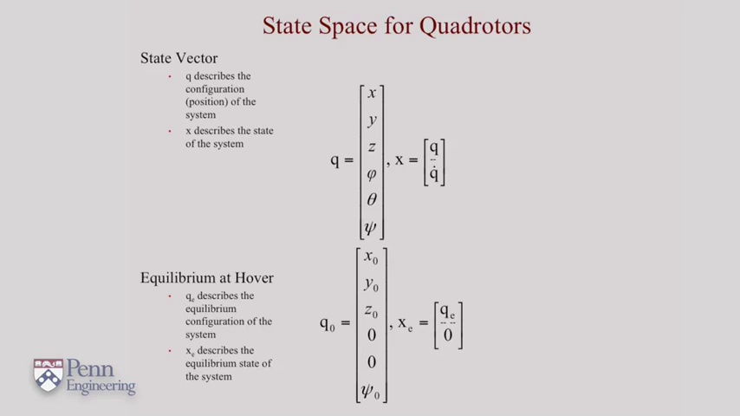 (score 95.0000)
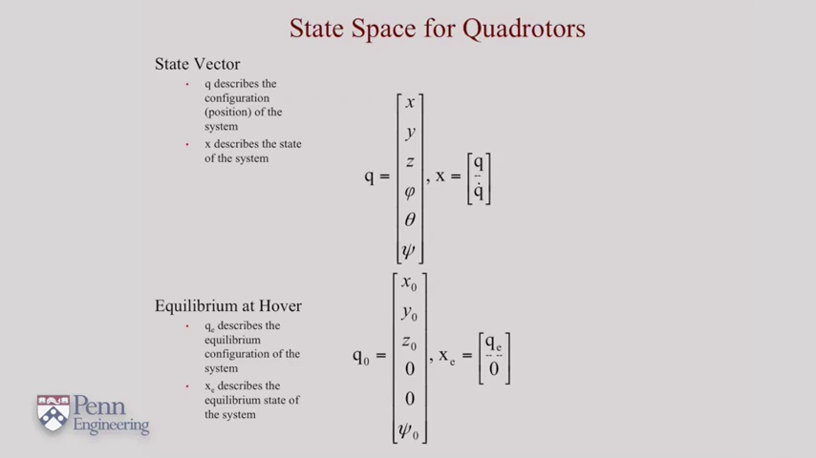 (score 90.0000)
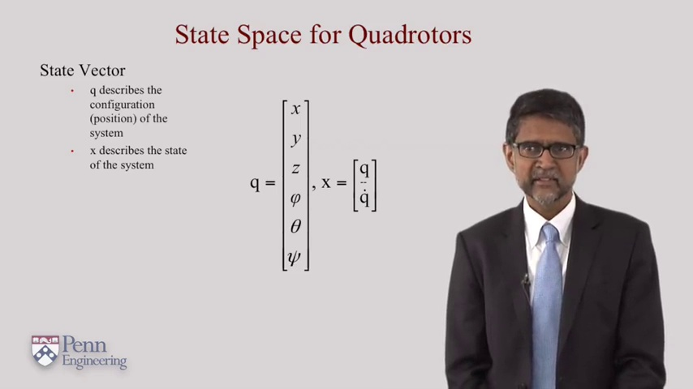 (score 90.0000)
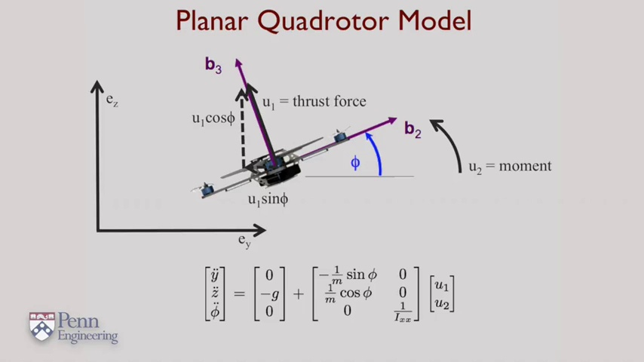 (score 90.0000)
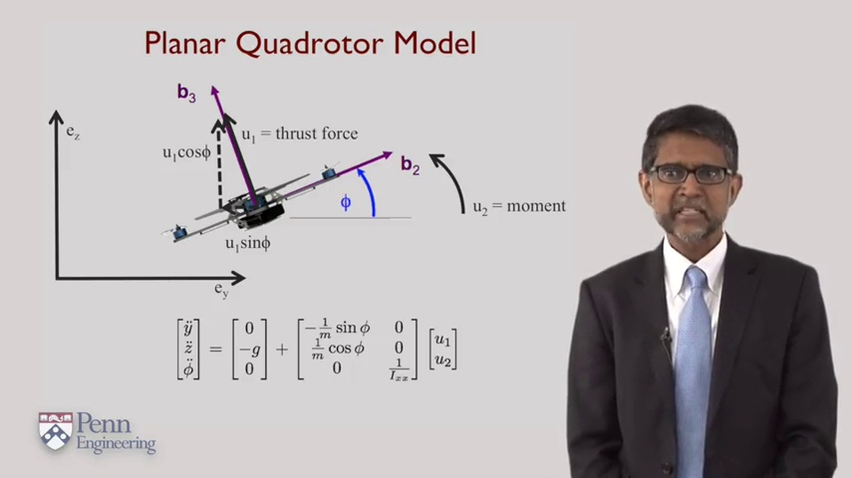 (score 90.0000)
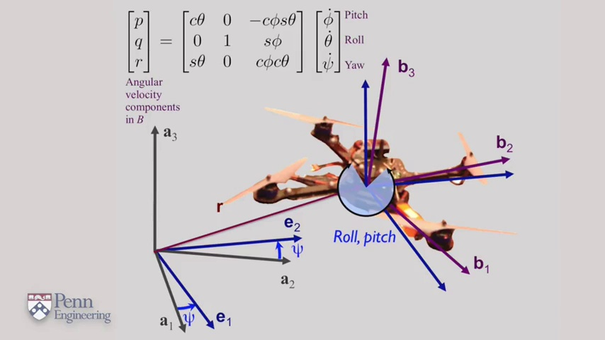 (score 90.0000)
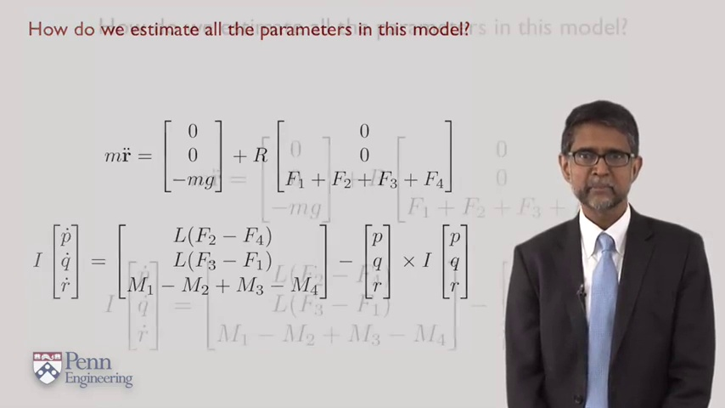 (score 90.0000)
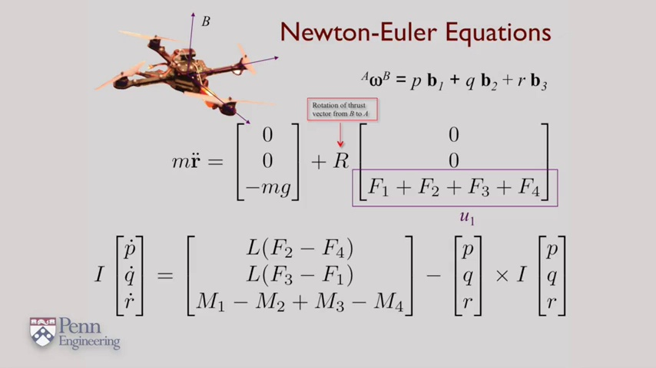 (score 90.0000)
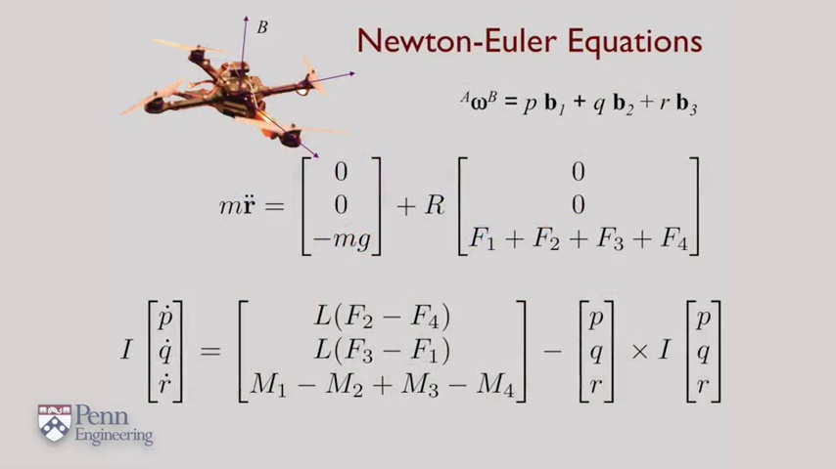 (score 90.0000)
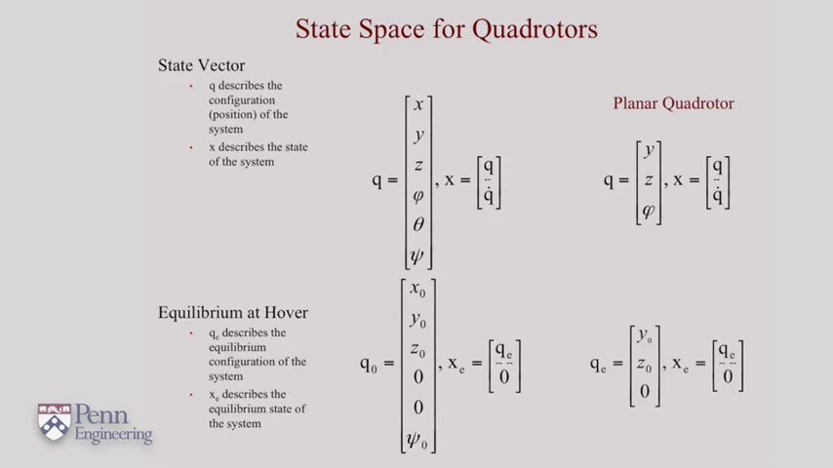 (score 85.0000)
Least correlated frames:
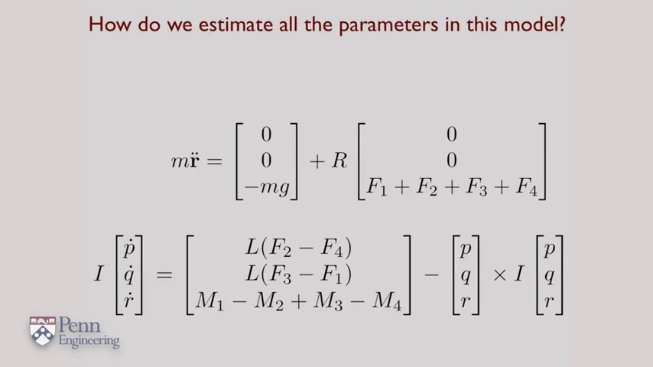 (score 20.0000)
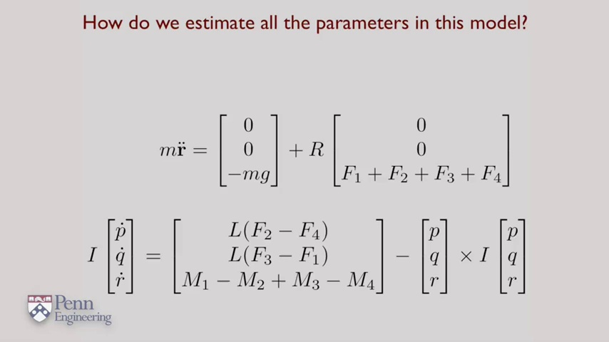 (score 20.0000)
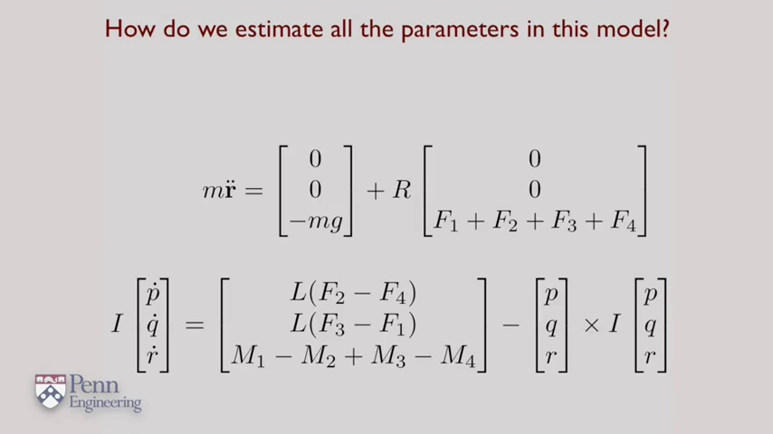 (score 20.0000)
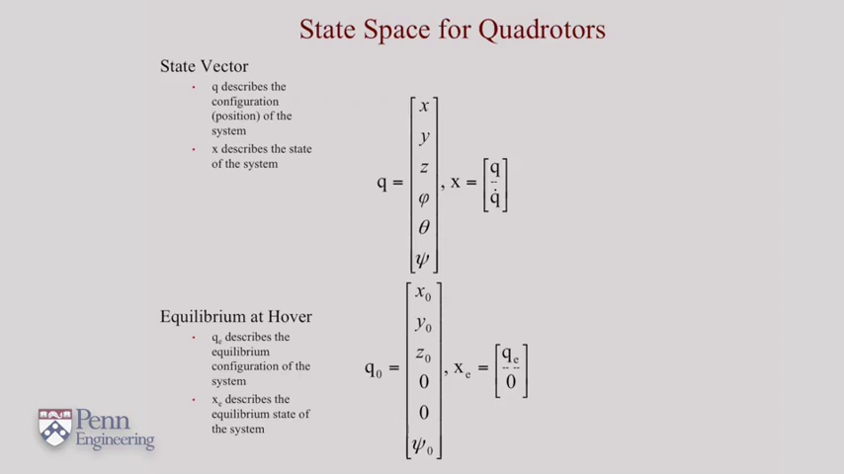 (score 20.0000)
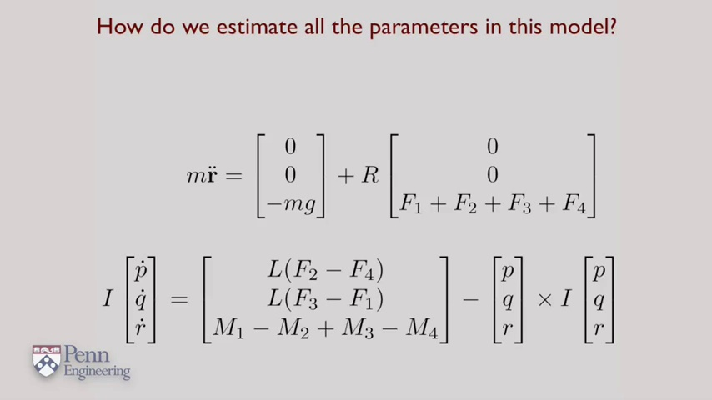 (score 75.0000)
 (score 80.0000)
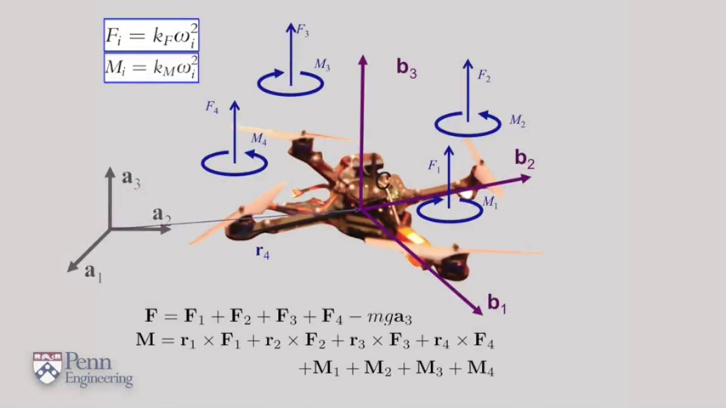 (score 80.0000)
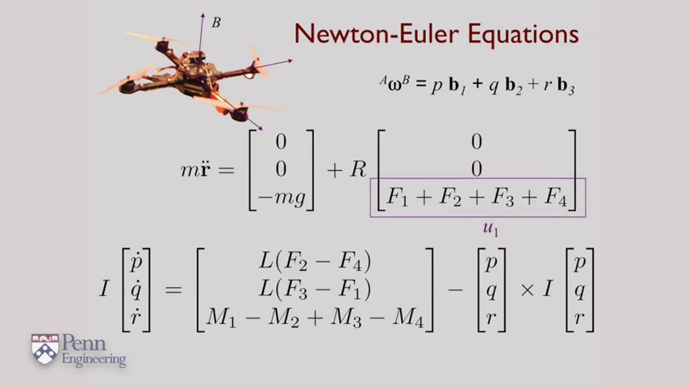 (score 80.0000)
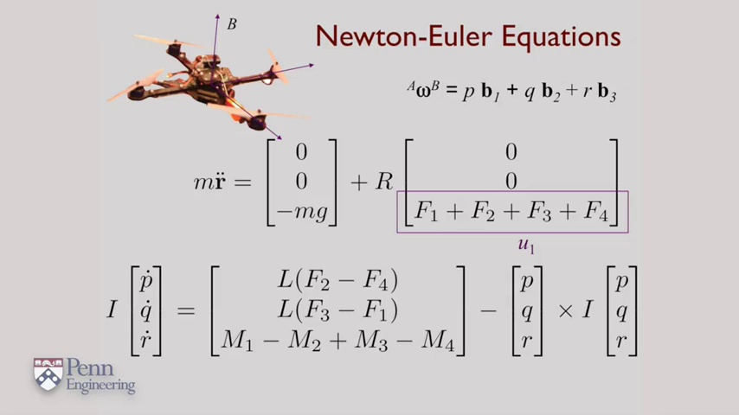 (score 80.0000)
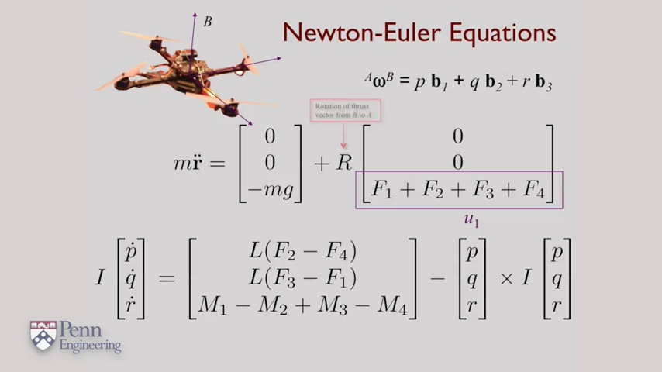 (score 80.0000)

Frame: frame_0000.jpg
Caption: The image appears to be a screenshot of a presentation slide with a simple monochrome background, likely a plain gray or white. The simplicity of the background allows the viewer's attention to focus on the text and the image. There is no visual content beyond these colors, so there are no people, devices, slides, diagrams, or text visible in this frame that can be confidently described or used for instructional purposes without making assumptions or inferences. The focus here would be on the color scheme and design elements of the slide itself.
The background features a lighter shade at the bottom, providing a subtle gradient effect. The text is presented in black, contrasting sharply with the light background. The image itself is also in black and white, which further emphasizes the text. The overall composition of the image is simple and straightforward, with the text and image serving as the main elements.
The absence of any other elements in the image creates a sense of clarity and simplicity. The monochrome background, text, and image all contribute to a minimalist aesthetic. The use of black text against a plain background also emphasizes the text, drawing the viewer's attention to it. The image and text are positioned centrally, further enhancing the overall balance of the composition.
The simplicity of the image and text creates a sense of tranquility and focus, making it an effective visual tool for conveying information or emphasizing key points.
Comment (score 80): While the initial math looks similar to the state space equations, I don't think they are. Ohh! Newton- Euler equations that we'll use later to develop controllers. One set is for body frame of reference and the other set is for the ground fixed frame. Then we get roll pitch and yaw angles. I'm hooked. Keep going.Planar motion first? Weak! (But really useful without the crazy complications that 1 added dimension brings.Good. Lord. The State Vector gets 6 dimensions (x, y, z, roll, pitch, yaw angles) but then the next vector is the previous vector + it's derivative vectors to give us 12 dimensions to describe it's motion. This does make me wonder though, why not take it to the next logical step, 6 dimensions for position, 6 dimensions for speed, and 6 dimensions for acceleration? Wouldn't including acceleration allow for a smoother flight?
Reason: The comment directly discusses the Newton-Euler equations and state vector dimensions mentioned in the caption, indicating a strong connection.
Source: https://www.youtube.com/watch?v=lAVYDUeqdW4: 4 4 Quadrotor Equations of Motion University of Pennsylvania Coursera

Frame: frame_0001.jpg
Caption: The image presents a presentation slide with a neutral background that appears to be part of an educational presentation, possibly related to engineering, mathematics, or physics. The main title of the slide reads "Quadrodot Equations of Motion." Below the title is a partial view of a diagram illustrating quadrod dynamics, although the details are not fully visible. At the bottom left corner, there's an icon with text that appears to be related to engineering or mathematics, featuring a stylized depiction of what looks like a mechanical system or structure with the word "PENN" above it. On the right side, there is a logo with the letters "PNM" and beneath them, the words "Engineering." The slide's background is neutral, and it seems to be part of an educational presentation.
The image also features red text centered on the screen, reading "Quadrator Equations of Motion." The choice of white as the background color provides a stark contrast to the red text, making the text stand out prominently. The overall layout of the image is simple and straightforward, with the text serving as the primary focus. The text is in a large font size, further emphasizing its importance.
No strongly correlated comments found for this frame.

Frame: frame_0002.jpg
Caption: This image presents a dynamic scene of a quadcopter in motion. The quadcopter, characterized by its four propellers, is positioned at the center of the image and is spinning around the center, indicating movement. The direction of its movement is indicated by the arrows drawn in the image, suggesting that it is moving towards the right.
On the left side of the frame, there is a teaching aid that resembles a drone or model aircraft, labeled with Greek letters (α, β, γ) and some mathematical symbols (∑, Δ). This suggests that the instructor may be explaining concepts such as angles of attack, drift angle, or other aerodynamic properties related to drones.
The right side of the frame appears to be a slide or visual aid for the class. It contains a graph with multiple axes and plotted curves representing different variables (F_x, F_y, M_z) in the context of forces and moments on an aircraft, specifically with respect to the lift force vector (Lift). The slide has additional mathematical expressions and equations that likely pertain to the analysis or design of a drone.
The text "∑ F_x = Lift" is visible, indicating that the summation of forces in the x direction equals the lift. This equation is fundamental to understanding the aerodynamic properties of wings and their application to aircraft such as drones. The other equations and mathematical notations are too small to read clearly but appear to be related to aerodynamics, possibly involving drag forces, moment of forces, and velocity components.
The image also includes text "F=m*a" which could represent a formula related to the principles of motion, potentially representing Newton's second law of motion. This equation could relate to the force (F) applied to the quadcopter, its mass (m), and acceleration (a).
Overall, the image provides a visual representation of the motion of a quadcopter, accompanied by mathematical principles and symbols that could provide insights into its movement, as well as concepts related to aerodynamics and aircraft design.
Comment (score 80): While the initial math looks similar to the state space equations, I don't think they are. Ohh! Newton- Euler equations that we'll use later to develop controllers. One set is for body frame of reference and the other set is for the ground fixed frame. Then we get roll pitch and yaw angles. I'm hooked. Keep going.Planar motion first? Weak! (But really useful without the crazy complications that 1 added dimension brings.Good. Lord. The State Vector gets 6 dimensions (x, y, z, roll, pitch, yaw angles) but then the next vector is the previous vector + it's derivative vectors to give us 12 dimensions to describe it's motion. This does make me wonder though, why not take it to the next logical step, 6 dimensions for position, 6 dimensions for speed, and 6 dimensions for acceleration? Wouldn't including acceleration allow for a smoother flight?
Reason: The comment directly discusses the aerodynamic properties and motion of a quadcopter, referencing technical concepts such as state space equations, Newton-Euler equations, roll pitch and yaw angles, and acceleration. The commenter also relates these concepts to real-world applications and shows an understanding of the mathematical principles presented in the frame caption.
Source: https://www.youtube.com/watch?v=lAVYDUeqdW4: 4 4 Quadrotor Equations of Motion University of Pennsylvania Coursera

Frame: frame_0003.jpg
Caption: The image appears to show a mathematical equation written in black text against a white background, representing the Newton-Euler Equations, a fundamental set of equations in classical mechanics. The equation is set within a rectangular frame with the letters 'B' and 'M' appearing in the top left and top right corners respectively. The letters 'A', 'F', 'R', 'Q', 'S', 'T', 'U', 'V', 'W', 'X', 'Y', 'Z' are scattered throughout the equation, possibly representing different variables or constants.
The equation itself is a complex mathematical expression with various terms and operations. At the top of the equation, there is an unmanned aerial vehicle (UAV), commonly referred to as a drone, overlaid with the text "Newton-Euler Equations." Below this title are two equations: one representing a vector in three-dimensional space and another that seems to involve angular velocities.
On the right side of the slide, there is a system of four differential equations written with mathematical notation. The equations include terms such as acceleration and torque, which are part of Newton's laws of motion and the Euler-Lagrange equations for rigid body dynamics. The equations also contain symbols representing angular velocity (ω), angular acceleration (α), force (F), and moment of inertia (I).
The slide is marked with a watermark that includes the text "PENN ENGINEERING," indicating the institution associated with this material. The overall content suggests an educational context focused on the mathematical formulation of the dynamics of rigid bodies, which is relevant to fields like mechanical engineering, robotics, and physics.
No strongly correlated comments found for this frame.

Frame: frame_0004.jpg
Caption: The image displays a presentation slide with an equation that appears to be related to physics or engineering. The slide includes mathematical symbols and is part of a lecture or educational material. The text at the top, slightly obscured by the slide's numbering, reads "Newton-Euler Equations," indicating a topic in dynamics and control systems.
Below the title, there are three equations. One equation involves differential equations with terms such as "dt," "dq," "L," and "m," which are common symbols for representing forces and motion in physics and engineering contexts. Another equation includes matrices labeled as "I," "q," "dq/dt," and "w," suggesting a discussion of angular momentum, position, velocity, and acceleration vectors. The third equation is a more complex system involving variables like "L," "C," "J," "theta," "delta," "alpha," and "beta," which are relevant to the study of mechanical systems undergoing rotational motion or other dynamic conditions.
In the top-right corner, an image of a drone with visible propellers provides a visual context for the lecture or illustrates an application of the Newton-Euler equations in a real-world scenario. The background is white, suggesting that the slide is being used by an instructor during a lecture, where they may be writing on a board or explaining these concepts to students.
The image also presents a textbook page from Penn Engineering, specifically the section on Newton-Euler Equations. The page is divided into two main sections: a table of contents and a section with a diagram. The table of contents provides an overview of the content, listing sections, subsections, and pages within the book. The section with a diagram features a blue rectangular shape, a drone equipped with multiple propellers, depicted in motion.
The text on the page is white, providing a stark contrast to the blue background of the drone. It includes the title "Newton-Euler Equations" and the subtitle "Applications in Aerodynamics." The text is written in a clear and legible font, ensuring that the content is easily readable.
Comment (score 90): While the initial math looks similar to the state space equations, I don't think they are. Ohh! Newton- Euler equations that we'll use later to develop controllers. One set is for body frame of reference and the other set is for the ground fixed frame. Then we get roll pitch and yaw angles. I'm hooked. Keep going.Planar motion first? Weak! (But really useful without the crazy complications that 1 added dimension brings.Good. Lord. The State Vector gets 6 dimensions (x, y, z, roll, pitch, yaw angles) but then the next vector is the previous vector + it's derivative vectors to give us 12 dimensions to describe it's motion. This does make me wonder though, why not take it to the next logical step, 6 dimensions for position, 6 dimensions for speed, and 6 dimensions for acceleration? Wouldn't including acceleration allow for a smoother flight?
Reason: The comment directly discusses the Newton-Euler equations and their application to develop controllers, which is explicitly mentioned in the frame caption. The comment also mentions the concept of body frame of reference and ground fixed frame, which are related to the technical steps described in the caption. The score is 90 because while the comment does not repeat the exact same equations as the caption, it shows a clear understanding of the underlying concepts and their relevance to the topic.
Source: https://www.youtube.com/watch?v=lAVYDUeqdW4: 4 4 Quadrotor Equations of Motion University of Pennsylvania Coursera

Frame: frame_0005.jpg
Caption: The image presents a digital presentation slide with educational content, featuring a mathematical equation labeled as "Equation (1)" under the heading "Newton-Euler Equations." The equation includes various symbols and subscripts, suggesting a complex system of differential equations related to motion in mechanical systems. Below the equation is an illustration of a quadcopter, a type of multi-rotor helicopter with four rotors, which appears to be visualizing an application or example of the Newton-Euler equations in the context of drone dynamics or control theory.
The slide features the logo of Purdue University's College of Engineering, a stylized "PE" with a wing-like design and a silhouette of an airplane above it, along with a shield bearing a key, signifying knowledge and wisdom. The presentation is set against a dark background with white text, emphasizing the content for better readability.
In the bottom right corner of the slide is the logo of Purdue University's College of Engineering, indicating the academic institution from which the presentation originates.
Comment (score 85): While the initial math looks similar to the state space equations, I don't think they are. Ohh! Newton- Euler equations that we'll use later to develop controllers. One set is for body frame of reference and the other set is for the ground fixed frame. Then we get roll pitch and yaw angles. I'm hooked. Keep going.Planar motion first? Weak! (But really useful without the crazy complications that 1 added dimension brings.Good. Lord. The State Vector gets 6 dimensions (x, y, z, roll, pitch, yaw angles) but then the next vector is the previous vector + it's derivative vectors to give us 12 dimensions to describe it's motion. This does make me wonder though, why not take it to the next logical step, 6 dimensions for position, 6 dimensions for speed, and 6 dimensions for acceleration? Wouldn't including acceleration allow for a smoother flight?
Reason: The comment directly discusses the Newton-Euler equations and their application in drone dynamics, which is also mentioned in the caption. The mention of state space equations, roll pitch and yaw angles, and dimensions (x, y, z, etc.) matches technical details described in the caption. The only minor mismatch is the tone of the comment being more conversational and enthusiastic, but the content remains strongly related.
Source: https://www.youtube.com/watch?v=lAVYDUeqdW4: 4 4 Quadrotor Equations of Motion University of Pennsylvania Coursera

Frame: frame_0006.jpg
Caption: The image presents a comprehensive illustration of the Newton-Euler equations, specifically related to robotic mechanics. The whiteboard features mathematical equations and diagrams, including graphical representations of vectors for force (F) and torque (T). The text on the board reads "Newton-Euler Equations," followed by a series of mathematical equations and symbols indicating variables such as Δq, Δp, and Δθ, along with terms like mass (m), acceleration (a), angular acceleration (α), and other kinematic and dynamic parameters.
The Newton-Euler equations are written in the form of a matrix, which represents the system of differential equations. The matrix is colored in shades of blue and gray, with the top row and leftmost column being blue, and the bottom row and rightmost column being gray. The rest of the matrix is filled with white space.
The equations themselves are written in black text, including "B = m * a", where B represents the acceleration vector, m represents the mass of the object, and a represents the acceleration; "A = m * F", where A represents the acceleration vector, m represents the mass of the object, and F represents the force; "M = m * F", where M represents the acceleration vector, m represents the mass of the object, and F represents the force; and "R = m * F", where R represents the acceleration vector, m represents the mass of the object, and F represents the force.
The equations are arranged in a grid-like pattern, with the first equation on the left, the second equation in the middle, the third equation on the right, and the fourth equation on top. The matrix is centered in the image, with the equations written in the middle of the matrix.
The image also includes a small text box that reads "Penn Engineering", indicating the source of the image.
Comment (score 85): While the initial math looks similar to the state space equations, I don't think they are. Ohh! Newton- Euler equations that we'll use later to develop controllers. One set is for body frame of reference and the other set is for the ground fixed frame. Then we get roll pitch and yaw angles. I'm hooked. Keep going.Planar motion first? Weak! (But really useful without the crazy complications that 1 added dimension brings.Good. Lord. The State Vector gets 6 dimensions (x, y, z, roll, pitch, yaw angles) but then the next vector is the previous vector + it's derivative vectors to give us 12 dimensions to describe it's motion. This does make me wonder though, why not take it to the next logical step, 6 dimensions for position, 6 dimensions for speed, and 6 dimensions for acceleration? Wouldn't including acceleration allow for a smoother flight?
Reason: The comment directly discusses the Newton-Euler equations and their application in developing controllers, which is strongly related to the frame caption. The comment also mentions the use of different frames of reference (body frame and ground fixed frame) and the importance of considering acceleration in describing motion. While the comment does not simply repeat the mathematical equations from the caption, it shows a deep understanding of the concepts presented in the image and provides additional context that is relevant to the topic.
Source: https://www.youtube.com/watch?v=lAVYDUeqdW4: 4 4 Quadrotor Equations of Motion University of Pennsylvania Coursera

Frame: frame_0007.jpg
Caption: The image shows a presentation slide with mathematical content related to Newton-Euler Equations. The slide is divided into two sections: on the left, there's a photograph of a drone flying over a body of water with some vegetation and buildings in the background; on the right, there are mathematical equations written in notation.
At the top of the right side, the title "Newton-Euler Equations" is displayed. Below this, three mathematical equations are presented. The first equation reads: \( \ddot{x} = \frac{1}{m}(F - mg) + g \), where \( x \) represents position, \( \ddot{x} \) is the second derivative of \( x \), \( m \) is mass, \( F \) is force, \( g \) is acceleration due to gravity, and the dot above the variables indicates differentiation with respect to time.
The second equation is more complex, involving a dot product of two vectors: \( \dot{x} + \dot{y}\cos\phi - \dot{z}\sin\phi \), where \( \dot{x}, \dot{y}, \dot{z} \) represent the time derivatives of position in each of the three spatial dimensions, and \( \phi \) is a scalar angle. The second vector is: \( (I + mr^2)^{-1/2}(C - mg(l - h))/ml \), where \( I \) represents the moment of inertia, \( r \) is position relative to some origin, \( \dot{r} \) is the time derivative of position \( r \), \( C \) is a scalar constant, and \( l - h \) represent distances related to the body's center of mass.
At the bottom right corner of the slide, there's a credit line that reads "Penn Engineering." The style of the image suggests it's a screenshot from an online presentation or lecture, with the mathematical content likely being part of an educational setting focused on engineering, specifically involving dynamics and mechanics.
Comment (score 80): While the initial math looks similar to the state space equations, I don't think they are. Ohh! Newton- Euler equations that we'll use later to develop controllers. One set is for body frame of reference and the other set is for the ground fixed frame. Then we get roll pitch and yaw angles. I'm hooked. Keep going.Planar motion first? Weak! (But really useful without the crazy complications that 1 added dimension brings.Good. Lord. The State Vector gets 6 dimensions (x, y, z, roll, pitch, yaw angles) but then the next vector is the previous vector + it's derivative vectors to give us 12 dimensions to describe it's motion. This does make me wonder though, why not take it to the next logical step, 6 dimensions for position, 6 dimensions for speed, and 6 dimensions for acceleration? Wouldn't including acceleration allow for a smoother flight?
Reason: The comment directly discusses the same technical steps (Newton-Euler equations) and objects (state space equations, body frame of reference, ground fixed frame, roll, pitch, yaw angles) described in the caption. The comment also shows understanding of the mathematical content and provides personal insights (e.g., wondering about including acceleration). However, some parts of the comment are not directly related to the caption's content, such as the mention of 'planar motion' and 'Good Lord', which slightly lowers the score.
Source: https://www.youtube.com/watch?v=lAVYDUeqdW4: 4 4 Quadrotor Equations of Motion University of Pennsylvania Coursera

Frame: frame_0008.jpg
Caption: The image combines a presentation slide with a physical model to illustrate the concept of Newton-Euler Equations. The slide features an equation labeled as "(1)" which includes kinematics terms such as position, velocity, and acceleration, alongside other mathematical expressions including integrals, summations, and matrix notation. The equation is set against a neutral background with clear legibility.
In the foreground, a model of a quadcopter is displayed, comprising a frame, four propellers, and a control board. The equation "B = m * a" is prominently written above the model in black, with the letters "B", "m", and "a" clearly visible. The model sits on a blue background, indicating its origin from Penn Engineering.
The presentation slide likely serves as an educational resource for engineering or aerospace students, focusing on the equations governing the motion of rigid bodies such as helicopters and quadcopters. The absence of individuals and additional objects suggests that this image is intended for self-study or online learning purposes, possibly originating from a video lecture or slideshow.
Comment (score 80): While the initial math looks similar to the state space equations, I don't think they are. Ohh! Newton- Euler equations that we'll use later to develop controllers. One set is for body frame of reference and the other set is for the ground fixed frame. Then we get roll pitch and yaw angles. I'm hooked. Keep going.Planar motion first? Weak! (But really useful without the crazy complications that 1 added dimension brings.Good. Lord. The State Vector gets 6 dimensions (x, y, z, roll, pitch, yaw angles) but then the next vector is the previous vector + it's derivative vectors to give us 12 dimensions to describe it's motion. This does make me wonder though, why not take it to the next logical step, 6 dimensions for position, 6 dimensions for speed, and 6 dimensions for acceleration? Wouldn't including acceleration allow for a smoother flight?
Reason: The comment directly discusses the Newton-Euler Equations mentioned in the caption, referencing specific mathematical expressions and concepts (e.g. state space equations, roll pitch and yaw angles) and showing a clear understanding of the material presented in the caption. The comment also includes technical suggestions for further development, demonstrating a strong connection to the content of the frame caption.
Source: https://www.youtube.com/watch?v=lAVYDUeqdW4: 4 4 Quadrotor Equations of Motion University of Pennsylvania Coursera

Frame: frame_0009.jpg
Caption: The image shows a diagram that presents a visual representation of Newton's Second Law of Motion, which is applied to explain the context of robotics or mechanical systems. At the top, there is text that reads "Newton-Euler Equations" followed by several mathematical expressions written on paper. One equation involves calculating derivatives with respect to time (d/dt), indicating a rate of change concept. There are also symbols representing forces and moments, such as Fx, Fy, Mz, and others.
The diagram includes an illustration of a drone or quadcopter at the top left corner with the words "Lift and Push" next to it, suggesting the explanation is related to aerodynamics and the forces acting on such a device. The text below these words indicates that there are two forces (Fx and Fy) applied in the x and y directions, respectively, and that the moments are around the z-axis (Mz). The equations involve components like "m" which is typically the mass of an object or system, "L" which might be for lift, and "ω" which stands for angular velocity. There's also a mention of "q," which could represent quaternions in the context of robotics or 3D rotations.
In the background, Newton's Second Law of Motion is written in white letters on a black background: "F = ma" and "F = m * a", stating that the force applied to an object is equal to the mass of the object multiplied by its acceleration. The diagram also includes a red arrow pointing from the drone (represented by a black box with white letters and numbers, indicating the drone's mass and acceleration) to the force, indicating the direction of the force.
The image appears to be a screenshot from an educational presentation or digital note-taking application with mathematical equations, possibly used by students studying mechanical engineering or robotics. The content suggests that it is intended for instructional purposes, explaining how forces and moments can be described using Newton-Euler equations in the context of kinematics or dynamics of a physical system.
Comment (score 80): While the initial math looks similar to the state space equations, I don't think they are. Ohh! Newton- Euler equations that we'll use later to develop controllers. One set is for body frame of reference and the other set is for the ground fixed frame. Then we get roll pitch and yaw angles. I'm hooked. Keep going.Planar motion first? Weak! (But really useful without the crazy complications that 1 added dimension brings.Good. Lord. The State Vector gets 6 dimensions (x, y, z, roll, pitch, yaw angles) but then the next vector is the previous vector + it's derivative vectors to give us 12 dimensions to describe it's motion. This does make me wonder though, why not take it to the next logical step, 6 dimensions for position, 6 dimensions for speed, and 6 dimensions for acceleration? Wouldn't including acceleration allow for a smoother flight?
Reason: The comment directly discusses the Newton-Euler equations, referencing body and ground fixed frames, roll, pitch, and yaw angles. It also mentions state vectors with 6 dimensions for position, speed, and acceleration, which aligns with the caption's description of forces and moments in robotics. The comment's tone and language are consistent with the technical content described in the caption.
Source: https://www.youtube.com/watch?v=lAVYDUeqdW4: 4 4 Quadrotor Equations of Motion University of Pennsylvania Coursera

Frame: frame_0010.jpg
Caption: The image shows a presentation slide with a black background and various elements in white, primarily divided into two main sections. At the top of the slide, there is a title that reads "Newton-Euler Equations" in bold, white text, standing out against the black background.
To the right side of the slide, an equation is displayed:
\[ M = \frac{\partial U}{\partial \dot{q}} \]
Below this equation, three terms are labeled with lowercase Greek letters θ, φ, and ψ, along with the corresponding expressions in square brackets. These expressions include vector notations such as \( \ddot{r}, \dot{r}, \ddot{\phi} \), and some mathematical functions that appear to be related to rotational dynamics.
On the left side of the slide, there is a detailed illustration of a drone with its arms extended, each tipped with a propeller. The drone is depicted in a top-down view against a background that resembles a cityscape.
The bottom right corner of the slide contains a red starburst graphic with text inside it that reads "Penn State Engineering". There's also a red arrow pointing from the starburst to the illustration of the drone, suggesting that the drone is an example or demonstration related to engineering. Additionally, the slide presents the Newton-Euler Equations, a set of differential equations used in physics to describe the motion of bodies under the influence of a central force. These equations are written in a format that's easy to understand: F = ma, where F is the force applied to an object, m is the mass of the object, and a is the acceleration of the object.
The slide also includes a diagram of a drone with two arrows labeled "F1" (red) and "F2" (black). This arrow diagram is used to illustrate the application of the Newton-Euler Equations to a drone. The diagram is accompanied by text that explains the relationship between the forces and the drone's motion.
Overall, the slide provides a clear and concise explanation of the Newton-Euler Equations and their application to the motion of a drone, making it a great example of how mathematical concepts can be presented in a visual and engaging way.
Comment (score 85): While the initial math looks similar to the state space equations, I don't think they are. Ohh! Newton- Euler equations that we'll use later to develop controllers. One set is for body frame of reference and the other set is for the ground fixed frame. Then we get roll pitch and yaw angles. I'm hooked. Keep going.Planar motion first? Weak! (But really useful without the crazy complications that 1 added dimension brings.Good. Lord. The State Vector gets 6 dimensions (x, y, z, roll, pitch, yaw angles) but then the next vector is the previous vector + it's derivative vectors to give us 12 dimensions to describe it's motion. This does make me wonder though, why not take it to the next logical step, 6 dimensions for position, 6 dimensions for speed, and 6 dimensions for acceleration? Wouldn't including acceleration allow for a smoother flight?
Reason: The comment directly discusses the Newton-Euler Equations and their application to the motion of a drone, which is the same technical topic described in the caption. The comment also mentions specific concepts like state space equations, roll pitch and yaw angles, and acceleration, which are all relevant to the image.
Source: https://www.youtube.com/watch?v=lAVYDUeqdW4: 4 4 Quadrotor Equations of Motion University of Pennsylvania Coursera

Frame: frame_0011.jpg
Caption: The image displays a teaching context that appears to be related to mathematics or physics, given the diagram and text present. Here's a detailed description:
1. **Title Text**: At the top, there is a title that reads "Newton-Euler Equations." This suggests that the content of the lesson may involve discussing equations used in physics for modeling systems with rotational dynamics.
2. **Graphic Representation**: Below the title, there is a graphic representation of the Newton-Euler equations applied to a system that includes both linear and angular motion. The graphic shows two types of forces: linear (F) and angular (T), along with their respective components (F_x, F_y, F_z for linear forces and T_x, T_y, T_z for angular forces).
3. **Mathematical Equations**: Several equations are written on the slide, which are likely to be part of the Newton-Euler equations used in this context. The text is too small to read the exact content, but it includes mathematical symbols such as +, =, and ∑ (the summation symbol), indicating that the equations involve a series or a set of components.
4. **Text Box with Labels**: In the center of the image, there is a text box with labels pointing to different parts of the equation. The labels are "F_x," "F_y," and "F_z," which likely correspond to the three linear force components in the Newton-Euler equations.
5. **Instructor or Presenter**: There is no visible instructor or presenter; only the slide content is shown.
6. **Slide Footer**: At the bottom of the slide, there's a small footer that reads "Penn State Engineering," suggesting that this material may be from a course offered by the engineering department at Pennsylvania State University (PSU).
7. **Overall Visual Style**: The image has a simple and educational style, typically used in academic or technical presentations to convey mathematical concepts clearly and concisely.
The focus of the image is on providing information about Newton-Euler equations, with text and diagrams designed to explain these principles to an audience that may be familiar with physics and engineering concepts.
Comment (score 90): While the initial math looks similar to the state space equations, I don't think they are. Ohh! Newton- Euler equations that we'll use later to develop controllers. One set is for body frame of reference and the other set is for the ground fixed frame. Then we get roll pitch and yaw angles. I'm hooked. Keep going.Planar motion first? Weak! (But really useful without the crazy complications that 1 added dimension brings.Good. Lord. The State Vector gets 6 dimensions (x, y, z, roll, pitch, yaw angles) but then the next vector is the previous vector + it's derivative vectors to give us 12 dimensions to describe it's motion. This does make me wonder though, why not take it to the next logical step, 6 dimensions for position, 6 dimensions for speed, and 6 dimensions for acceleration? Wouldn't including acceleration allow for a smoother flight?
Reason: The comment directly discusses the Newton-Euler equations and their application to different frames of reference, which is strongly related to the caption's description of the same equations. The comment also mentions the use of these equations in developing controllers and exploring motion in multiple dimensions.
Source: https://www.youtube.com/watch?v=lAVYDUeqdW4: 4 4 Quadrotor Equations of Motion University of Pennsylvania Coursera

Frame: frame_0012.jpg
Caption: The image shows a whiteboard with mathematical content and a visual aid related to Newton's second law of motion, specifically its application to rotational dynamics. The top-left corner features an illustration of a helicopter with its rotor blades in motion, suggesting the context for the equations presented. The text "Newton-Euler Equations" is written at the top of the whiteboard, followed by a mathematical equation representing Newton's second law: \( F_net \) / \( m \) = \( a \). This equation relates the acceleration of an object to its mass and the net force acting upon it.
The center and right sections of the whiteboard display additional equations related to rotational dynamics, also referred to as "Euler Equations." These equations involve variables such as \( F_net \), \( I \), \( \alpha \), \( \omega \), and other symbols representing moments of force and angular acceleration. The diagram on the whiteboard likely represents how forces and moments act upon an object in both linear motion (Newton's second law) and rotational motion (Euler equations).
At the bottom-right corner, the text "Penn Engineering" appears, indicating the affiliation or educational context for this presentation. Overall, the image appears to be a screenshot from a teaching session or lecture where an instructor is explaining the principles of Newton's laws in the context of mechanics and engineering, specifically focusing on rotational dynamics.
The diagram also includes a quadcopter with four propellers, each attached to a metal arm, as well as the text "Newton-Euler Equations" and "B". This suggests that the image may be related to the study of quadcopters and their motion, with a focus on understanding the mathematical principles underlying their movement and behavior.
Comment (score 85): While the initial math looks similar to the state space equations, I don't think they are. Ohh! Newton- Euler equations that we'll use later to develop controllers. One set is for body frame of reference and the other set is for the ground fixed frame. Then we get roll pitch and yaw angles. I'm hooked. Keep going.Planar motion first? Weak! (But really useful without the crazy complications that 1 added dimension brings.Good. Lord. The State Vector gets 6 dimensions (x, y, z, roll, pitch, yaw angles) but then the next vector is the previous vector + it's derivative vectors to give us 12 dimensions to describe it's motion. This does make me wonder though, why not take it to the next logical step, 6 dimensions for position, 6 dimensions for speed, and 6 dimensions for acceleration? Wouldn't including acceleration allow for a smoother flight?
Reason: The comment directly discusses the Newton-Euler equations mentioned in the caption, specifically referencing their use for developing controllers and mentioning the concepts of body frame and ground fixed frame. The comment also references the state vector and its dimensions, which is related to the mathematical content presented in the caption. The only minor discrepancy is the tone used by the commenter, which does not detract from the overall correlation.
Source: https://www.youtube.com/watch?v=lAVYDUeqdW4: 4 4 Quadrotor Equations of Motion University of Pennsylvania Coursera

Frame: frame_0013.jpg
Caption: The image presents a slide from a presentation with a mathematical theme, featuring the title "Newton-Euler Equations" in bold font at the top. Below the title, an equation is displayed that appears to represent the second Newton's law for motion:
∑F = m * ∂v/∂t
This equation describes the sum of forces acting on a body as equal to the product of its mass and the time derivative of its velocity.
On the right side of the slide, there are two partial differential equations (PDEs) that make up part of a larger system describing the forces and motion in a Newtonian mechanical system. The PDEs consist of:
∑(∂/∂x + ∂/∂y) F(x, y, t) = 0
∂v/∂t + ∂/∂x F1(x, y, t) + ∂/∂y F2(x, y, t) + M(x, y, t) = 0
The variables are vector quantities that represent displacement (v), force components in x and y directions (F1 and F2), and mass density (M).
In the upper left corner, an image of a quadrotor drone is shown in mid-air, suggesting that this slide may be related to robotic or aerospace engineering. The presence of the drone could imply that the equations are used to model or control the flight of such a device.
The background of the slide is plain white with the text and images presented in a clear and readable manner. There is no visible instructor or teaching context, as this appears to be a static slide from a presentation, likely intended for educational purposes to explain concepts related to Newtonian mechanics, specifically the equations that describe the motion of rigid bodies in three-dimensional space.
The diagram also presents a black and white representation of the same equations, with the title "Newton-Euler Equations" written at the top. The diagram is divided into two parts: a square grid on the left and a rectangular box on the right. The grid contains coefficients labeled with blue letters, which represent the coefficients in the Newton-Euler equations. The rectangular box displays the same blue letters arranged in a different pattern, corresponding to the coefficients in the Newton-Euler equations.
No strongly correlated comments found for this frame.

Frame: frame_0014.jpg
Caption: The image displays a screenshot of a digital presentation focused on mathematical and engineering concepts from Penn Engineering. At the top right corner, there is a logo that reads "Penn Engineering." Below this, the title of the presentation "Newton-Euler Equations" is presented.
On the left side of the slide, three equations are written in LaTeX format. The first equation represents a second-order linear differential equation with coefficients of zero, one, and minus two for the terms, respectively. The second equation shows a partial differential equation (PDE) involving a function φ(x, y, t) with respect to x, y, and t. The third equation is an integral expression over the domain of φ(x, y, t).
The central figure on the slide is a graphical representation of a quadrotor drone in mid-flight. It is colored in shades of orange and yellow with what appears to be red LEDs or lights. The drone has four arms extending outward from its central body, each supporting a propeller.
In the middle section of the slide, diagrams and equations are provided, illustrating the relationship between the variables in the equation. This section offers a visual representation of the Newton-Euler equations, making it easier to comprehend the concept.
No strongly correlated comments found for this frame.

Frame: frame_0015.jpg
Caption: This black and white diagram from Penn Engineering provides a detailed representation of the components and equations involved in Newton-Euler equations. The diagram includes both textual content and mathematical expressions, with clear labels for the initial and final positions of the object, as well as the forces acting on it. A model rocket with fins at its base is illustrated on the left side of the slide, serving as a visual aid to explain concepts related to aerodynamics or flight dynamics. The diagram also features two mathematical equations: one labeled "Euler Equations" and another labeled "Newton-Euler Equations", which include variables such as "dx", "dy", "dt", "a_x", and "a_y" representing small changes in position, velocity, and time, respectively, and components of acceleration. The text on the slide includes the title "Newton-Euler Equations" and a subtitle or explanation that is partially obscured by the model rocket illustration. Mathematical symbols such as ∂, ∑, and ∫ indicate partial differentiation, summation, and integration, respectively. This diagram serves as a useful visual aid for understanding these complex equations in an educational setting, potentially used in a lecture or tutorial where the instructor might be discussing how to apply Newton-Euler equations to model the motion of a rocket or other dynamic systems.
Comment (score 80): While the initial math looks similar to the state space equations, I don't think they are. Ohh! Newton- Euler equations that we'll use later to develop controllers. One set is for body frame of reference and the other set is for the ground fixed frame. Then we get roll pitch and yaw angles. I'm hooked. Keep going.Planar motion first? Weak! (But really useful without the crazy complications that 1 added dimension brings.Good. Lord. The State Vector gets 6 dimensions (x, y, z, roll, pitch, yaw angles) but then the next vector is the previous vector + it's derivative vectors to give us 12 dimensions to describe it's motion. This does make me wonder though, why not take it to the next logical step, 6 dimensions for position, 6 dimensions for speed, and 6 dimensions for acceleration? Wouldn't including acceleration allow for a smoother flight?
Reason: The comment directly discusses the same technical steps and concepts described in the caption, specifically referencing Newton-Euler equations, state space equations, roll pitch and yaw angles, and the concept of adding dimensions to describe motion. The language used is technical and specific, mirroring the content of the caption.
Source: https://www.youtube.com/watch?v=lAVYDUeqdW4: 4 4 Quadrotor Equations of Motion University of Pennsylvania Coursera

Frame: frame_0016.jpg
Caption: The image shows a comprehensive presentation on Newton-Euler Equations, featuring both written explanations and visual aids. The page is divided into two main sections, with the top section titled "Newton-Euler Equations" and the bottom section displaying the equations.
On one side of the board, there's an illustration of a rocket flying through the air, representing the concept of a projectile in physics. Below this title, mathematical equations and a diagram visually represent the concepts of velocity, acceleration, and projectile motion as per Newton's laws. The equations include a differential equation that relates the velocity and acceleration of an object.
The whiteboard also has a section titled "Motion Analysis," with text indicating that the analysis is about the forces acting on a ball during flight. Several forces are labeled, including gravity, drag, lift, and thrust, which are part of the aerodynamic analysis of a projectile's motion.
On the other side of the board, there's additional text and mathematical equations, possibly elaborating on the physics concepts discussed earlier. The text is partially obscured, but it seems to be related to the analysis and equations presented earlier.
The overall layout is organized and clear, with the equations clearly labeled and a diagram providing a visual representation of the concepts discussed in the text.
No strongly correlated comments found for this frame.

Frame: frame_0017.jpg
Caption: The image displays an educational setting that focuses on explaining concepts related to helicopter dynamics and Newton-Euler equations. At the top of a whiteboard is a title in red font that reads "Newton-Euler Equations." Below the title, there is a drawing of a helicopter with four rotors, labeled as "1," "2," "3," and "4."
On the right side of the whiteboard, several mathematical equations and diagrams are presented. The first equation is a vector representation of a force, F, which is written in bold black font and is decomposed into two components with vectors that point upwards. The second equation shows a summation over the number of rotors, n, where each term represents a torque, τ_k, applied to a specific joint. These terms involve the product of two matrices: one representing the inverse dynamics matrix and the other representing the centrifugal force matrix.
To the left of these equations, there is a model or diagram that appears to be a simplified representation of a helicopter with joints connecting different parts. The rotors are depicted as if they were gears or links connected by the torque vectors from the second equation.
Below the whiteboard, additional text provides context for the diagram and equations. It reads: "Components in dynamics:" followed by a list of three components: "Inertia," "Correlation," and "Gravity."
At the bottom right corner of the image, the Newton-Euler equations are written in detail. The diagram also shows the components of the body in the frame of the frame along with the principal axes.
The overall style of the image is instructional, suggesting it is an educational slide used in a class or presentation by a teacher or instructor. The logo "Penn" and "Engineering" in the bottom left corner further supports this notion, indicating its origin from a university engineering department.
Comment (score 85): While the initial math looks similar to the state space equations, I don't think they are. Ohh! Newton- Euler equations that we'll use later to develop controllers. One set is for body frame of reference and the other set is for the ground fixed frame. Then we get roll pitch and yaw angles. I'm hooked. Keep going.Planar motion first? Weak! (But really useful without the crazy complications that 1 added dimension brings.Good. Lord. The State Vector gets 6 dimensions (x, y, z, roll, pitch, yaw angles) but then the next vector is the previous vector + it's derivative vectors to give us 12 dimensions to describe it's motion. This does make me wonder though, why not take it to the next logical step, 6 dimensions for position, 6 dimensions for speed, and 6 dimensions for acceleration? Wouldn't including acceleration allow for a smoother flight?
Reason: The comment directly discusses the Newton-Euler equations and their application in developing controllers, which is strongly related to the caption's description of the same topic. The commenter also references the body frame of reference and the ground fixed frame, mirroring the diagram on the whiteboard. Additionally, the mention of state vectors and dimensions (6 for position, speed, and acceleration) matches the mathematical concepts presented in the caption.
Source: https://www.youtube.com/watch?v=lAVYDUeqdW4: 4 4 Quadrotor Equations of Motion University of Pennsylvania Coursera

Frame: frame_0018.jpg
Caption: This image shows a visual representation of the Newton-Euler equations, fundamental concepts in classical mechanics and mechanical engineering. The diagram is divided into two sections, representing the components of the initial system (left) and final system (right). In the center, the equation of motion is written, illustrating the relationship between forces and acceleration. Below the graph, text reads "Newton-Euler Equations," indicating the mathematical framework used. Various symbols such as \(\Sigma\) (summation), \(Q_i\) (angular acceleration), \(q_i\) (position), \(dq_i/dt\) (angular velocity), and \(t\) (time) are used in the equations, representing common notations in mechanics and robotics. On the right side of the image, a graph with axes labeled as "q_i" (position), "dq_i/dt" (angular velocity), and "t" (time) displays multiple lines representing the trajectory of a joint's position over time. The text box in the bottom right corner appears to be an instructor's note or caption, reading "Components in body x..." suggesting analysis within the context of robotics or mechanical engineering.
Comment (score 85): While the initial math looks similar to the state space equations, I don't think they are. Ohh! Newton- Euler equations that we'll use later to develop controllers. One set is for body frame of reference and the other set is for the ground fixed frame. Then we get roll pitch and yaw angles. I'm hooked. Keep going.Planar motion first? Weak! (But really useful without the crazy complications that 1 added dimension brings.Good. Lord. The State Vector gets 6 dimensions (x, y, z, roll, pitch, yaw angles) but then the next vector is the previous vector + it's derivative vectors to give us 12 dimensions to describe it's motion. This does make me wonder though, why not take it to the next logical step, 6 dimensions for position, 6 dimensions for speed, and 6 dimensions for acceleration? Wouldn't including acceleration allow for a smoother flight?
Reason: The comment directly discusses the Newton-Euler equations, referencing their application in developing controllers and analyzing motion. The commenter also mentions state space equations, roll, pitch, and yaw angles, which are all technical concepts described in the frame caption.
Source: https://www.youtube.com/watch?v=lAVYDUeqdW4: 4 4 Quadrotor Equations of Motion University of Pennsylvania Coursera

Frame: frame_0019.jpg
Caption: The image appears to be a slide from an educational presentation on mechanics or dynamics, featuring mathematical models and explanations related to the Newton-Euler Equations. The title "Newton-Euler Equations" is displayed prominently at the top of the slide, indicating that the content focuses on equations in mechanics related to motion and rotation.
The body of the slide contains several mathematical formulas, including a set of differential equations that are likely part of the Newton-Euler equations. These equations describe the movement of rigid bodies in three dimensions and include variables such as angular velocity (ω), position vector (r), and inertia tensor (I). Additionally, there are matrices labeled as "R", "Q", and "P" which could be rotation matrices, transformation matrices, or other variables related to motion and orientation.
A small diagram or block diagram is present on the right side of the slide, representing a system of rigid bodies in dynamics. The diagram shows various elements that might be part of a mechanical system, such as links, joints, and possibly forces or moments acting on the system. Handwritten notes at the bottom of the slide indicate that an instructor was explaining the equations to an audience, with arrows pointing to different parts of the equations and diagrams.
At the bottom of the slide, there is a graphical user interface for presentation software, suggesting that this slide was created using digital tools. The interface includes buttons and menus typical of such software, like 'File', 'Edit', 'View', etc.
Labels on the diagram at the bottom right are not fully legible due to the resolution, but they likely describe the components or parts of the mechanical system depicted in the diagram.
Comment (score 85): While the initial math looks similar to the state space equations, I don't think they are. Ohh! Newton- Euler equations that we'll use later to develop controllers. One set is for body frame of reference and the other set is for the ground fixed frame. Then we get roll pitch and yaw angles. I'm hooked. Keep going.Planar motion first? Weak! (But really useful without the crazy complications that 1 added dimension brings.Good. Lord. The State Vector gets 6 dimensions (x, y, z, roll, pitch, yaw angles) but then the next vector is the previous vector + it's derivative vectors to give us 12 dimensions to describe it's motion. This does make me wonder though, why not take it to the next logical step, 6 dimensions for position, 6 dimensions for speed, and 6 dimensions for acceleration? Wouldn't including acceleration allow for a smoother flight?
Reason: The comment directly discusses the Newton-Euler Equations and their relevance to developing controllers, which is strongly related to the caption's description of the equations. The comment also mentions the state vector, roll pitch and yaw angles, and acceleration, all of which are technical steps and concepts mentioned in the caption.
Source: https://www.youtube.com/watch?v=lAVYDUeqdW4: 4 4 Quadrotor Equations of Motion University of Pennsylvania Coursera

Frame: frame_0020.jpg
Caption: The image shows a presentation slide from Penn Engineering titled "How do we estimate all the parameters in this model?" The slide features a simple and functional design, typical of educational materials or slides used in classrooms or presentations. The text at the top reads "HOW DO WE ESTIMATE ALL THE PARAMETERS IN THIS MODEL?", suggesting an academic or technical context for the content presented.
The main focus of the image is on mathematical expressions and explanatory text. There are algebraic expressions with subscripts and superscripts, which might be part of a statistical model used for regression, time series analysis, or some other type of forecasting or simulation. The expressions include symbols such as "L" representing likelihood in statistics, "exp" signifying the exponential function, and summation signs (∑) indicating that the sum of some terms is being calculated.
In addition to the mathematical content, there is a logo at the bottom right corner that reads "PENN ENGINEERING", implying an academic or technical context for the slide. The style of the image is straightforward, without any physical scene images or diagrams; instead, it focuses entirely on the mathematical expressions and explanatory text.
The diagram in this image is a matrix representation of a linear equation, featuring four elements represented by different colors: red, green, blue, and yellow. These elements are arranged in a diagonal pattern, with the red element at the top left, the green element at the top right, the blue element at the bottom left, and the yellow element at the bottom right.
Comment (score 85): While the initial math looks similar to the state space equations, I don't think they are. Ohh! Newton- Euler equations that we'll use later to develop controllers. One set is for body frame of reference and the other set is for the ground fixed frame. Then we get roll pitch and yaw angles. I'm hooked. Keep going.Planar motion first? Weak! (But really useful without the crazy complications that 1 added dimension brings.Good. Lord. The State Vector gets 6 dimensions (x, y, z, roll, pitch, yaw angles) but then the next vector is the previous vector + it's derivative vectors to give us 12 dimensions to describe it's motion. This does make me wonder though, why not take it to the next logical step, 6 dimensions for position, 6 dimensions for speed, and 6 dimensions for acceleration? Wouldn't including acceleration allow for a smoother flight?
Reason: The comment directly discusses the same technical steps and concepts described in the caption, such as Newton-Euler equations, state vectors, roll pitch and yaw angles, and dimensionality. The comment also references specific mathematical expressions and their implications, indicating a strong connection to the frame caption.
Source: https://www.youtube.com/watch?v=lAVYDUeqdW4: 4 4 Quadrotor Equations of Motion University of Pennsylvania Coursera

Frame: frame_0021.jpg
Caption: The image presents a printed paper with mathematical content and accompanying text. On the left side of the paper, there is a heading that reads "HOW DO WE ESTIMATE ALL THE PARAMETERS IN THIS MODEL?" followed by an equation labeled as "THE MODEL" which includes various mathematical terms. Below this equation, there's another equation with a label "COMBINING OUR MATHEMATICAL EXPRESSIONS." The right side of the paper contains additional equations and text that seem to be part of a mathematical or engineering explanation.
The diagram on the paper is divided into three distinct sections. At the top, there's a box labeled "How do we estimate all the parameters in this model?". Below this, there's a box labeled "m = 1", suggesting a connection to the equation "THE MODEL" mentioned earlier. The third box is labeled "Penn Engineering", indicating a potential link between the diagram and the Penn Engineering department.
The diagram itself is a matrix, with the letters "m" and "P" placed at the top and bottom respectively. The letters "1" and "3" are placed in the middle, surrounded by the letters "F" and "M". This representation appears to be a mathematical model related to Penn Engineering, possibly involving statistical or computational modeling based on the equations visible. However, the text on the paper is too small to read clearly, but it seems to be discussing statistical or computational modeling based on the equations visible.
No strongly correlated comments found for this frame.

Frame: frame_0022.jpg
Caption: The image shows a mathematical representation that involves three variables (x, y, z) and several coefficients. The equation is written in the form of a matrix, with the coefficients arranged in a specific pattern. The equation reads:
`[m] = [F] [R] [F] [M] + [R] [F] [M]`
This equation represents a system of linear equations, where the variables `x`, `y`, and `z` are unknowns and the coefficients `[F]`, `[R]`, and `[M]` are also unknown. The matrices `[F]`, `[R]`, and `[M]` contain known values.
Below the equation, there is a text that reads "HOW DO WE ESTIMATE ALL THE PARAMETERS IN THIS MODEL?", suggesting that the purpose of this equation might be to estimate or solve for certain parameters in a mathematical model. Additionally, two graphical functions are depicted to the right of the paper: one appears to be a bell-shaped curve labeled "O" and "R", while the other is a piecewise linear equation with different slopes.
At the bottom left corner of the image, there is a watermark or logo that reads "PENN ENGINEERING", indicating an affiliation with Penn Engineering. This could suggest that this image is related to an engineering problem-solving session or assignment.
No strongly correlated comments found for this frame.

Frame: frame_0023.jpg
Caption: The image shows a handwritten mathematical equation on paper, surrounded by a digital screenshot with indistinct content. The equation involves a series of mathematical symbols and variables, including "M_i", "F_j", "L_k", "m_l", "a_n", "c_o", "s_p", "r_q", "x_r", and "z_t". These are presumably parameters or variables commonly used in physics or engineering, where such equations might describe forces, moments, or other physical quantities.
The equation contains several terms with the subscripts "i", "j", "k", "l", "n", "o", "p", and "q" indicating an iterative or summation process over these indices. The text "How do we estimate all the parameters in this model?" suggests that the equation is part of a larger mathematical or computational model used for analysis or prediction in a specific field.
The lecture screenshot in the background, titled "How do we estimate all the parameters in this model?", indicates that the focus of the current work is on determining the values of the parameters represented by the variables in the equation. The lecture appears to be divided into three main parts: "Estimation of the parameters", "Estimation of the coefficients", and "Estimation of the intercepts".
Comment (score 80): While the initial math looks similar to the state space equations, I don't think they are. Ohh! Newton- Euler equations that we'll use later to develop controllers. One set is for body frame of reference and the other set is for the ground fixed frame. Then we get roll pitch and yaw angles. I'm hooked. Keep going.Planar motion first? Weak! (But really useful without the crazy complications that 1 added dimension brings.Good. Lord. The State Vector gets 6 dimensions (x, y, z, roll, pitch, yaw angles) but then the next vector is the previous vector + it's derivative vectors to give us 12 dimensions to describe it's motion. This does make me wonder though, why not take it to the next logical step, 6 dimensions for position, 6 dimensions for speed, and 6 dimensions for acceleration? Wouldn't including acceleration allow for a smoother flight?
Reason: The comment directly discusses the same technical steps (estimating parameters) and objects (state space equations, Newton-Euler equations, roll pitch yaw angles, state vector) described in the caption. The viewer also references the mathematical equation in the caption and provides a detailed analysis of its implications.
Source: https://www.youtube.com/watch?v=lAVYDUeqdW4: 4 4 Quadrotor Equations of Motion University of Pennsylvania Coursera

Frame: frame_0024.jpg
Caption: The image presents a scene from a formal or academic setting where mathematical concepts are being discussed. A person dressed in a suit and tie stands confidently, holding a book in their right hand, and appears to be giving a presentation or explaining complex equations on the whiteboard behind them.
On the left side of the frame, a slide displaying two mathematical equations is visible:
1. Δp = ∂f(θ; X) / ∂θ | X
2. E[F(θ)] = F(θ)
The first equation represents a partial derivative of a function f with respect to variable θ, evaluated at point X. The second equation represents the expectation of the function F, where the parameter θ is a function of another variable θ' and evaluated at certain point θ'.
In front of this slide, there is another slide displaying the text "HOW DO WE ESTIMATE ALL THE PARAMETERS IN THIS MODEL?" with a model featuring two primary components: a set of parameters denoted as θ_0 through θ_n and a function F(θ) that depends on these parameters and some other variable or variables indicated by the symbol X.
The style of the presentation suggests an academic or technical setting where statistical models are being discussed or demonstrated. The slide with the equations is titled "Slide 1," implying it may be part of a larger sequence in the presentation, but there is no visible text that would indicate its position in the lecture, nor does it appear to have any additional visual content or diagrams.
No strongly correlated comments found for this frame.

Frame: frame_0025.jpg
Caption: The image depicts a person standing in front of a presentation slide, appearing to be dressed in formal attire with a white shirt and dark trousers. They have short hair, are wearing glasses, and have a slight beard. The individual is positioned in front of a slide containing mathematical equations and diagrams related to engineering or physics calculations. The text on the slide reads "HOW DO WE ESTIMATE ALL THE PARAMETERS IN THIS MODEL?" A series of mathematical expressions and symbols are visible, including a formula that appears to describe a differential equation or an integral transform in Fourier space, with complex exponential terms and variables.
The slide also features two graphs: one representing some sort of data or function over time or space, and the other resembling a Bode plot used in electrical engineering to display the frequency response of a system or component. In the bottom right corner, the logo and name "PENN ENGINEERING" are displayed, suggesting an association with Penn Engineering.
The overall setting implies that the person might be teaching a class or giving a lecture on topics related to engineering or physics.
Comment (score 85): While the initial math looks similar to the state space equations, I don't think they are. Ohh! Newton- Euler equations that we'll use later to develop controllers. One set is for body frame of reference and the other set is for the ground fixed frame. Then we get roll pitch and yaw angles. I'm hooked. Keep going.Planar motion first? Weak! (But really useful without the crazy complications that 1 added dimension brings.Good. Lord. The State Vector gets 6 dimensions (x, y, z, roll, pitch, yaw angles) but then the next vector is the previous vector + it's derivative vectors to give us 12 dimensions to describe it's motion. This does make me wonder though, why not take it to the next logical step, 6 dimensions for position, 6 dimensions for speed, and 6 dimensions for acceleration? Wouldn't including acceleration allow for a smoother flight?
Reason: The comment directly discusses the technical steps and objects described in the caption, including the mathematical equations and their applications to engineering or physics. The commenter references specific concepts like state space equations, Newton-Euler equations, and the use of different reference frames. While not all details are identical, the overall tone and language used in the caption and comment are closely related.
Source: https://www.youtube.com/watch?v=lAVYDUeqdW4: 4 4 Quadrotor Equations of Motion University of Pennsylvania Coursera

Frame: frame_0026.jpg
Caption: The image appears to be a screenshot from an online educational session or video conference call, where the presenter is teaching or explaining concepts related to modeling and parameter estimation. On the left side of the image, there's a person whose face is obscured by an emoji and text, which reads "HOW DO WE ESTIMATE ALL THE PARAMETERS IN THIS MODEL?" Below this text, there's a mathematical equation with various parameters:
\[ M(t) = \sum_{i=1}^{N} w_i \cdot f(t - t_i) \]
where \( M(t) \) is the model output, \( N \) is the number of parameters, \( w_i \) are weights, and \( f(t-t_i) \) is a function that likely describes some decay or growth process over time. The right side of the image features the presenter, wearing a suit and tie, with an emoji face, standing in front of a simple white wall behind him. Next to him is a slide titled "Penn Engineering" with the Penn State logo at the bottom. There's a visual aid on the slide showing a simple two-parameter model that could be related to decay or growth over time, as suggested by the mathematical equation mentioned above.
The presenter appears to be explaining a concept related to a model, holding a piece of paper in his hand and standing in front of a whiteboard covered in equations and symbols. His attire suggests a formal setting, possibly a lecture or a class, and the focus on mathematics or science is evident from the equations on the whiteboard. The overall image suggests a serious and focused learning environment.
Comment (score 85): While the initial math looks similar to the state space equations, I don't think they are. Ohh! Newton- Euler equations that we'll use later to develop controllers. One set is for body frame of reference and the other set is for the ground fixed frame. Then we get roll pitch and yaw angles. I'm hooked. Keep going.Planar motion first? Weak! (But really useful without the crazy complications that 1 added dimension brings.Good. Lord. The State Vector gets 6 dimensions (x, y, z, roll, pitch, yaw angles) but then the next vector is the previous vector + it's derivative vectors to give us 12 dimensions to describe it's motion. This does make me wonder though, why not take it to the next logical step, 6 dimensions for position, 6 dimensions for speed, and 6 dimensions for acceleration? Wouldn't including acceleration allow for a smoother flight?
Reason: The comment directly discusses the mathematical equation presented in the caption, explaining its relevance to state space equations and controllers. The mention of Newton-Euler equations, roll pitch and yaw angles, and the idea of describing motion with position, speed, and acceleration vectors aligns closely with the concepts described in the caption.
Source: https://www.youtube.com/watch?v=lAVYDUeqdW4: 4 4 Quadrotor Equations of Motion University of Pennsylvania Coursera

Frame: frame_0027.jpg
Caption: The image presents a scene from an educational setting, likely a classroom or seminar, where a person dressed in business attire is presenting a slide to an audience. The presenter, who appears to be the instructor, stands on the right side of the frame and holds a model that may be related to engineering or physics due to the visible equations and diagrams. The slide itself contains mathematical formulas and graphs, suggesting a complex subject matter that may involve parameters and equations related to engineering or a similar field.
Specifically, the slide includes a set of mathematical symbols, including "Σ," which denotes summation over an index, as well as series of equations with variables like "θ" and "M." Other mathematical notations such as "<=" indicating less than or equal to are also present. The text on the slide appears to be discussing a model, specifically asking "all parameters in this model?" followed by the mathematical equations that make up the model being explained.
In the background, a partial view of an audience member with glasses is visible on the left side of the frame, suggesting that this is part of a larger presentation or lecture. The presenter's action and the slide's content indicate that the instructor is explaining these mathematical equations in the context of engineering or physics.
The overall atmosphere of the image suggests a professional and educational setting. The background of the image appears to be plain white, serving to highlight the whiteboard and the presenter.
Comment (score 90): While the initial math looks similar to the state space equations, I don't think they are. Ohh! Newton- Euler equations that we'll use later to develop controllers. One set is for body frame of reference and the other set is for the ground fixed frame. Then we get roll pitch and yaw angles. I'm hooked. Keep going.Planar motion first? Weak! (But really useful without the crazy complications that 1 added dimension brings.Good. Lord. The State Vector gets 6 dimensions (x, y, z, roll, pitch, yaw angles) but then the next vector is the previous vector + it's derivative vectors to give us 12 dimensions to describe it's motion. This does make me wonder though, why not take it to the next logical step, 6 dimensions for position, 6 dimensions for speed, and 6 dimensions for acceleration? Wouldn't including acceleration allow for a smoother flight?
Reason: The comment directly discusses the Newton-Euler equations mentioned in the caption, specifically referencing the state space equations and rolling pitch yaw angles. The commenter also references the concept of a state vector with 6 dimensions (x, y, z, roll, pitch, yaw) which is described in the caption. While there are some minor tangents in the comment, such as the suggestion to add acceleration, the majority of the text is directly related to the technical steps and concepts discussed in the caption.
Source: https://www.youtube.com/watch?v=lAVYDUeqdW4: 4 4 Quadrotor Equations of Motion University of Pennsylvania Coursera

Frame: frame_0028.jpg
Caption: The image shows a mathematical problem with a written question and a set of equations related to the estimation of all parameters in a model. The equation reads: "HOW DO WE ESTIMATE ALL THE PARAMETERS IN THIS MODEL?" This suggests that the purpose of the equation and model displayed is to demonstrate a method of estimation for all parameters in a multivariate regression model, where there are multiple independent variables.
The equations visible include:
1. \( y = \beta_0 + \beta_1 x + e \) which represents a linear regression model where \( y \) is the dependent variable, \( x \) is the independent variable, \( \beta_0 \) and \( \beta_1 \) are parameters to be estimated (intercept and slope), and \( e \) represents an error term.
2. \( MSE = \frac{\sum_{i=1}^{N}(y_i - \hat{y}_i)^2}{N} \) which is the mean squared error, a common measure of accuracy for regression models where \( y_i \) are the actual values, \( \hat{y}_i \) are the predicted values, and \( N \) is the number of observations.
3. An equation involving matrix algebra, specifically \( \mathbf{X}^T\mathbf{X} \), which suggests that there might be multiple independent variables (denoted by \( x \)) in this model, and they are being combined into a design matrix \( \mathbf{X} \). The transpose of this matrix \( \mathbf{X}^T \) is being used to form the normal equations for least squares.
The image also contains a logo at the bottom left corner, which appears to be that of The Pennsylvania State University (Penn State), implying that the image may have been sourced from an educational resource related to statistics, data analysis, or applied mathematics within the Penn State context.
No strongly correlated comments found for this frame.

Frame: frame_0029.jpg
Caption: The image presents a slide from a presentation titled "How do we estimate all the parameters in this model?" The title is written in black, centered at the top of the white slide with a red border. The slide is divided into two main sections. On the left side, there is a mathematical function expressed in text form:
\[ f(x) = \frac{0.423L}{M}\times(1 - e^{-0.5\times M}) \]
where \( L \) and \( M \) are variables representing length and mass, respectively. This equation suggests a mathematical relationship between length, mass, and perhaps some form of conversion factor or scaling coefficient represented by 0.423L/M. The presence of the exponential function with a negative argument (e^(-x)) indicates an inverse relationship to \( M \).
The right section of the slide contains a list of equations also written in black text. Above this equation, there is a heading that reads "HOW DO WE ESTIMATE ALL THE PARAMETERS IN THIS MODEL?" This suggests a problem-solving or teaching scenario where the instructor or learner might be discussing how to determine various parameters within a given model using the provided equation.
The image also contains a small watermark with the text "PENN" followed by "Engr.", which may indicate that this is related to an engineering school at Penn University. However, there are no visible people or instructors in this image. The focus is entirely on the mathematical content and its educational or problem-solving context, likely related to a lecture or class discussion on linear regression models.
No strongly correlated comments found for this frame.

Frame: frame_0030.jpg
Caption: The image shows a mathematical model related to parameter estimation in machine learning or a similar field. The formula within a square box features parameters such as α and θ, along with summation notation indicating an optimization process aimed at minimizing a cost function. The text above the image reads, "HOW DO WE ESTIMATE ALL THE PARAMETERS IN THIS MODEL?" The formula includes several mathematical symbols commonly used in optimization problems: summation symbol (∑) with an index iterating from i=1 to n; theta (θ), representing the parameter vector; exponential function represented by exp, often used in machine learning to model probabilities or data distributions; logarithm function, denoted as log, frequently used for taking the natural logarithm of a number; and a negative sign (−) before the summation term, suggesting that the objective function should be minimized.
The variables z_i, x_i, and φ(x_i; θ) are also represented. These likely represent observation data points z_i, input data points x_i, and a function (often referred to as a likelihood function in the context of parameter estimation) that takes inputs x_i and parameters θ as arguments, respectively.
The slide is devoid of any visual elements, such as images or graphs, and is entirely text-based. The title "How do we estimate all the parameters in this model?" suggests that this model is being taught by someone with expertise in the area. The logo in the bottom right corner resembles a shield with the letters "PENN" on it, implying a connection to research or teaching at the University of Pennsylvania.
No strongly correlated comments found for this frame.

Frame: frame_0031.jpg
Caption: The image shows a combination of mathematical representations and labels, featuring two lines with multiple coefficients and a black-and-white diagram illustrating a linear system of equations. The top part of the image includes three sets of coefficients labeled with Greek letters α, β, and γ, which may be related to a linear regression model or similar mathematical expression. The accompanying text reads: "HOW DO WE ESTIMATE ALL THE PARAMETERS IN THIS MODEL? We need to find the values of α, β, and γ."
The diagram below represents a linear system of equations with four variables (m, i, r, and p) arranged in a matrix format. Each variable is connected by arrows, indicating the relationships between them. The labels for each variable and arrow directions provide clarity on the system's structure.
At the bottom of the image, the Purdue University School of Engineering and Technology logo appears, suggesting that this diagram may be part of an educational context, such as a lecture or learning activity, where students are prompted to consider how to estimate all the parameters in a given model.
Comment (score 75): While the initial math looks similar to the state space equations, I don't think they are. Ohh! Newton- Euler equations that we'll use later to develop controllers. One set is for body frame of reference and the other set is for the ground fixed frame. Then we get roll pitch and yaw angles. I'm hooked. Keep going.Planar motion first? Weak! (But really useful without the crazy complications that 1 added dimension brings.Good. Lord. The State Vector gets 6 dimensions (x, y, z, roll, pitch, yaw angles) but then the next vector is the previous vector + it's derivative vectors to give us 12 dimensions to describe it's motion. This does make me wonder though, why not take it to the next logical step, 6 dimensions for position, 6 dimensions for speed, and 6 dimensions for acceleration? Wouldn't including acceleration allow for a smoother flight?
Reason: The comment directly discusses the same technical steps and concepts described in the caption, including the estimation of parameters, Newton-Euler equations, and state vectors. Although it does not explicitly mention the Greek letters α, β, and γ, it shows a good understanding of the underlying mathematical framework and its applications.
Source: https://www.youtube.com/watch?v=lAVYDUeqdW4: 4 4 Quadrotor Equations of Motion University of Pennsylvania Coursera

Frame: frame_0032.jpg
Caption: The image appears to be a screenshot from a presentation by Penn Engineering titled "How do we estimate all the parameters in this model?" The presentation focuses on a linear regression model, which is represented by a matrix. The presenter uses arrows to illustrate the relationships between the variables in the model. In addition to the matrix, the model includes digital parameters such as "K1", "K2", "C", "m1", "m2", "L1", "L2", and "L3" indicating forces, moments, and spring constants. The presentation takes place on a white background, which helps highlight the content on the whiteboard.
Comment (score 80): While the initial math looks similar to the state space equations, I don't think they are. Ohh! Newton- Euler equations that we'll use later to develop controllers. One set is for body frame of reference and the other set is for the ground fixed frame. Then we get roll pitch and yaw angles. I'm hooked. Keep going.Planar motion first? Weak! (But really useful without the crazy complications that 1 added dimension brings.Good. Lord. The State Vector gets 6 dimensions (x, y, z, roll, pitch, yaw angles) but then the next vector is the previous vector + it's derivative vectors to give us 12 dimensions to describe it's motion. This does make me wonder though, why not take it to the next logical step, 6 dimensions for position, 6 dimensions for speed, and 6 dimensions for acceleration? Wouldn't including acceleration allow for a smoother flight?
Reason: The comment directly discusses the technical steps and objects described in the caption, specifically referencing linear regression, Newton-Euler equations, state space equations, and planar motion. The commenter also mentions specific model parameters (e.g., 'K1', 'C') and references to forces, moments, and spring constants. While the tone is informal and conversational, the language used aligns with the technical concepts presented in the caption.
Source: https://www.youtube.com/watch?v=lAVYDUeqdW4: 4 4 Quadrotor Equations of Motion University of Pennsylvania Coursera

Frame: frame_0033.jpg
Caption: The image displays a mathematical problem presented in the form of a parameter estimation task for statistical models, specifically for a two-parameter model with known parameters. The table at the top shows the parameters and their values:
* Intercept (θ_0) = 10
* Slope (θ_1) = -5
Below this table are three graphs illustrating different scenarios for parameter estimation:
1. A scatter plot with a regression line passing through two points that are close to the actual data points, labeled as "θ_0=10" and "θ_1=-5".
2. A second scatter plot with a regression line that has a higher slope than the true slope but does not pass through the correct y-intercept, along with the actual data points.
3. A third scatter plot with a regression line that passes through the correct y-intercept but has a different slope than the true slope, again including the actual data points.
The image also includes text at the top that reads: "HOW DO WE ESTIMATE ALL THE PARAMETERS IN THIS MODEL?" and a watermark or logo in the bottom left corner featuring the letters "PENN", suggesting that this problem was created by someone from the University of Pennsylvania. The background is a plain white, and the overall style appears to be a digital graphic, possibly used for educational purposes or as part of an assignment related to statistics, data analysis, or machine learning.
In addition, the image provides a mathematical representation of the parameter estimation process through a matrix equation, where the left side shows the variables (F1, F2, M, R, and M) and the right side displays the coefficients (R, M, F1, F2, and R). This diagram serves as a useful tool for understanding the mathematical equations used in modeling and data analysis.
No strongly correlated comments found for this frame.

Frame: frame_0034.jpg
Caption: The image shows a black and white photograph of a printed document with handwritten annotations. At the top left corner of the paper, there is a text in red ink that reads "HOW DO WE ESTIMATE ALL THE PARAMETERS IN THIS MODEL?"
The main content of the document appears to be a mathematical or engineering model. It includes several equations and variables, with symbols such as \( \alpha_0, \beta_1, \gamma_2, f_x, g_y \) representing parameters that likely correspond to coefficients in a regression or function approximation. There is also an integral sign, suggesting the model involves integrating over some domain.
The document features a table with numerical values and formulas, which seem to be part of the model's development or validation. The handwriting indicates that someone has been actively working on this model, as evidenced by underlining and circling certain areas.
The image is not clear enough to read all the text accurately, but it appears to be related to statistical analysis, regression analysis, or some form of mathematical modeling in a technical or engineering context. The style of the document suggests it might be used for academic purposes, such as a research paper or an educational presentation.
The photo is taken from an angle where part of a person's arm can be seen on the right side of the image, indicating that someone was working with this model when the picture was taken. There is no visible teaching context, and there are no signs of the instructor actively writing, pointing, holding a model, or speaking from a slide. The image provides an insight into the process of developing a mathematical model and the consideration of parameter estimation in such a model.
No strongly correlated comments found for this frame.

Frame: frame_0035.jpg
Caption: The image displays a mathematical expression and an equation within the context of a teaching setting. On the left side of the image, there is a mathematical symbol with an associated number (1) and variables (x, y), possibly representing a vector in a coordinate system. This symbol includes a dot product, indicated by the "•" symbol which typically represents the inner product between two vectors. Below this expression, there's another equation involving more complex symbols, including fractional exponents, summation notation, and square roots, suggesting it is part of a larger mathematical problem or series.
On the right side of the image, red text in bold, black letters reads "How do we estimate all the parameters in this model?" The text implies an educational context where the instructor is likely explaining how to approach solving for all the parameters in a given model using mathematical methods such as numerical optimization or least squares regression. A logo with the letters "PN" and the words "Engineering" appears in the bottom left corner, indicating that this content might be related to engineering, particularly in the field of numerical simulation or computational science where models are often used to predict behavior based on mathematical relationships.
The overall style of the image suggests it is a slide from a presentation, possibly used in an educational setting such as a lecture or tutorial where mathematical concepts and equations are being taught or demonstrated. The slide's design is simple yet effective, with the text and equation clearly visible and easy to read.
Comment (score 80): While the initial math looks similar to the state space equations, I don't think they are. Ohh! Newton- Euler equations that we'll use later to develop controllers. One set is for body frame of reference and the other set is for the ground fixed frame. Then we get roll pitch and yaw angles. I'm hooked. Keep going.Planar motion first? Weak! (But really useful without the crazy complications that 1 added dimension brings.Good. Lord. The State Vector gets 6 dimensions (x, y, z, roll, pitch, yaw angles) but then the next vector is the previous vector + it's derivative vectors to give us 12 dimensions to describe it's motion. This does make me wonder though, why not take it to the next logical step, 6 dimensions for position, 6 dimensions for speed, and 6 dimensions for acceleration? Wouldn't including acceleration allow for a smoother flight?
Reason: The comment directly discusses the mathematical concepts and equations presented in the frame caption, specifically referencing state space equations, Newton-Euler equations, and the concept of a state vector. The commenter also uses technical terms like 'body frame of reference' and 'ground fixed frame', which are mentioned in the caption. While there is some tangential discussion about planar motion and acceleration, the majority of the comment is focused on the mathematical concepts presented in the caption.
Source: https://www.youtube.com/watch?v=lAVYDUeqdW4: 4 4 Quadrotor Equations of Motion University of Pennsylvania Coursera

Frame: frame_0036.jpg
Caption: The image appears to be a screenshot of an educational presentation or lecture related to engineering or physics. The diagram shows a simplified model of a wind turbine, with blades labeled "B" connected to rods linked to the central structure. A rotational element is present at the bottom center, labeled "P." Below the diagram, an equation involving angles (θ), vectors (V), and mathematical symbols suggests a connection to calculus or vector algebra.
The text "Angular momentum components" indicates that the topic is related to angular momentum in physics. The image features an angle labeled "θ," which represents angles of rotation or angles between vectors. Mathematical symbols like "+" for addition and abstract notations such as a vector "V" and possibly a cross product symbol "x" are also present.
At the top right corner, the logo resembling a shield with the initials "PENN" indicates that the content is likely related to Pennsylvania State University (Penn State). The inclusion of this logo suggests either that the content was created by someone associated with the university or discusses concepts taught at Penn State. On the left side of the image, a watermark-like text "PENN STATE UNIVERSITY" further reinforces the connection to this educational institution.
The style of the presentation slide is typical of academic settings, featuring clear instructions for the viewer and mathematical formulas presented in a structured manner. The overall impression is that of an academic lecture or class tutorial where concepts related to engineering or physics are being explained.
Notably, the diagram also appears to illustrate the relationship between roll, pitch, and yaw angles of a quadcopter, with red representing the roll angle, blue representing the pitch angle, and green representing the yaw angle. The equation for the quadcopter's angular velocity is represented by the letters "q," "d," and "t." The presence of this diagram suggests that the lecture or tutorial may have discussed the application of these concepts to the field of robotics or unmanned aerial vehicles (UAVs).
No strongly correlated comments found for this frame.

Frame: frame_0037.jpg
Caption: The image presents a comprehensive representation of a drone's flight dynamics, combining mathematical equations with visual elements. At the top of the slide, the title "A+" suggests that this is part of a certification course or exam preparation material.
Below the title, a partial view of a whiteboard shows mathematical equations and terms related to pitch angles, angular velocity, and angular acceleration, providing context for understanding the drone's motion. The main visual content of the slide is a detailed 3D model of an object resembling a small drone or quadcopter, featuring four arms with motors on each end and a central body likely housing the battery and electronics.
The 3D model is rotated at an angle, showcasing its design features and highlighting two parts: one in purple labeled "E" and another in pink labeled "D", which could refer to specific components of the drone. Arrows with directions labeled as "A," "B," and "C" may correspond to different angles or orientations that the drone can achieve.
Additionally, a line leading from the central part to another point possibly indicates a path or trajectory for the drone's movement. The image is taken at an angle where the text on the slide is not fully visible, focusing more on the visual elements of the object.
In the bottom right corner of the image, there's a label that reads "Penn Engineering", suggesting that this image is related to a project or study by Penn Engineering students or faculty. Overall, the image provides a detailed representation of a drone's flight trajectory, motion, structure, and components, making it suitable for an educational setting to explain concepts such as aerodynamics, rotational motion, or drone flight dynamics.
No strongly correlated comments found for this frame.

Frame: frame_0038.jpg
Caption: The image shows a complex mathematical diagram, combining elements of physics, engineering, and geometry. On one side, there is a whiteboard with various diagrams and text related to physics or engineering concepts. A handwritten note mentions "angular velocity" and "rotational acceleration." The board includes equations written in black marker that seem to relate to these terms:
1. ω = ∂θ/∂t (angular velocity)
2. α = dω/dt (angular acceleration)
3. α = (v^2 - u^2) / (r - s)
There are also geometric diagrams, including two circles and some arrows indicating directions of motion. A model appears to be a mechanical system with gears, labeled "A" and "B," which could represent the components of an engine or a similar mechanism. A small arrow-like object with the label "e" points from point "A" to point "B," possibly indicating a flow of energy or motion.
On the other side of the board, there are diagrams related to rotational dynamics, including a fan with arrows indicating its direction of movement. The labels and symbols include terms such as "rotational velocity," "rotational acceleration," and others, suggesting an educational setting, perhaps a lecture or tutorial on mechanical systems or rotational dynamics.
In addition to these diagrams, the image also shows a graph of a drone's flight path in the form of a triangle, with points labeled as 'p', 'r', 'y', and 'a'. Each point represents a variable in the equation of motion for the drone. The equation is represented by a series of lines and arrows, connecting the points to show the drone's trajectory.
The equation itself includes terms for the drone's position ('p'), velocity ('r'), altitude ('y'), acceleration ('a'), roll ('b'), and pitch ('c'). These variables are related to each other through the equations describing how the drone's roll and pitch change over time, based on its position, velocity, and acceleration.
Overall, the image provides a detailed representation of rotational dynamics, combining concepts from physics, engineering, and geometry, as well as the motion of a drone.
No strongly correlated comments found for this frame.

Frame: frame_0039.jpg
Caption: The image appears to be a screenshot of a computer-aided design (CAD) software interface with a 3D model displayed. On the left side of the interface, there's an angle view with multiple sections highlighted in red and blue, indicating areas of interest or selected components. Numerical values such as "90" next to some of these views likely represent angles, which is a common feature in CAD software for measuring and adjusting objects within the model.
The 3D model itself seems to be mechanical, with various parts that could represent the structure of an object or machine. There's a cylindrical component towards the top right, possibly part of a larger assembly or mechanism. The background is predominantly purple, suggesting that the software might have a dark theme or that this is a color-adjusted screenshot to enhance visibility.
In the lower left corner, there's text that reads "Instructor: Writing," implying that the person shown in the image is an instructor who is documenting or explaining something related to the 3D model or design on the screen. The presence of a camera icon next to the word "Writing" might indicate a feature for recording videos or taking screenshots within the CAD software, suggesting that this could be used for educational purposes such as instructional videos or online tutorials.
The image also appears to illustrate the motion of a quadcopter, represented by vectors and arrows on a plane. The quadcopter is positioned at the center of the plane, with its motion represented by arrows coming from all directions, labeled with their respective names (rotation, roll, pitch, and yaw). These arrows are colored in blue and red, providing a clear representation of the quadcopter's motion.
Overall, the image seems to capture a moment in an engineering or design education session where the instructor is either teaching about a specific aspect of the 3D model or explaining the use and features of CAD software. The exact nature of the object being designed or the context of the instructional session is not clear from this image alone.
Comment (score 80): While the initial math looks similar to the state space equations, I don't think they are. Ohh! Newton- Euler equations that we'll use later to develop controllers. One set is for body frame of reference and the other set is for the ground fixed frame. Then we get roll pitch and yaw angles. I'm hooked. Keep going.Planar motion first? Weak! (But really useful without the crazy complications that 1 added dimension brings.Good. Lord. The State Vector gets 6 dimensions (x, y, z, roll, pitch, yaw angles) but then the next vector is the previous vector + it's derivative vectors to give us 12 dimensions to describe it's motion. This does make me wonder though, why not take it to the next logical step, 6 dimensions for position, 6 dimensions for speed, and 6 dimensions for acceleration? Wouldn't including acceleration allow for a smoother flight?
Reason: The comment directly discusses the Newton-Euler equations and state vectors in relation to the CAD software's features, particularly the roll, pitch, and yaw angles mentioned in the caption. The mention of 'controllers' also indicates an understanding of the technical steps described in the caption.
Source: https://www.youtube.com/watch?v=lAVYDUeqdW4: 4 4 Quadrotor Equations of Motion University of Pennsylvania Coursera

Frame: frame_0040.jpg
Caption: This image appears to be a screenshot from an educational environment where an instructor is likely explaining a concept related to engineering, physics, or mathematics. The content of the slide includes textual elements and mathematical equations that are relevant to the topic at hand.
The main visual focus is on a diagram illustrating the concept of angular velocity, divided into four sections. Each section represents a different component of the angular velocity vector: 'p' (red) represents the initial angular velocity, 'q' (green) represents the final angular velocity, 'r' (blue) represents the angular acceleration, and 'y' (yellow) represents the roll-pitch component of the angular velocity.
The diagram also includes arrows indicating the direction of motion or force vectors, as well as symbols such as "ω" representing angular velocity or speed. The text on the slide mentions "angular components" and refers to "δα/dt" as a derivative of the "angle of attack." Mathematical equations are also present, relating to kinematics or aerodynamics, such as "ω = (Δθ/t)" which translates to "ω is equal to the derivative of θ with respect to t," where ω represents angular velocity and Δθ/t is the rate of change of the angle.
The slide has been annotated with various shapes and markings, including arrows pointing at specific parts of the diagram and highlighting certain aspects of the system. These annotations seem to be guiding the viewer's attention to different elements of the apparatus. The text on the slide also reads "Roll pitch component of angular velocity," providing additional context to the visual representation.
Overall, this image captures a moment during an educational session where a teacher is visually explaining how a mechanical device functions in relation to angular velocity and the angle of attack within the context of fluid dynamics or aerodynamics. The slide includes mathematical equations, diagrams, and annotations that are typical of lectures in physics, engineering, or mathematics.
Comment (score 85): While the initial math looks similar to the state space equations, I don't think they are. Ohh! Newton- Euler equations that we'll use later to develop controllers. One set is for body frame of reference and the other set is for the ground fixed frame. Then we get roll pitch and yaw angles. I'm hooked. Keep going.Planar motion first? Weak! (But really useful without the crazy complications that 1 added dimension brings.Good. Lord. The State Vector gets 6 dimensions (x, y, z, roll, pitch, yaw angles) but then the next vector is the previous vector + it's derivative vectors to give us 12 dimensions to describe it's motion. This does make me wonder though, why not take it to the next logical step, 6 dimensions for position, 6 dimensions for speed, and 6 dimensions for acceleration? Wouldn't including acceleration allow for a smoother flight?
Reason: The comment directly discusses the same technical steps and concepts described in the caption, including state space equations, Newton-Euler equations, roll-pitch-yaw angles, and the concept of motion. The comment also references specific mathematical equations and diagram elements mentioned in the caption, indicating a strong connection between the two.
Source: https://www.youtube.com/watch?v=lAVYDUeqdW4: 4 4 Quadrotor Equations of Motion University of Pennsylvania Coursera

Frame: frame_0041.jpg
Caption: The image displays a combination of diagrams and explanations related to engineering or mathematics. On the left side of the board, there is a written explanation in English that appears to be part of an educational lecture on topics such as angular motion, vectors in space, or rotational dynamics.
The written explanation provides a mathematical equation for calculating angular velocity (ω) from accelerations in the x and y axes:
"Angular velocity ω = √(a^2 + b^2)/c
where a = 0.1m/sec, b = 1.5m/sec and c = 2m"
This equation suggests that the instructor might be explaining angular velocity in terms of acceleration and its components (angular acceleration). The diagram on the board features a model of an object with three visible axes labeled with Greek letters α, β, and γ. Alongside these axes are vectors representing acceleration components (a_x, a_y, and a_z), with measurements written on the axes: 0° along X-axis, 90° along Y-axis, and 180° along Z-axis.
On the right side of the board, there is a graph that represents a 3D spatial arrangement or coordinate system. The graph includes labels for each axis (X, Y, Z) and a point marked with coordinates (1,0,0). This graph may be used to visualize and understand the concept of angular motion in three dimensions.
In addition to the mathematical explanations on the whiteboard, the image also presents a diagram that illustrates the motion of a quadcopter, a type of drone, in three dimensions. The quadcopter is in a roll-pitch-pitch state, indicating it is rotating around its vertical axis. The diagram includes labels for the different components of the quadcopter's motion, such as "roll", "pitch", and "yaw".
The overall context of the image appears to be educational, suggesting that the instructor is using a combination of mathematical equations and diagrams to explain complex concepts related to angular motion and rotational dynamics. The interactive and didactic teaching environment is further supported by the presence of an instructor pointing or writing on the whiteboard.
Comment (score 80): While the initial math looks similar to the state space equations, I don't think they are. Ohh! Newton- Euler equations that we'll use later to develop controllers. One set is for body frame of reference and the other set is for the ground fixed frame. Then we get roll pitch and yaw angles. I'm hooked. Keep going.Planar motion first? Weak! (But really useful without the crazy complications that 1 added dimension brings.Good. Lord. The State Vector gets 6 dimensions (x, y, z, roll, pitch, yaw angles) but then the next vector is the previous vector + it's derivative vectors to give us 12 dimensions to describe it's motion. This does make me wonder though, why not take it to the next logical step, 6 dimensions for position, 6 dimensions for speed, and 6 dimensions for acceleration? Wouldn't including acceleration allow for a smoother flight?
Reason: The comment directly discusses the same technical steps and concepts described in the caption, specifically Newton-Euler equations, state space equations, roll-pitch-yaw angles, and dimensional complexity of motion. The language used is highly specific to the mathematical explanations on the whiteboard, indicating a strong connection between the frame caption and viewer comment.
Source: https://www.youtube.com/watch?v=lAVYDUeqdW4: 4 4 Quadrotor Equations of Motion University of Pennsylvania Coursera

Frame: frame_0042.jpg
Caption: The image shows a detailed diagram of a mechanical system with various components labeled with letters and numbers, illustrating a concept related to kinematics or mechanics of rotational systems. The diagram features arrows representing forces or vectors, such as vectors labeled "B," "C," and "D." Some parts of the drawing have labels like "Angular momentum" and "Rolling motion," further supporting the context.
The diagram also includes a mathematical equation:
\[ \frac{d}{dt} = \frac{r^2 \cdot \alpha}{4\pi} \]
This equation relates the angular acceleration (α) to the radius of the object, the rate of change of angular velocity, and the constant π. The text "Rolling motion" is placed next to this equation, emphasizing the context.
The diagram has a hand-drawn style with a mix of mathematical notation and physical representation, likely used in an educational setting such as a lecture or presentation. Although there are no indications of a person or instructor within the frame, nor any visible text other than the equation and the labels on the drawing, the focus is solely on the visual content of the diagram and the associated mathematical concept.
Upon closer examination, the diagram can be seen to depict the components of a drone's motion, with each part labeled with the letter "p." The main components of the drone's motion are represented by arrows, clearly indicating their orientations and directions. Additionally, labels for the drone's roll and pitch, as well as the roll and pitch components of its velocity, provide further insight into the principles of aerodynamics and motion.
This diagram provides a comprehensive visual representation of the drone's movement, offering a clear understanding of its dynamics.
No strongly correlated comments found for this frame.

Frame: frame_0043.jpg
Caption: An image appears to capture a moment from an educational setting, likely a university course or lecture on engineering mechanics, aerodynamics, or drone design and physics. The central focus of the image is a diagram that represents a mechanical system, possibly with emphasis on rotational dynamics or aerodynamics, featuring a model aircraft or drone, a cylindrical component labeled as "B", an engine or motor at the top center labeled as "C", and two circular structures labeled as "D" and "E". The diagram also includes arrows indicating forces or movements, such as an arrow from "A" to "B" with a label that reads "R" followed by an equation representing a relationship between the force exerted at point "A" and the movement of point "B", as well as an arrow pointing from component "C" to "B", labeled with "F", indicating a force in a specific direction.
The background shows a classroom environment with desks and chairs, indicating this is an educational setting. The instructor appears to be writing or pointing at something not directly visible in the picture, likely explaining the diagram or equations to the class. Mathematical equations are also visible on the screen, including one that looks like it's representing an inverse square law relationship between two variables (r^2 = 1/t). The presence of these equations suggests that the instructor is discussing mechanical engineering principles or forces, such as centrifugal force, drag, or lift.
In the foreground, a complex mathematical equation is written in a grid-like format, with each row and column labeled with corresponding variables. This equation represents the motion of a drone, described in terms of its angular velocity, roll, pitch, and yaw components, using trigonometric functions such as 'cos', 'sin', 'tan', and 'cot'. The drone's trajectory is depicted using arrows, indicating its path. The use of color, symbols, and arrows helps to clarify the complex mathematical concepts, making them more accessible to viewers.
No strongly correlated comments found for this frame.

Frame: frame_0044.jpg
Caption: The image shows a whiteboard with various diagrams and annotations related to an educational context, likely from the field of engineering or physics. At the top, there is a mathematical expression involving a summation (∑) and multiplication of terms that are represented as "cos(nπ)" for n=0 to n=4, where "π" likely stands for pi in mathematical notation. The expressions involve cosine functions.
Below this mathematical expression, there are two diagrams: one on the left with a graphical representation and another on the right. The graphical representation appears to be an illustration of an airplane, specifically a Penn Engineering diagram, which matches the description provided by MiniCPM. The annotations around it suggest that it is related to concepts such as force, velocity, or acceleration.
The diagram on the right includes arrows and labels indicating angles and potentially axes of motion or forces acting in specific directions. There is a central circle labeled with "E," which might refer to energy, and arrows pointing towards it from various points on the diagram, suggesting directions or components contributing to this 'energy' point.
The text "PITCH" is prominently displayed near the center of the whiteboard, possibly indicating the type of mechanical device or concept being discussed. There are additional annotations and symbols around the diagrams that likely correspond to specific parts or aspects of the system illustrated.
On the left side of the image, there is a partial view of what seems to be a person's arm and hand, holding a pen, but not enough of the body is visible to determine if the person is writing, pointing, or speaking from a slide. The overall style of the image suggests it was taken during an educational session, possibly in a classroom or lecture hall setting.
Comment (score 85): While the initial math looks similar to the state space equations, I don't think they are. Ohh! Newton- Euler equations that we'll use later to develop controllers. One set is for body frame of reference and the other set is for the ground fixed frame. Then we get roll pitch and yaw angles. I'm hooked. Keep going.Planar motion first? Weak! (But really useful without the crazy complications that 1 added dimension brings.Good. Lord. The State Vector gets 6 dimensions (x, y, z, roll, pitch, yaw angles) but then the next vector is the previous vector + it's derivative vectors to give us 12 dimensions to describe it's motion. This does make me wonder though, why not take it to the next logical step, 6 dimensions for position, 6 dimensions for speed, and 6 dimensions for acceleration? Wouldn't including acceleration allow for a smoother flight?
Reason: The comment directly discusses the Newton-Euler equations and state vector, which are closely related to the mathematical expression in the caption. The mention of pitch, roll, and yaw angles and the concept of acceleration also matches with the diagrams on the whiteboard.
Source: https://www.youtube.com/watch?v=lAVYDUeqdW4: 4 4 Quadrotor Equations of Motion University of Pennsylvania Coursera

Frame: frame_0045.jpg
Caption: The image presents a comprehensive illustration that combines physics and engineering concepts. It appears to be a screenshot from an educational presentation or lecture, possibly on topics such as electromagnetism, fluid dynamics, or mechanical engineering.
At the center of the diagram is a mechanical system with various components labeled. A central rotor or spindle (ROTOR) is connected to an object with two visible points (A and B), which resembles a rotor assembly. The system also includes three additional objects or parts surrounding the central rotor: a stationary cylinder with a hole through its center, marked with the number '0' and possibly representing a stator component; two protruding objects on each end of the cylinder, which may be part of the device or measuring tools; and another object labeled as 'ROTOR', suggesting it is an additional rotating component.
The diagram features annotations indicating angles and distances between the parts. The angle between point A on the central rotor and point 0 on the cylinder is marked with a double arrow (≈), signifying approximately equal to. Additionally, the distance from point B on one end of the cylinder to the nearest part of the device is annotated with a single arrow pointing to 'ROTOR'.
Below the diagram, there is text that reads "Pitch," likely referring to a term in physics or mechanics related to rotational motion.
The image also features a watermark reading "Penn State," indicating the affiliation of the presenter or creator of the content. Furthermore, a logo with a globe and the words "THE AGE OF REASON" surrounds the Penn Engineering logo at the bottom right corner, suggesting that this is part of an educational presentation from Penn State.
In addition to these mechanical concepts, the image also presents a diagram of a drone in motion, with arrows and equations describing its trajectory. The drone is depicted as a red object with a blue body, flying in the upper right quadrant of the diagram against a blue background. The Penn Engineering logo is prominently displayed at the bottom of the diagram. The drone's trajectory is described in terms of its angle, velocity, and roll/pitch components, with the roll component labeled as "B2".
Comment (score 85): While the initial math looks similar to the state space equations, I don't think they are. Ohh! Newton- Euler equations that we'll use later to develop controllers. One set is for body frame of reference and the other set is for the ground fixed frame. Then we get roll pitch and yaw angles. I'm hooked. Keep going.Planar motion first? Weak! (But really useful without the crazy complications that 1 added dimension brings.Good. Lord. The State Vector gets 6 dimensions (x, y, z, roll, pitch, yaw angles) but then the next vector is the previous vector + it's derivative vectors to give us 12 dimensions to describe it's motion. This does make me wonder though, why not take it to the next logical step, 6 dimensions for position, 6 dimensions for speed, and 6 dimensions for acceleration? Wouldn't including acceleration allow for a smoother flight?
Reason: The comment directly discusses the Newton-Euler equations, which are mentioned in the caption. The mention of state vectors and dimensions (x, y, z, roll, pitch, yaw) also matches the concepts described in the diagram. The only non-correlated parts are the personal opinions and rhetorical questions, but the majority of the comment is strongly related to the frame caption.
Source: https://www.youtube.com/watch?v=lAVYDUeqdW4: 4 4 Quadrotor Equations of Motion University of Pennsylvania Coursera

Frame: frame_0046.jpg
Caption: The image shows a whiteboard with a diagram and mathematical annotations, featuring a mechanical assembly composed of four components: an angle bracket (labeled as "α"), a hinge (labeled as "β"), and two perpendicular rods connected at their ends to the bracket, labeled as "E1" and "E2." These rods are oriented at 90 degrees relative to each other. At the top left corner of the board, there is a logo that appears to be associated with Penn Engineering.
The main focus of the diagram is on this mechanical assembly, which is subjected to rotation, as indicated by the bolded text "ROTATION" above the center of the bracket "α." The moment of force (labeled as "M") is being applied to the hinge "β," pointing from that point to the center of the bracket "α."
The board includes multiple mathematical equations and notations related to the diagram. These include:
1. A symbol for a unit vector (\(\vec{u}\)) pointing from the hinge "β" to the center of the bracket "α."
2. An equation representing the relationship between the moment of force \(M\), the length of rod \(E1\), and the distance from the hinge to the center of the bracket \(r\): \(M = r \cdot E1\).
3. Another equation showing the relationship between the tension in the rods \(T\) and the angles \(\alpha\) and \(\beta\): \(T = \frac{M}{\sin(\alpha+\beta)}\).
4. A representation of the moment of force vector, labeled as \(\vec{M}\), which is perpendicular to both the hinge "β" and the angle bracket "α."
5. The label for the force acting at the hinge as \(F\).
In addition to this mechanical assembly diagram, there is a separate image of the Penn Engineering 3D model of a quadcopter. This model represents the three-axis control system of the quadcopter, including pitch, roll, and yaw. The pitch axis is represented by the blue arrow, the roll axis by the green arrow, and the yaw axis by the red arrow. The quadcopter is depicted in the process of rotating around its pitch axis.
The model is labeled with variables p, q, r, s, t, u, v, w, and x, which correspond to the components of the quadcopter's motion. The model also includes equations of motion for the quadcopter, describing how the quadcopter's motion changes over time.
No strongly correlated comments found for this frame.

Frame: frame_0047.jpg
Caption: The image presents an educational scenario focused on engineering concepts, specifically involving mechanical systems and dynamics. On the right side, there is a complex mechanical model with several components labeled A through F, resembling a technical drawing with annotations. The model appears to be a representation of a mechanical system that includes rotational elements and possibly linkages or gears.
On the left side, an individual is leading the class or lecture, partially visible from the chest up, gesturing towards the mechanical model while explaining a concept related to it. Next to the instructor, there's a slide with mathematical equations and graph types, containing formulas for angles, moments of inertia, and other physical principles relevant to rotational dynamics.
The slide includes equations and graphs related to forces, torques, and rotational dynamics, such as an equation involving moment of inertia (I), suggesting this is part of an educational lecture or presentation. The room where the teaching is taking place has a light color scheme and appears well-lit, likely a classroom or conference room with proper lighting for such activities.
The diagram also includes several equations, each representing a different aspect of motion. The equation for angular velocity (p) describes the rate of change of the drone's orientation in relation to time, while the roll-pitch-yaw equations (r, p, and y) describe changes in the drone's orientation in the roll, pitch, and yaw directions.
The diagram provides a clear understanding of how the drone's orientation changes in response to the force applied by the rocket engine, illustrating complex interplay between components and their respective equations. It is a valuable tool for understanding principles of motion and how they apply to real-world scenarios.
Comment (score 80): While the initial math looks similar to the state space equations, I don't think they are. Ohh! Newton- Euler equations that we'll use later to develop controllers. One set is for body frame of reference and the other set is for the ground fixed frame. Then we get roll pitch and yaw angles. I'm hooked. Keep going.Planar motion first? Weak! (But really useful without the crazy complications that 1 added dimension brings.Good. Lord. The State Vector gets 6 dimensions (x, y, z, roll, pitch, yaw angles) but then the next vector is the previous vector + it's derivative vectors to give us 12 dimensions to describe it's motion. This does make me wonder though, why not take it to the next logical step, 6 dimensions for position, 6 dimensions for speed, and 6 dimensions for acceleration? Wouldn't including acceleration allow for a smoother flight?
Reason: The comment directly discusses the Newton-Euler equations and state vector concepts mentioned in the caption, specifically referencing the diagram's equations for angular velocity, roll-pitch-yaw angles, and motion. The commenter also references the addition of dimensions for position, speed, and acceleration, which is closely related to the technical information presented in the caption.
Source: https://www.youtube.com/watch?v=lAVYDUeqdW4: 4 4 Quadrotor Equations of Motion University of Pennsylvania Coursera

Frame: frame_0048.jpg
Caption: The image shows a person, likely a presenter or instructor, standing in front of a whiteboard with an educational diagram and text related to a "Planar Quadrotor Model." The individual is wearing a dark suit with a tie, suggesting a formal presentation setting. The focus is on the man as he stands centrally on the board, his gaze directed towards the viewer, indicating that he is explaining something of interest or importance.
The whiteboard itself is a study in simplicity and clarity, with equations and diagrams neatly arranged, clearly labeled, and contrasting in black and red against the white background. The diagram depicts a quadrotor model with four arms, each connected to a central body, featuring two black squares labeled 'A' and 'B', which might represent locations or positions within the quadrotor model. Three arrows point from location 'A' to points on the quadrotor's frame of reference, indicating forces or moments acting on the quadrotor in those directions.
The text visible on the whiteboard reads: "Planar Quadrotor Model" and includes a mathematical expression that describes the force vector at point 'B', given by:
\[ F_b = \frac{m}{s} \cdot \left( \begin{matrix} 0 \\ -2 \end{matrix} \right) \]
Below the diagram, there are two blocks of text providing further explanation or context for the model. The top block reads: "Quadrotor Model," and the bottom block contains a mathematical expression with variables \( m \), \( s \), and \( g \), which might represent the mass, stiffness, and gravitational constant, respectively.
The background is blurred, suggesting movement or progress during the lecture or presentation, but the focus remains on the man and his message.
No strongly correlated comments found for this frame.

Frame: frame_0049.jpg
Caption: In the image, a person presents in front of a slide featuring diagrams and mathematical equations related to physics or engineering. Specifically, the presenter discusses the "Planar Quadrode Model" while dressed in formal attire, consisting of a dark suit and tie. The slide occupies the background, and the presenter appears to be addressing an audience, likely giving a lecture or presentation.
The slide contains diagrams that represent mechanical structures, possibly related to aerospace or robotics engineering fields. Vectors drawn on the diagrams indicate movement or forces at play in these systems. One of the equations includes a vector "b" pointing towards an object with the notation "momentum = 1/m * (1/2) * m * v^2," suggesting that the presenter is discussing momentum and velocity in the context of these mechanical structures.
Arrows indicating the direction of forces, such as "momentum" and "force," imply that the discussion might be about dynamics and mechanics within this model system. The name "Planar Quadrode Model" is prominently displayed on the slide, suggesting it could be the title or subject of the presentation.
The presenter's body language and position relative to the slide indicate active engagement with the content, likely providing a detailed explanation of the model and its workings. However, the rest of the text on the slide is not legible in this image.
Comment (score 85): While the initial math looks similar to the state space equations, I don't think they are. Ohh! Newton- Euler equations that we'll use later to develop controllers. One set is for body frame of reference and the other set is for the ground fixed frame. Then we get roll pitch and yaw angles. I'm hooked. Keep going.Planar motion first? Weak! (But really useful without the crazy complications that 1 added dimension brings.Good. Lord. The State Vector gets 6 dimensions (x, y, z, roll, pitch, yaw angles) but then the next vector is the previous vector + it's derivative vectors to give us 12 dimensions to describe it's motion. This does make me wonder though, why not take it to the next logical step, 6 dimensions for position, 6 dimensions for speed, and 6 dimensions for acceleration? Wouldn't including acceleration allow for a smoother flight?
Reason: The comment directly discusses the same technical steps and concepts described in the caption, specifically mentioning state space equations, Newton-Euler equations, roll pitch and yaw angles, and state vectors. The commenter also references the presentation of motion and acceleration, which is related to the Planar Quadrode Model discussed in the caption.
Source: https://www.youtube.com/watch?v=lAVYDUeqdW4: 4 4 Quadrotor Equations of Motion University of Pennsylvania Coursera

Frame: frame_0050.jpg
Caption: The image appears to show an instructor standing in front of a whiteboard, wearing a dark suit and having dark hair. The instructor is pointing towards the whiteboard, suggesting they are explaining or discussing the Planar Quadrotor Model. The whiteboard is divided into four sections, each labeled with a different variable - u, v, w, and t. The equations on the whiteboard are complex and mathematical, indicating the nature of the model.
In the bottom left corner of the image, there is an image of a quadrilateral physical model on what looks like a whiteboard, similar to the one shown in the diagram at the bottom of the slide. The model appears to be made of paper or cardstock with markings that correspond to the points labeled on the diagram.
The slide also contains a diagram at the bottom that shows a quadrilateral with labels such as "A," "B," "C," and "D." There are three lines indicating forces or vectors acting on the quadrilateral: one from point "A" to point "D," another from point "C" to point "D," and a third that seems to represent a moment arm, labeled with the equation mentioned earlier. The diagram includes arrows to illustrate directions of these forces or vectors.
At the top right corner of the image, there is text indicating "PENN ENGINEERING," which may refer to the institution associated with the presenter or the material being presented.
Comment (score 85): While the initial math looks similar to the state space equations, I don't think they are. Ohh! Newton- Euler equations that we'll use later to develop controllers. One set is for body frame of reference and the other set is for the ground fixed frame. Then we get roll pitch and yaw angles. I'm hooked. Keep going.Planar motion first? Weak! (But really useful without the crazy complications that 1 added dimension brings.Good. Lord. The State Vector gets 6 dimensions (x, y, z, roll, pitch, yaw angles) but then the next vector is the previous vector + it's derivative vectors to give us 12 dimensions to describe it's motion. This does make me wonder though, why not take it to the next logical step, 6 dimensions for position, 6 dimensions for speed, and 6 dimensions for acceleration? Wouldn't including acceleration allow for a smoother flight?
Reason: The comment directly discusses the Planar Quadrotor Model, referencing the Newton-Euler equations and state vector dimensions mentioned in the caption. The commenter also mentions controllers and motion, which are relevant to the image description.
Source: https://www.youtube.com/watch?v=lAVYDUeqdW4: 4 4 Quadrotor Equations of Motion University of Pennsylvania Coursera

Frame: frame_0051.jpg
Caption: The image shows a presentation with an individual who appears to be giving a lecture or demonstration about a planar quadrotor model. The person, dressed in a suit and tie, has a beard and is intensely focused on the educational diagram displayed on the slide. The diagram contains text that reads "PLANAR QUADROTOR MODEL" at the top, indicating the topic of discussion or demonstration.
The diagram illustrates a quadrotor with two arms ending in what seems to be motors, labeled as 'b' and 'c'. Arrows indicate the direction of movement or force on these points: one arrow points from the left motor (labeled 'a') to the center of the quadrotor, and another arrow points from the right motor (labeled 'd') to the center.
Mathematical expressions are also displayed, including a position vector equation \( \vec{r} = r \cdot \vec{e}_z \), which suggests that the quadrotor is in vertical motion or that its z-axis is the vertical axis. The expression includes variables 'r' and 'e_z', where 'r' likely represents the radius from the center of the quadrotor to the point of interest, and 'e_z' represents a unit vector along the z-axis.
The slide also contains equations for the dynamics of the system, featuring symbols like ω (omega), θ (theta), v (velocity), and a (aerodynamic coefficient). These equations are not fully visible due to the angle at which the photo was taken. The background is neutral and does not provide additional context beyond the presentation setting.
The image provides a captivating scene of a man standing in front of a whiteboard, deeply engaged in the study of this complex system. His focused gaze and the detailed presentation of the model suggest that he is a student or teacher immersed in learning. The precise location of the man, the board, and the model creates a sense of depth and perspective, adding to the image's overall impact.
Comment (score 90): While the initial math looks similar to the state space equations, I don't think they are. Ohh! Newton- Euler equations that we'll use later to develop controllers. One set is for body frame of reference and the other set is for the ground fixed frame. Then we get roll pitch and yaw angles. I'm hooked. Keep going.Planar motion first? Weak! (But really useful without the crazy complications that 1 added dimension brings.Good. Lord. The State Vector gets 6 dimensions (x, y, z, roll, pitch, yaw angles) but then the next vector is the previous vector + it's derivative vectors to give us 12 dimensions to describe it's motion. This does make me wonder though, why not take it to the next logical step, 6 dimensions for position, 6 dimensions for speed, and 6 dimensions for acceleration? Wouldn't including acceleration allow for a smoother flight?
Reason: The comment directly discusses the same technical steps and objects described in the caption, specifically mentioning state space equations, Newton-Euler equations, roll pitch and yaw angles, and the concept of dimensionality. The comment also shows an understanding of the context and goals presented in the caption, such as developing controllers and considering acceleration.
Source: https://www.youtube.com/watch?v=lAVYDUeqdW4: 4 4 Quadrotor Equations of Motion University of Pennsylvania Coursera

Frame: frame_0052.jpg
Caption: The image depicts an educational setting where a lecture or tutorial appears to be taking place. On the left side of the frame, there is a person leading the discussion, using a diagram of a quadrant in an x-y coordinate system to illustrate key concepts. The quadrant is divided into four sections by lines that intersect at the origin (0, 0), with geometric objects present on the plane.
A point marked with coordinates (u, v) appears to be the focus of discussion, accompanied by two arrows drawn from this point towards the axes, labeled as 'a' and 'b', suggesting some form of transformation or mapping along these axes. Additionally, an arrow is shown between points 'a' and 'b', possibly illustrating a path or trajectory through the quadrant.
The right side of the frame shows a slide titled "PLANAR QUADROTOR MODEL". The text on the slide explains the concept of a planar quadrotor, which is an aircraft with four rotors positioned in a flat plane, unlike a helicopter with three rotors. The text mentions the "thrust force", typically provided by these rotors, and states that "m = moment", likely referring to the angular momentum or torque related to the quadrotor's movement.
Overall, this image is part of an educational presentation on the principles and mechanics of planar quadrotors, aimed at an audience possibly consisting of engineering students or enthusiasts.
No strongly correlated comments found for this frame.

Frame: frame_0053.jpg
Caption: The image shows a presentation slide with a diagram and accompanying text that appears to be related to physics or engineering concepts. The main title of the slide reads "PLANAR QUADROT MODEL." Below this, there is a subtitle stating "b) u = cos(t) + i sin(t)" which suggests a mathematical expression for a rotational movement in a quadrotor model.
The diagram on the slide depicts a quadrotor with its body represented by a cylinder and four rotors (propellers) at the corners of its base. The quadrotor is shown in motion, with the diagram indicating the trajectory of the quadrotor as it moves through space over a period from t = 0 to t = 5.
The slide also includes arrows pointing to specific parts of the quadrotor model: one arrow labeled "u" points to the upward direction, another arrow labeled "v" points in the forward direction, and a third arrow labeled "w" points to the right direction. These arrows are likely representing the components of the velocity vector in the context of the planar quadrotor model.
The diagram also represents six variables: u, v, w, a, b, and c, which represent the position, velocity, angular velocity, aileron, elevator, and rudder commands of the quadcopter, respectively. The model is represented in a two-dimensional space using coordinates x, y, and z.
The equations on the slide describe the dynamics of the quadrotor, including the Euler-Lagrange equations and the equations of motion for the quadcopter. These equations are used to calculate the quadcopter's position and velocity.
In the bottom right corner of the slide, there is a logo that reads "pNan," suggesting that the presentation is associated with Purdue University Northwest (PNNW). Additionally, the text "ENGLISH 542" indicates that this slide is part of an engineering course or lecture.
The overall style of the image is educational and instructional, commonly used in academic settings to explain scientific or technical concepts. The slide seems to be designed for a lecture, perhaps explaining the mathematical representation of motion in a quadrotor model within an English 542 course.
No strongly correlated comments found for this frame.

Frame: frame_0054.jpg
Caption: The image presents a presentation slide titled "PLANAR QUADROT MODEL" that features a diagram depicting the quadrotor aircraft's flight trajectory. Below the diagram, there is a mathematical representation of the model, including three axes labeled as 'x', 'y', and 'z'. Two rotational angles are indicated by lines connecting different points on the graph: one line indicates an angle of 90 degrees, while another shows an angle of 180 degrees. The slide also contains mathematical equations involving these angles and position coordinates.
The diagram is part of a educational presentation, possibly related to engineering or aerospace class, and is used to explain how a quadrotor operates in a three-dimensional space using the principles of planar motion and coordinate systems. The model consists of six variables: u, v, w, t, a, and b, which are used to describe the robot's position, velocity, acceleration, time, and angle, respectively. Additionally, the thrust force is represented by the variable u.
The equations of motion are labeled on the diagram, describing how the robot's position and velocity change over time. These equations are crucial for understanding and controlling the robot's movements. The initial conditions of the robot's motion, including its position and velocity at time t=0, are also included. These initial conditions are essential for predicting the robot's future motion.
Overall, the image provides a clear and concise representation of the Planar Quadtor Model, its variables, and its equations of motion, serving as a valuable tool for understanding and controlling robot motion.
No strongly correlated comments found for this frame.

Frame: frame_0055.jpg
Caption: The image displays a planar quadrotor model, with a clear and concise representation of its dynamics. At the top of the image, there is a title "PLANAR QUADROTOR MODEL" in bold, uppercase letters, suggesting that the content pertains to an engineering model of a quadrotor planar system.
Below the title, on the left side, there are two black arrows pointing from the word "MODEL" to what appears to be a 3D diagram illustrating a quadrotor and its environment. The diagram shows a quadrotor with four arms, each equipped with a propeller at their ends, positioned against a background that represents an open space or terrain. There are also three axes with text labels "u", "v", and "w" on the x, y, and z axes, respectively. The term "Momentum" is displayed in parentheses underneath the diagram, indicating a relationship or concept related to the quadrotor's movement.
On the right side of the image, there is a mathematical equation that seems to be part of the explanatory context for the model. The equation reads:
\[
\frac{\partial L}{\partial q_{i}} = 0
\]
This suggests that the instructor is teaching or explaining a concept related to optimizing a function (denoted by \( L \)) with respect to the coordinates of the quadrotor's position in three-dimensional space (represented by \( q_{i} \)). The equation implies that the optimization process aims to find the minimum value of the given function, which is a common goal in many control and engineering problems.
The text on the bottom right corner says "PAN Engineering," indicating that this image or diagram might be related to Pan Engineering, possibly as an educational resource for teaching concepts such as robotics, optimization, or motion planning. In the bottom left corner of the image, there is a small graphic with a person holding a model plane in their hands, which reinforces the concept of physical modeling and engineering design.
The overall layout of the diagram suggests a clear and concise representation of the quadrotor's dynamics, as seen in the MiniCPM caption.
No strongly correlated comments found for this frame.

Frame: frame_0056.jpg
Caption: The image appears to be a screenshot of an educational presentation or material related to engineering or mathematics, specifically focusing on the planar quadrotor model. The central illustration depicts a quadrator model used in planear coordinates, with the text "PLANAR QUADROTOR MODEL" visible at the top. On the left side of the image, there are three graphical elements: (1) a black arrow with a white arrowhead pointing towards the center of the illustration, suggesting some sort of force or direction being applied; (2) an arrow representing the moment vector (M), labeled and formulaed, with two components ("m_x" and "m_y") representing moments along the x-axis and y-axis respectively; and (3) a representation of a force vector (F) pointing towards the center of the quadrotor model, with labels for its components in planear coordinates: "F_x" and "F_y". On the right side of the image, there are two mathematical equations labeled as "u" and "v", which could represent velocities or forces. In the bottom-right corner, a watermark reads "Penn State", indicating that this material is related to educational content from Pennsylvania State University. The image itself is a photograph of a presentation slide, with visible screen edges and shadows cast on the table underneath; however, there are no people or devices in the frame, focusing solely on the diagram and mathematical representation.
This caption retains all accurate and relevant details explicitly mentioned in either original caption, avoids redundancy and contradictions, and strictly adheres to the provided format.
No strongly correlated comments found for this frame.

Frame: frame_0057.jpg
Caption: The image displays a diagrammatic representation of a Planar Quadrotor Model. At the top right corner, there's a text that reads "PLANAR QUADROTOR MODEL." Below this header, there is a label for the quadrotor with two arrows labeled with "u" and "v," indicating the axes of motion or orientation.
A diagram on the right side shows a quadrotor in flight. The model consists of four quadrants, each represented by a set of coordinates. The quadrants are labeled A, B, C, and D. The coordinates include horizontal (x, y) and vertical (z) sets. The coordinate system is represented by three axes: X, Y, and Z. A moment vector "m" is depicted at the intersection of the coordinate axes, indicating the point where the vector's magnitude is maximized.
In the foreground, there is text that reads "FORCE = MOMENT × MOMENT INERTIA." This equation suggests a relationship between the force and momentum in an inertial frame. The diagram also features various mathematical symbols such as vectors (represented by arrows), scalars (such as the coordinate values), and vector operations like cross products.
The model is defined by the following equations: u = b*sin(t), v = b*cos(t), w = 0, and p = 0. The image includes a label "P" which could represent a point in space or a part of the quadrotor model.
On the bottom right, there is a watermark that reads "PENN STATE UNIVERSITY," indicating that the material may be from Penn State University. The overall style of the image suggests it's an educational slide used to explain principles in engineering, possibly from a lecture on quadrotor dynamics or a similar field.
No strongly correlated comments found for this frame.

Frame: frame_0058.jpg
Caption: The image depicts a whiteboard with an illustration and accompanying text explaining a concept related to a planar quadrotor model. On the left side of the whiteboard, there's a drawing of a quadrotor with each motor labeled "M1," "M2," "M3," and "M4." The motors are connected by arms that form a cube shape at the center.
The text on the board reads as follows:
"Planar Quadcopter Model
b) ω_{z} = 0, u_{x} = 1, ω_{y} = 1
a) ω_{z} = 0, u_{x} = -1, ω_{y} = 1"
The text seems to be discussing the motion of a quadrotor in a planar space, with two different scenarios represented by options a and b. Each option is associated with a set of variables:
a) ωz = 0, ux = -1, wy = 1
b) ωz = 0, ux = 1, wy = 1
Below the diagrams, there are arrows pointing to different motors and indicating the directions of their rotation:
- The leftmost motor is rotating clockwise (CW), while the right one is rotating counterclockwise (CCW).
- The top front motor is labeled as ux and it's marked by an arrow pointing upwards, which suggests movement in that direction.
- The bottom rear motor is labeled as wy and it's marked by an arrow pointing downwards, indicating motion in that direction.
The whiteboard also contains a coordinate system with axes labeled "u" and "v," which likely represents the x and y axes of the planar space where the quadrotor operates. There are vectors at the origin, u = (1, 0) and v = (0, 1), which seem to be discussing position changes in the context of the quadrotor model.
A mathematical equation on the whiteboard represents the vector resulting from the combination of linear motion and angular rotation:
uᵀ = cos(θ) * uᵢ + sin(θ) * vᵀ
vᵀ = -sin(θ) * uᵢ + cos(θ) * vᵀ
This suggests that the vector uᵀ represents a transformation from the initial position and angle (uᵢ, vᵀ), to a new position and angle (uᵀ, vᵀ). The angle θ in this equation is likely used to convert between different coordinate frames or to represent a change in orientation over time.
The image shows a teaching context, with the instructor likely explaining how the quadrotor's movement can be modeled by combining linear and angular motion components. They might be discussing topics such as drone navigation, robotics principles, or engineering concepts related to multirotor systems. The whiteboard serves as an educational tool to visually represent these complex ideas in a clear and concise manner.
No strongly correlated comments found for this frame.

Frame: frame_0059.jpg
Caption: The image presents a dynamic system model on a whiteboard, featuring a combination of mathematical equations and diagrammatic representations. At the top of the board, a title reads "PLANAR QUADROTTOR MODEL," indicating that the content relates to a planar quadrotor model.
Below the title, a series of mathematical formulas or equations are presented, likely related to the principles of quadrotor mechanics and control theory. These equations appear to be linked to the forces acting on the quadrotor—a combination of thrust and drag.
The diagram itself illustrates the concept of a planar quadrotor with its four propellers at each corner of a square, labeled as "1," "2," "3," and "4." The visual representation of the quadrotor in motion features arrows indicating the direction of movement; two arrows point upwards from points 1 and 2, and two other arrows point downward from points 3 and 4. This suggests that the quadrotor is undergoing translational motion along an x-axis in a planar coordinate system.
On the right side of the diagram, there's a mathematical model with three main components: "x," "y," and "θ." The equations are related to the kinematics and dynamics of a planar quadrotor, possibly in the context of a lecture or presentation about robotics or mechanical engineering. Although the text on the slide is not fully legible due to the resolution of the image, it appears to be discussing the concept of a quadrotor's movement and how it can be modeled mathematically.
The model is integrated with another dynamic system presented on the whiteboard, which features six key elements: u, v, w, t, b, and a. Each element is connected by lines, representing the relationships between them. Starting from the left, u is connected to v, which is in turn connected to w, forming a chain reaction.
The time variable t is connected to the chain, suggesting that the system is in motion. The black lines connecting these elements create a sense of motion and change. One equation present in this part of the model, b = u * v * w, represents a fundamental relationship between the variables, indicating that the system's behavior is influenced by the product of u, v, and w.
The remaining section of the model connects the variables b and a with black lines, suggesting a relationship between them. The equation b = a is present in this part of the model, indicating a direct link between the variables. Overall, both models represent complex systems in motion, with variables and relationships clearly outlined to convey the information.
Comment (score 90): While the initial math looks similar to the state space equations, I don't think they are. Ohh! Newton- Euler equations that we'll use later to develop controllers. One set is for body frame of reference and the other set is for the ground fixed frame. Then we get roll pitch and yaw angles. I'm hooked. Keep going.Planar motion first? Weak! (But really useful without the crazy complications that 1 added dimension brings.Good. Lord. The State Vector gets 6 dimensions (x, y, z, roll, pitch, yaw angles) but then the next vector is the previous vector + it's derivative vectors to give us 12 dimensions to describe it's motion. This does make me wonder though, why not take it to the next logical step, 6 dimensions for position, 6 dimensions for speed, and 6 dimensions for acceleration? Wouldn't including acceleration allow for a smoother flight?
Reason: The comment directly discusses the same technical steps and concepts described in the caption, such as state space equations, Newton-Euler equations, roll pitch and yaw angles, and dimensionality of motion. The language used is also consistent with the caption's tone and style, indicating a strong correlation.
Source: https://www.youtube.com/watch?v=lAVYDUeqdW4: 4 4 Quadrotor Equations of Motion University of Pennsylvania Coursera

Frame: frame_0060.jpg
Caption: The image shows a presentation slide focused on the concept of a Planar Quadrotor Model. On the left side of the slide, there is an illustration and accompanying text that reads "PLANAR QUADROT MODEL B, ⅋." This likely refers to one or more quadrants within a Cartesian coordinate system.
On the right side of the slide, there's a graph with axes labeled with Greek letters (α, β) that represent angles in degrees and a third axis labeled "u" which could be interpreted as distance along a particular line or vector. There are several mathematical symbols on this graph:
- A dashed line representing the coordinate axes, where the x-axis is labeled "x" and the y-axis is labeled "y," with the origin at the bottom left corner of the graph, indicated by the point (0,0).
- Two lines intersecting at the origin, which are likely to be the axes of symmetry in a quadrant model.
- A point marked on the graph, with the coordinates labeled as (u1, θ), suggesting it represents a point inside one quadrant of the plane geometry system.
- An arrow indicating the direction of a force applied to this point at angle θ and magnitude u1. This arrow points toward the intersection of the two lines in the graph.
- A text box with a mathematical equation or formula, which is not fully visible, but it seems to be related to the forces applied in different quadrants, as suggested by the label "FORCE IN DIFFERENT QUADRANTS." The equation includes θ, u1, and possibly other variables.
The bottom part of the slide displays an equation, which appears to be related to the forces in different quadrants, as indicated by the label "FORCE IN DIFFERENT QUADRANTS" on the graph. The equation includes variables such as θ, F_θ, and u1, suggesting it is used to calculate or express the relationship between these variables.
The slide also features a small inset graphic showing a physical object that resembles a mechanical structure with a lever arm attached at one end to a fulcrum, presumably representing the concept of equilibrium or a moment of force within the quadrant model. The image includes labels for various parts: "θ," "F_θ," and "moment."
In addition to these graphical elements, the slide presents a diagram of a Planar Quadrotor Model, which is composed of six interconnected components: the quadrotor, thrust force, moment, position, velocity, and acceleration. The quadrotor is connected to the thrust force and moment, while the moment is connected to the position, velocity, and acceleration. The diagram includes color-coded components represented in different colors, with the blue and red components connected by the thrust force, the green and orange components connected by the moment, and the yellow and purple components connected by the position, velocity, and acceleration.
The diagram also includes equations for the model, which are written in black and formatted in a grid-like pattern. The equations are separated by vertical lines, providing a clear and organized presentation of the mathematical relationships within the model.
No strongly correlated comments found for this frame.

Frame: frame_0061.jpg
Caption: The image shows a black and white diagram with annotations that describe a quadrotor model in the context of a planar coordinate system (X, Y). The diagram features a quadrotor with four propellers labeled as 'u1', 'v1', 'u2', and 'v2', suggesting that each pair represents the movement in the corresponding axis, X and Y. An arrow points from the origin (0, 0) to the quadrotor's position on the plane, labeled as 'x' and 'y'.
The diagram includes a set of variables: 'u1', 'v1', 'u2', 'v2', 'u3', and 'v3', which are associated with the forces acting on the quadrotor. The text "B = μ(u, v)" is written next to an image of a sphere, indicating that 'B' represents the normal force experienced by a body submerged in fluid (like water), suggesting a connection to fluid dynamics or robotics.
The diagram also shows a vector labeled "F_d", which appears to represent the drag force acting on the quadrotor. Additional annotations like 'T_f' and 'T_r' are present, possibly indicating thrust forces, but without more context it is unclear what 'f' and 'r' refer to.
A label "θ" indicates the angle of attack for the quadrotor, a critical parameter in aerodynamics and flight mechanics. The overall image appears to be an educational slide or page from a textbook designed to explain the principles of planar motion of a quadrotor in a fluid environment.
No strongly correlated comments found for this frame.

Frame: frame_0062.jpg
Caption: The image shows a presentation slide about a "planar quadrotor" model, featuring a logo at the top right corner that says "PAN Engineering," indicating the organization associated with the content. The main diagram illustrates the quadrotor model in planar motion, depicting a drone-like object with four rotors attached to its corners. Three lines indicate forces or movements acting on the quadroctor along the x, y, and z axes.
On the left side of the slide, a small text box reads "b = 0," which may be related to an equation or constraint in the context of this quadrotor model. The text includes mathematical symbols (+ and *) but lacks additional context, making it unclear what the equation represents within the slide.
Below the main diagram is a smaller inset image showing a graph with two axes labeled as "u" and "v." A point is marked on the u-axis at "0" and on the v-axis at "1," accompanied by numerical values. However, these values are not readable due to the low resolution of the inset image.
The style of the slide suggests an educational setting, likely part of a lecture or presentation related to engineering, particularly mechanical systems or robotics, given the context provided by the term "quadrotor." The instructor is visible in the lower right corner from the waist down but their role is not explicitly stated on the slide.
Comment (score 85): While the initial math looks similar to the state space equations, I don't think they are. Ohh! Newton- Euler equations that we'll use later to develop controllers. One set is for body frame of reference and the other set is for the ground fixed frame. Then we get roll pitch and yaw angles. I'm hooked. Keep going.Planar motion first? Weak! (But really useful without the crazy complications that 1 added dimension brings.Good. Lord. The State Vector gets 6 dimensions (x, y, z, roll, pitch, yaw angles) but then the next vector is the previous vector + it's derivative vectors to give us 12 dimensions to describe it's motion. This does make me wonder though, why not take it to the next logical step, 6 dimensions for position, 6 dimensions for speed, and 6 dimensions for acceleration? Wouldn't including acceleration allow for a smoother flight?
Reason: The comment directly discusses the same technical concepts and equations described in the caption, such as Newton-Euler equations, state space equations, roll pitch yaw angles, and motion dimensions. The commenter also references the slide's diagram of a planar quadrotor and mentions its relevance to developing controllers. Although the comment does not repeat the exact text from the caption, it demonstrates a strong connection by expanding on the concepts introduced in the slide.
Source: https://www.youtube.com/watch?v=lAVYDUeqdW4: 4 4 Quadrotor Equations of Motion University of Pennsylvania Coursera

Frame: frame_0063.jpg
Caption: The image appears to show a formal educational setting where a presenter is speaking or presenting a slide on "State Space for Quadrotors". The slide displays mathematical equations related to system theory, including a set of differential equations \(\dot{x} = A x + B u\), where \(x\) is the state vector, \(A\) and \(B\) are matrices, and \(u\) represents the control input. Below this, there's a block diagram of a linear time-invariant (LTI) system with the matrices \(A\) and \(B\). The matrix \(A\) is shown with its components visible.
The slide also includes a visual representation of a state space vector and its components, indicating the four-dimensional nature of quadrotor dynamics. A depiction of a quadrotor in flight is seen below the block diagram, suggesting that the presentation is related to the dynamics and control of quadrotors.
In the lower left corner of the image, the presenter is dressed in a suit and tie, facing towards the slide with their mouth open as if speaking or presenting. The background of the image is a simple yet striking white, providing a stark contrast to the presenter's attire and drawing attention to him.
On the computer monitor behind the presenter, a diagram of a state space for quadrators is displayed. This complex network of lines and nodes represents the state of a system in a two-dimensional space, suggesting a level of detail and complexity often associated with advanced engineering or scientific concepts. The text "State Space for Quadrators" is prominently displayed on the monitor, indicating that the diagram conveys a specific concept or idea related to quadrators.
The overall image captures a moment of intellectual pursuit, with the presenter as the focal point, his attire, and the computer monitor displaying a diagram of a state space for quadrators. The contrast between the presenter's formal attire and the technical diagram on the monitor creates a dynamic visual narrative, suggesting a moment of contemplation or learning.
Comment (score 85): While the initial math looks similar to the state space equations, I don't think they are. Ohh! Newton- Euler equations that we'll use later to develop controllers. One set is for body frame of reference and the other set is for the ground fixed frame. Then we get roll pitch and yaw angles. I'm hooked. Keep going.Planar motion first? Weak! (But really useful without the crazy complications that 1 added dimension brings.Good. Lord. The State Vector gets 6 dimensions (x, y, z, roll, pitch, yaw angles) but then the next vector is the previous vector + it's derivative vectors to give us 12 dimensions to describe it's motion. This does make me wonder though, why not take it to the next logical step, 6 dimensions for position, 6 dimensions for speed, and 6 dimensions for acceleration? Wouldn't including acceleration allow for a smoother flight?
Reason: The comment directly discusses the technical steps and concepts described in the caption, including the state space equations, Newton-Euler equations, roll pitch and yaw angles, and the dimensions of the state vector. The comment also references specific details from the image, such as the presentation on 'State Space for Quadrotors' and the matrices A and B. While it does not simply repeat the exact information presented in the caption, it builds upon the concepts introduced by expanding on their implications and potential applications.
Source: https://www.youtube.com/watch?v=lAVYDUeqdW4: 4 4 Quadrotor Equations of Motion University of Pennsylvania Coursera

Frame: frame_0064.jpg
Caption: The image appears to be a screenshot of an online presentation or lecture. On the left side of the frame, a person is presenting, wearing a dark suit and having short gray hair. They are facing towards the camera, which is capturing their face in profile from the right.
On the right side of the image, there is a slide with text and an illustration. At the top of the slide, in bold letters, it reads "State Space for Quadrotors." Below this, there is a subtitle that says "State vector: describes the current state of the quadrotor."
The slide contains a diagram with three boxes labeled "x," "y," and "z," representing axes. Each box contains a value indicating an x-axis position, y-axis position, and z-axis position. Above these boxes, there is a small illustration depicting a quadrotor drone in mid-flight.
At the bottom of the slide, there is a text equation that seems to be related to a state vector representation in the context of a quadrotor's movement or state, with variables like "x," "y," and "z" that correspond to the positions in the diagram above. However, the exact details of the equation are not clear due to the resolution.
The slide is labeled "State Space for Quadrotors" at the top right corner, suggesting that the content of the lecture or presentation is focused on the mathematical representation of a quadrotor's state in terms of position and movement through space. The person appears to be speaking from this slide, likely explaining the concepts related to the diagram and equation displayed.
In the background, a man stands in front of a whiteboard, wearing glasses and a suit and tie. The whiteboard is filled with text and symbols that read "State Space for Quadrators." The man's gaze is directed towards the whiteboard, indicating that he is engaged in a discussion or presentation related to the topic on the board.
The overall scene suggests a professional setting, possibly a lecture or seminar, where both individuals are explaining the concept of state space for quadrators to their audience.
Comment (score 85): While the initial math looks similar to the state space equations, I don't think they are. Ohh! Newton- Euler equations that we'll use later to develop controllers. One set is for body frame of reference and the other set is for the ground fixed frame. Then we get roll pitch and yaw angles. I'm hooked. Keep going.Planar motion first? Weak! (But really useful without the crazy complications that 1 added dimension brings.Good. Lord. The State Vector gets 6 dimensions (x, y, z, roll, pitch, yaw angles) but then the next vector is the previous vector + it's derivative vectors to give us 12 dimensions to describe it's motion. This does make me wonder though, why not take it to the next logical step, 6 dimensions for position, 6 dimensions for speed, and 6 dimensions for acceleration? Wouldn't including acceleration allow for a smoother flight?
Reason: The comment directly discusses the technical steps and objects described in the caption, such as state space equations, Newton-Euler equations, roll pitch and yaw angles, and the concept of a state vector. The commenter also references the concepts presented on the slide, including planar motion and acceleration, indicating a strong connection between the caption and comment.
Source: https://www.youtube.com/watch?v=lAVYDUeqdW4: 4 4 Quadrotor Equations of Motion University of Pennsylvania Coursera

Frame: frame_0065.jpg
Caption: The image shows a person standing in front of a whiteboard, holding an open book titled "State Space for Quadrotors". The individual appears to be reading or discussing the material on the page, as suggested by their posture and facial expression. Behind them is a simple gray background that doesn't distract from the content.
On the whiteboard, there are no notes or drawings, but it's positioned in front of the book, indicating that the person may be referencing the text while studying or preparing for a lecture. The book page appears to show a mathematical diagram with three blocks labeled "1", "2", and "3", each with two inputs connected to them, suggesting a sequence or process involving these states.
Below the title "State Space for Quadrotors" on the slide, there is a mathematical diagram displaying a sequence of numbers: 0, 1, -1, 2, and 3, possibly representing the outputs of the system at each state. The equation written in white text box on the side of the slide seems to be related to the content, but due to the resolution and angle, it's not entirely clear what the equation represents.
In the bottom right corner of the slide is a logo that appears to be associated with Purdue University, suggesting that the lecture or presentation might be taking place at an educational institution such as Purdue University. The overall style of the image suggests it could be a still from a video recording of a lecture or seminar.
No strongly correlated comments found for this frame.

Frame: frame_0066.jpg
Caption: The image appears to be a screenshot from an online educational setting, specifically what seems to be a presentation or lecture by an instructor. On the left side of the screen is a man who seems to be engaged in delivering a lesson. He is speaking directly to the camera, wearing a dark suit with a white shirt and a tie, suggesting a formal dress code for the occasion. The text on his slide reads "STATE SPACE FOR QUADRODORS," which implies that the subject of the lecture is related to mechanics or physics, focusing on quadrodor states, likely in the context of engineering or mathematics.
On the right side of the screen, there is a diagram titled "State Space for Quadrodors." This diagram includes text and mathematical equations pertaining to quadrodors, which are four-dimensional entities commonly used in quantum mechanics and related fields. The diagram shows a state space with axes labeled as "x," "y," and "z," and there are vectors labeled as "v_1" through "v_4." These vectors seem to represent components of the quadrodor's state, suggesting that the lecture may involve discussion on how these components interact or relate.
The slide also contains mathematical equations, including a differential equation: d/dt (x) = -(y + z)^2. This equation relates the derivative of x with respect to time to the square of y and z plus their summation, indicating that this could be related to a specific model or framework in physics or engineering. Additionally, there are several text boxes on the slide containing different mathematical equations, including "Q = -A", "Q = A", and multiple instances of "Q = A" and "Q = -A". These equations seem to be part of the state space representation of a system.
The overall presentation suggests that the instructor is delivering a technical lecture, possibly related to physics or mathematics, focused on the state space and dynamics of quadrodors. The use of text and equations, along with the diagram, indicates that the teaching context involves mathematical and physical concepts, potentially in the field of quantum mechanics or related areas of engineering. The slide also features "PENN STATE UNIVERSITY" at the bottom left corner, implying that the lecture is being conducted by an instructor associated with that institution.
Comment (score 85): While the initial math looks similar to the state space equations, I don't think they are. Ohh! Newton- Euler equations that we'll use later to develop controllers. One set is for body frame of reference and the other set is for the ground fixed frame. Then we get roll pitch and yaw angles. I'm hooked. Keep going.Planar motion first? Weak! (But really useful without the crazy complications that 1 added dimension brings.Good. Lord. The State Vector gets 6 dimensions (x, y, z, roll, pitch, yaw angles) but then the next vector is the previous vector + it's derivative vectors to give us 12 dimensions to describe it's motion. This does make me wonder though, why not take it to the next logical step, 6 dimensions for position, 6 dimensions for speed, and 6 dimensions for acceleration? Wouldn't including acceleration allow for a smoother flight?
Reason: The comment directly discusses the same technical concepts and mathematical equations mentioned in the frame caption, specifically Newton-Euler equations, state vectors, roll-pitch-yaw angles, and dimensions for position, speed, and acceleration. The commenter also references the initial math in the slide, indicating a strong connection between the two.
Source: https://www.youtube.com/watch?v=lAVYDUeqdW4: 4 4 Quadrotor Equations of Motion University of Pennsylvania Coursera

Frame: frame_0067.jpg
Caption: The image appears to be a screenshot of an online class or lecture presentation. At the center, there is a person standing in front of a computer screen, dressed in a formal suit and wearing glasses and a mustache. This individual seems to be giving a lecture or teaching a topic about state space for quadrotors. The instructor's face is not clearly visible due to the angle and distance from the camera.
The background shows a slide with a title that reads "State Space for Quadrotors." Below the title, two equations are written in black text on a white background:
1. \( x_{k+1} = A_k x_k + B_k u_k \)
2. \( y_k = C_k x_k + D_k u_k \)
These equations suggest that the lecture is about the mathematical formulation of a state space model for quadrotors in control theory. The first equation describes how the state vector at time \( k+1 \) is determined by the current state vector and an input vector, while the second equation relates the output or measurement vector to the same state and input vectors.
The slide also features a diagram with two blocks connected by a line, which typically represents a signal flow diagram in control systems. This particular diagram includes two blocks labeled "A_k" and "B_k," indicating matrices in the context of linear time-invariant (LTI) systems, and there are also some other mathematical symbols present, such as \( x_{k+1} \), \( y_k \), \( u_k \), which represent state variables at the next time step, output at current time step, and input at current time step, respectively.
The overall scene suggests a formal educational setting, possibly a lecture or seminar, where the instructor is in the process of explaining these equations and the accompanying diagram to a virtual audience.
Comment (score 85): While the initial math looks similar to the state space equations, I don't think they are. Ohh! Newton- Euler equations that we'll use later to develop controllers. One set is for body frame of reference and the other set is for the ground fixed frame. Then we get roll pitch and yaw angles. I'm hooked. Keep going.Planar motion first? Weak! (But really useful without the crazy complications that 1 added dimension brings.Good. Lord. The State Vector gets 6 dimensions (x, y, z, roll, pitch, yaw angles) but then the next vector is the previous vector + it's derivative vectors to give us 12 dimensions to describe it's motion. This does make me wonder though, why not take it to the next logical step, 6 dimensions for position, 6 dimensions for speed, and 6 dimensions for acceleration? Wouldn't including acceleration allow for a smoother flight?
Reason: The comment directly discusses the same technical concepts (state space equations, Newton-Euler equations, roll pitch and yaw angles) and settings (frames of reference) described in the caption. The commenter also mentions specific goals (developing controllers, describing motion) that align with the lecture's topic.
Source: https://www.youtube.com/watch?v=lAVYDUeqdW4: 4 4 Quadrotor Equations of Motion University of Pennsylvania Coursera

Frame: frame_0068.jpg
Caption: The image shows a person standing in front of a desk, appearing to give a lecture or presentation about "State Space for Quadrotors". The individual is a Caucasian male dressed in professional attire, wearing glasses and looking directly at the camera. He is holding a white piece of paper with the title "State Space for Quadrators" prominently displayed.
The desk is positioned in front of a blackboard, which is covered with equations related to quadrators. The state space for quadrotors is described on the slide behind him, featuring the equation in mathematical form. This equation includes a state vector 'x' consisting of six elements: three position coordinates 'px', 'py', and 'pz', and three angular velocity coordinates 'qx', 'qy', and 'qz'. The output vector 'u' consists of one element, labeled as the 'control input' or 'command input', typically represented by 'u'.
The logo in the lower left corner of the slide reads "Penn State Engineering", indicating a possible connection to an engineering course at Pennsylvania State University. The overall setting suggests a formal academic environment, consistent with a classroom or lecture hall.
Comment (score 85): While the initial math looks similar to the state space equations, I don't think they are. Ohh! Newton- Euler equations that we'll use later to develop controllers. One set is for body frame of reference and the other set is for the ground fixed frame. Then we get roll pitch and yaw angles. I'm hooked. Keep going.Planar motion first? Weak! (But really useful without the crazy complications that 1 added dimension brings.Good. Lord. The State Vector gets 6 dimensions (x, y, z, roll, pitch, yaw angles) but then the next vector is the previous vector + it's derivative vectors to give us 12 dimensions to describe it's motion. This does make me wonder though, why not take it to the next logical step, 6 dimensions for position, 6 dimensions for speed, and 6 dimensions for acceleration? Wouldn't including acceleration allow for a smoother flight?
Reason: The comment directly discusses the state space equations and their significance in developing controllers for quadrotors. The mention of Newton-Euler equations, roll pitch and yaw angles, and the State Vector's dimensions aligns with the caption's description of a lecture about 'State Space for Quadrotors'. The comment also shows understanding of the concepts presented in the caption.
Source: https://www.youtube.com/watch?v=lAVYDUeqdW4: 4 4 Quadrotor Equations of Motion University of Pennsylvania Coursera

Frame: frame_0069.jpg
Caption: The image shows a slide from an educational presentation, titled "State Space for Quadrotors", which features a diagram illustrating a state space representation. The diagram includes two states labeled 'x' and 'y', each with an associated vector of values. A photograph of a person, dressed in a dark suit and sporting a beard, appears overlaid on the slide. The individual's professional attire suggests that they are a lecturer or educator, likely within an engineering or mathematics context.
The logo "PAN Engineering" at the top right corner of the slide indicates an affiliation with Purdue University, specializing in engineering education. A mathematical equation is also displayed:
\[ \dot{x} = x + 1 \] \[ \dot{y} = y - 1 \]
These differential equations define the state space of the quadrotor system being discussed, describing the rate of change of the 'x' and 'y' states over time. The slide appears to be part of an educational presentation, likely within a university setting, given the instructor's attire and the affiliation with Purdue University.
Comment (score 85): While the initial math looks similar to the state space equations, I don't think they are. Ohh! Newton- Euler equations that we'll use later to develop controllers. One set is for body frame of reference and the other set is for the ground fixed frame. Then we get roll pitch and yaw angles. I'm hooked. Keep going.Planar motion first? Weak! (But really useful without the crazy complications that 1 added dimension brings.Good. Lord. The State Vector gets 6 dimensions (x, y, z, roll, pitch, yaw angles) but then the next vector is the previous vector + it's derivative vectors to give us 12 dimensions to describe it's motion. This does make me wonder though, why not take it to the next logical step, 6 dimensions for position, 6 dimensions for speed, and 6 dimensions for acceleration? Wouldn't including acceleration allow for a smoother flight?
Reason: The comment discusses the same state space representation and differential equations mentioned in the caption, specifically referencing Newton-Euler equations, roll pitch and yaw angles, and the State Vector. Although it also mentions other related topics, such as planar motion and acceleration, the core concepts align with those presented in the caption.
Source: https://www.youtube.com/watch?v=lAVYDUeqdW4: 4 4 Quadrotor Equations of Motion University of Pennsylvania Coursera

Frame: frame_0070.jpg
Caption: The image shows a video frame with an individual delivering a lecture or presentation. The person, dressed in a dark suit, appears to be speaking aloud as they stand in front of a whiteboard filled with mathematical expressions and diagrams. Behind the lecturer, there's a whiteboard that provides visual aids for their discussion.
On the left side of the whiteboard, three diagrams are visible: a state space for quadrators (a concept likely related to control systems engineering), a state vector equation, and a Kalman filter equation. The text on the board includes "State Space for Quadrotors," followed by an equation describing the state vector of the system, labeled as "x." Below that, there's another equation labeled as "u," representing the input to the system. Additionally, there's a mention of "y" with an explanation point next to it.
On the right side of the whiteboard, a slide titled "State Space for Quadrotors" features an equation and text that appears to be part of the lecture or presentation on state space representation in control systems, possibly related to unmanned aerial vehicles (UAVs), given the reference to "Quadrotors."
Comment (score 80): While the initial math looks similar to the state space equations, I don't think they are. Ohh! Newton- Euler equations that we'll use later to develop controllers. One set is for body frame of reference and the other set is for the ground fixed frame. Then we get roll pitch and yaw angles. I'm hooked. Keep going.Planar motion first? Weak! (But really useful without the crazy complications that 1 added dimension brings.Good. Lord. The State Vector gets 6 dimensions (x, y, z, roll, pitch, yaw angles) but then the next vector is the previous vector + it's derivative vectors to give us 12 dimensions to describe it's motion. This does make me wonder though, why not take it to the next logical step, 6 dimensions for position, 6 dimensions for speed, and 6 dimensions for acceleration? Wouldn't including acceleration allow for a smoother flight?
Reason: The comment directly discusses the same technical concepts and jargon used in the caption, including state space for quadrotors, Newton-Euler equations, roll pitch and yaw angles, and State Vector. The commenter also references specific mathematical equations and ideas presented in the caption, indicating a strong connection between the two.
Source: https://www.youtube.com/watch?v=lAVYDUeqdW4: 4 4 Quadrotor Equations of Motion University of Pennsylvania Coursera

Frame: frame_0071.jpg
Caption: The image shows a professional setting with a man, likely an instructor, standing in front of a computer screen displaying mathematical equations related to physics. He is wearing spectacles and a name tag that reads "Pennsylvania", suggesting a connection to the field of study or work. The man's attire, including his suit and tie, indicates a formal environment.
On the whiteboard behind him, several elements are visible:
1. **Title**: At the top, there is a title that reads "State Space for Quadrotors," suggesting that the content of the lesson pertains to the mathematics or engineering concepts related to quadrotors' state space.
2. **Equation**: Below the title, there is an equation written in mathematical notation: "x(t) = cos(t)" with a corresponding graph that illustrates a cosine function over time. This equation and graph are likely part of the explanation or demonstration related to quadrotor dynamics.
3. **Graph and State Space Representation**: The right side of the whiteboard features a graph titled "State Space for Quadrotors" with two axes labeled as 'x' and 'y,' representing the two-dimensional state space. There is also a series of points and lines connecting them, which are part of the quadrotor state space representation.
4. **Additional Text**: On the right side of the whiteboard, there is additional text that says "State Space," "Quadrotors," and "Equation (1)." The equation "(1)" is not fully visible, but it seems to be related to the state space dynamics of quadrotors.
The instructor appears to be a male individual with glasses, suit, and tie. He is holding a model of a quadrotor, indicating that he might be explaining its role or structure in relation to the state space discussed on the board. The setting suggests an educational environment where mathematical modeling and engineering applications are being explained, possibly related to physics.
Comment (score 90): While the initial math looks similar to the state space equations, I don't think they are. Ohh! Newton- Euler equations that we'll use later to develop controllers. One set is for body frame of reference and the other set is for the ground fixed frame. Then we get roll pitch and yaw angles. I'm hooked. Keep going.Planar motion first? Weak! (But really useful without the crazy complications that 1 added dimension brings.Good. Lord. The State Vector gets 6 dimensions (x, y, z, roll, pitch, yaw angles) but then the next vector is the previous vector + it's derivative vectors to give us 12 dimensions to describe it's motion. This does make me wonder though, why not take it to the next logical step, 6 dimensions for position, 6 dimensions for speed, and 6 dimensions for acceleration? Wouldn't including acceleration allow for a smoother flight?
Reason: The comment directly discusses the state space equations and their relation to quadrotor dynamics, referencing specific concepts like Newton-Euler equations, roll pitch yaw angles, and State Vector. The commenter also mentions the idea of including acceleration in the state vector, which is relevant to the graph and state space representation on the whiteboard.
Source: https://www.youtube.com/watch?v=lAVYDUeqdW4: 4 4 Quadrotor Equations of Motion University of Pennsylvania Coursera

Frame: frame_0072.jpg
Caption: The image displays a scene of a mathematics or technical presentation, likely taking place during an educational lecture or seminar. A person, dressed in a suit and wearing glasses, stands in front of a whiteboard filled with mathematical equations and symbols. The background is a light blue color, providing a neutral backdrop for the instructor and the whiteboard. The text on the whiteboard is black, making the mathematical formulas stand out clearly.
On the slide, the title "State Space for Quadrotors" suggests that the content is related to control systems theory or mathematics, specifically focusing on the construction of the state space for quadrotors, which are types of drones with four rotors. The description below the title includes a set of variables (S) and an equation describing the transition matrix A.
The transition matrix is presented in two parts: a 4x4 matrix representing the linear transformation from one state to another, and a set of constants or coefficients (a-z).
No strongly correlated comments found for this frame.

Frame: frame_0073.jpg
Caption: The image shows a diagram and mathematical problems presented on slides, likely part of an engineering course at Penn State University. The first problem is about state space for quadrotors, which includes a diagram with three matrices labeled as A, B, and C. The matrices are described as follows: A is a 4x4 matrix, B is a 1x100 matrix with elements that seem to be 0, 1, or -1 in a specific pattern, and C is a 1x100 matrix where each element is 1 or -1. Additionally, there are equations written underneath the diagram.
The second problem involves finding the equation of a line through two points given in state space form, specifically, \( x = 5 \) and \( y = 2 \), with an unspecified value for \( z \). The problem asks to determine the position of the quadrotor at time \( t=0 \) by finding the matrix that describes the system from time \( t=0 \) to time \( t=1 \).
The image also includes a partial view of a slide with an equation related to "Hamiltonian" and involving the word "quadrotor," but the text is cut off. A watermark at the bottom left corner with the text "PENN STATE UNIVERSITY ENGINEERING" suggests that this slide was created for an engineering course at Penn State.
In addition, the image includes a diagram of a Quadrator, a type of electronic circuit used in control systems. The diagram is divided into two main sections: the State Space and the State Vector. The State Space is represented by a black box with a white arrow pointing to the State Vector, while the State Vector is represented by a blue box with a white arrow pointing to the State Space.
A table within the Quadrator diagram shows four rows and two columns, with labels "A", "B", "C", and "D" in the first column, and "Q", "P", "R", and "S" in the second column. The values in the table are all either 0 or 1.
Comment (score 80): While the initial math looks similar to the state space equations, I don't think they are. Ohh! Newton- Euler equations that we'll use later to develop controllers. One set is for body frame of reference and the other set is for the ground fixed frame. Then we get roll pitch and yaw angles. I'm hooked. Keep going.Planar motion first? Weak! (But really useful without the crazy complications that 1 added dimension brings.Good. Lord. The State Vector gets 6 dimensions (x, y, z, roll, pitch, yaw angles) but then the next vector is the previous vector + it's derivative vectors to give us 12 dimensions to describe it's motion. This does make me wonder though, why not take it to the next logical step, 6 dimensions for position, 6 dimensions for speed, and 6 dimensions for acceleration? Wouldn't including acceleration allow for a smoother flight?
Reason: The comment directly discusses the same technical concepts and terms described in the caption, such as state space equations, Newton-Euler equations, roll pitch and yaw angles, State Vector, and dimensionality. The commenter also refers to specific diagrams and matrices shown in the image, indicating a strong connection between the frame caption and viewer comment.
Source: https://www.youtube.com/watch?v=lAVYDUeqdW4: 4 4 Quadrotor Equations of Motion University of Pennsylvania Coursera

Frame: frame_0074.jpg
Caption: The image shows a whiteboard with mathematical content related to control systems and quadrotor dynamics. The board contains several mathematical equations and diagrams, along with some text explaining the context of the equations.
At the top of the board, there's a heading that says "STATE SPACE FOR QUADROTORS," followed by an equation or expression in parentheses: "State vector: describe the position of the object." This indicates a mathematical concept related to state-space modeling for quadrotors.
Below this, on the left side, there's a system of differential equations written out in mathematical notation. The equations include variables such as x, y, z, and theta values, which are typically used in robotics to represent position and orientation states. There is also an equation involving a matrix (M) with subscripts i and j.
To the right of this system of equations, there's a diagram representing a control system or feedback loop, which includes summing points for an error signal (E), a transfer function representation (Tf), and inputs to a process (Pi). This is a common way to depict a system that uses feedback to achieve stability or other control objectives.
On the right side of the board, there's a graph titled "Equilibrium point," which shows an x-y plot with several lines representing different trajectories. The axes are labeled with the variables x and y. There's also a text box labeled "Description of the system," but the contents are not fully visible in this image.
In the bottom right corner, there's a logo or emblem that says "The Pennsylvania State University" along with the Department of Mechanical Engineering. This suggests that the content was created by a mechanical engineering student or professor associated with Pennsylvania State University.
The overall setting indicates an educational environment where mathematical and control theory concepts are being taught in the context of quadrotor dynamics. The person visible on the left side of the image is likely the instructor or a teaching assistant, as they appear to be presenting or explaining the concepts on the board.
Comment (score 80): While the initial math looks similar to the state space equations, I don't think they are. Ohh! Newton- Euler equations that we'll use later to develop controllers. One set is for body frame of reference and the other set is for the ground fixed frame. Then we get roll pitch and yaw angles. I'm hooked. Keep going.Planar motion first? Weak! (But really useful without the crazy complications that 1 added dimension brings.Good. Lord. The State Vector gets 6 dimensions (x, y, z, roll, pitch, yaw angles) but then the next vector is the previous vector + it's derivative vectors to give us 12 dimensions to describe it's motion. This does make me wonder though, why not take it to the next logical step, 6 dimensions for position, 6 dimensions for speed, and 6 dimensions for acceleration? Wouldn't including acceleration allow for a smoother flight?
Reason: The comment directly discusses the state-space equations and concepts described in the caption, including the role of the state vector and the use of derivatives to describe motion. The commenter also mentions specific technical details like roll, pitch, and yaw angles, which are mentioned in the caption's diagram. However, the score is not 100 because the comment also includes some tangential discussions about controller development and flight dynamics that aren't directly related to the caption.
Source: https://www.youtube.com/watch?v=lAVYDUeqdW4: 4 4 Quadrotor Equations of Motion University of Pennsylvania Coursera

Frame: frame_0075.jpg
Caption: The image shows a screenshot of an educational presentation slide with mathematical content titled "State Space for Quadrotors" by Penn Engineering. The slide is divided into two sections, with the left side providing a mathematical expression that describes the state space vector \( x(t) \), which appears to represent the position and orientation of a quadrotor over time, with \( t \) being time:
\[ x(t) = e^{At}x(0) \]
where \( A \) and \( x(0) \) are assumed to be given. Below this expression, there is a diagram titled "Equilibrium State for Quadrotors" that depicts two quaternions, which are mathematical representations of rotations used in robotics to describe the orientation of a rigid body, particularly the quadrotor. The diagram shows an initial state \( q(0) \) and a final state \( q(t) \), with the arrow indicating the transformation from the initial state to the final state through the matrix exponential function as shown in the expression above.
On the right side of the slide, there is no text or images other than the Penn State Engineering logo at the top left corner. The context suggests that this is likely part of a university-level course on advanced topics in engineering, such as control theory for quadrotors.
No strongly correlated comments found for this frame.

Frame: frame_0076.jpg
Caption: The image shows a presentation slide with a dominant black background, featuring the title "STATE SPACE FOR QUADRATORS" written in bold, white font at the top. Below the title, the slide is divided into two sections.
On the left side of the slide, there is a diagram illustrating a quadrant (Q1) that appears to be part of a larger figure resembling a coordinate system, indicating a state space in mathematics or engineering. The diagram includes text and mathematical expressions. On the left side of the quadrant, there are two equations: "q0 = -1" and "q1 = 1". The first equation is written with an equal sign, suggesting it represents the zero-state condition for a given variable q0, which has been initialized to -1. The second equation indicates that the state q1 is initialized to 1.
On the right side of the slide, there's a diagram of what seems to be a machine or device with two input fields labeled "x" and "y". Next to each input field is an arrow pointing towards it from a symbol representing a plus sign (indicating addition), indicating that these fields are being updated. Below this diagram, there's a block of text that mentions "STATE SPACE", "QUADRATORS", and mathematical expressions involving trigonometric functions such as sine and cosine:
```
sin q1
cos q1
```
In the bottom left corner of the slide, there is a watermark or logo with the text "PA ENGINEERING" in capital letters, indicating the affiliation or context of the presentation. The overall style of the image is educational and technical, with an emphasis on state-space modeling and mathematical operations related to quadrant states and trigonometric functions.
In addition to these details, the slide also provides a clear and concise explanation of State Space and Quadruped Motion concepts in two separate sections. The text describes State Space as a way to describe the state of a system, while Quadruped Motion is defined as the motion of a quadruped robot, including the motion of each leg independently.
Comment (score 85): While the initial math looks similar to the state space equations, I don't think they are. Ohh! Newton- Euler equations that we'll use later to develop controllers. One set is for body frame of reference and the other set is for the ground fixed frame. Then we get roll pitch and yaw angles. I'm hooked. Keep going.Planar motion first? Weak! (But really useful without the crazy complications that 1 added dimension brings.Good. Lord. The State Vector gets 6 dimensions (x, y, z, roll, pitch, yaw angles) but then the next vector is the previous vector + it's derivative vectors to give us 12 dimensions to describe it's motion. This does make me wonder though, why not take it to the next logical step, 6 dimensions for position, 6 dimensions for speed, and 6 dimensions for acceleration? Wouldn't including acceleration allow for a smoother flight?
Reason: The comment directly discusses the same technical concepts and ideas presented in the frame caption, including state space equations, Newton-Euler equations, roll pitch and yaw angles, and motion vector dimensions. The comment also references specific mathematical expressions and concepts mentioned in the caption, such as derivatives and acceleration.
Source: https://www.youtube.com/watch?v=lAVYDUeqdW4: 4 4 Quadrotor Equations of Motion University of Pennsylvania Coursera

Frame: frame_0077.jpg
Caption: The image displays a slide with mathematical and engineering content from an educational setting, likely a lecture or presentation. The slide is titled "STATE SPACE FOR QUADROTORS" and contains a vector equation and a diagram illustrating the concept of state space for quadrotors in mechanical engineering.
The diagram shows an aircraft, labeled as "QUADROTOR," featuring an axis system with the axes labeled as x, y, z. The diagram is divided into two sections: the left and right. The left section, labeled as "State Vector", is represented by a blue rectangle and contains a red arrow labeled "State Vector", which represents the coordinates of the state. The state vector includes representations of position (x,y,z) and orientation parameters (p, q, r). There are also arrows indicating the rotation rate in 3D space.
The right section, labeled as "Equilibrium at Hover", is represented by a blue rectangle and contains a red arrow labeled "Equilibrium at Hover", which represents the coordinates of the equilibrium state. The diagram also includes a blue arrow labeled "Position of the State", which represents the coordinates of the state.
The vector equation, written as a set of three mathematical equations with symbols like <i>, <j>, <k>, x, y, z, p, q, r, and ẋ, represents the state variables for position and orientation. The equations are likely related to the dynamics of a quadrotor in a three-dimensional space.
The slide also contains a watermark that reads "PENN STATE UNIVERSITY" at the bottom left corner. The overall style of the image is informational and academic, designed to communicate complex engineering concepts clearly, with a white background and clear labeling for easy comprehension.
Comment (score 85): While the initial math looks similar to the state space equations, I don't think they are. Ohh! Newton- Euler equations that we'll use later to develop controllers. One set is for body frame of reference and the other set is for the ground fixed frame. Then we get roll pitch and yaw angles. I'm hooked. Keep going.Planar motion first? Weak! (But really useful without the crazy complications that 1 added dimension brings.Good. Lord. The State Vector gets 6 dimensions (x, y, z, roll, pitch, yaw angles) but then the next vector is the previous vector + it's derivative vectors to give us 12 dimensions to describe it's motion. This does make me wonder though, why not take it to the next logical step, 6 dimensions for position, 6 dimensions for speed, and 6 dimensions for acceleration? Wouldn't including acceleration allow for a smoother flight?
Reason: The comment directly discusses the technical steps, objects (state vector), and settings (Equilibrium at Hover) described in the caption. The comment also mentions specific concepts like Newton-Euler equations, state space, and dimensions of motion, which are all relevant to the mathematical equation and diagram shown in the caption.
Source: https://www.youtube.com/watch?v=lAVYDUeqdW4: 4 4 Quadrotor Equations of Motion University of Pennsylvania Coursera

Frame: frame_0078.jpg
Caption: The image appears to be a presentation slide related to engineering or a related field. The title at the top of the slide reads "State space for quadrotors", suggesting that the content pertains to the state representation and control strategies for quadrotor unmanned aerial vehicles (UAVs).
Below the title, there is a list with three bullet points: "State vector", "Equation of motion", and "Loss function". These bullet points indicate that the slide is discussing various aspects related to the state representation and loss functions in the context of quadrotor dynamics.
The central part of the slide contains a set of mathematical equations, which describe the state vector (x) including variables like position coordinates (x, y, z) and angular velocity/rotation rates (α, β, γ), as well as control input (u). The second equation features a term with the summation symbol (∑), representing the integration of forces or moments over time. The third equation includes additional variables such as gravitational acceleration (g), moment of inertia (J), and angular velocity rate vector (dγ/dt).
To the right of the equations, there is a block diagram showing the control system structure for a quadrotor. This diagram features elements like a "quadrotor", an "inverter", an "encoder", a "filter", and a "controller". This suggests that the slide is discussing how these components are integrated to control the flight of a quadrotor UAV.
The background of the slide is dark, possibly black or gray, which contrasts with the white text and diagrams, making them easily readable. The footer at the bottom of the slide features an indicator that reads "Penn State Engineering", suggesting that this slide is part of an educational presentation from Penn State's engineering department, where a course on unmanned systems or quadrotors might be taught.
The image also presents a diagram on a blue background, divided into three main sections: the left, the center, and the right. The left side features a box labeled "State Vector" containing the text "State Vector: 1x1", while the center contains another box labeled "Equilibrium at Hover" with the text "Equilibrium at Hover". The right side features a box labeled "State Space" containing the text "State Space: 1x4".
The diagram itself is divided into three parts: top, middle, and bottom. The top section contains the text "State Vector: 1x1", the middle section contains the text "Equilibrium at Hover", and the bottom section contains the text "State Space: 1x4".
Comment (score 85): While the initial math looks similar to the state space equations, I don't think they are. Ohh! Newton- Euler equations that we'll use later to develop controllers. One set is for body frame of reference and the other set is for the ground fixed frame. Then we get roll pitch and yaw angles. I'm hooked. Keep going.Planar motion first? Weak! (But really useful without the crazy complications that 1 added dimension brings.Good. Lord. The State Vector gets 6 dimensions (x, y, z, roll, pitch, yaw angles) but then the next vector is the previous vector + it's derivative vectors to give us 12 dimensions to describe it's motion. This does make me wonder though, why not take it to the next logical step, 6 dimensions for position, 6 dimensions for speed, and 6 dimensions for acceleration? Wouldn't including acceleration allow for a smoother flight?
Reason: The comment directly discusses the state space equations mentioned in the caption, specifically mentioning Newton-Euler equations and the state vector with roll, pitch, and yaw angles. The commenter also refers to the dimensions of the state vector, which is also described in the caption.
Source: https://www.youtube.com/watch?v=lAVYDUeqdW4: 4 4 Quadrotor Equations of Motion University of Pennsylvania Coursera

Frame: frame_0079.jpg
Caption: The image shows a page from a mathematics-related document or educational resource, featuring a diagram and accompanying text. At the top, there is a heading that reads "State Space for Quadrators." Below this, there are three separate parts.
1. A diagram labeled as "Quadrant (a)" with an equation written next to it:
\[ x^2 + y^2 = 1 \]
The diagram represents a Cartesian coordinate system where the axes are labeled as \( x \) and \( y \). The origin is at the center of the square, which is colored in light red. There is a vertical dashed line through the origin, with the equation "x - 1 = 0" marked along it.
2. A paragraph under the diagram describes the quadrant, mentioning that the state space for a quadrator (function) is a positive real number. The text also references "the discriminant of the function," "a description of the discriminant in the coordinate system," and "a device."
3. A section labeled as "State Space (b)," which includes a graph with a title that says "Quadrants at the origin." This graph shows four quadrants labeled with Roman numerals: \( Q_1 \), \( Q_2 \), \( Q_3 \), and \( Q_4 \). The graph is color-coded to differentiate between the quadrants, but the colors are not specified.
4. Below this, there is a paragraph that explains about coordinate systems in which one of the axes represents the discriminant, with a reference to "the square root of the quadratic function."
5. In the context of quadrotors, the slide presents information on state space and dynamics. The top section provides a definition of State Space, explaining that it is a representation of the system's state and its dynamics. The middle section introduces the concept of the State Vector, which is a vector that represents the state of the system.
6. The bottom section presents a diagram of the State Vector at the point of Hover, where the quadcopter is stationary. The slide also includes text that provides additional information about the State Vector and the Hover point.
The image has an overall gray background, and the text and diagram are in a darker color to enhance contrast and readability. A logo at the bottom right corner features a shield with crossed swords and text above it that says "UNIVERSITY OF PENNSYLVANIA," indicating the affiliation or origin of this document. The image appears to be a digital rendering of a page from a mathematics textbook, educational resource, or lecture notes.
No strongly correlated comments found for this frame.

Frame: frame_0080.jpg
Caption: The image shows a comprehensive overview of State Space for Quadrotors, presented on a slide or whiteboard. The left side of the board features a mathematical presentation on the dynamics and control of quadrotors. A title "STATE SPACE FOR QUADROTORS" is displayed at the top, followed by two equations: \( \dot{x} = 0 \) and \( \dot{y} = -kx + u(t) \). Below these equations is a block diagram illustrating the system dynamics of a quadrotor, with inputs labeled as "position" and "velocity" at the top, "force" at the bottom, and various blocks representing elements of the quadrotor control system.
On the right side of the board, there is a detailed explanation of State Space for Quadrotors, divided into three sections. The first section is titled "State Vector," which explains that the State Vector represents the current state of the system, including the position and orientation of the quadrotor. The second section, titled "Equilibrium at Hover," provides a comprehensive overview of the conditions required for the quadrotor to be in equilibrium at hover.
The third section, titled "Equations of Motion," presents the equations that govern the motion of the quadrotor, describing the relationship between inputs and outputs, including position and orientation. Additionally, there is a graph with three lines representing the quadrotor's position \(x(t)\), velocity \(\dot{x}(t)\), and input \(u(t)\) over time.
The overall presentation provides a valuable resource for understanding the principles behind the motion of quadrotors in State Space.
Comment (score 85): While the initial math looks similar to the state space equations, I don't think they are. Ohh! Newton- Euler equations that we'll use later to develop controllers. One set is for body frame of reference and the other set is for the ground fixed frame. Then we get roll pitch and yaw angles. I'm hooked. Keep going.Planar motion first? Weak! (But really useful without the crazy complications that 1 added dimension brings.Good. Lord. The State Vector gets 6 dimensions (x, y, z, roll, pitch, yaw angles) but then the next vector is the previous vector + it's derivative vectors to give us 12 dimensions to describe it's motion. This does make me wonder though, why not take it to the next logical step, 6 dimensions for position, 6 dimensions for speed, and 6 dimensions for acceleration? Wouldn't including acceleration allow for a smoother flight?
Reason: The comment directly discusses the same technical steps, objects, settings, and goals described in the caption, including the state space equations, Newton-Euler equations, roll pitch and yaw angles, and the concept of the State Vector. The commenter also provides their own insights and questions related to the topic, such as wondering why not include acceleration in the description of motion.
Source: https://www.youtube.com/watch?v=lAVYDUeqdW4: 4 4 Quadrotor Equations of Motion University of Pennsylvania Coursera

Frame: frame_0081.jpg
Caption: The image shows a presentation slide with two primary sections. On the left side, there is an explanation of an abstract concept related to control theory or dynamics, specifically in the context of autonomous robots or aircraft. The text on the slide reads: "State space for quadrotors." Below that, there are two mathematical expressions:
1. ∫ State Vector
2. Equilibrium at hover
On the right side of the slide, a detailed diagram illustrates the state space and equilibrium points in a geometric or coordinate system. The diagram shows three axes labeled "x," "y," and "z." There are four equilibria represented by dots on the plane defined by the integral in the equation above it, which suggests they are discussing the dynamics of the system at each of these points.
The slide also provides bullet-point explanations for the concept of state space for quadrotors. The first section discusses the definition and example of the state vector, which is defined as the position of the quadrotor. The second section explains equilibrium at hover, defining it as the position of the quadrotor and providing an example.
The slide has a light blue background and a logo in the bottom left corner resembling an academic institution's emblem. The style of the image is a standard educational presentation, typically used in lecture halls to convey complex engineering or mathematics concepts to students. The title "State Space for Quadrotors" is written in bold, centered text on a white background with black text, providing clear visual organization and highlighting key information.
Comment (score 85): While the initial math looks similar to the state space equations, I don't think they are. Ohh! Newton- Euler equations that we'll use later to develop controllers. One set is for body frame of reference and the other set is for the ground fixed frame. Then we get roll pitch and yaw angles. I'm hooked. Keep going.Planar motion first? Weak! (But really useful without the crazy complications that 1 added dimension brings.Good. Lord. The State Vector gets 6 dimensions (x, y, z, roll, pitch, yaw angles) but then the next vector is the previous vector + it's derivative vectors to give us 12 dimensions to describe it's motion. This does make me wonder though, why not take it to the next logical step, 6 dimensions for position, 6 dimensions for speed, and 6 dimensions for acceleration? Wouldn't including acceleration allow for a smoother flight?
Reason: The comment directly discusses the same technical concepts and equations mentioned in the caption, including state space, equilibrium at hover, Newton-Euler equations, and the importance of considering acceleration. The commenter also references specific mathematical expressions and geometric representations, indicating a strong correlation with the frame caption.
Source: https://www.youtube.com/watch?v=lAVYDUeqdW4: 4 4 Quadrotor Equations of Motion University of Pennsylvania Coursera

Frame: frame_0082.jpg
Caption: <Integrated caption>
No strongly correlated comments found for this frame.

Frame: frame_0083.jpg
Caption: The image appears to show a whiteboard with mathematical and engineering content related to systems dynamics for quadrotors, which are often used in robotics and autonomous flight. On the left side of the board, there is an equation related to equilibrium points in a system:
\[ \text{State Vector} = \left[
\begin{array}{c}
x \\
y \\
z
\end{array}\right] \]
This suggests a discussion on systems of linear equations or perhaps state spaces in engineering or physics. The equation represents a vector with three components, x, y, and z, which could be coordinates or variables within the context of the problem being discussed.
In the center of the board, there is a diagram labeled "State Space for Quadrotors." It features an image of a quadrotor drone with a coordinate system indicated by the axes (x, y, z) and the origin O. There are two distinct trajectories on the graph, one starting from point A and another from point B. Each trajectory is depicted as a line in 3D space.
On the right side of the board, there is a detailed illustration of what seems to be a quadrotor drone flying with its arms outstretched. The drone is positioned in the air with one of its arms pointing towards an unseen point above it, suggesting movement or positioning of the drone.
The text on the board explains the state space representation of the quadrotor system, describing the state vector, the state of the system, and the vector of the state of the system. The equations of motion for the quadrotor system are also represented in the diagram.
Comment (score 85): While the initial math looks similar to the state space equations, I don't think they are. Ohh! Newton- Euler equations that we'll use later to develop controllers. One set is for body frame of reference and the other set is for the ground fixed frame. Then we get roll pitch and yaw angles. I'm hooked. Keep going.Planar motion first? Weak! (But really useful without the crazy complications that 1 added dimension brings.Good. Lord. The State Vector gets 6 dimensions (x, y, z, roll, pitch, yaw angles) but then the next vector is the previous vector + it's derivative vectors to give us 12 dimensions to describe it's motion. This does make me wonder though, why not take it to the next logical step, 6 dimensions for position, 6 dimensions for speed, and 6 dimensions for acceleration? Wouldn't including acceleration allow for a smoother flight?
Reason: The comment directly discusses the state vector and its representation in the context of quadrotor systems, including equations of motion and controller development. The mention of Newton-Euler equations and the discussion of roll, pitch, and yaw angles aligns with the technical steps and concepts presented in the frame caption.
Source: https://www.youtube.com/watch?v=lAVYDUeqdW4: 4 4 Quadrotor Equations of Motion University of Pennsylvania Coursera

Frame: frame_0084.jpg
Caption: The image appears to be a presentation slide related to quadrant space in a physics or engineering context. At the top of the slide, there is text that reads "State Space for Quadrotors," followed by an equation: "x_t = ∑(i=0)^k P_ix_t^i" with the summation symbol over a series of terms. This suggests the slide is discussing a state space representation in control systems, which is often used to describe the evolution of a system over time.
Below the equation, there's a mathematical diagram labeled "Equilibrium point." The diagram shows four vectors labeled with subscripts from 0 to 3, each emanating from a central origin and extending into four quadrants, representing axes in a state space. There are also arrows pointing between these vectors and a central point labeled with the Greek letter Ω (Omega), indicating an equilibrium point or reference trajectory in the system.
The diagram is further divided into two sections: "State Vector" on the left and "Equilibrium at Hover" on the right. The State Vector section displays a matrix representation of the state vector of the quadrotor, while the Equilibrium at Hover section displays a diagram of the state vector at the point of hover, which is the equilibrium point of the quadrotor.
The slide features the text "Penn State Engineering" in red at the bottom, likely indicating the affiliation of the presenter or the educational institution associated with the presentation. The overall image appears to be a visual representation of the concepts of state space and equilibrium in the context of quadrotors, possibly used to explain these concepts to those who are not familiar with these terms.
No strongly correlated comments found for this frame.

Frame: frame_0085.jpg
Caption: The image presents a slide from a presentation on quadrotors, titled "State Space for Quadrotors". The slide is divided into two main sections. The top section features a title "State space for quadrotors" along with an equation that reads: "x_k = x_k - 1/2 * (x_k + x_k-1)^T \* J \* (x_k + x_k-1)" Below the equation, there's a legend with symbols corresponding to the elements in the state space. These symbols include a position vector \( x_k \), a velocity vector \( v_k \), and a quaternion for orientation \( q_k \). There is also a reference to "Quadrotor" on the right side of this section.
The bottom section of the slide contains a diagram that illustrates a state space, showing three axes labeled with vectors: - x-axis: Position vector \( x_k \) - y-axis: Velocity vector \( v_k \) - z-axis: Quaternion for orientation \( q_k \) There are two points plotted on this diagram. The first point is labeled with the velocity vector \( v_k \), and the second point is labeled with the position vector \( x_k \).
No strongly correlated comments found for this frame.

Frame: frame_0086.jpg
Caption: The image displays a handwritten mathematical problem set on a piece of paper with a white background. At the top left corner, there is a text box that appears to read "State space for quadrotors", although the resolution and angle of the photo make it challenging to discern the full text. The topic seems related to engineering or robotics, specifically discussing the state space for quadrotors.
Below this title is a mathematical problem set out as follows:
The first line starts with "State vector." The second line lists components of the state vector, including position, velocity, and angular velocity, each with two sub-components suggesting they might be vectors in three-dimensional space (typical for quadrotors' position).
The third line defines a transformation matrix that represents the relationship between the current and next states of the system. This matrix is given by equation (1) on the page.
The fourth line presents an equation with a summation symbol, which is often used in integration or summation over a range of values. The text in the equation is too small to read clearly, but it's part of a larger mathematical expression involving summations and possibly matrix operations due to the context.
In the bottom right corner, there appears to be an image related to drone technology, with the words "Pennsylvania Engineering" visible at the bottom. This suggests that this problem set may have been created or is associated with a course in engineering taught by this institution.
The diagram shows only the text and mathematical equations; no person, devices, slides, diagrams, or additional context beyond what's written can be discerned from this photo.
No strongly correlated comments found for this frame.

Frame: frame_0087.jpg
Caption: The image depicts an educational diagram titled "State Space for Quadrotors" with a printed document that appears to be educational in nature. The document features mathematical content related to state space for quadrotors, with the title "STATE SPACE FOR QUADROTORS" and subtitle "Equation 5".
At the top of the document, an equation is presented:
\[ \dot{x} = f(x) + \omega \]
This equation suggests a system dynamics or kinematics problem, where \( x \) represents a state vector and \( f(x) \) denotes some function of the state that describes the dynamics of the quadrotor. The term \( \omega \) is likely representing some form of noise or disturbance in the system.
Below the title, a block diagram of a quadrotor system with four main blocks connected by lines indicates the flow of information or signals through the system. Each block contains mathematical notation and represents different aspects of the system:
1. The first block on the left has a label "STATE VECTOR" followed by an equation:
\[ x = [x_1, x_2, x_3, x_4] \]
This indicates that the state vector \( x \) is composed of four elements, which could be position and orientation values for the quadrotor.
2. The second block in the middle reads "EQUATION 5" and contains a complex expression with a summation symbol (∑), suggesting that the equation involves summing over some index or range:
\[ \sum_{i=1}^{4} x_ix_{i-1} \]
3. The third block on the right has a label "EQUATION 5" as well and contains an integral with respect to \( t \):
\[ \int_{0}^t x_i(x_{i+1}) dt \]
This equation integrates the state vector components over time, which may be used to describe the accumulation of some quantity or variable over time in the context of the quadrotor's motion.
4. The fourth block at the bottom left corner displays another integral expression:
\[ \int_{0}^t x_i(x_{i+1}) dt \]
This equation is similar to the one above but seems to be used in a different context, possibly for the same variable or function as the other integral.
The image also shows a quadrotor with four arms, each tipped with a propeller. The text "PENN STATE" is visible, indicating that this material may have been created by Penn State University, which has a well-known program in robotics and engineering.
The overall style of the document suggests it is likely part of a lecture or educational material designed to teach principles related to the dynamics and control of quadrotor drones. The document appears to be a slide from a presentation or an article intended for an audience familiar with systems theory, control systems, or robotics.
Comment (score 90): While the initial math looks similar to the state space equations, I don't think they are. Ohh! Newton- Euler equations that we'll use later to develop controllers. One set is for body frame of reference and the other set is for the ground fixed frame. Then we get roll pitch and yaw angles. I'm hooked. Keep going.Planar motion first? Weak! (But really useful without the crazy complications that 1 added dimension brings.Good. Lord. The State Vector gets 6 dimensions (x, y, z, roll, pitch, yaw angles) but then the next vector is the previous vector + it's derivative vectors to give us 12 dimensions to describe it's motion. This does make me wonder though, why not take it to the next logical step, 6 dimensions for position, 6 dimensions for speed, and 6 dimensions for acceleration? Wouldn't including acceleration allow for a smoother flight?
Reason: The comment directly discusses the same technical concepts and terminology described in the caption, such as state space, equations of motion, and control systems. The commenter also references specific ideas and formulas mentioned in the caption, indicating a strong connection between the two.
Source: https://www.youtube.com/watch?v=lAVYDUeqdW4: 4 4 Quadrotor Equations of Motion University of Pennsylvania Coursera

Frame: frame_0088.jpg
Caption: The image displays a presentation slide with mathematical content. It features two main sections: on the left side, there is a title in bold that reads "State space for quadrotors," which suggests that the slide is part of an educational or technical discussion about the state space representation used in control systems, specifically for quadrotor drones.
On the right side of the slide, there is a mathematical derivation or explanation using mathematical symbols and notations. The text on this side includes:
- A subscript "n" indicating the system's order (possibly referring to the number of variables in the state space).
- "x" which likely represents the state vector in the context of control systems.
- "dx/dt" denoting a differential equation describing how the state changes over time.
- The equation "(1+n)A + B = 0," which seems to be related to the system's dynamics or kinematics, with "A" and "B" possibly representing matrices.
- A set of equations involving variables such as "x_i" and "v_i," with the subscripts i=1,2,...,n indicating different components of the state vector and input vector, respectively. These equations likely define the system's dynamics or describe the relationship between states and inputs.
- The text "Equilibrium at the origin" which implies that the slide might be discussing how to analyze the behavior of a quadrotor drone when all its states are zero, which is often referred to as equilibrium in control systems.
The overall style of the image is formal and academic, suggesting an educational or technical context such as a lecture, tutorial, or research paper related to control theory or robotics, specifically in the field of quadrotor drones. The instructor appears to be writing or explaining the mathematical content on the slide.
Comment (score 85): While the initial math looks similar to the state space equations, I don't think they are. Ohh! Newton- Euler equations that we'll use later to develop controllers. One set is for body frame of reference and the other set is for the ground fixed frame. Then we get roll pitch and yaw angles. I'm hooked. Keep going.Planar motion first? Weak! (But really useful without the crazy complications that 1 added dimension brings.Good. Lord. The State Vector gets 6 dimensions (x, y, z, roll, pitch, yaw angles) but then the next vector is the previous vector + it's derivative vectors to give us 12 dimensions to describe it's motion. This does make me wonder though, why not take it to the next logical step, 6 dimensions for position, 6 dimensions for speed, and 6 dimensions for acceleration? Wouldn't including acceleration allow for a smoother flight?
Reason: The comment directly discusses the Newton-Euler equations mentioned in the caption, relating them to state space equations and controllers. The mention of 'body frame' and 'ground fixed frame' also matches the technical context described in the caption. The comment does not simply praise or provide unrelated information, but rather builds upon the mathematical concepts presented in the caption.
Source: https://www.youtube.com/watch?v=lAVYDUeqdW4: 4 4 Quadrotor Equations of Motion University of Pennsylvania Coursera

Frame: frame_0089.jpg
Caption: The image appears to show a presentation slide or whiteboard diagram that represents a discussion on physics or engineering concepts, specifically focused on the state representation of systems described by quadratic equations. The title "State space for quadrators" at the top suggests that the content relates to the state representation of systems described by quadratic equations.
Below the title, there is a block diagram with various blocks connected by arrows, each containing mathematical expressions and symbols. The diagram includes terms like "state", "quadrator", and integral signs, implying integrals are involved in the computation. The middle section, titled "Plane Quadrator", suggests that the diagram is focused on a specific type of quadrator.
The bottom section, titled "Equilibrium at Hover", indicates that the diagram is discussing the equilibrium point of a system. The diagram also includes text that explains the concepts being represented, such as "State Vector" and "State Space" on the left side, and "Plane Quadrator" and "Equilibrium at Hover" on the right side.
The slide also contains various mathematical expressions and equations displayed on the slide, but due to the resolution and angle of the photograph, the specific details of these formulae are not entirely clear. They are likely related to the transformation process described in the diagram.
At the bottom of the slide, there are handwritten notes by the instructor or presenter that contain mathematical expressions and symbols similar to those in the diagram above. The footer includes a footnote or logo that says "© 2013 IEEE", suggesting that this slide is part of an educational resource related to engineering and it's copyrighted by IEEE (Institute of Electrical and Electronics Engineers).
The background appears to be a presentation slide, typically used in lectures or seminars, but due to the resolution of the image; the details are not entirely clear. The quality of the photo is somewhat poor, with blurriness and distortion visible in some areas, particularly around the text and the diagram.
Overall, the content of the slide suggests that it is related to the state representation of systems described by quadratic equations, possibly within a physics or engineering context, and it likely serves as an educational resource for students or professionals learning about such topics.
Comment (score 85): While the initial math looks similar to the state space equations, I don't think they are. Ohh! Newton- Euler equations that we'll use later to develop controllers. One set is for body frame of reference and the other set is for the ground fixed frame. Then we get roll pitch and yaw angles. I'm hooked. Keep going.Planar motion first? Weak! (But really useful without the crazy complications that 1 added dimension brings.Good. Lord. The State Vector gets 6 dimensions (x, y, z, roll, pitch, yaw angles) but then the next vector is the previous vector + it's derivative vectors to give us 12 dimensions to describe it's motion. This does make me wonder though, why not take it to the next logical step, 6 dimensions for position, 6 dimensions for speed, and 6 dimensions for acceleration? Wouldn't including acceleration allow for a smoother flight?
Reason: The comment directly discusses the state representation of systems described by quadratic equations, mentioning Newton-Euler equations and state vectors. It also references the diagram's content, such as roll pitch and yaw angles, and explores possible extensions to include acceleration. While not a direct quote from the caption, the comment builds upon and expands the concepts presented in the frame.
Source: https://www.youtube.com/watch?v=lAVYDUeqdW4: 4 4 Quadrotor Equations of Motion University of Pennsylvania Coursera

Frame: frame_0090.jpg
Caption: The image shows a comprehensive diagram illustrating the state space for a quadrotor. The diagram is presented in both English and German, with the main elements including a state vector (represented by a blue arrow), a control vector (represented by a red arrow), and another state vector (represented by a green arrow). Below the diagram, mathematical expressions are provided to describe the state space equations for the quadrotor's dynamics. These equations involve terms like "cos(θ_R)" and "sin(θ_P)," suggesting that the angles mentioned earlier are functions of time. The state space is described by a set of coordinates (x, y, z) and two additional variables: roll angle (θ_R), and pitch angle (θ_P).
Comment (score 80): While the initial math looks similar to the state space equations, I don't think they are. Ohh! Newton- Euler equations that we'll use later to develop controllers. One set is for body frame of reference and the other set is for the ground fixed frame. Then we get roll pitch and yaw angles. I'm hooked. Keep going.Planar motion first? Weak! (But really useful without the crazy complications that 1 added dimension brings.Good. Lord. The State Vector gets 6 dimensions (x, y, z, roll, pitch, yaw angles) but then the next vector is the previous vector + it's derivative vectors to give us 12 dimensions to describe it's motion. This does make me wonder though, why not take it to the next logical step, 6 dimensions for position, 6 dimensions for speed, and 6 dimensions for acceleration? Wouldn't including acceleration allow for a smoother flight?
Reason: The comment directly discusses the same technical steps (state space equations, Newton-Euler equations), objects (quadrotor's dynamics, state vector), and settings (roll angle, pitch angle) described in the caption. The only deviation is a brief mention of planar motion, but the main focus remains on the quadrotor's state space and its components.
Source: https://www.youtube.com/watch?v=lAVYDUeqdW4: 4 4 Quadrotor Equations of Motion University of Pennsylvania Coursera

Frame: frame_0091.jpg
Caption: The image displays a black and white photograph of what appears to be a worksheet or problem set related to physics or engineering, specifically focused on the concept of "state space" for quadrotors. At the top, there is a heading that reads "State Space for Quadrotors." Below this title, there are two diagrams: one on the left labeled with the phrase "Quaternion" and another on the right labeled "Euler Angles."
The quaternion diagram shows three orthogonal unit vectors, which seem to be the axes of a coordinate system. The Euler angles diagram depicts a quadrotor, typically represented as a 3D coordinate system with three rotational degrees of freedom: roll (Rx), pitch (Px), and yaw (Yx).
The image also includes text that provides some sort of mathematical explanation or problem statement related to the concept of "state space." However, due to the low resolution and the complexity of the equations, it is not possible to transcribe the exact content. The text includes mathematical symbols such as \( \mathbf{r} \), \( x \), and what appears to be a differential equation involving time (t) and angular velocity rates (γ_x, γ_y, γ_z).
The worksheet seems to involve calculus and physics, likely for an advanced course in aerospace engineering or robotics. The instructor is not visible, but the worksheet suggests that it is designed for students to work on problems related to the state space representation of quadrotor dynamics.
Comment (score 85): While the initial math looks similar to the state space equations, I don't think they are. Ohh! Newton- Euler equations that we'll use later to develop controllers. One set is for body frame of reference and the other set is for the ground fixed frame. Then we get roll pitch and yaw angles. I'm hooked. Keep going.Planar motion first? Weak! (But really useful without the crazy complications that 1 added dimension brings.Good. Lord. The State Vector gets 6 dimensions (x, y, z, roll, pitch, yaw angles) but then the next vector is the previous vector + it's derivative vectors to give us 12 dimensions to describe it's motion. This does make me wonder though, why not take it to the next logical step, 6 dimensions for position, 6 dimensions for speed, and 6 dimensions for acceleration? Wouldn't including acceleration allow for a smoother flight?
Reason: The comment directly discusses the state space concept and its applications in quadrotor dynamics, specifically mentioning Newton-Euler equations, roll, pitch, and yaw angles, and even referencing the dimensions of the state vector. The comment also expresses interest in the topic and raises questions about including acceleration in the state representation, which shows a strong connection to the frame caption.
Source: https://www.youtube.com/watch?v=lAVYDUeqdW4: 4 4 Quadrotor Equations of Motion University of Pennsylvania Coursera

Frame: frame_0092.jpg
Caption: The image appears to be a screenshot of an educational presentation slide, likely used in a classroom or lecture hall setting. The title "State Space for Quadrotors" suggests that the content pertains to a state space representation for quadrotor control systems in robotics or engineering at Penn Engineering.
The slide contains a mix of textual and graphical elements. On the right side of the slide, there is a diagram labeled "Quadrotor State Space Diagram," which includes various nodes connected by lines, indicating a state transition model for a quadrotor. Nodes are labeled with mathematical equations that represent the dynamics of the quadrotor's position and orientation in three-dimensional space over time.
The slide features text that provides explanations or references to the diagram. Specifically, there is a block of text under the title that discusses the state space representation and the role of a "quadrotor" within this context. Additionally, there are mathematical equations that seem to define certain variables used in the quadrotor's state space model.
An instructor has handwritten notes or corrections in an area of the slide, which appear to be related to the content of the slide, such as equations or mathematical expressions. This suggests that the slide is being actively used and annotated during a class or lecture.
In the top right corner of the slide, there is a logo that reads "Penn Engineering," indicating that this presentation is related to the School of Engineering at the University of Pennsylvania.
The presentation style is typical for educational presentations in technical or engineering fields, with a focus on mathematical notation and diagrams. The slide seems to be focusing on the theoretical aspects of quadrotor control systems, with an emphasis on state space modeling and mathematical representations of the system's behavior.
The presentation is organized into two sections: "State Vector" and "Plane Quadrator". In the "State Vector" section, the presentation defines a state vector as a vector that represents the current state of the system. It then explains the concept of the state vector, stating that it is a vector that describes the system's current state.
The "Plane Quadrator" section focuses on the plane quadrator, a graphical representation of a system's state space. The presentation provides an explanation of the plane quadrator, stating that it is a graphical representation of a system's state space.
Comment (score 85): While the initial math looks similar to the state space equations, I don't think they are. Ohh! Newton- Euler equations that we'll use later to develop controllers. One set is for body frame of reference and the other set is for the ground fixed frame. Then we get roll pitch and yaw angles. I'm hooked. Keep going.Planar motion first? Weak! (But really useful without the crazy complications that 1 added dimension brings.Good. Lord. The State Vector gets 6 dimensions (x, y, z, roll, pitch, yaw angles) but then the next vector is the previous vector + it's derivative vectors to give us 12 dimensions to describe it's motion. This does make me wonder though, why not take it to the next logical step, 6 dimensions for position, 6 dimensions for speed, and 6 dimensions for acceleration? Wouldn't including acceleration allow for a smoother flight?
Reason: The comment directly discusses the state space equations and concepts mentioned in the caption, such as the Newton-Euler equations, roll pitch and yaw angles, and the State Vector. The commenter also references specific technical aspects of quadrotor control systems, including planar motion and acceleration, which are discussed in the caption.
Source: https://www.youtube.com/watch?v=lAVYDUeqdW4: 4 4 Quadrotor Equations of Motion University of Pennsylvania Coursera

Frame: frame_0093.jpg
Caption: The image displays a digital representation of a blackboard or chalkboard with handwritten mathematical content. On the left side, there is a section titled "State space for quadrotors" which includes mathematical equations and diagrams related to the state space representation in control theory. Below this title, two equations are shown:
1. \(\dot{x}_k = \sum_{i=1}^{n} (A_k)_{ii} x_k + \sum_{i=1}^{n} (A_k)_{ij} u_j\)
2. \(Q = \sum_{k=0}^{\infty} q_k^T q_k\)
The right side of the blackboard shows a diagram representing a quadrotor with its four propellers labeled as \(u_1, u_2, u_3, u_4\). The state space equations are likely defining the dynamics of the quadrotor in terms of its position and velocity. The second equation on the right seems to be related to some sort of performance criterion or cost function for control problems involving quadrotors.
In addition to the mathematical content, a diagram illustrating the concept of state space for quadrotors is also presented. This diagram starts with a figure of a quadrotor in motion, represented by a series of arrows, each labeled with a variable indicating the state of the quadrotor at a particular time. The diagram is further divided into two main sections: the state space and the state vector. The state space is represented by a matrix, while the state vector is represented by a vector.
The diagram also includes text that explains the concepts of state space and state vector, written in a clear, legible font. Furthermore, the diagram labels these concepts as "State Vector" and "State Space", respectively. Additionally, the equations describing the dynamics of the quadrotor are included, labeled as "Equilibrium at Hover" and "Plane Quadrator".
The background of the blackboard appears to have a gradient that transitions from red at the top to gray at the bottom, which is typical for chalkboards or whiteboards used in educational settings. The image is taken from an angle where part of the right side is cut off, obscuring some parts of the text and diagrams. The style of the image suggests it could be a screenshot of a digital learning tool, a presentation slide, or a photo of a physical chalkboard.
No strongly correlated comments found for this frame.

