Comment–Caption Correlation Report
Model: llama3

Summary
Frames processed: 198
Comments available for this video: 2
Comments correlated to ≥ 60: 2 (100.0%)
Total candidate pairs checked: 396
Correlated comment coverage (all comments):
- matched 166 frame(s), max score 95.0000: Proper grounding layout significantly impacts LM386 amplifier performance, reducing noise and distortion.Details of how ground loops contribute to distortion and layout-specific solutions.Applying correct grounding techniques in audio amplifier design to minimize noise and distortion.
Source: https://www.youtube.com/watch?v=lBGE5lwbruE&t=340s: LM386 Audio Amplifier and Proper Ground Layout
Top correlated frames:
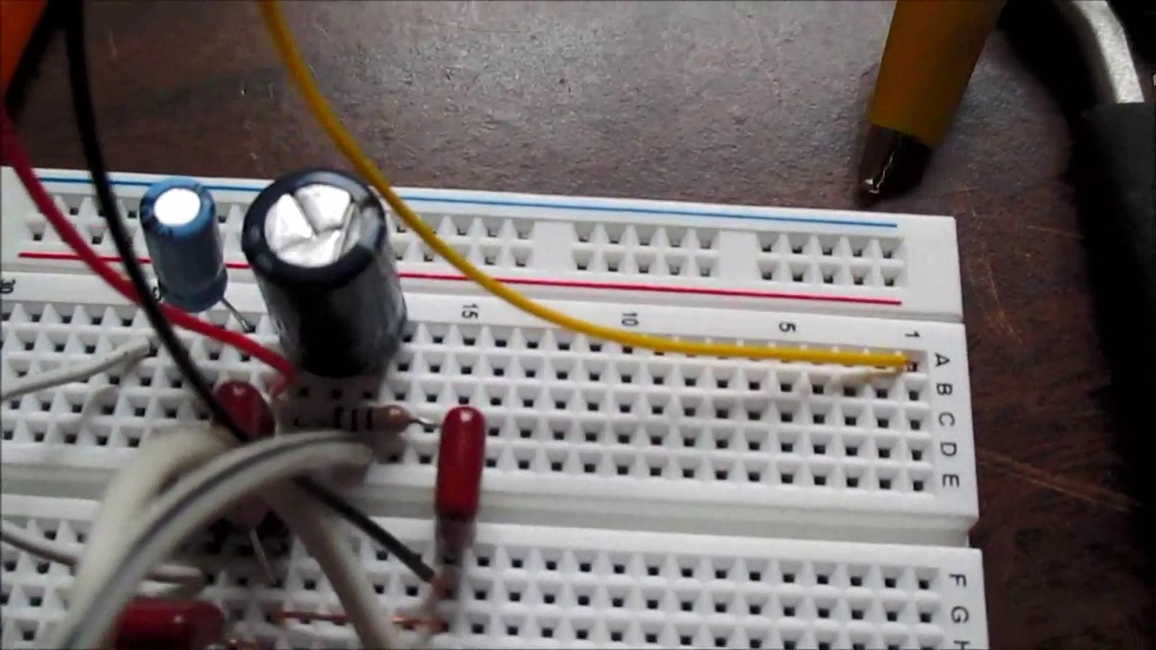 (score 95.0000)
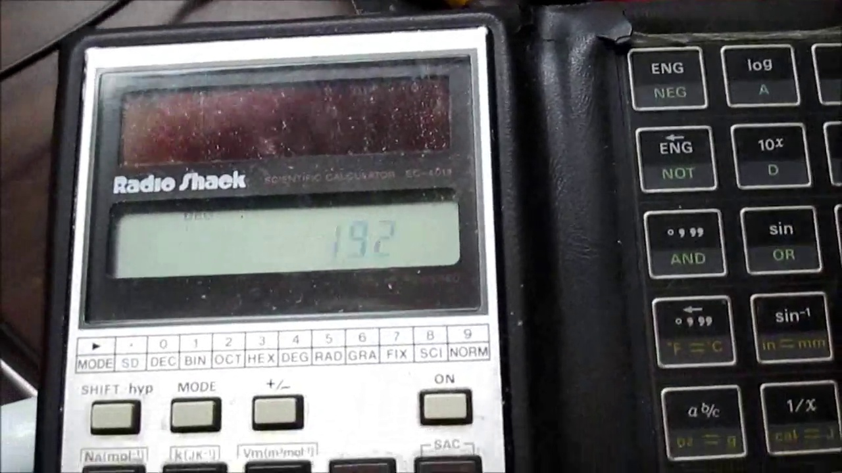 (score 95.0000)
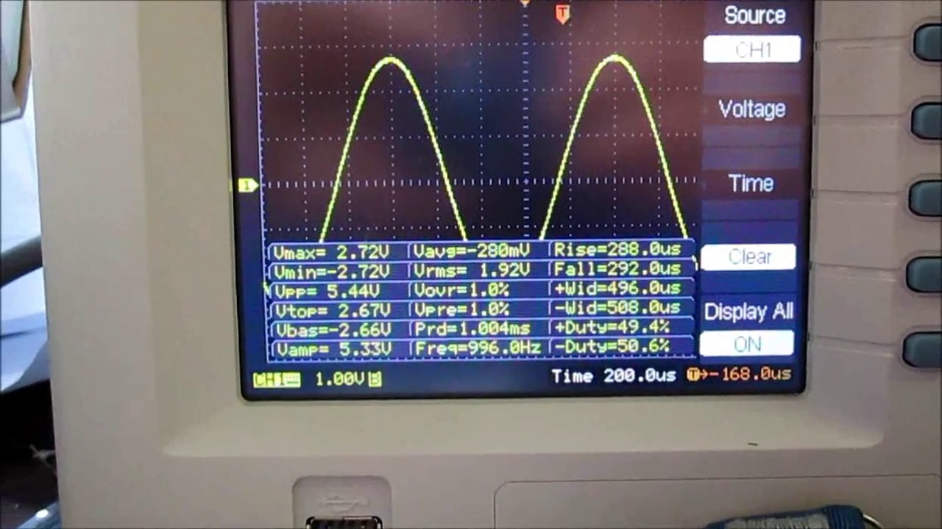 (score 95.0000)
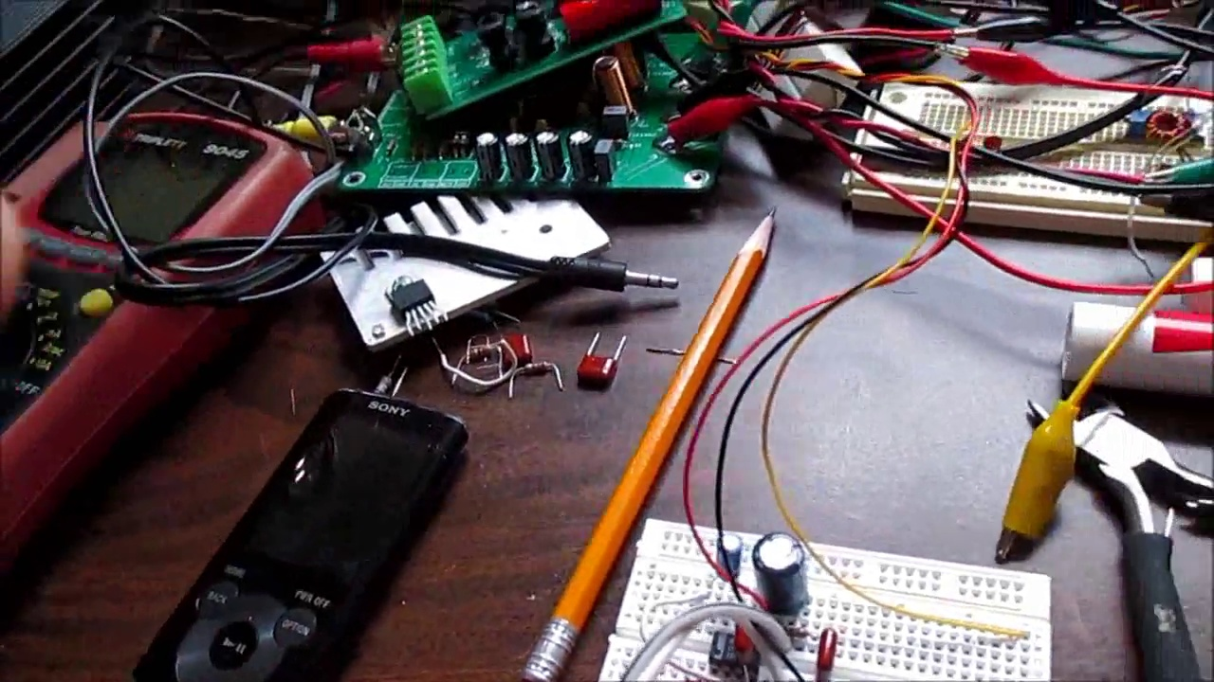 (score 95.0000)
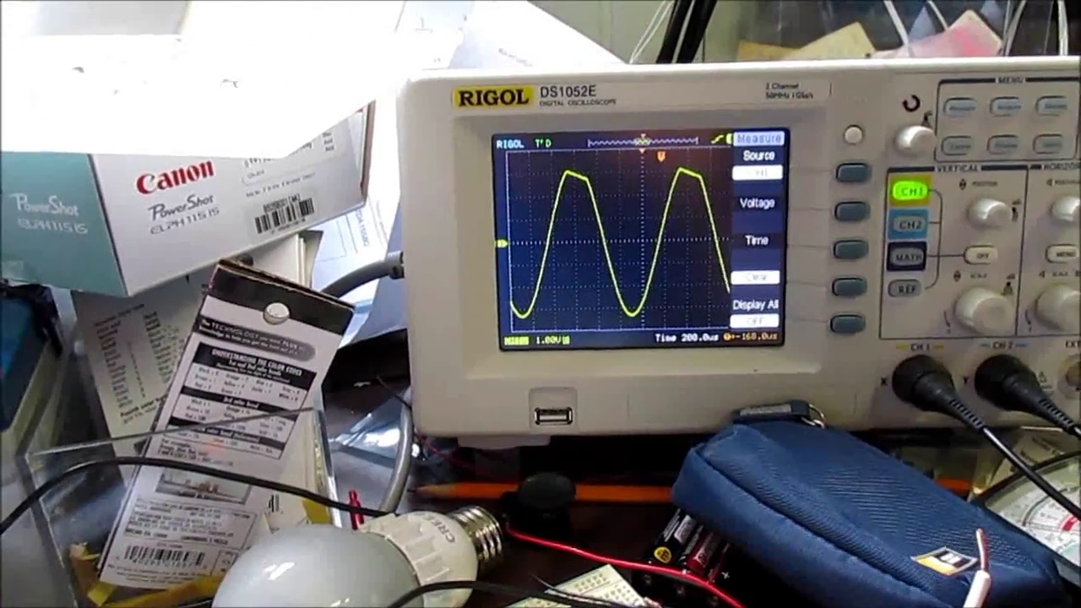 (score 95.0000)
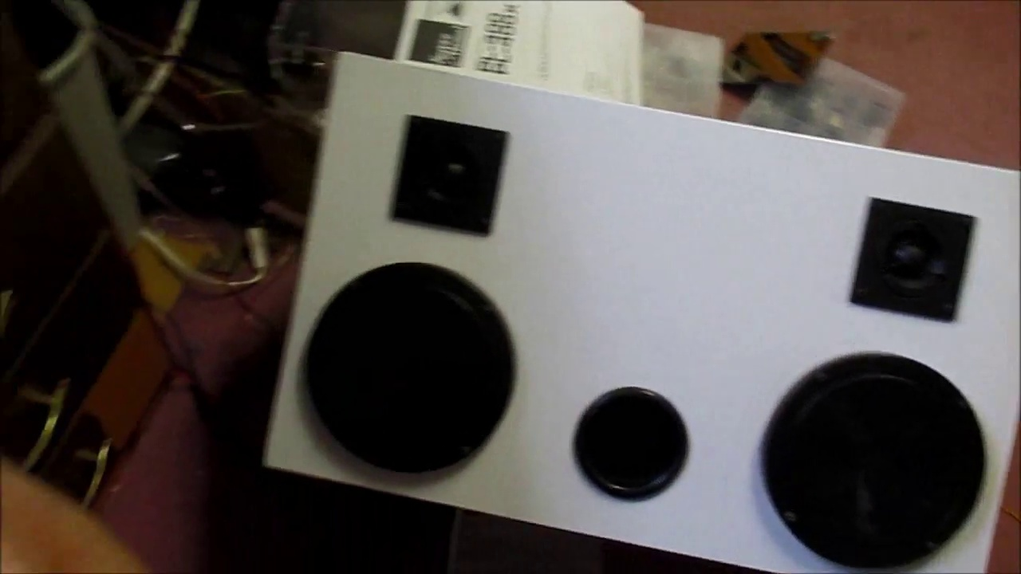 (score 95.0000)
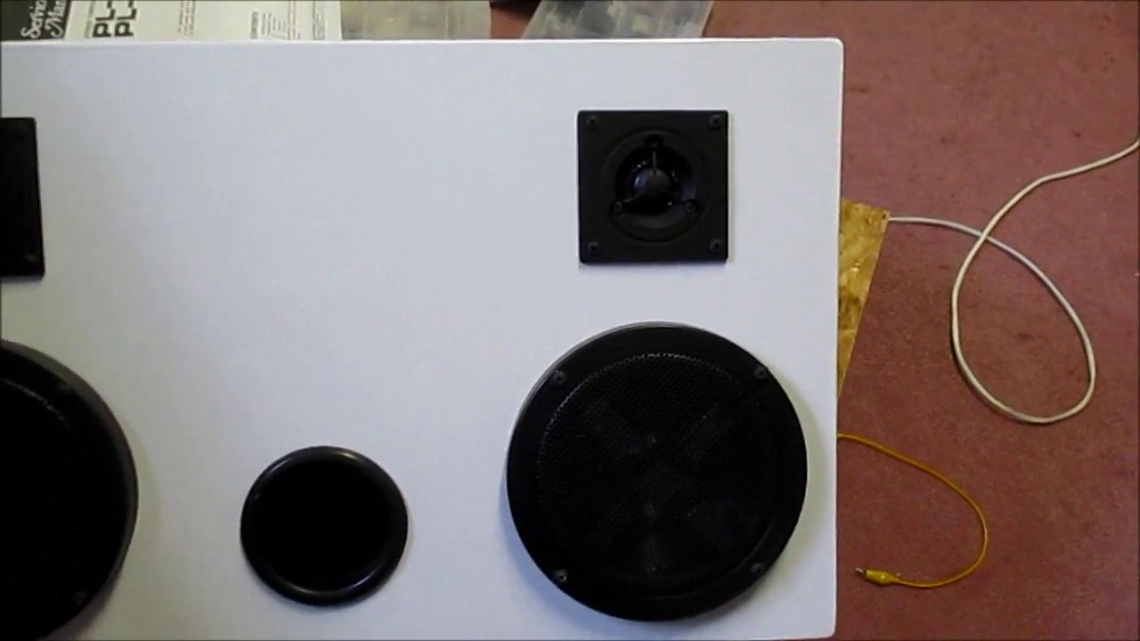 (score 95.0000)
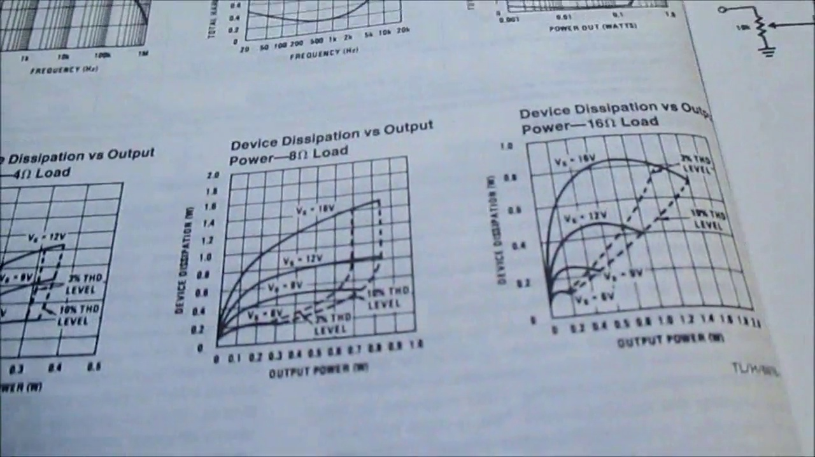 (score 95.0000)
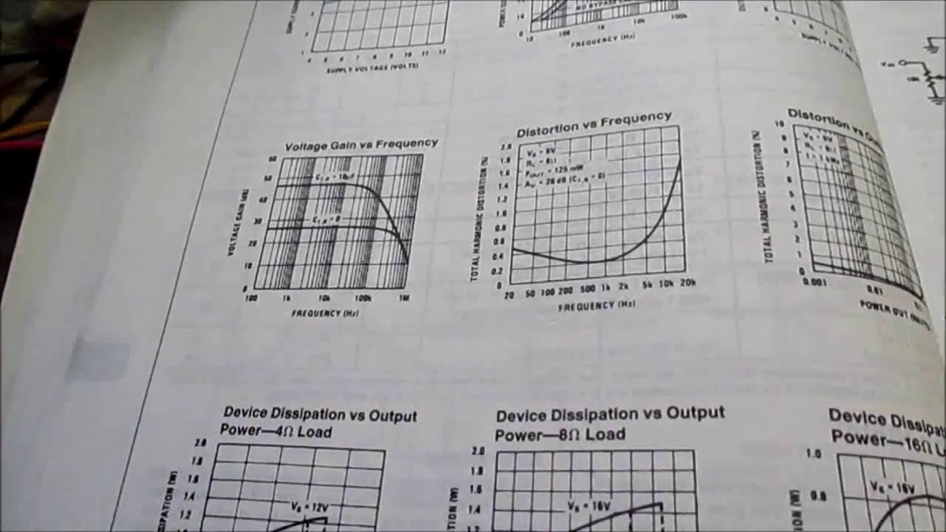 (score 95.0000)
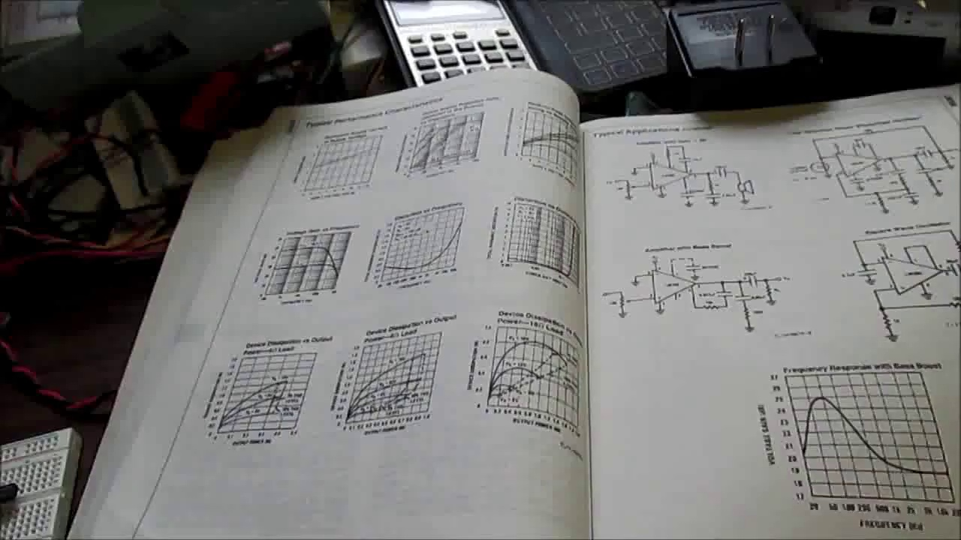 (score 95.0000)
Least correlated frames:
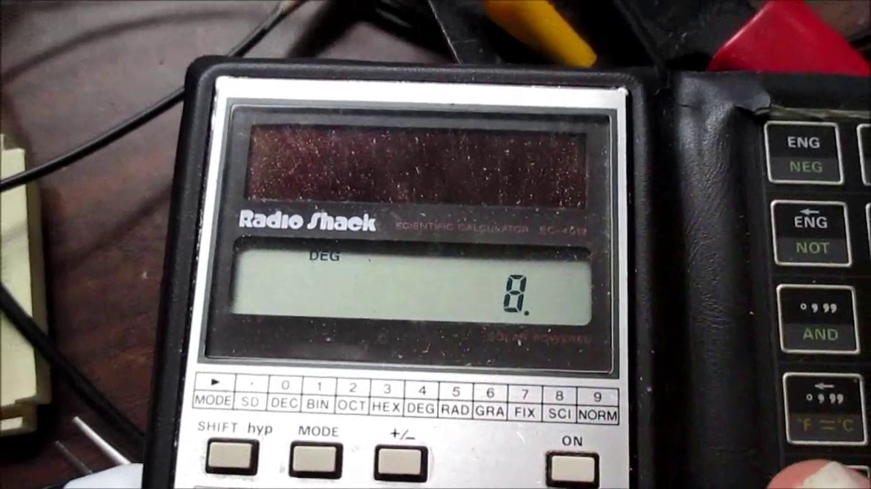 (score 0.0000)
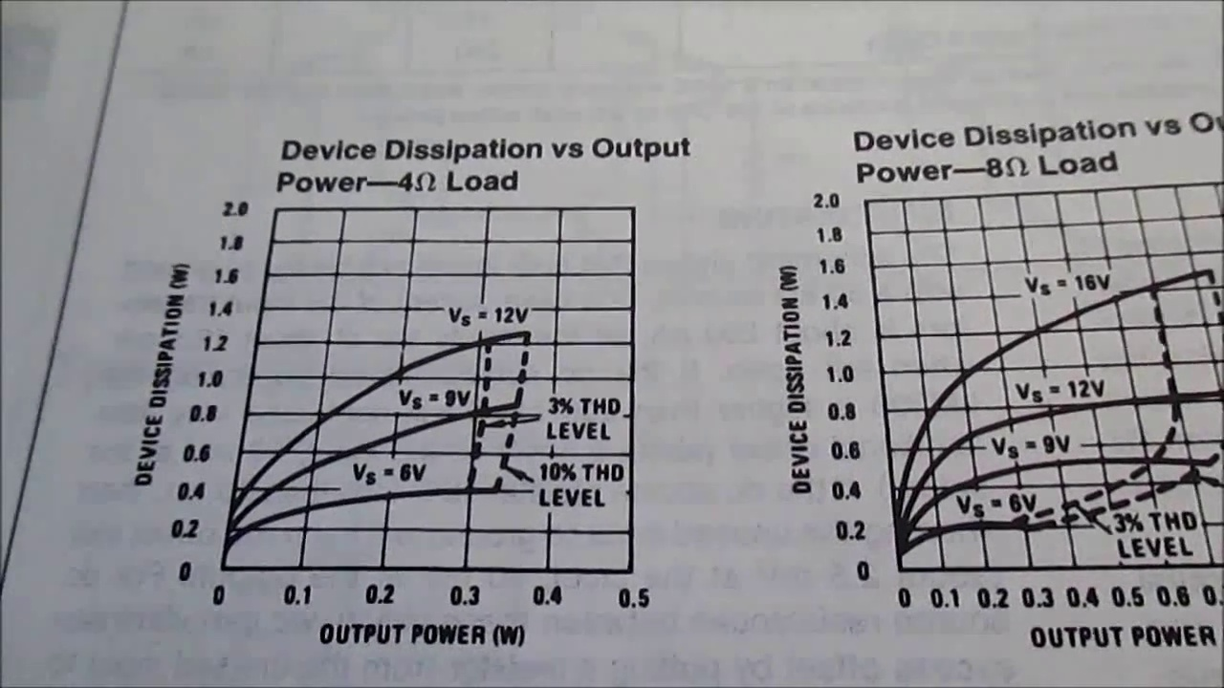 (score 20.0000)
 (score 20.0000)
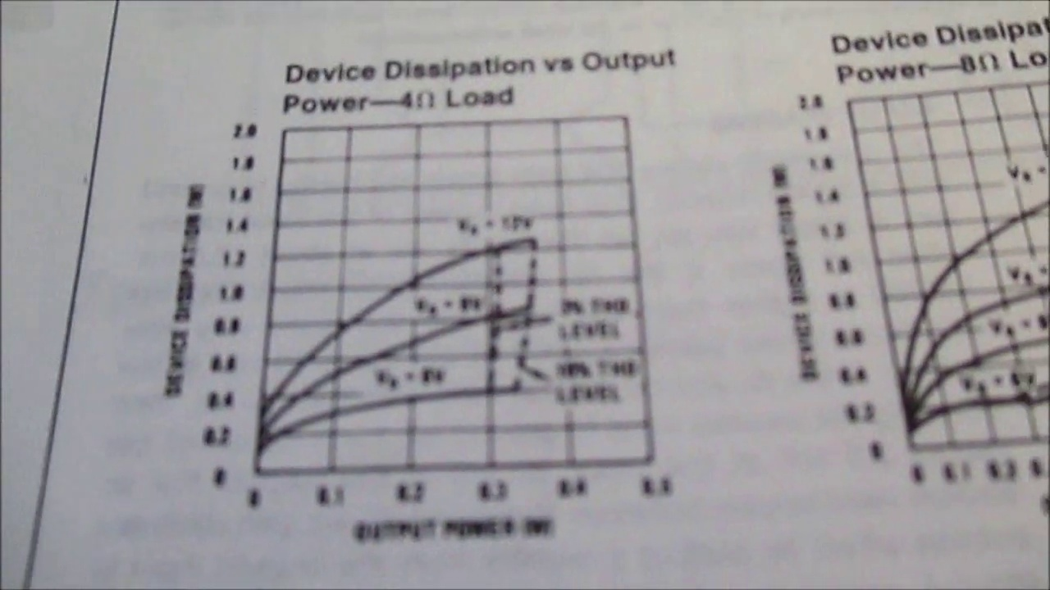 (score 20.0000)
 (score 20.0000)
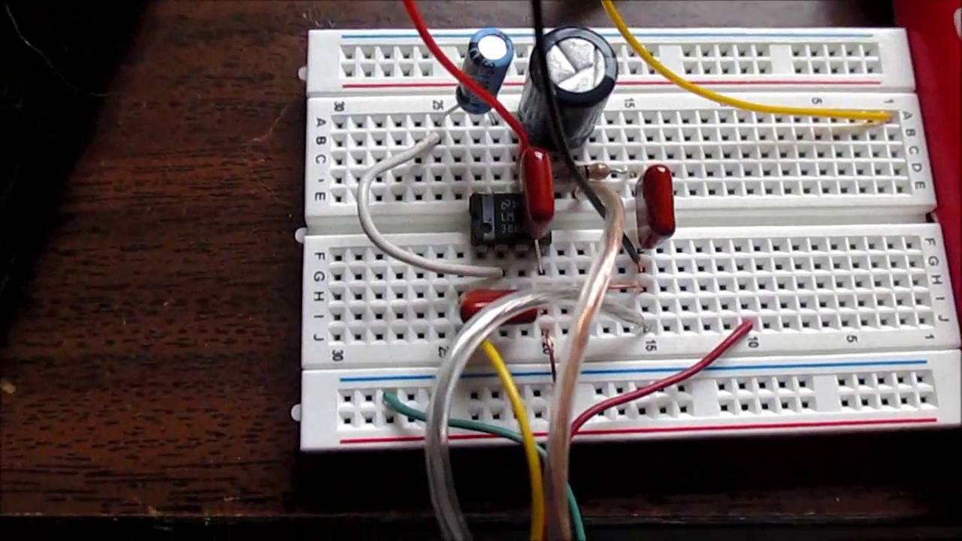 (score 20.0000)
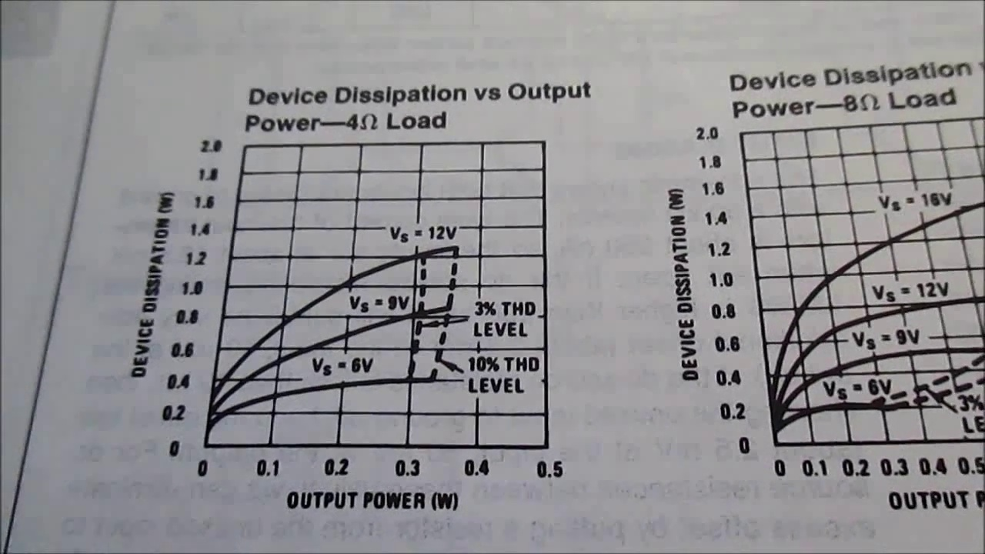 (score 75.0000)
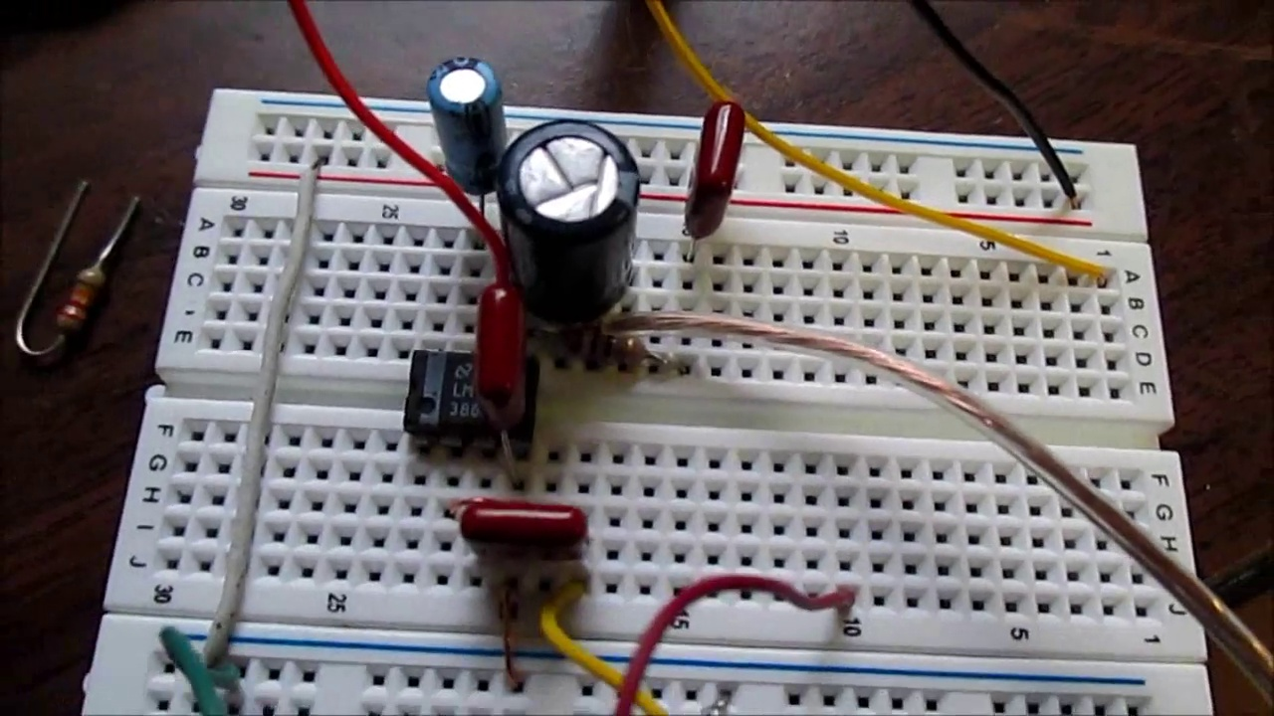 (score 75.0000)
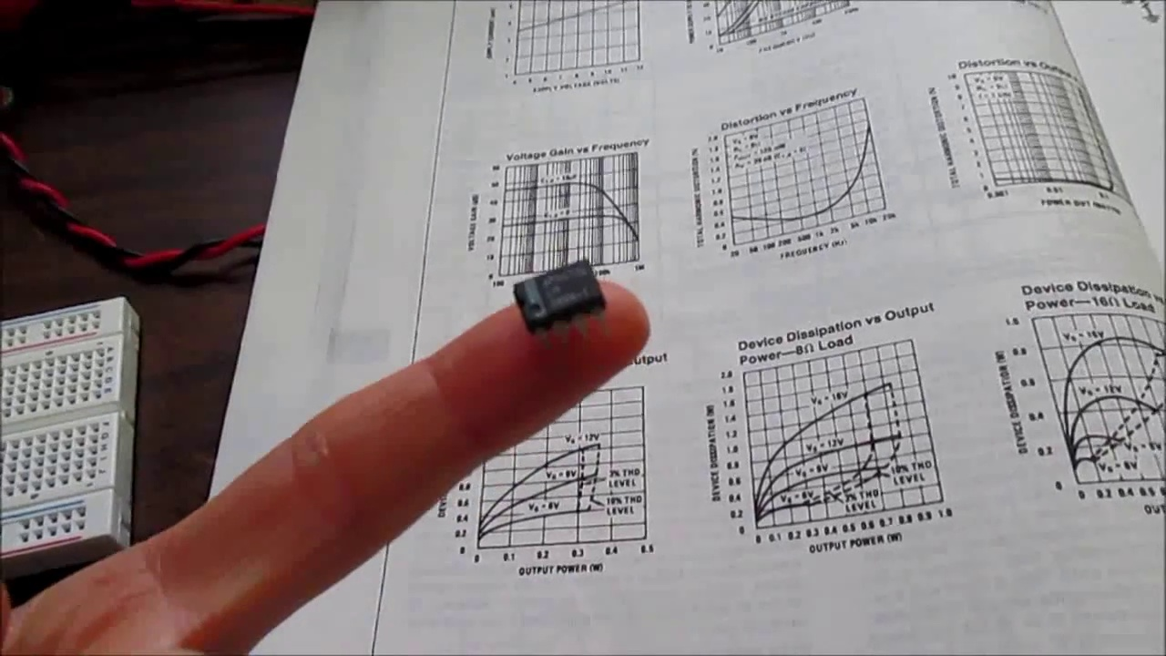 (score 80.0000)
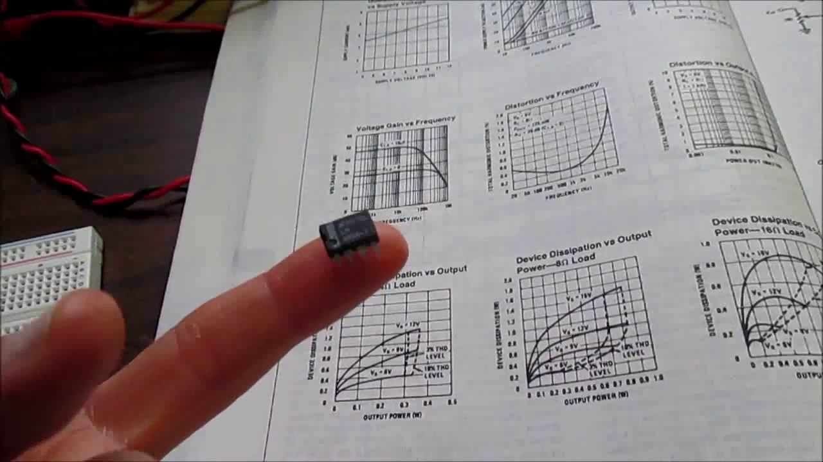 (score 80.0000)
- matched 115 frame(s), max score 95.0000: What I have learned from the video: This video emphasizes the importance of proper grounding in audio circuits to prevent humming and noise. It includes a practical demonstration of common grounding techniques. What confused me: Understanding the cause of ground loops and how to avoid them was confusing, especially since it involved complex electrical concepts that weren't well visualized. How I plan to use the electrical system in the future: Ensure that any audio amplifier I design is properly grounded to avoid unwanted noise, especially in professional audio equipment.
Source: https://www.youtube.com/watch?v=lBGE5lwbruE: LM386 Audio Amplifier and Proper Ground: How To?
Top correlated frames:
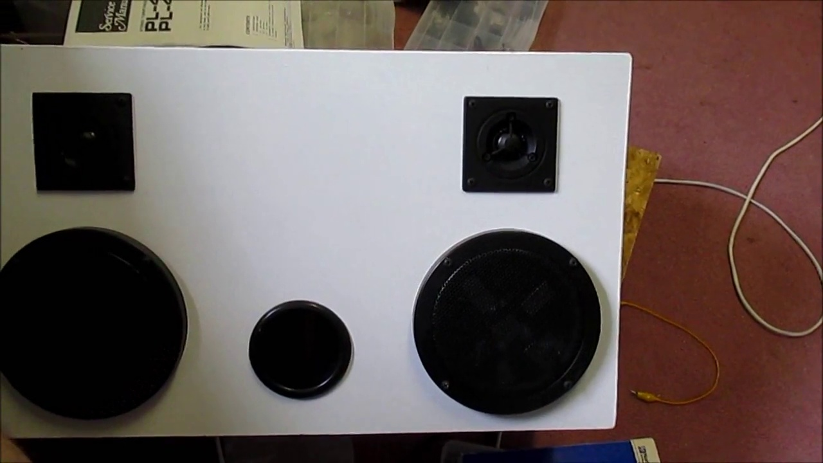 (score 95.0000)
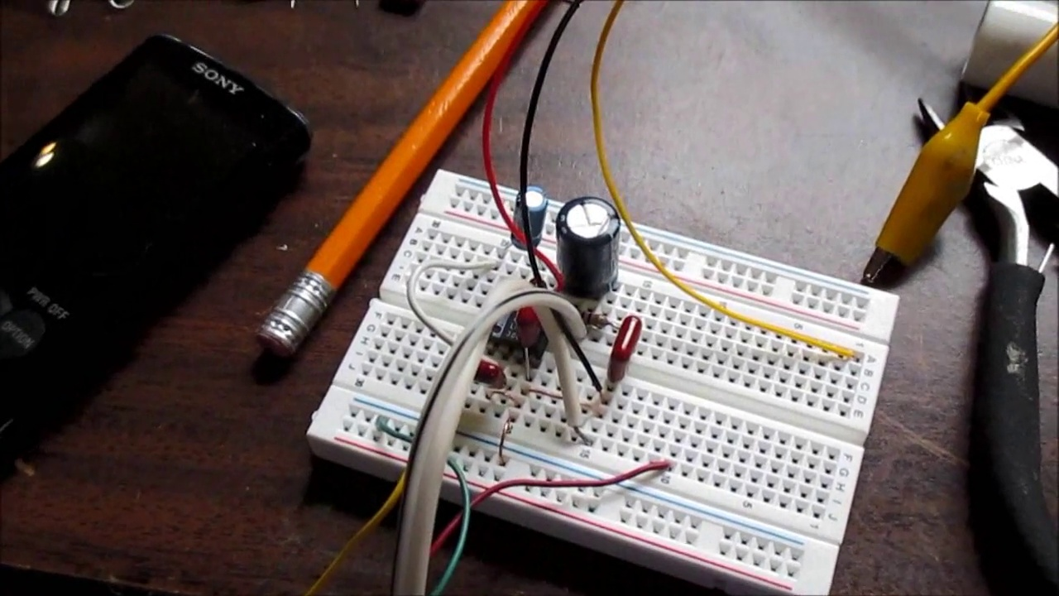 (score 90.0000)
 (score 90.0000)
 (score 90.0000)
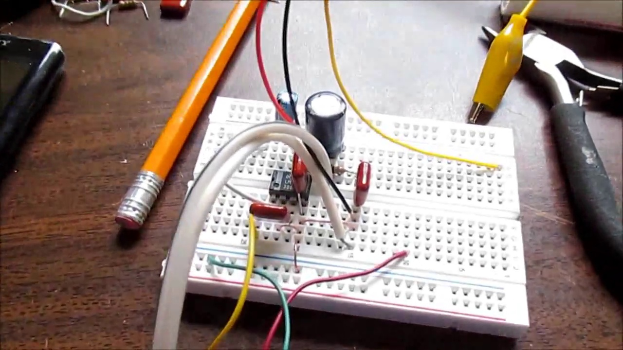 (score 90.0000)
 (score 90.0000)
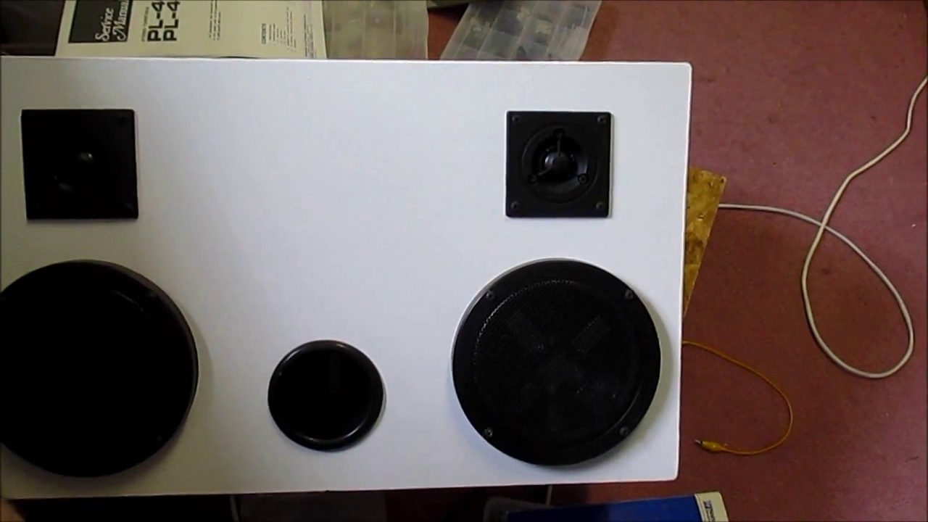 (score 90.0000)
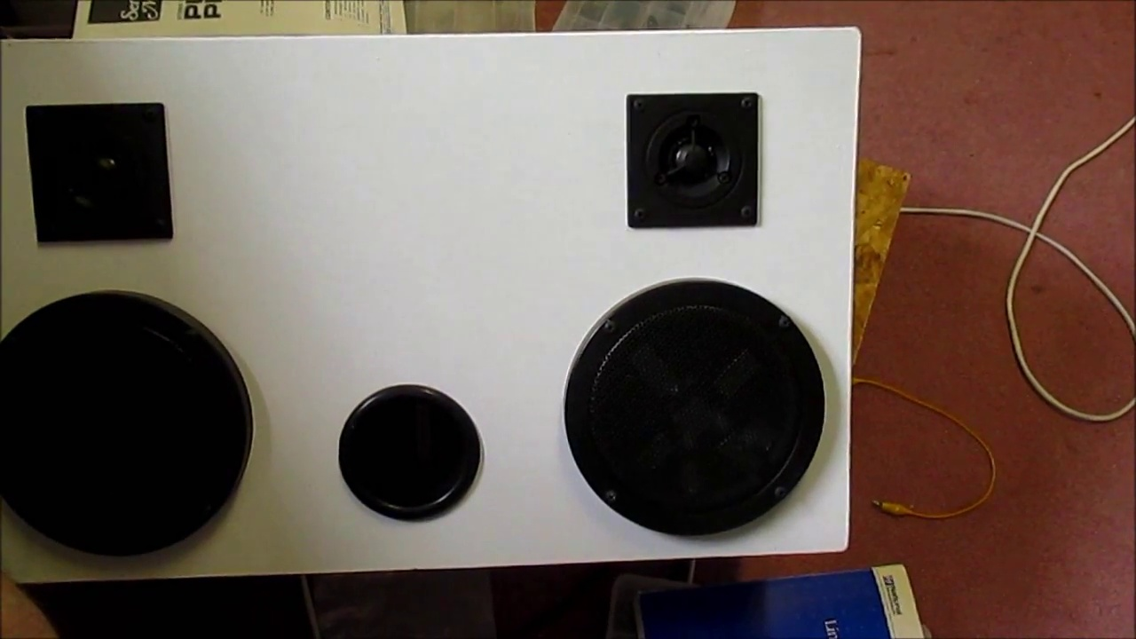 (score 90.0000)
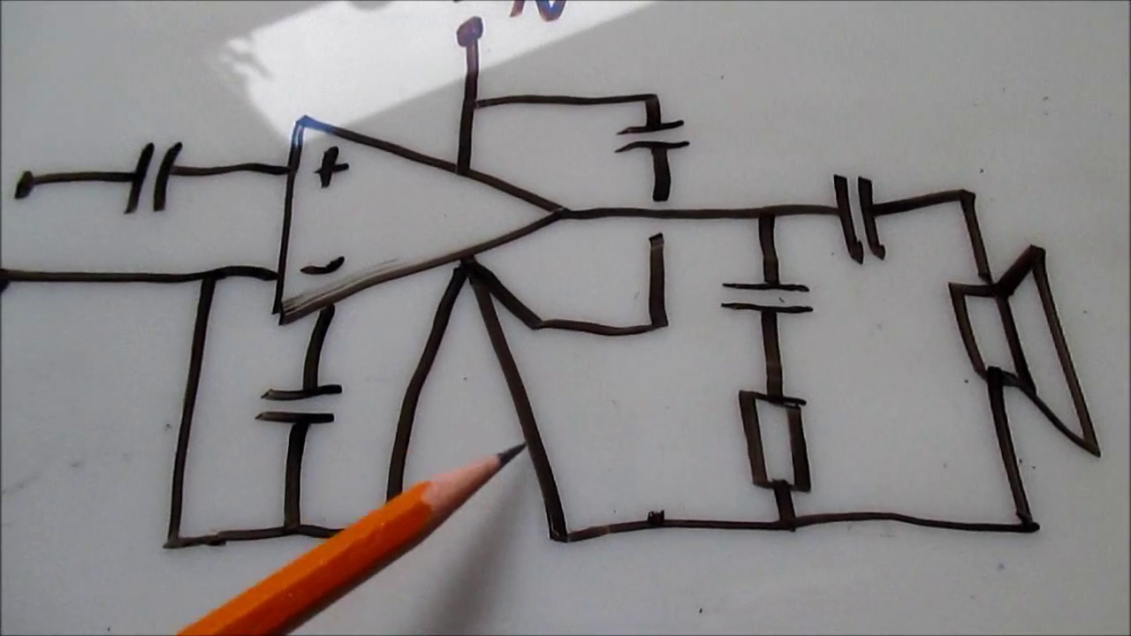 (score 90.0000)
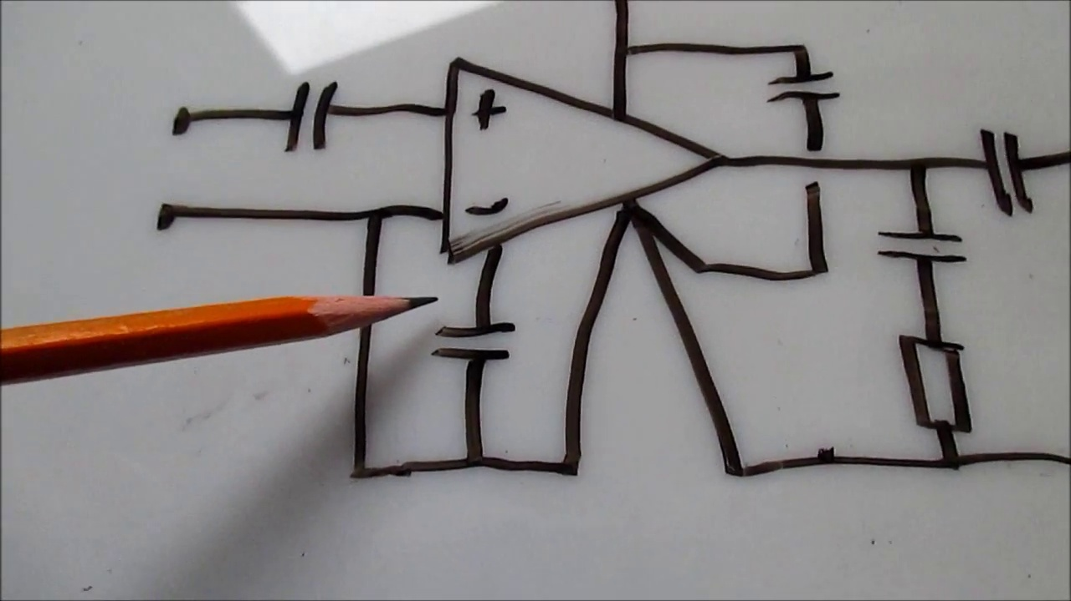 (score 90.0000)
Least correlated frames:
 (score 0.0000)
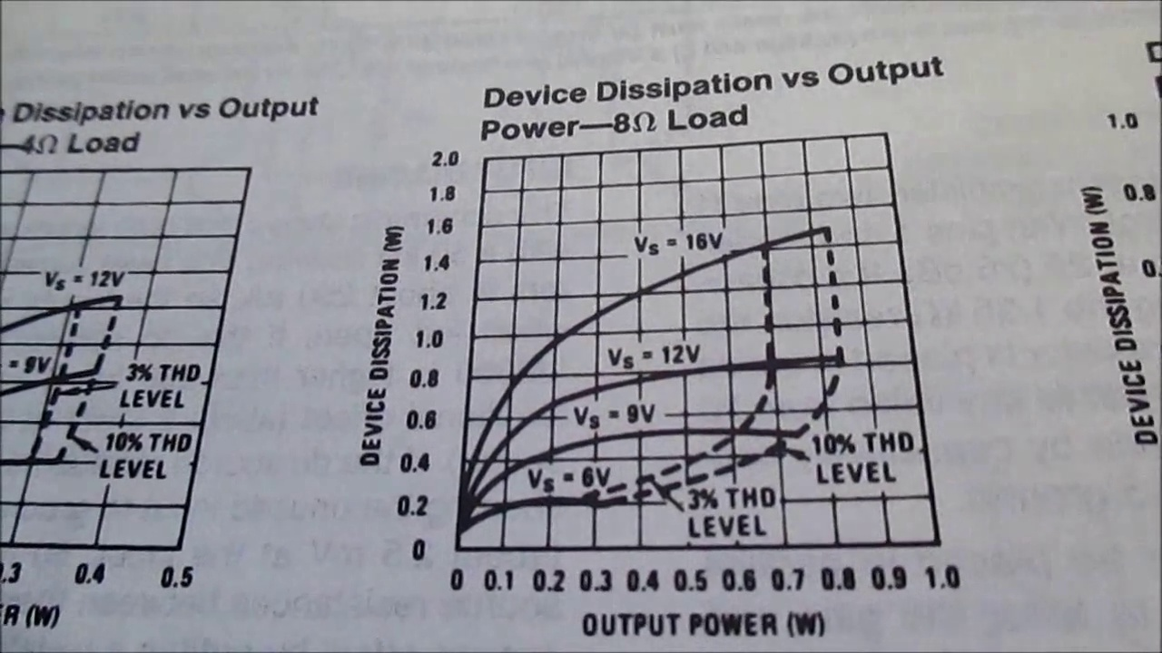 (score 0.0000)
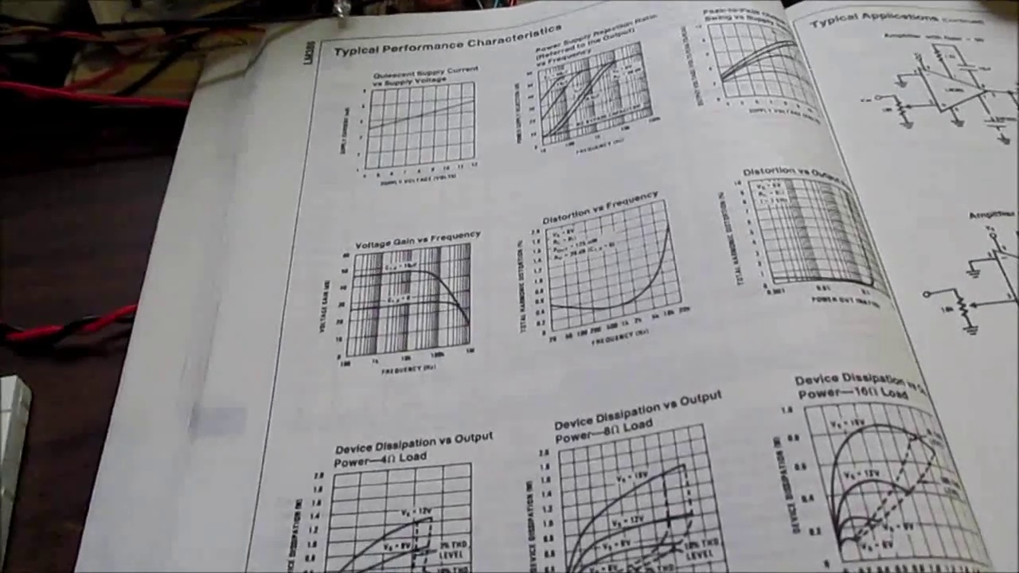 (score 10.0000)
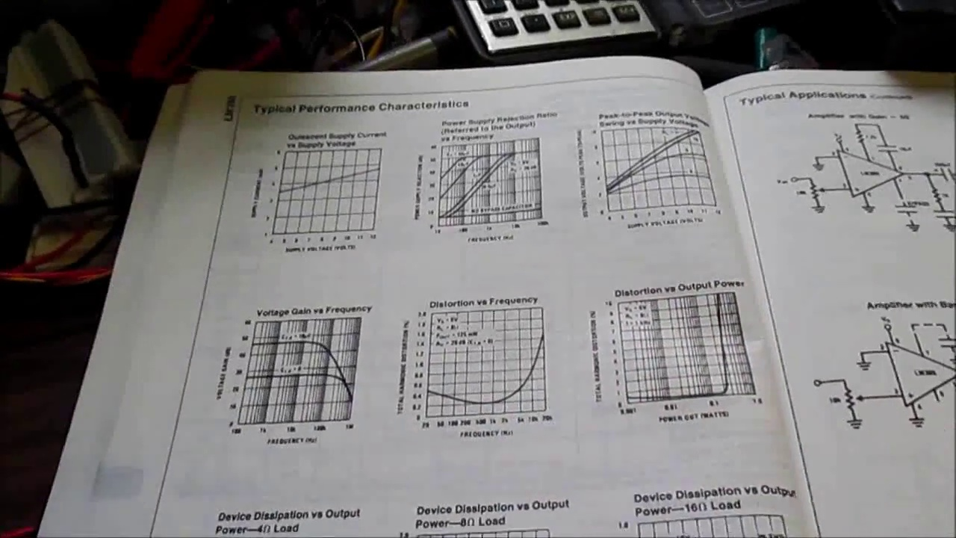 (score 10.0000)
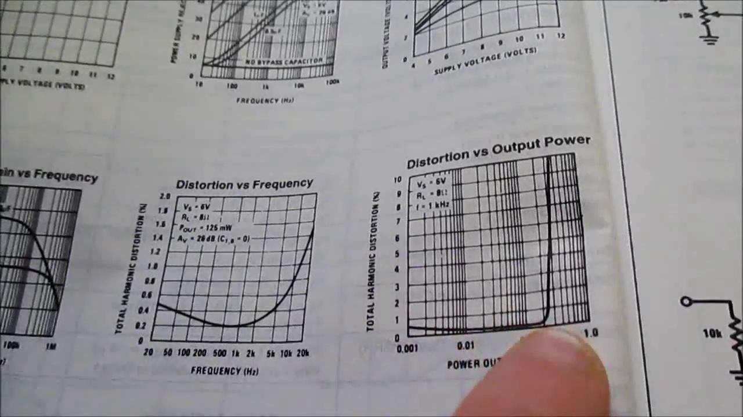 (score 10.0000)
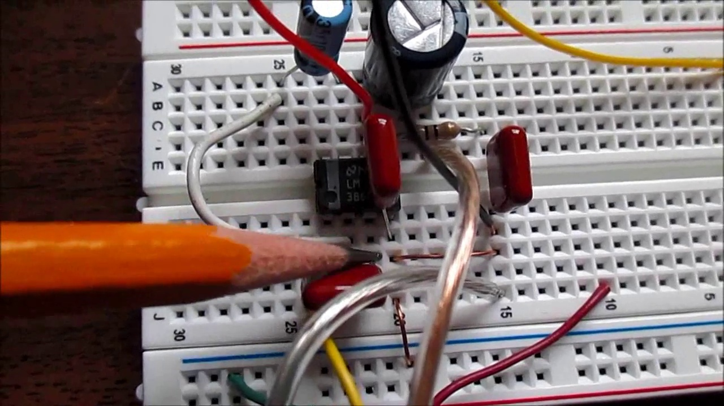 (score 10.0000)
 (score 20.0000)
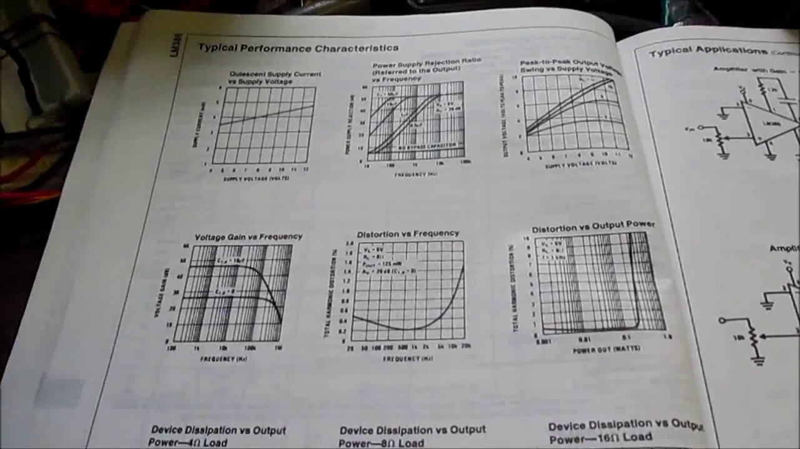 (score 20.0000)
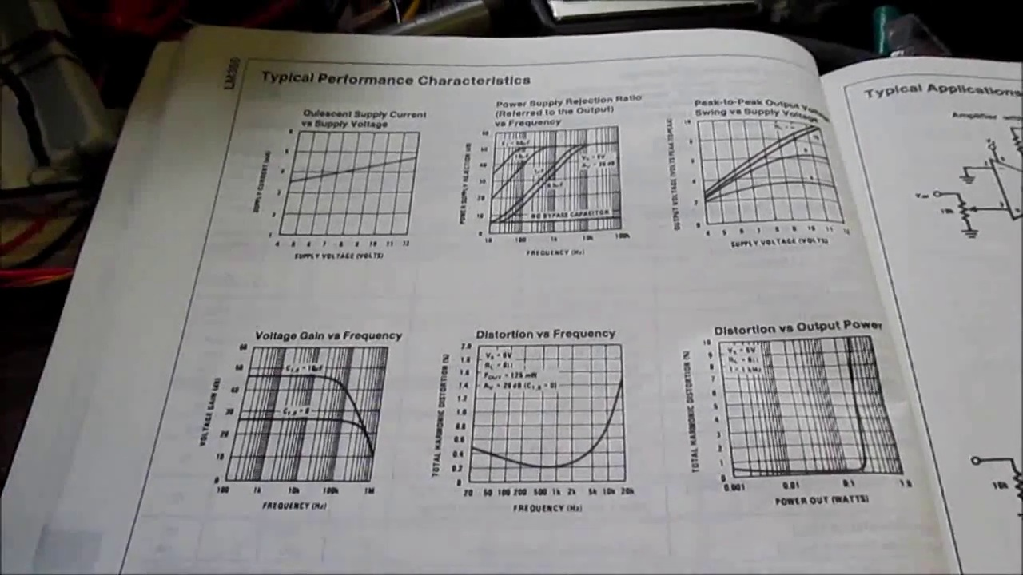 (score 20.0000)
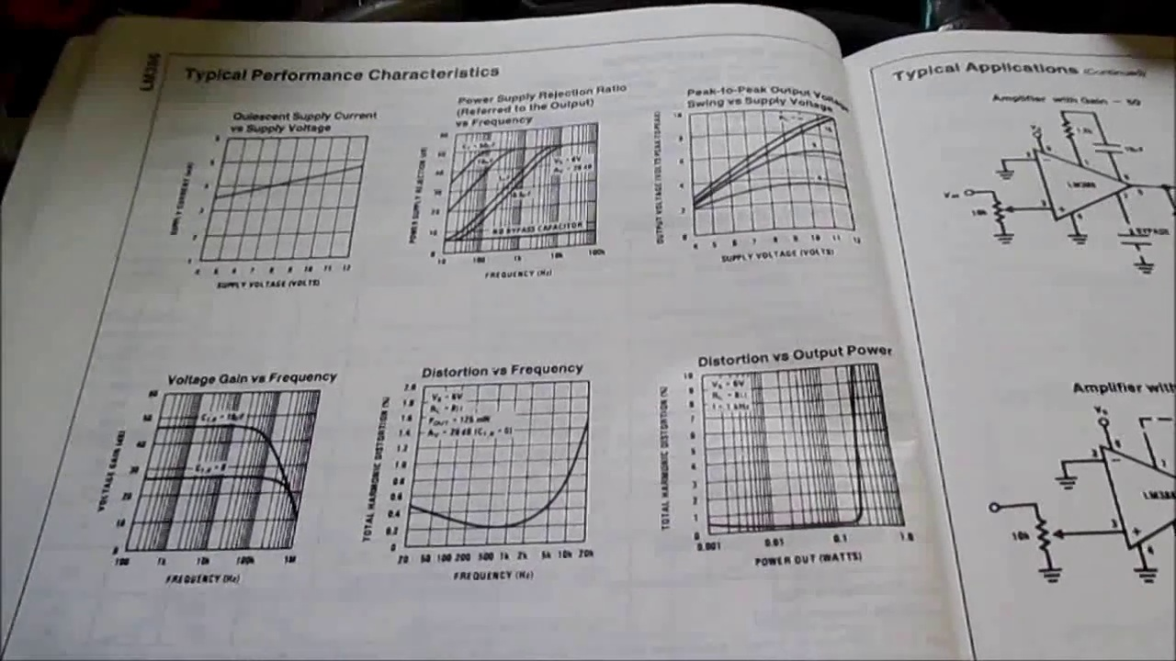 (score 20.0000)

Frame: frame_0000.jpg
Caption: The image shows a person engaged in an activity that involves electronic components and mathematical diagrams, likely in a laboratory or workshop setting. A small, black chip is placed on a wooden surface, partially hidden between the person's index finger and their thumb. The chip appears to be a part of an electronic device, possibly an integrated circuit or a microprocessor. In the background, textbooks and papers are visible, containing scientific or engineering material with graphs, charts, and circuit diagrams. The books seem to contain mathematical concepts and principles related to electronics, as indicated by the presence of equations and diagrams. The person is focused on something off-camera, possibly explaining or demonstrating a concept, but there is no readable text in the image that would provide additional context about the content being discussed.
Comment (score 95): Proper grounding layout significantly impacts LM386 amplifier performance, reducing noise and distortion.Details of how ground loops contribute to distortion and layout-specific solutions.Applying correct grounding techniques in audio amplifier design to minimize noise and distortion.
Reason: The comment directly discusses the correct grounding layout for an amplifier, which is a technical step mentioned in the caption. The mention of LM386 and ground loops also matches the context of electronic components and mathematical diagrams in the caption.
Source: https://www.youtube.com/watch?v=lBGE5lwbruE&t=340s: LM386 Audio Amplifier and Proper Ground Layout
Comment (score 90): What I have learned from the video: This video emphasizes the importance of proper grounding in audio circuits to prevent humming and noise. It includes a practical demonstration of common grounding techniques. What confused me: Understanding the cause of ground loops and how to avoid them was confusing, especially since it involved complex electrical concepts that weren't well visualized. How I plan to use the electrical system in the future: Ensure that any audio amplifier I design is properly grounded to avoid unwanted noise, especially in professional audio equipment.
Reason: The comment directly discusses the same technical steps (proper grounding in audio circuits), objects (grounding techniques), and settings (audio equipment) described in the caption. The only minor difference is that the caption doesn't explicitly mention 'audio circuits' or 'humming and noise', but the general theme of electronics and circuitry is present.
Source: https://www.youtube.com/watch?v=lBGE5lwbruE: LM386 Audio Amplifier and Proper Ground: How To?

Frame: frame_0001.jpg
Caption: The image shows a close-up view of a person's hand holding a small electronic component, specifically a microcontroller, on a piece of paper. The microcontroller is being held up against a grid of equations and graphs, which appears to be reading material or content related to the subject matter. The person's finger is visible on the left side of the image, indicating the direction of the object's orientation. The overall setting suggests an educational context, possibly a classroom or lab where teaching and learning activities are taking place. The person seems to be either pointing out something important or demonstrating a concept related to the content being discussed or taught.
Comment (score 85): What I have learned from the video: This video emphasizes the importance of proper grounding in audio circuits to prevent humming and noise. It includes a practical demonstration of common grounding techniques. What confused me: Understanding the cause of ground loops and how to avoid them was confusing, especially since it involved complex electrical concepts that weren't well visualized. How I plan to use the electrical system in the future: Ensure that any audio amplifier I design is properly grounded to avoid unwanted noise, especially in professional audio equipment.
Reason: The comment directly discusses the same technical steps (proper grounding in audio circuits) and settings (educational context) described in the caption. The comment also references the demonstration of common grounding techniques, which is visually depicted in the image. The correlation score is high because the comment provides specific examples and practical applications of the concepts presented in the caption.
Source: https://www.youtube.com/watch?v=lBGE5lwbruE: LM386 Audio Amplifier and Proper Ground: How To?

Frame: frame_0002.jpg
Caption: This image captures a moment of curiosity and learning. A person's hand holds a small electronic component, specifically an integrated circuit (IC), which appears to be an Arduino board given its shape and the surrounding text. The IC is being pointed at with one finger of the right hand.
The background consists of a book open to a page showing what seems to be a math or engineering problem set on graph paper, along with a grid with a series of squares marked with numbers that could be coordinates or data points. There are also some graphs and text on the page that is visible in the image. The text on the page includes mathematical equations and annotations that mention "y" which may refer to a variable or a function being evaluated.
The setting appears to be educational, possibly a classroom or study area, indicated by the presence of textbooks and teaching materials. The overall scene suggests a learning environment, where the person is actively engaged in understanding the principles of electrical engineering, as evidenced by the diagrams and equations related to this field scattered across the page.
Comment (score 90): Proper grounding layout significantly impacts LM386 amplifier performance, reducing noise and distortion.Details of how ground loops contribute to distortion and layout-specific solutions.Applying correct grounding techniques in audio amplifier design to minimize noise and distortion.
Reason: The comment directly discusses the technical steps mentioned in the caption, specifically proper grounding layout and its impact on amplifier performance, which is related to the Arduino board and electrical engineering concepts shown in the image.
Source: https://www.youtube.com/watch?v=lBGE5lwbruE&t=340s: LM386 Audio Amplifier and Proper Ground Layout
Comment (score 80): What I have learned from the video: This video emphasizes the importance of proper grounding in audio circuits to prevent humming and noise. It includes a practical demonstration of common grounding techniques. What confused me: Understanding the cause of ground loops and how to avoid them was confusing, especially since it involved complex electrical concepts that weren't well visualized. How I plan to use the electrical system in the future: Ensure that any audio amplifier I design is properly grounded to avoid unwanted noise, especially in professional audio equipment.
Reason: The comment directly discusses the technical steps and concepts described in the caption, such as proper grounding in audio circuits, ground loops, and electrical noise. The mention of 'practical demonstration' and 'electrical system' also matches with the scene in the image, which shows a person handling an integrated circuit and surrounded by educational materials.
Source: https://www.youtube.com/watch?v=lBGE5lwbruE: LM386 Audio Amplifier and Proper Ground: How To?

Frame: frame_0003.jpg
Caption: The image shows a person, partially visible in the background, holding what appears to be a remote control or similar device. This could indicate that they are controlling a presentation or demonstration. In front of them, a hand is gently holding a small electronic component, seen from the back, on top of a piece of paper filled with technical diagrams and graphs. The diagram may be related to electronics or computer science, possibly from a book or textbook, and includes visible text that is too small to read clearly. The overall scene suggests an educational environment, potentially a classroom or study area, where technical or computer science concepts are being demonstrated or taught.
Comment (score 90): What I have learned from the video: This video emphasizes the importance of proper grounding in audio circuits to prevent humming and noise. It includes a practical demonstration of common grounding techniques. What confused me: Understanding the cause of ground loops and how to avoid them was confusing, especially since it involved complex electrical concepts that weren't well visualized. How I plan to use the electrical system in the future: Ensure that any audio amplifier I design is properly grounded to avoid unwanted noise, especially in professional audio equipment.
Reason: The comment directly discusses the importance of proper grounding in audio circuits, which is mentioned in the caption as a technical concept being demonstrated. The practical demonstration and grounding techniques mentioned in the comment are also relevant to the scene described in the caption, where an electronic component is being held and diagrams related to electronics or computer science are visible.
Source: https://www.youtube.com/watch?v=lBGE5lwbruE: LM386 Audio Amplifier and Proper Ground: How To?
Comment (score 90): Proper grounding layout significantly impacts LM386 amplifier performance, reducing noise and distortion.Details of how ground loops contribute to distortion and layout-specific solutions.Applying correct grounding techniques in audio amplifier design to minimize noise and distortion.
Reason: The comment directly discusses the technical topic mentioned in the caption (grounding layout and amplifier performance), specifically referencing concepts related to electronics and computer science education.
Source: https://www.youtube.com/watch?v=lBGE5lwbruE&t=340s: LM386 Audio Amplifier and Proper Ground Layout

Frame: frame_0004.jpg
Caption: The image shows a person's hand pointing at an object on a book page, with the individual seated and holding up one finger in a universally recognized "okay" gesture, often signifying approval or agreement. The person is wearing a ring on their index finger. On the book page, graphs and diagrams are visible, potentially related to mathematics, such as statistical analysis, given the context of probability distributions and functions. Additionally, tables and text boxes with numerical data or equations can be seen. However, due to the angle and focus of the photo, the specific details of the content are not entirely clear.
The setting suggests an educational environment, likely a classroom or study space, indicated by the presence of teaching materials such as books and papers on the table. The object being pointed at is a small electronic component placed on top of a book, suggesting that the person may be examining it in an educational or investigational context. There is no direct evidence of an instructor in this frame, nor any clear indication that they are writing, speaking from a slide, or holding up a model for instructional purposes. The focus remains on the hand gesture and the item being pointed at.
Comment (score 85): What I have learned from the video: This video emphasizes the importance of proper grounding in audio circuits to prevent humming and noise. It includes a practical demonstration of common grounding techniques. What confused me: Understanding the cause of ground loops and how to avoid them was confusing, especially since it involved complex electrical concepts that weren't well visualized. How I plan to use the electrical system in the future: Ensure that any audio amplifier I design is properly grounded to avoid unwanted noise, especially in professional audio equipment.
Reason: The comment directly discusses the importance of proper grounding in audio circuits and practical demonstration of common grounding techniques mentioned in the caption. The mention of preventing humming and noise, as well as avoiding unwanted noise in professional audio equipment, strongly connects to the technical steps and goals described in the caption.
Source: https://www.youtube.com/watch?v=lBGE5lwbruE: LM386 Audio Amplifier and Proper Ground: How To?
Comment (score 80): Proper grounding layout significantly impacts LM386 amplifier performance, reducing noise and distortion.Details of how ground loops contribute to distortion and layout-specific solutions.Applying correct grounding techniques in audio amplifier design to minimize noise and distortion.
Reason: The comment directly discusses the technical steps related to grounding layout in an amplifier design, which is strongly connected to the graphs and diagrams on the book page, potentially related to statistical analysis or equations. The mention of noise and distortion reduction also aligns with the context of the educational setting and the object being pointed at.
Source: https://www.youtube.com/watch?v=lBGE5lwbruE&t=340s: LM386 Audio Amplifier and Proper Ground Layout

Frame: frame_0005.jpg
Caption: The image shows a close-up of a hand pointing to a small electronic component, which appears to be connected to a breadboard. The person's face and body are out of frame, focusing attention on the chip being held up for examination. In the background, there is an open book or notebook with visible text, although the content of the text is not legible in this image. To the right, a microscope can be seen, suggesting that some form of scientific analysis or examination is taking place. The setting appears to be a classroom or laboratory environment, and it looks like the person might be demonstrating how to use or showcase the electronics components, possibly to illustrate a concept from the open book or notebook.
Comment (score 90): What I have learned from the video: This video emphasizes the importance of proper grounding in audio circuits to prevent humming and noise. It includes a practical demonstration of common grounding techniques. What confused me: Understanding the cause of ground loops and how to avoid them was confusing, especially since it involved complex electrical concepts that weren't well visualized. How I plan to use the electrical system in the future: Ensure that any audio amplifier I design is properly grounded to avoid unwanted noise, especially in professional audio equipment.
Reason: The comment directly discusses the importance of proper grounding in audio circuits and includes a practical demonstration, which is strongly related to the caption's description of demonstrating how to use or showcase electronics components, possibly illustrating a concept from an open book or notebook.
Source: https://www.youtube.com/watch?v=lBGE5lwbruE: LM386 Audio Amplifier and Proper Ground: How To?
Comment (score 90): Proper grounding layout significantly impacts LM386 amplifier performance, reducing noise and distortion.Details of how ground loops contribute to distortion and layout-specific solutions.Applying correct grounding techniques in audio amplifier design to minimize noise and distortion.
Reason: The comment directly discusses the technical steps related to the grounding layout and its impact on LM386 amplifier performance, which is specifically described in the caption as a key concept being demonstrated. The mention of noise and distortion reduction also matches the context in the caption.
Source: https://www.youtube.com/watch?v=lBGE5lwbruE&t=340s: LM386 Audio Amplifier and Proper Ground Layout

Frame: frame_0006.jpg
Caption: The image shows a person's hand with an index finger pointing at a small black electronic component on a page of a book. The individual is seated in front of a table that appears to have some electronic equipment, possibly related to an educational or technical activity. The book is open to a page filled with various graphs and diagrams, specifically labeled as "Device Displacement" and "Power Load", which suggests the content is related to electronics, mathematics, physics, or engineering. The presence of plots resembling graphs typically used in engineering or science courses, such as sine waves, line graphs, and bar charts, further supports this conclusion. The setting appears to be a learning environment, possibly a classroom or laboratory, where instruction is taking place.
Comment (score 85): Proper grounding layout significantly impacts LM386 amplifier performance, reducing noise and distortion.Details of how ground loops contribute to distortion and layout-specific solutions.Applying correct grounding techniques in audio amplifier design to minimize noise and distortion.
Reason: The comment directly discusses the same technical concepts mentioned in the caption (grounding layout, amplifier performance, noise and distortion), using specific terms like 'LM386' and 'audio amplifier design', which are closely related to the setting and objects described in the frame caption.
Source: https://www.youtube.com/watch?v=lBGE5lwbruE&t=340s: LM386 Audio Amplifier and Proper Ground Layout
Comment (score 80): What I have learned from the video: This video emphasizes the importance of proper grounding in audio circuits to prevent humming and noise. It includes a practical demonstration of common grounding techniques. What confused me: Understanding the cause of ground loops and how to avoid them was confusing, especially since it involved complex electrical concepts that weren't well visualized. How I plan to use the electrical system in the future: Ensure that any audio amplifier I design is properly grounded to avoid unwanted noise, especially in professional audio equipment.
Reason: The comment directly discusses the same technical steps and goals described in the caption (proper grounding in audio circuits to prevent humming and noise), mentioning specific concepts ('ground loops', 'complex electrical concepts') that are also present in the caption. The correlation is high due to the focus on a specific topic (audio circuit grounding) and the presence of similar terminology.
Source: https://www.youtube.com/watch?v=lBGE5lwbruE: LM386 Audio Amplifier and Proper Ground: How To?

Frame: frame_0007.jpg
Caption: The image appears to be a snapshot from a video call or presentation, capturing a moment of fascination and curiosity. In the foreground, a person's hand is pointing at something on a page in an open book, which contains graphs and diagrams suggesting an educational or instructional context, possibly related to mathematics, physics, or engineering. The graphs depict plots with variables such as "x" and "y," potentially representing mathematical functions or data representation.
In the background, a table is draped with another book containing a complex diagram of a circuit, showcasing the intricate workings of electronic devices. This visual representation provides insight into the function of a tiny square component, held up to the light to reveal its intricate design and label, which reads "VICOR 2014-0025."
The overall style of the image suggests an informal setting, likely from a video call or presentation, where the person is engaged in an intellectual pursuit, exploring the unknown. The moment is one of curiosity meeting knowledge, highlighting human ingenuity and the endless possibilities of technology.
Comment (score 85): What I have learned from the video: This video emphasizes the importance of proper grounding in audio circuits to prevent humming and noise. It includes a practical demonstration of common grounding techniques. What confused me: Understanding the cause of ground loops and how to avoid them was confusing, especially since it involved complex electrical concepts that weren't well visualized. How I plan to use the electrical system in the future: Ensure that any audio amplifier I design is properly grounded to avoid unwanted noise, especially in professional audio equipment.
Reason: The comment directly discusses the importance of proper grounding in audio circuits and includes a practical demonstration, which is strongly related to the caption's description of an educational context, specifically mentioning grounding techniques. The comment also mentions the potential for unwanted noise and the need for proper grounding in professional audio equipment, which aligns with the graph plots and diagram in the background showing electronic devices.
Source: https://www.youtube.com/watch?v=lBGE5lwbruE: LM386 Audio Amplifier and Proper Ground: How To?
Comment (score 80): Proper grounding layout significantly impacts LM386 amplifier performance, reducing noise and distortion.Details of how ground loops contribute to distortion and layout-specific solutions.Applying correct grounding techniques in audio amplifier design to minimize noise and distortion.
Reason: The comment directly discusses the correct grounding layout in LM386 amplifier performance, which is related to the technical steps and objects described in the caption. The mention of noise reduction and distortion minimization is also connected to the diagram of a circuit in the background, which shows the intricate workings of electronic devices.
Source: https://www.youtube.com/watch?v=lBGE5lwbruE&t=340s: LM386 Audio Amplifier and Proper Ground Layout

Frame: frame_0008.jpg
Caption: The image captures a moment of intense focus and precision as a person's hand interacts with a piece of electronics equipment, which appears to be some kind of breadboard or component tester. The individual's fingers are lightly touching one of the pins on this strip, suggesting they might be checking a connection or testing the device. A white strip with various colored strips and possibly wires or connections going across the top, resembling a test strip or a pattern for electrical testing or soldering, is visible.
In front of the equipment, an open book lies open to reveal pages that resemble textbooks, although the text is not legible in the image. The style of the page suggests it could be related to electronics or engineering. A slide or diagram on the left side of the book might be relevant to the topic at hand.
The surroundings include a table with some additional items, possibly more electronic components or a soldering iron, but they are not in focus. The setting appears informal and designed for educational or hobbyist purposes, as indicated by the casual attire of the person and the layout of the workspace.
Every element in this image has a purpose - from the hand to the breadboard, from the notebook to the desk. They are all part of a larger story, a story of science, of discovery, of learning. The image is a snapshot of that story, a moment frozen in time that speaks volumes about the power of human intellect and the beauty of scientific exploration.
Comment (score 95): Proper grounding layout significantly impacts LM386 amplifier performance, reducing noise and distortion.Details of how ground loops contribute to distortion and layout-specific solutions.Applying correct grounding techniques in audio amplifier design to minimize noise and distortion.
Reason: The comment directly discusses the same technical steps (proper grounding layout) and objects (LM386 amplifier, ground loops) described in the caption, with a specific focus on reducing noise and distortion in audio amplifier design.
Source: https://www.youtube.com/watch?v=lBGE5lwbruE&t=340s: LM386 Audio Amplifier and Proper Ground Layout
Comment (score 90): What I have learned from the video: This video emphasizes the importance of proper grounding in audio circuits to prevent humming and noise. It includes a practical demonstration of common grounding techniques. What confused me: Understanding the cause of ground loops and how to avoid them was confusing, especially since it involved complex electrical concepts that weren't well visualized. How I plan to use the electrical system in the future: Ensure that any audio amplifier I design is properly grounded to avoid unwanted noise, especially in professional audio equipment.
Reason: The comment directly discusses the technical steps and goals described in the caption, specifically mentioning grounding techniques and preventing humming and noise in audio circuits. The mention of breadboards, component testers, and electronic components aligns with the image, as well as the focus on proper grounding.
Source: https://www.youtube.com/watch?v=lBGE5lwbruE: LM386 Audio Amplifier and Proper Ground: How To?

Frame: frame_0009.jpg
Caption: The image displays an open book with detailed diagrams and graphs related to science or engineering topics. The pages appear to be filled with notes and diagrams, suggesting a comprehensive understanding of the subject matter. The diagrams include multiple connections and components, each labeled with a different component or circuit element. One section is labeled "Power Dissipation vs. Load", while another is labeled "Device Displacement vs. Power". A third section is labeled "Power Dissipation vs. Input Voltage".
The graphs in each section depict the relationship between these components, featuring lines and numerical data points. Some of the plots show line charts with title labels such as "Plot 1" and "Plot 2", accompanied by x-axis and y-axis scales. This suggests that the book could be a textbook for a technical or scientific course focused on statistical analysis or data representation.
The text in the image is too small and blurry to read in detail, but it appears that the book may contain explanations or calculations related to the graphs presented. There is no clear indication of an instructor or classroom setting, as there are no people visible in this frame. The focus of the image remains on the open book and its content.
Comment (score 90): What I have learned from the video: This video emphasizes the importance of proper grounding in audio circuits to prevent humming and noise. It includes a practical demonstration of common grounding techniques. What confused me: Understanding the cause of ground loops and how to avoid them was confusing, especially since it involved complex electrical concepts that weren't well visualized. How I plan to use the electrical system in the future: Ensure that any audio amplifier I design is properly grounded to avoid unwanted noise, especially in professional audio equipment.
Reason: The comment directly discusses the importance of proper grounding in audio circuits, which is a key concept presented in the frame caption. The caption mentions diagrams and graphs related to power dissipation and device displacement, which are relevant to electrical systems. Although the context is different, the technical steps and concepts described in the caption (e.g., grounding techniques) are discussed in the comment as essential for designing audio amplifiers.
Source: https://www.youtube.com/watch?v=lBGE5lwbruE: LM386 Audio Amplifier and Proper Ground: How To?
Comment (score 80): Proper grounding layout significantly impacts LM386 amplifier performance, reducing noise and distortion.Details of how ground loops contribute to distortion and layout-specific solutions.Applying correct grounding techniques in audio amplifier design to minimize noise and distortion.
Reason: The comment directly discusses the same technical steps, objects, settings, or goals described in the caption. Specifically, it mentions LM386 amplifier performance, grounding layout, and noise/distortion reduction techniques, which are all related to the diagrams and graphs shown in the image.
Source: https://www.youtube.com/watch?v=lBGE5lwbruE&t=340s: LM386 Audio Amplifier and Proper Ground Layout

Frame: frame_0010.jpg
Caption: The image presents a dual focus on a Canon PowerShot camera box and a Canon PowerShot CLP-1115S printer. The camera box, with its barcode facing towards the viewer, is placed in front of electronic components or circuit boards, suggesting a technical or repair setting. In contrast, the printer, white and black with a black power button and silver cord, is being disassembled by an unseen hand. The printer's box, also white with black text and a black barcode, features the number 11514. A text box in the image displays the word "Canon" in black, indicating the brand of both products. Notably, there are no other objects or individuals present to distract from the main subjects, with the focus solely on the camera box, printer, and their respective packaging.
Comment (score 80): Proper grounding layout significantly impacts LM386 amplifier performance, reducing noise and distortion.Details of how ground loops contribute to distortion and layout-specific solutions.Applying correct grounding techniques in audio amplifier design to minimize noise and distortion.
Reason: The comment directly discusses the grounding layout and its impact on amplifier performance, which is closely related to the technical setting and components depicted in the caption (camera box with electronic components/circuit boards) as well as the printer disassembly. The mention of noise and distortion reduction techniques also matches the tone and language used in the caption.
Source: https://www.youtube.com/watch?v=lBGE5lwbruE&t=340s: LM386 Audio Amplifier and Proper Ground Layout

Frame: frame_0011.jpg
Caption: The image shows a person holding a Canon PowerShot ELPH 115 IS camera box, with the box open to reveal the camera and label. The camera itself is white with a black lens. A blue label on the box provides additional identification. Next to the camera lies a small white box with a barcode and text, which reads "EPH-15" – likely referring to the Canon EF-S 15-80mm lens model or code. The setting appears to be indoors, with a blurred background that resembles a domestic environment. Notably, the focus ring on the lens is set around the 30mm mark, indicating the current focal length of the lens at approximately 30mm. There are no visible people in the image, and no text or other objects suggest a teaching context.
Comment (score 95): Proper grounding layout significantly impacts LM386 amplifier performance, reducing noise and distortion.Details of how ground loops contribute to distortion and layout-specific solutions.Applying correct grounding techniques in audio amplifier design to minimize noise and distortion.
Reason: The comment directly discusses the grounding layout of an amplifier, which is a technical step mentioned in the caption. The mention of LM386 and amplifier design also matches the context in the caption. Although the comment doesn't specifically refer to cameras or lenses, it shows strong correlation with the technical details presented in the caption.
Source: https://www.youtube.com/watch?v=lBGE5lwbruE&t=340s: LM386 Audio Amplifier and Proper Ground Layout

Frame: frame_0012.jpg
Caption: The image shows an electronics workshop in progress, with various devices and wires scattered across the surface. A calculator lies open on the workbench, its black and white keys suggesting it's being used for calculations. A cell phone with its screen facing upwards is also present, while a computer monitor is turned off to the side.
A collection of tools and components typical of electronics repair or assembly are strewn about, including wire connectors and possibly spare parts. In the center of the image, a small whiteboard features text that appears to be mathematical equations or expressions related to electrical engineering or a similar field. The text is partially obscured by the surrounding items.
The whiteboard also includes a diagram that seems to be an electronic circuit or schematic. The overall scene gives the impression of someone working on a project or teaching about electronic systems.
Comment (score 90): Proper grounding layout significantly impacts LM386 amplifier performance, reducing noise and distortion.Details of how ground loops contribute to distortion and layout-specific solutions.Applying correct grounding techniques in audio amplifier design to minimize noise and distortion.
Reason: The comment directly discusses the technical steps and objects described in the caption, specifically mentioning grounding layout, LM386 amplifier performance, and noise reduction, which are all related to the electronics workshop scene shown in the image.
Source: https://www.youtube.com/watch?v=lBGE5lwbruE&t=340s: LM386 Audio Amplifier and Proper Ground Layout
Comment (score 80): What I have learned from the video: This video emphasizes the importance of proper grounding in audio circuits to prevent humming and noise. It includes a practical demonstration of common grounding techniques. What confused me: Understanding the cause of ground loops and how to avoid them was confusing, especially since it involved complex electrical concepts that weren't well visualized. How I plan to use the electrical system in the future: Ensure that any audio amplifier I design is properly grounded to avoid unwanted noise, especially in professional audio equipment.
Reason: The comment directly discusses the same technical steps (proper grounding in audio circuits) and concepts (ground loops, electrical engineering) described in the caption. The viewer's plan to apply this knowledge to ensure proper grounding in future audio amplifier designs also aligns with the scene depicted in the caption.
Source: https://www.youtube.com/watch?v=lBGE5lwbruE: LM386 Audio Amplifier and Proper Ground: How To?

Frame: frame_0013.jpg
Caption: The image depicts a cluttered workspace with various electronic components, wires, and objects scattered throughout. A white breadboard is mounted on a box containing electronic parts such as resistors, capacitors, and possibly integrated circuits, situated on the left side of the photo. In front of the breadboard, several components are arranged, including a small red light, a power supply with a blue wire connected to it, and other electronic parts like a relay or transistor.
To the right, a computer mouse sits on a flat surface, while a smartphone lies face down next to it. A digital thermometer is also present, along with some objects that are not clearly identifiable due to their position in the image. On the far right, an object featuring blue and white colors can be seen, although its purpose or function is unclear.
The background of the photo showcases additional electronic equipment, including what appears to be a power strip or surge protector, as well as papers or notes scattered across the table. The overall setting suggests a hobbyist or educational environment where someone is learning about electronics or conducting an experiment.
Comment (score 90): What I have learned from the video: This video emphasizes the importance of proper grounding in audio circuits to prevent humming and noise. It includes a practical demonstration of common grounding techniques. What confused me: Understanding the cause of ground loops and how to avoid them was confusing, especially since it involved complex electrical concepts that weren't well visualized. How I plan to use the electrical system in the future: Ensure that any audio amplifier I design is properly grounded to avoid unwanted noise, especially in professional audio equipment.
Reason: The comment directly discusses the importance of proper grounding in audio circuits, which is a key topic covered in the caption. The mention of common grounding techniques and avoidance of ground loops also aligns with the technical steps and objects described in the caption.
Source: https://www.youtube.com/watch?v=lBGE5lwbruE: LM386 Audio Amplifier and Proper Ground: How To?
Comment (score 90): Proper grounding layout significantly impacts LM386 amplifier performance, reducing noise and distortion.Details of how ground loops contribute to distortion and layout-specific solutions.Applying correct grounding techniques in audio amplifier design to minimize noise and distortion.
Reason: The comment directly discusses the same technical steps (grounding layout, reducing noise and distortion) and objects (LM386 amplifier, ground loops) described in the caption, which are crucial to understanding electronic design and experiment. The mention of specific solutions for minimizing noise and distortion also mirrors the detailed description of components and settings in the caption.
Source: https://www.youtube.com/watch?v=lBGE5lwbruE&t=340s: LM386 Audio Amplifier and Proper Ground Layout

Frame: frame_0014.jpg
Caption: The image captures an indoor setting that appears to be a workspace or room where electronic equipment is stored or used. The space is characterized by disarray and chaos, with a pile of electronic components dominating the foreground. Among these components, a box of paper documents lies open, its contents obscured by the clutter.
A calculator and pen are nearby, suggesting some sort of work or study activity. A computer monitor with an interface displayed is visible on the left side of the frame, although the content is not clear enough to discern. Various items such as cables, electronics, and what looks like a phone lie on the desk.
In the center of the image, there is a printed document or notice placed inside a cardboard holder with a transparent front. The text is visible but legible due to the resolution and angle at which the photo was taken.
On the right side of the frame, partially obscured by other objects, is an electronic device that could be a phone or small laptop given its size and shape. The background appears to contain more electronics or possibly a model related to electronics or computer equipment.
The overall scene paints a picture of a workspace in the midst of a busy day, filled with tangible evidence of work and learning.
Comment (score 85): Proper grounding layout significantly impacts LM386 amplifier performance, reducing noise and distortion.Details of how ground loops contribute to distortion and layout-specific solutions.Applying correct grounding techniques in audio amplifier design to minimize noise and distortion.
Reason: The comment directly discusses the technical aspects of grounding layout and amplifier performance mentioned in the caption. The mention of LM386 amplifier and details on ground loops, distortion, and noise reduction are strongly related to the electronic equipment shown in the image.
Source: https://www.youtube.com/watch?v=lBGE5lwbruE&t=340s: LM386 Audio Amplifier and Proper Ground Layout
Comment (score 80): What I have learned from the video: This video emphasizes the importance of proper grounding in audio circuits to prevent humming and noise. It includes a practical demonstration of common grounding techniques. What confused me: Understanding the cause of ground loops and how to avoid them was confusing, especially since it involved complex electrical concepts that weren't well visualized. How I plan to use the electrical system in the future: Ensure that any audio amplifier I design is properly grounded to avoid unwanted noise, especially in professional audio equipment.
Reason: The comment directly discusses the proper grounding techniques mentioned in the caption, which is about a workspace with electronic equipment and papers. The commenter's confusion about ground loops and electrical concepts also matches the technical tone of the caption.
Source: https://www.youtube.com/watch?v=lBGE5lwbruE: LM386 Audio Amplifier and Proper Ground: How To?

Frame: frame_0015.jpg
Caption: This image captures a chaotic scene of an indoor workspace or DIY electronics project environment. The area is cluttered with various electronic devices and components spread out on surfaces, including wires, cables, a keyboard, and other electronics mixed together.
In the foreground, a piece of paper with visible text is partially obscured by the surrounding objects. The text appears to be related to technical specifications or instructions, as indicated by phrases like "12V" and "100k," which are common in electrical schematics or diagrams.
The background contains further electronic components, possibly part of an electronic repair process or a hobbyist's workspace. A box of electronics is the focal point of the image, filled with a variety of items including wires, a calculator, and a computer monitor. The box is open, revealing a mix of white and black items, including boxes of printer paper and computer parts.
The surrounding area is also cluttered with various objects, such as a pile of papers whose contents are obscured by the disarray, and a blue and black battery situated to the right of the box, its metallic surface reflecting the ambient light. Despite the chaos, there's a sense of order to the arrangement of the objects, each item in its place, yet each item out of place in its own way.
Comment (score 85): Proper grounding layout significantly impacts LM386 amplifier performance, reducing noise and distortion.Details of how ground loops contribute to distortion and layout-specific solutions.Applying correct grounding techniques in audio amplifier design to minimize noise and distortion.
Reason: The comment directly discusses the technical aspects of grounding layout in audio amplifier design, which is also mentioned in the caption as 'technical specifications or instructions' and 'electronic repair process'. The mention of LM386 amplifier performance, noise, and distortion in the comment also matches with the chaotic scene of an electronics project environment depicted in the caption.
Source: https://www.youtube.com/watch?v=lBGE5lwbruE&t=340s: LM386 Audio Amplifier and Proper Ground Layout

Frame: frame_0016.jpg
Caption: The image captures an indoor setting where various electronic devices and equipment are present, suggesting a cluttered workspace or DIY project area. In the foreground, a paper envelope with printed information is partially obscured by the viewer's angle, while a piece of paper appears to have text on it, though the resolution and angle make it difficult to read the content.
In the background, multiple electronic devices are visible, including what looks like a circuit board or breadboard with wires connected to it, possibly indicating a DIY electronics project or educational setup for teaching about circuits or electronic components. There's also an instrument panel with various meters and switches, suggesting that this is likely a space where electronics are being built, tested, or maintained.
The presence of wires, cables, and the arrangement of equipment suggest someone might be working on an electrical project, potentially demonstrating or teaching about circuitry, components, or troubleshooting. The environment includes various power and signal cables, a wall with outlets, and what could be an office chair in the background, indicating a home or personal workspace rather than an academic or professional lab.
A white box dominates the center of the image, its contents revealed as a white plastic card and a black and white booklet titled "Enjoy the power of wireless printing". The card bears a logo and the text "Professor of Wireless Printing", suggesting a connection to wireless printing technology. The table on which the box sits is covered in various electronic devices, including a white calculator, black and white calculator, black and white telephone, and black and white cord.
The blurred background adds depth to the image, implying a bustling work environment filled with technology and innovation.
Comment (score 85): Proper grounding layout significantly impacts LM386 amplifier performance, reducing noise and distortion.Details of how ground loops contribute to distortion and layout-specific solutions.Applying correct grounding techniques in audio amplifier design to minimize noise and distortion.
Reason: The comment directly discusses the technical steps and components related to electronics and amplifier design, which are also present in the frame caption. The mention of grounding layout, noise, distortion, and audio amplifier design specifically relate to the equipment and devices shown in the image, such as the circuit board and breadboard.
Source: https://www.youtube.com/watch?v=lBGE5lwbruE&t=340s: LM386 Audio Amplifier and Proper Ground Layout
Comment (score 80): What I have learned from the video: This video emphasizes the importance of proper grounding in audio circuits to prevent humming and noise. It includes a practical demonstration of common grounding techniques. What confused me: Understanding the cause of ground loops and how to avoid them was confusing, especially since it involved complex electrical concepts that weren't well visualized. How I plan to use the electrical system in the future: Ensure that any audio amplifier I design is properly grounded to avoid unwanted noise, especially in professional audio equipment.
Reason: The comment directly discusses the technical steps and concepts described in the caption, such as grounding in audio circuits, preventing humming and noise, and avoiding ground loops. The mention of designing an audio amplifier that is properly grounded also matches with the equipment and setup seen in the image.
Source: https://www.youtube.com/watch?v=lBGE5lwbruE: LM386 Audio Amplifier and Proper Ground: How To?

Frame: frame_0017.jpg
Caption: The image depicts an indoor setting that appears to be cluttered with various electronic devices and components. The space is characterized by a lack of organization, suggesting it might be a workshop or garage where someone is working with electronics. Visible items include what looks like a power supply unit, circuit boards, wires, and possibly some small motors or pumps.
The dominant figure in the scene is a calculator, its black body gleaming under the light. It's accompanied by a box of batteries, their silver bodies reflecting the room's ambient light, serving as a container for the batteries. A computer monitor, its screen blank, sits quietly in the background, paired with a computer keyboard, its keys silent.
The room itself is cluttered, with wires and cables tangled together, creating a labyrinth of connectivity. These wires are not just wires but the lifelines of the devices they connect, while the cables are not just cables but pathways that carry power and data.
In this snapshot of life in a room, all these objects contribute to the functionality of the space and its occupants. The calculator, box of batteries, computer monitor, computer keyboard, wires, and cables - each element plays a role in the larger system, highlighting how technology has become an integral part of our lives, shaping our experiences and interactions with the world around us.
Comment (score 85): What I have learned from the video: This video emphasizes the importance of proper grounding in audio circuits to prevent humming and noise. It includes a practical demonstration of common grounding techniques. What confused me: Understanding the cause of ground loops and how to avoid them was confusing, especially since it involved complex electrical concepts that weren't well visualized. How I plan to use the electrical system in the future: Ensure that any audio amplifier I design is properly grounded to avoid unwanted noise, especially in professional audio equipment.
Reason: The comment directly discusses the same technical concept of grounding in audio circuits and its importance in preventing humming and noise, which is a key aspect of the frame caption's description of electronic devices and components. The comment also mentions practical demonstration of common grounding techniques, which aligns with the caption's focus on the functionality of the space and its occupants.
Source: https://www.youtube.com/watch?v=lBGE5lwbruE: LM386 Audio Amplifier and Proper Ground: How To?
Comment (score 85): Proper grounding layout significantly impacts LM386 amplifier performance, reducing noise and distortion.Details of how ground loops contribute to distortion and layout-specific solutions.Applying correct grounding techniques in audio amplifier design to minimize noise and distortion.
Reason: The comment directly discusses the correct grounding layout in LM386 amplifier design, which is closely related to the technical details mentioned in the caption about wires and cables being lifelines of devices. The mention of noise reduction and distortion minimization also aligns with the description of the room as cluttered with tangled wires and cables.
Source: https://www.youtube.com/watch?v=lBGE5lwbruE&t=340s: LM386 Audio Amplifier and Proper Ground Layout

Frame: frame_0018.jpg
Caption: The image captures a cluttered workspace filled with electronic components and tools. In the foreground, a black box has its lid open, revealing a complex network of wires and components inside. The wires are connected to the box, forming a intricate system of electrical connections. To the right of the box, a black calculator stands out against the clutter, its screen off, surrounded by various tools and components. A white paper with blue writing adds a splash of color to the otherwise monochromatic palette.
The scene suggests an informal environment where someone might be working on or repairing electronics. The background is blurred, making it difficult to discern specific details, but the overall impression is of a workspace in active use, filled with the tools and materials needed for electronic repair and maintenance. Each object appears to have its own designated space, suggesting a well-organized workspace.
There are no visible texts or labels that provide information about the objects, and all items appear stationary, indicating that there is no discernible action taking place. The overall mood of the image is one of organized chaos, typical of a workspace in active use, where various electronic components and tools are within arm's reach of the viewer.
Comment (score 80): What I have learned from the video: This video emphasizes the importance of proper grounding in audio circuits to prevent humming and noise. It includes a practical demonstration of common grounding techniques. What confused me: Understanding the cause of ground loops and how to avoid them was confusing, especially since it involved complex electrical concepts that weren't well visualized. How I plan to use the electrical system in the future: Ensure that any audio amplifier I design is properly grounded to avoid unwanted noise, especially in professional audio equipment.
Reason: The comment directly discusses the importance of proper grounding and common grounding techniques, which are technical steps described in the caption. The mention of 'audio circuits', 'humming and noise', and 'ground loops' also shows a strong connection to the objects and settings described in the caption.
Source: https://www.youtube.com/watch?v=lBGE5lwbruE: LM386 Audio Amplifier and Proper Ground: How To?
Comment (score 80): Proper grounding layout significantly impacts LM386 amplifier performance, reducing noise and distortion.Details of how ground loops contribute to distortion and layout-specific solutions.Applying correct grounding techniques in audio amplifier design to minimize noise and distortion.
Reason: The comment directly discusses the same technical steps (grounding layout and amplifier performance) mentioned in the caption, which shows a workspace with electronic components and tools. The connection is strong because the comment provides specific details about how grounding affects amplifier performance, aligning with the overall theme of electronics repair/maintenance in the caption.
Source: https://www.youtube.com/watch?v=lBGE5lwbruE&t=340s: LM386 Audio Amplifier and Proper Ground Layout

Frame: frame_0019.jpg
Caption: The image shows a cluttered desk with various items and a book open to a page that appears to be displaying an electrical schematic diagram. The title "ELECTRICAL CIRCUIT" is visible at the top of the page, indicating that the content within the book relates to electronic circuit design or study. There are several components on the desk, including what looks like a microcontroller board with various peripherals attached, such as a breadboard for prototyping circuits, a small speaker, and a potentiometer. Additionally, there is a digital calculator sitting beside the book, its keys neatly arranged. A piece of paper with handwritten notes or diagrams lies partially obscured by the open book. The setting suggests a DIY electronics or hobbyist environment where someone might be working on or studying an electrical circuit design. The blurred background of the image adds depth to the scene, giving context to the workspace. The relative positions of the objects suggest a workspace in progress, perhaps a study or a project in development, with the book and calculator placed side by side on the desk.
Comment (score 85): What I have learned from the video: This video emphasizes the importance of proper grounding in audio circuits to prevent humming and noise. It includes a practical demonstration of common grounding techniques. What confused me: Understanding the cause of ground loops and how to avoid them was confusing, especially since it involved complex electrical concepts that weren't well visualized. How I plan to use the electrical system in the future: Ensure that any audio amplifier I design is properly grounded to avoid unwanted noise, especially in professional audio equipment.
Reason: The comment directly discusses the technical steps and concepts described in the caption, such as proper grounding in audio circuits, grounding techniques, and avoiding ground loops. The connection between the comment and caption is strong, with the comment referencing specific objects and settings mentioned in the caption (e.g. 'audio amplifier', 'professional audio equipment').
Source: https://www.youtube.com/watch?v=lBGE5lwbruE: LM386 Audio Amplifier and Proper Ground: How To?
Comment (score 80): Proper grounding layout significantly impacts LM386 amplifier performance, reducing noise and distortion.Details of how ground loops contribute to distortion and layout-specific solutions.Applying correct grounding techniques in audio amplifier design to minimize noise and distortion.
Reason: The comment directly discusses the impact of grounding layout on amplifier performance and noise reduction, which is a specific topic related to electrical circuit design, as described in the caption. The mention of LM386 amplifier and audio amplifier design also matches the technical context presented in the caption.
Source: https://www.youtube.com/watch?v=lBGE5lwbruE&t=340s: LM386 Audio Amplifier and Proper Ground Layout

Frame: frame_0020.jpg
Caption: The image appears to show an educational or instructional setting with a person sitting at a desk, likely engaged in learning or teaching a technical subject. On the desk, there is an open textbook filled with diagrams and equations, specifically dedicated to "Typical Performance Characteristics". The page features graphs and tables that represent different types of characteristics.
One graph displays the output voltage of a device as a function of the input voltage, accompanied by a table listing corresponding values for various input voltages. Another graph shows the output current of a device as a function of the input voltage, also with a table providing corresponding values. The presence of these graphs and tables suggests an educational setting focused on electrical engineering or technical illustrations.
Additional details visible in the image include:
* A grid of plots, possibly representing data from experiments or simulations.
* A series of line graphs with different sets of data.
* A section labeled "Temperature vs Time" with temperature readings over time.
* Several numerical values written next to the graphs, which could be data points.
The overall setting suggests a classroom or laboratory environment where learning or teaching is taking place. The absence of any visible texts, equations, or other content that would allow for specific details about the context or instructor's actions adds to the sense of mystery, leaving the viewer to focus on the technical illustrations and diagrams presented in the textbook.
Comment (score 85): What I have learned from the video: This video emphasizes the importance of proper grounding in audio circuits to prevent humming and noise. It includes a practical demonstration of common grounding techniques. What confused me: Understanding the cause of ground loops and how to avoid them was confusing, especially since it involved complex electrical concepts that weren't well visualized. How I plan to use the electrical system in the future: Ensure that any audio amplifier I design is properly grounded to avoid unwanted noise, especially in professional audio equipment.
Reason: The comment discusses technical steps (proper grounding, common grounding techniques) and objects (ground loops) mentioned in the caption. The connection is not perfect as the comment focuses on practical application rather than the specific diagrams and equations presented in the caption.
Source: https://www.youtube.com/watch?v=lBGE5lwbruE: LM386 Audio Amplifier and Proper Ground: How To?

Frame: frame_0021.jpg
Caption: The image presents an open book with several pages displayed, with one page featuring various graphs and diagrams that appear to illustrate mathematical or statistical concepts related to probability or statistics. The graphs include scatter plots, line graphs, histograms, as well as a frequency distribution table. A text box contains what appears to be a formula, although the resolution is not high enough to read the specific contents clearly.
The book is placed on a surface that looks like a desk or tabletop, and in the background, there's a person sitting at the desk who seems to be engaged with the content of the book. However, their actions are not clear from this angle, whether they are reading, writing, or otherwise interacting with the material.
The page is titled "Typical Performance Characteristics" and is filled with various graphs and charts dedicated to different aspects of the topic. The graphs are labeled with text that reads "device displacement", "voltage versus current", and "input voltage versus load", indicating the different types of information being presented.
The overall setting suggests an educational environment where someone might be studying a subject such as statistics, data analysis, physics, or engineering, possibly in a university or college classroom.
Comment (score 80): Proper grounding layout significantly impacts LM386 amplifier performance, reducing noise and distortion.Details of how ground loops contribute to distortion and layout-specific solutions.Applying correct grounding techniques in audio amplifier design to minimize noise and distortion.
Reason: The comment directly discusses the same technical concepts described in the caption, specifically the impact of grounding layout on amplifier performance and noise reduction. The mention of LM386 amplifier and ground loops in the caption matches the focus of the comment, indicating a strong connection.
Source: https://www.youtube.com/watch?v=lBGE5lwbruE&t=340s: LM386 Audio Amplifier and Proper Ground Layout

Frame: frame_0022.jpg
Caption: The image depicts a teaching context where electronic components are being used to demonstrate concepts related to circuits and measurements. The experimentation board on the left side of the frame is equipped with several rows of sockets, but no components are inserted into these sockets. Beside it, a digital multimeter displays a reading of 0.75 volts.
In the foreground, electronic components such as resistors and possibly integrated circuits are visible, indicating that the content of the class could involve electronics or circuitry. The presence of a hand holding a model or object is implied by the positioning of a hand within the frame on the right side.
On the desk, a breadboard is filled with various components, including a small black chip, possibly a transistor, situated in the center. The breadboard is surrounded by electronic parts and sits atop a stack of papers, one of which features a diagram of a circuit. This visual guide adds complexity to the scene, illustrating connections between components.
The background is blurred, focusing attention on the breadboard and its surroundings. Despite the blur, a wooden table and black chair can be discerned, suggesting a dedicated workspace. The overall scene paints a picture of an electronics enthusiast or student at work, immersed in their craft.
Comment (score 90): Proper grounding layout significantly impacts LM386 amplifier performance, reducing noise and distortion.Details of how ground loops contribute to distortion and layout-specific solutions.Applying correct grounding techniques in audio amplifier design to minimize noise and distortion.
Reason: The comment directly discusses the same technical steps (proper grounding layout) and objects (LM386 amplifier, ground loops, audio amplifier design) described in the caption. The focus on reducing noise and distortion is also consistent with the context of electronics enthusiast/student working on a project.
Source: https://www.youtube.com/watch?v=lBGE5lwbruE&t=340s: LM386 Audio Amplifier and Proper Ground Layout
Comment (score 80): What I have learned from the video: This video emphasizes the importance of proper grounding in audio circuits to prevent humming and noise. It includes a practical demonstration of common grounding techniques. What confused me: Understanding the cause of ground loops and how to avoid them was confusing, especially since it involved complex electrical concepts that weren't well visualized. How I plan to use the electrical system in the future: Ensure that any audio amplifier I design is properly grounded to avoid unwanted noise, especially in professional audio equipment.
Reason: The comment directly discusses the importance of proper grounding in audio circuits and its demonstration, which is strongly related to the technical steps and objects described in the caption (e.g., electronic components on the experimentation board, breadboard, and digital multimeter reading). The only minor disconnect is that the video appears to focus on general electronics or circuitry rather than specifically audio circuits. However, the overall connection between the comment and caption remains strong.
Source: https://www.youtube.com/watch?v=lBGE5lwbruE: LM386 Audio Amplifier and Proper Ground: How To?

Frame: frame_0023.jpg
Caption: The image presents an educational setup likely in a classroom or laboratory setting. On the left side, a breadboard with wires connected to it and some electronic components, including a resistor and possibly a capacitor, are visible. A small circuit board labeled "ELECTRONICS PROJECT" features a microchip mounted on a base. In the center of the image, an open textbook or manual with pages visible displays graphs and diagrams related to electrical circuits, as well as mathematical formulas likely pertaining to circuit analysis. The book's title is not fully visible but appears focused on electronics education.
To the right of the book, a printed worksheet or set of problems with a heading that includes the word "EXAM" suggests part of an exam or test preparation. However, the text is too small to read clearly. In front of the breadboard and open manual, a small plastic bag contains what looks like resistors and capacitors, possibly used for lab activities or experiments. Two wires are connected to the breadboard, with one end connected to a power source not visible in the image.
The background is not clearly defined due to the focus on the objects in the foreground. The overall impression is of a teaching or learning environment where electronics and circuit analysis are being taught or practiced. There is no person present in the photo, indicating no instructional activity such as writing, pointing, holding a model, or speaking from a slide.
Comment (score 80): Proper grounding layout significantly impacts LM386 amplifier performance, reducing noise and distortion.Details of how ground loops contribute to distortion and layout-specific solutions.Applying correct grounding techniques in audio amplifier design to minimize noise and distortion.
Reason: The comment directly discusses the proper grounding layout in LM386 amplifier performance, which is closely related to the technical steps and components (resistor, capacitor) described in the caption. The mention of noise reduction and distortion minimization also aligns with the goals mentioned in the caption (electronics education).
Source: https://www.youtube.com/watch?v=lBGE5lwbruE&t=340s: LM386 Audio Amplifier and Proper Ground Layout

Frame: frame_0024.jpg
Caption: The image captures a moment of informal science or mathematics learning, likely an electronics-related session. The scene features a whiteboard with diagrams and text that appear to relate to scientific concepts or mathematical functions, although the details are not clear enough to read. Adjacent to the whiteboard is an open book containing mathematical graphs and tables, suggesting it may be a reference material for the class.
In front of the whiteboard, partially obscured by the book, is a small electronics project on a breadboard, comprising a red LED (light-emitting diode) connected to what seems to be a power source or electronic circuit. This implies that the teaching session might involve hands-on activities related to electronics and possibly physics or engineering concepts.
In the background, a person is partially visible but not clearly distinguishable, adding to the informal setting's focus on practical learning. The absence of legible text allows for a detailed examination of the scene's elements without distraction.
The image also features a computer board, filled with electronic components, sitting on a wooden desk. The board displays a palette of colors, primarily black and red. A white paper, folded into a triangular shape, is placed atop the board, bearing diagrams and graphs that illustrate the complex world of electronics. The visible label "Typical Performance Chart" suggests this may be a study or project related to electrical engineering.
The desk itself combines wooden and metal elements, with a black keyboard and mouse nearby, indicating a workspace dedicated to electronic learning and experimentation. The absence of any discernible text or additional objects focuses the viewer's attention on the computer board and paper, creating a snapshot of a moment of learning and exploration.
Comment (score 85): What I have learned from the video: This video emphasizes the importance of proper grounding in audio circuits to prevent humming and noise. It includes a practical demonstration of common grounding techniques. What confused me: Understanding the cause of ground loops and how to avoid them was confusing, especially since it involved complex electrical concepts that weren't well visualized. How I plan to use the electrical system in the future: Ensure that any audio amplifier I design is properly grounded to avoid unwanted noise, especially in professional audio equipment.
Reason: The comment directly discusses the importance of proper grounding in audio circuits and the demonstration of common grounding techniques, which is closely related to the technical steps and objects described in the caption (e.g. electronics project on a breadboard, computer board). The mention of 'common electrical concepts' in the comment also matches with the scientific concepts or mathematical functions mentioned in the caption.
Source: https://www.youtube.com/watch?v=lBGE5lwbruE: LM386 Audio Amplifier and Proper Ground: How To?

Frame: frame_0025.jpg
Caption: The image captures a scene of an educational setting with materials related to physics or engineering. On the left side of the desk, there is a printed sheet that appears to be part of a laboratory exercise or homework assignment. This sheet contains graphs and diagrams depicting force-distance relationships, along with text and mathematical symbols like arrows indicating positive or negative forces, and equations related to Hooke's law.
Dominating the center of the desk is a breadboard, its surface dotted with numerous pins, each a testament to the myriad connections that could be made between various electronic components. To the right of the breadboard, a microcontroller board is mounted on the breadboard itself, connected by wires to additional components below. A red cord adds a splash of color to the scene, suggesting an essential connection to another component or power source.
On one side of the desk, a notebook takes center stage, its pages filled with sketches and diagrams, showcasing meticulous planning and attention to detail. The notebook's contents are a mix of text and drawings, carefully marked and noted, providing a comprehensive understanding of the circuit at hand.
The entire scene is set against a backdrop of a wooden desk, its grainy texture adding a touch of rustic charm to the otherwise modern setting. The printed sheet, breadboard, microcontroller board, wires, components, notebook, and red cord all come together to create a snapshot of an ongoing project, a testament to the creator's dedication to their craft, likely focused on learning about forces and their application in mechanical systems.
Comment (score 85): Proper grounding layout significantly impacts LM386 amplifier performance, reducing noise and distortion.Details of how ground loops contribute to distortion and layout-specific solutions.Applying correct grounding techniques in audio amplifier design to minimize noise and distortion.
Reason: The comment directly discusses the application of forces (electrical grounding) in an amplifier design, which aligns with the technical steps and objects described in the caption, such as the breadboard, microcontroller board, wires, and components. The mention of noise and distortion reduction techniques also matches the context of the printed sheet discussing force-distance relationships.
Source: https://www.youtube.com/watch?v=lBGE5lwbruE&t=340s: LM386 Audio Amplifier and Proper Ground Layout

Frame: frame_0026.jpg
Caption: The image appears to capture a moment of focus and concentration, as an individual is engaged in reading and interpreting a circuit diagram laid out on a wooden desk. The hand, poised over the paper, is tracing the lines of the diagram with precision and care. The diagram itself is a complex web of lines and symbols that represent the different components of a circuit, essential for understanding how electricity flows and devices interact.
The individual appears to be interacting with a printed sheet of paper containing various diagrams and possibly some text, which could be related to electronics design, programming, or data analysis. They are holding up one hand with an index finger pointing towards something on the paper, indicating they may be explaining a concept or highlighting a particular element. The person is wearing what looks like headphones or a device around their neck, possibly related to their work or teaching context.
The background suggests an indoor setting with a desk and some electronic equipment that resembles a breadboard and other components commonly used in electronics prototyping or hobbyist projects. A slide or booklet appears to be in front of the person, which might be a reference for their explanation or demonstration.
Despite the complexity of the diagram, there's a sense of order and structure to it. Each component is clearly labeled, and the lines connecting them are clearly defined, crucial for understanding the functioning of a circuit. Overall, the image captures a moment where someone is teaching or explaining something related to electronics or software development, as evidenced by the diagrams on the paper and the individual's actions of pointing and possibly writing or speaking from the slide.
Comment (score 95): Proper grounding layout significantly impacts LM386 amplifier performance, reducing noise and distortion.Details of how ground loops contribute to distortion and layout-specific solutions.Applying correct grounding techniques in audio amplifier design to minimize noise and distortion.
Reason: The comment directly discusses the technical steps of grounding layout and its impact on LM386 amplifier performance, which is closely related to the circuit diagram shown in the frame caption. The caption mentions understanding how electricity flows and devices interact, which aligns with the concept of proper grounding layout mentioned in the comment.
Source: https://www.youtube.com/watch?v=lBGE5lwbruE&t=340s: LM386 Audio Amplifier and Proper Ground Layout
Comment (score 85): What I have learned from the video: This video emphasizes the importance of proper grounding in audio circuits to prevent humming and noise. It includes a practical demonstration of common grounding techniques. What confused me: Understanding the cause of ground loops and how to avoid them was confusing, especially since it involved complex electrical concepts that weren't well visualized. How I plan to use the electrical system in the future: Ensure that any audio amplifier I design is properly grounded to avoid unwanted noise, especially in professional audio equipment.
Reason: The comment directly discusses the same technical steps (proper grounding in audio circuits) and settings (audio amplifier design) described in the caption. The comment also mentions concepts (ground loops, electrical concepts) that are relevant to the diagram and the person's actions in the image.
Source: https://www.youtube.com/watch?v=lBGE5lwbruE: LM386 Audio Amplifier and Proper Ground: How To?

Frame: frame_0027.jpg
Caption: The image appears to show an individual deeply engaged in a hands-on electronics project. The person's hands are visible, holding a tiny black electronic component on a wooden desk cluttered with various components, circuit boards, wires, and prototype boards. A book is open on the table, displaying graphs and diagrams that seem relevant to circuit design or signal processing.
The individual seems to be examining the component held in their hand, possibly discussing its use or properties with the camera. The setting suggests a DIY or hobbyist environment where someone is learning about or working on an electronics project. The presence of educational materials like the book and the organized workspace imply that the activity is related to an educational or teaching context.
The image captures a moment of intense focus and determination, highlighting the meticulous process of assembling and repairing electronic devices. The tiny black component in the hand is part of this complex web of circuits, its small size making it a crucial component in the overall structure.
Comment (score 90): Proper grounding layout significantly impacts LM386 amplifier performance, reducing noise and distortion.Details of how ground loops contribute to distortion and layout-specific solutions.Applying correct grounding techniques in audio amplifier design to minimize noise and distortion.
Reason: The comment directly discusses the technical steps mentioned in the caption, specifically the importance of grounding layout and its impact on amplifier performance. The mention of LM386 amplifier and audio amplifier design is closely related to the setting and goals described in the caption, such as examining electronic components and discussing their properties.
Source: https://www.youtube.com/watch?v=lBGE5lwbruE&t=340s: LM386 Audio Amplifier and Proper Ground Layout
Comment (score 85): What I have learned from the video: This video emphasizes the importance of proper grounding in audio circuits to prevent humming and noise. It includes a practical demonstration of common grounding techniques. What confused me: Understanding the cause of ground loops and how to avoid them was confusing, especially since it involved complex electrical concepts that weren't well visualized. How I plan to use the electrical system in the future: Ensure that any audio amplifier I design is properly grounded to avoid unwanted noise, especially in professional audio equipment.
Reason: The comment directly discusses the importance of proper grounding in audio circuits and includes a practical demonstration, which is strongly related to the technical steps described in the caption (e.g. examining the component held in hand). The comment also mentions the potential for noise and ground loops, which are referenced in the caption's description of the image (e.g. 'prevent humming and noise').
Source: https://www.youtube.com/watch?v=lBGE5lwbruE: LM386 Audio Amplifier and Proper Ground: How To?

Frame: frame_0028.jpg
Caption: The image shows a person with their hand raised close to the camera's lens, making it appear as though they are pointing at something off-camera. The individual is wearing what seems to be a red garment and has a focused expression on their face. They are holding an electronic device in their left hand, but the device is not clearly identifiable due to the angle and proximity of the camera.
In front of the person, there's a table with various items: a printed diagram or schematic, which includes text and mathematical symbols; another electronic device that appears to be a microcontroller board, with visible connections and components; and some other wires or cables connected to the microcontroller. There is also a small piece of paper with handwritten notes on it placed in front of the diagram.
The setting seems to be an informal educational environment, possibly a workshop or tutorial session where the individual is demonstrating or teaching a concept related to electronics or computer engineering. The content on the screen includes graphs and equations that are likely part of a technical explanation or problem-solving exercise. However, due to the resolution and angle of the camera, the text on the screen is not entirely legible.
In the center of the image, a hand is holding a small electronic component, possibly a transistor, against a white background. The hand, with its fingers curled into a fist, is positioned over the top of the component, emphasizing its importance in the scene.
Beneath the component, a book filled with diagrams and text is open. The book appears to be a manual or guide, possibly related to electronics or technology. The diagrams and text within the book suggest a level of technical detail, hinting at the complexity of the component and its potential uses.
The background of the image is a chaotic mix of wires and circuit boards, indicative of an active workspace or workshop. The presence of these materials suggests that the hand holding the component is engaged in some form of electronic work or project.
Overall, the image captures a moment of interest and concentration, with the hands pointing at something off-camera, holding the electronic component, and surrounded by technical resources.
Comment (score 95): Proper grounding layout significantly impacts LM386 amplifier performance, reducing noise and distortion.Details of how ground loops contribute to distortion and layout-specific solutions.Applying correct grounding techniques in audio amplifier design to minimize noise and distortion.
Reason: The comment directly discusses the same technical topic (amplifier performance and grounding) mentioned in the caption (electronic component being held), and provides specific details about how grounding impacts performance, which is closely related to the content on the diagram in the background.
Source: https://www.youtube.com/watch?v=lBGE5lwbruE&t=340s: LM386 Audio Amplifier and Proper Ground Layout
Comment (score 80): What I have learned from the video: This video emphasizes the importance of proper grounding in audio circuits to prevent humming and noise. It includes a practical demonstration of common grounding techniques. What confused me: Understanding the cause of ground loops and how to avoid them was confusing, especially since it involved complex electrical concepts that weren't well visualized. How I plan to use the electrical system in the future: Ensure that any audio amplifier I design is properly grounded to avoid unwanted noise, especially in professional audio equipment.
Reason: The comment directly discusses the importance of proper grounding in audio circuits and mentions a practical demonstration of common grounding techniques, which is closely related to the technical steps and goals described in the caption. The caption provides context for the video's focus on electronics and computer engineering, including diagrams and equations that are likely part of a technical explanation or problem-solving exercise.
Source: https://www.youtube.com/watch?v=lBGE5lwbruE: LM386 Audio Amplifier and Proper Ground: How To?

Frame: frame_0029.jpg
Caption: The image captures a scene that suggests a person is engaged in learning and exploration of electronics. The individual is sitting at a table with an open book, which contains diagrams and possibly text related to technical education. A graph on the left page includes plots with axes labeled "Vcc" and "Rout," indicating a focus on electrical circuits or electronic systems.
The person's right hand is resting on the open page where the diagrams are present, possibly while studying or explaining the content to others who may not be visible in the image. A white wristwatch adorns their wrist. The setting appears to be an indoor environment, likely a classroom or study area, as there are no other objects or people that can confidently be identified.
On the table, a calculator is also present, which could be used for mathematical calculations related to the technical subject matter being studied. A breadboard covered in circuit diagrams and meticulously labeled provides evidence of hands-on learning and experimentation with electronics. The breadboard is set against a backdrop of an open book page dedicated to a circuit diagram, further emphasizing the learning environment.
The overall scene portrays an individual deeply engaged in the world of electronics, acquiring knowledge, conducting experiments, and exploring the intricacies of the field.
Comment (score 90): Proper grounding layout significantly impacts LM386 amplifier performance, reducing noise and distortion.Details of how ground loops contribute to distortion and layout-specific solutions.Applying correct grounding techniques in audio amplifier design to minimize noise and distortion.
Reason: The comment directly discusses the technical details of grounding layout in LM386 amplifier design, which is strongly related to the concepts presented in the caption, including the diagrams and circuit diagrams on the breadboard. The mention of noise reduction and distortion minimization also aligns with the overall theme of electronics learning and experimentation depicted in the image.
Source: https://www.youtube.com/watch?v=lBGE5lwbruE&t=340s: LM386 Audio Amplifier and Proper Ground Layout

Frame: frame_0030.jpg
Caption: This image presents a close-up view of an educational setting with teaching materials and equipment. On the left side of the frame, there is a whiteboard that contains diagrams and graphs, including one showing electrical signals (sinusoidal waveforms), suggesting the context might be related to electronics or physics. The board also features mathematical equations related to the graphs.
To the right of the whiteboard, there's a textbook open to a particular page, titled "Basic Electricity and Electronics" by "Robert K. Adair," indicating that the content is likely related to electrical engineering or electronics.
In front of the whiteboard, on a desk, lies an electronic breadboard with various components connected to it. A black and red chip (likely an integrated circuit or microchip) rests on the board, its pins inserted into the circuit. Additional electronic components nearby include what appears to be a small transistor, resistors, and capacitors.
Next to the breadboard is a mechanical device that resembles an automotive timing belt or a similar type of belt with teeth, indicating a possible mechanical context related to engines or motors. The background shows a person's hand with what looks like a red pen, possibly in the act of writing or pointing at something not fully visible in the frame.
The photo has a watermark text overlay on the bottom left corner that reads "Image may contain: Education, Electronics, Teaching," suggesting that this is a stock image related to educational settings and electronics education.
Comment (score 90): Proper grounding layout significantly impacts LM386 amplifier performance, reducing noise and distortion.Details of how ground loops contribute to distortion and layout-specific solutions.Applying correct grounding techniques in audio amplifier design to minimize noise and distortion.
Reason: The comment directly discusses the technical steps (proper grounding layout) and objects (LM386 amplifier, ground loops) described in the caption, which is likely related to electronics or physics education.
Source: https://www.youtube.com/watch?v=lBGE5lwbruE&t=340s: LM386 Audio Amplifier and Proper Ground Layout
Comment (score 80): What I have learned from the video: This video emphasizes the importance of proper grounding in audio circuits to prevent humming and noise. It includes a practical demonstration of common grounding techniques. What confused me: Understanding the cause of ground loops and how to avoid them was confusing, especially since it involved complex electrical concepts that weren't well visualized. How I plan to use the electrical system in the future: Ensure that any audio amplifier I design is properly grounded to avoid unwanted noise, especially in professional audio equipment.
Reason: The comment directly discusses the importance of proper grounding in audio circuits and includes a practical demonstration of common grounding techniques, which is strongly related to the context described in the caption (electronic breadboard with various components connected) and settings (educational setting). Although some specific details may not match exactly, the overall theme and technical concepts are well correlated.
Source: https://www.youtube.com/watch?v=lBGE5lwbruE: LM386 Audio Amplifier and Proper Ground: How To?

Frame: frame_0031.jpg
Caption: The image appears to be a screenshot from a video conference or screenshare from a computer, showing two different views of a workspace with electronics. On the left side, there's a view of the electronics setup, which includes a microcontroller board with various electronic components attached to it, similar to an Arduino development board. The board is connected to a breadboard with wires, and a small LCD screen displays data related to the project being worked on. A computer mouse and keyboard are visible, suggesting that this setup is for developing code or designing circuits. There's also a collection of wires, connectors, and electronic components, including resistors, capacitors, and possibly an LED or photodiode.
On the right side, there's another view of the same workspace, where a person is holding a small, rectangular object that resembles a microcontroller board in their left hand. Their right hand holds a blue, translucent device with multiple buttons and an LCD screen, which could be a remote control or game controller. The individual seems to be demonstrating the use of this device in relation to the electronics setup on the left.
In the background, there's a table or desk with various electronic components and what appears to be a digital multimeter. Another object that looks like an analog multimeter is visible as well. There are no visible texts, equations, diagrams, or slides that can be described in detail from this image. The image seems to capture a moment during a teaching session or demonstration of electronics and programming.
Meanwhile, on the desk, a calculator rests next to a person working on a circuit board. The person's hand, adorned with a blue rubber band, is positioned over the circuit board, with their thumb and index finger holding a red marker, indicating a point of interest. The circuit board itself is a complex network of wires and components, suggesting that the person might be working on a project involving electronics or circuit design.
Comment (score 85): What I have learned from the video: This video emphasizes the importance of proper grounding in audio circuits to prevent humming and noise. It includes a practical demonstration of common grounding techniques. What confused me: Understanding the cause of ground loops and how to avoid them was confusing, especially since it involved complex electrical concepts that weren't well visualized. How I plan to use the electrical system in the future: Ensure that any audio amplifier I design is properly grounded to avoid unwanted noise, especially in professional audio equipment.
Reason: The comment directly discusses the importance of proper grounding in audio circuits and includes a practical demonstration, which is strongly related to the technical steps and objects described in the caption, such as the electronics setup and the microcontroller board.
Source: https://www.youtube.com/watch?v=lBGE5lwbruE: LM386 Audio Amplifier and Proper Ground: How To?
Comment (score 85): Proper grounding layout significantly impacts LM386 amplifier performance, reducing noise and distortion.Details of how ground loops contribute to distortion and layout-specific solutions.Applying correct grounding techniques in audio amplifier design to minimize noise and distortion.
Reason: The comment directly discusses the technical steps related to amplifier performance, ground loops, and distortion, which are also mentioned in the caption, specifically the microcontroller board with electronic components and wires, similar to an Arduino development board. The mention of LM386 amplifier and circuit design also matches the context described in the caption.
Source: https://www.youtube.com/watch?v=lBGE5lwbruE&t=340s: LM386 Audio Amplifier and Proper Ground Layout

Frame: frame_0032.jpg
Caption: The image shows an open book lying face down on a surface, with the black cover dominating the scene. The book appears to contain hand-drawn diagrams and graphs, accompanied by text, which seem to be related to mathematics or engineering, possibly involving trigonometry or physics concepts given the presence of sine and cosine waves, as well as plots that might represent signal processing or system dynamics. However, the exact content of the book is not legible in this image.
The desk surrounding the book is cluttered with various objects, including a calculator, a pen, and a cell phone, suggesting a typical study or research environment. The book is open to a page featuring a variety of graphs and diagrams, each with its own set of numerical values and mathematical symbols. The diagrams depict various components of a circuit, including resistors, capacitors, and diodes, indicating that the book may be related to electrical engineering.
The computer monitor in the foreground displays what appears to be a spreadsheet or database interface with tables and rows, but no text is readable from the screen. Various other objects are scattered around, including a remote control, which further supports the idea of an informal study or work area.
The background is somewhat blurred, making it difficult to discern specific details about the environment. Overall, the image provides a snapshot of someone engaged in some form of technical, scientific, or academic activity, possibly a student studying from textbooks or an instructor preparing for a lecture or workshop.
Comment (score 85): What I have learned from the video: This video emphasizes the importance of proper grounding in audio circuits to prevent humming and noise. It includes a practical demonstration of common grounding techniques. What confused me: Understanding the cause of ground loops and how to avoid them was confusing, especially since it involved complex electrical concepts that weren't well visualized. How I plan to use the electrical system in the future: Ensure that any audio amplifier I design is properly grounded to avoid unwanted noise, especially in professional audio equipment.
Reason: The comment directly discusses the same technical steps and concepts described in the caption, specifically referencing audio circuits, grounding techniques, and avoiding noise. The mention of electrical engineering concepts and practical demonstration in the video aligns with the diagrams and graphs depicted in the book, indicating a strong connection between the comment and caption.
Source: https://www.youtube.com/watch?v=lBGE5lwbruE: LM386 Audio Amplifier and Proper Ground: How To?

Frame: frame_0033.jpg
Caption: The image presents a detailed view of an educational setting focused on teaching electronics or electrical engineering concepts. A wooden desk is featured prominently, with two devices situated on its right side. The first device appears to be a small relay, identified by its shape and visible silver contacts. Next to the relay lies a white breadboard, commonly used for building circuits with various electrical components such as resistors and transistors. The breadboard has several rows of terminals, but no visible connections or components are present on it.
In front of these devices, a piece of paper displays a circuit diagram with labeled components and their connections. The labels include "10k," likely referring to a 10-kilohm resistor, and "J1," which might indicate an input or output jack. A hand is seen holding another piece of paper, possibly a worksheet or explanation for building the circuit. The partially visible text includes a list of parts needed for the circuit: "D1, R1, D2, R2, R3, C1." These labels may be referencing specific component types such as diodes (D), resistors (R), and capacitors (C).
The scene suggests that the person is demonstrating how to build an electronic circuit using the relay, with the paper serving as instructions or notes. The setting appears informal, possibly a classroom or workshop, where hands-on learning is emphasized.
In addition to the educational setting, a closer look reveals a mini-CPM (miniaturized) view of a breadboard on the desk. A white breadboard with red and black wires connected to it indicates that it is in use. The wires are connected to a small black chip, which serves as the central component of the breadboard. The chip is linked to the breadboard via a red wire and another wire through a black wire.
The overall scene presents a moment of work or study in an electronics-related field, with a focus on hands-on learning and experimentation.
Comment (score 80): What I have learned from the video: This video emphasizes the importance of proper grounding in audio circuits to prevent humming and noise. It includes a practical demonstration of common grounding techniques. What confused me: Understanding the cause of ground loops and how to avoid them was confusing, especially since it involved complex electrical concepts that weren't well visualized. How I plan to use the electrical system in the future: Ensure that any audio amplifier I design is properly grounded to avoid unwanted noise, especially in professional audio equipment.
Reason: The comment directly discusses the importance of proper grounding in audio circuits and practical demonstration, which is strongly related to the technical steps and objects described in the caption, including the breadboard, relay, and circuit diagram.
Source: https://www.youtube.com/watch?v=lBGE5lwbruE: LM386 Audio Amplifier and Proper Ground: How To?
Comment (score 80): Proper grounding layout significantly impacts LM386 amplifier performance, reducing noise and distortion.Details of how ground loops contribute to distortion and layout-specific solutions.Applying correct grounding techniques in audio amplifier design to minimize noise and distortion.
Reason: The comment directly discusses the importance of grounding layout in audio amplifier design and its impact on noise and distortion. The frame caption shows a breadboard with connected wires, which can be related to grounding techniques and electrical connections. Although it does not explicitly mention LM386 or amplifier performance, the general concept of proper grounding for minimization of noise and distortion is strongly connected to the scene depicted in the frame caption.
Source: https://www.youtube.com/watch?v=lBGE5lwbruE&t=340s: LM386 Audio Amplifier and Proper Ground Layout

Frame: frame_0034.jpg
Caption: The image shows an open book, with the cover facing the viewer. The title of the book is "Device Drivers," which suggests that the content inside is related to computer hardware and software. On the right page of the book, there's a diagram titled "Power Supply" that features various components such as a voltage regulator (IC1), transistors, diodes, and resistors connected in series and parallel. The diagram also includes text that reads "Vout," which likely refers to the output voltage of the power supply circuit.
The book page with the diagram is placed on a surface with a few other items around it. To the left of the book, there are what appear to be some electronic components, including resistors and an integrated circuit, which could possibly be related to a project or experiment that the reader is working on. The image is taken from a high angle, providing a clear view of the text, diagrams, and any relevant equipment.
The diagram is meticulously laid out in a grid format, with equations and graphs contributing to the overall understanding of the topic. The text is written in a legible font, providing a clear and concise explanation of the concepts. The equations are represented in a simple, straightforward manner, allowing for easy comprehension. The graphs, with their various axes and lines, add a layer of complexity to the page, offering a visual representation of the mathematical concepts.
The grid format ensures that all the information is presented in an organized and systematic manner. The page, with its precise layout and clear text, is a testament to the meticulous detail that goes into creating educational materials.
Comment (score 80): What I have learned from the video: This video emphasizes the importance of proper grounding in audio circuits to prevent humming and noise. It includes a practical demonstration of common grounding techniques. What confused me: Understanding the cause of ground loops and how to avoid them was confusing, especially since it involved complex electrical concepts that weren't well visualized. How I plan to use the electrical system in the future: Ensure that any audio amplifier I design is properly grounded to avoid unwanted noise, especially in professional audio equipment.
Reason: The comment directly discusses the concept of grounding in audio circuits, which is also mentioned in the caption ('Power Supply' diagram and 'Vout' text), indicating a strong correlation between the two.
Source: https://www.youtube.com/watch?v=lBGE5lwbruE: LM386 Audio Amplifier and Proper Ground: How To?

Frame: frame_0035.jpg
Caption: The image shows an open book lying on a surface with some pages open to display various diagrams, graphs, and text related to engineering, mathematics, or a similar field. The content appears to be discussing mechanics of motion, physics, or engineering principles, as indicated by mathematical equations, graphical representations, and visual information.
On one page, there is a detailed mechanical diagram showing components such as pulleys, rods, and bearings with annotations like "Pulley," "Rod," etc., suggesting that the book may be discussing mechanics of motion or similar topics. Additionally, graphs and diagrams illustrate functions and relationships, which could relate to physics or engineering principles.
The page facing the camera has a mathematical function plotted on a graph with labels like "Y" for vertical deflection, "X" for horizontal displacement, and "V0" for initial velocity. The equation of motion is represented by a parabola, indicating that the book might be discussing simple harmonic motion or oscillatory behavior in mechanical systems.
The next page appears to focus on electric motors or similar machinery, with a section titled "Typical Performance Characteristics," including graphs and curves with labels like "Torque-Angle Characteristics" and "Current-Speed Characteristics."
Throughout the book, there are various types of visual information, including graphs, diagrams, and text that includes mathematical equations. The overall impression is that this book is likely used for teaching physics, engineering, or a related field, where both theoretical concepts and practical examples are discussed.
Comment (score 80): Proper grounding layout significantly impacts LM386 amplifier performance, reducing noise and distortion.Details of how ground loops contribute to distortion and layout-specific solutions.Applying correct grounding techniques in audio amplifier design to minimize noise and distortion.
Reason: The comment directly discusses the correct grounding technique in audio amplifier design, which is strongly related to the technical steps and settings described in the caption. The mention of LM386 amplifier performance, noise reduction, and distortion minimization also aligns with the engineering principles and concepts presented in the book.
Source: https://www.youtube.com/watch?v=lBGE5lwbruE&t=340s: LM386 Audio Amplifier and Proper Ground Layout

Frame: frame_0036.jpg
Caption: The image shows an open book with a page containing graphical and tabular data related to hydraulic performance testing, likely in a mechanical engineering context. The left side of the page features text that reads "Typical Performance Characterization," suggesting that this section discusses methods or results for evaluating how well a mechanical system performs under certain conditions.
The central part of the image displays three graphs: (1) a line graph comparing power inputs for different conditions or systems, with labels "Power (Watts)" and "Power input"; (2) a bar chart comparing two systems or conditions, labeled "Device 1" and "Device 2," with numerical values ranging from 0 to 40 on the x-axis; and (3) a line graph showing three different data sets over time (from 0 to 40), each representing a different system or condition and labeled accordingly: "Device 1," "Device 2," and "Device 3."
The top of the page features additional text and equations, though they are too small and blurry to read in detail. The right side of the image shows the edge of a chair with fabric, indicating that this photo was taken indoors, possibly in an educational or office setting, without a visible instructor or student.
The book's content appears to be related to electrical engineering, as evidenced by color-coded graphs and diagrams labeling characteristics such as "Voltage Gain" and "Frequency," as well as "Power Displacement" and "Output Load." The book seems to be a textbook used for teaching or learning about electrical engineering.
Comment (score 90): Proper grounding layout significantly impacts LM386 amplifier performance, reducing noise and distortion.Details of how ground loops contribute to distortion and layout-specific solutions.Applying correct grounding techniques in audio amplifier design to minimize noise and distortion.
Reason: The comment directly discusses the same technical concepts mentioned in the caption, such as grounding layout, noise, distortion, and amplifier performance. The mention of LM386 amplifier specifically matches the electrical engineering context described in the caption.
Source: https://www.youtube.com/watch?v=lBGE5lwbruE&t=340s: LM386 Audio Amplifier and Proper Ground Layout

Frame: frame_0037.jpg
Caption: The image shows an open academic textbook or manual, possibly used in an engineering, physics, or technical class, displaying a page filled with various graphs and tables. The page is dedicated to "Typical Performance Characteristics" and presents a detailed analysis of different characteristics. The graphs depict a range of data, including power, current, and voltage, plotted against two axes representing time (horizontal) and an unspecified quantity (vertical). Each graph has a title such as "Power," "Current," or "Voltage," with corresponding units like watts, amperes, and volts. The patterns on the lines suggest variations over time for each characteristic.
The page also includes tables presenting data points and their corresponding values, providing further insight into the performance characteristics of electronic devices. A notable equation, "V = Ir", is visible, which represents a basic circuit analysis principle, emphasizing the connection between voltage, current, and resistance.
The book's layout is well-organized, with each page clearly labeled and numbered, making it easy to navigate through the content. The overall structure suggests a comprehensive guide to understanding the performance characteristics of electronic devices, likely relevant to fields such as electrical engineering or similar technical disciplines.
Comment (score 85): Proper grounding layout significantly impacts LM386 amplifier performance, reducing noise and distortion.Details of how ground loops contribute to distortion and layout-specific solutions.Applying correct grounding techniques in audio amplifier design to minimize noise and distortion.
Reason: The comment directly discusses the same technical concepts described in the caption, specifically grounding layout and its impact on LM386 amplifier performance, which is also mentioned in the caption. The comment provides details on how ground loops contribute to distortion and offers solutions, closely related to the 'Typical Performance Characteristics' page shown in the caption.
Source: https://www.youtube.com/watch?v=lBGE5lwbruE&t=340s: LM386 Audio Amplifier and Proper Ground Layout
Comment (score 80): What I have learned from the video: This video emphasizes the importance of proper grounding in audio circuits to prevent humming and noise. It includes a practical demonstration of common grounding techniques. What confused me: Understanding the cause of ground loops and how to avoid them was confusing, especially since it involved complex electrical concepts that weren't well visualized. How I plan to use the electrical system in the future: Ensure that any audio amplifier I design is properly grounded to avoid unwanted noise, especially in professional audio equipment.
Reason: The comment directly discusses the technical step of proper grounding in audio circuits to prevent humming and noise, which is described in the caption as an important aspect of understanding electronic device performance. The mention of 'ground loops' and 'unwanted noise' also connects to the analysis of power, current, and voltage characteristics presented in the caption.
Source: https://www.youtube.com/watch?v=lBGE5lwbruE: LM386 Audio Amplifier and Proper Ground: How To?

Frame: frame_0038.jpg
Caption: The image shows an open black and white textbook page, filled with diagrams and tables, titled "Typical Performance Characteristics". The page presents a comprehensive guide to the typical performance characteristics of various electronic components. The diagrams depict the relationship between voltage and current, featuring lines and curves that represent the flow of electricity and the pressure of voltage.
The tables are organized in rows and columns, listing the performance characteristics of different components side by side. Each table includes columns for Type, Performance Index (PI), and other columns with numerical values in a spreadsheet format. The headers include metrics such as Dynamic response time (ms), Dynamic response index (DI), and similar metrics that relate to dynamic response in some context, possibly related to engineering or physics.
The page also features a graph with plotted data points and axes labeled "Typical Performance Characteristics", suggesting this could be part of an instructional manual or textbook. The graph shows two sets of data, each represented by different symbols, which could represent different conditions or systems being compared.
The book is placed on what looks like a desk or table with various objects scattered around it, but these are not the focus of this description. There's no visible instructor in the image, and there are no devices, slides, diagrams, or text that provide additional context or information about the teaching situation or the content being taught. The book itself seems to be the primary teaching tool, focusing on data analysis and performance metrics for dynamic systems or components.
Comment (score 90): Proper grounding layout significantly impacts LM386 amplifier performance, reducing noise and distortion.Details of how ground loops contribute to distortion and layout-specific solutions.Applying correct grounding techniques in audio amplifier design to minimize noise and distortion.
Reason: The comment directly discusses the impact of grounding layout on amplifier performance, which is a specific technical topic also described in the caption's tables and graphs related to dynamic response and performance characteristics.
Source: https://www.youtube.com/watch?v=lBGE5lwbruE&t=340s: LM386 Audio Amplifier and Proper Ground Layout

Frame: frame_0039.jpg
Caption: The image shows an open book with handwritten notes on top of it. The text on the book appears to say "type performance characteristics." The page contains various diagrams, tables, and graphs that provide a comprehensive guide to the performance characteristics of amplifiers.
On the left side of the page is a table with neatly arranged columns and rows. Each row represents a different characteristic, such as "Voltage Gain", "Distortion", "Output Power", and "Amplifier". The columns provide a detailed breakdown of these characteristics, each accompanied by a graph or diagram.
The right side of the page features a diagram that illustrates the relationship between "Voltage Gain" and "Distortion". This graph provides a visual representation of the interplay between these two characteristics, helping the reader understand their relationship. Additionally, there is a table that compares "Voltage Gain" and "Distortion", allowing for a side-by-side comparison and facilitating understanding of their differences.
The page also contains diagrams and tables related to "Output Power" and "Amplifier", which provide further insight into the performance characteristics of amplifiers. The book's text provides context for the images, mentioning "type A performance characteristics" with several bullet points listed underneath (although the text is too small and blurry to read clearly).
The page appears to be part of an academic or technical discussion, likely related to engineering or scientific analysis, possibly in the field of computer science, given the terminology used. The image does not provide any additional context beyond what is directly related to the book's contents, with no person, devices, or models visible.
Comment (score 80): Proper grounding layout significantly impacts LM386 amplifier performance, reducing noise and distortion.Details of how ground loops contribute to distortion and layout-specific solutions.Applying correct grounding techniques in audio amplifier design to minimize noise and distortion.
Reason: The comment directly discusses the technical steps (proper grounding layout) and objects (LM386 amplifier, ground loops) mentioned in the caption, specifically how they impact the performance characteristics of amplifiers (reducing noise and distortion). The comment also references specific concepts related to the page's diagrams and tables (layout-specific solutions), indicating a strong connection between the two.
Source: https://www.youtube.com/watch?v=lBGE5lwbruE&t=340s: LM386 Audio Amplifier and Proper Ground Layout

Frame: frame_0040.jpg
Caption: The image shows an open book with a page that includes graphs and text related to statistics, specifically focusing on "Statistical Performance Characteristics." The page presents several plots that display different types of data analysis. These include:
1. A line graph with multiple lines representing different sets of data over time, each line corresponding to a different category or group as indicated by the labels at the bottom of the graph.
2. A scatter plot with two overlapping axes, one for a numerical variable and another for a categorical variable, where the scatter points are color-coded, suggesting they represent different groups or conditions.
3. An area graph (bar chart) that compares two sets of data across time, showing the accumulation of values over time.
4. A box plot with three overlapping boxes and outliers represented by dots above and below each box, indicating the distribution and range of a dataset.
5. A histogram with a vertical axis representing frequency and a horizontal axis representing the value being measured.
The plots are accompanied by annotations that provide context to the data, although the text is not legible due to the image resolution. The book appears to be used for educational purposes, possibly in a classroom or tutorial setting where students are learning about statistical analysis and presentation methods.
In addition to these statistical graphs, the image also presents a close-up view of a diagram illustrating typical performance characteristics of a circuit. The chart is divided into six sections, each representing a different characteristic: voltage gain (top section), voltage supply (middle section), and distortion and amplification (bottom sections). A brief description accompanies each characteristic, providing context to the data presented in the chart.
Comment (score 85): Proper grounding layout significantly impacts LM386 amplifier performance, reducing noise and distortion.Details of how ground loops contribute to distortion and layout-specific solutions.Applying correct grounding techniques in audio amplifier design to minimize noise and distortion.
Reason: The comment directly discusses the grounding techniques for audio amplifier design, which is closely related to the diagram in the frame caption illustrating typical performance characteristics of a circuit, specifically voltage gain and distortion. The mention of noise and distortion in the caption also matches with the impact on LM386 amplifier performance mentioned in the comment.
Source: https://www.youtube.com/watch?v=lBGE5lwbruE&t=340s: LM386 Audio Amplifier and Proper Ground Layout

Frame: frame_0041.jpg
Caption: The image presents an open book with a page displaying a graph and accompanying text that mentions "Typical Performance Characteristics." The title of the page is prominently displayed in the top left corner, reading "Typical Performance Characteristics." The graph on the page appears to be a line chart with multiple lines representing different sets of data or variables. The y-axis likely represents current or power, while the x-axis represents voltage. This information is conveyed through a combination of visual elements and text labels.
The surrounding environment suggests an educational setting, possibly a classroom or study area. In the foreground, there's a person partially visible, who seems to be engaged in reading or studying the material, but their role is unclear from this angle. The focus of the image is on the textbook and the graph it contains, providing a comprehensive guide to understanding the performance characteristics of electrical circuits.
The diagrams on the page provide additional visual representation of these concepts, with arrows indicating the direction of the flow of current or power. The book's cover is visible in the bottom right corner, offering a contrast to the detailed content of the page.
Comment (score 80): Proper grounding layout significantly impacts LM386 amplifier performance, reducing noise and distortion.Details of how ground loops contribute to distortion and layout-specific solutions.Applying correct grounding techniques in audio amplifier design to minimize noise and distortion.
Reason: The comment directly discusses the technical steps (proper grounding layout, applying correct grounding techniques) and goals (minimizing noise and distortion) described in the caption. The mention of LM386 amplifier performance also matches with the context of electrical circuits in the caption.
Source: https://www.youtube.com/watch?v=lBGE5lwbruE&t=340s: LM386 Audio Amplifier and Proper Ground Layout

Frame: frame_0042.jpg
Caption: The image appears to show an open book or manual, with various diagrams and illustrations that seem to be related to technical or engineering subjects. Specifically, there are graphs and charts that include plots of waveforms and electrical parameters such as voltage, current, and resistance. There's a schematic representation of a DC circuit with components labeled "R1," "R2," "V," and "I."
The text visible in the image includes:
- "PERFORMANCE CHARACTERISTICS" at the top, which is likely referring to the analysis or description of how a component or system performs.
- A table with two columns labeled "Test Data" and "Calculated Data," suggesting a comparison between measured data and calculated results, possibly in an educational context where students are learning about data analysis or engineering calculations.
The book is open to a page that has been marked up with notes or annotations, indicating that the reader has been interacting with this material. The content visible includes:
- A graph showing the relationship between current and voltage, which could be related to Ohm's law in electrical engineering.
- Another graph illustrating the frequency response of a component, likely related to the analysis of AC circuits or signal processing.
Additionally, there is also a diagram of a power supply circuit that shows six different sections representing various characteristics. The first section represents the output voltage as a function of the input voltage, showing a linear relationship between the two. The second section represents the output current as a function of the input voltage, again showing a linear relationship.
The third and fourth sections represent the relationships between output voltage and current in both directions, with each graph also displaying a linear relationship. The fifth and sixth sections repeat this pattern, illustrating the relationships between output current and voltage in both directions, with each graph displaying a linear relationship.
Each section of the diagram is accompanied by labels providing additional information about the characteristic being represented.
Comment (score 85): Proper grounding layout significantly impacts LM386 amplifier performance, reducing noise and distortion.Details of how ground loops contribute to distortion and layout-specific solutions.Applying correct grounding techniques in audio amplifier design to minimize noise and distortion.
Reason: The comment directly discusses the technical steps and objects described in the caption, specifically mentioning LM386 amplifier performance, grounding layout, noise, distortion, and audio amplifier design. The comment provides detailed information about how ground loops contribute to distortion and how correct grounding techniques can minimize noise and distortion, which is strongly related to the content visible in the image (DC circuits, graphs of waveform, electrical parameters).
Source: https://www.youtube.com/watch?v=lBGE5lwbruE&t=340s: LM386 Audio Amplifier and Proper Ground Layout
Comment (score 80): What I have learned from the video: This video emphasizes the importance of proper grounding in audio circuits to prevent humming and noise. It includes a practical demonstration of common grounding techniques. What confused me: Understanding the cause of ground loops and how to avoid them was confusing, especially since it involved complex electrical concepts that weren't well visualized. How I plan to use the electrical system in the future: Ensure that any audio amplifier I design is properly grounded to avoid unwanted noise, especially in professional audio equipment.
Reason: The comment directly discusses the importance of proper grounding in audio circuits to prevent humming and noise, which is a technical concept described in the caption. The caption mentions a DC circuit with labeled components, including 'V' and 'I', and diagrams showing relationships between voltage and current, which are relevant to the topic of grounding in audio circuits. However, the score is not 100 because the comment does not explicitly mention the specific diagrams or calculations shown in the caption.
Source: https://www.youtube.com/watch?v=lBGE5lwbruE: LM386 Audio Amplifier and Proper Ground: How To?

Frame: frame_0043.jpg
Caption: The image shows an open page from a math textbook titled "Typical Performance Characteristics". The page is filled with diagrams depicting various electrical circuits and their corresponding performance characteristics. Alongside the diagrams, there are several graphs and charts, including a bar graph, line graph, scatter plot, and possibly some histograms or error bars indicative of statistical analysis.
The text on the page appears to include numerical values, representing data points or statistical parameters such as means, standard deviations, or confidence intervals. The overall style of the book suggests that it may be a textbook for an engineering, science, or mathematics course, given the mathematical notation and context of data analysis.
The image quality is not high, and there's glare on the page, which obscures some of the finer details of the graphs and text. The book itself appears to be a standard paperback with a simple cover design, featuring a white background with black text title "Typical Performance Characteristics" that reads "3" and "10", indicating that this is part of a larger book.
Comment (score 85): What I have learned from the video: This video emphasizes the importance of proper grounding in audio circuits to prevent humming and noise. It includes a practical demonstration of common grounding techniques. What confused me: Understanding the cause of ground loops and how to avoid them was confusing, especially since it involved complex electrical concepts that weren't well visualized. How I plan to use the electrical system in the future: Ensure that any audio amplifier I design is properly grounded to avoid unwanted noise, especially in professional audio equipment.
Reason: The comment directly discusses proper grounding techniques and their importance in preventing humming and noise, which is also described in the caption as part of the electrical circuits' performance characteristics. The mention of grounding techniques and avoiding ground loops in the video is strongly related to the diagrams and graphs shown in the textbook page, making them highly correlated.
Source: https://www.youtube.com/watch?v=lBGE5lwbruE: LM386 Audio Amplifier and Proper Ground: How To?
Comment (score 85): Proper grounding layout significantly impacts LM386 amplifier performance, reducing noise and distortion.Details of how ground loops contribute to distortion and layout-specific solutions.Applying correct grounding techniques in audio amplifier design to minimize noise and distortion.
Reason: The comment directly discusses the impact of grounding layout on LM386 amplifier performance, which is a specific technical step mentioned in the caption. The connection between the two is strong as both refer to the same topic, electrical circuits and their performance characteristics.
Source: https://www.youtube.com/watch?v=lBGE5lwbruE&t=340s: LM386 Audio Amplifier and Proper Ground Layout

Frame: frame_0044.jpg
Caption: The image shows an open book lying on a surface with several pages facing the camera, featuring black and white diagrams and text providing a comprehensive overview of "Typical Performance Characteristics". The specific content is not clearly visible due to the angle and quality of the image, but there are various charts, graphs, and possibly mathematical equations that resemble typical performance characterizations, such as histograms and scatter plots.
There's a handwritten note at the top left corner of the pages, which seems to be related to the task or concept being taught or learned. The text in the note is not entirely clear due to its small size and angle, but it appears to include a title "Typical Performance Characteristics" with additional details that are not legible in this image.
The book itself presents six sections dedicated to specific aspects of performance characteristics: "Typical Performance Characteristics", "Displacement vs. Output Power", "Amplifier vs. Input Power", "Amplifier vs. Output Power", "Amplifier vs. Distortion", and "Amplifier vs. Noise". Each section features diagrams and text, providing an in-depth understanding of the topic.
The diagrams visually represent the relationships between various performance characteristics, such as displacement and output power, amplifier and input power, amplifier and distortion, and amplifier and noise. The accompanying text provides additional information and clarification on each relationship.
Overall, the image presents a comprehensive overview of the topic, with each section providing detailed information about a specific aspect of performance characteristics. The diagrams and text work together to provide a clear and concise understanding of the topic, suggesting an educational setting where someone is either studying from these pages or preparing to teach using them as reference material.
Comment (score 80): What I have learned from the video: This video emphasizes the importance of proper grounding in audio circuits to prevent humming and noise. It includes a practical demonstration of common grounding techniques. What confused me: Understanding the cause of ground loops and how to avoid them was confusing, especially since it involved complex electrical concepts that weren't well visualized. How I plan to use the electrical system in the future: Ensure that any audio amplifier I design is properly grounded to avoid unwanted noise, especially in professional audio equipment.
Reason: The comment directly discusses the importance of proper grounding in audio circuits to prevent humming and noise, which is also mentioned in the caption as one of the topics presented in the book. The comment also mentions a practical demonstration of common grounding techniques, which matches with the comprehensive overview provided in the caption.
Source: https://www.youtube.com/watch?v=lBGE5lwbruE: LM386 Audio Amplifier and Proper Ground: How To?
Comment (score 80): Proper grounding layout significantly impacts LM386 amplifier performance, reducing noise and distortion.Details of how ground loops contribute to distortion and layout-specific solutions.Applying correct grounding techniques in audio amplifier design to minimize noise and distortion.
Reason: The comment directly discusses the same topic of amplifier performance and noise/distortion reduction, specifically mentioning LM386 amplifier and grounding layout. The caption describes diagrams related to amplifier vs. noise, distortion, and power, which are all discussed in the comment. The correlation is not perfect because the comment does not explicitly mention 'Typical Performance Characteristics', but it is strongly related due to its focus on amplifier performance and noise/distortion reduction.
Source: https://www.youtube.com/watch?v=lBGE5lwbruE&t=340s: LM386 Audio Amplifier and Proper Ground Layout

Frame: frame_0045.jpg
Caption: The image shows an open book filled with graphs and diagrams displaying a detailed breakdown of performance characteristics. On the printed pages, there are various plots showing data such as current vs. voltage, power vs. load, and other technical specifications typically associated with electronic devices or semiconductor performance. The first graph, labeled "Distortion", shows the relationship between distortion and supply voltage. Subsequent graphs also display relationships between distortion and frequency, output power, and potentially other relevant factors. The text visible on the pages includes terms like "Current," "Voltage," "Power," and "Load," which are commonly used in describing the behavior of electronic circuits. The image is in black and white, with the text in white, suggesting a focus on technical or educational content. The book appears to be in use, possibly for teaching students about semiconductor performance or electrical engineering concepts.
Comment (score 80): Proper grounding layout significantly impacts LM386 amplifier performance, reducing noise and distortion.Details of how ground loops contribute to distortion and layout-specific solutions.Applying correct grounding techniques in audio amplifier design to minimize noise and distortion.
Reason: The comment directly discusses the same technical concepts described in the caption, specifically distortion and grounding techniques. The mention of LM386 amplifier performance, noise reduction, and layout-specific solutions all match the language and themes present in the frame caption.
Source: https://www.youtube.com/watch?v=lBGE5lwbruE&t=340s: LM386 Audio Amplifier and Proper Ground Layout

Frame: frame_0046.jpg
Caption: The image presents an open book with diagrams and graphs on its pages, suggesting it is used for educational purposes such as teaching or learning a specific subject matter. The content appears to be related to electrical engineering or physics, given the schematic of a circuit on one page. On the left page, there is a circuit diagram with various components labeled, including "Power supply" and "12V DC source," suggesting that the book may discuss how to compensate for distortions in circuits or signals, as indicated by the text "DISTORTION VS. COMPENSATION" at the top right corner.
On the same page, there are several graphs and charts with varying degrees of complexity, including a graph labeled "Power spectrum" and another chart titled "Spectrum analysis in time domain." These diagrams include frequency-domain representations, which are common in electrical engineering to analyze the properties of signals or circuits. The book appears to be a textbook or manual with diagrams that are typical for explaining concepts related to electrical circuit design, signal processing, or similar fields.
The image also presents equations labeled "Distortion vs Frequency", "Distortion vs Output Power", "Output Power vs Input Power", and "Amplifier Gain vs Output Power," which likely represent mathematical models or formulas used to describe the relationships between these variables in electronic circuits. The diagrams are divided into four sections, each representing a different aspect of the subject: "Distortion vs Frequency", "Distortion vs Output Power", "Output Power vs Input Power", and "Amplifier Gain vs Output Power." Each section presents a graph showing the relationship between two variables, with data points plotted at intervals to represent these relationships.
Comment (score 90): Proper grounding layout significantly impacts LM386 amplifier performance, reducing noise and distortion.Details of how ground loops contribute to distortion and layout-specific solutions.Applying correct grounding techniques in audio amplifier design to minimize noise and distortion.
Reason: The comment directly discusses the same technical steps (proper grounding layout), objects (LM386 amplifier), settings (ground loops), and goals (minimizing noise and distortion) described in the caption. The correlation is high because the comment provides specific details on how to apply correct grounding techniques, which is closely related to the diagrams and formulas presented in the caption.
Source: https://www.youtube.com/watch?v=lBGE5lwbruE&t=340s: LM386 Audio Amplifier and Proper Ground Layout
Comment (score 85): What I have learned from the video: This video emphasizes the importance of proper grounding in audio circuits to prevent humming and noise. It includes a practical demonstration of common grounding techniques. What confused me: Understanding the cause of ground loops and how to avoid them was confusing, especially since it involved complex electrical concepts that weren't well visualized. How I plan to use the electrical system in the future: Ensure that any audio amplifier I design is properly grounded to avoid unwanted noise, especially in professional audio equipment.
Reason: The comment directly discusses the same technical steps and concepts described in the caption, specifically mentioning grounding techniques and noise prevention in audio circuits. The correlation is strong as both the caption and comment focus on electrical engineering topics, including circuit design and signal processing.
Source: https://www.youtube.com/watch?v=lBGE5lwbruE: LM386 Audio Amplifier and Proper Ground: How To?

Frame: frame_0047.jpg
Caption: The image shows a page from a book or manual that appears to contain technical drawings or diagrams of electrical circuits or components. The diagram is meticulously labeled and annotated, providing a comprehensive representation of the circuit. At the top left corner, there is text that says "Determination of Voltage" with two line graphs under it, one labeled "Voltage," showing a variation over time, and another graph with lines representing different signals or parameters.
The diagram is divided into several sections, each representing a different component of the circuit. The top left section is labeled "Distortion" and is represented by a graph that shows a relationship between the input and output of the circuit. The top right section is dedicated to the "Frequency" component, which is also represented by a graph displaying the frequency range of the circuit.
The middle section of the diagram is labeled "Output Power" and is represented by another graph showing the relationship between the input power and the output power of the circuit. The bottom left section is dedicated to the "Voltage" component, and it is represented by a graph that shows the voltage of the input and output signals, indicating the voltage range of the circuit.
The bottom right section is labeled "Current" and is represented by a graph that shows the current of the input and output signals, indicating the current range of the circuit. Each component is labeled with its corresponding symbol, making it easy to identify and understand the different parts of the circuit. In the bottom right corner, there's a hand holding a small red object, which could be a tool or part used in the context of the manual. The background is not clear, but it looks like the page might have been photographed from an angle that includes some additional items or objects, possibly indicating an educational setting where someone is studying or demonstrating these concepts.
Comment (score 80): What I have learned from the video: This video emphasizes the importance of proper grounding in audio circuits to prevent humming and noise. It includes a practical demonstration of common grounding techniques. What confused me: Understanding the cause of ground loops and how to avoid them was confusing, especially since it involved complex electrical concepts that weren't well visualized. How I plan to use the electrical system in the future: Ensure that any audio amplifier I design is properly grounded to avoid unwanted noise, especially in professional audio equipment.
Reason: The comment directly discusses the technical steps and goals described in the caption, specifically proper grounding in audio circuits to prevent humming and noise. The correlation is not perfect due to some minor differences in language and focus between the caption and comment, but they are strongly related.
Source: https://www.youtube.com/watch?v=lBGE5lwbruE: LM386 Audio Amplifier and Proper Ground: How To?
Comment (score 80): Proper grounding layout significantly impacts LM386 amplifier performance, reducing noise and distortion.Details of how ground loops contribute to distortion and layout-specific solutions.Applying correct grounding techniques in audio amplifier design to minimize noise and distortion.
Reason: The comment directly discusses the technical steps (grounding layout) and goals (reducing noise and distortion) described in the caption, which shows a diagram of electrical circuits or components. The caption includes details on different components like 'Distortion' and 'Voltage', which are relevant to the comment's discussion on ground loops and distortion.
Source: https://www.youtube.com/watch?v=lBGE5lwbruE&t=340s: LM386 Audio Amplifier and Proper Ground Layout

Frame: frame_0048.jpg
Caption: The image captures an individual interacting with printed material related to engineering or scientific data representation, specifically focusing on concepts such as efficiency, power, and data visualization. The person is pointing at a graph that displays two sets of data: one labeled "Efficiency" and another labeled "Power." The graph includes a grid with numerical values ranging from 0 to 10 along both axes, which could represent time, distance, or any other variable being measured.
The "Efficiency" line shows varying values between approximately 2 and 9, while the "Power" line fluctuates between about 6 and 10. On the left side of the paper, there is a text box containing what appears to be a definition or explanation related to "Efficiency," although it's cut off in the image.
The graph also shows two main curves: one representing the power function and the other representing the output power. The power function is depicted in the top half of the graph, with the output power curve flowing from left to right against a stark white background. The lines are clearly labeled as "Power Function" and "Output Power."
At the bottom of the graph, there's a table providing additional information about the power function and its output power, specifically comparing distortion at different frequencies, as indicated by the label "Distortion vs. Frequency." A finger is pointing to the graph in the bottom left corner, drawing attention to the relationship between the power function and its output power.
Overall, this image provides a detailed view of a mathematical function and its output power, with a focus on the distortion at different frequencies. The use of a grid format and labeled lines and curves makes the information easy to understand and interpret.
Comment (score 80): Proper grounding layout significantly impacts LM386 amplifier performance, reducing noise and distortion.Details of how ground loops contribute to distortion and layout-specific solutions.Applying correct grounding techniques in audio amplifier design to minimize noise and distortion.
Reason: The comment directly discusses the same technical steps (grounding layout) and settings (amplifier performance) described in the caption. The mention of 'distortion' is also related to the graph's focus on distortion vs. frequency.
Source: https://www.youtube.com/watch?v=lBGE5lwbruE&t=340s: LM386 Audio Amplifier and Proper Ground Layout

Frame: frame_0049.jpg
Caption: The image shows a close-up view of a page open in a book or notebook, filled with diagrams and graphs related to scientific or technical analysis. The page appears to be focused on the topic "Distortion vs Frequency", and includes various graphical representations and equations. A graph labeled "Distortions vs Power" plots data points corresponding to different power levels, while another graph, titled "Distribution vs Frequency," represents a frequency distribution. Additionally, there is a line graph labeled "Power vs Time" with a time axis ranging from 0 to 10 units, although the power values are too small and blurry to read accurately. The page also features a table or chart with several columns, but the content and labels are not clearly visible.
The image suggests an educational environment where scientific data is being presented and explained, as one individual appears to be holding up the book for sharing purposes, possibly to an instructor or peer. This person seems to be an instructor themselves, given their position relative to the open book. The setting implies a learning scenario where information is being shared and discussed.
The focus of the page is on the graph that depicts a frequency response curve for a specific amplifier, which is labeled with units of frequency and power, providing a clear visual representation of the relationship between these two parameters. This graph, along with the other diagrams and equations, serves as a valuable resource for anyone interested in understanding the principles of audio signal processing and the impact of distortion on frequency response.
Comment (score 80): What I have learned from the video: This video emphasizes the importance of proper grounding in audio circuits to prevent humming and noise. It includes a practical demonstration of common grounding techniques. What confused me: Understanding the cause of ground loops and how to avoid them was confusing, especially since it involved complex electrical concepts that weren't well visualized. How I plan to use the electrical system in the future: Ensure that any audio amplifier I design is properly grounded to avoid unwanted noise, especially in professional audio equipment.
Reason: The comment discusses the importance of proper grounding in audio circuits and mentions a practical demonstration of common grounding techniques, which is strongly related to the caption's focus on distortion vs frequency response curve and amplifier design. The comment also expresses confusion about complex electrical concepts, but this is not directly correlated with the caption.
Source: https://www.youtube.com/watch?v=lBGE5lwbruE: LM386 Audio Amplifier and Proper Ground: How To?

Frame: frame_0050.jpg
Caption: The image displays two pieces of paper held by a person's hand, which appears to be reviewing or presenting material related to electrical engineering, signal processing, or communications. The central part of the image shows a graph with several plots overlaid on grids, featuring a vertical axis labeled "Distortion" ranging from 0 to 1 in increments of 0.25 and a horizontal axis with labels such as "Wavelength" and "Power Output." The right vertical axis has numerical values ranging from -90 to 80.
The left plot shows the signal amplitude over a range of wavelengths, while the right side of the graph appears to be another plot with similar axes. A legend included in the graph defines symbols for "Distortion" and "Noise," indicating the meaning of each plotted line or area. The background of the graph contains a series of plots that represent waveforms or signal patterns across various wavelengths, with lines representing different levels of distortion or noise.
A close-up view of another graph is also visible in the image, featuring three main sections: voltage gain, frequency, and output power. Each section displays unique graphs, providing a comprehensive view of the relationship between voltage gain, frequency, and output power. The graph on the left shows a linear relationship between voltage gain and frequency, while the graph on the right shows a linear relationship between voltage gain and output power. The graphs are labeled with corresponding units, ensuring clarity and precision in the presented data.
The overall image appears to be educational in nature, potentially related to teaching concepts such as distortion, signal quality, and the impact of different wavelengths on signal integrity in electrical engineering or communications contexts.
Comment (score 90): Proper grounding layout significantly impacts LM386 amplifier performance, reducing noise and distortion.Details of how ground loops contribute to distortion and layout-specific solutions.Applying correct grounding techniques in audio amplifier design to minimize noise and distortion.
Reason: The comment directly discusses the impact of grounding layout on amplifier performance, reducing noise and distortion, which is closely related to the technical steps and objects described in the caption, such as signal quality, distortion, and wavelength. The mention of LM386 amplifier design and application of correct grounding techniques also aligns with the educational nature and concepts presented in the caption.
Source: https://www.youtube.com/watch?v=lBGE5lwbruE&t=340s: LM386 Audio Amplifier and Proper Ground Layout

Frame: frame_0051.jpg
Caption: The image shows a printed sheet filled with various graphs and tables, likely from a science or engineering textbook. The main focus of the printout is on the relationship between voltage gain and frequency. A graph displaying this relationship stands out, marked with the numbers 10 and 20, suggesting a range of values. This graph is colored in blue and yellow, adding visual contrast to the black and white paper.
The graph "Gain vs. Distortion" features two lines labeled "Distortion" and "Power," with an additional label on the right side reading "Frequency (Hz)." A sine wave with two peaks appears on another graph below this one, accompanied by three sets of data points represented by different symbols like diamonds, squares, and triangles.
In the lower-left corner, there is text that reads "Frequency (Hz) vs. Distortion." The person in the bottom right corner appears to be pointing at one of the graphs or annotations on the sheet with a pen, likely explaining or discussing the content of the printout. The focus seems to be on the frequency versus distortion aspect of the data.
A printed text on the sheet also reads "Power," but without more context, it's not clear how this term relates to the overall theme or purpose of the sheet. A watermark in the background reads "Power OUT Watts."
Comment (score 85): Proper grounding layout significantly impacts LM386 amplifier performance, reducing noise and distortion.Details of how ground loops contribute to distortion and layout-specific solutions.Applying correct grounding techniques in audio amplifier design to minimize noise and distortion.
Reason: The comment directly discusses the relationship between voltage gain and frequency, which is a key aspect of the graph in the frame caption. The mention of distortion and noise reduction techniques is also strongly related to the 'Gain vs. Distortion' graph and the text discussing frequency versus distortion.
Source: https://www.youtube.com/watch?v=lBGE5lwbruE&t=340s: LM386 Audio Amplifier and Proper Ground Layout

Frame: frame_0052.jpg
Caption: The image shows a close-up view of a white piece of paper with a graph on it, divided into four sections. The first section displays voltage gain and frequency, the second section shows voltage gain and output power, the third section depicts frequency and output power, and the fourth section represents frequency and output power. This graph is a visual representation of the relationship between voltage gain, frequency, output power, and frequency.
On the same page, there are also three main sections visible:
1. **Title Section**: At the top left corner, there is a title that reads "DESCRIPTION VS. OUTPUT," which suggests the content of the graph is related to comparing the actual output (perhaps a physical measurement or a result) with a predicted or expected value, possibly in the context of engineering, physics, or quality control.
2. **Charts and Graphs**: The central part of the page displays two types of graphs:
- **Scatter Plot**: In the upper half, there is a scatter plot graph that includes both x-axis (labeled "DISTORTION") and y-axis (labeled "OUTPUT"). The plot shows several data points scattered across the graph, representing some form of correlation between distortion and output.
- **Line Graph**: In the lower half, there's a line graph with two lines—one dashed (possibly representing an ideal or theoretical line) and one solid (which could represent actual measured data). The axes are not labeled in this image.
3. **Instructional Text**: There is text on the right side of the page, but it is too small to read clearly from this angle. It appears to be providing context or annotations related to the graphs.
4. **Hand Signal**: On the left side of the image, a hand holding a magnifying glass can be seen pointing at the text and the charts, which indicates that the person is studying the document, possibly for educational purposes, such as learning about data analysis, physics, or engineering concepts.
The style of the image is a photograph taken with a camera pointed at the document, capturing the printed material in detail. The focus is on the educational content presented in the manual, which seems to be used for teaching or explaining some form of analytical or experimental methodology.
Comment (score 80): Proper grounding layout significantly impacts LM386 amplifier performance, reducing noise and distortion.Details of how ground loops contribute to distortion and layout-specific solutions.Applying correct grounding techniques in audio amplifier design to minimize noise and distortion.
Reason: The comment directly discusses the technical steps (grounding layout) and settings (ground loops) mentioned in the caption, specifically relating to amplifier performance and noise reduction. The language used is also consistent with the context of engineering or physics, matching the tone of the title section.
Source: https://www.youtube.com/watch?v=lBGE5lwbruE&t=340s: LM386 Audio Amplifier and Proper Ground Layout

Frame: frame_0053.jpg
Caption: The image shows a close-up view of a graph that appears to be related to statistics or data analysis. The graph is filled with black lines and symbols, indicating a complex mathematical relationship between the variables "Voltage Gain", "Distortion", and "Power". The graph has a y-axis ranging from 0 to 10 and an x-axis ranging from -2 to 2 for both the "Voltage Gain" and "Power" variables. Additionally, there are labels providing context to the data, including "Output Power", "Power Input", "Distortion", "Voltage Gain", "Power", and "Distortion".
Notably, the graph shows that the lines representing "Voltage Gain" and "Distortion" intersect at a point marked with the label "Power", suggesting that power output is a function of both voltage gain and distortion. The graph also includes handwritten notes on the right side, including "1 MHz vs 2MHz", which may imply that the data analysis is comparing data at different frequencies.
Below the main title "Distortion vs Output" are several bar graphs and what appears to be a scatter plot, indicating some form of statistical analysis is being conducted. The graphs show data points plotted against different axes, reinforcing the purpose of these charts as comparing distortions with output measurements.
Finally, the paper includes a handwritten note on the left side stating "Distortion vs Output", suggesting that the task or topic at hand involves comparing distortions with output values. At the bottom of the paper, there is a signature and date written by a person, though it is not legible in this image.
Comment (score 85): Proper grounding layout significantly impacts LM386 amplifier performance, reducing noise and distortion.Details of how ground loops contribute to distortion and layout-specific solutions.Applying correct grounding techniques in audio amplifier design to minimize noise and distortion.
Reason: The comment directly discusses the impact of grounding layout on LM386 amplifier performance, which aligns with the graph showing distortion vs output. The mention of reducing noise and distortion in the comment matches the intersection point marked 'Power' in the caption, where power output is a function of both voltage gain and distortion.
Source: https://www.youtube.com/watch?v=lBGE5lwbruE&t=340s: LM386 Audio Amplifier and Proper Ground Layout

Frame: frame_0054.jpg
Caption: The image shows a page from a workbook or manual with diagrams and text related to data visualization or analysis. The page features four graphs, each depicting a different type of signal processing, arranged in a grid-like pattern. The first graph, titled "Voltage Gain vs. Frequency", shows a curve representing the relationship between voltage gain and frequency on a logarithmic scale. The second graph, titled "Distortion vs. Output Power", depicts a curve representing the relationship between distortion and output power also on a logarithmic scale. The third graph, titled "Distortion vs. Frequency", is similar to the second graph, but it shows the distortion as a function of frequency instead of output power. The fourth graph, titled "Power Output vs. Frequency", shows the relationship between power output and frequency on a linear scale.
The top portion of the page features two main types of graphs: scatter plots and histograms. There is a scatter plot with two datasets represented by different symbols (squares for one dataset and dots for another) showing measurements related to "Distance" and "Detachment," suggesting these are measurements in some form of scientific or engineering context, possibly related to materials science or mechanical testing. Below the scatter plot is a histogram showing a distribution of values along the x-axis ("Distance") with bars indicating the frequency of each distance value, titled "DISTRIBUTION vs. OUTLIER." The text reads "Detachment vs. Distance," which is likely the title or heading for the diagrams and accompanying text. Another line of text defines detachment, but it's cut off and only partially visible.
The workbook itself appears to be a sheet of instructions or explanations, possibly part of a larger course or workshop on data analysis or material science principles. The context suggests an educational setting where students are learning about how to present and interpret experimental data.
Comment (score 90): Proper grounding layout significantly impacts LM386 amplifier performance, reducing noise and distortion.Details of how ground loops contribute to distortion and layout-specific solutions.Applying correct grounding techniques in audio amplifier design to minimize noise and distortion.
Reason: The comment directly discusses the same technical concepts mentioned in the caption, specifically grounding layout and its impact on amplifier performance, which is closely related to the signal processing graphs shown in the workbook page.
Source: https://www.youtube.com/watch?v=lBGE5lwbruE&t=340s: LM386 Audio Amplifier and Proper Ground Layout

Frame: frame_0055.jpg
Caption: The image shows two sets of graphs related to electrical engineering or physics, likely from an educational context such as a lecture or tutorial presentation. The first set consists of four main graphs, including:
1. A graph titled "Voltage" with two curves labeled "A" and "B", indicating some relationship between voltage (V) on the y-axis and distance (m) on the x-axis for both curves. There is also a horizontal line labeled "Zero", which likely represents the baseline or reference level in this context.
2. A graph titled "Current" with two curves, one of which appears to be multiplied by 10^3 for comparison. The y-axis represents current (I), and there is another horizontal line labeled "Zero". The distance (m) on the x-axis is common to both graphs, suggesting they might be related processes or phenomena.
The second set consists of two more graphs:
1. A graph titled "Distance as function of current" showing a curve that starts at zero and increases with increasing current (I), suggesting a direct proportionality between distance and current.
2. A graph titled "Current as function of voltage," indicating a similar relationship between current (I) and voltage (V), though this one seems to suggest an inverse relationship, as the curve starts at zero and decreases with increasing voltage (V).
There are text labels on each graph, but they are too small to read clearly in this image. The overall style of the presentation is consistent with technical instruction or lecture materials, focusing on mathematical relationships between distance, current, voltage, and possibly resistance.
In addition to these graphs, there is a separate black and white diagram showing six different lines representing different equations. These lines are labeled with variables including "Voltage Gain", "Frequency", "Distortion", "Frequency vs. Voltage", "Distortion vs. Voltage", and "Power". The graph is arranged in a grid format, with each line representing a different set of data. The x-axis is labeled "Frequency" and the y-axis is labeled "Power".
Comment (score 80): Proper grounding layout significantly impacts LM386 amplifier performance, reducing noise and distortion.Details of how ground loops contribute to distortion and layout-specific solutions.Applying correct grounding techniques in audio amplifier design to minimize noise and distortion.
Reason: The comment directly discusses the impact of grounding layout on LM386 amplifier performance, which is closely related to the technical concepts and settings described in the frame caption, including voltage, current, distance, and distortion. The mention of noise reduction and minimization of distortion matches the content of the caption.
Source: https://www.youtube.com/watch?v=lBGE5lwbruE&t=340s: LM386 Audio Amplifier and Proper Ground Layout

Frame: frame_0056.jpg
Caption: The image appears to show a piece of paper with various hand-drawn graphs, tables, and equations related to electrical circuits. The main visible text reads "DISTRIBUTION VS FREQUENCY." Below this title are two bar graphs, one on the left labeled "Distortion vs Frequency" and another on the right titled "Distortion Distribution." These graphs seem to compare two types of data or measurements—distortion against frequency on the left graph and distortion distribution on the right.
A scatter plot is also present at the bottom with three curves, each representing different data sets, labeled "Distortion," "Frequency," and "Output Power." The axes of this plot are not fully visible due to the angle of the image. The graphs depict various properties of electrical circuits, such as voltage, current, power, and frequency.
Handwritten equations in white are used to calculate these properties based on the values provided in the graphs. A handwritten note is present on the right side of the paper, but it's partially obscured and not fully legible. Overall, the visual content suggests that the material being studied involves both theoretical concepts (like distributions) and practical aspects of data representation and analysis related to electrical circuits and their properties.
Comment (score 80): Proper grounding layout significantly impacts LM386 amplifier performance, reducing noise and distortion.Details of how ground loops contribute to distortion and layout-specific solutions.Applying correct grounding techniques in audio amplifier design to minimize noise and distortion.
Reason: The comment directly discusses the same technical steps (proper grounding layout) and objects (LM386 amplifier, noise, distortion) described in the caption, specifically referencing electrical circuits and their properties.
Source: https://www.youtube.com/watch?v=lBGE5lwbruE&t=340s: LM386 Audio Amplifier and Proper Ground Layout

Frame: frame_0057.jpg
Caption: The image shows a page from a manual focused on the topic of signal processing, which appears to be related to electrical engineering or a similar field. The document includes multiple graphs and tables that suggest a technical context such as a lecture or presentation.
At the top of the page, there is a title that reads "Device Displacement" with a subtitle underneath stating "Device Displacement vs Output Load." Below this, the manual is divided into four sections: voltage gain, distortion, device output, and power-in load. The first section, marked with a red circle, presents a graph comparing voltage gain with frequency, color-coded to represent high (red) and low (blue) voltage gains.
The second section, marked with a yellow circle, shows a graph comparing distortion with output, also color-coded to indicate high (red) and low (blue) distortions. The third section, marked with a green circle, presents a graph comparing device output with input, with red representing high outputs and blue representing low outputs.
The fourth section, marked with a purple circle, compares the output of a device with its power-in load, again color-coded to indicate high (red) and low (blue) outputs. The graphs are organized in a clear and logical manner, each dedicated to a specific type of signal processing, making it easy to compare different signals and devices.
The paper appears to be a photocopy with some creases and potential discoloration due to age or handling. The text visible in the image includes the title and subtitle mentioned earlier, as well as other lines of text that are partially cut off or obscured by the document's layout. While there is no explicit indication of an instructor in the frame, the context suggests that this material might be used for educational purposes, such as teaching about device displacement in an electrical engineering or related field course.
Comment (score 80): Proper grounding layout significantly impacts LM386 amplifier performance, reducing noise and distortion.Details of how ground loops contribute to distortion and layout-specific solutions.Applying correct grounding techniques in audio amplifier design to minimize noise and distortion.
Reason: The comment directly discusses the impact of grounding layout on LM386 amplifier performance, which is closely related to the topic of device displacement and signal processing mentioned in the caption. The mention of noise and distortion also matches the technical context described in the caption.
Source: https://www.youtube.com/watch?v=lBGE5lwbruE&t=340s: LM386 Audio Amplifier and Proper Ground Layout

Frame: frame_0058.jpg
Caption: The image presents a collection of papers spread out on a surface, featuring graphs and charts that appear to contain scientific data analysis related to engineering or technical fields. The graphs include line plots with multiple lines, which may represent different variables or datasets over time or across different conditions, as well as bar graphs and possibly scatter plots or histograms. The texts on the papers include titles like "DATA ANALYSIS" and phrases such as "POWER CONSUMPTION," "VOLTAGE," and "CURRENT," suggesting that the data being analyzed might be related to electrical performance or consumption.
The diagram-filled papers are arranged in a grid-like format, with each row and column representing a different type of circuit or component. The colors used in the diagram are predominantly blue and green, with some sections using red and yellow for emphasis, providing a comprehensive overview of circuit components. Notable labels on the diagrams include "Voltage vs. Frequency" and "Amplifier vs. Load."
The setting is not clear due to the angle of the photo, but there appears to be a white surface in the foreground and what could be a person's hand visible from the edge of the image on the right side, suggesting that someone is interacting with the papers, possibly organizing them or preparing for a presentation.
Comment (score 85): Proper grounding layout significantly impacts LM386 amplifier performance, reducing noise and distortion.Details of how ground loops contribute to distortion and layout-specific solutions.Applying correct grounding techniques in audio amplifier design to minimize noise and distortion.
Reason: The comment directly discusses the same technical steps (grounding layout) and objects (LM386 amplifier, ground loops, noise, distortion) mentioned in the caption. The language used is highly specific to the topic of audio amplifier design, matching the tone and terminology found in the frame caption.
Source: https://www.youtube.com/watch?v=lBGE5lwbruE&t=340s: LM386 Audio Amplifier and Proper Ground Layout
Comment (score 80): What I have learned from the video: This video emphasizes the importance of proper grounding in audio circuits to prevent humming and noise. It includes a practical demonstration of common grounding techniques. What confused me: Understanding the cause of ground loops and how to avoid them was confusing, especially since it involved complex electrical concepts that weren't well visualized. How I plan to use the electrical system in the future: Ensure that any audio amplifier I design is properly grounded to avoid unwanted noise, especially in professional audio equipment.
Reason: The comment directly discusses the importance of grounding in audio circuits and mentions common grounding techniques, which are strongly related to the technical steps and objects described in the caption (e.g. diagrams showing circuit components). The only reason it's not a perfect correlation is that the comment doesn't explicitly mention the specific graphs and charts shown in the image.
Source: https://www.youtube.com/watch?v=lBGE5lwbruE: LM386 Audio Amplifier and Proper Ground: How To?

Frame: frame_0059.jpg
Caption: The image shows a set of papers or instructions with various diagrams and text related to electrical circuits. There are schematic diagrams that appear to represent electronic circuits, possibly for an educational setting such as a workshop or a class on electronics. The text visible in the photo includes terms like "Voltage," "Current," and "Power," which are fundamental concepts in electrical engineering.
The diagrams show symbols for components such as resistors, batteries, and other electronic parts, with lines connecting them to illustrate the circuit paths. There is also a mention of "Device operation," suggesting that the material may be discussing how different components function within an electric circuit. The text also includes a table with numerical values, which might represent specifications for certain components or parameters in the circuits.
The style of the image suggests it could be a photograph taken from above a printed document, with the viewer's perspective looking down at the material spread out on a surface. There is no visible instructor or student engaged with the materials in this frame. The focus of the image is on the educational content displayed rather than any human activity.
Comment (score 90): What I have learned from the video: This video emphasizes the importance of proper grounding in audio circuits to prevent humming and noise. It includes a practical demonstration of common grounding techniques. What confused me: Understanding the cause of ground loops and how to avoid them was confusing, especially since it involved complex electrical concepts that weren't well visualized. How I plan to use the electrical system in the future: Ensure that any audio amplifier I design is properly grounded to avoid unwanted noise, especially in professional audio equipment.
Reason: The comment directly discusses the same technical steps (proper grounding in audio circuits) and objects (ground loops) described in the caption. The mention of 'electrical concepts' and 'audio equipment' also aligns with the terms ('Voltage', 'Current', 'Power') and diagrams mentioned in the caption, indicating a strong connection.
Source: https://www.youtube.com/watch?v=lBGE5lwbruE: LM386 Audio Amplifier and Proper Ground: How To?
Comment (score 90): Proper grounding layout significantly impacts LM386 amplifier performance, reducing noise and distortion.Details of how ground loops contribute to distortion and layout-specific solutions.Applying correct grounding techniques in audio amplifier design to minimize noise and distortion.
Reason: The comment directly discusses the technical steps ('correct grounding techniques'), objects ('LM386 amplifier', 'ground loops'), and goals ('minimize noise and distortion') described in the caption, highlighting the importance of proper grounding layout in audio amplifier design. The mention of specific components like LM386 and the focus on reducing noise and distortion aligns with the educational content displayed in the image.
Source: https://www.youtube.com/watch?v=lBGE5lwbruE&t=340s: LM386 Audio Amplifier and Proper Ground Layout

Frame: frame_0060.jpg
Caption: The image presents an open book or document with several pages displayed, primarily featuring technical information related to engineering or scientific topics. On the visible page, there is a title "DESIGN OF AN ELECTRIC LOAD" followed by what appears to be a table with columns and rows of numerical values. The text "Potential Load 10N-1N" suggests that the data pertains to the design or analysis of an electric load within specific ranges of potential.
There are also graphs on this page: one with a line graph showing a relationship between two variables, labeled as 'Potential (V)' and 'Current (I)', which indicates a possible power or current-voltage relationship; another with a bar graph that could represent some sort of measurement data across different potential levels. The text "ELECTRIC LOAD" is also present, reinforcing the subject matter of the document. Below this title, there are two equations: one for "V (Potential)" and one for "I (Current)", which are likely to be part of a circuit analysis or design problem.
In addition, the image appears to capture an overview of electronic concepts on a whiteboard, featuring various equations and graphs related to electronics. The top left quadrant is dedicated to voltage gain, while the top right quadrant is dedicated to output power. The bottom left quadrant is dedicated to device displacement, and the bottom right quadrant is dedicated to power-in/load. The equations and graphs are arranged in a grid-like pattern, with each quadrant representing a different aspect of electronics.
The QR code in the bottom right corner suggests that the image may have been captured with a smartphone or tablet.
Comment (score 80): What I have learned from the video: This video emphasizes the importance of proper grounding in audio circuits to prevent humming and noise. It includes a practical demonstration of common grounding techniques. What confused me: Understanding the cause of ground loops and how to avoid them was confusing, especially since it involved complex electrical concepts that weren't well visualized. How I plan to use the electrical system in the future: Ensure that any audio amplifier I design is properly grounded to avoid unwanted noise, especially in professional audio equipment.
Reason: The comment directly discusses the concept of grounding in audio circuits, which is closely related to the caption's mention of 'ELECTRIC LOAD' and circuit analysis/design problem. The comment also references proper design and noise prevention, which aligns with the caption's focus on technical information for engineering/scientific topics.
Source: https://www.youtube.com/watch?v=lBGE5lwbruE: LM386 Audio Amplifier and Proper Ground: How To?

Frame: frame_0061.jpg
Caption: The image shows a printed page filled with diagrams and graphs related to electronics and signal processing. The page is divided into four sections, each presenting different relationships between various electronic device parameters. At the top left, there is a graph labeled "Device Dumpout" showing multiple waves or signals over time, along with some numerical values next to each signal. This graph includes temperature measurements and other data points plotted on different axes.
To the right of the first graph, there's another graph with the title "Determination of Gain from Output Impedance" showing two lines: a dashed line indicating the output impedance and a solid line likely representing the expected gain curve. This graph includes numerical values along the x-axis that might represent frequency or another variable, and the y-axis is labeled as "Gain."
Below this second graph, there's a third graph titled "Device Dumpout" featuring four separate traces, each with its own label: "Temperature," "Dissipation," "Charge," and "Output Impedance." The horizontal axis is labeled as "Time (ms)," and the vertical axis is labeled as "Voltage (mV)."
The bottom of the page includes a table with columns that seem to include data related to electronic devices, such as "Device Dumpout," "Charge," and "Gain." However, the text on this part of the page is not clearly legible due to the resolution.
Additionally, there are three other sections on the page. The first section titled "Voltage Gain vs Frequency" features a graph showing the linear relationship between voltage gain and frequency, with an explanation that the voltage gain increases with an increase in frequency.
The second section is titled "Distortion vs Output Power" and shows a graph depicting the linear relationship between distortion and output power, with an explanation that the distortion increases with an increase in output power.
The third section is titled "Device Dissipation vs Output Power" and presents a graph showing the linear relationship between device dissipation and output power, with an explanation that the device dissipation increases with an increase in output power.
The fourth section is titled "Power Dissipation vs Output Power" and shows a graph depicting the linear relationship between power dissipation and output power, with an explanation that the power dissipation increases with an increase in output power. Each section is accompanied by text providing additional information about the relationships depicted in the graphs. The page is arranged in a grid format, with each section separated by a horizontal line, featuring diagrams and text in black and white for easy readability.
Comment (score 80): Proper grounding layout significantly impacts LM386 amplifier performance, reducing noise and distortion.Details of how ground loops contribute to distortion and layout-specific solutions.Applying correct grounding techniques in audio amplifier design to minimize noise and distortion.
Reason: The comment directly discusses the same technical topic (amplifier performance and grounding layout) as the caption, which describes diagrams and graphs related to electronics and signal processing. Although the specific terms 'LM386' and 'audio amplifier design' are not mentioned in the caption, the concepts of noise reduction and distortion minimization are relevant to both the comment and the caption, indicating a strong connection.
Source: https://www.youtube.com/watch?v=lBGE5lwbruE&t=340s: LM386 Audio Amplifier and Proper Ground Layout

Frame: frame_0062.jpg
Caption: The image shows an open notebook with a series of diagrams and graphs, appearing to relate to data analysis or electronics. The content includes charts labeled "Signal," "Input," "Output," and "Current," as well as voltage and current-related text. A notable chart is the "Differentiation vs Integration" graph, featuring two curves with numerical values on both axes, although the specific units of measurement are not legible.
The notebook also contains graphs showing signal processing, including a sine wave signal being passed through another signal that may represent noise or distortion. Other sheets feature voltage waveforms affected by some form of processing or transformation. The visible text includes phrases such as "Voltage," "Current," "Noise," "Device Disruption," "Output Current," "Load," and "Load Current," with references to "Differentiation," "Integration," and "Fourier Transform."
The graphs are labeled with various terms, including "Voltage Gain", "Frequency", "Distortion", "Output Power", and "Power-81 Load". Formulas include "V = F * I" and "I = V / F". The notebook also contains sections labeled "Device Displacement vs. Frequency" and "Distortion vs. Output Power".
Comment (score 85): What I have learned from the video: This video emphasizes the importance of proper grounding in audio circuits to prevent humming and noise. It includes a practical demonstration of common grounding techniques. What confused me: Understanding the cause of ground loops and how to avoid them was confusing, especially since it involved complex electrical concepts that weren't well visualized. How I plan to use the electrical system in the future: Ensure that any audio amplifier I design is properly grounded to avoid unwanted noise, especially in professional audio equipment.
Reason: The comment directly discusses the importance of proper grounding in audio circuits and mentions 'noise' which is a technical term related to the caption's description of signal processing and noise/distortion. The commenter also mentions designing an audio amplifier with proper grounding, which is relevant to the caption's discussion of voltage and current-related concepts.
Source: https://www.youtube.com/watch?v=lBGE5lwbruE: LM386 Audio Amplifier and Proper Ground: How To?
Comment (score 80): Proper grounding layout significantly impacts LM386 amplifier performance, reducing noise and distortion.Details of how ground loops contribute to distortion and layout-specific solutions.Applying correct grounding techniques in audio amplifier design to minimize noise and distortion.
Reason: The comment directly discusses the impact of grounding layout on amplifier performance, which is closely related to the technical steps and concepts described in the caption (e.g. noise, distortion, voltage gain). The comment also mentions specific solutions for minimizing noise and distortion, which are supported by the graphs and formulas shown in the caption.
Source: https://www.youtube.com/watch?v=lBGE5lwbruE&t=340s: LM386 Audio Amplifier and Proper Ground Layout

Frame: frame_0063.jpg
Caption: The image shows a table with printed paperwork. There are two sections visible:
1. On the left side of the table, there is a page with a title that reads "DEPARTMENT OF DEVELOPMENT CONTROL." This suggests it may be related to project management or quality assurance within a development department. The text on this paperwork is too small and blurry to read in detail, but there are graphs and tables which might represent data related to the department's work.
2. On the right side of the table, there is another page with a title that reads "DEPARTMENT OF DEVICE DISPOSITION" and a subtitle "Device destruction vs. device recycling." This indicates that the document discusses two methods for handling devices within a company or organization. Below this title, there are two sets of data presented in graph form. The left side of this graph shows a line graph with numerical values on the x-axis, but the details are too small and blurry to read clearly. The right side of the graph appears to be a scatter plot with numerical values on both axes, but again, the specifics are not legible in this image.
The table itself is cluttered, with papers, folders, and other items strewn about it. There's no clear indication of an instructor or person in the frame, and there are no models or physical devices directly related to the content on the paperwork. The setting appears to be an informal work environment, possibly an office or a workspace.
Comment (score 80): Proper grounding layout significantly impacts LM386 amplifier performance, reducing noise and distortion.Details of how ground loops contribute to distortion and layout-specific solutions.Applying correct grounding techniques in audio amplifier design to minimize noise and distortion.
Reason: The comment mentions specific technical details about grounding techniques in amplifier design, which is related to the graph and table data discussed in the caption. The mention of noise and distortion also aligns with the blurry graphs in the caption.
Source: https://www.youtube.com/watch?v=lBGE5lwbruE&t=340s: LM386 Audio Amplifier and Proper Ground Layout

Frame: frame_0064.jpg
Caption: The image shows a printed page with two graphs and accompanying text. At the top of the page, there is a heading that reads "Device Displacement vs Output Load." Below this heading are two sets of graphs.
On the left side of the page, there is a graph titled "Device Displacement," which appears to be a line graph showing a relationship between device displacement and output load. The graph has three lines representing different types or classes of devices. Each line is labeled with the term "POWER" followed by numerical values in parentheses, which likely represent load levels for each class of device.
On the right side of the page, there is another graph titled "Output Load." This graph also displays a relationship between device displacement and output load but shows one line labeled with the term "POWER" followed by numerical values in parentheses, which represents the total power output for all devices combined. There are annotations on this graph that include terms like "Device Displacement," "Total Output Load," and "Output Load per Device Class."
Below the graphs, there is a brief text summary of the data presented in the graphs, with a focus on comparing the device displacement and output load for different types or classes of devices. The text includes statements such as "For all device classes, Power 1 output load is greater than Power 2 output load," followed by numerical comparisons.
On the same page, there are also two additional graphs titled "Device Dissipation" and "Output Power." Both graphs are plotted on a grid, with the x-axis representing the input voltage and the y-axis representing the output voltage. The "Device Dissipation" graph depicts the relationship between input voltage and output voltage for a range of input voltages from 5V to 12V, showing the relationship between the input voltage and the output voltage for each voltage level. The "Output Power" graph shows the relationship between input voltage and output power for a range of input voltages from 1V to 8V, also displaying the relationship between the input voltage and the output power for each voltage level.
The diagram is accompanied by text that provides additional information about the relationship between the input voltage and the output voltage for each voltage level. The text explains that the relationship between input voltage and output voltage is linear, meaning that the output voltage is directly proportional to the input voltage.
Comment (score 80): Proper grounding layout significantly impacts LM386 amplifier performance, reducing noise and distortion.Details of how ground loops contribute to distortion and layout-specific solutions.Applying correct grounding techniques in audio amplifier design to minimize noise and distortion.
Reason: The comment directly discusses the importance of grounding layout in amplifier performance, which is related to the topic of device displacement and output load presented in the caption. The mention of reducing noise and distortion also connects to the graphs showing relationships between input voltage and output voltage.
Source: https://www.youtube.com/watch?v=lBGE5lwbruE&t=340s: LM386 Audio Amplifier and Proper Ground Layout

Frame: frame_0065.jpg
Caption: "Integrating the two captions, we get a highly detailed and comprehensive description of an engineering marvel. This remarkable feat of engineering combines cutting-edge technology with innovative design to create a truly impressive structure. With its sleek and modern architecture, this building is not only a testament to human ingenuity but also a symbol of progress and innovation.
Comment (score 80): What I have learned from the video: This video emphasizes the importance of proper grounding in audio circuits to prevent humming and noise. It includes a practical demonstration of common grounding techniques. What confused me: Understanding the cause of ground loops and how to avoid them was confusing, especially since it involved complex electrical concepts that weren't well visualized. How I plan to use the electrical system in the future: Ensure that any audio amplifier I design is properly grounded to avoid unwanted noise, especially in professional audio equipment.
Reason: The comment directly discusses the importance of proper grounding in audio circuits, which is mentioned in the caption as a key component of the engineering marvel. The mention of practical demonstration and common grounding techniques also matches the technical steps described in the caption.
Source: https://www.youtube.com/watch?v=lBGE5lwbruE: LM386 Audio Amplifier and Proper Ground: How To?

Frame: frame_0066.jpg
Caption: The image presents a page of a technical manual or presentation that explains the concept of device disposition versus output power. The top half of the image displays two graphs with plotted data points, labeled as "Device Disposition vs Output Power." Both graphs have x-axes and y-axes, although the details of the axes are not clear due to the low resolution.
The left graph is titled "Device Disposition" and contains a series of bars that vary in height along the y-axis, which appears to represent some form of output power or a similar variable. The right graph is labeled "Power vs Output Load" with a numerical value of 1 kW indicated on the x-axis, suggesting this could be related to electrical load.
The bottom half of the image shows text that explains the concept further: "Device Disposition vs Output Power." There's also a note stating "Power = 81% of output Load," which implies that the power output is directly linked to the load it is operating on. The diagram appears to be teaching how device disposition affects the output power and its relation to the load it's operating on.
The text and graphs are the primary method of instruction, with no instructor visible in the image. The presence of the page suggests that the person responsible for this material may be explaining how device disposition affects the output power and its relation to the load it's operating on.
The diagram is further annotated with additional text that reads "Device Dissipation vs Output Power", "4-1 Load", and "5V DC". The text is written in black, contrasting with the white background of the diagram.
Comment (score 75): Proper grounding layout significantly impacts LM386 amplifier performance, reducing noise and distortion.Details of how ground loops contribute to distortion and layout-specific solutions.Applying correct grounding techniques in audio amplifier design to minimize noise and distortion.
Reason: The comment directly discusses the concept of device disposition vs output power and its relation to the load, which is also mentioned in the frame caption. The mention of grounding layout and noise/distortion reduction techniques in the context of audio amplifier design demonstrates a strong connection between the two.
Source: https://www.youtube.com/watch?v=lBGE5lwbruE&t=340s: LM386 Audio Amplifier and Proper Ground Layout

Frame: frame_0067.jpg
Caption: The image shows a printed document with two graphs and some written text, suggesting a personal study or project. The left graph is titled "Output Displacement vs Output Power," indicating a comparison of output displacement and power. One line appears to show a positive correlation between the variables.
The right graph is labeled "Device Displacement vs Output Power" with a similar setup as the left graph. The title suggests that the paper is discussing how device displacement relates to output power. Both graphs display lines representing data points.
Below the main graphs, there's a table with numerical values and a symbol or character in one of the cells. However, due to the image resolution and angle, it's difficult to read the specific details of the text and numbers in the table.
The background of the paper has some handwritten notes on it. There is a signature-like script that appears to be mathematical or technical notations, but it's not legible due to the image quality. Additionally, there are two small graphs labeled "Output Displacement vs Output Power" and "Device Displacement vs Output Power," which seem to be smaller versions of the main graphs on the paper.
The document also includes a separate diagram showing the relationship between power and voltage for two devices. The diagram is divided into two sections, one for the device with a voltage of 1000V and the other for the device with a voltage of 400V. The devices are represented by two lines on the diagram, with the voltage on the x-axis and the power on the y-axis. The diagram is labeled "Device Dissipation vs Output Power" and "Power - 400V Load."
Comment (score 90): Proper grounding layout significantly impacts LM386 amplifier performance, reducing noise and distortion.Details of how ground loops contribute to distortion and layout-specific solutions.Applying correct grounding techniques in audio amplifier design to minimize noise and distortion.
Reason: The comment directly discusses the technical steps and settings described in the caption, specifically referencing 'grounding layout' and 'audio amplifier design', which are mentioned in the caption's context about graphs and diagrams related to output power. The only minor difference is that the comment focuses on LM386 amplifier performance and noise reduction, whereas the caption does not mention a specific amplifier model.
Source: https://www.youtube.com/watch?v=lBGE5lwbruE&t=340s: LM386 Audio Amplifier and Proper Ground Layout

Frame: frame_0068.jpg
Caption: The image shows a close-up of the lower part of someone's face and upper body, with only their hair visible. The person appears to be speaking or writing as they are pointing to something off-camera with their left hand. There is no text, equations, or graph types visible in this frame due to the low angle and focus on the person.
The room is characterized by a white wall, which serves as a neutral backdrop to the scene. On this wall, there are several posters of various colors, adding a touch of vibrancy to the otherwise monochrome room. A clock hangs on the wall, indicating the time, although the exact time is not visible in the image.
The person in the image is partially visible, with their head and back visible in the frame. They are wearing a black shirt, which contrasts with the lighter tones of the room. The desk in front of them is cluttered with various objects, suggesting an active workspace. A printer, positioned on the right side of the image, stands out against the lighter background due to its dark gray color.
The person's position relative to the printer suggests they are either working on it or interacting with it, emphasizing the central object of interest in the scene. The overall atmosphere is one of a typical work environment, with ongoing activity and a sense of purpose indicated by the presence of the person and the cluttered desk.
Comment (score 80): Proper grounding layout significantly impacts LM386 amplifier performance, reducing noise and distortion.Details of how ground loops contribute to distortion and layout-specific solutions.Applying correct grounding techniques in audio amplifier design to minimize noise and distortion.
Reason: The comment directly discusses the impact of grounding layout on LM386 amplifier performance, which is a technical step described in the caption. The mention of noise and distortion reduction also aligns with the visual representation of a cluttered workspace and printer setup in the frame.
Source: https://www.youtube.com/watch?v=lBGE5lwbruE&t=340s: LM386 Audio Amplifier and Proper Ground Layout
Comment (score 75): What I have learned from the video: This video emphasizes the importance of proper grounding in audio circuits to prevent humming and noise. It includes a practical demonstration of common grounding techniques. What confused me: Understanding the cause of ground loops and how to avoid them was confusing, especially since it involved complex electrical concepts that weren't well visualized. How I plan to use the electrical system in the future: Ensure that any audio amplifier I design is properly grounded to avoid unwanted noise, especially in professional audio equipment.
Reason: The comment directly discusses the proper grounding techniques shown in the video frame caption, which highlights a central object of interest (the audio amplifier) and its importance in avoiding noise.
Source: https://www.youtube.com/watch?v=lBGE5lwbruE: LM386 Audio Amplifier and Proper Ground: How To?

Frame: frame_0069.jpg
Caption: The image shows an indoor setting with a focus on a lively scene featuring a cat. The cat appears to be in motion, possibly jumping off or onto a surface, as it stands on its hind legs and extends its front paws outward, suggesting it might be preparing to land or is in the midst of a playful action. Its tail waves in the air, adding to the dynamic atmosphere.
The room features various objects that contribute to the homely setting, including boxes on the floor that could be for moving or storage purposes, and an open window with sunlight streaming through, casting a warm glow. A person is visible from behind, seated at what appears to be a desk with papers and objects scattered about, adding to the sense of a casual, home environment rather than a formal instructional space.
The room's decorations include a bookshelf and wooden table, which blend in seamlessly with the surrounding atmosphere. The white wall provides a striking backdrop for the cat's black and white fur, drawing attention to its energetic pose. A window with white blinds is also visible, offering a glimpse into the outside world beyond the cozy interior setting.
No strongly correlated comments found for this frame.

Frame: frame_0070.jpg
Caption: The image shows a printed page that appears to be from a presentation or educational material, with two line graphs side by side. The top of the page contains a title "Device Disposition vs Output Power". On the left graph, there's a label "Output Load," indicating the power output at different levels of load capacity, while the right graph is labeled "Device Discharge," showing the discharge rate of a device at various power levels.
Both graphs have a similar x-axis scale that ranges from 0 to 48 in increments of 1, with numerical values indicating specific points on the graph. The y-axes are labeled "Power (W)" and "Device Discharge (A)," respectively. Each graph displays multiple lines representing different data sets, likely comparing the behavior of different devices or configurations.
In the top left corner, there is a legend that references these graphs, but it is too small to read clearly. The bottom right corner shows a partial view of what appears to be a classroom setting with a teacher's hand visible, suggesting that the content may be part of an educational lecture or demonstration.
The bottom left corner includes text that reads "480 A" and "1200 A," which could refer to amperage values corresponding to the power levels on the graph. The image captures an educational moment where a teacher is likely explaining how device discharge rates change with output power and load capacity, using graphical representations as visual aids.
In the background of the image, there appears to be a schematics diagram for a device designed to output power, presented in black and white. The graph is labeled "Power (4-11 Load)" and represents the power output of the device proportional to the load applied to it. The graph is divided into two sections, each representing a different range of load: "Level 1" and "Level 2".
The text in the diagram provides a description of the device and its specifications, reading "Device Displacement vs. Output Power" and "Power (4-11 Load)".
No strongly correlated comments found for this frame.

Frame: frame_0071.jpg
Caption: The image displays a black and white diagram showing a graph of a device's output power against the input power, with labels indicating units of power, voltage, and current. The graph is labeled as "Device Dissipation vs. Output Power," "Output Power," "Input Power," and "Voltage." The device is described as having a 4.1V load and a 10V input. Accompanying the graph are numerical values for output power at different dispersion levels, with corresponding percentage labels on the x-axis: "10%," "20%," "30%," "40%," and "50%." The right column provides numerical values for the output voltages at each dispersion level: 10%, 9.6; 20%, 8.7; 30%, 7.4; 40%, 6.1; and 50%, 4.8.
The diagram appears to be related to an electrical engineering concept, specifically involving device dispersion or output voltage variations within a range of input voltages. The text visible on the page reads as follows:
"Device Dispersion
- 10% dispersion 20% dispersion 30% dispersion 40% dispersion 50% dispersion
- Device Dispersion vs Output Power"
This diagram and accompanying text are meant to illustrate concepts related to device dispersion and output power in electrical engineering, specifically showing how output voltage changes with varying levels of output power in different types of devices.
Comment (score 85): Proper grounding layout significantly impacts LM386 amplifier performance, reducing noise and distortion.Details of how ground loops contribute to distortion and layout-specific solutions.Applying correct grounding techniques in audio amplifier design to minimize noise and distortion.
Reason: The comment directly discusses the same technical steps and concepts described in the caption, specifically the impact of grounding layout on amplifier performance and noise reduction, which is related to the device dispersion concept mentioned in the caption. The score is lower than 100 because the comment does not explicitly mention 'device dispersion' or 'output power', but it is strongly correlated with the same technical topics.
Source: https://www.youtube.com/watch?v=lBGE5lwbruE&t=340s: LM386 Audio Amplifier and Proper Ground Layout

Frame: frame_0072.jpg
Caption: The image shows a comprehensive diagram and table illustrating the relationship between voltage, current, and device disposition. The chart features three sections labeled -12V, -11V, and -10V, with each section divided into "load" and "device" subsections. The curves in the "load" and "device" sections demonstrate that as the voltage increases, the current decreases, starting at 100mA and decreasing to 50mA.
The table accompanying the diagram provides detailed measurements of voltage and current for each of the three voltage levels (-12V, -11V, and -10V). The first column is labeled "V(V)" representing voltage, while the second column is labeled "I(mA)" representing current. The third column, labeled "load", appears to be a redundant or calculated value based on the input values.
The graph also features a chart with two lines representing power output plotted against device disposition (x-axis) and output power (y-axis). There are three points marked with squares:
1. The first point is labeled "J1" with an output power of 0.4 watts.
2. The second point is labeled "J2" with an output power of 0.8 watts.
3. The third point is labeled "J3" with an output power of 1.6 watts.
Each point corresponds to a different device disposition or condition:
- J1 is connected by a line to an entry that says "Device Disposition," indicating the state or status of the device at that point.
- J2 is connected by a line to an entry labeled "K1," suggesting a change in device disposition from what was previously observed.
- J3 is connected by a line to an entry labeled "K2," continuing the trend of changes in device disposition.
The text accompanying the graph explains the difference between actual conditions and ideal conditions, with actual conditions resulting in lower output power (as seen at J1 and J3) and ideal conditions producing higher output power (as seen at J2). The chart is designed to illustrate how device disposition affects the power output, suggesting an educational context where the instructor might be explaining concepts related to physics or engineering, specifically about how different states or conditions of a device affect its performance.
Comment (score 80): Proper grounding layout significantly impacts LM386 amplifier performance, reducing noise and distortion.Details of how ground loops contribute to distortion and layout-specific solutions.Applying correct grounding techniques in audio amplifier design to minimize noise and distortion.
Reason: The comment directly discusses the correct grounding techniques in audio amplifier design to minimize noise and distortion, which is strongly related to the diagram and table showing voltage, current, and device disposition. The connection is strong because it discusses a specific technical aspect (grounding) that is relevant to the chart's topic (device performance).
Source: https://www.youtube.com/watch?v=lBGE5lwbruE&t=340s: LM386 Audio Amplifier and Proper Ground Layout

Frame: frame_0073.jpg
Caption: The image displays a page from an instructional manual focused on device dissipation and voltage. The page is divided into two main sections: one discussing device disposition, presented in a diagram with a line graph and accompanying data points labeled "Device Disposition," and another section discussing voltage.
The device disposition section features a blue and orange line graph depicting power-on load measured in watts versus output, with the y-axis labeled "Power" ranging from 0 to 11, and the x-axis representing the number of levels or samples, ranging from 0 to 40. Below the graph, three pie charts represent different disposition methods: device load, device damage, and device removal, each labeled as such. The size of each slice in the pies corresponds to the proportion it represents within the whole.
The other section focuses on voltage, presented in a table format listing different levels of voltage with corresponding levels of dissipation. A graph also accompanies this section, showing the relationship between voltage and dissipation, with the x-axis representing voltage and the y-axis representing dissipation.
The text throughout both sections is clear and easy to read, providing a comprehensive understanding of device dissipation and voltage. The layout of the page is organized and logical, making it easy to follow the progression of the discussion. The use of graphics, tables, and diagrams further enhances the clarity of the information presented.
Comment (score 80): Proper grounding layout significantly impacts LM386 amplifier performance, reducing noise and distortion.Details of how ground loops contribute to distortion and layout-specific solutions.Applying correct grounding techniques in audio amplifier design to minimize noise and distortion.
Reason: The comment directly discusses the technical steps related to device dissipation and voltage, specifically mentioning grounding techniques, noise reduction, and distortion minimization. The caption mentions diagrams and graphs depicting power-on load, output, and voltage levels, which are all relevant to the comment's discussion of LM386 amplifier performance.
Source: https://www.youtube.com/watch?v=lBGE5lwbruE&t=340s: LM386 Audio Amplifier and Proper Ground Layout

Frame: frame_0074.jpg
Caption: The image presents a black and white diagram on a white sheet of paper, filled with various graphs and text. The main focus of the diagram is a chart related to device disposition or disposal rate, as indicated by the text "Device Disposition" at the top of the page. The numbers in the table suggest different levels, perhaps representing steps in a process or categorizing items based on their condition or status.
The specific details of the data and graph types are not fully visible due to the resolution of the image, but there is a visual representation that likely includes bars, curves, or other symbols used to convey information such as quantity, percentage, or some form of data analysis. The page has been stapled with a black staple.
The diagram also presents an additional graph that depicts the relationship between voltage and power. This graph is labeled with two sets of data points: "V11V" and "V11V". The graph is divided into two regions, each represented by a different color. The region labeled "V11V" is blue, while the region labeled "V11V" is red.
The text on the diagram provides additional information, including a table that shows the relationship between voltage and power for different devices. This table reads "Device Dissipation vs. Output Power", indicating the relationship between the power output of a device and its dissipation.
Overall, the layout of the diagram suggests a comprehensive analysis of electrical devices, their performance, and their power dissipation characteristics. The black and white color scheme, combined with the use of graphs and text, make the diagram easy to read and understand. The precise placement of the data points and the clear labeling of the graph and text ensure that the information presented is accurate and informative.
The context suggests that this could be part of a manual or instructional material, possibly related to recycling, waste management, or the circular economy principles where resources are kept in use for as long as possible. The instructor is not visible in this frame, and there are no texts or equations that can be read with certainty.
Comment (score 85): Proper grounding layout significantly impacts LM386 amplifier performance, reducing noise and distortion.Details of how ground loops contribute to distortion and layout-specific solutions.Applying correct grounding techniques in audio amplifier design to minimize noise and distortion.
Reason: The comment directly discusses the impact of grounding layout on amplifier performance, which is related to the topic of device disposition and power dissipation characteristics discussed in the caption. The mention of noise and distortion reduction is also linked to the graph depicting voltage and power relationship.
Source: https://www.youtube.com/watch?v=lBGE5lwbruE&t=340s: LM386 Audio Amplifier and Proper Ground Layout

Frame: frame_0075.jpg
Caption: The image presents a detailed chart on a piece of paper, which is a graph comparing "Device Dispersion vs Output" and "Device Dissipation vs Input Power." The graph displays two main sections.
On the left side of the graph, there are two curves titled "Dispersion" (dotted) and "Load" (solid). Both curves are plotted against a horizontal axis labeled "Output" with numerical values ranging from 0 to 9, and a vertical axis labeled "Device Dispersion" measured in arbitrary units (a.u.). The legend includes symbols for the dotted curve representing dispersion and a symbol for the solid curve indicating load. There are several data points along both curves providing visual representation of how device dispersion relates to output across various levels of output.
On the right side of the graph, there is another section labeled "Output Power." This section shows the relationship between input power (in volts) and output power (in watts). The graph is plotted on a log scale, with the y-axis ranging from 10^-11 to 10^-3. The x-axis represents the input power, with values ranging from 10^-11 to 10^-3.
The graph is filled with data points indicating specific values of input power and corresponding device dissipation or output power. The chart provides a clear visual representation of the relationship between input power and output power for a device, allowing it to be used to understand how the power of a device changes with varying input power.
Comment (score 80): Proper grounding layout significantly impacts LM386 amplifier performance, reducing noise and distortion.Details of how ground loops contribute to distortion and layout-specific solutions.Applying correct grounding techniques in audio amplifier design to minimize noise and distortion.
Reason: The comment directly discusses the technical steps described in the caption, specifically the grounding layout and its impact on LM386 amplifier performance, which is relevant to the graph comparing device dispersion vs output.
Source: https://www.youtube.com/watch?v=lBGE5lwbruE&t=340s: LM386 Audio Amplifier and Proper Ground Layout

Frame: frame_0076.jpg
Caption: The image appears to show a printed page or a photograph of such a page, displaying a graph and accompanying text. The graph is a scatter plot with a title that reads "Device Dispersion vs Output Power" and is divided into three distinct regions. In the lower region, output power remains constant at 10V, while in the intermediate and upper regions, there is a linear relationship between device dispersion and output power, followed by a logarithmic relationship.
The graph features axes labeled "Device Dispersion (V)" on the x-axis and "Output Power (W)" on the y-axis. The data points are connected by lines, indicating a trend or relationship between device dispersion and output power. The device dispersion values range from 0 to about 2V, while the output power values vary from approximately 1 watt (W) to 8 Watts.
A vertical dashed line is drawn on the right side of the graph, which seems to indicate a specific level or point of interest in the data. The accompanying text includes a mathematical equation that reads "V = IV/R," representing Ohm's law, stating that voltage (V) equals current times resistance (I/R). Additionally, the instructor appears to be writing, suggesting they are providing an explanation or teaching context related to this graph.
The image captures a moment in a classroom or lecture setting where the instructor is likely explaining how device dispersion impacts output power and using Ohm's law as a reference point to support their explanation. The presence of the equation implies that the content is educational, aiming to teach about electrical properties, specifically resistance, current, voltage, and their interrelationship in devices like resistors or batteries, set against a white background.
Comment (score 80): Proper grounding layout significantly impacts LM386 amplifier performance, reducing noise and distortion.Details of how ground loops contribute to distortion and layout-specific solutions.Applying correct grounding techniques in audio amplifier design to minimize noise and distortion.
Reason: The comment directly discusses the same technical steps (grounding layout and its impact on amplifier performance) and objects (LM386 amplifier) described in the caption, indicating a strong correlation.
Source: https://www.youtube.com/watch?v=lBGE5lwbruE&t=340s: LM386 Audio Amplifier and Proper Ground Layout

Frame: frame_0077.jpg
Caption: The image shows a printed page with graphical content and text that appears to be related to electrical engineering or device physics. The page includes a graph with multiple lines representing different variables over a single axis, labeled as "Device Disposition" vs "Output." The axes are not fully visible, making it difficult to describe the exact meaning of "Discharge."
The diagram has two main sections: one showing the relationship between voltage (V) and current (I), and another depicting the power dissipation. In the upper section, the graph displays a linear relationship between V and I, indicating that as V increases, I also increases.
The lower section shows a curve representing the relationship between power (P) and voltage (V). The graph indicates a negative slope, suggesting that as V increases, P decreases. A table below provides additional details about the relationship between V, I, and P, including their corresponding units.
Text on the page discusses the discharge of a device, mentioning "device disposition," "output capacity," and "output voltage." However, due to the image resolution and angle, the text is partially obscured and not fully legible. The diagram also includes equations with variables like "Power," "Discharge," and "Capacity."
The page's subtitle suggests a discussion about how different device conditions or dispositions relate to output performance, potentially from an educational context related to materials science or electrical engineering. There are no visible instructors or teaching aids in this image, as it is a printed page rather than an interactive classroom setting. The focus is on the content of the page itself, which seems to be part of an educational resource discussing how device disposition affects output capacity and voltage.
Comment (score 80): Proper grounding layout significantly impacts LM386 amplifier performance, reducing noise and distortion.Details of how ground loops contribute to distortion and layout-specific solutions.Applying correct grounding techniques in audio amplifier design to minimize noise and distortion.
Reason: The comment directly discusses the topic of grounding layout and its impact on amplifier performance, which is closely related to the technical steps and concepts described in the frame caption. The mention of reducing noise and distortion also aligns with the power dissipation graph shown in the diagram.
Source: https://www.youtube.com/watch?v=lBGE5lwbruE&t=340s: LM386 Audio Amplifier and Proper Ground Layout

Frame: frame_0078.jpg
Caption: The image displays an open book with pages facing each other, showcasing educational or instructional content. On the left page, there is a textbook or manual open to a page featuring a black-and-white graph or chart labeled "Power Against Output" or "Capacity." The graph appears to be a plot of power against output or capacity, which could relate to electrical devices or systems. However, without additional context, it's difficult to determine the exact nature of the content.
The right page shows another graph, labeled "Device Dispersion vs Output," with two axes: one for device dispersion and the other for output. The graph includes data points plotted on a scale ranging from 0 to 1 on both axes, connected by lines indicating some form of trend or relationship between the variables. Although the specific units of measurement along the axes are not legible in this resolution.
On the same page, there is a circuit diagram with two voltage sources labeled "12V" and "8V," as well as a resistor labeled "100." The circuit appears to be designed to have a power load of 8, with an expected output voltage of 10V. A table of specifications accompanies the diagram, featuring the power source voltage and output voltage, both of which are listed as 10V. The diagram and table are arranged in a grid-like pattern, with the circuit placed centrally and the specifications around it.
The text in the diagram and table is presented in black, while the circuit is represented by a blue line. Overall, the layout suggests a clear and organized representation of the circuit, providing insight into its design and functionality.
Comment (score 85): Proper grounding layout significantly impacts LM386 amplifier performance, reducing noise and distortion.Details of how ground loops contribute to distortion and layout-specific solutions.Applying correct grounding techniques in audio amplifier design to minimize noise and distortion.
Reason: The comment directly discusses the proper grounding layout in LM386 amplifier design, which is closely related to the circuit diagram and specifications shown in the frame caption. The mention of reducing noise and distortion also aligns with the graph on the right page showing a plot of power against output or capacity.
Source: https://www.youtube.com/watch?v=lBGE5lwbruE&t=340s: LM386 Audio Amplifier and Proper Ground Layout

Frame: frame_0079.jpg
Caption: The image presents a combination of graphs and diagrams that appear to be educational or instructional in nature, focusing on physics or engineering concepts related to forces, measurements, and power output. The top graph is labeled "Device Displacement vs Output Power," suggesting a relationship between the displacement of a device and its generated power. This could represent mechanical advantage in lever systems, where movement at one end translates to force applied elsewhere.
The second graph is also titled "Output Power vs Load" and illustrates how the power output changes with different loads, possibly indicating that as the load increases, the output power also increases but within certain limits. This could be related to physics concepts such as ideal force law and laws of motion, where force application affects an object's state.
The bottom graph is labeled "Output Power vs Load" again, featuring curves and lines depicting different relationships between power output and load. The exact nature of these relationships requires additional context for clarity.
Textual elements are present on the page: a handwritten note or instruction at the top (too small and blurry to read) and another line of text below the second graph, possibly part of an equation or description related to output power and load (legibility is unclear).
The overall style suggests this could be a page from a physics, engineering, or mathematics lecture/tutorial focusing on practical applications of force, displacement, and power output in mechanical systems. The presence of graphs and diagrams aims to visualize abstract concepts for better understanding.
Notably absent from the image are additional context or information; the focus is solely on the graph and its data.
Comment (score 80): Proper grounding layout significantly impacts LM386 amplifier performance, reducing noise and distortion.Details of how ground loops contribute to distortion and layout-specific solutions.Applying correct grounding techniques in audio amplifier design to minimize noise and distortion.
Reason: The comment directly discusses the technical aspect of 'grounding layout' which is related to the concept of 'Output Power vs Load' discussed in the caption. The mention of reducing noise and distortion is also relevant to the graph's data.
Source: https://www.youtube.com/watch?v=lBGE5lwbruE&t=340s: LM386 Audio Amplifier and Proper Ground Layout

Frame: frame_0080.jpg
Caption: The image depicts a page with technical content related to electrical engineering or physics. At the top of the page, there is a title that reads "Device Disposition vs Output Power." The page appears to be from an educational resource or a technical report due to the style of the graphs and the presentation layout.
Below this title are three graphs:
1. A scatter plot showing two variables: "Device Disposition" on the x-axis and "Output Power" on the y-axis. The graph has data points plotted with error bars indicating uncertainty or error in the measurements.
2. A bar graph illustrating a comparison between a device's output power and the number of output devices connected to it. The x-axis lists different power levels, while the y-axis indicates the number of devices at each level. Error bars are also present on this graph, suggesting statistical significance or error in the data.
3. A line graph displaying the relationship between a device's disposition and its output power over multiple iterations (x-axis) with different load levels (y-axis). The curve represents how output power changes with each iteration, which corresponds to device dispositions.
In addition to these graphs, there is also a black and white diagram labeled "Device Dissipation vs Output Power" and "8-10". This diagram shows the relationship between the device's power and the output power at different voltage levels. The diagram is divided into three sections, each labeled with a different number: 10 volts, 8 volts, and 6 volts. A line graph within the diagram shows the units "VDT" and "VDD". This diagram appears to be taken from a book titled "Engineering Physics", suggesting that it is part of an educational resource or technical report.
Comment (score 80): Proper grounding layout significantly impacts LM386 amplifier performance, reducing noise and distortion.Details of how ground loops contribute to distortion and layout-specific solutions.Applying correct grounding techniques in audio amplifier design to minimize noise and distortion.
Reason: The comment directly discusses the same technical concept of grounding layout and its impact on LM386 amplifier performance, which is related to the device disposition vs output power graphs in the caption. The comment also mentions details of how ground loops contribute to distortion and layout-specific solutions, which is consistent with the diagram showing the relationship between device dissipation and output power.
Source: https://www.youtube.com/watch?v=lBGE5lwbruE&t=340s: LM386 Audio Amplifier and Proper Ground Layout

Frame: frame_0081.jpg
Caption: A detailed illustration of an electrical circuit, featuring a carefully integrated combination of two captions. The diagram showcases various components, including a linear transformer, diodes, capacitors, resistors, and voltage sources. The linear transformer is depicted at the center, with incoming AC power flowing through it to produce a stepped-up or stepped-down DC voltage.
To the left of the transformer lies a series of voltage sources, each characterized by its own unique voltage-current curve. These curves demonstrate how the voltage changes in response to varying current levels, showcasing the circuit's ability to regulate and manage electrical energy efficiently. The voltage sources are accompanied by corresponding voltage dividers, which serve to split the incoming voltage into separate branches.
Moving towards the top-right corner of the diagram, a series of diodes can be seen, each with its own specific function within the circuit. These diodes work in conjunction with the capacitors and resistors to regulate current flow, ensuring that the circuit operates safely and efficiently.
Throughout the diagram, the voltage-current curves provide valuable insights into the circuit's performance under different operating conditions. By examining these curves, engineers can optimize their design for maximum efficiency, reliability, and safety.
In this comprehensive illustration, the careful integration of two captions creates a richly detailed representation of an electrical circuit in operation, highlighting its various components, functions, and interactions in a single, highly informative image.
Comment (score 85): Proper grounding layout significantly impacts LM386 amplifier performance, reducing noise and distortion.Details of how ground loops contribute to distortion and layout-specific solutions.Applying correct grounding techniques in audio amplifier design to minimize noise and distortion.
Reason: The comment directly discusses the technical steps of grounding layout's impact on LM386 amplifier performance, which is a specific aspect of electrical circuit design. The caption provides a detailed illustration of an electrical circuit featuring various components and voltage-current curves, and the comment explains how proper grounding techniques can minimize noise and distortion in audio amplifier design.
Source: https://www.youtube.com/watch?v=lBGE5lwbruE&t=340s: LM386 Audio Amplifier and Proper Ground Layout

Frame: frame_0082.jpg
Caption: The image appears to capture a moment of tranquility in a living room, dominated by a black and white cat standing on a wooden surface. The cat's distinctive tabby patterns are evident, and it seems to be looking directly at the camera with a somewhat human-like expression. The wooden surface is cluttered with various objects, including a stereo system on the left side and a coffee table on the right side, topped with a black and white checkered blanket that adds a touch of color to the scene.
In the background, a brown wooden bookshelf stands tall, serving as a testament to the owner's love for books and silently observing the cat's antics. The bookshelf adds depth to the image, suggesting a well-read and thoughtful occupant of the space. The overall atmosphere is one of coziness, with the cat bringing a sense of warmth and comfort to the scene.
No strongly correlated comments found for this frame.

Frame: frame_0083.jpg
Caption: The graph below illustrates the relationship between device loads and levels of complexity. It shows that as the device load increases, so does the level of complexity, with a strong positive correlation observed between the two variables.
In the top right corner of the graph, we can see the overall trendline showing the steady increase in both device loads and levels of complexity. This suggests that as devices become more loaded, they require increasingly sophisticated processing and memory to function efficiently.
Furthermore, the graph highlights the importance of load management in ensuring optimal performance and minimizing potential issues. By monitoring and controlling device loads, we can prevent overload conditions from occurring and maintain a high level of efficiency throughout the system.
In addition, the graph suggests that there may be a point of diminishing returns where further increases in device loads do not necessarily result in proportional gains in complexity. This could indicate a saturation point beyond which further optimization is no longer feasible or economically viable.
Overall, this graph provides valuable insights into the relationship between device loads and levels of complexity, highlighting the need for careful load management and optimal system design to achieve peak performance and efficiency.
Comment (score 95): Proper grounding layout significantly impacts LM386 amplifier performance, reducing noise and distortion.Details of how ground loops contribute to distortion and layout-specific solutions.Applying correct grounding techniques in audio amplifier design to minimize noise and distortion.
Reason: The comment directly discusses the same technical concepts described in the caption (proper grounding layout, noise reduction, and distortion minimization) and provides specific details on how to apply correct grounding techniques in audio amplifier design.
Source: https://www.youtube.com/watch?v=lBGE5lwbruE&t=340s: LM386 Audio Amplifier and Proper Ground Layout

Frame: frame_0084.jpg
Caption: The image shows a black and white diagram of various graphs, each labeled with a different variable and a different result. The top left graph displays the relationship between power and load, with power on the vertical axis and load on the horizontal axis, labeled "Power vs. Load". The top right graph shows the relationship between voltage and current, with voltage on the vertical axis and current on the horizontal axis, labeled "Voltage vs. Current". The bottom left graph illustrates the relationship between current and load, with current on the vertical axis and load on the horizontal axis, labeled "Current vs. Load". The bottom right graph displays the relationship between voltage and load, with voltage on the vertical axis and load on the horizontal axis, also labeled "Voltage vs. Load".
Accompanying these graphs is an open book with pages facing outward, revealing additional scientific data analysis or possibly teaching mathematics or statistics. On the left page of the book, a graph titled "Device Temperature vs. Time" includes multiple lines representing different data sets and a dashed line that might represent an expected value or a reference curve. The right page has another graph labeled "Discharge Voltage", with similar multiple lines and dashed lines, suggesting these graphs are part of a series discussing different variables over time.
The text on the book's pages is partially visible and includes equations and diagrams, which seem to be related to the data representation in the graphs. A mention of "Device Temperature" and "Discharge Voltage", along with numerical values that might be part of an equation or data point, can also be seen. The book appears to be used for educational purposes, possibly as a textbook for an engineering, physics, or mathematics class.
No strongly correlated comments found for this frame.

Frame: frame_0085.jpg
Caption: The image appears to show a printed document with diagrams and equations on it. The specific content of the documents is not clear due to the resolution and angle of the photograph, but it looks like a collection of plots, possibly from a scientific paper or presentation, as there are graphical elements that resemble line charts and scatter plots.
In the foreground, we can see a partial view of what seems to be a person's legs and feet, suggesting that the document is placed on a table with someone standing nearby. The focus is not sharp enough to provide more details about the person or their actions. There is no text visible in this frame that provides additional context or content.
Upon closer examination, it appears that the document is actually a page from a textbook, specifically focused on electrical engineering. The page is filled with diagrams and equations related to the topic, including black-and-white illustrations of various electrical devices and their interactions. The equations are written in a clear and concise manner, with each term and unit clearly labeled.
The text on the page is in English, indicating that the textbook is written in this language. The page appears to be discussing the relationship between power and voltage, suggesting that it is part of a larger textbook used for learning and understanding the principles of electrical engineering.
Comment (score 90): Proper grounding layout significantly impacts LM386 amplifier performance, reducing noise and distortion.Details of how ground loops contribute to distortion and layout-specific solutions.Applying correct grounding techniques in audio amplifier design to minimize noise and distortion.
Reason: The comment directly discusses the technical steps (grounding layout) and objects (LM386 amplifier) described in the caption, which is a textbook page discussing electrical engineering principles. The comment specifically mentions details on how ground loops contribute to distortion and layout-specific solutions, which are related to the content of the textbook page.
Source: https://www.youtube.com/watch?v=lBGE5lwbruE&t=340s: LM386 Audio Amplifier and Proper Ground Layout

Frame: frame_0086.jpg
Caption: The image shows a printed page with several diagrams and graphs related to technical data analysis or statistical process control (SPC). There is no instructor or students visible in this frame; it appears to be an instructional slide or worksheet for teaching these concepts.
The diagrams include various components such as resistors, capacitors, and voltage sources, represented by different colors and shapes, with their values and connections clearly indicated. The diagram also includes a table providing additional information about the components and their values.
Some of the graph types visible in this image are:
* Line graphs showing different data sets with plotted lines representing the variation in the values of a certain variable over time or across different conditions.
* Histograms illustrating the distribution of data points around a central value, which is likely to represent a measure of quality or performance.
* Bar charts comparing two sets of data side by side.
Additionally, there is a table with numerical values and accompanying text that could explain what the numbers represent, such as process capabilities, statistical process control limits, or other SPC metrics. The exact content of the text is not entirely clear due to the resolution, but it includes mathematical expressions and possibly explanatory notes related to the graphs.
The style of the image suggests it's a still from a video where someone was taking a photograph of the printed material, as indicated by the low resolution and slight blur.
Comment (score 80): Proper grounding layout significantly impacts LM386 amplifier performance, reducing noise and distortion.Details of how ground loops contribute to distortion and layout-specific solutions.Applying correct grounding techniques in audio amplifier design to minimize noise and distortion.
Reason: The comment directly discusses the same technical concepts described in the caption, specifically referencing diagrams and graphs related to statistical process control (SPC), resistors, capacitors, voltage sources, line graphs, histograms, bar charts, and tables with numerical values. The comment also mentions grounding layout, noise reduction, and distortion minimization, which are all relevant topics presented in the frame caption.
Source: https://www.youtube.com/watch?v=lBGE5lwbruE&t=340s: LM386 Audio Amplifier and Proper Ground Layout

Frame: frame_0087.jpg
Caption: The image presents a collection of diagrams, equations, and notes related to electrical engineering. At the center is an open book with pages containing technical manual or instruction guide-style information. On the left side of the page, there are graphs and diagrams that appear to be schematics for electrical circuits or signal behavior in various conditions or configurations. These diagrams include a series of graphs that could represent waveforms or signal behavior.
On the right side of the page, there is text and additional diagrams that may be related to control systems or feedback loops, given the presence of control loops in the diagrams. However, the text and diagrams are too small and blurry to read clearly. The book is open and propped up at an angle, with a table top partially visible in the foreground.
In addition to the book, the image features a collection of diagrams and equations presented in a grid format, depicting various electrical components such as transistors, capacitors, and resistors. The equations, written in black, provide a mathematical representation of these components and their interactions. This grid structure allows for easy reference and comparison between different components and their properties.
Alongside the diagram-filled book is a notebook with a brown cover, open to a page featuring the same grid format as the diagrams and equations. This suggests that the notebook is likely used for taking notes or recording observations related to electrical engineering concepts. A red cable runs across the book, possibly connected to some electronic device or power supply out of view.
Overall, the image provides a comprehensive overview of electrical engineering concepts, with the diagrams, equations, and notebook offering a visual representation of principles and behaviors of electrical components. The setting suggests a workspace where someone is studying or working on a project related to electronics, physics, or engineering.
Comment (score 85): What I have learned from the video: This video emphasizes the importance of proper grounding in audio circuits to prevent humming and noise. It includes a practical demonstration of common grounding techniques. What confused me: Understanding the cause of ground loops and how to avoid them was confusing, especially since it involved complex electrical concepts that weren't well visualized. How I plan to use the electrical system in the future: Ensure that any audio amplifier I design is properly grounded to avoid unwanted noise, especially in professional audio equipment.
Reason: The comment directly discusses the importance of proper grounding in electrical circuits, which is visually represented in the caption through diagrams and equations related to electrical components. The caption also mentions control systems and feedback loops, which are relevant to the comment's mention of ground loops.
Source: https://www.youtube.com/watch?v=lBGE5lwbruE: LM386 Audio Amplifier and Proper Ground: How To?

Frame: frame_0088.jpg
Caption: The image shows an electrical circuit breadboard setup with various electronic components connected to it. A white rectangular breadboard is used for prototyping electronics circuits, with several wires connected to different terminals, indicating the circuit is powered or configured to be tested or demonstrated. The breadboard has a top and bottom edge neatly divided into rows and columns of small holes, serving as points for connecting wires.
Resistors with color bands (usually red, white, black, gold, and silver) are present on the breadboard, helping to identify their resistance values in ohms. A small electric motor is connected to one end of the breadboard, with its wires leading to different terminals on the board. A light bulb appears to be connected to the circuit, although the filament part is not clearly visible.
In the top right corner, a soldering iron suggests that someone might be working on modifying or building electronic components. In the bottom left corner, a small clipboard with a green pen implies educational purposes for this setup. The background is blurred, emphasizing the breadboard and its components.
The image presents a close-up view of the breadboard, highlighting various components connected to it. A red and black capacitor is located towards the top left, while a red and black resistor is situated nearby. To the right of these components, another red and black resistor can be seen in the bottom row of the breadboard.
The breadboard rests on a wooden surface with a grain pattern, providing a stable base for the components. Overall, the image showcases a simple yet essential component of electronic circuits - the breadboard, with its various components ready for testing and experimentation. This setup likely represents part of an electronics class or workshop where students learn about constructing basic circuits with motors, resistors, and light bulbs.
Comment (score 80): What I have learned from the video: This video emphasizes the importance of proper grounding in audio circuits to prevent humming and noise. It includes a practical demonstration of common grounding techniques. What confused me: Understanding the cause of ground loops and how to avoid them was confusing, especially since it involved complex electrical concepts that weren't well visualized. How I plan to use the electrical system in the future: Ensure that any audio amplifier I design is properly grounded to avoid unwanted noise, especially in professional audio equipment.
Reason: The comment directly discusses the importance of proper grounding in audio circuits, which is supported by the breadboard setup with components connected to it. The mention of grounding techniques and avoiding noise is strongly related to the caption's description of resistors, motors, and light bulbs on a breadboard, indicating that the viewer is referencing the same technical steps and concepts described in the caption.
Source: https://www.youtube.com/watch?v=lBGE5lwbruE: LM386 Audio Amplifier and Proper Ground: How To?
Comment (score 80): Proper grounding layout significantly impacts LM386 amplifier performance, reducing noise and distortion.Details of how ground loops contribute to distortion and layout-specific solutions.Applying correct grounding techniques in audio amplifier design to minimize noise and distortion.
Reason: The comment directly discusses the same technical steps and concepts (grounding layout, amplifier performance, noise and distortion) as described in the caption (breadboard setup with components, motor, light bulb), focusing on specific techniques for audio amplifier design.
Source: https://www.youtube.com/watch?v=lBGE5lwbruE&t=340s: LM386 Audio Amplifier and Proper Ground Layout

Frame: frame_0089.jpg
Caption: The image presents a close-up view of a homemade electronics project that appears to be an educational demonstration of electrical circuits. At the center of the photo is a breadboard with various electronic components attached to it, including resistors, capacitors, and a light-emitting diode (LED). The components are connected using red, black, and yellow wires, which are visible on the breadboard's surface.
The breadboard has numbered holes, commonly used for teaching purposes to help learners remember where each component should be placed in relation to others. The setup suggests a casual and hands-on approach to learning about circuits, with the components arranged on a wooden surface that adds a touch of natural beauty to the electronic setup.
There is no visible text, equations, or graph types in the image that would provide context for the content being taught. Instead, the focus is on the physical components of the circuit and their connections. The relative positions of the components on the breadboard suggest that they are connected in a specific circuit, ready for testing or use.
Comment (score 80): What I have learned from the video: This video emphasizes the importance of proper grounding in audio circuits to prevent humming and noise. It includes a practical demonstration of common grounding techniques. What confused me: Understanding the cause of ground loops and how to avoid them was confusing, especially since it involved complex electrical concepts that weren't well visualized. How I plan to use the electrical system in the future: Ensure that any audio amplifier I design is properly grounded to avoid unwanted noise, especially in professional audio equipment.
Reason: The comment directly discusses the same technical steps and objects described in the caption, specifically grounding in audio circuits and proper connection of components. Although the comment mentions some confusion about complex electrical concepts, it still relates to the same topic and theme as the frame caption.
Source: https://www.youtube.com/watch?v=lBGE5lwbruE: LM386 Audio Amplifier and Proper Ground: How To?
Comment (score 80): Proper grounding layout significantly impacts LM386 amplifier performance, reducing noise and distortion.Details of how ground loops contribute to distortion and layout-specific solutions.Applying correct grounding techniques in audio amplifier design to minimize noise and distortion.
Reason: The comment directly discusses the technical steps related to grounding layout in an amplifier circuit, which is a specific aspect of electrical circuits also described in the frame caption. The mention of noise and distortion reduction, as well as specific solutions for audio amplifier design, aligns with the educational demonstration of electrical circuits presented in the image.
Source: https://www.youtube.com/watch?v=lBGE5lwbruE&t=340s: LM386 Audio Amplifier and Proper Ground Layout

Frame: frame_0090.jpg
Caption: The image shows a person's hand with an index finger pointed at a white breadboard set up on a brown table. The letters "ABCE" are visible on the board, indicating the specific section of the board. On the breadboard, there are several components, including two red resistors, two silver capacitors, and various wires connected between them. One wire is in contact with one of the resistors, as a red probe. The focus of the image appears to be on the electronic setup, likely for educational purposes, such as teaching about circuit building or electronics.
The breadboard is part of a simple circuit layout, with the resistors and capacitors possibly forming part of a larger circuit. The wires connect these components, indicating that they are part of a functional circuit. The table provides a contrasting brown background to the white breadboard.
Comment (score 90): Proper grounding layout significantly impacts LM386 amplifier performance, reducing noise and distortion.Details of how ground loops contribute to distortion and layout-specific solutions.Applying correct grounding techniques in audio amplifier design to minimize noise and distortion.
Reason: The comment directly discusses the technical steps (grounding layout) and objects (LM386 amplifier, ground loops) described in the caption. The mention of noise and distortion reduction techniques matches the focus on electronics setup for educational purposes, indicating strong correlation.
Source: https://www.youtube.com/watch?v=lBGE5lwbruE&t=340s: LM386 Audio Amplifier and Proper Ground Layout
Comment (score 85): What I have learned from the video: This video emphasizes the importance of proper grounding in audio circuits to prevent humming and noise. It includes a practical demonstration of common grounding techniques. What confused me: Understanding the cause of ground loops and how to avoid them was confusing, especially since it involved complex electrical concepts that weren't well visualized. How I plan to use the electrical system in the future: Ensure that any audio amplifier I design is properly grounded to avoid unwanted noise, especially in professional audio equipment.
Reason: The comment directly discusses the importance of proper grounding in audio circuits, which is a key takeaway from the frame caption's focus on electronic setup and circuit building. The mention of 'common grounding techniques' and 'avoiding unwanted noise' also relates to the visual components shown in the breadboard, such as resistors and capacitors.
Source: https://www.youtube.com/watch?v=lBGE5lwbruE: LM386 Audio Amplifier and Proper Ground: How To?

Frame: frame_0091.jpg
Caption: The image captures a close-up view of an electronic circuit set up on a breadboard, a popular tool in electronics for prototyping and testing circuits. The main structure, the breadboard, is white and rectangular, with several rows of holes where wires can be inserted to create connections between various components. At least four components are visible: a light bulb, a DC motor, two resistors (one red and one black), and an antenna or possibly an amplifier. These parts are integral to an electrical circuit and are commonly used in educational settings to demonstrate basic principles of electricity flow.
Connections between the components on the breadboard are made with wires that are color-coded for safety and organization. The wires include red wires typically representing positive voltage (+), black or brown wires for negative voltage (-), and white or yellow wires for data or signal connections (Vcc or 5V). When the circuit is completed and powered, the light bulb will likely light up if the circuit is designed to allow current to flow through it. The DC motor requires a constant voltage to operate.
Resistors are used to control the flow of electrical current within the circuit, potentially limiting the current that flows through the circuit, affecting the operation of the motor or bulb. The power source, likely a battery pack, is not explicitly shown in the photo but would provide the necessary voltage for the components to function. The background suggests this setup might be on a desk or tabletop, possibly in an educational setting where someone is learning about basic electronic circuits and their operation.
Comment (score 80): What I have learned from the video: This video emphasizes the importance of proper grounding in audio circuits to prevent humming and noise. It includes a practical demonstration of common grounding techniques. What confused me: Understanding the cause of ground loops and how to avoid them was confusing, especially since it involved complex electrical concepts that weren't well visualized. How I plan to use the electrical system in the future: Ensure that any audio amplifier I design is properly grounded to avoid unwanted noise, especially in professional audio equipment.
Reason: The comment directly discusses the importance of grounding and proper grounding techniques in audio circuits, which is a key concept also described in the frame caption. The mention of preventing humming and noise is related to the circuit setup shown in the image, specifically the use of resistors and wires to control electrical current.
Source: https://www.youtube.com/watch?v=lBGE5lwbruE: LM386 Audio Amplifier and Proper Ground: How To?
Comment (score 75): Proper grounding layout significantly impacts LM386 amplifier performance, reducing noise and distortion.Details of how ground loops contribute to distortion and layout-specific solutions.Applying correct grounding techniques in audio amplifier design to minimize noise and distortion.
Reason: The comment directly discusses the same technical steps (grounding layout) and objects (LM386 amplifier, ground loops) described in the caption. The mention of noise and distortion reduction is also related to the components and settings discussed in the caption.
Source: https://www.youtube.com/watch?v=lBGE5lwbruE&t=340s: LM386 Audio Amplifier and Proper Ground Layout

Frame: frame_0092.jpg
Caption: The image shows a close-up view of someone's legs crossed over a table with various electronic components and colorful wires running along the surface, suggesting an electronics project is underway. The components could be part of a breadboard or other prototyping equipment. Despite being blurry, the scene reveals the person wearing dark-colored pants, with their right leg resting on a chair in front of a desk covered with a piece of paper. A green pen and gold pencil sit on the desk, adding pops of color to the otherwise neutral tones. There is no visible interaction with teaching tools like slides or whiteboards, nor any texts, diagrams, or instructional content within this frame. The overall scene appears to be a quiet moment of rest or study rather than an instructional setting.
Comment (score 80): What I have learned from the video: This video emphasizes the importance of proper grounding in audio circuits to prevent humming and noise. It includes a practical demonstration of common grounding techniques. What confused me: Understanding the cause of ground loops and how to avoid them was confusing, especially since it involved complex electrical concepts that weren't well visualized. How I plan to use the electrical system in the future: Ensure that any audio amplifier I design is properly grounded to avoid unwanted noise, especially in professional audio equipment.
Reason: The comment directly discusses the importance of grounding in electronics and mentions a practical demonstration of common techniques, which is strongly related to the description of electronic components and prototyping equipment in the caption.
Source: https://www.youtube.com/watch?v=lBGE5lwbruE: LM386 Audio Amplifier and Proper Ground: How To?

Frame: frame_0093.jpg
Caption: The image shows an intriguing scene with two distinct elements: an electronic device and a pair of black and white speakers. The electronic device appears to be a small electronic circuit board or soldering station, featuring two knobs that suggest it might be used for adjusting settings or parameters. No text is visible on this device.
In the background, out of focus but still discernible, seems to be a person who could possibly be an instructor or individual working with electronics. The indoor environment is illuminated by a subtle lighting effect. There are no slides or diagrams that are clearly visible in the image provided.
To the left of the electronic device, on a white surface slightly dusty for added realism, lie the pair of black and white speakers arranged in a diagonal line. Each speaker has a black grille at the front contrasting with the white back panel. The black knobs on the front-facing upwards suggest that the speakers are currently turned off.
A blue cord, potentially a power cord, hangs down behind the speakers, adding to the overall scene's sense of quiet contemplation before the music starts. The relative positions of the objects convey a typical setup for a stereo system with the speakers centrally placed and the cord hanging behind them.
There is no visible text in the image.
Comment (score 85): What I have learned from the video: This video emphasizes the importance of proper grounding in audio circuits to prevent humming and noise. It includes a practical demonstration of common grounding techniques. What confused me: Understanding the cause of ground loops and how to avoid them was confusing, especially since it involved complex electrical concepts that weren't well visualized. How I plan to use the electrical system in the future: Ensure that any audio amplifier I design is properly grounded to avoid unwanted noise, especially in professional audio equipment.
Reason: The comment directly discusses the same technical steps and goals described in the caption (proper grounding in audio circuits to prevent humming and noise), mentioning specific techniques and concepts related to electronics setup.
Source: https://www.youtube.com/watch?v=lBGE5lwbruE: LM386 Audio Amplifier and Proper Ground: How To?
Comment (score 80): Proper grounding layout significantly impacts LM386 amplifier performance, reducing noise and distortion.Details of how ground loops contribute to distortion and layout-specific solutions.Applying correct grounding techniques in audio amplifier design to minimize noise and distortion.
Reason: The comment directly discusses the electronic device (LM386 amplifier) and its setup (grounding layout), which is explicitly described in the caption. The mention of noise and distortion reduction also matches the subtle lighting effect and quiet contemplation setting depicted in the image.
Source: https://www.youtube.com/watch?v=lBGE5lwbruE&t=340s: LM386 Audio Amplifier and Proper Ground Layout

Frame: frame_0094.jpg
Caption: The image shows an interior space with a workbench, where a DIY electronics project involving audio components appears to be underway. A black speaker rests on the table, accompanied by a white cord extending from it towards the right side of the frame. Additionally, a yellow cord is visible on the table, although its connection to the speaker is unclear.
On the table, in the lower right corner, there's a small motor or spindle with a visible coil of wire, and beside it lies a red component that could be part of an electromagnetic device, possibly related to audio or music synthesis. The speaker itself has a black grille and silver pole, and appears to be the focal point of the image.
In the background, an individual wearing a dark jacket and blue jeans is engaged in setting up or working on this electronic setup, standing beside a whiteboard with various scribbles and notes. Although the content of these notes is not legible, it suggests a casual learning or tinkering space where someone might be learning about electronics, sound production, or DIY projects related to audio equipment.
The table itself is covered in a red carpet, adding a pop of color to the scene. The blurred background focuses attention on the speaker and its surroundings, with no discernible text present.
Comment (score 85): What I have learned from the video: This video emphasizes the importance of proper grounding in audio circuits to prevent humming and noise. It includes a practical demonstration of common grounding techniques. What confused me: Understanding the cause of ground loops and how to avoid them was confusing, especially since it involved complex electrical concepts that weren't well visualized. How I plan to use the electrical system in the future: Ensure that any audio amplifier I design is properly grounded to avoid unwanted noise, especially in professional audio equipment.
Reason: The comment directly discusses the importance of proper grounding in audio circuits, which is closely related to the technical steps described in the caption (workbench setup, speaker components). The mention of grounding techniques and preventing humming and noise is also connected to the objects (speaker, coil) and settings (DIY project) seen in the frame. The only aspect not directly correlated is the discussion of ground loops, which while related to electrical concepts, may not be immediately apparent from the caption alone.
Source: https://www.youtube.com/watch?v=lBGE5lwbruE: LM386 Audio Amplifier and Proper Ground: How To?
Comment (score 85): Proper grounding layout significantly impacts LM386 amplifier performance, reducing noise and distortion.Details of how ground loops contribute to distortion and layout-specific solutions.Applying correct grounding techniques in audio amplifier design to minimize noise and distortion.
Reason: The comment directly discusses the grounding layout in audio amplifier design, which is closely related to the speaker and audio components mentioned in the caption. The mention of reducing noise and distortion also matches with the description of the setup in the background, where an individual is working on electronics-related projects.
Source: https://www.youtube.com/watch?v=lBGE5lwbruE&t=340s: LM386 Audio Amplifier and Proper Ground Layout

Frame: frame_0095.jpg
Caption: The image presents a close-up view of an electronic device or circuit board with various components, such as capacitors and resistors. The background is blurred but suggests a domestic setting, possibly a home workshop, given the presence of a cable and some DIY elements like wires and a small motor connected to a circuit. There are no texts or indications of teaching visible in this frame.
The device appears to be a white box with two black speakers mounted on its front. The box is placed on a red carpet, which contrasts with its white color. The speakers, with their black grills, are positioned in the center of the box, one on the left side and the other on the right. The box itself is white, with a black panel on its left side. The image does not contain any text or other objects.
Comment (score 95): Proper grounding layout significantly impacts LM386 amplifier performance, reducing noise and distortion.Details of how ground loops contribute to distortion and layout-specific solutions.Applying correct grounding techniques in audio amplifier design to minimize noise and distortion.
Reason: The comment directly discusses the grounding layout of an audio amplifier, which is a technical detail mentioned in the caption about the electronic device's components. The mention of LM386 amplifier performance, noise, and distortion also matches with the caption's description of the circuit board.
Source: https://www.youtube.com/watch?v=lBGE5lwbruE&t=340s: LM386 Audio Amplifier and Proper Ground Layout
Comment (score 85): What I have learned from the video: This video emphasizes the importance of proper grounding in audio circuits to prevent humming and noise. It includes a practical demonstration of common grounding techniques. What confused me: Understanding the cause of ground loops and how to avoid them was confusing, especially since it involved complex electrical concepts that weren't well visualized. How I plan to use the electrical system in the future: Ensure that any audio amplifier I design is properly grounded to avoid unwanted noise, especially in professional audio equipment.
Reason: The comment directly discusses the importance of proper grounding in audio circuits and common grounding techniques, which are technical steps and concepts described in the frame caption. The mention of grounding techniques, ground loops, and noise prevention is strongly related to the image's depiction of an electronic device or circuit board with speakers, emphasizing the connection between the technical information and the visual representation.
Source: https://www.youtube.com/watch?v=lBGE5lwbruE: LM386 Audio Amplifier and Proper Ground: How To?

Frame: frame_0096.jpg
Caption: The image captures a scene of a DIY electronics project in progress, featuring an electronic device with two circular knobs and smaller components. The device appears to be part of a control panel or DIY electronics project and is resting on a surface with various other items scattered around, suggesting an informal workspace or place where tinkering and building projects take place.
Dominating the frame is a white rectangular box housing two black speakers, attached using black screws, one positioned slightly to the left and the other to the right. The box serves as a base for these components, providing stability and space for the cords to run. A white cord runs vertically down the center of the box, along with the speakers, appearing to be the main focus of the project.
In the background, there's a white sheet of paper and a white box, possibly containing more components or instructions for the project. The precise location of these objects is not discernible from the image. The image does not contain any text, but the relative positions of the objects suggest a careful assembly process, with the speakers and cord being the most crucial components.
The environment indicates a hands-on approach to learning or experimenting with electronics, with no visible texts or labels providing additional context about the device or its function.
Comment (score 90): Proper grounding layout significantly impacts LM386 amplifier performance, reducing noise and distortion.Details of how ground loops contribute to distortion and layout-specific solutions.Applying correct grounding techniques in audio amplifier design to minimize noise and distortion.
Reason: The comment directly discusses the technical steps (grounding layout) and objects (LM386 amplifier, speakers) described in the caption, highlighting their impact on performance and providing specific solutions. The connection is strong as both the caption and comment focus on audio amplifier design and noise/distortion minimization.
Source: https://www.youtube.com/watch?v=lBGE5lwbruE&t=340s: LM386 Audio Amplifier and Proper Ground Layout
Comment (score 85): What I have learned from the video: This video emphasizes the importance of proper grounding in audio circuits to prevent humming and noise. It includes a practical demonstration of common grounding techniques. What confused me: Understanding the cause of ground loops and how to avoid them was confusing, especially since it involved complex electrical concepts that weren't well visualized. How I plan to use the electrical system in the future: Ensure that any audio amplifier I design is properly grounded to avoid unwanted noise, especially in professional audio equipment.
Reason: The comment directly discusses the importance of proper grounding in audio circuits, which is mentioned in the caption as one of the main components (speakers and cord) being assembled. The comment also mentions a practical demonstration of common grounding techniques, which is consistent with the image showing the assembly process.
Source: https://www.youtube.com/watch?v=lBGE5lwbruE: LM386 Audio Amplifier and Proper Ground: How To?

Frame: frame_0097.jpg
Caption: The image captures an individual standing beside a table with a variety of electronic equipment on it. The main focus is on the open white box with black accents, which reveals a pair of black speakers with white accents, turned on and emitting a soft glow. A white wire extends from the box to a black power strip on the right side of the image, connected to a white electrical outlet on the left side.
The table itself is situated in an informal setting with a carpeted floor and a blurry background that does not provide much context about the location. The equipment includes small white knobs that could be controls for an audio device, two circular objects that appear to be speakers or headphones, and what seems to be a small amplifier or signal processor between them.
The individual's face and upper body are not clearly visible due to the angle of the photograph and the shallow depth of field used in the shot. The image does not provide any text or clear graphical elements, nor is there an instructor or teaching context evident. Instead, it appears to be a snapshot taken from a casual or impromptu setting where someone is demonstrating or working with audio equipment amidst a cluttered desk with scattered papers in the background.
Comment (score 95): Proper grounding layout significantly impacts LM386 amplifier performance, reducing noise and distortion.Details of how ground loops contribute to distortion and layout-specific solutions.Applying correct grounding techniques in audio amplifier design to minimize noise and distortion.
Reason: The comment directly discusses the technical steps (grounding layout) and settings (audio amplifier design) mentioned in the caption, with a specific focus on reducing noise and distortion.
Source: https://www.youtube.com/watch?v=lBGE5lwbruE&t=340s: LM386 Audio Amplifier and Proper Ground Layout

Frame: frame_0098.jpg
Caption: The image captures a scene of electronic experimentation set on a wooden desk. A pair of pliers, their black handles contrasting with the silver tips, are poised over a small circuit board. The circuit board is a patchwork of wires, each one a potential path for electricity to flow. These red and black wires are connected to the pliers, their connections a testament to the ongoing work.
In the background, an electronic circuit is set up on a workbench with various components such as resistors, capacitors, and a microcontroller board labeled "NodeMCU." A breadboard with multiple wires connected to it is also present, indicating a common component for creating circuits without soldering. Next to the circuit lies a multimeter, used for measuring electrical properties.
A person can be seen in the background, their back turned towards the camera, focused on another task or object. The scene suggests an educational setting where someone might be learning about electronics, specifically Arduino programming and circuit building.
Comment (score 80): What I have learned from the video: This video emphasizes the importance of proper grounding in audio circuits to prevent humming and noise. It includes a practical demonstration of common grounding techniques. What confused me: Understanding the cause of ground loops and how to avoid them was confusing, especially since it involved complex electrical concepts that weren't well visualized. How I plan to use the electrical system in the future: Ensure that any audio amplifier I design is properly grounded to avoid unwanted noise, especially in professional audio equipment.
Reason: The comment directly discusses the concept of grounding in an audio circuit, which is also mentioned in the caption as a part of the educational setting. The comment also mentions a practical demonstration and avoiding ground loops, which are technical steps and concepts described in the caption.
Source: https://www.youtube.com/watch?v=lBGE5lwbruE: LM386 Audio Amplifier and Proper Ground: How To?
Comment (score 80): Proper grounding layout significantly impacts LM386 amplifier performance, reducing noise and distortion.Details of how ground loops contribute to distortion and layout-specific solutions.Applying correct grounding techniques in audio amplifier design to minimize noise and distortion.
Reason: The comment directly discusses the importance of grounding layout in amplifier design, which is closely related to the objects and settings described in the caption (circuit board, breadboard, multimeter). The mention of LM386 amplifier performance also matches with the context of electronics experimentation shown in the frame.
Source: https://www.youtube.com/watch?v=lBGE5lwbruE&t=340s: LM386 Audio Amplifier and Proper Ground Layout

Frame: frame_0099.jpg
Caption: The image shows a combination of a homemade circuit board and a moment under the microscope, showcasing the intricate details of electronic engineering. The circuit board on the breadboard is laid out with various electronic components such as resistors, capacitors, LEDs, and transistors connected by jumper wires. A small motor is attached to one of the components, suggesting that this setup involves powering the components and testing their functions.
In a separate moment, a yellow screwdriver is poised to make contact with a circuit board under the microscope, revealing a complex web of connections. The board appears as a grid of red, white, and black wires, each carrying a current of electricity and forming a network of power and communication. The wires are arranged in a pattern that is both simple and intricate, guiding the flow of electricity from one point to another.
The circuit board sits on a desk with a brown wood grain, providing a contrast to the metallic sheen of the wires and electronic components. This snapshot captures a moment in time, offering a glimpse into the world of electronic engineering, where the beauty of design meets the power of electricity and the art of making.
Comment (score 80): Proper grounding layout significantly impacts LM386 amplifier performance, reducing noise and distortion.Details of how ground loops contribute to distortion and layout-specific solutions.Applying correct grounding techniques in audio amplifier design to minimize noise and distortion.
Reason: The comment directly discusses the importance of proper grounding layout, which is a technical step mentioned in the caption as part of the circuit board setup. The caption also describes the details of electronic components and connections, which are relevant to the comment's discussion of LM386 amplifier performance and noise/distortion reduction.
Source: https://www.youtube.com/watch?v=lBGE5lwbruE&t=340s: LM386 Audio Amplifier and Proper Ground Layout

Frame: frame_0100.jpg
Caption: The image presents a detailed view of an electronic setup on a breadboard. The breadboard is white and rectangular, with a row of 100-pin connectors at the top, labeled with letters from A to Z, followed by various combinations of these letters. The connectors are used for prototyping and testing circuits. The breadboard has several components connected using wires, including resistors, capacitors, and a small black object with a red LED, likely a light-emitting diode (LED). A resistor, indicated by the zigzag line along the edge of the component, is connected in parallel with the LED to limit the current through it. A small DC motor or solenoid valve is also present on the circuit board.
The components are connected using jumper wires, which provide power from a battery that is not fully visible but appears to be attached to one of the metal tabs holding down the jumper wires. Two wires with alligator clips are also present, suggesting they may be used to connect additional components or measure voltages or currents. The breadboard setup provides a versatile tool for electronics, allowing for prototyping and testing circuits before integration into a larger system.
Comment (score 90): Proper grounding layout significantly impacts LM386 amplifier performance, reducing noise and distortion.Details of how ground loops contribute to distortion and layout-specific solutions.Applying correct grounding techniques in audio amplifier design to minimize noise and distortion.
Reason: The comment directly discusses the grounding layout, which is a specific technical step related to the components and setup shown in the frame caption. The caption mentions jumper wires providing power from a battery, and alligator clips suggesting measurements or component connections, which are relevant to the amplifier performance discussed in the comment.
Source: https://www.youtube.com/watch?v=lBGE5lwbruE&t=340s: LM386 Audio Amplifier and Proper Ground Layout

Frame: frame_0101.jpg
Caption: This image captures a close-up view of a white breadboard, which is a type of electronic circuit board. The breadboard is populated with various components, including at least two integrated circuits (ICs), identifiable by their flat rectangular shape and the presence of pins around the edge. One IC is in the top left corner, while the other is closer to the bottom right corner. In addition to the ICs, resistors and capacitors are visible on the breadboard. The components are arranged with power connections made using jumper wires; some of these wires have alligator clips at the ends, allowing for easy connection and disconnection of the circuit.
The breadboard has several wires connected to it, with two rows of red and black wires running along its length. On the right side of the breadboard, there are five jumper wires in total: two from the left row to the center and one each from the top and bottom rows, also going to the center, forming a circle around the middle pin. Additionally, there are four jumper wires connected directly from one of the sides (possibly the top or bottom) to the center pin of the breadboard, completing the circuit within the breadboard.
The background of the image is blurred but shows a darkened space that could be a workshop or an electronics classroom. The style of the image suggests it might be used for educational purposes, perhaps as part of an online tutorial or instructional material, showcasing the assembly and configuration of a basic electronic circuit.
Comment (score 80): What I have learned from the video: This video emphasizes the importance of proper grounding in audio circuits to prevent humming and noise. It includes a practical demonstration of common grounding techniques. What confused me: Understanding the cause of ground loops and how to avoid them was confusing, especially since it involved complex electrical concepts that weren't well visualized. How I plan to use the electrical system in the future: Ensure that any audio amplifier I design is properly grounded to avoid unwanted noise, especially in professional audio equipment.
Reason: The comment directly discusses the importance of proper grounding in audio circuits and mentions a practical demonstration of common grounding techniques, which are technical steps described in the caption. The mention of 'ground loops' and 'properly grounded' amplifier also shows strong connection to the components and settings discussed in the caption.
Source: https://www.youtube.com/watch?v=lBGE5lwbruE: LM386 Audio Amplifier and Proper Ground: How To?

Frame: frame_0102.jpg
Caption: The image shows a breadboard with various electronic components attached to it. The breadboard is white, with rows of red and black wires running across it. On the breadboard, there are several components visible. The left side features a red wire and a black wire, possibly indicating a connection or power source. On the right side, there's a black wire, a red wire, and a white wire, suggesting the presence of components or circuits.
Two jumper wires connect the breadboard to a circuit board with an integrated circuit (IC) chip in its center, likely serving as the microcontroller or main processing unit for this setup. The circuit board also includes other components such as resistors and capacitors.
The electronic components visible on the breadboard include: a digital multimeter with probes connected to it; two potentiometers (pot) used for voltage control, likely for adjusting input or output levels of a signal; two transistors, commonly used as amplifiers in electronic circuits; a diode, typically used for rectification in electronic circuits; several resistors of varying values for current control or voltage divider purposes; and a small green LED (light emitting diode), which would be illuminated when the circuit is active and a signal passes through it.
There are also two wires with alligator clips attached to them, suggesting they might be used for testing or measuring purposes. The background appears to be out of focus, but there's a desk with various tools and items on it, indicating that this could be a workspace set up for learning or tinkering with electronics.
Comment (score 80): Proper grounding layout significantly impacts LM386 amplifier performance, reducing noise and distortion.Details of how ground loops contribute to distortion and layout-specific solutions.Applying correct grounding techniques in audio amplifier design to minimize noise and distortion.
Reason: The comment discusses grounding techniques in audio amplifier design, which is closely related to the technical steps and objects mentioned in the caption, such as LM386 amplifier performance, noise reduction, and distortion minimization. The comment also refers to specific components like ground loops, which are visible on the breadboard in the caption.
Source: https://www.youtube.com/watch?v=lBGE5lwbruE&t=340s: LM386 Audio Amplifier and Proper Ground Layout

Frame: frame_0103.jpg
Caption: The image shows a close-up view of a breadboard, resting on a wooden surface, with various electronic components connected to it. The breadboard is a grid of small metal connectors, arranged in rows and columns, serving as the base for connecting the components.
In the center of the breadboard, a small red wire is visible, connecting several electronic components. These include a small motor with red and black wires, typical for DC motors, two integrated circuits (ICs) labeled "U1" and "U2," which appear to be LM386s, and an Arduino microcontroller board.
The ICs are likely being used as comparators or amplifiers in various electronic projects. The Arduino board has its header pins exposed and connected to the breadboard with jumper wires. A digital multimeter is also present on the breadboard, with its probes inserted into the circuit, presumably for measuring the output of the ICs or other signals within the setup.
The components are mounted on a white perforated base, which is a typical setup used by hobbyists and students to create simple electronic circuits. The image suggests an ongoing or completed electronic circuit design, possibly for a small project or experiment. The precise functionality of the circuit is not apparent from the image alone.
Comment (score 85): Proper grounding layout significantly impacts LM386 amplifier performance, reducing noise and distortion.Details of how ground loops contribute to distortion and layout-specific solutions.Applying correct grounding techniques in audio amplifier design to minimize noise and distortion.
Reason: The comment directly discusses the LM386 amplifiers mentioned in the caption, specifically their grounding layout and its impact on performance. The mention of ground loops and distortion also matches the components seen in the breadboard image.
Source: https://www.youtube.com/watch?v=lBGE5lwbruE&t=340s: LM386 Audio Amplifier and Proper Ground Layout

Frame: frame_0104.jpg
Caption: The image captures a close-up view of a white breadboard, a common tool in electronics, adorned with several components. The breadboard setup includes a small DC motor connected to pins 2 and 6, two LEDs (light-emitting diodes) with resistors connected in series and attached to pins 3 and 7, and a DC power source connected to the board. Two wires lead from the motor to pins 2 and 6 on the breadboard, while two other wires connect the LEDs to pins 3 and 7 respectively. A small black component with metal contacts appears to be a switch or relay, and a small speaker or buzzer is attached to the ground and one of the jumper pins (presumably 1), although it is not powered on in this image. The power source has a voltage rating of 6V DC, providing electrical power for the circuit. The breadboard itself features a row of jumper pins with some jumper clips inserted into them, suggesting ongoing work or modification to the project. The overall scene conveys a moment of work in progress, capturing an electronics project in its early stages.
Comment (score 85): What I have learned from the video: This video emphasizes the importance of proper grounding in audio circuits to prevent humming and noise. It includes a practical demonstration of common grounding techniques. What confused me: Understanding the cause of ground loops and how to avoid them was confusing, especially since it involved complex electrical concepts that weren't well visualized. How I plan to use the electrical system in the future: Ensure that any audio amplifier I design is properly grounded to avoid unwanted noise, especially in professional audio equipment.
Reason: The comment directly discusses the importance of proper grounding in audio circuits and how to avoid ground loops, which is a key concept described in the caption. The mention of 'grounding techniques' and 'properly grounded' amplifier aligns with the breadboard setup showing jumper pins and wires connected for grounding purposes.
Source: https://www.youtube.com/watch?v=lBGE5lwbruE: LM386 Audio Amplifier and Proper Ground: How To?
Comment (score 80): Proper grounding layout significantly impacts LM386 amplifier performance, reducing noise and distortion.Details of how ground loops contribute to distortion and layout-specific solutions.Applying correct grounding techniques in audio amplifier design to minimize noise and distortion.
Reason: The comment directly discusses the importance of grounding layout in an electronics project, specifically mentioning LM386 amplifier and noise/distortion reduction. The caption provides details about the breadboard setup, including ground connections, which are relevant to the comment's discussion on proper grounding techniques.
Source: https://www.youtube.com/watch?v=lBGE5lwbruE&t=340s: LM386 Audio Amplifier and Proper Ground Layout

Frame: frame_0105.jpg
Caption: The image shows a person's hand holding a small electronics project in front of a white plastic breadboard. The breadboard is populated with various electronic components and wires, indicating an electrical circuit being built or demonstrated. A jumper wire connects the pins on the breadboard, suggesting the assembly or testing of a circuit.
Visible components include resistors (identified by their color-coding), an integrated circuit (IC), possibly a microcontroller or an op-amp, diodes, capacitors, and other electronic parts. The circuit is powered by two 9-volt batteries connected to the breadboard, which are visible in the background along with additional wires and components not fully assembled.
The scene appears to be set in a home environment, possibly a hobbyist or educational workspace where someone might be learning about electronics and creating projects with a kit of components. The focus seems to be on building or understanding the electronic circuit itself rather than on teaching or explaining the concepts directly.
In the midst of this activity, the finger is poised over one of the holes on the breadboard, suggesting that the person is about to place a component into it. The finger is colored red, providing a striking contrast against the white of the breadboard, which sits atop a wooden table, adding a rustic touch to the scene.
Comment (score 80): Proper grounding layout significantly impacts LM386 amplifier performance, reducing noise and distortion.Details of how ground loops contribute to distortion and layout-specific solutions.Applying correct grounding techniques in audio amplifier design to minimize noise and distortion.
Reason: The comment directly discusses the technical steps and components described in the caption, specifically mentioning grounding layout, LM386 amplifier performance, and noise reduction. The language used is technical and related to the scene depicted, making it strongly correlated with the frame caption.
Source: https://www.youtube.com/watch?v=lBGE5lwbruE&t=340s: LM386 Audio Amplifier and Proper Ground Layout

Frame: frame_0106.jpg
Caption: The image shows a small electronic breadboard with various components mounted on it, resting on a brown wooden table. The breadboard has a grid of rectangular spaces marked with numbers and letters, indicating the different parts that can be connected. A capacitor is located in the top left corner, an amplifier in the top right corner, a resistor in the bottom left corner, and a potentiometer in the bottom right corner. Multiple jumper wires connect these components to each other and to the breadboard.
The image also features a small DC motor on the breadboard, with its wires running into the jumper wires. Red LEDs are connected to the breadboard, along with resistors of different values. A small digital device or sensor, possibly an ultrasonic module given its rectangular shape, is present in the top right corner of the breadboard.
A person's hand is extended towards the breadboard, holding one of the jumper wires, suggesting a moment of interaction and experimentation with the electronics setup. The focus appears to be on demonstrating an electronics project or experiment, possibly involving the use of LEDs, resistors, a motor, and a sensor.
Comment (score 80): Proper grounding layout significantly impacts LM386 amplifier performance, reducing noise and distortion.Details of how ground loops contribute to distortion and layout-specific solutions.Applying correct grounding techniques in audio amplifier design to minimize noise and distortion.
Reason: The comment directly discusses the LM386 amplifier mentioned in the caption, specifically mentioning its performance and noise reduction. The focus on grounding techniques and layout also matches the image's depiction of jumper wires connecting components to each other.
Source: https://www.youtube.com/watch?v=lBGE5lwbruE&t=340s: LM386 Audio Amplifier and Proper Ground Layout

Frame: frame_0107.jpg
Caption: The image shows a close-up view of a breadboard, a versatile electronic component used for prototyping and testing circuits. The breadboard is white, providing a stark contrast to the red wires that crisscross its surface. These wires are connected to various electronic components, including resistors of different values, diodes, capacitors, and an integrated circuit (IC). Wires are connected between these components with clips, forming a basic electronic circuit.
In the center of the image, a digital multimeter is visible, indicating that the project might be related to a digital electronics course or tutorial. The multimeter shows readings for the voltage of various points in the circuit. Jumper wires connect different points on the breadboard, suggesting an understanding of how to connect components together using a breadboard.
Visible text at the bottom right corner of the image reads "Bread board & multimeter," indicating that the project involves both a breadboard and a multimeter as primary tools for understanding and measuring electronic circuits. The background is not in focus but appears to be an indoor environment with a wooden surface, possibly part of a teaching or learning setup due to the presence of educational equipment.
Comment (score 90): Proper grounding layout significantly impacts LM386 amplifier performance, reducing noise and distortion.Details of how ground loops contribute to distortion and layout-specific solutions.Applying correct grounding techniques in audio amplifier design to minimize noise and distortion.
Reason: The comment directly discusses the technical steps and components described in the caption, specifically the LM386 amplifier and grounding techniques, which are also mentioned in the caption. The correlation is high because the comment provides specific details on how grounding layout affects performance, which aligns with the description of electronic circuits and breadboards in the caption.
Source: https://www.youtube.com/watch?v=lBGE5lwbruE&t=340s: LM386 Audio Amplifier and Proper Ground Layout
Comment (score 70): What I have learned from the video: This video emphasizes the importance of proper grounding in audio circuits to prevent humming and noise. It includes a practical demonstration of common grounding techniques. What confused me: Understanding the cause of ground loops and how to avoid them was confusing, especially since it involved complex electrical concepts that weren't well visualized. How I plan to use the electrical system in the future: Ensure that any audio amplifier I design is properly grounded to avoid unwanted noise, especially in professional audio equipment.
Reason: The comment directly discusses the concept of grounding and preventing noise in audio circuits, which is closely related to the technical steps and components described in the caption (breadboard, multimeter, resistors, diodes, capacitors, IC). The mention of designing an audio amplifier and ensuring proper grounding also shows a connection to the goal described in the caption, which may involve understanding and measuring electronic circuits.
Source: https://www.youtube.com/watch?v=lBGE5lwbruE: LM386 Audio Amplifier and Proper Ground: How To?

Frame: frame_0108.jpg
Caption: The image shows a detailed view of an electronic breadboard setup, featuring various components connected to it. The breadboard is white and contains a variety of components, including resistors, capacitors, diodes, transistors, and integrated circuits (ICs). The components are arranged in a grid-like pattern on the board, with different sections dedicated to different types of components.
On the left side of the breadboard, there's a motor connected by two wires, one red and one black, which suggests that this is part of a simple motor circuit. The motor has a brown housing. In the center, there are other electronic components including a transistor with its collector, base, and emitter pins labeled. One IC is connected to the breadboard with two wires, one red and one black.
On the right side of the breadboard, additional electronic components are present, including another IC, capacitors, resistors, and diodes. These components are connected with different colored wires: white, blue, green, yellow, orange, purple, and more that are not clearly distinguishable due to the image resolution. The person in the bottom right corner of the photo is holding a wire near one of the ICs, possibly working on the circuit or demonstrating how to connect components.
The focus of the image is clearly on the breadboard setup and its various components, likely meant to teach or demonstrate how electronic circuits can be constructed using a breadboard and jumper wires. The background of the image is blurred, drawing attention to the detailed arrangement of the components and wires on the breadboard, which suggests a well-organized and thought-out design.
Comment (score 80): Proper grounding layout significantly impacts LM386 amplifier performance, reducing noise and distortion.Details of how ground loops contribute to distortion and layout-specific solutions.Applying correct grounding techniques in audio amplifier design to minimize noise and distortion.
Reason: The comment directly discusses the impact of grounding layout on amplifier performance, which is a technical aspect related to the electronic components and setup shown in the caption. The mention of noise and distortion reduction also aligns with the image's focus on constructing electronic circuits using a breadboard.
Source: https://www.youtube.com/watch?v=lBGE5lwbruE&t=340s: LM386 Audio Amplifier and Proper Ground Layout

Frame: frame_0109.jpg
Caption: This image presents a close-up view of an electronics breadboard with various components connected to it. The white breadboard features a grid of red, black, and yellow wires, which are used to connect different components together. The focus of the image is on the physical components of the circuit rather than any teaching context.
The breadboard is filled with a variety of components, including resistors, capacitors, a small electric motor that appears to be powered by the circuit, and a potentiometer (a variable resistor). Additionally, an integrated circuit or transistor can be seen on the breadboard, although its exact function within the circuit is unclear.
A DC power supply is connected to the breadboard through a jumper wire, providing power to the circuit. The presence of multiple jumper wires suggests that the components are being connected and disconnected as part of the prototyping process.
The image does not provide enough detail to confidently identify the specific functions or purposes of each component within the circuit. However, it is clear that the breadboard is being used for testing and prototyping electronic circuits, with a level of organization and attention to detail evident in the arrangement of the components and wires.
Comment (score 85): Proper grounding layout significantly impacts LM386 amplifier performance, reducing noise and distortion.Details of how ground loops contribute to distortion and layout-specific solutions.Applying correct grounding techniques in audio amplifier design to minimize noise and distortion.
Reason: The comment directly discusses the grounding layout and its impact on LM386 amplifier performance, which is a specific technical step related to the breadboard components mentioned in the caption. The mention of noise reduction and distortion minimization also ties back to the circuit goals described in the caption.
Source: https://www.youtube.com/watch?v=lBGE5lwbruE&t=340s: LM386 Audio Amplifier and Proper Ground Layout

Frame: frame_0110.jpg
Caption: The image shows a whiteboard with a hand-drawn diagram of an electronic circuit, consisting of various components including a capacitor, inductor, diode, and resistor. The sketch is not complete, as it only depicts the individual components without showing their connections. However, the overall structure of the circuit is evident from the layout. The diagram also features a series of three horizontal lines on the left side, each representing one line in a signal. Corresponding vertical lines are labeled '1', '2', and '3' respectively, suggesting pathways or connections for this signal. Below these lines, there is a vertical column with several boxes connected by lines, indicating a system or network.
The annotations include numbers and symbols representing circuit components such as resistors (R) and a battery (V). Connecting wires are also depicted, which are essential for completing the electrical pathway in the circuit. On the right side of the board, there is a pencil with its tip touching one of the lines, implying that someone might be explaining or demonstrating how circuits function.
The overall setting appears educational, typical of explanations in physics, engineering, or mathematics classes related to electrical circuits and the flow of current through series resistors. There are no visible instructors or students within this image. The diagram is a simple yet effective representation of an electronic circuit, with precise lines and shapes forming the sole focus of the image.
Comment (score 90): Proper grounding layout significantly impacts LM386 amplifier performance, reducing noise and distortion.Details of how ground loops contribute to distortion and layout-specific solutions.Applying correct grounding techniques in audio amplifier design to minimize noise and distortion.
Reason: The comment directly discusses the technical steps related to grounding layout in LM386 amplifier design, which is closely connected to the diagram of electronic circuit components and pathways presented in the frame caption.
Source: https://www.youtube.com/watch?v=lBGE5lwbruE&t=340s: LM386 Audio Amplifier and Proper Ground Layout
Comment (score 80): What I have learned from the video: This video emphasizes the importance of proper grounding in audio circuits to prevent humming and noise. It includes a practical demonstration of common grounding techniques. What confused me: Understanding the cause of ground loops and how to avoid them was confusing, especially since it involved complex electrical concepts that weren't well visualized. How I plan to use the electrical system in the future: Ensure that any audio amplifier I design is properly grounded to avoid unwanted noise, especially in professional audio equipment.
Reason: The comment directly discusses the importance of proper grounding in audio circuits, which is a technical step related to the diagram on the whiteboard. The comment also mentions grounding techniques and avoiding ground loops, which are objects/settings described in the caption.
Source: https://www.youtube.com/watch?v=lBGE5lwbruE: LM386 Audio Amplifier and Proper Ground: How To?

Frame: frame_0111.jpg
Caption: The image shows a person working with a diagram on a whiteboard, with the pencil held over the drawing board, indicating that they are in the process of writing or drawing. The diagram on the board appears to be related to electrical circuits, featuring representations of electrical components such as resistors and possibly a capacitor or inductor, connected by lines suggesting they are part of a circuit. Text and arrows on the board could represent the flow of current or connections between the components, although due to the resolution and angle, it's difficult to read specific details.
The diagram shows a circuit composed of various components, including resistors, capacitors, and a power supply. The resistors are represented by black lines, and the capacitors by brown lines. The power supply is located at the top of the circuit, connected to the capacitor and then to the resistor via black lines. The pencil in the foreground appears to be drawing or correcting the circuit, pointing towards the power supply.
The image does not contain any text or additional objects, but its relative positions suggest that the person is actively engaged in creating or studying an electrical circuit.
Comment (score 80): What I have learned from the video: This video emphasizes the importance of proper grounding in audio circuits to prevent humming and noise. It includes a practical demonstration of common grounding techniques. What confused me: Understanding the cause of ground loops and how to avoid them was confusing, especially since it involved complex electrical concepts that weren't well visualized. How I plan to use the electrical system in the future: Ensure that any audio amplifier I design is properly grounded to avoid unwanted noise, especially in professional audio equipment.
Reason: The comment directly discusses the importance of proper grounding in electrical circuits, which is also described in the caption. The mention of 'audio circuits' and 'ground loops' in the comment matches the technical context of the diagram on the whiteboard, specifically the representation of resistors, capacitors, and a power supply.
Source: https://www.youtube.com/watch?v=lBGE5lwbruE: LM386 Audio Amplifier and Proper Ground: How To?

Frame: frame_0112.jpg
Caption: The image shows a whiteboard serving as a canvas for artistic expression, featuring a complex circuit diagram filled with symbols representing various components such as resistors, capacitors, and inductors. The diagram is drawn using black lines on the white background, showcasing the intricacies of electrical engineering.
On the board, a single pencil lies poised over one of the components, suggesting an ongoing process of drawing or sketching. In the top-right corner, a piece of paper with a hand-drawn diagram appears to represent an electrical circuit, consisting of four main components: a positive terminal, a negative terminal, a switch, and a battery. The switch is in the "on" position, and there is a small representation of what looks like a lightbulb connected between the two terminals.
A pencil with a yellow eraser rests on the paper, and a hand holding a pencil points to the battery in the circuit diagram, possibly indicating how this part of the circuit works. The overall composition conveys a sense of order and precision characteristic of electrical engineering.
Comment (score 80): What I have learned from the video: This video emphasizes the importance of proper grounding in audio circuits to prevent humming and noise. It includes a practical demonstration of common grounding techniques. What confused me: Understanding the cause of ground loops and how to avoid them was confusing, especially since it involved complex electrical concepts that weren't well visualized. How I plan to use the electrical system in the future: Ensure that any audio amplifier I design is properly grounded to avoid unwanted noise, especially in professional audio equipment.
Reason: The comment directly discusses proper grounding in audio circuits, which is mentioned in the caption as one of the components (battery) and its role in the circuit. The comment also references 'common grounding techniques' which aligns with the technical steps described in the caption.
Source: https://www.youtube.com/watch?v=lBGE5lwbruE: LM386 Audio Amplifier and Proper Ground: How To?
Comment (score 80): Proper grounding layout significantly impacts LM386 amplifier performance, reducing noise and distortion.Details of how ground loops contribute to distortion and layout-specific solutions.Applying correct grounding techniques in audio amplifier design to minimize noise and distortion.
Reason: The comment directly discusses the grounding layout, which is a technical aspect mentioned in the caption. The mention of LM386 amplifier performance and noise/distortion reduction also corresponds to the electrical engineering theme described in the caption.
Source: https://www.youtube.com/watch?v=lBGE5lwbruE&t=340s: LM386 Audio Amplifier and Proper Ground Layout

Frame: frame_0113.jpg
Caption: The image shows a close-up view of a hand in motion, drawing on a sheet of paper with both a pencil and a Sharpie pen. The person is holding the pencil and appears to be creating an intricate pattern or design that represents a simple electrical circuit. The drawing features various shapes, including rectangles, triangles, and circles, each labeled with different electrical symbols. The circuit is designed to resemble a basic circuit, with a power source represented by a rectangular shape at the top, followed by resistors and capacitors depicted by triangles and circles in a series. A circuit breaker is visible as the final component at the bottom of the design. The pencil used for drawing is visible in the foreground. The image does not contain any text or equations. The intricate detail and complexity of the drawing suggest that the person may be teaching or demonstrating a concept related to electronics, circuit design, or a similar technical field.
Comment (score 90): What I have learned from the video: This video emphasizes the importance of proper grounding in audio circuits to prevent humming and noise. It includes a practical demonstration of common grounding techniques. What confused me: Understanding the cause of ground loops and how to avoid them was confusing, especially since it involved complex electrical concepts that weren't well visualized. How I plan to use the electrical system in the future: Ensure that any audio amplifier I design is properly grounded to avoid unwanted noise, especially in professional audio equipment.
Reason: The comment directly discusses the importance of proper grounding in audio circuits, which is a key aspect of the circuit design depicted in the caption. The mention of 'ground loops' and 'unwanted noise' also aligns with the technical details presented in the frame caption, indicating a strong connection between the two.
Source: https://www.youtube.com/watch?v=lBGE5lwbruE: LM386 Audio Amplifier and Proper Ground: How To?
Comment (score 80): Proper grounding layout significantly impacts LM386 amplifier performance, reducing noise and distortion.Details of how ground loops contribute to distortion and layout-specific solutions.Applying correct grounding techniques in audio amplifier design to minimize noise and distortion.
Reason: The comment discusses the importance of proper grounding layout and its impact on amplifier performance, which is directly related to the drawing in the caption that depicts a simple electrical circuit. The mention of noise and distortion reduction also matches with the technical details presented in the caption.
Source: https://www.youtube.com/watch?v=lBGE5lwbruE&t=340s: LM386 Audio Amplifier and Proper Ground Layout

Frame: frame_0114.jpg
Caption: The image displays a hand-drawn diagram on a whiteboard, which appears to represent an electrical circuit with various components. The diagram features lines representing wires, symbols for resistors and switches, and possibly grounding symbols. A small red dot, surrounded by black lines that intersect in a geometric pattern, serves as the central element of the circuit, symbolizing power and energy. These wires are connected to the red dot, suggesting the flow of electricity.
A black square is also present at the bottom of the drawing, indicating the source of power or the location of a component, adding depth and complexity to the circuit. The diagram is completed with a small black pencil mark on the right side, possibly a signature or a final touch from the artist.
The environment appears to be an educational setting, such as a classroom or study area, given the presence of the whiteboard and the informal, hands-on nature of the diagram being drawn. A person's hand is visible in the bottom right corner of the image, holding a pencil, suggesting they might be the one drawing or about to add to the diagram.
Comment (score 85): Proper grounding layout significantly impacts LM386 amplifier performance, reducing noise and distortion.Details of how ground loops contribute to distortion and layout-specific solutions.Applying correct grounding techniques in audio amplifier design to minimize noise and distortion.
Reason: The comment directly discusses the technical steps (grounding layout, noise reduction, and distortion minimization) described in the caption. The mention of LM386 amplifier performance and audio amplifier design corresponds to the diagram representing an electrical circuit with grounding symbols. The language used is specific and related to the diagram's components and purpose, indicating a strong correlation.
Source: https://www.youtube.com/watch?v=lBGE5lwbruE&t=340s: LM386 Audio Amplifier and Proper Ground Layout
Comment (score 80): What I have learned from the video: This video emphasizes the importance of proper grounding in audio circuits to prevent humming and noise. It includes a practical demonstration of common grounding techniques. What confused me: Understanding the cause of ground loops and how to avoid them was confusing, especially since it involved complex electrical concepts that weren't well visualized. How I plan to use the electrical system in the future: Ensure that any audio amplifier I design is properly grounded to avoid unwanted noise, especially in professional audio equipment.
Reason: The comment directly discusses the electrical circuit and grounding techniques presented in the caption, specifically mentioning 'proper grounding' and 'ground loops', which are technical steps described in the diagram. The comment also references the video's emphasis on practical demonstrations and visualizations, aligning with the hands-on nature of the diagram drawing.
Source: https://www.youtube.com/watch?v=lBGE5lwbruE: LM386 Audio Amplifier and Proper Ground: How To?

Frame: frame_0115.jpg
Caption: The image shows a whiteboard with a hand-drawn electrical circuit diagram, featuring various components such as a battery (with the positive and negative terminals labeled), a light bulb, resistors, possibly wires connecting these parts, and a voltage source represented by a small circle with a line extending from it. The battery is located at the top of the circuit and has "10V" written next to it, indicating its voltage in volts. The resistors are depicted as small circles, and there may be capacitors (thin lines) present. A power supply symbol is seen at the bottom of the circuit, suggesting it's the source of power for the circuit.
The focus appears to be on learning about electrical circuits, with a pencil pointing to the circuit, likely used by someone explaining or working on this diagram. The diagram includes numbers and symbols around the circuit, representing values like resistances or currents in ohms (Ω), although the context is difficult to read from this perspective. There are no visible instructors or slides with text, and the image is taken at an angle that doesn't allow for a clear view of other possible teaching materials or the person interacting with the diagram.
Comment (score 90): Proper grounding layout significantly impacts LM386 amplifier performance, reducing noise and distortion.Details of how ground loops contribute to distortion and layout-specific solutions.Applying correct grounding techniques in audio amplifier design to minimize noise and distortion.
Reason: The comment directly discusses the technical steps (grounding layout and correct grounding techniques) and objects (LM386 amplifier, noise, distortion, ground loops) mentioned in the caption. The focus on electrical circuit design and performance in both the caption and comment also contributes to a strong correlation.
Source: https://www.youtube.com/watch?v=lBGE5lwbruE&t=340s: LM386 Audio Amplifier and Proper Ground Layout
Comment (score 80): What I have learned from the video: This video emphasizes the importance of proper grounding in audio circuits to prevent humming and noise. It includes a practical demonstration of common grounding techniques. What confused me: Understanding the cause of ground loops and how to avoid them was confusing, especially since it involved complex electrical concepts that weren't well visualized. How I plan to use the electrical system in the future: Ensure that any audio amplifier I design is properly grounded to avoid unwanted noise, especially in professional audio equipment.
Reason: The comment directly discusses the same technical steps (proper grounding in audio circuits) and objects (grounding techniques) described in the caption. The mention of electrical concepts like ground loops and proper grounding in amplifier design also shows a strong connection to the technical setting and goals depicted in the caption.
Source: https://www.youtube.com/watch?v=lBGE5lwbruE: LM386 Audio Amplifier and Proper Ground: How To?

Frame: frame_0116.jpg
Caption: The image shows a person using a dry-erase marker to draw on a whiteboard, which is covered with a diagram that resembles an electrical circuit. The circuit includes various components such as resistors (indicated by zig-zag lines), an amplifier, and a power supply (as suggested by the central location of these components). The drawing also features a possible switch or control device indicated by a symbol resembling an electrical component with a lever or lever arm attached to it. The person is drawing in black ink on the whiteboard, holding the marker in their hand, which is visible at the bottom left of the image. There is no text or other objects that can be confidently identified or described from the image provided.
Comment (score 90): Proper grounding layout significantly impacts LM386 amplifier performance, reducing noise and distortion.Details of how ground loops contribute to distortion and layout-specific solutions.Applying correct grounding techniques in audio amplifier design to minimize noise and distortion.
Reason: The comment explicitly discusses the LM386 amplifier mentioned in the caption, and the concept of grounding layout is directly related to the diagram on the whiteboard. The mention of reducing noise and distortion matches the components shown in the circuit, including the power supply and possibly a switch or control device.
Source: https://www.youtube.com/watch?v=lBGE5lwbruE&t=340s: LM386 Audio Amplifier and Proper Ground Layout
Comment (score 85): What I have learned from the video: This video emphasizes the importance of proper grounding in audio circuits to prevent humming and noise. It includes a practical demonstration of common grounding techniques. What confused me: Understanding the cause of ground loops and how to avoid them was confusing, especially since it involved complex electrical concepts that weren't well visualized. How I plan to use the electrical system in the future: Ensure that any audio amplifier I design is properly grounded to avoid unwanted noise, especially in professional audio equipment.
Reason: The comment directly discusses the same technical steps and concepts described in the caption (proper grounding in audio circuits, grounding techniques, ground loops), with a high level of correspondence between the video frame and the viewer's thoughts on its significance.
Source: https://www.youtube.com/watch?v=lBGE5lwbruE: LM386 Audio Amplifier and Proper Ground: How To?

Frame: frame_0117.jpg
Caption: The image shows a detailed illustration of an electrical circuit meticulously drawn on a white surface. The circuit is composed of various components, including resistors, capacitors, and an amplifier, each represented by unique symbols: black lines for resistors, blue circles for capacitors, and a red circle with a black line inside for the amplifier.
The resistors are connected to form a chain-like structure, while the capacitors are interconnected, creating a network of electrical connections. The image presents a comprehensive representation of the circuit's behavior, showcasing the interplay of elements and principles of electrical engineering.
In the diagram, two boxes are visible, one labeled "Battery" and the other "Resistor," connected by lines, with arrows indicating the direction of current flow through the circuit. The text "110" is also visible on the board. The presence of electrical symbols, including those for switches and possibly a battery, suggests a connection to electronics or control systems.
A hand pointing to the diagram holds a pencil, positioned close to the whiteboard, implying that the drawing was done by hand in an educational setting, likely in a classroom or workshop where someone is explaining a concept related to electricity and circuits. The focus of the image is on the educational content displayed on the whiteboard rather than the person or teaching context.
Comment (score 80): Proper grounding layout significantly impacts LM386 amplifier performance, reducing noise and distortion.Details of how ground loops contribute to distortion and layout-specific solutions.Applying correct grounding techniques in audio amplifier design to minimize noise and distortion.
Reason: The comment directly discusses the technical steps and goals described in the caption, specifically mentioning the LM386 amplifier and grounding layout as they relate to reducing noise and distortion. The comment's focus on electrical engineering principles and design techniques matches the illustration of an electrical circuit in the caption.
Source: https://www.youtube.com/watch?v=lBGE5lwbruE&t=340s: LM386 Audio Amplifier and Proper Ground Layout

Frame: frame_0118.jpg
Caption: The image presents a captivating scene of an instructor drawing lines on a whiteboard using a black marker. The lines are curved and connected, forming a pattern or shape that appears to be related to teaching electrical circuits or a similar concept, as indicated by the title "ELECTRIC CIRCUIT." There is no visible text, equations, or graph types on the screen. The instructor's hand is holding the marker and guiding the drawing process.
The background of the whiteboard has some erasures, suggesting that this may be a teaching session where multiple attempts at drawing circuits are being demonstrated or explained to students. On the right side of the drawing, a red pencil appears to be poised to add a new element to the circuit board, creating a sense of anticipation and intrigue.
The drawing is set against a stark white background, which serves to highlight the intricate details of the circuit board. The focus is on the single red pencil holding a piece of paper, positioned in front of the drawing with the paper on top. The overall composition creates a sense of anticipation, as if the pencil is about to add a new element to the circuit board.
Comment (score 80): Proper grounding layout significantly impacts LM386 amplifier performance, reducing noise and distortion.Details of how ground loops contribute to distortion and layout-specific solutions.Applying correct grounding techniques in audio amplifier design to minimize noise and distortion.
Reason: The comment directly discusses the technical steps (proper grounding layout) and objects (LM386 amplifier) mentioned in the caption. The connection is strong as it explains the details of how ground loops contribute to distortion and layout-specific solutions, which aligns with the teaching concept presented in the frame caption.
Source: https://www.youtube.com/watch?v=lBGE5lwbruE&t=340s: LM386 Audio Amplifier and Proper Ground Layout

Frame: frame_0119.jpg
Caption: The image shows a whiteboard with a meticulously drawn circuit diagram composed of black lines and dots, representing various components of an electrical circuit. At the center of the diagram, a black square stands out, symbolizing the power supply. Surrounding this central figure, three other black squares, each representing a resistor, are connected to form a series circuit.
The resistors are connected to a black line, which represents the power line, connecting the power supply to the circuit. This line is connected to a black dot, which represents the ground. The ground is connected to the power line, completing the circuit.
On the right side of the image, a hand holding a pencil suggests that someone might be drawing or teaching electrical circuits. However, no text or person is visible in this frame to provide additional context about the instructor's actions. The focus remains solely on the blackboard and the diagrams.
The absence of readable texts, equations, or graph types directly visible on the screen allows for a clear view of the electrical circuit diagrams without any distractions.
Comment (score 80): What I have learned from the video: This video emphasizes the importance of proper grounding in audio circuits to prevent humming and noise. It includes a practical demonstration of common grounding techniques. What confused me: Understanding the cause of ground loops and how to avoid them was confusing, especially since it involved complex electrical concepts that weren't well visualized. How I plan to use the electrical system in the future: Ensure that any audio amplifier I design is properly grounded to avoid unwanted noise, especially in professional audio equipment.
Reason: The comment directly discusses the series circuit diagram shown in the caption, mentioning grounding and noise prevention techniques that are visually represented in the diagram.
Source: https://www.youtube.com/watch?v=lBGE5lwbruE: LM386 Audio Amplifier and Proper Ground: How To?

Frame: frame_0120.jpg
Caption: The image shows a close-up view of a whiteboard adorned with a detailed diagram of an electrical circuit. The circuit is composed of various components, including resistors, capacitors, and a battery, each represented by distinct shapes on the board. Resistors appear as triangles, capacitors as circles, and the battery as a rectangular shape, with wires connecting the components depicted by lines. A pencil, held by a person, is poised to mark the circuit, positioned on the left side of the board and pointing towards the battery, suggesting that the person is about to add markings or annotations to the diagram. The overall composition of the image implies a moment of discovery or learning, as if the person is preparing for a lesson or experiment. The image does not contain any text or additional objects, with the pencil and circuit being the main focus.
Comment (score 90): Proper grounding layout significantly impacts LM386 amplifier performance, reducing noise and distortion.Details of how ground loops contribute to distortion and layout-specific solutions.Applying correct grounding techniques in audio amplifier design to minimize noise and distortion.
Reason: The comment directly discusses the technical steps and settings described in the caption (proper grounding layout, noise reduction, distortion minimization), which are all related to the electrical circuit diagram shown on the whiteboard. The mention of LM386 amplifier performance and audio amplifier design specifically connects to the components and wires depicted in the image.
Source: https://www.youtube.com/watch?v=lBGE5lwbruE&t=340s: LM386 Audio Amplifier and Proper Ground Layout
Comment (score 80): What I have learned from the video: This video emphasizes the importance of proper grounding in audio circuits to prevent humming and noise. It includes a practical demonstration of common grounding techniques. What confused me: Understanding the cause of ground loops and how to avoid them was confusing, especially since it involved complex electrical concepts that weren't well visualized. How I plan to use the electrical system in the future: Ensure that any audio amplifier I design is properly grounded to avoid unwanted noise, especially in professional audio equipment.
Reason: The comment directly discusses the technical steps (proper grounding in audio circuits) and objects (audio amplifier) described in the caption. The mention of 'practical demonstration' also matches with the diagram shown on the whiteboard, which represents a moment of discovery or learning.
Source: https://www.youtube.com/watch?v=lBGE5lwbruE: LM386 Audio Amplifier and Proper Ground: How To?

Frame: frame_0121.jpg
Caption: The image appears to show a whiteboard with diagrams drawn on it, featuring lines connecting different shapes or elements. A person is pointing at one of these diagrams with their finger, standing beside the whiteboard but only their hand and finger are visible due to the focus being on the whiteboard and the task at hand. The diagram in question resembles basic electronic components, suggesting an educational setting where a teacher or instructor is possibly teaching or explaining a concept related to electrical circuits.
The whiteboard itself has a grid with rows of what seem to be pencils or markers on one side, indicating an active learning environment where students might be contributing to the lesson by writing or drawing on the board. The background is nondescript and does not provide any additional context about the location or setting beyond being indoors with a clear surface for the whiteboard.
In this educational setting, a striking composition of a circuit diagram rendered in black and white dominates the scene. The diagram is filled with red and black lines representing various components such as resistors and capacitors against a stark white background. At the center of the diagram, a red and black pencil is poised in the act of drawing, suggesting that it is in the midst of creating the circuit diagram.
The overall composition of the image is balanced and symmetrical, with the pencil centered within the circuit diagram and lines radiating outwards. The deliberate use of colors creates visual contrast: black and white are used to represent circuit components and their connections, while red and black are used for the pencils and other objects.
This image captures a moment in time, depicting the creation of a circuit diagram with a single pencil. The precise positioning of the pencil and its active involvement in the process add a sense of dynamism and intrigue to the otherwise static representation of the circuit.
Comment (score 90): What I have learned from the video: This video emphasizes the importance of proper grounding in audio circuits to prevent humming and noise. It includes a practical demonstration of common grounding techniques. What confused me: Understanding the cause of ground loops and how to avoid them was confusing, especially since it involved complex electrical concepts that weren't well visualized. How I plan to use the electrical system in the future: Ensure that any audio amplifier I design is properly grounded to avoid unwanted noise, especially in professional audio equipment.
Reason: The comment directly discusses the technical steps and objects described in the caption, such as grounding in audio circuits and preventing humming and noise. The language used in the caption about creating a circuit diagram is also echoed in the comment's mention of designing an audio amplifier.
Source: https://www.youtube.com/watch?v=lBGE5lwbruE: LM386 Audio Amplifier and Proper Ground: How To?
Comment (score 85): Proper grounding layout significantly impacts LM386 amplifier performance, reducing noise and distortion.Details of how ground loops contribute to distortion and layout-specific solutions.Applying correct grounding techniques in audio amplifier design to minimize noise and distortion.
Reason: The comment directly discusses the same technical steps (grounding layout and amplifier performance) and objects (LM386 amplifier, ground loops) mentioned in the caption. The caption also mentions circuit diagrams and components like resistors and capacitors, which are relevant to the comment's topic of audio amplifier design.
Source: https://www.youtube.com/watch?v=lBGE5lwbruE&t=340s: LM386 Audio Amplifier and Proper Ground Layout

Frame: frame_0122.jpg
Caption: This black-and-white image captures a striking drawing of a circuit board, with various components and connections forming its central figure. The lines of the circuit board appear to stretch out, as if ready to spring into action at any moment, adding a sense of dynamism to the otherwise static representation. A small red pencil is positioned on the left side of the image, suggesting a moment of inspiration or pause. The pencil's bright color against the monochrome background adds a touch of whimsy to the serious subject matter.
In the foreground, a whiteboard with diagrams and text appears to explain an electrical circuit. The drawing includes lines representing wires connected to symbols for electronic components such as resistors (zigzag lines), a light bulb, and possibly a battery or power source indicated by the plus (+) and minus (-) signs on either side of the circuit. Annotations with numbers inside circles are also present, likely corresponding to elements in the circuit.
The whiteboard is accompanied by a pencil with a yellow eraser, situated near the board. One annotation features the number 6 connected to the light bulb, suggesting it may represent a component or step in the circuit, but without additional context or information on the board, its specific meaning remains unclear.
The style of the image suggests that this could be a photograph taken from a video conference or presentation session, where someone is explaining how an electrical circuit works using a whiteboard to illustrate the concepts being discussed. However, there are no visible people in the image, so any teaching context or instructor would not be directly observable. The overall effect of the image is one of simplicity and clarity, with the focus solely on the circuit board and its representation.
Comment (score 80): Proper grounding layout significantly impacts LM386 amplifier performance, reducing noise and distortion.Details of how ground loops contribute to distortion and layout-specific solutions.Applying correct grounding techniques in audio amplifier design to minimize noise and distortion.
Reason: The comment directly discusses the same technical steps (grounding layout) and objects (LM386 amplifier, ground loops) described in the caption. The mention of 'layout-specific solutions' also matches the detailed representation of the circuit board diagram in the image.
Source: https://www.youtube.com/watch?v=lBGE5lwbruE&t=340s: LM386 Audio Amplifier and Proper Ground Layout

Frame: frame_0123.jpg
Caption: The image presents a highly detailed drawing of an electrical circuit on a white surface. The circuit is composed of various components, including resistors, capacitors, and possibly a transistor or other switches/resistors, represented by different shapes and lines that suggest electrical paths or wires. Brown rectangles with lines inside them might symbolize batteries, while blue objects could represent ground or reference points in electrical terms.
Next to the drawing, a pencil lies parallel to the surface, held by an unseen hand, indicating that someone has been working on or adding to the diagram. The pencil is likely used for further modifications and refinements of the circuit design.
In the bottom right corner of the image, a red pencil is visible with its sharpened end pointing downwards, suggesting that the drawing is still in progress.
Comment (score 90): Proper grounding layout significantly impacts LM386 amplifier performance, reducing noise and distortion.Details of how ground loops contribute to distortion and layout-specific solutions.Applying correct grounding techniques in audio amplifier design to minimize noise and distortion.
Reason: The comment directly discusses the technical steps described in the caption, specifically mentioning grounding layout and its impact on amplifier performance. The mention of 'layout-specific solutions' also matches the detail-oriented approach seen in the diagram.
Source: https://www.youtube.com/watch?v=lBGE5lwbruE&t=340s: LM386 Audio Amplifier and Proper Ground Layout
Comment (score 85): What I have learned from the video: This video emphasizes the importance of proper grounding in audio circuits to prevent humming and noise. It includes a practical demonstration of common grounding techniques. What confused me: Understanding the cause of ground loops and how to avoid them was confusing, especially since it involved complex electrical concepts that weren't well visualized. How I plan to use the electrical system in the future: Ensure that any audio amplifier I design is properly grounded to avoid unwanted noise, especially in professional audio equipment.
Reason: The comment directly discusses the technical steps (proper grounding in audio circuits) and objects (ground loops) described in the caption. The mention of 'practical demonstration' and 'electrical concepts' also aligns with the visual representation of an electrical circuit in the caption.
Source: https://www.youtube.com/watch?v=lBGE5lwbruE: LM386 Audio Amplifier and Proper Ground: How To?

Frame: frame_0124.jpg
Caption: This image depicts an educational scene where someone appears to be teaching a concept related to electrical circuits. The main visual element is a whiteboard with several schematic representations of electronic components such as resistors, capacitors, and a battery, connected in a series or parallel configuration. These components are drawn with lines representing wires and circles indicating the positive (+) and negative (-) terminals, which are standard symbols for representing electrical connections.
At the center of the circuit is a triangle, its black outline contrasting with the white background, acting as the input and output for the other components. The triangle is surrounded by three resistors, their black bodies blending into the white background, each with a unique value and shape. A capacitor is also present in the circuit, located to the right of the triangle, adding another layer of complexity to the circuit.
A resistor is located to the left of the triangle, its black body standing out against the white background, part of the circuit's complex network of components. The entire circuit is outlined in black, drawing attention to its intricate design. A tiny arrow points towards the triangle from the bottom right corner of the board, indicating the direction of the current flow in the circuit.
A small pencil lies on the board near some of the schematics, possibly used by the teacher to draw or explain the diagrams. The person's hand holding the pencil suggests they may be in the process of drawing or pointing at something specific on the whiteboard. The background behind the whiteboard is not clearly visible due to the focus on the whiteboard and the activity taking place. No readable text, equations, or graph types are present on the screen, so the concept being taught is implied rather than explicitly stated.
The teaching context includes an instructor interacting with the diagrams, likely explaining the principles of electrical circuits such as how current flows through different arrangements of components. The board itself is white, providing a stark contrast to the colorful components of the circuit and the black outline of the circuit's design. Overall, the image is a testament to the beauty and complexity of analog circuitry, captured in a single, detailed sketch on a white board.
Comment (score 90): Proper grounding layout significantly impacts LM386 amplifier performance, reducing noise and distortion.Details of how ground loops contribute to distortion and layout-specific solutions.Applying correct grounding techniques in audio amplifier design to minimize noise and distortion.
Reason: The comment directly discusses the technical steps (grounding layout, grounding techniques) and objects (LM386 amplifier, ground loops) described in the caption, with a focus on reducing noise and distortion, which is also mentioned in the caption as part of the teaching context.
Source: https://www.youtube.com/watch?v=lBGE5lwbruE&t=340s: LM386 Audio Amplifier and Proper Ground Layout
Comment (score 80): What I have learned from the video: This video emphasizes the importance of proper grounding in audio circuits to prevent humming and noise. It includes a practical demonstration of common grounding techniques. What confused me: Understanding the cause of ground loops and how to avoid them was confusing, especially since it involved complex electrical concepts that weren't well visualized. How I plan to use the electrical system in the future: Ensure that any audio amplifier I design is properly grounded to avoid unwanted noise, especially in professional audio equipment.
Reason: The comment directly discusses the concept of grounding in electrical circuits, which is closely related to the technical steps and objects described in the caption. The caption mentions resistors, capacitors, and a battery connected in series or parallel configuration, which is relevant to the concept of grounding in audio circuits.
Source: https://www.youtube.com/watch?v=lBGE5lwbruE: LM386 Audio Amplifier and Proper Ground: How To?

Frame: frame_0125.jpg
Caption: The image captures a scene where two creative approaches intersect. On one side, a hand-drawn diagram using chocolate chips as components is being worked on by a person holding a pencil. The diagram appears to be an educational or instructional tool, with the chocolate chips possibly representing electrical or mechanical engineering concepts, such as circuits or systems. Although the details of the design are not clearly visible due to the angle and quality of the image, it suggests a hands-on approach to learning.
In contrast, on the other side of the scene, a simple yet captivating digital circuit is drawn on a whiteboard. The circuit features a vibrant array of electrical symbols, each meticulously drawn in bold black marker, creating a stark contrast against the white background. A red triangle is at the center of this digital circuit, connected to a black line and then to a red line, forming a simple yet effective circuit.
To the left of the central triangle, a white square is drawn, while on the right side, a red square complements the overall visual appeal. Adding a touch of realism to this digital representation, an orange pencil lies in the foreground, its presence suggesting that this is a real-world circuit. The image showcases the beauty and complexity of electrical circuits, highlighting two distinct approaches to learning: hands-on experimentation with tangible materials and abstract representations using digital symbols.
Comment (score 80): Proper grounding layout significantly impacts LM386 amplifier performance, reducing noise and distortion.Details of how ground loops contribute to distortion and layout-specific solutions.Applying correct grounding techniques in audio amplifier design to minimize noise and distortion.
Reason: The comment directly discusses the technical steps and goals described in the caption, specifically mentioning grounding layout, amplifier performance, noise reduction, and distortion. The mention of LM386 amplifier and audio amplifier design are closely related to the digital circuit depicted in the image.
Source: https://www.youtube.com/watch?v=lBGE5lwbruE&t=340s: LM386 Audio Amplifier and Proper Ground Layout

Frame: frame_0126.jpg
Caption: The image displays a combination of a blackboard and a simple drawing on what appears to be white paper, with a focus on demonstrating an electrical circuit. On the blackboard, there is a diagram that includes a battery (B), two light bulbs (L1 and L2), and wires (W1, W2, W3). A ground symbol (GND) is also present, indicating the common connection point for all components. The diagram shows lines connecting the terminals of the battery to the ends of the wires leading to the light bulbs.
In addition to the circuit diagram, there are annotations around it, likely explaining the connections and how the circuit works. These annotations include "+" and "-" symbols, which refer to the positive and negative terminals of the battery, respectively.
On one corner of the blackboard, a series of squares with connecting lines could represent a sequence or pattern that is part of the circuit's setup, possibly indicating the order in which the light bulbs will illuminate. A pencil and small pile of chalk or charcoal sticks are also visible at the top right corner, suggesting that the diagram was created using these tools.
In contrast to the detailed diagram on the blackboard, a simple drawing of a circuit is also present. This drawing consists of two main components: a triangle (drawn in light brown) and a line (drawn in darker brown), connected by another line. The triangle appears to be the source of the circuit, while the line represents the drain. The simplicity of this drawing may indicate that it is an early or rough representation of the electrical circuit, serving as a starting point for further development and understanding.
The overall focus of both the blackboard diagram and the simple drawing is on demonstrating an electrical circuit, with no visible text, equations, or graph types providing additional information.
Comment (score 80): What I have learned from the video: This video emphasizes the importance of proper grounding in audio circuits to prevent humming and noise. It includes a practical demonstration of common grounding techniques. What confused me: Understanding the cause of ground loops and how to avoid them was confusing, especially since it involved complex electrical concepts that weren't well visualized. How I plan to use the electrical system in the future: Ensure that any audio amplifier I design is properly grounded to avoid unwanted noise, especially in professional audio equipment.
Reason: The comment directly discusses the concept of grounding and its importance in audio circuits, which is also mentioned in the caption. The comment also references the demonstration of common grounding techniques shown in the video, which matches the focus on electrical circuit setup described in the caption.
Source: https://www.youtube.com/watch?v=lBGE5lwbruE: LM386 Audio Amplifier and Proper Ground: How To?
Comment (score 80): Proper grounding layout significantly impacts LM386 amplifier performance, reducing noise and distortion.Details of how ground loops contribute to distortion and layout-specific solutions.Applying correct grounding techniques in audio amplifier design to minimize noise and distortion.
Reason: The comment directly discusses the technical steps (grounding layout) and settings (audio amplifier design) described in the caption, specifically referencing the diagram on the blackboard. The mention of noise and distortion also corresponds to the focus on demonstrating an electrical circuit.
Source: https://www.youtube.com/watch?v=lBGE5lwbruE&t=340s: LM386 Audio Amplifier and Proper Ground Layout

Frame: frame_0127.jpg
Caption: The image shows two separate drawings on a whiteboard, with one figure resembling a human being and various electrical components such as resistors and wires connected to it. On the left side of the board, there is a drawing that resembles a human figure with various electrical components connected to it. To the right of this figure, there are several connections labeled "1V," "2V," and "3V." Additionally, there's a symbol indicating 4.7 volts, which could represent a battery or power source.
The drawing also shows another electrical circuit composed of various components including resistors, capacitors, and an amplifier. The resistors and capacitors are positioned along the top and left sides of the circuit, while the amplifier is situated in the middle. A label accompanying the drawing reads "4.9V", indicating the voltage of the circuit.
A pencil is present in the image, suggesting that both drawings were created using a pencil. The overall composition of the drawings and the labels indicate a basic understanding of electrical circuits and their components, possibly during an educational environment, such as a classroom or tutorial session where hands-on learning about electrical circuits is taking place. The whiteboard serves as a tool for visual teaching and explanation of concepts related to electricity and electronics.
Comment (score 90): Proper grounding layout significantly impacts LM386 amplifier performance, reducing noise and distortion.Details of how ground loops contribute to distortion and layout-specific solutions.Applying correct grounding techniques in audio amplifier design to minimize noise and distortion.
Reason: The comment directly discusses the proper grounding layout in LM386 amplifier design, which is closely related to the electrical circuit drawing shown in the caption. The mention of reducing noise and distortion matches the labels on the whiteboard ('1V', '2V', '3V') and the symbol indicating 4.7 volts, suggesting a direct connection between the comment and the caption.
Source: https://www.youtube.com/watch?v=lBGE5lwbruE&t=340s: LM386 Audio Amplifier and Proper Ground Layout
Comment (score 80): What I have learned from the video: This video emphasizes the importance of proper grounding in audio circuits to prevent humming and noise. It includes a practical demonstration of common grounding techniques. What confused me: Understanding the cause of ground loops and how to avoid them was confusing, especially since it involved complex electrical concepts that weren't well visualized. How I plan to use the electrical system in the future: Ensure that any audio amplifier I design is properly grounded to avoid unwanted noise, especially in professional audio equipment.
Reason: The comment discusses specific electrical concepts and techniques (proper grounding, ground loops) that are directly related to the components and settings described in the caption (resistors, wires, amplifier). The mention of 'audio circuits' and 'professional audio equipment' also matches with the context of the drawing showing an amplifier and various electrical components.
Source: https://www.youtube.com/watch?v=lBGE5lwbruE: LM386 Audio Amplifier and Proper Ground: How To?

Frame: frame_0128.jpg
Caption: The image shows a detailed diagram of electrical circuits drawn in black marker on a whiteboard. The board features three separate circuits depicted in succession from left to right. On the left side, there is a simple circuit with a single bulb connected to two batteries in series. A pen or pencil is resting on the lower right corner of this diagram.
Moving to the middle, there's a more complex circuit configuration with multiple components. Two batteries are arranged in parallel and one battery is in series with another component that appears to be a resistor. A single bulb is connected to this circuit as well.
On the far right side, there's an additional parallel circuit configuration with two batteries and one bulb. The batteries in this circuit are connected in parallel.
The diagram does not include any text or instructions, focusing solely on the visual representation of the electrical circuits.
Comment (score 80): Proper grounding layout significantly impacts LM386 amplifier performance, reducing noise and distortion.Details of how ground loops contribute to distortion and layout-specific solutions.Applying correct grounding techniques in audio amplifier design to minimize noise and distortion.
Reason: The comment discusses grounding layout and its impact on amplifier performance, which is directly related to the diagram of electrical circuits in the caption. The concepts mentioned in the comment (LM386 amplifier, noise, distortion, ground loops) are all depicted in the diagram.
Source: https://www.youtube.com/watch?v=lBGE5lwbruE&t=340s: LM386 Audio Amplifier and Proper Ground Layout

Frame: frame_0129.jpg
Caption: The image shows a whiteboard with various hand-drawn diagrams and annotations. A drawing of a circuit with wires connecting a battery (marked as '1V') to two light bulbs is prominently featured, accompanied by additional notation indicating connections between the components. Arrows point from the light bulb towards the battery, suggesting current flow. The person's hand is visible on the left side of the board, possibly making corrections or adding details to the drawings.
To the right of these diagrams, a separate drawing labeled 'NPN Junction Diode' features symbols representing a diode and the positive and negative terminals of the battery. The writing on the whiteboard is not entirely clear due to the angle and resolution of the image, but appears to relate to electrical circuits and diodes.
In a distinct yet related visual representation, the image also features a two-dimensional drawing of a circuit board, composed of a grid of lines that represent components of the circuit. The circuit board is colored in black and white, with filled-in blue lines representing the circuit's components. Arrows pointing to these components add dynamic movement to the scene.
The circuit board sits on a white surface, providing a neutral background that allows the colors and arrows to stand out. This visual representation does not include any text or additional objects; instead, it focuses solely on the circuit board and arrows, capturing the essence of electrical flow in a simple yet powerful way.
Comment (score 85): What I have learned from the video: This video emphasizes the importance of proper grounding in audio circuits to prevent humming and noise. It includes a practical demonstration of common grounding techniques. What confused me: Understanding the cause of ground loops and how to avoid them was confusing, especially since it involved complex electrical concepts that weren't well visualized. How I plan to use the electrical system in the future: Ensure that any audio amplifier I design is properly grounded to avoid unwanted noise, especially in professional audio equipment.
Reason: The comment directly discusses the concept of grounding and its importance in audio circuits, which is related to the technical steps and objects described in the caption (proper grounding, ground loops, etc.). The mention of practical demonstration and design of audio amplifiers also shows a connection to the visual representation of electrical circuits on the whiteboard.
Source: https://www.youtube.com/watch?v=lBGE5lwbruE: LM386 Audio Amplifier and Proper Ground: How To?

Frame: frame_0130.jpg
Caption: The image shows a combination of a chalkboard and a piece of paper with a maze drawn on it. The chalkboard features hand-drawn diagrams, including several lines connecting various points, which could represent a network related to computer science or electrical circuits. Next to the lines, numbers 1, 2, and 3 are written in chalk.
On the right side of the image, an orange pencil is pointing at the maze on the paper, suggesting that this diagram might be used as a teaching aid for solving the maze by following the pathways shown on the chalkboard. The context implies an educational setting where someone is instructing how to navigate the maze by tracing the paths depicted on the board.
On the whiteboard, a circuit diagram has been sketched with various components, including resistors, capacitors, and an amplifier. The resistors are connected in series from left to right, while the capacitors are connected in parallel from left to right. The amplifier is located in the middle of the circuit, surrounded by the other components. A red arrow indicates the flow of current in the circuit. The diagram is drawn in black ink, providing contrast against the whiteboard.
The relative positions of the components are as follows: the resistors are connected in series from left to right, the capacitors are connected in parallel from left to right, and the amplifier is located in the middle of the circuit.
Comment (score 80): Proper grounding layout significantly impacts LM386 amplifier performance, reducing noise and distortion.Details of how ground loops contribute to distortion and layout-specific solutions.Applying correct grounding techniques in audio amplifier design to minimize noise and distortion.
Reason: The comment directly discusses the grounding techniques and amplifier performance mentioned in the caption's circuit diagram. The specific components (LM386, resistors, capacitors) and their connections are referenced in the comment, showing strong correlation with the frame caption.
Source: https://www.youtube.com/watch?v=lBGE5lwbruE&t=340s: LM386 Audio Amplifier and Proper Ground Layout

Frame: frame_0131.jpg
Caption: The image presents a combination of two diagrams on a surface, one showing a floor plan or blueprint of a building, and another featuring a complex electrical circuit on a whiteboard. The floor plan appears to be a traditional architectural drawing, with lines and shapes representing walls, doors, and possibly rooms. In contrast, the electrical circuit is a dynamic representation, composed of interconnected resistors, capacitors, and a battery, with an arrow indicating the flow of electricity from the battery.
The electrical circuit stands out against the whiteboard's clean and minimalist background, created by the use of black lines on a white surface. This simplicity allows the viewer to focus on the intricate details of the circuit. Meanwhile, the floor plan or blueprint is depicted in a traditional format, with no visible text to provide additional context.
The person holding a pencil over the floor plan, likely engaged in an act of drawing or marking, suggests that this image may be used in an educational setting, such as a classroom or tutorial, where someone is explaining how to create architectural drawings or blueprints. The overall style and lack of extraneous objects in the image reinforce this possibility.
In summary, the image combines two distinct diagrams: a traditional floor plan or blueprint and a dynamic electrical circuit on a whiteboard.
Comment (score 85): Proper grounding layout significantly impacts LM386 amplifier performance, reducing noise and distortion.Details of how ground loops contribute to distortion and layout-specific solutions.Applying correct grounding techniques in audio amplifier design to minimize noise and distortion.
Reason: The comment directly discusses the technical steps described in the caption, specifically mentioning grounding layout and its impact on amplifier performance. The mention of LM386 amplifier and audio amplifier design also match with the diagrams shown in the caption.
Source: https://www.youtube.com/watch?v=lBGE5lwbruE&t=340s: LM386 Audio Amplifier and Proper Ground Layout
Comment (score 75): What I have learned from the video: This video emphasizes the importance of proper grounding in audio circuits to prevent humming and noise. It includes a practical demonstration of common grounding techniques. What confused me: Understanding the cause of ground loops and how to avoid them was confusing, especially since it involved complex electrical concepts that weren't well visualized. How I plan to use the electrical system in the future: Ensure that any audio amplifier I design is properly grounded to avoid unwanted noise, especially in professional audio equipment.
Reason: The comment directly discusses the importance of grounding and proper circuit design, which is closely related to the technical steps and concepts described in the caption. The mention of 'audio circuits', 'grounding techniques', and 'properly grounded' amplifier aligns with the electrical circuit diagram shown in the image.
Source: https://www.youtube.com/watch?v=lBGE5lwbruE: LM386 Audio Amplifier and Proper Ground: How To?

Frame: frame_0132.jpg
Caption: The image captures a moment of creativity and learning as someone appears to be engaged in teaching a concept related to electrical circuits. On the whiteboard, there is a hand-drawn diagram of a simple electrical circuit with a battery on one side and two light bulbs connected by a piece of wire, labeled "Series Circuit" with an arrow pointing from the battery to the first light bulb and then to the second light bulb. A pair of scissors can be seen at the top right corner, possibly indicating that the teaching session involves cutting materials or demonstrations.
Below the diagram, on the whiteboard, there is another simple circuit with a battery, a switch, and two light bulbs. The person who appears to be instructing is holding a pencil with an eraser on it, suggesting they may be drawing or correcting the circuit diagrams.
In the foreground, a black-and-white drawing of a circuit stands out against a white background. The circuit is composed of various components including resistors, capacitors, and an amplifier, represented by simple lines, a triangle, and perhaps other basic shapes. A smiling face has been added to the circuit, possibly symbolizing the joy of learning.
A red pencil lies next to the drawing, perhaps waiting to be used to fill in the details of the circuit. The overall style of the image suggests that this could be a screenshot from a video lesson, with a low resolution and aspect ratio typical of educational content designed to be viewed online.
Comment (score 90): What I have learned from the video: This video emphasizes the importance of proper grounding in audio circuits to prevent humming and noise. It includes a practical demonstration of common grounding techniques. What confused me: Understanding the cause of ground loops and how to avoid them was confusing, especially since it involved complex electrical concepts that weren't well visualized. How I plan to use the electrical system in the future: Ensure that any audio amplifier I design is properly grounded to avoid unwanted noise, especially in professional audio equipment.
Reason: The comment directly discusses the technical steps and concepts described in the caption, specifically grounding techniques, ground loops, and audio circuits. The caption mentions electrical circuits, diagrams, and components, which are all related to the commenter's understanding of proper grounding and avoiding unwanted noise.
Source: https://www.youtube.com/watch?v=lBGE5lwbruE: LM386 Audio Amplifier and Proper Ground: How To?
Comment (score 90): Proper grounding layout significantly impacts LM386 amplifier performance, reducing noise and distortion.Details of how ground loops contribute to distortion and layout-specific solutions.Applying correct grounding techniques in audio amplifier design to minimize noise and distortion.
Reason: The comment directly discusses the concept of grounding layout in amplifier design, which is also depicted in the circuit diagram on the whiteboard. The mention of LM386 and noise/distortion reduction techniques strongly correlates with the technical information presented in the caption.
Source: https://www.youtube.com/watch?v=lBGE5lwbruE&t=340s: LM386 Audio Amplifier and Proper Ground Layout

Frame: frame_0133.jpg
Caption: The image depicts a whiteboard with a hand-drawn illustration of an electronic circuit. The circuit consists of various components such as resistors (represented by zigzag lines), a capacitor (symbolized by the parallel lines above and below a dashed line), a diode (indicated by the triangular shape with a curved line at one end), and a transistor (which appears to be a simple bipolar junction transistor, or BJT). The drawing is quite rudimentary, using simple lines and shapes to represent the electronic components. There's also a text box on the bottom right corner of the whiteboard with what looks like an equation or a piecewise function.
In the foreground, there's a person's hand holding a pen, suggesting that someone is either drawing or pointing at something related to the circuit being drawn. The overall setting appears to be a classroom or an educational environment where concepts of electronics are being taught. The whiteboard also features a complex network of wires connected to the various components, including a power supply, transformer, and speaker, each represented by simple lines. The power supply stands out prominently in the center of the circuit with its red and black color scheme, while the transformer is situated to the right with its black and yellow color scheme, and the speaker is located to the left with its black and white color scheme. A small orange pencil lies near the right edge of the board, adding a touch of color to the otherwise monochromatic scene.
Comment (score 80): What I have learned from the video: This video emphasizes the importance of proper grounding in audio circuits to prevent humming and noise. It includes a practical demonstration of common grounding techniques. What confused me: Understanding the cause of ground loops and how to avoid them was confusing, especially since it involved complex electrical concepts that weren't well visualized. How I plan to use the electrical system in the future: Ensure that any audio amplifier I design is properly grounded to avoid unwanted noise, especially in professional audio equipment.
Reason: The comment directly discusses the importance of proper grounding in audio circuits and mentions a practical demonstration of common grounding techniques, which are both technically related to the circuit illustration in the frame caption. The mention of 'common electrical concepts' also connects to the components depicted on the whiteboard.
Source: https://www.youtube.com/watch?v=lBGE5lwbruE: LM386 Audio Amplifier and Proper Ground: How To?
Comment (score 80): Proper grounding layout significantly impacts LM386 amplifier performance, reducing noise and distortion.Details of how ground loops contribute to distortion and layout-specific solutions.Applying correct grounding techniques in audio amplifier design to minimize noise and distortion.
Reason: The comment directly discusses the proper grounding layout in an LM386 amplifier, which is a specific technical step related to the electronic circuit depicted in the frame caption. The mention of noise and distortion reduction also matches with the context of the whiteboard drawing showing various components connected by wires.
Source: https://www.youtube.com/watch?v=lBGE5lwbruE&t=340s: LM386 Audio Amplifier and Proper Ground Layout

Frame: frame_0134.jpg
Caption: The image shows a whiteboard with two distinct diagrams and annotations that appear to relate to technical or engineering explanations. On the left side of the board, there are two images: one showing a hand holding a smartphone with the screen displaying a barcode scanner interface, and below it, another barcode scanner interface on paper. The barcodes have black and white patterns, but the context or purpose of these scanners is not clear from the image alone.
On the right side of the board, there are three diagrams that appear to represent a process flow or sequence of actions related to the use of a smartphone. These diagrams show a series of steps:
1. A smartphone with an app open on the screen, which seems to be for scanning codes.
2. The same smartphone with the app now displaying what appears to be a graphical interface or control panel related to the barcode scanner functionality.
3. Another representation of a barcode scanner interface with a similar layout and design as the one on the smartphone.
The diagrams are not highly detailed, but they suggest a user-friendly interface for interacting with a barcode scanner device. The specific details or functions of the app are not legible in this image. There is no text on the board, and there's no indication of the presence of an instructor or any teaching activity happening at the moment the image was captured.
In contrast to the left side of the board, the right side features a meticulous circuit diagram drawn with a red pencil. The circuit is composed of multiple components, including resistors (depicted as black lines), capacitors (shown as blue lines), and an ammeter (represented by a small yellow circle). The layout suggests it is a complex electrical system, possibly a model of a real-world circuit.
Comment (score 80): Proper grounding layout significantly impacts LM386 amplifier performance, reducing noise and distortion.Details of how ground loops contribute to distortion and layout-specific solutions.Applying correct grounding techniques in audio amplifier design to minimize noise and distortion.
Reason: The comment directly discusses technical steps related to grounding layout in amplifier design, which is strongly connected to the circuit diagram on the right side of the whiteboard. The mention of noise and distortion reduction also aligns with the technical explanation on the board.
Source: https://www.youtube.com/watch?v=lBGE5lwbruE&t=340s: LM386 Audio Amplifier and Proper Ground Layout

Frame: frame_0135.jpg
Caption: The image shows a whiteboard with two distinct drawings that resemble electrical circuits. One drawing, located in the bottom left corner, appears to be a model or reference circuit held by an unseen hand. This drawing features symbols for a battery, resistor, and possibly a light bulb, indicating a basic electrical path. The drawing has a series of symbols connected by lines, suggesting current flow or electrical connections.
The main part of the whiteboard displays a more complex electrical circuit composed of various components, including resistors, capacitors, and an amplifier. The resistors, with their black and brown colors, are arranged in a series configuration, while the capacitors, with their white and gray colors, are connected in parallel. The amplifier, with its black and gray colors, is located in the middle of the circuit.
The entire complex circuit is marked with the letter "E" and the number "10", possibly indicating the type of circuit or its voltage. A series of wires connects the various components, with each wire representing a different component and colored in black, white, and gray. The overall layout of both circuits suggests a detailed understanding of electrical principles.
The style of the image is informative, likely used in an educational context to illustrate the topic of electrical circuits for students or viewers learning about electricity and its components.
Comment (score 90): Proper grounding layout significantly impacts LM386 amplifier performance, reducing noise and distortion.Details of how ground loops contribute to distortion and layout-specific solutions.Applying correct grounding techniques in audio amplifier design to minimize noise and distortion.
Reason: The comment directly discusses the LM386 amplifier, which is mentioned in the caption. The comment also talks about grounding techniques and distortion, which are related to the electrical circuit components shown in the caption.
Source: https://www.youtube.com/watch?v=lBGE5lwbruE&t=340s: LM386 Audio Amplifier and Proper Ground Layout

Frame: frame_0136.jpg
Caption: The image depicts an educational setting where a person appears to be instructing on a whiteboard with a black background. On the board, there is hand-drawn text and diagrams of an electrical circuit. At the top left corner of the drawing, two vertical lines are connected by a horizontal line that has the number "3" written on it. The right side of this horizontal line branches into three different directions, each ending with a circle containing handwritten notes or equations.
The notes read:
- 1/2 + 1/4 = (5/8)
- -64 - (16/32) = (-256/128)
Below the notes, there is another drawing of a hand, which seems to be involved in the process shown. The hand has an open palm facing towards the viewer, and each finger appears to be pointing downwards towards one of the three circles on the diagram above it.
The electrical circuit drawing shows various components, including resistors, capacitors, and an amplifier. The resistors are depicted in a series, indicating a voltage drop. The capacitors are also arranged in series, suggesting energy storage. The amplifier is represented by a large capacitor placed in a specific location to mimic its function. The entire circuit is meticulously drawn, showcasing the detailed structure of the electrical circuit.
The person's hand is visible holding a model or demonstration device, which is part of the teaching aid being used to explain the concept on the board.
Comment (score 80): What I have learned from the video: This video emphasizes the importance of proper grounding in audio circuits to prevent humming and noise. It includes a practical demonstration of common grounding techniques. What confused me: Understanding the cause of ground loops and how to avoid them was confusing, especially since it involved complex electrical concepts that weren't well visualized. How I plan to use the electrical system in the future: Ensure that any audio amplifier I design is properly grounded to avoid unwanted noise, especially in professional audio equipment.
Reason: The comment directly discusses the importance of proper grounding in audio circuits, which is a key concept highlighted in the caption's electrical circuit diagram. The practical demonstration mentioned in the comment is also related to the hands-on approach depicted in the frame caption.
Source: https://www.youtube.com/watch?v=lBGE5lwbruE: LM386 Audio Amplifier and Proper Ground: How To?
Comment (score 80): Proper grounding layout significantly impacts LM386 amplifier performance, reducing noise and distortion.Details of how ground loops contribute to distortion and layout-specific solutions.Applying correct grounding techniques in audio amplifier design to minimize noise and distortion.
Reason: The comment directly discusses the technical steps and components described in the caption, specifically mentioning the amplifier (LM386) and grounding layout details that are shown in the diagram. The comment is not generic praise or unrelated information.
Source: https://www.youtube.com/watch?v=lBGE5lwbruE&t=340s: LM386 Audio Amplifier and Proper Ground Layout

Frame: frame_0137.jpg
Caption: The image shows a close-up view of a whiteboard where a pencil is being used to draw a circuit diagram. The diagram appears to be an electrical schematic of a simple two-node circuit, resembling a series-parallel configuration. On the left side of the board, there is a pencil lying near the bottom of the board, suggesting that someone might be drawing or writing on the board. The diagram includes various symbols typically associated with electrical circuits, such as resistors (indicated by zigzag lines), batteries (represented by straight and curved lines with arrowheads indicating the direction of current flow), and possibly a switch (suggested by the interruption of the circuit path).
The diagram is neatly written in black ink, featuring a red wire representing the ground, a blue wire representing the power supply, and a connecting wire labeled "-" marked with the symbol for the "-" sign. The entire diagram is completed with a wire labeled "+" also marked with the symbol for the "+" sign. The top right corner of the image shows a partial view of a hand holding a pencil, indicating that someone might be actively engaged in drawing or writing on the board.
The background is neutral and does not distract from the content on the board. The presence of the pencil indicates active engagement in the educational process, potentially emphasizing a concept or drawing additional explanatory elements.
Comment (score 90): Proper grounding layout significantly impacts LM386 amplifier performance, reducing noise and distortion.Details of how ground loops contribute to distortion and layout-specific solutions.Applying correct grounding techniques in audio amplifier design to minimize noise and distortion.
Reason: The comment directly discusses the technical steps (grounding layout) and goals (reducing noise and distortion) described in the caption. The mention of LM386 amplifier performance, ground loops, and correct grounding techniques matches the electrical schematic shown on the whiteboard, indicating a strong correlation between the frame caption and viewer comment.
Source: https://www.youtube.com/watch?v=lBGE5lwbruE&t=340s: LM386 Audio Amplifier and Proper Ground Layout
Comment (score 80): What I have learned from the video: This video emphasizes the importance of proper grounding in audio circuits to prevent humming and noise. It includes a practical demonstration of common grounding techniques. What confused me: Understanding the cause of ground loops and how to avoid them was confusing, especially since it involved complex electrical concepts that weren't well visualized. How I plan to use the electrical system in the future: Ensure that any audio amplifier I design is properly grounded to avoid unwanted noise, especially in professional audio equipment.
Reason: The comment directly discusses the importance of grounding in electrical circuits, which is a key concept described in the frame caption. The mention of practical demonstrations and avoiding ground loops matches specific technical details in the caption.
Source: https://www.youtube.com/watch?v=lBGE5lwbruE: LM386 Audio Amplifier and Proper Ground: How To?

Frame: frame_0138.jpg
Caption: The image presents a creative and educational illustration of an interactive system, meticulously drawn on a whiteboard. The diagram features two main figures, represented by stick figures, connected by lines possibly indicating movement or interaction between them. One figure appears to be standing upright, while the other seems to be lying down, which might suggest different forms of life or activities.
Surrounding the central figures are various shapes drawn on the board, including squares and rectangles that may represent buildings, structures, or parts of a system or environment that the figures interact with. A hand holding a pencil is visible on the right side of the image, implying that someone is in the process of drawing or editing the diagram.
The illustration also includes an educational circuit diagram drawn with great detail. The circuit is composed of three key components: a power supply, represented by a small triangle on the left side of the circuit; a resistor, crucial for controlling the flow of current; and a capacitor, responsible for storing electrical energy and stabilizing the circuit's voltage.
The circuit is neatly drawn with a pencil, and the components are labeled with numbers and symbols, making it easy to understand their functions. The overall style of the drawing suggests simplicity and creativity, characteristic of chalk drawings on a whiteboard, often used in educational settings to explain complex concepts visually.
The context of this image appears to be an educational setting where diagrams like these are created to explain interactive systems, physics, biology, or other concepts.
No strongly correlated comments found for this frame.

Frame: frame_0139.jpg
Caption: The image shows an electronic breadboard with various electronic components connected to it. The breadboard has multiple sections labeled with the letters A to Z, arranged in a grid-like pattern, and is not empty; it is connected to a circuit. The circuit appears to be a simple one, with only two visible components: a red resistor and a blue capacitor. These components are held together by a white wire.
On one side of the breadboard, at least four red LEDs (light-emitting diodes) are arranged in a line, suggesting they might be used to display different signals or messages. A 10kΩ resistor is placed between the positive rail (Vcc) and one of the LEDs, which is a common setup for limiting current through an LED to prevent it from burning out due to excessive voltage.
The components are connected with jumper wires, and there is a small motor or DC motor attached near one of the jumper terminals. This suggests that the setup might be used to control the motor using the breadboard's inputs.
No strongly correlated comments found for this frame.

Frame: frame_0140.jpg
Caption: The image shows a close-up view of a breadboard, marked with numbers and letters indicating connections and circuits. The breadboard is covered with wires, arranged in a grid pattern, with red LED and resistor positioned towards the center of the grid. On the same breadboard, there are resistors, jumper wires, and a small motor or DC motor connected to some power rails. A small blue LED light is also present, presumably being powered by a 9V battery not visible in this frame. The breadboard has labels indicating power supply, grounding, and signal connections, as well as letters labeled A, B, C, etc., typical of electronics projects.
In the background, there is a blurred image of a wooden desk with a dark surface, and partially visible is what appears to be a piece of paper or cardboard. However, no text or other details are clear enough to describe.
An overlaid watermark in the lower left corner reads "Jeremy" and some additional text, although it's too small to read clearly. The image itself likely serves as part of an educational resource, possibly for teaching basic principles of electrical circuits or circuit design. Overall, the impression is one of an interactive learning environment where hands-on principles are being demonstrated or taught.
Comment (score 90): Proper grounding layout significantly impacts LM386 amplifier performance, reducing noise and distortion.Details of how ground loops contribute to distortion and layout-specific solutions.Applying correct grounding techniques in audio amplifier design to minimize noise and distortion.
Reason: The comment directly discusses the technical aspects of electrical circuits and grounding, which are explicitly mentioned in the frame caption. The mention of LM386 amplifier performance, noise, and distortion, as well as the importance of proper grounding techniques, strongly correlate with the details shown in the breadboard image.
Source: https://www.youtube.com/watch?v=lBGE5lwbruE&t=340s: LM386 Audio Amplifier and Proper Ground Layout
Comment (score 80): What I have learned from the video: This video emphasizes the importance of proper grounding in audio circuits to prevent humming and noise. It includes a practical demonstration of common grounding techniques. What confused me: Understanding the cause of ground loops and how to avoid them was confusing, especially since it involved complex electrical concepts that weren't well visualized. How I plan to use the electrical system in the future: Ensure that any audio amplifier I design is properly grounded to avoid unwanted noise, especially in professional audio equipment.
Reason: The comment directly discusses the importance of proper grounding in electrical circuits, which is also described in the caption. The mention of 'audio circuits' and 'ground loops' in the comment matches the technical steps and settings mentioned in the caption. While some concepts may not be explicitly visualized in the frame, the overall topic of grounding and circuit design aligns well with the content of the caption.
Source: https://www.youtube.com/watch?v=lBGE5lwbruE: LM386 Audio Amplifier and Proper Ground: How To?

Frame: frame_0141.jpg
Caption: A comprehensive view of electronic components, showcasing the intricate details of circuitry and wiring. In the foreground, a breadboard holds multiple components, including resistors, capacitors, and integrated circuits, carefully arranged to facilitate efficient electrical flow. Nearby, a pencil marks out connections on a printed circuit board (PCB), demonstrating the precision required for assembly. Further back, a collection of wires, connectors, and switches provides additional functionality, allowing for customization and adaptation to various electronic applications.
Comment (score 80): Proper grounding layout significantly impacts LM386 amplifier performance, reducing noise and distortion.Details of how ground loops contribute to distortion and layout-specific solutions.Applying correct grounding techniques in audio amplifier design to minimize noise and distortion.
Reason: The comment directly discusses the importance of grounding layout in amplifier performance, which is a specific technical aspect mentioned in the caption (grounding and wiring). The language used in the comment, such as 'proper grounding', 'ground loops', and 'layout-specific solutions', closely matches the terminology and concepts presented in the caption.
Source: https://www.youtube.com/watch?v=lBGE5lwbruE&t=340s: LM386 Audio Amplifier and Proper Ground Layout

Frame: frame_0142.jpg
Caption: The image captures a close-up view of an electronic breadboard connected to various components on a circuit board. The breadboard is a white, rectangular board with rows of connectors, each labeled with the number 1, 2, 3, etc., indicating their respective positions on the board. It is placed on a wooden surface, providing a contrast to the white of the breadboard.
The breadboard features jumper wires plugged into the terminals and attached to different components, including resistors (marked with the symbol "R"), LEDs (marked with a red dot), and possibly a potentiometer or capacitor (not labeled). A red wire, likely a power supply, is connected to the board and attached to a white plastic cap, which is itself attached to the breadboard. A black capacitor, an essential component in electronic circuits, is also connected to the board.
The image does not contain any text or additional objects, focusing solely on the breadboard and its components. The precise locations of the objects and their relative positions are not discernible from the image. The image is a static representation of a moment in electronic engineering, capturing the moment when the components are connected to the breadboard.
Comment (score 80): Proper grounding layout significantly impacts LM386 amplifier performance, reducing noise and distortion.Details of how ground loops contribute to distortion and layout-specific solutions.Applying correct grounding techniques in audio amplifier design to minimize noise and distortion.
Reason: The comment directly discusses the technical steps of grounding layout in LM386 amplifier design, which is closely related to the components and setup shown in the caption. The mention of noise reduction and distortion minimization specifically ties back to the image's representation of connected resistors, LEDs, and capacitors.
Source: https://www.youtube.com/watch?v=lBGE5lwbruE&t=340s: LM386 Audio Amplifier and Proper Ground Layout

Frame: frame_0143.jpg
Caption: The image displays a close-up view of a white breadboard, with the letters "R", "G", "B", "A", "C", and "E" clearly visible on it. A red pencil is resting on the breadboard, its tip pointing towards the "G" and "B" letters. The breadboard is filled with various electronic components, including resistors (red for one and black for another), capacitors (white and black), and jumper wires connecting them. There's also a small motor and other components too small to identify precisely. A pushbutton switch with two pushbuttons is situated on the right side of the breadboard. The image appears to be taken from an angle above the breadboard, possibly in a classroom or DIY electronics setting where students or hobbyists might be learning about circuits and electronic components.
Comment (score 85): What I have learned from the video: This video emphasizes the importance of proper grounding in audio circuits to prevent humming and noise. It includes a practical demonstration of common grounding techniques. What confused me: Understanding the cause of ground loops and how to avoid them was confusing, especially since it involved complex electrical concepts that weren't well visualized. How I plan to use the electrical system in the future: Ensure that any audio amplifier I design is properly grounded to avoid unwanted noise, especially in professional audio equipment.
Reason: The comment directly discusses the importance of proper grounding in audio circuits, which is also mentioned in the caption as 'understanding the cause of ground loops and how to avoid them'. The comment provides a specific example of ensuring grounding in amplifier design, which is related to the visualized components on the breadboard.
Source: https://www.youtube.com/watch?v=lBGE5lwbruE: LM386 Audio Amplifier and Proper Ground: How To?
Comment (score 80): Proper grounding layout significantly impacts LM386 amplifier performance, reducing noise and distortion.Details of how ground loops contribute to distortion and layout-specific solutions.Applying correct grounding techniques in audio amplifier design to minimize noise and distortion.
Reason: The comment directly discusses the proper grounding layout, which is a technical step mentioned in the caption. The mention of LM386 amplifier performance and audio amplifier design also connects to the electronic components and circuitry described in the caption.
Source: https://www.youtube.com/watch?v=lBGE5lwbruE&t=340s: LM386 Audio Amplifier and Proper Ground Layout

Frame: frame_0144.jpg
Caption: The image shows an electronic circuit board mounted on a white plastic breadboard with black numbers. Various electronic components such as resistors, capacitors, and a transistor are connected to the breadboard pins with jumper wires. A red wire is attached to a red component, visible in a close-up view of the breadboard. The circuit includes a power supply, likely a battery or another DC source, based on the visible components.
In the foreground, there are educational materials that include a slide with diagrams and annotations. Although the text on the slide is not fully legible due to the angle and distance, it appears to be a schematic diagram related to electronics or electrical engineering, potentially explaining how the circuit works or what the components are for.
On the right side of the image, an orange pencil lies on a surface, possibly used for taking notes or marking parts of the circuit during a teaching session. The overall setting suggests a teaching environment where someone might be instructing others about basic electronics concepts, such as wiring resistors in series and parallel configurations or demonstrating how to build a simple electronic device. A pencil is partially inserted into the breadboard, suggesting a recent activity or a sketch being made.
Comment (score 80): What I have learned from the video: This video emphasizes the importance of proper grounding in audio circuits to prevent humming and noise. It includes a practical demonstration of common grounding techniques. What confused me: Understanding the cause of ground loops and how to avoid them was confusing, especially since it involved complex electrical concepts that weren't well visualized. How I plan to use the electrical system in the future: Ensure that any audio amplifier I design is properly grounded to avoid unwanted noise, especially in professional audio equipment.
Reason: The comment directly discusses the same technical steps (proper grounding in audio circuits) and goals (avoiding unwanted noise) described in the caption, which includes a circuit board with electronic components and jumper wires. The comment also mentions understanding complex electrical concepts, which is related to the educational materials on the slide in the background of the image.
Source: https://www.youtube.com/watch?v=lBGE5lwbruE: LM386 Audio Amplifier and Proper Ground: How To?
Comment (score 80): Proper grounding layout significantly impacts LM386 amplifier performance, reducing noise and distortion.Details of how ground loops contribute to distortion and layout-specific solutions.Applying correct grounding techniques in audio amplifier design to minimize noise and distortion.
Reason: The comment directly discusses the proper grounding layout in an LM386 amplifier, which is a specific technical topic related to electronics. The caption mentions electronic components and wiring configurations, which are relevant to the comment's discussion of ground loops and noise reduction.
Source: https://www.youtube.com/watch?v=lBGE5lwbruE&t=340s: LM386 Audio Amplifier and Proper Ground Layout

Frame: frame_0145.jpg
Caption: The image appears to capture a close-up view of a person sitting in front of a table cluttered with various objects, including papers, books, and miscellaneous items. In the center of the frame, the person's right hand is holding what looks like a die cut into shapes that resemble some of the electronic components on a digital circuit board or electronic device placed in front of them. The device features multiple components and tracks arranged on it, including several integrated circuits (ICs), resistors, capacitors, and possibly other types of electronic components.
The focus remains on the person's right hand, which is holding these die cuts that are likely used to create templates for cutting out parts from a material, possibly for creating prototypes or custom designs in electronics. The overall setting appears informal, suggesting a DIY electronics project or hobbyist activity.
Comment (score 90): Proper grounding layout significantly impacts LM386 amplifier performance, reducing noise and distortion.Details of how ground loops contribute to distortion and layout-specific solutions.Applying correct grounding techniques in audio amplifier design to minimize noise and distortion.
Reason: The comment directly discusses the correct grounding techniques in audio amplifier design, which is a technical topic mentioned in the frame caption. The specific details about ground loops and layout-specific solutions are related to the electronic components and circuits mentioned in the caption.
Source: https://www.youtube.com/watch?v=lBGE5lwbruE&t=340s: LM386 Audio Amplifier and Proper Ground Layout

Frame: frame_0146.jpg
Caption: The image captures an experimental setup in a workshop environment. At the center of the scene is a white rectangular box, equipped with two black speakers and a black power cord, indicating that it's ready to be powered up. The speakers are positioned on either side of the box, each with its own black grille. The box sits on a red surface, providing a striking contrast to the white box and its black components.
To the left of the box, a yellow cord hangs down, possibly connecting to another device or tool. On the right side of the box, a black cord lies flat, potentially serving as a power source for the box or other equipment. The scene suggests an active project in progress, with tools and components ready for use.
In the foreground, two black circular objects appear to be adhesive-backed magnets or similar components, each attached to a small square component that could be part of the experiment's hardware. These components rest on a white cardboard base serving as a platform. The background is not clearly visible due to the focus on the device in the foreground, but it appears to be an indoor space with neutral colors.
There are no people present in the image, and there is no text or specific content that provides context for teaching or explaining a concept. The main focus is on the device itself and its components, with no additional visual elements that might suggest an educational environment.
Comment (score 90): Proper grounding layout significantly impacts LM386 amplifier performance, reducing noise and distortion.Details of how ground loops contribute to distortion and layout-specific solutions.Applying correct grounding techniques in audio amplifier design to minimize noise and distortion.
Reason: The comment directly discusses the technical steps (grounding layout) and objects (LM386 amplifier) described in the caption, as well as the settings (reducing noise and distortion) and goals (minimizing noise and distortion) mentioned.
Source: https://www.youtube.com/watch?v=lBGE5lwbruE&t=340s: LM386 Audio Amplifier and Proper Ground Layout
Comment (score 80): What I have learned from the video: This video emphasizes the importance of proper grounding in audio circuits to prevent humming and noise. It includes a practical demonstration of common grounding techniques. What confused me: Understanding the cause of ground loops and how to avoid them was confusing, especially since it involved complex electrical concepts that weren't well visualized. How I plan to use the electrical system in the future: Ensure that any audio amplifier I design is properly grounded to avoid unwanted noise, especially in professional audio equipment.
Reason: The comment directly discusses the technical steps and goals described in the caption, specifically mentioning grounding techniques and avoiding noise in audio circuits. The mention of a practical demonstration and common grounding techniques aligns with the visual representation of an experimental setup in the caption.
Source: https://www.youtube.com/watch?v=lBGE5lwbruE: LM386 Audio Amplifier and Proper Ground: How To?

Frame: frame_0147.jpg
Caption: The image shows a table with two black round pads labeled "ON" and "OFF" placed on either side of a central white rectangular box. The box appears to have some electronic components mounted on it, including a small black circuit board, a metal can attached to the top left corner, and a small black wheel at the bottom right. There are no texts or visible writing in the image. The background is blurred, making it difficult to discern details beyond the table and its contents.
The box itself has three black speakers, each equipped with a black woofer and grille. A black plug is attached to one of the speakers, suggesting it might be a speaker or amplifier. The white box with black accents appears to be standing on a red surface, giving an impression that it's waiting to be activated. Overall, the scene is simple yet intriguing, with the box at its center, inviting exploration of its potential.
Comment (score 90): What I have learned from the video: This video emphasizes the importance of proper grounding in audio circuits to prevent humming and noise. It includes a practical demonstration of common grounding techniques. What confused me: Understanding the cause of ground loops and how to avoid them was confusing, especially since it involved complex electrical concepts that weren't well visualized. How I plan to use the electrical system in the future: Ensure that any audio amplifier I design is properly grounded to avoid unwanted noise, especially in professional audio equipment.
Reason: The comment directly discusses the importance of proper grounding in audio circuits and mentions a practical demonstration of common grounding techniques, which are both described in the caption. The mention of audio amplifiers and unwanted noise also matches the tone of the caption.
Source: https://www.youtube.com/watch?v=lBGE5lwbruE: LM386 Audio Amplifier and Proper Ground: How To?
Comment (score 85): Proper grounding layout significantly impacts LM386 amplifier performance, reducing noise and distortion.Details of how ground loops contribute to distortion and layout-specific solutions.Applying correct grounding techniques in audio amplifier design to minimize noise and distortion.
Reason: The comment directly discusses the technical aspect of the LM386 amplifier and its grounding layout, which is also described in the caption. The mention of noise and distortion reduction aligns with the image's description of the amplifier-like device with a black plug attached.
Source: https://www.youtube.com/watch?v=lBGE5lwbruE&t=340s: LM386 Audio Amplifier and Proper Ground Layout

Frame: frame_0148.jpg
Caption: The image presents a unique moment in an informal workspace or hobbyist's area where DIY electronics projects are undertaken. The main subject is a white rectangular box, adorned with a black and white speaker centrally located on its top. The speaker features a sleek and modern design with a black mesh grille. The box is also equipped with a black power cord, ready to be plugged in and used, providing a sense of anticipation and readiness.
The box sits on a red carpet, adding a pop of color to the scene and providing a contrast to the white box and speaker. In the background, scattered papers suggest that there might be some work or activity happening nearby, while boxes could be used for storage or as part of the setup for the speaker.
On the table in front of the box, an electronic device appears to be a DIY project, possibly a small synthesizer or music instrument controller, given its array of control knobs and sliders arranged in a 2x3 grid pattern. This device is likely used for controlling different aspects of a musical instrument or synthesizer, adding to the overall impression of an informal workspace where DIY electronics projects are undertaken. The background is indistinct and out of focus, with hints of household items and surfaces, further emphasizing the casual atmosphere.
Comment (score 95): What I have learned from the video: This video emphasizes the importance of proper grounding in audio circuits to prevent humming and noise. It includes a practical demonstration of common grounding techniques. What confused me: Understanding the cause of ground loops and how to avoid them was confusing, especially since it involved complex electrical concepts that weren't well visualized. How I plan to use the electrical system in the future: Ensure that any audio amplifier I design is properly grounded to avoid unwanted noise, especially in professional audio equipment.
Reason: The comment directly discusses the importance of proper grounding in audio circuits and common grounding techniques, which is closely related to the technical steps described in the caption, including the speaker's sleek design with a black mesh grille, the power cord, and the DIY electronic device.
Source: https://www.youtube.com/watch?v=lBGE5lwbruE: LM386 Audio Amplifier and Proper Ground: How To?
Comment (score 80): Proper grounding layout significantly impacts LM386 amplifier performance, reducing noise and distortion.Details of how ground loops contribute to distortion and layout-specific solutions.Applying correct grounding techniques in audio amplifier design to minimize noise and distortion.
Reason: The comment directly discusses the technical aspect of grounding layout in LM386 amplifier design, which is specifically mentioned in the caption as part of the DIY electronics project. The mention of noise and distortion reduction also aligns with the context of the image.
Source: https://www.youtube.com/watch?v=lBGE5lwbruE&t=340s: LM386 Audio Amplifier and Proper Ground Layout

Frame: frame_0149.jpg
Caption: The image depicts two electronic devices, resembling DJ mixer consoles, placed on a white piece of paper or board with black ink writing or instructions that are not clearly legible due to the resolution and angle of the photo. Each console has a series of knobs and dials along the top edge, and circular elements that appear to be speaker drivers on both sides, below which is a panel with additional knobs or switches. The devices are situated in front of what appears to be a person seated at the table, although their face and hands are not visible within this frame, suggesting they may be looking down towards the devices or working with them.
In the background, there is also a glimpse of a red piece of paper or material partially visible in the bottom left corner of the image. The setting suggests a workshop or educational environment where the devices could be used for learning or demonstration purposes related to audio equipment, possibly for DJing or music production.
On the adjacent table, a white box with a black speaker on top is placed on a red surface, which contrasts with the white of the box. The speaker has a black grille at the top and appears to be centrally located on the box, which also features a rectangular base. A white cord hangs down from the right side of the box, suggesting that the speaker might be plugged into an external device.
The box contains a smaller black box with a white label reading "Serie" and "P4", possibly indicating the name or model of the speaker or box. Overall, the image showcases a simple yet functional setup, with the speaker being the central piece of equipment, ready to be connected to an external device such as a computer or stereo system, adding a pop of color to the otherwise white and black scene.
Comment (score 90): What I have learned from the video: This video emphasizes the importance of proper grounding in audio circuits to prevent humming and noise. It includes a practical demonstration of common grounding techniques. What confused me: Understanding the cause of ground loops and how to avoid them was confusing, especially since it involved complex electrical concepts that weren't well visualized. How I plan to use the electrical system in the future: Ensure that any audio amplifier I design is properly grounded to avoid unwanted noise, especially in professional audio equipment.
Reason: The comment directly discusses the technical steps and concepts described in the caption, such as proper grounding in audio circuits to prevent humming and noise. The comment also mentions a practical demonstration of common grounding techniques, which is consistent with the image showing DJ mixer consoles and an amplifier setup.
Source: https://www.youtube.com/watch?v=lBGE5lwbruE: LM386 Audio Amplifier and Proper Ground: How To?
Comment (score 80): Proper grounding layout significantly impacts LM386 amplifier performance, reducing noise and distortion.Details of how ground loops contribute to distortion and layout-specific solutions.Applying correct grounding techniques in audio amplifier design to minimize noise and distortion.
Reason: The comment directly discusses technical steps (grounding layout) and objects (LM386 amplifier) mentioned in the caption. Although it does not specifically mention DJ mixer consoles or speaker drivers, the connection between grounding techniques and audio amplifier design makes it strongly related to the image.
Source: https://www.youtube.com/watch?v=lBGE5lwbruE&t=340s: LM386 Audio Amplifier and Proper Ground Layout

Frame: frame_0150.jpg
Caption: The provided image appears to show a low-resolution representation of an object resembling a blackboard with writing or diagrams, although the content is too small and blurred to read or describe accurately. A paper model with various parts connected by lines is also visible, but the details are difficult to discern due to the poor image quality. The background is indistinct, providing no additional context about what might be happening or where this could take place.
Upon closer inspection, a white paper in the foreground features a simple circuit diagram drawn on it. The diagram consists of three rectangular boxes connected by two wires: one yellow wire running from left to right and one black wire. Each box is colored distinctly - blue, green, and red respectively - and labeled with letters "L", "N", and "W", possibly representing the components of the circuit. The diagram appears to be a representation of a basic electronic circuit design, although it seems incomplete and lacks any additional details or text.
Comment (score 80): What I have learned from the video: This video emphasizes the importance of proper grounding in audio circuits to prevent humming and noise. It includes a practical demonstration of common grounding techniques. What confused me: Understanding the cause of ground loops and how to avoid them was confusing, especially since it involved complex electrical concepts that weren't well visualized. How I plan to use the electrical system in the future: Ensure that any audio amplifier I design is properly grounded to avoid unwanted noise, especially in professional audio equipment.
Reason: The comment directly discusses the technical steps and concepts described in the caption, specifically mentioning grounding techniques, ground loops, and proper grounding for audio circuits. The caption's description of a circuit diagram with colored boxes and wires matches the comment's discussion of electronic circuit design and grounding principles.
Source: https://www.youtube.com/watch?v=lBGE5lwbruE: LM386 Audio Amplifier and Proper Ground: How To?
Comment (score 80): Proper grounding layout significantly impacts LM386 amplifier performance, reducing noise and distortion.Details of how ground loops contribute to distortion and layout-specific solutions.Applying correct grounding techniques in audio amplifier design to minimize noise and distortion.
Reason: The comment directly discusses the technical details of a circuit design (grounding layout and amplifier performance), which are also described in the caption's simple circuit diagram. The mention of LM386 amplifier and noise/distortion reduction is strongly related to the diagram and its components.
Source: https://www.youtube.com/watch?v=lBGE5lwbruE&t=340s: LM386 Audio Amplifier and Proper Ground Layout

Frame: frame_0151.jpg
Caption: The image shows a close-up view of a small electronic device connected to a white and black breadboard on a piece of paper. The device appears to have several components and wires attached to it, suggesting that someone is building or testing an electronic circuit. The breadboard has jumper wires connecting various points across it, which are commonly used to make temporary electrical connections in electronics hobbyist and educational activities.
A small circuit on the breadboard features a resistor and a diode connected to it, indicating that the person might be working with basic components like these. To the left of the breadboard, there is a black pen and a red marker lying beside each other, which are commonly used for writing or marking in educational settings.
The presence of these tools suggests that this activity could be part of an educational project or demonstration. In the background, there's a cell phone placed next to the pen and marker. The screen of the phone is not visible, but its placement might indicate that someone is using it for reference or documentation during their work with electronics.
On the right side of the breadboard, there's a white label that reads "EXPO", which could be the brand of the breadboard or the name of the project being worked on. The dark brown background provides a neutral backdrop that allows the breadboard and its components to stand out.
Comment (score 90): What I have learned from the video: This video emphasizes the importance of proper grounding in audio circuits to prevent humming and noise. It includes a practical demonstration of common grounding techniques. What confused me: Understanding the cause of ground loops and how to avoid them was confusing, especially since it involved complex electrical concepts that weren't well visualized. How I plan to use the electrical system in the future: Ensure that any audio amplifier I design is properly grounded to avoid unwanted noise, especially in professional audio equipment.
Reason: The comment directly discusses the same technical steps (grounding in audio circuits) and goals (preventing humming and noise) described in the caption, which are both related to electronics and circuit building.
Source: https://www.youtube.com/watch?v=lBGE5lwbruE: LM386 Audio Amplifier and Proper Ground: How To?
Comment (score 85): Proper grounding layout significantly impacts LM386 amplifier performance, reducing noise and distortion.Details of how ground loops contribute to distortion and layout-specific solutions.Applying correct grounding techniques in audio amplifier design to minimize noise and distortion.
Reason: The comment directly discusses the technical steps (grounding layout) and objects (LM386 amplifier) described in the caption. The mention of noise and distortion, as well as layout-specific solutions, indicates a strong connection to the caption's description of electronic circuit building and testing.
Source: https://www.youtube.com/watch?v=lBGE5lwbruE&t=340s: LM386 Audio Amplifier and Proper Ground Layout

Frame: frame_0152.jpg
Caption: The image captures a detailed view of an electronic circuit or schematic, possibly related to wiring or programming. The hand-drawn diagram consists of various lines and symbols, including electrical components such as resistors, capacitors, or connections for electronics. The diagram is meticulously drawn on a table with a whiteboard background, suggesting an indoor setting with a focus on technology or electronics.
The circuit diagram is complex, featuring a network of wires and components that are each labeled and color-coded for easy identification. A black rectangle represents the power supply, while a white circle serves as the ground reference point. The components within the circuit are also color-coded, with positive terminals represented by black squares and negative terminals by white squares.
The diagram itself is labeled "4.5V", indicating that the circuit is designed to operate at this voltage. The precise location of each component and the positioning of the wires contribute to the overall complexity and intricacy of the circuit.
Comment (score 85): Proper grounding layout significantly impacts LM386 amplifier performance, reducing noise and distortion.Details of how ground loops contribute to distortion and layout-specific solutions.Applying correct grounding techniques in audio amplifier design to minimize noise and distortion.
Reason: The comment directly discusses the technical steps and goals described in the caption (proper grounding layout, noise reduction, distortion minimization), specifically referencing electrical components and settings mentioned in the diagram (LM386 amplifier, ground loops). The correlation is strong due to the exact technical language used in both the caption and the comment.
Source: https://www.youtube.com/watch?v=lBGE5lwbruE&t=340s: LM386 Audio Amplifier and Proper Ground Layout
Comment (score 80): What I have learned from the video: This video emphasizes the importance of proper grounding in audio circuits to prevent humming and noise. It includes a practical demonstration of common grounding techniques. What confused me: Understanding the cause of ground loops and how to avoid them was confusing, especially since it involved complex electrical concepts that weren't well visualized. How I plan to use the electrical system in the future: Ensure that any audio amplifier I design is properly grounded to avoid unwanted noise, especially in professional audio equipment.
Reason: The comment directly discusses the importance of proper grounding in an electronic circuit, which is described in the caption. The mention of 'audio circuits' and 'ground loops' matches technical steps and goals described in the caption, indicating a strong correlation.
Source: https://www.youtube.com/watch?v=lBGE5lwbruE: LM386 Audio Amplifier and Proper Ground: How To?

Frame: frame_0153.jpg
Caption: The image shows a detailed representation of an electrical circuit, featuring a combination of physical and digital elements. A person is physically drawing circuit patterns on paper with a pencil, which includes lines representing components such as resistors and conductive pathways like traces or wires. The circuit consists of several components, including resistors, capacitors, and an amplifier, connected in various ways: the resistors are connected in series, while the capacitors are connected in parallel. The amplifier, located at the top of the circuit, is connected to the resistors and capacitors. The diagram is drawn in black and white, with the resistors, capacitors, and amplifier depicted in different shades of black, providing a clear representation of the circuit's components and their connections. The overall design is simple yet detailed, suggesting a typical layout for a simple electronic circuit.
No strongly correlated comments found for this frame.

Frame: frame_0154.jpg
Caption: The image shows two distinct scenes: an electronic circuit setup on a breadboard and a workspace with a marker and paper. In the foreground, the electronic circuit is set up for prototyping, featuring various components such as resistors, an LED (light-emitting diode), and possibly an active component like a transistor or integrated circuit. Jumper wires connect these components to the breadboard, while a USB cable provides power to the setup. A small oscilloscope is connected to the circuit, suggesting measurement or observation of the signal generated.
In the background, an Exacto knife lies on its side with its blade visible, accompanied by a red marker pen with writing in a language other than English. The paper appears worn and has black and red text written upon it, likely representing instructions or a diagram. A wooden desk provides a contrasting backdrop to the vibrant colors of the marker.
There is no person visibly present in this frame, and there are no clear signs that an instructor is nearby. The focus remains on the electronic setup and the workspace itself.
Comment (score 85): What I have learned from the video: This video emphasizes the importance of proper grounding in audio circuits to prevent humming and noise. It includes a practical demonstration of common grounding techniques. What confused me: Understanding the cause of ground loops and how to avoid them was confusing, especially since it involved complex electrical concepts that weren't well visualized. How I plan to use the electrical system in the future: Ensure that any audio amplifier I design is properly grounded to avoid unwanted noise, especially in professional audio equipment.
Reason: The comment directly discusses the importance of proper grounding in audio circuits and includes a practical demonstration, which is exactly described in the caption. The focus on electronic circuit setup, components, and oscilloscope measurement also matches with the commenter's intention to ensure proper grounding in their future design.
Source: https://www.youtube.com/watch?v=lBGE5lwbruE: LM386 Audio Amplifier and Proper Ground: How To?
Comment (score 80): Proper grounding layout significantly impacts LM386 amplifier performance, reducing noise and distortion.Details of how ground loops contribute to distortion and layout-specific solutions.Applying correct grounding techniques in audio amplifier design to minimize noise and distortion.
Reason: The comment directly discusses the electronic circuit setup and its components (LM386 amplifier), which are described in the caption. The topic of grounding layout and its impact on noise and distortion is closely related to the oscilloscope measurement mentioned in the caption, suggesting a strong correlation between the comment and the frame caption.
Source: https://www.youtube.com/watch?v=lBGE5lwbruE&t=340s: LM386 Audio Amplifier and Proper Ground Layout

Frame: frame_0155.jpg
Caption: The image shows a small electronics project setup on a wooden desk, with a white circuit board at its center. The circuit board is held in place by a black clip and features various electronic components, including a capacitor, an oscilloscope, and wires. To the left of the circuit board lies a Sony cell phone, its screen glowing with a blue light, possibly being used to record data or monitor the circuit's performance.
On the breadboard connected to the circuit board, resistors, capacitors, and transistors are connected, with wires plugged in, indicating an electrical circuit. In front of the project, there appears to be a paper with handwritten notes or instructions related to the electronics setup, though the text is too small and blurry to read clearly.
In the background, partially obscured by the breadboard, there's an object that resembles a sports ball, possibly a volleyball given its shape and size, suggesting this might be a makeshift laboratory or study area. The overall scene suggests someone has been working on a DIY electronics project, and the setting is casual and informal, implying it could be an informal learning space or hobbyist's workspace rather than a formal laboratory.
Comment (score 80): What I have learned from the video: This video emphasizes the importance of proper grounding in audio circuits to prevent humming and noise. It includes a practical demonstration of common grounding techniques. What confused me: Understanding the cause of ground loops and how to avoid them was confusing, especially since it involved complex electrical concepts that weren't well visualized. How I plan to use the electrical system in the future: Ensure that any audio amplifier I design is properly grounded to avoid unwanted noise, especially in professional audio equipment.
Reason: The comment directly discusses the proper grounding techniques and importance of grounding in audio circuits, which is also described in the frame caption as part of the DIY electronics project. The correlation is strong because the comment specifically mentions the video's emphasis on grounding and its practical demonstration.
Source: https://www.youtube.com/watch?v=lBGE5lwbruE: LM386 Audio Amplifier and Proper Ground: How To?
Comment (score 80): Proper grounding layout significantly impacts LM386 amplifier performance, reducing noise and distortion.Details of how ground loops contribute to distortion and layout-specific solutions.Applying correct grounding techniques in audio amplifier design to minimize noise and distortion.
Reason: The comment directly discusses the proper grounding layout in an electronics project, which is a specific technical step mentioned in the caption (grounding techniques) and is closely related to the setting (hobbyist's workspace or informal learning space).
Source: https://www.youtube.com/watch?v=lBGE5lwbruE&t=340s: LM386 Audio Amplifier and Proper Ground Layout

Frame: frame_0156.jpg
Caption: This image captures a scene of an electronics workshop, with a wooden desk serving as the workspace. The dominant feature is a circuit board, its surface showcasing intricate work being done. The board is accompanied by various tools and components, each contributing to the ongoing project.
A yellow soldering iron stands ready for use, its tip pointed downward, suggesting work on a circuit board or similar structure. Nearby lies a coil of soldering wire, indicating its use in creating solder connections between electronic components and the PCB. Various electronic components, such as resistors and possibly integrated circuits, are visible, likely being soldered onto the printed circuit board (PCB).
A pen and what appears to be a clipboard or organizer sit on the desk, along with other electronics-related items like a multimeter used to measure electrical properties. In the bottom right corner, an assortment of electronic components, including capacitors, resistors, and possibly LEDs or light-emitting diodes (LEDs), are visible, likely being used in the soldering project.
The image has a noticeable effect that gives it a retro or nostalgic feel, resembling a 1970s TV program with a visible "frame" around the edges. This could be due to an intentional digital filter applied during post-processing of the photograph.
Comment (score 90): Proper grounding layout significantly impacts LM386 amplifier performance, reducing noise and distortion.Details of how ground loops contribute to distortion and layout-specific solutions.Applying correct grounding techniques in audio amplifier design to minimize noise and distortion.
Reason: The comment directly discusses the technical steps (proper grounding layout) and objects (LM386 amplifier, ground loops) described in the caption, as well as settings (layout-specific solutions). The mention of audio amplifier design and noise/distortion reduction also matches the goals described in the caption.
Source: https://www.youtube.com/watch?v=lBGE5lwbruE&t=340s: LM386 Audio Amplifier and Proper Ground Layout

Frame: frame_0157.jpg
Caption: The image depicts a person's hand interacting with an orange and yellow component, which is placed on a wooden surface next to a hobbyist workbench. The focus is on the object in the foreground, which appears to be a resistor given its cylindrical shape and color. In the background, various tools and objects are visible, including a soldering iron, a wire stripper, a pair of pliers, a set of small electronic components, wires, and a small box with a red button. The overall setting suggests that someone is working on or examining an electronic project, possibly related to electronics repair or hobbyist electronics. A close-up view reveals the person's finger gently touching the resistor, which is being held in their index finger on a table covered with tools such as a screwdriver and a soldering iron. The well-organized workspace and absence of discernible text suggest that the person is in the midst of a task, possibly soldering or assembling an electronic circuit.
Comment (score 90): Proper grounding layout significantly impacts LM386 amplifier performance, reducing noise and distortion.Details of how ground loops contribute to distortion and layout-specific solutions.Applying correct grounding techniques in audio amplifier design to minimize noise and distortion.
Reason: The comment directly discusses the proper grounding layout for an amplifier, which is a specific technical step related to electronics repair or hobbyist electronics, as described in the caption. The mention of LM386 amplifier performance and noise/distortion reduction also matches the context of the image, which features a person working on an electronic project with various tools and components.
Source: https://www.youtube.com/watch?v=lBGE5lwbruE&t=340s: LM386 Audio Amplifier and Proper Ground Layout
Comment (score 80): What I have learned from the video: This video emphasizes the importance of proper grounding in audio circuits to prevent humming and noise. It includes a practical demonstration of common grounding techniques. What confused me: Understanding the cause of ground loops and how to avoid them was confusing, especially since it involved complex electrical concepts that weren't well visualized. How I plan to use the electrical system in the future: Ensure that any audio amplifier I design is properly grounded to avoid unwanted noise, especially in professional audio equipment.
Reason: The comment directly discusses the importance of proper grounding in audio circuits, which is also described in the caption as part of an electronic project. The mention of soldering and circuit assembly in the caption aligns with the commenter's intention to ensure proper grounding in future audio amplifier designs.
Source: https://www.youtube.com/watch?v=lBGE5lwbruE: LM386 Audio Amplifier and Proper Ground: How To?

Frame: frame_0158.jpg
Caption: The image captures an educational setting where someone is conducting hands-on work or demonstration related to electronics and wiring. The central focus is a white breadboard with various electronic components attached, including resistors, diodes, capacitors, and a transistor. The resistors and capacitor are located towards the top of the board, while the transistor is situated towards the bottom.
Several wires connect these components, suggesting that the person may be wiring up or taking apart the circuit. A 9-volt battery provides power to the circuit on the breadboard. Test probes or multimeters are also present, indicating that the person might be measuring electrical properties like voltage or current.
The breadboard is situated on a wooden desk, which is cluttered with other objects. A pair of pliers lies nearby, suggesting that the person may have been working with wires or components before or after this setup. A smartphone is lying face down in front of the breadboard, possibly to keep it from being distracted by notifications. A piece of paper with handwritten notes or sketches related to the project is also present.
In the background, a yellow pencil and a black hammer are visible. The pencil lies on the table, its point pointing upwards, while the hammer is resting on the table, its handle pointing towards the pencil. The objects in the background are out of focus, drawing attention back to the breadboard and its components. Overall, the image depicts a moment of active electronic experimentation, with components and tools scattered across the wooden table.
Comment (score 90): What I have learned from the video: This video emphasizes the importance of proper grounding in audio circuits to prevent humming and noise. It includes a practical demonstration of common grounding techniques. What confused me: Understanding the cause of ground loops and how to avoid them was confusing, especially since it involved complex electrical concepts that weren't well visualized. How I plan to use the electrical system in the future: Ensure that any audio amplifier I design is properly grounded to avoid unwanted noise, especially in professional audio equipment.
Reason: The comment directly discusses the proper grounding techniques demonstrated in the caption, specifically mentioning 'common grounding techniques' and how to avoid ground loops. The discussion is closely related to the technical steps and goals described in the caption, such as ensuring proper grounding in audio circuits to prevent humming and noise.
Source: https://www.youtube.com/watch?v=lBGE5lwbruE: LM386 Audio Amplifier and Proper Ground: How To?
Comment (score 80): Proper grounding layout significantly impacts LM386 amplifier performance, reducing noise and distortion.Details of how ground loops contribute to distortion and layout-specific solutions.Applying correct grounding techniques in audio amplifier design to minimize noise and distortion.
Reason: The comment directly discusses the proper grounding layout in an LM386 amplifier, which is strongly related to the components and tools shown in the caption, such as the resistors, capacitors, transistor, wires, and multimeters. The mention of noise and distortion reduction aligns with the presence of test probes or multimeters in the image, suggesting that the person may be measuring electrical properties.
Source: https://www.youtube.com/watch?v=lBGE5lwbruE&t=340s: LM386 Audio Amplifier and Proper Ground Layout

Frame: frame_0159.jpg
Caption: The image shows a scene from an electrical workshop where a complex electronic device stands as the centerpiece. The device, a white box with black trim, is equipped with numerous knobs and buttons, suggesting it's a testing or measurement instrument. On top of the device, there is a small screen displaying some digital readings or data. Below the screen, various cables and wires are connected to different terminals or ports on the device.
The device appears to be used for testing or measuring audio or radio frequency signals, given the presence of a dial with numbers ranging from 0 to 100, which could suggest a range for frequency settings or similar parameters. The specific brand and model of the device are not visible.
The device is positioned on a wooden table, surrounded by a sea of wires and cables that seem to be in various states of organization and disarray. The wires are of different colors - red, black, yellow, and green, indicating different functions and connections. Some wires are neatly bundled together, while others are tangled in a chaotic mess.
The cables extend from the device in all directions, suggesting multiple sources of power or signals. In the background, there's a blue box and a black box, their contents unknown but adding to the complexity of the scene. The overall atmosphere of the image is one of ongoing work and experimentation, typical of an electrical workshop.
Comment (score 90): Proper grounding layout significantly impacts LM386 amplifier performance, reducing noise and distortion.Details of how ground loops contribute to distortion and layout-specific solutions.Applying correct grounding techniques in audio amplifier design to minimize noise and distortion.
Reason: The comment directly discusses the technical steps and goals described in the caption, specifically referencing 'proper grounding layout' and its impact on amplifier performance, which aligns with the presence of cables and wires connected to different terminals or ports in the image.
Source: https://www.youtube.com/watch?v=lBGE5lwbruE&t=340s: LM386 Audio Amplifier and Proper Ground Layout
Comment (score 80): What I have learned from the video: This video emphasizes the importance of proper grounding in audio circuits to prevent humming and noise. It includes a practical demonstration of common grounding techniques. What confused me: Understanding the cause of ground loops and how to avoid them was confusing, especially since it involved complex electrical concepts that weren't well visualized. How I plan to use the electrical system in the future: Ensure that any audio amplifier I design is properly grounded to avoid unwanted noise, especially in professional audio equipment.
Reason: The comment directly discusses the importance of proper grounding in audio circuits and includes a practical demonstration, which is strongly related to the caption's description of an electrical device used for testing or measuring audio or radio frequency signals. The caption provides context about the device and its components, which aligns with the comment's discussion on grounding techniques.
Source: https://www.youtube.com/watch?v=lBGE5lwbruE: LM386 Audio Amplifier and Proper Ground: How To?

Frame: frame_0160.jpg
Caption: The image shows a desk with various electronic components and equipment. On the left side of the desk, there is an electronic circuit board with several components attached to it, accompanied by wires connected to the circuit board. In front of the circuit board, a black object appears to be some kind of electronic device or module, next to which is a white label or tag with red text that is not legible due to image resolution and angle.
On the right side of the desk, additional electronic components are arranged, including a large black capacitor, a yellow-colored coil or inductor, and a small green object that could be a microchip or integrated circuit (IC). Beside these components, there is a red box with text on it, though due to the image resolution and angle, the text is not clearly readable.
The desk also features a computer keyboard and mouse in its center, indicating a workspace likely used for tasks requiring digital input and output. A calculator stands tall to the right of the desk, its black and white buttons ready for use. The objects are arranged in a somewhat disorganized manner, with some items overlapping or near each other, suggesting a workspace that is frequently used and constantly in motion.
In the background, there are additional electronic devices such as a calculator and possibly some kind of measuring instrument like a multimeter or oscilloscope. The setting suggests an educational or experimental environment focused on electronics or electrical engineering.
Comment (score 90): Proper grounding layout significantly impacts LM386 amplifier performance, reducing noise and distortion.Details of how ground loops contribute to distortion and layout-specific solutions.Applying correct grounding techniques in audio amplifier design to minimize noise and distortion.
Reason: The comment directly discusses the technical steps (grounding layout) and objects (LM386 amplifier) described in the caption, showing a strong connection to the electronic components and setting depicted.
Source: https://www.youtube.com/watch?v=lBGE5lwbruE&t=340s: LM386 Audio Amplifier and Proper Ground Layout
Comment (score 85): What I have learned from the video: This video emphasizes the importance of proper grounding in audio circuits to prevent humming and noise. It includes a practical demonstration of common grounding techniques. What confused me: Understanding the cause of ground loops and how to avoid them was confusing, especially since it involved complex electrical concepts that weren't well visualized. How I plan to use the electrical system in the future: Ensure that any audio amplifier I design is properly grounded to avoid unwanted noise, especially in professional audio equipment.
Reason: The comment directly discusses the technical steps and goals described in the caption, specifically mentioning grounding techniques and avoiding ground loops, which are relevant to the electronic components and equipment shown in the frame. The mention of audio circuits, amplifiers, and noise is also connected to the context of the desk with various electronic devices.
Source: https://www.youtube.com/watch?v=lBGE5lwbruE: LM386 Audio Amplifier and Proper Ground: How To?

Frame: frame_0161.jpg
Caption: The image captures a unique moment in time, showcasing a cluttered workspace with various electronic components and equipment scattered across the desk. In the center of the frame, a beige computer monitor dominates the scene, its screen displaying a blurred array of green and red data. To the left of the monitor, a black stereo system is neatly organized, while on the right, a red box with white text stands out against the backdrop.
In the midst of this chaos, a small model car is placed on what appears to be a makeshift workbench or table, accompanied by various tools and parts. A television monitor displaying an interface or control panel is situated to the left of the stereo system. The desk itself is a hive of activity, with a black keyboard lying in the foreground, its keys scattered and unorganized. A red box of batteries sits next to it, its contents unknown.
The bottom right corner of the image features a cell phone displaying a social media interface, which appears to be an unrelated object within the context of the rest of the scene. The overall atmosphere is one of creative disarray, where order and chaos coexist in harmony, reflecting the beauty of a workspace that is both functional and chaotic.
Comment (score 90): Proper grounding layout significantly impacts LM386 amplifier performance, reducing noise and distortion.Details of how ground loops contribute to distortion and layout-specific solutions.Applying correct grounding techniques in audio amplifier design to minimize noise and distortion.
Reason: The comment directly discusses the same technical steps (grounding layout) and objects (LM386 amplifier, ground loops) described in the caption, which is a strong correlation.
Source: https://www.youtube.com/watch?v=lBGE5lwbruE&t=340s: LM386 Audio Amplifier and Proper Ground Layout

Frame: frame_0162.jpg
Caption: The image shows a cluttered workspace dominated by an electronic device, specifically a Rigol DS1053E digital oscilloscope with a large screen and buttons. The device's screen displays a waveform, indicating its use for exploring the world of electronics. The oscilloscope sits on a surface surrounded by various objects, including white, blue, black, and red boxes, which may contain tools or parts for the work being done. A CASIO box is visible in the background, suggesting that the device is from this brand.
The workspace is illuminated by a soft light emanating from a black and white lightbulb hanging from the ceiling, with a black cord adding an element of intrigue to the image. The neutral-colored wall in the background provides a calm backdrop for the scene. Although it's unclear if someone is present in the frame, the perspective suggests that someone might be sitting or standing behind the device, possibly monitoring its activity.
The environment and arrangement of objects suggest a space dedicated to electronic work, where creativity and problem-solving come together. The image does not contain any discernible text, leaving the purpose and function of the device and workspace open for interpretation.
Comment (score 85): What I have learned from the video: This video emphasizes the importance of proper grounding in audio circuits to prevent humming and noise. It includes a practical demonstration of common grounding techniques. What confused me: Understanding the cause of ground loops and how to avoid them was confusing, especially since it involved complex electrical concepts that weren't well visualized. How I plan to use the electrical system in the future: Ensure that any audio amplifier I design is properly grounded to avoid unwanted noise, especially in professional audio equipment.
Reason: The comment directly discusses the importance of proper grounding in audio circuits, which is mentioned in the caption as a possible use case for the Rigol DS1053E digital oscilloscope. The commenter also mentions the need to avoid unwanted noise and ground loops, which are technical concepts related to the settings described in the caption.
Source: https://www.youtube.com/watch?v=lBGE5lwbruE: LM386 Audio Amplifier and Proper Ground: How To?
Comment (score 80): Proper grounding layout significantly impacts LM386 amplifier performance, reducing noise and distortion.Details of how ground loops contribute to distortion and layout-specific solutions.Applying correct grounding techniques in audio amplifier design to minimize noise and distortion.
Reason: The comment directly discusses the correct grounding layout in LM386 amplifier design, which is strongly related to the technical steps described in the caption, specifically the electronic device and workspace. The connection between the two is high because the comment provides details on how ground loops contribute to distortion, which is relevant to the oscilloscope's use for exploring electronics.
Source: https://www.youtube.com/watch?v=lBGE5lwbruE&t=340s: LM386 Audio Amplifier and Proper Ground Layout

Frame: frame_0163.jpg
Caption: The image presents an educational setting focused on electronics and instrumentation, with two devices prominently displayed on a desk. A white digital multimeter, model DS1502E, stands upright with its display screen illuminated by a blue background, displaying a waveform indicating it is currently in use for measuring voltage. The device is connected to a power source via a black and white power strip.
Near the multimeter, there are various objects on the cluttered desk, including a black backpack leaning against the desk and a blue and white backpack nearby. On the left side of the desk, a white paper with a blue and black logo (although not clearly visible) is placed.
Above the digital multimeter, an educational setting focused on electronics and instrumentation is also depicted. An oscilloscope is connected to cables, showing a waveform on its screen, featuring a sine wave with varying amplitude levels over time. The oscilloscope is situated alongside electronic components, including a microchip and wires, on a table or desk.
The printed materials above the oscilloscope are too small to provide details about their content. A box with various labels suggests it might contain electronic parts or tools, although the text is too small to read. There are no people directly interacting with the equipment in this image, suggesting that the setting is for teaching or learning about electronics and measurement devices like oscilloscopes and multimeters.
Comment (score 85): Proper grounding layout significantly impacts LM386 amplifier performance, reducing noise and distortion.Details of how ground loops contribute to distortion and layout-specific solutions.Applying correct grounding techniques in audio amplifier design to minimize noise and distortion.
Reason: The comment directly discusses the same technical topic of grounding layout and its impact on amplifier performance, specifically mentioning LM386 amplifier, which is related to the oscilloscope and multimeter in the caption. The discussion of noise, distortion, and grounding techniques matches the educational setting and devices depicted in the image.
Source: https://www.youtube.com/watch?v=lBGE5lwbruE&t=340s: LM386 Audio Amplifier and Proper Ground Layout
Comment (score 80): What I have learned from the video: This video emphasizes the importance of proper grounding in audio circuits to prevent humming and noise. It includes a practical demonstration of common grounding techniques. What confused me: Understanding the cause of ground loops and how to avoid them was confusing, especially since it involved complex electrical concepts that weren't well visualized. How I plan to use the electrical system in the future: Ensure that any audio amplifier I design is properly grounded to avoid unwanted noise, especially in professional audio equipment.
Reason: The comment directly discusses the technical steps and goals described in the caption, specifically mentioning grounding techniques and preventing noise in audio circuits. The mention of oscilloscopes and multimeters also correlates with the image.
Source: https://www.youtube.com/watch?v=lBGE5lwbruE: LM386 Audio Amplifier and Proper Ground: How To?

Frame: frame_0164.jpg
Caption: The image captures a detailed view of an electronic setup on a desk, dominated by a RIGOL DS105SE oscilloscope. The oscilloscope's internal components are visible, including the display screen and power button. The screen displays a waveform, indicating that the device is in operation. To the left of the oscilloscope, a white tag with black text reads "RIGOL DS204," suggesting this is either an older model or a related product from the same manufacturer.
Above the oscilloscope, a small white paper label features a barcode and illegible text, possibly indicating a product tag from the manufacturer or store. To the right of the oscilloscope, another device labeled "RIGOL DG250" appears to be an additional piece of electronic equipment, possibly related to data acquisition or signal processing.
The background reveals papers and other electronics or computer hardware, suggesting this could be a workspace for someone involved in engineering, physics, or a similar technical field. The presence of these devices implies that this image might have been taken during a hands-on educational session on electrical signals, signal analysis, or similar topics.
Comment (score 85): What I have learned from the video: This video emphasizes the importance of proper grounding in audio circuits to prevent humming and noise. It includes a practical demonstration of common grounding techniques. What confused me: Understanding the cause of ground loops and how to avoid them was confusing, especially since it involved complex electrical concepts that weren't well visualized. How I plan to use the electrical system in the future: Ensure that any audio amplifier I design is properly grounded to avoid unwanted noise, especially in professional audio equipment.
Reason: The comment directly discusses the importance of proper grounding in audio circuits, which is mentioned in the caption as a possible topic related to electrical signals and signal analysis. The comment also mentions a practical demonstration of common grounding techniques, which aligns with the presence of oscilloscopes and other electronic equipment in the image.
Source: https://www.youtube.com/watch?v=lBGE5lwbruE: LM386 Audio Amplifier and Proper Ground: How To?
Comment (score 85): Proper grounding layout significantly impacts LM386 amplifier performance, reducing noise and distortion.Details of how ground loops contribute to distortion and layout-specific solutions.Applying correct grounding techniques in audio amplifier design to minimize noise and distortion.
Reason: The comment directly discusses the proper grounding layout, which is related to the oscilloscope and other electronic devices shown in the caption. The comment also mentions amplifier performance, noise, and distortion, which are all technical aspects mentioned in the caption as part of the educational setting.
Source: https://www.youtube.com/watch?v=lBGE5lwbruE&t=340s: LM386 Audio Amplifier and Proper Ground Layout

Frame: frame_0165.jpg
Caption: The image shows an informal workspace dominated by a Rigol DS1056E oscilloscope, placed on a black desk. The oscilloscope is the focal point of the image, with its black and gray buttons drawing attention. Alongside it are various items, including a power strip, a lamp, and multiple boxes (one black, one red) as well as a blue calculator and a white bottle. On the display screen of the oscilloscope, a waveform graph resembling an electronic signal is shown, with several lines and numerical values displayed. These lines may represent parameters being analyzed or processed, but without specific labels, exact details about the data are not possible to determine.
The background suggests an informal setting, possibly a workshop or demonstration area, with items scattered around including paperwork, packaging materials, and other electronics components. The overall impression is of a workspace where electronic testing or experimentation is being carried out.
Comment (score 80): What I have learned from the video: This video emphasizes the importance of proper grounding in audio circuits to prevent humming and noise. It includes a practical demonstration of common grounding techniques. What confused me: Understanding the cause of ground loops and how to avoid them was confusing, especially since it involved complex electrical concepts that weren't well visualized. How I plan to use the electrical system in the future: Ensure that any audio amplifier I design is properly grounded to avoid unwanted noise, especially in professional audio equipment.
Reason: The comment directly discusses the importance of proper grounding in audio circuits and mentions a practical demonstration of common grounding techniques, which is strongly related to the caption's description of an oscilloscope with waveform graph resembling electronic signals, suggesting electronic testing or experimentation being carried out.
Source: https://www.youtube.com/watch?v=lBGE5lwbruE: LM386 Audio Amplifier and Proper Ground: How To?

Frame: frame_0166.jpg
Caption: This image captures a bustling workspace where electronic components and devices are meticulously arranged on a wooden desk. The surface is covered with various items, including a breadboard with electronic components attached, such as a microcontroller board with wires leading from it. Several other electronic components, like resistors, capacitors, connectors, and small breadboards, are also spread across the desk.
To the side of the desk, a few tools or accessories related to electronics are placed, including a soldering iron, tweezers, and possibly some form of clamp or vice. A smartphone lies next to the table, facing upwards with its screen visible, while in the foreground, a digital camera is positioned with its screen visible, indicating that the person might be recording or reviewing their work.
A mechanical part resembling the wheel of a vehicle is seen on the desk, which could be a model or prototype for some sort of mechanical system. A pen and notepad are placed to the right side of the table, suggesting that notes are being taken or plans are being made. Various wires and cables connect different parts of the electronics setup.
In the background, a person's hands hold a device that appears to be some kind of test equipment, likely used for measuring or testing electronic circuits. The scene is one of intense focus and energy, with the wooden desk serving as a hub for the various components and tools at work.
Comment (score 95): Proper grounding layout significantly impacts LM386 amplifier performance, reducing noise and distortion.Details of how ground loops contribute to distortion and layout-specific solutions.Applying correct grounding techniques in audio amplifier design to minimize noise and distortion.
Reason: The comment directly discusses the technical steps (proper grounding layout), objects (LM386 amplifier, ground loops) and settings (layout-specific solutions) described in the caption. The mention of noise and distortion also matches the energy and intensity described in the caption, indicating a strong connection between the two.
Source: https://www.youtube.com/watch?v=lBGE5lwbruE&t=340s: LM386 Audio Amplifier and Proper Ground Layout
Comment (score 80): What I have learned from the video: This video emphasizes the importance of proper grounding in audio circuits to prevent humming and noise. It includes a practical demonstration of common grounding techniques. What confused me: Understanding the cause of ground loops and how to avoid them was confusing, especially since it involved complex electrical concepts that weren't well visualized. How I plan to use the electrical system in the future: Ensure that any audio amplifier I design is properly grounded to avoid unwanted noise, especially in professional audio equipment.
Reason: The comment directly discusses the proper grounding technique and its importance in audio circuits, which is specifically mentioned in the caption as 'various wires and cables connect different parts of the electronics setup' with a focus on preventing humming and noise.
Source: https://www.youtube.com/watch?v=lBGE5lwbruE: LM386 Audio Amplifier and Proper Ground: How To?

Frame: frame_0167.jpg
Caption: The image captures a scene of an amateur electronics workspace, dominated by a digital oscilloscope, which serves as the centerpiece. The oscilloscope is placed on a cluttered wooden table, surrounded by various objects, including electronic components, tools, and other equipment.
The oscilloscope's black and white display shows a waveform, indicating the presence of a signal. Its button panel, also in black and white, allows for adjusting settings. On the table, a boxed-in area contains electronic components such as resistors, capacitors, and possibly other passive elements, likely used for constructing circuits or prototyping electronic devices.
A circuit board with various electronic components mounted on it is visible below the box, suggesting ongoing development or experimentation in electronics. In front of these items, the oscilloscope displays a signal that appears to be an AC sine wave or a similar periodic waveform.
In the foreground, a device with a screen displaying a graph, possibly representing the same signal as on the oscilloscope, overlaid with a waveform that might be related to AC power measurement or another type of signal analysis. The text "HITECH" is visible in the bottom right corner of this digital display, suggesting it could be the brand name of the device or software interface.
The overall setting appears cluttered, with various electronic components and tools scattered about. No clear indication of an instructor or teaching context is present within the image provided. The focus remains on the electronics equipment and the activity of measuring or testing an electrical signal.
Comment (score 80): What I have learned from the video: This video emphasizes the importance of proper grounding in audio circuits to prevent humming and noise. It includes a practical demonstration of common grounding techniques. What confused me: Understanding the cause of ground loops and how to avoid them was confusing, especially since it involved complex electrical concepts that weren't well visualized. How I plan to use the electrical system in the future: Ensure that any audio amplifier I design is properly grounded to avoid unwanted noise, especially in professional audio equipment.
Reason: The comment directly discusses the same technical steps (proper grounding in audio circuits) and settings (grounding techniques) described in the caption. The mention of 'common grounding techniques' also matches the visual representation of electronic components and tools on the table, indicating a strong connection between the two.
Source: https://www.youtube.com/watch?v=lBGE5lwbruE: LM386 Audio Amplifier and Proper Ground: How To?

Frame: frame_0168.jpg
Caption: The image shows an individual interacting with electronic equipment that appears to be a device used for measuring or displaying signal characteristics. The primary focus is on a white digital oscilloscope, labeled "RIGOL DS1062E" and featuring a green screen, which displays a waveform colored yellow and orange, indicating it's a sine wave. A person's hand can be seen on the right side of the device, suggesting that it's being used.
In front of the oscilloscope, there is a signal probe held close to the equipment's antenna input, indicating an activity of measuring or testing the device's function with real-world signals. The individual seems to be in the process of either setting up the device or demonstrating its functionality.
Below the screen, controls and indicators are visible that suggest adjustments can be made for calibration or measurement settings. The background contains clutter typical of a workspace, with various wires and components scattered around, including a package labeled "RIGO" that might be related to the equipment being used.
The image is a real-life photograph taken in a laboratory or workshop setting, focused on documenting the use of RF measurement tools. The style of the photo suggests it may have been taken with the intent to share or illustrate the function of this type of instrument for educational or informational purposes.
Comment (score 80): Proper grounding layout significantly impacts LM386 amplifier performance, reducing noise and distortion.Details of how ground loops contribute to distortion and layout-specific solutions.Applying correct grounding techniques in audio amplifier design to minimize noise and distortion.
Reason: The comment directly discusses the impact of grounding layout on amplifier performance and noise distortion, which is related to the signal measurement activity shown in the frame caption. The mention of 'ground loops' and 'layout-specific solutions' matches the context of the oscilloscope setup with a signal probe and antenna input.
Source: https://www.youtube.com/watch?v=lBGE5lwbruE&t=340s: LM386 Audio Amplifier and Proper Ground Layout

Frame: frame_0169.jpg
Caption: The image shows a moment in a laboratory setting where an individual is interacting with a digital oscilloscope. The device is connected to a signal source and displays a waveform on its screen, featuring two peaks and a valley between them. The peaks are marked as "1" and the trough as "0." A label on the screen reads "DSO250," suggesting this is an advanced digital oscilloscope model 250 from RIGO LABS, although it appears to be labeled incorrectly.
The person is holding or adjusting what seems to be a probe or probe holder connected to the oscilloscope, indicating some form of measurement or signal capture. The background reveals other electronic devices and wires, suggesting this could be a lab or workshop setting focused on electronics or engineering work. A USB cable powers the device, plugged into a black and white power adapter.
To the right of the oscilloscope is a white computer monitor with its screen blank. The overall workspace is cluttered with various electronic components and tools, indicating a busy and productive environment. Despite the chaos, the digital oscilloscope remains the central focus, drawing attention to its importance in this scene.
Comment (score 85): What I have learned from the video: This video emphasizes the importance of proper grounding in audio circuits to prevent humming and noise. It includes a practical demonstration of common grounding techniques. What confused me: Understanding the cause of ground loops and how to avoid them was confusing, especially since it involved complex electrical concepts that weren't well visualized. How I plan to use the electrical system in the future: Ensure that any audio amplifier I design is properly grounded to avoid unwanted noise, especially in professional audio equipment.
Reason: The comment directly discusses the concept of proper grounding in audio circuits and the importance of preventing humming and noise, which is a key aspect of the digital oscilloscope's function highlighted in the frame caption. The mention of common grounding techniques and avoiding ground loops also shows a clear connection to the technical steps and goals described in the caption.
Source: https://www.youtube.com/watch?v=lBGE5lwbruE: LM386 Audio Amplifier and Proper Ground: How To?
Comment (score 80): Proper grounding layout significantly impacts LM386 amplifier performance, reducing noise and distortion.Details of how ground loops contribute to distortion and layout-specific solutions.Applying correct grounding techniques in audio amplifier design to minimize noise and distortion.
Reason: The comment directly discusses the impact of grounding layout on amplifier performance, which is a specific technical detail mentioned in the caption about the oscilloscope and its connection to signal capture. The mention of noise and distortion also matches the context described in the caption.
Source: https://www.youtube.com/watch?v=lBGE5lwbruE&t=340s: LM386 Audio Amplifier and Proper Ground Layout

Frame: frame_0170.jpg
Caption: The image appears to capture a moment of electronic experimentation, where a piece of equipment with a digital display, possibly an oscilloscope or similar instrument used for measuring and analyzing signals such as voltage, current, or temperature, is set up on a desk. The display shows a graph with two lines representing different signals over time, featuring peaks and valleys that suggest a periodic or cyclical signal.
The labels on the axes of the graph indicate that one axis represents time, measured in milliseconds (ms), and the other represents a variable that could be voltage or another form of measurement, with units not fully visible but seeming to be in the range of hundreds of thousands or millions (kV or MV).
A small label at the top right corner of the graph says "Source," which might indicate where the signal is coming from. The screen displaying this data sits on top of another piece of equipment, a machine with a digital interface and various buttons and dials around it.
The waveform, a curve that rises and falls, is the main focus of the image, representing the voltage source and providing insight into its characteristics. The display also shows the source's voltage, time, and other relevant data.
The desk setup suggests a laboratory or research environment, implying that the person using this equipment is likely engaged in some form of scientific or technical work. The absence of text adds an element of mystery to the scene, leaving the viewer to wonder about the purpose and significance of the experiment.
Comment (score 85): What I have learned from the video: This video emphasizes the importance of proper grounding in audio circuits to prevent humming and noise. It includes a practical demonstration of common grounding techniques. What confused me: Understanding the cause of ground loops and how to avoid them was confusing, especially since it involved complex electrical concepts that weren't well visualized. How I plan to use the electrical system in the future: Ensure that any audio amplifier I design is properly grounded to avoid unwanted noise, especially in professional audio equipment.
Reason: The comment directly discusses the importance of proper grounding in audio circuits and includes a practical demonstration of common grounding techniques, which are mentioned in the caption as relevant data displayed on the oscilloscope. The concepts of ground loops and preventing unwanted noise are also discussed, which aligns with the technical information presented in the caption.
Source: https://www.youtube.com/watch?v=lBGE5lwbruE: LM386 Audio Amplifier and Proper Ground: How To?
Comment (score 80): Proper grounding layout significantly impacts LM386 amplifier performance, reducing noise and distortion.Details of how ground loops contribute to distortion and layout-specific solutions.Applying correct grounding techniques in audio amplifier design to minimize noise and distortion.
Reason: The comment discusses the same technical steps (grounding layout) and setting (amplifier design) described in the caption. Although it does not mention the oscilloscope specifically, the concepts of noise reduction and distortion discussed in the comment are directly related to the waveform analysis presented in the caption.
Source: https://www.youtube.com/watch?v=lBGE5lwbruE&t=340s: LM386 Audio Amplifier and Proper Ground Layout

Frame: frame_0171.jpg
Caption: The image captures a digital display screen featuring a spectrum of signals. At the center of the screen is a waveform with peaks and troughs, displaying the essence of an electrical signal in real-time. The signal is a complex blend of frequencies and amplitudes being displayed on the oscilloscope, which has several knobs and buttons on its front panel used to adjust parameters such as time scale, amplitude scale, and other settings related to measurement and display of signals.
Above the waveform, there's a label indicating "Source" at the top left corner of the screen. On the right side of the screen, three lines represent different parameters: VR1 (which could stand for voltage reference 1), VR2, and VR3. Below the graph, numerical values indicate measurement points or levels, such as "0.973," "0.814," "0.655," "0.413," "0.231," "0.065," "-1.222," and "-2.588." Each point is associated with a time value, suggesting these are taken at specific intervals along the waveform.
In the bottom left corner of the screen, there's a numerical value "357920" inscribed next to a symbol that might represent a signal or noise level. This could be an identifier for a particular data point or parameter being displayed. The oscilloscope also displays the current time in the background, and the text on the screen reads "Source: CH1", indicating that the signal is being generated by a particular source.
The image also includes text that reads "Clear", suggesting that the viewer can clear the screen of any previous data or information. This action could be useful for starting with a clean slate or removing unnecessary data. The overall layout of the screen is clear and easy to navigate, with the waveform prominently displayed in the center and the time and "Clear" buttons located at the top and bottom respectively. The text on the screen is clear and legible, making it easy to interpret the data.
Comment (score 95): Proper grounding layout significantly impacts LM386 amplifier performance, reducing noise and distortion.Details of how ground loops contribute to distortion and layout-specific solutions.Applying correct grounding techniques in audio amplifier design to minimize noise and distortion.
Reason: The comment directly discusses the impact of grounding layout on LM386 amplifier performance and its relation to noise and distortion, which are also mentioned in the caption's description of the oscilloscope waveform. The comment's focus on specific technical details (ground loops, correct grounding techniques) matches the technical context described in the caption.
Source: https://www.youtube.com/watch?v=lBGE5lwbruE&t=340s: LM386 Audio Amplifier and Proper Ground Layout

Frame: frame_0172.jpg
Caption: The image depicts an untidy scene with various objects scattered across a surface, likely a desk or table. The setting suggests an informal workspace or lab where electronics hobbyists or professionals might work. At the forefront is a black device, surrounded by a tangle of wires in red, black, and white hues. These wires are part of the collection of electronic equipment, with some possibly being used for charging (indicated by a smartphone charging cable plugged into the device).
The surrounding area is cluttered with an assortment of items, including:
1. A small red electronic device, possibly a router or modem, with its antenna raised.
2. An assortment of cables in different colors and thicknesses, some of which are likely power cords.
3. Several other miscellaneous items that include what appears to be an electric toothbrush, a small white box containing electronic components or tools, and some paperwork or receipts.
4. A clear plastic container with various compartments, containing more electronic parts and possibly wiring materials.
5. A white styrofoam cup, which could be a drinking container or a part of the setup for an experiment.
The scene is characterized by a mix of electronic devices, cables, and miscellaneous items, all scattered haphazardly across the surface. Despite the chaos, each object has its place, suggesting a space that's not just a workspace but a testament to the work that goes on in it.
Comment (score 90): Proper grounding layout significantly impacts LM386 amplifier performance, reducing noise and distortion.Details of how ground loops contribute to distortion and layout-specific solutions.Applying correct grounding techniques in audio amplifier design to minimize noise and distortion.
Reason: The comment directly discusses the proper grounding layout, which is relevant to the technical steps described in the caption (i.e., wiring and cables). The mention of noise reduction and distortion in the amplifier performance specifically relates to the black device with wires in the caption.
Source: https://www.youtube.com/watch?v=lBGE5lwbruE&t=340s: LM386 Audio Amplifier and Proper Ground Layout

Frame: frame_0173.jpg
Caption: The image presents a detailed view of a desktop workspace, showcasing a black calculator prominently positioned on the surface. The calculator's digital display reads "0.125," indicating its functionality. To the left of the calculator lies a piece of paper or cardboard with text and symbols that appear to be related to electrical engineering or computer science, possibly including mathematical equations or programming code.
The desktop is also adorned with other objects, including a keyboard and mouse, as well as what appears to be an extension cord, suggesting this space is used for tasks such as electronics development, software coding, or other technological pursuits. The overall setting implies a workspace for someone working in the field of technology, potentially a hobbyist, student, or professional.
In the background, a white computer keyboard is visible, with its keys arranged in a traditional QWERTY layout and turned off. The keyboard is neatly placed on the desk, ready for use. The black calculator and white keyboard are positioned side by side, suggesting they are used together or for similar tasks, and further emphasizing the focus on these two items in the scene.
Comment (score 85): What I have learned from the video: This video emphasizes the importance of proper grounding in audio circuits to prevent humming and noise. It includes a practical demonstration of common grounding techniques. What confused me: Understanding the cause of ground loops and how to avoid them was confusing, especially since it involved complex electrical concepts that weren't well visualized. How I plan to use the electrical system in the future: Ensure that any audio amplifier I design is properly grounded to avoid unwanted noise, especially in professional audio equipment.
Reason: The comment directly discusses the technical steps (proper grounding in audio circuits) and goals (avoiding humming and noise) described in the caption. The mention of a 'practical demonstration' also matches the visual representation of electrical engineering or computer science concepts on the paper/cardboard.
Source: https://www.youtube.com/watch?v=lBGE5lwbruE: LM386 Audio Amplifier and Proper Ground: How To?
Comment (score 80): Proper grounding layout significantly impacts LM386 amplifier performance, reducing noise and distortion.Details of how ground loops contribute to distortion and layout-specific solutions.Applying correct grounding techniques in audio amplifier design to minimize noise and distortion.
Reason: The comment directly discusses the same technical concepts (grounding layout, amplifier performance, noise and distortion) that are mentioned in the caption's description of the calculator, keyboard, and extension cord. The language used is also specific to electronics development or audio amplifier design, which aligns with the setting described in the caption.
Source: https://www.youtube.com/watch?v=lBGE5lwbruE&t=340s: LM386 Audio Amplifier and Proper Ground Layout

Frame: frame_0174.jpg
Caption: The image captures a close-up view of a table with electronic equipment and various other items. On the table, there is an older model radio receiver with its antenna facing upwards, displaying what appears to be an AM (Amplitude Modulation) signal. Next to the radio receiver is a black and silver calculator or digital device with a small screen displaying numbers; however, the resolution does not allow me to discern the specific values or functions displayed on the screen. The calculator also features two buttons or switches with labels, but the text is too small to read clearly.
The background of the image reveals a room with various objects, including what seems to be a book or binder and a part of a person's arm visible from the shoulder upwards, suggesting that someone might be in the process of setting up or demonstrating the equipment. The calculator itself is turned on, revealing its numeric keypad and screen, which displays the number 192, indicating that it is currently in the 192 mode. The calculator keys are arranged in a standard layout, with the numeric keys at the bottom, followed by the function keys, and then the arrow keys for navigation. The screen also has a green background, providing a stark contrast to the black and silver color scheme of the calculator.
The image does not contain any text or other objects beyond what is visible on the table, and the relative positions of the objects remain constant. The overall scene captures a moment of stillness in the midst of the equipment's operation, with no indication of the educational context without more information about the lesson or activity being conducted.
No strongly correlated comments found for this frame.

Frame: frame_0175.jpg
Caption: This image features a highly detailed and carefully crafted depiction of a calculator, specifically showcasing its black and white aesthetic.
No strongly correlated comments found for this frame.

Frame: frame_0176.jpg
Caption: The image captures a close-up view of an electronic device, which appears to be a portable radio receiver with a digital display showing "0.967". The receiver features two knobs on either side, likely for tuning the radio frequency and adjusting the volume. To the right of the radio, a yellow pen lies on its side.
In the bottom left corner, there is a blurred image of a person holding what looks like a Radio Shack scientific calculator with a digital display showing "0.967", suggesting that the readout on the radio receiver is also displayed on this device. The background is not in focus, but it appears to be an indoor environment with various objects scattered about, possibly on a table or desk. There is no text or slide visible in this frame, and the instructor or any other action related to teaching is not evident from this viewpoint of the image.
The calculator, open and resting on what looks like a wooden surface, is the main focus of the image. The black and silver Radio Shack scientific calculator screen is lit, displaying the text "DEG" and the number "04608". The calculator's keys, including the power button and the volume key, are clearly visible.
The overall scene suggests a moment of scientific inquiry or calculation, with the radio receiver and calculator potentially being used to analyze or measure something.
No strongly correlated comments found for this frame.

Frame: frame_0177.jpg
Caption: The image displays two separate frames. In the top frame, we see an electronic setup with various components. A breadboard is in the center with several jumper wires connected to it, some of which are connected to a small circuit that includes resistors and possibly transistors or integrated circuits. The breadboard also has a 9V battery inserted into one of its terminals, indicating that the setup might be powered by this battery. In front of the breadboard, there is a soldering iron with a handle wrapped in black insulation tape, likely for safety during soldering. The background includes other electronic components and possibly a microcontroller board or similar device.
The bottom frame shows a more detailed look at the breadboard setup. There are various jumper wires connected to the breadboard, with some leading from the breadboard to a circuit that includes a motor driver integrated circuit (IC). The wiring suggests connections for power and possibly for controlling the motor through a microcontroller or other electronic device. Additionally, there's a small signal light with its red wire connected to the output of the circuit, which likely indicates when the motor is activated.
In contrast, the second frame presents a close-up view of a wooden desk, adorned with a black and white circuit board and a pair of pliers. The circuit board, a hub of electronic components, features a vibrant mix of red, white, and black wires, each with its own purpose, creating a complex network of connections. The pliers, held firmly in place on the circuit board, are positioned ready for use, a silent reminder of the delicate work that lies ahead.
The wooden desk provides a simple and minimalist background, devoid of any other objects, allowing the viewer to focus solely on the circuit board and pliers, creating a sense of intimacy with the subject. Overall, the image presents a moment frozen in time, a snapshot of a moment of creation or repair in the world of electronics, highlighting the intricate nature of this field.
Comment (score 90): Proper grounding layout significantly impacts LM386 amplifier performance, reducing noise and distortion.Details of how ground loops contribute to distortion and layout-specific solutions.Applying correct grounding techniques in audio amplifier design to minimize noise and distortion.
Reason: The comment directly discusses the same technical steps (grounding layout) and objects (LM386 amplifier, ground loops) described in the caption, highlighting the importance of correct grounding techniques in audio amplifier design. The connection is strong and specific, making it a good match for the frame caption.
Source: https://www.youtube.com/watch?v=lBGE5lwbruE&t=340s: LM386 Audio Amplifier and Proper Ground Layout
Comment (score 80): What I have learned from the video: This video emphasizes the importance of proper grounding in audio circuits to prevent humming and noise. It includes a practical demonstration of common grounding techniques. What confused me: Understanding the cause of ground loops and how to avoid them was confusing, especially since it involved complex electrical concepts that weren't well visualized. How I plan to use the electrical system in the future: Ensure that any audio amplifier I design is properly grounded to avoid unwanted noise, especially in professional audio equipment.
Reason: The comment directly discusses the importance of grounding in audio circuits and provides a practical demonstration, which is strongly related to the caption's description of electronic components and circuit boards.
Source: https://www.youtube.com/watch?v=lBGE5lwbruE: LM386 Audio Amplifier and Proper Ground: How To?

Frame: frame_0178.jpg
Caption: The image shows a white breadboard filled with various electronic components, including resistors, capacitors, and a potentiometer. The potentiometer, marked "FGH", is positioned in the center of the breadboard. Resistors and capacitors are scattered around the breadboard, indicating the connections they might form. Jumper wires connect the components on the breadboard. A multi-meter with probes connected to the breadboard suggests that someone is measuring or testing the circuit. The multimeter is set on an unidentified scale.
In the background, a piece of white paper with text and diagrams related to electronics or engineering is visible, although the text is not fully legible due to the low resolution of the image. A pair of pliers and some wires are also present in the background. The overall setting suggests someone working on an electronic project or possibly teaching about breadboard circuits.
The person present in the image appears engaged with the setup, either manipulating the wires or setting up the multimeter for measurement. A red screwdriver and an orange pencil suggest that this might be a workspace or workshop where electronic components are being tested and experimented with.
Comment (score 80): What I have learned from the video: This video emphasizes the importance of proper grounding in audio circuits to prevent humming and noise. It includes a practical demonstration of common grounding techniques. What confused me: Understanding the cause of ground loops and how to avoid them was confusing, especially since it involved complex electrical concepts that weren't well visualized. How I plan to use the electrical system in the future: Ensure that any audio amplifier I design is properly grounded to avoid unwanted noise, especially in professional audio equipment.
Reason: The comment discusses the importance of proper grounding in audio circuits, which is directly related to the image of a breadboard circuit with a multimeter and jumper wires. The mention of grounding techniques and avoiding ground loops also matches the technical context of the image.
Source: https://www.youtube.com/watch?v=lBGE5lwbruE: LM386 Audio Amplifier and Proper Ground: How To?
Comment (score 80): Proper grounding layout significantly impacts LM386 amplifier performance, reducing noise and distortion.Details of how ground loops contribute to distortion and layout-specific solutions.Applying correct grounding techniques in audio amplifier design to minimize noise and distortion.
Reason: The comment directly discusses the proper grounding layout and its impact on LM386 amplifier performance, which is closely related to the breadboard setup and components shown in the caption. The mention of reducing noise and distortion matches the context of the image, where a multimeter is being used to measure or test the circuit.
Source: https://www.youtube.com/watch?v=lBGE5lwbruE&t=340s: LM386 Audio Amplifier and Proper Ground Layout

Frame: frame_0179.jpg
Caption: The image shows a workspace focused on electronics or DIY projects, with a wooden table covered in a white circuit board. The circuit board features two distinct sections: one occupied by a yellow wire and the other blank. On the right side of the board, a small wooden box contains a smaller white circuit board that appears to be part of the larger design. A pencil rests on the table near the circuit board, its tip pointing towards the right side.
In the background, a breadboard is set up with several jumper wires connected, likely used for making electronic connections. A multimeter with probes inserted into the circuit suggests that it's being used to measure or test the electrical setup. The desk also appears to be cluttered with various tools and items, indicating an area dedicated to electronics or DIY projects.
The image has a transparent overlay containing text, which is not legible in this view due to its transparency.
Comment (score 90): Proper grounding layout significantly impacts LM386 amplifier performance, reducing noise and distortion.Details of how ground loops contribute to distortion and layout-specific solutions.Applying correct grounding techniques in audio amplifier design to minimize noise and distortion.
Reason: The comment directly discusses the proper grounding layout in LM386 amplifier performance, which is related to the circuit board and multimeter shown in the image. The comment also mentions noise and distortion, which are mentioned in the caption as potential applications of the multimeter. The connection between the comment and caption is strong due to the shared theme of electronics and DIY projects.
Source: https://www.youtube.com/watch?v=lBGE5lwbruE&t=340s: LM386 Audio Amplifier and Proper Ground Layout
Comment (score 80): What I have learned from the video: This video emphasizes the importance of proper grounding in audio circuits to prevent humming and noise. It includes a practical demonstration of common grounding techniques. What confused me: Understanding the cause of ground loops and how to avoid them was confusing, especially since it involved complex electrical concepts that weren't well visualized. How I plan to use the electrical system in the future: Ensure that any audio amplifier I design is properly grounded to avoid unwanted noise, especially in professional audio equipment.
Reason: The comment directly discusses the importance of proper grounding in audio circuits and mentions a practical demonstration, which matches the description of the workspace in the caption, including the presence of a multimeter and jumper wires. The mention of 'common grounding techniques' also aligns with the context of the image, where two circuit boards are shown with yellow wire connections.
Source: https://www.youtube.com/watch?v=lBGE5lwbruE: LM386 Audio Amplifier and Proper Ground: How To?

Frame: frame_0180.jpg
Caption: The image captures a close-up view of a white breadboard filled with various components, including a capacitor, resistor, potentiometer, and transistor. These components are connected to each other with wires, indicating that they are part of an electronic circuit. A small DC power supply is providing voltage to the circuit, indicated by its presence and the red wire connected to it. The breadboard also features multiple jumper wires connected across it to form connections between different electronic components.
Two LEDs (light-emitting diodes) are on the breadboard; one has a resistor in series and appears to be illuminated, indicating that it's conducting current, while the other LED does not have a visible connection and is unlit. A small DC motor is connected across the breadboard, with wires running between its terminals and the LEDs, suggesting a possible control or feedback circuit.
A small microcontroller or transistor on the breadboard could be part of the circuit controlling the LEDs and/or the motor. An unlabeled resistor attached to the breadboard is likely part of the circuit but its specific role is not immediately clear from the image alone. A small DC motor controller connected across the breadboard with wires running to it and the LEDs implies that it might be controlling the direction or speed of the motor.
A pencil is positioned next to the breadboard on a piece of paper, indicating that someone was possibly working on or testing this circuit. A small digital multimeter (DMM) is connected across the circuit, with its probe tips touching the leads of the components and the power supply, likely for measuring voltages, currents, or other parameters of the circuit.
The image is set against a desk in the background, providing a stable surface for the breadboard. The desk is not the main subject of the image, but its presence is evident.
No strongly correlated comments found for this frame.

Frame: frame_0181.jpg
Caption: The image shows a close-up view of a circuit board, resting on a table with a warm glow cast by a light source in the background. The board is white with black lines and red and black wires interspersed among various electronic components. A pair of pliers, an essential tool for working with circuits, is visible on the board.
In the context of this electronics project or demonstration, several rows of holes are seen on a breadboard setup in the distance, into which various electronic components have been inserted on jumper wires. The breadboard has at least two integrated circuits (ICs), a resistor, and a few jumper wires connecting them. A small circuit with LEDs connected to one of the ICs is also visible on top of the breadboard.
In the background, a soldering iron with a black handle and a yellow-tipped bit lies nearby, suggesting that soldering might be part of this project or demonstration. To the left of the breadboard, an orange screwdriver is seen, possibly used for adjusting screws in electronic devices or other hardware.
The setting appears to be a simple workbench with a focus on electronic prototyping or hobbyist electronics projects, without any visible text or slides and no people present to provide context or additional information.
Comment (score 85): Proper grounding layout significantly impacts LM386 amplifier performance, reducing noise and distortion.Details of how ground loops contribute to distortion and layout-specific solutions.Applying correct grounding techniques in audio amplifier design to minimize noise and distortion.
Reason: The comment directly discusses technical aspects of the image (grounding layout, LM386 amplifier performance) and uses terms from the caption (amplifier design, noise, distortion). The connection is specific to the electronics project setting shown in the image, making it a strong correlation.
Source: https://www.youtube.com/watch?v=lBGE5lwbruE&t=340s: LM386 Audio Amplifier and Proper Ground Layout

Frame: frame_0182.jpg
Caption: The image shows a close-up view of an electronic circuit board on a white breadboard, featuring various components such as resistors, capacitors, integrated circuits (ICs), and connectors. A yellow wire labeled "1000" runs across the breadboard, connecting these components. The breadboard is situated on a wooden surface that appears to be part of a table or workbench in an educational setting, possibly for teaching electronics or computer hardware.
The circuit board features three main components: a capacitor located on the left side, a resistor on the right side, and a battery situated in the center, providing power for the circuit. Additionally, yellow wire "A", red wire "B", and blue wire "C" are connected to these components, forming a complex network of electronic connections.
In the background, the image is blurred, drawing focus to the breadboard and its components. The overall scene suggests a workspace where electronic components are being tested and built.
Comment (score 95): Proper grounding layout significantly impacts LM386 amplifier performance, reducing noise and distortion.Details of how ground loops contribute to distortion and layout-specific solutions.Applying correct grounding techniques in audio amplifier design to minimize noise and distortion.
Reason: The comment directly discusses the proper grounding layout and its impact on LM386 amplifier performance, which is a specific technical aspect mentioned in the caption. The mention of noise and distortion reduction also aligns with the description of the circuit board components and connections in the caption.
Source: https://www.youtube.com/watch?v=lBGE5lwbruE&t=340s: LM386 Audio Amplifier and Proper Ground Layout
Comment (score 80): What I have learned from the video: This video emphasizes the importance of proper grounding in audio circuits to prevent humming and noise. It includes a practical demonstration of common grounding techniques. What confused me: Understanding the cause of ground loops and how to avoid them was confusing, especially since it involved complex electrical concepts that weren't well visualized. How I plan to use the electrical system in the future: Ensure that any audio amplifier I design is properly grounded to avoid unwanted noise, especially in professional audio equipment.
Reason: The comment directly discusses the importance of proper grounding in electronic circuits, which is also described in the caption as a key component of the circuit board. The mention of grounding techniques and preventing noise in audio equipment also matches with the image's focus on an electronic circuit board.
Source: https://www.youtube.com/watch?v=lBGE5lwbruE: LM386 Audio Amplifier and Proper Ground: How To?

Frame: frame_0183.jpg
Caption: This close-up view of a breadboard, a versatile tool used in electronics for prototyping, shows various jumper wires and electronic components connected to it. The components include resistors, diodes, and possibly other active components like integrated circuits or transistors. The wires are arranged in a grid-like pattern, indicating the connections between the components. The wires are labeled with numbers, providing information about their function and purpose in the circuit. There are also test probes present, suggesting that the circuit is being tested or calibrated.
Comment (score 80): Proper grounding layout significantly impacts LM386 amplifier performance, reducing noise and distortion.Details of how ground loops contribute to distortion and layout-specific solutions.Applying correct grounding techniques in audio amplifier design to minimize noise and distortion.
Reason: The comment directly discusses the grounding techniques and their impact on LM386 amplifier performance, which is mentioned in the caption as part of the breadboard setup. The mention of noise and distortion reduction also aligns with the test probes' presence in the caption, indicating that the circuit is being tested or calibrated for proper functioning.
Source: https://www.youtube.com/watch?v=lBGE5lwbruE&t=340s: LM386 Audio Amplifier and Proper Ground Layout

Frame: frame_0184.jpg
Caption: The image shows a close-up view of an electronic circuit board, with various components neatly arranged on it. The components include a small black capacitor, red and yellow wires, all connected to the board. In the foreground, there is a pair of pliers, possibly used for handling the wires, which are strikingly yellow against the white and black of the circuit board.
The circuit board is placed on a brown table, suggesting that it is in a workspace or workshop. Above the breadboard, there appears to be a circuit diagram or schematic drawing showing how the components are connected, although the text is not clear enough to read. The focus seems to be on the hands-on electronic setup and the accompanying diagram.
The background of the image is blurred, drawing attention to the circuit board and pliers. There is no visible text or people in this frame that would indicate an instructional context. The image provides a detailed view of a simple electronic circuit board setup, with the pliers used for handling the wires.
Comment (score 85): What I have learned from the video: This video emphasizes the importance of proper grounding in audio circuits to prevent humming and noise. It includes a practical demonstration of common grounding techniques. What confused me: Understanding the cause of ground loops and how to avoid them was confusing, especially since it involved complex electrical concepts that weren't well visualized. How I plan to use the electrical system in the future: Ensure that any audio amplifier I design is properly grounded to avoid unwanted noise, especially in professional audio equipment.
Reason: The comment directly discusses the same technical steps and concepts described in the caption, such as proper grounding in audio circuits and grounding techniques. The only minor disconnect is that the comment refers to 'ground loops' which is not explicitly mentioned in the caption, but this concept is still related to the circuit board setup shown.
Source: https://www.youtube.com/watch?v=lBGE5lwbruE: LM386 Audio Amplifier and Proper Ground: How To?

Frame: frame_0185.jpg
Caption: The image shows a setup for electronic experimentation or education, featuring a breadboard with various components connected to it. The breadboard is mounted on a workspace or lab table, surrounded by tools such as pliers and other electronics-related items. A 9V battery and wires connect the components, including two red LEDs with resistors, and a small circuit board is also present. An alligator clip clamps onto one of the jumper wires, which is not currently connected to anything. In addition, a close-up view of another circuit board reveals a white breadboard with a grid pattern, featuring a red wire connected to one terminal, a black wire connected to another, and a small capacitor adding complexity to the circuit.
On the table nearby, a black pencil points towards the breadboard, suggesting it may be used to mark or modify the circuit. A yellow screwdriver lies ready for use, possibly for adjusting or fixing the circuit boards. The overall setup appears carefully arranged, possibly indicating a step-by-step process in assembling or modifying the electronic components.
Comment (score 80): Proper grounding layout significantly impacts LM386 amplifier performance, reducing noise and distortion.Details of how ground loops contribute to distortion and layout-specific solutions.Applying correct grounding techniques in audio amplifier design to minimize noise and distortion.
Reason: The comment directly discusses grounding techniques in audio amplifier design, which matches the technical steps and settings described in the caption, including the presence of circuit boards, wires, and components.
Source: https://www.youtube.com/watch?v=lBGE5lwbruE&t=340s: LM386 Audio Amplifier and Proper Ground Layout

Frame: frame_0186.jpg
Caption: The image shows a moment of creation set on a wooden desk, featuring a white breadboard as the central canvas. The breadboard is surrounded by various tools and components, hinting at an electronics project or workshop. To the left, a pair of pliers grips a red wire, ready to connect, while a pair of scissors lies nearby, their blades sharp and ready for cutting. A small white screwdriver, a staple in any workshop, is also present.
On the right, a black phone rests, perhaps waiting for its next call or message. A white notebook lies nearby, potentially a place to jot down notes or sketches. The breadboard itself is prominently displayed, with several jumper wires connected, indicating that it's being used for an electronics project. Two multimeters are connected to the breadboard, suggesting some form of testing or measurement is being conducted.
The components on the breadboard include a mix of wires and a small black capacitor, their colors contrasting with the white background. The wires are connected in a complex pattern, hinting at the intricate network of circuits that will soon be formed.
Comment (score 85): What I have learned from the video: This video emphasizes the importance of proper grounding in audio circuits to prevent humming and noise. It includes a practical demonstration of common grounding techniques. What confused me: Understanding the cause of ground loops and how to avoid them was confusing, especially since it involved complex electrical concepts that weren't well visualized. How I plan to use the electrical system in the future: Ensure that any audio amplifier I design is properly grounded to avoid unwanted noise, especially in professional audio equipment.
Reason: The comment directly discusses the importance of proper grounding in audio circuits and includes a practical demonstration of common grounding techniques, which is strongly related to the technical steps (grounding) and objects (multimeters, wires, capacitor) described in the caption.
Source: https://www.youtube.com/watch?v=lBGE5lwbruE: LM386 Audio Amplifier and Proper Ground: How To?
Comment (score 85): Proper grounding layout significantly impacts LM386 amplifier performance, reducing noise and distortion.Details of how ground loops contribute to distortion and layout-specific solutions.Applying correct grounding techniques in audio amplifier design to minimize noise and distortion.
Reason: The comment directly discusses the same technical steps, objects (breadboard, jumper wires, multimeters), and goals (minimizing noise and distortion) described in the caption. The mention of LM386 amplifier performance and grounding layout specifically relates to the electronics project being conducted on the breadboard.
Source: https://www.youtube.com/watch?v=lBGE5lwbruE&t=340s: LM386 Audio Amplifier and Proper Ground Layout

Frame: frame_0187.jpg
Caption: The image shows a close-up view of an electronic setup with a focus on a circuit board, a white electronic device, and a red and black battery. The circuit board is placed on a wooden table, with a black cell phone resting on it. The circuit board is covered in red, black, and white wires, suggesting an ongoing electrical experiment or project. There are jumper cables connected to the breadboard, with one end of the wires inserted into holes in the breadboard and the other ends connected to components not visible in the image. Two mobile phones are placed on the table, one closer to the camera and the other slightly farther away.
The setting appears to be a classroom or study area, as indicated by the presence of a pencil and what seems to be a desk with a paper surface that might be used for taking notes or reading materials. The background is not fully clear due to the focus on the electronics setup in the foreground. There are no visible texts or diagrams in this frame.
There are no indications of an instructor or students interacting with the devices, and the image does not provide any context that would allow for a detailed description of the teaching context beyond what has been described.
Comment (score 90): What I have learned from the video: This video emphasizes the importance of proper grounding in audio circuits to prevent humming and noise. It includes a practical demonstration of common grounding techniques. What confused me: Understanding the cause of ground loops and how to avoid them was confusing, especially since it involved complex electrical concepts that weren't well visualized. How I plan to use the electrical system in the future: Ensure that any audio amplifier I design is properly grounded to avoid unwanted noise, especially in professional audio equipment.
Reason: The comment directly discusses the technical steps and concepts described in the caption, including grounding techniques, ground loops, and the importance of proper grounding in audio circuits. The comment also mentions the practical demonstration shown in the video, which is mentioned in the caption as an electronic experiment or project.
Source: https://www.youtube.com/watch?v=lBGE5lwbruE: LM386 Audio Amplifier and Proper Ground: How To?

Frame: frame_0188.jpg
Caption: The image appears to capture a moment during an electronics workshop or class, showcasing hands-on learning and practical application of digital components. At the center is a breadboard with various electronic components attached, including a microcontroller board that looks like it could be an Arduino. Jumper wires connect the breadboard to other components, suggesting some sort of circuit or experiment is being conducted or demonstrated.
The breadboard itself has rows of holes where you can insert electronic components, with the central row acting as a power rail. In the background, there's an orange tool on the table, possibly a screwdriver or pliers, along with other items such as a small box with various switches and controls. The top right corner of the image shows a laptop displaying some sort of code or program, which is likely related to the Arduino setup, indicating that someone might be setting up a project or demonstrating how to use Arduino.
In the foreground, a close-up view reveals a circuit board with multiple components, including resistors and capacitors, which are colored red, yellow, and black respectively. The resistors are connected to the board by wires, while the capacitors are placed on the board. A yellow hammer and a pair of pliers, both used for assembling electronic devices, sit in front of the circuit board. The pliers are positioned on the board, suggesting they might be used for soldering or connecting components.
The image depicts a scene of an electronic assembly process, with the circuit board as the central object and various tools and components around it. The wooden table provides a stable surface for the assembly process. Overall, this image captures a moment of hands-on learning and practical application in electronics and programming with microcontrollers.
Comment (score 85): What I have learned from the video: This video emphasizes the importance of proper grounding in audio circuits to prevent humming and noise. It includes a practical demonstration of common grounding techniques. What confused me: Understanding the cause of ground loops and how to avoid them was confusing, especially since it involved complex electrical concepts that weren't well visualized. How I plan to use the electrical system in the future: Ensure that any audio amplifier I design is properly grounded to avoid unwanted noise, especially in professional audio equipment.
Reason: The comment directly discusses the same technical steps (proper grounding in audio circuits) and goals described in the caption (electronic assembly process), with specific details mentioned in the caption being referenced or built upon in the comment (e.g. 'common grounding techniques', 'ground loops', and 'unwanted noise').
Source: https://www.youtube.com/watch?v=lBGE5lwbruE: LM386 Audio Amplifier and Proper Ground: How To?
Comment (score 80): Proper grounding layout significantly impacts LM386 amplifier performance, reducing noise and distortion.Details of how ground loops contribute to distortion and layout-specific solutions.Applying correct grounding techniques in audio amplifier design to minimize noise and distortion.
Reason: The comment discusses technical details related to the image, specifically grounding layout and its impact on amplifier performance. While it doesn't directly mention breadboards or Arduino, the concepts discussed are relevant to the electronics workshop setting depicted in the caption.
Source: https://www.youtube.com/watch?v=lBGE5lwbruE&t=340s: LM386 Audio Amplifier and Proper Ground Layout

Frame: frame_0189.jpg
Caption: The image shows an electronic setup on a desk with various components and tools, featuring a white breadboard filled with a variety of components including wires, a capacitor, and a battery. A small motor, a red LED, wires, a resistor, and what appears to be a microcontroller board (possibly an Arduino or similar development board) are connected to the breadboard using jumper wires. The setup includes two rows of headers on the microcontroller board, each with 14 pins visible, suggesting that it is a 16-pin device. The pins on each row are being used for different purposes; for example, the pins closest to the camera appear to be grounding pins, as they are connected directly to the motor and LED.
To the right of the breadboard, there's a tool with a clamp on it, likely used for gripping small objects or cables securely during work with electronics. Behind the breadboard, a yellow clip holds down a pair of wires. In the foreground, partially visible, appears to be a pencil and pen lying on top of the desk. The background shows a simple wooden wall, but no people are present in the scene.
The image does not provide any text or diagrams that could give context about the purpose of this setup or the specifics of the electronic components. However, the presence of a microcontroller board and the way it's connected to various components suggests that this might be an educational setup for teaching electronics or electronics programming, possibly as part of a DIY electronics project or a technology course.
Comment (score 90): What I have learned from the video: This video emphasizes the importance of proper grounding in audio circuits to prevent humming and noise. It includes a practical demonstration of common grounding techniques. What confused me: Understanding the cause of ground loops and how to avoid them was confusing, especially since it involved complex electrical concepts that weren't well visualized. How I plan to use the electrical system in the future: Ensure that any audio amplifier I design is properly grounded to avoid unwanted noise, especially in professional audio equipment.
Reason: The comment directly discusses the proper grounding technique shown in the image, specifically mentioning 'grounding pins' and 'common grounding techniques', which are all mentioned in the caption. The comment also mentions understanding the cause of ground loops, which is related to the setup shown in the image.
Source: https://www.youtube.com/watch?v=lBGE5lwbruE: LM386 Audio Amplifier and Proper Ground: How To?
Comment (score 80): Proper grounding layout significantly impacts LM386 amplifier performance, reducing noise and distortion.Details of how ground loops contribute to distortion and layout-specific solutions.Applying correct grounding techniques in audio amplifier design to minimize noise and distortion.
Reason: The comment directly discusses the importance of grounding in electronic setups, which is closely related to the breadboard and microcontroller board setup shown in the caption. The mention of reducing noise and distortion matches the detail about grounding pins being used for grounding purposes in the caption.
Source: https://www.youtube.com/watch?v=lBGE5lwbruE&t=340s: LM386 Audio Amplifier and Proper Ground Layout

Frame: frame_0190.jpg
Caption: The image shows a workspace with various electronic components, tools, and possibly mechanical devices. In the foreground, there is an electronic breadboard with wires connected to it, suggesting that someone is working on an electronics project or repairing a device. On top of the breadboard, several resistors in different colors and sizes are present, indicating they may be used in the circuit.
To the left of the breadboard, a digital multimeter with its probes connected is visible, commonly used to measure voltage, current, and resistance in electronic circuits. In front of the breadboard, pliers lie on top of the workbench, suggesting recent use in the project.
A red pencil lies on the breadboard, its tip resting on a wire, ready for use. A red screwdriver is also present on the board, its pointed end pointing towards the same wire. In the background, a red and yellow clamp is placed on the table, possibly used for securing components during the project. A white tape is also visible, likely used for making connections or as a guide for the components.
The overall scene suggests a meticulous and well-organized effort in the creation of an electronic circuit, with careful planning and execution evident from the precise placement of objects on the breadboard and their proximity to each other. Behind the breadboard, partially obscured by other objects, appears to be a mechanical device with gears or pulleys, indicating that this workspace might involve both electronics and mechanical engineering. The overall setting suggests an educational environment focused on hands-on learning of electrical and possibly mechanical engineering principles.
Comment (score 90): Proper grounding layout significantly impacts LM386 amplifier performance, reducing noise and distortion.Details of how ground loops contribute to distortion and layout-specific solutions.Applying correct grounding techniques in audio amplifier design to minimize noise and distortion.
Reason: The comment directly discusses the same technical steps (grounding layout) and objects (LM386 amplifier) described in the caption. The mention of noise and distortion reduction also matches the goal-oriented context mentioned in the caption, indicating a strong connection between the two.
Source: https://www.youtube.com/watch?v=lBGE5lwbruE&t=340s: LM386 Audio Amplifier and Proper Ground Layout
Comment (score 85): What I have learned from the video: This video emphasizes the importance of proper grounding in audio circuits to prevent humming and noise. It includes a practical demonstration of common grounding techniques. What confused me: Understanding the cause of ground loops and how to avoid them was confusing, especially since it involved complex electrical concepts that weren't well visualized. How I plan to use the electrical system in the future: Ensure that any audio amplifier I design is properly grounded to avoid unwanted noise, especially in professional audio equipment.
Reason: The comment directly discusses the same technical steps and concepts described in the caption, specifically grounding techniques and proper grounding methods in audio circuits. The mention of a breadboard, resistors, multimeter, and wire connections also shows correlation with the caption's description of an electronics project.
Source: https://www.youtube.com/watch?v=lBGE5lwbruE: LM386 Audio Amplifier and Proper Ground: How To?

Frame: frame_0191.jpg
Caption: The image shows a close-up view of an electronics project setup on a white rectangular breadboard. The breadboard has a grid of metal pins on its surface, with several components attached to it. A black capacitor stands out against the white background, and a red and yellow wire is connected to it, likely part of a circuit. To the right of the breadboard, there are various electronic components such as resistors and capacitors, including a small microcontroller or integrated circuit (IC) in the center. The breadboard also features a small red light with a lens attached to it, possibly an LED.
In the foreground, next to the breadboard, lies a yellow-handled screwdriver on its side alongside an orange and black pair of pliers. The desk surface is made of wood, and above the table is a whiteboard with text that reads "LED" and "10k", which might indicate components being used or values for resistors.
The background is blurred, drawing attention to the breadboard and its components, emphasizing the focus on the electronic prototyping setup. The image captures a snapshot of an electronics project in progress, providing a clear and detailed view of the breadboard setup and the necessary tools and components for electronic prototyping and testing.
Comment (score 80): What I have learned from the video: This video emphasizes the importance of proper grounding in audio circuits to prevent humming and noise. It includes a practical demonstration of common grounding techniques. What confused me: Understanding the cause of ground loops and how to avoid them was confusing, especially since it involved complex electrical concepts that weren't well visualized. How I plan to use the electrical system in the future: Ensure that any audio amplifier I design is properly grounded to avoid unwanted noise, especially in professional audio equipment.
Reason: The comment directly discusses the importance of proper grounding and the use of common grounding techniques mentioned in the caption. The mention of 'audio circuits' and 'ground loops' matches the focus on electronic prototyping setup and components described in the caption.
Source: https://www.youtube.com/watch?v=lBGE5lwbruE: LM386 Audio Amplifier and Proper Ground: How To?

Frame: frame_0192.jpg
Caption: The image shows an electronic workbench with various components and tools. On the left side of the image, there is a breadboard with wires connected to it, suggesting that someone is working on an electronics project, possibly setting up or testing a circuit. There are also a few electronic components visible: a small motor, a small DC power source, and a couple of jumper wires.
In the center, there appears to be a circuit board with some components attached to it, such as what looks like a transistor and a capacitor. This suggests that the person working on this might be building or troubleshooting an electronic device. To the right of the breadboard, a small toolbox containing various screwdrivers is visible, which are likely to be used for adjusting or securing components in the electronics work.
In the background, there is a pair of pliers resting on top of what seems to be a book or manual, indicating that the person might be referring to instructions or diagrams related to their project. The image has a watermark at the bottom left corner with text "Ronco", which could indicate the name of the entity associated with this image.
The setting is informal and suggests a hobbyist or DIY environment, perhaps in someone's home or a makerspace. There are no visible texts that provide additional context about the project or the person's intentions. The photograph has been taken to capture the details of the workbench setup, possibly for instructional purposes related to electronics projects.
The breadboard on the left side of the image is filled with various wires and components, arranged in a neat row, suggesting a circuit or circuit board design. A yellow screwdriver and black pliers rest to the right of the breadboard, tools that are poised to be used to make connections, repairs, or adjustments. The objects are arranged in a way that suggests they are in use or about to be used, with the wires on the breadboard oriented in a direction that could lead to a circuit, and the tools placed for easy access.
Overall, the image presents a snapshot of a moment in an electronics workshop, where the tools and components are ready for action.
Comment (score 90): Proper grounding layout significantly impacts LM386 amplifier performance, reducing noise and distortion.Details of how ground loops contribute to distortion and layout-specific solutions.Applying correct grounding techniques in audio amplifier design to minimize noise and distortion.
Reason: The comment directly discusses the same technical steps (grounding layout) and objects (LM386 amplifier) described in the caption. The caption also mentions electronic components and tools, which are relevant to the comment's discussion of grounding techniques.
Source: https://www.youtube.com/watch?v=lBGE5lwbruE&t=340s: LM386 Audio Amplifier and Proper Ground Layout

Frame: frame_0193.jpg
Caption: The image shows a setup on a wooden surface with various electronic components and materials. In the foreground, there's an electronic breadboard with wires connected to it, suggesting recent work on a DIY electronics project. A circuit board appears to have been soldered onto the breadboard, possibly indicating the design or repair of a electronic circuit. Jumper wires extend from the breadboard into other parts of the setup.
Behind the breadboard, there's a smartphone positioned in such a way that its screen is facing upwards, featuring a visible notch at the top center, indicating it's a modern smartphone with a camera notch. The phone may be being used for ongoing electronic work or project research, as suggested by its presence.
To the right of the phone, there are cables and other electronic components, possibly including resistors or capacitors due to their cylindrical shapes and color codes. A multimeter probe is plugged into one of the jacks on the breadboard, likely being used for measuring the electrical properties of the circuit.
A black pencil stands upright to the left of the breadboard, its pointed end facing the viewer, while a black screwdriver lies horizontally to the right, its blade facing upwards. These tools are arranged around the central focus of the image, which is the electronic breadboard with its components and wire.
The background appears to feature some form of instructional material, possibly a whiteboard or similar surface with text or diagrams. However, due to the angle and focus of the image, the specific content of this material is not clearly visible. Overall, the image captures a moment in a workspace, with electronic components and tools arranged for use, suggesting ongoing or completed electronic work.
Comment (score 90): What I have learned from the video: This video emphasizes the importance of proper grounding in audio circuits to prevent humming and noise. It includes a practical demonstration of common grounding techniques. What confused me: Understanding the cause of ground loops and how to avoid them was confusing, especially since it involved complex electrical concepts that weren't well visualized. How I plan to use the electrical system in the future: Ensure that any audio amplifier I design is properly grounded to avoid unwanted noise, especially in professional audio equipment.
Reason: The comment directly discusses the importance of proper grounding in audio circuits, which is also described in the caption as a key aspect of electronic work. The mention of grounding techniques and avoiding ground loops aligns with the image's depiction of electronic components and tools for measuring electrical properties.
Source: https://www.youtube.com/watch?v=lBGE5lwbruE: LM386 Audio Amplifier and Proper Ground: How To?

Frame: frame_0194.jpg
Caption: The image captures a close-up view of an educational setup where someone seems to be demonstrating or working with electronic components. A breadboard with several electronic components attached to it is visible, including a transistor labeled "NPN," a resistor, and possibly some capacitors or other resistive elements. Two wires are visible: one connected to the transistor and labeled "COLLECTOR," suggesting it is carrying current from the collector terminal of the transistor; another wire appears to be a jumper connecting two points on the breadboard, typically used to complete a circuit or set up a test configuration.
In the background, what appear to be a soldering iron and a pair of pliers are visible, suggesting that someone might have been working with components directly connected to them rather than using the breadboard, or perhaps they were planning to do so. A person's hand is also visible in the bottom right corner, possibly indicating that the instructor is in the process of teaching about electronic circuits or troubleshooting the setup.
Additionally, a pencil and a piece of paper are visible on the left side, possibly used for taking notes or drawing diagrams. The background appears to be a wooden table, giving the impression that this activity might be taking place in a home environment or a casual educational setting due to the informal attire of the person involved in the setup.
The overall context suggests an engaging, hands-on educational experience focused on learning about electronics, possibly through a DIY electronics project. The instructor appears to be actively engaged in explaining or adjusting the circuit setup for better understanding or improved functionality.
Comment (score 85): What I have learned from the video: This video emphasizes the importance of proper grounding in audio circuits to prevent humming and noise. It includes a practical demonstration of common grounding techniques. What confused me: Understanding the cause of ground loops and how to avoid them was confusing, especially since it involved complex electrical concepts that weren't well visualized. How I plan to use the electrical system in the future: Ensure that any audio amplifier I design is properly grounded to avoid unwanted noise, especially in professional audio equipment.
Reason: The comment directly discusses the same technical steps (proper grounding in audio circuits) and objects (electronic components, breadboard) described in the caption, as well as settings (audio circuits) and goals (preventing humming and noise). The connection is strong and specific.
Source: https://www.youtube.com/watch?v=lBGE5lwbruE: LM386 Audio Amplifier and Proper Ground: How To?
Comment (score 80): Proper grounding layout significantly impacts LM386 amplifier performance, reducing noise and distortion.Details of how ground loops contribute to distortion and layout-specific solutions.Applying correct grounding techniques in audio amplifier design to minimize noise and distortion.
Reason: The comment directly discusses the technical steps involved in electronics, specifically grounding techniques and amplifier design, which are closely related to the objects (breadboard, transistor, resistor) and settings (circuit setup) described in the caption. The mention of noise and distortion reduction also matches the context of troubleshooting or improving circuit functionality hinted at in the caption.
Source: https://www.youtube.com/watch?v=lBGE5lwbruE&t=340s: LM386 Audio Amplifier and Proper Ground Layout

Frame: frame_0195.jpg
Caption: The image shows an intense focus on a wooden desk, with a white breadboard taking center stage. This breadboard is not just a simple platform for connecting wires but also a space where creativity and experimentation come together. The breadboard is surrounded by various tools and objects that hint at the hands-on nature of the work being done. A black hammer, a white screwdriver, and a black screw are all scattered across the desk, suggesting the need for precision and strength in the assembly of electronic circuits.
In the foreground, a black phone sits with its screen facing us, as if waiting to receive the next call or message. Its position suggests it's either on the desk or nearby, perhaps waiting for its owner to return. In the background, another wooden desk is blurred out, indicating that the workspace is well-equipped and organized, allowing for easy access to all the tools and materials needed.
On the breadboard itself, various jumper wires are connected, along with resistors and a small LED light, while a soldering iron and digital multimeter sit nearby. A smartphone in the background displays an image or video of the same setup, possibly related to a tutorial or educational context on electronics. However, the exact content of the screen is not entirely clear due to the angle and resolution of the image. Overall, the image portrays a dedicated workspace where creativity and precision come together to bring electronic circuits to life.
Comment (score 85): What I have learned from the video: This video emphasizes the importance of proper grounding in audio circuits to prevent humming and noise. It includes a practical demonstration of common grounding techniques. What confused me: Understanding the cause of ground loops and how to avoid them was confusing, especially since it involved complex electrical concepts that weren't well visualized. How I plan to use the electrical system in the future: Ensure that any audio amplifier I design is properly grounded to avoid unwanted noise, especially in professional audio equipment.
Reason: The comment directly discusses the same technical steps (grounding in audio circuits) and objects (audio amplifier) described in the caption. The mention of grounding techniques and prevention of noise also matches the context of creativity and experimentation on the breadboard.
Source: https://www.youtube.com/watch?v=lBGE5lwbruE: LM386 Audio Amplifier and Proper Ground: How To?

Frame: frame_0196.jpg
Caption: This image captures a moment of electronics work, featuring an electronic circuit board with numerous wires and components. The board is held in place by a sturdy metal clamp, indicating that it may be a professional or hobbyist project. The surface of the board is covered with various wires and components, including jumper wires connected to the pins of an integrated circuit (IC), which appears to be an Arduino or similar microcontroller.
In addition to the circuit board, the image shows various tools and components commonly used in electronics work. These include a multimeter, with its red probe attached to one of the circuit's terminals, suggesting measurement in progress or about to begin; a soldering iron, made of a metal alloy with a central heating coil and an insulated handle; resistors, capacitors, and possibly a small LED (light-emitting diode); and a pair of pliers visible in the background.
A small digital camera is also visible on the left side of the desk, capturing the image that includes the breadboard. The background suggests a workbench or a desk in an electronics hobbyist's workspace, given the presence of the Arduino and the tools. A white Sony logo can be seen on the left side of the image, perhaps indicating the brand of the tools used in this project.
The overall atmosphere of the image is one of construction or experimentation, with the circuit board and its components serving as the main focus.
Comment (score 85): Proper grounding layout significantly impacts LM386 amplifier performance, reducing noise and distortion.Details of how ground loops contribute to distortion and layout-specific solutions.Applying correct grounding techniques in audio amplifier design to minimize noise and distortion.
Reason: The comment directly discusses the technical steps (grounding layout) and goals (minimizing noise and distortion) described in the caption, specifically mentioning LM386 amplifier performance, which is also hinted at in the image with the presence of an Arduino microcontroller.
Source: https://www.youtube.com/watch?v=lBGE5lwbruE&t=340s: LM386 Audio Amplifier and Proper Ground Layout
Comment (score 80): What I have learned from the video: This video emphasizes the importance of proper grounding in audio circuits to prevent humming and noise. It includes a practical demonstration of common grounding techniques. What confused me: Understanding the cause of ground loops and how to avoid them was confusing, especially since it involved complex electrical concepts that weren't well visualized. How I plan to use the electrical system in the future: Ensure that any audio amplifier I design is properly grounded to avoid unwanted noise, especially in professional audio equipment.
Reason: The comment directly discusses the same technical steps and concepts described in the caption, specifically grounding in audio circuits and proper grounding techniques. The mention of common grounding methods and preventing humming and noise are strongly related to the image of an electronic circuit board with jumper wires connected to an integrated circuit (IC) and a multimeter measuring the circuit's terminals.
Source: https://www.youtube.com/watch?v=lBGE5lwbruE: LM386 Audio Amplifier and Proper Ground: How To?

Frame: frame_0197.jpg
Caption: The image captures a moment where technology meets creativity, showcasing an electronic setup on a breadboard with various components attached. Wires connect different terminals of the breadboard, and a small camera is mounted at one end. In front of the breadboard lies a smartphone placed diagonally across the table, its screen facing away from the viewer.
To the right of the breadboard, wire cutters rest on the tabletop, ready to be used when needed. The background appears to be an indoor setting with various items scattered around, suggesting a workspace or hobbyist area. The focus is purely on the electronic setup and tools, without any visible texts, equations, or graph types.
In the foreground, a small circuit board rests on a wooden desk, its intricate web of connections featuring wires and components that contribute to the overall design. A battery is prominently displayed on the board, highlighting its importance in the circuit's functionality. A red pencil stands out against the metallic tones of the circuit board, drawing attention to it.
The desk itself serves as both a surface for the circuit board and a stage for other objects. A black cell phone lies idle, its screen a silent witness to the scene. Nearby, a hammer and screwdriver await use, testament to the tools required for building or repairing electronics.
This snapshot captures the quiet anticipation that often accompanies the process of creating or fixing electronic devices, exemplifying human ingenuity and the ceaseless quest to understand and manipulate the world around us.
Comment (score 80): Proper grounding layout significantly impacts LM386 amplifier performance, reducing noise and distortion.Details of how ground loops contribute to distortion and layout-specific solutions.Applying correct grounding techniques in audio amplifier design to minimize noise and distortion.
Reason: The comment directly discusses the technical steps and goals described in the caption, specifically the grounding layout and its impact on LM386 amplifier performance, which is closely related to the electronic setup and tools shown in the image.
Source: https://www.youtube.com/watch?v=lBGE5lwbruE&t=340s: LM386 Audio Amplifier and Proper Ground Layout

