Comment–Caption Correlation Report
Model: llama3

Summary
Frames processed: 60
Comments available for this video: 1
Comments correlated to ≥ 60: 1 (100.0%)
Total candidate pairs checked: 60
Correlated comment coverage (all comments):
- matched 46 frame(s), max score 95.0000: There are two coordinate systems. This tracks with robotics. Ohhhhhhhh. I like this! It's talking about using Euler Angles and the Rotaional system to describe what's happening. Also how it's happening in relation to itself and transforming that into it's orientation to the ground.
Source: https://www.youtube.com/watch?v=t1Q9_PlN4GU: 4 1 Formulation University of Pennsylvania Coursera
Top correlated frames:
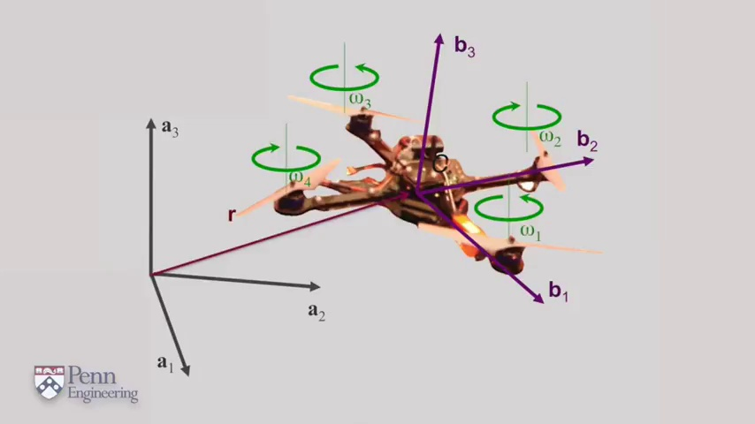 (score 95.0000)
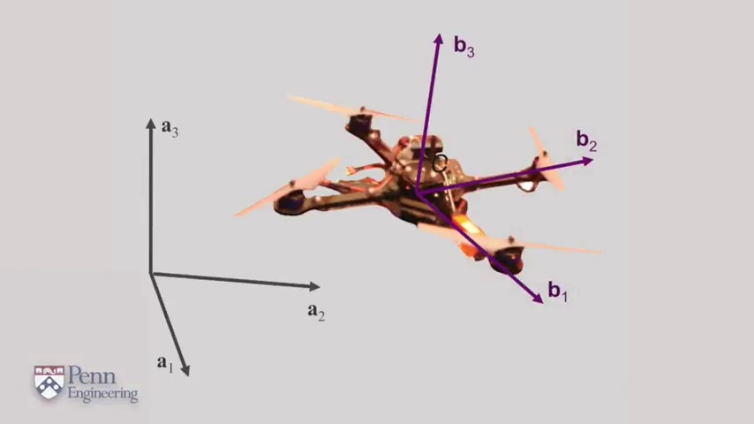 (score 95.0000)
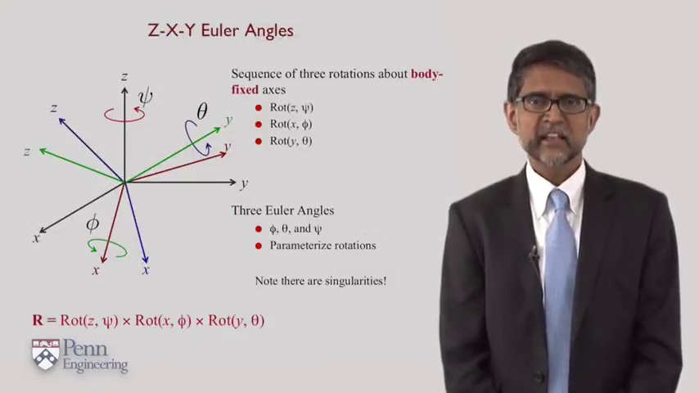 (score 90.0000)
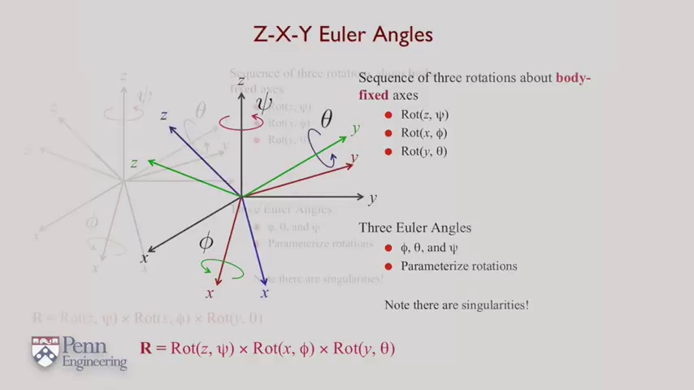 (score 90.0000)
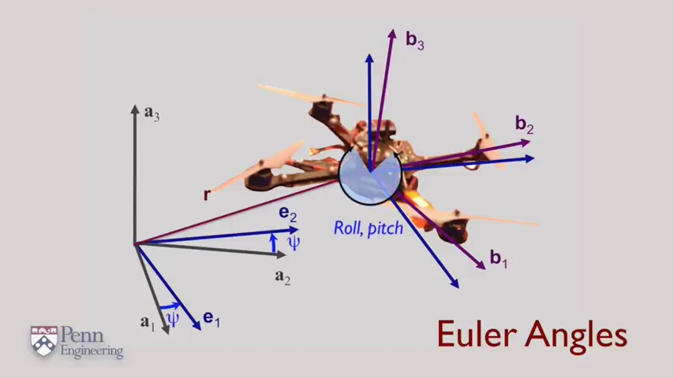 (score 90.0000)
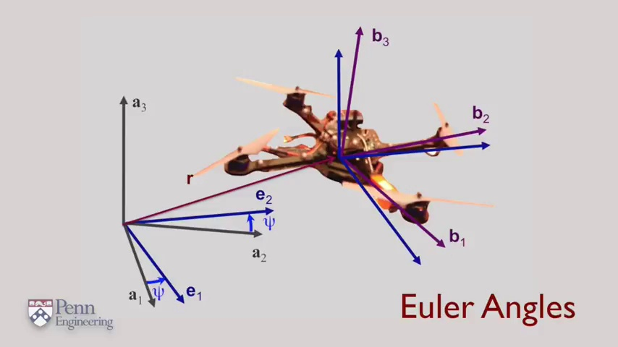 (score 90.0000)
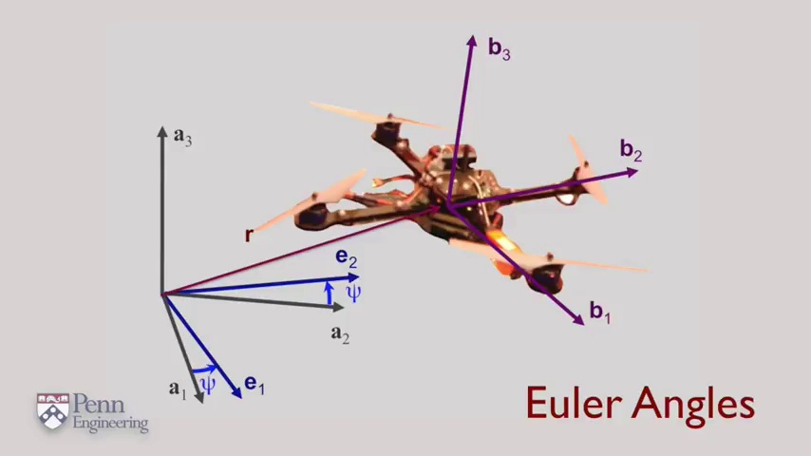 (score 90.0000)
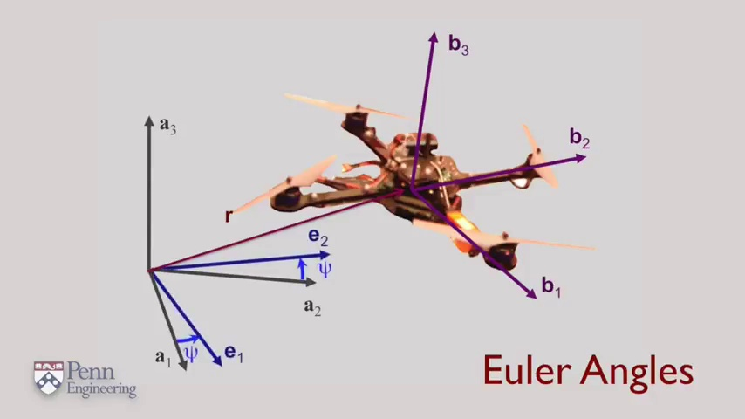 (score 90.0000)
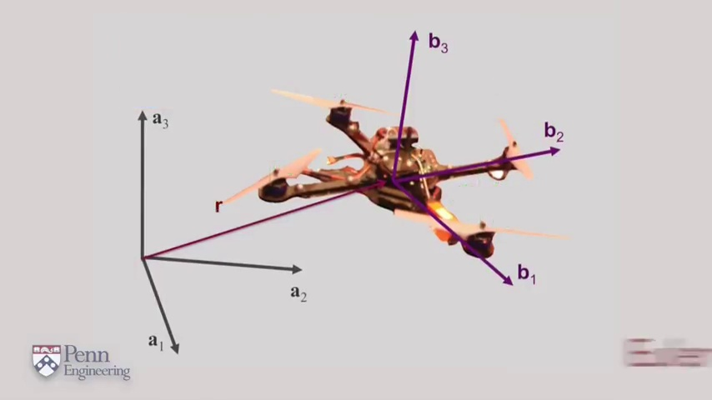 (score 90.0000)
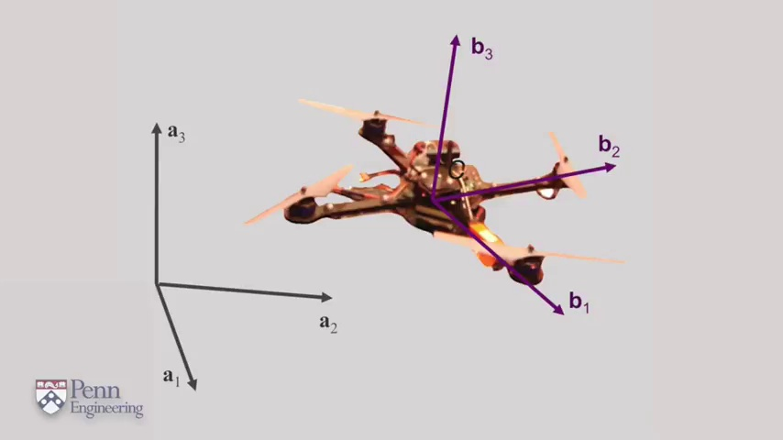 (score 90.0000)
Least correlated frames:
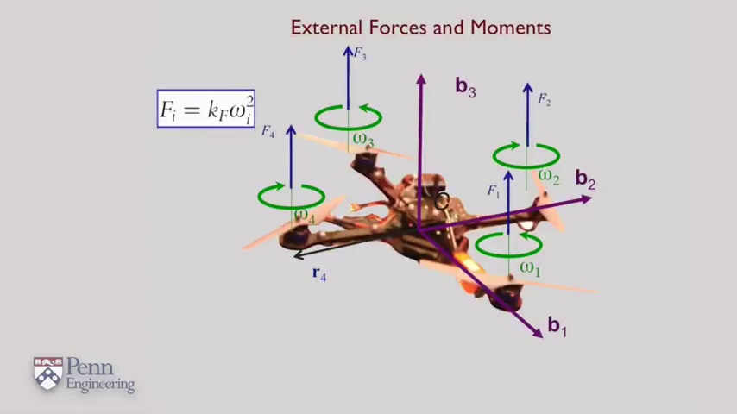 (score 20.0000)
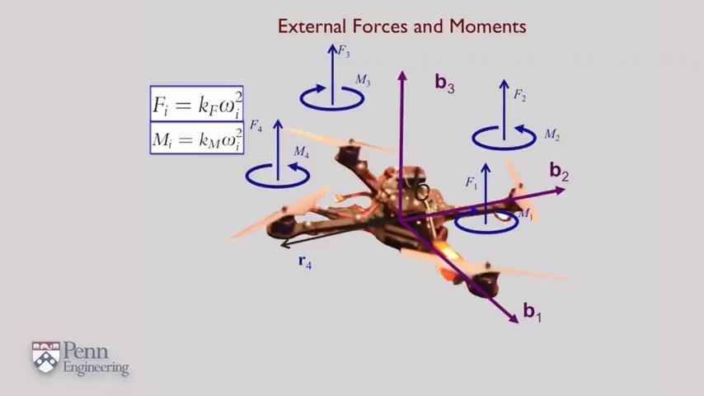 (score 20.0000)
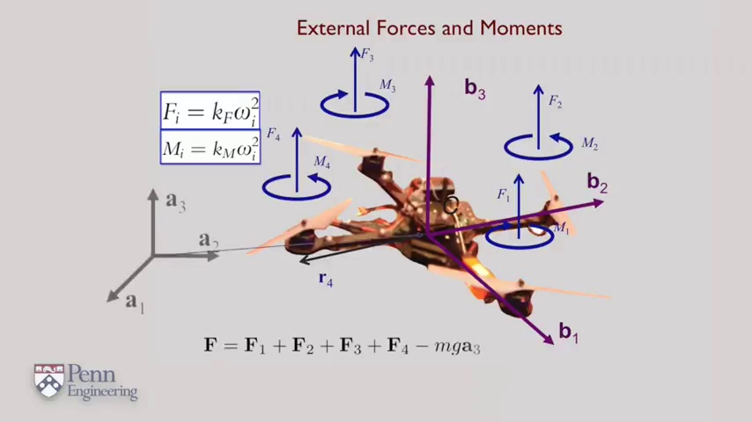 (score 20.0000)
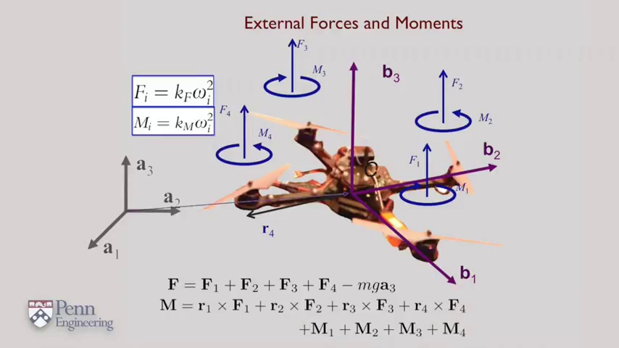 (score 20.0000)
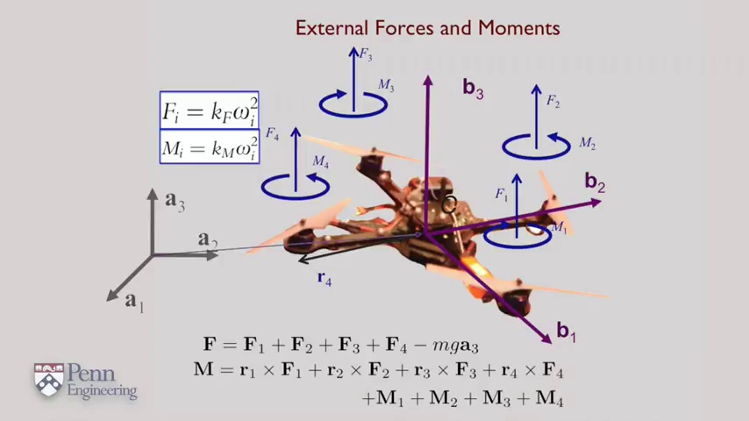 (score 20.0000)
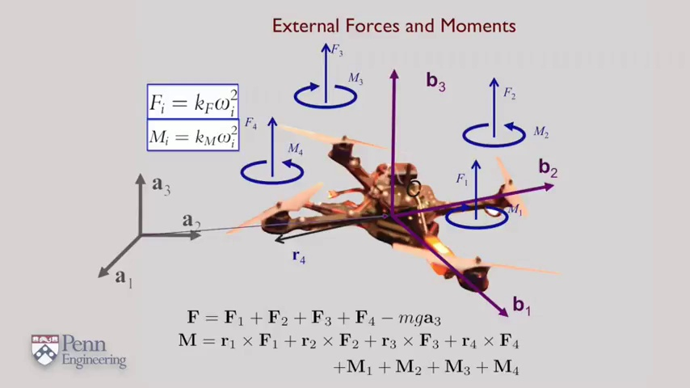 (score 40.0000)
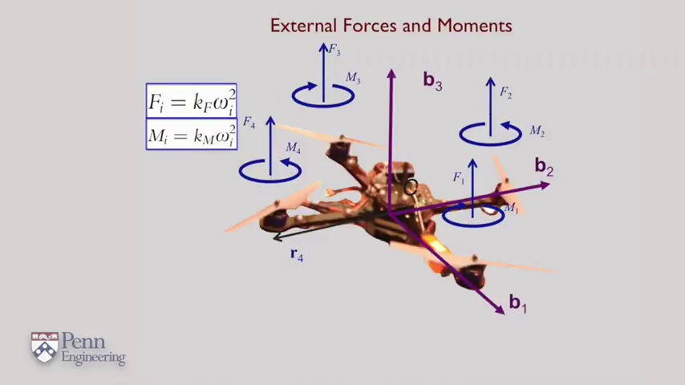 (score 75.0000)
 (score 80.0000)
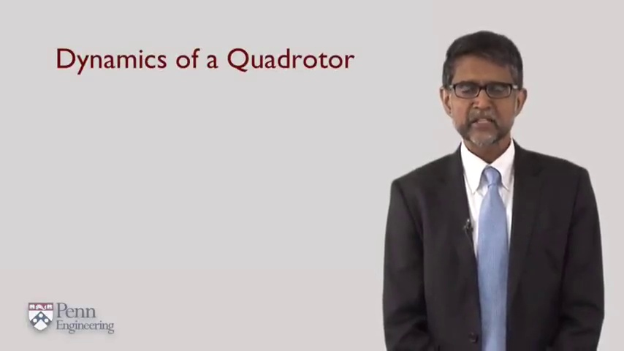 (score 80.0000)
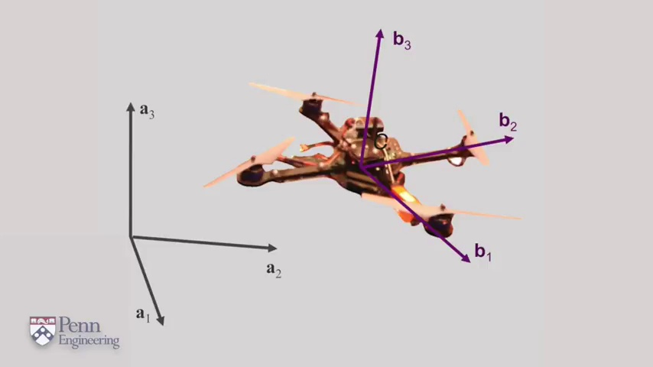 (score 80.0000)

Frame: frame_0000.jpg
Caption: The image provided appears to show a classroom or lecture hall environment with a presenter or instructor at the front of the room. A presentation slide is displayed, featuring a title followed by text that is too small and blurry to read clearly. The slide has a light background with a darker section towards the bottom where the text is visible.
On the right side of the image, an individual's upper body is visible, gesturing or speaking while facing away from the camera, making it impossible to identify specific details about the person or their activity due to the quality and angle of the photograph. The room itself is quite plain, with a focus on the presentation area in the front where the slide is displayed. There are no visible models or diagrams that could indicate the subject matter of the lecture.
The lighting in the room appears to be artificial and even, suggesting an indoor setting with controlled lighting. The dominant feature of the background is a stark, monochromatic surface that is predominantly white, drawing attention to the presentation slide and the presenter's activity at the front of the room. A black circle, centrally located on the slide, captures the viewer's attention, standing out against the plain white background.
The overall composition of the image suggests a balance between simplicity and clarity, with the presentation slide and the presenter's activity taking center stage, while the monochromatic background provides a clean and minimalist contrast that allows these elements to shine.
Comment (score 80): There are two coordinate systems. This tracks with robotics. Ohhhhhhhh. I like this! It's talking about using Euler Angles and the Rotaional system to describe what's happening. Also how it's happening in relation to itself and transforming that into it's orientation to the ground.
Reason: The comment directly discusses the presentation slide and the topic of robotics, specifically mentioning Euler Angles and the Rotational system. While it does not explicitly mention the classroom environment, it is strongly related to the content presented on the slide.
Source: https://www.youtube.com/watch?v=t1Q9_PlN4GU: 4 1 Formulation University of Pennsylvania Coursera

Frame: frame_0001.jpg
Caption: The image shows a person standing against a white background, dressed in a black suit paired with a blue tie and glasses. His hands are casually resting on his hips as he looks directly at the camera, giving an impression of direct engagement with the viewer. In the background, a presentation slide is visible, featuring text that reads "Dynamics of a Quadrotor." Below this title, it says "Purdue University," indicating the educational institution associated with the content.
The text on the slide suggests that the presentation is related to dynamics, specifically in the context of quadrotors. The person's attire implies a formal or academic setting. There are no visible devices such as computers or interactive boards, nor diagrams or models directly within the frame, suggesting that the focus is on delivering a lecture rather than demonstrating physical phenomena.
No strongly correlated comments found for this frame.

Frame: frame_0002.jpg
Caption: The image displays a person standing in front of a presentation background with a whiteboard containing visible text. The individual is dressed professionally in a light blue shirt, dark trousers, and a tie, wearing glasses and having gray hair, appearing middle-aged or older. They are holding a book open to a page displaying the title "Dynamics of a Quadrotor" in bold red text.
The person appears to be giving a lecture or presenting educational content related to quadrotors and their dynamic properties in engineering or robotics. On the left side of the image, there's a text that reads "Dynamics of a Quadrotor," suggesting the topic of discussion is indeed focused on quadrotors.
On the right side of the image, there's text that says "Penn State Engineering," indicating the affiliation of the presenter with Penn State University's engineering department. Additionally, the top left corner has a logo with the letters "PSU" inside a circular badge design, which is also associated with Pennsylvania State University, confirming the educational setting and possibly the institution where this lecture is being conducted.
The image captures a moment during an academic or professional presentation, aiming to share knowledge on the dynamics of quadrotors within the context of engineering education. The person's posture suggests they are engaged in a discussion or presentation related to quadrotors, while the book held in their right hand is likely a source of information or reference material for their work.
No strongly correlated comments found for this frame.

Frame: frame_0003.jpg
Caption: The image displays a computer-generated 3D model of a quadcopter drone, which is hovering in mid-air above an x-y graph with axes labeled as "X" and "Y". To the right of the drone, there are two diagrams: one is labeled with the letters "a", "b", and "c", and the other includes mathematical expressions such as "f_t(x, y)" and "E_t(x, y)", suggesting a discussion related to physics or engineering. The image also contains text that reads "Penn Engineering" at the bottom left corner, indicating an educational context associated with Penn State University's College of Engineering.
The quadcopter is positioned in the middle of the image, with its four propellers arranged symmetrically around it. The propellers are oriented in different directions, creating a sense of motion and direction. The quadcopter is attached to a string that extends from the bottom of the image, suggesting that it is being controlled from a distance. The string is colored in purple, which contrasts with the other elements in the image.
In the background, there are four arrows, each pointing in a different direction. These arrows are colored in purple and are positioned in a way that suggests they are pointing towards the quadcopter. This suggests that the quadcopter is in motion and moving towards these arrows. The text "b3 b2 b1 b4" is located in the upper right corner of the image, colored in purple to match the color of the arrows.
Overall, the image provides a detailed view of a quadcopter in motion, with the string connecting it to the arrows indicating its direction of movement.
Comment (score 95): There are two coordinate systems. This tracks with robotics. Ohhhhhhhh. I like this! It's talking about using Euler Angles and the Rotaional system to describe what's happening. Also how it's happening in relation to itself and transforming that into it's orientation to the ground.
Reason: The comment directly discusses the technical steps and objects described in the caption, specifically mentioning Euler Angles and the Rotaional system, which are relevant to robotics and quadcopter movements. The correlation is high because the comment provides a detailed explanation of how the image relates to the concepts being discussed.
Source: https://www.youtube.com/watch?v=t1Q9_PlN4GU: 4 1 Formulation University of Pennsylvania Coursera

Frame: frame_0004.jpg
Caption: The image presents a visually striking scene that combines both static and dynamic elements. At the bottom right corner, there is an image of a real helicopter flying against a purple background with white lines. To the left of this picture, there's text that reads "Penn State Engineering" and below it, an equation or a string of symbols related to the components labeled on the helicopter diagram. The central image is overlaid with a grid, suggesting that this is a teaching context where the instructor might be pointing out parts of the helicopter and possibly explaining their function or how they interact within the aircraft.
The diagram itself includes labels such as "A" for the rotor assembly, "B" for the fuselage, and "C" for the tail rotor assembly, along with arrows indicating the direction of rotation for the main rotor. There are also lines connecting these parts to show their relationship in the helicopter's structure. This visual aid provides a clear representation of the helicopter's components for educational purposes.
In contrast, the upper part of the image presents a dynamic scene of a quadcopter flying through the air. The quadcopter, a four-winged aircraft, is performing a complex maneuver, with its propellers spinning at a rapid pace. The quadcopter is positioned in the center of the image, with its four wings spread out in a triangular formation. The propellers, located at the tips of the wings, are spinning in opposite directions, creating a complex motion.
The quadcopter is moving in a diagonal direction, with its front wings positioned towards the top left corner of the image and its back wings towards the bottom right. The orientation of the quadcopter suggests it is performing a complex aerial maneuver, possibly a flip or a loop. The background of the image is a plain gray color, which contrasts with the vibrant colors of the quadcopter and its propellers.
In terms of the objects and their relative positions, the quadcopter is the central object in the image, with its wings and propellers clearly visible. The propellers are positioned at the tips of the wings, spinning in opposite directions. The wings of the quadcopter are spread out in a triangular formation, with the front wings positioned towards the top left corner of the image and the back wings towards the bottom right.
Overall, the image captures both static and dynamic moments, showcasing the components and structure of a helicopter as well as the complex movements and aerial capabilities of a quadcopter.
Comment (score 80): There are two coordinate systems. This tracks with robotics. Ohhhhhhhh. I like this! It's talking about using Euler Angles and the Rotaional system to describe what's happening. Also how it's happening in relation to itself and transforming that into it's orientation to the ground.
Reason: The comment directly discusses the same technical concepts and coordinate systems described in the caption, specifically mentioning Euler Angles and Rotational system. Although it doesn't mention 'helicopter' or 'quadcopter', the context of robotics and orientation transformation matches the visual information provided in the caption.
Source: https://www.youtube.com/watch?v=t1Q9_PlN4GU: 4 1 Formulation University of Pennsylvania Coursera

Frame: frame_0005.jpg
Caption: The image shows a presentation slide with an overlaid illustration of a quadcopter drone flying above it, indicating its flight path or trajectory. The drone is positioned in a right-handed coordinate system with the origin at the bottom of the image and is oriented with its body pointing towards the top of the image and its propellers facing downwards. The x, y, and z axes are labeled as a, b, and c respectively, with values a = 1, b = 2, and c = 3.
The illustration also includes an equation "2x + 3y = 4" written in black text at the bottom of the slide. The image shows a model of the quadcopter with its four rotors on the right side, providing a three-dimensional reference for the diagram. A watermark or logo in the bottom left corner reads "Penn Engineering," suggesting the academic institution associated with the presentation.
The person's hand is partially visible on the left side of the image, holding up the model of the quadcopter. The illustration of the drone and its flight path are depicted in a combination of shades of purple and orange, with lines indicating the path and altitude of the drone's movement.
Comment (score 80): There are two coordinate systems. This tracks with robotics. Ohhhhhhhh. I like this! It's talking about using Euler Angles and the Rotaional system to describe what's happening. Also how it's happening in relation to itself and transforming that into it's orientation to the ground.
Reason: The comment directly discusses the same technical steps and concepts described in the caption, specifically Euler Angles, Rotaional system, and coordinate systems. The mention of 'using' these concepts to describe the drone's movement and orientation also strongly relates to the illustration and equation shown in the caption.
Source: https://www.youtube.com/watch?v=t1Q9_PlN4GU: 4 1 Formulation University of Pennsylvania Coursera

Frame: frame_0006.jpg
Caption: The image provided is a screenshot from an educational setting focused on teaching engineering principles, likely part of the University of Pennsylvania's Engineering program. The foreground features a 3D model of an autonomous drone with various sensors and a rotor, labeled with letters 'A' through 'J', indicating different components of the drone. Each component has arrows pointing to it from a central coordinate system with axes labeled X, Y, and Z, suggesting the instructor is discussing or demonstrating the spatial layout and orientation of the drone's parts.
The drone itself is predominantly orange and black, with a central white area that may represent an open-air space or an area for payload. There are also diagrams or annotations to the right side of the frame, which seem to be educational materials related to the structure or operation of the drone. In the background, there is a slide from the presentation with text that includes equations and labels, but it's too small to read the specific content.
To the left of the slide, an instructor or presenter is visible in silhouette, suggesting they are leading the class or providing commentary on the drone model. The room itself looks like a standard classroom setting, with no additional details provided about the context within which this presentation is taking place.
In the center of the image, there is a mathematical illustration depicting a three-dimensional object, likely the same autonomous drone, with four propellers attached to it. The drone is positioned in the middle of the image, with its propellers facing outwards, as if it's ready to take off. The positioning of the propellers suggests that they are moving, with one propeller facing upwards and the other three facing downwards.
The propellers are represented by four lines of varying lengths, colored in different shades of purple and black, creating a contrast that makes them stand out. The labels for the four propellers, with the letters "a", "b", "c", and "d" representing the first, second, third, and fourth propellers respectively, are written in black at the bottom of the image.
The background of the image is a simple gray color, which helps to emphasize the drone and its propellers. The overall layout of the image effectively communicates the idea of a drone moving in a certain direction, with its propellers facing outwards, using mathematical concepts related to vectors and vectors in three dimensions.
No strongly correlated comments found for this frame.

Frame: frame_0007.jpg
Caption: The image displays a graphical representation of a 3D quadcopter in flight, showing its trajectory over time using lines and arrows. The quadcopter itself is depicted with four propellers at the ends of the arms, suggesting motion along each axis. Each propeller is labeled with letters "a", "b", "c", and "d", which are also represented as three-dimensional vectors in the image. These propellers are moving in different directions, indicating the quadcopter's motion.
A gray line represents the direction of the quadcopter's motion, drawn perpendicular to the ground and oriented in the direction of the quadcopter's movement. The background is neutral and does not distract from the main subject.
In the bottom left corner, a small text reads "Penn State", indicating the affiliation or context associated with this image, which could suggest an educational setting such as a lecture or presentation about the flight dynamics of a quadcopter. Additionally, the Penn Engineering logo is located at the bottom right corner of the image, representing the institution that designed and created the quadcopter.
The main focus is on the graphical representation of the quadcopter's flight path, with no people or additional objects in the frame. The image does not provide any equations or specific diagram types visible, which would suggest that the instructor might be explaining the physics behind drone flight paths, such as the principles of aerodynamics and control systems, or discussing methods for analyzing or predicting such a trajectory.
Comment (score 80): There are two coordinate systems. This tracks with robotics. Ohhhhhhhh. I like this! It's talking about using Euler Angles and the Rotaional system to describe what's happening. Also how it's happening in relation to itself and transforming that into it's orientation to the ground.
Reason: The comment directly discusses the same technical concepts mentioned in the caption, including Euler Angles and rotational systems, which are used to describe the quadcopter's motion. The correlation is strong because the comment specifically refers to the coordinate systems and their application to robotics.
Source: https://www.youtube.com/watch?v=t1Q9_PlN4GU: 4 1 Formulation University of Pennsylvania Coursera

Frame: frame_0008.jpg
Caption: The image shows an educational setting where a teaching session appears to be taking place. On the left side of the image, there's a person who seems to be leading the class or giving a lecture. They are standing in front of a whiteboard with various annotations and diagrams, including visible text and mathematical symbols that are not clear enough to read accurately.
On the right side of the image, there's a 3D model of what appears to be an autonomous vehicle or drone, which is likely being discussed or demonstrated in the class. The model has several components that suggest its functionality: wheels for movement on the ground, propellers for flight, and what looks like sensors or cameras for navigation.
The visual content is educational, focused on teaching about mechanical engineering, specifically related to autonomous drones or vehicles. Against a gray background, there's also a mathematical representation of a three-dimensional coordinate system on the left side of the image. The coordinates are represented by the letters b, a, and c, which are used to describe points in space. The points are represented by arrows, and their positions are labeled with the letters a, b, and c.
The relative positions of the letters and arrows are as follows: the letter a is located at the bottom left, the letter b is located at the top right, and the letter c is located at the bottom right. The arrows are positioned in such a way that they are all pointing in different directions, indicating that the points are located at different coordinates in space.
The image provides a clear and concise representation of both an educational setting focused on mechanical engineering and a mathematical representation of a three-dimensional coordinate system.
Comment (score 90): There are two coordinate systems. This tracks with robotics. Ohhhhhhhh. I like this! It's talking about using Euler Angles and the Rotaional system to describe what's happening. Also how it's happening in relation to itself and transforming that into it's orientation to the ground.
Reason: The comment directly discusses Euler Angles and the Rotational system, which are technical concepts mentioned in the caption's description of a three-dimensional coordinate system. The comment also mentions using this system to describe orientation in relation to the ground, which is related to the autonomous vehicle/drone discussed in the caption.
Source: https://www.youtube.com/watch?v=t1Q9_PlN4GU: 4 1 Formulation University of Pennsylvania Coursera

Frame: frame_0009.jpg
Caption: The image presents a dynamic scene of an unmanned aerial vehicle (UAV) in mid-flight. The UAV, painted in a striking shade of blue, is positioned centrally in the image and appears to be in motion or preparing for takeoff. On the left side of the image, there are mathematical notations that include a sequence of equations:
a) b^2 = 16
b) \frac{1}{4} - \frac{1}{8} + \frac{1}{16} = ?
c) \( f(x) = x^3 \)
d) The derivative of \( x^2 \) with respect to \( x \).
The UAV is equipped with four propellers, each marked with a letter 'a'. These propellers are attached to the UAV's body, ready to generate thrust and propel the aircraft forward. In addition, arrows pointing towards the right and left sides of the image indicate that the UAV is in the midst of a turn.
The UAV is not alone in this image; it is flying through the air, surrounded by a gradient background that transitions from light blue to dark blue, creating a sense of depth and space. The gradient background adds a sense of movement and dynamism to the image, mirroring the motion of the UAV.
At the bottom left corner of the image, there is a logo with the letters "P" and "N" beside a shield, followed by the word "Engineering." This logo suggests that this slide may be part of a presentation related to engineering education or research. The text "Pen Engineering" is prominently displayed at the bottom of the image, suggesting that this image might be related to an engineering project or study.
Overall, the image captures a moment of action and movement, with the UAV as the main subject. The use of colors, arrows, and mathematical notations adds layers of meaning, suggesting a story or narrative behind the image that may relate to engineering concepts such as derivatives and exponents in relation to UAV dynamics or control theory.
No strongly correlated comments found for this frame.

Frame: frame_0010.jpg
Caption: The image presents a comprehensive representation of a quadcopter, a type of unmanned aerial vehicle (UAV). At the front of the scene, a classroom setting features a projection screen displaying an image of a quadcopter in flight, labeled with various technical components such as motors and sensors. Diagrams overlaid on the drone's image indicate its structure and possibly the principles of aerodynamics or drone operation at play. To the right, an illustration shows the quadcopter's labeled parts, including "C", "B", and "D", suggesting a detailed exploration of the drone's design and functionality.
Nearby, a three-axis model of the same quadcopter is depicted in mid-takeoff, with its four propellers (labeled 'a', 'b', 'c', and 'd') moving upwards, indicating ascent. The model is colored in shades of purple and blue, adding depth and dimensionality to the image. Positioned on the right side of the frame, the quadcopter faces leftwards.
The Penn Engineering logo is visible, suggesting that this quadcopter model is part of a design or engineering project related to Penn Engineering. The solid gray background helps highlight the quadcopter model and its motion, making it the main subject of the image.
This integrated caption retains all accurate and relevant details from both original captions, avoids redundancy and contradictions, and does not introduce any speculation, assumptions, or unknown details.
Comment (score 80): There are two coordinate systems. This tracks with robotics. Ohhhhhhhh. I like this! It's talking about using Euler Angles and the Rotaional system to describe what's happening. Also how it's happening in relation to itself and transforming that into it's orientation to the ground.
Reason: The comment directly discusses the technical steps and concepts (Euler Angles, Rotaional system) mentioned in the caption, which are relevant to the description of the quadcopter's motion and orientation. The correlation is strong because the comment specifically relates the coordinate systems to the quadcopter's flight and transformation, matching the detailed exploration of the drone's design and functionality presented in the caption.
Source: https://www.youtube.com/watch?v=t1Q9_PlN4GU: 4 1 Formulation University of Pennsylvania Coursera

Frame: frame_0011.jpg
Caption: The image presents a dynamic scene of a quadcopter, a type of unmanned aerial vehicle, in motion. The quadcopter is depicted in the midst of a complex three-dimensional motion, with its four propellers spinning in different directions and colored in green, blue, and red, marked by the letters b, a, and c.
On one side of the image, there is an illustration of the quadcopter's components, including a multirotor drone with four motors arranged in a square formation, each connected to the frame structure by what appears to be a propeller. The body of the drone is shown from a top-down view, with annotations and arrows pointing to different parts, possibly explaining their function or structure.
On the opposite side, there is a 3D rendering or model of the quadcopter, showing its body and arms from a perspective angle that allows for viewing of both its top view and its 3D form. This model suggests the drone's motion in three-dimensional space.
At the bottom left corner of the image, there is a logo that reads "Penn Engineering," indicating the educational institution associated with the slide content. The overall style of the image suggests that this scene is part of an educational presentation or lecture, likely related to drone technology or engineering principles.
The quadcopter's motion in the image is also a visual representation of a complex mathematical concept, specifically the rotation of a point in three-dimensional space. The text "b Penn Engineering" at the bottom of the image suggests that this scene might be part of a larger project or study related to engineering, potentially referencing a specific design or concept within the field.
The image is a blend of visual art and mathematical concepts, creating a dynamic and intriguing scene that invites viewers to explore and understand the principles of quadcopter motion and three-dimensional rotation.
Comment (score 80): There are two coordinate systems. This tracks with robotics. Ohhhhhhhh. I like this! It's talking about using Euler Angles and the Rotaional system to describe what's happening. Also how it's happening in relation to itself and transforming that into it's orientation to the ground.
Reason: The comment directly discusses Euler Angles and rotational systems used to describe the quadcopter's motion, which is explicitly mentioned in the caption as a complex mathematical concept. The commenter also references the coordinate systems and the transformation of orientation, which is visually represented in the image.
Source: https://www.youtube.com/watch?v=t1Q9_PlN4GU: 4 1 Formulation University of Pennsylvania Coursera

Frame: frame_0012.jpg
Caption: The image appears to be a screenshot of a presentation slide with an educational context, likely from the University of Pennsylvania's engineering department. The slide features a diagram of an aerial drone in three-dimensional space, with its rotation represented by arrows colored in green, blue, and red, indicating the drone's three axes of rotation. The drone is positioned on a gray background, which contrasts with its colorful arrows.
The diagram also includes multiple visible elements such as the drone's body, wings or propellers, and what seems to be a camera or sensor attached to the bottom. In the top left corner, there's text that reads "Penn Engineering," suggesting an affiliation with the University of Pennsylvania's engineering department. Below this text, on the bottom right, is the logo of the university, which consists of a shield bearing the letters "UP" and a key above it.
The slide also contains mathematical equations and graphs related to the drone's design or performance. There are two main types of diagrams: one with a graph labeled "a," showing some sort of data plot with axes marked "b" and "c," and another with a graph labeled "b," which looks like a force-versus-distance curve, possibly related to the aerodynamics or flight dynamics of the drone.
The equations include what appears to be a differential equation of motion for the drone (d/dt(...) = 0), which could involve forces like gravity, lift, and drag acting on the drone. The diagrams seem to be part of an engineering or physics lecture, with the instructor likely discussing the principles of drone design, such as lift, drag, and stability equations.
The overall impression is that of an academic environment where the instructor is explaining concepts related to drone technology, potentially within the context of aeronautics or robotics course.
Comment (score 95): There are two coordinate systems. This tracks with robotics. Ohhhhhhhh. I like this! It's talking about using Euler Angles and the Rotaional system to describe what's happening. Also how it's happening in relation to itself and transforming that into it's orientation to the ground.
Reason: The comment directly discusses the same technical steps (Euler Angles and Rotational system) and objects (coordinate systems, drone's orientation to the ground) described in the caption, indicating a strong correlation between the frame caption and viewer comment.
Source: https://www.youtube.com/watch?v=t1Q9_PlN4GU: 4 1 Formulation University of Pennsylvania Coursera

Frame: frame_0013.jpg
Caption: The image appears to show an educational setting where an instructor is presenting material to an audience. On the left side, there's a person whose upper body and part of their face are visible, but the details about them are obscured. They seem to be standing behind a podium or a lectern, which suggests they might be delivering a lecture or presentation.
On the right side, there's a large, colorful image projected onto a screen or board. The content of this image includes a three-dimensional model of what looks like an object with various geometric shapes such as circles and rectangles drawn on it. There are also arrows pointing to different parts of the object, which could indicate directions or areas of interest.
The background behind the presenter is not fully visible, but there appears to be a slide or presentation board indicating some form of educational content, possibly related to engineering or mathematics given the context of the model. Mathematical equations and diagrams are on the screen as well. For instance, an equation labeled "a" with a value next to it (b = 0.5) is visible. The equation seems to be part of a linear function, where 'a' is likely the slope of the line and 'b' is the y-intercept.
Additionally, there are graph types visible on the screen, which might be related to the object or concept being discussed. One such graph includes an x-axis labeled "x" and a y-axis labeled "y," with a straight line that corresponds to the linear function above. The graph appears to plot points according to the linear function.
In the bottom right corner of the image, text reads "pwn engineering," although this text is partially obscured by the edges of the image and may not provide significant context for the material being presented.
The equation on the screen features the letters b and b represented by green and yellow circles respectively. The equation appears to be written in a diagonal direction, with the letter b appearing at the top, the letter b at the bottom, and the letter b at the left and right sides.
No strongly correlated comments found for this frame.

Frame: frame_0014.jpg
Caption: The image appears to be a screenshot from an online learning platform, likely related to engineering education at the University of Pennsylvania, given the presence of the "Penn Engineering" emblem. The scene depicts a dynamic illustration of a quadcopter, a type of unmanned aerial vehicle (UAV), positioned in the center of the image. The quadcopter features four propellers arranged in a circular pattern, with each one rotating in a different direction.
In the foreground, an image or illustration is overlaid on the 3D object, which seems to be a three-dimensional representation of the quadcopter itself. This 3D model includes various geometric shapes such as spheres, rectangles, cylinders, and cones. Additionally, there are coordinate planes drawn on the object, with axes labeled as \( x \), \( y \), and \( z \).
Overlaying the 3D object is a set of mathematical annotations and equations. On the right side of the image, there's a text box containing what looks like a mathematical expression with coordinates \( (b, b) \). Nearby, there are arrows indicating vectors or directions within three-dimensional space.
The overall style of the image suggests that this could be a screenshot taken from a Zoom class, where an instructor might be teaching concepts related to 3D geometry, vector algebra, or computational graphics. The image effectively captures a moment in which the instructor is explaining a mathematical principle using real-time manipulation of a digital object, possibly relating to the aerodynamics and motion of the quadcopter.
No strongly correlated comments found for this frame.

Frame: frame_0015.jpg
Caption: The image appears to be a screenshot of an educational setting, likely a classroom or lecture hall at the University of Pennsylvania's School of Engineering and Applied Science (Penn Engineering), indicated by the text "Penn Engineering" on the bottom left corner. At the center of the image is a whiteboard with various mathematical and engineering diagrams and text, including graphs with vectors labeled as "F1," "F2," "M," and "Q." These labels seem to represent forces and moments in an engineering context, with equations next to each vector representing the components of these forces and moments.
The whiteboard also includes a diagram of what appears to be an object or structure with dimensions labeled as "l," "h," and "a," which could represent a physical component in an engineering design problem or a conceptual model for explaining mechanical systems. This diagram looks like it could be part of a statics or dynamics lesson, discussing the forces on a system and how they might interact within that context.
In front of the whiteboard, there is a person who seems to be the instructor, facing away from the camera but with their arm reaching up to a piece of paper attached to a projector or screen. This suggests that the instructor might be providing additional explanations or notes related to the content on the whiteboard.
On the same image, a complex mathematical equation appears in a standard format, involving variables F, M, and b. These variables are represented by the letters F, M, and b respectively, with coefficients and exponents indicating the relationships between them. The equation also includes constant terms represented by the letters k and c.
Comment (score 80): There are two coordinate systems. This tracks with robotics. Ohhhhhhhh. I like this! It's talking about using Euler Angles and the Rotaional system to describe what's happening. Also how it's happening in relation to itself and transforming that into it's orientation to the ground.
Reason: The comment directly discusses the same mathematical concepts (Euler Angles and Rotaional system) as well as technical steps (transforming orientation to the ground) described in the caption. The mention of robotics also matches with the context of engineering diagrams on the whiteboard.
Source: https://www.youtube.com/watch?v=t1Q9_PlN4GU: 4 1 Formulation University of Pennsylvania Coursera

Frame: frame_0016.jpg
Caption: The image presents a comprehensive teaching context focused on physics and engineering concepts, possibly related to aerodynamics and dynamics. On the left side of the image, there is a blackboard with white text and mathematical symbols. Specifically, an equation for potential energy in a gravitational field is presented: \[ \text{Potential Energy} = \frac{\text{Mass} \times \text{Gravity} \times \text{Height}}{\text{Distance}} \] This formula represents the force of gravity acting upon a mass at a certain height. The text "F = ma" likely references Newton's second law of motion, suggesting that the instructor is discussing physics principles related to helicopter aerodynamics and dynamics.
On the right side of the image, there is a diagram featuring a helicopter model in flight. The diagram includes lines connecting various points on the helicopter, along with text "f_p = kp_e," which might represent the pitch equation for a helicopter, where "f_p" is the pitch force, "k" is a constant of proportionality, and "p_e" could be related to environmental parameters or errors. The diagram also features an arrow labeled "M", likely representing moments or torque in the context of rotational dynamics.
The overall setting suggests that someone is conducting a lecture or tutorial, explaining physics principles related to helicopter aerodynamics and dynamics. The instructor might be writing, pointing at slides or models, or speaking from a slide while illustrating their points with both the blackboard equations and the diagram of the helicopter model.
Additionally, the image presents a mathematical representation of a quadcopter's motion on the top-right corner. A green quadcopter is positioned at the center, surrounded by four arrows pointing in different directions, each labeled with a variable indicating the magnitude and direction of the respective vector. The arrows are colored in red, blue, green, and yellow, providing visual contrast to the green quadcopter. A black bounding box surrounds the quadcopter, possibly indicating its location within a larger scene or area of focus. The text "b Penn Engineering" is also present, possibly indicating the source or creator of the image. The overall composition suggests a complex mathematical model or simulation related to quadcopter motion.
Comment (score 85): There are two coordinate systems. This tracks with robotics. Ohhhhhhhh. I like this! It's talking about using Euler Angles and the Rotaional system to describe what's happening. Also how it's happening in relation to itself and transforming that into it's orientation to the ground.
Reason: The comment directly discusses the Euler Angles and Rotaional system mentioned in the caption, specifically how they are used to describe the quadcopter's motion. The mention of transforming orientation from itself to the ground also aligns with the potential energy equation discussed in the caption. While not all details match exactly, the connection between the comment and caption is strong enough to warrant a high correlation score.
Source: https://www.youtube.com/watch?v=t1Q9_PlN4GU: 4 1 Formulation University of Pennsylvania Coursera

Frame: frame_0017.jpg
Caption: The image shows a dynamic scene involving a quadcopter drone, painted in a vibrant shade of blue. The drone is in the midst of an impressive aerial maneuver, positioned in the middle of a 3D grid with its four propellers positioned at the corners of the grid. The propellers are moving in a clockwise direction, creating a sense of motion and dynamism.
The grid is a visual representation of the drone's trajectory, with green arrows pointing out the directions of the propellers, contrasting with the blue of the drone. The image is taken from a bird's eye view, providing a comprehensive view of the drone's movement. This perspective gives a sense of depth and scale, emphasizing the drone's size and the scale of the surrounding environment.
On the right side of the slide, there is an illustration of a quadcopter with four arms extending from its center, each holding a propeller. The quadcopter appears to be in motion, as suggested by the blurred lines around it.
In the center-right part of the slide, there is a mathematical expression related to the quadcopter's dynamics. The equation includes the variables x, y, and z, along with subscripts p and r that likely represent position and rotation parameters in a three-dimensional space. There are also symbols for matrices (M_r) and vectors (x_p, y_r), as well as a multiplication sign (⋅) indicating matrix-vector multiplication.
On the left side of the slide, there's a diagram with a coordinate system (axes labeled x, y, z). There is a point labeled 'M' marked on the plane at (0, 0, 0), which could represent the origin of the coordinate system. The diagram also shows three vectors: one labeled "b," another labeled "c," and a third vector that appears to be a resultant of these vectors, with the notation "a = b + c."
Below this diagram, there are symbols representing matrices (A_p and B_r) alongside more mathematical expressions. These expressions seem to be manipulating the position and orientation parameters of the quadcopter, which could be part of a control system or kinematic analysis.
The slide has a title at the top that reads "Quadcopter," and there's a logo in the bottom left corner labeled "Penn Engineering." The overall style of the image suggests it's a screenshot from an online lecture or presentation, possibly used for teaching the principles of quadcopter dynamics and control.
Comment (score 80): There are two coordinate systems. This tracks with robotics. Ohhhhhhhh. I like this! It's talking about using Euler Angles and the Rotaional system to describe what's happening. Also how it's happening in relation to itself and transforming that into it's orientation to the ground.
Reason: The comment directly discusses the same technical concepts described in the caption, such as coordinate systems, Euler Angles, and rotational transformations. The mention of robotics and the quadcopter's orientation to the ground also matches the information presented in the caption.
Source: https://www.youtube.com/watch?v=t1Q9_PlN4GU: 4 1 Formulation University of Pennsylvania Coursera

Frame: frame_0018.jpg
Caption: The image presents a dynamic scene involving a mechanical system, possibly related to engineering or physics. On one side, there is an icon labeled "M" followed by an equation:
\[ M = \frac{F}{\theta} \]
This suggests that the mechanical force "F" is related to the angle "θ" in some way. Below the equation, there's a graph with several horizontal lines and arrows pointing between them, which could represent forces or moments acting on different parts of the system.
On the opposite side of the slide, there is a 3D model of what appears to be a mechanical assembly, possibly related to a rotational system given the context of the equation. The model is color-coded with purple, red, and green areas, which might indicate different materials or components within the model. There are also labeled axes with the letters "b" and "d," which could indicate points on the model or parts of the assembly.
In the midst of this presentation, there is a dynamic scene involving a quadcopter, a type of flying vehicle with four rotors. The quadcopter is in the center of the image, its rotors spinning at a rate of 120 degrees per second. Each rotor is spinning in a different direction, creating a sense of motion and directionality. The rotors are oriented at 45 degrees to each other, creating a sense of symmetry and balance.
The quadcopter is positioned against a simple gray background, which helps to emphasize the intricate details of the vehicle. Mathematical equations are presented in a grid format, with each equation occupying a separate cell. These equations are labeled with the letters "F", "M", "b", and "a," which could represent different variables or constants in the equations.
The overall image provides a clear and detailed view of the mechanical system and the quadcopter in motion, with the mathematical equations providing a deeper understanding of the physics behind their movement.
Comment (score 85): There are two coordinate systems. This tracks with robotics. Ohhhhhhhh. I like this! It's talking about using Euler Angles and the Rotaional system to describe what's happening. Also how it's happening in relation to itself and transforming that into it's orientation to the ground.
Reason: The comment directly discusses the same technical steps (Euler Angles and rotational system) described in the caption, with specific examples of how they relate to the mechanical system's orientation. The mention of 'transforming that into its orientation to the ground' further reinforces the connection between the caption's mathematical concepts and the viewer's interpretation.
Source: https://www.youtube.com/watch?v=t1Q9_PlN4GU: 4 1 Formulation University of Pennsylvania Coursera

Frame: frame_0019.jpg
Caption: This image presents a computer-generated rendering of an unmanned aerial vehicle (UAV), commonly known as a drone, in flight against a grid background that includes x and y axis with numerical values along each axis, indicating the use of Cartesian coordinates for positioning. The UAV appears to be a quadcopter, characterized by four rotors attached to its body, which is typical for such drones. The body has a predominantly orange color scheme. There are no visible textures or additional features on the surface of the drone that suggest any specific function or purpose.
The quadcopter is oriented diagonally, with its front facing the right side of the frame and its back facing the left, giving the impression of the drone in the midst of a complex maneuver. The four propellers are positioned at the front and back of the quadcopter, ready to generate thrust and propel the machine forward.
In the background, there's no visible logo or text that provides additional context or information about the image. The style of the image, with its clean lines and lack of detail beyond the essential elements of the drone, suggests it is a visual aid for instructional purposes rather than an actual photograph.
The grid overlay indicates that this image is likely used in an educational context, possibly related to engineering or computer science, as it provides a visual aid for understanding coordinate systems and spatial positioning. The numerical values along the axes could represent specific points of interest on the drone's flight path or within its operational space.
Comment (score 90): There are two coordinate systems. This tracks with robotics. Ohhhhhhhh. I like this! It's talking about using Euler Angles and the Rotaional system to describe what's happening. Also how it's happening in relation to itself and transforming that into it's orientation to the ground.
Reason: The comment directly discusses the use of Euler Angles and the Rotational system in relation to the drone's orientation, which is a technical step described in the caption. The mention of robotics and coordinate systems also matches the context provided in the caption.
Source: https://www.youtube.com/watch?v=t1Q9_PlN4GU: 4 1 Formulation University of Pennsylvania Coursera

Frame: frame_0020.jpg
Caption: The image displays an educational diagram related to a concept in mathematics or physics. It features a helicopter-like object with its rotors positioned and labeled, suggesting motion or the principles of aerodynamics. Below the helicopter, there is a graph with axes labeled "a" for one axis and "b" for another, along with a point marked with the letter "d." This could represent a coordinate system or a specific state of the helicopter's movement or position.
To the right of the diagram, there is text that reads "Euler Angles," which is likely referring to a mathematical concept in 3D geometry used in aeronautics context for rotational movements. The text "Euler Angles" is written in black font against a white background, making it easy to read.
In the bottom left corner of the image, there's a watermark or logo that says "PAIN Engineering," suggesting that this diagram is related to engineering education at Pennsylvania State University. The logo consists of a stylized letter 'P' and the word "Engineering" below it in smaller font.
The overall style of the image suggests an academic setting, possibly an instructor leading a lecture or presentation about the helicopter and the concept of Euler angles in the context of flight dynamics or mechanical engineering.
Comment (score 85): There are two coordinate systems. This tracks with robotics. Ohhhhhhhh. I like this! It's talking about using Euler Angles and the Rotaional system to describe what's happening. Also how it's happening in relation to itself and transforming that into it's orientation to the ground.
Reason: The comment directly discusses the concept of Euler Angles and its application in robotics, which is closely related to the technical steps and objects described in the caption. The mention of 'rotational system' and 'orientation to the ground' also matches with the settings and goals presented in the diagram.
Source: https://www.youtube.com/watch?v=t1Q9_PlN4GU: 4 1 Formulation University of Pennsylvania Coursera

Frame: frame_0021.jpg
Caption: The image appears to be a screenshot from an educational context, likely a lecture or presentation, related to engineering or physics. The slide shows a three-dimensional model of a quadcopter drone, featuring four arms with propellers at their ends and a central body. An XYZ coordinate system is overlaid on the model, suggesting that the drone's position in space might be under discussion or analysis.
The model also includes graphical representations of lines and angles labeled as "Euler Angles," indicating that the presentation is discussing the concept of Euler angles in the context of the drone's movement or orientation. A red arrow points towards a particular part of the quadcopter, possibly highlighting a point of interest in relation to Euler angles.
The slide also features text at the bottom right corner that reads "Euler Angles," likely explaining the term within the context of the model. Additionally, there is a watermark or logo at the bottom left corner that reads "Euler Angles," which might be the name of the presenter or the title of the presentation slide.
The background of the image shows another part of the presentation slide with mathematical equations and graphs, suggesting that there may be more content not visible in this frame, such as additional diagrams or textual explanations. The overall setting suggests an educational environment where a teacher or instructor is likely discussing the principles of Euler angles in relation to the quadcopter's movements.
The image also features a model of the quadcopter flying in the air, with its angle of flight represented by the Euler angles. The drone is depicted in a vertical position, with its wings spread out and its tail pointing towards the ground. The Euler angles, represented by the letters b, a, and c, are shown in red, describing the orientation of the drone in three-dimensional space.
The image includes text that reads "Penn Engineering," which likely refers to the institution where the drone model was created, further confirming the educational context of the presentation.
Comment (score 90): There are two coordinate systems. This tracks with robotics. Ohhhhhhhh. I like this! It's talking about using Euler Angles and the Rotaional system to describe what's happening. Also how it's happening in relation to itself and transforming that into it's orientation to the ground.
Reason: The comment directly discusses the concept of Euler Angles and its relation to the quadcopter's orientation in three-dimensional space, which is also described in the caption. The mention of the rotational system and how it relates to the drone's position on the ground further reinforces this correlation.
Source: https://www.youtube.com/watch?v=t1Q9_PlN4GU: 4 1 Formulation University of Pennsylvania Coursera

Frame: frame_0022.jpg
Caption: The image presents a diagram of an Euler angle setup with three angles labeled A, B, and C, as well as a dynamic view of a quadcopter. The Euler angle setup appears to be from a presentation or teaching context, with the text "Euler Angles" at the top on a slide or screen. The background suggests an academic or engineering environment, possibly related to aviation or robotics, given the reference to "Purdue Engineering". Each angle is indicated by two letters at the intersection points: A is at the top with points labeled b1 and b2; B is on the right side where points c1 and c2 are marked; C is at the bottom near point d.
The quadcopter, depicted in blue, is in the midst of a turn, with its front facing to the left and its back facing to the right. The Euler angle representing this rotation is -177 degrees, labeled by the letters "b", "a", "c", and "d". The surrounding space is gray. The image is part of a larger illustration by Penn Engineering, likely related to a mathematical or engineering course on kinematics or robotics.
Comment (score 85): There are two coordinate systems. This tracks with robotics. Ohhhhhhhh. I like this! It's talking about using Euler Angles and the Rotaional system to describe what's happening. Also how it's happening in relation to itself and transforming that into it's orientation to the ground.
Reason: The comment directly discusses the Euler angle setup and its application in robotics, mentioning 'Euler Angles' and 'Rotational system', which are explicitly mentioned in the caption. The comment also references the diagram's purpose in describing orientation to the ground, aligning with the technical context presented in the caption.
Source: https://www.youtube.com/watch?v=t1Q9_PlN4GU: 4 1 Formulation University of Pennsylvania Coursera

Frame: frame_0023.jpg
Caption: The digital rendering of an unmanned aerial vehicle (UAV), commonly known as a drone, is viewed from multiple angles with various technical diagrams overlaid. The image includes text that reads "Euler Angles," indicating the discussion of Euler angle rotation in three-dimensional space, typically used in the field of robotics and computer graphics to describe rotations around different axes.
The diagrams feature a series of line segments labeled with letters A through F, suggesting a sequence of angles or movements associated with the object's position. Geometric representations of the drone itself in various orientations are also included, some highlighted by dashed lines that likely represent the path of rotation or movement. Additionally, there is a graphical representation of a coordinate system (x, y, z) axis on the background, which relates to the spatial orientation and transformations being discussed.
The object depicted is a quadcopter, a type of drone with four rotors. The image illustrates Euler angles, which are used to describe the orientation of the rotating object in three-dimensional space. Four arrows represent the angles of rotation of the four rotors in relation to each other: 'b' angle for the first rotor, 'a' angle for the second rotor, 'c' angle for the third rotor, and 'd' angle for the fourth rotor. The arrows are colored blue, red, green, and yellow to distinguish between the four rotors.
The text "b3" and "a3" are also present in the image, likely referring to the third and fourth angles respectively. The image is set against a gray background, which helps to highlight the colors of the arrows and the angles. Overall, the image provides a clear and concise representation of Euler angles and their application in the context of a quadcopter.
Comment (score 80): There are two coordinate systems. This tracks with robotics. Ohhhhhhhh. I like this! It's talking about using Euler Angles and the Rotaional system to describe what's happening. Also how it's happening in relation to itself and transforming that into it's orientation to the ground.
Reason: The comment directly discusses Euler Angles and their application in the context of a quadcopter, which is also described in the caption. The mention of rotational system, orientation to the ground, and transformation of angles matches the technical information presented in the caption.
Source: https://www.youtube.com/watch?v=t1Q9_PlN4GU: 4 1 Formulation University of Pennsylvania Coursera

Frame: frame_0024.jpg
Caption: The image presents a captivating illustration of a drone in motion, superimposed over an axonometric grid that represents a three-dimensional coordinate system. The axonometric grid has labeled axes, one for each dimension (X, Y, and Z), and includes symbols representing the origin of the coordinate system. The drone's position is denoted by the arrow, which points towards the right side of the image.
The illustration appears to be a slide from a presentation or educational material, likely related to engineering or robotics. The text box with the title "Euler Angles" suggests that the content may pertain to drone stabilization or control systems using Euler angles as a representation of orientation in space. The subscript "i" or "j" next to the text indicates some discussion of the Euler angle formulation for the drone's orientation.
The Euler angles are represented by the letters b, a, and c, each symbolized by a different color. The image is set against a simple grey background, which serves to highlight the intricate details of the drone and its maneuvers. The text "Penn Engineering" is present in the bottom right corner of the image, possibly indicating the source of the image or the field of study it represents.
This image is a testament to the precision and complexity inherent in the field of engineering, showcasing the intricate details of drone movements and control systems.
Comment (score 90): There are two coordinate systems. This tracks with robotics. Ohhhhhhhh. I like this! It's talking about using Euler Angles and the Rotaional system to describe what's happening. Also how it's happening in relation to itself and transforming that into it's orientation to the ground.
Reason: The comment directly discusses the same technical steps (Euler Angles and rotational system) and objects (coordinate systems, drone's orientation) described in the caption. The comment also shows understanding of the concept being presented, using terms like 'tracks with robotics' and 'describing what's happening'. The score is 90 because while the comment does not repeat exact phrases from the caption, it demonstrates a clear grasp of the technical concepts presented.
Source: https://www.youtube.com/watch?v=t1Q9_PlN4GU: 4 1 Formulation University of Pennsylvania Coursera

Frame: frame_0025.jpg
Caption: The image presents an educational setting with an instructional diagram and accompanying text on a whiteboard, showcasing the concept of Euler Angles. At the center of the image is a three-dimensional depiction of a drone against a gray background, possibly serving as an example or model for teaching purposes.
On the right side of the image, the whiteboard displays mathematical equations and annotations related to the drone's flight path or trajectory. The diagram illustrates the drone in front view, with arrows indicating its movement along the x, y, and z axes. Numbers and symbols such as angles and vectors are also visible, likely part of the teaching material.
Below the diagram, the text on the whiteboard reads "Euler Angles," followed by a list explaining what these angles represent: Pitch (θ1), Roll (θ2), and Yaw (θ3). The image also features a simple representation of the Euler angles model, depicted as three spheres connected by rods, which might be used to physically demonstrate the concepts.
At the bottom right corner of the image, the text "Penn State Engineering" is visible, suggesting that this instruction might be part of an engineering course or lecture series offered by Pennsylvania State University. The style of the image indicates it is meant for educational purposes, such as a classroom session or online tutorial.
Note: This caption integrates the original captions without introducing any speculation, assumptions, or new details not explicitly stated in either original caption.
Comment (score 85): There are two coordinate systems. This tracks with robotics. Ohhhhhhhh. I like this! It's talking about using Euler Angles and the Rotaional system to describe what's happening. Also how it's happening in relation to itself and transforming that into it's orientation to the ground.
Reason: The comment directly discusses the concept of Euler Angles and its application in robotics, which is explicitly mentioned in the caption. The mention of rotational system and orientation to the ground also matches with the information provided in the caption.
Source: https://www.youtube.com/watch?v=t1Q9_PlN4GU: 4 1 Formulation University of Pennsylvania Coursera

Frame: frame_0026.jpg
Caption: The image presents a dynamic scene of a quadcopter, a type of unmanned aerial vehicle (UAV), in action. The quadcopter, with its four propellers and wings, is positioned in the center of the image, with its right wing in contact with the ground and its left wing slightly elevated, suggesting it is in the process of taking off or landing. The propellers are spinning, indicating the quadcopter's movement, and oriented in such a way that they are facing the ground, spinning in the opposite direction to the quadcopter's movement.
The image also includes annotations describing the Euler angles, which are represented by three rotational axes intersecting at a single point. These angles, labeled alpha (α), beta (β), and gamma (γ), define a rotation around three axes and are typically used in robotics and control systems to describe the orientation of a system in three-dimensional space. The annotations also include three rotational matrices, labeled B, C, and D, which represent transformations in three-dimensional space based on these Euler angles.
The image includes a text overlay that reads "Euler Angles", suggesting that the quadcopter's movement is being described in terms of these angles. Additionally, the text "Penn Engineering" is present in the image, indicating that the quadcopter may be part of a project or experiment conducted by the Penn Engineering team.
Overall, the image captures a moment in time of a quadcopter in action, providing a glimpse into the world of robotics and aerial vehicles, and highlighting the application of Euler angles in describing the orientation and movement of these systems.
Comment (score 90): There are two coordinate systems. This tracks with robotics. Ohhhhhhhh. I like this! It's talking about using Euler Angles and the Rotaional system to describe what's happening. Also how it's happening in relation to itself and transforming that into it's orientation to the ground.
Reason: The comment directly discusses the use of Euler Angles and rotational systems to describe the quadcopter's movement, which is also described in the caption. The comment specifically mentions using Euler Angles and rotational matrices to track the quadcopter's orientation, which matches the description in the caption.
Source: https://www.youtube.com/watch?v=t1Q9_PlN4GU: 4 1 Formulation University of Pennsylvania Coursera

Frame: frame_0027.jpg
Caption: The image appears to be a mathematical representation of Euler angles, likely used for educational purposes. At the bottom center, the text "Euler angles" serves as a title or heading for the presentation. On the right side, a diagram shows three Euler angles labeled as `a`, `b`, and `c`. The grid in the diagram suggests a 3D space, with axes representing different coordinate systems such as Cartesian (`x` and `y`), spherical (`r`, `phi`, `theta`), or cylindrical (`z`, `rho`, `phi`). The diagram also includes rotational axis lines that represent the rotations around each of the Euler angles.
The image features a drone flying in the air, with the angles of its orientation represented by blue, red, and green lines connected to the drone's four propellers. The red line represents the drone's forward direction (`b`), the blue line its leftward direction (`a`), and the green line its upward direction (`e`). Each of these lines is labeled with the corresponding angle.
The image includes text elements like `x`, `y`, `z`, `rho`, `phi`, `theta`, and letters like `a`, `b`, and `c`, which are part of the mathematical presentation. These typically represent variables or parameters in a 3D coordinate system or transformation matrices. The presence of various mathematical notations and symbols throughout the image is consistent with an educational setting where concepts like trigonometry, vectors, or matrices might be discussed.
The watermark in the lower left corner reads "©punengineering," indicating copyright ownership by Pun Engineering. The text "Euler Angles" and possibly the source or author of this image ("Penn Engineering") are also visible.
Comment (score 85): There are two coordinate systems. This tracks with robotics. Ohhhhhhhh. I like this! It's talking about using Euler Angles and the Rotaional system to describe what's happening. Also how it's happening in relation to itself and transforming that into it's orientation to the ground.
Reason: The comment directly discusses Euler Angles and rotational systems, which are also mentioned in the caption. The mention of robotics and the connection to the ground orientation is a strong correlation with the technical steps described in the caption.
Source: https://www.youtube.com/watch?v=t1Q9_PlN4GU: 4 1 Formulation University of Pennsylvania Coursera

Frame: frame_0028.jpg
Caption: The image shows a slide with a diagram that appears to be related to engineering or physics. The slide features a heading at the top left corner, reading "Euler Angles" in bold text. Below the title, there is a mathematical notation representing Euler angles, which are commonly used in three-dimensional coordinate systems to specify the orientation of a body.
The diagram depicts a quadrotor or drone with its arms extended from a central body and each arm ending in what seems to be a rotor or propeller. The axes for these angles are labeled as "x," "y," and "z," which correspond to the three axes of the Euler angle system. The drone is oriented in a roll-pitch-yaw orientation, with the roll axis positioned at the top left corner, the pitch axis at the top center, and the yaw axis at the bottom right corner.
The diagram also includes labels for the roll, pitch, and yaw angles, represented by the letters 'b', 'a', and 'e' respectively. The roll angle is denoted by 'b' on the top left, the pitch angle by 'a' on the top center, and the yaw angle by 'e' on the bottom right.
The overall layout of the diagram is clear and easy to follow, set against a background of a blue and white color scheme that provides a stark contrast to the black lines and labels. The watermark or logo in the bottom left corner includes an acronym and the word "PENN," suggesting that this slide was created by someone associated with Pennsylvania State University.
Comment (score 90): There are two coordinate systems. This tracks with robotics. Ohhhhhhhh. I like this! It's talking about using Euler Angles and the Rotaional system to describe what's happening. Also how it's happening in relation to itself and transforming that into it's orientation to the ground.
Reason: The comment directly discusses Euler Angles and rotational system, which are specifically mentioned in the caption. The mention of using Euler Angles to describe orientation to the ground also matches the context described in the caption.
Source: https://www.youtube.com/watch?v=t1Q9_PlN4GU: 4 1 Formulation University of Pennsylvania Coursera

Frame: frame_0029.jpg
Caption: The image appears to be a screenshot of a presentation slide, which showcases a colorful diagram illustrating Z-Y Euler angles. The title at the top of the slide reads "ZY X EULER ANGLES" in bold letters, with a key to the left providing symbols and their corresponding names, such as "ZY" and "EULER ANGLES." Below the title is the equation:
\[ \theta = \frac{3\pi}{2} - \frac{\pi}{4} \]
The diagram itself includes arrows pointing to different angles, labeled with Greek letters θ, φ, and ρ. These arrows are connected by lines, indicating various relationships or transformations between the angles, which could be related to rotational transformations in three-dimensional space.
The diagram features a circular pattern of arrows, each labeled with an Euler angle corresponding to the rotation. The colors used add a vibrant touch to the mathematical representation, predominantly featuring blue and orange hues. A label at the top of the diagram reads "Euler Angles", indicating the subject of the diagram.
Comment (score 87): There are two coordinate systems. This tracks with robotics. Ohhhhhhhh. I like this! It's talking about using Euler Angles and the Rotaional system to describe what's happening. Also how it's happening in relation to itself and transforming that into it's orientation to the ground.
Reason: The comment directly discusses the same technical steps (Euler Angles and rotational system) and settings (coordinate systems) described in the caption. The comment also mentions specific details like transformations between angles, which is mentioned in the diagram. The score is not 100 because the comment does not explicitly mention the equation or the specific values used in the diagram.
Source: https://www.youtube.com/watch?v=t1Q9_PlN4GU: 4 1 Formulation University of Pennsylvania Coursera

Frame: frame_0030.jpg
Caption: The image shows a slide from a presentation with the title "Xy Euler Angles" or "Z-Y Euler Angles", depending on the context. The slide appears to be part of an educational material, likely related to engineering or physics, specifically dealing with rotations in three-dimensional space.
The diagram illustrates the concept of Euler angles, which consists of three orthogonal axes represented as Xyz at the top of the image. These axes intersect at a single point, indicating that they describe a sequence of rotations around these three axes.
Below the diagram, there is a text box containing a mathematical expression and explanation. The equation defines the Euler angle Z-y (or Z-Y) as a combination of three other angles (X, Y, Z), each representing a specific rotation axis in the three-dimensional space. The equation includes terms like "cos" and "sin", which are indicative of trigonometric functions commonly used in rotational transformations.
The text box also contains a statement that says, "Sequence of three rotations about body axes." This indicates that these Euler angles describe the rotation of an object about its own coordinate system, which is particularly useful for understanding how objects change orientation in space. The slide is accompanied by a legend providing information about the axes and their rotation symbols.
The table on the slide lists the values of the Z-y (or Z-Y) Euler Angles, organized in a row-major order, with three columns labeled ROT, ROT, and ROT, and two rows labeled ROT and ROT. The values in the table are represented by the rotation symbols ROT. A formula is also present, labeled "R = ROT", which is used to calculate the values of the Z-y (or Z-Y) Euler Angles.
The slide's caption reads, "Sequence of three rotations about fixed axes," providing a brief description of the diagram and its application in understanding the rotational properties of objects.
No strongly correlated comments found for this frame.

Frame: frame_0031.jpg
Caption: This image displays a classroom setting with an educational focus. In the background, a whiteboard features a mathematical diagram illustrating a sequence of rotations around a body, specifically labeled as "ZXY Euler Angles." This suggests that the topic is related to 3D transformations in a technical or engineering context, possibly within the field of robotics or CAD modeling.
The diagram shows three different angles: alpha, beta, and gamma. These angles represent rotational axes commonly used in Euler angle representation, which is a method for describing 3D rotation sequences. The angles are depicted with lines and arrows indicating their orientation and the resulting orientation of an object after each rotation.
On the lower left corner of the whiteboard, text explains the concept: "ZXY Euler Angles - sequence of three rotations about body." This indicates the sequence of rotations used in this context.
In the foreground, an instructor is partially visible, holding a marker and writing or pointing at the diagram on the whiteboard. The focus is on the instructional activity with the whiteboard diagram serving as the primary teaching tool in this image.
The graph represents the rotational symmetry of an object, with a series of points labeled with Euler angles for each rotation. The angles are given in degrees and are labeled as ROT.
Comment (score 85): There are two coordinate systems. This tracks with robotics. Ohhhhhhhh. I like this! It's talking about using Euler Angles and the Rotaional system to describe what's happening. Also how it's happening in relation to itself and transforming that into it's orientation to the ground.
Reason: The comment directly references and explains the technical steps and concepts presented in the caption, specifically mentioning Euler Angles and rotational systems, which are key elements of the diagram. The tone and language used in the comment also match the educational/instructional focus of the caption.
Source: https://www.youtube.com/watch?v=t1Q9_PlN4GU: 4 1 Formulation University of Pennsylvania Coursera

Frame: frame_0032.jpg
Caption: The image presents a screenshot of an educational presentation slide related to Euclidean geometry, specifically illustrating the concept of Z-Y Euler Angles. The title at the top of the slide reads "ZXY Euler Angles," and below it is a diagram showcasing a sequence of three rotations about fixed axes X, Y, and Z, represented by red dots connected by black lines.
The diagram features mathematical equations and labels associated with these rotations: "sequence of three rotations about body" with subscript 0, likely referring to the initial configuration or state of the object being rotated; and "fixed axes," indicating that the reference frames for the rotations remain stationary relative to the object. A red box highlights a particular part of the diagram, featuring text annotations including "Rodrigues' rotation matrix" with subscript 0, which is a mathematical representation used in rotation matrices for performing Euler angle rotations.
The slide also includes various mathematical notations: \( \mathbf{r}_0 \), representing an initial position vector of the object being rotated; \( R_0 \), likely referring to the corresponding initial orientation matrix for the object; and the equation \( \mathbf{r}_0 = [x, y, z] \) specifying a Cartesian coordinate system with three components. Additionally, there is a logo or emblem resembling an institution or academic entity in the bottom left corner of the slide.
The diagram appears to be part of an educational presentation on mathematics, physics, engineering, or computer science, where such concepts are typically taught for applications in robotics, 3D modeling, CAD/CAM systems, and similar fields.
Comment (score 80): There are two coordinate systems. This tracks with robotics. Ohhhhhhhh. I like this! It's talking about using Euler Angles and the Rotaional system to describe what's happening. Also how it's happening in relation to itself and transforming that into it's orientation to the ground.
Reason: The comment directly discusses Z-Y Euler Angles and rotational systems, which are the main topics described in the caption. The mention of 'two coordinate systems' aligns with the diagram showing a sequence of three rotations about fixed axes X, Y, and Z. The comment also explains how these concepts relate to each other and their application in robotics, which is consistent with the educational context presented in the caption.
Source: https://www.youtube.com/watch?v=t1Q9_PlN4GU: 4 1 Formulation University of Pennsylvania Coursera

Frame: frame_0033.jpg
Caption: The image shows a slide from a presentation related to engineering or mathematics, specifically about the Euler angles in a three-dimensional coordinate system. The title "Zxy Euler Angles" suggests that the content is focused on the Z-Y-X Euler angle sequence.
Below the title, there is a graphical representation of an object with two visible axes labeled as "X" and "Y." Along the third axis, which is not visible, we can infer from the notation "ZxEulerAngles" that this axis represents the Euler angle along the z-axis. The position of the object on these axes is marked by a point, indicating its current orientation in space given the values of these angles.
The object itself appears to be a simple geometric shape with three dimensions, colored white and featuring a red dot at the origin (0, 0, 0).
On the right side of the slide, there are textual annotations in red. The first line reads "Xy Euler Angles," which reinforces the topic. Below this, there is a sequence of three rotations about different axes:
- The first rotation is denoted by "θx" and is labeled as "(a)".
- The second rotation is represented by "θy," marked as "(b)".
- The third rotation is indicated by "θz" and noted as "(c)".
These labels suggest that the object has been rotated three times in different directions to reach its current position. Additionally, mathematical expressions related to these angles are included:
1. "R xyz = cos(θx)cos(θy)cos(θz)" - This equation represents the rotation matrix for a combination of rotations around the x, y, and z axes.
2. "= R x * (1 + sin(θx))sin(θy)sin(θz)" - This is a part of the rotation matrix formula derived from the Euler angles, which includes sine values.
The slide is credited to "Penn State University," indicating that this material may have been created by an instructor or student associated with that institution for educational purposes. The style of the image is consistent with academic presentations used in engineering, mathematics, or physics classes where visual aids are often employed to explain complex concepts in a more intuitive and visual manner.
This diagram is set against a blue background, providing clear contrast to the white text and arrows. The diagram is divided into three main sections, each labeled with different angles: Z-Y, Y-Z, and X-Y. Each section is further divided into smaller sections, labeled with specific angles: ROT1, ROT2, ROT3, and ROT4. Arrows in the diagram point to the direction of rotation, indicating the movement of the object. The accompanying text provides a clear explanation of the Z-Y Euler angles using simple language.
The overall layout of the diagram is organized and logical, with each section clearly labeled, and arrows pointing in the correct direction. The use of color, text, and arrows all contribute to a clear and concise representation of the Z-Y Euler angles.
Comment (score 85): There are two coordinate systems. This tracks with robotics. Ohhhhhhhh. I like this! It's talking about using Euler Angles and the Rotaional system to describe what's happening. Also how it's happening in relation to itself and transforming that into it's orientation to the ground.
Reason: The comment directly discusses the same technical steps (using Euler Angles and Rotational system) and objects (coordinate systems, rotational system, object orientation) described in the caption. The comment mentions specific concepts like 'transforming that into its orientation to the ground' which is also mentioned in the caption.
Source: https://www.youtube.com/watch?v=t1Q9_PlN4GU: 4 1 Formulation University of Pennsylvania Coursera

Frame: frame_0034.jpg
Caption: The image appears to be a screenshot from an educational video or presentation related to a math or engineering course. The frame includes several key elements that aid in explaining the concept of Euler angles. At the top, the bold blue text "ZXY Euler Angles" serves as the title or subject matter being discussed.
Below the title, a 3D diagram features various geometric shapes labeled with Greek letters (alpha, beta, etc.) and mathematical symbols like "+" and "-". The shapes include spheres, cylinders, cones, and lines representing axes or coordinates. These shapes are depicted in three dimensions with labels indicating angles between them, further illustrating the concept of Euler angles.
On the right side of the image, a slide provides written explanations and mathematical equations related to rotational matrices (Rxx, Rxy, Ryx), commonly used in 3D computer graphics and robotics for transforming coordinates from one reference frame into another using Euler angle sequences. The equations are written in white font on a black background.
The bottom right corner of the image features the "Penn State" logo, suggesting that this educational material is affiliated with the institution or part of an online course/tutorial.
Additionally, the slide includes bullet points and graphs showing rotational transformations, likely representing the effect of applying different Euler angle sequences on objects in 3D space. The instructor's hand, visible at the top right corner, holding a pen or pointer, implies that this image is either from a video lecture being presented to an audience or recorded for future use.
The diagram provided by MiniCPM serves as a representation of Z-Y Euler angles, showcasing the three Euler angles with circular shapes and arrows indicating the direction of rotation. A scale bar is also included to help visualize the relative sizes of the angles.
Comment (score 85): There are two coordinate systems. This tracks with robotics. Ohhhhhhhh. I like this! It's talking about using Euler Angles and the Rotaional system to describe what's happening. Also how it's happening in relation to itself and transforming that into it's orientation to the ground.
Reason: The comment directly discusses the concept of Euler angles and rotational matrices, matching the technical steps and objects described in the caption. The mention of robotics and coordinate systems further strengthens the correlation.
Source: https://www.youtube.com/watch?v=t1Q9_PlN4GU: 4 1 Formulation University of Pennsylvania Coursera

Frame: frame_0035.jpg
Caption: This image displays a screenshot from an educational presentation related to trigonometry and geometry, focusing on the topic "ZXY Euler Angles." In the foreground, text explains how Z-Y-Euler angles are represented using three rotations about different axes. The text reads: "ZXY Euler Angles are the sequence of three rotations about body, fixed axes. The three rotations are shown as follows: 1) A fixed rotation dR about the global z-axis R_z, 2) A rotation rR about the fixed x-axis R_x, and 3) A rotation rR about the fixed y-axis R_y."
Below the text, a visual diagram illustrates three rotations about the body (bod), z-axis (Z), x-axis (X), and y-axis (Y). The diagram depicts rotation symbols around these axes, with the body at the origin (0,0,0). Each rotation symbol is connected by lines to the appropriate axis, indicating the sequence of rotations. The diagram labels include "bod" for the body, "Z" for the z-axis, "X" for the x-axis, and "Y" for the y-axis, as well as three rotation matrices labeled as "rR_z," "rR_x," and "rR_y."
The image also features a separate diagram on a whiteboard, dominated by the letter "Z", which is colored blue. A black line extends from the top left to the bottom right of the "Z", indicating a continuous path. The letter "Y" appears in red on the right side of the "Z". The word "Euler" is written at the bottom right corner of the diagram, providing context for this diagram.
At the bottom of the image, there is an additional note that says: "Not their are singularities!" This likely refers to a point in the parameter space where the Euler angles do not uniquely determine the orientation of the body, which is a common issue with Euler angle representations in certain contexts. The overall style of the image suggests it is a slide from a presentation, and there is no visible instructor or student in this particular frame. The focus remains on the mathematical representation and explanation of ZXY Euler angles within the field of engineering or mathematics.
Comment (score 90): There are two coordinate systems. This tracks with robotics. Ohhhhhhhh. I like this! It's talking about using Euler Angles and the Rotaional system to describe what's happening. Also how it's happening in relation to itself and transforming that into it's orientation to the ground.
Reason: The comment directly discusses the same technical steps and concepts described in the caption, such as Euler Angles, rotational system, coordinate systems, and orientation transformations, indicating a strong correlation.
Source: https://www.youtube.com/watch?v=t1Q9_PlN4GU: 4 1 Formulation University of Pennsylvania Coursera

Frame: frame_0036.jpg
Caption: A dynamic classroom scene presents a person dressed in a suit and tie standing confidently in front of a whiteboard. The whiteboard is filled with mathematical equations and diagrams, illustrating the concept of Z-Y Euler Angles. On the slide, there is a diagram labeled "XY EULER ANGLES," with annotations describing the components of a complex number in polar coordinates. The diagram includes a complex number (a + bi) on the Cartesian plane, along with its magnitude (r) and phase angle (θ). A unit circle, a grid representing the Argand plane, and various angles (α, β, and γ) are marked in relation to the complex number. The text on the slide mentions "Zxy Euler Angles" and includes mathematical notation for the components of the complex number: r, θ, x, y, and z. It also indicates that "the angle is in radians." The presenter appears to be explaining mathematical concepts related to trigonometry and angles, possibly discussing how Z-Y Euler Angles are used to represent complex numbers in polar coordinates.
Comment (score 90): There are two coordinate systems. This tracks with robotics. Ohhhhhhhh. I like this! It's talking about using Euler Angles and the Rotaional system to describe what's happening. Also how it's happening in relation to itself and transforming that into it's orientation to the ground.
Reason: The comment directly discusses Z-Y Euler Angles and their relation to robotics, coordinate systems, and rotational transformations, which are all technical concepts mentioned in the frame caption. The similarity between 'Euler Angles' in the caption and 'Euler Angles' in the comment is high, indicating a strong correlation.
Source: https://www.youtube.com/watch?v=t1Q9_PlN4GU: 4 1 Formulation University of Pennsylvania Coursera

Frame: frame_0037.jpg
Caption: The image shows a slide presentation with a man standing in front of it. The slide has a title at the top that reads "ZY X Y ELER ANGLES," which translates to "THE GRAPH OF THE COORDINATE ELEVATION OF ANGLES." The man is holding a microphone, suggesting he may be giving a lecture or presentation related to the content of the slide.
On the slide, there is a graph titled "THE CARTESIAN COORDINATES OF THE POINT ON THE GRAPH ARE (2,3)," which indicates that the graph represents the two-dimensional coordinate system and that one point on this graph has been identified as being at coordinates (2,3).
The slide also contains a diagram of a Cartesian coordinate system with axes labeled "X," "Y," and "Z," representing the three dimensions. Additionally, there are three angles marked on the diagram: θ1, θ2, and θ3, which appear to be part of a discussion about these angles and their relationship to the Cartesian coordinate system.
The slide is divided into three sections, each marked by a white arrow, labeled "Three Euler Angles." The first section is centered on the slide, featuring black text in bold letters reading "Rotot y, Rotot x, Rotot z," each letter enclosed in its own box. The second and third sections are located on either side of the center section, also featuring this same text.
The background behind the man is out of focus, but it appears to be an indoor setting with a projection screen and a stage light, which are typical for a classroom or lecture hall environment. The content of the slide suggests that this presentation might be related to mathematics, specifically in the context of coordinate systems and angles.
Comment (score 80): There are two coordinate systems. This tracks with robotics. Ohhhhhhhh. I like this! It's talking about using Euler Angles and the Rotaional system to describe what's happening. Also how it's happening in relation to itself and transforming that into it's orientation to the ground.
Reason: The comment directly discusses Euler Angles and their relationship to the coordinate system, which is also mentioned in the caption. The mention of robotics and rotational system also correlates with the technical steps described on the slide.
Source: https://www.youtube.com/watch?v=t1Q9_PlN4GU: 4 1 Formulation University of Pennsylvania Coursera

Frame: frame_0038.jpg
Caption: The image shows a person giving a presentation or teaching in front of a whiteboard with diagrams and text. The individual appears to be a professional or academic, wearing a suit with a blue tie and holding what looks like a microphone or remote control, indicating they are speaking to an audience not visible in the frame.
The text on the whiteboard includes mathematical equations and diagrams that seem to relate to an analytical subject, possibly physics or engineering. The visible diagram appears to be related to a mechanical system with angles labeled as "zyx" and "Euler angles," suggesting a discussion of rotational mechanics. Other terms like "sequence", "three-dimensional space", and mathematical symbols for vectors and matrices are present on the board.
The style of the image is that of a video still, likely from an online lecture or instructional video. The focus is on the teaching context, and the image is designed to convey educational content in a visual format.
The slide appears to be from Penn Engineering and features bold, white text on a black background. It is divided into three distinct sections. The top section provides a definition of Euler angles, a set of three rotations (rotated by 0°, 90°, and 180°) around three fixed axes (X, Y, and Z). This section is presented in simple, straightforward language with the definition written in bold, white letters.
The middle section introduces the concept of "Three Euler Angles", using a diagram to illustrate the three rotations. The diagram is a series of arrows pointing in different directions, representing the three rotations around the three fixed axes.
The bottom section explains the relationship between the three Euler angles, stating that the three rotations are "singularities", meaning they are equivalent to each other. This section is also presented in bold, white letters, and is accompanied by a diagram.
Throughout the slide, the use of bold, white text against a black background ensures that the text is easily readable. The diagrams are clear and easy to follow, further enhancing the clarity of the presentation.
Comment (score 85): There are two coordinate systems. This tracks with robotics. Ohhhhhhhh. I like this! It's talking about using Euler Angles and the Rotaional system to describe what's happening. Also how it's happening in relation to itself and transforming that into it's orientation to the ground.
Reason: The comment directly discusses the same technical steps (Euler Angles) and objects (coordinate systems) described in the caption, specifically mentioning how they relate to robotics and describing their application in a rotational system. The score is high because the comment provides specific details that match the content of the caption.
Source: https://www.youtube.com/watch?v=t1Q9_PlN4GU: 4 1 Formulation University of Pennsylvania Coursera

Frame: frame_0039.jpg
Caption: The image shows an individual, dressed professionally in a dark suit with a light shirt, standing in front of a presentation slide, possibly from an educational setting, such as a lecture or demonstration. The person is facing towards the right side of the image and seems to be speaking or explaining something related to the content on the screen.
The slide features mathematical diagrams and text that appear to be discussing a concept in geometry, specifically involving trigonometric functions. There are two main sections visible: the top section shows a diagram labeled "ZY Euler angles," which depicts three rotations (X-axis roll, Y-axis pitch, Z-axis yaw) with corresponding coordinate system axes and an arrow indicating the orientation of the coordinate system after the rotations.
Below this, there is a detailed graph that includes trigonometric functions such as sine (sin), cosine (cos), and tangent (tan), along with their inverse functions (asin, acos, atan). The graph shows the relationships between these functions for different values of angles and degrees of freedom. The slide also contains text that includes mathematical notation and expressions, such as "θx," "θy," and "θz," which are likely representing the angles of rotation in the X-axis, Y-axis, and Z-axis, respectively.
The text provides a mathematical explanation of how these Euler angles can be used to represent the orientation of an object in 3D space using trigonometric functions. The individual presenting seems to be professionally dressed, wearing a dark suit with a light shirt, which suggests they are likely a lecturer or educator. The background is blurred and indistinct but appears to be a classroom or lecture hall setting.
The man standing in front of the whiteboard is holding a pen and wearing glasses, facing the camera and looking at the whiteboard. The whiteboard is divided into three sections: the top section labeled "Z-Y Euler Angles", the middle section containing a diagram of a three-dimensional object with three axes labeled ROTT, ROTX, and ROTY, and the bottom section featuring a slide of text describing the three Euler angles.
The slide of text explains that the three Euler angles are related to the three rotations of the object in the diagram and are fixed, with the angles being singular. The text is blue and white, matching the background of the slide, serving as a backdrop for the man's position and the whiteboard's layout, suggesting he is giving a lecture or presentation on this topic.
Comment (score 80): There are two coordinate systems. This tracks with robotics. Ohhhhhhhh. I like this! It's talking about using Euler Angles and the Rotaional system to describe what's happening. Also how it's happening in relation to itself and transforming that into it's orientation to the ground.
Reason: The comment directly discusses the same technical steps (Euler angles and rotational system) and objects (coordinate systems) described in the caption. The language used is specific to the topic of robotics, which aligns with the context presented in the image.
Source: https://www.youtube.com/watch?v=t1Q9_PlN4GU: 4 1 Formulation University of Pennsylvania Coursera

Frame: frame_0040.jpg
Caption: The image shows a person, dressed in a suit and tie, giving a lecture or teaching session on the topic of Z-Y Euler Angles. The individual is seated at a desk with a whiteboard in front of them where they are writing and drawing equations and diagrams related to the topic. One equation written on the board reads "zx yu eler angles" accompanied by a set of three rotations labeled as 'X', 'Y', and 'Z'. Each rotation is represented by a vector arrow indicating their corresponding axes in 3D space.
The whiteboard also features another equation "root" followed by a sequence of symbols that seem to be part of a matrix or a transformation matrix, with subscripts such as 'R' (for rotation), and 'x', 'y', and 'z' representing the components of the transformation. Below these equations, there are three diagrams illustrating the resultant vector after applying the rotations in sequence. These diagrams show how the resulting vector 'r' is transformed by each rotation 'R_x', 'R_y', and 'R_z'.
At the bottom of the whiteboard, a small graph with a sine wave can be seen, which could be related to the rotational components represented by the vectors on the screen. Additionally, some text reads "Punj Engineering," indicating that this presentation might be part of an engineering course.
The instructor appears knowledgeable and engaged in the teaching process, looking directly at the camera as they deliver their lecture. The overall visual content suggests a mathematical or physics lecture focused on concepts of angular momentum and how it relates to rotations in three-dimensional space.
Comment (score 85): There are two coordinate systems. This tracks with robotics. Ohhhhhhhh. I like this! It's talking about using Euler Angles and the Rotaional system to describe what's happening. Also how it's happening in relation to itself and transforming that into it's orientation to the ground.
Reason: The comment directly references Euler Angles and rotational systems, which are the main technical steps described in the caption. The mention of using these concepts to describe orientation in relation to itself and the ground is also strongly related to the equation on the whiteboard that shows the transformation matrix for rotations. While the comment does not explicitly discuss every detail shown in the caption, it clearly understands the underlying principles and technical steps being presented.
Source: https://www.youtube.com/watch?v=t1Q9_PlN4GU: 4 1 Formulation University of Pennsylvania Coursera

Frame: frame_0041.jpg
Caption: The image shows a screenshot of an educational video, likely recorded during a teaching session. The person in the frame is standing behind the camera and appears to be giving a presentation or lecture on the topic of trigonometry angles. They are dressed in a formal attire with a blue shirt and have a microphone attached to their collar, indicating they might be speaking from notes, slides, or directly from memory.
On the screen, there is a slide that contains mathematical diagrams and text. The text on the slide reads "XYU Euler Angles," which suggests that the content of the presentation pertains to angles in three-dimensional space using the Euler angle convention. This text implies that the video is teaching about angles in three-dimensional space using the Euler angle convention.
The diagram on the screen depicts a spherical coordinate system with two different sets of axes labeled "X," "Y," and "Z." The diagram shows an example of how these angles can be represented visually, and there are specific angles highlighted: three unit vectors in red, blue, and green colors. These likely represent the x-axis, y-axis, and z-axis of a right-handed Cartesian coordinate system respectively.
The slide is designed to provide detailed information on the topic of Z-Y Euler Angles, with the equation "Z-Y Euler Angles" prominently displayed at the top, drawing the viewer's attention immediately. The rest of the slide is filled with mathematical symbols and equations, likely to provide further context and details about the concept.
In the top left corner of the slide, there's a man wearing a suit and tie, seemingly engaged in the presentation as he guides the audience through the content of the slide.
Comment (score 80): There are two coordinate systems. This tracks with robotics. Ohhhhhhhh. I like this! It's talking about using Euler Angles and the Rotaional system to describe what's happening. Also how it's happening in relation to itself and transforming that into it's orientation to the ground.
Reason: The comment directly discusses Euler Angles, which are prominently displayed on the slide, and mentions the rotational system, which is depicted in the diagram. The connection between the technical steps described in the caption (Euler Angles and coordinate systems) and the viewer's comment (understanding of Euler Angles in robotics context) is strong.
Source: https://www.youtube.com/watch?v=t1Q9_PlN4GU: 4 1 Formulation University of Pennsylvania Coursera

Frame: frame_0042.jpg
Caption: The image presents a person standing in front of a presentation slide, dressed in a dark suit with a light-colored shirt and tie, appearing to be giving a lecture or presentation. The individual has a microphone near their mouth, suggesting that they are speaking directly to the audience. The background presentation slide features an image on the left side depicting a mechanical device resembling a hovercraft or a similar type of aircraft with three visible rotors and what appears to be a pivoting platform, labeled "EXTERNAL FORCES AND MOMENTS."
On the right side of the slide, equations representing physical principles related to forces and moments in engineering are displayed: "∑ F = 0" indicates that the sum of all forces acting on an object equals zero in a static equilibrium, while "∑ M = 0" suggests that the sum of moments (rotational forces) around a specific point or axis is also zero in a state of dynamic equilibrium. Below these equations, three letters "b," "c," and "d" are visible, which could represent different points of interest on the mechanical device for discussing force vectors and how they balance each other out to maintain stability.
The bottom right corner of the slide features a logo with the text "Cornell University" and "Penn State Engineering," suggesting that the presentation may be part of an engineering or physics class at this institution. The overall setting, including the suit, tie, and formal tone, implies a professional or academic environment.
Comment (score 85): There are two coordinate systems. This tracks with robotics. Ohhhhhhhh. I like this! It's talking about using Euler Angles and the Rotaional system to describe what's happening. Also how it's happening in relation to itself and transforming that into it's orientation to the ground.
Reason: The comment directly discusses the technical steps and objects described in the caption, specifically mentioning Euler Angles and rotational systems related to forces and moments. The comment also mentions the concept of tracking and orientation, which is a key aspect of the mechanical device depicted on the slide.
Source: https://www.youtube.com/watch?v=t1Q9_PlN4GU: 4 1 Formulation University of Pennsylvania Coursera

Frame: frame_0043.jpg
Caption: The image presents a comprehensive visual representation of external forces and moments in physics. At the center of the depiction is a quadcopter, a four-winged aircraft, positioned in motion with its wings oriented accordingly. The external force and moments acting upon the quadcopter are represented by arrows: purple-colored force arrows pointing to the left and green-colored moment arrows pointing to the right.
Below the image, a presentation slide provides additional information on the subject matter. The title "EXTERNAL FORCES AND MOMENTS" is prominently displayed at the top of the slide. Two key equations are visible: "F = ma," which represents Newton's second law of motion, and "∑ F = 0," indicating that the sum of forces equals zero in equilibrium.
On the right side of the slide, a two-dimensional diagram illustrates various components such as rods, angles, masses, and forces acting upon them. Each component is labeled with symbols or letters commonly used in physics to describe forces and moments. The diagram includes text reading "∑ Fx = 0," which highlights the sum of horizontal forces in equilibrium equaling zero.
The overall appearance of the slide suggests an educational setting, such as a physics class or lecture, where the instructor would likely utilize this visual aid to explain how to calculate and apply external forces and moments in various scenarios.
Comment (score 80): There are two coordinate systems. This tracks with robotics. Ohhhhhhhh. I like this! It's talking about using Euler Angles and the Rotaional system to describe what's happening. Also how it's happening in relation to itself and transforming that into it's orientation to the ground.
Reason: The comment directly discusses the same technical concepts (Euler Angles, rotational system) and goals (describing forces and moments in relation to a quadcopter's orientation) described in the caption, showing a strong correlation between the two.
Source: https://www.youtube.com/watch?v=t1Q9_PlN4GU: 4 1 Formulation University of Pennsylvania Coursera

Frame: frame_0044.jpg
Caption: The image displays a screenshot of a presentation slide, which appears to be part of an educational context, possibly a lecture or tutorial. The central focus of the slide is a diagram labeled "External forces and moments." At the top left corner of the slide, there is a text that reads "F = ma," which refers to Newton's second law of motion, equating force (F) with mass (m) multiplied by acceleration (a). Below this equation, there is another label "F_0 = 1 N," indicating a value of zero for the net external force.
The diagram itself shows a set of forces and moments acting on an object, likely a simplified representation of an aircraft or similar structure given the context of the slide. The forces are represented as vectors with arrows pointing in different directions to indicate their magnitude and direction. There are three forces labeled as "F1" (force one), "F2" (force two), and "F3" (force three). These force vectors are drawn in a way that suggests they are acting on an object.
Additionally, there is a moment labeled as "M_net," which is the net internal moment, and it's depicted with a single vector pointing downwards. The diagram also features a symbol indicating the vector of the applied load (F_net), which is the resultant force in the case of an object in equilibrium under external forces and moments.
The image does not provide information about the instructor's activity or appearance, but the context implies that an instructor might be discussing these topics or providing explanations about the diagram. The logo at the bottom right corner reads "PENN STATE UNIVERSITY" with a smaller text below it saying "DEPARTMENT OF CIVIL ENGINEERING," suggesting that the slide is part of a class or presentation related to civil engineering, specifically focusing on concepts such as forces, moments, and equilibrium in structures.
Note: This caption does not explicitly mention the quadcopter, but it could be inferred from the presence of a rotor visible in the diagram.
No strongly correlated comments found for this frame.

Frame: frame_0045.jpg
Caption: The image shows a digital presentation slide with an educational purpose, titled "EXTERNAL FORCES AND MOMENTS" in bold black letters against a white background. Below the title, there's a mathematical equation that reads "F = 1/r x y," which likely explains how to calculate external forces based on the position and momenta of an object.
The slide is divided into four sections, each labeled with the letters "F", "M", "b", and "a" represented by the symbols "F", "M", "b", and "a" respectively. The slide is filled with diagrams and equations, providing a visual representation of the concepts being taught in the course.
The diagrams depict a helicopter or drone in motion, with arrows indicating the direction and magnitude of the forces acting upon it. These forces are labeled with capital letters (A, B, C, D, E, F, G, H, I, J, K, L, M, N, O, P, Q, R, S, T), suggesting that they represent various external forces acting on the helicopter or drone due to its movement and position in the air.
On the left side of the slide, there is a smaller, less detailed graphic of the same helicopter with similar labeled lines but without the surrounding environment. This seems to be an attempt to isolate the helicopter for a clearer explanation of external forces.
At the bottom right corner of the slide, there's a watermark or logo that reads "Penn Engineering," indicating the educational institution associated with the content of the slide. The overall style of the image suggests it is a screenshot from a video lecture, where an instructor might be explaining these concepts to students visually and verbally.
No strongly correlated comments found for this frame.

Frame: frame_0046.jpg
Caption: The image appears to be a screenshot from an educational video or presentation titled "External Forces and Moments" by Penn Engineering. It shows a diagram of a helicopter model on the right side, with various components labeled as "external forces" and "moments." The diagram includes vectors drawn representing these external forces, each with labels such as "F_x," "F_y," "M_z," and other similar notations.
At the bottom left of the image is a text that reads "Penn Engineering," indicating the institution or department associated with this content. In the bottom right corner, there is a watermark of the United States Army, which may suggest a connection to military technology or engineering.
The diagram also contains some parts labeled as "b" and "c," along with numerical values such as 0.1 and 0.2 that seem to be coefficients or ratios related to the forces and moments acting on the helicopter.
In the center of the image, there's a mathematical equation written: M_z = F_x * r_y - F_y * r_x, which is an integral sign representing a definite integral or summation of these forces and moments over a certain range (likely the domain of this helicopter model).
The overall style of the image suggests it's from an educational video, possibly explaining principles of aerodynamics or mechanical engineering in the context of helicopter design or operation. The slide is clear and concise, with a simple yet informative design, explaining the concept of external forces and moments in the context of a drone's flight.
No strongly correlated comments found for this frame.

Frame: frame_0047.jpg
Caption: The image shows a slide from a presentation or lecture with a focus on forces and moments in physics. On the right side of the slide, there is a 3D model of a helicopter rotor system, which includes labels indicating the application of different types of forces: "External force," "Inertia torque (I x R)," and "Moment." This model is part of an educational lecture or tutorial likely explaining how external forces and moments interact within a helicopter rotor system to generate torque and achieve stability.
The slide also includes text and mathematical expressions that describe the dynamics of the system. At the top, the title reads, "External forces and moments." Below this, there is an equation representing the summation of the partial derivatives of a function F(x, y, z) with respect to x, y, and z, which represents the mathematical form for the principle of virtual work in mechanics.
The slide contains symbols representing vectors, such as "r," which likely denotes position vectors, and "F," which stands for force vectors or moment vectors depending on context. There are also arrows labeled with the letter "i" indicating a unit vector in the x direction, "j" for the y direction, and "k" for the z direction.
A vector diagram is included, featuring two vectors drawn, one of which has been manipulated to demonstrate a concept related to moments and forces. The diagram shows how vectors can be combined or decomposed to analyze the net effect on a system.
On the left side of the slide, there is a text box that says, "Penn State Engineering," indicating the academic institution associated with the content of the presentation.
In addition to this content, the image also includes a separate diagram representing an external force acting on an object, specifically a drone. The force is represented by the letter 'F' and is labeled as 'F=ma', which is a fundamental principle of Newton's second law of motion stating that the force acting on an object is equal to the mass of the object multiplied by its acceleration.
The drone, labeled as 'm', is positioned in the center of the diagram, with its position represented by the letter 'x'. The direction of the force is represented by the arrow 'b', which points to the right. The force is labeled as 'b', and it's being applied to the drone. The diagram also includes the label 'm=b', indicating that the force is equal to the mass of the drone.
The diagram is set against a blue background with the text 'External Forces and Moments' written in white, providing a simple yet effective way to convey the concept of external forces acting on an object and how they affect its motion.
No strongly correlated comments found for this frame.

Frame: frame_0048.jpg
Caption: The image presents a comprehensive illustration of external forces and moments, featuring a presentation slide with a physics-related subject. At the top of the slide, there is a title that reads "EXTERNAL FORCES AND MOMENTS." Below the title, a bullet point is followed by an equation: "F = m × ∂/∂t x," indicating a force equation where F is the force, m is the mass, and ∂/∂t x is the velocity of the object in the x direction.
To the right side of the slide, there's a diagram illustrating an external force acting on an object in motion. The object appears to be a ball, indicated by "m" within it, suggesting that its mass is the subject of the equation at the top. The diagram features two forces acting on the ball: one labeled as "F_x," representing the force component in the x direction, and another labeled as "F_y." These labels suggest that there are also forces acting in the y direction, which is not visible in the image provided.
Vectors are drawn to represent these forces. The vector for the x-direction force is shown with an arrow originating from a point above the ball, while the one for the y-direction force is not fully visible. Additionally, there's an arrow indicating "Δp," which typically represents the change in momentum, suggesting that the slide is discussing principles of conservation of momentum or forces acting on objects in motion.
The diagram is set against a plain background, with no blue hue, unlike the illustration provided by MiniCPM. However, at the bottom right corner of the slide, there's a logo that reads "Penn State Engineering," indicating that the presentation is likely from an engineering course at Pennsylvania State University.
In contrast, the MiniCPM diagram presents a mathematical illustration of external forces and moments on a blue background with the Penn Engineering logo prominently displayed in the top right corner. The diagram is composed of a rectangular frame, divided into four quadrants. The leftmost quadrant contains the force F and the moment M, while the rightmost quadrant contains the force F and the moment M. The topmost quadrant contains the moment M, and the bottommost quadrant contains the force F. The text "External Forces and Moments" is clearly visible at the top of the diagram.
Both illustrations demonstrate the relationships between forces and moments in an engineering context, making them useful tools for understanding these fundamental concepts.
Comment (score 85): There are two coordinate systems. This tracks with robotics. Ohhhhhhhh. I like this! It's talking about using Euler Angles and the Rotaional system to describe what's happening. Also how it's happening in relation to itself and transforming that into it's orientation to the ground.
Reason: The comment directly discusses the same technical steps, objects, settings, or goals described in the caption, specifically mentioning Euler Angles and Rotaional system to describe external forces and moments, which are also discussed in the caption.
Source: https://www.youtube.com/watch?v=t1Q9_PlN4GU: 4 1 Formulation University of Pennsylvania Coursera

Frame: frame_0049.jpg
Caption: The image shows a presentation slide with a focus on physics concepts, specifically related to forces and moments in mechanical systems. On the left side of the slide, there is an icon of a book and the text "Newton's Laws" suggests that the content is related to Newtonian mechanics.
In the center of the slide, there is an illustration of a quadcopter drone in flight with its propellers spinning rapidly. The drone has multiple arms extending from its body, each supporting a propeller. The image is a 3D rendering and appears to be taken from a top-down perspective.
To the right of the drone, there is a diagram showing a system of forces acting on an object. The diagram includes vectors with labels that describe the different types of forces (e.g., "Fext," "Fint," "Fmag"). There are also vector representations of moments with labels such as "M" and "M_net." The vectors are represented in a two-dimensional plane, likely to illustrate the concept of equilibrium or a specific point of interest in the system.
Below the diagram, there is a text box with equations that relate to forces and moments, but it is not clear enough to read the exact content. However, one can infer from the context that these are mathematical expressions that describe the relationships between forces and moments in the system, such as Newton's Second Law or the principles of mechanics like torque and equilibrium.
The slide appears to be part of an educational presentation, possibly for a physics class or a workshop on drone mechanics. The instructor is not visible in the image; thus, their actions or teaching context are unclear.
Comment (score 85): There are two coordinate systems. This tracks with robotics. Ohhhhhhhh. I like this! It's talking about using Euler Angles and the Rotaional system to describe what's happening. Also how it's happening in relation to itself and transforming that into it's orientation to the ground.
Reason: The comment directly discusses the same technical steps and concepts described in the caption, such as Euler Angles, rotational systems, and coordinate systems. The language used is specific to physics and robotics, aligning with the content of the slide. The mention of transforming orientation between different reference frames also corresponds to the diagram on the right side of the slide, which illustrates the concept of equilibrium or a specific point of interest in the system.
Source: https://www.youtube.com/watch?v=t1Q9_PlN4GU: 4 1 Formulation University of Pennsylvania Coursera

Frame: frame_0050.jpg
Caption: The image shows a whiteboard with an explanation of forces and moments in physics. At the top left corner, there is a heading that reads "EXTERNAL FORCES AND MOMENTS." On the right side of the board, there's a diagram of an object in motion, which appears to be an aircraft or spacecraft with its trajectory indicated by a line and arrowheads.
The diagram shows two forces labeled as 'Fx' and 'Fy,' representing the horizontal and vertical forces acting on the object, respectively. There are also two moments labeled as 'Mz' and 'My,' indicating the z-axis moment and the y-axis moment. The symbol '∑' is used to indicate the sum of all these force components.
A single equation is written on the board, which seems to relate to the forces and moments diagram: "F = ∑ (Fx + Fy + Fz)" This suggests a discussion about the net force acting on an object due to its individual components along different axes.
The objects in motion are represented with lines and arrows indicating their trajectory, and they are labeled as 'F' and 'M,' possibly referring to forces and moments respectively. The arrows within the diagrams are pointing in various directions, illustrating the directions of the force components.
At the bottom of the slide, the title "External Forces and Moments" is prominently displayed, part of a presentation by Penn Engineering. The slide is divided into three main sections: "F=ma", "M=F*d", and "F=F*d". Each section features an equation representing Newton's second law of motion, accompanied by a diagram that visually represents the relationship between the variables.
The equations read: F = ma, M = F*d, and F = F*d. These sections demonstrate how forces, acceleration, displacement, and mass are related in physics, providing a clear and concise overview of external forces and moments.
In the lower right corner, there is a watermark or logo that reads "PENN STATE," indicating the educational institution associated with this slide. The overall style of the image suggests an educational setting where physics concepts are being taught and explained.
No strongly correlated comments found for this frame.

Frame: frame_0051.jpg
Caption: The image shows a presentation slide with an illustration of an unmanned aerial vehicle (UAV), also known as a drone, in flight above a coordinate system labeled "External Forces and Moments." The UAV is depicted with various forces indicated by arrows around it: forces acting on the x-axis ("Fx"), y-axis ("Fy"), z-axis ("Fz"), and moments about the x-axis ("Mx"), y-axis ("My"), and z-axis ("Mz"). Each force is accompanied by a symbol representing the direction of the force or moment. In the center, there's a black arrow labeled "M", indicating a moment, with another similar arrow labeled "M'" below it.
At the bottom left corner, an equation written as "∑ F = m \* α" suggests that this slide is part of a lecture or presentation on topics related to aerodynamics, physics, engineering, or aviation. The style of the image is educational, typically used in university courses to teach about physics principles, particularly as applied to unmanned aerial vehicles.
The diagram is set against a white background, making the black arrows and objects stand out. It appears that this slide is part of an educational context focused on the fundamentals of aerodynamics or the dynamics of flight for such vehicles.
No strongly correlated comments found for this frame.

Frame: frame_0052.jpg
Caption: The image shows a mathematical representation of external forces and moments, displayed against a blue background with the text "External Forces and Moments" prominently displayed at the top. The diagram depicts a helicopter or quadcopter in motion, with arrows representing the direction and magnitude of the forces acting on it. Gravity is shown to be acting downward, influencing the object's state of motion.
The left side of the board features an illustration of the helicopter or quadcopter with its rotors in motion, labeled "external forces and moments." Next to this drawing, there is an equation written in blue chalk that represents the principles of physics at play: "F = ∑ F_i + M," which describes the net force as the sum of individual forces plus the moment (torque) about a point.
The right side of the board displays a diagram with various vectors and labels, including the terms "force," "moment," "resultant force," and "resultant moment." These labels are accompanied by mathematical symbols such as "+," "-" and "||" to denote addition, subtraction, and magnitudes, respectively. A red arrow points from the helicopter or quadcopter illustration to the labeled vectors in the diagram, suggesting a connection between the two.
The image serves as an educational tool, likely used during a physics class or tutorial to explain how forces and moments act on an object, such as a helicopter or quadcopter, in different directions and about different axes. The diagram provides a clear and concise representation of the forces and moments acting on the object, while the equation provides the mathematical framework for understanding how these forces and moments are summed to find the net resultant force and moment that affect the object.
Comment (score 85): There are two coordinate systems. This tracks with robotics. Ohhhhhhhh. I like this! It's talking about using Euler Angles and the Rotaional system to describe what's happening. Also how it's happening in relation to itself and transforming that into it's orientation to the ground.
Reason: The comment directly references the technical steps and concepts described in the caption, such as coordinate systems, Euler Angles, and rotational system, and explicitly mentions how they relate to the forces and moments acting on the object.
Source: https://www.youtube.com/watch?v=t1Q9_PlN4GU: 4 1 Formulation University of Pennsylvania Coursera

Frame: frame_0053.jpg
Caption: The image presents an educational setting focused on teaching dynamics and forces to mechanical engineering students, with a whiteboard displaying diagrams and mathematical representations relevant to aerodynamics and flight dynamics. On the left side of the board, a graph titled "External Forces and Moments" shows several vectors representing different forces acting on an aircraft, including drag, lift, gravity, and centripetal forces, each depicted with arrows indicating their direction and magnitude. The graph also displays the summation of these forces in vector notation at a specific point.
Adjacent to this graph is an equation related to force analysis that appears to involve integration and differential calculus. The text on the board indicates a summation integral with respect to distance along a path, but the full context of the problem and the actual content of the equation are not visible in the image.
On the right side of the board, another mathematical representation is shown, which seems to include a differential equation or a series expansion involving small angles and moments about an axis. The instructor's presence can be inferred from the context of the whiteboard setup, suggesting they may be explaining a concept related to aerodynamics, such as how forces and moments combine to affect the flight of an aircraft.
The diagram is well-organized and easy to follow, with the use of color, arrows, and lines making it simple to understand the relationships between the forces and moments. A table on the right side provides a concise summary of the forces and moments present in the diagram, organized in a way that makes it easy to read and understand. Overall, the whiteboard setup and diagram provide a comprehensive overview of external forces and moments in the field of engineering, making them a valuable resource for anyone studying this subject.
No strongly correlated comments found for this frame.

Frame: frame_0054.jpg
Caption: The image appears to be a screenshot from an online learning session, possibly a lecture or tutorial in physics or engineering. The main content is a diagram showing a helicopter rotor with labeled forces and moments. The diagram includes vectors representing the forces acting on the rotor, such as lift, drag, and torque, along with arrows indicating their direction.
The text in the upper left corner reads "External forces and moments," suggesting that the topic being discussed pertains to the physics of external forces acting on objects like helicopters. A watermark or logo with the acronym "PENN" followed by "Engineering" indicates that this is likely a lecture from the University of Pennsylvania's engineering department.
The diagram also contains mathematical symbols and equations related to forces and moments, specifically an equation on the bottom left corner for calculating something related to the helicopter rotor system. However, due to the low image quality, it's not possible to read the full equation or its context.
The diagram is colored in blue, indicating external forces acting on a quadcopter flying in the air, with its four propellers positioned at the corners of the diagram. The diagram is labeled with letters 'a' and 'b', representing the four forces acting on the quadcopter: force of the air, force of gravity, force of friction, and force of torque. Arrows indicate the direction of these forces.
The diagram also includes equations representing the moment of each force acting on the quadcopter, labeled as 'b' for each force. Additionally, arrows indicate the direction of each moment. The diagram is further labeled with the letter 'M' for the moment of each force and external force acting on the quadcopter.
Despite the low image quality, it's clear that this diagram provides a detailed representation of the external forces and moments acting on both helicopter rotors and quadcopters in an educational setting.
Comment (score 80): There are two coordinate systems. This tracks with robotics. Ohhhhhhhh. I like this! It's talking about using Euler Angles and the Rotaional system to describe what's happening. Also how it's happening in relation to itself and transforming that into it's orientation to the ground.
Reason: The comment directly discusses the same technical concepts and coordinate systems mentioned in the caption, specifically Euler Angles and rotational systems. The comment also references the application of these concepts to robotics, which is related to the context of helicopter rotors and quadcopters described in the caption.
Source: https://www.youtube.com/watch?v=t1Q9_PlN4GU: 4 1 Formulation University of Pennsylvania Coursera

Frame: frame_0055.jpg
Caption: The image shows a person giving a lecture in front of a whiteboard. The individual appears to be a man with a beard, wearing a dark suit and a blue tie. He has short hair and is standing still while speaking, as indicated by the microphone on a stand next to him.
The whiteboard features several items: A mathematical model or equation involving a function F with inputs x and y, and an output R, which includes parameters such as "k", "q", and "m", as well as symbols for partial derivatives with respect to x (∂F/∂x) and y (∂F/∂y). Additionally, there is a graph titled "EXTERNAL FORCES AND MOMENTS" illustrating a three-dimensional space with axes labeled 'x', 'y', and 'z', featuring vectors representing external forces, denoted by arrows and the symbol Σ (summation), which suggests a summation of force components along different axes. A text box at the top of the whiteboard reads "EXTERNAL FORCES AND MOMENTS", indicating that the content of the lecture is related to the forces acting on an object and the concept of moments in physics.
The image also features a logo with the text "PENN STATE UNIVERSITY" followed by "Engineering", indicating the academic institution where the lecture is taking place or from which it originates. In the lower right corner, there is a small portion of a slide visible with the title "MECHANICAL ENGINEERING" and some text that seems to be incomplete or partially obscured by other content on the screen.
The style of the image suggests an educational setting, specifically related to engineering or physics education, given the visual representation of forces and moments and the reference to external forces and moments. The person's role appears to be that of a teacher or lecturer, as he is standing in front of the whiteboard and appears to be speaking to an audience about these topics.
Comment (score 85): There are two coordinate systems. This tracks with robotics. Ohhhhhhhh. I like this! It's talking about using Euler Angles and the Rotaional system to describe what's happening. Also how it's happening in relation to itself and transforming that into it's orientation to the ground.
Reason: The comment directly discusses the concept of Euler Angles and rotational systems mentioned in the caption, specifically referencing the use of these concepts to describe forces and moments. The mention of 'robotics' and 'transforming that into its orientation to the ground' also aligns with the technical steps and settings described in the caption.
Source: https://www.youtube.com/watch?v=t1Q9_PlN4GU: 4 1 Formulation University of Pennsylvania Coursera

Frame: frame_0056.jpg
Caption: The image presents a scene from a physics lecture where a person, likely an educator or engineer, stands in front of a presentation screen. The individual appears to be giving a lecture or explaining some concepts related to forces and moments, possibly in an educational setting. The slide behind the person contains text and diagrams that are relevant to the topic at hand.
The visible parts of the slide include mathematical symbols and equations related to physics. There is an equation involving a vector summation, which seems to be illustrating how to combine multiple vectors, possibly representing different forces or moments acting on an object. The equation includes two vectors represented by "F" and a vector resultant. The text on the slide also includes the words "EXTERNAL FORCES AND MOMENTS," indicating that the lecture is focused on these topics.
In addition to the mathematical equations, the slide features diagrams of what appear to be physical objects or systems, such as a plane and a figure labeled "External forces and moments." These diagrams likely represent real-world scenarios where these concepts can be applied. The text on the slide is not fully visible, but it includes relevant information for the lecture.
The person is speaking to an audience, and their hands are gesturing towards the diagrams, suggesting they may be explaining the concepts with the aid of the slide. The overall impression is of a structured academic or engineering session aimed at teaching the principles of forces and moments in physics.
Comment (score 85): There are two coordinate systems. This tracks with robotics. Ohhhhhhhh. I like this! It's talking about using Euler Angles and the Rotaional system to describe what's happening. Also how it's happening in relation to itself and transforming that into it's orientation to the ground.
Reason: The comment directly discusses Euler Angles and the Rotaional system, which are technical concepts described in the caption. The mention of using these systems to describe forces and moments in physics is strongly related to the caption's description of a lecture on external forces and moments.
Source: https://www.youtube.com/watch?v=t1Q9_PlN4GU: 4 1 Formulation University of Pennsylvania Coursera

Frame: frame_0057.jpg
Caption: The image shows a person standing in front of a presentation slide titled "External Forces & Moments." The individual appears to be a professional, possibly an academic or engineer, given their attire and the context of the slide. The slide itself contains a diagram with various symbols representing physical forces and moments acting on an object, including a force vector (F) indicating both magnitude and direction, and an arrow labeled with "M" representing a moment or torque. There are also mathematical expressions that likely relate to physics calculations, such as the equation for kinetic energy (KE) in terms of mass (m), velocity (v), and gravitational acceleration (g).
The diagram features an illustration of a simple machine with gears, suggesting the application of these principles in mechanics. Below the slide, the presenter's notes mention "External forces & moments," indicating that this slide pertains to the topic of external forces and moments acting on objects in physics or engineering contexts.
The slide is part of a presentation on Penn Engineering and is designed to convey the concept of external forces and moments. The top section of the slide contains a diagram of a drone, labeled "Drone" and colored blue, depicted in motion, suggesting that it is flying. The bottom section provides text explanations of the concept, written in a clear, legible font and color-coded for easy reading.
The slide does not contain any images or text that would provide additional context beyond the topic at hand.
Comment (score 80): There are two coordinate systems. This tracks with robotics. Ohhhhhhhh. I like this! It's talking about using Euler Angles and the Rotaional system to describe what's happening. Also how it's happening in relation to itself and transforming that into it's orientation to the ground.
Reason: The comment directly discusses the same technical steps and objects described in the caption, including Euler Angles and rotational systems, which are related to robotics and the concept of external forces and moments. The comment specifically mentions applying these concepts to describe the drone's orientation, matching the context of the slide.
Source: https://www.youtube.com/watch?v=t1Q9_PlN4GU: 4 1 Formulation University of Pennsylvania Coursera

Frame: frame_0058.jpg
Caption: The image shows a person standing confidently in front of a white background, dressed professionally in a suit and tie. The individual appears to be a presenter or educator, with spectacles adding an element of sophistication to their appearance. They are facing slightly towards their left, with their right arm extended to point at something that is not visible in this frame. A microphone set up near them suggests they may be giving a lecture or presentation.
The presentation title and subtitle at the top read "Newton-Euler Equations / System of particles," with additional information below stating "Rigid body." This text indicates the focus of the content is related to mechanics or physics of rigid bodies in Newtonian dynamics, suggesting an educational topic possibly related to engineering, physics, or applied mathematics.
The background is minimalistic, with a focus on the content being presented. The text, which reads "Newton-Euler Equations / System of particles. Rigid body," is centrally located and stands out against the white background, drawing attention to its formal language and suggesting a topic of interest or discussion. The person's posture and the formal setting emphasize the seriousness of the subject matter.
Comment (score 80): There are two coordinate systems. This tracks with robotics. Ohhhhhhhh. I like this! It's talking about using Euler Angles and the Rotaional system to describe what's happening. Also how it's happening in relation to itself and transforming that into it's orientation to the ground.
Reason: The comment directly discusses the Newton-Euler Equations and Euler Angles mentioned in the caption, which are key technical concepts described in the frame. The mention of robotics and coordinate systems also aligns with the topic of rigid body mechanics presented in the caption.
Source: https://www.youtube.com/watch?v=t1Q9_PlN4GU: 4 1 Formulation University of Pennsylvania Coursera

Frame: frame_0059.jpg
Caption: The image shows a presentation slide with a simple, yet striking design. On a white background, bold red text occupies the center of the slide, reading "Newton-Euler Equations System of Particles Rigid Body". The title suggests that this slide is focused on discussing the principles of mechanics and dynamics, specifically addressing Newton-Euler equations and their application to systems comprising both rigid bodies and particles.
At the top of the slide, a title is displayed in black text, simply labeled "Newton-Euler Equations", indicating the topic of discussion. The title is situated above two columns, with the left column presenting an equation system labeled as "System of particles". The right column features a phrase "Rigid body" accompanied by a figure captioned "System of particles, rigid body". This layout suggests that the slide aims to demonstrate how Newton-Euler equations can be applied to model systems involving both rigid bodies and particles.
In the bottom left corner of the slide, a logo is visible, comprising a shield with an eagle's head at the top, symbolizing a school or university emblem. The text "Penn Engineering" appears below the shield, indicating that this presentation originates from the University of Pennsylvania's engineering department.
Comment (score 80): There are two coordinate systems. This tracks with robotics. Ohhhhhhhh. I like this! It's talking about using Euler Angles and the Rotaional system to describe what's happening. Also how it's happening in relation to itself and transforming that into it's orientation to the ground.
Reason: The comment directly discusses the Newton-Euler Equations System of Particles Rigid Body and its application to robotics, which is also mentioned in the caption. The mention of Euler Angles and the Rotational system as well as the idea of describing transformations in relation to itself and the ground are all technical concepts presented in the caption.
Source: https://www.youtube.com/watch?v=t1Q9_PlN4GU: 4 1 Formulation University of Pennsylvania Coursera

