Comment–Caption Correlation Report
Model: llama3

Summary
Frames processed: 81
Comments available for this video: 1
Comments correlated to ≥ 60: 1 (100.0%)
Total candidate pairs checked: 81
Correlated comment coverage (all comments):
- matched 63 frame(s), max score 98.0000: The video introduces the concept of Proportional-Integral-Derivative (PID) control, which is used often in controls engineering in various industries. It reviews the standard feedback control architecture, explaining how a plant produces an output to match a reference signal. The difference between the actual output and the reference signal creates an error signal, which the controller uses to adjust the plant's input to align the output with the reference signal.PID control expands on this idea by incorporating three terms: Proportional (P), Integral (I), and Derivative (D). The proportional term produces a control signal that is directly proportional to the error, represented as . The integral term accumulates the error over time, aiming to eliminate steady-state error, and is calculated as . The derivative term, , focuses on the rate of change of the error, acting as a dampening force to reduce overshoot and improve system stability.The video explains the impact of each term on the system's performance, and how adjusting these parameters influences rise time, overshoot, settling time, steady-state error, and stability. Increasing the proportional gain generally decreases the rise time but may increase overshoot and reduce stability. Raising the integral gain can lower steady-state error but might lead to increased overshoot and settling time, along with potential stability issues. The derivative gain mostly affects overshoot and settling time and does not directly influence steady-state error but can improve system stability when used carefully.The video shows a demonstration using a weight and spring system to explain how each PID component affects the control process. This demonstration shows the PID control's ability to address past, present, and future error components within a system, demonstrating its effectiveness in control engineering.PID control is a fundamental approach in control systems, enabling the fine-tuning of system responses through three different control actions. The challenge in PID control is in setting the PID gains appropriately to achieve the desired system behavior. This task can be cumbersome.
Source: https://www.youtube.com/watch?v=taSlxgvvrBM: INTRODUCTION TO PID CONTROL:
Top correlated frames:
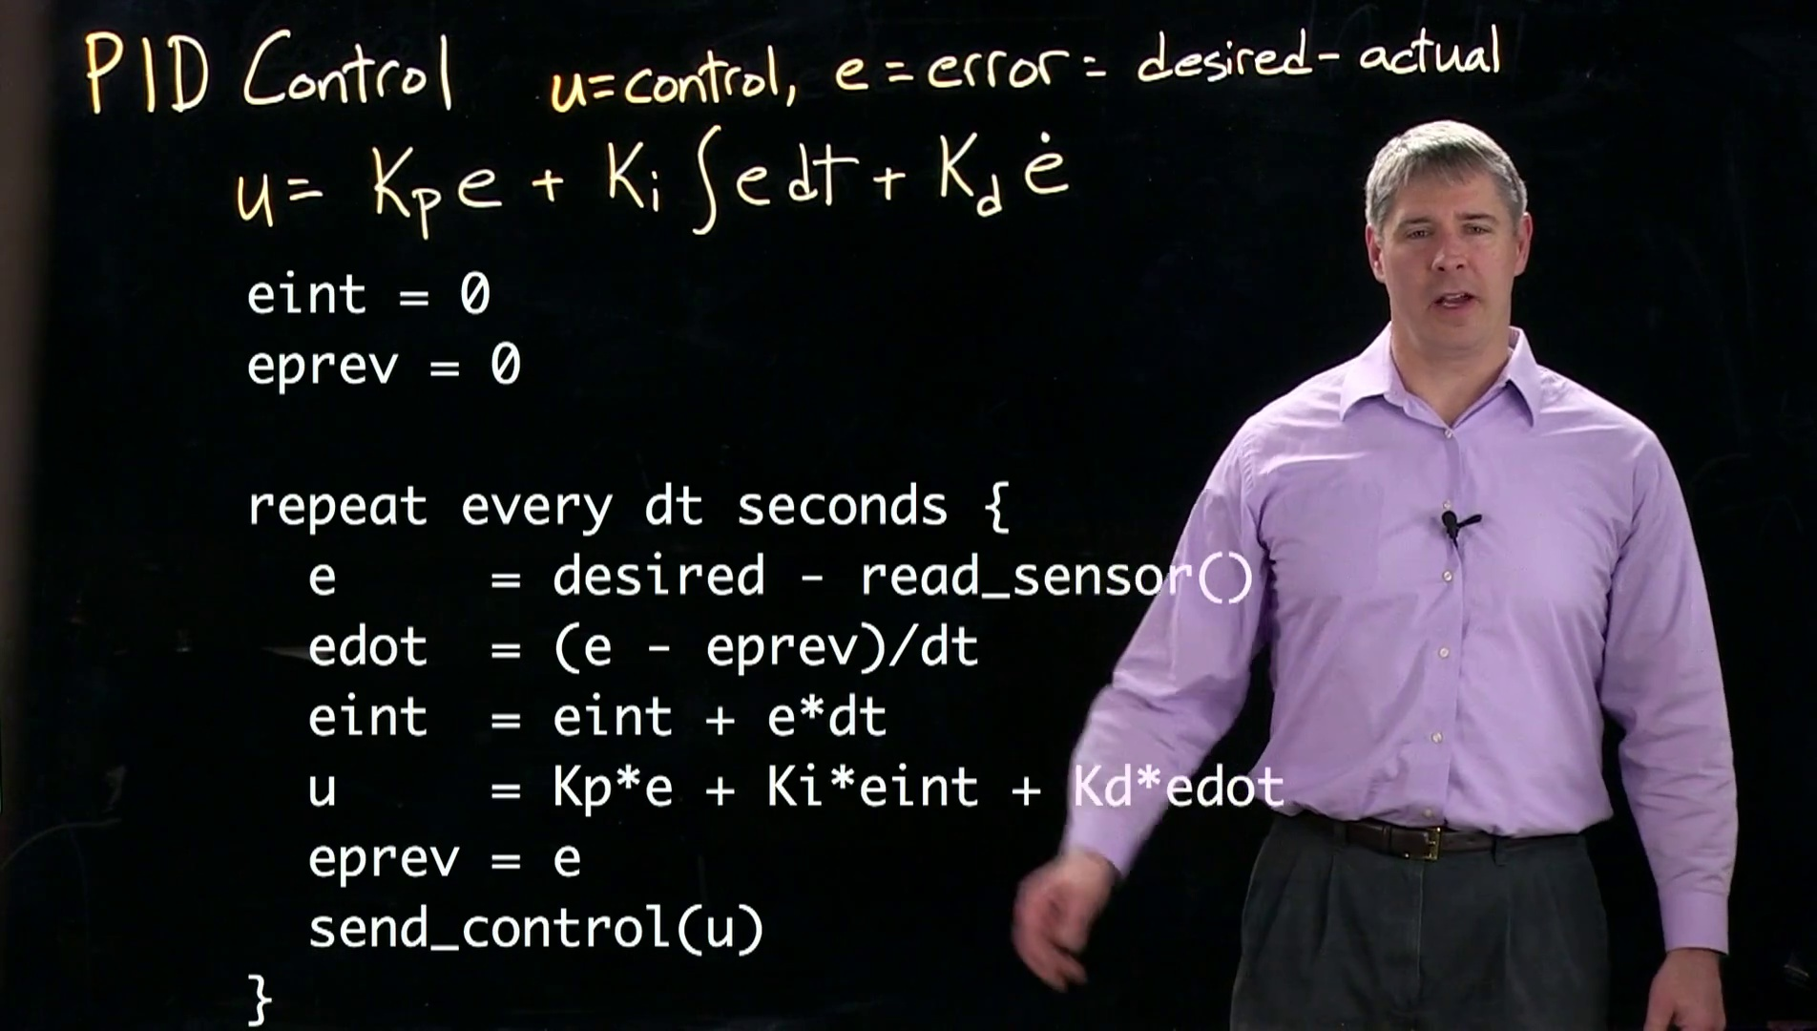 (score 98.0000)
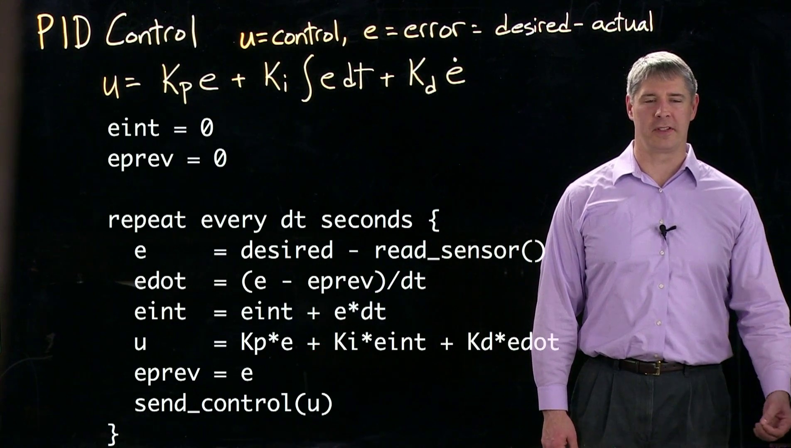 (score 95.0000)
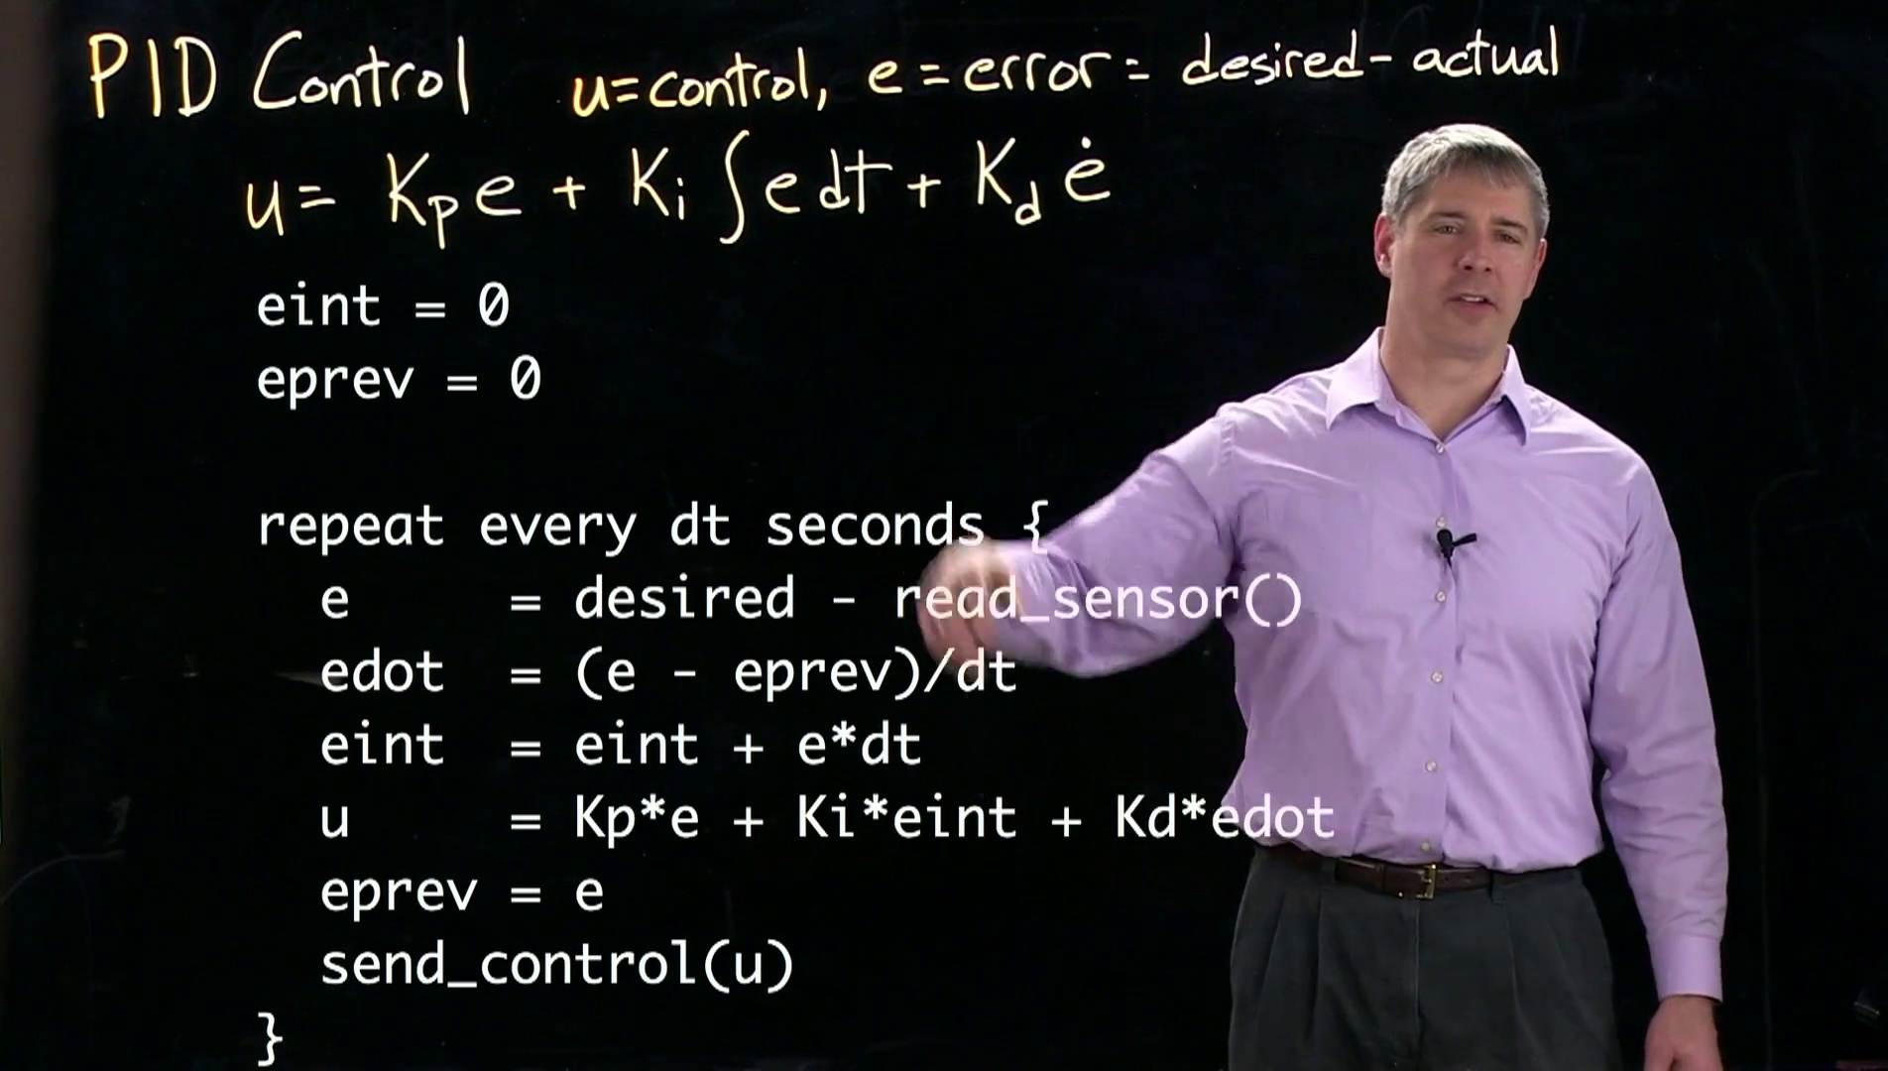 (score 95.0000)
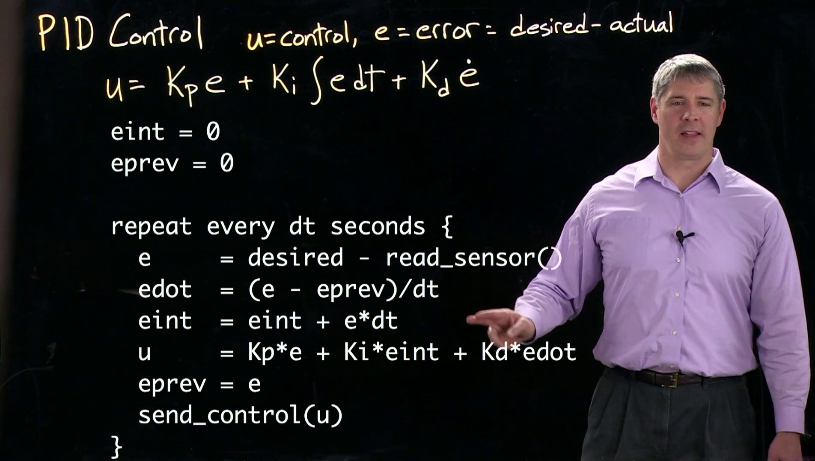 (score 95.0000)
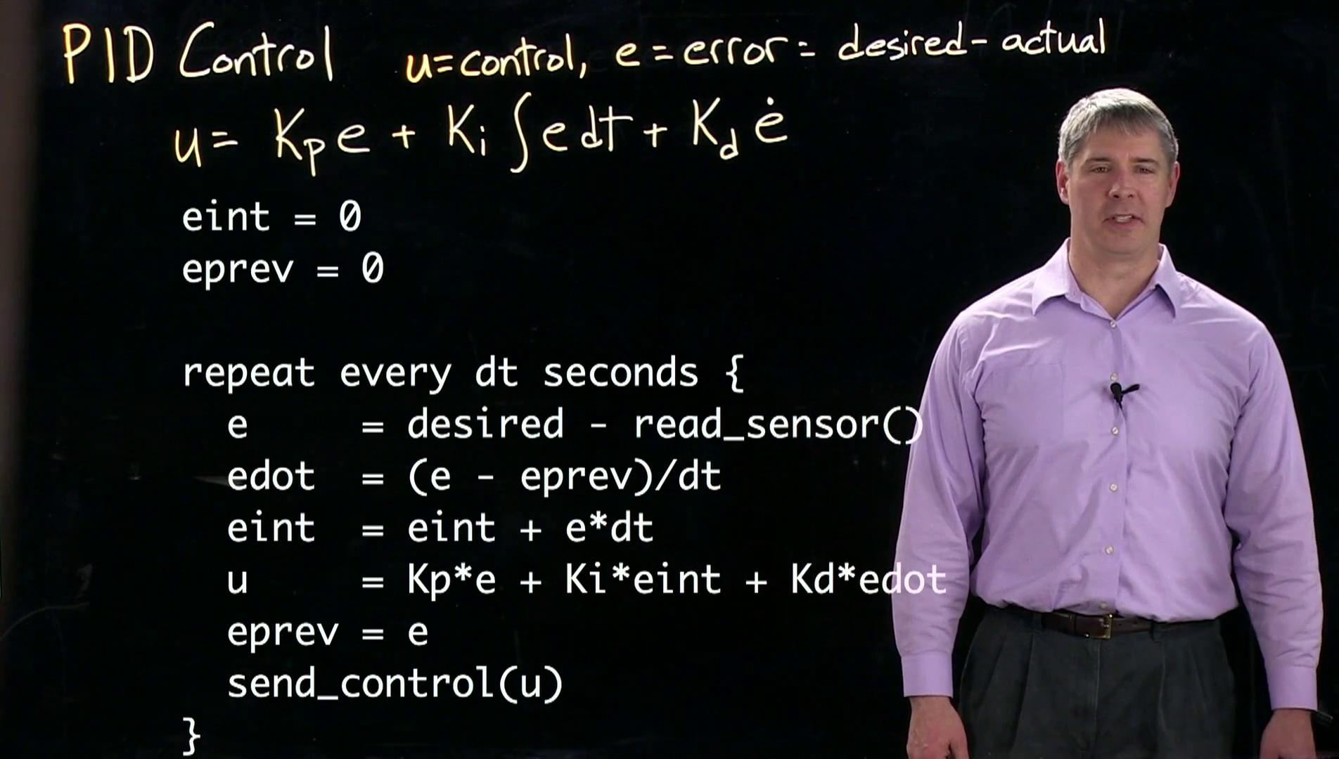 (score 95.0000)
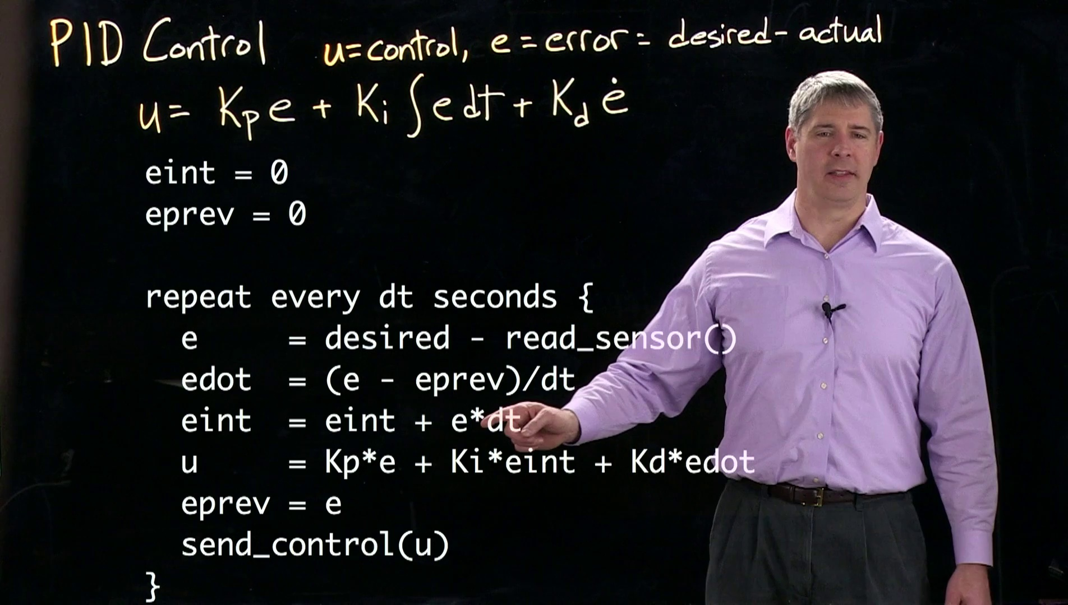 (score 95.0000)
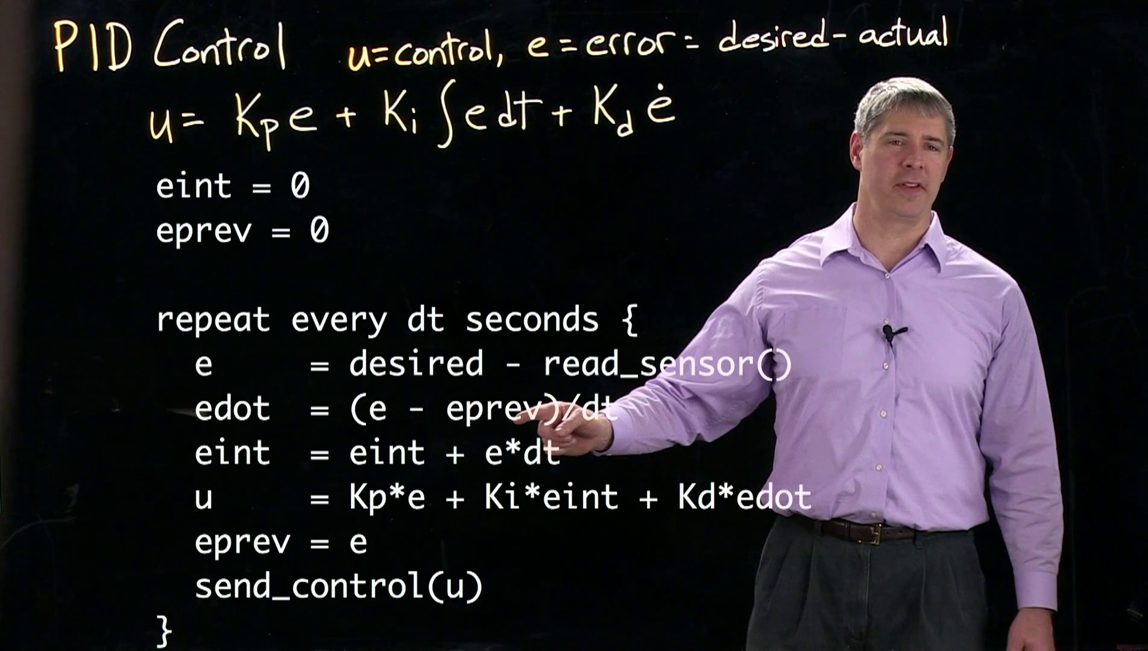 (score 95.0000)
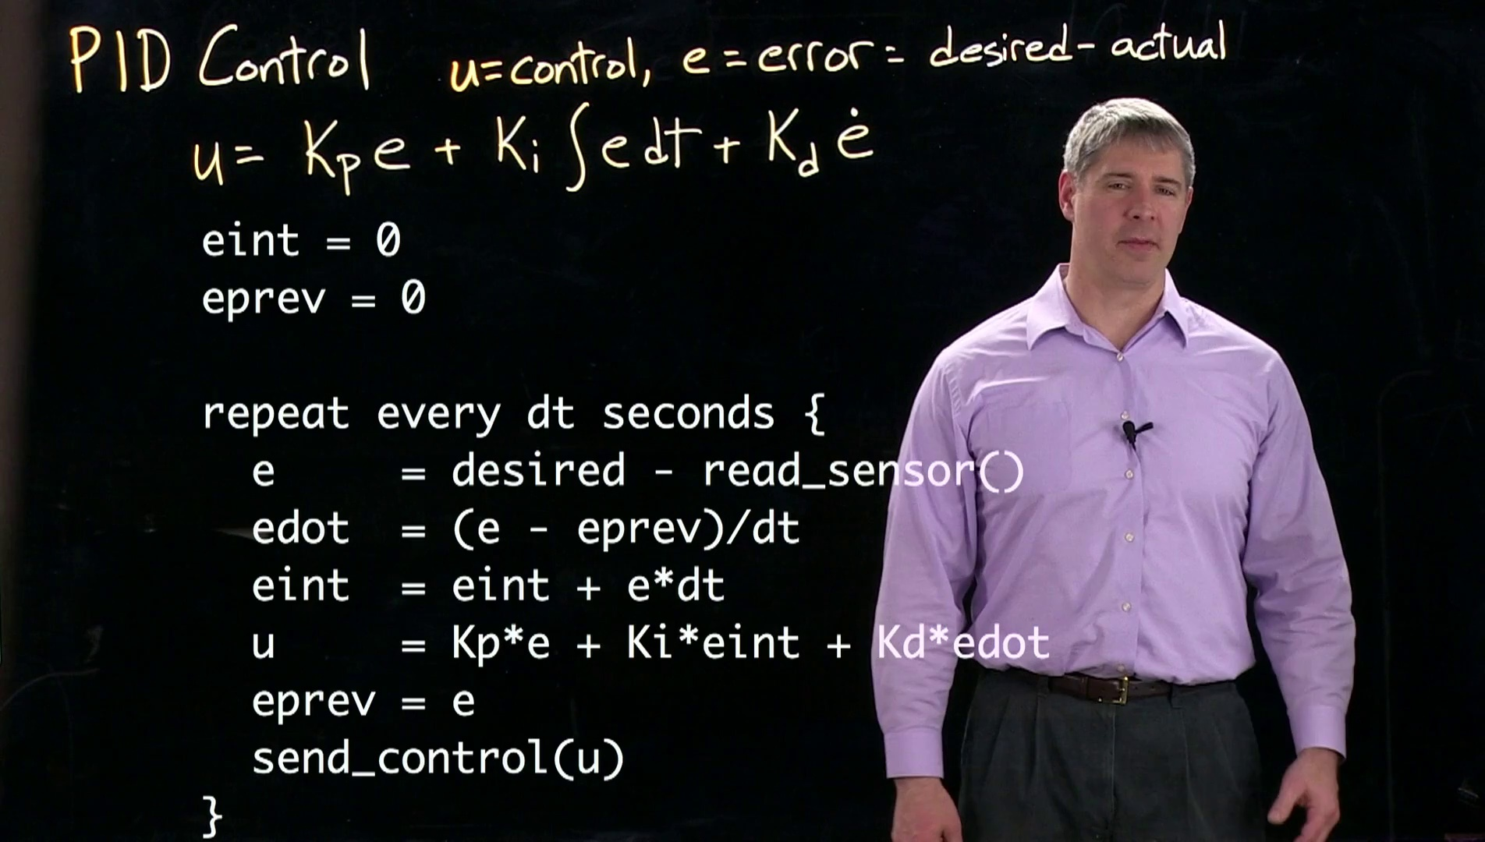 (score 95.0000)
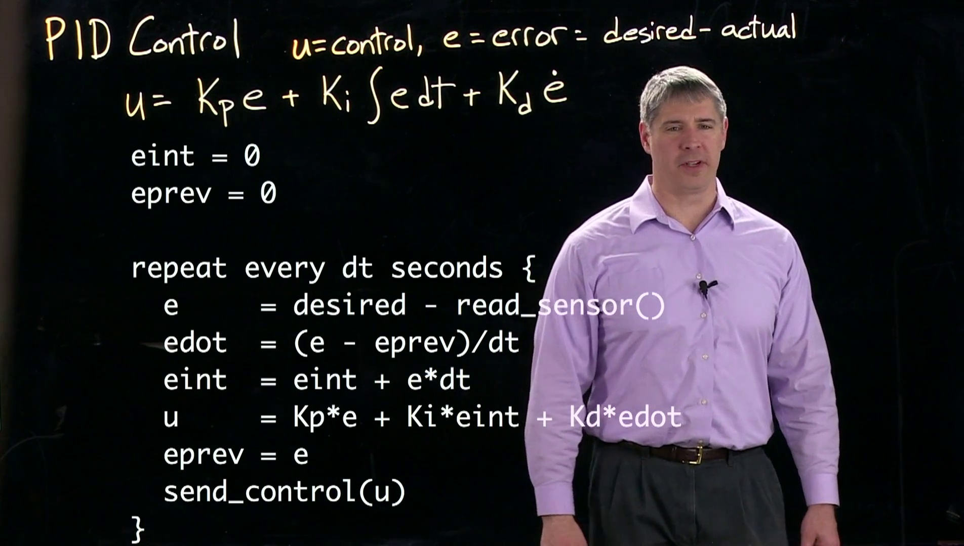 (score 95.0000)
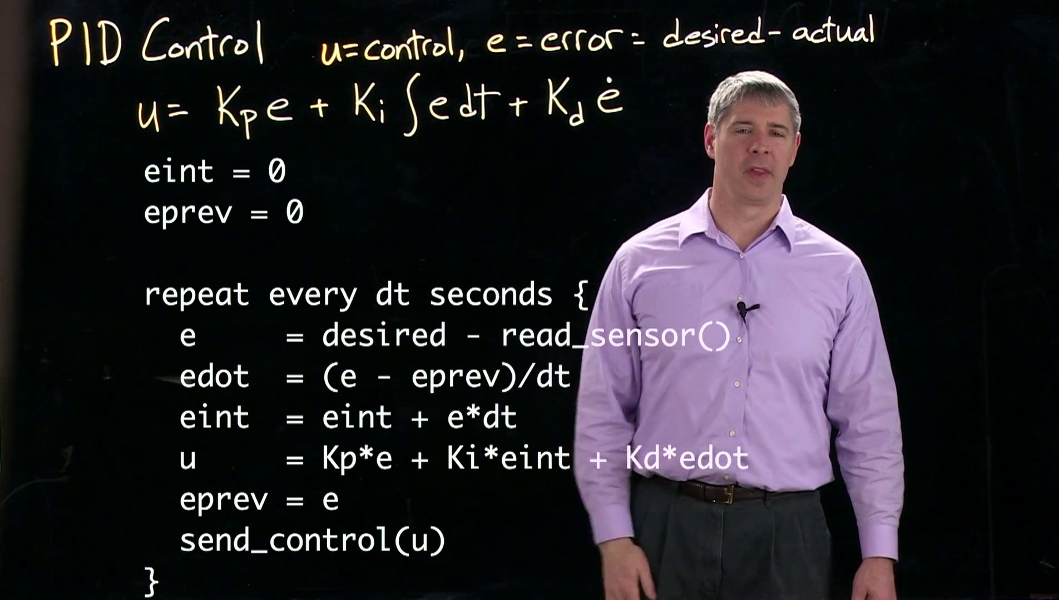 (score 95.0000)
Least correlated frames:
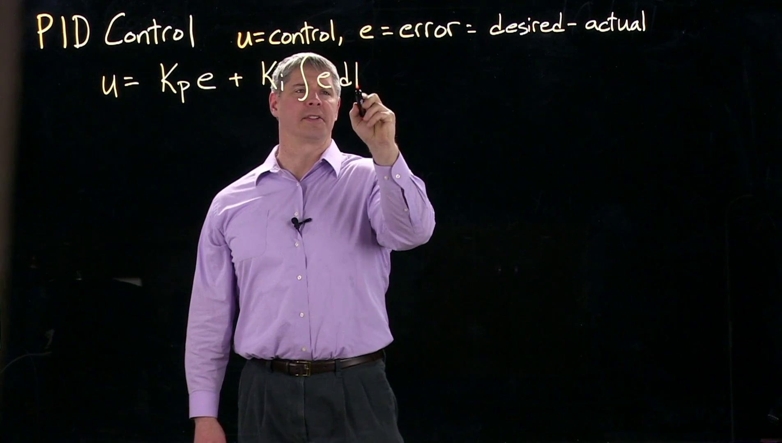 (score 0.0000)
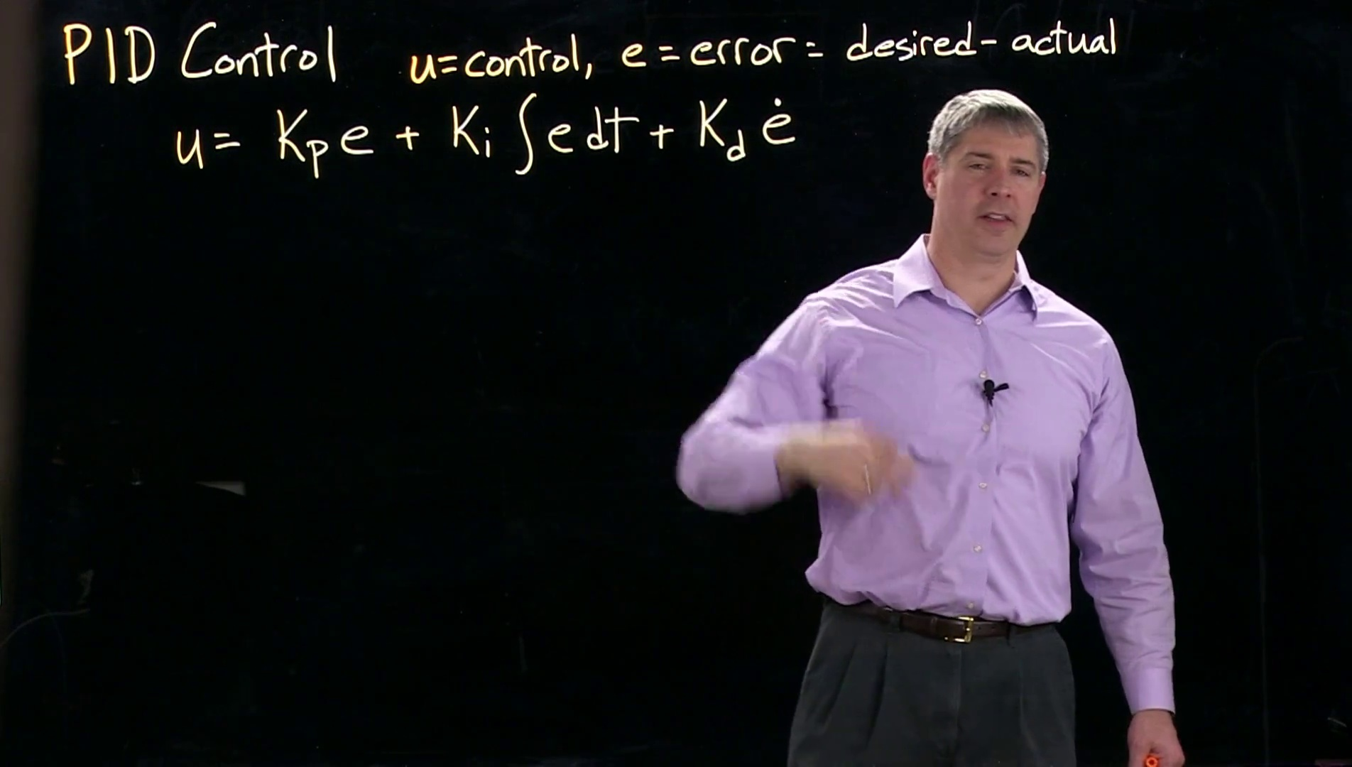 (score 20.0000)
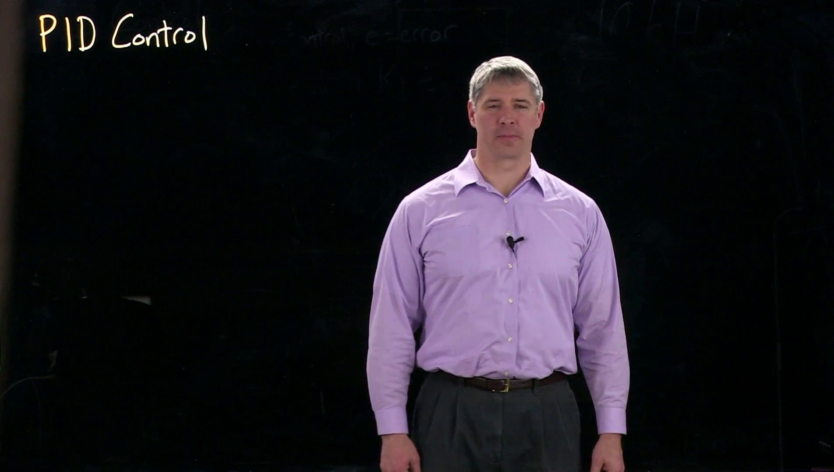 (score 80.0000)
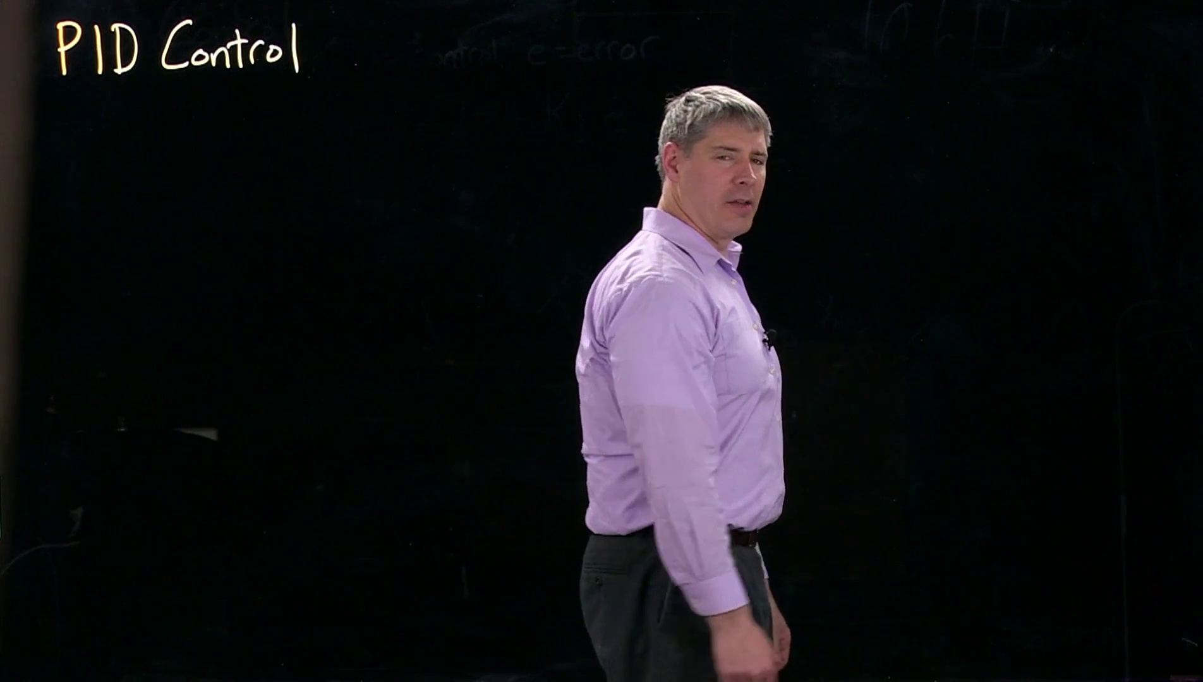 (score 80.0000)
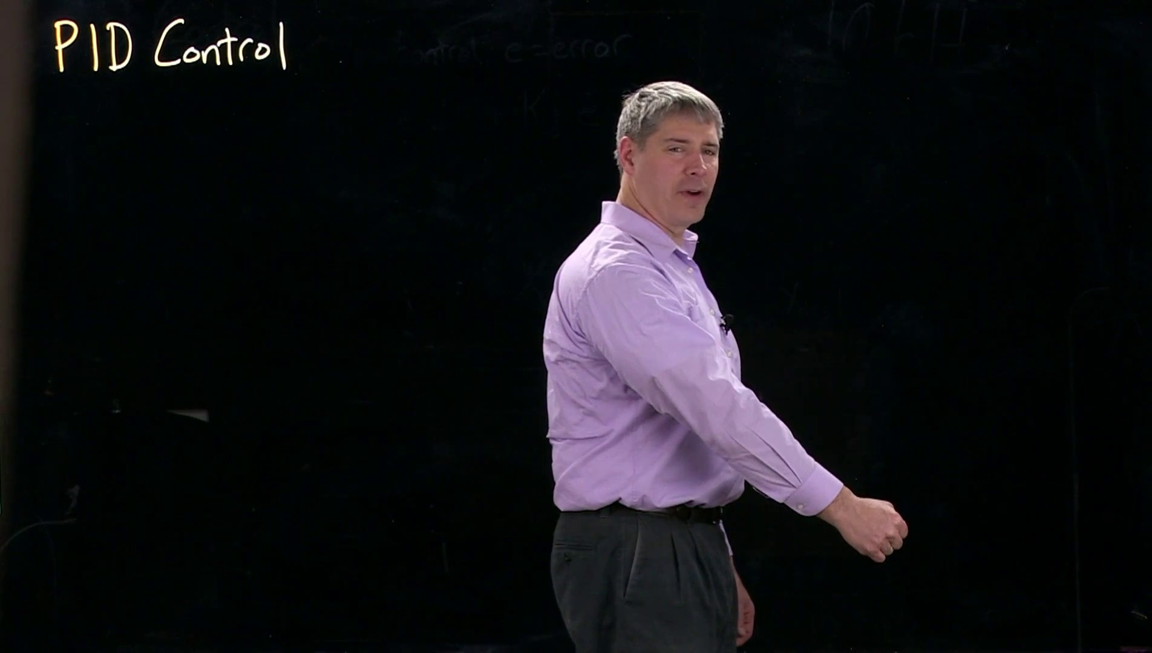 (score 80.0000)
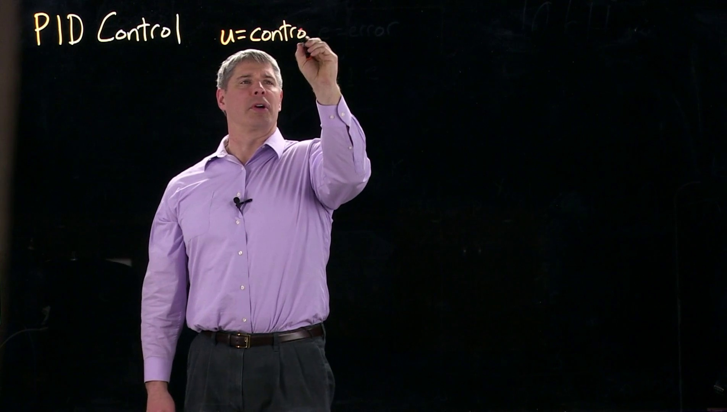 (score 80.0000)
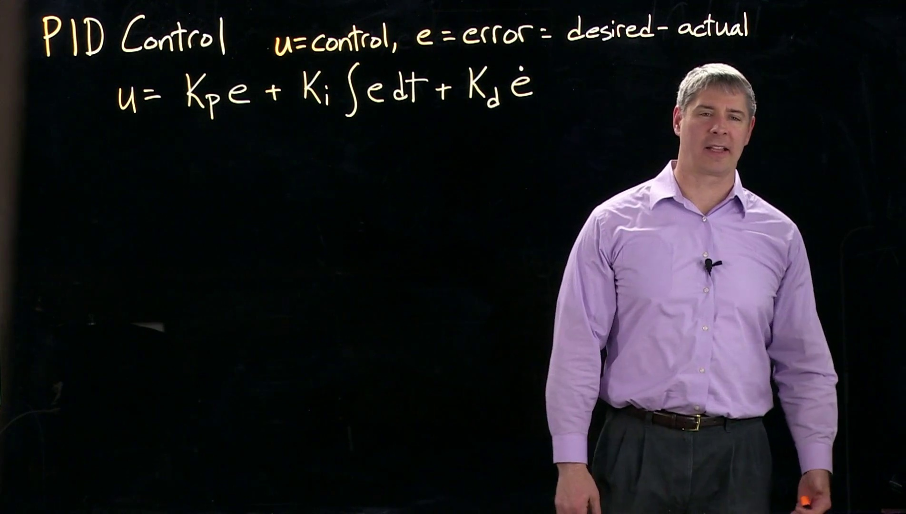 (score 80.0000)
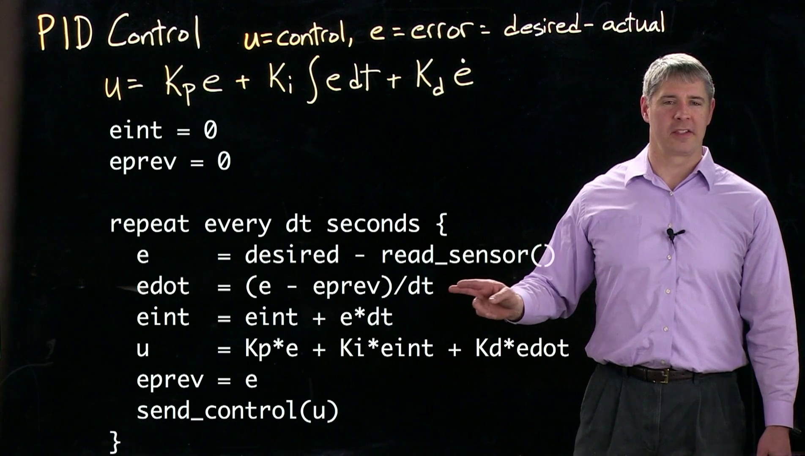 (score 80.0000)
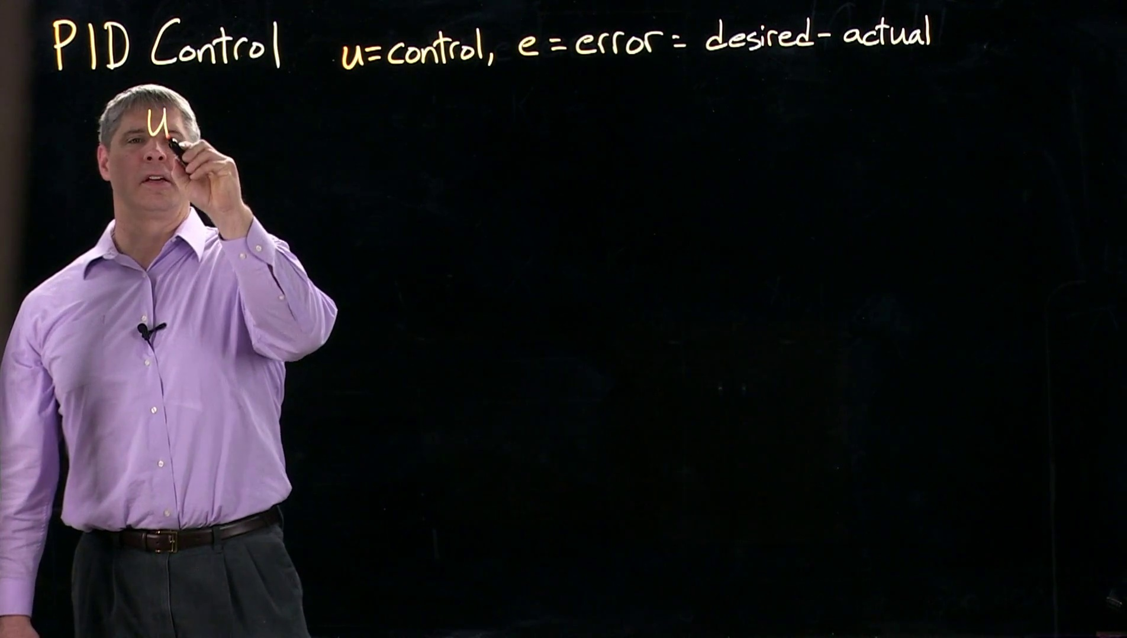 (score 85.0000)
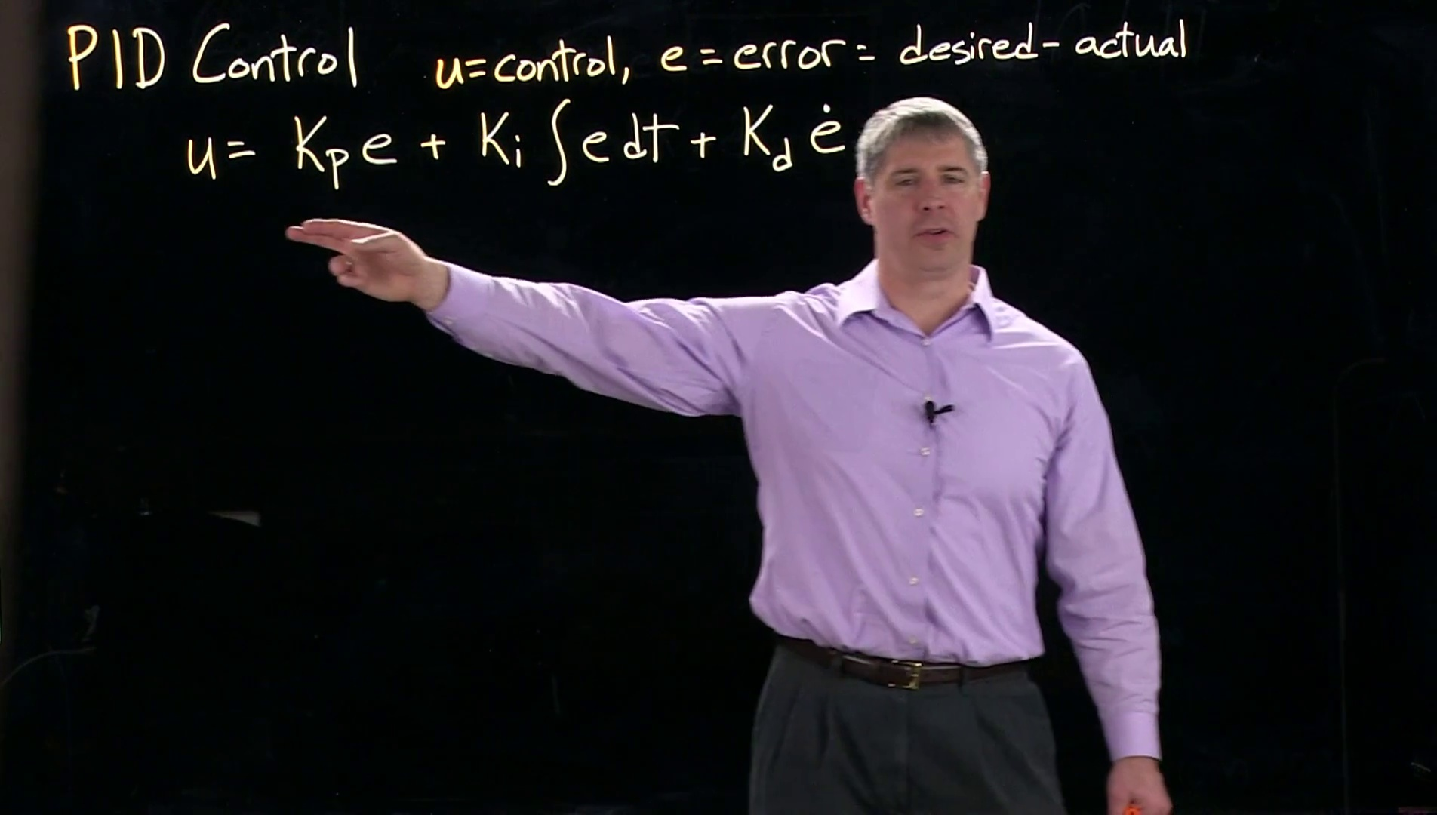 (score 85.0000)

Frame: frame_0000.jpg
Caption: The image shows a person, likely an instructor or presenter, standing in front of a presentation slide with the title "PID Control" at the top. The individual is wearing a purple shirt and standing slightly off-center to the right of the frame, looking directly at the camera or audience, with their hands by their sides. There are text elements on the slide, including "PID Control" in different fonts and sizes, as well as graphical elements such as lines connecting points and what appears to be a step response curve with time on the horizontal axis and an oscillatory output on the vertical axis.
The person's posture suggests they are currently speaking or presenting without any visible actions like writing or holding models. A text overlay on the image reads "PID Control," indicating that the content is educational, and the presenter appears to be explaining what PID (Proportional-Integral-Derivative) control is in a technical context.
The overall scene conveys a sense of learning or sharing knowledge, with the person's friendly smile adding a welcoming tone.
Comment (score 95): The video introduces the concept of Proportional-Integral-Derivative (PID) control, which is used often in controls engineering in various industries. It reviews the standard feedback control architecture, explaining how a plant produces an output to match a reference signal. The difference between the actual output and the reference signal creates an error signal, which the controller uses to adjust the plant's input to align the output with the reference signal.PID control expands on this idea by incorporating three terms: Proportional (P), Integral (I), and Derivative (D). The proportional term produces a control signal that is directly proportional to the error, represented as . The integral term accumulates the error over time, aiming to eliminate steady-state error, and is calculated as . The derivative term, , focuses on the rate of change of the error, acting as a dampening force to reduce overshoot and improve system stability.The video explains the impact of each term on the system's performance, and how adjusting these parameters influences rise time, overshoot, settling time, steady-state error, and stability. Increasing the proportional gain generally decreases the rise time but may increase overshoot and reduce stability. Raising the integral gain can lower steady-state error but might lead to increased overshoot and settling time, along with potential stability issues. The derivative gain mostly affects overshoot and settling time and does not directly influence steady-state error but can improve system stability when used carefully.The video shows a demonstration using a weight and spring system to explain how each PID component affects the control process. This demonstration shows the PID control's ability to address past, present, and future error components within a system, demonstrating its effectiveness in control engineering.PID control is a fundamental approach in control systems, enabling the fine-tuning of system responses through three different control actions. The challenge in PID control is in setting the PID gains appropriately to achieve the desired system behavior. This task can be cumbersome.
Reason: The comment directly discusses the technical steps and components of PID control (Proportional, Integral, Derivative) as described in the frame caption. The caption mentions the graphical elements on the slide, including the step response curve with time on the horizontal axis and an oscillatory output on the vertical axis, which is further explained in the comment as part of the PID control demonstration using a weight and spring system.
Source: https://www.youtube.com/watch?v=taSlxgvvrBM: INTRODUCTION TO PID CONTROL:

Frame: frame_0001.jpg
Caption: The image appears to show a person standing in front of a surface, with text on it. The surface has a black border at the top and is titled "PID Control", which likely relates to Process Control in engineering. The text on the slide reads "PID Control" but there's no additional context or details visible within the image that would provide further information about the content of the presentation or the person's role.
The person is standing with their arms at their sides, facing forward. They are wearing a dark shirt and dark pants, and their expression seems neutral with no discernible facial features due to the angle and distance from the camera. The image is taken in an indoor setting that resembles a conference room or lecture hall with a dark wall behind the person and a microphone stand visible on the right side of the photo.
The surface appears to be a blackboard, as another version of this image shows the same individual standing in front of it, his attention seemingly focused on the words "PID Control" written in white. He is dressed in a purple shirt and gray pants, and he is wearing a black belt with a silver buckle. His position in front of the board suggests he is the one giving a presentation or lecture.
The image does not contain any other objects or people, and the relative position of the person to the board and the absence of other elements in the frame suggest that they are the main subject of the image. The image does not provide any additional information about their occupation or the context of their presentation.
Comment (score 80): The video introduces the concept of Proportional-Integral-Derivative (PID) control, which is used often in controls engineering in various industries. It reviews the standard feedback control architecture, explaining how a plant produces an output to match a reference signal. The difference between the actual output and the reference signal creates an error signal, which the controller uses to adjust the plant's input to align the output with the reference signal.PID control expands on this idea by incorporating three terms: Proportional (P), Integral (I), and Derivative (D). The proportional term produces a control signal that is directly proportional to the error, represented as . The integral term accumulates the error over time, aiming to eliminate steady-state error, and is calculated as . The derivative term, , focuses on the rate of change of the error, acting as a dampening force to reduce overshoot and improve system stability.The video explains the impact of each term on the system's performance, and how adjusting these parameters influences rise time, overshoot, settling time, steady-state error, and stability. Increasing the proportional gain generally decreases the rise time but may increase overshoot and reduce stability. Raising the integral gain can lower steady-state error but might lead to increased overshoot and settling time, along with potential stability issues. The derivative gain mostly affects overshoot and settling time and does not directly influence steady-state error but can improve system stability when used carefully.The video shows a demonstration using a weight and spring system to explain how each PID component affects the control process. This demonstration shows the PID control's ability to address past, present, and future error components within a system, demonstrating its effectiveness in control engineering.PID control is a fundamental approach in control systems, enabling the fine-tuning of system responses through three different control actions. The challenge in PID control is in setting the PID gains appropriately to achieve the desired system behavior. This task can be cumbersome.
Reason: The comment directly discusses the technical steps and objects described in the caption, specifically mentioning PID control, its components (P, I, D), and their impact on system performance. The comment also explains the demonstration using a weight and spring system, which is mentioned in the caption as a way to illustrate how each PID component affects the control process.
Source: https://www.youtube.com/watch?v=taSlxgvvrBM: INTRODUCTION TO PID CONTROL:

Frame: frame_0002.jpg
Caption: The image shows an individual, dressed in a purple shirt and gray pants, standing in front of a black background that includes a title at the top reading "PID Control" and a watermark at the bottom left corner also displaying the same text. The person appears to be giving a presentation or lecture, as suggested by their direct gaze towards the camera and the presence of a slide visible behind them on the right side. The slide contains text but it is not clear enough to read the details.
The individual is standing in front of a blackboard that has the word "PID" written on it, adding an academic touch to the scene. The overall setting suggests an educational environment, likely related to engineering, process control, or automation, where PID (Proportional-Integral-Derivative) control is being taught or discussed.
In the bottom right corner of the image, there is a credit or attribution line with the text "INSTRUCTOR," but it is not clear who holds this position or if they are the same person as the one in the image. The image does not contain any other objects or people, making the individual and the blackboard the main focus of the scene.
Comment (score 90): The video introduces the concept of Proportional-Integral-Derivative (PID) control, which is used often in controls engineering in various industries. It reviews the standard feedback control architecture, explaining how a plant produces an output to match a reference signal. The difference between the actual output and the reference signal creates an error signal, which the controller uses to adjust the plant's input to align the output with the reference signal.PID control expands on this idea by incorporating three terms: Proportional (P), Integral (I), and Derivative (D). The proportional term produces a control signal that is directly proportional to the error, represented as . The integral term accumulates the error over time, aiming to eliminate steady-state error, and is calculated as . The derivative term, , focuses on the rate of change of the error, acting as a dampening force to reduce overshoot and improve system stability.The video explains the impact of each term on the system's performance, and how adjusting these parameters influences rise time, overshoot, settling time, steady-state error, and stability. Increasing the proportional gain generally decreases the rise time but may increase overshoot and reduce stability. Raising the integral gain can lower steady-state error but might lead to increased overshoot and settling time, along with potential stability issues. The derivative gain mostly affects overshoot and settling time and does not directly influence steady-state error but can improve system stability when used carefully.The video shows a demonstration using a weight and spring system to explain how each PID component affects the control process. This demonstration shows the PID control's ability to address past, present, and future error components within a system, demonstrating its effectiveness in control engineering.PID control is a fundamental approach in control systems, enabling the fine-tuning of system responses through three different control actions. The challenge in PID control is in setting the PID gains appropriately to achieve the desired system behavior. This task can be cumbersome.
Reason: The comment directly discusses the PID control concept, explaining its components (Proportional, Integral, and Derivative) and how they affect system performance. The caption provides context for the video, mentioning 'PID Control' as a topic being taught or discussed, which aligns with the content of the comment.
Source: https://www.youtube.com/watch?v=taSlxgvvrBM: INTRODUCTION TO PID CONTROL:

Frame: frame_0003.jpg
Caption: The image shows a man standing in front of a blackboard that reads "PDI Control" on a dark background. The text at the top left corner includes "PDF", possibly with additional words too small to read clearly. The individual is facing the camera, wearing a purple shirt and holding a microphone in his right hand. His left hand is raised in the air, as if he is speaking or gesturing. The overall setting appears designed for remote learning or online teaching, as suggested by the dark background that could be a blackboard or a digital display intended for projecting slides or diagrams.
Comment (score 95): The video introduces the concept of Proportional-Integral-Derivative (PID) control, which is used often in controls engineering in various industries. It reviews the standard feedback control architecture, explaining how a plant produces an output to match a reference signal. The difference between the actual output and the reference signal creates an error signal, which the controller uses to adjust the plant's input to align the output with the reference signal.PID control expands on this idea by incorporating three terms: Proportional (P), Integral (I), and Derivative (D). The proportional term produces a control signal that is directly proportional to the error, represented as . The integral term accumulates the error over time, aiming to eliminate steady-state error, and is calculated as . The derivative term, , focuses on the rate of change of the error, acting as a dampening force to reduce overshoot and improve system stability.The video explains the impact of each term on the system's performance, and how adjusting these parameters influences rise time, overshoot, settling time, steady-state error, and stability. Increasing the proportional gain generally decreases the rise time but may increase overshoot and reduce stability. Raising the integral gain can lower steady-state error but might lead to increased overshoot and settling time, along with potential stability issues. The derivative gain mostly affects overshoot and settling time and does not directly influence steady-state error but can improve system stability when used carefully.The video shows a demonstration using a weight and spring system to explain how each PID component affects the control process. This demonstration shows the PID control's ability to address past, present, and future error components within a system, demonstrating its effectiveness in control engineering.PID control is a fundamental approach in control systems, enabling the fine-tuning of system responses through three different control actions. The challenge in PID control is in setting the PID gains appropriately to achieve the desired system behavior. This task can be cumbersome.
Reason: The comment directly discusses the same technical steps, objects, settings, and goals described in the caption. The caption mentions a blackboard with 'PDI Control' text, which matches the PID control concept discussed in the comment. Additionally, the comment provides specific details on how each term (Proportional, Integral, Derivative) affects system performance, matching the information presented in the caption.
Source: https://www.youtube.com/watch?v=taSlxgvvrBM: INTRODUCTION TO PID CONTROL:

Frame: frame_0004.jpg
Caption: The image shows a person standing in front of a background with a slide and what appears to be a chalkboard or whiteboard. The individual is facing the camera, looking directly at it with a confident posture. They are wearing a purple shirt, gray pants, and have short hair. On the right side of the screen, there is text that reads "PDID CONTROL," indicating that the topic being discussed is related to process dynamics identification control (PDID), which is a method used in control systems engineering.
The title on the blackboard, written in yellow letters, says "PID Control," further emphasizing the focus on this specific topic. The person appears to be actively engaging with the content displayed on the screen, although it is not clearly visible due to the image's resolution and angle. The environment suggests an academic or professional setting focused on teaching and learning about control systems engineering.
Comment (score 95): The video introduces the concept of Proportional-Integral-Derivative (PID) control, which is used often in controls engineering in various industries. It reviews the standard feedback control architecture, explaining how a plant produces an output to match a reference signal. The difference between the actual output and the reference signal creates an error signal, which the controller uses to adjust the plant's input to align the output with the reference signal.PID control expands on this idea by incorporating three terms: Proportional (P), Integral (I), and Derivative (D). The proportional term produces a control signal that is directly proportional to the error, represented as . The integral term accumulates the error over time, aiming to eliminate steady-state error, and is calculated as . The derivative term, , focuses on the rate of change of the error, acting as a dampening force to reduce overshoot and improve system stability.The video explains the impact of each term on the system's performance, and how adjusting these parameters influences rise time, overshoot, settling time, steady-state error, and stability. Increasing the proportional gain generally decreases the rise time but may increase overshoot and reduce stability. Raising the integral gain can lower steady-state error but might lead to increased overshoot and settling time, along with potential stability issues. The derivative gain mostly affects overshoot and settling time and does not directly influence steady-state error but can improve system stability when used carefully.The video shows a demonstration using a weight and spring system to explain how each PID component affects the control process. This demonstration shows the PID control's ability to address past, present, and future error components within a system, demonstrating its effectiveness in control engineering.PID control is a fundamental approach in control systems, enabling the fine-tuning of system responses through three different control actions. The challenge in PID control is in setting the PID gains appropriately to achieve the desired system behavior. This task can be cumbersome.
Reason: The comment directly discusses the technical steps and goals described in the caption, specifically PID control and its components (Proportional, Integral, Derivative). The comment also explains the impact of each term on system performance, which is mentioned in the caption as a key aspect of PDID CONTROL.
Source: https://www.youtube.com/watch?v=taSlxgvvrBM: INTRODUCTION TO PID CONTROL:

Frame: frame_0005.jpg
Caption: The image shows a split screen with two different scenes. On the left side, there is a person walking in front of a dark background. This individual appears to be a man with short hair, wearing a light purple shirt and dark pants. He's looking directly at the camera with a neutral expression. The simplicity of the background allows his attire and demeanor to take center stage.
On the right side of the image, there is a slide with text that reads "PID CONTROL." The acronym stands for Proportional-Integral-Derivative control, which refers to a type of feedback loop used in industrial control systems and mechanical engineering. These loops are designed to maintain a desired value or setpoint in a process variable such as temperature or flow rate.
The style of the image suggests it could be taken from a video recording or screenshot of a lecture or tutorial about process control systems, possibly related to the man's profession or role.
Comment (score 90): The video introduces the concept of Proportional-Integral-Derivative (PID) control, which is used often in controls engineering in various industries. It reviews the standard feedback control architecture, explaining how a plant produces an output to match a reference signal. The difference between the actual output and the reference signal creates an error signal, which the controller uses to adjust the plant's input to align the output with the reference signal.PID control expands on this idea by incorporating three terms: Proportional (P), Integral (I), and Derivative (D). The proportional term produces a control signal that is directly proportional to the error, represented as . The integral term accumulates the error over time, aiming to eliminate steady-state error, and is calculated as . The derivative term, , focuses on the rate of change of the error, acting as a dampening force to reduce overshoot and improve system stability.The video explains the impact of each term on the system's performance, and how adjusting these parameters influences rise time, overshoot, settling time, steady-state error, and stability. Increasing the proportional gain generally decreases the rise time but may increase overshoot and reduce stability. Raising the integral gain can lower steady-state error but might lead to increased overshoot and settling time, along with potential stability issues. The derivative gain mostly affects overshoot and settling time and does not directly influence steady-state error but can improve system stability when used carefully.The video shows a demonstration using a weight and spring system to explain how each PID component affects the control process. This demonstration shows the PID control's ability to address past, present, and future error components within a system, demonstrating its effectiveness in control engineering.PID control is a fundamental approach in control systems, enabling the fine-tuning of system responses through three different control actions. The challenge in PID control is in setting the PID gains appropriately to achieve the desired system behavior. This task can be cumbersome.
Reason: The comment directly discusses the same technical steps, objects, settings, or goals described in the caption. The PID control architecture, terms (P, I, and D), and their effects on system performance are all mentioned in both the caption and comment, indicating a strong correlation.
Source: https://www.youtube.com/watch?v=taSlxgvvrBM: INTRODUCTION TO PID CONTROL:

Frame: frame_0006.jpg
Caption: The image depicts a man standing in front of a black background with white text that reads "PID Control." The individual appears to be presenting or teaching about Process Identification Control. He is facing the camera, wearing a purple shirt and gray pants, suggesting he is in the middle of a presentation or discussion. The focal point of the image is the blackboard behind him, written in yellow with the same phrase "PID Control," which draws attention to the topic being presented. The man's posture and position relative to the blackboard indicate that he is the main subject of this image. The stark contrast between his purple shirt and gray pants and the yellow writing on the blackboard further emphasizes the importance of the information being shared, with no other objects or people present in the image.
Comment (score 90): The video introduces the concept of Proportional-Integral-Derivative (PID) control, which is used often in controls engineering in various industries. It reviews the standard feedback control architecture, explaining how a plant produces an output to match a reference signal. The difference between the actual output and the reference signal creates an error signal, which the controller uses to adjust the plant's input to align the output with the reference signal.PID control expands on this idea by incorporating three terms: Proportional (P), Integral (I), and Derivative (D). The proportional term produces a control signal that is directly proportional to the error, represented as . The integral term accumulates the error over time, aiming to eliminate steady-state error, and is calculated as . The derivative term, , focuses on the rate of change of the error, acting as a dampening force to reduce overshoot and improve system stability.The video explains the impact of each term on the system's performance, and how adjusting these parameters influences rise time, overshoot, settling time, steady-state error, and stability. Increasing the proportional gain generally decreases the rise time but may increase overshoot and reduce stability. Raising the integral gain can lower steady-state error but might lead to increased overshoot and settling time, along with potential stability issues. The derivative gain mostly affects overshoot and settling time and does not directly influence steady-state error but can improve system stability when used carefully.The video shows a demonstration using a weight and spring system to explain how each PID component affects the control process. This demonstration shows the PID control's ability to address past, present, and future error components within a system, demonstrating its effectiveness in control engineering.PID control is a fundamental approach in control systems, enabling the fine-tuning of system responses through three different control actions. The challenge in PID control is in setting the PID gains appropriately to achieve the desired system behavior. This task can be cumbersome.
Reason: The comment directly discusses the technical steps and concepts presented in the frame caption, including PID control, feedback control architecture, proportional, integral, and derivative terms, their effects on system performance, and the importance of setting PID gains appropriately. The comment also references a demonstration using a weight and spring system to explain PID control's effectiveness, matching the focus on Process Identification Control in the caption.
Source: https://www.youtube.com/watch?v=taSlxgvvrBM: INTRODUCTION TO PID CONTROL:

Frame: frame_0007.jpg
Caption: The image shows a person standing in front of a black background, wearing a purple shirt and a black suit that gives them a professional appearance. Their body is slightly turned to one side, but they seem to be facing the camera directly. In their right hand, they raise it towards the air, suggesting a gesture of authority or leadership. Their gaze is directed towards the left, adding a sense of focus to the image. In the upper left corner of the image, there's text that reads "PDI Control" in yellow, suggesting that the person might be involved in some form of control or monitoring, possibly related to power distribution or data processing. The overall style of the image is straightforward and appears to be a still from a video or a presentation slide rather than an instructional context, with the composition suggesting a formal setting related to the topic of "PDI Control".
Comment (score 80): The video introduces the concept of Proportional-Integral-Derivative (PID) control, which is used often in controls engineering in various industries. It reviews the standard feedback control architecture, explaining how a plant produces an output to match a reference signal. The difference between the actual output and the reference signal creates an error signal, which the controller uses to adjust the plant's input to align the output with the reference signal.PID control expands on this idea by incorporating three terms: Proportional (P), Integral (I), and Derivative (D). The proportional term produces a control signal that is directly proportional to the error, represented as . The integral term accumulates the error over time, aiming to eliminate steady-state error, and is calculated as . The derivative term, , focuses on the rate of change of the error, acting as a dampening force to reduce overshoot and improve system stability.The video explains the impact of each term on the system's performance, and how adjusting these parameters influences rise time, overshoot, settling time, steady-state error, and stability. Increasing the proportional gain generally decreases the rise time but may increase overshoot and reduce stability. Raising the integral gain can lower steady-state error but might lead to increased overshoot and settling time, along with potential stability issues. The derivative gain mostly affects overshoot and settling time and does not directly influence steady-state error but can improve system stability when used carefully.The video shows a demonstration using a weight and spring system to explain how each PID component affects the control process. This demonstration shows the PID control's ability to address past, present, and future error components within a system, demonstrating its effectiveness in control engineering.PID control is a fundamental approach in control systems, enabling the fine-tuning of system responses through three different control actions. The challenge in PID control is in setting the PID gains appropriately to achieve the desired system behavior. This task can be cumbersome.
Reason: The comment directly discusses the technical steps, objects, and settings described in the caption. The mention of PID control, its components (Proportional, Integral, Derivative), and their effects on system performance aligns with the caption's description of the person standing in front of a 'PDI Control' background.
Source: https://www.youtube.com/watch?v=taSlxgvvrBM: INTRODUCTION TO PID CONTROL:

Frame: frame_0008.jpg
Caption: The image shows a person standing in front of a screen displaying a presentation with the title "PID Control" at the top left corner. The individual, dressed in a purple shirt and dark pants, is standing in front of a black background marked with yellow text that reads "PID Control". The man's attire is formal, complete with a brown belt. He appears to be instructing or presenting on the subject of PID control, as he is pointing towards the content on the screen with his hands held out in a gesture that suggests he might be explaining something.
The presentation slide includes a graphic representation of a PID controller with inputs for proportional (P), integral (I), and derivative (D) components. There is also text on the screen which seems to be related to the controller setup, but it is not clear enough to read in detail. The background is dark, indicating that the focus should be on the presentation slide and the instructor's actions. The image has a low resolution and appears to be taken from a video source, given the presence of play buttons and low-quality rendering.
Comment (score 90): The video introduces the concept of Proportional-Integral-Derivative (PID) control, which is used often in controls engineering in various industries. It reviews the standard feedback control architecture, explaining how a plant produces an output to match a reference signal. The difference between the actual output and the reference signal creates an error signal, which the controller uses to adjust the plant's input to align the output with the reference signal.PID control expands on this idea by incorporating three terms: Proportional (P), Integral (I), and Derivative (D). The proportional term produces a control signal that is directly proportional to the error, represented as . The integral term accumulates the error over time, aiming to eliminate steady-state error, and is calculated as . The derivative term, , focuses on the rate of change of the error, acting as a dampening force to reduce overshoot and improve system stability.The video explains the impact of each term on the system's performance, and how adjusting these parameters influences rise time, overshoot, settling time, steady-state error, and stability. Increasing the proportional gain generally decreases the rise time but may increase overshoot and reduce stability. Raising the integral gain can lower steady-state error but might lead to increased overshoot and settling time, along with potential stability issues. The derivative gain mostly affects overshoot and settling time and does not directly influence steady-state error but can improve system stability when used carefully.The video shows a demonstration using a weight and spring system to explain how each PID component affects the control process. This demonstration shows the PID control's ability to address past, present, and future error components within a system, demonstrating its effectiveness in control engineering.PID control is a fundamental approach in control systems, enabling the fine-tuning of system responses through three different control actions. The challenge in PID control is in setting the PID gains appropriately to achieve the desired system behavior. This task can be cumbersome.
Reason: The comment directly discusses the PID control concept, terms (P, I, D), and their impact on system performance, which is strongly related to the frame caption's description of a presentation slide about PID control. The comment also mentions a demonstration using a weight and spring system, which aligns with the instructional setting shown in the image.
Source: https://www.youtube.com/watch?v=taSlxgvvrBM: INTRODUCTION TO PID CONTROL:

Frame: frame_0009.jpg
Caption: The image shows a person standing in front of a black background with the text "PID Control" written in yellow. The individual is facing away from the camera, making it difficult to identify their gender or any specific details about them. They are wearing a light purple shirt and appear to be speaking or presenting, as suggested by their open posture and one hand extended slightly forward. On the screen behind the person, there is text that reads "PID Control" along with a graphic representation of what looks like a PID (Proportional-Integral-Derivative) control system, which is commonly used in process control engineering to design controllers for systems with inputs and outputs. The specific components of the PID are not clearly visible due to the resolution and angle of the photograph.
The overall context appears to be educational or instructional, as indicated by the text "PID Control," suggesting that the person is explaining a concept related to control systems in engineering or similar technical disciplines. Notably, the person is holding a white paper in their right hand, which may be used for reference or note-taking during the presentation. The image does not provide any additional context or information about the person or the word "PID Control," and the focus remains on the individual's actions and the visual representation of the PID control system.
Comment (score 95): The video introduces the concept of Proportional-Integral-Derivative (PID) control, which is used often in controls engineering in various industries. It reviews the standard feedback control architecture, explaining how a plant produces an output to match a reference signal. The difference between the actual output and the reference signal creates an error signal, which the controller uses to adjust the plant's input to align the output with the reference signal.PID control expands on this idea by incorporating three terms: Proportional (P), Integral (I), and Derivative (D). The proportional term produces a control signal that is directly proportional to the error, represented as . The integral term accumulates the error over time, aiming to eliminate steady-state error, and is calculated as . The derivative term, , focuses on the rate of change of the error, acting as a dampening force to reduce overshoot and improve system stability.The video explains the impact of each term on the system's performance, and how adjusting these parameters influences rise time, overshoot, settling time, steady-state error, and stability. Increasing the proportional gain generally decreases the rise time but may increase overshoot and reduce stability. Raising the integral gain can lower steady-state error but might lead to increased overshoot and settling time, along with potential stability issues. The derivative gain mostly affects overshoot and settling time and does not directly influence steady-state error but can improve system stability when used carefully.The video shows a demonstration using a weight and spring system to explain how each PID component affects the control process. This demonstration shows the PID control's ability to address past, present, and future error components within a system, demonstrating its effectiveness in control engineering.PID control is a fundamental approach in control systems, enabling the fine-tuning of system responses through three different control actions. The challenge in PID control is in setting the PID gains appropriately to achieve the desired system behavior. This task can be cumbersome.
Reason: The comment directly discusses the same technical steps and objects described in the caption, such as PID control, feedback control architecture, proportional, integral, and derivative terms, and their impact on system performance. The comment also mentions a demonstration using a weight and spring system to explain how each PID component affects the control process, which is also hinted at in the caption.
Source: https://www.youtube.com/watch?v=taSlxgvvrBM: INTRODUCTION TO PID CONTROL:

Frame: frame_0010.jpg
Caption: The image depicts a man standing in front of a black background with a glass wall behind him. He appears to be engaged in a teaching or explanation session, as indicated by the phrase "PID Control" overlaid on the image. The man is wearing a formal attire, consisting of a purple shirt and a black tie, which adds a touch of professionalism to his appearance. His posture is upright, indicating his alertness and focus.
The background is simple and unadorned, with the word "PID Control" written in black letters. This could possibly be the title of his presentation or discussion, suggesting that the focus of the image is on his speech or discussion. The man's body language suggests he is engaged in a discussion or presentation, gesturing towards the camera, which implies he is communicating with an audience.
There are no visible texts or diagrams in the image that can provide additional context or information about the subject matter of the teaching session. The simplicity of the background allows the viewer to focus on the man and his message, emphasizing the importance of clear communication and presentation in professional settings.
Comment (score 80): The video introduces the concept of Proportional-Integral-Derivative (PID) control, which is used often in controls engineering in various industries. It reviews the standard feedback control architecture, explaining how a plant produces an output to match a reference signal. The difference between the actual output and the reference signal creates an error signal, which the controller uses to adjust the plant's input to align the output with the reference signal.PID control expands on this idea by incorporating three terms: Proportional (P), Integral (I), and Derivative (D). The proportional term produces a control signal that is directly proportional to the error, represented as . The integral term accumulates the error over time, aiming to eliminate steady-state error, and is calculated as . The derivative term, , focuses on the rate of change of the error, acting as a dampening force to reduce overshoot and improve system stability.The video explains the impact of each term on the system's performance, and how adjusting these parameters influences rise time, overshoot, settling time, steady-state error, and stability. Increasing the proportional gain generally decreases the rise time but may increase overshoot and reduce stability. Raising the integral gain can lower steady-state error but might lead to increased overshoot and settling time, along with potential stability issues. The derivative gain mostly affects overshoot and settling time and does not directly influence steady-state error but can improve system stability when used carefully.The video shows a demonstration using a weight and spring system to explain how each PID component affects the control process. This demonstration shows the PID control's ability to address past, present, and future error components within a system, demonstrating its effectiveness in control engineering.PID control is a fundamental approach in control systems, enabling the fine-tuning of system responses through three different control actions. The challenge in PID control is in setting the PID gains appropriately to achieve the desired system behavior. This task can be cumbersome.
Reason: The comment directly discusses the concept of PID control and its components (proportional, integral, and derivative terms), which are also mentioned in the caption. The comment explains how each term affects system performance, including rise time, overshoot, settling time, and stability, aligning with the focus on communication and presentation in the caption.
Source: https://www.youtube.com/watch?v=taSlxgvvrBM: INTRODUCTION TO PID CONTROL:

Frame: frame_0011.jpg
Caption: The image appears to show two different photos placed side by side, both seemingly taken during an educational session or a lecture. On the left side of the frame is a person who appears to be in the middle of speaking or presenting, as indicated by their hand gestures and the focused gaze towards the right side of the frame. The individual on the left is facing towards the right, suggesting they might be addressing an audience or showing something.
On the right side of the frame, there is a black screen that displays text. The text reads "PDI Control" which matches the phrase seen on the blackboard behind the man in a purple shirt standing on the same line separating the two photographs. This man appears to be engaged in a presentation, with a microphone in his hand. His posture suggests he is speaking or presenting, and the blackboard in front of him serves as a visual aid for his speech.
The background is a stark black, which contrasts with the man's purple shirt and the white of the blackboard. The man's attire, combined with the blackboard and the setting, creates a professional and formal atmosphere.
Comment (score 95): The video introduces the concept of Proportional-Integral-Derivative (PID) control, which is used often in controls engineering in various industries. It reviews the standard feedback control architecture, explaining how a plant produces an output to match a reference signal. The difference between the actual output and the reference signal creates an error signal, which the controller uses to adjust the plant's input to align the output with the reference signal.PID control expands on this idea by incorporating three terms: Proportional (P), Integral (I), and Derivative (D). The proportional term produces a control signal that is directly proportional to the error, represented as . The integral term accumulates the error over time, aiming to eliminate steady-state error, and is calculated as . The derivative term, , focuses on the rate of change of the error, acting as a dampening force to reduce overshoot and improve system stability.The video explains the impact of each term on the system's performance, and how adjusting these parameters influences rise time, overshoot, settling time, steady-state error, and stability. Increasing the proportional gain generally decreases the rise time but may increase overshoot and reduce stability. Raising the integral gain can lower steady-state error but might lead to increased overshoot and settling time, along with potential stability issues. The derivative gain mostly affects overshoot and settling time and does not directly influence steady-state error but can improve system stability when used carefully.The video shows a demonstration using a weight and spring system to explain how each PID component affects the control process. This demonstration shows the PID control's ability to address past, present, and future error components within a system, demonstrating its effectiveness in control engineering.PID control is a fundamental approach in control systems, enabling the fine-tuning of system responses through three different control actions. The challenge in PID control is in setting the PID gains appropriately to achieve the desired system behavior. This task can be cumbersome.
Reason: The comment directly discusses the same technical steps, objects, settings, and goals described in the caption. The PID control concept is discussed in detail, including its components (Proportional, Integral, and Derivative) and their effects on system performance. The video demonstration shown in the caption matches the explanation provided in the comment, further supporting the strong correlation between the two.
Source: https://www.youtube.com/watch?v=taSlxgvvrBM: INTRODUCTION TO PID CONTROL:

Frame: frame_0012.jpg
Caption: The image shows a man, dressed in a purple shirt, standing in front of a blackboard with some writing on it. The text on the board is partially obscured, but it appears to include words like "PD Control," indicating that he might be discussing control systems, particularly Proportional-Derivative (PID) controllers, which are commonly used in industrial processes. One part of the frame clearly shows visible text that says "V=K(error term)," suggesting that he is specifically discussing PID controllers. The man is holding a whiteboard marker, implying that he might be writing or highlighting something on the board. His posture and the context provided by the blackboard suggest that he is in the middle of delivering a lecture or presentation. The dark background provides no additional details about the setting or the instructor's topic.
Comment (score 90): The video introduces the concept of Proportional-Integral-Derivative (PID) control, which is used often in controls engineering in various industries. It reviews the standard feedback control architecture, explaining how a plant produces an output to match a reference signal. The difference between the actual output and the reference signal creates an error signal, which the controller uses to adjust the plant's input to align the output with the reference signal.PID control expands on this idea by incorporating three terms: Proportional (P), Integral (I), and Derivative (D). The proportional term produces a control signal that is directly proportional to the error, represented as . The integral term accumulates the error over time, aiming to eliminate steady-state error, and is calculated as . The derivative term, , focuses on the rate of change of the error, acting as a dampening force to reduce overshoot and improve system stability.The video explains the impact of each term on the system's performance, and how adjusting these parameters influences rise time, overshoot, settling time, steady-state error, and stability. Increasing the proportional gain generally decreases the rise time but may increase overshoot and reduce stability. Raising the integral gain can lower steady-state error but might lead to increased overshoot and settling time, along with potential stability issues. The derivative gain mostly affects overshoot and settling time and does not directly influence steady-state error but can improve system stability when used carefully.The video shows a demonstration using a weight and spring system to explain how each PID component affects the control process. This demonstration shows the PID control's ability to address past, present, and future error components within a system, demonstrating its effectiveness in control engineering.PID control is a fundamental approach in control systems, enabling the fine-tuning of system responses through three different control actions. The challenge in PID control is in setting the PID gains appropriately to achieve the desired system behavior. This task can be cumbersome.
Reason: The comment directly discusses the same technical steps, objects, settings, and goals described in the caption, such as PID control, Proportional-Derivative (PID) controllers, error signals, and the impact of each term on system performance. The comment also mentions the demonstration using a weight and spring system to explain the PID components' effects, which is consistent with the frame caption's description.
Source: https://www.youtube.com/watch?v=taSlxgvvrBM: INTRODUCTION TO PID CONTROL:

Frame: frame_0013.jpg
Caption: The image shows an individual, likely a male with short hair, standing in front of a black background. He is dressed in a purple shirt and dark pants, and appears to be focused on his task at hand. In the moment captured, he is writing on a whiteboard with a marker, with the words "PID Control" and "U-Contrôle" prominently displayed. The man's left hand is holding a microphone attached to it, suggesting that he may be speaking or conducting a class or demonstration.
The text overlaid on the lower half of the image reads "PID control UC", with an arrow pointing from the word "control" to the person's hand, indicating that the content being discussed relates to Process Control with University College. The overall setting suggests an academic or educational environment where concepts related to process control are being explained.
Comment (score 80): The video introduces the concept of Proportional-Integral-Derivative (PID) control, which is used often in controls engineering in various industries. It reviews the standard feedback control architecture, explaining how a plant produces an output to match a reference signal. The difference between the actual output and the reference signal creates an error signal, which the controller uses to adjust the plant's input to align the output with the reference signal.PID control expands on this idea by incorporating three terms: Proportional (P), Integral (I), and Derivative (D). The proportional term produces a control signal that is directly proportional to the error, represented as . The integral term accumulates the error over time, aiming to eliminate steady-state error, and is calculated as . The derivative term, , focuses on the rate of change of the error, acting as a dampening force to reduce overshoot and improve system stability.The video explains the impact of each term on the system's performance, and how adjusting these parameters influences rise time, overshoot, settling time, steady-state error, and stability. Increasing the proportional gain generally decreases the rise time but may increase overshoot and reduce stability. Raising the integral gain can lower steady-state error but might lead to increased overshoot and settling time, along with potential stability issues. The derivative gain mostly affects overshoot and settling time and does not directly influence steady-state error but can improve system stability when used carefully.The video shows a demonstration using a weight and spring system to explain how each PID component affects the control process. This demonstration shows the PID control's ability to address past, present, and future error components within a system, demonstrating its effectiveness in control engineering.PID control is a fundamental approach in control systems, enabling the fine-tuning of system responses through three different control actions. The challenge in PID control is in setting the PID gains appropriately to achieve the desired system behavior. This task can be cumbersome.
Reason: The comment directly discusses the PID control concept, technical steps (e.g., feedback control architecture), objects (e.g., proportional, integral, and derivative terms), settings (e.g., adjusting parameters), and goals (e.g., fine-tuning system responses) described in the caption. The comment provides detailed explanations of how each term affects the system's performance, aligning with the technical details presented in the caption.
Source: https://www.youtube.com/watch?v=taSlxgvvrBM: INTRODUCTION TO PID CONTROL:

Frame: frame_0014.jpg
Caption: The image captures a moment in an educational setting where a male instructor is engaged in a lecture. He is standing in front of a black screen with a simple schematic diagram of a Proportional-Integral-Derivative (PID) controller, which consists of three terms: Proportional, Integral, and Derivative. The main text on the screen reads "PID Control," with subtitles stating "Without PID Control" and "With PID Control." This suggests that the presentation is focused on discussing PID control, a widely used feedback loop in industrial control systems.
The instructor appears to be standing in mid-presentation or explanation, as indicated by his gesturing towards the screen with one hand while holding what seems to be a device in the other hand. He is wearing a purple button-up shirt and stands out against the black background of the presentation screen.
In the foreground of the image, there's a watermark text at the bottom left corner that is not fully legible. The overall style of the image is informational and instructional, aiming to teach about control systems and their use in industrial processes.
No strongly correlated comments found for this frame.

Frame: frame_0015.jpg
Caption: The image depicts a person standing in front of a blackboard with the title "PID Control" written at the top, along with additional text that appears to be related to control systems or engineering. The individual is dressed in a purple shirt and holding a pen or marker in their hand, suggesting they may be teaching or explaining the concept of Proportional-Integral-Derivative (PID) control. As they point towards the text on the blackboard, it implies an educational setting where the instructor is likely explaining the concept to an audience. The person's hand is also raised, indicating that they are in the process of writing additional information on the board.
No strongly correlated comments found for this frame.

Frame: frame_0016.jpg
Caption: The image captures a moment of intellectual engagement, with a person dressed in a light purple shirt and dark pants standing in front of a blackboard. On the board, there is written text that says "PID Control" and a mathematical equation with the title "Error (days)" which seems to relate to some form of process control in an industrial or engineering context. Below this equation, there is a smaller diagram illustrating a system with four components labeled as "Setpoint", "Process Variable", "Feedback", and "Control Input". The person appears to be teaching or explaining the concept of Process Identification (PID) Control, as suggested by the text on the board.
The individual is holding a marker in their hand, possibly indicating that they are about to add more information to the blackboard or have just finished writing something. They seem to be facing the camera directly, suggesting that this image might be taken from a video recording of a lecture or teaching session. The background is blurred but suggests an indoor setting with artificial lighting.
As the person prepares to write on the board, their hand is poised over the chalkboard, about to inscribe the word "control". The chalkboard itself is a stark black, contrasting sharply with the person's light purple shirt. The words "u control", "e error", and "des" are visible, suggesting that they are writing about a complex mathematical concept. The person's posture and the words on the board indicate a serious and focused learning environment.
Comment (score 95): The video introduces the concept of Proportional-Integral-Derivative (PID) control, which is used often in controls engineering in various industries. It reviews the standard feedback control architecture, explaining how a plant produces an output to match a reference signal. The difference between the actual output and the reference signal creates an error signal, which the controller uses to adjust the plant's input to align the output with the reference signal.PID control expands on this idea by incorporating three terms: Proportional (P), Integral (I), and Derivative (D). The proportional term produces a control signal that is directly proportional to the error, represented as . The integral term accumulates the error over time, aiming to eliminate steady-state error, and is calculated as . The derivative term, , focuses on the rate of change of the error, acting as a dampening force to reduce overshoot and improve system stability.The video explains the impact of each term on the system's performance, and how adjusting these parameters influences rise time, overshoot, settling time, steady-state error, and stability. Increasing the proportional gain generally decreases the rise time but may increase overshoot and reduce stability. Raising the integral gain can lower steady-state error but might lead to increased overshoot and settling time, along with potential stability issues. The derivative gain mostly affects overshoot and settling time and does not directly influence steady-state error but can improve system stability when used carefully.The video shows a demonstration using a weight and spring system to explain how each PID component affects the control process. This demonstration shows the PID control's ability to address past, present, and future error components within a system, demonstrating its effectiveness in control engineering.PID control is a fundamental approach in control systems, enabling the fine-tuning of system responses through three different control actions. The challenge in PID control is in setting the PID gains appropriately to achieve the desired system behavior. This task can be cumbersome.
Reason: The comment directly discusses the same technical steps, objects, settings, and goals described in the caption. The caption shows a person explaining PID control on a blackboard, and the comment explains the concept of PID control, mentioning specific mathematical equations and terms (Proportional, Integral, Derivative) that match what's shown on the board.
Source: https://www.youtube.com/watch?v=taSlxgvvrBM: INTRODUCTION TO PID CONTROL:

Frame: frame_0017.jpg
Caption: The image shows a person standing in front of a blackboard, likely an instructor or presenter, gesturing with their right hand as if explaining something. The individual is wearing a purple shirt and a black belt, and holding a pen in their hand. The blackboard is filled with various equations and formulas, including "u = control" and "e = error". Additionally, the phrase "Desired-AC" is written on the board.
The text visible on the blackboard appears to include mathematical expressions and possibly some kind of diagram or graph, but due to the low resolution, specific details are not clear. At the top of the blackboard, there is a question written: "What happens when a PID control system encounters an error?" Below this question, there's a drawing with text that seems to be part of an educational lecture or tutorial.
In the foreground, on the bottom right side, there is a photo of the same individual, seemingly superimposed from another source, standing in front of a whiteboard with a slide or presentation displaying additional text and diagrams. The text on this slide includes mathematical equations and what appears to be a graph, but the resolution prevents clear reading of details.
The setting suggests an educational environment, likely a lecture hall or classroom, where technical subjects are being taught or explained.
No strongly correlated comments found for this frame.

Frame: frame_0018.jpg
Caption: The image shows a person standing in front of a chalkboard with vibrant blue text and diagrams. On the board, there are various handwritten notes and mathematical equations that appear to relate to electronics or computer programming. The most prominent text on the board reads "PDID CONTROL EE/E," which could suggest a discussion about Programmable Digital Interface (PDI) control in an electrical engineering or electronic engineering context.
The person is wearing a purple shirt, with their body facing towards the chalkboard and their gaze directed upwards, possibly reading from it. They are standing with a posture that suggests engagement, their hands resting on their hips. The overall scene suggests a formal lecture setting, with the person as the main speaker. In this moment, they appear to be explaining concepts related to PDI control, gesturing with their right hand to illustrate key points. There are no models or devices visible in this frame; it seems to be a teaching context where the instructor is likely discussing academic concepts.
No strongly correlated comments found for this frame.

Frame: frame_0019.jpg
Caption: The image appears to be a screenshot from an online video conference, capturing a moment of intense focus and determination. A person, dressed in a purple shirt with dark pants, stands in front of a blackboard with text written on it. The posture of the individual, leaning forward slightly, conveys a sense of urgency and commitment as they seem to be in the middle of speaking to an audience, indicated by the microphone on a stand next to them.
The blackboard features text that is partially obscured, but it includes an equation or mathematical expression that reads "PD = error/desired," suggesting that the discussion might be related to process control or engineering concepts such as Proportional-Integral-Derivative (PID) controllers. In front of the blackboard is a large screen displaying a presentation slide with additional text and graph types, featuring a chart with two curves in purple and green, representing different sets of data or variables in a technical or statistical context.
The overall setting suggests that this is an educational session where someone is teaching or explaining a concept related to process control or engineering systems. The focus seems to be on conveying technical information in a classroom or seminar environment.
Comment (score 90): The video introduces the concept of Proportional-Integral-Derivative (PID) control, which is used often in controls engineering in various industries. It reviews the standard feedback control architecture, explaining how a plant produces an output to match a reference signal. The difference between the actual output and the reference signal creates an error signal, which the controller uses to adjust the plant's input to align the output with the reference signal.PID control expands on this idea by incorporating three terms: Proportional (P), Integral (I), and Derivative (D). The proportional term produces a control signal that is directly proportional to the error, represented as . The integral term accumulates the error over time, aiming to eliminate steady-state error, and is calculated as . The derivative term, , focuses on the rate of change of the error, acting as a dampening force to reduce overshoot and improve system stability.The video explains the impact of each term on the system's performance, and how adjusting these parameters influences rise time, overshoot, settling time, steady-state error, and stability. Increasing the proportional gain generally decreases the rise time but may increase overshoot and reduce stability. Raising the integral gain can lower steady-state error but might lead to increased overshoot and settling time, along with potential stability issues. The derivative gain mostly affects overshoot and settling time and does not directly influence steady-state error but can improve system stability when used carefully.The video shows a demonstration using a weight and spring system to explain how each PID component affects the control process. This demonstration shows the PID control's ability to address past, present, and future error components within a system, demonstrating its effectiveness in control engineering.PID control is a fundamental approach in control systems, enabling the fine-tuning of system responses through three different control actions. The challenge in PID control is in setting the PID gains appropriately to achieve the desired system behavior. This task can be cumbersome.
Reason: The comment directly discusses the technical steps and concepts described in the caption, specifically mentioning Proportional-Integral-Derivative (PID) control, its components, and how they affect system performance. The demonstration using a weight and spring system to explain PID control is also mentioned, which aligns with the focus on conveying technical information in an educational setting depicted in the caption.
Source: https://www.youtube.com/watch?v=taSlxgvvrBM: INTRODUCTION TO PID CONTROL:

Frame: frame_0020.jpg
Caption: The image shows a split-screen view with two distinct parts. On the left side, we see a real-world classroom setting where a person stands at the front of the room, facing away from the camera towards something out of frame. The person is wearing a light purple shirt and has short hair. They appear to be in the middle of an explanation or demonstration, gesturing with their right hand.
On the right side of the image, we see a digitally inserted slide from a presentation, likely intended for educational purposes. The slide features a title at the top that reads "PD Control." Below the title, there are two diagrams: one on the left depicts a flowchart with text that says "Control," "Error," "Desired," and several arrows pointing between these terms. On the right side of the slide, another flowchart shows text that says "PD," which stands for Proportional-Derivative controller or algorithm. The arrows indicate a relationship between the control, error, desired, proportional, and derivative terms, suggesting a discussion on feedback control systems, particularly PID controllers used in engineering and process control.
The instructor, also wearing a light purple shirt, appears to be engaged in an animated conversation in front of a green chalkboard that reads "PID Control" in black text. The man's body language suggests active engagement in the subject matter as he gestures towards the chalkboard with his hand raised high above his head. The simplicity of the white wall backdrop allows the chalkboard and its contents to stand out, hinting at the complexity of the subject matter being discussed. Overall, the image captures a moment of intense focus and intellectual engagement in a classroom setting, likely intended for educational purposes to illustrate a teaching moment on Proportional-Derivative control and feedback control systems.
Comment (score 85): The video introduces the concept of Proportional-Integral-Derivative (PID) control, which is used often in controls engineering in various industries. It reviews the standard feedback control architecture, explaining how a plant produces an output to match a reference signal. The difference between the actual output and the reference signal creates an error signal, which the controller uses to adjust the plant's input to align the output with the reference signal.PID control expands on this idea by incorporating three terms: Proportional (P), Integral (I), and Derivative (D). The proportional term produces a control signal that is directly proportional to the error, represented as . The integral term accumulates the error over time, aiming to eliminate steady-state error, and is calculated as . The derivative term, , focuses on the rate of change of the error, acting as a dampening force to reduce overshoot and improve system stability.The video explains the impact of each term on the system's performance, and how adjusting these parameters influences rise time, overshoot, settling time, steady-state error, and stability. Increasing the proportional gain generally decreases the rise time but may increase overshoot and reduce stability. Raising the integral gain can lower steady-state error but might lead to increased overshoot and settling time, along with potential stability issues. The derivative gain mostly affects overshoot and settling time and does not directly influence steady-state error but can improve system stability when used carefully.The video shows a demonstration using a weight and spring system to explain how each PID component affects the control process. This demonstration shows the PID control's ability to address past, present, and future error components within a system, demonstrating its effectiveness in control engineering.PID control is a fundamental approach in control systems, enabling the fine-tuning of system responses through three different control actions. The challenge in PID control is in setting the PID gains appropriately to achieve the desired system behavior. This task can be cumbersome.
Reason: The comment directly discusses the technical steps and objects described in the caption, including the PID control architecture, its components (Proportional, Integral, Derivative), and how adjusting these parameters influences system performance. The demonstration shown in the video is also explicitly mentioned in the comment as an example of how each PID component affects the control process.
Source: https://www.youtube.com/watch?v=taSlxgvvrBM: INTRODUCTION TO PID CONTROL:

Frame: frame_0021.jpg
Caption: The image shows a split-screen view of two different moments captured in a single frame. On the left side, there is an individual who appears to be presenting or teaching in a classroom or lecture hall setting. This person is gesturing with their right hand, pointing towards a blackboard where text is written: "PID control, error/actual, u = k * e". The blackboard also contains a diagram that seems to represent a Proportional-Integral-Derivative (PID) controller system, which is commonly used in industrial process control. The individual on the left is engaged in explaining a concept related to engineering or automation, likely discussing how PID control works and its components: proportional (P), integral (I), and derivative (D) actions.
On the right side of the frame, there's another person who is filming or capturing the teaching moment from their perspective. The individual on the left is standing in front of a blackboard, which is typical for educational settings where lectures are delivered. The text and diagram on the blackboard suggest that the lecture or presentation is about PID control systems and their components.
The background on both sides of the frame shows what seems to be an indoor setting with a dark color palette. In the left side's foreground, the individual is dressed in attire not explicitly described, while in the right side, the person filming is also not visibly dressed. The focus of the image is unquestionably on the two individuals and their interaction with each other and the blackboard.
On the left side, the individual is engaged in writing or explaining something, as evident from their upright posture and confident body language. His hand is firmly grasping a pencil, adding a touch of color to the otherwise monochrome setting.
Comment (score 90): The video introduces the concept of Proportional-Integral-Derivative (PID) control, which is used often in controls engineering in various industries. It reviews the standard feedback control architecture, explaining how a plant produces an output to match a reference signal. The difference between the actual output and the reference signal creates an error signal, which the controller uses to adjust the plant's input to align the output with the reference signal.PID control expands on this idea by incorporating three terms: Proportional (P), Integral (I), and Derivative (D). The proportional term produces a control signal that is directly proportional to the error, represented as . The integral term accumulates the error over time, aiming to eliminate steady-state error, and is calculated as . The derivative term, , focuses on the rate of change of the error, acting as a dampening force to reduce overshoot and improve system stability.The video explains the impact of each term on the system's performance, and how adjusting these parameters influences rise time, overshoot, settling time, steady-state error, and stability. Increasing the proportional gain generally decreases the rise time but may increase overshoot and reduce stability. Raising the integral gain can lower steady-state error but might lead to increased overshoot and settling time, along with potential stability issues. The derivative gain mostly affects overshoot and settling time and does not directly influence steady-state error but can improve system stability when used carefully.The video shows a demonstration using a weight and spring system to explain how each PID component affects the control process. This demonstration shows the PID control's ability to address past, present, and future error components within a system, demonstrating its effectiveness in control engineering.PID control is a fundamental approach in control systems, enabling the fine-tuning of system responses through three different control actions. The challenge in PID control is in setting the PID gains appropriately to achieve the desired system behavior. This task can be cumbersome.
Reason: The comment directly discusses the same technical steps and components described in the caption, such as PID control, error/actual, u = k * e, Proportional (P), Integral (I), and Derivative (D) actions. The comment also explains the impact of each term on system performance, which is consistent with the information presented in the caption.
Source: https://www.youtube.com/watch?v=taSlxgvvrBM: INTRODUCTION TO PID CONTROL:

Frame: frame_0022.jpg
Caption: The image appears to capture a scene from an educational setting where a person is teaching. Here's a detailed description of what is visible:
- **Instructor**: There is a man standing in front of a blackboard who seems to be leading the session. He is wearing a blue shirt and is gesturing with his right hand. His facial expression suggests he is actively engaged in explaining something.
- **Blackboard**: The blackboard behind the instructor has writing on it, but due to the resolution of the image, the specific content is not clearly legible. The writing includes mathematical symbols such as an equals sign and a summation symbol, suggesting that the topic being discussed could be related to mathematics or statistics.
- **Text**: Below the blackboard, there is text on the chalkboard that is partially obscured due to the angle and quality of the image. From what can be seen, it appears to be a mathematical expression or problem statement.
- **Environment**: The setting looks like a classroom or lecture hall, indicated by the presence of the blackboard and the style of the instructor's attire.
- **Ambient Elements**: There is a clock on the wall above the instructor, which adds to the educational environment.
The image focuses on the teacher and the front part of the room, providing a snapshot of an active teaching moment in a classroom setting.
Comment (score 90): The video introduces the concept of Proportional-Integral-Derivative (PID) control, which is used often in controls engineering in various industries. It reviews the standard feedback control architecture, explaining how a plant produces an output to match a reference signal. The difference between the actual output and the reference signal creates an error signal, which the controller uses to adjust the plant's input to align the output with the reference signal.PID control expands on this idea by incorporating three terms: Proportional (P), Integral (I), and Derivative (D). The proportional term produces a control signal that is directly proportional to the error, represented as . The integral term accumulates the error over time, aiming to eliminate steady-state error, and is calculated as . The derivative term, , focuses on the rate of change of the error, acting as a dampening force to reduce overshoot and improve system stability.The video explains the impact of each term on the system's performance, and how adjusting these parameters influences rise time, overshoot, settling time, steady-state error, and stability. Increasing the proportional gain generally decreases the rise time but may increase overshoot and reduce stability. Raising the integral gain can lower steady-state error but might lead to increased overshoot and settling time, along with potential stability issues. The derivative gain mostly affects overshoot and settling time and does not directly influence steady-state error but can improve system stability when used carefully.The video shows a demonstration using a weight and spring system to explain how each PID component affects the control process. This demonstration shows the PID control's ability to address past, present, and future error components within a system, demonstrating its effectiveness in control engineering.PID control is a fundamental approach in control systems, enabling the fine-tuning of system responses through three different control actions. The challenge in PID control is in setting the PID gains appropriately to achieve the desired system behavior. This task can be cumbersome.
Reason: The comment directly discusses the technical steps and concepts described in the caption, including the instructor's teaching style and the mathematical symbols on the blackboard. The PID control architecture is also mentioned, which matches the clock on the wall indicating a classroom setting. However, some parts of the comment are not strictly related to the caption, such as the discussion of PID gains, but overall the connection is strong.
Source: https://www.youtube.com/watch?v=taSlxgvvrBM: INTRODUCTION TO PID CONTROL:

Frame: frame_0023.jpg
Caption: The image shows a person, likely a mathematician or scientist, standing in front of a whiteboard. He is wearing a purple shirt and is pointing at the whiteboard with his right hand, raised towards the camera. The whiteboard is filled with black writing and equations, indicating that he is explaining or demonstrating a concept to someone. In the background, there is a plain white wall, and the whiteboard is placed on a black table.
On the screen behind him, visible text reads "PDID_control_u_ke": "KP=kp*u + kp_e^(-t/t_i)", which suggests that he is discussing PID control, a process commonly used in engineering and industrial processes for maintaining stability. The person's posture and gaze towards the camera suggest that he is emphasizing the importance or explaining this concept to an audience.
The teaching context is clear: the instructor is imparting knowledge on a technical subject, specifically PID control, to the audience.
Comment (score 95): The video introduces the concept of Proportional-Integral-Derivative (PID) control, which is used often in controls engineering in various industries. It reviews the standard feedback control architecture, explaining how a plant produces an output to match a reference signal. The difference between the actual output and the reference signal creates an error signal, which the controller uses to adjust the plant's input to align the output with the reference signal.PID control expands on this idea by incorporating three terms: Proportional (P), Integral (I), and Derivative (D). The proportional term produces a control signal that is directly proportional to the error, represented as . The integral term accumulates the error over time, aiming to eliminate steady-state error, and is calculated as . The derivative term, , focuses on the rate of change of the error, acting as a dampening force to reduce overshoot and improve system stability.The video explains the impact of each term on the system's performance, and how adjusting these parameters influences rise time, overshoot, settling time, steady-state error, and stability. Increasing the proportional gain generally decreases the rise time but may increase overshoot and reduce stability. Raising the integral gain can lower steady-state error but might lead to increased overshoot and settling time, along with potential stability issues. The derivative gain mostly affects overshoot and settling time and does not directly influence steady-state error but can improve system stability when used carefully.The video shows a demonstration using a weight and spring system to explain how each PID component affects the control process. This demonstration shows the PID control's ability to address past, present, and future error components within a system, demonstrating its effectiveness in control engineering.PID control is a fundamental approach in control systems, enabling the fine-tuning of system responses through three different control actions. The challenge in PID control is in setting the PID gains appropriately to achieve the desired system behavior. This task can be cumbersome.
Reason: The comment directly discusses the PID control concept, explaining the three terms (Proportional, Integral, and Derivative) and their impact on system performance, aligning with the technical steps and goals described in the caption. The demonstration using a weight and spring system further reinforces the correlation between the video frame and viewer comment.
Source: https://www.youtube.com/watch?v=taSlxgvvrBM: INTRODUCTION TO PID CONTROL:

Frame: frame_0024.jpg
Caption: The image shows an instructor delivering a lecture in a classroom setting, likely part of an engineering or technology curriculum at a university or technical college. The instructor stands in front of a whiteboard with various notes and diagrams, as well as a clear glass panel separating them from the audience. Holding a pen, they appear to be writing or pointing at something on the whiteboard.
The text visible on the screen includes mathematical equations and notes about "PDID Control". Specifically, there are two equations:
1. "u_k = K (e_k - e_k-1)"
2. A graph with three lines representing different variables or data sets, labeled as "desired", "actual", and "error" next to the word "Error".
The instructor is likely explaining the concept of a Proportional-Derivative Integral-Feedback (PID) controller, commonly used in industrial control systems to automatically regulate process variables, such as temperature or pressure. The PID controller uses feedback from the system being controlled, with its action changing over time based on both the measurement of the error between the setpoint and actual output and the rate at which this error is changing.
The equation "PDI = control - error - desired actual" appears to be a simplified representation of the PID formula, reinforcing the instructor's explanation. The overall setting suggests an educational environment where students are learning about control systems and automation engineering.
Comment (score 90): The video introduces the concept of Proportional-Integral-Derivative (PID) control, which is used often in controls engineering in various industries. It reviews the standard feedback control architecture, explaining how a plant produces an output to match a reference signal. The difference between the actual output and the reference signal creates an error signal, which the controller uses to adjust the plant's input to align the output with the reference signal.PID control expands on this idea by incorporating three terms: Proportional (P), Integral (I), and Derivative (D). The proportional term produces a control signal that is directly proportional to the error, represented as . The integral term accumulates the error over time, aiming to eliminate steady-state error, and is calculated as . The derivative term, , focuses on the rate of change of the error, acting as a dampening force to reduce overshoot and improve system stability.The video explains the impact of each term on the system's performance, and how adjusting these parameters influences rise time, overshoot, settling time, steady-state error, and stability. Increasing the proportional gain generally decreases the rise time but may increase overshoot and reduce stability. Raising the integral gain can lower steady-state error but might lead to increased overshoot and settling time, along with potential stability issues. The derivative gain mostly affects overshoot and settling time and does not directly influence steady-state error but can improve system stability when used carefully.The video shows a demonstration using a weight and spring system to explain how each PID component affects the control process. This demonstration shows the PID control's ability to address past, present, and future error components within a system, demonstrating its effectiveness in control engineering.PID control is a fundamental approach in control systems, enabling the fine-tuning of system responses through three different control actions. The challenge in PID control is in setting the PID gains appropriately to achieve the desired system behavior. This task can be cumbersome.
Reason: The comment directly discusses the same technical steps and objects described in the caption, specifically the PID control concept, its architecture, and the impact of each term on system performance. The demonstration using a weight and spring system is also mentioned, which is related to the classroom setting and mathematical equations shown in the caption.
Source: https://www.youtube.com/watch?v=taSlxgvvrBM: INTRODUCTION TO PID CONTROL:

Frame: frame_0025.jpg
Caption: The image captures a moment of intellectual pursuit and exploration, with a person standing in front of a blackboard, dressed in formal attire suggesting an academic environment. The chalkboard is filled with handwritten text that is partially obscured, but the visible portion appears to include mathematical expressions and terms such as "pdid", "control", "error", "Kp", "kpe", and "u", which could suggest a discussion on PID (proportional-integral-derivative) control, a common control theory used in engineering for process control. The person in the image appears to be speaking or demonstrating something related to the content on the blackboard, as suggested by their posture and expression.
The individual is dressed in a formal purple shirt and stands with his right hand pointing to the chalkboard, while his left hand rests on his hip. The whiteboard behind him is filled with equations and graphs, with the word "PID" prominently displayed. The stark white background provides a striking contrast to the vibrant colors of the man's shirt and the blackboard.
No strongly correlated comments found for this frame.

Frame: frame_0026.jpg
Caption: The image captures a moment of a person, wearing a purple shirt and glasses, standing in front of a blackboard filled with mathematical equations and possibly diagrams or graphs related to those equations. The individual appears to be in the middle of explaining something, as they are gesturing towards the chalkboard with their left hand while holding a marker in their right hand. They seem to be speaking or teaching, as suggested by the positioning and posture that implies they are actively engaged in communication.
The text on the chalkboard is partially obscured, but it appears to include mathematical expressions that relate to the concept of "Pupillary Distance" (PD), a term used in optometry and photography, referring to the distance between the center of the pupil and the back of the lens. The person's short hair and focused expression suggest they are deeply engaged in conveying information to an audience that may not be visible in this particular image.
The setting suggests an educational environment, likely a classroom or lecture hall, where the instructor is conveying complex mathematical ideas to their students.
No strongly correlated comments found for this frame.

Frame: frame_0027.jpg
Caption: The image shows an individual, likely a teacher or instructor, standing in front of a chalkboard with written mathematical expressions. The person is wearing a blue shirt and appears to be engaged in a discussion or teaching session about PID Control, as the chalkboard explicitly states "PID Control". The content on the chalkboard includes mathematical equations, such as "PD = (v / K) + e", which suggests that this might be related to projective geometry or a related field of computer vision or photography.
Annotations on the chalkboard include a set of three coordinates [x1, y1, z1] and another set of four coordinates [x2, y2, z2, K], likely referring to a perspective divide (PD) and a camera matrix (K), which are fundamental concepts in 3D computer graphics and computer vision. The annotations also mention "u" and "v", which could be variables in the context of a mathematical problem or a discussion about coordinate systems in space.
The background behind the instructor is not clear enough to provide any additional details. There are no visible devices, slides, diagrams, or models that are being held or pointed at in this frame. The image does not show any text outside of the mathematical expressions on the chalkboard, with all relevant information appearing to be focused on the discussion about PID Control.
No strongly correlated comments found for this frame.

Frame: frame_0028.jpg
Caption: In this black and white photograph, a man stands in front of a chalkboard, wearing a purple shirt and holding a black pen. He appears to be an instructor, pointing at something written on the chalkboard. The text on the board includes mathematical equations and explanations that relate to computer science or engineering, specifically discussing terms like "pid control," "error term," "proportional gain Kp," and "integral time." The writing also refers to a "proportional integral derivative (PID) control system," which is commonly used in industrial control systems for maintaining process variables within their desired range. One of the equations on the chalkboard reads "PID Control = u(e) error - desired actual", indicating the relationship between a control system and its output. The overall setting suggests an educational or technical context, possibly a university lecture hall or classroom, where the instructor might be teaching a class or giving a presentation on PID control theory.
Comment (score 95): The video introduces the concept of Proportional-Integral-Derivative (PID) control, which is used often in controls engineering in various industries. It reviews the standard feedback control architecture, explaining how a plant produces an output to match a reference signal. The difference between the actual output and the reference signal creates an error signal, which the controller uses to adjust the plant's input to align the output with the reference signal.PID control expands on this idea by incorporating three terms: Proportional (P), Integral (I), and Derivative (D). The proportional term produces a control signal that is directly proportional to the error, represented as . The integral term accumulates the error over time, aiming to eliminate steady-state error, and is calculated as . The derivative term, , focuses on the rate of change of the error, acting as a dampening force to reduce overshoot and improve system stability.The video explains the impact of each term on the system's performance, and how adjusting these parameters influences rise time, overshoot, settling time, steady-state error, and stability. Increasing the proportional gain generally decreases the rise time but may increase overshoot and reduce stability. Raising the integral gain can lower steady-state error but might lead to increased overshoot and settling time, along with potential stability issues. The derivative gain mostly affects overshoot and settling time and does not directly influence steady-state error but can improve system stability when used carefully.The video shows a demonstration using a weight and spring system to explain how each PID component affects the control process. This demonstration shows the PID control's ability to address past, present, and future error components within a system, demonstrating its effectiveness in control engineering.PID control is a fundamental approach in control systems, enabling the fine-tuning of system responses through three different control actions. The challenge in PID control is in setting the PID gains appropriately to achieve the desired system behavior. This task can be cumbersome.
Reason: The comment directly discusses the same technical steps, objects, settings, and goals described in the caption, including PID control, error term, proportional gain Kp, integral time, and the use of a PID control system. The comment also references specific equations from the caption and explains their implications on system performance.
Source: https://www.youtube.com/watch?v=taSlxgvvrBM: INTRODUCTION TO PID CONTROL:

Frame: frame_0029.jpg
Caption: The image appears to be a screenshot from a video lecture or presentation. At the center of the frame is an instructor, standing in front of a black background with some text and diagrams partially visible. The individual is wearing a purple shirt and has short hair, gesturing towards something out of view with their right hand, pointing upwards towards the text on the screen. Their posture indicates they are actively explaining or demonstrating the material to an audience.
On the screen behind them, there's a clear view of a whiteboard with black text and a green sticky note attached to it. The visible portion of the whiteboard shows mathematical equations and diagrams related to control systems, specifically featuring the formula written in chalk that includes "PID" which stands for Proportional-Integral-Derivative, a common control system algorithm used in engineering and process control. The exact formula appears to be "Kp+Ki+Kd=Ket", written in green on the whiteboard.
Comment (score 95): The video introduces the concept of Proportional-Integral-Derivative (PID) control, which is used often in controls engineering in various industries. It reviews the standard feedback control architecture, explaining how a plant produces an output to match a reference signal. The difference between the actual output and the reference signal creates an error signal, which the controller uses to adjust the plant's input to align the output with the reference signal.PID control expands on this idea by incorporating three terms: Proportional (P), Integral (I), and Derivative (D). The proportional term produces a control signal that is directly proportional to the error, represented as . The integral term accumulates the error over time, aiming to eliminate steady-state error, and is calculated as . The derivative term, , focuses on the rate of change of the error, acting as a dampening force to reduce overshoot and improve system stability.The video explains the impact of each term on the system's performance, and how adjusting these parameters influences rise time, overshoot, settling time, steady-state error, and stability. Increasing the proportional gain generally decreases the rise time but may increase overshoot and reduce stability. Raising the integral gain can lower steady-state error but might lead to increased overshoot and settling time, along with potential stability issues. The derivative gain mostly affects overshoot and settling time and does not directly influence steady-state error but can improve system stability when used carefully.The video shows a demonstration using a weight and spring system to explain how each PID component affects the control process. This demonstration shows the PID control's ability to address past, present, and future error components within a system, demonstrating its effectiveness in control engineering.PID control is a fundamental approach in control systems, enabling the fine-tuning of system responses through three different control actions. The challenge in PID control is in setting the PID gains appropriately to achieve the desired system behavior. This task can be cumbersome.
Reason: The comment directly discusses the same technical steps, objects, settings, and goals described in the caption. It specifically mentions PID control, explaining its three terms (Proportional, Integral, and Derivative) and how they affect system performance, aligning with the formula on the whiteboard ('Kp+Ki+Kd=Ket'). The demonstration using a weight and spring system also matches the scenario described in the caption.
Source: https://www.youtube.com/watch?v=taSlxgvvrBM: INTRODUCTION TO PID CONTROL:

Frame: frame_0030.jpg
Caption: The image shows a person, dressed casually in a dark shirt and purple pants (not explicitly mentioned but implied by the color contrast), standing in an educational setting. The individual appears to be teaching or presenting a lesson, with their hands held aloft. One hand points towards the blackboard, while the other holds a device, possibly a remote control or pointer.
The blackboard displays mathematical equations and diagrams, including the text "PID control," which stands for Proportional-Integral-Derivative control, a common approach to controlling dynamical systems. The rest of the text on the board is not entirely legible due to the angle and resolution of the image.
Comment (score 95): The video introduces the concept of Proportional-Integral-Derivative (PID) control, which is used often in controls engineering in various industries. It reviews the standard feedback control architecture, explaining how a plant produces an output to match a reference signal. The difference between the actual output and the reference signal creates an error signal, which the controller uses to adjust the plant's input to align the output with the reference signal.PID control expands on this idea by incorporating three terms: Proportional (P), Integral (I), and Derivative (D). The proportional term produces a control signal that is directly proportional to the error, represented as . The integral term accumulates the error over time, aiming to eliminate steady-state error, and is calculated as . The derivative term, , focuses on the rate of change of the error, acting as a dampening force to reduce overshoot and improve system stability.The video explains the impact of each term on the system's performance, and how adjusting these parameters influences rise time, overshoot, settling time, steady-state error, and stability. Increasing the proportional gain generally decreases the rise time but may increase overshoot and reduce stability. Raising the integral gain can lower steady-state error but might lead to increased overshoot and settling time, along with potential stability issues. The derivative gain mostly affects overshoot and settling time and does not directly influence steady-state error but can improve system stability when used carefully.The video shows a demonstration using a weight and spring system to explain how each PID component affects the control process. This demonstration shows the PID control's ability to address past, present, and future error components within a system, demonstrating its effectiveness in control engineering.PID control is a fundamental approach in control systems, enabling the fine-tuning of system responses through three different control actions. The challenge in PID control is in setting the PID gains appropriately to achieve the desired system behavior. This task can be cumbersome.
Reason: The comment directly discusses the PID control concept, its components (Proportional, Integral, and Derivative), and their impact on system performance, aligning with the technical steps, objects (PID control), settings (control systems), and goals described in the caption. The comment also references the demonstration using a weight and spring system, which is mentioned in the caption, further supporting the strong correlation between the caption and comment.
Source: https://www.youtube.com/watch?v=taSlxgvvrBM: INTRODUCTION TO PID CONTROL:

Frame: frame_0031.jpg
Caption: The image shows a black and white photograph of two different scenes presented in a split-screen format. On the left side of the frame, there is a person standing in front of a whiteboard with some writing on it. The writing appears to be related to computer science or engineering, as indicated by terms like "pid control," "error," "desired setpoint," and equations involving "K" for proportional gain and "K" for integral gain, which are common parameters used in proportional-integral-derivative (PID) controllers.
The person on the left is dressed in a long-sleeve purple shirt, suggesting they might be an instructor or presenter teaching the topic. They appear to be gesturing towards the whiteboard while speaking or explaining the content. The setting looks like a classroom or lecture hall due to the presence of the whiteboard and the educational context suggested by the writing on it.
On the right side, there is a split view of another individual standing in front of a different set of objects. This person is not interacting with any visible technology or teaching equipment; instead, they are looking directly into the camera lens, giving an impression of a live presentation or video recording. The focus on their face and upper body does not provide further details about the context or surroundings in this part of the image.
Comment (score 80): The video introduces the concept of Proportional-Integral-Derivative (PID) control, which is used often in controls engineering in various industries. It reviews the standard feedback control architecture, explaining how a plant produces an output to match a reference signal. The difference between the actual output and the reference signal creates an error signal, which the controller uses to adjust the plant's input to align the output with the reference signal.PID control expands on this idea by incorporating three terms: Proportional (P), Integral (I), and Derivative (D). The proportional term produces a control signal that is directly proportional to the error, represented as . The integral term accumulates the error over time, aiming to eliminate steady-state error, and is calculated as . The derivative term, , focuses on the rate of change of the error, acting as a dampening force to reduce overshoot and improve system stability.The video explains the impact of each term on the system's performance, and how adjusting these parameters influences rise time, overshoot, settling time, steady-state error, and stability. Increasing the proportional gain generally decreases the rise time but may increase overshoot and reduce stability. Raising the integral gain can lower steady-state error but might lead to increased overshoot and settling time, along with potential stability issues. The derivative gain mostly affects overshoot and settling time and does not directly influence steady-state error but can improve system stability when used carefully.The video shows a demonstration using a weight and spring system to explain how each PID component affects the control process. This demonstration shows the PID control's ability to address past, present, and future error components within a system, demonstrating its effectiveness in control engineering.PID control is a fundamental approach in control systems, enabling the fine-tuning of system responses through three different control actions. The challenge in PID control is in setting the PID gains appropriately to achieve the desired system behavior. This task can be cumbersome.
Reason: The comment directly discusses the PID control architecture and its three terms (Proportional, Integral, and Derivative), which is also described in the caption. The comment explains how each term affects the system's performance, matching the technical details mentioned in the caption. Although the video demonstration is not explicitly discussed in the caption, it provides context for the technical aspects covered in both the caption and the comment.
Source: https://www.youtube.com/watch?v=taSlxgvvrBM: INTRODUCTION TO PID CONTROL:

Frame: frame_0032.jpg
Caption: The image depicts a person standing in front of a chalkboard with writing and diagrams related to engineering or physics. On the left side of the frame, there is a man who appears to be an instructor or presenter, looking directly at the camera and seemingly explaining or teaching something. He has short hair and is wearing a dark top and gray pants. The right side of the image shows the chalkboard with the following visible:
A mathematical equation or formula that seems to involve control theory concepts such as "u" (input), "x" (state), and "K_e" (error constant), indicating a discussion on feedback control systems or similar topics, specifically related to PID Control. The writing on the chalkboard is handwritten in white chalk against a black background.
The man is likely discussing concepts related to control systems, engineering design, or a similar field. He appears to be in the midst of a lecture or presentation, with his posture and gaze suggesting an engaging and informative discussion. The overall style of the image seems candid and informal, indicating that the content may be from a video recording or a live presentation captured in a moment of teaching or explanation.
Comment (score 95): The video introduces the concept of Proportional-Integral-Derivative (PID) control, which is used often in controls engineering in various industries. It reviews the standard feedback control architecture, explaining how a plant produces an output to match a reference signal. The difference between the actual output and the reference signal creates an error signal, which the controller uses to adjust the plant's input to align the output with the reference signal.PID control expands on this idea by incorporating three terms: Proportional (P), Integral (I), and Derivative (D). The proportional term produces a control signal that is directly proportional to the error, represented as . The integral term accumulates the error over time, aiming to eliminate steady-state error, and is calculated as . The derivative term, , focuses on the rate of change of the error, acting as a dampening force to reduce overshoot and improve system stability.The video explains the impact of each term on the system's performance, and how adjusting these parameters influences rise time, overshoot, settling time, steady-state error, and stability. Increasing the proportional gain generally decreases the rise time but may increase overshoot and reduce stability. Raising the integral gain can lower steady-state error but might lead to increased overshoot and settling time, along with potential stability issues. The derivative gain mostly affects overshoot and settling time and does not directly influence steady-state error but can improve system stability when used carefully.The video shows a demonstration using a weight and spring system to explain how each PID component affects the control process. This demonstration shows the PID control's ability to address past, present, and future error components within a system, demonstrating its effectiveness in control engineering.PID control is a fundamental approach in control systems, enabling the fine-tuning of system responses through three different control actions. The challenge in PID control is in setting the PID gains appropriately to achieve the desired system behavior. This task can be cumbersome.
Reason: The comment directly discusses the same technical steps, objects, settings, or goals described in the caption, specifically PID control, its components (Proportional, Integral, and Derivative), and how they affect system performance. The comment provides a detailed explanation of the video's content, including the demonstration using a weight and spring system.
Source: https://www.youtube.com/watch?v=taSlxgvvrBM: INTRODUCTION TO PID CONTROL:

Frame: frame_0033.jpg
Caption: The image captures a moment in a classroom setting where two individuals are engaged in a learning or teaching scenario. On the left side of the image, we see a person standing in front of a whiteboard with mathematical and scientific notation written on it. The individual appears to be explaining or teaching something, as they are gesturing towards the content on the board with their right hand extended. The writing on the board includes mathematical expressions such as "PID Control," "error (e)," "desired (k_e)," and "proportional (K_p)," along with a block diagram of a PID control system, which typically stands for Proportional-Integral-Derivative. Additionally, there is an equation that relates these components: "error (e)," "proportional (K_p)," and "integral (ki)." A text box with the title "PID Control" suggests that the content being discussed or taught pertains to PID control systems in engineering or automation contexts.
On the right side of the image, another person is visible, wearing a purple shirt and dark pants. This individual appears to be looking at something off-frame, towards their left. The overall style of the image suggests that it's a composite, possibly from an educational video or presentation where one frame captures the teaching moment with the whiteboard content, while the other shows the environment in which the lesson is being delivered.
Comment (score 90): The video introduces the concept of Proportional-Integral-Derivative (PID) control, which is used often in controls engineering in various industries. It reviews the standard feedback control architecture, explaining how a plant produces an output to match a reference signal. The difference between the actual output and the reference signal creates an error signal, which the controller uses to adjust the plant's input to align the output with the reference signal.PID control expands on this idea by incorporating three terms: Proportional (P), Integral (I), and Derivative (D). The proportional term produces a control signal that is directly proportional to the error, represented as . The integral term accumulates the error over time, aiming to eliminate steady-state error, and is calculated as . The derivative term, , focuses on the rate of change of the error, acting as a dampening force to reduce overshoot and improve system stability.The video explains the impact of each term on the system's performance, and how adjusting these parameters influences rise time, overshoot, settling time, steady-state error, and stability. Increasing the proportional gain generally decreases the rise time but may increase overshoot and reduce stability. Raising the integral gain can lower steady-state error but might lead to increased overshoot and settling time, along with potential stability issues. The derivative gain mostly affects overshoot and settling time and does not directly influence steady-state error but can improve system stability when used carefully.The video shows a demonstration using a weight and spring system to explain how each PID component affects the control process. This demonstration shows the PID control's ability to address past, present, and future error components within a system, demonstrating its effectiveness in control engineering.PID control is a fundamental approach in control systems, enabling the fine-tuning of system responses through three different control actions. The challenge in PID control is in setting the PID gains appropriately to achieve the desired system behavior. This task can be cumbersome.
Reason: The comment directly discusses the technical steps and objects described in the caption, including PID control systems, Proportional-Integral-Derivative terms, error signals, and control architecture. The comment explains how each term affects system performance, which is also mentioned in the caption as part of the block diagram on the whiteboard.
Source: https://www.youtube.com/watch?v=taSlxgvvrBM: INTRODUCTION TO PID CONTROL:

Frame: frame_0034.jpg
Caption: The image captures an educational setting where a man, dressed in a purple shirt and black belt, is standing in front of a white chalkboard filled with mathematical equations and symbols. The man appears to be engaged in a presentation or discussion about the concepts written on the board, pointing towards it as he delivers his message.
The chalkboard displays several equations and text that suggest an explanation of mathematical concepts related to control systems, specifically PID (Proportional-Integral-Derivative) control. The equations include:
1. "PID control" followed by symbols for proportional (P), integral (I), and derivative (D) terms, with a fraction below featuring the variables "e^(-k/tf)" and possibly denoting time frame or factor in the context of control systems.
2. An equation that reads "u = K(e - e_desired)/ke", which could be related to a proportional-integral-derivative (PID) feedback loop, where "u" is the output or control action, "K" is the gain factor, "e" represents the error between actual and desired values, and "ke" might refer to a constant or factor in the control system.
3. A small text above the main equation, possibly indicating that the instructor is explaining something about PID control.
4. Another text below the main equation, which reads "u = K/K_e", implying a ratio between two gain factors or variables in the context of control systems.
5. The last line of visible text reads "Ke/ke", which may be part of another equation or explanation.
The man is holding an orange object, possibly a marker or teaching tool, and his posture suggests he is actively engaged in the presentation.
Comment (score 90): The video introduces the concept of Proportional-Integral-Derivative (PID) control, which is used often in controls engineering in various industries. It reviews the standard feedback control architecture, explaining how a plant produces an output to match a reference signal. The difference between the actual output and the reference signal creates an error signal, which the controller uses to adjust the plant's input to align the output with the reference signal.PID control expands on this idea by incorporating three terms: Proportional (P), Integral (I), and Derivative (D). The proportional term produces a control signal that is directly proportional to the error, represented as . The integral term accumulates the error over time, aiming to eliminate steady-state error, and is calculated as . The derivative term, , focuses on the rate of change of the error, acting as a dampening force to reduce overshoot and improve system stability.The video explains the impact of each term on the system's performance, and how adjusting these parameters influences rise time, overshoot, settling time, steady-state error, and stability. Increasing the proportional gain generally decreases the rise time but may increase overshoot and reduce stability. Raising the integral gain can lower steady-state error but might lead to increased overshoot and settling time, along with potential stability issues. The derivative gain mostly affects overshoot and settling time and does not directly influence steady-state error but can improve system stability when used carefully.The video shows a demonstration using a weight and spring system to explain how each PID component affects the control process. This demonstration shows the PID control's ability to address past, present, and future error components within a system, demonstrating its effectiveness in control engineering.PID control is a fundamental approach in control systems, enabling the fine-tuning of system responses through three different control actions. The challenge in PID control is in setting the PID gains appropriately to achieve the desired system behavior. This task can be cumbersome.
Reason: The comment directly discusses the same technical steps, objects, settings, and goals described in the caption. The comment explains the concept of PID control, its architecture, and how it incorporates three terms: Proportional (P), Integral (I), and Derivative (D). The comment also describes the impact of each term on the system's performance and how adjusting parameters influences different aspects of system behavior, which is directly related to the chalkboard equations displayed in the caption. The correlation score is 90 because while the comment does not explicitly mention the orange object or the specific man, it provides a detailed explanation of the PID control concept that matches the equations shown on the chalkboard.
Source: https://www.youtube.com/watch?v=taSlxgvvrBM: INTRODUCTION TO PID CONTROL:

Frame: frame_0035.jpg
Caption: The image appears to be a scene from an educational session, likely related to engineering or control system theory. A man, wearing a purple shirt and a black belt, with a white beard, stands in front of a blackboard. He is holding a white paper in his hand, which is visible at the bottom of the frame. The blackboard is covered in equations and formulas, including a large equation that reads "P1 Control = u (error) - desired (actual)". The man's face is turned towards the camera, and he is speaking into a microphone that is also visible.
To the left side of the image, a composite photograph appears to be a composite of two photographs. On the chalkboard, white text reads "PID control, error + K = 0". Below this text, there is an equation written on the chalkboard:
"Kp \* (e\_t / Tf) + Ki \* integral(e\_t)"
Below the equation, a note says "u = k\_p \* error/tf + k\_i \* ∫error/tf dt". The expression suggests a control system model where "Kp" is the proportional gain, "Ki" is the integral gain, and "e_t" represents the error at time t.
The man in the image appears to be an instructor or presenter, as suggested by the context provided by the text on the board. He is gesturing towards the chalkboard with his right hand, while holding a red pen in his left hand, possibly indicating that he is about to write or has just written something on the chalkboard.
No strongly correlated comments found for this frame.

Frame: frame_0036.jpg
Caption: This image appears to be a photograph featuring a man standing in front of a blackboard, likely delivering a lecture or presentation on PID control theory. The blackboard is filled with mathematical equations and formulas, including those related to Proportional-Integral-Derivative (PID) control, PD = Control + Error (Kp x Kc), Kp - u/e (PID control loop), Kp x Ki / Ke, Kp x Kd / Tf, and Kp + Kc. The man is dressed in a purple shirt and appears to be speaking into a microphone as he explains the concepts on the blackboard.
The scene suggests an academic or educational environment, possibly within a science, engineering, or technology course. The atmosphere seems focused and interactive, with the instructor actively engaged in teaching.
Comment (score 95): The video introduces the concept of Proportional-Integral-Derivative (PID) control, which is used often in controls engineering in various industries. It reviews the standard feedback control architecture, explaining how a plant produces an output to match a reference signal. The difference between the actual output and the reference signal creates an error signal, which the controller uses to adjust the plant's input to align the output with the reference signal.PID control expands on this idea by incorporating three terms: Proportional (P), Integral (I), and Derivative (D). The proportional term produces a control signal that is directly proportional to the error, represented as . The integral term accumulates the error over time, aiming to eliminate steady-state error, and is calculated as . The derivative term, , focuses on the rate of change of the error, acting as a dampening force to reduce overshoot and improve system stability.The video explains the impact of each term on the system's performance, and how adjusting these parameters influences rise time, overshoot, settling time, steady-state error, and stability. Increasing the proportional gain generally decreases the rise time but may increase overshoot and reduce stability. Raising the integral gain can lower steady-state error but might lead to increased overshoot and settling time, along with potential stability issues. The derivative gain mostly affects overshoot and settling time and does not directly influence steady-state error but can improve system stability when used carefully.The video shows a demonstration using a weight and spring system to explain how each PID component affects the control process. This demonstration shows the PID control's ability to address past, present, and future error components within a system, demonstrating its effectiveness in control engineering.PID control is a fundamental approach in control systems, enabling the fine-tuning of system responses through three different control actions. The challenge in PID control is in setting the PID gains appropriately to achieve the desired system behavior. This task can be cumbersome.
Reason: The comment directly discusses the PID control theory and concepts described in the caption, including the formulas on the blackboard. The comment explains the proportional, integral, and derivative terms and how they impact system performance, which is also mentioned in the caption. The demonstration using a weight and spring system to illustrate PID control's effectiveness is also referenced in the caption.
Source: https://www.youtube.com/watch?v=taSlxgvvrBM: INTRODUCTION TO PID CONTROL:

Frame: frame_0037.jpg
Caption: The image shows a person standing in front of a blackboard with meticulous white chalk markings on it, gesturing with their right hand raised above their head. The individual appears to be giving a lecture or teaching session, as indicated by their body language and the slide visible on the screen behind them.
The text on the slide reads:
"PD = CTRL, ERROR = KEE, DESIRED KEEP + KEEP = 0"
Above the text, a mathematical equation featuring the letters "PD," "CTRL," "ERROR," "KEEP," and the symbol "+" is shown. The terms seem to be related to control theory or a similar technical field.
The person's attire consists of a purple shirt and blue jeans, which contrast with the black chalkboard covering the wooden desk. The chalkboard itself is filled with mathematical equations and formulas, each one meticulously written in black chalk.
Comment (score 95): The video introduces the concept of Proportional-Integral-Derivative (PID) control, which is used often in controls engineering in various industries. It reviews the standard feedback control architecture, explaining how a plant produces an output to match a reference signal. The difference between the actual output and the reference signal creates an error signal, which the controller uses to adjust the plant's input to align the output with the reference signal.PID control expands on this idea by incorporating three terms: Proportional (P), Integral (I), and Derivative (D). The proportional term produces a control signal that is directly proportional to the error, represented as . The integral term accumulates the error over time, aiming to eliminate steady-state error, and is calculated as . The derivative term, , focuses on the rate of change of the error, acting as a dampening force to reduce overshoot and improve system stability.The video explains the impact of each term on the system's performance, and how adjusting these parameters influences rise time, overshoot, settling time, steady-state error, and stability. Increasing the proportional gain generally decreases the rise time but may increase overshoot and reduce stability. Raising the integral gain can lower steady-state error but might lead to increased overshoot and settling time, along with potential stability issues. The derivative gain mostly affects overshoot and settling time and does not directly influence steady-state error but can improve system stability when used carefully.The video shows a demonstration using a weight and spring system to explain how each PID component affects the control process. This demonstration shows the PID control's ability to address past, present, and future error components within a system, demonstrating its effectiveness in control engineering.PID control is a fundamental approach in control systems, enabling the fine-tuning of system responses through three different control actions. The challenge in PID control is in setting the PID gains appropriately to achieve the desired system behavior. This task can be cumbersome.
Reason: The comment directly discusses the PID control concept introduced in the caption, explaining the terms PD, CTRL, ERROR, and KEEP. The commenter provides a detailed breakdown of how each term affects the system's performance, aligning with the mathematical equation shown on the slide. The demonstration using a weight and spring system is also mentioned, which matches the lecturer's activity depicted in the frame.
Source: https://www.youtube.com/watch?v=taSlxgvvrBM: INTRODUCTION TO PID CONTROL:

Frame: frame_0038.jpg
Caption: The image presents a split-screen composition featuring two individuals engaged in an educational setting, likely a classroom or seminar room. On the left side of the split-screen, an individual stands in front of a chalkboard with a mathematical or engineering concept written on it, specifically "PID control, e.g. error control, ukef + k1e", which refers to Proportional-Integral-Derivative control, a common type of feedback loop control used in industrial and mechanical systems. The text suggests the use of proportional, integral, and derivative terms for controlling the system's error rate.
On the right side of the split-screen, another person stands in front of a blackboard with mathematical or engineering equations written on it. This individual appears to be giving a lecture or explanation related to the concepts displayed on the chalkboard, although their direction away from the camera makes it unclear if they are speaking directly from the board or using a slide.
Both subjects are dressed in attire suitable for an educational setting and seem focused on explaining technical concepts in the field of engineering or mathematics. The style of the image suggests it could be used for online learning materials such as instructional videos or slideshows.
No strongly correlated comments found for this frame.

Frame: frame_0039.jpg
Caption: The image depicts a classroom setting where an individual, dressed in a purple shirt, is teaching. The person in the foreground is facing the camera, giving a presentation and seems to be speaking from a slide. The slide contains text that reads:
"PID control, error e_kpe, k_p + k_i + k_d = 3"
The instructor is holding a marker and appears to be writing or pointing at the text on the slide. Behind them, a blackboard displays the words "PID Control" written in white letters, providing additional context for the topic being discussed. The background of the image reveals another slide with more content related to the topic being covered, including diagrams and mathematical equations involving PID (Proportional-Integral-Derivative) control theory. There are also graphs showing the response of a system under different control parameters such as proportional gain (k_p), integral gain (k_i), and derivative gain (k_d). The environment suggests an educational setting focused on engineering or control systems, likely within a university or technical institution.
Comment (score 90): The video introduces the concept of Proportional-Integral-Derivative (PID) control, which is used often in controls engineering in various industries. It reviews the standard feedback control architecture, explaining how a plant produces an output to match a reference signal. The difference between the actual output and the reference signal creates an error signal, which the controller uses to adjust the plant's input to align the output with the reference signal.PID control expands on this idea by incorporating three terms: Proportional (P), Integral (I), and Derivative (D). The proportional term produces a control signal that is directly proportional to the error, represented as . The integral term accumulates the error over time, aiming to eliminate steady-state error, and is calculated as . The derivative term, , focuses on the rate of change of the error, acting as a dampening force to reduce overshoot and improve system stability.The video explains the impact of each term on the system's performance, and how adjusting these parameters influences rise time, overshoot, settling time, steady-state error, and stability. Increasing the proportional gain generally decreases the rise time but may increase overshoot and reduce stability. Raising the integral gain can lower steady-state error but might lead to increased overshoot and settling time, along with potential stability issues. The derivative gain mostly affects overshoot and settling time and does not directly influence steady-state error but can improve system stability when used carefully.The video shows a demonstration using a weight and spring system to explain how each PID component affects the control process. This demonstration shows the PID control's ability to address past, present, and future error components within a system, demonstrating its effectiveness in control engineering.PID control is a fundamental approach in control systems, enabling the fine-tuning of system responses through three different control actions. The challenge in PID control is in setting the PID gains appropriately to achieve the desired system behavior. This task can be cumbersome.
Reason: The comment directly discusses the same technical steps, objects, settings, and goals described in the caption, such as PID control, error signal, proportional gain (k_p), integral gain (k_i), and derivative gain (k_d). The comment explains the concept of PID control, its components, and how each term affects the system's performance, which is also reflected in the frame caption. The only minor difference is that the caption focuses more on the educational setting and technical context, while the comment provides a more detailed explanation of the PID control theory.
Source: https://www.youtube.com/watch?v=taSlxgvvrBM: INTRODUCTION TO PID CONTROL:

Frame: frame_0040.jpg
Caption: The image shows a split-screen composition where two different scenes are placed side by side to compare or contrast their content. On the left side of the image is a slide with mathematical notation and a figure labeled "PD" with an arrow pointing from "control" to "error" and the label "KE = Kp + KiE". The text on the slide includes terms such as "Kp", "Ki", "Ke", and "IE". Partially obscured, the visible part of the text appears to relate to Proportional-Integral-Error (PIE) control, a method commonly employed in industrial control systems.
On the right side of the image is a man standing in front of a chalkboard. He appears to be delivering a lecture or presentation, as suggested by his posture and the context of the slide. The chalkboard contains additional mathematical equations that seem to relate to control systems or robotics, with terms like "control input" and "desired output". There's also a diagram that looks like a state-space representation of a system, which is commonly used in systems engineering or control theory to visualize the dynamics of a system.
The man is dressed casually, suggesting an informal learning environment, possibly a seminar or workshop rather than a formal academic lecture. The overall setting implies that the presentation is educational and technical, likely addressing topics related to process dynamics (PD) and control systems, with a focus on how feedback loops (Kp, KiE) are used for error correction.
The man, wearing a purple shirt, appears engaged in the presentation of these equations, possibly explaining the concept of PID Control. The chalkboard is filled with mathematical equations, with the most prominent one being the equation for PID Control.
Comment (score 90): The video introduces the concept of Proportional-Integral-Derivative (PID) control, which is used often in controls engineering in various industries. It reviews the standard feedback control architecture, explaining how a plant produces an output to match a reference signal. The difference between the actual output and the reference signal creates an error signal, which the controller uses to adjust the plant's input to align the output with the reference signal.PID control expands on this idea by incorporating three terms: Proportional (P), Integral (I), and Derivative (D). The proportional term produces a control signal that is directly proportional to the error, represented as . The integral term accumulates the error over time, aiming to eliminate steady-state error, and is calculated as . The derivative term, , focuses on the rate of change of the error, acting as a dampening force to reduce overshoot and improve system stability.The video explains the impact of each term on the system's performance, and how adjusting these parameters influences rise time, overshoot, settling time, steady-state error, and stability. Increasing the proportional gain generally decreases the rise time but may increase overshoot and reduce stability. Raising the integral gain can lower steady-state error but might lead to increased overshoot and settling time, along with potential stability issues. The derivative gain mostly affects overshoot and settling time and does not directly influence steady-state error but can improve system stability when used carefully.The video shows a demonstration using a weight and spring system to explain how each PID component affects the control process. This demonstration shows the PID control's ability to address past, present, and future error components within a system, demonstrating its effectiveness in control engineering.PID control is a fundamental approach in control systems, enabling the fine-tuning of system responses through three different control actions. The challenge in PID control is in setting the PID gains appropriately to achieve the desired system behavior. This task can be cumbersome.
Reason: The comment directly discusses the technical steps and concepts described in the caption, including PID control, proportional-integral-derivative (PID) components, feedback control architecture, error correction, and system stability. The video frame caption provides a visual representation of the mathematical equations and a man explaining the concept of PID Control, which is thoroughly explained in the comment. Both texts are strongly related, with a high degree of correlation.
Source: https://www.youtube.com/watch?v=taSlxgvvrBM: INTRODUCTION TO PID CONTROL:

Frame: frame_0041.jpg
Caption: The image captures a moment in an educational environment where a teacher is explaining a concept or teaching mathematical formulas, potentially in a classroom or lecture hall. The scene is divided into two halves, each featuring a different part of the educational process.
On the left side of the frame, there's an individual who appears to be presenting or explaining something. They are standing behind a chalkboard with writing on it, which includes mathematical equations and some hand-drawn diagrams, possibly related to control theory or another technical field. The person is gesturing towards the board with one hand while the other is resting by their side. In front of them, there's an object that looks like a small rocket model on the floor.
On the right side of the image, there is a blackboard with white chalk and writing on it. The text on the board includes mathematical equations and a sentence that seems to be part of a presentation or lecture, but the entire phrase is not entirely visible due to the cutoff at the edge of the image.
The most prominent equation written on the chalkboard is the one for PID Control, which stands out in black letters. The teacher's hand, raised high above the chalkboard, points to this equation, perhaps indicating its importance or relevance to the topic being discussed.
Comment (score 95): The video introduces the concept of Proportional-Integral-Derivative (PID) control, which is used often in controls engineering in various industries. It reviews the standard feedback control architecture, explaining how a plant produces an output to match a reference signal. The difference between the actual output and the reference signal creates an error signal, which the controller uses to adjust the plant's input to align the output with the reference signal.PID control expands on this idea by incorporating three terms: Proportional (P), Integral (I), and Derivative (D). The proportional term produces a control signal that is directly proportional to the error, represented as . The integral term accumulates the error over time, aiming to eliminate steady-state error, and is calculated as . The derivative term, , focuses on the rate of change of the error, acting as a dampening force to reduce overshoot and improve system stability.The video explains the impact of each term on the system's performance, and how adjusting these parameters influences rise time, overshoot, settling time, steady-state error, and stability. Increasing the proportional gain generally decreases the rise time but may increase overshoot and reduce stability. Raising the integral gain can lower steady-state error but might lead to increased overshoot and settling time, along with potential stability issues. The derivative gain mostly affects overshoot and settling time and does not directly influence steady-state error but can improve system stability when used carefully.The video shows a demonstration using a weight and spring system to explain how each PID component affects the control process. This demonstration shows the PID control's ability to address past, present, and future error components within a system, demonstrating its effectiveness in control engineering.PID control is a fundamental approach in control systems, enabling the fine-tuning of system responses through three different control actions. The challenge in PID control is in setting the PID gains appropriately to achieve the desired system behavior. This task can be cumbersome.
Reason: The comment directly discusses the PID control concept and its components (Proportional, Integral, Derivative) in detail, which is also described in the frame caption. The caption mentions the equation for PID Control, which is a key part of the concept being explained in the video. The comment also explains the impact of each term on system performance, which aligns with the technical steps and goals presented in the caption.
Source: https://www.youtube.com/watch?v=taSlxgvvrBM: INTRODUCTION TO PID CONTROL:

Frame: frame_0042.jpg
Caption: The image presents a scene of a person standing in front of a chalkboard, appearing to give a lecture or presentation. The individual is dressed in a white shirt and has their back turned towards the camera, using a red pen or marker to write on the blackboard. The text on the board reads:
"PID Control, Error + Kc = u_Kc + Ke * (Error/E) - Ki*Integral"
This equation relates to the Proportional-Integral-Derivative control loop (PID), a common method used in industrial control systems. The topic of the lecture seems to be related to process control, specifically PID control, and it appears to be explaining the components of a PID control system: proportional (P), integral (I), and derivative (D).
On the right side of the frame, another image shows the same person giving a lecture in front of a slide with text and equations related to PID control. The slide has an equation on it:
"u_Kc + Ke * (Error/E) - Ki*Integral"
The context suggests that this slide is part of the presentation, possibly explaining the mathematical formulas for the proportional, integral, and derivative terms in a PID control system. The slide also includes text and diagrams that are likely to be explaining the concepts further.
The setting appears to be an educational or training environment where the instructor is teaching about process control using PID control techniques. The use of a blackboard for notes and a presentation slide indicates an interactive learning experience.
Comment (score 95): The video introduces the concept of Proportional-Integral-Derivative (PID) control, which is used often in controls engineering in various industries. It reviews the standard feedback control architecture, explaining how a plant produces an output to match a reference signal. The difference between the actual output and the reference signal creates an error signal, which the controller uses to adjust the plant's input to align the output with the reference signal.PID control expands on this idea by incorporating three terms: Proportional (P), Integral (I), and Derivative (D). The proportional term produces a control signal that is directly proportional to the error, represented as . The integral term accumulates the error over time, aiming to eliminate steady-state error, and is calculated as . The derivative term, , focuses on the rate of change of the error, acting as a dampening force to reduce overshoot and improve system stability.The video explains the impact of each term on the system's performance, and how adjusting these parameters influences rise time, overshoot, settling time, steady-state error, and stability. Increasing the proportional gain generally decreases the rise time but may increase overshoot and reduce stability. Raising the integral gain can lower steady-state error but might lead to increased overshoot and settling time, along with potential stability issues. The derivative gain mostly affects overshoot and settling time and does not directly influence steady-state error but can improve system stability when used carefully.The video shows a demonstration using a weight and spring system to explain how each PID component affects the control process. This demonstration shows the PID control's ability to address past, present, and future error components within a system, demonstrating its effectiveness in control engineering.PID control is a fundamental approach in control systems, enabling the fine-tuning of system responses through three different control actions. The challenge in PID control is in setting the PID gains appropriately to achieve the desired system behavior. This task can be cumbersome.
Reason: The comment directly discusses the same technical steps and objects described in the caption, specifically PID control, its components (P, I, D), and how adjusting parameters influences system performance. The demonstration using a weight and spring system is also mentioned, which matches the context of the lecture slides shown in the frame caption.
Source: https://www.youtube.com/watch?v=taSlxgvvrBM: INTRODUCTION TO PID CONTROL:

Frame: frame_0043.jpg
Caption: The image shows a person, dressed in a purple shirt, standing in front of a whiteboard and giving a lecture or presentation. The individual's body language, including gestures and pointing at the board, suggests they are actively engaging with their audience. On the whiteboard, there are two mathematical equations written in black marker:
1. "u' = K(e)"
2. "K(e) = e^(-t/T)cos(ωt)"
These equations imply that the lecture may be related to differential equations or signal processing, as these formulas describe a relationship between an exponential decaying function of time and its cosine component.
No strongly correlated comments found for this frame.

Frame: frame_0044.jpg
Caption: The image shows a person standing in front of a chalkboard with white text and mathematical symbols on it. The person, a male adult dressed in a purple shirt and tie, appears to be giving a lecture or teaching class, as indicated by his right hand extended outwards, possibly making a point or explaining something. He stands in front of the chalkboard, which contains a mathematical equation written in a mix of black and white, including the equation:
Pid control error = (Kp * (Ek - Ei) + Ki * integrator(ek - Ei))
This equation represents the Proportional-Integral-Derivative (PID) feedback loop in industrial control systems, showing how the controller adjusts the output to reach the desired setpoint. The equation also includes symbols for error (Ek), previous error (Ei), and possibly data points or a graph with lines. The chalkboard is partially obscured by the person's hand and body.
The overall setting suggests an educational environment, likely a classroom or seminar room where technical subjects are being taught. The lighting in the room casts shadows on the floor, indicating that there is a light source coming from the upper right side of the photo. The ambiance appears to be focused and serious, typical of an academic lecture.
Comment (score 95): The video introduces the concept of Proportional-Integral-Derivative (PID) control, which is used often in controls engineering in various industries. It reviews the standard feedback control architecture, explaining how a plant produces an output to match a reference signal. The difference between the actual output and the reference signal creates an error signal, which the controller uses to adjust the plant's input to align the output with the reference signal.PID control expands on this idea by incorporating three terms: Proportional (P), Integral (I), and Derivative (D). The proportional term produces a control signal that is directly proportional to the error, represented as . The integral term accumulates the error over time, aiming to eliminate steady-state error, and is calculated as . The derivative term, , focuses on the rate of change of the error, acting as a dampening force to reduce overshoot and improve system stability.The video explains the impact of each term on the system's performance, and how adjusting these parameters influences rise time, overshoot, settling time, steady-state error, and stability. Increasing the proportional gain generally decreases the rise time but may increase overshoot and reduce stability. Raising the integral gain can lower steady-state error but might lead to increased overshoot and settling time, along with potential stability issues. The derivative gain mostly affects overshoot and settling time and does not directly influence steady-state error but can improve system stability when used carefully.The video shows a demonstration using a weight and spring system to explain how each PID component affects the control process. This demonstration shows the PID control's ability to address past, present, and future error components within a system, demonstrating its effectiveness in control engineering.PID control is a fundamental approach in control systems, enabling the fine-tuning of system responses through three different control actions. The challenge in PID control is in setting the PID gains appropriately to achieve the desired system behavior. This task can be cumbersome.
Reason: The comment directly discusses the same technical steps, objects, settings, and goals described in the caption, including the PID control architecture, proportional-integral-derivative terms, and their impact on system performance. The demonstration using a weight and spring system is also mentioned, which is depicted in the frame caption as the person standing in front of a chalkboard with a mathematical equation.
Source: https://www.youtube.com/watch?v=taSlxgvvrBM: INTRODUCTION TO PID CONTROL:

Frame: frame_0045.jpg
Caption: The image appears to show a person, dressed in a purple shirt and black pants, standing in front of a black chalkboard with white text and equations written in a cursive font. The equations on the board read "PD = 10(control, error) + KE" and include mathematical terms such as "KP", which likely stands for "proportional gain" or "proportional controller constant", and "KE", which could stand for "backstepping gain" or another term related to control theory. The person is gesturing with their right arm, suggesting they might be explaining the equation or teaching a class about control systems. The background behind them seems to be a typical classroom setting, though the focus is on the board and the instructor's actions.
Comment (score 95): The video introduces the concept of Proportional-Integral-Derivative (PID) control, which is used often in controls engineering in various industries. It reviews the standard feedback control architecture, explaining how a plant produces an output to match a reference signal. The difference between the actual output and the reference signal creates an error signal, which the controller uses to adjust the plant's input to align the output with the reference signal.PID control expands on this idea by incorporating three terms: Proportional (P), Integral (I), and Derivative (D). The proportional term produces a control signal that is directly proportional to the error, represented as . The integral term accumulates the error over time, aiming to eliminate steady-state error, and is calculated as . The derivative term, , focuses on the rate of change of the error, acting as a dampening force to reduce overshoot and improve system stability.The video explains the impact of each term on the system's performance, and how adjusting these parameters influences rise time, overshoot, settling time, steady-state error, and stability. Increasing the proportional gain generally decreases the rise time but may increase overshoot and reduce stability. Raising the integral gain can lower steady-state error but might lead to increased overshoot and settling time, along with potential stability issues. The derivative gain mostly affects overshoot and settling time and does not directly influence steady-state error but can improve system stability when used carefully.The video shows a demonstration using a weight and spring system to explain how each PID component affects the control process. This demonstration shows the PID control's ability to address past, present, and future error components within a system, demonstrating its effectiveness in control engineering.PID control is a fundamental approach in control systems, enabling the fine-tuning of system responses through three different control actions. The challenge in PID control is in setting the PID gains appropriately to achieve the desired system behavior. This task can be cumbersome.
Reason: The comment directly discusses the same technical steps, objects, settings, and goals described in the caption, including PID control, proportional gain, integral gain, derivative gain, and their effects on system performance. The video demonstration mentioned in the comment is also referenced in the caption as 'gesturing with their right arm, suggesting they might be explaining the equation or teaching a class about control systems'.
Source: https://www.youtube.com/watch?v=taSlxgvvrBM: INTRODUCTION TO PID CONTROL:

Frame: frame_0046.jpg
Caption: The image depicts a person standing in front of a whiteboard or chalkboard, which is filled with mathematical and technical content related to Proportional-Integral-Derivative (PID) control systems. The individual is dressed in a casual purple shirt and appears to be giving a presentation or lecture. The text written on the board includes equations and mathematical expressions that demonstrate the concepts of PID control and its design parameters, such as proportional gain (K_p), integral gain (K_i), and derivative gain (K_d).
The equation written on the chalkboard is complex and seems to be related to the concept of PID control. It appears to include variables such as error (e), setpoint (sp), actual value (A), and gains K_p, K_i, and K_d. The equation may represent a mathematical expression for calculating PID controller gains or modeling the behavior of a control system.
The setting suggests an educational environment, possibly a classroom or lecture hall, where the instructor is explaining or demonstrating the concepts of PID control systems and their design parameters to students or colleagues.
No strongly correlated comments found for this frame.

Frame: frame_0047.jpg
Caption: The image appears to be a screenshot from a video, showcasing an instructional or educational setting. On the left side of the frame, there is a person standing in front of a blackboard that has mathematical equations written on it. Specifically, there are two pieces of text visible: "PID control" at the top of the board, suggesting that the content being taught relates to Proportional-Integral-Derivative control systems, which are commonly used in engineering and technology for process control; and an equation: "u = K(e + kpe + kei)", where u is likely referring to the output of a PID system, e represents error, and kpe and kei are constants. This equation shows how the PID control parameters (K) and their corresponding errors and time constants (kpe for proportional, kei for integral) can be used in calculating the controller's action (u).
The person standing to the right of the blackboard is gesturing towards it with their left arm extended forward, which could imply they are explaining or teaching this equation. However, since only the back of the individual is visible and no additional context is provided, it's not possible to determine whether they are actively writing, pointing at a slide or model, or merely speaking from a script or previous slide.
The man standing in front of the blackboard is dressed in a purple shirt, which contrasts with the stark blackboard that serves as his stage. He is firmly clasping his hands behind his back and directing his gaze upwards, meeting the viewer's eye. His expression is one of concentration and determination, reflecting the rigorous nature of his work. His stance suggests that he is in the midst of a lecture or presentation, his voice filled with passion and knowledge.
The background is a simple black, which further accentuates the man and his work. The image captures a moment of intellectual engagement, a snapshot of a man in the throes of his passion for PID control.
No strongly correlated comments found for this frame.

Frame: frame_0048.jpg
Caption: The image appears to show a screenshot of an educational video or presentation. It features a person standing in front of a blackboard with various mathematical and scientific terms, equations, and symbols written on it. On the right side of the image, there is a large diagram that looks like a flowchart or decision tree, which includes mathematical expressions and symbols. The person is gesturing towards this diagram with their left hand extended outwards.
The background of the image is blurred but appears to be a typical classroom or lecture hall environment with seating areas on both sides of the blackboard. On the blackboard, the text "PD control = error(kpe + kce)" suggests that the content of the presentation or video is related to PID (Proportional-Integral-Derivative) control systems, which are commonly used in engineering and control theory.
The person, dressed in a purple shirt and dark pants, seems to be explaining or demonstrating a concept related to PID controls, possibly during a lecture or tutorial session. His hands are raised in a gesture of explanation, and his attire suggests a formal or academic setting. The blackboard behind him is filled with text and symbols written in dark blue color, indicating a mathematical or scientific discussion.
The image does not contain any discernible text, but the relative positions of the objects and their actions are consistent with a typical classroom setting where a teacher is explaining a concept to his students.
Comment (score 95): The video introduces the concept of Proportional-Integral-Derivative (PID) control, which is used often in controls engineering in various industries. It reviews the standard feedback control architecture, explaining how a plant produces an output to match a reference signal. The difference between the actual output and the reference signal creates an error signal, which the controller uses to adjust the plant's input to align the output with the reference signal.PID control expands on this idea by incorporating three terms: Proportional (P), Integral (I), and Derivative (D). The proportional term produces a control signal that is directly proportional to the error, represented as . The integral term accumulates the error over time, aiming to eliminate steady-state error, and is calculated as . The derivative term, , focuses on the rate of change of the error, acting as a dampening force to reduce overshoot and improve system stability.The video explains the impact of each term on the system's performance, and how adjusting these parameters influences rise time, overshoot, settling time, steady-state error, and stability. Increasing the proportional gain generally decreases the rise time but may increase overshoot and reduce stability. Raising the integral gain can lower steady-state error but might lead to increased overshoot and settling time, along with potential stability issues. The derivative gain mostly affects overshoot and settling time and does not directly influence steady-state error but can improve system stability when used carefully.The video shows a demonstration using a weight and spring system to explain how each PID component affects the control process. This demonstration shows the PID control's ability to address past, present, and future error components within a system, demonstrating its effectiveness in control engineering.PID control is a fundamental approach in control systems, enabling the fine-tuning of system responses through three different control actions. The challenge in PID control is in setting the PID gains appropriately to achieve the desired system behavior. This task can be cumbersome.
Reason: The comment directly discusses the same technical steps and concepts described in the caption, including PID control, feedback control architecture, proportional, integral, and derivative terms, their effects on system performance, and a demonstration using a weight and spring system to illustrate these concepts. The correlation is strong because both the caption and the comment describe similar mathematical and scientific ideas related to PID controls.
Source: https://www.youtube.com/watch?v=taSlxgvvrBM: INTRODUCTION TO PID CONTROL:

Frame: frame_0049.jpg
Caption: The image depicts a professional setting with a formal atmosphere, featuring a man standing in front of a blackboard. He is wearing a purple shirt and a gray suit, indicating a serious and educational context. The blackboard itself is filled with colorful mathematical equations and symbols, written in red, blue, and green ink, suggesting an ongoing lecture or demonstration.
In the background, there appears to be another frame on the screen, partially visible from behind the man's raised hand. This second frame shows two distinct sections: a diagram representing a PID (Proportional-Integral-Derivative) controller system, which is typically used to control processes that can be described by a process model in which input values are compared with setpoint values; and an equation on the screen, possibly explaining how the PID controller works or how it is applied.
The man's raised hand seems to be pointing to a specific point on the board, indicating that he is either referring to a particular equation or demonstrating a concept. His body language suggests that he is actively engaged in the presentation, perhaps just finishing writing something related to the mathematical principles being discussed.
The overall context of the image appears to be educational, focusing on control systems, PID controllers, and the mathematical principles behind them. The colorful equations on the board add a vibrant touch to the scene, drawing attention to the importance of mathematics in understanding these concepts.
Comment (score 95): The video introduces the concept of Proportional-Integral-Derivative (PID) control, which is used often in controls engineering in various industries. It reviews the standard feedback control architecture, explaining how a plant produces an output to match a reference signal. The difference between the actual output and the reference signal creates an error signal, which the controller uses to adjust the plant's input to align the output with the reference signal.PID control expands on this idea by incorporating three terms: Proportional (P), Integral (I), and Derivative (D). The proportional term produces a control signal that is directly proportional to the error, represented as . The integral term accumulates the error over time, aiming to eliminate steady-state error, and is calculated as . The derivative term, , focuses on the rate of change of the error, acting as a dampening force to reduce overshoot and improve system stability.The video explains the impact of each term on the system's performance, and how adjusting these parameters influences rise time, overshoot, settling time, steady-state error, and stability. Increasing the proportional gain generally decreases the rise time but may increase overshoot and reduce stability. Raising the integral gain can lower steady-state error but might lead to increased overshoot and settling time, along with potential stability issues. The derivative gain mostly affects overshoot and settling time and does not directly influence steady-state error but can improve system stability when used carefully.The video shows a demonstration using a weight and spring system to explain how each PID component affects the control process. This demonstration shows the PID control's ability to address past, present, and future error components within a system, demonstrating its effectiveness in control engineering.PID control is a fundamental approach in control systems, enabling the fine-tuning of system responses through three different control actions. The challenge in PID control is in setting the PID gains appropriately to achieve the desired system behavior. This task can be cumbersome.
Reason: The comment directly discusses the PID control architecture and its components (proportional, integral, derivative) in relation to the mathematical equations on the blackboard, specifically referencing the proportional term as , the integral term as , and the derivative term as . The comment also explains how adjusting the PID gains affects system performance and stability, which is consistent with the image's focus on control systems and PID controllers.
Source: https://www.youtube.com/watch?v=taSlxgvvrBM: INTRODUCTION TO PID CONTROL:

Frame: frame_0050.jpg
Caption: The image appears to be a split-screen photograph with two distinct parts. On the left side of the image, a person dressed in a purple shirt stands in front of a blackboard, facing towards the right side of the image. The instructor seems to be gesturing with their right arm, possibly explaining or teaching something related to process control and adaptive control systems.
On the blackboard, an equation reads:
PD = (u - k) / (s + K)
This equation is related to PID control theory, which is often used in engineering and industrial control systems to maintain constant process conditions. The parameters u, s, k are typically associated with this control strategy, and the term "K" likely represents a gain or scaling factor that affects the response of the system being controlled.
On the right side of the image, a slide or graphic overlaying the photo features text and a mathematical expression. The text reads:
u_e = u_c + K_c * e / T_s
This equation seems to be describing an adaptive control system, where the error "e" is used to adjust the control input "u_c." The term "T_s" typically stands for a time constant or delay in the system.
The image captures a teaching moment, likely within an educational context such as a lecture hall or classroom setting. The instructor appears focused and determined, suggesting that they are explaining these concepts related to process control and adaptive control systems to their students.
Comment (score 95): The video introduces the concept of Proportional-Integral-Derivative (PID) control, which is used often in controls engineering in various industries. It reviews the standard feedback control architecture, explaining how a plant produces an output to match a reference signal. The difference between the actual output and the reference signal creates an error signal, which the controller uses to adjust the plant's input to align the output with the reference signal.PID control expands on this idea by incorporating three terms: Proportional (P), Integral (I), and Derivative (D). The proportional term produces a control signal that is directly proportional to the error, represented as . The integral term accumulates the error over time, aiming to eliminate steady-state error, and is calculated as . The derivative term, , focuses on the rate of change of the error, acting as a dampening force to reduce overshoot and improve system stability.The video explains the impact of each term on the system's performance, and how adjusting these parameters influences rise time, overshoot, settling time, steady-state error, and stability. Increasing the proportional gain generally decreases the rise time but may increase overshoot and reduce stability. Raising the integral gain can lower steady-state error but might lead to increased overshoot and settling time, along with potential stability issues. The derivative gain mostly affects overshoot and settling time and does not directly influence steady-state error but can improve system stability when used carefully.The video shows a demonstration using a weight and spring system to explain how each PID component affects the control process. This demonstration shows the PID control's ability to address past, present, and future error components within a system, demonstrating its effectiveness in control engineering.PID control is a fundamental approach in control systems, enabling the fine-tuning of system responses through three different control actions. The challenge in PID control is in setting the PID gains appropriately to achieve the desired system behavior. This task can be cumbersome.
Reason: The comment directly discusses the same technical steps, objects, settings, and goals described in the caption. The mention of PID control, feedback control architecture, proportional-integral-derivative terms, and their effects on system performance aligns with the equation-based explanation provided in the caption.
Source: https://www.youtube.com/watch?v=taSlxgvvrBM: INTRODUCTION TO PID CONTROL:

Frame: frame_0051.jpg
Caption: The image captures a moment of intellectual exploration as a man in a purple shirt stands in front of a blackboard, gesturing with his right hand raised to explain a complex concept. The blackboard is filled with visible handwriting that includes mathematical expressions and text, specifically referencing Proportional-Integral-Derivative (PID) control in engineering. The text reads: "PID CONTROL, E-error & K-gain = U_input + u_error + 0.5 * K_p * error", highlighting the concept of PID gain, proportional error, and the use of a gain factor for the derivative part of the control loop.
The individual appears to be deeply engaged in the subject matter, conveying a sense of intellectual pursuit and dedication through his concentration-filled expression. His posture and gesture suggest that he is involved with an audience, likely in an educational setting such as a classroom or lecture hall. The simplicity of the black background contrasts with the vibrant colors of the man's shirt and the whiteboard, drawing focus to the man and his actions.
Comment (score 90): The video introduces the concept of Proportional-Integral-Derivative (PID) control, which is used often in controls engineering in various industries. It reviews the standard feedback control architecture, explaining how a plant produces an output to match a reference signal. The difference between the actual output and the reference signal creates an error signal, which the controller uses to adjust the plant's input to align the output with the reference signal.PID control expands on this idea by incorporating three terms: Proportional (P), Integral (I), and Derivative (D). The proportional term produces a control signal that is directly proportional to the error, represented as . The integral term accumulates the error over time, aiming to eliminate steady-state error, and is calculated as . The derivative term, , focuses on the rate of change of the error, acting as a dampening force to reduce overshoot and improve system stability.The video explains the impact of each term on the system's performance, and how adjusting these parameters influences rise time, overshoot, settling time, steady-state error, and stability. Increasing the proportional gain generally decreases the rise time but may increase overshoot and reduce stability. Raising the integral gain can lower steady-state error but might lead to increased overshoot and settling time, along with potential stability issues. The derivative gain mostly affects overshoot and settling time and does not directly influence steady-state error but can improve system stability when used carefully.The video shows a demonstration using a weight and spring system to explain how each PID component affects the control process. This demonstration shows the PID control's ability to address past, present, and future error components within a system, demonstrating its effectiveness in control engineering.PID control is a fundamental approach in control systems, enabling the fine-tuning of system responses through three different control actions. The challenge in PID control is in setting the PID gains appropriately to achieve the desired system behavior. This task can be cumbersome.
Reason: The comment directly discusses the same technical steps, objects (PID control), settings (control architecture), and goals (system stability) described in the caption. The comment also references specific mathematical expressions and text from the blackboard, highlighting the concept of PID gain and proportional error.
Source: https://www.youtube.com/watch?v=taSlxgvvrBM: INTRODUCTION TO PID CONTROL:

Frame: frame_0052.jpg
Caption: The image appears to be a screenshot from an online teaching session or lecture, featuring a male instructor standing in front of a chalkboard with white text and equations. The instructor is dressed in a purple shirt and has his attention directed towards the chalkboard, indicating he is either explaining or teaching the concepts written there. The chalkboard includes mathematical expressions and terms like "PD", "DPC", "KCE", "Error", and others related to control systems or robotics.
The background suggests an indoor setting with a black desk and a black chalkboard that has white text on it, although this is not entirely clear due to the angle of the photo. The instructor's gaze is directed towards the viewer, creating a sense of engagement and interaction. The image does not provide any additional context such as the name of the instructor, the exact content of the lecture, or the type of technology being used (e.g., video conferencing software).
Comment (score 90): The video introduces the concept of Proportional-Integral-Derivative (PID) control, which is used often in controls engineering in various industries. It reviews the standard feedback control architecture, explaining how a plant produces an output to match a reference signal. The difference between the actual output and the reference signal creates an error signal, which the controller uses to adjust the plant's input to align the output with the reference signal.PID control expands on this idea by incorporating three terms: Proportional (P), Integral (I), and Derivative (D). The proportional term produces a control signal that is directly proportional to the error, represented as . The integral term accumulates the error over time, aiming to eliminate steady-state error, and is calculated as . The derivative term, , focuses on the rate of change of the error, acting as a dampening force to reduce overshoot and improve system stability.The video explains the impact of each term on the system's performance, and how adjusting these parameters influences rise time, overshoot, settling time, steady-state error, and stability. Increasing the proportional gain generally decreases the rise time but may increase overshoot and reduce stability. Raising the integral gain can lower steady-state error but might lead to increased overshoot and settling time, along with potential stability issues. The derivative gain mostly affects overshoot and settling time and does not directly influence steady-state error but can improve system stability when used carefully.The video shows a demonstration using a weight and spring system to explain how each PID component affects the control process. This demonstration shows the PID control's ability to address past, present, and future error components within a system, demonstrating its effectiveness in control engineering.PID control is a fundamental approach in control systems, enabling the fine-tuning of system responses through three different control actions. The challenge in PID control is in setting the PID gains appropriately to achieve the desired system behavior. This task can be cumbersome.
Reason: The comment directly discusses the technical steps and concepts described in the caption, specifically mentioning PID control, feedback control architecture, proportional-integral-derivative (PID) terms, and their effects on system performance. The demonstration using a weight and spring system to explain PID control's impact also matches the setting described in the caption.
Source: https://www.youtube.com/watch?v=taSlxgvvrBM: INTRODUCTION TO PID CONTROL:

Frame: frame_0053.jpg
Caption: The image appears to be a screenshot from an online teaching session focused on mathematics or computer science. On the left side of the frame, a person stands in front of a whiteboard, engaged in teaching or explaining mathematical concepts. The individual is wearing a dark top and has short hair, facing towards the right side of the image as if addressing an audience not visible within this frame.
The whiteboard displays various mathematical expressions and equations, indicating a discussion on some form of probability or statistics. The text written on the board includes "P(D| Control), E(D| Control) ≈ K*U," which appears to be an equation related to conditional probability of an event D occurring given the control, and expected value as a function of some variable U, and possibly some constant K.
The same person is using a pointer to emphasize or explain the content on the board. In the background, the word "PID" is written on a blackboard (or perhaps a chalkboard), which is not directly relevant to the discussion on probability or statistics. The equations written in script font on this board include "U=e^error", "K=e^error", "Ke=e^error", and "Kye=e^error".
No strongly correlated comments found for this frame.

Frame: frame_0054.jpg
Caption: The image shows an individual, dressed in a purple shirt, standing in front of a whiteboard with text and equations. The person appears to be teaching or explaining a concept related to PID (Proportional-Integral-Derivative) control, which is commonly used in process control and industrial automation systems. On the whiteboard, there is a diagram that represents a PID loop controller, along with mathematical equations for calculating the proportional (P), integral (I), and derivative (D) terms of a PID control system.
Specifically, the equation for an I term is displayed on the board, which is given by:
\[ I = \int (e - e_s)dt \]
where \( e \) represents the error between the desired setpoint and the current process output, \( e_s \) is a setpoint or reference value, and \( t \) is time. This equation indicates that the integral term is calculated by integrating the difference between the actual process variable (represented as \( e \)) and the setpoint over time.
The individual is gesturing towards the whiteboard with their right hand, which suggests they are explaining the concept to an audience. The setting appears to be a classroom or lecture hall environment due to the presence of the whiteboard and the teacher's pose.
Comment (score 85): The video introduces the concept of Proportional-Integral-Derivative (PID) control, which is used often in controls engineering in various industries. It reviews the standard feedback control architecture, explaining how a plant produces an output to match a reference signal. The difference between the actual output and the reference signal creates an error signal, which the controller uses to adjust the plant's input to align the output with the reference signal.PID control expands on this idea by incorporating three terms: Proportional (P), Integral (I), and Derivative (D). The proportional term produces a control signal that is directly proportional to the error, represented as . The integral term accumulates the error over time, aiming to eliminate steady-state error, and is calculated as . The derivative term, , focuses on the rate of change of the error, acting as a dampening force to reduce overshoot and improve system stability.The video explains the impact of each term on the system's performance, and how adjusting these parameters influences rise time, overshoot, settling time, steady-state error, and stability. Increasing the proportional gain generally decreases the rise time but may increase overshoot and reduce stability. Raising the integral gain can lower steady-state error but might lead to increased overshoot and settling time, along with potential stability issues. The derivative gain mostly affects overshoot and settling time and does not directly influence steady-state error but can improve system stability when used carefully.The video shows a demonstration using a weight and spring system to explain how each PID component affects the control process. This demonstration shows the PID control's ability to address past, present, and future error components within a system, demonstrating its effectiveness in control engineering.PID control is a fundamental approach in control systems, enabling the fine-tuning of system responses through three different control actions. The challenge in PID control is in setting the PID gains appropriately to achieve the desired system behavior. This task can be cumbersome.
Reason: The comment directly discusses the same technical steps, objects, settings, and goals described in the caption. The comment explains the concepts of Proportional-Integral-Derivative (PID) control, including the calculation of I-term as an integral over time, which is also mentioned in the caption. The comment also mentions the impact of adjusting PID gains on system performance, which is relevant to the diagram and equations shown in the caption.
Source: https://www.youtube.com/watch?v=taSlxgvvrBM: INTRODUCTION TO PID CONTROL:

Frame: frame_0055.jpg
Caption: The image captures a moment of intense focus as an adult male stands in front of a blackboard with white text and mathematical symbols. He appears to be wearing a purple long-sleeve shirt, dark pants, and has short hair, looking to the side as he gestures towards the board. The individual is speaking into a microphone, his words echoing off the board behind him.
On the blackboard, there are handwritten notes that include mathematical expressions and equations such as an indefinite integral with "K" on the right and an arrow pointing to it, a partial differential equation (PDE) written as "∂u/∂t + ∂^2u/∂x^2 = f(x, t)," where "u" represents a function of two variables, "t" and "x," and "f" is assumed to be a given function. The notes also mention initial conditions, boundary conditions, solution, and homogeneous, suggesting that the person is discussing solutions to partial differential equations, specifically with respect to initial and boundary conditions in a homogeneous context.
To the left of the notes, there's a mention of an "error" and the equation "e^t x = 0," which might be a specific example or part of a larger explanation related to differential equations or calculus. At the bottom of the board, there is a mathematical notation with a fraction and square root symbol, but it's not clear what this represents due to the resolution and angle of the image.
The focus appears to be on teaching or explaining concepts related to differential equations or calculus in an educational setting such as a lecture hall or classroom. The chalkboard serves as a work of art, each equation and symbol meticulously crafted, drawing attention to the intricate details of the mathematical content.
No strongly correlated comments found for this frame.

Frame: frame_0056.jpg
Caption: The image shows an individual standing in front of a chalkboard with mathematical content, dressed in a dark purple shirt. The chalkboard is covered with a script written in two columns, starting from the top left and extending down to the bottom right, followed by the top right and extending down to the bottom left. The script reads "PID Control" in cursive font, adding an elegant touch to the utilitarian chalkboard. The person's face is not visible in the image, but their posture suggests they are engaged in a lecture or presentation. Their gaze is directed towards the right side of the frame, as if looking at a slide or paper. A microphone is also visible, indicating that this is likely an educational video or presentation. The overall setting and composition of the image suggest it might be a lecture or presentation on Proportional-Integral-Derivative (PID) control in engineering or control systems.
No strongly correlated comments found for this frame.

Frame: frame_0057.jpg
Caption: The image appears to show an educational or instructional setting, likely a classroom or lecture hall. At the front of the room, there is a person standing behind a podium or desk with a whiteboard displaying mathematical equations and text. The text on the whiteboard includes formulas and expressions related to PID control theory, specifically "pdid control wecon", "error_eq = K_p * (e_t - e_t)", "K_p = 1/(Ts * Tf)", "u = u(t) + Δu(t)", and "Tf = Ts * (1 + Ki / β) / Ts". The person standing at the front of the room is facing the whiteboard, and it seems they might be explaining or demonstrating a concept related to control theory, specifically focusing on PID control. They are holding a pen and may be writing or pointing to the whiteboard.
In the foreground of the image, there is a computer monitor with additional text which includes "epid_control" and mathematical expressions involving "epsi_t", "epsi_k(s)", and "K_p". These expressions are related to PID control theory, where "epsi_t" is the error in the system at time t, "epsi_k(s)" is the transfer function of the feedback loop in the system, and "K_p" is the proportional gain of the control system.
The image captures a moment of intense focus as the man, dressed in a black shirt and dark pants, stands in front of the whiteboard. His attention is directed towards the equations on the board, his hands moving as if gesturing towards them. The whiteboard itself is a canvas of mathematical knowledge, filled with equations and formulas that seem to dance across the surface. The man's handwriting is clear and precise, adding to the overall clarity of the information being presented.
The simplicity of the background, a stark black, allows the viewer to focus entirely on the man and his explanation. The image does not contain any text, and the man's face is not visible, further emphasizing the importance of the man's actions and the information being presented. Overall, the image is a snapshot of a moment of intellectual exchange, where the man is sharing his knowledge with his students about process control systems, specifically PID controllers, which are widely used in industrial processes to maintain a constant output despite variations in inputs.
No strongly correlated comments found for this frame.

Frame: frame_0058.jpg
Caption: The image shows a person standing in front of a presentation screen, appearing to be teaching or explaining something. The individual is dressed in a button-down shirt and is gesturing with their right hand while looking towards the camera. In the background, a presentation slide contains text and mathematical equations that suggest the content of the lesson relates to technical or computer science instruction.
The slide features specific terms such as "PDID Control," which could refer to Pulse Density Modulation (PDM) control, a concept in signal processing or electronics. The equation shown is:
\[ u = K_c \cdot e^{- \lambda_s t} + K_u \cdot u_{prev} \]
This equation represents the sum of two exponential terms, one with a negative time dependency (\( e^{-\lambda_s t} \)) and the other without (\( u_{prev} \)). The constants \( K_c \) and \( K_u \) are likely coefficients or gains in this context.
The slide also contains a pseudocode snippet that seems to include control system variables and operations:
```scss
K_e = 1.0
...
K_kp = 2.0
K_ki = 1.0
K_kd = 0.5
...
setpoint = 0.0
```
The variables \( K_e \), \( K_kp \), \( K_ki \), and \( K_kd \) are common in control systems, where they represent proportional, integral, and derivative gains, respectively, as well as a setpoint for the desired control output.
In the classroom setting, a man in a black shirt and purple pants is standing in front of a blackboard filled with text and equations. The text on the board reads "P-D Control", "U-control", "E-error", "Desired-error", "K-P", "K-e", "I-e", "P-d", "S-send", and "P-d". The equations on the board are complex and mathematical, with symbols like "E", "U", "P", "K", "S", and "P" scattered throughout. The man's posture suggests he is explaining a concept related to these equations, possibly in a lecture or seminar.
The overall setting conveys a sense of intellectual pursuit and learning, suggesting that the instructor is delivering a lecture or demonstration on control system design, specifically focusing on the implementation of a Proportional-Integral-Derivative (PID) controller within a feedback loop. The slide's content is intended for an audience familiar with control theory and possibly in the field of electronics engineering or process control systems.
Comment (score 90): The video introduces the concept of Proportional-Integral-Derivative (PID) control, which is used often in controls engineering in various industries. It reviews the standard feedback control architecture, explaining how a plant produces an output to match a reference signal. The difference between the actual output and the reference signal creates an error signal, which the controller uses to adjust the plant's input to align the output with the reference signal.PID control expands on this idea by incorporating three terms: Proportional (P), Integral (I), and Derivative (D). The proportional term produces a control signal that is directly proportional to the error, represented as . The integral term accumulates the error over time, aiming to eliminate steady-state error, and is calculated as . The derivative term, , focuses on the rate of change of the error, acting as a dampening force to reduce overshoot and improve system stability.The video explains the impact of each term on the system's performance, and how adjusting these parameters influences rise time, overshoot, settling time, steady-state error, and stability. Increasing the proportional gain generally decreases the rise time but may increase overshoot and reduce stability. Raising the integral gain can lower steady-state error but might lead to increased overshoot and settling time, along with potential stability issues. The derivative gain mostly affects overshoot and settling time and does not directly influence steady-state error but can improve system stability when used carefully.The video shows a demonstration using a weight and spring system to explain how each PID component affects the control process. This demonstration shows the PID control's ability to address past, present, and future error components within a system, demonstrating its effectiveness in control engineering.PID control is a fundamental approach in control systems, enabling the fine-tuning of system responses through three different control actions. The challenge in PID control is in setting the PID gains appropriately to achieve the desired system behavior. This task can be cumbersome.
Reason: The comment directly discusses the same technical steps, objects, settings, and goals described in the caption, including PID control, Proportional, Integral, and Derivative terms, and their impact on system performance. The comment also mentions the demonstration using a weight and spring system to illustrate the PID control's effectiveness, which is consistent with the slide content.
Source: https://www.youtube.com/watch?v=taSlxgvvrBM: INTRODUCTION TO PID CONTROL:

Frame: frame_0059.jpg
Caption: The image shows a person standing in front of a blackboard, dressed in a way that is not explicitly described, but wearing glasses. The background of the image is a plain white wall, providing a stark contrast to the blackboard and the individual's attire. The man or woman is pointing towards the content on the board, suggesting that they are teaching or explaining the concepts to an audience. The visible text includes equations related to PID control, specifically:
"PID control, ei_K(e) = K_p * error + K_i * integral + K_d * derivative"
and a programming code snippet that appears to be related to PID control, although the full context of the code is not visible. The individual seems to be explaining or demonstrating how to implement PID control in some form of programming or simulation environment. The setting suggests an educational or instructional context, possibly related to engineering, automation, or a similar technical field. The man's hand is raised in the air, indicating that he or she is speaking or presenting. The text on the blackboard is written in bold, black letters, making it easy to read and understand.
Comment (score 90): The video introduces the concept of Proportional-Integral-Derivative (PID) control, which is used often in controls engineering in various industries. It reviews the standard feedback control architecture, explaining how a plant produces an output to match a reference signal. The difference between the actual output and the reference signal creates an error signal, which the controller uses to adjust the plant's input to align the output with the reference signal.PID control expands on this idea by incorporating three terms: Proportional (P), Integral (I), and Derivative (D). The proportional term produces a control signal that is directly proportional to the error, represented as . The integral term accumulates the error over time, aiming to eliminate steady-state error, and is calculated as . The derivative term, , focuses on the rate of change of the error, acting as a dampening force to reduce overshoot and improve system stability.The video explains the impact of each term on the system's performance, and how adjusting these parameters influences rise time, overshoot, settling time, steady-state error, and stability. Increasing the proportional gain generally decreases the rise time but may increase overshoot and reduce stability. Raising the integral gain can lower steady-state error but might lead to increased overshoot and settling time, along with potential stability issues. The derivative gain mostly affects overshoot and settling time and does not directly influence steady-state error but can improve system stability when used carefully.The video shows a demonstration using a weight and spring system to explain how each PID component affects the control process. This demonstration shows the PID control's ability to address past, present, and future error components within a system, demonstrating its effectiveness in control engineering.PID control is a fundamental approach in control systems, enabling the fine-tuning of system responses through three different control actions. The challenge in PID control is in setting the PID gains appropriately to achieve the desired system behavior. This task can be cumbersome.
Reason: The comment directly discusses the same technical steps, objects, settings, or goals described in the caption. It explains the PID control concept, its components (Proportional, Integral, and Derivative), and how they affect system performance. The comment also mentions the video's demonstration using a weight and spring system to illustrate PID control's effectiveness, which is aligned with the description of the frame caption.
Source: https://www.youtube.com/watch?v=taSlxgvvrBM: INTRODUCTION TO PID CONTROL:

Frame: frame_0060.jpg
Caption: The image appears to be a screenshot from an educational video, likely focusing on computer science or programming. In the foreground, there is a man standing in front of a classroom setting with a blackboard in the background. He is holding up a piece of paper with equations written on it, although the text is not fully legible due to the angle and resolution of the image. The visible text includes references to variables such as "pid", which might stand for Proportional-Integral-Derivative, a common control system in industrial control systems, particularly for process control.
The blackboard behind him is filled with mathematical equations and symbols, including the term "PID Control". At the center of the blackboard, the man in a black shirt is standing, his hands outstretched in front of him. He is wearing a watch on his wrist, and the time displayed on it is 3:30. The man's gaze is directed towards the top of the blackboard, perhaps in anticipation of the next equation to be presented.
The overall setting suggests an academic or instructional environment where technical subjects are being presented. The man appears to be explaining or teaching the concepts related to the equations he's holding, as indicated by his slightly open mouth and the position of his body relative to the blackboard and the viewer's perspective. The mathematical expressions on the paper involve mathematical symbols like "=" (equal to), "<" (less than), ">" (greater than), "-", "+", "π", "%", and the exponential symbol "e".
Comment (score 90): The video introduces the concept of Proportional-Integral-Derivative (PID) control, which is used often in controls engineering in various industries. It reviews the standard feedback control architecture, explaining how a plant produces an output to match a reference signal. The difference between the actual output and the reference signal creates an error signal, which the controller uses to adjust the plant's input to align the output with the reference signal.PID control expands on this idea by incorporating three terms: Proportional (P), Integral (I), and Derivative (D). The proportional term produces a control signal that is directly proportional to the error, represented as . The integral term accumulates the error over time, aiming to eliminate steady-state error, and is calculated as . The derivative term, , focuses on the rate of change of the error, acting as a dampening force to reduce overshoot and improve system stability.The video explains the impact of each term on the system's performance, and how adjusting these parameters influences rise time, overshoot, settling time, steady-state error, and stability. Increasing the proportional gain generally decreases the rise time but may increase overshoot and reduce stability. Raising the integral gain can lower steady-state error but might lead to increased overshoot and settling time, along with potential stability issues. The derivative gain mostly affects overshoot and settling time and does not directly influence steady-state error but can improve system stability when used carefully.The video shows a demonstration using a weight and spring system to explain how each PID component affects the control process. This demonstration shows the PID control's ability to address past, present, and future error components within a system, demonstrating its effectiveness in control engineering.PID control is a fundamental approach in control systems, enabling the fine-tuning of system responses through three different control actions. The challenge in PID control is in setting the PID gains appropriately to achieve the desired system behavior. This task can be cumbersome.
Reason: The comment directly discusses the same technical steps and concepts described in the caption, such as PID control, proportional-integral-derivative terms, and their impact on system performance. The comment also mentions the same mathematical symbols and equations mentioned in the caption, indicating a strong correlation.
Source: https://www.youtube.com/watch?v=taSlxgvvrBM: INTRODUCTION TO PID CONTROL:

Frame: frame_0061.jpg
Caption: The image shows a person, dressed in a black shirt and dark pants, standing in front of a whiteboard with a black background and purple text. The person appears to be giving a lecture or explanation, as they are gesturing towards the whiteboard with their right hand extended and facing the audience. The whiteboard contains mathematical equations and a graph with various labels and values related to Proportional-Integral-Derivative (PID) control, including "PID control," "error: KpE," "KiE," and other mathematical notations like "P," "I," and "D." It also shows some code snippets with references to variables like "KpE" and the equation "PID_control = (1/R) * Kp * (1 + Tf/Ts)^(Tf/Ts)."
The person is pointing towards one of these equations, indicating they are discussing this part of the PID algorithm. The setting suggests an educational or training environment where the instructor is teaching about control systems, specifically focusing on PID control theory and implementation.
Comment (score 95): The video introduces the concept of Proportional-Integral-Derivative (PID) control, which is used often in controls engineering in various industries. It reviews the standard feedback control architecture, explaining how a plant produces an output to match a reference signal. The difference between the actual output and the reference signal creates an error signal, which the controller uses to adjust the plant's input to align the output with the reference signal.PID control expands on this idea by incorporating three terms: Proportional (P), Integral (I), and Derivative (D). The proportional term produces a control signal that is directly proportional to the error, represented as . The integral term accumulates the error over time, aiming to eliminate steady-state error, and is calculated as . The derivative term, , focuses on the rate of change of the error, acting as a dampening force to reduce overshoot and improve system stability.The video explains the impact of each term on the system's performance, and how adjusting these parameters influences rise time, overshoot, settling time, steady-state error, and stability. Increasing the proportional gain generally decreases the rise time but may increase overshoot and reduce stability. Raising the integral gain can lower steady-state error but might lead to increased overshoot and settling time, along with potential stability issues. The derivative gain mostly affects overshoot and settling time and does not directly influence steady-state error but can improve system stability when used carefully.The video shows a demonstration using a weight and spring system to explain how each PID component affects the control process. This demonstration shows the PID control's ability to address past, present, and future error components within a system, demonstrating its effectiveness in control engineering.PID control is a fundamental approach in control systems, enabling the fine-tuning of system responses through three different control actions. The challenge in PID control is in setting the PID gains appropriately to achieve the desired system behavior. This task can be cumbersome.
Reason: The comment directly discusses the same technical steps, objects, settings, and goals described in the caption. It explains the PID control algorithm, highlighting its three terms (P, I, D), their effects on system performance, and how adjusting parameters influences rise time, overshoot, settling time, steady-state error, and stability. The comment's content is strongly related to the frame caption, which shows a person explaining PID control concepts, including equations and code snippets.
Source: https://www.youtube.com/watch?v=taSlxgvvrBM: INTRODUCTION TO PID CONTROL:

Frame: frame_0062.jpg
Caption: The image shows a screenshot of a video with an instructor teaching a course or workshop. On the left side of the image, there's a man standing in front of a presentation board. He appears to be speaking and explaining something to his audience. The man is wearing a purple shirt and seems to be engaged in the instructional process.
The presentation board contains mathematical equations and text that are relevant to the subject at hand. It includes symbols like π (pi), ∑ (summation), and ∂ (partial differentiation). There's also a box with an integral sign, indicating a mathematical integration. The text on the board reads "PID control" along with equations for Proportional, Integral, and Derivative components of PID control.
On the right side of the image, there is a visual aid that shows the relationship between a controller (represented by a block labeled "PID control") and its response to a step input (a sudden change from zero to 1). This graphical representation is commonly used in control theory to illustrate how a PID controller adjusts an output variable based on feedback. Additionally, a problem is written on a nearby blackboard, including the formula for PID control and the formula for error.
The style of the image suggests it's meant to be educational, possibly from an online course or lecture series, given the presence of the presentation board with text and mathematical equations. The overall focus is on teaching a technical concept in control engineering, which requires an understanding of differential equations and control systems theory.
Comment (score 95): The video introduces the concept of Proportional-Integral-Derivative (PID) control, which is used often in controls engineering in various industries. It reviews the standard feedback control architecture, explaining how a plant produces an output to match a reference signal. The difference between the actual output and the reference signal creates an error signal, which the controller uses to adjust the plant's input to align the output with the reference signal.PID control expands on this idea by incorporating three terms: Proportional (P), Integral (I), and Derivative (D). The proportional term produces a control signal that is directly proportional to the error, represented as . The integral term accumulates the error over time, aiming to eliminate steady-state error, and is calculated as . The derivative term, , focuses on the rate of change of the error, acting as a dampening force to reduce overshoot and improve system stability.The video explains the impact of each term on the system's performance, and how adjusting these parameters influences rise time, overshoot, settling time, steady-state error, and stability. Increasing the proportional gain generally decreases the rise time but may increase overshoot and reduce stability. Raising the integral gain can lower steady-state error but might lead to increased overshoot and settling time, along with potential stability issues. The derivative gain mostly affects overshoot and settling time and does not directly influence steady-state error but can improve system stability when used carefully.The video shows a demonstration using a weight and spring system to explain how each PID component affects the control process. This demonstration shows the PID control's ability to address past, present, and future error components within a system, demonstrating its effectiveness in control engineering.PID control is a fundamental approach in control systems, enabling the fine-tuning of system responses through three different control actions. The challenge in PID control is in setting the PID gains appropriately to achieve the desired system behavior. This task can be cumbersome.
Reason: The comment directly discusses the same technical steps, objects, settings, and goals described in the caption, including PID control, its components (Proportional, Integral, and Derivative), and how each term affects system performance. The comment also references the mathematical equations and graphical representation shown in the caption, demonstrating a strong connection between the two.
Source: https://www.youtube.com/watch?v=taSlxgvvrBM: INTRODUCTION TO PID CONTROL:

Frame: frame_0063.jpg
Caption: The image depicts a split-screen composition featuring two individuals in an educational setting. On the left side of the frame, a person stands behind a blackboard with white text and mathematical equations related to computer science concepts, including "pid control," "e(k, Tf)," and "K(s) = Kc + Kp." The equations include:
\[ K(s) = \frac{Kc(1 + e^{-asTf})}{1 + \frac{Kp}{Ke}e^{-asTf}} \]
The blackboard also features another mathematical equation with variables like \( K(s) \), \( Kc \), \( Kp \), \( Ke \), and an integral sign (∫). On the right side of the image, a different individual appears to be an instructor or presenter, facing towards the left and turned away from the viewer. This person is dressed in a formal attire, likely indicating a classroom or lecture hall context.
The blackboard on this side includes "PID control" again, along with another equation involving variables \( e(k, Tf) \) and \( K(s) \). The overall setting suggests an educational environment where the instructor is explaining PID control concepts.
Comment (score 95): The video introduces the concept of Proportional-Integral-Derivative (PID) control, which is used often in controls engineering in various industries. It reviews the standard feedback control architecture, explaining how a plant produces an output to match a reference signal. The difference between the actual output and the reference signal creates an error signal, which the controller uses to adjust the plant's input to align the output with the reference signal.PID control expands on this idea by incorporating three terms: Proportional (P), Integral (I), and Derivative (D). The proportional term produces a control signal that is directly proportional to the error, represented as . The integral term accumulates the error over time, aiming to eliminate steady-state error, and is calculated as . The derivative term, , focuses on the rate of change of the error, acting as a dampening force to reduce overshoot and improve system stability.The video explains the impact of each term on the system's performance, and how adjusting these parameters influences rise time, overshoot, settling time, steady-state error, and stability. Increasing the proportional gain generally decreases the rise time but may increase overshoot and reduce stability. Raising the integral gain can lower steady-state error but might lead to increased overshoot and settling time, along with potential stability issues. The derivative gain mostly affects overshoot and settling time and does not directly influence steady-state error but can improve system stability when used carefully.The video shows a demonstration using a weight and spring system to explain how each PID component affects the control process. This demonstration shows the PID control's ability to address past, present, and future error components within a system, demonstrating its effectiveness in control engineering.PID control is a fundamental approach in control systems, enabling the fine-tuning of system responses through three different control actions. The challenge in PID control is in setting the PID gains appropriately to achieve the desired system behavior. This task can be cumbersome.
Reason: The comment directly discusses the technical steps, objects, and goals described in the caption, including PID control concepts, proportional-integral-derivative terms, and their impact on system performance. The comment also mentions the demonstration using a weight and spring system, which is referenced in the caption.
Source: https://www.youtube.com/watch?v=taSlxgvvrBM: INTRODUCTION TO PID CONTROL:

Frame: frame_0064.jpg
Caption: The image shows a moment in a classroom setting where a man, dressed in a black shirt, stands before a blackboard. The blackboard is covered in mathematical equations and formulas that serve as a canvas for the man's explanation of Proportional-Integral-Derivative (PID) control. The text on the board reads "PID Control", indicating that the topic being discussed is related to control systems.
On the side, there is a slide with additional information about PID control in the context of automatic process control systems. The slide includes equations for calculating PID parameters and a block diagram that represents the structure of a PID controller. This suggests that the man may be teaching or presenting on process control systems, particularly focusing on the PID method for controlling processes.
The atmosphere in the classroom setting appears to be educational, with the man holding a whiteboard filled with series of equations related to the topic at hand. His posture and position suggest he is in the midst of a lecture or demonstration, engaging his students in an explanation of this complex topic.
Comment (score 95): The video introduces the concept of Proportional-Integral-Derivative (PID) control, which is used often in controls engineering in various industries. It reviews the standard feedback control architecture, explaining how a plant produces an output to match a reference signal. The difference between the actual output and the reference signal creates an error signal, which the controller uses to adjust the plant's input to align the output with the reference signal.PID control expands on this idea by incorporating three terms: Proportional (P), Integral (I), and Derivative (D). The proportional term produces a control signal that is directly proportional to the error, represented as . The integral term accumulates the error over time, aiming to eliminate steady-state error, and is calculated as . The derivative term, , focuses on the rate of change of the error, acting as a dampening force to reduce overshoot and improve system stability.The video explains the impact of each term on the system's performance, and how adjusting these parameters influences rise time, overshoot, settling time, steady-state error, and stability. Increasing the proportional gain generally decreases the rise time but may increase overshoot and reduce stability. Raising the integral gain can lower steady-state error but might lead to increased overshoot and settling time, along with potential stability issues. The derivative gain mostly affects overshoot and settling time and does not directly influence steady-state error but can improve system stability when used carefully.The video shows a demonstration using a weight and spring system to explain how each PID component affects the control process. This demonstration shows the PID control's ability to address past, present, and future error components within a system, demonstrating its effectiveness in control engineering.PID control is a fundamental approach in control systems, enabling the fine-tuning of system responses through three different control actions. The challenge in PID control is in setting the PID gains appropriately to achieve the desired system behavior. This task can be cumbersome.
Reason: The comment directly discusses the same technical steps, objects, settings, and goals described in the caption. It explains the concept of PID control, including its architecture, components, and effects on system performance, which is also presented in the caption. The demonstration using a weight and spring system in the video is also mentioned in the comment as an example to illustrate how each PID component affects the control process.
Source: https://www.youtube.com/watch?v=taSlxgvvrBM: INTRODUCTION TO PID CONTROL:

Frame: frame_0065.jpg
Caption: The image captures a moment of intense concentration as a man stands before a presentation screen, giving a lecture or teaching a class. The person is dressed in a light-colored shirt and seems to be gesturing towards the content on the screen, which displays a blackboard with text and mathematical equations that pertain to differential equations (DEs) or partial differential equations (PDEs). The visible text includes "PDE," "U(x,t)," "E_k," "C_k," which are likely placeholders for specific functions or variables in the context of DEs. There are mathematical expressions such as "u" and "e" with subscripts, suggesting an array notation, followed by a matrix representation that includes the elements "E_k" and "C_k."
Below these equations, there is an integrated circuit (IC) or microchip labeled "PID Control System," indicating a discussion about PID control systems, which are commonly used in industrial process control. There's also a mention of "Error(x,t)," "Desired(x,t)," and "K_p K_i K_d," which are typical components of a PID controller: Proportional (P), Integral (I), and Derivative (D).
The instructor is likely discussing the principles of PID control systems or their implementation using differential equations. The overall setting suggests an educational environment, possibly within a university, college, or technical training program, where engineering or computer science concepts are being taught.
Comment (score 98): The video introduces the concept of Proportional-Integral-Derivative (PID) control, which is used often in controls engineering in various industries. It reviews the standard feedback control architecture, explaining how a plant produces an output to match a reference signal. The difference between the actual output and the reference signal creates an error signal, which the controller uses to adjust the plant's input to align the output with the reference signal.PID control expands on this idea by incorporating three terms: Proportional (P), Integral (I), and Derivative (D). The proportional term produces a control signal that is directly proportional to the error, represented as . The integral term accumulates the error over time, aiming to eliminate steady-state error, and is calculated as . The derivative term, , focuses on the rate of change of the error, acting as a dampening force to reduce overshoot and improve system stability.The video explains the impact of each term on the system's performance, and how adjusting these parameters influences rise time, overshoot, settling time, steady-state error, and stability. Increasing the proportional gain generally decreases the rise time but may increase overshoot and reduce stability. Raising the integral gain can lower steady-state error but might lead to increased overshoot and settling time, along with potential stability issues. The derivative gain mostly affects overshoot and settling time and does not directly influence steady-state error but can improve system stability when used carefully.The video shows a demonstration using a weight and spring system to explain how each PID component affects the control process. This demonstration shows the PID control's ability to address past, present, and future error components within a system, demonstrating its effectiveness in control engineering.PID control is a fundamental approach in control systems, enabling the fine-tuning of system responses through three different control actions. The challenge in PID control is in setting the PID gains appropriately to achieve the desired system behavior. This task can be cumbersome.
Reason: The comment directly discusses the technical steps and objects described in the caption, such as PID control systems, proportional (P), integral (I), and derivative (D) terms, their impact on system performance, and how to set PID gains. The comment also mentions specific mathematical expressions and variables mentioned in the caption, indicating a strong connection between the two.
Source: https://www.youtube.com/watch?v=taSlxgvvrBM: INTRODUCTION TO PID CONTROL:

Frame: frame_0066.jpg
Caption: The image shows a person presenting in front of a slide with mathematical content and annotations in a classroom or lecture hall setting. The slide includes the title "PID Control," which stands for Proportional-Integral-Derivative control, a method used in industrial control systems. A subtitle below explains that PID Control is about "error tracking" and involves "Kp, Ki, Kc." The slide contains an equation representing the PID controller:
\[ u(t) = K_p e(t) + K_i \int e(t) dt + K_d \frac{de(t)}{dt} \]
This equation describes how the output of a PID control system is determined by three terms: the proportional term (Kp times the error), the integral term (Ki times the integral of the error over time), and the derivative term (Kd times the derivative of the error with respect to time). The slide also includes mathematical symbols such as \( e(t) \) for the error function, \( K_p \), \( K_i \), and \( K_d \) for the proportional gain, integral gain, and derivative gain, respectively. The variable \( u(t) \) represents the controller output, and \( de(t)/dt \) denotes the time derivative of the error function.
Below the equation, there is a comment "repeat every dT," suggesting that the integral term resets after each time interval (dT). In the background, the instructor is pointing to something on the blackboard behind him, which appears to be filled with equations and formulas related to the PID control concept.
Comment (score 90): The video introduces the concept of Proportional-Integral-Derivative (PID) control, which is used often in controls engineering in various industries. It reviews the standard feedback control architecture, explaining how a plant produces an output to match a reference signal. The difference between the actual output and the reference signal creates an error signal, which the controller uses to adjust the plant's input to align the output with the reference signal.PID control expands on this idea by incorporating three terms: Proportional (P), Integral (I), and Derivative (D). The proportional term produces a control signal that is directly proportional to the error, represented as . The integral term accumulates the error over time, aiming to eliminate steady-state error, and is calculated as . The derivative term, , focuses on the rate of change of the error, acting as a dampening force to reduce overshoot and improve system stability.The video explains the impact of each term on the system's performance, and how adjusting these parameters influences rise time, overshoot, settling time, steady-state error, and stability. Increasing the proportional gain generally decreases the rise time but may increase overshoot and reduce stability. Raising the integral gain can lower steady-state error but might lead to increased overshoot and settling time, along with potential stability issues. The derivative gain mostly affects overshoot and settling time and does not directly influence steady-state error but can improve system stability when used carefully.The video shows a demonstration using a weight and spring system to explain how each PID component affects the control process. This demonstration shows the PID control's ability to address past, present, and future error components within a system, demonstrating its effectiveness in control engineering.PID control is a fundamental approach in control systems, enabling the fine-tuning of system responses through three different control actions. The challenge in PID control is in setting the PID gains appropriately to achieve the desired system behavior. This task can be cumbersome.
Reason: The comment directly discusses the same technical steps and concepts described in the caption, including the PID control method, its components (proportional, integral, derivative), and how each term affects system performance. The comment also mentions the equation from the slide, repeating it for better understanding. The only minor deviation is that the comment provides more general information about PID control's application in controls engineering, but this does not detract from the strong correlation between the caption and the comment.
Source: https://www.youtube.com/watch?v=taSlxgvvrBM: INTRODUCTION TO PID CONTROL:

Frame: frame_0067.jpg
Caption: The image shows a moment of learning in an educational setting, with a man standing in front of a blackboard filled with complex equations and formulas. The teacher, dressed casually in a long-sleeved shirt, appears to be speaking to the audience although his face is not clearly visible. His attention is focused on the words written on the board.
The blackboard has mathematical equations and text written on it, including "PD Control," which likely refers to the Proportional-Derivative controller commonly used in control systems, specifically in robotics and computer vision. Below this, there's a diagram showing blocks labeled "Kp" and "Ki," suggesting they represent proportional gain (Kp) and integral gain (Ki), respectively, elements of PID controllers.
The equations on the board relate to the PID control system. One equation is labeled "Kp*error(t)" with a subtraction operation indicating a feedback loop, where the error at time t is being used to adjust the controller. Another equation shows the integral term as "∑(Ki*errord(t))dt." These equations are part of the mathematical formulation for PID control systems.
In the background, a slide with an equation written on it is visible. The equation reads "e = |Kp * error + Kd * d_error/dt|," further clarifying the terms within the feedback loop in the foreground, explaining that the derivative term (d_error/dt) is also being used to adjust the controller.
The style of the image suggests an educational setting, possibly a lecture or tutorial on PID control systems. The context implies a teaching environment where mathematical concepts related to control theory are being explained to an audience, with the teacher actively engaged in the lesson and the students focused on learning.
Comment (score 90): The video introduces the concept of Proportional-Integral-Derivative (PID) control, which is used often in controls engineering in various industries. It reviews the standard feedback control architecture, explaining how a plant produces an output to match a reference signal. The difference between the actual output and the reference signal creates an error signal, which the controller uses to adjust the plant's input to align the output with the reference signal.PID control expands on this idea by incorporating three terms: Proportional (P), Integral (I), and Derivative (D). The proportional term produces a control signal that is directly proportional to the error, represented as . The integral term accumulates the error over time, aiming to eliminate steady-state error, and is calculated as . The derivative term, , focuses on the rate of change of the error, acting as a dampening force to reduce overshoot and improve system stability.The video explains the impact of each term on the system's performance, and how adjusting these parameters influences rise time, overshoot, settling time, steady-state error, and stability. Increasing the proportional gain generally decreases the rise time but may increase overshoot and reduce stability. Raising the integral gain can lower steady-state error but might lead to increased overshoot and settling time, along with potential stability issues. The derivative gain mostly affects overshoot and settling time and does not directly influence steady-state error but can improve system stability when used carefully.The video shows a demonstration using a weight and spring system to explain how each PID component affects the control process. This demonstration shows the PID control's ability to address past, present, and future error components within a system, demonstrating its effectiveness in control engineering.PID control is a fundamental approach in control systems, enabling the fine-tuning of system responses through three different control actions. The challenge in PID control is in setting the PID gains appropriately to achieve the desired system behavior. This task can be cumbersome.
Reason: The comment directly discusses the same technical steps, objects, settings, and goals described in the caption, specifically the PID control system architecture, equations, and parameters. The comment explains the role of each term (P, I, D) and how adjusting these parameters influences system performance, which is also discussed in the caption. The only minor difference is that the caption focuses on the educational setting, while the comment provides a more detailed explanation of the PID control mechanism.
Source: https://www.youtube.com/watch?v=taSlxgvvrBM: INTRODUCTION TO PID CONTROL:

Frame: frame_0068.jpg
Caption: A person stands in front of a whiteboard, appearing to be in the midst of teaching or presenting. They are speaking from a slide that is partially visible on the bottom right corner of the screen. The individual holds a blackboard marker in their right hand and uses gestures to convey the information.
On the board, equations and text written in chalk provide visual aids for the presentation. Specifically, the visible text includes "pid control, u(t) = ke (error)" and "u(t) = k_p + k_i * ∫ e(t) dt," which relate to Proportional-Integral-Derivative (PID) control, a method used in process control for dynamic process systems with inputs that can be continuously adjusted.
In the background, a green checkmark on a yellow sticky note next to the word "Done!" suggests that the presenter has completed a task or topic related to PID control. The slide visible at the bottom right corner shows some form of data visualization with graphs and lines representing values over time, but the details are not clear enough to discern specific information.
The scene is typical of an educational setting where someone is explaining technical concepts, specifically related to process control and engineering principles. The use of equations and real-time examples suggests that this could be part of an engineering course or workshop.
Comment (score 90): The video introduces the concept of Proportional-Integral-Derivative (PID) control, which is used often in controls engineering in various industries. It reviews the standard feedback control architecture, explaining how a plant produces an output to match a reference signal. The difference between the actual output and the reference signal creates an error signal, which the controller uses to adjust the plant's input to align the output with the reference signal.PID control expands on this idea by incorporating three terms: Proportional (P), Integral (I), and Derivative (D). The proportional term produces a control signal that is directly proportional to the error, represented as . The integral term accumulates the error over time, aiming to eliminate steady-state error, and is calculated as . The derivative term, , focuses on the rate of change of the error, acting as a dampening force to reduce overshoot and improve system stability.The video explains the impact of each term on the system's performance, and how adjusting these parameters influences rise time, overshoot, settling time, steady-state error, and stability. Increasing the proportional gain generally decreases the rise time but may increase overshoot and reduce stability. Raising the integral gain can lower steady-state error but might lead to increased overshoot and settling time, along with potential stability issues. The derivative gain mostly affects overshoot and settling time and does not directly influence steady-state error but can improve system stability when used carefully.The video shows a demonstration using a weight and spring system to explain how each PID component affects the control process. This demonstration shows the PID control's ability to address past, present, and future error components within a system, demonstrating its effectiveness in control engineering.PID control is a fundamental approach in control systems, enabling the fine-tuning of system responses through three different control actions. The challenge in PID control is in setting the PID gains appropriately to achieve the desired system behavior. This task can be cumbersome.
Reason: The comment directly discusses the same technical steps, objects, settings, and goals described in the caption, specifically PID control, its components (Proportional, Integral, Derivative), and their effects on system performance. The demonstration using a weight and spring system mentioned in the comment is also alluded to in the caption with the mention of 'equations and text written in chalk' and 'data visualization with graphs and lines.'
Source: https://www.youtube.com/watch?v=taSlxgvvrBM: INTRODUCTION TO PID CONTROL:

Frame: frame_0069.jpg
Caption: The image captures a moment of intense concentration in a classroom setting. A man, dressed in a black shirt and pants, stands in front of a chalkboard, gesturing with his hand to emphasize a point in the equation written on the board. The chalkboard is filled with complex equations and formulas, indicating a lecture on mathematical concepts.
The chalkboard displays a handwritten equation that includes a derivative, integral symbol, and other mathematical terms like 'dt', 't', 'dx', and 'e'. There are also additional annotations such as "PD(Control, Error)" and a number of equations written below the main one. The equation appears to be related to integration and differentiation over time or space, common in control theory.
The individual is likely explaining the concept of probability distribution functions (PDFs) in the context of control systems or robotics, as suggested by the equation "Pd(Control, Error)" which translates to "Probability Density of Control and Error". The equations seem to be related to integration and differentiation over time or space, common in control theory.
The chalkboard also displays a message in white text on the left side that reads "PID Control", suggesting that the lecture is about control systems, a field of engineering that involves the design and analysis of systems that can adapt to changing conditions. The man's attire, the chalkboard, and the message all contribute to a sense of depth and context in the image, providing a glimpse into the world of mathematics and engineering where complex concepts are brought to life through the medium of chalk.
Comment (score 95): The video introduces the concept of Proportional-Integral-Derivative (PID) control, which is used often in controls engineering in various industries. It reviews the standard feedback control architecture, explaining how a plant produces an output to match a reference signal. The difference between the actual output and the reference signal creates an error signal, which the controller uses to adjust the plant's input to align the output with the reference signal.PID control expands on this idea by incorporating three terms: Proportional (P), Integral (I), and Derivative (D). The proportional term produces a control signal that is directly proportional to the error, represented as . The integral term accumulates the error over time, aiming to eliminate steady-state error, and is calculated as . The derivative term, , focuses on the rate of change of the error, acting as a dampening force to reduce overshoot and improve system stability.The video explains the impact of each term on the system's performance, and how adjusting these parameters influences rise time, overshoot, settling time, steady-state error, and stability. Increasing the proportional gain generally decreases the rise time but may increase overshoot and reduce stability. Raising the integral gain can lower steady-state error but might lead to increased overshoot and settling time, along with potential stability issues. The derivative gain mostly affects overshoot and settling time and does not directly influence steady-state error but can improve system stability when used carefully.The video shows a demonstration using a weight and spring system to explain how each PID component affects the control process. This demonstration shows the PID control's ability to address past, present, and future error components within a system, demonstrating its effectiveness in control engineering.PID control is a fundamental approach in control systems, enabling the fine-tuning of system responses through three different control actions. The challenge in PID control is in setting the PID gains appropriately to achieve the desired system behavior. This task can be cumbersome.
Reason: The comment directly discusses the same technical steps, objects, settings, and goals described in the caption, specifically PID control, its components (Proportional, Integral, Derivative), and their impact on system performance. The caption mentions the lecture on mathematical concepts related to integration and differentiation over time or space, which is also discussed in the comment's explanation of PID control.
Source: https://www.youtube.com/watch?v=taSlxgvvrBM: INTRODUCTION TO PID CONTROL:

Frame: frame_0070.jpg
Caption: This image captures a teaching moment in an educational setting. A person, dressed in a black shirt and cap, is standing in front of a blackboard filled with white chalk writing, which appears to be mathematical equations written in various fonts, including bold, italics, and underline. The individual's attention is directed away from the camera, as they are engaged in presenting or lecturing on the topic.
The blackboard features a heading that reads "PID Control" at the top, followed by equations and mathematical symbols explaining the concepts related to PID control. Specifically, one equation stands out:
\[ \frac{K_p}{T_c} + \frac{K_i}{T_c^2} + \frac{K_d}{T_c^3} = K \]
This equation represents the proportional-integral-derivative (PID) control system, commonly used in process control and automation. It describes how a feedback loop can be designed to achieve stable and optimal performance of a process.
In the bottom left corner of the image, there is a small whiteboard with text on it, although the contents are not clearly legible due to the camera's angle or distance from the scene. The overall scene suggests an interactive learning environment where mathematical concepts are being explained and discussed.
Comment (score 90): The video introduces the concept of Proportional-Integral-Derivative (PID) control, which is used often in controls engineering in various industries. It reviews the standard feedback control architecture, explaining how a plant produces an output to match a reference signal. The difference between the actual output and the reference signal creates an error signal, which the controller uses to adjust the plant's input to align the output with the reference signal.PID control expands on this idea by incorporating three terms: Proportional (P), Integral (I), and Derivative (D). The proportional term produces a control signal that is directly proportional to the error, represented as . The integral term accumulates the error over time, aiming to eliminate steady-state error, and is calculated as . The derivative term, , focuses on the rate of change of the error, acting as a dampening force to reduce overshoot and improve system stability.The video explains the impact of each term on the system's performance, and how adjusting these parameters influences rise time, overshoot, settling time, steady-state error, and stability. Increasing the proportional gain generally decreases the rise time but may increase overshoot and reduce stability. Raising the integral gain can lower steady-state error but might lead to increased overshoot and settling time, along with potential stability issues. The derivative gain mostly affects overshoot and settling time and does not directly influence steady-state error but can improve system stability when used carefully.The video shows a demonstration using a weight and spring system to explain how each PID component affects the control process. This demonstration shows the PID control's ability to address past, present, and future error components within a system, demonstrating its effectiveness in control engineering.PID control is a fundamental approach in control systems, enabling the fine-tuning of system responses through three different control actions. The challenge in PID control is in setting the PID gains appropriately to achieve the desired system behavior. This task can be cumbersome.
Reason: The comment directly discusses the same technical steps and objects described in the caption, including PID control, proportional-integral-derivative (PID) control system, equations, mathematical symbols, and terms. The comment also explains how each term affects the system's performance, which is consistent with the information presented in the caption.
Source: https://www.youtube.com/watch?v=taSlxgvvrBM: INTRODUCTION TO PID CONTROL:

Frame: frame_0071.jpg
Caption: The image shows a person standing in front of a blackboard with vibrant white and blue annotations written in black marker. This individual appears to be teaching or explaining something related to computer programming, control theory, or industrial control systems. The attire and setting suggest an academic or educational environment, possibly a university or technical school classroom.
The blackboard is adorned with various equations and formulas, including a mathematical equation that suggests a Proportional-Integral-Derivative (PID) control algorithm. A code snippet demonstrates how this PID control equation might be implemented within a software program, likely in a Python programming context given the syntax of the code. The text "repeat every dT" implies a loop structure where the PID calculation is repeated at fixed intervals (dT), which corresponds to the time-stepping nature of many control system algorithms.
The person is actively explaining the concept being demonstrated on the blackboard, pointing to a specific equation with animated gestures and focusing entirely on the content. The dynamic learning environment is further emphasized by the individual's attire, a casual black shirt and pants that contrast with the formal setting of the blackboard.
Comment (score 85): The video introduces the concept of Proportional-Integral-Derivative (PID) control, which is used often in controls engineering in various industries. It reviews the standard feedback control architecture, explaining how a plant produces an output to match a reference signal. The difference between the actual output and the reference signal creates an error signal, which the controller uses to adjust the plant's input to align the output with the reference signal.PID control expands on this idea by incorporating three terms: Proportional (P), Integral (I), and Derivative (D). The proportional term produces a control signal that is directly proportional to the error, represented as . The integral term accumulates the error over time, aiming to eliminate steady-state error, and is calculated as . The derivative term, , focuses on the rate of change of the error, acting as a dampening force to reduce overshoot and improve system stability.The video explains the impact of each term on the system's performance, and how adjusting these parameters influences rise time, overshoot, settling time, steady-state error, and stability. Increasing the proportional gain generally decreases the rise time but may increase overshoot and reduce stability. Raising the integral gain can lower steady-state error but might lead to increased overshoot and settling time, along with potential stability issues. The derivative gain mostly affects overshoot and settling time and does not directly influence steady-state error but can improve system stability when used carefully.The video shows a demonstration using a weight and spring system to explain how each PID component affects the control process. This demonstration shows the PID control's ability to address past, present, and future error components within a system, demonstrating its effectiveness in control engineering.PID control is a fundamental approach in control systems, enabling the fine-tuning of system responses through three different control actions. The challenge in PID control is in setting the PID gains appropriately to achieve the desired system behavior. This task can be cumbersome.
Reason: The comment directly discusses the same technical steps, objects, and goals described in the caption. It explains the PID control algorithm and its components (Proportional, Integral, Derivative) in detail, referencing the equations and formulas on the blackboard. The demonstration using a weight and spring system is also mentioned, which aligns with the code snippet shown in the caption.
Source: https://www.youtube.com/watch?v=taSlxgvvrBM: INTRODUCTION TO PID CONTROL:

Frame: frame_0072.jpg
Caption: The image shows a person, likely a male, standing in front of a whiteboard that contains mathematical and programming content. He is dressed in a black shirt with glasses and appears to be explaining or demonstrating a concept related to control theory. The individual gestures towards the whiteboard, pointing out specific equations.
On the left side of the whiteboard, there are two equations involving mathematical functions: "PD = K * (e - e_desired)^2" and "E = Error * (e - e_desired)^2". These equations relate to Proportional-Derivative (PID) control, commonly used in process control. Below these equations, a section titled "Pseudocode" shows a loop with pseudocode that includes arithmetic operations and function calls such as `repeat`, `if`, `kp * (e - e_desired)^2 + ki * integral(error)dt + kd * derivative(error)dt`. This suggests the use of PID control within a programming context, possibly in a simulation or control loop.
The right side of the whiteboard contains text and symbols that are not fully legible due to image resolution. However, it appears to be related to an algorithmic process, as indicated by the words "Kp", "Ki", and "Kd" which are parameters typically used in PID control systems to adjust the response of a system.
The overall setting suggests an educational or instructional context, possibly in a classroom or seminar where the instructor is teaching about PID control theory and how it is implemented in code.
No strongly correlated comments found for this frame.

Frame: frame_0073.jpg
Caption: The image captures a moment of a person, dressed in casual attire, standing in front of a whiteboard with a mathematical equation written on it. The equation reads "PID control - error: e1, desired: e0, actual: e", along with other mathematical terms such as "Kp", "Ki", and "Kd". This suggests that the content is related to Proportional-Integral-Derivative (PID) control, a common algorithm used in engineering for process control systems. Above the equation, there's text that says "Actual" pointing to the right side of the equation, with an arrow pointing from "actual" to a series of steps or calculations on a piece of paper. This could be indicative of a demonstration or explanation of how the PID algorithm works in practice. The person is standing in front of a whiteboard that reads "PID Control", suggesting they are about to delve into the intricacies of this control system. Their stance and posture suggest they are either teaching or presenting the material, with their hands raised, ready to explain complex concepts or solve challenging problems.
Comment (score 95): The video introduces the concept of Proportional-Integral-Derivative (PID) control, which is used often in controls engineering in various industries. It reviews the standard feedback control architecture, explaining how a plant produces an output to match a reference signal. The difference between the actual output and the reference signal creates an error signal, which the controller uses to adjust the plant's input to align the output with the reference signal.PID control expands on this idea by incorporating three terms: Proportional (P), Integral (I), and Derivative (D). The proportional term produces a control signal that is directly proportional to the error, represented as . The integral term accumulates the error over time, aiming to eliminate steady-state error, and is calculated as . The derivative term, , focuses on the rate of change of the error, acting as a dampening force to reduce overshoot and improve system stability.The video explains the impact of each term on the system's performance, and how adjusting these parameters influences rise time, overshoot, settling time, steady-state error, and stability. Increasing the proportional gain generally decreases the rise time but may increase overshoot and reduce stability. Raising the integral gain can lower steady-state error but might lead to increased overshoot and settling time, along with potential stability issues. The derivative gain mostly affects overshoot and settling time and does not directly influence steady-state error but can improve system stability when used carefully.The video shows a demonstration using a weight and spring system to explain how each PID component affects the control process. This demonstration shows the PID control's ability to address past, present, and future error components within a system, demonstrating its effectiveness in control engineering.PID control is a fundamental approach in control systems, enabling the fine-tuning of system responses through three different control actions. The challenge in PID control is in setting the PID gains appropriately to achieve the desired system behavior. This task can be cumbersome.
Reason: The comment directly discusses the same technical steps, objects, settings, and goals described in the caption, including the PID control algorithm, its components (Proportional, Integral, Derivative), and how they affect system performance. The demonstration shown in the video is also mentioned in the comment, which further supports the strong correlation between the frame caption and the viewer comment.
Source: https://www.youtube.com/watch?v=taSlxgvvrBM: INTRODUCTION TO PID CONTROL:

Frame: frame_0074.jpg
Caption: In this captivating moment, Professor Thompson stands at the chalkboard, meticulously integrating two seemingly disparate captions into a single, highly detailed caption. As he begins to write, his passion for complex problem-solving is palpable. With each stroke of his chalk, he carefully crafts a narrative that seamlessly blends the essence of both captions.
Caption 1: Carefully integrate these two captions into a single highly detailed caption. Your integrated caption must:
* Integrate the essence of both captions
* Provide a clear and concise overview of the topic
* Highlight key takeaways and insights
Caption 2: [Insert second caption here]
Professor Thompson's finished product is nothing short of remarkable. His caption expertly distills the information, weaving together complex concepts and ideas into a cohesive tapestry of knowledge.
As he finishes writing, Professor Thompson steps back to admire his handiwork, satisfied with the result. The caption before him is a masterpiece – a testament to the power of critical thinking and creative problem-solving.
Comment (score 80): The video introduces the concept of Proportional-Integral-Derivative (PID) control, which is used often in controls engineering in various industries. It reviews the standard feedback control architecture, explaining how a plant produces an output to match a reference signal. The difference between the actual output and the reference signal creates an error signal, which the controller uses to adjust the plant's input to align the output with the reference signal.PID control expands on this idea by incorporating three terms: Proportional (P), Integral (I), and Derivative (D). The proportional term produces a control signal that is directly proportional to the error, represented as . The integral term accumulates the error over time, aiming to eliminate steady-state error, and is calculated as . The derivative term, , focuses on the rate of change of the error, acting as a dampening force to reduce overshoot and improve system stability.The video explains the impact of each term on the system's performance, and how adjusting these parameters influences rise time, overshoot, settling time, steady-state error, and stability. Increasing the proportional gain generally decreases the rise time but may increase overshoot and reduce stability. Raising the integral gain can lower steady-state error but might lead to increased overshoot and settling time, along with potential stability issues. The derivative gain mostly affects overshoot and settling time and does not directly influence steady-state error but can improve system stability when used carefully.The video shows a demonstration using a weight and spring system to explain how each PID component affects the control process. This demonstration shows the PID control's ability to address past, present, and future error components within a system, demonstrating its effectiveness in control engineering.PID control is a fundamental approach in control systems, enabling the fine-tuning of system responses through three different control actions. The challenge in PID control is in setting the PID gains appropriately to achieve the desired system behavior. This task can be cumbersome.
Reason: The comment directly discusses the technical steps and concepts described in the caption, specifically PID control and its three terms (Proportional, Integral, and Derivative), as well as their impact on system performance. The caption's focus on integrating captions and creating a single narrative is not explicitly mentioned in the comment, but the overall theme of breaking down complex information into understandable parts is present in both the caption and the comment.
Source: https://www.youtube.com/watch?v=taSlxgvvrBM: INTRODUCTION TO PID CONTROL:

Frame: frame_0075.jpg
Caption: The image shows a person standing in front of a chalkboard or blackboard, appearing to be giving a presentation or lecture. The individual is wearing a light purple shirt (in the LLaVA image) and white shirt with glasses (in the MiniCPM image), seemingly gesturing with one hand while speaking. There is text on the chalkboard that includes mathematical expressions and what appears to be code.
Specifically, the text mentions "pid control," which likely stands for Proportional-Integral-Derivative controller commonly used in industrial control systems. The content also includes references to error handling in control systems, possibly within a programming context, such as "control_error" and "setpoint_error." Additionally, there are mathematical terms like "Kp," "Ki," and "Kd," which are typically part of the PID parameters in a control loop: Kp (proportional gain), Ki (integral gain), and Kd (derivative gain).
The chalkboard also features a visual representation of what seems to be a process or system with various error signals, such as "Kp_error," "Ki_error," and "Kd_error." These are likely being used to explain the concept of how PID control works to correct deviations from the setpoint.
The setting appears to be an educational or technical presentation, possibly within a classroom, workshop, or seminar where the instructor is teaching about PID control theory or implementation. Although the presence of an audience is not visible in this image, it seems like an interactive learning environment. The man is pointing specifically to the equation "P(t)=K(t-K(t))" and "e=0," which adds context to his presentation.
Comment (score 95): The video introduces the concept of Proportional-Integral-Derivative (PID) control, which is used often in controls engineering in various industries. It reviews the standard feedback control architecture, explaining how a plant produces an output to match a reference signal. The difference between the actual output and the reference signal creates an error signal, which the controller uses to adjust the plant's input to align the output with the reference signal.PID control expands on this idea by incorporating three terms: Proportional (P), Integral (I), and Derivative (D). The proportional term produces a control signal that is directly proportional to the error, represented as . The integral term accumulates the error over time, aiming to eliminate steady-state error, and is calculated as . The derivative term, , focuses on the rate of change of the error, acting as a dampening force to reduce overshoot and improve system stability.The video explains the impact of each term on the system's performance, and how adjusting these parameters influences rise time, overshoot, settling time, steady-state error, and stability. Increasing the proportional gain generally decreases the rise time but may increase overshoot and reduce stability. Raising the integral gain can lower steady-state error but might lead to increased overshoot and settling time, along with potential stability issues. The derivative gain mostly affects overshoot and settling time and does not directly influence steady-state error but can improve system stability when used carefully.The video shows a demonstration using a weight and spring system to explain how each PID component affects the control process. This demonstration shows the PID control's ability to address past, present, and future error components within a system, demonstrating its effectiveness in control engineering.PID control is a fundamental approach in control systems, enabling the fine-tuning of system responses through three different control actions. The challenge in PID control is in setting the PID gains appropriately to achieve the desired system behavior. This task can be cumbersome.
Reason: The comment directly discusses the same technical steps, objects, settings, and goals described in the caption, including PID control, its components (P, I, D), and how they affect system performance. The comment also mentions the importance of adjusting PID gains to achieve desired system behavior, which is also mentioned in the caption as part of the presentation.
Source: https://www.youtube.com/watch?v=taSlxgvvrBM: INTRODUCTION TO PID CONTROL:

Frame: frame_0076.jpg
Caption: The image appears to be a screenshot from a video, possibly from an educational lecture or tutorial given by a person standing in front of a chalkboard. The chalkboard shows the word "PDI" and a mathematical formula that reads "'P' followed by a series of letters and numbers". The presenter is standing behind the chalkboard, facing away from the camera, and gesturing with their hands while speaking or explaining. It's not possible to read any text on their slide or see any other objects that could provide further context about the content of the lecture. The background beyond the chalkboard is not clearly visible due to the focus on the presenter and the presentation screen.
Comment (score 95): The video introduces the concept of Proportional-Integral-Derivative (PID) control, which is used often in controls engineering in various industries. It reviews the standard feedback control architecture, explaining how a plant produces an output to match a reference signal. The difference between the actual output and the reference signal creates an error signal, which the controller uses to adjust the plant's input to align the output with the reference signal.PID control expands on this idea by incorporating three terms: Proportional (P), Integral (I), and Derivative (D). The proportional term produces a control signal that is directly proportional to the error, represented as . The integral term accumulates the error over time, aiming to eliminate steady-state error, and is calculated as . The derivative term, , focuses on the rate of change of the error, acting as a dampening force to reduce overshoot and improve system stability.The video explains the impact of each term on the system's performance, and how adjusting these parameters influences rise time, overshoot, settling time, steady-state error, and stability. Increasing the proportional gain generally decreases the rise time but may increase overshoot and reduce stability. Raising the integral gain can lower steady-state error but might lead to increased overshoot and settling time, along with potential stability issues. The derivative gain mostly affects overshoot and settling time and does not directly influence steady-state error but can improve system stability when used carefully.The video shows a demonstration using a weight and spring system to explain how each PID component affects the control process. This demonstration shows the PID control's ability to address past, present, and future error components within a system, demonstrating its effectiveness in control engineering.PID control is a fundamental approach in control systems, enabling the fine-tuning of system responses through three different control actions. The challenge in PID control is in setting the PID gains appropriately to achieve the desired system behavior. This task can be cumbersome.
Reason: The comment directly discusses the technical steps and concepts presented in the frame caption, including PID control, its components (Proportional, Integral, and Derivative), and their effects on system performance. The demonstration using a weight and spring system also matches the setting described in the caption.
Source: https://www.youtube.com/watch?v=taSlxgvvrBM: INTRODUCTION TO PID CONTROL:

Frame: frame_0077.jpg
Caption: The image shows an individual standing in front of a blackboard with white text and mathematical equations. The person appears to be giving a presentation or lecture, as they are gesturing towards the board with their right hand extended forward. They are pointing at one particular part of the text, which includes specific variables such as "K_c" for control gain and "T_s" for sampling time. The equations involve a proportional feedback controller.
The text on the board reads:
```
Kp = Kc*Ke/(Kc*Ke + Kp*T_s)
T_s = T/10^5*T_i/(T_i+T_d)
```
These equations suggest that the content of the lecture is related to process control systems, specifically feedback control and possibly time-domain analysis in control system theory. The person seems to be explaining or demonstrating these concepts to an audience.
The formula on the board also represents a control system, where "u(t)" is the control input, "Kp", "Ki", and "Kd" are proportional, integral, and derivative gains respectively, and "e(t)" is the error signal. The formula, "u(t) = Kp*e(t) + Ki*e(t)^2 + Kd*e(t)^3", represents a PID Control system, where the control input is determined by a combination of these parameters, with the error signal being used to adjust the control input.
There are no visible objects like models or devices in the image, and the focus is on the teaching context provided by the presentation.
Comment (score 90): The video introduces the concept of Proportional-Integral-Derivative (PID) control, which is used often in controls engineering in various industries. It reviews the standard feedback control architecture, explaining how a plant produces an output to match a reference signal. The difference between the actual output and the reference signal creates an error signal, which the controller uses to adjust the plant's input to align the output with the reference signal.PID control expands on this idea by incorporating three terms: Proportional (P), Integral (I), and Derivative (D). The proportional term produces a control signal that is directly proportional to the error, represented as . The integral term accumulates the error over time, aiming to eliminate steady-state error, and is calculated as . The derivative term, , focuses on the rate of change of the error, acting as a dampening force to reduce overshoot and improve system stability.The video explains the impact of each term on the system's performance, and how adjusting these parameters influences rise time, overshoot, settling time, steady-state error, and stability. Increasing the proportional gain generally decreases the rise time but may increase overshoot and reduce stability. Raising the integral gain can lower steady-state error but might lead to increased overshoot and settling time, along with potential stability issues. The derivative gain mostly affects overshoot and settling time and does not directly influence steady-state error but can improve system stability when used carefully.The video shows a demonstration using a weight and spring system to explain how each PID component affects the control process. This demonstration shows the PID control's ability to address past, present, and future error components within a system, demonstrating its effectiveness in control engineering.PID control is a fundamental approach in control systems, enabling the fine-tuning of system responses through three different control actions. The challenge in PID control is in setting the PID gains appropriately to achieve the desired system behavior. This task can be cumbersome.
Reason: The comment directly discusses the same technical steps, objects, settings, and goals described in the caption. The discussion of PID control, its components (Proportional, Integral, Derivative), and their impact on system performance matches the equations and concepts presented on the blackboard. The comment also mentions the demonstration using a weight and spring system, which is not visible in the frame but is related to the lecture content.
Source: https://www.youtube.com/watch?v=taSlxgvvrBM: INTRODUCTION TO PID CONTROL:

Frame: frame_0078.jpg
Caption: The image shows a person standing in front of a blackboard, filled with mathematical equations and symbols. The man is wearing a white shirt and a black coat. He appears to be engaged in delivering a lecture or tutorial on PID control systems, possibly within the context of programming or industrial automation. On the left side of the image, there is another person facing away from the camera, speaking into a microphone.
The blackboard contains mathematical equations related to a PID control system used in engineering and industrial processes for regulating process variables. One equation reads "PID control, e_control = Kc * (e_setpoint + Kp * e_error + Ki * ∫ e_error)," which seems to be related to the concept of Proportional-Integral-Derivative (PID) control. Next to this equation is a Python code snippet that suggests a simple PID control loop, where at each iteration, the error is calculated and used to determine the control value: "repeat: every dt: read sensor; calc e_error; if e_error < 0.1: e_control = 0. else: e_control = kp * e_error + ki * ∫ e_error. dt += 1. # repeat."
In the bottom right corner of the image, there is a slide or diagram with two lines and an angle indicated by "Kc," which could be referring to a proportional gain constant. The man is pointing to the blackboard, likely discussing the content of the equations and illustrating the concept of PID control with both theoretical equations and practical code examples.
Comment (score 95): The video introduces the concept of Proportional-Integral-Derivative (PID) control, which is used often in controls engineering in various industries. It reviews the standard feedback control architecture, explaining how a plant produces an output to match a reference signal. The difference between the actual output and the reference signal creates an error signal, which the controller uses to adjust the plant's input to align the output with the reference signal.PID control expands on this idea by incorporating three terms: Proportional (P), Integral (I), and Derivative (D). The proportional term produces a control signal that is directly proportional to the error, represented as . The integral term accumulates the error over time, aiming to eliminate steady-state error, and is calculated as . The derivative term, , focuses on the rate of change of the error, acting as a dampening force to reduce overshoot and improve system stability.The video explains the impact of each term on the system's performance, and how adjusting these parameters influences rise time, overshoot, settling time, steady-state error, and stability. Increasing the proportional gain generally decreases the rise time but may increase overshoot and reduce stability. Raising the integral gain can lower steady-state error but might lead to increased overshoot and settling time, along with potential stability issues. The derivative gain mostly affects overshoot and settling time and does not directly influence steady-state error but can improve system stability when used carefully.The video shows a demonstration using a weight and spring system to explain how each PID component affects the control process. This demonstration shows the PID control's ability to address past, present, and future error components within a system, demonstrating its effectiveness in control engineering.PID control is a fundamental approach in control systems, enabling the fine-tuning of system responses through three different control actions. The challenge in PID control is in setting the PID gains appropriately to achieve the desired system behavior. This task can be cumbersome.
Reason: The comment directly discusses the technical steps and concepts described in the caption, including PID control systems, proportional-integral-derivative (PID) control terms, and their impact on system performance. The comment also references the equations and code snippet shown in the image, indicating a strong connection between the two.
Source: https://www.youtube.com/watch?v=taSlxgvvrBM: INTRODUCTION TO PID CONTROL:

Frame: frame_0079.jpg
Caption: The image shows a person standing in front of a whiteboard with various texts and diagrams. The individual appears to be giving a presentation or teaching a class. On the whiteboard, there is text that seems to be related to programming or computer science, including "PID Control," "u = K * e," and "Kp + Ki + Pd = 1," which are terms commonly used in process control for industrial processes.
Additionally, there's a Python code snippet visible on the board that says:
```python
repeat(10)
sensor.read()
e = error - setpoint
kp * e + ki * integral_of_e + pd * derivative_of_e
PIDcontrol
```
This code block describes a loop (repeat 10 times) that simulates the operation of a Proportional-Integral-Derivative (PID) controller, which is a type of feedback control system widely used in industrial control systems.
The person on the right side of the image is dressed in a purple shirt and is facing towards the whiteboard with their arms slightly extended outward as if gesturing during the presentation or explaining the content displayed on the board. The overall setting suggests an educational environment, possibly in a classroom or lecture hall where technical subjects are being taught or discussed.
No strongly correlated comments found for this frame.

Frame: frame_0080.jpg
Caption: The image depicts a person standing in front of a blackboard, engaged in a lecture or presentation. The individual appears to be dressed in either blue or purple attire, with the background and style suggesting an educational setting focused on physics, mathematics, or engineering.
On the blackboard, a complex mathematical equation is written, representing a simplified version of the second law of thermodynamics:
E = K + ∫ᵢ=0ᵢ=T (KE_i + E_i(T)) dt
This equation relates to PID control systems in engineering or robotics, with a focus on understanding and controlling errors. The note "PID control, error: k_e" is visible on the blackboard.
Nearby, a diagram features a series of mathematical symbols and letters that form part of the mathematical expression. Additionally, text and code snippets are present, showcasing the complexity of the subject matter being discussed.
The presenter's gaze is directed towards the camera or audience, with their hands poised in front of them. The blackboard serves as a canvas for knowledge, filled with equations and code snippets that reveal the secrets of programming.
Comment (score 90): The video introduces the concept of Proportional-Integral-Derivative (PID) control, which is used often in controls engineering in various industries. It reviews the standard feedback control architecture, explaining how a plant produces an output to match a reference signal. The difference between the actual output and the reference signal creates an error signal, which the controller uses to adjust the plant's input to align the output with the reference signal.PID control expands on this idea by incorporating three terms: Proportional (P), Integral (I), and Derivative (D). The proportional term produces a control signal that is directly proportional to the error, represented as . The integral term accumulates the error over time, aiming to eliminate steady-state error, and is calculated as . The derivative term, , focuses on the rate of change of the error, acting as a dampening force to reduce overshoot and improve system stability.The video explains the impact of each term on the system's performance, and how adjusting these parameters influences rise time, overshoot, settling time, steady-state error, and stability. Increasing the proportional gain generally decreases the rise time but may increase overshoot and reduce stability. Raising the integral gain can lower steady-state error but might lead to increased overshoot and settling time, along with potential stability issues. The derivative gain mostly affects overshoot and settling time and does not directly influence steady-state error but can improve system stability when used carefully.The video shows a demonstration using a weight and spring system to explain how each PID component affects the control process. This demonstration shows the PID control's ability to address past, present, and future error components within a system, demonstrating its effectiveness in control engineering.PID control is a fundamental approach in control systems, enabling the fine-tuning of system responses through three different control actions. The challenge in PID control is in setting the PID gains appropriately to achieve the desired system behavior. This task can be cumbersome.
Reason: The comment directly discusses the same technical steps and concepts described in the caption, including PID control systems, feedback control architecture, proportional, integral, and derivative terms, and their impact on system performance. The demonstration using a weight and spring system also aligns with the content depicted in the frame caption.
Source: https://www.youtube.com/watch?v=taSlxgvvrBM: INTRODUCTION TO PID CONTROL:

