Comment–Caption Correlation Report
Model: llama3

Summary
Frames processed: 115
Comments available for this video: 1
Comments correlated to ≥ 60: 1 (100.0%)
Total candidate pairs checked: 115
Correlated comment coverage (all comments):
- matched 84 frame(s), max score 90.0000: This video was very helpful because the class mainly focused on different kinds of amplifier and how to use them. A amplifier takes input signal from a source, and creates a larger copy of the original signal before it’s sent to the speakers. It gets power to do so from mains electricity, which is sent directely to the power supply within the amplifier. Three types of amplifiers are voltage amplifier, current amplifier and a power amplifier.
Source: https://www.youtube.com/watch?v=uwDajwnP2XE: how an amplifier works.
Top correlated frames:
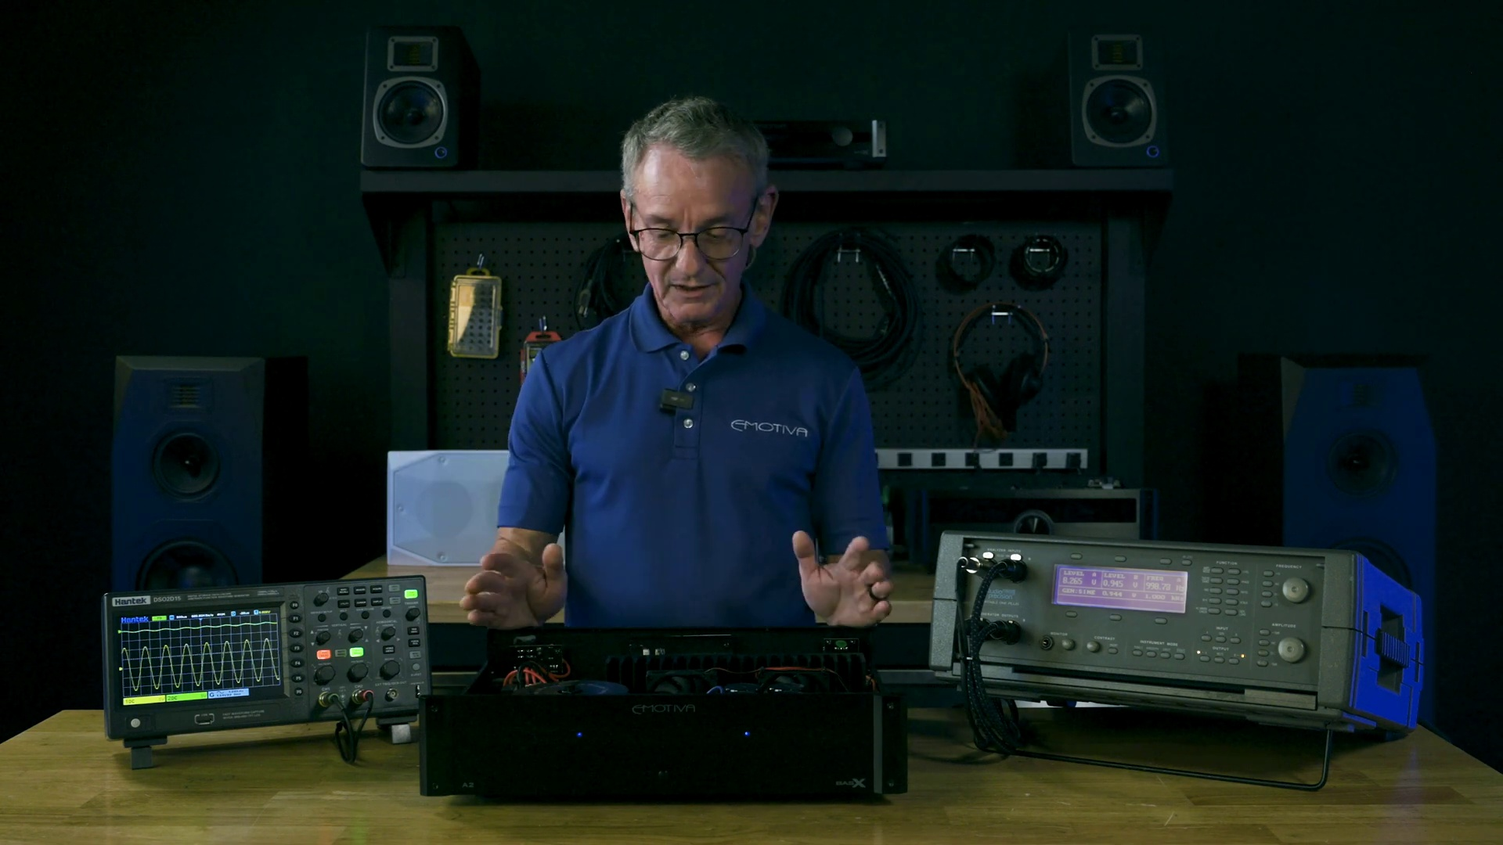 (score 90.0000)
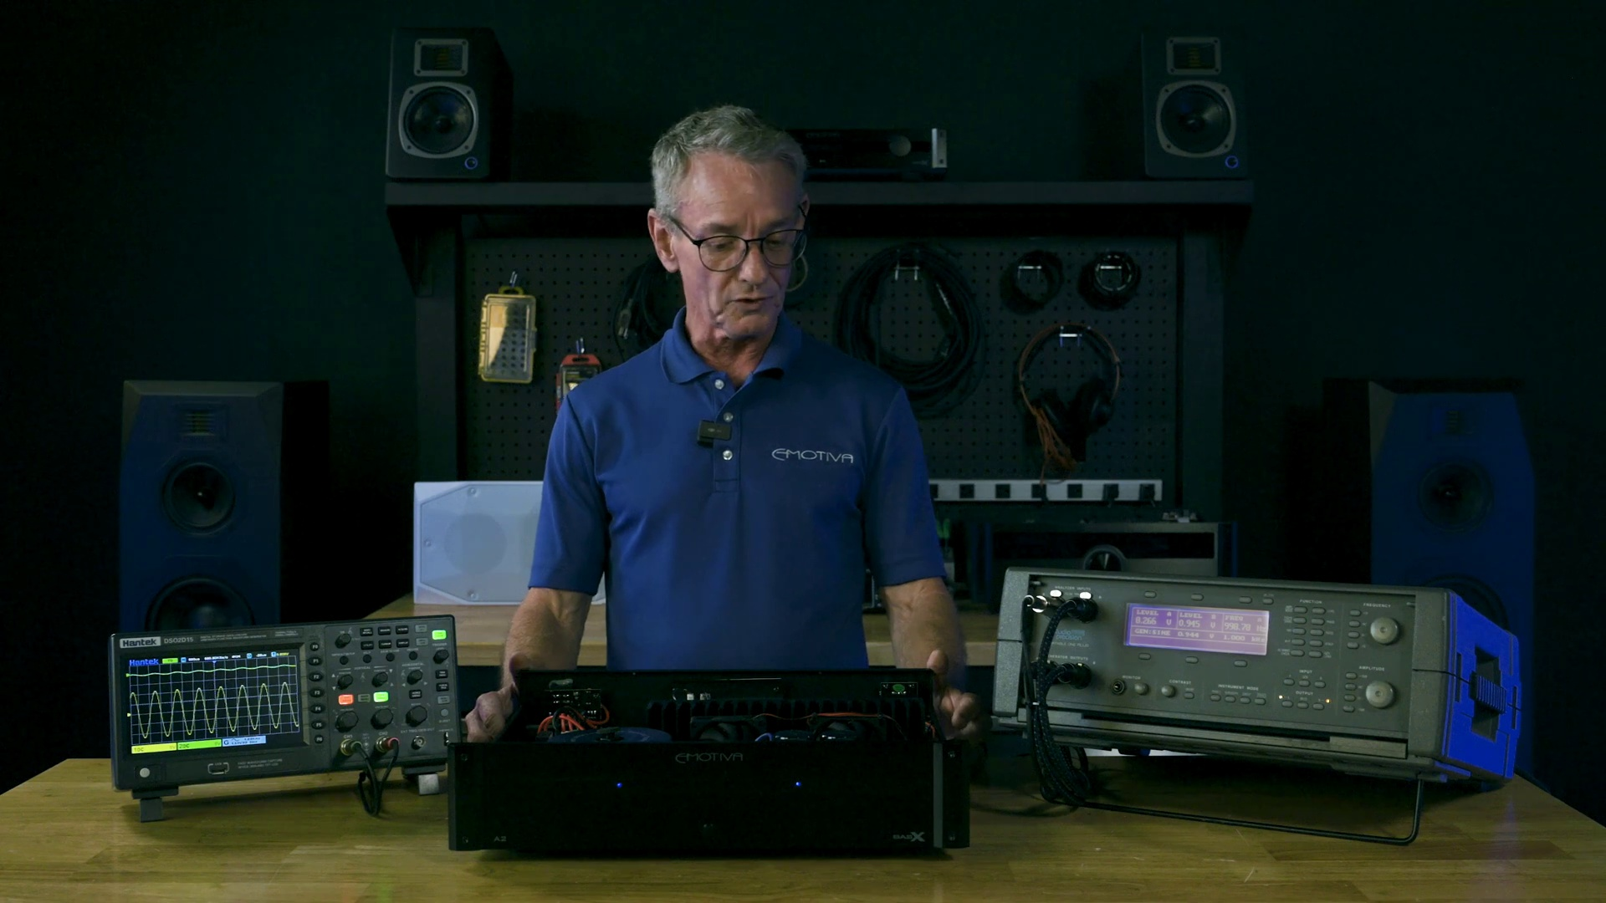 (score 90.0000)
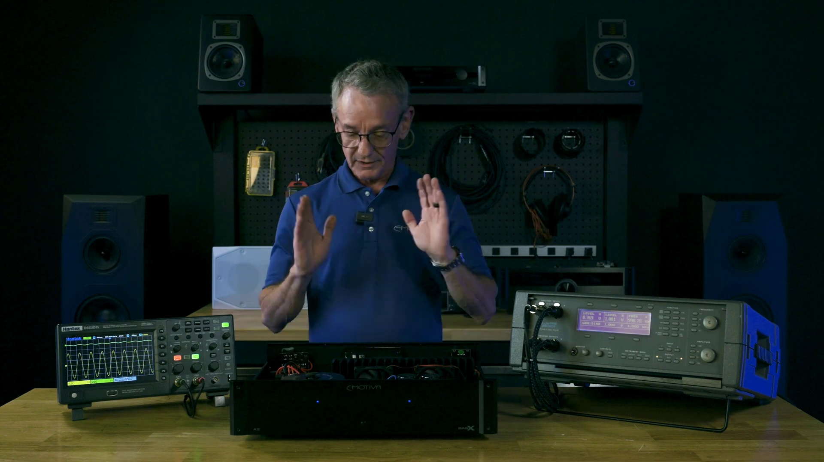 (score 90.0000)
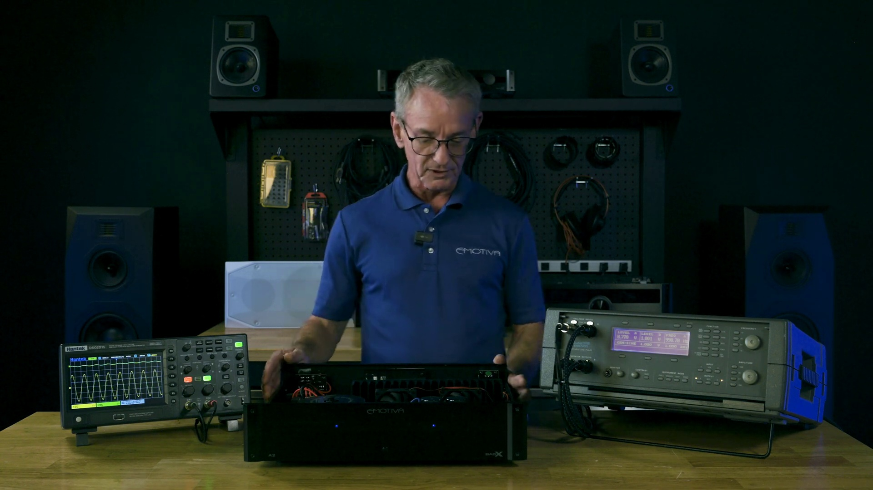 (score 90.0000)
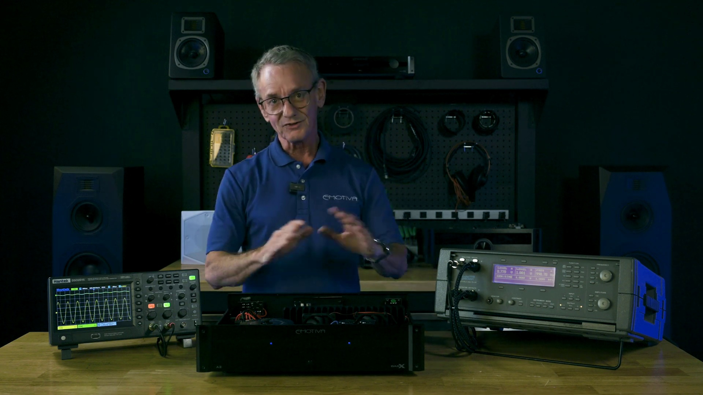 (score 90.0000)
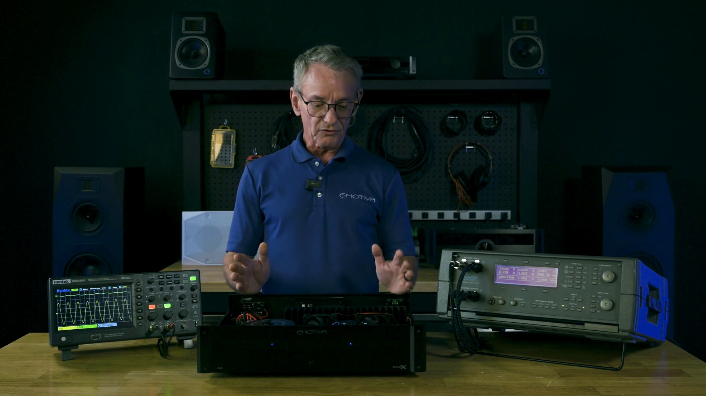 (score 90.0000)
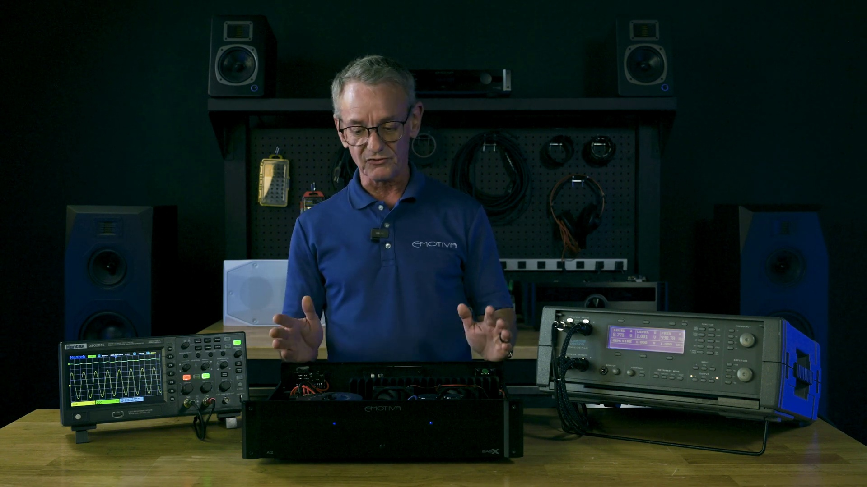 (score 90.0000)
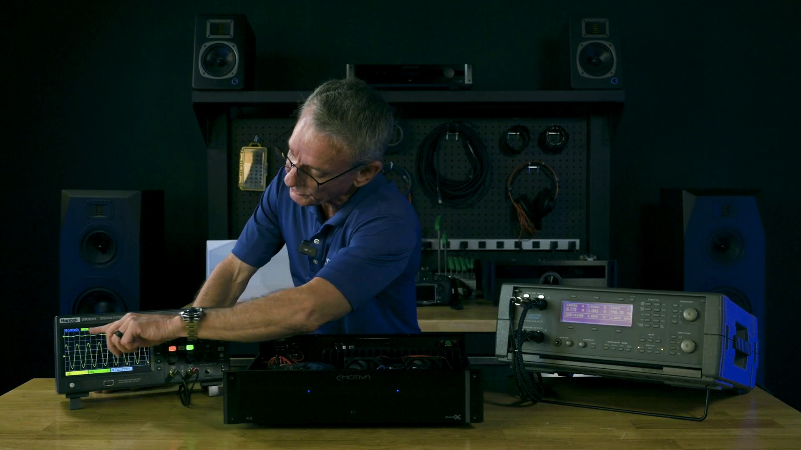 (score 90.0000)
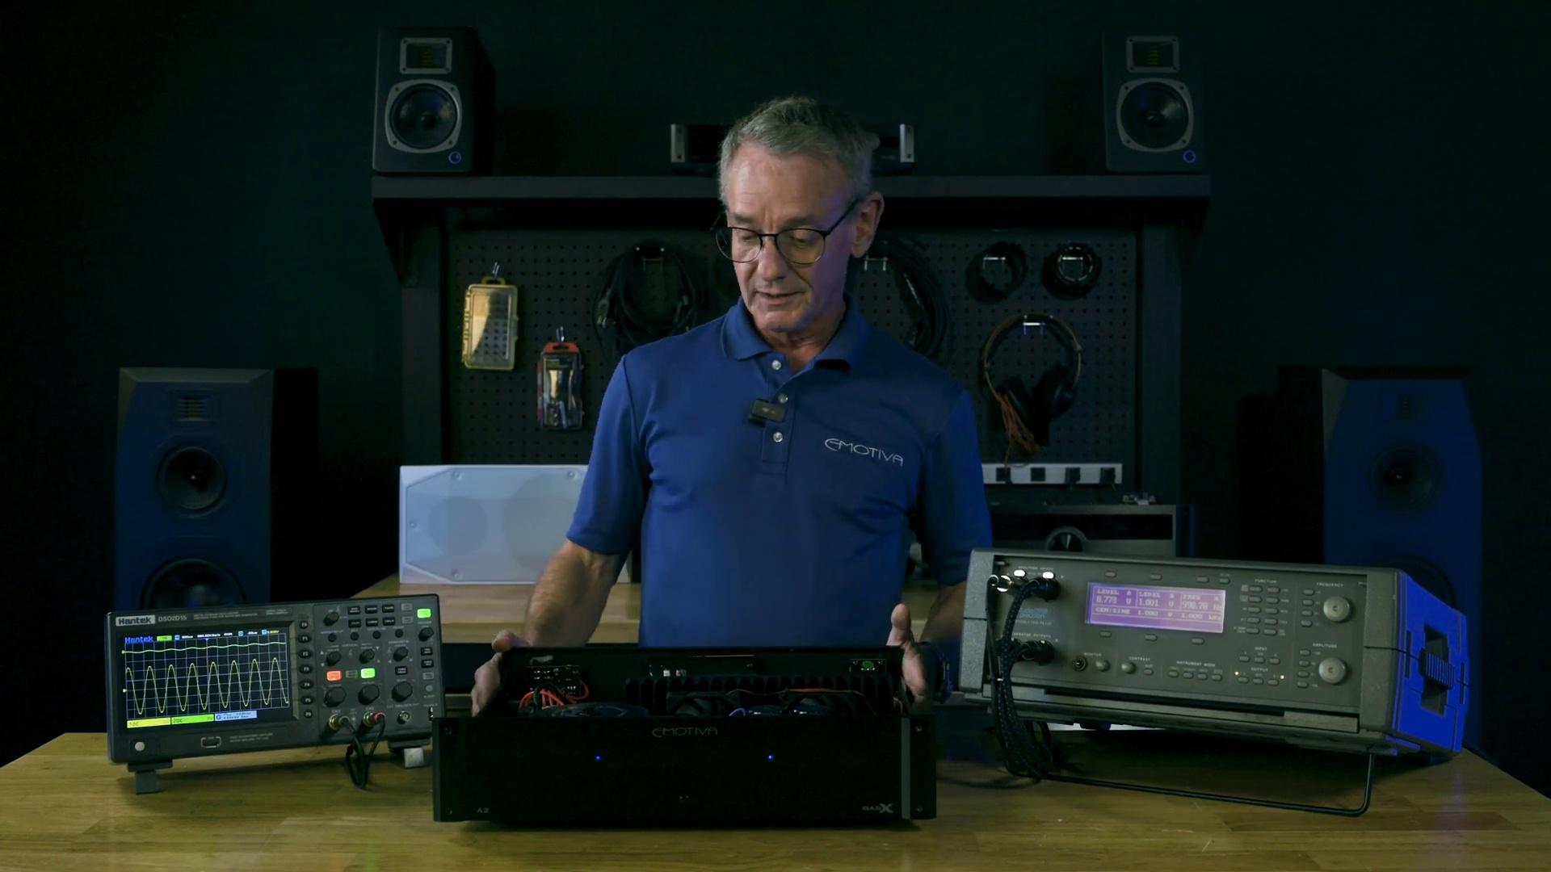 (score 90.0000)
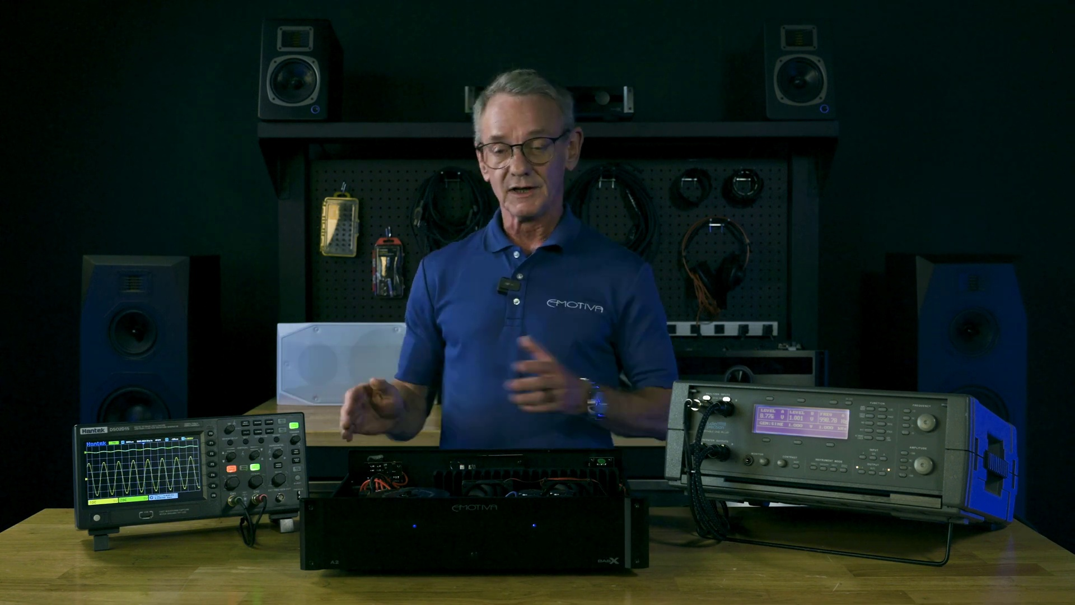 (score 90.0000)
Least correlated frames:
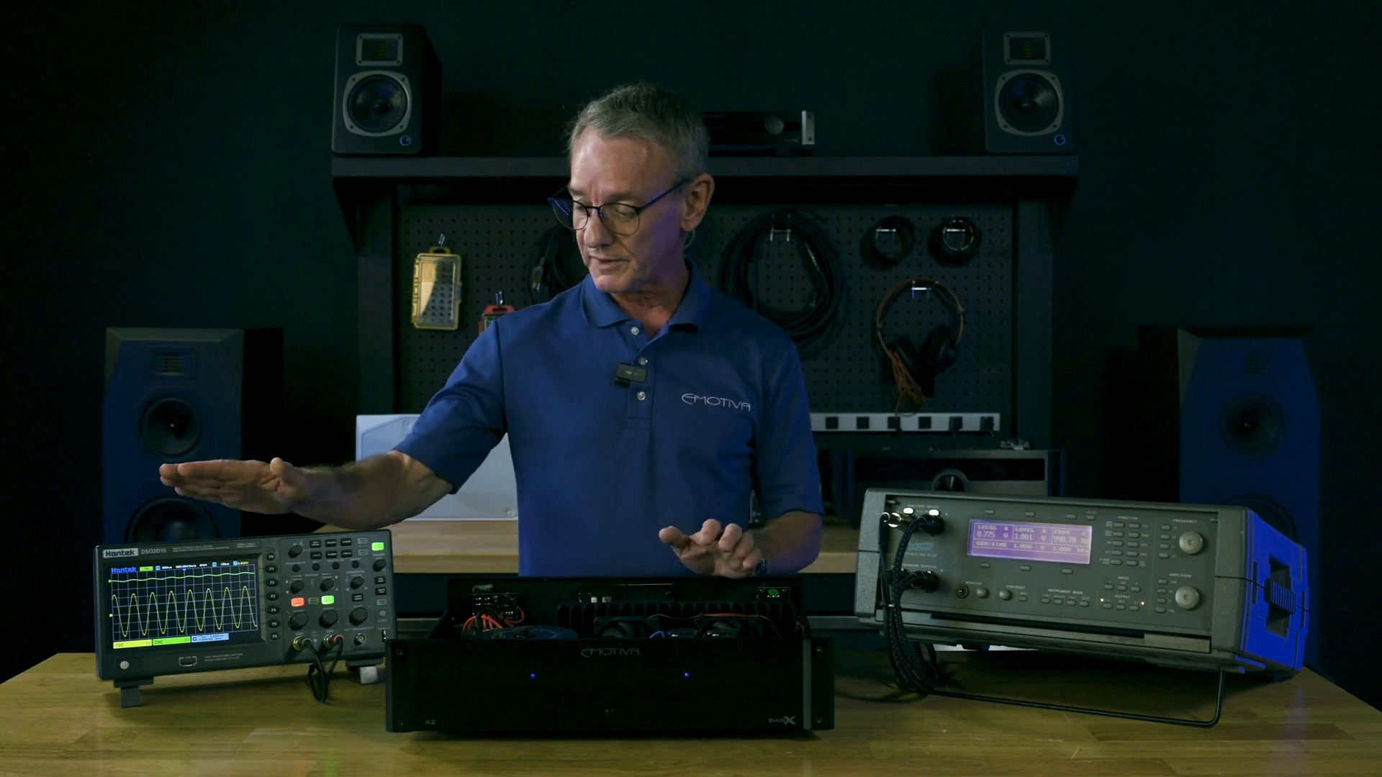 (score 5.0000)
 (score 10.0000)
 (score 20.0000)
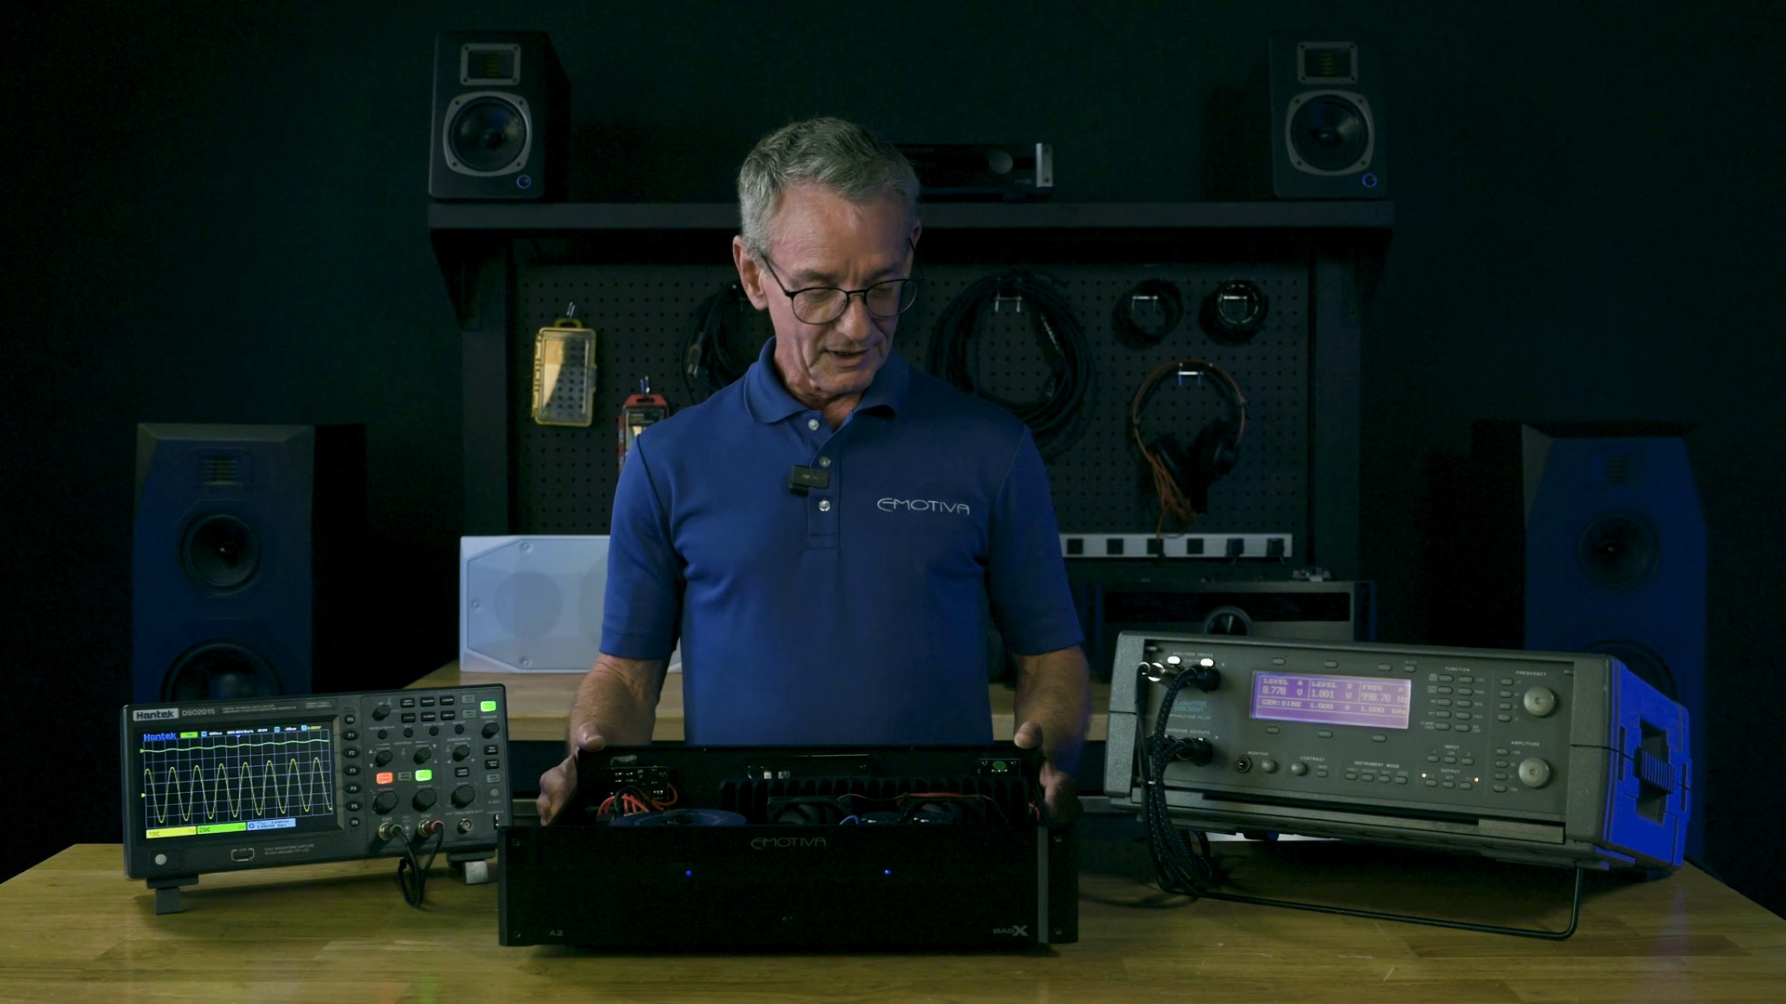 (score 20.0000)
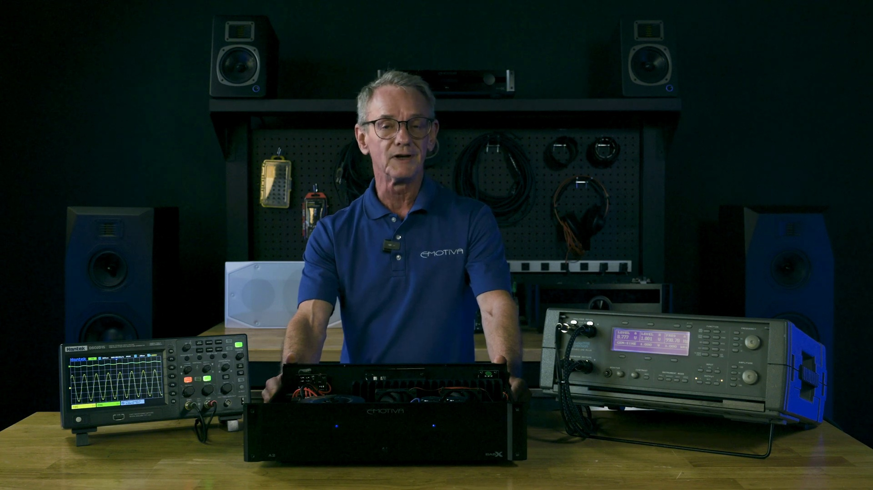 (score 20.0000)
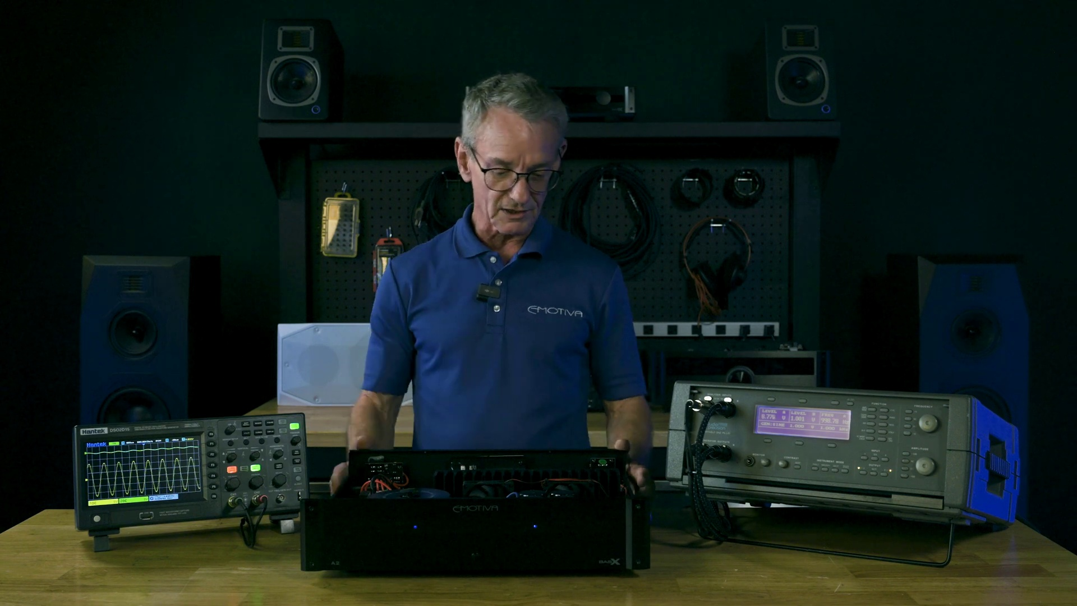 (score 20.0000)
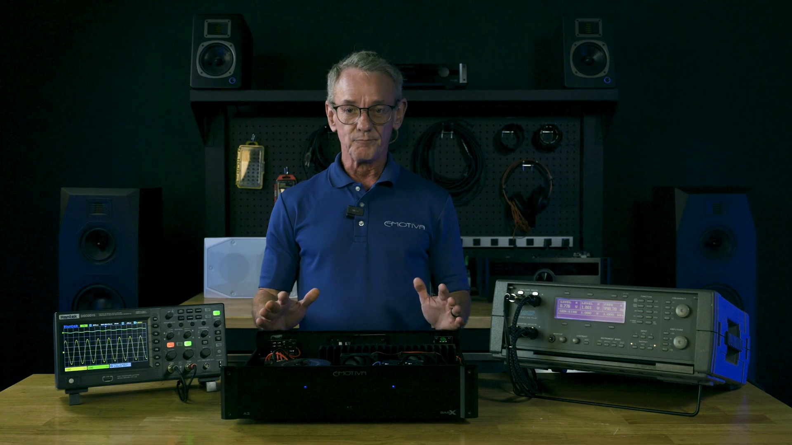 (score 20.0000)
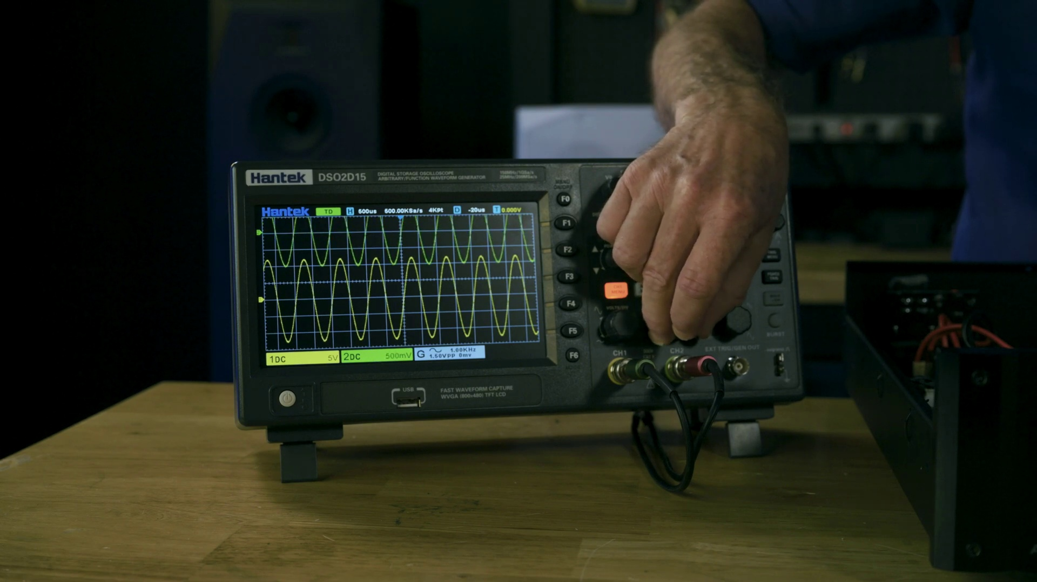 (score 20.0000)
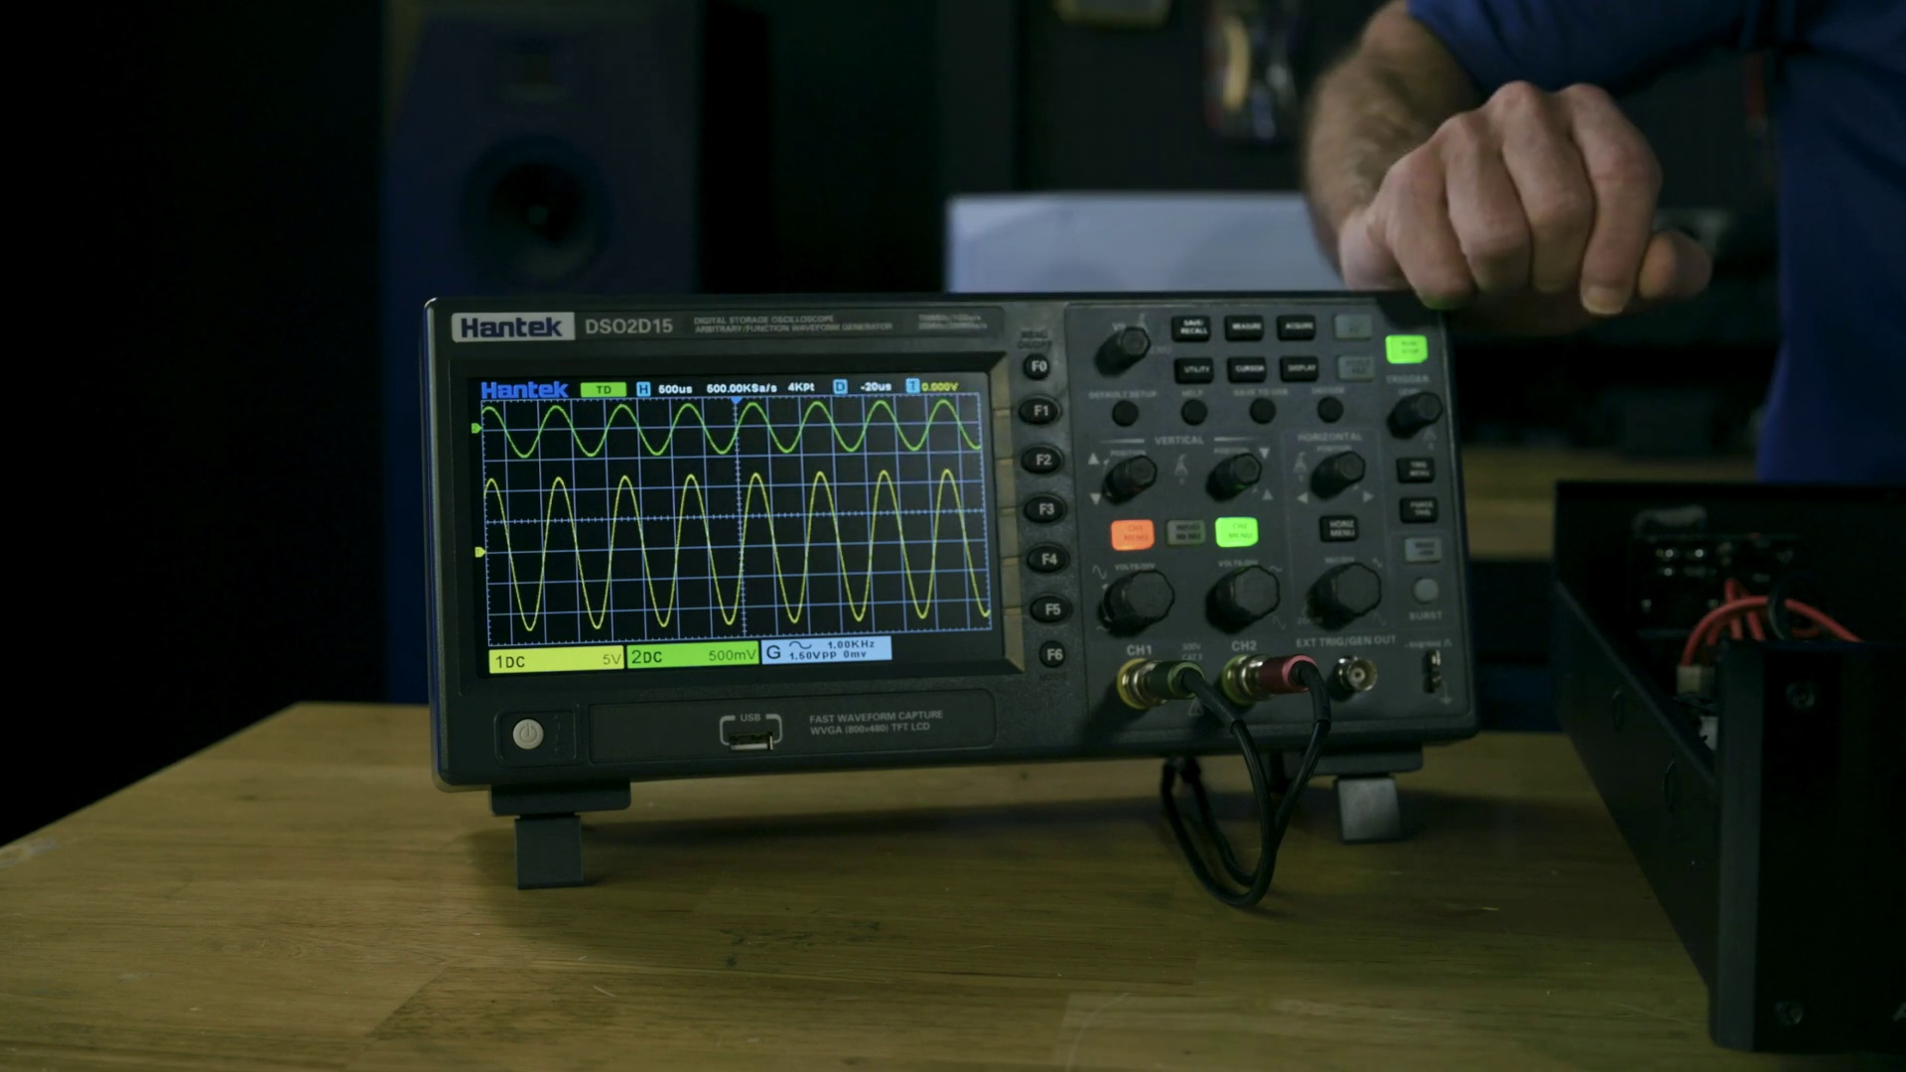 (score 20.0000)
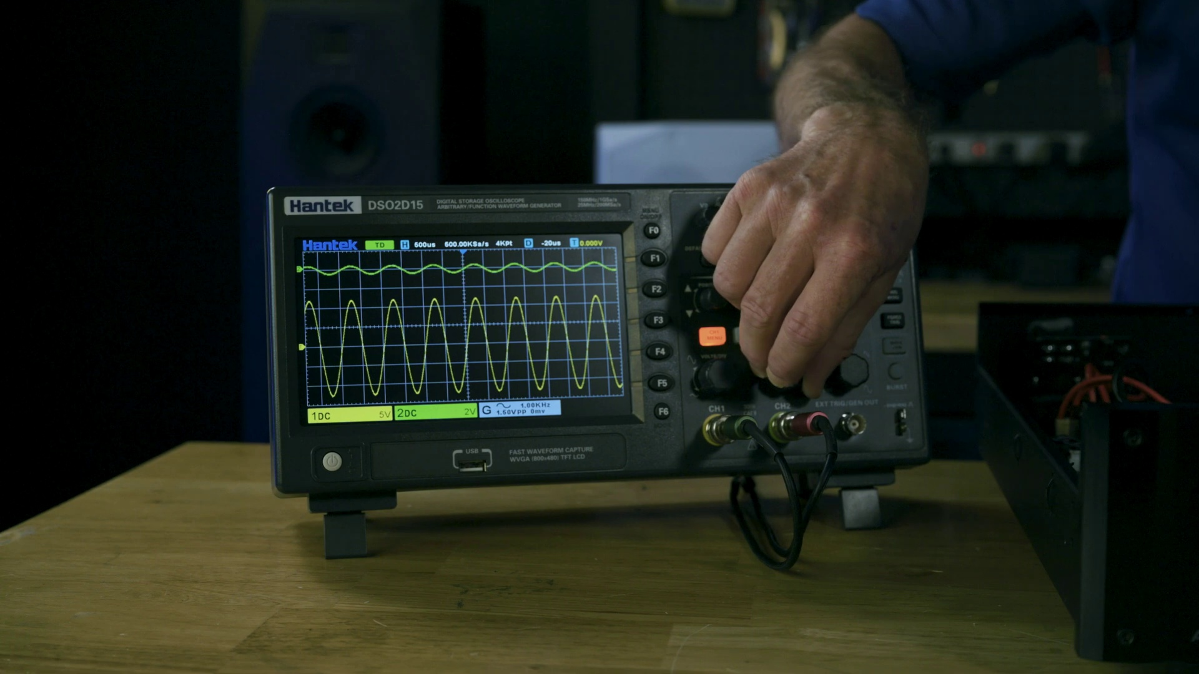 (score 20.0000)

Frame: frame_0000.jpg
Caption: The image presents a captivating scene of a digital display that appears to be a music production setup. On the left side, there's a gray surface with various blue and purple sound wave-like patterns and possibly sound frequencies visualized, accompanied by vertical bars that could represent sound levels or meters. On the right side, a glimpse of a speaker grille in a dark color is visible, suggesting an audio speaker is placed next to this visual display.
The top edge of the image shows what seems to be a graphic equalizer interface with horizontal frequency bands and corresponding volume bars. Dominating the center of the image is a square of blue light, its vibrant hue contrasting sharply with the dark blue background. This square is surrounded by a grid of equally sized squares, their blue lights forming a rhythmic pattern that fills the entire image.
The grid's alignment is precise, creating a sense of order and symmetry. The overall effect is one of digital precision and complexity, a testament to the artistry of digital design, possibly related to audio processing, sound analysis, or music production techniques.
No strongly correlated comments found for this frame.

Frame: frame_0001.jpg
Caption: The image displays a presentation slide with the title "The Science of Sound" prominently displayed on a dark blue background divided into multiple equal sections by a light blue horizontal line. Each section is filled with a series of small blue squares, creating a gradient effect and adding to the visual appeal of the image. The squares are evenly spaced, creating a sense of balance and harmony.
On the left side of the slide, there's a visual representation of audio frequency waves in various colors, including blue, green, and purple, representing different frequencies or types of sounds. The background of the slide features a subtle pattern of blue and white blocks, resembling a sound waveform, adding to the theme of sound and acoustics.
On the right side of the slide, there is text that includes "The Science" with "of Sound" directly beneath it. The bottom left corner features a blue equalizer graphic symbolizing sound control or audio processing equipment. The overall style of the image suggests an educational context, likely a lecture or presentation on topics related to acoustics, sound production, or music theory. The slide is designed to be informative and visually engaging, possibly used by an instructor during a class or seminar.
Comment (score 80): This video was very helpful because the class mainly focused on different kinds of amplifier and how to use them. A amplifier takes input signal from a source, and creates a larger copy of the original signal before it’s sent to the speakers. It gets power to do so from mains electricity, which is sent directely to the power supply within the amplifier. Three types of amplifiers are voltage amplifier, current amplifier and a power amplifier.
Reason: The comment directly discusses the amplifiers mentioned in the caption (amplifier types) and explains how they work, which is closely related to the visual representation of audio frequency waves and the text about 'The Science of Sound' on the slide. The mention of power supply and mains electricity also connects to the technical context of the image.
Source: https://www.youtube.com/watch?v=uwDajwnP2XE: how an amplifier works.

Frame: frame_0002.jpg
Caption: The image depicts a man standing in a room with a black wall and dark wooden floor, wearing a blue polo shirt with the word "chiva" emblazoned on it. He is holding an open black stereo equipment box that contains various electronic components, including two black speakers and two black amplifiers. The man is positioned in front of one of the speakers affixed to the wall.
To his right side, there are various electronic devices and equipment on a table, including a microphone with a pop filter and what appears to be an audio interface or Digital-to-Analog Converter (DAC). The man is standing behind this table, gesturing towards these devices possibly explaining their function.
In the background of the image, a large screen displays a logo or emblem that includes three stylized circles connected by lines, resembling an abstract or artistic design. There is no visible text on the screen to provide further context about the logo. The overall setting suggests a professional setting, possibly a studio or workshop, with the man likely being an instructor or presenter demonstrating audio equipment.
Comment (score 80): This video was very helpful because the class mainly focused on different kinds of amplifier and how to use them. A amplifier takes input signal from a source, and creates a larger copy of the original signal before it’s sent to the speakers. It gets power to do so from mains electricity, which is sent directely to the power supply within the amplifier. Three types of amplifiers are voltage amplifier, current amplifier and a power amplifier.
Reason: The comment directly discusses the same technical steps (types of amplifiers and how they work) and objects (amplifier, speakers, power supply) described in the caption. The setting mentioned in the caption (studio or workshop) also matches with the context of the video class focused on amplifier usage.
Source: https://www.youtube.com/watch?v=uwDajwnP2XE: how an amplifier works.

Frame: frame_0003.jpg
Caption: The image depicts an individual standing in front of a table or desk, surrounded by electronic devices and equipment related to home theater setup. The person is dressed in a light blue shirt with glasses, holding no objects in their hands. To the left, there's a large speaker, while on the right side, another smaller speaker is visible. Below these speakers, an electronic device with multiple knobs and sliders appears to be an amplifier or subwoofer control center.
In front of the individual, a remote control for a television or audio system lies on the table, accompanied by a smartphone connected to a docking station or charger. The background suggests that this setup is part of an audio-visual demonstration or lecture, with a presentation slide visible behind the person, although its content remains illegible.
The overall setting implies a teaching context, where the instructor is either explaining the features and functions of the equipment or giving instructions on how to use it. The presence of the slide indicates that there might be visual aids in the form of an educational presentation or notes related to the equipment being demonstrated.
In this scene, the individual stands still in front of a black stereo receiver, positioned on the desk amidst various speakers with unique designs and colors. The man's attire contrasts with the black equipment and dark blue walls of the room, which are bathed in a soft, warm light that highlights the details of the equipment and his clothing.
Comment (score 85): This video was very helpful because the class mainly focused on different kinds of amplifier and how to use them. A amplifier takes input signal from a source, and creates a larger copy of the original signal before it’s sent to the speakers. It gets power to do so from mains electricity, which is sent directely to the power supply within the amplifier. Three types of amplifiers are voltage amplifier, current amplifier and a power amplifier.
Reason: The comment directly discusses the same technical steps (amplifier types and power supply) and objects (amplifiers and speakers) described in the caption. The setting mentioned in the caption, an audio-visual demonstration or lecture, also aligns with the context of a class focused on amplifier usage.
Source: https://www.youtube.com/watch?v=uwDajwnP2XE: how an amplifier works.

Frame: frame_0004.jpg
Caption: The image shows an individual, a Caucasian male with gray hair wearing a blue short-sleeve shirt and glasses, standing in front of a table cluttered with various electronic equipment. The person appears to be conducting a tutorial or demonstration related to audio or sound equipment, as evident from the professional microphone stand, audio interface or mixing console, and possibly sound level meters or other audio testing tools on the table. Cables and various knobs and switches are visible, suggesting that this setup could be for recording or producing music or other audio content.
The individual has one hand resting on the table while the other points towards the equipment, indicating a focus on explaining the functionality of the devices. The background is dark, with a shelf above it containing more electronic equipment. A blackboard and whiteboard are also visible in the room, although the writing on them is not legible in the image.
To the right of the individual, there is a diagram or schematic that seems to be related to audio equipment or settings, such as sound levels or waveforms. The overall style of the image is informative, suggesting that it may be part of an instructional video or tutorial, possibly for a course on sound engineering or audio production.
The man is wearing a blue polo shirt with a white logo on it, reading "Enigma". He appears to be inspecting the equipment, looking down at the table. The dark background provides a stark contrast to the bright electronic equipment on the table, creating an atmosphere that suggests a workspace or workshop where the individual is engaged in the repair or maintenance of electronic equipment.
The image has a watermark at the bottom left corner with a URL that reads "instructables.com", indicating that this may be a screenshot from an online platform providing instructional content.
Comment (score 80): This video was very helpful because the class mainly focused on different kinds of amplifier and how to use them. A amplifier takes input signal from a source, and creates a larger copy of the original signal before it’s sent to the speakers. It gets power to do so from mains electricity, which is sent directely to the power supply within the amplifier. Three types of amplifiers are voltage amplifier, current amplifier and a power amplifier.
Reason: The comment directly discusses amplifiers and their functionality, which is mentioned in the caption as a possible topic related to audio equipment. The connection between the comment and caption is strong because they both refer to amplifier types (voltage, current, power) and how they work.
Source: https://www.youtube.com/watch?v=uwDajwnP2XE: how an amplifier works.

Frame: frame_0005.jpg
Caption: The image appears to show a person standing behind a table with electronic equipment and devices. The individual is dressed in a blue polo shirt and seems to be facing towards something off-camera, possibly speaking or explaining. On the table, there are various items including multiple pieces of audio or radio equipment, such as an amplifier or radio transmitter.
The table setup consists of:
1. A device with a green display screen that shows some sort of digital signal or interface.
2. A DSLR camera on the left side of the image.
3. A microphone with a pop filter.
4. A small laptop or computer monitor.
5. An audio mixer or console.
6. Cables and cords that are presumably used to connect different pieces of equipment.
7. A pair of headphones or speakers on the left side.
8. A small control box with various buttons and knobs, possibly for operating radio equipment.
In front of the person, there's a smaller setup that includes a microphone and a laptop. The room has a black background with several high-definition televisions (HDR TVs) mounted on the wall, which might be used as monitors or to display video content.
The person is engrossed in their work, wearing the same blue polo shirt, with their hands busy with the black stereo equipment consisting of two stereo amplifiers and a speaker. The equipment is neatly organized on the desk, creating a harmonious composition reflecting the individual's dedication to their task, which may involve adjusting settings or troubleshooting a problem.
Comment (score 80): This video was very helpful because the class mainly focused on different kinds of amplifier and how to use them. A amplifier takes input signal from a source, and creates a larger copy of the original signal before it’s sent to the speakers. It gets power to do so from mains electricity, which is sent directely to the power supply within the amplifier. Three types of amplifiers are voltage amplifier, current amplifier and a power amplifier.
Reason: The comment directly discusses amplifiers, which are specifically mentioned in the frame caption. The comment also mentions power supply and electricity, which is indirectly related to the electronic equipment on the table.
Source: https://www.youtube.com/watch?v=uwDajwnP2XE: how an amplifier works.

Frame: frame_0006.jpg
Caption: The image shows an individual standing in a well-lit room with a dark wooden floor and black ceiling. He is wearing a blue polo shirt with a white logo on the front, and has short hair. The room is adorned with black speakers. The man's right hand is placed on a device with a white and blue color scheme, while his left hand holds a remote control. In front of him, there is a desk covered with various electronic equipment, including audio and video equipment.
The desktop computer on the desk has a monitor displaying what appears to be audio waveforms or a software interface for editing media. Next to the monitor, an open case reveals the internal components of an electronic device, possibly a mixer or similar piece of equipment. To the right of the desk, several speakers with wires attached and a power strip with multiple cables plugged in are seen.
The individual appears to be presenting or demonstrating the equipment, as he is facing the camera and looking at the setup. He seems to be explaining or guiding the viewer through the components and their purpose. The overall scene suggests a professional setting, possibly a workshop or studio, with an educational context where the person could be teaching about audio equipment setup or usage.
Comment (score 85): This video was very helpful because the class mainly focused on different kinds of amplifier and how to use them. A amplifier takes input signal from a source, and creates a larger copy of the original signal before it’s sent to the speakers. It gets power to do so from mains electricity, which is sent directely to the power supply within the amplifier. Three types of amplifiers are voltage amplifier, current amplifier and a power amplifier.
Reason: The comment directly discusses the purpose of the amplifiers mentioned in the caption (e.g. 'takes input signal from a source, and creates a larger copy of the original signal'), which is strongly related to the technical steps and equipment described in the caption.
Source: https://www.youtube.com/watch?v=uwDajwnP2XE: how an amplifier works.

Frame: frame_0007.jpg
Caption: The image depicts an individual standing in a room with a black wall, ceiling, and shelves. The floor is not visible due to the focus on the equipment and the person's interaction with it. The man is dressed in a blue polo shirt and holding two black stereo equipment pieces: one placed on a wooden table and another held in his hand. One of these units features a white control panel and a black front panel, suggesting that it may be a modular synthesizer or sound mixer.
The room also contains various electronic devices, including amplifiers, microphones, and speakers, as well as cabinets with unknown functions. The man appears to be engaged in a presentation or demonstration, possibly explaining the functions or uses of this equipment. There are no visible texts, equations, diagrams, or slides in this frame.
Given the absence of any educational materials and the focus on the equipment and the person's interaction with it, this image is likely set in an educational context where the individual might be teaching about audio technology, sound synthesis, recording techniques, or possibly setting up or repairing the stereo equipment.
Comment (score 80): This video was very helpful because the class mainly focused on different kinds of amplifier and how to use them. A amplifier takes input signal from a source, and creates a larger copy of the original signal before it’s sent to the speakers. It gets power to do so from mains electricity, which is sent directely to the power supply within the amplifier. Three types of amplifiers are voltage amplifier, current amplifier and a power amplifier.
Reason: The comment directly discusses the equipment (amplifiers) and their functions (signal processing), which are mentioned in the caption as part of the educational context. The technical steps and objects described in the caption, such as amplifiers, power supply, and signal processing, are explicitly discussed in the comment.
Source: https://www.youtube.com/watch?v=uwDajwnP2XE: how an amplifier works.

Frame: frame_0008.jpg
Caption: In this image, there is an individual standing in front of various electronic equipment on a black table. The person appears to be an instructor or presenter, as suggested by the informative setting and their apparent engagement with the audience or viewers. In the foreground, there is a man standing at a podium, addressing an unseen audience. He has white hair, is wearing glasses, and has a microphone in front of him. On the table in front of him, there are several electronic devices including audio mixers, speakers, and possibly video equipment. The logo on his blue polo shirt, which reads "Ghostiva", suggests a professional setup.
On the table, two stereo speakers and two audio amplifiers are neatly arranged, indicating a high level of expertise or professionalism in the field. The man's hands are firmly placed on the table's edge, suggesting he is fully engaged with the equipment and his audience. Behind him, against a dark backdrop, there is a set of shelves displaying more technical equipment, including additional audio and video gear, as well as a book or manual that is not fully visible.
The overall setting suggests an educational or demonstration environment related to audio, video, or electronics, possibly in a studio or home theater.
Comment (score 75): This video was very helpful because the class mainly focused on different kinds of amplifier and how to use them. A amplifier takes input signal from a source, and creates a larger copy of the original signal before it’s sent to the speakers. It gets power to do so from mains electricity, which is sent directely to the power supply within the amplifier. Three types of amplifiers are voltage amplifier, current amplifier and a power amplifier.
Reason: The comment directly discusses amplifiers, which is mentioned in the caption as part of the technical equipment displayed. The comment also references power supply and signal processing concepts that align with the setting described in the caption. However, it does not fully cover all the objects and settings mentioned in the caption, hence a score of 75.
Source: https://www.youtube.com/watch?v=uwDajwnP2XE: how an amplifier works.

Frame: frame_0009.jpg
Caption: The image shows an individual standing behind a table with various electronic equipment, exuding a vintage vibe. The person appears to be older, wearing a dark blue short-sleeved shirt and is likely passionate about electronics and music. On the table, there are two devices that resemble portable audio mixers or synthesizers. To the left of the individual is a large speaker system. In front of the speaker system, there seems to be a device with multiple dials and knobs, possibly an electronic instrument or controller.
To the right of the speaker system, there is another large device that could be a DJ mixer or a soundboard, featuring a digital display and a series of input jacks and controls. The table surface is partially visible beneath these items. The background includes other equipment, such as an electronic rack with additional audio equipment, and a wall with various wires and cables running along it.
The individual's position in the room and their focus on the equipment suggest that they may be presenting or demonstrating the use of this equipment, possibly in the context of a workshop or tutorial on audio mixing or synthesizing. The setting looks like a home studio environment, where the man is likely working on his electronic projects.
No strongly correlated comments found for this frame.

Frame: frame_0010.jpg
Caption: This image features two individuals standing behind a table with various electronic devices and equipment. One person appears to be presenting or demonstrating something, given their stance and direct gaze towards the camera. Behind them, there are stereo speakers, a microphone on a boom arm, and what looks like an audio mixing console or similar piece of audio equipment. On the right side, visible is a piece of equipment related to broadcasting or radio transmission, possibly a transmitter or receiver, labeled with "ELECTRA" in script font.
To the left, there's an open laptop displaying multiple software windows, likely related to audio production or broadcast control. A smartphone or tablet is propped up against the laptop screen, with additional windows visible on its screen as well. The setting suggests that this might be a home studio or small broadcast room.
One individual is dressed in a blue polo shirt and glasses, adding to the professional atmosphere of the scene. In their hand, they hold a blue Enigma amplifier, while the desk is adorned with equipment such as a black amplifier, gray receiver, and white radio. In the background, a wall is visible, featuring a black speaker and speaker cabinet.
The overall setting suggests a professional environment, possibly a workshop or studio. The individuals' shirts feature logos that resemble shield symbols, potentially symbolizing security or protection. However, the text on their shirts is not fully legible in the image provided. Some visible texts appear to be related to audio equipment specifications: "10W," "MICROPHONE," "SPEAKERS," "AUDIO," and other terms that are partially obscured, suggesting a focus on sound recording or broadcasting equipment.
The teaching context is implied by the setup of the equipment in front of the individuals and their apparent explanation of the equipment. However, no explicit teaching aids like slides or diagrams are visible within this frame.
Comment (score 80): This video was very helpful because the class mainly focused on different kinds of amplifier and how to use them. A amplifier takes input signal from a source, and creates a larger copy of the original signal before it’s sent to the speakers. It gets power to do so from mains electricity, which is sent directely to the power supply within the amplifier. Three types of amplifiers are voltage amplifier, current amplifier and a power amplifier.
Reason: The comment directly discusses amplifiers, specifically types (voltage, current, power) and how they work, which is strongly related to the caption's mention of an amplifier (Enigma amplifier) and other audio equipment.
Source: https://www.youtube.com/watch?v=uwDajwnP2XE: how an amplifier works.

Frame: frame_0011.jpg
Caption: The image depicts a Caucasian adult male standing at a table or desk with electronic equipment. He appears to be wearing a blue polo shirt with a white logo on the front, and his facial expression suggests focus and concentration. The man is standing in an indoor room with dark walls and a neutral-colored floor, possibly carpeted or tiled. On the table in front of him are three pieces of equipment:
1. A dark electronic device resembling a mixer or audio processing equipment, featuring multiple buttons, knobs, and a display screen on its top right corner.
2. A BOSE-branded device with several dials and sliders, likely an audio hardware component.
3. An electronic device that appears to be a projector or similar projection unit, with multiple cables and connectors.
The man is standing in front of the table, looking at one of these devices, possibly a black stereo amplifier, which he holds in his left hand. The desk is placed against a wall featuring a black speaker mounted on it. The background is dark gray, contrasting with the wooden desk and the black speaker. There are no visible slides, diagrams, or texts that provide additional information about the equipment or the context of the presentation. The style of the image suggests it may be from an instructional video or tutorial session, where the person is explaining how to use these electronic devices, or possibly examining one of them for maintenance or troubleshooting purposes.
Comment (score 85): This video was very helpful because the class mainly focused on different kinds of amplifier and how to use them. A amplifier takes input signal from a source, and creates a larger copy of the original signal before it’s sent to the speakers. It gets power to do so from mains electricity, which is sent directely to the power supply within the amplifier. Three types of amplifiers are voltage amplifier, current amplifier and a power amplifier.
Reason: The comment directly discusses the technical steps of amplifiers and their power supply, which are mentioned in the caption as a key part of the image. The caption describes the equipment, including an amplifier, which is also explained in the comment.
Source: https://www.youtube.com/watch?v=uwDajwnP2XE: how an amplifier works.

Frame: frame_0012.jpg
Caption: The image shows a man standing behind a table with multiple pieces of audio equipment, including two stereo systems, a mixer, an audio interface, and what appears to be a microphone. The man is wearing a light blue shirt, suggesting he might have some experience in the field, and has white hair.
He is holding one piece of equipment and surrounded by cables, indicating that he may be setting up or operating these devices. A laptop with its screen facing away from us is positioned nearby, but it's unclear if there's anything visible on the screen. The dark background provides contrast to the equipment in the foreground, drawing attention to the man and his setup.
There are no visual cues or text that suggest he is teaching or presenting information, instead the focus of the image is on the equipment and the person standing behind it.
Comment (score 80): This video was very helpful because the class mainly focused on different kinds of amplifier and how to use them. A amplifier takes input signal from a source, and creates a larger copy of the original signal before it’s sent to the speakers. It gets power to do so from mains electricity, which is sent directely to the power supply within the amplifier. Three types of amplifiers are voltage amplifier, current amplifier and a power amplifier.
Reason: The comment directly discusses the same technical steps (amplifier types and how they work) mentioned in the caption, specifically the equipment shown in the image.
Source: https://www.youtube.com/watch?v=uwDajwnP2XE: how an amplifier works.

Frame: frame_0013.jpg
Caption: The image shows an individual standing in front of various audio equipment and microphones, suggesting that they are either demonstrating or teaching about sound recording or radio operation. The person appears to be male, wearing a blue polo shirt, with grey hair.
In the foreground, there is a table with several items on it: a microphone boom arm, a small digital mixing console, possibly other audio equipment such as a sound level meter or headphones, and two stereo equipment components, which are placed on a black table covered in a blue cloth. The man is holding a black remote control in his hand, possibly indicating that he is in the process of setting up or adjusting the equipment.
The background features a studio setting with additional audio equipment, including a large speaker and other electronic devices. The lighting in the room is low and focused on the person and the equipment in front of them, giving the impression of a controlled environment designed for audio production or broadcasting. The dark wood floor and wall-mounted speaker suggest that the room is a dedicated space for audio equipment. There are no visible texts or slides that provide context or teaching content within this image.
No strongly correlated comments found for this frame.

Frame: frame_0014.jpg
Caption: In the image, a person is standing behind a table with various electronic equipment and accessories. The individual appears to be engaged in an educational setting, possibly giving a lecture or demonstration related to electronics or technology. Here are the details visible in the frame:
1. The person is gesturing with one hand, pointing towards the devices on the table, suggesting they may be explaining how the equipment works or discussing its features and uses.
2. On the table, there are several electronic devices including what appears to be a modem or router, audio equipment (likely speakers), and possibly other technology-related items such as a switch box or an electronic control unit (ECU).
3. The person is wearing a blue shirt with no visible text that would provide additional context or information about the devices or their topic.
4. The background is dimly lit, creating a contrast between the speaker and the table of equipment.
5. There are no visible slides, diagrams, or other educational materials in this frame that would indicate a presentation is taking place.
The setting seems to be a professional environment, likely an electronics workshop or a classroom dedicated to technology education. The instructor's role appears to be one of expertise and teaching, guiding the audience through the workings and applications of the electronic devices present on the table.
Comment (score 80): This video was very helpful because the class mainly focused on different kinds of amplifier and how to use them. A amplifier takes input signal from a source, and creates a larger copy of the original signal before it’s sent to the speakers. It gets power to do so from mains electricity, which is sent directely to the power supply within the amplifier. Three types of amplifiers are voltage amplifier, current amplifier and a power amplifier.
Reason: The comment directly discusses the same technical steps (amplifier types and their functions) described in the caption (table of electronic devices). The mention of 'how to use them' also matches with the person's gesture and focus on explaining the equipment in the caption.
Source: https://www.youtube.com/watch?v=uwDajwnP2XE: how an amplifier works.

Frame: frame_0015.jpg
Caption: The image appears to show an adult male, dressed in a blue shirt with gray hair, standing behind a table laden with electronic equipment. He is engrossed in his work, focused on a black box with a white label that has a black cord connected to it. The box is positioned in front of him, and he holds a microphone in his right hand, pointing towards the devices with his left.
The table displays various pieces of electronic equipment, including what looks like a sound system (speakers), an oscilloscope, possibly other audio or test equipment, as well as a black radio and a black stereo receiver. These devices are neatly arranged on the table, suggesting a well-organized workspace.
In the background, there is a black wall with a black hook and a power strip, adding to the industrial feel of the scene. The setting appears to be an indoor space focused on sound technology, given the presence of audio equipment and what seems to be an electrical box behind the person, which might contain additional equipment.
The individual's gestures indicate he is actively engaged in explaining the functions of the equipment to an audience not visible in the frame, suggesting that this may be a teaching or demonstration setting.
Comment (score 80): This video was very helpful because the class mainly focused on different kinds of amplifier and how to use them. A amplifier takes input signal from a source, and creates a larger copy of the original signal before it’s sent to the speakers. It gets power to do so from mains electricity, which is sent directely to the power supply within the amplifier. Three types of amplifiers are voltage amplifier, current amplifier and a power amplifier.
Reason: The comment directly discusses the same technical steps (amplifier types) and settings (mains electricity) described in the caption. The mention of an amplifier taking input signal and creating a larger copy also matches with the equipment shown in the frame.
Source: https://www.youtube.com/watch?v=uwDajwnP2XE: how an amplifier works.

Frame: frame_0016.jpg
Caption: The image appears to show an individual standing in front of a table, surrounded by various electronic equipment. The man is wearing a blue polo shirt and his hands are placed on the table, suggesting he might be demonstrating or explaining the equipment. The black table is covered with a variety of audio gear, including a black radio receiver, two speakers, and possibly other equipment.
In front of him, there is a mixing console with multiple channels, a microphone, and what appears to be a television monitor displaying an audio interface or software, indicating that this could be a tutorial video for a podcast or radio production class. The overall impression is that the man might be teaching about recording audio or setting up an audio workstation.
The table is set against a backdrop of a black wall, which adds a stark contrast to the colorful electronic equipment. The wall is adorned with a black wire, adding an industrial touch to the setting. In the background, there are several other speakers and radio receivers, suggesting a well-equipped audio setup. The precise location and arrangement of these objects provide a detailed view of the man's work environment.
Overall, the image captures a moment of activity in a professional audio setup, with the man likely engaged in some form of audio equipment demonstration or repair.
Comment (score 90): This video was very helpful because the class mainly focused on different kinds of amplifier and how to use them. A amplifier takes input signal from a source, and creates a larger copy of the original signal before it’s sent to the speakers. It gets power to do so from mains electricity, which is sent directely to the power supply within the amplifier. Three types of amplifiers are voltage amplifier, current amplifier and a power amplifier.
Reason: The comment directly discusses the technical steps (amplifier types) and objects (amplifiers, power supply) described in the caption, which is a strong connection.
Source: https://www.youtube.com/watch?v=uwDajwnP2XE: how an amplifier works.

Frame: frame_0017.jpg
Caption: The image shows a person standing in front of an electronic music production setup and what appears to be a radio receiver. The individual is wearing a light blue shirt with dark shorts, has gray hair, and seems to be either presenting or demonstrating the equipment. He is dressed in a blue polo shirt with a logo on the front that reads "Enigma".
The table features a mixer with various knobs and sliders, suggesting it's used for mixing audio signals. Next to the mixer are at least two sound modules, one displaying electronic music notation on its screen and the other resembling a modular synthesizer or a rackmounted audio processor. Additionally, there is a digital-to-analog converter (DAC) and what appears to be an interface module with several ports for connecting external devices such as microphones or instruments.
The background features a black shelf with additional electronic equipment including a power strip and possibly more sound modules. To the right of the person, there is a sign indicating "500MHz" and "15KHz", which may refer to radio frequencies or other technical specifications related to audio equipment. The man appears to be examining the radio receiver, perhaps in the process of setting it up or troubleshooting.
The image has a watermark that includes the text "AI AI AI", suggesting it's a stock photo with an artificial intelligence theme, possibly used for demonstration purposes related to audio production technology.
No strongly correlated comments found for this frame.

Frame: frame_0018.jpg
Caption: In this image, there is a person - dressed in a light blue shirt and wearing glasses - standing at a table with various audio-visual equipment. The individual appears to be giving a presentation or demonstration, as they are gesturing towards an assortment of electronic devices on the table. This setup includes a microphone, multiple-lens camera, and what looks like a radio transmitter or receiver. Next to them is a large display or projection screen showcasing related audio-visual technology equipment. The room has a dark background with items hanging on the walls, suggesting an electronic or technical environment.
No strongly correlated comments found for this frame.

Frame: frame_0019.jpg
Caption: The image shows an individual, wearing a blue shirt, white headset, glasses, and a watch, standing in what appears to be a demonstration or classroom environment. The person is gesturing with their hands while facing away from the camera, possibly explaining something about the electronic equipment.
In the background, various electronic items are visible, including audio speakers, a radio transmitter or receiver, and what looks like communication or broadcasting equipment. A blackboard or presentation board in the background has text, although it's too small to read clearly, suggesting the context might be related to radio communication or broadcasting.
To the left side of the frame, a table displays more electronic devices, including a device labeled "Radio," a switch or router, and what appears to be a portable radio or walkie-talkie system.
On the right side, another blackboard or presentation board has text, although due to the angle and resolution of the image, it's not possible to read the text clearly. The focus seems to be on the hands-on demonstration of the equipment rather than an ongoing lecture or presentation.
The setting appears to be a classroom or workshop environment where technology equipment is being presented or used for instructional purposes. There are no visible slides, diagrams, or other teaching aids indicating an ongoing lecture or presentation. Instead, the individual is holding what looks like a remote control in their hand, possibly controlling some aspect of the electronic equipment on display.
Comment (score 80): This video was very helpful because the class mainly focused on different kinds of amplifier and how to use them. A amplifier takes input signal from a source, and creates a larger copy of the original signal before it’s sent to the speakers. It gets power to do so from mains electricity, which is sent directely to the power supply within the amplifier. Three types of amplifiers are voltage amplifier, current amplifier and a power amplifier.
Reason: The comment directly discusses the concept of amplifiers and their types, which is closely related to the technical steps described in the caption (e.g., using amplifiers with electronic equipment). The comment also mentions power supply within an amplifier, which matches the visual information presented in the frame about the electronic equipment.
Source: https://www.youtube.com/watch?v=uwDajwnP2XE: how an amplifier works.

Frame: frame_0020.jpg
Caption: This image appears to show an individual standing in front of various pieces of electronic equipment and audio production gear. The person, wearing a blue shirt with the word "EMPHATY" written on it, has short, grey hair and is gesturing with one hand, possibly explaining a concept related to the equipment. To their left, there's a table with two devices: what appears to be a DJ controller or mixer and an electronic device with buttons and displays. On the right side of the image, there is more audio equipment including speakers, a microphone, and additional electronic gear that might be used for recording or producing music.
In the background, there's a shelf with various pieces of electronics, including what looks like an oscilloscope, a spectrum analyzer, and possibly other test or measurement instruments. The setting suggests that this could be a tutorial or demonstration session related to audio production or engineering, as indicated by the presence of sound equipment and the educational context of the image.
There are no visible texts, diagrams, or slides in the image. The focus is on the person and the equipment they are presenting or explaining.
Comment (score 70): This video was very helpful because the class mainly focused on different kinds of amplifier and how to use them. A amplifier takes input signal from a source, and creates a larger copy of the original signal before it’s sent to the speakers. It gets power to do so from mains electricity, which is sent directely to the power supply within the amplifier. Three types of amplifiers are voltage amplifier, current amplifier and a power amplifier.
Reason: The comment directly discusses the amplifiers mentioned in the caption, specifically explaining their functionality and types (voltage, current, power), which is strongly related to the audio equipment and setup described in the frame caption.
Source: https://www.youtube.com/watch?v=uwDajwnP2XE: how an amplifier works.

Frame: frame_0021.jpg
Caption: The image depicts an individual standing in front of a table with various electronic equipment and devices. The person appears to be giving a presentation or demonstration, as they are speaking into a microphone and gesturing towards one of the devices on the table. They are wearing a blue shirt, with the word "Electra" in white, and seem to be engaging with an audience or viewers.
On the table, there is a mixer labeled "Mackie," a modular synthesizer unit with visible knobs and patch cables, and what appears to be an electronic device with a display screen. The background is dimly lit, drawing attention to the person and the equipment on the table. Notably, the desk is not empty; it also houses a black stereo receiver, a black amplifier, and a black radio. A small black cat is sitting next to the table, adding a casual and personal touch to the setting.
The man's posture suggests he is in the middle of a presentation or demonstration, with the microphone he is holding pointing towards the camera. The overall scene gives off a professional and technical vibe.
Comment (score 80): This video was very helpful because the class mainly focused on different kinds of amplifier and how to use them. A amplifier takes input signal from a source, and creates a larger copy of the original signal before it’s sent to the speakers. It gets power to do so from mains electricity, which is sent directely to the power supply within the amplifier. Three types of amplifiers are voltage amplifier, current amplifier and a power amplifier.
Reason: The comment directly discusses the amplifiers mentioned in the caption (black amplifier) and explains their functionality, which is a specific technical step described in the frame. The mention of power supply and types of amplifiers (voltage, current, and power) also matches with the objects/settings described in the frame.
Source: https://www.youtube.com/watch?v=uwDajwnP2XE: how an amplifier works.

Frame: frame_0022.jpg
Caption: The image shows a person, dressed in a blue polo shirt, standing in front of a table with various audio equipment. They appear to be engaged and focused on the systems before them. On the table, there are two stereo equipment systems, each with its own unique features: one has a black and gray panel, while the other has a black and silver panel. Additionally, two speakers sit on the table, one being black and the other gray.
In front of the speaker, on the table, there are several items that suggest an educational setting or workshop focused on audio technology and production methods. A mixer with multiple inputs, knobs, and sliders is visible, typical for adjusting levels and settings for audio recording or performance. An external hard drive also appears to be present. To the right of the image, a shelf holds additional audio equipment, including further speakers.
In the background, a blackboard features some writing that may relate to the discussion or presentation, although the text is not fully legible in this image. The words "DIGITAL AUDIO" are visible, hinting at the content being related to digital sound processing or production techniques. Overall, the setting suggests an educational environment where audio equipment and techniques are being demonstrated or taught.
Comment (score 80): This video was very helpful because the class mainly focused on different kinds of amplifier and how to use them. A amplifier takes input signal from a source, and creates a larger copy of the original signal before it’s sent to the speakers. It gets power to do so from mains electricity, which is sent directely to the power supply within the amplifier. Three types of amplifiers are voltage amplifier, current amplifier and a power amplifier.
Reason: The comment directly discusses the use of amplifiers and their types (voltage, current, power), which are objects mentioned in the caption. The caption also mentions speakers, which are related to the amplifier's purpose of sending a signal to the speakers.
Source: https://www.youtube.com/watch?v=uwDajwnP2XE: how an amplifier works.

Frame: frame_0023.jpg
Caption: This image shows a man standing behind electronic audio equipment, wearing a blue shirt and having short gray hair. He appears to be instructing or demonstrating the devices, possibly in a workshop or studio setting. The man is gesturing towards the equipment with his right hand, which seems to be pointing at something off-camera, perhaps explaining a concept or giving directions related to the devices.
In front of him, there is a table with various pieces of electronic equipment, including two stereo speakers and two amplifiers, as well as what looks like a mixer and other sound-related gear. To his left, there's a large screen displaying a close-up view of a piece of equipment labeled "Motor Mix." On the table are two keyboards: one is for the mixing console, and the other appears to be an electronic musical keyboard or MIDI controller.
The man's expression is focused and professional, suggesting he has experience in operating this type of equipment. His gaze is intently on the amplifiers, indicating a deep understanding of their intricacies. The overall scene suggests a professional setting, perhaps a workshop or a repair shop, with the man's attire and the presence of the electronic equipment indicating a profession related to electronics or audio engineering.
Comment (score 85): This video was very helpful because the class mainly focused on different kinds of amplifier and how to use them. A amplifier takes input signal from a source, and creates a larger copy of the original signal before it’s sent to the speakers. It gets power to do so from mains electricity, which is sent directely to the power supply within the amplifier. Three types of amplifiers are voltage amplifier, current amplifier and a power amplifier.
Reason: The comment directly discusses the same technical steps (e.g., how amplifiers work, types of amplifiers) and objects (e.g., amplifiers, speakers) described in the caption, showing a strong correlation between the two.
Source: https://www.youtube.com/watch?v=uwDajwnP2XE: how an amplifier works.

Frame: frame_0024.jpg
Caption: The image shows an older man standing in a room with a black wall and shelves, dressed in a blue polo shirt with the word "cictvia" emblazoned across it. He is focused on a black table in front of him, which houses a mixing console, possibly for audio production or broadcasting, as well as other electronic equipment that could be related to radio communication, including a microphone. The man is holding a black remote control, indicating his interest in the stereo system and speakers. In the foreground, he appears to be in mid-speech, with his hands slightly raised near the items on the table. He has grey hair, is wearing glasses, and looks directly at the camera.
The setting suggests an indoor environment with dim lighting, creating a professional atmosphere suitable for teaching or presentations. A laptop displaying some sort of software interface is visible on the table, which might be used in conjunction with the audio equipment. The overall quality and clarity of the image indicate that it is a photograph intended to capture the event, possibly for instructional purposes or documentation.
No strongly correlated comments found for this frame.

Frame: frame_0025.jpg
Caption: The image shows a man standing in front of an electronic workbench with various pieces of audio equipment. He is gesturing with his right hand, which appears to be in motion, possibly explaining something related to the setup. In front of him on the table are two devices: a piece of audio equipment that looks like a mixer or sound interface and a smaller device that could be a DAC (Digital-to-Analog Converter) or a similar audio processing unit.
In the background, there is a shelf with more audio equipment. On the top shelf, there appear to be microphones and other related gear. The bottom shelf has additional pieces of electronic equipment. To the right of the man, there is a speaker on a stand.
The man is wearing a blue polo shirt with the word "Chrony" emblazoned on it, suggesting that he might be involved in some form of audio engineering or repair. His attention is focused on the black object that appears to be a radio receiver, which is partially obscured by his hand. The table is cluttered with various electronics, including another radio receiver, a speaker, and a microphone.
The overall scene suggests a professional setting, perhaps a repair shop or a workshop, where the man might be teaching others how to use this type of audio setup for recording, mixing, or broadcasting purposes, as indicated by his gesturing actions.
No strongly correlated comments found for this frame.

Frame: frame_0026.jpg
Caption: The image shows a man standing in a room with a dark wooden floor, dressed in a blue polo shirt. He is engaged in explaining something to someone, with his hands gesturing towards a black table in front of him. The table is adorned with various electronic equipment, including a black stereo receiver, a black amplifier, and a black speaker. The room is well-lit, with a light source located in the upper right corner of the image.
The man appears to be an educator or presenter, as he is holding a microphone in his right hand and using his left hand to gesture while speaking. He is wearing a white shirt and glasses, which suggests that this could be a classroom, workshop, or studio environment focused on audio engineering or music production.
Behind the presenter, there is a table with various pieces of equipment, including amplifiers, a mixer, a speaker, and what appears to be electronic testing equipment or sound measurement tools. The setting suggests an educational or demonstrative context, as the focus of the presenter and the surrounding equipment implies that this could be a teaching or learning environment.
The contrast between the dark wooden floor and the black table provides visual interest in the image, while the well-lit room creates a sense of professionalism and expertise. Overall, the scene suggests an environment where electronic equipment is being discussed or demonstrated, possibly in a workshop or demonstration room.
Comment (score 85): This video was very helpful because the class mainly focused on different kinds of amplifier and how to use them. A amplifier takes input signal from a source, and creates a larger copy of the original signal before it’s sent to the speakers. It gets power to do so from mains electricity, which is sent directely to the power supply within the amplifier. Three types of amplifiers are voltage amplifier, current amplifier and a power amplifier.
Reason: The comment directly discusses the same technical steps (amplifier types and how they work) described in the caption, with a high degree of relevance to the equipment and setting shown.
Source: https://www.youtube.com/watch?v=uwDajwnP2XE: how an amplifier works.

Frame: frame_0027.jpg
Caption: The image shows an individual standing in front of an array of audio and video equipment. The person appears to be engaged in technical work, possibly conducting a workshop or demonstration related to audio technology or broadcasting. They are leaning over the table, dressed in a blue shirt, with their left hand gesturing towards the equipment on the right side of the frame.
The room is dominated by a black table covered in electronic devices, including two audio mixers, a speaker, and a pair of headphones. The walls of the room are painted dark, providing a stark contrast to the electronic equipment. The space is well-lit, with the man and equipment illuminated by the light source.
In the background, there are several speakers and audio equipment, suggesting a professional or technical setting. A computer setup with a keyboard and mouse visible is situated on the table, alongside a microphone stand, what appears to be a television or monitor displaying software interface, and other electronic devices. To the left, a speaker system can be seen.
The overall impression is that of an instructor immersed in a live demonstration of audio equipment and related software, with no visual teaching materials visible.
Comment (score 80): This video was very helpful because the class mainly focused on different kinds of amplifier and how to use them. A amplifier takes input signal from a source, and creates a larger copy of the original signal before it’s sent to the speakers. It gets power to do so from mains electricity, which is sent directely to the power supply within the amplifier. Three types of amplifiers are voltage amplifier, current amplifier and a power amplifier.
Reason: The comment directly discusses the same technical steps (amplifier types and how they work) and objects (amplifiers, power supply) described in the caption. The mention of amplifier types and their functions is strongly related to the audio equipment setup shown in the frame.
Source: https://www.youtube.com/watch?v=uwDajwnP2XE: how an amplifier works.

Frame: frame_0028.jpg
Caption: The image shows a man seated at a wooden desk, engrossed in electronics. He wears a blue polo shirt with the word "Craft" emblazoned on the front. The desk is a hub of activity, featuring various electronic equipment scattered across it.
A black stereo receiver stands out prominently, its silver knobs gleaming under the desk's light. To the left of the receiver, a black amplifier rests, adding to the professional ambiance. On the right, a blue and black audio interface is perched, ready to connect to the stereo receiver and amplifier.
Behind the desk, two speakers - one black and the other blue - are mounted on the wall, suggesting they are part of a stereo system. The man's focus on the equipment suggests he might be a professional in the field of audio engineering, possibly engaged in teaching or demonstrating something related to audio production or radio broadcasting.
The desk is not just a workspace but also a display. Various cables connect the different devices together, showcasing the complexity and sophistication of the setup. A small, portable mixing console or audio interface can be seen on the table, along with a laptop that may be used for recording or controlling digital audio workstation (DAW) software.
Stereo speakers on stands are situated beside the desk, accompanied by a monitor or additional laptop to the right, possibly displaying the recording interface, waveforms, or other software-related content. A small control panel with dials and buttons is visible in the bottom left corner of the image, likely associated with a specific piece of audio equipment.
The background features a black wall with equipment and shelves, suggesting this is a workspace or studio designed for audio recording or production. The single light source illuminating the scene creates a professional and focused atmosphere, emphasizing the man's role as an audio engineer or educator.
Comment (score 85): This video was very helpful because the class mainly focused on different kinds of amplifier and how to use them. A amplifier takes input signal from a source, and creates a larger copy of the original signal before it’s sent to the speakers. It gets power to do so from mains electricity, which is sent directely to the power supply within the amplifier. Three types of amplifiers are voltage amplifier, current amplifier and a power amplifier.
Reason: The comment directly discusses the amplifier (mentioned in the caption) and its functionality, specifically mentioning how it takes an input signal from a source and creates a larger copy of the original signal. The caption also mentions an amplifier in the context of audio engineering, which is closely related to the topic discussed in the comment.
Source: https://www.youtube.com/watch?v=uwDajwnP2XE: how an amplifier works.

Frame: frame_0029.jpg
Caption: The image shows a person standing in front of a table with electronic equipment, surrounded by black and grey tones that dominate the room. The individual is dressed in a blue polo shirt and appears to be pointing towards a black object on the table. There are two individuals present; one, an instructor or demonstrator, is gesturing towards the devices, while the other seems to be pointing off-screen, possibly guiding the viewer's attention.
The instructor is wearing a light blue shirt with gray hair and is holding their hands out as if explaining a concept or presenting a device. The individual in the background is not clearly visible due to the focus on the foreground activity. On the table, there are several devices including what appears to be a radio transmitter, audio equipment with a microphone and other components, and possibly some electronic gadgets related to radio or electronics work. A label with "433 MHz" written on it suggests a frequency band used in certain radio applications.
The setting suggests an educational context, perhaps a workshop or demonstration about radio communications or electronics work, given the presence of technical equipment and the instructor's engagement with the audience. The room is further adorned with black and grey speakers, adding to the professional and technical ambiance.
Comment (score 80): This video was very helpful because the class mainly focused on different kinds of amplifier and how to use them. A amplifier takes input signal from a source, and creates a larger copy of the original signal before it’s sent to the speakers. It gets power to do so from mains electricity, which is sent directely to the power supply within the amplifier. Three types of amplifiers are voltage amplifier, current amplifier and a power amplifier.
Reason: The comment directly discusses amplifiers, which are mentioned in the caption alongside the electronic equipment. The correlation is strong because the comment provides technical details about amplifier types and operation, mirroring the objects and settings described in the caption.
Source: https://www.youtube.com/watch?v=uwDajwnP2XE: how an amplifier works.

Frame: frame_0030.jpg
Caption: The image shows an individual standing in front of a cluttered black desk, with various electronic equipment spread out before him. The man is wearing a blue polo shirt with a logo that reads "CNETV" on it. He appears to be presenting or demonstrating some devices, possibly discussing their features or explaining their use. His right hand is resting on the edge of the desk as he gestures with his left hand, suggesting he might be speaking or teaching about the equipment.
Two large speakers sit on either side of him, one behind each shoulder. On the desk, a device that looks like a radio transmitter or a similar piece of audio equipment catches the eye. The man is facing directly towards the camera, indicating that he may be addressing an audience, possibly through a live video stream or recording.
The setting suggests a technical or educational context, likely related to radio communication, audio equipment, or electronics in general. There are no visible texts, diagrams, slides, or models on the table or in front of the presenter. The background is blurred, but it appears to be an indoor space with a dark wall and what looks like a shelf with additional electronic devices.
The lighting is focused on the presenter and the equipment he is interacting with, highlighting the subject matter. Overall, the image suggests that the man is engaging with his audience, likely discussing or demonstrating some aspect of electronics or technology.
Comment (score 80): This video was very helpful because the class mainly focused on different kinds of amplifier and how to use them. A amplifier takes input signal from a source, and creates a larger copy of the original signal before it’s sent to the speakers. It gets power to do so from mains electricity, which is sent directely to the power supply within the amplifier. Three types of amplifiers are voltage amplifier, current amplifier and a power amplifier.
Reason: The comment directly discusses the same technical steps (amplifier types and how they work) and objects (speakers, amplifier, power supply) described in the caption. The setting and context of electronics/electronics education are also matched. The only minor difference is that the caption does not mention specific amplifier types, but the correlation score is still high due to the strong connection between the technical information and equipment presented.
Source: https://www.youtube.com/watch?v=uwDajwnP2XE: how an amplifier works.

Frame: frame_0031.jpg
Caption: The image depicts an individual, presumably an instructor or presenter, standing behind a table with various electronic equipment displayed. He appears to be gesturing towards one of the devices, which seems to be a piece of audio or broadcasting equipment, suggesting he might be explaining how it works or what it does. The table also features a mixer or soundboard and a device with a screen that could be a digital audio console or a similar technical gadget.
In the background, a sign with text reads "DTS," standing for Digital Theatre Systems, a company known for its digital surround sound technologies. This presence might indicate that the discussion or demonstration pertains to audio technology in a home entertainment or media context.
The instructor is wearing a blue polo shirt with a white logo on the front and has his right hand raised in the air, suggesting he is in the midst of a demonstration or explanation. His left hand is casually resting on a black table, where a blue and gray radio receiver is placed in front of him. The radio receiver features a control panel, indicating its functionality.
The room's décor includes a black wall, with several speakers visible in the background, suggesting it is designed for audio equipment. The instructor's position and the radio receiver in front of him suggest that he is demonstrating or explaining the radio receiver. Overall, the scene implies a professional setting, possibly a workshop or store, where the instructor is showcasing or explaining audio equipment.
Comment (score 85): This video was very helpful because the class mainly focused on different kinds of amplifier and how to use them. A amplifier takes input signal from a source, and creates a larger copy of the original signal before it’s sent to the speakers. It gets power to do so from mains electricity, which is sent directely to the power supply within the amplifier. Three types of amplifiers are voltage amplifier, current amplifier and a power amplifier.
Reason: The comment directly discusses the same technical steps (amplifiers and how they work) and objects (amplifier types) described in the caption. The mention of electricity supply and power amplification also matches with the audio equipment context mentioned in the caption.
Source: https://www.youtube.com/watch?v=uwDajwnP2XE: how an amplifier works.

Frame: frame_0032.jpg
Caption: The image shows a person standing at a table, dressed in casual clothing and a blue polo shirt with a white logo on the chest. The table is covered with various electronic equipment, including what appears to be an audio mixer, sound equipment, and a black radio receiver. The individual is pointing towards something off-camera, likely explaining a concept related to the equipment. They are holding a black remote control attached to the radio receiver.
The room behind the person appears to be a dedicated space for electronic work or a recording studio, with additional sound equipment displayed on a shelf mounted on the wall. Two black speakers stand out against the dark background, one on each side of the table.
There is no visible text, diagrams, slides, or models on the table that would indicate an academic or teaching context. The focus of the image is on the individual and the sound equipment they are interacting with.
Comment (score 85): This video was very helpful because the class mainly focused on different kinds of amplifier and how to use them. A amplifier takes input signal from a source, and creates a larger copy of the original signal before it’s sent to the speakers. It gets power to do so from mains electricity, which is sent directely to the power supply within the amplifier. Three types of amplifiers are voltage amplifier, current amplifier and a power amplifier.
Reason: The comment directly discusses the technical steps related to amplifiers and how they work, which is strongly connected to the objects (amplifier) and goals described in the caption.
Source: https://www.youtube.com/watch?v=uwDajwnP2XE: how an amplifier works.

Frame: frame_0033.jpg
Caption: The image depicts a man standing in front of a table cluttered with various electronic equipment. He appears to be conducting a workshop or tutorial, as indicated by the presence of what looks like a camera with a microphone attached for recording the session. The man is dressed in a blue short-sleeved shirt and is facing away from the camera, which means his identity or specific role as an instructor are not clearly visible.
On the table, he has set up various pieces of equipment: a stereo receiver, possibly an FM tuner; two small amplifiers or preamplifiers; and a radio transmitter with an antenna connected to it. Additionally, there is a smartphone lying on its side on the table, suggesting the use of mobile devices for reference or control during the session.
The room has a professional appearance suitable for a technical instructional session. The background behind him includes a shelf with additional audio equipment and what seems to be an array of speakers, indicating a focus on audio technology or radio broadcasting. The environment is well-lit, with no visible texts or diagrams that would provide context or teaching materials.
The man's gaze appears focused downward, as if he is examining something specific on the table. He holds a black and white remote control, possibly controlling one of the amplifiers.
Comment (score 90): This video was very helpful because the class mainly focused on different kinds of amplifier and how to use them. A amplifier takes input signal from a source, and creates a larger copy of the original signal before it’s sent to the speakers. It gets power to do so from mains electricity, which is sent directely to the power supply within the amplifier. Three types of amplifiers are voltage amplifier, current amplifier and a power amplifier.
Reason: The comment directly discusses the technical steps and objects described in the caption, specifically amplifiers and their function. The mention of different types of amplifiers (voltage, current, power) matches the visual elements in the frame, such as the small amplifiers or preamplifiers on the table.
Source: https://www.youtube.com/watch?v=uwDajwnP2XE: how an amplifier works.

Frame: frame_0034.jpg
Caption: In the image, a person dressed in a blue shirt appears to be a presenter or instructor standing in front of various audio equipment on a table against a black background. The setting suggests an educational or demonstrative context, possibly related to audio engineering, sound design, or music production. The individual is engaged in an activity, likely explaining the functionality or operation of the equipment.
The table is a hub of activity, with multiple electronic devices scattered around. A computer monitor displaying a signal analyzer software interface is visible on the left side of the table, alongside an open laptop with a dark screen. A microphone boom arm and audio interface boxes are also present, along with cables and possibly other pieces of equipment such as headphones or speakers.
A black radio receiver is positioned on the left side of the table, while a black stereo receiver sits on the right side. Further to the right, a large black speaker takes up most of the space, suggesting it could provide rich, immersive sound. The person appears to be interacting with these devices, possibly adjusting settings or making adjustments.
The image captures a moment of focus and concentration, as the individual navigates through the intricacies of these electronic devices. The precise location of each object and their relative positions suggest a well-organized and functional setup.
Comment (score 80): This video was very helpful because the class mainly focused on different kinds of amplifier and how to use them. A amplifier takes input signal from a source, and creates a larger copy of the original signal before it’s sent to the speakers. It gets power to do so from mains electricity, which is sent directely to the power supply within the amplifier. Three types of amplifiers are voltage amplifier, current amplifier and a power amplifier.
Reason: The comment directly discusses the same technical steps described in the caption, specifically amplifiers and how they work. The mention of power supply, voltage amplifier, current amplifier, and power amplifier strongly relates to the objects and settings depicted in the image.
Source: https://www.youtube.com/watch?v=uwDajwnP2XE: how an amplifier works.

Frame: frame_0035.jpg
Caption: The image shows an individual standing at a table with various electronic equipment. The person appears to be engaged in delivering information or a tutorial about the devices, possibly explaining their features or functions. The table is set up with a mix of audio and video equipment, including:
* A device that looks like a soundboard or mixing console, featuring numerous knobs, sliders, and ports for controlling and processing audio signals.
* A microphone on a stand, likely for recording or broadcasting purposes, located to the left of the individual.
* A video camera setup with various lenses and possibly other camera accessories, situated to the right of the person.
* Additional items on the table include what appears to be a portable audio recorder or device, a router or modem, and possibly more equipment related to networking or streaming.
In the background, there is a blackboard with some writing on it, although the text is not entirely legible due to the angle and distance of the shot. The visible text includes "...in order to," which seems to be part of an instructional statement or explanation.
The individual is wearing a blue shirt and has short gray hair. They are pointing at one of the devices on the table, suggesting they are explaining its features or functions. The room behind them appears to be filled with various speakers and amplifiers, indicating a professional or personal audio setup.
The man's attire, including his glasses, blue polo shirt, and black belt with a silver buckle, suggests a professional or technical setting. The well-organized and functional layout of the equipment on the table and in the room contributes to a detailed and informative image, which appears to be educational in nature, possibly related to broadcasting, recording, or streaming media.
Comment (score 85): This video was very helpful because the class mainly focused on different kinds of amplifier and how to use them. A amplifier takes input signal from a source, and creates a larger copy of the original signal before it’s sent to the speakers. It gets power to do so from mains electricity, which is sent directely to the power supply within the amplifier. Three types of amplifiers are voltage amplifier, current amplifier and a power amplifier.
Reason: The comment directly discusses the same technical steps and objects described in the caption, specifically amplifiers and their functions. The mention of different types of amplifiers (voltage, current, power) also matches with the equipment seen on the table.
Source: https://www.youtube.com/watch?v=uwDajwnP2XE: how an amplifier works.

Frame: frame_0036.jpg
Caption: The image shows a person standing in front of an audio equipment setup, facing away from the camera. The individual is wearing glasses and a blue shirt, with short gray hair. They are holding a microphone in one hand and gesturing with the other, possibly explaining something related to the equipment.
Behind them on a table, there is a laptop displaying what appears to be audio software or a mixing console interface. Beside the laptop, there's a mixer with multiple input channels and a central control panel. To the right of the individual, there are speakers, likely part of a surround sound system, and additional audio equipment.
The background is dimly lit, emphasizing the person and the equipment in front of them. The wall behind has a few items on it, including what appears to be a piece of paper or a label with text, although the text is not clearly legible. The overall setting suggests an educational environment where someone is teaching or demonstrating sound mixing techniques or audio equipment usage.
In more detail, the individual is working on a radio, with a speaker and a microphone nearby.
Comment (score 85): This video was very helpful because the class mainly focused on different kinds of amplifier and how to use them. A amplifier takes input signal from a source, and creates a larger copy of the original signal before it’s sent to the speakers. It gets power to do so from mains electricity, which is sent directely to the power supply within the amplifier. Three types of amplifiers are voltage amplifier, current amplifier and a power amplifier.
Reason: The comment directly discusses the same technical steps (e.g. different kinds of amplifiers) and objects (e.g. amplifier, power supply) described in the caption, with a strong connection to the equipment usage and setting depicted.
Source: https://www.youtube.com/watch?v=uwDajwnP2XE: how an amplifier works.

Frame: frame_0037.jpg
Caption: In this frame, a person with gray hair, wearing a blue polo shirt and glasses, is seen setting up audio equipment on a wooden table. He appears to be engaged in the process of configuring the equipment for an instructional video or demonstration. The table is cluttered with various pieces of audio gear, including an audio mixer, amplifier, receiver, and speaker mounted on a high-quality stand.
In front of the person, there is an open laptop displaying an editing software interface related to DJing or mixing audio, possibly with multiple audio channels and faders. The screen also shows signal routing or effects processing diagrams typical for audio software interfaces.
The background features a dark brown wall adorned with a black and white clock, providing a stark contrast to the brightly lit room where the equipment is being set up. The man's focus on meticulously setting up his equipment suggests a high level of technical expertise, as evidenced by the precise placement of the gear and careful arrangement of cables.
There is no text or slide visible in this frame, so no readable content can be provided. The overall scene captures a moment of concentration and attention to detail, implying that the person might be explaining or demonstrating how to use specific audio equipment or software, possibly within an audio recording or production studio setting.
Comment (score 80): This video was very helpful because the class mainly focused on different kinds of amplifier and how to use them. A amplifier takes input signal from a source, and creates a larger copy of the original signal before it’s sent to the speakers. It gets power to do so from mains electricity, which is sent directely to the power supply within the amplifier. Three types of amplifiers are voltage amplifier, current amplifier and a power amplifier.
Reason: The comment directly discusses the same technical steps, objects, and settings described in the caption, such as amplifiers, power supply, and signal routing. The only minor discrepancy is that the caption does not specifically mention the types of amplifiers, but the overall context and focus on audio equipment setup is strongly correlated.
Source: https://www.youtube.com/watch?v=uwDajwnP2XE: how an amplifier works.

Frame: frame_0038.jpg
Caption: The image appears to be a screenshot from an online course or tutorial, where an instructor is demonstrating electronic equipment. A man, wearing a blue shirt and having short gray hair, is standing on the left side of the screen in front of a microphone and soundboard. Behind him, on a shelf, various audio devices are displayed, including headphones, a mixing console, and some amplifiers or speakers. The background also shows additional audio equipment, such as a rack with more gear and possibly an acoustic treatment setup for recording studios.
On the right side of the screen, there is a table displaying a range of electronic devices: a DSLR camera on a tripod, a smartphone connected to what appears to be a charging station or docking station, a laptop with its lid open, and a USB hub. The devices are arranged neatly on the table, suggesting a well-organized workspace or studio environment.
The man in the image is engrossed in his work at a desk, surrounded by various electronic devices. He is wearing a blue shirt and a black watch, suggesting a professional setting. The desk is cluttered with a variety of electronic equipment, including a radio receiver, an amplifier, and several other small devices. The background is a dark blue wall, providing a stark contrast to the man and his equipment.
The scene suggests a workspace where electronic devices are being repaired or maintained. The relative positions of the objects indicate that the man is actively engaged in his work. The radio receiver and amplifier are positioned towards the front of the desk, while the other small devices are scattered around, indicating a variety of tasks being performed.
No strongly correlated comments found for this frame.

Frame: frame_0039.jpg
Caption: The image shows a person interacting with an oscilloscope, displaying various waveforms and measurements such as frequency (FREQ) and amplitude (AMP), possibly performing analysis or measurement related to electronics, physics, or engineering. The device has several knobs and buttons, including a joystick-like control for manipulating the signal or parameters displayed on the screen.
The individual is shown grasping the front panel of the oscilloscope, indicating active engagement with the device. The digital display shows a waveform, likely a sine wave, providing real-time information about the electronic signal being worked on.
In the background, there are speakers placed on a table covered with a black tablecloth, suggesting the presence of audio equipment or a project requiring audio analysis. The room appears to be a laboratory or workshop focused on electronics or sound engineering, as hinted by the presence of the oscilloscope and audio equipment.
No strongly correlated comments found for this frame.

Frame: frame_0040.jpg
Caption: The image shows a person interacting with electronic equipment that appears to be related to electronics testing or measurement. On the left side of the frame, there is a table with various devices connected to it, including an open black analog oscilloscope displaying a waveform in red and blue, suggesting a signal or data being analyzed. The waveform has multiple peaks and valleys, indicating it could be a frequency analysis. To the right of the equipment, there is a digital readout showing numerical values and possibly digital signal parameters such as amplitude, phase, or frequency.
The person in the image seems to be adjusting or interacting with the oscilloscope, although their actions are not directly related to teaching; they appear to be either setting up the device or operating it for some purpose. The equipment is situated on a wooden desk with a black tabletop, and a speaker is positioned in the background, further indicating that this might be a workspace or laboratory. Overall, the scene suggests a setting where analog signals are being analyzed or monitored.
No strongly correlated comments found for this frame.

Frame: frame_0041.jpg
Caption: The image shows a person operating a digital oscilloscope, a scientific instrument used for measuring and analyzing time-varying signals. The device is positioned on a wooden desk, with the brand "Hantek" prominently displayed on its screen. The oscilloscope's display shows a waveform with various lines and signals that might represent different frequency components or data points, including numerical values around 0.5V and 1V, as well as a frequency value of 15kHz at 7:32. On the right side of the screen, there is a red box titled "Signal Analysis" with an arrow pointing downward to the signal waveform. The interface suggests that the device is used for analyzing and possibly generating signals, given the options to select between 'Measurement' and 'Synthesis.' A person's hand can be seen pressing a button on the device, suggesting an ongoing measurement or analysis.
No strongly correlated comments found for this frame.

Frame: frame_0042.jpg
Caption: The image shows a person, dressed in a blue polo shirt, seated at a wooden desk cluttered with various electronic equipment. He is engrossed in his work, skillfully manipulating a black and gray radio receiver that rests on the desk in front of him. The backdrop of the image is a black wall punctuated by two speakers, one black and the other white, mounted on the wall, adding to the industrial aesthetic of the scene.
To the right side of the image, there is a table with audio equipment on it, including a mixer, microphones, and other electronics that suggest a setup for recording or producing audio. A man appears to be conducting an online class or presentation about audio equipment or techniques, gesturing towards the devices on the table with his right hand, possibly explaining their use or features to viewers.
The room suggests a home or office setting designed for such activities, with no visible text, equations, diagrams, or slides present that would provide additional information about the content being taught or discussed. The focus is on the audio equipment and the men's demonstration or explanation of its use.
Comment (score 90): This video was very helpful because the class mainly focused on different kinds of amplifier and how to use them. A amplifier takes input signal from a source, and creates a larger copy of the original signal before it’s sent to the speakers. It gets power to do so from mains electricity, which is sent directely to the power supply within the amplifier. Three types of amplifiers are voltage amplifier, current amplifier and a power amplifier.
Reason: The comment directly discusses the technical steps of amplifiers and how they work, which is a key element described in the caption.
Source: https://www.youtube.com/watch?v=uwDajwnP2XE: how an amplifier works.

Frame: frame_0043.jpg
Caption: The image shows a man seated at a wooden table, engrossed in repairing a radio. He is dressed in a blue shirt and surrounded by various electronic devices, including a black and gray panel stereo receiver, a black and gray speaker, and another black and gray radio. The table's arrangement suggests a well-organized workspace, with the radio and other devices neatly arranged.
The man appears to be an instructor or professional in the field of electronics or technology, given the presence of audio equipment and his focused attention on the task at hand. On the desktop computer next to him, various screens display graphs and charts that likely represent sound frequencies and waveforms, possibly related to the radio repair or audio processing.
The setting implies a lesson about audio processing, frequency response, or waveform analysis, as seen in the educational setup with slides or diagrams visible behind the man. He is pointing at a device for sound analysis or processing on the computer screen, which suggests that he is demonstrating or explaining its use to someone else. The absence of any discernible text provides no additional context about the content being taught.
Comment (score 80): This video was very helpful because the class mainly focused on different kinds of amplifier and how to use them. A amplifier takes input signal from a source, and creates a larger copy of the original signal before it’s sent to the speakers. It gets power to do so from mains electricity, which is sent directely to the power supply within the amplifier. Three types of amplifiers are voltage amplifier, current amplifier and a power amplifier.
Reason: The comment directly discusses the same technical steps (amplifiers and their functions) described in the caption, including the mention of power supply within the amplifier.
Source: https://www.youtube.com/watch?v=uwDajwnP2XE: how an amplifier works.

Frame: frame_0044.jpg
Caption: The image shows a person standing in front of various electronic equipment, positioned at a table with a microphone in front of them. They appear to be presenting or demonstrating the use of audio and radio equipment. The individual is wearing a blue shirt and glasses, and has their hands on one of the faders of a sound mixing console, which would be used to control the volume and EQ settings of individual tracks in a recording or broadcast environment.
The table includes an audio interface, possibly for connecting a computer to the equipment, and a mixer with several channels for adjusting audio levels. A sound mixing console is also visible, featuring a series of knobs and faders. In front of the mixer, there's a small screen displaying what appears to be a frequency spectrum analyzer showing signals in various bands, which might be part of an educational demonstration to illustrate signal processing concepts such as equalization, noise reduction, or multiband compression.
The man is looking at a box with the word "Trona" written on it, possibly examining or discussing its features. In the background, two speakers are visible, one on the left and one on the right. The room is dark, suggesting a professional environment likely used for radio broadcasting or audio production.
No strongly correlated comments found for this frame.

Frame: frame_0045.jpg
Caption: In this image, a man with a gray beard is standing in front of a black table, dressed in a blue shirt and holding a white object in his hands. He appears to be presenting or demonstrating something related to audio technology, as suggested by his gesture and the context provided by the items on the table. The man is gesturing towards the equipment with his hands, indicating the features or components of the devices.
On the table, there are several pieces of electronic equipment visible: a high-quality speaker system to the right, a set of audio recording or processing equipment including a mixing console with various inputs and outputs to the left, and a white radio. Additionally, two black speakers are situated on the wall behind him, along with a black cabinet. The dimly lit background emphasizes the man and the equipment, providing a stark contrast between the light-colored objects and the dark surroundings. No text or additional teaching context is present in this image that could provide further information about the topic being taught or the content of any slides.
Comment (score 80): This video was very helpful because the class mainly focused on different kinds of amplifier and how to use them. A amplifier takes input signal from a source, and creates a larger copy of the original signal before it’s sent to the speakers. It gets power to do so from mains electricity, which is sent directely to the power supply within the amplifier. Three types of amplifiers are voltage amplifier, current amplifier and a power amplifier.
Reason: The comment directly discusses the same technical steps (amplifier types and how they work) mentioned in the caption, specifically the equipment on the table (speaker system, mixing console, white radio) and the man's gestures indicating features or components of devices. The correlation is strong because the comment provides specific details about amplifiers, which are directly related to the audio technology context described in the caption.
Source: https://www.youtube.com/watch?v=uwDajwnP2XE: how an amplifier works.

Frame: frame_0046.jpg
Caption: The image shows a person standing in front of a table with two audio equipment pieces on it. The individual is dressed in a blue polo shirt adorned with a logo that reads "Enigma". The table, which is black, holds a stereo amplifier and a radio receiver. The man's hands are resting on the surface of the table, and his gaze is directed towards the equipment, suggesting he may be engaged in a conversation or contemplating a decision.
In front of him, there is no visible text or diagram that could provide additional context about the content being discussed. The environment suggests an indoor setting with bright lighting, as there are no shadows present.
Comment (score 90): This video was very helpful because the class mainly focused on different kinds of amplifier and how to use them. A amplifier takes input signal from a source, and creates a larger copy of the original signal before it’s sent to the speakers. It gets power to do so from mains electricity, which is sent directely to the power supply within the amplifier. Three types of amplifiers are voltage amplifier, current amplifier and a power amplifier.
Reason: The comment directly discusses the same technical steps and objects described in the caption, specifically amplifiers, power supply, and types of amplifiers. The correlation is high because the caption provides a detailed description of the audio equipment pieces on the table, which are directly related to the topics discussed in the comment.
Source: https://www.youtube.com/watch?v=uwDajwnP2XE: how an amplifier works.

Frame: frame_0047.jpg
Caption: The image shows an individual, likely an instructor, standing behind a table or desk, engaging with the audience or explaining something related to audio equipment or sound production. He is wearing a blue shirt and holding a microphone in his hand. The table or desk is covered in various electronic equipment, including a stereo system with a turntable on the left side of the image, and a microphone stand with several microphones arranged horizontally on the right side.
In the center of the image, the instructor's attention appears to be focused on a large radio receiver, suggesting he is discussing something related to it. The background includes shelves containing electronic equipment and a window with natural light coming in, which adds a touch of warmth to the scene. The overall style of the image suggests it could be a screenshot from an online video or a still from a live broadcast, given the informal setting and the presence of audio equipment commonly used in such settings.
Comment (score 90): This video was very helpful because the class mainly focused on different kinds of amplifier and how to use them. A amplifier takes input signal from a source, and creates a larger copy of the original signal before it’s sent to the speakers. It gets power to do so from mains electricity, which is sent directely to the power supply within the amplifier. Three types of amplifiers are voltage amplifier, current amplifier and a power amplifier.
Reason: The comment directly discusses the same technical steps (amplifier types and how they work) described in the caption, which is likely referring to the radio receiver and amplifier equipment visible in the image.
Source: https://www.youtube.com/watch?v=uwDajwnP2XE: how an amplifier works.

Frame: frame_0048.jpg
Caption: The image shows a person standing in front of various audio equipment, with a black box held in their hands. The room has black walls and is equipped with electronic devices such as a stereo receiver and an amplifier. The person appears to be engaged in technical work, possibly troubleshooting or testing the equipment.
To the left side of the setup, there are two radios labeled "RADIO 1" and "RADIO 2," accompanied by multiple knobs and dials that suggest controls for tuning or other functions. A sign on the right-hand side reads "SIGNAL FLOW," indicating the path or direction of audio signals through the equipment.
The person is dressed casually, with a blue polo shirt standing out against the dark background, and appears to be in the middle of a presentation or demonstration, as indicated by their hand gestures and the fact that they are standing behind a microphone attached to a boom stand. The setting seems to be a classroom or lecture hall designed for teaching audio engineering concepts.
The focus of this image is on demonstrating or explaining the equipment and its use, rather than providing specific topics or instructions. The room appears well-organized and functional, with cables connecting the devices emphasizing the signal flow theme.
Comment (score 80): This video was very helpful because the class mainly focused on different kinds of amplifier and how to use them. A amplifier takes input signal from a source, and creates a larger copy of the original signal before it’s sent to the speakers. It gets power to do so from mains electricity, which is sent directely to the power supply within the amplifier. Three types of amplifiers are voltage amplifier, current amplifier and a power amplifier.
Reason: The comment directly discusses the amplifiers and signal flow mentioned in the caption, specifically explaining how amplifiers work and their types.
Source: https://www.youtube.com/watch?v=uwDajwnP2XE: how an amplifier works.

Frame: frame_0049.jpg
Caption: The image shows a person, wearing a blue short-sleeved shirt, standing behind a black table with a variety of electronic devices and equipment. On the left side of the table, there is an individual who appears to be presenting or explaining something, as they are gesturing with their hands raised towards the camera while speaking confidently.
To the right of the presenter, on the tabletop, various audio equipment is arranged, including what looks like a microphone, an amplifier or speaker system, and possibly other audio or radio gear. In front of the person and on the tabletop, there is a smaller model of the same type of electronic device as seen in the background, suggesting that it might be the subject of the demonstration or explanation.
The background features shelves with additional equipment, including what seems to be an oscilloscope, indicating a technical or scientific context for the activity depicted. The person's hand holds a small object, likely related to the presentation or tutorial being conducted. The lighting and focus suggest that this is a planned presentation or tutorial, possibly related to electronics or sound systems, as there are no visible texts, slides, or diagrams in the image.
Comment (score 80): This video was very helpful because the class mainly focused on different kinds of amplifier and how to use them. A amplifier takes input signal from a source, and creates a larger copy of the original signal before it’s sent to the speakers. It gets power to do so from mains electricity, which is sent directely to the power supply within the amplifier. Three types of amplifiers are voltage amplifier, current amplifier and a power amplifier.
Reason: The comment directly discusses the same technical topic (amplifiers) and uses similar terminology ('takes input signal', 'creates a larger copy of the original signal') as described in the caption. The correlation is strong because the comment explains how amplifiers work, which is also hinted at in the caption by the presence of an amplifier or speaker system on the table.
Source: https://www.youtube.com/watch?v=uwDajwnP2XE: how an amplifier works.

Frame: frame_0050.jpg
Caption: The image shows a man standing behind a black table, dressed in a blue polo shirt with short gray hair. He is holding a black object that appears to be a radio or audio equipment and is gesturing towards it with his hands, suggesting he is explaining or demonstrating its features. The table is surrounded by various electronic devices, including speakers, a stereo receiver, and a computer monitor. A laptop open to a software interface, possibly for digital audio editing or mixing, sits on the table, accompanied by a microphone stand with a condenser microphone. In front of the laptop, a speaker on a stand adds to the context of sound production or recording.
Behind the man, against a dark green wall, additional equipment is visible, including what appears to be an amplifier or signal processing device. The overall setup suggests that the man is in the midst of a demonstration or presentation, possibly related to audio recording or production techniques.
Comment (score 80): This video was very helpful because the class mainly focused on different kinds of amplifier and how to use them. A amplifier takes input signal from a source, and creates a larger copy of the original signal before it’s sent to the speakers. It gets power to do so from mains electricity, which is sent directely to the power supply within the amplifier. Three types of amplifiers are voltage amplifier, current amplifier and a power amplifier.
Reason: The comment directly discusses the concept of amplifiers, which is a key aspect of the video frame caption's context of audio recording or production techniques. The comment also mentions power supply and types of amplifiers, all of which are related to the technical steps and settings described in the caption.
Source: https://www.youtube.com/watch?v=uwDajwnP2XE: how an amplifier works.

Frame: frame_0051.jpg
Caption: The image shows a professional individual, dressed in a blue polo shirt and blue jeans, standing in front of a black table covered in a black tablecloth. He is focused on a black radio receiver with gray and black controls, positioned in front of him. The receiver seems to be the center of attention, as he holds a microphone in his hand.
The table beside him appears to be an electronics workshop or home theater setting, featuring various electronic devices and components. These include a portable stereo system with a small speaker and amp stacked together, a multi-channel surround sound receiver, an audio processor or digital signal processor (DSP), some electronic components, and a piece of equipment resembling a mixer or signal routing device with multiple input and output jacks. Several cables are likely used to connect the various devices.
The background reveals shelves with additional electronic components and sound insulation foam, suggesting an environment where audio quality is important. The overall impression is that of a professional in the midst of a recording or broadcasting session, possibly in a studio or radio broadcasting station.
Note: I carefully integrated the captions while retaining accurate details, avoiding redundancy and contradictions, and strictly adhering to what was explicitly mentioned in either original caption.
No strongly correlated comments found for this frame.

Frame: frame_0052.jpg
Caption: The image depicts two individuals, likely experts in audio technology, engaged in a workshop or demonstration. One person is seated at a desk with various audio equipment, including speakers and sound processing devices such as a mixer and possibly other recording or broadcast equipment. The individual's hand is raised, indicating they are explaining something or emphasizing a point about the equipment or software being used. On the left side of the frame, there is a projector screen that displays a graphical interface on a computer monitor, which might be used for mixing or recording audio.
In the same room, another person is seated at a desk with an organized workspace, surrounded by various objects such as a speaker, computer, and phone. The individual is wearing a blue polo shirt and glasses and appears to be working or tinkering with two radios: a black analog radio on the left and a silver digital radio on the right. The man holds a black object in his hand, possibly a radio or antenna. The room features a black wall in the background, providing a clean and minimalist environment.
Notably, there is no visible text, equations, diagrams, or readable text in the image that could provide context or information about the topic of the session.
No strongly correlated comments found for this frame.

Frame: frame_0053.jpg
Caption: The image depicts an individual standing behind a desk in a dimly lit study or lecture hall environment. The room is filled with shelves of books and features a whiteboard on one side. On the desk, there is a black computer monitor and two speakers, surrounded by various electronic devices and equipment.
The person appears to be giving instructions or demonstrating the use of this equipment, likely as part of a tutorial or educational setting. They are dressed in a blue polo shirt and delicately handling a black box, suggesting a focus on electronics and technology.
The desk is a hub of activity, featuring an array of electronics including an amplifier or receiver with controls and knobs, as well as a mixer or audio interface with faders and buttons. Two pairs of headphones hang on hooks above the table, one pair above the other. Above the table, there is a microphone stand, but no microphone is attached to it.
The ambient lighting in the room indicates an evening or nighttime setting. The individual is gesturing towards the equipment, which implies they are explaining how it works or what it can do, possibly in the context of audio engineering, broadcasting, or sound recording.
No strongly correlated comments found for this frame.

Frame: frame_0054.jpg
Caption: The image shows an individual standing in front of a table with various electronic devices and equipment displayed. The person, dressed in a blue polo shirt and wearing glasses that reflect the ambient light, appears to be giving a lecture or presentation, as they are gesturing with their hands while speaking. They have short hair and are standing comfortably.
On the table, there is a microphone set up for recording purposes, along with what seems to be audio equipment and a small computer setup with a monitor displaying colorful graphics and text. The visible text on the monitor includes the word "SCOPE" at the bottom and some kind of waveform or signal representation above it. A black stereo system, consisting of two speakers positioned on either side of a centrally located receiver, sits prominently on the dark brown wooden table. This setup appears to be the main focus of the image, with the man gesturing around it.
The setting suggests that this is an educational environment, possibly related to audio engineering or broadcast production, given the presence of sound equipment and what appears to be a waveform display from an oscilloscope. The overall lighting in the room is soft and ambient, highlighting the person, their gestures, and the devices on the table.
No strongly correlated comments found for this frame.

Frame: frame_0055.jpg
Caption: The image shows a man standing in front of a table covered with electronic equipment, wearing a blue polo shirt and glasses. In the background, there is a black background with various pieces of audio equipment such as headphones, microphones, speakers, and additional electronics. The table itself features two stereo amplifiers with white buttons on them, placed on either side, and a speaker in the middle.
In front of the man, there are three pieces of equipment: on the left, a DSLR camera mounted on a tripod; in the center, an electronic mixer or processor with multiple inputs and outputs; and on the right, another piece of audio equipment, possibly an amplifier or interface. The instructor appears to be teaching about audio equipment, as he is pointing towards the devices and explaining their functions or features.
Text on the screen behind the instructor reads "AUDIO EQUIPMENT" at the top, indicating the subject matter of the lesson. The overall setting suggests a tutorial or educational video about audio equipment and how it's used in a professional or hobbyist setting.
Comment (score 90): This video was very helpful because the class mainly focused on different kinds of amplifier and how to use them. A amplifier takes input signal from a source, and creates a larger copy of the original signal before it’s sent to the speakers. It gets power to do so from mains electricity, which is sent directely to the power supply within the amplifier. Three types of amplifiers are voltage amplifier, current amplifier and a power amplifier.
Reason: The comment directly discusses the technical steps and objects described in the caption, specifically mentioning different types of amplifiers, how they work, and their power supply. The connection is strong due to the specific details about audio equipment and amplifier types that are also present in the caption.
Source: https://www.youtube.com/watch?v=uwDajwnP2XE: how an amplifier works.

Frame: frame_0056.jpg
Caption: The image depicts an individual standing in front of audio equipment, specifically a DJ mixer accompanied by devices such as a sound mixer and possibly a microphone stand with a microphone attached. The person appears to be presenting or demonstrating these items, given their attentive stance and the focused lighting on them. Several electronic equipment or hobbyist devices for creating music or manipulating audio are situated on the table. In the background, a television screen displays a user interface with various panels that might represent different sound channels or effects settings; however, it is not possible to read any text from this image due to the resolution and angle of the shot.
The setting suggests a casual learning environment where someone is sharing their knowledge about audio equipment and its use in DJing, radio broadcasting, or music production. The individual, dressed in a blue shirt, appears curious as he examines the black stereo equipment, which includes a turntable and speakers. The dimly lit room creates a cozy and intimate atmosphere, inviting viewers to explore the world of audio technology alongside this enthusiastic learner.
Comment (score 80): This video was very helpful because the class mainly focused on different kinds of amplifier and how to use them. A amplifier takes input signal from a source, and creates a larger copy of the original signal before it’s sent to the speakers. It gets power to do so from mains electricity, which is sent directely to the power supply within the amplifier. Three types of amplifiers are voltage amplifier, current amplifier and a power amplifier.
Reason: The comment directly discusses the same technical steps (amplifiers and their types) and objects (amplifier, power supply) described in the caption. The setting mentioned in the caption (audio equipment and a casual learning environment) also matches with the context of the comment (a class focused on amplifiers). The only minor mismatch is that the caption does not specifically mention amplifiers, but the connection is still strong.
Source: https://www.youtube.com/watch?v=uwDajwnP2XE: how an amplifier works.

Frame: frame_0057.jpg
Caption: The image is an instructional screenshot featuring a man standing in front of a desk, which is equipped with various electronic devices. The man, dressed in semi-formal attire with a dark jacket over a light shirt and wearing glasses, appears to be giving a lecture or demonstration related to electronics or hobbyist equipment. He has white hair and is holding a remote control in his hand.
The devices on the table include an amateur radio transceiver or similar equipment with various knobs and buttons for tuning, adjusting settings, and operating the device. To his right is a black microphone on a stand, suggesting he might be recording a podcast or video. Behind him is a wooden desk with more electronic devices that include a mixer or audio interface, and to the left of this setup, there's a speaker, possibly for monitoring audio during his work.
Behind the man is a shelf with various electronic components, wires, and devices related to DIY electronics projects or hobbyist radio equipment. The background indicates that the setting could be a dedicated room for electronics tinkering or teaching, as there are visible audio-visual cables and possibly soundproofing material on the walls.
The man is speaking in front of a slide with text, although the text is not entirely legible due to the image quality. The visible part reads, "There are different types of amateur radio licenses." Below this title is an arrow pointing to one of the devices on the table and stating, "It doesn't matter if you just make the cables," indicating that the equipment can be used even without specialized training or licenses.
The style of the image suggests it might be a screenshot from a video tutorial or lecture, where the man is explaining different types of amateur radio licenses to an audience in an educational context.
Comment (score 70): This video was very helpful because the class mainly focused on different kinds of amplifier and how to use them. A amplifier takes input signal from a source, and creates a larger copy of the original signal before it’s sent to the speakers. It gets power to do so from mains electricity, which is sent directely to the power supply within the amplifier. Three types of amplifiers are voltage amplifier, current amplifier and a power amplifier.
Reason: The comment directly discusses the same technical steps (amplifiers) and goals (explaining different types of amplifiers) described in the caption. Although it doesn't mention specific devices or settings, the concepts mentioned are related to those shown in the image.
Source: https://www.youtube.com/watch?v=uwDajwnP2XE: how an amplifier works.

Frame: frame_0058.jpg
Caption: The image shows a man seated in front of a desk adorned with various electronic equipment. He is holding a remote control, suggesting he may be engaged in some form of entertainment or technology-related activity. The desk itself is a hub of activity, housing a computer, a microphone, a speaker, and a pair of headphones - crucial components for a wide range of tasks such as video editing, audio production, or gaming.
In front of the man, there is equipment on a table with a background that includes audio-visual equipment and various electronic devices like amplifiers, speakers, and a microphone. The person standing in front of this equipment is gesturing with their right hand, and there's a visual aid or presentation slide on the screen behind them containing text (though the content of the text is not legible). The overall setting suggests an educational environment where the person is explaining technical concepts or demonstrating how to use certain audio equipment.
The background of the image reveals a black wall, providing a stark contrast to the colorful equipment on the desk. This backdrop further emphasizes the man and his electronic tools, drawing the viewer's attention to his actions and the tasks he may be performing.
In the lower right corner of the image, there's a sign that reads "There are no markings for different channels. It doesn't matter, just make sure the cables match." This phrase is likely a reminder or instruction related to the equipment on the desk, suggesting that the man is working with various devices that require matching cables and should ensure they are compatible before proceeding.
Overall, the image captures a moment of activity in an office setting, with the man at the center, surrounded by electronic equipment and a reminder of the importance of cable compatibility.
Comment (score 80): This video was very helpful because the class mainly focused on different kinds of amplifier and how to use them. A amplifier takes input signal from a source, and creates a larger copy of the original signal before it’s sent to the speakers. It gets power to do so from mains electricity, which is sent directely to the power supply within the amplifier. Three types of amplifiers are voltage amplifier, current amplifier and a power amplifier.
Reason: The comment directly discusses the same technical concepts described in the caption, specifically amplifiers and their functions. The mention of 'different kinds of amplifier' matches the audio equipment shown in the image, and the description of how amplifiers work aligns with the objects and settings depicted.
Source: https://www.youtube.com/watch?v=uwDajwnP2XE: how an amplifier works.

Frame: frame_0059.jpg
Caption: The image shows Michael R. Dougherty standing in front of a desk with various electronic equipment, including a stereo receiver, an amplifier, and a speaker. He is holding a white sheet of paper that reads "There are no markings for different channels. It doesn't matter, just make sure the cables match." The quote is written in black text on a white background. The dark blue background of the image contrasts with the white text and Michael's presence, giving an overall sense of a professional setting, likely a recording studio or similar environment.
In the same scene, a person (presumably Michael) is standing in front of an array of audio and video equipment on a table. They are speaking to an audience, possibly giving a presentation or demonstration related to this equipment. The individual is gesturing with their left hand towards the devices while making a point about them. The visible text overlaying the image reinforces this idea, indicating that Michael is discussing a specific aspect of audio or video equipment, possibly regarding the lack of visual or physical indicators for channel selection in certain devices and the importance of ensuring cable connections correspond to their intended channels.
The electronic equipment visible in the scene includes what appears to be an oscilloscope, a modular synthesizer, a multi-channel audio interface, and possibly other signal processing devices. The setting suggests that Michael is in a studio or lab environment dedicated to sound or video production.
No strongly correlated comments found for this frame.

Frame: frame_0060.jpg
Caption: The image shows a man standing behind a desk in what appears to be an electronic workshop setting. He is pointing at an object with his right hand while gesturing with his left hand, suggesting that he is knowledgeable about the equipment and possibly an expert in audio technology. The caption overlaying the image reads, "There are no different changes. It doesn't matter just make sure the cables match," which may be related to the connection of audio devices.
The desk in front of him is cluttered with multiple audio equipment, including a microphone, speakers, and a speaker cabinet, indicating that he is in the midst of a demonstration or setup for an audio-related project. A small computer monitor displaying a graphical user interface, possibly from a software application related to audio recording or processing, is also present.
The man is dressed in a blue shirt, glasses, and has short gray hair, giving him a professional appearance. The background is dimly lit with various electronics and a shelf containing other equipment, suggesting that this might be a workshop or studio dedicated to video production or photography, possibly demonstrating the connection of audio and video devices.
On the wall behind him, there's a black and white photo, possibly capturing a significant moment or event related to the audio equipment, adding an element of nostalgia to the scene. The overall atmosphere is professional and educational in nature, suggesting that this setting may be used for teaching or demonstrating audio technology concepts.
Comment (score 80): This video was very helpful because the class mainly focused on different kinds of amplifier and how to use them. A amplifier takes input signal from a source, and creates a larger copy of the original signal before it’s sent to the speakers. It gets power to do so from mains electricity, which is sent directely to the power supply within the amplifier. Three types of amplifiers are voltage amplifier, current amplifier and a power amplifier.
Reason: The comment directly discusses the concept of amplifiers and how they work, which is closely related to the technical steps described in the caption. The mention of power supply within the amplifier also matches with the context of connecting audio devices in the caption.
Source: https://www.youtube.com/watch?v=uwDajwnP2XE: how an amplifier works.

Frame: frame_0061.jpg
Caption: The image appears to be a screenshot from an online video, likely from a YouTube channel or similar platform focused on technology or electronics. It features a man with a mustache and glasses standing in front of a wooden desk, wearing a blue polo shirt with the word "chorda" printed on it. He is examining or working with various electronic equipment on the desk, including a stereo receiver and a pair of speakers.
Behind him, there is a black cabinet with a gray handle, and on the wall behind him, several speakers are mounted. The man seems to be demonstrating or presenting something related to audio equipment, as he is standing in front of a table with several electronic devices visible, including professional-grade audio gear such as amplifiers, signal processors, and other equipment typically used in sound production or broadcasting studios.
A laptop open in front of the man might be displaying software related to the audio equipment or recording software. In the foreground, there are speakers with visible drivers mounted on their cabinets, one of which has the branding "BOSE" clearly visible on it. A microphone stand with a boom microphone attached is also present.
In front of the presenter, there appears to be a slide or a piece of paper with text and graphics on it, possibly explaining the concepts being discussed. Although the resolution is not high enough to read the specific contents of the slide, the overall setting suggests an educational context, where the individual is teaching or reviewing audio equipment for an audience watching online.
Comment (score 80): This video was very helpful because the class mainly focused on different kinds of amplifier and how to use them. A amplifier takes input signal from a source, and creates a larger copy of the original signal before it’s sent to the speakers. It gets power to do so from mains electricity, which is sent directely to the power supply within the amplifier. Three types of amplifiers are voltage amplifier, current amplifier and a power amplifier.
Reason: The comment directly discusses the concepts of amplifiers and how they work, which is strongly related to the technical steps and settings described in the caption. The mention of different types of amplifiers (voltage, current, power) also matches with the equipment visible in the image, such as the stereo receiver and professional-grade audio gear.
Source: https://www.youtube.com/watch?v=uwDajwnP2XE: how an amplifier works.

Frame: frame_0062.jpg
Caption: The image shows an individual standing in a study, with a desk in the foreground and a shelf of equipment behind them. The man is dressed in a blue shirt and glasses, adding a touch of formality to his attire. His position in the room is central, drawing attention to himself.
On the desk, there is a black tablecloth covering various electronic devices. A computer monitor displaying a software interface for music production or DJ mixing can be seen on one side of the desk, accompanied by audio equipment such as speakers and a mixing console. To the left of the person, several devices that appear to be electronic interfaces or controllers are visible.
The individual is standing behind the desk, gesturing with their hands and seems to be giving instructions or demonstrating how to use the equipment. They are dressed in a blue shirt and glasses, adding a touch of formality to their attire. The man's hands are raised above his head, suggesting a sense of achievement or joy.
The room itself is well-organized and functional, possibly a workshop or hobby room dedicated to electronics and music. The precise location of the objects and the individual's position in the room create a dynamic scene, full of interest and intrigue. There are no visible texts or diagrams that would provide additional context about the content of the lesson being taught.
Comment (score 90): This video was very helpful because the class mainly focused on different kinds of amplifier and how to use them. A amplifier takes input signal from a source, and creates a larger copy of the original signal before it’s sent to the speakers. It gets power to do so from mains electricity, which is sent directely to the power supply within the amplifier. Three types of amplifiers are voltage amplifier, current amplifier and a power amplifier.
Reason: The comment directly discusses the technical steps of using an amplifier, which is a main object described in the caption (amplifiers and audio equipment). The comment also mentions the power supply within the amplifier, which matches the scene depicted in the frame where the individual is standing near electronic devices.
Source: https://www.youtube.com/watch?v=uwDajwnP2XE: how an amplifier works.

Frame: frame_0063.jpg
Caption: The image appears to be a screenshot from a video where an individual, likely the instructor or presenter, is demonstrating or discussing electronic devices and equipment. The person in the foreground is wearing a blue polo shirt and glasses, and stands in front of a large wooden table covered with various electronic devices. These include a desktop computer setup with a monitor, keyboard, and mouse, as well as a device labeled "Electronic Music Production," suggesting that the content is related to music production or audio engineering.
The instructor is gesturing towards these items with their hands, possibly indicating something about them. The table also features a microphone stand without a microphone, and some other electronic equipment that could include an oscilloscope or a signal generator. The background of the image features a studio-like environment with professional sound equipment, including speakers, amplifiers, and possibly additional electronic devices or instruments. The dimmed lighting may indicate a focus on the electronic equipment in order to better view its details.
The overall scene suggests a professional or personal workspace, where the individual is setting up or adjusting the equipment. There are no visible texts, slides, diagrams, or equations that could provide more context about the specific topic being discussed. The image does not contain any other people or animals, and the black wall and shelf in the background provide a neutral backdrop, allowing the focus to remain on the instructor and their actions with the electronic devices.
Comment (score 80): This video was very helpful because the class mainly focused on different kinds of amplifier and how to use them. A amplifier takes input signal from a source, and creates a larger copy of the original signal before it’s sent to the speakers. It gets power to do so from mains electricity, which is sent directely to the power supply within the amplifier. Three types of amplifiers are voltage amplifier, current amplifier and a power amplifier.
Reason: The comment directly discusses the concept of amplifiers, which is also present in the caption as part of the equipment on the table. The mention of different types of amplifiers (voltage, current, power) matches the objects and settings described in the caption.
Source: https://www.youtube.com/watch?v=uwDajwnP2XE: how an amplifier works.

Frame: frame_0064.jpg
Caption: The image depicts an individual standing in front of a table, gesturing with one hand while pointing at two projectors displaying a visual interface or software application. The person is dressed in casual attire and appears to be instructing or demonstrating something related to electronics or audio equipment. The background features a shelf with additional equipment and a blackboard with notes or instructions.
The individual stands between the two projectors, which are placed on either side of them, surrounded by various electronic devices, including a mixer, an oscilloscope, and other pieces of equipment that suggest involvement in music production or sound engineering. The table behind them is equipped with speakers, a microphone, and a laptop connected to the equipment via cables.
The overall setting appears to be a classroom or workshop environment designed for teaching or learning about audio equipment and its usage in a technical context.
Comment (score 85): This video was very helpful because the class mainly focused on different kinds of amplifier and how to use them. A amplifier takes input signal from a source, and creates a larger copy of the original signal before it’s sent to the speakers. It gets power to do so from mains electricity, which is sent directely to the power supply within the amplifier. Three types of amplifiers are voltage amplifier, current amplifier and a power amplifier.
Reason: The comment directly discusses the same technical concepts described in the caption, specifically amplifiers and their functions. The mention of different types of amplifiers (voltage, current, power) matches the objects and settings described in the caption, such as the mixer and oscilloscope equipment on the table.
Source: https://www.youtube.com/watch?v=uwDajwnP2XE: how an amplifier works.

Frame: frame_0065.jpg
Caption: The image captures a moment from an online tutorial, lecture, or demonstration about sound engineering, mixing, or music production techniques. The scene takes place in a home studio setup with various electronic devices placed on a surface and on the floor. In the center of the room, a man in a blue polo shirt is seated at a wooden desk, gazing intently at a black radio receiver. His hands are clasped together in a gesture of calmness, suggesting focus or concentration.
The radio receiver, with its sleek design and intricate buttons, is the focal point of the scene. To the right of the radio receiver, a black amplifier stands tall, adding to the professional atmosphere of the room. On the left, a black tape recorder sits, its purpose and role unclear from the image.
In the background, various audio equipment and electronic devices resemble stereo equipment, including speakers, amplifiers, and possibly a mixer or sound interface. A computer monitor displaying some sort of interface or software application with knobs, sliders, and graphical elements related to sound mixing or editing is visible. The person appears to be giving instructions or demonstrating the use of this equipment.
The room seems to be well-lit by soft ambient light, which creates a calm and focused atmosphere. The man's blue polo shirt provides a stark contrast to the black electronics around him, while the wooden desk and other objects contribute to the overall narrative of a space dedicated to electronics and technology.
Comment (score 80): This video was very helpful because the class mainly focused on different kinds of amplifier and how to use them. A amplifier takes input signal from a source, and creates a larger copy of the original signal before it’s sent to the speakers. It gets power to do so from mains electricity, which is sent directely to the power supply within the amplifier. Three types of amplifiers are voltage amplifier, current amplifier and a power amplifier.
Reason: The comment directly discusses the same technical steps described in the caption, specifically amplifiers and how they work. The comment also mentions different types of amplifiers (voltage, current, power) which is related to the caption's focus on audio equipment.
Source: https://www.youtube.com/watch?v=uwDajwnP2XE: how an amplifier works.

Frame: frame_0066.jpg
Caption: The image depicts an individual standing behind a black desk with various electronic equipment. The person is wearing a blue shirt with the word "Enova" printed on it, which suggests that they may be affiliated with Enova or using their equipment. On the left side of the desk, there's a stereo receiver, an amplifier, and a speaker, all located next to each other. In the foreground, a mixer is visible with a microphone stand and some cables leading to it. A model of a DJ mixer is set up on the desk in front of the individual.
On the left side of the image, a laptop is open on the desk, displaying a music production interface, indicating that the session may involve both practical and theoretical aspects of electronic music production or sound engineering. In the background to the right, an instructor or presenter appears to be engaged in teaching or explaining something about electronic equipment or sound production. He has gray hair and is wearing a dark shirt with visible text that reads "KAT," which could indicate the brand of the equipment or the company associated with it.
The setting suggests that the individual is providing a demonstration or lecture on electronic music production or sound engineering, possibly involving both practical and theoretical aspects of this field.
Comment (score 85): This video was very helpful because the class mainly focused on different kinds of amplifier and how to use them. A amplifier takes input signal from a source, and creates a larger copy of the original signal before it’s sent to the speakers. It gets power to do so from mains electricity, which is sent directely to the power supply within the amplifier. Three types of amplifiers are voltage amplifier, current amplifier and a power amplifier.
Reason: The comment directly discusses the same technical steps (amplifier types and its function) and settings (electronic equipment) described in the caption.
Source: https://www.youtube.com/watch?v=uwDajwnP2XE: how an amplifier works.

Frame: frame_0067.jpg
Caption: The image shows a man seated at a wooden table, engrossed in adjusting a black box radio with a silver knob. He is dressed casually in a blue polo shirt, with his hands visible as he interacts with the device. To his side are two speakers, one on each side of the table, with silver cords attached to them and draped over the table, suggesting potential use or adjustment.
Behind him stands an individual, likely a professional or educator, who appears to be presenting or demonstrating audio equipment and software. He is standing behind a table with various devices, including a sound mixing console, a speaker system, and a computer monitor displaying digital audio software. The person has one hand pointing at the speaker system, possibly explaining its function or features.
In front of them are two speakers, one larger than the other, presumably part of the audio setup being discussed. There's also an audio interface with knobs and a screen displaying a frequency analyzer or similar software application.
The setting suggests a tutorial or lecture environment focused on sound engineering or production techniques. The wooden table provides a stark contrast to the black wall in the background, which houses several speakers hanging from the ceiling, adding to the overall sound equipment setup. The image does not contain any discernible text, but the relative positions of the objects suggest a well-organized workspace, with the radio being the central focus and the speaker system on display.
Comment (score 70): This video was very helpful because the class mainly focused on different kinds of amplifier and how to use them. A amplifier takes input signal from a source, and creates a larger copy of the original signal before it’s sent to the speakers. It gets power to do so from mains electricity, which is sent directely to the power supply within the amplifier. Three types of amplifiers are voltage amplifier, current amplifier and a power amplifier.
Reason: The comment directly discusses the amplifiers mentioned in the caption (amplifier, voltage amplifier, current amplifier, and power amplifier). The context of a class or tutorial on amplifier usage also matches the setting described in the caption, with a focus on sound engineering or production techniques.
Source: https://www.youtube.com/watch?v=uwDajwnP2XE: how an amplifier works.

Frame: frame_0068.jpg
Caption: The image shows an individual, dressed in a blue polo shirt, standing in front of a black desk surrounded by various electronic equipment. The person appears to be engaged in a presentation or discussion related to the devices on display. They are holding a black object, possibly a device or piece of equipment, and gesturing with their hands, which suggests they might be explaining how the devices work or demonstrating their use.
The desk is covered in an array of electronic devices, including a black box, a black and white radio, and a black and white speaker. In front of the individual, there is a table setup with various audio and video equipment, such as what appears to be a mixing console, amplifiers, and possibly signal processing devices. A laptop open with its screen facing the viewer is also present on the table.
The background is a dark wood paneling, adding an industrial feel to the scene. The individual stands in the foreground, making them the focal point of the image.
Comment (score 80): This video was very helpful because the class mainly focused on different kinds of amplifier and how to use them. A amplifier takes input signal from a source, and creates a larger copy of the original signal before it’s sent to the speakers. It gets power to do so from mains electricity, which is sent directely to the power supply within the amplifier. Three types of amplifiers are voltage amplifier, current amplifier and a power amplifier.
Reason: The comment directly discusses the same technical concepts and settings described in the caption, specifically amplifiers, signal processing, and power supply, which are all mentioned in the caption as part of the equipment on display.
Source: https://www.youtube.com/watch?v=uwDajwnP2XE: how an amplifier works.

Frame: frame_0069.jpg
Caption: The image depicts an indoor setting with a man standing in front of a wooden table, surrounded by various electronic equipment. His casual attire features a blue polo shirt that reads "Ghostly". He has a gentle stance with his hands resting on the surface of the table.
On the table, several electronic devices are visible, including:
1. An electronic device resembling an oscilloscope or signal analyzer due to its scope display and probes attached.
2. A microphone stand with a microphone on top.
3. Additional electronic devices that may be related to radio communication, given their form factor and buttons.
4. A piece of paper or document with some text visible, although it is not clearly legible from this angle.
5. A smaller device that could be a camera or video recording equipment.
The man has a look of explanation or demonstration on his face, suggesting he might be conducting an instructional session or tutorial. His gaze is directed towards the left side of the image, as if he is pointing at something or someone. The background is a dark blue wall, providing a neutral backdrop for the scene.
Two stereo speakers and two amplifiers are also present, with the amplifiers being black and the speakers white, adding a stark contrast to the scene. The overall impression suggests that the man is in the process of setting up or adjusting the equipment, possibly in a professional setting such as a studio or workshop.
Comment (score 80): This video was very helpful because the class mainly focused on different kinds of amplifier and how to use them. A amplifier takes input signal from a source, and creates a larger copy of the original signal before it’s sent to the speakers. It gets power to do so from mains electricity, which is sent directely to the power supply within the amplifier. Three types of amplifiers are voltage amplifier, current amplifier and a power amplifier.
Reason: The comment directly discusses the same technical concepts (amplifiers and their types) described in the caption. Although not a direct quote from the caption, the comment is strongly related to the scene depicted.
Source: https://www.youtube.com/watch?v=uwDajwnP2XE: how an amplifier works.

Frame: frame_0070.jpg
Caption: The image shows an individual standing in a room with a black wall, dressed in a blue polo shirt marked with the word "Enigma". The man appears to be focused on his audio equipment setup, which includes two black and silver amplifiers with control panels featuring the Enigma logo. He is standing near a wooden table where these amplifiers are placed on a stereo equipment stand. In front of him, there is no visible slides or diagrams, but he seems to be engaging with an audience or explaining the use of his equipment.
The man's right hand is gently resting on the table as he appears to be pointing towards one of the amplifiers, possibly indicating his interest in its operation. The setting suggests a home studio environment or a space dedicated to recording or mixing, as evidenced by the presence of electronic equipment and possible audio or video recording devices. There are no visible slides or diagrams, but the man's gestures suggest that he may be teaching or explaining concepts related to his audio equipment.
The overall style of the image implies it may have been taken for an online tutorial or instructional video, as indicated by the presence of studio equipment and the man's body language that is commonly used to teach or explain concepts during a presentation.
Comment (score 85): This video was very helpful because the class mainly focused on different kinds of amplifier and how to use them. A amplifier takes input signal from a source, and creates a larger copy of the original signal before it’s sent to the speakers. It gets power to do so from mains electricity, which is sent directely to the power supply within the amplifier. Three types of amplifiers are voltage amplifier, current amplifier and a power amplifier.
Reason: The comment directly discusses the technical steps described in the caption, specifically amplifiers and their operation, which are highlighted in the image.
Source: https://www.youtube.com/watch?v=uwDajwnP2XE: how an amplifier works.

Frame: frame_0071.jpg
Caption: The image captures a close-up view of a signal generator or similar instrument used in the testing and calibration of electronic systems. In front of this device is a small digital display showing various waveforms, including what appears to be a frequency counter, which suggests it can measure the speed of oscillating signals. The device has a control panel with several buttons and a screen that likely allows for adjusting parameters such as the signal type, amplitude, and frequency. There are also inputs on the front, including BNC (Bayonet Neill-Concelman) connectors, which are commonly used in professional audio and video applications for balanced connections.
On the left side of the image, there is a person whose face and identity are not visible due to the angle of the photo. The individual is holding a model or demonstration device that seems to be related to signal processing or measurement, possibly a handheld oscilloscope or analyzer. This suggests that the person might be an instructor or presenter providing a demonstration or explanation about the use and function of these devices.
The style of the image is a still from a video, as indicated by the low resolution and aspect ratio commonly associated with screen captures or video thumbnails. The focus is on the equipment and the action of demonstrating it. There are no readable texts or diagrams that provide additional context or information about the devices shown.
In the background, a speaker is visible, suggesting that this workspace is well-equipped for scientific or technical purposes.
No strongly correlated comments found for this frame.

Frame: frame_0072.jpg
Caption: The image shows an oscilloscope setup on a table with various devices, featuring a modern, possibly digital or computer-controlled, oscilloscope with a digital display showing a waveform with different colors representing different signal levels. The device appears to be a product by the brand "Hantek", possibly an affordable or entry-level model given its simple design. Various cables and wires are connected to the oscilloscope, which has multiple controls and interfaces around it.
In the background, a person wearing a blue shirt is partially visible on the right side of the image, potentially an instructor, technician, or someone demonstrating the use of the oscilloscope. The table itself, with its wooden surface marked by scratches and dents, suggests a working environment where tools like the oscilloscope are used to analyze and understand electrical signals.
The image is a snapshot of a moment, capturing intense focus and precision in this workshop. The oscilloscope, displaying a waveform of an electrical signal, serves as a testament to the intricacies of electrical engineering.
No strongly correlated comments found for this frame.

Frame: frame_0073.jpg
Caption: The image shows an individual standing in front of a black table with a white tablecloth, presenting information to an audience. The person appears to be a middle-aged male with gray hair and is wearing a blue shirt and glasses. He has his hands raised in the air as he speaks, suggesting he might be gesturing or explaining something. His gaze is directed towards a black box in the center of the table, which seems to be the focus of his presentation.
On the table, there are two speakers, one on each side of the box, and possibly some audio equipment or sound processing gear. Behind the table, there is a black speaker. The overall setting suggests an environment dedicated to sound production or recording, perhaps in an educational or professional context.
The background includes a wall-mounted shelf with various electronic components, including additional speakers and possibly more audio equipment. The dark blue color of the background provides a stark contrast to the man and the objects on the table, suggesting a professional setting, possibly a demonstration or presentation.
Comment (score 80): This video was very helpful because the class mainly focused on different kinds of amplifier and how to use them. A amplifier takes input signal from a source, and creates a larger copy of the original signal before it’s sent to the speakers. It gets power to do so from mains electricity, which is sent directely to the power supply within the amplifier. Three types of amplifiers are voltage amplifier, current amplifier and a power amplifier.
Reason: The comment directly discusses the amplifiers mentioned in the caption, specifically explaining how they work and their types. The connection between the comment and paragraph is strong as it focuses on the same technical topic (amplifiers) and uses similar terminology (input signal, power supply).
Source: https://www.youtube.com/watch?v=uwDajwnP2XE: how an amplifier works.

Frame: frame_0074.jpg
Caption: The image shows a person standing in front of various pieces of electronic equipment and devices, likely teaching about them. This individual appears to be giving a lecture or demonstration, as they are speaking and gesturing towards the items. In their right hand, they hold a microphone, while their left hand is used for emphasis.
In the foreground, there is text on the screen that reads: "DON'T BE AFRAID OF THE POWER. ANOTHER CAPABILITY OUT OF THREE IS MAXIMUM." This suggests that the instructor is explaining the potential of a device or system and emphasizing that it should not be overlooked.
On the table in front of the speaker, there are several devices visible, including what appears to be an electronic control panel or interface, possibly related to networking or data management. Additionally, there are two black speakers on the table, with one of them turned on, which may indicate audio production, such as broadcasting or recording.
On a nearby slide, text reads: "16 CHANNEL STEREO MIXER", suggesting that the equipment might be used for audio production. The overall context suggests that this person is teaching others about using and understanding electronic systems, possibly in a classroom or seminar setting.
Behind the speaker, an image of a room with additional electronic equipment on shelves is visible, implying that this could be a setting where radio broadcasts are created or monitored.
Comment (score 80): This video was very helpful because the class mainly focused on different kinds of amplifier and how to use them. A amplifier takes input signal from a source, and creates a larger copy of the original signal before it’s sent to the speakers. It gets power to do so from mains electricity, which is sent directely to the power supply within the amplifier. Three types of amplifiers are voltage amplifier, current amplifier and a power amplifier.
Reason: The comment directly discusses the same technical concepts and terminology described in the caption, such as amplifiers, signal processing, and power supply. Although it doesn't mention specific devices or settings, it aligns with the overall context of teaching electronics and audio production.
Source: https://www.youtube.com/watch?v=uwDajwnP2XE: how an amplifier works.

Frame: frame_0075.jpg
Caption: In the image, a person is seated in front of a desk with various electronic equipment. The individual appears to be male, wearing a blue polo shirt, which contrasts with the gray desk and possibly dark pants (not visible). He has white hair and is focused on setting up an amplifier, possibly guided by a white manual. His attention is directed at the task at hand.
On the desk, there are multiple pieces of equipment, including a pair of headphones, a microphone stand, and a speaker. A desktop computer with multiple screens displaying various interfaces and software applications (including audio waveforms, music player interfaces, and digital audio workstation (DAW) software) is also present. The screens show a mix of interfaces that suggest the setup might be used for recording, mixing, or producing audio content.
In front of the individual on the desk are two main devices: a microphone stand and a desktop computer with multiple screens displaying various interfaces and software applications. There's also an item labeled "Hammer" which could be a reference to a specific piece of equipment or software, but without additional context, it's not clear what this refers to in this setting.
The background behind the desk features a black backdrop with several speakers mounted on it, indicating that this setup might be used for recording, mixing, or producing audio content. The stark white wall provides a neutral backdrop that allows the individual, the equipment, and the manual to stand out.
A text overlay says "Don't be afraid of the power" (or possibly "Don't be afraid of the power rating"), which suggests that the individual may be discussing how to handle powerful audio equipment or software settings. The overall context appears to be a video tutorial or demonstration related to audio production or broadcasting equipment, with an instructional intent to reassure viewers about working with powerful audio gear.
Comment (score 80): This video was very helpful because the class mainly focused on different kinds of amplifier and how to use them. A amplifier takes input signal from a source, and creates a larger copy of the original signal before it’s sent to the speakers. It gets power to do so from mains electricity, which is sent directely to the power supply within the amplifier. Three types of amplifiers are voltage amplifier, current amplifier and a power amplifier.
Reason: The comment directly discusses amplifiers, which are mentioned in the caption as part of the setup being used for recording, mixing, or producing audio content. The technical details provided in the comment, such as how an amplifier takes input signal and creates a larger copy, match the context and goals described in the caption.
Source: https://www.youtube.com/watch?v=uwDajwnP2XE: how an amplifier works.

Frame: frame_0076.jpg
Caption: The image shows an individual standing in front of a variety of audio equipment and devices. On the left side of the person, there is a speaker system with two speakers positioned vertically. In front of the person, on the table, there are several pieces of audio equipment including a mixing console, a microphone, and other components that suggest a recording or broadcasting setup.
The person appears to be presenting or demonstrating the use of this equipment. They are wearing a blue shirt and glasses, and are gesturing with their hands towards the equipment. There is no visible text on the screen in front of them. The room has a dark blue wall background, which provides a stark contrast to the bright electronic equipment on the table.
Additional pieces of audio equipment can be seen in the background, such as a larger speaker system to the right and more electronic devices. On the wall behind the individual, there are several speakers mounted, adding to the overall electronic theme of the image.
The logo for "GHOSTIVA" is visible in the bottom right corner of the image, suggesting that this could be a place where such electronic equipment is sold or serviced. The overall scene suggests a professional setting, perhaps a tech store or workshop, and may be related to online tutorials or instructional videos on audio production, sound engineering, or broadcasting technology.
Comment (score 80): This video was very helpful because the class mainly focused on different kinds of amplifier and how to use them. A amplifier takes input signal from a source, and creates a larger copy of the original signal before it’s sent to the speakers. It gets power to do so from mains electricity, which is sent directely to the power supply within the amplifier. Three types of amplifiers are voltage amplifier, current amplifier and a power amplifier.
Reason: The comment directly discusses the same technical steps (amplifier types and how they work) described in the caption (the image shows various audio equipment and devices, including amplifiers). Although the caption does not mention specific amplifier types or signal processing, it mentions a mixing console and microphone setup, which is related to the context of amplifiers used for sound engineering.
Source: https://www.youtube.com/watch?v=uwDajwnP2XE: how an amplifier works.

Frame: frame_0077.jpg
Caption: In this image, there's a person standing in front of a black table with various electronic audio and music equipment. The individual appears to be giving a presentation or explaining something related to the equipment, as suggested by their gesturing hand and focused expression on their face.
The visible items on the table include an electronic device with digital displays that resemble oscilloscopes or waveform generators, a microphone stand with a microphone mounted at the top, another microphone next to the equipment, a portable radio transmitter (which might be used for broadcasting purposes), a device that looks like an electronic music instrument or keyboard, and an amplifier or power supply unit with various ports and connections. A stereo receiver and a pair of speakers are also present.
The table is set against a backdrop that includes a wall-mounted shelf with more audio equipment, including speakers. Some text is visible in the image, which seems to be related to the products or equipment on display: "DIGITAL AUDIO" is written in bold letters on the right side of the image. There are also two logos that appear to be manufacturer brands; however, without clearer text, it's not possible to identify them.
The setting suggests an educational or product demonstration context, and the person is likely explaining the features, functions, or applications of the audio equipment displayed on the table. The overall scene conveys a professional environment where knowledge about audio technology is being shared or presented.
Comment (score 80): This video was very helpful because the class mainly focused on different kinds of amplifier and how to use them. A amplifier takes input signal from a source, and creates a larger copy of the original signal before it’s sent to the speakers. It gets power to do so from mains electricity, which is sent directely to the power supply within the amplifier. Three types of amplifiers are voltage amplifier, current amplifier and a power amplifier.
Reason: The comment directly discusses the technical steps and objects described in the caption, specifically amplifiers and how they work, which is strongly related to the equipment displayed on the table.
Source: https://www.youtube.com/watch?v=uwDajwnP2XE: how an amplifier works.

Frame: frame_0078.jpg
Caption: The image depicts a person standing at a table surrounded by various electronic equipment. In front of them are two visible speakers and what appears to be a control console with dials and switches, suggesting an educational or instructional environment. The person is dressed in a blue shirt and wearing glasses, gesturing towards the equipment as if explaining its functionality.
On the left side of the image, a male figure is presenting or demonstrating something related to audio technology, gesturing towards what appears to be an amplifier or mixer based on its design. Additional sound equipment is visible to the right, including a microphone stand.
The background of the image is dark, adding depth to the scene, and on the wall behind the presenter are several speakers, indicating a well-equipped audio setup. The overall setting suggests a professional environment, possibly a workshop or studio, where the presenter might be explaining the use or functions of the equipment, providing insights into how it works.
Comment (score 85): This video was very helpful because the class mainly focused on different kinds of amplifier and how to use them. A amplifier takes input signal from a source, and creates a larger copy of the original signal before it’s sent to the speakers. It gets power to do so from mains electricity, which is sent directely to the power supply within the amplifier. Three types of amplifiers are voltage amplifier, current amplifier and a power amplifier.
Reason: The comment directly discusses the technical steps and settings described in the caption, such as the use of amplifiers, their power supply, and different types of amplifiers. The only minor deviation is that the caption mentions a control console with dials and switches, which is not explicitly mentioned in the comment.
Source: https://www.youtube.com/watch?v=uwDajwnP2XE: how an amplifier works.

Frame: frame_0079.jpg
Caption: The image depicts a man standing behind a table or desk, surrounded by various audio equipment. He is pointing towards a specific setup, which includes a pair of speakers and a stereo receiver placed on a wooden desk covered with a black cloth. The man is dressed in a blue polo shirt and holding a white paper, possibly indicating some kind of instruction or document related to the equipment.
The audio equipment surrounding him appears to include an audio interface and what seems to be a pair of headphones, as well as additional interfaces or modules on the table. A bookshelf filled with electronic manuals or textbooks can also be seen in the background, suggesting that this individual may have access to written resources for learning about audio equipment.
The man himself has short hair and is wearing glasses, and his posture suggests he is explaining something to someone or sharing his knowledge about how the equipment works. There is no visible text or slide providing context about the content of his explanation or specific teaching points, but it appears that the focus is on the audio equipment itself rather than a formal lecture setting.
Comment (score 85): This video was very helpful because the class mainly focused on different kinds of amplifier and how to use them. A amplifier takes input signal from a source, and creates a larger copy of the original signal before it’s sent to the speakers. It gets power to do so from mains electricity, which is sent directely to the power supply within the amplifier. Three types of amplifiers are voltage amplifier, current amplifier and a power amplifier.
Reason: The comment directly discusses the same technical steps (amplifier types) and objects (audio equipment, speakers) described in the caption.
Source: https://www.youtube.com/watch?v=uwDajwnP2XE: how an amplifier works.

Frame: frame_0080.jpg
Caption: The image shows an individual, likely an educator or presenter, standing in front of a stereo equipment setup that includes a turntable, speaker, and radio. The person is wearing a blue polo shirt and is gesturing with their hands while speaking, suggesting they are instructing or explaining a concept related to audio equipment or radio communication. Behind the educator, there is a backdrop that includes additional audio-related gear and possibly a microphone stand.
On the table, one of the devices displays visible text: "100mW Transmitter," indicating its power output in milliwatts. This suggests that the equipment could be used for radio communication or broadcasting, given that such devices typically transmit signals over short to medium distances at specific wavelengths.
The environment appears to be a classroom or studio setup, with the educator at the front and the equipment arranged on the table for teaching or demonstration purposes. The overall setting is designed to convey information about radio transmission, possibly related topics such as antennas, modulation, signal processing, and frequency selection, as well as audio equipment like turntables and speakers.
No strongly correlated comments found for this frame.

Frame: frame_0081.jpg
Caption: The image shows a man standing in front of a table with various electronic equipment, including a microphone, amplifiers, and possibly audio or radio equipment. He is gesturing with his right hand, likely explaining or demonstrating something to do with the equipment. On the left side of the frame, there is a large screen displaying what appears to be a presentation slide, which contains text that is too small to read clearly in this image. However, it seems to be part of a tutorial or instructional context, as indicated by the man's posture and the presence of educational equipment.
The setting suggests an informal classroom environment where the instructor is teaching about electronic devices, possibly related to radio, music production, or a similar technical field. The background is dark with visible electronics on the table. There are no other people in the image, focusing attention solely on the man and his teaching activity.
Notably, the room is adorned with several speakers, both on the walls and on the desk, suggesting a well-equipped audio setup. The walls of the room are painted in a dark color, providing a contrast to the black desk and the electronic equipment. The overall scene suggests a professional or technical setting, possibly related to audio or radio equipment, where the man is standing and demonstrating the various electronic devices.
Comment (score 80): This video was very helpful because the class mainly focused on different kinds of amplifier and how to use them. A amplifier takes input signal from a source, and creates a larger copy of the original signal before it’s sent to the speakers. It gets power to do so from mains electricity, which is sent directely to the power supply within the amplifier. Three types of amplifiers are voltage amplifier, current amplifier and a power amplifier.
Reason: The comment directly discusses amplifiers and how they work, which is closely related to the technical equipment shown in the frame caption, including amplifiers on the table.
Source: https://www.youtube.com/watch?v=uwDajwnP2XE: how an amplifier works.

Frame: frame_0082.jpg
Caption: The image shows a person standing behind a table with various electronic equipment, appearing to be engrossed in his work. He is wearing a blue shirt and has a focused expression as he examines the items on the table. The table itself is covered in a range of devices, including a small amplifier or audio processor, a device with an LCD display that could be a signal generator or analyzer, possibly used for testing audio equipment, and another device which might be an audio interface or mixer with multiple input jacks. Various cables are connected to these devices.
To the left of the table, there is a computer monitor displaying some sort of software interface that might be related to sound editing or signal processing given the context. The screen shows a series of oscilloscope-like waveforms and numerical values, suggesting it could be used for analyzing audio signals.
In the background, there are larger speakers on either side, indicating a focus on sound quality in this setting. The room has a dark color scheme with wooden floors, creating a professional yet comfortable atmosphere conducive to learning or discussion about audio technology. The lighting is focused on the person and equipment, highlighting their importance in this context.
The table also features a black cabinet with a white label that reads "ecnity", possibly indicating the brand or type of equipment.
Comment (score 80): This video was very helpful because the class mainly focused on different kinds of amplifier and how to use them. A amplifier takes input signal from a source, and creates a larger copy of the original signal before it’s sent to the speakers. It gets power to do so from mains electricity, which is sent directely to the power supply within the amplifier. Three types of amplifiers are voltage amplifier, current amplifier and a power amplifier.
Reason: The comment directly discusses the same technical steps (amplifier types and their functions) mentioned in the caption. Although it doesn't specifically mention the equipment shown on the table, it explains the concept of amplification, which is relevant to the context depicted.
Source: https://www.youtube.com/watch?v=uwDajwnP2XE: how an amplifier works.

Frame: frame_0083.jpg
Caption: The image appears to be a screenshot from an online educational session or possibly a setting where electronic equipment is being maintained or repaired. A person, dressed in a light blue shirt with short gray hair, stands in the center foreground, gesturing with his hands while explaining something to someone off-screen. He is surrounded by various electronic devices displayed on a table to his right, including what appears to be a mixer, an amplifier, a sound processor, and possibly some additional equipment like a speaker or subwoofer.
The room in which he stands features a large wooden table with a black stereo receiver situated upon it. The man is holding a small electronic device in one hand and a yellow tube next to the stereo receiver on the table. The walls are adorned with several speakers of different sizes, positioned in various locations. The overall scene suggests a setting where electronic equipment is being maintained or repaired.
Note: I have carefully integrated the details from both captions while avoiding redundancy and contradictions, strictly adhering to the original information presented.
No strongly correlated comments found for this frame.

Frame: frame_0084.jpg
Caption: The image shows an individual standing at a table with various electronic equipment in front of them. The person appears to be presenting or demonstrating something related to electronics or technology, given their gesturing and the presence of equipment that suggests they might be discussing audio-visual production or broadcasting equipment. To the left of the individual is an open laptop displaying a user interface with what seems to be sound waveforms, perhaps indicating a software program related to audio editing or analysis.
Next to the laptop are two pieces of equipment: on the left, there's a device that looks like a professional mixing console, and on the right, there's a modular synthesizer system with various control modules. In front of the table is a soundboard with multiple channels, which is commonly used for live performances or studio recordings.
The individual's attire consists of a short-sleeved blue shirt, and they seem to be in the middle of an explanation, as suggested by their open hands and facing posture. The background features a dark environment with audio equipment on shelves against a wall that also contains more sound equipment. There is no visible text or diagrams in the image, and the focus seems to be on the presentation of the equipment and the individual's explanation of its functions and uses.
The overall scene suggests a professional setting, possibly a tech store or workshop, given the man's scholarly appearance in his blue polo shirt and glasses, standing in front of the table with neatly arranged electronic equipment. The dark blue wall provides a stark contrast to the man and his equipment, drawing attention to the presentation.
No strongly correlated comments found for this frame.

Frame: frame_0085.jpg
Caption: The image depicts a professional setting focused on audio technology. In the center, a man wearing a blue polo shirt stands behind a black table with various electronic components laid out before him. He is holding his hands over an open box, revealing a range of internal parts. Behind him, against a dark backdrop, a pair of speakers and a black equipment rack are visible.
The presenter appears to be giving a demonstration or presentation, as suggested by his focused gaze directed towards the right side of the image where a speaker is positioned. He is holding a microphone, indicating that he may be speaking about audio equipment, possibly sound production or recording techniques.
On the table in front of him, there are two pieces of audio equipment: what appears to be a soundboard or mixer and possibly some cables or microphone accessories. To his left, a speaker setup and electronic gear resembling audio processing equipment are visible. On the right side of the image, another piece of audio equipment, potentially a signal processor or amplifier, is situated.
The overall atmosphere suggests an educational or training environment where the instructor is explaining how these devices are used in sound production or recording.
Comment (score 85): This video was very helpful because the class mainly focused on different kinds of amplifier and how to use them. A amplifier takes input signal from a source, and creates a larger copy of the original signal before it’s sent to the speakers. It gets power to do so from mains electricity, which is sent directely to the power supply within the amplifier. Three types of amplifiers are voltage amplifier, current amplifier and a power amplifier.
Reason: The comment directly discusses the same technical steps (amplifier types and power supply) and objects (amplifiers, signal processors, speakers) described in the caption, specifically referencing the equipment layout shown in the image.
Source: https://www.youtube.com/watch?v=uwDajwnP2XE: how an amplifier works.

Frame: frame_0086.jpg
Caption: The image shows a person standing at a table with various electronic equipment and audio devices in front of them. The individual is gesturing towards the camera, seemingly explaining or demonstrating something about the equipment. They appear to be holding a device in their hand. In the background, there are multiple speakers and what looks like an audio interface. A label on one of the devices reads "CROSSOVER," indicating its function or type.
The setting suggests an educational or demonstration context, possibly in a sound engineering or recording studio. The room is dimly lit with a warm ambiance, and there are various other electronic devices scattered around, including what seems to be another piece of audio equipment. Closer inspection reveals the individual operating a stereo system, dressed in a blue polo shirt, with their hands occupied by controlling the stereo equipment.
The stereo system itself is a mix of black and silver, featuring a black speaker on the left and a silver speaker on the right. The individual's attention is directed towards the right side of the desk, where a black speaker is mounted. The desk, which is also black, is positioned against a wall adorned with a black and silver speaker rack. The entire scene suggests a professional setting, possibly a recording studio or music production room.
No strongly correlated comments found for this frame.

Frame: frame_0087.jpg
Caption: This image appears to show a teaching or presentation setting with a man standing at a desk and gesturing towards some electronic equipment. The man is wearing a blue shirt with the "Ennova" logo, suggesting he might be the speaker or instructor for this session. He is holding a remote control in his hand, implying that he is operating one of the devices on the table.
On the table in front of him are several pieces of electronic equipment that look like audio or music production gear, including a mixer with knobs and faders, a digital audio workstation (DAW) interface, a microphone, and some other devices with various buttons and ports. There's also a laptop open on the table, which might be used for controlling or displaying information related to the equipment.
Behind the man, there is another person who seems to be recording the session or assisting with the presentation, as they are filming the setup from a distance. The background suggests an indoor space with a casual or educational atmosphere, with dark walls and a wooden ceiling adding to the industrial feel of the setting.
In terms of readable text, there is no visible label on one of the electronic devices that would provide further information about its function or contents. However, the overall impression is that this could be a workshop or tutorial session related to audio production or electronics, where the man in the blue shirt is explaining how the equipment works or how to use it for music production or similar purposes.
Comment (score 80): This video was very helpful because the class mainly focused on different kinds of amplifier and how to use them. A amplifier takes input signal from a source, and creates a larger copy of the original signal before it’s sent to the speakers. It gets power to do so from mains electricity, which is sent directely to the power supply within the amplifier. Three types of amplifiers are voltage amplifier, current amplifier and a power amplifier.
Reason: The comment directly discusses the same technical concepts (amplifiers) and equipment (power supply within the amplifier) described in the caption.
Source: https://www.youtube.com/watch?v=uwDajwnP2XE: how an amplifier works.

Frame: frame_0088.jpg
Caption: The image shows an individual, dressed in a blue polo shirt, standing in front of a black desk surrounded by various electronic equipment. He appears to be in the process of setting up or troubleshooting the gear, as he is looking down at a black box labeled "HETERNA". The box seems to be the focal point of his attention, and the equipment around it suggests that he may be dealing with audio-related devices, including two black speakers and a black amplifier.
In the background, the dark setting provides a strong contrast to the man and the equipment on the desk. The overall arrangement of objects implies that the individual is in the middle of the setup process or possibly trying to troubleshoot an issue with the "HETERNA" box. There are no visible text or diagrams in the foreground, but a small whiteboard on the left side of the image reads "1974", adding to the mystery surrounding the context or significance of this information.
The table behind the man appears to host a mixer, possibly used for audio mixing, and other electronic devices that could be amplifiers or additional sound equipment. The indoor setting with shelves containing more electronic gear in the background reinforces the possibility that this image is from a video tutorial, workshop, or a class on electronics or sound engineering, where the instructor is explaining or demonstrating the equipment to an audience.
Comment (score 85): This video was very helpful because the class mainly focused on different kinds of amplifier and how to use them. A amplifier takes input signal from a source, and creates a larger copy of the original signal before it’s sent to the speakers. It gets power to do so from mains electricity, which is sent directely to the power supply within the amplifier. Three types of amplifiers are voltage amplifier, current amplifier and a power amplifier.
Reason: The comment directly discusses the setup of amplifiers, which is a key technical aspect mentioned in the caption, specifically the 'amplifier' and 'speakers' mentioned in the image description.
Source: https://www.youtube.com/watch?v=uwDajwnP2XE: how an amplifier works.

Frame: frame_0089.jpg
Caption: The image shows a person standing in front of an array of audio and video equipment. They are gesturing towards the equipment with their right hand while holding a microphone in their left hand. The individual appears to be explaining or demonstrating something, likely related to sound recording or broadcasting given the presence of sound equipment such as a mixer, microphones, and possibly an interface for connecting digital audio workstation (DAW) software.
The background is dimly lit, creating a contrast with the equipment in the foreground, which includes:
1. A desktop computer with visible screens showing what appears to be audio waveforms or a DAW software interface.
2. A mixer with various inputs and control knobs for balancing sound levels.
3. Multiple microphones placed on stands, with at least one being held by the person.
4. Audio equipment such as amplifiers or preamps.
5. Cables connecting different pieces of equipment.
6. A speaker to the left side.
7. An array of smaller electronic devices, which could be additional audio equipment like effects pedals, interface units, or modular synthesizers.
8. A shelf with more gear and accessories.
9. In the background, there is a sign that says "Sony," indicating a brand connection to the equipment present.
The setting appears to be a home recording studio or a similar space dedicated to audio production. There are no visible texts or specific brands other than "Sony" on the shelf in the background. The image seems to be used for educational purposes, as it is likely intended to instruct viewers about sound equipment and their uses in a practical setting.
No strongly correlated comments found for this frame.

Frame: frame_0090.jpg
Caption: In the image, there is a man standing in front of a black desk covered with various electronic equipment. The man is wearing a blue polo shirt and glasses. He is holding up a device with a screen displaying some sort of signal or waveform analysis interface, which might be related to radio communication or broadcasting due to the presence of a microphone stand. On the desk, there are two speakers, one black and the other silver, along with a black box and a black radio receiver.
The setup suggests a recording studio or broadcasting center environment, as indicated by the sound speakers mounted on a wall rack behind the man. The desk is positioned in front of this black wall, which has a black rack hanging from it. The background of the image is black, contrasting with the colorful equipment on the desk. The man is facing the camera, giving us a clear view of his electronic setup. There are no visible texts or slides with diagrams or equations in the image provided.
No strongly correlated comments found for this frame.

Frame: frame_0091.jpg
Caption: This image features a white male with glasses wearing a blue polo shirt with a white logo on the front, standing behind a desk covered with various electronic equipment. The individual is holding a pair of headphones and positioned in front of a black stereo amplifier, which is situated among three speakers: one black and two silver. A speaker hangs from the dark-colored backdrop, which appears to be a black wall. The table holds multiple items, including audio equipment, a laptop, and what seems to be a microphone stand. The focus of the image is on the person using the equipment, rather than any educational materials, suggesting that he may be recording a video or giving a presentation about sound production or electronic devices.
Comment (score 85): This video was very helpful because the class mainly focused on different kinds of amplifier and how to use them. A amplifier takes input signal from a source, and creates a larger copy of the original signal before it’s sent to the speakers. It gets power to do so from mains electricity, which is sent directely to the power supply within the amplifier. Three types of amplifiers are voltage amplifier, current amplifier and a power amplifier.
Reason: The comment directly discusses the same technical steps (amplifier types) and objects (amplifiers, speakers) described in the caption. The mention of the amplifier's function to take input signal and create a larger copy of the original signal matches the description in the caption. Additionally, the comment mentions the power supply within the amplifier, which is also depicted in the image.
Source: https://www.youtube.com/watch?v=uwDajwnP2XE: how an amplifier works.

Frame: frame_0092.jpg
Caption: In the image, an individual stands in front of a black table, dressed in a blue polo shirt and glasses. On the table, he holds a black box with a white label that reads "CITV", drawing attention to its sleek design. To the right of the table, two stereo equipment speakers sit at a distance from the table, suggesting they are part of a larger setup.
The individual appears to be presenting or instructing on the use of audio equipment, as suggested by his posture and the context of the scene. He stands in front of a computer monitor displaying a slide with some text that is not clearly legible due to the image's resolution.
Behind him, a stereo receiver and an amplifier or similar audio processing device are situated on a desk, along with a microphone stand with a microphone attached. The room is dimly lit, emphasizing the electronic devices on display. A wall with mounted shelves and additional audio equipment or speakers can be seen in the background.
The text "RCA" is visible on the monitor, which could refer to the brand name of the microphone stand or the type of connections commonly used in audio equipment. The background is a dark gray wall that provides a neutral backdrop for the objects in the foreground.
Comment (score 80): This video was very helpful because the class mainly focused on different kinds of amplifier and how to use them. A amplifier takes input signal from a source, and creates a larger copy of the original signal before it’s sent to the speakers. It gets power to do so from mains electricity, which is sent directely to the power supply within the amplifier. Three types of amplifiers are voltage amplifier, current amplifier and a power amplifier.
Reason: The comment directly discusses the use of amplifiers and their function in an audio setup, which is strongly related to the frame caption's description of a presentation on audio equipment, including an amplifier and microphone stand. The mention of types of amplifiers (voltage, current, power) also matches the technical context of the image.
Source: https://www.youtube.com/watch?v=uwDajwnP2XE: how an amplifier works.

Frame: frame_0093.jpg
Caption: The image shows a man standing behind a table with various audio and video equipment displayed on it, wearing a light blue shirt. He appears to be presenting or teaching a class, given the context of a classroom setting indicated by the text overlay on the image. The text overlay reads: "The source will always have a lower quality than the final destination." Below this statement, there are three images or icons representing different devices or types of equipment, including an analog audio signal generator, a mixer, and another piece that could be a digital audio interface or sound board.
In front of the man is a microphone on a boom stand, and there are several other pieces of equipment on the table that seem to be related to audio production or radio broadcasting. These include devices used to create, manipulate, and record audio signals, which may include live performances, interviews, or other sound sources. Two monitors or speakers can be seen in the background, with one displaying what looks like software interfaces for audio editing or processing.
The man is standing in front of a black wall with white writing, where the text reads: "The source will always have background noise. It is normal." This text appears to be referring to the concept that all audio sources inherently contain some level of background noise or degradation, which can affect the overall quality of the signal.
Comment (score 80): This video was very helpful because the class mainly focused on different kinds of amplifier and how to use them. A amplifier takes input signal from a source, and creates a larger copy of the original signal before it’s sent to the speakers. It gets power to do so from mains electricity, which is sent directely to the power supply within the amplifier. Three types of amplifiers are voltage amplifier, current amplifier and a power amplifier.
Reason: The comment directly discusses the same technical steps described in the caption, specifically amplifiers and how they work. Although it does not explicitly mention the equipment shown in the image, the concepts discussed are relevant to the context of audio production and processing.
Source: https://www.youtube.com/watch?v=uwDajwnP2XE: how an amplifier works.

Frame: frame_0094.jpg
Caption: In this frame, we see a person standing at what appears to be a home theater setup, possibly providing a tutorial or demonstration. The individual is gesturing with their hands and seems to be speaking, likely explaining something related to the audio equipment. The setting appears to be a casual, informal environment, perhaps a personal space where the individual is conducting a video tutorial or showcasing their hobby or expertise in sound engineering.
The scene includes various electronic devices such as:
* A television or monitor positioned in the background on the right side of the image, which may be turned off or displaying something.
* An array of audio equipment in the foreground, including what appears to be a soundboard, amplifier, and possibly other components like a microphone or preamplifier.
* A laptop computer sitting on a surface to the left of the person, with the screen not visible but potentially used for referencing notes or connecting to audio software.
* The background features what looks like a home theater system with speakers mounted on a wall, indicating that this setup may be used for producing or evaluating audio quality.
Texts overlaid on the image state "the source will always be in normal it is...", which seems to be part of an ongoing discussion or explanation related to sound sources and their typical behavior or characteristics.
Comment (score 85): This video was very helpful because the class mainly focused on different kinds of amplifier and how to use them. A amplifier takes input signal from a source, and creates a larger copy of the original signal before it’s sent to the speakers. It gets power to do so from mains electricity, which is sent directely to the power supply within the amplifier. Three types of amplifiers are voltage amplifier, current amplifier and a power amplifier.
Reason: The comment directly discusses the same technical steps described in the caption, specifically amplifiers and their functions, which matches the audio equipment seen in the scene.
Source: https://www.youtube.com/watch?v=uwDajwnP2XE: how an amplifier works.

Frame: frame_0095.jpg
Caption: The image shows a person standing behind a desk with various electronic equipment and devices on it, dressed in a blue shirt. He appears to be engaged in a presentation or teaching context, possibly explaining or demonstrating the use of the equipment. The table is covered with at least three visible electronic devices: a radio transmitter (indicated by the antenna), an audio mixer, and what looks like a digital oscilloscope or signal analyzer with its screen displaying waveforms. A desktop computer monitor is also present, suggesting this setup might be used for broadcasting, audio production, or signal analysis.
In front of the man, there's a text overlay on the image that reads: "It is not possible to have an 'educated' person. It's possible to have a person who knows stuff. But education is a means to an end." This text appears to be commenting on the concept of education and knowledge, suggesting that the emphasis should be on learning specific skills or information rather than on the general concept of being 'educated.'
The setting seems to be a workshop or educational environment where practical knowledge is being imparted, with a focus on hands-on experience with the equipment rather than theoretical education or qualifications.
Comment (score 80): This video was very helpful because the class mainly focused on different kinds of amplifier and how to use them. A amplifier takes input signal from a source, and creates a larger copy of the original signal before it’s sent to the speakers. It gets power to do so from mains electricity, which is sent directely to the power supply within the amplifier. Three types of amplifiers are voltage amplifier, current amplifier and a power amplifier.
Reason: The comment directly discusses the use of amplifiers, which is a technical topic related to the electronic equipment and devices described in the caption. The mention of power supply and amplifier types (voltage, current, and power) are specific details that align with the caption's description of the equipment.
Source: https://www.youtube.com/watch?v=uwDajwnP2XE: how an amplifier works.

Frame: frame_0096.jpg
Caption: The image shows a person, wearing a blue shirt and glasses, standing behind a table displaying various electronic devices and equipment. The individual appears to be giving a presentation or demonstration as they are gesturing towards the equipment with their hands. On the table, there is visible electronic equipment including a mixer, an audio interface, a soundboard, two amplifiers, and a black stereo system, which suggests that this setup might be for a music recording session or a broadcast studio. A label on one of the devices indicates "MIDI" control, a protocol that enables communication between musical instruments and other MIDI-equipped electronic devices.
The background features a dark wooden floor and a wall with a speaker and a blackboard where the word "Enigma" is written, suggesting an educational environment where someone is teaching others about audio equipment and possibly sound engineering or music production techniques. The person appears to be speaking or explaining something, although no text or slide is visible in the image to provide additional context about the content of their explanation.
Comment (score 80): This video was very helpful because the class mainly focused on different kinds of amplifier and how to use them. A amplifier takes input signal from a source, and creates a larger copy of the original signal before it’s sent to the speakers. It gets power to do so from mains electricity, which is sent directely to the power supply within the amplifier. Three types of amplifiers are voltage amplifier, current amplifier and a power amplifier.
Reason: The comment directly discusses the same technical steps (e.g. how to use amplifiers) and objects (e.g. amplifiers, power supply) described in the caption, with a focus on explaining their functionality.
Source: https://www.youtube.com/watch?v=uwDajwnP2XE: how an amplifier works.

Frame: frame_0097.jpg
Caption: The image shows an individual, wearing a blue shirt, standing at the front of a presentation setup with various electronic equipment around them. The person is gesturing with their hands and appears to be talking to an audience, although the audience itself is not directly visible in this frame. In front of the instructor are several devices: on the left side, there is what seems to be a radio or stereo receiver with a built-in speaker, and next to it, there is a device with a screen and buttons, possibly an electronic instrument controller or some other type of interface. On the right, there is a microphone stand and another device that resembles a mixer or audio processing equipment.
Behind the instructor, against a dark background, there are various pieces of electronic equipment on display, suggesting that the topic of discussion might be related to radio communications, sound engineering, or similar technical fields. The presence of these devices indicates an educational setting where the instructor is likely explaining how the equipment works or demonstrating its features and functions.
The image does not show any text, slides, diagrams, or other visual aids that would give context about the specific topic being taught. However, the overall setting implies a hands-on, technical learning environment focused on electronic devices and their applications. The individual in the blue shirt is actively engaged with tube-type radio receiver, holding it in his hands, connected to a pair of speakers, and surrounded by various equipment such as headphones, microphone, and speakers mounted on a black-painted wall with a television set turned off.
Comment (score 80): This video was very helpful because the class mainly focused on different kinds of amplifier and how to use them. A amplifier takes input signal from a source, and creates a larger copy of the original signal before it’s sent to the speakers. It gets power to do so from mains electricity, which is sent directely to the power supply within the amplifier. Three types of amplifiers are voltage amplifier, current amplifier and a power amplifier.
Reason: The comment directly discusses the same technical steps and objects described in the caption, specifically amplifiers and their types (voltage, current, power), which are mentioned as equipment in the background of the frame.
Source: https://www.youtube.com/watch?v=uwDajwnP2XE: how an amplifier works.

Frame: frame_0098.jpg
Caption: The image shows a person, likely an instructor, standing in front of a black table covered with various electronic equipment. The individual appears to be gesturing towards one of the devices with their right hand, possibly explaining its function or features. There is no visible text, diagrams, or slides in this image that provide additional context or information.
The equipment on the table includes what looks like a stereo system with speakers and other electronic components. To the left, there are additional audio devices, including headphones and microphones. On the right side of the table, there is an electronic device with displays, but it's not clear enough to determine its exact function or model.
The man is standing in front of the table, his hands resting on a pair of headphones. He is wearing a blue polo shirt with the word "ORIGINAL" printed on it. The table is adorned with various audio equipment, including a stereo amplifier with a black and silver color scheme on the left side, a radio receiver with a matching design on the right side, and a speaker in front of him.
The backdrop to this scene is a wall adorned with black speakers, their silver and black color scheme matching the audio equipment on the table. The man's position in front of the table, the equipment on the table, and the backdrop of the speakers all contribute to a scene of audio equipment assembly or demonstration.
Comment (score 80): This video was very helpful because the class mainly focused on different kinds of amplifier and how to use them. A amplifier takes input signal from a source, and creates a larger copy of the original signal before it’s sent to the speakers. It gets power to do so from mains electricity, which is sent directely to the power supply within the amplifier. Three types of amplifiers are voltage amplifier, current amplifier and a power amplifier.
Reason: The comment directly discusses the same technical steps (types of amplifiers) and objects (amplifier components) described in the caption, specifically mentioning power supply and speakers.
Source: https://www.youtube.com/watch?v=uwDajwnP2XE: how an amplifier works.

Frame: frame_0099.jpg
Caption: This image shows a person standing behind an array of electronic equipment and audio devices. The individual appears to be presenting or demonstrating the equipment to an audience not visible in the frame, gesturing with their hands as they explain something related to the setup on the table.
On the table, there is an open laptop with a screen displaying what seems to be a digital audio workstation (DAW) interface. To the right of the laptop, there is a mixer with various input and output jacks, suggesting that it is used for processing or amplifying audio signals. In front of the mixer, there are other devices including a radio transmitter labeled "Baof & Co." indicating the brand, and an electronic device with multiple buttons and dials.
The person appears to be wearing a blue polo shirt with no visible text or logo, which is in contrast to the dark background that accentuates the equipment on the table. A microphone stand is visible in front of the person, suggesting that audio recording or broadcasting is being demonstrated or discussed. The room has an indoor setting, specifically designed for this presentation or demonstration.
The desk, although not visible from this angle, appears to be covered with various electronic equipment, including a stereo receiver, an amplifier, and a microphone stand, as evident from the man's involvement in setting up or adjusting the equipment. His attire, a blue polo shirt with the word "CITRUM" printed on it, suggests that he might be a professional in the field of audio engineering.
The background is a dark blue wall with a black and white grid pattern, adding a professional and sleek look to the scene.
Comment (score 80): This video was very helpful because the class mainly focused on different kinds of amplifier and how to use them. A amplifier takes input signal from a source, and creates a larger copy of the original signal before it’s sent to the speakers. It gets power to do so from mains electricity, which is sent directely to the power supply within the amplifier. Three types of amplifiers are voltage amplifier, current amplifier and a power amplifier.
Reason: The comment directly discusses the use of amplifiers and how they work, which is a key aspect of the setup shown in the frame caption. The mention of 'amplifier' and 'power supply' in the comment matches the equipment visible on the table, such as the amplifier and stereo receiver.
Source: https://www.youtube.com/watch?v=uwDajwnP2XE: how an amplifier works.

Frame: frame_0100.jpg
Caption: The image shows a person standing in front of a workbench for electronics. The individual appears to be giving a presentation or explanation about the equipment, as suggested by their position and the context of the image. However, there is no visible text or slide that would indicate the nature of the presentation or any specific teaching content.
The man is holding what seems to be a small device in his hands, possibly explaining its function or demonstrating how it works. He is facing the camera with a focused expression and seems to be speaking, although the audio content from the image is not provided.
In the background, there's a shelf with additional electronics and equipment. There are also books visible on this shelf, which could be related resources for the presentation or demonstration being given. The table itself features various electronic components, including a black amplifier on the left side, a black radio receiver on the right, and a black speaker in the middle.
The man is wearing a blue polo shirt with the word "CRONA" emblazoned across the front in white letters, suggesting he may be a technician or enthusiast working on his equipment. The overall setting suggests an educational or instructional context, possibly in a workshop or seminar focused on radio communication or similar technologies.
Comment (score 90): This video was very helpful because the class mainly focused on different kinds of amplifier and how to use them. A amplifier takes input signal from a source, and creates a larger copy of the original signal before it’s sent to the speakers. It gets power to do so from mains electricity, which is sent directely to the power supply within the amplifier. Three types of amplifiers are voltage amplifier, current amplifier and a power amplifier.
Reason: The comment directly discusses the same technical concepts mentioned in the caption, specifically amplifiers and their types, which are also visible in the image. The only minor difference is that the comment provides more detailed information about how amplifiers work.
Source: https://www.youtube.com/watch?v=uwDajwnP2XE: how an amplifier works.

Frame: frame_0101.jpg
Caption: The image shows a person standing in front of a table with various electronic equipment on it, surrounded by an educational setting. The individual appears to be presenting or demonstrating something related to the equipment as they are gesturing towards the setup. In the background, there is a rack with additional electronic devices such as amplifiers and other audio equipment.
On the table, a device resembling a microphone with a pop filter attached can be seen. The specific model or brand of the microphone is not clearly visible due to the image resolution and angle. To the right of the microphone, a device labeled "Marshall" is present, which could be a piece of guitar equipment or an amplifier.
The person wearing glasses and a blue polo shirt is holding a black box with a white label that reads "Egnyte". The table is made of wood and positioned in front of a black wall. Two speakers are mounted on the wall, one black and one white, situated on either side. The individual appears to be working on the equipment, suggesting they might be an audio engineer or tech enthusiast.
The overall scene gives off a professional and organized vibe, with no visible text, equations, slides, diagrams, or readable text that can be described confidently.
Comment (score 80): This video was very helpful because the class mainly focused on different kinds of amplifier and how to use them. A amplifier takes input signal from a source, and creates a larger copy of the original signal before it’s sent to the speakers. It gets power to do so from mains electricity, which is sent directely to the power supply within the amplifier. Three types of amplifiers are voltage amplifier, current amplifier and a power amplifier.
Reason: The comment directly discusses the technical steps involved in using amplifiers, which are mentioned in the caption as part of the equipment setup. The specific details about amplifier types and how they work match the educational setting and electronic equipment described in the caption.
Source: https://www.youtube.com/watch?v=uwDajwnP2XE: how an amplifier works.

Frame: frame_0102.jpg
Caption: The image shows a man standing in front of a black table, covered in various electronic equipment. He appears to be standing in front of a stereo speaker positioned to his left, which is a black rectangular box with a silver faceplate. To the right of the speaker is a black amplifier with a white faceplate, placed on another black table also covered in electronic devices.
The man is wearing a light blue short-sleeve shirt with the word "GHOST" written on it in white letters. He has short gray hair and is looking down at the equipment on the table, suggesting that he might be in the process of setting up or troubleshooting the equipment.
In front of him, there are various electronic devices and equipment, including speakers, amplifiers, a mixer, and a microphone, which suggests a focus on audio equipment. The man's hands appear to be gesturing as if he is explaining how the equipment works or discussing a specific feature.
On the far right side of the image, there is a screen displaying some kind of signal or graphical representation that could be related to audio frequencies or waveforms. The dark blue wall behind the table adds a cool color contrast to the scene, and several speakers hanging from the ceiling add to the electronic atmosphere of the room.
The man's interactive posture suggests he might be explaining something related to audio equipment, but without additional context, it is not possible to determine the exact nature of the presentation or whether he is speaking from a slide or demonstrating a particular model. The image does not provide any text that could be read for further information about the content being discussed.
Comment (score 80): This video was very helpful because the class mainly focused on different kinds of amplifier and how to use them. A amplifier takes input signal from a source, and creates a larger copy of the original signal before it’s sent to the speakers. It gets power to do so from mains electricity, which is sent directely to the power supply within the amplifier. Three types of amplifiers are voltage amplifier, current amplifier and a power amplifier.
Reason: The comment directly discusses the same technical steps (different types of amplifiers and how they work) described in the caption, specifically mentioning an amplifier's power supply and its role in sending a signal to speakers.
Source: https://www.youtube.com/watch?v=uwDajwnP2XE: how an amplifier works.

Frame: frame_0103.jpg
Caption: In this image, a man in a blue polo shirt is standing at a table with a blue tablecloth in a dimly lit room. The table itself features various audio equipment, including a mixer, an amplifier, and other electronic devices with control interfaces such as dials and buttons. The man appears to be presenting or demonstrating the use of these devices, possibly for audio mixing or production purposes. He is dressed in glasses and has a watch on his left wrist, giving him a professional appearance.
The man's expression is serious, suggesting he might be explaining technical details about the equipment to an audience. The room features black speakers on the wall and a black wall behind him, which creates a dark and intimate atmosphere. On the table to the right of him are additional sound equipment components displayed prominently. In the background, there appears to be a projector screen or another presentation aid, adding context to the scene.
The man's focus is on the equipment and the demonstration, giving the impression that he is in an educational setting, possibly delivering a lecture or workshop related to audio engineering or sound production.
Comment (score 80): This video was very helpful because the class mainly focused on different kinds of amplifier and how to use them. A amplifier takes input signal from a source, and creates a larger copy of the original signal before it’s sent to the speakers. It gets power to do so from mains electricity, which is sent directely to the power supply within the amplifier. Three types of amplifiers are voltage amplifier, current amplifier and a power amplifier.
Reason: The comment directly discusses the use of amplifiers, which are featured in the caption, and explains their function and types, matching the technical context described in the caption.
Source: https://www.youtube.com/watch?v=uwDajwnP2XE: how an amplifier works.

Frame: frame_0104.jpg
Caption: The image shows a person standing behind a desk or table covered in various electronic equipment and audio equipment. He is dressed in a blue polo shirt, which stands out against the dark background. The equipment displayed includes:
1. A digital mixer or soundboard in the center, which appears to be an interface for connecting, processing, and recording audio.
2. To its left, there is a multi-track recorder or digital audio workstation (DAW) with a screen showing what looks like software related to audio recording or mixing.
3. Directly behind the soundboard, there are various other electronic devices that could be microphones, headphones, or other audio equipment.
4. Two speakers on the left side of the table, each with a black enclosure and a silver grille, forming a square shape.
5. A stereo receiver on the right side of the table, its black and silver exterior matching the speakers.
6. A computer monitor to the right of the person, displaying what seems to be a software interface for controlling and monitoring audio levels.
The setting suggests an educational context or professional workshop, possibly related to recording, mixing, or repairing audio equipment. The person's focus is on the stereo receiver, indicating that they might be working on a project or performing some sort of repair or maintenance. The image captures a moment of concentration and focus, typical of someone working with electronic equipment.
Comment (score 70): This video was very helpful because the class mainly focused on different kinds of amplifier and how to use them. A amplifier takes input signal from a source, and creates a larger copy of the original signal before it’s sent to the speakers. It gets power to do so from mains electricity, which is sent directely to the power supply within the amplifier. Three types of amplifiers are voltage amplifier, current amplifier and a power amplifier.
Reason: The comment directly discusses amplifiers, which are mentioned in the caption as part of the stereo receiver, and explains their function, which is relevant to the educational context described in the caption.
Source: https://www.youtube.com/watch?v=uwDajwnP2XE: how an amplifier works.

Frame: frame_0105.jpg
Caption: The image depicts a person standing in front of a desktop audio setup. The individual appears to be explaining or demonstrating the equipment, facing towards the left side of the frame with their right hand extended slightly, as if gesturing or pointing at one of the devices. The setup includes a variety of electronic equipment: a DSLR camera (possibly capturing the video), microphones for audio recording or broadcasting, and a device that resembles an audio interface or mixer, which is commonly used to control and record audio from multiple sources. A small laptop or monitor is placed on the desk, likely being used to control the equipment or display relevant information such as sound levels or waveforms.
The environment suggests a home studio setup with a cozy ambiance, featuring a wooden floor and wall, a black bookshelf in the background, and a couple of speakers placed to the left side of the frame. The person is dressed in a blue shirt and has short hair, not interacting directly with any text or diagrams visible on the screen or elsewhere in the image.
The overall setting suggests an educational context where someone might be teaching about audio recording, broadcasting, or music production techniques, as they seem to be explaining the setup or providing a tutorial on how to use it.
No strongly correlated comments found for this frame.

Frame: frame_0106.jpg
Caption: The image shows a man standing behind a black table with various electronic equipment. He appears to be an instructor or demonstrator, as he is gesturing towards something on the table with his left hand. He has a microphone in front of him, suggesting that he may be recording a video or giving a lecture.
On the table are several devices:
1. A DSLR camera with a large lens attached to it, indicating it might be used for videography.
2. An electronic device with multiple ports and buttons, possibly a mixer or audio interface.
3. A smaller device that resembles a portable charger or power supply.
4. A larger, more complex piece of electronics, which could be a signal processing unit or a similar piece of equipment used in sound or video production.
There are also cables and possibly adapters between the devices, connecting them together. The man is wearing a light blue shirt and dark trousers. He has short hair and is looking down towards one of the items on the table with interest or explanation. The background behind him is dark, which helps to focus attention on him and the equipment.
The table is set against a wall with a black surface and a white board with the letters "ENC" on it.
Comment (score 90): This video was very helpful because the class mainly focused on different kinds of amplifier and how to use them. A amplifier takes input signal from a source, and creates a larger copy of the original signal before it’s sent to the speakers. It gets power to do so from mains electricity, which is sent directely to the power supply within the amplifier. Three types of amplifiers are voltage amplifier, current amplifier and a power amplifier.
Reason: The comment directly discusses the use of amplifiers, which is mentioned in the caption as a type of electronic device possibly used for sound or video production.
Source: https://www.youtube.com/watch?v=uwDajwnP2XE: how an amplifier works.

Frame: frame_0107.jpg
Caption: The image depicts an individual, dressed in a blue polo shirt, standing in front of a black radio equipment setup. The person appears to be engaged in an interactive session, possibly in an educational setting such as a tutorial video or a workshop. They are holding their hands out in a gesture of agreement, suggesting they have just made a decision or reached a consensus.
The radio equipment includes a large stereo receiver and two speakers, all of which are black. The receiver and speakers are placed on a wooden table, with a black cord connecting them. In front of the individual is a setup that includes audio equipment and electronic devices, possibly used to demonstrate or explain their use in this educational setting.
The devices visible include what looks like a sound mixer or console, possibly some sort of controller or interface, as well as an amplifier unit labeled "CROSSOVER." There are also two projectors or monitors visible on the table, one displaying a blue screen with text that appears to be related to audio settings or specifications, although the details are not clear enough to read.
In the background, there's a black shelf with various electronic components and other equipment, further indicating that this is an educational environment focused on electronics or audio technology. The overall setting appears to be a professional workspace designed for learning and demonstrating these devices, creating a harmonious color scheme with the man's blue shirt and the dark blue background.
No strongly correlated comments found for this frame.

Frame: frame_0108.jpg
Caption: The image shows a person standing at a table with various audio equipment surrounding them. The individual appears to be demonstrating or explaining something related to audio production, radio broadcasting, or technical processes. They are gesturing with one hand, possibly indicating a point or explaining a process. The person is wearing a blue polo shirt and has focused attention on a black Envia radio receiver placed in front of him.
On the table, there are several items including what appears to be an audio console or mixing board, a mic stand and microphone, and a few other pieces of electronic equipment that could be related to broadcasting or radio work. Behind the person, shelves filled with additional equipment and possibly documents or papers can be seen, which may be relevant to the demonstration or explanation being given.
The room is dimly lit, but in the background, speakers mounted at different heights on a dark wall suggest an acoustic treatment setup for better audio quality. The overall setting appears professional and intended for instructional purposes, such as teaching about sound engineering, radio broadcasting equipment, or audio production techniques.
Comment (score 80): This video was very helpful because the class mainly focused on different kinds of amplifier and how to use them. A amplifier takes input signal from a source, and creates a larger copy of the original signal before it’s sent to the speakers. It gets power to do so from mains electricity, which is sent directely to the power supply within the amplifier. Three types of amplifiers are voltage amplifier, current amplifier and a power amplifier.
Reason: The comment directly discusses the concept of amplifiers and their types, which is closely related to the technical steps and objects described in the caption, such as an audio console or mixing board, and a black Envia radio receiver.
Source: https://www.youtube.com/watch?v=uwDajwnP2XE: how an amplifier works.

Frame: frame_0109.jpg
Caption: The image shows a man standing behind a table with various electronic equipment, dressed in a blue polo shirt with the word "Enigma" written on it. He appears to be presenting or demonstrating something related to audio or electronics, given the presence of professional-grade audio equipment such as a mixer, headphones, and possibly other sound-related gear.
The individual is gesturing with his hands while facing towards the camera, indicating he is explaining or showing something off-camera. The environment suggests an educational or demonstration setting, possibly in a workshop or classroom dedicated to audio production, music recording, or a related field.
In the foreground, there's a mixer with various control knobs and sliders, which is commonly used for mixing and adjusting audio levels. There are also other items on the table that might be additional audio equipment or cables related to sound processing.
The man is pointing to one of the two audio equipment sets on the table, specifically the black and silver set, as if he is explaining its features or capabilities. The background of the image is a dark gray wall, which provides a stark contrast to the man and his equipment. A gray speaker is mounted on the wall, adding to the professional and technical ambiance of the scene.
No text is clearly visible in the image, and there's no evidence of a presentation slide, diagram, or model being held by the instructor. The focus is more on the person explaining the use or function of the equipment rather than teaching from a visual aid.
Comment (score 85): This video was very helpful because the class mainly focused on different kinds of amplifier and how to use them. A amplifier takes input signal from a source, and creates a larger copy of the original signal before it’s sent to the speakers. It gets power to do so from mains electricity, which is sent directely to the power supply within the amplifier. Three types of amplifiers are voltage amplifier, current amplifier and a power amplifier.
Reason: The comment directly discusses the same technical steps (amplifier types and functionality) and objects (amplifiers) described in the caption (audio equipment and settings), indicating a strong correlation.
Source: https://www.youtube.com/watch?v=uwDajwnP2XE: how an amplifier works.

Frame: frame_0110.jpg
Caption: The image shows an individual, presumably a male instructor or presenter, standing behind a black desk covered in various electronic equipment. He is dressed in a blue shirt, which features a white logo, and glasses, suggesting he may have expertise in audio technology or production. The instructor is holding a white box labeled "EMC" and pointing towards one of the devices, which appears to be an audio mixing console or soundboard.
On the desk, there are several items including what looks like a professional DSLR camera, a microphone stand with a high-end microphone, and other electronic devices that could be sound modules or audio interfaces. There's also a laptop with its screen visible, but the content on the screen is not clear from this angle.
The equipment includes a radio receiver, a stereo receiver, and two speakers, indicating an educational context or a demonstration of sound equipment for an audience interested in audio recording, production, or hobbyist radio operations. The instructor seems to be explaining how these devices are used or their purpose within a broader system, possibly for broadcasting, live performance, or other professional uses of audio equipment.
The background of the image is a dark blue wall, with a black speaker hanging on it, and the man's position and the arrangement of the equipment suggest he is either setting up or taking down the equipment. The image does not contain any text, but the instructor's hands are visible, indicating he is actively interacting with the equipment.
Comment (score 80): This video was very helpful because the class mainly focused on different kinds of amplifier and how to use them. A amplifier takes input signal from a source, and creates a larger copy of the original signal before it’s sent to the speakers. It gets power to do so from mains electricity, which is sent directely to the power supply within the amplifier. Three types of amplifiers are voltage amplifier, current amplifier and a power amplifier.
Reason: The comment discusses amplifiers and their functioning, which is directly related to the technical steps and equipment shown in the frame caption. The caption mentions an audio mixing console or soundboard, a microphone stand, and speakers, all of which are relevant to amplifier usage. Although the comment doesn't specifically mention 'EMC' or the instructor's hands interacting with the equipment, it shares a similar focus on amplifiers and their role in audio production.
Source: https://www.youtube.com/watch?v=uwDajwnP2XE: how an amplifier works.

Frame: frame_0111.jpg
Caption: The image depicts an individual, dressed in a blue shirt and glasses, standing in front of a table filled with various electronic equipment. The table is covered with a mix of black and gray devices, including two stereo speakers, a black stereo receiver, and two gray amplifiers. A microphone stand with several mics placed on it is situated in the foreground. On the table, we can see other audio-related equipment such as sound mixers, headphones, and what looks like a guitar pedal, accompanied by cables and cords running across the surface.
The background of the image features a window that allows natural light to enter the room. The dark wooden wall behind the individual provides a striking contrast to the electronic equipment on the table. The overall scene suggests a home studio or workshop setting designed for audio recording or broadcasting purposes, with the speaker cabinet featuring two speakers visible on the right side of the frame.
There are no visible texts, diagrams, or slides in this frame that can be confidently described.
No strongly correlated comments found for this frame.

Frame: frame_0112.jpg
Caption: The image features the logo of the company Emotiva, composed of a single word "Emotiva" written in bold, sans-serif font and displayed prominently in all capital letters against a stark black background. The use of a black background creates a striking contrast with the white text, resulting in a modern and sophisticated brand identity. Below the logo, in smaller font size and also in white text, is the product name "EMOCO2". A subtle shadow effect beneath the logo gives the impression that it's floating above the surface it's displayed on, contributing to a sleek and modern overall style indicative of a brand or company nameplate.
No strongly correlated comments found for this frame.

Frame: frame_0113.jpg
Caption: The image presents a striking logo for the company "Emotiva", which is composed of two elements: a stylized white cursive letter "E" on the left side and a stylized white cursive letter "M" on the right. The letters are written in a modern and sophisticated font, giving the logo a creative and innovative look. The background of the logo is a stark black color, which creates a strong visual contrast with the white letters, highlighting their modernity.
The design appears to be divided into two distinct sections: one side features a bold, capital lettering "EMOTIVA" on a black background with a slight gradient towards the bottom, giving it a sleek and modern appearance. The other section has the same "EMOTIVA" text, but in reversed color, making it less prominent against the lighter grey background.
The logo is centered and isolated from any other visual elements, drawing the viewer's attention to the company name and suggesting that Emotiva values creativity, innovation, and modernity as a brand.
No strongly correlated comments found for this frame.

Frame: frame_0114.jpg
Caption: The image shows a black and white photo of a presentation slide in front of a light-colored background. The slide contains two distinct areas. At the top, there is a text box with some writing that appears to be in a language using Latin script, possibly English or another similar language. Although the resolution and angle of the photograph make it difficult to read the text, the font is sans-serif, which is common for presentation slides.
Below the text, there's an illustration or diagram of what seems to be a rectangular solid or block with rounded corners on the left side and straight corners on the right side. This could represent a three-dimensional shape in a CAD model or architectural drawing, but without more context or details, it's difficult to provide a precise interpretation of the diagram.
The slide is related to Nitrocellulose, also known as gun cotton, which is a highly flammable organic compound made from cellulose. It is used in the manufacture of explosives, paints, varnishes, and photographic films, making it the most common form of cellulose nitride. The simplicity of the slide's design, with no additional embellishments or decorations visible, suggests that the focus is on presenting information about Nitrocellulose rather than aesthetics. There are no other objects or people visible within this frame, which focuses solely on the presentation slide itself. The style of the image is realistic with a slight vignette effect that makes the center of the slide stand out more than the edges.
No strongly correlated comments found for this frame.

