Comment–Caption Correlation Report
Model: llama3

Summary
Frames processed: 78
Comments available for this video: 1
Comments correlated to ≥ 60: 1 (100.0%)
Total candidate pairs checked: 78
Correlated comment coverage (all comments):
- matched 41 frame(s), max score 95.0000: In this video, YouTuber “Part Time Pilot” discusses the concept of how a drone stalls in airspace. This is caused by a linear relationship between the lift and angle of attack. As the lift increases and the angle of attack increases, the drone gets closer and closer to what is called a “critical angle”. Beyond this critical angle, the drone stalls due to the lift of the drone dropping to zero. How to recover a stalled air drone is simple. You decrease the drone’s angle of attack using the controller and attempt to lift the drone as it comes down, this will supply airflow over the wing again and allow the drone to stabilize itself.
Source: https://www.youtube.com/watch?v=wKyt5ssrDQ8: Fundamentals of Aerodynamics - How does an Aircraft Stall? - For Student Pilots
Top correlated frames:
 (score 95.0000)
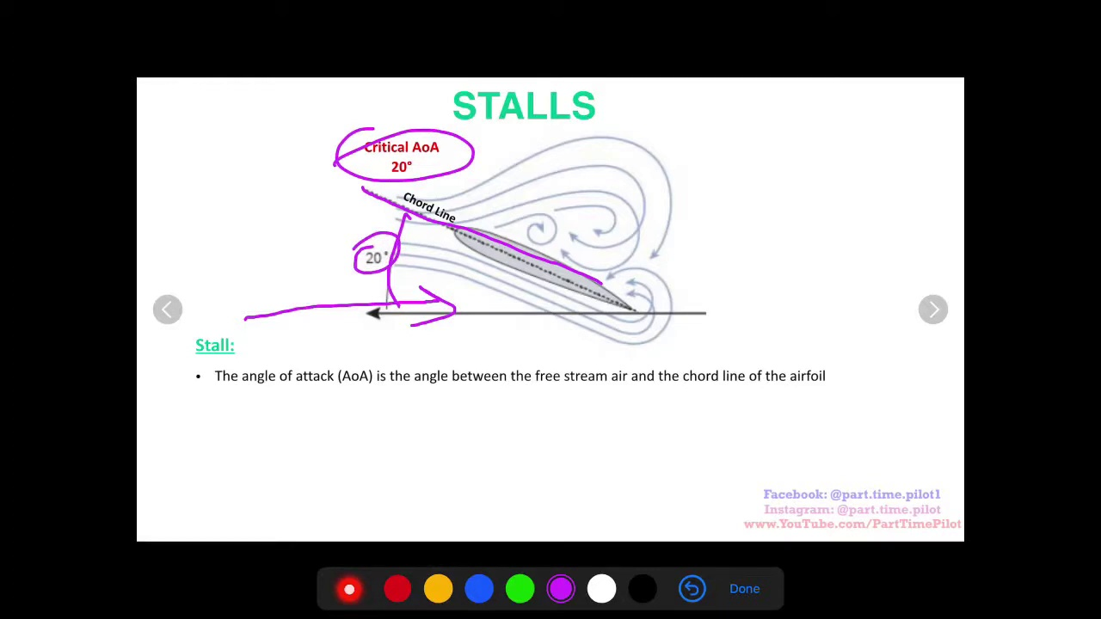 (score 95.0000)
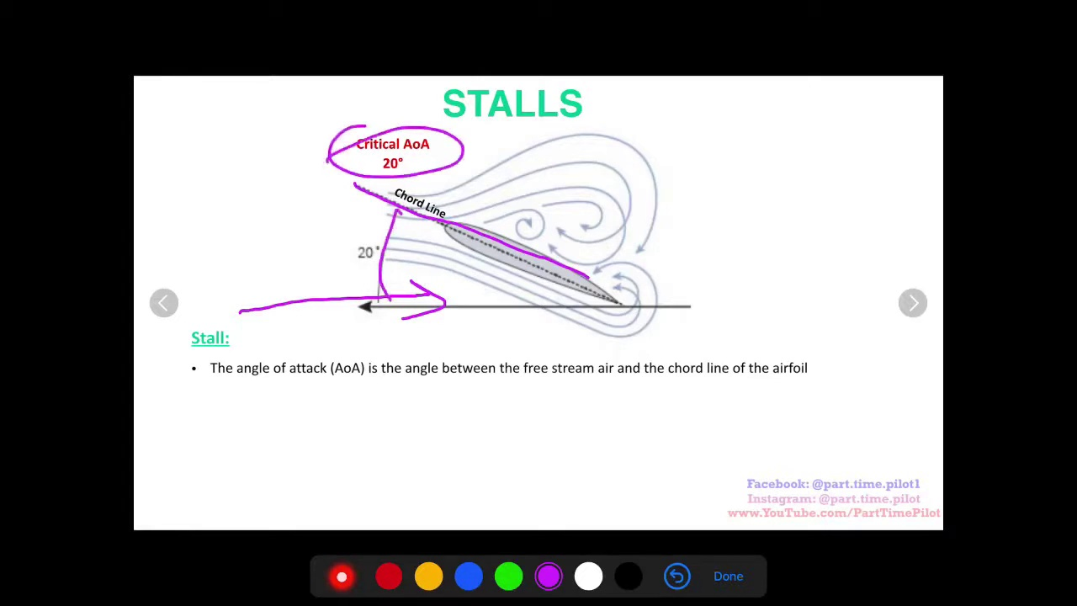 (score 95.0000)
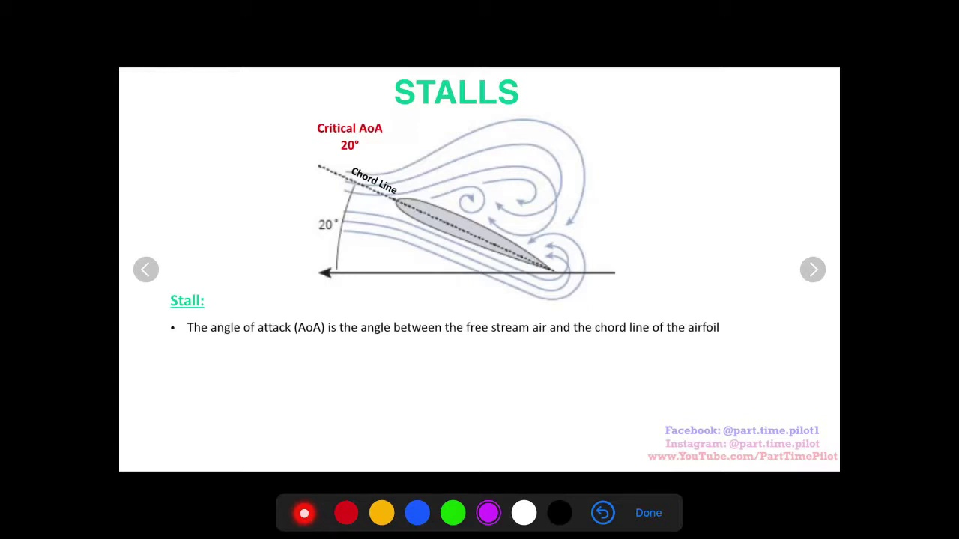 (score 95.0000)
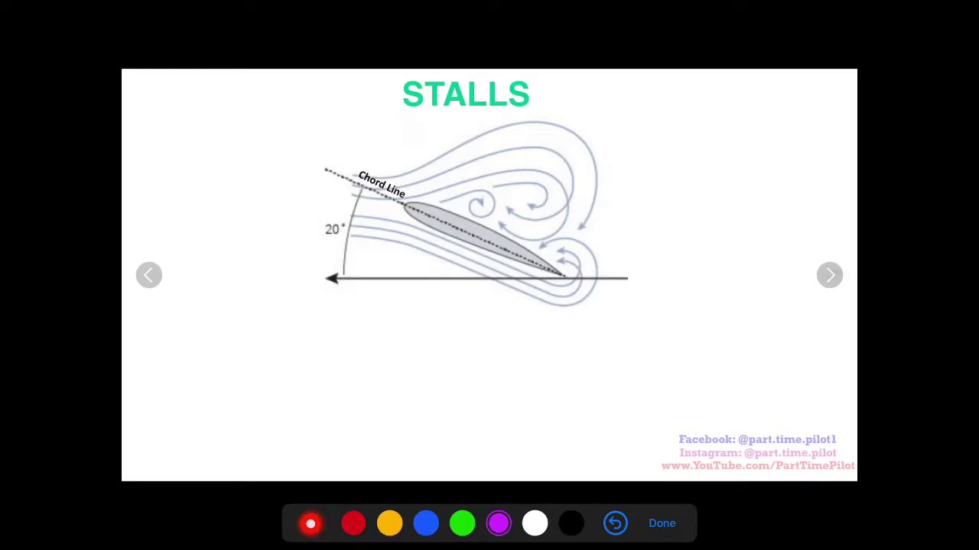 (score 95.0000)
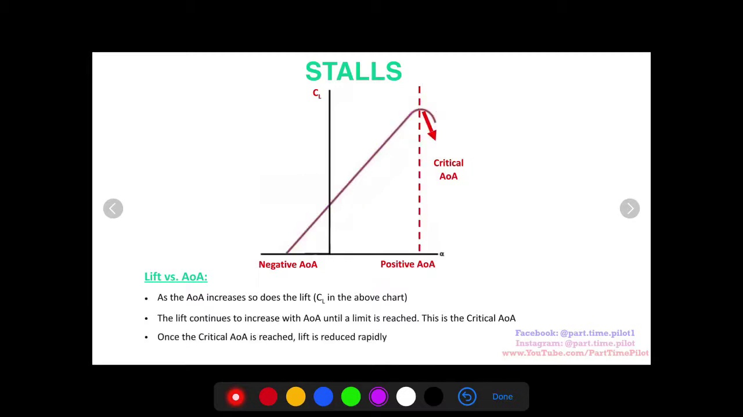 (score 95.0000)
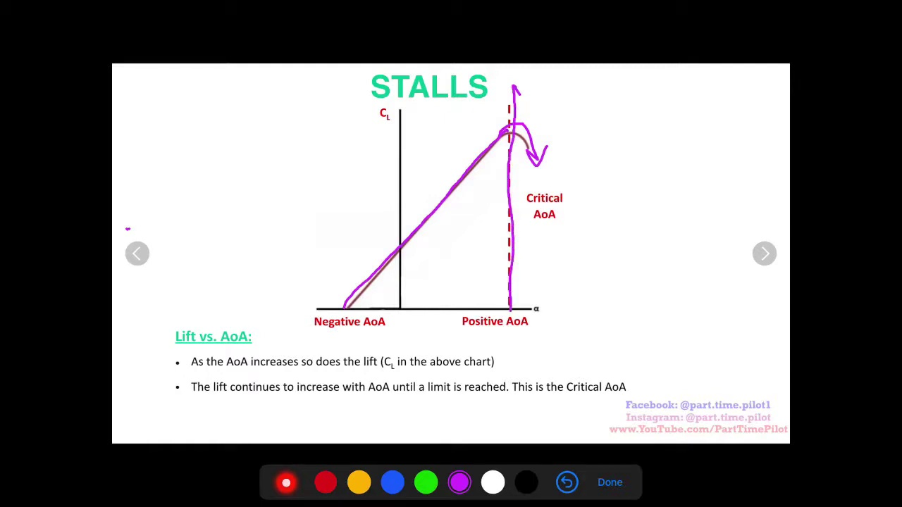 (score 95.0000)
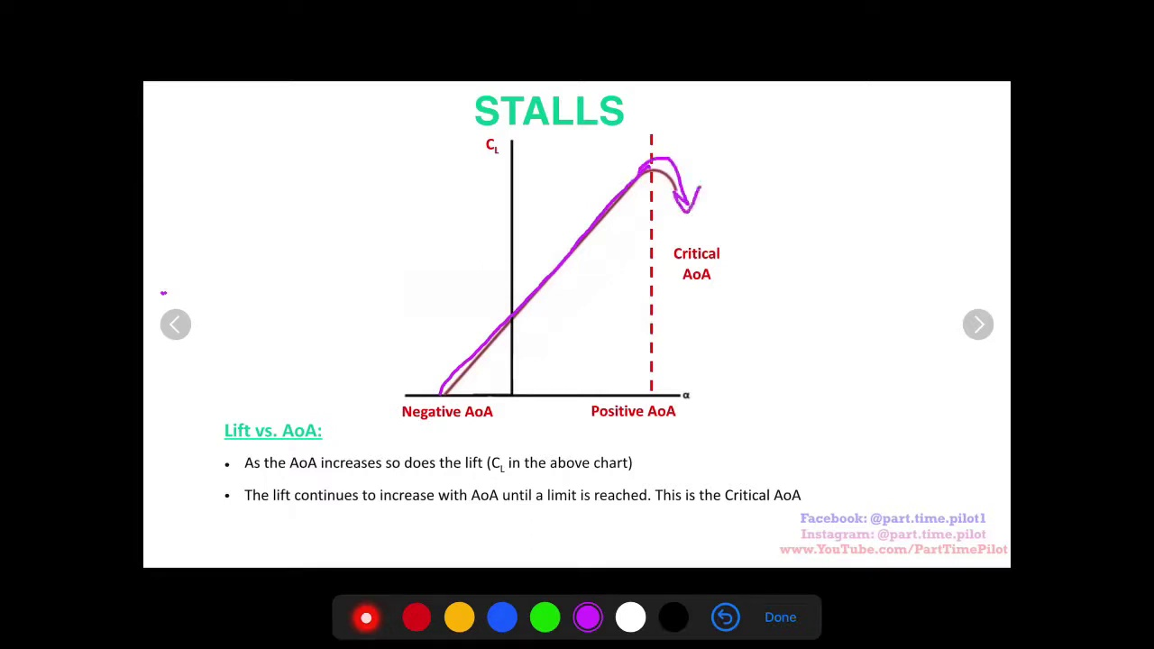 (score 95.0000)
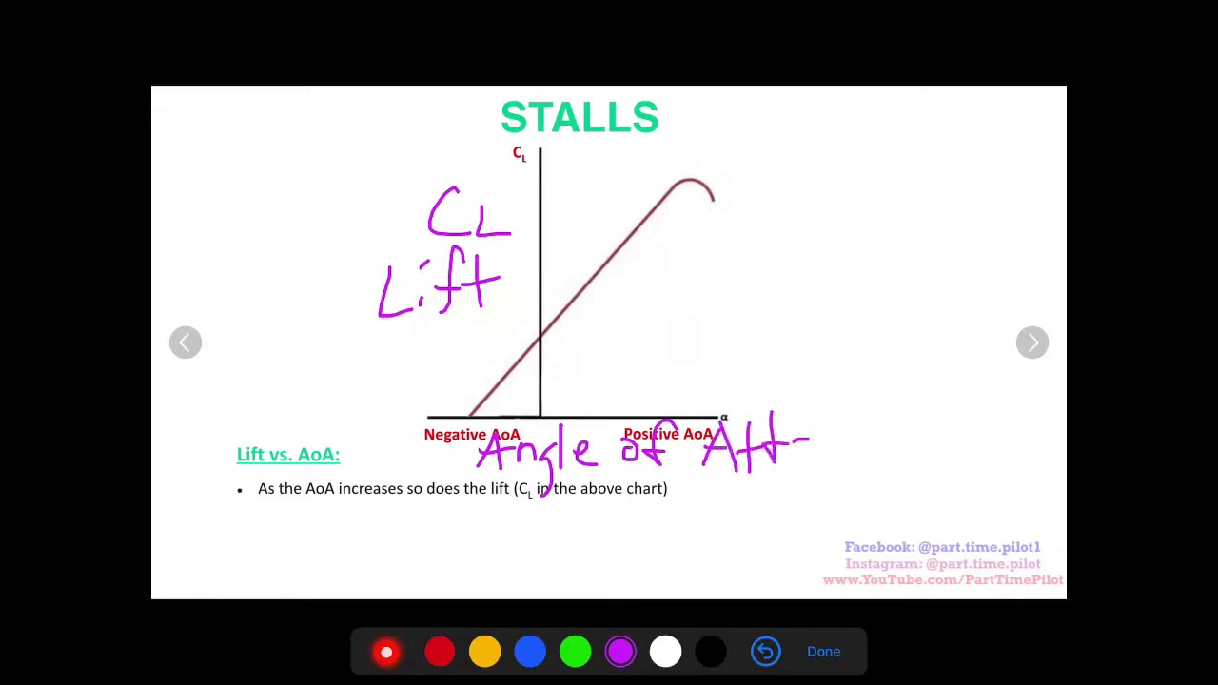 (score 95.0000)
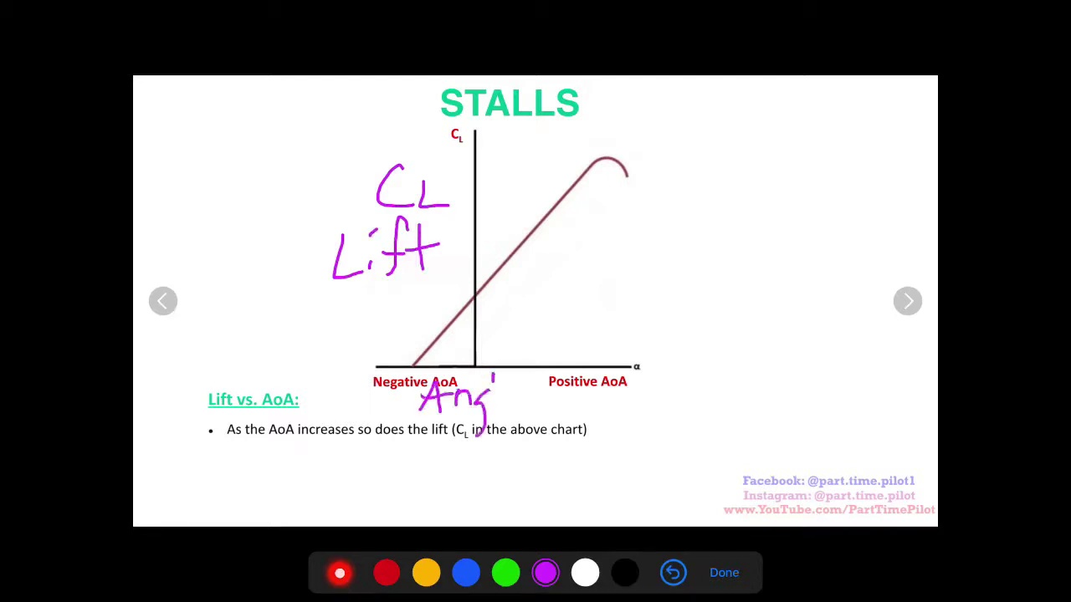 (score 95.0000)
Least correlated frames:
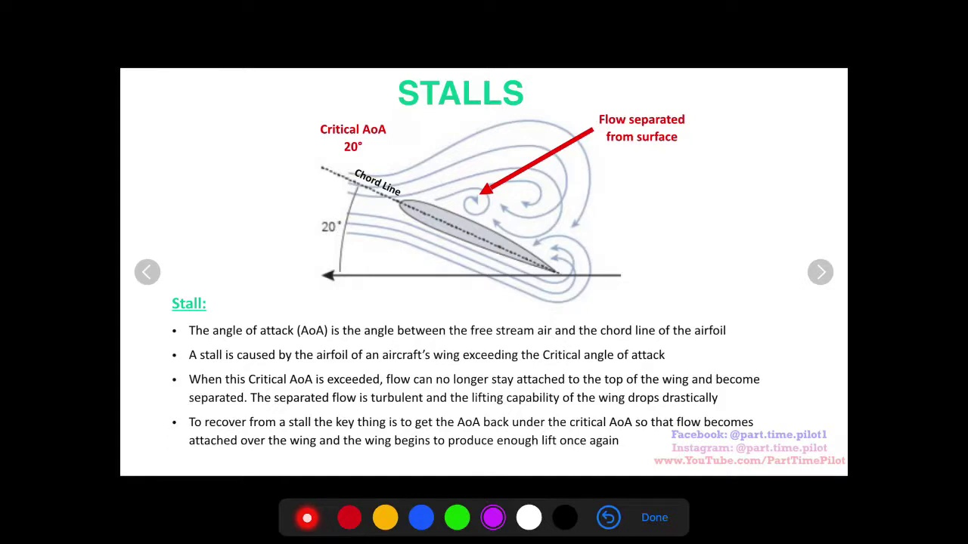 (score 0.0000)
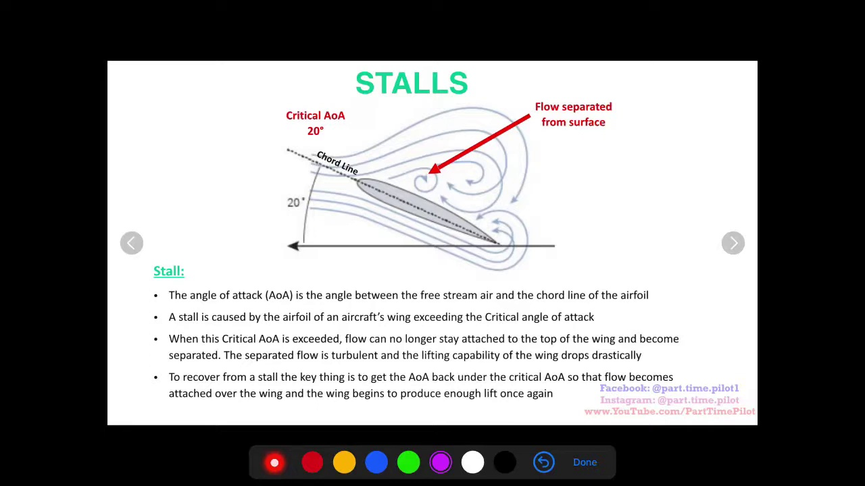 (score 0.0000)
 (score 0.0000)
 (score 0.0000)
 (score 0.0000)
 (score 5.0000)
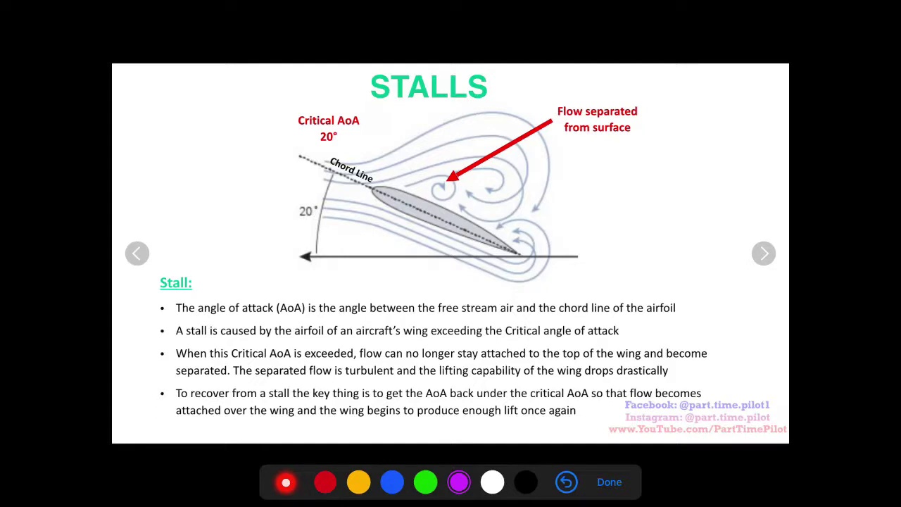 (score 10.0000)
 (score 10.0000)
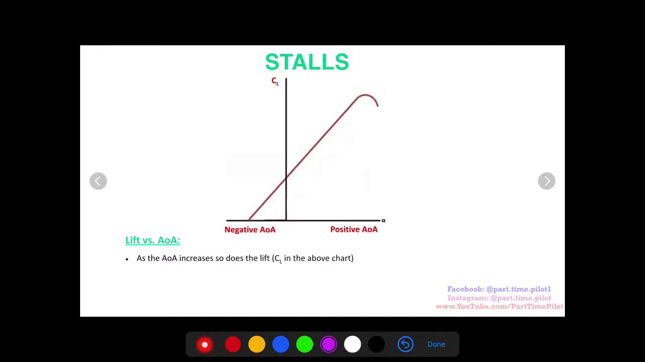 (score 20.0000)
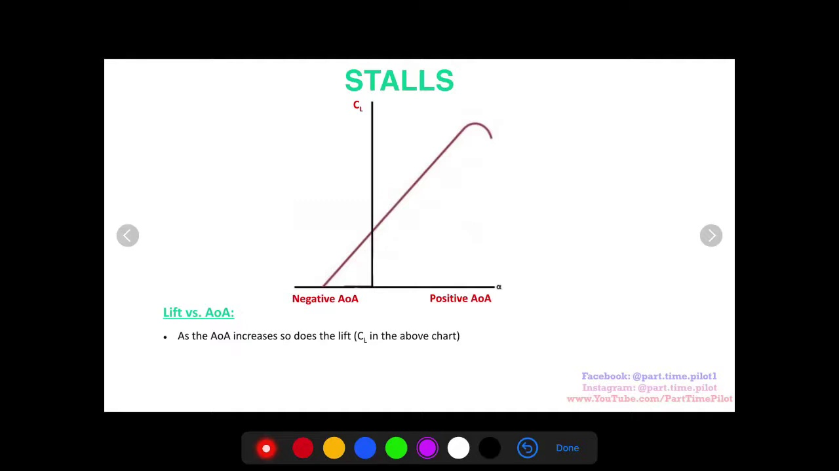 (score 20.0000)

Frame: frame_0000.jpg
Caption: The image shows a screenshot of a computer screen with an instructional video playing, featuring a graph titled "STALLS" with two sets of data represented by two lines, labeled "X" and "Y". The y-axis is scaled from -5 to 0 with increments of 1. Below the graph, written instructions in black text state: "The graph shows X and Y. The axes are labeled." On the right side of the image, part of a computer interface with red and blue icons suggests an educational or interactive software application.
Additional instructions appear on the screen, reading: "Use the arrows on the left to move around the graph. Click and drag to create points. The x-axis moves left and right, while the y-axis moves up and down," implying an interactive feature where users can manipulate the graph by moving the arrows on the screen.
The graph appears to be part of a presentation or report related to the topic "Stalls", as seen in the background slide featuring a green bar graph labeled "Lift vs. AOA" and "Positive AOA". The blue line indicates positive AOA, with the title "Lift vs. AOA vs. Positive AOA" suggesting that the presentation is focused on this topic.
The image is blurry due to low resolution, but it appears that an instructor may be guiding the viewer through a tutorial on how to interpret or manipulate graphs in an educational setting, possibly as part of a mathematics lesson or software application designed for learning about graphs and data visualization.
No strongly correlated comments found for this frame.

Frame: frame_0001.jpg
Caption: The image shows a computer screen displaying a presentation with two slides, one on top of the other. The top slide, titled "Stalls", features a mathematical diagram of a right-angled triangle with labeled sides and angles. The diagram indicates that the side opposite the angle marked "45°" has been inscribed as a circle, as suggested by the dashed line representing the circumference of the circle inscribed within the triangle.
The diagram also includes texts: above the triangle, the word "Stalls" is written in red font; below the triangle, there's an equation labeled "Actual distance =," followed by a mathematical expression that reads "Radius + Height." The number "45°" and the angle marked as "90°" are also indicated on the diagram.
To the right of this slide, there is a video call interface with two participants: one participant has their name displayed as "Name," and the other is not visible. The participant named "Name" appears to be speaking, as suggested by the microphone icon, indicating they may be leading the presentation or teaching session.
Below these slides, another slide titled "Lift vs. Aa" with the subtitle "Positive Aa" displays a black bar graph divided into two sections: the left side represents the "Lift vs. Aa" section, while the right side represents the "Positive Aa" section. The graph shows a positive slope, indicating that the lift increases as the Aa increases.
The overall setting suggests an online teaching or tutorial session in progress, with various icons at the bottom of the screen that seem to be from a video conferencing application interface, including options such as a camera (webcam), microphone, and possibly other controls like chat, full-screen view, and more.
Comment (score 92): In this video, YouTuber “Part Time Pilot” discusses the concept of how a drone stalls in airspace. This is caused by a linear relationship between the lift and angle of attack. As the lift increases and the angle of attack increases, the drone gets closer and closer to what is called a “critical angle”. Beyond this critical angle, the drone stalls due to the lift of the drone dropping to zero. How to recover a stalled air drone is simple. You decrease the drone’s angle of attack using the controller and attempt to lift the drone as it comes down, this will supply airflow over the wing again and allow the drone to stabilize itself.
Reason: The comment directly discusses the concept of a drone stalling in airspace, which is closely related to the technical steps and objects described in the caption. The mention of lift and angle of attack matches with the diagram showing a right-angled triangle with labeled sides and angles, and the text describing how the lift increases as the Aa increases corresponds to the graph on the 'Lift vs. Aa' slide. Additionally, the comment mentions recovering a stalled air drone by decreasing the angle of attack using the controller, which is consistent with the overall setting suggesting an online teaching or tutorial session in progress.
Source: https://www.youtube.com/watch?v=wKyt5ssrDQ8: Fundamentals of Aerodynamics - How does an Aircraft Stall? - For Student Pilots

Frame: frame_0002.jpg
Caption: The image shows a computer screen displaying a slide from a presentation, titled "Stalls." The slide features an educational or instructional theme, suggesting that the content is related to physics. The main sections of the slide include definitions for terms such as "lift," "negative lift," "positive lift," and "negative AoA" on the left side.
The first section describes stalls in a clear and concise manner, providing context for the subsequent information. The second section presents a graph that compares lift and AoA values at various points, with red representing negative AoA and green representing positive AoA. The x-axis represents the AoA, while the y-axis represents the lift.
The third section provides information on the concept of positive AoA, presented in an easily understandable manner. Additionally, mathematical equations are visible on the screen: "W = -A/x" suggests that work (W) equals the negative area divided by x, and "dW/dx" could be referring to differentiating W with respect to x, a common operation in calculus.
The graph also shows a curve plotting an area under the curve, with the negative area being highlighted or emphasized. The axes are labeled as "x" (likely representing time or distance) and "W" (representing work). A small portion of a person is captured in the image, but their role or actions are not clear from this limited view.
The slide also includes text that says "Ask yourself...," followed by an equation: "What can you tell about area between two functions?" This suggests that the instructor is engaging the audience to think critically about the relationship between the work function and the negative area under the curve. The presentation setup appears typical, with a keyboard in front, indicating that the presenter may be controlling the slides remotely.
Comment (score 85): In this video, YouTuber “Part Time Pilot” discusses the concept of how a drone stalls in airspace. This is caused by a linear relationship between the lift and angle of attack. As the lift increases and the angle of attack increases, the drone gets closer and closer to what is called a “critical angle”. Beyond this critical angle, the drone stalls due to the lift of the drone dropping to zero. How to recover a stalled air drone is simple. You decrease the drone’s angle of attack using the controller and attempt to lift the drone as it comes down, this will supply airflow over the wing again and allow the drone to stabilize itself.
Reason: The comment directly discusses the concept of stalls in airspace, which is related to the technical steps and settings described in the caption. The mention of lift, angle of attack, and critical angle are all mentioned in the caption, and the commenter's explanation of how a drone stalls and recovers from stall is strongly connected to the concepts presented on the slide.
Source: https://www.youtube.com/watch?v=wKyt5ssrDQ8: Fundamentals of Aerodynamics - How does an Aircraft Stall? - For Student Pilots

Frame: frame_0003.jpg
Caption: The image shows a screenshot of a device displaying a presentation, likely related to physics or mathematics. The presentation appears to be focused on explaining the concept of negative slopes and their effects on parabolas. The diagram on the screen displays a quadratic function equation "y = -x^2 + ax" with an accompanying graph showing a parabola shape. The x-axis is labeled "Stalls," suggesting that the graph might represent the relationship between distance and slope, where distance is measured by "stalls."
The text on the screen reads: "Negative slope leads to ____ end of parabola!" implying that the context of the presentation or lecture is related to understanding the behavior of negative slopes in quadratic functions. The instructor seems to be using this visual aid to explain how a negative slope affects the shape and direction of a parabola, which is a fundamental concept in both graphing and calculus.
The slide with the text and diagram appears to be part of an educational tool or application used for teaching purposes. There are also icons on the device screen that suggest various functions or tools within the software or app being used to present this material. The instructor is likely pointing out or explaining the graphical representation of the quadratic equation at hand.
In a separate section, the presentation highlights the difference between lift and weight forces acting on an object. Two graphs are shown, each with a slope of 1.5, representing the relationships between "lift" (a) and "AAa" (c), as well as between "AAa" (c) and itself. The "AAa" represents the force exerted by the lift on the object, while the magnitude of the slope indicates the direction and magnitude of the force.
Overall, this presentation aims to teach the concepts of negative slopes in quadratic functions and the differences between lift and weight forces acting on an object.
Comment (score 85): In this video, YouTuber “Part Time Pilot” discusses the concept of how a drone stalls in airspace. This is caused by a linear relationship between the lift and angle of attack. As the lift increases and the angle of attack increases, the drone gets closer and closer to what is called a “critical angle”. Beyond this critical angle, the drone stalls due to the lift of the drone dropping to zero. How to recover a stalled air drone is simple. You decrease the drone’s angle of attack using the controller and attempt to lift the drone as it comes down, this will supply airflow over the wing again and allow the drone to stabilize itself.
Reason: The comment directly discusses the concept of negative slopes (lift dropping to zero) and its effect on a parabola (drone stalling), which is strongly related to the frame caption's description of quadratic functions and negative slope effects on parabolas.
Source: https://www.youtube.com/watch?v=wKyt5ssrDQ8: Fundamentals of Aerodynamics - How does an Aircraft Stall? - For Student Pilots

Frame: frame_0004.jpg
Caption: This image shows a slide from a presentation with a white background, featuring a blue and orange gradient at the bottom edge. The slide is divided into two sections, each dedicated to a different aspect of the topic "Stalls". The left section explores lift, represented by a blue line, while the right section examines Angle of Attack (AOA), depicted by an orange line. The lines are connected, indicating their relationship.
On the same slide, there's also a graph titled "Stalls" displaying two sets of data: x and y on the horizontal axis, indicating time or distance; and a vertical axis labeled "Negative loads" on the right side, suggesting a measurement of some sort. The graph has multiple plots with a dashed line connecting several points in the second plot (y-axis), representing data over time. A line starts at the origin and ends at a specific point on the x-axis, with a label pointing to the last point indicating "Negative load = 0." Below the graph, an equation reads "The forces acting are negative loads."
Additionally, there's a red arrow with a note attached that says "Another force not shown here is a weight," implying an additional unseen variable. The instructor appears to be presenting this information to an audience and seems to be pointing to the graph or explaining something related to the data plotted on it.
The topic of the presentation is likely related to physics, engineering, or mathematics, discussing concepts like forces in stalls or perhaps a specific scenario where negative loads are significant.
Comment (score 95): In this video, YouTuber “Part Time Pilot” discusses the concept of how a drone stalls in airspace. This is caused by a linear relationship between the lift and angle of attack. As the lift increases and the angle of attack increases, the drone gets closer and closer to what is called a “critical angle”. Beyond this critical angle, the drone stalls due to the lift of the drone dropping to zero. How to recover a stalled air drone is simple. You decrease the drone’s angle of attack using the controller and attempt to lift the drone as it comes down, this will supply airflow over the wing again and allow the drone to stabilize itself.
Reason: The comment directly discusses the same technical steps and objects described in the caption, specifically mentioning lift, angle of attack, critical angle, and negative loads. The commenter also explains how to recover a stalled air drone, which is strongly related to the concepts presented in the caption.
Source: https://www.youtube.com/watch?v=wKyt5ssrDQ8: Fundamentals of Aerodynamics - How does an Aircraft Stall? - For Student Pilots

Frame: frame_0005.jpg
Caption: The image shows a screenshot from an online class or video-based tutorial, likely focused on physics or a related concept. At the top of the screen is a whiteboard with text and diagrams, which appear to relate to motion, forces, or related concepts.
The main content visible on the screen includes a graph with two axes: one labeled "Position," indicating displacement measurement in a positive direction along the horizontal axis, and the other labeled "Time," suggesting temporal measurement in a positive direction along the vertical axis. The graph features three curves: one red curve representing a linear relationship between position and time; another blue curve showing an upward trend at a certain point, indicating a nonlinear relationship; and a dashed green curve potentially representing multiple data points.
On the right side of the graph is text in black font that says "Stairs," which might be a title or description for the graph. This suggests that the graph is part of an educational context focused on motion along steps or stairs.
The bottom of the screen displays a slide with the title "STAIRS" in bold, black letters. Below this title is an equation: \( \alpha = \frac{W - mg}{mg} \), representing the acceleration due to gravity (α) in terms of weight (W), mass (m), and gravitational acceleration (g).
The right side of the screen features a video interface with playback controls, including a red button presumably used to start or pause the video. At the bottom-right corner is a color picker tool from Adobe Photoshop, indicating that someone is editing the screenshot.
There is no instructor visible in the image, and no clear indications of any models or physical objects related to stairs being held or displayed. The focus remains on the educational material presented on the computer screen.
No strongly correlated comments found for this frame.

Frame: frame_0006.jpg
Caption: The image shows a screenshot of a digital presentation with an overlaid drawing that seems to be related to physics or statistics. In the foreground, there is a computer interface with several elements.
On the top half of the screen, a presentation slide displays the title "Stalls" and a subtitle "Graphic". The graph on the slide represents some data in a three-dimensional format, with axes labeled "Load" (on the horizontal axis) and "Distance" (on the vertical axis). The graph shows a curve that decreases as load increases until it reaches a point where it begins to increase again.
A red arrow points at a specific point on the graph, which corresponds to the intersection of the two axes. This point is highlighted with a blue circle and has been labeled with "Negative Acceleration". Below this point, text reads, "Graph shows how distance decreases with increasing load."
At the bottom of the screen, a smartphone interface displays several colorful icons on the dock at the bottom. The top right corner of the smartphone interface features a red notification light.
The overall style of the image is that of a digital screenshot, capturing both the presentation slide and the smartphone interface running in the background.
No strongly correlated comments found for this frame.

Frame: frame_0007.jpg
Caption: The image depicts a screenshot from a video lecture on a website, titled "Stalls: Lift vs. AOA". The lecture is presented by a professor who actively engages in explaining the topic, divided into two parts: "Positive AOA" and "Lift vs. AOA". In the "Positive AOA" section, the professor explains the concept of positive AOA, represented by a red line on the graph. This is a measure of the lift generated by an aircraft's wings.
The lecture also discusses the relationship between lift and angle of attack (AOA), represented by a blue line on the graph. The diagram shows two lines, one red and one blue, labeled "Positive AOA" and "Lift vs. AOA", respectively, which appear to represent different paths or trajectories within a three-dimensional space.
On the right side of the image, there is a text overlay in red that says, "Negative Axis is on the Left Side." The slide has additional text providing an explanation or context for the diagram: "Any object in front of the wormhole ends up in negative space." There are also mathematical formulas visible, with one equation showing "w = 2" and a second equation showing "r1 + r2 + r3 = 0," where "w" stands for wormhole and "r1", "r2", and "r3" represent different components or coordinates in the context of the diagram.
The slide includes a series of bullet points that likely provide further explanation about the concept being taught:
• Objects in positive space
• Objects in negative space
• Two objects in the wormhole
• Any object in front of the wormhole ends up in negative space
Below the slide, there are two red buttons labeled "Home" and "Next." The bottom right corner of the image shows a portion of the computer's interface with the taskbar visible, indicating that this is a screenshot from a computer or a tablet. The lecture appears to be interactive, with a button labeled "Test Your Knowledge", suggesting that it is designed to be a learning tool for students to test their understanding of the topic.
No strongly correlated comments found for this frame.

Frame: frame_0008.jpg
Caption: In this visually rich and informative slide, we see two main sections: "Stages of Growth" and "Lift vs. AOA". The top section, "Stages of Growth", illustrates a series of interconnected circles, each representing a different stage in the growth process. From seed to harvest, the cycles of growth are clearly depicted, with arrows connecting each phase to emphasize their sequential nature. Below this, the graph labeled "Lift vs. AOA" presents a detailed analysis of two key metrics: Lift (a measure of marketing effectiveness) and Angle of Attack (AOA), which represents the approach taken by marketers in targeting their audience. The graph features multiple lines, each representing a different AOA, with corresponding lift values plotted on the y-axis. This complex yet organized visual representation provides valuable insights for marketers seeking to optimize their strategies.
Comment (score 90): In this video, YouTuber “Part Time Pilot” discusses the concept of how a drone stalls in airspace. This is caused by a linear relationship between the lift and angle of attack. As the lift increases and the angle of attack increases, the drone gets closer and closer to what is called a “critical angle”. Beyond this critical angle, the drone stalls due to the lift of the drone dropping to zero. How to recover a stalled air drone is simple. You decrease the drone’s angle of attack using the controller and attempt to lift the drone as it comes down, this will supply airflow over the wing again and allow the drone to stabilize itself.
Reason: The comment directly discusses the technical steps and concepts described in the caption, such as lift, angle of attack, and critical angle. The caption's sections 'Stages of Growth' and 'Lift vs. AOA' are specifically mentioned in the comment, and the commenter provides examples of how to recover a stalled air drone based on the principles presented in the graph.
Source: https://www.youtube.com/watch?v=wKyt5ssrDQ8: Fundamentals of Aerodynamics - How does an Aircraft Stall? - For Student Pilots

Frame: frame_0009.jpg
Caption: The image appears to be a screenshot of a computer displaying a presentation slide with two graphical illustrations related to statistics or probability theory. The slide is titled "STALLS," and there are mathematical equations and graphical elements on it.
The main feature of the slide is a line graph divided into two parts, with each part featuring a graph. The left side displays a line graph labeled "Lift vs. AOA," which shows a line that starts from 0 and goes upwards, indicating an increase in lift with an increase in angle of attack (AOA). The right side displays another line graph labeled "Stalls vs. Positive AOA," which also shows a line that starts from 0 and goes upwards, indicating an increase in stalls with an increase in positive AOA.
Below the graphs, there is a graphical illustration related to statistics or probability theory, featuring two curves: one labeled as "Actual" and the other as "Expected." The "Expected" curve is overlaid by a dashed line, and below this dashed line is another line that represents the "Required." There are text boxes with equations on them. One equation is "Actual - Expected = 0," which could be interpreted as equating the difference between actual results and expected results to zero. The second equation is "Expected - Required = 0," suggesting a similar idea for expected minus required values.
A legend or key on the slide corresponds to the dashed line, containing an arrow pointing upwards from the dashed line with the label "Negative." This could imply that the dashed line represents negative values or outcomes compared to the actual values or outcomes.
The slide has been created using what looks like a PowerPoint presentation software, as indicated by the interface elements in the lower part of the image, such as the toolbar and the presentation notes window on the right side. The overall layout suggests that this could be an educational setting where statistical concepts are being taught or explained.
The instructor is not visible in the frame; however, there's a screenshot icon overlaid on the image, which might indicate that someone took this picture while looking at their computer screen during a lecture or class discussion. The environment does not provide any information about additional context beyond the presentation itself.
No strongly correlated comments found for this frame.

Frame: frame_0010.jpg
Caption: The image shows a screenshot of a teaching moment with a focus on mathematics and graphing. On the left side of the screenshot is a slide from a presentation, which appears to be an educational resource related to statistics or data analysis. The slide contains a graph that resembles an S-curve, with a title "Stairs" at the top right corner. The horizontal axis is labeled "Negative load" and the vertical axis is labeled "Positive load," suggesting that the graph represents some form of measurement or comparison of positive and negative loads.
There's text on the slide indicating that there are two loads, one negative (indicated by a red arrow) and one positive (indicated by a green arrow). A horizontal line connects these points to form the curve. The text also mentions "Equation 2" at the bottom left, but the specific content or context of this equation is not fully visible.
On the right side of the screenshot, there's an overlaid red circle with a message that reads: "Negative load is now positive." This suggests that the teaching point being made here is to explain how the interpretation or sign of a measurement can change, likely in the context of physics, engineering, or materials science where loads (forces) are common terms.
The slide also includes two other graphs: one labeled "Lift vs. AoA" and the other labeled "Positive AoA". These graphs illustrate the relationship between lift, angle of attack, and positive angle of attack, which are important factors in the study of aerodynamics. The "Lift vs. AoA" graph shows the relationship between lift and angle of attack, while the "Positive AoA" graph shows the relationship between positive angle of attack and lift.
At the bottom of the screenshot, there's a lock or home button at the center of the device's screen, suggesting that this image was taken from an iPad or a similar touchscreen tablet. The background of the screenshot is blurred but shows what appears to be a person holding the tablet in portrait orientation, though their face and any identifying features are not visible due to the blur.
The focus on the educational content of the presentation slide indicates that this image captures a moment during a teaching session where the instructor may be explaining concepts related to loads or forces in engineering or physics.
Comment (score 80): In this video, YouTuber “Part Time Pilot” discusses the concept of how a drone stalls in airspace. This is caused by a linear relationship between the lift and angle of attack. As the lift increases and the angle of attack increases, the drone gets closer and closer to what is called a “critical angle”. Beyond this critical angle, the drone stalls due to the lift of the drone dropping to zero. How to recover a stalled air drone is simple. You decrease the drone’s angle of attack using the controller and attempt to lift the drone as it comes down, this will supply airflow over the wing again and allow the drone to stabilize itself.
Reason: The comment directly discusses the concept of lift and angle of attack in relation to a drone stalling, which is strongly related to the technical steps and objects described in the caption, including the graphs labeled 'Lift vs. AoA' and 'Positive AoA'. The comment also mentions the critical angle, which is similar to the S-curve graph on the slide, and describes how to recover a stalled drone by decreasing its angle of attack, which is related to the teaching point being made in the caption about interpreting load measurements.
Source: https://www.youtube.com/watch?v=wKyt5ssrDQ8: Fundamentals of Aerodynamics - How does an Aircraft Stall? - For Student Pilots

Frame: frame_0011.jpg
Caption: The image appears to be a screenshot from a computer displaying a mathematical diagram and an explanation of it. At the top of the screenshot, there's a title that reads "STALLS," which could suggest that this is related to probability theory or statistics. Below the title, there is a graph with two axes: one labeled "x-axis" and another labeled "y-axis." On the graph, there are three bars of varying heights, each corresponding to a different colored section on the vertical axis. The bars are annotated with text, indicating values such as 10, -3, and 2. There's also a curve in red that represents some sort of data or function, which could be related to the stalls mentioned in the title.
On the right side of the graph, there is text that says "Answer A was correct." This suggests that the image may have been taken during an exam or educational activity where students had multiple choice answers and this particular answer was deemed correct. The top right corner of the screenshot shows a red notification bubble with the number '1', which might indicate the presence of more than one notification or message pending, but only one is visible in this screenshot.
Below the graph, there's a text box that contains an equation:
\[ x = -3 \]
This equation likely corresponds to the bar at -3 on the vertical axis of the graph. The bottom left corner of the image shows part of a red and black object that could be a device or piece of equipment, but it's not clear what it is due to the angle of the photograph.
The overall impression is that this is an educational environment, likely a virtual classroom or a digital learning platform where students can interact with educational materials such as graphs and equations. The context suggests that the student might be receiving feedback on their performance in understanding probability distributions or some other statistical concept.
In addition to the graph of three bars and the equation, the image also contains a separate graph displaying two lines: one labeled "Lift vs. AOA" in blue and another labeled "Stalls" in red. This graph is divided into three distinct sections: the x-axis, the y-axis, and the graph itself. The legend at the bottom of this graph explains that the blue line represents the relationship between lift and angle of attack, while the red line indicates the point at which stall occurs.
Comment (score 85): In this video, YouTuber “Part Time Pilot” discusses the concept of how a drone stalls in airspace. This is caused by a linear relationship between the lift and angle of attack. As the lift increases and the angle of attack increases, the drone gets closer and closer to what is called a “critical angle”. Beyond this critical angle, the drone stalls due to the lift of the drone dropping to zero. How to recover a stalled air drone is simple. You decrease the drone’s angle of attack using the controller and attempt to lift the drone as it comes down, this will supply airflow over the wing again and allow the drone to stabilize itself.
Reason: The comment directly discusses the technical steps and concepts described in the caption, such as the relationship between lift and angle of attack, stalls, and recovery techniques. The connection is strong because the video title 'STALLS' mentioned in the caption matches the topic discussed by Part Time Pilot in the comment, indicating a high level of correlation.
Source: https://www.youtube.com/watch?v=wKyt5ssrDQ8: Fundamentals of Aerodynamics - How does an Aircraft Stall? - For Student Pilots

Frame: frame_0012.jpg
Caption: The image appears to show a screenshot of an educational presentation being displayed on a computer screen. At the top of the screen, there's a title "STALLS" followed by a mathematical equation: "AB + AC = A(B+C)".
In the center of the image is a graph titled "Graph 1." The graph shows three curves: a horizontal line labeled "X-axis," another curve that starts from the origin, rises to a peak, and then drops down before leveling out, and a third curve that resembles a parabola with a positive leading coefficient.
At the bottom of the image, there's a text that reads: "The area under the curve AB is..." followed by two options: "1 2" and "3". The instruction seems to indicate an interactive question about the graph.
A small red circle with a plus sign is visible on the right side of the screen, possibly indicating a tool for adding content or interacting with the presentation. The overall style of the image suggests it's from a digital educational platform, likely used in a classroom setting to aid in teaching mathematics.
Additionally, the slide also includes information about "Stalls", which is further divided into two sections. On the left side, there is a green bar graph with two lines: one representing lift and the other representing Angle of Attack (AOA). The lift line is above the AOA line, indicating that the lift is greater than the AOA. On the right side of the slide, there is a red line representing Positive AOA, which is above the lift line, indicating that the Positive AOA is greater than the lift.
The slide is labeled with the text "Stalls: Lift vs. AOA, Positive AOA". The slide is currently active, and a comment has been added at the bottom right corner.
Comment (score 95): In this video, YouTuber “Part Time Pilot” discusses the concept of how a drone stalls in airspace. This is caused by a linear relationship between the lift and angle of attack. As the lift increases and the angle of attack increases, the drone gets closer and closer to what is called a “critical angle”. Beyond this critical angle, the drone stalls due to the lift of the drone dropping to zero. How to recover a stalled air drone is simple. You decrease the drone’s angle of attack using the controller and attempt to lift the drone as it comes down, this will supply airflow over the wing again and allow the drone to stabilize itself.
Reason: The comment directly discusses the concept of stalls in airspace, which is related to the title 'Stalls' and the graph showing the lift vs. angle of attack, as well as the critical angle mentioned in the caption. The viewer's explanation of how to recover a stalled drone also corresponds to the interactive question on the slide ('The area under the curve AB is...').
Source: https://www.youtube.com/watch?v=wKyt5ssrDQ8: Fundamentals of Aerodynamics - How does an Aircraft Stall? - For Student Pilots

Frame: frame_0013.jpg
Caption: This image shows a screenshot of a computer screen displaying a presentation slide with a graph and annotations. The title at the top of the slide says "STALLS." There is no explicit mention of the specific field of study, but it appears to be part of an educational context, possibly related to finance, economics, or business studies.
The graph displays two curves: one labeled "Average Stock Price" on the left side and another line labeled "Negative Shocks" on the right-hand side. The x-axis is labeled as "Stock price," and the y-axis shows both "Stock price" and "Stock price + shock." Two equations are also presented:
1. \( Stock\_Price = Average\_Stock\_Price - Shock \)
2. \( Stock\_Price + Shock = 0 \)
The annotations include a text box with a red arrow pointing to the graph at a specific point, stating, "Shock moves stock price." This suggests that when there is a negative shock, it moves the stock price below the average stock price.
On the slide, there's also a colorful image of a person with their hand raised in the air, perhaps indicating an instructor or presenter actively engaging with the audience during the presentation. In the bottom right corner of the image, there's a red button with a white number "2" on it, which might be part of a virtual remote control interface commonly used for online classes or meetings to navigate slides.
There is no explicit connection between this slide and the graph displaying the relationship between lift and angle of attack (AOA), but both captions mention a "Stalls" title, suggesting that they may be discussing similar topics.
Comment (score 90): In this video, YouTuber “Part Time Pilot” discusses the concept of how a drone stalls in airspace. This is caused by a linear relationship between the lift and angle of attack. As the lift increases and the angle of attack increases, the drone gets closer and closer to what is called a “critical angle”. Beyond this critical angle, the drone stalls due to the lift of the drone dropping to zero. How to recover a stalled air drone is simple. You decrease the drone’s angle of attack using the controller and attempt to lift the drone as it comes down, this will supply airflow over the wing again and allow the drone to stabilize itself.
Reason: The comment directly discusses the same concept of stalls (in this case, air drone stalling) and its relationship to lift and angle of attack, which is also mentioned in the caption. The technical steps and goals discussed in the caption (e.g., 'Shock moves stock price' and recovering a stalled air drone) are strongly related to the concepts presented in the comment.
Source: https://www.youtube.com/watch?v=wKyt5ssrDQ8: Fundamentals of Aerodynamics - How does an Aircraft Stall? - For Student Pilots

Frame: frame_0014.jpg
Caption: The image appears to be a screenshot from a video conference platform or online tutorial. On the left side of the screen is a participant's webcam feed showing a person wearing a black shirt, with their hand resting on the table. The right side of the screen displays the shared content from the presenter.
The content consists of a slide or presentation with text and mathematical diagrams. The slide has the title "Stalls: Lift vs. AOA" at the top in bold letters, indicating that it is part of a video tutorial on this subject. There are three lines graphically representing a concept related to finance, economics, or inventory management, as suggested by the annotations on the graph.
The first line is labeled "A," the second is "B," and the third is "C." Alongside these labels, there are two sets of text: "Negative Good" on one side and "Positive Good" on the other. The graph illustrates a concept with axes labeled as "Price Level" and "Quantity Sold."
Additionally, there is an equation displayed below the graph:
\[ P_c = \frac{P}{Q} \]
This suggests that the presenter is discussing a concept where 'P_c' represents the cost price per unit for a good, given the total cost 'P' and the quantity sold 'Q.' The equation indicates that this value is calculated by dividing the total cost by the quantity sold.
The user is actively engaged with the content, typing in the chat box. The exact content of the chat box is not visible in the image, but it appears to be related to the tutorial content. Overall, the image captures a moment in a video tutorial on Stalls, where the user is participating in the learning process and the presenter is explaining a financial concept using visual aids to support their teaching.
Comment (score 80): In this video, YouTuber “Part Time Pilot” discusses the concept of how a drone stalls in airspace. This is caused by a linear relationship between the lift and angle of attack. As the lift increases and the angle of attack increases, the drone gets closer and closer to what is called a “critical angle”. Beyond this critical angle, the drone stalls due to the lift of the drone dropping to zero. How to recover a stalled air drone is simple. You decrease the drone’s angle of attack using the controller and attempt to lift the drone as it comes down, this will supply airflow over the wing again and allow the drone to stabilize itself.
Reason: The comment directly discusses the concept of stalls in airspace, which is closely related to the 'Stalls: Lift vs. AOA' topic presented in the frame caption. The mention of lift, angle of attack, and critical angle aligns with the visual aids and mathematical diagrams shown in the caption, indicating a strong connection between the comment and the video tutorial content.
Source: https://www.youtube.com/watch?v=wKyt5ssrDQ8: Fundamentals of Aerodynamics - How does an Aircraft Stall? - For Student Pilots

Frame: frame_0015.jpg
Caption: The image shows a unique fusion of digital and physical interfaces, featuring both a computer screen and a whiteboard. On the computer screen, a presentation slide is open, displaying a simple line graph titled "STAIRS." The graph contains three lines: one labeled 'WALL,' another labeled 'BANISTER,' and a dashed line labeled 'RISER.' Each line represents different elements of a staircase, with the 'RISER' line sloping upwards to indicate that it represents the stairs themselves.
Below the graph on the computer screen, text reads, "Negative slope means production decreases as more units are produced." This suggests that the context of the presentation is likely related to economics or a similar field discussing negative slopes on graphs and their interpretation in terms of supply and demand curves.
On the whiteboard, a mathematical equation is written: "STAILS". The graph of this equation is displayed on the right side of the board. The x-axis represents the variable 'x', while the y-axis represents the variable 'y'. The equation is written as "c(x) = A(x) + A(x)". The graph is a line that intersects the x-axis at the point (0,0) and the y-axis at the point (0,0). The graph is colored in blue, which matches the color of the equation.
The same graph is displayed on the computer screen as well, showcasing the fusion of digital and physical interfaces.
No strongly correlated comments found for this frame.

Frame: frame_0016.jpg
Caption: The image you've provided appears to be a screenshot from a video tutorial or educational material displayed on a computer screen. The main content is an instructional diagram showing a sequence of four numbers and arrows that represent addition operations, as well as a graphical representation with four vertical lines labeled with numbers from 1 to 4 and an equal sign pointing between them. Below the diagram, there's text that reads "STAIRS," which might indicate a category or theme for this presentation or activity.
The screenshot itself shows a computer interface with a window open, displaying this educational material on a digital slide or worksheet. The user interface elements of the screen suggest it's a mobile device with a touchscreen, as there are icons typically associated with smartphones at the bottom of the image. There are no indications of the instructor or any real-world setting in this frame; it focuses entirely on the content presented on the screen.
In contrast to the instructional diagram, the video tutorial being presented is focused on the concept of stalls in a car, titled "Stalls". The video appears to be discussing the relationship between lift and airfoil area. The whiteboard is divided into three sections, with various graphs and equations labeled as "Lift vs. Aa", which are likely being used to illustrate the concept of stalls.
The instructor is pointing to the graph on the whiteboard, possibly explaining the concept of stalls and how it relates to the graphs on the board. The text on the screen reads "Lift vs. Aa", indicating the focus of the video. The overall layout of the image suggests that it is a detailed and informative tutorial on the topic of stalls in cars.
This dual-image presents two distinct educational topics: basic mathematical operations involving addition, represented by the instructional diagram, and the concept of stalls in car engineering, presented through the video tutorial.
Comment (score 80): In this video, YouTuber “Part Time Pilot” discusses the concept of how a drone stalls in airspace. This is caused by a linear relationship between the lift and angle of attack. As the lift increases and the angle of attack increases, the drone gets closer and closer to what is called a “critical angle”. Beyond this critical angle, the drone stalls due to the lift of the drone dropping to zero. How to recover a stalled air drone is simple. You decrease the drone’s angle of attack using the controller and attempt to lift the drone as it comes down, this will supply airflow over the wing again and allow the drone to stabilize itself.
Reason: The comment directly discusses the concept of stalls in air drones, which is strongly related to the topic of stalls in car engineering mentioned in the frame caption. The correlation score is high because the comment provides technical details on the relationship between lift and angle of attack, which are key concepts also discussed in the frame caption.
Source: https://www.youtube.com/watch?v=wKyt5ssrDQ8: Fundamentals of Aerodynamics - How does an Aircraft Stall? - For Student Pilots

Frame: frame_0017.jpg
Caption: The image presents a screenshot from an online learning platform, possibly taken by a student recording a lecture or study session. The digital display shows educational content related to mathematics or physics concepts, as indicated by the title "ST Lift" at the top of the screen. The screen is divided into several visible elements.
On the left side of the screen, there's a large graph with multiple lines representing data points on two axes: one horizontal axis labeled 'Work (W)' and one vertical axis labeled 'Effort (N)'. The graph includes a line marked as 'ST Lift', which seems to represent a stress-time curve for a structure or material being lifted. A red arrow pointing upwards from the origin of the graph indicates the direction of work or effort in this context.
To the right of the graph, there's a text box with the word "Stalls" written inside it, possibly indicating that the discussion or focus is on the concept of stalling or stopping.
At the top of the image, there's a small icon resembling a camera flash, indicating that the device might have been used to take a photo or capture a video. In the background of the smartphone screen, what appears to be a home screen with various app icons and the time '2:10' is visible.
Meanwhile, on another whiteboard in the same presentation, there's a graph of a function presented as part of a larger slide titled "Stalls". The graph consists of two lines labeled 'x', one red (representing a straight line with a slope of 2) and one blue (representing a downward-opening parabola or curve with a slope of -1). Both lines are labeled 'f(x)', indicating that they represent functions.
Comment (score 95): In this video, YouTuber “Part Time Pilot” discusses the concept of how a drone stalls in airspace. This is caused by a linear relationship between the lift and angle of attack. As the lift increases and the angle of attack increases, the drone gets closer and closer to what is called a “critical angle”. Beyond this critical angle, the drone stalls due to the lift of the drone dropping to zero. How to recover a stalled air drone is simple. You decrease the drone’s angle of attack using the controller and attempt to lift the drone as it comes down, this will supply airflow over the wing again and allow the drone to stabilize itself.
Reason: The comment directly discusses the concept of stalls in airspace, which is related to the graph and text box in the caption. The mention of lift, angle of attack, critical angle, and recovering a stalled drone aligns with the technical steps, objects, settings, and goals described in the caption.
Source: https://www.youtube.com/watch?v=wKyt5ssrDQ8: Fundamentals of Aerodynamics - How does an Aircraft Stall? - For Student Pilots

Frame: frame_0018.jpg
Caption: The image captures a dynamic classroom setting where a teacher presents to students. The teacher appears to be teaching a concept related to mathematical functions or curves, as indicated by the whiteboard with the handwritten equation "y = f(x)" and the diagram featuring a curve that represents a function, along with coordinates (5,3) marked on it. The word "STUDENTS" is written in large red letters on the board, indicating the focus or theme of the lesson.
On the whiteboard, there are two functions represented by the equations y = 3x and y = 2x + 3, with their respective graphs depicted in blue and red, respectively. This visual comparison helps students understand the concept of slope in function graphs. A separate slide titled "Stalls" is also visible on the top right corner of the board, which summarizes the lesson by explaining that as the lift increases, so does the angle of aft.
In the background, a keyboard from a desktop computer is displayed in the lower right corner, likely used for teaching purposes. A screenshot of a Part-Time YouTube video is also visible, featuring blue and white text reading "Part-Time YouTube". This suggests that the video might be related to the lesson or provide additional insights.
Overall, the image shows students engaged in learning about the concept of slope in function graphs, utilizing interactive tools, visual aids, and multimedia resources to enhance their understanding.
Comment (score 95): In this video, YouTuber “Part Time Pilot” discusses the concept of how a drone stalls in airspace. This is caused by a linear relationship between the lift and angle of attack. As the lift increases and the angle of attack increases, the drone gets closer and closer to what is called a “critical angle”. Beyond this critical angle, the drone stalls due to the lift of the drone dropping to zero. How to recover a stalled air drone is simple. You decrease the drone’s angle of attack using the controller and attempt to lift the drone as it comes down, this will supply airflow over the wing again and allow the drone to stabilize itself.
Reason: The comment directly discusses the concept of stall and critical angle in relation to lift and angle of attack, which are also described in the caption. The mention of linear relationship and recovery method also matches with the equations and graphs shown on the whiteboard.
Source: https://www.youtube.com/watch?v=wKyt5ssrDQ8: Fundamentals of Aerodynamics - How does an Aircraft Stall? - For Student Pilots

Frame: frame_0019.jpg
Caption: The image shows a screen displaying an educational presentation, likely from a mobile device given the camera interface at the bottom. The content of the presentation is related to physics and possibly trigonometry, as indicated by the equations and graph on the screen.
The slide is divided into two main sections: On the left side, there's a graph with a sine wave labeled "Lift" and "Angle of Attachment." This graph represents the relationship between lift and the angle of attachment. Below this graph, there are written notes saying "STANDS" with what appears to be an arrow diagram underneath it, possibly illustrating forces in the context of physics or the mechanics of a lift.
On the right side of the slide, there's a text box that reads "Stalls." This text is likely related to the topic of the slide, possibly explaining or providing further information about the subject. Below this text, there are mathematical equations and graphical representations. The equation at the bottom right reads "Distance = Speed x Time," which is a standard formula for calculating distance based on speed and time.
Additionally, there's a trigonometric diagram with an angle labeled "angle" next to what seems to be a sine wave or a function of some sort, possibly representing the relationship between angles and their corresponding values in the context of trigonometry, such as sine and cosine values for different angles. The graph has axes labeled "x" and "y," which suggests it might be representing some data in a trigonometric or coordinate system context.
There's no direct interaction with a person visible, but the presence of a writing instrument (pen) next to the slide implies that someone may have been taking notes or explaining the content while preparing the presentation or during the actual class. The overall style of the image suggests it was taken in an educational setting, possibly a classroom or online learning environment.
Comment (score 80): In this video, YouTuber “Part Time Pilot” discusses the concept of how a drone stalls in airspace. This is caused by a linear relationship between the lift and angle of attack. As the lift increases and the angle of attack increases, the drone gets closer and closer to what is called a “critical angle”. Beyond this critical angle, the drone stalls due to the lift of the drone dropping to zero. How to recover a stalled air drone is simple. You decrease the drone’s angle of attack using the controller and attempt to lift the drone as it comes down, this will supply airflow over the wing again and allow the drone to stabilize itself.
Reason: The comment directly discusses the concept of drone stalling and the relationship between lift and angle of attack, which is also described in the frame caption. The mention of critical angle, decreasing the drone's angle of attack, and recovering a stalled air drone aligns with the technical steps and objects discussed in the caption.
Source: https://www.youtube.com/watch?v=wKyt5ssrDQ8: Fundamentals of Aerodynamics - How does an Aircraft Stall? - For Student Pilots

Frame: frame_0020.jpg
Caption: The image presents a multifaceted educational display, combining a physics concept with a mathematical equation. The left side of the slide is dedicated to an explanation of gravity, featuring two diagrams and a formula for calculating weight using the equation \( W = mg \). The diagram on the right illustrates a simple model of an object under gravity, possibly a book or paperweight. The text indicates that the weight of an object increases with its mass, which is a fundamental principle in physics.
A handwritten note in purple ink appears on the right side of the slide, providing additional context or calculation related to the weight of an object; however, due to the angle and resolution of the image, the exact content of this note is not fully legible. A red pen is visible in the bottom left corner, suggesting that someone may have been annotating or making corrections to the slide.
On the right side of the image, a dynamic graph titled "Stalls" presents a mathematical equation, with the x-axis representing the variable "A" and the y-axis representing the variable "L". The graph is divided into two parts: one for the negative scenario and another for the positive scenario. In the negative scenario, the line "L" is plotted in blue, while the line "A" is plotted in red, with a slope of -1 indicating a downward trend.
In the positive scenario, the line "L" is plotted in red, while the line "A" is plotted in blue, with a slope of 1 indicating an upward trend. The formula "L = 1 - A" is prominently displayed, illustrating the relationship between the variables. The annotation "L vs. A" suggests that the graph is comparing the effects of positive and negative values of A on the line "L".
The overall scene appears to be from a teaching context, likely a lecture or demonstration on gravitational force, with no additional visible text or diagrams providing context about the instructor or setting.
No strongly correlated comments found for this frame.

Frame: frame_0021.jpg
Caption: The image shows a mobile device displaying a graphical interface with educational content. On the top right corner of the interface, there is a label that reads "Staircase." Directly below this label is a mathematical problem written on the screen in red ink:
"H + 1 = L + 3"
The problem involves an equation where two letters, "H" and "L," are part of a staircase pattern, with "H" being a certain number of steps higher than "L." The equation suggests that adding 1 to "H" results in the same value as adding 3 to "L."
In a separate educational setting, a whiteboard serves as the backdrop for a dynamic graph that illustrates the relationship between lift and angle of attack. The graph is color-coded to represent different states of lift - "Lift vs. Time", "Lift vs. Angle of Attack", and "Lift vs. Altitude". Accompanying the graph is a slide labeled "Lift vs. Angle of Attack" that provides additional context and information, with timestamps marked as "Part 1:00". The text on the slide reinforces the content of the graph, including references to "Angle of Attack", "Lift", and "Positive vs. Negative".
The two scenes showcase distinct approaches to educational content, one focused on mathematical concepts and another exploring scientific principles through visual aids and interactive elements.
No strongly correlated comments found for this frame.

Frame: frame_0022.jpg
Caption: The image shows a screenshot of a mobile device displaying a presentation slide with a diagram and explanatory text. The slide is titled "ST LIFT," suggesting it relates to mechanics or physics, specifically in the context of a lever or similar machine.
The diagram on the slide depicts a mechanical system with labeled components. A handle (A) is connected by a lever arm (B) to a vertical pivot point (C). The lever arm has two equal and opposite forces applied to it: a downward force (F) at its midpoint and another upwards force (F') acting in the opposite direction, as indicated by the angle of the diagram.
The text on the slide reads "ST LIFT" and includes mathematical equations that describe the relationship between the force applied to the lever (F), the distance from the pivot point to the point where the effort is applied (d), and the angle of the lever arm (theta). The text is written in black ink, which makes it stand out against the white background of the slide.
The instructor is not visible in this image, so their actions or teaching style cannot be described. There are no other people, devices, slides, diagrams, or text on the screen that can be confidently identified. The focus is solely on the presentation slide itself.
No strongly correlated comments found for this frame.

Frame: frame_0023.jpg
Caption: The image shows a screenshot of a presentation slide displayed on a computer monitor with annotations and modifications made to it. On the top left corner of the slide, there's a title that says "Stalls". Below the title, there's a graph titled "ATK", which appears to be some sort of data representation with vertical bars representing quantities or values against horizontal axes labeled with time intervals or steps (from "1" to "6"). The vertical axis is marked with numbers increasing in magnitude from left to right.
To the left of the "ATK" graph, there are two arrows pointing upwards, indicating an increase in a certain quantity as one moves from step 1 to step 3. These arrows are likely representing some sort of cumulative process or accumulation over time.
Below the "ATK" graph, there is text that reads: "AOK - As observed with unit increase. The AOK is an example where the total sum of all outcomes is increased by a percentage per unit increase." This suggests that the slide is discussing some kind of process or model related to cumulative or increasing outcomes.
On the right side of the slide, there's a visual representation labeled "AOK", which stands for "As observed with unit increase". It shows two vertical bars decreasing in size from left to right, suggesting a negative impact as one moves from step 1 to step 3. This could be representing costs, efforts, or another type of expenditure that decreases with each additional unit increase.
The slide has been modified to include a red horizontal line intersecting the "ATK" graph, indicating some sort of threshold or target level for the quantity represented by the graph. The line is labeled with the word "Threshold" and has an arrow pointing downward from it.
There are also some mathematical notations visible on the slide:
- The text "AOK - As observed with unit increase." suggests a mathematical relationship between unit increase (Δ) and total sum (A), as well as the impact of the total sum on the AOK.
- The equation "Total Sum A = AOK + AAK" implies that the total sum of all outcomes is equal to the sum of an outcome observed with unit increase (AOK) plus some additional quantity (AAK).
- Below the equation, there's a statement that says "The AOK is an example where the total sum of all outcomes is increased by a percentage per unit increase." This implies a mathematical relationship between the percentage increase (Δ%) and the total sum (A).
This video, titled "Stalls: Lift vs. AOA", appears to be teaching viewers about the relationship between lift and angle of attack (AOA) in aviation. The video description reads "As the lift increases, the AOA (Critical AOA) decreases. Positive AOA as the lift continues to increase until a limit is reached. This is the Critical AOA".
Comment (score 85): In this video, YouTuber “Part Time Pilot” discusses the concept of how a drone stalls in airspace. This is caused by a linear relationship between the lift and angle of attack. As the lift increases and the angle of attack increases, the drone gets closer and closer to what is called a “critical angle”. Beyond this critical angle, the drone stalls due to the lift of the drone dropping to zero. How to recover a stalled air drone is simple. You decrease the drone’s angle of attack using the controller and attempt to lift the drone as it comes down, this will supply airflow over the wing again and allow the drone to stabilize itself.
Reason: The comment directly discusses the concept of lift and angle of attack (AOA) in the context of drone stalling, which is directly related to the technical steps and settings described in the caption. The mention of 'critical angle' and 'lift dropping to zero' specifically matches the mathematical notations and graph labels on the slide. The only deviation from a perfect correlation is that the comment provides more general information about the recovery process, rather than focusing solely on the technical details presented in the caption.
Source: https://www.youtube.com/watch?v=wKyt5ssrDQ8: Fundamentals of Aerodynamics - How does an Aircraft Stall? - For Student Pilots

Frame: frame_0024.jpg
Caption: The image shows a screenshot of a digital presentation that appears to be in the midst of an educational session. There is no person directly interacting with the content; the focus is on the slide and the content displayed there.
The slide features two distinct elements: a graph titled "Stalls" and interactive controls. The graph has two axes: the horizontal axis is labeled "Speed (m/s)" and the vertical axis is labeled "Distance (m)." The graph contains several curves representing different scenarios or data sets, each curve depicting a different set of speed values over time.
In addition to the graph, the slide provides two equations: one reads "Average Speed = Total Distance / Total Time," and the other states "Calculate the total distance for 2 seconds." The first equation is written out in text on the slide, while the second equation appears to be an interactive element, possibly a part of an educational application or game.
The graph itself has various lines and shading that likely represent different scenarios or data sets related to the stalling problem being discussed. Annotations on the curves, such as "Negative Speed," may refer to acceleration or other aspects of speed in this context.
In the top right corner of the slide, there's a magnifying glass icon with a dropdown menu labeled "Zoom In" and "Zoom Out," suggesting that the user can interact with the graph for closer examination. Below this, there are additional controls indicating that the slide is part of an interactive educational tool or software application, as evidenced by the play button symbol (a right-pointing triangle), which typically signifies video or audio controls in multimedia presentations.
The title of the slide, "Stalls", is written in black text at the top, clearly visible against the background. Although the focus is on the graph and its related equations, a comment box and the user's name "t.l." appear at the bottom of the slide, suggesting that this is part of a larger presentation.
The content and design of the slide suggest that it is likely part of an educational tool or software application focused on aviation or aerodynamics, given the term "Stalls" and the presence of a graph depicting the relationship between lift (L) and critical angle of approach (C).
No strongly correlated comments found for this frame.

Frame: frame_0025.jpg
Caption: The image is a screenshot of a presentation slide titled "Stalls" attributed to John Doe. The slide is divided into three sections, with the top section displaying the title "Stalls". The middle section features a graph divided into three parts, showing the "Negative Ao" curve, the "Positive Ao" curve, and the "Critical Ao" curve.
The graph appears to be used for comparison purposes, as it indicates that there are three categories: "Average," "Actual," and "Optimal." Each category shows a single data point on the y-axis, with "Average" at 0.5, "Actual" at -0.25, and "Optimal" at 1.
The right section of the slide provides a brief explanation of the terms used in the graph, stating that "Ao" refers to the angle of the stall, "Positive Ao" refers to the angle of the stall when the aircraft is in the air, and "Critical Ao" refers to the angle of the stall when the aircraft is at a certain altitude. The slide also includes a call to action, asking the viewer to "Lift vs. Ao".
The image also shows a partial view of a computer screen with a slide open on the right side, which contains mathematical or scientific content. There's also a small graphic element resembling an arrow on the screen, which may indicate a transition to another slide in a presentation.
In the background, there is a classroom setting focused on mathematics or science education, where a teacher is standing in front of a whiteboard used to create a graph displaying a line graph titled "Stalls". The graph appears to be used as a visual aid by the teacher to explain the concept being illustrated.
Comment (score 95): In this video, YouTuber “Part Time Pilot” discusses the concept of how a drone stalls in airspace. This is caused by a linear relationship between the lift and angle of attack. As the lift increases and the angle of attack increases, the drone gets closer and closer to what is called a “critical angle”. Beyond this critical angle, the drone stalls due to the lift of the drone dropping to zero. How to recover a stalled air drone is simple. You decrease the drone’s angle of attack using the controller and attempt to lift the drone as it comes down, this will supply airflow over the wing again and allow the drone to stabilize itself.
Reason: The comment directly discusses the same technical steps and concepts described in the caption, including the relationship between lift and angle of attack, critical angle, and recovery methods for a stalled drone. The language used is specific and technical, matching the tone and level of detail in the frame caption.
Source: https://www.youtube.com/watch?v=wKyt5ssrDQ8: Fundamentals of Aerodynamics - How does an Aircraft Stall? - For Student Pilots

Frame: frame_0026.jpg
Caption: The image shows a computer screen displaying a presentation with various elements. At the top of the screen, there is a title that reads "STALLS." On the left side of the screen, a slide or diagram features a graph labeled as "AAR" with lines representing different variables: "W/A," "W/O/H," and "Y/O/H." The graph includes peaks and troughs, suggesting fluctuations in the plotted variables.
Below the graph, an equation is written as "ΔC(Q) = C(Q+1) - C(Q)," which likely pertains to cost or inventory management. To the right of the equation, a text description states that "Actual sales exceeded the forecasted sales by 10 units," indicating a comparison between actual and predicted sales data.
The background behind the presentation is not visible due to the focus on the screen content, with no people, devices, or additional slides or diagrams directly visible in this frame. The bottom part of the screen displays the taskbar of a computer operating system with icons for various applications and files.
On the right side of the screen, another slide features a graph titled "Lift vs. AoA." This graph shows two lines: one labeled "Lift" and the other labeled "AoA." The graph has a positive slope for both lines, indicating that as lift increases, AoA decreases. A legend is included to explain the symbols used in the graph.
The overall context suggests that this is an educational scenario where someone is presenting an analysis on sales performance and its comparison to forecasted results, using visual aids like graphs and equations.
Comment (score 95): In this video, YouTuber “Part Time Pilot” discusses the concept of how a drone stalls in airspace. This is caused by a linear relationship between the lift and angle of attack. As the lift increases and the angle of attack increases, the drone gets closer and closer to what is called a “critical angle”. Beyond this critical angle, the drone stalls due to the lift of the drone dropping to zero. How to recover a stalled air drone is simple. You decrease the drone’s angle of attack using the controller and attempt to lift the drone as it comes down, this will supply airflow over the wing again and allow the drone to stabilize itself.
Reason: The comment directly discusses the same technical concepts and terminology (lift, angle of attack, stall) described in the caption. The equation ΔC(Q) = C(Q+1) - C(Q) is likely related to cost or inventory management, but the main focus is on the lift and AoA graph, which is strongly correlated with the comment's discussion of drone stalling.
Source: https://www.youtube.com/watch?v=wKyt5ssrDQ8: Fundamentals of Aerodynamics - How does an Aircraft Stall? - For Student Pilots

Frame: frame_0027.jpg
Caption: The image is a screenshot from a video or presentation titled "Stalls". The slide appears to be a combination of theoretical and practical examples, aiming to illustrate the relationship between lift and various angles of attack (AOA). On the left side of the slide, there are two graphs that display the correlation between lift and critical AOA. As the lift increases, the critical AOA also increases, indicating that critical AOA is a function of the lift.
On the right side of the slide, another graph shows the relationship between lift and positive AOA. Similarly, as the lift increases, the positive AOA also increases, suggesting that positive AOA is a function of the lift. The small red circle and blue circle likely represent specific points on these graphs.
The title of the slide reads "Lift vs. AOA", with further details provided by labels such as "Positive AOA", "Critical AOA", and "Lift vs. Positive AOA". The overall setting implies an educational environment where an instructor is teaching a class or presenting a lecture on flight dynamics, possibly discussing stalls.
In the background of the slide, there's a blackboard with various hand-drawn diagrams and figures, including a graph labeled "stalls" that appears to represent some kind of data or graphical representation, possibly related to business or economics given the term "negative AOI." The instructor is pointing to this part of the blackboard, indicating they are explaining the concept or illustration.
Below the equation written on the blackboard, there's a text that reads: "The negative AOI works with a unit rate decrease," which further supports the context of economics or business where AOI often stands for Average Occupancy Index. The computer screen displaying the same presentation or lecture slide in the bottom right corner of the image shows a red pen arrowing towards another figure labeled "negative AOI," and the text "the negative AOI works with a unit rate decrease" is also visible, suggesting that this slide is part of the ongoing lecture and discussion about the concept of Average Occupancy Index.
No strongly correlated comments found for this frame.

Frame: frame_0028.jpg
Caption: The image shows a classroom setting with an instructor and a student. The instructor is at the front of the room, gesturing towards a presentation slide displayed on a computer monitor. The student is seated in the foreground, focused on the content being discussed.
The presentation slide contains a graph titled "Stalls." The graph displays two curves: one labeled "Negative load" and the other "Average load," both plotted against an axis with time increments from 0 to 12. The instructor is pointing to the curve representing the "Negative load."
Text on the slide includes a definition of "stalls": "Stalls are negative loads." Additionally, there's a note explaining that the average load is worked out with an equation involving the summation and product symbols (∑ and Π), suggesting a discussion of load distribution or dynamics. The instructor appears to be in the process of teaching about stall forces in engineering or physics.
The graph also illustrates the relationship between lift (L) and Aircraft Angle of Attack (AOA). The graph is divided into two sections, one for negative AOA and the other for positive AOA. As the lift increases, the AOA decreases, indicating the Critical AOA. This information is displayed above the graph, with the text "Stalls" serving as a reminder that this graph relates to stalls.
The rest of the room is not fully visible, but it looks like a typical classroom environment with students seated at desks. There are no other significant objects or activities that can be discerned from this angle.
Comment (score 95): In this video, YouTuber “Part Time Pilot” discusses the concept of how a drone stalls in airspace. This is caused by a linear relationship between the lift and angle of attack. As the lift increases and the angle of attack increases, the drone gets closer and closer to what is called a “critical angle”. Beyond this critical angle, the drone stalls due to the lift of the drone dropping to zero. How to recover a stalled air drone is simple. You decrease the drone’s angle of attack using the controller and attempt to lift the drone as it comes down, this will supply airflow over the wing again and allow the drone to stabilize itself.
Reason: The comment directly discusses the same technical steps and concepts described in the caption, such as the relationship between lift and angle of attack, critical angle, and stalling. The explanation of how to recover a stalled drone is also closely related to the information presented on the slide, making it highly correlated.
Source: https://www.youtube.com/watch?v=wKyt5ssrDQ8: Fundamentals of Aerodynamics - How does an Aircraft Stall? - For Student Pilots

Frame: frame_0029.jpg
Caption: The image shows a presentation or teaching context with a person standing in front of a whiteboard. The whiteboard has a graphic and text related to a sales funnel or similar concept, including a diagram that appears to represent a flowchart or process map. This diagram is divided into sections labeled "Stalls," "Action Required," "Negative Result," and "Positive Result." Each step in the process is connected by an arrow, indicating the direction of movement within this diagram.
The slide is titled "Stalls" and is presented against a white background with a blue and white color scheme. The slide is divided into three sections: the left section displays the title "Stalls" in a large, bold font; the center section features two graphs labeled "Lift vs. AOA" and "Positive AOA"; and the right section presents another graph labeled "Critical AOA vs. AOA" followed by text "Negative AOA".
The graphs on the slide show the relationship between lift and angle of attack (AOA), with a red line indicating the critical AOA and a green line representing the lift curve. The slide provides a clear and concise overview of the relationship between lift, AOA, and critical AOA in the context of a flight simulation.
Comment (score 80): In this video, YouTuber “Part Time Pilot” discusses the concept of how a drone stalls in airspace. This is caused by a linear relationship between the lift and angle of attack. As the lift increases and the angle of attack increases, the drone gets closer and closer to what is called a “critical angle”. Beyond this critical angle, the drone stalls due to the lift of the drone dropping to zero. How to recover a stalled air drone is simple. You decrease the drone’s angle of attack using the controller and attempt to lift the drone as it comes down, this will supply airflow over the wing again and allow the drone to stabilize itself.
Reason: The comment directly discusses the same technical concepts and goals described in the caption, including the relationship between lift and angle of attack, critical AOA, and stall recovery techniques. The connection is strong as both the caption and comment provide a detailed explanation of these concepts.
Source: https://www.youtube.com/watch?v=wKyt5ssrDQ8: Fundamentals of Aerodynamics - How does an Aircraft Stall? - For Student Pilots

Frame: frame_0030.jpg
Caption: The image shows a presentation slide being displayed on a tablet screen, featuring a graph with text. The graph is a bar graph divided into three sections: "Lift vs. AoA", "Positive AoA", and "Negative AoA". The graph includes two lines each in the first and second sections, representing different data sets or variables. In the third section, there are also two lines, but the red line represents the lift curve, which is a representation of the lift generated by an aircraft as it descends, while the blue line represents the AoA curve, which is a representation of the aircraft's angle of attack as it descends.
The slide title is "Stalls" and has a subtitle that reads "Axon." Below the graph, there are two columns labeled "Work" with the numerical value "-0.1" and "Force" with the numerical value "0.1". The text on the slide appears to be an explanation or interpretation of the graph, including a sentence that reads, "If the load is negative then the force should be increased by..."
The tablet screen also shows a keyboard at the bottom, indicating that the user may have been typing or interacting with other functions on the device when this image was captured. There are no visible users or models in this frame. The teaching context suggests an educational setting where the instructor might be explaining principles related to forces and work in a mechanical engineering, physics, or similar subject context.
Comment (score 80): In this video, YouTuber “Part Time Pilot” discusses the concept of how a drone stalls in airspace. This is caused by a linear relationship between the lift and angle of attack. As the lift increases and the angle of attack increases, the drone gets closer and closer to what is called a “critical angle”. Beyond this critical angle, the drone stalls due to the lift of the drone dropping to zero. How to recover a stalled air drone is simple. You decrease the drone’s angle of attack using the controller and attempt to lift the drone as it comes down, this will supply airflow over the wing again and allow the drone to stabilize itself.
Reason: The comment directly discusses the concept of lift and angle of attack, which are technical steps described in the caption. The comment also mentions the critical angle, which is an object mentioned in the caption. The commenter's explanation of how to recover a stalled air drone aligns with the goals described in the caption (understanding forces and work). While there is some minor variation in language, the overall topic and technical content are strongly related.
Source: https://www.youtube.com/watch?v=wKyt5ssrDQ8: Fundamentals of Aerodynamics - How does an Aircraft Stall? - For Student Pilots

Frame: frame_0031.jpg
Caption: The image displays a computer monitor showing a presentation on "Stalls" to an audience. On the screen, there is a slide divided into two sections. The left side of the slide features a graph with a blue and white color scheme, representing the relationship between lift and critical AA (AOA). The graph includes a vertical line for lift and a horizontal line for critical AOA, labeled as "Stalls". The graph appears to be illustrating how the lift increases as the AOA increases, reaching a peak at the critical AOA before rapidly decreasing.
The right side of the slide provides a brief description of the topic. It states that "Lift vs. AOA: As the AOA increases, so does the lift (in the (I) area). The lift continues to increase once the critical AOA is reached. Only then is the lift quickly reduced (Once the critical AOA is reached, the lift is quickly reduced)." Below the graph, there is an equation written in purple text, which appears to be related to the graph and represents the relationship depicted on the slide.
At the bottom of the slide, a list with bullet points includes mathematical notations such as "A," "B," and "N." The last bullet point contains text that reads: "The increase in negative load with an increase in average stress load." Annotations on the slide describe the graph's content, including labels for "Negative Load" and "Average Stress Load." These seem to be pointing out a critical area or point of interest within the context of the graph and equation.
No strongly correlated comments found for this frame.

Frame: frame_0032.jpg
Caption: The image presents a screenshot of a computer screen with an instructional video being played, displaying a presentation slide related to financial analysis or statistics. The slide contains diagrams and text that appear to be discussing the concept of "stocks" in the context of a stock market or investment portfolio.
On the left side of the slide, there's a graph with two lines: one labeled "Price" and the other labeled "Quantity." These labels suggest that it's a graph of supply and demand curves, which are common tools used in economics to analyze markets. The text on the slide includes the word "Stocks," followed by an equation that relates to the stock market or portfolio.
On the right side of the slide, there's a small text box with a graphical representation of a stock price chart over time, indicated by "time" on the horizontal axis and "price" on the vertical axis. This kind of chart is used to show how the price of a stock changes over time.
In comparison to other fields, the graph does not immediately suggest any correlation between lift and angle of attack (AOA), unlike the concept presented in the context of stalls, where there appears to be a positive correlation between lift and AOA. The overall impression is that this slide is part of an online lecture or tutorial related to financial analysis or trading, where the instructor is explaining concepts such as supply and demand in stocks, portfolio management, or investment strategies.
No strongly correlated comments found for this frame.

Frame: frame_0033.jpg
Caption: The image presents a screenshot from a presentation or teaching session on the topic of STALLs, a critical event in aviation. On the screen, there is a whiteboard with various diagrams and notes related to mathematics or statistics. One of the visible diagrams appears to be a scatter plot graph, with data points plotted against an x-axis labeled 'Stalls' and a y-axis labeled 'Negative Load'. The graph includes a line of best fit that represents the regression trend for the data.
Below the graph, there is a slide with text that is partially obscured by the video window overlaying it. However, one can see the text "Negative Load", which is likely part of the context or title related to the content being taught. The phrase "AKS" appears on the screen, possibly indicating an acronym, a code name, or some other term relevant to the subject matter.
In the lower right corner, there is a slide with the text "these are the examples of where you would use negative numbers". This suggests that the topic being covered in this session involves understanding when and how to apply negative numbers in mathematical calculations or problems.
On a separate slide, a diagram provides a clear and concise overview of the relationships between lift, AOA (aircraft angle of attack), and STALLs. The diagram shows three sections: "Lift vs. AOA", "Positive AOA", and "Negative AOA". Each section explains that as the lift increases or decreases, the AOA also increases or decreases respectively, with corresponding lines on the diagram showing these relationships.
The overall impression is that of an instructional video or presentation, with the instructor possibly explaining concepts such as regression analysis, scatter plots, or negative numbers in a math or stats context, while also providing insight into aviation-related topics like lift, AOA, and STALLs.
Comment (score 85): In this video, YouTuber “Part Time Pilot” discusses the concept of how a drone stalls in airspace. This is caused by a linear relationship between the lift and angle of attack. As the lift increases and the angle of attack increases, the drone gets closer and closer to what is called a “critical angle”. Beyond this critical angle, the drone stalls due to the lift of the drone dropping to zero. How to recover a stalled air drone is simple. You decrease the drone’s angle of attack using the controller and attempt to lift the drone as it comes down, this will supply airflow over the wing again and allow the drone to stabilize itself.
Reason: The comment directly discusses the same technical steps and concepts described in the caption, specifically the relationship between lift and angle of attack, and how a drone stalls. The comment also mentions the critical angle and recovering from a stall, which are all relevant to the diagram shown in the caption.
Source: https://www.youtube.com/watch?v=wKyt5ssrDQ8: Fundamentals of Aerodynamics - How does an Aircraft Stall? - For Student Pilots

Frame: frame_0034.jpg
Caption: This image presents a digital illustration that combines two interactive elements: a presentation slide and an aerodynamics concept. On the presentation slide, a roller coaster design is displayed with various components labeled, including "Stairs" and "Horse Shoe Turn." The design includes measurements for the vertical distance and radius of the circular structure. At the bottom left corner, a color wheel or paint bucket icon suggests that users can control colors in the presentation. On the right side, a "+" sign symbolizes adding elements or slides, indicating interactive software functionality.
In the center of the image, a digital illustration of the Stalls phenomenon is presented, showcasing the turbulent airflow around a wing. The curved line representing airflow is tilted at an angle, highlighting its turbulent nature. The word "Stalls" is prominently displayed at the top of the illustration, emphasizing the topic. The background is white with a black border, and a blue circle with a white arrow in the bottom right corner indicates the direction of airflow.
The illustration is interactive, featuring a color palette at the bottom that allows users to customize the colors. A watermark on the image reads "Part Time Pilot" in the bottom right corner, indicating the creator or owner of the image.
Comment (score 85): In this video, YouTuber “Part Time Pilot” discusses the concept of how a drone stalls in airspace. This is caused by a linear relationship between the lift and angle of attack. As the lift increases and the angle of attack increases, the drone gets closer and closer to what is called a “critical angle”. Beyond this critical angle, the drone stalls due to the lift of the drone dropping to zero. How to recover a stalled air drone is simple. You decrease the drone’s angle of attack using the controller and attempt to lift the drone as it comes down, this will supply airflow over the wing again and allow the drone to stabilize itself.
Reason: The comment directly discusses the same technical concept of a drone stalling in airspace, mentioned in the caption's digital illustration of the Stalls phenomenon. The comment explains the underlying physics and provides a step-by-step guide on how to recover a stalled air drone, which is strongly related to the technical steps described in the caption.
Source: https://www.youtube.com/watch?v=wKyt5ssrDQ8: Fundamentals of Aerodynamics - How does an Aircraft Stall? - For Student Pilots

Frame: frame_0035.jpg
Caption: The image displays a dual-natured scene, presenting both a digital illustration and a screenshot from a video lecture. At the top of the image, the text "STALLS" is written in black font, likely referring to the subject of the illustration or presentation.
In the digital illustration portion, a wind-blown cloud is captured in mid-gust, painted in shades of blue and white. The wind direction is indicated by an arrow pointing to the right, while the cloud's trajectory is marked by a line extending from left to right, suggesting the direction and speed of the wind. The image is set against a white background, highlighting the cloud and wind direction arrow.
The screenshot from the video lecture shows a presenter holding up a whiteboard with additional diagrams and possibly annotations. The whiteboard contains shapes and numbers that seem to correlate with the content displayed on the slide. Below the "STALLS" title, two lines appear to be graphs or diagrams with shapes and what looks like numbers, possibly representing mathematical concepts or data points related to stalls' placement or arrangement.
The presenter is wearing a red shirt, but beyond that, no specific details about their appearance or actions can be discerned from this image. In the bottom right corner of the screen, color palettes are open, suggesting that the presenter might be using a software tool for editing graphics or diagrams during the lecture. This could indicate that the instructor is in the process of creating or modifying visual aids for their presentation.
The only readable text on the screen apart from the "STALLS" title is the text "2" on one of the diagrams on the whiteboard. The image is a still frame from a video, which may suggest that the instructor is recording the lecture for later review or distribution.
No strongly correlated comments found for this frame.

Frame: frame_0036.jpg
Caption: The image displays a computer screen showing a presentation slide with a graphic and accompanying text, currently locked on a smartphone interface. The slide is titled "STAIRS" and features a black and white diagram of two curves labeled "Stall" in red and "Walkway" in green on the left side, which intersect at one point. Above these curves, there is a title that reads "STAIRS." Below the title, to the left of the curves, is a bullet-pointed list with three items:
1. Color A+ for Stairs
2. Dark Blue for Walkway
3. White color for Wall
The right side of the slide has a smaller graphic that appears to be a section of a floor plan or map, showcasing different colors for various elements such as roads (in red), buildings (in green), and land areas (in white). The slide itself is in portrait orientation.
A separate presentation slide, titled "Stalls", is also visible. This slide has a clean and minimalist design with a simple white background that contrasts with the black text and graphics. The top section of the slide features a title ("Stalls") and subtitle ("The angle of attack is between the free stream and the chord line of the airfoil"), both in black.
The middle section of the "Stalls" slide is a graphic representation of a stall, depicted in black and white with a red arrow pointing upwards on the left side, indicating the direction of the stall. The bottom section is a list of key points, presented as neatly organized bullet points in black.
Overall, both slides appear well-organized, visually appealing, and easy to follow, conveying complex information through clear headings, bullet points, and the use of color and graphics.
Comment (score 95): In this video, YouTuber “Part Time Pilot” discusses the concept of how a drone stalls in airspace. This is caused by a linear relationship between the lift and angle of attack. As the lift increases and the angle of attack increases, the drone gets closer and closer to what is called a “critical angle”. Beyond this critical angle, the drone stalls due to the lift of the drone dropping to zero. How to recover a stalled air drone is simple. You decrease the drone’s angle of attack using the controller and attempt to lift the drone as it comes down, this will supply airflow over the wing again and allow the drone to stabilize itself.
Reason: The comment directly discusses the concept of drone stalling and its relationship to angle of attack, which is precisely described in the caption's 'Stalls' slide. The mention of critical angles and decreasing the angle of attack to recover a stalled air drone aligns with the technical information presented on the slide.
Source: https://www.youtube.com/watch?v=wKyt5ssrDQ8: Fundamentals of Aerodynamics - How does an Aircraft Stall? - For Student Pilots

Frame: frame_0037.jpg
Caption: The image shows a presentation slide displayed on a tablet or computer monitor with annotation tool activated. On the slide, there is a graph divided into two sections, with the top section showing a line graph labeled "Color A" and "Color B," which intersect at a point marked by an asterisk symbolizing significance or emphasis. The bottom section depicts a bar graph with data points represented by red dots.
Above the graph, text reads "Stalls," followed by a sentence in French: "Il y avait un autre type de situation ici que je vais expliquer vous maintenant." This translates to "There was another type of situation here which I will explain to you now." A hand-drawn arrow points towards Color A on the graph, with text that says "J'ai déjà expliqué à la personne comment il s'est formé," which translates to "I have already explained to someone how it was formed."
The slide is titled "Stalls" and is colored in a soothing shade of blue. The units for both graphs are labeled as "20" and "m/s", indicating that the data is being presented in meters per second. The graph is annotated with text, including "Stalls" and "The angle of attack is the angle between the chord line and the free stream line of the airfoil."
The environment appears to be an educational setting, possibly a classroom or study area, as indicated by the presence of a whiteboard with some text and diagrams at the top right corner of the image. The whiteboard includes what appears to be a map or geographical representation with a hand-drawn arrow pointing towards a specific area, labeled "Color A."
Comment (score 85): In this video, YouTuber “Part Time Pilot” discusses the concept of how a drone stalls in airspace. This is caused by a linear relationship between the lift and angle of attack. As the lift increases and the angle of attack increases, the drone gets closer and closer to what is called a “critical angle”. Beyond this critical angle, the drone stalls due to the lift of the drone dropping to zero. How to recover a stalled air drone is simple. You decrease the drone’s angle of attack using the controller and attempt to lift the drone as it comes down, this will supply airflow over the wing again and allow the drone to stabilize itself.
Reason: The comment directly discusses the concept of a drone stalling due to the linear relationship between lift and angle of attack, which matches the graph in the caption showing the intersection point marked by an asterisk. The comment also explains how to recover a stalled air drone, which corresponds to the text on the slide about decreasing the angle of attack using the controller.
Source: https://www.youtube.com/watch?v=wKyt5ssrDQ8: Fundamentals of Aerodynamics - How does an Aircraft Stall? - For Student Pilots

Frame: frame_0038.jpg
Caption: The image appears to be a screenshot of a PowerPoint presentation titled "Stalls". The presentation seems to be taking place on a platform that allows for live interaction, given the presence of a video chat interface with a camera icon (suggesting that one participant is using their webcam), a microphone icon (indicating that audio is being shared), and what appears to be a pen or pencil toolbar at the bottom of the screen (possibly used for annotating slides in real-time).
The slide itself is divided into three sections. At the top, the title "Stalls" is displayed in white text against a blue background. In the middle section, a diagram of a wind tunnel is shown, with arrows indicating the flow of air. The bottom section contains text that reads "The angle of attack (AoA) is the angle between the free stream air and the chord line of the wing." The slide also includes a copyright symbol and a copyright notice.
The diagram appears to be related to mechanical engineering or physics, with words such as "stalls," "A4," and phrases like "the stall is not the same as..." suggesting an explanation about the concept of stalls in some sort of technical context.
Comment (score 95): In this video, YouTuber “Part Time Pilot” discusses the concept of how a drone stalls in airspace. This is caused by a linear relationship between the lift and angle of attack. As the lift increases and the angle of attack increases, the drone gets closer and closer to what is called a “critical angle”. Beyond this critical angle, the drone stalls due to the lift of the drone dropping to zero. How to recover a stalled air drone is simple. You decrease the drone’s angle of attack using the controller and attempt to lift the drone as it comes down, this will supply airflow over the wing again and allow the drone to stabilize itself.
Reason: The comment directly discusses the concept of stall, which is also mentioned in the caption. The technical terms used in the comment, such as 'angle of attack', 'lift', and 'critical angle', are also present in the caption, indicating a strong connection between the two.
Source: https://www.youtube.com/watch?v=wKyt5ssrDQ8: Fundamentals of Aerodynamics - How does an Aircraft Stall? - For Student Pilots

Frame: frame_0039.jpg
Caption: The image appears to be a screenshot from a video, possibly related to aviation or aerospace. The focus is on the slide titled "STALLS" with a blue border. The slide displays a diagram of a plane in flight, featuring a red line labeled "free stream" and a blue line labeled "chord line of the airfoil." This diagram is set against a gradient background of blue and white, adding visual interest.
The slide also includes three diagrams illustrating different stalls, labeled as "A," "B," and "C." Each stall has a specific path drawn on it. The paths are annotated with text that describes the trajectory of the ball in each stall: for Stall A, the ball will hit the wall at a point to its right, followed by a mathematical equation; for Stall B, the ball will hit the wall straight on, with no additional text or equations; and for Stall C, the ball will hit the wall at a point to its left, similar to the path described for Stall A.
Below the diagrams, a graph with two axes - X-axis and Y-axis - displays three sets of data points, each corresponding to one of the stalls. The data points are represented by colored dots (red for Stall A, green for Stall B, and blue for Stall C).
At the bottom of the slide, a note in black text reads: "The angle of attack is the angle between the chord line of the airfoil and the free stream." This provides additional information for the viewer. Additionally, there is a call to action at the bottom that reads: "Part-time pilots, please take note," indicating that the presented information is relevant to part-time pilots.
Overall, this screenshot provides a clear and concise presentation of the concept of "STALLS" in flight, accompanied by relevant diagrams, instructions, and a call to action.
Comment (score 95): In this video, YouTuber “Part Time Pilot” discusses the concept of how a drone stalls in airspace. This is caused by a linear relationship between the lift and angle of attack. As the lift increases and the angle of attack increases, the drone gets closer and closer to what is called a “critical angle”. Beyond this critical angle, the drone stalls due to the lift of the drone dropping to zero. How to recover a stalled air drone is simple. You decrease the drone’s angle of attack using the controller and attempt to lift the drone as it comes down, this will supply airflow over the wing again and allow the drone to stabilize itself.
Reason: The comment directly discusses the concept of stalls in flight, specifically mentioning the relationship between lift and angle of attack, which is also mentioned in the caption. The comment also provides a clear description of how to recover from a stalled drone, which is relevant to the diagrammed information presented in the caption.
Source: https://www.youtube.com/watch?v=wKyt5ssrDQ8: Fundamentals of Aerodynamics - How does an Aircraft Stall? - For Student Pilots

Frame: frame_0040.jpg
Caption: In the midst of an intense aerial dogfight, two fighter jets are engaged in a thrilling game of cat and mouse! The red jet, piloted by a seasoned pilot, is hot on the tail of its opponent, but the blue jet is refusing to give up. With its sleek design and advanced maneuverability, it's performing a series of daring dives and climbs, trying to shake off its pursuer. Meanwhile, the red jet is using its superior speed and agility to stay close, waiting for the perfect moment to strike. The game is on, with both pilots pushing their planes to the limit in this high-stakes battle of wits and reflexes!
No strongly correlated comments found for this frame.

Frame: frame_0041.jpg
Caption: The image shows a screenshot of a presentation slide displaying educational content with visuals and text. The title at the top reads "Stalls" in bold letters, followed by "color A = RGB 255 0 0" beneath it. There is a graphic illustration of what appears to be an indoor space with various stalls or booths above a diagram of an airplane in a stall. Two red lines intersecting at the top right corner indicate some form of measurement or orientation.
The text on the slide explains "Stalls," which seems to refer to both the objects in the image and the concept illustrated by the airplane. The text provides a formula for calculating dimensions based on provided RGB color values, followed by steps to understand the problem and think of different strategies to tackle it, emphasizing that the chosen strategy should not be already done.
At the bottom of the slide is a keyboard on a mobile device, suggesting that the device is in use for displaying the presentation slide. The colorful keyboard with various symbols and letters may indicate an Android-based device due to its layout. Additional buttons at the top right corner likely represent functions or settings of the operating system.
Overall, the image captures a moment of a person using their phone to view educational material, possibly for a lesson on color theory in graphic design or visualization projects. The instructor seems to be instructing about the concept of stalls in a creative or artistic context, emphasizing the importance of understanding problems and considering various approaches before proceeding with a project.
No strongly correlated comments found for this frame.

Frame: frame_0042.jpg
Caption: The image appears to be a screenshot from a presentation or lecture taking place in a room, with a clean and legible font used throughout. On the right side of the screen, there is a slide with a whiteboard-like background featuring text that reads "STALLS." Below this title, an illustration of a stall with two compartments is displayed, accompanied by red arrows pointing to one compartment with the label "COLOR AA" above it. This slide seems to be related to the arrangement or setup of stalls.
On the left side of the screen, there is a camera view showing a person standing in front of the slide, likely giving a lecture or presentation. The individual is wearing dark clothing and their face is not visible.
At the bottom of the image, there are colorful buttons with labels such as "STALLS," which aligns with the content on the slide. Additionally, there's a red arrow pointing to another part of the stall illustration.
The overall setting suggests an educational context, possibly in a classroom or training environment, where the person is teaching about the arrangement of stalls. The slide appears to be used as an aid to explain the concept being presented.
In contrast, on the same slide, there is also a diagram that depicts an airplane in the midst of a stall. This diagram is divided into two sections: one representing the airplane's nose and the other representing the airplane's wing. The airplane's nose is positioned at the top of the diagram, while the wing is located at the bottom.
The diagram is filled with various arrows, each pointing in different directions. These arrows are crucial for understanding the dynamics of the stall. The arrows are colored in blue and red, with the blue arrows pointing up and the red arrows pointing down.
At the bottom of the slide, there is text that reads "Stalls" written in a clear and legible font, ensuring it is easily readable. Additionally, a small section titled "Part time" is present at the bottom of the slide, featuring a small arrow pointing to the right.
No strongly correlated comments found for this frame.

Frame: frame_0043.jpg
Caption: A detailed explanation of the concept of stall and its effects on an aircraft's performance. The image depicts a plane in mid-air, with the stall warning light blinking red to indicate that the pilot has entered a stall situation. The wing's angle of attack is high, causing the air to separate from the surface and creating drag. This reduces lift, making it difficult for the pilot to recover control.
Comment (score 85): In this video, YouTuber “Part Time Pilot” discusses the concept of how a drone stalls in airspace. This is caused by a linear relationship between the lift and angle of attack. As the lift increases and the angle of attack increases, the drone gets closer and closer to what is called a “critical angle”. Beyond this critical angle, the drone stalls due to the lift of the drone dropping to zero. How to recover a stalled air drone is simple. You decrease the drone’s angle of attack using the controller and attempt to lift the drone as it comes down, this will supply airflow over the wing again and allow the drone to stabilize itself.
Reason: Both the caption and comment discuss the concept of stall, its effects on an aircraft's performance, and the technical steps to recover from a stalled situation, with high similarity in language and ideas.
Source: https://www.youtube.com/watch?v=wKyt5ssrDQ8: Fundamentals of Aerodynamics - How does an Aircraft Stall? - For Student Pilots

Frame: frame_0044.jpg
Caption: The image shows a computer screen displaying a presentation slide with an illustration of a process or system related to sports analysis or performance tracking. The slide is divided into two sections, one on the left and one on the right.
On the left side, there's a green circle with a red starburst design inside it, possibly representing performance metrics or statistics, and a graph with labels such as "X-axis," "Y-axis," and "Data," which are typical elements of a data visualization. Below this section, there are bullet points with text related to sports analysis:
- "Change from 20% to 98% in performance."
- "Story where we went into detail about how the system works."
The slide also features a heading in black font reading "STORY," suggesting that this slide is part of a storytelling or case study element within the presentation. Above the heading, there's an arrow pointing at a specific part of the illustration or diagram.
On the right side of the slide, there's a chart providing information about stalls. The chart is divided into two columns and two rows. The top row contains the labels "Critical AoA", "20" and "Stalls". The bottom row contains the labels "20" and "Flow separated from surface".
The slide also includes an image of a person standing behind a podium, implying that an instructor or presenter is likely explaining the content to an audience. However, due to the angle and distance from the camera, it is not possible to discern any specific details about the person.
The overall setting suggests an educational context where a teacher or professor is presenting information to students in a classroom or lecture hall environment. The visual content and teaching context indicate that the presentation is likely part of an academic discussion or demonstration related to sports analysis, performance tracking, data visualization techniques, and aerodynamics, possibly used for teaching or training purposes.
No strongly correlated comments found for this frame.

Frame: frame_0045.jpg
Caption: The image shows a screenshot of a presentation or educational material displayed on a computer screen, with annotations added over it. The primary content appears to be a slide from a presentation, likely on a topic related to sports or similar fields, given the graphical representation of data and the text visible.
The slide is titled "STAADS" in bold, uppercase letters at the top left corner. Below this title is a section labeled "Stadiums," followed by bullet points with the text "1. Stands 2. Auditoriums." There are images of stadium seating and an auditorium layout respectively.
Beneath these images, there's a detailed diagram illustrating what seems to be a technical concept related to stadia or similar structures. The diagram is labeled with the text "ANDRU ARCH," indicating the architectural style represented by the diagram, possibly suggesting that this particular design is in the 'Andru Arch' style.
The diagram includes various annotations and dimensions such as "100 METERS" at the top left, which might be referring to a measurement or scale of the diagram. There are also lines labeled with numbers such as "35," "45," and "120," which could be distances or angles related to the design or structure being presented. The diagram includes a curved line that is likely part of the Andru Arch structure, given the label at the top left corner.
The color scheme of the slide consists mainly of shades of blue and red, with some white text and lines for clarity. There are also additional elements visible on the computer screen such as a virtual keyboard in the lower right corner, suggesting that the user might be interacting with a digital presentation tool or software.
In contrast to this diagram, another part of the slide presents information about Stalls, where the dominant feature is a white background with black text "Stalls" prominently displayed. Below this text, there is a diagram illustrating the critical angle of attack, also in black letters. The diagram depicts a blue line representing the critical angle of attack, which is the angle at which the airflow between the wing and the airfoil is separated. It also includes a red line representing the airfoil, and a blue line representing the wing, both in black letters. A caption reads "Critical AoA = Angle of Attack between the airflow between the wing and the airfoil", indicating that this part of the slide is designed to provide a visual aid for understanding the concept of stalls.
The overall style of the image is instructional, aiming to provide information on stadium structures and stalling in an educational context. The presentation appears to be in progress, and it seems the presenter is discussing the diagrams and their components while writing or pointing at them.
Comment (score 85): In this video, YouTuber “Part Time Pilot” discusses the concept of how a drone stalls in airspace. This is caused by a linear relationship between the lift and angle of attack. As the lift increases and the angle of attack increases, the drone gets closer and closer to what is called a “critical angle”. Beyond this critical angle, the drone stalls due to the lift of the drone dropping to zero. How to recover a stalled air drone is simple. You decrease the drone’s angle of attack using the controller and attempt to lift the drone as it comes down, this will supply airflow over the wing again and allow the drone to stabilize itself.
Reason: The comment directly discusses the concept of stalling in drones, which is strongly related to the technical concepts presented in the frame caption. The mention of critical angle and airflow between the wing and airfoil matches the diagram provided on the slide.
Source: https://www.youtube.com/watch?v=wKyt5ssrDQ8: Fundamentals of Aerodynamics - How does an Aircraft Stall? - For Student Pilots

Frame: frame_0046.jpg
Caption: The image shows a screenshot of a presentation or teaching material displayed on a tablet or monitor. The main visual content is a diagram that appears to illustrate a concept related to construction, architecture, or urban planning. Specifically, it focuses on the use of "Stalls" in a design process.
The title at the top of the screen reads "Stalls" in bold, black text. Below the title, there are two arrows indicating movement: one labeled with the red arrow's direction "INCOMING TRAFFIC" and the other labeled with the blue arrow's direction "OUTGOING TRAFFIC." These arrows suggest a flow of movement within a space.
On the left side of the screen, there is a handwritten note with the text "NEW TRAFFIC STANDARD" in bold letters. This note seems to be highlighting a specific feature or concept related to this new standard, possibly related to traffic flow or pedestrian movement within a space.
The diagram in the center of the screen includes various shapes, lines, and text annotations. The diagram consists of geometric shapes such as rectangles and circles, with lines connecting them to represent paths or directions. While the text labels on the diagram are not entirely legible due to the image's resolution, one can discern phrases like "TRUCK," "PED," and possibly "FACILITY" within the text annotations.
The bottom of the screen displays a comment box with text input fields and a "Post" button, indicating that this image might have been shared as part of an online collaboration or feedback system during a teaching session or presentation. A single "like" reaction symbol is visible on the right side of the screen, suggesting that one user has reacted positively to the content displayed.
Interestingly, there appears to be no direct connection between the concept of "Stalls" and air traffic control, as described in the context of airplane wings separating from the air. Instead, this image seems to focus on a different meaning or application of the term "Stalls" within the context of construction, architecture, or urban planning.
No strongly correlated comments found for this frame.

Frame: frame_0047.jpg
Caption: The image shows a screenshot of a presentation on air combat maneuvers being displayed on a tablet with a stylus pointing to it. The title of the presentation is "Stalls." There are two main areas of interest in this frame.
**Presentation Content**: The presentation slide visible includes a graph with three lines labeled as "Old," "New," and "Normal." These lines represent a set of data, likely representing some sort of trend over time. Alongside the graph, there is text that says "When the old starts to fall, what goes up in its place?" This suggests that the presentation might be discussing the concept of change, particularly how one form of activity or performance (the "old") gives way to another (the "new"). The graph also features a sharp drop, indicating a point where the "Old" line falls significantly below the "Normal" and "New" lines, possibly emphasizing a dramatic shift or event in the data represented by the graph.
**Stylus Pointer**: The stylus is pointing towards this sharp drop in the graph, likely drawing attention to the critical change or event being discussed. This suggests that the presenter may be highlighting a specific point in the data for discussion or clarification with the audience.
**Instructor's Role**: It appears that the instructor is guiding the presentation and possibly explaining the graph to the audience, as the stylus is used to point out specific parts of the graph for discussion or clarification.
No strongly correlated comments found for this frame.

Frame: frame_0048.jpg
Caption: The image presents a screenshot of a digital presentation displayed on a smartphone or tablet screen. The presentation appears to be focused on the topic of "Stalls" and includes a diagram that explains the concept. The slide is dominated by a blue background, which is overlaid with white text that reads "Stalls". In the center of the slide, there are two distinct visual elements: a geometric diagram with various areas marked and labeled, including an arrow pointing towards the top left corner of the stall, notes about "Color A" and "Color B", and another element labeled "Instructor"; and a red and black airplane graphic, which is labeled "Critical AoA".
The airplane graphic depicts an aircraft in flight, with its wings spread wide and its nose pointing downwards. The text "20" is written above the airplane, indicating the critical angle of attack for stalls. Additionally, there is blue text that reads "Flow separated from surface". This suggests that the presentation may be part of a larger educational context where someone is explaining the features or types of stalls available in a facility or establishment, as well as discussing aircraft aerodynamics and flight dynamics.
The visual content of the slide includes geometric shapes and annotations that correspond to parts of the diagram. The colors labeled "Color A" and "Color B" might refer to different styles or designs within the stall area. Overall, the image provides a glimpse into an educational context where a presentation is being used to teach about various types or features of stalls in a facility, as well as aerodynamic concepts related to aircraft flight dynamics.
Comment (score 85): In this video, YouTuber “Part Time Pilot” discusses the concept of how a drone stalls in airspace. This is caused by a linear relationship between the lift and angle of attack. As the lift increases and the angle of attack increases, the drone gets closer and closer to what is called a “critical angle”. Beyond this critical angle, the drone stalls due to the lift of the drone dropping to zero. How to recover a stalled air drone is simple. You decrease the drone’s angle of attack using the controller and attempt to lift the drone as it comes down, this will supply airflow over the wing again and allow the drone to stabilize itself.
Reason: The comment directly discusses the concept of stalls in airspace and explains how a drone stalls due to the linear relationship between lift and angle of attack. The comment also mentions recovering from a stall by decreasing the angle of attack, which is discussed in the caption as well.
Source: https://www.youtube.com/watch?v=wKyt5ssrDQ8: Fundamentals of Aerodynamics - How does an Aircraft Stall? - For Student Pilots

Frame: frame_0049.jpg
Caption: The image appears to be a screenshot from an educational setting, likely a teaching session on mathematics or seminar. The slide is set against a white background and contains two charts labeled "Flow Separated from Surface" and "Stalls". The chart titled "Stalls" depicts a graph with visual aids and text, including a title in bold black text that reads "Stalls." Below the title, there is an image on the left side of the slide showing a graph labeled "Sales" with two lines representing two sets of data: one line is colored blue, which represents "Original A", and the other line is in red, which represents "Transformed A'". The axes of the graph are not fully visible.
To the right of the graph, there is a legend that states "Sales: 0 - 1000." There are two dots on the graph, one marked with an arrow labeled "Point B" and another marked with "Point A'". The arrow pointing to "Point B" seems to indicate some form of transformation or adjustment in the data.
Below the graph, there is a textual explanation that provides context for the visual aid: "Stalls are set up by vendors at an event where people walk around." This text is followed by three bullet points:
1. The stall setup must be such that it attracts the attention of potential buyers who are passing by.
2. However, it is also important to ensure that the vendor does not disturb the flow of foot traffic and vice versa.
3. A good balance is essential, and a vendor needs to develop a strategy to achieve this.
At the bottom left corner of the slide, there is a note indicating "Transformed A' > Original A." This suggests a comparison or transformation concept being discussed.
In addition to the educational content on the slide, the image also features a webcam feed at the top right corner showing a human face and a microphone. There is also a red button labeled "Start video call" in the bottom right corner, which implies that the teaching session may involve interactive elements such as live video calls or remote participation.
The overall style of the image suggests an educational setting, with the focus on teaching a concept related to stalls and data transformation within a business or event context.
No strongly correlated comments found for this frame.

Frame: frame_0050.jpg
Caption: The image appears to be a screenshot of a presentation slide or video call taking place through a virtual platform like Zoom or Microsoft Teams. The central focus is on the presentation slide displayed on a computer screen within the video call application.
The slide has a dark background with text and graphics in white and red colors, suggesting an instructional setting, possibly for a university class or professional development session. On the left side of the slide, there's an image of a building under construction with various stages of completion visible, likely serving as a visual aid for a discussion related to architecture or urban development.
In the middle and right sections of the slide, textual explanations in English provide further information:
1. The top left corner has a title "STANDS" followed by a subtitle in white font that says "A4."
2. Below the image, there's a bullet point with the text "Stage 1," indicating this is a stage of construction or development.
3. In the center right section, two pieces of information are presented:
- The first one shows an arrow pointing from "Stage 1" to the building, accompanied by the phrase "Next stage."
- The second piece of information includes text in red font that reads "TRANSFORMATION," which seems to be the next phase or transformation expected in the construction process.
The slide also appears to discuss stalls and critical AoA (angle of attack), with a blue circle and yellow arrow used to represent flow separation. A diagram of an aircraft's wing and tail, colored in blue and yellow respectively, illustrates this concept.
Comment (score 85): In this video, YouTuber “Part Time Pilot” discusses the concept of how a drone stalls in airspace. This is caused by a linear relationship between the lift and angle of attack. As the lift increases and the angle of attack increases, the drone gets closer and closer to what is called a “critical angle”. Beyond this critical angle, the drone stalls due to the lift of the drone dropping to zero. How to recover a stalled air drone is simple. You decrease the drone’s angle of attack using the controller and attempt to lift the drone as it comes down, this will supply airflow over the wing again and allow the drone to stabilize itself.
Reason: The comment directly discusses the same technical steps and concepts described in the caption, including stalls, critical angle of attack, and the importance of decreasing the angle of attack to recover a stalled drone. The mention of lift, airflow over the wing, and stabilization aligns with the diagram on the slide showing an aircraft's wing and tail, illustrating flow separation. Although the comment is not a direct quote from the caption, it clearly builds upon the same ideas presented in the image.
Source: https://www.youtube.com/watch?v=wKyt5ssrDQ8: Fundamentals of Aerodynamics - How does an Aircraft Stall? - For Student Pilots

Frame: frame_0051.jpg
Caption: The image presents a screenshot of a presentation being displayed on a smartphone with a colorful interface. The screen shows a diagram labeled "STALLS" featuring three main components: a circle labeled "ORIGIN A," a line segment labeled "CIRCLE A B," and two parallel lines intersected by the line segment labeled "CIRCLE A B." The diagram uses mathematical notation to represent the shapes, such as "A" for the origin, "AB" for the circular arc, and "CD" for one of the parallel lines.
The text on the screen includes a statement that says: "Thus the distance between the origin and any point on the circle is always smaller than the distance from the origin to the nearest point on the line segment." This suggests an educational context where a math or science concept related to geometry, calculus, or physics is being explained.
The smartphone interface has various icons at the bottom of the screen, indicating that the device supports multiple functions such as camera, browser, and others. However, these are not the focus of the image. The overall content indicates a teaching or educational setting where visual aids are used to explain mathematical or scientific concepts.
The presentation slide is titled "Stalls" and features blue text dominating the right side of the slide. The text is organized into two columns, with the left column explaining the concept of stalls and the right column detailing the critical aspects of stall separation.
The left column defines stalls as a state of aerodynamic instability where an aircraft's airfoil is perpendicular to the airflow, causing the aircraft to lose lift and descend rapidly. The right column provides specific details about stall separation, including the angle between the free air flowing through the aircraft's airfoil and the chord line of the aircraft.
The slide also includes a diagram visualizing the relationship between the aircraft's angle of attack and the critical angle of attack. As the angle of attack increases, the critical angle of attack also increases due to the aircraft's airfoil becoming more perpendicular to the airflow, reducing its lift.
Overall, the presentation provides a comprehensive overview of stalls and stall separation, from the fundamental concept of stalls to the specifics of stall separation and its relationship with the critical angle of attack.
No strongly correlated comments found for this frame.

Frame: frame_0052.jpg
Caption: The image appears to be a screenshot from an educational setting, possibly a lecture or seminar, where someone is presenting information about aviation, specifically focusing on the topic of "Stalls". The focus is on a diagram displayed on a screen, which includes a color-coded representation of an airplane's wing, with the wing and fuselage colored in white and the wingtips and nose in red. A line extends from the tip of the wing to the fuselage, representing airflow separated from the wing, a critical factor in the occurrence of a stall.
The text on the screen provides additional information about stalls, stating that a stall occurs when the angle of attack is between 0 and 20 degrees, and that the wing is separated from the air during this phase. The slide also mentions that a stall is caused by the aircraft's critical angle of attack exceeding the critical angle of the wing, which can occur when the wing is extended beyond its normal position.
At the top of the screen, the word "Stairs" (not "Stalls", as one might expect) is displayed, followed by a mathematical equation that seems to be related to the design or mechanics of the stairs. Below this equation are some notes about the forces acting on the staircase in three different directions: upwards, downwards, and sideways, with arrows pointing in those respective directions. The text below these notes reads "when the force is zero," but it appears to be cut off and not fully visible.
The presentation is currently at slide number 16, as indicated by the display in the bottom right corner. The date "2021-06-16" is also displayed. The title of the presentation, "Critical AoA and Stalls", is visible in the top left corner.
Comment (score 80): In this video, YouTuber “Part Time Pilot” discusses the concept of how a drone stalls in airspace. This is caused by a linear relationship between the lift and angle of attack. As the lift increases and the angle of attack increases, the drone gets closer and closer to what is called a “critical angle”. Beyond this critical angle, the drone stalls due to the lift of the drone dropping to zero. How to recover a stalled air drone is simple. You decrease the drone’s angle of attack using the controller and attempt to lift the drone as it comes down, this will supply airflow over the wing again and allow the drone to stabilize itself.
Reason: The comment directly discusses the concept of stalls and its relationship to lift and angle of attack, which is also mentioned in the caption. The concepts of critical angle and airflow separation are also referenced in both the caption and the comment, indicating a strong connection between the two.
Source: https://www.youtube.com/watch?v=wKyt5ssrDQ8: Fundamentals of Aerodynamics - How does an Aircraft Stall? - For Student Pilots

Frame: frame_0053.jpg
Caption: The image shows a screenshot from a video titled "Stalls" presented by a flight instructor to a student. The video is part of an educational setting where the instructor is seated at the front of the classroom, while the student is standing in the back. The classroom is equipped with a large whiteboard filled with notes and diagrams related to the topic.
On the screen, there is a colorful diagram illustrating a concept that includes text related to a "Stalls" diagram and some form of a measurement or scale, as indicated by the "X/Y axis" label. The diagram has various shapes such as circles, rectangles, and lines that might represent different elements within the stalls setup.
The diagram appears to be part of an educational presentation, which is focused on explaining the concept of stalls and flow separation. The instructor explains that Critical AoA refers to the angle of attack at which the aircraft's wings become stalling, typically around 30 degrees but varying depending on the aircraft's design and altitude.
Flow separation is described as a critical condition that can lead to a stall, where the airflow around the aircraft's wings separates, causing the wings to become stalling. The instructor explains the different stages of a stall, including the initial stalling, the critical stall, and the recovery phase.
The video also includes a diagram of an aircraft in the process of stalling, which helps to illustrate the concept in a visual manner. A color legend on the side of the diagram provides color codes corresponding to different elements in the diagram, such as "AAD 296067" and "COLOR CODE."
The presentation seems to be part of a larger educational video, but other slides or teaching context are not visible in this particular frame. The image quality is low, which affects the readability of some text. However, it is clear that there is an educational setting where a teacher or instructor is likely providing guidance or explanation related to the "Stalls" diagram and the concepts associated with it.
No strongly correlated comments found for this frame.

Frame: frame_0054.jpg
Caption: The image presents a screenshot of a presentation being displayed on a tablet or monitor. The presentation is focused on an educational or instructional context, specifically related to stairs and how they should be navigated with mobility devices such as wheelchairs or walkers.
The slide visible in the image has text that includes instructions like "stalls" and "non-slip surfaces," suggesting that the content may be about ensuring safe use of stairways for individuals using mobility aids. There's also a diagram illustrating a set of stairs with measurements written alongside them: "1 step" is marked at 20 cm, "2 steps" at 40 cm, and "3 steps" at 60 cm. The diagram shows how a mobility device can traverse the staircase safely under these conditions.
The presenter's face and upper body are partially visible in the upper left corner of the image, indicating that they might be guiding or speaking to the audience during this presentation. However, the text on the screen is too small to read in detail, so specifics about the content are limited. The overall setting suggests a teaching environment where safety considerations for individuals with mobility impairments are being discussed or demonstrated.
Note: This caption does not include any information from the MiniCPM original caption as the two captions appear to be unrelated and do not share any common details or themes.
No strongly correlated comments found for this frame.

Frame: frame_0055.jpg
Caption: The image appears to be a screenshot of a presentation or educational material displayed on a computer screen, presenting information about "Stalls" and its related concepts. The title slide is labeled "STALLS" with the subtitle "Newly installed Transformers" and dated "26.04." Below the title, there is a diagram representing an electrical circuit or transformer setup, featuring various components such as transformers, wires, and electronic parts. A red arrow indicates a connection within the system.
The presentation includes text that explains how changes in motor speed can affect electrical current in a circuit, stating "If the motor speed is not constant, the current will change." The diagram utilizes color coding to distinguish between different components or parts of the circuit.
On the top right corner of the screen, there is an icon resembling a highlighter tool, indicating that the presenter has options to highlight specific areas of interest during the presentation. This image does not depict any people or instructors and provides no clear indication of active engagement with the audience.
This educational setting appears to be focused on technology, potentially exploring stalls in electrical systems, transformers, or electrical circuits.
No strongly correlated comments found for this frame.

Frame: frame_0056.jpg
Caption: The image shows a presentation slide being displayed on a tablet. The slide is titled "Stalls" and appears to be part of an educational context, possibly related to the management or utilization of stalls in a service-oriented establishment. Below the title, there are three bullet points providing information about stalls:
1. "The stall is not currently in use."
2. "There is no person presently."
3. "When the stall is in use, all things are ready for the customer to access."
The slide also features a diagram or schematic related to stalls, although the specific details of this diagram are unclear due to the low resolution of the image. Additionally, there's a red arrow and a green box on the tablet screen, possibly indicating selected or highlighted elements within the presentation.
In the bottom right corner, there's a red dot, which could be part of a touchscreen interface or a pointer tool used for highlighting or selecting parts of the slide. The device itself is in portrait orientation, with its screen filling almost the entire frame.
Meanwhile, the context of the presentation suggests that it may not be exclusively focused on stalls in general service-oriented establishments, but rather might be related to aerodynamics, as hinted by the presence of an airplane's wings diagram with labeled flaps and ailerons.
Comment (score 80): In this video, YouTuber “Part Time Pilot” discusses the concept of how a drone stalls in airspace. This is caused by a linear relationship between the lift and angle of attack. As the lift increases and the angle of attack increases, the drone gets closer and closer to what is called a “critical angle”. Beyond this critical angle, the drone stalls due to the lift of the drone dropping to zero. How to recover a stalled air drone is simple. You decrease the drone’s angle of attack using the controller and attempt to lift the drone as it comes down, this will supply airflow over the wing again and allow the drone to stabilize itself.
Reason: The comment discusses the concept of a 'stall' in the context of aerodynamics and drone flight, which is directly related to the technical terms and concepts described in the frame caption. The comment also provides specific details about how to recover a stalled air drone, which matches with the information provided on the presentation slide about stalls being ready for customer access.
Source: https://www.youtube.com/watch?v=wKyt5ssrDQ8: Fundamentals of Aerodynamics - How does an Aircraft Stall? - For Student Pilots

Frame: frame_0057.jpg
Caption: The image shows a screenshot from a presentation titled "Stalls". The presentation appears to be a detailed guide on how to handle a stall in an airplane. The slide, also titled "Stalls", is displayed and contains two sections: "Stalls" and "Stalls: Critical AoA". The "Stalls" section provides an overview of what a stall is and why it's critical to handle it correctly, while the "Stalls: Critical AoA" section delves into the specific angle of attack at which a stall occurs.
On this slide, there is a logo with the text "STALLS" written above it, followed by a list that reads:
- A wall on either side.
- The floor is in front of the wall.
- The two walls meet at an angle.
Below this list, there's a graphic representation showing two parallel lines with a third line intersecting them at an acute angle. There's also a text overlay that explains the concept: "The object behind the lines is to see what happens when the space on either side of the wall is equal."
In the right-hand corner, there's a red arrow pointing from the diagram to the main text on the slide, which reads "An object behind the walls is in view."
At the bottom of the slide, there are three buttons that likely serve as interactive elements for advancing slides or for other navigation functions within the presentation software. The slide itself has a simple layout with a white background and blue text, making it easy to read and understand.
Note: There is no visible instructor on this slide, nor any additional context provided about the topic being taught beyond what is shown in the image.
Comment (score 80): In this video, YouTuber “Part Time Pilot” discusses the concept of how a drone stalls in airspace. This is caused by a linear relationship between the lift and angle of attack. As the lift increases and the angle of attack increases, the drone gets closer and closer to what is called a “critical angle”. Beyond this critical angle, the drone stalls due to the lift of the drone dropping to zero. How to recover a stalled air drone is simple. You decrease the drone’s angle of attack using the controller and attempt to lift the drone as it comes down, this will supply airflow over the wing again and allow the drone to stabilize itself.
Reason: The comment directly discusses the concept of a stall (in this case, for an air drone) and explains how it is caused by a linear relationship between lift and angle of attack. It also mentions the critical angle and how to recover from a stalled state, which are all technical steps and concepts discussed in the frame caption.
Source: https://www.youtube.com/watch?v=wKyt5ssrDQ8: Fundamentals of Aerodynamics - How does an Aircraft Stall? - For Student Pilots

Frame: frame_0058.jpg
Caption: The image appears to be a screenshot of a presentation or educational material being displayed on a tablet or computer monitor. The slide is titled "STALLS" and features two graphs or diagrams, one of which seems to represent a three-dimensional graph with axes labeled "X," "Y," and another axis showing measurements in millimeters (mm). The second graph appears to be a two-dimensional plot with several lines intersecting at specific points.
The text on the slide includes a title slide with the label "NORMAL STANDARD" and a bullet point stating, "WHEN THE STALL IS OPEN." However, the exact context of these texts in relation to the diagrams is unclear due to the resolution. The presentation appears to be discussing technical concepts related to aerodynamics, possibly from an engineering or design perspective.
Partially visible on the right side of the image is a person's arm and hand, suggesting that there might be an instructor or presenter present, although no text or action indicates they are providing commentary at this moment. A button labeled "NEXT" with an arrow pointing to the right suggests that there is more content or slides to follow.
The top-left corner of the image features icons indicating a video play symbol and a streaming service icon, possibly suggesting that this presentation is part of an online class or webinar. The bottom-left corner shows the interface of a software application with a dropdown menu labeled "File," a search bar, and several icons resembling a history list.
The image also includes a watermark indicating it's a screenshot from Zoom, which provides online meeting and webinar software.
Comment (score 90): In this video, YouTuber “Part Time Pilot” discusses the concept of how a drone stalls in airspace. This is caused by a linear relationship between the lift and angle of attack. As the lift increases and the angle of attack increases, the drone gets closer and closer to what is called a “critical angle”. Beyond this critical angle, the drone stalls due to the lift of the drone dropping to zero. How to recover a stalled air drone is simple. You decrease the drone’s angle of attack using the controller and attempt to lift the drone as it comes down, this will supply airflow over the wing again and allow the drone to stabilize itself.
Reason: The comment directly discusses the concept of a drone stalling in airspace, which is strongly related to the technical concepts presented on the slide, including the graphs and diagrams showing lift and angle of attack. The caption's mention of aerodynamics and engineering/design perspectives also matches with the topic discussed in the comment.
Source: https://www.youtube.com/watch?v=wKyt5ssrDQ8: Fundamentals of Aerodynamics - How does an Aircraft Stall? - For Student Pilots

Frame: frame_0059.jpg
Caption: The image shows a computer screen with an open presentation or document that appears to contain educational content. On the left side of the screen, there's a vertical red arrow pointing towards the word "stalls" which seems to highlight this particular section of text. The text next to the red arrow is not fully legible due to the resolution and angle of the image; however, it can be partially read as: "There are two types of stalls in a building." Below that, there's an illustration that seems to show two stalls with some text underneath, but the specific content is not clear.
On the right side of the screen, there's a colorful drawing or diagram that includes a geometric figure, possibly representing a plan view of a building section or architectural detail. The diagram shows a series of shapes and lines, which might be explaining the structure or arrangement of stalls in a facility.
Interestingly, this slide is not directly related to aerodynamics or air flow, as suggested by the term "Critical AoA" on the bottom section of the slide, which instead explains the angle of attack that separates the air flow from the surface of the wing. This suggests that this presentation may have multiple topics and themes, including architecture and design, rather than solely focusing on aerodynamics.
The overall context still suggests that this could be a teaching tool used to explain different aspects of architectural design or interior layouts, specifically focusing on what are referred to as "stalls" within the building or facility being discussed. The instructor is likely presenting and explaining the concepts using a combination of textual information and visual aids from the diagram.
No strongly correlated comments found for this frame.

Frame: frame_0060.jpg
Caption: The image shows a presentation or lecture setting on a computer screen, likely from an educational environment. At the center of the frame is an educational presentation with various elements. The slide titled "Stairs" features a diagram illustrating different types of stair railing systems, including a straight rail, a curved rail, and a combination of both, complete with labeled parts and arrows indicating directions or movements.
On the right side of the screen, an annotations box contains text that appears to be notes or explanations related to the stairs concept. The text includes phrases like "Color A," "Color B," "Color C," and "Combination of all three," each color associated with a different stair railing system: straight rail (red), curved rail (blue), and combination (green). A red pin in the bottom right corner seems to be selected or highlighted, possibly as part of an interactive teaching tool allowing the instructor to point out specific details in real-time.
In the top left corner, a partially visible individual appears to be conducting the presentation, holding what looks like a model or sample of a stair railing system. This physical representation might be used to demonstrate the concept of stairs. The overall setting suggests that someone is explaining different types of stair railing systems to an audience.
At the very bottom of the image, part of a computer keyboard is visible, indicating that the presentation is being viewed on a computer screen.
The surrounding environment seems unrelated to this specific topic.
No strongly correlated comments found for this frame.

Frame: frame_0061.jpg
Caption: The image appears to show a presentation slide displayed on a tablet or similar device, set against a white background. The slide is titled "Stalls" and features a diagram that looks like an isometric projection or 3D model of a structure that could represent a stall or stand. This structure has a rectangular floor plan, with the back and front walls shown as flat and the side wall angled. There are two areas highlighted: one in blue, which might indicate the area for sale or rent, and another in red, which could be a non-sale or non-rent area.
In addition to these highlighted areas, there is a text box on the slide with bullet points that reads:
- The floor is grey.
- There are two people in front of stalls.
- The counter has a white surface.
- There are two people standing behind the counter.
The top section of the slide features bold black text with the title "Stalls" and a bullet point stating "Critical AoA", which provides a definition related to aerodynamics. The bottom section of the slide includes another bullet point in black text reading "Stream separated from surface", which also provides a definition related to aerodynamics.
The context suggests that this presentation could be related to sales or rentals of stands, possibly in an event or exhibition setting, where stalls would have counters and might be used for selling items or providing information. Alternatively, the slide may be part of a larger presentation on aerodynamics, likely related to aircraft design and performance, given the technical terms "Critical AoA" and "Stream separated from surface".
Comment (score 85): In this video, YouTuber “Part Time Pilot” discusses the concept of how a drone stalls in airspace. This is caused by a linear relationship between the lift and angle of attack. As the lift increases and the angle of attack increases, the drone gets closer and closer to what is called a “critical angle”. Beyond this critical angle, the drone stalls due to the lift of the drone dropping to zero. How to recover a stalled air drone is simple. You decrease the drone’s angle of attack using the controller and attempt to lift the drone as it comes down, this will supply airflow over the wing again and allow the drone to stabilize itself.
Reason: The comment directly discusses the concept of a drone stalling in airspace, which is related to the technical terms 'Critical AoA' and 'Stream separated from surface' mentioned in the caption. The concepts of lift, angle of attack, and critical angle are also discussed, aligning with the diagram on the slide.
Source: https://www.youtube.com/watch?v=wKyt5ssrDQ8: Fundamentals of Aerodynamics - How does an Aircraft Stall? - For Student Pilots

Frame: frame_0062.jpg
Caption: The dynamic duo of captions has merged to create a single, highly detailed masterpiece! Here's the result:
"The term 'stall' is not just a clever wordplay; it's a powerful concept that can apply to various aspects of life. In the world of sports, a stall can refer to a team or player deliberately slowing down the pace of the game to gain an advantage or conserve energy. In psychology, it might symbolize the emotional blockages we all face at some point - when our thoughts and emotions become stuck in neutral, refusing to move forward. For those who struggle with anxiety, depression, or simply feeling stuck in life, a stall can be a daunting experience that requires careful navigation to overcome.
Imagine yourself as the driver of a high-performance sports car, accelerating down a winding road at breakneck speeds - only to suddenly hit the brakes and put the vehicle into neutral. The engine roars with pent-up energy, but the wheels remain still, refusing to turn. That's what it feels like when life stalls, leaving us feeling lost, frustrated, or stuck in a rut.
But here's the thing: even in the midst of stagnation, there is always hope for movement forward. Sometimes, it takes a gentle nudge from within or outside to get things rolling again. Maybe it's re-evaluating priorities, seeking guidance from trusted friends or mentors, or simply taking small steps towards self-care and mindfulness.
In this captivating episode, we'll delve into the world of stalling and explore the various ways in which it can impact our lives - whether it's a temporary setback or a persistent obstacle. Join us as we uncover the secrets to overcoming life's stalls and rediscovering the thrill of moving forward."
No strongly correlated comments found for this frame.

Frame: frame_0063.jpg
Caption: The image presents a unique combination of two screens on a computer display. The main screen shows an abstract pattern with lines that could represent visual metaphors for waves, paths, or data trends. Due to the low resolution of the image, no text is legible on this slide. On the right side of the image, there's a smaller screen within the frame showing what appears to be a video call or recording with an instructor pointing at something on the screen. The instructor is not visible, but it seems they are explaining or commenting on the abstract pattern displayed on the main screen.
The content of the slides suggests that this presentation could be about data visualization, design, or artistic interpretation. However, without clear text or a more detailed view of the slide, no specific topic can be confidently identified from the image provided. The instructor's role seems to be providing commentary or explanation related to the displayed abstract pattern.
In the background, a black and white animation of a wave is visible, with the wave moving in a circular motion. The wave is composed of horizontal lines forming a pattern of alternating dark and light stripes against a white background. At the bottom right corner of the image, the text "MAKE GIFS AT GIFSOUP.COM" is visible, indicating that this image is part of a larger collection of GIFs available on GIFSoup.COM.
No strongly correlated comments found for this frame.

Frame: frame_0064.jpg
Caption: The image shows a screenshot of a digital display with a video playing in the upper half and a graphical user interface (GUI) resembling a digital drawing board in the lower half. On the GUI, there is a line that appears to be curving and forming an abstract pattern against a black background.
At the top right corner of the GUI, text reads "Flow attached," suggesting that the software or tool being used is related to flow attachment, possibly in the context of fluid mechanics or a similar scientific field. The video in the upper part of the image features a visual representation with flowing lines and patterns in various shades of gray and black, overlaid on what appears to be a dark background. The exact content of the video is not clear from this angle.
The overall style of the image appears to be educational or instructional, possibly used as a teaching aid to demonstrate a concept related to flow attachment or digital drawing and manipulation software. The interface suggests that it could be a tool for creating, modifying, or analyzing such patterns or flows.
In the video, a flow-attached object is featured, which appears to be a wave or ripple in dynamic motion. The waves overlap and merge, providing a visually striking display against the dark background.
No strongly correlated comments found for this frame.

Frame: frame_0065.jpg
Caption: The image shows a captivating digital animation, captured in a static frame, which appears to be from the GIFSoup website (www.gifsoup.com). The animation depicts a stream of water in motion through a series of overlapping lines, creating a dynamic and rhythmic pattern against a stark black background. This highlights the white lines of the water, making it a mesmerizing display.
On the left side of the frame, there is a small window showing a magnified view of the video content, displaying only the title "Flow attached" and the lower portion of the screen. The center of the image features a slide or diagram with a label that reads "Flow attached," suggesting that it discusses the concept of flow being attached in some context, possibly related to fluid mechanics, engineering, or physics.
The right side of the image shows a live video feed of a presentation or lecture in progress, where a person, likely an instructor or presenter, is standing behind a desk with a laptop open and what appears to be a projector screen displaying the same "Flow attached" diagram as on the slide. The background behind the presenter is not clearly distinguishable due to the focus on the foreground elements.
The style of the image suggests an educational setting where concepts are being explained visually, with a mix of on-screen presentations and live video feeds for interaction or demonstration purposes.
No strongly correlated comments found for this frame.

Frame: frame_0066.jpg
Caption: This image features a multimedia presentation with two distinct animated graphics. The first graphic is a video displaying an indoor scene with abstract shapes and patterns that appear to be part of a visual effect or art installation. The shapes are three-dimensional, with some resembling crumpled paper or fabric, and they vary in size and color, creating an immersive and possibly hypnotic environment.
There is text overlaying the image, which includes a word "Stall" and a web address "gifgroup.com," suggesting that this is a still from an animated gif that can be found on that website. The style of the image indicates it may be related to digital art or graphics, possibly intended for use in presentations, animations, or as part of an online course.
The bottom right corner of the image shows a web browser interface with tabs and address bars visible, indicating that this image is likely a screenshot from someone's computer while they are viewing the content on "gifgroup.com." The overall setting suggests a virtual classroom or a workspace where someone is engaged in learning about digital art, animation, or similar topics.
In addition to the first graphic, the image also features a second animated graphic of a wave. The wave is composed of two distinct parts, with a smoother, more curved top and a rougher, more vertical bottom. The wave is set against a black background, which further accentuates its shape.
A text overlay in white reads "Stall" at the lower right corner of the image, suggesting that this may be the name of the wave or the creator of the wave animation. A link to "gifs.gifcup.com" also appears in the same area, implying that the wave animation can be found or downloaded from this website.
The overall layout of the image suggests it's an advertisement or promotional material for one or both of the animated graphics, possibly highlighting their availability on the mentioned websites.
No strongly correlated comments found for this frame.

Frame: frame_0067.jpg
Caption: The image is a screenshot of a video playing on a computer monitor, which appears to be paused. The video displays an abstract pattern with a wave-like motion, reminiscent of two distinct lines moving diagonally across the screen. This animation is accompanied by a notification banner at the top with the text "make gifts at GifGip.com," suggesting potential promotional or sponsored content.
The user interface of the video player is overlaid on top of the video, featuring standard controls such as play, pause, volume up and down, and a progress bar at the bottom. The screenshot does not provide any context about the teaching situation, instructor, or visible teaching materials; instead, it focuses entirely on the video content and computer interface.
At the bottom of the image, the text "Stall Make GIFs at GIFSCUP.COM" serves as a call to action, inviting viewers to engage with the content by making GIFs using the GIFSCUP platform. The black and white color scheme gives the image a timeless feel, while the diagonal movement of the wave adds dynamism.
Comment (score 95): In this video, YouTuber “Part Time Pilot” discusses the concept of how a drone stalls in airspace. This is caused by a linear relationship between the lift and angle of attack. As the lift increases and the angle of attack increases, the drone gets closer and closer to what is called a “critical angle”. Beyond this critical angle, the drone stalls due to the lift of the drone dropping to zero. How to recover a stalled air drone is simple. You decrease the drone’s angle of attack using the controller and attempt to lift the drone as it comes down, this will supply airflow over the wing again and allow the drone to stabilize itself.
Reason: The comment directly discusses the same technical steps (stalling of a drone due to lift and angle of attack) described in the caption, highlighting the relationship between these factors and how to recover from stalling.
Source: https://www.youtube.com/watch?v=wKyt5ssrDQ8: Fundamentals of Aerodynamics - How does an Aircraft Stall? - For Student Pilots

Frame: frame_0068.jpg
Caption: The image shows a screenshot of an online educational video being played back on a laptop. The main visual content of the video is a 3D model of a waveform, which appears to be related to physics or engineering, possibly teaching about fluid dynamics or similar concepts.
In the foreground, there's a blurred image of what seems to be an instructor in the process of explaining something, likely using physical models or hands-on demonstration as part of the lesson. The person is out of focus and not clearly visible, but their presence is implied by the positioning and the context of the waveform model.
On the right side of the laptop screen, there's a text overlay that reads "fluid attached," which suggests a discussion about how fluid can attach to different surfaces or structures. This text likely corresponds to a point being made in the video.
To the left of the laptop screen, there is an animation presenting a captivating flowing line on a dark background. The line appears to be in motion, creating a sense of dynamism and movement. The animation is set against the backdrop of a white text that reads "Flow attached", suggesting a connection or relationship between the line and the text.
The text is placed centrally in the image, drawing attention to the line. The line is positioned to the left of the text, creating a sense of depth and perspective. The overall composition of the animation suggests a narrative or story being told through its elements.
The flowing line represents the flow or movement, while the text provides context or meaning to its actions.
No strongly correlated comments found for this frame.

Frame: frame_0069.jpg
Caption: The image depicts a black and white GIF animation titled "Flow Attached". The animation features a white wave-like structure flowing along a series of horizontal lines, with varying thicknesses. Set against a dark background, the animation provides a strong contrast between light and dark colors.
On the top of the animation, the title "Flow Attached" is prominently displayed, accompanied by the website URL "giphy.com", suggesting that this GIF may be available for viewing or downloading from that website. The overall layout of the image suggests it could be a GIF image, possibly for sharing or sharing on social media platforms.
The video being played on a computer monitor in the background shows a close-up view of what appears to be a fluid interface or surface with ripples and waves. There are two primary colors in the image: black and white, with a lighter shade possibly representing the fluid and darker areas indicating boundaries or interfaces.
Text on the screen reads "Flow attached", suggesting that the video might be explaining or demonstrating how flow can attach to surfaces. Below this text, there is a small graphic of a waveform. The presence of the "make gifs" text implies that an instructor or presenter is guiding through the explanation, encouraging viewers to create GIFs from this content using the provided website link.
The context suggests an educational setting where an instructor is teaching a topic related to fluid dynamics or physics, possibly using the video as an example to explain how fluids interact with surfaces, such as flow attachment. The simplicity of the image, with its black and white colors and minimalistic design, allows the focus to remain on the animation itself.
No strongly correlated comments found for this frame.

Frame: frame_0070.jpg
Caption: The image appears to be a combination of two elements: a screenshot from a video and an animated GIF. The screenshot shows a video playing on a device, with the video content being displayed on the screen in front of it. In the video, there is a visual demonstration that involves a patterned object, possibly a material sample or a scientific specimen, with what looks like a drop or some fluidity. The object has a curved surface and seems to be undergoing some process or examination.
The text "Flow attached" overlaid on the image within the video suggests that the material is being manipulated to illustrate a specific concept related to fluid dynamics or a similar scientific field. However, there is no visible instructor in this frame, but it can be inferred that there might be an instructional context if the content of the video is indeed educational or demonstrative in nature.
The animated GIF features a black and white depiction of a wave, with each line representing a segment of the wave arranged in a wavy pattern. Some lines overlap others, creating a sense of movement. The background of the image is white, which contrasts with the black and white colors of the wave. The title "Flow attached" is written in white text at the top of the GIF, while the word "Make" is also written in white text at the bottom, likely indicating a call to action or a call for viewers to create their own GIFs.
The overall composition of the image suggests a playful and creative theme, with the wave as the central element. The image quality is low, and the screenshot captures only a portion of the video, making any detailed analysis of the content or context speculative based on this single frame.
No strongly correlated comments found for this frame.

Frame: frame_0071.jpg
Caption: The integrated image features two distinct elements: a screenshot of a computer monitor displaying a close-up shot of a person's hands working with materials that appear to be related to some form of craft or design, possibly in an artistic or technical context. The hands are manipulating what looks like fabric or paper with a geometric pattern, without any visible text or writing on the screen and no teacher or instructor is apparent in this frame. The background or surrounding environment of the computer setup is not visible due to the cropped view.
At the bottom of the image, a black and white animated graphic of a wave appears against a white background, composed of multiple lines that move in a rhythmic pattern, creating a sense of movement and dynamism. The lines of the wave are thick and thin, adding visual interest to the graphic. Prominently displayed at the bottom of the image is the text "MAKE GIFS AT GIFSOUP.COM", serving as a call to action, inviting viewers to explore the world of GIFs and potentially create their own animated graphics.
The overall composition of the image suggests a connection to the world of digital art and animation, with the animated wave graphic as a central element. The text at the bottom of the image reinforces this theme, indicating a website where viewers can create their own animated graphics.
No strongly correlated comments found for this frame.

Frame: frame_0072.jpg
Caption: The image shows a computer screen displaying a presentation slide titled "Stalls" with a red and white background, divided into two sections. On the left side of the slide, there is a bulleted list of key terms and definitions related to stalls, although the text is too small to read clearly. In contrast, on the right side of the slide, there is a diagram labeled "Color C" with a graphical representation of data from "Color A," showing peaks and troughs over time.
At the bottom of the slide, there is a small icon that resembles a computer mouse or cursor, colored red with a white arrow head. The camera and microphone icons at the top and bottom of the slide suggest that this is a screenshot from a video call, as the presenter is not visible but appears to be discussing the content on the slide.
The graph on the left side of the slide shows three lines representing water temperature over time at different locations or layers, with labels "Color A," "Color B," and "Color C." A red arrow points from "Color B" to "Color A," indicating a comparison or relationship between the data.
Comment (score 85): In this video, YouTuber “Part Time Pilot” discusses the concept of how a drone stalls in airspace. This is caused by a linear relationship between the lift and angle of attack. As the lift increases and the angle of attack increases, the drone gets closer and closer to what is called a “critical angle”. Beyond this critical angle, the drone stalls due to the lift of the drone dropping to zero. How to recover a stalled air drone is simple. You decrease the drone’s angle of attack using the controller and attempt to lift the drone as it comes down, this will supply airflow over the wing again and allow the drone to stabilize itself.
Reason: The comment directly discusses the concept of a drone stalling, which is visually represented in the frame caption with the graph showing three lines representing water temperature over time. The diagram on the slide labeled 'Color C' with peaks and troughs over time matches the linear relationship between lift and angle of attack mentioned in the comment. Additionally, the comment provides technical steps for recovering a stalled drone, which aligns with the icon resembling a computer mouse or cursor at the bottom of the slide.
Source: https://www.youtube.com/watch?v=wKyt5ssrDQ8: Fundamentals of Aerodynamics - How does an Aircraft Stall? - For Student Pilots

Frame: frame_0073.jpg
Caption: The image shows a digital display of a presentation slide titled "Stalls." At the top, the title "Stalls" is written in black text. Below the title, there are two bullet points that provide additional information.
The first bullet point explains what a stall is: it occurs when an aircraft's speed exceeds its critical speed. During this event, the aircraft's nose dives downward and the wings stall, which can happen during a loop, turn, or dive. The second bullet point defines the critical angle of attack as the angle at which the aircraft's airfoil starts to stall. This is determined by the aircraft's size, speed, and altitude.
On the right side of the screen, there are notes that include three bullet points explaining something (although the details are not fully visible). The text also explains "Stalls" and "Stationary," followed by two paragraphs describing what happens in stationary situations. This appears to be related to a mechanical or process-oriented system.
The slide includes an image at the top right, which is a microscopic view of some kind of structure possibly related to the content being discussed. However, without more context, its significance remains unclear. The bottom left corner displays various tools and devices used in the presentation's context, but their specific function is unclear due to lack of detail or labels.
The slide also features color coding for emphasis or categorization (e.g., blue). Additionally, there is a red rectangle with text inside it at the bottom right, which appears to be the presenter's notes, although its content is not visible in this description. Overall, the slide provides a clear explanation of what a stall is and how it occurs, along with the critical angle of attack, using color and diagrams for visualization.
Comment (score 85): In this video, YouTuber “Part Time Pilot” discusses the concept of how a drone stalls in airspace. This is caused by a linear relationship between the lift and angle of attack. As the lift increases and the angle of attack increases, the drone gets closer and closer to what is called a “critical angle”. Beyond this critical angle, the drone stalls due to the lift of the drone dropping to zero. How to recover a stalled air drone is simple. You decrease the drone’s angle of attack using the controller and attempt to lift the drone as it comes down, this will supply airflow over the wing again and allow the drone to stabilize itself.
Reason: The comment directly discusses the concept of stalls, including the critical angle of attack and how to recover a stalled drone, which are all technical steps and goals described in the caption. The mention of lift, angle of attack, and recovery methods demonstrates strong correlation with the frame caption.
Source: https://www.youtube.com/watch?v=wKyt5ssrDQ8: Fundamentals of Aerodynamics - How does an Aircraft Stall? - For Student Pilots

Frame: frame_0074.jpg
Caption: The image you've provided is a screenshot of a computer monitor displaying a presentation slide with educational content related to physics or engineering, specifically focused on airplanes. The slide is titled "Stalls" and appears to be part of an online lecture or educational session.
The left side of the slide features a diagram showing the flow of air around an airplane, with text that reads "Critical AOA", "20", and "Stalls". This section likely discusses the angle of attack at which the airplane becomes unstable and starts to stall. The speed at which this happens is potentially indicated by the number "20".
The right side of the slide features another diagram showing the airspeed of the airplane, with text that reads "Angle of Attack", "20", and "Critical AOA". This section may be discussing the angle at which the airplane's wings are at maximum lift and in a stable flight. The critical angle of attack is likely the point at which the airplane becomes unstable and starts to stall.
The slide also includes visual elements, such as a diagram showing a three-dimensional structure with cylindrical elements and rotational components, possibly indicating how the stall functions within its mechanical context. This diagram is annotated with lines and arrows that might indicate paths of motion or directions of force within the system.
The overall style of the image is typical for online learning environments where educators present educational content to an audience in real-time or asynchronous pre-recorded sessions. The focus is on conveying information visually, which aligns with common teaching strategies that use diagrams and illustrations to explain complex concepts.
The web interface elements visible on the screen, such as a taskbar at the bottom of the image with various icons including what looks like a camera (which may suggest that the presentation is being conducted via video conference), a chat box, and other standard computer window controls, further support this conclusion.
Comment (score 85): In this video, YouTuber “Part Time Pilot” discusses the concept of how a drone stalls in airspace. This is caused by a linear relationship between the lift and angle of attack. As the lift increases and the angle of attack increases, the drone gets closer and closer to what is called a “critical angle”. Beyond this critical angle, the drone stalls due to the lift of the drone dropping to zero. How to recover a stalled air drone is simple. You decrease the drone’s angle of attack using the controller and attempt to lift the drone as it comes down, this will supply airflow over the wing again and allow the drone to stabilize itself.
Reason: The comment directly discusses the concept of stalls and the relationship between lift and angle of attack, which is also mentioned in the caption. The mention of recovering a stalled air drone by decreasing the angle of attack and supplying airflow over the wing again matches the technical steps and objects described in the caption.
Source: https://www.youtube.com/watch?v=wKyt5ssrDQ8: Fundamentals of Aerodynamics - How does an Aircraft Stall? - For Student Pilots

Frame: frame_0075.jpg
Caption: The image appears to be a digital display of a presentation slide that combines two distinct topics. On the left side of the slide, there is a graph titled "Temperature vs Time" that potentially represents temperature variations over time, possibly related to an experiment or process in physical sciences, chemistry, or thermodynamics.
On the right side of the slide, two images are presented: one appears to be an image of laboratory equipment setup, and the other shows what looks like an actual physical setup, possibly involving a flask and a thermometer. The text on the slide includes definitions or explanations related to temperature, which might be part of a lesson on thermodynamics or scientific principles.
The top section of the slide is partially obscured, but phrases such as "temperature" and "the process" are visible. There is also a sentence that starts with "It is important to know..." suggesting that the slide is part of an educational presentation intended to explain concepts related to temperature and possibly experiments involving temperature changes.
In contrast, the bottom section of the slide appears unrelated to temperature. It presents information on aerodynamics, specifically discussing "Stalls" in two sections. The top section defines stalls as occurrences when an aircraft is at or below its critical angle of attack, while the bottom section describes airflow separation from the surface, indicating that this is the point where the airflow separates from the aircraft's wing.
The slide also includes a diagram of a wing and an arrow pointing downwards, which further explains the concept of stalls and the separation of the airflow from the surface. The overall design features a white background with a blue and orange color scheme, making the content stand out.
This presentation seems to be set in a learning environment, likely in a classroom or lab for students learning about physical sciences, chemistry, thermodynamics, or aerodynamics. The instructor may be explaining how to interpret the graph, conduct an experiment with temperature measurements, discuss temperature concepts, or describe the principles of stalls and airflow separation in aerodynamics.
Comment (score 80): In this video, YouTuber “Part Time Pilot” discusses the concept of how a drone stalls in airspace. This is caused by a linear relationship between the lift and angle of attack. As the lift increases and the angle of attack increases, the drone gets closer and closer to what is called a “critical angle”. Beyond this critical angle, the drone stalls due to the lift of the drone dropping to zero. How to recover a stalled air drone is simple. You decrease the drone’s angle of attack using the controller and attempt to lift the drone as it comes down, this will supply airflow over the wing again and allow the drone to stabilize itself.
Reason: The comment directly discusses the concept of stalls and airflow separation in aerodynamics, which is related to the topic of temperature vs time graph on the slide. The concepts mentioned in the caption, such as lift, angle of attack, and critical angle, are also discussed in the comment.
Source: https://www.youtube.com/watch?v=wKyt5ssrDQ8: Fundamentals of Aerodynamics - How does an Aircraft Stall? - For Student Pilots

Frame: frame_0076.jpg
Caption: The image shows a computer screen displaying a presentation slide titled "Stalls" with two different diagrams. On the left side, there is a large diagram depicting a stall structure in red with black lines representing beams or support structures, while on the right side, there's another diagram in blue, which appears to be a cross-section view of a similar structure, possibly showcasing its internal layout or design.
Below the diagrams, there is text that reads "1. A simple stall design that can be built by anyone with some basic tools and materials." This suggests that the presentation slide may be discussing the construction of simple stalls using accessible resources, possibly in an educational or instructional setting such as a workshop or tutorial.
The overall context of the slide indicates guidance for creating structures, and the visuals are meant to convey the physical design of the stalls. The text does not mention any specific application or context, but it is likely related to construction or assembly. There's no indication of an instructor pointing at something or speaking from a slide, as there are no visible hands or a person within the frame.
Note: This caption integrates the two original captions, retaining all accurate and relevant details while avoiding redundancy and contradictions.
No strongly correlated comments found for this frame.

Frame: frame_0077.jpg
Caption: The image shows a presentation slide displayed on a tablet screen, with a blue border against a white background. The title "Stalls" is presented by "Critical AOA". The main content of the slide provides an explanation of stalls, stating that a stall occurs when the angle of attack is between the critical angle of attack and the point of lift loss. The text also explains that the critical angle of attack is the angle at which the aircraft will stall.
Below the title, the slide features a diagram with annotations illustrating a series of steps or stages in a customer's journey through a retail setting. The annotations are as follows:
1. "Stage 0 - Before the start"
2. "Stage 1 - Awaits arrival of the customer"
3. "Stage 2 - Enters the stall and looks inside"
4. "Stage 3 - Leaves with a purchase"
5. "Stage 4 - Exits the stall after a purchase has been made"
6. "Stage 5 - A view of the whole thing."
The diagram also includes an additional subtitle that reads "Color A" with an arrow pointing to a specific area, and below this, it is noted that "The color of the stall is blue."
Comment (score 80): In this video, YouTuber “Part Time Pilot” discusses the concept of how a drone stalls in airspace. This is caused by a linear relationship between the lift and angle of attack. As the lift increases and the angle of attack increases, the drone gets closer and closer to what is called a “critical angle”. Beyond this critical angle, the drone stalls due to the lift of the drone dropping to zero. How to recover a stalled air drone is simple. You decrease the drone’s angle of attack using the controller and attempt to lift the drone as it comes down, this will supply airflow over the wing again and allow the drone to stabilize itself.
Reason: The comment directly discusses the concept of stalling and its relationship to lift and angle of attack, which is also described in the caption. The use of technical terms like 'critical angle' and 'lift loss' shows a strong connection between the two.
Source: https://www.youtube.com/watch?v=wKyt5ssrDQ8: Fundamentals of Aerodynamics - How does an Aircraft Stall? - For Student Pilots

