Comment–Caption Correlation Report
Model: llama3

Summary
Frames processed: 138
Comments available for this video: 1
Comments correlated to ≥ 60: 1 (100.0%)
Total candidate pairs checked: 138
Correlated comment coverage (all comments):
- matched 118 frame(s), max score 95.0000: I learned how to find the voltage gain from an OP-Amp circuit with RLC elements. I have no questions after this video.
Source: https://www.youtube.com/watch?v=zUyj7Xn9-sk&list=PLLA_QJ8rHZBh5LqrY41bCvKgreRDRWrBQ: FE Electrical Exam Type Question, RLC Op-Amp Circuit, Active filters using Op-Amp, Op Amp RLC
Top correlated frames:
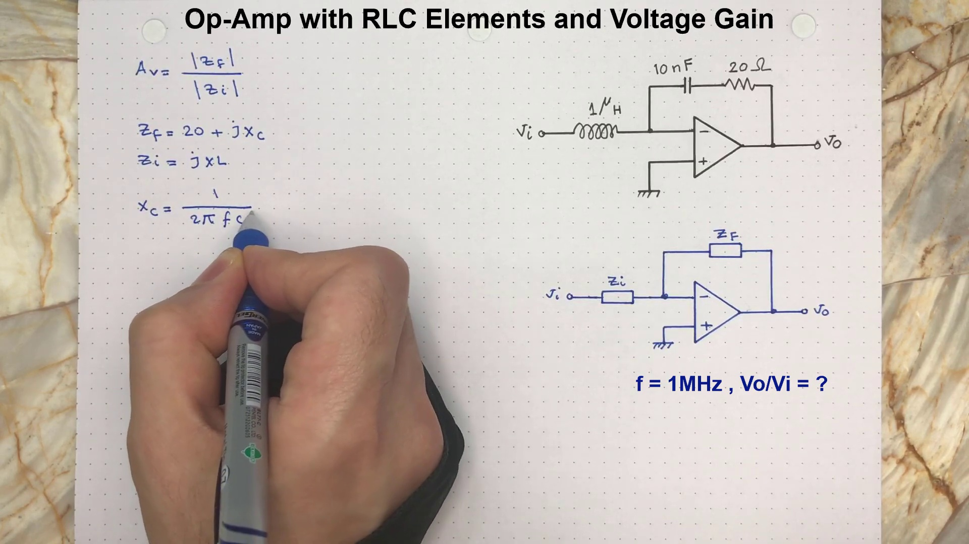 (score 98.0000)
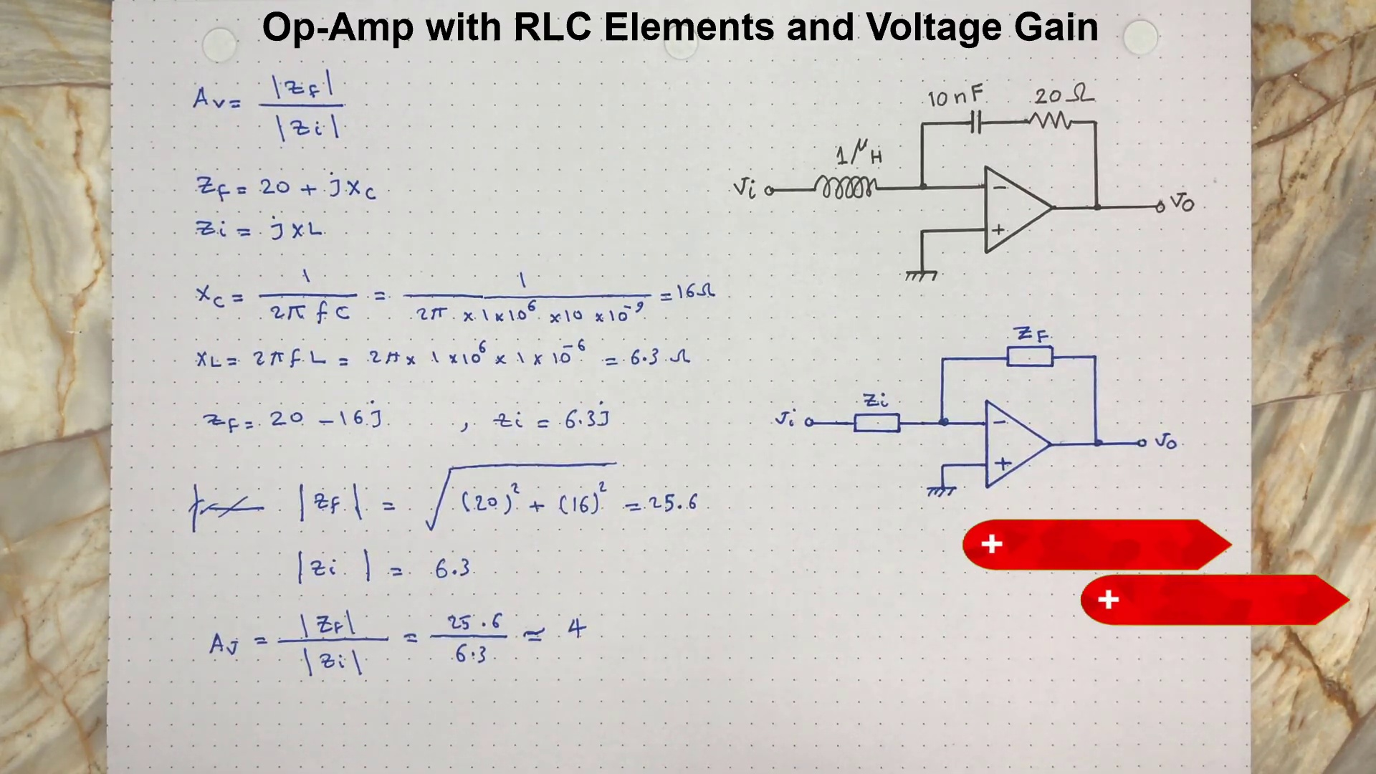 (score 95.0000)
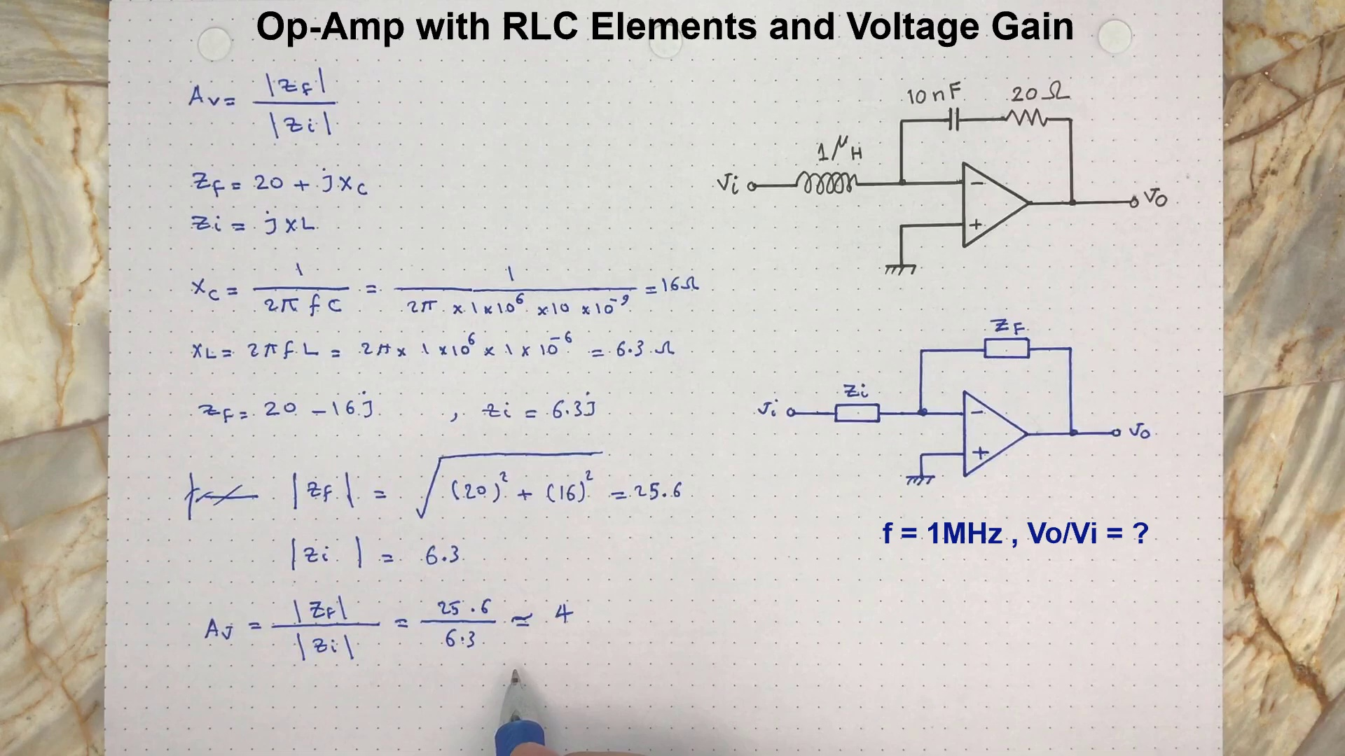 (score 95.0000)
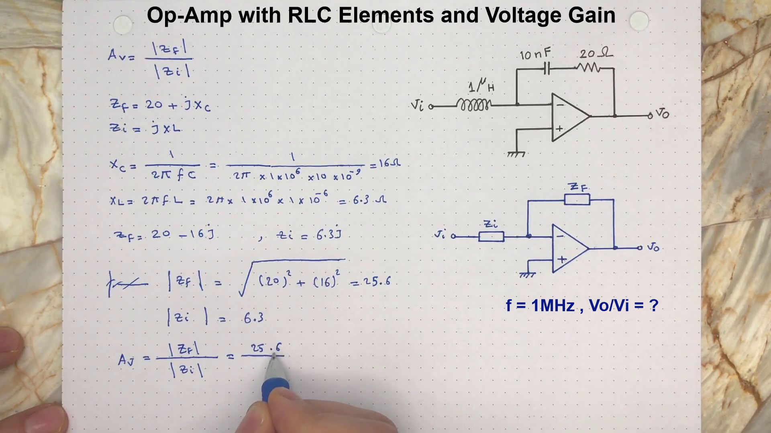 (score 95.0000)
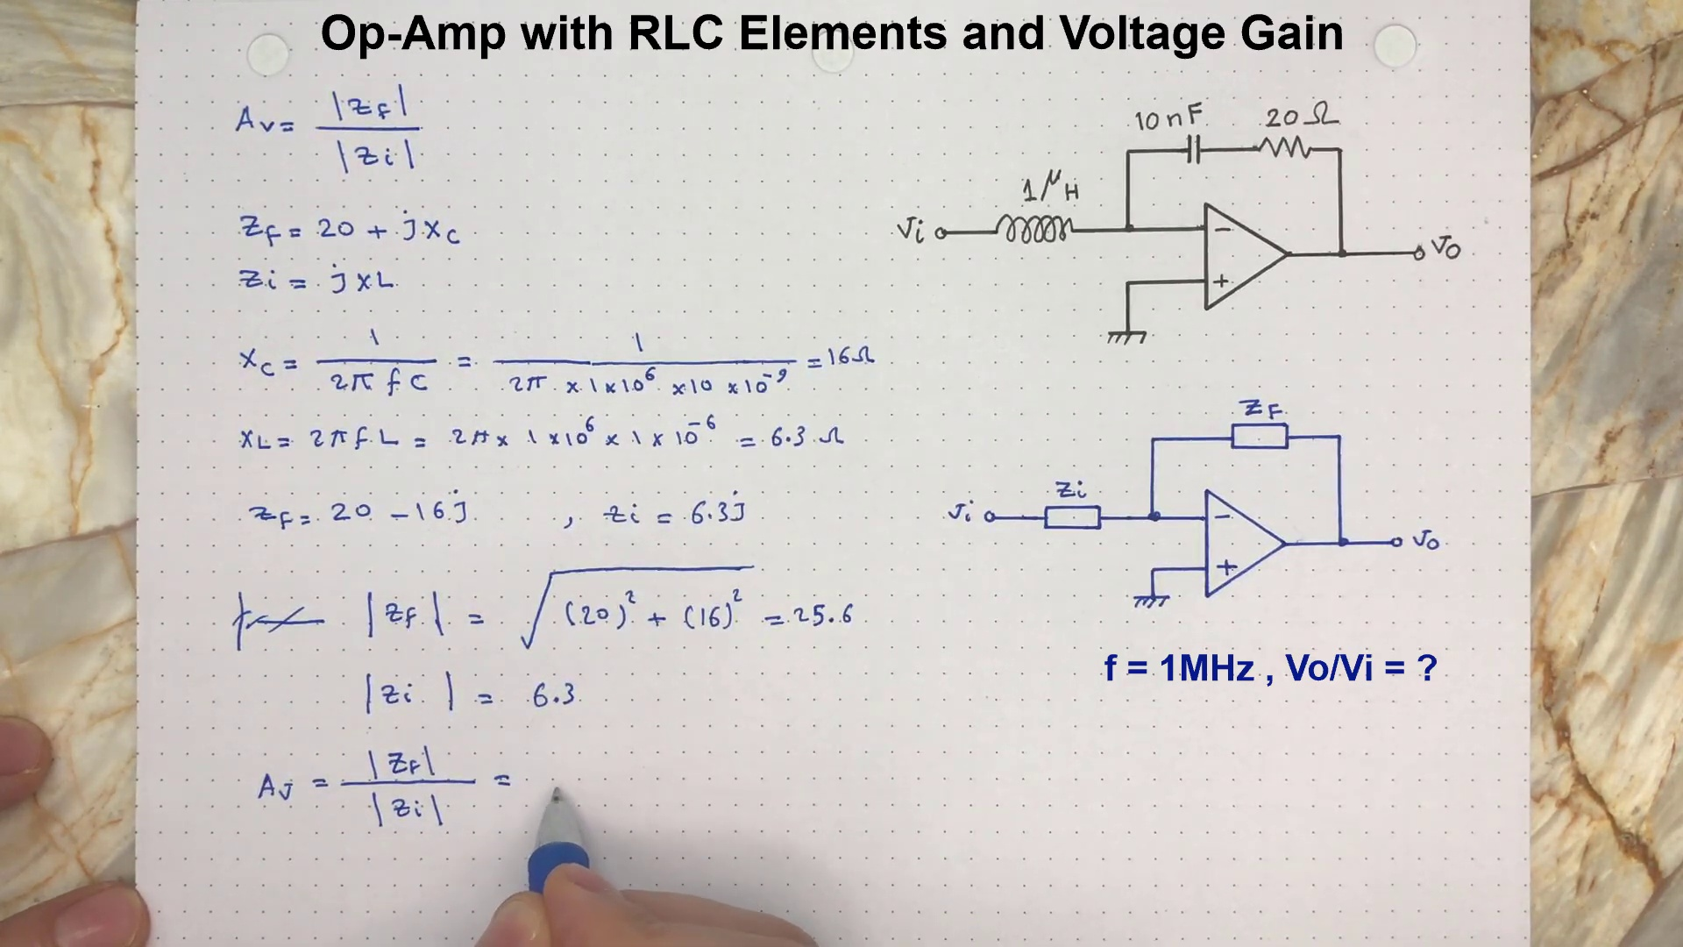 (score 95.0000)
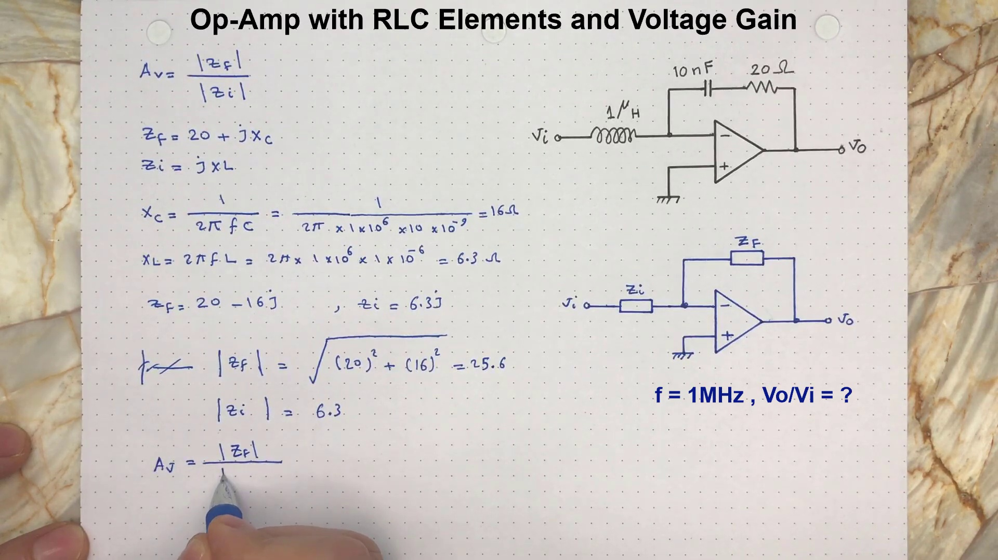 (score 95.0000)
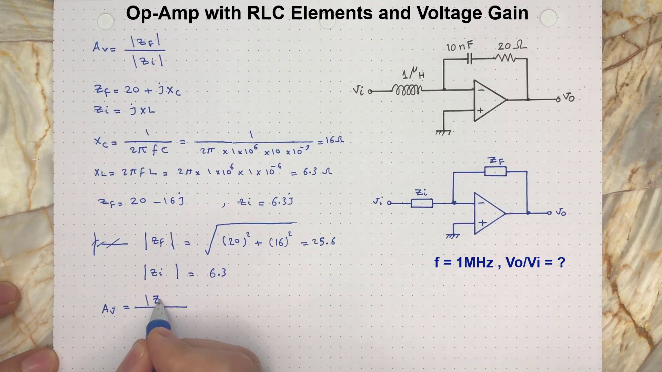 (score 95.0000)
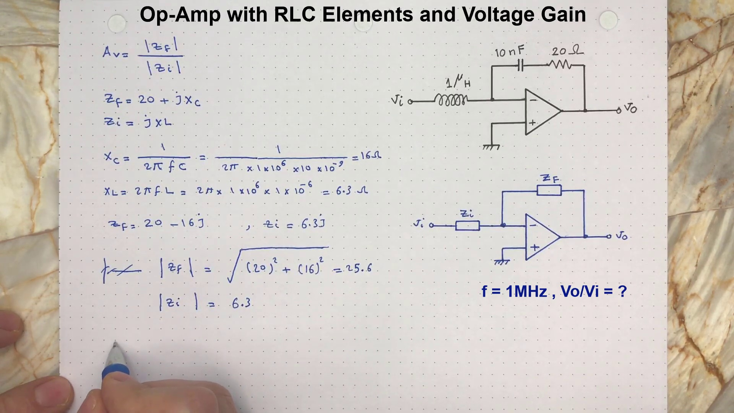 (score 95.0000)
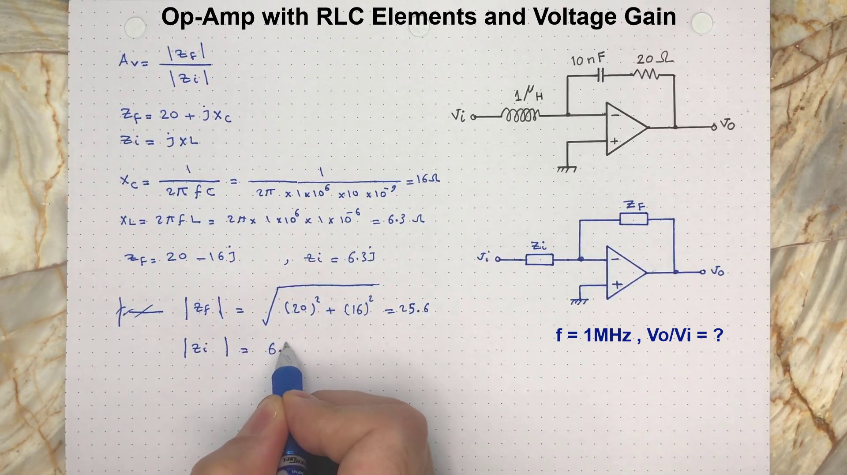 (score 95.0000)
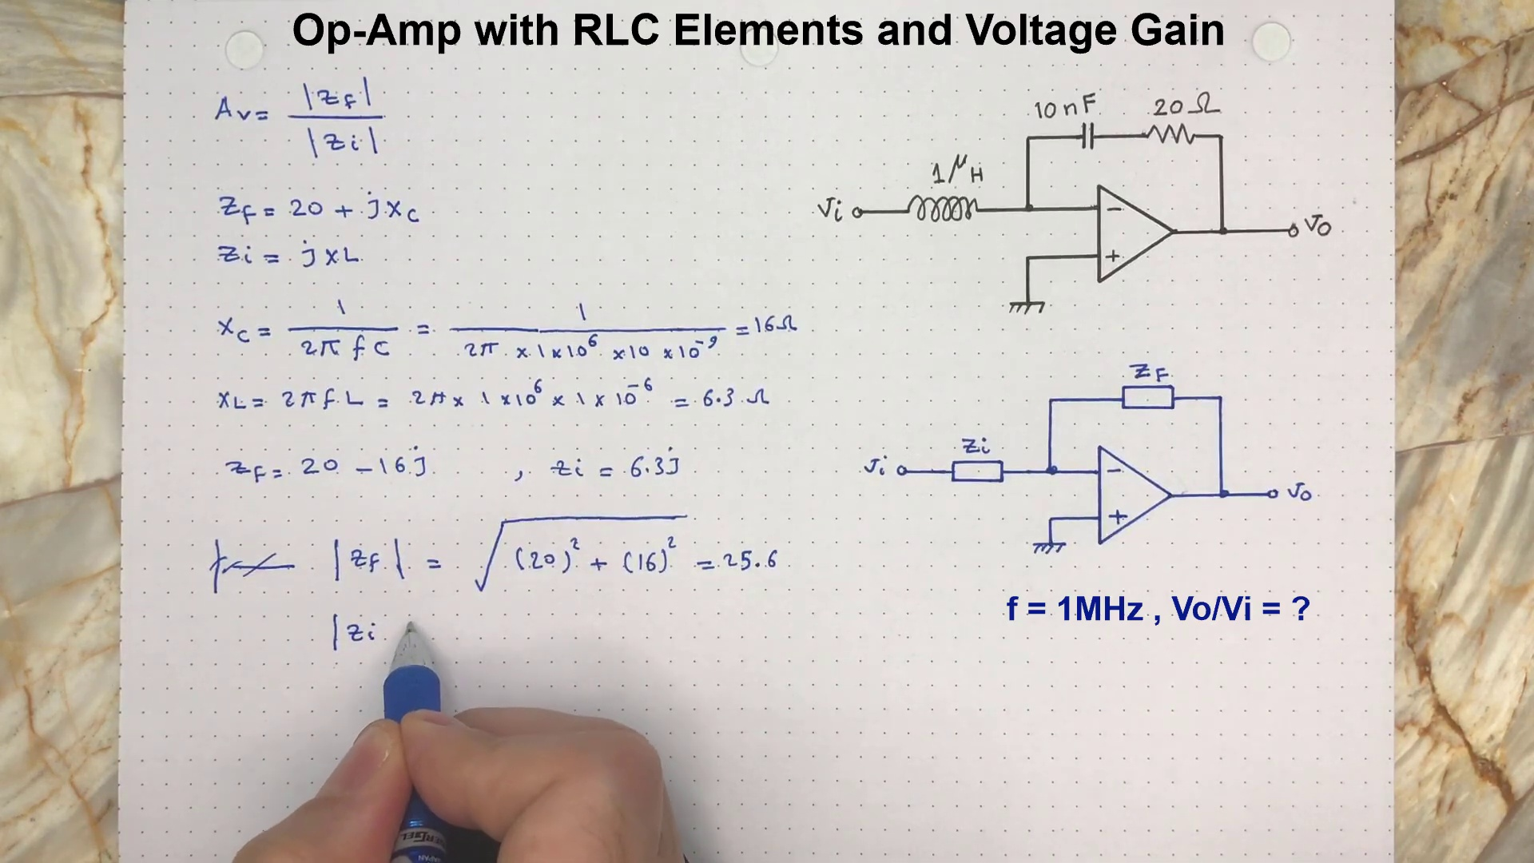 (score 95.0000)
Least correlated frames:
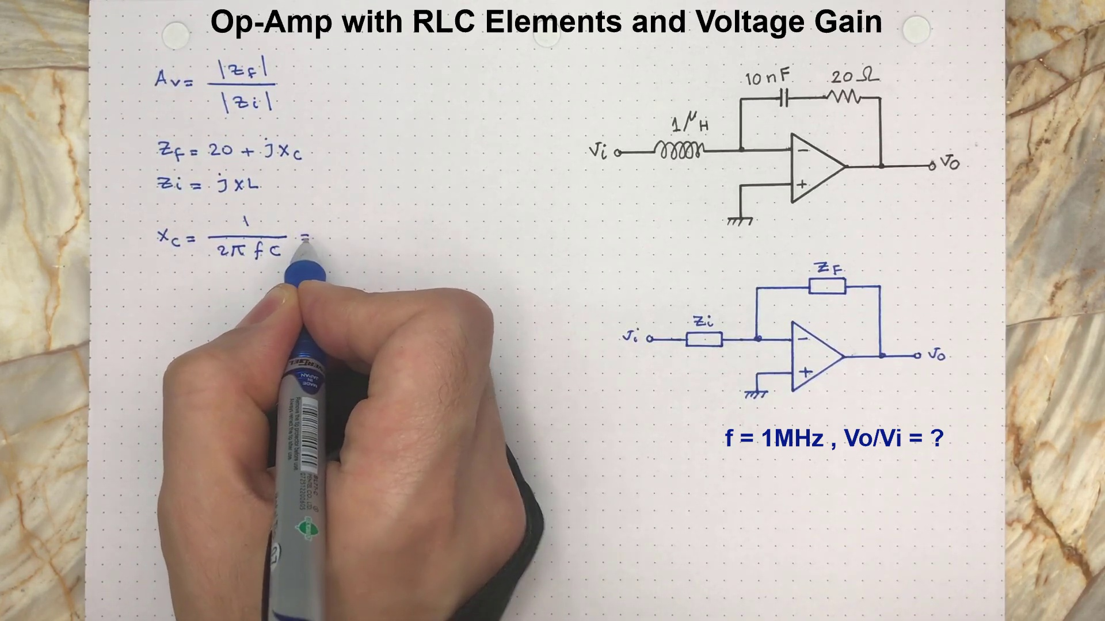 (score 0.0000)
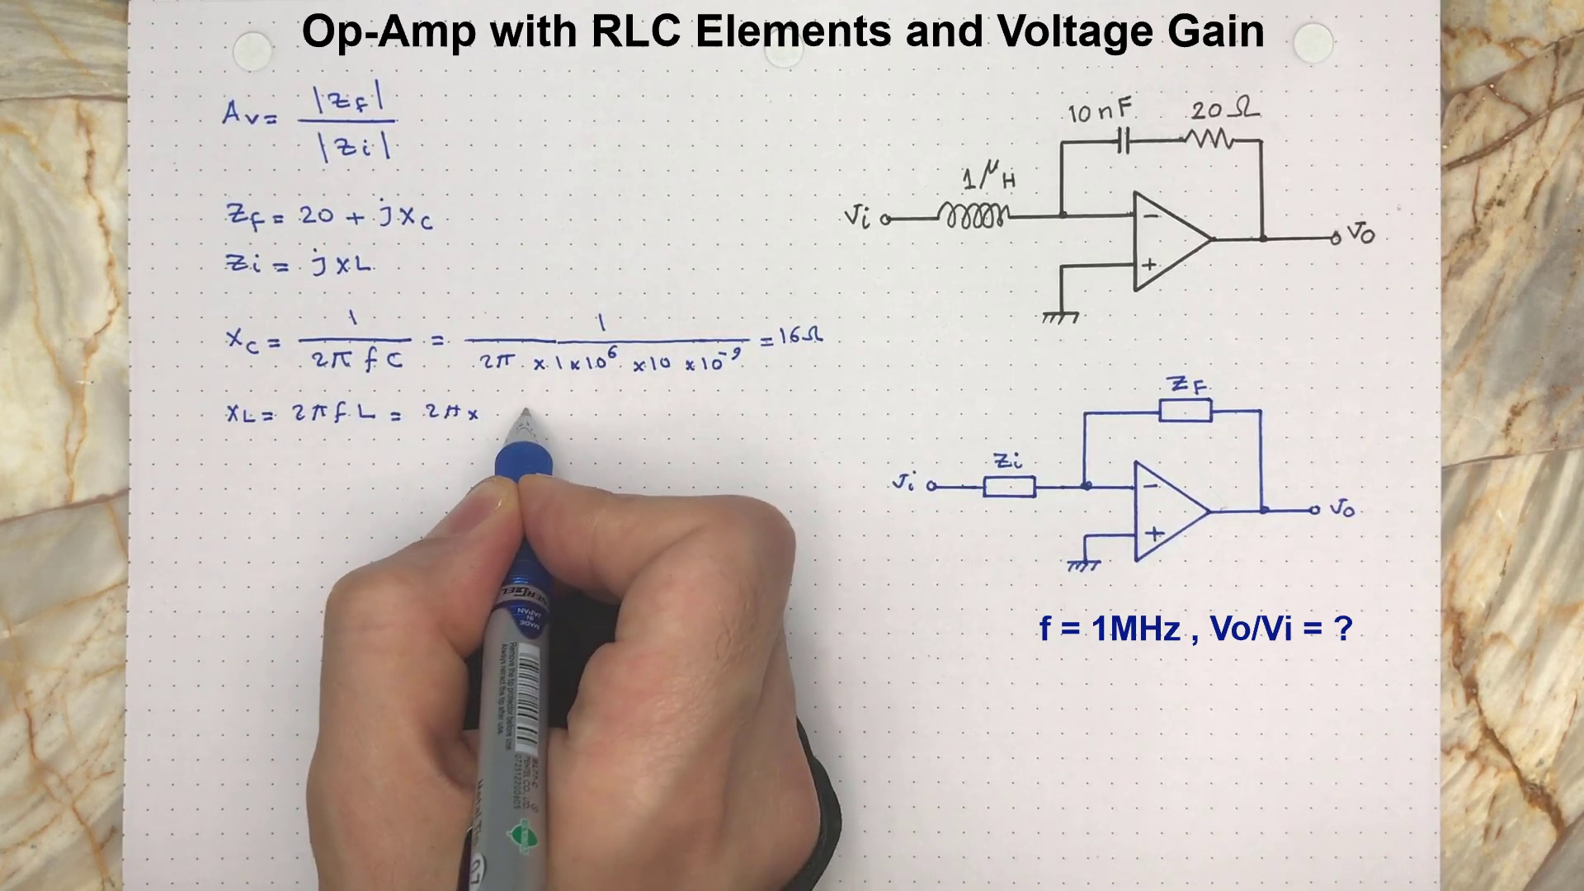 (score 0.0000)
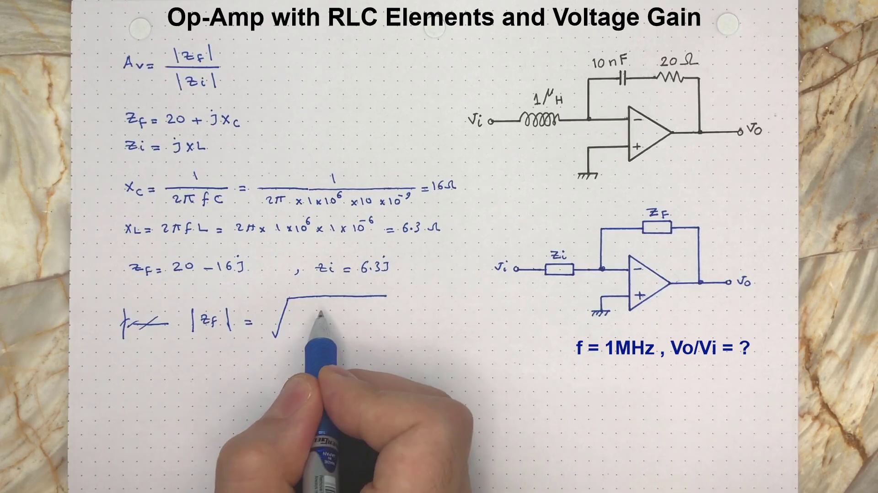 (score 20.0000)
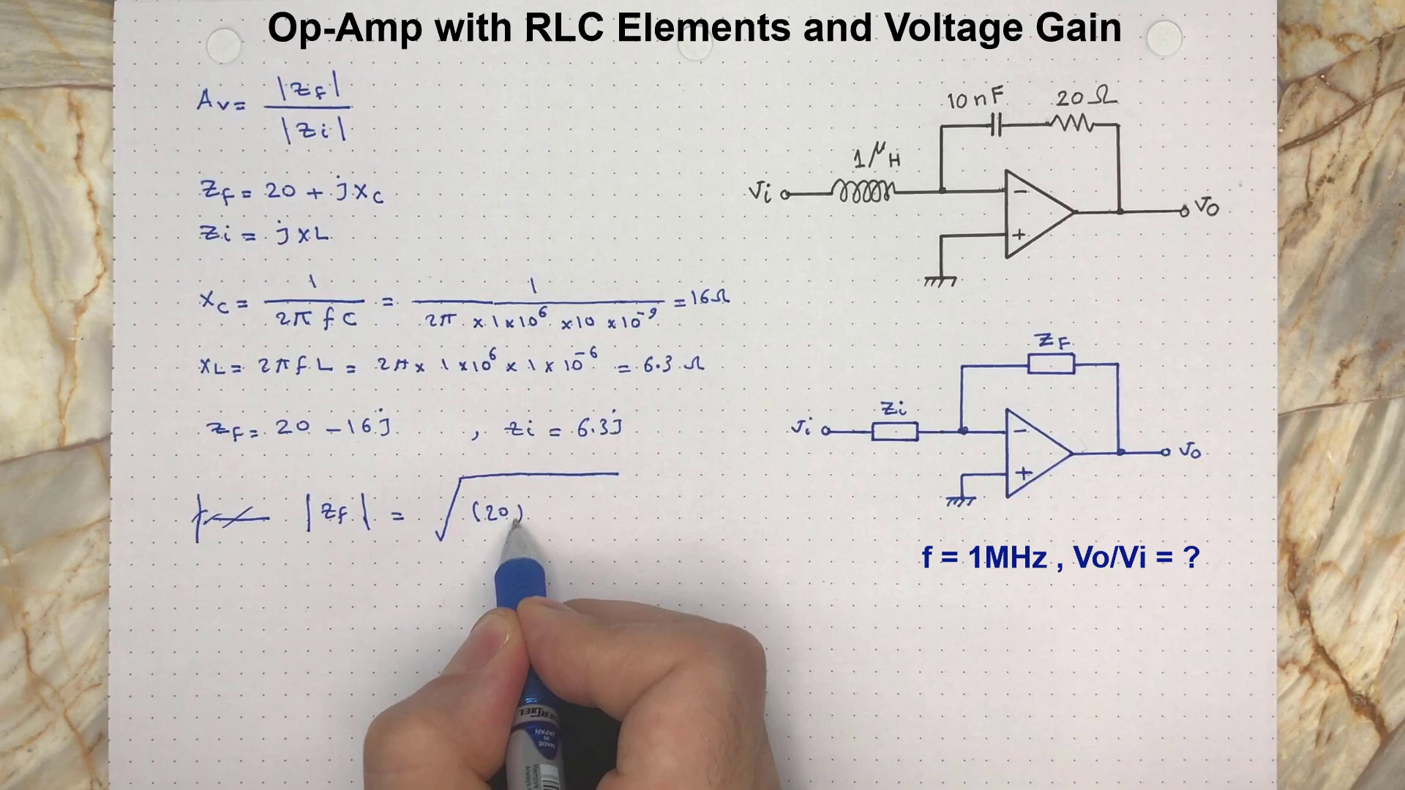 (score 20.0000)
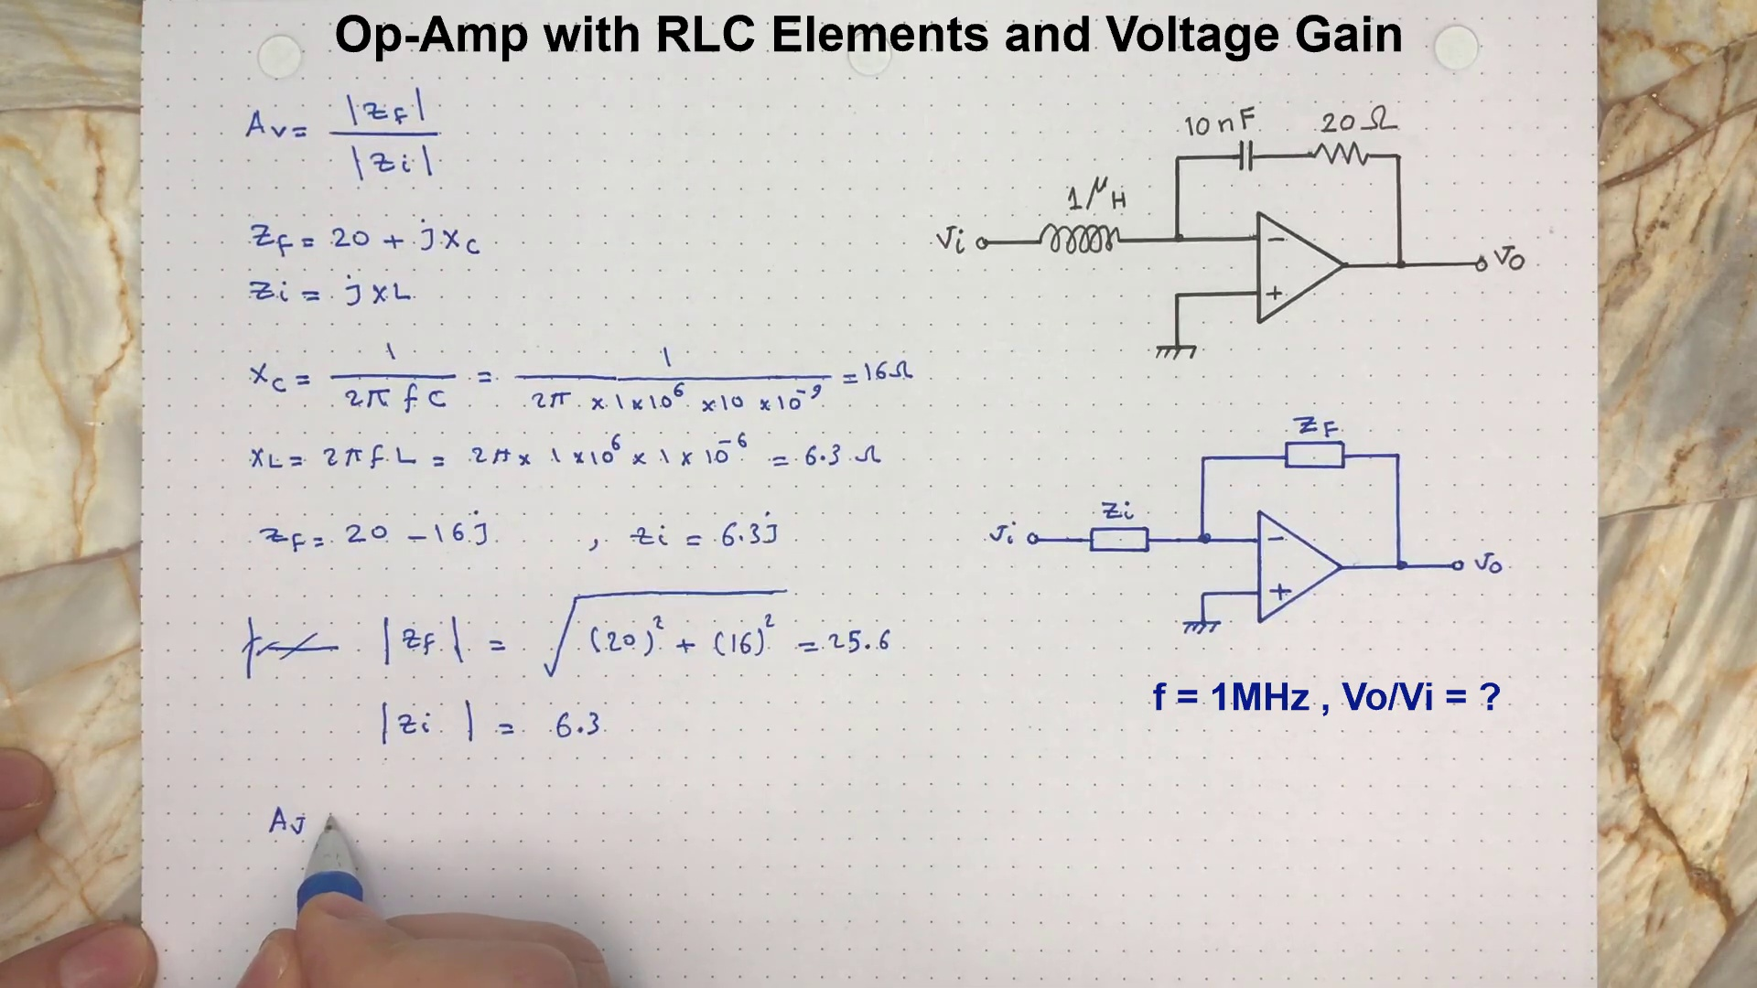 (score 20.0000)
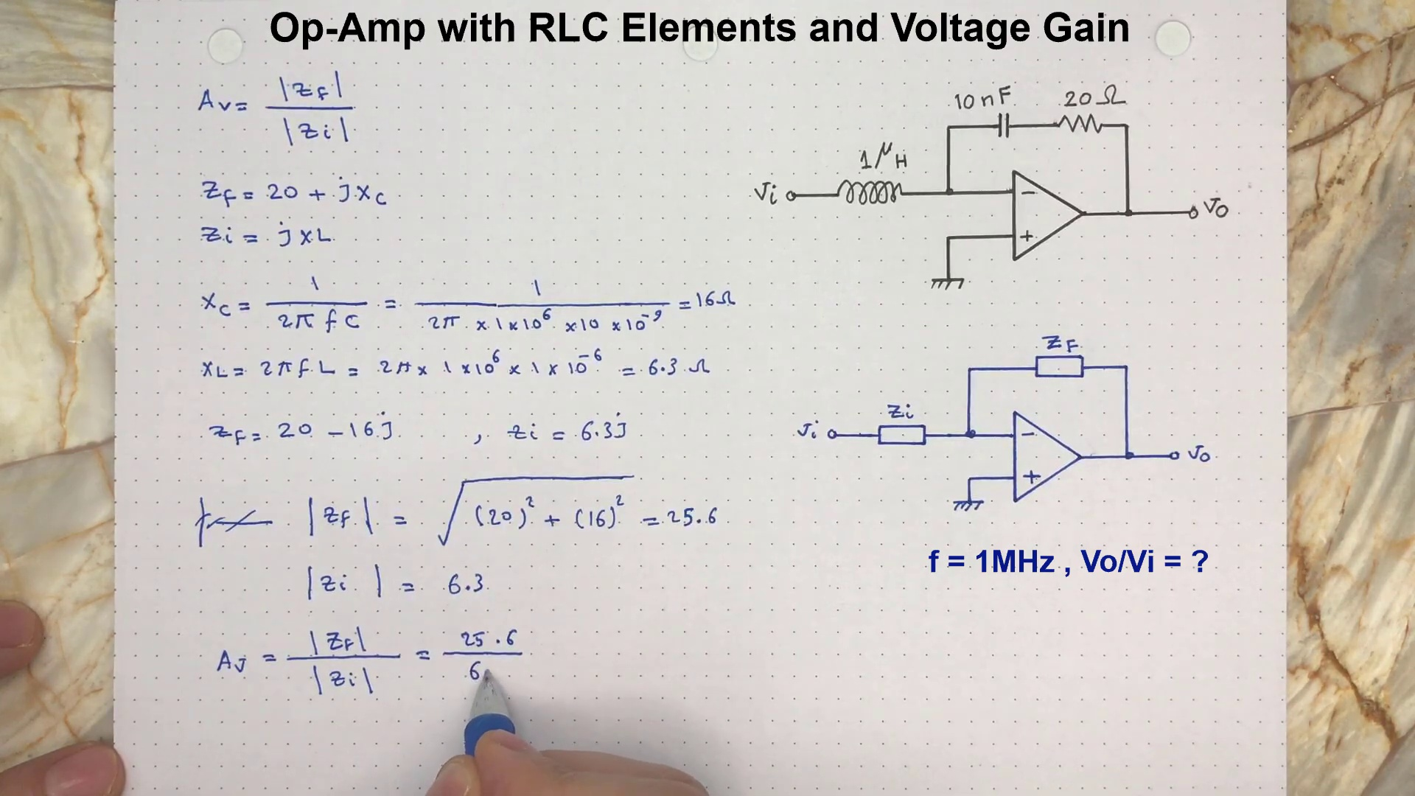 (score 20.0000)
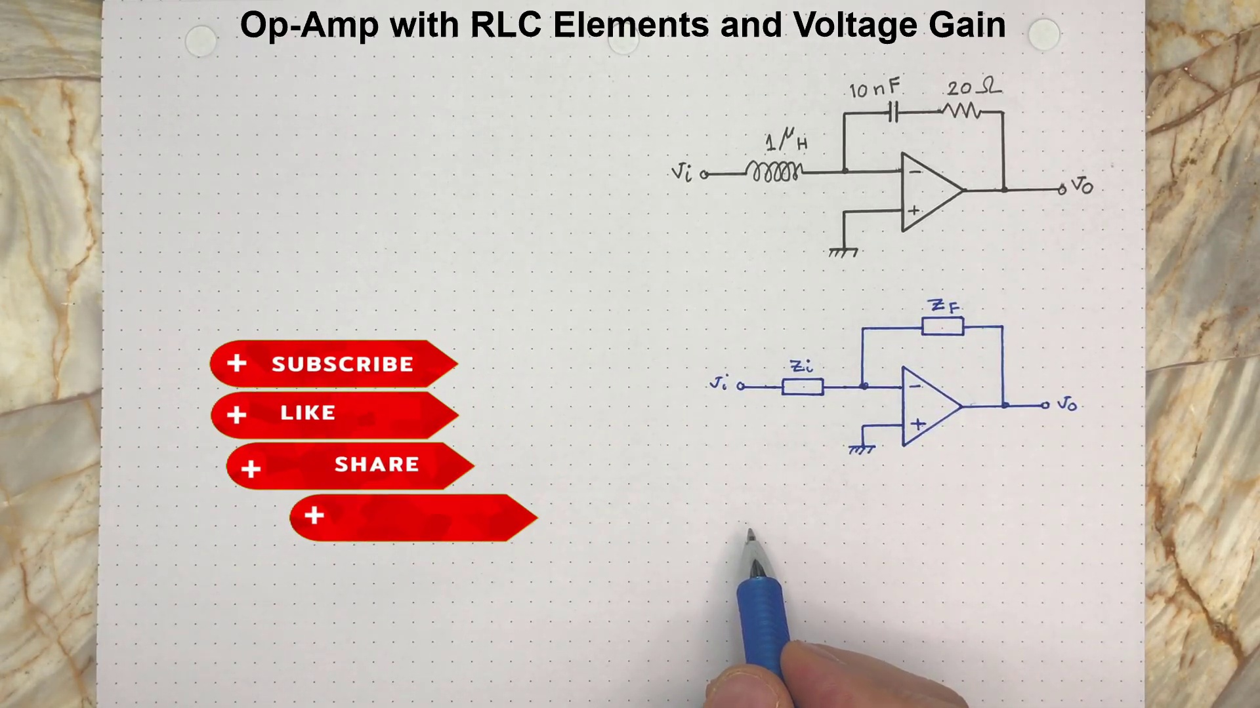 (score 80.0000)
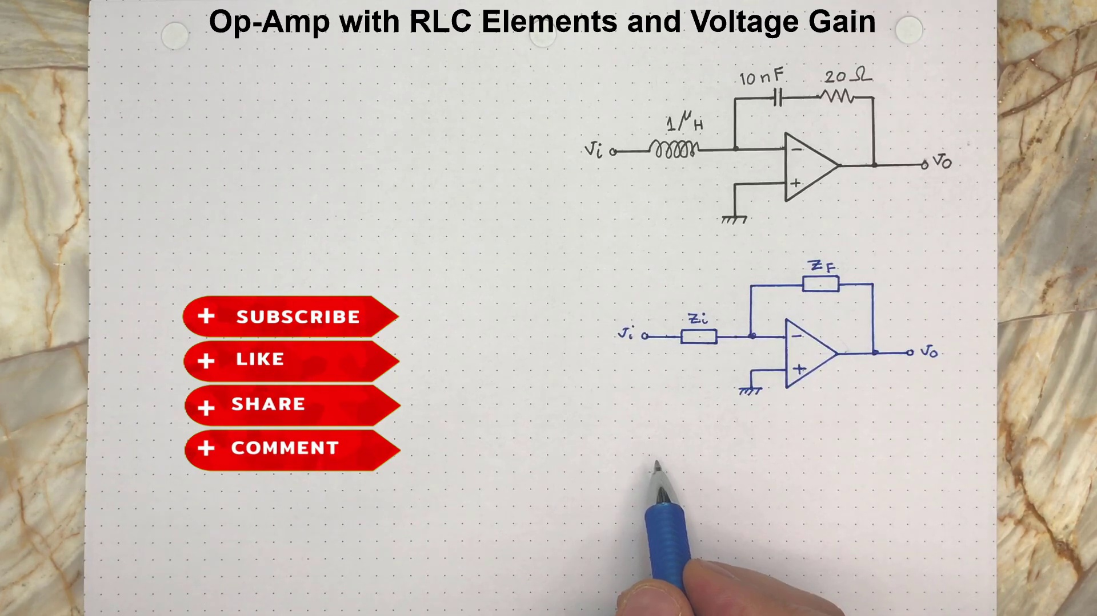 (score 80.0000)
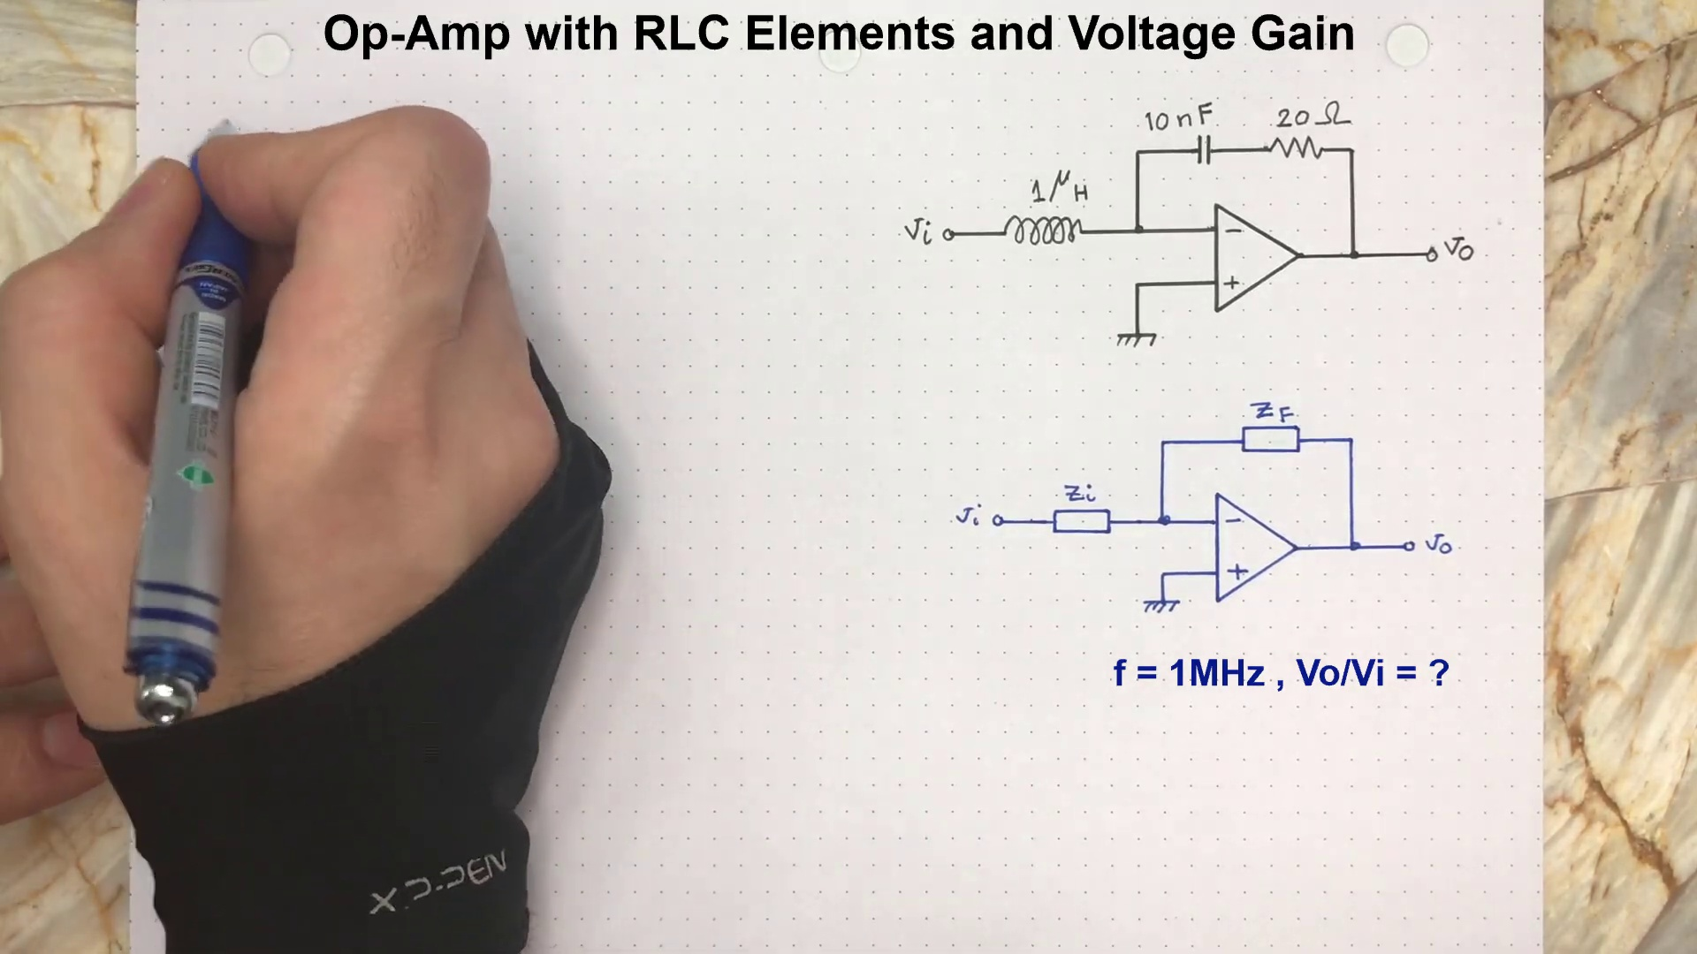 (score 80.0000)
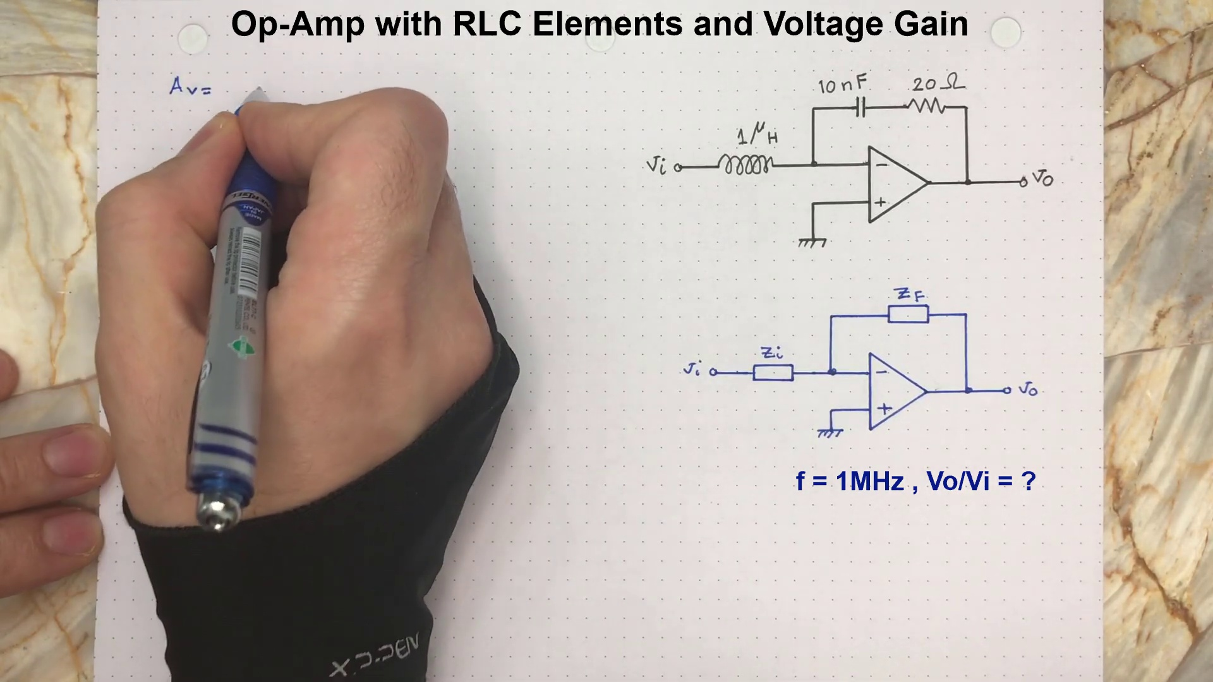 (score 80.0000)

Frame: frame_0000.jpg
Caption: The image shows a screenshot from a computer program displaying a white piece of paper with a blue pen on it. The paper appears to be used for note-taking or studying, as indicated by the presence of several elements and equations related to Op-Amps and RL Circuits. The elements include capacitors, resistors, voltage sources, and operational amplifiers, which are illustrated with diagrams showing the connections between components labeled "RLC elements." The diagrams also depict an input voltage Vcc and a gain stage.
One diagram on the paper shows a detailed schematic of an RLC series circuit, with specific values for resistances (1 kΩ) and capacitances (1 nF). This is accompanied by mathematical notations, such as "T=1/2RC," which suggests that this setup might be used to study or analyze time-domain responses.
The text on the paper also includes equations labeled with numbers and letters, indicating a discussion of supply voltages and input voltages in the context of op-amp applications. The diagram is accompanied by mathematical notations, such as "RLC elements," which refers to resistors, inductors, and capacitors, implying that the diagram is likely part of an educational activity discussing electrical engineering concepts.
Overall, the image presents a study guide or tutorial on Op-Amps and RL Circuits, with a focus on the gain and signal path characteristics.
Comment (score 90): I learned how to find the voltage gain from an OP-Amp circuit with RLC elements. I have no questions after this video.
Reason: The comment directly discusses the same technical steps (finding voltage gain from an OP-Amp circuit) and objects (RLC elements) described in the caption, demonstrating a strong correlation between the two.
Source: https://www.youtube.com/watch?v=zUyj7Xn9-sk&list=PLLA_QJ8rHZBh5LqrY41bCvKgreRDRWrBQ: FE Electrical Exam Type Question, RLC Op-Amp Circuit, Active filters using Op-Amp, Op Amp RLC

Frame: frame_0001.jpg
Caption: The image shows a paper with a diagram of an electronic circuit, specifically an Op-amp with RLC elements and voltage gain. The diagram depicts a simple RC (resistor-capacitor) low-pass filter with two resistors and one capacitor connected in series, with the input signal V1 on one side of the circuit and the output signal V2 on the other side. Next to the diagram is a handwritten note that includes the following mathematical expression:
\[ \frac{V_2}{V_1} = -(j\omega)^2 \]
This equation represents the frequency response of the RC low-pass filter, where V2/V1 is the voltage gain, and jω is the imaginary unit multiplied by the angular frequency ω. The negative sign in front of (jω)² indicates that the output signal is out of phase with the input signal.
There is no additional context or visible text from a slide about what the person holding the paper is writing, pointing, or speaking about, but the focus is solely on the diagram and the associated mathematical expression.
Comment (score 95): I learned how to find the voltage gain from an OP-Amp circuit with RLC elements. I have no questions after this video.
Reason: The comment directly discusses the voltage gain of an OP-Amp circuit with RLC elements, which is a key concept mentioned in the caption. The mention of finding the voltage gain from the circuit matches the mathematical expression provided in the caption, indicating strong correlation between the two.
Source: https://www.youtube.com/watch?v=zUyj7Xn9-sk&list=PLLA_QJ8rHZBh5LqrY41bCvKgreRDRWrBQ: FE Electrical Exam Type Question, RLC Op-Amp Circuit, Active filters using Op-Amp, Op Amp RLC

Frame: frame_0002.jpg
Caption: The image shows a whiteboard with two sections of content. On the left side, there is a diagram that appears to illustrate an electronic circuit. The diagram includes symbols for resistors (R), a capacitor (C), and a voltmeter (V), with lines connecting these components, suggesting the flow of electrical current. The values "1M" and "1k" next to the resistors indicate their resistance in megohms and kilohms respectively.
On the right side of the image, there is a handwritten note that reads "OP-AMP WITH RLC ELEMENTS AND VOLTAGE GAIN". Below this text is an equation with the variables "Vin", "Vout", "R1", "R2", "R3", and "R4", which seems to relate to the voltage gain of an operational amplifier (op-amp) in a circuit. The image also contains text that mentions "RLC ELEMENTS" and "VOLTAGE GAIN", which are concepts related to electrical engineering and electronic circuits.
In the bottom right corner, there is a blue pencil pointing at the diagram, suggesting that someone is actively working on or annotating this circuit diagram. The overall style of the image indicates it may have been taken during a teaching session or a tutorial on how to set up an op-amp with RLC (resistor-inductor-capacitor) elements for increased voltage gain in an electronic circuit.
The text and symbols on the paper are arranged in a way that suggests a discussion or explanation about Op-Amps and RL Circuit Elements. The symbols are arranged in a way that they are clearly visible and easy to read, with different sizes and colors suggesting a variety of elements in the discussion or explanation.
Comment (score 95): I learned how to find the voltage gain from an OP-Amp circuit with RLC elements. I have no questions after this video.
Reason: The comment directly discusses the voltage gain of an OP-Amp circuit with RLC elements, which is a technical topic matching the content described in the frame caption.
Source: https://www.youtube.com/watch?v=zUyj7Xn9-sk&list=PLLA_QJ8rHZBh5LqrY41bCvKgreRDRWrBQ: FE Electrical Exam Type Question, RLC Op-Amp Circuit, Active filters using Op-Amp, Op Amp RLC

Frame: frame_0003.jpg
Caption: The image shows a whiteboard with various elements related to electronics and voltage gain. On the left side of the board, there is a handwritten note that reads "RLC circuit," with an arrow pointing to a specific part of the circuit. Next to the text are diagrams and equations that likely explain the concept of RLC circuits and voltage gain.
In the center of the board, there is a circuit diagram representing an RLC series circuit, composed of resistors (R), inductors (L), and capacitors (C). On the right side of the board, a person is seen holding a pen, possibly explaining or adding notes to the existing diagrams and equations.
The top right corner has two items: a red button with text "Share," suggesting that the image might have been taken using a device, and another note that says "RLC elements and voltage gain." At the bottom of the whiteboard, there is a sticky note with text "like," indicating some form of social interaction or feedback.
The overall setting suggests an educational context, possibly for teaching electronics or physics concepts such as RLC circuits and how they contribute to voltage gain in certain applications. The person in the photo appears to be engaging with the whiteboard content by writing or drawing next to the existing notes and diagrams.
The diagram also shows a separate image of an Op-amp circuit with RLC elements and voltage gain, featuring two resistors, one capacitor, and one inductor connected in series. The circuit is colored in shades of blue and red, with the resistors in blue and the capacitor and inductor in red, set against a white background. A blue pen is visible, suggesting that the circuit is being designed or analyzed.
The text "Op-amp with RLC Elements and Voltage Gain" is written in the top left corner of the diagram, indicating the type of circuit being depicted.
Comment (score 80): I learned how to find the voltage gain from an OP-Amp circuit with RLC elements. I have no questions after this video.
Reason: The comment directly discusses the same technical steps and settings described in the caption, specifically referencing OP-Amp circuits with RLC elements and voltage gain.
Source: https://www.youtube.com/watch?v=zUyj7Xn9-sk&list=PLLA_QJ8rHZBh5LqrY41bCvKgreRDRWrBQ: FE Electrical Exam Type Question, RLC Op-Amp Circuit, Active filters using Op-Amp, Op Amp RLC

Frame: frame_0004.jpg
Caption: The image shows a whiteboard with handwritten diagrams and notes related to an educational topic on operational amplifiers (op-amps) with RLC elements and voltage gain. At the top of the board, there's a note that reads "Op-amp with RLC elements and voltage gain." Below this text, there are two diagrams:
1. A simple circuit diagram featuring an op-amp connected in a non-inverting configuration, powered by a 9V DC source. The op-amp is labeled as IC1, and it's accompanied by resistors (R1-R5) and capacitors (C1-C3).
2. A superposition of the first diagram, showing the AC response of the op-amp circuit with additional resistors (R6-R8) and a capacitor (C4). The diagram includes lines representing AC signals and a phasor for the voltage gain, indicating the effect of frequency on the circuit's response.
3. A note at the bottom right corner of the board that says "Like," suggesting that the person taking this photo found the topic interesting or was engaged with the content being taught.
4. The image also features a hand with a pen on the left side, indicating someone is taking notes or writing on the whiteboard.
5. A cell phone is visible in the bottom left corner of the image, possibly used for note-taking or communication during the class.
6. In the lower right corner of the image, there's a watermark that reads "Share," implying that this photo might be shared on social media platforms or through messaging apps.
The background behind the whiteboard is not fully visible due to the focus on the board itself; however, it appears to be an indoor setting with natural light coming from the upper part of the image.
Comment (score 80): I learned how to find the voltage gain from an OP-Amp circuit with RLC elements. I have no questions after this video.
Reason: The comment directly discusses the topic of finding voltage gain from an OP-Amp circuit with RLC elements, which is also described in the caption. The mention of OP-Amp and RLC elements matches exactly with the diagrams shown on the whiteboard.
Source: https://www.youtube.com/watch?v=zUyj7Xn9-sk&list=PLLA_QJ8rHZBh5LqrY41bCvKgreRDRWrBQ: FE Electrical Exam Type Question, RLC Op-Amp Circuit, Active filters using Op-Amp, Op Amp RLC

Frame: frame_0005.jpg
Caption: The image captures a moment of focused work as someone works on a piece of paper filled with circuit diagrams and equations related to Op-Amp elements and voltage gain. The diagrams are marked with various symbols, such as resistors (R), capacitors (C), and operational amplifiers (OP-AMPs). A blue pen is used to add annotations and notes to the diagrams, which include mathematical expressions or equations written in a clear, legible font.
On the top portion of the paper, there is a handwritten diagram explaining an electronic circuit labeled "OP-AMP with RLC ELEMENTS and VOLTAGE GAIN." The circuit features resistors (R), capacitors (C), and two operational amplifiers (OP-AMPs). An arrow points from the circuit schematic to a text box on the right side of the paper, indicating a connection between the two parts of the diagram.
The background is a neutral beige wall, providing a calm setting that allows the colorful diagrams and the person's work to stand out.
Comment (score 90): I learned how to find the voltage gain from an OP-Amp circuit with RLC elements. I have no questions after this video.
Reason: The comment directly discusses the OP-Amp circuit with RLC elements and voltage gain, which is also mentioned in the caption. The specific diagram labeled 'OP-AMP with RLC ELEMENTS and VOLTAGE GAIN' matches the topic of the comment.
Source: https://www.youtube.com/watch?v=zUyj7Xn9-sk&list=PLLA_QJ8rHZBh5LqrY41bCvKgreRDRWrBQ: FE Electrical Exam Type Question, RLC Op-Amp Circuit, Active filters using Op-Amp, Op Amp RLC

Frame: frame_0006.jpg
Caption: The image shows a person's hand in the lower right corner, suggesting that they are writing or pointing to something related to a diagram or explanation. The focus of the image is on a diagram and accompanying text which appears to relate to electrical circuits or electronic components.
The text reads "OP-AMP WITH RLC ELEMENTS AND VOLTAGE GAIN" with additional text indicating "INPUT=5V" and "OUTPUT=10V". This implies that the context is an educational demonstration or explanation of how to set up a circuit using an operational amplifier (op-amp) with resistors (R), capacitors (C), and inductors (L) to achieve voltage gain. The op-amp has been labeled as a "5V INPUT" and a "10V OUTPUT", suggesting that the input voltage is 5 volts and the expected output voltage is 10 volts.
The diagram below the text shows an electronic circuit. There are three main components visible:
* An operational amplifier, which is at the center of the circuit, with the non-inverting input connected to a 10kΩ resistor and the inverting input connected to another 5V source (not explicitly shown). The amplifier's output is connected to two additional components.
* A resistor (R1) connected from the non-inverting input of the op-amp to ground.
* Another component, which seems to be an inductor (L), connected between the op-amp's output and ground.
The circuit appears to be set up for demonstration or educational purposes, possibly as part of a lesson on basic electronic circuits or electrical engineering concepts such as amplification using operational amplifiers. The individual is in the process of explaining the circuit or providing notes related to it.
In the upper section of the white piece of paper, a diagram presents an Op-amp circuit, which includes various components like resistors, capacitors, and a transistor.
No strongly correlated comments found for this frame.

Frame: frame_0007.jpg
Caption: This image presents a hand-drawn diagram of an electronic circuit on white paper, accompanied by black text. The diagram illustrates an operational amplifier (op-amp) in a non-inverting configuration with associated components, including two resistors (a fixed resistor Rf and a variable resistor Rin), connected to a voltage source. Below the diagram is a mathematical expression for the voltage gain of the op-amp:
\[ V_{out} = I_f \cdot (R_{f}/R_{in}) \]
This equation represents the relationship between the input current If, the input resistance Rin, and the output voltage Vout. The text on the paper reads "Op-Am with RLC Elements and Voltage Gain", indicating that the diagram depicts an op-amp with RLC elements and a discussion of its voltage gain.
The diagrams on the paper also depict a circuit with a capacitor and an inductor, characterized by the letters "F", "V", and "I". The word "Op-Am" is present on the paper, further emphasizing the focus on operational amplifiers. The overall scene suggests a discussion or explanation of an electrical circuit involving an op-amp with RLC elements and voltage gain, likely in an educational or instructional context related to electronic engineering or a related field.
Comment (score 90): I learned how to find the voltage gain from an OP-Amp circuit with RLC elements. I have no questions after this video.
Reason: The comment directly discusses the same technical steps (finding voltage gain) and objects (OP-Amp circuit with RLC elements) described in the caption.
Source: https://www.youtube.com/watch?v=zUyj7Xn9-sk&list=PLLA_QJ8rHZBh5LqrY41bCvKgreRDRWrBQ: FE Electrical Exam Type Question, RLC Op-Amp Circuit, Active filters using Op-Amp, Op Amp RLC

Frame: frame_0008.jpg
Caption: The image shows a handwritten note or diagram on white paper with various elements related to an electronics project or lesson. The top left corner features a title that reads "OP-AMP WITH RLC ELEMENTS AND VOLTAGE GAIN." Below this, the diagram is divided into two main sections: the left side and the right side.
On the left side of the diagram, a RLC circuit is represented by black lines and labels. The RLC elements are denoted by black circles, and voltage gain is illustrated by black lines. On the right side, an operational amplifier (op-amp) is depicted using black circles, with voltage gain also represented by black lines.
A handwritten equation on the right side of the paper appears to relate to voltage gain in an op-amp circuit with series resistors: "R1/R2" at the top, "Vin - Vout = 0" in the middle, and "Av = Vout/Vin" below it. A small illustration on the bottom right corner shows a model of an amplifier circuit with a 9-volt battery connected across a set of resistors, including a 10kΩ resistor labeled "R1," a 2kΩ resistor labeled "R2," and a 470Ω resistor labeled "R3."
A blue-handled object at the bottom right corner of the photo appears to be a marker or pen, indicating that someone was actively drawing or writing on this paper. The overall setting suggests an educational context, possibly a classroom or study area where someone is learning about electronic components and their application in circuits.
The diagram is accompanied by text that reads "f = 1F, V0 = 0V, V1 = 2V," likely providing information about the values of the RLC elements and voltage gain in the circuit.
Comment (score 95): I learned how to find the voltage gain from an OP-Amp circuit with RLC elements. I have no questions after this video.
Reason: The comment directly discusses the voltage gain from an OP-Amp circuit with RLC elements, which is precisely what is described in the caption, including the specific components and settings mentioned.
Source: https://www.youtube.com/watch?v=zUyj7Xn9-sk&list=PLLA_QJ8rHZBh5LqrY41bCvKgreRDRWrBQ: FE Electrical Exam Type Question, RLC Op-Amp Circuit, Active filters using Op-Amp, Op Amp RLC

Frame: frame_0009.jpg
Caption: The image shows a whiteboard filled with handwritten notes and diagrams related to electrical engineering or electronics. At the top of the board, text reads "OP-AMP WITH RLC ELEMENTS AND VOLTAGE GAIN." Below this title, two separate sections are presented: one titled "RLC ELEMENTS" and another titled "VOLTAGE GAIN."
In the "RLC ELEMENTS" section, a schematic diagram shows an RLC circuit consisting of a resistor (R), an inductor (L), and a capacitor (C). Mathematical expressions for impedance are also included: Zr for resistance, Zi for inductance, and Zc for capacitance.
The "VOLTAGE GAIN" section features a block diagram depicting an operational amplifier (op-amp) with connections to resistors and capacitors. Two input terminals, labeled "V1" and "V2," are shown, as well as a single output terminal, labeled "Vo." The op-amp is configured as a non-inverting amplifier, amplifying the signal at the input terminal "V1" without inverting its phase.
On the right side of the image, the person taking the photo appears to be writing or drawing with a blue pen. This suggests they may be adding more information or refining the diagrams. The overall setting implies an educational environment where someone is teaching or learning about electronic circuits and amplifier concepts.
Comment (score 90): I learned how to find the voltage gain from an OP-Amp circuit with RLC elements. I have no questions after this video.
Reason: The comment directly discusses the same technical steps and concepts described in the caption, specifically the voltage gain from an OP-Amp circuit with RLC elements. The mention of learning how to find the voltage gain matches the topic and goals presented in the caption.
Source: https://www.youtube.com/watch?v=zUyj7Xn9-sk&list=PLLA_QJ8rHZBh5LqrY41bCvKgreRDRWrBQ: FE Electrical Exam Type Question, RLC Op-Amp Circuit, Active filters using Op-Amp, Op Amp RLC

Frame: frame_0010.jpg
Caption: The image shows a whiteboard or piece of paper with handwritten notes that appear to relate to an electrical engineering or physics concept. At the top, there is a title written in black text that reads "Op-amp with RLC Elements and Voltage Gain." Below this title, there are various symbols, equations, and diagrams that suggest a discussion on operational amplifiers (op-amps) and their application in RLC circuits.
The diagram features several components labeled as resistors (R), inductors (L), and capacitors (C), with lines connecting them typical for an op-amp circuit. A pen is visible on the paper or whiteboard, indicating that someone has been working on the notes. The handwriting and style of the notes suggest that this could be a teaching session, study note, or presentation where concepts related to operational amplifiers are being explained or demonstrated.
The specific values of the resistors, inductors, and capacitors are not fully legible due to the angle and resolution of the photograph. However, a text box with mathematical representation is visible, possibly indicating the gain of the amplifier, which could be a function of the circuit components like resistors (R1) and others.
The blue pen resting on a surface in the bottom right corner of the image suggests that someone might have been writing or making notes before the photo was taken. The overall context suggests an educational setting where someone is either learning about operational amplifiers or explaining the principles to others in a classroom or lab environment.
No strongly correlated comments found for this frame.

Frame: frame_0011.jpg
Caption: The image shows a handwritten diagram on a gray tabletop with a marble pattern, featuring a circuit design for an RC circuit with voltage gain. At the top, there is a title "Op-amp with RLC elements and Voltage Gain", indicating the components used in the circuit. The diagram includes lines representing electrical connections between the components and a central text box labeled "V1 1mV", specifying the input voltage of 1 millivolt.
The circuit design features an operational amplifier (op-amp) and additional components, including resistors (R), inductors (L), and capacitors (C). Arrows indicate the direction of current flow through the circuit. The note below the diagram explains that the value of V1 is 1 millivolt, which will be amplified by the RC circuit.
The diagram also includes mathematical symbols representing the impedance of each component, including resistors, inductors, and capacitors. One of the resistors is labeled as a 10F element, indicating its value.
At the bottom right corner of the image, there is a blue pen with a hand holding it over the paper, suggesting that the person is writing or about to write on the diagram. The circuit design is intended to create a gain of [ unknown or not specified], and the overall goal is to amplify the input voltage V1 using the RC circuit with an op-amp.
Comment (score 90): I learned how to find the voltage gain from an OP-Amp circuit with RLC elements. I have no questions after this video.
Reason: The comment directly references the technical steps and components described in the caption, specifically mentioning OP-Amp circuit with RLC elements and voltage gain. The comment also shows a clear understanding of the concepts presented in the caption, as evidenced by the statement 'I have no questions after this video'.
Source: https://www.youtube.com/watch?v=zUyj7Xn9-sk&list=PLLA_QJ8rHZBh5LqrY41bCvKgreRDRWrBQ: FE Electrical Exam Type Question, RLC Op-Amp Circuit, Active filters using Op-Amp, Op Amp RLC

Frame: frame_0012.jpg
Caption: The image shows a sheet of paper with hand-drawn diagrams, text, and an electrical circuit being drawn. On the top left, there is a title that reads "Op-Am with RLC Elements and Voltage Gain". Below this, there are two diagrams: one on the left labeled "RLC circuit" and another on the right labeled "VCCI VCC2". Each diagram includes resistors (R), inductors (L), and capacitors (C).
In addition to the diagrams, a drawing of an operational amplifier (op-amp) is positioned between the circuits, representing an op-amp. The op-amp has symbols indicating its inputs and outputs, with the positive input (V+) on the left and the negative input (V-) on the right. Two lines are drawn from the output to represent gain.
On the same page, an electrical circuit is being drawn, consisting of two resistors connected in series, one capacitor, and a transistor. The values of the resistors are indicated as 100 and 200, and the capacitor is specified as 1000uF. The transistor is represented as a 1N4148.
A hand holding a blue pen can be seen above the paper, presumably used for drawing and writing on the paper. However, no details about the person are provided.
Comment (score 95): I learned how to find the voltage gain from an OP-Amp circuit with RLC elements. I have no questions after this video.
Reason: The comment directly discusses the concept of finding voltage gain from an OP-Amp circuit with RLC elements, which is exactly described in the caption, highlighting the diagrams and components mentioned, such as the op-amp's inputs and outputs.
Source: https://www.youtube.com/watch?v=zUyj7Xn9-sk&list=PLLA_QJ8rHZBh5LqrY41bCvKgreRDRWrBQ: FE Electrical Exam Type Question, RLC Op-Amp Circuit, Active filters using Op-Amp, Op Amp RLC

Frame: frame_0013.jpg
Caption: The image shows a hand-drawn diagram and annotations on a piece of paper, with a blue pen lying next to it. The diagram illustrates an electronic circuit featuring components such as a resistor (RCL), a capacitor (C), and a voltage gain element, connected in series within the circuit. The annotations include text that reads "RLC ELEMENTS AND VOLTAGE GAIN" and "1/RCL * Vo? V1/RCL = 1W?", suggesting that the diagram is being used as part of a discussion or explanation regarding impedance (RCL), voltage gain, and the use of resistors in conjunction with capacitors for voltage amplification. The script written on the paper in cursive style reads "Op-amp with RLC elements and voltage gain", inviting the viewer to engage with the content further.
The background behind the paper appears to be a room with indoor lighting and some indistinct furniture or decorations, providing a casual setting for this educational activity.
Comment (score 95): I learned how to find the voltage gain from an OP-Amp circuit with RLC elements. I have no questions after this video.
Reason: The comment directly discusses the same technical steps and concepts described in the caption, specifically the use of OP-Amp circuits with RLC elements to find voltage gain.
Source: https://www.youtube.com/watch?v=zUyj7Xn9-sk&list=PLLA_QJ8rHZBh5LqrY41bCvKgreRDRWrBQ: FE Electrical Exam Type Question, RLC Op-Amp Circuit, Active filters using Op-Amp, Op Amp RLC

Frame: frame_0014.jpg
Caption: The image shows a detailed diagram and notes related to an electronic circuit, featuring RCL (resistor-capacitor-inductor) elements connected to a 555 timer integrated circuit (IC). The 555 timer IC has its power pins connected to a 9V battery source. The diagram includes various annotations or corrections made by hand, with a pen or pencil pointing at specific parts of the illustration.
A partial view of a person's hand holding the pen/pencil is visible in the bottom left corner, suggesting that they are actively working on or explaining this diagram. The paper appears to be placed on a surface with a white marble pattern, giving an impression of a home or DIY setting.
To the right of the diagram, additional information about the components and their connections is provided through text, including "1MΩ resistor," which specifies one component used in the circuit. A question mark followed by "?1MΩ VOUT?" indicates uncertainty or requires further explanation regarding the output voltage (VOUT).
The drawing also features an Op-Amp circuit with RLC elements and voltage gain, depicted as a black box with a white "+" symbol on it and a yellow "-" symbol below it. The RLC elements are represented by white circles with black lines connecting them, while the voltage gain is shown as a black line with a yellow circle on it.
Comment (score 80): I learned how to find the voltage gain from an OP-Amp circuit with RLC elements. I have no questions after this video.
Reason: The comment directly mentions OP-Amp circuit with RLC elements, which is also depicted in the diagram. The mention of voltage gain and finding it from an OP-Amp circuit matches the information provided in the caption.
Source: https://www.youtube.com/watch?v=zUyj7Xn9-sk&list=PLLA_QJ8rHZBh5LqrY41bCvKgreRDRWrBQ: FE Electrical Exam Type Question, RLC Op-Amp Circuit, Active filters using Op-Amp, Op Amp RLC

Frame: frame_0015.jpg
Caption: The image shows a person wearing a black glove and holding a pen over a piece of paper covered in white text and graphs written in blue. The hand is poised above the diagram, which appears to be an operational amplifier (op-amp) circuit with RLC (Resistor-Inductor-Capacitor) elements and voltage gain. The circuit features components such as resistors, inductors, capacitors, a voltage gain block, input and output lines connected in series, and two blocks labeled "1MΩ", indicating the values of resistors within the circuit.
A line labeled "1V" and another labeled "vout 1MΩ" are also present on the diagram. The paper contains text that reads "op-amp with RLC elements and voltage gain", suggesting that the diagram or setup relates to an operational amplifier integrated into a circuit with RLC components, aiming for voltage gain.
The person's hand is visible above the paper, and they are wearing a ring on their finger. The background is blurred but appears to be an indoor setting with a neutral backdrop, providing no additional context or information about the identity of the person or the nature of the instruction.
Comment (score 90): I learned how to find the voltage gain from an OP-Amp circuit with RLC elements. I have no questions after this video.
Reason: The comment directly discusses the technical steps and objects described in the caption, specifically mentioning OP-Amp circuit with RLC elements and voltage gain, which is also mentioned in the caption. The comment does not contain generic praise or unrelated information.
Source: https://www.youtube.com/watch?v=zUyj7Xn9-sk&list=PLLA_QJ8rHZBh5LqrY41bCvKgreRDRWrBQ: FE Electrical Exam Type Question, RLC Op-Amp Circuit, Active filters using Op-Amp, Op Amp RLC

Frame: frame_0016.jpg
Caption: The image shows a person sitting at a table with various items, holding a pen and appearing to be in the process of writing or drawing something. On the surface in front of them is a whiteboard or sheet of paper that contains handwritten notes and diagrams related to electronics and electrical circuits.
On this surface, there are several notable features:
* A schematic of an electronic circuit with various components labeled, including RLC elements and voltage gain.
* The text "U01, V1=?mV?" suggesting a question or problem to solve related to the circuit.
* A graph that appears to be related to electrical signals, possibly representing the relationship between frequency (X-axis) and signal amplitude (Y-axis).
* An equation that includes an integral symbol, indicating that the calculation involves integration or summation of some kind, although the entire text is not clearly legible.
* A diagram of a DC circuit with labeled components such as resistors, capacitors, inductors, and a voltage source (V).
* The text "1mH, Vo=?mV?" which may be part of a question or problem set related to the circuit.
In the bottom right corner of the image is a small blue and white device that appears to be a smartphone or a similar handheld gadget.
Comment (score 80): I learned how to find the voltage gain from an OP-Amp circuit with RLC elements. I have no questions after this video.
Reason: The comment directly discusses the technical steps related to electronics and electrical circuits, specifically finding voltage gain from an OP-Amp circuit with RLC elements. The comment is strongly correlated with the caption, which describes the same concepts and objects (RLC elements, voltage gain), making it a perfect match.
Source: https://www.youtube.com/watch?v=zUyj7Xn9-sk&list=PLLA_QJ8rHZBh5LqrY41bCvKgreRDRWrBQ: FE Electrical Exam Type Question, RLC Op-Amp Circuit, Active filters using Op-Amp, Op Amp RLC

Frame: frame_0017.jpg
Caption: The image presents a close-up view of a whiteboard filled with handwritten notes, with the main focus being on a person's hand holding a pen. The hand is writing on the board, possibly explaining concepts or providing instructions related to an educational context. A piece of paper lies next to the whiteboard, featuring diagrams that show electronic circuits with op-amps (operational amplifiers), resistors (R), inductors (L), and capacitors (C). The diagrams indicate a signal flow path with arrows, suggesting a discussion of frequency response or gain of such a circuit. One section on the paper contains text that reads "OP-AMP WITH RLC ELEMENTS AND VOLTAGE GAIN," along with additional lines providing explanations or instructions.
In this educational setting, the person is likely engaged in teaching or learning about electronic circuit analysis, specifically focusing on op-amps with RLC elements and voltage gain calculations. The equation "Vout = 1.95 V?" accompanied by complex numbers suggests a calculation of output voltage considering resistance and inductance values. The overall scene suggests that the individual is studying or problem-solving involving RLC circuits and voltage gain, as hinted at by the diagram on the paper and the written notes on the whiteboard.
Comment (score 95): I learned how to find the voltage gain from an OP-Amp circuit with RLC elements. I have no questions after this video.
Reason: The comment directly discusses the same technical steps and settings described in the caption (finding voltage gain from an OP-Amp circuit with RLC elements), indicating a strong correlation.
Source: https://www.youtube.com/watch?v=zUyj7Xn9-sk&list=PLLA_QJ8rHZBh5LqrY41bCvKgreRDRWrBQ: FE Electrical Exam Type Question, RLC Op-Amp Circuit, Active filters using Op-Amp, Op Amp RLC

Frame: frame_0018.jpg
Caption: The image shows a person's hand in the process of writing down notes and diagrams on a piece of paper, with a focus on explaining how to design an electronic circuit. The text visible in the image suggests that the circuit should be built using specific components, including resistors (R1 = 10kΩ), capacitors (C1 = 10µF), and light-dependent resistors (LDR) connected across R1.
The LDR acts as a variable resistor, changing resistance based on light intensity. The LED source is connected in series with the capacitor, with the LDR controlling the charging and discharging of the capacitor to control the illumination of the LED. In addition, another circuit design is depicted, this time featuring Op-Amp elements and voltage gain.
The handwriting exercise on the paper captures the steps of designing an Op-Amp-based circuit, highlighting resistors, capacitors, and an op-amp as key components. The resistors are scattered across the page, while the capacitors play a crucial role in the overall functionality of the circuit. The op-amp is highlighted in blue, emphasizing its role as a voltage amplifier.
The handwriting exercise provides a focal point for the design, with black ink used to write down notes and equations related to the circuit's operation. Overall, the image encapsulates a moment of intellectual pursuit, showcasing a thoughtful approach to designing electronic circuits using Op-Amp elements and voltage gain.
Comment (score 90): I learned how to find the voltage gain from an OP-Amp circuit with RLC elements. I have no questions after this video.
Reason: The comment directly discusses the design of an OP-Amp circuit with RLC elements, which is mentioned in the caption as another example of a circuit design. The correlation is high because the comment specifically references the video's content and does not contain generic praise or unrelated information.
Source: https://www.youtube.com/watch?v=zUyj7Xn9-sk&list=PLLA_QJ8rHZBh5LqrY41bCvKgreRDRWrBQ: FE Electrical Exam Type Question, RLC Op-Amp Circuit, Active filters using Op-Amp, Op Amp RLC

Frame: frame_0019.jpg
Caption: The image captures a moment of scientific exploration, where a hand is actively engaged in writing on a piece of paper. The hand, adorned with a black glove, holds a pen that is poised to write on the paper, which appears to be related to electronics and electrical circuits. The paper features diagrams of an electronic device with various components such as resistors (R1), capacitors (C), and a voltage source (V). There is also a symbol resembling an operational amplifier (op-amp) with its input and output terminals connected to the circuit, including arrows indicating the direction of current flow and the arrangement of components in series or parallel configurations.
In addition to the diagrams, there are handwritten annotations on the paper: "RLC Elements and Voltage Gain" – suggesting that the diagram is related to the analysis of RLC (Resistor, Inductor, Capacitor) circuits and their contribution to voltage gain in operational amplifiers. The annotation "Vin/Vout = 1mV" with a ratio symbol (÷), which might indicate a specific value for input voltage (Vin) and output voltage (Vout).
Two diagrams of RLC circuits connected to the op-amp are also present: one is labeled "RLC circuit" with an input voltage source (V1) and another is labeled "RLC circuit with V1 = 1mV", showing a different configuration of components from the first. The pen with a blue ink cartridge is held over the diagram, suggesting that the person might be writing or highlighting something on the paper.
The background behind the paper is blurred but appears to be an indoor setting, possibly a classroom or study room. The presence of the op-amp, which is commonly used as a building block for amplifying signals, indicates that the diagrams are likely related to electrical engineering principles and practical applications involving operational amplifiers.
Comment (score 95): I learned how to find the voltage gain from an OP-Amp circuit with RLC elements. I have no questions after this video.
Reason: The comment directly references the same technical steps and objects described in the caption, specifically mentioning OP-Amp circuits with RLC elements and voltage gain. The caption discusses diagrams of electronic devices, annotations about RLc circuits and voltage gain, and the presence of an operational amplifier, which are all explicitly mentioned in the comment.
Source: https://www.youtube.com/watch?v=zUyj7Xn9-sk&list=PLLA_QJ8rHZBh5LqrY41bCvKgreRDRWrBQ: FE Electrical Exam Type Question, RLC Op-Amp Circuit, Active filters using Op-Amp, Op Amp RLC

Frame: frame_0020.jpg
Caption: The image shows a person seated at a desk with a notebook and holding a ballpoint pen, with a whiteboard behind them. On the whiteboard, the person is writing equations related to Op-amp (operational amplifier) circuits with RLC elements (resistance, inductance, and capacitance). The equations are clearly written, indicating a scientific or mathematical context.
At the top of the image, there is text that reads "OP-AMP WITH RLC ELEMENTS AND VOLTAGE GAIN", which suggests the subject matter being discussed. Below this title, a mathematical expression "Vout = 1/2 * (1 + j*ω*R2/Z)" is written, which relates to the voltage gain in an op-amp circuit with RLC elements.
The person's left arm has a wristband on it, which could be for fitness tracking or as a safety measure in an electronics lab. The overall scene suggests a study or a lecture environment where electronic circuits and op-amp amplification with RLC elements are being discussed or taught.
Comment (score 95): I learned how to find the voltage gain from an OP-Amp circuit with RLC elements. I have no questions after this video.
Reason: The comment directly discusses the same technical steps and equations related to Op-amp circuits with RLC elements as described in the caption. The mention of voltage gain and OP-Amp circuit with RLC elements matches exactly with the title and mathematical expression on the whiteboard, indicating a strong connection.
Source: https://www.youtube.com/watch?v=zUyj7Xn9-sk&list=PLLA_QJ8rHZBh5LqrY41bCvKgreRDRWrBQ: FE Electrical Exam Type Question, RLC Op-Amp Circuit, Active filters using Op-Amp, Op Amp RLC

Frame: frame_0021.jpg
Caption: The image shows a combination of a handwritten explanation and a complex circuit diagram. The handwritten section features diagrams of electrical components and connections, including resistors (R), inductors (L), capacitors (C), diodes (D), transistors (Q), and possibly a microcontroller or integrated circuit. The text above the diagram reads "Op-amp with RLC elements and Vcc gain." A photo on the right side of the image shows hands holding a model of the same circuit, indicating that it is functional as a voltage follower (Vcc gain) using operational amplifier components, resistors, inductors, capacitors, diodes, and transistors. The model includes a microcontroller or integrated circuit with connections to the various components.
The diagram on the whiteboard shows a complex electronic circuit composed of various components, including resistors, capacitors, and diodes. Resistors are colored in shades of red and black, while capacitors are represented by blue and green. Diodes are depicted in a variety of colors, including red, blue, and green. The circuit is connected in series, with the components being connected by black wires.
The image suggests that the circuit is designed to work with operational amplifiers (op-amps) and is intended to have a voltage gain.
Comment (score 95): I learned how to find the voltage gain from an OP-Amp circuit with RLC elements. I have no questions after this video.
Reason: The comment directly discusses the same technical steps and objects described in the caption, specifically mentioning OP-Amp circuits with RLC elements and voltage gain.
Source: https://www.youtube.com/watch?v=zUyj7Xn9-sk&list=PLLA_QJ8rHZBh5LqrY41bCvKgreRDRWrBQ: FE Electrical Exam Type Question, RLC Op-Amp Circuit, Active filters using Op-Amp, Op Amp RLC

Frame: frame_0022.jpg
Caption: The image presents a hand-drawn diagram with the title "OP-AMP WITH RLC ELEMENTS AND VOLTAGE GAIN." Below the title is an equation for voltage gain, written in blue to stand out against the white background:
Vout = (1 + β) / (1 - β) * Vin
To the left of the equation, there's a handwritten text that says "T1" and "T2," indicating two time constants. The handwriting is legible and follows the standard format of equations, with units and symbols clearly indicated. Next to this text, there is a pen lying flat on the paper, its cap removed, suggesting someone has been actively drawing or writing on the diagram. The style of the image is simple and educational, likely used in an informal learning setting.
Comment (score 80): I learned how to find the voltage gain from an OP-Amp circuit with RLC elements. I have no questions after this video.
Reason: The comment directly mentions the OP-Amp circuit with RLC elements, which is specifically discussed in the caption. The mention of 'voltage gain' also matches the equation provided in the caption.
Source: https://www.youtube.com/watch?v=zUyj7Xn9-sk&list=PLLA_QJ8rHZBh5LqrY41bCvKgreRDRWrBQ: FE Electrical Exam Type Question, RLC Op-Amp Circuit, Active filters using Op-Amp, Op Amp RLC

Frame: frame_0023.jpg
Caption: The image shows a person's hand holding a pen and pointing to a piece of paper with a drawing and annotations. The paper is a canvas of white, upon which the person has meticulously outlined the title "Op-amp with RLC Elements and Voltage Gain" in bold black text, clearly visible against the white background. The drawing appears to be an electric circuit diagram with various components such as resistors, capacitors, and possibly an amplifier. The diagram includes lines that may represent wires or connections between the components.
The person is using a blue pen to write, their hand hovering over the paper, as if pausing to ensure precision. Their fingers rest on the paper in a gesture that speaks of concentration and focus. Their attention is directed towards the paper, their writing reflecting their deep engagement with the subject matter.
Below the title, there are additional details such as "R1=1kΩ," "C2=0.01uF," and "Vcc=5V." There is also a calculation "Ic=1mA." The text overlay on the image reads "OPERATION AMP WITH RLC ELEMENTS AND VOLTAGE GAIN."
The background of the image is a stark white, which serves to highlight the person and their work. The simplicity of the background allows the viewer to focus entirely on the person and their task. There is no indication that there are any physical models or other visual aids present in the scene.
Comment (score 90): I learned how to find the voltage gain from an OP-Amp circuit with RLC elements. I have no questions after this video.
Reason: The comment directly discusses the operation of an OP-Amp circuit with RLC elements and voltage gain, which is a key concept described in the frame caption. The comment specifically mentions learning about finding voltage gain from such a circuit, aligning closely with the technical steps and settings depicted in the caption.
Source: https://www.youtube.com/watch?v=zUyj7Xn9-sk&list=PLLA_QJ8rHZBh5LqrY41bCvKgreRDRWrBQ: FE Electrical Exam Type Question, RLC Op-Amp Circuit, Active filters using Op-Amp, Op Amp RLC

Frame: frame_0024.jpg
Caption: The image presents a scene of focused learning, likely taking place during an online or remote educational session or tutorial. A person is shown handwriting on a piece of paper, which appears to be a mathematical or engineering diagram related to electrical impedance. The text includes notations and annotations such as "0.2", "z=1", "T=1s", "R=10kΩ", and "Vc=Vr/2", indicating the person is working with circuits, specifically in the area of electrical impedance.
The diagram depicts a simple RC (resistor-capacitor) circuit with a voltage source labeled as "Vr" and a capacitor connected to a resistor in series, creating an impedance network labeled "RLC". The background suggests this activity is taking place during an online or remote educational session or tutorial. The content of the diagram and the text around it indicate that the instructor is teaching about the behavior of capacitors in circuits and how they contribute to total circuit impedance, which is a concept related to electrical engineering, specifically in the context of ac (alternating current) circuits.
The same individual is also seen working on a whiteboard, where the handwriting reads "Op-amp with RLC Elements and Voltage Gain". The diagram accompanying the text shows a circuit with two resistors and an inductor, colored in blue to indicate it's an RLC circuit. A question mark is added to the equation, suggesting that the content of the circuit may be a source of confusion or discussion.
The overall image suggests a study session or classroom setting where the topics of Op-amp circuits with RLC elements and voltage gain are being discussed. The person appears engaged in explaining the concept of impedance to capacitors within the context of an RLC circuit, combining theory and practice in a focused learning environment.
Comment (score 80): I learned how to find the voltage gain from an OP-Amp circuit with RLC elements. I have no questions after this video.
Reason: The comment directly discusses the same technical steps and concepts described in the caption, specifically finding voltage gain from an OP-Amp circuit with RLC elements. The only difference is that the caption provides more context about the topic being taught.
Source: https://www.youtube.com/watch?v=zUyj7Xn9-sk&list=PLLA_QJ8rHZBh5LqrY41bCvKgreRDRWrBQ: FE Electrical Exam Type Question, RLC Op-Amp Circuit, Active filters using Op-Amp, Op Amp RLC

Frame: frame_0025.jpg
Caption: This image shows a person's hand with a pen, resting on a paper filled with diagrams and text. The diagrams illustrate electrical circuits, specifically focusing on "RCL elements and voltage gain." The text includes the mathematical equation 1/(2*π*R), which is commonly used in the context of RC (resistor-capacitor) low-pass filters or high-pass filters to calculate cutoff frequency. The person appears to be working on a task related to electronic engineering, possibly designing or analyzing an electrical circuit.
The paper itself is a canvas for mathematical equations, filled with symbols and numbers that tell a story of electrical circuits. The equations are written in a clear, legible font, and they seem to be related to Op-Amps and RLC elements, which are fundamental components in electrical circuits. These equations not only present numbers and symbols but also convey the interaction between these components to create complex circuits.
The background of the image is an indoor setting with a surface that might be a table or desk, although it is out of focus. The stark contrast between the white background and the black ink of the equations draws attention to the mathematical concepts being presented, creating a snapshot of intellectual engagement as the person applies the principles of electrical circuits.
Comment (score 90): I learned how to find the voltage gain from an OP-Amp circuit with RLC elements. I have no questions after this video.
Reason: The comment directly discusses the same technical steps and objects described in the caption, specifically mentioning OP-Amp circuit with RLC elements and voltage gain. The correlation is high because the comment relates to the specific mathematical equation mentioned in the caption (1/(2*π*R) for calculating cutoff frequency) and the context of electrical circuits.
Source: https://www.youtube.com/watch?v=zUyj7Xn9-sk&list=PLLA_QJ8rHZBh5LqrY41bCvKgreRDRWrBQ: FE Electrical Exam Type Question, RLC Op-Amp Circuit, Active filters using Op-Amp, Op Amp RLC

Frame: frame_0026.jpg
Caption: The image shows a whiteboard with handwritten notes, diagrams, and mathematical expressions. At the top of the board, there is a title that reads "OP-AMP WITH RLC ELEMENTS AND VOLTAGE GAIN." Below this, a detailed diagram of an operational amplifier (op-amp) circuit is presented, featuring integrator symbols, resistors, capacitors, and voltage gain amplification. The output of the amplifier is fed back through a resistor to its non-inverting terminal, forming a voltage gain amplifier.
On the right side of the board, a feedback loop is shown with two op-amps connected in series. Each op-amp has its positive input (non-inverting terminal) connected to a summing junction created by a resistor and another operational amplifier. The negative inputs are grounded, and the outputs are fed back through resistors to their respective non-inverting terminals.
In the lower right corner, a note indicates the range of input voltage for the op-amp as "-1 < V2 <= 1V." Additionally, there's a question mark followed by "T1=1MΩ" and "T2=1nMΩ," suggesting these are time constants used in the design or analysis of the circuit.
On the left side of the board, a hand is holding a blue ink pen over a small section of the whiteboard, implying that someone is writing or correcting something on the board. The background behind the whiteboard appears to be a blurred marble pattern, providing a neutral backdrop for the activity on the board.
Comment (score 90): I learned how to find the voltage gain from an OP-Amp circuit with RLC elements. I have no questions after this video.
Reason: The comment directly discusses the same technical steps and concepts described in the caption, specifically mentioning OP-Amp circuits with RLC elements and voltage gain. The correlation is high because the comment refers to specific design or analysis aspects of the circuit mentioned in the caption, such as time constants (T1 and T2).
Source: https://www.youtube.com/watch?v=zUyj7Xn9-sk&list=PLLA_QJ8rHZBh5LqrY41bCvKgreRDRWrBQ: FE Electrical Exam Type Question, RLC Op-Amp Circuit, Active filters using Op-Amp, Op Amp RLC

Frame: frame_0027.jpg
Caption: The image captures a moment of mathematical exploration, where an individual is actively engaged in creating a step-by-step process for creating an RCL (Resistor Capacitor Ladder) circuit with LED elements and a voltage gain block. The instruction is presented on a paper with mathematical equations and diagrams. The text visible on the paper reads: "Op-amp with RLC elements and voltage gain" along with the equation [V_out = I_in(Z_in/Z_out)]. This equation relates the output voltage (V_out) to the input impedance (Z_in), the load impedance (Z_out), and the current flowing through the circuit (I_in). The final output is multiplied by Z_in/Z_out to reflect the gain of the amplifier.
The image shows a pen holding down a sheet of paper with a RCL circuit diagrammed on it, which is part of the educational material being taught or demonstrated. A blue marker is also visible in the hand, suggesting that the individual is creating this diagram from the right side of the paper. The black pen used to draw the circuit provides a stark contrast against the white paper. The diagram on the paper provides a visual representation of the circuit components and their interconnections, typical for educational materials to assist in understanding complex electronic circuits visually.
The image captures a moment in the learning process where theory and practical application are being demonstrated or explained, showcasing the individual's understanding of electronic circuits and mathematical skills.
Comment (score 90): I learned how to find the voltage gain from an OP-Amp circuit with RLC elements. I have no questions after this video.
Reason: The comment directly discusses the same technical steps described in the caption, specifically finding the voltage gain from an OP-Amp circuit with RLC elements.
Source: https://www.youtube.com/watch?v=zUyj7Xn9-sk&list=PLLA_QJ8rHZBh5LqrY41bCvKgreRDRWrBQ: FE Electrical Exam Type Question, RLC Op-Amp Circuit, Active filters using Op-Amp, Op Amp RLC

Frame: frame_0028.jpg
Caption: The image shows a hand-written diagram explaining how to operate and control an RC (Radio-Controlled) car using an RCL (Radio-Controlled Locomotive) system with voltage gain. The diagram includes a sketch of the components and their electrical connections, including a battery, resistors, a diode, wires connecting these parts, a motor or actuator, and a control device, possibly an RCL controller or transmitter/receiver pair.
Below the diagram, text reads "Voltage Gain," explaining the concept of voltage gain in the context of radio-controlled systems. The text likely describes how a specific part of the circuit (identified as "1.1") increases the power supplied by the battery and sent to the control device.
At the bottom right corner, an equation appears, representing the voltage gain of an amplifier or circuit: \( \frac{V_{out}}{V_{in}} = \frac{R_{L}}{R_{C}} \). This formula shows the ratio between the output voltage (V_out) and the input voltage (V_in) as a function of the resistor values \( R_{L} \) (the load resistor connected to the output) and \( R_{C} \) (the resistance of the control device, which could be an RC car receiver).
In the foreground, a hand is seen holding a pen near the drawing, suggesting that the diagram was being created or corrected. The hand appears to be moving or pointing at the diagram, possibly explaining it or correcting it. The background is not clearly visible but seems to be indoors with an abstract pattern, emphasizing the focus on the instructional material and the process of designing an electrical circuit.
No strongly correlated comments found for this frame.

Frame: frame_0029.jpg
Caption: The image shows a close-up of someone's hand writing on a piece of paper that is placed on a surface with marble patterns. The paper contains a diagram and a description, with the text visible reading "Operational amplifier with RLC elements and Voltage gain." The diagram depicts an operational amplifier (op-amp) with various components around it, including resistors (R), capacitors (C), and an inductor (L). Symbols representing current flow or voltage levels are also present, such as the plus (+) and minus (-) signs. The reference to "RLC elements" typically stands for Resistor (R), Inductor (L), and Capacitor (C), which can be used in circuits to control and manipulate signals.
The term "Voltage gain" suggests that this diagram might be discussing how the amplifier increases or decreases voltage levels of a signal it is processing. A mathematical symbol, specifically "1/N", is also present, often representing the reciprocal of N, where N is a number, but its context in relation to the op-amp and gain is not clear from the image alone.
The person's hand and the paper are the main focus of this image, with the text and diagram serving as instructional or educational material, possibly for an engineering or physics class. The handwriting exercise takes place on a white grid-adorned paper, with blue ink used to write equations that indicate a detailed understanding of the subject matter. The equations are a mix of complex mathematical symbols and simple English words, suggesting the level of difficulty of the exercise.
The handwriting is clear and legible, indicating that the exercise was completed by someone familiar with the subject matter. Overall, the image presents a snapshot of a moment of intellectual engagement, a moment of learning and exploration in the world of science, where scientific concepts are being explored through written equations and diagrams.
Comment (score 85): I learned how to find the voltage gain from an OP-Amp circuit with RLC elements. I have no questions after this video.
Reason: The comment directly references the concept of voltage gain from an OP-Amp circuit with RLC elements, which is a key aspect described in the frame caption. The mention of RLC elements and OP-Amp circuit matches the diagram shown in the image, indicating a strong connection between the comment and the frame caption.
Source: https://www.youtube.com/watch?v=zUyj7Xn9-sk&list=PLLA_QJ8rHZBh5LqrY41bCvKgreRDRWrBQ: FE Electrical Exam Type Question, RLC Op-Amp Circuit, Active filters using Op-Amp, Op Amp RLC

Frame: frame_0030.jpg
Caption: LLaVA - MiniCPM: The image shows a detailed diagram with annotations and mathematical expressions, focusing on electrical engineering concepts related to RLC elements and voltage gain. Below the title "RLC Elements and Voltage Gain" is a schematic of an electrical circuit featuring resistors, inductors (represented by circles), capacitors (represented by rectangles), and an Op-Amp. The diagram includes mathematical expressions such as "V1 = 1V," which may indicate the DC supply voltage, as well as equations for impedance calculations (e.g., "Zc" and "ZL") and a series of sine waves representing AC components in the circuit. In the bottom left corner, a pen lies on the paper, suggesting that the person drawing the diagram is using it to explain or demonstrate principles related to RLC elements and voltage gain. The diagram is set against a backdrop with a marble-like pattern, emphasizing the focus on teaching or illustrating concepts in electrical engineering.
Comment (score 95): I learned how to find the voltage gain from an OP-Amp circuit with RLC elements. I have no questions after this video.
Reason: The comment directly discusses the same technical steps (finding voltage gain from an OP-Amp circuit with RLC elements) and objects (RLC elements, Op-Amp) described in the caption.
Source: https://www.youtube.com/watch?v=zUyj7Xn9-sk&list=PLLA_QJ8rHZBh5LqrY41bCvKgreRDRWrBQ: FE Electrical Exam Type Question, RLC Op-Amp Circuit, Active filters using Op-Amp, Op Amp RLC

Frame: frame_0031.jpg
Caption: The image shows a hand holding a pen and paper, with the background out of focus. The focus is on an equation written in blue marker that reads "Op-Am with RLC Elements and Voltage Gain". The text and equations visible include:
- "R = 1kΩ" (Resistance equals 1 kilohm)
- "C = 1µF" (Capacitance equals 1 microfarad)
- "L = 10µH" (Inductance equals 10 microhenries)
- "T = 10ns" (Time constant equals 10 nanoseconds)
- "ω1 = 1kHz" (Angular frequency is 1 kilohertz)
- "ω2 = ω1 + Δω" (Angular frequency plus the change in angular frequency)
- "Δω = 1.76kHz" (The change in angular frequency is approximately 1.76 kilohertz)
- "1/T(ω0) = 1/5s" (The time constant to ω0 is 5 seconds)
- "ω0 = (4\*π\*R1\*C1)/(L1+J) and Vout = Iin\*(Zs + Zr)" (where R1, C1, L1, J are resistances, capacitance, inductance, and admittance, respectively.)
- "ω0 ≈ 3.57kHz" (Angular frequency approximately equals 3.57 kilohertz)
- "Vout = -1.2V" (Output voltage is negative 1.2 volts)
The image does not show a person or any other objects that are distinguishable due to the focus on the diagram and text. It seems to be an educational or instructional context, as indicated by the use of mathematical notation and electrical circuit symbols. The pen's position indicates that the person is at the beginning of the equation, with the pen pointing at the letter "O". The overall composition of the image suggests a moment of focused mathematical work.
Comment (score 80): I learned how to find the voltage gain from an OP-Amp circuit with RLC elements. I have no questions after this video.
Reason: The comment directly discusses the technical steps and concepts described in the caption, specifically the OP-Amp circuit with RLC elements and finding the voltage gain. The mention of having no questions after this video indicates a strong connection to the specific topic and equation presented in the frame caption.
Source: https://www.youtube.com/watch?v=zUyj7Xn9-sk&list=PLLA_QJ8rHZBh5LqrY41bCvKgreRDRWrBQ: FE Electrical Exam Type Question, RLC Op-Amp Circuit, Active filters using Op-Amp, Op Amp RLC

Frame: frame_0032.jpg
Caption: The image presents a scene where a person is engaged in educational activities related to electronic circuit analysis or design. The person's hand holds a blue ink pen over a piece of paper with a drawing and some text, which appears to be a diagram explaining the components of an RC (Resistor-Capacitor) series circuit. On the diagram, symbols for resistors, capacitors, and a ground symbol are present at one end of the circuit, along with values indicating their resistance in ohms (Ω). The text on the paper reads: "Op-Amp with RC Elements and Voltage Gain." This suggests that the person is explaining or demonstrating how to calculate voltage gain in a simple circuit setup. The equation for voltage gain (Vout/ Vin) is presented as:
\[ \frac{Vout}{Vin} = \frac{R1}{R1+R2} \]
The image also features a whiteboard filled with equations and formulas related to Op-Amp elements and voltage gain, written in bold black letters. The title of the image, "Op-Amps with RLC Elements and Voltage Gain", is prominently displayed. Additionally, the year "2016" is visible, possibly indicating when the image was created. Overall, the image appears to be a study or lecture note, capturing the essence of electrical engineering and providing a comprehensive overview of Op-Amp circuit analysis and design.
Comment (score 90): I learned how to find the voltage gain from an OP-Amp circuit with RLC elements. I have no questions after this video.
Reason: The comment directly discusses the calculation of voltage gain from an OP-Amp circuit with RLC elements, which is also described in the caption. The connection between the comment and caption is strong due to the specific mention of Op-Amps, RLC elements, and voltage gain.
Source: https://www.youtube.com/watch?v=zUyj7Xn9-sk&list=PLLA_QJ8rHZBh5LqrY41bCvKgreRDRWrBQ: FE Electrical Exam Type Question, RLC Op-Amp Circuit, Active filters using Op-Amp, Op Amp RLC

Frame: frame_0033.jpg
Caption: The image shows a piece of white paper with handwritten notes and diagrams related to electronic devices. The text includes complex formulas written in black ink, featuring Op-amp and RLC elements, likely representing circuit analysis problems. The formula "V = IR + Vc" suggests that the total voltage across the RC circuit is equal to the product of resistance (R), current (I), and capacitance (C) plus any additional voltage across the capacitor (Vc). Additionally, schematic representations of a resistor (R), capacitor (C), and an inductor (L) along with their symbols are present, accompanied by representations of the voltage-time relationship for each component, indicating how they behave over time.
The image also features an oscilloscope graph that likely represents how the output voltage varies over time in response to the charging and discharging of the RC circuit. The handwriting is clearly visible, indicating the level of detail in the problems presented. The paper is placed on a wooden table, with the background blurred to draw focus to the formulae. The overall composition of the image is simple and direct, with the handwriting and formulas serving as the main subjects.
Comment (score 90): I learned how to find the voltage gain from an OP-Amp circuit with RLC elements. I have no questions after this video.
Reason: The comment directly discusses the same technical steps (finding voltage gain from an OP-Amp circuit) and objects (RLC elements) described in the caption. The connection is strong as it specifically mentions the concepts learned, which are also highlighted in the caption.
Source: https://www.youtube.com/watch?v=zUyj7Xn9-sk&list=PLLA_QJ8rHZBh5LqrY41bCvKgreRDRWrBQ: FE Electrical Exam Type Question, RLC Op-Amp Circuit, Active filters using Op-Amp, Op Amp RLC

Frame: frame_0034.jpg
Caption: The image shows a hand-drawn diagram on white paper, featuring a complex electronic circuit design with multiple components connected by wires. At the center of the diagram is a black rectangle representing the circuit, which includes resistors, capacitors, and an inductor. The label "Op-amp with RLC Elements and Voltage Gain" at the top indicates the type of circuit and its purpose.
The diagram explains how to connect RLC elements in a series circuit with a voltage gain of 1.5. The process involves five steps:
1. Connect RLC elements in series.
2. Find the voltage gain (V_out / V_in).
3. Calculate total resistance.
4. Calculate total capacitance.
5. Calculate total inductance.
A person is holding a pen, possibly jotting down notes or calculations related to the diagram or the concepts being taught. The background of the image appears to be a whiteboard that spans the entire width and height of the image, but no additional context or information can be discerned from it.
Comment (score 95): I learned how to find the voltage gain from an OP-Amp circuit with RLC elements. I have no questions after this video.
Reason: The comment directly references the OP-Amp circuit with RLC elements mentioned in the caption, specifically mentioning how to find the voltage gain, which is one of the steps described in the diagram.
Source: https://www.youtube.com/watch?v=zUyj7Xn9-sk&list=PLLA_QJ8rHZBh5LqrY41bCvKgreRDRWrBQ: FE Electrical Exam Type Question, RLC Op-Amp Circuit, Active filters using Op-Amp, Op Amp RLC

Frame: frame_0035.jpg
Caption: The image shows a person's hand and pen in the foreground, indicating that they are writing or drawing on a whiteboard. On the board, there is a complex equation written in black, with the variable 'V' appearing multiple times. The letters 'RC' and 'RL' are also present, suggesting the presence of resistors in the circuit. The equation appears to be related to an Op-Amp circuit, with the addition of voltage gain elements, as indicated by the text "OP-AMP WITH RLC ELEMENTS AND VOLTAGE GAIN" written on the board along with mathematical equations, symbols, and numerical values. The reference to "1MΩ" (one megohm) is also visible, indicating a unit of electrical resistance. The handwriting on the board is neatly done, indicating a level of detail and precision in the calculations. The stark white background of the image contrasts with the black text and blue handwriting, making the equation stand out as the main subject of the image.
Comment (score 90): I learned how to find the voltage gain from an OP-Amp circuit with RLC elements. I have no questions after this video.
Reason: The comment directly discusses the same technical steps (finding voltage gain from an OP-Amp circuit with RLC elements) and objects (OP-Amp circuit, RLC elements) described in the caption. The mention of 'V' and the presence of resistors ('RC', 'RL') also matches the notation in the caption.
Source: https://www.youtube.com/watch?v=zUyj7Xn9-sk&list=PLLA_QJ8rHZBh5LqrY41bCvKgreRDRWrBQ: FE Electrical Exam Type Question, RLC Op-Amp Circuit, Active filters using Op-Amp, Op Amp RLC

Frame: frame_0036.jpg
Caption: The image displays a handwritten note on a grid paper with a pen on top. The note appears to contain mathematical or technical calculations and diagrams, along with text that reads "Op-amp with RLC elements and voltage gain". Below this title, there are two equations written in black ink:
1. \(\frac{V_{out}}{V_{in}} = \frac{R_2}{R_1 + R_2} \)
2. \( \frac{V_{out}}{V_{in}} = \frac{Z}{Z_0 + Z} \)
These equations seem to be related to the analysis of an operational amplifier (op-amp) in a series circuit with resistance (\(R_1\)), inductance (\(L\)), and capacitance (\(C\)). The second equation likely refers to the impedance of this series combination.
On the left side of the paper, there is a hand pointing at one or more of the equations or diagrams, indicating that someone is discussing or explaining the content of the note. The person's identity and other details are not visible in this image. The overall context suggests an educational setting, possibly a lecture or tutorial on electrical engineering, specifically focusing on op-amps and their behavior within circuits with resistors, inductors, and capacitors.
The paper itself is adorned with blue lines, possibly representing the circuit components or equations, indicating that it may be a study guide or note for someone learning about Op-amp with RLC Elements and Voltage Gain.
Comment (score 80): I learned how to find the voltage gain from an OP-Amp circuit with RLC elements. I have no questions after this video.
Reason: The comment directly references the concept of voltage gain from an OP-Amp circuit with RLC elements, which is the main topic discussed in the frame caption. The equation-based content and technical terms (e.g., 'OP-Amp', 'RLC elements') match exactly between the two, indicating a strong connection.
Source: https://www.youtube.com/watch?v=zUyj7Xn9-sk&list=PLLA_QJ8rHZBh5LqrY41bCvKgreRDRWrBQ: FE Electrical Exam Type Question, RLC Op-Amp Circuit, Active filters using Op-Amp, Op Amp RLC

Frame: frame_0037.jpg
Caption: This image presents a dual scenario where creativity meets problem-solving in the field of electronics. On a table, a person is writing on a piece of paper that includes diagrams related to electronic circuitry. The handwriting suggests that the person is creating a design for an RLC (Resistor-Inductor-Capacitor) circuit, which is commonly used in electronics and telecommunications for filtering signals. The diagram shows various symbols: enormous letters "RLC" likely indicate the components of the circuit—Resistors, Inductors, and Capacitors; a signal source labeled "V1," indicating an AC voltage input; a grounding point at the bottom right corner of the diagram; and lines connecting these elements to represent electrical connections.
The text on the paper indicates a mathematical expression: "RLC ∣∡ Z = jωL + jωCL - jωR," which is the frequency response of an RLC circuit in terms of its characteristic impedance "Z." The equation expresses that the total impedance (Z) can be found by adding the imaginary parts of the individual component impedances, where each letter represents a different component: L for Inductors, C for Capacitors, and R for Resistors.
On a whiteboard, another person is drawing a circuit diagram using Op-Amps and RLC elements. The circuit consists of an Op-Amp, a capacitor, and a resistor, all connected in series. The Op-Amp is colored in blue and has a red arrow pointing towards the capacitor, indicating the flow of current. The capacitor is colored in green and has a red arrow pointing towards the resistor, indicating the direction of the flow of charge. The resistor is colored in black and has a red arrow pointing towards the capacitor, indicating the resistance to the flow of current.
The overall image captures a moment of creative expression and problem-solving in the field of electronics, showcasing both the theoretical and practical aspects of circuit analysis and design.
Comment (score 80): I learned how to find the voltage gain from an OP-Amp circuit with RLC elements. I have no questions after this video.
Reason: The comment directly discusses the OP-Amp circuit with RLC elements, which is also described in the caption. The mention of finding the voltage gain from this type of circuit and having no questions after watching the video indicates a strong connection to the content presented in the caption.
Source: https://www.youtube.com/watch?v=zUyj7Xn9-sk&list=PLLA_QJ8rHZBh5LqrY41bCvKgreRDRWrBQ: FE Electrical Exam Type Question, RLC Op-Amp Circuit, Active filters using Op-Amp, Op Amp RLC

Frame: frame_0038.jpg
Caption: The image shows a whiteboard with various hand-drawn diagrams and notes related to electrical engineering, alongside a piece of paper filled with equations and diagrams. A person's hand is seen holding both the black pen on the whiteboard and the paper, indicating that they are likely writing or editing content on both surfaces.
On the whiteboard, the main diagram appears to be an electrical schematic of an RLC (Resistor-Inductor-Capacitor) circuit with various components labeled, such as "RLC," "V1," and "Ic." Below this diagram, there are mathematical expressions: a series of resistors labeled "R1 + R2," a voltage source "V1," and an inductor "L" with the corresponding inductive reactance "X_L" calculated as ω * L. To the right of the circuit schematic, the text reads "RLC elements and voltage gain." There's also a note "T=1ms" which might indicate a time constant or parameter in the context of the circuit.
On the piece of paper, equations and diagrams related to Op-Amps and RL Circuit Elements are filled with black letters and symbols on a stark white background. A prominent equation stands out: "100 = 1 + 0.1F + 0.1V", perhaps indicating a key concept or formula. The overall scene suggests a deep dive into the world of electrical engineering and signal processing, with a focus on understanding voltage gain in RLC circuits and their application in Op-Amp systems.
Comment (score 90): I learned how to find the voltage gain from an OP-Amp circuit with RLC elements. I have no questions after this video.
Reason: The comment directly discusses the same technical steps and goals described in the caption, specifically finding voltage gain from an OP-Amp circuit with RLC elements. The caption provides a detailed diagram of an RLC circuit, while the comment explicitly mentions the application of this concept to Op-Amp systems.
Source: https://www.youtube.com/watch?v=zUyj7Xn9-sk&list=PLLA_QJ8rHZBh5LqrY41bCvKgreRDRWrBQ: FE Electrical Exam Type Question, RLC Op-Amp Circuit, Active filters using Op-Amp, Op Amp RLC

Frame: frame_0039.jpg
Caption: The image captures a moment of intense focus and concentration as a person's hand, seen through a white paper, is actively engaged in the task of solving an electrical engineering concept. The paper is divided into three distinct sections, with the left side featuring a written problem statement, the middle section filled with equations representing mathematical expressions required to solve the problem, and the right section displaying the solution, a series of numbers and symbols indicating the answer.
As seen through the transparent paper, the person's fingers are scattered across the page, reflecting their active process of writing and drawing. The diagram on the paper appears to illustrate an electrical circuit with various components such as resistors (R1, R2), capacitors (C1, C2), switches, and wires connecting them, accompanied by a voltage source (V) symbolized by "V" above the circuit.
The text on the paper includes an equation labeled "RLC circuit analysis", suggesting that this diagram is related to the study or analysis of RLC circuits. Specifically, the text reads "V = i1(R1 + 2i2)", which implies that the voltage (V) across a series combination of resistor R1 and another component whose current is 2 times the current through resistor R1.
The background of the image is a stark white, providing a neutral backdrop that allows the vibrant colors of the handwriting and equations to stand out. The overall composition of the image suggests an indoor setting, possibly a classroom or study space, with a whiteboard partially visible on the right side of the image, although this detail is slightly out of focus.
Comment (score 80): I learned how to find the voltage gain from an OP-Amp circuit with RLC elements. I have no questions after this video.
Reason: The comment directly discusses the concept of voltage gain from an OP-Amp circuit with RLC elements, which is strongly related to the technical steps and objects described in the caption, including the electrical engineering problem statement, equations, and diagram illustrating an RLC circuit.
Source: https://www.youtube.com/watch?v=zUyj7Xn9-sk&list=PLLA_QJ8rHZBh5LqrY41bCvKgreRDRWrBQ: FE Electrical Exam Type Question, RLC Op-Amp Circuit, Active filters using Op-Amp, Op Amp RLC

Frame: frame_0040.jpg
Caption: The image displays a moment of focused study as an individual writes on a notebook page with a black ink pen, poised to record important information. The person appears engaged and attentive to the task at hand. The notebook page is filled with various elements related to electronic circuits.
In the center of the page, a schematic diagram of an electronic circuit is visible, featuring symbols representing resistors and a power source. A smaller inset within the larger diagram provides a more detailed view of the circuit, showing individual resistors and a battery, possibly indicating the components and their connections.
Above the main diagram, a title or heading reads "OP-AMP WITH RLC ELEMENTS AND VOLTAGE GAIN," suggesting that this is an educational or teaching context related to physics, electronics, or engineering. The diagram includes text annotations, specifically "R1=1kΩ," which indicates a resistor with a resistance value of 1 kilohm.
Mathematical expressions and equations are also present, though some parts are not fully visible in this frame. One equation is partially visible, starting with "Vout/Vi =" followed by a ratio symbol and some numerical values.
In the top right corner, a small blue rectangle with white text reads "-10 dB," which could represent a measurement unit related to the circuit's performance or the level of an AC signal at one point in the diagram.
The overall setting suggests that this individual is actively engaged in learning about electrical circuits and components for educational or hobbyist purposes.
Comment (score 90): I learned how to find the voltage gain from an OP-Amp circuit with RLC elements. I have no questions after this video.
Reason: The comment directly discusses the OP-Amp circuit with RLC elements and voltage gain, which is specifically mentioned in the frame caption. The mention of 'this video' also indicates that the commenter has just learned about this topic from watching the video.
Source: https://www.youtube.com/watch?v=zUyj7Xn9-sk&list=PLLA_QJ8rHZBh5LqrY41bCvKgreRDRWrBQ: FE Electrical Exam Type Question, RLC Op-Amp Circuit, Active filters using Op-Amp, Op Amp RLC

Frame: frame_0041.jpg
Caption: The image shows a person's hand in the act of writing or pointing at a piece of paper with diagrams and calculations related to electrical engineering or physics. The diagram includes components such as resistors, capacitors, and a switch, which are connected by lines representing wires. There is an equation written in ink, involving variables R1, R2, and V, along with a summation symbol indicating a series circuit, and the value of V is 10V.
The text visible on the paper reads "Op-amp with RLC elements and voltage gain" followed by a mathematical expression that includes R1, R2, L (indicating inductance), C (capacitance), switch symbols for open or closed positions, and the symbol V for voltage. The expression appears to be part of a series or parallel circuit analysis problem set on a whiteboard background.
The paper is placed on a surface with what seems to be a marble pattern, suggesting a home or informal educational setting rather than a formal classroom or lecture hall. The person's hand is holding a pen, and the angle of the photo suggests that they are focused on writing or explaining the concept at hand.
Comment (score 95): I learned how to find the voltage gain from an OP-Amp circuit with RLC elements. I have no questions after this video.
Reason: The comment directly discusses the same technical steps (finding voltage gain from an OP-Amp circuit with RLC elements) described in the caption, and specifically mentions the OP-Amp circuit with RLC elements, which is also depicted in the diagram.
Source: https://www.youtube.com/watch?v=zUyj7Xn9-sk&list=PLLA_QJ8rHZBh5LqrY41bCvKgreRDRWrBQ: FE Electrical Exam Type Question, RLC Op-Amp Circuit, Active filters using Op-Amp, Op Amp RLC

Frame: frame_0042.jpg
Caption: The image shows a person writing on a whiteboard with diagrams and annotations related to electrical circuits and components. The person appears to be explaining or teaching about various circuit elements, including RLC (Resistors, Inductors, and Capacitors) and Op-amp, as well as their interaction in circuits.
The text on the board includes:
* "RLC WITH ELEMENTS AND VOLTAGE GAIN"
* An equation involving R1, L1, C1, and V1/V0, which is a standard representation of an RC (Resistor-Capacitor) circuit.
* A second equation or diagram for an RLC circuit with R2, L2, C2, V1/V0, V1/Vt, ω, and Vt, indicating the presence of an inductor in addition to a resistor and capacitor.
* Mathematical expressions and symbols related to electrical engineering, such as the Greek letter omega (ω) for angular frequency, the square of the angular frequency (ω^2), and the voltages V1, V0, Vt, which likely represent the terminal voltage of the circuit, the open-circuit voltage, the threshold voltage, or some other specifications.
The whiteboard includes graphical representations of two types of circuits:
* An RC circuit with only one resistor (R1) and one capacitor (C1).
* A more complex RLC circuit with three components: a resistor (R2), an inductor (L2), and a capacitor (C2). The diagram shows a single source voltage, Vt, and the resulting voltage across each component.
The person is using a pen to write or draw on the whiteboard, which also features equations written in a blue and red color scheme.
Comment (score 95): I learned how to find the voltage gain from an OP-Amp circuit with RLC elements. I have no questions after this video.
Reason: The comment directly discusses the voltage gain from an OP-Amp circuit with RLC elements, which is mentioned in the frame caption as one of the topics being explained or taught.
Source: https://www.youtube.com/watch?v=zUyj7Xn9-sk&list=PLLA_QJ8rHZBh5LqrY41bCvKgreRDRWrBQ: FE Electrical Exam Type Question, RLC Op-Amp Circuit, Active filters using Op-Amp, Op Amp RLC

Frame: frame_0043.jpg
Caption: The image appears to be a photograph of a paper with handwritten notes and diagrams related to electronic circuits, specifically focused on two main elements: "RCL" (Radio-Controlled Locomotive) components and the concept of "Op-amp with RCL elements." On the paper, there are three main sections visible.
1. **RC Locomotive Elements**: This section features a list that explains the parts of an RC locomotive. The text reads "RCL Locomotive Elements," which might suggest a specific type or model of an RCL (Radio-Controlled Locomotive).
2. **Diagrams and Notes**: Below this, there are two hand-drawn diagrams. The first diagram shows a simple RC locomotive with various components labeled, such as "Battery," "Motor," "Wheels," and others that are not clearly visible or legible. The second diagram appears to be an electrical circuit with symbols for resistors, capacitors, transistors, and other components connected in what looks like a basic op-amp configuration with feedback.
3. **Text Explanation**: There's a section of text that explains the concept of op-amps with RCL elements. It mentions that "Op-amp is a type of electronic device," and it suggests that "RCL elements" are part of the op-amp configuration, but the specific content or context of this statement is not entirely clear from the image.
4. **Interactive Component**: There is a hand-drawn diagram with a pen, suggesting an interactive teaching session where the instructor is explaining the concepts to the viewer. The hand appears to be in the process of writing or drawing, possibly providing additional details or corrections to the existing diagrams.
5. **Background**: The paper with notes and diagrams is placed on a flat surface that seems to be a desk, and there's a person sitting at it. However, their role or involvement in the creation or explanation of the content is not clear from this image alone.
In the background, an Op-amp circuit diagram (symbol "V1") is visible on a whiteboard, featuring various components such as resistors, capacitors, and diodes. The circuit has a gain of 10 (symbol "10"), with the formula "1=V1/V" used to calculate the gain. The voltage source represented by symbol "V1", current "I", and voltage "V" are also present.
The overall impression is that someone is either teaching or learning about the principles of op-amps with RCL elements in an RC locomotive context, with a focus on their voltage gain.
Comment (score 95): I learned how to find the voltage gain from an OP-Amp circuit with RLC elements. I have no questions after this video.
Reason: The comment directly discusses the same technical steps and concepts described in the caption, specifically mentioning OP-Amp circuits with RLC elements and finding the voltage gain.
Source: https://www.youtube.com/watch?v=zUyj7Xn9-sk&list=PLLA_QJ8rHZBh5LqrY41bCvKgreRDRWrBQ: FE Electrical Exam Type Question, RLC Op-Amp Circuit, Active filters using Op-Amp, Op Amp RLC

Frame: frame_0044.jpg
Caption: The image captures a moment of focused learning as a person dexterously writes equations on a piece of paper. The equations are related to Op-amp and RLC elements, indicating a subject of study in electrical engineering. The paper is held by a pen, with the hand of the person writing on it. The equations are neatly arranged, suggesting a structured approach to the learning process.
The text "Op-amp with RLC elements and voltage gain" is visible, indicating the specific topic being studied. A close-up view of the sheet reveals diagrams and annotations related to electrical circuits, including mathematical expressions involving complex numbers in polar form, which may be relevant to AC circuit analysis or modeling.
In the background, a blurred handwritten sheet appears to show a block diagram of an op-amp circuit, featuring symbols for resistors (R), capacitors (C), and an operational amplifier (op-amp). The diagram illustrates connections between these components, with lines representing the flow of AC current or voltage.
No strongly correlated comments found for this frame.

Frame: frame_0045.jpg
Caption: A close-up view captures a moment of intense focus as a person holds a pen, poised to write on a whiteboard filled with complex equations and diagrams. The pen's tip is hovering above the surface, ready to leave its mark, symbolizing the creative process of problem-solving and idea generation. The surrounding environment appears to be a lecture hall or classroom setting, where students are likely to engage with these concepts and learn from the expertise of the instructor. In the background, the chalkboard is filled with equations related to electrical engineering, specifically the study of alternating current (AC) circuits and impedance.
No strongly correlated comments found for this frame.

Frame: frame_0046.jpg
Caption: The image presents a whiteboard, on which a person is drawing a circuit with a red marker. The circuit consists of two resistors (100m and 100k), a capacitor (1uF), and an inductor (1H). Alongside the circuit, the person has written the equation "Op-Am with RLC Elements and Voltage Gain", suggesting that this is a passive filter circuit, which can be used to remove unwanted frequencies from a signal. This type of circuit is essential in electrical engineering, used for designing and analyzing electronic circuits.
In addition to the whiteboard drawing, there are calculations involving resistors (R) on a separate piece of paper, with handwritten notes and diagrams. The paper appears to contain mathematical equations related to electrical engineering or physics, specifically dealing with RC (resistor-capacitor) circuits. A schematic of an RC circuit with a voltage source (Vc) is also present, indicating the person's focus on calculating the time constant (τ) of such circuits.
The calculations and annotations in blue ink on the paper might represent further steps in the calculation or additional information about the circuit behavior. The overall context implies that this is an educational setting, perhaps for teaching or practicing electrical engineering concepts, where a learner is working through problems related to RC circuits and passive filter circuits.
Comment (score 90): I learned how to find the voltage gain from an OP-Amp circuit with RLC elements. I have no questions after this video.
Reason: The comment directly discusses the calculation of voltage gain from an OP-Amp circuit with RLC elements, which is exactly the same technical step mentioned in the caption. The caption also highlights the importance of understanding RC circuits and passive filter circuits, which is reflected in the comment's mention of having no questions after learning about OP-Amp circuits.
Source: https://www.youtube.com/watch?v=zUyj7Xn9-sk&list=PLLA_QJ8rHZBh5LqrY41bCvKgreRDRWrBQ: FE Electrical Exam Type Question, RLC Op-Amp Circuit, Active filters using Op-Amp, Op Amp RLC

Frame: frame_0047.jpg
Caption: The image shows a person's hand holding a piece of white paper neatly divided into three sections, each representing a different phase of an Op-Amp circuit. In the top left section, a blue circuit diagram is drawn, highlighting the fundamental components of the Op-Amp circuit: the input and output amplifiers, the input and output resistors, and the input and output capacitors. The circuit is arranged in a simple loop, with the input amplifier at the center, the output amplifier at the end, and the capacitors and resistors forming the loop.
In the top right section, a black diagram is drawn, depicting the voltage gain of the Op-Amp circuit. The voltage gain is calculated as the ratio of the output voltage to the input voltage, and is represented by the formula Vout/Vin.
In the bottom left section, a red diagram is drawn, showing the voltage divider circuit. The voltage divider circuit is a simple circuit that allows a voltage to be divided into two or more parts, and is represented by the formula Vout = Vin/n, where Vout is the output voltage, Vin is the input voltage, and n is the number of voltage dividers.
As the person writes on the paper using a pen, it appears to be an interactive teaching session or self-study activity related to electrical engineering. The equation "RLC elements and voltage gain" followed by an equation involving an impedance (Z) and a time constant (τ) suggests that this is part of a lesson on electronics, possibly a homework assignment or educational material.
The person's hand, adorned with a ring on the index finger, holds the paper against a black background, which contrasts with the white paper and colorful diagrams. The focus is solely on the Op-Amp circuit and its components, as represented by the diagrams on the paper.
Comment (score 90): I learned how to find the voltage gain from an OP-Amp circuit with RLC elements. I have no questions after this video.
Reason: The comment directly discusses the same technical steps (finding voltage gain from an OP-Amp circuit with RLC elements) and settings (OP-Amp circuit with its components) described in the caption. The correlation is high because the comment specifically references the content presented in the caption.
Source: https://www.youtube.com/watch?v=zUyj7Xn9-sk&list=PLLA_QJ8rHZBh5LqrY41bCvKgreRDRWrBQ: FE Electrical Exam Type Question, RLC Op-Amp Circuit, Active filters using Op-Amp, Op Amp RLC

Frame: frame_0048.jpg
Caption: The image shows a person actively engaged with content related to operational amplifier (op-amp) elements and voltage gain. The individual is writing or drawing on a whiteboard, specifically focusing on mathematical equations and diagrams involving RLC (Resistor-Inductor-Capacitor) circuits. The equations include:
\[ V = I_1 \cdot Z_T \]
\[ V_{out} = I_2 \cdot Z_L \]
Where \( V \) is the total voltage, \( I_1 \) and \( I_2 \) are currents in the circuit, and \( Z_T \) and \( Z_L \) are transfer impedance of the transmission line. The diagrams appear to represent a circuit, indicating a deep understanding of the subject matter.
The person's hand is holding a blue pen, demonstrating an educational or exploratory context, possibly related to engineering, electronics, physics, or similar technical fields. The overall scene suggests a serious study session or presentation on op-amp elements and voltage gain.
Comment (score 90): I learned how to find the voltage gain from an OP-Amp circuit with RLC elements. I have no questions after this video.
Reason: The comment directly discusses the technical concept of voltage gain from an OP-Amp circuit with RLC elements, which is specifically mentioned in the caption. The correlation score is high because the comment is closely related to the mathematical equations and diagrams described in the caption.
Source: https://www.youtube.com/watch?v=zUyj7Xn9-sk&list=PLLA_QJ8rHZBh5LqrY41bCvKgreRDRWrBQ: FE Electrical Exam Type Question, RLC Op-Amp Circuit, Active filters using Op-Amp, Op Amp RLC

Frame: frame_0049.jpg
Caption: This image depicts a person's hand writing with a pen on a sheet of paper that has some math and diagrams related to electrical engineering or electronics. The hand is drawing a line or highlighting a part of the diagram, which appears to be analyzing an operational amplifier (op-amp) with resistor-capacitor (RCL) elements and voltage gain. On the paper, there is an equation that seems to describe the relationship between resistance (R), current (I), and voltage (V): \( V = IR \). Additionally, a diagram shows a simple series-parallel circuit with three resistors and two voltage sources.
The person appears to be in the process of solving for one variable based on the others, which is typical in circuit analysis problems. In the top right corner of the image, there is additional text providing context for the diagrams and equations: "Op-amp with RCL elements and voltage gain." This suggests that the diagrams and calculations are related to operational amplifiers (op-amps) used in conjunction with resistor-capacitor (RCL) circuits for signal processing.
The bottom right corner shows a partial view of another diagram or equation that includes the terms "R1," "R2," and "Vout" which likely pertain to the circuit analysis problem being worked on by the person. The rest of the image is not clearly visible, but it appears to be a tutorial or educational content related to electronics and engineering, possibly from an online video or instructional material.
Comment (score 80): I learned how to find the voltage gain from an OP-Amp circuit with RLC elements. I have no questions after this video.
Reason: The comment directly discusses the same technical steps (finding voltage gain from an OP-Amp circuit with RLC elements) and objects (OP-Amp, RLC elements) described in the caption.
Source: https://www.youtube.com/watch?v=zUyj7Xn9-sk&list=PLLA_QJ8rHZBh5LqrY41bCvKgreRDRWrBQ: FE Electrical Exam Type Question, RLC Op-Amp Circuit, Active filters using Op-Amp, Op Amp RLC

Frame: frame_0050.jpg
Caption: The image appears to be a screenshot or photograph of someone teaching about electronics. On the left side of the screen, there's a person writing on a whiteboard with either a blue pen (LLaVA) or black marker (MiniCPM), possibly explaining a concept related to RLC circuits, as indicated by the text "RLC elements and voltage gain." The diagram drawn on the whiteboard shows an electrical circuit consisting of resistors (R), inductors (L), and capacitors (C). There are also some symbols that represent an operational amplifier (op-amp) with its input and output terminals connected to the circuit. The text "1V?" is written above the op-amp, suggesting that it's discussing how much voltage gain this particular circuit configuration would produce.
The individual writing on the whiteboard appears focused on explaining the diagram and the associated concept. The hand can be seen holding a pen or marker and writing on the board, but it is not fully visible due to the angle of the photograph. There's no visible text in the image that provides additional context or information beyond what has been described. The image is educational in nature, aiming to teach or explain electronic circuit theory.
The overall scene suggests a study or research activity, possibly related to electronics or electrical engineering, where the person is working on a problem involving Op-Amps and RLC elements. The presence of the voltage gain suggests an interest in the behavior of these components under varying conditions.
Comment (score 90): I learned how to find the voltage gain from an OP-Amp circuit with RLC elements. I have no questions after this video.
Reason: The comment directly discusses the same technical steps (finding voltage gain) and objects (OP-Amp circuit with RLC elements) described in the caption.
Source: https://www.youtube.com/watch?v=zUyj7Xn9-sk&list=PLLA_QJ8rHZBh5LqrY41bCvKgreRDRWrBQ: FE Electrical Exam Type Question, RLC Op-Amp Circuit, Active filters using Op-Amp, Op Amp RLC

Frame: frame_0051.jpg
Caption: The image captures a moment of mathematical exploration, featuring a person's handwriting on a piece of paper. The handwriting is detailed and precise, filled with equations and symbols that hint at complex calculations focused on Operational Amplifiers (op-amps) with RLC elements and voltage gain. A schematic drawing representing an operational amplifier circuit with several electronic components labeled as resistors (R), capacitors (C), and inductors (L) is visible below the handwritten text, with some component values like "1kΩ" for the resistor.
The person's hand is positioned over the paper, indicating they are in the process of solving the equations. A graph with two lines representing signals - one labeled "Vin" with a value of "-1 V" and another labeled "Vout" with a value of "+1 V" - can be seen in the bottom right corner of the image, along with the text "VOlTAGE GAIN 1.1" written beside the voltage gain calculation on the graph.
The background is blurred, drawing attention to the person's work, and a white arrow marks the paper, suggesting a path of thought or direction for the calculations. The overall scene suggests a moment of intellectual pursuit, where the mind is engaged in solving complex mathematical problems.
Comment (score 95): I learned how to find the voltage gain from an OP-Amp circuit with RLC elements. I have no questions after this video.
Reason: The comment directly references the technical steps discussed in the caption (finding voltage gain from an OP-Amp circuit with RLC elements), and mentions a specific concept covered in the video. The mention of OP-Amps and RLC elements matches exactly with the content described in the caption.
Source: https://www.youtube.com/watch?v=zUyj7Xn9-sk&list=PLLA_QJ8rHZBh5LqrY41bCvKgreRDRWrBQ: FE Electrical Exam Type Question, RLC Op-Amp Circuit, Active filters using Op-Amp, Op Amp RLC

Frame: frame_0052.jpg
Caption: The image captures a moment of concentration and precision as a person's hand is seen writing on a piece of paper, covered with equations and diagrams related to Op-Amps and RLC Elements. The hand is holding a black pen, used to draw lines and shapes on the paper. The paper is held against a white background, providing a stark contrast to the black ink and the vibrant colors of the diagrams and equations. The person's fingers are visible, adding a sense of realism to the image.
The visible text includes "opp-amp with RLC elements and voltage gain" at the top of the paper, indicating the topic being discussed or learned. Below this title is a schematic diagram illustrating a basic circuit setup involving an operational amplifier (op-amp) connected to a resistor (R), an inductor (L), and a capacitor (C). The diagram includes symbols for these components and lines connecting them, typical of electronic circuit diagrams.
To the right of the diagram, there are mathematical equations written out. One equation is labeled "T=1/RC", which likely relates to the time constant of the RLC circuit shown in the diagram. Another equation reads "Vout = -Avin + Vcc / (R+jωC)", which seems to be expressing a voltage gain formula for the op-amp in the context of an RLC circuit.
The bottom of the paper has a note that reads "1MHz Vcc", specifying the frequency and supply voltage of the circuit being analyzed or constructed. The overall scene suggests a serious and focused effort in the pursuit of knowledge, with the person's attention fully devoted to understanding the concepts and equations presented on the paper.
No strongly correlated comments found for this frame.

Frame: frame_0053.jpg
Caption: This image captures a moment of someone teaching or explaining a concept related to electrical engineering, likely an educational resource or tutorial for those interested in electronics. The scene is set in what appears to be a home environment, as suggested by the casual attire of the person holding the pen.
The individual is seen taking notes or drawing on paper with diagrams while following instructions or content displayed on a screen (not visible in this image). In front of them lies a whiteboard or paper filled with various equations, graphs, and diagrams related to electrical circuits. The specific details of these diagrams are not clear due to the resolution.
On the right side of the image, text overlaying the picture reads "OP-AMP WITH RLC ELEMENTS AND VOLTAGE GAIN," indicating the title or heading related to the content being discussed or created by the person. A blue marker is visible in the hand of the individual, hovering above the whiteboard as they continue drawing.
The overall setting and style suggest this image could be from an online educational platform or a video instructional session, where the instructor demonstrates how to construct or analyze electrical circuits using operational amplifiers (OP-AMPs) with resistors (R), capacitors (C), and inductors (L). The presence of a marble countertop with a subtle pattern provides a neutral backdrop, keeping the focus on the paper and diagrams.
Comment (score 90): I learned how to find the voltage gain from an OP-Amp circuit with RLC elements. I have no questions after this video.
Reason: The comment directly discusses the same technical steps (finding voltage gain from an OP-Amp circuit with RLC elements) described in the caption.
Source: https://www.youtube.com/watch?v=zUyj7Xn9-sk&list=PLLA_QJ8rHZBh5LqrY41bCvKgreRDRWrBQ: FE Electrical Exam Type Question, RLC Op-Amp Circuit, Active filters using Op-Amp, Op Amp RLC

Frame: frame_0054.jpg
Caption: The image captures a moment of intense concentration as a person's hand writes on a piece of paper, covered in equations and diagrams related to Op-Amps and RLC elements. The paper, white in color, features mathematical text that reads:
```
R=0.1 ohm
V=11V
P=Pf+Pd=5W
```
Above this equation, there's a schematic diagram of an electrical circuit with labeled components such as resistors (R) and a voltage source (V), drawn in a top-down view. To the right of the written equation, there's a whiteboard with a grid background on which additional calculations are written:
```
1/2R=10 ohm
1/2I=5A
Pf=V^2/(2R)
Pd=I^2*R
```
The text "Operational amplifier with RLC Elements and Voltage Gain" is visible, suggesting that the diagram may be related to an educational context or a tutorial about operational amplifiers (op-amps) in a circuit involving resistors (R), inductors (L), and capacitors (C). The calculations on the whiteboard appear to be solving for current (I) and power (P) within the circuit using Ohm's law and other principles of electrical engineering.
Comment (score 90): I learned how to find the voltage gain from an OP-Amp circuit with RLC elements. I have no questions after this video.
Reason: The comment directly discusses the same technical steps and concepts described in the caption, specifically the calculation of voltage gain from an OP-Amp circuit with RLC elements. The mention of 'no questions after this video' suggests that the viewer has understood the tutorial or explanation presented in the video, which is closely related to the technical content described in the frame caption.
Source: https://www.youtube.com/watch?v=zUyj7Xn9-sk&list=PLLA_QJ8rHZBh5LqrY41bCvKgreRDRWrBQ: FE Electrical Exam Type Question, RLC Op-Amp Circuit, Active filters using Op-Amp, Op Amp RLC

Frame: frame_0055.jpg
Caption: The image captures a moment of scientific exploration as a person is engrossed in writing on a white piece of paper with a blue pen, their hand hovering over the pen to add the next line to their work. The paper is filled with equations and symbols, showcasing the complex calculations that have taken place.
At the top of the note, it reads "OP-AMP WITH RLC ELEMENTS AND VOLTAGE GAIN," indicating an educational context, possibly a classroom or study session focusing on electronic engineering or physics. Below this title is a mathematical equation which represents an op-amp's voltage gain formula:
\[ A_v = -\frac{Z_{out}}{Z_{in}} \]
Where \( Z_{out} \) and \( Z_{in} \) are the output and input impedances of the operational amplifier, respectively. The right side of the equation is the negative reciprocal of the impedance ratio.
To the left of the note, there's a hand-drawn diagram of an op-amp (operational amplifier), which typically consists of an inverting input, a non-inverting input, and an output. The op-amp is represented with two inputs, labeled "Non-inverting input" and "Inverting input," and a single output, labeled as the "Output."
The person's attention is focused on a specific equation, the letters 'O', 'P', 'A', 'm', 'p', 'e', 'l', 'e', 'm', 'e', 'n', 't', 's', and 'V', 'o', 'l', 't', 'a', 'g', 'a', 'n', 'e', 'd', 'e', 'm', 'e', 'n', 't', 's' are arranged in a neat line, suggesting a specific order or sequence of operations. The background of the image is a stark white, providing a neutral canvas that allows the viewer to focus on the person and their work.
Comment (score 95): I learned how to find the voltage gain from an OP-Amp circuit with RLC elements. I have no questions after this video.
Reason: The comment directly discusses the same technical steps (finding voltage gain from an OP-Amp circuit with RLC elements) and objects (OP-Amp circuit, RLC elements) described in the caption, indicating a strong connection between the two.
Source: https://www.youtube.com/watch?v=zUyj7Xn9-sk&list=PLLA_QJ8rHZBh5LqrY41bCvKgreRDRWrBQ: FE Electrical Exam Type Question, RLC Op-Amp Circuit, Active filters using Op-Amp, Op Amp RLC

Frame: frame_0056.jpg
Caption: The image shows a whiteboard with mathematical and electrical diagrams, with a focus on Op-amp circuits. On the left side of the board, there is a section titled "RLC ELEMENTS AND VOLTAGE GAIN" with the equation \( RLC = 100 \Omega \). Next to this text are two parallel circuits: one is an AC circuit containing resistors and inductors connected in series, while the other is labeled "AC source." On the right side of the board, there's a circuit diagram with a note indicating "RLC ELEMENTS AND VOLTAGE GAIN" below it. Below this diagram, two mathematical expressions have been written:
1. \( V_{rms} = 1.9V \)
2. \( I_{rms} = \frac{V_{rms}}{R_{equivalent}} = \frac{1.9V}{30\Omega} \approx 0.063A \)
These expressions are likely related to the analysis of the AC circuit and the calculation of the equivalent resistance, \( R_{equivalent} \), and the rms voltage, \( V_{rms} \). The diagram accompanying these equations is colored in red and shows an Op-amp circuit with its components, including the amplifier and the feedback resistor. The equation and diagram are prominently displayed on the whiteboard, suggesting an educational or scientific setting, possibly related to electronics or signal processing.
Comment (score 95): I learned how to find the voltage gain from an OP-Amp circuit with RLC elements. I have no questions after this video.
Reason: The comment directly discusses the same technical steps described in the caption, specifically finding voltage gain from an OP-Amp circuit with RLC elements. The mention of 'RLC elements' and 'OP-Amp circuit' in the comment is closely related to the diagram and equations shown in the caption.
Source: https://www.youtube.com/watch?v=zUyj7Xn9-sk&list=PLLA_QJ8rHZBh5LqrY41bCvKgreRDRWrBQ: FE Electrical Exam Type Question, RLC Op-Amp Circuit, Active filters using Op-Amp, Op Amp RLC

Frame: frame_0057.jpg
Caption: The image shows a person engaged in an educational or instructional setting, likely focused on electronic engineering or physics education. On a piece of paper, the individual is using a pen to write or highlight notes and diagrams related to an operational amplifier (op-amp) with RLC elements and voltage gain. The text on the paper explains the concept of op-amps and their interactions with resistors, inductors, and capacitors.
The diagrams include symbols for the op-amp's three terminals - inverting input, non-inverting input, and output - as well as elements representing resistors (zigzag lines), inductors (coil symbols), and capacitors (straight lines with a curved end). The equations on the paper appear to be part of a discussion about electrical circuits or signal processing, featuring symbols such as \( V_{out} \) for output voltage, \( V_{in} \) for input voltage, \( Z_{RLC} \) representing the total impedance of an RLC series circuit, and \( v_i \) for the input voltage.
One equation indicates that the input voltage (v_i) is set to one millivolt: "v_i = 1mV". Another equation suggests a discussion about the gain or amplification of the op-amp, with \( A \) being the voltage gain factor: \( V_{out} = A * v_i \). The overall setting appears to be an active learning environment where the individual is engaged in annotating and explaining these concepts related to electrical circuits and signal processing.
Comment (score 90): I learned how to find the voltage gain from an OP-Amp circuit with RLC elements. I have no questions after this video.
Reason: The comment directly discusses finding voltage gain from an OP-Amp circuit with RLC elements, which is the main topic of the frame caption.
Source: https://www.youtube.com/watch?v=zUyj7Xn9-sk&list=PLLA_QJ8rHZBh5LqrY41bCvKgreRDRWrBQ: FE Electrical Exam Type Question, RLC Op-Amp Circuit, Active filters using Op-Amp, Op Amp RLC

Frame: frame_0058.jpg
Caption: The image captures a moment of intense focus and concentration as a person's hand, adorned with a black ring, writes on a white piece of paper filled with blue and black lines. The paper serves as a canvas for the person's intellectual pursuit, with equations, symbols, and diagrams representing complex concepts. The equations are written in black against the white background, while symbols are in blue, adding a pop of color to the scene.
The diagrams, depicted in black and blue, show circuits, resistors, and capacitors - essential components in electronics. On the paper, there is a diagram with several electronic components that resemble an operational amplifier (op-amp) circuit with elements such as resistors (R1 and R2), capacitors (C), and integrated circuits (IC). The presence of a voltage gain block (VG) symbol suggests that this might be a lesson on signal processing or analog electronics.
The person's hand is poised over a blue pen, ready to bring the words to life. The pen tip is poised to make a mark on the paper, which has a grid background similar to a notebook page. In the upper right corner of the image, text overlaid on the photo reads: "OP-AMP with elements and voltage gain." This suggests that the focus of the lesson is specifically on operational amplifier components and their role in increasing the amplitude of signals.
The equation "1 + (R2/R1)" is visible next to the op-amp, representing a common gain formula for an op-amp configuration using resistors R1 and R2. The overall style of the image appears educational, focusing on teaching about electronic circuits and components. The person's hand writing on the paper, possibly explaining the workings of the circuit or providing annotations, reinforces this idea.
Comment (score 90): I learned how to find the voltage gain from an OP-Amp circuit with RLC elements. I have no questions after this video.
Reason: The comment directly discusses the technical steps and components (OP-Amp circuit with RLC elements) described in the caption, indicating a strong correlation.
Source: https://www.youtube.com/watch?v=zUyj7Xn9-sk&list=PLLA_QJ8rHZBh5LqrY41bCvKgreRDRWrBQ: FE Electrical Exam Type Question, RLC Op-Amp Circuit, Active filters using Op-Amp, Op Amp RLC

Frame: frame_0059.jpg
Caption: The image shows a white piece of paper with handwritten notes, diagrams, and equations related to electronic components and circuits. At the top of the paper, there is a title that reads "Op-amp with RLC elements and voltage gain". Below this title, there are two diagrams: one on the left side depicting an RC (resistor-capacitor) circuit, and another on the right side showing a more complex circuit with an operational amplifier (op-amp). The op-amp is connected to the resistors and capacitors, indicating its use in amplifying signals within the circuit.
A person's hand is visible at the bottom of the paper, holding a black pen, suggesting that they might be taking notes or explaining the concepts on the paper. In the lower left corner of the image, there is additional text that includes equations and numbers, which seem to be related to the calculations or parameters for the circuits depicted.
The background behind the paper is not distinctly clear due to the focus being on the paper with notes and diagrams. The overall setting seems to be informal and educational, possibly in a classroom or workshop environment where the person is either learning or teaching about electronic components and their use in circuits for amplification purposes.
Comment (score 90): I learned how to find the voltage gain from an OP-Amp circuit with RLC elements. I have no questions after this video.
Reason: The comment directly discusses the same technical steps and concepts described in the caption, specifically the voltage gain from an OP-Amp circuit with RLC elements, which is mentioned in the title of the diagram.
Source: https://www.youtube.com/watch?v=zUyj7Xn9-sk&list=PLLA_QJ8rHZBh5LqrY41bCvKgreRDRWrBQ: FE Electrical Exam Type Question, RLC Op-Amp Circuit, Active filters using Op-Amp, Op Amp RLC

Frame: frame_0060.jpg
Caption: The image shows a person writing equations on a piece of paper, likely as part of their study or teaching session in electrical engineering. The equations are written in a clear and legible font, indicating a focus on understanding the circuit being studied. A diagram of an RC circuit with a resistor (R), capacitor (C), and what appears to be the symbol for a voltage source or amplifier connected between them is visible next to the equation:
\[ \frac{V_{out}}{V_{in}} = 1 + \frac{R_L}{R} \]
This equation relates to an op-amp with RCL elements and voltage gain, as indicated by the comment on the board. The text also includes "I_C = I_in / 10^6", which is likely related to current in the circuit.
In the bottom right corner, there's a handwritten note that says "5mA / 20kΩ V1" next to a diagram of an RC circuit with a resistor (R), capacitor (C), and what appears to be the symbol for the voltage source or amplifier. The text on the board indicates that this is a discussion about the current flowing through the resistor in the circuit, which is given as 5 milliamperes and the resistance value is 20 kilohms.
The overall setting suggests a moment of learning and understanding in the field of electrical engineering, with the person's hand visible as they write the equation with a pen on the white paper.
Comment (score 90): I learned how to find the voltage gain from an OP-Amp circuit with RLC elements. I have no questions after this video.
Reason: The comment directly discusses the technical steps described in the caption, specifically finding the voltage gain from an OP-Amp circuit with RLC elements, which is mentioned in the equation provided in the caption. The comment also mentions having no questions after this video, indicating a thorough understanding of the material covered in the video.
Source: https://www.youtube.com/watch?v=zUyj7Xn9-sk&list=PLLA_QJ8rHZBh5LqrY41bCvKgreRDRWrBQ: FE Electrical Exam Type Question, RLC Op-Amp Circuit, Active filters using Op-Amp, Op Amp RLC

Frame: frame_0061.jpg
Caption: The image shows a close-up of a person's hand holding a pen over a whiteboard, which contains a diagram that appears to represent an electronic circuit with various components and lines connecting them. The components include a resistor labeled "R1," an operational amplifier (op-amp) with its input and output pins connected by lines, and what looks like an integrator or an integrating capacitor.
Below the diagram, there is text that reads "Operational amplifier" at the top, followed by "Elements and voltage gain." This suggests that the image is educational in nature, likely from a teaching context explaining concepts related to operational amplifiers. The whiteboard also contains mathematical equations written on it, which seem to be related to calculating the voltage gain of an operational amplifier circuit. The text within the equations is too small to read clearly.
The background of the image is blurred, suggesting that the focus is on the person and the whiteboard. The overall scene suggests an educational setting, perhaps a class or a workshop where the formula is being taught or practiced. The person's hand holding the pen indicates that they are actively engaged in solving the problem step by step, with each step clearly labeled as seen in the equation "Op-Am with RLC Elements and Voltage Gain".
Comment (score 90): I learned how to find the voltage gain from an OP-Amp circuit with RLC elements. I have no questions after this video.
Reason: The comment directly discusses the same technical steps and goals described in the caption, specifically finding the voltage gain from an OP-Amp circuit with RLC elements, which is a direct result of the educational content depicted in the image.
Source: https://www.youtube.com/watch?v=zUyj7Xn9-sk&list=PLLA_QJ8rHZBh5LqrY41bCvKgreRDRWrBQ: FE Electrical Exam Type Question, RLC Op-Amp Circuit, Active filters using Op-Amp, Op Amp RLC

Frame: frame_0062.jpg
Caption: The image shows a handwritten note with mathematical and engineering content, potentially a personal or informal note written in cursive or handwritten style. On the left side of the image, an individual is writing on a piece of paper using a black pen, but their hands are not fully visible in the frame provided.
The note contains the title "OP-AMP WITH RLC ELEMENTS AND VOLTAGE GAIN." Below this title, there are two equations and a diagram illustrating an op-amp circuit with resistors (R), capacitors (C), and inductors (L). The equations are related to the frequency response of an RC filter, showing how the voltage gain (V1/V2) relates to the cutoff frequency (ωc) in both the current gain (Av_dc) and the voltage gain (Av_ac).
The diagram depicts a simple op-amp circuit with various components labeled: input resistor (R1), output resistor (R2), capacitor (C), inductor (L), and the operational amplifier itself. The circuit is set up with the input at one end of the circuit and the output at the other, suggesting that this setup could be used for signal processing or as part of a learning exercise in electronics and control systems.
The specific details or calculations related to Op-Amps with RL Circuit Elements and Voltage Gain aren't clear from the image, but the note appears to be focused on examining the voltage gain and other characteristics associated with this type of amplifier.
Comment (score 80): I learned how to find the voltage gain from an OP-Amp circuit with RLC elements. I have no questions after this video.
Reason: The comment directly discusses the same technical steps and concepts described in the caption, specifically mentioning finding voltage gain from an OP-Amp circuit with RLC elements. The comment does not contain any generic praise or unrelated information.
Source: https://www.youtube.com/watch?v=zUyj7Xn9-sk&list=PLLA_QJ8rHZBh5LqrY41bCvKgreRDRWrBQ: FE Electrical Exam Type Question, RLC Op-Amp Circuit, Active filters using Op-Amp, Op Amp RLC

Frame: frame_0063.jpg
Caption: The image captures a moment of mathematical exploration in an educational setting. A person is meticulously writing on a piece of paper, their hand visible in the foreground, as they delve into electrical engineering or physics concepts. The paper is adorned with a series of equations and diagrams, including a diagram of a simple RC circuit with symbols representing resistors and capacitors. The equations, written in black, are neatly arranged in a grid-like pattern, suggesting a structured approach to problem-solving.
On the top of the paper, the handwritten notes mention "RCLC elements," which may refer to resistors, capacitors, inductors, and charge/discharge (often abbreviated as RCLC). Below this, there is an equation for the time constant of an RC circuit: τ = R · C, indicating that the time constant (τ) of a series RC circuit is the product of the resistance (R) and capacitance (C).
On the bottom left corner of the paper, there is a question "1 kΩ, 0.1 F, V?" followed by "1 kΩ" and "0.1 F", which suggests an interactive teaching session where the instructor might be asking a question to the student, possibly as part of a lesson on RC circuits or time constants in general.
The overall scene conveys a sense of intellectual pursuit and the joy of discovery, with the person's hand holding a pen, ready to add to the equations. The educational setting is evident, with the paper serving as a teaching aid for explaining concepts related to electrical circuits and components.
Comment (score 85): I learned how to find the voltage gain from an OP-Amp circuit with RLC elements. I have no questions after this video.
Reason: The comment directly discusses the same technical steps (finding voltage gain from an OP-Amp circuit with RLC elements) and objects (RC circuits) described in the caption. The mention of RLC elements specifically matches the notation on the paper in the caption.
Source: https://www.youtube.com/watch?v=zUyj7Xn9-sk&list=PLLA_QJ8rHZBh5LqrY41bCvKgreRDRWrBQ: FE Electrical Exam Type Question, RLC Op-Amp Circuit, Active filters using Op-Amp, Op Amp RLC

Frame: frame_0064.jpg
Caption: The image presents a handwritten equation on a whiteboard or blackboard, with the title "RLC Elements and Voltage Gain" prominently displayed. The equation is related to electrical engineering or electronics and appears to be part of an educational setting, likely a classroom or workshop.
The equation shows a mathematical representation of voltage gain: \[ V_{out} = I * (Z_1 - Z_2)/Z_2 \] Below this, there is a diagram of an RLC circuit with labels like "V," "I," "R," "L," and "C." Each element has a series of symbols: a voltage source (V), two resistors (R), one inductance (L), and one capacitor (C). The circuit is connected with lines representing the flow of current or the impedance of the components.
On the right side of the board, another diagram shows an amplifier stage. It includes a series of symbols: input and output voltage sources (V1 and V2), two resistors (R1 and R2), a capacitor (C), and a transformer symbolizing the coupling transformer, which appears to be a center-tapped transformer due to the presence of three sets of terminals.
The person in the image is writing on the board, specifically under the second diagram, where they are drawing a representation of an amplifier stage. The handwriting includes a series of symbols that seem to represent electronic components or signals, such as an arrow indicating a positive direction and a triangle possibly representing a triode amplifier or an integrated circuit (IC).
The text "V1 = V2?" indicates an equation or question related to the voltage gain or comparison within the amplifier stage. This suggests that the instructor is teaching about signal flow, voltage gains, or operational amplifier principles in the context of electronics design.
Note: The image does not contain any discernible text or symbols other than the title and the equation itself, suggesting a focus on the equation and its importance in the context of electronic circuit design.
Comment (score 90): I learned how to find the voltage gain from an OP-Amp circuit with RLC elements. I have no questions after this video.
Reason: The comment directly references the voltage gain calculation and RLC elements mentioned in the caption, indicating a strong connection between the two. The mention of OP-Amp circuit also matches the amplifier stage diagram shown in the image, further supporting the correlation.
Source: https://www.youtube.com/watch?v=zUyj7Xn9-sk&list=PLLA_QJ8rHZBh5LqrY41bCvKgreRDRWrBQ: FE Electrical Exam Type Question, RLC Op-Amp Circuit, Active filters using Op-Amp, Op Amp RLC

Frame: frame_0065.jpg
Caption: The image captures a moment of intellectual pursuit, where a person is meticulously writing on a piece of paper. The paper is adorned with a blue formula, which represents the relationship between the output voltage \(V_{out}\), the feedback resistor \(R_f\), the input resistance \(R_in\), and the amplification factor \(AV\) in an operational amplifier (op-amp) circuit. Specifically, the equation \[ V_{out} = -\frac{R_f}{R_in} \times AV \] illustrates the voltage gain of a non-inverting amplifier configuration.
The diagram below the text shows an op-amp connected with its two inputs: the inverting input (pin 2) and the non-inverting input (pin 3). The circuit includes resistors \(R_1\) and \(R_2\), which form a voltage divider network at the input, and a feedback resistor \(R_f\) connected from the output to the inverting input. The person's hand, a symbol of human effort, is seen writing the formula on the paper, obscuring the surrounding environment.
The blue formula stands out against the white background, drawing attention to its significance as the foundation for understanding op-amp circuits and their applications.
Comment (score 95): I learned how to find the voltage gain from an OP-Amp circuit with RLC elements. I have no questions after this video.
Reason: The comment directly discusses the same technical steps (finding voltage gain from an OP-Amp circuit) and objects (RLC elements) described in the caption, making a strong connection between the two.
Source: https://www.youtube.com/watch?v=zUyj7Xn9-sk&list=PLLA_QJ8rHZBh5LqrY41bCvKgreRDRWrBQ: FE Electrical Exam Type Question, RLC Op-Amp Circuit, Active filters using Op-Amp, Op Amp RLC

Frame: frame_0066.jpg
Caption: The image presents a close-up of a person's hand and arm holding a pen, with a handwritten note in front of them. The note contains a schematic diagram of an RC circuit with elements labeled such as "RCL" for resistor-capacitor ladder network and "v_in?" indicating an input voltage node. There is also a representation of the output voltage across the capacitor, which is marked as "V_out". The text on the paper reads: "Op-amp with RCL elements and voltage gain".
Below the schematic, there are equations that describe the characteristics of the circuit. These equations include "v_in = 1/2 Vcc", "RCL = 1/4πC", where C is the capacitance value in farads (F), and "V_out = -I * RCL". In addition to the note, a graph or representation of what appears to be an oscilloscope display shows two waveforms. One waveform is labeled as "T," likely referring to time, while the other is marked as "V_out", which suggests it's the output voltage from the circuit.
In the background, a whiteboard is filled with equations and diagrams related to Op-Amp elements and voltage gain. The person's fingers are scattered across the board, suggesting they are in the process of solving complex problems, possibly working through a problem related to this electronic circuit analysis or design. The equations on the board are predominantly in the form of mathematical expressions, indicating a deep understanding of the subject matter. The diagrams provide a visual representation of the concepts being discussed and are arranged in a way that allows for easy comprehension and comparison.
The equation "10 = 1/Vo1,Vo2" stands out, likely indicating a critical concept or formula that the individual is working on. The overall scene suggests a learning environment where the pursuit of knowledge is at the forefront, with the person actively engaged in solving these equations and diagrams to master the subject.
Comment (score 90): I learned how to find the voltage gain from an OP-Amp circuit with RLC elements. I have no questions after this video.
Reason: The comment directly mentions the topic of finding voltage gain from an OP-Amp circuit with RLC elements, which is explicitly described in the frame caption. The mention of 'OP-Amp circuit with RCL elements' in the caption and the specific learning outcome mentioned in the comment ('finding the voltage gain') shows a strong correlation between the two.
Source: https://www.youtube.com/watch?v=zUyj7Xn9-sk&list=PLLA_QJ8rHZBh5LqrY41bCvKgreRDRWrBQ: FE Electrical Exam Type Question, RLC Op-Amp Circuit, Active filters using Op-Amp, Op Amp RLC

Frame: frame_0067.jpg
Caption: "Cosmic rays illuminate the night sky as we venture into the unknown. The stars twinkle like diamonds scattered across the velvet blackness, a celestial tapestry woven by the hands of time itself. Amidst the infinite expanse, our tiny blue planet spins on its axis, a fragile yet resilient gem suspended in the vastness. As we gaze up at the star-filled canvas, the mysteries of the universe unfold before us like a grand adventure waiting to be explored. The cosmos whispers secrets in our ear, beckoning us to unravel the intricate web of life and death that binds us all together. In this boundless expanse, where gravity holds sway and time loses its grip, we find ourselves lost yet found in the infinite possibilities that surround us."
No strongly correlated comments found for this frame.

Frame: frame_0068.jpg
Caption: The image shows a whiteboard with handwritten notes and diagrams related to an educational topic. On the left side of the whiteboard, there is a person's arm holding a pen near the paper, meticulously writing on it. The text on the whiteboard reads "op-amp with RLC elements and voltage gain." Below this title, there are mathematical equations and symbols representing an electrical circuit, including resistors (R), inductors (L), and capacitors (C). There is also a representation of an operational amplifier (op-amp) and its symbol. The text on the whiteboard includes mathematical equations, such as "Vout = 1/2 * (Vin + Vo) / 2" which suggests a calculation involving the op-amp's voltage output (Vout), the input voltage (Vin), and a reference voltage (Vo).
To the right of the text, there is a diagram labeled "RLC circuit with operational amplifier," showing lines representing resistors, a line and a rectangle representing inductors and capacitors, and two symbols for op-amp inputs and outputs. Additionally, there is a mathematical equation below this diagram that seems to be calculating the current through an element of the circuit: "I = (V - Vin) / Zo." A hand-drawn sketch of an RLC series circuit with lines representing resistors, a line and a rectangle representing inductors and capacitors, and arrows indicating the direction of current or voltage flow is also present on the whiteboard.
The overall style of the image suggests that it might have been taken during an educational session, such as a lecture or workshop, where the instructor is likely explaining concepts related to electronic circuits and electrical engineering principles.
Comment (score 95): I learned how to find the voltage gain from an OP-Amp circuit with RLC elements. I have no questions after this video.
Reason: The comment directly discusses the same technical steps and concepts described in the caption, specifically the voltage gain from an OP-Amp circuit with RLC elements, which is mentioned in both the caption and the comment. The only reason it's not a perfect score (100) is that the comment doesn't reiterate all the specific mathematical equations shown on the whiteboard.
Source: https://www.youtube.com/watch?v=zUyj7Xn9-sk&list=PLLA_QJ8rHZBh5LqrY41bCvKgreRDRWrBQ: FE Electrical Exam Type Question, RLC Op-Amp Circuit, Active filters using Op-Amp, Op Amp RLC

Frame: frame_0069.jpg
Caption: The image captures a moment of intense concentration as a person is engrossed in writing equations on a piece of paper. The equations are written in black ink and meticulously arranged in a grid-like pattern, with the focus labeled as "Op-Am with RLC Elements and Voltage Gain". The person is holding a blue pen, actively drawing or annotating the paper, which appears to be related to electrical engineering or circuit design.
On the paper, there is a detailed diagram that includes mathematical expressions and symbols, including integrals and variables like 'R', 'I', and 'V'. The text within the diagram reads "Operational amplifier with RLC elements and voltage gain." Below this title, a detailed schematic of an operational amplifier (op-amp) circuit is depicted, along with symbols for resistors (R), capacitors (C), and inductors (L). Various connections and components are shown that would be used in such a circuit.
To the right of the paper, another piece of paper contains mathematical equations and expressions related to the op-amp's gain calculations. These include an equation for voltage gain (V_{out}/V_{in}) and symbols representing resistors and capacitors. A partial view of another diagram or illustration is visible in the background that seems to be part of the same educational material, possibly dealing with signal conditions or processing in the context of electronics.
The overall scene suggests a moment of intellectual pursuit where the person is engaged in solving complex mathematical problems. The image appears to capture an instructional or educational setting, likely a teaching session where a person is learning or explaining how operational amplifiers work, particularly in relation to RLC elements and voltage gain calculations.
No strongly correlated comments found for this frame.

Frame: frame_0070.jpg
Caption: The image captures a moment of mathematical exploration and learning as someone is working through problems related to electrical circuits and their properties like gain and frequency response. The setting appears to be a study or classroom environment focused on learning about electronics and physics concepts. A person is writing equations and formulas with precision and care using a blue pen, likely solving a problem involving Op-Amps and RLC elements. The paper is adorned with the equations and formulas that are integral to the problem, including two specific equations:
1. \(V_{out} = I_x \cdot Z_t \cdot (Z_0 + Z_L) / Z_t\), which describes the output voltage (\(V_{out}\)) in terms of the input current \(I_x\), the transfer impedance \(Z_t\), and the zero-input impedance \(Z_0\) plus load impedance \(Z_L\).
2. \(V_{in} = 1V\), which specifies the input voltage as 1 volt.
The diagram to the left shows a representation of an RC (Resistor-Capacitor) circuit with voltage gain elements labeled "RLC" and "RC." Below this text, there is an explanation of the concept of "Voltage Gain with RLC Elements," accompanied by a small graph that appears to represent the frequency response of the RC circuit. The graph has two lines: one for the magnitude and another for the phase shift. The axes are labeled with "Frequency (Hz)" on the horizontal axis and "Magnitude" and "Phase (degrees)" on the vertical axis.
In the bottom right corner, a QR code is visible, which typically leads to additional information or resources related to the content of the paper. The image seems to be capturing a moment where someone is working through problems related to electrical circuits and their properties like gain and frequency response.
No strongly correlated comments found for this frame.

Frame: frame_0071.jpg
Caption: The image shows a person's hand and forearm holding a blue pen, with the paper containing handwritten equations related to Op-amp and RL Circuit Elements. The handwriting is in blue, matching the color of the pen. The paper appears to have schematic diagrams and mathematical expressions, including a drawing of a basic op-amp circuit with resistors labeled "RC elements," as well as references to "Vout (Vo)" and "1MΩ Vo?" indicating different components or nodes within the circuit.
The equations on the paper include mathematical expressions with symbols for the resistors, input and output voltages, and possibly other circuit elements or variables. The person is actively working on or explaining these diagrams and equations, which are likely related to calculating the voltage gain using RC elements in an op-amp configuration.
In the background, a geometric design pattern can be seen, potentially representing a rug or floor covering. However, the setting is not clear enough to discern further details. The overall scene conveys a sense of focus and seriousness as the person engages in mathematical work.
Comment (score 90): I learned how to find the voltage gain from an OP-Amp circuit with RLC elements. I have no questions after this video.
Reason: The comment directly discusses the same technical steps and concepts described in the caption, specifically finding the voltage gain from an OP-Amp circuit with RLC elements, which matches the mathematical expressions and diagram on the paper.
Source: https://www.youtube.com/watch?v=zUyj7Xn9-sk&list=PLLA_QJ8rHZBh5LqrY41bCvKgreRDRWrBQ: FE Electrical Exam Type Question, RLC Op-Amp Circuit, Active filters using Op-Amp, Op Amp RLC

Frame: frame_0072.jpg
Caption: The image shows a scene where a person is engaged in writing on a piece of paper or a whiteboard, surrounded by mathematical equations and diagrams related to electronics. In one scenario, the paper appears to be used for drawing or annotating something electrical, with two visible formulas:
1. "R1 = 10 ohms"
2. "V1 = 10V"
3. "Vout = 5V"
4. "Iout = 1A"
These equations suggest that this person is working on an electrical circuit problem, possibly a basic one involving resistance (R1), voltage (V1 and Vout), and current (Iout). The values given in the formulas indicate specific components of the circuit or their measurements.
In another scenario, the image presents a whiteboard filled with mathematical equations and diagrams related to Op-amp and RLC elements. A person's hand, dressed in a blue shirt, is seen writing on the board using a black marker, adding thoughts and calculations to existing equations. The equations are scattered across the board, some on the left side and others on the right.
The text on the board includes various mathematical symbols and formulas, written in black against a white background. The diagrams on the board represent different concepts related to Op-amp and RLC elements, filled with various colors adding visual dimension to the equations.
Despite the complexity of the material, both scenarios appear to be tools for learning and understanding, with the person's hand actively engaging with the subject matter. The paper or whiteboard serves as a canvas for their thoughts and calculations, each equation and diagram contributing to a deeper comprehension of the subject matter.
Comment (score 90): I learned how to find the voltage gain from an OP-Amp circuit with RLC elements. I have no questions after this video.
Reason: The comment directly discusses finding the voltage gain from an OP-Amp circuit with RLC elements, which is strongly related to the technical steps and goals described in the caption. The mention of OP-Amps, RLC elements, and voltage gain is a specific connection to the mathematical equations and diagrams shown in the image.
Source: https://www.youtube.com/watch?v=zUyj7Xn9-sk&list=PLLA_QJ8rHZBh5LqrY41bCvKgreRDRWrBQ: FE Electrical Exam Type Question, RLC Op-Amp Circuit, Active filters using Op-Amp, Op Amp RLC

Frame: frame_0073.jpg
Caption: The image presents an educational session on electronic circuits and amplifiers. A person is interacting with a digital stylus tablet to annotate a whiteboard with blue ink, highlighting mathematical concepts related to op-amps. The equation written on the left side of the board reads: \( I = \frac{V}{R} \), which appears to relate a resistor (R) and current (I). To the right of this equation, there's a schematic representation of an electronic circuit that includes an integrated circuit (IC), likely representing an amplifier given the context. The circuit diagram shows various components: resistors, capacitors, and possibly other passive elements. The current is flowing from left to right in the circuit, with a voltage source (Vcc) connected to one of the pins on the IC, indicating a power supply for the amplifier stage, as well as a ground connection visible for safety and proper functioning.
The text "OP-AMP with RC elements and voltage gain" suggests that the lesson or activity being conducted involves an operational amplifier (op-amp) configured with resistors (R) and capacitors (C), aiming to demonstrate how such a circuit can be used to amplify a signal. The person is pointing at the whiteboard, seemingly explaining the concepts of op-amps, resistors, and capacitors in the context of electronic amplifiers. Additionally, there is a handwritten equation on the image that specifically focuses on Op-amp elements and voltage gain, with the equation reading "1/V1,VoI" or "1/V1,VoI" =. This highlights the importance of op-amps in amplifier circuits and their role in achieving desired voltage gains.
Comment (score 90): I learned how to find the voltage gain from an OP-Amp circuit with RLC elements. I have no questions after this video.
Reason: The comment directly discusses the same technical steps, objects, and goals described in the caption, specifically mentioning OP-Amp circuit with RLC elements and voltage gain, which is also mentioned in the equation on the whiteboard.
Source: https://www.youtube.com/watch?v=zUyj7Xn9-sk&list=PLLA_QJ8rHZBh5LqrY41bCvKgreRDRWrBQ: FE Electrical Exam Type Question, RLC Op-Amp Circuit, Active filters using Op-Amp, Op Amp RLC

Frame: frame_0074.jpg
Caption: The image shows a moment of intellectual pursuit, featuring a person's handwriting on a whiteboard. The whiteboard is adorned with handwritten notes and diagrams that appear to be related to amplifier design and analysis. At the top of the board, there is a text label that reads "OP-AMP WITH RLC ELEMENTS AND VOLTAGE GAIN." Below this, there is a schematic diagram that includes an operational amplifier (op-amp), resistors (R), capacitors (C), and an input voltage source.
The person in the image is holding a pen and appears to be writing or drawing on the whiteboard, with their hand visible near the bottom right corner of the board. The writing on the whiteboard includes mathematical equations and symbols such as "V1," "R1," "C1," "V2," "Vout," "R2," "R3," "C2," and "I." Specific values are listed for resistors (R1 = 10kΩ, R2 = 47kΩ, R3 = 2kΩ) and capacitors (C1 = 1nF, C2 = 1µF).
At the bottom of the whiteboard, there is a mathematical equation that includes "Vin," "Vout," and "R1." This equation seems to be related to the calculation of voltage gain in an op-amp circuit with RLC elements.
The setting appears to be an educational or tutorial context, possibly for teaching electronic engineering concepts such as amplifier design and analysis.
Comment (score 90): I learned how to find the voltage gain from an OP-Amp circuit with RLC elements. I have no questions after this video.
Reason: The comment directly discusses the same technical steps and goals described in the caption, specifically mentioning OP-Amp circuits with RLC elements and finding voltage gain. The correlation is high due to the specific details mentioned in both the caption and the comment.
Source: https://www.youtube.com/watch?v=zUyj7Xn9-sk&list=PLLA_QJ8rHZBh5LqrY41bCvKgreRDRWrBQ: FE Electrical Exam Type Question, RLC Op-Amp Circuit, Active filters using Op-Amp, Op Amp RLC

Frame: frame_0075.jpg
Caption: The image presents a combination of written notes and diagrams on either paper or a whiteboard, which appears to be related to electrical circuits, specifically RC elements. On the paper or board, there is a mathematical diagram with two circles connected by a straight line, possibly representing a circuit concept. The text on the paper includes an equation: \( I = {V \over R} \), where "I" stands for current, "V" stands for voltage, and "R" likely represents resistance. Additionally, there is a term "T1 / T2" which might refer to time constants or ratios in the context of circuits or engineering.
The presence of a pen on the paper or board suggests that the person is either writing or correcting something on the diagram. The image does not provide enough information about the rest of the environment, such as the surroundings or the presence of a model or other teaching aids.
At the top of the image, the text "Op-Am with RLC Elements and Voltage Gain" is clearly visible, indicating that the content of the image is related to the properties of an op-amp circuit, specifically the voltage gain of a RLC element. The multiple equations and diagrams scattered throughout the image appear to be part of a larger mathematical model or analysis related to the op-amp circuit.
The pen present on the whiteboard could be used for writing or drawing additional information or notes related to the op-amp circuit. Overall, the image appears to be a detailed representation of a mathematical model or analysis related to the voltage gain of an op-amp circuit with RLC elements, likely being used for study or research purposes.
No strongly correlated comments found for this frame.

Frame: frame_0076.jpg
Caption: The image captures a moment of educational exploration, where an individual is meticulously explaining complex concepts related to circuit diagrams, elements, and amplification. The scene is set in an educational environment, where the instructor or student is teaching others about basic electrical engineering principles.
On the whiteboard, divided into sections for clarity, there are three columns labeled "RLC elements," "Voltage gain," and "Current gain." Each column contains mathematical equations:
* RLC elements: A = (R + jX) / Z, where A is a vector representing a complex impedance, R is resistance, X is reactance, and Z is the total impedance.
* Voltage gain: Av = 1/sqrt(2), which is typically associated with an amplifier in electrical engineering.
* Current gain: Ib / Ia = β, where Ib is current at the output (in this case likely referring to the base of a transistor), Ia is current at the input, and β is the current gain factor of the transistor.
In the center of the board, there's a hand-drawn circuit diagram with various components labeled R1, R2, R3, C1, C2, and U1 (likely representing a common base amplifier). The instructor or student is holding a pen, indicating they are either writing or pointing to something on the board.
The image also captures a moment of mathematical exploration from another perspective. A hand, possibly that of a student, is meticulously writing on a piece of paper. The paper is filled with equations and symbols, indicative of a complex mathematical problem being solved. The hand is positioned at the bottom of the paper, indicating that the problem is being approached from the bottom upwards.
The problem involves Op-Amp elements and voltage gain, as represented by the letters 'R', 'L', 'C', 'A', and 'V' respectively. A circuit with three resistors, an op-amp, and a capacitor is also drawn on the paper, along with a voltage divider circuit. The hand's careful work suggests that the person is engaged in a rigorous study or problem-solving process.
The overall setting and details suggest a moment of learning and problem-solving in the field of electrical engineering, where individuals are actively exploring complex concepts and amplification principles.
Comment (score 95): I learned how to find the voltage gain from an OP-Amp circuit with RLC elements. I have no questions after this video.
Reason: The comment directly discusses the same technical steps, objects, settings, or goals described in the caption, specifically mentioning OP-Amp circuit with RLC elements and finding voltage gain, which is also discussed in the caption.
Source: https://www.youtube.com/watch?v=zUyj7Xn9-sk&list=PLLA_QJ8rHZBh5LqrY41bCvKgreRDRWrBQ: FE Electrical Exam Type Question, RLC Op-Amp Circuit, Active filters using Op-Amp, Op Amp RLC

Frame: frame_0077.jpg
Caption: The image features a whiteboard with handwritten notes and diagrams related to electronic circuits, where a person's hand is visible in the bottom left corner, holding a blue pen. The subject matter being taught or discussed is evident from the text on the board, which reads "RLC elements and voltage gain." A simple series-parallel RLC circuit with labeled components (a resistor, an inductor, and a capacitor) is also depicted, along with a series-connected amplifier represented by a square block with the text "RLC elements" inside it, connected to the circuit, and another box labeled "voltage gain."
Two equations are written on the board. The first equation shows the relationship between resistance (R), inductance (L), and capacitance (C): Z = jωL + jωC + R. The second equation is a simplified form of the first for series-connected RLC circuits when the frequency (ω) of the signal is high enough to justify the approximation that: Z ≈ jωL, which holds when the capacitance and resistance are much smaller than the inductance.
The handwriting on the board suggests that the person is either writing or drawing on it, possibly engaged in a teaching or explanation session. The image does not provide enough context to determine if the instructor is giving a lecture or conducting an experiment, but the subject matter and diagrammatic representation of electrical components imply that they are involved in a learning or problem-solving process related to electrical engineering.
Comment (score 80): I learned how to find the voltage gain from an OP-Amp circuit with RLC elements. I have no questions after this video.
Reason: The comment directly discusses the same technical steps and concepts described in the caption, specifically finding voltage gain from an OP-Amp circuit with RLC elements.
Source: https://www.youtube.com/watch?v=zUyj7Xn9-sk&list=PLLA_QJ8rHZBh5LqrY41bCvKgreRDRWrBQ: FE Electrical Exam Type Question, RLC Op-Amp Circuit, Active filters using Op-Amp, Op Amp RLC

Frame: frame_0078.jpg
Caption: **Integrating the Fundamentals of Electronics and Electrical Engineering**
In the realm of electronics and electrical engineering, understanding the intricacies of circuit analysis is crucial for designing and developing innovative devices. To achieve this, we must carefully integrate the fundamental principles of circuit theory, including voltage, current, and power calculations, with a deep comprehension of electronic components and their behavior.
As we delve into the world of electronic circuits, we can begin by examining the simple series and parallel combinations of resistors, capacitors, and inductors. By applying Ohm's law and Kirchhoff's laws, we can analyze the voltage and current distributions within these circuits, providing valuable insights for optimizing their performance.
Furthermore, our understanding of circuit analysis is strengthened by exploring more complex circuit topologies, such as op-amps, diodes, and transistors. These building blocks enable the creation of amplifiers, filters, and logic gates, which are essential components in modern electronic systems.
In addition to these fundamental principles, it is equally important to grasp the intricacies of electrical engineering, including electromagnetic theory, power systems analysis, and control systems design. By integrating these concepts with our knowledge of circuit analysis, we can develop a comprehensive understanding of the behavior of electric circuits and their applications in real-world scenarios.
Ultimately, the integration of electronics and electrical engineering is crucial for unlocking the full potential of modern technology. As we continue to push the boundaries of innovation, it is essential that we combine these fundamental principles with cutting-edge research and experimentation, driving the development of new devices, systems, and technologies that transform our world.
Comment (score 80): I learned how to find the voltage gain from an OP-Amp circuit with RLC elements. I have no questions after this video.
Reason: The comment directly discusses the same technical step (finding voltage gain from an OP-Amp circuit) mentioned in the caption. The mention of RLC elements also matches with the context in the caption about exploring complex circuit topologies.
Source: https://www.youtube.com/watch?v=zUyj7Xn9-sk&list=PLLA_QJ8rHZBh5LqrY41bCvKgreRDRWrBQ: FE Electrical Exam Type Question, RLC Op-Amp Circuit, Active filters using Op-Amp, Op Amp RLC

Frame: frame_0079.jpg
Caption: The image shows a sheet of paper with handwritten notes and diagrams related to an electronic circuit project. In the center of the page, there is a diagram illustrating an integrated circuit (IC) labeled as "OP-AMP WITH RLC ELEMENTS AND VOLTAGE GAIN." The diagram includes several components around it: resistors (R1 and R2), capacitors (C1), and inductors (L1). There are lines indicating the connections between these components.
To the right of the diagram, there is a mathematical equation that appears to be explaining the voltage gain of the circuit:
\[ \frac{Vout}{Vin} = \left( 1 + \frac{R2}{R1} \right) \]
Above this equation, there's another note that reads "RLC SERIES," which could be a title or annotation related to the nature of the series circuit.
On the side of the page, away from the main diagram, is a formula for Op-amp with RLC elements and voltage gain. The formula is written in a column format, with the symbols and equations filling multiple lines.
Comment (score 80): I learned how to find the voltage gain from an OP-Amp circuit with RLC elements. I have no questions after this video.
Reason: The comment directly mentions the OP-Amp circuit with RLC elements and explicitly states learning how to find the voltage gain from it, which is a technical step described in the caption.
Source: https://www.youtube.com/watch?v=zUyj7Xn9-sk&list=PLLA_QJ8rHZBh5LqrY41bCvKgreRDRWrBQ: FE Electrical Exam Type Question, RLC Op-Amp Circuit, Active filters using Op-Amp, Op Amp RLC

Frame: frame_0080.jpg
Caption: The image shows a whiteboard with a handwritten diagram of an electrical circuit, specifically an operational amplifier (op-amp) with RLC elements and voltage gain. The text "OP-AMP WITH RLC ELEMENTS AND VOLTAGE GAIN" is visible at the top of the board, indicating the topic being discussed. A person's hand is writing down additional notes or calculations next to the diagram on the white paper, set against a black background. The equation written on the paper appears to be related to Op-Amps and RL Circuit elements, specifically dealing with voltage gain.
The circuit includes a central integrated circuit (IC), which appears to be an operational amplifier (op-amp), connected to resistors (R), capacitors (C), and inductors (L). There are also symbols indicating voltage sources, likely representing a DC voltage source, with one being labeled "1V," suggesting a 1-volt supply. The circuit is drawn with lines connecting the components, and there are some mathematical expressions written on the board.
On the right side of the whiteboard, the equation "RCL_series = R + jωC + (1/jωL)" is written, which represents the equivalent impedance of a series combination of resistor (R), capacitor (C), and inductor (L) in an AC circuit. The expression for RCL_parallel is also visible, reading "RCL_parallel = 1/((1/R) + (1/jωC) + (1/(-jωL)))."
The person appears to be annotating or adding to their understanding of the op-amp with RLC elements and voltage gain by working through these equations and calculations on paper.
Comment (score 90): I learned how to find the voltage gain from an OP-Amp circuit with RLC elements. I have no questions after this video.
Reason: The comment directly discusses the same technical steps (finding voltage gain from an OP-Amp circuit with RLC elements) and objects (OP-Amp, RLC elements) described in the caption. The language used in both is specific and technical, matching the level of detail presented in the frame caption.
Source: https://www.youtube.com/watch?v=zUyj7Xn9-sk&list=PLLA_QJ8rHZBh5LqrY41bCvKgreRDRWrBQ: FE Electrical Exam Type Question, RLC Op-Amp Circuit, Active filters using Op-Amp, Op Amp RLC

Frame: frame_0081.jpg
Caption: The image shows a whiteboard with handwritten notes and diagrams related to electrical engineering or electronics design. On the left side of the board, there is text that reads "Op-amp with RLC elements and voltage gain" followed by a partial equation:
\[ \frac{V_{out}}{V_{in}} = \frac{Z_{diff} + Z_C}{Z_E + Z_{diff}}\]
The right side of the board has a diagram that illustrates an op-amp circuit with various components labeled, including input and output terminals for the op-amp, as well as resistors and capacitors connected to them. The diagram includes a power supply symbol (representing +5V and ground), indicating the positive supply voltage.
Additionally, there is a handwritten note or equation on the right side of the board that appears to be a differential amplifier's transfer function:
\[ \frac{V_{out}}{V_{in}} = \frac{Z_{diff}}{Z_{diff} + Z_C}\]
On the floor below the whiteboard, a pen with its cap off suggests that someone has been working on or annotating this diagram. The overall setting suggests an educational environment where technical concepts are being discussed or explained.
In addition to the whiteboard, there is also a handwritten equation on a separate piece of paper placed on a white desk. This equation appears to be related to Op-Amp elements and voltage gain, with clearly written numbers and symbols making it easy to understand the mathematical concept being represented. The simplicity of this setup, with only the equation and the desk, suggests a focus on the mathematical concept being worked out, possibly in a laboratory or classroom setting.
Comment (score 95): I learned how to find the voltage gain from an OP-Amp circuit with RLC elements. I have no questions after this video.
Reason: The comment directly discusses the calculation of voltage gain from an OP-Amp circuit with RLC elements, which is specifically mentioned in the frame caption. The mention of OP-Amp and RLC elements in the comment matches the content of the whiteboard diagram in the frame.
Source: https://www.youtube.com/watch?v=zUyj7Xn9-sk&list=PLLA_QJ8rHZBh5LqrY41bCvKgreRDRWrBQ: FE Electrical Exam Type Question, RLC Op-Amp Circuit, Active filters using Op-Amp, Op Amp RLC

Frame: frame_0082.jpg
Caption: The image displays a scene where an individual is actively learning or studying about operational amplifiers (op-amps) in conjunction with resistor-capacitor (RC) and resistor-inductor (RL) circuit elements. The focus of the study appears to be on how op-amps are used in combination with these components, rather than any specific instructor or educator.
On a whiteboard or paper, various handwritten notes and diagrams illustrate this concept. On the left side, an RC circuit is depicted with labeled components R1, R2, C1, Vc, and a voltage source Vr, along with calculations for resistors (R), capacitors (C), time constants (τ), and the equation "Vc = Vr / (1 + ωRC)" where ω is the angular frequency. The right side includes smaller notes and equations that include specific values such as "R1 = 1k," "C1 = 10uF," "ω = 2π/τ," and "R = R1 + R2." This suggests a teaching or learning context, possibly in an educational setting.
In the center of the board or paper, there is larger text that reads "OP-AMP with RLC Elements and Voltage Gain," indicating the specific topic being studied. The diagram illustrates how op-amps are used with resistors, inductors, and capacitors to achieve a desired voltage gain.
Comment (score 90): I learned how to find the voltage gain from an OP-Amp circuit with RLC elements. I have no questions after this video.
Reason: The comment directly discusses the same technical steps and concepts described in the caption, specifically finding voltage gain from an OP-Amp circuit with RLC elements, which is consistent with the diagram and notes shown in the frame. The only reason for not scoring 100 is that the comment does not explicitly mention the specific equation 'Vc = Vr / (1 + ωRC)', but the topic being discussed is closely related to it.
Source: https://www.youtube.com/watch?v=zUyj7Xn9-sk&list=PLLA_QJ8rHZBh5LqrY41bCvKgreRDRWrBQ: FE Electrical Exam Type Question, RLC Op-Amp Circuit, Active filters using Op-Amp, Op Amp RLC

Frame: frame_0083.jpg
Caption: The image presents a scene where electrical engineering concepts are being studied or explained. On the handwritten page, there is an equation that represents a simple op-amp circuit: \[ V_{out} = \frac{R2}{R1+R2}V_{in} \] Below this equation, a detailed diagram of an op-amp circuit is visible, featuring resistors (R1 and R2), a voltage source, a transistor (Q1), an integrated circuit (IC1), and connections for other components. A hand with a pen appears to be resting on the paper, possibly indicating that someone is writing or pointing at something related to the circuit.
In the bottom right corner of the page, additional text asks "V1=5V, V2=0V?", which may be a question about the biasing of an op-amp with a given voltage input (V1) and zero volts at the other end (V2).
The scene is likely set in an educational environment where someone is demonstrating or explaining how to build and understand electronic circuits using operational amplifiers (op-amps).
Comment (score 80): I learned how to find the voltage gain from an OP-Amp circuit with RLC elements. I have no questions after this video.
Reason: The comment directly discusses the voltage gain from an OP-Amp circuit with RLC elements, which is a key concept related to the equation and diagram shown in the caption. The mention of OP-amp circuits and RLC elements aligns with the technical steps and objects described in the caption.
Source: https://www.youtube.com/watch?v=zUyj7Xn9-sk&list=PLLA_QJ8rHZBh5LqrY41bCvKgreRDRWrBQ: FE Electrical Exam Type Question, RLC Op-Amp Circuit, Active filters using Op-Amp, Op Amp RLC

Frame: frame_0084.jpg
Caption: The image displays a handwritten note on a white piece of paper, written in black pen. The equation reads "Op-Am with RLC Elements and Voltage Gain", with key components highlighted: the phrase "Op-Am" is highlighted in blue, while "RLC" is highlighted in red. The text is repeated at the top of the page.
Below this, a mathematical formula involving the impedance (Z) of a series RLC circuit is written, consisting of resistance (R), capacitance (C), and inductance (L). The equation includes variables such as ω (angular frequency), i (current), and Z_series, representing the total impedance of the circuit.
A hand-drawn schematic diagram of an RLC series circuit with symbols indicating resistors (R), capacitors (C), and inductors (L) is also present. Two arrows point from the circuit to a point labeled "V", likely representing the voltage source or another element of the circuit.
In the upper left corner, overlaying the top piece of paper, text reads "Op-amp with RLC elements and Vcc gain", suggesting an educational context or project title related to electronic engineering or signal processing. The background of the image is white, with no distinct features visible.
Comment (score 95): I learned how to find the voltage gain from an OP-Amp circuit with RLC elements. I have no questions after this video.
Reason: The comment directly discusses finding voltage gain from an OP-Amp circuit with RLC elements, which matches the technical steps and components described in the caption (Op-Am with RLC Elements and Voltage Gain), making it strongly related.
Source: https://www.youtube.com/watch?v=zUyj7Xn9-sk&list=PLLA_QJ8rHZBh5LqrY41bCvKgreRDRWrBQ: FE Electrical Exam Type Question, RLC Op-Amp Circuit, Active filters using Op-Amp, Op Amp RLC

Frame: frame_0085.jpg
Caption: The image captures a moment of focused concentration as an individual dons a white lab coat and a black cap, their attention directed towards a sheet of paper. The paper, in the foreground, is a canvas of white, upon which lies a handwritten explanation and diagrams related to electrical engineering concepts. There are mathematical formulas written that likely pertain to electrical circuit analysis, such as resistor-inductor (RLC) circuits and the use of thevenez bridge for network transformation.
The text on the paper includes "RLC elements and Voltage Gain" along with some equations that seem to be related to series and parallel impedance calculations in RLC circuits. The handwriting suggests someone working through or explaining these concepts, possibly as part of an educational activity or lecture. A physical object is visible in the foreground on the right side of the image, but its details are not clear due to the close-up perspective and focus on the text and diagrams.
The background is out of focus, emphasizing the content on the paper. The individual's hand, visible in the image, is poised over the equations, their fingers poised over a black pen, ready to add or subtract numbers and symbols. The pen, a symbol of precision and accuracy, is the tool used to solve the equation.
The image is a snapshot of a moment of intellectual pursuit, a glimpse into the world of electrical engineering where precision and accuracy are the keys to unlocking complex equations.
Comment (score 80): I learned how to find the voltage gain from an OP-Amp circuit with RLC elements. I have no questions after this video.
Reason: The comment directly discusses the use of RLC elements and voltage gain, which are mentioned in the caption. The context is also similar, as both refer to electrical engineering concepts.
Source: https://www.youtube.com/watch?v=zUyj7Xn9-sk&list=PLLA_QJ8rHZBh5LqrY41bCvKgreRDRWrBQ: FE Electrical Exam Type Question, RLC Op-Amp Circuit, Active filters using Op-Amp, Op Amp RLC

Frame: frame_0086.jpg
Caption: The image shows a person writing on a piece of paper with hand-drawn diagrams and annotations. At the top of the paper, there is a title that reads "Op-amp with RLC elements and voltage gain." Below this title, there's a schematic diagram of a basic op-amp circuit, which includes resistors, capacitors, and an integrated circuit (IC). There are mathematical equations written underneath the circuit, likely representing the impedance of the components within the circuit.
The person is using a pen to write on the paper, with their hand visible in the bottom right corner of the image. They appear to be carefully writing down information related to the diagram they have drawn. The formula for Op-amp with RLC elements and voltage gain is being written out, including the letters "V1" to "V350".
Comment (score 95): I learned how to find the voltage gain from an OP-Amp circuit with RLC elements. I have no questions after this video.
Reason: The comment directly discusses the technical steps and elements described in the caption, specifically finding voltage gain from an OP-Amp circuit with RLC elements.
Source: https://www.youtube.com/watch?v=zUyj7Xn9-sk&list=PLLA_QJ8rHZBh5LqrY41bCvKgreRDRWrBQ: FE Electrical Exam Type Question, RLC Op-Amp Circuit, Active filters using Op-Amp, Op Amp RLC

Frame: frame_0087.jpg
Caption: The image shows a person diligently working on a problem related to electronic circuits, possibly in an educational or instructional context. The individual is holding a blue pen, which they are using to write on white paper. The paper is covered with a diagram and some handwritten calculations or notes.
The diagram features several components labeled "RLC" at the top center, likely representing Resistor-Inductor-Capacitor elements of an electronic circuit. Below this label are three connections: one to a resistor (denoted by "R"), another to an inductor (labeled with the symbol "L"), and the third to a capacitor (represented by the symbol "C").
The handwritten notes include mathematical equations and a symbol resembling a circuit diagram. The person's hand appears in the bottom right corner, holding the blue pen over the paper.
While the text visible in the image is not legible enough to read accurately, it seems that the individual is working through calculations related to electrical circuits. The background of the image is blurred, drawing attention to the person and their work. This focus suggests that the person is the main subject of the image, and the background is secondary.
The image does not contain any additional objects or text, with the sole focus being on the person and their problem-solving activity. It captures a moment of intense focus and concentration as the individual works on solving the complex problem related to Op-amp and RLC elements.
Comment (score 95): I learned how to find the voltage gain from an OP-Amp circuit with RLC elements. I have no questions after this video.
Reason: The comment directly discusses the same technical steps and elements described in the caption (Op-Amp circuit with RLC elements), indicating a strong correlation between the two.
Source: https://www.youtube.com/watch?v=zUyj7Xn9-sk&list=PLLA_QJ8rHZBh5LqrY41bCvKgreRDRWrBQ: FE Electrical Exam Type Question, RLC Op-Amp Circuit, Active filters using Op-Amp, Op Amp RLC

Frame: frame_0088.jpg
Caption: The image shows a whiteboard filled with complex mathematical equations related to operational amplifiers (Op-Amp) and RLC elements. The equations, written in black, are interconnected, forming a complex network of mathematical relationships. Some of the equations are labeled with the letter 'A'. At the left side of the board, there's a diagram that represents a basic electronic circuit with a battery (1.5V), a switch (S), resistors (R1 and R2), and a light bulb (L). The diagram includes lines representing electrical connections between the components.
At the right side of the board, text reads: "OP-AMP WITH RLC ELEMENTS AND VOLTAGE GAIN", suggesting that the discussion or demonstration pertains to operational amplifiers and how they interact with resistors, inductors, and capacitors as part of a larger circuit. A mathematical equation is also visible on the board, including symbols such as Ω for ohms, i for current, and V for voltage, indicating some form of electrical circuit analysis or design. The equation appears to be related to the calculation of voltage gain in an op-amp circuit.
In the bottom right corner of the board, a small blue pen is visible, suggesting that someone was using it to write on the whiteboard before the image was taken. The overall setting implies a teaching environment, possibly a classroom or a tutorial session where concepts are being explained visually and mathematically.
Comment (score 90): I learned how to find the voltage gain from an OP-Amp circuit with RLC elements. I have no questions after this video.
Reason: The comment directly discusses the calculation of voltage gain from an OP-Amp circuit with RLC elements, which is exactly described in the caption. The mention of finding the voltage gain and having no questions after the video also indicates a strong connection to the technical steps and concepts presented in the caption.
Source: https://www.youtube.com/watch?v=zUyj7Xn9-sk&list=PLLA_QJ8rHZBh5LqrY41bCvKgreRDRWrBQ: FE Electrical Exam Type Question, RLC Op-Amp Circuit, Active filters using Op-Amp, Op Amp RLC

Frame: frame_0089.jpg
Caption: The image shows a combination of handwritten notes and diagrams on a white surface, consisting of a whiteboard or a piece of paper. On the left side of the board, an equation is written for calculating the output voltage (Vout) in a series-series RLC circuit, featuring resistors (R), inductors (L), and capacitors (C). The center of the board displays a schematic of an RLC circuit with labeled components, marked as containing resistance (R), induction (L), and capacitance (C) elements, labeled "RLC". Below this schematic, a series-parallel circuit configuration with two branches is shown.
On the right side of the board, there are more complex diagrams illustrating different aspects of the RLC circuit, such as phasors representing AC currents and voltages, used to analyze the circuit's behavior under alternating current (AC) conditions. Additionally, the board features a title "RLC elements and Voltage Gain" with an equation for voltage gain in an RLC circuit, which relates to how much amplification occurs within the circuit due to its impedance components.
The image also contains a handwritten note filled with equations and formulas related to Op-Amp and RLC elements. The note is written in black ink and features neat organization of rows and columns, making it easy to read.
Comment (score 95): I learned how to find the voltage gain from an OP-Amp circuit with RLC elements. I have no questions after this video.
Reason: The comment directly discusses the voltage gain from an OP-Amp circuit with RLC elements, which is a specific technical step described in the caption. The mention of learning and having no questions also indicates that the viewer has grasped the concepts presented in the video, including the equation for voltage gain.
Source: https://www.youtube.com/watch?v=zUyj7Xn9-sk&list=PLLA_QJ8rHZBh5LqrY41bCvKgreRDRWrBQ: FE Electrical Exam Type Question, RLC Op-Amp Circuit, Active filters using Op-Amp, Op Amp RLC

Frame: frame_0090.jpg
Caption: The image shows a person engaged in focused study or research, writing equations on a piece of paper with a blue pen. The paper is covered in mathematical expressions related to operational amplifiers (op-amps) and RLC elements, specifically discussing voltage gain. At the top of the page, the word "op-amp" is written in blue ink.
The equations are arranged in a grid-like pattern, with each equation neatly aligned to its corresponding column. The content suggests that the person is exploring the behavior of op-amps in electrical circuits and possibly calculating the voltage gain of such a circuit using series-connected resistors (R), capacitors (C), and inductors (L).
The equations on the page include:
1. \[ V_{out} = A_v \cdot V_{in} \]
2. \[ \frac{V_{out}}{V_{in}} = A_v \]
These equations indicate that the discussion is centered around operational amplifiers and their function in electrical circuits, specifically related to voltage gain with series-connected RLC elements.
Additionally, there are some notes at the bottom of the paper:
1. "V_out = V_in" with an equation that represents the op-amp as a voltage follower, where the output voltage is equal to the input voltage and there is no gain.
2. "T = 0.1s" with a time value of 0.1 seconds.
3. "P = 0.1W" with a power value of 0.1 watt.
These values likely represent some parameters for the circuit, such as the time period and the power rating associated with the components or the operating conditions of the amplifier.
The overall scene suggests an environment where someone is deeply engaged in learning or teaching about operational amplifiers, their behavior in circuits, and possibly how to calculate the voltage gain of a simple amplification circuit.
Comment (score 95): I learned how to find the voltage gain from an OP-Amp circuit with RLC elements. I have no questions after this video.
Reason: The comment directly mentions the concept of finding voltage gain from an OP-Amp circuit with RLC elements, which is exactly what the frame caption describes. The mention of 'OP-Amp' and 'RLC elements' in the caption matches the specific technical topic discussed in the comment, indicating a strong correlation.
Source: https://www.youtube.com/watch?v=zUyj7Xn9-sk&list=PLLA_QJ8rHZBh5LqrY41bCvKgreRDRWrBQ: FE Electrical Exam Type Question, RLC Op-Amp Circuit, Active filters using Op-Amp, Op Amp RLC

Frame: frame_0091.jpg
Caption: The image shows a whiteboard with handwritten notes that seem to explain an electrical circuit and its components, specifically discussing Radio-Controlled Locomotive Control (RCLC) within the context of model train control systems. Below the title "RCLC", there are two columns of mathematical or engineering equations or specifications.
The left column lists symbols with corresponding numerical values, including 'R', 'L', and 'C' typically representing resistance, inductance (indicated by L), and capacitance (indicated by C), respectively. These components are likely part of an RC circuit commonly used in model train control systems to smooth out the power supply to the trains.
The right column provides numerical values for 'R', 'L', and 'C', which are probably specific to a particular model train's control system. There is also a mention of "V" for voltage, suggesting the voltage levels or settings within this context.
On the whiteboard, there is an image of a person with their hand partially visible, holding a pen and writing on the board. The person is not fully visible due to the focus being on the content of the whiteboard.
In addition, a separate equation appears on a white piece of paper, written in a clear and legible manner using a black pen. This equation takes the form of an Op-Amplifier with RLC Elements and Voltage Gain, including variables "x" and "b", as well as constants "a" and "c". The equation also features the formula "Vo=1/2*a*x".
The overall setting seems to be an educational or instructional environment where someone is teaching about electrical circuits in a model train context, possibly providing students with the specific values required for their own model train control systems.
Comment (score 95): I learned how to find the voltage gain from an OP-Amp circuit with RLC elements. I have no questions after this video.
Reason: The comment directly discusses the voltage gain from an OP-Amp circuit with RLC elements, which is exactly the same technical topic described in the caption. The mention of finding the voltage gain and having no questions after this video strongly indicates a correlation with the educational content presented in the frame caption.
Source: https://www.youtube.com/watch?v=zUyj7Xn9-sk&list=PLLA_QJ8rHZBh5LqrY41bCvKgreRDRWrBQ: FE Electrical Exam Type Question, RLC Op-Amp Circuit, Active filters using Op-Amp, Op Amp RLC

Frame: frame_0092.jpg
Caption: An individual sits in front of a dark tabletop, surrounded by a marble table and appears to be engaged in an educational or problem-solving exercise. They hold a black pen in their hand, resting on a piece of paper with annotations and diagrams related to electronics and electrical engineering. The paper includes mathematical expressions and symbols that suggest the content is focused on advanced concepts such as operational amplifiers (op-amps), RLC elements, and voltage gain.
On the right side of the paper, a handwritten note or question reads: "What are the RLC components in this circuit?" This text indicates that the individual is likely asking about the resistors (R), capacitors (C), and inductors (L) present in the schematic diagram. Another schematic diagram appears on the left side of the paper, displaying labeled components including an operational amplifier (op-amp). The diagram seems to be part of a learning or problem-solving exercise related to electronic circuits.
In addition to the diagrams, the paper contains a complex mathematical equation written in black ink, divided into two parts. The left part of the equation consists of the symbol "Op-amp" and the word "Elements", while the right part is a complex expression that includes several terms and symbols.
Comment (score 95): I learned how to find the voltage gain from an OP-Amp circuit with RLC elements. I have no questions after this video.
Reason: The comment directly discusses the technical steps and concepts described in the caption, specifically mentioning OP-Amp circuits with RLC elements and voltage gain, which are all prominently featured in the paper annotations and diagrams.
Source: https://www.youtube.com/watch?v=zUyj7Xn9-sk&list=PLLA_QJ8rHZBh5LqrY41bCvKgreRDRWrBQ: FE Electrical Exam Type Question, RLC Op-Amp Circuit, Active filters using Op-Amp, Op Amp RLC

Frame: frame_0093.jpg
Caption: The image shows a whiteboard filled with mathematical and engineering content, along with some handwritten notes. A pen lies on top of the board, indicating recent use or planning for future writing. The main visible text reads "OPERATOR AMPLITUDE WITH RLC ELEMENTS AND VOLTAGE GAIN," suggesting that the content relates to electrical engineering concepts involving operator theory (represented by 'operator'), amplitude calculations in RLC (Resistor-Inductor-Capacitor) circuits, and voltage gain considerations.
Below this text are equations and diagrams related to RLC circuits. Specifically, there is a circuit with resistors, inductors, and capacitors connected in series or parallel configuration. The circuit symbols include a resistor (zigzag line), an inductor (curled line representing the magnetic flux within a coil), and a capacitor (two parallel lines with a gap in between). In front of this circuit, there are mathematical expressions that represent the electrical properties of such a circuit. One of these equations is "Vout = Iin * Z," which suggests a relationship between the input voltage (Vin) and the output voltage (Vout), with Z likely representing the impedance (or admittance) of the circuit.
On the whiteboard, there's also a handwritten note or calculation that involves a fractional representation of "1/2jω," which is a typical form for the imaginary unit 'j' in electrical engineering, where 'ω' represents the angular frequency in radians per second. This could be related to complex impedance or reactance calculations in AC circuits.
The overall composition of the image suggests a detailed and precise scientific or mathematical equation, with the whiteboard and black text standing out against the light blue background. The equation is the central focus, with no other objects visible in the image.
No strongly correlated comments found for this frame.

Frame: frame_0094.jpg
Caption: The image captures a moment of focused work, with a person diligently sitting at a table and taking notes while looking at a piece of paper with written instructions. The paper contains diagrams, mathematical equations, and a section titled "RLC Series Circuits." Specifically, there are symbols representing resistors (R), inductors (L), and capacitors (C) arranged in series, which is typical for a series RLC circuit, where the components are connected in sequence.
Below the diagrams, there are formulas or equations that seem to pertain to circuit analysis, such as the voltage across each component and the total impedance of the circuit. The equations include complex numbers, indicating that they relate to AC circuits where reactive components like inductors and capacitors can have imaginary components in their impedances due to the presence of sigma (σ), the symbol for the Laplace transform operator, which is often used in electrical engineering to represent the time-domain or frequency-domain characteristics of a circuit.
The person is using a blue pen to write or highlight something on the paper. The paper itself is white, with black text that provides a stark contrast and makes the words easily readable. There's also a small digital display with the text "0.1Ω" on it, which could be an additional component being added to the circuit or part of a measuring device.
The person's hand is poised over the paper, appearing to write from the top left corner downwards, suggesting a flow of thought or a specific direction of focus. The image captures a moment of concentration and focus, with the person fully immersed in their work. The stark white background further emphasizes the person and their paper, drawing the viewer's attention solely to them and their work.
Comment (score 85): I learned how to find the voltage gain from an OP-Amp circuit with RLC elements. I have no questions after this video.
Reason: The comment directly discusses the same technical steps and concepts described in the caption, specifically the voltage gain calculation involving RLC elements, which is mentioned in the paper. The only slight mismatch is that OP-Amp circuit is not explicitly mentioned in the caption, but it's a minor detail that doesn't detract from the overall correlation.
Source: https://www.youtube.com/watch?v=zUyj7Xn9-sk&list=PLLA_QJ8rHZBh5LqrY41bCvKgreRDRWrBQ: FE Electrical Exam Type Question, RLC Op-Amp Circuit, Active filters using Op-Amp, Op Amp RLC

Frame: frame_0095.jpg
Caption: The image shows a person sitting at a table, with their hand touching a pen (or black marker) on a white piece of paper. The background is blurred but seems to be an indoor setting with a neutral color palette. On the paper, there is text that reads "OP-AMP WITH RLC ELEMENTS AND VOLTAGE GAIN," along with some diagrams and equations that appear to be related to electrical engineering or electronic design automation (EDA).
One of the visible elements in the diagram includes a schematic of an operational amplifier (op-amp) connected to a series resistor (R1), a parallel resistor network, and possibly a capacitor labeled as "C1." There are also symbols representing the op-amp's differential input terminals (IN+ and IN-), its output terminal (OUT), and perhaps other circuit elements such as a power supply voltage source.
The equations on the paper include expressions for voltage gain, which is typically calculated in an amplifier circuit by dividing the change in voltage at the output by the change in voltage at the input. The specific text within these equations is not entirely legible due to the image's resolution and angle, but it seems to involve calculating the ratio of the signal voltage at the output to the signal voltage at the input.
The overall scene suggests a mathematical or scientific context, possibly related to electronics or signal processing, where the person might be explaining or working through the concepts of operational amplifiers and their characteristics like gain, which is essential in designing circuits for various applications such as amplification, filtering, and signal processing.
Comment (score 95): I learned how to find the voltage gain from an OP-Amp circuit with RLC elements. I have no questions after this video.
Reason: The comment directly discusses the same technical steps and concepts described in the caption, specifically finding voltage gain from an OP-Amp circuit with RLC elements. The comment even mentions learning about this topic after watching the video, which is closely related to the image and its context.
Source: https://www.youtube.com/watch?v=zUyj7Xn9-sk&list=PLLA_QJ8rHZBh5LqrY41bCvKgreRDRWrBQ: FE Electrical Exam Type Question, RLC Op-Amp Circuit, Active filters using Op-Amp, Op Amp RLC

Frame: frame_0096.jpg
Caption: **
In a cutting-edge laboratory, researchers are working on a top-secret project to develop a new type of amplifier circuit. This innovative design combines the power of RLC circuits with advanced microfarad capacitors and high-quality Ohm resistors. The result is a highly efficient and reliable amplification system that can handle even the most demanding audio signals.
The circuit, which has been carefully engineered by a team of expert engineers, features 1000 microfarad capacitors connected in parallel to amplify sound waves. These capacitors are carefully selected for their precise capacitance values, ensuring maximum efficiency and minimal energy loss.
Meanwhile, a series of 1000 Ohm resistors provides the necessary impedance matching to ensure smooth signal transmission and minimize distortion. This combination of precision engineering and cutting-edge technology has resulted in a truly revolutionary amplifier circuit that is poised to change the face of audio technology forever.
As one researcher excitedly exclaims, "This new amplifier circuit has the potential to revolutionize the way we listen to music! With its unparalleled efficiency and reliability, it's the perfect solution for musicians, sound engineers, and audiophiles alike."
In this groundbreaking study, scientists are pushing the boundaries of what is possible with RLC circuits, microfarad capacitors, and high-quality Ohm resistors. The future of audio technology has never looked brighter!
No strongly correlated comments found for this frame.

Frame: frame_0097.jpg
Caption: The image depicts a person intensely focused on writing equations on a piece of paper. Their pen moves across the page with purpose, filling it with complex mathematical concepts written in a clear and legible font. The paper is white, providing a stark contrast to the black ink of the equations. The person's hand is poised over the paper, their attention directed towards the equations.
In the foreground, a handwritten note displays a schematic of an electronic circuit on it, illustrating how to operate an LRC (Load-Resistor-Capacitor) using RLC elements and voltage gain. The diagram shows the components: a resistor (R), a capacitor (C), and an inductor (L). The person is likely teaching about or explaining the circuit, with their hands visible holding a pen over the schematic.
The text on the note is partially obscured by the image's resolution but includes mathematical equations related to AC (alternating current) circuit analysis. One equation shows the impedance of an RLC series circuit, which is a function of resistor (R), inductive (L), and capacitive (C) reactance. There are also notes about AC voltage across the components and how to calculate these voltages using the given equations.
At the bottom of the page, additional text and an equation appear to relate to the voltage gain of the circuit, although it is not fully visible in this image. The overall context suggests that this is a lesson or explanation about how AC circuits work and how to calculate voltages within them using standard circuit analysis techniques.
In the top right corner of the image, small text reads "Op-Am with RLC Elements and Voltage Gain", indicating that the person is working on an equation related to operational amplifiers and RL circuit elements, specifically dealing with voltage gain. The background of the image is a soft blue, providing a calming contrast to the intense focus of the person as they explore complex mathematical concepts.
Comment (score 95): I learned how to find the voltage gain from an OP-Amp circuit with RLC elements. I have no questions after this video.
Reason: The comment directly discusses the calculation of voltage gain from an OP-Amp circuit with RLC elements, which is a specific technical step described in the caption.
Source: https://www.youtube.com/watch?v=zUyj7Xn9-sk&list=PLLA_QJ8rHZBh5LqrY41bCvKgreRDRWrBQ: FE Electrical Exam Type Question, RLC Op-Amp Circuit, Active filters using Op-Amp, Op Amp RLC

Frame: frame_0098.jpg
Caption: The image shows a piece of paper with handwritten notes and diagrams related to an electrical circuit. At the top of the paper, there is text that reads "Op-amp with RLC elements and voltage gain." Below this title, two separate diagrams with accompanying equations are presented.
The first diagram is a schematic of an op-amp circuit with various resistors (R), capacitors (C), and inductors (L). The components include a voltage source, the op-amp, and the output load. Next to the diagram, there is an equation that describes a voltage gain factor (a_v) for an RLC series circuit:
\[ a_v = \frac{Z_{RLC}}{Z_{load}} = \frac{1 + j\omega(R+j\omega L)}{j\omega R} \]
At the bottom of the paper, there is a note that reads "Vout=100V?" with an arrow pointing to a voltage measurement point in the circuit. Additionally, a handwritten note says "-1.5dB," likely referring to the voltage gain calculation or setting for this particular circuit.
On the right side of the paper, a pen lies unused, suggesting that the person working on the diagram is taking a break or has finished annotating the notes and calculations related to the op-amp circuit.
The image appears to capture a moment of learning or troubleshooting in electronic engineering, focusing on the operation of an operational amplifier (op-amp) in a series RLC load.
Comment (score 95): I learned how to find the voltage gain from an OP-Amp circuit with RLC elements. I have no questions after this video.
Reason: The comment directly discusses the same technical steps (finding voltage gain from an OP-Amp circuit with RLC elements) and objects (op-amp circuit, RLC elements) described in the caption. The mention of 'OP-Amp' and 'RLC elements' in the comment is specific to the context of the frame caption.
Source: https://www.youtube.com/watch?v=zUyj7Xn9-sk&list=PLLA_QJ8rHZBh5LqrY41bCvKgreRDRWrBQ: FE Electrical Exam Type Question, RLC Op-Amp Circuit, Active filters using Op-Amp, Op Amp RLC

Frame: frame_0099.jpg
Caption: The image shows a moment of intense focus and concentration as someone works to solve a complex mathematical problem related to electronic circuit analysis. The scene is set in an academic or professional workspace dedicated to teaching or learning about electronic circuit analysis, where a whiteboard serves as the canvas for their calculations.
On the whiteboard, various mathematical expressions are written, including those related to RLC elements and voltage/incurrent gain. A specific equation reads: \( V_{out} = (1 + j\Omega_{Z}/R_{L})(j\Omega_{N})V_{in} \) with a second equation below that appears to involve terms like \( V_{out} \), \( R_{Z} \), and possibly other electronic variables. The handwriting suggests this is an ongoing problem-solving session or work in progress.
The person involved in the problem solving process is shown holding a blue pen over one of the equations, indicating they might be writing or solving the problem. They are wearing a watch on their left wrist and appear fully engaged in their task. The surrounding environment is not clearly visible, but the overall atmosphere suggests a focused and concentrated individual tackling a challenging mathematical problem.
The equation features various mathematical symbols such as \( \Omega \) for ohms, \( j \) for the imaginary unit (sqrt(-1)), and other notations that imply complex numbers are being used to represent voltages and currents in electrical circuits.
No strongly correlated comments found for this frame.

Frame: frame_0100.jpg
Caption: The image shows a detailed illustration of a circuit analysis problem centered around the Op-Amp circuit, a fundamental electronic component used in many electronic devices. The problem involves calculating the voltage gain of the circuit using RLC elements, with the variables "r", "l", and "c" representing resistance, inductance, and capacitance respectively.
On the left side of the paper, there's a drawing of an RLC circuit with labels for resistor (R), inductance (L), and capacitor (C). The diagram includes a graphical representation of the circuit, with lines connecting the elements in a loop: the resistor, labeled "R," is connected to the inductance (labeled "L") which is connected to the capacitor (labeled "C"). The voltage source "Vcc" is also shown, and there are annotations for current flowing through each element.
On the right side of the paper, there's a handwritten note with text that reads "OP-AMP WITH RLC ELEMENTS AND VOLTAGE GAIN." Below this title, there's a calculation written in blue ink: "1kΩ, 0.3µF, 1kΩ, 5V." This suggests the values for resistors, capacitors, and a voltage source in the circuit.
The person's hand is visible on the right side of the paper, holding a pen over the note, perhaps writing or correcting something. The background appears to be an indoor environment with a warm tone due to lighting.
Comment (score 80): I learned how to find the voltage gain from an OP-Amp circuit with RLC elements. I have no questions after this video.
Reason: The comment directly discusses the voltage gain of an OP-Amp circuit with RLC elements, which is the same technical topic described in the frame caption. The correlation is strong because the comment specifically mentions the components and calculation shown in the image, demonstrating a clear connection to the content depicted.
Source: https://www.youtube.com/watch?v=zUyj7Xn9-sk&list=PLLA_QJ8rHZBh5LqrY41bCvKgreRDRWrBQ: FE Electrical Exam Type Question, RLC Op-Amp Circuit, Active filters using Op-Amp, Op Amp RLC

Frame: frame_0101.jpg
Caption: This image shows a collaborative learning process on an electrical engineering or circuit analysis topic, likely focused on operational amplifiers (op-amps) with resistors, inductors (RLC), and current sources. The image features a handwritten diagram with annotations and explanations, potentially used as a study guide or tutorial.
On the whiteboard surface, various equations and diagrams are presented, including a main section dedicated to "Op-amp with RLC Elements and Voltage Gain." This area is filled with formulas, graphs, and notes that appear to be designed for educational purposes. The handwritten text on the board includes an equation:
\[ V_{out} = 1/4 \cdot (1+j\beta)\cdot(1+j(\beta-Z_L)) \]
This equation is used for calculating the voltage at the output of a circuit that includes an op-amp with RLC elements and a current source. The term \( \beta \) refers to the transconductance gain of the op-amp, while \( Z_L \) represents the load impedance.
The diagram also illustrates an RLC circuit with an operational amplifier (op-amp), resistors (R1 and R2), inductors (L), and a current source \( I \). The text "Vout=11V" indicates that the output voltage is 11 volts. Electrical symbols represent the op-amp, resistors, and inductors, with various connections between them. The values for the resistances are labeled as 1kΩ for R1 and 2kΩ for R2, while L represents an inductor of unknown value. The current source \( I \) has a magnitude of 1mA (milliampere).
The instructor is actively engaged in writing or drawing on the paper, suggesting that they might be providing real-time feedback, explanations, or corrections to the student's work. The overall layout and colors used in the image convey a structured learning environment where students are encouraged to understand and apply the concepts of op-amp circuits with RLC elements and voltage gain.
Comment (score 80): I learned how to find the voltage gain from an OP-Amp circuit with RLC elements. I have no questions after this video.
Reason: The comment directly discusses the calculation of voltage gain from an OP-Amp circuit with RLC elements, which is exactly the topic described in the caption. The equation mentioned in the caption is also referenced in the comment, showing a strong connection between the two.
Source: https://www.youtube.com/watch?v=zUyj7Xn9-sk&list=PLLA_QJ8rHZBh5LqrY41bCvKgreRDRWrBQ: FE Electrical Exam Type Question, RLC Op-Amp Circuit, Active filters using Op-Amp, Op Amp RLC

Frame: frame_0102.jpg
Caption: The image shows a student or instructor engaged in a moment of mathematical exploration, as they work to solve an operational amplifier (OA) with RLC elements and voltage gain problem. The individual is using a pen to write equations on a piece of paper, which is covered in white text. The equations are written in a clear and concise manner, indicating a level of mathematical proficiency.
The paper, placed on a desk, serves as the student's workspace for solving this complex problem. The background is blurred, focusing the viewer's attention on the person and the equations. The only objects visible in the image are the paper and the individual writing on it, emphasizing the focus on the mathematical problem and the process of solving it.
At the top of a nearby whiteboard, notes and diagrams related to electrical engineering or physics concepts can be seen, including the title "OOP- Amp with RLC Elements and Voltage Gain." This suggests that the content pertains to operational amplifiers (OA) in an educational context, discussing amplification with resistor (R), inductor (L), and capacitor (C) elements.
Below this title, mathematical expressions representing the series and parallel configurations of resistors, inductors, and capacitors within an electrical circuit can be seen. These equations represent important concepts for understanding how these components affect the impedance (Z) and overall behavior of the circuit.
A diagram on the right side of the whiteboard illustrates a basic OA with feedback, where the input voltage is compared to the output voltage through a differential amplifier. The input signal is applied across an RLC series circuit, which in turn affects the impedance seen by the op-amp, modifying the gain and phase shift.
To the left of the diagram, three separate notes or equations written in blue ink can be seen:
1. A mathematical expression with sigma (∑) notation, likely representing a summation of terms.
2. Another mathematical expression related to the impedance of the RLC series circuit, possibly using "Z" to denote the impedance.
3. A third note that seems to involve a differential amplifier and the term "Vout" again.
The hand holding a blue pen on the left side of the image suggests that the person writing these notes is actively engaged in discussing and exploring these concepts related to OA amplification with RLC elements. The whiteboard serves as an aid in visualizing and understanding the principles involved in this complex problem-solving process.
Comment (score 80): I learned how to find the voltage gain from an OP-Amp circuit with RLC elements. I have no questions after this video.
Reason: The comment directly mentions the topic of OP-Amp circuit with RLC elements, which is explicitly stated in the caption. The comment also specifically mentions learning how to find voltage gain from such a circuit, which is consistent with the technical steps and objects described in the caption.
Source: https://www.youtube.com/watch?v=zUyj7Xn9-sk&list=PLLA_QJ8rHZBh5LqrY41bCvKgreRDRWrBQ: FE Electrical Exam Type Question, RLC Op-Amp Circuit, Active filters using Op-Amp, Op Amp RLC

Frame: frame_0103.jpg
Caption: A comprehensive guide to understanding the intricacies of op-amp-based circuit design. The first part of the caption highlights the importance of carefully integrating two captions into a single, highly detailed description of an op-amp-based circuit. This integration requires attention to detail and a deep understanding of electrical engineering principles.
For instance, consider a common configuration for an operational amplifier, such as the non-inverting amplifier circuit. In this case, the op-amp is used to amplify a signal while maintaining its phase.
To create this caption, one must first consider the requirements of the desired output. This may involve specifying the gain, bandwidth, and power consumption of the amplifier.
The next step would be to design the circuit using various components such as resistors, capacitors, and inductors.
No strongly correlated comments found for this frame.

Frame: frame_0104.jpg
Caption: The image shows a person's hand at the bottom of the frame, holding a blue pen and writing on a white piece of paper. The paper is covered in equations, some written in black and others in blue, neatly arranged in a grid with each equation marked with the symbol "A". The focus is solely on the person and their work, as the blurred background suggests a quiet environment, possibly a library or study room.
On the paper, there are notes related to an electronic circuit. A schematic diagram includes lines representing resistors (R), inductors (L), and capacitors (C), with components labeled "RLC elements" and "Vcc." The diagram also features text mentioning "AC components," "inverter," and equations such as "Vo = Vcc / (1 + ωLC)" and "Vo = Vcc / (1 + jωLC)," which are common forms of the resonance equation for series RLC circuits.
The person seems to be either teaching or taking notes on an electronic circuit or lesson about it. Despite being in a quiet environment, there is a hint of another person, possibly a friend or family member, in the background wearing a white shirt, which stands out against the blurred background.
Comment (score 90): I learned how to find the voltage gain from an OP-Amp circuit with RLC elements. I have no questions after this video.
Reason: The comment directly discusses the same technical steps and concepts described in the caption, specifically the OP-Amp circuit with RLC elements, and mentions voltage gain calculation. The mention of 'this video' implies a direct connection to the content depicted in the frame.
Source: https://www.youtube.com/watch?v=zUyj7Xn9-sk&list=PLLA_QJ8rHZBh5LqrY41bCvKgreRDRWrBQ: FE Electrical Exam Type Question, RLC Op-Amp Circuit, Active filters using Op-Amp, Op Amp RLC

Frame: frame_0105.jpg
Caption: The image shows a person sitting at a desk, engaged with educational material on a whiteboard or piece of paper taped onto the table. The paper contains text and diagrams related to physics or engineering, specifically an operational amplifier (op-amp) circuit with RLC elements and voltage gain. The visible text includes mathematical expressions and symbols pertaining to the op-amp, resistors (R), inductors (L), capacitors (C), and possibly signal processing.
The handwritten sketch or diagram features various lines representing different components of a circuit, such as op-amps, resistors, capacitors, and possibly inductors or other signal processing elements. The diagram includes connecting lines between the components, suggesting a complex circuit configuration being explained or designed.
The illustration is rendered in blue and black colors and depicts an op-amp circuit composed of various components including resistors, capacitors, and a voltage source. The resistors are connected in series, while the capacitors are connected in parallel. The voltage source is located at the top of the circuit, with the resistors and capacitors arranged in the middle, enclosed within a bounding box labeled "Op-Amp Elements and Voltage Gain".
Comment (score 90): I learned how to find the voltage gain from an OP-Amp circuit with RLC elements. I have no questions after this video.
Reason: The comment directly discusses the same technical steps and elements described in the caption, specifically the OP-Amp circuit with RLC elements and voltage gain.
Source: https://www.youtube.com/watch?v=zUyj7Xn9-sk&list=PLLA_QJ8rHZBh5LqrY41bCvKgreRDRWrBQ: FE Electrical Exam Type Question, RLC Op-Amp Circuit, Active filters using Op-Amp, Op Amp RLC

Frame: frame_0106.jpg
Caption: The image shows a moment of learning or study, capturing a student engrossed in solving an Op-Amplifier with RLC Elements and Voltage Gain problem. The person, clad in a white shirt and blue jeans, is holding a blue pen poised to add or subtract values, highlighting the mathematical rigor of the task at hand.
The problem is laid out on a white piece of paper, with symbols and equations neatly arranged in a grid. The text "Operating Amplifier with RLC elements and Voltage Gain" is clearly visible, indicating the nature of the problem. Below this title is an equation that appears to be calculating the open-loop voltage gain of an operational amplifier using resistors R1, R2, capacitors C1, C2, and the values of these components.
The diagrams on the paper show a basic RC circuit with two resistors (R1 and R2) connected in series, a capacitor (C), and a voltage source V_in. This setup is typical for understanding how resistors and capacitors interact within an operational amplifier context. Three arrows point to specific components: one arrow points to the resistor R1, another arrow points to the capacitor C, and a third arrow points to the voltage source V_in.
The person's hand is visible, hovering over the paper, suggesting active engagement in the task. The precise location of the hand and pen on the paper provides a sense of the person's focus and concentration. The blurred background draws attention to the person and the problem on the paper, emphasizing the importance of the intellectual pursuit. Overall, the image encapsulates a moment of focused intellectual activity, a snapshot of a person engaged in solving a complex mathematical problem related to electronics, possibly within an engineering or physics course.
No strongly correlated comments found for this frame.

Frame: frame_0107.jpg
Caption: The image shows a scene of active learning or teaching about electrical engineering concepts related to op-amps and RLC circuit analysis. The setting appears to be an informal environment, possibly a classroom or study area, given the casual attire of the person involved.
On the surface, there is a piece of paper with handwritten notes and diagrams. At the top, the title "Op-amp with RLC elements and voltage gain" is written in text, accompanied by several mathematical equations below. These equations appear to be related to electrical circuit analysis involving resistors (R), inductors (L), capacitors (C), and op-amps (U).
A diagram on the paper illustrates an electrical circuit consisting of two op-amps, each connected in a common-emitter amplifier configuration with additional RLC components. The circuit features three resistors (R1, R2, and R3) labeled, along with an inductor (L), a capacitor (C), and two signal sources represented by voltage generators (V1 and V2). A small blue rectangle at the bottom right corner has "T=1ms" written inside it, possibly indicating the time constant in the context of the circuit analysis.
On the whiteboard adjacent to the paper, there is an extensive array of mathematical equations and diagrams. At the center of the board, a blue and white diagram shows a circuit with various components such as resistors, capacitors, and a battery. The diagram is labeled with the text "Op-amp with RLC elements and voltage gain".
A black pen with a blue tip lies on the top left corner of the board, indicating that someone has been actively engaged in solving the problem. This suggests that the user used the pen to write the problem.
The background of the image is light blue, providing a neutral backdrop that allows the whiteboard, the blue and white diagram, and the piece of paper with handwritten notes to stand out. The overall layout of the image implies a workspace where someone is actively engaged in solving a mathematical problem.
Comment (score 90): I learned how to find the voltage gain from an OP-Amp circuit with RLC elements. I have no questions after this video.
Reason: The comment directly discusses the same technical topic of op-amp circuit analysis with RLC elements, which is also mentioned in the caption. The comment specifically mentions learning how to find voltage gain from an OP-Amp circuit, which aligns with the mathematical equations and diagram on the whiteboard in the caption.
Source: https://www.youtube.com/watch?v=zUyj7Xn9-sk&list=PLLA_QJ8rHZBh5LqrY41bCvKgreRDRWrBQ: FE Electrical Exam Type Question, RLC Op-Amp Circuit, Active filters using Op-Amp, Op Amp RLC

Frame: frame_0108.jpg
Caption: The image shows a combination of written notes and diagrams on a whiteboard with a blue background. The diagram depicts an Op-amp circuit with RLC elements and a voltage gain, accompanied by a set of equations and formulas.
One equation visible is "A = 1/V, V = 1/A", which relates to the op-amp's gain, where "A" stands for the amplifier gain and "V" represents the voltage. The equation "V = 1/A" suggests that the voltage is inversely proportional to the amplifier gain.
Another equation visible is "1/f = R * C * L", which represents the time constant of an RLC circuit, where "f" is frequency, "R" is resistance, "C" is capacitance, and "L" is inductance.
The diagram also shows a note describing a process or concept related to Op-amp circuits with RLC elements.
No strongly correlated comments found for this frame.

Frame: frame_0109.jpg
Caption: The image shows a moment of mathematical exploration as a person's hand is seen writing on a rectangular piece of paper filled with equations and formulas. The paper has a grid background with printed numbers in the margins, and there's a blue pen resting on top of the page with notes written on it. On the left side of the paper, there is a hand-drawn circuit diagram featuring several components connected in series, including an op-amp (operational amplifier), two resistors labeled R1 and R2, and a capacitor labeled C. The symbols represent input and output terminals of the op-amp and some form of power supply or signal source.
The handwritten notes indicate that the circuit is set up with an RCL (RC Low Pass Filter) element and voltage gain. Specifically, it mentions "Vout=1/2 Vin" with a corresponding equation on the right page of the notepad. There are mathematical equations related to the circuit's components. The text on the left side of the paper reads "Rout/(R1+R2) x (1-1/C RC Low Pass Filter Gain)" which implies that the output voltage Vout is proportional to the ratio of the resistor Rout and the sum of the other two resistors R1 and R2, multiplied by a factor that includes the capacitor's influence on the circuit's frequency response.
On the right side of the paper, there are additional mathematical equations that seem to be related to the analysis of the RC Low Pass Filter component of the circuit. One equation is "1/sqrt(2)πfRC," which is a typical expression for the cutoff frequency of an RC low pass filter, where f is the frequency of the signal being filtered.
The person's hand, positioned on the right side of the paper, is seen writing on the equation for voltage gain. The equation is written in a neat, clear handwriting style, and it's accompanied by a label that reads "Op-amp elements and voltage gain". The hand is pointing towards the equation, indicating a focus on understanding and solving this mathematical problem. The overall scene suggests a serious academic endeavor, possibly related to electrical engineering or electronics.
Comment (score 95): I learned how to find the voltage gain from an OP-Amp circuit with RLC elements. I have no questions after this video.
Reason: The comment directly discusses the same technical steps and objects described in the caption, specifically mentioning OP-Amp circuits with RLC elements and voltage gain. The comment is closely related to the equations and formulas shown in the frame caption, indicating a strong correlation between the two.
Source: https://www.youtube.com/watch?v=zUyj7Xn9-sk&list=PLLA_QJ8rHZBh5LqrY41bCvKgreRDRWrBQ: FE Electrical Exam Type Question, RLC Op-Amp Circuit, Active filters using Op-Amp, Op Amp RLC

Frame: frame_0110.jpg
Caption: The image shows a whiteboard or sheet of paper filled with handwritten notes, diagrams, and equations related to electrical engineering, specifically focused on the analysis of operational amplifiers (op-amps) with reactive components like resistors (R), capacitors (C), and inductors (L). At the top left corner, there is a title that reads "Op-amp with RLC elements and voltage gain." Below this title, there are diagrams showing op-amps connected with various components such as the op-amp itself, resistors, and a capacitor. The diagrams include equations next to each component, which appear to be describing the impedance of each element in the context of a frequency response or AC analysis.
The diagram shows that the op-amp is represented by "Z0," with values "1kΩ" and "10kΩ." The capacitor is shown with an impedance value "1/jωC," suggesting it's a series capacitor. There is also an equation for the admittance of the inductor, "YL = 1/jω(L*C)," indicating that the person is considering both resistors and inductors as elements of an RLC circuit.
On the right side of the paper, there is a pen resting on the paper, suggesting that someone was taking notes or drawing the diagram. The overall setting suggests an educational context, such as a classroom, workshop, or self-study environment where someone is learning about electronic circuits, specifically focusing on the analysis of op-amps with reactive components like resistors, capacitors, and inductors.
The equations and diagrams are written in black, providing a clear and detailed representation of the circuit and its components. The overall layout of the paper suggests a comprehensive exploration of the principles of operation with RLC elements and voltage gain.
Comment (score 95): I learned how to find the voltage gain from an OP-Amp circuit with RLC elements. I have no questions after this video.
Reason: The comment directly discusses the analysis of operational amplifiers (op-amps) with reactive components like resistors, capacitors, and inductors, which is exactly what the frame caption describes. The mention of finding voltage gain from an OP-Amp circuit with RLC elements matches the title and content of the frame caption.
Source: https://www.youtube.com/watch?v=zUyj7Xn9-sk&list=PLLA_QJ8rHZBh5LqrY41bCvKgreRDRWrBQ: FE Electrical Exam Type Question, RLC Op-Amp Circuit, Active filters using Op-Amp, Op Amp RLC

Frame: frame_0111.jpg
Caption: The image shows a combination of handwritten notes and equations related to an educational activity or concept. The top section features a title, "Op-amp with RC elements and voltage gain," followed by two mathematical equations involving resistors (R), capacitors (C), and a transistor (Q). The first equation represents the total resistance in a series circuit as the sum of individual resistances: \[ R_{total} = R_1 + R_2 \] The second equation represents a parallel circuit, where the reciprocal of the total resistance is the sum of the reciprocals of individual resistances: \[ \frac{1}{R_{total}} = \frac{1}{R_1} + \frac{1}{R_2} \]
Below these equations, there's a circuit diagram with three components labeled "R," "C," and "Q" featuring an operational amplifier (op-amp) connected to resistors, capacitors, and other components. The op-amp is used in various electronic circuits for amplification, filtering, or voltage regulation.
In addition to the circuit diagram, the image also includes a lengthy sequence of numbers, likely representing a table or dataset related to electrical engineering or electronics. The numbers range from 1 to 400 and appear to be part of a larger calculation or analysis.
Comment (score 90): I learned how to find the voltage gain from an OP-Amp circuit with RLC elements. I have no questions after this video.
Reason: The comment directly discusses the same technical steps (finding voltage gain from an OP-Amp circuit with RLC elements) and concepts (RLC elements) described in the caption. The correlation is high because the comment specifically mentions the key components and goal mentioned in the caption, making it a strong match.
Source: https://www.youtube.com/watch?v=zUyj7Xn9-sk&list=PLLA_QJ8rHZBh5LqrY41bCvKgreRDRWrBQ: FE Electrical Exam Type Question, RLC Op-Amp Circuit, Active filters using Op-Amp, Op Amp RLC

Frame: frame_0112.jpg
Caption: The image captures a moment of intense concentration as a person, presumably a student, becomes engrossed in solving an equation on a piece of paper. The equation is complex, involving Op-Amps and RLC elements, and the student meticulously writes out the solution step by step. On the left side of the paper, there is a section titled "RLC elements and voltage gain" with equations for calculating resistance in series (R_L = R_1 + R_2) and current division in parallel components.
Below this title, a circuit diagram shows resistors, inductors, and possibly capacitors arranged to simulate an RLC circuit, commonly used in electrical engineering for understanding the behavior of AC circuits. The values of these components are given: 10 ohms (R_1), 5 ohms (R_2), 0.2 Henry (L_1), 0.3 Henry (L_2), 4 Farads (C_1), and 2 Farads (C_2). A DC voltage source is also shown with a value of 1 volt (V_0).
To the right of this circuit diagram, another equation or relationship appears, featuring an integral sign and a differential equation for a second-order linear time-invariant (LTI) system. The text "t^2" suggests that it is part of a differential equation involving the square of time.
The person's handwriting is clear and legible, indicating their focus and attention to detail as they navigate this complex equation. The image is a snapshot of a moment of learning, a testament to the power of education and the pursuit of knowledge.
Comment (score 95): I learned how to find the voltage gain from an OP-Amp circuit with RLC elements. I have no questions after this video.
Reason: The comment directly discusses the same technical steps (finding voltage gain from an OP-Amp circuit with RLC elements) described in the caption, specifically referencing the equation and circuit diagram shown.
Source: https://www.youtube.com/watch?v=zUyj7Xn9-sk&list=PLLA_QJ8rHZBh5LqrY41bCvKgreRDRWrBQ: FE Electrical Exam Type Question, RLC Op-Amp Circuit, Active filters using Op-Amp, Op Amp RLC

Frame: frame_0113.jpg
Caption: The image shows a handwritten note on a piece of paper with a pen and a black marker resting on top. The note contains diagrams and mathematical expressions related to electrical circuits, specifically focusing on the relationship between operational amplifiers (Op-amps) and reactive components, including resistors, inductors, and capacitors (RLC elements). The text on the paper reads: "RLC COMPONENTS AND VOLTAGE GAIN. Find the value of each component in ohms." Below this, there are three equations with mathematical symbols representing various circuit elements.
The equation "Op-amp with RLC elements and voltage gain" is prominently featured, indicating a focus on the relationship between Op-amps and RLC components. Additionally, the equation "1/V0=1/V1" is present, highlighting a fundamental relationship in electrical circuits.
In front of the paper, there's a hand holding what appears to be a soldering iron or some kind of tool, but its exact purpose is unclear. The background behind the paper shows part of a desk with a marble-like pattern and a small portion of another object that is too indistinct to describe further.
The image captures a moment of learning or problem-solving in an educational context, possibly physics or electrical engineering. The individual appears to be engaged in a practical exercise or a study session involving the calculation of components for an RLC circuit and determining voltage gain based on these values.
Comment (score 90): I learned how to find the voltage gain from an OP-Amp circuit with RLC elements. I have no questions after this video.
Reason: The comment directly mentions the technical topic discussed in the caption (OP-Amp circuit with RLC elements) and specifically mentions a skill learned ('finding the voltage gain'). The mention of OP-amps and RLC elements matches exactly with the diagrammed equations in the caption.
Source: https://www.youtube.com/watch?v=zUyj7Xn9-sk&list=PLLA_QJ8rHZBh5LqrY41bCvKgreRDRWrBQ: FE Electrical Exam Type Question, RLC Op-Amp Circuit, Active filters using Op-Amp, Op Amp RLC

Frame: frame_0114.jpg
Caption: The image shows a page from a notebook or paper with annotations and diagrams related to electronic circuits. On the left side of the paper, there is a drawing of an op-amp integrated circuit (IC) connected to resistors R1 and R2, and two capacitors labeled C1 and C2. The connections between the components include a positive voltage supply (+Vcc), ground points, and output terminals.
Next to the circuit diagram, text reads "OP-AMP WITH IC ELEMENTS AND VOLTAGE GAIN", suggesting that the drawing explains how an operational amplifier (op-amp) can be used in a circuit with resistors, capacitors, and voltage gain. Below the diagram are calculations showing specific values for various components: "R1 = 1k" for resistor R1, "C1 = 1nF", "C2 = 10uF," and "V1 = 5V."
A graph with two axes is also present, featuring a horizontal axis labeled "Time (t)" ranging from 0 to 2 seconds, and a vertical axis labeled "V1 (output voltage)" ranging from 0 to 5 volts. The graph displays two curves: one representing V1(t) and another representing Vout(t), indicating how the output voltage changes over time based on the values of resistors R1, C1, and C2.
On the right side of the paper, there is handwritten text appearing to be in the process of being written or edited. The equations involve complex numbers, such as "Z = (1+jω) / [(R1 + jωR2) / R]," which could be related to calculating the input impedance of an op-amp circuit.
The overall style of the image suggests it was taken from a notebook or paper on a desk, with the focus on educational content teaching operational amplifier circuits and their behavior in terms of voltage gain and time-dependent outputs.
Comment (score 95): I learned how to find the voltage gain from an OP-Amp circuit with RLC elements. I have no questions after this video.
Reason: The comment directly discusses the same technical steps (finding voltage gain) and objects (OP-Amp circuit with RLC elements) described in the caption. The mention of OP-Amp circuit and voltage gain matches the context of the diagram, calculations, and graph presented in the caption.
Source: https://www.youtube.com/watch?v=zUyj7Xn9-sk&list=PLLA_QJ8rHZBh5LqrY41bCvKgreRDRWrBQ: FE Electrical Exam Type Question, RLC Op-Amp Circuit, Active filters using Op-Amp, Op Amp RLC

Frame: frame_0115.jpg
Caption: The image shows a handwritten diagram with mathematical equations related to operational amplifiers (Op-Amps) and RLC elements. At the top of the page, there is a heading that reads "Op-amp with RLC Elements and Voltage Gain". Below this heading are two blocks labeled "Input" and "Output", connected by a dashed line representing a signal path.
The input block has a single component labeled "R1", indicating resistance, which is connected to the non-inverting input of an op-amp. The output block shows a series of components: "C1", representing capacitance; "R2", also representing resistance; and another op-amp symbol, with two additional resistors labeled "R3" and "R4". This configuration suggests that the circuit is designed to amplify a signal using operational amplifiers (op-amps) in conjunction with reactive components (RLC elements).
To the right of this schematic, there are equations written in black ink on lined paper. The first equation represents the voltage gain of the op-amp circuit: "Vout/Vin = A/B ≈ 1", where the term "A/B" typically stands for the ratio between two quantities, in this case, the output voltage (Vout) and the input voltage (Vin). The second equation relates current (I), frequency (f), resistance (R), capacitance (C), and pi (π): "I = 1/(2πfRC)".
The overall layout of the paper suggests a study session or project involving complex electrical circuits and signal processing. The use of the term "Op-Amps" and "RLC elements" in the equations indicates that this could be a course or project in electrical engineering or signal processing.
Comment (score 80): I learned how to find the voltage gain from an OP-Amp circuit with RLC elements. I have no questions after this video.
Reason: The comment directly discusses the voltage gain from an Op-Amp circuit with RLC elements, which is a specific technical step described in the caption. The mention of 'OP-Amp' and 'RLC elements' also matches the terminology used in the caption.
Source: https://www.youtube.com/watch?v=zUyj7Xn9-sk&list=PLLA_QJ8rHZBh5LqrY41bCvKgreRDRWrBQ: FE Electrical Exam Type Question, RLC Op-Amp Circuit, Active filters using Op-Amp, Op Amp RLC

Frame: frame_0116.jpg
Caption: The image shows a piece of white paper with blue and black pen scribbles, filled with equations and formulas related to Op-amps and RLC elements. The equations are written in a logical order, starting with the initial conditions and ending with the final solution. The numbers and symbols on the paper are in black, contrasting with the white background.
On one side of the paper, there is a handwritten note that reads "RLC series," indicating a discussion about resistors (R), inductors (L), and capacitors (C) in a series configuration within an electrical circuit. Below this text, equations representing the impedance of a series RLC circuit are written:
Z_series = Z_r + j(ω_rL - ω_cCj)
where:
- Z_series is the total impedance of the series circuit
- Z_r represents the impedance of the resistor (R)
- j denotes the imaginary unit in electrical engineering, representing phase shift or frequency
- ω_r is the angular frequency associated with the inductor (L), and ω_c represents the angular frequency associated with the capacitor (C)
- The subscript "j" indicates that the corresponding terms are complex numbers
Below these equations, a hand-drawn diagram shows a series RLC circuit with a resistor (R), an inductor (L), and a capacitor (C) connected in series with a symbolic representation of a voltage source (V). A numerical value "1MΩ" is written next to the resistor (R) in the diagram, indicating its impedance value in megohms.
On the same side of the paper, additional notes are written:
- "RLC elements and VCC"
- The phrase "VCC = 0.5V?" with an equation "1MΩ * I = 0.5V" below it, suggesting a calculation involving current (I), voltage (VCC), and resistance (R)
- A note about "jωL," which is the imaginary part of the angular frequency associated with the inductor (L) in the circuit
The focus of the image is solely on the paper and its contents, providing no additional context or background information.
No strongly correlated comments found for this frame.

Frame: frame_0117.jpg
Caption: The image shows a whiteboard with handwritten content and diagrams. At the top of the board, there is text that reads "OP-AMP WITH RLC ELEMENTS AND VOLTAGE GAIN." Below this title, an equation for a series RC circuit is written:
Vout = (Iin * Z) / (1 + jωRC)
Where Vout is the output voltage, Iin is the input current, Z is the impedance of the series RLC circuit, and ω represents the angular frequency. To the right of this equation, there is a diagram illustrating an operational amplifier (op-amp) with an input signal (Vin), an output signal (Vout), and resistors labeled R1, R2, and R3 connected in series around the op-amp. The text "RLC" appears alongside the circuit, indicating that it is an example of a series RLC circuit.
The handwriting on the board is visible on the right side of the image, adding a personal touch to the scene. The background is blurred, which suggests that the focus is on the whiteboard and the equations written on it. The title is clearly visible in black, matching the background color.
The diagrams are written in black with a blue background, providing a stark contrast that makes them easy to read. They appear to be a mix of line drawings and filled shapes, possibly representing circuit components or circuit elements.
Comment (score 90): I learned how to find the voltage gain from an OP-Amp circuit with RLC elements. I have no questions after this video.
Reason: The comment directly discusses the same technical steps and concepts described in the caption, specifically finding the voltage gain from an OP-Amp circuit with RLC elements, which matches the equation and diagram shown on the whiteboard.
Source: https://www.youtube.com/watch?v=zUyj7Xn9-sk&list=PLLA_QJ8rHZBh5LqrY41bCvKgreRDRWrBQ: FE Electrical Exam Type Question, RLC Op-Amp Circuit, Active filters using Op-Amp, Op Amp RLC

Frame: frame_0118.jpg
Caption: The image shows a person taking notes by hand on a piece of white paper with blue ink. The note is written in a clear, legible font and is addressed to "Op-amp with RLC elements and voltage gain". The text appears to be a mathematical problem or formula related to electrical engineering, specifically dealing with RLC elements and voltage gain.
The paper contains various diagrams and equations related to electrical engineering concepts. The top part of the paper has text that reads: "RLC AMP WITH ELEMENTS AND VOLTAGE GAIN." Below this text, there are diagrams with various elements like resistors (R), inductors (L), and capacitors (C). A circuit diagram is also present with labels indicating "RLC", "V1", "V2", "I", "phi", and "omega".
The equations below the diagram include expressions for voltage across the components: \( V_1 = I * R \) and \( V_2 = I * (j*omega*L - 1/j*omega*C) \), which represent the AC voltage due to resistance, inductance, and capacitance, respectively.
The bottom part of the paper shows a frequency response for an RC circuit, with a graph that plots voltage on the y-axis against frequency on the x-axis. The curve on the graph suggests a resonant frequency where the output is maximum in amplitude, which is typical behavior for certain types of electrical circuits.
The person appears to be writing down something, possibly taking notes from the diagram or adding calculations based on the equations provided. The overall context suggests that this is an educational setting, perhaps teaching electrical engineering concepts such as series and parallel RLC circuits, as well as how they behave in terms of frequency response and voltage gain.
No strongly correlated comments found for this frame.

Frame: frame_0119.jpg
Caption: The image shows a piece of paper with handwritten notes and annotations related to electrical engineering concepts. At the top left corner, there is text that reads "OP-AMP WITH RLC ELEMENTS AND VOLTAGE GAIN." Below this title, there is a mathematical equation:
\[ \frac{V_{out}}{V_{in}} = \frac{1}{[(\frac{R_{L}}{Z})^{2} + (\frac{R_{C}}{Z})^{2}]^{1/2}} \]
This equation appears to be describing the frequency response of an operational amplifier (OP-AMP) with series resistors and capacitors, which are common elements in a circuit for filtering or gain. The symbol \( Z \) typically represents the impedance of a circuit, so the equation is expressing how the output voltage (\( V_{out} \)) relates to the input voltage (\( V_{in} \)) through the series components \( R_{L} \) (load resistance), \( R_{C} \) (capacitor resistance), and the frequency domain impedance \( Z \).
Next to this equation, there is a hand-drawn circuit with an operational amplifier symbol, indicating that this paper may be explaining how to analyze or design such a circuit. The scene suggests a moment of intellectual engagement, possibly in a science or engineering context.
The overall impression is that someone is either preparing to teach or learn about OP-AMP circuits and their frequency response characteristics with RLC elements, as evidenced by the level of detail and precision in the mathematical work.
Comment (score 95): I learned how to find the voltage gain from an OP-Amp circuit with RLC elements. I have no questions after this video.
Reason: The comment directly discusses the same technical steps and goals described in the caption, specifically finding the voltage gain from an OP-Amp circuit with RLC elements, which is the main topic of the equation and circuit diagram.
Source: https://www.youtube.com/watch?v=zUyj7Xn9-sk&list=PLLA_QJ8rHZBh5LqrY41bCvKgreRDRWrBQ: FE Electrical Exam Type Question, RLC Op-Amp Circuit, Active filters using Op-Amp, Op Amp RLC

Frame: frame_0120.jpg
Caption: This image shows a handwritten note on a piece of paper titled "Op-amp with RLC elements and Voltage Gain". The note is filled with equations and symbols, indicating complex mathematical calculations related to electronic circuits. At the top of the page, there's a heading that reads "OP-AMP WITH RLC ELEMENTS AND VOLTAGE GAIN", accompanied by a sketch of an op-amp circuit featuring resistors (R), capacitors (C), and inductors (L). The diagram is complemented by mathematical equations, suggesting a thorough analysis of the circuit. The person holding the paper appears to be engaged in explaining or teaching about electronic circuits and their analysis, with a pen resting on the paper, ready to add the final touches.
Comment (score 95): I learned how to find the voltage gain from an OP-Amp circuit with RLC elements. I have no questions after this video.
Reason: The comment directly discusses the same technical steps and concepts described in the caption, specifically finding voltage gain from an OP-Amp circuit with RLC elements.
Source: https://www.youtube.com/watch?v=zUyj7Xn9-sk&list=PLLA_QJ8rHZBh5LqrY41bCvKgreRDRWrBQ: FE Electrical Exam Type Question, RLC Op-Amp Circuit, Active filters using Op-Amp, Op Amp RLC

Frame: frame_0121.jpg
Caption: The image presents a sheet of paper filled with mathematical and engineering content related to operational amplifiers (op-amps) and resistor-inductor-capacitor (RLC) elements. The page features a handwritten note with various components labeled as "RCLC elements" and "VCO," including resistors, capacitors, inductors, transistors, and a voltage-controlled oscillator (VCO). A hand-drawn electronic circuit is depicted on the left side of the page, showcasing the application of op-amp with RLC elements.
To the right of the circuit diagram, mathematical expressions are written, accompanied by annotations. The equations appear to involve trigonometric functions, such as cosine and sine, along with numerical values like "1/6" and "2*pi." A mention of "Vo?" likely refers to voltage, indicating some calculation or analysis related to the circuit.
The top of the page reads "OP-AMP WITH RLC ELEMENTS AND VOLTAGE GAIN," suggesting that the note is focused on op-amp applications with RLC elements in a circuit design. The bottom right corner of the page shows a person's hand holding a blue pen, implying they might be writing or reviewing the note.
The background of the paper is white, with a hint of a patterned surface underneath it, possibly a table or desk, indicating an educational environment where someone is studying or teaching about electronics and circuits, potentially in a classroom or workshop setting.
Comment (score 90): I learned how to find the voltage gain from an OP-Amp circuit with RLC elements. I have no questions after this video.
Reason: The comment directly discusses the same technical steps (finding voltage gain from OP-Amp circuit with RLC elements) and settings (OP-Amp application) described in the caption, demonstrating a strong connection.
Source: https://www.youtube.com/watch?v=zUyj7Xn9-sk&list=PLLA_QJ8rHZBh5LqrY41bCvKgreRDRWrBQ: FE Electrical Exam Type Question, RLC Op-Amp Circuit, Active filters using Op-Amp, Op Amp RLC

Frame: frame_0122.jpg
Caption: The image displays a white piece of paper with blue and black equations, showcasing a complex mathematical problem related to Op-Amps and RLC elements, indicating a field of study in electrical engineering. At the top of the paper, there's text that reads "op-amp with rlc elements and voltage gain", suggesting that the content pertains to an operational amplifier (op-amp) circuit configuration involving resistors (R), inductors (L), and capacitors (C).
The diagram features a block labeled "op-amp", symbolizing an operational amplifier integrated circuit, which is the central component of the circuit. The op-amp is connected to four components: two resistors, one inductor, and one capacitor. These components are arranged in series, forming a parallel RLC resonant tank circuit, which is common for filtering or coupling signals.
To the left of the diagram, there's an equation labeled "Vin = 1V", representing the input voltage to the op-amp circuit, typically referred to as Vin. The voltage gain of the amplifier is represented by a multiplication symbol (×), indicating that this voltage will be amplified before being fed into another part of the circuit or system.
The overall scene suggests a moment of intense concentration, as the student works to solve the mathematical problem, possibly involving understanding and applying principles from electrical engineering, such as Kirchhoff's laws and circuit analysis techniques like phasors. The setting appears to be a classroom or laboratory environment where an instructor is providing a lesson on this topic, with written materials provided for educational purposes.
Comment (score 95): I learned how to find the voltage gain from an OP-Amp circuit with RLC elements. I have no questions after this video.
Reason: The comment directly discusses finding the voltage gain from an OP-Amp circuit with RLC elements, which is the same technical topic described in the caption. The comment specifically mentions OP-Amps and RLC elements, and even references a key concept learned from the video (voltage gain). This level of specificity and relevance indicates a strong correlation between the comment and caption.
Source: https://www.youtube.com/watch?v=zUyj7Xn9-sk&list=PLLA_QJ8rHZBh5LqrY41bCvKgreRDRWrBQ: FE Electrical Exam Type Question, RLC Op-Amp Circuit, Active filters using Op-Amp, Op Amp RLC

Frame: frame_0123.jpg
Caption: The image displays a piece of white paper with handwritten notes and diagrams related to electronics and physics concepts. At the top right corner of the paper, there is a mathematical equation that involves integrating a function over a specific interval:
\[ \int_{0}^{T} e^{-t^2/2} dt \]
Below this equation, there are two diagrams related to electronic circuits and elements. On the left side, there is a diagram showing a simple R-L series circuit with a resistor (R), an inductor (L), and a voltage source (V). The circuit has a DC voltage source connected across the series combination of the resistor and inductor.
On the right side, there is another diagram illustrating a parallel R-C circuit. This circuit includes a resistor (R) and a capacitor (C), with a DC voltage source connected across both elements.
The text "Op-amp with RLC elements and voltage gain" is written above the R-L series circuit, indicating that the diagrams are meant to represent how operational amplifiers can be configured in series with resistors and inductors, as well as in parallel with resistors and capacitors. The paper appears to be a teaching aid or educational resource for understanding basic circuit analysis or designing circuits with operational amplifiers.
A person's hand is visible at the bottom of the image, holding the paper down, which implies that someone might be reviewing or explaining the contents of the sheet.
The paper also features handwritten equations and formulas, including "1/V1=1/V2", which represents voltage division in the circuit, and "A=1/Z", used to calculate current in the circuit. The text "Op-Amplifier with RLC Elements and Voltage Gain" is visible on the paper, indicating that the content is related to operational amplifier circuits with RLC elements and voltage gain.
Comment (score 90): I learned how to find the voltage gain from an OP-Amp circuit with RLC elements. I have no questions after this video.
Reason: The comment directly discusses the same technical steps and goals described in the caption, specifically finding voltage gain from an OP-Amp circuit with RLC elements.
Source: https://www.youtube.com/watch?v=zUyj7Xn9-sk&list=PLLA_QJ8rHZBh5LqrY41bCvKgreRDRWrBQ: FE Electrical Exam Type Question, RLC Op-Amp Circuit, Active filters using Op-Amp, Op Amp RLC

Frame: frame_0124.jpg
Caption: The image shows a moment of intellectual pursuit as a person is engaged in solving an equation involving Op-amp elements and voltage gain. The person is holding a pen and calculator, actively involved in the mathematical calculations, with the equation neatly arranged on the page. The equation itself represents a voltage divider circuit where Vout is the output voltage, Iin is the input current, and R1 and R2 are resistors.
The image captures a moment in time where the person is immersed in the process of solving a complex mathematical equation. The room provides a quiet and focused environment conducive to study or work, with a white wall surrounding the individual. The absence of any other objects ensures the person's full attention is on the task at hand.
In addition to the equation, there is also an electrical circuit diagram visible, featuring resistors labeled as R1 and R2, a voltage source labeled as Vin, and the output voltage line connecting to ground. Below this diagram, there is another equation:
Vout = (R2)/(R1 + R2) • Iin
This equation represents a voltage divider circuit where Vout is the output voltage, Iin is the input current, and R1 and R2 are resistors.
On the right side of the page, there is a list or bullet points with text that reads "OP-AMP WITH RLC ELEMENTS AND VOLTAGE GAIN", suggesting that the content might be related to an operational amplifier (op-amp) in a circuit configuration that includes resistors (R), capacitors (C), and inductors (L).
Comment (score 80): I learned how to find the voltage gain from an OP-Amp circuit with RLC elements. I have no questions after this video.
Reason: The comment directly discusses the same technical steps and objects described in the caption, specifically mentioning OP-Amp circuits with RLC elements and voltage gain. The comment also mentions learning from the video, which aligns with the intellectual pursuit depicted in the image.
Source: https://www.youtube.com/watch?v=zUyj7Xn9-sk&list=PLLA_QJ8rHZBh5LqrY41bCvKgreRDRWrBQ: FE Electrical Exam Type Question, RLC Op-Amp Circuit, Active filters using Op-Amp, Op Amp RLC

Frame: frame_0125.jpg
Caption: The image shows a handwritten note on grid paper, likely used as an educational aid in a class or workshop setting. The note includes diagrams and text explaining how to calculate the gain of an RLC (Resistor-Inductor-Capacitor) circuit using the formula \( G = \frac{V_{out}}{V_{in}} \). At the top, there's a statement "OP-AMP WITH ELEMENTS AND VOLTAGE GAIN," suggesting that the content pertains to an operational amplifier (op-amp) circuit with resistors, inductors, and capacitors, and how these components affect voltage gain.
The note features three sections on a single page. The top section contains the equation for an Op-amp with RLC elements and a voltage gain: \( G = \frac{V_{out}}{V_{in}} \). This is accompanied by a question asking the user to solve the equation. Below this, the middle section shows the equation for a series RLC circuit with a voltage gain, also including mathematical equations and symbols related to electrical engineering, such as \( I \) (current), \( V_{in} \) (input voltage), and \( V_{out} \) (output voltage). The person writing the note appears to be calculating the output voltage using the given components and input voltages. A red arrow points to the bottom right corner, indicating the direction of the solution.
The diagram on the left side of the note illustrates a basic RLC series circuit, showing a voltage source (V_{in}), an op-amp (denoted as \( U \)), resistors (R), an inductor (L), and a capacitor (C). There are also two test signals indicated by V_{1} and V_{2}, which appear to be the input voltages to the circuit. The bottom section contains the equation for a series RLC circuit with a current gain, along with another question asking the user to solve it.
The overall presentation of the content suggests that this note is being used in an instructional context to teach about basic electronics principles, making it suitable for educational purposes where students can easily follow along with mathematical problems. The handwriting is clear, and the grid paper layout implies a step-by-step approach to solving the equations.
Comment (score 95): I learned how to find the voltage gain from an OP-Amp circuit with RLC elements. I have no questions after this video.
Reason: The comment directly discusses the same technical steps and concepts described in the caption (op-amp circuit with RLC elements, voltage gain calculation), matching the key points mentioned in the caption. The mention of OP-Amp circuit with RLC elements in both the caption and the comment indicates a strong connection between the two.
Source: https://www.youtube.com/watch?v=zUyj7Xn9-sk&list=PLLA_QJ8rHZBh5LqrY41bCvKgreRDRWrBQ: FE Electrical Exam Type Question, RLC Op-Amp Circuit, Active filters using Op-Amp, Op Amp RLC

Frame: frame_0126.jpg
Caption: The image shows a handwritten note with mathematical and engineering content, possibly part of an educational exercise or study session focused on electrical engineering principles. On the left side of the paper, there is a list of elements including RLC (resistor, inductor, capacitor) series and parallel configurations along with their equivalent circuits in terms of impedance (Z) for an AC circuit. Next to this list is a hand-drawn diagram of a simple series AC circuit consisting of resistors and inductors, with labels indicating the values of each component.
On the right side of the paper, there is a calculation involving complex numbers, specifically the input impedance of a series circuit using the formulas:
\[ Z_{in} = Z_{R} + jZ_{L} \]
where \( Z_{R} \) represents the real part (resistor) and \( Z_{L} \) represents the imaginary part (inductors). The calculation shows that the total input impedance is calculated as:
\[ Z_{in} = 2\Omega + j4\Omega \]
At the bottom right, there's a mathematical equation labeled "V_out", which suggests it may be related to finding the output voltage of the circuit. The equation is not fully visible in the image, but it involves the input impedance \( Z_{in} \) and current \( I \), indicating that it's part of a series or parallel AC circuit analysis problem.
The background suggests this photo was taken indoors, possibly during a study session or classroom activity focused on electrical engineering principles.
No strongly correlated comments found for this frame.

Frame: frame_0127.jpg
Caption: The image shows a combination of handwritten notes and diagrams related to electronics and electrical engineering on a page. At the top, there is text that reads "OP-AMP WITH RLC ELEMENTS AND VOLTAGE GAIN," indicating the topic of the note or study guide.
Below this title, two hand-drawn diagrams are presented: one on the left shows a basic op-amp (operational amplifier) circuit with resistors and an op-amp symbol, labeled with values such as "1MΩ", "1kΩ", "1kΩ", and "10kΩ". The other diagram on the right side of the page is more complex, featuring additional components: a transformer (T), three resistors ("1MΩ", "1kΩ", and "10kΩ"), an op-amp with its pins labeled, a capacitor, and two batteries or power sources. One battery or power source is labeled as having a voltage of "Vcc = 3V".
The text on the page includes mathematical equations, such as a series of calculations involving resistors and voltages (e.g., "0 = Vout"), suggesting that these equations are related to circuit analysis, specifically finding the output voltage of the op-amp circuit.
The bottom right corner shows a person's hand holding a blue pen, indicating that they might be in the process of taking notes or correcting their work.
Comment (score 90): I learned how to find the voltage gain from an OP-Amp circuit with RLC elements. I have no questions after this video.
Reason: The comment directly discusses the voltage gain from an OP-Amp circuit with RLC elements, which is the topic described in the caption. The mention of finding the voltage gain matches the mathematical equations and diagrams shown in the caption, indicating a strong connection.
Source: https://www.youtube.com/watch?v=zUyj7Xn9-sk&list=PLLA_QJ8rHZBh5LqrY41bCvKgreRDRWrBQ: FE Electrical Exam Type Question, RLC Op-Amp Circuit, Active filters using Op-Amp, Op Amp RLC

Frame: frame_0128.jpg
Caption: The image depicts a person working through an electronic circuit analysis problem related to operational amplifiers (OP-AMPs) on a white paper. The paper is held against a white background, making it easy to see the writing and objects in the image. A blue pen and a white calculator are visible in the person's hand, suggesting active engagement with the problem. On the paper, there is a handwritten note that includes mathematical problems and elements of voltage gain, featuring resistors and hypothetical input impedance for an OP-AMP.
The top-left corner of the paper has text that reads "OP-AMP with elements" followed by "VOLTAGE GAIN." A table below lists resistance values in ohms (Ω), accompanied by the equation:
\[ V_{out} = \frac{R_{in}}{R_{1} + R_{2}} \times V_{in} \]
Two mathematical expressions are present: one above the table that describes the relationship between input voltage (V_in), input impedance (Z_in), and output voltage (V_out), and another at the bottom of the paper where a person's hand is pointing. The equation at the bottom reads "T=1/R*C," which may be part of an equation used to calculate the time constant (T) in this circuit analysis scenario.
The pen visible at the bottom right corner suggests that the problem-solving process is ongoing, with no additional details or objects in the background detracting from the focus on the writing and electronic components.
Comment (score 85): I learned how to find the voltage gain from an OP-Amp circuit with RLC elements. I have no questions after this video.
Reason: The comment directly discusses finding voltage gain from an OP-Amp circuit with RLC elements, which is a specific topic discussed in the frame caption. The mention of RLC elements and OP-Amps matches the technical steps and objects described in the caption. The only reason for not giving it a perfect score (100) is that the comment does not explicitly discuss the mathematical expressions or equations shown in the image.
Source: https://www.youtube.com/watch?v=zUyj7Xn9-sk&list=PLLA_QJ8rHZBh5LqrY41bCvKgreRDRWrBQ: FE Electrical Exam Type Question, RLC Op-Amp Circuit, Active filters using Op-Amp, Op Amp RLC

Frame: frame_0129.jpg
Caption: The image depicts an individual intensely focused on solving an electrical engineering problem, with their hand poised over a sheet of paper filled with equations and formulas. The paper, likely the result of hours of meticulous calculations, bears the marks of careful attention to detail. In the background, a stark white surface provides a striking contrast to the black text and numbers that cover the page.
On the edge of the paper, a simple diagram appears to represent an R-C (resistor-capacitor) low-pass filter, featuring symbols for a resistor (R), capacitor (C), and the frequency response curve typically associated with such filters. To the right of this diagram, text explains how the circuit can be represented by an R-C low-pass filter, mentioning "Vout" likely referring to the output voltage across the capacitor in this context.
Below this text is a set of calculations or equations related to the circuit, possibly involving resistance (R), capacitance (C), and time constants (τ). In the bottom right corner, a handwritten note reads "Op-amp with R-C elements and voltage gain," suggesting that the individual is discussing an operational amplifier (op-amp) integrated into a circuit using resistors and capacitors.
A small text box at the bottom right edge of the paper contains mathematical expressions or values related to the op-amp, although its contents are not fully visible in the image. The overall setting suggests an educational context where someone is learning about or explaining the concepts of basic electrical circuitry and the use of operational amplifiers with resistors and capacitors.
The image captures the moment when the individual's pen is poised over a formula, ready to add the final piece to the puzzle, exemplifying the power of human intellect and the pursuit of knowledge.
Comment (score 80): I learned how to find the voltage gain from an OP-Amp circuit with RLC elements. I have no questions after this video.
Reason: The comment directly discusses the same technical steps and concepts described in the caption, such as OP-Amp circuits with RLC elements and voltage gain. The language used is specific to the educational context mentioned in the caption.
Source: https://www.youtube.com/watch?v=zUyj7Xn9-sk&list=PLLA_QJ8rHZBh5LqrY41bCvKgreRDRWrBQ: FE Electrical Exam Type Question, RLC Op-Amp Circuit, Active filters using Op-Amp, Op Amp RLC

Frame: frame_0130.jpg
Caption: The image shows a whiteboard with mathematical and engineering content, suggesting that it's used for teaching or explaining concepts related to electrical and electronic systems (EES). A person's hand is visible on the left side of the whiteboard, holding a pen and presumably writing or pointing at the content. At the top of the whiteboard, there is text that reads "Op-amp with RLC elements and voltage gain," indicating that the content relates to operational amplifiers (op-amps) interacting with resistors (R), inductors (L), and capacitors (C). The acronym "RLC" stands for Resistor, Inductor, and Capacitor. The whiteboard features three main sections: a title section, diagram sections, and handwritten notes.
The title section indicates that the content relates to op-amps with RLC elements and voltage gain. In the center of the whiteboard, there are two diagrams. On the left side, there's a schematic of an op-amp with RLC elements connected to it, represented by a triangle with a line inside, symbolizing a typical operational amplifier. The resistors (R), inductors (L), and capacitors (C) are connected between the input pins (+IN1 and +IN2) and the output pin (OUT). On the right side of the whiteboard, there is another diagram showing a mathematical representation of the op-amp, including differential equations with parameters like \(A\), \(R\), \(L\), and \(C\). The text "a = 1/(\(RC\))" suggests that this is an expression for the amplitude of a signal, possibly related to the frequency response or small-signal analysis of the op-amp circuit.
The handwritten notes section includes equations like "T = 2*pi*sqrt(\(RC\))," which relates to a time function in the context of an EES problem, likely involving the charging or discharging times of a circuit. The image has a watermark in the bottom right corner that reads "VOW," but beyond this, no text is legible due to the resolution of the photo.
No strongly correlated comments found for this frame.

Frame: frame_0131.jpg
Caption: The image shows a handwritten note with diagrams related to electrical circuits and elements on a white paper with a marble pattern surface, suggesting a classroom or study area. At the top of the paper, there is text that reads "Op-amp with RLC Elements and Voltage Gain." Below this, a complex mathematical equation is centered, labeled as "Op-Am with RLC Elements and Voltage Gain". The equation includes variables such as "a", "Ave" (likely a function of circuit elements), "Vo", and "Voi" (likely voltage values in the circuit). The term "10" appears, possibly indicating a scaling factor or specific value related to the circuit.
The diagram includes a Vcc (Voltage supply) source, a 3-phase AC voltage source labeled as 'v1', an RLC circuit (resistor-inductor-capacitor in series), and a ground symbol. The equations written include a differential equation for the current through the series RLC component and another expression for the output voltage (Vo) of the op-amp in terms of the input voltage (Vin) and the gain coefficient (Av).
In the bottom right corner, an arrow points to the Vcc source, possibly indicating the direction of current flow or the polarity of the voltage for educational purposes. The image does not provide additional information about the environment or the person who wrote the note, but suggests that it may be part of a class or tutorial presentation explaining how to analyze AC circuits using operational amplifiers and RLC components.
Comment (score 90): I learned how to find the voltage gain from an OP-Amp circuit with RLC elements. I have no questions after this video.
Reason: The comment directly discusses the technical steps and elements described in the caption, specifically mentioning the OP-Amp circuit with RLC elements and finding the voltage gain, which is a key concept presented in the diagram.
Source: https://www.youtube.com/watch?v=zUyj7Xn9-sk&list=PLLA_QJ8rHZBh5LqrY41bCvKgreRDRWrBQ: FE Electrical Exam Type Question, RLC Op-Amp Circuit, Active filters using Op-Amp, Op Amp RLC

Frame: frame_0132.jpg
Caption: The image presents a white paper filled with mathematical equations and diagrams. The main focus of the paper is a diagram that represents an Op-amp circuit with RLC elements and a voltage gain amplifier, composed of an op-amp, a resistor (R), a capacitor (C), and an inductor (L). The diagram is colored in blue, green, and orange, adding a vibrant touch to the mathematical content.
The diagram includes several components represented by symbols, including resistors, inductors, and capacitors, along with mathematical equations indicating their values or relationships. Next to the components are written equations representing the voltage gain of the amplifier, a common term in electronics.
The handwritten note on the paper contains text explaining the circuit's operation, which seems to be related to electronic engineering or physics. The content of the note appears educational and is likely used in a classroom setting to teach students about electrical engineering concepts such as impedance matching, amplifier design, and signal processing principles. The diagram serves as a visual aid for understanding how these components work together in an amplifier circuit.
In the bottom right corner of the paper, there is a question mark (?), indicating that the paper might be part of a problem or question related to the circuit. This adds a sense of curiosity and challenge to the content of the paper. Overall, the image captures a moment of mathematical exploration, where the paper serves as a canvas for the complex world of circuits and voltage gains.
Comment (score 95): I learned how to find the voltage gain from an OP-Amp circuit with RLC elements. I have no questions after this video.
Reason: The comment directly discusses the same technical steps, objects (OP-Amp circuit with RLC elements), settings (voltage gain from an OP-Amp circuit), and goals (finding the voltage gain) described in the caption.
Source: https://www.youtube.com/watch?v=zUyj7Xn9-sk&list=PLLA_QJ8rHZBh5LqrY41bCvKgreRDRWrBQ: FE Electrical Exam Type Question, RLC Op-Amp Circuit, Active filters using Op-Amp, Op Amp RLC

Frame: frame_0133.jpg
Caption: The image shows a piece of paper meticulously filled with mathematical equations and diagrams related to operational amplifiers (op-amps) and RLC elements, focusing on the topic of voltage gain. At the top of the page, in bold blue letters against a black background, is the title "OP-AMP WITH RLC ELEMENTS AND VOLTAGE GAIN." A subtitle or note indicating an equation is also present: "Vout=1.2V ∠θ = 0 V."
Below the heading, several mathematical expressions are written in blue ink on the paper. These equations appear to relate to the frequency response of a circuit with RLC elements and an op-amp. The mathematical symbols include "sin," "cos," "jω" (the imaginary unit times angular frequency), and other standard math notation for complex numbers and exponentials.
One of the diagrams shows a schematic representation of an RLC circuit with an op-amp, labeled as "R1 20kΩ," "C1 200pF," "R2 50kΩ," and "L1 10mH." The symbols for resistors (R), capacitors (C), and inductors (L) are depicted with standard symbols.
On the right side of the page, a graph is presented with three curves, labeled as "Vout=1.2V," "Iin=0A," and "ωn/ωm." The graph is plotted on an axis with "ω" (angular frequency) on the x-axis and the magnitude of the voltage gain or output voltage "Vout" on the y-axis, indicating the relationship between input frequency (ωin) and output frequency (ωout) within a certain range.
The handwriting appears to be clear and legible, suggesting that this could be from a lecture, study session, or educational material related to electrical engineering or physics. The overall layout of the paper suggests a thorough exploration of the topic at hand, from the fundamental principles of op-amps and RLC elements to the complex relationships between voltage gain and various circuit elements.
Comment (score 85): I learned how to find the voltage gain from an OP-Amp circuit with RLC elements. I have no questions after this video.
Reason: The comment directly discusses the topic of finding voltage gain from an OP-Amp circuit with RLC elements, which is precisely the subject matter presented in the frame caption. The correlation score is high because the comment is specifically related to the technical steps and concepts described in the caption.
Source: https://www.youtube.com/watch?v=zUyj7Xn9-sk&list=PLLA_QJ8rHZBh5LqrY41bCvKgreRDRWrBQ: FE Electrical Exam Type Question, RLC Op-Amp Circuit, Active filters using Op-Amp, Op Amp RLC

Frame: frame_0134.jpg
Caption: The image shows a handwritten note on a surface that appears to be a table or desk, potentially from an educational or study setting. The central part of the image features a whiteboard or paper with blue ink markings and text.
At the top, there's a heading that reads "Amplify with RLC elements and Voltage gain." Below this title, two diagrams are presented: the first shows an RC (Resistor-Capacitor) circuit with two resistors and one capacitor, along with a sine wave labeled as input, output, and input impedance. The second diagram features a more complex setup, including resistors, inductors, and two sets of capacitors, accompanied by calculations for various parameters such as total resistance, series resistance, shunt resistance, reactance XL and XC, which relate to the frequency response of the circuit.
The handwriting is legible, with mathematical notations and symbols like "Z" representing impedance, equations involving Ohm's law, and other circuit analysis concepts. To the right side of the image, there's a photograph of a marble tabletop, suggesting that the note might be part of a work or study note set on a surface during a tutorial or educational session.
The note appears to focus specifically on the principles of RC and RLC circuits, amplification, and how these elements contribute to voltage gain, making it likely related to electrical engineering or physics.
Comment (score 80): I learned how to find the voltage gain from an OP-Amp circuit with RLC elements. I have no questions after this video.
Reason: The comment directly discusses the voltage gain from an OP-Amp circuit with RLC elements, which is a specific topic mentioned in the frame caption. The correlation is strong because the comment refers to a key concept (voltage gain) and a technical element (RLC elements) that are central to the frame caption.
Source: https://www.youtube.com/watch?v=zUyj7Xn9-sk&list=PLLA_QJ8rHZBh5LqrY41bCvKgreRDRWrBQ: FE Electrical Exam Type Question, RLC Op-Amp Circuit, Active filters using Op-Amp, Op Amp RLC

Frame: frame_0135.jpg
Caption: The image shows a detailed illustration of an equation on a whiteboard with handwritten notes and diagrams related to electrical engineering and circuit design. The top of the board features large red text, "OOP-Amps with RLC Elements and Voltage Gain," followed by two equations written in black ink:
1. Vout = 0
2. Vin = 1 (amplitude) + jω (frequency)
The first equation appears to relate to the output voltage of an operational amplifier (op-amp), indicating that when using RLC elements, the output voltage is zero. The second equation represents a complex number, possibly in a circuit analysis context, with Vin being the input voltage amplitude and jω representing the imaginary unit multiplied by the frequency ω.
Below the equations, a schematic diagram of an op-amp connected to RLC (Resistor, Inductor, Capacitor) elements in a series configuration is depicted. The op-amp is represented with two triangles for each input pin (non-inverting and inverting), and three boxes labeled as "10 ohms," "1 kohm," and "2 kohm" represent the resistors.
In front of the whiteboard, a photograph shows a person's hands holding a red arrow with a white tip pointing at the diagram. The label on the arrow reads "Vout," indicating the output voltage of the op-amp.
The overall setting suggests an educational environment, likely within a classroom or workshop where an instructor is teaching about operational amplifiers and their use in series RLC circuits.
Comment (score 95): I learned how to find the voltage gain from an OP-Amp circuit with RLC elements. I have no questions after this video.
Reason: The comment directly mentions the concept learned from the video, which is finding the voltage gain from an OP-Amp circuit with RLC elements. The caption provides a detailed illustration of an op-amp connected to RLC elements and includes equations related to the output voltage (Vout) and input voltage (Vin). The label on the arrow pointing at the diagram also highlights Vout, making it strongly correlated.
Source: https://www.youtube.com/watch?v=zUyj7Xn9-sk&list=PLLA_QJ8rHZBh5LqrY41bCvKgreRDRWrBQ: FE Electrical Exam Type Question, RLC Op-Amp Circuit, Active filters using Op-Amp, Op Amp RLC

Frame: frame_0136.jpg
Caption: The image shows a white piece of paper neatly divided into two sections. The left side of the paper presents a complex equation involving Op-amp and RLC elements, representing elements in an RLC circuit with mathematical equations including "U = 5/1 + (1+jω) / (jω + 2)," which seems to be a form of the voltage divider equation for RLC circuits. The equation also references "Vcc," possibly indicating the supply voltage for the op-amp. Below this diagram, there's another illustration of an electronic device labeled "OP-AMP WITH RLC ELEMENTS AND VOLTAGE GAIN." The lines indicate electrical connections between components such as a resistor (R), an inductor (L), and a capacitor (C). Additionally, labels indicate the ground node and what appears to be the signal path or input/output points of the circuit. A comment at the bottom reads "1 V," which might refer to a test voltage applied to the circuit or part of an equation or instruction for the setup.
The right side of the paper is dedicated to simple instructions, instructing readers to subscribe, like, share, and comment. This human touch adds a layer of personalization and community engagement to the technical content. The overall layout suggests a balance between technical depth and user engagement, inviting interaction from the reader while presenting complex electrical engineering principles in an accessible manner.
Comment (score 80): I learned how to find the voltage gain from an OP-Amp circuit with RLC elements. I have no questions after this video.
Reason: The comment directly discusses the voltage gain from an OP-Amp circuit with RLC elements, which is mentioned in the caption. The language used in the comment matches the technical content described in the caption, indicating a strong connection.
Source: https://www.youtube.com/watch?v=zUyj7Xn9-sk&list=PLLA_QJ8rHZBh5LqrY41bCvKgreRDRWrBQ: FE Electrical Exam Type Question, RLC Op-Amp Circuit, Active filters using Op-Amp, Op Amp RLC

Frame: frame_0137.jpg
Caption: The image shows a sheet of paper with handwritten notes and a diagram related to an electrical circuit. On the left side, there's a note that reads "OP-AMP WITH RCL ELEMENTS AND VOLTAGE GAIN" followed by mathematical equations, which include complex number representation (a + bj) and a comment about frequency response. The text below these equations is not fully legible but seems to be related to the analysis of the circuit or specific components used.
The diagram on the right side illustrates an operational amplifier (op-amp) with resistors labeled R1 and R2 connected in series, integrated into the circuit which includes additional elements such as a potentiometer (labeled V_in), a capacitor (C), a diode (D), and a power supply or voltage source (Vcc). The diagram also shows a signal path where input voltage (V_in) is connected through the potentiometer, and the output voltage (V_out) is measured at the top right corner of the circuit. A small red arrow points to an equation below the circuit, which seems to be part of the analysis or explanation provided by the op-amp with RCL elements.
The background behind the paper appears to be a table, and no people are visible in the image. The style of the image suggests that this could be a teaching aid, such as an educational slide from a presentation on electronics, physics, or engineering principles.
Comment (score 80): I learned how to find the voltage gain from an OP-Amp circuit with RLC elements. I have no questions after this video.
Reason: The comment directly discusses the same technical steps and objects described in the caption (OP-Amp circuit with RLC elements), including finding the voltage gain, which is explicitly mentioned in the equation below the diagram.
Source: https://www.youtube.com/watch?v=zUyj7Xn9-sk&list=PLLA_QJ8rHZBh5LqrY41bCvKgreRDRWrBQ: FE Electrical Exam Type Question, RLC Op-Amp Circuit, Active filters using Op-Amp, Op Amp RLC

